No. 31 953

THE SOUTH AUSTRALIAN

GOVERNMENT GAZETTE

PUBLISHED BY AUTHORITY

ALL PUBLIC ACTS appearing in this GAZETTE are to be considered official, and obeyed as such

ADELAIDE, THURSDAY, 22 MARCH 2001

CONTENTS

Page
Acts Assented To 954
Appointments, Resignations, Etc. 954
Copyright Act 1968—Notice 955
Corporations and District Councils—Notices 1054
Crown Lands Act 1929—Notices 979
Development Act 1993—Notices 979
Electoral Act 1985—Notices 980
ETSA Utilities Connection and Supply Contract—Notice 987
Harbors and Navigation Act 1993—Notices 987
Independent Industry Regulator Act 1999—Notice 988
Land and Business (Sale and Conveyancing) Act 1994—
Notice 988
Liquor Licensing Act 1997—Notices 988
Page
Mining Act 1971—Notices 990
National Parks and Wildlife Act 1972—Notices 994
Petroleum Act 2000—Notices 996
Private Advertisements 1055
Proclamation 954
Public Trustee Office—Administration of Estates 1055

REGULATIONS
Chiropodists Act 1950 (No. 22 of 2001) 1042
Public Corporations Act 1993 (No. 23 of 2001) 1043
Roads (Opening and Closing) Act 1991—Notice 991
Road Traffic Act 1961—Notices 1000
Water Mains and Sewers—Mains Laid, Replaced, Etc. 1040

GOVERNMENT GAZETTE NOTICES
ALL poundkeepers’ and private advertisements forwarded for publication in the South Australian Government Gazette must be PAID FOR PRIOR TO INSERTION; and all notices, from whatever source, should be legibly written on one side of the paper only and sent to Government Publishing SA (formerly Riverside 2000) so as to be received no later than 4 p.m. on the Tuesday preceding the day of publication. Phone 8207 1045 or Fax 8207 1040. E-mail: governmentgazette@saugov.sa.gov.au. Send as attachments in Word format and please confirm your transmission with a faxed copy of your document, including the date the notice is to be published and to whom the notice will be charged.

Department of the Premier and Cabinet
Adelaide, 22 March 2001
HIS Excellency the Governor directs it to be notified for general information that he has in the name and on behalf of Her Majesty The Queen, this day assented to the undermentioned Acts passed by the Legislative Council and House of Assembly in Parliament assembled, viz.:
No. 1 of 2001: Hairdressers (Miscellaneous) Amendment Act 2001—An Act to amend the Hairdressers Act 1988.
No. 2 of 2001: Netherby Kindergarten (Variation of Waite Trust) Act Repeal Act 2001—An Act to repeal the Netherby Kindergarten (Variation of Waite Trust) Act 1997; and for other purposes.
By command,
Malcolm Buckby, for Premier
DPC 97/0415

SHOP TRADING HOURS ACT 1977 SECTION 13: ALTERATION OF SHOP TRADING HOURS IN CERTAIN PROCLAIMED SHOPPING DISTRICTS—EASTER 2001
Proclamation By The Governor
(l.s.) E. J. Neal
PURSUANT to section 13 of the Shop Trading Hours Act 1977 and with the advice and consent of the Executive Council, I authorise, subject to the conditions specified in the Schedule, the opening of all shops—
(a) in the Balaklava Shopping District from 9 a.m. until
5 p.m. on the following days:
Saturday, 14 April 2001
Monday, 16 April 2001;
(b) in the Burra Shopping District from 9 a.m. until
11.30 a.m. on Saturday, 14 April 2001;
(c) in the Clare Shopping District from 9 a.m. until 5 p.m. on the following days:
Saturday, 14 April 2001
Sunday, 15 April 2001
Monday, 16 April 2001;
(d) in the Jamestown Shopping District as follows:
from 7 a.m. until 5 p.m. on Saturday, 14 April 2001
from 9 a.m. until 5 p.m. on Monday, 16 April 2001;
(e) in the Kingscote Shopping District from 9 a.m. until
4 p.m. on Saturday, 14 April 2001;
(f) in the Millicent Shopping District from 7 a.m. until
5 p.m. on Saturday, 14 April 2001;
(g) in the Minlaton Shopping District from 8 a.m. until 5.30 p.m. on Saturday, 14 April 2001;
(h) in the Mount Gambier Shopping District from 6 a.m. until 5 p.m. on Saturday, 14 April 2001.
Schedule
This proclamation only authorises the opening of a shop if—
(a) all relevant industrial awards, workplace agreements and enterprise agreements are observed by the shopkeeper and persons employed in the business of the shop during and in relation to the hours specified in this proclamation during which the shop is open; and
(b) subject to an industrial award, workplace agreement or enterprise agreement to the contrary—a person who is employed in the business of the shop is entitled to refuse to work at the shop during the hours specified in this proclamation unless he or she has agreed with the shopkeeper to work during those hours.
Given under my hand and the Public Seal of South Australia, at Adelaide, 22 March 2001.
By command,
Malcolm Buckby, for Premier
MWR 01/008 CS

Department of the Premier and Cabinet
Adelaide, 22 March 2001
HIS Excellency the Governor in Executive Council has been pleased to appoint the undermentioned to the Residential Tenancies Tribunal, pursuant to the provisions of the Residential Tenancies Act 1995:
Member: (from 22 March 2001 until 30 November 2002)
Penelope Lesley Wright
By command,
Malcolm Buckby, for Premier
ATTG 7/99 CS

Department of the Premier and Cabinet
Adelaide, 22 March 2001
HIS Excellency the Governor in Executive Council has been pleased to appoint the undermentioned to the South Australian Council on Reproductive Technology, pursuant to the provisions of the Reproductive Technology Act 1988:
Deputy Member: (from 23 March 2001 until 22 March 2004)
Sally Castell-McGregor (Deputy to Harvey)
Karen Looi (Deputy to Judd)
Sheryl deLacey (Deputy to Braendler-Phillips)
Rob Pollnitz (Deputy to Fleming)
Peter Woolcock (Deputy to Stoffell)
John Kerin (Deputy to Kirby)
Julia Mary Nicholls (Deputy to Cox)
By command,
Malcolm Buckby, for Premier
MHS 030/075/009PT2 CS

Department of the Premier and Cabinet
Adelaide, 22 March 2001
HIS Excellency the Governor in Executive Council has been pleased to appoint the undermentioned to the Medical Practitioners Professional Conduct Tribunal, pursuant to the provisions of the Medical Practitioners Act 1983:
Member: (from 23 March 2001 until 22 March 2004)
Peter Murray Last
Laurence Leigh Wilson
Keith Chessell
Trevor George Pickering
Deputy Member: (from 23 March 2001 until 22 March 2004)
Peter David Hans Heysen (Deputy to Last)
Orietta Elisabeth Wicks (Deputy to Pickering)
By command,
Malcolm Buckby, for Premier
MHS 030/004/026 CS

Department of the Premier and Cabinet
Adelaide, 22 March 2001
HIS Excellency the Governor in Executive Council has been pleased to declare the ‘City of Tea Tree Gully Development Plan—Heritage Plan Amendment’ to be an authorised Plan Amendment and fix 22 March 2001 as the day on which it will come into operation, pursuant to section 27 (1) of the Development Act 1993.
By command,
Malcolm Buckby, for Premier
MTUP-PL 0002/01 CS

COPYRIGHT ACT 1968
The State Library of South Australia
THE Department for Transport, Urban Planning and the Arts gives notice that the State Library of South Australia will make two copies of the following non-print publications for the purposes of preservation and on-site access under the Commonwealth Copyright Act 1968 section 183 (4), use of copyright material for the services of the Crown.
No copying for other purposes will be authorised by the State Library of South Australia without copyright holder’s permission.
Titles for the period July 2000 to February 2001:
12 GREAT SONGS [SOUND RECORDING]. Adelaide: EMS, [197-?]. EMS-3018.
1930S CRICKET LEGENDS [VIDEORECORDING] [Sydney: R. Brierley, 1999].
1964 SANFL GRAND FINAL [VIDEORECORDING]. Adelaide: S.A. Video Warehouse, 1993.
1965 SAFL GRAND FINAL [VIDEORECORDING]. Adelaide: S.A. Video Warehouse, 1993.
1967 SAFL GRAND FINAL [VIDEORECORDING]. Adelaide: S.A. Video Warehouse, 1993.
1973 S.A.N.F.L. GRAND FINAL [SOUND RECORDING]. [Adelaide: 5KA, 1973].
1st Goodwood Scout Group. GAY TIME ‘67 [SOUND RECORDING].
20 YEARS OF AUSTRALIAN ROCK [SOUND RECORDING]. [Melbourne]: Mushroom Records, 1981. L-27108.
5!NYTK (Musical group). BBC SESSIONS [SOUND RECORDING]. [Adelaide]: What Records?, [2000].
5!NYTK (Musical group). GO! GO! KOREA [SOUND RECORDING]. [Adelaide]: What? Records, [2000]. 466281 2.
618 HOUSE SOUNDS OF ADELAIDE|[SOUND RECORDING]. Kent Town, S. Aust.: Onion Magazine, 2000.
99 Reasons Why (Musical group). CAREFUL WHAT YOU WISH FOR [SOUND RECORDING] Marleston, S. Aust.: Strategy Records, 2000. SR1005.
Adams, Stephen, 1844-1913. THE LOST CHORD. [England]: His Master’s Voice, [1938]. C. 3038.
Adamson, Trevor. WHERE I BELONG [SOUND RECORDING]. Alice Springs, N.T.: Central Australian Aboriginal Media Association, 1989.
ADDIO - TRADIZIONE [VIDEORECORDING]: A FILM. [South Australia?]: Open Window Productions, c1994.
THE ADELAIDE CHAMBER ORCHESTRA, ELDER HALL 30 AUGUST 1995 [SOUND RECORDING]. Adelaide: University Radio 5UV, 1995.
Adelaide Concert Orchestra. LET’S GO WALKABOUT [SOUND RECORDING] SWING SOFTLY Sydney: ABC Programme Exchange Service. PRX5475.
Adelaide Congress Hall Band of the Salvation Army. ADELAIDE CONGRESS HALL BAND [SOUND RECORDING]. Melbourne: Klarion Enterprises, [1970]. SA-235.
ADELAIDE CROWS [VIDEORECORDING]: CELEBRAT-ING 10 YEARS, 1991-2000. South Yarra, Vic.: Australian Football Video, 2000. AFV 246.
Adelaide Lutheran Choir. HYMN TREASURES [SOUND RECORDING] Adelaide: Lutheran Publishing House, 1978. LPH008.
ADELAIDE MALE VOICE CHOIR, ELDER HALL 24 SEPTEMBER 1995 [SOUND RECORDING]. Adelaide: University Radio, 1995.
Adelaide Philharmonia Chorus. BEETHOVEN [SOUND RECORDING]. Adelaide: 5UV, 1998.
Adelaider Liedertafel. THERE IS A LAND [SOUND RECORDING]: 140 YEARS ANNIVERSARY CON-CERT, ADELAIDER LIEDERTAFEL 1858. Adelaide: University Radio 5UV, 1998.
ADELAIDE’S CUP [VIDEORECORDING]: SNAPSHOT. [Collinswood?, S. Aust.: ABC TV South Australia, 2000].
AEU PARTNERSHIPS 21 [VIDEORECORDING]: SHIFT-ING THE BLAME [Parkside, S. Aust.: South Australian Branch, Australian Education Union, 1999].
Ajemaluda (Musical group). AJEMALUDA [SOUND RECORDING]. [Adelaide: Ajemaluda, 1992].
Alice’s Wonderband. ALICE’S WONDERBAND [SOUND RECORDING]. Adelaide: EMS, [1977?]. GEMS 7059.
ALL MY FRIENDS ARE ANIMALS [SOUND RECORD-ING]. Ultimo, N.S.W.: Dino Music, [199-?]. DIN860D.
Allen, Christie. DETOUR [SOUND RECORDING]. [Mel-bourne]: Mushroom Records, p1980. L-37489.
And Then There Were III. AND THEN THERE WERE III [SOUND RECORDING]. [Adelaide?]: Triplet Music, 1990.
Andrew, Auriel. JUST FOR YOU [SOUND RECORDING]. Adelaide: Nationwide, [197-?]. NLP-023.
Andrewartha, Graham STRESS REST TREATMENT KIT [KIT]: PROFESSIONAL COUNSELLING IN YOUR OWN HOME. Adelaide: Impact Centre, c1983.
Angels (Musical group). THE ANGELS GREATEST HITS [SOUND RECORDING]. [Sydney?]: Albert Productions, [197-?]. APLP-043.
Angels (Musical group). HOWLING [SOUND RECORD-ING]. [Sydney]: Mushroom, 1986. RML 53226.
Angels (Musical group). INTO THE HEAT [SOUND RECORDING]. New Zealand: Epic, 1980. Angel 001.
Angels (Musical group). LIVELINE [SOUND RECORD-ING]. [Melbourne]: Mushroom, 1987. 59001. 59002.
Angels (Musical group). TWO MINUTE WARNING [SOUND RECORDING]. [Melbourne]: Mushroom, p1984. RML-53154.
ANIMATED [VIDEORECORDING] [South Melbourne, Vic.]: Pointblank Pictures [production company], 1989.
Anthony, Julie, 1951-. HERE I AM [SOUND RECORDING]. [Sydney?]: J&B Records, [198-?]. JB-110.
Anthony, Julie, 1951-. HERE I GO AGAIN [SOUND RECORDING]. [Sydney?]: J&B Records, [1982?]. JB-150.
Antireason (Musical group). NEVER & ALWAYS [SOUND RECORDING]. Norwood, S. Aust.: Dominator Records and Tapes, 1989. DOMC007.
Arcanum (Musical group). ARCANUM [SOUND RECORD-ING]. [Adelaide: Arcanum, 199-?].
Archer, Robyn, 1948-. ROUGH AS GUTS [SOUND RECORDING]. [Melbourne?]: Armada Records, [1980]. ARM 50034.
Ark B (Musical group). ARK B [SOUND RECORDING]. [Adelaide: Ark B, 198-?].
Arlen, Albert, 1905-1993. THE SENTIMENTAL BLOKE [SOUND RECORDING Sydney: Talent City, [197-]. TC003.
Arm the Insane (Musical group). ARM THE INSANE [SOUND RECORDING]. [Norwood, S. Aust.: Dominator, 1987?]. DOMA 014.
Arm the Insane (Musical group). ENDING TIMES OF CHANGE [SOUND RECORDING].
Adelaide: Dominator Records and Tapes, 1990. DOMA014.
Armenia (Musical group). ARMENIA [SOUND RECORD-ING]. [Adelaide: Armenia, 1999].
Armstrong, Andy. THE BOOK PLACE ALBUM [SOUND RECORDING]: FAVOURITE SONGS FROM THE SEVEN NETWORK PRE-SCHOOL PROGRAM. Adelaide: Seven Network, p1993. BOOK2.
Armstrong, Andy. MY ADELAIDE [SOUND RECORD-ING] Adelaide: Dept. of the Premier and Cabinet, 1985.
Armstrong, Bob. ISLAND OF DREAMS [SOUND RECORDING [Sydney?]: Mighty Boy, [1992?]. MBLP7019.
AROUND THE WORLD IN 42 MINUTES [SOUND RECORDING]. [London?]: Zinger Records, 1988.
Zinger 1.
Arrernte Desert Posse (Musical group). ARRERNTE DESERT POSSE [SOUND RECORDING]. [Adelaide: Arrernte Desert Posse, 199-?].
Ashdown, Doug. THE AGE OF MOUSE [SOUND RECORDING]. [Adelaide]: Sweet Peach, [1971]. SP 12001.
Ashdown, Doug. LEAVE LOVE ENOUGH ALONE [SOUND RECORDING]. [Sydney?]: Billingsgate Records, 1974. L-35, 294.
Ashdown, Doug. MOUSE [SOUND RECORDING]. [Adelaide]: Sweet Peach Records, 1979. C45603.
Ashdown, Doug. THE REAL THING [SOUND RECORD-ING]. [Sydney?]: CBS, [1966]. SBP-233317.
Ashdown, Doug. SOURCE [SOUND RECORDING]. Sydney: CBS, [1967?]. SBP-233516.
Ashdown, Doug. TREES [SOUND RECORDING]. [Melbourne]: Ash, [1977]. BGLP-1001.
Asio. BIOCARBINE [SOUND RECORDING]. [Brooklyn Park, S. Aust.: Juice Records, 1994]. Juice 010.
ASSESSMENT IN COMMUNITY CARE SERVICES [VIDEORECORDING]: GETTING BETTER ALL THE TIME. [Kent Town, S. Aust.: Community Care Service Providers’ Network, 1998].
ASSORTED DESECRATIONS AND MAGNIFICENT MUTATIONS [SOUND RECORDING]. Sydney South: Phantom Records, 1988. PHLP-4.
Atkins, Gary. NOTHIN’ ELSE AROUND [SOUND RECORDING]. Nairne, S. Aust.: W. Recordings, 1975.
W-001C.
Atomics (Musical group). THE ATOMICS [SOUND RECORDING]. [Adelaide: The Atomics, 199-?].
Australia. Army. Citizen Military Forces. Adelaide University Regiment. THE HILLS OF DELAMERE [SOUND RECORDING] Adelaide: Nationwide, [1973?]. NLP 083.
AUSTRALIAN ABORIGINAL SONGS [SOUND RECORDING] Adelaide: University of Adelaide Board for Anthropological Research. PRX-9.
AUSTRALIAN FITNESS EDUCATION AWARD [KIT]. Hindmarsh, S. AUST.: Australian Council for Health, Physical Education and Recreation, 1996.
AUSTRALIAN HOLIDAY [SOUND RECORDING]. [Adelaide?]: ABC, 1962. O/N 21797.
Avalyne (Musical group). AVALYNE [SOUND RECORDING]. [Adelaide: Avalyne, 1997].
Avon (Musical group). PICTURES VERSUS THE STAGE [SOUND RECORDING]. Unley Park, S. Aust.: Avon, 2000.
AWARD RESTRUCTURING [SOUND RECORDING]: [A REVOLUTION IN THE WORKPLACE?] [Adelaide, S. Aust.]: Labour Studies Resource Centre, South Australia C.A.E., 1990.
Axiom (Musical group). IF ONLY [SOUND RECORDING]. [Sydney?]: Warner Bros., [1971]. WS-3009.
Azure (Musical group). DON’T BE AFRAID [SOUND RECORDING]. [Adelaide]: Azure, 2000. AZ02A.
Azure (Musical group). SHOULD BE SET FREE [SOUND RECORDING]. [Adelaide: Azure Entertainment], 2000.
BAGOT’S FORTUNE [VIDEORECORDING]. Angaston, S. Aust.: Memories on Video Productions, [1999].
Bailey, Kerin. JAZZIN’ AROUND PLUS [SOUND RECORDING] Kent Town, S. Aust.: Kerin Bailey, 1997. KB 02025.
Baker, Greg. WHAT A BARGAIN [SOUND RECORDING]. [Adelaide: G. Baker, 1990].
Ball and Chain (Musical group). AUTUMN DAYS IN CLARE VALLEY [SOUND RECORDING] [Clare, S. Aust.: Ball & Chain, 1976?]. NCP 200.
Ball, Ernest R. TILL THE SANDS OF THE DESERT GROW COLD [SOUND RECORDING] Hayes, Middle-sex: His Master’s Voice, [1922?]. B 1479.
Ball, Holly. HOLLY BALL [SOUND RECORDING]. [Adelaide]: 2 Microns, 2000. 61889199989.
Ballpark (Musical group). BALLPARK [SOUND RECORD-ING]. Adelaide: Big Rig Records, 2000. BRD002.
Bardot (Musical group). BARDOT [SOUND RECORDING]. Australia: WEA, [2000]. 8573830922.
Bardot (Musical group). THESE DAYS [SOUND RECORD-ING] BARDOT. [Australia]: Five divas Pty Ltd/WEA Records, [2000]. 8573848732.
Barker, Sue. SUE BARKER [SOUND RECORDING]. Adelaide: Sound and Film Australia, 1980? CRT-036.
Barkers Nest (Musical group). JUST QUIETLY [SOUND RECORDING]. [Adelaide]: Wet Fart Music, [199-?].
Barnes, Jimmy. BARNESTORMING [SOUND RECORD-ING]. [Melbourne]: Mushroom Records, p & c1988. TVL 98001/2(D58001/2).
Barnes, Jimmy. SOUL DEEPER [SOUND RECORDING] ...SONGS FROM THE DEEP SOUTH [Australia]: Warner Music Australia, 2000. 8573856432.
Barnes, Jimmy. TOO MUCH AIN’T ENOUGH LOVE [SOUND RECORDING]; [Melbourne]: Mushroom, 1987. X-14519.
Barnes, Jimmy. WORKING CLASS MAN (REMIX) [SOUND RECORDING]. Geffen Records, 1985. PRO-A-2452.
Barnett, Julian. CRAZY WOODEN CATTLE BOAT [SOUND RECORDING]. [Clearview, S. Aust.: Julian Barnett], 1990.
Barnett, Julian. OUTLET [SOUND RECORDING]. [Adelaide: Julian Barnett], 1989.
Bassham, Scott. TUNAKARMA [SOUND RECORDING]. Port Lincoln, S. Aust.: Scott Bassham, 2000.
Baterz. OUT OF HELL [SOUND RECORDING]. Prospect, S. Aust.: Army of Nerds, 2000.
Baterz. THE RED SINGLE [SOUND RECORDING]. Prospect, S. Aust.: Army of Nerds, 1999.
Baterz. THE YELLOW SINGLE [SOUND RECORDING]. Prospect, S. Aust.: Army of Nerds, 2000.
Batteries Not Included (Musical group). BATTERIES NOT INCLUDED [SOUND RECORDING]. [Adelaide: BNI, 1992].
Be Brave (Musical group). WHAT ABOUT THE TIME ... [SOUND RECORDING]. [Adelaide: Be Brave, 1991].
Be Servants (Musical group). SONGS OF LITURGY AND REFLECTION [SOUND RECORDING] [Adelaide]: Crypt Music, 1985.
Beadell, Len. TOO LONG IN THE BUSH: TALKS AT SHEPPARTON 2 MARCH 1991 [SOUND RECORD-ING]. Lyndoch, S. Aust.: A. Beadell, 1991.
Bearded Clams (Musical group). CLAMJAM [SOUND RECORDING]. [Adelaide: The Bearded Clams, 1992].
BEAT THE GROG, WAMA WANTI = DRINK LITTLE BIT [SOUND RECORDING]. Alice Springs, N.T.: Central Australian Aboriginal Media Association for the National Drug Offensive, 1988.
Beatles. SMASH HITS OF THE BEATLES [SOUND RECORDING]. VOL. 2. Adelaide: EMS, [197-?]. EMS 1006.
Bell, Roger. ROGER BELL AND THE PAGAN PIPERS [SOUND RECORDING]. [Melbourne?]: W & G, [196-?]. WG-25, 1704.
Belle of Chaos (Musical group). BELLE OF CHAOS [SOUND RECORDING]. North Adelaide, S. Aust.: E.C. Productions, 1999. EC-039CD.
Bellew, Steve. ARTESIAN WATER [SOUND RECORD-ING]. [Elizabeth Grove, S. Aust.]: Steve Bellew, 1989.
Beltane (Musical group). DIONYSIAN BLOOD [SOUND RECORDING]. Kensington, S. Aust.: Definitive Recordings, 1999. DSD001.
Beltane (Musical group). THE FIRE OF BECOMING [SOUND RECORDING]. Kensington, S. Aust.: Definitive Recordings, 2000. Diffd 1002.
Benjow. MILLIPEDE EP [SOUND RECORDING]. Prospect, S. Aust.: Army of Nerds, 1999.
Bergerac (Musical group). WHEN THE WEATHER’S FINE I GO BY FOOT [SOUND RECORDING]. [Adelaide: Bergerac], 2000.
THE BEST OF CHART RECORDS [SOUND RECORD-ING]: GREAT HITS OF AUSTRALIA’S BIG STARS. [Sydney?]: Chart Records, [1970?]. SCHL-100.
Betts, Simon James. BEFORE YOU LEAVE [SOUND RECORDING]. [Adelaide]: Simon James Betts, 2000. SJB01.
Bhangaroo Magic (Musical Group). BHANGAROO MAGIC [SOUND RECORDING]. [Adelaide, S. Aust.?: Bhan-garoo], 2000.
Bhela, Baljit. STEPPING OUT [KIT]: IDEAS FOR LITERACY & NUMERACY TUTORS & LEARNERS Adelaide, S. Aust.: Adelaide Institute of Vocational Education, 1993.
Big Things Flying (Musical group). BIG THINGS FLYING [SOUND RECORDING]. [Adelaide: Big Things Flying, 199-?].
Bingham, Geoffrey C. HOLY HATRED AND DIVINE LOVE CONTINUED [SOUND RECORDING] Black-wood, S. Aust.: New Creation Publications, 1992.
Bingham, Geoffrey C. THE KINGDOM OF LOVE [SOUND RECORDING] Blackwood, S. Aust.: New Creation Publications, 1992. SCH 39.
Bingham, Geoffrey C. KNOWING GOD AS LOVE [SOUND RECORDING]. Blackwood, S. Aust.: New Creation Publications, [198-?]. ITS 4.
Bingham, Geoffrey C. THE PASTORAL AND PERSONAL POWER OF JOY [SOUND RECORDING]. Blackwood, S. Aust.: New Creation Publications, 1992.
THE BIRDSVILLE TRACK [VIDEORECORDING]. Adelaide, S. Aust.: Festive Video, 2000.
Birtles, Beeb. THE LAST ROMANCE [SOUND RECORD-ING]. [Sydney?]: Capitol, 1980. ST-12078.
Biscoe, Patsy. JESUS LOVES ME [SOUND RECORDING]. Adelaide: EMS, 1979. EMS/TV/7178.
Biscoe, Patsy. MY 100 FAVOURITE NURSERY RHYMES [SOUND RECORDING]: VOLUME ONE. Christchurch, NZ: Music World, 1983. 241-024/1.
Biscoe, Patsy. PATSY BISCOE SINGS FAVOURITE CHILDRENS SONGS [SOUND RECORDING]. [Melbourne?]: Powderworks; 1986. POW 3062.
Biscoe, Patsy. PATSY’S CHRISTMAS ALBUM [SOUND RECORDING]. [Sydney?]: RCA, 1985. VAL1 0675.
Blacher, Bindi. DOWN [SOUND RECORDING]. Magill. S. Aust.: Bindi Blacher, 1999.
Black, Alastair, didjeridu player. DIDGERIDOO EARTH TONES [SOUND RECORDING]. Paddington, NSW: Larrikin Records, c1991. TCLRF246.
Black, Alastair, didjeridu player. DIDGERIDOO - HOW TO PLAY [SOUND RECORDING]: A BEGINNERS GUIDE TO THIS UNIQUE INSTRUMENT OF THE AUS-TRALIAN ABORIGINAL. Paddington, NSW: Larrikin Records, c1991. TCLRF245.
Black, Moore. CONSCIOUS MAN [SOUND RECORD-ING]. [Adelaide]: Moore Black, 1999.
Black Velvet Band. BLACK VELVET BAND [SOUND RECORDING]. [Mt. Gambier, S. Aust.?: Juniors Farm, 198-?].
Blackwood High School Stage Band. BLACKWOOD HIGH SCHOOL STAGE BAND [SOUND RECORDING]. [Eden Hills, S. Aust.: Blackwood High School], 1993.
BLANK TAPES CD SAMPLER 2 [SOUND RECORDING]. Torrensville Plaza, S. Aust.: Blank Tapes, [199?].
Blindvision (Musical group). AT NIGHT [SOUND RECORDING]. [Adelaide]: Blindvision, 2000.
Bliss (Musical group). BLISS [SOUND RECORDING]. [Adelaide: Bliss, 199-?].
Blood Sucking Freaks (Musical group). BOTTLESICK [SOUND RECORDING]. Prahran, Vic.: Stolen Records; c1999. STOLEN-009CD.
Blood Sucking Freaks (Musical group). CUNT ACT [VIDEORECORDING]: THE VERY WORST OF THE BLOODSUCKING FREAKS LIVE!! [North Adelaide, S. Aust.: Bloodsucking Freaks, 2000?].
Blue Brigade (Musical group). BLUE BRIGADE [SOUND RECORDING]. [Adelaide: Blue Brigade, 198-?].
Blue Brigade (Musical group). BLUE BRIGADE [SOUND RECORDING]. [Adelaide: Blue Brigade, 1983?].
Blue Experience (Musical group). BLUE EXPERIENCE [SOUND RECORDING]. [Adelaide: Blue Experience, 1992].
Blunt Cudgle (Musical group). BLUNT CUDGLE [SOUND RECORDING]. [Adelaide: Blunt Cudgle, 199-?].
Bobby & Laurie (Musical group). GO!! [SOUND RECORDING] [Melbourne]: Go!!, [1966]. GLP-3001.
Bobby & Laurie (Musical group). HITCH HIKER [SOUND RECORDING]: CUM SUNT AMBULANT Sydney: Parlophone, [1966]. PMCO-7535.
Bobby & Laurie (Musical group). HITCH HIKER [SOUND RECORDING]: CUM SUNT AMBULANT [Sydney?]: Parlophone, [1966]. PMEO-9438.
BOBBY LIMB’S CENTENARY TV SHOW [SOUND RECORDING]. [Sydney?]: Festival, [196-?]. FL-31, 796.
BOBBY LIMB’S SOUND OF MUSIC [SOUND RECORDING]. [Sydney?]: Select, [197-?]. US-1006.
BOBBY LIMB’S TV SOUND OF MUSIC [SOUND RECORDING]. [Sydney?]: Festival, [1963]. FL-31, 668.
Bodgies (Musical group). SENSATIONAL [SOUND RECORDING]. [Adelaide]: Widgie Records, [1980]. YPRX 7825.
Bogle, Eric, 1944- .ERIC BOGLE SONGBOOK [SOUND RECORDING]. [Sydney]: Axis, p1986. TCAX 701256.
Bogle, Eric, 1944- . IT’S NOT CRICKET [SOUND RECORDING]. [Paddington, NSW]: Larrikin Records, p1992. PODCS5296.
Bolan, Bernard. SEND THE CITY SUNSHINE [SOUND RECORDING]. [Sydney?]: ABC Records, 1982. ABCL8204.
Bolton, Ken. KEN BOLTON [SOUND RECORDING]: LIVE AT THE CLUB FOOTE ON MARY CHRISTIE NIGHT. [Adelaide]: Little Esther, 1989.
Bond, Tom R. THE B.-P. STORY [SOUND RECORDING] [Adelaide: EMI Custom Service, 196-?]. PR-3477.
Boogie Men (Musical group). THE BOOGIE MEN - LIVE [SOUND RECORDING]. [Adelaide]: Whitehouse Productions, 2000. WH003.
Boogie Men (Musical group). DON’T DANCE [SOUND RECORDING]. Montacute, S. Aust.: Whitehouse Productions, 2000. WH003.
BOOK LAUNCH [VIDEORECORDING]: MY TUNNEL OF LIFE. [Underdale, S. Aust.: Document Services?, University of South Australia, 1998].
Borderers (Musical group). THE GATHERING [SOUND RECORDING]. [Adelaide]: The Borderers, 1999. BOR 005.
Both Barrels (Musical group). THE SOUTH’S GONNA RISE [SOUND RECORDING]. [Adelaide]: Both Barrels, 198-?]. 010989.
Bow Wow Wow (Musical group). SEE JUNGLE! SEE JUNGLE! GO JOIN YOUR GANG YEAH! CITY ALL OVER, GO APE CRAZY [SOUND RECORDING]. New York: RCA Victor, p1981. AFL1-4147.
BRADMAN DINNER AND AUCTION [VIDEO-RECORDING]. [Adelaide: Channel 9 for State Library of South Australia Foundation, 1998].
Bradman, Donald, Sir, 1908- . WORDS FROM ‘THE DON’ [SOUND RECORDING]: A COLLECTION OF SPEECHES BY THE GREAT SIR DONALD BRADMAN. [Adelaide: State Library of South Australia, 1999?].
Braille (Musical group). SWEET SLICE [SOUND RECORDING]. Adelaide: Braille, 1995.
Brand, Paul. FEELING FOLK BLUES [SOUND RECORDING]. Norwood, S. Aust.: Kenton, [196-?]. KLP 3398.
Breathe (Musical group). BREATHE [SOUND RECORDING]. [Adelaide: Breathe, 1995].
Bright, Bobby. BOBBY BRIGHT [SOUND RECORDING]. Sydney: RCA, 1975. VPL-0119-G.
BROADVIEW UNITING CHURCH 50TH ANNI-VERSARY SERVICE [SOUND RECORDING] [Broad-view, S. Aust.: Broadview Uniting Church, 1980?].
Bromide (Musical group). HISTORY OF THE MAIN COMPLAINT [SOUND RECORDING] North Fitzroy, Vict.: Sexy Diablo, 2000. SD011.
Brown Brothers (Musical group). STARTING OVER [SOUND RECORDING]. Lyndoch, S. Aust.: The Crossing Record Company, 1999. TC6399.
Bruce Gray’s All Stars (Musical group). FINE AND MELLOW [SOUND RECORDING] South Yarra, Vic.: Swaggie Records, [1972?]. S1304.
Bruce Gray’s All Stars (Musical group). SO WHAT’S NEW [SOUND RECORDING] South Yarra, Vic.: Swaggie Records, [1971?]. S1265.
Bruderhans, Zdenek. 18TH CENTURY GERMAN UNACCOMPANIED FLUTE [SOUND RECORDING]. Hove, S. Aust.: Arbitrium Records, [1999?]. AR 1112.
Bruderhans, Zdenek. AT NORTH TERRACE [SOUND RECORDING]. Hove, S. Aust.: Arbitrium Records, [1999?].
Brunatex (Musical group). CUT [SOUND RECORDING]. [Adelaide]: Brunatex, 2000.
BUFFET TECHNIQUES [VIDEORECORDING]. [Can-berra]: ACTRAC, c1994.
BUILDING BRIDGES [SOUND RECORDING]. [Sydney?]: CBS, 1989. 4632614.
Bunney, Andrew. MAYDAY [SOUND RECORDING]. Australia: Lone Wolf Records, [1999].
Burgon, Geoffrey. JOSE SEREBRIER, BRIDESHEAD VARIATIONS [SOUND RECORDING] [Sydney]: ABC Records, 1982 ([Sydney]: CBS Records Australia). ABCS 1201.
Burgon, Geoffrey. JOSE SEREBRIER, BRIDESHEAD VARIATIONS [SOUND RECORDING]. [Sydney]: ABC Records, 1984 ([Sydney]: Festival Records). LA-27141.
Bushbrat (Musical group). BUSHBRAT [SOUND RECORD-ING]. Unley, S. Aust.: Bushbrat, 1990.
BY STEAM TO VICTOR HARBOR [SOUND RECORDING]. [Adelaide]: W.L. & R.A. Mudie, 1984.
CS 10.
BYE BYE SLAPSTICK [VIDEORECORDING]: OCCU-PATIONAL HEALTH, SAFETY AND WELFARE AT THE ADELAIDE CONVENTION CENTRE. [Adelaide: Adelaide Convention Centre, 199-?].
C38 CLASS VISIT SOUTH AUSTRALIA AND PIRINARI WHYALLA [SOUND RECORDING]. [Adelaide]: R.A. Mudie, 1974. CS 2.
Cain, Vivien, 1945- . MORE BY BLOOD THAN EAR [SOUND RECORDING]. Adelaide: Tantrum Press, 1991.
Calmer (Musical Group). CALMER [SOUND RECORD-ING]. [Adelaide: Calmer, 199-?].
Canvas (Musical group). CANVAS [SOUND RECORD-ING]. [Adelaide]: Canvas Music, 2000. CM08123-2.
Car Hank Died In (Musical group). THE FIRST YEEHAW [SOUND RECORDING]. [Adelaide: The Car Hank Died In?], 1986.
CARERS ARE CUSTOMERS TOO [KIT]. [Unley, S. Aust.]: Carers Association of South Australia, c1997.
Carpenter, Katrina. KATRINA CARPENTER [SOUND RECORDING]. Normanville, S. Aust.: Hard Yacka Records, 1990. GC 1002.
Carpenter, Katrina. WHERE LEGENDS ARE REMEM-BERED [SOUND RECORDING] [Normanville, S. Aust.?]: Hard Yacka Records, 1988. GC1001.
Carr, Phillip. THE PROBLEM OF PAIN AND SUFFERING [SOUND RECORDING]. Adelaide: Uniting Church of Australia, S.A. Synod.
Casley-Smith, Judith R. EXERCISES FOR ARM LYPHOEDEMA [SOUND RECORDING]. Adelaide: Lymphoedema Association of Australia, [1997].
Casley-Smith, Judith R. EXERCISES FOR LEG LYMPHOEDEMA [SOUND RECORDING]. Adelaide: Lymphoedema Association of Australia, [1997].
CATAPULT [SOUND RECORDING]. [Adelaide]: Big Boot Records, 1999. BBRC-004.
CATCHING THE LIGHT [VIDEORECORDING]: THE FOSTERING EXPERIENCE. [North Adelaide, S. Aust.: Women’s and Children’s Hospital, 2000].
Caton, Katrina. CROSS THAT LINE [SOUND RECORD-ING]. [Adelaide: Katrina Caton, 1999?].
Chalk (Musical group). KIDS, MUSIC, COMEDY [SOUND RECORDING]. Goodwood, S. Aust.: Chalk Music, 1999.
Chambers, Kasey. THE CAPTAIN [SOUND RECORDING]. Australia: EMI, 1999. 7243 5 20355 2 6.
Chambers, Kasey. THE CAPTAIN [SOUND RECORDING]. Australia: EMI, 2000. 7243 8 87877 2 7.
Chantoozies (Musical group). LOVE THE ONE YOU’RE WITH. [Melbourne]: Mushroom, 1991. C 10354.
Cheeseworld (Musical group). NOWHERE NEAR ANY-WHERE [SOUND RECORDING]. Forestville, S. Aust.: Cheeseworld, 1999.
CHOPPER [SOUND RECORDING]. Australia: Liberation, 2000. LIBCD2003.2.
Clark, Dave, 1944- . ROUGH AND READY FOLK [SOUND RECORDING] Norwood, S. Aust.: [Ausfolk], [1977]. AUSFOLK 001.
Clermont, Andrew. HOME-GROWN [SOUND RECORD-ING]. [Adelaide: Andrew Clermont?, 1985?].
CLOSET SPACE [VIDEORECORDING]: PARENTS DISCOVERING THAT THEIR CHILDREN ARE GAY. Seaton, S. Aust.: Parents Supporting Parents Flag (SA), 2000.
Coad Brothers (Musical group). COAD BROTHERS COUNTRY [SOUND RECORDING]. [Hawker, S. Aust.]: Coad Brothers?, 1984. CRS 110 C.
Coad, Mal. HAWKER CENTENARY 1880 1980 [SOUND RECORDING]. [Adelaide]: Sate Recordings, 1980.
Sate 37.
Colcannon (Musical group). STRENGTH TO STRENGTH [SOUND RECORDING]. [Sydney?]: Colcannon, [1990?].
Cold Chisel (Musical group). A TRACK BY TRACK RUN THROUGH [SOUND RECORDING]: RADIO SONGS FROM A BEST OF COLD CHISEL. [Sydney?: WEA, 1985].
Cold Chisel (Musical group). BARKING SPIDERS LIVE 1983 [SOUND RECORDING]. [Sydney?]: WEA, 1983. 251525.1.
Cold Chisel (Musical group). CHOIR GIRL [SOUND RECORDING] [Sydney?]: WEA, 1979. SP 718.
Cold Chisel (Musical group). CIRCUS ANIMALS [SOUND RECORDING]. [Sydney?]: WEA, p1982. 600113.
Colder (Musical group). HEINOUS [SOUND RECORD-ING]. [Adelaide: Colder, 1997].
Colder (Musical group). HEY! [SOUND RECORDING]. [Seaton, S. Aust.]: Anyway Records, 1999. AR-001.
Cole (Musical group). (DON’T DO IT) [SOUND RECORD-ING]. [Adelaide: Mark Coleman, 2000].
Collyns, Sally. MOTOR VEHICLE ACCIDENTS [KIT]. Adelaide: Centre for Applied Linguistics in the University of South Australia in association with the Legal Services Commission of South Australia, c1997.
Collyns, Sally. SOCIAL SECURITY [KIT]. Adelaide: Centre for Applied Linguistics in the University of South Australia in association with the Legal Services Commission of South Australia, c1996.
Colorblind (Musical group). TIED/GO [SOUND RECORD-ING]. [Adelaide: Colorblind], 2000.
Coloryard (Musical group). COLORYARD [SOUND RECORDING]. Fullarton, S. Aust.: Management in Motion, [2000].
Coloured Stone (Musical group). BLACK ROCK FROM THE RED CENTRE [SOUND RECORDING] [Sydney?]: Powderworks, 1986. POW 6123.
Coloured Stone (Musical group). LOVE IS THE MEDICINE [SOUND RECORDING] [Sydney?]: BMG, [1990?].
Colourwheel (Musical group). COLOURWHEEL [SOUND RECORDING]. [Adelaide: Colourwheel, 199-?].
Combe, Peter. MOOVY GROOVY SONGS [SOUND RECORDING]. [Melbourne]: Rascal Records, 1996.
Combe, Peter. SONGS FOR LITTLE KIDS [SOUND RECORDING]: 22 SONGS Carlton S., [Vic.]: Move Records, 1985, c1982. MC3063.
Company Blue (Musical group). COMPANY BLUE [SOUND RECORDING]. [Adelaide]: EMS, [197-?]. GNLP 7054.
THE COODABEEN CHAMPIONS GO BACK TO BACK [SOUND RECORDING]. [Melbourne?]: Impressive Records, 1991.
THE COODABEEN CHAMPIONS [SOUND RECORD-ING]: THE DOUBLE WHITE ALBUM. [Melbourne?]: Impressive Records, 1989.
Cook, Mary. WINGS OF IKAROS [SOUND RECORDING]. [Gumeracha, S. Aust.: M. Lesses-Cook, 1994].
Cook, Mary Lesse. TA PHTERA TOY ‘IKAROY [SOUND RECORDING] Gumeracha, S. Aust.: M. Cook, 1997.
COOKING WITH GEORGE [SOUND RECORDING]. Sydney: ABC, 1984. X13185.
Cooper, Jacki. JACKI COOPER JAZZ QUARTET [SOUND RECORDING]. [Adelaide]: Jacki Cooper, 2000. JC001.
Cooperblack (Musical group). MELISMA [SOUND RECORDING]. [Adelaide]: Cooperblack, 2000.
Cooperblack (Musical group). PRESBUS [SOUND RECORDING]. Hindmarsh, S. Aust.: Krell Records, 1999. KR0009.
COPING WITH UNEMPLOYMENT [VIDEO-RECORD-ING]. Brooklyn Park, S. Aust.: Avante Media Australia [for] the Western Region Unemployed Support Group, 2000.
Cotton, Lloyd and Christian. COTTON, LLOYD AND CHRISTIAN [SOUND RECORDING]. Los Angeles, Ca: 20th Century Records, 1975. 6370 238.
Cotton, Lloyd and Christian. NUMBER TWO [SOUND RECORDING] Los Angeles, Ca.: 20th Century Records, p1976. T-519. L 36055.
COUNTRY A LA CARTE [SOUND RECORDING]. [Adelaide]: Nationwide, [197-?]. NLP 035.
Country Express (Musical group). THE COUNTRY EXPRESS [SOUND RECORDING]. Tamworth, NSW: Hadley Records, [198-?]. HCS 51227.
Cox, Lesley M. THE COLOURS OF CHRISTMAS [KIT]. Eden Hills, S. Aust.: Lesley Cox Publications, 1983.
Cox, Lesley M. LET’S GET MOVING [SOUND RECORD-ING]. Eden Hills, S. Aust.: Lesley Cox Publications, 1980.
Cox, Lesley M. MUSIC MOVEMENT AND DRAMA THROUGH THE SINGING-GAME [SOUND RECORD-ING]. Eden Hills, S. AUST.: Lesley Cox Productions, 1980.
Cox, Lesley M. SOMETHING NEW: FOR AGES TEN TO TWO [KIT]. Eden Hills, S. Aust.: Lesley Cox Publications, 1985.
Cox, Lesley M. TOPS AND TOES: FOR TWO’S TO TEN’S [KIT]. Eden Hills, S. Aust.: Lesley Cox Publications, 1982.
Crago, Liz. COUNTRY LINES [SOUND RECORDING]. Tamworth, NSW: Beat ‘N Track Records, 1991. BNT 0022C.
Crago, Liz. HOMEWARD [SOUND RECORDING]. [Brighton, S. Aust.]: Ochre Records, p1993. LCP O51CD.
Crago, Liz. THE RIVER SINGS THE SAME SONG [SOUND RECORDING]. West Tamworth, N.S.W.: Beat’n Trak, 1989. BNT 006C.
Crave (Musical group). CRAVE [SOUND RECORDING]. [Adelaide: Crave, 1993].
Crazies (Musical group). BENEATH THE VALLEY OF THE ULTRA CRAZIES [SOUND RECORDING]. Kings-wood, S. Aust.: Jazz From Hell Tapes, [1990].
Creekwater (Musical group). SUITE AUSTRALIANA [SOUND RECORDING]. [Wayville, S. Aust.]: Christopher Henderson, 2000.
Cronin, David. GO FOR BROKE [SOUND RECORDING]: A MUSICAL CLOWN PLAY Brighton, S. Aust.: David Cronin, 1990.
Cross Bred Mongrels (Musical group). OVERGROWN TOWN [SOUND RECORDING] [Adelaide]: Cross Bred Mongrels, 2000.
Crouch, Harold. BIRD CALLS OF THE INLAND [SOUND RECORDING] [Adelaide, S. Aust.: South Australian Museum, 1977?].
Crouch, Harold. MORE ABOUT BIRDS [SOUND RECORDING]. [Quorn, S. Aust.]: S.A. Ornithological Association, [1977?].
Crouch, Harold. SONG BIRDS OF SOUTH AUSTRALIA [SOUND RECORDING] [Quorn, S. Aust.: S.A. Ornith-ological Association, 1977?].
Crouch, Jonathon. OUR MAN ON THE STREET [SOUND RECORDING]. [Adelaide]: C. Starbuck Productions, 2000.
Cruel Sea (Musical group). CRUEL SEA [SOUND RECORDING]. [Adelaide: Cruel Sea, 1994].
Crunch Factor (Musical group). UNIVERSE [SOUND RECORDING]. [Adelaide]: Crunch Factor, 1999.
Crystal Image (Musical group). PICTURES IN THE SKY [SOUND RECORDING]. [Prospect, S. Aust.]: Lightworks, 1986. LW002.
Crystal Image (Musical group). THROUGH THE WINDOW [SOUND RECORDING]. [Adelaide: Crystal Image], 1985.
Curtis, Cosmo. BLOCKHEAD [SOUND RECORDING]. Victor Harbor, S. Aust.: Mountain Music, 1989?
Cyclops (Musical Group). CYCLOPS [SOUND RECORD-ING]. [Adelaide: Cyclops, 199-?].
Cyren (Musical group). CYREN [SOUND RECORDING]. [Adelaide: Cyren, 1995].
Dagman Allstars (Musical group). ALL I WANT [SOUND RECORDING]. [Adelaide]: Whackbyrd Records, 2000. WAK001.
Daisy Clover (Musical group). FLASHBACK TO THE 60’S [SOUND RECORDING] [Adelaide]: EMS Records, [197-?]. EMS-3039.
Daisyheads (Musical group). THE DAISYHEADS [SOUND RECORDING]. [Adelaide: The Daisyheads, 1992].
Dallwitz, Dave. IT CAN’T BE TRUE [SOUND RECORD-ING]. Seacliff, S. Aust.: Seacliff Jazz, [1988].
Dallwitz, Dave. WALLABY REVELRY [SOUND RECORDING]: THE DAVE DALLWITZ JAZZ BAND IN CHICAGO. Seacliff, S. Aust.: [Dave Dallwitz?, 1987].
Danny and Lea (Musical group). TALKIN’ BOUT LOVE [SOUND RECORDING]. [Clare, S. Aust.: Danny and Lea Hooper], 1991.
DATURA DREAMTIME [SOUND RECORDING]: FURTHER PSYCHOTIC EXPERIMENTATION FROM BEYOND THE FOREST OF GOLDTOPS. [Australia]: Boobsalot; [2000?]. CD02.
Dave Dallwitz & His Jazz Band. DAVE DALLWITZ & HIS JAZZ BAND [SOUND RECORDING]. THE CAMPUS SIX. Kew, Vic.: Jazznote, [197-]. JNLP-008/S.
Dave Dallwitz Feetwarmers (Musical group). IT CAN’T BE TRUE [SOUND RECORDING] Seacliff, S. Aust.: Seacliff Jazz, [1988].
Davis, Barrie. COONAWARRA HAS THREE SHADOWS [SOUND RECORDING]. Bridgewater, S. Aust.: Barrie Davis, [2000].
Davis, Barrie. JUST FOR STARTERS [SOUND RECORD-ING]. Bridgewater, S. Aust.: Barrie Davis, 1999.
Dawson, Peter, 1882-1961. THE A.I.F. IS MARCHING [SOUND RECORDING] Australia: Regal Zonophone, [194-?]. C24078.
Dawson, Peter, 1882-1961. THE ADMIRAL’S BROOM [SOUND RECORDING]. Hayes, Middlesex: His Master’s Voice, [1929]. B 3186.
Dawson, Peter, 1882-1961. THE ADMIRAL’S YARN [SOUND RECORDING]. Hayes, Middlesex: His Master’s Voice, [1928]. B. 2661.
Dawson, Peter, 1882-1961. THE ARROW AND THE SONG [SOUND RECORDING]. England: Zonophone, [1910?]. 852.
Dawson, Peter, 1882-1961. AULD SONGS O’ HAME [SOUND RECORDING] Sydney: His Master’s Voice, [1933?]. C. 2597.
Dawson, Peter, 1882-1961. AUSTRALIA [SOUND RECORDING] England: His Master’s Voice, [1916?].
B-841.
Dawson, Peter, 1882-1961. A BANJO SONG [SOUND RECORDING]: BANDANNA BALLADS, OP. 22, NO. 4 Hayes, Middlesex: His Master’s Voice, [1920]. B 1141.
Dawson, Peter, 1882-1961. BEDOUIN LOVE SONG [SOUND RECORDING]. Hayes, Middlesex: Zonophone, [1909]. 519.
Dawson, Peter, 1882-1961. THE BELL RINGER [SOUND RECORDING]. England: Zonophone, [190-?]. A 107.
Dawson, Peter, 1882-1961. THE BLUE DRAGOONS [SOUND RECORDING] Hayes, Middlesex: His Master’s Voice, [1912]. B 318.
Dawson, Peter, 1882-1961. BOYS OF THE OLD BRIGADE [SOUND RECORDING]. [Sydney?]: His Master’s Voice, [1962?]. OCLP 7581.
Dawson, Peter, 1882-1961. CARGOES [SOUND RECORD-ING]. Hayes, Middlesex: His Master’s Voice, [1949]. B 1930.
Dawson, Peter, 1882-1961. CARTLOAD O’ HAY [SOUND RECORDING]. Hayes, Middlesex: Zonophone, [1921?]. 2214.
Dawson, Peter, 1882-1961. THE DEAR HOMELAND / SLAUGHTER; SONG OF THE VOLGA [SOUND RECORDING PERFORMED BY]. Sydney: His Master’s Voice, [1903?]. C. 1342.
Dawson, Peter, 1882-1961. THE DEVOUT LOVER [SOUND RECORDING]. THE TRAMP’S SONG; Hayes, Middlesex: His Master’s Voice, [192-?]. B. 8191.
Dawson, Peter, 1882-1961. A DINDER COURTSHIP [SOUND RECORDING] Hayes, Middlesex: Zonophone Records, [190-?]. 1054.
Dawson, Peter, 1882-1961. THE DROVER [SOUND RECORDING] Hayes, Middlesex: Zonophone, [1912]. 3013.
Dawson, Peter, 1882-1961. EMPTY SADDLES [SOUND RECORDING]. [England?]: His Master’s Voice, [1936?]. B. 8475.
Dawson, Peter, 1882-1961. FATHER O’FLYNN [SOUND RECORDING] Hayes, Middlesex: His Master’s Voice, [192-?]. B 1485.
Dawson, Peter, 1882-1961. THE FLORAL DANCE [SOUND RECORDING] Sydney, NSW: His Master’s Voice; [1927?]. C. 1313.
Dawson, Peter, 1882-1961. THE FLORAL DANCE [SOUND RECORDING] [England?]: Zonophone, [1911]. Serial 1005.
Dawson, Peter, 1882-1961. THE FLOWERS O’ THE FOREST [SOUND RECORDING] London: Zonophone, [190-?]. X 42874.
Dawson, Peter, 1882-1961. THE FLOWERS O’ THE FOREST [SOUND RECORDING]. Hayes, Middlesex: Zonophone, [190-?]. X-42874.
Dawson, Peter, 1882-1961. GLORIOUS DEVON [SOUND RECORDING]. Hayes, Middlesex: Zonophone, 1910. 588.
Dawson, Peter, 1882-1961. HARLEQUIN [SOUND RECORDING]. Hayes, Middlesex: His Master’s Voice, [1922]. B 1348.
Dawson, Peter, 1882-1961. HE HEARD THE GREAT SEA CALLING [SOUND RECORDING]. Sydney: His Master’s Voice, [1918?]. B. 2747.
Dawson, Peter, 1882-1961. HOMEWARD BOUND [SOUND RECORDING] Hayes, Middlesex: His Master’s Voice, [1928]. C 1479.
Dawson, Peter, 1882-1961. A HUNDRED FATHOMS DEEP [SOUND RECORDING] London: Zonophone, [1924].
Dawson, Peter, 1882-1961. I FEAR NO FOE [SOUND RECORDING]. Hayes, Middlesex: His Master’s Voice, [190-?]. 02453.
Dawson, Peter, 1882-1961. I HEARD A FOREST PRAY-ING. Sydney: His Master’s Voice; 10 in. B. 8904.
Dawson, Peter, 1882-1961. KASHMIRI LOVE SONG [SOUND RECORDING]. Hayes, Middlesex: His Master’s Voice, [1926]. B 2256.
Dawson, Peter, 1882-1961. KING CHARLES [SOUND RECORDING]. Hayes, Middlesex: His Master’s Voice, [1919]. B 1242.
Dawson, Peter, 1882-1961. LEAD, KINDLY LIGHT [SOUND RECORDING] London: Zonophone, [190-?]. 511.
Dawson, Peter, 1882-1961. THE LEGION OF THE LOST [SOUND RECORDING] Sydney: His Master’s Voice, [1931]. C. 2507.
Dawson, Peter, 1882-1961. THE LITTLE GREY HOME IN THE WEST [SOUND RECORDING]. London: Zono-phone; [1912]. 123.
Dawson, Peter, 1882-1961. THE LOST CHORD [SOUND RECORDING]. London: Zonophone; 1923. Serial 526.
Dawson, Peter, 1882-1961. THE LOST CHORD [SOUND RECORDING]. [England]: His Master’s Voice, [1938]. C. 3038.
Dawson, Peter, 1882-1961. A LOVER IN DAMASCUS [SOUND RECORDING] Hayes, Middlesex: His Master’s Voice, [1931]. C 2096.
Dawson, Peter, 1882-1961. MY SWORD AND I [SOUND RECORDING]. [London]: His Master’s Voice, [1925]. B.3812.
Dawson, Peter, 1882-1961. THE NIGHT WATCH [SOUND RECORDING]. Hayes, Middlesex: His Master’s Voice, [1923]. C 1103.
Dawson, Peter, 1882-1961. OH! OH! HEAR THE WILD WINDS BLOW [SOUND RECORDING] Australia]: Zonophone, [192-?]. 683.
Dawson, Peter, 1882-1961. OL’ MAN RIVER [SOUND RECORDING]. Sydney: His Master’s Voice, [1927?]. B.2858.
Dawson, Peter, 1882-1961. PADDY’S WEDDING [SOUND RECORDING] Hayes, Middlesex: His Master’s Voice, [19-?]. B 1840.
Dawson, Peter, 1882-1961. A PETER DAWSON RECITAL [SOUND RECORDING]. Sydney, N.S.W.: HMV, [19--]. ODLP.7511.
Dawson, Peter, (1882-1961). [PETER DAWSON] [SOUND RECORDING]. Port Macquarie, NSW: Kingfisher Cassettes, [1999?].
Dawson, Peter, 1882-1961. THE PIRATE SONG / H.F. GILBERT; [PERFORMED BY] PETER DAWSON. A NORTH SEA SKIPPER [SOUND RECORDING]. Hayes, Middlesex: Zonophone, [190-?]. 2453.
Dawson, Peter, 1882-1961. ROCKED IN THE CRADLE OF THE DEEP [SOUND RECORDING] London: Zonophone, [1922]. X-42805.
Dawson, Peter, 1882-1961. THE SACRED HOUR [SOUND RECORDING] Hayes, Middlesex: His Master’s Voice, [1933]. C.2595.
Dawson, Peter, 1882-1961. SANCTUARY OF THE HEART [SOUND RECORDING] [Australia]: His Master’s Voice, [1925]. C. 2491.
Dawson, Peter, 1882-1961. SINCERITY [SOUND RECORDING] Hayes, Middlesex: His Master’s Voice, [1926?]. C 439.
Dawson, Peter, 1882-1961. THE SINGER WAS IRISH [SOUND RECORDING] London: Zonophone, [19--?]. 516.
Dawson, Peter, 1882-1961. THE SMUGGLER’S SONG [SOUND RECORDING] Sydney: His Master’s Voice, [1914]. B. 3072.
Dawson, Peter, 1882-1961. A SONG FOR EVERYONE [SOUND RECORDING] Dee Why West, NSW: Music for Pleasure; 12 in. MFP-8028.
Dawson, Peter, 1882-1961. THE TEMPLE BELLS [SOUND RECORDING]. Sydney: His Master’s Voice, [1926]. B. 2255.
Dawson, Peter, 1882-1961. THEY ALL LOVE JACK [SOUND RECORDING] / S. ADAMS; SUNG BY PETER DAWSON. SAILING. London: Zonophone, [1910?]. 513.
Dawson, Peter, 1882-1961. TREES [SOUND RECORD-ING]. Sydney: H.M.V., [192-?]. B. 8244.
Dawson, Peter, 1882-1961. TWO OLD TRAMPS [SOUND RECORDING] Hayes, Middlesex: His Master’s Voice, [1928]. B 2651.
Dawson, Peter, 1882-1961. WHEN JOHNNY COMES MARCHING HOME [SOUND RECORDING] [England]: Zonophone, [1917]. Serial 1777.
Dawson, Peter, 1882-1961. WHEN MY SHIPS COME SAILING HOME [SOUND RECORDING]. Sydney: Zonophone, [1903?]. A. 134.
Dawson, Peter, 1882-1961. WHEN THE SERGEANT-MAJOR’S ON PARADE [SOUND RECORDING]. Sydney: His Master’s Voice, [1926]. C.1245.
Dawson, Peter, 1882-1961. THE YEOMAN OF ENGLAND [SOUND RECORDING] Hayes, Middlesex: Zonophone, [1902]. 573.
Dead Ringer Band. HOME FIRES [SOUND RECORDING]. [Crows Nest, NSW]: Massive Recording Co., 1995. 7310752.
Dead Ringer Band. HOPEVILLE [SOUND RECORDING]. Crows Nest, N.S.W.: Massive Recording Co., 1998. 7321962.
Deadlock (Musical group). DEADLOCK [SOUND RECORDING]. [Adelaide: Deadlock, 199-?].
Deep Cartland (Musical group). DEEP CARTLAND [SOUND RECORDING]. [Adelaide: R. Whelan, 1996].
Def FX (Musical group). BLINK [SOUND RECORDING]. Sydney South: Phantom Records, 1992. PH12-52X.
Def FX (Musical group). SURGE [SOUND RECORDING]. [Sydney South]: Phantom Records, [1991]. PHMLP-12.
DEFEND YOUR COUNTRY [VIDEORECORDING]: BE A FRUIT FLY FIGHTER. [Mildura?, Vic.: Apricot Film & Television [for] the Tristate Fruit Fly Committee, 1998?].
Del Webb Explosion (Musical group). DEL WEBB EXPLOSION [SOUND RECORDING]. [Adelaide: Del Webb Explosion?, 1983].
Del Webb Explosion (Musical group). DEL WEBB EXPLOTION [I.E.] EXPLOSION LIVE AT THE BRIDGEWAY [SOUND RECORDING]: HELL IS DEL IN THE MARQUEE. [Adelaide: Del Webb Explosion, 1983?].
Delltones (Musical group). LONDON SESSION [SOUND RECORDING]. Sydney: Parlophone, [1972]. SPMEO-9764.
Deluded (Musical group). DELUDED [SOUND RECORD-ING]. [Adelaide: Deluded, 199-?].
Dennis, C. J. (Clarence James), 1876-1938. THE MOODS OF GINGER MICK [SOUND RECORDING] [Australia]: Australian Broadcasting Commission, c1979.
Dennis, C. J. (Clarence James), 1876-1938. SELECTIONS FROM THE SENTIMENTAL BLOKE [SOUND RECORDING]. [Australia]: Calendar, [196-?]. R66-496.
Detours (Musical group). DAWN OF TIME [SOUND RECORDING]. [Adelaide]: Good God, 1981. 8136 S.
Dial (Musical group). FIFTY CENTS WELL SPENT [SOUND RECORDING]. [Adelaide: Dial, 1999].
Dickson, Barbara. THE BARBARA DICKSON ALBUM [SOUND RECORDING]. N[ew] Y[ork], N.Y.: Columbia, p1980. JC 36495.
Diddychwy Folk Band. DIDDYCHWY FOLK BAND [SOUND RECORDING]. [Prospect, S. Aust.: Diddychwy, 1990?].
Diplomat (Musical group). WELCOME DEPARTURE [SOUND RECORDING]. Glenelg South, S. Aust.: Nicenoise, 2000. Nice383.
DIRECTIONS ... FOR SOUTH AUSTRALIA, EASTER SPECIAL 1 [VIDEORECORDING]. [Adelaide]: TAV Productions [for Channel 9], 2000.
DIRECTIONS ... FOR SOUTH AUSTRALIA [VIDEO-RECORDING]. [Adelaide]: Southern Television Corpora-tion, 1996.
Dirtyfrank (Musical group). PICK-UP LINE [SOUND RECORDING]. [Adelaide]: Dirtyfrank, 2000?
Disciple (Musical group). SACRED KNIGHTS [SOUND RECORDING]. Adelaide: [Disciple?], 1988.
DISCO DISCO DOUBLE [SOUND RECORDING]. Adelaide: EMS, [1979?]. EMS TV 7159.
DISCO FEVER [SOUND RECORDING]. Adelaide: EMS, [1979?]. SDA 7139.
Divine Hand (Musical group). THE DIVINE HAND [SOUND RECORDING]. [Adelaide: The Divine Hand], 1999.
DJ Opiate. CRYO-FUSION [SOUND RECORDING]. [Adelaide]: DJ Opiate, 2000.
Djuric, Deanna. CHILD’S PLAY [SOUND RECORDING]. [Adelaide]: Deanna Djuric, 1999.
THE DNA TAPE NO. 2 [SOUND RECORDING]. [North Adelaide, S. Aust.]: El Crappo Productions, 1983. EC-003.
Dogboat (Musical group). DOGBOAT [SOUND RECORD-ING]. [Adelaide: Dogboat], 1997.
Don Morrison’s Raging Thirst (Musical group). SOME NEW THING [SOUND RECORDING] [Adelaide: B. Morrison], 1992.
Double Take (Musical group). PERSPECTIVE [SOUND RECORDING]. Adelaide: [Double Take?], 1987.
DOWN SYNDROME MEANS YOU’RE SPECIAL [SOUND RECORDING] Adelaide: University Radio 5UV 531; Australian Down Syndrome Association, c1990.
DOWN UNDER DREAMTIME [SOUND RECORDING] Camberwell, N.S.W.: Raven, p1989. RVLP-35.
[DRAGON FLY EP] [SOUND RECORDING]. [Adelaide]: Juice Records, [1993]. Juice 006.
DRIVE TO SURVIVE [SOUND RECORDING]. Adelaide: South Australian Health Commission, Health Promotion Services, 1983.
Driving Past (Musical group). REAL ESTATE [SOUND RECORDING]. Parkville, Vic.: Chapter Music, [199?]. CH 27.
DT’s (Musical group). GOING DOWN WITH THE DT’S [SOUND RECORDING]. [Mount Gambier, S. Aust.: The DT’s, 1986].
Duncan, Brett. PROGRESSIVE BLUES ACOUSTIC GUITAR METHOD [MUSIC]. [Hindmarsh, S. Aust.]: Koala Publications, [1998?].
Duncan, Brett. PROGRESSIVE FINGERPICKING GUITAR LICKS [MUSIC]. Flinders Park, S. Aust.: Koala Publications, c1990.
Duncan, Brett. PROGRESSIVE SLIDE GUITAR LICKS [MUSIC]. Flinders Park, S. Aust.: Koala Publications, c1991. KP-SGL.
Duncan, Brett. PROGRESSIVE SLIDE GUITAR TECH-NIQUE [MUSIC]. Flinders Park, S. Aust.: Koala Publications, c1991. KP-SGT.
Dunstan, Don. WHITLAM LECTURE SERIES [SOUND RECORDING]. Adelaide: 5UV, 1998.
Dunstan, Rohan. LONELY NIGHTS [SOUND RECORD-ING] [Adelaide: Raindrop Recordings, 1980].
EAGLES 1984 [VIDEORECORING]. Adelaide: S.A. Video Warehouse, 1996.
Earth Singing (Musical group). EARTH SINGING [SOUND RECORDING]. [South Australia]: Earth Singing, 1991.
Echo Chamber (Musical Group). STOP ME AND TRY ONE! [SOUND RECORDING]. [Adelaide: The Echo Chamber, 1999].
Eddy White’s All Star Band. EDDY WHITE’S ALL STAR BAND [SOUND RECORDING]. Adelaide: Farr, 1958. L2-069.
Edmonds, Thomas. CONCERT FAVOURITES [SOUND RECORDING] VOLUME 1. [Adelaide: Soundtrack?], 1986.
Edmonds, Thomas. THOMAS EDMONDS SINGS SONGS OF FAITH [SOUND RECORDING] [Sydney?]: RCA, [1976]. OCMS-165.
Edwards, Dennis. SINGALONG - FOLLOW THE BOUN-CING BALL [SOUND RECORDING]. [Adelaide]: EMS, [197-?]. CEMS-TV-7066.
ElectraSet (Musical group). THE W DEMO [SOUND RECORDING]. [Adelaide: ElectraSet?], 1984.
Electro Set (Musical group). THE ELECTRO SET [SOUND RECORDING]. [Adelaide: Electro Set, 199-?].
Elizabeth and Salisbury District Primary School. Choir. ELIZABETH AND SALISBURY DISTRICT PRIMARY SCHOOL [SOUND RECORDING]. [Adelaide?]: Pako Amplifiers, [197-?]. NCP 069.
Elwes, Gervase, 1866-1921. SO WE’LL GO NO MORE A-ROVING [SOUND RECORDING] Hayes, Middlesex: His Master’s Voice, [19--?]. C 459.
Embodiment 12: 14 (Musical group). ELEMENTS OF THIS MANMADE MAN [SOUND RECORDING] Richmond, Vic.: Trial and Error, [1998?]. 008cd.
Embodiment (Musical group). DISHALLOWENT GROUNDS [SOUND RECORDING]. Noarlunga Centre, S. Aust.: Embodiment, 1994. DEX12961.
Emerald Sun (Musical Group). EMERALD SUN [SOUND RECORDING]. [Adelaide: Emerald Sun], 1993.
Endeavourers (Musical group). LIFT UP THE LORD [SOUND RECORDING]. [Prospect, S. Aust.]: Lightworks, 1987. LWO 5.
Esperanto (Musical group). ESPERANTO ROCK ORCHESTRA [SOUND RECORDING]. [Sydney?]: A&M, 1973. L-34, 930.
Et-Nik Tribe (Musical group). ROMANCING THE RACIST [SOUND RECORDING]. [Adelaide]: Opium Records, 1998. OPM001.
Etypejazz (Musical group). AT LAST [SOUND RECORD-ING]. [Adelaide]: Etypejazz, 2000.
European Big Band Orchestra. BIG BAND BEAT [SOUND RECORDING] ORCHESTRA. Adelaide: EMS, [197-?]. EMS-3024.
European Show Orchestra. POP CLASSIC WORKSHOP: THE MASTERWORKS OF THE BEATLES [SOUND RECORDING]. [Adelaide]: EMS, [197-?]. EMS 4001.
Evans, Seaweed. A BIG MEAL AT THE GRAND HOTEL [SOUND RECORDING]. [Adelaide: Seaweed Evans], 1990. BM001.
Every Brothers (Musical group). PICKS AND PENS [SOUND RECORDING]. Adelaide: Greasy Pop Records, 1986. GPR Tape 123.
Every Brothers (Musical group). TINTINARA BREAK-DOWN [SOUND RECORDING] [Norwood, S. Aust.]: Round Records, [2000]. CDRR030.
F Troop Groop (Musical group). EVERYBODY’S MAKIN’ IT BIG BUT U.S. [SOUND RECORDING] [Adelaide]: Nationwide, [197-?]. GNLP 7151.
Farnham, John, 1947- . JOHNNY FARNHAM SINGS THE BIG HITS OF ‘73 LIVE! [SOUND RECORDING]. [Sydney?]: EMI, 1973. EMC-2506.
Fastlake (Musical group). DOING WHAT IT DOES [SOUND RECORDING]. [Adelaide]: Fastlake, 2000.
FAVOURITE SONGS AT GREY WARD [SOUND RECORDING]. [Adelaide: Grey Ward Children’s Centre, 1993].
Fear and Loathing (Musical group). MONEY SHOT [SOUND RECORDING]. North Adelaide, S. Aust.: E.C. Productions, 2000. EC-040CD.
February, Billy. BILLY FEBRUARY [SOUND RECORD-ING]. Old Noarlunga, S. Aust.: Billy February, 1998.
February, Billy. NORTHWIND [SOUND RECORDING]. Old Noarlunga, S. Aust.: Legend Records, 1999. Legend 001.
Fenoughty, Des. MUST BE GONE [SOUND RECORDING]. Adelaide: Des Fenoughty, 1989.
FESTIVAL OF MUSIC, 1966 [SOUND RECORDING]. Adelaide: EMI (Australia), 1966. PRX-5587.
Film 77 Big Band. FLASHBACK TO THE 20’S [SOUND RECORDING]. Adelaide: EMS, [197-?]. EMS-3035.
Filthy Scumbags (Musical group). LAGER DRINKERS FROM HELL [SOUND RECORDING] Norwood, S. Aust.: Dominator Records and Tapes, [198-?]. DOMC003.
Finch, Arthur. A MAN CALLED PETER [SOUND RECORDING]. Adelaide: Advertiser Broadcast Network, 1955.
Finch, Arthur. MARY [SOUND RECORDING] [Adelaide]: Williamson Sound Recording, 1951.
Finley, Karen. KAREN FINLEY [SOUND RECORDING]. [Adelaide: K. Finley, 199-?].
Fiona Beverage (Musical group). DANGER/DANCING [SOUND RECORDING]. Parkville, Vic.: Patsy Records, 2000. Tomkat 01/Patsy 09.
THE FIRST NOEL [SOUND RECORDING]. Adelaide, S. Aust.: E.M.S. Sound Industries, [197-?]. SEMS 7030.
Fitzgerald, Paul. UNIQUELY PAUL [SOUND RECORD-ING]. [Clapham, S. Aust.: Paul Fitzgerald], 1992.
Flannel Pan (Musical group). ROCKN70SROLL: [SOUND RECORDING]. [Adelaide]: Ultra Shag, [1999].
Flat Stanley (Rock musical group). THE WHITES OF THEIR EYES [SOUND RECORDING]. [Adelaide]: Arctic Records, 1999. Arctic 0007.
FLYING SCOTSMAN DOWN UNDER [SOUND RECORDING]. [Warradale, S. Aust.]: W.L. & R.A. Mudie, 1989. CS 4472.
FOCUS ON ASSESSMENT [VIDEORECORDING]: A LIFE STRENGTHS APPROACH TO CLIENT ASSESS-MENT: A FULL DAY SESSION PRESENTED BY QUALITY IMPROVEMENT GROUP, COMMUNITY CARE SERVICE PROVIDERS’ NETWORK. [Kent Town, S. Aust.: The Network, 1998].
FOLK DANCES WITH TEACHING PROGRESSIONS [SOUND RECORDING]. [Adelaide]: South Australian College of Addvanced Education, 1989.
FOOT IN THE DOOR [SOUND RECORDING]: 2. Seacombe Heights, S. Aust.: Riffind Music, 1999. RIF 002.
FOOT IN THE DOOR [SOUND RECORDING]: THE 3RD CUT. Seacombe Heights, S. Aust.: Riffind Music, 2000. RIF 003.
A FOREST OF GOLD TOPS IN THE LAND OF OZ [SOUND RECORDING] [Australia: Gift Records, 2000?]. GCD1001.
Frahn, Heather. HEATHER FRAHN [SOUND RECORD-ING]. Mitcham, S. Aust.: Punchbox Music, 1999. HF50002 Punchbox Music.
Francis, Bob. ONE DAY AT A TIME [SOUND RECORD-ING]. Adelaide: EMS, [197-?]. EMS-TV-7065.
Fraternity (Musical group). FLAMING GALAH [SOUND RECORDING]. Sydney: RCA Victor, 1971. SL-102038.
Fraternity (Musical group). LIVESTOCK [SOUND RECORDING]. [Adelaide]: Sweet Peach, [1972]. ACT 2378.
Freestyle (Musical group). FREESTYLE [SOUND RECORDING]. [Adelaide]: Freestyle, 2000.
Friedman, Noemi. RE-CORDING [SOUND RECORDING]. Blackwood, S. Aust.: Noemi Friedman, 1999.
FROM THE BUSH [SOUND RECORDING]. Alice Springs, N.T.: Central Australian Aboriginal Media Association, 1989.
Fury (Musical group). STIGMATISED [SOUND RECORD-ING]. [Adelaide]: Fury, 2000. FCD002.
Fusco, Vince Anthony. VINCE ANTHONY FUSCO [SOUND RECORDING]. [Adelaide: Maria Demana, 1993?].
Fusier. FUSIONITE (FREESTYLE FUSION). Cumberland Park, S. Aust: Zygosin Production, 2000. ZYGOCD003.
G.S.D. (Musical group). THINKING MUSIC FOR THE MODERN PUNK [SOUND RECORDING]. [Adelaide: G.S.D., 1990].
G.S.D. (Musical group). WILDEBEEST [SOUND RECORD-ING]. [Adelaide: G.S.D., 1991?].
THE GANG SHOW OF 1963 [SOUND RECORDING]. [Adelaide]: Australian Boy Scouts’ Association (S.A. Branch), 1963.
Gelling, Peter. PROGRESSIVE BLUES GUITAR LICKS [MUSIC]. Hindmarsh, S. Aust.: Koala Publications, c1998.
Gelling, Peter. PROGRESSIVE BLUES KEYBOARD METHOD [MUSIC]. Hindmarsh, S. Aust.: Koala Publications, c1998.
Gelling, Peter. PROGRESSIVE BLUES RHYTHM GUITAR METHOD [MUSIC]. Hindmarsh, S. Aust.: Koala Publications, 1998.
Gelling, Peter. PROGRESSIVE KEYBOARD TECHNIQUE [MUSIC]. Hindmarsh, S. Aust.: Koala Publications, c1998.
Gelling, Peter. PROGRESSIVE ROCK KEYBOARD METHOD [MUSIC]. Hindmarsh, S. Aust.: Koala Publications, c1998.
George, Linda. STEP BY STEP [SOUND RECORDING]. [Melbourne]: Image, 1975. ILP-750.
Gershwin, George, 1898-1937. GERSHWIN PLAYS GIRSHWIN [SOUND RECORDING]. Adelaide: SATE Recording, 1961.
THE GHAN, AFGHANS & GHANTOWNS [VIDEO-RECORDING]: ODER, WIE DAS KAMEL NACH AUSTRALIEN KAM. Eschborn, Germany: H. Stuckmann, 1997.
Gibson, Carol (Carol Margaret). IELTS PRACTICE NOW [KIT]: PRACTICE IN LISTENING, READING, WRITING AND SPEAKING FOR THE IELTS TEST. Adelaide, S. Aust.: CALUSA, c1996.
Gill Family Singers (Musical group). THE GILL FAMILY SINGS A CAPELLA [SOUND RECORDING]. [Clearview, S. Aust.: The Gill Family Singers], 1991.
Gill, Merri-May. ONE MIXED BAG [SOUND RECORD-ING]. Walkerville, S. Aust.: Merri-May Gill, 1999.
GIRLS! GIRLS! GIRLS! [SOUND RECORDING] Potts Point, N.S.W.: Canetoad Records, [199?]. CTCD-013.
Glen and the Peanutbutter Men (Musical group). NIGHT OF THE LIVING DRUNK [SOUND RECORDING]. East Cheltenham, Vic.: Noise Pollution Records, 1999. NPR06.
Goat (Musical group). THE LUNATIC’S HANDBOOK [SOUND RECORDING]. [Adelaide: Goat], 1999.
God’s Country (Musical group). GOD’S COUNTRY [SOUND RECORDING]. Adelaide: God’s Country, 2000.
GOLDEN MILES [SOUND RECORDING]: AUSTRALIAN PROGRESSIVE ROCK 1969-1974. Australia: Raven, p1994. RVCD-39.
THE GOLDEN YEARS 1966-1976 [SOUND RECORD-ING]; INTRODUCTION BY JOHN HALBERT. [Unley, S. Aust.: Sturt Football Club, 1976]. NCP 246.
Gone To Earth (Musical group). V [SOUND RECORDING]. North Adelaide, S. Aust.: Gone To Earth, 2000.
GTE2000-01.
Goossens, Eugene, Sir, 1893-1962. SYMPHONY, NO. 1, OP. 58 [SOUND RECORDING]. Holland: Unicorn-Kanchana, 1980. KP 8000.
Gotham City (Musical group). RADIOACTIVE [SOUND RECORDING]. Sydney: Boulevard, 1982. YPRX-1970.
Graham, Amanda, 1961- . THE TRICKY TRUCK TRACK [KIT]. Flinders Park, S. Aust.: Era Publications, 2000.
Grainger, Percy, 1882-1961. THE GRAINGER EDITION [SOUND RECORDING]. Colchester, England: Chandos Records, p1996- . CHAN 9549. CHAN 9549. CHAN 9503. CHAN 9503. CHAN 9493. CHAN 9584. CHAN 9499. Chan 9610. Chan 9630. Chan 9554. Chan 9653. Chan 9721. CHAN 9702. Chan 9730. CHAN 9819.
THE GRAND BRADMAN DINNER [VIDEO-
RECORDING]. [Adelaide]: State Library of South Australia Foundation, [1998].
Graney, Dave. MY LIFE ON THE PLAINS [SOUND RECORDING] NY, New York: Fire Records, 1989. FIREUS3-1.
A GREASY SELECTION [SOUND RECORDING]. Adelaide: Greasy Pop Records, 1985. GPR Tape 1.
Greasy Spoon (Musical group). GREASY SPOON [SOUND RECORDING]. [Adelaide]: Spoonlogic, 1999. SL9901.
GREAT MEALS AND SNACKS [VIDEORECORDING]: A COMPANION VIDEO TO EATING WELL ON HAEMO-DIALYSIS. North Adelaide, S. Aust.: Foundation Studios, c1998.
Green Circles (Musical group). GREEN CIRCLES [SOUND RECORDING]. [Adelaide: Green Circles, 1999].
Green, Graeme. GREEN IS BLUE [SOUND RECORDING]. Adelaide: EMS, [197-?]. NLP-149.
Grice, Fred. SPINDLES AND THE LAMB [SOUND RECORDING]. Auburn, NSW: Genesis Records, 1982. GS 5021.
Griffiths, Andy. PROGRESSIVE ROCK DRUMMING: FOR BEGINNER TO ADVANCED STUDENT [MUSIC]. Flinders Park, S. AUST.: Koala Publications, 1990.
Grimpil (Musical group). HERB BREAD [SOUND RECORDING]. [Adelaide: Grimpil, 199-?].
GRIND ‘EM DOWN [SOUND RECORDING]. Norwood, S. Aust.: Dominator Records and Tapes, 1991. DOMA-012.
Gringos (Musical group). LOOKING FOR SOMEONE [SOUND RECORDING]. [Sydney?]: Philips, [1971?]. 6357 004.
Grong Grong (Musical group). THE DNA TAPE NO. 5 [SOUND RECORDING]. [North Adelaide]: El Crappo Productions, 1985.
Grong Grong (Musical group). GRONG GRONG [SOUND RECORDING]. [Sydney South]: Aberrant Records, 1986. Grunt 1.
Grong Grong (Musical group). GRONG GRONG [SOUND RECORDING]. San Francisco, Ca.: Alternative Tentacles Records, 1986. Virus 49.
Groove Terminator. HERE COMES ANOTHER ONE [SOUND RECORDING]. [Australia]: Virgin Records Australia, 1999.
Groove Terminator. ROAD KILL [SOUND RECORDING]. [Sydney]: Virgin Records Australia, 2000.
GT Stringer (Musical group). SPACE OUT [SOUND RECORDING]. Henley Beach, S. Aust.: Tremolo 10 Recording, 2000. Trem 10/004.
Gun Control (Musical group). GUN CONTROL [SOUND RECORDING]. [Adelaide: Gun Control, 1982].
Guster, Tim. COUNT ON ME [SOUND RECORDING]. Blackwood, S. Aust.: Tim Guster, 1993.
Guster, Tim. HEY! LOOK AT ME [SOUND RECORDING]: SONGS FOR CHILDREN. Unley, Victoria: Artec Sound Vision Productions, c1988.
Guster, Tim. I LIKE TREES [SOUND RECORDING]. Blackwood, S. Aust.: Tim Guster, [1990?].
Guster, Tim. I WANT TO LISTEN TO TIM’S TAPE [SOUND RECORDING]. Blackwood, S. Aust.: Tim Guster, 1986.
Guster, Tim. LOOK OUT FOR THE SNAKE [SOUND RECORDING]: SONGS FOR CHILDREN. Blackwood, S. Aust.: Tim Guster, 1987.
Guster, Tim. TOO MANY MOSQUITOES [SOUND RECORDING]. Blackwood, S. Aust.: Tim Guster, 1991.
Guster, Tim. YOU ASKED FOR IT [SOUND RECORDING]. Blackwood, S. Aust.: Tim Guster, 1992.
GYMNASTICS: UPPER PRIMARY & LOWER SECON-DARY [SOUND RECORDING]. Hindmarsh, S. Aust.: Australian Council for Health, Physical Education and Recreation, 1999.
Habel, Robyn. THE SON SESSIONS [SOUND RECORD-ING]. Fitzroy, S. Aust.: The Habel Label, 1989.
Habel, Robyn. WELCOME TO MY LIVING ROOM [SOUND RECORDING]. Fitzroy, S. Aust.: The Habel Label, 1989.
Hall, Barry. CHRISTMAS ORGAN [SOUND RECORD-ING]. [Sydney?: RCA Camden, 1975. VCL1-0091.
HammerHead Ted (Musical group). SPACEMONKEY [SOUND RECORDING]. [Adelaide: HammerHead Ted, 1996].
HANDFUL OF SONGS [SOUND RECORDING]. Adelaide: Visound Recording Studios, [196-?].
Handsome Devils (Musical group). THE HANDSOME DEVILS [SOUND RECORDING]. [Goodwood, S. Aust.]: Handsome Devils, 1990. HD01.
Hannan, Paul. LIVIN’ ABOVE THE LINE|[SOUND RECORDING]. Glebe, NSW: Manpower Management, [198-?].
Hanrahan, Barbara, 1939-1991. BARBARA HANRAHAN; JUDITH RODRIGUEZ [SOUND RECORDING]. Adelaide: CALS (Media Unit), Adelaide College of TAFE, [1988?].
Hanson, Chick. CHICK HANSON SINGS NOSTALGIC LOVE SONGS (HIS WAY) [SOUND RECORDING]. [Adelaide: Valentine, 1974].
Happy Davros (Musical group). HAPPY DAVROS [SOUND RECORDING]. [Adelaide: Happy Davros, 199-?].
Happy Porpak (Musical group). FUNHOUSE [SOUND RECORDING]. [Norwood, S. Aust.]: Dominator Records and Tapes, 1987.
Harpies Bizarre (Musical group). INTO THE DREAMING [SOUND RECORDING]. Kingswood, S. Aust.: [Harpies Bizarre, 198-?].
Harrell, Bev. I BELIEVE IN MUSIC [SOUND RECORD-ING]. Sydney: RCA, 1974. MVPL1-0017.
Hawke, Bob, 1929- . A CONFIDENT AUSTRALIA [SOUND RECORDING]: THE INAUGURAL HAWKE LECTURE GIVEN BY THE HON. R.J.L. HAWKE AC, IN THE BROOKMAN HALL, UNIVERSITY OF SOUTH AUSTRALIA, 12 MAY 1998. Adelaide: Bob Hawke Prime Ministerial Library, [1998].
Hawkes, John. DEATH [SOUND RECORDING]. Adelaide: John Hawkes, 1991.
Haywire, Jack. SECRET WEAPON 2 [SOUND RECORD-ING]. [Brooklyn Park, S. Aust.]: Juice Records, [1993]. SW 03.
Head On (Musical group). THE DNA TAPE NUMBER ONE [SOUND RECORDING] [North Adelaide]: El Crappo Productions, [1982]. EC-002.
Heading, Rex. REFLECTIONS [SOUND RECORDING]. Adelaide: EMS, [197-?]. EMS-TV-7069.
Heartbeats (Musical group). KIRSTY [SOUND RECORD-ING]. [Bordertown, S. Aust.]: Rapps Studio, 1990.
HEDLEY AT THE KEYBOARD [SOUND RECORDING]. Adelaide: Nationwide, [197-?]. NCP 135.
Helga (Musical group). HELGA [SOUND RECORDING]. [Adelaide: Helga, 1994].
Helga (Musical group). HELGA [SOUND RECORDING]. [Adelaide: Helga, 199-?].
Hemus, Percy. RING OUT WILD BELLS [SOUND RECORDING] Hayes, Middlesex: His Master’s Voice, [1917?]. C 1089.
HERBICIDE RESISTANCE [VIDEORECORDING]: IT’S YOUR MOVE. Adelaide: Farm Chemicals Program, Primary Industries of South Australia, [1996].
Hermel, Jim. HIGHWAY TO RIDE [SOUND RECORD-ING]. Prospect, S. Aust.: Jim Hermel, 1999. JH0599.
Hermel, Jim. SON OF A WHISKEY DRINKIN’ GAMBLIN’ QUEEN [SOUND RECORDING] Adelaide: EMS [198-?].
Hermel, Jim. SOUTHERN BOOGIE [SOUND RECORD-ING] Adelaide: eg Records [197-?]. YPRX-2087.
Hi-God People (Musical group). NEGA THE EIGHT HEADED SERPENT [SOUND RECORDING] Torrens-ville Plaza, S. Aust.: Varispeed Recordings, [1999?]. 006.
Hill, Alfred, 1870-1960. WAIATA POI [SOUND RECORD-ING]. Sydney, N.S.W.; His Master’s Voice, [194-?]. B.8771.
Hindle, Kevin. FIRST BITE AT THE BIG TIME [SOUND RECORDING]. Adelaide: EMS, [197-?]. EMS 7153.
HISTORY FORUM ‘88 [SOUND RECORDING]. Mt. Gambier, S. Aust.: Mt. Gambier Bicentennial Committee, 1988.
HIT PARADE [SOUND RECORDING]. Adelaide: Wonder Disc, [1978?]. DA 7071.
HMC. SCIENTIFIC FUNKTIONS EP [SOUND RECORD-ING]. Adelaide: Juice Records, 1994. Juice 008.
HMC. SOUTHERN HEMISPHERE EP [SOUND RECORD-ING]. [Brooklyn Park, S. Aust.]: Juice Records, 1992. Juice 004.
Hobson’s Choice (Musical group). CRIMINAL E.P. [SOUND RECORDING]. [Adelaide: Hobson’s Choice, 199-?].
Hobson’s Choice (Musical group). HOBSON’S CHOICE [SOUND RECORDING]. [Adelaide: Butchered Productions, 1994].
Holden, Mark. DAWN IN DARKNESS [SOUND RECORD-ING]. [Sydney?]: EMI, 1982. EMA-315.
Holden, Mark. MOMENTS [SOUND RECORDING]. [Sydney]: EMI, 1979. EMC-2690.
Holy Trinity Church (Adelaide, S. Aust.). TRINITY RECORDING NO. 1 [SOUND RECORDING] Adelaide, S. Aust.: The Church, [between 1958 and 1962].
Holy Trinity Church (Adelaide, S. Aust.). TRINITY RECORDING NO. 2 [SOUND RECORDING] Adelaide, S. Aust.: The Church, [between 1958 and 1962].
Holy Trinity Church (Adelaide, S. Aust.). TRINITY RECORDING NO. 3 [SOUND RECORDING] Adelaide, S. Aust.: Trinity Publishing Society, [between 1959 and 1962] (Melbourne: W. & G. Record Processing Co.).
Home for the Def (Musician). REFUGE ISLAND [SOUND RECORDING] [Adelaide]: Blank Tapes, [2000].
Home For The Def (Musician). “STOP ME IF YOU THINK THAT YOU’VE HEARD THIS ONE BEFORE...” [SOUND RECORDING]. West Lakes, S. Aust.: Blank Tapes, [2000].
Honeyfix (Musical group). 4OURTUNES [SOUND RECORDING]. Hindmarsh, S. Aust.: Krell Records, [1999]. KR0007.
Honeymoon in Green (Musical group). HONEYMOON IN GREEN [SOUND RECORDING]. [Adelaide: Honeymoon in Green, 198-?].
Honky Stomp (Musical group). ON OUR WAY [SOUND RECORDING]. [McLaren Vale, S. Aust.: Honky Stomp], 1991? CAS09142.
Hopscotch (Musical group). ISLAND SONG [SOUND RECORDING]. [Adelaide: Hopscotch, 1989?].
Hotdog the Band. HOTDOG THE BAND [SOUND RECORDING]. [Sydney]: Hotdog Productions, 1998.
Houck, Howard. OLD EGO [SOUND RECORDING]. [Adelaide?]: Stonehenge, 1979. NCP316.
Huddleston, Colin. LEARN TO SQUARE DANCE WITH COLIN HUDDLESTONE [SOUND RECORDING]. VOLUME ONE. [Adelaide]: Nationwide, [197-?]. NLP-040.
Hummel (Musical group). DOWNTOWN [SOUND RECORDING]. St Angus, S. Aust.: Hummel, [2000].
HUMPHREY AND CINDERELLA BEAR [VIDEO-RECORDING]: PLUS GAMES, SONGS, STORIES & FUN WITH HUMPHREY; HUMPHREY AND LITTLE RED RIDING HOOD: GAMES, SONGS & ACTIVITIES FOR PRESCHOOLERS. [Adelaide]: Banksia Productions, 1998. 3984250463.
HUMPHREY’S CHRISTMAS AND HOLIDAY ALBUM [SOUND RECORDING]. [Adelaide?]: Warner Music Australia, 1998.
Icecream Hands (Musical group). MEMORY LANE TRAFFIC JAM [SOUND RECORDING] Albert Park, Vic.: Rubber Records, 1997. 74321511622.
Icecream Hands (Musical group). SWEETER THAN THE RADIO [SOUND RECORDING]. Hawksburn, Vic.: Rubber Records, 1999. 74321693132.
Ihuza (Musical group). MUTE [SOUND RECORDING]. [Australia]: Incinerator Records, [1999]. 001NCINHU01.
Ilkari Maru (Musical group). ILKARI MARU [SOUND RECORDING]. Alice Springs, N.T.: Central Australian Aboriginal Media Association; Imparja [distributor], [1984].
Ilkari Maru (Musical group). LIGHTNING STRIKES [SOUND RECORDING]. Alice Springs, N.T.: Imparja, [1987]. no. 17.
Imelda’s Shoes (Musical group). IMELDA’S SHOES [SOUND RECORDING]. [Adelaide: Imelda’s Shoes,
199-?].
In-Sect (Musical group). IN-SECT A-SIDES [SOUND RECORDING]. [Melbourne]: W & G Records, [1966]. WG-25/5045.
IN THE SUPERBOX WITH THE COODABEEN CHAMPIONS [SOUND RECORDING]. [Melbourne?]: Impressive Records, 1987.
IN THE YEAR 5AD [SOUND RECORDING]. Adelaide: 5AD, [1972?]. 5AD LP 001.
IN YA FACE [KIT]: COUNTERING VIOLENCE IN SCHOOLS. [Adelaide]: Dept. of Education, Training and Employment, 1998.
Indeeka (Musical group). INDEEKA [SOUND RECORD-ING]. [Adelaide: Indeeka, 199-?].
Indeeka (Musical group). PILOT [SOUND RECORDING]. Adelaide: Indeeka, 2000.
Indian Pacific Quintet (Musical group). YOUR VOICE WITHIN ME [SOUND RECORDING]. [Adelaide]: Indian Pacific, 1989.
INFANT HOLY [SOUND RECORDING]. Adelaide, S. Aust.: Lutheran Publishing House, 1976. LPH007.
Inflictor (Musical group). FREEFALL [SOUND RECORD-ING]. [Thebarton, S. Aust.]: Inflictor, 1991.
Innervision (Musical group). TO THE RIVER [SOUND RECORDING]. [Adelaide]: Innervision, 2000.
INSIGHTS TO AN ISLAND [SOUND RECORDING]: A PERSONAL HISTORY AS TOLD BY KANGAROO ISLANDERS. Kangaroo Island, S. Aust.: J Ayliffe, 1991.
INSTRUMENTAL HITS IN DYNAMIC STEREO [SOUND RECORDING]. Adelaide: EMS, [197-?]. EMS-3002.
International Conference on Industrial Democracy, (1978: Adelaide, S. AUST.). INDUSTRIAL DEMOCRACY [SOUND RECORDING]. St. Peters, N.S.W.: KGC Magnetic Tape, 1978.
INTERSTATE TRUCKIN’ [SOUND RECORDING]: SOUTH AUSTRALIA. Harbord, NSW: Trans Tasman Productions, [198-?]. TRUCK-4.
INTERVIEWING SKILLS / JACQUIE LAW ..., [ET AL.] [KIT]. Salisbury, S. Aust.: Salisbury Education Centre, c1982-1984.
Iris (Musical group). LIVING PROOF [SOUND RECORD-ING]. [Adelaide]: Iris, 2000.
Jack Varney and His Varmints (Musical group). BLUES FOR SHIRLEY [SOUND RECORDING] Melbourne: Amper-sand Records, 1944. 10.
Jackson, Janett. SEEING THROUGH DIFFERENT EYES [KIT]: TOWARDS RECONCILLIATION [I.E. RECON-CILIATION] THROUGH DRAMA, DANCE AND SOCIETY AND ENVIRONMENT: ONE APPROACH: A VIDEO. [Adelaide]: Department of Education, Training and Employment, c2000.
Jacob Zladder (Musical group). JACOB ZLADDER [SOUND RECORDING]. [Glenelg, S. Aust.]: Jacob Zladder, 1998.
Jaensch, Merle. A BROWN BIRD SINGING [SOUND RECORDING]; THE SWALLOWS; WE’LL GATHER LILACS; WALTZ OF MY HEART; NEARER MY GOD TO THEE; COUNT YOUR BLESSINGS [Adelaide?]: Kay Bee, [1959].
James and the b-Rads (Musical group). FOLKEN WORD [SOUND RECORDING]. Modbury North, S. Aust.: James and the b-Rads, 2000.
Jaundice (Musical group). MERGE [SOUND RECORDING]. [Adelaide: Jaundice], 1999.
Jaynes (Musical group). - ALL THE COLOURS IN THE WORLD [SOUND RECORDING]. [Unley, S. Aust.: the Jaynes?]: 1991.
Jenkin, Graham, 1938- . CALLING ME HOME: THE ROMANCE OF SOUTH AUSTRALIA IN STORY AND SONG Adelaide, SA: South Australian College of Advanced Education, 1989.
JIM MCLEOD’S JAZZ TRACKS [SOUND RECORDING]: VOLUME II. [Sydney?]: ABC Records, 1990. 846 223-4.
Johnson, Kevin, IN THE QUIET CORNERS OF MY MIND [SOUND RECORDING] [Adelaide]: Sweet Peach, [197-?]. SPL 101.
Jones, Helen Ruth. SOLITUDE [SOUND RECORDING]. [Adelaide: Helen Ruth Jones/PA mwmi, 1984.
Jones-Hudson, Eleanor. A SUMMER NIGHT [SOUND RECORDING] England: Zonophone, [1910?]. 805.
Joplin, Scott, 1868-1917. SCOTT JOPLIN [SOUND RECORDING]: RAGTIME KING. [Adelaide]: EMS, [197-?]. EMS-6001.
J ‘Swansons Article (Musical group). J’SWANSONS ARTICLE [SOUND RECORDING]. [Adelaide: J’Swansons Article, 199-?].
THE JUG OF PUNCH [SOUND RECORDING]: IRISH FOLK SONG: AIR, THE ROBBER Sydney: His Master’s Voice, [193-?]. B.1265.
July 14th (Musical group). CUT IT LIVE [SOUND RECORDING]. Adelaide: Greasy Pop Records, 1986. GPR Tape 3.
July 14th (Musical group). TILL WE MEET AGAIN [SOUND RECORDING]. Adelaide: Greasy Pop Records, 1988. GPR Tape 134.
Junction Theatre Company. THE CORPORATE PLAN [SOUND RECORDING] [Adelaide]: Junction Theatre Company, 1987.
Just Cordial (Musical group). JUST CORDIAL [SOUND RECORDING]. [Adelaide: Bliss Records], 2000.
Justice, Tubby. CONTINENTAL GARDEN [SOUND RECORDING]. Eastwood, S. Aust.: [Continental Garden], 1990. CG001.
Justice, Tubby. FISHING [SOUND RECORDING]. Fullarton, S. Aust.: Continental Garden, 1999. CG 008.
Justice, Tubby. IN THE CLEAR BLUE SKY [SOUND RECORDING]. Fullarton, S. Aust.: Continental Garden, 1998. CG 007.
Justice, Tubby. LIVE [SOUND RECORDING]. Fullarton, S. Aust.: Continental Garden, 2000. CG 009.
Justice, Tubby. SENSE [SOUND RECORDING]. [Walker-ville, S. Aust.]: Round Records, 1989. RR001.
Justice, Tubby. STORM IN A TEACUP [SOUND RECORDING]. Eastwood, S. Aust.: Continental Garden, [1991]. CG 002.
Kaleidoscope (Musical group). KALEIDOSCOPE [SOUND RECORDING]. [Adelaide: Kaleidoscope, 1996].
Kaleidoscope (Musical group). SLOT CAR SLUT [SOUND RECORDING]. [Australia]: MGM Australia, 2000. KM: 01.
Kamahl. ALL I HAVE TO OFFER YOU IS LOVE [SOUND RECORDING]. Dee Why West, NSW: Summit Records, [197-?]. SRA-295018.
Kamahl. ALWAYS ON MY MIND [SOUND RECORD-ING]. [Sydney?]: J&B Records, 1992. JB-120.
Kamahl. AROUND THE WORLD [SOUND RECORDING]. Australia: Philips, 1978. 6460 9331.
Kamahl. AROUND THE WORLD [SOUND RECORDING]. Australia: Philips, [196-?]. 6830 077.
Kamahl. DREAMS OF LOVE [SOUND RECORDING]. [Sydney?]: Philips, 1969. PDS 308.
Kamahl. ENCORE [SOUND RECORDING]. [Sydney?]: Philips, 1975. 6537 022.
Kamahl. I THINK OF YOU [SOUND RECORDING]. [Sydney?]: Philips, 1973. 6537 014.
Kamahl. THE IMPOSSIBLE DREAM [SOUND RECORD-ING]. [Sydney?]: Fontana, 1973. 6471 504.
Kamahl. KAMAHL [SOUND RECORDING]. [Sydney?]: Philips, [196-?]. 6830 077.
Kamahl. KAMAHL AT THE OPERA HOUSE [SOUND RECORDING]. [Sydney?]: Philips, 1974. 6499 983.
Kamahl. KAMAHL IN LONDON [SOUND RECORDING]. [Sydney?]: Philips, [196-?]. 6357006.
Kamahl. LET IT BE ME [SOUND RECORDING]. [Sydney?]: Philips, 1975. 6537 024.
Kamahl. MIRACLES & OLD TOY TRAINS [SOUND RECORDING]. [Sydney?]: Festival, 1984. RML-51002.
Kamahl. MY WAY [SOUND RECORDING]. Dee Why West, NSW: Summit Records, [197-?]. SG 008.
Kamahl. PORTRAIT OF MY LOVE [SOUND RECORD-ING]. Sydney: Philips, 1978. 6357 053.
Kamahl. PRECIOUS WORDS & SOOTHING SONGS [SOUND RECORDING]. Ultimo, N.S.W.: Dino Music, [1990]. DIN 133.
Kamahl. SHE BELIEVES IN ME [SOUND RECORDING]. [Sydney?]: Philips, 1979. 6537 066.
Kamahl. SOUNDS OF KAMAHL [SOUND RECORDING]. [Sydney?]: Philips, [1970?]. PDS-345.
Kamahl. THIS LOVE WE SHARE [SOUND RECORDING]. [Sydney?]: Festival, 1984. RML-52045.
Kamahl. TREAT HER LIKE A LADY [SOUND RECORD-ING]. [Sydney?]: Philips, 1980. 6537 125.
Kamahl. WONDERFUL DAY [SOUND RECORDING. Sydney: RCA, [1973]. SP-126.
Kamahl. YOU ARE EVERYTHING [SOUND RECORD-ING]. [Sydney?]: Festival, 1985. L-38478.
Keays, Jim. PSYCHOTIC REACTION [SOUND RECORD-ING]. [Sydney?]: Virgin, 1987. VOZT 021.
Keays, Jim. UNDECIDED [SOUND RECORDING]. [Sydney?]: Virgin, p 1987. VOZ 01712.
KEEP YOURSELF ALIVE 5UV [SOUND RECORDING]. Adelaide: 5UV, 1998.
Keith Martyns Almanyak (Musical group). DETENTION ATTENDED [SOUND RECORDING] Glenelg South, S. Aust.: 2kphatlandrecordingco, [2000]. phat two.
Kelly, Paul, 1955- . POST [SOUND RECORDING]. [Australia]: White Label, p1985, [c1990]. L19467.
Kelly, Paul, 1955- . TALK [SOUND RECORDING]. [Melbourne?]: Mushroom Records, 1981. C37512.
Ken Noath Ockerstra (Musical group). JOHN VINCENT PRESENTS THE KEN NOATH OCKERSTRA JUST SHOWING OFF [SOUND RECORDING]; WITH BEN, GAMBLE AND SHAMROCK. [Adelaide?]: , [1978?]. NCP 299.
Kenny, Mike. A CHIMES AND ORGAN CHRISTMAS [SOUND RECORDING] [Sydney?]: EMI, 1982. EMB-10507.
Kensington and Norwood City Band. THE MUSIC NIGHT [SOUND RECORDING] [Norwood, S. Aust.: Kensington and Norwood City Band, 198-?].
Kilfinnan (Musical group). KILFINNAN [SOUND RECORDING]. [Adelaide: Kilfinnan, 199-?].
Kilmarnock (Musical group). FIDDLING AROUND [SOUND RECORDING]. Adelaide: Hard Yacka Records, 1993. EB1 CD 1004.
Kindergarten Union of South Australia. KINDERGARTEN UNION OF SOUTH AUSTRALIA: ITS STRUCTURE AND OPERATIONS [KIT]. [Adelaide: Kindergarten Union of South Australia, 1983?].
King Krill (Musical group). COOKING THE ELECTRIC WAY [SOUND RECORDING] Artarmon, NSW: Blind Records, [1999?]. BLIND037 Blind Records.
King Krill (Musical group). PARALOWIE [SOUND RECORDING]. Artarmon, N.S.W.: Blind Records, 1999. 029.
Kiwi Country (Musical group). TAKE THE TIME [SOUND RECORDING]. Brighton, S. Aust.: [Soundworks], 1990.
Klang (Musical group). KLANG [SOUND RECORDING]. [Adelaide]: Wiggle Wiggle Splat Recordings 1999. WWS01.
Kleemann, Evan. BAROSSA HUMOUR [SOUND RECORDING]. Tanunda, S. Aust.: [Rothe Electrical], [198-?]. BT 001.
Kleemann, Evan. BAROSSA HUMOUR [SOUND RECORDING]. VOL. 2. Tanunda, S. Aust.: [Rothe Electrical], [198-?]. BT 003.
Kleemann, Evan. BAROSSA HUMOUR [SOUND RECORDING]. VOL. 3. Tanunda, S. Aust.: [Rothe Electrical], [198-?]. BT 004.
Kleemann, Evan. BAROSSA HUMOUR [SOUND RECORDING]. VOL. 4. Tanunda, S. Aust.: [Rothe Electrical], [198-?]. BT 005.
Kleemann, Evan. BAROSSA HUMOUR [SOUND RECORDING]. VOL. 5. Tanunda, S. Aust.: [Rothe Electrical], [1985?]. BT 005.
Kokoshkar (Musical group). ALLAH AKBAR OVERDRIVE [SOUND RECORDING] Clarendon, S. Aust.: Organic Records, [1999].
Kontogon es, Stamates. POTE GELIO POTE DAKPY [SOUND RECORDING] Plympton, S. Aust.: Nick Love Productions; 1996. NLP003.
Kranktus (Musical group). REEL BLOOD [SOUND RECORDING]. [Adelaide: Kranktus, 199-?].
Krucial Fix (Musical Group). A TASTE OF KRUCIAL FIX [SOUNDRECORDING]. [Adelaide: Krucial Fix], 1995.
Krutch Rash (Musical group). KRUTCH RASH [SOUND RECORDING]. [Adelaide: Krutch Rash, 199-?].
Kulshrestha, Devendra Kumar. EMOTIONS [SOUND RECORDING]: OH, ROSE OF ENGLAND. Oaklands, S. Aust.: Lal Vati Enterprises, c1999.
Kurb (Musical group). OBSERVATIONS FROM A MOVING VEHICLE [SOUND RECORDING. North Adelaide: Kurb, 1999.
Lambert, Tom. ROAD TO GOLD [SOUND RECORDING]. Adelaide: Nationwide, [1974?]. NLP 145.
Langhorn, Bill. BARADINE BOY [SOUND RECORDING]. [St. Agnes, S. Aust.: Bill Langhorn], 1992.
Lapdogs (Musical group). HEYWOOD JABLOWMEE [SOUND RECORDING]. [Adelaide]: Lapdogs, 2000.
Latta, Jim. PROGRESSIVE ROCK, JAZZ & FUNK DRUMMING [MUSIC]. Burnside, S. AUST.: Koala Publications, 1990.
LAW & LITERACY PROJECTS: CHILD SUPPORT. Adelaide: University of South Australia, 1996.
Lawrie, Glen. DREAM STREAMS [SOUND RECORD-ING]. Beaumont, S. Aust.: Top Billing, 1989. GLDS001.
Lawton, Tina. TINA LAWTON [SOUND RECORDING]. Adelaide, S. Aust.: Lutheran Publishing House [distributor], [197-?]. NCP 162.
Lawton, Tina. TINA LAWTON [SOUND RECORDING]. [Sydney?]: CBS, [1965?]. BP-233277.
Lawyers, Guns & Money (Musical group). LAWYERS, GUNS & MONEY [SOUND RECORDING]. [Malvern, S. Aust.: Lawyers, Guns & Money], 1991.
Lazy Ade’s Back Room Jazz (Musical group). C 7TH STOMP [SOUND RECORDING] Melbourne: Ampersand Records, 1947. 14.
Lazy Ade’s Back Room Jazz (Musical group). THE FATHER’S BLUES [SOUND RECORDING]. Melbourne: Ampersand Records, 1947. 9.
Lazy Ade’s Back Room Jazz (Musical group). JUST A CLOSER WALK WITH THEE [SOUND RECORDING] Melbourne: Ampersand Records, 1947. 12.
Lazy Ade’s Late Hour Boys (Musical group). OLD FASHIONED LOVE [SOUND RECORDING] Melbourne: Melbourne University Rhythm Club, 1949.
Leask, Betty. CONSUMER RIGHTS [KIT]. Adelaide, S. Aust.: Centre for Applied Linguistics in the University of South Australia in association with the Legal Services Commission of South Australia, 1996.
Lehmann, Peter. PETER LEHMANN ON WINE [SOUND RECORDING] [Sydney]: Australian Broadcasting Com-mission, 1980.
Leigh, Louise. A PARADISE FOR TWO [SOUND RECORDING] Hayes, Middlesex: His Master’s Voice, [1917]. B 805.
Leila Goes Hypo (Musical group). LAZY SUNDAY [SOUND RECORDING]. [Adelaide: Leila Goes Hypo, 199-?].
Lennox, Steve. STEVE LENNOX [SOUND RECORDING]. [Adelaide: S. Lennox, 1994].
Lennox, Steve. WOOBI [SOUND RECORDING]. [Adelaide]: Elephant Records, 1999. 001.
Leonard, Art. OUR DON BRADMAN [SOUND RECORD-ING]. [Sydney?]: Regal, [193-?]. G20744.
Levelle, Keren. SOMEBODY’S CHILD [SOUND RECORD-ING] Brighton, S. Aust.: K&M Products [distributor], 1989.
Levi Smith’s Clefs (Musical group). EMPTY MONKEY [SOUND RECORDING]. [Adelaide]: Sweet Peach, [1970]. SPB 504.
LIBRARIANS AT WORK [SOUND RECORDING] Adelaide: L.A.A. S. A. Branch, c1980.
LIBRARY TECHNICIANS AT WORK [SOUND RECORD-ING. Adelaide: L.A.A. S.A. Branch, c1980.
Licorice Gate (Musical group). LICORICE GATE [SOUND RECORDING]. [Adelaide: Licorice Gate, 1995].
Lidgett, Imogen. BACCHANALIA [SOUND RECORDING]. [S. Aust.?: Imogen, 1998?].
Life on Mars [Musical Group]. LIFE ON MARS [SOUND RECORDING]. [Adelaide: Life on Mars, 199-?].
Lift Dwellers (Musical group). DWELLERWARE [SOUND RECORDING]. Hindmarsh, S. Aust.: The Lift Dwellers, 2000. LDCD003 The Lift Dwellers.
LIGHTWORKS PRESENTS - [SOUND RECORDING]. [Prospect, S. Aust.]: Lightworks, 1988. LW 06.
Limb, Bobby, 1924-1999. AUTUMN LEAVES [SOUND RECORDING] = LES FEUILLES MORTES FY-1005.
Limb, Bobby, 1924-1999. SOFT SHOE SONG [SOUND RECORDING] FY-1031.
LINDEN PARK REMEMBERED [VIDEORECORDING]. Glenunga, S. Aust.: Write Media [for] Linden Park Primary School, 2000.
Ling, Rod. PROGRESSIVE HEAVY METAL LEAD GUITAR LICKS. VOLUME 1 [MUSIC]. Flinders Park, S. Aust.: Koala Publications, c1991.
Ling, Rod. PROGRESSIVE HEAVY METAL TECH-NIQUES FOR LEAD GUITAR FOR BEGINNING HEAVY METAL GUITARISTS [MUSIC]. Flinders Park, S. Aust.: Koala Publications, c1991. KP-H.
Linus... (Musical group). ABSENT FRIEND [SOUND RECORDING] [Adelaide]: Linus..., 2000.
LISTEN WITH HUMPHREY [SOUND RECORDING] Adelaide: Southern Television Corp. Ltd., [197-?]. HB 02. HB 01.
Little Richard, 1932- . LITTLE RICHARD SINGS HIS GREATEST HITS [SOUND RECORDING]. Adelaide: EMS, [197-?]. DA 7083.
Little River Band. FIRST UNDER THE WIRE [SOUND RECORDING]. US: Capitol; Australia: EMI [Manufacturer], 1979. ST-11954.
Little River Band. GREATEST HITS [SOUND RECORD-ING]: VOLUME 2. Sydney: EMI, 1982. PLAY-1023.
LIVE IT [SOUND RECORDING]. Adelaide: Adelaide Festival Centre, 2000.
Livermore, Reg. NED KELLY [SOUND RECORDING]: THE ROCK OPERA Sydney: Hamlyn Group, 1974. HG001.
Lizard Train (Musical group). EVERYTHING MOVES [SOUND RECORDING]. [Adelaide: Lizard Train, 1994].
Lizard Train (Musical group). THE RIDE [SOUND RECORDING]. Adelaide: Greasy Pop Records, 1990. GPR 156.
Lizard Train (Musical group). SLIPPERY [SOUND RECORDING]. London: Zinger, 1987. ZINLP2.
Lizardmen (Musical group). MORE THAN MEN LESS THAN HUMAN [SOUND RECORDING]. [Adelaide: Lizardmen, 1987].
Loaded (Musical group). OUTBACK DISCO PARTY [SOUND RECORDING]. [Adelaide: Loaded], 2000.
Lobethal Harmony Club. A CENTURY OF SONG [SOUND RECORDING]. Lobethal, S. Aust.: The Club; [1978]. NCP 286.
LOOKING FOR JAPANESE PORN [SOUND RECORD-ING]. Adelaide, S. Aust.: Paroxysm Press, 2000. PAR002(CD).
Lookout Joe (Musical group). HEAT HAZE [SOUND DISC]. [Adelaide]: Eel Records, 1999.
Loreto Convent (Marryatville, S. Aust.). Senior Choir. SONGS OF UNIVERSAL LOVE [SOUND RECORD-ING] Marryatville, S. Aust.: Loreto Convent, 1978. NCP 306.
LOST SOULS [SOUND RECORDING]. [Adelaide: Victims of Crime, 1995].
Lounge (Musical group). LOUNGE [SOUND RECORD-ING]. [Adelaide: The Lounge], 1981.
Low, Jed. SMOKIN DOPE [SOUND RECORDING]. Hindmarsh, S. Aust.: Krell Records, 2000. KR0009.
Mac, Johnny. JOHNNY MAC’S COUNTRY STYLE [SOUND RECORDING]. [Sydney: Festival Records, [197-?]. SFL-933, 802.
Mac, Johnny. RAILROAD TRACKS [SOUND RECORD-ING]. [Adelaide]: W & G Records [1967]. WG-25/5113.
Macdonald, Heather. THE ART OF BREAST CARE [KIT]. [Adelaide]: Health Promotion Services, South Australian Health Commission, 1982.
MADE IN AUSTRALIA [SOUND RECORDING]. [Sydney?]: EMI, 1987. RP 144.
MAGPIES 1984 [VIDEORECORDING]. Adelaide: S.A. Video Warehouse, 1996.
Manser, Brenton. THIS GENERATION [SOUND RECORDING]. [Adelaide]: Brenton Manser, 1987. FXBM-01.
Marco. WHO DO YOU SAY THAT I AM? [SOUND RECORDING]. [Rostrevor, S. Aust.: M. Fino], 1991.
Mardi-Ga-Ga (Musical group). L’ORCHESTRE DE MARDI-GA-GA [SOUND RECORDING]. [Adelaide: Stoy to the World, 1985].
MARK BICKLEY “BICKS” [VIDEORECORDING]. South Yarra, Vic.: Visual Entertainment Group [distributor], 1999.
Mark of Cain (Musical group). ATTRITION [SOUND RECORDING]. North Adelaide: El Crappo Production, 1987.
Mark of Cain (Musical group). THE COMPLETE RECORDINGS 88-98 [SOUND RECORDING] Australia: rooArt, 1998. TMOCBOX1.
Mark of Cain (Musical group). THE UNCLAIMED PRIZE [SOUND RECORDING]. Norwood, S. Aust.: Dominator Records and Tapes, 1990. DOMA 010.
Mark of Cain (Musical group). THE UNCLAIMED PRIZE [SOUND RECORDING]. [Sydney?]: CBS, 1990. DOMA 010.
Marr. DIRTY LAUNDRY [SOUND RECORDING] [Adelaide]: Iron Ideas, 2000.
THE MARRIAGE OF MR & MRS LANG, KENT TOWN METHODIST CHURCH [SOUND RECORDING]. [Torrens Park, S. Aust.]: Clarion Transcriptions, 1967.
Marshall, Rocky. ROCKY MARSHALL PRESENTS STORIES OF AUSTRALIA [SOUND RECORDING]. [Oaklands Park, S. Aust.]: Rocky Marshall, 1991.
Martinu, Bohuslav, 1890-1959. CONCERTO FOR OBOE AND ORCHESTRA (1955) [SOUND RECORDING]. Tusmore, S. Aust.: SAREC, c1980. ACR 1002.
Mary MacKillop College (Kensington, S. Aust.). Music Group. SYNERGY [SOUND RECORDING]. [Kensington, S. Aust.]: Mary MacKillop College, 1996.
Masongreystrange (Musical group). INTERSTATE [SOUND RECORDING]. [Adelaide: Masongreystrange, 2000].
Mass MC. MASTERMIND ALLIANCE [SOUND RECORDING]. [Australia]: Statik/Double Beef Recordings, 2000. DSR-003.
Masters Apprentices (Musical group). BECAUSE I LOVE YOU (ALBUM VERSION) [SOUND RECORDING] [Sydney?]: Virgin Records, 1988. VOZT 039.
Masters Apprentices (Musical group). CHOICE CUTS [SOUND RECORDING] [Sydney]: Columbia, [1970]. SCXO-7983.
Masters Apprentices (Musical group). COMPLETE RECORDINGS [SOUND RECORDING]: 1965-1968 Sydney, NSW: Ascension; [2000?]. ANCD 010.
Masters Apprentices (Musical group). DO WHAT YOU WANNA DO [SOUND RECORDING] [Sydney?]: Virgin Records, 1988. VOZ2022.
Masters Apprentices (Musical group). MASTERPIECE [SOUND RECORDING]. Hartwell, Vic.: World Record Club, [1970]. S-5141.
Masters Apprentices (Musical group). NICKELODEON [SOUND RECORDING]. [Sydney?]: Columbia, [1972]. SCXO-7992.
Masters Apprentices (Musical group). NICKELODEON [SOUND RECORDING]. Sydney, NSW: Ascension Records, c1999, p1971. ANCD 007.
Masters Apprentices (Musical group). A TOAST TO PANAMA RED [SOUND RECORDING] Sydney South, NSW: Ascension Records, c1999, p1972. ANCD 008.
Masters Apprentices (Musical group). TURN UP YOUR VIDEO [VIDEORECORDING] [Sydney?]: Australian Broadcasting Corporation, c2000.
McAveena, David. GREAT EXPECTATIONS [SOUND RECORDING]. [Adelaide, S. Aust.: D. McAveena], 1986. DM 001.
McCarthy Brothers (Musical group). AGAIN! [SOUND RECORDING]. [Adelaide]: G & R McCarthy, 1999.
McCarthy Brothers (musical group). HILLS OF HOME [SOUND RECORDING]. [Adelaide]: G. McCarthy, 1998.
McDade, Rob. EARTHROCK [SOUND RECORDING]. Ethelton, S. Aust.: Robmusic Productions, 1995.
McDade, Rob. TURTLE DINNER [SOUND RECORDING]. Ethelton, S. Aust.: Robmusic Productions, 1995.
McDonald, Gary, 1950- . JOIN THE DOTS [SOUND RECORDING]. [Sydney?]: Plaza Records; 1984. PLAZ-1204.
McDowall, Ian. MY FATHER’S LAND [SOUND RECORDING]. [Aldgate, S. Aust]: Pit Records, 1999. PIT 101 ADD.
McLeod, Lachlan. LACHLAN MCLEOD’S BALLARD OF A VINEYARD [SOUND RECORDING]. [Adelaide: 5KA Today, 197-?].
Mead, Janet. BRAND NEW WORLD [SOUND RECORD-ING]. Pyrmont, NSW: K-tel, [198-?]. NA 648.
Melbourne Pops Orchestra. REFLECTIONS [SOUND RECORDING] [Sydney?]: RCA Victor, 1975. VCLI-0097. SP-159.
A MEMORY 1914-1918 [VIDEORECORDING]: SNAP-SHOT. [Collinswood?, S. Aust.: Australian Broad-casting Corporation, 1999].
Messy Hair Collection (Musical group). THE MESSY HAIR COLLECTION [SOUND RECORDING]. [Adelaide: The Messy Hair Collection, 1996].
Metal Environmentalist. METAL MANIPULATIONS [SOUND RECORDING]: 159 PIECES OF METAL AND A COMPUTER. Cumberland Park, S. Aust.: Zygosin Productions, 1999. ZYGCD005.
Metropolitan Male Choir of South Australia. THE METRO-POLITAN MALE CHOIR OF SOUTH AUSTRALIA GOLDEN JUBILEE [SOUND RECORDING]. [Hove, S. Aust.]: Sate Recordings, [1978]. NCP 274.
Metropolitan Male Choir of South Australia. SONGS OF AUSTRALIA [SOUND RECORDING] [Adelaide, S. Aust.]: The Choir, [2000].
THE MICROCIRCULATION [VIDEORECORDING]: BLOOD VESSELS TISSUE CHANNELS AND LYMPHATICS. [Adelaide: Video Studio, 199-?].
Middlebrook, Douglas, 1922- . A SWAG OF 15 AUSTRALIAN SONGS [SOUND RECORDING] North Adelaide: Chamber Theatre of Adelaide, 1988.
Mike Kenny Orchestra. MIKE KENNY ORCHESTRA [SOUND RECORDING]. Adelaide: EMS, [197-?]. EMS TV 7087.
Millards (Musical group). MILLARDS [SOUND RECORD-ING]. [Adelaide: Millards, 1991].
Millards (Musical group). TRANNY [SOUND RECORD-ING]. Adelaide: Butchered Records, 1994. BR 158.
Miller, Pete. HERE’S THAT TRAIN [SOUND RECORD-ING]. Magill, S. Aust.: P. Miller, 1999. UXBCD002.
Miltons (Musical group). MILTONS [SOUND RECORD-ING]. [Adelaide: Miltons?, 1993].
Mindset (Musical group). PSYCHOALPHAMADISCO [SOUND RECORDING]. [Adelaide: Mindset, 199-?].
Mississippi (Musical group). MISSISSIPPI [SOUND RECORDING]. [Sydney?]: EMI Music Australia, 2000, c1972. 724352243822.
Mixtures (Musical group). IN THE SUMMERTIME [SOUND RECORDING] [Melbourne]: Fable, [1972]. FBSA-003.
Mobile (Musical group). SOUND SWORDS [SOUND RECORDING]. [Adelaide]: Flo Records, 2000.
Modula (Musical group). AUDIO DISMANTLE [SOUND RECORDING]. Fullarton, S. Aust.: Surgery Records, 2000. Surge0003.
Monnot, Marguerite. IRMA LA DOUCE [SOUND RECORDING]: A NEW MUSICAL COMEDY. [Sydney?]: Philips, [196-?]. B 10738 L.
Moodists (Musical group). HEY LITTLE GARY [SOUND RECORDING]; SOMEONE’S GOT TO GIVE SOME-BODY TO LOVE; IT TAKES A THIEF. [London?]: T.I.M., 1987. 12 MoT 5.
Moodists (Musical group). RUNAWAY [SOUND RECORD-ING]; CHEVROLET RISE; BUSY SPLINTERS [Sydney?]: Virgin, 1984.
Moodists (Musical group). THIRSTY’S CALLING [SOUND RECORDING]. [Sydney?]: Virgin [distributor], [1984]. RFA 39.
Moonies (Musical group). AT THE MOVIES [SOUND RECORDING]; ON TV. Adelaide: Sexy Diablo, 2000. SD009. SD010.
Moonshiners (Musical group). THE MOONSHINERS [SOUND RECORDING]; Adelaide: EMS, [197-?]. EMS-3027.
Mos Eisley (Musical group). MOS EISLEY ‘96-’97 [SOUND RECORDING]. [Adelaide]: Mos Eisley, 2000.
Moss, Katie. THE FLORAL DANCE [SOUND RECORD-ING] Hayes, Middlesex: His Master’s Voice; [1915?].
C 441.
MOTHERSHIP [SOUND RECORDING]. [Adelaide]: Juice Records, 1993. Juice 007.
Mower (Musical group). MOWER [SOUND RECORDING]. [Adelaide: Mower, 199-?].
Mower (Musical group). NICE DEMENTIA [SOUND RECORDING]. [Adelaide: Mower], 2000.
Mozart, Wolfgang Amadeus, 1756-1791. DIVERTIMENTO NO.11, IN D, K.251 [SOUND RECORDING] Tusmore, S. Aust.: SAREC, c1979. ACR 1001. SCR 1A. SCR 1B.
Mr Holland (Musical group). DOIN’ THE ROUNDS [SOUND RECORDING]. [Adelaide]: B.T.K. Management, 1999.
Mr Whippy (Musical group). CONE [SOUND RECORD-ING]. Adelaide: Silent Music, 1989.
Mr Whippy (Musical group). EFFIGY [SOUND RECORD-ING]. [Adelaide]: Silent Music, 1990.
Mr Whippy (Musical group). QUIRKS OF FATE [SOUND RECORDING]. [Adelaide]: Silent Music, 1992.
Mr Whippy (Musical group). ROUNDABOUTS AND SWINGS [SOUND RECORDING]. [Adelaide]: Silent Music, 1991.
Mudmen (Musical group). PATH [SOUND RECORDING]. [Adelaide]: Mudmen, 1999. MMMCD3.
Muff (Musical group). MUFF 94 [SOUND RECORDING]. [Adelaide: Muff, 1994].
Muff (Musical group). PAIN [SOUND RECORDING]. [Adelaide: Muff, 1992].
Mummery, Browning, 1889- . SOMEWHERE [SOUND RECORDING]. Hayes, Middlesex: Zonophone, [190-?]. 2415.
THE MUSIC ASSIGNMENT [SOUND RECORDING]. Ashgrove, Qld: Windforce Music, 1986. WF8602.
THE MUSIC OF AUSTRALIA [SOUND RECORDING]. Hampstead Gardens, S. Aust.: Panorama Australia, [199-?].
A MUSICAL CELEBRATION [SOUND RECORDING]. Walkerville, S. AUST.: St. Andrew’s School, [2000].
My Arctic Surrender (Musical group). MY ARCTIC SURRENDER [SOUND RECORDING]. Adelaide: My Arctic Surrender, 2000. MAS001.
Myselph (Musical group). HANDFUL [SOUND RECORD-ING]. [Adelaide]: Mondo Bizarro Records, [1999]. MBCD-001.
Naked Groove (Musical group). THE NAKED GROOVE [SOUND RECORDING]. [Adelaide: The Naked Groove, 199-?].
NARRUNGA, KAURNA & NGARRINDJERI SONGS [KIT]. Elizabeth, S. AUST.: Ngarrindjeri, Narrunga and Kaurna Languages Project, [1990].
THE NATURAL CHOICE METHOD OF WEIGHT CONTROL [SOUND RECORDING]. Glenside, S. Aust.: Healthwise, 1986. HW101.
NATURE’S HARMONY [SOUND RECORDING]. High-bury, S. Aust.: Sound Environment Productions, 1991.
Negative Joe (Musical group). CARE FACTOR ZERO [SOUND RECORDING]. [Adelaide: Negative Joe, 199-?].
Nemesis (Musical group). CATACLYSM [SOUND RECORDING]. [Adelaide: Nemesis, 1995].
Nemesis (Musical group). NEMESIS [SOUND RECORD-ING]. [Adelaide: Nemesis, 199-?].
A NEW BEGINNING [VIDEORECORDING]. Loxton, S. Aust.: Win Television SA Pty Ltd. for Southern Mallee District Council, 1999.
Newton, Leigh. CHRISTMAS IN THE SCRUB [MUSIC]. Mt. Compass [S. Aust.]: L. Newton, 1988.
Newton, Leigh. JUST PEACE [SOUND RECORDING]. Mt Compass [S. Aust.]: Leigh Newton; [Adelaide?]: Recorded at Fossil Lodge, 1986.
Newton, Leigh. OFF BY HEART: LUTHER’S SMALL CATECHISM TO MUSIC [MUSIC]. Mt. Compass, S. Aust.: L. Newton & T. Wittwer, 1989.
Nexus (Musical group). NEXUS [SOUND RECORDING]. [Adelaide: Nexus, 199-?].
Ninnes, David. DAVID NINNES [SOUND RECORDING]. Adelaide: EMS, [197-?]. EMS-3031.
No Fixed Address (Musical group). FROM MY EYES [SOUND RECORDING]. [Melbourne?]: Rough Diamond Records, 1982. RDM 8804.
No Fixed Address (Musical group). WRONG SIDE OF THE ROAD [SOUND RECORDING] [Adelaide?]: Black Australia Records: Manufactured and distributed by E.M.I. Records Australia, 1981. YPRX-1905.
No-is-y (Musical group). THE Y FILES [SOUND RECORDING]. [Adelaide]: No-is-y, 1999.
Nocturnal (Musical group). NOCTURNAL [SOUND RECORDING]: DEMO. [Adelaide: Nocturnal, 1995?].
Norman, Terence John, 1948- . THE COLOURS OF THE GRAND ORGAN [SOUND RECORDING]: TERRY NORMAN PLAYS THE ORGAN IN THE ADELAIDE TOWN HALL. Lenswood, S. Aust.: Academy Music for Black Wattle Music, p1997. BWC001.
NORTH ADELAIDE FOOTBALL CLUB [VIDEO-RECORDING]: TEAM OF THE CENTURY, 1900-2000. [Prospect, S. Aust.: North Adelaide Football Club, 2000].
Northcott, Nickolas. A SILENCE FALLEN ON DEAF EARS [SOUND RECORDING]. [Perth, Western Aust.]; Gibsonics Productions, 1997. GPCD08.
Norwood Boys’ Technical High School. REFLECTIONS [SOUND RECORDING] [Adelaide]: Nationwide, [1971?]. NLP-016.
Norwood Boys’ Technical High School. SOUNDS LIKE NORWOOD [SOUND RECORDING]. [Adelaide]: Nationwide, 1969. X4RM-0616. X4RM-0617.
Norwood High School Singers. NORWOOD HIGH SCHOOL SINGERS [SOUND RECORDING]. Adelaide: SATE Recordings, [1961].
Novacaine (Musical group). COMIN’ HOME [SOUND RECORDING]. [Adelaide: Novacaine, 1996].
NU-MUSIC SAMPLER [SOUND RECORDING]: SERIES 4. Collingwood, Vic.: Studio 52 Records, 1992. 52CD020/NU#4.
Numbskulls (Musical group). LEADER-MEREDITH-MCARTHUR [SOUND RECORDING]; HEADS IN THE SAND. [Adelaide]: Numbskulls, 2000.
Nun Nicer (Musical group). AUTOLYSIN [SOUND RECORDING]. [Adelaide]: Definative Recordings, 1999.
Ohm (Musical group). OHM [SOUND RECORDING]. [Adelaide: Ohm, 1995].
ON THE BENCH WITH THE COODABEEN CHAMPIONS [SOUND RECORDING]. [Melbourne?]: Impressive, 1988.
THE OODNADATTA TRACK [VIDEORECORDING]. Adelaide, S. Aust.: Festive Video, 2000.
OPEN FOR BUSINESS [VIDEORECORDING]: TRAIN-ING FOR SUCCESS IN SMALL BUSINESS Adelaide, S. Aust.: Adelaide Institute of TAFE, [1994?].
OPENING ACCESS [VIDEORECORDING]: AUSTRA-LIAN EXPERTISE IN OPEN LEARNING AND DISTANCE EDUCATION. [Sydney]: Open Learning Technology Corporation, 1995.
OPENING ACCESS [VIDEORECORDING]: AUSTRA-LIAN EXPERTISE IN OPEN LEARNING AND DISTANCE EDUCATION: AN OVERVIEW. [Sydney]: Open Learning Technology Corporation, 1995.
OPENING ACCESS [VIDEORECORDING]: AUSTRA-LIAN EXPERTISE IN OPEN LEARNING AND DISTANCE EDUCATION IN TWO SCHOOLS. [Sydney]: Media Production Unit, Open Training & Education Network, c1995.
OPENING ACCESS [VIDEORECORDING]: AUSTRA-LIAN EXPERTISE IN OPEN LEARNING AND DISTANCE EDUCATION AT TWO HIGHER EDUCATION INSTITUTIONS. [Sydney]: Media Production Unit, Open Training & Education Network, c1995.
Osborne, Tony. NICE AND EASY WITH TONY OSBORNE [SOUND RECORDING]. Adelaide: EMS, [197-?]. EMS-3012.
Our Thing Big Band. OUR THING BIG BAND [SOUND RECORDING]. [Adelaide?]: EMS, [197-?]. CEMS TV 7177.
OUT OF ORDER [SOUND RECORDING] [Brooklyn Park, S. Aust.]: Juice Records, 1992. Juice 003.
Outrage (Musical group). SONGS FOR A ROMANTIC EVENING [SOUND RECORDING]. [Collinswood, S. Aust.: Outrage?, 198-?].
Overlanders Bush Band. NOSTALGIA [SOUND RECORD-ING]. Port Augusta, S. Aust.: Overlanders Bush Band, 1990.
Palais Royal Band. YOU CAME ALONG; REMARKABLY NICE TO KNOW; THE SMARTEST GIRL IN TOWN [SOUNDRECORDING] Adelaide: The Advertiser Broad-casting Network, [194-?].
PANTHERS 1984 [VIDEORECORDING]. Adelaide: S.A. Video Warehouse, 1996.
Paper Cage (Musical Group). 15 MINUTES OF PAIN [SOUND RECORDING]. [Adelaide: Paper Cage, 199-?].
Paranomina (Musical group). PARANOMINA [SOUND RECORDING]. [Adelaide: Paranomina, 1994].
Pariah (Musical group). HYPOTHETICAL [SOUND RECORDING]. [Adelaide: Pariah, 1997].
Parkers (Musical group). SOMETHING SIMPLE [SOUND RECORDING]. [Adelaide]: The Parkers, 1999.
Payne, Herbert. MY DREAM OF LOVE IS O’ER [SOUND RECORDING]. Hayes, Middlesex: Zonophone; [190-?]. Serial 530.
THE PEACE SONGBOOK [KIT]. Mt. Compass, S.A: Leigh Newton and Tanya Wittwer, 1987.
Pearce, Colin (Colin John). UNCLE COLIN [SOUND RECORDING]. West Lakes, S. Aust.: Colin Pearce and Associates, 1989.
PERCUSSION TASK CARDS [KIT]. [Adelaide: Curriculum Directorate, Education Department of South Australia], 1979.
Perdition (Musical group). DRIBBLING IN ADELAIDE [SOUND RECORDING]. North Adelaide: El Crappo Productions, 1988. EC-021.
Perdition (Musical group). DRUNK AND FARTING IN MELBOURNE [SOUND RECORDING]. North Adelaide: El Crappo Production, 1988.
Perdition (Musical group). FROM ANARCHY TO INTOXI-CATION [SOUND RECORDING]. North Adelaide: El Crappo Production, 1988.
Peter, Dawson, 1882-1961. TURN YE TO ME [SOUND RECORDING]. [Sydney]: His Master’s Voice; 10 in. B. 2561.
PICHI RICHI RAILWAY [SOUND RECORDING]: STEAM ACTION IN THE FLINDERS RANGES Port Augusta, S. Aust.: M.W. Huxley, 1979.
PICHI RICHI SOUNDS [SOUND RECORDING]. [Warra-dale, S. Aust.]: W.L. Mudie, 1993. CS14.
Pig Swill (Musical group). FLY [SOUND RECORDING]. [Adelaide]: Die Like A Dog Records, [1999]. DLADR 1.
Pike, Ernest. ALBION, ON THY FERTILE PLAINS [SOUND RECORDING]. Hayes, Middlesex: Zonophone, ?. A 73.
Pike, Ernest. GOD BE WITH YOU [SOUND RECORDING] London: Zonophone; [1905]. 536.
Pike, Ernest. THE MOON HAS RAISED HER LAMP [SOUND RECORDING] England: Zonophone, [190-?].
A 49.
Pike, Ernest. SOLDIERS OF FORTUNE [SOUND RECORDING England: Zonophone, [1910?]. 916.
Pixie Roberts’ Leprechauns (Musical group). BLUES IN THIRDS [SOUND RECORDING] Melbourne: Ampersand Records, 1949. S26.
PLANT PROTECTION 1 [VIDEORECORDING]: SUMMER. Gilles Plains, S. Aust.: Torrens Valley Institute of Vocational Education, [199-?].
Plateau (Musical group). PLATEAU [SOUND RECORD-ING]. [Adelaide: Plateau, 199-?].
Pledger, Michael. SKYSCRAPERS [SOUND RECORD-ING]. [Adelaide]: Neo/Noir Records, 1999. NN001.
Polished Brass (Musical group). POLISHED BRASS CHRISTMAS [SOUND RECORDING]. Adelaide: Polished Brass, 1979. NCP 323.
Pontiac Conspiracy (Musical group). FANTASY [SOUND RECORDING] [Adelaide: Pontiac Conspiracy, 198-?].
Port Adelaide People. COME ON IN [SOUND RECORD-ING]. [Exeter, S. Aust.: Chester Schultz, 198-?].
Port Adelaide People (Musical group). PORT HOLES [SOUND RECORDING]. [Exeter, S. Aust.: Chester Schultz, 1983].
Port Adelaide People (Musical group). ROOM AT HOME [SOUND RECORDING] [Exeter, S. Aust.: Chester Schultz, 1981].
Porter, Brian. THE MAGIC OF BRIAN PORTER [SOUND RECORDING]. [Adelaide]: EMS, [1979?]. CEMSTV-7161.
Porter, Cole, 1891-1964. MEYER DAVIS PLAYS COLE PORTER [SOUND RECORDING]. Adelaide: EMS, [197-?]. EMS TV 7041.
POWER SURGE 99 [VIDEORECORDING]. South Yarra, Vic.: Australian Football Video, 1999. AFV 228.
Procession (Musical group). PROCESSION [SOUND RECORDING]. [New York?]: Smash, [196-?]. SRS-67122.
Procession (Musical group). PROCESSION LIVE AT SEBASTIAN’S [SOUND RECORDING]. [Sydney?]: Festival, [1968]. FL-32, 903.
PROFILE: UNKNOWN QUANTITY [SOUND RECORD-ING]. Adelaide: Adrenalin Records, 2000. AR: 001.
PROGRESSIVE GUITAR MASTERPIECES OF THE 19TH CENTURY [MUSIC] Burnside, S. Aust.: Koala Publications, c1989.
PROGRESSIVE POPULAR CLASSICS OF THE GREAT COMPOSERS [MUSIC] [Burnside, S. Aust.: Koala Publications], c1989.
PROJECT FIREGUARD [KIT]: PUTTING CHILDREN ON GUARD AGAINST FIRE AND BURNS [Adelaide: SA Country Fire Service], 1991.
Psychic Healers (Musical group). SONICUS MAXIMUS [SOUND RECORDING]. [Adelaide: Psychic Healers, 2000].
Public Examinations Board of South Australia. 1978 FRENCH MATRICULATION [SOUND RECORDING] [Adelaide]: Slater Studios, 1978. SSM 2001.
Public Examinations Board of South Australia. LEAVING FRENCH, 1968 [SOUND RECORDING]. [North Adelaide]: Gamba, 1971.
Public Examinations Board of South Australia. LEAVING FRENCH, 1969 [SOUND RECORDING]. [North Adelaide]: Gamba, 1969.
Public Examinations Board of South Australia. LEAVING FRENCH, 1970 [SOUND RECORDING]. [North Adelaide]: Gamba, 1970.
Public Examinations Board of South Australia. LEAVING FRENCH, 1971 [SOUND RECORDING]: [North Adelaide]: Gamba, 1971.
Public Examinations Board of South Australia. LEAVING FRENCH, 1972 [SOUND RECORDING]: SYLLABUS A; LEAVING FRENCH, 1972: SYLLABUS B. [Adelaide]: Slater, 1972.
Public Examinations Board of South Australia. LEAVING FRENCH, 1973 [SOUND RECORDING]: SYLLABUS A; LEAVING FRENCH, 1973: SYLLABUS B. North Adelaide: Production Centre Pty Ltd., 1973. PCM 1001.
Public Examinations Board of South Australia. LEAVING FRENCH, 1974: SYLLABUS A [SOUND RECORDING]; LEAVING FRENCH, 1974: SYLLABUS B. [Adelaide]: Slater, 1974. SSM-1001.
Public Examinations Board of South Australia. MAT-RICULATION FRENCH, 1969 [SOUND RECORDING] [North Adelaide]: Gamba, 1969.
Public Examinations Board of South Australia. MAT-RICULATION FRENCH, 1971 [SOUND RECORDING] [North Adelaide]: Gamba, 1971.
Public Examinations Board of South Australia. MAT-RICULATION FRENCH, 1972 [SOUND RECORDING] [Adelaide]: Slater, 1972.
Public Examinations Board of South Australia. MAT-RICULATION FRENCH, 1974 [SOUND RECORDING] [Adelaide]: Slater Studios, 1974.
Public Examinations Board of South Australia. MAT-RICULATION FRENCH, 1979 [SOUND RECORDING] [Adelaide]: Slater, 1979.
Public Examinations Board of South Australia. TEST RECORD [SOUND RECORDING]. [Adelaide]: EMI Custom Service, [1962?]. PR-3409.
[PUBLIC RELATIONS SEMINAR] [SOUND RECORD-ING]. [Adelaide?: s.n., 198-?].
Puck (Musical group). PUCK [SOUND RECORDING]. [Adelaide: Puck, 1996].
Puliatti, Anna-Maria. FAMILY LAW [KIT]. Adelaide, S. Aust.: Centre for Applied Linguistics in the University of South Australia in association with the Legal Services Commission of South Austral, 1997.
Pure Bristle (Musical group). UNPLUCKED [SOUND RECORDING]. [Adelaide]: Male Close-Harmony Octet, 1998. MCHO1998.
QUALITY ASSESSMENT TASK: A MODULE FOR TEACHING, LEARNING, ASSESSING & MODERAT-ING [KIT]. BAND B. [Adelaide]: Dept. of Education, Training and Employment, 1998.
Quarmby, Mike. IT’S NOTHING YOU COULD EVER HANG A NAME ON [SOUND RECORDING] [Adelaide]: EMS Gold Label, [197-?]. GNLP 7057.
Quarmby, Mike. VISIONS [SOUND RECORDING]. [Sydney?]: CBS, 1973. SBP-234385.
RABBLE ROUSER [SOUND RECORDING]. [Adelaide: Rabble Rouser Magazine, 1992].
RADIORAW [SOUND RECORDING] [Moore Park, N.S.W.]: Digital One Pty Ltd, 2000. RAWCD01.
RAW CUTS VOLUME 4 [SOUND RECORDING]: AUSTRALIAN NITRO. Reading: Satellite Records, 1987. RAW 4.
Raw Power (Musical group). GOODBYE BOZOS - LIVE [SOUND RECORDING]. [North Adelaide]: El Crappo Productions, 1986.
RECONSTRUCTING AUSTRALIA [SOUND RECORD-ING] [Adelaide]: The Centre, c1988.
Red Textas (Musical group). RED TEXTAS [SOUND RECORDING]. [Adelaide: Red Textas, 199-?].
Redfins (Musical group). GET OFF THE PHONE [SOUND RECORDING]. [Adelaide]: Gills Music, 1993. GMCD001.
Redgum (Musical group). BROWN RICE AND KEROSINE [SOUND RECORDING]. Sydney: CBS Records Australia, 1981. ELPS 4257.
REDLEGS 1984 [VIDEORECORDING]. [Adelaide: Videos Direct 2U, 1999].
REG LINDSAY’S NATIONAL COUNTRY AND WESTERN HOUR [SOUND RECORDING]. [Sydney?]: Festival, [196-?]. FL, 31, 945.
ReGeneration (Musical group). MAN WITH A MISSION [SOUND RECORDING]. [Elizabeth Park, S. Aust.]: Regeneration, 1993.
REGULAR ROCKABILLY [SOUND RECORDING]: MINI ALBUM. Potts Point, NSW: Regular Records, 1984.
L-20048.
Relics (Musical group). LIVE RECORDING AT THE GRENFELL TAVERN [SOUND RECORDING] [Adelaide: The Relics, 1989].
Rene, Roy, 1892-1954. THE IMMORTAL MO [SOUND RECORDING]. [Sydney?]: Festival, 1974. L45431.
Rene, Roy, 1892-1954. MR MACACHIE PART 1; MR MACACHIE / PART 2 [SOUND RECORDING]. [Sydney?]: Regal Zonophone, [194-?]. G20913.
Repercussions (Musical group). REPERCUSSIONS [SOUND RECORDING]. [Millswood, S. Aust.: I Brown, 198-?].
Retreads (Musical group). EASY DOES IT [SOUND RECORDING]. [Adelaide: The Retreads, 2000].
RHYTHM & BLUES FESTIVAL ‘90 [SOUND RECORD-ING]. [Adelaide: G. Baker, 1991?].
Richter, Stephan. PROGRESSIVE BASS LICKS [MUSIC]. Flinders Park, S. Aust.: Koala Publications, c1991.
Richter, Stephan. PROGRESSIVE HEAVY METAL BASS LICKS [MUSIC]. Flinders Park, S. Aust.: Koala Publications Pty Ltd, c1991.
Richter, Stephan. PROGRESSIVE HEAVY METAL METHOD FOR BASS [MUSIC]. Flinders Park, S. Aust.: Koala Publications, c1991.
Richter, Stephan. PROGRESSIVE HEAVY METAL TECHNIQUE FOR BASS [MUSIC] Flinders Park, S. Aust.: Koala Publications, c1991.
Richter, Stephan. PROGRESSIVE SLAP TECHNIQUE FOR BASS GUITAR: FROM BEGINNER TO PROFES-SIONAL LEVEL [MUSIC]. Flinders Park, S. Aust.: Koala Publications, c1991.
Richter, Stephan. PROGRESSIVE TAPPING TECHNIQUE FOR BASS GUITAR: FROM BEGINNER TO PROFES-SIONAL LEVEL [MUSIC]. [Burnside, S. Aust.: Koala Publications, 1989?].
Ricochet (Popular musical group). RICOCHET [SOUND RECORDING]. [Adelaide: Ricochet], 1998.
Ridd, H. G. OLD MAN RIVER; BLESS THIS HOUSE; THE LORD’S PRAYER; HE LIFTED ME; DOWN FROM HIS GLORY; THE RUGGED CROSS; WHAT WILL YOU DO WITH JESUS; TAKE UP THY CROSS [SOUND RECORDING]. Adelaide: SATE Recordings, [196-?]. 213P.
RIM OF HELL [SOUND RECORDING]. [Glenelg, S. Aust.: Rim of Hell Enterprises, 1986.
Robinson, Kay, 1948- . COUNT IT ALL JOY [SOUND RECORDING]. Blackwood, S. Aust.: New Creation Publications Inc., 1987. MS 13 8713M.
Robinson, Kay, 1948- . HEREIN IS LOVE [SOUND RECORDING]. Blackwood, S. Aust.: New Creation Publications, 1977. MS 7 7616M.
Robinson, Kay, 1948- . SON RISE [SOUND RECORDING]. Blackwood, S. Aust.: New Creation Publications Inc., 1980. MS 11 8011 M.
Robinson, Kay, 1948- . SONGS OF A NEW CREATION [SOUND RECORDING]. Blackwood, S. Aust.: New Creation Publications, 1978. MS 10 7810M.
Robinson, Kay, 1948- . TELL OUT HIS WONDERFUL WORKS-! [SOUND RECORDING]. Blackwood, S. Aust.: New Creation Publications, 1984. MS 12 8412M.
Robinson, Kay, 1948- . YOU DO ALL THINGS WELL [SOUND RECORDING]. Blackwood, S. Aust.: New Creation Publications, 1991. MS 14 9114M.
ROCK DA CITY [SOUND RECORDING]. [Australia]: Nuffsaid Records, 1999.
RODEO PROMOTION 1994 [VIDEORECORDING]. North Adelaide, S. Aust.: Foundation Studios, Women’s and Children’s Hospital, 1994.
ROLLER COASTER [VIDEORECORDING]: DEALING WITH THE UPS AND DOWNS. [Adelaide, S. Aust.]: Department of Human Services; City Dub Duplication, 1999.
Romany Soup (Musical group). FIRST COURSE F[SOUND RECORDING]. [Mount Gambier, S. Aust.]: [Romany Soup?], 1989.
Rome, Aleesha. ALEESHA ROME [SOUND RECORD-ING]. Australia: Australian Music Corporation, 2000. 7243 5 25303 2 8.
Rome, Aleesha. DO YOU FEEL ME? [SOUND RECORDING]. [Australia]: Australian Music Corporation, 2000. 7243 8 88563 2 4.
Rome, Aleesha. SEARCH MY HEAVEN [SOUND RECORDING]. [Australia]: Australian Music Corporation, 2000. 7243 8 88360 2 9.
ROOART JAZZ PRESENTS A SELECTION OF AUSTRALIAN JAZZ [SOUND RECORDING]. Australia: RooArt, 1990. 846 283-4.
Rotation. MOONDUST 1; MOONDUST 2 [SOUND RECORDING]. Adelaide: Juice Records, 1994. Juice 009.
Rotation. ROTATION EP [SOUND RECORDING]. [Adelaide]: Juice Records, [1993]. Juice 005.
ROYAL ADELAIDE HOSPITAL FOUNDATION DAY 2000 [VIDEORECORDING]. Adelaide, S. Aust.: Royal Adelaide Hospital, 2000.
Royal Music Festival (1954; Adelaide, S. Aust.). ROYAL MUSIC FESTIVAL [SOUND RECORDING]. [Sydney, N.S.W.?]: Philips, [1954?]. A 00591 L.
ROYAL PROGRESS IN AUSTRALIA [SOUND RECORD-ING]: ON THE OCCASION OF THE VISIT OF HER MAJESTY QUEEN ELIZABETH II AND H.R.H. THE DUKE OF EDINBURGH, FEBRUARY 3 TO APRIL 1, 1954. [Sydney?]: Radiola Records, 1954.
Rusek, Wanda. CHILD SUPPORT [KIT]. Adelaide, S. Aust.: Centre for Applied Linguistics in the University of South Australia in association with the Legal Services Commission of South Australia, c1997.
Russell, Willy. JOHN, PAUL, GEORGE, RINGO AND BERT [SOUND RECORDING]: THE ORIGINAL CAST RECORDING WITH BARBARA DICKSON [London]: RSO, 1974. 2394 141.
S.A.N.F.L 1962 GRAND FINAL [SOUND RECORDING]: PT ADELAIDE V WEST ADELAIDE. Melbourne: W & G, 1962.
Saboteurs (Musical group). SABOTEURS [SOUND RECORDING]. [Adelaide: Saboteurs, 199-?].
Salvation Jane (Musical group). SALVATION JANE [SOUND RECORDING]. [Adelaide: Salvation Jane, 1995].
SAMPLE PEOPLE [SOUND RECORDING]: SOUND-TRACK TO THE MOVIE ‘SAMPLE PEOPLE’. [Australia]: Festival, 2000. D32146.
Satellites (Rockabilly musical group). GO MAN GO! [SOUND RECORDING]. Greenacres, S. Aust.: The Satellites, 2000.
THE SCAM [VIDEORECORDING]. [Australia]: Shadow Video Animations, 1999.
SCENES DES BALLETS FROM TCHAIKOVSKY’S THE NUTCRACKER & DELIBES’ COPPELIA [SOUND RECORDING]. [New York]: Tioch Digital Records, 1982. TD 1002.
Schultz, Chester, 1945- . SOUNDS LIKE WORK [SOUND RECORDING]. Adelaide, South Australia: Good God, [1978?]. 8017 S.
SCOTS CHURCH 150TH COMMEMORATION SERVICE, 16TH JULY, 1989 [SOUND RECORDING]. [Adelaide: Scots Church, 1989].
Scott, Andrew. PROGRESSIVE CLARINET METHOD [MUSIC]. Burnside, S. Aust.: Koala Publications, [1987?].
Scott, Andrew. PROGRESSIVE ELECTRONIC KEY-BOARD METHOD. BOOK 1 [MUSIC] Flinders Park, S. AUST.: Koala Publications, c1991.
Scott, Andrew. PROGRESSIVE ELECTRONIC KEY-BOARD METHOD FOR YOUNG BEGINNERS. BOOK 1 [MUSIC]. Flinders Park, S. Aust.: Koala Publications, c1991.
Scott, Andrew. PROGRESSIVE FIRST FLUTE BOOK [MUSIC]. Flinders Park, S. Aust.: Koala Publications, c1990.
Scott, Andrew. PROGRESSIVE FIRST RECORDER BOOK [MUSIC]. Flinders Park, S. Aust.: Koala Publications, c1991.
Scott, Andrew. PROGRESSIVE FLUTE METHOD [MUSIC]. Burnside, S. Aust.: Koala Publications, c1986-1991.
Scott, Andrew. PROGRESSIVE GUITAR METHOD FOR YOUNG BEGINNERS [MUSIC]. Flinders Park, S. AUST.: Koala Publications, 1990.
Scott, Andrew. PROGRESSIVE MUSIC THEORY. GRADE ONE [MUSIC]. Flinders Park, S. Aust.: Koala Publications, c1991.
Scott, Andrew. PROGRESSIVE ORGAN METHOD FOR YOUNG BEGINNERS. BOOK 1 [MUSIC] Flinders Park, S. Aust.: Koala Publications, c1990.
Scott, Andrew. PROGRESSIVE PIANO METHOD FOR YOUNG BEGINNERS [MUSIC] Flinders Park, S. AUST.: Koala Publications, c1990-<1991>
Scott, Andrew. PROGRESSIVE RECORDER METHOD FOR YOUNG BEGINNERS [MUSIC] Flinders Park, S. Aust: Koala Publications, c1990-<1991>
Scott, Andrew. PROGRESSIVE SAXOPHONE METHOD. BOOK 1 [MUSIC]. Flinders Park, S. Aust.: Koala Publications, c1991.
Scott, Andrew. PROGRESSIVE TRUMPET AND CORNET METHOD. BOOK 1 [MUSIC]. Flinders Park, S. Aust.: Koala Publications, c1990.
Scott Brothers (Musical group). WALK RIGHT BACK [SOUND RECORDING]. Adelaide: EMS, [197-?]. E.M.S. 1002.
Scott, David J. HELPING LEARNERS TO LEARN [KIT]. Magill, S. AUST.: Leadership Education and Resource Network, [1978].
A SCRAP OF CANVAS [SOUND RECORDING]. Port Adelaide: The Association, [198-?].
Scrubby Rubbable (Musical group). EARWAX WONDERS [SOUND RECORDING]. Panorama, S. Aust.: Scrubby Rubbable, 1996.
Scrubby Rubbable (Musical group). SCRUBBY RUBBABLE [SOUND RECORDING]. [Adelaide: Scrubby Rubble, 1996].
Seaborn, Ian. CLASSIC GUITAR [KIT]: A MODERN APPROACH BUKOJEMSKI. North Adelaide: Foundation Studios, 1995.
THE SECOND CRICKET ALBUM [SOUND RECORD-ING]. [Melbourne?]: Impressive Records, 1989.
SECRET WEAPON 3 [SOUND RECORDING]. [Brooklyn Park, S. Aust.: Juice Records, 1994]. SW 04.
See Saw Trace (Musical group). THE BANDAGED EP [SOUND RECORDING]. [Adelaide: See Saw Trace, 1997].
Seen (Ska musical group). CHECKOUT [SOUND RECORD-ING]. [Adelaide]: The Seen, 2000. SLP 01.
Segneri, Betty. LEARN AS YOU SING, VOLUME 1 [SOUND RECORDING]. Hallet Cove, S. Aust.: Fairscope Productions, 1999.
Sensational Western Senators (Musical group). SPIN IT AGAIN [SOUND RECORDING] [Adelaide]: EMS, [197-?]. CEMSTV 7171.
SENTIMENTAL SOUNDS OF STEAM [SOUND RECORDING]: SOUNDS OF STEAM IN S.A. [Adelaide]: Australian Railway Historical Society, S.A. Division, 1981. ARHS 520.
Seraphs Coal (Musical group). OPERATION SAVE THE HUMANS [SOUND RECORDING] Marleston, S. Aust.: Strategy Records, 2000. SR1006.
Sexy Camp Dogs (Musical group). SEXY CAMP DOGS [SOUND RECORDING]. [Adelaide: Sexy Camp Dogs, 1992].
SGT. PEPPER’S LONELY HEARTS CLUB BAND [SOUND RECORDING]. [London]: RSO Records, 1978. 2658 128.
SGT. PEPPER’S LONELY HEARTS CLUB BAND [SOUND RECORDING]. Adelaide: EMS, [1978?]. EMS TV 7158.
Shakespeare, William, 1564-1616. SHAKESPEARE’S SONNETS [SOUND RECORDING]. North Adelaide, S. Aust: Chamber Theatre of Adelaide, [between 1980 and 1987].
SHAPING THE FUTURE [VIDEORECORDING]: [THE ROLE OF PRINCIPALS AS CURRICULUM LEADERS]. [Adelaide, S. Aust.]: Dept. for Education and Children’s Services, 1995.
Sharp (Musical group). THE SHARP [SOUND RECORD-ING]. [Adelaide: The Sharp, 199-?].
Shorrock, Glenn. THE FIRST TWENTY YEARS [SOUND RECORDING]. Sydney: J & B Records, p1985. JB 229.
Shorrock, Glenn. THE FIRST TWENTY YEARS [SOUND RECORDING]. [Australia]: bEMI Australia, 1996. 077774630689.
SHOULDER TO SHOULDER [SOUND RECORDING]. Adelaide: Multicultural Artworkers Committee, 1990.
SHOWBAG [SOUND RECORDING]. [Adelaide: Showbag, 1999]. WM199001.
Sigley, Ernie. MIDNIGHT [SOUND RECORDING] [Melbourne]: Kingsley Radio Co., [between 1958 and 1966]. KR 104.
Sigley, Ernie. SHE WAS ONLY SEVENTEEN [SOUND RECORDING] [Melbourne]: Kingsley Radio Co., [between 1958 and 1966]. KR 108.
Sinbolex (Musical group). SINBOLEX [SOUND RECORD-ING]. [Adelaide: Sinbolex, 199-?].
SING OUT 1974 [SOUND RECORDING]. [Adelaide?]; Sing Out Group, 1974.
Singh, Dya. BANDAGI (LIVING IN THE DIVINE) [SOUND RECORDING] SELECTED HYMNS FROM THE SRI GURU GRANTH SAHIB. Adelaide, S. Aust.: D. Singh, [2000]. DS00 14.
SIXTIES DOWNUNDER [SOUND RECORDING]: 27 OZ ROCK CLASSICS. Camberwell, Vic.: Raven, 1988. RVCD-01.
SIXTIES DOWNUNDER. VOL. 2 [SOUND RECORDING]: 20 OZ ROCK CLASSICS. Camberwell, Vic.: Raven, 1990. RVCD-07.
SIXTIES DOWNUNDER. [SOUND RECORDING] VOL. 3. East Ivanhoe, Vic.: Raven, 1998. RVCD-81.
SIXTIES DOWNUNDER. [SOUND RECORDING] VOL. 4. East Ivanhoe, Vic.: Raven, 1998. RVCD-82.
Sixty Foot Robot (Musical group). SIXTY FOOT ROBOT [SOUND RECORDING]. [Adelaide: Sixty Foot Robot, 199-?].
Skunks (Musical group). THE DNA TAPE NUMBER 3 [SOUND RECORDING]. [North Adelaide]: El Crappo, 1983. EC-004.
Sky (Musical group). CADMIUM [SOUND RECORDING]. [England]: Ariola Records, p1983. RML-53109.
Sky (Musical group). THE GREAT BALLOON RACE [SOUND RECORDING]. [Sydney?]: Epic, 1985. ELPS 4474.
Sky (Musical group). THE MOZART ALBUM [SOUND RECORDING]. New York, NY: Mercury: PolyGram Records [distributor], p1987. 832 908-1.
Sky (Musical group). SKY 2 [SOUND RECORDING]. England: Ariola Records, 1980. VAL2-0289 - VAL2-0289.
Sky (Musical group). SKY 3 [SOUND RECORDING]. England: Ariola Records, p1981. VPL1-6558.
Sky (Musical group). SKY FIVE LIVE [SOUND RECORDING]. England: Arista Records, p1983. L-60003.
Sky (Musical group). SKY TRAILS. [Sydney]: Arista Records, p.1987. SFL10164.
Slater, Stephen. NEIGHBOURS [KIT]. Adelaide, S. Aust.: Centre for Applied Linguistics in the University of South Australia in association with the Legal Services Commission of South Australia, 1997.
Smith, Al. THREE DAY WONDER [SOUND RECORD-ING]. [Adelaide: A. Smith, 1997].
Smith, Donald, 1922- . DONALD SMITH SERENADES [SOUND RECORDING]. Australia: EMI, p1975. OASD-7587.
Smorgasbord (Musical group). APPETIZER? [SOUND RECORDING]. [Adelaide]: Whackbyrd Records, 2000. WAK002.
Smythe, David. PASTORAL CARE [SOUND RECORD-ING]: MOUNTAIN CLIMBING WITH ONE ANOTHER. Seaton, S. Aust.: Christian Family Centre Tapes, 1989.
SO YOU WANNA BE A ROCK ‘N’ ROLL STAR? [SOUND RECORDING]. [Australia]: Festival Records, 1998. D89931.
Somersault (Musical group). SOMERSAULT [SOUND RECORDING]. Elizabeth, S. Aust.: Somersault, 1999.
Something Else (Musical group). THE YUPPIE [SOUND RECORDING]. [Holden Hill, S. Aust.]: [Enterprise Recordings], 1992.
SONG AND DANCE ALBUM [SOUND RECORDING]. [Adelaide?]: Warner Music Australia, 1998.
SONGS FROM BLUE BOSTON BAY [SOUND RECORDING]. Port Lincoln, S. Aust.: [Studio Leichardt Production, 198-?].
SONGS OF NEW BIRTH [SOUND RECORDING]. Blackwood, S. Aust.: New Creation, 1994. DEX14383.
Sons and Lovers (Musical group). YOU’RE FINGERS ON THE WRONG HOLE [SOUND RECORDING] [Adelaide: Sons and Lovers?], 1984.
Soul Purpose (Musical group). SOUL PURPOSE LIVE IN THE STUDIO [SOUND RECORDING] [Adelaide]: Play at Own Risk Music, 1988.
Soul Purpose (Musical group). WATCHING OVER ME [SOUND RECORDING]. [Adelaide: Soul Purpose], 1989.
SOUNDS LIKE THE CARPENTERS [SOUND RECORD-ING]. [London]: International Artists; [Adelaide]: EMS, [197-?]. 1A 10-173.
SOUNDS OF SOUTH AUSTRALIA [SOUND RECORD-ING]. [Highbury, S. AUST.]: Sound Environment Productions, [1988].
SOUTH AUSTRALIAN 900 CLASS DIESELS [SOUND RECORDING]. Mile End, S. Aust.: Mile End Railway Museum, 1984. MERM 900.
SOUTH AUSTRALIAN NEW MUSIC SAMPLER [SOUND RECORDING]: VOLUME 1. Adelaide: 5UV, 1997.
SOUTH AUSTRALIAN NEW MUSIC SAMPLER [SOUND RECORDING]: VOLUME 2. Adelaide: 5UV, 1998.
SOUTH AUSTRALIAN NEW MUSIC SAMPLER [SOUND RECORDING]: VOLUME 3. Adelaide: 5UV, 1998.
SOUTH AUSTRALIAN NEW MUSIC SAMPLER [SOUND RECORDING]: VOLUME 4: GLOBAL RHYTHM WORLD MUSIC. Adelaide: 5UV, 1998.
South Australian Police Band. MARCH TIME [SOUND RECORDING] [Sydney?]: CBS Coronet, [1961]. KLP-912.
South Australian Police Band. ON THE BEAT [SOUND RECORDING] [Adelaide?]: Edition One Records, [196-?]. ELMS-1006.
Southside Christian Centre (Musical group). GREAT DAY [SOUND RECORDING] O’Hallaran Hill, S. Aust.: Southside Christian Church, [2000].
Southside Christian Centre (Musical group). ONE SUNDAY AFTERNOON [SOUND RECORDING] INSTRU-MENTAL WORSHIP O’Halloran Hill, S. Aust.: Southside Christian Centre, [1999].
Southside Christian Centre (Musical group). YOU’RE SO GOOD [SOUND RECORDING] Reynella, S. Aust.: Southside Christian Centre, [1999].
Special Patrol Group (Musical group). LEAD PIPE DREAMS [SOUND RECORDING] [Adelaide]: Wag Records, 1999.
Speedboat (Musical group). SINK OR SWIM [SOUND RECORDING]. Hackney, S. Aust.: Experimental Art Foundation, 1985.
Spinning John (Musical Group). SPINNING JOHN [SOUND RECORDING]. [Adelaide: Spinning John, 1995].
THE SPIRIT OF STRATHMONT CENTRE [SOUND RECORDING]. [Adelaide: IDSC, 2000].
SPIRIT OF THE OUTBACK [SOUND RECORDING] AN ESSENTIAL SELECTION OF TRADITIONAL AND CONTEMPORARY ABORIGINAL SONGS. Cowley, U.K.: Manteca, 2000. MANTCD002 Manteca.
Spitfires (Musical group). I WAS A TEENAGE TEENAGER [SOUND RECORDING]. [Adelaide]: Rivet Records, 1983. L-20025.
Sporer, Kevin. COUNTRY SOUNDS [SOUND RECORD-ING]. VOLUME 1 [Mount Gambier, S. Aust.]: Windfall, 1978. NCP.281.
Sportsday ‘83 (Musical group). SPORTSDAY ‘83 [SOUND RECORDING]. [Adelaide]: Sportsday ‘83, 1999.
Springfield, Rick. ANTHOLOGY [SOUND RECORDING]. [Australia]: BMG, 1998. 7432160 2202.
Spurling, Leon. HIGHEST EMOTIONAL LEVEL [SOUND RECORDING]. [Alice Springs, N.T.: L. Spurling, 1995].
St Vincent Jazz Band. ST VINCENT JAZZ BAND [SOUND RECORDING]. Norwood, S. Aust.: Kenton, [1960]. KLP 3133.
THE STATE LIBRARY OF SA [VIDEORECORDING]. Adelaide: Killey Withy Punshon Advertising [for the] State Library of South Australia, [1999].
STEAM IN SOUTH AUSTRALIA [SOUND RECORDING]. [Adelaide]: W.L. & R.A. Mudie, 1982. CS 6.
STEAM IN SOUTH AUSTRALIA [SOUND RECORDING]: VOLUME II. [Adelaide]: W.L. & R.A. Mudie, 1985. CS11.
STEAM RAILWAY SOUNDS VOLUME 1 [SOUND RECORDING]: PRESERVED LOCOMOTIVES. [Warra-dale, S. Aust.: W.L. Mudie], 1994. SRSCS-001.
STEAM VISITORS TO SOUTH AUSTRALIA [SOUND RECORDING]. [Adelaide]: W.L [and] R.A. Mudie, 1989. CS 13.
Steffensen, Jyanni. FINGERS [SOUND RECORDING]. [North Adelaide]: Experimental Art Foundation [and] Little Esther Productions, c1989.
Stonyfell (Musical group). BIRTH SESSION AT 52 [SOUND RECORDING]. [Adelaide: Stonyfell, 1999].
Straight Out (Musical group). LONG BLACK FLAT WHITE [SOUND RECORDING]. Adelaide: Straight Out, 1999.
Streamliners (Musical group). TWO MINUTES TO CURTAINS [SOUND RECORDING]. West Richmond, S. Aust.: The Streamliners, 1999. 2 Moons 002.
THE STRZELECKI TRACK [VIDEORECORDING]. [Adelaide, S. Aust.]: Festive Video, 1999.
STURT ‘84 [VIDEORECORDING]. Adelaide: S.A. Video Warehouse, 1996.
STURT LEGENDS VS STATE ALL-STARS [VIDEO-RECORDING]. [Adelaide]: Video Studio, 1996.
Sudefed (Musical group). RACE TO OBLIVION [SOUND RECORDING]. Unley, S. Aust.: Sudefed, 1988.
Super Science (Musical group). LOVE LIKE LIFE IN MINIATURE [SOUND RECORDING]. Kent Town, South Aust.: Surgery Records, 2000.
Superjesus (Musical group). GRAVITY [SOUND RECORDING]. [Australia]: Warner Music Australia, 2000. 8573848762.
Superjesus (Musical group). JET AGE [SOUND RECORDING]. [Australia]: Warner Music Australia, 2000. 8573852092.
Sutherland, Margaret, 1897-1984. THE YOUNG KAB-BARLI [SOUND RECORDING]: A CHAMBER OPERA IN ONE ACT. [Sydney?]: His Master’s Voice, [1973]. Q4OASD-7569.
Sutton, Ralph. REVELATIONS [SOUND RECORDING]. [Bridgewater, S. Aust.]: Jazz in the Hills, 1990. A8801.
Suzi’s Backyard (Musical group). IN THE SUN [SOUND RECORDING]. [Australia]: Warner Music, 1999. 8573823732.
SWAGS, SWINGING AND FOLK [SOUND RECORD-ING]. [Adelaide]: SATE Recordings, [197-?].
Swan, Anne, 1948- . INCOME TAX [KIT]. Adelaide, S. Aust.: Centre for Applied Linguistics in the University of South Australia in association with the Legal Services Commission of South Australia, 1996.
Swan, Anne, 1948- . WORKERS’ RIGHTS [KIT]. Adelaide, S. AUST.: Centre for Applied Linguistics in the University of South Australia in association with the Legal Services Commission of South Australia, 1997.
Swanee (Musical group). BUSHIDO [SOUND RECORD-ING]. [Sydney?]: RCA Victor, 1985. SFLI-0126.
Swanee (Musical group). READY FOR ACTION [SOUND RECORDING]: LIVE IN THE SNOW [Sydney?]: WEA, p1983. 250241-1.
Sweet Baby James Trio (Musical group). MORE LIKE THIS [SOUND RECORDING] [Adelaide]: Sweet Baby James Trio, 1999. SBJCD002.
Sweets of Sin (Musical group). SWEETS OF SIN [SOUND RECORDING]. [Adelaide?]: Jarrah Hill, 1987. JHR2011.
Sweets of Sin (Musical group). SWEETS OF SIN [SOUND RECORDING]. [Adelaide?]: Jarrah Hill, [1989?]. TC-JHR2011.
Swerve (Musical group). SWERVE [SOUND RECORD-ING]: DEMO. [Adelaide: Swerve], 1994.
T.A.Z. Razzle (Musical group). BUSYBODIES ABC [SOUND RECORDING]. [Brooklyn Park, S. Aust.]: Era Publications, 2000.
TAFE/INDUSTRY LIAISON [KIT]. Payneham, S. Aust.: TAFE National Centre for Research and Development, 1988.
Taheny, Ronnie. BRIEFCASE [SOUND RECORDING]. [Dublin, Ireland]: Arty Records, 1999. ARTY04.
Taheny, Ronnie. DEEP SEA [SOUND RECORDING]. [Glenelg, S. Aust.: R. Taheny], 1993.
Tall Stories (Musical group). SLEEPING THROUGH ANOTHER WAR [SOUND RECORDING] Norwood, S. Aust.: Tall Stories, 1987. TS 01.
Tanith, Mij. JUST WRITE [SOUND RECORDING]. [Adelaide]: Junction Theatre Company.
Tantra (Musical group). TANTRA [SOUND RECORDING]. [Adelaide: Tantra, 1995].
Tanunda Town Brass Band. BAROSSA OOM PAH [SOUND RECORDING]. [Tanunda, S. Aust.: Tanunda Town Band, 198-?]. TJR 103.
Tanunda Town Brass Band. MORE BAROSSA OOM PAH [SOUND RECORDING] [Tanunda, S. Aust.: Tanunda Town Band, 198-?]. TJAV10.
Tarney, Alan. TARNEY AND SPENCER [SOUND RECORDING]. Australia: M7, 1977. MLF-163.
A TASTE OF ADELAIDE [VIDEORECORDING]. Adelaide: South Australian Film Corporation [for] South Australian Government Tourist Bureau, 1973.
Tchaikovsky, Peter Ilich, 1840-1893. PIANO CONCERTO NO. 1 IN B FLAT MINOR OP.23; WALTZ OF THE FLOWERS: PIANO TRANSCRIPTION FROM NUT-CRACKER BALLET, OP.71 [SOUND RECORDING] Sydney: RCA red seal, p.1980. VRL 1 0342.
Tchaikovsky, Peter Ilich, 1840-1893. SEXTET FOR STRINGS, OP. 70, SOUVENIR DE FLORENCE [SOUND RECORDING] Tusmore, S. Aust.: SAREC, [1982]. ACR 1005.
Tea Rose Duo. A LITTLE CHRISTMAS PEACE [SOUND RECORDING]. Brighton, S. Aust.: Tea Rose Duo, 2000. TRD2221-2.
Tea Rose Duo. YOU’RE THE CREAM IN MY COFFEE [SOUND RECORDING]. Brighton, S. Aust.: Tea Rose Duo, 1998. TRD 9991-2.
TELSTRA ADELAIDE FESTIVAL, 3-19 MARCH 2000 [VIDEORECORDING]. [Adelaide: Adelaide Festival, 2000].
TEN SOLID ROCKIN’ INCHES OF ROCK SOLID ROCK [SOUND RECORDING] [Long Beach, Ca.]: Sympathy For The Record Industry. SFTRI 336.
Terminal Zero (Musical group). ONCE AROUND THE SUN [SOUND RECORDING]. [Adelaide]: Terminal Zero, 2000.
Testeagles (Musical group). LIKE NO OTHER [SOUND RECORDING]. [Adelaide]: Krell Records, 2000. 669169 2.
Testeagles (Musical group). NON-COMPREHENDUS [SOUND RECORDING]. [Adelaide]: Krell Records, 2000. 495473 2.
Testeagles (Musical group). RARITIES [SOUND RECORDING]. [Adelaide]: Krell Records, [2000].
THE DOUBLE VISION PROJECT [SOUND RECORD-ING]: YES! [Norwood, S. Aust.: Scout Association of S.A., 1992?].
Thinktank (Musical group). OF CHILDHOOD KINGS [SOUND RECORDING]. Marleston, S. Aust.: Strategy Records, 1999. SR10004.
This House is Jumping (Musical group). REWRITE THE LEGEND [SOUND RECORDING] [Brighton, S. Aust.: This House is Jumping], 1990. THIJ 02.
This House is Jumping (Musical group). VELVET GLOVE. Daw Park, S. Aust.: This House is Jumping, 1991. SAM 003.
Those ... Kodiaks (Musical group). BIG BEN [SOUND RECORDING]. [St. Morris, S. Aust.]: Round Records, [1992?]. CS 001.
Three Corner Jack (Musical group). THREE CORNER JACK [SOUND RECORDING]. Mount Compass, S. Aust.: Good God, [198-?].
Tidal (Musical group). TIDAL [SOUND RECORDING]. Flagstaff Hill, S. Aust.: Tidal, 2000.
Tierras (Musical group). TIERRAS [SOUND RECORDING]. [Adelaide]: Tierras, 1989. TMC 001.
Tilbrook, Peter. THE RAGING SIXTIES [SOUND RECORDING]. [Flagstaff Hill, S. Aust.?: Peter Tilbrook, 1993?]. D8647.
Timothy (Musical group). JOE JERRY [SOUND RECORD-ING]. [Adelaide]: Timothy, 2000.
Tin and Timbre (Musical group). SIP [SOUND RECORD-ING]. [Adelaide]: a.k.a. Music, 2000. Alias001.
Titan (Musical group). DAY AFTER DAY [SOUND RECORD] [Adelaide: Titan], 1991.
TJ Brown and the Cool Machine (Musical group). NIGHT RADIO [SOUND RECORDING] Walkerville, S. Aust.: TJ Brown and the Cool Machine, 2000.
Toothbrush Family (Musical group). THE TOOTHBRUSH FAMILY [SOUND RECORDING]. [Adelaide: The Tooth-brush Family, 199-?].
TORRENS LAKE DREDGING [VIDEORECORDING]. Gilberton, S. Aust.: Filmhouse, [2000].
Tracey, Lynne. NIGHTPIECE [SOUND RECORDING] Fitzroy, Vic.: Sidetrack, [198-?]. CTMS 1006.
TRACK BY TRACK INTERVIEW [SOUND RECORD-ING]: JOHN SCHUMANN. [Sydney?]: CBS, [1987]. SAMP 166.
TRAD. JAZZ IN AUSTRALIA [SOUND RECORDING]. Hartwell, Vic.: World Record Club, [1975?]. R.03167.
Traitor (Musical group). ROCK YA TO THE GROUND [SOUND RECORDING]. [Adelaide]: Traitor, 1984.
Trask, Diana. DIANA TRASK [SOUND RECORDING]. [USA?]: CBS, [1959?]. KLL-1651.
Trask, Diana. DIANA TRASK ON TV [SOUND RECORDING] [USA?]: CBS Coronet, [1960]. KLL-1686.
Trev and Dennis (Musical group). COUNTRY BOUND [SOUND RECORDING] [Adelaide]: Nationwide, [197-?]. NLP-052.
Trev and Dennis (Musical group). COUNTRY FROM THE CITY [SOUND RECORDING] [Adelaide]: EMS Gold Label, [197-?]. GLNP-7053.
Trev and Dennis (Musical group). COUNTRY INSTRU-MENTALS [SOUND RECORDING]. Adelaide: EMS, [197-?]. GNLP 7070.
Trev and Dennis (Musical group). COUNTRY OUR WAY [SOUND RECORDING] [Adelaide]: EMS Silver Label, [197-?]. SNLP-7022.
Trims (Musical group). 100% POLYESTER [SOUND RECORDING]. [Adelaide: The Trims], 2000.
Trip (Musical group). THE TRIP [SOUND RECORDING]. [Adelaide: The Trip, 199-?].
Tripwired (Musical group). SLOW BURNER [SOUND RECORDING]. [Adelaide: Tripwired], 2000.
Turner, Gary. PROGRESSIVE BASS GUITAR: FOR BEGINNER TO ADVANCED STUDENTS [MUSIC]. Flinders Park, S. Aust.: Koala Publcations, c1991.
Turner, Gary. PROGRESSIVE FINGERPICKING GUITAR [MUSIC]. Flinders Park, S. Aust.: Koala Publications, 1991.
Turner, Gary. PROGRESSIVE GUITAR METHOD. BOOK ONE, BEGINNER [MUSIC] Flinders Park, S. Aust; Koala Publications: c1991.
Turner, Gary. PROGRESSIVE GUITAR METHOD. BOOK TWO, INTERMEDIATE [MUSIC] Flinders Park, S. Aust.: Koala Publications, c1991.
Turner, Gary. PROGRESSIVE LEAD GUITAR [MUSIC]. Flinders Park, S. Aust.: Koala Publications, c1991.
Turner, Gary. PROGRESSIVE RHYTHM GUITAR: FOR BEGINNER TO ADVANCED STUDENTS [MUSIC]. Flinders Park, S. Aust.: Koala Publications, c1991.
“TWENTY TWO WOMEN” [SOUND RECORDING] Adelaide: Tantrum Press, c1988.
Twilights (Musical group). THE TWILIGHTS [SOUND RECORDING]. Dee Why West, NSW: Music For Pleasure, [1968]. MFP-8129.
UNIONS IN CHANGE [SOUND RECORDING]: A PROFILE OF SOUTH AUSTRALIAN TRADE UNIONS. [Adelaide, S. Aust.]: Labour Studies Resource Centre, South Australian College of Advanced Education, 1988.
University of Adelaide Footlights Club. CAFE FAUX PAS [SOUND RECORDING] Adelaide: The Club. YPRX 1686.
University of Adelaide. Public Examinations Board. INTERMEDIATE EXAMINATION, 1964 FRENCH DICTATION [SOUND RECORDING] [Adelaide]: EMI Custom Service, 1964. PRX-5466.
University of Adelaide. Public Examinations Board. INTERMEDIATE EXAMINATION, 1965 FRENCH DICTATION [SOUND RECORDING] [Adelaide]: EMI Custom Service, 1965. PRX-5511.
University of Adelaide. Public Examinations Board. INTERMEDIATE EXAMINATION, 1966 FRENCH DICTATION [SOUND RECORDING] [Adelaide]: EMI Custom Service, 1966. PRX-5591.
University of Adelaide. Public Examinations Board. INTERMEDIATE FRENCH, 1968 [SOUND RECORD-ING] [North Adelaide]: Gamba, 1968.
University of Adelaide. Public Examinations Board. INTERMEDIATE FRENCH DICTATION EXAMINA-TION, 1963 [SOUND RECORDING]. [Adelaide]: EMI Custom Service, 1963. PRX-5378.
University of Adelaide. Public Examinations Board. LEAVING EXAMINATION, 1964 FRENCH DICTA-TION [SOUND RECORDING]. [Adelaide]: EMI Custom Service, 1964. PRX-5467.
University of Adelaide. Public Examinations Board. LEAVING EXAMINATION, 1965 FRENCH DICTATION [SOUND RECORDING]. [Adelaide]: EMI Custom Service, 1965. PRX-5512.
University of Adelaide. Public Examinations Board. LEAVING EXAMINATION, 1966 FRENCH DICTA-TION [SOUND RECORDING]. [Adelaide]: EMI Custom Service, 1966. PRX-5592.
University of Adelaide. Public Examinations Board. LEAVING EXAMINATION, 1967 FRENCH DICTA-TION [SOUND RECORDING]. [Adelaide]: RCA Custom, 1967. U4RM 0401.
University of Adelaide. Public Examinations Board. LEAVING FRENCH DICTATION EXAMINATION, 1963 [SOUND RECORDING]. [Adelaide]: EMI Custom Service, 1963. PRX-5379.
University of Adelaide. Public Examinations Board. LEAVING HONOURS EXAMINATION, 1964 FRENCH DICTATION [SOUND RECORDING] [Adelaide]: EMI Custom Service, 1964. PRX-5468.
University of Adelaide. Public Examinations Board. LEAVING HONOURS EXAMINATION, 1965 FRENCH DICTATION [SOUND RECORDING] [Adelaide]: EMI Custom Service, 1965. PRX-5513.
University of Adelaide. Public Examinations Board. LEAVING HONOURS FRENCH DICTATION EXAMINATION, 1963 [SOUND RECORDING] [Adelaide]: EMI Custom Service, 1963. PRX-5380.
University of Adelaide. Public Examinations Board. MATRICULATION EXAMINATION, 1966 FRENCH DICTATION [SOUND RECORDING] [Adelaide]: EMI Custom Service, 1966. PRX-5593.
University of Adelaide. Public Examinations Board. MATRICULATION EXAMINATION, 1967 FRENCH DICTATION [SOUND RECORDING [Adelaide]: RCA Custom, 1967. U4RM 0403.
University of Adelaide. Public Examinations Board. MATRICULATION FRENCH, 1968 [SOUND RECORD-ING] [North Adelaide]: Gamba, 1968.
University of Adelaide. Public Examinations Board. MATRICULATION FRENCH, 1977 [SOUND RECORD-ING] [Adelaide]: Slater Studios, 1977. SSM 2012.
Unstrung (Musical group). UNSTRUNG [SOUND RECORDING]. [Adelaide]: Unstrung, 2000. CD 003.
Unsung Heroes (Musical group). GIVE ‘EM SOMETHING TO CROW ABOUT [SOUND RECORDING]. [Melbourne?]: Raging Bull Records, 1994.
Urban Guerillas (Musical group). ANOTHER VIEW [SOUND RECORDING]. Sydney: Forest Records, 1990. FO9014.
UV’s (Musical group). UV’S [SOUND RECORDING]. [Adelaide: UV’s, 198-?].
UWANKARA PALYANKU KANYINTJAKU [SOUND RECORDING] = A STRATEGY FOR WELL BEING. Alice Springs, N.T.: Central Australian Aboriginal Media Association, p1989.
Vatovec, Adrian. SPIRIT OF CHRISTMAS [SOUND RECORDING] Adelaide: Research Consulting Group, 1995.
Vermen (Musical group). G’DAY FROM STREAKY BAY [SOUND RECORDING]. Port Lincoln, S. Aust.: Vermen Vision, 1999.
Vic Conrad and The First Third (Musical group). PEOPLE WHO CARE [SOUND RECORDING]; DNA FOR ALICE (LONG). Adelaide: EDME Music, 2000. EE1002.
Vic Conrad and The First Third (Musical group). VIC CONRAD AND THE FIRST THIRD [SOUND RECORD-ING]. [United Kingdom]: Woronzow Records, [2000?]. WOO 40.
Vincent, John. DAUGHTER OF OWYAGOIN’ [SOUND RECORDING]. [Sydney?]: RCA Camden, 1973. CAMS-197.
Vincent, John. OWYAGOIN’ [SOUND RECORDING]. [Sydney?]: RCA Camden, [1967]. OCM-178.
VIOLENCE IN THE HOME HAS MANY FORMS [SOUND RECORDING]: MULTICULTURAL DOMESTIC VIOLENCE RADIO ANNOUNCEMENTS. Adelaide: Partnerships Against Domestic Violence: Dept. of Human Services, 1998.
Violet Town (Musical group). AUDIBLE ART [SOUND RECORDING]. [Adelaide?]: Violet Town, 1990. VT01.
Violets (Musical group). NERO [SOUND RECORDING]. [Adelaide]: Krell Records, 2000. KR0010.
Virgin Black (Musical group). SOMBRE ROMANTIC [SOUND RECORDING] Flinders Park, S. Aust.: Virgin Black, 2000.
Vishus Fish (Musical group). TESTING THE WATER [SOUND RECORDING]. [Adelaide]: Vishus Fish, 1999.
VITAL INVOLVEMENT [VIDEORECORDING]: MAXI-MISING STRENGTHS IN CHILDHOOD, OLD AGE AND EVERYTHING IN BETWEEN: A WORKSHOP PROVIDED BY COMMUNITY CARE SERVICE PROVIDERS’ NETWORK IN CONJUNCTION WITH THE DEPARTMENT OF HUMAN SERVICES THROUGH THE OFFICE FOR THE AGEING. [Kent Town, S. Aust.: the Network], 1999.
VoxMoment (Musical group). MUSICAL EXCERPTS [SOUND RECORDING]. [Adelaide: VoxMoment], 1991.
Wade, Dez. LANDER LANE. Adelaide: Zed Music, 1991. Zed 1.
Waiting for Venus (Musical group). WAITING FOR VENUS [SOUND RECORDING]. [Adelaide: Waiting for Venus, 1996].
THE WAKKIEST RACES ON RECORD [SOUND RECORDING]. Adelaide: EMS, [197-?]. EMS TV 7038.
Waldron, Jason. PROGRESSIVE CLASSICAL GUITAR METHOD. BOOK 1 [MUSIC]; Flinders Park, S. Aust.: Koala Publications, c1991.
Walker, Don. FREEDOM [SOUND RECORDING]: MOTION PICTURE SOUNDTRACK. [Sydney]: WEA, [1981]. 600119.
Wallflowers (Musical group). ELEPHANT [SOUND RECORDING]. [West Beach, S. Aust.: Wallflowers], 1992.
Wallflowers (Musical group). ELEPHANT [SOUND RECORDING]. [Adelaide: Wallflowers, 1992].
Warner, Trevor. NOTHING FANCY [SOUND RECORD-ING]. [Adelaide?]: Red Dog Records, [198-?].
WARRIORS ‘84 [VIDEORECORDING]: WOODVILLE FOOTBALL CLUB SANFL. [Adelaide: Videos Direct 2U, 1999].
Waters, Melville. FOUR RANK MIXTURE [SOUND RECORDING]. Adelaide: Organ Music Society of Adelaide, p1998. OMS0198.
THE WAY IT WAS ‘84 [VIDEORECORDING]. [Adelaide: Videos Direct 2U, 1999?].
Wedgetail Eagle Band. WEDGETAIL EAGLE [SOUND RECORDING]. Alice Springs, N.T.: Imparja, [1986].
Wesley Three (Musical group). LEANING ON A LAMP-POST [SOUND RECORDING]. [Sydney?]: CBS, [1967]. BP 233425.
Wesley Three (Musical group). THE WESLEY THREE PRESENTS IN STORY AND SONG BANJO (THE SINGING RABBIT) AND MISTER THWUMP [SOUND RECORDING]. [Sydney?]: CBS, [196-?]. BP-233344.
Westminster School (Marion, S. Aust.). Symphonic Band. WESTMINSTER SCHOOL SYMPHONIC BAND [SOUND RECORDING] [Brighton, S. Aust.]: Westminster School, [197-?].
WHAT DOES PARTNERSHIPS 21 MEAN FOR SSOS [VIDEORECORDING] [Parkside, S. Aust.: South Austra-lian Branch, Australian Education Union, 1999].
WHATS WORKING FOR WOMEN [SOUND RECORD-ING]: STRATEGIES FOR CHANGE. [S. Aust.]: Labour Studies Resource Centre, 1989.
WHILE THE CITY SLEEPS [SOUND RECORDING]. [Adelaide]: Six One Eight Recordings, 2000. 618-001.
Why (Musical group). WHY [SOUND RECORDING]. [Adelaide: Why, 199-?].
WHYALLA COMMUNITY PRAYER SERVICE: SUNDAY 11TH JUNE 2000; IN REMEMBRANCE OF THOSE WHO DIED ON WHYALLA AIRLINES FLIGHT 904 [SOUND RECORDING]. [Collinswood, S. Aust.]: Austra-lian Broadcasting Commission, 2000.
Whyalla Wizzbangs (Musical group). WOODCHOPPERS BALL [SOUND RECORDING] Adelaide: The Advertiser Broadcast Network, [1956].
Wibberley, John. FEAR AND THE LOST HIGHWAY [SOUND RECORDING]. Australia: Festival, 1999. D31990.
Williams, Greg. LOUDER THAN WORDS [SOUND RECORDING]. Adelaide: Greasy Record Company, p1991.
Willoughby, Sam. NAKED FLAME [SOUND RECORD-ING]. Stirling, S. Aust.: Sam Willoughby, 2000. SW01.
Wilson, Pat. UNARMED WOMBAT [SOUND RECORDING]. [Adelaide]: Freda Blenkinsop Interiors, 1981.
THE WINE COLLECTION [VIDEORECORDING]. [Adelaide: State Library of South Australia Foundation, 1999?].
WINKY DINK’S EASTER MESSAGE [SOUND RECORD-ING]. North Adelaide: Gamba, [1970?]. GLP1.
WINNING [VIDEORECORDING]: THE MALCOLM BLIGHT STORY. [Melbourne?]: Australian Football Video], 1999.
WOMEN IN SMALL BUSINESS [SOUND RECORDING] [Adelaide: Muriel Ellis & Kay Hannaford, 198-?].
Wood, Tanya. GETTING TO KNOW YOU [SOUND RECORDING]. [Adelaide]: Sate Recordings, [197-?].
Woodforde-Finden, Amy, 1860-1919. FOUR INDIAN LOVE LYRICS [SOUND RECORDING] Hayes, Middlesex: His Master’s Voice, [1923?]. B1685. B1686.
Woodville High School Stage Band. WOODVILLE HIGH SCHOOL STAGE BAND 1985 [SOUND RECORDING] [Woodville, S. Aust.: Woodville High School?], [1985].
Work Experience (Musical group). WORK EXPERIENCE [SOUND RECORDING]. [Adelaide: Work Experience, 199-?].
WORK TO LIVE [SOUND RECORDING]: MAKES SENSE IN ANY LANGUAGE. [Adelaide?: Workcover Corporation, 2000].
WorkCover Corporation (S. Aust.). IMPORTANT HEALTH AND SAFETY INFORMATION FOR NEW WORKERS [SOUND RECORDING]. [Adelaide: WorkCover Corporation, 1998].
WORKING TO LIVE [KIT]: SMALL BUSINESS HEALTH AND SAFETY STARTER KIT [Adelaide]: Workcover Corporation, [2000].
WORKPLACE HEALTH AND SAFETY TRAINING RESOURCE KIT Adelaide: WorkCover Corporation, c1998- [2000].
Wormald, Jeanette. MALLEE BRIDE [SOUND RECORD-ING]. Loxton, S. Aust.: D.J. & J.G. Wormald, 1994.
Wrench (Musical group). OSCILLATOR BLUES [SOUND RECORDING]. Goodwood, S. Aust.: Tab Recordings, 1999. TAB 003.
WRITING WORKSHOP [VIDEORECORDING]. [Brooklyn Park. S. Aust.]: Era Publications, 2000.
Wylie-West Band. MAKING TRACKS [SOUND RECORDING]. [Adelaide?]: EMI Custom Records, 1981. YPRX1900.
Xeni, Polly. TA LAIKA TES POLYXENES [SOUND RECORDING]. Plympton, S. Aust.: Nick Love Productions, 1995.
Yakspit (Musical group). BREAKFAST RADIO (WAKE UP) [SOUND RECORDING]. [Australia]: Warner Music Australia, 2000. 8573844312.
Yeatman, Phil. PHIL YEATMAN, ORGANIST [SOUND RECORDING]. Hove, S. AUST.: Sate Recordings, [between 1970 and 1988?].
YES, WHAT [SOUND RECORDING]. Melbourne, Vic.: VSBH Productions, 1991. DEX7987.
YITPI [VIDEORECORDING]: FUN WITH FEELINGS. Port Adelaide, S. Aust.: Port Youth Theatre Workshop Inc., c1998.
YOU CAN’T BUY THIS EITHER! [SOUND RECORD-ING]: MUSIC 5000. [Kent Town, S. Aust: Tardis Music, 1999].
YOU DON’T NEED SOMEONE NEW [SOUND RECORD-ING]. [England]: Sylvan/Arista, p1983. SYL-122.
Young Homebuyers (Musical group). THE YOUNG HOMEBUYERS [SOUND RECORDING]. [Melbourne?]: Rough Diamond Records, 1982. RDL 8807.
YOU’RE NEVER TOO YOUNG TO LEARN FIRE SAFETY [VIDEORECORDING]. [Adelaide]: South Australian Fire Services, Fire Safety Department, 1999.
Zoot (Musical group). JUST ZOOT [SOUND RECORD-ING]. Sydney: Columbia, [1969?]. SCXO-7916.
Zoot (Musical group). ZOOT OUT [SOUND RECORDING]. Sydney: Columbia, [1971]. SOEX-9842.
Zytnik, Anton. FOR A SMART TEEN DOLL [SOUND RECORDING]. [Adelaide: Anton Zytnik], 1999.
M. Allen, Associate Director, Library and Information Services.

CROWN LANDS ACT 1929: SECTION 5
TAKE NOTICE that pursuant to the Crown Lands Act 1929, I PETER MACLAREN KENTISH, Surveyor-General and Delegate appointed by IAIN EVANS, Minister for Environment and Heritage, Minister of the Crown to whom the administration of the Crown Lands Act 1929 is committed DO HEREBY:
1. Resume the land defined in The First Schedule.
2. Dedicate the Crown Land defined in The Second Schedule as a Tourist and Kiosk Reserve and declare that such land shall be under the care, control and management of the City of Onkaparinga, subject to the following condition: that no transfer of the Trust Grant will be permitted without the prior written consent of the Minister for Environment and Heritage.
3. Dedicate the Crown Land defined in The Third Schedule as a Recreation Reserve and declare that such land shall be under the care, control and management of the City of Onkaparinga.
The First Schedule
Reserve for District Council Purposes, section 286, Hundred of Willunga, the proclamation of which was published in the Government Gazette of 2 December 1937 at page 1513, being the whole of the land comprised in Crown Record Volume 5752 Folio 685.
The Second Schedule
Allotment 1 of DP 56399, Hundred of Willunga, County of Adelaide, exclusive of all necessary roads.
The Third Schedule
Allotment 2 of DP 56399, Hundred of Willunga, County of Adelaide, exclusive of all necessary roads.
Dated 20 March 2001.
P. M. Kentish, Surveyor-General
DEHAA 12/0555

CROWN LANDS ACT 1929: SECTION 5
TAKE NOTICE that pursuant to the Crown Lands Act 1929, I PETER MACLAREN KENTISH, Surveyor-General and Delegate appointed by IAIN EVANS, Minister for Environment and Heritage, Minister of the Crown to whom the administration of the Crown Lands Act 1929 is committed DO HEREBY dedicate the Crown Land defined in The Schedule as Public Roads.
The Schedule
Allotments 4, 5 and 6 of DP 41778, Nookamka Division, Cobdogla Irrigation Area, County of Hamley, being within the Berri and Barmera district.
Dated 20 March 2001.
P. M. Kentish, Surveyor-General
DL 3079/1984

CROWN LANDS ACT 1929: SECTION 5
TAKE NOTICE that pursuant to the Crown Lands Act 1929, I PETER MACLAREN KENTISH, Surveyor-General and Delegate appointed by IAIN EVANS, Minister for Environment and Heritage, Minister of the Crown to whom the administration of the Crown Lands Act 1929 is committed DO HEREBY:
1. Resume the land defined in The First Schedule.
2. Dedicate the Crown Land defined in The Second Schedule as a Depot Reserve and declare that such land shall be under the care, control and management of the Minister for Administrative and Information Services.
The First Schedule
Reserve for the purposes of the Public Buildings Department, allotments 663 and 664, Town of Berri, Berri Irrigation Area, County of Hamley, the proclamation of which was published in the Government Gazette of 7 November 1963 at page 1426, being the whole of the land comprised in Crown Record Volume 5761 Folio 160.
The Second Schedule
Allotment 1 of DP 56551, Town of Berri, Berri Irrigation Area, County of Hamley, exclusive of all necessary roads.
Dated 20 March 2001.
P. M. Kentish, Surveyor-General
DEHAA 17/1061 Pt 1

DEVELOPMENT ACT 1993, SECTION 27 (1): CITY OF TEA TREE GULLY DEVELOPMENT PLAN—HERITAGE PLAN AMENDMENT
Preamble
The Minister for Transport and Urban Planning has approved the amendment entitled ‘City of Tea Tree Gully Development Plan—Heritage Plan Amendment’ (the Plan Amendment) and has referred it to the Governor.
Notice
PURSUANT to section 27 (1) of the Development Act 1993, I, the Governor with the advice and consent of the Executive Council, declare the Plan Amendment to be an authorised Plan Amendment and fix 22 March 2001, as the day on which it will come into operation.
Dated 22 March 2001.
E. J. Neal, Governor
MTUP CAB 02/01CS

DEVELOPMENT ACT 1993
Stormwater in Urban Areas Plan Amendment Report Prepared by the Minister—Draft for Public Consultation
NOTICE is hereby given that the Minister for Transport and Urban Planning has, pursuant to sections 24 and 26 of the Development Act 1993, prepared a draft Development Plan Amendment Report to amend a number of Development Plans.
The draft Plan Amendment Report will amend the council-wide sections of the affected Development Plans by the inclusion of advisory objectives and principles of development control to provide a development assessment framework to facilitate appropriate management of stormwater. The councils whose Development Plans are affected by this draft Plan Amendment Report are located, wholly or partly, within the catchment areas of the Torrens Catchment Water Management Board and the Patawalonga Catchment Water Management Board. Those Councils are—Adelaide; Adelaide Hills; Barossa; Burnside; Campbelltown; Charles Sturt; Holdfast Bay; Marion; Mitcham; Norwood, Payneham and St Peters; Onkaparinga; Port Adelaide Enfield; Prospect; Tea Tree Gully; Unley; Walkerville and West Torrens.
Copies of the draft Plan Amendment Report will be available for public inspection and purchase during normal office hours at the Department for Transport, Urban Planning and the Arts (Planning SA), Level 5, 136 North Terrace, Adelaide (telephone (08) 8303 0724). The Plan Amendment Report can also be viewed on the Internet (www.planning.sa.gov.au/stormwater). Alterna-tively, the Plan Amendment Report can be viewed during office hours at Council offices from Thursday, 22 March 2001 to Friday, 25 May 2001.
Enquiries relating to the:
• purchase of the Plan Amendment Report can be directed to Planning SA on telephone (08) 8303 0724;
• policies proposed in the Plan Amendment Report can be directed to Malcolm Govett of Planning SA on telephone (08) 8303 0791.
The draft Plan Amendment Report will be on display from Thursday, 22 March 2001 to Friday, 25 May 2001.
Written and electronic submissions regarding the draft Plan Amendment Report should be submitted no later than 5 p.m. on Friday, 25 May 2001. Written submissions should be addressed to the Presiding Member, Development Policy Advisory Committee, G.P.O. Box 1815, Adelaide, S.A. 5001 and should clearly indicate whether you wish to be heard in support of your submission. Electronic submissions can be made at the above-mentioned web site.
Copies of all submissions will be available for inspection by interested persons at the Department for Transport, Urban Planning and The Arts, Level 5, 136 North Terrace, Adelaide, S.A. 5000 from the expiration of the display period until the conclusion of the public hearing.
A public hearing will be held on Monday, 18 June 2001 at the Grosvenor Vista Hotel, Level 1, Pioneer Room, 125 North Terrace, Adelaide, S.A. 5000 at 7.30 p.m. at which time interested persons may appear to be heard in relation to the draft Plan Amendment Report and the submissions. The public hearing will not be held if no submissions are received or if no submission makes a request to be heard.
G. Holland-Booker, Secretary, Development Policy, Advisory Committee

ELECTORAL ACT 1985: PART III, DIVISION IV
District Polling Places
PURSUANT to section 18 of the Electoral Act 1985, I, Steven Hunter Tully, Electoral Commissioner, hereby abolish the polling places described in the notice contained on pages 341 and 342 of the Government Gazette dated 14 August 1997, and appoint the following places to be polling places for both the Legislative Council district of South Australia and for the House of Assembly districts as specified:
District of Adelaide
Adelaide, Adelaide Hospital, Adelaide South, Adelaide West, Collinswood (S1), Lower North Adelaide, Nailsworth (S2), North Adelaide East, Prospect, Prospect Estate, Prospect North (S1), Prospect South, Walkerville.
District of Ashford
Black Forest, Clarence Gardens, Clarence Park (S1), Clarence Park West, Cowandilla (S1), Cowandilla West (S1), Edwards-town (S2), Glandore South, Goodwood (S1), Keswick, Kurralta Park, Plympton, Plympton North, Plympton West (S1), Rich-mond, South Plympton.
District of Bragg
Beaumont, Beulah Park (S2), Burnside, Glen Osmond, Glenunga (S2), Linden Park, Marryatville, Norwood (S2), Rose Park, Stonyfell, Tusmore, Wattle Park.
District of Bright
Brighton, Brighton South, Christie Downs (S2), Hallett Cove, Hallett Cove South, Marino, O’Sullivan Beach, Seacliff, West Brighton (S2).
District of Chaffey
Barmera, Berri, Cobdogla, Glossop, Loxton, Loxton North, Lyrup, Monash, Moorook, Paringa, Ramco, Renmark, Renmark North, Renmark West, Waikerie, Winkie.
District of Cheltenham
Albert Park, Cheltenham, Pennington, Queenstown, Rose-water, Royal Park (S1), Royal Park South (S1), Seaton Park (S2), Woodville (S1), Woodville Gardens (S2), Woodville North, Woodville South, Woodville West.
District of Colton
Findon West, Fulham, Fulham Gardens, Grange (S1), Henley Beach, Henley South, Kidman Park, Kidman Park South, Lockleys (S2), Seaton Park (S1), Seaton West (S2).
District of Croydon
Allenby Gardens, Beverley, Brompton, Croydon, Croydon Park, Croydon Park West (S1), Findon, Flinders Park, Kilkenny, Renown Park, West Croydon, West Hindmarsh, Woodville (S2).
District of Davenport
Bedford Park, Belair (S2), Bellevue Heights, Blackwood, Blackwood Central, Coromandel Valley, Eden Hills, Flagstaff Hill (S1), Flagstaff Hill East (S1), Hawthorndene, Pasadena (S2).
District of Elder
Ascot Park South, Edwardstown (S1), Forbes, Marion (S1), Melrose Park, Mitchell Park (S1), Morphettville (S1), Oaklands Park (S2), Parkholme, Parkholme South, Pasadena (S1), St Marys, Warradale (S2).
District of Elizabeth
Elizabeth East (S2), Elizabeth Grove, Elizabeth South (S2), Elizabeth Vale, Fairview Park, Golden Grove, Greenwith (S2), Hillbank, Salisbury Heights, Salisbury Park (S1), Surrey Downs.
District of Enfield
Blair Athol, Blair Athol North, Broadview, Collinswood (S2), Croydon Park West (S2), Enfield, Enfield North (S1), Enfield South, Ferryden Park, Kilburn, Mansfield Park (S1), Nailsworth (S1), Northfield South (S1), Prospect North (S2), Woodville Gardens (S1).
District of Finniss
American River, Ashbourne, Currency Creek, Delamere, Goolwa, Gosse, Hindmarsh Island, Hope Forest, Inman Valley, Kingscote, Middleton, Mount Compass, Myponga, Parawa, Parndana, Penneshaw, Port Elliot, Second Valley, Victor Harbor, Victor Harbor East, Victor Harbor South, Yankalilla.
District of Fisher
Aberfoyle Park, Aberfoyle Park North, Aberfoyle Park South, Flagstaff Hill (S2), Flagstaff Hill East (S2), Happy Valley, O’Halloran Hill, Reynella East (S1).
District of Flinders
Arno Bay, Ceduna, Cleve, Coffin Bay, Cowell, Cummins, Darke Peak, Elliston, Karkoo, Kimba, Kirton Point, Lock, Minnipa, North Shields, Poochera, Port Kenny, Port Lincoln, Port Lincoln Central, Port Lincoln South, Port Neill, Smoky Bay, Streaky Bay, Tumby Bay, Ungarra, Wangary, Warramboo, Wirrulla, Wudinna.
District of Florey
Gilles Plains East (S1), Holden Hill North, Hope Valley, Modbury Central (S1), Modbury Heights, Modbury North, Modbury West, Para Hills East (S2), Para Vista (S2), St Agnes West (S2), Valley View (S2).
District of Frome
Auburn, Blyth, Brinkworth, Clare, Crystal Brook, George-town, Gladstone, Laura, Lochiel, Manoora, Marrabel, Napper-by, Port Broughton, Port Pirie South, Port Pirie West, Redhill, Risdon Park East, Risdon Park South, Riverton, Saddleworth, Snowtown, Solomontown, Tarlee, Watervale, Yacka.
District of Giles
Andamooka, Coober Pedy, Iron Knob, Roxby Downs, Whyalla Central East, Whyalla Central West, Whyalla Norrie East, Whyalla Norrie North, Whyalla Norrie North-West, Whyalla Norrie South, Whyalla Stuart South, Whyalla Stuart West, Woomera.
District of Goyder
Alford, Ardrossan, Arthurton, Balaklava, Bute, Coobowie, Corny Point, Curramulka, Dublin, Edithburgh, Hamley Bridge, Hardwicke Bay, Kadina, Maitland, Mallala, Marion Bay, Minlaton, Moonta, Moonta Mines, Owen, Paskeville, Pine Point, Port Clinton, Port Victoria, Port Vincent, Port Wakefield, Stansbury, Wallaroo, Wallaroo Mines, Warooka, Yorketown.
District of Hammond
Coomandook, Jervois, Karoonda, Lameroo, Langhorne Creek, Meningie (S2), Milang, Murray Bridge, Murray Bridge East, Murray Bridge South, Murray Bridge West, Mypolonga, Nildottie, Parilla, Pinnaroo, Purnong, Strathalbyn, Swan Reach, Tailem Bend, Wellington West, Woodchester, Woods Point.
District of Hartley
Campbelltown, Felixstow, Glynde, Hectorville North, Ken-sington Gardens, Kensington Park, Magill (S2), Magill North, Marden West (S2), Paradise (S2), Paradise West, Tranmere.
District of Heysen
Aldgate, Basket Range, Belair (S1), Bridgewater, Cherry Gardens, Clarendon, Crafers, Echunga, Hahndorf (S2), Kangarilla, Longwood, Macclesfield, Meadows, Mount Barker (S2), Mylor, Norton Summit (S1), Piccadilly, Prospect Hill, Stirling East, Stirling West, Summertown, Upper Sturt, Uraidla.
District of Kaurna
Aldinga Beach, Christie Downs (S1), Christies Beach, Christies Beach North, Maslin Beach, Moana, Old Noarlunga, Port Noarlunga, Seaford, Seaford Rise, Sellicks Beach.
District of Kavel
Balhannah, Birdwood, Brukunga, Callington, Charleston, Cud-lee Creek, Forreston, Gumeracha, Hahndorf (S1), Harrogate, Houghton, Kersbrook, Lenswood, Littlehampton, Lobethal, Mount Barker (S1), Mount Torrens, Nairne, One Tree Hill (S2), Paracombe, Woodside.
District of Lee
Birkenhead (S2), Ethelton, Grange (S2), Royal Park (S2), Royal Park South (S2), Seaton, Seaton West (S1), Semaphore, Semaphore Park, Semaphore Park South, Semaphore South, West Lakes Shore.
District of Light
Angle Vale (S1), Davoren Park North (S2), Evanston, Evanston Gardens, Freeling, Gawler, Gawler East, Gawler River, Gawler South, Gawler West, Greenock, Munno Para, Roseworthy, Smithfield Plains, Wasleys, Willaston.
District of MacKillop
Beachport, Bordertown, Coonalpyn, Coonawarra, Frances, Furner, Greenways, Hynam, Keith, Kingston, Kybybolite, Lucindale, Meningie (S1), Millicent, Millicent South, Mount Burr, Mundulla, Naracoorte, Naracoorte Hospital, Naracoorte South, Padthaway, Penola, Rendlesham, Robe, Southend, Tantanoola, Tintinara, Western Flat, Willalooka, Wolseley.
District of Mawson
Hackham, Hackham East (S1), Hackham South, McLaren Flat, McLaren Vale, Noarlunga Downs, Onkaparinga Hills (S2), Reynella East (S2), Willunga, Woodcroft.
District of Mitchell
Darlington, Dover Gardens, Marion (S2), Mitchell Park (S2), Oaklands Park (S1), Reynella (S1), Seacombe Heights, Seaview Downs, Sheidow Park North, Sheidow Park South, Sturt, Tonsley Park, Warradale (S3).
District of Morialta
Athelstone, Athelstone West, Magill (S1), Montacute, New-ton, Norton Summit (S2), Paradise (S1), Rostrevor, Rostrevor South.
District of Morphett
Glenelg Central, Glenelg East, Glenelg North, Glenelg South, Glengowrie, Grovene, Morphettville (S2), North Brighton, Novar Gardens (S1), Somerton Park East, Warradale (S1), West Brighton (S1).
District of Mount Gambier
Carpenter Rocks, Compton, Glenburnie, Glencoe, Kalan-gadoo, Kongorong, Moorak, Mount Gambier, Mount Gambier East, Mount Gambier North, Mount Gambier Park, Mount Gambier West, Nangwarry, Port MacDonnell, Suttontown, Tarpeena, Yahl.
District of Napier
Craigmore, Craigmore North, Craigmore South, Davoren Park North (S1), Davoren Park South, Elizabeth, Elizabeth Downs, Elizabeth East (S1), Elizabeth North, Elizabeth Park, One Tree Hill (S1), Smithfield.
District of Newland
Banksia Park, Highbury East, Highbury South (S2), Modbury Central (S2), Redwood Park, Ridgehaven, St Agnes, St Agnes West (S1), Tea Tree Gully.
District of Norwood
Beulah Park (S1), Hackney, Joslin, Kent Town, Klemzig (S2), Marden West (S1), Maylands, Norwood (S1), Norwood West, St Morris, Trinity Gardens, Vale Park.
District of Playford
Enfield North (S2), Ingle Farm, Ingle Farm North, Northfield (S2), Para Hills, Para Hills East (S1), Para Hills West, Para Vista (S1), Pooraka, Pooraka North, Valley View (S1).
District of Port Adelaide
Birkenhead (S1), Largs Bay, Largs Bay Central, Mansfield Park (S2), North Haven, Ottoway, Parafield Gardens (S1), Parafield Gardens Central (S2), Port Adelaide, Taperoo, Taperoo East.
District of Ramsay
Brahma Lodge, Parafield Gardens (S2), Parafield Gardens Central (S1), Parafield Gardens North-West (S1), Paralowie (S1), Salisbury, Salisbury Central, Salisbury Downs, Salisbury North (S1), Salisbury North-West (S2), Salisbury Park (S2).
District of Reynell
Christie Downs (S3), Hackham East (S2), Lonsdale, Morphett Vale, Morphett Vale East, Morphett Vale North, Morphett Vale South, Onkaparinga Hills (S1), Pimpala, Reynella (S2), Reynella South.
District of Schubert
Angaston, Blanchetown, Cambrai, Eden Valley, Kapunda, Keyneton, Lyndoch, Mannum, Moculta, Mount Pleasant, Nuriootpa, Palmer, Ponde, Sandy Creek, Sedan, Springton, Stockwell, Tanunda, Truro, Walker Flat, Williamstown.
District of Stuart
Booborowie, Booleroo Centre, Burra, Cadell, Davenport, Eudunda, Farrell Flat, Hallett, Hawker, Jamestown, Leigh Creek, Melrose, Morgan, Orroroo, Peterborough, Point Pass, Port Augusta, Port Augusta West, Port Germein, Quorn, Robertstown, Spalding, Stirling North, Terowie, Willsden, Wilmington, Wirrabara.
District of Taylor
Andrews Farm, Angle Vale (S2), Direk, Elizabeth South (S1), Parafield Gardens North-West (S2), Paralowie (S2), Paralowie West, Salisbury North (S2), Salisbury North-West (S1), St Kilda, Two Wells, Virginia.
District of Torrens
Dernancourt, Gilles Plains East (S2), Greenacres, Hampstead Gardens, Highbury South (S1), Hillcrest, Holden Hill, Klemzig (S1), Northfield (S1), Northfield South (S2), Windsor Gardens East, Windsor Gardens West.
District of Unley
Clarence Park (S2), Fullarton, Glenunga (S1), Goodwood (S2), Goodwood Park, Hyde Park, Malvern, Myrtle Bank, Parkside East, Unley, Wayville.
District of Waite
Belair (S3), Clapham, Colonel Light Gardens, Daw Park, Hawthorn West, Kingswood, Mitcham, Netherby, Panorama, Pasadena (S3), Westbourne Park.
District of West Torrens
Brooklyn Park, Brooklyn Park South, Camden Park, Cowan-dilla (S2), Cowandilla West (S2), Lockleys (S1), Lockleys North, Mile End, Netley, Novar Gardens (S2), Plympton West (S2), Torrensville, West Beach, West Richmond.
District of Wright
Golden Grove Central, Golden Grove East, Greenwith (S1), Salisbury East, Salisbury East Central, Salisbury Heights South, Wynn Vale.
Polling Places designated with (S1), (S2) or (S3) indicate that polling booths for more than one district will be established.
Dated 22 March 2001.
S. H. Tully, Electoral Commissioner
SED 542/01

ELECTORAL ACT 1985: PART IX, DIVISION V
Declared Institutions
PURSUANT to section 83 of the Electoral Act 1985, I, Steven Hunter TULLY, Electoral Commissioner, hereby revoke the Schedule of declared institutions contained on page 178 of the Government Gazette dated 24 July 1997 and pronounce the following as declared institutions:
THE SCHEDULE
A M RAMSAY RETIREMENT VILLAGE, 77 Seaview Road, PORT AUGUSTA 5700
ABERGELDIE SPECIALIST HOSPITAL, 548 Portrush Road, GLEN OSMOND 5064
ACACIA COURT AGED CARE COMPLEX, (EXCLUDING Independent living units) 81 Tapleys Hill Road, HENDON 5014
ADELAIDE COMMUNITY HEALTHCARE ALLIANCE - ASHFORD HOSPITAL, 55 Anzac Highway, ASHFORD 5035
ADELAIDE COMMUNITY HEALTHCARE ALLIANCE - SOUTHWEST CAMPUS, 18 Lurline Street, MILE END 5031
ADELAIDE COMMUNITY HEALTHCARE ALLIANCE - THE MEMORIAL HOSPITAL, Sir Edwin Smith Avenue, NORTH ADELAIDE 5006
ADELAIDE PRE-RELEASE CENTRE, Grand Junction Road, NORTHFIELD 5085
ADELAIDE REMAND CENTRE, 208 Currie Street, ADELAIDE 5000
ADELAIDE WOMENS PRISON, Grand Junction Road, NORTHFIELD 5085
ALDERSGATE VILLAGE AND NURSING HOME, 160 O.G. Road, FELIXSTOW 5070
ALDINGA BEACH COURT, Pridham Boulevard, ALDINGA BEACH 5173
ALDIS NURSING HOME AND ALLAN TINSLEY HOSTEL, 54 Woodcroft Drive, MORPHETT VALE 5162
ALEXAM PLACE REST HOME, 24 Hazel Road, SALISBURY EAST 5109
ALL HALLOWS NURSING HOME, 20 Norseman Avenue, WESTBOURNE PARK 5041
ALLAMBI, (EXCLUDING Independent living units) 86 Oaklands Road, GLENGOWRIE 5044
ALLORA AGED CARE FACILITY, 15 Rosemary Street, WOODVILLE WEST 5011
ALWYNDOR AGED CARE HOSTEL AND NURSING HOME, 52 Dunrobin Road, HOVE 5048
AMBER LODGE, 4 Gordon Tce, MORPHETTVILLE 5043
AMINYA VILLAGE HOSTEL, 14 Adelaide Road, MANNUM 5238
ANDREWARTHA MEMORIAL HOSTEL, 4 Gibb Road, ALDGATE 5154
ANNIE LOCKWOOD COURT HOSTEL, 7 Newton Street, WHYALLA 5600
ARDROSSAN & DISTRICT HOSTEL, 30 Fifth Street, ARDROSSAN 5571
ARDROSSAN COMMUNITY HOSPITAL INC, 37 Fifth Street, ARDROSSAN 5571
ASHLEY COURT RETIREMENT SERVICES, 96-100 Bowker Street, WARRADALE 5046
ASHMAN GROVE AGED CARE HOSTEL, Ethelbert Square, BROMPTON 5007
AUSTRAL NURSING HOME, 29 Austral Terrace, MORPHETTVILLE 5043
BALAKLAVA & RIVERTON DISTRICTS HEALTH SERVICE - BALAKLAVA CAMPUS, War Memorial Drive, BALAKLAVA 5461
BALAKLAVA MILLCOURT HOSTEL, 7 Railway Terrace, BALAKLAVA 5461
BALTIC COMMUNITIES HOME, 58 Avenue Road, PARADISE 5075
BAROSSA AREA HEALTH SERVICE - ANGASTON CAMPUS, 29 North Street, ANGASTON 5353
BAROSSA AREA HEALTH SERVICE - TANUNDA CAMPUS, 15 Mill Street, TANUNDA 5352
BAROSSA VILLAGE AND NURSING HOME, 14 Scholz Avenue, NURIOOTPA 5355
BARTON VALE NURSING HOME, 6 Ellis Street, ENFIELD 5085
BARUNGA VILLAGE INCORPORATED, 11 Edmund Street, PORT BROUGHTON 5522
BELLEVUE NURSING HOME AND HOSTEL, 51 Eve Road, BELLEVUE HEIGHTS 5050
BLACKWOOD & DISTRICT COMMUNITY HOSPITAL INC, Laffers Road, BELAIR 5052
BLIND WELFARE ASSOCIATION HOSTEL, 1 Grant Avenue, GILLES PLAINS 5086
BLIND WELFARE ASSOCIATION, 1-3 Burman Avenue, GILLES PLAINS 5086
BOANDIK LODGE - CROUCH STREET, 26 Crouch Street, MOUNT GAMBIER 5290
BOANDIK LODGE - LAKE TERRACE, (EXCLUDING Independent living units) 101 Lake Terrace East, MOUNT GAMBIER 5290
BOOLEROO CENTRE DISTRICT HOSPITAL & HEALTH SERVICES, Stephens Street, BOOLEROO CENTRE 5482
BORDERTOWN MEMORIAL HOSPITAL, 23 South Terrace, BORDERTOWN 5268
BURNLEIGH PRIVATE NURSING HOME, 17 Robsart Street, PARKSIDE 5063
BURNSIDE WAR MEMORIAL HOSPITAL INC, 120 Kensington Road, TOORAK GARDENS 5065
BURRA, CLARE & SNOWTOWN HEALTH SERVICE - BURRA CAMPUS, 46 Commercial Street, BURRA 5417
BURRA, CLARE & SNOWTOWN HEALTH SERVICE - CLARE CAMPUS & KARA HOUSE, 47 Farrell Flat Road, CLARE 5453
BURRA, CLARE, SNOWTOWN HEALTH SERVICE - SNOWTOWN AND LUMEAH HOMES, South Terrace, SNOWTOWN 5520
CADELL TRAINING CENTRE, Boden Road, CADELL 5321
CALVARY HOSPITAL ADELAIDE INC, 89 Strangways Terrace, NORTH ADELAIDE 5006
CARINYA HOME FOR THE AGED, 17-19 Victoria Road, CLARE 5453
CARNARVON HOSTEL, 3 Wheelton Street, KINGSCOTE 5223
CEDUNA HOSPITAL INC, 3 Eyre Highway, CEDUNA 5690
CENTRAL DISTRICTS PRIVATE HOSPITAL, 25-37 Jarvis Road, ELIZABETH VALE 5112
CENTRAL YORKE PENINSULA HOSPITAL, 65 Robert Street, MAITLAND 5573
CHARLA LODGE, 23 South Terrace, BORDERTOWN 5268
CHRISTIES BEACH RESIDENTIAL CARE SERVICES, 50 Gulfview Road, CHRISTIES BEACH 5165
CLAYTON CHURCH HOMES, (EXCLUDING Independent living units) 148 Beulah Road, NORWOOD 5067
CLAYTON CHURCH HOMES, 156 Main North Road, PROSPECT 5067
CLEVE DISTRICT HEALTH & AGED CARE, North Terrace, CLEVE 5640
COLLEGE GROVE PRIVATE HOSPITAL, 18 North East Road, WALKERVILLE 5081
COPPERHOUSE COURT HOSTEL, 43A Flinders Avenue, WHYALLA STUART 5600
COTTAGE GROVE, 150 Reynell Road, WOODCROFT 5162
COWELL COMMUNITY HEALTH & FRANKLIN HARBOUR VILLAGE, 17 South Terrace, COWELL 5602
CRESTVIEW HOSTEL, Third Street, CLEVE 5640
CRYSTAL BROOK DISTRICT HOSPITAL, Edmund Terrace, CRYSTAL BROOK 5523
DISABLED PEOPLES INC, Hawdon Street, WHYALLA NORRIE 5608
DOREEN BOND HOUSE, 34 Molesworth Street, NORTH ADELAIDE 5006
DUNBAR HOMES SALISBURY, 2 North Lane, SALISBURY 5108
DUTTON COURT HOSTEL, 23 Catalina Road, ELIZABETH EAST 5112
EASTERN EYRE HEALTH & AGED CARE - KIMBA CAMPUS, 7-13 Martin Terrace, KIMBA 5641
ELANORA HOSTEL, Pioneer Street, STANSBURY 5582
ELDERCARE INC THE VILLAGE, (EXCLUDING Independent living units) 1 Centenary Avenue, MAITLAND 5573
EUDUNDA & KAPUNDA HEALTH SERVICE: THE EUDUNDA HOSPITAL CAMPUS AND HOSTEL, 40 Ward Street, EUDUNDA 5374
EUDUNDA & KAPUNDA HEALTH SERVICE: THE KAPUNDA HOSPITAL CAMPUS, Nash Street, KAPUNDA 5373
EYRE PENINSULA OLD FOLKS HOME, 26-30 Flinders Highway, PORT LINCOLN 5606
FALCON LODGE RETIREMENT VILLAGE, 695 Lower North East Road, PARADISE 5075
FAR WEST SENIOR CITIZENS VILLAGE, 3 O’Loughlin Tce, CEDUNA 5690
FLINDERS HOUSE HOME FOR THE AGED, 18 West Terrace, QUORN 5433
FLINDERS MEDICAL CENTRE,**
(EXCLUDING:
(a) Consulting Clinic G, ground floor, main building; and
(b) that area immediately adjacent to the entrance situated on the western side of the main building and delineated –
• on the east by the outside at ground level of the entrance doors of the main building and the wall in which they are located;
• on the north by the outside at ground level of the wall of the main building forming the northern facade of the entrance and by the projection at ground level of the line of that northern facade in a westerly direction from the north western corner of the entrance to the eastern alignment of Flinders Drive;
• on the south by the outside at ground level of the wall of the main building forming the southern facade of the entrance and by the projection at ground level of the line of the southern facade in a westerly direction from the south western corner of the entrance to the eastern alignment of Flinders Drive; and
• on the west by the eastern alignment of Flinders Drive).
Flinders Drive, BEDFORD PARK 5042
FLINDERS PRIVATE HOSPITAL, off Flinders Drive, BEDFORD PARK 5042
FULLARTON LUTHERAN HOMES INC, (EXCLUDING Independent living units) 14 Frew Street, FULLARTON 5063
FULLARTON PRIVATE HOSPITAL, 293-295 Fullarton Road, PARKSIDE 5063
GAWLER HEALTH SERVICE, 21 Hutchinson Road, GAWLER EAST 5118
GILBERT VALLEY SENIOR CITIZENS HOMES, 20 Masters Street, RIVERTON 5412
GLENEAGLES PRIVATE NURSING HOME, 1099 Grand Junction Road, HOLDEN HILL 5088
GLENELG COMMUNITY HOSPITAL INC, 5 Farrell Street, GLENELG SOUTH 5045
GLENROSE COURT, (EXCLUDING independent living units) 550 Portrush Road, GLEN OSMOND 5064
GLENSIDE CAMPUS OF ROYAL ADELAIDE HOSPITAL, 226 Fullarton Road, GLENSIDE 5063
GRIFFITH REHABILITATION HOSPITAL, 13 Dunrobin Road, HOVE 5048
HAHNDORF NURSING HOME, 1A Main Street, HAHNDORF 5245
HALLIDAY STREET NURSING HOME, 15 Halliday Street, PORT PIRIE 5540
HAMLEY BRIDGE MEMORIAL HOSPITAL INC AND HOSTEL, 19 Albert Street, HAMLEY BRIDGE 5401
HAMPSTEAD REHABILITATION CENTRE, 207-255 Hampstead Road, NORTHFIELD 5085
HELPING HAND AGED CARE INC PARAFIELD GARDENS, 437 Salisbury Highway, PARAFIELD GARDENS 5107
HELPING HAND INGLE FARM, Shackleton Avenue, INGLE FARM 5098
HILLS MALLEE SOUTHERN AGED CARE FACILITY, 14 Alfred Place, STRATHALBYN 5255
HOPE VALLEY HOSTEL, 1215 Grand Junction Road, HOPE VALLEY 5090
ILLOURA VILLAGE, 157 Beulah Road, NORWOOD 5067
ITALIAN BENEVOLENT FOUNDATION SA INC, (EXCLUDING Independent living units) 6 Mumford Avenue, ST AGNES 5097
JALLARAH HOMES FOR THE AGED, South Terrace, MENINGIE 5264
JAMES BROWN MEMORIAL TRUST KALYRA HOSTEL AND NURSING HOME, 54 Gloucester Avenue, BELAIR 5052
JAMES MARTIN NURSING HOME, 19 Dawkins Avenue, WILLASTON 5118
JAMES NASH HOUSE, 140 Hill Top Dr (Off Fosters Rd), OAKDEN 5710
JAMESTOWN & DISTRICT HOME FOR THE AGED, 1-7 Cumnock Street, JAMESTOWN 5491
JAMESTOWN HOSPITAL & HEALTH SERVICE, South Terrace, JAMESTOWN 5491
JOHN PAUL II VILLAGE, 6A Dianne Street, KLEMZIG 5087
JULIA FARR CENTRE,**
(EXCLUDING:
(a) the James Irwin Hall; and
(b) that area immediately adjacent to the two entrances situated on the eastern side of the James Irwin Hall (‘the Hall’) and delineated by -
• the outside at ground level of the eastern wall of the Hall; and
• an arc outside the eastern wall of the Hall having a radius of 10 m centred at ground level on a point located on the outside of the eastern wall of the Hall, midway between the two entrance doorways; and
• meeting at its northern and southern ends, the outside at ground level of the eastern wall of the Hall).
103 Fisher Street, FULLARTON 5063
KADISTRA HOSTEL, Stokes Road, KAROONDA 5307
KAHLYN PRIVATE HOSPITAL, 40 Briant Road, MAGILL 5072
KALYRA VALE AGED CARE, 19 Aldersey Street, McLAREN VALE 5171
KANGAROO ISLAND HEALTH SERVICE, The Esplanade, KINGSCOTE 5223
KAPARA HOSTEL AND NURSING HOME, 80 Moseley Street, GLENELG SOUTH 5045
KAPUNDA HOMES, Nash Street, KAPUNDA 5373
KAROONDA & DISTRICT SOLDIERS’ MEMORIAL HOSPITAL, Stokes Road, KAROONDA 5307
KEITH & DISTRICT HOSPITAL, Hill Street, KEITH 5267
KIAMA AT ENCOUNTER BAY, 150-164 Bay Road, VICTOR HARBOR 5211
KIANDRA RESIDENTIAL AGED CARE, 20 Alpha Road, PROSPECT 5082
KIMBA PIONEER MEMORIAL HOSTEL, 7-13 Martin Terrace, KIMBA 5641
KINGSTON SOLDIERS’ MEMORIAL HOSPITAL, Young Street, KINGSTON 5275
KIRKHOLME, 7 Victoria Street, GOODWOOD 5034
KLEMZIG NURSING HOME, Leighton Avenue, KLEMZIG 5087
KYEEMA HOSTEL, Taylors Road, LAMEROO 5302
LABRINA AVENUE VILLAGE, 63-71 Labrina Avenue, PROSPECT 5082
LAMBERT LODGE, 87 Gray Street, MOUNT GAMBIER 5290
LAMEROO DISTRICT HOSPITAL, 1A Vardon Terrace, LAMEROO 5302
LAURA & DISTRICT HOSPITAL, Mill Street, LAURA 5480
LEAHURST HOME, 502 Magill Road, MAGILL 5072
LERWIN NURSING HOME, 59-67 Joyce Street, MURRAY BRIDGE 5253
LIFEPLAN BRADFORD AGED CARE, 5 Bradford Court, ENFIELD 5085
LIGHTHOUSE LODGE, 12 Acraman Street, KINGSTON SE 5275
LINSELL LODGE, 430 Morphett Street, ADELAIDE 5000
LOBETHAL & DISTRICT AGED HOMES INC RESTVALE HOSTEL, 8 Woodside Road, LOBETHAL 5241
LONGRIDGE RETIREMENT VILLAGE, (EXCLUDING Independent living units) Attiwill Street, NARACOORTE 5271
LOURDES VALLEY HOSTEL, 18 Cross Road, MYRTLE BANK 5064
LOWER EYRE HEALTH SERVICES: CUMMINS HOSPITAL CAMPUS, Tumby Bay Road, CUMMINS 5631
LOWER EYRE HEALTH SERVICES: TUMBY BAY HOSPITAL CAMPUS, Esplanade, TUMBY BAY 5605
LOXTON DISTRICT NURSING HOME, Drabsch Street, LOXTON 5333
LOXTON HOSPITAL COMPLEX, Drabsch Street, LOXTON 5333
LOXTON HOSTEL FOR THE AGED, Drabsch Street, LOXTON 5333
LUTHERAN HOMES GLYNDE NURSING HOME AND HOSTEL, 24 Avenue Road, GLYNDE 5070
MAKK AND MCLEAY NURSING HOME, 200 Fosters Road, OAKDEN 5086
MALLALA COMMUNITY HOSPITAL, Aerodrome Road, MALLALA 5502
MARTEN RESIDENTIAL CARE CENTRE, 110 Strathfield Terrace, LARGS NORTH 5016
MARTINDALE NURSING HOME, 1 Duffield Street, GAWLER EAST 5118
MASONIC HOMES INC SOMERTON HOUSE,**
(EXCLUDING:
(a) the Independent living units;
(b) the Alexander Russell Memorial Hall; and
(c) that area immediately adjacent to the entrance situated on the north eastern side of the Alexander Russell Memorial Hall (‘the Hall’) and delineated -
• on the south west by the outside at ground level of the north eastern wall of the Hall;
• on the west by the projection at ground level of the line of the wall between the Hall and Fred Martin Wing from the outside of the north eastern wall of the Hall to the south western alignment of Baker Street;
• on the south by the projection at ground level of the line of the wall between the Hall and the Fred Martin Wing from the outside of the north eastern wall of the Hall to the north western alignment of Diagonal Road;
• on the north by the south western alignment of Baker Street; and
• on the east by the north western alignment of Diagonal Road).
91 Diagonal Road, SOMERTON PARK 5044
MATTHEW FLINDERS NURSING HOME, 61-63 Oxford Terrace, PORT LINCOLN 5606
MENINGIE & DISTRICTS MEMORIAL HOSPITAL & HEALTH SERVICES, South Terrace, MENINGIE 5264
MID WEST HEALTH SERVICE - CENTRAL EYRE PENINSULA, 16-24 Richards Avenue, WUDINNA 5652
MID WEST HEALTH SERVICE - STREAKY BAY CAMPUS, 1 Flinders Drive, STREAKY BAY 5680
MILLICENT & DISTRICT HOSPITAL & HEALTH SERVICES, Mt Gambier Road, MILLICENT 5280
MILLICENT DISTRICT HOSPITAL & HEALTH SERVICE INC - TOWER ROAD, Towers Road, MILLICENT 5280
MILPARA HOSTEL & NURSING HOME, 147 St Bernards Road, ROSTREVOR 5073
MIROMA PLACE HOSTEL, Tumby Bay Road, CUMMINS 5631
MIROMA RESIDENTIAL CARE FACILITY, 7 Lancelot Drive, DAW PARK 5041
MITCHAM RESIDENTIAL CARE FACILITY, 22 Harrow Terrace, KINGSWOOD 5062
MOBILONG PRISON, Maurice Road, MURRAY BRIDGE 5253
MODBURY AGED CARE FACILITY, 84 Reservoir Road, MODBURY 5092
MODBURY HOSPITAL, Smart Road, MODBURY 5092
MOONTA HEALTH & AGED CARE SERVICE INC AND MOONTA COMMUNITY NURSING HOME, 5/9 Majors Road, MOONTA 5558
MORPETH NURSING HOME, 52 Esplanade, SEMAPHORE 5019
MORTLOCK HOUSE, 26 Norseman Avenue, WESTBOURNE PARK 5041
MOUNT BARKER DISTRICT SOLDIERS’ MEMORIAL HOSPITAL, Wellington Road, MOUNT BARKER 5251
MOUNT CARMEL HOSTEL, 740 Torrens Road, ROSEWATER 5013
MOUNT GAMBIER & DISTRICTS HEALTH SERVICE, 276-300 Wehl Street North, MOUNT GAMBIER 5290
MOUNT GAMBIER PRISON, Benara Road, MOORAK 5291
MOUNT GAMBIER PRIVATE HOSPITAL INC, 276-300 Wehl Street North, MOUNT GAMBIER 5290
MOUNT VIEW HOMES, 24 Arthur Street, BOOLEROO CENTRE 5482
MT BARKER & DISTRICT HOME FOR THE AGED - SASH FERGUSON, 8 Fletcher Road, MOUNT BARKER 5251
MULLANA AGED CARE HOSTEL, 53-59 Austral Terrace, MORPHETTVILLE 5043
MURRAY BRIDGE SOLDIERS’ MEMORIAL HOSPITAL, Swanport Road, MURRAY BRIDGE 5253
MURRAY MUDGE AGED CARE, 7 Raymond Grove, GLENELG 5045
MURRAY MUDGE NURSING HOME, 5 Maturin Road, GLENELG 5045
NALYA LODGE, 11 Street, PETERBOROUGH 5422
NARACOORTE HEALTH SERVICE AND NURSING HOME,**
(EXCLUDING:
(a) the Day Care Centre;
(b) that area immediately adjacent to the entrance situated on the northern side of the Day Care Centre and delineated by -
• the outside at ground level of the northern wall of the Day Care Centre and the projection at ground level in an easterly direction of the line of that wall; and
• an arc outside the northern wall of the Day Care Centre -
• having a radius of 10 m centred at ground level on the mid-point of the entrance doorway of the Day Care Centre; and
• meeting at its western end, the outside at ground level of the northern wall of the Day Care Centre and, at its eastern end, the projection at ground level in an easterly direction of the line of the northern wall of the Day Care Centre and excepting from the area excluded that portion of the courtyard which comes within the area so delineated).
Jenkins Terrace, NARACOORTE 5271
NAROOMA AGED CARE CENTRE, 150 Adams Road, CRAIGMORE 5114
NERRILDA NURSING HOME, 71 Stokes Terrace, PORT AUGUSTA WEST 5700
NOARLUNGA HEALTH SERVICES: NOARLUNGA PUBLIC HOSPITAL, Alexander Kelly Drive, NOARLUNGA CENTRE 5168
NOARLUNGA PRIVATE HOSPITAL, Alexander Kelly Drive, NOARLUNGA CENTRE 5168
NORTH EASTERN COMMUNITY HOSPITAL AND NURSING HOME, 580 Lower North East Road, CAMPBELLTOWN 5074
NORTH WESTERN ADELAIDE HEALTH SERVICE - LYELL MCEWIN HEALTH SERVICE CAMPUS, Haydown Road, ELIZABETH VALE 5112
NORTH WESTERN ADELAIDE HEALTH SERVICE -T.Q.E.H. CAMPUS, 28 Woodville Road, WOODVILLE SOUTH 5011
NORTHERN ADELAIDE HILLS HEALTH SERVICE - GUMERACHA CAMPUS AND GLENVIEW HOMES, 2 Albert Street, GUMERACHA 5233
NORTHERN ADELAIDE HILLS HEALTH SERVICE - MOUNT PLEASANT CAMPUS, Hospital Road, MOUNT PLEASANT 5235
NORTHERN YORKE PENINSULA HEALTH SERVICE AND NORTHERN YORKE PRIVATE HOSPITAL, Ernest Terrace, WALLAROO 5556
NORTHERN YORKE PRIVATE HOSPITAL, Ernest Terrace, WALLAROO 5556
OAKDEN EXTENDED CARE SERVICES, 200 Fosters Road, OAKDEN 5086
OAKLANDS RESIDENTIAL CARE FACILITY, 2 Jean Street, OAKLANDS PARK 5046
OCEAN GROVE REST HOME, 39 Beach Road, BRIGHTON 5048
ORROROO & DISTRICT HOSPITAL, Pekina Road, ORROROO 5431
ORROROO COMMUNITY HOME, 43 Fourth Street, ORROROO 5431
OXFORD NURSING HOME, 35 Hulbert Street, HOVE 5048
PARA HILLS PRIVATE NURSING HOME, 50 Kesters Road, PARA HILLS WEST 5096
PARK VILLAGE, 30 Shillabeer Road, ELIZABETH PARK 5113
PARKLYN NURSING HOME, 6 Booth Avenue, LINDEN PARK 5065
PARKROSE VILLAGE NURSING HOME AND HOSTEL, 34 Norman Terrace, EVERARD PARK 5035
PARKVIEW HOSTEL, 10-12 Majors Road, MOONTA 5558
PARKWYND PRIVATE HOSPITAL, 137 East Terrace, ADELAIDE 5000
PENNINGTON AGED CARE VILLAGE, 19 Windsor Avenue, PENNINGTON 5013
PENOLA WAR MEMORIAL HOSPITAL, 18 Church Street, PENOLA 5277
PERRY PARK NURSING HOME AND HOSTEL, 26 River Road, PORT NOARLUNGA 5167
PETERBOROUGH SOLDIERS’ MEMORIAL HOSPITAL, 23 Hurlstone Street, PETERBOROUGH 5422
PHILIP KENNEDY CENTRE,**
(EXCLUDING:
(a) the “Chapel” located on the corner of Military Road and Everard Street; and
(b) the “Hall” located on the corner of Military Road and Everard Street).
Everard Street, LARGS BAY 5016
PINCHUNGA, 18 Church Street, PENOLA 5277
PINNAROO SOLDIERS’ MEMORIAL HOSPITAL, Bundey Terrace, PINNAROO 5304
PORT ADELAIDE CENTRAL MISSION INC - WESTMINSTER VILLAGE, corner Fort Street and Sylvan Way, GRANGE 5022
PORT AUGUSTA HOSPITAL & REGIONAL HEALTH SERVICES, Hospital Road, PORT AUGUSTA 5700
PORT AUGUSTA PRISON, Stirling North, PORT AUGUSTA 5700
PORT BROUGHTON DISTRICT HOSPITAL & HEALTH SERVICES, Bay Street, PORT BROUGHTON 5522
PORT LINCOLN HEALTH SERVICES, Oxford Terrace, PORT LINCOLN 5606
PORT LINCOLN PRISON, Pound Lane, PORT LINCOLN 5606
PORT PIRIE REGIONAL HEALTH SERVICE, The Terrace, PORT PIRIE 5540
QUORN & DISTRICT MEMORIAL HOSPITAL, Hospital Road, QUORN 5433
RENMARK AND PARINGA DISTRICT HOSPITAL, NURSING HOME AND HOSTEL, Ral Ral Avenue, RENMARK 5341
REPATRIATION GENERAL HOSPITAL, Daws Road, DAW PARK 5041
RESTHAVEN BELLEVUE HEIGHTS HOSTEL, 47 Eve Road, BELLEVUE HEIGHTS 5050
RESTHAVEN LEABROOK, 336 Kensington Road, LEABROOK 5068
RESTHAVEN MALVERN, 43 Marlborough Street, MALVERN 5061
RESTHAVEN MARION, 39 Finniss Street, MARION 5043
RESTHAVEN MITCHAM, 17 Hill Street, KINGSWOOD 5062
RESTHAVEN MURRAY BRIDGE HOSTEL, 53 Swanport Road, MURRAY BRIDGE 5253
RESTHAVEN PARADISE, 61 Silkes Road, PARADISE 5075
RESTHAVEN WESTBOURNE PARK, 30 Sussex Terrace, WESTBOURNE PARK 5041
REYNELLA LODGE ACCOMMODATION AND CARE, (EXCLUDING independent living units) 7 Railway Terrace, OLD REYNELLA 5161
RIDGE PARK HEALTH CARE CENTRE, 32 Cross Road, MYRTLE BANK 5064
RIDGEHAVEN HOUSE, (EXCLUDING independent living units) Hazel Grove, RIDGEHAVEN 5097
RIDLEYTON GREEK HOME, 89 Hawker Street, BROMPTON 5007
RIVERLAND PRIVATE HOSPITAL INC, Maddern Street, BERRI 5343
RIVERLAND REGIONAL HEALTH SERVICE INC - BERRI, Maddern Street, BERRI 5343
RIVERLAND REGIONAL HEALTH SERVICE INC & BONNEY LODGE, (EXCLUDING independent living units at Ayling & Thomas Cottages and Bonney View Village) Hawdon Street, BARMERA 5345
RIVERTON DISTRICTS SOLDIERS MEMORIAL HOSPITAL, 23 Moorhouse Terrace, RIVERTON 5412
RIVERVIEW LUTHERAN REST HOME, 5 Luther Road, LOXTON 5333
ROSELIN COURT NURSING HOME AND HOSTEL, 251 Payneham Road, JOSLIN 5070
ROSS ROBERTSON MEMORIAL, 19 Cornhill Road, VICTOR HARBOR 5211
ROSS ROBERTSON MEMORIAL NURSING HOME, 17 Cornhill Road, VICTOR HARBOR 5211
ROTARY HOUSE, 49 Buxton Street, NORTH ADELAIDE 5006
ROYAL ADELAIDE HOSPITAL,**
(EXCLUDING:
(a) the Outpatients Department in the Main Block; and
(b) that area immediately adjacent to the entrance situated on the southern side of the Outpatients Department in the Main Block and delineated by -
• the outside at ground level of the southern wall of the Outpatients Department in the Main Block; and
• an arc outside the southern wall of the Outpatients Department in the Main Block; and
• having a radius of 10 m centred at ground level on the mid-point of the entrance doorway on the southern side of the Outptients Department in the Main Block; and
• meeting at its eastern and western ends, the outside at ground level of the southern wall of the Outpatients Department in the Main Block).
North Terrace, ADELAIDE 5000
RSL VILLAS ANGLE PARK, 18 Trafford Street, ANGLE PARK 5010
SENATE ROAD HOSTEL, 360 Senate Road, RISDON PARK 5540
SHEOAK LODGE, Mt Gambier Road, MILLICENT 5280
SOUTH COAST COMMUNITY HOSPITAL AND SOUTH COAST DISTRICT HOSPITAL, Bay Road, VICTOR HARBOR 5211
SOUTHERN CROSS CARE - LOURDES VALLEY, 18 Cross Road, MYRTLE BANK 5064
SOUTHERN CROSS CARE (SA) INC GAWLER VILLAGE HOSTEL, Bellevue Court, GAWLER EAST 5118
SOUTHERN CROSS HOMES FULLARTON HOSTEL, 345 Fullarton Road, FULLARTON 5063
SOUTHERN DISTRICTS WAR MEMORIAL HOSPITAL, Aldersey Street, McLAREN VALE 5171
SPORTS MED-SA PRIVATE HOPITAL, 32 Payneham Road, STEPNEY 5069
ST ANDREW’S HOSPITAL INC, 350 South Terrace, ADELAIDE 5000
ST ANNA’S HOSTEL, 41 Burley Griffin Boulevard, BROMPTON 5007
ST BASIL’S HOSTEL NOARLUNGA, 10 Morton Road, CHRISTIE DOWNS 5164
ST CATHERINE’S BERRI, 12 Coneybeer Street, BERRI 5343
ST JOSEPH’S HOUSE, 22 Norman Street, PORT PIRIE 5540
ST LAURENCE’S COURT NURSING HOME, 56 High Street, GRANGE 5022
ST MARGARET’S HOSPITAL, 65 Military Road, SEMAPHORE SOUTH 5019
ST MARTIN’S HOSTEL, 11-15 Aldridge Terrace, MARLESTON 5033
ST MARTIN’S NURSING HOME, 18-20 Cudmore Street, MARLESTON 5033
ST MICHAEL’S REST HOME, 494 Fullarton Road, MYRTLE BANK 5064
ST PAULS - HAHNDORF, 7 Braun Drive, HAHNDORF 5245
ST RAPHAELS HOME FOR THE AGED, 2 Franciscan Avenue, LOCKLEYS 5032
STAR OF THE SEA HOME FOR THE AGED, 15 Elizabeth Street, WALLAROO 5556
STIRLING & DISTRICTS HOSPITAL INC, 20 Milan Terrace, STIRLING 5152
STRATHALBYN & DISTRICT SOLDIERS’ MEMORIAL HOSPITAL, 14 Alfred Place, STRATHALBYN 5255
STRATHALBYN AND DISTRICT AGED CARE FACILITY, 43 High Street, STRATHALBYN 5255
SUMMERHILL HOSTEL, Greenhill Road, URAIDLA 5142
SUNNYDALE RETIREMENT & REST HOME, 247 Military Road, SEMAPHORE 5019
SUTHERLAND COURT RETIREMENT VILLAGE, 15-19 Woodville Road, WOODVILLE SOUTH 5011
TAILEM BEND DISTRICT HOSPITAL, 74 Princes Highway, TAILEM BEND 5260
TANUNDA LUTHERAN HOME, 27 Bridge Street, TANUNDA 5352
THE ADELAIDE CLINIC, 33 Park Terrace, GILBERTON 5081
THE AEGEAN VILLAGE AND ST BASIL’S HOSTEL, 10 Morton Road, CHRISTIE DOWNS 5164
THE AVENUES NURSING HOME, 20 Third Avenue, ST PETERS 5069
THE BONEHAM COTTAGE HOMES INC, 82 William Road, MILLICENT 5280
THE GROVE AGED CARE FACILITY, (EXCLUDING independent living units) 1 Steele Street, CAMPBELLTOWN 5074
THE KENSINGTON RESIDENTIAL CARE FACILITY, 276 Portrush Road, BEULAH PARK 5067
THE LODGE, 14-20 King William Road, WAYVILLE 5034
THE MANNUM DISTRICT HOSPITAL, Parker Street, MANNUM 5238
THE OAKS AGED CARE FACILITY, Lake Terrace East, YAHL 5291
THE PENINSULA RESIDENTIAL CARE CENTRE, 8 Mine Street, KADINA 5554
THE PINES, 342 Marion Road, NORTH PLYMPTON 5037
THE SALVATION ARMY EDENFIELD HOSTEL, 20-36 Gardenia Drive, PARAFIELD GARDENS 5107
THE SALVATION ARMY SUNSET LODGE SENIOR CITIZENS RESIDENCE, 9 Brenchley Grove, KINGSWOOD 5062
THE VALES AGED CARE FACILITY, 60-66 States Road, MORPHETT VALE 5162
THE VINES NURSING HOME, 1217 Grand Junction Road, HOPE VALLEY 5090
THE WILLOCHRA HOME, corner Gadd Ave/Allen Street, CRYSTAL BROOK 5523
THOMAS HUTCHINSON RETIREMENT VILLAGE, 6-8 East Terrace, GAWLER EAST 5118
TORRENS ROAD NURSING HOME, 2 Jelley Street, WOODVILLE 5011
TREGENZA AVENUE AGED CARE SERVICE, 21 Tregenza Avenue, ELIZABETH SOUTH 5112
TREVU NURSING HOME, 1 Deland Avenue, GAWLER 5118
TROWBRIDGE HOUSE, 9 Luhrs Road, PAYNEHAM SOUTH 5070
URINGA HOSTEL, Wibberly Street, TUMBY BAY 5605
VALLEY VIEW RESIDENTIAL CARE FACILITY, 66 Nelson Road, VALLEY VIEW 5093
VICTOR HARBOR NURSING HOME, 20 Coral Street, VICTOR HARBOR 5211
VILLA ST HILLARION - FULHAM, 21 Farncomb Road, FULHAM 5024
WAIKERIE HOSPITAL & HEALTH SERVICE AND PIONEER LODGE HOSTEL, 1 Lawrie Terrace, WAIKERIE 5330
WAKEFIELD HOSPITAL, 300 Wakefield Street, ADELAIDE 5000
WALKERVILLE RESIDENTIAL CARE CENTRE, 160-178 Walkerville Terrace, WALKERVILLE 5081
WAR VETERANS’ HOME,**
(EXCLUDING:
(a) the Independent living units;
(b) the Amenities Room; and
(c) that area immediately adjacent to the southern wall of the building housing the Amenities Room delineated by -
• the outside at ground level of the southern wall of the building in which the Amenities Room is located and the projection at ground level in an easterly direction of the line of that wall; and
• an arc outside the building -
• having a radius of 10 m centred at ground level on the mid point of the entrance doorway to that building; and
• meeting, at its western end, the outside at ground level of the southern wall of the building housing the Amenities Room and, at its eastern end, the projection at ground level in an easterly direction of the line of the outside of the southern wall of the building housing the Amenities Room and excepting from the area excluded that portion of the Gaza Wing which comes within the area so delineated).
55-59 Ferguson Avenue, MYRTLE BANK 5064
WAREKILA LODGE HOSTEL, 39 Campus Drive, ABERFOYLE PARK 5159
WARRINA HOMES INC, 57 Hill Street, CAMPBELLTOWN 5074
WARRINA PARK, 59 George Street, PARADISE 5075
WESLEY HOUSE, (EXCLUDING units at 2, 12 Recreation Parade) 324 Military Road, SEMAPHORE PARK 5019
WEST PARK AGED CARE & HOUSING GROUP, 7 Partridge Street, GOOLWA 5214
WESTBOURNE HOUSE, 16 Norseman Avenue, WESTBOURNE PARK 5041
WESTERN HOSPITAL AGED CARE, 168 Cudmore Terrace, HENLEY BEACH 5022
WESTMINSTER VILLAGE NURSING HOME, 4 Sylvan Way, GRANGE 5022
WHEATFIELDS INCORPORATED, 8 Cherry Street, FREELING 5372
WHYALLA HOSPITAL & HEALTH SERVICE, 39 Wood Terrace, WHYALLA 5600
WINCHESTER RESIDENTIAL CARE, 30-40 Winchester Street, MALVERN 5061
WOMEN’S & CHILDREN’S HOSPITAL, 72 King William Road, NORTH ADELAIDE 5006
WYNWOOD NURSING HOME, 77 Sydenham Road, NORWOOD 5067
YATALA LABOR PRISON, 1 Peter Brown Drive, NORTHFIELD 5085
YELTANA NURSING HOME, 25 Newton Street, WHYALLA 5600
YORKETOWN HOSPITAL, 19 Waterloo Bay Road, YORKETOWN 5576
** Public Polling Booth
Dated 22 March 2001.
S. H. Tully, Electoral Commissioner
SED 513/2001

ELECTORAL ACT 1985: PART III, DIVISION II
Remote Subdivisions
PURSUANT to section 15 of the Electoral Act 1985, I, Steven Hunter Tully, Electoral Commissioner, hereby revoke the declaration contained on page 884 of the Government Gazette dated 25 September 1997, and declare that the following subdivisions to be remote subdivisions:
Chaffey-Wake
Flinders-Grey
Giles-Grey
Goyder-Wake
Hammond-Bark
MacKillop-Bark
Stuart-Grey
Dated 22 March 2001.
S. H. Tully, Electoral Commissioner
SED 171/98



HARBORS AND NAVIGATION ACT 1993
Determination of the State Crewing Committee
THE following determination made on 25 October 2000 by the State Crewing Committee is published pursuant to part 6, section 45 of the Harbors and Navigation Act 1993.
Diana Laidlaw, Minister for Transport and Urban Planning.
TSA 2000/08244 (V10088)

HARBORS AND NAVIGATION ACT 1993
Determination of the State Crewing Committee in respect of the M.V. ‘Princess Andrea’
THE following determination is made by the State Crewing Committee pursuant to part 6, section 45 of the Harbors and Navigation Act 1993, in respect of the Princess Andrea whilst operating within the following limits:
Operational limits
1. Within the River Murray of South Australia not below Wellington.
Berthed Overnight Operations
2. Within the River Murray of South Australia not below Wellington.
Minimum complement
1. Two persons—Master and GP (General Purpose Person).
2. Three persons—Master and 2 GPs.
Minimum Qualifications of Crew
Master—Certificate of Competency as Master Class 5 RMIW.
GP—General purpose person, an able bodied person not less than 16 years of age with not less than 3 months experience and has successfully completed an approved Elements of Shipboard Safety Course.
Note: Either the Master or a GP must possess a Certificate of Competency as Marine Engine Driver Grade III.
Capt. W. J. Stuart, Presiding Member, State Crewing Committee.

HARBORS AND NAVIGATION ACT 1993
Determination of the State Crewing Committee
THE following determination made on 28 February 2001 by the State Crewing Committee is published pursuant to part 6, section 45 of the Harbors and Navigation Act 1993.
Diana Laidlaw, Minister for Transport and Urban Planning.
TSA 2001/02018 (V27922)

HARBORS AND NAVIGATION ACT 1993
Determination of the State Crewing Committee in respect of the M.V. ‘Remarkable’
THE following determination is made by the State Crewing Committee pursuant to part 6, section 45 of the Harbors and Navigation Act 1993, in respect of the Remarkable whilst operating within 30 nautical miles of the coast of South Australia.
Minimum complement
Two persons—Master and GP (General Purpose Person).
Minimum Qualifications of Crew
Master—Certificate of Competency as Master Class 5.
GP—General purpose person, an able bodied person not less than 16 years of age with not less than 3 months experience and has successfully completed an approved Elements of Shipboard Safety Course.
Note: Either the Master or GP must possess a Certificate of Competency as Marine Engine Driver Grade 1.
Capt. W. J. Stuart, Presiding Member, State Crewing Committee.

HARBORS AND NAVIGATION ACT 1993
Determination of the State Crewing Committee
THE following determination made on 22 September 1999 by the State Crewing Committee is published pursuant to part 6, section 45 of the Harbors and Navigation Act 1993.
Diana Laidlaw, Minister for Transport and Urban Planning.
TSA 99/08335 (V11162)

HARBORS AND NAVIGATION ACT 1993
Determination of the State Crewing Committee in respect of the M.V. ‘Sea Horse’
THE following determination is made by the State Crewing Committee pursuant to part 6, section 45 of the Harbors and Navigation Act 1993, in respect of the Sea Horse whilst operating within the following limits:
Operational Limits
1. Within 15 nautical miles of the coast of South Australia.
2. Partially Smooth Waters limits of South Australia.
Minimum complement
1. and 2. Two persons—Master and GP (General Purpose Person).
Minimum Qualifications of Crew
Master—Certificate of Competency as Master Class 5.
GP—General purpose person, an able bodied person not less than 16 years of age with not less than 3 months experience and has successfully completed an approved Elements of Shipboard Safety Course.
Note: Either the Master or GP must possess a Marine Engine Driver Grade III Certificate of Competency.
Capt. W. J. Stuart, Presiding Member, State Crewing Committee.

INDEPENDENT INDUSTRY REGULATOR ACT 1999
Notice of Variation of the Distribution Code
NOTICE is hereby given that the Industry Regulator has, pursuant to section 23 of the Independent Industry Regulator Act 1999, varied the Distribution Code.
The amendments take effect on 22 March 2001.
A copy of the amended Distribution Code may be inspected and/or purchased from Information SA, Ground Floor, Australis Building, 77 Grenfell Street, Adelaide, S.A. 5000, or is available at www.saiir.sa.gov.au/regulatory.html.
Queries in relation to the amendments or the Distribution Code may be directed to the Office of the South Australian Indepen-dent Industry Regulator (SAIIR), Level 8, 50 Pirie Street, Adelaide. Telephone (08) 8463 4444 or Freecall 1800 633 592.
Dated 22 March 2001.
L. Owens, Industry Regulator

LAND AND BUSINESS (SALE AND CONVEYANCING) ACT 1994
Exemption
TAKE notice that, pursuant to section 23 (3) of the Land and Business (Sale and Conveyancing) Act 1994, I, Kenneth Trevor Griffin, Minister for Consumer Affairs, do hereby exempt the person named in Schedule 1 from the application of section 23 (2) of the Act in relation to the purchase of the land specified in Schedule 2.
Schedule 1
Elizabeth Mary Short, an officer/employee of Teekay Invest-ments Pty Ltd.
Schedule 2
The whole of the land described in certificate of title register book volume 5815, folio 193, situated at allotment 382, Byrnes Road, Goolwa, S.A. 5214.
Dated 22 March 2001.
Signed for and on behalf of the Minister for Consumer Affairs by the Commissioner for Consumer Affairs:
M. D. Bodycoat, Commissioner

LIQUOR LICENSING ACT 1997
Notice of Application
NOTICE is hereby given, pursuant to section 52 (2) (b) of the Liquor Licensing Act 1997, that Lighturn Pty Ltd (ACN 076 245 513), c/o Wallmans Lawyers, 173 Wakefield Street, Adelaide, S.A. 5000 has applied to the Licensing Authority for a Producer’s Licence in respect of premises situated at Wild Street, Williamstown, S.A. 5351.
The application has been set down for hearing on 20 April 2001.
Any person may object to the application by lodging a notice of objection in the prescribed form with the Licensing Authority, and serving a copy of the notice on the applicant at the applicant’s address given above, at least seven days before the hearing date.
Plans in respect of the premises the subject of the application are open to public inspection without fee at the Office of the Liquor and Gaming Commissioner, 9th Floor, East Wing, 50 Grenfell Street, Adelaide, S.A. 5000.
Dated 15 March 2001.
Applicant

LIQUOR LICENSING ACT 1997
Notice of Application
NOTICE is hereby given, pursuant to section 52 (2) (b) of the Liquor Licensing Act 1997, that Australian Beer Distributors Pty Ltd has applied to the Licensing Authority for a Wholesale Liquor Merchant’s Licence in respect of premises to be situated at 36 Sherwood Drive, Glenalta, S.A. 5052 and to be known as Australian Beer Distributors Pty Ltd.
The application has been set down for hearing on 20 April 2001.
Any person may object to the application by lodging a notice of objection in the prescribed form with the Licensing Authority, and serving a copy of the notice on the applicant at the applicant’s address given above, at least seven days before the hearing date.
Plans in respect of the premises the subject of the application are open to public inspection without fee at the Office of the Liquor and Gaming Commissioner, 9th Floor, East Wing, 50 Grenfell Street, Adelaide, S.A. 5000.
Dated 15 March 2001.
Applicant

LIQUOR LICENSING ACT 1997
Notice of Application
NOTICE is hereby given, pursuant to section 52 (2) (b) of the Liquor Licensing Act 1997, that Flinders Touring Motorcycle Association has applied to the Licensing Authority for a Limited Club Licence with Entertainment Consent in respect of premises situated at Abbitior Road, Warnertown, S.A. 5540 and known as Flinders Touring Motorcycle Association.
The application has been set down for hearing on 20 April 2001.
Any person may object to the application by lodging a notice of objection in the prescribed form with the Licensing Authority, and serving a copy of the notice on the applicant at the applicant’s address given above, at least seven days before the hearing date.
Plans in respect of the premises the subject of the application are open to public inspection without fee at the Office of the Liquor and Gaming Commissioner, 9th Floor, East Wing, 50 Grenfell Street, Adelaide, S.A. 5000.
Dated 15 March 2001.
Applicant

LIQUOR LICENSING ACT 1997
Notice of Application
NOTICE is hereby given, pursuant to section 52 (2) (b) of the Liquor Licensing Act 1997, that Kabminye Pty Ltd (ACN 096 021 519), c/o HLB Mann Judd Stephens, 82 Fullarton Road, Norwood, S.A. 5067 has applied to the Licensing Authority for a Producer’s Licence in respect of premises situated at 13 Kokoda Road, Nuriootpa.
The application has been set down for hearing on 20 April 2001.
Any person may object to the application by lodging a notice of objection in the prescribed form with the Licensing Authority, and serving a copy of the notice on the applicant at the applicant’s address given above, at least seven days before the hearing date.
Plans in respect of the premises the subject of the application are open to public inspection without fee at the Office of the Liquor and Gaming Commissioner, 9th Floor, East Wing, 50 Grenfell Street, Adelaide, S.A. 5000.
Dated 14 March 2001.
Applicant

LIQUOR LICENSING ACT 1997
Notice of Application
NOTICE is hereby given, pursuant to section 52 (2) (b) of the Liquor Licensing Act 1997, that Margaret Nelson has applied to the Licensing Authority for a Hotel Licence with Entertainment Consent in respect of premises situated at Minnie Terrace, Port Hughes, S.A. 5558.
The application has been set down for hearing on 20 April 2001.
Condition
The following licence condition is sought:
Extended Trading Authorisation: Sunday, 8 p.m. to mid-night.
Any person may object to the application by lodging a notice of objection in the prescribed form with the Licensing Authority, and serving a copy of the notice on the applicant at the applicant’s address given above, at least seven days before the hearing date.
Plans in respect of the premises the subject of the application are open to public inspection without fee at the Office of the Liquor and Gaming Commissioner, 9th Floor, East Wing, 50 Grenfell Street, Adelaide, S.A. 5000.
Dated 14 March 2001.
Applicant

LIQUOR LICENSING ACT 1997
Notice of Application
NOTICE is hereby given, pursuant to section 52 (2) (b) of the Liquor Licensing Act 1997, that Robert Matthew Ford, 10 Grand View Drive, Seacombe Heights, S.A. 5047 has applied to the Licensing Authority for a Special Circumstances Licence in respect of premises situated at 10 Grand View Drive, Seacombe Heights, S.A. 5047 and to be known as Route 66 Tours.
The application has been set down for hearing on 20 April 2001.
Conditions
The following licence conditions are sought:
The licensee authorises the sale, supply and consumption of liquor to and by passengers on any day and at any time in the vehicles and areas adjacent thereto, provided such sales and consumption is always under the supervision and control of the driver of the subject vehicles.
Any person may object to the application by lodging a notice of objection in the prescribed form with the Licensing Authority, and serving a copy of the notice on the applicant at the applicant’s address given above, at least seven days before the hearing date.
Plans in respect of the premises the subject of the application are open to public inspection without fee at the Office of the Liquor and Gaming Commissioner, 9th Floor, East Wing, 50 Grenfell Street, Adelaide, S.A. 5000.
Dated 14 March 2001.
Applicant

LIQUOR LICENSING ACT 1997
Notice of Application
NOTICE is hereby given, pursuant to section 52 (2) (b) of the Liquor Licensing Act 1997, that Eurest (Australia) Pty Ltd (ACN 002 275 247), c/o Griffins Lawyers, Level 14, 26 Flinders Street, Adelaide, S.A. 5000 has applied to the Licensing Authority for the grant of a Special Circumstances Licence with Entertainment Consent in respect of premises situated at Frome Road, Adelaide and known as The Zoological Gardens.
The application has been set down for hearing on 20 April 2001 at 9 a.m.
Conditions
The following licence conditions are sought:
This licence will authorise the licensee to sell liquor to patrons, whether seated or standing, for consumption on the licensed premises from 11 a.m. to midnight on any day, with or without a meal.
Any person may object to the application by lodging a notice of objection in the prescribed form with the Licensing Authority, and serving a copy of the notice on the applicant at the applicant’s address given above, at least seven days before the hearing date.
Plans in respect of the premises the subject of the application are open to public inspection without fee at the Office of the Liquor and Gaming Commissioner, 9th Floor, East Wing, 50 Grenfell Street, Adelaide, S.A. 5000.
Dated 8 March 2001.
Applicant

LIQUOR LICENSING ACT 1997
Notice of Application
NOTICE is hereby given, pursuant to section 52 (2) (b) of the Liquor Licensing Act 1997, that Antonio De Ieso, 36 Kays Road, Torrens Park, S.A. 5062 has applied to the Licensing Authority for the transfer of a Restaurant Licence in respect of premises situated at 61 Unley Road, Parkside, S.A. 5063 and known as Tombola on Unley.
The application has been set down for hearing on 23 April 2001 at 10 a.m.
Any person may object to the application by lodging a notice of objection in the prescribed form with the Licensing Authority, and serving a copy of the notice on the applicant at the applicant’s address given above, at least seven days before the hearing date.
Plans in respect of the premises the subject of the application are open to public inspection without fee at the Office of the Liquor and Gaming Commissioner, 9th Floor, East Wing, 50 Grenfell Street, Adelaide, S.A. 5000.
Dated 13 March 2001.
Applicant

LIQUOR LICENSING ACT 1997
Notice of Application
NOTICE is hereby given, pursuant to section 52 (2) (b) of the Liquor Licensing Act 1997, that Vittorio De Ieso, 265 Cross Road, Clarence Gardens, S.A. 5039 has applied to the Licensing Authority for the transfer of a Restaurant Licence in respect of premises situated at 100 Hindley Street, Adelaide, S.A. 5000 and known as Hindley Pasta Palace.
The application has been set down for hearing on 23 April 2001 at 9.30 a.m.
Any person may object to the application by lodging a notice of objection in the prescribed form with the Licensing Authority, and serving a copy of the notice on the applicant at the applicant’s address given above, at least seven days before the hearing date.
Plans in respect of the premises the subject of the application are open to public inspection without fee at the Office of the Liquor and Gaming Commissioner, 9th Floor, East Wing, 50 Grenfell Street, Adelaide, S.A. 5000.
Dated 13 March 2001.
Applicant

LIQUOR LICENSING ACT 1997
Notice of Application
NOTICE is hereby given, pursuant to section 52 (2) (b) of the Liquor Licensing Act 1997, that Con Katsaros & Assoc. Pty Ltd as trustee for Katnik Trust, 6 Cricklewood Road, Aldgate, S.A. 5154 has applied to the Licensing Authority for the transfer of a Hotel Licence in respect of premises situated at Onkaparinga Valley Road, Verdun, S.A. 5245 and known as Stanley Bridge Tavern.
The application has been set down for hearing on 23 April 2001 at 9 a.m.
Any person may object to the application by lodging a notice of objection in the prescribed form with the Licensing Authority, and serving a copy of the notice on the applicant at the applicant’s address given above, at least seven days before the hearing date.
Plans in respect of the premises the subject of the application are open to public inspection without fee at the Office of the Liquor and Gaming Commissioner, 9th Floor, East Wing, 50 Grenfell Street, Adelaide, S.A. 5000.
Dated 12 March 2001.
Applicant

LIQUOR LICENSING ACT 1997 AND GAMING MACHINES ACT 1992
Notice of Application
NOTICE is hereby given, pursuant to section 52 (2) (b) of the Liquor Licensing Act 1997 and section 29 (2) (a) of the Gaming Machines Act 1992, that Astonmede Pty Ltd (ACN 095 773 774) (the proposed transferee of the Hotel Licence and Gaming Machine Licence) has applied to the Licensing Authority for a variation of the Conditions of the Entertainment Consent in respect of the premises situated at 33 Main North Road, Willaston and known as Willaston Hotel.
The applications have been set down for hearing on Friday, 20 April 2001 at 9 a.m.
Conditions
The following licence conditions are sought:
Entertainment is proposed to be conducted in the area shown on the current plan as Area 2. There will be no heavy metal or rock style music.
Application has also been made to relocate the gaming area to the area referred to on the same plan as Area 3 and saddlery store, and to incoporate on third of the adjacent building.
Any person may object to the application by lodging a notice of objection in the prescribed form with the Licensing Authority, and serving a copy of the notice on the applicant at the applicant’s address given above, no later than 12 April 2001.
Plans in respect of the premises the subject of the application are open to public inspection without fee at the Office of the Liquor and Gaming Commissioner, 9th Floor, East Wing, 50 Grenfell Street, Adelaide, S.A. 5000.
Dated 10 March 2001.
Applicant

LIQUOR LICENSING ACT 1997 AND GAMING MACHINES ACT 1992
Notice of Application
NOTICE is hereby given, pursuant to section 52 of the Liquor Licensing Act 1997 and section 29 of the Gaming Machines Act 1992, that Retbusch Pty Ltd (ACN 095 382 371), c/o Shaw Business Services Pty Ltd, Suite 3A, 16 Bartley Terrace, Wayville, S.A. 5034 has applied to the Liquor and Gaming Commissioner for the transfer of a Hotel Licence and Gaming Machine Licence in respect of premises situated at 143 North East Road, Collinswood and known as the Hampstead Hotel.
The applications have been set down for hearing on Friday, 20 April 2001.
Any person may object to the application by lodging a notice of objection in the prescribed form with the Licensing Authority, and serving a copy of the notice on the applicant at the applicant’s address given above, at least seven days before the hearing date.
Plans in respect of the premises the subject of the application are open to public inspection without fee at the Office of the Liquor and Gaming Commissioner, 9th Floor, East Wing, 50 Grenfell Street, Adelaide, S.A. 5000.
Dated 13 March 2001.
Applicant

MINING ACT 1971
NOTICE is hereby given in accordance with section 28 (5) of the Mining Act 1971, that the Minister for Minerals and Energy proposes to grant an Exploration Licence over the under-mentioned areas:
Applicant: South Australian Coal Corporation Pty Ltd
Location: Mount Willoughby-Arckaringa area—Approxi-mately 120 km north of Coober Pedy, bounded as follows:
Area ‘A’—Commencing at a point being the inter-section of latitude 28°00′S and longitude 134°07′E, thence east to longitude 134°10′E, south to latitude 28°18′S, west to longitude 134°07′E, south to latitude 28°26′S, west to longitude 133°51′E, north to latitude 28°15′S, east to longitude 133°54′E, north to latitude 28°08′S, east to longitude 134°07′E, and north to the point of commencement but excluding Tarcoola-Alice Springs Railway (see Government Gazette 13.11.75).
Area ‘B’—Commencing at a point being the intersection of latitude 27°53′S and longitude 134°13′E, thence east to longitude 134°30′E, south to latitude 28°09′S, west to longitude 134°22′E, north to latitude 28°05′S, west to longitude 134°15′E, north to latitude 28°00′S, west to longitude 134°13′E, and north to the point of commencement.
Area ‘C’—Commencing at a point being the intersection of latitude 27°53′S and longitude 134°38′E, thence east to longitude 134°51′E, south to latitude 27°56′S, east to longitude 135°02′E, south to latitude 27°58′S, west to longitude 134°38′E, and north to the point of commencement.
Area ‘D’—Commencing at a point being the intersection of latitude 27°47′S and longitude 135°06′E, thence east to longitude 135°12′E, south to latitude 27°50′S, west to longitude 135°08′E, south to latitude 27°55′S, west to longitude 135°05′E, north to latitude 27°53′S, west to longitude 135°03′E, north to latitude 27°48′S, east to longitude 135°06′E, and north to the point of commencement.
All the within latitudes and longitudes are geodetic and expressed in terms of the Australian Geodetic Datum as defined on p. 4984 of Commonwealth Gazette number 84 dated 6 October 1966 (AGD66).
Term: 1 year
Area in km²: 2 052
Ref: 117/2000
H. Tyrteos, Acting Mining Registrar, Department of Primary Industries and Resources.

MINING ACT 1971
NOTICE is hereby given in accordance with section 28 (5) of the Mining Act 1971, that the Minister for Minerals and Energy proposes to grant an Exploration Licence over the under-mentioned areas:
Applicant: Meningie Gypsum Pty Ltd
Location: Ashville area—Approximately 100 km south-east of Adelaide, bounded as follows: Commencing at a point being the intersection of latitude 35°30′S and longitude 139°22′E, thence east to longitude 139°27′E, south to latitude 35°34′S, west to longitude 139°21′E, north to latitude 35°33′S, east to longitude 139°22′E, and north to the point of commencement, all the within latitudes and longitudes being geodetic and expressed in terms of the Australian Geodetic Datum as defined on p. 4984 of Commonwealth Gazette number 84 dated 6 October 1966 (AGD66).
Term: 1 year
Area in km²: 59
Ref: 002/2001
H. Tyrteos, Acting Mining Registrar, Department of Primary Industries and Resources.

ROADS (OPENING AND CLOSING) ACT 1991:
SECTION 24
NOTICE OF CONFIRMATION OF ROAD
PROCESS ORDER
Minchinbury Terrace, Marion
Deposited Plan 56716
BY Road Process Order made on 22 December 2000, The Corporation of the City of Marion ordered that:
1. Portion of Minchinbury Terrace and the whole of the un-named road adjoining the western boundaries of allotment 380 in Deposited Plan 3054, more particularly delineated and lettered ‘A’ in Preliminary Plan No. PP32/0579 be closed.
2. The whole of the land subject to closure be transferred to WAYNE MAXWELL WERNER and RAY-JEAN THOMSON WERNER in accordance with agreement for transfer dated 12 December 2000 entered into between The Corporation of the City of Marion and W. M. Werner and
R. T. Werner.
On 9 March 2001 that order was confirmed by the Minister for Administrative and Information Services, conditionally on approval and deposit of the survey plan by the Registrar-General. The condition has now been fulfilled.
Pursuant to section 24(5) of the Roads (Opening and Closing) Act 1991, NOTICE of the order referred to above and its confirmation is hereby given.
Dated 22 March 2001.
P. M. Kentish, Surveyor-General

MISCELLANEOUS LEGISLATION AND GOVERNMENT PUBLICATIONS PRICES AS FROM 1 JULY 2000

Acts, Bills, Rules, Parliamentary Papers and Regulations
Pages | Main | Amends | Pages | Main | Amends

1-16 | 1.80 | 0.80 | 497-512 | 26.25 | 25.25
17-32 | 2.55 | 1.60 | 513-528 | 27.00 | 26.00
33-48 | 3.25 | 2.35 | 529-544 | 27.75 | 26.75
49-64 | 4.15 | 3.10 | 545-560 | 28.50 | 27.75
65-80 | 4.90 | 4.00 | 561-576 | 29.25 | 28.50
81-96 | 5.60 | 4.70 | 577-592 | 30.25 | 29.00
97-112 | 6.45 | 5.45 | 593-608 | 31.00 | 30.00
113-128 | 7.20 | 6.30 | 609-624 | 31.75 | 31.00
129-144 | 8.10 | 7.10 | 625-640 | 32.50 | 31.50
145-160 | 8.90 | 7.85 | 641-656 | 33.25 | 32.25
161-176 | 9.70 | 8.70 | 657-672 | 33.75 | 33.00
177-192 | 10.40 | 9.50 | 673-688 | 35.00 | 33.75
193-208 | 11.20 | 10.30 | 689-704 | 35.75 | 34.75
209-224 | 12.00 | 11.00 | 705-720 | 36.25 | 35.50
225-240 | 12.70 | 11.80 | 721-736 | 37.50 | 36.00
241-257 | 13.60 | 12.50 | 737-752 | 38.00 | 37.00
258-272 | 14.40 | 13.30 | 753-768 | 39.00 | 37.50
273-288 | 15.20 | 14.20 | 769-784 | 39.50 | 38.75
289-304 | 15.90 | 14.90 | 785-800 | 40.25 | 39.50
305-320 | 16.70 | 15.70 | 801-816 | 41.00 | 40.00
321-336 | 17.50 | 16.50 | 817-832 | 42.00 | 41.00
337-352 | 18.30 | 17.40 | 833-848 | 42.75 | 41.75
353-368 | 19.10 | 18.10 | 849-864 | 43.50 | 42.50
369-384 | 19.90 | 19.00 | 865-880 | 44.25 | 43.50
385-400 | 20.60 | 19.70 | 881-896 | 44.75 | 44.00
401-416 | 21.40 | 20.40 | 897-912 | 46.00 | 44.75
417-432 | 22.30 | 21.30 | 913-928 | 46.50 | 46.00
433-448 | 23.00 | 22.00 | 929-944 | 47.50 | 46.50
449-464 | 23.90 | 22.80 | 945-960 | 48.50 | 47.00
465-480 | 24.50 | 23.60 | 961-976 | 49.00 | 48.00
481-496 | 25.25 | 24.30 | 977-992 | 50.00 | 48.50

Legislation—Acts, Regulations, etc: $
Subscriptions:
Acts 162.85
All Bills as Laid 388.90
Rules and Regulations 388.90
Parliamentary Papers 388.90
Bound Acts 179.75
Index 87.05
Government Gazette
Copy 4.30
Subscription 214.85
Hansard
Copy 11.60
Subscription—per session (issued weekly) 336.95
Cloth bound—per volume 144.70
Subscription—per session (issued daily) 336.95
Legislation on Disk
Whole Database 2 488.80
Annual Subscription for fortnightly updates 765.20
Individual Act(s) including updates POA
Compendium
Subscriptions:
New Subs 1 476.60
Updates 527.10

(All the above prices include GST)

All Legislation, Government Gazette, Hansard and Legislation on disk are available from:
Counter Sales Information SA (State Government Bookshop)
and Mail Orders: Australis Centre, Ground Floor, 77 Grenfell Street, Adelaide, S.A. 5000.
Phone: (08) 8204 1900. Fax: (08) 8204 1909
S.A. Country Customer Free Call: 1800 182 234
TTY (Hearing Impaired): (08) 8204 1923
Subscriptions and Standing Orders:
Phone: (08) 8207 0908, (08) 8207 0910. Fax: (08) 8207 1040
Box 9, Plaza Level, Riverside Centre, North Terrace, Adelaide, S.A. 5000.

GOVERNMENT GAZETTE ADVERTISEMENT RATES

To apply from 1 July 2000

$  Agents, Ceasing to Act as 32.00  Associations:  Incorporation 16.30  Intention of Incorporation 40.25  Transfer of Properties 40.25  Attorney, Appointment of 32.00  Bailiff’s Sale 40.25  Cemetery Curator Appointed 23.90  Companies:  Alteration to Constitution 32.00  Capital, Increase or Decrease of 40.25  Ceasing to Carry on Business 23.90  Declaration of Dividend 23.90  Incorporation 32.00  Lost Share Certificates:  First Name 23.90  Each Subsequent Name 8.20  Meeting Final 26.75  Meeting Final Regarding Liquidator’s Report on  Conduct of Winding Up (equivalent to ‘Final  Meeting’)  First Name 32.00  Each Subsequent Name 8.20  Notices:  Call 40.25  Change of Name 16.30  Creditors 32.00  Creditors Compromise of Arrangement 32.00  Creditors (extraordinary resolution that ‘the Com-pany be wound up voluntarily and that a liquidator be appointed’) 40.25  Release of Liquidator⎯Application⎯Large Ad. 64.00  ⎯Release Granted 40.25  Receiver and Manager Appointed 37.25  Receiver and Manager Ceasing to Act 32.00  Restored Name 30.25  Petition to Supreme Court for Winding Up 55.50  Summons in Action 47.50  Order of Supreme Court for Winding Up Action 32.00  Register of Interests⎯Section 84 (1) Exempt 72.00  Removal of Office 16.30  Proof of Debts 32.00  Sales of Shares and Forfeiture 32.00  Estates:  Assigned 23.90  Deceased Persons⎯Notice to Creditors, etc. 40.25  Each Subsequent Name 8.20  Deceased Persons⎯Closed Estates 23.90  Each Subsequent Estate 1.00  Probate, Selling of 32.00  Public Trustee, each Estate 8.20 |  | $  Firms:  Ceasing to Carry on Business (each insertion) 21.30  Discontinuance Place of Business 21.30  Land⎯Real Property Act:  Intention to Sell, Notice of 40.25  Lost Certificate of Title Notices 40.25  Cancellation, Notice of (Strata Plan) 40.25  Mortgages:  Caveat Lodgment 16.30  Discharge of 17.20  Foreclosures 16.30  Transfer of 16.30  Sublet 8.20  Leases⎯Application for Transfer (2 insertions) each 8.20  Lost Treasury Receipts (3 insertions) each 23.90  Licensing 47.50  Municipal or District Councils:  Annual Financial Statement⎯Forms 1 and 2 451.00  Electricity Supply⎯Forms 19 and 20 319.00  Default in Payment of Rates:  First Name 64.00  Each Subsequent Name 8.20  Noxious Trade 23.90  Partnership, Dissolution of 23.90  Petitions (small) 16.30  Registered Building Societies (from Registrar-  General) 16.30  Register of Unclaimed Moneys⎯First Name 23.90  Each Subsequent Name 8.20  Registers of Members⎯Three pages and over:  Rate per page (in 8pt) 204.00  Rate per page (in 6pt) 269.00  Sale of Land by Public Auction 40.75  Advertisements 2.25  Advertisements, other than those listed are charged at $2.25 per column line, tabular one-third extra.  Notices by Colleges, Universities, Corporations and District Councils to be charged at $2.25 per line.  Where the notice inserted varies significantly in length from that which is usually published a charge of $2.25 per column line will be applied in lieu of advertisement rates listed.  South Australian Government publications are sold on the condition that they will not be reproduced without prior permission from the Government Printer.
All the above prices include GST

GOVERNMENT GAZETTE NOTICES
ALL private advertisements forwarded for publication in the South Australian Government Gazette must be PAID FOR PRIOR TO INSERTION; and all notices, from whatever source, should be legibly written on one side of
the paper only and sent to Government Publishing SA (formerly Riverside 2000) so as to be received no later than 4 p.m. Tuesday preceding the day of publication. Phone 8207 1045 or Fax 8207 1040. E-mail: governmentgazette@saugov.sa.gov.au. Send as attachments in Word format and please confirm your transmission with a faxed copy of your document, including the date the notice is to be published and to whom the notice will be charged.

NATIONAL PARKS AND WILDLIFE ACT 1972
Declaration of Kurrara Sanctuary
I, IAIN EVANS, Minister for Environment and Heritage and Minister of the Crown for the time being administering the National Parks and Wildlife Act 1972, being of the opinion that it is desirable to conserve the animals and plants for which the land depicted as a sanctuary in the schedule hereto is a natural habitat or environment and having received all necessary consents, do hereby declare the said land to be a sanctuary for the purposes of the said Act.
Dated 2 January 2001.
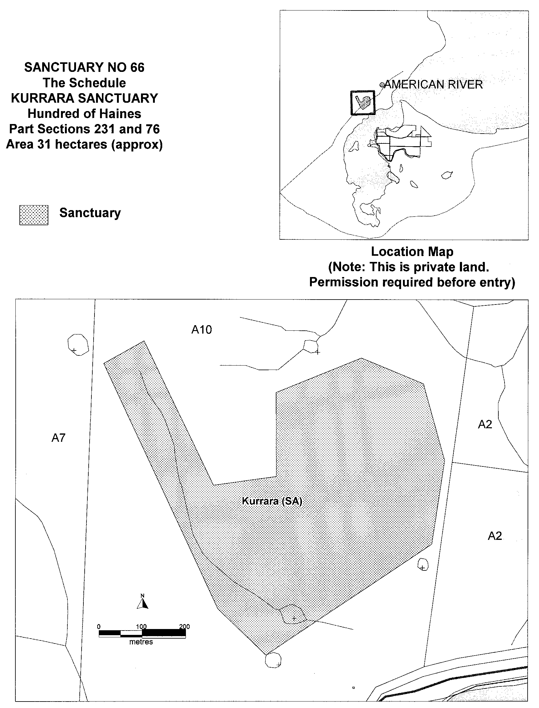

Iain Evans, Minister for Environment and Heritage

NATIONAL PARKS AND WILDLIFE ACT 1972
Declaration of Attunga Sanctuary
I, IAIN EVANS, Minister for Environment and Heritage and Minister of the Crown for the time being administering the National Parks and Wildlife Act 1972, being of the opinion that it is desirable to conserve the animals and plants for which the land depicted as a sanctuary in the schedule hereto is a natural habitat or environment and having received all necessary consents, do hereby declare the said land to be a sanctuary for the purposes of the said Act.
Dated 2 January 2001.
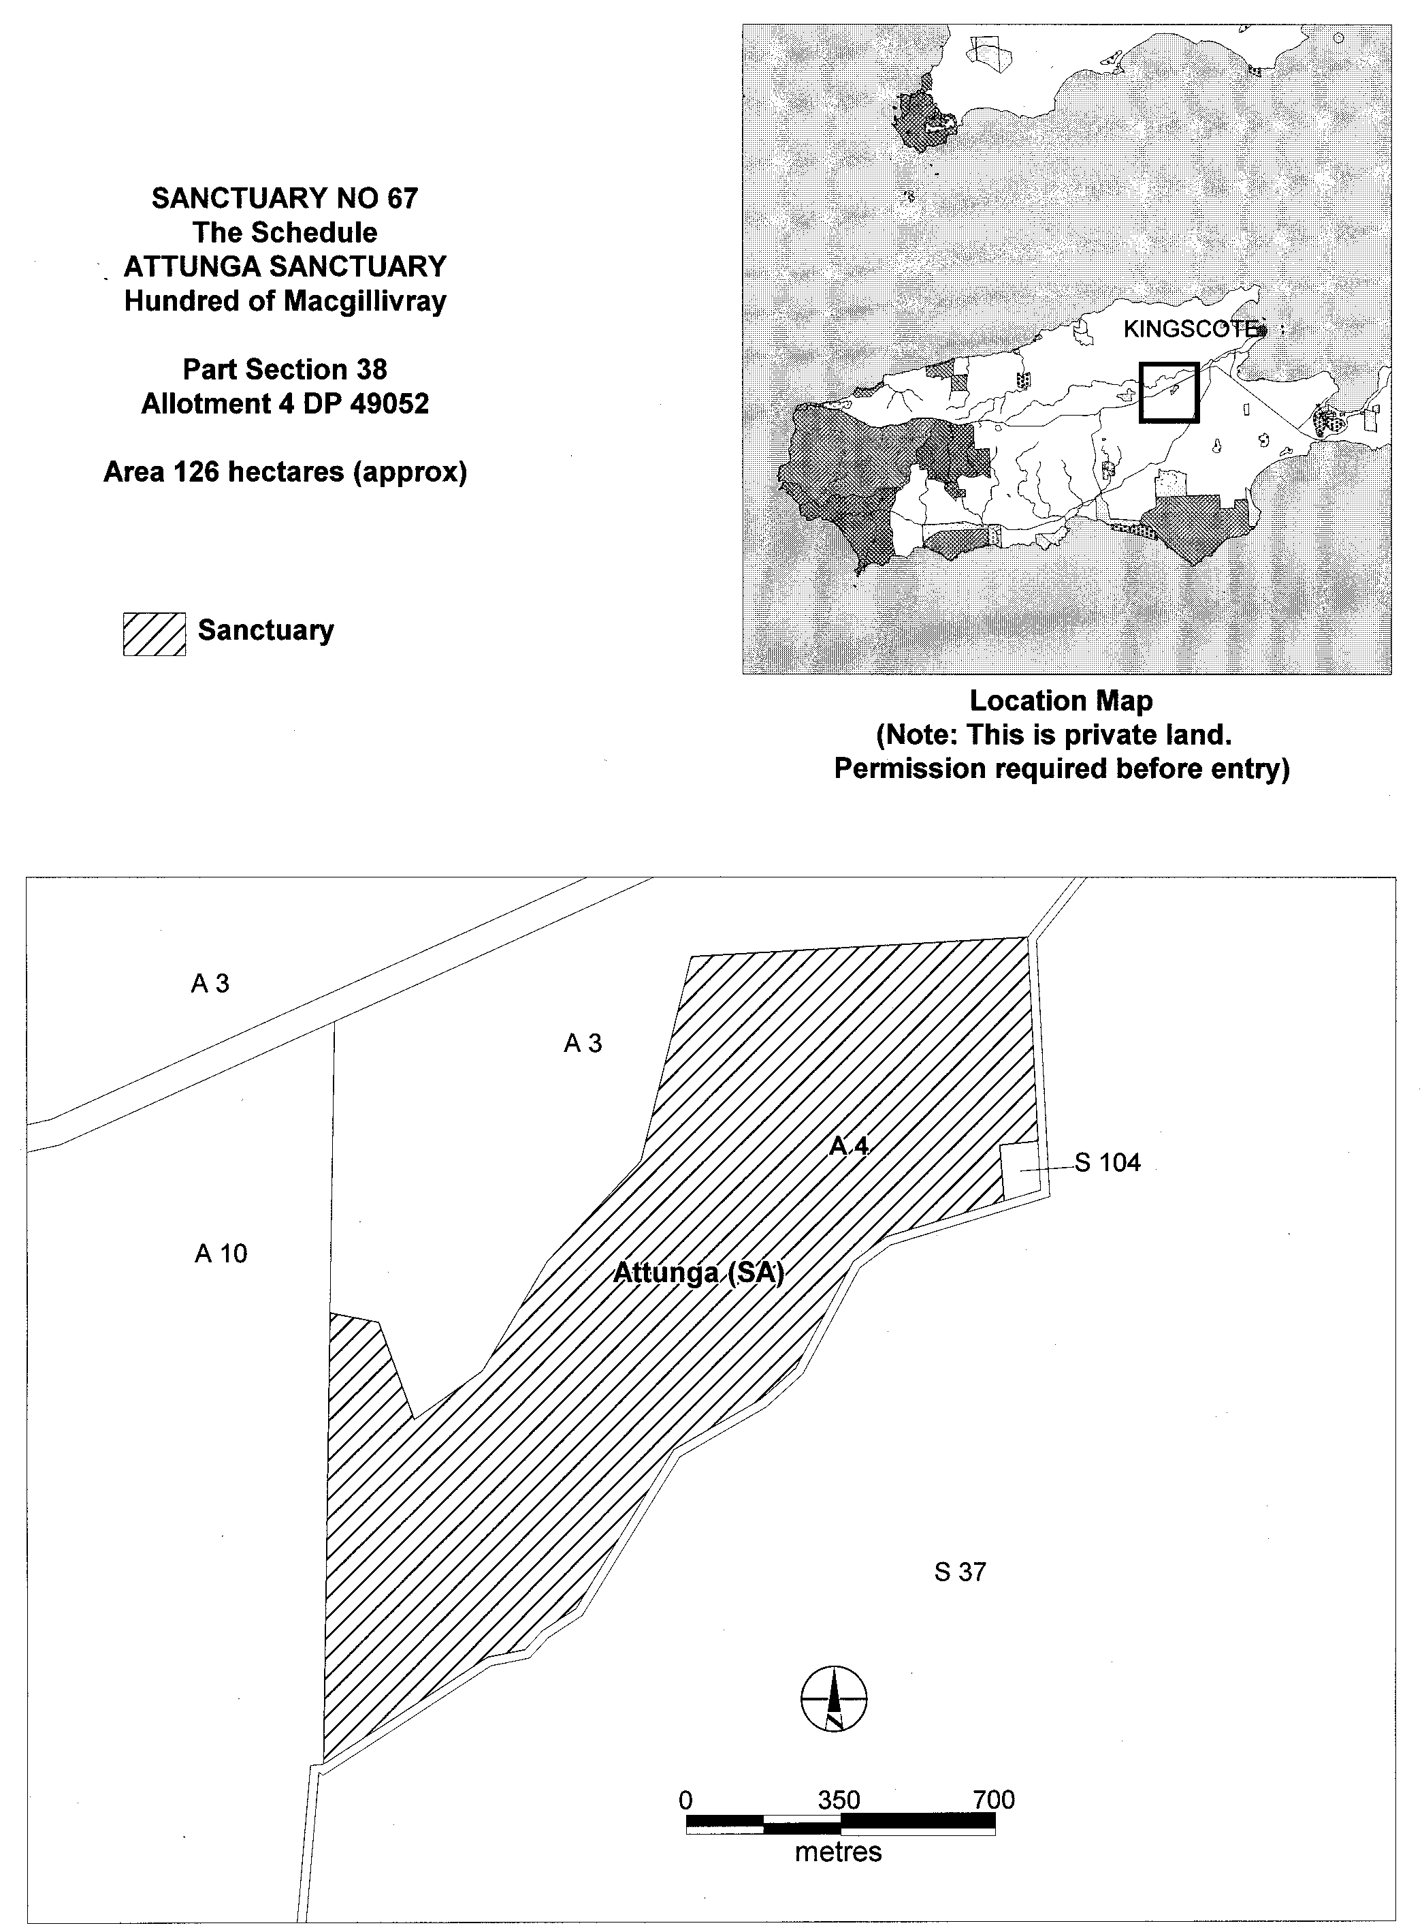

Iain Evans, Minister for Environment and Heritage

GRANT OF EXPLORATION LICENCE No. 83
Office of Minerals and Energy Resources, Adelaide, 15 March 2001
NOTICE is hereby given that the undermentioned exploration licence has been granted under the provisions of the Petroleum Act 2000, pursuant to delegated powers dated 25 September 2000, Gazetted 28 September 2000, page 2289.
R. A. Laws, Director Petroleum, Office of Minerals and Energy Resources, Delegate of the Minister for Minerals and Energy
No. of  Licence | Licensee | Locality | Date of  Expiry | Area in  km² | Reference

83 | Origin Energy Resources Ltd  Beach Oil and Gas Pty Ltd |  | Otway Basin of South Australia | 14 March 2006 | 413 | SR.27.2.210

Description of the Area
All that part of the State of South Australia bounded as follows: commencing at a point being the intersection of latitude 37°08′30″S GDA94 and longitude 140°45′E GDA94, thence east to longitude 140°49′30″E GDA94, south to latitude 37°09′30″S GDA94, east to longitude 140°50′30″E GDA94, south to latitude 37°12′30″S GDA94, east to longitude 140°53′E GDA94, south to latitude 37°14′30″S GDA94, east to longitude 140°55′30″E GDA94, south to latitude 37°15′30″S GDA94, east to the eastern border of the State of South Australia, thence southerly along the border of the said State to latitude 37°42′30″S AGD66, west to longitude 140°55′E AGD66, north to latitude 37°35′S AGD66, west to longitude 140°52′30″E AGD66, south to latitude 37°37′30″S AGD66, west to longitude 140°45′E AGD66, north to latitude 37°35′S AGD66, west to longitude 140°42′30″E AGD66, north to latitude 37°32′30″S AGD66, east to longitude 140°42′40″E GDA94, north to latitude 37°32′S GDA94, east to longitude 140°43′10″E GDA94, south to latitude 37°32′20″S GDA94, east to longitude 140°44′30″E GDA94, south to latitude 37°33′S GDA94, east to longitude 140°50′E GDA94, north to latitude 37°29′10″S GDA94, east to longitude 140°51′E GDA94, north to latitude 37°28′50″S GDA94, east to longitude 140°55′E AGD66, north to latitude 37°22′S AGD66, east to longitude 140°56′E AGD66, north to latitude 37°19′S AGD66, west to longitude 140°49′E AGD66, north to latitude 37°18′S AGD66, west to longitude 140°48′E AGD66, north to latitude 37°16′S AGD66, west to longitude 140°46′E AGD66, north to latitude 37°14′S AGD66, west to longitude 140°43′E AGD66, north to latitude 37°12′S AGD66, west to longitude 140°43′E GDA94, north to latitude 37°11′30″S GDA94, east to longitude 140°45′E GDA94 and north to the point of commencement, all the within latitudes and longitudes are expressed in terms of the following datums:
GDA94—Geocentric Datum of Australia.
AGD66—Australian Geodetic Datum as defined on p. 4984 of Commonwealth Gazette number 84 dated 6 October 1966.

GRANT OF SPECULATIVE SURVEY LICENCE No. 1
Office of Minerals and Energy Resources, Adelaide, 16 March 2001
NOTICE is hereby given that the undermentioned Speculative Survey Licence has been granted under the provisions of the Petroleum Act 2000, pursuant to delegated powers dated 25 September 2000, Gazetted 28 September 2000, page 2289.
R. A. Laws, Director Petroleum, Office of Minerals and Energy Resources, Delegate of the Minister for Minerals and Energy
No. of  Licence | Licensee | Locality | Date of  Expiry | Area in  km² | Reference

1 | Origin Energy Resources Ltd |  | Otway Basin of South Australia | 15 March 2002 | 131 | SR.27.2.218

Description of the Area
All that part of the State of South Australia bounded as follows: commencing at a point being the intersection of latitude 37°08′00″S GDA94 and longitude 140°31′00″E GDA94, thence east to longitude 140°37′00″E GDA94, south to latitude 37°10′00″S GDA94, east to longitude 140°43′00″E GDA94, south to latitude 37°13′00″S GDA94, west to longitude 140°31′00″E GDA94, and north to the point of commencement.

PETROLEUM ACT 2000
Notice of Invitation of Applications for Exploration Licences
I, ROBERT ANTHONY LAWS, Director Petroleum, Depart-ment of Primary Industries and Resources in the State of South Australia pursuant to the provisions of the Petroleum Act 2000, and pursuant to delegated powers dated 25 September 2000, gazetted 28 September 2000, page 2289 and in accordance with section 22 (1) of the Petroleum Act 2000, hereby invite applications for the grant of an Exploration Licence in respect of the following areas as described below:
OT2001-A
Description of Area
All that part of the State of South Australia, bounded as follows:
Commencing at a point being the intersection of latitude 37°10’S GDA94 and longitude 140°05′E GDA94, thence east to longitude 140°15′E AGD66, south to latitude 37°17′30″S AGD66, east to longitude 140°27′30″E AGD66, south to latitude 37°25′S AGD66, west to longitude 140°22′30″E AGD66, south to latitude 37°26′S AGD66, west to longitude 140°05′E AGD66, north to latitude 37°25′S AGD66, west to longitude 140°03′30″E AGD66, north to latitude 37°20′S AGD66, west to longitude 139°59′E AGD66, north to latitude 37°19′S AGD66, west to longitude 139°54′30″E AGD66, north to latitude 37°16′S AGD66, west to the Territorial Sea Baseline at low water mark, Southern Ocean, thence generally north-westerly and northerly along the said baseline to latitude 37°05′S GDA94, east to longitude 140°05′E GDA94, and south to the point of commencement, all the within latitudes and longitudes are expressed in terms of the following datums:
GDA94—Geocentric Datum of Australia.
AGD66—Australian Geodetic Datum as defined on p. 4984 of Commonwealth Gazette number 84 dated 6 October 1966.
Area: 1 418 km² (approx.)
OT2001-B
Description of Area
Commencing at a point being the intersection of latitude 36°50′S GDA94 and longitude 140°00′E GDA94, thence east to longitude 140°50′E GDA94, south to latitude 37°00′S GDA94, east to the eastern border of the State of South Australia, thence southerly along the border of the said State to latitude 37°15′30″S GDA94, west to longitude 140°55′30″E GDA94, north to latitude 37°14′30″S GDA94, west to longitude 140°53′E GDA94, north to latitude 37°12′30″S GDA94, west to longitude 140°50′30″E GDA94, north to latitude 37°09′30″S GDA94, west to longitude 140°49′30″E GDA94, north to latitude 37°08′30″S GDA94, west to longitude 140°45′E GDA94, south to latitude 37°11′30″S GDA94, west to longitude 140°43′E GDA94, south to latitude 37°12′S AGD66, west to longitude 140°37′E AGD66, north to latitude 37°11′S AGD66, west to longitude 140°32′30″E AGD66, south to latitude 37°12′S GDA94, west to longitude 140°28′E GDA94, north to latitude 37°09′30″S GDA94, west to longitude 140°20′E GDA94, south to latitude 37°10′S AGD66, west to longitude 140°15′E AGD66, south to latitude 37°10′S GDA94, west to longitude 140°05′E GDA94, north to latitude 37°05′S GDA94, west to the Territorial Sea Baseline at low water mark, Southern Ocean, thence generally north-westerly and north-easterly along the said baseline to latitude 36°54′S GDA94, east to longitude 140°00′E GDA94 and north to the point of commencement but excluding the area bounded as follows:
Commencing at a point being the intersection of latitude 36°57′S AGD66 and longitude 140°00′E AGD66, thence east to longitude 140°06′E AGD66, south to latitude 36°58′S AGD66, east to longitude 140°07′E AGD66, south to latitude 36°59′S AGD66, east to longitude 140°14′E AGD66, south to latitude 37°01′S AGD66, west to longitude 139°58′30″E AGD66, north to latitude 37°00′S AGD66, west to longitude 139°55′E AGD66, north to latitude 36°57′30″S AGD66, east to longitude 140°00′E AGD66, and north to the point of commencement, all the within latitudes and longitudes are expressed in terms of the following datums:
GDA94—Geocentric Datum of Australia.
AGD66—Australian Geodetic Datum as defined on p. 4984 of Commonwealth Gazette number 84 dated 6 October 1966.
Area: 3 371 km² (approx.)
Applications lodged under section 65 (1) of the Petroleum Act 2000 are required to be made in the approved form as identified in Petroleum Exploration Data Package No. 10 (can be viewed at: www.petroleum.pir.sa.gov.au) and include details as follows:
• must satisfy the requirements of Regulation 4 of the Regulations under the Petroleum Act 2000;
• must be accompanied by a proposed work program for the 5 year first term of the licence;
• must be accompanied by a statement of the financial and technical resources available to the applicant; and
• must be accompanied by the then scheduled application fee.
Applications, together with relevant data should be submitted in the following manner to the Minister for Minerals and Energy, c/o Director Petroleum, Department of Primary Industries and Resources SA, Level 7, 101 Grenfell Street, Adelaide, S.A. 5000. Applications close at 4 p.m. on Thursday, 26 July 2001.
The following special instructions should be observed:
• the application and supporting data, together with the scheduled application fee, (currently $2 362 but scheduled to be subject to a consumer price index adjustment on 1 July 2001) payable to the Department of Primary Industries and Resources should be enclosed in an envelope or package;
• the application should then be sealed and clearly marked as ‘Application for Area OT2001….…—Commercial-in-Confidence’;
• this envelope or package should then be enclosed in a plain covering envelope or package and delivered by hand or posted to the relevant address above.
Copies of the basic exploration data pertaining to the areas comprising this notice may be purchased from the Petroleum Group of the Department of Primary Industries and Resources SA. Inquiries may be directed to R. Laws, Director, Petroleum Group (Telephone (08) 8463 3200; email:
laws.bob@saugov.sa.gov.au).
Criteria for Assessment of Applications
The basic objective in awarding an exploration licence is to select the work program most likely to evaluate the prospectivity of the licence area and discovering petroleum within the initial five-year term of the licence. Work program bids will be assessed taking account of the criteria listed below. All these criteria are used when selecting the winning bid. It is important to note that the timing of activities, especially the drilling of wells, and the extent of the guaranteed nature of the program carry substantial weight in the assessment process.
The most important criteria for assessment of work programs are:
• number of exploration wells (dry-hole basis) to be drilled, their timing and the anticipated number of exploration objectives to be drilled by the wells;
• extent that the wells proposed to be drilled are supported by adequate seismic or other geophysical techniques;
• number of years that the applicant is willing to guarantee the work program;
• adequacy of financial resources and technical expertise available to the applicant;
• past performance in fulfilling work program commitments of the applicant elsewhere in Australia.
Secondary criteria that may be taken into account are:
• the amount and nature of seismic surveying to be carried out and its timing;
• other data acquisition and seismic reprocessing to be carried out.
In addition to the above criteria, where work program bids are similar, the benefits of the introduction of new explorers into the area (including intention with regard to establishing an office in South Australia) may be taken into account. It should be noted that there are no criteria limiting the number of (P)ELs which may be offered to one applicant providing the applicant has adequate financial resources to complete all programs. In the case of ‘cascading bids’ (i.e. multiple or hybrid bids for an area by one applicant or joint venture) only the highest of the bids will be considered.
Dated 15 March 2001.
R. A. Laws, Director Petroleum, Delegate of the Minister for Primary Industries and Resources.

PETROLEUM ACT 2000
Notice of Invitation of Applications for Exploration Licences
I, ROBERT ANTHONY LAWS, Director Petroleum, Depart-ment of Primary Industries and Resources in the State of South Australia pursuant to the provisions of the Petroleum Act 2000, and pursuant to delegated powers dated 25 September 2000, gazetted 28 September 2000, page 2289 and in accordance with section 22 (1) of the Petroleum Act 2000, hereby invite applications for the grant of an Exploration Licence in respect of the following areas as described below:
CO 2001-A
Description of Area
Commencing at a point being the intersection of latitude 27°56′40″S AGD66 and longitude 139°47′45″E AGD66, thence east to longitude 139°48′20″E AGD66, south to latitude 27°57′10″S AGD66, east to longitude 139°48′30″E AGD66, south to latitude 27°57′30″S AGD66, east to longitude 139°48′40″E AGD66, south to latitude 27°57′40″S AGD66, east to longitude 139°49′00″E AGD66, south to latitude 27°58′15″S AGD66, west to longitude 139°48′00″E AGD66, north to latitude 27°57′55″S AGD66, west to longitude 139°47′50″E AGD66, north to latitude 27°57′35″S AGD66, west to longitude 139°47′45″E AGD66, and north to the point of commencement, all the within latitudes and longitudes being geodetic and expressed in terms of the Australian Geodetic Datum as defined on p. 4984 of Commonwealth Gazette number 84 dated 6 October 1966 (AGD66).
Area: 4 km² (approx.)
CO 2001-B
Description of Area
Commencing at a point being the intersection of latitude 28°00′25″S AGD66 and longitude 139°29′15″E AGD66, thence east to longitude 139°29′45″E AGD66, south to latitude 28°00′35″S AGD66, east to longitude 139°29′50″E AGD66, south to latitude 28°00′40″S AGD66, east to longitude 139°29′55″E AGD66, south to latitude 28°00′45″S AGD66, east to longitude 139°30′20″E AGD66, south to latitude 28°00′55″S AGD66, east to longitude 139°30′40″E AGD66, south to latitude 28°01′05″S AGD66, east to longitude 139°30′55″E AGD66, south to latitude 28°01′30″S AGD66, east to longitude 139°31′15″E AGD66, south to latitude 28°01′45″S AGD66, east to longitude 139°32′00″E AGD66, south to latitude 28°02′25″S AGD66, west to longitude 139°30′50″E AGD66, north to latitude 28°02′10″S AGD66, west to longitude 139°30′20″E AGD66, north to latitude 28°02′05″S AGD66, west to longitude 139°29′50″E AGD66, north to latitude 28°01′20″S AGD66, west to longitude 139°29′35″E AGD66, north to latitude 28°01′10″S AGD66, west to longitude 139°29′25″E AGD66, north to latitude 28°01′00″S AGD66, west to longitude 139°29′15″E AGD66, and north to the point of commencement, all the within latitudes and longitudes being geodetic and expressed in terms of the Australian Geodetic Datum as defined on p. 4984 of Common-wealth Gazette number 84 dated 6 October 1966 (AGD66).
Area: 8 km² (approx.)
CO 2001-C
Description of Area
Commencing at a point being the intersection of latitude 28°29′07.5″S AGD66 and longitude 139°58′40″E AGD66, thence east to longitude 139°59′00″E AGD66, south to latitude 28°29′15″S AGD66, east to longitude 139°59′30″E AGD66, north to latitude 28°29′05″S AGD66, east to longitude 140°00′05″E AGD66, south to latitude 28°29′15″S AGD66, west to longitude 140°00′00″E AGD66, south to latitude 28°29′20″S AGD66, west to longitude 139°59′55″E AGD66, south to latitude 28°29′25″S AGD66, west to longitude 139°59′45″E AGD66, south to latitude 28°29′35″S AGD66, west to longitude 139°59′40″E AGD66, south to latitude 28°29′40″S AGD66, west to longitude 139°59′30″E AGD66, north to latitude 28°29′20″S AGD66, west to longitude 139°58′40″E AGD66, and north to the point of commencement, all the within latitudes and longitudes being geodetic and expressed in terms of the Australian Geodetic Datum as defined on p. 4984 of Commonwealth Gazette number 84 dated 6 October 1966 (AGD66).
Area: 1 km² (approx.)
CO 2001-D
Description of Area
Commencing at a point being the intersection of latitude 28°33′30″S AGD66 and longitude 140°20′30″E AGD66, thence east to longitude 140°20′50″E AGD66, south to latitude 28°33′40″S AGD66, east to longitude 140°21′30″E AGD66, south to latitude 28°34′00″S Clarke 1858, east to longitude 140°22′00″E AGD66, north to latitude 28°33′50″S AGD66, east to longitude 140°22′10″E AGD66, south to latitude 28°34′05″S AGD66, west to longitude 140°21′30″E AGD66, south to latitude 28°34′10″S AGD66, west to longitude 140°21′20″E AGD66, south to latitude 28°34′20″S AGD66, west to longitude 140°20′30″E AGD66, and north to the point of commencement, all the within latitudes and longitudes are expressed in terms of the following datums:
AGD66—Australian Geodetic Datum as defined on p. 4984 of Commonwealth Gazette number 84 dated 6 October 1966.
Clarke 1858—Clarke 1858 Spheroid (Transverse Mercator Projection).
Area: 2 km² (approx.)
CO 2001-E
Description of Area
Commencing at a point being the intersection of latitude 28°30′30″S AGD66 and longitude 140°25′30″E AGD66, thence east to longitude 140°26′00″E AGD66, south to latitude 28°31′10″S AGD66, west to longitude 140°25′50″E AGD66, south to latitude 28°31′20″S AGD66, west to longitude 140°25′30″E AGD66, and north to the point of commencement, all the within latitudes and longitudes being geodetic and expressed in terms of the Australian Geodetic Datum as defined on p. 4984 of Commonwealth Gazette number 84 dated 6 October 1966 (AGD66).
Area: 1 km² (approx.)
CO 2001-F
Description of Area
Commencing at a point being the intersection of latitude 28°29′15″S AGD66 and longitude 140°41′00″E AGD66, thence east to longitude 140°42′40″E AGD66, south to latitude 28°29′20″S AGD66, west to longitude 140°42′10″E AGD66, south to latitude 28°29′30″S AGD66, west to longitude 140°41′40″E AGD66, south to latitude 28°30′40″S AGD66, east to longitude 140°42′35″E AGD66, south to latitude 28°31′05″S AGD66, west to longitude 140°41′00″E AGD66, north to latitude 28°30′35″S AGD66, west to longitude 140°40′55″E AGD66, north to latitude 28°30′15″S AGD66, east to longitude 140°41′00″E AGD66, and north to the point of commencement, all the within latitudes and longitudes being geodetic and expressed in terms of the Australian Geodetic Datum as defined on p. 4984 of Commonwealth Gazette number 84 dated 6 October 1966 (AGD66).
Area: 5 km² (approx.)
Applications lodged under section 65 (1) of the Petroleum Act 2000 are required to be made in the approved form as identified in Petroleum Exploration Data Package No. 11 (can be viewed at: www.petroleum.pir.sa.gov.au) and include details as follows:
• must satisfy the requirements of Regulation 4 of the Regulations under the Petroleum Act 2000;
• must be accompanied by a proposed work program for the 5 year first term of the licence;
• must be accompanied by a statement of the financial and technical resources available to the applicant; and
• must be accompanied by the standard scheduled application fee.
Applications, together with relevant data should be submitted in the following manner to the Minister for Minerals and Energy, c/o Director Petroleum, Department of Primary Industries and Resources SA, Level 7, 101 Grenfell Street, Adelaide, S.A. 5000. Applications close at 4 p.m. on Thursday, 2 August 2001.
The following special instructions should be observed:
• the application and supporting data, together with the scheduled application fee, (currently $2 362 but scheduled to be subject to a consumer price index adjustment on 1 July 2001) payable to the Department of Primary Industry and Resources should be enclosed in an envelope or package;
• the application should then be sealed and clearly marked as ‘Application for Area CO2001-….…—Commercial-in-Confidence’;
• this envelope or package should then be enclosed in a plain covering envelope or package and delivered by hand or posted to the relevant address above.
Copies of the basic exploration data pertaining to the areas comprising this notice may be purchased from the Petroleum Group of the Department of Primary Industries and Resources SA. Inquiries may be directed to R. Laws, Director, Petroleum Group (Telephone (08) 8463 3200; email:
laws.bob@saugov.sa.gov.au).
Criteria for Assessment of Applications
Bids will be assessed taking account of the criteria listed below. All these criteria are used when selecting the winning bid. It is important to note that the timing of well drilling may be taken into account. As stated above, proposals to drill more than one well in each block will not be taken into account in the bid assessment process. The bidder with the highest cash bid will be successful. The most important criteria for assessment of CO2001 work programs are:
• amount of cash bid;
• adequacy of financial resources and technical expertise available to the applicant;
• applicant’s past performance in fulfilling work program commitments elsewhere in South Australia;
• for blocks CO2001-B and D, whether any proposed well is guaranteed.
The timing of drilling will be taken into account if cash bids are equal. In addition to the above criteria, where bids are similar, the benefits of the introduction of new explorers into the area (including intention with regard to establishing an office in South Australia) may be taken into account.
It should be noted that there are no criteria limiting the number of (P)ELs which may be offered to one applicant providing the applicant has adequate financial resources to complete all programs. In the case of ‘cascading bids’ (i.e. multiple or hybrid bids for an area by one applicant or joint venture) only the highest of the bids will be considered.
Dated 15 March 2001.
R. A. Laws, Director Petroleum, Delegate of the Minister for Primary Industries and Resources.

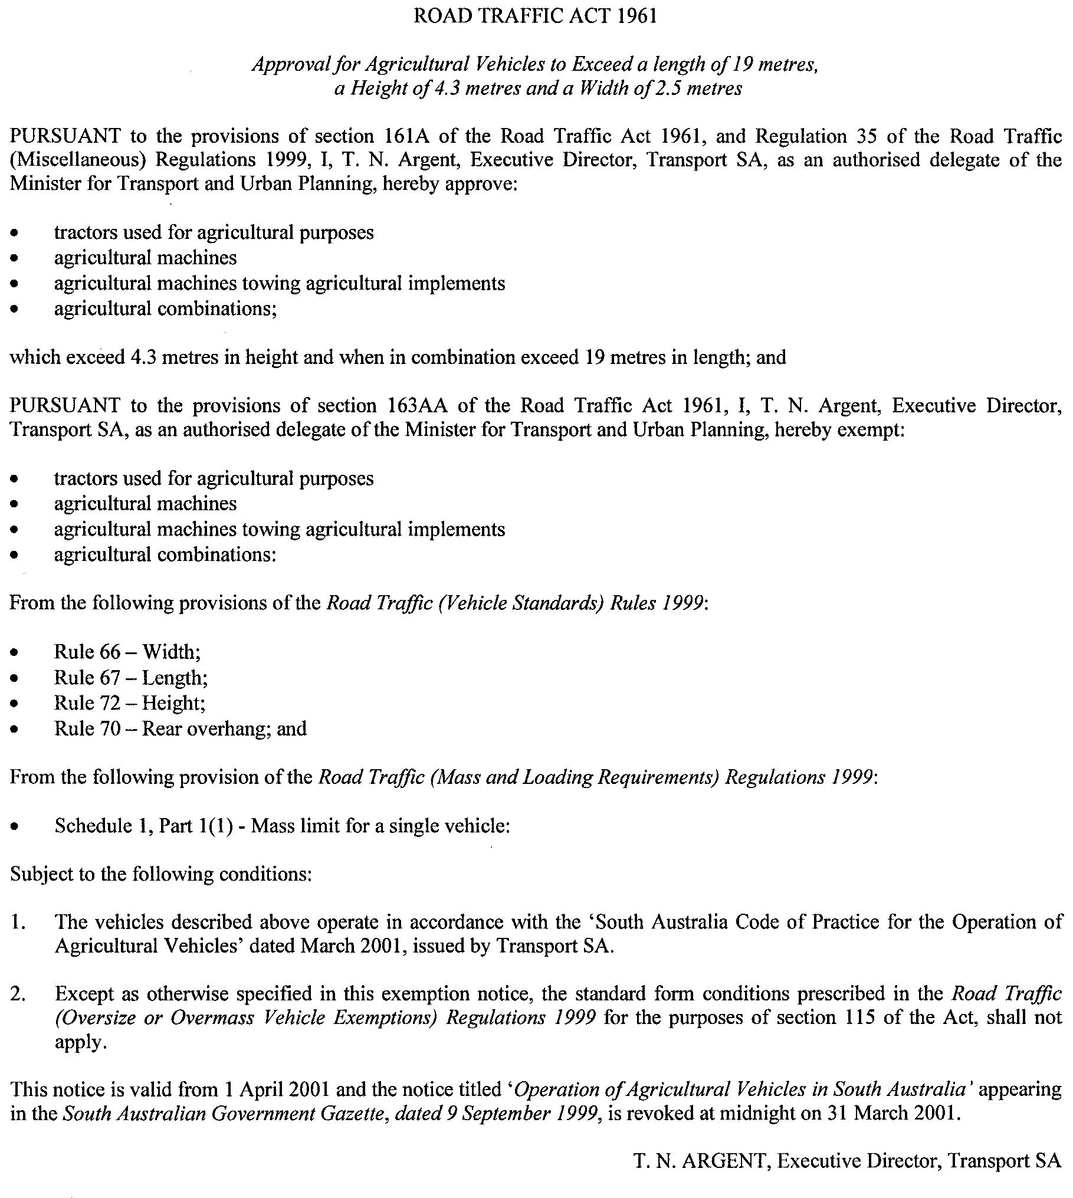
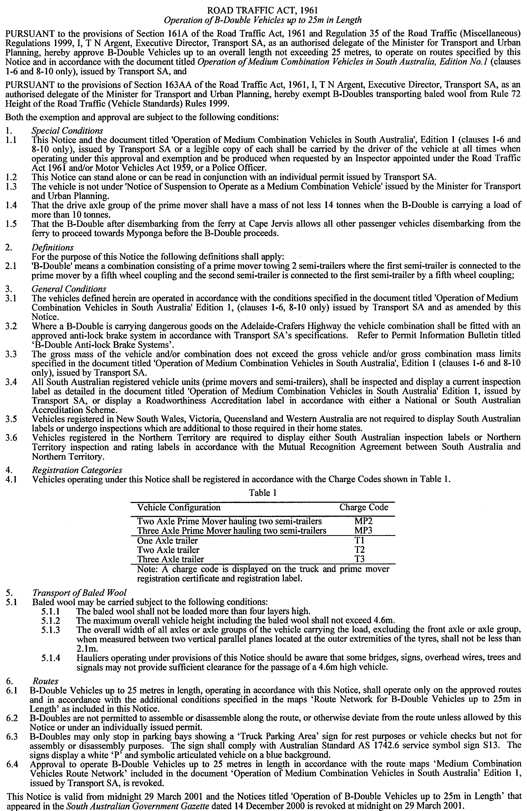
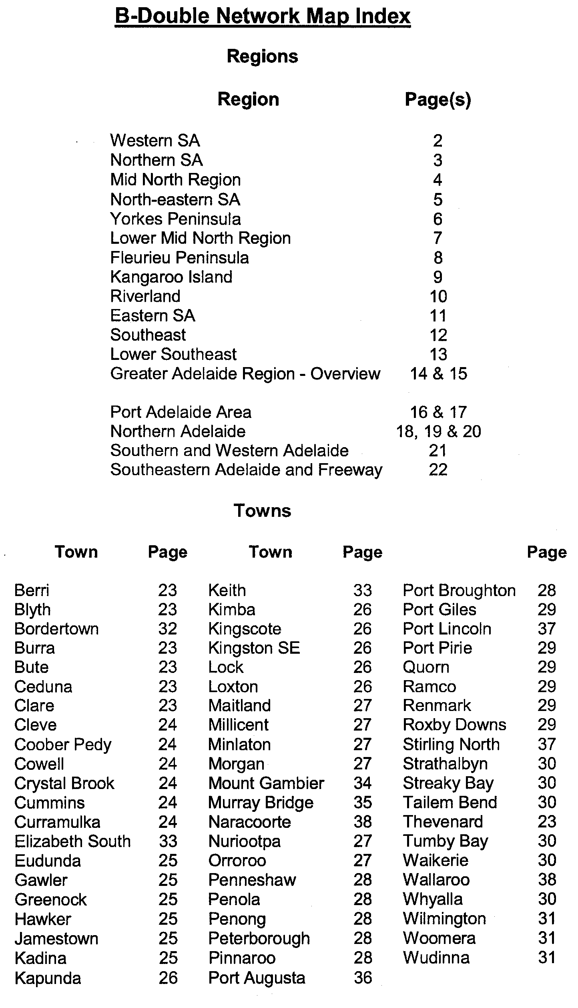
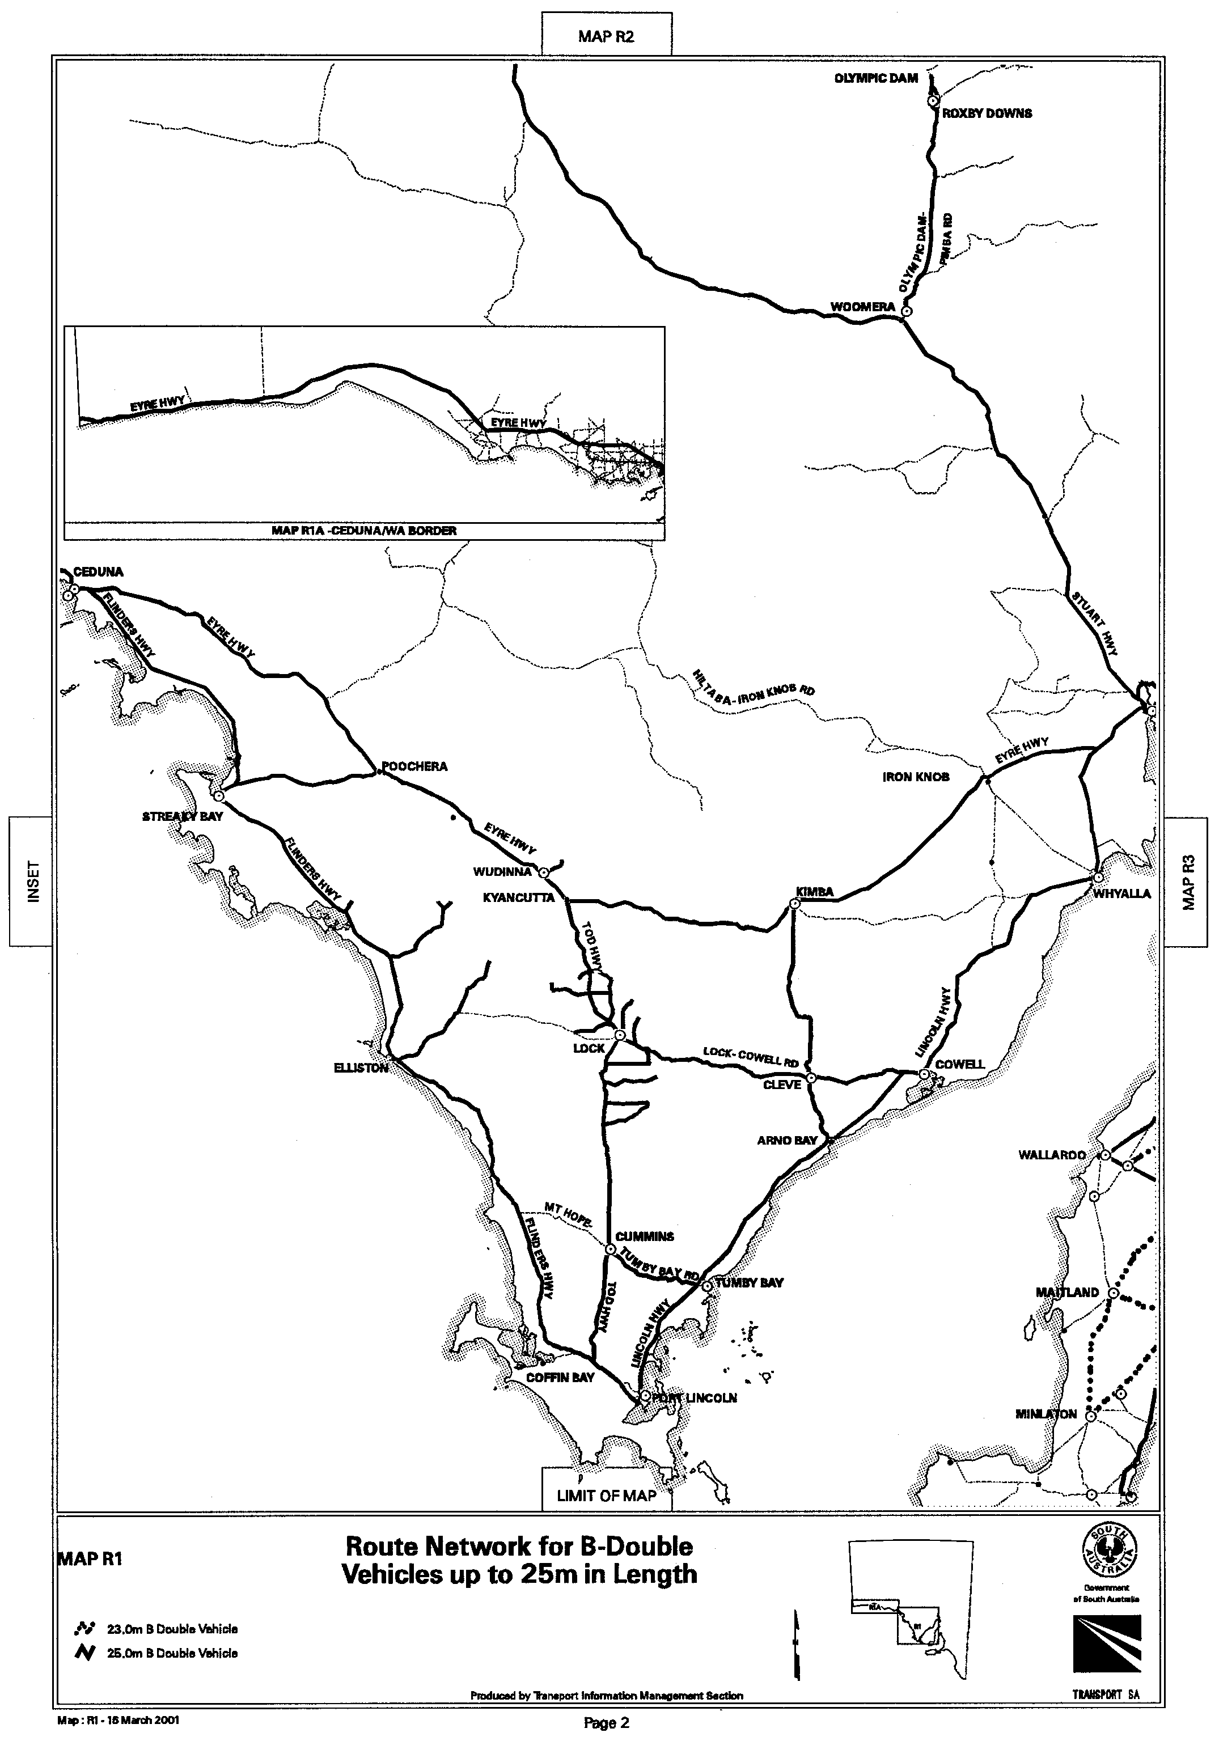
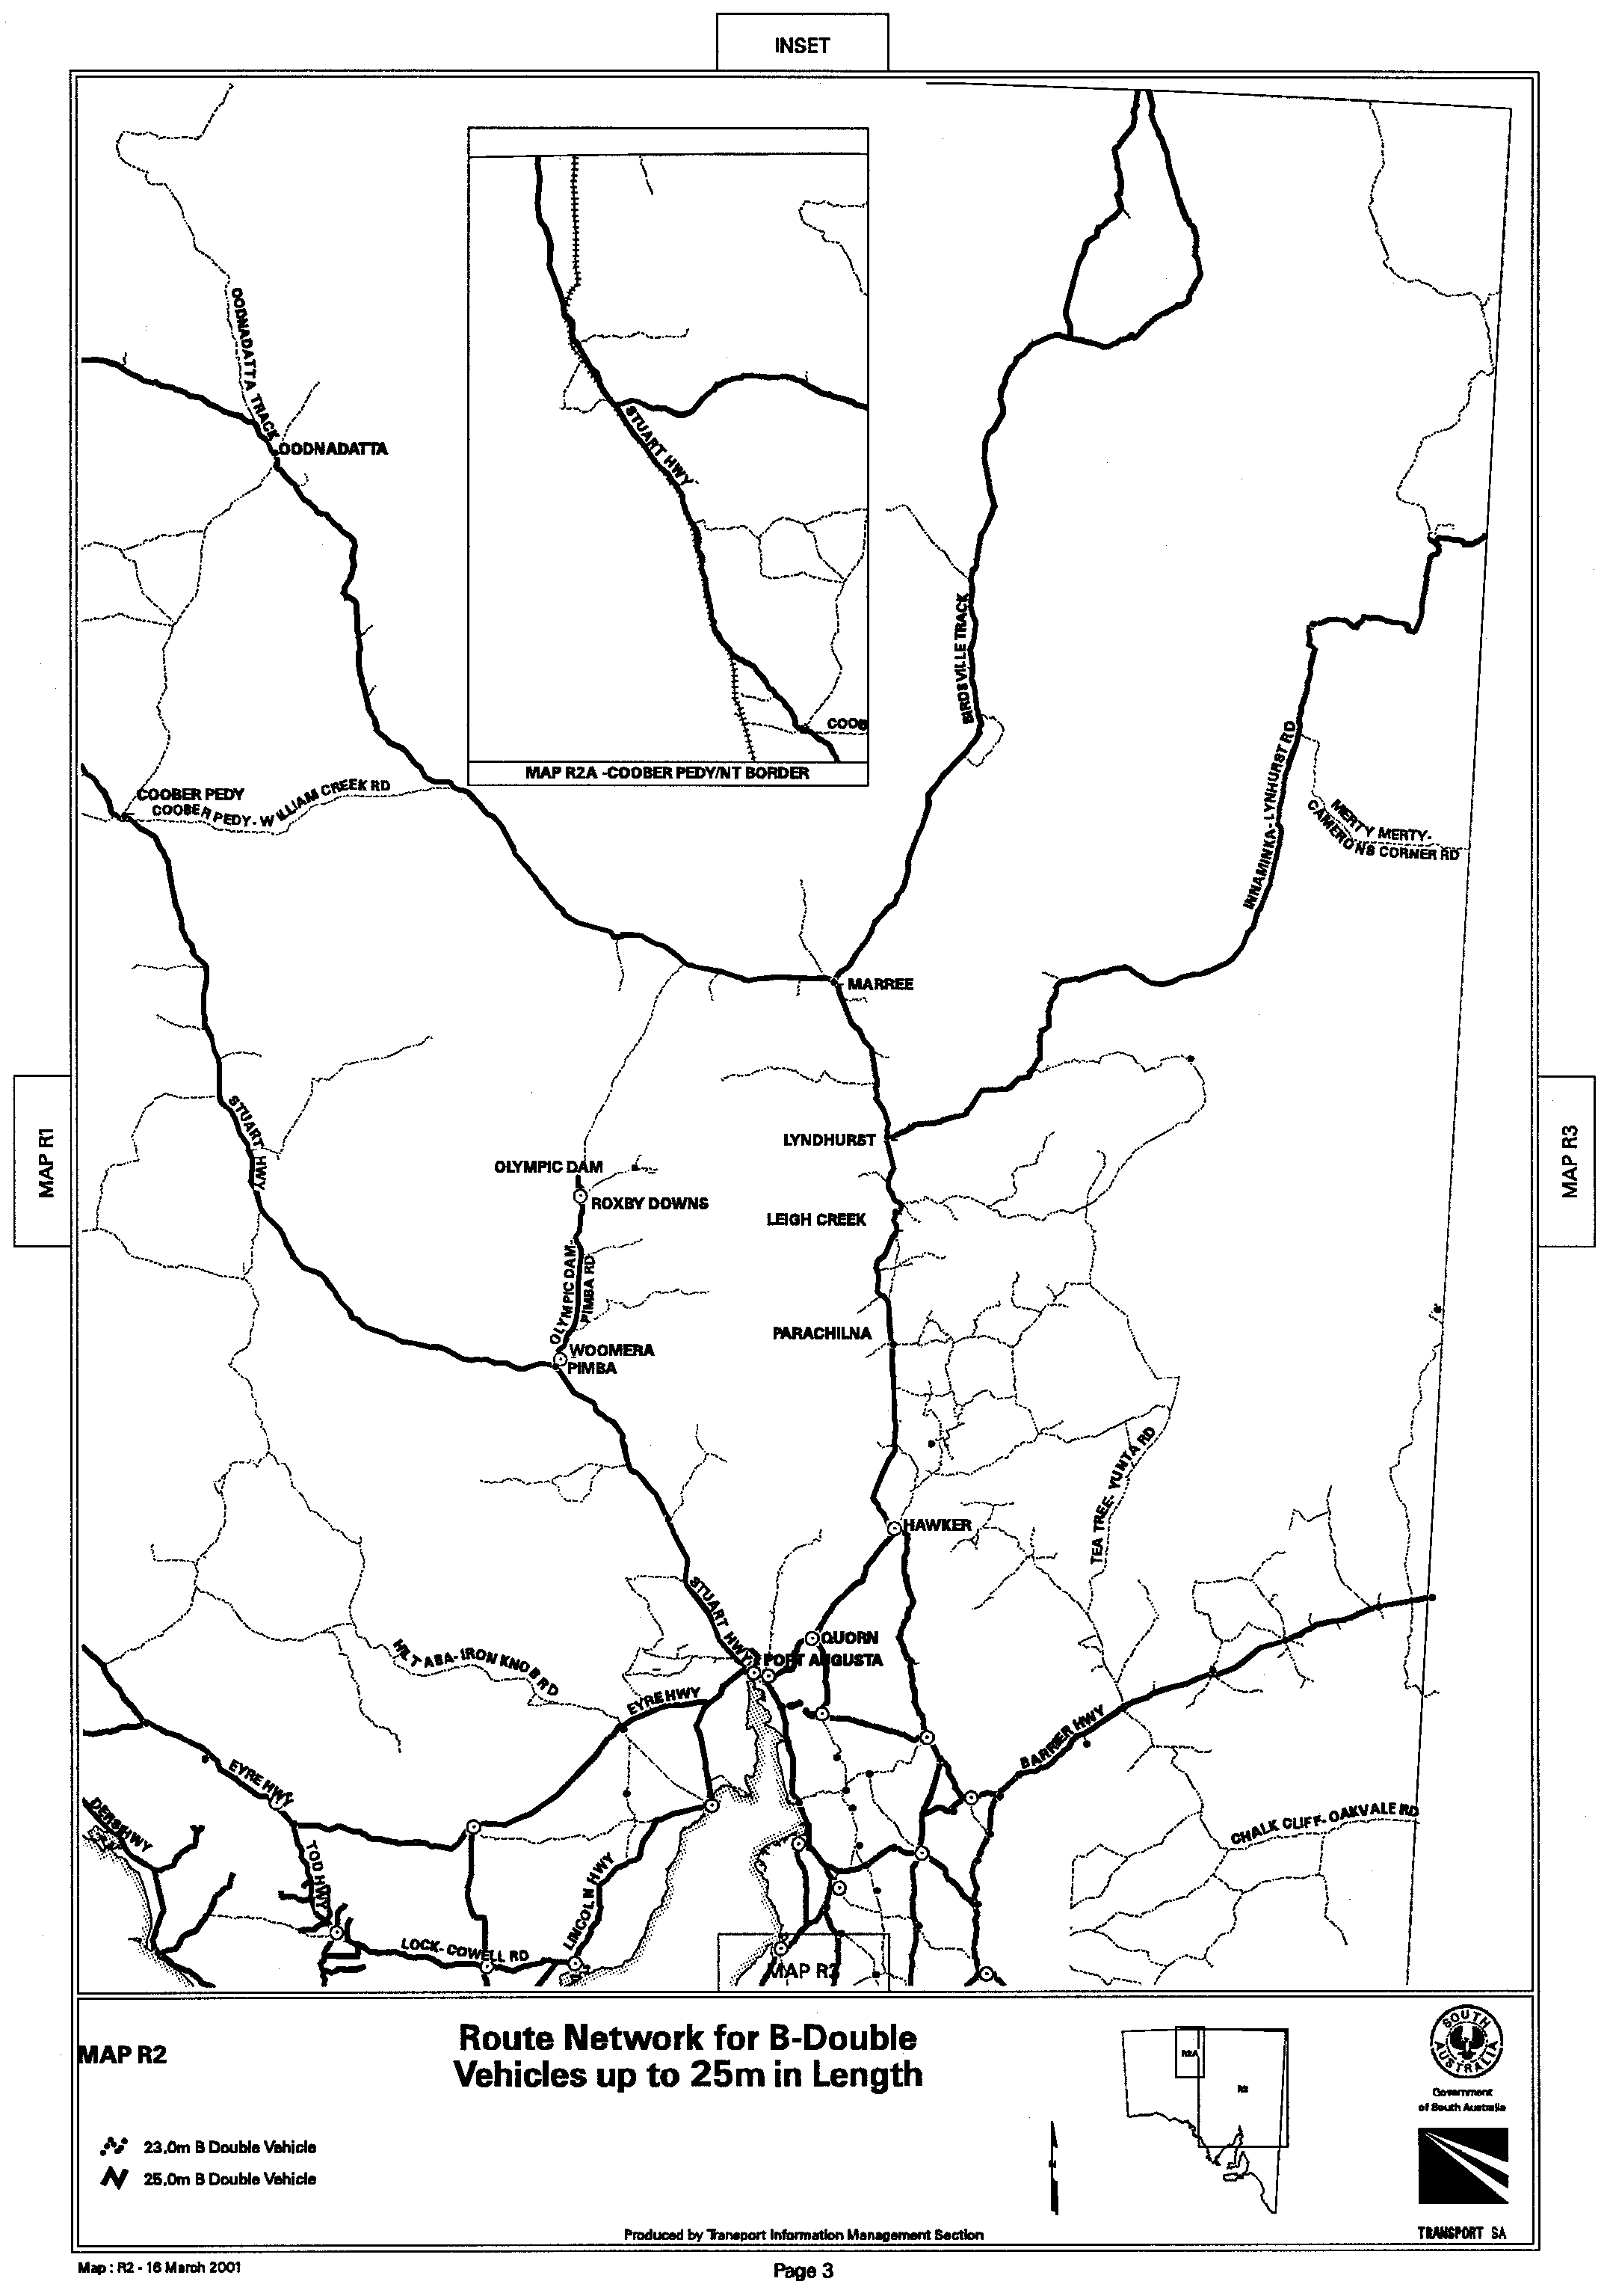
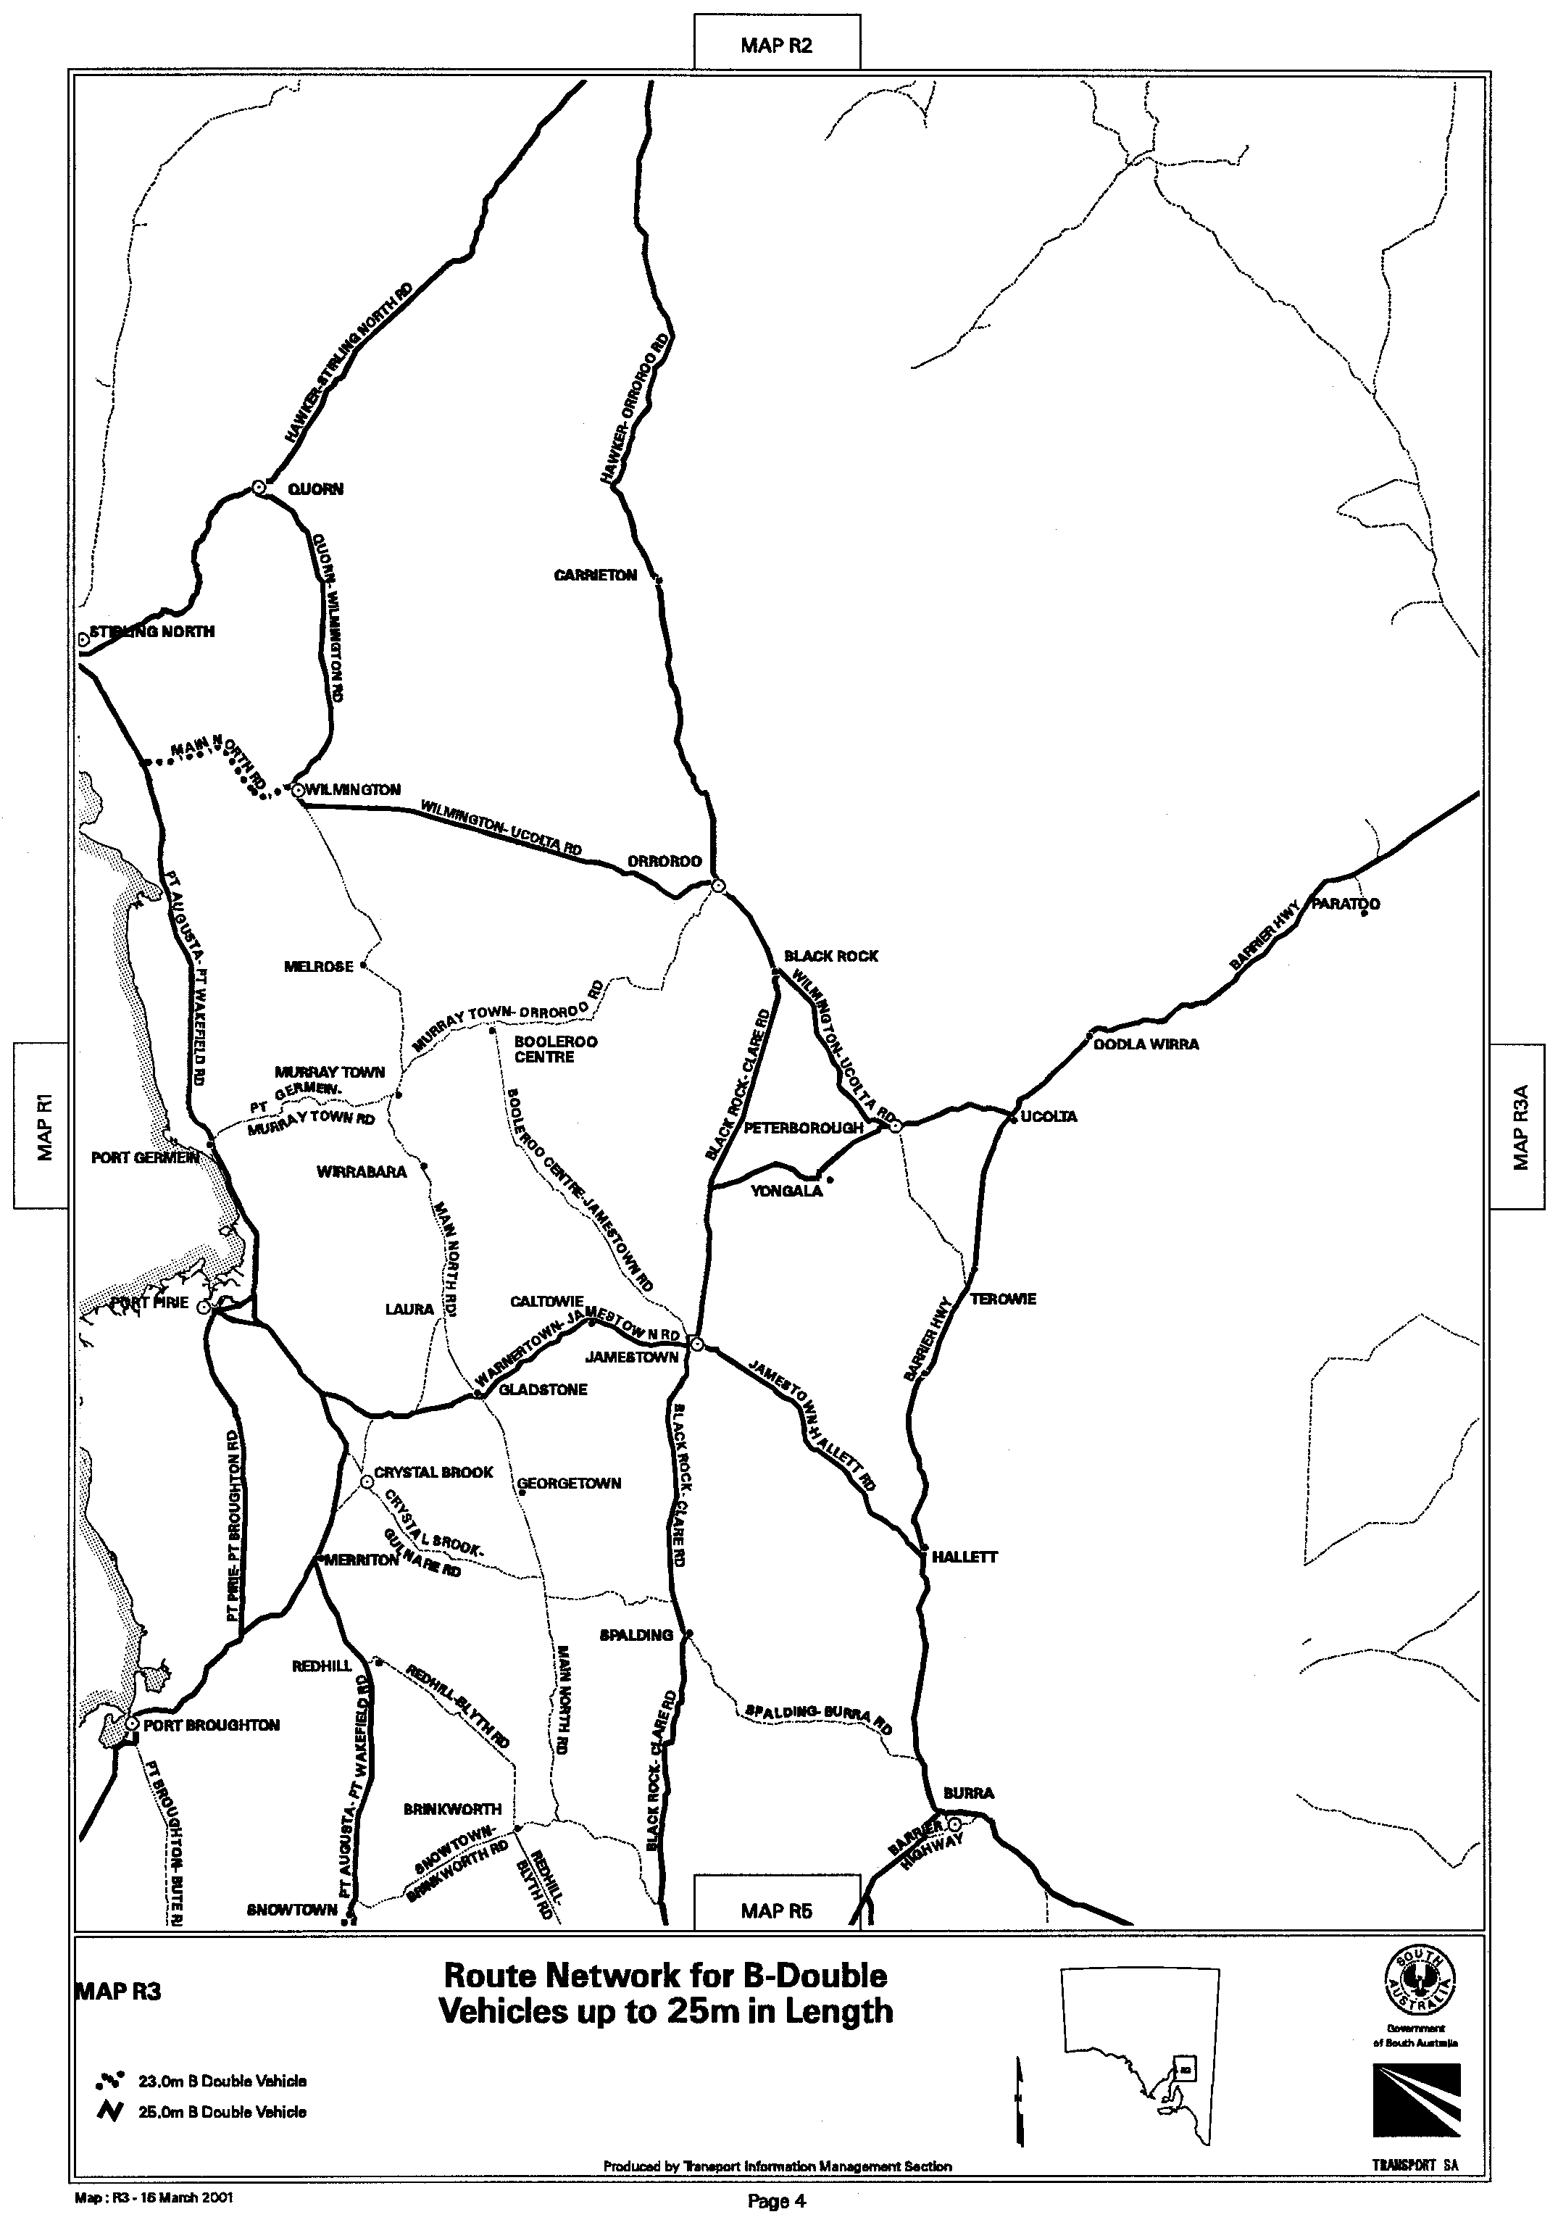
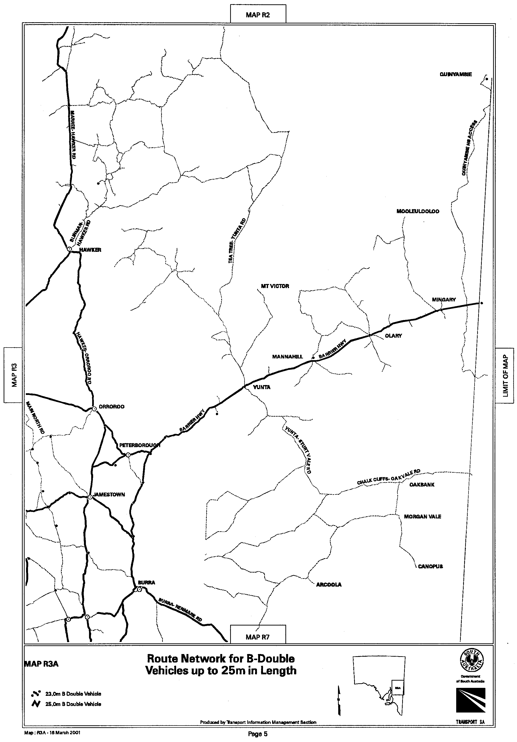
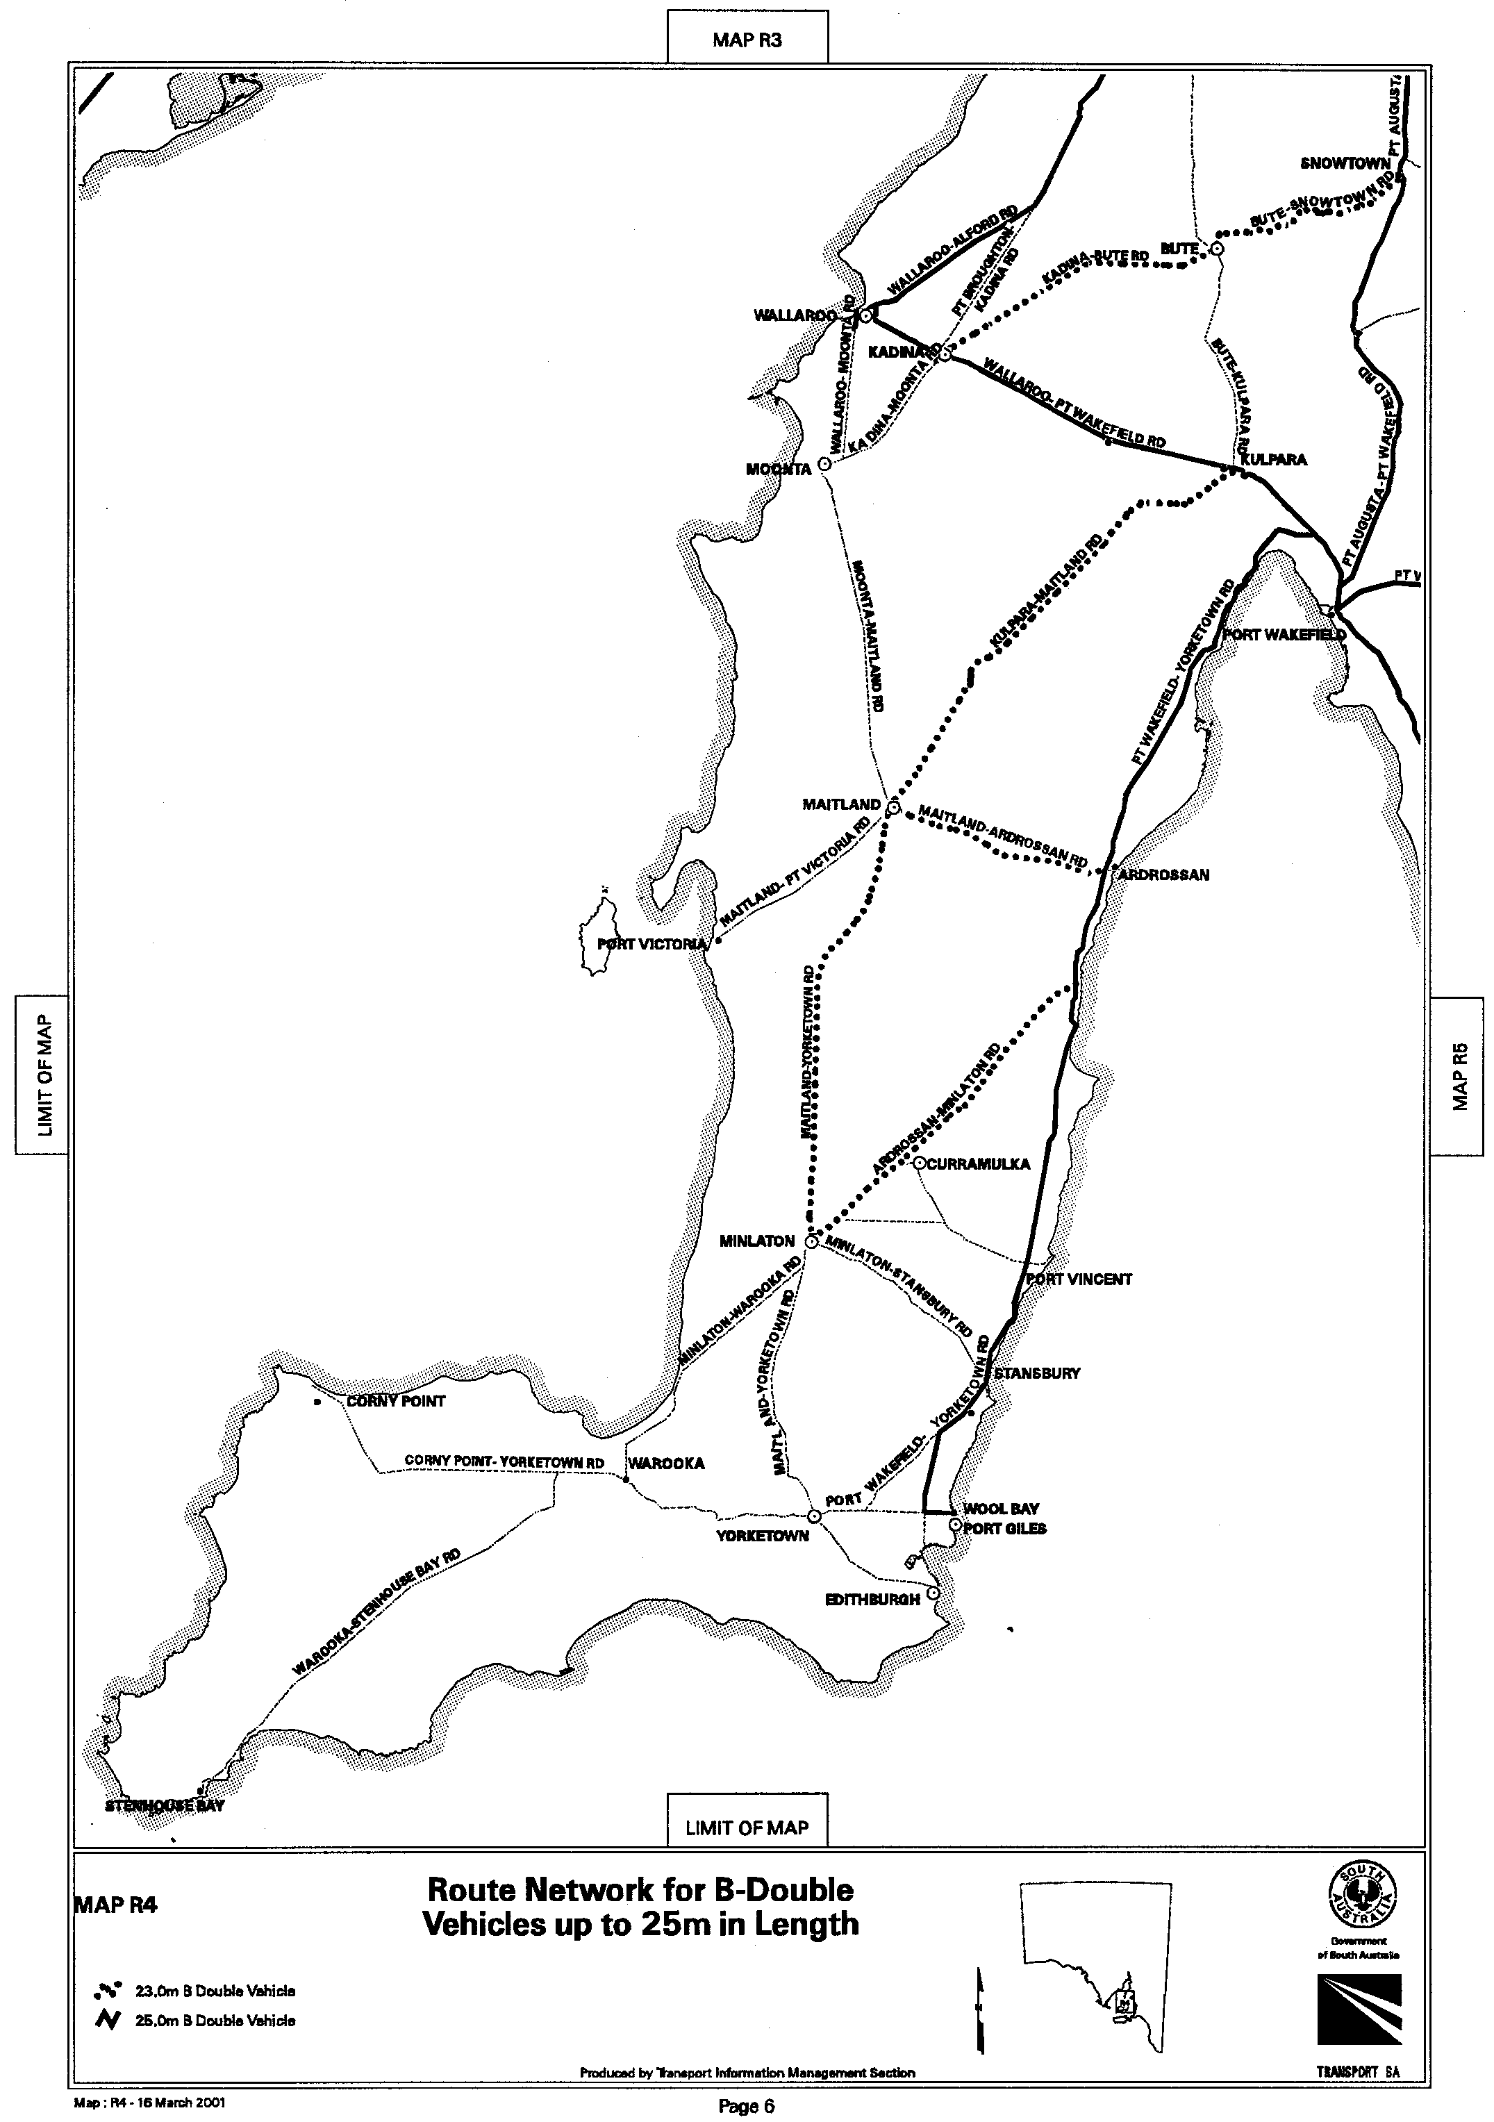
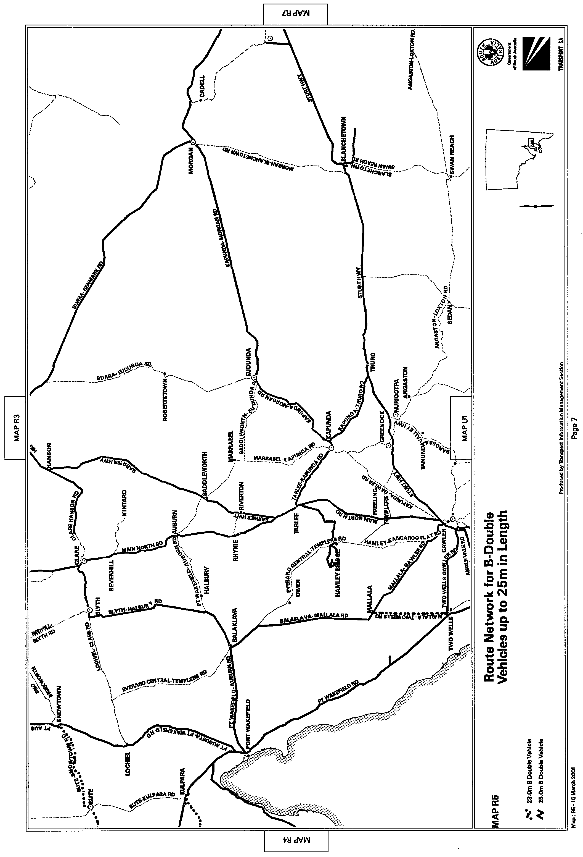
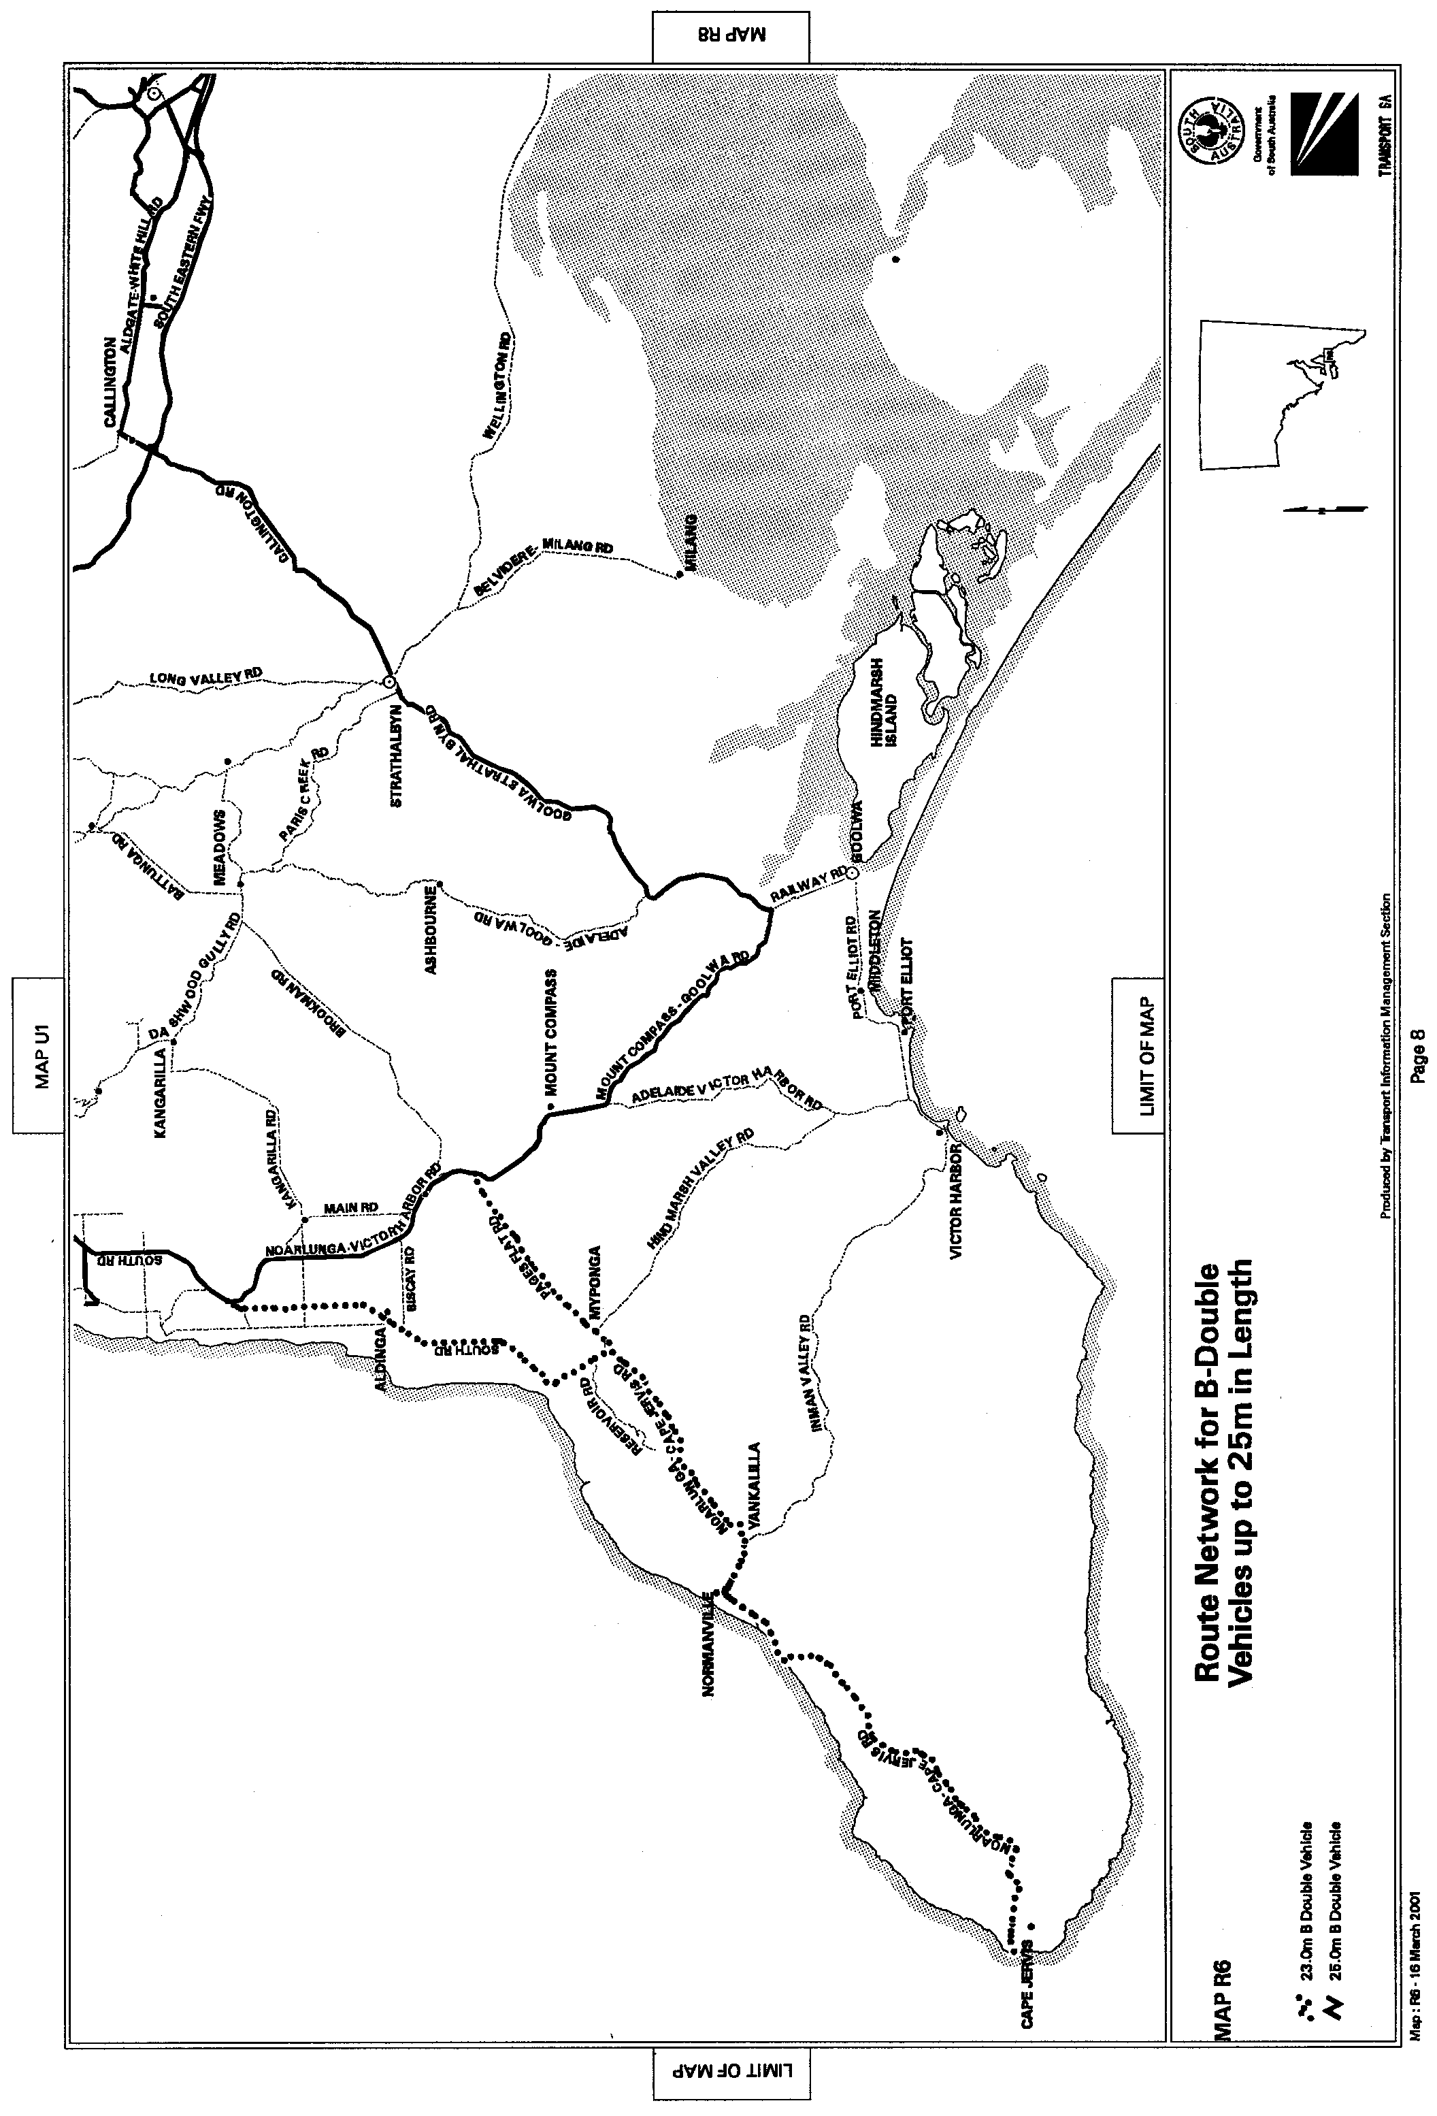
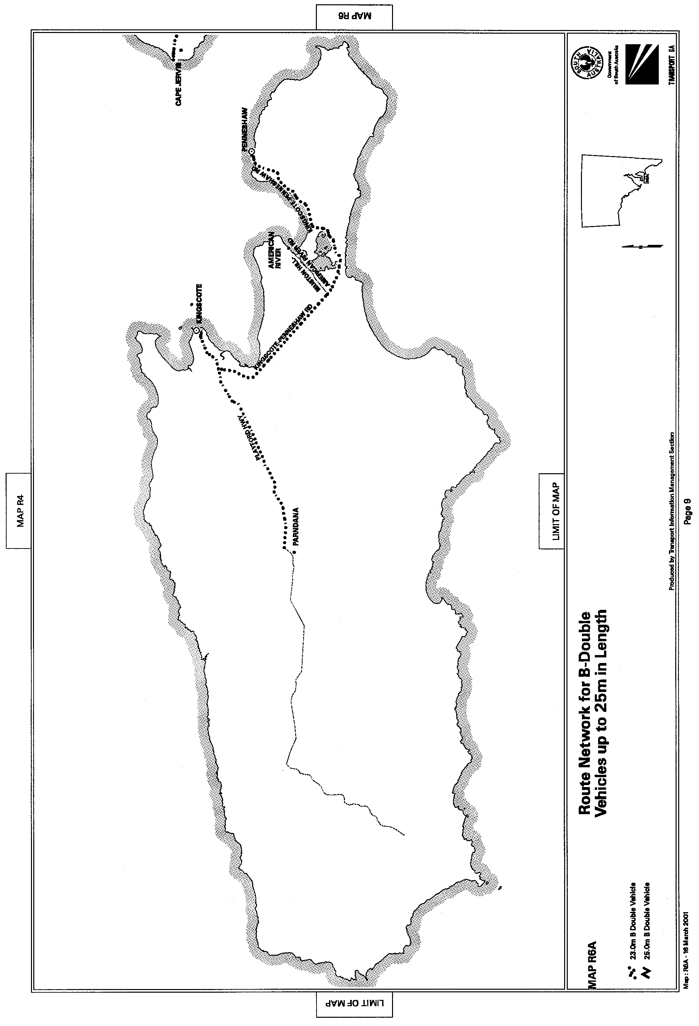
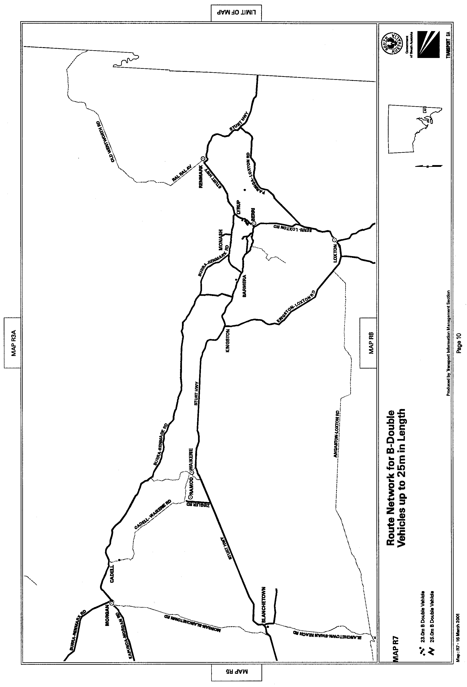
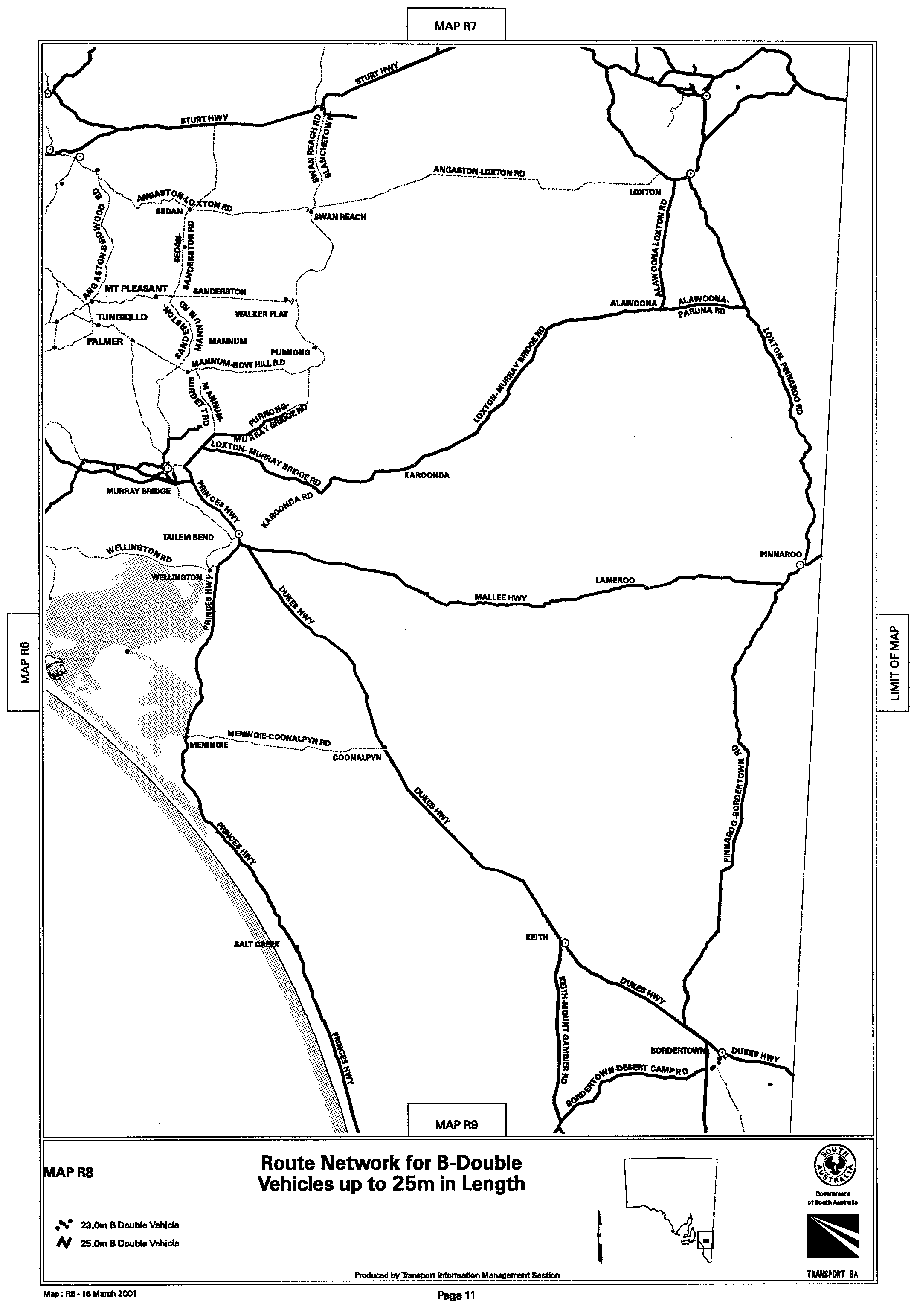
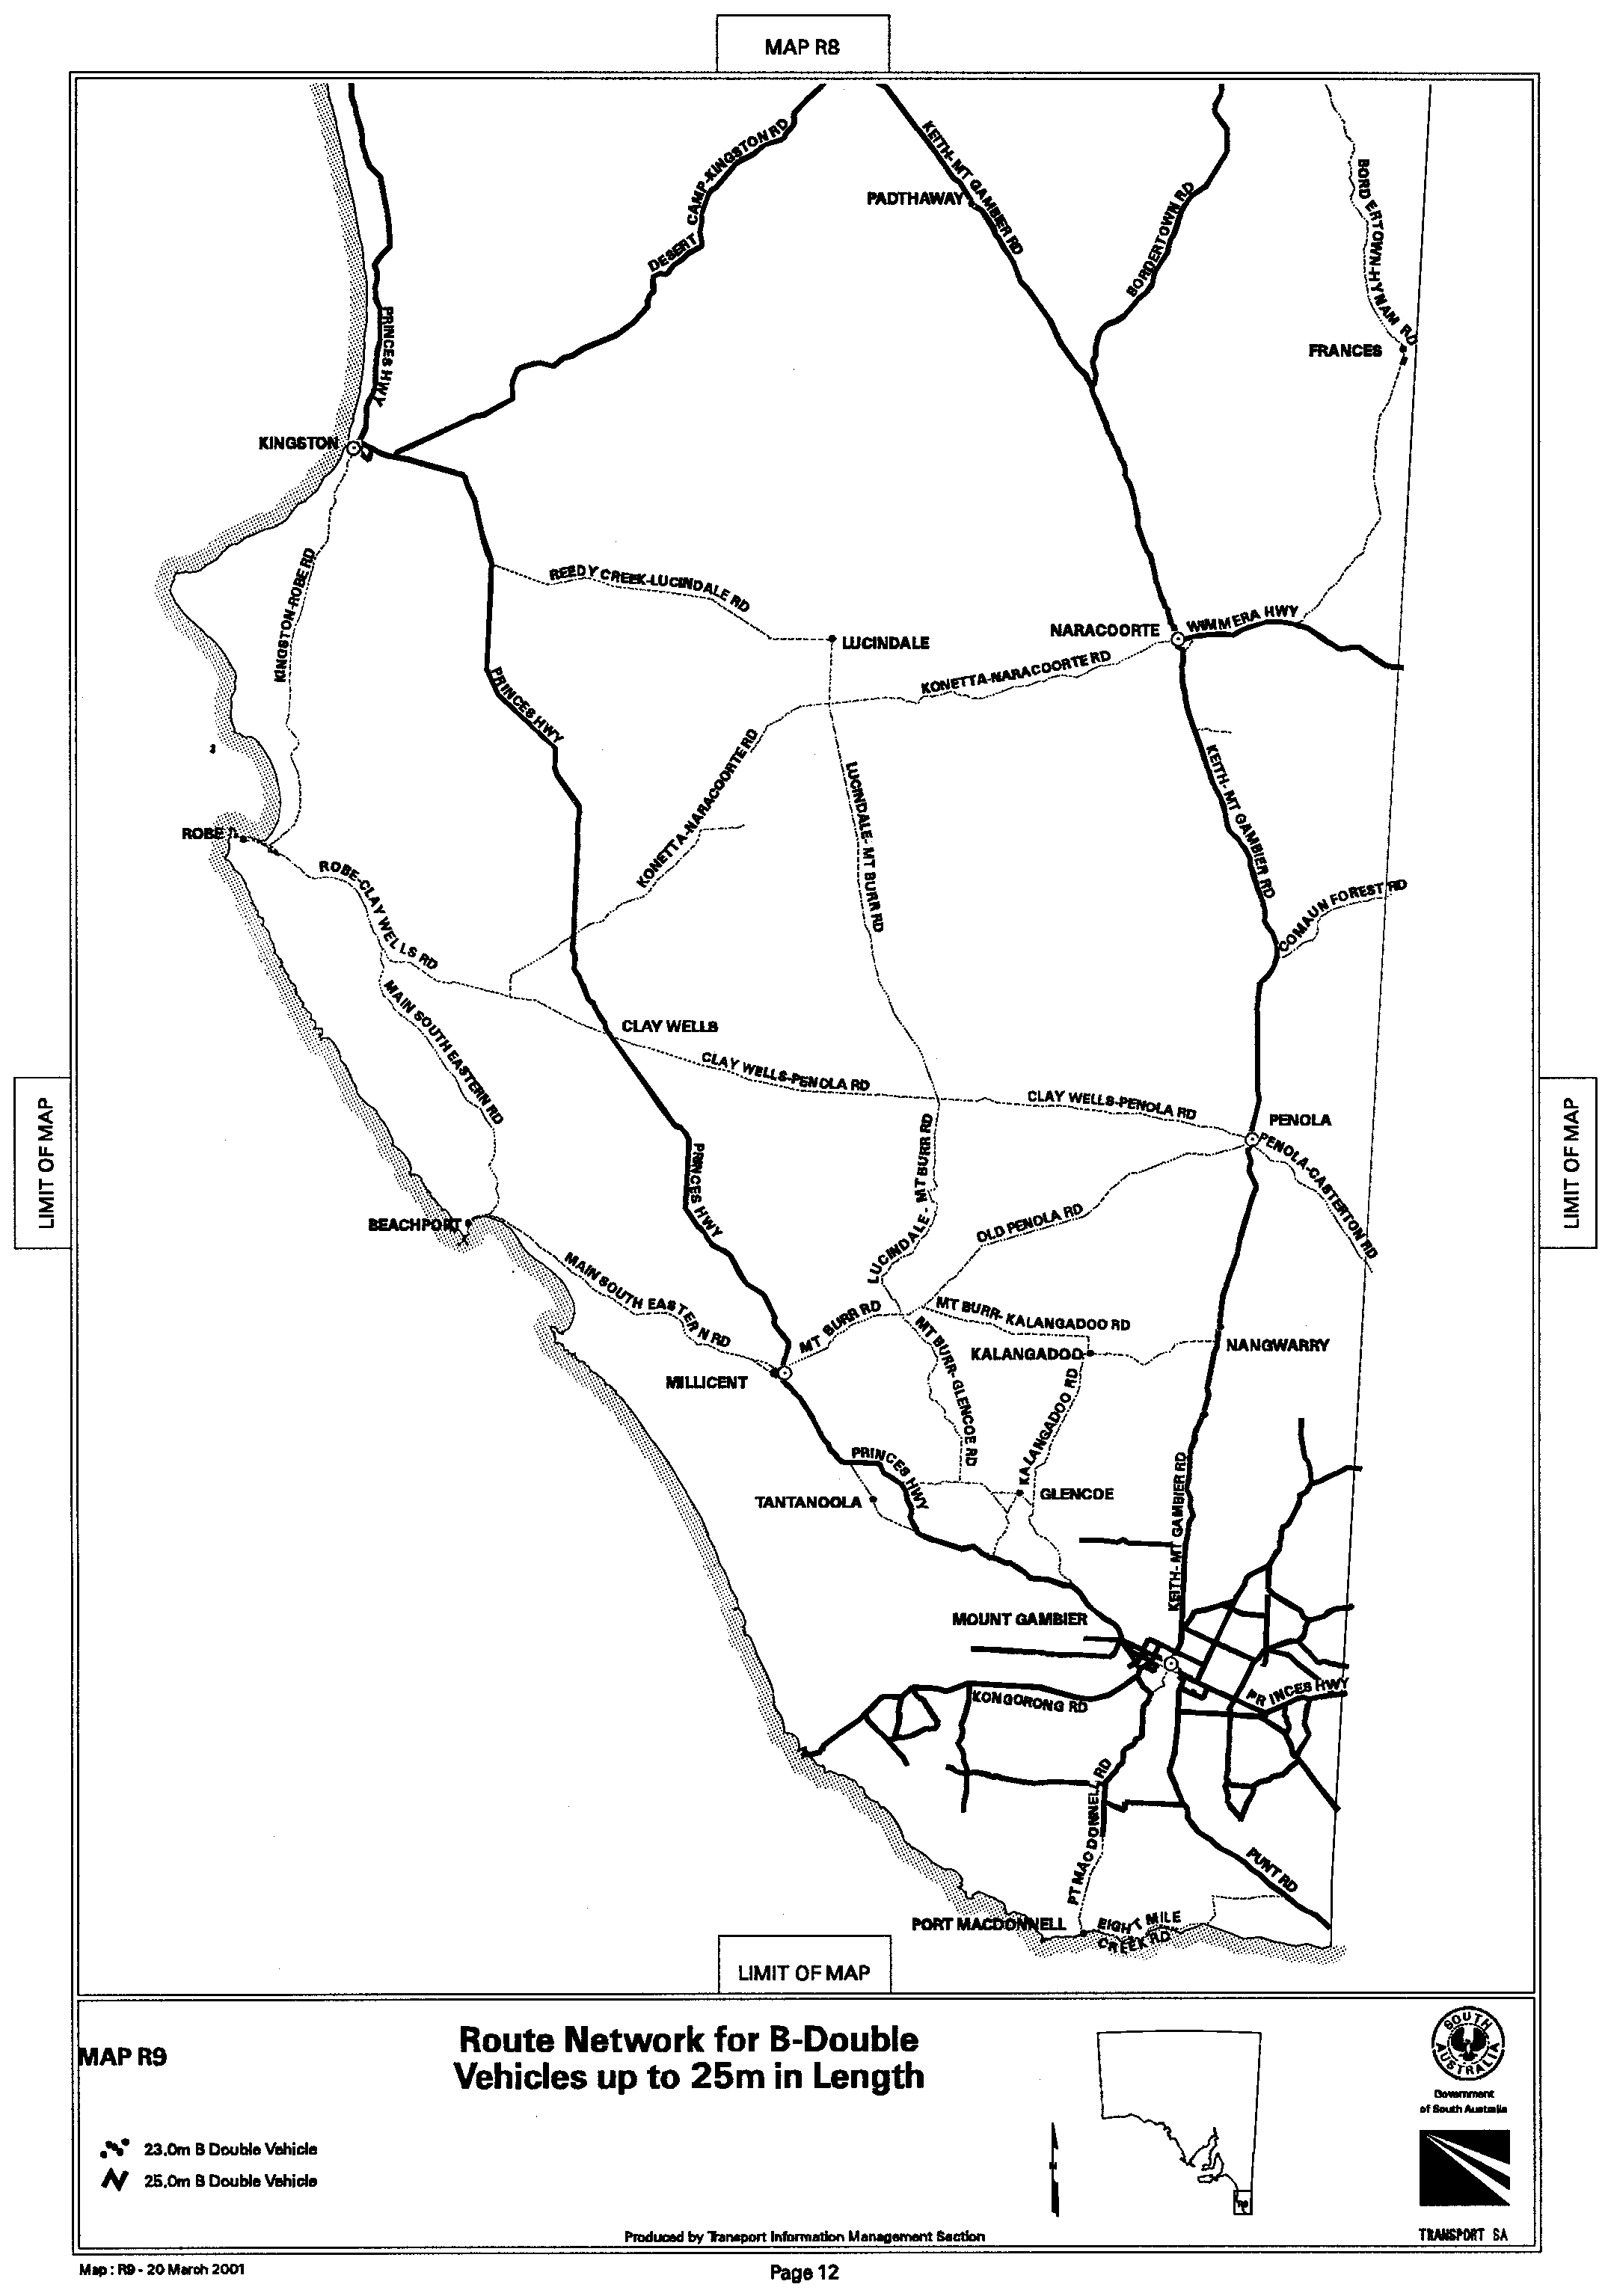
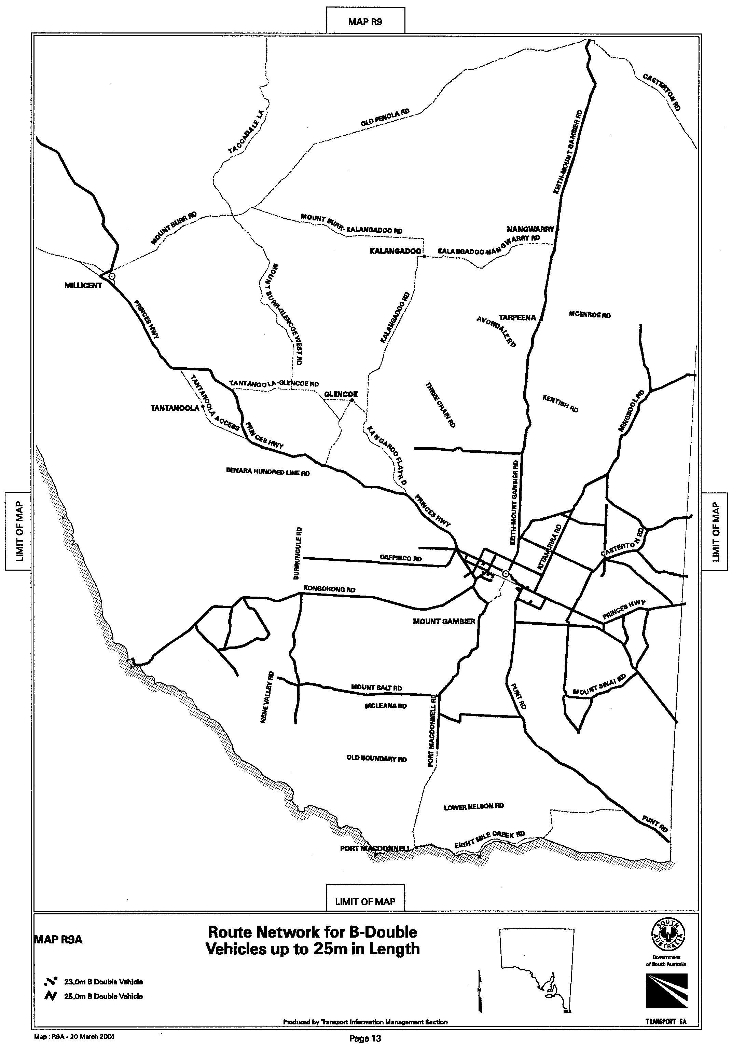
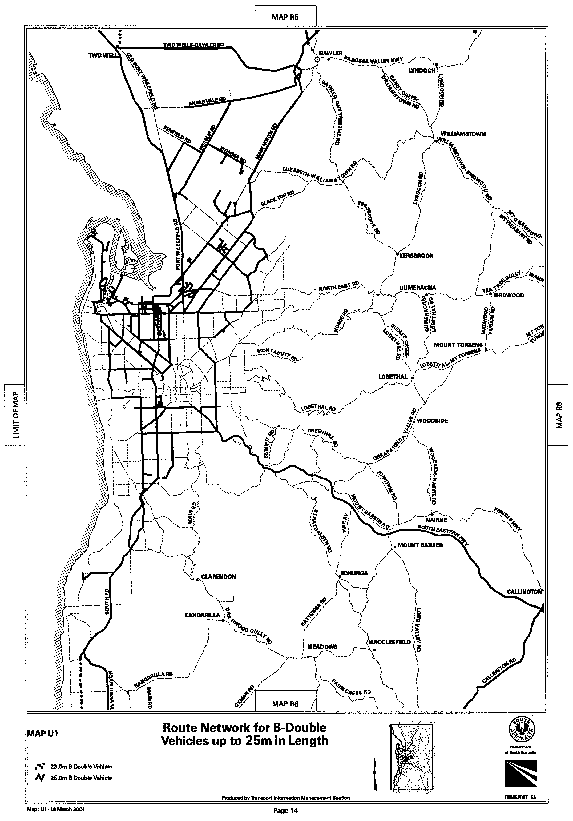
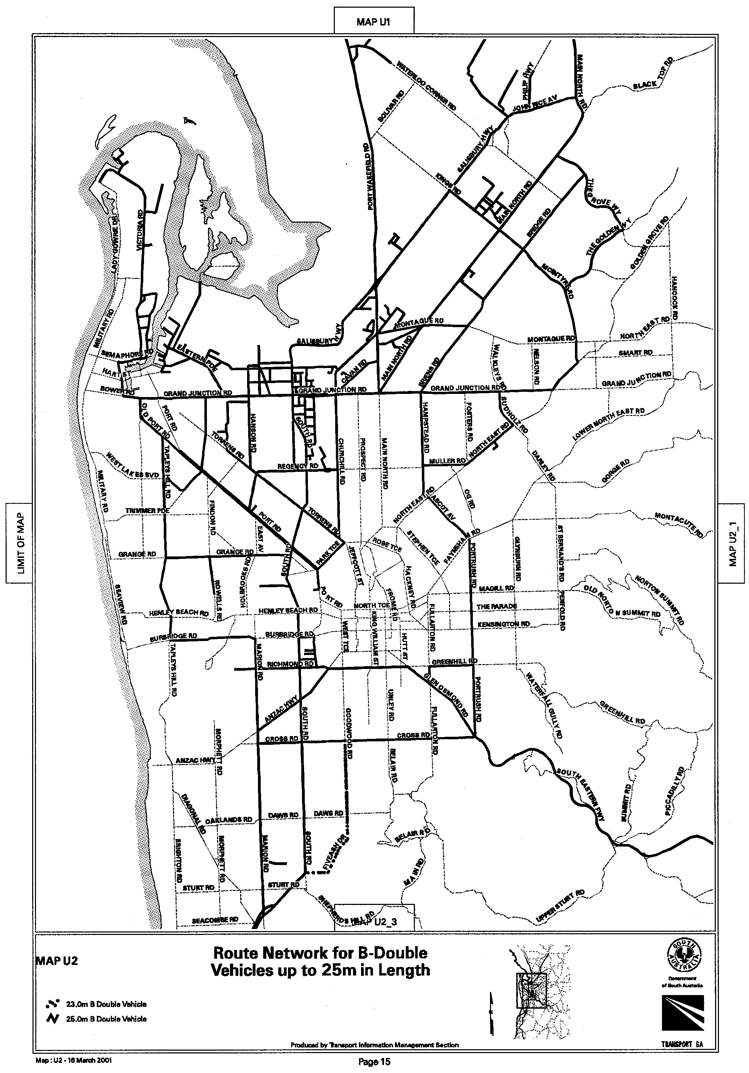
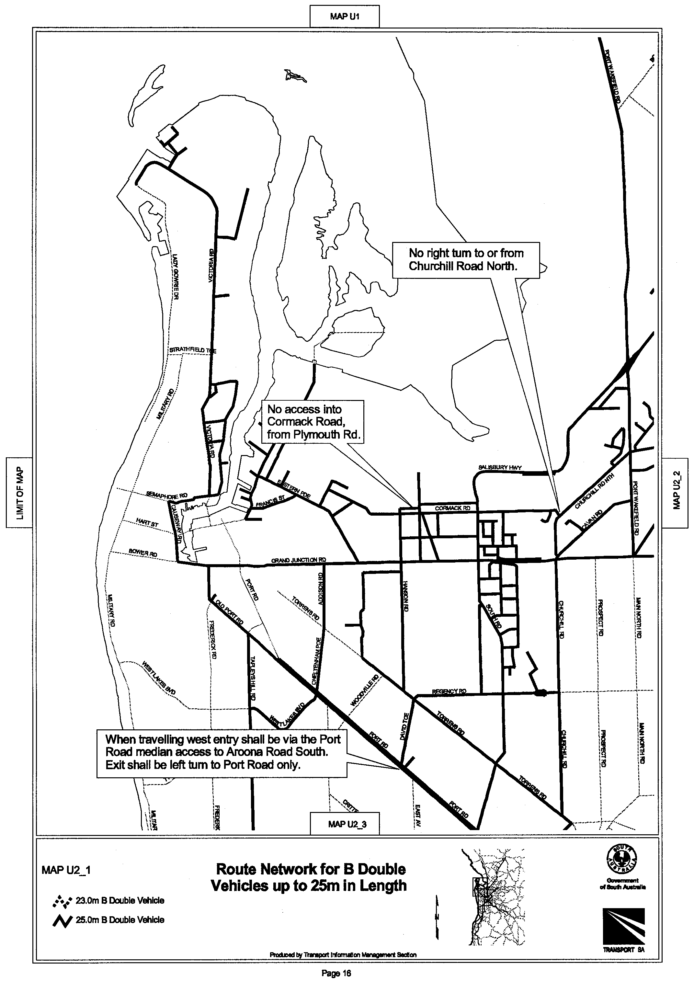
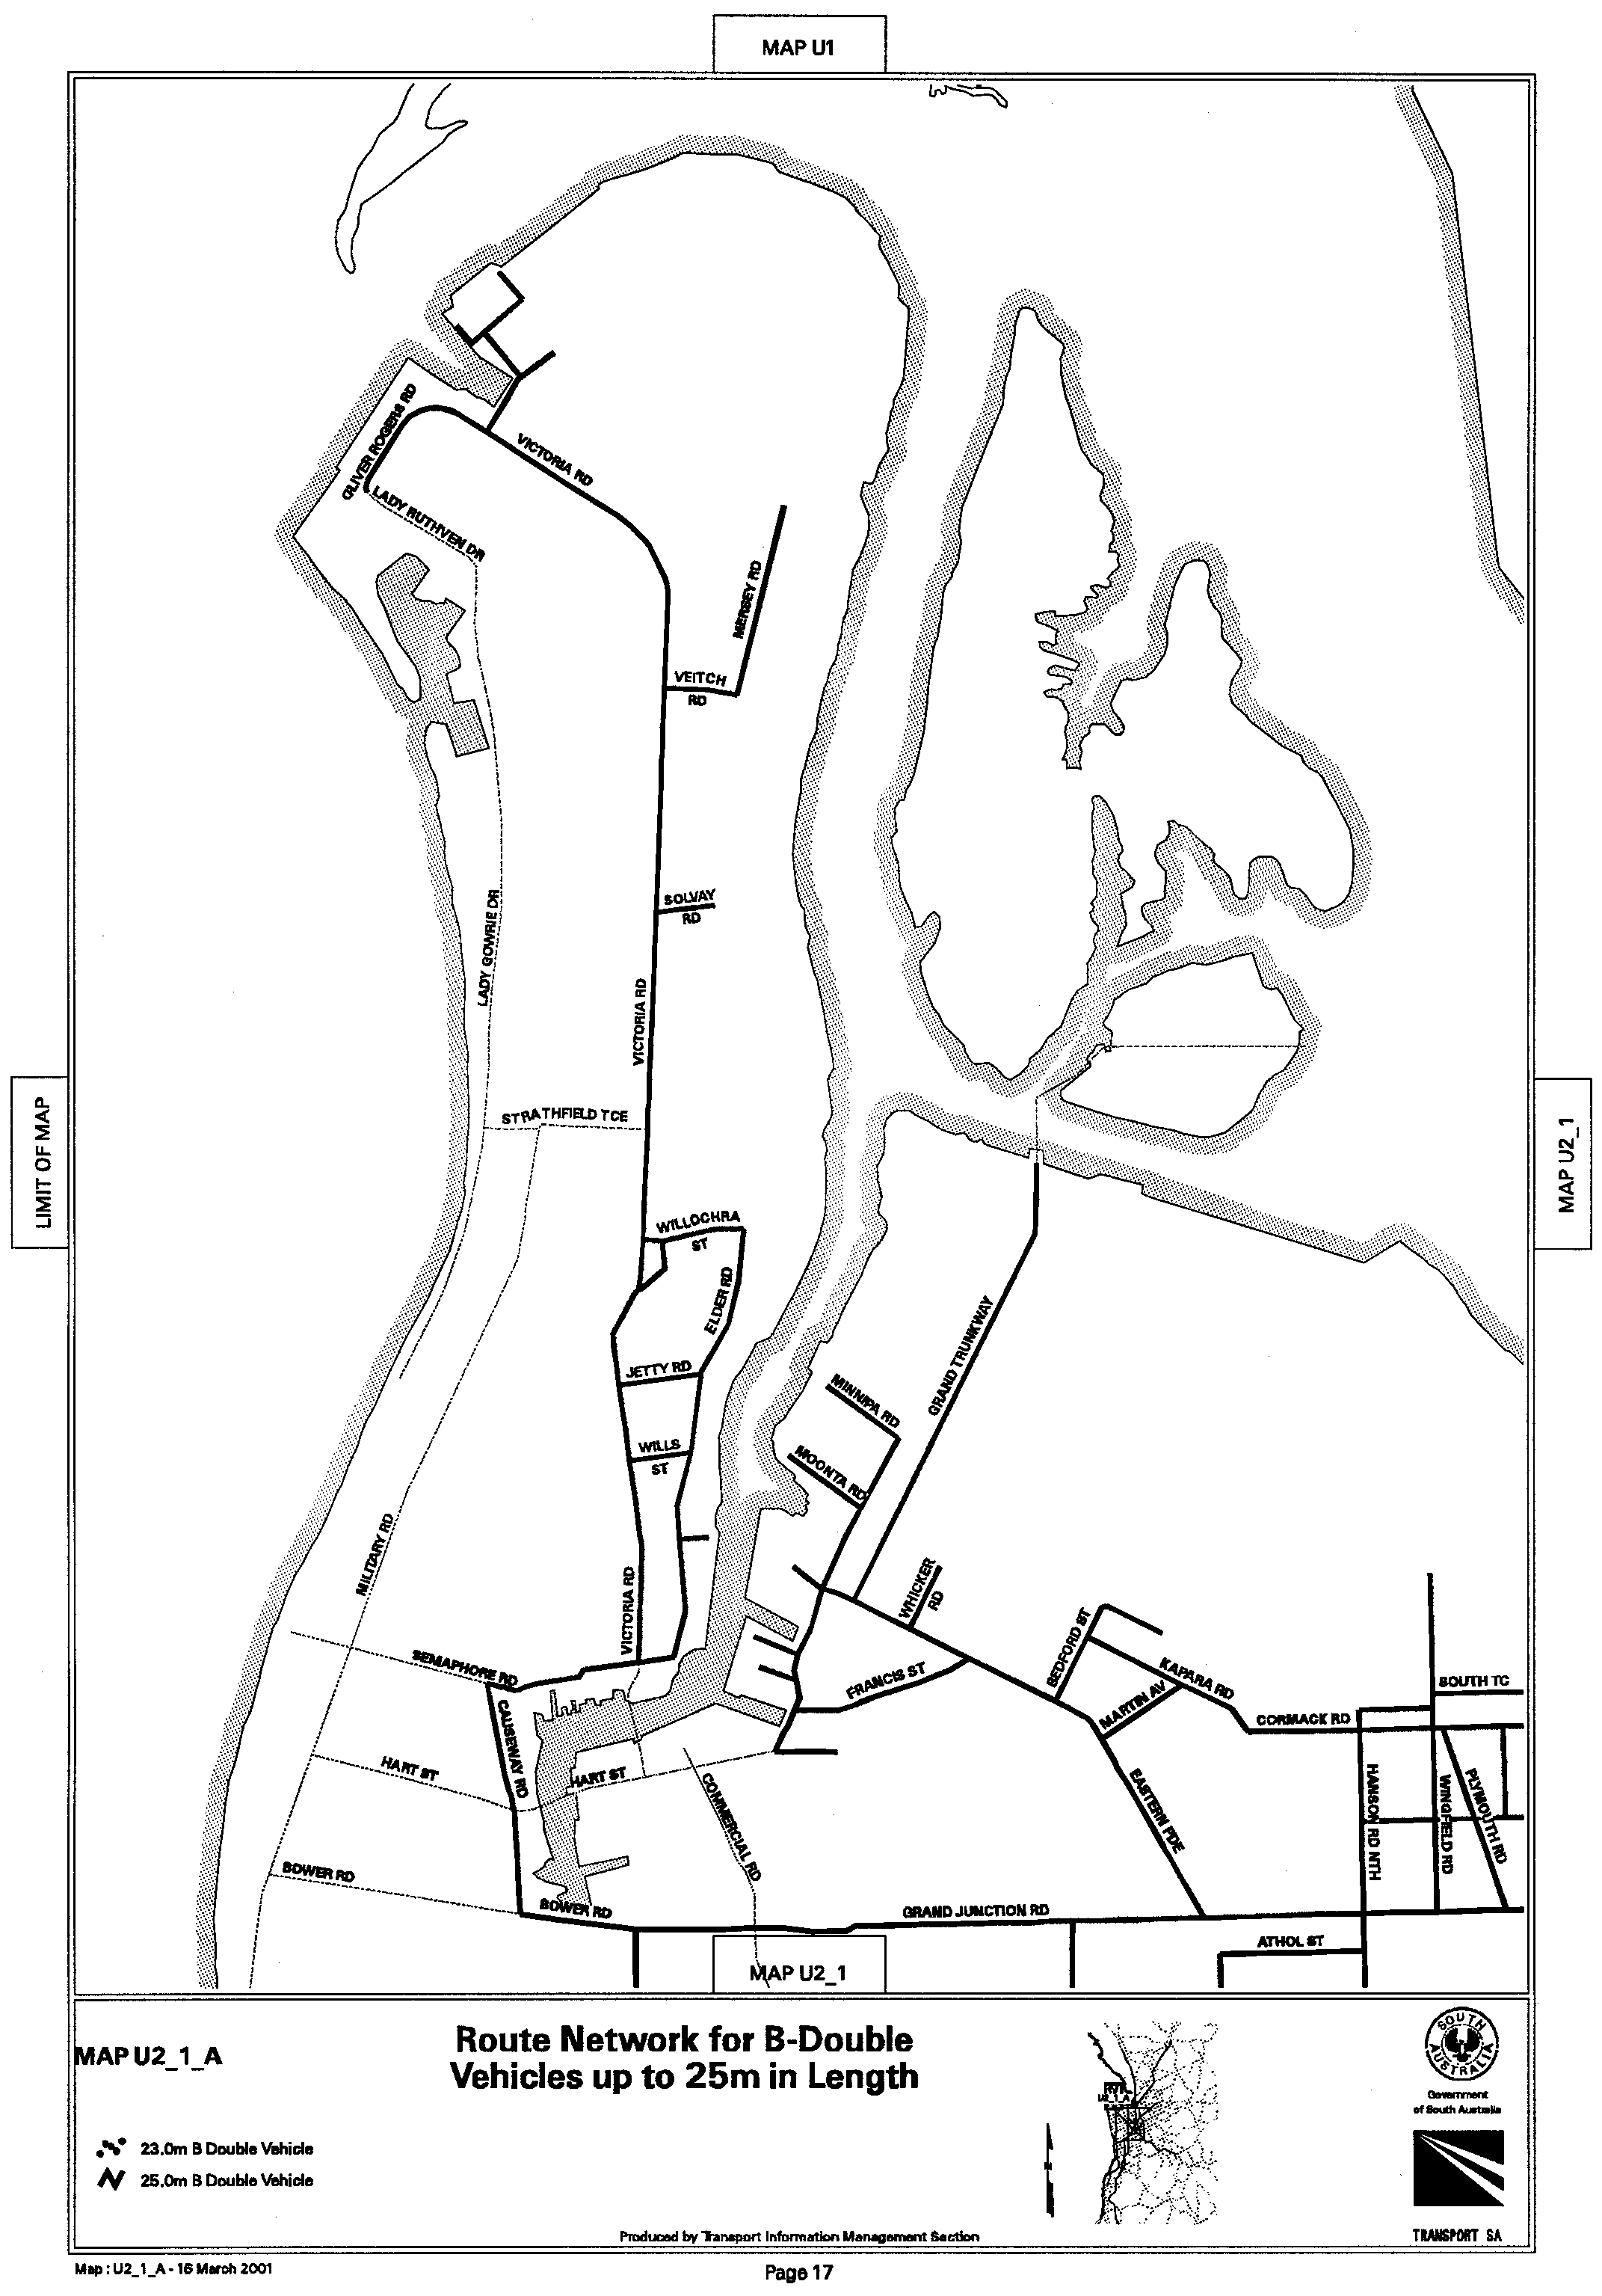
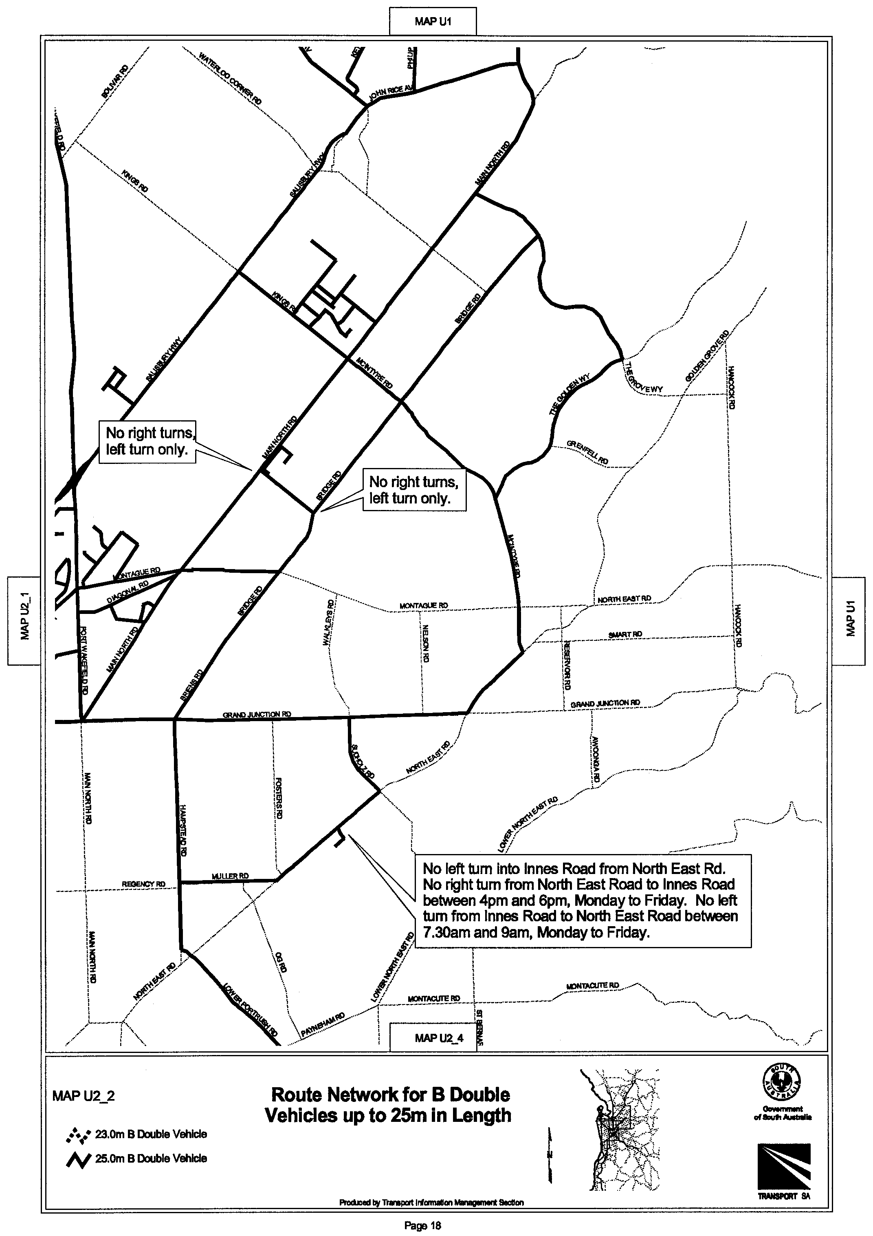
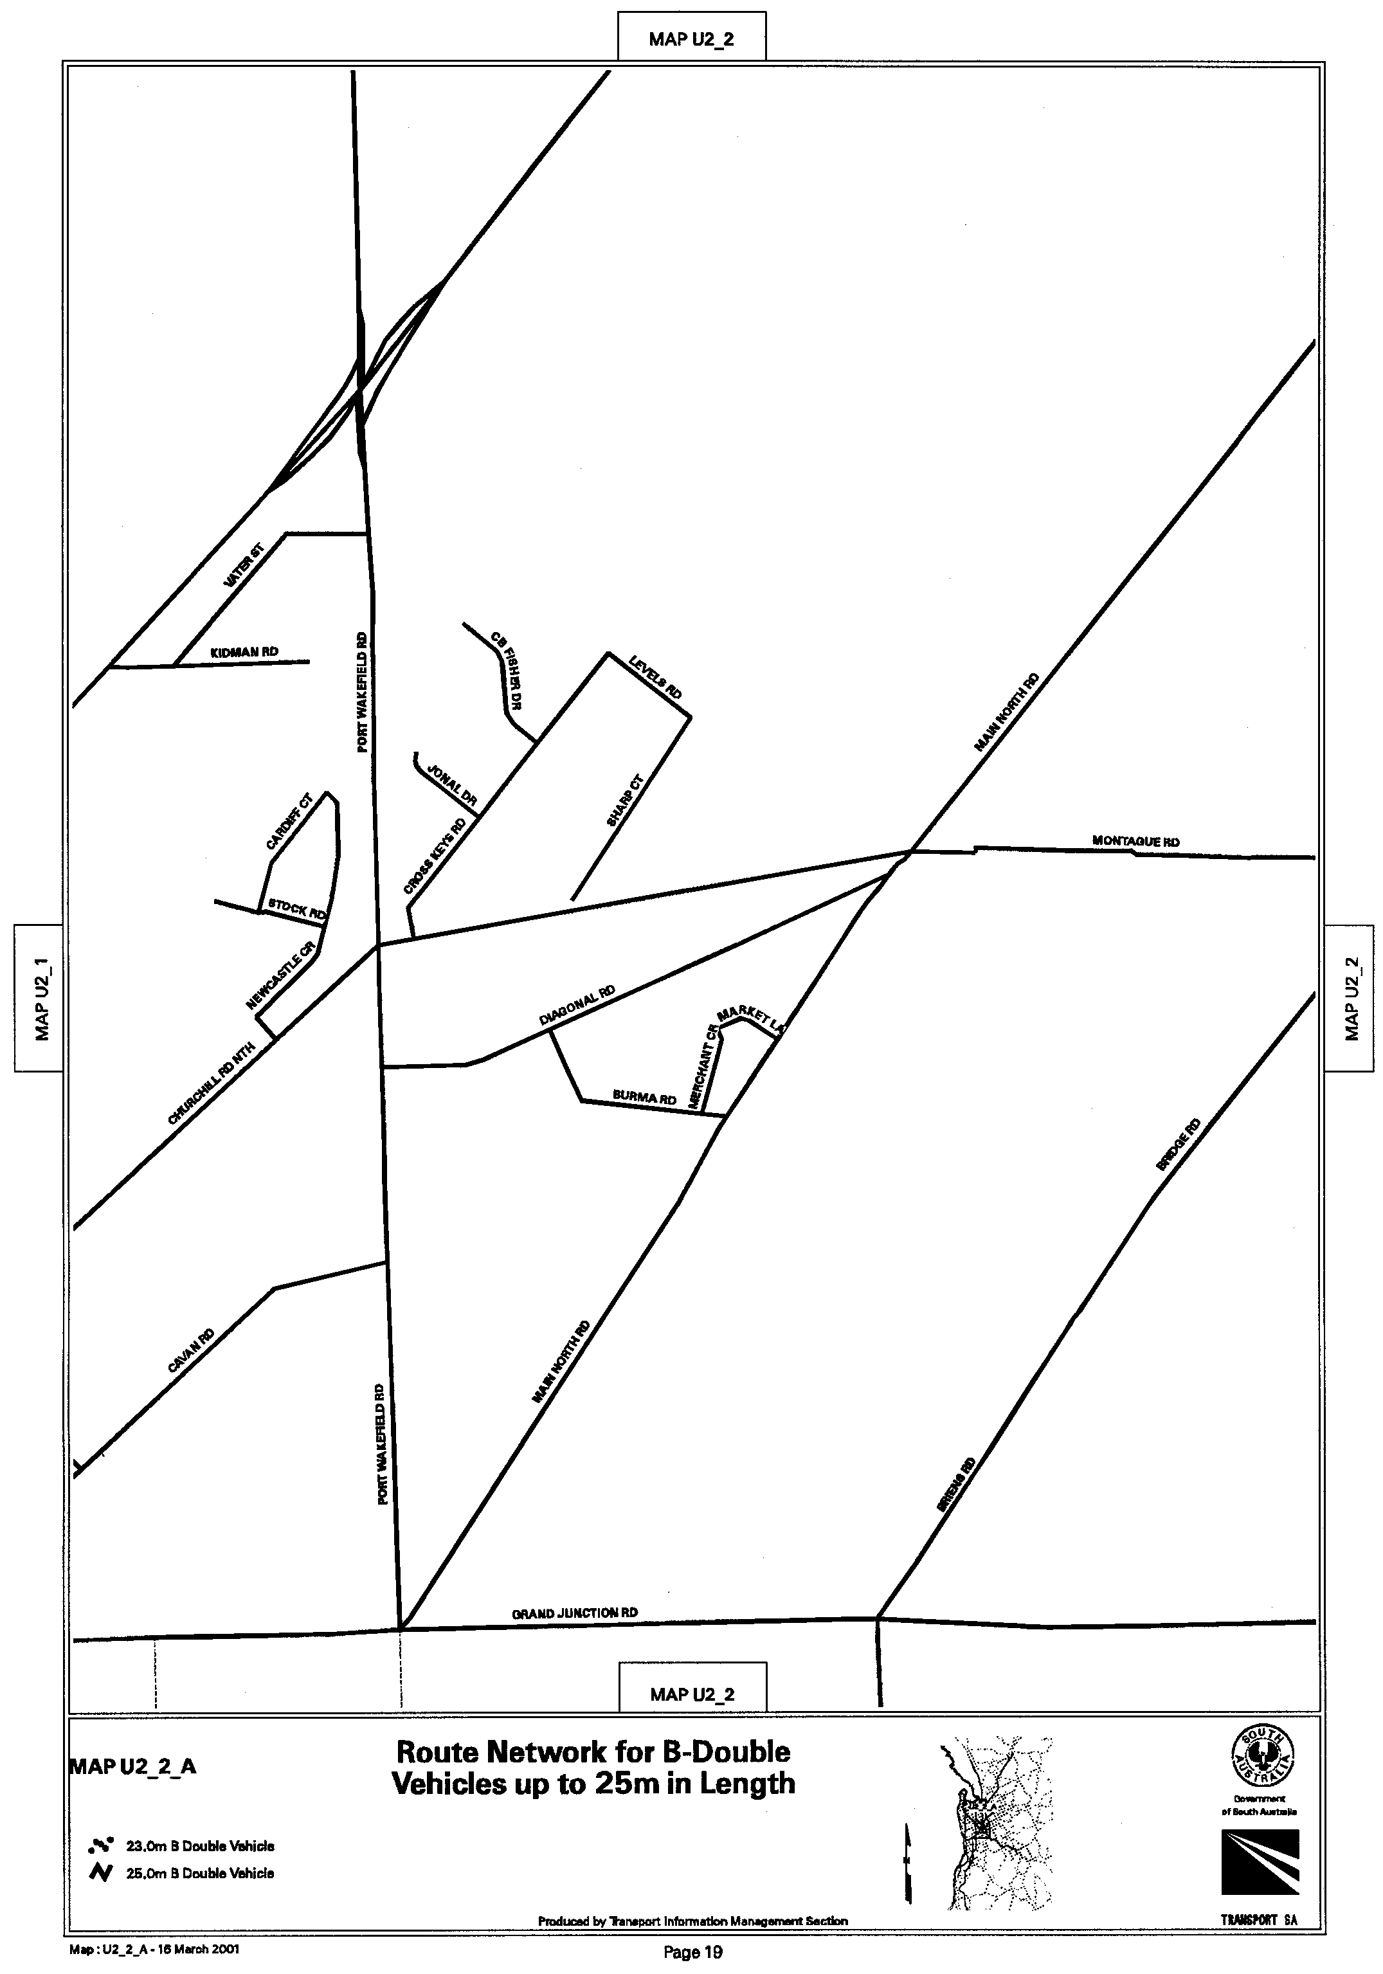
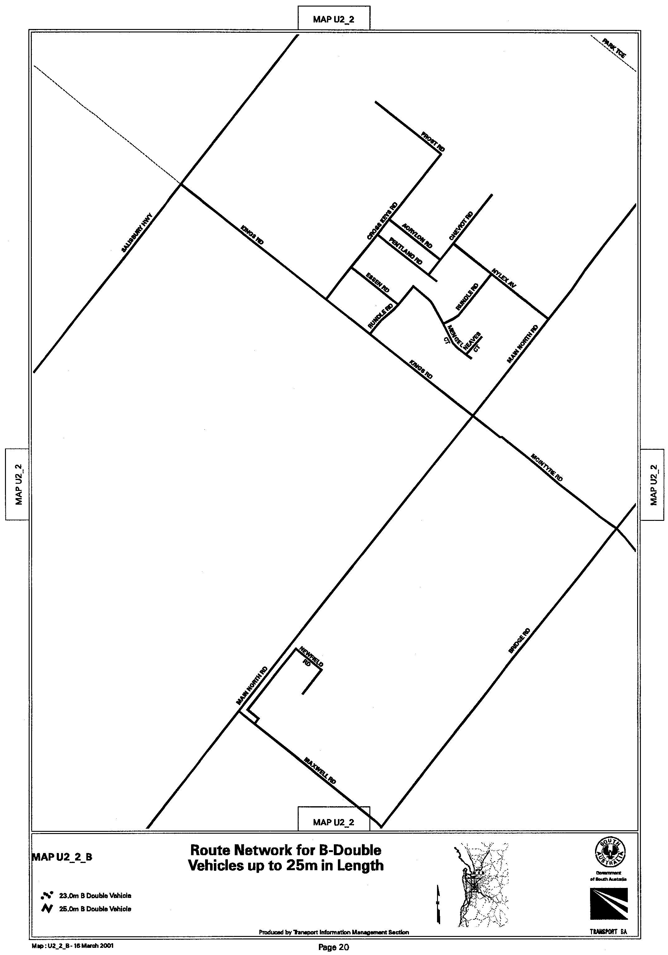
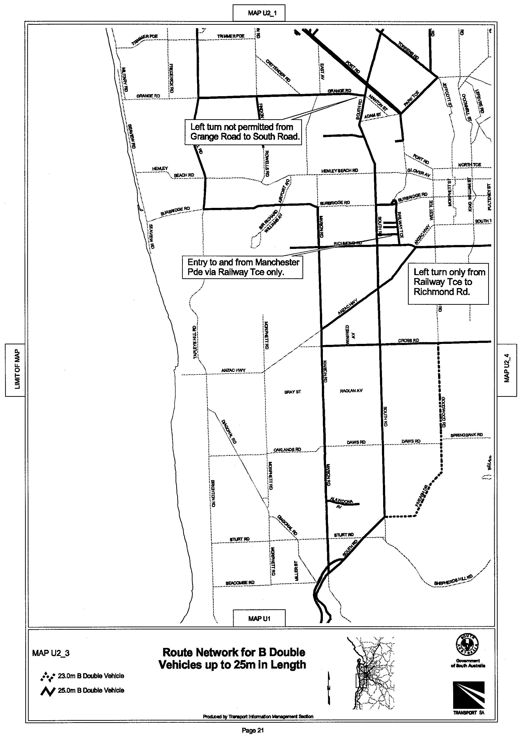
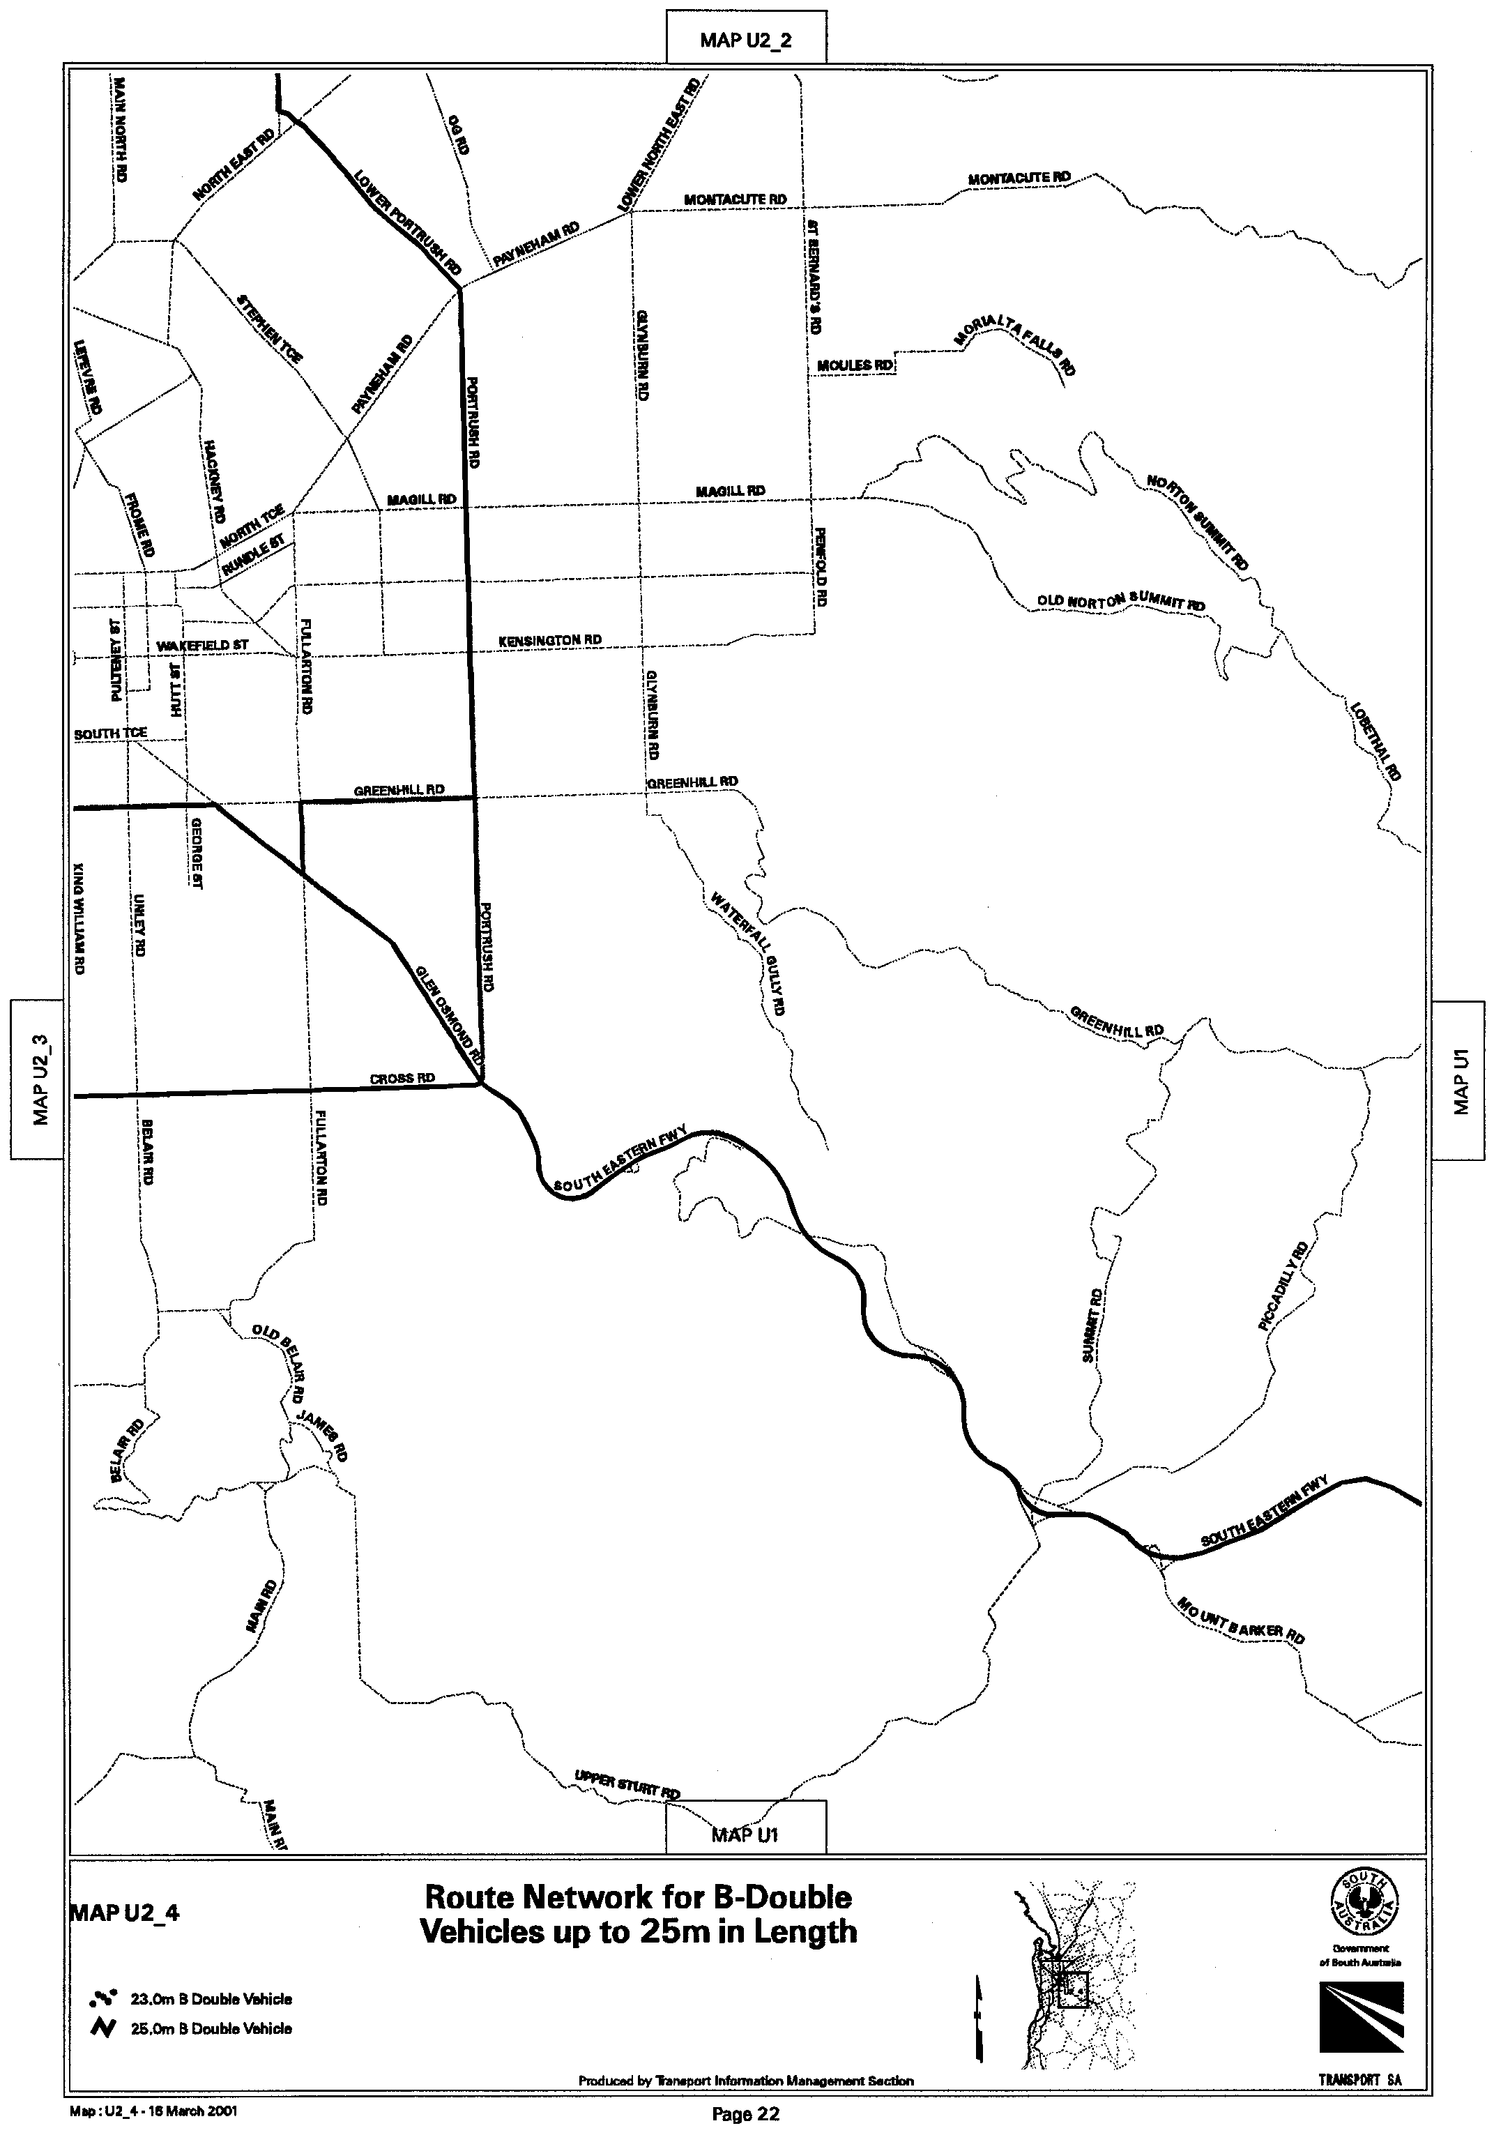
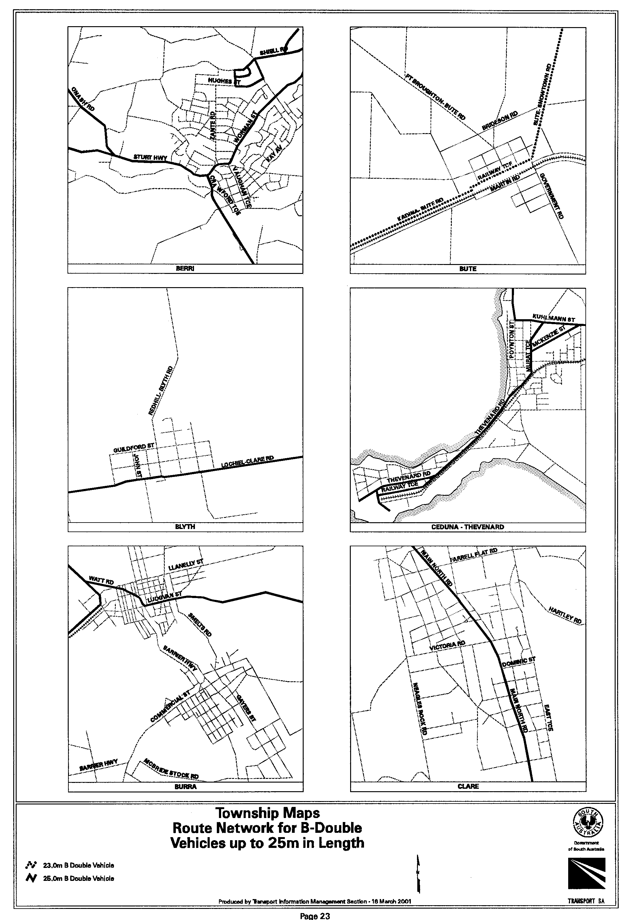
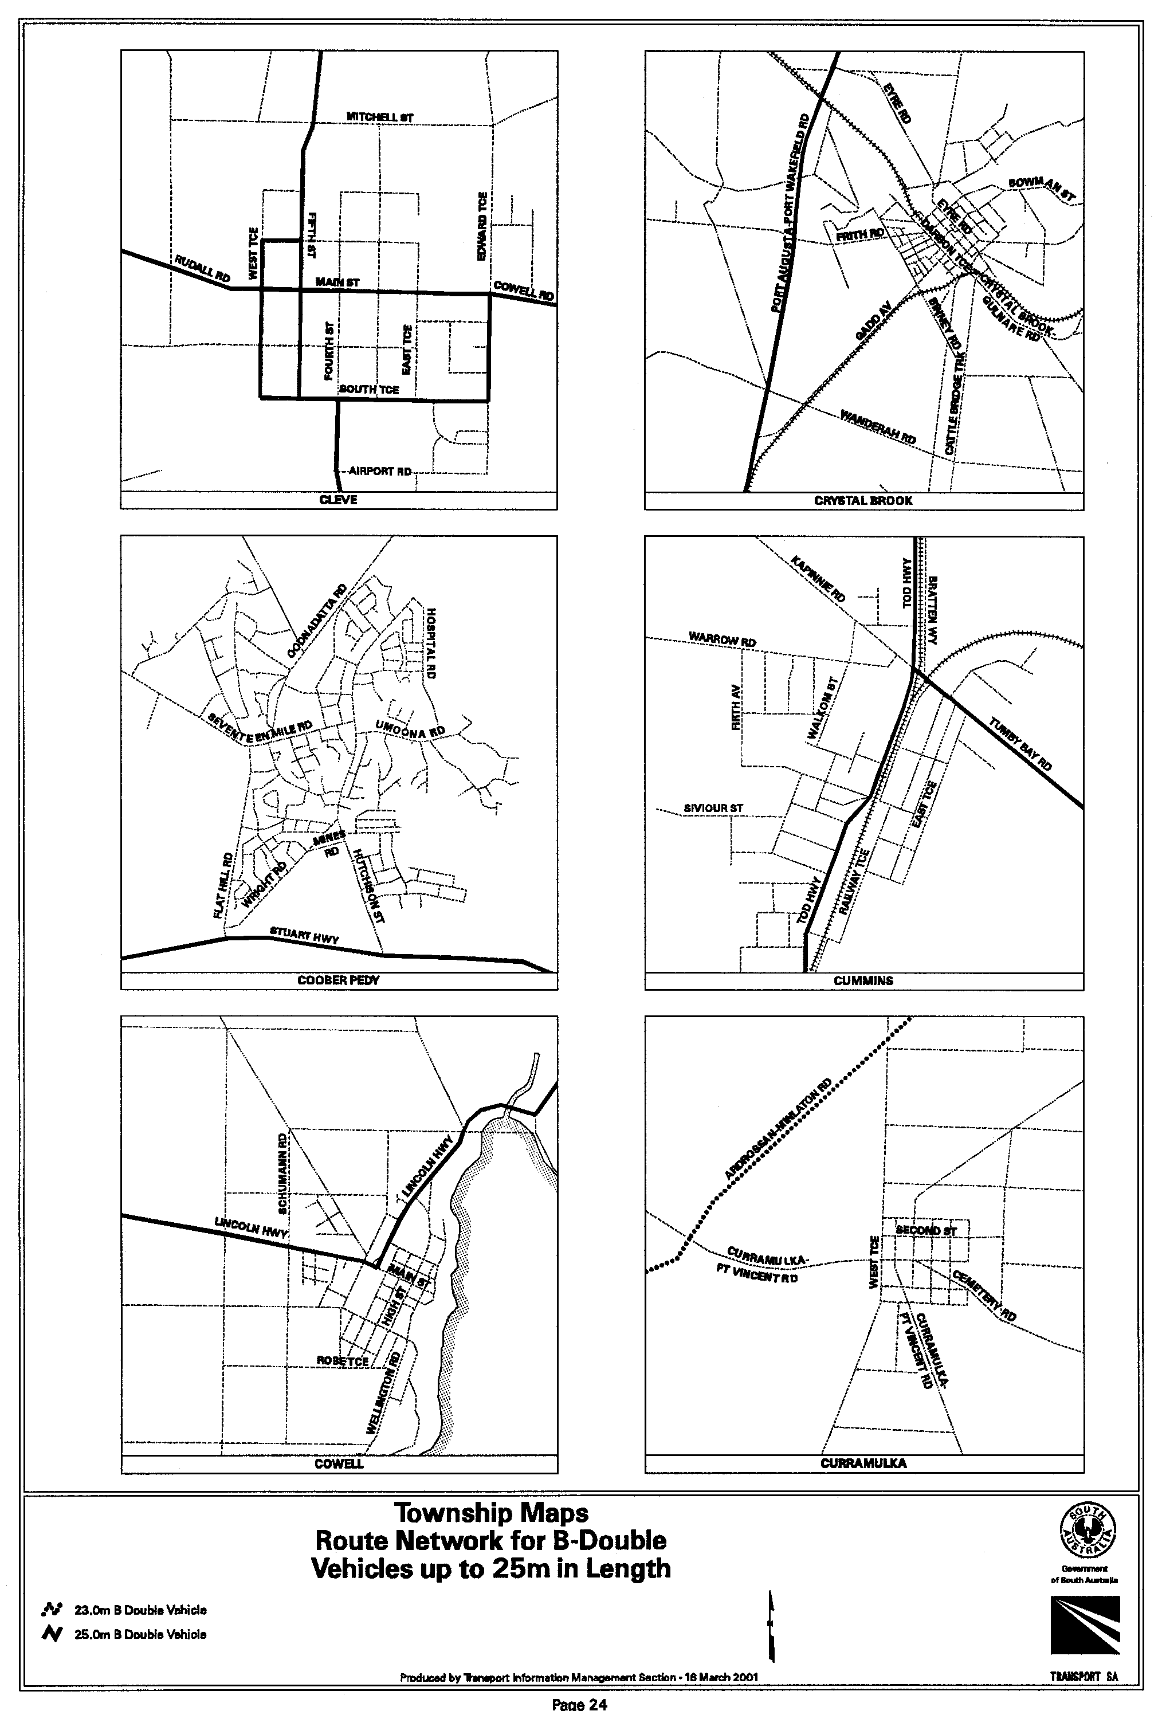
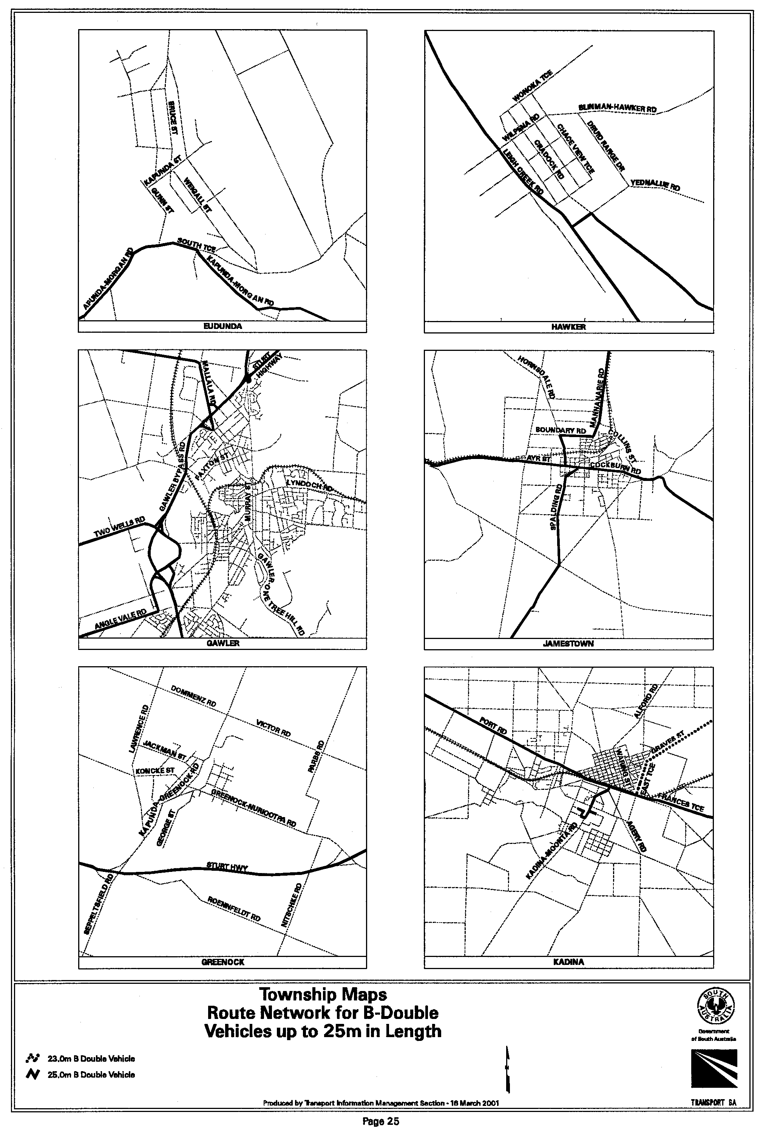
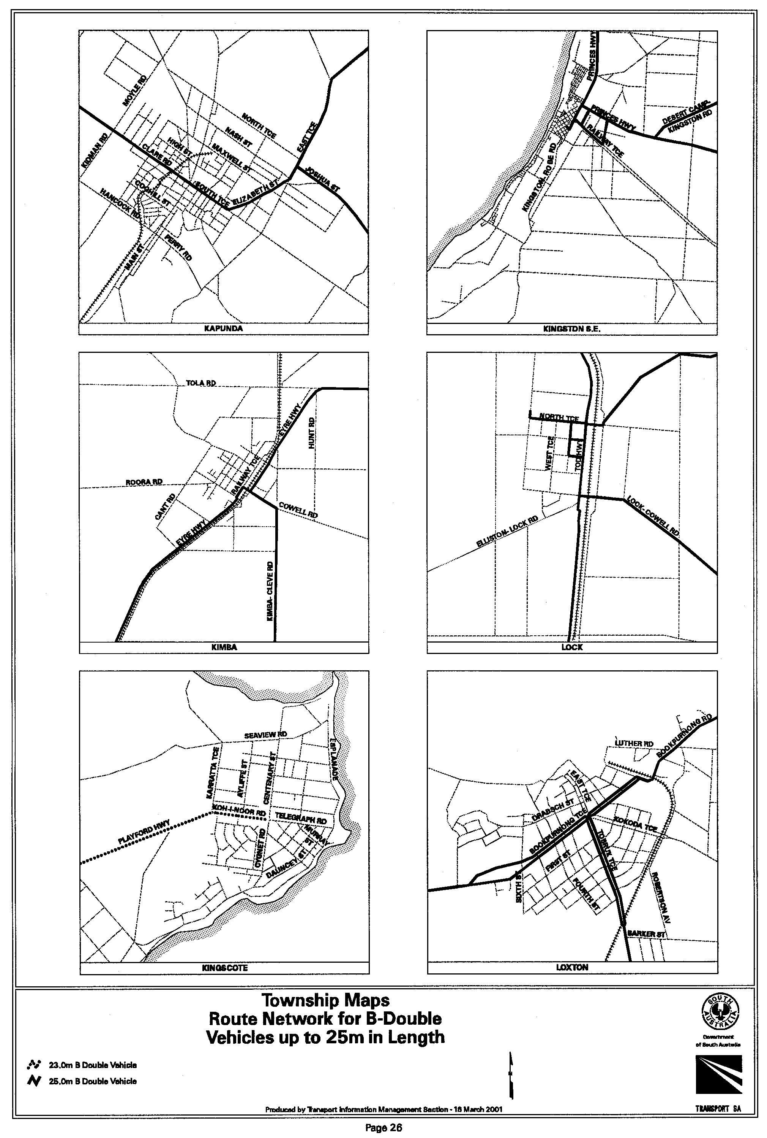
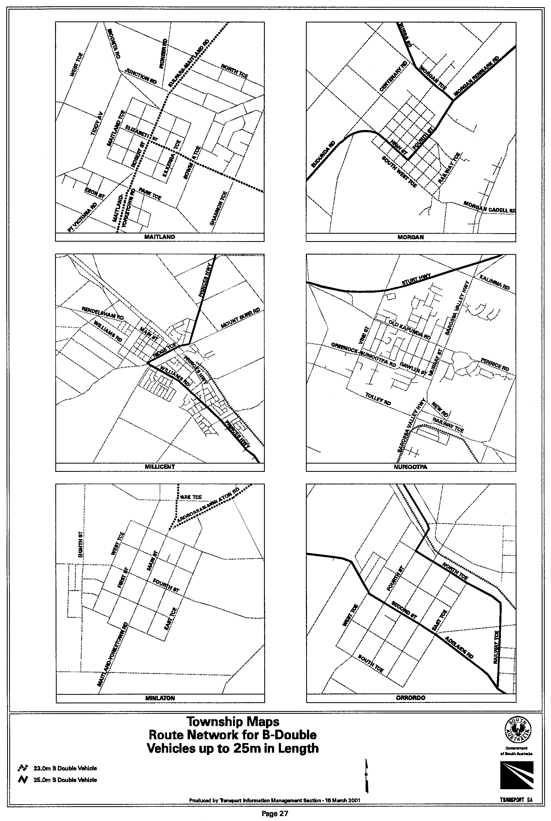
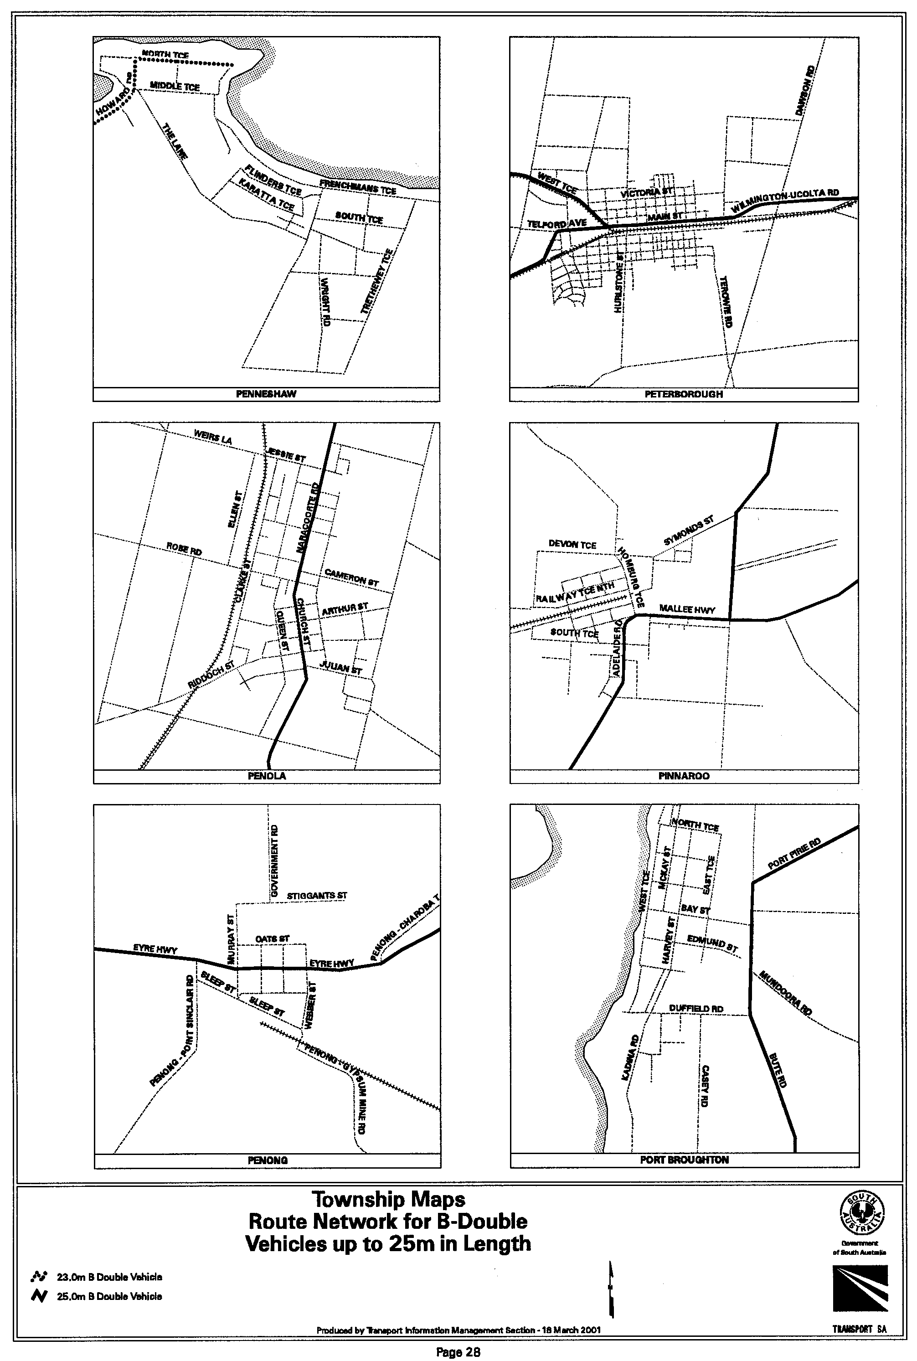
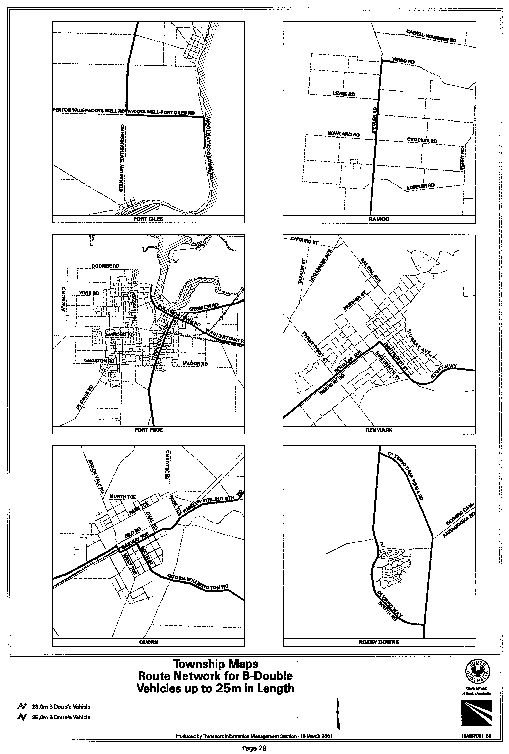
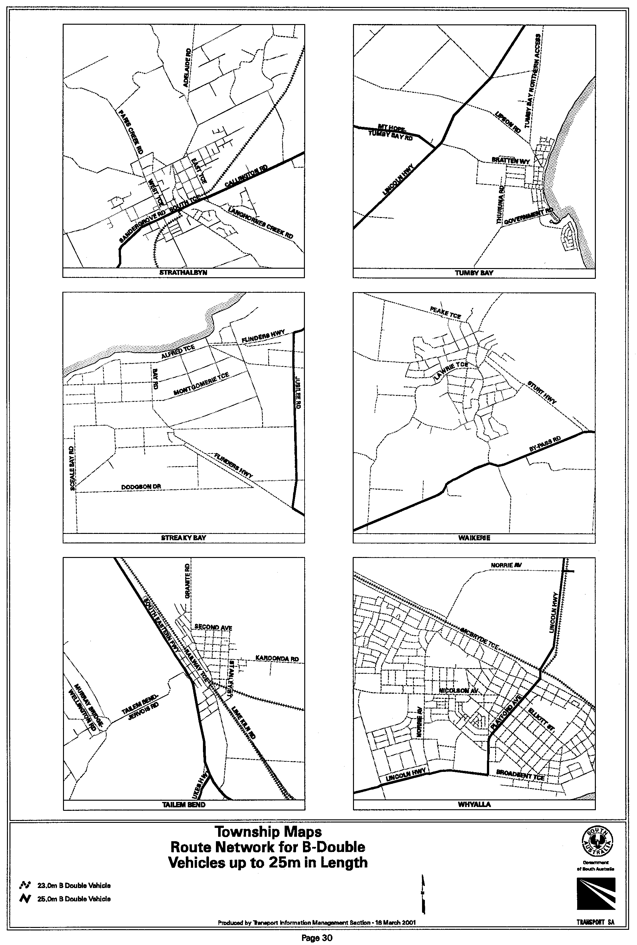
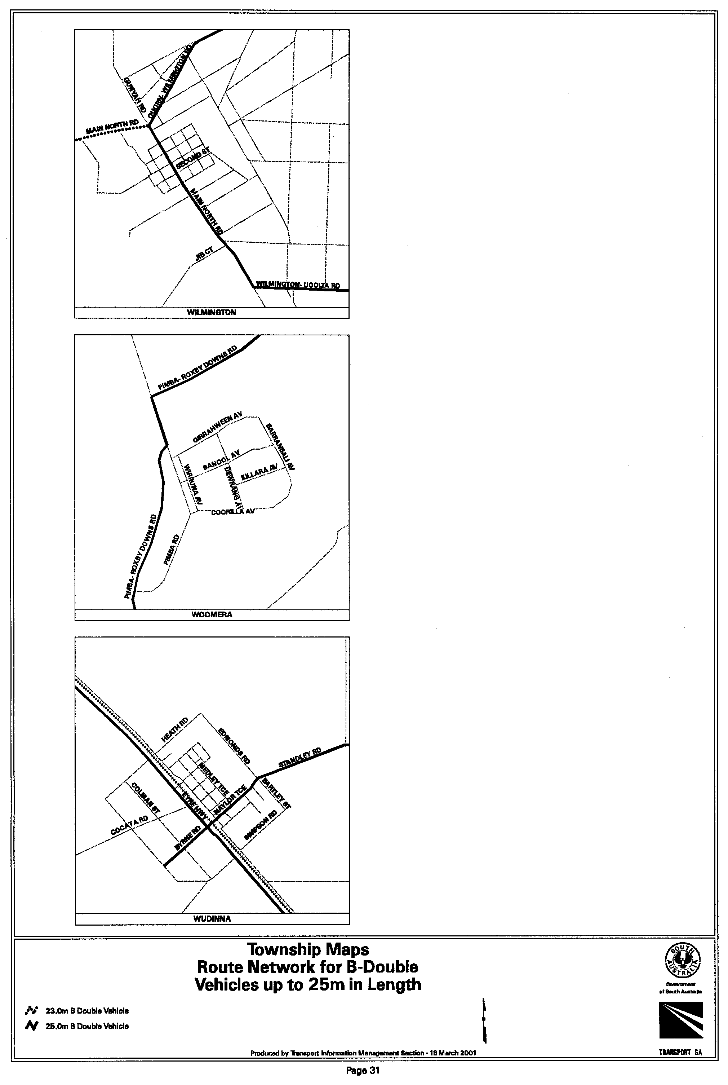
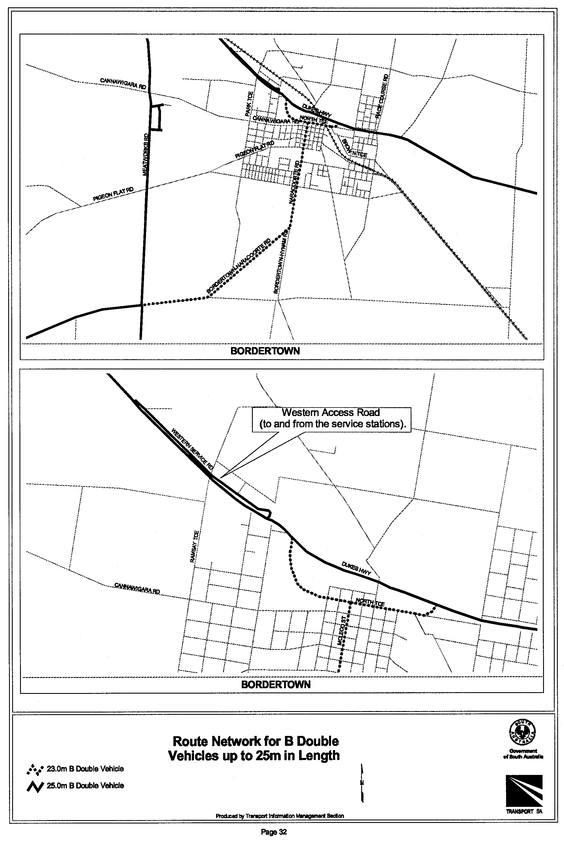
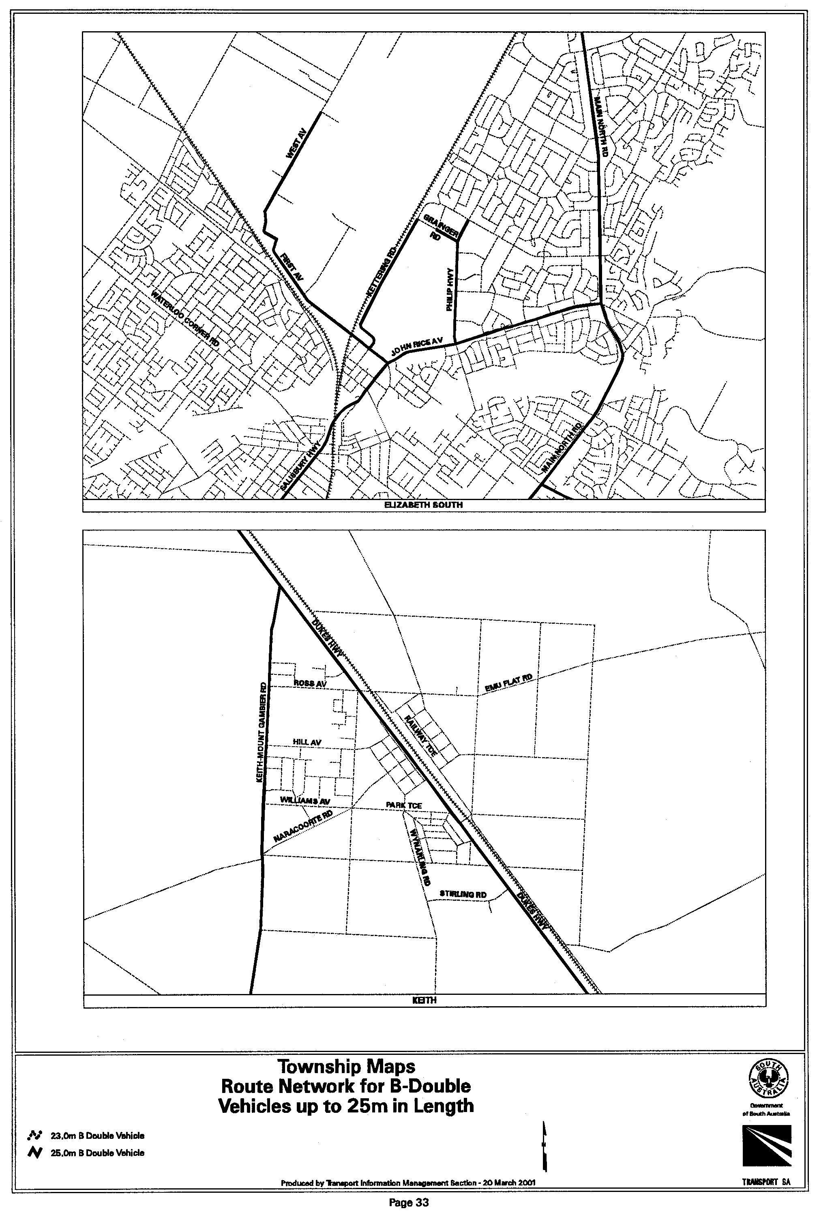
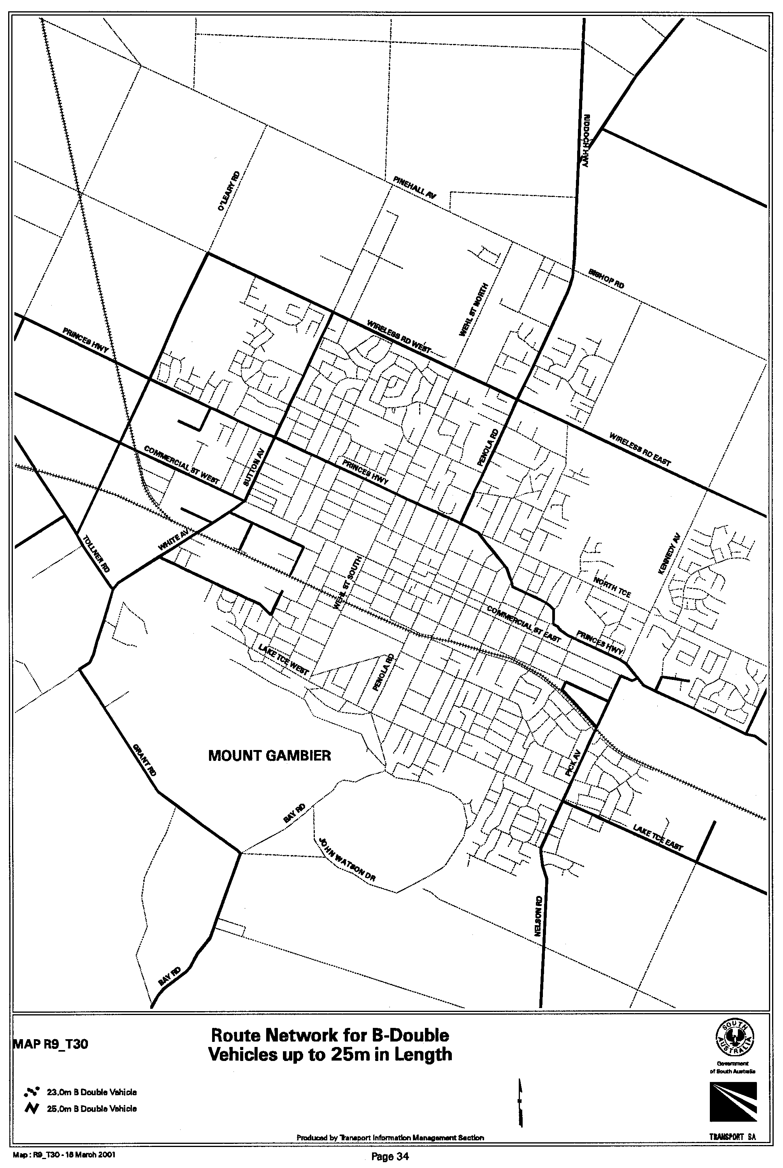
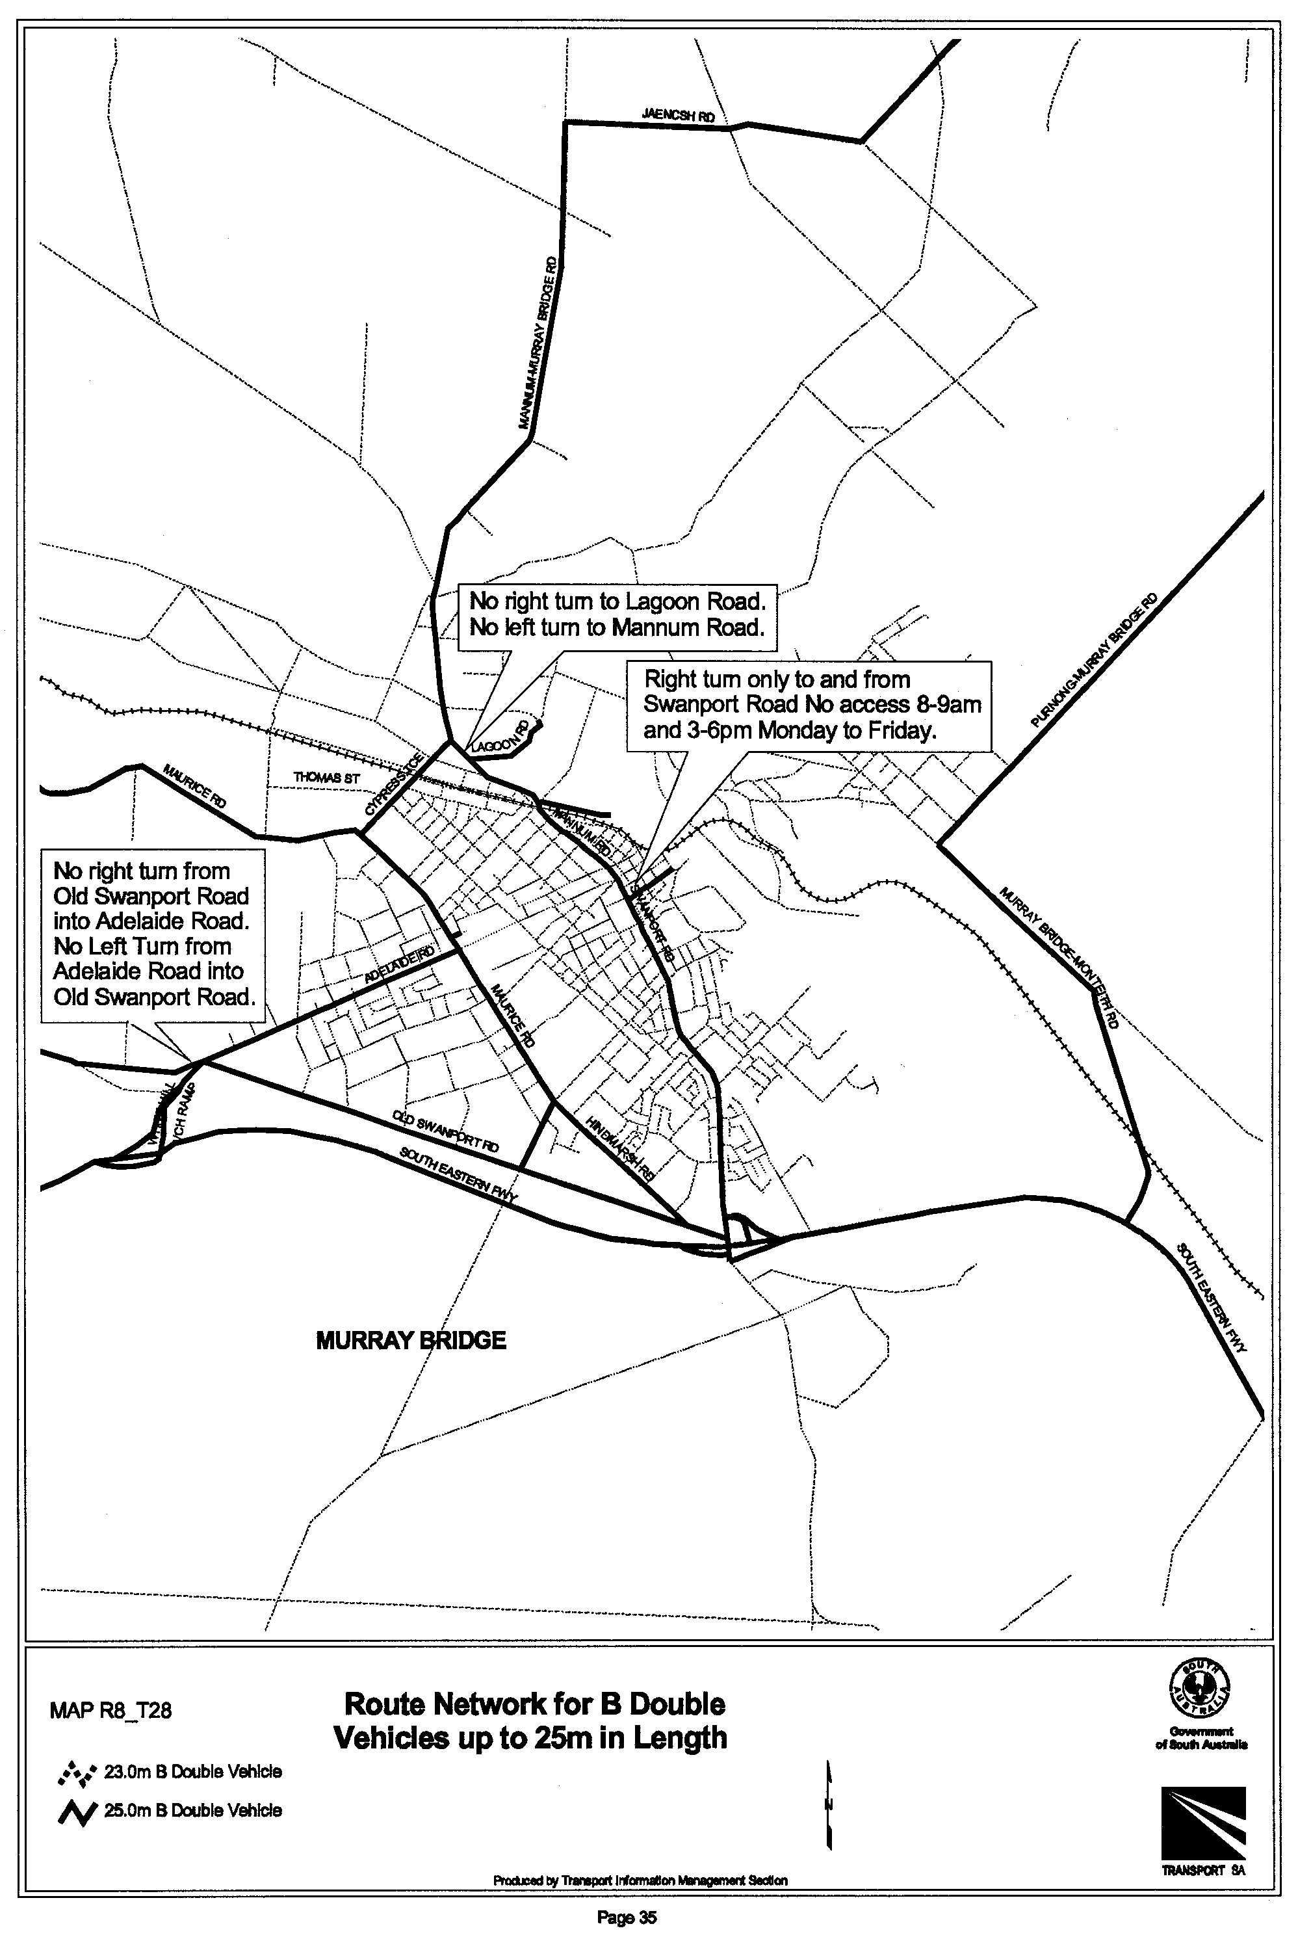
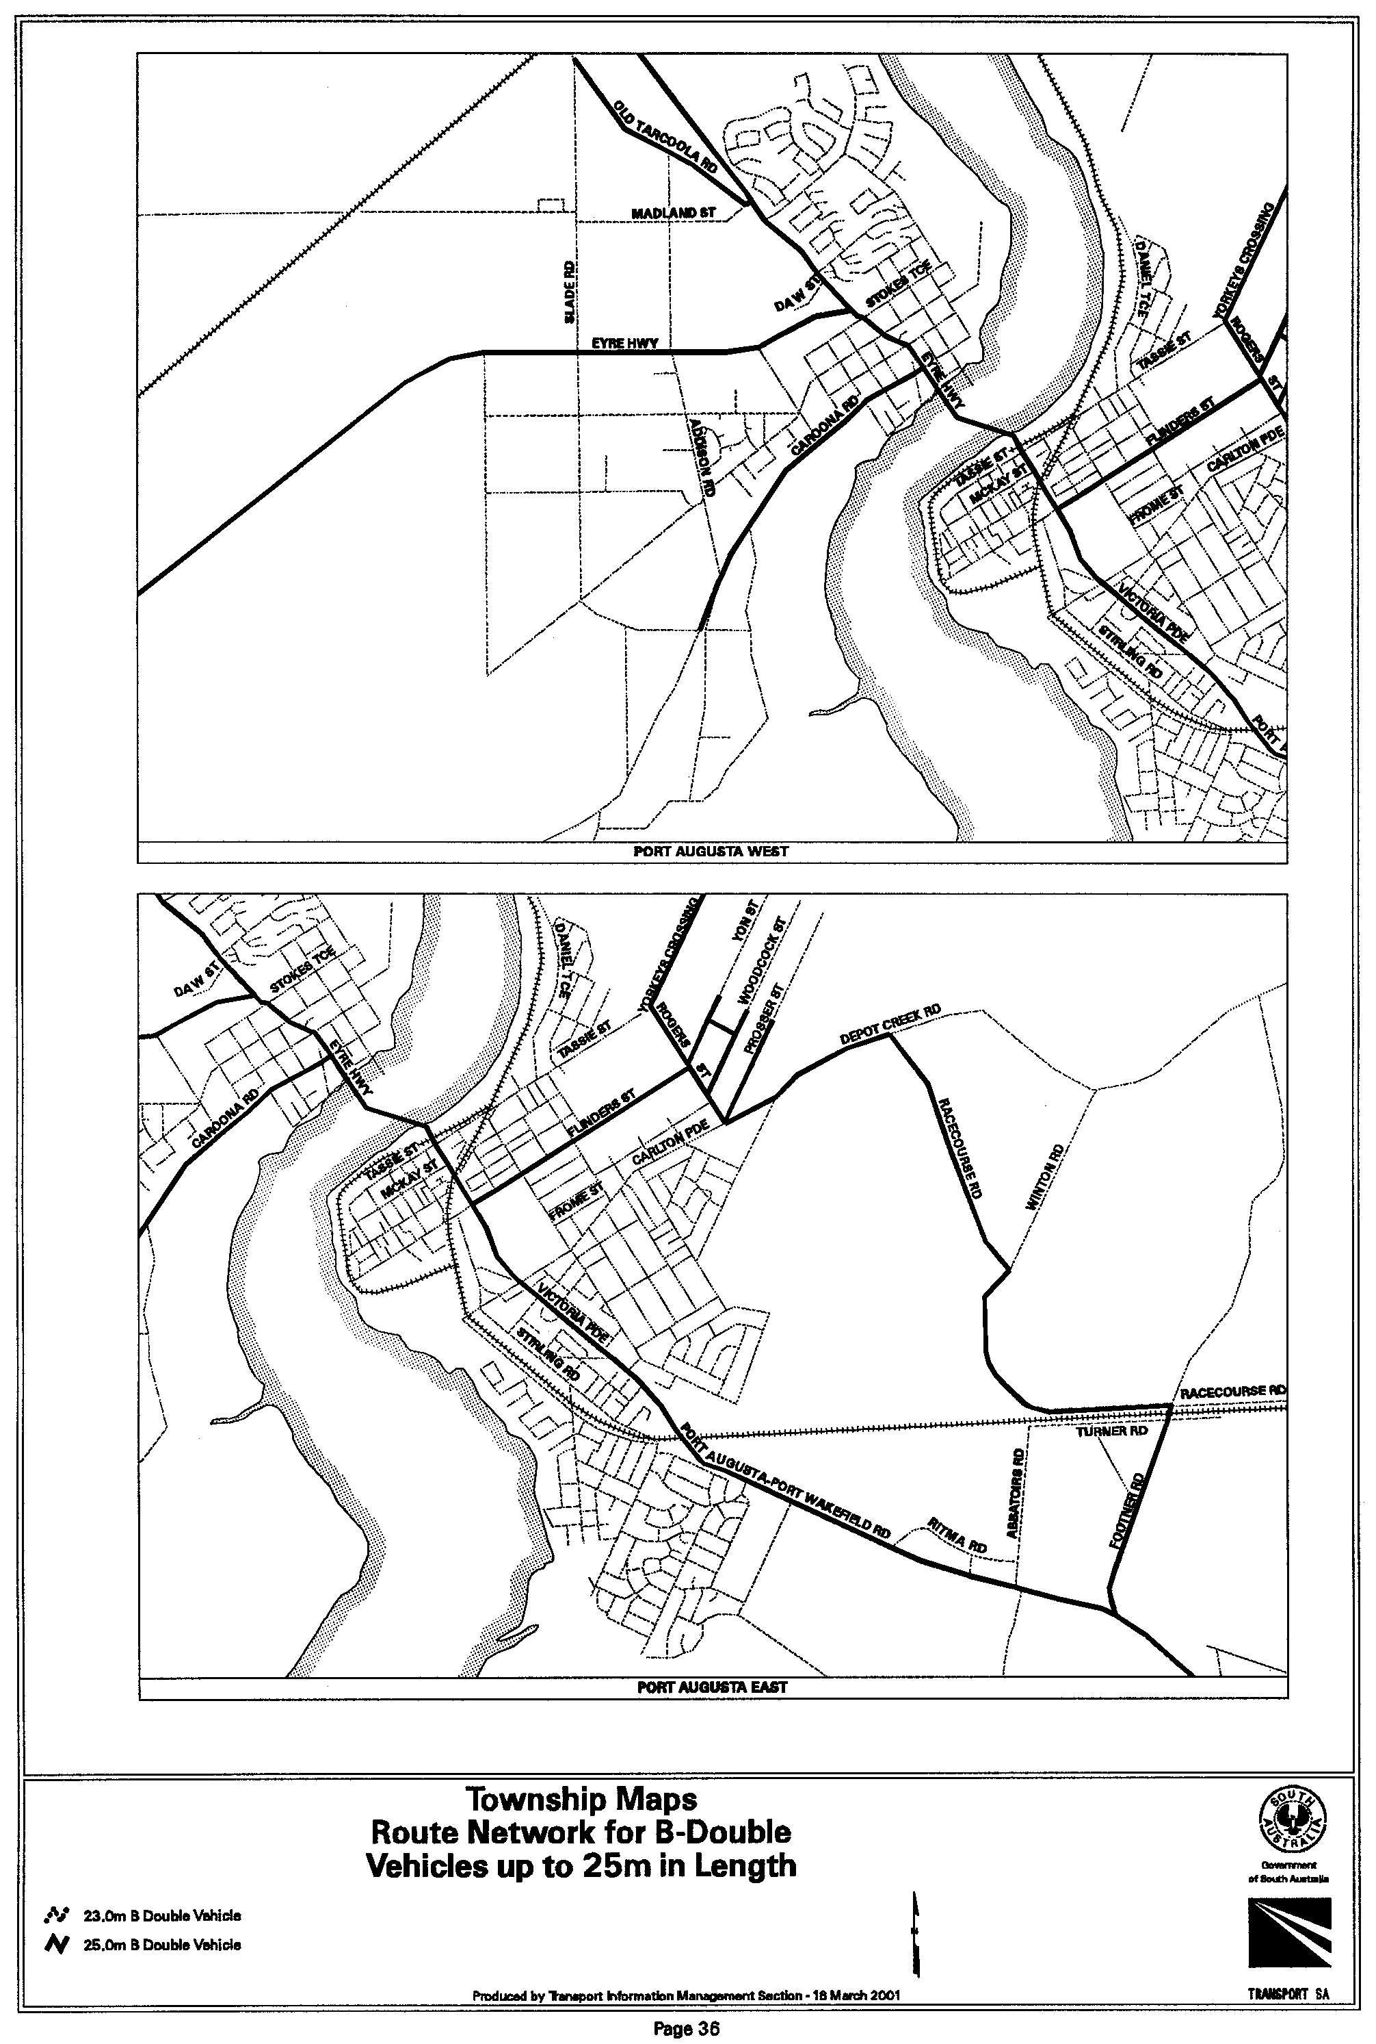
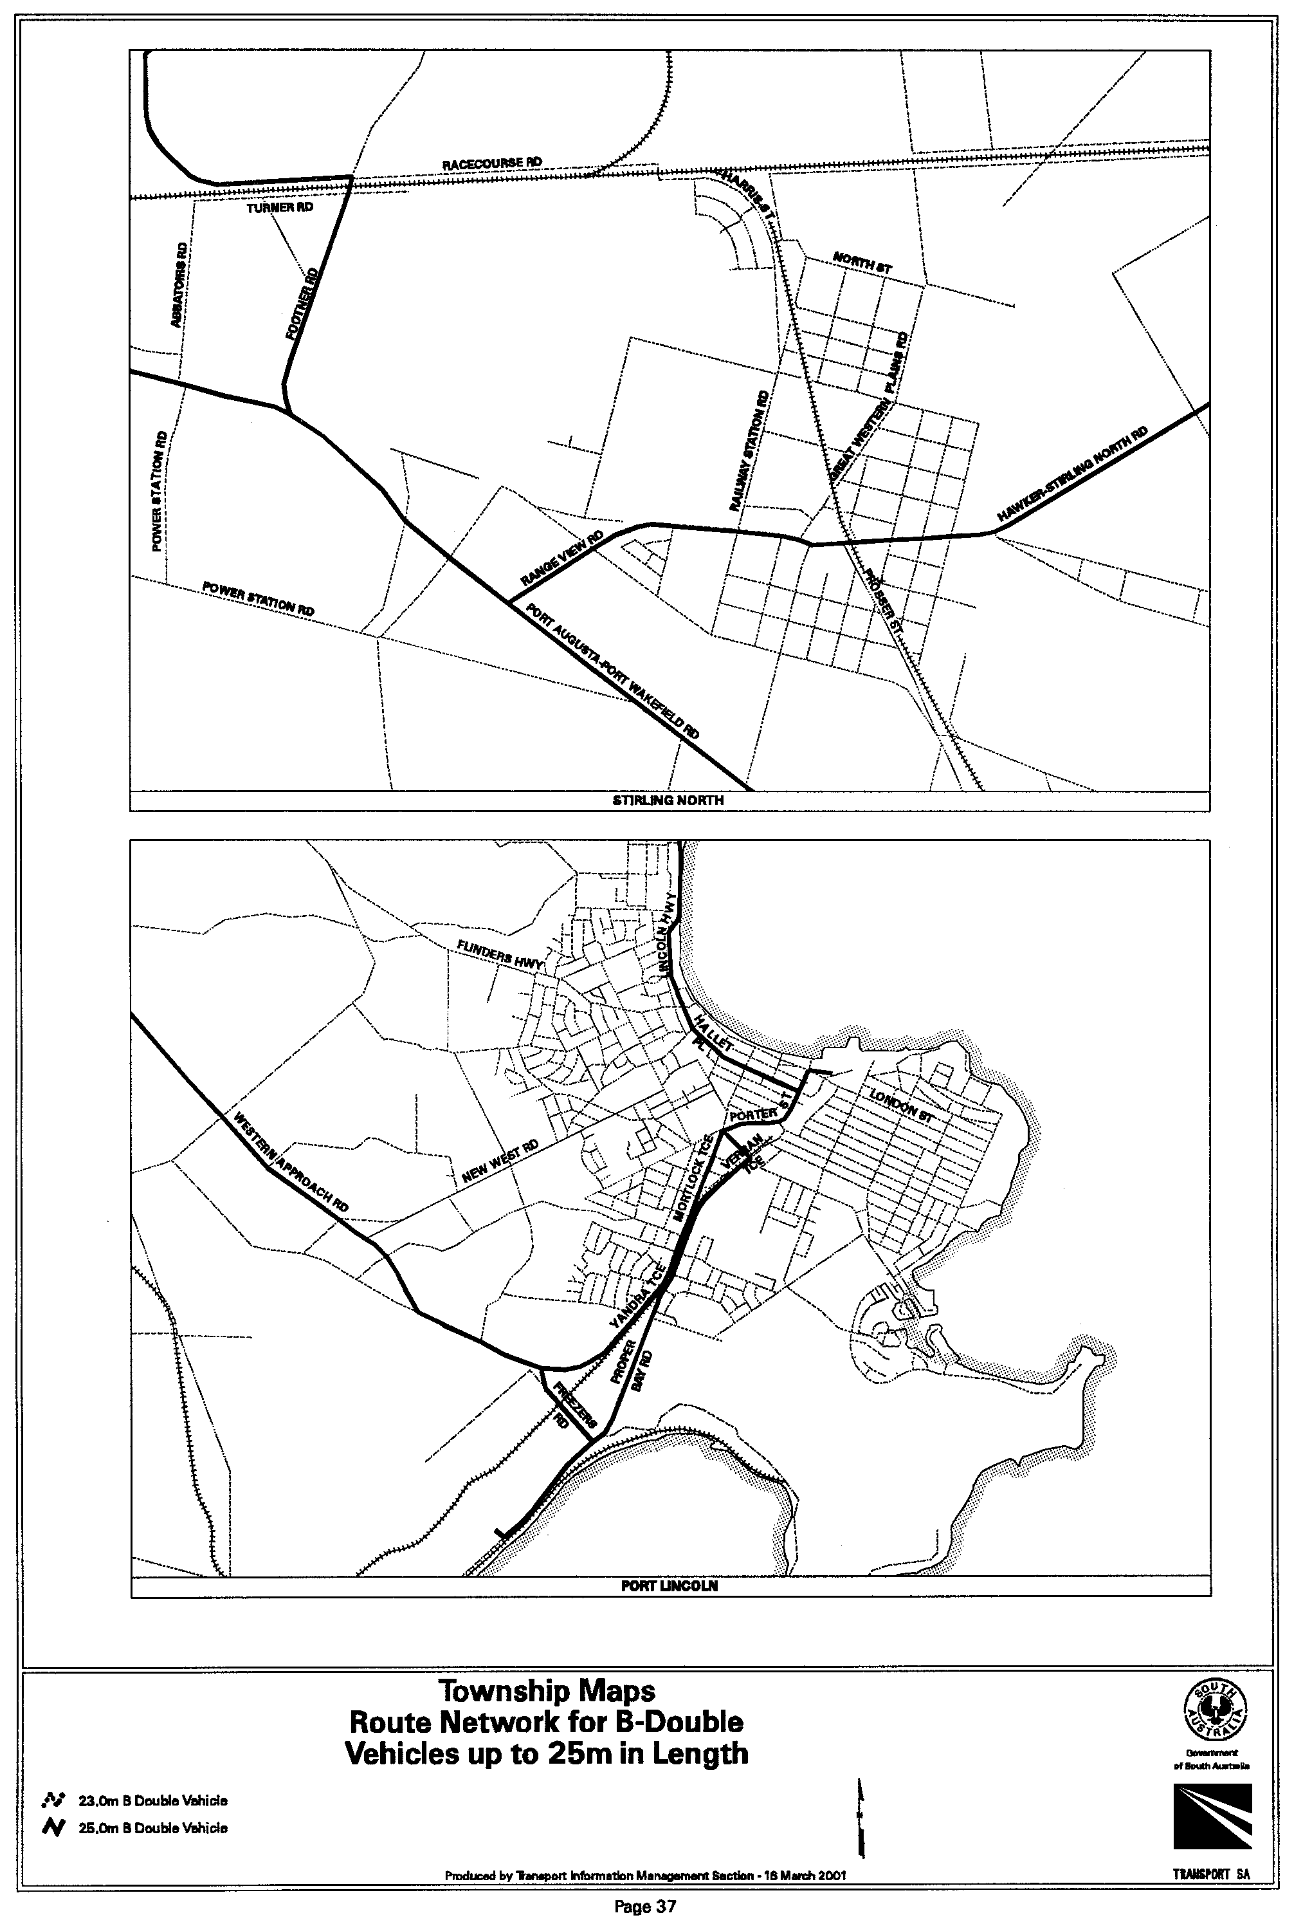

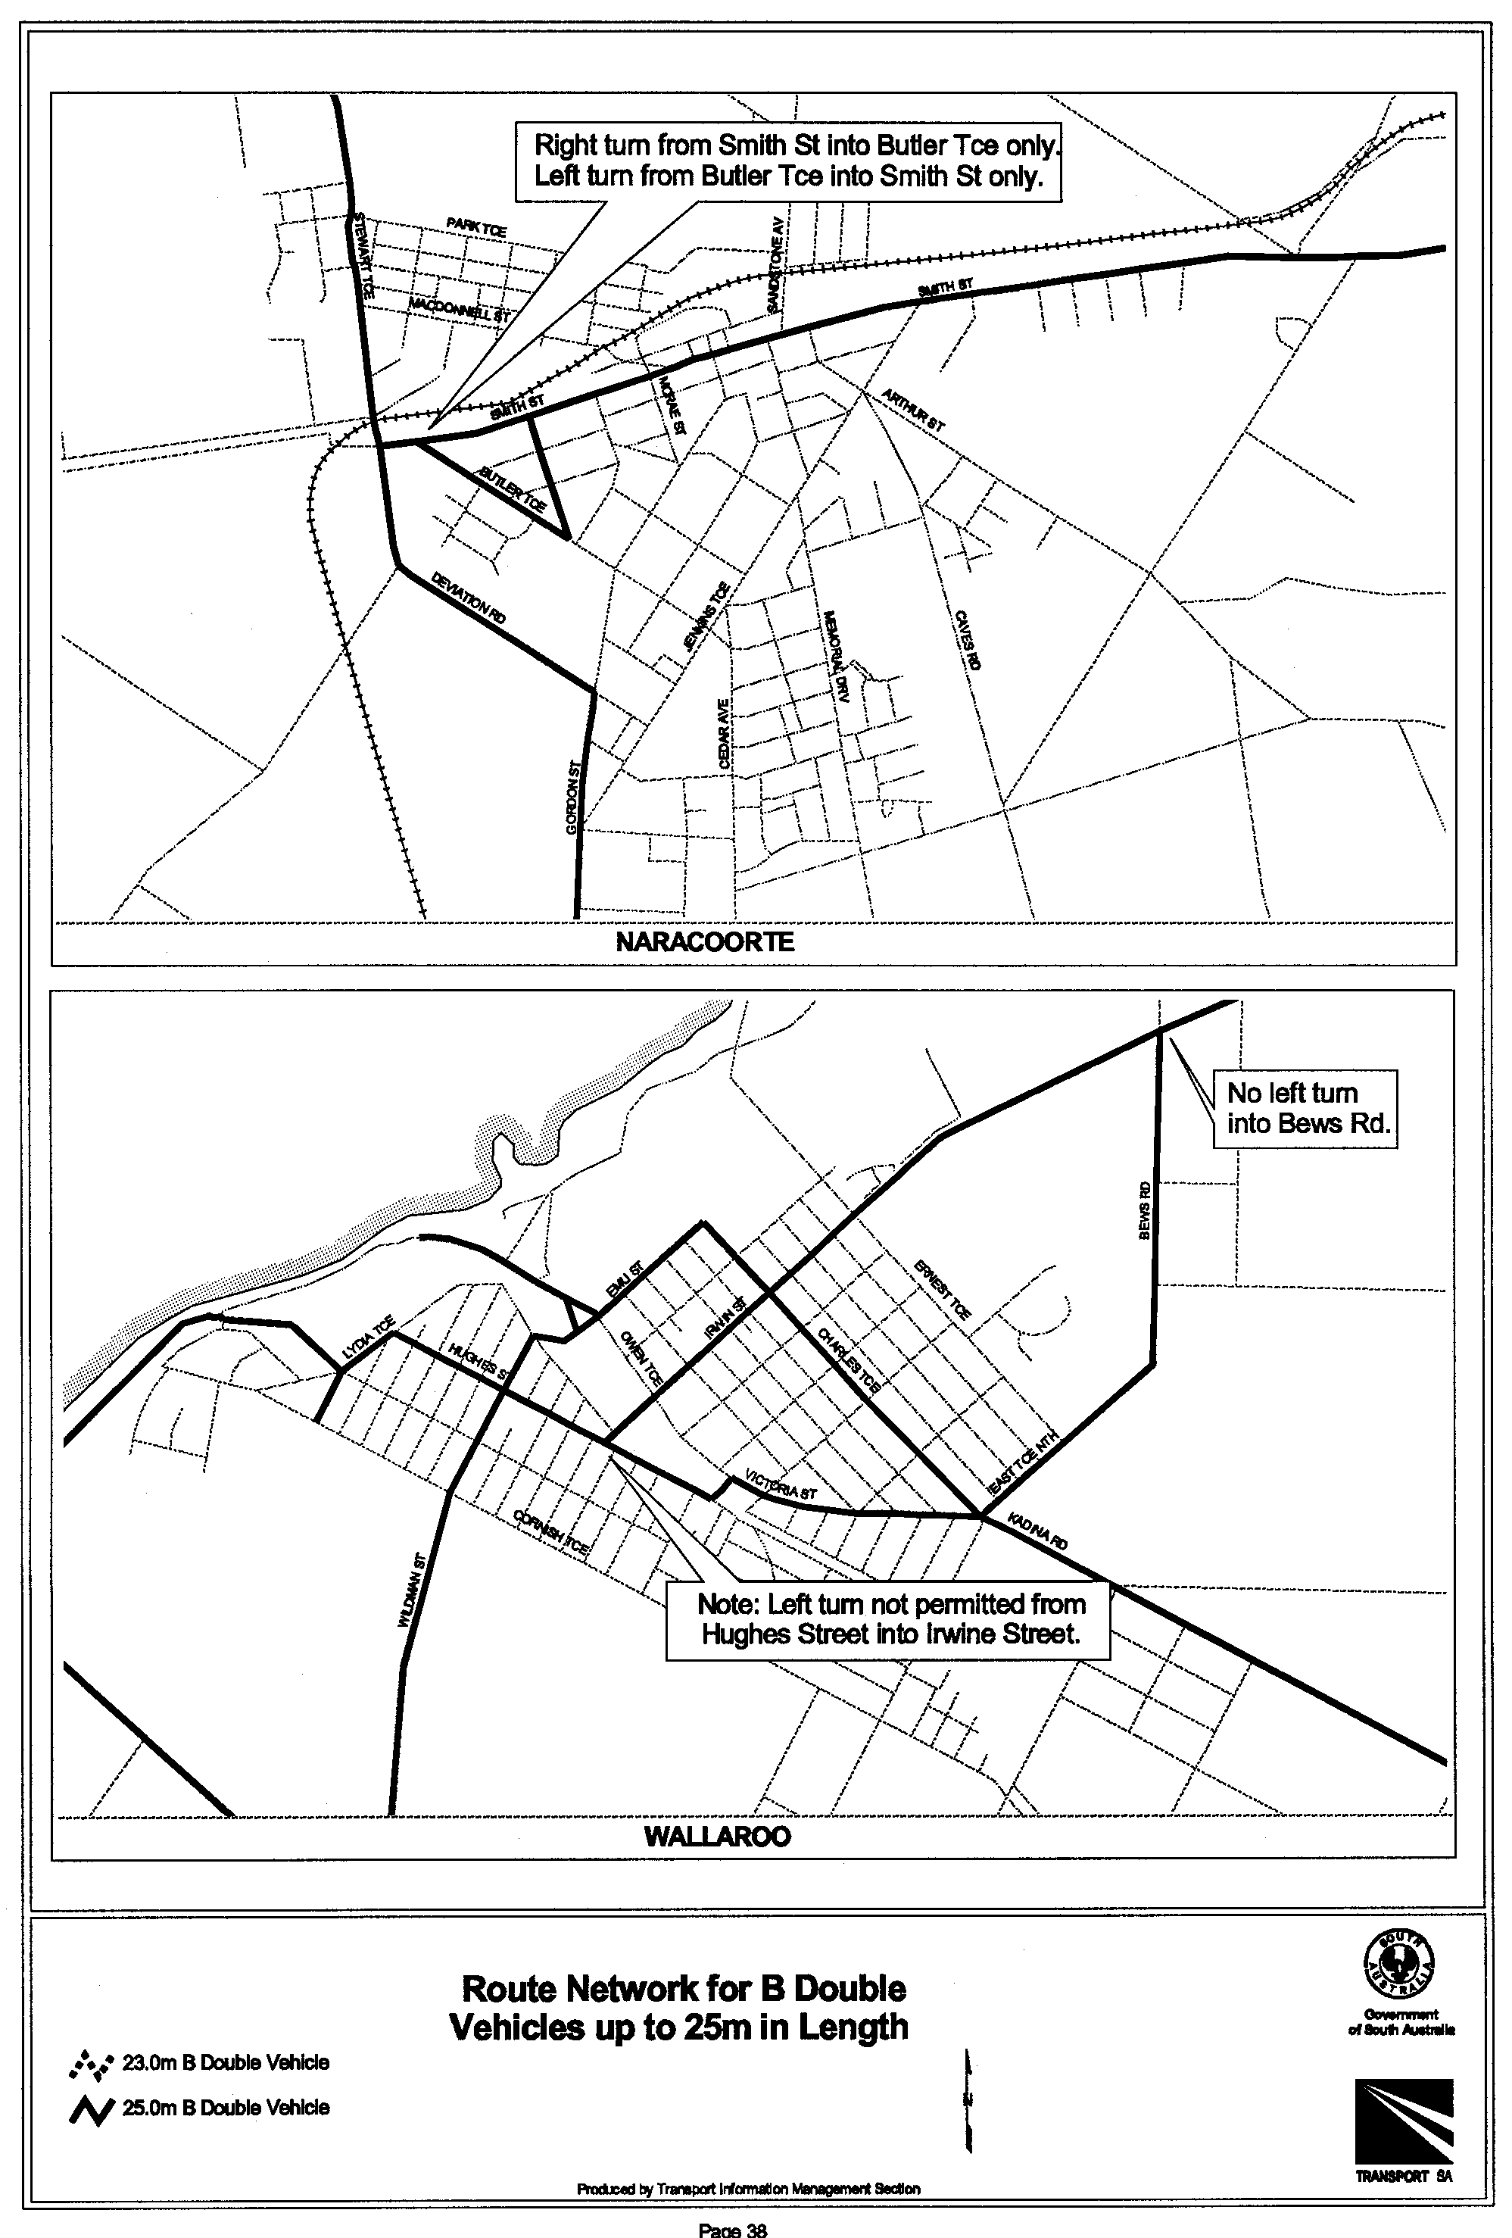
T. N. Argent, Executive Director, Transport SA

WATER MAINS AND SEWERS

Office of the South Australian Water Corporation
Adelaide, 22 March 2001.

WATER MAINS LAID

Notice is hereby given that the following main pipes or parts of main pipes have been laid down by the South Australian Water Corporation in or near the undermentioned water districts and are now available for a constant supply of water to adjacent land.

ADELAIDE WATER DISTRICT

CITY OF MARION
Lonsdale Highway, Hallett Cove. p4
Anna Drive, Hallett Cove. p4 and 5
Elizabeth Crescent, Hallett Cove. p5
Sally Court, Hallett Cove. p5 and 4
Thomas Way, Hallett Cove. p5

CITY OF MITCHAM
University Way, Bellevue Heights. p9
Flinders Road, Bellevue Heights. p9
McLaren Street, Torrens Park. p11

DISTRICT OF MOUNT BARKER
Easement in lot 2010, Burnbank Way, Mount Barker. p6
Burnbank Way, Mount Barker. p6-8
Sheridan Court, Mount Barker. p7
Dalmaney Drive, Mount Barker. p7
Schaefer Court, Mount Barker. p7 and 8

CITY OF ONKAPARINGA
Richards Road, Willunga. p2
Easement in lot 102, Richards Road, Willunga. p2

CITY OF WEST TORRENS
Azalea Drive, Lockleys. p3

PENOLA WATER DISTRICT

WATTLE RANGE COUNCIL
Shanks Street, Penola. p13

PINNAROO WATER DISTRICT

SOUTHERN MALLEE DISTRICT COUNCIL
Railway South Terrace, Pinnaroo. p1 and 24
Gordon Terrace, Pinnaroo. p25

PORT LINCOLN WATER DISTRICT

CITY OF PORT LINCOLN
Flinders Highway, Port Lincoln. p12

WATER MAINS ABANDONED

Notice is hereby given that the undermentioned water mains have been abandoned by the South Australian Water Corporation.

ADELAIDE WATER DISTRICT

CITY OF MARION
Across Lonsdale Highway, Hallett Cove. p4

CITY OF MITCHAM
Easements in lot 43, Springbank Road, Clapham and Torrens Park. p14 and 15
Waterworks land (lot 51), Springbank Road, Torrens Park. p15

CITY OF PORT ADELAIDE ENFIELD
Across Military Road, Osborne. p10
Easement in lot 100 (formerly Waterworks land), Military Road, Osborne. p10

PINNAROO WATER DISTRICT

SOUTHERN MALLEE DISTRICT COUNCIL
Railway South Terrace, Pinnaroo. p1 and 24
Across Gordon Terrace, Pinnaroo. p25

WATER MAINS LAID

Notice is hereby given that the undermentioned water mains have been laid down by the South Australian Water Corporation and are not available for a constant supply of water to adjacent land.

ADELAIDE WATER DISTRICT

CITY OF MITCHAM
Waterworks land (lot 51), Springbank Road, Torrens Park. p15-19

ADDENDA

Addendum to notice in “Government Gazette” of 20 March 1958.

“WATER MAINS LAID”

“Notice is hereby given that the following main pipes or parts of main pipes have been laid down by the South Australian Water Corporation in or near the undermentioned water districts and are now available for a constant supply of water to adjacent land.”

“YORKE PENINSULA COUNTRY LANDS WATER
DISTRICT”

“DISTRICT OF YORKE PENINSULA”
“Easements in sections 235, 263 and 252, hundred of Maitland, easements in sections 88, 156, 132 and 151, Government road south of sections 151 and 148, hundred of Muloowurtie, Government road south of sections 205s, 201, hundred of Wauraltee, easements in sections 78 and 79, Government road north of sections 79 and 80, Government road west of sections 81, 70, 27 and 4, hundred of Koolywurtie, Government road west of sections 94 and 166, hundred of Minlacowie.—18,640ft. (5681.5 m) of 18in. (450 mm) MSCL main, 67,829ft. (20674.3 m) of 16in. (400 mm) MSCL main, 104,374ft. (31813.2 m) of 14in. (350 mm) MSCL main and 4,627ft. (1410.3 m) of 12in. (300 mm) MSCL main running northerly, easterly, southerly, westerly and again southerly from Maitland Tank to north-west corner of section 290, Minlaton.”

To this notice add “This main is available for house connections on application only on the western side to lot 101 in LTRO DP 53230. p23”

CORRECTION

Correction to notice in “Government Gazette” of 21 February 1963.

“WATER MAINS LAID”

“Notice is hereby given that the following main pipes or parts of main pipes have been laid down by the South Australian Water Corporation in or near the undermentioned water districts and are now available for a constant supply of water to adjacent land.”

“WARREN COUNTRY LANDS WATER DISTRICT”

“DISTRICT OF THE BAROSSA COUNCIL”
“Government road (now Basedow Road) north-west of section 77, hundred of Moorooroo.—70ft. (21.3 m) of 2in. (50 mm) main from 2in. main road (Light Pass Road) south-west of section 7 running north easterly.” p75
For “70ft. (21.3 m)” read “110ft. (33.5 m)”
SEWERS LAID

Notice is hereby given that the following sewers have been laid down by the South Australian Water Corporation in the undermentioned drainage areas and are now available for house connections.

ADELAIDE DRAINAGE AREA

CITY OF CHARLES STURT
Reynell Street, Kilkenny. FB 1094 p30

CITY OF PORT ADELAIDE ENFIELD
Standard Avenue, Croydon Park. FB 1094 p31

CITY OF PROSPECT
Ian Street, Broadview. FB 1094 p32

CITY OF SALISBURY
Stratford Road, Salisbury North. FB 1094 p33

CORPORATE TOWN OF WALKERVILLE
Doreen Street, Vale Park. FB 1094 p29

CITY OF WEST TORRENS
Azalea Drive, Lockleys. FB 1094 p16

MURRAY BRIDGE COUNTRY DRAINAGE AREA

RURAL CITY OF MURRAY BRIDGE
Easement in lot 503, Railway Terrace, Murray Bridge. FB 1094 p34

STIRLING COUNTRY DRAINAGE AREA

DISTRICT OF ADELAIDE HILLS COUNCIL
Easements in lot 20, Merrion Terrace and lots 19, 22 and 23, Vista Terrace, Stirling. FB 1094 p27 and 28
Sewerage land (lot 172), Stacey Street, Crafers. FB 1094 p35
Stacey Street, Crafers. FB 1094 p20, 21 and 23
Easements in lot 1, Stacey Street and lot 102, Schocroft Avenue, Crafers. FB 1094 p20 and 22
Schocroft Avenue, Crafers. FB 1094 p17, 18, 25 and 26
Sandercock Road, Crafers. FB 1094 p17 and 18
Easements in lot 106 and 39, Schocroft Avenue, Crafers. FB 1094 p17 and 18
Oliver Street, Crafers. FB 1094 p25 and 26
Walkway west of lot 42, Schocroft Avenue, Crafers. FB 1094 p17 and 18
Easements in lot 2, Stacey Street and lot 61, Lampert Place, Crafers. FB 1094 p20 and 23
Easements in lot 1, Stacey Street and lot 29, Schocroft Avenue, Crafers. FB 1094 p20 and 23

SEWERS ABANDONED

Notice is hereby given that the undermentioned sewer has been abandoned by the South Australian Water Corporation.

MURRAY BRIDGE COUNTRY DRAINAGE AREA

RURAL CITY OF MURRAY BRIDGE
Easement in lot 503, Railway Terrace, Murray Bridge. FB 1094 p34

SEWERS LAID

Notice is hereby given that the undermentioned sewers have been laid down by the South Australian Water Corporation and are not available for house connections.

STIRLING COUNTRY DRAINAGE AREA

ADELAIDE HILLS COUNCIL
Sewerage land (lot 172), Stacey Street, Crafers—100 mm PVCR pumping main. FB 1094 p35, 20 and 24
Stacey Street, Crafers—100 mm PVCR pumping main. FB 1094 p20 and 24
Rudall Avenue, Crafers—100 mm PVCR pumping main. FB 1094 p20 and 24
A. Howe, Acting Chief Executive Officer, South Australian Water Corporation

REGULATIONS UNDER THE CHIROPODISTS ACT 1950
────
No. 22 of 2001
────
At the Executive Council Office at Adelaide 22 March 2001

PURSUANT to the Chiropodists Act 1950, on the recommendation of The Chiropody Board of South Australia and with the advice and consent of the Executive Council, I make the following regulations.

E. J. NEAL Governor

PURSUANT to section 10AA(2) of the Subordinate Legislation Act 1978, I certify that, in my opinion, it is necessary or appropriate that the following regulations come into operation as set out below.

DEAN BROWN Minister for Human Services
───────────────────
SUMMARY OF PROVISIONS

1. Citation
2. Commencement
3. Variation of reg. 18—Fees
────────────────────────

Citation
1. The Chiropodists Regulations 1989 (see Gazette 16 February 1989 p. 475), as varied, are referred to in these regulations as "the principal regulations".

Commencement
2. These regulations will come into operation on 1 July 2001.

Variation of reg. 18—Fees
3. Regulation 18 of the principal regulations is varied by striking out "160.00" twice occurring and substituting, in each case, "165.00".

MH (CS) 030/001/017 R. DENNIS Clerk of the Council

REGULATIONS UNDER THE PUBLIC CORPORATIONS ACT 1993
────
No. 23 of 2001
────
At the Executive Council Office at Adelaide 22 March 2001

PURSUANT to the Public Corporations Act 1993 and with the advice and consent of the Executive Council, I make the following regulations.
E. J. NEAL Governor

PURSUANT to section 10AA(2) of the Subordinate Legislation Act 1978, I certify that, in my opinion, it is necessary or appropriate that the following regulations come into operation as set out below.

ROB LUCAS Treasurer
───────────────────
SUMMARY OF PROVISIONS

PART 1
PRELIMINARY

1. Citation
2. Commencement
3. Interpretation

PART 2
APPLICATION OF ACT TO MINISTER

4. Application of Act to Minister

PART 3
AUSTRALIAN CHILDREN'S PERFORMING ARTS COMPANY

DIVISION 1—ESTABLISHMENT AND CONSTITUTION OF SUBSIDIARY

5. Establishment of subsidiary (s. 24)
6. Establishment of board
7. Composition of board
8. Conditions of membership
9. Vacancies or defects in appointment of directors
10. Remuneration
11. Proceedings
12. Disclosure

DIVISION 2—FUNCTIONS AND PERFORMANCE

13. Functions of subsidiary
14. Charter
15. Performance statement
16. Subsidiary companies
17. Indirect or joint operations by subsidiary

DIVISION 3—FINANCIAL AND RELATED MATTERS

18. Internal audit
19. Quarterly reports
20. Loans, etc., require approval
21. Provision of information
22. Common seal and execution of documents
23. Annual report
────────────────────────

PART 1
PRELIMINARY

Citation
1. These regulations may be cited as the Public Corporations (Australian Children's Performing Arts Company) Regulations 2001.

Commencement
2. These regulations come into operation on the day on which they are made.

Interpretation
3. In these regulations, unless the contrary intention appears—

"Act" means the Public Corporations Act 1993;

"board" means the board of directors established as the governing body of the subsidiary under Part 3;

"director" means a person appointed or holding office as a member of the board under Part 3;

"Minister" means the Minister for the Arts;

"the subsidiary" means the Australian Children's Performing Arts Company established under Part 3.

PART 2
APPLICATION OF ACT TO MINISTER

Application of Act to Minister
4. The following provisions of the Act apply to the Minister:

(a) Part 1 (Preliminary);

(b) section 24 (Formation of subsidiary by regulation);

(c) section 25 (Dissolution of subsidiary established by regulation);

(d) the schedule (Provisions applicable to subsidiaries), other than clause 12.

PART 3
AUSTRALIAN CHILDREN'S PERFORMING ARTS COMPANY

DIVISION 1—ESTABLISHMENT AND CONSTITUTION OF SUBSIDIARY

Establishment of subsidiary (s. 24)
5. (1) The Australian Children's Performing Arts Company is established as a subsidiary of the Minister.

(2) The subsidiary—

(a) is a body corporate; and

(b) has perpetual succession and a common seal; and

(c) is capable of suing and being sued in its corporate name.

Establishment of board
6. (1) A board of directors is established as the governing body of the subsidiary.

(2) Anything done by the board in the administration of the subsidiary's affairs is binding on the subsidiary.

Composition of board
7. (1) The board consists of the number of directors appointed by the Minister (being not more than eight) for the time being holding office as members of the board.

(2) A person appointed as a director must have such commercial, corporate governance, arts, financial or other qualifications or experience as are, in the Minister's opinion, necessary to enable the board to carry out its functions effectively.

(3) One director must be a person nominated by the Minister for Education and Children's Services.

(4) One director will be appointed by the Minister to chair meetings of the board.

(5) The Minister may appoint a director to be the deputy of the director appointed to chair the board and the deputy may perform or exercise the functions and powers of that director in his or her absence.

(6) On the office of a director becoming vacant, a person may be appointed in accordance with this regulation to the vacant office.

(7) The Minister may appoint a suitable person to be deputy of a member of the board during any period of absence of the member (and any reference to a director in these regulations will be taken to include, unless the contrary intention appears, a reference to a deputy while acting as a member of the board).

Conditions of membership
8. (1) A director will be appointed for a term, not exceeding three years, specified in the instrument of appointment and, at the expiration of a term of appointment, will be eligible for reappointment.

(2) The office of a director becomes vacant if the director—

(a) dies; or

(b) completes a term of office and is not reappointed; or

(c) resigns by written notice to the Minister; or

(d) becomes bankrupt or applies to take the benefit of a law for the relief of insolvent debtors; or

(e) is convicted of an indictable offence; or

(f) is removed from office by the Minister by written notice.

Vacancies or defects in appointment of directors
9. An act of the board is not invalid by reason only of a vacancy in its membership or a defect in the appointment of a director.

Remuneration
10. A director is entitled to be paid from the funds of the subsidiary such remuneration, allowances and expenses as may be determined by the Minister.

Proceedings
11. (1) A quorum of the board consists of one half of the total number of members (ignoring any fraction resulting from the division) plus one.

(2) The director appointed to chair the board will preside at meetings of the board at which he or she is present.

(3) If the director appointed to chair the board is absent from a meeting of the board—

(a) if another director has been appointed as that director's deputy and is present at the meeting—the deputy; or

(b) in any other case—a director chosen by the directors present at the meeting,

will preside.

(4) A decision carried by a majority of the votes cast by directors at a meeting is a decision of the board.

(5) Each director present at a meeting of the board has one vote on a question arising for decision and, if the votes are equal, the director presiding at the meeting may exercise a casting vote.

(6) A telephone or video conference between directors will, for the purposes of this regulation, be taken to be a meeting of the board at which the participating directors are present if—

(a) notice of the conference is given to all directors in the manner determined by the board for that purpose; and

(b) each participating director is capable of communicating with every other participating director during the conference.
(7) A proposed resolution of the board becomes a valid decision of the board despite the fact that it is not voted on at a meeting of the board if—

(a) notice of the proposed resolution is given to all directors in accordance with procedures determined by the board; and

(b) a majority of the directors express their concurrence in the proposed resolution by letter, telex or facsimile transmission, or other form of communication determined by the Board, setting out the terms of the resolution.

(8) The board must cause accurate minutes to be kept of its proceedings.

(9) A person authorised in writing by the Minister may attend (but not participate in) a meeting of the board and may have access to papers provided to directors for the purpose of the meeting.

(10) If the board considers that a matter dealt with at a meeting attended by a representative of the Minister should be treated as confidential, the board may advise the Minister of that opinion giving the reason for the opinion and the Minister may, subject to subregulation (11), act on that advice as the Minister thinks fit.

(11) If the Minister is satisfied on the basis of the board's advice under subregulation (10) that the subsidiary owes a duty of confidence in respect of a matter, the Minister must ensure the observance of that duty in respect of the matter, but this subregulation does not prevent a disclosure as required in the proper performance of ministerial functions or duties.

(12) Subject to these regulations, the board may determine its own procedures.

Disclosure
12. (1) Where the subsidiary discloses to the Minister in pursuance of the Act or these regulations a matter in respect of which the subsidiary owes a duty of confidence, the subsidiary must give notice in writing of the disclosure to the person to whom the duty is owed.

(2) A director of the subsidiary does not commit any breach of duty by reporting a matter relating to the affairs of the subsidiary to the Minister.

DIVISION 2—FUNCTIONS AND PERFORMANCE

Functions of subsidiary
13. (1) The subsidiary is established as a children's performing arts company to produce, present, facilitate, manage and promote high quality performing arts productions and other arts activities for children, young people, families, schools and other groups or bodies, both within the State and nationally and internationally and, in so doing, the subsidiary may—

(a) produce, present, manage, promote or conduct performances and entertainment of any kind as may in its opinion tend to promote artistic performance for children, young people and their families; and

(b) promote or commission the writing of plays or dramas, the scoring and writing of operas and other musical performances, the scoring, writing and choreography of dance, and other works for performance; and

(c) promote the training of all persons concerned in the production, presentation or performance of artistic performances or presentations; and
(d) assist financially or otherwise in the production, presentation, management, promotion or conduct of performances for children, young people and their families; and

(e) promote public interest and participation in performance for children, young people and their families; and

(f) establish and maintain a collection of objects of public interest relating to the past and present practice of the performing arts for children and young people and, for that purpose, purchase, hire, accept by way of gift or loan, or otherwise acquire any such objects; and

(g) establish and conduct schools, courses, lectures, seminars and discussions on the art of performance; and

(h) enter into contracts (including contracts of employment), or other forms of agreement, connected with the production, management, presentation or promotion of performances, and enter into other forms of contract or agreement; and

(i) make charges for admission to any performance, production or presentation; and

(j) grant or dispose of rights or arrangements to televise, broadcast or record any performances undertaken under its auspices; and

(k) acquire, develop, hold, enhance or dispose of intellectual property; and

(l) perform or exercise incidental functions or powers; and

(m) undertake other functions or activities approved by the Minister.

(2) The subsidiary must obtain the approval of the Minister before it makes a material change to a policy direction or budget.

(3) The subsidiary should only undertake activities outside the State to the extent approved by the Minister or provided for by its charter.

Charter
14. (1) The Minister must prepare a charter for the subsidiary.

(2) The charter must address—

(a) the nature and scope of the subsidiary's operations;

(b) the subsidiary's obligations to report on its operations;

(c) the form and contents of the subsidiary's accounts and financial statements;

(d) any accounting, internal auditing or financial systems or practices to be established or observed by the subsidiary;

(e) the acquisition or disposal of capital or assets.

(3) The charter may—

(a) limit the functions or powers of the subsidiary; and
(b) deal with any other matter not specifically referred to in subregulation (2).

(4) The charter must be reviewed by the Minister at the end of each financial year.

(5) The Minister may amend the charter at any time.

(6) The charter, or an amendment to the charter, comes into force and is binding on the subsidiary on a day specified in the charter or amendment (but without affecting any contractual obligations previously incurred by the subsidiary).

(7) On the charter or an amendment to the charter coming into force, the Minister must, within 12 sitting days, have copies of the charter, or the charter in its amended form, laid before both Houses of Parliament.

Performance statement
15. (1) The Minister must, when preparing the charter for the subsidiary, also prepare, after consultation with the subsidiary, a performance statement setting the various performance targets that the subsidiary is to pursue in the coming financial year or other period specified in the statement and dealing with such other matters as the Minister considers appropriate.

(2) The Minister must, after consultation with the subsidiary, review the performance statement when reviewing the subsidiary's charter.

(3) The Minister may, after consultation with the subsidiary, amend the performance statement at any time.

Subsidiary companies
16. (1) The subsidiary must not, without the approval of the Minister—

(a) form a subsidiary corporation; or

(b) acquire, or enter into any arrangement under which it will at a future time or would on the happening of some contingency hold, relevant interests in shares in a corporation such that the corporation becomes a subsidiary of the subsidiary.

(2) The Minister may, as a condition of approval under this section, or by direction, require the subsidiary to take steps to include in a subsidiary corporation's constitution such provisions as the Minister considers appropriate—

(a) imposing limitations on the nature or scope of the corporation's operations; or

(b) imposing other controls or practices,

consistent with those applicable to the subsidiary.

Indirect or joint operations by subsidiary
17. Despite any other regulation, the subsidiary must not, without the approval of the Minister (given either personally with respect to a particular case or class of case, or through the provisions of the subsidiary's charter), establish a trust scheme or a partnership or other scheme or arrangement for sharing of profits or joint venture with another person or undertake any operations or transactions pursuant to such a scheme or arrangement.

DIVISION 3—FINANCIAL AND RELATED MATTERS

Internal audit
18. The subsidiary must establish and maintain effective internal auditing of its operations.

Quarterly reports
19. The subsidiary must report to the Minister on the subsidiary's financial position on a quarterly basis.

Loans, etc., require approval
20. (1) The subsidiary must not lend or advance to any person any money, securities or property without the prior written approval of the Treasurer.

(2) The subsidiary must not undertake commercial borrowings without the prior written approval of the Treasurer.

Provision of information
21. (1) The subsidiary must, at the request in writing of the Minister, furnish the Minister with such information or records in the possession or control of the subsidiary as the Minister may require in such manner and form as the Minister may require.

(2) If a record in the possession or control of the subsidiary is furnished to the Minister under this regulation, the Minister may make, retain and deal with copies of the record as the Minister thinks fit.

(3) If the board considers that information or a record furnished under this regulation contains matters that should be treated as confidential, the board may advise the Minister of that opinion giving the reason for the opinion and the Minister may, subject to subregulation (4), act on that advice as the Minister thinks fit.

(4) If the Minister is satisfied on the basis of the board's advice under subregulation (3) that the subsidiary owes a duty of confidence in respect of a matter, the Minister must ensure the observance of that duty in respect of the matter, but this subregulation does not prevent a disclosure as required in the proper performance of ministerial functions or duties.

Common seal and execution of documents
22. (1) The common seal of the subsidiary must not be affixed to a document except in pursuance of a decision of the board, and the affixing of the seal must be attested by the signatures of two directors.

(2) The board may, by instrument under the common seal of the subsidiary, authorise a director, an employee of the subsidiary (whether nominated by name or by office or title) or any other person to execute documents on behalf of the subsidiary subject to limitations (if any) specified in the instrument of authority.

(3) Without limiting subregulation (2), an authority may be given so as to authorise two or more persons to execute documents jointly on behalf of the subsidiary.

(4) A document is duly executed by the subsidiary if—

(a) the common seal of the subsidiary is affixed to the document in accordance with this regulation; or

(b) the document is signed on behalf of the subsidiary by a person or persons in accordance with authority conferred under this regulation.

Annual report
23. (1) The subsidiary must, within three months after the end of each financial year, deliver to the Minister a report on the operations of the subsidiary during that financial year.

(2) The Minister must cause a copy of the report to be laid before both Houses of Parliament within 12 sitting days after receipt of the report.

ASACAB 009/00 R. DENNIS Clerk of the Council

FAXING COPY?

IF you fax copy to Government Publishing SA (formerly Riverside 2000), for inclusion in the Government Gazette, there is no need to send a Confirmation Copy to us as well.

This creates confusion and may well result in your notice being printed twice.

Please use the following fax number:

Fax transmission: (08) 8207 1040
Phone Inquiries: (08) 8207 1045

Please include a contact person, phone number and order number so that we can phone back with any queries we may have regarding the fax copy.

NOTE: Closing time for lodging new copy (either fax or hard copy) is 4 p.m. on Tuesday preceding the day of publication.

Government Gazette notices can be E-mailed.

The address is:

governmentgazette@saugov.sa.gov.au

Documents should be sent as attachments in Word format.

When sending a document via E-mail, please confirm your transmission with a faxed copy of your document, including the date the notice is to be published.

Fax transmission: (08) 8207 1040
Enquiries: (08) 8207 1045

CITY OF ADELAIDE
Declaration of Public Road
NOTICE is hereby given, pursuant to section 210 of the Local Government Act 1999, that at a future meeting the council intends to declare the following roads to be public roads:
Clarence Place in Town Acre 79, which is delineated as Allotment 10 on L.T.O. Plan FP 25447;
Gawler Place in Town Acres 81, 82, 105 and 106, which is delineated as Gawler Place on L.T.O. Plan FPX 18302; and
Twin Street in Town Acres 85 and 102, which is delineated as Twin Street on L.T.O. Plan C-1573.
S. Law, Chief Executive Officer

CITY OF PORT AUGUSTA
Development Act 1993
Draft for Public Consultation
NOTICE is hereby given that the Corporation of the City of Port Augusta has prepared a draft Plan Amendment Report (PAR) to amend the City of Port Augusta Development Plan. This draft amendment affects the entire council area.
This draft PAR has reflected the intentions of the approved Statement of Intent and the Planning Strategy and has resulted in a clear more concise set of policies to manage development in the City of Port Augusta. It consolidates the relevant city-wide policies into one place grouped by topic. The public notification categories have been incorporated in the simplest way possible. The PAR therefore will result in a Development Plan that is easier to understand and to use, by both professionals and non-professionals.
The draft PAR will be available for public inspection and free purchase during normal office hours at the Civic Centre and Public Library, from Thursday, 22 March 2001 to Friday, 25 May 2001.
Written submissions on the draft PAR will be accepted by the City of Port Augusta up to the close of business at 5 p.m. on Friday, 25 May 2001. Any written submission should also clearly indicate whether the writer wishes to speak at the public hearing in support of their submission. All submissions should be addressed to the Chief Executive Officer, City of Port Augusta, P.O. Box 1704, Port Augusta, S.A. 5700.
Copies of all submissions received will be available for inspection by interested persons at the Civic Centre and Public Library, until the conclusion of the public hearing.
A public hearing will be held at 7.30 p.m. in the Council Chambers, 4 Mackay Street, Port Augusta, S.A. 5700 on Tuesday, 12 June 2001. The public hearing may not be held if no submission indicates an interest in speaking at the public hearing.
Dated 13 March 2001.
I. D. McSporran, Chief Executive Officer

CITY OF PORT AUGUSTA
Temporary Road Closure
NOTICE is hereby given that having regard to a decision of council on Monday, 12 March 2001, the following traffic arrangements will apply on Saturday, 24 March 2001:
Pursuant to section 359 of the Local Government Act 1934, as amended, the council hereby resolves to temporarily close (to exclude motor vehicles generally), Beauchamps Lane on Saturday, 24 March 2001, between the hours of 8 a.m. and 10 p.m. to allow for Praise Corroboree to be held in Gladstone Square.
I. D. McSporran, City Manager

CITY OF PROSPECT
Supplementary Election—Nailsworth Ward—Nominations Received
NOTICE is hereby given that at the close of nominations at
12 noon on Thursday, 15 March 2001, the following persons have been accepted as candidates and are listed in the order in which they will appear on the ballot papers:
Ward Councillor (one vacancy)
Arnold, Damian
Randle, Peter John
Wellby, Trudy
Domeika, Glenn
Wong, Anthony
Postal Voting
The election will be conducted entirely by postal voting. No polling booths will be open for voting on polling day. Voting is not compulsory.
Voting material will be dispatched by post to every natural person, body corporate and group, who were listed on the voters roll as at roll closure on 31 January 2001.
The mail-out will commence on Tuesday, 3 April 2001, with all voting materials to be delivered by Tuesday, 10 April 2001.
A person who has not received voting material and who believes that he or she is entitled to vote, should apply to the State Electoral Office, 134 Fullarton Road, Rose Park, S.A. 5067, or telephone 8401 4324.
A pre-paid addressed envelope for each elector entitlement will be provided. Completed ballot material must be returned to reach the Returning Officer no later than 12 noon on Monday, 23 April 2001.
A ballot box will be provided at the City of Prospect Council Office for electors who personally wish to deliver their completed ballot material during office hours.
Counting of Votes
The scrutiny and counting of votes will take place in the Mayor’s Parlour at the City of Prospect Council Office, 128 Prospect Road, Prospect, as soon as practicable after 12.30 p.m. on Monday, 23 April 2001. A provisional declaration will be made at the conclusion of the count.
Campaign Donations Return
Candidates must forward a campaign donations return to the Council City Manager within 6 weeks after the conclusion of the election.
S. H. Tully, Returning Officer

CITY OF SALISBURY
Declaration of Public Road
NOTICE is hereby given that pursuant to section 208 (4) of the Local Government Act 1999, the City of Salisbury resolved at its meeting held on 26 February 2001, that the following allotments mentioned below, all in the Lands Titles Office, be declared as public road:
Allotment 200 in Deposited Plan 56250;
Allotment 202 in Deposited Plan 56250;
Allotment 203 in Deposited Plan 56249;
Allotment 204 in Deposited Plan 56248;
Allotment 205 in Deposited Plan 56247;
Allotment 207 in Deposited Plan 56251;
Allotment 209 in Deposited Plan 56252.
S. Hains, City Manager

CITY OF VICTOR HARBOR
Casual Vacancy
NOTICE is hereby given that pursuant to section 54 of the Local Government Act 1999, the City of Victor Harbor has a casual vacancy for a Councillor, due to the death of Enid Muriel Bray Sutton, effective from 3 March 2001.
G. K. Maxwell, City Manager

LIGHT REGIONAL COUNCL
Temporary Road Closure
NOTICE is hereby given that pursuant to Section 359 of the Local Government Act 1934, as amended, Council resolved that Les Dunkley Road, from its intersection with Graetz Road and Heinjus Road to a position 800 m south from the Sturt Highway, be closed to all traffic with the exception of emergency vehicles and authorised vehicles, effective from Thursday, 22 March 2001 until further notice, for the purpose of the demolition of the existing bridge structure and construction of a new bridge.
P. J. Beare, Chief Executive Officer

DISTRICT COUNCIL OF PETERBOROUGH
Supplementary Election—Close of Roll
NOTICE is hereby given that due to the resignation of a member of the council, a Supplementary Election will be necessary to fill one vacancy of Area Councillor for the District Council of Peterborough.
The voters roll to conduct this Supplementary Election will close at 5 p.m. on Friday, 30 March 2001.
Nominations to fill the vacancy will open on Thursday, 26 April 2001 and will be received up until 12 noon on Thursday, 17 May 2001.
The election will be conducted entirely by post with the return of ballot material to the Returning Officer no later than 12 noon on Wednesday, 20 June 2001.
S. H. Tully, Returning Officer

IN the matter of the estates of the undermentioned deceased persons:
Buchanan, Evangeline, late of 26 River Road, Port Noarlunga, retired secretary, who died on 25 December 2000.
Donato, Quintino, late of 68 Charles Street, Norwood, retired taxi driver, who died on 2 December 2000.
Fennell, George Edward, late of Towers Road, Millicent, retired plant operator, who died on 12 December 2000.
Gunnourie, Margaret June, late of 5 Jeanette Crescent, Aberfoyle Park, home duties, who died on 25 January 2001.
Jewell, Olive Gladys, late of 22 Norman Street, Port Pirie, widow, who died on 6 January 2001.
Jones, Ada, late of 6 Alexander Avenue, Naracoorte, retired domestic worker, who died on 21 January 2001.
Kelsey, Phyllis May, late of 580 Lower North East Road, Campbelltown, of no occupation, who died on 15 December 2000.
Lawn, Ida May Doreen, late of 150 Adams Road, Craigmore, widow, who died on 12 October 2000.
Lyons, Kevin John, late of 39 Myall Avenue, Kensington Gardens, retired cinema projectionist, who died on 4 January 2001.
Manning, Ena Maud, late of 1075 Grand Junction Road, Holden Hill, of no occupation, who died on 29 December 2000.
Mathews, Myrtle Doris, late of 86 Oaklands Road, Glen-gowrie, widow, who died on 12 December 2000.
Minck, Alexdrina, late of 20 Wootten Street, Greenacres, home duties, who died on 21 January 2001.
Morris, Phillis Vera, late of 18 HMS Buffalo Avenue, Edwardstown, of no occupation, who died on 2 January 2001.
Petherick, Nancy, late of 43 Heysen Crescent, West Lakes Shore, home duties, who died on 22 January 2001.
Phillips, Lilly Adelaide, late of 18 Cross Road, Myrtle Bank, widow, who died on 14 January 2001.
Radcliffe, Emma Cleora, late of 7 Marsha Drive, Banksia Park, home duties, who died on 8 November 2000.
Rodbourn, Lois, late of 6 Linwood Terrace, Brighton, home duties, who died on 14 January 2001.
Smith, Harold Desmond, late of 73 Collins Street, Broadview, retired public servant, who died on 28 January 2001.
Stone, Derrick John William, late of 22 Bolingbroke Avenue, Fulham Gardens, retired welder, who died on 12 January 1997.
Notice is hereby given pursuant to the Trustee Act 1936, as amended, the Inheritance (Family Provision) Act 1972, and the Family Relationships Act 1975, that all creditors, beneficiaries, and other persons having claims against the said estates are required to send, in writing, to the Public Trustee, 25 Franklin Street, Adelaide 5000, full particulars and proof of such claims, on or before 20 April 2001, otherwise they will be excluded from the distribution of the said estate; and notice is also hereby given that all persons who are indebted to the said estates are required to pay the amount of their debts to the Public Trustee or proceedings will be taken for the recovery thereof; and all persons having any property belonging to the said estates are forthwith to deliver the same to the Public Trustee.
Dated 22 March 2001.
J. H. Worrall, Public Trustee

SOUTH AUSTRALIA—In the Supreme Court. No. 836 of 1998. In the matter of ACN 066 796 889 Pty Ltd (formerly Sewmail (Australia) Pty Ltd) and in the matter of the Corporations Law.
Notice of Release of Liquidator and Dissolution of the Company
Take notice that by an order of the Supreme Court of South Australia, dated 13 March 2001, I, David John Olifent, Price-waterhouseCoopers, 91 King William Street, Adelaide, S.A. 5000, the liquidator of the abovenamed company, was granted my release as liquidator and the company was dissolved as at the date of this order.
Dated 16 March 2001.
D. J. Olifent, Liquidator

SOUTH AUSTRALIA—In the Supreme Court. No. 492 of 2001. In the matter of P. & H. Tiling Pty Ltd (ACN 008 262 511).
Notice of Application for Winding-up Order
1. A proceeding for the winding up of P. & H. Tiling Pty Ltd (ACN 008 262 511) was commenced by the Plaintiff, Marcem Pty Ltd, on 13 March 2001 and will be heard by Judge Burley at the Supreme Court of South Australia, 1 Gouger Street, Adelaide, S.A. 5000 at 2.15 p.m. on 10 April 2001. Copies of documents filed may be obtained from the Plaintiff’s address for service.
2. The Plaintiff’s address for service is c/o Scales & Partners, 48 Carrington Street, Adelaide, S.A. 5000.
3. Any person intending to appear at the hearing must file a notice of appearance, in accordance with the prescribed form, together with any affidavit on which the person intends to rely and serve a copy of the notice and any affidavit on the Plaintiff at the Plaintiff’s address for service at least 3 days before the date fixed for the hearing.
Dated 19 March 2001.
F. M. B. Turner, Legal Practitioner

ATTENTION

CUSTOMERS requiring a proof of their notice for inclusion in the Government Gazette, please note that the onus is on you to inform Government Publishing SA (formerly Riverside 2000) of any subsequent corrections by 10 a.m. on Thursday, which is our publication deadline.

For any corrections to your notice please phone 8207 1045 or Fax 8207 1040 before 10 a.m. on Thursday.

If we do not receive any communication by 10 a.m. on Thursday (day of publication) we will presume the notice is correct and will print it as it is.

Remember—the onus is on you to inform us of any corrections necessary to your notice.

NOTE: Closing time for lodging new copy (either fax or hard copy) is 4 p.m. on Tuesday preceding the day of publication. Ph. 8207 1045—Fax 8207 1040.

Printed and published by authority every Thursday by J. D. FERGUSON, Government Printer, South Australia
Price: $4.30, plus postage; to subscribers, $214.85 per annum.
(The above prices are inclusive of GST)

