No. 58 1771

THE SOUTH AUSTRALIAN

GOVERNMENT GAZETTE

PUBLISHED BY AUTHORITY

ALL PUBLIC ACTS appearing in this GAZETTE are to be considered official, and obeyed as such

ADELAIDE, THURSDAY, 17 MAY 2001

CONTENTS

Page
Acts Assented To 1772
Appointments, Resignations, Etc. 1772
Brands Act 1933—1st Quarter 2001 1774
Corporations and District Councils—Notices 1832
Development Act 1993—Notices 1782
Electoral Act 1985—Notice 1787
Electricity Pricing Order—Notice 1787
Environment Protection Act 1993—Notices 1787
Fisheries Act 1982—Notices 1789
Harbors and Navigation Act 1993—Notice 1793
Liquor Licensing Act 1997—Notices 1793
Local Government Act 1999—Notice 1800
Petroleum Act 2000—Notice 1816
Private Advertisements 1833
Page
Proclamations 1772
Public Trustee Office—Administration of Estates 1833
Rail Safety Act 1996—Notice 1816
REGULATIONS
Stamp Duties Act 1923 (No. 38 of 2001) 1828
Environment Protection Act 1993 (No. 39 of 2001) 1829
Roads (Opening and Closing) Act 1991—Notices 1816
Sale of Property 1834
Soil Conservation and Land Care Act 1989—Notice 1817
Transport SA—Notice of Mariners 1817
Unclaimed Moneys Act 1891—Notices 1834
Water Mains and Sewers—Mains Laid, Replaced, Etc. 1817
Workers Rehabilitation and Compensation Act 1986—
Notice 1819

GOVERNMENT GAZETTE NOTICES
ALL poundkeepers’ and private advertisements forwarded for publication in the South Australian Government Gazette must be PAID FOR PRIOR TO INSERTION; and all notices, from whatever source, should be legibly written on one side of the paper only and sent to Government Publishing SA so as to be received no later
than 4 p.m. on the Tuesday preceding the day of publication. Phone 8207 1045 or Fax 8207 1040. E-mail: governmentgazette@saugov.sa.gov.au. Send as attachments in Word format and please confirm your transmission with a faxed copy of your document, including the date the notice is to be published and to whom the notice will be charged.

Department of the Premier and Cabinet
Adelaide, 17 May 2001
HIS Excellency the Governor directs it to be notified for general information that he has in the name and on behalf of Her Majesty The Queen, this day assented to the undermentioned Acts passed by the Legislative Council and House of Assembly in Parliament assembled, viz.:
No. 15 of 2001: Listening Devices (Miscellaneous) Amend-ment Act 2001—An Act to amend the Listening Devices Act 1972; and to make related amendments to the Director of Public Prosecutions Act 1991.
No. 16 of 2001: Statutes Amendment (Avoidance of Duplication of Environmental Procedures) Act 2001—An Act to amend the Development Act 1993, the Environment Protection Act 1993, the Mining Act 1971, the Native Vegetation Act 1991, the Petroleum Act 2000 and the Water Resources Act 1997.
No. 17 of 2001: Statutes Amendment (Transport Portfolio) Act 2001—An Act to amend the Harbors and Navigation Act 1993, the Motor Vehicles Act 1959 and the Road Traffic Act 1961.
By command,
Mark Brindal, for Premier
DPC 97/0415

PRIVACY COMMITTEE OF SOUTH AUSTRALIA: VARIATION OF PROCLAMATION
Proclamation By The Governor
(l.s.) E. J. Neal
WITH the advice and consent of the Executive Council, I vary the proclamation made on 6 July 1989 (see Gazette 6 July 1989 p. 6), as varied—
(a) by striking out from clause 1(2) ‘Governor’ and substituting ‘Minister’;
(b) by striking out from clause 1(2)(a) ‘three will be appointed on the nomination of the Minister, of whom’ and substituting ‘three will be chosen by the Minister, and of these’;
(c) by inserting after subclause (3) of clause 1 the following subclause:
(3a) Where a member is appointed for a term of less than four years, the Minister may, with the consent of the member, extend the term of the appointment for a period ending on or before the fourth anniversary of the day on which the appoint-ment took effect.
Given under my hand and the Public Seal of South Australia, at Adelaide, 17 May 2001.
By command,
Mark Brindal, for Premier
MAS 01/004/CS

PLANNING ACT 1982, SECTION 62(4): REVOCATION OF OPEN SPACE PROCLAMATION BY THE GOVERNOR
Proclamation By The Governor
(l.s.) E. J. Neal
Preamble
1. On 30 September 1982 the division of certain land in the Hundred of Wallaroo was, by proclamation under the Planning and Development Act 1966, prohibited in order to preserve the land for open space (see Gazette 30 September 1982 p. 920).
2. Section 21 of the Statutes Repeal and Amendment (Development) Act 1993 provides that a proclamation made under section 61 of the Planning and Development Act 1966 continues in force and effect as if the Planning Act 1982 had not been repealed, and that the Planning Act 1982 continues to apply in relation to the proclamation (see also the schedule to the Planning Act 1982).
3. It is now desirable to revoke the prohibition insofar as it affects certain land.
Proclamation
PURSUANT to section 62(4) of the Planning Act 1982 and with the advice and consent of the Executive Council, I revoke the prohibition imposed by the proclamation referred to in clause 1 of the preamble insofar as it affects the land specified in the schedule.
Schedule
The land contained in Sections 227 to 231, Hundred of Wallaroo.
Given under my hand and the Public Seal of South Australia, at Adelaide, 17 May 2001.
By command,
Mark Brindal, for Premier
MFTUP CAB 0016/01

Department of the Premier and Cabinet
Adelaide, 17 May 2001
HIS Excellency the Governor in Executive Council has been pleased to appoint the undermentioned to the Citrus Board of South Australia, pursuant to the provisions of the Citrus Industry Act 1991:
Member: (from 17 May 2001 until 16 May 2004)
Bernard Lawry Lange
Carole Walker
Edward Peter Angove
Bill Ekonomopoulos
Mark Chown
Alan Leon Spehr
John Henwood
Amos Weigall
Presiding Member: (from 17 May 2001 until 16 May 2004)
Bernard Lawry Lange
Deputy Presiding Member: (from 17 May 2001 until 16 May 2004)
Edward Peter Angove
By command,
Mark Brindal, for Premier
MPRI 023/2001CS

Department of the Premier and Cabinet
Adelaide, 17 May 2001
HIS Excellency the Governor in Executive Council has been pleased to appoint the Honourable Malcolm Robert Buckby, MP, Minister for Education and Children’s Services to be also Acting Minister for Primary Industries and Resources and Acting Minister for Regional Development for the period 22 June 2001 to 29 June 2001 inclusive, during the absence of the Honourable Robert Gerard Kerin, MP.
By command,
Mark Brindal, for Premier
MPRI 021/2001CS

Department of the Premier and Cabinet
Adelaide, 17 May 2001
HIS Excellency the Governor in Executive Council has been pleased to appoint the people listed as Justices of the Peace for South Australia, pursuant to section 4 of the Justices of the Peace Act 1991:
Kevin Wayne Bawden
Debra Jane Bria
Kerry Paul Bromilow
Martina Cale
Kim Michelle Casey
Colin George Camac
Lynn Clyde Colls
Dace Darzins
Anthony Warren Doudle
Kate Emily Fallon
Sylvia Fisher
Bryon David Franklin
Kelvin Leigh Goldstone
Barry Bruce Gooley
Gaetano Grech
Judith Ann Hage
Robert Wilfred Hamdorf
Nouhad Jawhari
Stefan Richard Koplin
Stephen Francis Larkin
Ian Stuart Law
Peter Maurice Mase
Rory Dominic Mooney
Donald Ivan Perry
Tadeus Philips
Mark Christopher Reincke
Matthew James Rogers
Murray James Squire
By command,
Mark Brindal, for Premier
ATTG 43/99CS

Department of the Premier and Cabinet
Adelaide, 17 May 2001
HIS Excellency the Governor in Executive Council has removed from office the Justices of the Peace listed, pursuant to section 6 of the Justices of the Peace Act 1991:
Kent James Palmer Brown
Dagmar Renate Carroll
Bernadette Francis Carrucan
Tracy Coral Dickens
Marie Dwyer
Neil Malcolm Excell
Susan Jillian Forder
Maxine Faye Grieve
Kevin John Hannagan
Aleksander Ivkovic
Matthew Thomas Loader
James Henry Lukeman
Joan Dorothy Menzel
Julie Therese Piggott
Kenneth Clarence Riches
John Spencer Roper
Ian Stanley Schneider
Norma Patricia Shields
Sara Ann Jepherson Shields
David Herbert Stewart-Jones
Elva Joyce Verrall
Roger Egerton Welbourn
Ross Thomas Wheeler
By command,
Mark Brindal, for Premier
ATTG 54/99CS
ATTG 42/99CS

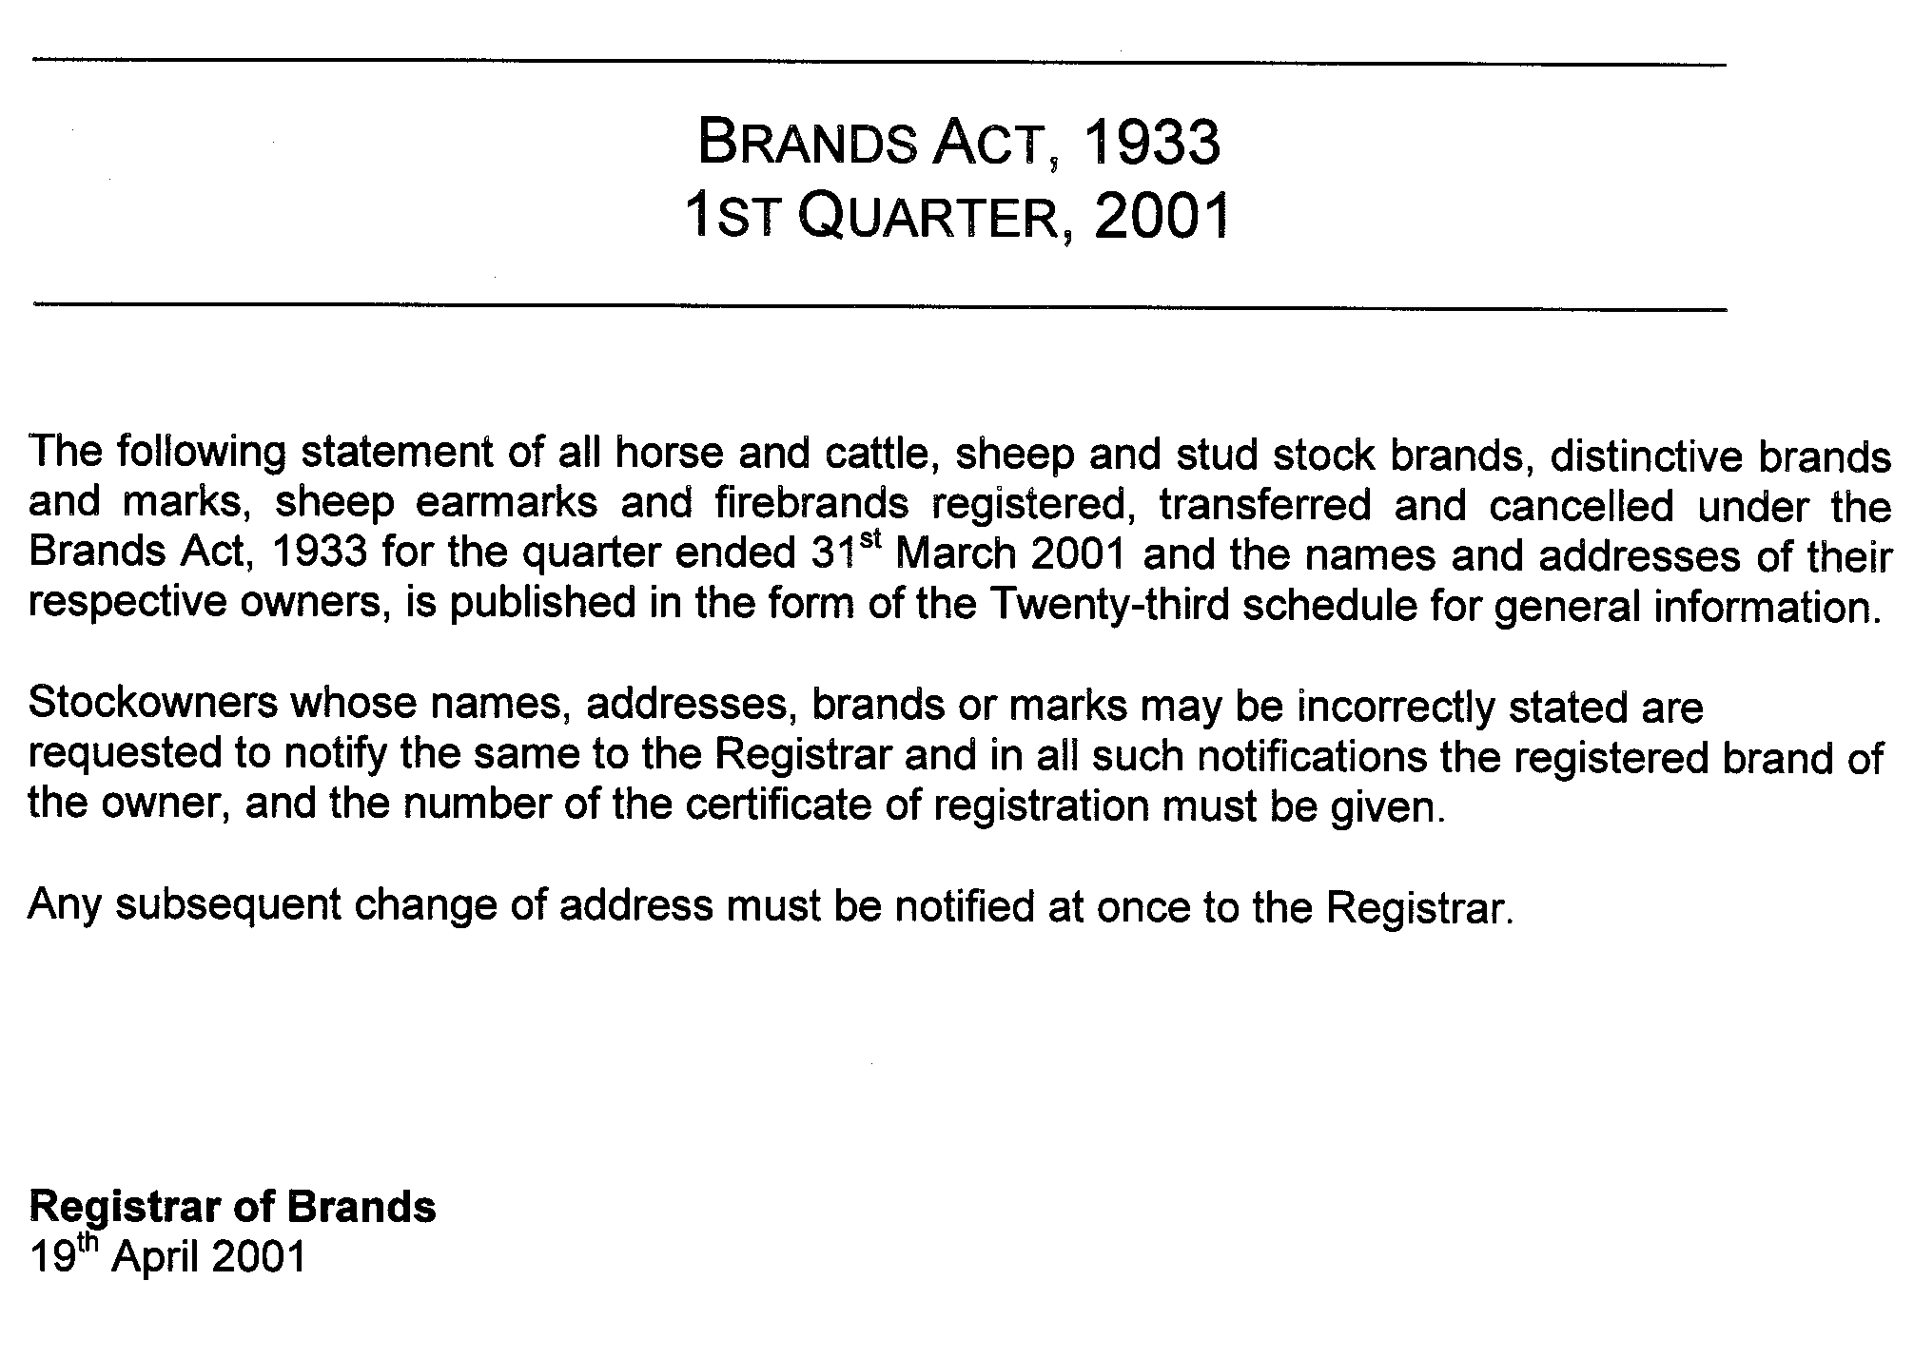
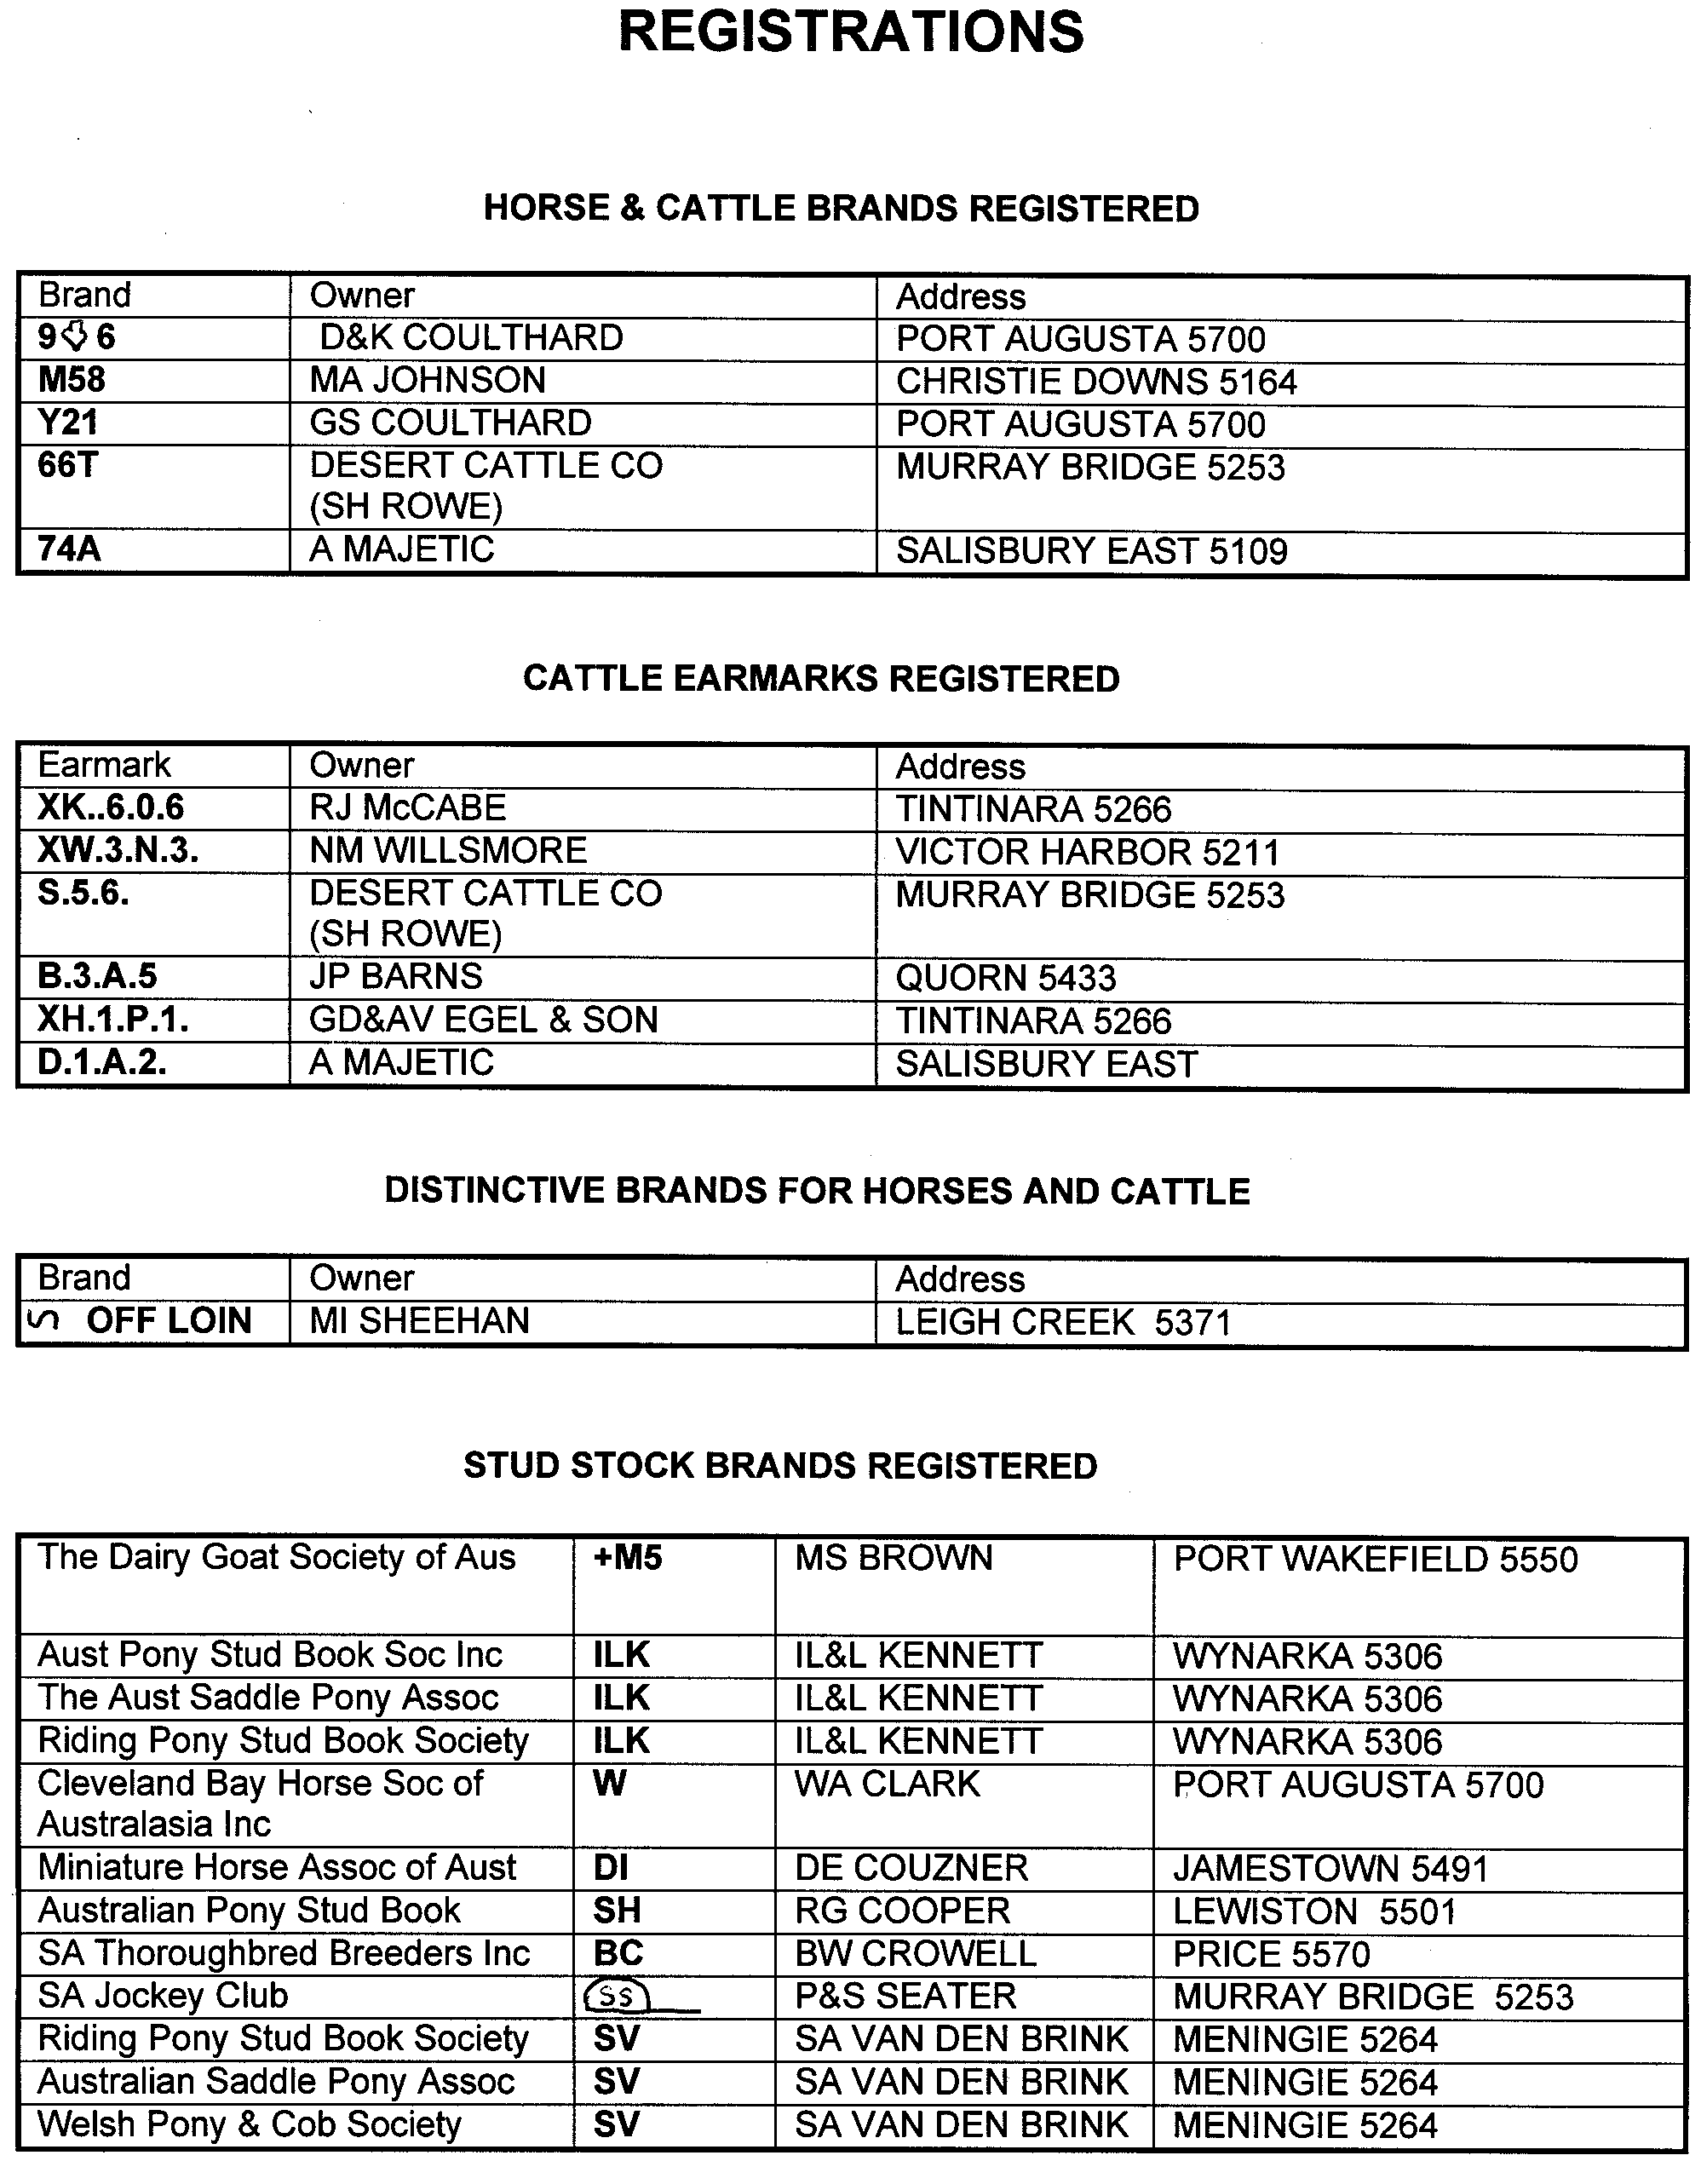
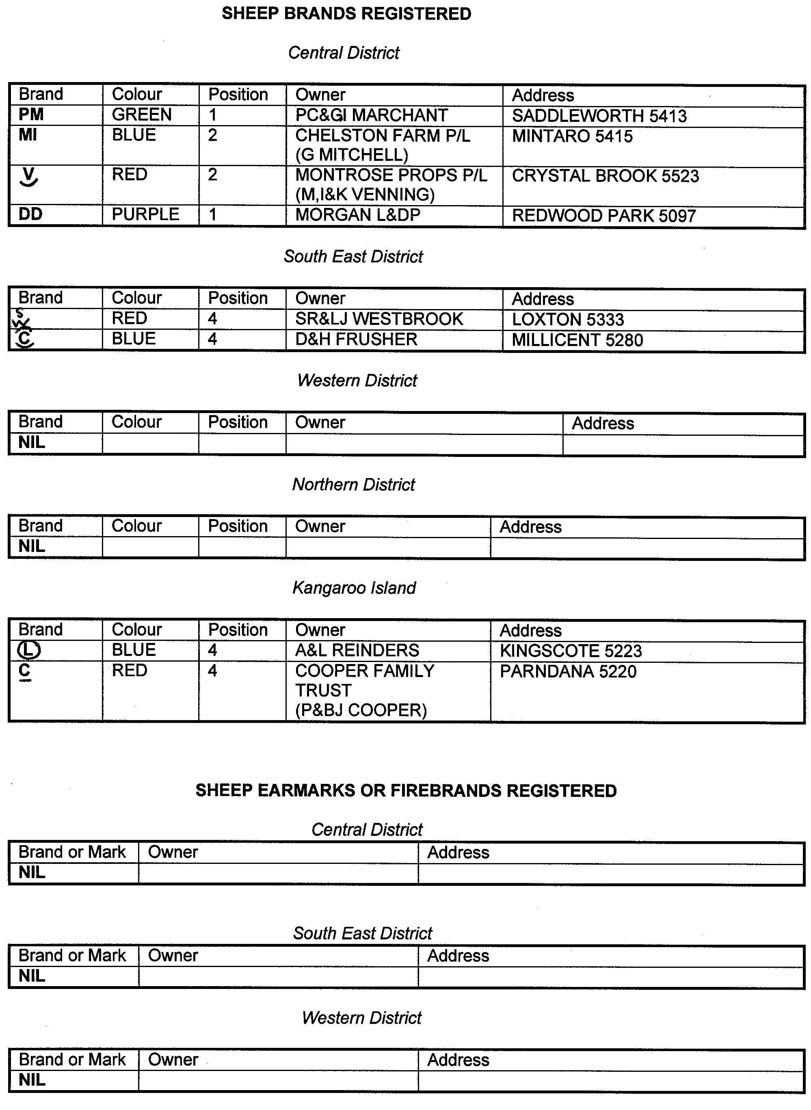
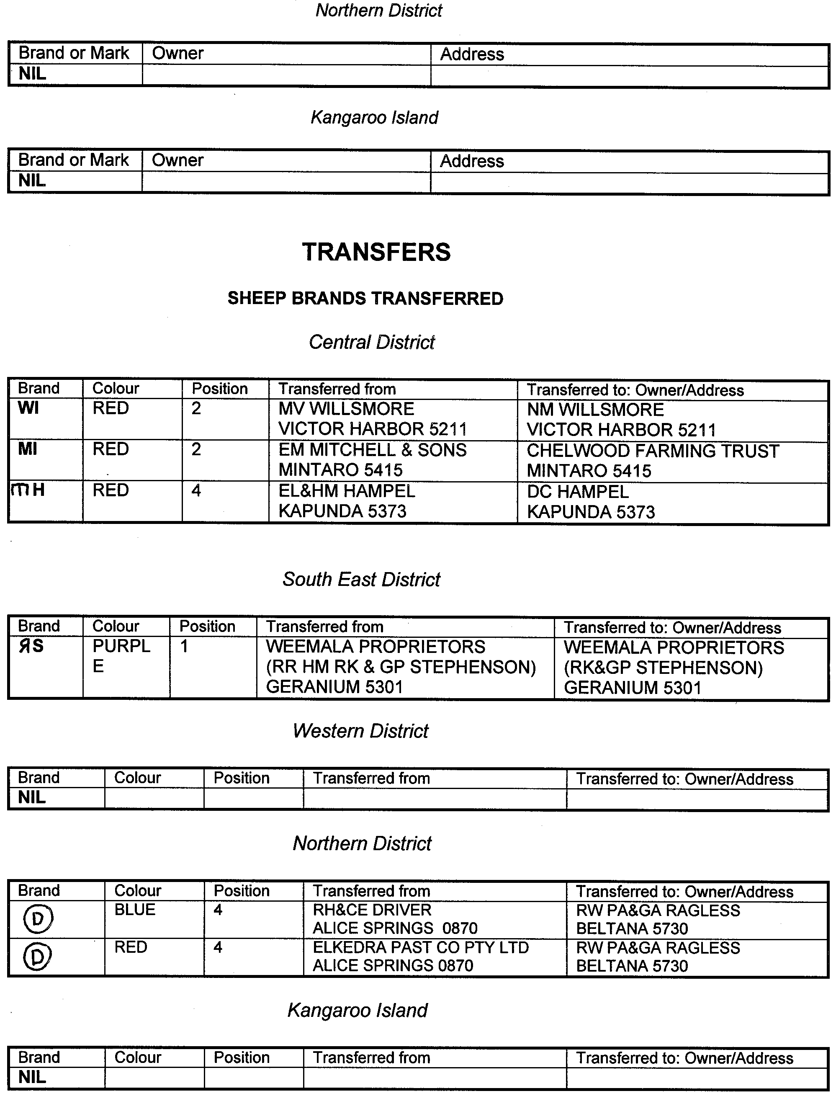
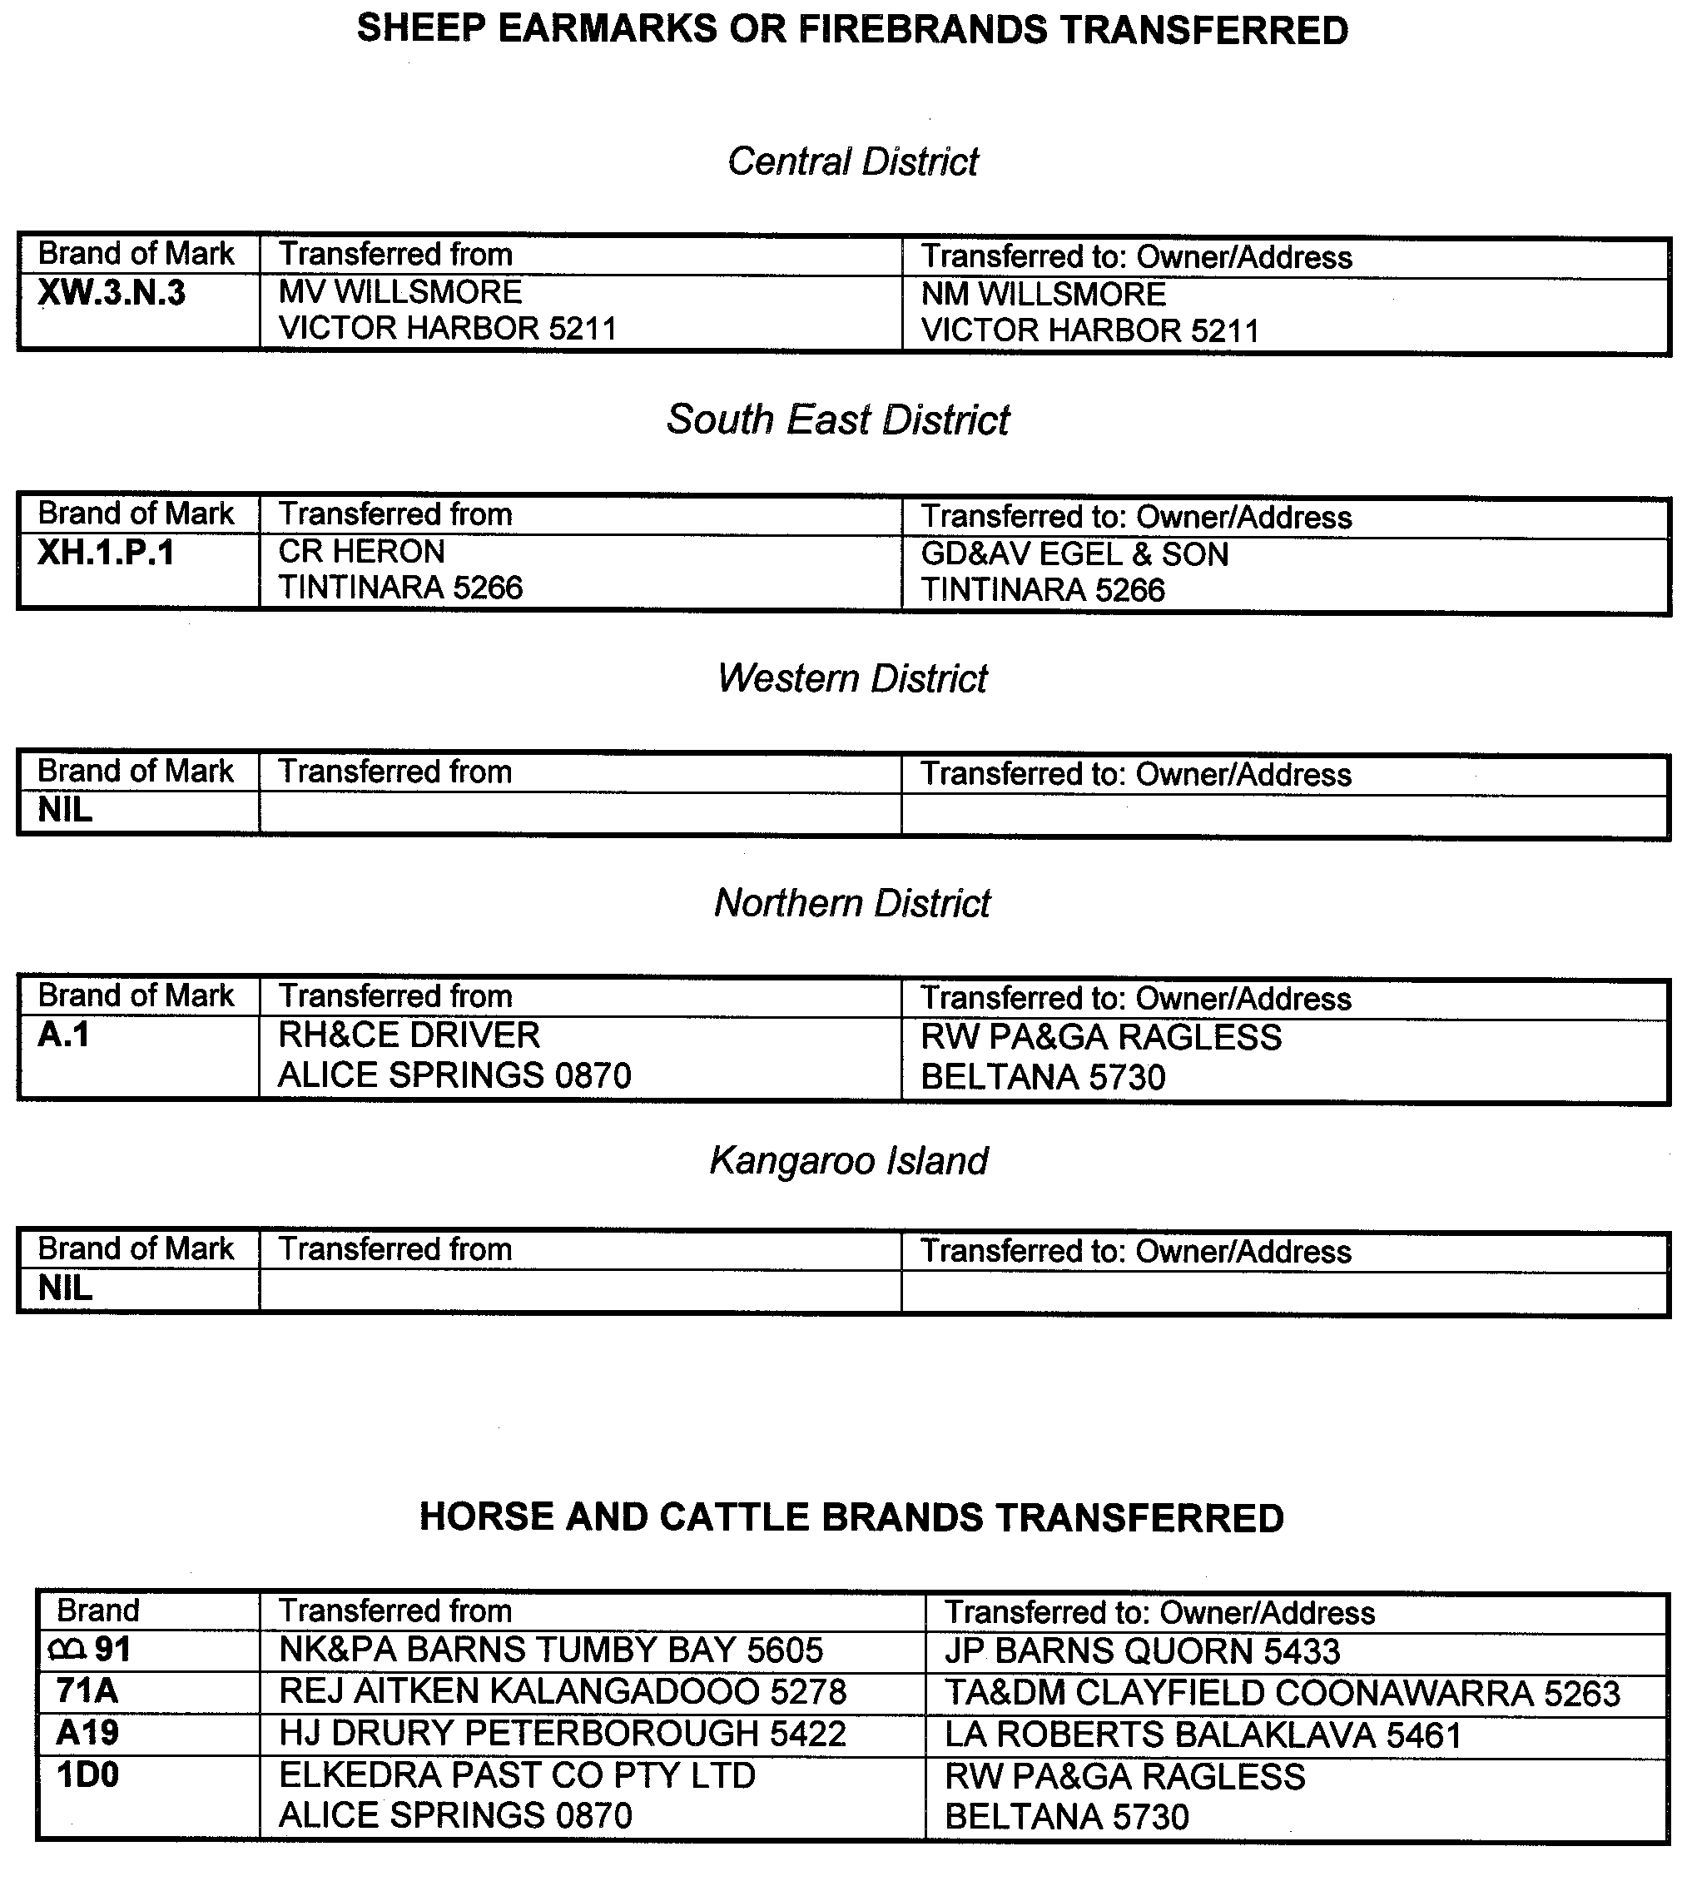
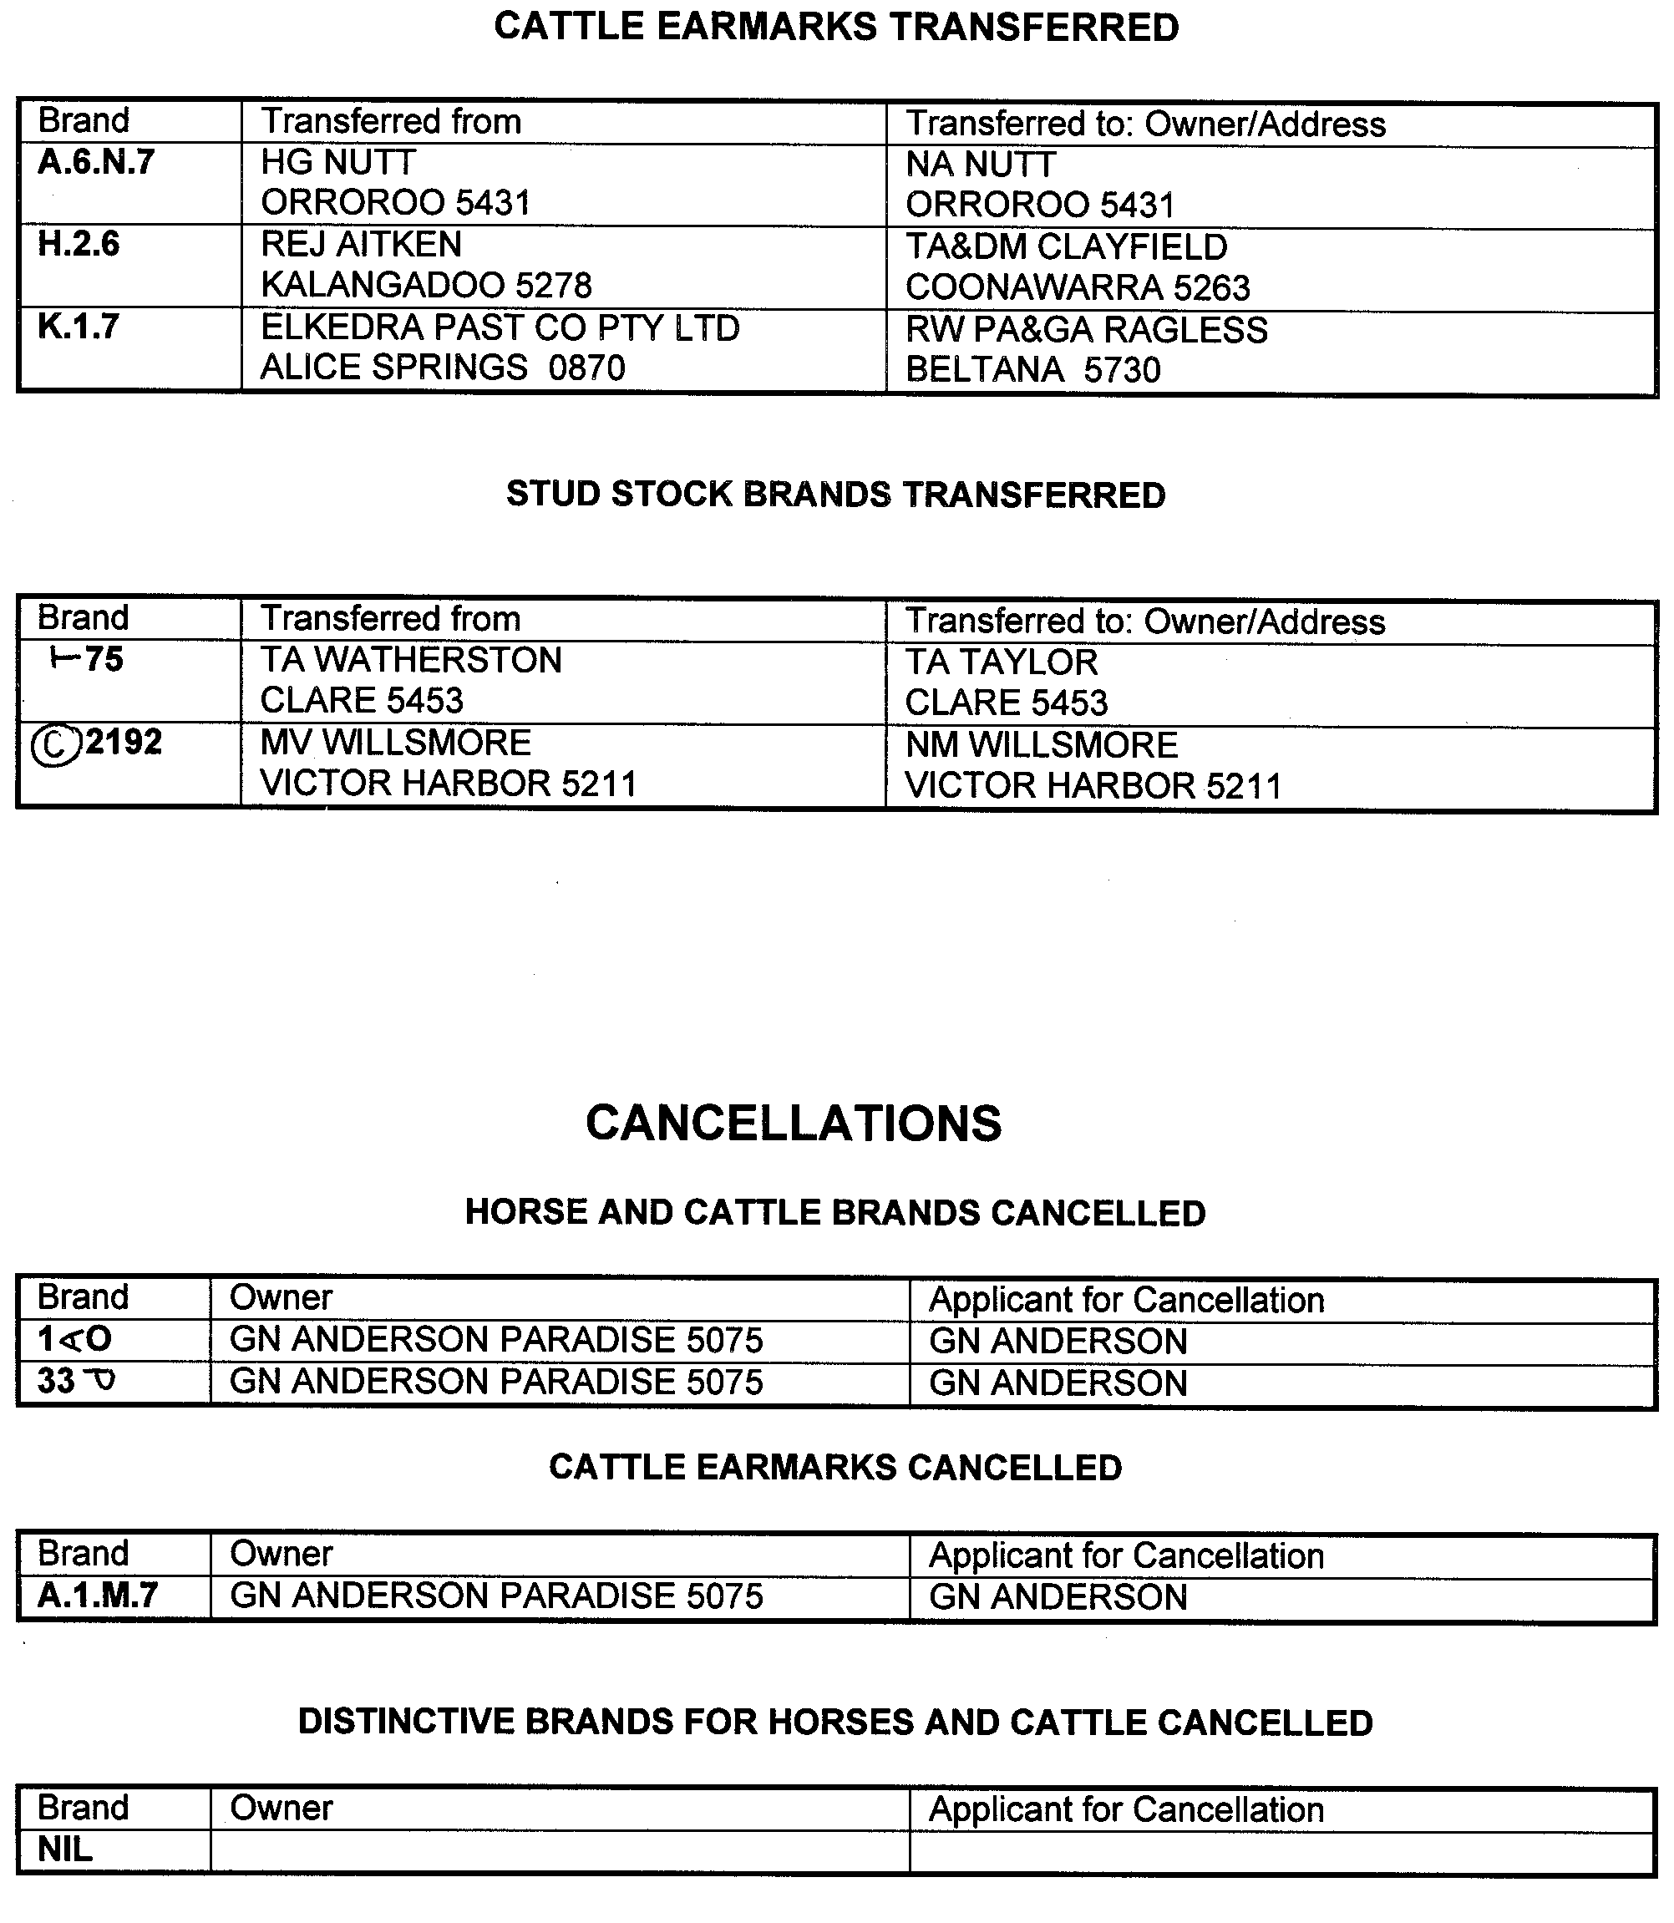
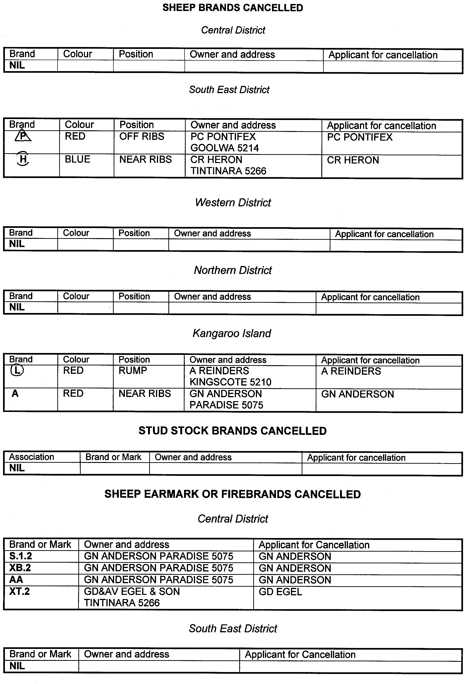
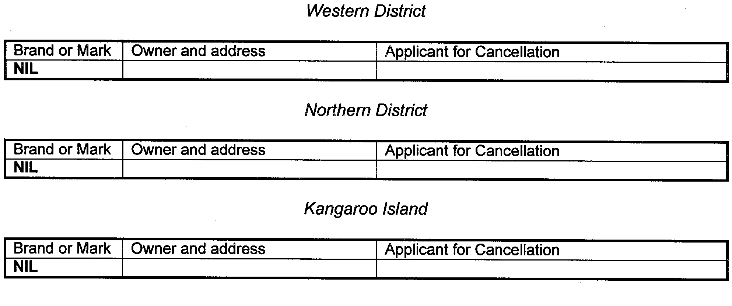
DEVELOPMENT ACT 1993: SECTION 46 (1)
Notice
Preamble
Section 46 (1) of the Development Act 1993, allows the Minister for Transport and Urban Planning to apply that section to a specified kind of development or project if the Minister is of the opinion that a declaration under that section is appropriate or necessary for the proper assessment of development or a project of major environmental, social or economic importance.
Notice
PURSUANT to Section 46 (1) of the Development Act 1993, being of the opinion that a declaration under that section is appropriate for the proper assessment of development of major environmental, social and economic importance, I declare that section 46 of the Act applies in that part of the State, to all development of a kind specified in Schedule 1.
Schedule 1
The following kinds of development are specified if undertaken in, or in relation to, that part of the State specified in Schedule 2:
(a) building work;
(b) change in the use of land;
(c) division of allotments;
(d) construction of roads, streets and thoroughfares;
(e) the excavating or filling (or excavation and filling) of land, or the forming of a levee or mound; and
(f) all other kind of development,
for the purpose of, or ancillary to, establishing or operating a residential waterfront development, marina and boat harbour facility, public boat ramp facility and sites for holiday unit accommodation and a tourist resort development (including the provision of infrastructure for water supply, stormwater disposal and effluent disposal).
Schedule 2
The following parts of the State are specified for the purposes of Schedule 1.
1. The whole of the land comprised in Allotment 1 of DP 33897 (Certificate of Title Register Book Volume 5150, Folio 131), Allotment 2 of DP 33897 (Certificate of Title Register Book Volume 5150, Folio 132), Allotment 3 of DP 33898 (Part Certificate of Title Register Book Volume 5150, Folio 133), Section 176 (Crown Reserve Volume 5765, Folio 552) and Closed Road A (RP 8751).
2. Part of Allotment 4 of DP 33898 (Part Certificate of Title Register Book Volume 5150, Folio 133) as shown on attached map of Schedule 3.
3. Part of Section 177 (Part of Crown Reserve Volume 5765, Folio 553) as shown on attached map of Schedule 3.
4. Part of Section 114 (Part Certificate of Title Register Book Volume 5482, Folio 309) as shown on attached map of Schedule 3.
5. Portion of Public Road between Allotment 3 and Allotment 4 of DP 33898 and Section 177 as shown on attached map of Schedule 3.
6. An area adjacent to the coastline extending into the Spencer Gulf as shown on attached map of Schedule 3.
7. Other land on which it is necessary or desirable to undertake the kinds of development referred to in Schedule 1 for or related to the provision of infrastructure for water supply, stormwater disposal and effluent disposal for, or associated with, the establishment or operation of a residential waterfront development and marina facility on the land referred to in clause 1.
Schedule 3
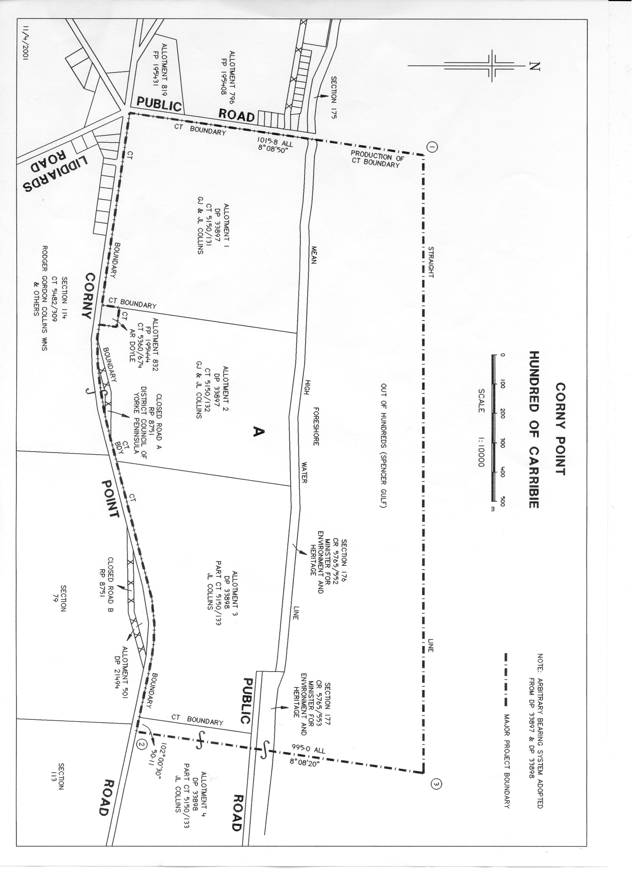
Diana Laidlaw, Minister for Transport and Urban Planning

DEVELOPMENT ACT 1993, SECTION 25 (17): CITY OF NORWOOD, PAYNEHAM AND ST PETERS—PAYNE-HAM (CITY) DEVELOPMENT PLAN—MARDEN PLAN AMENDMENT
Preamble
1. The Development Plan amendment entitled ‘City of Norwood, Payneham and St Peters—Payneham (City) Develop-ment Plan—Marden Plan Amendment’ (the Plan Amendment) has been finalised in accordance with the provisions of the Development Act 1993.
2. The Minister for Transport and Urban Planning has decided to approve the Plan Amendment.
PURSUANT to section 25 of the Development Act 1993, I:
(a) approve the Plan Amendment; and
(b) fix the day on which this notice is published in the Gazette as the day on which the Plan Amendment will come into operation.
Dated 17 May 2001.
Diana Laidlaw, Minister for Transport and Urban Planning
PLN 00/0193

DEVELOPMENT ACT 1993, SECTION 25 (17): CITY OF SALISBURY—SALISBURY (CITY) DEVELOPMENT PLAN—ANN STREET PRECINCT—SALISBURY TOWN CENTRE PLAN AMENDMENT
Preamble
1. The Development Plan amendment entitled ‘City of Salisbury—Salisbury (City) Development Plan—Ann Street Precinct—Salisbury Town Centre Plan Amendment’ (the Plan Amendment) has been finalised in accordance with the provisions of the Development Act 1993.
2. The Minister for Transport and Urban Planning has decided to approve the Plan Amendment.
PURSUANT to section 25 of the Development Act 1993, I:
(a) approve the Plan Amendment; and
(b) fix the day on which this notice is published in the Gazette as the day on which the Plan Amendment will come into operation.
Dated 17 May 2001.
Diana Laidlaw, Minister for Transport and Urban Planning
PLN 00/0213

DEVELOPMENT ACT 1993, SECTION 48: DECISION BY THE DEVELOPMENT ASSESSMENT COMMISSION AS DELEGATE OF THE GOVERNOR
Preamble
1. The decision of the Governor under section 48 of the Development Act 1993, to approve the development of the Holdfast Shores Stage 2A development located adjacent to Chappell Drive, Glenelg was published in the Gazette on 8 June 2000.
2. An amended proposal to develop the Holdfast Shores Stage 2A development was subsequently considered and approved by the Development Assessment Commission and published in the Gazette on 7 December 2000.
3. A further amended proposal to develop the Holdfast Shores Stage 2A development was subsequently considered and approved by the Development Assessment Commission and published in the Gazette on 1 March 2001.
4. A subsequent amended proposal to develop the Holdfast Shores Stage 2A development has now been under consideration under Division 2 of Part 4 of the Development Act 1993.
5. The proposed amendments include the division of allotment 1, certificate of title, volume 5711, folio 325, in DP 53445 into two allotments, (proposed allotment 700 and 701) to accom-modate the construction of the approved Holdfast Shores Stage 2A development.
6. The amendments to the development are contained in:
(a) the letter from Alexander Symonds on behalf of Hold-fast Shores Consortium to the Development Assessment Commission dated 6 April 2001;
(b) the following plans prepared by Alexander Symonds:
Map Reference 6628-50-j & h dated 10.5.01.
7. The Development Assessment Commission has, in consider-ing the application, had regard to all relevant matters under section 48 (5) of the Development Act 1993.
8. The Development Assessment Commission is satisfied that the amendments do not require the preparation of a further or amended Development Report.
Decision
PURSUANT to section 48 of the Development Act 1993, the Development Assessment Commission, as delegate of the Governor, grants development approval to the amended Holdfast Shores Stage 2A proposal located adjacent to Chappell Drive for land division, hotel, car parking, landscaping and associated works, Glenelg subject to conditions.
Conditions of Approval:
1. The Holdfast Shores Stage 2A development must be undertaken in accordance with:
(a) the following plans contained in the Development Report dated December 1999, as they relate to the proposals for Stage 2A, except to the extent that they are varied by the plans described in paragraphs (c), (d) and (e):
• Site plan, Plan 5;
• Pedestrian movement, Plan 7;
• Vehicular movement, Plan 8;
• Urban spaces, Plan 9;
• Hotel environs study, Plan 18;
• Public art Masterplan, Plan 21; and
• Hotel: landscaping plan, Plan 36; and
(b) the following plans contained in the report from Wood-head International and Masterplan to Planning SA (a branch of the Department of Transport, Urban Planning and the Arts) dated 25 February 2000, except to the extent that they are varied by the plans described in paragraphs (c) and (d):
• Revised hotel plaza plan, supplementary plan, SP 6, dated February 2000;
• Revised hotel plaza section, supplementary plan SP 7, dated February 2000;
• Revised hotel plaza details, supplementary plan SP 8, dated February 2000;
• Bridge—plan, elevation and details, supplementary plan SP 23, dated February 2000;
• West plaza level detail, supplementary plan SP 30, dated February 2000;
• East plaza level detail, supplementary plan SP 31, dated February 2000;
• Open space/vegetation, supplementary plan SP 32, dated December 1999; and
• Amended dining room window, supplementary plan SP 33, dated December 1999; and
(c) the following plans except that they are varied by the plans described in paragraph (d):
• Hotel undercroft plan, supplementary plan, SP 34 Rev. A, dated 27 March 2000;
• Hotel plaza plan, supplementary plan, SP35 Rev. A, dated 27 March 2000;
• Temporary carpark option 1, supplementary plan SP36, undated;
• Temporary toilets, supplementary plan SP 39, dated 27 March 2000;
• Hotel western edge, plan detail, supplementary plan SP 40 A, dated April 2000; and
• Hotel western edge, section details, supplementary plan SP41 A, dated April 2000; and
(d) the following plans except that they are varied by the plans described in paragraph (e):
• Perspective, supplementary plan SP 42 dated 15 November 2000;
• Site Coverage Comparison: Original Masterplan and Amended Plan, supplementary plan SP 50 dated 15 November 2000;
• Site Coverage Comparison: Approved Plan and Amended Plan, supplementary plan SP 51 dated 15 November 2000;
• Traffic Circulation Diagram, supplementary plan SP 52 dated 15 November 2000; and
• Eastern Plaza: Urban Design Amendments, supple-mentary plan SP 53 dated 15 November 2000; and
(e) the following plans except that they are varied by the plans described in paragraph (f):
• Car Park Floor Plan Supplementary Plan SP 55 dated 2 February 2001;
• Ground Floor Plan Supplementary Plan SP 56 dated 2 February 2001;
• First, Second, Third, Fourth Floor Plans Supplemen-tary Plan SP 57 dated 2 February 2001;
• Fifth, Sixth, Seventh Roof Plans Supplementary Plan SP 58 dated 2 February 2001;
• Elevations Supplementary Plan SP 59 dated 2 February 2001;
• Elevations Supplementary Plan SP 60 dated 2 February 2001;
• Sections Supplementary Plan SP 61 dated 2 February 2001; and
• Supplementary Plan SP 62 dated 16 February 2001; and
(f) the following plan:
• Map Reference 6628-50-j & h dated 10.5.01 by Alexander Symonds;
(g) the following documents except to the extent that they are varied by the plans described in paragraphs (a) to (f) inclusive:
• facsimiles dated 3 March 2000, 20 March 2000 and 22 March 2000, from Woodhead International to Planning SA (a branch of the Department of Transport, Urban Planning and the Arts);
• the reports dated 25 February 2000, 28 February 2000, 29 February 2000, 14 March 2000 and 4 April 2000, from Woodhead International and Masterplan to Planning SA (a branch of the Department of Transport, Urban Planning and the Arts);
• the two reports dated 18 April 2000, from Woodhead International to Planning SA (a branch of the Department of Transport, Urban Planning and the Arts);
• the letters from Murray Young and Associates, traffic consultants, to Woodhead International dated 3 April 2000, 14 April 2000, 28 April 2000 and 9 November 2000;
• the letter from Woodhead International to the Development Assessment Commission dated 10 November 2000; and
• the report entitled ‘Holdfast Shores Stage 2. Hotel and Associated Facilities Amendment Report’ prepared by Master Plan SA Pty Ltd dated November 2000.
• the letter from Woodhead International to the Development Assessment Commission dated 31 January 2001;
• the report entitled ‘Holdfast Shores Stage 2—Hotel and Associated Facilities Amendment Report 2’ prepared by Master Plan SA Pty Ltd dated February 2001;
• the ‘Car Parking Review of Amendment 2’ from Murray F. Young and Associates dated February 2001 and 12 February 2001.
2. No works may be commenced unless and until:
(a) a private certifier or the City of Holdfast Bay has certified to the Development Assessment Commission that all work that constitutes building work under the Development Act 1993, complies with the Building Rules;
(b) an Environmental Management Plan (EMP) has been prepared in consultation with the Environment Protec-tion Authority and the City of Holdfast Bay to address the management issues during construction. Matters to be addressed in the EMP must include:
• traffic management during construction, including transport beyond the development site;
• control and management of construction noise;
• dust and mud control;
• working hours;
• stormwater management during construction;
• site security and fencing;
• disposal of building waste and refuse;
• protection and cleaning of roads and pathways;
• site clean up; and
(c) adherence to all relevant Environment Protection Authority codes of practice for construction sites.
3. The hotel must not be used or occupied for the purposes outlined in the application until:
(a) all car parks proposed for Stage 2A have been established in accordance with the plans listed in Condition 1 (e);
(b) plans for street furniture and directional signs for Stage 2A (including siting, elevations and materials) have been prepared by the proponent to the satisfaction of the Development Assessment Commission in consultation with the City of Holdfast Bay;
(c) plans for public art for Stage 2A in accordance with plan 21 entitled ‘Public Art Masterplan’ and dated December 1999 (including siting, elevations and materials) have been prepared by the proponent to the satisfaction of the Development Assessment Commis-sion in consultation with the City of Holdfast Bay;
(d) lighting of all external areas has been provided to the satisfaction of the Development Assessment Commis-sion to ensure the safety of users of the pedestrian paths and plazas; and
(e) (i) plans for the drainage of stormwater from the Stage 2A site (including siting, elevations and materials) have been prepared by the proponent to the satisfaction of the Development Assessment Com-mission in consultation with the City of Holdfast Bay;
(ii) stormwater infrastructure has been installed in accordance with the plans prepared pursuant to condition 3 (e) (i) to the satisfaction of the Devel-opment Assessment Commission in consultation with the City of Holdfast Bay; and
(iii) stormwater infrastructure is operational.
4. Street furniture and directional signs for the Stage 2A development must be established in accordance with the plans prepared pursuant to condition 3 (b) within six months of the first occupation of the hotel to the satisfaction of the Development Assessment Commission.
5. Public art for the Stage 2A development must be established in accordance with the plans prepared pursuant to condition 3 (c) within six months of the first occupation of the hotel to the satisfaction of the Development Assessment Commission.
6. The car parking areas must be designed in accordance with Australian Standards 2890.1-1993 and line markings must be maintained in good and substantial condition at all times.
7. The pedestrian paths and plazas proposed in the application, including the area situated between the existing Glenelg Surf Life Saving Club and the hotel building, must be open for pedestrian use from the commencement of use and occupation of the hotel and must then be kept open for pedestrian use at all times.
8. An iron-barred gate of at least 1.5 m in height must be constructed at the entrance to the stairwell on the south-eastern corner of the hotel building.
9. Access for service deliveries and waste disposal vehicles at the hotel plaza level must only be allowed between 7 a.m. and 10 a.m. daily.
10. The proposed toilets to replace the existing toilets adjoining the kiosk on the north-eastern side of the site must be established to the satisfaction of the Development Assessment Commission in consultation with the City of Holdfast Bay prior to the demolition of these existing toilets.
11. Driveways, parking and manoeuvring areas and footpaths must be kept illuminated during the hours of darkness when the bar and lounge facilities are open to the public, and such lights must be directed and screened so that drivers are not distracted by lights.
12. Landscaping proposed in the application must be estab-lished before the first occupation of the hotel and plants must be maintained in good health and condition at all times. A plant must be replaced if or when it dies or becomes seriously diseased within the first growing season after the plant dies or becomes seriously diseased.
13. Vegetation proposed to be established along the western edge of the undercroft parking of the hotel must:
• provide sufficient foliage and density of planting to screen the undercroft to ensure that the presence of cars is not obtrusive when viewed from the promenade; and
• not unreasonably inhibit ventilation from the undercroft parking areas (which may require pruning or thinning of the vegetation from time to time).
14. Management of stormwater from the Stage 2A site must comply with the Environment Protection Authority’s ‘Stormwater Pollution Prevention Code of Practice for Local, State and Federal Government’ during construction of the Stage 2A development.
15. The quality of any stormwater entering the Holdfast Shores marina from the Stage 2A development must comply with the guidelines applicable to secondary recreational use and the protection of aquatic ecosystems within the ANZECC Australian Water Quality Guidelines for Fresh and Marine Waters (November 1992), or any standard that may be subsequently substituted therefor.
16. Stormwater from the Stage 2A site must not be disposed of by way of a pipe or similar structure that conveys the stormwater to the beach.
17. Site works, construction work and truck movements to and from the site must only be carried out between 7 a.m. and 6 p.m., Monday to Saturday inclusive.
18. Payment of $1 620.00 shall be made into the Planning and Development Fund (1 allotment @ $1 620.00 per allotment). Cheques shall be made payable and marked ‘Not Negotiable’ to the Development Assessment Commission and payment made on Level 5, Roma Mitchell House, 136 North Terrace, Adelaide, (opposite the Railway Station) or sent to G.P.O. Box 1815, Adelaide.
Notes to the Applicant:
1. The plans and documents referred to in Condition 1 of the approval together describe the development hereby approved.
2. No advertising signs are hereby approved. The display of any advertising sign will require separate approval.
3. This approval does not allow the use of any part of the site for outdoor dining. Any such use will require approval of an amendment of the development hereby approved. Detailed information on the use, nature and extent of outdoor dining on the plaza and the parking requirements for this additional dining area would be required in the consideration of any amendment to the development hereby approved. The proponent should also consult with the Council about any proposal for outdoor dining.
4. Noise emissions from the Stage 2A development will be subject to the Environment Protection (Industrial Noise) Policy 1994 and the Environment Protection Act 1993.
5. The proponent should consult with Adelaide Airport Ltd on crane operations prior to construction.
Dated 17 May 2001.
Gloria Holland-Booker, Secretary, Development Assessment Commission.

DEVELOPMENT ACT 1993
Industry (Gawler Belt) Zone—Plan Amendment Report by the Minister—Draft for Public Consultation
NOTICE is hereby given that the Minister for Transport and Urban Planning has, pursuant to section 26 of the Development Act 1993, prepared a draft Plan Amendment Report relating to land within the Light (DC) (Outer Metropolitan) Development Plan.
The draft Plan Amendment Report will amend the Light (DC) (Outer Metropolitan) Development Plan by:
• extending the existing Industry (Gawler Belt) Zone and establishing two policy areas in the proposed Zone to differentiate between land intended for large scale industries, particularly those which support the wider region’s wine industry, and additional land for light industry/commercial uses in the southern part of the Zone to accommodate anticipated growth in wine related industries generally;
• establishing a new policy area in the Rural Zone immediately north of the extended Industry (Gawler Belt) Zone for large scale winery development with relevant objectives and principles to guide development of the policy area;
• introducing public notification policies in the Industry (Gawler Belt) Zone and the Rural Zone that reflect the policy intentions of the relevant zones;
• introducing additional policies in the council-wide section of the Development Plan which identify the need to protect all industrial land from encroachment of conflic-ting land uses, identify the preferred locations for large scale industry and additional policies to discourage new residential or other sensitive development from establish-ing too close to the proposed Industry (Gawler Belt) Policy Area 7;
• amending and introducing illustrative, zone and policy area mapping to reflect the above policy amendments.
Copies of this draft Plan Amendment Report will be available for public inspection during normal office hours at the Depart-ment of Transport, Urban Planning and the Arts (Planning SA), Level 5, 136 North Terrace, Adelaide or can be viewed on the internet (www.planning.sa.gov.au). Alternatively the draft Plan Amendment Report can be viewed during office hours at the Light Regional Council Offices.
The draft Plan Amendment Report will be on display from 17 May 2001 to 17 July 2001.
Written submissions regarding the draft Plan Amendment Report should be submitted no later than 17 July 2001. All submissions should be addressed to the Presiding Member, Development Policy Advisory Committee, G.P.O. Box 1815, Adelaide, S.A. 5001 and should clearly indicate whether you wish to be heard in support of your submission.
Copies of all submissions will be available for inspection by interested persons at the Department of Transport, Urban Planning and the Arts (Planning SA), Level 5, 136 North Terrace, Adelaide from 17 July 2001 to 31 July 2001.
A public hearing will be held on 31 July 2001, in the Café Nova, Conference Room, 19 Murray Street, Gawler, com-mencing at 7 p.m, at which time interested persons may appear to be heard in relation to the draft Plan Amendment Report and the sub-missions. The public hearing will not be held if no submissions are received or no submission makes a request to be heard.
G. Holland-Booker, Secretary Development Policy Advisory Committee

ELECTORAL ACT 1985
Registration of Political Parties
NOTICE is hereby given that the following application for registration as a registered political party under the provisions of Part 6 of the Electoral Act 1985, has been received:
Name of Party: Community Leadership Independence Coalition Party
Abbreviation of Name of Party—CLIC Party
Name of Applicant: Ivan Peter Lewis
Any elector who believes that the party should not be registered:
• because the party does not have as a purpose, the promotion of the election to the State Parliament of its endorsed candidate(s); or
• because the application does not fulfill the technical requirements specified in the Act; or
• because the party’s name is likely to be confused with that of another registered party, Parliamentary party or prominent public body,
can formally object in writing to the Electoral Commissioner by close of business on 18 June 2001. Objections must contain the postal address and signature of the objector.
Dated 17 May 2001.
S. H. Tully, Electoral Commissioner
SEO 22/01

ELECTRICITY PRICING ORDER
Change to Non-Contestable Retail Tarrifs
NOTICE is hereby given, pursuant to clause 1.6 (c) (ii) of the Electricity Pricing Order (EPO), that the Industry Regulator has approved a change in the AGL SA’s non-contestable retail tariffs. The changes to the tariffs were calculated in accordance with the formula set out in Schedule 7 of the EPO.
The altered non-contestable retail tariffs are to be applied for consumption during the year 1 July 2001 to 30 June 2002.
A copy of the altered non-contestable retail tariffs may be inspected and/or purchased from Information SA, Ground Floor, Australis Building, 77 Grenfell Street, Adelaide, S.A. 5000.
Queries in relation to the altered tariffs may be directed to the office of the South Australian Independent Industry Regulator (SAIIR), Level 8, 50 Pirie Street, Adelaide. Telephone (08) 8463 4444 or Freecall 1800 633 592.
Dated 17 May 2001.
L. Owens, Industry Regulator

ENVIRONMENT PROTECTION ACT 1993, SECTION 32 (1): AMENDMENT OF ENVIRONMENT PROTECTION POLICY
Notice By The Minister
Preamble
1. Regulation 4A(2) of the Environment Protection (General) Regulations 1994 (see Gazette 27 October 1994 p. 1346), as varied, specifies the kinds of amendments that can be made by the Minister, by notice in the Gazette, to the National Environment Protection (Used Packaging Materials) Measure under section 32(1) of the Environment Protection Act 1993.
2. It is now proposed to make amendments of the specified kinds.
Notice
PURSUANT to section 32 of the Environment Protection Act 1993 and with the advice and consent of the Executive Council, I amend the National Environment Protection (Used Packaging Materials) Measure:
(a) by striking out clause 1 and substituting the following clause:
Citation
1. This policy may be cited as the Environment Protection (Used Packaging Materials) Policy 2001.;
(b) by inserting in clause 2 “or on the Covenant ceasing to be in force, whichever occurs first” after “date of com-mencement”;
(c) by inserting after the definition of “consumer packag-ing” in clause 3 the following definition:
“council” means a council constituted under the Local Government Act 1999;;
(d) by inserting after the present contents of clause 3 (now to be designated as subclause (1)) the following subclause:
(2) In this policy, the expression “Mandatory pro-vision” followed by a statement as to the category of an offence is to be taken to signify that contravention of the provision at whose foot the expression appears will be an offence of the category so stated for the purposes of Part 5 of the Act.;
(e) by striking out Parts 3 and 4 and substituting the following Parts:
PART 3
OBLIGATIONS OF BRAND OWNERS
Application of Part
8. This Part does not apply in relation to the following:
(a) consumer packaging:
(i) that is a container to which Division 2 of Part 8 of the Act applies; or
(ii) that is of a type declared by the Authority by notice published in the Gazette to be con-sumer packaging to which this policy does not apply;
(b) brand owners:
(i) who do not contribute significantly to the waste stream; or
(ii) who are signatories to, and comply with, the Covenant; or
(iii) who can satisfy the Authority that they:
(A) engage in practices that produce equiva-lent outcomes to those achieved through the Covenant; or
(B) are part of an industry or industry sector for which arrangements exist that produce equivalent outcomes to those achieved through the Covenant.
(2) In making a declaration under subclause (1)(a)(ii), the Authority must have regard to:
(a) the practices and achievements of Covenant signatories; and
(b) the materials that are collected for re-use, recycling or energy recovery whether through kerbside recycling collection or otherwise; and
(c) the state of technologies for re-use, recycling or energy recovery; and
(d) any competitive issues that may arise from including or excluding particular materials.
(3) For the purposes of subclause (1)(b)(i), a brand owner will only be taken to be a brand owner that does not contribute significantly to the waste stream if the brand owner’s products:
(a) amount to 1 per cent or less of the notional market share for the products; and
(b) are sold only within the State.
(4) In this clause:
“notional market share”, in relation to products, means the estimated value of the State’s share of national annual retail sales of such products determined in accordance with the following formula:
$\text{NM} = A × \frac{\text{PSA}}{\text{PA}}$ Where—
NM is the notional market share.
A is the value, determined by the Authority, of national annual retail sales of such products.
PSA is the most recent estimate of the population of South Australia published by the Aust-ralian Bureau of Statistics.
PA is the most recent estimate of the population of Australia published by the Australian Bureau of Statistics.
Brand owner to prepare action plan
9. (1) A brand owner must:
(a) prepare, maintain and implement an action plan in accordance with this clause; and
(b) comply with the plan.
Mandatory provision: Category B offence.
(2) The action plan must contain the following infor-mation:
(a) how the brand owner intends to ensure that consumer packaging in which the brand owner’s products are sold, or consumer packaging that is substantially the same as that packaging, is recovered and re-used, recycled or used for energy recovery; and
(b) the quantity of each type of consumer packaging proposed to be recovered and re-used, recycled or used for energy recovery; and
(c) how the brand owner intends to inform the public of the way in which the consumer packaging may be recovered.
(3) The quantity referred to in subclause (2)(b) must be at least equivalent to the levels of recovery and re-use, recycling or use for energy recovery agreed between participating jurisdictions in relation to the relevant type of consumer packaging or, in the absence of such an agreement, the levels achieved by signatories to the Covenant in relation to that type of packaging.
(4) A prosecution must not be commenced against a brand owner under this clause unless:
(a) the Authority has served the brand owner with a notice, in writing, giving particulars of an alleged contravention of the clause and requiring the brand owner to comply with the clause within 3 months of the date of service of the notice; and
(b) the Authority is satisfied that the brand owner has failed to comply with the requirement specified in the notice.
Records to be kept by brand owners
10. (1) A brand owner must, within three months of the end of a financial year, record the following information in relation each type of material used as consumer packaging by the brand owner during that financial year:
(a) the number of units of packaging;
(b) the total weight of material used;
(c) the total weight of material recovered;
(d) the total weight of recovered material re-used and recycled in Australia;
(e) the total weight of recovered material re-used and recycled through export;
(f) the total weight of recovered material used for energy recovery;
(g) the total weight of recovered material disposed of to landfill;
(h) the recovery rate calculated in accordance with the following formula:
$\text{RR} = \frac{\text{WMR}}{\text{WMS}} × \text{100}$ Where—
RR is the recovery rate
WMR is the weight of material recovered from the post-consumer waste stream
WMS is the weight of material sold as packaging within Australia.
Mandatory provision: Category B offence.
(2) A brand owner must:
(a) keep a record required under this clause for a period of five years commencing on the last day of the financial year to which the record relates; and
(b) at the request of the Authority, make a record required to be kept under this clause available for inspection by the Authority.
Mandatory provision: Category B offence.
PART 4
OBLIGATIONS OF COUNCILS
Reporting obligations
11. A council that has, during a financial year or any part of a financial year, operated a kerbside recycling collection service must, within three months after the end of that financial year, provide the Authority with the following information:
(a) the number of residential and non-residential premises in the council’s area;
(b) the number of residential and non-residential premises in the council’s area that were covered by the service;
(c) the participation rate for the service;
(d) the fee charged by the council in respect of the service;
(e) the total weight of each recyclable material collected;
(f) the total weight of each recyclable material collected that was then disposed of to landfill.
An amendment specified in this notice comes into operation on the day on which it is published in the Gazette.
Iain Evans, Minister for Environment and Heritage
MEH 00/0021 CS

ENVIRONMENT PROTECTION ACT 1993
Exemptions
THE following persons are exempt from section 75 of the Environment Protection Act 1993, subject to the provisions of Regulation 6 of the Regulations under the Environment Protection Act 1993, dated 27 October 1994, by virtue of owning or possessing equipment containing ozone depleting substances:
Tom Johnston Motors Pty Ltd (21); B. & L. Refrigeration Pty Ltd (24); Farmers Centre Pty Ltd (30); Southcool Refrigeration & Air Conditioning Pty Ltd (44); R. Byrne Nominees Pty Ltd (64); J. H. Rosewarne Pty Ltd (71); Growers Services Pty Ltd (95); Paul and David Berry (117);
J. L. Lennard Food Equipment Pty Ltd (129); Glenn Raphael (151); Paul Clarke (178); John Bruce Motors Pty Ltd (197); M. J. Wright Pty Ltd (277); Mervyn Eric Size (303); Clive Anthony Malsom (441); Richard Neil and Sheree K. Clements (490); Frank Agostino Nominees Pty Ltd (556); Christopher P. Black (563); Laszlo Purczel, Roslyn Jean Purczel (588); Angas Schwarz (668); Claude Arthur Bartel (680); Michael W. Siegele (762); William Dennis Discombe (828); Ian O. R. Dyer (944); Reckezane Pty Ltd (1004); David John Stehbens (1016); Valley Refrigeration Pty Ltd (1155); Gerard Industries Pty Ltd (1239); Hugh David Magarey (1240); Issacs Nominees Pty Ltd (1254); Corjay Aire Pty Ltd (1358); Shane Alan Cobb (1378); Nicholas Liemareff (1445); Marcus Gerard Frank Huizinga (1458); Graeme John Marshall (1558); Eddies Auto Electrical Sales & Service Pty Ltd (1569); Southgate Motors Pty Ltd (1627); Littlehampton Automotive Engineering Pty Ltd (1737); Smulders Investments Pty Ltd (1741); Royal Adelaide Hospital, Engineering & Building Service (1778); Stephen Malcolm Munn (1815); North City Star Pty Ltd (1999); Frank Palmeri (2153); Mark Andrew Weedon (2303); Allan Cresswell (2461); Leslie Owen Ferguson (2467); Phildyn Pty Ltd (2706); Haigh’s Pty Ltd (2897); Gregory Ian Clark (3079); Kelly Bros Pty Ltd (3123); Colin James Leslie (3206); C. & C. Ioanni Nominees Pty Ltd (3475); Simon Ashley Parker (3595); Cecilio Gaviola (3706); Michael Dean Hurrell, Deborah Jean Hurrell (5076); J. J. & A. M. McKerlie Pty Ltd (5266); Endeavour Motor Engineers (5277); Webb David Thomas (5337); Alex Janic (5370); Brambles Australia Ltd (5695); Corporate Air Conditioning (SA) Pty Ltd (6172); Allen Garry Nielsen (6177); Allen Wehrmann (6297); Dusko Ramesa (6396); Robert John Wescombe (6466); Anthony Paul Malycha (6512); Donald Mark Smith (6649); Scott Cannard (6679); Peter Allan Williams (6991); Nicholas Skoularikis (7198); Antonios Georgaras (7216); Australian Fumigation Services Pty Ltd (7223); Elders Ltd (7370); Charlinga Nominees Pty Ltd (7446); Angelo Desimoni (7464); Mehrdad Yazdani (7520); Michael Bridge Pty Ltd (7550); Mount Thebarton Pty Ltd (10067); Martin Joseph Muscat (10090); Ferguson’s Diesel Services Pty Ltd (10875); Stefanicki Andru (10967); Haden Facilities Management Pty Ltd (11041); Matthew John Smith (11087); Atofina (Australia) Pty Ltd (1295); Southern Cross Fumigation Services Pty Ltd (7383); Chem-Supply Pty Ltd (2452); Solvents Australia Pty Ltd (6938); SA Rural Agencies Pty Ltd (7205); Dascem Holdings Pty Ltd (430); R. & R. Fumigation Services Pty Ltd (7388); Ashdown Enterprises (Wholesale) Pty Ltd (7535); Reliable Airconditioning Pty Ltd (7377); David King, Stefan King, Verran King, Digna King (2295); Bronte Kassulke (248); All-Tech Refrigeration Services (Australia) Pty Ltd (12); Murray Heating & Cooling Pty Ltd (20); G. J. S. Holdings Pty Ltd (84); R. J. Crash Repairs Pty Ltd (105); Paul Lawrence Coventry (173); Neil Douglas Sparks (341); Dennis William Schulz (477); Gawler Auto Electrics Wholesale Pty Ltd (497); West Croydon General Motor Repairs Pty Ltd (541); Joseph Peter Stevens (544); Ian Leslie Dreckow (598); Yorke Motors (City) Pty Ltd (679); Robert Geoffrey Radford (689); Evans Deakin Pty Ltd (754); Commercial Motor Industries Pty Ltd (778); Sitehost Pty Ltd (1139); McLeod’s Whyalla Motor Company Pty Ltd (1142); N. & B. Coffey Pty Ltd (1226); Bridgestone TG Australia Pty Ltd (1403); JD Schmitzer Nominees Pty Ltd (2073); Glenn and Samantha Stodulka (2076); Toop Motors Pty Ltd (2180); Grant Richard Goonan (2190); Bradbill Pty Ltd (2454); Wirrina Resort Pty Ltd
(2935); Jennifer Joy Quinn and William Laurence Quinn (3492); Mayne Nickless Limited (3750); Robert Picariello (4851); Engco Pty Ltd (4888); Malcolm R. Nottle (5128); Craig Douglas Turner (5220); Paul John Fitzgerald (5269); Phillmax Pty Ltd (5539); Douglas Brian Falland (6460); Colin Murray Prichard (6521); Ceduna Auto Electrical Pty Ltd (6672); Llewelyn Transport Pty Ltd (6754); David Caviuolo (6757); Digby Gerard O’Callaghan (6982); Centennial Park Cemetery Trust (7001); Garry Schneider (7144); A. and G. and F. Penta (7226); Graham Martin Harding (7258); Jean-Pierre Lorriaux (7389); Noel Patrick Smith (7456); John William Halls (7472); Air-Command Australia Pty Ltd (10026); White Refrigeration Pty Ltd (10333); Luciuero Plumbing Pty Ltd (10476); National Power Synergen Pty Ltd (10498); Richard John Clayton (10733); Keith Manuel (10734); Dennis Scott Miels (10897); Christian Carabelas of Patamo Pty Ltd (11061); George Kavukis (11082).
G. Sclare, Manager, Licensing and Operations Services.

FISHERIES ACT 1982: SECTION 59
TAKE notice that, pursuant to section 59 of the Fisheries Act 1982, Stephen J. Morris (19760) (or his agent) (hereinafter referred to as the ‘exemption holder’), 26 Bordeaux Drive, Woodcroft, S.A. 5162 shall not be guilty of an offence when engaging in the activities and to do the acts specified in Schedule 1 subject to the conditions specified in Schedule 2 from the date of gazettal of this exemption until revoked by the Director of Fisheries.
Schedule 1
The importation and release of Carp (Cyprinus carpio) into ponds, dams and tanks located at Section 399 in the Hundred of Kuitpo.
Schedule 2
1. The exemption holder must obtain an independent risk assessment on the proposed farm site and farm management practices, and submit the risk management strategy to the Director of Fisheries for approval prior to the introduction of fish.
2. The exemption holder must not sell Carp (Cyprinus carpio) to any person, company or agent in South Australia.
3. The exemption holder must not import any live fish (ova, fry, or adult) into South Australia unless the shipment has certification from an appropriate authority in the State from which they are obtained that they are free from all relevant notifiable diseases listed in Schedule 4 of the Fisheries (Exotic Fish, Fish Farming and Fish Diseases) Regulations 1984.
4. No movement of Carp (Cyprinus carpio) either on or off the farm is permitted without prior notification to, and approval from, the Director of Fisheries.
5. The exemption holder must not contravene or fail to comply with the Fisheries Act 1982 or any regulations made under the Act, except where specifically permitted by this notice.
6. The exemption holder must retain the copy of this permit which has been supplied by the Director of Fisheries, and if requested by a PIRSA Fisheries and Aquaculture Compliance Officer, produce that permit for inspection.
7. The fish farmer must report all notifiable diseases to the General Manager Aquaculture.
8. The fish farmer must monitor farm fish mortalities and notify the General Manager Aquaculture of a mortality rate over 5% in 24 hours.
Dated 14 May 2001.
I. Nightingale, General Manager Aquaculture as the delegate of the Minister for Primary Industries
FT 00635

FISHERIES ACT 1982
Marine Mollusc Farming Licence FM00338
Licence to Farm Fish under section 53 of the Fisheries
Act 1982
THE Minister for Primary Industries and Resources (‘the Minister’) hereby grants to:
Adam J. Barnes (1098)
Section 186 in the Hundred of Mundoora
Port Broughton, S.A. 5522
a licence to occupy and use the waters and airspace over the land specified in Item 1 of Schedule 1 of this licence (‘the site’) for the purpose of farming and taking the permitted species (‘the permitted use’) for the period commencing on 1 July 2000 and ending, subject to any earlier termination under this licence, on 30 June 2001 (‘the term’) subject to the following terms and conditions:
Conditions of This Licence
1. Marked-off Areas
1.1 Subject to section 53A of the Fisheries Act 1982, this licence does not entitle the licensee to exclusive rights of entry to and occupation of the site. The rights granted by this licence are exercisable by the licensee in common with any other occupiers of the site from time to time.
1.2 For the purposes of section 53A of the Fisheries Act 1982, the marked-off areas within the site are that area or those areas marked-off or indicated in the manner set out in Item 2 of Schedule 1 of this licence.
2. Permitted Species
The licensee:
2.1 must not farm or introduce any species at the site other than the permitted species referred to in Schedule 2; and
2.2 must not take any wild fish from the site except for recreational purposes.
3. Permitted Use
The licensee must not use the site for any purpose other than the permitted use.
4. Permitted Methods
4.1 The licensee must, in undertaking the permitted use, take all reasonable and practicable measures to prevent or minimise damage to the environment. Without limiting the generality of the foregoing, the licensee:
4.1.1 must ensure the total length of each unit does not exceed 3 km of longline or 1 km of racking per hectare, and each unit must be at least 5 m from any other unit;
4.1.2 must not use the anti-fouling chemical tributyltin (TBT) on any equipment used at the site;
4.1.3 must not use any chemical or drug for either therapeutic or prophylactic purpose except with the prior approval of the Minister;
4.1.4 must undertake an environmental monitoring program approved by the Minister and as specified in Clause 4.3;
4.1.5 must not introduce the permitted species to the site before the approval of the environmental monitoring program referred to in 4.1.4 by the Minister;
4.1.6 must comply with the schedule of reporting for the environmental monitoring program as pres-cribed in Schedule 6 and submit the final results of the environmental monitoring program to the Minister 30 days before expiry of the term of this licence.
4.2 SASQAP
4.2.1 It is a condition of your licence to farm bivalve molluscs that only shellfish from Classified and Approved areas under the South Australian Shellfish Quality Assurance Program (SASQAP) may be sold for human consumption.
4.2.2 The licensee must continue to meet all the regulations required under the Food Standards Code to produce a product safe for human consumption.
4.3 The licensee must submit a draft environmental monitoring program to the Minister for approval within 60 days of the grant of the licence by the Minister. The draft environmental monitoring program must include the qualifications and experience of the person(s) designing and undertaking the program and address the matters listed in Schedule 5.
5. Marking and Maintaining the Site
The licensee:
5.1 must ensure that the site is maintained in a good, tidy and safe condition to the satisfaction of the Minister;
5.2 must remove and lawfully dispose of any waste or debris on the site as soon as is reasonably practicable and in particular must comply with any guidelines issued from time to time by the Minister in relation to the removal from the site of any unhealthy or dead fish;
5.3 must maintain all buoys, crosses, and markers on the site in good condition and in accordance with the colours specified in Schedule 1 of this licence; and
5.4 must mark the site boundary in accordance with the requirements of the Minister for Transport.
6. Site Inspection and Supervision
The licensee:
6.1 must at all times permit the Minister, his employees, agents or contractors or any employees, agents or contractors of the Crown to enter the site for the purposes of inspecting the site, the sea floor and the flora and fauna on or in the vicinity of the site; and
6.2 must comply with all reasonable directions of any such person authorised by the Director of Fisheries to inspect the conduct of the licensee’s activities at the site.
7. Fees and Returns
The licensee:
7.1 must pay to the Minister the licence fee in accordance with Item 1 of Schedule 3 of this licence;
7.2 must on or before 31 January and 31 July during the term, submit to the Minister a return supplying all of the information described in Schedule 4 of this licence.
8. Public Risk Insurance
The licensee must at its own cost during the term maintain in full force and effect in respect of the site and the permitted use a policy of public risk insurance in the joint names of the licensee and the Minister. The limits of public risk must not be less than the amount specified in Item 2 of Schedule 3 of this licence, or such other amount as the Minister may from time to time reasonably require. A policy of insurance or copy thereof or a certificate of insurance must be produced by the licensee to the Minister on written request.
9. Guarantee or Indemnity Scheme
The licensee must either:
9.1 provide a guarantee from its bankers to the amount specified in Item 3 of Schedule 3; or
9.2 contribute to an indemnity scheme established for the aquaculture and fisheries industry and approved by the Minister,
to and in favour of and for the benefit of the Minister by way of security for the due and punctual performance by the licensee of the terms and conditions of this licence and in particular the obligations of the licensee to rehabilitate the site immediately prior to the expiration or sooner determination of the term of this licence. Such guarantee or indemnity scheme must have effect from the date of commencement of the term.
10. No Assignment
The licensee must not assign or sublet or deal in any other way with any interest in this licence.
11. Variation and Cancellation
11.1 The Minister may without prior notice vary or cancel this licence immediately during the term for the purposes of preventing or minimising any damage or threat of damage to the environment. For the purpose of this condition the Minister may have regard to but is not limited by the following considerations:
11.1.1 the results of monitoring undertaken pursuant to Clause 4.1.5;
11.1.2 the results of any other monitoring as may from time to time be carried out; or
11.1.3 such other relevant information within the knowledge of the Minister.
11.2 Subject to and without limiting Condition 13.1, in the event of breach by the licensee of any term or condition of this licence, the Minister may:
11.2.1 give to the licensee written notice of such breach and the Minister’s requirements for rectification thereof; or
11.2.2 cancel this licence for failure to comply with such requirements for rectification.
11.3 The Minister may cancel this licence if the licensee is a body corporate, and any of the following occur:
11.3.1 the licensee is unable to pay its debts as and when they fall due or is otherwise insolvent;
11.3.2 an order is made for the winding up or liquidation of the licensee;
11.3.3 the licensee enters into a scheme of arrange-ment, compromise, moratorium or other form of composition with its creditors or any class of its creditors;
11.3.4 a receiver, a manager or a receiver and manager, a company administrator or other insolvency administrator is appointed to the licensee; or
11.3.5 a mortgagee, chargee or other encumbran-cee is appointed over or takes possession of or appoints an agent to take possession of all or any of the licensee’s assets.
11.4 The Minister may cancel this licence if the licensee is an individual, and the licensee:
11.4.1 becomes bankrupt or assigns its estate or enters into a deed of arrangement or other form of composition for the benefit of the licensee’s creditors; or
11.4.2 is convicted of an indictable offence.
11.5 Cancellation of this licence by the Minister shall be without prejudice to any rights, remedies or actions that the Minister may have against the licensee in respect of any antecedent breach by the licensee of the terms and conditions contained in this licence.
Granted by the General Manager Aquaculture, delegate for the purposes of section 53 of the Minister responsible for adminis-tration of the Fisheries Act 1982, on 10 May 2001.
I. Nightingale, General Manager Aquaculture
Schedule 1
Item 1—The Site
Area applicable to this licence:
Licensed Area Licensed
Hectares
AGD 66—Zone 53
764450E 6292700N 9.5
764025E 6292950N
764100E 6293150N
764525E 6292850N
All St Andrew’s crosses must be marked with the site’s unique ‘FM number’; that is the licence number.
Item 2—Marked-off Areas
[Co-ordinates of developed areas within the site to be provided by the licensee].
White buoys of at least 12 inches in diameter must be placed around the whole of the perimeter of the developed areas within the site at a distance of no less than 50 m from one another.
Schedule 2
Item 1—Permitted Species
The Director of Fisheries has, pursuant to section 50 (2) of the Act, issued a permit for the release of the fish specified in this Schedule:
Blue Mussels (Mytilus edulis)
Native Oysters (Ostrea angasi)
Pacific Oysters (Crassostrea gigas)
Commercial Scallops (King) (Pecten fumatus)
Scallops (Queen) (Equichlamys bifrons)
Scallops (Dough Boy) (Mimachlamys asperrimus)
Item 2—Permitted Farming Methods
Longlines
The total length of each unit must not exceed 3 km of longline not less than 3 m apart, or 1 km of racking per hectare, and each unit must be at least 5 m from any other unit.
Schedule 3
Item 1—Fees
Annual licence fees are:
$
FRDC Levy per hectare 9.5 at $9.50 each 90.25
Base Licence Fee per hectare 9.5 at $66 each 627.00
Total Annual Licence Fee 717.25
Quarterly Instalments 179.31
Item 2—Insurance
Ten million dollars ($10 000 000).
Item 3—Guarantee
Ten thousand dollars ($10 000).
Schedule 4
Returns
The licensee must submit the following information to the Minister, c/o General Manager Aquaculture SA, 14th Floor, 25 Grenfell Street, G.P.O. Box 1625, Adelaide, S.A. 5000 on or before 31 January and 31 July during the term of this licence:
1. Name of licensee.
2. Address of licensee.
3. Species of fish farmed and held on the site.
4. Location of aquaculture operation.
5. Period covered by return.
6. Number of life stage of each species of fish held.
7. Number, weight and value of each species of fish held.
8. Details of any disease detected in any fish kept.
9. Source (whether interstate or intrastate) of any stock acquired and date of acquisition (if relevant, include name of authority that provided certification that stock was free from disease).
10. If any fish were brought into the State, the number of fish and the life stage of the fish.
11. If fish were brought into the State, the purpose for which they were brought in.
12. Method of disposal of water and packaging use for transporting the fish.
13. If any disease or symptom of disease occurred in the acquired fish.
14. Method of disposal of diseased or dead fish and the number disposed of.
15. Signature, date and telephone number.
16. Use of any chemicals for fish husbandry—type of chemical and quantity used, purpose and date of use.
Schedule 5
Environmental Monitoring Program
MATTERS TO BE ADDRESSED
The monitoring program should address the following matters in relation to the permitted use:
Farm Management
1. Approximate layout of all structures on the site during the term including location, number and size.
2. Growth and condition of the permitted species.
3. Occurrence of disease incidents in the permitted species.
Water Quality
1. Phytoplankton including species composition and abun-dance.
2. Status of the site under the South Australian Shellfish Quality Assurance Program during the term (including closures).
Feral Oysters
Presence and numbers of feral oysters.
Benthic Sediments
1. Sedimentation.
2. Movement of sand.
Benthic Fauna and Flora
Benthic macro-flora communities including composition, distribution and abundance.
METHODOLOGY
Draft Environmental Monitoring Program
The draft environmental monitoring program should include an initial assessment of the site and analyse the variability of parameters to be measured to identify appropriate numbers of replicates and sample sizes for statistical rigour.
Control Sites
In addition to the site, the draft environmental monitoring program should identify appropriate control sites at which monitoring will occur. At least two controls should be identified at increasing distance from the site. At least one control site must be located more than 1 km from the site.
Video Transects
Video transects should be used to assess broad scale changes in sediment consistency, presence of farming waste and the composition and abundance of macro-flora communities.
Video transects must be collected using equipment capable of producing a clear and well lit image. Transects must be at least 50 m long and a scale must be clearly visible on the video at all times. The location of video transects must be identified on a map attached to the environmental monitoring report. Each transect must be identified on the video with a unique transect number.
Report
The environmental monitoring report must be legible and contain a declaration regarding the authenticity and source of all data and results contained in the report. This declaration must be signed by the licence holder and the person(s) conducting the monitoring program.
The report must include an assessment of the results of the monitoring program against the provisions of the Environment Protection (Marine) Policy 1994, and must be accompanied by all raw data, video footage and diver notes.
Schedule 6
Schedule of Environmental Monitoring Reports
The licensee must submit a final environmental monitoring program report within 12 months of the commencement of this licence to the Minister, c/o General Manager Aquaculture SA, 14th Floor, 25 Grenfell Street, G.P.O. Box 1625, Adelaide, S.A. 5000.

FISHERIES ACT 1982: SECTION 53
TAKE note that the licence to farm fish made under section 53 of the Fisheries Act 1982, and published in the South Australian Government Gazette, dated 14 September 2000, on page 1985, being the second notice on that page through to page 1988 and referring to Adam J. Barnes is hereby revoked.
Dated 10 May 2001.
I. Nightingale, General Manager Aquaculture as the delegate of the Minister for Primary Industries

DEPARTMENT OF PRIMARY INDUSTRIES—
FISHERIES DIVISION
NOTICE is hereby given pursuant to section 28 (10) (b) of the South Australian Fisheries Act 1982, that the following items have been seized by officers of the Department of Primary Industries, Fisheries Division at Brighton Jetty on 7 April 2001:
Two orange hand casters with red and yellow foam floats and bait type squid jags attached by colour mono filament fishing line.
The above items were suspected to have been used or intended to be used, in contravention of the Fisheries Act 1982, and were taken into possession at Brighton Jetty.
After the expiration of one month from the date of this notice the items listed above shall, on the order of the Minister of Primary Industries, be forfeited to the Crown and shall be either disposed of by sale or destruction.
The above items may be viewed at the Birkenhead Office,
2 Victoria Road, office of the Department of Primary Industries, Fisheries Division.
Dated 7 April 2001.
B. E. Hemming, Manager Fisheries Compliance

DEPARTMENT OF PRIMARY INDUSTRIES—
FISHERIES DIVISION
NOTICE is hereby given pursuant to section 28 (10) (b) of the South Australian Fisheries Act 1982, that the following items have been seized by officers of the Department of Primary Industries, Fisheries Division at Robe on 1 May 2001.
1 rock lobster pot with cane neck
1 green rope
1 white/yellow buoy
1 red float
2 black bait baskets
The above items were suspected to have been used or intended to be used, in contravention of the Fisheries Act 1982, and were taken into possession at Robe.
After the expiration of one month from the date of this notice the items listed above shall, on the order of the Minister of Fisheries, be forfeited to the Crown and shall be either disposed of by sale or destruction.
The above items may be viewed at Kingston an office of the Department of Primary Industries, Fisheries Division.
Dated 13 May 2001.
B. E. Hemming, Manager Fisheries Compliance

DEPARTMENT OF PRIMARY INDUSTRIES—
FISHERIES DIVISION
NOTICE is hereby given pursuant to section 28 (10) (b) of the South Australian Fisheries Act 1982, that the following items have been seized by officers of the Department of Primary Industries, Fisheries Division at Robe on 1 May 2001.
1 rock lobster pot with black plastic neck
2 red bait baskets
1 orange rope
1 white rope
1 white buoy
1 red buoy
The above items were suspected to have been used or intended to be used, in contravention of the Fisheries Act 1982, and were taken into possession at Robe.
After the expiration of one month from the date of this notice the items listed above shall, on the order of the Minister of Fisheries, be forfeited to the Crown and shall be either disposed of by sale or destruction.
The above items may be viewed at Kingston an office of the Department of Primary Industries, Fisheries Division.
Dated 13 May 2001.
B. E. Hemming, Manager Fisheries Compliance

DEPARTMENT OF PRIMARY INDUSTRIES—
FISHERIES DIVISION
NOTICE is hereby given pursuant to section 28 (10) (b) of the South Australian Fisheries Act 1982, that the following items have been seized by officers of the Department of Primary Industries, Fisheries Division at Robe on 1 May 2001.
1 rock lobster pot with cane neck
1 black bait basket and 1 brown bait basket
1 red float
1 ½ yellow float
1 white float
1 white rope
The above items were suspected to have been used or intended to be used, in contravention of the Fisheries Act 1982, and were taken into possession at Robe.
After the expiration of one month from the date of this notice the items listed above shall, on the order of the Minister of Fisheries, be forfeited to the Crown and shall be either disposed of by sale or destruction.
The above items may be viewed at Kingston an office of the Department of Primary Industries, Fisheries Division.
Dated 13 May 2001.
B. E. Hemming, Manager Fisheries Compliance

HARBORS AND NAVIGATION ACT 1993
Determination of the State Crewing Committee
THE following determination made on 25 October 2000, by the State Crewing Committee is published pursuant to part 6, section 45 of the Harbors and Navigation Act 1993.
Diana Laidlaw, Minister for Transport and Urban Planning
TSA 2000/08224 (V27696)

HARBORS AND NAVIGATION ACT 1993
Determination of the State Crewing Committee in respect of the M.V. ‘Odyssey 1’
THE following determination is made by the State Crewing Committee pursuant to part 6, section 45 of the Harbors and Navigation Act 1993, in respect of the Odyssey 1 whilst operating within the River Murray of South Australia not below Wellington.
Minimum complement
Two persons—Master and GP (General Purpose Person).
Minimum Qualifications of Crew
Master— Certificate of Competency as Master Class 5 RMIW.
GP—General purpose person, an able bodied person not less than 16 years of age with not less than 3 months experience and has successfully completed an approved Elements of Shipboard Safety Course.
Note: Either the Master or GP must possess a Certificate of Competency as a Marine Engine Driver Grade III.
Capt. C. Kavina, Presiding Member, State Crewing Committee

LIQUOR LICENSING ACT 1997
Notice of Application
NOTICE is hereby given, pursuant to section 52 (2) (b) of the Liquor Licensing Act 1997, that Retbusch Pty Ltd (ACN 095 382 371) has applied to the Licensing Authority for approval of alterations in respect of premises situated at 143 North East Road, Collinswood and known as Hampstead Hotel. The alterations provide a new gaming room, dining room and sports bar.
The application has been set down for hearing on Friday, 1 June 2001 at 9 a.m.
Any person may object to the application by lodging a notice of objection in the prescribed form with the Licensing Authority, and serving a copy of the notice on the applicant at the applicant’s address given above, at least seven days before the hearing date.
Plans in respect of the premises the subject of the application are open to public inspection without fee at the Office of the Liquor and Gaming Commissioner, 9th Floor, East Wing, 50 Grenfell Street, Adelaide, S.A. 5000.
Dated 9 May 2001.
Applicant

LIQUOR LICENSING ACT 1997
Notice of Application
NOTICE is hereby given, pursuant to section 52 (2) (b) of the Liquor Licensing Act 1997, that Tucker Seabrook (SA) Pty Ltd (ACN 087 978 578), 128-134 Gilbert Street, Adelaide, S.A. 5000 has applied to the Licensing Authority for the removal of a Wholesale Liquor Merchant’s Licence in respect of premises currently situated at 128-134 Gilbert Street, Adelaide, S.A. to the premises to be situated at 46 Greenhill Road, Wayville, S.A. 5034.
The application has been set down for hearing on 8 June 2001.
Any person may object to the application by lodging a notice of objection in the prescribed form with the Licensing Authority, and serving a copy of the notice on the applicant at the applicant’s address given above, at least seven days before the hearing date.
Plans in respect of the premises the subject of the application are open to public inspection without fee at the Office of the Liquor and Gaming Commissioner, 9th Floor, East Wing, 50 Grenfell Street, Adelaide, S.A. 5000.
Dated 8 May 2001.
Applicant

LIQUOR LICENSING ACT 1997 AND GAMING MACHINES ACT 1992
Notice of Application
NOTICE is hereby given, pursuant to section 52 (2) (b) of the Liquor Licensing Act 1997 and section 29 of the Gaming Machines Act 1992, that the South Australian Jockey Club Inc. has applied to the Liquor and Gaming Commissioner for Redefinition of the Licensed Premises and Gaming Machine Room in accordance with the plans lodged, variation to the Extended Trading Authorisation and variation to the Entertain-ment Consent in respect of the premises situated at Morphettville Racecourse, Morphettville, S.A. 5043 and known as Morphett-ville Racecourse.
The application has been set down for hearing on 8 June 2001.
Conditions
The following licence conditions are sought:
The hours sought in the variation to the extended trading authorisation for the redefined area (auditorium):
Monday to Wednesday, 8 a.m. to 1 a.m. on the following day; Thursday to Saturday, 8 a.m. to 2 a.m. on the following day; Sunday, 10 a.m. to 10 p.m. excluding Good Friday; the day after Good Friday between midnight and 2 a.m. or the day after Christmas Day between midnight and 2 a.m., except with meals.
Any person may object to the application by lodging a notice of objection in the prescribed form with the Licensing Authority, and serving a copy of the notice on the applicant at the applicant’s address given above, at least seven days before the hearing date.
Plans in respect of the premises the subject of the application are open to public inspection without fee at the Office of the Liquor and Gaming Commissioner, 9th Floor, East Wing, 50 Grenfell Street, Adelaide, S.A. 5000.
Applicant

LIQUOR LICENSING ACT 1997
Notice of Application
NOTICE is hereby given, pursuant to section 52 (2) (b) of the Liquor Licensing Act 1997, that Quang Sam, 24 Hawke Street, Albert Park, S.A. 5014 has applied to the Licensing Authority for the transfer of a Restaurant Licence in respect of premises situated at 97-103 St Vincent Street, Port Adelaide, S.A. 5015 and known as Portside Saloon Chinese Restaurant.
The application has been set down for hearing on 14 June 2001.
Any person may object to the application by lodging a notice of objection in the prescribed form with the Licensing Authority, and serving a copy of the notice on the applicant at the applicant’s address given above, at least seven days before the hearing date.
Plans in respect of the premises the subject of the application are open to public inspection without fee at the Office of the Liquor and Gaming Commissioner, 9th Floor, East Wing, 50 Grenfell Street, Adelaide, S.A. 5000.
Dated 7 May 2001.
Applicant

LIQUOR LICENSING ACT 1997
Notice of Application
NOTICE is hereby given, pursuant to section 52 (2) (b) of the Liquor Licensing Act 1997, that Scomel (Holdings) Pty Ltd (ACN 096 516 273), c/o David Watts & Associates, Liquor Licensing Consultants, 1 Cator Street, Glenside, S.A. 5065, has applied to the Licensing Authority for a Wholesale Liquor Merchant’s Licence in respect of premises situated at 6 Adermener Street, Athol Park, S.A. 5012 and to be known as Bottoms Up. Scomel (Holdings) Pty Ltd has also applied to the Licensing Authority for a Direct Sale Licence in respect of premises situated at 62 Torres Avenue, Flinders Park, S.A. 5025.
The applications have been set down for hearing on 15 June 2001 at 9 a.m.
Any person may object to the application by lodging a notice of objection in the prescribed form with the Licensing Authority, and serving a copy of the notice on the applicant at the applicant’s address given above, at least seven days before the hearing date.
Plans in respect of the premises the subject of the application are open to public inspection without fee at the Office of the Liquor and Gaming Commissioner, 9th Floor, East Wing, 50 Grenfell Street, Adelaide, S.A. 5000.
Dated 7 May 2001.
Applicant

LIQUOR LICENSING ACT 1997 AND GAMING MACHINES ACT 1992
Notice of Application
NOTICE is hereby given, pursuant to section 52 (2) (b) of the Liquor Licensing Act 1997 and section 29 of the Gaming Machines Act 1992, that Waikerie Hotel Motel Ltd has applied to the Licensing Authority for Redefinition and Alterations to the licensed premises pursuant to the Liquor Licensing Act as per plans lodged with the Licensing Authority and Redefinition and variation of gaming layout pursuant to the Gaming Machine Act—relocating two machines to the front bar and creating a new Gaming Room in accordance with the plans lodged with the Licensing Authority in respect of premises situated at the corner of Coombe and McCoy Streets, Waikerie, S.A. 5330.
The application has been set down for hearing on 15 June 2001.
Any person may object to the application by lodging a notice of objection in the prescribed form with the Licensing Authority, and serving a copy of the notice on the applicant at the applicant’s address given above, at least seven days before the hearing date.
Plans in respect of the premises the subject of the application are open to public inspection without fee at the Office of the Liquor and Gaming Commissioner, 9th Floor, East Wing, 50 Grenfell Street, Adelaide, S.A. 5000.
Applicant

LIQUOR LICENSING ACT 1997
Notice of Application
NOTICE is hereby given, pursuant to section 52 (2) (b) of the Liquor Licensing Act 1997, that Gambier Hotel Pty Ltd (ACN 007 612 071) has applied to the Licensing Authority for a variation to the extended trading authorisation which is in force in respect of premises situated at 2 Commercial Street West, Mount Gambier and known as Mount Gambier Hotel.
The application has been set down for hearing on 15 June 2001 at 9 a.m.
Conditions
The following licence conditions are sought:
1. That the licensee be permitted to sell liquor for consumption on the licensed premises each Monday, Tuesday and Wednesday, from midnight to 1.30 a.m. the following morning.
2. That the extended trading authorisation shall apply to the areas referred to on the plan held in the Liquor and Gaming Commission as Areas 1, 2, 3, 4, 5, 6 and 12 during the days and times sought in this application. This is in addition to all other days, times and areas previously authorised for extended trading.
3. Entertainment will not be provided during the proposed extended trading hours.
Any person may object to the application by lodging a notice of objection in the prescribed form with the Licensing Authority, and serving a copy of the notice on the applicant at the applicant’s address given above, at least seven days before the hearing date.
Plans in respect of the premises the subject of the application are open to public inspection without fee at the Office of the Liquor and Gaming Commissioner, 9th Floor, East Wing, 50 Grenfell Street, Adelaide, S.A. 5000.
Dated 7 May 2001.
Applicant

LIQUOR LICENSING ACT 1997
Notice of Application
NOTICE is hereby given, pursuant to section 52 (2) (b) of the Liquor Licensing Act 1997, that Ecos College Inc. has applied to the Licensing Authority for a special circumstances licence with entertainment consent in respect of premises situated at 4 Jumbuk Road, Goolwa, S.A. 5214 and known as Ecos College Inc.
The application has been set down for hearing on 15 June 2001.
Conditions
The following licence conditions are sought:
For consumption on the licensed premises at any time on any day whether the vessel is at its moorings or is cruising:
• to passengers to whom the licensee or its agents have issued a cruise ticket for a genuine cruise;
• to persons covered by and included in a genuine charter of the vessel during the period of such charter;
• to crew members;
• to persons dining on board the vessel;
• to bona fide guests who have pre-booked for a function on the vessel while the vessel is at its moorings,
to carry off the licensed premises for consumption in the overnight camping areas that have been designated as part of the camping cruise when the vessel is moored for the night, in such amounts as could be reasonably consumed during any 12 hour period by:
• passengers to whom the licensee or its agents have issued a cruise ticket for a genuine cruise;
• persons covered by and included in a genuine charter of the vessel during the period of such charter;
• crew members;
• persons who have dined on board the vessel;
• a guest(s) of a passenger at the cost of and in the presence of such passenger.
Any person may object to the application by lodging a notice of objection in the prescribed form with the Licensing Authority, and serving a copy of the notice on the applicant at the applicant’s address given above, at least seven days before the hearing date.
Plans in respect of the premises the subject of the application are open to public inspection without fee at the Office of the Liquor and Gaming Commissioner, 9th Floor, East Wing, 50 Grenfell Street, Adelaide, S.A. 5000.
Dated 8 May 2001.
Applicant

LIQUOR LICENSING ACT 1997
Notice of Application
NOTICE is hereby given, pursuant to section 52 (2) (b) of the Liquor Licensing Act 1997, that Berren Asset Management Limited, c/o Georgiadis & Co., 4th Floor, 185 Victoria Square, Adelaide, S.A. 5000 has applied to the Licensing Authority for a Direct Sales Licence in respect of premises situated at 62 Greenhill Road, Wayville, S.A. 5034 and to be known as Berren Asset Management.
The application has been set down for hearing on 15 June 2001 at 9 a.m.
Any person may object to the application by lodging a notice of objection in the prescribed form with the Licensing Authority, and serving a copy of the notice on the applicant at the applicant’s address given above, at least seven days before the hearing date.
Plans in respect of the premises the subject of the application are open to public inspection without fee at the Office of the Liquor and Gaming Commissioner, 9th Floor, East Wing, 50 Grenfell Street, Adelaide, S.A. 5000.
Dated 8 May 2001.
Applicant

LIQUOR LICENSING ACT 1997
Notice of Application
NOTICE is hereby given, pursuant to section 52 (2) (b) of the Liquor Licensing Act 1997, that Heysen Wines Pty Ltd (ACN 094 672 714), 34 Hastings Street, Glenelg South, S.A. 5045, has applied to the Licensing Authority for the grant of a Direct Sales Licence in respect of premises situated at 34 Hastings Street, Glenelg South and to be known as Heysen Wines.
The application has been set down for hearing on 15 June 2001.
Any person may object to the application by lodging a notice of objection in the prescribed form with the Licensing Authority, and serving a copy of the notice on the applicant at the applicant’s address given above, at least seven days before the hearing date.
Plans in respect of the premises the subject of the application are open to public inspection without fee at the Office of the Liquor and Gaming Commissioner, 9th Floor, East Wing, 50 Grenfell Street, Adelaide, S.A. 5000.
Dated 8 May 2001.
Applicant

LIQUOR LICENSING ACT 1997
Notice of Application
NOTICE is hereby given, pursuant to section 52 (2) (b) of the Liquor Licensing Act 1997, that DMY Co. Pty Ltd (ACN 096 602 603), c/o Lee Green, 1st Floor, 133 Archer Street, North Adelaide, S.A. 5006, has applied to the Licensing Authority for the transfer of an Entertainment Venue Licence in respect of premises situated at 135 Melbourne Street, North Adelaide and known as Now & Zen and to be known as Cubar.
The application has been set down for hearing on 15 June 2001.
Any person may object to the application by lodging a notice of objection in the prescribed form with the Licensing Authority, and serving a copy of the notice on the applicant at the applicant’s address given above, at least seven days before the hearing date.
Plans in respect of the premises the subject of the application are open to public inspection without fee at the Office of the Liquor and Gaming Commissioner, 9th Floor, East Wing, 50 Grenfell Street, Adelaide, S.A. 5000.
Dated 8 May 2001.
Applicant

LIQUOR LICENSING ACT 1997
Notice of Application
NOTICE is hereby given, pursuant to section 52 (2) (b) of the Liquor Licensing Act 1997, that Wisanger Sports Club Inc., c/o Ivan Smith, 2 Todd Street, Kingscote, Kangaroo Island, S.A. 5223 has applied to the Licensing Authority for a Limited Club Licence with an Extended Trading Authorisation and Entertain-ment Consent in respect of premises situated at Shoal Bay Recreation Oval, Wisanger, Kangaroo Island and to be known as Wisanger Sports Club Inc.
The application has been set down for hearing on 15 June 2001 at 9 a.m.
Conditions
The following licence conditions are sought:
1. An Extended Trading Authorisation:
Saturday: Midnight to 2 a.m. the following day.
2. Entertainment Consent is sought during these hours.
Any person may object to the application by lodging a notice of objection in the prescribed form with the Licensing Authority, and serving a copy of the notice on the applicant at the applicant’s address given above, at least seven days before the hearing date.
Plans in respect of the premises the subject of the application are open to public inspection without fee at the Office of the Liquor and Gaming Commissioner, 9th Floor, East Wing, 50 Grenfell Street, Adelaide, S.A. 5000.
Dated 10 May 2001.
Applicant

LIQUOR LICENSING ACT 1997
Notice of Application
NOTICE is hereby given, pursuant to section 52 (2) (b) of the Liquor Licensing Act 1997, that Rort Pty Ltd (ACN 070 241 913) as Trustee for the Avoca Trust and Kyledon Pty Ltd (ACN 064 140 263) as Trustee for the Avoca Trust, c/o Grope Hamilton Budini Lawyers, Old Farmers Trustee Building, 15 Bentham Street, Adelaide, S.A. 5000 have applied to the Liquor Licensing Authority for the transfer of a Hotel and Gaming Licence in respect of premises situated at 893 South Road, Edwardstown, S.A. 5039 and known as the Avoca Hotel.
The application has been set down for hearing on 15 June 2001 at 9 a.m.
Any person may object to the application by lodging a notice of objection in the prescribed form with the Licensing Authority, and serving a copy of the notice on the applicants at the applicants’ address given above, at least seven days before the hearing date.
Plans in respect of the premises the subject of the application are open to public inspection without fee at the Office of the Liquor and Gaming Commissioner, 9th Floor, East Wing, 50 Grenfell Street, Adelaide, S.A. 5000.
Dated 9 May 2001.
Applicants

LIQUOR LICENSING ACT 1997
Notice of Application
NOTICE is hereby given, pursuant to section 52 (2) (b) of the Liquor Licensing Act 1997, that Tommaso Guidone and Ursula Guidone, 7 Darryl Avenue, Athelstone, S.A. 5076 have applied to the Licensing Authority for the transfer of a Restaurant Licence in respect of premises situated at 59A The Parade, Norwood, S.A. 5067 and currently known as Cafe Medici and to be known as Martini Cafe.
The application has been set down for hearing on 18 June 2001.
Any person may object to the application by lodging a notice of objection in the prescribed form with the Licensing Authority, and serving a copy of the notice on the applicants at the applicants’ address given above, at least seven days before the hearing date.
Plans in respect of the premises the subject of the application are open to public inspection without fee at the Office of the Liquor and Gaming Commissioner, 9th Floor, East Wing, 50 Grenfell Street, Adelaide, S.A. 5000.
Dated 6 May 2001.
Applicants

LIQUOR LICENSING ACT 1997
Notice of Application
NOTICE is hereby given, pursuant to section 52 (2) (b) of the Liquor Licensing Act 1997, that Middleton Wines Pty Ltd, White Roofs, Glenford Gully Road, Middleton, S.A. 5213 has applied to the Licensing Authority for the transfer of a Producer’s Licence in respect of premises situated at Lot 3, Flagstaff Hill Road, Middleton and known as Middleton Estate Winery.
The application has been set down for hearing on 18 June 2001 at 9.30 a.m.
Any person may object to the application by lodging a notice of objection in the prescribed form with the Licensing Authority, and serving a copy of the notice on the applicant at the applicant’s address given above, at least seven days before the hearing date.
Plans in respect of the premises the subject of the application are open to public inspection without fee at the Office of the Liquor and Gaming Commissioner, 9th Floor, East Wing, 50 Grenfell Street, Adelaide, S.A. 5000.
Dated 8 May 2001.
Applicant

LIQUOR LICENSING ACT 1997
Notice of Application
NOTICE is hereby given, pursuant to section 52 (2) (b) of the Liquor Licensing Act 1997, that Ayan Company Pty Ltd (ACN 096 355 798), 1st Floor, 133 Archer Street, North Adelaide, S.A. 5006, has applied to the Licensing Authority for the transfer of a Restaurant Licence in respect of premises situated at 125A The Parade, Norwood and known as the Red Rock Noodle Bar & Restaurant—Norwood.
The application has been set down for hearing on 18 June 2001.
Any person may object to the application by lodging a notice of objection in the prescribed form with the Licensing Authority, and serving a copy of the notice on the applicant at the applicant’s address given above, at least seven days before the hearing date.
Plans in respect of the premises the subject of the application are open to public inspection without fee at the Office of the Liquor and Gaming Commissioner, 9th Floor, East Wing, 50 Grenfell Street, Adelaide, S.A. 5000.
Dated 2 May 2001.
Applicant

LIQUOR LICENSING ACT 1997
Notice of Application
NOTICE is hereby given, pursuant to section 52 (2) (b) of the Liquor Licensing Act 1997, that Woolies Liquor Stores Pty Ltd (ACN 007 939 531), 599 Main North Road, Gepps Cross, S.A. 5094, has applied to the Liquor and Gaming Commissioner for the transfer of a Retail Liquor Merchant’s Licence in respect of premises situated at 25 Ral Ral Avenue, Renmark, S.A. 5341 and known as Colonial Cellars.
The application has been set down for hearing on 19 June 2001.
Any person may object to the application by lodging a notice of objection in the prescribed form with the Licensing Authority, and serving a copy of the notice on the applicant at the applicant’s address given above, at least seven days before the hearing date.
Plans in respect of the premises the subject of the application are open to public inspection without fee at the Office of the Liquor and Gaming Commissioner, 9th Floor, East Wing, 50 Grenfell Street, Adelaide, S.A. 5000.
Dated 10 May 2001.
Applicant

LIQUOR LICENSING ACT 1997
Notice of Application
NOTICE is hereby given, pursuant to section 52 (2) (b) of the Liquor Licensing Act 1997, that Woolies Liquor Stores Pty Ltd (ACN 007 939 531), 599 Main North Road, Gepps Cross, S.A. 5094, has applied to the Liquor and Gaming Commissioner for the transfer of a Retail Liquor Merchant’s Licence in respect of premises situated at White Street, Waikerie, S.A. 5330 and known as Clark’s Colonial Cellars—Waikerie.
The application has been set down for hearing on 19 June 2001.
Any person may object to the application by lodging a notice of objection in the prescribed form with the Licensing Authority, and serving a copy of the notice on the applicant at the applicant’s address given above, at least seven days before the hearing date.
Plans in respect of the premises the subject of the application are open to public inspection without fee at the Office of the Liquor and Gaming Commissioner, 9th Floor, East Wing, 50 Grenfell Street, Adelaide, S.A. 5000.
Dated 10 May 2001.
Applicant

LIQUOR LICENSING ACT 1997
Notice of Application
NOTICE is hereby given, pursuant to section 52 (2) (b) of the Liquor Licensing Act 1997, that Woolies Liquor Stores Pty Ltd (ACN 007 939 531), 599 Main North Road, Gepps Cross, S.A. 5094, has applied to the Liquor and Gaming Commissioner for the transfer of a Retail Liquor Merchant’s Licence in respect of premises situated at 1 Martha Street, Loxton, S.A. 5333 and known as Colonial Cellars.
The application has been set down for hearing on 19 June 2001.
Any person may object to the application by lodging a notice of objection in the prescribed form with the Licensing Authority, and serving a copy of the notice on the applicant at the applicant’s address given above, at least seven days before the hearing date.
Plans in respect of the premises the subject of the application are open to public inspection without fee at the Office of the Liquor and Gaming Commissioner, 9th Floor, East Wing, 50 Grenfell Street, Adelaide, S.A. 5000.
Dated 10 May 2001.
Applicant

LIQUOR LICENSING ACT 1997
Notice of Application
NOTICE is hereby given, pursuant to section 52 (2) (b) of the Liquor Licensing Act 1997, that Flip Dog Pty Ltd, c/o Anthony Koon & Co., 18 Greenhill Road, Wayville has applied to the Licensing Authority for a variation to an Extended Trading Authorisation in respect of premises situated at 182B Hindley Street West, Adelaide, S.A. 5000 and known as Supermild.
The application has been set down for hearing on 22 June 2001.
Conditions
The following licence conditions are sought:
To vary the trading hours as follows:
Sunday to Thursday: 11 a.m. to 3 a.m. the following day.
Friday and Saturday: 11 a.m. to 5 a.m. the following day.
Any person may object to the application by lodging a notice of objection in the prescribed form with the Licensing Authority, and serving a copy of the notice on the applicant at the applicant’s address given above, at least seven days before the hearing date.
Plans in respect of the premises the subject of the application are open to public inspection without fee at the Office of the Liquor and Gaming Commissioner, 9th Floor, East Wing, 50 Grenfell Street, Adelaide, S.A. 5000.
Dated 10 May 2001.
Applicant

LIQUOR LICENSING ACT 1997
Notice of Application
NOTICE is hereby given, pursuant to section 52 (2) (b) of the Liquor Licensing Act 1997, that St Luke’s Mission Inc. has applied to the Licensing Authority for a Special Circumstances Licence in respect of premises situated at 35 Whitmore Square, Adelaide, S.A. 5000 and known as Angel Tours & St Lukes Mission Inc.
The application has been set down for hearing on 22 June 2001.
Conditions
The following licence conditions are sought:
For Hire Cars and Buses: For consumption on or adjacent to the licensed premises provided that the passengers are always under the supervision and control of the driver of the subject vehicles on any given day at anytime (except Good Friday).
35 Whitmore Square: For consumption on the licensed premises to a person:
• with or ancillary to a meal provided by the licensee;
• seated at a table; or
• attending a function at which food is provided:
Sunday to Thursday: 8 a.m. to midnight;
Good Friday: With or auxiliary to a meal provided by the licensee;
Friday and Saturday: 8 a.m. to 2 a.m. on the following day.
The Extended Trading Authorisation does not allow trading between the hours of midnight and 5 a.m. on Good Friday, the day after Good Friday or the day after Christmas.
Entertainment consent is sought.
Any person may object to the application by lodging a notice of objection in the prescribed form with the Licensing Authority, and serving a copy of the notice on the applicant at the applicant’s address given above, at least seven days before the hearing date.
Plans in respect of the premises the subject of the application are open to public inspection without fee at the Office of the Liquor and Gaming Commissioner, 9th Floor, East Wing, 50 Grenfell Street, Adelaide, S.A. 5000.
Dated 30 April 2001.
Applicant

LIQUOR LICENSING ACT 1997
Notice of Application
NOTICE is hereby given, pursuant to section 52 (2) (b) of the Liquor Licensing Act 1997, that Zbigniew Rzetelski and Joanna Rzetelski, 15 Rhyl Avenue, Wayville, S.A. 5034 have applied to the Licensing Authority for the removal of a Wholesale Liquor Merchant’s Licence from 83 Greenhill Road, Wayville to premises situated at 4/348 Richmond Road, Netley, S.A. 5037 and known as The Concordia Group.
The application has been set down for hearing on 22 June 2001.
Any person may object to the application by lodging a notice of objection in the prescribed form with the Licensing Authority, and serving a copy of the notice on the applicants at the applicants’ address given above, at least seven days before the hearing date.
Plans in respect of the premises the subject of the application are open to public inspection without fee at the Office of the Liquor and Gaming Commissioner, 9th Floor, East Wing, 50 Grenfell Street, Adelaide, S.A. 5000.
Dated 7 May 2001.
Applicants

LIQUOR LICENSING ACT 1997
Notice of Application
NOTICE is hereby given, pursuant to section 52 (2) (b) of the Liquor Licensing Act 1997, that Dean Stephen Fletcher and Sandra Jayne Fletcher, P.O. Box 785, Barmera, S.A. 5345 have applied to the Licensing Authority for the transfer of a Retail Liquor Merchant’s Licence in respect of premises situated at Sheuard Road, Cobdogla, S.A. 5346 and known as Cobby Liquor Shop.
The application has been set down for hearing on 25 June 2001.
Any person may object to the application by lodging a notice of objection in the prescribed form with the Licensing Authority, and serving a copy of the notice on the applicants at the applicants’ address given above, at least seven days before the hearing date.
Plans in respect of the premises the subject of the application are open to public inspection without fee at the Office of the Liquor and Gaming Commissioner, 9th Floor, East Wing, 50 Grenfell Street, Adelaide, S.A. 5000.
Dated 7 May 2001.
Applicants

MISCELLANEOUS LEGISLATION AND GOVERNMENT PUBLICATIONS PRICES AS FROM 1 JULY 2000

Acts, Bills, Rules, Parliamentary Papers and Regulations
Pages | Main | Amends | Pages | Main | Amends

1-16 | 1.80 | 0.80 | 497-512 | 26.25 | 25.25
17-32 | 2.55 | 1.60 | 513-528 | 27.00 | 26.00
33-48 | 3.25 | 2.35 | 529-544 | 27.75 | 26.75
49-64 | 4.15 | 3.10 | 545-560 | 28.50 | 27.75
65-80 | 4.90 | 4.00 | 561-576 | 29.25 | 28.50
81-96 | 5.60 | 4.70 | 577-592 | 30.25 | 29.00
97-112 | 6.45 | 5.45 | 593-608 | 31.00 | 30.00
113-128 | 7.20 | 6.30 | 609-624 | 31.75 | 31.00
129-144 | 8.10 | 7.10 | 625-640 | 32.50 | 31.50
145-160 | 8.90 | 7.85 | 641-656 | 33.25 | 32.25
161-176 | 9.70 | 8.70 | 657-672 | 33.75 | 33.00
177-192 | 10.40 | 9.50 | 673-688 | 35.00 | 33.75
193-208 | 11.20 | 10.30 | 689-704 | 35.75 | 34.75
209-224 | 12.00 | 11.00 | 705-720 | 36.25 | 35.50
225-240 | 12.70 | 11.80 | 721-736 | 37.50 | 36.00
241-257 | 13.60 | 12.50 | 737-752 | 38.00 | 37.00
258-272 | 14.40 | 13.30 | 753-768 | 39.00 | 37.50
273-288 | 15.20 | 14.20 | 769-784 | 39.50 | 38.75
289-304 | 15.90 | 14.90 | 785-800 | 40.25 | 39.50
305-320 | 16.70 | 15.70 | 801-816 | 41.00 | 40.00
321-336 | 17.50 | 16.50 | 817-832 | 42.00 | 41.00
337-352 | 18.30 | 17.40 | 833-848 | 42.75 | 41.75
353-368 | 19.10 | 18.10 | 849-864 | 43.50 | 42.50
369-384 | 19.90 | 19.00 | 865-880 | 44.25 | 43.50
385-400 | 20.60 | 19.70 | 881-896 | 44.75 | 44.00
401-416 | 21.40 | 20.40 | 897-912 | 46.00 | 44.75
417-432 | 22.30 | 21.30 | 913-928 | 46.50 | 46.00
433-448 | 23.00 | 22.00 | 929-944 | 47.50 | 46.50
449-464 | 23.90 | 22.80 | 945-960 | 48.50 | 47.00
465-480 | 24.50 | 23.60 | 961-976 | 49.00 | 48.00
481-496 | 25.25 | 24.30 | 977-992 | 50.00 | 48.50

Legislation—Acts, Regulations, etc: $
Subscriptions:
Acts 162.85
All Bills as Laid 388.90
Rules and Regulations 388.90
Parliamentary Papers 388.90
Bound Acts 179.75
Index 87.05
Government Gazette
Copy 4.30
Subscription 214.85
Hansard
Copy 11.60
Subscription—per session (issued weekly) 336.95
Cloth bound—per volume 144.70
Subscription—per session (issued daily) 336.95
Legislation on Disk
Whole Database 2 488.80
Annual Subscription for fortnightly updates 765.20
Individual Act(s) including updates POA
Compendium
Subscriptions:
New Subs 1 476.60
Updates 527.10

(All the above prices include GST)

All Legislation, Government Gazette, Hansard and Legislation on disk are available from:
Counter Sales Information SA (State Government Bookshop)
and Mail Orders: Australis Centre, Ground Floor, 77 Grenfell Street, Adelaide, S.A. 5000.
Phone: (08) 8204 1900. Fax: (08) 8204 1909
S.A. Country Customer Free Call: 1800 182 234
TTY (Hearing Impaired): (08) 8204 1923
Subscriptions and Standing Orders:
Phone: (08) 8207 0908, (08) 8207 0910. Fax: (08) 8207 1040
Box 9, Plaza Level, Riverside Centre, North Terrace, Adelaide, S.A. 5000.

GOVERNMENT GAZETTE ADVERTISEMENT RATES

To apply from 1 July 2000

$  Agents, Ceasing to Act as 32.00  Associations:  Incorporation 16.30  Intention of Incorporation 40.25  Transfer of Properties 40.25  Attorney, Appointment of 32.00  Bailiff’s Sale 40.25  Cemetery Curator Appointed 23.90  Companies:  Alteration to Constitution 32.00  Capital, Increase or Decrease of 40.25  Ceasing to Carry on Business 23.90  Declaration of Dividend 23.90  Incorporation 32.00  Lost Share Certificates:  First Name 23.90  Each Subsequent Name 8.20  Meeting Final 26.75  Meeting Final Regarding Liquidator’s Report on  Conduct of Winding Up (equivalent to ‘Final  Meeting’)  First Name 32.00  Each Subsequent Name 8.20  Notices:  Call 40.25  Change of Name 16.30  Creditors 32.00  Creditors Compromise of Arrangement 32.00  Creditors (extraordinary resolution that ‘the Com-pany be wound up voluntarily and that a liquidator be appointed’) 40.25  Release of Liquidator⎯Application⎯Large Ad. 64.00  ⎯Release Granted 40.25  Receiver and Manager Appointed 37.25  Receiver and Manager Ceasing to Act 32.00  Restored Name 30.25  Petition to Supreme Court for Winding Up 55.50  Summons in Action 47.50  Order of Supreme Court for Winding Up Action 32.00  Register of Interests⎯Section 84 (1) Exempt 72.00  Removal of Office 16.30  Proof of Debts 32.00  Sales of Shares and Forfeiture 32.00  Estates:  Assigned 23.90  Deceased Persons⎯Notice to Creditors, etc. 40.25  Each Subsequent Name 8.20  Deceased Persons⎯Closed Estates 23.90  Each Subsequent Estate 1.00  Probate, Selling of 32.00  Public Trustee, each Estate 8.20 |  | $  Firms:  Ceasing to Carry on Business (each insertion) 21.30  Discontinuance Place of Business 21.30  Land⎯Real Property Act:  Intention to Sell, Notice of 40.25  Lost Certificate of Title Notices 40.25  Cancellation, Notice of (Strata Plan) 40.25  Mortgages:  Caveat Lodgment 16.30  Discharge of 17.20  Foreclosures 16.30  Transfer of 16.30  Sublet 8.20  Leases⎯Application for Transfer (2 insertions) each 8.20  Lost Treasury Receipts (3 insertions) each 23.90  Licensing 47.50  Municipal or District Councils:  Annual Financial Statement⎯Forms 1 and 2 451.00  Electricity Supply⎯Forms 19 and 20 319.00  Default in Payment of Rates:  First Name 64.00  Each Subsequent Name 8.20  Noxious Trade 23.90  Partnership, Dissolution of 23.90  Petitions (small) 16.30  Registered Building Societies (from Registrar-  General) 16.30  Register of Unclaimed Moneys⎯First Name 23.90  Each Subsequent Name 8.20  Registers of Members⎯Three pages and over:  Rate per page (in 8pt) 204.00  Rate per page (in 6pt) 269.00  Sale of Land by Public Auction 40.75  Advertisements 2.25  Advertisements, other than those listed are charged at $2.25 per column line, tabular one-third extra.  Notices by Colleges, Universities, Corporations and District Councils to be charged at $2.25 per line.  Where the notice inserted varies significantly in length from that which is usually published a charge of $2.25 per column line will be applied in lieu of advertisement rates listed.  South Australian Government publications are sold on the condition that they will not be reproduced without prior permission from the Government Printer.
All the above prices include GST

GOVERNMENT GAZETTE NOTICES
ALL private advertisements forwarded for publication in the South Australian Government Gazette must be PAID FOR PRIOR TO INSERTION; and all notices, from whatever source, should be legibly written on one side of the paper only and sent to Government Publishing SA so as to be received no later than 4 p.m. Tuesday preceding the day of publication. Phone 8207 1045 or Fax 8207 1040. E-mail: governmentgazette@saugov.sa.gov.au. Send as attachments in Word format and please confirm your transmission with a faxed copy of your document, including the date the notice is to be published and to whom the notice will be charged.

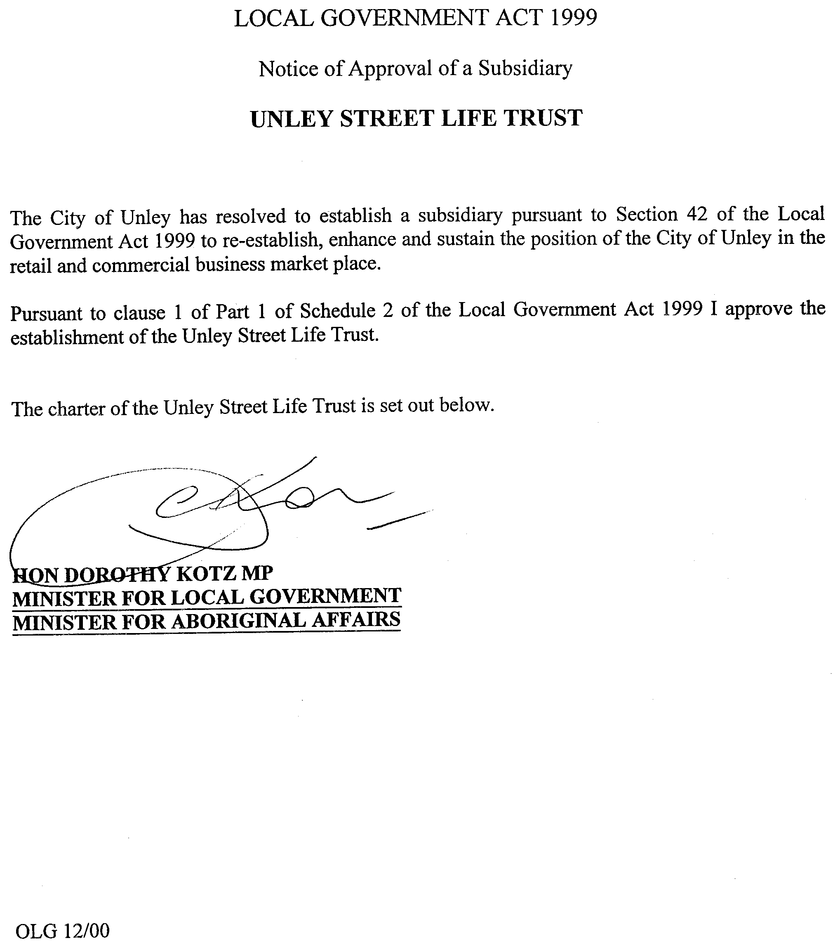
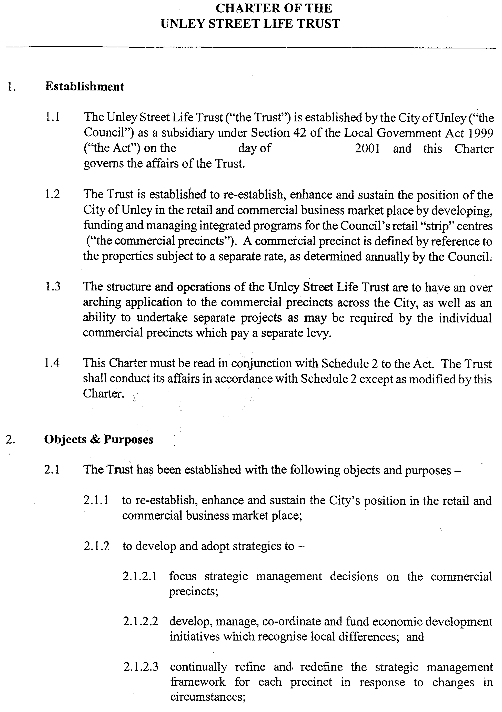
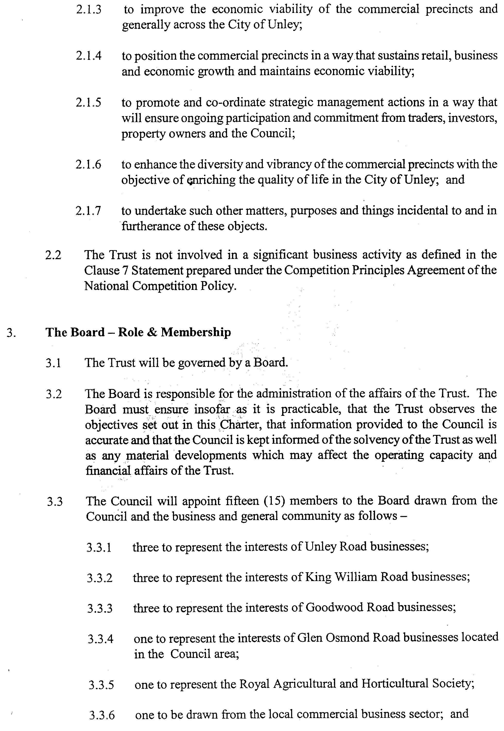
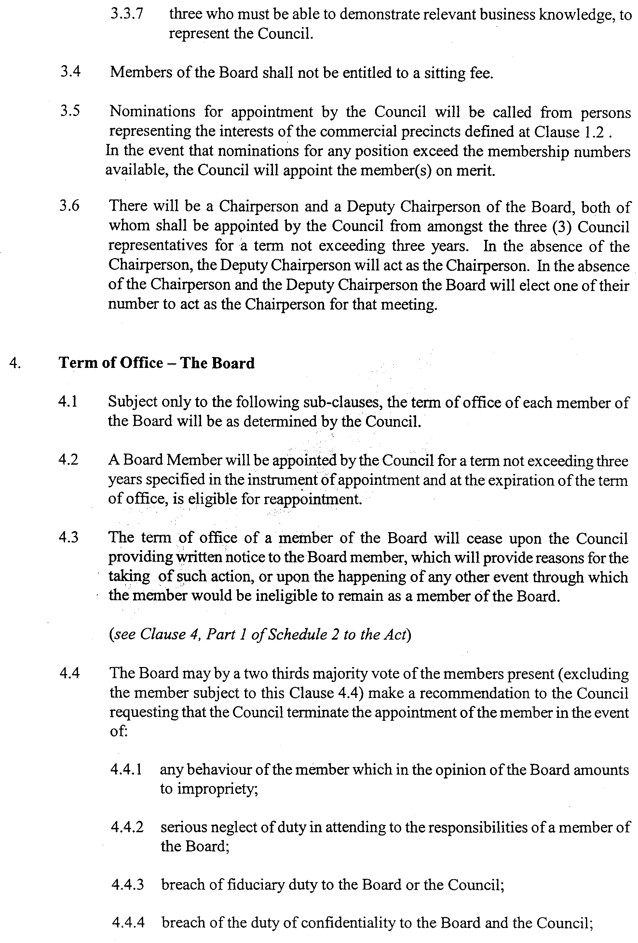
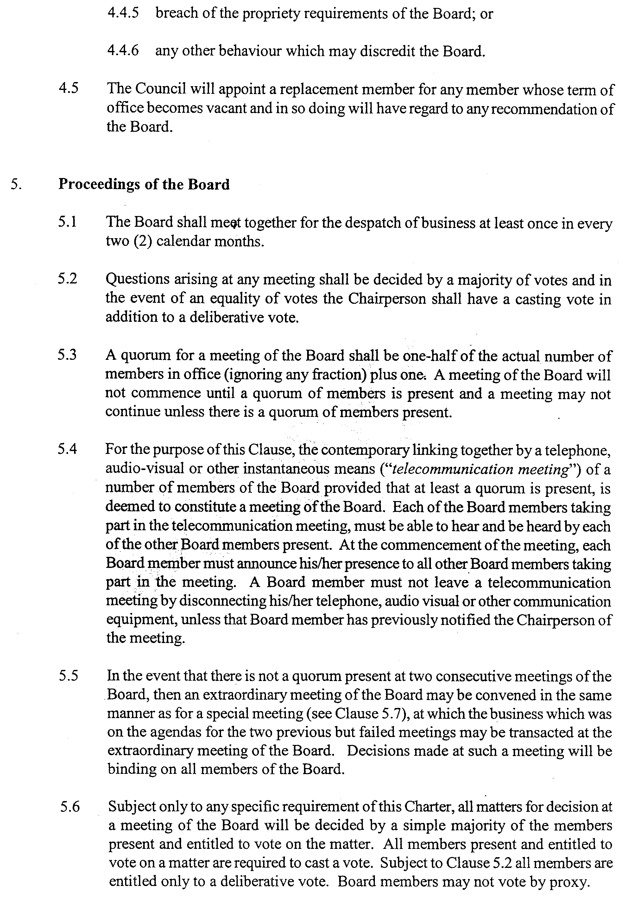
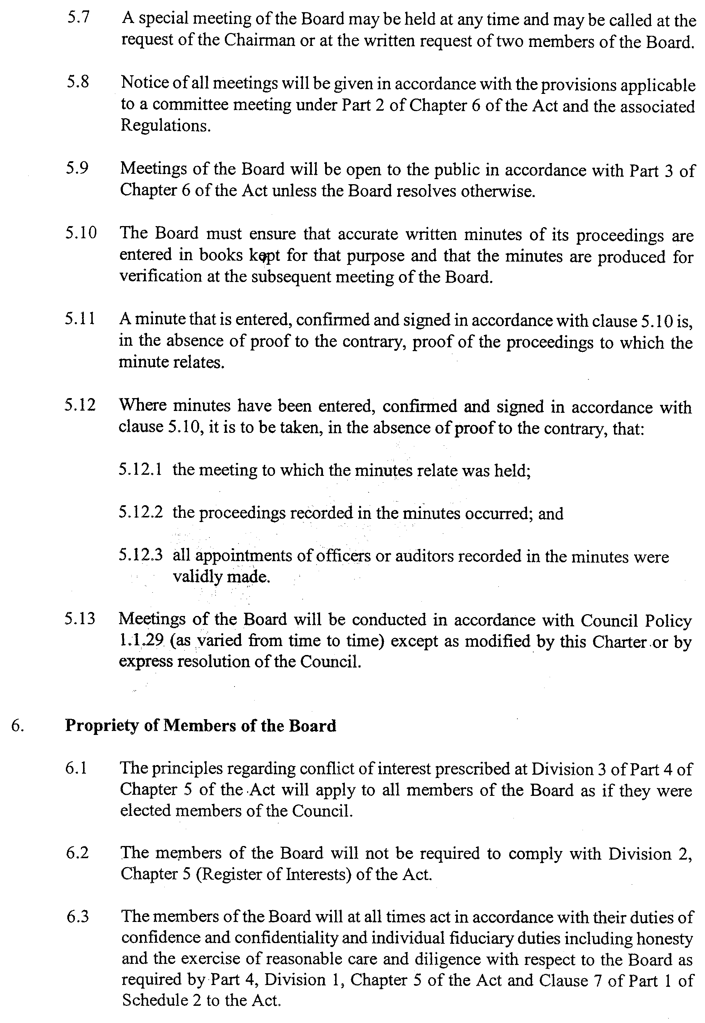
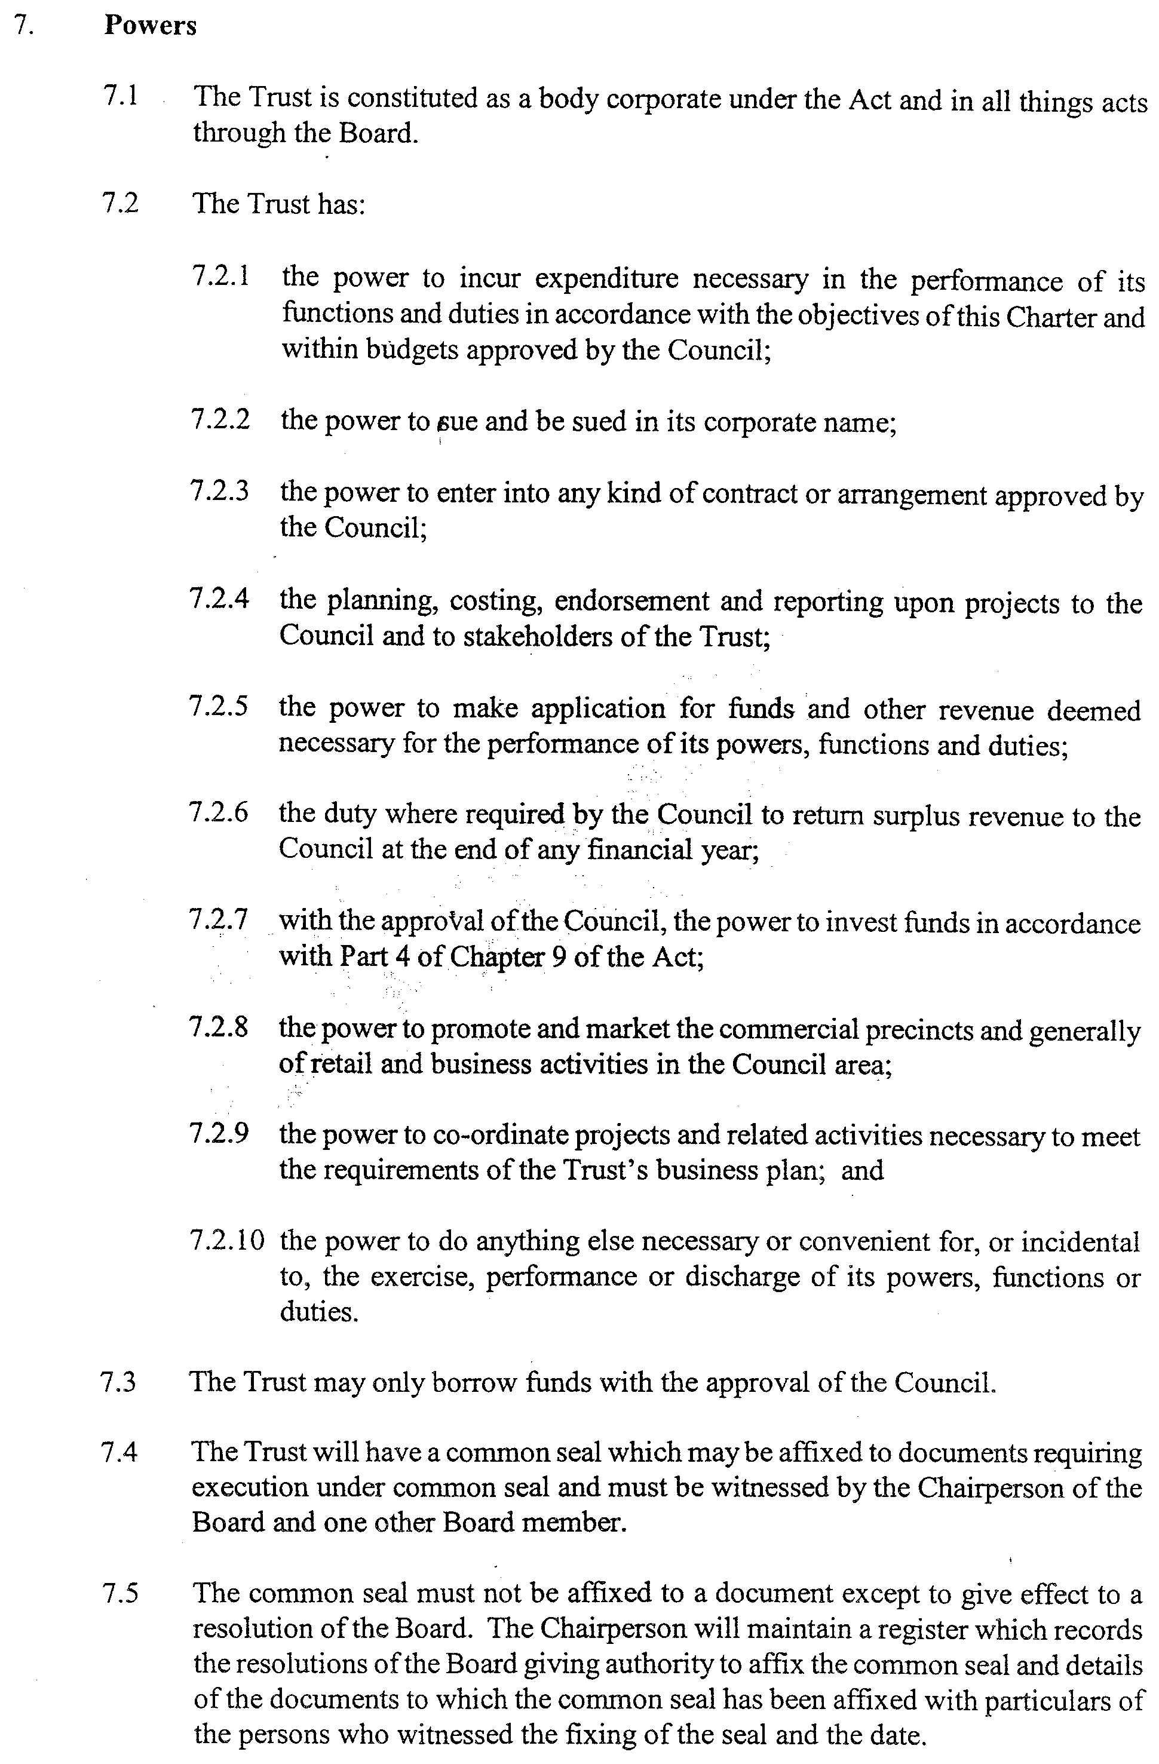
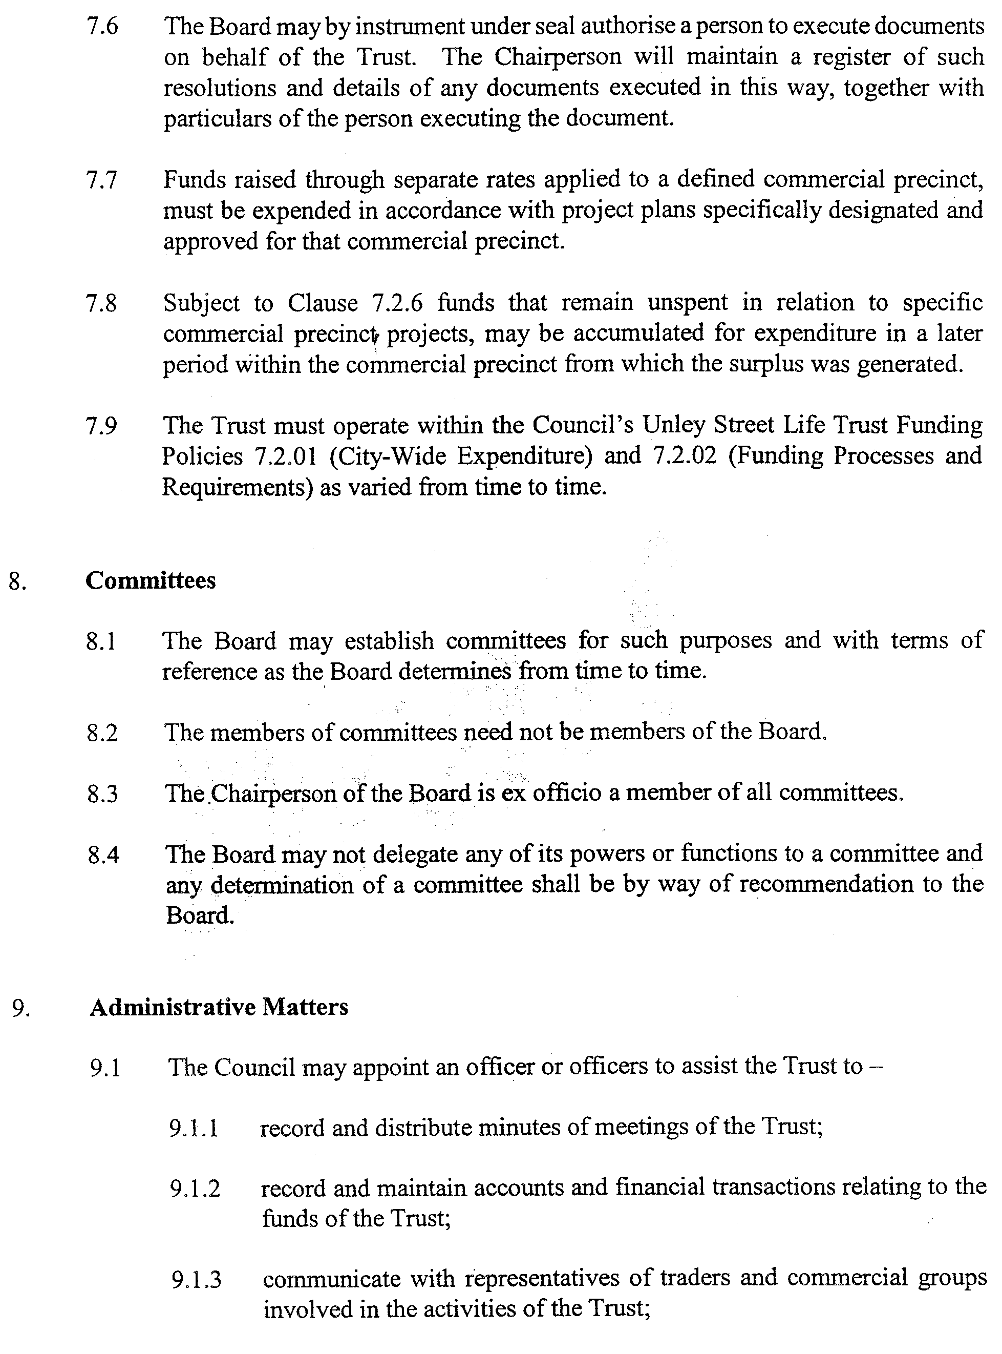
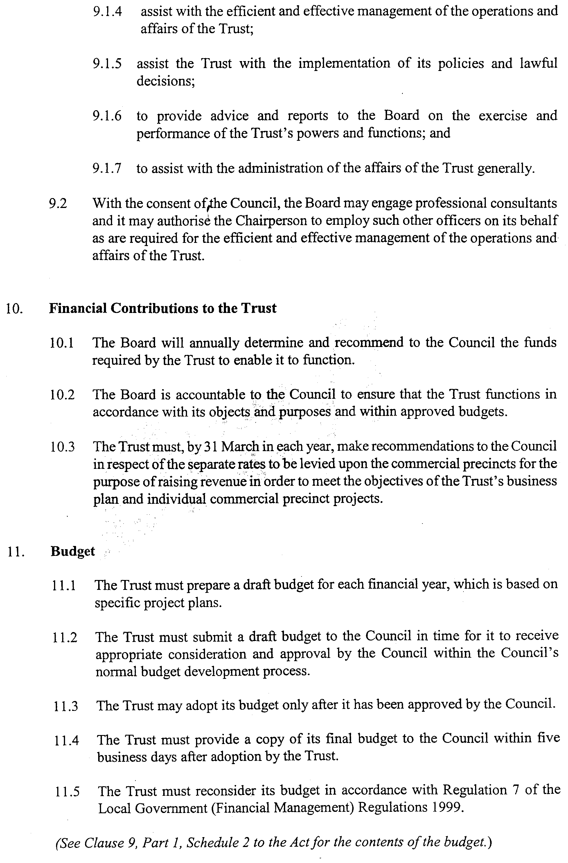
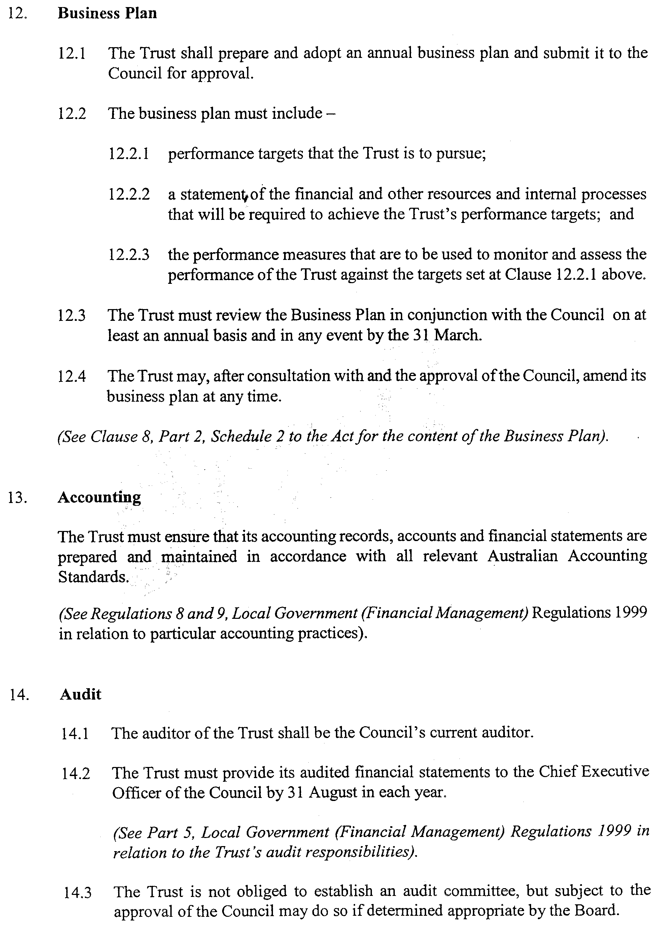
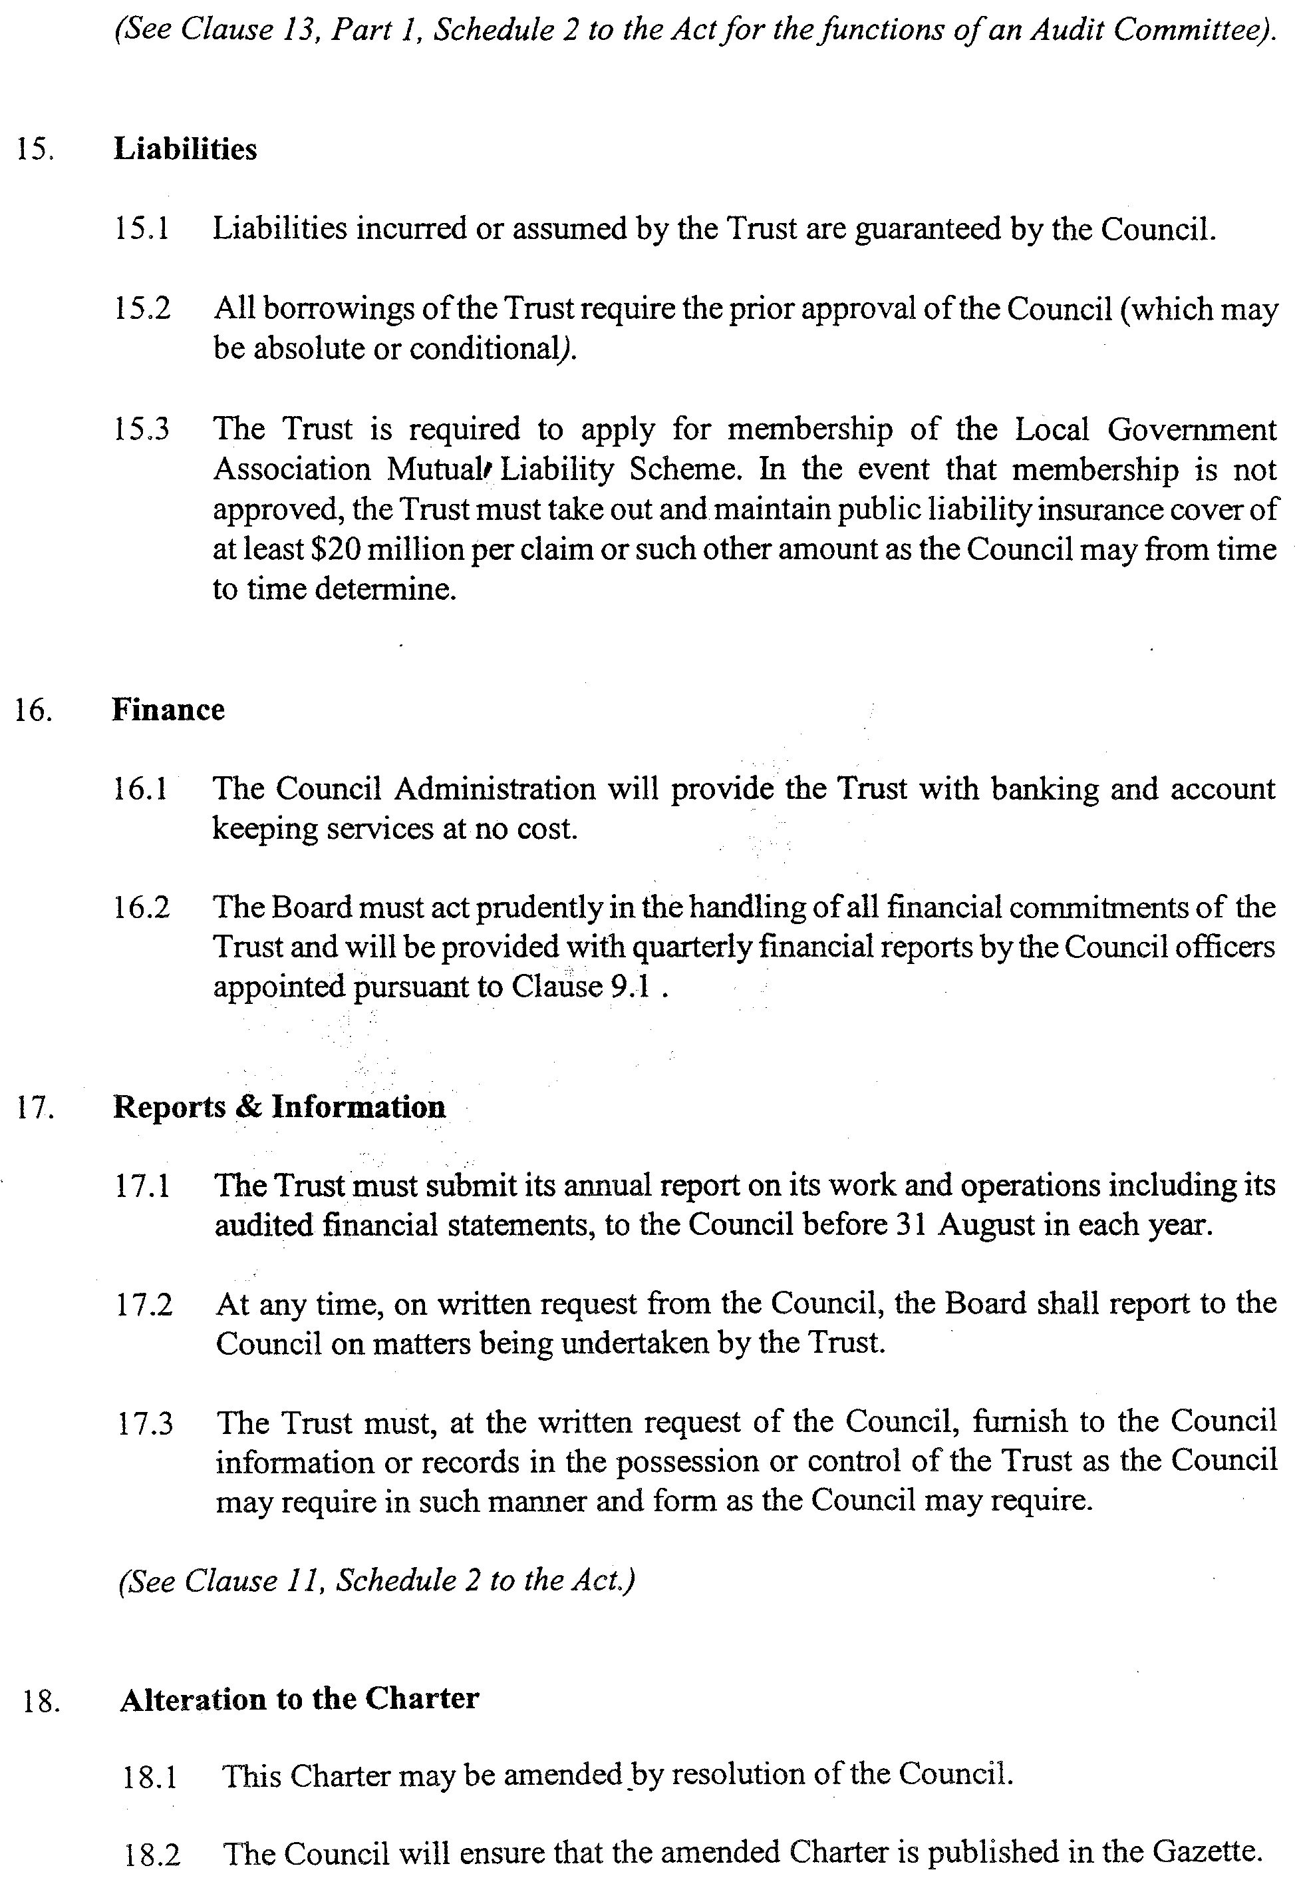
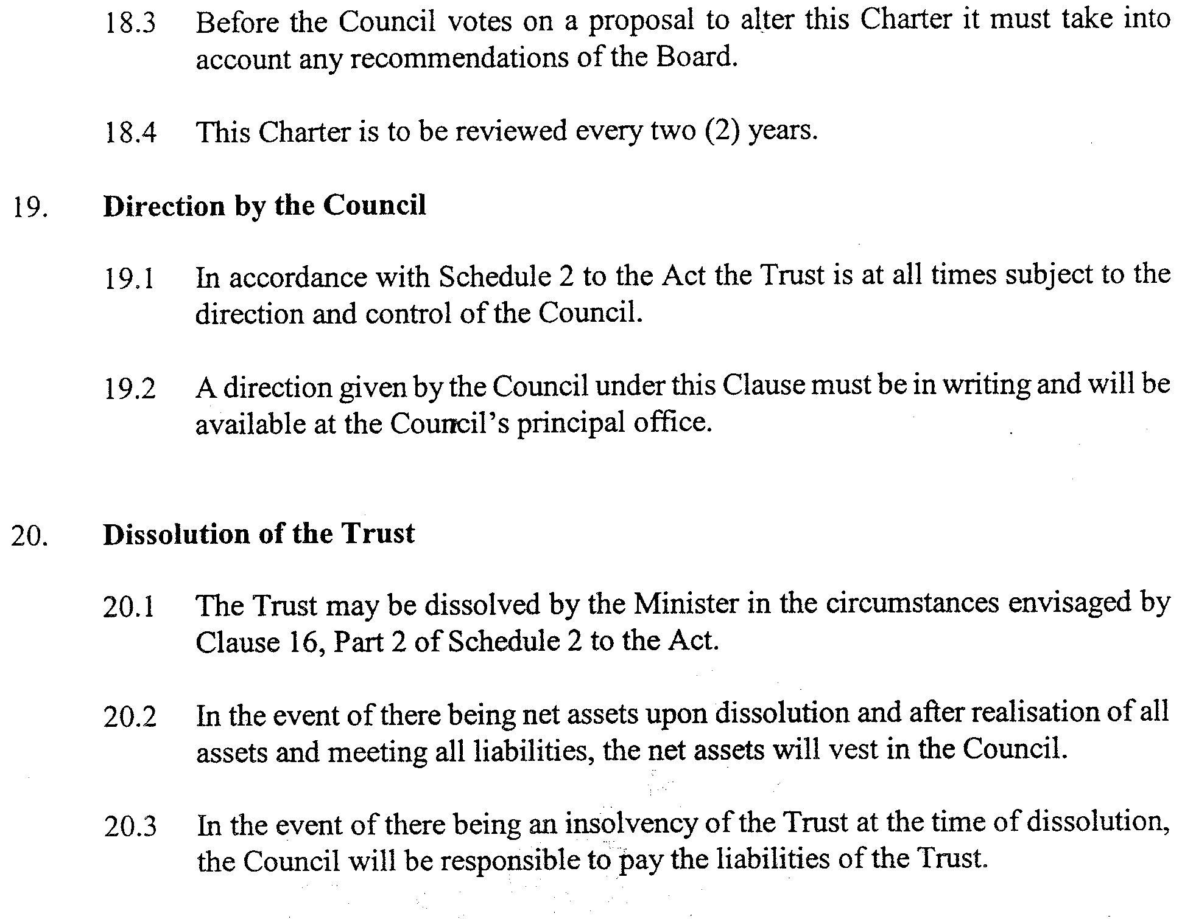
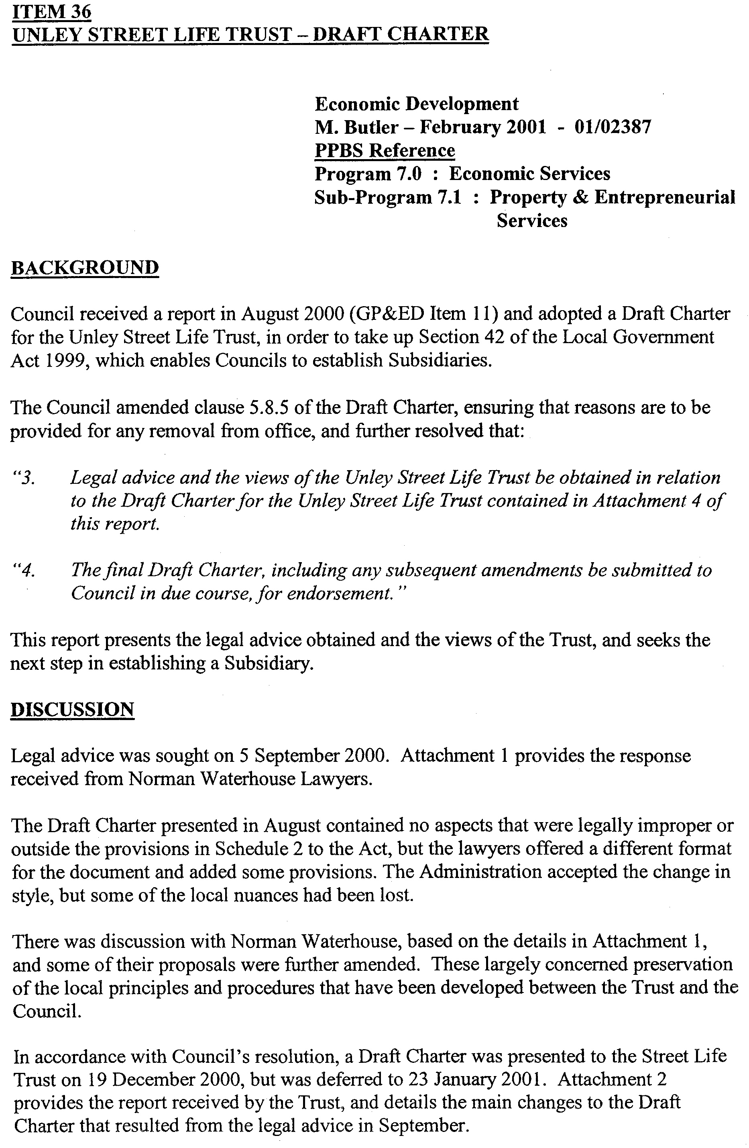
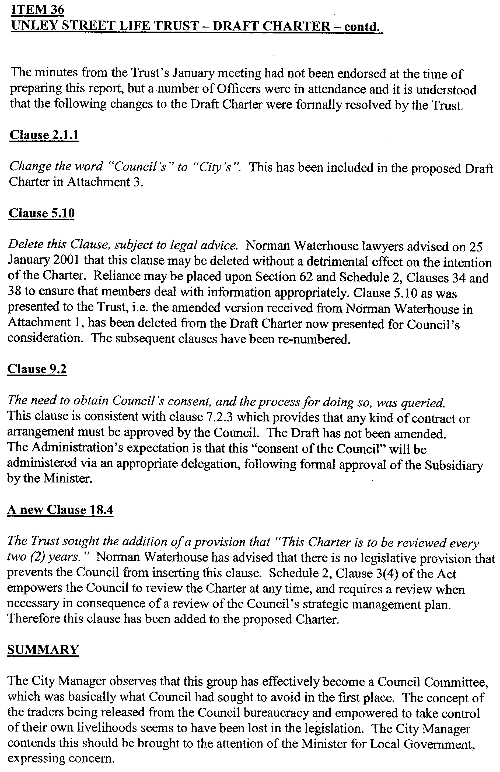
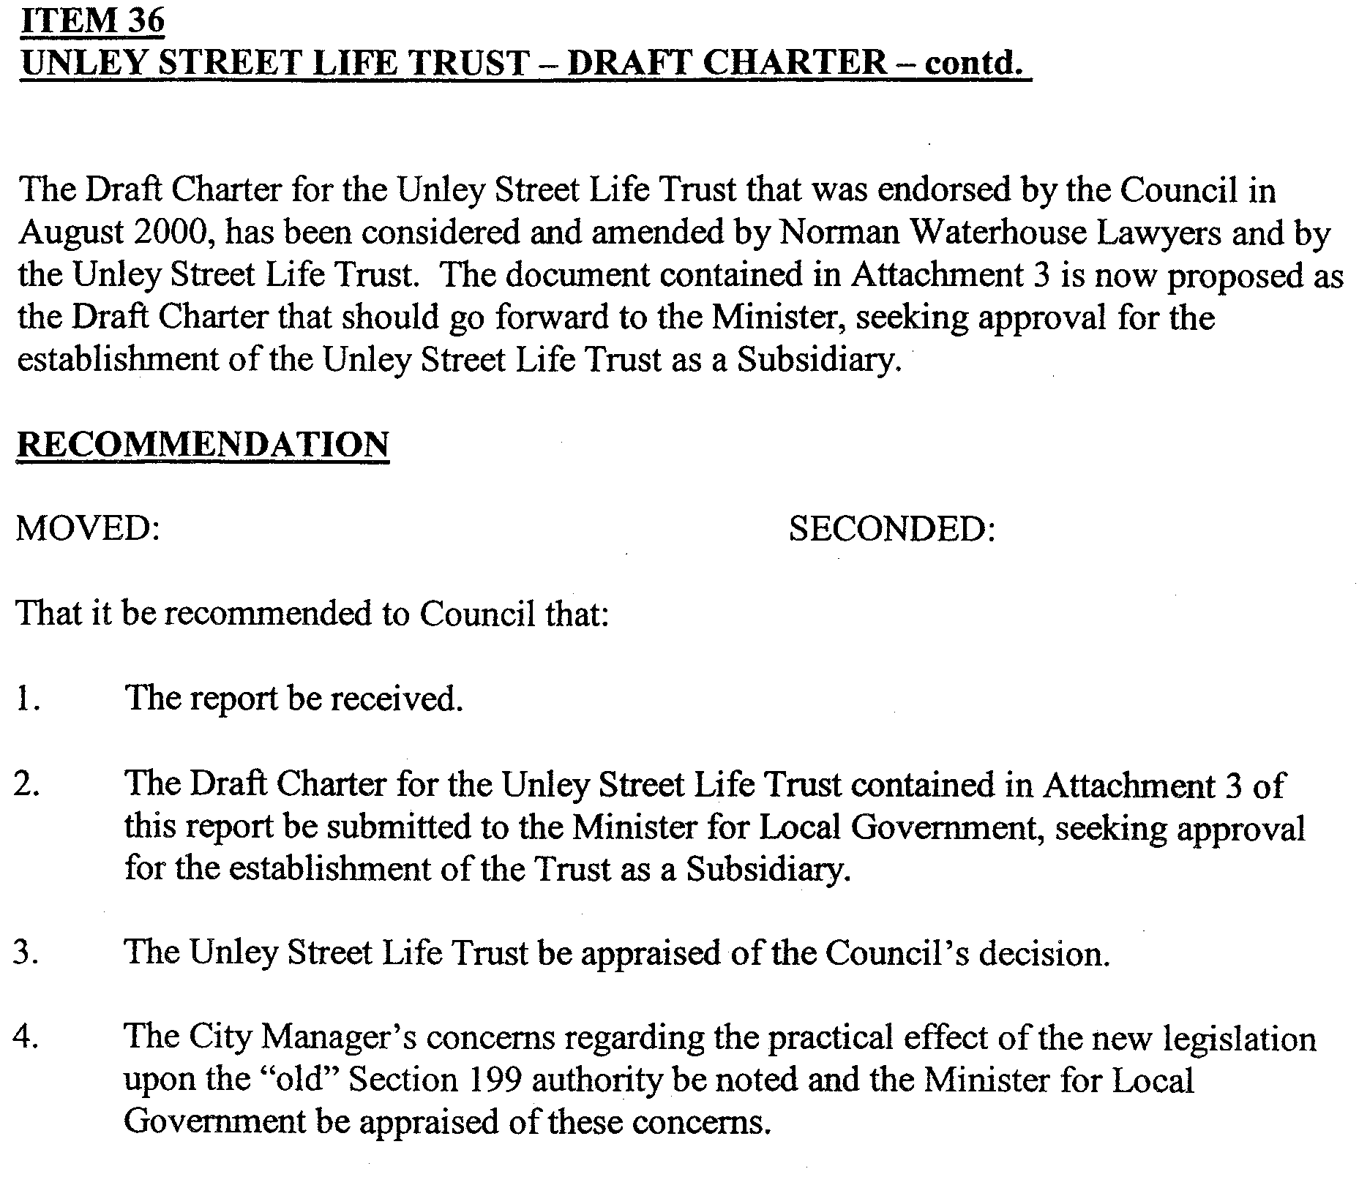
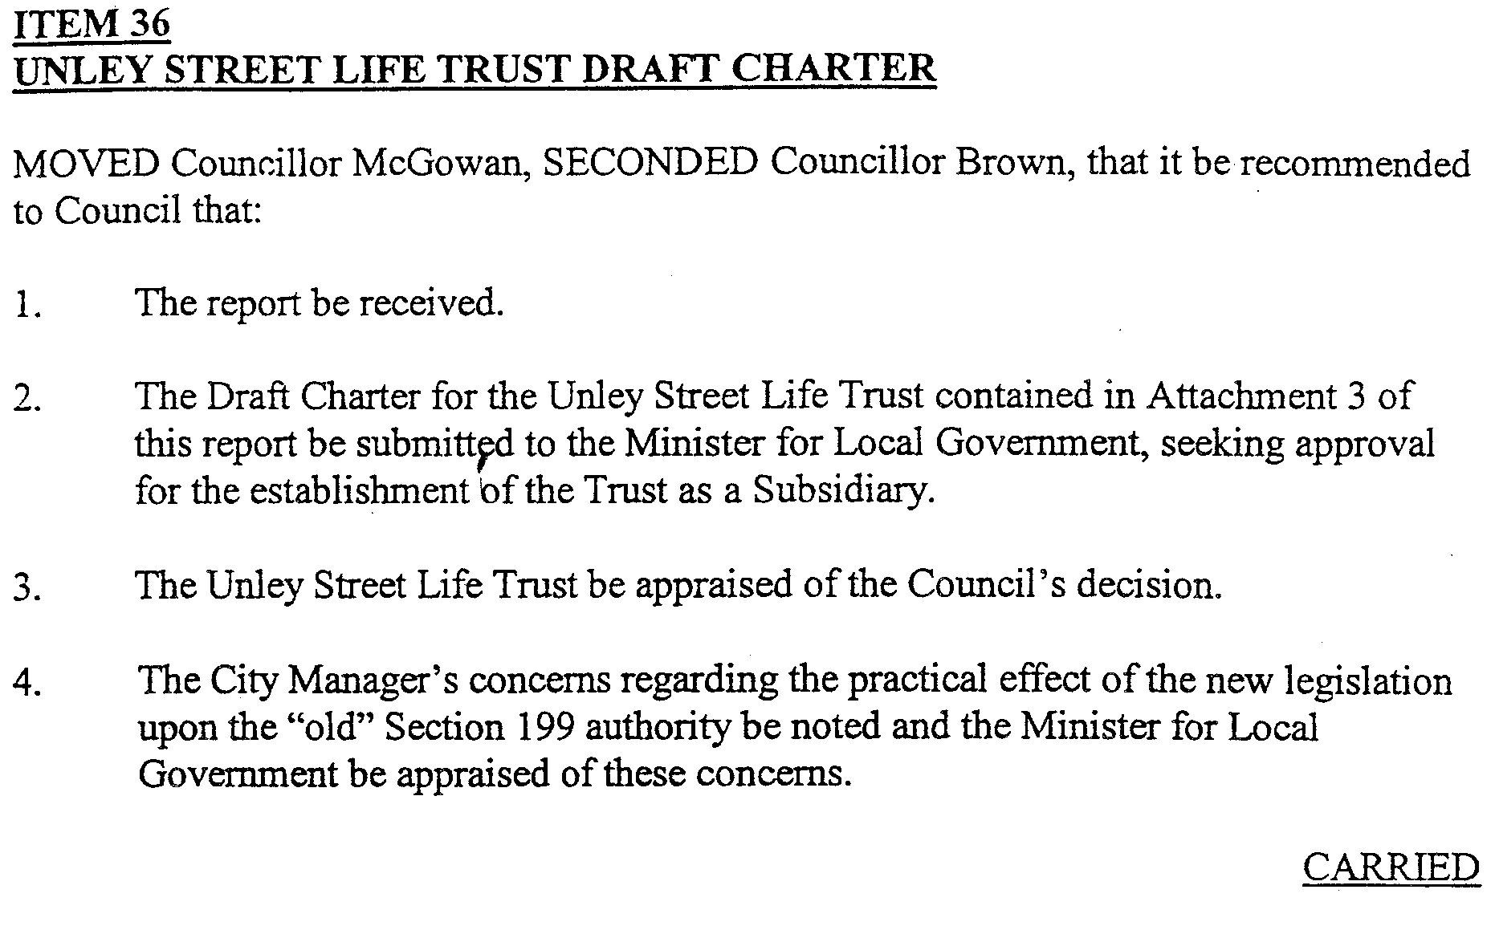

PETROLEUM ACT 2000
Statement of Environmental Objectives for Existing Regulated Activities
PURSUANT to section 104 (1) of the Petroleum Act 2000 (the Act) I, Robert Anthony Laws, Director Petroleum, Office of Minerals and Energy Resources, Department of Primary Industries and Resources SA, Delegate of the Minister for Minerals and Energy, pursuant to Delegation dated 25 September 2000, Gazetted 28 September 2000, do hereby publish the following document as having been approved as a statement of environmental objectives under the Act.
This document is available for public inspection on the Environmental Register section of the Petroleum Group’s web site (www.petroleum.pir.sa.gov.au) or at the Public Office determined pursuant to section 107 (1) of the Act to be at:
Minerals and Petroleum Centre
Office of Minerals and Energy Resources
Ground Floor
101 Grenfell Street
Adelaide, S.A. 5000
Document:
1. Origin Energy Resources Limited Statement of Environ-mental Objectives for Drilling Pad and Access Road Construc-tion On Private Land Otway Basin—South Australia May 2001 approved on 14 May 2001.
R. A. Laws, Delegate of the Minister for Minerals and Energy Resources

RAIL SAFETY ACT 1996
Fees Payable by Accredited Railway Owners and Operators and Owners of Registered Private Railway Sidings
I, DIANA VIVIENNE LAIDLAW, the Minister for Transport and Urban Planning, pursuant to sections 21 and 22 of the said Act, do hereby fix the following fees.
Dated 15 May 2001.
Diana Laidlaw, Minister for Transport and Urban Planning

Effective 1 July 2001
Schedule of Fees
Fees Payable by Accredited Railway Owners and Operators and Owners of Registered Private Railway Sidings
Applicable Fees
No fee payable.
Annual Fee—Commercial Railway Owners and Operators
An accredited person shall pay annual accreditation fees according to their accreditation category or categories.
A person accredited as both an owner and an operator shall pay an annual fee equal to the total of both the owner and operator annual fee. A person accredited as both a Category 4 Owner and a Category 4 Operator shall pay a maximum combined annual fee of $5 000.
For temporary accreditation the amount payable shall be based on the estimated annual fee proportionally adjusted on a pro rata basis to reflect the actual number of weeks, or part thereof, that the accreditation will remain in force. A minimum fee of $100 applies for temporary accreditation.
Commercial Railway Owner and Operator Annual Fee:
Accreditation Owner Operator
Category Annual Fee Annual Fee
$ $
1 27 795 27 795
2 18 530 18 530
3 9 265 9 265
4 (minimum fee) 5 000 5 000

Annual Fee—Not-for-Profit Heritage/Tourist Owners and
Operators
No fee payable.
Annual Fee—Owner of a Registered Private Siding
No fee payable.
Fee for Late Payment of Annual Fees
Where payment of fees is made after the due date, then payment must be accompanied by a late payment fee of 5 per cent of the amount outstanding on the due date.
Commercial Railway Owner and Operator Accreditation Category
Historical information, where available, will be used for the purpose of determining the accreditation category. Where historical information is not available, a projected assessment will be used.
Owner Criteria
Track Owned Accreditation Category
(Main Line Kilometres)

Greater than 1 000 1
Greater than 500 up to 1 000 2
Greater than 50 up 500 3
From 0 to 50 and/or passenger or freight 4
terminal/marshalling yard owner, or rail
infrastructure maintainer only

Operator Criteria
Train Kilometres Operated Accreditation Category
(Main Line)

(including train kilometres operated as a hook-and-pull provider)
Greater than 3 million per annum 1
Greater than 1 million up to 3 million 2
per annum
Greater than 50 000 up to 1 million 3
per annum
Up to 50 000 per annum, or rolling stock 4
maintainer and/or provider only, or train
operator which only contracts other
accredited operators to hook-and-pull
its trains

ROADS (OPENING AND CLOSING) ACT 1991:
SECTION 24
NOTICE OF CONFIRMATION OF ROAD
PROCESS ORDER
Marine Parade/Jervois Terrace, Marino
Deposited Plan 53225
BY Road Process Order made on 3 August 1999, The Corporation of the City of Marion ordered that:
1. Portion of the public roads (Marine Parade and Jervois Terrace) adjoining the northern and western boundaries of allotment 21 in Filed Plan 104575, more particularly delineated and lettered ‘A’ and ‘B’ in Preliminary Plan No. PP32/0241 be closed.
2. The whole of the land subject to closure transferred to TEKIN SABUNCU and GULTEN SABUNCU in accordance with agreement for transfer dated 30 December 1998, entered into between The Corporation of the City of Marion and
T. Sabuncu and G. Sabuncu.
On 30 September 1999, that order was confirmed by the Minister for Administrative Services, conditionally on approval and deposit of the survey plan by the Registrar-General. The condition has now been fulfilled.
Pursuant to section 24(5) of the Roads (Opening and Closing) Act 1991, NOTICE of the order referred to above and its confirmation is hereby given.
Dated 17 May 2001.
P. M. Kentish, Surveyor-General

ROADS (OPENING AND CLOSING) ACT 1991:
SECTION 24
NOTICE OF CONFIRMATION OF ROAD
PROCESS ORDER
McClory Place, Adelaide
Deposited Plan 56912
BY Road Process Order made on 29 March 2001, The Corporation of the City of Adelaide ordered that:
1. The whole of the public road (McClory Place) adjoining Symonds Place shown more particularly delineated and lettered ‘A’ on Preliminary Plan No. PP32/0497 be closed.
2. Issue a Certificate of Title to THE CORPORATION OF THE CITY OF ADELAIDE for the whole of the land subject to closure which land is being retained by Council for merging with Council owned land.
On 9 April 2001, that order was confirmed by the Minister for Administrative and Information Services, conditionally on approval and deposit of the survey plan by the Registrar-General. The condition has now been fulfilled.
Pursuant to section 24(5) of the Roads (Opening and Closing) Act 1991, NOTICE of the order referred to above and its confirmation is hereby given.
Dated 17 May 2001.
P. M. Kentish, Surveyor-General

SOIL CONSERVATION AND LAND CARE ACT 1989
Appointment
I, ROBERT GERARD KERIN, Minister for Primary Industries and Resources in the State of South Australia to whom the administration of the Soil Conservation and Land Care Act 1989, has been committed, do hereby appoint the following person as a member of the Eastern Eyre Peninsula Soil Conservation Board, pursuant to section 24 of the Act until 13 October 2002:
Steven Edwin Edwards
Dated 13 May 2001.
Rob Kerin, Minister for Primary Industries and Resources

NOTICE TO MARINERS
No. 28 of 2001
Spencer Gulf—Approaches to Port Augusta—Buoy Markers Lit
NEW lights have been established on the beacons in AGD co-ordinates as follows:
Beacon No. 13: Latitude 32°36′30″S
Longitude 137°46′18″E
Flashing Green 15 every 60 seconds
Beacon No. 16: Latitude 32°36′32″S
Longitude 137°46′16″E
Flashing Red 15 every 60 seconds
Navy Charts affected: Aus 778
Publication affected: Australia Pilot, Volume 1 (Seventh Edition, 1992) pages 106 and 107.
Adelaide, 17 May 2001.
Diana Laidlaw, Minister for Transport and Urban Planning
TSA 2001/00309

WATER MAINS AND SEWERS

Office of the South Australian Water Corporation
Adelaide, 17 May 2001.

WATER MAINS LAID

Notice is hereby given that the following main pipes or parts of main pipes have been laid down by the South Australian Water Corporation in or near the undermentioned water districts and are now available for a constant supply of water to adjacent land.

ADELAIDE WATER DISTRICT

CITY OF ADELAIDE
Catherine Helen Spence Street, Adelaide. p3 and 4
Howard Florey Street, Adelaide. p4

CITY OF CHARLES STURT
Kristoff Avenue, Fulham Gardens. p6
Kopcheff Avenue, Fulham Gardens. p6

CITY OF HOLDFAST BAY
Bishop Avenue, Somerton Park. p9
Elgar Road, Somerton Park. p9

DISTRICT OF MOUNT BARKER
O’Donnell Drive, Littlehampton. p5
Rule Court, Littlehampton. p5

CITY OF ONKAPARINGA
Across Kenihans Road, Happy Valley. p10
Merrivale Drive, Happy Valley. p10 and 11
Benacre Close, Happy Valley. p10
Mowbray Terrace, Happy Valley. p10 and 11

CITY OF PLAYFORD
Kingate Boulevard, Blakeview. p8
Garden Street, Blakeview. p8
Easement in lot 2012, Hay Crescent, Blakeview. p8
Eucalypt Circuit, Blakeview. p12 and 13

CITY OF TEA TREE GULLY
Martindale Avenue, Golden Grove. p1

MANNUM WATER DISTRICT

MID MURRAY COUNCIL
River Lane, Mannum. p2

NURIOOTPA WATER DISTRICT

THE BAROSSA COUNCIL
Traminer Way, Nuriootpa, Nuriootpa. p7

SEWERS LAID

Notice is hereby given that the following sewers have been laid down by the South Australian Water Corporation in the undermentioned drainage areas and are now available for house connections.

ADELAIDE DRAINAGE AREA

CITY OF ADELAIDE
Catherine Helen Spence Street, Adelaide. FB 1095 p28 and 29

CITY OF CHARLES STURT
Kristoff Avenue, Fulham Gardens. FB 1095 p20 and 21
Kopcheff Avenue, Fulham Gardens. FB 1095 p20 and 21

CORPORATE TOWN OF GAWLER
Gleeson Grove, Evanston Park. FB 1095 p17 and 18
Maxwell Court, Evanston Park. FB 1095 p17 and 18
Mullen Court, Evanston Park. FB 1095 p17 and 18

CITY OF ONKAPARINGA
Across Kenihans Road, Happy Valley. FB 1095 p25 and 26
Easements in reserve (lot 52), Kenihans Road, Happy Valley. FB 1095 p25 and 26
Merrivale Road, Happy Valley. FB 1095 p25-27
Mowbray Terrace, Happy Valley. FB 1095 p25 and 27
Benacre Close, Happy Valley. FB 1095 p25 and 26

CITY OF PLAYFORD
Kingate Boulevard, Blakeview. FB 1095 p23 and 24
Garden Street, Blakeview. FB 1095 p23 and 24
Easement in lot 2012, Hay Crescent, Blakeview. FB 1095 p23 and 24
Easement in lots 185-181, Kingate Boulevard, Blakeview. FB 1095 p23 and 24

CITY OF SALISBURY
Easements in lot 13, Resthaven Road, Parafield Gardens. FB 1095 p19 and 20

CITY OF TEA TREE GULLY
Martindale Avenue, Golden Grove. FB 1095 p15 and 16

CITY OF UNLEY
Anderson Street, Fullarton. FB 1095 p14

SEWERS ABANDONED

Notice is hereby given that the undermentioned sewer/s has/have been abandoned by the South Australian Water Corporation.

ADELAIDE DRAINAGE AREA

CITY OF ADELAIDE
Howard Florey Street, Adelaide. FB 1095 p29

A. Howe, Chief Executive Officer, South Australian Water Corporation

WORKERS REHABILITATION AND COMPENSATION ACT 1986

THE WORKCOVER CORPORATION OF SOUTH AUSTRALIA ("the Corporation") in accordance with those provisions of the WORKERS REHABILITATION AND COMPENSATION ACT 1986 as amended ("the Act") identified in Item 1 of the Schedule hereto ("the Schedule") makes its determination in the terms set out in Item 2 of the Schedule upon the grounds set out in Item 3 of the Schedule, if any, to come into effect on the date set out in Item 4 of the Schedule and determines further that notice of this determination shall be provided in the manner set out in Item 5 of the Schedule.

SCHEDULE
Item 1 Section Empowering Determination

Section 66

Item 2 Terms of Determination

2.1 Amendment to Levy Rates
That the Determinations of the Corporation as to the percentage of aggregate remuneration paid to an employer's workers payable as the levy made prior to the making of this Determination be and are hereby varied so that the percentage of aggregate remuneration paid to an employer's workers in each class of industry, referred to in Column No. 2 of the Appendix hereto, payable as the levy, shall be the corresponding percentage set out in Column No.3 of the Appendix hereto.

Item 3 Grounds of Determination

3.1 In respect of the levy applicable to the classes of industry that the percentages applicable take into account:

(a) the extent to which work carried on in a relevant class is likely to contribute to the cost of compensable disability; and

(b) the need to establish and maintain sufficient funds:

(i) to satisfy the Corporation's future liabilities in respect of compensable disabilities attributable to traumas occurring from the date of commencement of this Determination until the 30th day of June 2002 from the levy raised from remuneration in that period; and

(ii) to make proper provision for administrative and other expenditure of the Corporation; and

(iii) to make up any insufficiency in the Compensation Fund resulting from previous liabilities or expenditures or from a reassessment of future liabilities.

3.2 That the percentages so determined in accordance with Section 66(7) of the Act (not exceeding 7.5 per cent) are as follows:

0.40 per cent 1.90 per cent 3.40 per cent 4.90 per cent 6.40 per cent
0.50 per cent 2.00 per cent 3.50 per cent 5.00 per cent 6.50 per cent
0.60 per cent 2.10 per cent 3.60 per cent 5.10 per cent 6.60 per cent
0.70 per cent 2.20 per cent 3.70 per cent 5.20 per cent 6.70 per cent
0.80 per cent 2.30 per cent 3.80 per cent 5.30 per cent 6.80 per cent
0.90 per cent 2.40 per cent 3.90 per cent 5.40 per cent 6.90 per cent
1.00 per cent 2.50 per cent 4.00 per cent 5.50 per cent 7.00 per cent
1.10 per cent 2.60 per cent 4.10 per cent 5.60 per cent 7.10 per cent
1.20 per cent 2.70 per cent 4.20 per cent 5.70 per cent 7.20 per cent
1.30 per cent 2.80 per cent 4.30 per cent 5.80 per cent 7.30 per cent
1.40 per cent 2.90 per cent 4.40 per cent 5.90 per cent 7.40 per cent
1.50 per cent 3.00 per cent 4.50 per cent 6.00 per cent 7.50 per cent
1.60 per cent 3.10 per cent 4.60 per cent 6.10 per cent
1.70 per cent 3.20 per cent 4.70 per cent 6.20 per cent
1.80 per cent 3.30 per cent 4.80 per cent 6.30 per cent
Item 4 Commencement Date of Determination

1st day of July 2001

Item 5 Notice of Determination

That notice of this determination be published in the South Australian Government Gazette.

Confirmed as a true and correct record of the decision of the Corporation.

P. GUNNER, Chairperson
11.5.2001

APPENDIX
WORKCOVER CORPORATION OF SOUTH AUSTRALIA
WorkCover Levy Rates per $100 Remuneration exclusive of GST - Effective 1 July 2001

Column Column Column Column Column Column
1 2 3 1 2 3

SAWIC Levy SAWIC Levy
Code Description Rate Code Description Rate
Number per $100 Number per $100

AGRICULTURE, FORESTRY AND FISHING

012401 Poultry farming 3.80
013401 Grape growing 2.80
(incl sun-drying)
013601 Fruit growing 3.10
014401 Vegetable growing 4.10
018101 Grain growing 3.20
018201 Grain-sheep, grain-beef cattle farming 3.10
018401 Sheep-beef cattle farming 4.10
018501 Sheep farming 4.50
018601 Beef cattle farming 4.60
018701 Dairy cattle farming 4.70
018801 Pig farming 5.10
019301 Tobacco growing 7.50
019401 Cotton growing 7.50
019501 Plant nurseries 3.20
019601 Agriculture nec 4.70
020401 Shearing services 7.50
020501 Aerial agricultural services 3.90
020601 Services to agriculture nec 3.70
030301 Logging 4.70
030401 Forestry and services to forestry 3.70
043101 Rock lobster fishing 3.70
043201 Prawn fishing 3.80
043301 Ocean and coastal fishing nec 4.30
043401 Aquaculture 2.10
044001 Hunting and trapping 4.00

MINING

111101 Iron ore mining 4.00
112201 Copper ore mining 2.20
112301 Gold ore mining 3.60
112401 Mineral sand mining 3.40
112501 Nickel ore mining 3.40
112601 Silver-lead-zinc ore mining 4.10
112801 Metal ore mining nec 4.40
120101 Black coal mining 3.40
120201 Brown coal mining 3.40
130001 Oil and gas extraction 1.90
140101 Gravel and sand quarrying 3.80
140401 Construction material mining nec 3.90
150401 Salt production by evaporation, mining, 3.20
crushing, screening or washing
150501 Non-metallic minerals nec 3.70
mining, quarrying, crushing or screening
161101 Petroleum exploration (own account) 4.00
161201 Mineral exploration (own account) 3.50
162001 Mining and exploration services nec 3.00

MANUFACTURING

211501 Meat processing (except livestock) 6.90
211505 Livestock processing 7.50
211601 Poultry processing 6.70
211701 Bacon, ham and smallgoods 6.20
manufacturing

212101 Milk and cream processing 3.50
212301 Dairy products manufacturing nec 3.10
212401 Ice cream, frozen confections 3.10
manufacturing
213101 Fruit and vegetable processing 3.30
(except sun-drying)
214001 Oil and fat manufacturing 4.10
215101 Flour mill products manufacturing 5.30
(excl cornflour or rice flour)
215201 Starch, gluten and starch sugars 7.50
manufacturing
(incl arrowroot and cornflour)
215301 Cereal foods and baking mixes 3.70
manufacturing
(incl rice flour, pasta, jelly crystals,
custard powder)
216101 Bread and biscuit manufacturing 5.70
216201 Cakes, pastries, pies, manufacturing 3.70
217101 Sugar manufacturing 7.50
217301 Confectionery manufacturing 4.50
217401 Seafood processing 3.80
217501 Prepared animal and bird feed 4.10
manufacturing
217601 Food manufacturing nec 4.50
218501 Soft drink, cordial and syrup 2.60
manufacturing
218601 Beer ale, stout or porter manufacturing 2.20
218701 Malt manufacturing 4.00
218801 Wine, brandy, fortifying spirits, 2.60
fermented cider and wine vinegar
manufacturing (incl blending)
218901 Alcoholic beverages manufacturing nec 2.50
(incl blending)
219001 Tobacco product manufacturing 7.50
234001 Yarns and broadwoven fabrics 3.80
manufacturing
234201 Wool scouring and top making 3.80
(incl fellmongering, scouring,
carbonising, carding, combing,
manufacturing tops)
234801 Narrow woven textiles manufacturing 3.80
(30 cm or less in width)
and elastic textiles manufacturing
234901 Textile finishing 3.80
(incl bleaching, dyeing, printing,
pleating or other finishing of threads,
fabrics and other textiles)
235101 Household textiles manufacturing 3.20
235201 Textile floor covering manufacturing 3.10
235301 Felt and felt products manufacturing, 3.90
235401 Canvas and associated products nec 3.50
manufacturing
235501 Rope, cordage, twine, and related 3.30
products manufacturing
235601 Textile products manufacturing nec 3.10
245001 Clothing manufacturing 2.70

WORKCOVER CORPORATION OF SOUTH AUSTRALIA
WorkCover Levy Rates per $100 Remuneration exclusive of GST - Effective 1 July 2001

Column Column Column Column Column Column
1 2 3 1 2 3

SAWIC Levy SAWIC Levy
Code Description Rate Code Description Rate
Number per $100 Number per $100

246001 Footwear or footwear components 3.90
manufacturing
253101 Log sawmilling 5.50
(incl softwood woodchipping and chemically
preserving timber)
253201 Resawn and dressed timber manufacturing 7.50
(incl kiln drying or seasoning)
253301 Veneers and manufactured boards of 7.50
wood manufacturing (incl laminations of
timber with non-timber materials)
253501 Wooden structural component n.e.c 4.10
manufacturing
(excl on-site fabrication with installation)
253601 Wooden containers manufacturing 7.50
(incl pallets or staves)
253701 Hardwood woodchips manufacturing 7.50
253801 Wood products nec manufacturing 5.80
253805 Selected wood products manufacturing 2.60
254101 Furniture manufacturing, reupholstery, 4.40
french polishing, shop fitting
manufacture and installation nec
(excl sheet metal)
254201 Mattresses, pillows, cushions 4.40
manufacturing (excl rubber)
263101 Pulp, paper or paperboard manufacturing 3.80
263201 Paper bags manufacturing (incl textile bags) 5.10
263401 Paperboard containers or sheeting 3.90
manufacturing
263501 Paper product manufacturing nec 1.50
264101 Publishing 0.70
(incl sale of advertising space)
264201 Printing and publishing 0.90
264301 Paper stationery manufacturing 2.30
(excl commission printing)
264401 Printing and bookbinding 1.70
264501 Services to printing 0.70
275101 Fertiliser manufacturing 3.70
275201 Industrial gas manufacturing 3.70
275301 Synthetic resins, rubber and plastic 4.80
materials manufacturing
275501 Industrial chemicals manufacturing nec 2.80
276101 Explosives, fireworks, and 3.20
matches manufacturing
276201 Paint manufacturing 2.80
276301 Medicinal and pharmaceutical product 1.40
manufacturing
276401 Pesticide manufacturing 3.20
276501 Soap and other detergent manufacturing 1.70
276601 Cosmetic and toiletry preparation 1.70
manufacturing nec
276701 Ink manufacturing 1.70
276801 Chemical product manufacturing nec 3.20
277001 Petroleum refining 1.50
278001 Petroleum and coal product 1.80
manufacturing nec
285001 Glass and glass products manufacturing 4.40
286101 Clay brick manufacturing 5.80
286201 Refractory product and industrial 6.30
ceramic manufacturing
286301 Ceramic tiles and pipes or other 3.80
ceramic construction goods manufacturing
(excl vitreous china or porcelain)
286401 Ceramic goods nec manufacturing 3.80
287101 Cement manufacturing 3.70
287201 Concrete slurry manufacturing 4.20
287401 Concrete products manufacturing nec 7.00
288101 Plaster products and expanded minerals 5.00
manufacturing
288201 Stone products manufacturing 6.40
(incl installation of headstones)
288301 Glass wool and mineral wool products 5.00
manufacturing
288401 Non-metallic mineral products 5.20
manufacturing nec
294101 Basic iron and steel manufacturing 6.90
294201 Iron and steel casting and forging 7.50
294501 Steel pipe and tube manufacturing 3.90
(excl cast or forged)
295201 Silver, lead, zinc smelting, refining 3.80
295401 Aluminium smelting recovery 3.80
295601 Basic non-ferrous metal 7.50
manufacturing nec
295701 Secondary recovery and alloying of 7.50
non-ferrous metals nec from scrap
(incl tin solder, liquid soldering
or welding flux manufacturing)
296101 Aluminium rolling, drawing, extruding 5.70
296201 Non-ferrous metal nec rolling, drawing, 7.50
extruding
296301 Non-ferrous metal casting or forging 7.50
314101 Structural steel fabricating (incl 6.40
prefabricated steel buildings manufacturing)
314201 Architectural aluminium product 3.80
manufacturing
314301 Structural metal product manufacturing nec 7.20
315101 Metal container manufacturing 7.50
315201 Sheet metal furniture manufacturing 7.50
315301 Sheet metal product manufacturing nec 5.40
316101 Cutlery and hand tool manufacturing nec 3.90
(excl wood, pneumatic or power tools)
316201 Spring and wire product manufacturing 5.20
316301 Nut, bolt, screw and rivet manufacturing 3.60
316401 Metal coating and finishing 5.80
316501 Non-ferrous pipe fitting manufacturing 5.90
316601 Boiler and plate work 7.40
(incl installation of factory assembled
industrial or commercial boilers)
316701 Metal blinds and awnings manufacturing 3.10
(incl venetian blinds of any material)
316801 Fabricated metal products 5.10
manufacturing nec
323101 Motor vehicle manufacturing 4.50
323201 Motor vehicle body manufacturing 6.60
323301 Automotive electrical and instrument 4.10
manufacturing (excl batteries)
323401 Automotive component manufacturing 4.90
nec (excl motor vehicle engine
reconditioning)
324101 Ship building 6.70
324105 Submarine building, converting, refitting 3.40
or repairing
324201 Boat building 4.00
324301 Railway equipment manufacturing 6.20
or repairing

WORKCOVER CORPORATION OF SOUTH AUSTRALIA
WorkCover Levy Rates per $100 Remuneration exclusive of GST - Effective 1 July 2001

Column Column Column Column Column Column
1 2 3 1 2 3

SAWIC Levy SAWIC Levy
Code Description Rate Code Description Rate
Number per $100 Number per $100

324401 Aircraft manufacturing 2.80
324501 Transport equipment manufacturing nec 4.10
334101 Photographic equipment or supplies and 1.70
optical instruments or equipment
manufacturing
334201 Photographic film processing 1.10
334301 Measuring, professional and scientific 2.00
instruments or equipment
manufacturing nec
335101 Radio and tv receivers and audio 1.30
equipment manufacturing (incl records,
tapes, compact discs and video tapes)
335201 Electronic equipment or parts 0.80
manufacturing nec
335301 Household appliance manufacturing 4.90
335401 Water heating systems manufacturing 4.00
335501 Electric cable and wire manufacturing 4.20
335601 Battery manufacturing 5.00
335701 Electrical machinery, equipment, 3.20
supplies, components or accessories
manufacturing nec
336001 General engineering with activities in 4.90
more than three industrial manchinery
and equipment manufacturing codes
and less than twenty employees
336101 Agricultural machinery manufacturing 4.50
336201 Construction or earthmoving machinery, 5.50
equipment or attachments manufacturing
336301 Lifting and material handling equipment 5.10
manufacturing
336401 Wood and metal working machinery or 4.30
equipment manufacturing
336501 Pump and compressor manufacturing 3.80
336601 Commercial space heating and cooling 4.10
equipment or parts manufacturing
336701 Dies, saw blades and machine tool 3.00
accessories or attachments manufacturing
(incl micrometers, etc., saw sharpening
or reconditioning)
336801 Food processing machinery 3.70
manufacturing
336901 Industrial machinery and equipment 3.20
manufacturing nec
345101 Leather tanning and fur dressing 4.00
345201 Leather and leather substitute product 3.10
manufacturing nec
346101 Rubber tyres, tubes, belts, hoses and 6.30
sheets manufacturing
(incl tyre reconditioning)
346201 Rubber product manufacturing nec 6.60
347101 Flexible packaging and plastic coated 4.00
and abrasive papers manufacturing
347201 Rigid plastic sheeting manufacturing 3.80
347301 Hard surface floor coverings 7.50
manufacturing nec
347401 Plastic products manufacturing nec 4.70
348101 Ophthalmic articles manufacturing 1.50
(incl grinding spectacle lenses)
348201 Jewellery and silverware manufacturing 1.00
(incl costume jewellery and cutting
or polishing stones)
348301 Brooms and brushes, coir mats and 7.50
matting manufacturing
348401 Signs and advertising displays 2.10
manufacturing (incl sign or ticket writing)
348501 Sporting equipment manufacturing 3.30
348601 Writing and marking equipment 1.00
manufacturing nec
348701 Selected manufacturing 2.10

ELECTRICITY, GAS AND WATER

361001 Electricity supply 1.40
362001 Gas supply 1.40
370101 Water supply 1.50
(incl operating irrigation systems)
370201 Water and sewerage systems 4.70

CONSTRUCTION

411101 House construction 3.10
411201 Residential building construction nec 6.50
411301 Non-residential building construction 3.80
411302 Local Capital Works Program 7.50
412101 Road and bridge construction (or 3.70
general repair)
412201 Non-building construction nec 4.10
423101 Concreting services 7.30
423201 Bricklaying services 7.40
423301 Roofing services 6.50
423401 Tiling and carpeting services 3.70
424101 Structural steel erection 6.30
424201 Plumbing services 3.80
424301 Electrical services 2.20
424401 Air conditioning and heating services 3.60
(excl motor vehicle air conditioning)
424501 Plastering and ceiling services 6.30
424601 Carpentry services 6.50
424701 Painting and decorating services 4.40
424801 Site preparation services 4.30
424901 Construction services n.e.c 5.50
424905 Fire or security systems services 2.70
424906 Window or door replacement services 4.90

WHOLESALE AND RETAIL TRADE

471001 General wholesalers dealing in 2.50
combination of goods in three or more
industry groups
471002 General agents dealing in combination 0.70
of goods in three or more industry groups
- not physically handling any stock
472701 Timber dealing 4.20
472702 Timber agents 0.70
- not physically handling any stock
472801 Building supplies dealing nec 1.80
(excl cutting, bevelling or coating
flat glass or glazing)
472802 Building supplies agents nec 1.20
- not physically handling any stock
472805 Glazing services 5.90
(incl cutting, bevelling or coating flat glass)
473101 Farm machinery dealing (incl repairing) 1.90

WORKCOVER CORPORATION OF SOUTH AUSTRALIA
WorkCover Levy Rates per $100 Remuneration exclusive of GST - Effective 1 July 2001

Column Column Column Column Column Column
1 2 3 1 2 3

SAWIC Levy SAWIC Levy
Code Description Rate Code Description Rate
Number per $100 Number per $100

473102 Farm and construction machinery and 0.70
parts agents
- not physically handling any stock
473105 Agricultural machinery wholesaling 2.30
(incl. repairing)
473106 Construction and earthmoving 3.00
machinery equipment and parts
wholesaling (incl. repairing)
473201 Motor vehicle part wholesaling 1.60
473202 Motor vehicle part agents 0.70
- not physically handling any stock
473301 Professional equipment wholesaling 0.70
473302 Professional equipment agents 0.70
- not physically handling any stock
473401 Business machines wholesaling 0.70
473402 Business machines agents 0.70
- not physically handling any stock
473501 Electrical and electronic equipment 0.70
wholesaling nec
473502 Electrical and electronic equipment 0.70
agents nec
- not physically handling any stock
473601 Machinery and equipment wholesaling 1.50
473602 Machinery and equipment agents nec 0.50
- not physically handling any stock
473701 Computer wholesaling 0.40
473702 Computer agents 0.70
- not physically handling any stock
474101 Petroleum product wholesaling 1.50
474102 Petroleum product agents 0.80
- not physically handling any stock
474201 Metal wholesaling 4.10
474202 Metal agents 0.70
- not physically handling any stock
474401 Mineral and metal wholesaling nec 2.20
474402 Mineral and metal agents nec 0.70
- not physically handling any stock
474501 Chemical wholesaling nec 1.40
474502 Chemical agents nec 0.70
- not physically handling any stock
475101 Wool selling, farm supply wholesaling 1.00
475102 Wool selling brokers and stock and 0.80
station agents
- not physically handling any stock
475201 Wool buying and wholesaling 3.90
475202 Wool buying agents 0.70
- not physically handling any stock
475301 Cereal grain wholesaling 2.90
475302 Cereal grain agents 0.60
- not physically handling any stock
475401 Farm produce wholesaling nec 1.60
475402 Farm produce agents nec 0.70
- not physically handling any stock
476101 Meat wholesaling 4.00
476102 Meat agents 0.70
- not physically handling any stock
476201 Poultry, smallgood and dairy produce 3.70
wholesaling
476202 Poultry, smallgood and dairy produce 0.70
agents
- not physically handling any stock
476301 Fish wholesaling 3.50
476302 Fish agents 0.70
- not physically handling any stock
476401 Fruit and vegetable wholesaling 3.90
476402 Fruit and vegetable agents 0.70
- not physically handling any stock
476501 Egg wholesaling 3.90
476502 Egg agents 0.70
- not physically handling any stock
476601 Confectionery and soft drink wholesaling 2.20
476602 Confectionery and soft drink agents 0.70
- not physically handling any stock
476701 Liquor wholesaling 2.50
476702 Liquor agents 0.70
- not physically handling any stock
476801 Tobacco product wholesaling 1.60
476802 Tobacco product agents 0.70
- not physically handling any stock
476901 Grocery wholesaling nec 2.90
476902 Grocery agents nec 0.70
- not physically handling any stock
476905 Fruit juice vendors 0.80
477101 Clothing wholesaling 0.80
477102 Clothing agents 0.60
- not physically handling any stock
477301 Footwear wholesaling 0.80
477302 Footwear agents 0.70
- not physically handling any stock
477401 Textile product wholesaling 0.90
477402 Textile product agents 0.60
- not physically handling any stock
478101 Household appliance wholesaling 1.40
478102 Household appliance agents 0.70
- not physically handling any stock
478201 Household good wholesaling nec 1.00
478202 Household good agents 0.60
- not physically handling any stock
478301 Furniture wholesaling 1.10
478302 Furniture agents 0.80
- not physically handling any stock
478401 Floor covering wholesaling 1.20
478402 Floor covering agents 0.60
- not physically handling any stock
479101 Photographic equipment wholesaling 0.90
479102 Photographic equipment agents 0.70
- not physically handling any stock
479201 Jewellery, watches, precious stones or 1.10
silverware or parts wholesaling
479202 Jewellery, watches, precious stones or 0.70
silverware or parts agents
- not physically handling any stock
479301 Toy and sporting good wholesaling 0.90
479302 Toy and sporting good agents 0.70
- not physically handling any stock
479401 Pulp, paper, paper products and books 1.50
wholesaling
479402 Pulp, paper, paper products and books 0.80
agents
- not physically handling any stock
479403 Office and business equipment, 0.90
stationery and supplies wholesaling

WORKCOVER CORPORATION OF SOUTH AUSTRALIA
WorkCover Levy Rates per $100 Remuneration exclusive of GST - Effective 1 July 2001

Column Column Column Column Column Column
1 2 3 1 2 3

SAWIC Levy SAWIC Levy
Code Description Rate Code Description Rate
Number per $100 Number per $100

479404 Office and business equipment, 0.60
stationery and supplies agents
- not physically handling any stock
479501 Pharmaceutical and toiletry 1.10
wholesaling
479502 Pharmaceutical and toiletry agents 0.70
- not physically handling any stock
479601 Wholesaling nec 1.20
479602 Agents nec 0.70
- not physically handling any stock
479605 Salvage and recycling 5.50
(incl paper)
481401 Department stores 1.40
481501 General/variety stores 1.60
484001 Clothing or clothing accessories retailing 0.80
(incl tailoring, dressmaking, repairing
or altering)
484501 Footwear retailing 0.70
484601 Shoe repairing 1.20
484701 Fabric and household textile retailing 1.50
484801 Floor covering retailing 1.80
484901 Furniture retailing 2.40
485301 Hardware retailing 1.70
(incl repairing lawn mowers,
locks and lock duplicating)
485401 Watch and jewellery retailing 0.80
(incl repairing)
485501 Music and musical instruments retailing 0.50
(incl repairing)
485601 Household appliance retailing 1.10
485605 Video hire and retailing 0.80
485701 Household electric appliance 1.50
repairing nec
486101 New motor vehicle dealing 1.70
(passenger/light commercial)
486102 New motor vehicle parts or accessories 1.60
retailing nec
486105 New commercial vehicle dealing 3.70
486106 Automotive repair and services nec 3.30
486107 Automotive electrical services 1.80
486108 Automotive radiator services 2.50
486201 Used motor vehicle dealing 2.10
(incl dismantling and parts)
486401 Service stations (excl repairs) 2.10
486501 Smash repairing (incl towing services) 3.40
486505 Motor trimming 3.30
486601 Motor cycle dealing 1.90
(incl parts or accessories, repairing)
486701 Boat and caravan dealing 2.30
(incl hiring of caravans, repairing and
reconditioning marine outboard engines)
486801 Tyre and battery retailing 3.60
487801 Bread vending 0.80
487901 Milk vending 1.70
488101 Supermarket and grocery stores 3.10
488105 Confectioners and tobacconists 1.30
488201 Fresh meat retailing 3.80
488301 Fruit and vegetable retailing 1.80
488401 Liquor retailing 1.80
488501 Bread and cake retailing 1.70
(incl baking and retailing at same location)
488601 Fish and take away food retailing 2.10
489101 Pharmaceutical, cosmetic and toiletry 0.50
retailing
489201 Photographic equipment retailing 0.50
489301 Sporting goods and toys retailing 0.70
489401 Newspaper, book and stationery retailing 0.70
489501 Antique and used good retailing 2.20
489505 Coin and stamp dealing 0.60
489601 Plant and flower retailing 1.70
489701 Retailing nec 1.20
489705 Party hire 3.90

TRANSPORT AND STORAGE

511101 Road freight transport 5.80
511401 Road freight forwarding 4.70
512101 Long distance bus transport 3.80
512201 Short distance bus transport 3.20
(incl tramway)
512301 Taxi and other road passenger transport 3.80
512305 Radio base operation 1.70
(taxi cab, taxi truck and courier)
520001 Rail transport 3.00
530801 Coastal water transport 4.50
530901 Inland water transport 3.90
540601 Scheduled air transport 2.50
540701 Non-scheduled air transport 1.20
550001 Transport nec 1.40
(incl pipeline operation nec)
571101 Motor vehicle hiring 1.20
571201 Parking services 1.40
571301 Services to road transport nec 2.90
572101 Stevedoring 4.10
572201 Water transport terminals 3.90
572301 Shipping agents - handling goods 1.30
572302 Shipping agents - not physically 0.50
handling any goods
572401 Services to water transport nec 2.10
573001 Services to air transport 1.20
574101 Travel agency services 0.40
574201 Freight forwarding (except road) 2.80
574202 Freight forwarding agents (except road) 0.60
- not physically handling any goods
574301 Customs agency services 0.90
574401 Services to transport nec 3.40
580101 Grain storage 3.50
580201 Cold storage 5.20
(incl cool or controlled atmosphere)
580301 Storage nec 4.00

COMMUNICATION

590001 Telecommunication services 1.10
590002 Unofficial post office (80 percent 0.80
of revenue is from commission from
Australia Post or Telecom)

FINANCE, PROPERTY AND BUSINESS
SERVICES

614201 Banks 0.50
615101 Building societies 0.50

WORKCOVER CORPORATION OF SOUTH AUSTRALIA
WorkCover Levy Rates per $100 Remuneration exclusive of GST - Effective 1 July 2001

Column Column Column Column Column Column
1 2 3 1 2 3

SAWIC Levy SAWIC Levy
Code Description Rate Code Description Rate
Number per $100 Number per $100

615301 Credit unions 0.50
615401 Money market dealers 0.40
615601 Financiers nec 0.40
616301 Financial Asset Investors 0.40
617101 Stock exchanges 0.40
617201 Services to finance and investment nec 0.40
623101 Life insurance 0.40
623201 Superannuation funds 0.40
623301 Health insurance 0.40
623401 General insurance 0.50
624001 Services to insurance 0.40
631001 Real estate agents 0.40
632201 Property operators and developers nec 1.00
(excl provision of accommodation services)
633401 Architectural services 0.40
633501 Surveying services 0.90
633601 Technical services nec (incl consultant 0.40
engineering)
637101 Legal services 0.40
637201 Accounting services 0.40
638101 Data processing services 0.40
638105 Information storage, retrieval services 0.40
638106 Computer maintenance services 0.40
638107 Computer consultancy services 0.40
638201 Advertising services 0.40
638301 Market/business consultancy services 0.40
638401 Secretarial services 0.90
638501 Collecting and credit reporting services 0.60
638601 Pest control services 3.20
638701 Cleaning services 6.00
638801 Contract packing services nec 2.30
638901 Business services nec 1.60
638905 Interior design 0.40
638906 Quantity surveying 0.40
638907 Security and Investigation services 3.80
638908 Auction rooms/services 1.30
638910 Interior decorating 2.20
639001 Plant hire or leasing nec 5.30

PUBLIC ADMINISTRATION AND DEFENCE

711201 State government administration 0.40
(excl locations engaged in
identifiable industry activity)
711301 Local government administration 3.40
(excl locations engaged in
identifiable industry activity)
712001 Justice 0.40
713001 Foreign government representation 0.50

COMMUNITY SERVICES

814101 Hospitals 2.60
(except psychiatric hospitals)
814201 Psychiatric hospitals 2.50
814301 Nursing or convalescent homes 5.60
providing nursing or medical care
815101 Medical practice provided by registered 0.40
medical practitioners
815201 Dental services 0.40
815301 Dental laboratories 0.40
815401 Optometry and optical dispensing 0.40
(incl dispensing hearing aids)
815501 Ambulance services 1.20
815601 Community health centres (medical) 1.80
815701 Community health centres (paramedical) 3.90
815801 Allied health, paramedical services nec 0.60
815805 Nursing (own account and agencies) 2.70
816001 Veterinary services 1.30
823101 Preschool education 1.30
823201 Primary education 0.70
823301 Secondary education 0.80
823501 Special school education 1.80
824101 Higher education 0.70
824301 Technical and further education 1.20
824401 Education nec 1.10
825101 Libraries 1.20
825201 Museums and art galleries 1.40
830401 Welfare and charitable homes n.e.c 4.00
830501 Welfare and charitable services nec 2.10
830505 Child care services 2.70
830506 Charities and community services 1.90
830507 Sheltered workshop operation n.e.c 7.50
830601 Religious organisations 0.70
846101 Scientific research 0.40
846201 Meteorological services 0.40
847101 Business and professional associations 0.60
847201 Labour associations 1.50
848101 Political parties 0.40
848201 Community organisations nec 1.20
for promotion of community or sectional
interests
849101 Employment services – Category 1 5.70
849102 Employment services – Category 2 2.40
849103 Employment services – Category 3 0.80
849105 Employment placement services 0.40
849106 Employment programs 1.80
849201 Police 3.10
849301 Corrective centres 6.70
849401 Fire brigade services 3.50
849501 Waste disposal services 7.50

RECREATIONAL, PERSONAL AND OTHER
SERVICES

913101 Film and video production 0.70
913201 Film and video distribution 0.50
913301 Motion picture exhibition 1.00
913401 Radio services 0.40
913501 Television services 0.60
913601 Music and theatre productions 2.50
913605 Sound recording studios 0.40
913606 Performing arts venues 2.10
913701 Creative arts 0.40
913801 Services to the arts n.e.c 2.10
914101 Parks and zoological gardens 2.70
914201 Lotteries 1.20
914301 Gambling services nec 1.00
914305 Casinos 1.70
914401 Sport and recreation nec 1.70
914402 Sport and recreation promotion and 0.50
development

WORKCOVER CORPORATION OF SOUTH AUSTRALIA
WorkCover Levy Rates per $100 Remuneration exclusive of GST - Effective 1 July 2001

Column Column Column Column Column Column
1 2 3 1 2 3

SAWIC Levy SAWIC Levy
Code Description Rate Code Description Rate
Number per $100 Number per $100

914405 Horse related recreation and sport 7.50
914406 Other recreation services 2.20
923101 Cafes and restaurants 2.60
923201 Hotels, bars etc. (mainly drinking places) 2.40
923301 Accommodation 2.70
923305 Caravan parks/camping grounds 1.90
924101 Clubs (hospitality) 2.30
934001 Laundry services 4.60
(incl nappy or linen hire)
934005 Dry cleaning services 3.50
934006 Carpet cleaning services 3.80
935201 Hairdressing & beauty salons 1.40
936101 Photography services nec 0.90
936201 Funeral directors 1.90
936301 Crematoria and cemeteries 6.00
936401 Personal services 1.30
936405 Pet care services 3.70
(excl veterinary services)
936406 Domestic services on a contract or 5.10
fee basis
940001 Private households employing staff 3.60

NON-CLASSIFIABLE

990001 Non-classifiable economic units 1.40

REGULATIONS UNDER THE STAMP DUTIES ACT 1923
────
No. 38 of 2001
────
At the Executive Council Office at Adelaide 17 May 2001

PURSUANT to the Stamp Duties Act 1923 and with the advice and consent of the Executive Council, I make the following regulations.
E. J. NEAL Governor

PURSUANT to section 10AA(2) of the Subordinate Legislation Act 1978, I certify that, in my opinion, it is necessary or appropriate that the following regulations come into operation as set out below.

ROB LUCAS Treasurer
───────────────────
SUMMARY OF PROVISIONS

1. Citation
2. Commencement
3. Insertion of Part 2A
PART 1A
RECOGNISED STOCK EXCHANGES
4A. Recognised stock exchanges
────────────────────────

Citation
1. The Stamp Duties Regulations 1991 (see Gazette 19 December 1991 p. 1936), as varied, are referred to in these regulations as "the principal regulations".

Commencement
2. These regulations will come into operation on the day on which they are made.

Insertion of Part 2A
3. The following Part is inserted after regulation 4 of the principal regulations:

PART 1A
RECOGNISED STOCK EXCHANGES

Recognised stock exchanges
4A. The following are recognised stock exchanges for the purposes of the definition of "recognised stock exchange" in section 2 of the Act:

(a) Stock Exchange of Newcastle Limited;

(b) Bendigo Stock Exchange Ltd;

(c) stock exchanges that are members of the Fédération Internationale des Bourses de Valeurs.

T&F 00/093 CS R. DENNIS Clerk of the Council

REGULATIONS UNDER THE ENVIRONMENT PROTECTION ACT 1993
────
No. 39 of 2001
────
At the Executive Council Office at Adelaide 17 May 2001

PURSUANT to the Environment Protection Act 1993 and with the advice and consent of the Executive Council, I make the following regulations.
E. J. NEAL Governor

PURSUANT to section 10AA(2) of the Subordinate Legislation Act 1978, I certify that, in my opinion, it is necessary or appropriate that the following regulations come into operation as set out below.

IAIN EVANS Minister for Environment and Heritage
───────────────────
SUMMARY OF PROVISIONS

1. Citation
2. Commencement
3. Interpretation
4. Exemptions under section 140(2)(b)

SCHEDULE
Exempt Classes of Persons and Activities
────────────────────────

Citation
1. These regulations may be cited as the Environment Protection (Exempt Classes of Persons and Activities) Regulations 2001.

Commencement
2. These regulations will come into operation on 17 May 2001.

Interpretation
3. In these regulations—

"the Act" means the Environment Protection Act 1993, and includes statutory instruments made under the Act.

Exemptions under section 140(2)(b)
4. Under section 140(2)(b) of the Act, the classes of persons and activities set out in the Schedule are exempt, either unconditionally or subject to conditions specified in the Schedule, from the application of the Act or provisions of the Act that are specified in the Schedule.

SCHEDULE
Exempt Classes of Persons and Activities

The generation of electricity by gas turbines located outside Metropolitan Adelaide (as defined in the Development Act 1993) is exempt from the application of item 4(c) of the Schedule of the Environment Protection (Air Quality) Policy 1994.

EH 01/0024 CS R. DENNIS Clerk of the Council

FAXING COPY?

IF you fax copy to Government Publishing SA for inclusion in the Government Gazette, there is no need to send a Confirmation Copy to us as well.

This creates confusion and may well result in your notice being printed twice.

Please use the following fax number:

Fax transmission: (08) 8207 1040
Phone Inquiries: (08) 8207 1045

Please include a contact person, phone number and order number so that we can phone back with any queries we may have regarding the fax copy.

NOTE: Closing time for lodging new copy (either fax or hard copy) is 4 p.m. on Tuesday preceding the day of publication.

Government Gazette notices can be E-mailed.

The address is:

governmentgazette@saugov.sa.gov.au

Documents should be sent as attachments in Word format.

When sending a document via E-mail, please confirm your transmission with a faxed copy of your document, including the date the notice is to be published.

Fax transmission: (08) 8207 1040
Enquiries: (08) 8207 1045

CITY OF CHARLES STURT
Revocation of Land and Declaration as Public Road
NOTICE is hereby given that council at its meeting held on 23 April 2001, resolved in accordance with section 193 of the Local Government Act 1999, to exclude those pieces of land described as parcel reference FP 13 L 233 defined in certificate of title volume 5782, folio 878, and parcel reference HP 106100 L 5830 defined in certificate of title volume 5753, folio 916, from classification as community land and dedicate the above parcels of land as public road in accordance with section 208 of the Local Government Act 1999.
P. Lockett, Chief Executive

PORT PIRIE REGIONAL COUNCIL
Roads (Opening and Closing) Act 1981—Portion of Mangroves Road, Hundred of Pirie
NOTICE is hereby given pursuant to section 10 of the Roads (Opening and Closing) Act 1981, that the Port Pirie Regional Council proposes to make a Road Process Order to close that portion of the public road (Mangroves Road) in the north-east corner of section 812, Hundred of Pirie, adjacent to piece 119 in FP 215479, more particularly delineated and marked ‘A’ in Preliminary Plan No. PP32/0652.
The portion marked ‘A’ is to be transferred to the adjacent owner and merged with allotment comprising pieces 118 and 119 in FP 215479 (certificate of title 5643/159).
A copy of the Preliminary Plan and statement of persons affected is available for public inspection at the Council Office, 115 Ellen Street, Port Pirie, S.A. 5540, or at the Adelaide office of the Surveyor-General, during normal office hours.
Any person affected may object to the proposed road process, or apply for an easement to be granted in the person’s favour over land subject to the proposed road closure. Such objection, or application for an easement, must set out the full name and address of the person and reason for making the objection or application. Any application for an easement must give full particulars of the nature and location of the easement and where made by a person as the owner of adjoining or nearby land, specify the land to which the easement is to be annexed.
An objection or application for an easement, must be lodged in writing with the Port Pirie Regional Council, P.O. Box 45, Port Pirie, S.A. 5540, and a copy lodged with the Surveyor-General, Department of Administrative and Information Services, G.P.O. Box 1354, Adelaide, S.A. 5001, within 28 days of this notice.
Where an objection or application for an easement is made the council will give notification of a meeting at which the matter will be considered, so that the person making the objection or application may attend, if desired, personally or by a representative.
C. Byles, Acting Chief Executive Officer

CITY OF SALISBURY
Development Act 1993
Development Plan Format Review and Orderly Residential Development Concept Plans—Plan Amendment Report—Draft for Public Consultation
THE City of Salisbury has prepared a draft Plan Amendment Report (PAR) to amend the Development Plan. The Development Plan Format Review component of this PAR affects the whole of the Salisbury Council area, whilst the orderly residential development concept plans affect areas within the suburbs of Burton, Paralowie, Salisbury, Salisbury Downs, Parafield Gardens and Salisbury Plain.
Council is seeking to update the Development Plan to produce a user-friendly document, integrate metropolitan policies with council-wide policies and clarify public notification arrangements.
The key structural and policy changes are:
(1) The consolidation of the Metropolitan Objectives and Principles and the Salisbury council-wide policies to
avoid overlapping policies, to delete repetitive policies and to delete policies not associated with the Salisbury Council area. The consolidation will not result in any changes to existing policy.
(2) A new structure to the council-wide Objectives and Principles of Development Control to make the document easier to understand.
(3) The inclusion of two new Tables—Complying Development and Category 1 Development for Public Notification Purposes—based on, but no more onerous than, the Development Regulations 1993.
(4) Inclusion of public notification categories in all zones. This is based on, but no more onerous than, the Development Regulations 1993.
Further, it has come to light that a series of orderly residential development concept plans (contained in the Orderly Residential Development Supplementary Development Plan (SDP)) have been in interim operation since 1 February 1990. That is, whilst council has had regard to the eleven concept plans when assessing residential development in the defined area, the concept plans have not been technically consolidated within council’s Development Plan. This amendment will incorporate the concept plans into the Development Plan.
The amendment does not propose or require rezoning of any land within the affected areas.
The draft Plan Amendment Report and Statement of Investigations will be available for public inspection and purchase during normal office hours at the Council Office (12 James Street, Salisbury, S.A. 5108) from Thursday, 17 May 2001 to Tuesday, 17 July 2001. A copy of the Plan Amendment Report can be purchased, at $7.50 per copy, from the Council office.
Written submissions regarding the draft amendment will be accepted by the City of Salisbury until 5 p.m. on Tuesday, 17 July 2001. The written submission should also clearly indicate whether you wish to speak at the public hearing on your submission. All written submissions should be addressed to the City Manager, City of Salisbury, at P.O. Box 8, Salisbury, S.A. 5108.
Copies of all submissions received will be available for inspection by interested persons at 12 James Street, Salisbury, S.A. 5108 from Wednesday, 18 July 2001 until the date of the public hearing.
Should an opportunity to present a submission be sought by any person, a public hearing will be held at 6 p.m. in the Council Chambers, 12 James Street, Salisbury, S.A. 5108 on Monday, 23 July 2001.
Dated 17 May 2001.
S. Hains, City Manager

CITY OF WHYALLA
Coastal Policies Plan Amendment Report
Invitation for Public Comments
NOTICE is hereby given that council has resolved to undertake a Plan Amendment Report (PAR) which will introduce new controls as they relate to coastal development within the City.
In particular the Plan Amendment Report proposes to:
• The proposed changes will introduce policies for holiday house and waterfront areas, of a type and nature which currently exist for the Coastal Zone, but do not exist for areas outside the Coastal Zone.
• New Zones containing development policies will be created for the Marina area, Point Lowly (recognising council’s tourist and recreational objectives for this area) and other Holiday House areas. New maps will be created to identify these areas within the Development Plan.
• The new controls will include hazard risk and inundation controls together with policies on new dwellings (to replace existing), outbuildings such as sheds or garages, septic tank installations, landscaping, clearing of sites and managing the impacts on the environment.
• Policies relating to the land based components of marine aquaculture development will be introduced.
Copies of the plan are available for inspection or purchase from the Whyalla City Council, Darling Terrace, Whyalla, both Civic and Alex Ramsay Libraries during normal hours and on council’s website.
Submissions will be received for a two month period, to expire on Thursday, 19 July 2001 at 5 p.m.
Submissions will be available for inspection by any interested person at the council offices until the conclusion of the public hearing, which has been set down for Wednesday, 25 July 2001 at 5 p.m. in the Council Chamber, Darling Terrace, Whyalla, at which interested persons may be heard in relation to the Plan Amendment Report and submissions received.
Further enquiries should be directed to Michele Schoell on 8640 3447.
D. Knox, City Manager

THE BAROSSA COUNCIL
Elected Representation Review
NOTICE is hereby given that pursuant to section 12 of the Local Government Act 1999, The Barossa Council has undertaken a review for the purpose of considering:
(a) whether the composition of council should be altered (number of elected members);
(b) whether wards should/should not exist and if so, where the boundaries should be.
At its meeting held on 1 May 2001, the council considered the report on the review and the public consultation which had been undertaken. Council favours retaining the status quo (i.e. a Mayor and 13 councillors and a no ward system).
A copy of the report is available for public inspection from the Principal Office, 1 Washington Street, Angaston, S.A. 5353.
Any person wishing to make a written submission in relation to the report may do so by addressing a submission to the Chief Executive Officer, The Barossa Council, P.O. Box 295, Angaston, S.A. 5353, to be received no later than 5 p.m. on 13 June 2001.
Any person who makes a written submission will be given an opportunity to appear before council to be heard on their submission.
J. G. Jones, Chief Executive Officer

DISTRICT COUNCIL OF CEDUNA
Exclusion of Classification as Community Land
TAKE notice that on 10 May 2001 the District Council of Ceduna resolved pursuant to section 193 of the Local Government Act 1999, to exclude the following land from classification as community land:
1. Vacant land situated at 14 O’Loughlin Terrace, Ceduna, being the land comprised in certificate of title 5276/636
2. Property situated 3 Poynton Street, Ceduna, being the land comprised in certificate of title 5276/637.
A. J. Irvine, Chief Executive Officer

IN the matter of the estates of the undermentioned deceased persons:
Bain, Mary, late of 6 Ellis Street, Enfield, of no occupation, who died on 3 March 2001.
Bart, John Kazik, late of 695 Lower North East Road, Paradise, of no occupation, who died on 22 January 2001.
Boehm, Ernest James, late of 11 Pier Street, Glenelg, retired plumber, who died on 18 March 2001.
Dawson, Harold James, late of 50 Kesters Road, Para Hills West, retired machinery operator, who died on 17 March 2001.
Hanns, Gladys May, late of 2 North Lane, Salisbury, of no occupation, who died on 18 March 2001.
Harrison, Annie Hilda, late of Sturdee Street, Linden Park, of no occupation, who died on 5 December 2001.
Kirk, Olive, late of 6 Everard Avenue, Andrews Farm, home duties, who died on 20 March 2001.
MacLennan, Fergus Hamilton, late of 25 Sutherland Avenue, Hayborough, retired master baker, who died on 9 March 2001.
McKenzie, Lynette Kaye, late of 44 Illyarrie Avenue, Surrey Downs, retired schoolteacher, who died on 8 December 2001.
Murdy, Jean Olive, late of 35 Hulbert Street, Hove, of no occupation, who died on 29 March 2001.
Park, Ellen Margaret, late of 2 Jean Street, Oaklands Park, of no occupation, who died on 4 April 2001.
Phillips, Vivian Owen, late of 168 Cudmore Terrace, Henley Beach, retired seaman, who died on 23 March 2001.
Priest, Ada, late of 26 River Road, Port Noarlunga, of no occupation, who died on 11 May 1999.
Reed, James Thomas, late of Fosters Road, Oakden, retired male nurse, who died on 3 March 2001.
Reynolds, Gladys Betty, late of 17 Hill Street, Kingswood, of no occupation, who died on 26 October 2000.
Robinson, Stephanie Elsa, late of 52 Dunrobin Road, Hove, of no occupation, who died on 8 March 2001.
Werfel, Evelyn Mary, late of 19 Hardy Street, Risdon Park, of no occupation, who died on 30 December 2000.
Notice is hereby given pursuant to the Trustee Act 1936, as amended, the Inheritance (Family Provision) Act 1972, and the Family Relationships Act 1975, that all creditors, beneficiaries, and other persons having claims against the said estates are required to send, in writing, to the Public Trustee, 25 Franklin Street, Adelaide, S.A. 5000, full particulars and proof of such claims, on or before 15 June 2001, otherwise they will be excluded from the distribution of the said estate; and notice is also hereby given that all persons who are indebted to the said estates are required to pay the amount of their debts to the Public Trustee or proceedings will be taken for the recovery thereof; and all persons having any property belonging to the said estates are forthwith to deliver the same to the Public Trustee.
Dated 17 May 2001.
J. H. Worrall, Public Trustee

SOUTH AUSTRALIA—In the Supreme Court. No. 864 of 1999. In the matter of ACN 061 775 817 Pty Ltd (in liquidation) formerly trading as Fraser Precision Engineering Pty Ltd (ACN 061 775 817) and in the matter of the Corporations Law.
Notice by a Liquidator of His Intention to Seek His Release and Dissolution of the Company
Take notice that I, John Sheahan, Level 8, 26 Flinders Street, Adelaide, S.A. 5000, the liquidator of the abovenamed company, intend to make application to the Supreme Court of South Australia for my release as the liquidator and dissolution of the abovenamed company.
And take further notice that if you have any objection to the granting of my release and dissolution of the company you must file at the Supreme Court and also forward to me within 21 days of the publication in the Gazette of the notice of my intention to apply for a release and dissolution of the company a notice of objection in the form laid down by the Corporations (South Australia) Rules 1993.
Dated 4 May 2001.
J. Sheahan, Liquidator
Note: Section 481 of the Corporations Law enacts that an order of the Court releasing a liquidator shall discharge him/her in the administration of the affairs of the company, or otherwise in relation to his or her conduct as liquidator, but any such order may be revoked on proof that it was obtained by fraud or by suppression or by concealment of any material fact.

SOUTH AUSTRALIA—In the Supreme Court No. 594 of 1997. In the matter of South Eastern Agribusiness Pty Ltd (ACN 008 162 945) and in the matter of the Corporations Law.
Notice of Release of Liquidator and Dissolution of the Company
Take notice that by order of the Supreme Court of South Australia dated 8 May 2001, I, John Sheahan, Level 8, 26 Flinders Street, Adelaide, S.A. 5000 the liquidator of the abovenamed company, was granted my release as liquidator and the company was dissolved as at the date of this order.
Dated 14 May 2001.
J. Sheahan, Liquidator

SALE OF PROPERTY
Auction Date: Wednesday, 6 June 2001 at 10 a.m.
Location: Government Auctions SA
47 Transport Avenue, Netley
NOTICE is hereby given that on the above date at the time and place stated, by virtue of Order for Sale issued by the Fines Payment Unit of South Australia—Penalty No. EXREG—98—19161/1 and others, are directed to the Sheriff of South Australia in an action wherein Phillip John Phillips is the Defendant, I, Tim Goodes, Sheriff of the State of South Australia, will by my auctioneers, Government Auctions SA make sale of the following:
Ford Cortina TE GL sedan
Registration Number: SMW 337

SALE OF PROPERTY
Auction Date: Wednesday, 6 June 2001 at 10 a.m.
Location: Government Auctions SA
47 Transport Avenue, Netley
NOTICE is hereby given that on the above date at the time and place stated, by virtue of Order for Sale issued by the Fines Payment Unit of South Australia—Penalty No. EXREG—00—69100/1 and others, are directed to the Sheriff of South Australia in an action wherein Alisdair McLellan is the Defendant, I, Tim Goodes, Sheriff of the State of South Australia, will by my auctioneers, Government Auctions SA make sale of the following:
Holden VB Commodore sedan
Registration Number: SOH 119

SALE OF PROPERTY
Auction Date: Wednesday, 6 June 2001 at 10 a.m.
Location: Government Auctions SA
47 Transport Avenue, Netley
NOTICE is hereby given that on the above date at the time and place stated, by virtue of Order for Sale issued by the Fines Payment Unit of South Australia—Penalty No. EXREG—00—7405/1 and others, are directed to the Sheriff of South Australia in an action wherein Angela Louise De Palma is the Defendant, I, Tim Goodes, Sheriff of the State of South Australia, will by my auctioneers, Government Auctions SA make sale of the following:
BMW 520 sedan
Registration Number: VLT 179

SALE OF PROPERTY
Auction Date: Wednesday, 6 June 2001 at 10 a.m.
Location: Government Auctions SA
47 Transport Avenue, Netley
NOTICE is hereby given that on the above date at the time and place stated, by virtue of Order for Sale issued by the Fines Payment Unit of South Australia—Penalty No. MCHHL—98—2293/1 and others, are directed to the Sheriff of South Australia in an action wherein William Joseph Birch is the Defendant, I, Tim Goodes, Sheriff of the State of South Australia, will by my auctioneers, Government Auctions SA make sale of the following:
Holden HG Kingswood station sedan
Registration Number: RXG 809

UNCLAIMED MONEYS ACT 1891
Register of Unclaimed Money Held by OneSteel Whyalla Steelworks (formerly BHP Long Products Whyalla) for the
Year Ended 1993

Name Description Amount
$

A. W. Battye House rent acc 81085 J/E 0585 143.00

UNCLAIMED MONEYS ACT 1891
Register of Unclaimed Money Held by OneSteel Whyalla Steelworks (formerly BHP Long Products Whyalla) for the
Year Ended 1994

Name Description Amount
$

Ms Smyth, Cross
and Anderson Brad/Flat rental J/E 0821 170.00

UNCLAIMED MONEYS ACT 1891
Register of Unclaimed Moneys held by Southcorp Limited—1993 Dividend

Name |  | Address |  | Amount  $
Acott, R. G. |  | — | 56.70
Alcock, Helen, William and James |  | P.O. Box 43, Smithfield, S.A. 5114 | 172.94
Allen, Stephen N. |  | Unit 6, 135 West Street, Crows Nest, N.S.W. 2065 | 46.31
Amin, R. |  | — | 170.10
Andrews, L. R. |  | — | 15.50
Ash, J. H. |  | — | 18.90
Bail, Percival J. |  | Owen Street, Woodville North, S.A. 5011 | 21.74
Barker, Nellie C. B. (deceased) |  | 111 Elizabeth Street, Sydney, N.S.W. 2000 | 25.52
Barter, J. E. |  | — | 128.52
Beaumont-Smith, P. M. |  | — | 32.00
Bernardi, C. |  | — | 68.04
Birt, Arthur F. |  | 15 Blair Street, Old Erowal Bay, N.S.W. 2540 | 85.05
Black, H. M. |  | — | 22.68
Black, Roger F. |  | 483 Magill Road, Tranmere, S.A. 5073 | 51.19
Braybrooks, S. |  | — | 11.34
Bristow, Mark W. |  | RMB 4635, Euroa, Vic. 3666 | 38.43
Brock, S. T. J. |  | — | 185.22
Brogan and Pfitzner, Terence and Ross |  | 28 Restormal Avenue, Fullarton, S.A. 5063 | 57.65
Bryant, A. M. |  | — | 11.34
Burden, A. (deceased) |  | — | 241.92
Burford, D. |  | — | 15.12
Carnegie, L. R. |  | — | 209.25
Chalk, B. |  | — | 143.64
C. J. Christian Pty Ltd |  | — | 78.75
Clarke, M. I. |  | — | 241.92
Clarke and Stough, M. and C. |  | — | 22.68
Clifford, Michele L. |  | 82 Emmett Road, Crafers, S.A. 5152 | 24.10
Colman and Reeves, H. and A. |  | — | 22.68
Cook, R. and E. S. |  | — | 238.14
Coulson, P. M. |  | — | 56.70
Coventry, William R. (deceased) |  | 13 Castle Street, Liverpool, L24SU | 63.55
Cox, S. M. |  | — | 234.36
Croser, G. R. |  | — | 11.34
Crowley, E. (deceased) |  | Mundulla, S.A. 5270 | 58.43
D’arcy and Darcy, F. V. (deceased) and E. J. |  | — | 241.92
Dagostino, M. P. |  | — | 60.48
Damman, R. (deceased) |  | — | 80.00
Daniel, Rosemary |  | 20 Beaufort Crescent, Felixstow, S.A. 5070 | 45.68
Davies, Brett |  | 29 Brallos Avenue, Holsworthy, N.S.W. 2173 | 51.98
Deca Investments Pty Ltd |  | — | 71.82
Dickenson, I. I. D. |  | — | 41.58
Dorratt, S. R. |  | — | 136.08
Douglas, William J. |  | Swinside, Coleraine, Vic. 3315 | 76.86
Foreman, T. J. (deceased) and McMahon, M. E. |  | — | 241.92
Forwood, Samuel J. B. |  | 123 March Street, Orange, N.S.W. 2800 | 45.36
Francis Stuart Holdings Pty Ltd |  | 8 Goodall Street, Hawthorn, Vic. 3122 | 24.10
Freeman Estate, Joseph |  | Government Buildings, Kalgoorlie, W.A. 6430 | 471.08
Fulton, Frances A. T. |  | 5 Leon Road, Dalkeith, W.A. 6009 | 25.52
Gaiter, G. A. |  | — | 15.12
Gill, B. G. |  | 23/3-5 Kireep Road, Balwyn, Vic. 3103 | 323.66
Great Grapevine Pty Ltd |  | — | 26.46
Green, Daryl and Beryl |  | 175 Lane Street, Broken Hill, N.S.W. 2880 | 279.72
Hall, L. E. |  | — | 211.68
Hancock, N. D. |  | — | 291.06
Harwill Investments Pty Ltd |  | — | 117.18
Hiatt, Robert W. P. |  | 34/297 Edgecliff Road, Woollahra, N.S.W. 2025 | 526.84
Hiatt, Robert and Stuart |  | 34/297 Edgecliff Road, Woollahra, N.S.W. 2025 | 219.56
Hiatt, Stuart I. P. |  | 34/297 Edgecliff Road, Woollahra, N.S.W. 2025 | 263.50
Hiatt, Suzanne L. P. |  | 34/297 Edgecliff Road, Woollahra, N.S.W. 2025 | 877.75
Holmes, Charles A. |  | 2 Seashell Avenue, Mian Beach, Qld. 4215 | 192.15
Holt and Edwards, Arthur and Lennard |  | P.O. Box 250, Warwick, Qld. 4370 | 153.72
Hope, J. A. |  | — | 52.92
Hunt, Stephen B. |  | 8/28-34 N\Bent Street, Neutral Bay, N.S.W. 2089 | 63.95
Kampf, J. H. |  | — | 177.66
Kearney, R. P. |  | — | 185.22
Kemp, A. |  | — | 162.54
Klenke, K. W. |  | — | 11.34
Knight, Michael J. |  | G.P.O. Box 2160, Canberra, A.C.T. 2601 | 16.70
Kranz, E. |  | — | 192.78
Kuhl, I. R. J. |  | — | 49.14
Langrehr, E. (deceased) |  | — | 241.92
Lardner Byfieldt and Stephenson |  | — | 15.75
Leonard, Joanne L. |  | 30 Racecourse Crescent, Launceston, Tas. 7250 | 41.92
Lomer, R. J. |  | — | 45.36
Lynch, Adeline E. |  | — | 241.92
Maclean and Verrando, D. T. and V. F. |  | — | 94.50
Name |  | Address |  | Amount  $
Macpart Nominees Pty Ltd |  | — | 11.34
Maiorano, S. |  | — | 238.14
Marano and Middleton, G. and W. |  | — | 151.20
Mavropoulos, Y. |  | — | 37.80
May, P. J. |  | — | 68.04
McDonald, D. J. |  | — | 83.16
McDowall, Karen E. |  | 3/169 Barton Terrace, North Adelaide, S.A. 5006 | 24.01
McInnes, H. M. (deceased) |  | — | 553.92
McIntosh, Andrew D. |  | 38 Tudley Road, Ivanhoe, Vic. 3079 | 31.97
McQueen, T. |  | — | 64.26
Metzer McDonald Williams and Waterman |  | — | 30.24
Milton, J. |  | — | 204.12
Moore, Brian J. |  | 4 Windermere Crescent, Brighton, Vic. 3186 | 65.36
Du Boil, Lidia O. L. M. |  | 25 Murphy Street, Fulham Gardens, S.A. 5024 | 48.04
Murray, M. P. |  | — | 80.00
Nedlands Pty Ltd |  | — | 151.20
Newbury, Christopher J. |  | 2/88 Celtic Avenue, Clovelly Park, S.A. 5042 | 58.75
Neylan, M. A. |  | — | 38.58
O’Leary, C. E. |  | — | 56.70
Odlum, Norman (deceased) |  | 1 Glenelg Lane, Gawler, S.A. 5118 | 24.10
Page, G. R. |  | — | 539.56
Peat and Nurton, R. and D. |  | — | 52.92
Phillips, R. F. |  | — | 11.34
Piloiras, P. |  | — | 75.60
Pryor, A. E (deceased) |  | — | 343.98
Rechelmann, Georg (deceased) |  | 461 Bourke Street, Melbourne, Vic. 3000 | 138.29
Reed, Alan F. |  | P.O. Box 1429, Cairns, Qld. 4870 | 288.07
Reid, J. |  | — | 15.50
Reoch, B. |  | — | 192.78
Rich, L. |  | — | 151.20
Robazza, G. |  | — | 80.24
Roberg, Kara H. J. |  | 16 Grandview Road, Glen Iris, Vic. 3146 | 176.00
Roxburgh Nominees Pty Ltd |  | — | 320.00
Russell, K. H. |  | — | 64.26
Sharp, M. J. |  | — | 56.00
Shillito, M. |  | — | 52.92
Skyband Systems Pty Ltd |  | — | 60.48
Smith, Ian G. |  | 281 Maroondah Highway, Croydon, Vic. 3136 | 114.19
Starr, K. R. |  | — | 60.48
Szpitalak, E. M. |  | — | 34.02
Tait, J. A. |  | — | 35.91
Tremethick, Hayden G. |  | 4 Ferry Avenue, Plympton Park, S.A. 5038 | 62.00
Van Os, Pamela J. (deceased) |  | 5 Myora Place, Jindalee, Qld. 4074 | 129.15
Walker, R. A. |  | — | 71.82
Walker, William |  | Woomera, S.A. 5720 | 1 106.12
Walwin, P. C. |  | — | 513.36
Ward, J. L. (deceased) |  | — | 241.92
Webber Nominees Pty Ltd |  | — | 45.36
Whitcher, E. T. |  | — | 49.14
White, B. J. |  | — | 34.02
Whiting, J. J. |  | — | 22.68
Williams, Charlene J. |  | 122 Hancock Road, St Agnes, S.A. 5097 | 57.65
Willis, P. |  | — | 45.36
Wood, M. P. and S. |  | — | 75.60
Worthington, R. |  | — | 80.00
Wright, S. |  | — | 192.78
 |  | Total | $17 199.78

UNCLAIMED MONEYS ACT 1891
Register of Unclaimed Moneys held by Southcorp Limited—1994 Dividend

Name |  | Address |  | Amount  $
Alcock, Helen, William and James |  | P.O. Box 43, Smithfield, S.A. 5114 | 181.18
Allen, Stephen N. |  | Unit 6, 135 West Street, Crows Nest, N.S.W. 2065 | 48.52
Bail, Percival J. |  | Owen Street, Woodville North, S.A. 5011 | 22.78
Barker, Nellie C. B. (deceased) |  | 111 Elizabeth Street, Sydney, N.S.W. 2000 | 26.74
Basnec, E. L. |  | — | 69.30
Beale, Jason Peter |  | 75 Flinders Highway, Port Lincoln, S.A. 5606 | 11.22
Beaumont-Smith, P. M. |  | — | 33.00
Birt, Arthur F. |  | 15 Blair Street, Old Erowal Bay, N.S.W. 2540 | 89.10
Black, Roger F. |  | 483 Magill Road, Tranmere, S.A. 5073 | 53.62
Boase, A. J. |  |  | 33.00
Bristow, Mark W. |  | RMB 4635, Euroa, Vic. 3666 | 40.26
Brogan, and Pfitzner, T. T. and R. |  | 28 Restormal Avenue, Fullarton, S.A. 5063 | 60.40
Name |  | Address |  | Amount  $
Brown, F. D. and G. D. |  | — | 67.65
Brown, W. M. K. |  | — | 188.51
C. J. Christian Pty Ltd |  | — | 82.50
Case, Colin Charles |  | P.O. Box 594, Humpty Doo, N.T. 0836 | 107.25
Clifford, Michele L. |  | 82 Emmett Road, Crafers, S.A. 5152 | 25.24
Cobungra Pty Ltd |  | — | 82.50
Cocks, B. E. M. (deceased) |  | — | 72.85
Connolly, Tracy |  | 19 Connaught Street, Grange, S.A. 5022 | 45.68
Crowley, E. (deceased) |  | Mundulla, S.A. 5270 | 61.22
Daniel, Rosemary |  | 20 Beaufort Crescent, Felixstow, S.A. 5070 | 47.86
Davies, Brett |  | 29 Brallos Avenue, Holsworthy, N.S.W. 2173 | 54.46
Davis, Jane Elizabeth |  | 9 Wesfield Close, Salisbury Wilts, Great Britain | 54.94
Daw, Felicity Jane |  | 6 Whistler Avenue, Unley Park, S.A. 5061 | 47.11
Douglas, William J. |  | Swinside, Coleraine, Vic. 3315 | 80.52
Flavel |  | — | 49.50
Ford |  | — | 425.87
Forwood, Samuel J. B. |  | 123 March Street, Orange, N.S.W. 2800 | 47.52
Francis Stuart Holdings Pty Ltd |  | 8 Goodall Street, Hawthorn, Vic. 3122 | 25.24
Freeman (Estate), Joseph |  | Government Buildings, Kalgoorlie, W.A. 6430 | 493.52
Fulton, Frances A. T. |  | 5 Leon Road, Dalkeith, W.A. 6009 | 26.74
Gates, Dorothy Mary Groves (deceased) |  | G.P.O. Box 439, Adelaide, S.A. 5001 | 521.32
Geary, Michele Angelique |  | Unit 1, 4 Girdwood Road, Boronia, Vic. 3155 | 65.09
Gill, B. G. |  | 23/3-5 Kireep Road, Balwyn, Vic. 3103 | 339.08
Gregor, P. W. |  | — | 179.85
Harris, Michael Forster |  | 76 Denison Street, Lewisham, N.S.W. 2049 | 1 320.17
Hiatt, Robert W. P. |  | 34/297 Edgecliff Road, Woollahra, N.S.W. 2025 | 551.92
Hiatt, Robert and Stuart |  | 34/297 Edgecliff Road, Woollahra, N.S.W. 2025 | 230.02
Hiatt, Stuart I. P. |  | 34/297 Edgecliff Road, Woollahra, N.S.W. 2025 | 276.04
Hiatt, Suzanne L. P. |  | 34/297 Edgecliff Road, Woollahra, N.S.W. 2025 | 919.54
Holmes, Charles A. |  | 2 Seashell Avenue, Mian Beach, Qld. 4215 | 201.30
Holt and Edwards, Arthur and Lennard |  | P.O. Box 250, Warwick, Qld. 4370 | 161.04
Howeison, L. P. |  | — | 33.00
Hunt, Margaret Ruth |  | 71 Watson Avenue, Toorak Gardens, S.A. 5065 | 82.50
Hunt, Stephen B. |  | 8/28-34 N\Bent Street, Neutral Bay, N.S.W. 2089 | 67.00
Hunt, T. |  | — | 115.50
Ifould, Melanie Frances |  | 50 Myola Road, Newport, N.S.W. 2106 | 11.72
Jenkins, P. A. |  | — | 247.50
Kelly, Adam |  | Flat 4/1 Sackville Street, Kew, Vic. 3101 | 82.50
Kinnear, A. E. |  | — | 165.00
Knight, Michael J. |  | G.P.O. Box 2160, Canberra, A.C.T. 2601 | 17.50
Lardner Byfieldt and Stephenson |  | — | 16.50
Leonard, Joanne L. |  | 30 Racecourse Crescent, Launceston, Tas. 7250 | 86.46
Mattschoss, Malcolm and Marjoria |  | RMB 799, Nhill, Vic. 3418 | 82.50
McIntosh, Andrew D. |  | 38 Tudley Road, Ivanhoe, Vic. 3079 | 33.50
Meyers, Fred |  | Lot 102 Pomonard, Empire Bay, N.S.W. 2257 | 41.25
Milton-Hine, Raymond Richard |  | Unit 3, 233 East Terrace, Adelaide, S.A. 5000 | 78.62
Moore, Brian J. |  | 4 Windermere Crescent, Brighton, Vic. 3186 | 68.48
Morel Du Boil, Lidia O. L. |  | 25 Murphy Street, Fulham Gardens, S.A. 5024 | 50.32
Naish, Lee |  | 885 Park Street, Brunswick West, Vic. 3055 | 412.50
O’Brien, David Michael |  | 267 Maroubra Road, Maroubra, N.S.W. 2035 | 357.50
Odlum, Norman (deceased) |  | 1 Glenelg Lane, Gawler, S.A. 5118 | 25.24
Oldfield, Mary Therese |  | Mungerannie Station, via Maree, S.A. 5733 | 94.22
O’Loughlin, Paul Anthony |  | 4 Ross Street, Everard Park, S.A. 5035 | 36.22
Page, G. R. |  | — | 158.74
Peters, Cassie Joanna |  | P.O. Box 251, Alberton, S.A. 5014 | 18.81
Pyne and Farr, C. L. and J. |  | — | 37.79
Rechelmann, Georg (deceased) |  | 461 Bourke Street, Melbourne, Vic. 3000 | 144.88
Reed, Alan F. |  | P.O. Box 1429, Cairns, Qld. 4870 | 301.78
Roberg, Kara H. J. |  | 16 Grandview Road, Glen Iris, Vic. 3146 | 181.50
Rowson, M. J. |  | — | 27.56
Rundle, G. E. |  | — | 82.50
Russell, C. S. N. |  | — | 333.96
Smith, Ian G. |  | 281 Maroondah Highway, Croydon, Vic. 3136 | 119.62
Stewart, Prudence Jeanette |  | 1 Puerta Street, Burwood, Vic. 3125 | 165.00
Syme, O. A. |  | — | 173.25
Tait, J. A. |  | — | 37.62
Tenukest, Andrew Nicholas |  | 58 Spruson Street, Neutral Bay, N.S.W. 2089 | 18.82
Top Knotch Pty Ltd |  | — | 41.25
Van Os, Pamela J. (deceased) |  | 5 Myora Place, Jindalee, Qld. 4074 | 135.30
Walker, William |  | Woomera, S.A. 5720 | 1 158.80
Walwin, P. C. |  | — | 1 058.80
Wenlock, I. M. |  | — | 82.50
Williams, Charlene J. |  | 122 Hancock Road, St Agnes, S.A. 5097 | 60.40
Zhong, M. G. |  | — | 107.25
 |  | Total | $14 172.83

ATTENTION

CUSTOMERS requiring a proof of their notice for inclusion in the Government Gazette, please note that the onus is on you
to inform Government Publishing SA of any subsequent corrections by 10 a.m. on Thursday, which is our publication deadline.

For any corrections to your notice please phone 8207 1045 or Fax 8207 1040 before 10 a.m. on Thursday.

If we do not receive any communication by 10 a.m. on Thursday (day of publication) we will presume the notice is correct and will print it as it is.

Remember—the onus is on you to inform us of any corrections necessary to your notice.

NOTE: Closing time for lodging new copy (either fax or hard copy) is 4 p.m. on Tuesday preceding the day of publication. Phone 8207 1045—Fax 8207 1040.

Printed and published by authority every Thursday by J. D. FERGUSON, Government Printer, South Australia
Price: $4.30, plus postage; to subscribers, $214.85 per annum.
(The above prices are inclusive of GST)

