No. 62 1845

THE SOUTH AUSTRALIAN

GOVERNMENT GAZETTE

PUBLISHED BY AUTHORITY

ALL PUBLIC ACTS appearing in this GAZETTE are to be considered official, and obeyed as such

ADELAIDE, THURSDAY, 24 MAY 2001

CONTENTS

Page
Corporations and District Councils—Notices 1880
Development Act 1993—Notices 1847
Environment Protection Act 1993—Notice 1859
Fisheries Act 1982—Notices 1859
Housing Improvement Act 1940—Notices 1868
Land and Business (Sale and Conveyancing) Act 1994—
Notices 1865
Legislative Council—Disallowance 1846
Liquor Licensing Act 1997—Notices 1870
Livestock Act 1997—Notice 1865
Lottery and Gaming Act 1936—Notice 1874
National Parks and Wildlife—Notice 1865
Private Advertisements 1881
Proclamation 1846
Rail Safety Act 1996—Erratum 1874
REGULATIONS
Second-hand Dealers and Pawnbrokers Act 1996
(No. 40 of 2001) 1877
Land Agents Act 1994 (No. 41 of 2001) 1878
Roads (Opening and Closing) Act 1991—Notices 1875
Valuation of Land Act 1971—Notice 1875

GOVERNMENT GAZETTE NOTICES
ALL poundkeepers’ and private advertisements forwarded for publication in the South Australian Government Gazette must be PAID FOR PRIOR TO INSERTION; and all notices, from whatever source, should be legibly written on one side of the paper only and sent to Government Publishing SA so as to be received no later
than 4 p.m. on the Tuesday preceding the day of publication. Phone 8207 1045 or Fax 8207 1040. E-mail: governmentgazette@saugov.sa.gov.au. Send as attachments in Word format and please confirm your transmission with a faxed copy of your document, including the date the notice is to be published and to whom the notice will be charged.

LAKE EYRE BASIN (INTERGOVERNMENTAL AGREE-MENT) ACT 2001 (Act No. 9 of 2001): DAY OF COMMENCEMENT
Proclamation By The Governor
(l.s.) E. J. Neal
WITH the advice and consent of the Executive Council, I fix 24 May 2001 as the day on which the Lake Eyre Basin (Intergovernmental Agreement) Act 2001 will come into operation.

Given under my hand and the Public Seal of South Australia, at Adelaide, 24 May 2001.
By command,
Mark Brindal, for Premier
WR 01/0018 CS

Legislative Council Office, 17 May 2001
FORWARDED to the Honourable the Premier the following Resolution, passed by the Legislative Council on 17 May 2001:
That the District Council of Loxton Waikerie By-law No. 7 concerning Moveable Signs, made on 19 January 2001, and laid on the table of this council on 27 March 2001, be disallowed.
J. M. Davis, Clerk

Legislative Council Office, 16 May 2001
FORWARDED to the Honourable the Premier the following Resolution, passed by the Legislative Council on 16 May 2001:
That the Corporation of the City of Onkaparinga By-law No. 1 concerning Local Government Land, made on 19 September 2000, and laid on the table of this council on 13 March 2001, be disallowed.
J. M. Davis, Clerk

Legislative Council Office, 16 May 2001
FORWARDED to the Honourable the Premier the following Resolution, passed by the Legislative Council on 16 May 2001:
That the Corporation of the City of Onkaparinga By-law No. 2 concerning Roads, made on 19 September 2000, and laid on the table of this council on 13 March 2001, be disallowed.
J. M. Davis, Clerk

Legislative Council Office, 16 May 2001
FORWARDED to the Honourable the Premier the following Resolution, passed by the Legislative Council on 16 May 2001:
That the Corporation of the City of Onkaparinga By-law No. 3 concerning Domestic Waste, made on 19 September 2000, and laid on the table of this council on 13 March 2001, be disallowed.
J. M. Davis, Clerk

Legislative Council Office, 16 May 2001
FORWARDED to the Honourable the Premier the following Resolution, passed by the Legislative Council on 16 May 2001:
That the Corporation of the City of Onkaparinga By-law No. 4 concerning Bridges and Jetties, made on 19 September 2000, and laid on the table of this council on 13 March 2001, be disallowed.
J. M. Davis, Clerk

Legislative Council Office, 16 May 2001
FORWARDED to the Honourable the Premier the following Resolution, passed by the Legislative Council on 16 May 2001:
That the Corporation of the City of Onkaparinga By-law No. 5 concerning Moveable Signs, made on 19 September 2000, and laid on the table of this council on 13 March 2001, be disallowed.
J. M. Davis, Clerk

Legislative Council Office, 16 May 2001
FORWARDED to the Honourable the Premier the following Resolution, passed by the Legislative Council on 16 May 2001:
That the Corporation of the City of Onkaparinga By-law No. 6 concerning Boat Ramp, made on 19 September 2000, and laid on the table of this council on 13 March 2001, be disallowed.
J. M. Davis, Clerk

Legislative Council Office, 16 May 2001
FORWARDED to the Honourable the Premier the following Resolution, passed by the Legislative Council on 16 May 2001:
That the Corporation of the City of Onkaparinga By-law No. 7 concerning Permits and Penalties, made on 19 September 2000, and laid on the table of this council on 13 March 2001, be disallowed.
J. M. Davis, Clerk

Legislative Council Office, 16 May 2001
FORWARDED to the Honourable the Premier the following Resolution, passed by the Legislative Council on 16 May 2001:
That the Corporation of the City of Onkaparinga By-law No. 10 concerning STED Schemes, made on 19 September 2000, and laid on the table of this council on 13 March 2001, be disallowed.
J. M. Davis, Clerk

Legislative Council Office, 16 May 2001
FORWARDED to the Honourable the Premier the following Resolution, passed by the Legislative Council on 16 May 2001:
That the Corporation of the City of Onkaparinga By-law No. 11 concerning Beach and Foreshore, made on 19 September 2000, and laid on the table of this council on 13 March 2001, be disallowed.
J. M. Davis, Clerk

Legislative Council Office, 16 May 2001
FORWARDED to the Honourable the Premier the following Resolution, passed by the Legislative Council on 16 May 2001:
That the Corporation of the City of West Torrens By-law No. 1 concerning Permits and Penalties, made on 3 October 2000, and laid on the table of this council on 28 November 2000, be disallowed.
J. M. Davis, Clerk

Legislative Council Office, 16 May 2001
FORWARDED to the Honourable the Premier the following Resolution, passed by the Legislative Council on 16 May 2001:
That the Corporation of the City of West Torrens By-law No. 2 concerning Moveable Signs, made on 3 October 2000, and laid on the table of this council on 28 November 2000, be disallowed.
J. M. Davis, Clerk

Legislative Council Office, 16 May 2001
FORWARDED to the Honourable the Premier the following Resolution, passed by the Legislative Council on 16 May 2001:
That the Corporation of the City of West Torrens By-law No. 3 concerning Local Government Land, made on 3 October 2000, and laid on the table of this council on 28 November 2000, be disallowed.
J. M. Davis, Clerk

Legislative Council Office, 16 May 2001
FORWARDED to the Honourable the Premier the following Resolution, passed by the Legislative Council on 16 May 2001:
That the Corporation of the City of West Torrens By-law No. 4 concerning Roads, made on 3 October 2000, and laid on the table of this council on 28 November 2000, be disallowed.
J. M. Davis, Clerk

Legislative Council Office, 16 May 2001
FORWARDED to the Honourable the Premier the following Resolution, passed by the Legislative Council on 16 May 2001:
That the Corporation of the City of West Torrens By-law No. 5 concerning Dogs, made on 3 October 2000, and laid on the table of this council on 28 November 2000, be disallowed.
J. M. Davis, Clerk

DEVELOPMENT ACT 1993, NOTICE UNDER SECTION 26 (8): ADELAIDE AIRPORT ZONE—PLAN AMEND-MENT
Preamble
1. The Development Plan amendment entitled ‘Adelaide Airport Zone Plan Amendment’ (the Plan Amendment) has been finalised in accordance with the provisions of the Development Act 1993.
2. The Minister for Transport and Urban Planning has decided to approve the Plan Amendment.
PURSUANT to section 26 of the Development Act 1993, I—
(a) approve the Plan Amendment; and
(b) fix the day on which this notice is published in the Gazette as the day on which the Plan Amendment will come into operation.
Dated 24 May 2001.
Diana Laidlaw, Minister for Transport and Urban Planning
PLN/98/0764

DEVELOPMENT ACT 1993: SECTION 48
Notice by the Governor
Preamble
1. I have given a development authorisation pursuant to section 48 of the Development Act 1993 concerning the proposal to develop a haul road from the Mount Hutton magnesite ore deposit, located approximately 25 km north-west of Leigh Creek, to the former Telford Rail Siding, located approximately 20 km north of Leigh Creek and the location of an Ore Loading Facility site at the former Telford Rail Siding.
2. It is appropriate to delegate certain powers to the Development Assessment Commission in relation to this matter.
Delegation
PURSUANT to section 48 (8) of the Development Act 1993 and with the advice and consent of the Executive Council, I delegate to the Development Assessment Commission—
(a) the power to approve amendments of the development referred to in paragraph 1 of the preamble (including
the development as it may be amended from time to time), provided that any such amendment does not require the preparation of a further or amended Environmental Impact Statement;
(b) the power to grant development authorisation to the matters reserved under Section 48 (6) of the Development Act 1993; and
(c) the power to vary or revoke any condition to which the relevant development authorisation is subject, or to attach new conditions.
Given under my hand at Adelaide, 24 May 2001.
E. J. Neal, Governor

DEVELOPMENT ACT: SECTION 48
Decision by the Governor
Preamble
1. A proposal for the development of a haul road from the Mount Hutton magnesite ore deposit, about 25 km north-west of Leigh Creek, to the former Telford Rail Siding, about 20 km north of Leigh Creek, and an ore loading facility at the former Telford Rail Siding has been under consideration under Division 2 of Part 4 of the Development Act 1993.
2. The development has been the subject of an Environmental Impact Statement and an Assessment Report under sections 46 and 46B of the Development Act 1993.
3. Application has now been made to the Governor under section 48 of the Development Act 1993 for the approval of the development. The application, as it relates to the haul road and ore loading facility, lodged on 16 April 1999, has been amended and expanded upon by the Environmental Impact Statement dated August 2000 and the following updated drawings and documents:
Drawings:
(a) Drawing Titled: Mount Hutton to Telford Ore Haulage Road, Proposed Highway 83 Crossing, Drawing Number: Plan: PSA-200108 (dated 8 March 2001).
(b) Drawing Titled: Mount Hutton to Telford Ore Haulage Road, Sheet 1, Drawing Number: Plan: PSA200103 (dated 8 March 2001).
(c) Drawing Titled: Mount Hutton to Telford Ore Haulage Road, Sheet 2, Drawing Number: Plan: PSA-200104 (dated 8 March 2001).
(d) Drawing Titled: Mount Hutton to Telford Ore Haulage Road, Sheet 3, Drawing Number: Plan: PSA-200105 (dated 8 March 2001).
(e) Drawing Titled: Mount Hutton to Telford Ore Haulage Road, Sheet 4, Drawing Number: Plan: PSA-200106 (dated 8 March 2001).
(f) Drawing Titled: Mount Hutton to Telford Ore Haulage Road, Sheet 5, Drawing Number: Plan: PSA-200107 (dated 8 March 2001).
Documents:
(a) the letter from SAMAG Ltd to the Environmental Impact Assessment Branch, Planning SA dated 9 March 2001 (enclosing final drawings);
(b) the letter from NRG Flinders Power to Planning SA dated 4 April 2001 approving the most recent drawings/plans as it relates to land under its control.
4. I am satisfied that an appropriate Environmental Impact Statement, and an Assessment Report, have been prepared in relation to the development, in accordance with the requirements of Division 2 of Part 4 of the Development Act 1993.
5. I have, in considering the application, had regard to all relevant matters under section 48 (5) of the Development Act 1993.
6. It has been decided to grant provisional development approval to some components of the development at this stage, and to reserve the decisions on the remaining components until further assessments have been made.
Decision
PURSUANT to section 48 of the Development Act 1993 and with the advice and consent of the Executive Council, I grant development authorisation for the proposal submitted by SAMAG Ltd for the development of a haul road from the Mount Hutton magnesite ore deposit, about 25 km north-west of Leigh Creek, to the former Telford Rail Siding, about 20 km north of Leigh Creek, and the location of an ore loading facility at the former Telford Rail Siding, subject to conditions, and reserve my decision on specified matters until further assessments have been made.
Development approval is granted for the following components of the development:
(a) the route, width and materials of the haul road (excluding the Highway 83 crossing, creek crossings, and laydown and turnaround areas); and
(b) the location of the ore loading facility (but not the development of the facility).
Components of development reserved:
(a) The development of the crossing of Highway 83.
The applicant must produce for assessment and approval its proposals for the development of the crossing of Highway 83, including signage and warning devices associated with the crossing.
(b) The development of creek crossings and culverts for the haul road.
The applicant must produce for assessment and approval its proposals for the development of creek crossings and culverts associated with the haul road. Creek crossing design will need to minimise the potential for the damming of water flows and for causing changes in flow regimes.
(c) The development of laydown and turnaround areas associated with the haul road.
The applicant must produce for assessment and approval its proposals for the development of laydown and turnaround areas associated with the haul road. In submitting the proposals for assessment, the applicant will need to submit a flora and fauna survey relevant to the proposed location of the laydown and turnaround areas that have been completed to the reasonable satisfaction of the Development Assessment Commission in consultation with the National Parks and Wildlife Service SA (a branch of the Department for Environment and Heritage) which identify the relevant areas as not being of environmental significance.
Conditions of approval:
1. The haul road and ore loading facility must be undertaken in accordance with:
(a) the following drawings as they relate to the haul road and ore loading facility:
(i) Drawing Titled: Mount Hutton to Telford Ore Haulage Road, Proposed Highway 83 Crossing, Drawing Number: Plan: PSA-200108 (dated 8 March 2001);
(ii) Drawing Titled: Mount Hutton to Telford Ore Haulage Road, Sheet 1, Drawing Number: Plan: PSA200103 (dated 8 March 2001);
(iii) Drawing Titled: Mount Hutton to Telford Ore Haulage Road, Sheet 2, Drawing Number: Plan: PSA-200104 (dated 8 March 2001);
(iv) Drawing Titled: Mount Hutton to Telford Ore Haulage Road, Sheet 3, Drawing Number: Plan: PSA-200105 (dated 8 March 2001);
(v) Drawing Titled: Mount Hutton to Telford Ore Haulage Road, Sheet 4, Drawing Number: Plan: PSA-200106 (dated 8 March 2001);
(vi) Drawing Titled: Mount Hutton to Telford Ore Haulage Road, Sheet 5, Drawing Number: Plan: PSA-200107 (dated 8 March 2001); and
(b) the following documents as they relate to the haul road and ore loading facility, except to the extent that they are varied by the drawings described in Condition 1 (a):
(i) the Environmental Impact Statement prepared by PB Environmental Services for SAMAG Ltd dated August 2000;
(ii) the Response Document prepared by PB Environmental Services for SAMAG Ltd dated November 2000;
(iii) the letter from SAMAG Ltd to the Environmental Impact Assessment Branch, Planning SA dated 9 March 2001;
(iv) the letter from NRG Flinders Power to Planning SA dated 4 April 2001 approving the most recent drawings/plans;
(v) the Assessment Report prepared by the Minister for Transport and Urban Planning dated April 2001.
2. No works may be commenced unless and until:
(a) the reserved components of the development have been approved;
(b) a further baseline flora and fauna survey for the haul road and ore loading facility sufficient to enable the proper development of a progressive rehabilitation plan for the development site (in accordance with condition 2 (d)) have been undertaken to the satisfaction of the Development Assessment Commission in consultation with the National Parks and Wildlife Service SA (a branch of the Department for Environment and Heritage). The survey must extend for a width of 50 m from each boundary of the road formation (or necessary drainage works) and will need to include the following elements:
(i) the conduct of survey work must take place as soon as practicable after a significant rainfall event to maximise the opportunity for the identification of ephemeral species or before 1 January 2002, whichever is the sooner;
(ii) the identification of the positions of all monitoring sites in relation to the haul road and ore loading facility;
(iii) a map or maps clearly identifying:
(I) the distribution of vegetation communities and trees of significance;
(II) the known position of any plant or animal species identified as being or potentially being, Rare, Vulnerable or Questionable/Unknown depending upon the level of identification undertaken, pursuant to the National Parks and Wildlife Act 1972 (SA);
(III) the ranges of fauna species determined by the National Parks and Wildlife Service SA to be of conservation significance; and
(IV) any critical habitat for the species identified in (III) above,
on the proposed haul road and ore loading facility site and its immediate locality; and
(iv) a description of any critical habitat identified;
(c) a building certifier has certified to the Development Assessment Commission that any work that constitutes building work under the Development Act 1993, complies with the Building Rules; and
(d) an Environmental Management and Monitoring Plan (EMMP) to address management issues during construction and the ongoing operation of the haul road and ore loading has been prepared by the proponent to the satisfaction of the Development Assessment Commission in consultation with the Environment Protection Agency and the National Parks and Wildlife Service SA (both branches of the Department for Environment and Heritage). The EMMP must relate to the land within 50 m from each boundary of the road formation (or necessary drainage works) as well as the road formation. Matters to be addressed in the EMMP must include:
(i) soil erosion and drainage management;
(ii) dust control;
(iii) traffic management during construction and for ongoing operations;
(iv) ongoing and baseline flora and fauna monitoring;
(v) management measures relating to any species identified as Rare, Vulnerable or Questionable/ Unknown pursuant to the National Parks and Wildlife Act 1972 (SA);
(vi) pest plant and animal control;
(vii) site clean up and rehabilitation (including pro-gressive rehabilitation of the road construction footprint during construction); and
(viii) disposal arrangements for construction waste and contaminated materials.
3. No works may commence on the ore loading facility unless and until a Soil Erosion and Drainage Management Plan (SEDMP) for the ore loading facility has been prepared by the proponent to the reasonable satisfaction of the Development Assessment Commission in consultation with the Environment Protection Agency (a branch of the Department for Environment and Heritage). The SEDMP must ensure that drainage practices are based on the principles outlined in the Stormwater Pollution Prevention Code of Practice for the Building and Construction Industry (March 1999) prepared by the Environment Protection Agency (a branch of the Department for Environment and Heritage).
4. The haul road must not be used or occupied (other than for the purpose of its construction) until:
(a) plans for signs warning the public of the potential dangers associated with travelling on the haul road have been prepared by the proponent to the satisfaction of the Development Assessment Commission in consultation with Transport SA (a branch of the Department for Transport, Urban Planning and the Arts); and
(b) signs have been installed in accordance with the plans prepared pursuant to Condition 4 (a) to the satisfaction of the Development Assessment Commission in consultation with Transport SA.
5. The development must be undertaken in accordance at all times with the requirements of:
(a) the EMMP prepared pursuant to Condition 2 (d);
(b) the SEDMP prepared pursuant to Condition 3;
(c) the document entitled ‘Stormwater Pollution Prevention Codes of Practice for the Building and Construction Industry (March 1999)’ prepared by the Environment Protection Agency (a branch of the Department for Environment and Heritage);
(d) the document entitled ‘Environmental Best Practice for Outback Roads’ dated August 2000 and prepared by Transport SA (a branch of the Department for Transport, Urban Planning and the Arts); and
(e) the document entitled ‘Environmental Code of Practice for Construction—Road, Bridge and Marine facilities’ dated August 1997 and prepared by Transport SA.
6. Construction materials must be stored in a neat and tidy fashion at all times.
7. The road formation, that is, the actual road surface and adjacent drainage channels, must not exceed 9 m in width at any given point. The road construction footprint (including the road formation) must not exceed 15 m in total width at any given point. Necessary drainage works can exceed these parameters provided that rill or gully erosion is prevented both within the drain and at its discharge point.
8. The construction footprint for the ore loading facility must not extend more than 5 m beyond the boundary of the ore loading facility at any given point.
9. Any clearance of native vegetation in association with the development must be limited to within the confines of the road construction footprint, laydown and turnaround areas, drainage works and the construction footprint of the ore loading facility.
10. Areas which are affected during roadworks not forming part of the road formation, laydown or turnaround areas or the site of the ore loading facility in which vegetation clearance or other damage occurs during road construction must be protected against erosion and rehabilitated in accordance with the EMMP prepared pursuant to Condition 2 (d) to the reasonable satis-faction of the Development Assessment Commission within two weeks of completion of work requiring access to that area of the development.
11. The road formation must be maintained in a good and reasonable condition at all times to allow ready access by vehicles onto and along the haul road.
12. Water or other damage to creek crossings on the haul road must be repaired as soon as practicable following the damage occurring.
13. Silt collected from the sedimentation pond of the ore loading facility must be disposed of to the satisfaction of the Development Assessment Commission in consultation with the Environment Protection Agency (a branch of the Department for Environment and Heritage).
14. The Highway 83 crossing, including strengthened paving, and associated signage/warning devices must be developed at the proponent’s own cost.
Notes:
1. No development approval is hereby granted for the development of the ore loading facility. This component will require the approval of an amended proposal of the development hereby approved. Detailed plans and elevations of this structure will be required to be submitted for its assessment.
2. With the exception of the crossing of Highway 83, deviations of up to 50 m from the approved route may be allowed where damage to significant cultural or environmental sites would otherwise occur.
3. Development authorisation under the Development Act 1993 only has been granted for the proposed haul road and location of the ore loading facility. Compliance with all other relevant legislation, including the Environment Protection Act 1993 (SA), the Aboriginal Heritage Act 1988 (SA), the Native Title Act 1994 (SA) and the National Parks and Wildlife Act 1972 (SA) is still required.
Given under my hand at Adelaide, 24 May 2001.
E. J. Neal, Governor

DEVELOPMENT ACT 1993, SECTION 29 (2) (b)
AMENDMENT TO THE CITY OF CHARLES STURT—HENLEY AND GRANGE (CITY) DEVELOPMENT PLAN
Preamble
It is necessary to amend the Henley and Grange (City) Development Plan dated 24 May 2001.
Notice
PURSUANT to Section 29 (2) (b) of the Development Act 1993, I, Diana Laidlaw, being the Minister administering the Act, amend:
The Henley and Grange (City) Development Plan dated 24 May 2001, as follows:
Delete Maps HeG/ 2, 3, 4, 7 and 8;
Insert Maps HeG/ 2, 3, 4, 7, 8 and 9, as contained in Attachment ‘A’; and
The Mapping cross-references appearing within the Henley and Grange (City) Development Plan are to be amended accordingly.
Attachment A
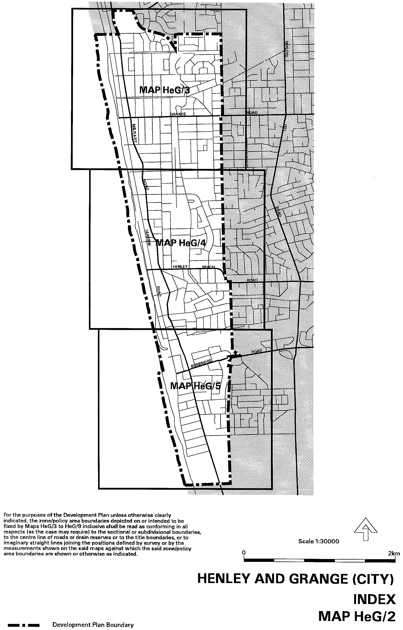
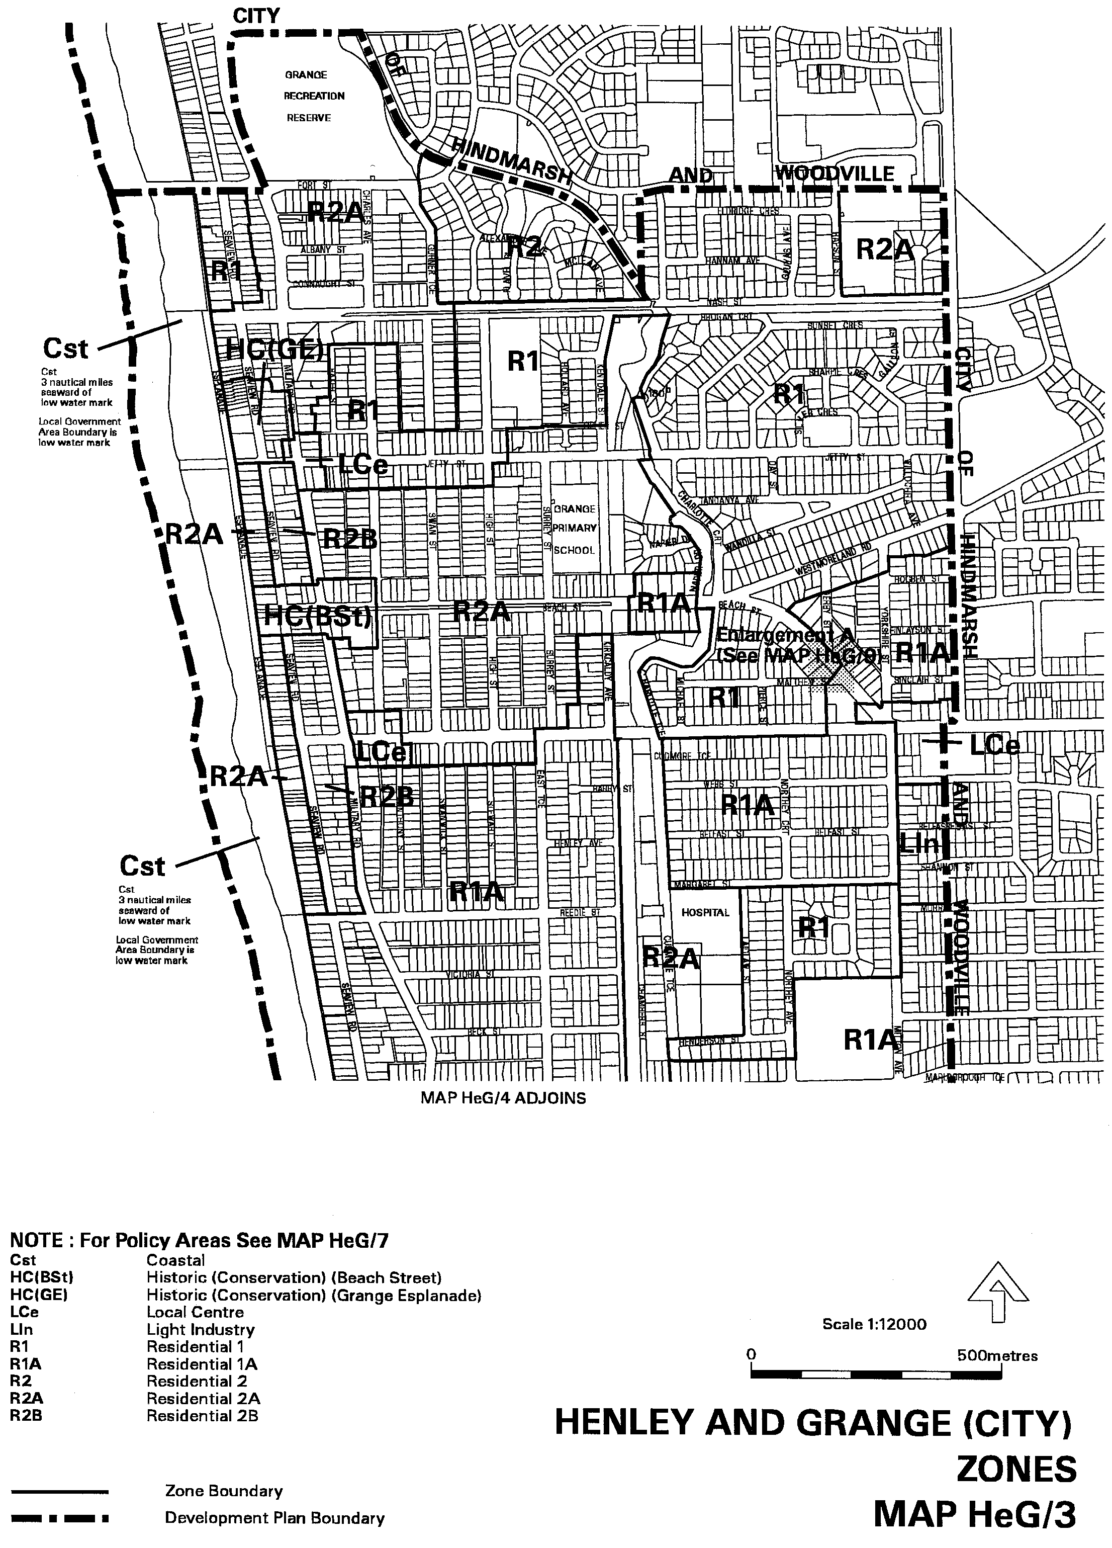
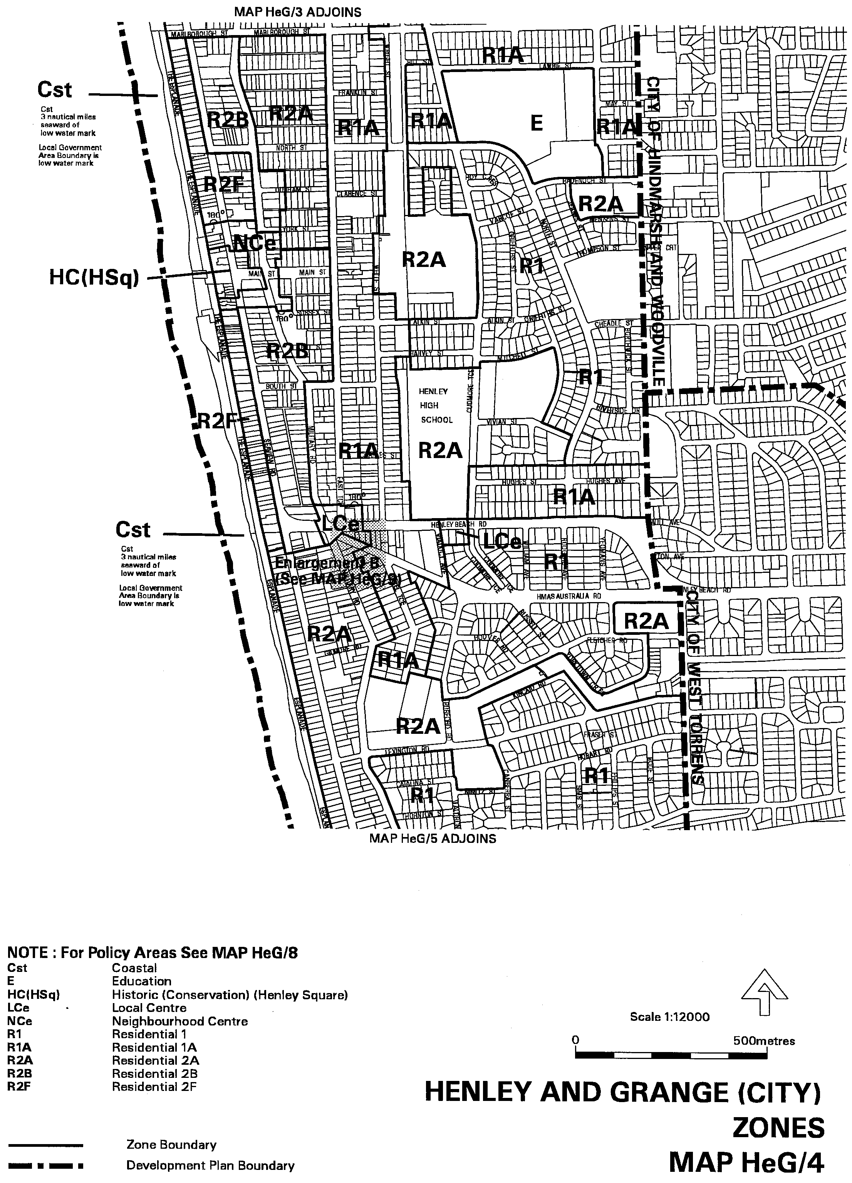
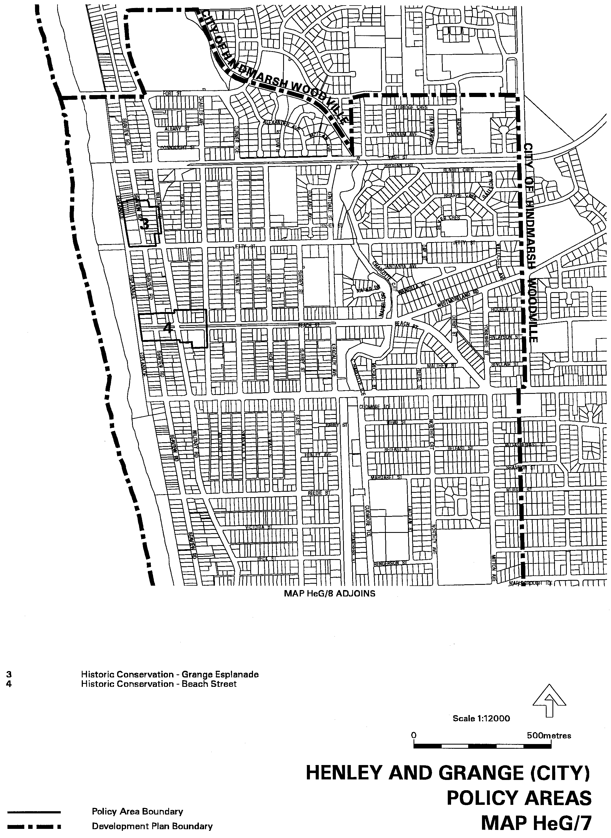
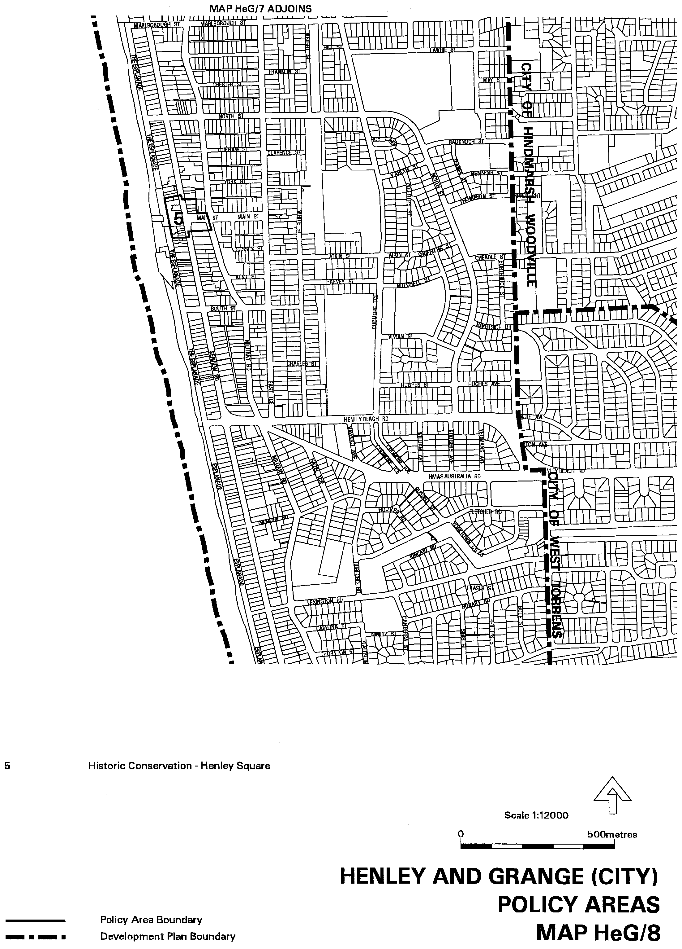
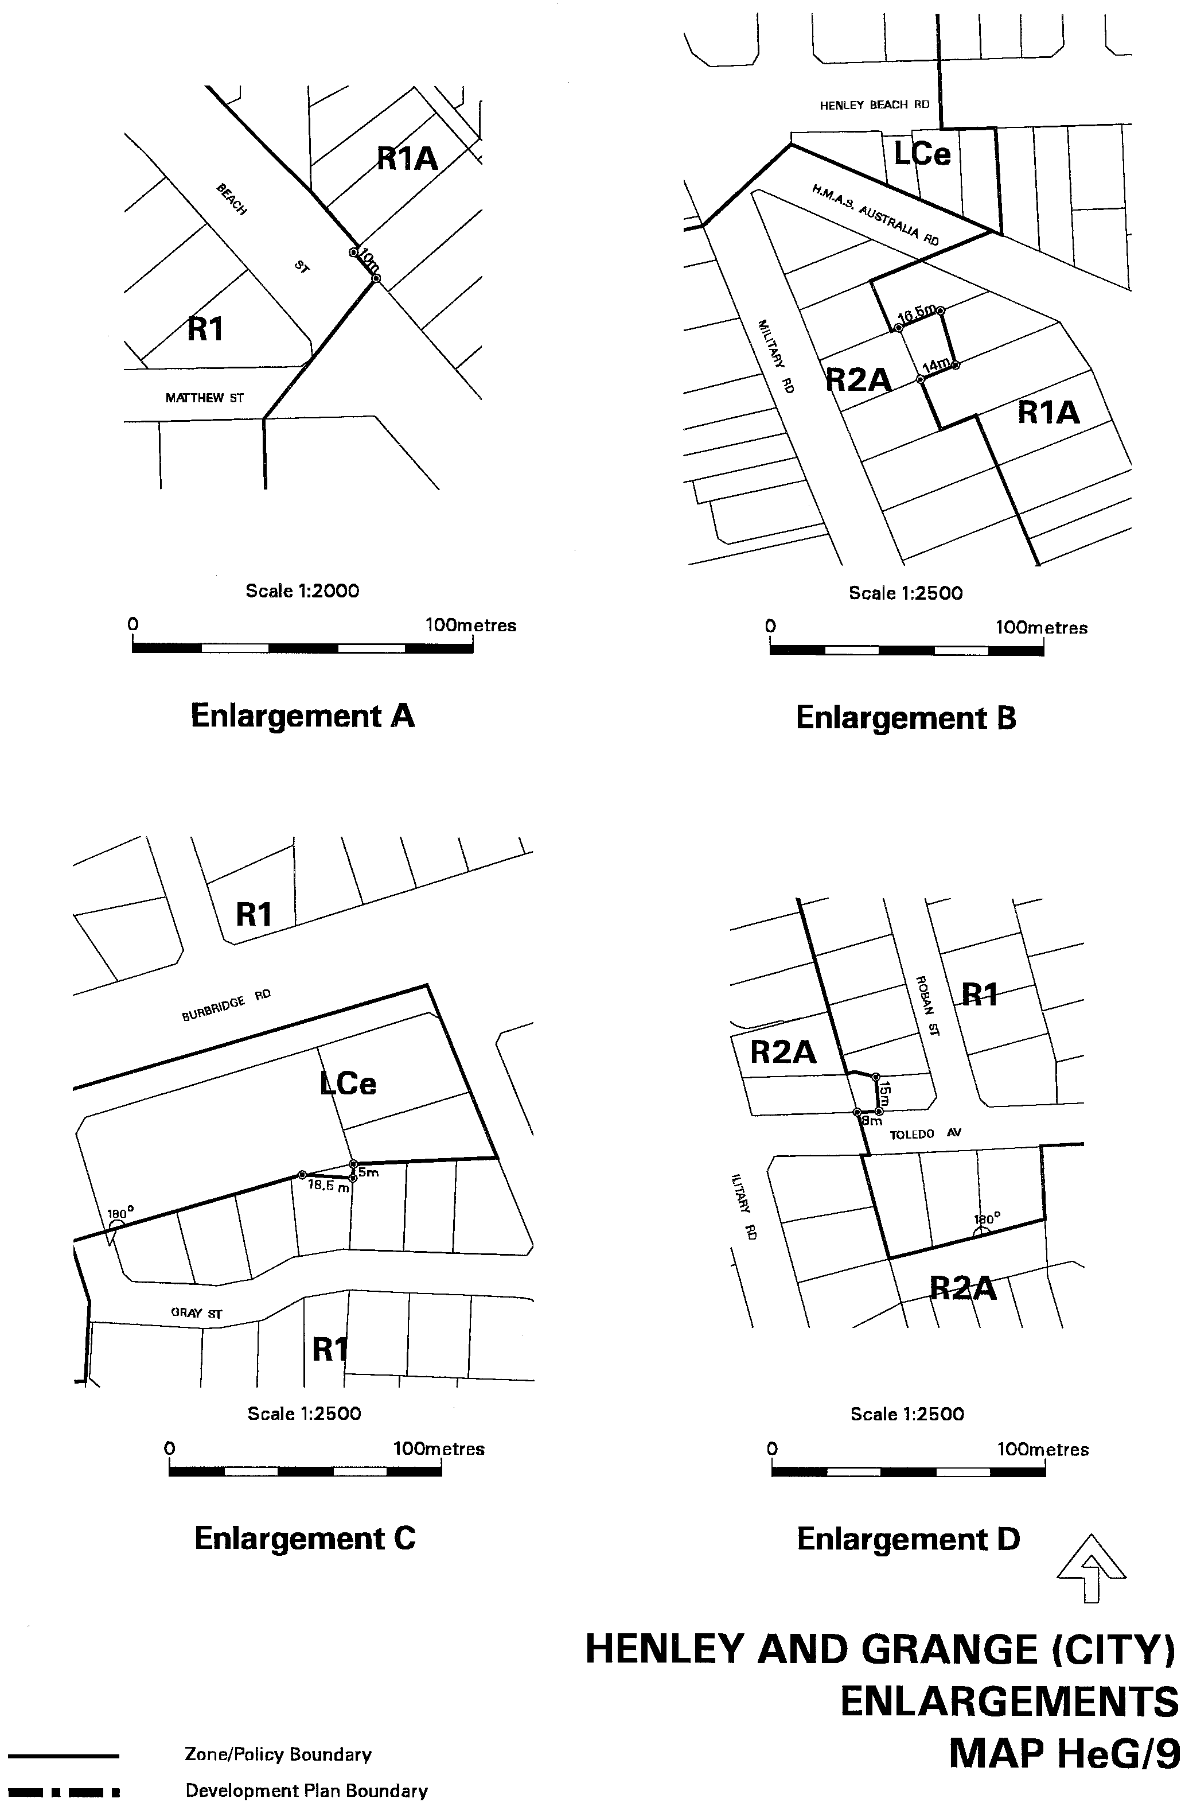
Dated 24 May 2001.
Diana Laidlaw, Minister for Transport and Urban Planning
PLN/99/0290

DEVELOPMENT ACT 1993, SECTION 29 (2) (b)
AMENDMENT TO THE CITY OF WEST TORRENS—WEST TORRENS (CITY) DEVELOPMENT PLAN
Preamble
It is necessary to amend the West Torrens (City) Development Plan dated 24 May 2001.
Notice
PURSUANT to Section 29 (2) (b) of the Development Act 1993, I, Diana Laidlaw, being the Minister administering the Act, amend:
The West Torrens (City) Development Plan dated 24 May 2001, as follows:
• Delete Maps WeT/21, 22 and 23.
• Insert Maps WeT/ 21, 22 and 23, as contained in Attachment ‘A’; and
• The Mapping cross-references appearing within the West Torrens (City) Development Plan are to be amended accordingly.
Attachment A
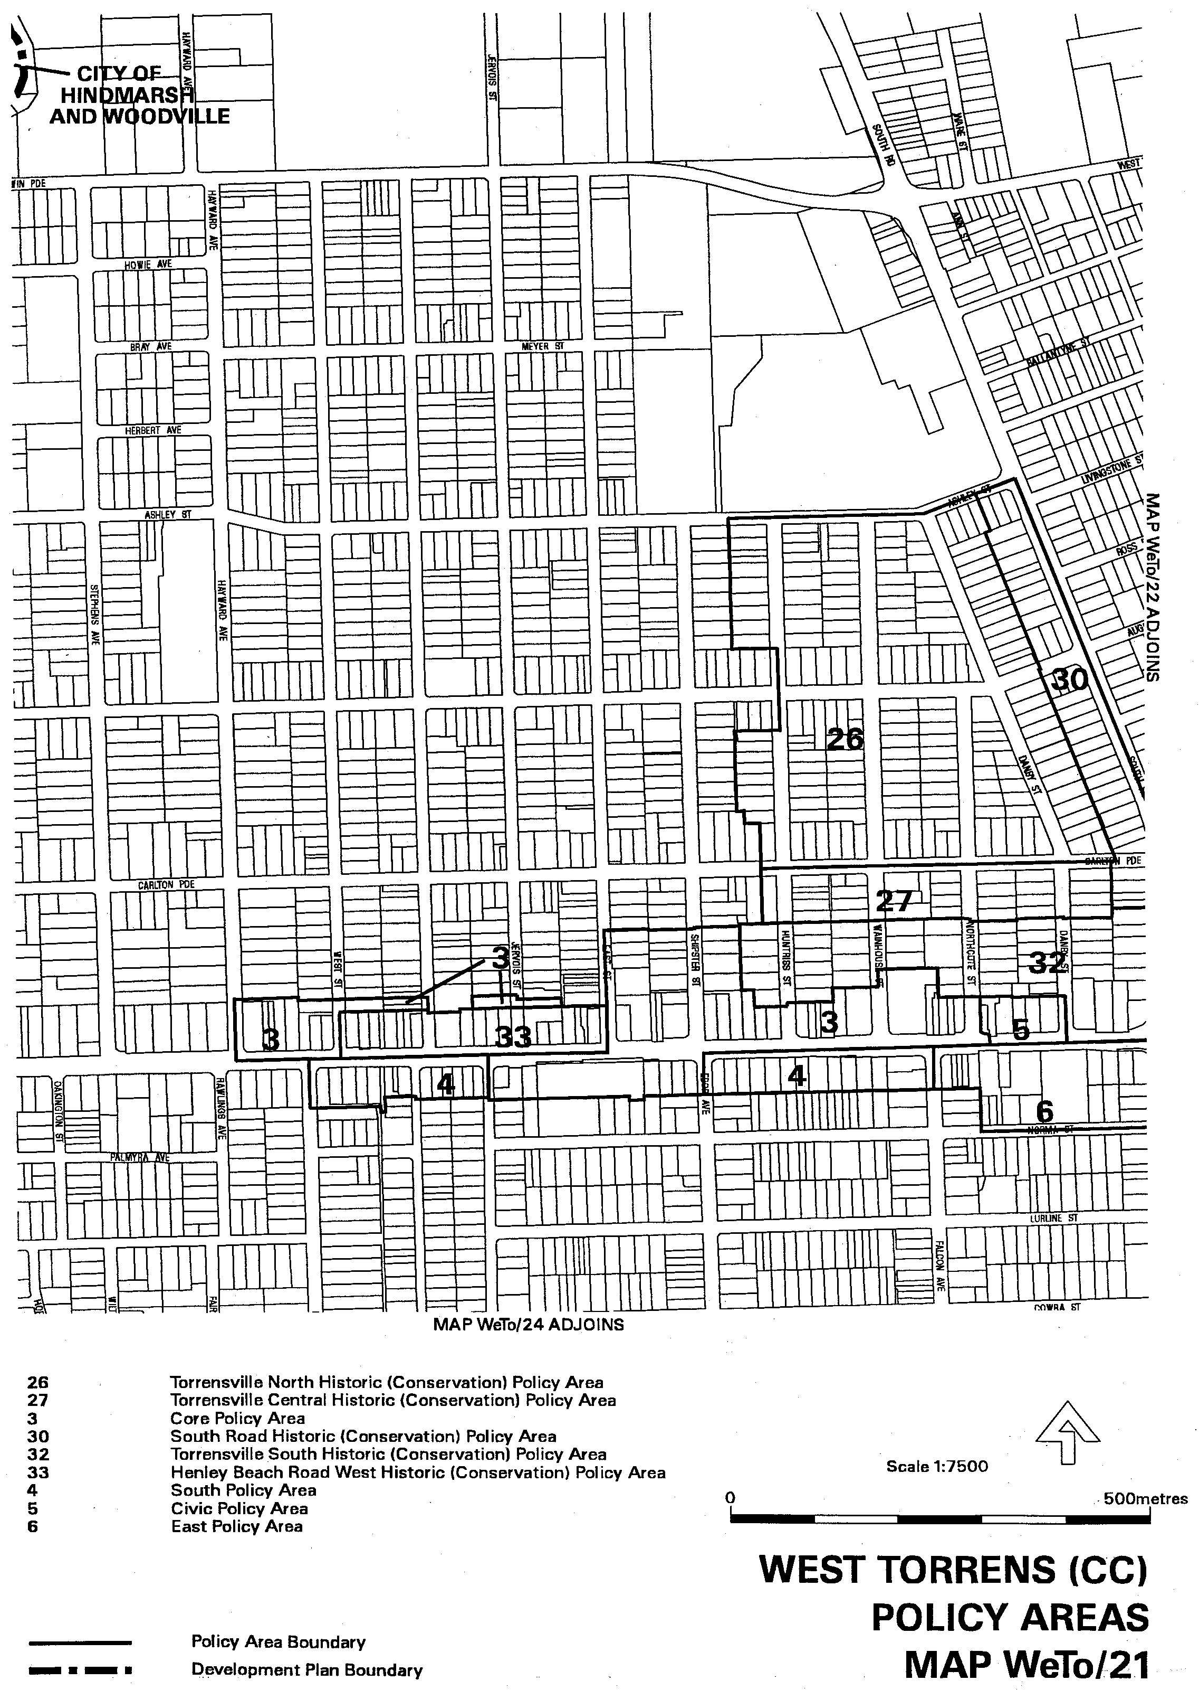
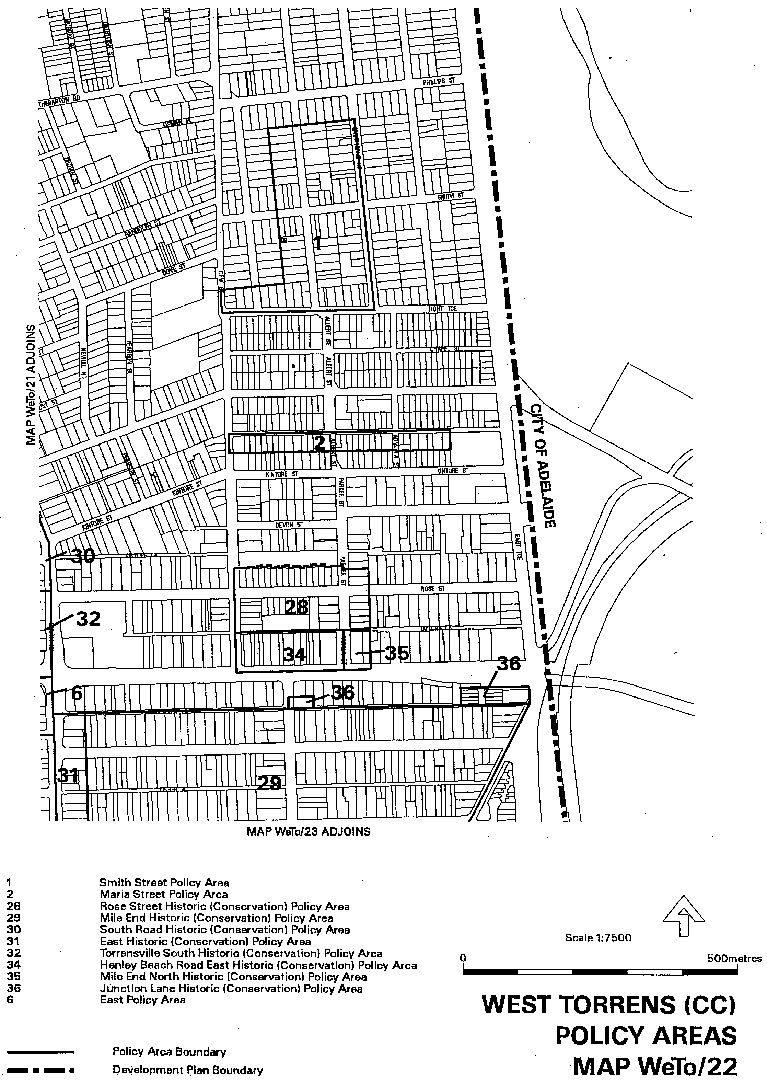
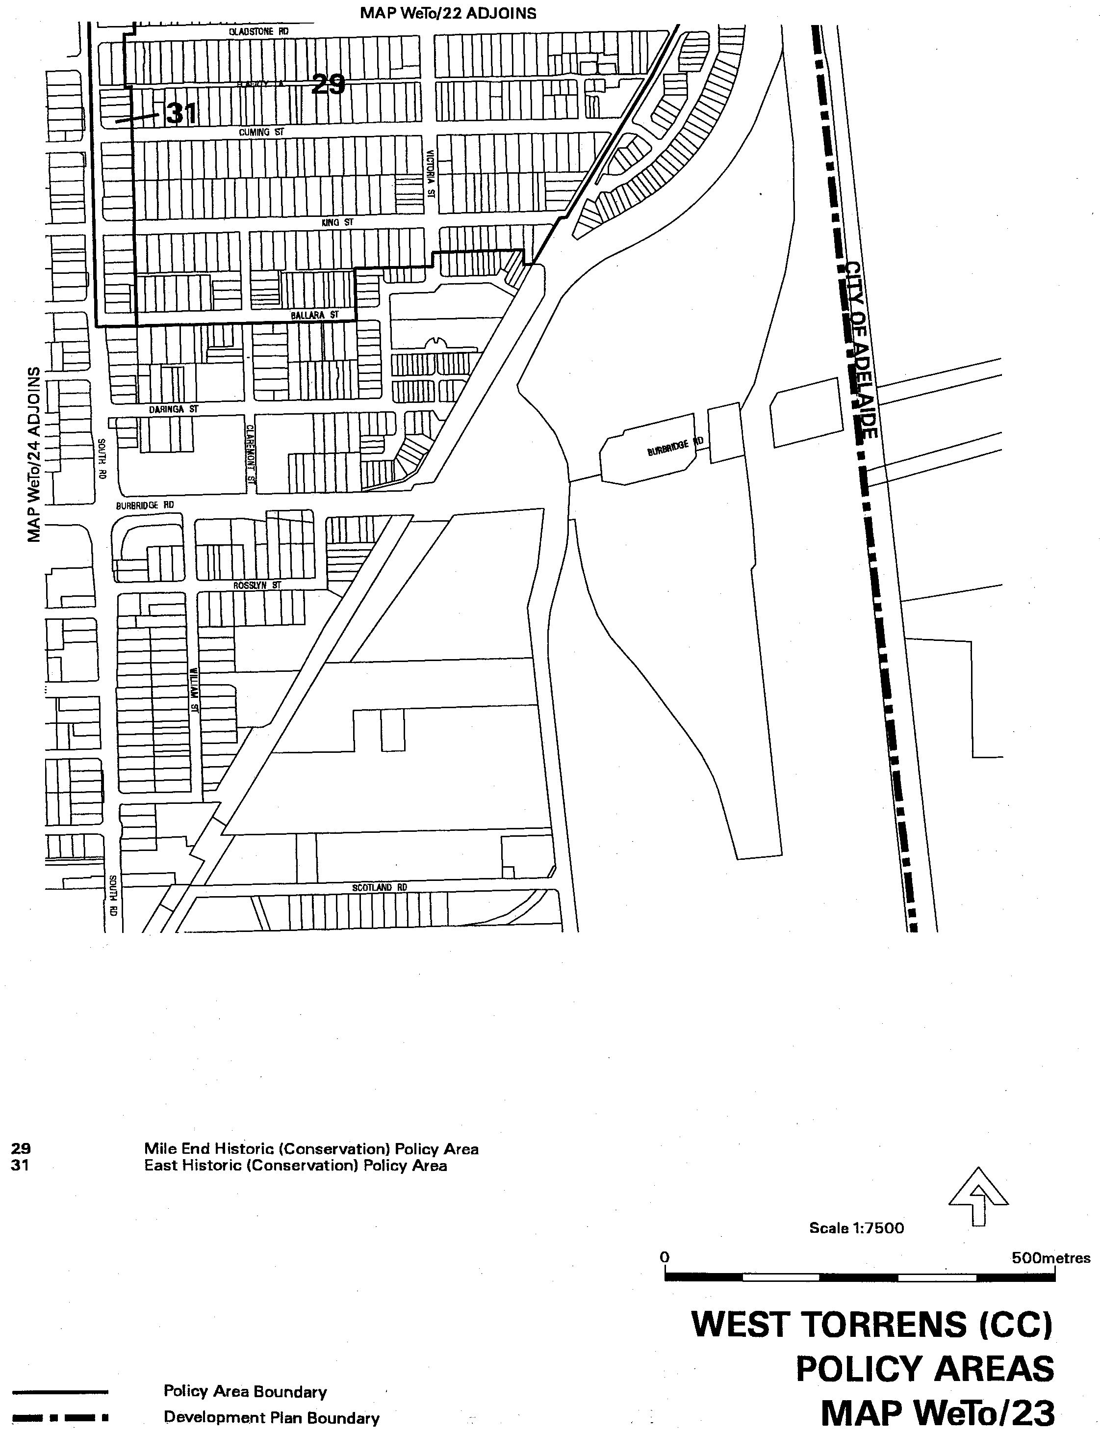
Dated 24 May 2001.
Diana Laidlaw, Minister for Transport and Urban Planning
PLN/99/0355

ENVIRONMENT PROTECTION ACT 1993
Exemption
THE following persons are exempt from section 75 of the Environment Protection Act 1993 subject to the provisions of Regulation 6 of the Regulations under the Environment Protection Act 1993 dated 27 October 1994 by virtue of owning or possessing equipment containing ozone depleting substances:
N. J. & T. McMullen Pty Ltd (2078); Warwick Adrian Joyce (42); Australian Broadcasting Corporation (1571); Gaetano D’Ettorre (59); Victor Piscopo (70); R. H. Fraser Nominees Pty Ltd (109); R. Vaughan and Joscelyn K. McWaters (111); A. E. & C. A. Pickering Pty Ltd (154); L. M. Refrigeration Service Pty Ltd (172); Winnall Motors Pty Ltd (209); Australian Motors (S.A.) Pty Ltd (233); Raymond Johns (276); Eglinton Bros Pty Ltd (280); Hogarth Motors Pty Ltd (290); Robert Charles Thomson (293); P. R. & K. R. Hood Pty Ltd (307); S. & J. Riley Nominees Pty Ltd (308); Gawler Farm Machinery Pty Ltd (309); Jeffrey Mark Kerley (312); Sellars Farm Service Pty Ltd (328); Boehringer Ingelheim Pty Ltd (336); Price’s Operations Pty Ltd (351); Hampstead Auto Electrical Pty Ltd (366); Davweir Pty Ltd (367); Electrolux Home Products Pty Ltd (463); Clisby Electrical Pty Ltd (468); Coonalpyn Farm Machinery Pty Ltd (473); Nancarrow Pty Ltd (474); Marion Air-Conditioning Pty Ltd (475); Malcolm Gardner (486); Road & Track Services (S.A.) Pty Ltd (494); Claude Black Motors Pty Ltd (512); Richard James McInerney (538); Griffin Auto Parts Pty Ltd (564); Epic Energy South Australia Pty Ltd (584); W. F. Murphy Nominees Pty Ltd (594); Warren Richard and Margaret Anne Johns (681); Herbert Kunzelmann (876); Robert John Butler (996); Cadbury Schweppes Pty Ltd (1006); Robert Walter Schmerl (1018); S.A. Water Corporation (1133); Redden’s Machinery Pty Ltd (1136); Jeffrey and Doreen Hall (1149); P. Z. Electrical Pty Ltd (1151); Morphett Vale Auto Electrics Pty Ltd (1154); Trevlyn Smith Electrical Pty Ltd (1224); PBS Refrigeration & Air Conditioning Pty Ltd (1225); Albert McIntosh Webster (1229); Anthony Glen Schmidtke (1232); M. W. & S. K. Hennessy Pty Ltd (1241); Australian Crash Repairs Pty Ltd (1361); Stevens Motors Pty Ltd (1381); Butterfields Services (S.A.) Pty Ltd (1451); Dent Motors Pty Ltd (1455); Keith Kimber (1466); Leslie Rodway and Nellie Madge (1475); Ozlead Pty Ltd (1481); Alfred George Dennis (1534); Taylor Motors Pty Ltd (1577); R. H. Schulz Pty Ltd (1579); Robert W. Watson (1653); A. Raptis & Sons Pty Ltd (1745); Nicholas John Knape (1809); E. K. Dunstan & Co. Pty Ltd (1817); William Ian Loughlin (1990); Mario Segulin (2079); K. M. & C. J. Lill Pty Ltd (2168); Trevor Fuller (2286); Catholic Diocese of Port Pirie Incorporated (2315); Ashley Smith (2353); Sandam Pty Ltd (2439); Hills Auto Electrical Pty Ltd (2449); David Brenton McKay (2457) Main North Pty Ltd (2488); Olaf Horst and Undine Elvira Zaworski (2618); Julie and Robert Searle (2707); Philrob Pty Ltd (2807); L. R. & C. A. Wiseman Nominees Pty Ltd (2808); Trevor McKay (2812); Doyle Motor Corporation Pty Ltd (2823); Hage & Co. Pty Ltd (2991); Warren Ludlow (3275); Bernie and Yvonne Schulz (3558); J. V. Crash Repairs Pty Ltd (3669); Silver Auto Centre Pty Ltd (3692); Northern Territory Freight Services Pty Ltd (3804); Peter Russo (4699); Kym Peter Crawford and Judith Ann Crawford (4764); P. S. Engelhardt Pty Ltd (4816); Don Pirrotta (4852); I. M. and A. E. Dickson (4954); Malcolm Allan and Judith Anne Cutts (4985); Shannahan Crash Repairs Pty Ltd (5056); Mark Andrew Blagrove (5095); Eric William Smith (5244); Dosill Pty Ltd (5292); Joseph Allan Ellis Bohlin (5404); Stephen Murray (5594); Terry Frahn (5672); Gary James Joseph (5968); Imerio Iammarino (6011); Ross John Beckmann (6040); Richard Charles Simpson (6293); Maxwell Cutts Pty Ltd (6375); John Harrison (6420); Jason Corey Harden and Paul Geoffrey Hayford (6784); Stephen Zeugofsge (6787); Alpha (S.A.) Pty Ltd (6798); Penrice Soda Products Pty Ltd (6829); Bruce Walker Refrigeration Pty Ltd (6919); Helios Electro Heat Pty Ltd (6933); David Walker (6970); Albert William George Russell (7005); Barry William Martin (7051); Peter and Kerryn Oates (7066); Christopher and Nalda Holland (7093); Jim Gerazounis (7168); Murray Pest & Weed Control (S.A.) Pty Ltd (7208); Angas Park Fruit Co Pty Ltd (7263); Mecair Engineering Pty Ltd (7372) B. & M. Stoeff Pty Ltd (7385); Selgar Systems Pty Ltd (7386); SAM Airconditioning Pty Ltd (7387); Watson Fitzgerald and Associates Pty Ltd (7390); Brett Hayward Mayger (7395); Chris Boundy (7399); Joseph Kennedy (7416); PRD Nominees Pty Ltd (7420); Gregory Milton and Jacqueline Rebecca Goding (7421); Lindsay John Hennessy (7455); Mattins Holdings Pty Ltd (7460); Stanislaw Parkitny (7463); Michael John Rushton (7480); Philip Andrew Atkinson (7492); Mark Jenkins (7502); Michael and Helen Zeunert (7505); Christopher Evans (7509); Max Hunt (7549); Janos Ellul (10021); Brian Potter (10206); Ian Thorley (10250); The Distribution Group Limited (10354); R., B. J., G. R. Simmonds Pty Ltd (10435); Spotless Services Limited (10842); Browntree Trading Company Proprietary Limited (10870); Uni-Chill Pty Ltd (10953); Anthony Gordon Sheridan (10959); David Scott Fillery (11090); Scott Treloar (11093); Anthony Zammit (6527).
G. Sclare, Manager, Licensing and Operations Services

FISHERIES ACT 1982: SECTION 59
TAKE notice that subject to section 59 of the Fisheries Act 1982, Philip J. Penalurick, P.O. Box 680, Port Lincoln, S.A. 5606 (or his registered masters) holder of Western Zone Abalone Fishery Licence No. W11, issued pursuant to the Scheme of Management (Abalone Fisheries) Regulations 1991 (hereinafter referred to as the ‘exemption holder’) is exempted from the provisions of Clause 60 of Schedule 1 of Fisheries (General) Regulations 2000 in that the exemption holder shall not be guilty of an offence when taking Roe’s abalone (Haliotis roei) which is undersize, from those waters defined in Schedule 2 (hereinafter referred to as the ‘exempted activity’) subject to the conditions specified in Schedule 1 from the date of gazettal of this notice until 2 July 2001.
Schedule 1
1. The exemption holder may only engage in the exempted activity at the direction of an officer from the South Australian Research and Development Institute.
2. Whilst engaged in the exempted activity, the exemption holder may only take Haliotis roei provided that it is not less than 60 mm in length at its greatest dimension. All abalone must be landed in the shell.
3. On any day the exemption holder engages in the exempted activity only abalone of the species (Haliotis roei) may be taken.
4. No more than one registered master may engage in the exempted activity on any one day.
5. The exemption holder may conduct the exempted activity in more than one area as defined in Schedule 2 on any one day, as directed by an officer of the South Australian Research and Development Institute, provided that a separate notification pursuant to condition 5 below has been made for each area prior to conducting any fishing activity in that area.
6. The exemption holder must notify the PIRSA Fisheries Compliance Unit on 1800 244 317 prior to engaging in the exempted activity with the following information:
(a) the name of the person making the call and the Western Zone Abalone Fishery Licence Number;
(b) the name of the registered master who will be conducting the exempted activity on that day;
(c) the date on which the exempted activity will take place;
(d) the port of departure;
(e) the designated area from Schedule 2 which is to be fished; and
(f) where the exemption holder is nominating to fish in an additional designated area from the previous nominated designated area on any one day, the exemption holder must wait at least 30 minutes prior to leaving the point from where the nomination was made.
7. Upon completion of the day’s fishing activities the exemption holder shall complete the Daily Research Data Logsheet provided including the following information:
• Drop Number;
• Fishing Location (each dive entry location using GPS marks in decimal minutes including seconds);
• Time Underwater;
• Swell;
• Number of H. Roei;
• Tag Number; and
• CDR Number.
The completed Daily Research Data Logsheets must be posted or delivered to the Chief Scientist, South Australian Research and Development Institute within seven days of the completion of the day’s fishing activities to which it relates.
8. Upon completion of the dive at each site and before landing, the exemption holder shall place the abalone in the bag supplied and complete the information on the tag provided including the date and CDR number. The catch is to be bagged separately for each dive location and the tag included with the catch. If more than one bag is taken in one dive location, the tag numbers are to be recorded in the row beneath the original on the Daily Research Data Logsheet provided.
The total number of bags for that day and the numbers of the tags placed on each bag shall be included on the CDR 1. The CDR 1 must be completed within 50 m of landing and the white and yellow copies of the CDR 1 must accompany the abalone to the fish processing premises.
9. The exemption holder must make a record in writing immediately at the conclusion of a fishing trip and before the abalone are consigned to a registered fish processor setting out details of the abalone taken during that fishing trip. This record must be completed within 50 m of the point of landing of the catch and before the catch is consigned to a nominated processor and/or taken onto processor premises where such premises are within 50 m of the point of landing or at the end of each day of fishing where the catch is not landed on that day. The details of such record shall be recorded on and be such as are sufficient to complete in triplicate a CDR 1 form.
10. All Haliotis roei taken pursuant to this notice shall be delivered to one of the registered fish processors detailed in Schedule 3 for weighing, within 48 hours of landing, within the State of South Australia.
11. The exemption holder shall not, during the period of this notice, take a combined quantity of Haliotis roei which exceeds 1 000 kg wholeweight.
12. The amount of Haliotis roei allocated pursuant to this notice is non-transferable.
13. The exemption holder shall not intentionally induce weight loss of abalone by any means.
14. The exemption holder whilst engaged in the exempted activity must conduct such activity from a boat registered pursuant to Western Zone Abalone Fishery Licence No. W11.
15. The exemption holder shall not contravene or fail to comply with the Fisheries Act 1982, or any other regulations made under that Act except where specifically exempted by this notice.
16. Whilst engaged in the exempted activity the exemption holder must have in his possession a copy of this notice and produce a copy of the notice if required by a PIRSA Fisheries Compliance Officer.
Schedule 2
AREA 1
Lipson Island Fishdown
All waters contained within the following boundaries:
latitude 34.2637° longitude 136.2667°, latitude 34.2638° longitude 136.2624°, latitude 34.2665° longitude 136.2667°, latitude 34.2665° longitude 136.2624°.
Grindal Island Fishdown
All waters contained within the following boundaries:
latitude 34.9048° longitude 136.0398°, latitude 34.9050° longitude 136.0234°, latitude 34.9228° longitude 136.0400°, latitude 34.9230° longitude 136.0236°.
AREA 2
Venus Bay Fishdown
All waters contained within the following boundaries:
latitude 33.2301° longitude 134.6413°, latitude 33.2300°, longitude 134.6301°, latitude 33.2469° longitude 134.6412°, latitude 33.2469° longitude 134.6301°.
Kiana Beach Fishdown
All waters contained within the following boundaries:
latitude 34.0252° longitude 135.2707°, latitude 34.0252° longitude 135.2599°, latitude 34.0342° longitude 135.2708°, latitude 34.0342° longitude 135.2599°.
AREA 3
Granite Island Fishdown
All waters contained within the following boundaries:
latitude 33.0152° longitude 134.1339°, latitude 33.0156° longitude 134.1251°, latitude 33.0191° longitude 134.1339°, latitude 33.0195° longitude 134.1251°.
Highcliff Fishdown
All waters contained within the following boundaries:
latitude 32.8677° longitude 134.1021°, latitude 32.8677° longitude 134.0968°, latitude 32.8768° longitude 134.1020°, latitude 32.8767° longitude 134.0967°.
AREA 4
Clare Bay Fishdown
All waters contained within the following boundaries:
latitude 31.9520° longitude 132.6882°, latitude 31.9519° longitude 132.6813°, latitude 31.9568° longitude 132.6881°, latitude 31.9567° longitude 132.6812°.
Pt Sinclair Fishdown
All waters contained within the following boundaries:
latitude 32.0995° longitude 132.9917°, latitude 32.0994° longitude 132.9864°, latitude 32.1063° longitude 132.9916°, latitude 32.1062° longitude 132.9863°.
Schedule 3
FP0008
Western Abalone Processors Pty Ltd
P.O. Box 914
Port Lincoln, S.A. 5606
FP0120
Smoothpool Nominees Pty Ltd
Trading as Blancheport Fisheries
12 Alfred Terrace
Streaky Bay, S.A. 5680
FP0132
Yorkeshell Pty Ltd
Trading as Australian Southern Seafood
P.O. Box 1579
Port Lincoln, S.A. 5606
FP0142
Eyrewoolf Enterprises
P.O. Box 73
Streaky Bay, S.A. 5680
Dated 18 May 2001.
W. Zacharin, Director of Fisheries

FISHERIES ACT 1982: SECTION 59
TAKE notice that subject to section 59 of the Fisheries Act 1982, Philip J. Penalurick, P.O. Box 680, Port Lincoln, S.A. 5606 (or his registered masters), holder of Western Zone Abalone Fishery Licence No. W11, issued pursuant to the Scheme of Management (Abalone Fisheries) Regulations 1991 (hereinafter referred to as the ‘exemption holder’) is exempted from the provisions of Clause 60 of Schedule 1 of the Fisheries (General) Regulations 2000 in that the exemption holder shall not be guilty of an offence when taking Roe’s abalone (Haliotis roei) which is undersize, from those waters defined as the Western Zone in the Scheme of Management (Abalone Fisheries) Regulations 1991 (hereinafter referred to as the ‘exempted activity’) subject to the conditions specified in Schedule 1 from the date of gazettal of this notice until 2 July 2001.
Schedule 1
1. Whilst engaged in the exempted activity, the exemption holder may only take Haliotis roei provided that it is not less than 75 mm in length at its greatest dimension. All abalone must be landed in the shell.
2. On any day the exemption holder engages in the exempted activity only abalone of the species (Haliotis roei) may be taken.
3. No more than one registered master may engage in the exempted activity on any one day.
4. The exemption holder may conduct the exempted activity in more than one area as defined in Schedule 2 on any one day, provided that a separate notification pursuant to condition 5 below has been made for each area prior to conducting any fishing activity in that area.
5. The exemption holder must notify the PIRSA Fisheries Compliance Unit on 1800 244 317 prior to engaging in the exempted activity with the following information:
(a) the name of the person making the call and the Western Zone Abalone Fishery Licence Number;
(b) the name of the registered master who will be conducting the exempted activity on that day;
(c) the date on which the exempted activity will take place;
(d) the port of departure;
(e) the designated area from Schedule 2 which is to be fished; and
(f) where the exemption holder is nominating to fish in an additional designated area from the previous nominated designated area on any one day, the exemption holder must wait at least 30 minutes prior to leaving the point from where the nomination was made.
6. Upon completion of the day’s fishing activities the exemption holder shall complete the Daily Research Data Logsheet provided including the following information:
• Drop Number;
• Fishing Location (each dive entry location using GPS marks in decimal minutes including seconds);
• Time Underwater;
• Swell;
• Number of H. Roei;
• Tag Number; and
• CDR Number.
The completed Daily Research Data Logsheets must be posted or delivered to the Chief Scientist, South Australian Research and Development Institute within seven days of the completion of the day’s fishing activities to which it relates.
7. Upon completion of the dive at each site and before landing, the exemption holder shall place the abalone in the bag supplied and complete the information on the tag provided including the date and CDR number. The catch is to be bagged separately for each dive location and the tag included with the catch. If more than one bag is taken in one dive location, the tag numbers are to be recorded in the row beneath the original on the Daily Research Data Logsheet provided.
The total number of bags for that day and the numbers of the tags placed on each bag shall be included on the CDR 1. The CDR 1 must be completed within 50 m of landing and the white and yellow copies of the CDR 1 must accompany the abalone to the fish processing premises.
8. The exemption holder must make a record in writing immediately at the conclusion of a fishing trip and before the abalone are consigned to a registered fish processor setting out details of the abalone taken during that fishing trip. This record must be completed within 50 m of the point of landing of the catch and before the catch is consigned to a nominated processor and/or taken onto processor premises where such premises are within 50 m of the point of landing or at the end of each day of fishing where the catch is not landed on that day. The details of such record shall be recorded on and be such as are sufficient to complete in triplicate a CDR 1 form.
9. All Haliotis roei taken pursuant to this notice shall be delivered to one of the registered fish processors detailed in Schedule 3 for weighing, within 48 hours of landing, within the State of South Australia.
10. The exemption holder shall not, during the period of this notice, take a combined quantity of Haliotis roei which exceeds 1 000 kg wholeweight.
11. The amount of Haliotis roei allocated pursuant to this notice is non-transferable.
12. The exemption holder shall not intentionally induce weight loss of abalone by any means.
13. The exemption holder whilst engaged in the exempted activity must conduct such activity from a boat registered pursuant to Western Zone Abalone Fishery Licence No. W11.
14. The exemption holder shall not contravene or fail to comply with the Fisheries Act 1982, or any other regulations made under that Act except where specifically exempted by this notice.
15. Whilst engaged in the exempted activity the exemption holder must have in his possession a copy of this notice and produce a copy of the notice if required by a PIRSA Fisheries Compliance Officer.
Schedule 2
AREA 1
All waters east of the Western/Central zone boundary (longitude 136.5°E) to Shoal Point (longitude 135.5°E) excluding the following sub-area 1 in which no activity may take place:
All waters contained within the following boundaries:
latitude 34.2440° longitude 136.2690°, latitude 34.2441° longitude 136.2611°, latitude 34.2568° longitude 136.2690°, latitude 34.2569° longitude 136.2611° and excluding the following sub-areas 2 and 3 in which fishdown activities may be conducted pursuant to separate exemption.
Lipson Island Fishdown
All waters contained within the following boundaries:
latitude 34.2637° longitude 136.2667°, latitude 34.2638° longitude 136.2624°, latitude 34.2665° longitude 136.2667°, latitude 34.2665° longitude 136.2624°.
Grindal Island Fishdown
All waters contained within the following boundaries:
latitude 34.9048° longitude 136.0398°, latitude 34.9050° longitude 136.0234°, latitude 34.9228° longitude 136.0400°, latitude 34.9230° longitude 136.0236°.
AREA 2
All waters extending from Shoal Point (135.5°E) to Cape Radstock (longitude 134.33°E) excluding the following sub-area 1 in which no activity may take place:
All waters contained within the following boundaries:
latitude 33.2046° longitude 134.6276°, latitude 33.2045° longitude 134.5892°, latitude 33.2449° longitude 134.6275°, latitude 33.2448° longitude 134.5891° and excluding the following sub-areas 2 and 3 in which fishdown activities may be conducted pursuant to separate exemption.
Venus Bay Fishdown
All waters contained within the following boundaries:
latitude 33.2301° longitude 134.6413°, latitude 33.2300°, longitude 134.6301°, latitude 33.2469° longitude 134.6412°, latitude 33.2469° longitude 134.6301°.
Kiana Beach Fishdown
All waters contained within the following boundaries:
latitude 34.0252° longitude 135.2707°, latitude 34.0252° longitude 135.2599°, latitude 34.0342° longitude 135.2708°, latitude 34.0342° longitude 135.2599°.
AREA 3
All waters extending from Cape Radstock (longitude 134.33°E) to Point Bell (longitude 133.13°E) excluding the following sub-area 1 in which no activity may take place:
All waters contained within the following boundaries:
latitude 32.9312° longitude 134.1442°, latitude 32.9310° longitude 134.1122°, latitude 32.9492° longitude 134.1441°, latitude 32.9490° longitude 134.1120° and excluding the following sub-areas 2 and 3 in which fishdown activities may be conducted pursuant to separate exemption.
Granite Island Fishdown
All waters contained within the following boundaries:
latitude 33.0152° longitude 134.1339°, latitude 33.0156° longitude 134.1251°, latitude 33.0191° longitude 134.1339°, latitude 33.0195° longitude 134.1251°.
Highcliff Fishdown
All waters contained within the following boundaries:
latitude 32.8677° longitude 134.1021°, latitude 32.8677° longitude 134.0968°, latitude 32.8768° longitude 134.1020°, latitude 32.8767° longitude 134.0967°.
AREA 4
All waters extending from Point Bell (longitude 133.13°E) to a point approximately 5 km south-east of the eastern extreme of the Great Australian Bight Marine Park (longitude 131.55°E) excluding the following sub-areas 2 and 3 in which fishdown activities may be conducted pursuant to separate exemption:
Clare Bay Fishdown
All waters contained within the following boundaries:
latitude 31.9520° longitude 132.6882°, latitude 31.9519° longitude 132.6813°, latitude 31.9568° longitude 132.6881°, latitude 31.9567° longitude 132.6812°.
Pt Sinclair Fishdown
All waters contained within the following boundaries:
latitude 32.0995° longitude 132.9917°, latitude 32.0994° longitude 132.9864°, latitude 32.1063° longitude 132.9916°, latitude 32.1062° longitude 132.9863°.
Schedule 3
FP0008
Western Abalone Processors Pty Ltd
P.O. Box 914
Port Lincoln, S.A. 5606
FP0120
Smoothpool Nominees Pty Ltd
Trading as Blancheport Fisheries
12 Alfred Terrace
Streaky Bay, S.A. 5680
FP0132
Yorkeshell Pty Ltd
Trading as Australian Southern Seafood
P.O. Box 1579
Port Lincoln, S.A. 5606
FP0142
Eyrewoolf Enterprises
P.O. Box 73
Streaky Bay, S.A. 5680
Dated 18 May 2001.
W. Zacharin, Director of Fisheries

FISHERIES ACT 1982
Marine Mollusc Farming Licence FM00146
(Previous Licence No. F827)
Licence to Farm Fish under section 53 of the Fisheries
Act 1982
THE Minister for Primary Industries and Resources (‘the Minister’) hereby grants to:
Gregory M. Lawrence (20112)
Lot 2, Weashir Street
Wangary, S.A. 5607
a licence to occupy and use the waters and airspace over the land specified in Item 1 of Schedule 1 of this licence (‘the site’) for the purpose of farming and taking the permitted species (‘the permitted use’) for the period commencing on 1 July 2000 and ending, subject to any earlier termination under this licence, on 30 June 2001 (‘the term’) subject to the following terms and conditions:
Conditions of This Licence
1. Marked-off Areas
1.1 Subject to section 53A of the Fisheries Act 1982, this licence does not entitle the licensee to exclusive rights of entry to and occupation of the site. The rights granted by this licence are exercisable by the licensee in common with any other occupiers of the site from time to time.
1.2 For the purposes of section 53A of the Fisheries Act 1982, the marked-off areas within the site are that area or those areas marked-off or indicated in the manner set out in Item 2 of Schedule 1 of this licence.
2. Permitted Species
The licensee:
2.1 must not farm or introduce any species at the site other than the permitted species referred to in Schedule 2; and
2.2 must not take any wild fish from the site except for recreational purposes.
3. Permitted Use
The licensee must not use the site for any purpose other than the permitted use.
4. Permitted Methods
4.1 The licensee must, in undertaking the permitted use, take all reasonable and practicable measures to prevent or minimise damage to the environment. Without limiting the generality of the foregoing, the licensee:
4.1.1 must ensure the total length of each unit does not exceed 3 km of longline or 1 km of racking per hectare, and each unit must be at least 5 m from any other unit;
4.1.2 must not use the anti-fouling chemical tributyltin (TBT) on any equipment used at the site;
4.1.3 must not use any chemical or drug for either therapeutic or prophylactic purpose except with the prior approval of the Minister;
4.1.4 must undertake an environmental monitoring program approved by the Minister and as specified in Clause 4.3;
4.1.5 must not introduce the permitted species to the site before the approval of the environmental monitoring program referred to in 4.1.4 by the Minister;
4.1.6 must comply with the schedule of reporting for the environmental monitoring program as pres-cribed in Schedule 6 and submit the final results of the environmental monitoring program to the Minister 30 days before expiry of the term of this licence.
4.2 SASQAP
4.2.1 It is a condition of your licence to farm bivalve molluscs that only shellfish from Classified and Approved areas under the South Australian Shellfish Quality Assurance Program (SASQAP) may be sold for human consumption.
4.2.2 The licensee must continue to meet all the regulations required under the Food Standards Code to produce a product safe for human consumption.
4.3 The licensee must submit a draft environmental monitoring program to the Minister for approval within 60 days of the grant of the licence by the Minister. The draft environmental monitoring program must include the qualifications and experience of the person(s) designing and undertaking the program and address the matters listed in Schedule 5.
5. Marking and Maintaining the Site
The licensee:
5.1 must ensure that the site is maintained in a good, tidy and safe condition to the satisfaction of the Minister;
5.2 must remove and lawfully dispose of any waste or debris on the site as soon as is reasonably practicable and in particular must comply with any guidelines issued from time to time by the Minister in relation to the removal from the site of any unhealthy or dead fish;
5.3 must maintain all buoys, crosses, and markers on the site in good condition and in accordance with the colours specified in Schedule 1 of this licence; and
5.4 must mark the site boundary in accordance with the requirements of the Minister for Transport.
6. Site Inspection and Supervision
The licensee:
6.1 must at all times permit the Minister, his employees, agents or contractors or any employees, agents or contractors of the Crown to enter the site for the purposes of inspecting the site, the sea floor and the flora and fauna on or in the vicinity of the site; and
6.2 must comply with all reasonable directions of any such person authorised by the Director of Fisheries to inspect the conduct of the licensee’s activities at the site.
7. Fees and Returns
The licensee:
7.1 must pay to the Minister the licence fee in accordance with Item 1 of Schedule 3 of this licence;
7.2 must on or before 31 January and 31 July during the term, submit to the Minister a return supplying all of the information described in Schedule 4 of this licence.
8. Public Risk Insurance
The licensee must at its own cost during the term maintain in full force and effect in respect of the site and the permitted use a policy of public risk insurance in the joint names of the licensee and the Minister. The limits of public risk must not be less than the amount specified in Item 2 of Schedule 3 of this licence, or such other amount as the Minister may from time to time reasonably require. A policy of insurance or copy thereof or a certificate of insurance must be produced by the licensee to the Minister on written request.
9. Guarantee or Indemnity Scheme
The licensee must either:
9.1 provide a guarantee from its bankers to the amount specified in Item 3 of Schedule 3; or
9.2 contribute to an indemnity scheme established for the aquaculture and fisheries industry and approved by the Minister,
to and in favour of and for the benefit of the Minister by way of security for the due and punctual performance by the licensee of the terms and conditions of this licence and in particular the obligations of the licensee to rehabilitate the site immediately prior to the expiration or sooner determination of the term of this licence. Such guarantee or indemnity scheme must have effect from the date of commencement of the term.
10. No Assignment
The licensee must not assign or sublet or deal in any other way with any interest in this licence.
11. Variation and Cancellation
11.1 The Minister may without prior notice vary or cancel this licence immediately during the term for the purposes of preventing or minimising any damage or threat of damage to the environment. For the purpose of this condition the Minister may have regard to but is not limited by the following considerations:
11.1.1 the results of monitoring undertaken pursuant to Clause 4.1.5;
11.1.2 the results of any other monitoring as may from time to time be carried out; or
11.1.3 such other relevant information within the knowledge of the Minister.
11.2 Subject to and without limiting Condition 13.1, in the event of breach by the licensee of any term or condition of this licence, the Minister may:
11.2.1 give to the licensee written notice of such breach and the Minister’s requirements for rectification thereof; or
11.2.2 cancel this licence for failure to comply with such requirements for rectification.
11.3 The Minister may cancel this licence if the licensee is a body corporate, and any of the following occur:
11.3.1 the licensee is unable to pay its debts as and when they fall due or is otherwise insolvent;
11.3.2 an order is made for the winding up or liquidation of the licensee;
11.3.3 the licensee enters into a scheme of arrange-ment, compromise, moratorium or other form of composition with its creditors or any class of its creditors;
11.3.4 a receiver, a manager or a receiver and manager, a company administrator or other insolvency administrator is appointed to the licensee; or
11.3.5 a mortgagee, chargee or other encumbran-cee is appointed over or takes possession of or appoints an agent to take possession of all or any of the licensee’s assets.
11.4 The Minister may cancel this licence if the licensee is an individual, and the licensee:
11.4.1 becomes bankrupt or assigns its estate or enters into a deed of arrangement or other form of composition for the benefit of the licensee’s creditors; or
11.4.2 is convicted of an indictable offence.
11.5 Cancellation of this licence by the Minister shall be without prejudice to any rights, remedies or actions that the Minister may have against the licensee in respect of any antecedent breach by the licensee of the terms and conditions contained in this licence.
Granted by the General Manager Aquaculture, delegate for the purposes of section 53 of the Minister responsible for adminis-tration of the Fisheries Act 1982, on 16 May 2001.
I. Nightingale, General Manager Aquaculture
Schedule 1
Item 1—The Site
Area applicable to this licence:
Licensed Area Licensed
Hectares
AGD 66—Zone 53
531459E 6177465N 2
531512E 6177522N
531512E 6177678N
531412E 6177678N
531412E 6177455N
All St Andrew’s crosses must be marked with the site’s unique ‘FM number’; that is the licence number.
Item 2—Marked-off Areas
[Co-ordinates of developed areas within the site to be provided by the licensee].
White buoys of at least 12 inches in diameter must be placed around the whole of the perimeter of the developed areas within the site at a distance of no less than 50 m from one another.
Schedule 2
Item 1—Permitted Species
The Director of Fisheries has, pursuant to section 50 (2) of the Act, issued a permit for the release of the fish specified in this Schedule:
Pacific Oysters (Crassostrea gigas)
Item 2—Permitted Farming Methods
Longlines
The total length of each unit must not exceed 3 km of longline not less than 3 m apart, or 1 km of racking per hectare, and each unit must be at least 5 m from any other unit.
Schedule 3
Item 1—Fees
Annual licence fees are:
$
FRDC Levy per hectare 2 at $9.50 each 19.00
EMP Fee per hectare 2 at $17.70 each 35.40
Base Licence Fee per hectare 2 at $66 each 132.00
SASQAP (Classified Area) per hectare 2 at $80
each 160.00
Total Annual Licence Fee 346.40
Quarterly Instalments 86.60
Item 2—Insurance
Ten million dollars ($10 000 000).
Item 3—Guarantee
Ten thousand dollars ($10 000).
Schedule 4
Returns
The licensee must submit the following information to the Minister, c/o General Manager Aquaculture SA, 14th Floor, 25 Grenfell Street, G.P.O. Box 1625, Adelaide, S.A. 5000 on or before 31 January and 31 July during the term of this licence:
1. Name of licensee.
2. Address of licensee.
3. Species of fish farmed and held on the site.
4. Location of aquaculture operation.
5. Period covered by return.
6. Number of life stage of each species of fish held.
7. Number, weight and value of each species of fish held.
8. Details of any disease detected in any fish kept.
9. Source (whether interstate or intrastate) of any stock acquired and date of acquisition (if relevant, include name of authority that provided certification that stock was free from disease).
10. If any fish were brought into the State, the number of fish and the life stage of the fish.
11. If fish were brought into the State, the purpose for which they were brought in.
12. Method of disposal of water and packaging use for transporting the fish.
13. If any disease or symptom of disease occurred in the acquired fish.
14. Method of disposal of diseased or dead fish and the number disposed of.
15. Signature, date and telephone number.
16. Use of any chemicals for fish husbandry—type of chemical and quantity used, purpose and date of use.
Schedule 5
Environmental Monitoring Program
MATTERS TO BE ADDRESSED
The monitoring program should address the following matters in relation to the permitted use:
Farm Management
1. Approximate layout of all structures on the site during the term including location, number and size.
2. Growth and condition of the permitted species.
3. Occurrence of disease incidents in the permitted species.
Water Quality
1. Phytoplankton including species composition and abun-dance.
2. Status of the site under the South Australian Shellfish Quality Assurance Program during the term (including closures).
Feral Oysters
Presence and numbers of feral oysters.
Benthic Sediments
1. Sedimentation.
2. Movement of sand.
Benthic Fauna and Flora
Benthic macro-flora communities including composition, distribution and abundance.
METHODOLOGY
Draft Environmental Monitoring Program
The draft environmental monitoring program should include an initial assessment of the site and analyse the variability of parameters to be measured to identify appropriate numbers of replicates and sample sizes for statistical rigour.
Control Sites
In addition to the site, the draft environmental monitoring program should identify appropriate control sites at which monitoring will occur. At least two controls should be identified at increasing distance from the site. At least one control site must be located more than 1 km from the site.
Video Transects
Video transects should be used to assess broad scale changes in sediment consistency, presence of farming waste and the composition and abundance of macro-flora communities.
Video transects must be collected using equipment capable of producing a clear and well lit image. Transects must be at least 50 m long and a scale must be clearly visible on the video at all times. The location of video transects must be identified on a map attached to the environmental monitoring report. Each transect must be identified on the video with a unique transect number.
Report
The environmental monitoring report must be legible and contain a declaration regarding the authenticity and source of all data and results contained in the report. This declaration must be signed by the licence holder and the person(s) conducting the monitoring program.
The report must include an assessment of the results of the monitoring program against the provisions of the Environment Protection (Marine) Policy 1994, and must be accompanied by all raw data, video footage and diver notes.
Schedule 6
Schedule of Environmental Monitoring Reports
The licensee must submit a final environmental monitoring program report within 12 months of the commencement of this licence to the Minister, c/o General Manager Aquaculture SA, 14th Floor, 25 Grenfell Street, G.P.O. Box 1625, Adelaide, S.A. 5000.

FISHERIES ACT 1982: SECTION 59
TAKE note that the notice made under section 59 of the Fisheries Act 1982, and published in the South Australian Government Gazette on page numbers 786 and 787, dated 27 February 2001, referring to Leonard S. Newton and the taking of undersize Roe’s abalone, is hereby revoked.
Dated 18 May 2001.
W. Zacharin, Director of Fisheries

FISHERIES ACT 1982: SECTION 59
TAKE note that the notice made under section 59 of the Fisheries Act 1982, and published in the South Australian Government Gazette on page numbers 774 and 775, dated 27 February 2001, referring to Leonard S. Newton and the taking of undersize Roe’s abalone, is hereby revoked.
Dated 18 May 2001.
W. Zacharin, Director of Fisheries

FISHERIES ACT 1982: SECTION 53
TAKE note that the licence to farm fish made under section 53 of the Fisheries Act 1982, and published in the South Australian Government Gazette, dated 9 November 2000, on page number 3032, being the second notice on that page, through to page number 3035 and referring to Brenton J. Lawrence is hereby revoked.
Dated 16 May 2001.
I. Nightingale, General Manager Aquaculture, as the delegate of the Minister for Primary Industries.

LAND AND BUSINESS (SALE AND CONVEYANCING) ACT 1994
Exemption
TAKE notice that, pursuant to section 23 (3) of the Land and Business (Sale and Conveyancing) Act 1994, I, Kenneth Trevor Griffin, Minister for Consumer Affairs, do hereby exempt the person named in Schedule 1 from the application of section 23 (2) of the Act in relation to the purchase of the land specified in Schedule 2.
Schedule 1
Frederick Hamden and Anne Ellen Hamden, officers/employ-ees of Golden Way Realty (S.A.) Pty Ltd.
Schedule 2
The whole of the land described in Certificate of Title Register Book Volume 5047, folio 578 situated at Unit 1, 4 Shirley Crescent, West Beach, S.A. 5024.
Dated 24 May 2001.
Signed for and on behalf of the Minister for Consumer Affairs by the Commissioner for Consumer Affairs:
M. D. Bodycoat, Commissioner

LAND AND BUSINESS (SALE AND CONVEYANCING) ACT 1994
Exemption
TAKE notice that, pursuant to section 23 (3) of the Land and Business (Sale and Conveyancing) Act 1994, I, Kenneth Trevor Griffin, Minister for Consumer Affairs, do hereby exempt the person named in Schedule 1 from the application of section 23 (2) of the Act in relation to the purchase of the land specified in Schedule 2.
Schedule 1
Andrew Koukourou, an officer/employee of Adelaide Resi-dential Marketing Pty Ltd.
Schedule 2
The whole of the land described in Certificate of Title Register Book Volume 5597, folio 915 situated at 30 Kensington Street, Clovelly Park, S.A. 5042.
Dated 24 May 2001.
Signed for and on behalf of the Minister for Consumer Affairs by the Commissioner for Consumer Affairs:
M. D. Bodycoat, Commissioner

LAND AND BUSINESS (SALE AND CONVEYANCING) ACT 1994
Exemption
TAKE notice that, pursuant to section 23 (3) of the Land and Business (Sale and Conveyancing) Act 1994, I, Kenneth Trevor Griffin, Minister for Consumer Affairs, do hereby exempt the person named in Schedule 1 from the application of section 23 (2) of the Act in relation to the purchase of the land specified in Schedule 2.
Schedule 1
Brenton Ross Hill, an officer/employee of Ann Owen Real Estate Pty Ltd.
Schedule 2
The whole of the land described in Certificate of Title Register Book Volume 5089, folio 488 situated at 11 Todd Avenue, Murray Bridge, S.A. 5253.
Dated 24 May 2001.
Signed for and on behalf of the Minister for Consumer Affairs by the Commissioner for Consumer Affairs:
M. D. Bodycoat, Commissioner

LIVESTOCK ACT 1997 SECTIONS 33 AND 87: VARIATION TO THE DOCUMENTATION REQUIRED TO ACCOM-PANY LIVESTOCK OR LIVESTOCK PRODUCTS EN-ROUTE INTO THE STATE
Notice by the Minister
Preamble
1. On 18 January 2000 the Minister, by notice in the Gazette (dated 21 January 2000, pages 486 to 495 inclusive), required that certain documentation, as described in the notice, accompany livestock or livestock products of a certain class en-route into South Australia.
2. It is now considered appropriate to vary certain requirements for documentation in relation to the movement of cattle into the Control Zone for bovine Johne’s disease from a Residual Zone.
Notice
PURSUANT to sections 33 and 87 of the Livestock Act 1997, I, Robert Gerard Kerin, Minister for Primary Industries and Resources, vary the requirement for documentation accom-panying livestock or livestock products as set out in column 2 of the notice referred to in clause 1 of the Preamble by including for the species cattle, bison, buffalo, South American camelids, goats and deer entering into South Australia the requirement that:
3. If entering into the Control Zone for bovine Johne’s disease of South Australia (as described in schedule 1) from a Residual Zone for bovine Johne’s disease, a completed Declaration of Johne’s Disease Status for Cattle/Goats form as approved by the Chief Inspector of Stock.
Dated 19 May 2001.
Rob Kerin, Minister for Primary Industries and Resources

NATIONAL PARKS AND WILDLIFE ACT 1972
Mount Remarkable National Park
Draft Management Plan
I, IAIN EVANS, Minister for Environment and Heritage, hereby give notice under the provisions of section 38 of the National Parks and Wildlife Act 1972, that a draft management plan has been proposed for Mount Remarkable National Park.
Copies of the draft plan may be inspected at or obtained at
no cost ($2 postage within South Australia) from The Environ-ment Shop, Ground Floor, SA Water Building, 77 Grenfell Street, Adelaide, S.A. 5000 (G.P.O. Box 1047, Adelaide, S.A. 5001) telephone (08) 8204 1910 or, the Department for Environ-ment and Heritage, NPWSA Port Augusta Office, Level 1, 9 Mackay Street, Port Augusta, S.A. 5700 (P.O. Box 78, Port Augusta, S.A. 5700) telephone (08) 8648 5300 or the Mambray Creek Office in Mount Remarkable National Park or at www.parks.sa.gov.au/management_plans.html#Plan_list.
Any person may make representations in connection with the draft management plan during the period up to and including Friday, 31 August 2001.
Written comments should be forwarded to the Regional Manager, Ranges, Department for Environment and Heritage, P.O. Box 78, Port Augusta, S.A. 5700 or emailed to:
arnold.brenton@saugov.sa.gov.au.
Iain Evans, Minister for Environment and Heritage.

MISCELLANEOUS LEGISLATION AND GOVERNMENT PUBLICATIONS PRICES AS FROM 1 JULY 2000

Acts, Bills, Rules, Parliamentary Papers and Regulations
Pages | Main | Amends | Pages | Main | Amends

1-16 | 1.80 | 0.80 | 497-512 | 26.25 | 25.25
17-32 | 2.55 | 1.60 | 513-528 | 27.00 | 26.00
33-48 | 3.25 | 2.35 | 529-544 | 27.75 | 26.75
49-64 | 4.15 | 3.10 | 545-560 | 28.50 | 27.75
65-80 | 4.90 | 4.00 | 561-576 | 29.25 | 28.50
81-96 | 5.60 | 4.70 | 577-592 | 30.25 | 29.00
97-112 | 6.45 | 5.45 | 593-608 | 31.00 | 30.00
113-128 | 7.20 | 6.30 | 609-624 | 31.75 | 31.00
129-144 | 8.10 | 7.10 | 625-640 | 32.50 | 31.50
145-160 | 8.90 | 7.85 | 641-656 | 33.25 | 32.25
161-176 | 9.70 | 8.70 | 657-672 | 33.75 | 33.00
177-192 | 10.40 | 9.50 | 673-688 | 35.00 | 33.75
193-208 | 11.20 | 10.30 | 689-704 | 35.75 | 34.75
209-224 | 12.00 | 11.00 | 705-720 | 36.25 | 35.50
225-240 | 12.70 | 11.80 | 721-736 | 37.50 | 36.00
241-257 | 13.60 | 12.50 | 737-752 | 38.00 | 37.00
258-272 | 14.40 | 13.30 | 753-768 | 39.00 | 37.50
273-288 | 15.20 | 14.20 | 769-784 | 39.50 | 38.75
289-304 | 15.90 | 14.90 | 785-800 | 40.25 | 39.50
305-320 | 16.70 | 15.70 | 801-816 | 41.00 | 40.00
321-336 | 17.50 | 16.50 | 817-832 | 42.00 | 41.00
337-352 | 18.30 | 17.40 | 833-848 | 42.75 | 41.75
353-368 | 19.10 | 18.10 | 849-864 | 43.50 | 42.50
369-384 | 19.90 | 19.00 | 865-880 | 44.25 | 43.50
385-400 | 20.60 | 19.70 | 881-896 | 44.75 | 44.00
401-416 | 21.40 | 20.40 | 897-912 | 46.00 | 44.75
417-432 | 22.30 | 21.30 | 913-928 | 46.50 | 46.00
433-448 | 23.00 | 22.00 | 929-944 | 47.50 | 46.50
449-464 | 23.90 | 22.80 | 945-960 | 48.50 | 47.00
465-480 | 24.50 | 23.60 | 961-976 | 49.00 | 48.00
481-496 | 25.25 | 24.30 | 977-992 | 50.00 | 48.50

Legislation—Acts, Regulations, etc: $
Subscriptions:
Acts 162.85
All Bills as Laid 388.90
Rules and Regulations 388.90
Parliamentary Papers 388.90
Bound Acts 179.75
Index 87.05
Government Gazette
Copy 4.30
Subscription 214.85
Hansard
Copy 11.60
Subscription—per session (issued weekly) 336.95
Cloth bound—per volume 144.70
Subscription—per session (issued daily) 336.95
Legislation on Disk
Whole Database 2 488.80
Annual Subscription for fortnightly updates 765.20
Individual Act(s) including updates POA
Compendium
Subscriptions:
New Subs 1 476.60
Updates 527.10

(All the above prices include GST)

All Legislation, Government Gazette, Hansard and Legislation on disk are available from:
Counter Sales Information SA (State Government Bookshop)
and Mail Orders: Australis Centre, Ground Floor, 77 Grenfell Street, Adelaide, S.A. 5000.
Phone: (08) 8204 1900. Fax: (08) 8204 1909
S.A. Country Customer Free Call: 1800 182 234
TTY (Hearing Impaired): (08) 8204 1923
Subscriptions and Standing Orders:
Phone: (08) 8207 0908, (08) 8207 0910. Fax: (08) 8207 1040
Box 9, Plaza Level, Riverside Centre, North Terrace, Adelaide, S.A. 5000.

GOVERNMENT GAZETTE ADVERTISEMENT RATES

To apply from 1 July 2001

$  Agents, Ceasing to Act as 32.75  Associations:  Incorporation 16.70  Intention of Incorporation 41.25  Transfer of Properties 41.25  Attorney, Appointment of 32.75  Bailiff’s Sale 41.25  Cemetery Curator Appointed 24.50  Companies:  Alteration to Constitution 32.75  Capital, Increase or Decrease of 41.25  Ceasing to Carry on Business 24.50  Declaration of Dividend 24.50  Incorporation 32.75  Lost Share Certificates:  First Name 24.50  Each Subsequent Name 8.40  Meeting Final 27.50  Meeting Final Regarding Liquidator’s Report on  Conduct of Winding Up (equivalent to ‘Final  Meeting’)  First Name 32.75  Each Subsequent Name 8.40  Notices:  Call 41.25  Change of Name 16.70  Creditors 32.75  Creditors Compromise of Arrangement 32.75  Creditors (extraordinary resolution that ‘the Com-pany be wound up voluntarily and that a liquidator be appointed’) 41.25  Release of Liquidator⎯Application⎯Large Ad. 65.50  ⎯Release Granted 41.25  Receiver and Manager Appointed 38.25  Receiver and Manager Ceasing to Act 32.75  Restored Name 31.00  Petition to Supreme Court for Winding Up 57.00  Summons in Action 48.75  Order of Supreme Court for Winding Up Action 32.75  Register of Interests⎯Section 84 (1) Exempt 74.00  Removal of Office 16.70  Proof of Debts 32.75  Sales of Shares and Forfeiture 32.75  Estates:  Assigned 24.50  Deceased Persons⎯Notice to Creditors, etc. 41.25  Each Subsequent Name 8.40  Deceased Persons⎯Closed Estates 24.50  Each Subsequent Estate 1.05  Probate, Selling of 32.75  Public Trustee, each Estate 8.40 |  | $  Firms:  Ceasing to Carry on Business (each insertion) 21.80  Discontinuance Place of Business 21.80  Land⎯Real Property Act:  Intention to Sell, Notice of 41.25  Lost Certificate of Title Notices 41.25  Cancellation, Notice of (Strata Plan) 41.25  Mortgages:  Caveat Lodgment 16.70  Discharge of 17.60  Foreclosures 16.70  Transfer of 16.70  Sublet 8.40  Leases⎯Application for Transfer (2 insertions) each 8.40  Lost Treasury Receipts (3 insertions) each 24.50  Licensing 48.75  Municipal or District Councils:  Annual Financial Statement⎯Forms 1 and 2 462.00  Electricity Supply⎯Forms 19 and 20 327.00  Default in Payment of Rates:  First Name 65.50  Each Subsequent Name 8.40  Noxious Trade 24.50  Partnership, Dissolution of 24.50  Petitions (small) 16.70  Registered Building Societies (from Registrar-  General) 16.70  Register of Unclaimed Moneys⎯First Name 24.50  Each Subsequent Name 8.40  Registers of Members⎯Three pages and over:  Rate per page (in 8pt) 209.00  Rate per page (in 6pt) 276.00  Sale of Land by Public Auction 41.75  Advertisements 2.30  Advertisements, other than those listed are charged at $2.30 per column line, tabular one-third extra.  Notices by Colleges, Universities, Corporations and District Councils to be charged at $2.30 per line.  Where the notice inserted varies significantly in length from that which is usually published a charge of $2.30 per column line will be applied in lieu of advertisement rates listed.  South Australian Government publications are sold on the condition that they will not be reproduced without prior permission from the Government Printer.
All the above prices include GST

GOVERNMENT GAZETTE NOTICES
ALL private advertisements forwarded for publication in the South Australian Government Gazette must be PAID FOR PRIOR TO INSERTION; and all notices, from whatever source, should be legibly written on one side of the paper only and sent to Government Publishing SA so as to be received no later than 4 p.m. Tuesday preceding the day of publication. Phone 8207 1045 or Fax 8207 1040. E-mail: governmentgazette@saugov.sa.gov.au. Send as attachments in Word format and please confirm your transmission with a faxed copy of your document, including the date the notice is to be published and to whom the notice will be charged.

HOUSING IMPROVEMENT ACT 1940
NOTICE is hereby given that the South Australian Housing Trust in the exercise of the powers conferred by the Housing Improvement Act 1940, does hereby declare the houses described in the table hereunder to be substandard for the purposes of Part VII of the Housing Improvement Act 1940.
No. of House and Street | Locality | Allotment, Section, etc. | Certificate of Title  Volume Folio

8 George Street |  | Alberton | Allotment 45 in deposited plan 312, Hundred of Yatala | 5237 | 32
4 Morgan Street |  | Aldinga Beach | Allotment 268 in deposited plan 4625, Hundred of Willunga | 5149 | 577
45 Kent Avenue |  | Clearview | Allotment 97 in deposited plan 5453, Hundred of Yatala | 5618 | 296
109 Gawler River Road |  | Gawler River | Allotment comprising of pieces 1 and 2 in deposited plan 5130, Hundred of Mudla Wirra | 5665 | 857
20 Eton Street |  | Malvern | Allotment 148 in deposited plan 1153, Hundred of Adelaide | 5060 | 649
Lot 19, Upper Sturt Road |  | Upper Sturt | Allotment 19 in filed plan 151274, Hundred of Adelaide | 5619 | 961

Dated at Adelaide, 24 May 2001. G. Black, General Manager, Housing Trust

HOUSING IMPROVEMENT ACT 1940
WHEREAS by notice published in the Government Gazette on the dates mentioned in the following table the South Australian Housing Trust did declare the houses described in the said table to be substandard for the purposes of Part VII of the Housing Improvement Act 1940, the South Australian Housing Trust in the exercise of the powers conferred by the said Part, does hereby fix as the maximum rental per week which shall be payable subject to section 55 of the Residential Tenancies Act 1995, in respect of each house described in the following table the amount shown in the said table opposite the description of such house and this notice shall come into force on the date of this publication in the Gazette.
Address of House | Allotment, Section, etc. | Certificate of Title  Volume Folio | Date and page of Government Gazette in which notice declaring house to be substandard published | Maximum rental per week payable in respect of each house  $

20 Claxton Street, Adelaide |  | Allotment 643 in Filed Plan 183105, Hundred of Adelaide | 5846 | 895 |  | 6.2.69, page 451 | 55.00
Dug-out at Lot 1880, Hallion Street, Coober Pedy |  | Allotment 1880 in Deposited Plan 33158, in the Area named Coober Pedy, Out of Hundreds (Coober Pedy) | Crow  5751 | n Record  42 |  | 1.3.01, page 805 | 10.00
37 Tanunda Road, Nuriootpa |  | Allotment 6 in Deposited Plan 33334, Hundred of Moorooroo | 5225 | 245 |  | 28.9.95, page 831 | 110.00
9 Threadgold Street, Peterborough |  | Allotment 347 in Deposited Plan 3523, Hundred of Yongala | 5623 | 852 |  | 6.12.90, page 1688 | 20.00
56 Webb Street, Queenstown |  | Allotment 92 in Filed Plan 142733, Hundred of Yatala | 5708 | 999 |  | 29.3.01, page 1477 | 85.00
100 Old Port Wakefield Road, Two Wells |  | Allotment 9 in Filed Plan 105539, Hundred of Port Gawler | 5179 | 783 |  | 28.8.97, page 468 | 107.00
14 Gardiner Street, Wallaroo |  | Allotment 659 in Filed Plan 189601, Hundred of Wallaroo | 5453 | 778 |  | 30.3.89, page 895 | 90.00
12 Young Street, Wallaroo |  | Allotment 10 in Deposited Plan 39852, Hundred of Wallaroo | 5198 | 94 |  | 25.10.90, page 1313 | 115.00

Dated at Adelaide, 24 May 2001. G. Black, General Manager, Housing Trust

HOUSING IMPROVEMENT ACT 1940
WHEREAS by notice published in the Government Gazette on the dates mentioned in the following table the South Australian Housing Trust did declare the houses described in the said table to be substandard for the purposes of Part VII of the Housing Improvement Act 1940, and whereas the South Australian Housing Trust is satisfied that each of the houses described hereunder has ceased to be substandard, notice is hereby given that, in exercise of the powers conferred by the said Part, the South Australian Housing Trust does hereby revoke the said declaration in respect of each house.
Address of House | Allotment, Section, etc. | Certificate of Title  Volume Folio | Date and page of Government Gazette in which notice declaring house to be substandard published

2 Sunset Boulevard (also known as South Terrace, Blanchetown) |  | Allotment 141 in filed plan 177347, Hundred of Skurray | 5350 | 812 |  | 28.1.93, page 484
71 (lot 50) Esplanade, Christies Beach (also known as Port Noarlunga) |  | Allotment 50 in deposited plan 52877, Hundred of Noarlunga | 5716 | 519 |  | 11.10.79, page 971
10 Third Avenue, Cheltenham |  | Allotments 19 and 20 in deposited Plan 987, Hundred of Yatala | 5470 | 931 |  | 30.7.81, page 347
165 Shepherds Hill Road, Eden Hills |  | Allotment 311 in deposited plan 2193, Hundred of Adelaide | 5124 | 277 |  | 24.9.87, page 963
623 Main North Road, Elizabeth North |  | Allotment 697 in deposited plan 6448, Hundred of Munno Para | 5260 | 345 |  | 27.2.97, page 1054
57 Exmouth Road, Exeter |  | Allotment 363 in filed plan 17705, Hundred of Port Adelaide | 5369 | 460 |  | 9.11.67, page 2049
Unit 1/27 Arthur Crescent, Risdon Park |  | Allotment 8 in filed plan 106624, Hundred of Pirie | 5174 | 130 |  | 24.8.00, page 598
31 Henry Street, Stepney |  | Allotment 83 in filed plan 134734, Hundred of Adelaide  Allotment 88 in filed plan 134734, Hundred of Adelaide | 5380  5380 | 197  196 |  | 11.10.79, page 972  11.10.79, page 972
7 Cawthorne Street, Thebarton |  | Allotment 2 in deposited plan 33899, Hundred of Adelaide | 5072 | 361 |  | 13.12.79, page 2248
Detached timber framed house leased by L. D. T. Moyle at lot 1727 (also known as lots 2 and 3) Chatfield Terrace, Wallaroo |  | Allotments 2 and 3 in deposited plan 35942, Hundred of Wallaroo | 5428 | 25 |  | 27.1.94, page 154
Detached timber framed house leased by M. P. Brennan at lot 1727 (also known as lots 2 and 3) Chatfield Terrace, Wallaroo |  | Allotments 2 and 3 in deposited plan 35942, Hundred of Wallaroo | 5428 | 25 |  | 27.1.94, page 154
106 Findon Road, Woodville West |  | Allotment 93 in filed plan 119111, Hundred of Yatala | 5784 | 712 |  | 26.5.94, page 1278

Dated at Adelaide, 24 May 2001. G. Black, General Manager, Housing Trust

LIQUOR LICENSING ACT 1997
Notice of Application
NOTICE is hereby given, pursuant to section 52 (2) (b) of the Liquor Licensing Act 1997, that Michael Chomenko has applied to the Licensing Authority for a Special Circumstances Licence in respect of premises situated at 73 Stanley Street, Woodville Park, S.A. 5011 and known as Temptations Limousine Service.
The application has been set down for hearing on 22 June 2001.
Conditions
The following licence conditions are sought:
The licence authorises the sale, supply and consumption of all types of liquor to and by passengers on any day and at any time except Sunday, 5 a.m. to 8 a.m.; Good Friday, midnight to 5 a.m. the day after Good Friday and midnight to 5 a.m. the day after Christmas Day in the vehicle and areas adjacent thereto provided such sales and consumption is always under the supervision and control of the driver of the subject vehicle.
Any person may object to the application by lodging a notice of objection in the prescribed form with the Licensing Authority, and serving a copy of the notice on the applicant at the applicant’s address given above, at least seven days before the hearing date.
Plans in respect of the premises the subject of the application are open to public inspection without fee at the Office of the Liquor and Gaming Commissioner, 9th Floor, East Wing, 50 Grenfell Street, Adelaide, S.A. 5000.
Dated 17 May 2001.
Applicant

LIQUOR LICENSING ACT 1997
Notice of Application
NOTICE is hereby given, pursuant to section 52 of the Liquor Licensing Act 1997 that Briden Investments Pty Ltd (ACN 096 445 171), 66 Greenhill Road, Wayville, S.A. 5034 has applied to the Liquor and Gaming Commissioner for the transfer of a Hotel Licence and a Gaming Machine Licence in respect of premises situated at cnr Forsyth Street and Darling Terrace, Whyalla, S.A. 5600 and known as Hotel Spencer.
The application has been set down for hearing on 22 June 2001.
Any person may object to the application by lodging a notice of objection in the prescribed form with the Licensing Authority, and serving a copy of the notice on the applicant at the applicant’s address given above, at least seven days before the hearing date.
Plans in respect of the premises the subject of the application are open to public inspection without fee at the Office of the Liquor and Gaming Commissioner, 9th Floor, East Wing, 50 Grenfell Street, Adelaide, S.A. 5000.
Dated 17 May 2001.
Applicant

LIQUOR LICENSING ACT 1997
Notice of Application
NOTICE is hereby given, pursuant to section 52 of the Liquor Licensing Act 1997 that Cleco Nominees No. 295 Pty Ltd (ACN 096 802 863) (a company which intends to change its name to Coffin Bay Hotel Motel Pty Ltd), 19 Adelaide Place, Port Lincoln, S.A. 5606 has applied to the Liquor and Gaming Commissioner for the transfer of a Hotel Licence and a Gaming Machine Licence in respect of premises situated at Coffin Bay and known as Coffin Bay Hotel.
The application has been set down for hearing on 22 June 2001.
Any person may object to the application by lodging a notice of objection in the prescribed form with the Licensing Authority, and serving a copy of the notice on the applicant at the applicant’s address given above, at least seven days before the hearing date.
Plans in respect of the premises the subject of the application are open to public inspection without fee at the Office of the Liquor and Gaming Commissioner, 9th Floor, East Wing, 50 Grenfell Street, Adelaide, S.A. 5000.
Dated 17 May 2001.
Applicant

LIQUOR LICENSING ACT 1997
Notice of Application
NOTICE is hereby given, pursuant to section 52 of the Liquor Licensing Act 1997 that C. S. Binns Nominees Pty Ltd (ACN 007 992 734), 62 The Parade, Norwood, S.A. 5067 and Cleco Nominees No. 291 Pty Ltd (ACN 096 596 637) (a company which intends to change its name to S. J. Webb Nominees Pty Ltd), 116 Greenhill Road, Unley, S.A. 5061 have applied to the Liquor and Gaming Commissioner for the transfer of a Hotel Licence and a Gaming Machine Licence in respect of premises situated at 315 Portrush Road, Norwood, S.A. 5067 and known as Robin Hood Hotel.
The application has been set down for hearing on 22 June 2001.
Any person may object to the application by lodging a notice of objection in the prescribed form with the Licensing Authority, and serving a copy of the notice on the applicants at the applicants’ address given above, at least seven days before the hearing date.
Plans in respect of the premises the subject of the application are open to public inspection without fee at the Office of the Liquor and Gaming Commissioner, 9th Floor, East Wing, 50 Grenfell Street, Adelaide, S.A. 5000.
Dated 17 May 2001.
Applicants

LIQUOR LICENSING ACT 1997
Notice of Application
NOTICE is hereby given, pursuant to section 52 (2) (b) of the Liquor Licensing Act 1997, that Simon Robert Couham and Cory Brett Ryan, P.O. Box 261, Angaston, S.A. 5353 have applied to the Licensing Authority for the grant of a Producer’s Licence in respect of premises situated at Lot 434, Penrice Road, Light Pass, S.A. 5353. and known as Sons of Eden.
The application has been set down for hearing on 15 June 2001.
Any person may object to the application by lodging a notice of objection in the prescribed form with the Licensing Authority, and serving a copy of the notice on the applicants at the applicants’ address given above, at least seven days before the hearing date.
Plans in respect of the premises the subject of the application are open to public inspection without fee at the Office of the Liquor and Gaming Commissioner, 9th Floor, East Wing, 50 Grenfell Street, Adelaide, S.A. 5000.
Dated 6 March 2001.
Applicants

LIQUOR LICENSING ACT 1997
Notice of Application
NOTICE is hereby given, pursuant to section 52 (2) (b) of the Liquor Licensing Act 1997, that Angove’s Pty Ltd, Bookmark Avenue, Renmark, S.A. 5341 has applied to the Licensing Authority for the grant of a Special Circumstances Licence in respect of premises situated at Bookmark Avenue, Renmark, S.A. 5341 and known as Angove’s Pty Ltd.
The application has been set down for hearing on 22 June 2001.
Conditions
The following licence conditions are sought:
1. To sell liquor produced by the licensee, and agency lines for which the company has distribution responsibility in Australia, at any time for consumption on the licensed premises.
2. To sell liquor produced by the licensee, and agency lines for which the company has distribution responsibility in Australia, at any time for consumption off the licensed premises.
3. To sell or supply the licensee’s products or agency lines by way of sample for consumption on the licensed premises in the area outlined in yellow on the lodged plan.
4. To sell the licensee’s product or agency lines at any time through direct sales transactions.
Any person may object to the application by lodging a notice of objection in the prescribed form with the Licensing Authority, and serving a copy of the notice on the applicant at the applicant’s address given above, at least seven days before the hearing date.
Plans in respect of the premises the subject of the application are open to public inspection without fee at the Office of the Liquor and Gaming Commissioner, 9th Floor, East Wing, 50 Grenfell Street, Adelaide, S.A. 5000.
Dated 11 May 2001.
Applicant

LIQUOR LICENSING ACT 1997 AND GAMING MACHINES ACT 1992
Notice of Application
NOTICE is hereby given, pursuant to section 52 of the Liquor Licensing Act 1997 and section 29 of the Gaming Machines Act 1992, that A. G. and J. J. Carter Pty Ltd (ACN 008 179 217), c/o Piper Alderman, 167 Flinders Street, Adelaide, S.A. 5000 has applied to the Liquor and Gaming Commissioner for the transfer of a Hotel Licence and a Gaming Machine Licence and an Extended Trading Authorisation in respect of premises situated at Main Street, Wilmington, S.A. 5485 and known as Wilmington Hotel.
The applications have been set down for hearing on 22 June 2001 at 9 a.m.
Conditions
The following licence conditions are sought:
1. That the licensee be permitted to sell liquor for consumption on the licensed premises on Friday and Saturday from midnight to 2 a.m. the following day; Sunday from 8 a.m. to 11 a.m. and 8 p.m. to midnight; Christmas Eve from midnight to 2 a.m. the following day and any day immediately preceding a public holiday from midnight to 2 a.m. the following day.
2. That the extended trading authorisation shall apply to Areas 1 to 3 inclusive as per the plan held at the Office of the Liquor and Gaming Commissioner.
3. That the licensee be permitted to sell liquor for consumption off the licensed premises on Sunday between 8 a.m. and 11 a.m. and 8 p.m. and 9 p.m.
4. That the existing entertainment consent shall apply to the extended trading authorisation sought (Area 3 only).
Any person may object to the application by lodging a notice of objection in the prescribed form with the Licensing Authority, and serving a copy of the notice on the applicant at the applicant’s address given above, at least seven days before the hearing date.
Plans in respect of the premises the subject of the application are open to public inspection without fee at the Office of the Liquor and Gaming Commissioner, 9th Floor, East Wing, 50 Grenfell Street, Adelaide, S.A. 5000.
Dated 14 May 2001.
Applicant

LIQUOR LICENSING ACT 1997
Notice of Application
NOTICE is hereby given, pursuant to section 52 (2) (b) of the Liquor Licensing Act 1997, that Nigel Wilson and Tracy Wilson, Main Street, Palmer, S.A. 5237 have applied to the Licensing Authority for an Extended Trading Authorisation with Enter-tainment Consent and Carry Off on Sunday until 9 p.m. in respect of premises situated at Main Street, Palmer, S.A. 5237 and known as Palmer Hotel.
The application has been set down for hearing on 22 June 2001 at 9 a.m.
Conditions
The following licence conditions are sought:
1. An Extended Trading Authorisation:
Friday and Saturday, midnight to 1 a.m. the following day; Sunday, 8 a.m. to 11 a.m. and 8 p.m. to midnight.
2. Entertainment Consent is sought during these hours.
3. Consent for Carry Off on Sunday to 9 p.m.
Any person may object to the application by lodging a notice of objection in the prescribed form with the Licensing Authority, and serving a copy of the notice on the applicants at the applicants’ address given above, at least seven days before the hearing date.
Plans in respect of the premises the subject of the application are open to public inspection without fee at the Office of the Liquor and Gaming Commissioner, 9th Floor, East Wing, 50 Grenfell Street, Adelaide, S.A. 5000.
Dated 15 May 2001.
Applicants

LIQUOR LICENSING ACT 1997
Notice of Application
NOTICE is hereby given, pursuant to section 52 (2) (b) of the Liquor Licensing Act 1997, that Bullatus Pty Ltd (ACN 091 773 705) has applied to the Licensing Authority for a variation to the Extended Trading Authorisation in respect of premises situated at 156 Smith Street, Naracoorte and known as Kincraig Hotel.
The application has been set down for hearing on Friday, 22 June 2001 at 9 a.m.
Conditions
The following licence conditions are sought:
1. That the licensee be permitted to sell liquor for consumption on the licensed premises each Thursday, Friday, Saturday, public holiday and the day preceding a public holiday from midnight to 3 a.m. the following morning.
2. That the Extended Trading Authorisation shall apply to the areas referred to on the plan held at the Liquor and Gaming Commission as Areas 1 to 7 inclusive, during the days and times sought in this application. This is in addition to all other days and times previously authorised for extended trading.
Entertainment is proposed to be provided during the extended trading hours.
Any person may object to the application by lodging a notice of objection in the prescribed form with the Licensing Authority, and serving a copy of the notice on the applicant at the applicant’s address given above, at least seven days before the hearing date.
Plans in respect of the premises the subject of the application are open to public inspection without fee at the Office of the Liquor and Gaming Commissioner, 9th Floor, East Wing, 50 Grenfell Street, Adelaide, S.A. 5000.
Dated 14 May 2001.
Applicant

LIQUOR LICENSING ACT 1997
Notice of Application
NOTICE is hereby given, pursuant to section 52 (2) (b) of the Liquor Licensing Act 1997, that M and S Fixing Pty Ltd has applied to the Licensing Authority for a variation of conditions of the Special Circumstances Licence in respect of premises situated at corner of Main North Road and Port Wakefield Road, Leasingham, S.A. 5452 and known as Leasingham Restaurant and Juds Hill Brian Barry Wines Cellar Door Sales.
The application has been set down for hearing on 22 June 2001.
Conditions
The following licence conditions are sought:
To sell and supply Thorogoods Alcoholic Cider for Consumption On the licensed premises in the part of the licensed premises outlined in yellow in accordance with the existing plan and approved hours.
To sell Thorogoods Alcoholic Cider for Consumption Off the licensed premises in the part of the licensed premises outlined in yellow in accordance with the existing plan and approved hours.
Any person may object to the application by lodging a notice of objection in the prescribed form with the Licensing Authority, and serving a copy of the notice on the applicant at the applicant’s address given above, at least seven days before the hearing date.
Plans in respect of the premises the subject of the application are open to public inspection without fee at the Office of the Liquor and Gaming Commissioner, 9th Floor, East Wing, 50 Grenfell Street, Adelaide, S.A. 5000.
Applicant

LIQUOR LICENSING ACT 1997
Notice of Application
NOTICE is hereby given, pursuant to section 52 (2) (b) of the Liquor Licensing Act 1997, that Keith Jun Loy Kwong and Dieu My Kwong, 1/40 Jetty Road, Glenelg, S.A. 5045 have applied to the Licensing Authority for the grant of a Restaurant Licence in respect of premises situated at 1/40 Jetty Road, Glenelg, S.A. 5045 and to be known as Streets of Asia.
The application has been set down for hearing on 22 June 2001 at 9 a.m.
Any person may object to the application by lodging a notice of objection in the prescribed form with the Licensing Authority, and serving a copy of the notice on the applicants at the applicants’ address given above, at least seven days before the hearing date.
Plans in respect of the premises the subject of the application are open to public inspection without fee at the Office of the Liquor and Gaming Commissioner, 9th Floor, East Wing, 50 Grenfell Street, Adelaide, S.A. 5000.
Dated 15 May 2001.
Applicants

LIQUOR LICENSING ACT 1997
Notice of Application
NOTICE is hereby given, pursuant to section 52 (2) (b) of the Liquor Licensing Act 1997, that Bryan Cullen and Geoffrey Rice have applied to the Licensing Authority for the transfer of a Hotel Licence with Entertainment Consent and an Extended Trading Authorisation in respect of premises situated at Sutherlands, S.A. 5374 and known as The Sutherlands Hotel.
The application has been set down for hearing on 22 June 2001.
Conditions
The following licence conditions are sought:
Hours sought for the extended trading authorisation:
Thursday, Friday and Saturday—midnight to 2 a.m. the following day.
Entertainment consent sought for the entire premises.
Any person may object to the application by lodging a notice of objection in the prescribed form with the Licensing Authority, and serving a copy of the notice on the applicants at the applicants’ address given above, at least seven days before the hearing date.
Plans in respect of the premises the subject of the application are open to public inspection without fee at the Office of the Liquor and Gaming Commissioner, 9th Floor, East Wing, 50 Grenfell Street, Adelaide, S.A. 5000.
Applicants

LIQUOR LICENSING ACT 1997
Notice of Application
NOTICE is hereby given, pursuant to section 52 (2) (b) of the Liquor Licensing Act 1997, that Icon Brands Pty Ltd (ACN 095 481 262), 170 Greenhill Road, Parkside, S.A. 5063 has applied to the Licensing Authority for the grant of a Wholesale Liquor Merchant’s Licence in respect of premises situated at Lyndoch Road, Lyndoch, S.A. 5351 and known as Yaldara Wines.
The application has been set down for hearing on 22 June 2001.
Any person may object to the application by lodging a notice of objection in the prescribed form with the Licensing Authority, and serving a copy of the notice on the applicant at the applicant’s address given above, at least seven days before the hearing date.
Plans in respect of the premises the subject of the application are open to public inspection without fee at the Office of the Liquor and Gaming Commissioner, 9th Floor, East Wing, 50 Grenfell Street, Adelaide, S.A. 5000.
Dated 17 May 2001.
Applicant

LIQUOR LICENSING ACT 1997
Notice of Application
NOTICE is hereby given, pursuant to section 52 (2) (b) of the Liquor Licensing Act 1997, that Mandumo Pty Ltd, (trading as Anglers Inn Hotel Motel) has applied to the Licensing Authority for a variation to the existing Extended Trading Authorisation in respect of premises situated at 9-11 Bagot Street, Wallaroo and known as Anglers Inn Hotel Motel.
The application has been set down for hearing on 22 June 2001.
Conditions
The following licence conditions are sought:
Hours sought: Sunday, 8 p.m. to midnight.
Any person may object to the application by lodging a notice of objection in the prescribed form with the Licensing Authority, and serving a copy of the notice on the applicant at the applicant’s address given above, at least seven days before the hearing date.
Plans in respect of the premises the subject of the application are open to public inspection without fee at the Office of the Liquor and Gaming Commissioner, 9th Floor, East Wing, 50 Grenfell Street, Adelaide, S.A. 5000.
Dated 12 May 2001.
Applicant

LIQUOR LICENSING ACT 1997
Notice of Application
NOTICE is hereby given, pursuant to section 52 (2) (b) of the Liquor Licensing Act 1997, that Christopher James March and Nathan Christopher Crudden, 28-30 Pickering Street, Brompton, S.A. 5007 have applied to the Licensing Authority for the transfer of a Special Circumstances Licence in respect of premises situated at 149 Waymouth Street, Adelaide, S.A. 5000 and known as Inzone Nightclub.
The application has been set down for hearing on 25 June 2001 at 10.30 a.m.
Any person may object to the application by lodging a notice of objection in the prescribed form with the Licensing Authority, and serving a copy of the notice on the applicants at the applicants’ address given above, at least seven days before the hearing date.
Plans in respect of the premises the subject of the application are open to public inspection without fee at the Office of the Liquor and Gaming Commissioner, 9th Floor, East Wing, 50 Grenfell Street, Adelaide, S.A. 5000.
Dated 17 May 2001.
Applicants

LIQUOR LICENSING ACT 1997
Notice of Application
NOTICE is hereby given, pursuant to section 52 (2) (b) of the Liquor Licensing Act 1997, that Sonya Louise Little, P.O. Box 3073, Unley, S.A. 5061 has applied to the Licensing Authority for the transfer of a Special Circumstances Licence in respect of premises situated at 246 Brighton Road, Somerton Park, S.A. 5044 and to be situated at 10 Village Road, Hackham West, S.A. 5163 and known as Glenelg Limousine Services.
The application has been set down for hearing on 25 June 2001.
Any person may object to the application by lodging a notice of objection in the prescribed form with the Licensing Authority, and serving a copy of the notice on the applicant at the applicant’s address given above, at least seven days before the hearing date.
Plans in respect of the premises the subject of the application are open to public inspection without fee at the Office of the Liquor and Gaming Commissioner, 9th Floor, East Wing, 50 Grenfell Street, Adelaide, S.A. 5000.
Dated 14 May 2001.
Applicant

LIQUOR LICENSING ACT 1997
Notice of Application
NOTICE is hereby given, pursuant to section 52 (2) (b) of the Liquor Licensing Act 1997, that Ann White and John Robert Luke have applied to the Licensing Authority for the transfer of a Restaurant Licence in respect of premises situated at Gorge Road, Cudlee Creek, S.A. 5232 and known as The Old Creamery.
The application has been set down for hearing on 26 June 2001.
Any person may object to the application by lodging a notice of objection in the prescribed form with the Licensing Authority, and serving a copy of the notice on the applicants at the applicants’ address given above, at least seven days before the hearing date.
Plans in respect of the premises the subject of the application are open to public inspection without fee at the Office of the Liquor and Gaming Commissioner, 9th Floor, East Wing, 50 Grenfell Street, Adelaide, S.A. 5000.
Dated 17 May 2001.
Applicants

LIQUOR LICENSING ACT 1997
Notice of Application
NOTICE is hereby given, pursuant to section 52 (2) (b) of the Liquor Licensing Act 1997, that Marion Blackham Pty Ltd (ACN 089 455 247), 15 Hindley Street, Adelaide, S.A. 5000 has applied to the Licensing Authority for the transfer of a Hotel and Gaming Machine Licence in respect of premises situated at 15 Hindley Street, Adelaide, S.A. 5000 and known as Adelaide Paringa Motel.
The application has been set down for hearing on 26 June 2001.
Any person may object to the application by lodging a notice of objection in the prescribed form with the Licensing Authority, and serving a copy of the notice on the applicant at the applicant’s address given above, at least seven days before the hearing date.
Plans in respect of the premises the subject of the application are open to public inspection without fee at the Office of the Liquor and Gaming Commissioner, 9th Floor, East Wing, 50 Grenfell Street, Adelaide, S.A. 5000.
Applicant

LIQUOR LICENSING ACT 1997 AND GAMING MACHINES ACT 1992
Notice of Application
NOTICE is hereby given, pursuant to section 52 of the Liquor Licensing Act 1997 and section 29 of the Gaming Machines Act 1992, that Camaby Pty Ltd (ACN 096 553 892), has applied to the Licensing Authority for the transfer of a Hotel Licence and a Gaming Machine Licence in respect of premises situated at 16 Railway Terrace, Quorn, S.A. 5433 and known as Austral Hotel Motel.
The applications have been set down for hearing on 15 June 2001.
Any person may object to the application by lodging a notice of objection in the prescribed form with the Licensing Authority, and serving a copy of the notice on the applicant at the applicant’s address given above, at least seven days before the hearing date.
Plans in respect of the premises the subject of the application are open to public inspection without fee at the Office of the Liquor and Gaming Commissioner, 9th Floor, East Wing, 50 Grenfell Street, Adelaide, S.A. 5000.
Dated 8 May 2001.
Applicant

LIQUOR LICENSING ACT 1997 AND GAMING MACHINES ACT 1992
Notice of Application
NOTICE is hereby given, pursuant to section 52 of the Liquor Licensing Act 1997 and section 29 of the Gaming Machines Act 1992, that Norma Nominees (SA) Pty Ltd (ACN 096 703 338), c/o Piper Alderman, 167 Flinders Street, Adelaide has applied to the Liquor and Gaming Commissioner for the transfer of a Hotel Licence and a Gaming Machine Licence in respect of premises situated at Greenhill Road, Uraidla, S.A. 5142 and known as Uraidla Hotel.
The applications have been set down for hearing on 22 June 2001.
Any person may object to the application by lodging a notice of objection in the prescribed form with the Licensing Authority, and serving a copy of the notice on the applicant at the applicant’s address given above, at least seven days before the hearing date.
Plans in respect of the premises the subject of the application are open to public inspection without fee at the Office of the Liquor and Gaming Commissioner, 9th Floor, East Wing, 50 Grenfell Street, Adelaide, S.A. 5000.
Dated 14 May 2001.
Applicant

RAIL SAFETY ACT 1996
Erratum
IN Government Gazette of 17 May 2001, page 1816, second notice appearing, the heading Applicable Fees should read Application Fees.
[*]

LOTTERY AND GAMING ACT 1936, SECTION 57 (2): EXEMPTION OF THE RIVERLAND GREYHOUND RACING CLUB
Notice by the Treasurer
PURSUANT to section 57 (2) of the Lottery and Gaming Act 1936, I exempt the Riverland Greyhound Racing Club for the 2000-2001 racing season from the operation of section 57 (1) of that Act, subject to the conditions set out in the schedule attached to this notice.
Dated 14 May 2001.
Rob Lucas, Treasurer

Schedule
1. The exemption only relates to, and is in relation to, a punters’ club conducted on behalf of the racing club by a person appointed by the club for that purpose.
2. A punters’ club can only be conducted on behalf of a racing club in a racecourse during the holding of a race meeting by that racing club.
3. The person conducting the club must not receive any valuable thing, except money, for investment by the club.
4. A punters’ club referred to in this Schedule has the following characteristics:
(a) a club is made up of persons who purchase tickets issued by the person conducting the club;
(b) a ticket entitles the holder to membership of a club in respect of the race meeting in relation to which the ticket is issued;
(c) the money paid for tickets plus any moneys received in the form of sponsorship, forms the opening balance which may be invested by the club on races;
(d) 50 per cent of any winnings from investments are to be paid into a fund and the members of the club are entitled to share the fund in proportion to the number of tickets held by each member;
(e) 50 per cent of any winnings from investments may be reinvested if it is in the best interests of the members of the punters’ club to do so.
5. Tickets printed and issued shall be consecutively numbered and shall show the date designated for such meeting.
6. Tickets cannot be sold by a club after it has invested money on a race.
7. The following information must be announced and displayed at the place at which the operations of the punters’ club are conducted:
(a) the opening balance of the fund which may be invested by the club; and
(b) the number of tickets issued to members of the punters’ club; and
(c) the bets and the races on which they are placed; and
(d) the winnings and losses resulting from those bets.
8. The information:
(a) referred to in clause 7 must be announced on-course and displayed in legible letters and numerals that are of sufficient size to be understood easily by members of the public;
(b) referred to in clause 7 (c) must be announced on-course and displayed before the race to which it relates is run.
9. The amount to be shared between the members of the punters’ club is:
• the amount paid by members for tickets issued by the club
• plus any moneys received in the form of sponsorship
• plus 50 per cent of the amount of any winnings in accordance with clause 4 (d)
• plus any winnings not reinvested in accordance with 4 (c)
• less the amount invested in bets on races.
The dividend declared shall be rounded up to the nearest 5 cents.
10. Within 21 days after the holding of a race meeting, the club that has conducted a punters’ club must lodge a return with the Office of the Liquor and Gaming Commissioner in the attached form.
11. If at the expiration of two months after a race meeting a punters’ club holds unclaimed money on behalf of a member, the club must on the appropriate form provide details of all punters’ club tickets that are unclaimed and must pay the money to the Office of the Liquor and Gaming Commissioner.
Punters’ Club—Details of Investments
Name of Club:
Date of Race Meeting:
No. of tickets sold . . . . . . . @ $ . . . . . . . $
Sponsorship . . . . . . . . . . . . . . . . . . . . . $
Total $
Plus
Winnings: Bookmakers
On-Course Totalizator $
⎯⎯⎯⎯⎯
Sub Total $
Less
Amount Invested: Bookmakers
On-Course
Totalizator $
⎯⎯⎯⎯⎯
Balance $
⎯⎯⎯⎯⎯
⎯⎯⎯⎯⎯
Amount to be Distributed to Each Ticket Holder= $
Race Day Transaction Summary—Totalizator Investments
Code | Race No. | Bet Details | Amount Invested | Winnings

Race Day Transaction Summary—Bookmaker Investments
State | Race No. | Bet Details | Amount Invested | Winnings

Club Nominee

ROADS (OPENING AND CLOSING) ACT 1991:
SECTION 24
NOTICE OF CONFIRMATION OF ROAD
PROCESS ORDER
Public Road adjacent Railway Terrace, Waikerie
Deposited Plan 53293
BY Road Process Order made on 28 July 1999, the District Council of Loxton Waikerie ordered that:
1. The whole of the un-named public road adjoining Railway Terrace and allotment 11 in Deposited Plan 50625, more particularly delineated and lettered ‘C’ in Preliminary Plan No. PP32/0450 be closed.
2. Issue a Certificate of Title to the District Council of Loxton Waikerie for the whole of the land subject to closure which land is being retained by Council.
On 12 October 1999 that order was confirmed by the Minister for Administrative Services conditionally on approval and deposit of the survey plan by the Registrar-General. The condition has now been fulfilled.
Pursuant to section 24(5) of the Roads (Opening and Closing) Act 1991, NOTICE of the order referred to above and its confirmation is hereby given.
Dated 24 May 2001
P.M. Kentish, Surveyor-General

ROADS (OPENING AND CLOSING) ACT 1991:
SECTION 24
NOTICE OF CONFIRMATION OF ROAD
PROCESS ORDER
Burton Road, adjacent Hollywood Plaza
Deposited Plan 56160
BY Road Process Order made on 28 November 2000, the City of Salisbury ordered that:
1. That portion of Burton Road north of Winzor Road (no longer required due to the re-alignment of the Burton Road/Spains Road intersection) adjoining allotment 200 in Filed Plan 11847, more particularly lettered ‘A’ in Preliminary Plan No. PP32/0551 be closed.
2. The whole of the land subject to closure be transferred to SANDHURST TRUSTEES LTD in accordance with agreement for transfer dated 25 July 2000 entered into between the City of Salisbury and Sandhurst Trustees Ltd.
3. The following easements are granted over the land subject to that closure.
Grant to the Distribution Lessor Corporation an easement for overhead electricity supply purposes over portion of the land.
Grant to Envestra (SA) Limited an easement for gas supply purposes over portion of the land.
Grant to South Australian Water Corporation easements for water supply and sewerage purposes over the whole of the land.
On 1 February 2001 that order was confirmed by the Minister for Administrative and Information Services conditionally on approval and deposit of the survey plan by the Registrar-General. The condition has now been fulfilled.
Pursuant to section 24(5) of the Roads (Opening and Closing) Act 1991, NOTICE of the order referred to above and its confirmation is hereby given.
Dated 24 May 2001
P.M. Kentish, Surveyor-General

ROADS (OPENING AND CLOSING) ACT 1991:
SECTION 24
NOTICE OF CONFIRMATION OF ROAD PROCESS ORDER
Kensington Road, Leabrook
Deposited Plan 56578
BY Road Process Order made on 18 January 2001, the City of Burnside ordered that:
1. Portion of Kensington Road east of Bretwalder Avenue adjoining the northern boundaries of allotments 25 and 24 in Filed Plan 9132, more particularly lettered ‘A’ and ‘B’ (respectively) in Preliminary Plan No. PP32/0482 be closed.
2. The whole of the land subject to closure lettered ‘A’ be transferred to PAMELA ANN WILKINSON and COLIN JOHN BOYCE in accordance with agreement for transfer dated 13 July 2000 entered into between the City of Burnside and P. A. Wilkinson and C. J. Boyce.
3. The whole of the land subject to closure lettered ‘B’ be transferred to ROBERT VIDA and BEBA WILKOSZEWSKI in accordance with agreement for transfer dated 27 June 2000 entered into between the City of Burnside and R. Vida and
B. Wilkoszewski.
4. The following easement is granted over portion of the land subject to that closure.
Grant to Distribution Lessor Corporation an easement for overhead electricity supply purposes.
On 19 February 2001 that order was confirmed by the Minister for Administrative and Information Services conditionally on approval and deposit of the survey plan by the Registrar-General. The condition has now been fulfilled.
Pursuant to section 24(5) of the Roads (Opening and Closing) Act 1991, NOTICE of the order referred to above and its confirmation is hereby given.
Dated 24 May 2001
P.M. Kentish, Surveyor-General

VALUATION OF LAND ACT 1971
Notice of General Valuation
PURSUANT to the Valuation of Land Act 1971-1981, notice is hereby given that within the following Local Government Areas, I have made a general valuation of all land subject to general valuation. The values are assigned as at 1 January 2001:
L.G.A. Local Government Area
No.
0200 Adelaide
0300 Adelaide Hills 1
0400 Port Adelaide Enfield 1
0500 Prospect
0600 Port Adelaide Enfield 2
0710 Metropolitan UIA
0800 Mitcham
0900 Unley
1000 Marion
1200 Holdfast Bay
1300 Onkaparinga 1
1400 Onkaparinga 2
1500 Norwood Payneham & St Peters 1
1600 Norwood Payneham & St Peters 2
1700 Campbelltown
1800 Burnside
1900 Norwood Payneham & St Peters 3
2000 Walkerville
2200 West Torrens
L.G.A. Local Government Area
No.
2500 Charles Sturt
2600 Yankalilla
2800 Tea Tree Gully
2910 Playford 1
3030 Wakefield 1
3050 Copper Coast 1
3120 Mallala
3130 Kapunda Light
3200 Playford 2
3300 Adelaide Hills 2
3410 Copper Coast 2
3430 Barunga West 1
3530 Port Pirie 3
3540 Port Pirie 1
3550 Port Pirie 2
3720 Wakefield 2
3820 Grant 1
3840 Mount Gambier City
4000 Tatiara
4150 Murray Bridge
4230 Goyder 1
4240 Goyder 2
4310 Clare & Gilbert Valleys 1
4320 Clare & Gilbert Valleys 2
4530 Victor Harbor
4540 Alexandrina 1
4610 Yorke Peninsula 1
4710 Adelaide Hills 3
4820 Orroroo Carrieton 1
4830 Flinders Ranges 1
4900 Gawler
5010 Peterborough 1
5020 Orroroo Carrieton 2
5030 Peterborough 2
5120 Coorong 1
5130 Karoonda East Murray
5210 Kangaroo Island 1
5230 Kangaroo Island 2
5410 Yorke Peninsula 2
5420 Yorke Peninsula 3
5430 Yorke Peninsula 4
5500 Loxton Waikerie 1
5630 Adelaide Hills 4
5700 Coorong 2
5800 Mount Barker
5910 Loxton Waikerie 2
6400 Lacepede
6600 Port Augusta
6710 Naracoorte Lucindale 1
L.G.A. Local Government Area
No.
6720 Naracoorte Lucindale 2
6802 Eyre UIA
6803 Riverland UIA
6804 Yorke UIA
6805 Lower North UIA
6806 Southern UIA
6910 Coober Pedy
6920 Roxby Downs
7100 Mid Murray
7210 Southern Mallee 1
7220 Southern Mallee 2
7310 Grant 2
7400 Flinders Ranges 2
7530 Renmark Paringa
7550 Loxton Waikerie 3
7560 Berri Barmera
7610 Northern Areas 1
7630 Northern Areas 2
7710 Alexandrina 2
7830 Streaky Bay
7840 Ceduna
8000 Coorong 3
8210 Naracoorte Lucindale 3
8220 Robe
8300 Mount Remarkable
8400 Wattle Range 1
8500 Whyalla
8600 Onkaparinga 3
8710 Northern Areas 1
8920 Wattle Range 2
8930 Wattle Range 3
9000 Kimba
9250 Tumby Bay
9260 Cleve
9270 Le Hunte
9280 Franklin Harbour
9360 Elliston
9420 Barunga West 2
9680 Clare & Gilbert Valleys 3
9690 Barossa
9810 Goyder 3
9820 Goyder 4
These values will come into force from 1 July 2001.
Dated 18 May 2001.
N. A. Bray, Valuer-General
CL 110/93

REGULATIONS UNDER THE SECOND-HAND DEALERS AND PAWNBROKERS ACT 1996
────
No. 40 of 2001
────
At the Executive Council Office at Adelaide 24 May 2001

PURSUANT to the Second-hand Dealers and Pawnbrokers Act 1996 and with the advice and consent of the Executive Council, I make the following regulations.
E. J. NEAL Governor

PURSUANT to section 10AA(2) of the Subordinate Legislation Act 1978, I certify that, in my opinion, it is necessary or appropriate that the following regulations come into operation as set out below.

K. T. GRIFFIN Minister for Justice
───────────────────
SUMMARY OF PROVISIONS

1. Commencement
2. Variation
────────────────────────

Commencement
1. These regulations come into operation on the day on which they are made.

Variation
2. The regulations published in the Gazette on 1 March 2001 at page 816 varying the Second-hand Dealers and Pawnbrokers Regulations 1998 are varied—

(a) by striking out from regulation 3(3) "and regulation 7";

(b) by striking out regulation 7.

AGCS3-00 R. DENNIS Clerk of the Council

REGULATIONS UNDER THE LAND AGENTS ACT 1994
────
No. 41 of 2001
────
At the Executive Council Office at Adelaide 24 May 2001

PURSUANT to the Land Agents Act 1994 and with the advice and consent of the Executive Council, I make the following regulations.
E. J. NEAL Governor

PURSUANT to section 10AA(2) of the Subordinate Legislation Act 1978, I certify that, in my opinion, it is necessary or appropriate that the following regulations come into operation as set out below.

K. T. GRIFFIN Minister for Consumer Affairs
───────────────────
SUMMARY OF PROVISIONS

1. Citation
2. Commencement
3. Variation of Sched. 2—Qualifications of Sales Representative
────────────────────────

Citation
1. The Land Agents Regulations 1995 (see Gazette 25 May 1995 p. 2464), as varied, are referred to in these regulations as "the principal regulations".

Commencement
2. These regulations come into operation on the day on which they are made.

Variation of Sched. 2—Qualifications of Sales Representative
3. Schedule 2 of the principal regulations is varied by inserting after clause 3 the following clause:

3A. Certificate IV in Business (Real Estate Sales) conferred by Training Education Systems (SA) Pty. Ltd. ACN 087 835 943, trading as Training and Education Systems South Australia (being a body registered under Part 3 of the Vocational Education, Employment and Training Act 1994 as a provider of an accredited course for that certificate).

OCBACS 00/015 R. DENNIS Clerk of the Council

FAXING COPY?

IF you fax copy to Government Publishing SA for inclusion in the Government Gazette, there is no need to send a Confirmation Copy to us as well.

This creates confusion and may well result in your notice being printed twice.

Please use the following fax number:

Fax transmission: (08) 8207 1040
Phone Inquiries: (08) 8207 1045

Please include a contact person, phone number and order number so that we can phone back with any queries we may have regarding the fax copy.

NOTE: Closing time for lodging new copy (either fax or hard copy) is 4 p.m. on Tuesday preceding the day of publication.

Government Gazette notices can be E-mailed.

The address is:

governmentgazette@saugov.sa.gov.au

Documents should be sent as attachments in Word format.

When sending a document via E-mail, please confirm your transmission with a faxed copy of your document, including the date the notice is to be published.

Fax transmission: (08) 8207 1040
Enquiries: (08) 8207 1045

CITY OF VICTOR HARBOR
Supplementary Election—Area Councillor Nominations
NOTICE is hereby given that at the close of nominations at
12 noon on Thursday, 17 May 2001, the following persons were accepted as candidates and are listed in the order in which they will appear on the ballot paper.
Area Councillor (one vacancy):
Chigwidden, Pat
Charles, Peter
Gelling, Tony
Chismon, Graham
Loeser, Keith
Postal Voting
The election will be conducted entirely by postal voting. No polling booth will be open for voting on polling day. Voting is not compulsory.
Voting material will be dispatched by post to every natural person, body corporate and group listed on the voters’ roll as at roll closure on 30 March 2001.
The mailout will commence on Thursday, 31 May, with all voting materials to be delivered by Wednesday, 6 June 2001.
A person who has not received voting material and who believes that he or she is entitled to vote should apply to the
City of Victor Harbor, Bay Road, Victor Harbor, or telephone 8551 0500.
A pre-paid addressed envelope for each elector entitlement will be provided. Completed ballot material must be returned to reach the Deputy Returning Officer no later than 12 noon on Wednesday, 20 June 2001.
A ballot box will be provided at the City of Victor Harbor Council Office for electors who personally wish to deliver their completed ballot material during office hours.
Place of Counting of Votes
The scrutiny and counting of votes will take place at the City of Victor Harbor, Bay Road, Victor Harbor as soon as practicable after 1 p.m. on Wednesday, 20 June 2001. A provisional declaration will be made at the conclusion of the count.
Campaign Donations Return
Candidates must forward a campaign donations return to the Council Chief Executive Officer within six weeks after the conclusion of the election.
S. H. Tully, Returning Officer

THE BAROSSA COUNCIL
Temporary Street Closure
NOTICE is hereby given that pursuant to the provisions of section 359 of the Local Government Act 1934, as amended, The Barossa Council resolves that the following public road will be closed to all vehicles, except emergency vehicles and authorised service vehicles, between 7.45 a.m. and 11.30 a.m. on Sunday, 27 May 2001:
Magnolia Road, Tanunda, from Menge Road to Research Road.
J. G. Jones, Chief Executive Officer

DISTRICT COUNCIL OF ELLISTON
Supplementary Election for Councillor for Anxious Bay Ward
NOTICE is hereby given that nominations are hereby invited and will be received at the District Council of Elliston located at Beach Terrace, Elliston, from Thursday, 24 May 2001 until 12 noon on Thursday, 14 June 2001, from any person eligible to be a candidate for election to the vacancy.
Nomination forms and candidate’s handbooks are available from the District Council of Elliston.
A candidate must submit a profile of not more than 150 words with the nomination form.
A candidate photograph of predominantly the head and shoulders, taken within the preceding 12 months, may also be submitted.
A briefing session for prospective candidates will be conducted at 6 p.m. on Tuesday, 12 June 2001 at the council office.
If more than the required number of nominations are received for the vacancy, an election will be conducted entirely by postal ballot with the return of the completed ballot papers to reach the Returning Officer no later than 12 noon on Monday, 16 July 2001.
S. H. Tully, Returning Officer

DISTRICT COUNCIL OF LOXTON WAIKERIE
Temporary Road Closure
NOTICE is hereby given that at a meeting of council held on 18 May 2001, the District Council of Loxton Waikerie, pursuant to section 359 of the Local Government Act 1934, as amended, hereby resolved to exclude all vehicles, with the exception of emergency vehicles, from the portion of road, being the entrance to Francis Street, Waikerie, from 8 a.m. to 12 noon on Thursday, 24 May 2001, for the Biggest Morning Tea.
Pursuant to section 33 (1) (b) of the Road Traffic Act 1961, council made an order directing that persons taking part in the event be exempted, in relation to the road, from duty to observe the Australian Road Rules specified below, subject to any conditions described below and attaching to the exemption, Australian Road Rules Exemption and Conditions:
1. Rule 230: Crossing a road—general.
2. Rule 238: Pedestrians travelling along a road (except in or on a wheeled recreational device or toy).
T. L. Burgemeister, District Manager

DISTRICT COUNCIL OF MOUNT BARKER
Change of Road Names
NOTICE is hereby given that pursuant to section 219 of the Local Government Act 1999, council resolved at a council meeting held on 7 May 2001 to use the spelling Britannia for the road that runs for 1 km almost parallel to Princes Highway, south of the township of Nairne.
All the relevant Government agencies and emergency services have been notified as have the residents affected by these changes.
Should anyone need further clarification of these name changes, please contact the Customer Service Centre, District Council of Mount Barker, 23 Mann Street, Mount Barker or phone 8391 1633.
B. Rattray, Acting Chief Executive Officer

DISTRICT COUNCIL OF MOUNT REMARKABLE
Supplementary Election for Councillor for Willochra Ward
NOTICE is hereby given that nominations are hereby invited and will be received at the District Council of Mount Remarkable, Stuart Street, Melrose, from Thursday, 24 May 2001 until 12 noon on Thursday, 14 June 2001, from any person eligible to be a candidate for election to fill the vacancy.
Nomination forms and candidate’s handbooks are available from the District Council of Mount Remarkable.
A candidate must submit a profile of not more than 150 words with the nomination form.
A candidate photograph of predominantly the head and shoulders, taken within the preceding 12 months, may also be submitted.
A briefing session for prospective candidates will be conducted at 6 p.m. on Tuesday, 12 June 2001, at the Council Chambers.
If more than the required number of nominations are received for the vacancy, an election will be conducted entirely by postal ballot with the return of the completed ballot papers to reach the Returning Officer no later than 12 noon on Monday, 16 July 2001.
S. H. Tully, Returning Officer

DISTRICT COUNCIL OF PETERBOROUGH
Supplementary Election
NOTICE is hereby given that at the close of nominations at 12 noon on 17 May 2001, one nomination only had been received for the vacancy of Area Councillor.
In accordance with section 25 (1) of the Local Government (Elections) Act 1999, and in my capacity as Returning Officer, I declare David Mercer elected to the vacancy of Area Councillor for the duration of the term of the current council.
S. H. Tully, Returning Officer

WATTLE RANGE COUNCIL
Revocation of Community Land Classification—Southend
NOTICE is hereby given that council at a meeting held on Tuesday, 15 May 2001, resolved pursuant to section 194 (3) (b) of the Local Government Act 1999, to revoke from classification as community land, allotments 203 and 205 in deposited plan 36373, part section 4001, Hundred of Rivoli Bay, Southend.
F. N. Brennan, Chief Executive Officer

SOUTH AUSTRALIA—In the Supreme Court. No. 1368 of 1995. In the matter of ACN 003 678 831 Pty Limited (in liquidation) and in the matter of the Corporations Law.
Notice by a Liquidator of His Intention to Seek His Release
Take notice that I, Austin Robert Meerten Taylor, Horwath Adelaide Partnership, 99 Frome Street, Adelaide, S.A. 5000, the liquidator of the abovenamed company, intend to make application to the Supreme Court of South Australia for my release as the liquidator of the abovenamed company.
And take further notice that if you have any objection to the granting of my release you must file at the Supreme Court and also forward to me, within 21 days of the publication in the Gazette of the notice of my intention to apply for a release a notice of objection in the form laid down by the Corporations (South Australia) Rules 1993. A summary of my receipts and payments as liquidator is available from my office.
Dated 6 May 2001.
A. R. M. Taylor, Liquidator
Note: Section 481 of the Corporations Law enacts that an order of the Court releasing a liquidator shall discharge him/her in the administration of the affairs of the company, or otherwise in relation to his or her conduct as liquidator, but any such order may be revoked on proof that it was obtained by fraud or by suppression or by concealment of any material fact.

CEMENTAID (SA) PTY LTD
(ACN 007 612 633)
COMFORT ENGINEERING PTY LTD (ACN 007 759 695) (trading as Oasis Airconditioning) has brought a summons in Action No. 751 of 2001 in the Supreme Court of South Australia seeking the winding up of Cementaid (SA) Pty Ltd. The summons is listed for hearing on 5 June 2001 at not before 2.15 p.m. Any creditor or contributory of Cementaid (SA) Pty Ltd wishing to be heard on the summons must file and serve a notice in accordance with Rule 20 of the Corporations (South Australia) Rules 1993, at least three business days before the day on which the summons is listed for hearing and must attend at the Supreme Courthouse, Victoria Square, Adelaide at the time set for the hearing of the summons. A copy of the summons and the affidavit can be obtained on payment of the proper cost from Windevere Bellman Solicitors, 24 Halifax Street, Adelaide, S.A. 5000.

MANTEL HOMES PTY LTD
(ACN 008 054 251)
NORTH EAST CEILINGS PTY LTD (ACN 059 570 491) has brought a summons in Action No. 736 of 2001 in the Supreme Court of South Australia seeking the winding up of Mantel Homes Pty Ltd. The summons is listed for hearing on 5 June 2001 at not before 2.15 p.m. Any creditor or contributory of Mantel Homes Pty Ltd wishing to be heard on the summons must file and serve a notice in accordance with Rule 20 of the Corporations (South Australia) Rules 1993, at least three business days before the day on which the summons is listed for hearing and must attend at the Supreme Courthouse, Victoria Square, Adelaide at the time set for the hearing of the summons. A copy of the summons and the affidavit can be obtained on payment of the proper cost from Windevere Bellman Solicitors, 24 Halifax Street, Adelaide, S.A. 5000.

ATTENTION

CUSTOMERS requiring a proof of their notice for inclusion in the Government Gazette, please note that the onus is on you
to inform Government Publishing SA of any subsequent corrections by 10 a.m. on Thursday, which is our publication deadline.

For any corrections to your notice please phone 8207 1045 or Fax 8207 1040 before 10 a.m. on Thursday.

If we do not receive any communication by 10 a.m. on Thursday (day of publication) we will presume the notice is correct and will print it as it is.

Remember—the onus is on you to inform us of any corrections necessary to your notice.

NOTE: Closing time for lodging new copy (either fax or hard copy) is 4 p.m. on Tuesday preceding the day of publication. Phone 8207 1045—Fax 8207 1040.

Printed and published by authority every Thursday by J. D. FERGUSON, Government Printer, South Australia
Price: $4.30, plus postage; to subscribers, $214.85 per annum.
(The above prices are inclusive of GST)

