No. 156 5077

THE SOUTH AUSTRALIAN

GOVERNMENT GAZETTE

PUBLISHED BY AUTHORITY

ALL PUBLIC ACTS appearing in this GAZETTE are to be considered official, and obeyed as such

ADELAIDE, THURSDAY, 22 NOVEMBER 2001

CONTENTS

Page
Act Assented To 5078
Appointments, Resignations, Etc. 5078
Corporations and District Councils—Notices 5145
Crown Lands Act 1929—Notice 5078
Development Act 1993—Notices 5079
Fisheries Act 1982—Notice 5085
Gaming Machines Act 1992—Notice 5085
Land and Business (Sale and Conveyancing) Act 1994—
Notice 5085
Liquor Licensing Act 1997—Notices 5086
Mining Act 1971—Notices 5090
National Parks Regulations 2001—Notice 5091
National Third Party Access Code for Natural Gas Pipeline
Systems—Amending Agreement 5092
Page
Passenger Transport Act 1994—Notices 5102
Petroleum Act 2000—Notices 5100
Private Advertisements 5153
Proclamation 5078
Public Trustee Office—Administration of Estates 5152

REGULATIONS
Explosives Act 1936—
(No. 244 of 2001) 5112
(No. 245 of 2001) 5116
Roads (Opening and Closing) Act 1991—Notices 5102
Rules of Court 5103
Sale of Property 5154
Waterworks Act 1932—Notices 5111

GOVERNMENT GAZETTE NOTICES
ALL poundkeepers’ and private advertisements forwarded for publication in the South Australian Government Gazette must be PAID FOR PRIOR TO INSERTION; and all notices, from whatever source, should be legibly written on one side of the paper only and sent to Government Publishing SA so as to be received no later
than 4 p.m. on the Tuesday preceding the day of publication. Phone 8207 1045 or Fax 8207 1040. E-mail: governmentgazette@saugov.sa.gov.au. Send as attachments in Word format and please confirm your transmission with a faxed copy of your document, including the date the notice is to be published and to whom the notice will be charged.

Department of the Premier and Cabinet
Adelaide, 22 November 2001
HER Excellency the Governor directs it to be notified for general information that she has in the name and on behalf of Her Majesty The Queen, this day assented to the undermentioned Act passed by the Legislative Council and House of Assembly in Parliament assembled, viz.:
No. 59 of 2001—Retirement Villages (Miscellaneous) Amendment Act 2001. An Act to amend the Retirement Villages Act 1987 and to make a related amendment to the Residential Tenancies Act 1995.
By command,
D. C. Kotz, for Premier
DPC 97/0415

EXPLOSIVES (MISCELLANEOUS) AMENDMENT ACT 2001 (Act No. 31 of 2001): DAY OF COMMENCEMENT
Proclamation By The Governor
(l.s.) Marjorie Jackson-Nelson
WITH the advice and consent of the Executive Council, I fix
1 December 2001 as the day on which the Explosives (Mis-cellaneous) Amendment Act 2001 will come into operation.
Given under my hand and the Public Seal of South Australia, at Adelaide, 22 November 2001.
By command,
D. C. Kotz, for Premier
MWR 01/011CS

Department of the Premier and Cabinet
Adelaide, 22 November 2001
HER Excellency the Governor in Executive Council has revoked the appointment of Ian Kenneth Trengove as a Deputy Member of the Animal and Plant Control Commission, pursuant to the Animal and Plant Control (Agricultural Protection and Other Purposes) Act 1986 and the Acts Interpretation Act 1915.
By command,
D. C. Kotz, for Premier
MPRI 0062/01CS

Department of the Premier and Cabinet
Adelaide, 22 November 2001
HER Excellency the Governor in Executive Council has been pleased to appoint Christopher John Legoe as Auditor of the Operations Intelligence Section of the Major Events Planning and Operations Intelligence Branch of the South Australian Police, for a term commencing on 22 November 2001 and expiring on 30 September 2004, pursuant to section 68 of the Constitution Act 1934.
By command,
D. C. Kotz, for Premier
MPOL 0013/01CS

Department of the Premier and Cabinet
Adelaide, 22 November 2001
HER Excellency the Governor in Executive Council has revoked the appointment of Brian Kenneth Gorringe as Deputy Official Secretary to Her Excellency, pursuant to the Constitution Act 1934 and the Acts Interpretation Act 1915.
By command,
D. C. Kotz, for Premier
DPC 036/97CS

Department of the Premier and Cabinet
Adelaide, 22 November 2001
HER Excellency the Governor in Executive Council has been pleased to appoint the undermentioned to the Guardianship Board, pursuant to the provisions of the Guardianship and Administration Act 1993:
Deputy President: (from 12 December 2001 until 11 Decem-ber 2006)
David Ash Black
Penelope Lesley Wright
By command,
D. C. Kotz, for Premier
MHS 003/00CS

Department of the Premier and Cabinet
Adelaide, 22 November 2001
HER Excellency the Governor in Executive Council has been pleased to appoint the undermentioned to the Equal Opportunity Tribunal, pursuant to the provisions of the Equal Opportunity Act 1984:
Panel Member: (from 22 November 2001 until 21 Novem-ber 2004)
Richard Wayne Altman
Bruno Krumins
David Reginald Shetliffe
Barbara Elizabeth Worley
By command,
D. C. Kotz, for Premier
ATTG 42/95CS

Department of the Premier and Cabinet
Adelaide, 22 November 2001
HER Excellency the Governor in Executive Council has been pleased to appoint the undermentioned to the Animal and Plant Control Commission, pursuant to the provisions of the Animal and Plant Control (Agricultural Protection and Other Purposes) Act 1986:
Member: (from 22 November 2001 until 28 November 2004)
Roger Barrington Wickes
Elizabeth Inglis Nicholls
Ian Kenneth Trengove
Deputy Member: (from 22 November 2001 until 28 Novem-ber 2004)
Peter Robert Butler (Deputy to Wickes)
John Anthony Mundy (Deputy to Nicholls)
Monica Dodd (Deputy to Trengove)
Deputy Member: (from 22 November 2001 until 11 August 2002)
Heather Margaret I’Anson (Deputy to McTaggart)
Peter James Alexander (Deputy to Best)
Presiding Officer: (from 22 November 2001 until 28 November 2004)
Roger Barrington Wickes
By command,
D. C. Kotz, for Premier
MPRI 0062/01CS

CROWN LANDS ACT 1929: SECTION 5
TAKE NOTICE that pursuant to the Crown Lands Act 1929, I PETER MACLAREN KENTISH, Surveyor-General and Delegate appointed by IAIN EVANS, Minister for Environment and Heritage, Minister of the Crown to whom the administration of the Crown Lands Act 1929 is committed DO HEREBY dedicate the Crown Land defined in The Schedule as a Nature Conservation and Plantation Reserve and declare that such land shall be under the care, control and management of the Friends of Nurragi Association Incorporated and the National Trust of South Australia.
The Schedule
Allotment 20 of DP 27551, Hundred of Alexandrina, County of Hindmarsh, exclusive of all necessary roads, being the whole of the land comprised in Crown Record Volume 5858 Folio 254.
Dated 20 November 2001.
P. M. Kentish, Surveyor-General
DEHAA 12/0554

DEVELOPMENT ACT 1993, SECTION 29 (2) (b): AMENDMENT TO THE LAND NOT WITHIN A COUNCIL AREA (METROPOLITAN) DEVELOPMENT PLAN
Preamble
It is necessary to amend the Land Not Within A Council Areas (Metropolitan) Development Plan dated 1 February 2001.
Notice
PURSUANT to section 29 (2) (b) of the Development Act 1993, I, Diana Laidlaw, being the Minister administering the Act, amend The Land Not Within A Council Areas (Metropolitan) Development Plan dated 1 February 2001, as follows:
In Glenelg (Foreshore/Patawalonga) Zone:
(a) In the first paragraph under the heading ‘Introduction’:
(i) Delete ‘…Out of Council (Metropolitan) area.’; and insert:
‘…Land Not Within A Council Areas (Metropolitan) area.’;
(ii) Delete ‘…the Glenelg (City)…’; and insert:
‘…the Holdfast Bay (City)…; and
(iii) Delete ‘…Maps Gle/3 and 4.’; and insert:
‘…Map HoB/5.’; and
(b) In ‘Objective 5’:
(i) Delete ‘…City of Glenelg.’; and insert:
‘…City of Holdfast Bay.’.
(c) Figure ‘Concept Plan Fig G(F/P)1’ on page 54:
(i) Delete the contents of page 54; and insert the contents of Attachment A.
In Recreation (West Beach) Zone:
(a) In the first paragraph under the heading ‘Introduction’:
(i) Delete ‘…Maps LNWCA(MA)/4 and 5.’; and insert:
‘…Map LNWCA(MA)/3.’;
(ii) Delete ‘…Maps WeT/10, 11, 15 and 16.’; and insert:
‘…Map WeTo/13.’; and
(b) Figure ‘Concept Plan Fig Rec(WB)/1’ on page 59:
(i) Delete the contents of page 59; and insert the contents of Attachment B.
In Recreation (West Beach) Zone, Boating (Area 5):
(a) Amend the heading ‘Boating (Area 5)’ by:
(i) Delete thew heading ‘Boating (Area 5)’; and insert:
‘Boating (Area 1)’; and
(b) In the first paragraph under the heading ‘Introduction’:
(i) Delete ‘…Boating Area (Area 5)…’; and insert:
‘…Boating Ara (Area 1)…’;
(ii) Delete ‘…Map LNWCA(MA)/6.’ and insert:
‘…Map LNWCA/(MA)/4.’;
(iii) Delete ‘…Boating Area (Area 5)…’; and insert:
‘…Boating Ara (Area 25)…’; and
(iv) Delete ‘…Map WeT/19.’ and insert:
‘…Map WeTo/28.’.
In Land Not Within A Council Area mapping:
(a) Delete ‘MAP LNWCA(MA)/2’, ‘MAP LNWCA(MA)/3’ and ‘MAP LNWCA(MA)/4’ and insert the contents of Attachment C; and
(b) Delete the maps ‘MAP LNWCA(MA)/5’ and ‘MAP LNWCA(MA)/6’.
Attachment A
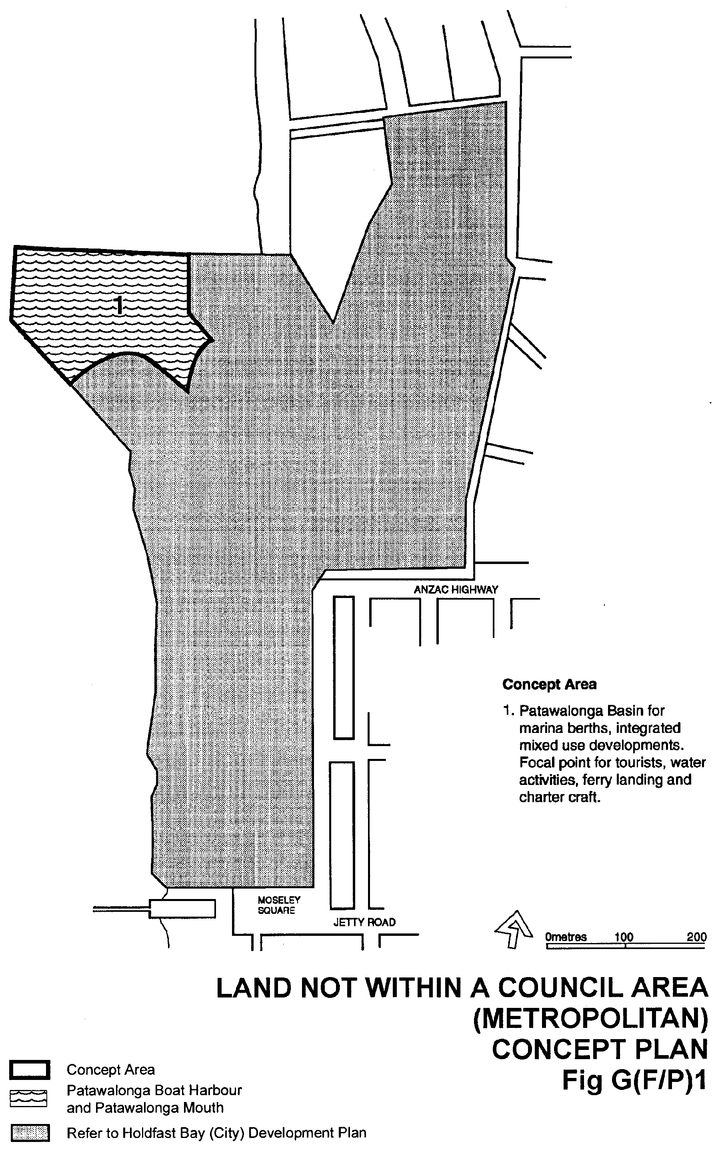
Attachment B
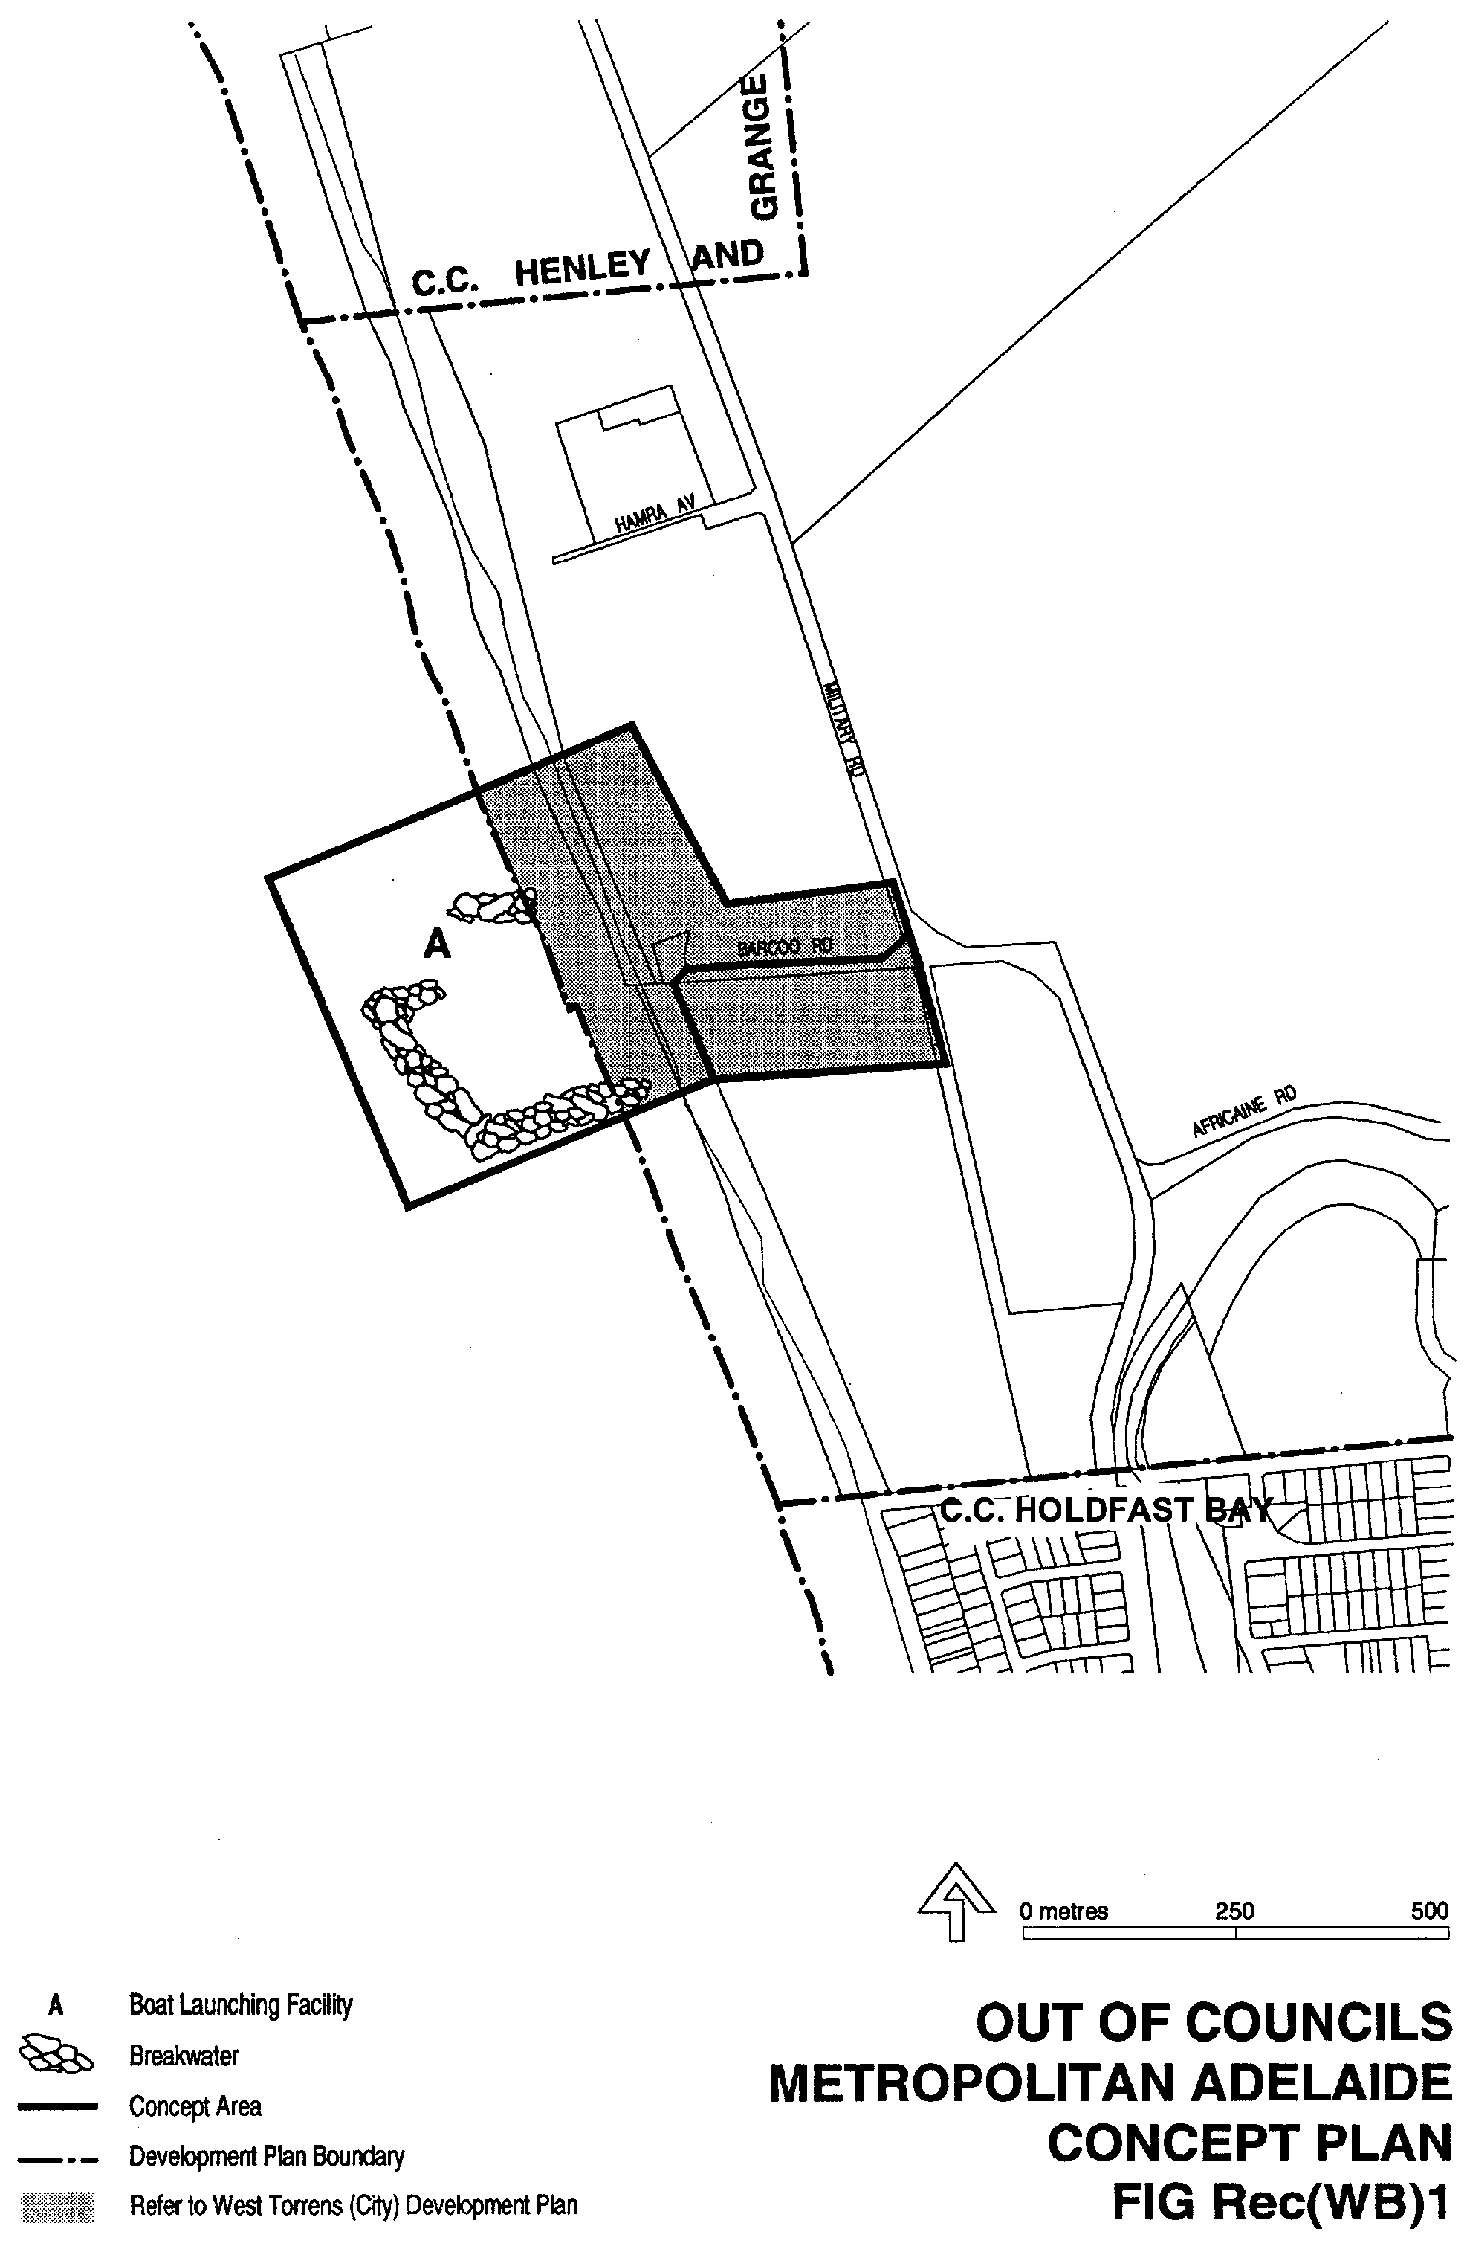
Attachment C
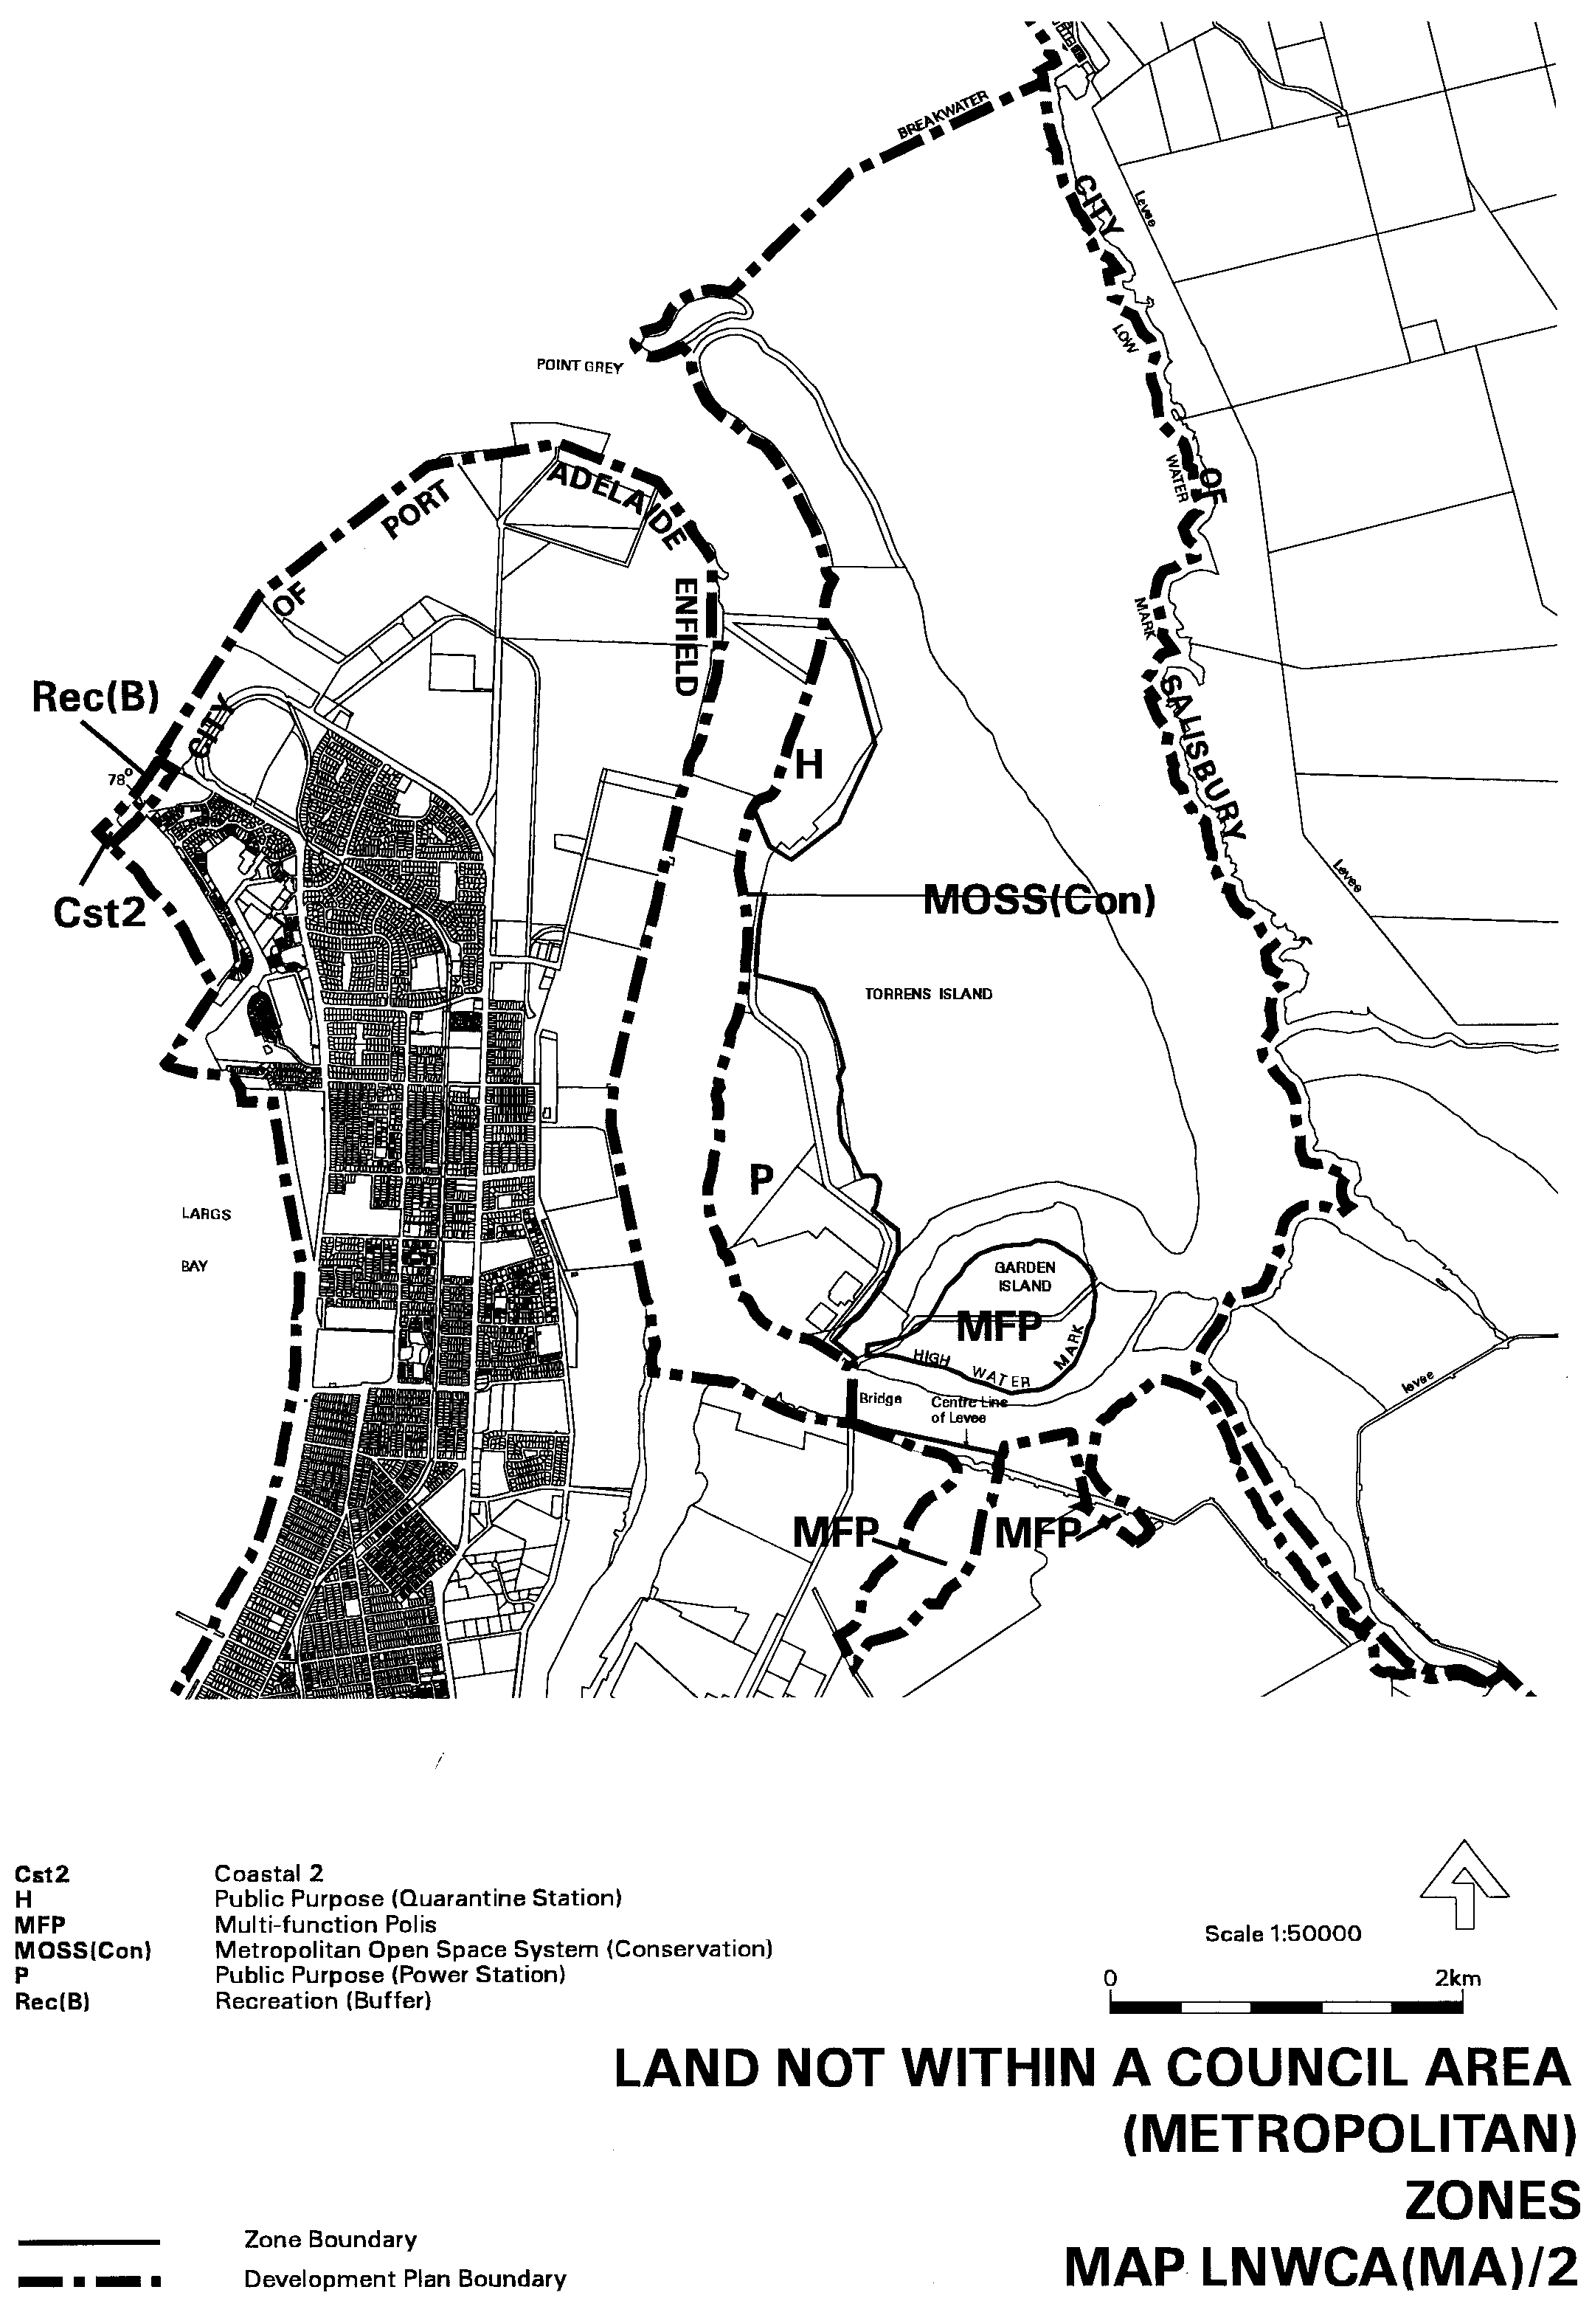
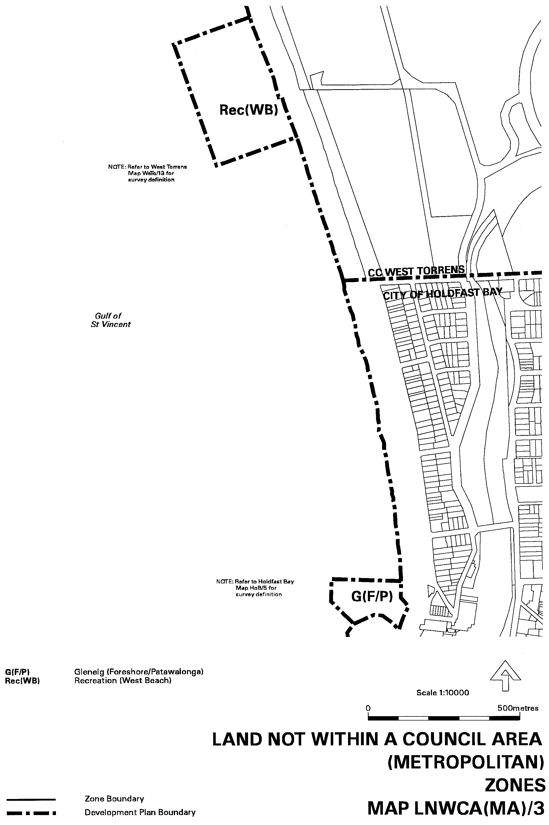
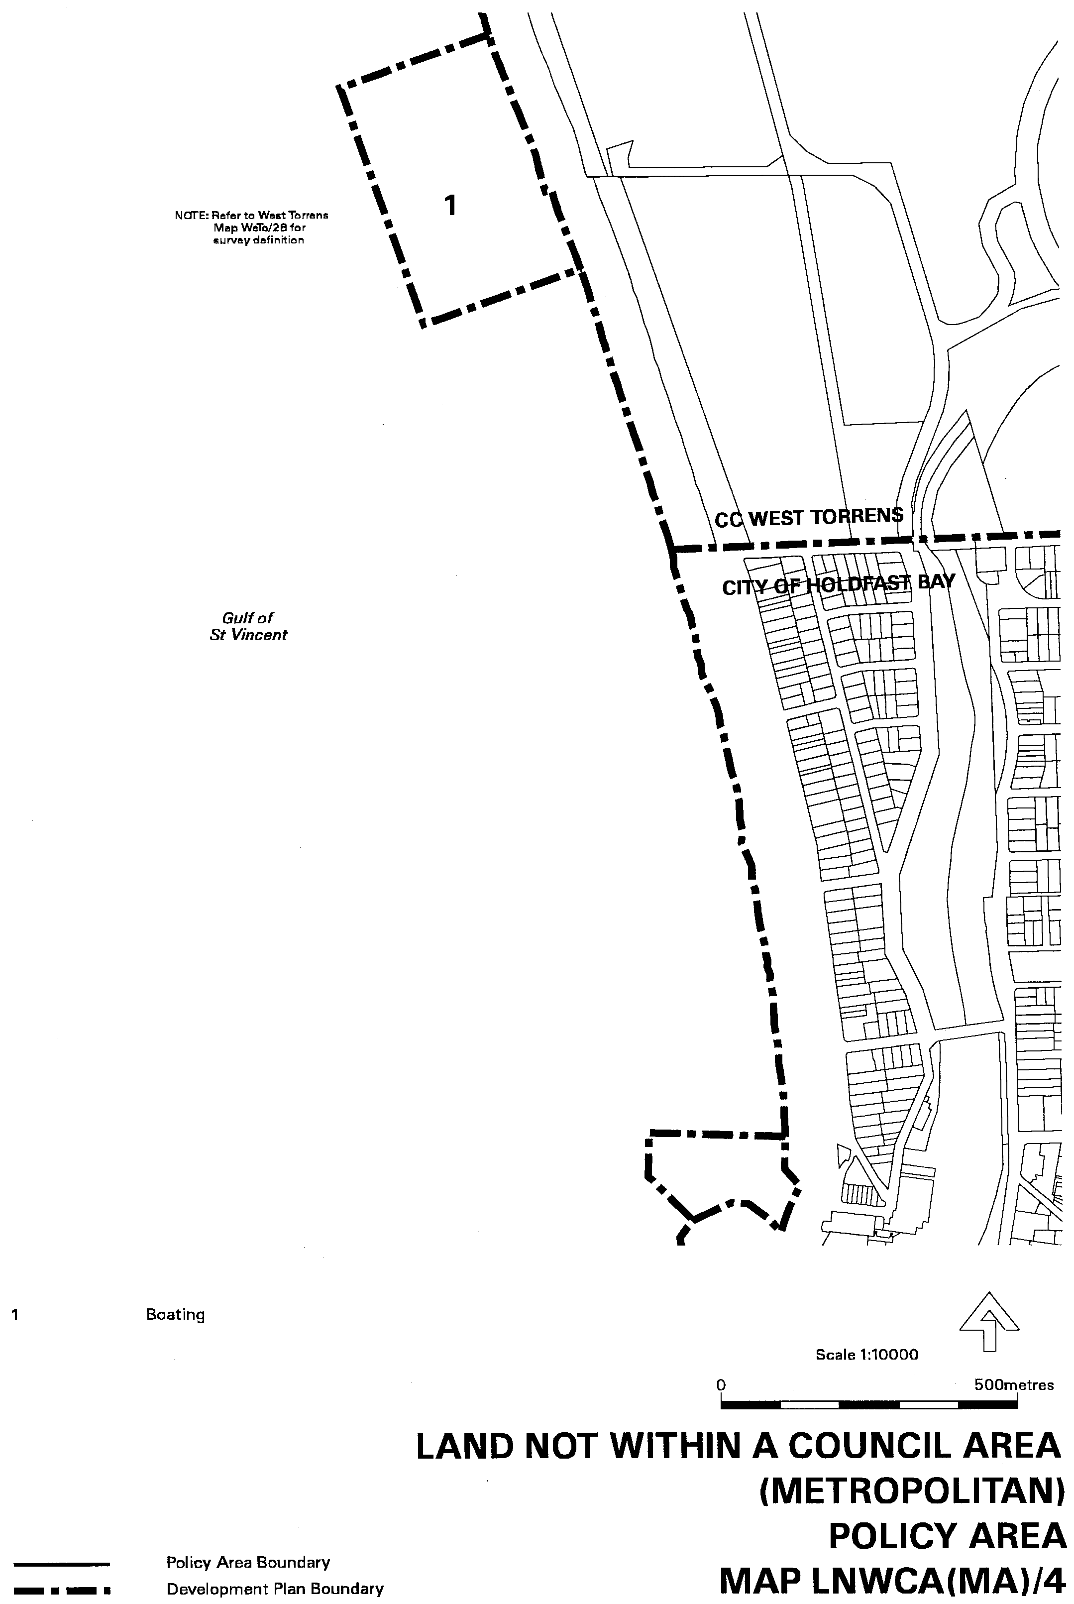

Dated 22 November 2001.
Diana Laidlaw, Minister for Transport and Urban Planning
PLN/ 01

DEVELOPMENT ACT 1993, SECTION 25 (17): CITY OF ONKAPARINGA—NOARLUNGA (CITY) DEVELOP-MENT PLAN—BEACH ROAD AND LINEAR CENTRES PLAN AMENDMENT
Preamble
1. The Development Plan amendment entitled ‘City of Onkaparinga—Noarlunga (City) Development Plan—Beach Road and Linear Centres Plan Amendment’ (the Plan Amendment) has been finalised in accordance with the provisions of the Develop-ment Act 1993.
2. The Minister for Transport and Urban Planning has decided to approve the Plan Amendment.
Notice
PURSUANT to section 25 of the Development Act 1993, I:
(a) approve the Plan Amendment; and
(b) fix the day on which this notice is published in the Gazette as the day on which the Plan Amendment will come into operation.
Dated 22 November 2001.
Diana Laidlaw, Minister for Transport and Urban Planning
PLN 99/0146

FISHERIES ACT 1982: SECTION 59
TAKE notice that pursuant to section 59 of the Fisheries Act 1982, Rolf Czabayski, 5 Willowbridge Grove, Burnside, S.A. 5066 (hereinafter referred to as the ‘permit holder’) is exempt from regulation 35C of the Fisheries (General) Regulations 1984, in that the permit holder shall not be guilty of an offence when using berley within the waters specified in Schedule 1 to attract white sharks (Carchardon carcharias) for the purpose of cage viewing only (hereinafter referred to as the ‘permitted activity’), subject to the conditions specified in Schedule 2, for the dates specified in Schedule 3.
Schedule 1
Coastal waters contained within the Neptune Islands Conserva-tion Park, and the following portions of the Sir Joseph Banks Islands Conservation Park, English and Sibsey Islands.
Note: During Australian Sea Lion breeding periods at Danger-ous Reef, permits will not be provided for eight months. This period will begin eight weeks after the appearance of the first pups.
Schedule 2
1. The permit holder must be on board the boat when con-ducting the permitted activity.
2. All berley used while conducting the permitted activity must consist of fish based products only. All berley (other than fish oil) must be stored below a maximum temperature of 4 °C.
3. The permit holder must notify the public by a Notice to Mariners through the Australian Maritime Safety Authority, by public notice in the Adelaide Advertiser at least 24 hours in advance of berleying operations, advising the local coastguard and the Fisheries Compliance Unit on 1800 065 522 at least two hours prior to conducting the permitted activities.
4. The permit holder shall allow an officer of the Department of Environment and Heritage or nominee to be present on board the boat during the permitted activities if requested and subject to negotiation and availability of space.
5. The permit holder must comply with all instructions (including ceasing to berley if so instructed) given by an officer from DEH.
6. Whilst engaged in the permitted activity, a pennant (approved by DEH) must be flown from the boat so as to be clearly visible.
7. Whilst engaged in the permitted activity the permit holder must have in his/her possession a copy of this notice and produce a copy of the notice if required by a Fisheries Compliance Officer.
8. The permit holder shall not contravene or fail to comply with the Fisheries Act 1982, or any regulations made under the Act, except where specifically exempted by this notice.
9. The permit holder must maintain a log whilst engaged in the permitted activity which includes the date and location, number of passengers, number of hours berleying, number of sharks observed and any other relevant observations or comments. Records must be kept in a form determined by the operators’ association in conjunction with CSIRO Marine Research Unit and endorsed by the Minister for Environment and Heritage. A copy of the log must be provided to the relevant DEH office within 14 days of each calendar month. Failure to submit a log within the agreed time period may preclude the provision of future permits until such outstanding logs are received by the relevant DEH office.
10. The permit holder must conform to a code of conduct developed by the operators’ association and endorsed by the Minister for Environment and Heritage.
11. The permit holder will operate in co-operation with and in agreement of any other approved operator at the same location.
12. The permit holder must have public liability insurance to an amount determined by the Minister for Environment and Heritage and ensure vessels are surveyed and staffed as per Department of Transport regulations.
Schedule 3
Dates permitted to berley: 5 to 11 December 2001.
Dated 2 October 2001.
R. Allen, Acting Regional Manager West

GAMING MACHINES ACT 1992
Notice of Application for Grant or Transfer of a Gaming Machine Licence
NOTICE is hereby given, pursuant to section 29 of the Gaming Machines Act 1992 that The Roosters Club Inc., 43 Menzies Crescent, Prospect has applied to the Liquor and Gaming Commissioner for the grant of a Gaming Machine Licence in respect of premises situated at 255 Main North Road, Sefton Park and for the surrender of the Gaming Machine Licence held in respect of premises situated at 43 Menzies Crescent, Prospect.
The application has been set down for hearing on 11 December 2001 at 9.15 a.m.
Any person may object to the application by lodging a notice of objection in the prescribed form with the Licensing Authority, and serving a copy of the notice on the applicant at the applicant’s address given above, at least seven days before the hearing date.
Plans in respect of the premises the subject of the application are open to public inspection without fee at the Office of the Liquor and Gaming Commissioner, 9th Floor, East Wing, 50 Grenfell Street, Adelaide, S.A. 5000.
Applicant

LAND AND BUSINESS (SALE AND CONVEYANCING) ACT 1994
Exemption
TAKE notice that, pursuant to section 23 (3) of the Land and Business (Sale and Conveyancing) Act 1994, I, Kenneth Trevor Griffin, Minister for Consumer Affairs, do hereby exempt the person named in Schedule 1 from the application of section 23 (2) of the Act in relation to the purchase of the land specified in Schedule 2.
Schedule 1
Peter Charles Wall, an officer/employee of Barrie Magain Realty (The Hub) Pty Ltd.
Schedule 2
The whole of the land described in certificate of title register book volume 5107, folio 730, situated at Allotment 558, Davis Street, Christies Beach, S.A. 5165.
Dated 22 November 2001.
Signed for and on behalf of the Minister for Consumer Affairs by the Commissioner for Consumer Affairs:
M. Bodycoat, Commissioner

LIQUOR LICENSING ACT 1997 AND GAMING MACHINES ACT 1992
Notice of Application
NOTICE is hereby given, pursuant to section 52 of the Liquor Licensing Act 1997 and section 29 of the Gaming Machines Act 1992, that Mandon Hotels Pty Ltd (ACN 098 556 239) c/o Piper Alderman, 167 Flinders Street, Adelaide, S.A. 5000 has applied to the Liquor and Gaming Commissioner for the transfer of a Hotel Licence and a Gaming Machine Licence in respect of premises situated at Main Street, Lobethal, S.A. 5241 and known as Rising Sun Hotel.
The applications have been set down for hearing on 21 December 2001.
Any person may object to the application by lodging a notice of objection in the prescribed form with the Licensing Authority, and serving a copy of the notice on the applicant at the applicant’s address given above, at least seven days before the hearing date.
Plans in respect of the premises the subject of the application are open to public inspection without fee at the Office of the Liquor and Gaming Commissioner, 9th Floor, East Wing, 50 Grenfell Street, Adelaide, S.A. 5000.
Dated 15 November 2001.
Applicant

LIQUOR LICENSING ACT 1997 AND GAMING MACHINES ACT 1992
Notice of Application
NOTICE is hereby given, pursuant to section 52 of the Liquor Licensing Act 1997 and section 29 of the Gaming Machines Act 1992, that McMahons Tavern Pty Ltd (ACN 007 609 396) and M. Steele Investments Pty Ltd (ACN 008 079 696) c/o 243 Carrington Street, Adelaide, S.A. 5000 have applied to the Liquor and Gaming Commissioner for the transfer of a Hotel Licence and a Gaming Machine Licence in respect of premises situated at 540 Port Road, Allenby Gardens, S.A. 5009 and known as Tavern 540.
The applications have been set down for hearing on 21 December 2001 at 9 a.m.
Any person may object to the application by lodging a notice of objection in the prescribed form with the Licensing Authority, and serving a copy of the notice on the applicants at the applicants’ address given above, at least seven days before the hearing date.
Plans in respect of the premises the subject of the application are open to public inspection without fee at the Office of the Liquor and Gaming Commissioner, 9th Floor, East Wing, 50 Grenfell Street, Adelaide, S.A. 5000.
Dated 15 November 2001.
Applicants

LIQUOR LICENSING ACT 1997
Notice of Application
NOTICE is hereby given, pursuant to section 52 (2) (b) of the Liquor Licensing Act 1997, that Trevor Eric Gum and Jenifer Kay Gum, c/o Piper Alderman, 167 Flinders Street, Adelaide, S.A. 5000 have applied to the Licensing Authority for the transfer of a Residential Licence and Section 33 (1) (b) authorisation in respect of the premises situated at 875 Main North, Pooraka, S.A. 5095 and known as Pooraka Motor Inn.
The application has been set down for hearing on 19 December 2001 at 11.30 a.m.
Any person may object to the application by lodging a notice of objection in the prescribed form with the Licensing Authority, and serving a copy of the notice on the applicants at the applicants’ address given above, at least seven days before the hearing date.
Plans in respect of the premises the subject of the application are open to public inspection without fee at the Office of the Liquor and Gaming Commissioner, 9th Floor, East Wing, 50 Grenfell Street, Adelaide, S.A. 5000.
Dated 15 November 2001.
Applicants

LIQUOR LICENSING ACT 1997
Notice of Application
NOTICE is hereby given, pursuant to section 52 (2) (b) of the Liquor Licensing Act 1997, that Montshach Pty Ltd (ACN 098 616 365) has applied to the Licensing Authority for the transfer of a Hotel Licence in respect of premises situated at Upper Sturt Road, Belair, S.A. 5052 and known as Caddy’s Tavern.
The application has been set down for hearing on 19 December 2001 at 2 p.m.
Any person may object to the application by lodging a notice of objection in the prescribed form with the Licensing Authority, and serving a copy of the notice on the applicant at the applicant’s address given above, at least seven days before the hearing date.
Plans in respect of the premises the subject of the application are open to public inspection without fee at the Office of the Liquor and Gaming Commissioner, 9th Floor, East Wing, 50 Grenfell Street, Adelaide, S.A. 5000.
Dated 15 November 2001.
Applicant

LIQUOR LICENSING ACT 1997
Notice of Application
NOTICE is hereby given, pursuant to section 52 (2) (b) of the Liquor Licensing Act 1997, that Nevar Pty Ltd (ACN 066 075 625) as trustee for the R. G. Trott Family Trust c/o Fisher Jeffries, SGIC Building, Level 15, 211 Victoria Square, Adelaide, S.A. 5000 has applied to the Licensing Authority for the transfer of a Restaurant Licence held in respect of the premises situated at 1 Horseshoe Bay, Port Elliot, S.A. 5212 and currently known as The Horseshoe Bay Fish Cafe and to be known as Flying Fish Cafe.
The application has been set down for hearing on 19 December 2001 at 10 a.m.
Any person may object to the application by lodging a notice of objection in the prescribed form with the Licensing Authority, and serving a copy of the notice on the applicant at the applicant’s address given above, at least seven days before the hearing date.
Plans in respect of the premises the subject of the application are open to public inspection without fee at the Office of the Liquor and Gaming Commissioner, 9th Floor, East Wing, 50 Grenfell Street, Adelaide, S.A. 5000.
Dated 15 November 2001.
Applicant

LIQUOR LICENSING ACT 1997
Notice of Application
NOTICE is hereby given, pursuant to section 52 (2) (b) of the Liquor Licensing Act 1997, that Tan Thi Dang, 2 Branston Avenue, Devon Park, S.A. 5008 has applied to the Licensing Authority for the transfer of a Restaurant Licence in respect of premises situated at 320 South Road, Croydon Park, S.A. 5008 and known as Lucky Chef.
The application has been set down for hearing on 19 December 2001 at 11 a.m.
Any person may object to the application by lodging a notice of objection in the prescribed form with the Licensing Authority, and serving a copy of the notice on the applicant at the applicant’s address given above, at least seven days before the hearing date.
Plans in respect of the premises the subject of the application are open to public inspection without fee at the Office of the Liquor and Gaming Commissioner, 9th Floor, East Wing, 50 Grenfell Street, Adelaide, S.A. 5000.
Dated 15 November 2001.
Applicant

LIQUOR LICENSING ACT 1997
Notice of Application
NOTICE is hereby given, pursuant to section 52 (2) (b) of the Liquor Licensing Act 1997, that Truong Phuc Australia Pty Ltd (ACN 098 540 384), 403 Torrens Road, Kilkenny, S.A. 5009, Yen Tang, 1 Moresby Street, Wayville, S.A. 5034 and Ky Thai Lu and Hue Nghi Tran, 27 Third Avenue, Klemzig, S.A. 5087 have applied for the transfer of a Restaurant Licence in respect of premises situated at 187D Rundle Street, Adelaide, S.A. 5000 and known as the Red Rock Noodle Bar.
The application has been set down for hearing on 20 December 2001 at 10 a.m.
Any person may object to the application by lodging a notice of objection in the prescribed form with the Licensing Authority, and serving a copy of the notice on the applicants at the applicants’ addresses given above, at least seven days before the hearing date.
Plans in respect of the premises the subject of the application are open to public inspection without fee at the Office of the Liquor and Gaming Commissioner, 9th Floor, East Wing, 50 Grenfell Street, Adelaide, S.A. 5000.
Dated 8 November 2001.
Applicants

LIQUOR LICENSING ACT 1997
Notice of Application
NOTICE is hereby given, pursuant to section 52 (2) (b) of the Liquor Licensing Act 1997, that Peter Batrachenko and Michelle Louise Batrachenko, Unit 1, 60 Clayton Drive, North Beach, Wallaroo, S.A. 5556 have applied to the Licensing Authority for the transfer of a Restaurant Licence in respect of premises situated at 4 Goyder Street, Kadina, S.A. 5554 and known as Kadina Dynasty Room.
The application has been set down for hearing on 20 December 2001 at 10.30 a.m.
Any person may object to the application by lodging a notice of objection in the prescribed form with the Licensing Authority, and serving a copy of the notice on the applicants at the applicants’ address given above, at least seven days before the hearing date.
Plans in respect of the premises the subject of the application are open to public inspection without fee at the Office of the Liquor and Gaming Commissioner, 9th Floor, East Wing, 50 Grenfell Street, Adelaide, S.A. 5000.
Dated 13 November 2001.
Applicants

LIQUOR LICENSING ACT 1997
Notice of Application
NOTICE is hereby given, pursuant to section 52 (2) (b) of the Liquor Licensing Act 1997, that Jason Banks Spehr and Helen Joy Spehr, 59 Sea Parade, Port MacDonnell, S.A. 5291, have applied to the Licensing Authority for the transfer of a Restaurant Licence in respect of premises situated at 60A Sea Parade, Port MacDonnell and known as Pelican’s Licensed Cafe Restaurant.
The application has been set down for hearing on 20 December 2001 at 11 a.m.
Any person may object to the application by lodging a notice of objection in the prescribed form with the Licensing Authority, and serving a copy of the notice on the applicants at the applicants’ address given above, at least seven days before the hearing date.
Plans in respect of the premises the subject of the application are open to public inspection without fee at the Office of the Liquor and Gaming Commissioner, 9th Floor, East Wing, 50 Grenfell Street, Adelaide, S.A. 5000.
Dated 14 November 2001.
Applicants

LIQUOR LICENSING ACT 1997
Notice of Application
NOTICE is hereby given, pursuant to section 52 (2) (b) of the Liquor Licensing Act 1997, that Maureen Andison and David Andison, P.O. Box 260, Mannum, S.A. 5238 have applied to the Licensing Authority for the transfer of a Special Circumstances Licence in respect of premises situated at 137 Adelaide Road, Murray Bridge, S.A. 5253 and known as Bridge Pool Hall.
The application has been set down for hearing on 20 December 2001 at 11.30 a.m.
Any person may object to the application by lodging a notice of objection in the prescribed form with the Licensing Authority, and serving a copy of the notice on the applicants at the applicants’ address given above, at least seven days before the hearing date.
Plans in respect of the premises the subject of the application are open to public inspection without fee at the Office of the Liquor and Gaming Commissioner, 9th Floor, East Wing, 50 Grenfell Street, Adelaide, S.A. 5000.
Dated 14 November 2001.
Applicants

LIQUOR LICENSING ACT 1997
Notice of Application
NOTICE is hereby given, pursuant to section 52 (2) (b) of the Liquor Licensing Act 1997, that Tandou Ltd (ACN 001 014 562) of Tandou Menindee, N.S.W. 2879 has applied to the Licensing Authority for the transfer of a Producer’s Licence in respect of premises situated at Nixon Road, Monash, S.A. 5342 and known as Normans Lone Gum Winery.
The application has been set down for hearing on 20 December 2001 at 2.30 p.m.
Any person may object to the application by lodging a notice of objection in the prescribed form with the Licensing Authority, and serving a copy of the notice on the applicant at the applicant’s address given above, at least seven days before the hearing date.
Plans in respect of the premises the subject of the application are open to public inspection without fee at the Office of the Liquor and Gaming Commissioner, 9th Floor, East Wing, 50 Grenfell Street, Adelaide, S.A. 5000.
Dated 14 November 2001.
Applicant

LIQUOR LICENSING ACT 1997
Notice of Application
NOTICE is hereby given, pursuant to section 52 (2) (b) of the Liquor Licensing Act 1997, that Tandou Ltd (ACN 001 014 562) of Tandou Menindee, N.S.W. 2879 has applied to the Licensing Authority for the transfer of a Wholesale Liquor Merchant’s Licence in respect of premises situated at Nixon Road, Monash, S.A. 5342 and known as Normans Lone Gum Winery.
The application has been set down for hearing on 20 December 2001 at 3 p.m.
Any person may object to the application by lodging a notice of objection in the prescribed form with the Licensing Authority, and serving a copy of the notice on the applicant at the applicant’s address given above, at least seven days before the hearing date.
Plans in respect of the premises the subject of the application are open to public inspection without fee at the Office of the Liquor and Gaming Commissioner, 9th Floor, East Wing, 50 Grenfell Street, Adelaide, S.A. 5000.
Dated 14 November 2001.
Applicant

LIQUOR LICENSING ACT 1997
Notice of Application
NOTICE is hereby given, pursuant to section 52 (2) (b) of the Liquor Licensing Act 1997, that Nina Nye, Unit 2, 42 Main Road, Hahndorf, S.A. 5245 has applied to the Licensing Authority for the transfer of a Restaurant Licence in respect of premises situated at Unit 2, 42 Main Road, Hahndorf, and known as Alt Heidelberg Cafe and to be known as Cafe Fiore.
The application has been set down for hearing on 20 December 2001 at 2 p.m.
Any person may object to the application by lodging a notice of objection in the prescribed form with the Licensing Authority, and serving a copy of the notice on the applicant at the applicant’s address given above, at least seven days before the hearing date.
Plans in respect of the premises the subject of the application are open to public inspection without fee at the Office of the Liquor and Gaming Commissioner, 9th Floor, East Wing, 50 Grenfell Street, Adelaide, S.A. 5000.
Dated 15 November 2001.
Applicant

LIQUOR LICENSING ACT 1997
Notice of Application
NOTICE is hereby given, pursuant to section 52 (2) (b) of the Liquor Licensing Act 1997, that Magdalene Wines Pty Ltd, P.O. Box 480, Littlehampton, S.A. 5250 has applied to the Licensing Authority for a Producer’s Licence in respect of premises situated at Gully Road, Carey Gully, S.A. 5142 and to be known as Magdalene Wines Pty Ltd.
The application has been set down for hearing on 21 December 2001 at 9 a.m.
Any person may object to the application by lodging a notice of objection in the prescribed form with the Licensing Authority, and serving a copy of the notice on the applicant at the applicant’s address given above, at least seven days before the hearing date.
Plans in respect of the premises the subject of the application are open to public inspection without fee at the Office of the Liquor and Gaming Commissioner, 9th Floor, East Wing, 50 Grenfell Street, Adelaide, S.A. 5000.
Dated 9 November 2001.
Applicant

LIQUOR LICENSING ACT 1997
Notice of Application
NOTICE is hereby given, pursuant to section 52 (2) (b) of the Liquor Licensing Act 1997, that E. & N.C. Nominees Pty Ltd (ACN 007 954 565), c/o David Watts & Associates, 1 Cator Street, Glenside, S.A. 5065, has applied to the Licensing Authority for a Direct Sales Licence in respect of premises situated at Rogers Road, Eden Valley, S.A. 5235 and to be known as Glenerron Wines.
The application has been set down for hearing on 21 December 2001 at 9 a.m.
Any person may object to the application by lodging a notice of objection in the prescribed form with the Licensing Authority, and serving a copy of the notice on the applicant at the applicant’s address given above, at least seven days before the hearing date.
Plans in respect of the premises the subject of the application are open to public inspection without fee at the Office of the Liquor and Gaming Commissioner, 9th Floor, East Wing, 50 Grenfell Street, Adelaide, S.A. 5000.
Dated 12 November 2001.
Applicant

LIQUOR LICENSING ACT 1997
Notice of Application
NOTICE is hereby given, pursuant to section 52 (2) (b) of the Liquor Licensing Act 1997, that Trevor Colin Hueppauff and Treen Kathleen Hueppauff, c/o David Watts & Associates,
1 Cator Street, Glenside, S.A. 5065, have applied to the Licensing Authority for a Direct Sales Licence in respect of premises situated at Lot 550, Trig Point Hill Road, Angaston, S.A. 5353 and to be known as Tobias Wines.
The application has been set down for hearing on 21 December 2001 at 9 a.m.
Any person may object to the application by lodging a notice of objection in the prescribed form with the Licensing Authority, and serving a copy of the notice on the applicants at the applicants’ address given above, at least seven days before the hearing date.
Plans in respect of the premises the subject of the application are open to public inspection without fee at the Office of the Liquor and Gaming Commissioner, 9th Floor, East Wing, 50 Grenfell Street, Adelaide, S.A. 5000.
Dated 12 November 2001.
Applicants

LIQUOR LICENSING ACT 1997
Notice of Application
NOTICE is hereby given, pursuant to section 52 (2) (b) of the Liquor Licensing Act 1997, that Riverland Regional Cultural Trust, Eighteenth Street, Renmark, S.A. 5341 has applied to the Licensing Authority to redefine the Extended Trading Author-isation and Entertainment Consent in respect of premises situated at Eighteenth Street, Renmark and known as Chaffey Theatre.
The application has been set down for hearing on 21 December 2001 at 9 a.m.
Conditions
The following licence conditions are sought:
1. Hours sought for the Extended Trading Authorisation:
Monday to Sunday: 10 a.m. to midnight.
2. Redefine the licensed premises as per plans lodged with the Licensing Authority.
3. Entertainment Consent in Drama Workshop as per plans lodged with the Licensing Authority.
Any person may object to the application by lodging a notice of objection in the prescribed form with the Licensing Authority, and serving a copy of the notice on the applicant at the applicant’s address given above, at least seven days before the hearing date.
Plans in respect of the premises the subject of the application are open to public inspection without fee at the Office of the Liquor and Gaming Commissioner, 9th Floor, East Wing, 50 Grenfell Street, Adelaide, S.A. 5000.
Dated 13 November 2001.
Applicant

LIQUOR LICENSING ACT 1997
Notice of Application
NOTICE is hereby given, pursuant to section 52 (2) (b) of the Liquor Licensing Act 1997, that Graham Andrew Virgin and Robyn Anne Virgin, Section 90, Stenhouse Bay Road, Marion Bay, S.A. 5575 have applied to the Licensing Authority for an Entertainment Consent in Areas 1, 2 and 3 as per the plan lodged with the Liquor and Gaming Commissioner in respect of premises situated at Section 90, Stenhouse Bay Road, Marion Bay and known as Marion Bay Tavern.
The application has been set down for hearing on 21 December 2001 at 9 a.m.
Any person may object to the application by lodging a notice of objection in the prescribed form with the Licensing Authority, and serving a copy of the notice on the applicants at the applicants’ address given above, at least seven days before the hearing date.
Plans in respect of the premises the subject of the application are open to public inspection without fee at the Office of the Liquor and Gaming Commissioner, 9th Floor, East Wing, 50 Grenfell Street, Adelaide, S.A. 5000.
Dated 14 Novemer 2001.
Applicants

LIQUOR LICENSING ACT 1997
Notice of Application
NOTICE is hereby given, pursuant to section 52 (2) (b) of the Liquor Licensing Act 1997, that Ronald William Day, P.O. Box 703, Unley, S.A. 5061 has applied to the Licensing Authority for a Producer’s Licence in respect of premises situated at Lot 4, Hicks Road, Armagh via Clare, S.A. 5453 and to be known as Daybreak Ridge Wines.
The application has been set down for hearing on 21 December 2001 at 9 a.m.
Any person may object to the application by lodging a notice of objection in the prescribed form with the Licensing Authority, and serving a copy of the notice on the applicant at the applicant’s address given above, at least seven days before the hearing date.
Plans in respect of the premises the subject of the application are open to public inspection without fee at the Office of the Liquor and Gaming Commissioner, 9th Floor, East Wing, 50 Grenfell Street, Adelaide, S.A. 5000.
Dated 15 November 2001.
Applicant

LIQUOR LICENSING ACT 1997
Notice of Application
NOTICE is hereby given, pursuant to section 52 (2) (b) of the Liquor Licensing Act 1997, that West Paddock Pty Ltd has applied to the Licensing Authority for a variation of conditions of licence in respect of premises situated at Shop 2052B Westfield Shopping Town, Oaklands Park, S.A. 5046 and known as Zanzibar Marion.
The application has been set down for hearing on 21 December 2001 at 9 a.m.
Conditions
The following licence conditions are sought:
• Approval is sought under section 32 (3) (a) and (c) of the Act for obligatory trading hours to be varied as follows:
Sunday to Friday: No obligatory trading
Saturday: Trading hours may commence at 8 p.m.
Any person may object to the application by lodging a notice of objection in the prescribed form with the Licensing Authority, and serving a copy of the notice on the applicant at the applicant’s address given above, at least seven days before the hearing date.
Plans in respect of the premises the subject of the application are open to public inspection without fee at the Office of the Liquor and Gaming Commissioner, 9th Floor, East Wing, 50 Grenfell Street, Adelaide, S.A. 5000.
Dated 15 November 2001.
Applicant

LIQUOR LICENSING ACT 1997
Notice of Application
NOTICE is hereby given, pursuant to section 52 (2) (b) of the Liquor Licensing Act 1997, that Simon James Wright and Janet Lorraine Smith have applied to the Licensing Authority for the transfer of a Retail Liquor Merchant’s Licence in respect of the premises situated at Lot 3, Scenic Drive, American River, S.A. 5221 and known as American River General Store.
The application has been set down for hearing on 21 December 2001.
Conditions
The following conditions are sought to be removed:
1. The licensee shall not sell beer in kegs or barrels.
2. The area in which deliveries can be made is limited to within a 10 mile radius of the licensed premises.
Any person may object to the application by lodging a notice of objection in the prescribed form with the Licensing Authority, and serving a copy of the notice on the applicants at the applicants’ address given above, at least seven days before the hearing date.
Plans in respect of the premises the subject of the application are open to public inspection without fee at the Office of the Liquor and Gaming Commissioner, 9th Floor, East Wing, 50 Grenfell Street, Adelaide, S.A. 5000.
Applicants

LIQUOR LICENSING ACT 1997
Notice of Application
NOTICE is hereby given, pursuant to section 52 (2) (b) of the Liquor Licensing Act 1997, that Antonio Pedicini and Despina Siopoulos, 112 North Parade, Torrensville, S.A. 5031 have applied to the Licensing Authority for a Restaurant Licence in respect of premises situated at 168C Jetty Road, Glenelg, S.A. 5045 and to be known as La Tavola.
The application has been set down for hearing on 21 December 2001 at 9 a.m.
Any person may object to the application by lodging a notice of objection in the prescribed form with the Licensing Authority, and serving a copy of the notice on the applicants at the applicants’ address given above, at least seven days before the hearing date.
Plans in respect of the premises the subject of the application are open to public inspection without fee at the Office of the Liquor and Gaming Commissioner, 9th Floor, East Wing, 50 Grenfell Street, Adelaide, S.A. 5000.
Dated 15 November 2001.
Applicants

LIQUOR LICENSING ACT 1997
Notice of Application
NOTICE is hereby given, pursuant to section 52 (2) (b) of the Liquor Licensing Act 1997, that Hockray Wine Sales Pty Ltd has applied to the Licensing Authority for the removal of a Direct Sales Licence in respect of premises currently situated at 33 Waymouth Street, Adelaide, S.A. 5000 and to be situated at Level 9, 82 King William Street, Adelaide and known as Hockray Wine Sales.
The application has been set down for hearing on 21 December 2001.
Any person may object to the application by lodging a notice of objection in the prescribed form with the Licensing Authority, and serving a copy of the notice on the applicant at the applicant’s address given above, at least seven days before the hearing date.
Plans in respect of the premises the subject of the application are open to public inspection without fee at the Office of the Liquor and Gaming Commissioner, 9th Floor, East Wing, 50 Grenfell Street, Adelaide, S.A. 5000.
Applicant

LIQUOR LICENSING ACT 1997
Notice of Application
NOTICE is hereby given, pursuant to section 52 (2) (b) of the Liquor Licensing Act 1997, that Mondo Sojourn Pty Ltd has applied to the Licensing Authority for a Residential Licence with Entertainment Consent and Extended Trading Authorisation in respect of premises situated at Levels 1 and 2, 52-62 King William Street, Adelaide, S.A. 5000 and to be known as Adelaide Rundle-Mall Backpackers Lodge.
The application has been set down for hearing on 21 December 2001 at 9 a.m.
Conditions
The following licence conditions are sought:
• Extended Trading Authorisation:
Monday to Saturday: Midnight to 3 a.m. the following day;
Sunday: 8 a.m. to 11 a.m. and 8 p.m. to 3 a.m. the following day.
• Entertainment Consent.
Any person may object to the application by lodging a notice of objection in the prescribed form with the Licensing Authority, and serving a copy of the notice on the applicant at the applicant’s address given above, at least seven days before the hearing date.
Plans in respect of the premises the subject of the application are open to public inspection without fee at the Office of the Liquor and Gaming Commissioner, 9th Floor, East Wing, 50 Grenfell Street, Adelaide, S.A. 5000.
Dated 16 November 2001.
Applicant

LIQUOR LICENSING ACT 1997
Notice of Application
NOTICE is hereby given, pursuant to section 52 (2) (b) of the Liquor Licensing Act 1997, that Adrian Cyril Irlam and Michelle Lyn Keen have applied to the Licensing Authority for a Residential Licence in respect of premises situated at 262-266 Hindley Street, Adelaide and to be known as Princes Arcade/ Kiwi Lodge.
The application has been set down for hearing on 21 December 2001.
Conditions
The following licence conditions are sought:
1. Extended trading authorisation, hours sought:
Thursday to Saturday: Midnight to 2 a.m. the following day;
Sunday: 8 p.m. to midnight;
Public Holidays: Midnight to 2 a.m. the following day.
2. The applicant is seeking a condition that authorises the licensee to sell liquor on any day except Good Friday and Christmas Day for consumption on the licensed premises by persons:
(a) seated at a table; or
(b) attending a function at which food is provided.
3. Entertainment Consent is sought.
Any person may object to the application by lodging a notice of objection in the prescribed form with the Licensing Authority, and serving a copy of the notice on the applicants at the applicants’ address given above, at least seven days before the hearing date.
Plans in respect of the premises the subject of the application are open to public inspection without fee at the Office of the Liquor and Gaming Commissioner, 9th Floor, East Wing, 50 Grenfell Street, Adelaide, S.A. 5000.
Applicants

MINING ACT 1971
NOTICE is hereby given in accordance with section 28 (5) of the Mining Act 1971, that the Minister for Minerals and Energy proposes to grant an Exploration Licence over the under-mentioned area:
Applicant: RMG Services Pty Ltd
Location: Mid-Lake Torrens area—Approximately 140 km north of Port Augusta, bounded as follows: Commencing at a point being the intersection of latitude 31°08′S and longitude 137°23′E, thence east to longitude 137°36′E, south to latitude 31°15′S, west to longitude 137°23′E, and north to the point of commencement, all the within latitudes and longitudes being geodetic and expressed in terms of the Australian Geodetic Datum as defined on p. 4984 of Commonwealth Gazette number 84 dated 6 October 1966 (AGD66).
Term: 1 year
Area in km²: 267
Ref: 039/2001
H. Tyrteos, Acting Mining Registrar

MINING ACT 1971
NOTICE is hereby given in accordance with section 28 (5) of the Mining Act 1971, that the Minister for Minerals and Energy proposes to grant an Exploration Licence over the under-mentioned area:
Applicant: Dominion Gold Operations Pty Ltd (90%) and Coombedown Resources NL (10%)
Location: Campfire Bore area—Approximately 100 km south-west of Coober Pedy, bounded as follows: Com-mencing at a point being the intersection of latitude 29°36′S and longitude 133°43′E, thence east to longitude 133°46′E, south to latitude 29°37′S, west to longitude 133°45′E, south to latitude 29°40′S, west to longitude 133°42′E, north to latitude 29°39′S, west to longitude 133°41′E, north to latitude 29°37′S, east to longitude 133°43′E, and north to the point of commencement, all the within latitudes and longitudes being geodetic and expressed in terms of the Australian Geodetic Datum as defined on p. 4984 of Commonwealth Gazette number 84 dated 6 October 1966 (AGD66).
Term: 1 year
Area in km²: 42
Ref: 084/2001
H. Tyrteos, Acting Mining Registrar

NATIONAL PARKS REGULATIONS 2001
Closure of Granite Island Recreation Park
PURSUANT to Regulations 8 (3) (a), (c) and (d) of the National Parks Regulations 2001, I, Edward Gregory Leaman, the Director of National Parks and Wildlife, close to the public the whole of Granite Island Recreation Park during the following times:
• from 0.01 hours on Friday, 23 November 2001 until
05.30 hours on Friday, 23 November 2001;
• from 00.01 hours on Saturday, 24 November 2001 until 05.30 hours on Saturday, 24 November 2001;
• from 00.01 hours on Sunday, 25 November 2001 until 05.30 hours on Sunday, 25 November 2001;
• from 00.01 hours on Monday, 26 November 2001 until 05.30 hours on Monday, 26 November 2001;
• from 00.01 hours on Tuesday, 27 November 2001 until 05.30 hours on Tuesday, 27 November 2001;
• from 00.01 hours on Wednesday, 28 November 2001 until 05.30 hours on Wednesday, 28 November 2001;
• from 00.01 hours on Thursday, 29 November 2001 until 05.30 hours on Thursday, 29 November 2001;
• from 00.01 hours on Friday, 30 November 2001 until
05.30 hours on Friday, 30 November 2001;
• from 00.01 hours on Saturday, 1 December 2001 until 05.30 hours on Saturday, 1 December 2001;
• from 00.01 hours on Sunday, 2 December 2001 until
05.30 hours on Sunday, 2 December 2001;
• from 00.01 hours on Monday, 3 December 2001 until
05.30 hours on Monday, 3 December 2001.
The purpose of the abovementioned closures is, that in my opinion, during Schoolies Week 2001, the staff necessary to patrol the reserve are unavailable, and it is in the interest of public safety to close the reserve during the abovementioned times.
Permission to enter and remain in the Reserve
Pursuant to Regulations 8 (4) and 41 of the National Parks Regulations 2001, I, Edward Gregory Leaman, the Director of National Parks and Wildlife, grant permission to persons under-taking legitimate recreational and commercial fishing activities to enter and remain in the area between the causeway and the screw pile jetty on Granite Island Recreation Park during the above-mentioned times.
Pursuant to Regulations 8 (4) and 41 of the National Parks Regulations 2001, I, Edward Gregory Leaman, the Director of National Parks and Wildlife, grant permission to the lessee and employees of the Granite Island Nature Park, whilst undertaking duties of his or her employment, to enter and remain in the Granite Island Recreation Park during the abovementioned times.
This permission is conditional upon the observance by each of those persons of the requirements of the National Parks and Wildlife Act 1972 and the National Parks Regulations 2001, including those requiring compliance with the directions, requests, requirements and orders of a warden.
Dated 15 November 2001.
E. G. Leaman, Director National Parks and Wildlife

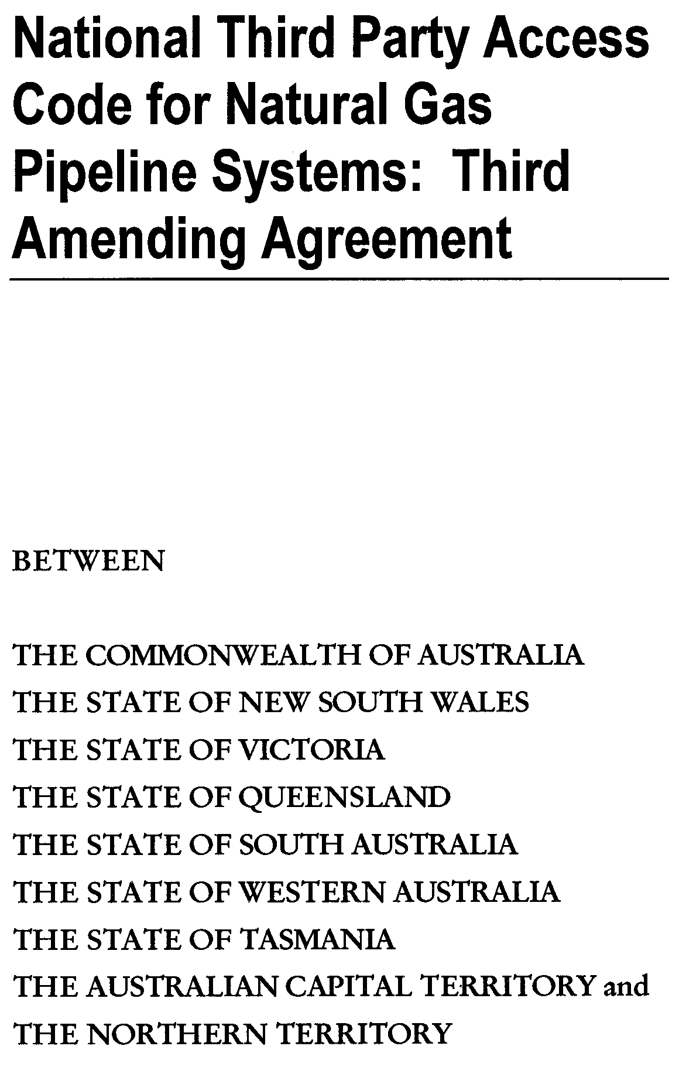
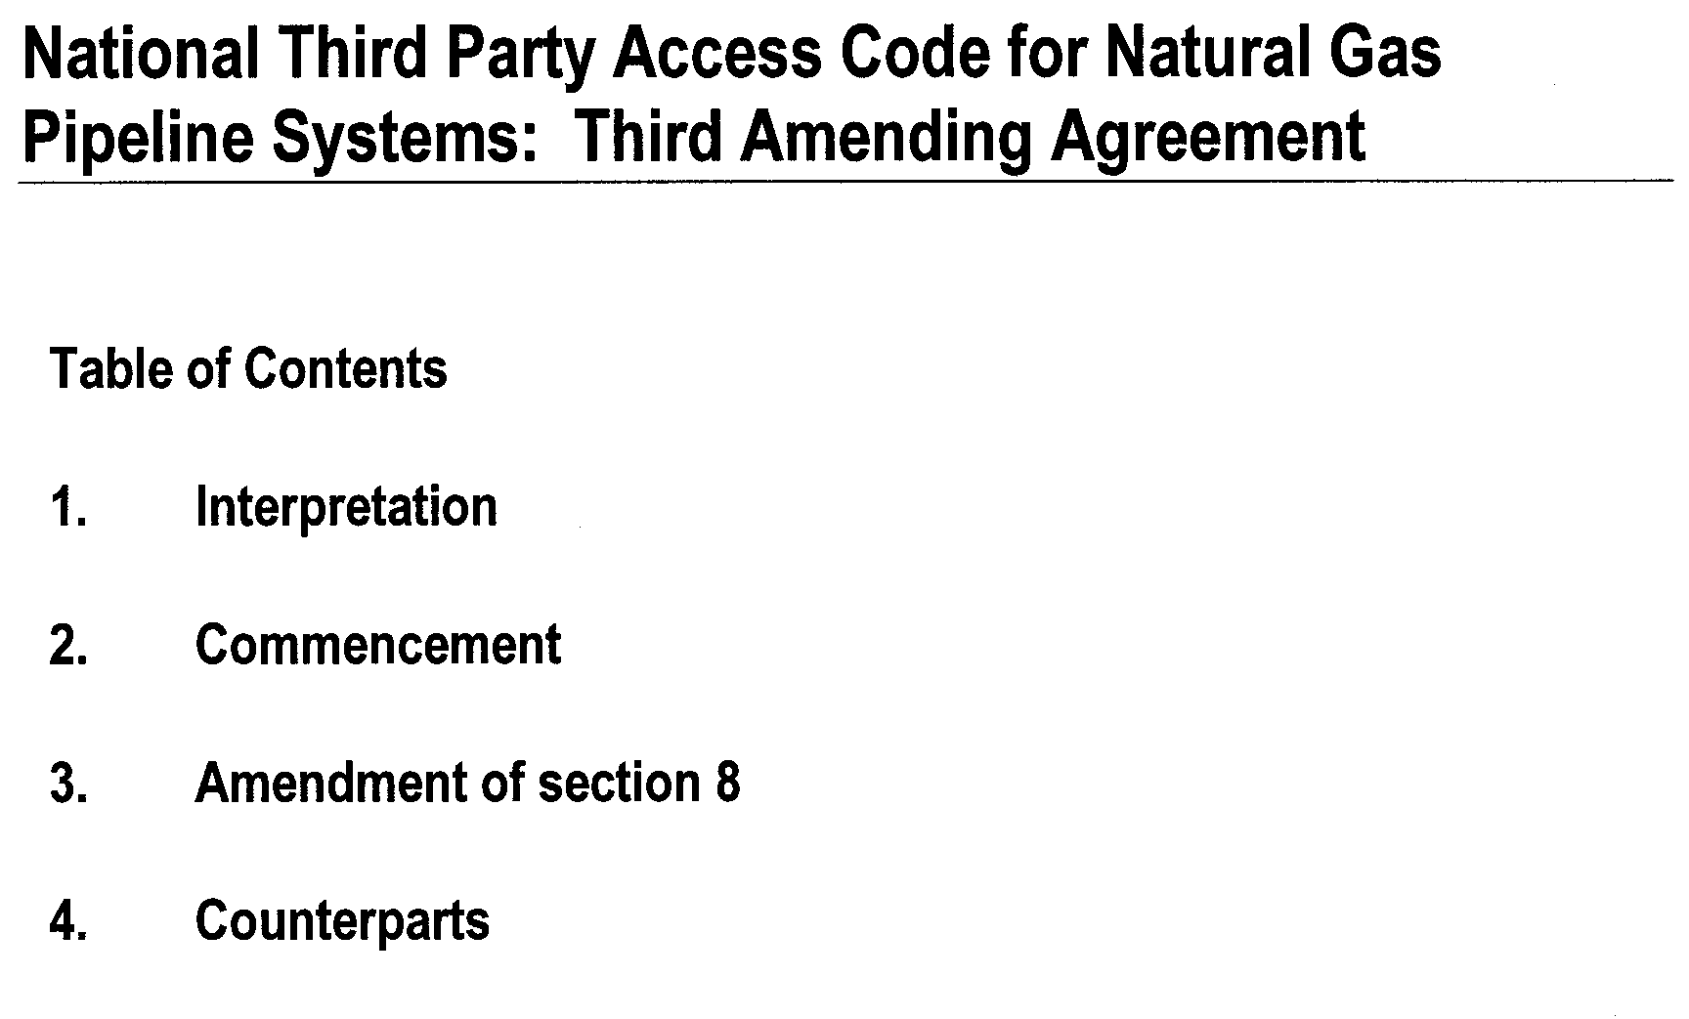
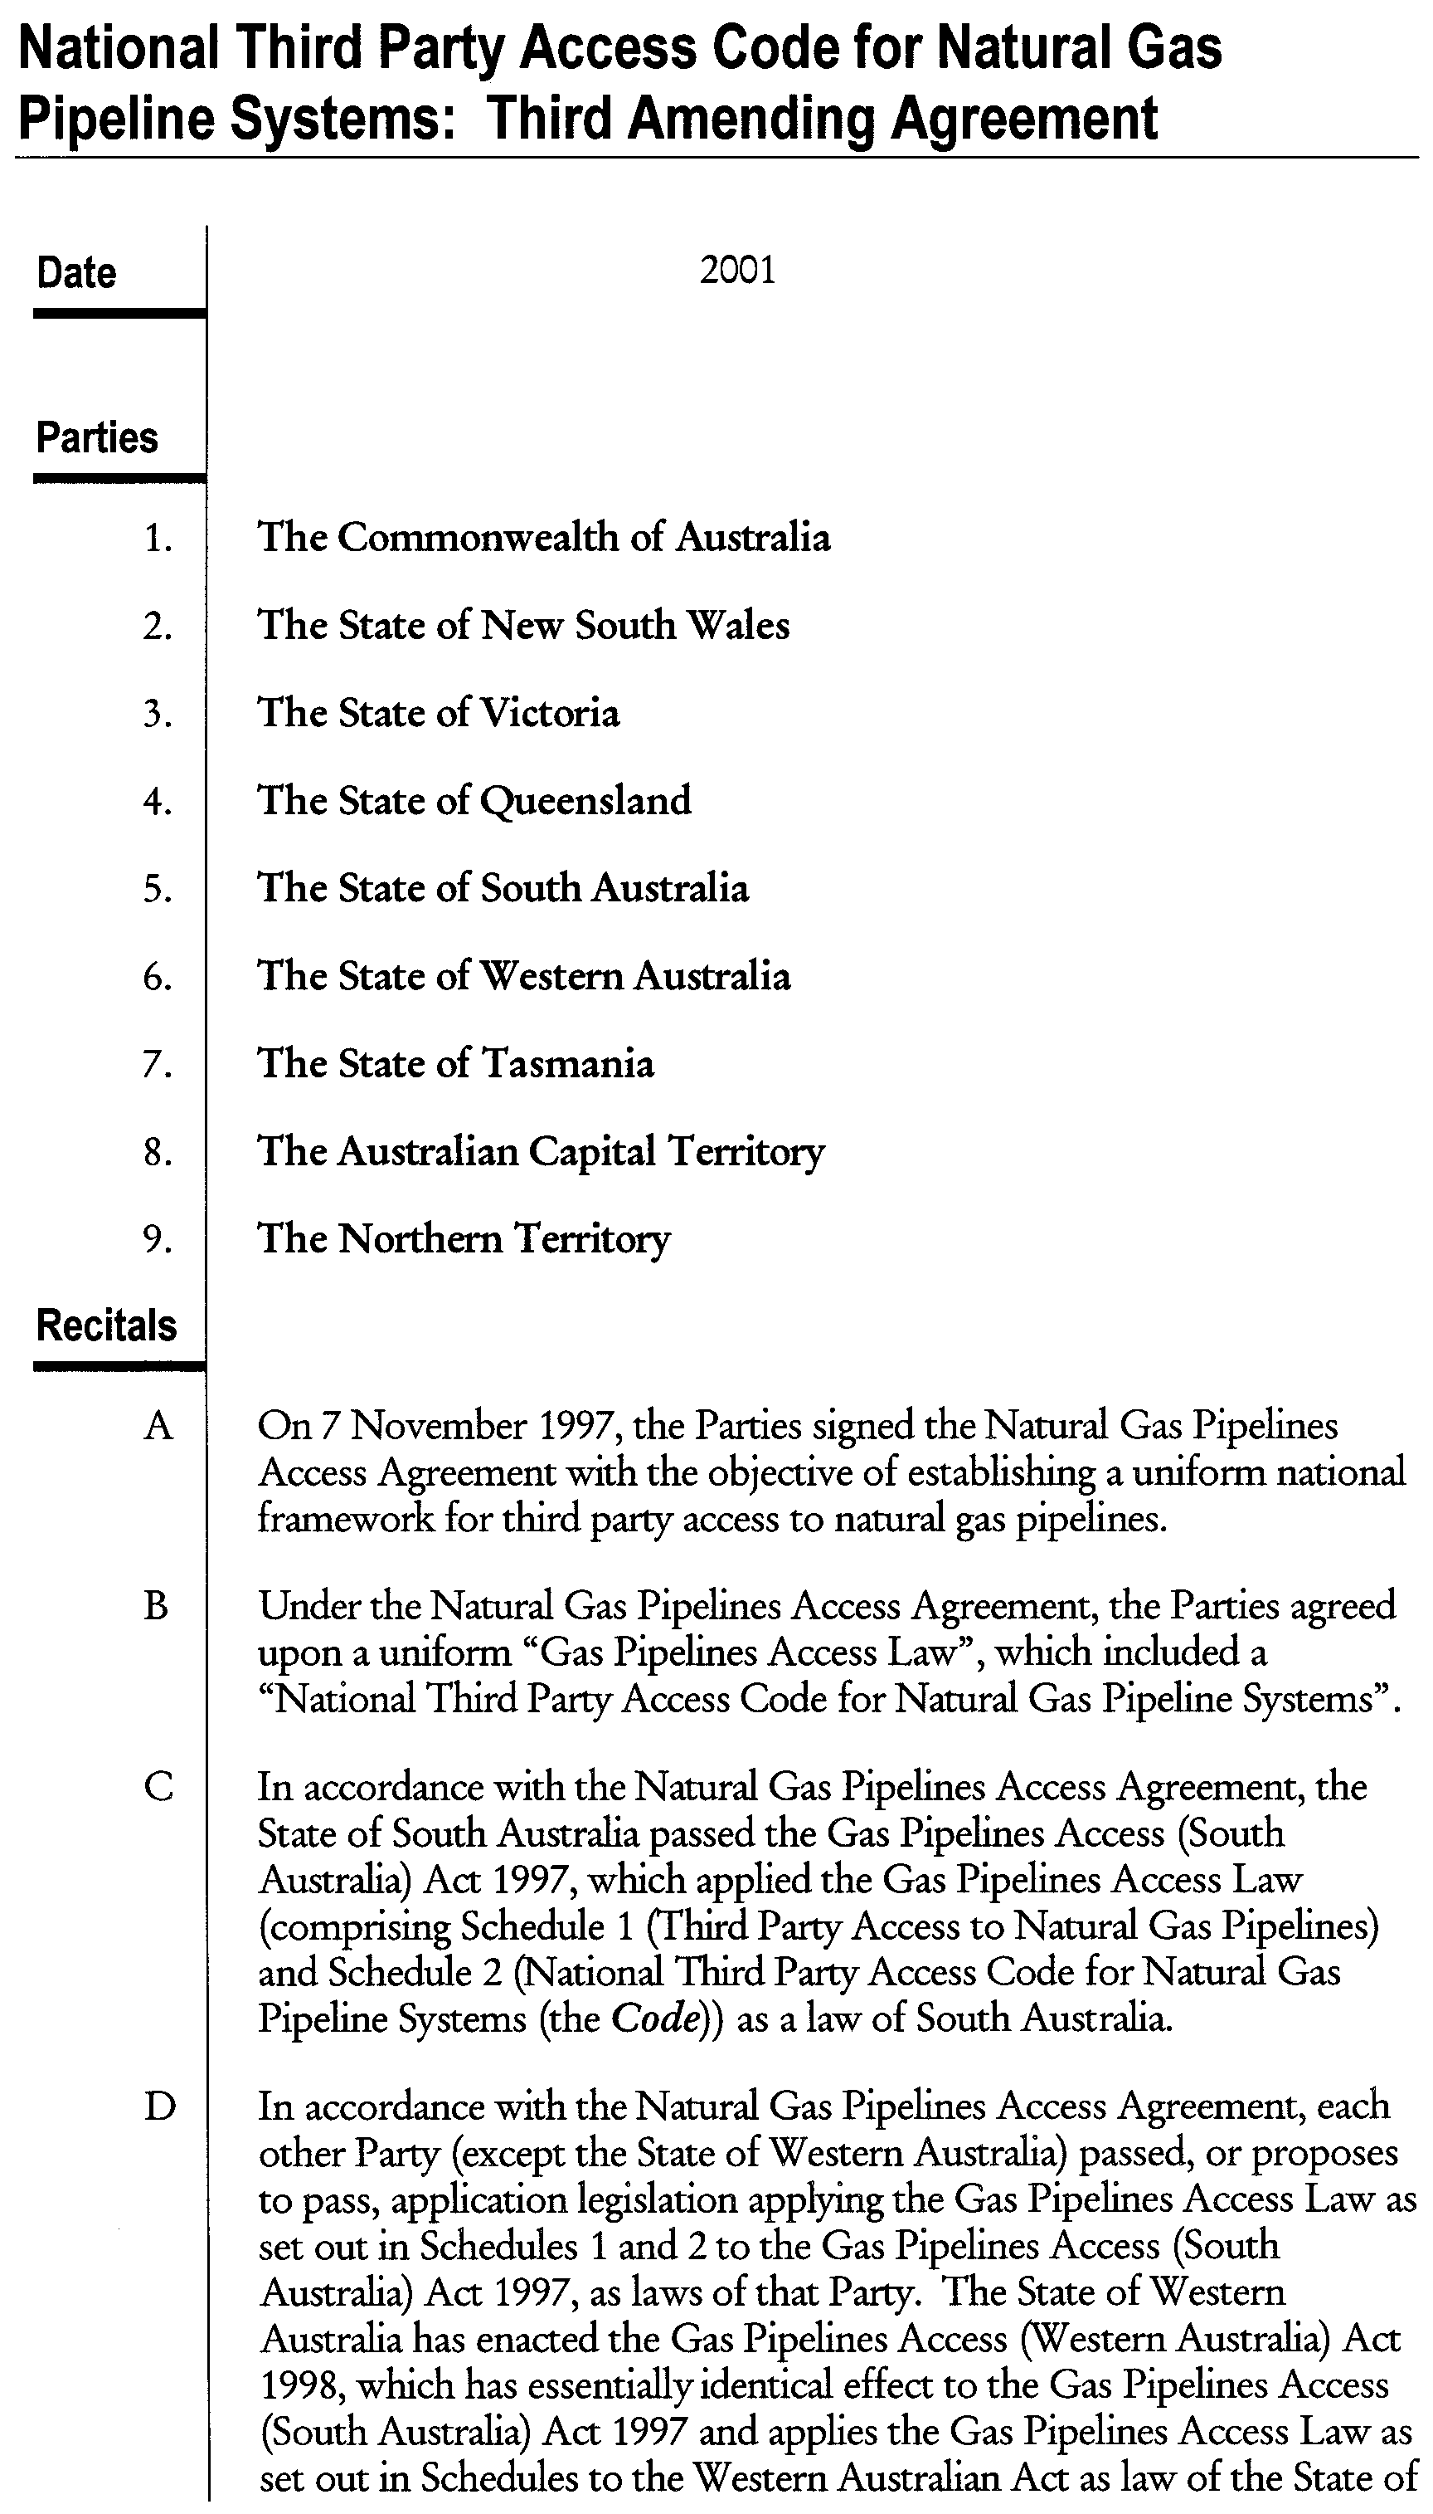
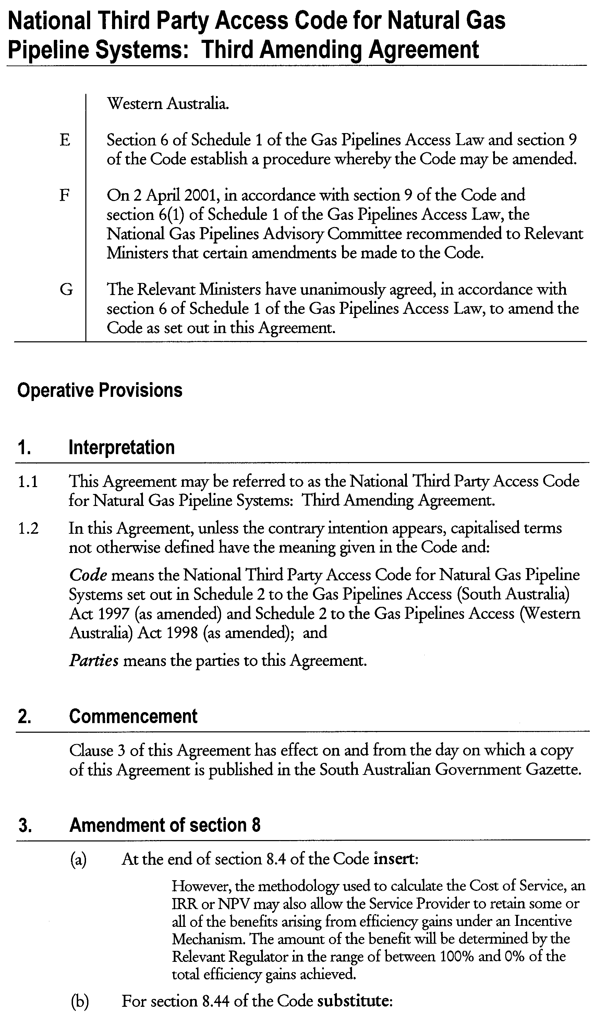
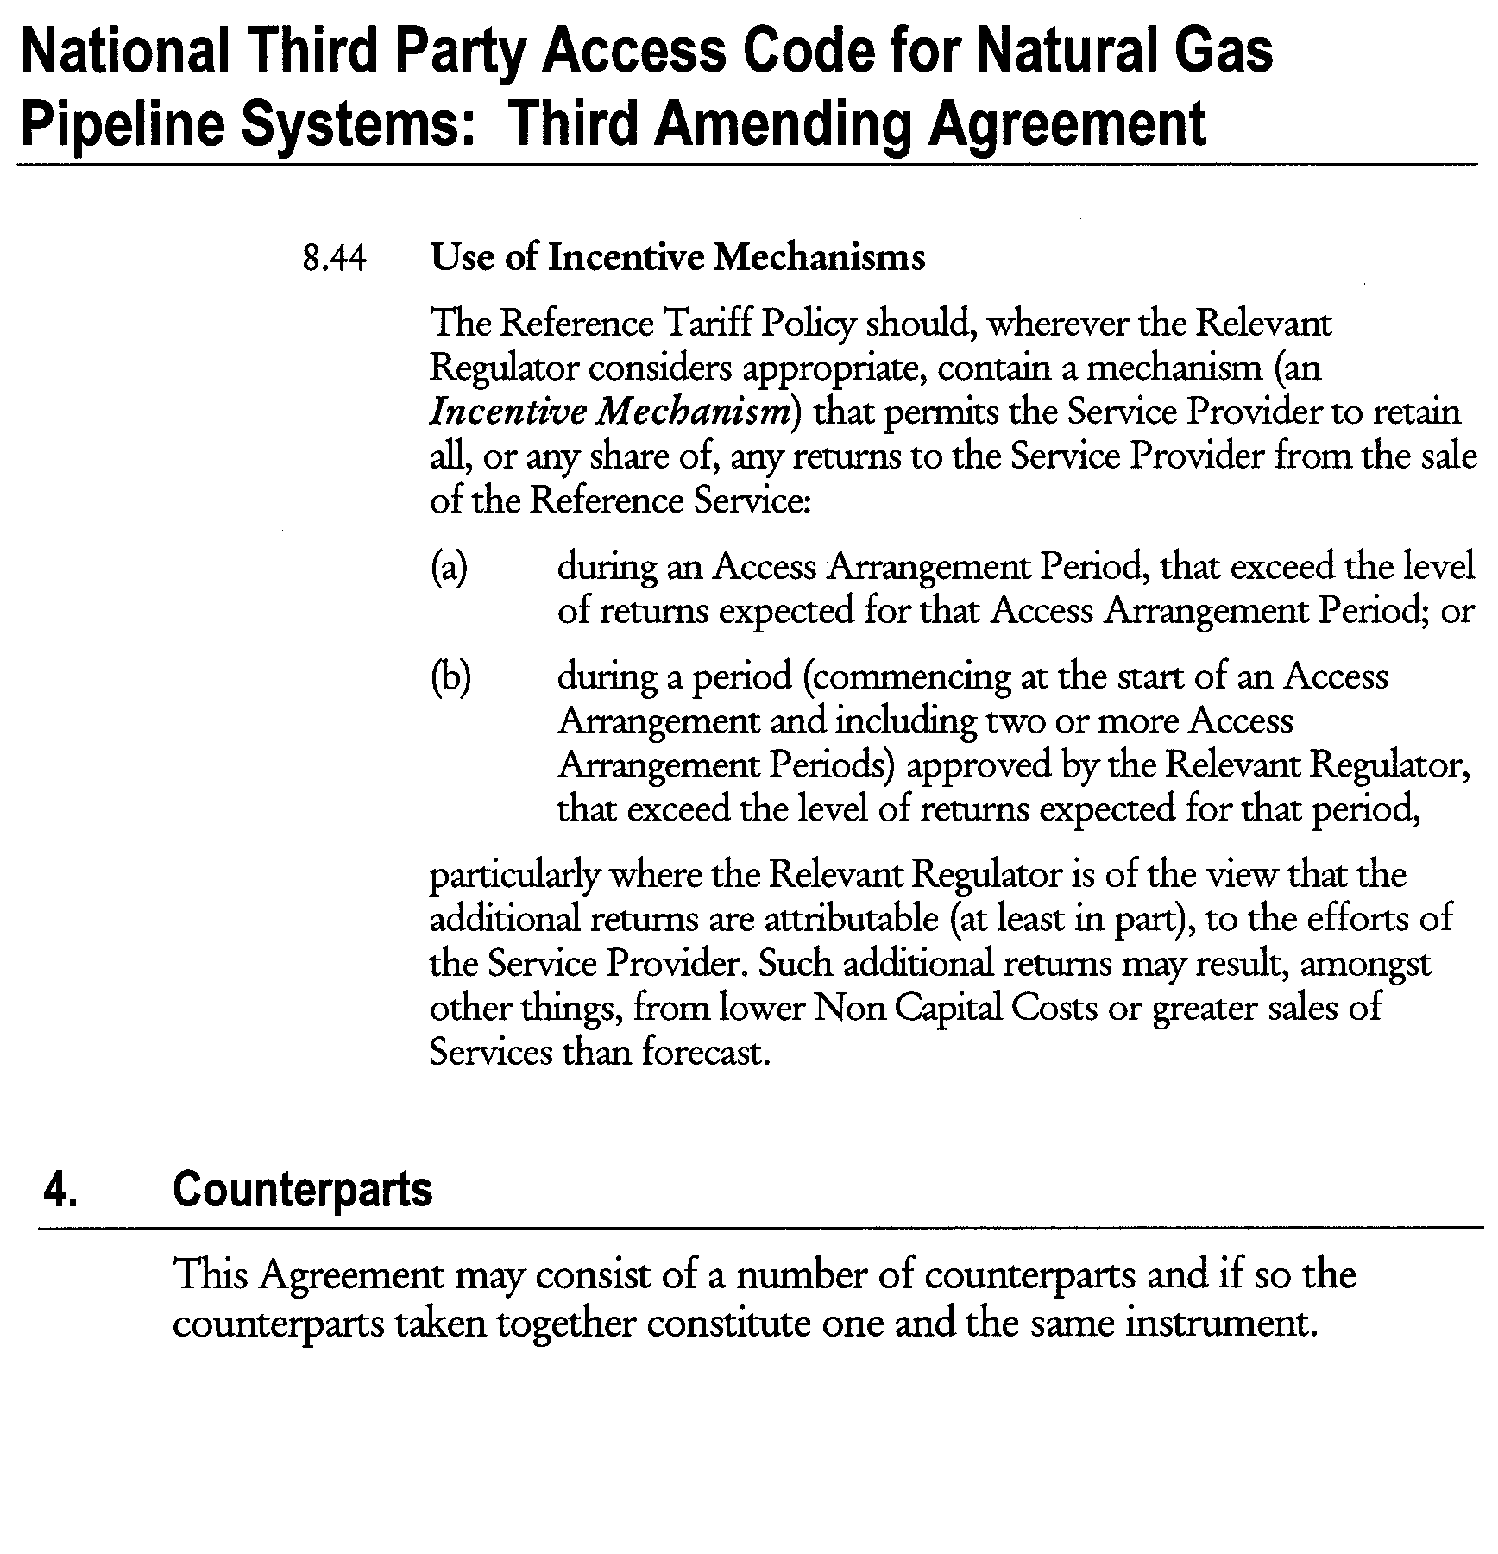

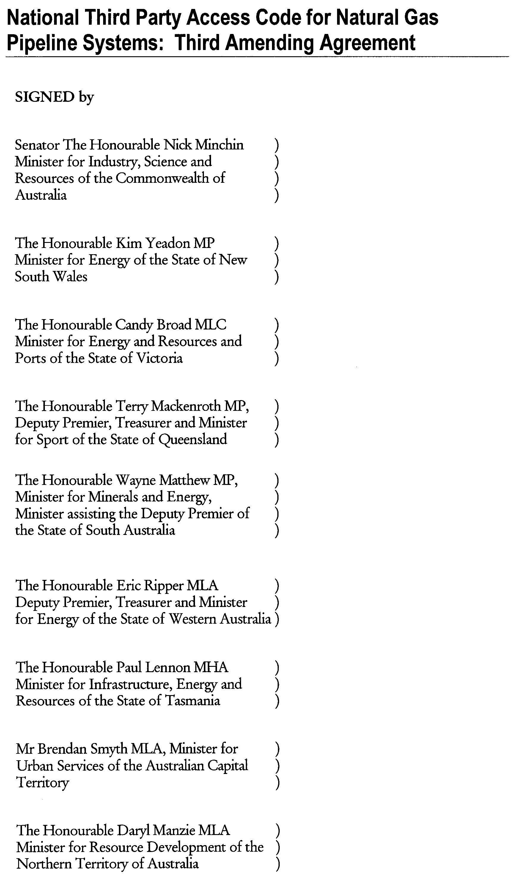

GOVERNMENT GAZETTE ADVERTISEMENT RATES

To apply from 1 July 2001

$  Agents, Ceasing to Act as 32.75  Associations:  Incorporation 16.70  Intention of Incorporation 41.25  Transfer of Properties 41.25  Attorney, Appointment of 32.75  Bailiff’s Sale 41.25  Cemetery Curator Appointed 24.50  Companies:  Alteration to Constitution 32.75  Capital, Increase or Decrease of 41.25  Ceasing to Carry on Business 24.50  Declaration of Dividend 24.50  Incorporation 32.75  Lost Share Certificates:  First Name 24.50  Each Subsequent Name 8.40  Meeting Final 27.50  Meeting Final Regarding Liquidator’s Report on  Conduct of Winding Up (equivalent to ‘Final  Meeting’)  First Name 32.75  Each Subsequent Name 8.40  Notices:  Call 41.25  Change of Name 16.70  Creditors 32.75  Creditors Compromise of Arrangement 32.75  Creditors (extraordinary resolution that ‘the Com-pany be wound up voluntarily and that a liquidator be appointed’) 41.25  Release of Liquidator⎯Application⎯Large Ad. 65.50  ⎯Release Granted 41.25  Receiver and Manager Appointed 38.25  Receiver and Manager Ceasing to Act 32.75  Restored Name 31.00  Petition to Supreme Court for Winding Up 57.00  Summons in Action 48.75  Order of Supreme Court for Winding Up Action 32.75  Register of Interests⎯Section 84 (1) Exempt 74.00  Removal of Office 16.70  Proof of Debts 32.75  Sales of Shares and Forfeiture 32.75  Estates:  Assigned 24.50  Deceased Persons⎯Notice to Creditors, etc. 41.25  Each Subsequent Name 8.40  Deceased Persons⎯Closed Estates 24.50  Each Subsequent Estate 1.05  Probate, Selling of 32.75  Public Trustee, each Estate 8.40 |  | $  Firms:  Ceasing to Carry on Business (each insertion) 21.80  Discontinuance Place of Business 21.80  Land⎯Real Property Act:  Intention to Sell, Notice of 41.25  Lost Certificate of Title Notices 41.25  Cancellation, Notice of (Strata Plan) 41.25  Mortgages:  Caveat Lodgment 16.70  Discharge of 17.60  Foreclosures 16.70  Transfer of 16.70  Sublet 8.40  Leases⎯Application for Transfer (2 insertions) each 8.40  Lost Treasury Receipts (3 insertions) each 24.50  Licensing 48.75  Municipal or District Councils:  Annual Financial Statement⎯Forms 1 and 2 462.00  Electricity Supply⎯Forms 19 and 20 327.00  Default in Payment of Rates:  First Name 65.50  Each Subsequent Name 8.40  Noxious Trade 24.50  Partnership, Dissolution of 24.50  Petitions (small) 16.70  Registered Building Societies (from Registrar-  General) 16.70  Register of Unclaimed Moneys⎯First Name 24.50  Each Subsequent Name 8.40  Registers of Members⎯Three pages and over:  Rate per page (in 8pt) 209.00  Rate per page (in 6pt) 276.00  Sale of Land by Public Auction 41.75  Advertisements 2.30  Advertisements, other than those listed are charged at $2.30 per column line, tabular one-third extra.  Notices by Colleges, Universities, Corporations and District Councils to be charged at $2.30 per line.  Where the notice inserted varies significantly in length from that which is usually published a charge of $2.30 per column line will be applied in lieu of advertisement rates listed.  South Australian Government publications are sold on the condition that they will not be reproduced without prior permission from the Government Printer.
All the above prices include GST

GOVERNMENT GAZETTE NOTICES
ALL private advertisements forwarded for publication in the South Australian Government Gazette must be PAID FOR PRIOR TO INSERTION; and all notices, from whatever source, should be legibly written on one side of the paper only and sent to Government Publishing SA so as to be received no later than 4 p.m. Tuesday preceding the day of publication. Phone 8207 1045 or Fax 8207 1040. E-mail: governmentgazette@saugov.sa.gov.au. Send as attachments in Word format and please confirm your transmission with a faxed copy of your document, including the date the notice is to be published and to whom the notice will be charged.

MISCELLANEOUS LEGISLATION AND GOVERNMENT PUBLICATIONS PRICES AS FROM 1 JULY 2001

Acts, Bills, Rules, Parliamentary Papers and Regulations
Pages | Main | Amends | Pages | Main | Amends

1-16 | 1.85 | 0.80 | 497-512 | 27.00 | 26.00
17-32 | 2.60 | 1.65 | 513-528 | 27.75 | 26.50
33-48 | 3.35 | 2.40 | 529-544 | 28.50 | 27.50
49-64 | 4.25 | 3.20 | 545-560 | 29.25 | 28.50
65-80 | 5.00 | 4.10 | 561-576 | 30.00 | 29.25
81-96 | 5.75 | 4.80 | 577-592 | 31.00 | 29.75
97-112 | 6.60 | 5.60 | 593-608 | 31.75 | 30.75
113-128 | 7.40 | 6.45 | 609-624 | 32.50 | 31.75
129-144 | 8.30 | 7.30 | 625-640 | 33.25 | 32.25
145-160 | 9.10 | 8.05 | 641-656 | 34.00 | 33.00
161-176 | 9.95 | 8.90 | 657-672 | 34.50 | 33.75
177-192 | 10.70 | 9.75 | 673-688 | 36.00 | 34.50
193-208 | 11.50 | 10.60 | 689-704 | 36.75 | 35.50
209-224 | 12.30 | 11.30 | 705-720 | 37.25 | 36.50
225-240 | 13.00 | 12.10 | 721-736 | 38.50 | 37.00
241-257 | 13.90 | 12.80 | 737-752 | 39.00 | 38.00
258-272 | 14.80 | 13.60 | 753-768 | 40.00 | 38.50
273-288 | 15.60 | 14.60 | 769-784 | 40.50 | 39.75
289-304 | 16.30 | 15.30 | 785-800 | 41.25 | 40.50
305-320 | 17.10 | 16.10 | 801-816 | 42.00 | 41.00
321-336 | 17.90 | 16.90 | 817-832 | 43.00 | 42.00
337-352 | 18.80 | 17.80 | 833-848 | 43.75 | 42.75
353-368 | 19.60 | 18.60 | 849-864 | 44.50 | 43.50
369-384 | 20.40 | 19.50 | 865-880 | 45.25 | 44.50
385-400 | 21.10 | 20.20 | 881-896 | 45.75 | 45.00
401-416 | 21.90 | 20.90 | 897-912 | 47.25 | 45.75
417-432 | 22.90 | 21.80 | 913-928 | 47.75 | 47.25
433-448 | 23.60 | 22.60 | 929-944 | 48.75 | 47.75
449-464 | 24.50 | 23.40 | 945-960 | 49.50 | 48.25
465-480 | 25.00 | 24.20 | 961-976 | 50.25 | 49.25
481-496 | 26.00 | 24.90 | 977-992 | 51.25 | 49.75

Legislation—Acts, Regulations, etc: $
Subscriptions:
Acts 166.90
All Bills as Laid 398.60
Rules and Regulations 398.60
Parliamentary Papers 398.60
Bound Acts 184.25
Index 89.20
Government Gazette
Copy 4.40
Subscription 220.20
Hansard
Copy 11.90
Subscription—per session (issued weekly) 345.35
Cloth bound—per volume 148.30
Subscription—per session (issued daily) 345.35
Legislation on Disk
Whole Database 2 551.00
Annual Subscription for fortnightly updates 784.30
Individual Act(s) including updates POA
Compendium
Subscriptions:
New Subs 1 513.50
Updates 540.25

(All the above prices include GST)

All Legislation, Government Gazette, Hansard and Legislation on disk are available from:
Counter Sales Information SA (State Government Bookshop)
and Mail Orders: Ground Floor, 77 Grenfell Street, Adelaide, S.A. 5000.
Phone: (08) 8204 1900. Fax: (08) 8204 1909
Online Shop: www.info.sa.gov.au
S.A. Country Customer Free Call: 1800 182 234
TTY (Hearing Impaired): (08) 8204 1923
Subscriptions and Standing Orders:
Phone: (08) 8207 0908, (08) 8207 0910. Fax: (08) 8207 1040
Box 9, Plaza Level, Riverside Centre, North Terrace, Adelaide, S.A. 5000.

GRANT OF PETROLEUM EXPLORATION LICENCE (P)EL 135 AND (P)EL 136
Office of Minerals and Energy Resources, Adelaide, 8 November 2001
NOTICE is hereby given that the undermentioned Exploration Licences have been granted under the provisions of the Petroleum Act 2000, pursuant to delegated powers dated 25 September 2000, Gazetted 28 September 2000, page 2289.
R. A. Laws, Director Petroleum, Office of Minerals and Energy Resources, Delegate of the Minister for Minerals and Energy
No. of  Licence | Licensees | Locality | Date of Expiry | Area in  km² | Reference

135  136 | Beach Petroleum NL  Beach Petroleum NL |  | Cooper Basin of South Australia  Cooper Basin of South Australia | 7 November 2006  7 November 2006 | 1 418  3 371 | SR.27.2.226  SR.27.2.227

Description of the Area
All that part of the State of South Australia, bounded as follows:
PEL 135
Commencing at a point being the intersection of latitude 37°10′S GDA94 and longitude 140°05′E GDA94, thence east to longitude 140°15′E AGD66, south to latitude 37°17′30″S AGD66, east to longitude 140°27′30″E AGD66, south to latitude 37°25′S AGD66, west to longitude 140°22′30″E AGD66, south to latitude 37°26′S AGD66, west to longitude 140°05′E AGD66, north to latitude 37°25′S AGD66, west to longitude 140°03′30″E AGD66, north to latitude 37°20′S AGD66, west to longitude 139°59′E AGD66, north to latitude 37°19′S AGD66, west to longitude 139°54′30″E AGD66, north to latitude 37°16′S AGD66, west to the Territorial Sea Baseline at low water mark, Southern Ocean, thence generally north-westerly and northerly along the said Baseline to latitude 37°05′S GDA94, east to longitude 140°05′E GDA94, and south to the point of commencement, all the within latitudes and longitudes are expressed in terms of the following datums:
GDA94—Geocentric Datum of Australia.
AGD66—Australian Geodetic Datum as defined on p. 4984 of Commonwealth Gazette number 84 dated 6 October 1966.
Area: 1 418 km² (approx.)
PEL 136
Commencing at a point being the intersection of latitude 36°50′S GDA94 and longitude 140°00′E GDA94, thence east to longitude 140°50′E GDA94, south to latitude 37°00′S GDA94, east to the eastern border of the State of South Australia, thence southerly along the border of the said State to latitude 37°15′30″S GDA94, west to longitude 140°55′30″E GDA94, north to latitude 37°14′30″S GDA94, west to longitude 140°53′E GDA94, north to latitude 37°12′30″S GDA94, west to longitude 140°50′30″E GDA94, north to latitude 37°09′30″S GDA94, west to longitude 140°49′30″E GDA94, north to latitude 37°08′30″S GDA94, west to longitude 140°45′E GDA94, south to latitude 37°11′30″S GDA94, west to longitude 140°43′E GDA94, south to latitude 37°12′S AGD66, west to longitude 140°37′E AGD66, north to latitude 37°11′S AGD66, west to longitude 140°32′30″E AGD66, south to latitude 37°12′S GDA94, west to longitude 140°28′E GDA94, north to latitude 37°09′30″S GDA94, west to longitude 140°20′E GDA94, south to latitude 37°10′S AGD66, west to longitude 140°15′E AGD66, south to latitude 37°10′S GDA94, west to longitude 140°05′E GDA94, north to latitude 37°05′S GDA94, west to the Territorial Sea Baseline at low water mark, Southern Ocean, thence generally north-westerly and north-easterly along the said Baseline to latitude 36°54′S GDA94, east to longitude 140°00′E GDA94 and north to the point of commencement but excluding the area bounded as follows:
Commencing at a point being the intersection of latitude 36°57′S AGD66 and longitude 140°00′E AGD66, thence east to longitude 140°06′E AGD66, south to latitude 36°58′S AGD66, east to longitude 140°07′E AGD66, south to latitude 36°59′S AGD66, east to longitude 140°14′E AGD66, south to latitude 37°01′S AGD66, west to longitude 139°58′30″E AGD66, north to latitude 37°00′S AGD66, west to longitude 139°55′E AGD66, north to latitude 36°57′30″S AGD66, east to longitude 140°00′E AGD66, and north to the point of commencement, all the within latitudes and longitudes are expressed in terms of the following datums:
GDA94—Geocentric Datum of Australia.
AGD66—Australian Geodetic Datum as defined on p. 4984 of Commonwealth Gazette number 84 dated 6 October 1966.
Area: 3 371 km² (approx.)

GRANT OF EXPLORATION LICENCE (P)EL 88
Office of Minerals and Energy Resources, Adelaide, 16 November 2001
NOTICE is hereby given that the undermentioned Exploration Licence has been granted under the provisions of the Petroleum Act 2000, pursuant to delegated powers dated 25 September 2000, Gazetted 28 September 2000, page 2289.
R. A. Laws, Director Petroleum, Office of Minerals and Energy Resources, Delegate of the Minister for Minerals and Energy
No. of  Licence | Licensee | Locality | Date of Expiry | Area in  km² | Reference

88 | Liberty Petroleum Corporation |  | Cooper Basin of South Australia | 15 November 2006 | 4 987 | SR.27.2.166

Description of the Area
All that part of the State of South Australia, bounded as follows: Commencing at a point being the intersection of the northern border of the State of South Australia and longitude 140°20′E, thence easterly along the border of the said State to the eastern border of the State of South Australia, thence southerly along the border of the said State to latitude 26°50′S, west to longitude 140°45′E, north to latitude 26°35′S, west to longitude 140°20′E and north to the point of commencement but excluding the area bounded as follows:
Commencing at a point being the intersection of latitude 26°48′30″S and longitude 140°50′25″E, thence east to longitude 140°50′55″E, south to latitude 26°48′40″S, east to longitude 140°51′05″E, south to latitude 26°49′20″S, east to longitude 140°51′10″E, south to latitude 26°49′30″S, west to longitude 140°51′05″E, south to latitude 26°49′40″S, west to longitude 140°50′25″E, north to latitude 26°49′30″S, west to longitude 140°50′15″E, north to latitude 26°48′40″S, east to longitude 140°50′25″E, and north to the point of commencement, all the within latitudes and longitudes are geodetic and expressed in terms of the Australian Geodetic Datum as defined on p. 4984 of Commonwealth Gazette number 84 dated 6 October 1966.
Area: 4 987 km² approximately.

GRANT OF GEOTHERMAL EXPLORATION LICENCE (G)EL 97
Office of Minerals and Energy Resources, Adelaide, 14 November 2001
NOTICE is hereby given that the undermentioned Exploration Licence has been granted under the provisions of the Petroleum Act 2000, pursuant to delegated powers dated 25 September 2000, Gazetted 28 September 2000, page 2289.
R. A. Laws, Director Petroleum, Office of Minerals and Energy Resources, Delegate of the Minister for Minerals and Energy
No. of  Licence | Licensee | Locality | Date of Expiry | Area in  km² | Reference

97 | South Australia Geothermal Energy Pty Ltd |  | Cooper Basin of South Australia | 13 November 2006 | 497 | SR.27.2.215

Description of the Area
All that part of the State of South Australia, bounded as follows: Commencing at a point being the intersection of latitude 27°41′00″S GDA94 and longitude 140°36′00″E GDA94, thence east to longitude 140°41′00″E GDA94, south to latitude 27°52′00″S GDA94, west to longitude 140°39′00″E GDA94, south to latitude 27°53′00″S GDA94, west to longitude 140°35′00″E GDA94, south to latitude 27°54′00″S GDA94, west to longitude 140°30′00″E GDA94, north to latitude 27°53′00″S GDA94, west to longitude 140°28′00″E GDA94, north to latitude 27°51′00″S GDA94, west to longitude 140°27′00″E GDA94, north to latitude 27°50′00″S GDA94, west to longitude 140°26′00″E GDA94, north to latitude 27°43′00″S GDA94, east to longitude 140°32′00″E GDA94, north to latitude 27°42′00″S GDA94, east to longitude 140°36′00″E GDA94, and north to point of commencement.
Area: 497 km² approximately.

PASSENGER TRANSPORT ACT 1994
Appointment
NOTICE is hereby given that the following person has been appointed by the Minister for Transport and Urban Planning under section 53 of the Passenger Transport Act 1994, to be an Authorised Officer under that Act:
Greg Mahon
H. Webster, Executive Director, Passenger Transport Board

PASSENGER TRANSPORT ACT 1994
Appointment
PURSUANT to section 57 of the Passenger Transport Act 1994, the following person has been authorised by the Passenger Transport Board to act as a Prescribed Officer:
Greg Mahon
H. Webster, Executive Director, Passenger Transport Board

ROADS (OPENING AND CLOSING) ACT 1991:
SECTION 24
NOTICE OF CONFIRMATION OF ROAD
PROCESS ORDER
Public Roads south of Bates Road, Emu Bay
Deposited Plan 58205
BY Road Process Order made on 13 September 2001, the Kangaroo Island Council ordered that:
1. The whole of the unnamed public roads south of Bates Road adjoining sections 385 and 386 in the Hundred of Menzies, more particularly lettered ‘A’ and ‘B’ in Preliminary Plan No. PP32/0663 be closed.
2. The whole of the land subject to closure be transferred to CAJETAN JOHN AMADIO and GIANNINA AMADIO in accordance with agreement for transfer dated 13 September 2001, entered into between the Kangaroo Island Council and C. J. Amadio and G. Amadio.
On 2 November 2001, that order was confirmed by the Minister for Administrative and Information Services condition-ally on approval and deposit of the survey plan by the Registrar-General. The condition has now been fulfilled.
Pursuant to section 24(5) of the Roads (Opening and Closing) Act 1991, NOTICE of the order referred to above and its confirmation is hereby given.
Dated 22 November 2001.
P. M. Kentish, Surveyor-General

ROADS (OPENING AND CLOSING) ACT 1991
CORRIGENDUM
NOTICE OF CONFIRMATION OF ROAD
PROCESS ORDER
Jarrat Road (formerly Ridley Grove), Ferryden Park
Deposited Plan 58103
THE notice appearing in Government Gazette dated 1 November 2001 on page 4807, pursuant to section 24 (5) of the Roads (Opening and Closing) Act 1991, for the Development Assess-ment Commission subclause 1., third line . . . allotments 232 to 235 (inclusive) in Deposited Plan 58103 to read as follows:
allotments 232 to 235 (inclusive) in Deposited Plan 4973 . . .
Dated 22 November 2001.
P. M. Kentish, Surveyor-General

RULES OF COURT
Amending the Supreme Court Criminal Rules 1992
Amendment No. 13 to the Supreme Court
Criminal Rules
BY virtue and in pursuance of section 72 of the Supreme Court Act 1935, and all other enabling powers, We, Judges of the Supreme Court of South Australia, make the following Rules to take effect as amendments to the Supreme Court Criminal Rules 1992, as amended:
1. These Rules may be cited as the ‘Supreme Court Criminal Rules 1992 Amendment No. 13’.
2. The Supreme Court Criminal Rules 1992 as amended by these Rules may be cited as the ‘Supreme Court Criminal Rules 1992’.
3. That Rule 6.04 is amended by:
(1) inserting ‘(1)’ before the existing rule.
(2) adding the following new subrules (2), (3) and (4) at the end of subrule (1):
‘(2) Where a defendant has pleaded not guilty, or an issue of fitness to stand trial has been raised without a plea being entered, the Certificate required by section 8 (2) of the Criminal Law (Legal Representation) Act 2001 is to be part of the questionnaire as set out in Form 3 and is to be filed at least 7 days before the date fixed for the first directions hearing.
(3) Where a questionnaire has been filed before the arraignment in anticipation of a plea of guilty, or on a committal for sentence, but the defendant pleads not guilty, or an issue of fitness to stand trial has been raised without a plea being entered, a further questionnaire is to be filed in accordance with subrule (2).
(4) The assurance to be given by an unrepresented defendant pursuant to section 8 (3) of the Criminal Law (Legal Representation) Act 2001 is to be in Form 6.’
4. Rule 6.05 is amended by:
(1) in its preamble after ‘upon arraignment’ inserting ‘or attendance for arraignment’.
(2) after subparagraph (a) adding a new subparagraph (ab) as follows:
‘(ab) an issue of fitness to stand trial has been raised and no plea has been entered.’
5. A new Rule 17.05 be added as follows:
‘17.05 An application under subsection 269P or 269U of the Criminal Law Consolidation Act 1935 (other than a telephone application under section 269U(1)) is to be in Form 7.’
6. Form 3 in the Schedule be amended by adding at the end of its Part C the following new Part D as follows:
‘PART D (This part must be included where section 8 (2) of the Criminal Law (Legal Representation) Act 2001 applies to the proceedings.)
1. I ………………………………. of …………………………………………… act for the abovenamed defendant.
2. I certify that the defendant is an assisted person,
or
I undertake that the defendant will be provided with legal representation for the duration of the trial,
or
I certify that the defendant is not an assisted person and I am not prepared to give an undertaking that the defendant will be provided with legal represen-tation for the duration of the trial.
[Delete whichever is inapplicable.]
DATED THIS ……………………..DAY OF …………………………………..…..
…………..……………………
[Signed]’
7. A new Form 6 is added after Form 5 as follows:
‘FORM 6
The Queen v ……………………….
Court of Trial ……………..
ASSURANCE PURSUANT TO CRIMINAL LAW (LEGAL
REPRESENTATION) ACT 2001 section 8 (3)
I, …………………………………… of ……………….……………………………
[insert name and address]
HEREBY STATE:
1. I am the defendant in these proceedings.
2. I am charged with [set out charge/charges]:
................................................…......................................
................................................…......................................
................................................…......................................
................................................…......................................
................................................…......................................
................................................…......................................
................................................…......................................
3. I do not want to be legally represented at the trial of the above charge/charges.
DATED THIS …………………...….. DAY OF ……….…………..……………….
……………….………………………..
[Signature of defendant]’
8. A new Form 7 is added to the schedule as follows:
‘FORM 7
APPLICATION
………………………………………..(Name and address of applicant) applies to the Supreme Court under Section ………… of the Criminal Law Consolidation Act against ………………………………………...(full name of the defendant) for the following orders:
(Set out the orders sought.)
DATED THIS …………….……………… DAY OF …………….………………...
………………….………………….
Signed by the applicant.
The above application will be heard by a Judge on ……………………………….. (insert time and date of hearing) in a courtroom at the Sir Samuel Way Building, Victoria Square, Adelaide.
………………….………………….
Registrar of the Court’
9. This amendment No 13 is to operate from the later of its gazettal or the commence-ment of section 8 of the Criminal Law (Legal Representation) Act 2001.
GIVEN under our hands and the Seal of the Supreme Court of South Australia this 16th day of November 2001.
(l.s.) J. DOYLE, CJ
G. C. PRIOR, J
J. W. PERRY, J
K. P. DUGGAN, J
E. P. MULLIGHAN, J
B. M. DEBELLE, J
M. J. NYLAND, J
B. T. LANDER, J
H. C. WILLIAMS, J
D. J. BLEBY, J
D. F. WICKS, J
BRIAN MARTIN, J
T. A. GRAY, J
A. BESANKO, J

RULES OF COURT
Amending the Supreme Court Rules 1987
Amendment No. 84 to the Supreme Court Rules
BY virtue and in pursuance of section 72 of the Supreme Court Act 1935, and all other enabling powers, We, the Judges of the Supreme Court of South Australia, make the following Rules to take effect as amendments to the Supreme Court Rules 1987, as amended:
1. These Rules may be cited as the ‘Supreme Court Rules 1987, Amendment No. 84’.
2. The Supreme Court Rules 1987, as amended, by these Rules may be cited as the ‘Supreme Court Rules 1987.’
3. Rule 46A.05 (2) (b) is amended by deleting the word ‘relief’ and inserting in lieu thereof the word ‘relied’.
4. A new Rule 114A be added after Rule 114 as follows:
‘Rule 114A Criminal Law (Legal Representation) Act 2001
114A.01 (1) This rule applies to proceedings under the Criminal Law (Legal Representation) Act 2001 which for the purposes of this Rule only is referred to as ‘the Act’.
(2) The definitions in the Act apply to Rule 114A.
114A.02 (1) Proceedings under Part 5 of the Act other than proceedings under subsection 12 (7) and (8) are to be actions in the civil jurisdiction of the Court commenced by an inter partes summons.
(2) The heading to the action is to contain the words ‘In the matter of an application for legal assistance by (full name of the assisted person).’
114A.03 (1) A summons under Part 5 is to be supported by an affidavit which sets out the relief sought and the matters giving rise to it.
(2) An application for directions containing a return date not less than 28 days from the issue of the summons is to be issued upon the filing of the summons.
114A.04 (1) The summons is to be served on the assisted persons whether they are named as defendants or not.
(2) The summons may be served on assisted persons by delivering it to the solicitors acting for them in the related criminal proceedings.
114A.05 The time limited for each defendant served within this State to file an appearance is to be 7 days after service.
114A.06 (1) Defendants who wish to oppose an application must file an affidavit in answer to the relief sought against them within 14 days of the service of the summons upon them.
(2) Where the summons seeks contribution from financially associated persons under section 13 of the Act those persons are to set out their financial positions, insofar as it is relevant to the relief sought, in their answering affidavits.
114A.07 Unless the Court otherwise directs Rule 56B is not to apply to actions under the Act.
114A.08 Discovery of documents is to be made in actions under the Act only as directed by the Court and Rule 58A is only to apply to such discovery as is specifically directed by the Court.
114A.09 Where any defendant to an action under the Act does not file an appearance, or does not attend at any hearing, the Court may order relief under the Act against such defendant in default of appearance or attendance.
114A.10 In giving directions in actions under Rule 114A the Court is to endeavour to resolve the action as quickly as possible so as to avoid any undue delay in having the criminal proceedings against the assisted person brought to trial.
114A.11
(a) A party who is dissatisfied with the decision of a Master under Part 5 of the Act may, within 14 days from the date of the Master’s decision, apply to a Judge for a review of the decision of the Master.
(b) An application under (a) shall set out the grounds upon which the review is sought.
(c) The review shall be heard and determined by the Judge upon the evidence which has been brought before the Master, and further evidence shall not be received upon the hearing of the review unless the Judge so orders.’
GIVEN under our hands and the Seal of the Supreme Court of South Australia this 16th day of November 2001.
(l.s.) J. DOYLE, CJ
G. C. PRIOR, J
J. W. PERRY, J
K. P. DUGGAN, J
E. P. MULLIGHAN, J
B. M. DEBELLE, J
M. J. NYLAND, J
B. T. LANDER, J
H. C. WILLIAMS, J
D. J. BLEBY, J
D. F. WICKS, J
BRIAN MARTIN, J
T. A. GRAY, J
A. BESANKO, J

RULES OF COURT
Amending the District Court Rules 1992
Amendment No. 34 of the District Court Rules
BY virtue and in pursuance of section 51 of the District Court Act 1991, and all other powers us thereunto enabling, We, Terence Anthony Worthington, Chief Judge, and Robert Martin Lunn and Peter Anthony John Herriman, Judges of the District Court of South Australia, do hereby make the following Rules of Court:
1. These Rules may be cited as the ‘District Court Rules 1992, Amendment No. 34.’
2. The District Court Rules 1992, as amended, by these Rules, may be cited as the ‘District Court Rules 1992’.
3. That a new Rule II-27A be inserted after Rule II-27 as follows:
‘II-27A Rule 65 is not to apply to the District Court and the following new Rule 65 is to apply in lieu of it:
65.01 A plaintiff seeking a summary order for possession of land may proceed under Rules 25.01 or 25.02.
65.02 In any action seeking possession of land:
(1) all persons in occupation of the land, or claiming any entitlement to possession of it, are to be defendants in the action;
(2) where the plaintiff cannot reasonably ascertain the identity of any person in occupation of the land that person may be described in the action as “the occupier”.
65.03 Where any defendant named or described in a summons seeking possession of land cannot be served personally without undue expense and delay the summons may be served non personally on that defendant or person by affixing a sealed copy of it in a prominent position on the land.’
4. That a new Rule III-2A be inserted after Rule III-2 as follows:
‘III-2A Rule 111 is only to apply to the District Court insofar as it has jurisdiction under the Aged and Infirm Persons Property Act 1940 pursuant to Section 4 (1a) of that Act.’
5. That a new Rule III-2B be inserted after the new Rule III.2A as follows:
‘III-2B Rule 112 is not to apply to the District Court.’
6. That Rule III-6 be repealed and the following new rule is substituted for it:
‘III-6 Rule 117 is not to apply to the District Court.’
7. That Rules III-7 to III-11 be all repealed and a new Rule III-7 be inserted as follows:
‘III-7 Rule 119 is not to apply to the District Court.’
8. That Rule IV-6.04 be amended by:
(1) Inserting ‘(1)’ before the existing rule.
(2) By adding the following new subrules (2), (3) and (4) at the end of subrule (1):
‘(2) Where a defendant has pleaded not guilty, or an issue of fitness to stand trial has been raised without a plea being entered, the Certificate required by section 8(2) of the Criminal Law (Legal Representation) Act 2001 is to be part of the questionnaire as set out in Form 3 and is to be filed at least 7 days before the date fixed for the first directions hearing.
(3) Where a questionnaire has been filed before the arraignment in anticipation of a plea of guilty, or on a committal for sentence, but the defendant pleads not guilty, or an issue of fitness to stand trial has been raised without a plea being entered, a further questionnaire is to be filed in accordance with subrule (2).
(4) The assurance to be given by an unrepresented defendant pursuant to section 8(3) of the Criminal Law (Legal Representation) Act 2001 is to be in Form 6.’
9. That Rule IV-6.05 be amended by:
(1) In its preamble after ‘upon arraignment’ inserting ‘or attendance for arraignment’.
(2) After subparagraph (a) adding a new subparagraph (ab) as follows:
‘(ab) an issue of fitness to stand trial has been raised and no plea has been entered.’
10. That a new Rule IV-17.05 be added as follows:
‘IV-17.05 An application under sections 269P or 269U of the Criminal Law Consolidation Act 1935 (other than a telephone application under section 269U(1)) is to be in Form 7.’
11. That Form IV-3 in the Schedule be amended by adding at the end of its Part C the following new Part D as follows:
‘PART D. (This Part must be included where section 8 of the Criminal Law (Legal Representation) Act 2001 applies to the proceedings.)
1. I ...................................... of ...............…..............................
act for the abovenamed defendant.
2. I certify that the defendant is an assisted person,
or
I undertake that the defendant will be provided with legal representation for the duration of the trial,
or
I certify that the defendant is not an assisted person and I am not prepared to give an undertaking that the defendant will be provided with legal representation for the duration of the trial.
[Delete whichever is inapplicable.]
DATED THIS .............…... DAY OF .....................…........................
..……...............................
[Signed]’
12. That a new Form IV-6 be added after Form IV-5 as follows:
‘FORM 6
The Queen v ..................................................
Court of Trial ...............................
ASSURANCE PURSUANT TO CRIMINAL LAW (LEGAL
REPRESENTATION) ACT 2001 section 8(3)
I, ....................................... of ....................................................
......................................….........................................................
[insert name and address]
HEREBY STATE:
1. I am the defendant in these proceedings.
2. I am charged with [set out charge/charges]:
.................................................….....................................
.................................................….....................................
.................................................….....................................
.................................................….....................................
.................................................….....................................
.................................................….....................................
.................................................….....................................
3. I do not want to be legally represented at the trial of the above charge/ charges.
DATED THIS ........................ DAY OF ..........................................
.............................................................
[Signature of defendant]’
13. That a new Form IV-7 be added to the Schedule as follows:
‘FORM 7
APPLICATION
(Name and address of applicant) applies to the District Court under
Section .......... of the Criminal Law Consolidation Act against (full name of the defendant) for the following orders:
(Set out the orders sought.)
DATED
......…………............................
Signed by applicant.
The above application will be heard by a Judge on (insert time and date of hearing) in a courtroom at the Sir Samuel Way Building, Victoria Square, Adelaide.
......…………............................
Registrar of the Court’
14. Paragraphs 8, 9, 11 and 12 above of this Amendment No. 34 are to operate from the later of its gazettal or the commencement of section 8 of the Criminal Law (Legal Representation) Act 2001.
DATED 16 November 2001.
T. A. Worthington, Chief Judge
R. M. Lunn, Judge
P. A. J. Herriman, Judge

WATERWORKS ACT 1932
Variation of Notice
PURSUANT to section 6 (2) of the Waterworks Act 1932, the South Australian Water Corporation varies the notice dated 25 October 2001, and published in the Government Gazette of 1 November 2001 at page 4810, more particularly set forth in the Schedule hereto, by deleting the number 56156 appearing in clause (a) thereof and substituting therefor the number 56516.

Schedule
WATERWORKS ACT 1932
Removal of Land from Encounter Bay Country Lands Water
District and Addition to Middleton Water District
PURSUANT to section 6 of the Waterworks Act 1932, the South Australian Water Corporation:
(a) removes from the Encounter Bay Country Lands Water District and adds to the Middleton Water District all the land contained in allotment 51 in Deposited Plan 56156 (except the portion of that land already in the Middleton Water District); and
(b) declares that this notice has effect from the commence-ment of the financial year in which it is published in the Gazette.

Dated 16 November 2001.
Signed for and on behalf of the South Australian Water Corporation by a person duly authorised so to do:
N. K. T. White, General Manager Retail
In the presence of: P. M. Rucioch, Rates Officer
SAWATER 01/00495 W1121

WATERWORKS ACT 1932
Addition of Land to, and Removal of Land from, Millicent
Water District
PURSUANT to section 6 of the Waterworks Act 1932, the South Australian Water Corporation:
(a) adds to the Millicent Water District all the land con-tained in:
(i) allotments 10 and 11 in Deposited Plan 21640;
(ii) allotment 10 in Deposited Plan 46855;
(iii) the portion of Aberle Street, Millicent abutting allotment 10 in Deposited Plan 46855; and
(iv) the portion of Belt Road, Millicent abutting allot-ment 10 in Deposited Plan 46855;
(b) removes from the Millicent Water District all the land contained in piece 3 in Deposited Plan 31486 (except the portion of that land already outside the Millicent Water District); and
(c) declares that this notice has effect from the commence-ment of the financial year in which it is published in the Gazette.
Dated 16 November 2001.
Signed for and on behalf of the South Australian Water Corporation by a person duly authorised so to do:
N. K. T. White, General Manager Retail
In the presence of: P. M. Rucioch, Rates Officer
SAWATER 01/00497 W1123

WATERWORKS ACT 1932
Addition of Land to Adelaide Water District
PURSUANT to section 6 of the Waterworks Act 1932, the South Australian Water Corporation:
(a) adds to the Adelaide Water District all the land con-tained in allotment 1 in Filed Plan 6785 (except the portion of that land already in the Adelaide Water District); and
(b) declares that this notice has effect from the commence-ment of the financial year in which it is published in the Gazette.
Dated 16 November 2001.
Signed for and on behalf of the South Australian Water Corporation by a person duly authorised so to do:
N. K. T. White, General Manager Retail
In the presence of: P. M. Rucioch, Rates Officer
SAWATER 01/01051 W1132

REGULATIONS UNDER THE EXPLOSIVES ACT 1936
────
No. 244 of 2001
────
At the Executive Council Office at Adelaide, 22 November 2001

PURSUANT to the Explosives Act 1936 and with the advice and consent of the Executive Council, I make the following regulations.
MARJORIE JACKSON-NELSON, Governor

PURSUANT to section 10AA(2) of the Subordinate Legislation Act 1978, I certify that, in my opinion, it is necessary or appropriate that the following regulations come into operation as set out below.

MICHAEL ARMITAGE, Minister for Government Enterprises
───────────────────
SUMMARY OF PROVISIONS

1. Citation
2. Commencement
3. Revocation of reg. 1.04
4. Variation of reg. 1.05
5. Variation of reg. 1.06
6. Variation of reg. 10.09
7. Variation of heading to Part 14
8. Revocation of heading
9. Insertion of reg. 14.001
14.001 Application of Part
10. Variation of reg. 14.02
11. Variation of reg. 14.10
12. Variation of reg. 14.11
13. Revocation of Divisions 2 and 3 excluding reg. 14.35
14. Insertion of reg. 15.07A, 15.07B and 15.07C
15.07A Prohibited model rocket engines and distress signals
15.07B Disposal of out of date distress signals
15.07C Production of licence, permit or other authorisation
15. Variation of Part 16
───────────────────

Citation
1. The Explosives Regulations 1996 (see Gazette 15 August 1996 p. 578), as varied, are referred to in these regulations as "the principal regulations".

Commencement
2. These regulations will come into operation on 1 December 2001.

Revocation of reg. 1.04
3. Regulation 1.04 of the principal regulations is revoked.

Variation of reg. 1.05
4. Regulation 1.05 of the principal regulations is varied by inserting after the definition of "define" the following definitions:

"distress signal" means a pyrotechnic device intended for signalling or warning or similar purposes and includes a marine flare or signal, landing flare, highway flare, highway fusee, line-carrying rocket, anti-hail rocket, cloud seeding rocket, avalanche rocket, railway fog signal or smoke generator;

"firework" has the same meaning as in the Explosives (Fireworks) Regulations 2001;

"general use firework" has the same meaning as in the Explosives (Fireworks) Regulations 2001;

"indoor firework" has the same meaning as in the Explosives (Fireworks) Regulations 2001;.

Variation of reg. 1.06
5. The schedule to regulation 1.06 is varied by striking out all entries in the table after the entry relating to regulation 14.12 and substituting the following entries:

15.07A Any person
15.07B Owner

Variation of reg. 10.09
6. Regulation 10.09 of the principal regulations is varied—

(a) by striking out from paragraph (a) "display fireworks (except those of Division 1.1) or of distress signals or similar fireworks (except those of Division 1.1)" and substituting "distress signals or fireworks (except those of Division 1.1)";

(b) by striking out paragraphs (b) and (c).

Variation of heading to Part 14
7. The heading to Part 14 of the principal regulations is varied by inserting "OTHER THAN FIREWORKS" after "EXPLOSIVES".

Revocation of heading
8. The heading to Division 1 of Part 14 of the principal regulations is revoked.

Insertion of reg. 14.001
9. The following regulation is inserted before regulation 14.01 of the principal regulations:

Application of Part
14.001 This Part applies to explosives other than fireworks.

Variation of reg. 14.02
10. Regulation 14.02 of the principal regulations is varied—

(a) by striking out from subregulation (1) "or, except for permits for the purchase of explosives required for an organised fireworks display or for other entertainment purposes,";

(b) by striking out subregulation (3).
Variation of reg. 14.10
11. Regulation 14.10 of the principal regulations is varied by striking out paragraph (e).

Variation of reg. 14.11
12. Regulation 14.11 of the principal regulations is varied—

(a) by striking out from subregulation (1) "(2), (3) and (4)" and substituting "(2) and (3)";

(b) by striking out subregulation (4).

Revocation of Divisions 2 and 3 excluding reg. 14.35
13. Divisions 2 and 3 of Part 14 of the principal regulations excluding regulation 14.35 (i.e. regulations 14.13 to 14.34) are revoked.

Insertion of reg. 15.07A, 15.07B and 15.07C
14. The following regulations are inserted after regulation 15.07 of the principal regulations:

Prohibited model rocket engines and distress signals
15.07A A person must not manufacture, keep, convey, sell or use—

(a) a model rocket engine or distress signal that is constructed in a manner that may allow the escape of an explosive substance from its casing; or

(b) a distress signal that contains a mixture of a chlorate with sulphur, a sulphide or phosphorus other than for the purpose of its means of ignition; or

(c) a distress signal that explodes wholly or in part and contains a mixture of a chlorate with aluminium or magnesium.

Disposal of out of date distress signals
15.07B The owner of a distress signal that becomes outdated must deliver it for disposal—

(a) to a police station; or

(b) to a person approved by the Director.

Production of licence, permit or other authorisation
15.07C An inspector may direct a person to produce for inspection a licence, permit or other authorisation held by the person under the Act or regulations made under the Act.

Variation of Part 16
15. Part 16 of the principal regulations is varied—

(a) by striking out from Schedule D—

*† Explosives required for entertainment purposes—
(a) Fireworks of Classification Code (except
) required for an organised
display to be held on / /19 and for
which permission has been granted by the Director.
(b) Other

and substituting:

* Other (specify) ;

(b) by striking out from Schedule D "To appear on reverse side of Schedule D:—" and all the words following that phrase;

(c) by striking out from Schedule E—

*† Explosives required for entertainment purposes—
(a) Fireworks of Classification Code (except
) required for an approved organised
display to be held on / /19
(b) Other

and substituting:

* Other (specify) ;

(d) by striking out Schedules F and G;

(e) by striking out clause 8 from Schedule V.

MWR 01/011 CS R. DENNIS, Clerk of the Council

REGULATIONS UNDER THE EXPLOSIVES ACT 1936
────
No. 245 of 2001
────
At the Executive Council Office at Adelaide, 22 November 2001

PURSUANT to the Explosives Act 1936 and with the advice and consent of the Executive Council, I make the following regulations.
MARJORIE JACKSON-NELSON, Governor

PURSUANT to section 10AA(2) of the Subordinate Legislation Act 1978, I certify that, in my opinion, it is necessary or appropriate that the following regulations come into operation as set out below.

MICHAEL ARMITAGE, Minister for Government Enterprises
───────────────────
SUMMARY OF PROVISIONS

PART 1
PRELIMINARY

1. Citation
2. Commencement
3. Interpretation
4. Inspectors

PART 2
PROHIBITIONS

5. Prohibited fireworks
6. Unlawful sale, supply or possession of fireworks
7. Unlawful sale, supply or possession of certain imported items
8. Prepared fireworks not to be transported on public roads

PART 3
USE OF FIREWORKS

DIVISION 1—PYROTECHNICIAN'S LICENCE

9. Requirement to hold pyrotechnician's licence
10. Criteria for grant of pyrotechnician's licence
11. Term and renewal of pyrotechnician's licence
12. Guidelines on appropriate practical experience and training or instruction
13. Notification of fireworks displays and special effects displays
14. Public liability insurance
15. Log book to be kept by licensed pyrotechnician
16. Log book to accompany application for pyrotechnician's licence
17. Compliance with requirements of Schedules 1 and 2

DIVISION 2—PYROTECHNIC DISPLAYS BUSINESS LICENCE

18. Requirement to hold pyrotechnic displays business licence
19. Criteria for grant of pyrotechnic displays business licence
20. Term and renewal of pyrotechnic displays business licence
21. Requirement to ensure displays conducted in compliance with regulations

DIVISION 3—EXEMPT DISPLAY PERMIT

22. Exempt display permit

PART 4
SALE OF FIREWORKS

23. Requirement to hold pyrotechnic sales business licence
24. Criteria for grant of pyrotechnic sales business licence
25. Term and renewal of pyrotechnic sales business licence
26. General conditions of pyrotechnician sales business licence
27. Requirements for premises
28. Packaging of fireworks
29. Records

PART 5
PROVISIONS OF GENERAL APPLICATION TO LICENCES

30. Conditions of licence
31. Offence to breach conditions of licence
32. Cancellation or suspension of licence
33. Right of appeal

PART 6
MISCELLANEOUS

34. Manner and form of applications
35. Licence to include photograph
36. Fees
37. Production of licences, permits and records
38. False or misleading statements
39. Police report

SCHEDULE 1
General requirements for use of fireworks

1. General duty
2. Written plans
3. Persons using fireworks under supervision
4. String crackers
5. Use of fireworks indoors
6. Flash powder
7. Aerial shells
8. Tubes, mortars and supporting structures for fireworks
9. Fireworks ignited electrically
10. Misfires
11. Precautions against fire and fallout

SCHEDULE 2
General requirements for conduct of fireworks displays

1. Time at which display may be conducted
2. Requirement to have licence or permit at display
3. Notice of display
4. Conditions requiring display to be postponed or halted
5. Keeping and positioning of fireworks at display site
6. Prohibition against reloading mortars during display
7. Prohibited area
8. Minimum separation distance from spectators
9. Searches following display

SCHEDULE 3
Fees

SCHEDULE 4

Transitional provisions

1. Initial term of licence
2. Adjustment of fees
3. Provisional licence
───────────────────

PART 1
PRELIMINARY

Citation
1. These regulations may be cited as the Explosives (Fireworks) Regulations 2001.

Commencement
2. These regulations will come into operation on 1 December 2001.

Interpretation
3. In these regulations, unless the contrary intention appears—

"Act" means the Explosives Act 1936;

"aerial firework" means a firework designed to have an effect at a height greater than 20 metres (whether or not it also has an effect at or below that height);

"aerial shell" means a firework that is designed to burst high in the air and is projected from a mortar by a lifting charge;

"cracker shell" means a 12 gauge cartridge designed and manufactured principally for use in scaring and dispersing birds and other animals and containing a projectile that explodes;

"director" of a body corporate includes—

(a) a person occupying or acting in the position of director or member of the governing body of the body corporate, by whatever name called and whether or not validly appointed to occupy or duly authorised to act in the position; and

(b) any person in accordance with whose directions or instructions the directors or members of the governing body of the body corporate are accustomed to act;

"distress signal" means a pyrotechnic device intended for signalling or warning or similar purposes and includes a marine flare or signal, landing flare, highway flare, highway fusee, line-carrying rocket, anti-hail rocket, cloud seeding rocket, avalanche rocket, railway fog signal or smoke generator;

"exempt display permit"—see Part 3 Division 3;

"firecracker" means a firework consisting of a casing fitted with a wick and filled with gunpowder or other pyrotechnic composition and designed to explode with a single sharp report;

"firework" means—

(a) a manufactured firework item; or

(b) an item designed or adapted so as to contain or include an explosive that on ignition burns or explodes, or both, to produce a visual effect or aural effect, or both; or

(c) flash powder or other pyrotechnic substance,

but does not include a distress signal, a model rocket motor or a cracker shell;

"fireworks display" means an event or activity involving the outdoor use of fireworks other than general use fireworks, but does not include—

(a) a test or private demonstration for a potential customer of fireworks by the holder of a pyrotechnic sales business licence; or

(b) a special effects display;

"general use firework" means—

(a) toy pistol caps; or

(b) starting pistol caps; or

(c) sparklers; or

(d) items commonly known as party poppers; or

(e) bonbon crackers or snaps for bonbon crackers; or

(f) items commonly known as blaster balls; or

(g) small fireworks commonly known as aluminium torches, amorces, indoor table bombs or magnesium torches;

"ignite" a firework includes initiate a firework (and "ignition" has a corresponding meaning);

"indoor firework" means—

(a) flash powder; or

(b) a firework that is designed to be safe for indoor use and is fitted with, or adapted for use with, an electrical ignition device;

"licence" means (except in Part 2)—

(a) a pyrotechnician's licence; or

(b) a pyrotechnic displays business licence; or

(c) a pyrotechnic sales business licence;

"pyrotechnic displays business licence"—see Part 3 Division 2;

"pyrotechnic sales business licence"—see Part 4;

"pyrotechnician's licence"—see Part 3 Division 1;

"sell" includes supply in the course of a business (whether or not for valuable consideration) and offer or expose for sale or such supply (and "sale" has a corresponding meaning);

"sky rocket" means a firework with a casing that contains pyrotechnic substance which on ignition produces a jet of flame and escaping gases that propel the rocket into the air;

"special effects display" means an event or activity involving the use of fireworks (other than indoor fireworks or general use fireworks) conducted for the purpose of a stunt, or other special effect, for theatrical, cinematic or other entertainment purposes;

"string cracker" means a firework consisting of a series of firecrackers with their wicks intertwined to form a string, designed to explode in a rapid series of sharp reports;

"substance" includes a mixture of substances;

"supply" includes offer or expose for supply;

"use" a firework includes prepare a firework for use or ignite a firework.

Inspectors
4. These regulations do not apply to an inspector acting in the course of official duties.
PART 2
PROHIBITIONS

Prohibited fireworks
5. (1) A person must not, without the written approval of the Director, manufacture, keep, convey, sell or use—

(a) an encased firework that is constructed in a manner that may allow the escape of an explosive substance from its casing; or

(b) a firework, other than a general use firework, that contains a mixture of a chlorate with sulphur, a sulphide or phosphorus; or

(c) a firework that explodes wholly or in part and contains a mixture of a chlorate with aluminium or magnesium; or

(d) a firecracker other than one included in—

(i) a firework not comprised solely of firecrackers; or

(ii) a string cracker; or

(e) a string cracker other than a string cracker where—

(i) the quantity of gunpowder in each firecracker does not exceed 0.3 grams; and

(ii) the length of each firecracker does not exceed 50mm; and

(iii) the length of the string cracker does not exceed 3 000mm and is not less than 500mm; or

(f) a firework that explodes wholly or in part and contains components (other than components constructed solely of lightweight material such as paper or thin cardboard or plastic) that may be projected without disintegration by the explosion of the firework; or

(g) a firework, other than a general use firework, that contains its own means of ignition, ie a device attached to or forming part of the firework and adapted to ignite the firework by friction or percussion; or

(h) a firework that, on ignition, is liable to be projected along the ground or through the air in an erratic or unpredictable flight; or

(i) a firework consisting of a sky rocket; or

(j) a firework that resembles or is packaged to resemble, or is labelled as being, a form of military munition.

Maximum penalty: $5 000.

(2) Subregulation (1)(f) does not prohibit the manufacture, keeping, conveyance, sale or use of a line rocket, being a rocket attached to a line and designed to travel the length of the line on ignition.

Unlawful sale, supply or possession of fireworks
6. (1) A person must not—

(a) sell or supply a firework, other than a general use firework; or

(b) have a firework, other than a general use firework, in his or her possession or custody,

except—

(c) in the course of activities authorised by a licence or an exempt display permit; or

(d) by, or in the course of, delivering the firework, in circumstances not requiring the carrier to hold a licence, to the holder of a licence or exempt display permit authorising activities in relation to the firework or an inspector; or

(e) by, or in the course of, returning the firework to the holder of a licence from whom the firework was obtained; or

(f) in respect of possession or custody—as authorised by section 23(2) of the Act; or

(g) with the written approval of the Director.

Maximum penalty: $5 000.
Expiation fee: If the person has possession or custody of less than 3 kilograms (gross weight) of fireworks—$315.

(2) In this regulation—

"licence" means a licence granted under the Act, these regulations or any other regulations made under the Act.

Unlawful sale, supply or possession of certain imported items
7. (1) A person must not sell or supply an imported firework comprising of aerial shells packaged together with a reloadable mortar of a kind that does not comply with the requirements of Schedule 1.

Maximum penalty: $5 000.

(2) A person who imports, or otherwise becomes the owner of, a firework of a kind referred to in subregulation (1) must, as soon as reasonably practicable after the firework comes into his or her possession or custody, cause the reloadable mortar to be removed from the package and to be properly disposed of.

Maximum penalty: $2 500.
Expiation fee: $210.

Prepared fireworks not to be transported on public roads
8. A person must not, without the written approval of the Director, transport a firework on a public road if it has been prepared for display.

Maximum penalty: $5 000.

PART 3
USE OF FIREWORKS

DIVISION 1—PYROTECHNICIAN'S LICENCE

Requirement to hold pyrotechnician's licence
9. (1) A person must not personally use a firework (other than a general use firework) unless the person—

(a) holds a pyrotechnician's licence; or

(b) is acting under the direct supervision of a person who holds a pyrotechnician's licence.

Maximum penalty: $5 000.
Expiation fee: If the offence involves less than 3 kilograms (gross weight) of fireworks—$315.

(2) A person must not conduct a fireworks display or special effects display unless—

(a) the person holds a pyrotechnician's licence; or

(b) the person acts through the instrumentality of such a person.

Maximum penalty: $5 000.
Expiation fee: If the offence involves less than 3 kilograms (gross weight) of fireworks—$315.

(3) The Director may, by conditions of licence—

(a) limit the types of fireworks authorised to be used under a pyrotechnician's licence;

(b) limit the types of displays authorised to be conducted under a pyrotechnician's licence.

Criteria for grant of pyrotechnician's licence
10. A pyrotechnician's licence will only be granted by the Director if the applicant for the licence satisfies the Director that he or she—

(a) has, personally or under the direct supervision of the holder of a pyrotechnician's licence, gained practical experience in the use of fireworks that is, in the opinion of the Director, appropriate for the grant of the licence; and

(b) has successfully completed training or instruction of a kind that is, in the opinion of the Director, appropriate for the grant of the licence; and

(c) has attained the age of 21 years; and

(d) is otherwise a fit and proper person to hold the licence.

Term and renewal of pyrotechnician's licence
11. (1) A pyrotechnician's licence has, subject to these regulations, effect for a period of 12 months from the date on which it is granted.

(2) A pyrotechnician's licence may be renewed for successive terms of 12 months.
(3) An application for renewal of a pyrotechnician's licence must be lodged with the Director before, or within one month after, the date of expiry of the licence.

(4) The Director may—

(a) refuse to renew a pyrotechnician's licence if the Director is satisfied the applicant has not acted under the authority of the licence to an extent that is, in the opinion of the Director, appropriate for the renewal of the licence; or

(b) require an applicant for renewal to satisfactorily complete a form of instruction specified by the Director before the renewal is granted.

(5) A pyrotechnician's licence that is renewed by the Director under this regulation will be taken to have been renewed from the date on which the licence last expired.

Guidelines on appropriate practical experience and training or instruction
12. (1) The Director will publish guidelines as to the practical experience and training or instruction that the Director will consider appropriate for the grant or renewal of a pyrotechnician's licence.

(2) The requirements may vary according to the type of fireworks authorised to be used under the pyrotechnician's licence or any other factor.

Notification of fireworks displays and special effects displays
13. (1) Subject to subregulation (2), it is a condition of a pyrotechnician's licence that the holder of the licence must ensure that the Director is notified (in the manner and form approved by the Director) at least 5 clear business days prior to the conduct of a fireworks display or special effects display under the authority of the licence.

(2) The Director may, by conditions of licence, require the holder of the licence to obtain the prior approval of the Director for each special effects display, or each special effects display of a specified kind, conducted under the authority of the licence.

Public liability insurance
14. It is a condition of a pyrotechnician's licence that the holder of the licence must ensure that, for each fireworks display conducted under the authority of the licence, a policy of public liability insurance is maintained in respect of death, personal injury and property damage arising out of the display in an amount of—

(a) if the display involves the use of aerial fireworks, at least $5 million; or

(b) in any other case, at least $1 million.

Log book to be kept by licensed pyrotechnician
15. (1) It is a condition of a pyrotechnician's licence that the holder of the licence must—

(a) keep a log book in accordance with this regulation recording each event or activity involving the use of a firework under the authority of the licence; and

(b) retain the log book for at least 3 years after the event or activity to which the latest entry in the log book relates.

(2) The log book must, unless otherwise approved by the Director, be bound and consist of consecutively numbered pages and entries in the book must be handwritten.

(3) The log book must set out—

(a) the name of the licensed pyrotechnician; and

(b) the serial number of the pyrotechnician's licence; and

(c) in respect of each event or activity involving the use of a firework under the authority of the pyrotechnician's licence—

(i) the name and address of the person who employed or engaged the licensed pyrotechnician (if anyone); and

(ii) if the event or activity is a fireworks display or special effects display, the date on which the Director was notified of the display; and

(iii) the name and address of each person using fireworks under the supervision of the licensed pyrotechnician; and

(iv) the date and place of the event or activity; and

(v) the quantity and description of the fireworks used (including misfires and details of how each misfire was dealt with); and

(vi) a reference to the written plan prepared in relation to the event or activity sufficient to enable the plan to be identified (see Schedule 1).

(4) If an error is made in the log book, the error must be ruled out or otherwise marked so as to still be clearly legible and the entry signed and dated by the licensed pyrotechnician.

Log book to accompany application for pyrotechnician's licence
16. (1) An applicant for a pyrotechnician's licence must, unless the Director approves otherwise, produce to the Director a log book kept by the applicant relating to each event or activity involving the use of fireworks under the supervision of a licensed pyrotechnician relied on for the purposes of the application.

(2) The log book must, unless otherwise approved by the Director, be bound and consist of consecutively numbered pages and entries in the book must be handwritten.

(3) The log book must—

(a) set out the name and address of the applicant; and

(b) in respect of each event or activity involving the use of a firework, set out—

(i) the name of the supervising licensed pyrotechnician; and

(ii) the serial number of the supervising pyrotechnician's licence; and

(iii) the name and address of the person who employed or engaged the licensed pyrotechnician (if anyone); and
(iv) the date and place of the event or activity; and

(v) a description of the duties of the applicant in relation to the display; and

(vi) the quantity and description of the fireworks (if any) used by the applicant under the supervision of the licensed pyrotechnician,

and be certified correct by signature of the supervising licensed pyrotechnician.

(4) If an error is made in the log book, the error must be ruled out or otherwise marked so as to still be clearly legible and the entry signed and dated by the supervising licensed pyrotechnician.

Compliance with requirements of Schedules 1 and 2
17. It is a condition of a pyrotechnician's licence that the holder of the licence must ensure that the requirements of Schedules 1 and 2 are complied with in respect of the use of fireworks or the conduct of a fireworks display under the authority of the licence.

DIVISION 2—PYROTECHNIC DISPLAYS BUSINESS LICENCE

Requirement to hold pyrotechnic displays business licence
18. (1) A person must not carry on a business constituted of, or involving, the conduct or arranging for the conduct of fireworks displays or special effects displays unless the person is the holder of—

(a) a pyrotechnician's licence; or

(b) a pyrotechnic displays business licence.

Maximum penalty: $5 000.

(2) The Director may, by conditions of licence, limit the types of displays that may be conducted or arranged to be conducted in the course of the business authorised by a pyrotechnic displays business licence.

Criteria for grant of pyrotechnic displays business licence
19. A pyrotechnic displays business licence will not be granted by the Director unless the applicant for the licence satisfies the Director that—

(a) adequate arrangements are or will be in place to ensure compliance with the conditions of the licence; and

(b) in the case of a natural person, he or she is a fit and proper person to hold a pyrotechnic displays business licence; and

(c) in the case of a body corporate, each of the directors of the body corporate is a fit and proper person to hold a pyrotechnic displays business licence.

Term and renewal of pyrotechnic displays business licence
20. (1) A pyrotechnic displays business licence has, subject to these regulations, effect for a period of 12 months from the date on which it is granted.

(2) A pyrotechnic displays business licence may be renewed for successive terms of 12 months.

(3) An application for renewal of a pyrotechnic displays business licence must be lodged with the Director at least 14 days prior to the date of expiry of the licence.

Requirement to ensure displays conducted in compliance with regulations
21. It is a condition of a pyrotechnic displays business licence that the holder of the licence must take all practicable steps to ensure that each display conducted or arranged to be conducted in the course of the business authorised by the licence is conducted in accordance with these regulations.

DIVISION 3—EXEMPT DISPLAY PERMIT

Exempt display permit
22. (1) The Director may, on application, grant an exempt display permit to a person authorising the conduct of a specified fireworks display or specified series of fireworks displays in the course of a specified event.

(2) An application for an exempt display permit may only be made by a natural person who proposes to be responsible for the conduct of the fireworks display and to personally use the fireworks in the conduct of the display.

(3) An exempt display permit exempts the holder, any person acting through the instrumentality of the holder and any person acting under the direct supervision of the holder from the application of Division 1 in relation to the display for which the permit is granted.

(4) An exempt display permit is not to be granted unless the applicant satisfies the Director that—

(a) the fireworks display is to be conducted for public or community purposes by or on behalf of a prescribed body and it is not practicable to engage a licensed pyrotechnician to conduct the display due to the distance that would need to be travelled by the licensed pyrotechnician to the place at which the display is to be conducted; and

(b) the fireworks display is of a kind that is appropriate to be conducted by a person who is not a licensed pyrotechnician taking into account, without limitation, the amount and types of fireworks involved, the method of ignition of the fireworks, the complexity of the display, the nature of the display site and the proposed arrangements for safeguarding persons and property; and

(c) the applicant—

(i) has appropriate experience in, or has or will receive appropriate training or instruction in, the safe use and handling of fireworks of the kind to be used in the display; and

(ii) does not carry on a business consisting of, or involving, the use of fireworks; and

(iii) has attained the age of 21 years; and

(iv) is otherwise a fit and proper person to use fireworks in the conduct of the display.

(5) Subject to this regulation, the Director has an absolute discretion whether to grant or refuse an application for an exempt display permit.

(6) An exempt display permit is subject to the following conditions:

(a) a condition that the holder ensure that, except to the extent that the Director approves otherwise in relation to the particular display, the requirements of Schedules 1 and 2 are complied with in respect of the use of fireworks, and the conduct of the fireworks display, under the authority of the permit; and

(b) any other conditions that the Director imposes on the permit.

(7) A person must not contravene or fail to comply with a condition of an exempt display permit.

Maximum penalty: $5 000.
Expiation fee: $315.

(8) The Director may, on application or on his or her own initiative by written notice to the holder of an exempt display permit, vary or revoke the permit.

(9) In this regulation—

"prescribed body" means—

(a) a charitable or religious body; or

(b) a body formed to promote sport or any other social or community activity; or

(c) a body formed for educational purposes; or

(d) a body formed to promote any other public purpose.

PART 4
SALE OF FIREWORKS

Requirement to hold pyrotechnic sales business licence
23. (1) A person must not carry on a business constituted of, or involving, the sale of fireworks (whether by retail or wholesale) unless the person is the holder of a pyrotechnic sales business licence.

Maximum penalty: $5 000.

(2) The Director may, by conditions of licence, limit the business authorised by a pyrotechnic sales business licence to a retail sale business or to a wholesale business.

(3) This regulation does not apply to—

(a) the sale of general use fireworks; or

(b) the sale of fireworks in the course of activities authorised by a pyrotechnic displays business licence, a pyrotechnician's licence or an exempt display permit.

Criteria for grant of pyrotechnic sales business licence
24. A pyrotechnic sales business licence will not be granted by the Director unless the applicant for the licence satisfies the Director that—

(a) adequate arrangements are or will be in place to ensure compliance with the conditions of the licence; and

(b) in the case of a natural person, he or she is a fit and proper person to hold a pyrotechnic sales business licence; and

(c) in the case of a body corporate, each of the directors of the body corporate is a fit and proper person to hold a pyrotechnic sales business licence.

Term and renewal of pyrotechnic sales business licence
25. (1) A pyrotechnic sales business licence has, subject to these regulations, effect for a period of 12 months from the date on which it is granted.

(2) A pyrotechnic sales business licence may be renewed for successive terms of 12 months.

(3) An application for renewal of a pyrotechnic sales business licence must be lodged with the Director at least 14 days prior to the date of expiry of the licence.

General conditions of pyrotechnician sales business licence
26. It is a condition of a pyrotechnic sales business licence that the holder of the licence must ensure that the following requirements are complied with:

(a) the business conducted under the licence must, at all times, be under direct personal supervision of a licensed pyrotechnician approved by the Director;

(b) only fireworks of the kind authorised to be used under the pyrotechnician's licence of the approved person may be sold;

(c) fireworks may only be sold from premises approved by the Director for the sale of fireworks;

(d) fireworks must not be sold in this State to a person other than—

(i) the holder of a pyrotechnician's licence, or an exempt display permit, authorising use of fireworks of the kind sold; or

(ii) the holder of a pyrotechnic displays business licence authorising a business constituted of, or involving, the conduct, or arranging for the conduct of, displays involving the use of fireworks of the kind sold; or

(iii) the holder of a pyrotechnic sales business licence authorising the sale of fireworks of the kind sold;

(e) a transaction for the sale in this State of fireworks must not be entered into unless steps of a kind approved by the Director have been taken to verify that the purchaser is a person of a class referred to in paragraph (d).

Requirements for premises
27. It is a condition of a pyrotechnic sales business licence that the holder of the licence must ensure that the following requirements are complied with in respect of premises at which a customer may attend to purchase or collect fireworks:

(a) the words "licensed to sell fireworks" and the serial number of the licence must be conspicuously displayed at each entrance to the premises;

(b) signs indicating that fire, naked flame and smoking are prohibited must be conspicuously displayed at each entrance to the premises and at each place within the premises at which fireworks may be delivered to a customer;

(c) smoking must not be permitted on the premises;

(d) fireworks must not be exposed or displayed for sale (although dummy fireworks containing no explosives and labelled as dummies may be used for display purposes);

(e) fireworks must be stored as required by the Act and regulations under the Act.

Packaging of fireworks
28. It is a condition of a pyrotechnic sales business licence that the holder of the licence must ensure that the following requirements are complied with in respect of each package of fireworks supplied to a customer:

(a) the fireworks must be packaged, and the packages marked, as required by Part 6 of the Explosives Regulations 1996 or, if the original outer packaging has been removed to allow for the sale of a smaller quantity of fireworks, the fireworks must be packaged into packagings that are sufficiently strong and closed so as to prevent spillage of loose fireworks;

(b) if the package contains more than 3 kilograms (gross weight) of fireworks, the word "fireworks" must be conspicuously displayed on the outer packaging;

(c) the package must have attached to it or enclosed within it readily understood instructions in English relating to the manner in which the fireworks are to be ignited and the manner in which the fireworks are designed to perform;

(d) matches, including Bengal matches, magic matches and similar articles, must not be included in any package with fireworks.

Records
29. It is a condition of a pyrotechnic sales business licence that the holder of the licence must ensure that a record is made of each sale of fireworks (and retained for at least two years after the sale to which it relates) setting out—

(a) the name of the holder of the licence; and

(b) the serial number of the licence; and

(c) the date of the transaction; and

(d) the quantity and description of the fireworks; and

(e) if the sale takes place in this State, the name and address of the holder of the licence or exempt display permit purchasing the fireworks, the serial number of that licence or permit and any information required to be recorded by the Director for the purpose of evidencing the verification of the identity of the purchaser; and

(f) if the sale takes place outside the State, the name and address of the person purchasing the fireworks.

PART 5
PROVISIONS OF GENERAL APPLICATION TO LICENCES

Conditions of licence
30. (1) The Director may—

(a) impose conditions on a licence as contemplated by these regulations;

(b) in addition to the conditions imposed or contemplated by these regulations, impose conditions on a licence that the Director considers appropriate;

(c) on application by the holder of, or an applicant for, a licence or on his or her own initiative, exempt (conditionally or unconditionally) the applicant from a condition of the licence imposed by these regulations if satisfied that it is appropriate to do so in the particular circumstances.

(2) The Director may, on application by the holder of a licence or on his or her own initiative, by notice in writing to the holder of the licence—

(a) vary or revoke a condition of the licence imposed by the Director; or

(b) attach a further condition to the licence; or

(c) vary or revoke an exemption under subregulation (1)(c).

Offence to breach conditions of licence
31. The holder of a licence must not contravene or fail to comply with a condition of the licence.

Maximum penalty: $5 000.
Expiation fee: $315.

Cancellation or suspension of licence
32. The Director may, by notice in writing to the holder of a licence, suspend the licence for a specified period or cancel the licence if satisfied—

(a) that the holder of the licence has contravened or failed to comply with—

(i) the Act or regulations under the Act; or

(ii) any other law relating to explosives (including a law of another State or a Territory of the Commonwealth); or

(b) that a person has otherwise acted unlawfully or improperly in the conduct of activities authorised by the licence; or

(c) that an event has occurred, or circumstances have come to light, that show the holder of the licence or, in the case of a body corporate, a director of the body corporate, to be a person who is not a fit and proper person to hold such a licence.

Right of appeal
33. (1) The following appeals may be made to the Administrative and Disciplinary Division of the District Court:

(a) an applicant for a licence may appeal against a decision of the Director—

(i) to refuse to grant the licence; or

(ii) to impose particular conditions on the licence;

(b) a person who holds or formerly held a licence may appeal against a decision of the Director—

(i) to suspend or cancel the licence; or

(ii) to impose or vary particular conditions on the licence.

(2) Subject to this regulation, an appeal must be instituted within one month of the making of the decision appealed against.

(3) The Director must, on application by a person seeking to appeal a decision of the Director, state in writing the reasons for the decision.

(4) If the reasons of the Director are not given in writing at the time of making a decision and the person affected by the decision, within one month of the making of the decision, requires the Director to state the reasons in writing, the time for instituting an appeal runs from the time when the person receives the written statement of those reasons.

PART 6
MISCELLANEOUS

Manner and form of applications
34. (1) An application under these regulations (including an application for the approval of the Director) must—

(a) be made to the Director in the manner and form approved by the Director for the purpose; and

(b) be accompanied by documents or records as required by the Director.

(2) An applicant must—

(a) provide the Director with such additional information as the Director requires to enable the Director to determine the application; and

(b) if the Director so requires, verify any information provided to the Director by statutory declaration.

Licence to include photograph
35. (1) A licence granted to a natural person will, if the Director so determines, include a photograph of the holder of the licence.

(2) For that purpose, an applicant for a licence who is a natural person may be required by the Director—

(a) to attend at a specified place to have the applicant's photograph taken; or

(b) to supply the Director with one or more photographs of the applicant as specified by the Director.

Fees
36. (1) The fees fixed by Schedule 3 are payable to the Director for the purposes set out in the Schedule.

(2) The Director may waive or reduce a fee payable under these regulations if the Director considers it appropriate to do so.

(3) A licence will not be granted or renewed, and an exempt display permit will not be granted, unless the appropriate fee has been paid.

Production of licences, permits and records
37. (1) An inspector may require a person to whom a licence or exempt display permit has been granted under these regulations to produce for inspection the licence or permit or records required to be kept by the person under these regulations.

(2) A person who does not comply with a requirement of an inspector under subregulation (1) is guilty of an offence.

Maximum penalty: $5 000.
Expiation fee: $315.

False or misleading statements
38. A person must not make a statement that is false or misleading in a material particular (whether by reason of the inclusion or omission of any particular) in any information provided or record kept under these regulations.

Maximum penalty: $5 000.

Police report
39. The Commissioner of Police must, at the request of the Director, provide to the Director any information required by the Director for the purpose of determining—

(a) an application under these regulations; or

(b) whether a licence should be suspended or cancelled; or

(c) whether an exempt display permit should be revoked.
SCHEDULE 1
General requirements for use of fireworks

General duty
1. Whenever fireworks are used such precautions must be taken and care exercised as is reasonable in the circumstances in order to avoid endangering the health or safety of any person or the safety of property.

Written plans
2. (1) For each event or activity involving fireworks a written plan must be prepared (of a level of detail appropriate to the type of event or activity) addressing compliance with these regulations and the risks involved in the event or activity, including risks relating to—

(a) the nature of the site and the proximity to buildings, structures and other fire hazards; and

(b) crowd control; and

(c) the positioning and method of igniting the fireworks.

(2) A written plan prepared under subclause (1) must be retained for a period of at least 3 years after the event or activity takes place.

Persons using fireworks under supervision
3. Each person using fireworks under the authority of the pyrotechnician's licence or exempt display permit (as the case requires) must—

(a) be directly supervised by the holder of the licence or permit; and

(b) have attained the age of 18 years; and

(c) have been appropriately trained or instructed in the safe use and handling of the fireworks.

String crackers
4. String crackers may only be used in the course of a cultural or religious ceremony or celebration of a kind for which string crackers are traditionally used as an integral part of the ceremony or celebration (such as Chinese New Year).

Use of fireworks indoors
5. (1) Fireworks, other than indoor fireworks or general use fireworks, must not be ignited indoors without the written approval of the Director.

(2) Indoor fireworks must not be ignited indoors while a spectator is closer to the point of firing than—

(a) if the manufacturer's instructions for use displayed on the firework or packaging containing the firework or supplied with the firework specify a distance for that purpose—that distance; or

(b) if a distance is not so specified—3 metres.

Flash powder
6. (1) Flash powder must not—

(a) be mixed with any other substance; or

(b) be used in a pot made of steel or other ferrous material or with an opening that is at any point less than 5 times greater than the depth of the pot; or

(c) be subjected to vibration; or

(d) be ignited before the pot is in place; or

(e) be ignited by any means other than an electrical firing system; or

(f) be ignited unless the licensed pyrotechnician has a clear view of the area in which the flash powder is being used and has determined, having regard to all the circumstances, that it is safe to do so.

(2) A pot containing flash powder for use must—

(a) be positioned so as not to cause an obstruction to any exit; and

(b) be at least 3 metres from any person or flammable material.

Aerial shells
7. (1) Mortars for firing aerial shells must be suitable for the purpose, robust and in sound condition and must be arranged and secured to prevent movement during firing and danger to persons due to premature explosion of shells.

(2) If the diameter of an aerial shell is greater than 150mm, the mortar—

(a) must be buried to its full length in the ground; or

(b) if burying the mortar is not practicable, must be surrounded to over its full length with bags of sand to a width of at least 1 metre in all directions;

(3) An aerial shell with a diameter of 150mm or greater must not be ignited except by means of remote electrical ignition.

Tubes, mortars and supporting structures for fireworks
8. (1) Firework support structures must be sufficiently secure so as to not fall over on the ignition of the firework.

(2) Subject to subclause (3), tubes or mortars for fireworks or stakes, frames, supports or securing devices to which fireworks are immediately attached must not be comprised of or contain metal (although nails may be used in the construction of such devices and metal bearings may be used in parts of such devices designed to spin).

(3) Indoor fireworks may, when used indoors, be attached to stakes, frames, supports or other securing devices comprised of or containing metal if no part of such device is positioned so as to be between the firework and any spectator.

(4) Tubes or mortars must not be made of polyvinyl chloride.

Fireworks ignited electrically
9. If fireworks are to be ignited electrically—

(a) reasonable precautions must be taken to ensure that the only person who may access the firing unit is a person who may lawfully use the fireworks; and

(b) reasonable precautions must be taken to prevent the fireworks from being accidentally ignited by static electricity, stray electrical currents, radio transmitters or other foreseeable cause; and

(c) electrical cable used in connection with the fireworks must be secured and protected from abrasion; and

(d) during the testing of the firing circuits, no person may be closer than 5 metres to any firework attached to the circuit;

Misfires
10. (1) A firework that misfires must not be approached within 20 minutes of the misfire.

(2) A misfired shell in a mortar must be covered with water before removal (unless, in the case of fireworks used by or under the supervision of a licensed pyrotechnician, the licensed pyrotechnician has identified the cause of the misfire and has determined that it is safe to remove the shell without first covering it with water).

Precautions against fire and fallout
11. (1) When preparing fireworks and when fireworks are in position for use, there must be no open flame within 15 metres of the fireworks and no ignition or fuel source within 5 metres of the fireworks.

(2) Adequate fire protection and a suitable means of firefighting must be available at the place the fireworks are being used.

(3) Precautions must be taken to prevent fallout or burning particles from fireworks from igniting other fireworks.

(4) Fireworks must not be positioned so as to be above a person when ignited unless precautions are taken to ensure that burning or hot debris cannot fall on the person.

SCHEDULE 2
General requirements for conduct of fireworks displays

Time at which display may be conducted
1. A fireworks display may only be conducted—

(a) between 4:00 pm and 10:00 pm; or

(b) on New Year's Eve between 4:00 pm and 12:30 am; or

(c) at some other time approved in writing by the Director.

Requirement to have licence or permit at display
2. At all times during a fireworks display and when fireworks are being prepared for a fireworks display, the person responsible for the conduct of the fireworks display must be present and have available for inspection his or her pyrotechnician's licence or exempt display permit.

Notice of display
3. At least 7 and not more than 14 days before a fireworks display is conducted, a notice specifying the place, date and time of the display and the name and contact details of the person conducting the display must be published as follows:

(a) if the display involves the use of aerial fireworks—the notice must be published in a newspaper circulating in the area in which the display is to be conducted;

(b) if the display does not involve the use of aerial fireworks but does involve the use of fireworks principally designed to produce an aural effect—either the notice may be published in a newspaper circulating in the area in which the display is to be conducted or a copy of the notice left in the letterbox of each premises in an area approved by the Director on request;

(c) in any other case—either the notice may be published in a newspaper circulating in the area in which the display is to be conducted or a copy of the notice left in the letterbox of each premises adjoining the display site or that would adjoin the display site apart from an intervening road or public area.

Conditions requiring display to be postponed or halted
4. (1) A fireworks display must be postponed or halted if weather conditions may result in danger to the safety of persons or property arising from the holding or continuation of the display.

(2) If a firework malfunctions, or some other incident occurs, resulting in danger to the safety of persons, the display must be halted and must not be resumed until it is safe to do so.

Keeping and positioning of fireworks at display site
5. (1) Fireworks kept at the site prior to being positioned for the display must be kept within a secured area in sturdy spark-proof closed receptacles clearly and conspicuously marked with the word "fireworks" and a person responsible for the fireworks must be present at all times while the fireworks are so kept (but the fireworks must not be at the site prior to being positioned for the display for longer than 24 hours).

(2) Fireworks positioned for the display must not remain so positioned for longer than 48 hours before the commencement of the display and a person responsible for the fireworks must be present at all times while the fireworks are so positioned.

Prohibition against reloading mortars during display
6. Reloading of mortars (if used for the display) must not occur during a fireworks display.

Prohibited area
7. (1) For the purposes of protecting the safety of members of the public, a prohibited area must be created in respect of a fireworks display encompassing—

(a) an area surrounding the point or points at which the fireworks are positioned; and
(b) an area set aside as the fall-out area for unexploded shells or debris from ignited fireworks,

(eg by erecting barricades around the area, using natural barriers such as a body of water or by sufficient security patrols of the area).

(2) The prohibited area must be determined taking into account the nature of the fireworks, the angle at which they are to be fired, wind conditions and other relevant factors, but in any event must be such as to ensure compliance with clause .

(3) After the fireworks are in position for the display, during the display and until the searches required by this subregulation have been completed, members of the public must be excluded from the prohibited area.

(4) During the display, each person within the prohibited area must wear spark resistant clothing (including a hat), eye protection, enclosed footwear and, if the fireworks used include fireworks principally designed to produce an aural effect, ear protection.

(5) Adequate fire fighting equipment and, if required for use in connection with that equipment, an adequate supply of water must be available within the prohibited area.

(6) Each firework must be positioned or aimed so that any debris falls in the pre-determined fall-out area (comprising part of the prohibited area) away from spectators and the firework does not cross over or burst in airspace above spectators.

Minimum separation distance from spectators
8. (1) Subject to subclause (2), for the purposes of this clause the size of an aerial firework is—

(a) in the case of an aerial shell—the greater of the diameter of the shell or the length of the shell; and

(b) in any other case—the inside diameter of the tube comprising or containing the firework.

(2) In the case of an aerial shell that is a multi-break shell, the size of the shell will be regarded as being within the range of shell sizes in the Table in subclause (3) that is one greater than the range in which it actually falls.

(3) No spectator is to be closer to a point at which fireworks are positioned for a fireworks display than the distance determined in accordance with the following table:

Firework Type | Distance in metres
String cracker | 5
Indoor firework | 5
Aerial firework—
51mm or less—  ⋅ salute  ⋅ other | 70  50
greater than 51mm and less than or equal to 64mm—  ⋅ salute  ⋅ other | 75  50
Aerial firework— | If fireworks are angled away from spectators | In any other case
greater than 64mm and less than or equal to 76mm—  ⋅ salute  ⋅ other | 80  55 | 80  65
greater than 76mm and less than or equal to 102mm | 65 | 85
greater than 102mm and less than or equal to 127mm | 85 | 110
greater than 127mm and less than or equal to 152mm | 100 | 130
greater than 152mm and less than or equal to 178mm | 120 | 150
greater than 178mm and less than or equal to 203mm | 140 | 170
greater than 203mm and less than or equal to 254mm | 170 | 215
greater than 254mm | 200 | 255
Other firework | 40

Note—The distances fixed for aerial fireworks (other than fireworks angled away from spectators) have been based on vertical mortars and conditions of no wind.

Searches following display
9. (1) After a fireworks display is completed, a search must be made of the prohibited area for unfired or unexploded fireworks or parts of fireworks and any such fireworks or parts, or any other debris resulting from the use of the fireworks, must be collected and disposed of safely.

(2) The search must be undertaken immediately after the display is completed and, if the light or weather conditions at that time prevent a thorough search being conducted, a further thorough search must be conducted as soon as practicable after the light and weather conditions allow it.

(3) The prohibited area must remain secured from unauthorised access until the required searches are completed.

SCHEDULE 3
Fees

1. Pyrotechnician's licence or renewal of pyrotechnician's licence $150

2. Pyrotechnic displays business licence or renewal of pyrotechnic displays business licence $100

3. Pyrotechnic sales business licence or renewal of pyrotechnic sales business licence $100

4. Exempt display permit $20

SCHEDULE 4
Transitional provisions

Initial term of licence
1. In the case of a licence granted to a person on an application made prior to the commencement of these regulations or within one month after that commencement, the licence has effect, despite regulations , and , for a period specified by the Director (being not less than 10 months and not more than 14 months).

Adjustment of fees
2. If a licence is granted for a period specified by the Director, the fee must be adjusted on a pro rata basis.

Provisional licence
3. (1) If a person makes an application for a licence prior to the commencement of these regulations or within one month after that commencement, the Director may, without determining the application, grant the person a provisional licence of the kind sought.

(2) Subject to these regulations, a provisional licence remains in force until the Director determines the application.

(3) The Director may impose conditions on a provisional licence that limit the acts or activities that may be conducted under the authority of the licence to one or more specified acts or activities.

(4) The term of a licence granted by the Director to an applicant who was granted a provisional licence will run from the date on which the provisional licence took effect.

(5) Subject to this regulation, these regulations apply in relation to a provisional licence as if it were a licence.

MWR 01/011 CS R. DENNIS, Clerk of the Council

FAXING COPY?

IF you fax copy to Government Publishing SA for inclusion in the Government Gazette, there is no need to send a Confirmation Copy to us as well.

This creates confusion and may well result in your notice being printed twice.

Please use the following fax number:

Fax transmission: (08) 8207 1040
Phone Inquiries: (08) 8207 1045

Please include a contact person, phone number and order number so that we can phone back with any queries we may have regarding the fax copy.

NOTE: Closing time for lodging new copy (either fax or hard copy) is 4 p.m. on Tuesday preceding the day of publication.

Government Gazette notices can be E-mailed.

The address is:

governmentgazette@saugov.sa.gov.au

Documents should be sent as attachments in Word format.

When sending a document via E-mail, please confirm your transmission with a faxed copy of your document, including the date the notice is to be published.

Fax transmission: (08) 8207 1040
Enquiries: (08) 8207 1045

CITY OF ADELAIDE
Declaration as Public Road
NOTICE is hereby given pursuant to section 210 of the Local Government Act 1999, that at a future meeting council intends to declare the following roads to be public roads:
(1) Albert Street in Town Acres 184 and 185, which is delineated as Albert Street on LTO Plan A-5132.
(2) Clifton Place in Town Acre 125, which is delineated as Clifton Place on LTO Plan C-3295.
(3) Elizabeth Street in Town Acres 130 and 181, which is delineated as Elizabeth Street on LTO Plan FP 4757.
(4) Gray Street in Town Acres 127 and 184, which is delineated as Gray Street on LTO Plan A-5132.
(5) Kings Court in Town Acre 126, which is delineated as Kings Court on LTO Plan DP52884.
(6) North Street in Town Acres 128 and 183, which is delineated as North Street on LTO Plan A-8526.
(7) Prince Court in Town Acre 185, which is delineated as Victoria Place on LTO Plan A-5132.
(8) Queens Court in Town Acre 126, which is delineated as Queens Court on LTO Plan DP52884.
(9) That part of Hyde Street in Town Acres 209 and 230 delineated as Hyde Street on LTO Plan C-2278.
(10) Stockley Alley in Town Acres 230 and 231, which is delineated as Stockley Alley on LTO Plan C-1082.
(11) That part of Wyatt Street in Town Acres 208 and 231 delineated as Wyatt Street on LTO Plan A-3892.
Susan Law, Chief Executive Officer

CITY OF ADELAIDE
Declaration as Public Road
NOTICE is hereby given pursuant to section 210 of the Local Government Act 1999, that at its meetings of 15 October 2001 and 12 November 2001, council declared the following roads to be public roads:
(1) Chesser Street in Town Acres 145 and 166, which is delineated as Chesser Street on LTO Plan DP2195.
(2) Coromandel Place in Town Acres 144 and 167, which is delineated as Coromandel Place on LTO Plan DP21959.
(3) The part of Exchange Place in Town Acre 170 delineated as Allotment 1 on LTO Plan FP15231.
(4) French Street in Town Acres 144 and 145, which is delineated as French Street on LTO Plan DP21959.
(5) Gawler Place in Town Acres 143, 144, 167 and 168, which is delineated as Gawler Place on LTO Plan C-1429.
(6) Hyde Street in Town Acres 147 and 164, which is delineated as Hyde Street on LTO Plan B-538.
(7) Wyatt Street in Town Acres 146 and 165, which is delineated as Wyatt Street on LTO Plan A-6062.
(8) Blackburn Street in Town Acres 653 and 670, which is delineated as Allotment 35 on LTO Plan DP221.
(9) Louisa Street in Town Acres 652 and 671, which is delineated as Allotment 34 and labelled Frederic Street on LTO Plan DP221.
(10) The un-named roads in Town Acres 652, 653, 670 and 671 which are delineated as Allotments 36, 37 and 38 on LTO Plan DP221 and includes partially cancelled certificate of title volume 64, folio 140.
(11) The un-named road in Town Acre 654 delineated as Private Road on LTO Plan A-916 and contained in partially cancelled certificate of title volume 12, folio 116.
(12) The un-named roads in Town Acres 653 and 670 which are delineated as Private Road on LTO Plan A-916 and includes certificate of title volume 140, folio 72.
(13) Charlotte Place in Town Acres 672 and 673, which is delineated as Charlotte Place on LTO Plan FPX26296.
(14) The un-named road in Town Acres 672 and 673 delineated and marked ‘A’ on LTO Plan FPX26296.
(15) Charlotte Street in Town Acres 650 and 673, which is delineated as Charlotte Street on LTO Plan B-2047 and includes certificate of title volume 5550, folio 790.
(16) Cromwell Street in Town Acre 647, which is delineated as Cromwell Street on LTO Plan B-2047.
(17) The un-named road in Town Acres 675 and 676 which is delineated as Private Road on LTO Plan B-2047 and is contained in partially cancelled certificates of title volume 646, folios 184 and 185, volume 647, folio 35 and volume 666, folio 92.
(18) Cromwell Alley in Town Acre 647 delineated as private road on LTO Plan B-2047 excluding the land contained in certificate of title volume 5067, folio 404.
(19) Cairns Street in Town Acres 575, 576, 591 and 592, which is delineated as Cairns Street on LTO Plan A-1964.
(20) The un-named road in Town Acre 591 marked ‘D’ on LTO Plan DP26095 and contained in partially cancelled certificate of title volume 224, folio 179.
(21) Cardwell Street in Town Acres 574, 575, 592 and 593, which is delineated as Cardwell Street on LTO Plan FP19661.
(22) Pank Lane in Town Acre 574, which is delineated as Allotments 6 and 7 on LTO Plan DP650 and contained in partially cancelled certificate of title volume 270, folio 50 and volume 665, folio 110.
(23) Castle Street in Town Acres 572 and 595, which is delineated as Castle Street on LTO Plan A-6232 plus Allotment 32 on LTO Plan DP446 which is contained in certificate of title volume 5833, folio 538.
(24) That part of Ely Place in Town Acres 594 and 595 delineated as Allotments 28 and 33 on LTO Plan DP446 which are contained in certificate of title volume 5833, folio 538.
(25) Saunders Lane in Town Acre 592, which is delineated as Allotments 12 and 13 on LTO Plan DP576 and contained in partially cancelled certificate of title volume 256, folio 164.
(26) Wakeham Street in Town Acres 571 and 596, which is delineated as Wakeham Street on LTO Plan A-6232 plus Allotment 29 on LTO Plan DP446 which is contained in certificate of title volume 5833, folio 538.
Susan Law, Chief Executive Officer

CITY OF MOUNT GAMBIER
Close of Roll for Supplementary Election
NOTICE is hereby given that due to the resignation of a member of the council, a supplementary election will be necessary to fill the vacancy of Councillor for South East Ward.
The voters roll to conduct this supplementary election will close at 5 p.m. on Friday, 30 November 2001.
Nominations to fill the vacancy will open on Thursday, 3 January 2002 and will be received up until 12 noon on Thursday, 24 January 2002.
The election will be conducted entirely by post with the return of ballot material to reach the Returning Officer no later than
12 noon on Monday, 25 February 2002.
S. H. Tully, Returning Officer

CITY OF PORT LINCOLN
Development Act 1993
Development Plan Review—Public consultation
NOTICE is hereby given that pursuant to section 30 of the Development Act 1993, the City of Port Lincoln is reviewing its Development Plan. The Development Plan Review will deter-mine the appropriateness of the Development Plan to the Council area and its consistency with the State Planning Strategy for the Development of Regional South Australia.
Public consultation for the Development Plan Review will be for a two-month period, from Thursday, 22 November 2001 until Friday, 1 February 2002. During this time any interested person is invited to make written submissions on the subject of the Development Plan Review. Any person who makes a written submission in response to this invitation will be given an opportunity to appear personally or by representative before council or a council committee to be heard on their submission.
An Issues Paper and questionnaire will be available from the City of Port Lincoln, Level One, Civic Centre, 60 Tasman Terrace, Port Lincoln and the Port Lincoln Public Library, 2 London Street, Port Lincoln. The Issues Paper and questionnaire will be available during normal office hours during the Develop-ment Plan Review public consultation period.
Written submissions regarding the Issues Paper, the completed questionnaire and/or any other issue associated with the Development Plan Review must be forwarded to the City of Port Lincoln no later than 5 p.m. on Friday, 1 February 2002. Persons making written submissions should indicate whether they wish to be heard on their submission at a subsequent public hearing and if so, contact details should be provided. All submissions should be addressed to:
Development Plan Review
Chief Executive Officer
City of Port Lincoln
P.O. Box 1787
Port Lincoln, S.A. 5606
Following the public consultation period, a public hearing will be held, at which time persons who have made a submission will be invited to be heard on their submission. The public hearing will not be held if no submissions are received or no submission makes a request to be heard.
Further information on the Development Plan Review can be obtained by contacting:
Jodie Johnson
Development Manager
City of Port Lincoln
Phone: 8682 3033
Email: developmgr@plcc.sa.gov.au
Dated 22 November 2001.
I. Burfitt, Chief Executive Officer

CITY OF TEA TREE GULLY
Declaration of Public Road
NOTICE is hereby given that pursuant to section 210 of the Local Government Act 1999, Allotment 113 in Filed Plan 217389 being the land comprised in General Memorial No. 79, Book 503 be declared to be a public road, and to be known as Perseverance Road, Tea Tree Gully.
G. J. Perkin, Chief Executive Officer

TOWN OF WALKERVILLE
Close of Roll for Supplementary Election
NOTICE is hereby given that due to the resignation of a member of the council, a supplementary election will be necessary to fill the vacancy of Councillor for Walkerville Ward.
The voters roll to conduct this supplementary election will close at 5 p.m. on Friday, 30 November 2001.
Nominations to fill the vacancy will open on Thursday, 3 January 2002 and will be received up until 12 noon on Thursday, 24 January 2002.
The election will be conducted entirely by post with the return of ballot material to reach the Returning Officer no later than
12 noon on Monday, 25 February 2002.
S. H. Tully, Returning Officer

ALEXANDRINA COUNCIL
Declaration of Road Reserve
NOTICE is hereby given pursuant to section 210 of the Local Government Act 1999, that, whereas the owners of land comprised in Registered Book volume 5548, folio 428 and volume 5684, folio 691 have entered into a private treaty to transfer land to council for road purposes, being lots 102 and 103 respectively of the plan of division of Allotments 806 in FP166055 and 807 in FP166056. Council hereby declares that, pursuant to section 210 of the Local Government Act 1999, the said land be declared as road.
C. Whitcher, Asset and Legal Services Officer

THE BAROSSA COUNCIL
By-law Made Under the Local Government Act 1999
By-law No. 6—Moveable Signs
TO regulate and control the placement of, and to set standards for, moveable signs on roads for the purpose of public safety and amenity, moveable signs are proposed to be subjected to the following criteria:
Definitions
1. (1) ‘business’ means the business to which a moveable sign relates.
(2) ‘footpath’ means the part of a road between the property boundary of the road and the edge of the carriageway on the same side as that boundary.
(3) ‘moveable sign’ has the same meaning attributed to that term in section 4 of the Local Government Act 1999.
(4) ‘pole’ includes any pole, post, bollard, garden planter or bench whether resting on or fixed in place on a road or footpath.
(5) ‘premises’ means the premises from which a business is conducted.
(6) ‘reserve’ means any reserve, lawn or garden area forming part of a road or footpath.
(7) ‘road’ means public streets and public roads.
Construction
2. A moveable sign displayed on a road or footpath:
(1) shall be of a kind known as an ‘A’ Frame or Sandwich Board sign, or an ‘inverted “T”’ sign;
(2) shall:
(a) be constructed of durable material so as to with-stand adverse weather conditions;
(b) be constructed and maintained in good quality and condition;
(c) be stable when in position and effectively braced when displayed so as to withstand adverse weather conditions;
(d) be of strong construction with no sharp or jagged edges or corners;
(3) shall not:
(a) exceed 900 mm in height, 600 mm in width;
(b) by its construction, present any hazard to the public;
(e) be painted with iridescent colours or be unsightly or offensive in appearance or intent;
(d) include a part which is capable of rotating or moving;
(e) be internally illuminated or contain flashing or animated lights;
(4) additionally in the case of an ‘A’ Frame or Sandwich Board sign:
(a) shall be hinged or joined at the top;
(b) shall be of such construction that its sides shall contain no struts or members that extend between the display area and the base of the sign;
(5) additionally in the case of an ‘inverted “T”’ sign, shall contain no struts or members that extend between the display area and the base of the sign.
Position of Signs
3. A moveable sign, its supporting structure and any attach-ments shall not be positioned:
(1) other than directly on the surface of the footpath;
(2) on a footpath that is of less width than 2.5 m;
(3) on a road in such a position or in such circumstances that the safety of any user of the road is at risk;
(4) on a road closer to the edge of the carriageway or any other object than 500 mm;
(5) on a road within 6 m of the intersection or junction of two or more roads;
(6) on a road within 1 m of an entrance to premises adjacent thereto;
(7) on a road unless it is:
(a) on the same side of the road directly in front of and immediately opposite, the premises to which it relates;
(b) within the frontage projected between the side boundaries of the premises to which it relates;
(8) on the sealed part of any footpath if there is any suitable unsealed part of a footpath on which the sign can be placed.
Restrictions
4. A moveable sign shall not be placed on a road:
(1) (a) unless it only displays material which advertises a business being conducted on premises immediately adjacent to the sign, or the products currently available from that premises but no brand names of products shall be displayed unless the name of the business is also displayed on the sign;
(b) if another moveable sign which relates to the same business is already displayed on the road;
(c) unless the business to which it relates is open to the public during the time the moveable sign is displayed;
(2) in such a position or in such circumstances that the safety of any user of that road is at risk;
(3) during the hours of darkness unless it is clearly lit in accordance with relevant standards and where external lighting is required to adequately light a moveable sign, such lighting shall be placed so as not to create a nuisance or hazard to pedestrian or vehicular traffic;
(4) if it is in any way fixed or attached to any building, structure, tree or pole;
(5) no person shall place or cause to be placed a moveable sign on any recreation reserve, playground, conserva-tion area or residential zone unless the council has approved, in writing, such a location for the sign.
Appearance
5. A moveable sign displayed on a road shall:
(1) be painted or otherwise detailed in a competent and professional manner;
(2) be attractive, legible and simply worded to convey a precise message;
(3) be of such design and contain such colours which are compatible with the architectural design of the premises adjacent to the sign, and which relate well to the town-scape and overall amenity of the locality in which it is situated;
(4) not have balloons, flags, streamers or other objects attached to it;
(5) not in the reasonable opinion of the council be unsightly or offensive in appearance or intent;
(6) be maintained at all times in good order and condition.
Exemptions
6. (1) Paragraphs 3 (7), 4.1 (1) and (2) do not apply to any of the following moveable signs:
(a) a sign designed to direct people to an actual open inspection of any land or building that is available for purchase or lease;
(b) an unsupported rectangular frame designed and used to contain newspaper, magazine or journal headlines or banners;
(c) a sign designed to direct people to a charitable function;
(d) a sign used with permission, in writing, from an Authorised Officer of the council,
provided it is not placed on a median strip, or on the carriage-way of a road, or on any traffic control device, infrastructure utility, or device or support.
(2) Paragraph 4.1 (a) does not apply to a flat sign the message of which only contains newspaper headlines and the name of a newspaper.
Penalty
7. A person who breaches any provision of this by-law is deemed guilty of an offence.
Maximum Penalty: $750
Minimum Penalty: $200
The foregoing by-law was duly made and passed at a meeting of The Barossa Council held on 1 May 2001, by an absolute majority of the members for the time being constituting the council, there being at least two-thirds of the members present.
J. Jones, Chief Executive Officer

DISTRICT COUNCIL OF CEDUNA
Council Representation Review
NOTICE is hereby given that the District Council of Ceduna has undertaken a review required by section 12 of the Local Govern-ment Act 1999 of its membership structure and boundaries with the following results:
• retention of the existing structure of no wards;
• retention of the existing elected member number of one Mayor and eight elected members;
• retention of the existing area of council with no boundary realignment, extension, or reduction.
A copy of the review can be viewed at the Council Offices, or may be purchased for a small fee.
T. Irvine, Chief Executive Officer

DISTRICT COUNCIL OF CLEVE
Elector Representation Review
NOTICE is hereby given that pursuant to section 12 of the Local Government Act 1999, the District Council of Cleve has under-taken a review and adopted recommendations on:
(a) whether the composition of council should be altered (number of elected members);
(b) whether wards should/should not exist and if so, where the boundaries should be.
Council’s Final Report on the review, recommending no change to the status quo (i.e. eight councillors including a chair-man, and no wards) was certified by the Electoral Commissioner on 5 November 2001. No written submissions were received during the review process. A copy of the review report is available at the council office.
F. Gillings, Chief Executive Officer

DISTRICT COUNCIL OF COOBER PEDY
Periodical Review
NOTICE is hereby given that the District Council of Coober Pedy, in accordance with the requirements of section 12 (4) of the Local Government Act 1999, has reviewed its composition and elector representation arrangements.
Pursuant to section 12 (3) (a) of the said Act, the Electoral Commissioner has certified that the review undertaken by council satisfies the requirements of section 12 and may therefore now be put into effect as from the day of the first general election held after the expiration of five months from the publication of this notice.
The revised representation arrangements are as follows:
The representation arrangement will be retained as the present composition and structure of a Mayor and eight councillors who represent the area.
T. McLeod, Chief Executive Officer

COORONG DISTRICT COUNCIL
By-law Made Under the Local Government Act 1999
Part A: Definitions and Construction
1. In these by-laws, unless the context otherwise indicates:
‘camp’ includes setting up a camp, or allowing a caravan or tent or motor home to remain on land whether or not any person is in attendance or sleeps on the land;
‘council land’ means any land vested in or under the care, control or management of the council, but does not include a road unless specifically mentioned;
‘footpath area’ means that part of a road between a road boundary and the edge of the carriageway on the same side as that boundary;
‘permission’ means permission of the council given in writing;
‘small dwelling’ means the premises of a self-contained dwelling either:
(a) commonly known as a flat, service flat, home unit or the like; or
(b) which is contained in a separate strata or com-munity title.
2. These by-laws are subject to any Act of Parliament and the general law of the State.
Part B: Moveable Signs
Construction of moveable signs
1. A moveable sign displayed on a road:
(1) shall be of a kind known as an ‘A’ Frame or Sandwich Board sign, an ‘inverted “T”’ sign, or a flat sign;
(2) (a) shall be constructed and maintained in good quality and condition;
(b) shall be of strong construction with no sharp or jagged edges or corners;
(c) shall not be unsightly or offensive in appearance;
(3) shall:
(a) be constructed of timber, metal, plastic or plastic coated cardboard, or a mixture of such materials;
(b) not exceed 900 mm in height, 600 mm in width or 600 mm in depth;
(4) shall not be likely to fall over or collapse;
(5) in the case of an ‘A’ Frame or Sandwich Board sign:
(a) shall be hinged or joined at the top;
(b) shall be of such construction that its sides shall be securely fixed or locked in position when erected; and
(6) in the case of an ‘inverted “T”’ sign, shall contain no struts or members that run between the display area and the base of the sign.
Appearance of moveable signs
2. A moveable sign displayed on a road shall:
(1) be painted or otherwise detailed in a competent and professional manner;
(2) be attractive, legible and simply worded to convey a precise message;
(3) be of such design and contain such colours which are compatible with the architectural design of the premises adjacent to the sign, and which relate well to the townscape and overall amenity of the locality in which it is situated;
(4) contain combinations of colour and typographical styles which blend in with and reinforce the heritage qualities of the locality and the buildings where it is situated;
(5) not rotate, contain a flashing light, or have balloons, flags, streamers or other things attached to it.
Position of moveable signs
3. A moveable sign shall not be positioned on a road:
(1) so that it obstructs or impedes a vehicle door being opened that is parked lawfully on the carriageway;
(2) so that it prevents a clear passage of 1.9 m in width for users of the footpath area;
(3) on a footpath area that is of less width than 2 m;
(4) unless it rests on the surface of the footpath area or traffic island;
(5) on a footpath area attached to or within 1.4 m of any other structure, fixed object, tree, bush or plant (except-ing a building adjacent to the footpath area);
(6) within 1 m of:
(a) an entrance to premises adjacent thereto; or
(b) a point where two road boundaries join or inter-sect;
(7) on the sealed part of any footpath area, if there is any unsealed part of that area on which the sign can be placed in accordance with this by-law;
(8) on or attached to a vehicle or another object, tree, bush or plant; or
(9) on a carriageway or traffic island (except as provided in these by-laws).
Restrictions
4. A moveable sign shall not be placed on a road:
(1) (a) unless it only displays material which advertises a business being conducted on premises in front of which the sign is displayed, or the services avail-able from that business, but no brand names of products shall be displayed;
(b) if two other moveable signs which relate to the same business are already displayed on the street or road;
(c) unless the business to which it relates is open;
(2) in a wind if it is likely to be blown over or swept away;
(3) in such a position or circumstance that it unreasonably causes an obstruction or places the safety of any other person at risk;
(4) during the hours of darkness unless it is clearly lit.
Offence
5. No person shall display, position or place a moveable sign contrary to these by-laws.
Part C: Council Land
General by-laws
1. No person shall on any council land:
Improper use of things
(1) improperly remove or improperly interfere with or use or wilfully damage any chattel or thing the property of the council;
Organised or dangerous sports
(2) (a) promote or conduct any organised athletic sport;
(b) to which this by-law Part C: 1 (2) (b) applies, play or practise any game which involves, kicking, hitting or throwing a ball or other object;
Removal and use of sand, plants, wood etc.
(3) to which these by-laws Part C: 1 (3) apply:
(a) remove therefrom any mineral or vegetable matter that is part of the land;
(b) collect, take or use any wood or timber thereon for the purpose of making or maintaining a fire, or for any other purpose;
(c) pick any plant or any fruits, nuts or berries there-on;
unless the land is a reserve and the removal, collection, taking, using or picking of that item is permitted by the purpose for which that land has been reserved;
Fauna
(4) (a) take, interfere with or disturb any animal or bird or the eggs or young of any animal or bird;
(b) disturb, interfere with or damage any burrow, nest or habitat of any animal or bird; or
(c) use, possess or have control of any device for the purpose of killing or capturing any animal or bird;
Prevention of damage
(5) (a) attach, hang or fix any rug, blanket, sheet, rope or other material to any tree, shrub, plant, tree guard, tree stake, notice board, seat, fence, post, wall or other item or structure the property of the council;
(b) ride, drive or lead any animal or vehicle, or run, stand or walk on any flower bed or garden plot;
Tents and structures
(6) to which this by-law Part C: 1 (6) applies, erect or construct any tent, building or other structure thereon;
Camping
(7) to which this by-law Part C: 1 (7) applies, camp or stay overnight thereon;
Lighting fires
(8) to which this by-law Part C: 1 (8) applies, light or maintain a fire except in places set aside by the council for that purpose (but a gas fire or gas barbeque may be used for cooking purposes);
Rubbish
(9) (a) place any rubbish of a certain kind in a rubbish bin where a sign or signs indicate that rubbish of another kind only is permitted to be placed in that bin; or
(b) place any rubbish in a rubbish bin otherwise than in accordance with a sign or signs which give direc-tions in relation to the placement of rubbish in that bin; or
(c) place any waste foodstuffs or rubbish other than in receptacles provided by the council for that purpose;
Levying charges
(10) levy or collect a charge for admission to any part thereof (with the exception of a person who holds a lease or licence from the council to use a part of council land, in relation to that part, and in accordance with any terms and conditions in the lease or licence);
Interference with use
(11) (a) annoy or unreasonably interfere with any other person’s normal use of the land by making a noise or creating a disturbance;
(b) interrupt, disrupt or interfere with any person’s use of the land for which permission has been granted;
Fireworks
(12) ignite, discharge or use any firework thereon;
Advertising
(13) display any sign for the purpose of commercial advertising;
Burials and memorials
(14) (a) bury or inter any human or animal remains; or
(b) erect any memorial.
Smoking
(15) smoke tobacco or any other substance in any building or part thereof to which this by-law Part C: 1 (15) applies;
Use of equipment
(16) (a) deface, foul, use other than for its proper purpose or cause any insanitary or unclean condition in any toilet, shower or ablutionary building or any apparatus, fixtures or fittings therein; or
(b) generally, use any item of equipment or council property other than in the manner and for the purpose for which it was designed or set aside;
Directions
(17) fail to comply with any reasonable direction or request from an authorised officer of the council relating to:
(a) that person’s use of the land;
(b) that person’s conduct and behaviour on the land;
(c) that person’s safety on the land; or
(d) the safety and enjoyment of the land by other persons.
Vehicles on council land
2. No person shall on any council land:
Speed of vehicles
(1) to which this by-law Part C: 2 (1) applies, drive or propel a vehicle at a greater speed than 25 km/h;
Exclusion of vehicles
(2) to which this by-law Part C: 2 (2) applies, drive or propel a vehicle on such land;
Motor cycles
(3) to which this by-law Part C: 2 (3) applies, drive or propel a motor cycle on such land;
Vehicle control
(4) (a) drive or propel a vehicle thereon (except a wheel-chair), unless for the purpose of attending to stock (depasturing thereon with permission), or unless on an area, path, or road constructed or set aside by the council for the parking or travelling of that kind of vehicle; or
(b) promote, organise or take part in any race, test or trial of any kind in which motor vehicles, motor cycles, motor scooters or bicycles take part (except on a properly constructed area for the purpose); or
Repairing vehicles
(5) perform the work of repairing, washing, painting, panel-beating or other work of any nature on or to any vehicle (with the exception of running repairs in the case of breakdown);
Animals on council land
3. No person shall on any council land:
Animals causing pollution or damage
(1) being the person responsible for an animal, fail to ensure that the animal does not pollute any lake, dam, channel or other body of water, or does not cause any damage to council property;
Depasturing
(2) cause, suffer or allow any animal under his or her control to depasture thereon;
Dog free areas
(3) to which this by-law Part C: 3 (3) applies, cause, suffer or permit any dog under that person’s control, charge or authority to be or remain in that place;
Dog on leash areas
(4) to which this by-law Part C: 3 (4) applies, cause, suffer or permit any dog under that person’s control, charge or authority to be or remain in that place unless such dog is restrained by a strong leash not exceeding 2 m in length and either tethered securely to a fixed object or held by a person capable of controlling the dog and preventing it from being a nuisance or a danger to other persons; or
Horse free areas
(5) to which this by-law Part C: 3 (5) applies, cause, suffer or permit any horse under that person’s control, charge or authority to be or remain in that place.
Camping and use of council land
4. No person shall on any council land:
Limit on camping time
(1) camp overnight thereon for more than three consecutive nights;
Break in camping time
(2) having camped overnight thereon for three consecutive nights, camp thereon until a further period of seven consecutive nights has expired;
Fail to keep site clean
(3) fail to keep the area on which he or she is camped and the surrounds in a clean, tidy and sanitary condition;
Fail to allow inspection
(4) fail to permit any council officer or authorised person to enter onto and inspect his or her camp site or any tent, caravan or vehicle thereon or thereby.
Restricted lands
5. No person shall enter or remain on any part of council land:
(1) at any time during which the council has by resolution declared that part to be closed to the public, and which is indicated by a sign adjacent to the entrance to that part; or
(2) where the land is enclosed with fences and/or walls and gates, at any time when the gates have been closed and locked; or
(3) at any time when the council has fixed a fee for entry to or use of that part, without payment of the fee, or otherwise without permission; or
(4) where that person has been requested by an officer, employee or agent of the council or a council subsidiary to leave that land.
Council rubbish tips
6. (1) No person shall deposit or dispose of any rubbish in a council rubbish tip otherwise than:
(a) in compliance with reasonable directions given by any officer, employee, agent or contractor of the council on duty at the tip; and
(b) in compliance with any signs that may be erected at the tip by the council.
(2) No person shall:
(a) enter or remain on a council rubbish tip outside of its hours of operation;
(b) set fire to any rubbish at a council rubbish tip; or
(c) fail to leave a council rubbish tip when requested to do so by an officer, employee, agent or contractor of the council; or
(d) interfere with, remove or take away any rubbish that has been discarded at a council rubbish tip (unless with the approval of an officer, employee, agent or con-tractor of the council).
Interference with council rubbish bins
7. No person shall remove, disperse or interfere with any rubbish (including bottles, newspapers, cans, containers or packaging) that has been discarded in a council rubbish bin on council land or on a road, or that is the property of the council.
Part D: Restriction on Dog Numbers
1. The limit on the number of dogs kept:
(1) in a township:
(a) in a small dwelling, shall be one dog;
(b) on premises other than a small dwelling, shall be two dogs;
(2) outside of a township, shall be three dogs.
2. Dogs used for the purpose of herding sheep or cattle and kept outside of a township shall not be taken into account in determining the numbers of dogs permitted under these by-laws.
3. No person shall keep any dog on any premises where the number of dogs being kept on those premises exceeds the limit.
Part E: Use of Tents and Certain Buildings for Human Habitation
No person shall erect any tent or building constructed of other than brick, stone, concrete or similar material, which is used or adapted for the purpose of human habitation, on any land which is not council land and which is abutting or within view of any public road or any reserve or foreshore.
Part F: Exemptions
1. By-law Part B: 4 (1) does not apply to a flat sign the message of which only contains newspaper headlines and the name of a newspaper.
2. Notwithstanding by-laws Part B: 1 (3) (b) and Part B: 3 (9), one moveable sign which does not exceed 1 500 mm in height, 1 000 mm in width or 800 mm in depth may be displayed in front of business premises to which the message on the sign relates:
(1) in the case of a township with a service road alongside a main carriageway, on a traffic island between that service road and that main carriageway; and
(2) in the case of other townships, on the footpath area,
provided that there is compliance with all other requirements of Part B of these by-laws.
3. A requirement of Part B of these by-laws will not apply where permission has been granted for the sign to be displayed contrary to that requirement.
4. A person can perform the acts prohibited in Parts C, D or E of these by-laws:
(1) with permission; or
(2) if they are performed during the course of and as part of their official duties as a public official or an officer, employee, agent or contractor of the council; and
(3) it is otherwise lawful to do so.
5. A person granted permission under these by-laws shall comply with any conditions imposed thereon.
Part G: Application
Any of by-laws Part C: 1 (2) (b), Part C: 1 (3), (6), (7), (8), (15), Part C: 2 (1), (2), (3), Part C: 3 (3), (4) and (5) shall apply only within such part or parts of the area as the council may determine from time to time.
Part H: Penalties
1. A person who breaches any of these by-laws is guilty of an offence and is liable to a penalty, being the maximum amount that can be generally prescribed by by-law, for any breach of a by-law. (Maximum Penalty: $750.)
2. Unless otherwise decided by resolution of the council, the expiation fee for an alleged offence against these by-laws is 25% of the maximum penalty.
Schedule: Repeal of By-laws
All by-laws of the council made prior to the date this by-law is made are hereby repealed.
The foregoing by-laws were duly made and passed at a meeting of the Coorong District Council held on 13 November 2001, by an absolute majority of the members for the time being constituting the council, there being at least two-thirds of the members present.
W. R. Paterson, Chief Executive Officer

District Council of Grant
Supplementary Election of Councillor for North West Ward and Port MacDonnell Ward—Nominations Received
NOTICE is hereby given that at the close of nominations at 12 noon on 15 November 2001, the following persons have been accepted as candidates and are listed in the order in which they will appear on the ballot paper:
Councillor for North West Ward (one vacancy)
Spehr, Alan L. (elected unopposed).
Councillor for Port MacDonnell Ward (one vacancy)
Deak, Alex
Hay, Albert.
Postal Voting
The election will be conducted entirely by postal voting. No polling booth will be open for voting on polling day. Voting is not compulsory.
Voting material will be dispatched by post to every natural person, body corporate and group listed on the voters roll as at roll closure on 28 September 2001.
The mailout will commence on 27 November 2001 with all voting materials to be delivered by 3 December 2001.
A person who has not received voting material by 3 December 2001 and who believes that he or she is entitled to vote should apply to the Australian Electoral Commission Divisional Office of Barker on 8723 1197.
A pre-paid addressed envelope for each elector entitlement will be provided. Completed ballot material must be returned to reach the Deputy Returning Officer no later than 12 noon on Monday, 17 December 2001.
Ballot boxes will be provided at the Council Office, 324 Commercial Street West, Mount Gambier, the Council Branch Office, 53 Meylin Street, Port MacDonnell and the Australian Electoral Commission Divisional Office of Barker, 2 Mitchell Street, Mount Gambier for electors who wish to personally deliver their completed ballot material during office hours. The Port MacDonnell Branch Office hours are not standard business hours and electors should check the opening times with the Council on 8721 0444.
Place of Counting Votes
The scrutiny and counting of votes will take place at the Australian Electoral Commission Divisional Office of Barker at
2 Mitchell Street, Mount Gambier as soon as practicable after
12 noon on Monday, 17 December 2001. A provisional declara-tion will be made at the conclusion of the election count.
Campaign Donations Return
All candidates must forward a campaign donations return to the Council Chief Executive Officer within six weeks after the conclusion of the election.
S. H. Tully, Returning Officer

DISTRICT COUNCIL OF GRANT
Elector Representation Review
NOTICE is hereby given that the District Council of Grant, pursuant to the provisions of section 12 of the Local Government Act 1999, is carrying out an Elector Representation Review.
Interested persons may obtain a copy of the Elector Representation Review document from the Mount Gambier Office, the Port MacDonnell Branch Office and council’s web-site www.dcgrant.sa.gov.au.
Written submissions in respect of this review will be received by the District Manager, District Council of Grant, P.O. Box 724, Mount Gambier, S.A. 5290.
Submissions will be received no later than the close of business on Friday, 19 January 2002.
Any person making a written submission will have the opportunity to appear personally, or by representative, before the Planning and Development Committee, to be heard on those submissions.
R. Peate, District Manager

DISTRICT COUNCIL OF MOUNT REMARKABLE
Care, Control and Management of Melrose Cemetery
NOTICE is hereby given that the council at a meeting held on 13 November 2001, pursuant to section 590 of the Local Govern-ment Act 1934, as amended, assumed the care, control and management of the Melrose Cemetery, comprised on certificate of title 5852/728.
P. J. Moore, District Clerk

DISTRICT COUNCIL OF ORROROO/CARRIETON
Appointments
NOTICE is hereby given that the council at its meeting held on Tuesday, 13 November 2001, resolved that Terry Donald Barnes be appointed as the Chief Executive Officer of the District Council of Orroroo/Carrieton in accordance with section 98 (5) of the Local Government Act 1999.
Terry Donald Barnes is also to be appointed as an Authorised Officer for the following Acts of Parliament—Local Government Act 1999, Country Fires Act 1989, Food Act 1985, Impounding Act 1920-1975, Roads (Opening and Closing) Act 1991, Development Act 1993, the Dog and Cat Management Act 1995 and the Environment Protection Act 1993.
All previous appointments appointing Rex Mooney as an Authorised Officer of the council are to be rescinded.
T. Barnes, Chief Executive Officer

Federation of North Eastern Councils
Appointment
NOTICE is hereby given that the council at its meeting held on Thursday, 8 November 2001, resolved that Terry Donald Barnes be appointed as the Chief Executive Officer of the Federation of North Eastern Councils in accordance with section 98 (5) of the Local Government Act 1999.
T. Barnes, Chief Executive Officer

DISTRICT COUNCIL OF RENMARK PARINGA
Name Change of Roads
NOTICE is hereby given that at a meeting of council held on 23 October 2001, and pursuant to section 219 (1) of the Local Government Act 1999, council resolved to change the name of public roads within the township of Renmark as follows:
Murray Avenue between Fourteenth Street and Tolarno Street to be renamed Sonnemann’s Lane.
Fourteenth Street between Murray Avenue and Tolarno Street to be renamed Murray Avenue.
B. C. Hurst, Chief Executive Officer

ROXBY DOWNS COUNCIL
Exclusion from the Classification of Community Land
NOTICE is hereby given that on 31 October 2001, council resolved pursuant to section 193 of the Local Government Act 1999, having conducted the public consultation process, that the following parcel of land in its ownership, care and management, be excluded from the Classification of Community Land.
Property Description | Location | CT Reference
Land comprising tourist office and disused shed for council works operations | 28 Olympic Way, Roxby Downs | CT 4359/328
Dated 31 October 2001.
W. J. Boehm, Administrator

DISTRICT COUNCIL OF TATIARA
Close of Roll for Supplementary Election
NOTICE is hereby given that due to the death of a member of the council, a supplementary election will be necessary to fill the vacancy of Councillor for East Ward.
The voters roll to conduct this supplementary election will close at 5 p.m. on Friday, 30 November 2001.
Nominations to fill the vacancy will open on Thursday, 3 January 2002 and will be received up until 12 noon on Thursday, 24 January 2002.
The election will be conducted entirely by post with the return of ballot material to reach the Deputy Returning Officer no later than 12 noon on Monday, 25 February 2002.
S. H. Tully, Returning Officer

DISTRICT COUNCIL OF TATIARA
Close of Roll for Supplementary Election
NOTICE is hereby given that due to the resignation of a member of the council, a supplementary election will be necessary to fill the vacancy of Councillor for West Ward.
The voters roll to conduct this supplementary election will close at 5 p.m. on Friday, 30 November 2001.
Nominations to fill the vacancy will open on Thursday, 3 January 2002 and will be received up until 12 noon on Thursday, 24 January 2002.
The election will be conducted entirely by post with the return of ballot material to reach the Deputy Returning Officer no later than 12 noon on Monday, 25 February 2002.
S. H. Tully, Returning Officer

DISTRICT COUNCIL OF YORKE PENINSULA
Development Act 1993
Land not within a Council Area (Coastal Waters)—Port Vincent Marina Plan Amendment Report prepared by the Council—Withdrawal From Public Exhibition
NOTICE is hereby given that the District Council of Yorke Peninsula has prepared a draft Plan Amendment Report to rezone land associated with the Port Vincent Marina.
The draft Plan Amendment Report has recently been on public exhibition, but is now withdrawn pending resolution of amendments to the council boundary to bring the land into the jurisdiction of the council, and consequently the council’s Development Plan.
In order to complete the review process, and to ensure that the draft Plan Amendment Report can be properly authorised as an amendment to the Council’s Development Plan, the council now advises that the PAR has been withdrawn from public exhibition.
The plan will be placed on exhibition again on resolution of the amendment to the council boundary and will be the subject of further notification at this time.
Dated 22 November 2001.
S. Griffiths, Chief Executive Officer

IN the matter of the estates of the undermentioned deceased persons:
Bajszi, Janos, late of 30 Queen Street, Norwood, retired labourer, who died on 13 October 2001.
Beavis, Margaret Ellen, late of 1 Kent Street, Hawthorn, widow, who died on 17 September 2001.
Blacksell, Kevin Charles, late of 1A Mostyn Avenue, North-field, retired clerical officer, who died on 26 September 2001.
Boon, Erna Kathleen, late of Philip Avenue, Victor Harbor, retired secretary, who died on 21 August 2001.
Corti, Ettore, 85 Hindley Street, Adelaide, of no occupation, who died on 19 July 2001.
Coxall, Laurence Jack, late of 401 Portrush Road, Toorak Gardens, retired nurse, who died on 23 September 2001.
Dassiras, Lydia, late of 336 Kensington Road, Leabrook, of no occupation, who died on 21 July 2001.
De Marchi Alan Christopher, late of 43A Flinders Avenue, Whyalla Stuart, retired pastoralist, who died on 1 Sep-tember 2001.
Dicker, Philip John, late of Broadbent Terrace, Whyalla, of no occupation, who died on 23 June 2001.
Docherty, Edith Annie, late of Shackleton Avenue, Ingle Farm, of no occupation, who died on 26 September 2001.
Dontscheff, Erna, late of 45 Wright Street, Henley Beach, of no occupation, who died on 24 July 2001.
Edwards, Alice Winifred, late of 26 River Road, Port Noar-lunga, of no occupation, who died on 28 September 2001.
Furness, Merle Viola, late of Daws Road, Daws Park, widow, who died on 18 September 2001.
Gledden, Ethel, late of 147 Broadway Road, Risdon Park, widow, who died on 27 September 2001.
Greenwood, Millicent May, late of 47 Balham Avenue, Kings-wood, of no occupation, who died on 9 October 2001.
Humphries, Ronald Clark, late of 72 Scottsglade Road, Christie Downs, retired army serviceman, who died on 19 June 2001.
Marshall, Robert Hartley, late of 2 Johnston Street, Goolwa, retired managing director, who died on 10 October 2001.
McArthur, June, late of 20 Norseman Avenue, Westbourne Park, of no occupation, who died on 4 October 2001.
Metcalfe, Kenneth John, late of 15 Francis Street, Quorn, retired engine driver, who died on 26 September 2001.
Moore, Leslie John, late of 15 Breaker Street, St Morris, retired painter, who died on 6 September 2001.
Rainsford, Vera Margaret May, late of Warhurst Avenue, Toronto, New South Wales, widow, who died on 9 July 2001.
Rice, Ronald Albert, late of 24 Lindsay Avenue, Edwards-town, retired fitter and turner, who died on 1 September 2001.
Rundle, Wilford Jack, late of 39 Martin Avenue, Fitzroy, retired brass moulder, who died on 27 August 2001.
Spencer, Alma Alfreda, late of Sturdee Street, Linden Park, widow, who died on 2 October 2001.
Watkins, Myra Jean, late of 40 Barnes Avenue, Magill, home duties, who died on 13 September 2001.
Ziolek, Tadeusz, late of Cowra Street, Renmark, retired electrician, who died on 10 June 2001.
Notice is hereby given pursuant to the Trustee Act 1936, as amended, the Inheritance (Family Provision) Act 1972, and the Family Relationships Act 1975, that all creditors, beneficiaries, and other persons having claims against the said estates are required to send, in writing, to the Public Trustee, 25 Franklin Street, Adelaide 5000, full particulars and proof of such claims, on or before 21 December 2001, otherwise they will be excluded from the distribution of the said estate; and notice is also hereby given that all persons who are indebted to the said estates are required to pay the amount of their debts to the Public Trustee or proceedings will be taken for the recovery thereof; and all persons having any property belonging to the said estates are forthwith to deliver the same to the Public Trustee.
Dated 22 November 2001.
J. H. Worrall, Public Trustee

SOUTH AUSTRALIA—In the Supreme Court. No. 319 of 1999. In the matter of Bondgild Pty Ltd (ACN 053 541 914) and in the matter of the Corporations Law.
Notice by a Liquidator of His Intention to Seek His Release and
Dissolution of the Company
Take notice that I, Austin Robert Meerten Taylor, of Grant Thornton, 67 Greenhill Road, Wayville, the liquidator of the abovenamed company, intend to make application to the Supreme Court of South Australia for my release as the liquidator of the abovenamed company and for the company to be dissolved.
And further take notice that if you have any objection to the granting of my release and dissolution of the company you must file at the Supreme Court and also forward to me within 21 days of the publication in the Gazette of the notice of my intention to apply for a release a notice of objection in the form laid down by the Corporations (South Australia) Rules 1993. A summary of my receipts and payments as liquidator is available from my office.
Dated 18 November 2001.
A. R. M. Taylor, Liquidator
Note: Section 481 of the Corporations Act 2001 enacts that an order of the Court releasing a liquidator shall discharge him/her in the administration of the affairs of the company, or otherwise in relation to his or her conduct as liquidator, buy any such order may be revoked on proof that it was obtained by fraud or by suppression or by concealment of any material fact.

SOUTH AUSTRALIA—In the Supreme Court. No. 318 of 1999. In the matter of Morespark Pty Ltd (ACN 008 028 279) and in the matter of the Corporations Law.
Notice by a Liquidator of His Intention to Seek His Release and
Dissolution of the Company
Take notice that I, Austin Robert Meerten Taylor, of Grant Thornton, 67 Greenhill Road, Wayville, the liquidator of the abovenamed company, intend to make application to the Supreme Court of South Australia for my release as the liquidator of the abovenamed company and for the company to be dissolved.
And further take notice that if you have any objection to the granting of my release and dissolution of the company you must file at the Supreme Court and also forward to me within 21 days of the publication in the Gazette of the notice of my intention to apply for a release a notice of objection in the form laid down by the Corporations (South Australia) Rules 1993. A summary of my receipts and payments as liquidator is available from my office.
Dated 18 November 2001.
A. R. M. Taylor, Liquidator
Note: Section 481 of the Corporations Act 2001 enacts that an order of the Court releasing a liquidator shall discharge him/her in the administration of the affairs of the company, or otherwise in relation to his or her conduct as liquidator, buy any such order may be revoked on proof that it was obtained by fraud or by suppression or by concealment of any material fact.

SOUTH AUSTRALIA—In the Supreme Court. No. 683 of 1996. In the matter of P. H. & Sons Pty Ltd (ACN 008 208 464) and in the matter of the Corporations Law.
Notice by a Liquidator of His Intention to Seek His Release and
Dissolution of the Company
Take notice that I, Austin Robert Meerten Taylor, of Grant Thornton, 67 Greenhill Road, Wayville, the liquidator of the abovenamed company, intend to make application to the Supreme Court of South Australia for my release as the liquidator of the abovenamed company and for the company to be dissolved.
And further take notice that if you have any objection to the granting of my release and dissolution of the company you must file at the Supreme Court and also forward to me within 21 days of the publication in the Gazette of the notice of my intention to apply for a release a notice of objection in the form laid down by the Corporations (South Australia) Rules 1993. A summary of my receipts and payments as liquidator is available from my office.
Dated 14 November 2001.
A. R. M. Taylor, Liquidator
Note: Section 481 of the Corporations Act 2001 enacts that an order of the Court releasing a liquidator shall discharge him/her in the administration of the affairs of the company, or otherwise in relation to his or her conduct as liquidator, buy any such order may be revoked on proof that it was obtained by fraud or by suppression or by concealment of any material fact.

SOUTH AUSTRALIA—In the Supreme Court. No. 1242 of 1997. In the matter of VIP Shopping Trolley Collection Services Pty Ltd (in liquidation) (ACN 070 217 668) and in the matter of the Corporations Law.
Notice by a Liquidator of His Intention to Seek His Release
Take notice that I, Austin Robert Meerten Taylor, of Grant Thornton, 67 Greenhill Road, Wayville, the liquidator of the abovenamed company, intend to make application to the Supreme Court of South Australia for my release as the liquidator of the abovenamed company.
And further take notice that if you have any objection to the granting of my release you must file at the Supreme Court and also forward to me within 21 days of the publication in the Gazette of the notice of my intention to apply for a release a notice of objection in the form laid down by the Corporations (South Australia) Rules 1993. A summary of my receipts and payments as liquidator is available from my office.
Dated 13 November 2001.
A. R. M. Taylor, Liquidator
Note: Section 481 of the Corporations Act 2001 enacts that an order of the Court releasing a liquidator shall discharge him/her in the administration of the affairs of the company, or otherwise in relation to his or her conduct as liquidator, buy any such order may be revoked on proof that it was obtained by fraud or by suppression or by concealment of any material fact.

SALE OF PROPERTY
Auction Date: Friday, 7 December 2001 at 11 a.m.
Location: Lots 224-230, Hundred of Cunningham.
NOTICE is hereby given that on the above date at the time and place stated, by virtue of the Warrant of Sale issued out of the Magistrates Court of South Australia, Adelaide Registry, Action No. 4326 of 2001, directed to the Sheriff of South Australia in an action wherein Connolly & Co. is Plaintiff and Eric Peter Gianakos is Defendant, I, Tim Goodes, Sheriff of the State of South Australia, will by my auctioneers, L. J. Hooker Real Estate, make sale of the estate, right, title or interest whatsoever it may be of the defendant Eric Peter Gianakos as the registered proprietor of an estate in fee simple in the following:
That piece of land situated in the area named Price, being 224-230 Hundred of Cunningham, being the property comprised in Crown Lease Register Book Volume 1569, Folio 14.
Further particulars from the auctioneers.
L. J. Hooker
38 First Street
Ardrossan, S.A. 5571
Telephone: 8837 3620

SALE OF PROPERTY
Auction Date: Friday, 14 December 2001 at 11 a.m.
Location: 39 Equestrian Drive, Woodcroft.
NOTICE is hereby given that on the above date at the time and place stated, by virtue of the Warrant of Sale issued out of the Magistrates Court of South Australia, Adelaide Registry, Action No. 4173 of 2001, directed to the Sheriff of South Australia in an action wherein General Motors Acceptance is Plaintiff and Alex and Elvira Pipinias are Defendants, I, Tim Goodes, Sheriff of the State of South Australia, will by my auctioneers, Griffin Real Estate, make sale of the estate, right, title or interest whatsoever it may be of the defendant Alex and Elvira Pipinias as the registered proprietor of an estate in fee simple in the following:
That piece of land situated in the area named Woodcroft, being 39 Equestrian Drive, Woodcroft, being the property comprised in Crown Lease Register Book Volume 5378, Folio 748.
Further particulars from the auctioneers.
Griffin Real Estate
179 King William Road
Hyde Park, S.A. 5061
Telephone: 8357 3177

ATTENTION

CUSTOMERS requiring a proof of their notice for inclusion in the Government Gazette, please note that the onus is on you to inform Government Publishing SA of any subsequent corrections by 10 a.m. on Thursday, which is our publication deadline.

For any corrections to your notice please phone 8207 1045 or Fax 8207 1040 before 10 a.m. on Thursday.

If we do not receive any communication by 10 a.m. on Thursday (day of publication) we will presume the notice is correct and will print it as it is.

Remember—the onus is on you to inform us of any corrections necessary to your notice.

NOTE: Closing time for lodging new copy (electronically, fax or hard copy) is 4 p.m. on Tuesday preceding the day of publication. Phone 8207 1045—Fax 8207 1040.
Email: governmentgazette@saugov.sa.gov.au

Printed and published by authority every Thursday by J. D. FERGUSON, Government Printer, South Australia
Price: $4.40, plus postage; to subscribers, $220.20 per annum.
(The above prices are inclusive of GST)

