No. 123 4339

THE SOUTH AUSTRALIAN

GOVERNMENT GAZETTE

PUBLISHED BY AUTHORITY

ALL PUBLIC ACTS appearing in this GAZETTE are to be considered official, and obeyed as such

ADELAIDE, THURSDAY, 4 OCTOBER 2001

CONTENTS

Page
Appointments, Resignations, Etc 4341
Associations Incorporation Act 1985—Notice 4341
Corporations and District Councils—Notices 4390
Crown Lands Act 1929—Notice 4341
Development Act 1993—Notice 4342
Electricity Act 1996—Customer Sale Contract 4343
Fisheries Act 1982—Notices 4357
Government House—Appointment 4340
Housing Improvement Act 1940—Erratum 4358
Land and Business (Sale and Conveyancing) Act 1994—
Notices 4358
Liquor Licensing Act 1997—Notices 4358
National Parks and Wildlife Act 1972—Notices 4361
Northern Adelaide Waste Management Authority—
Charter 4363
Page
Outback Areas Community Development Trust—
Appointment 4373
Petroleum Act 2000—Notice to be Disregarded 4373
Proclamations 4340
Public Trustee Office—Administration of Estates 4391
Real Property Act 1886—Notice 4372

REGULATIONS
Local Government Act 1999 (No. 225 of 2001) 4375
Harbors and Navigation Act 1993 (No. 226 of 2001) 4377
Roads (Opening and Closing) Act 1991—Notice 4373
Road Traffic Act 1961—Republished 4372
Sale of Property 4391
Water Mains and Sewers—Mains Laid, Replaced, Etc. 4373

GOVERNMENT GAZETTE NOTICES
ALL poundkeepers’ and private advertisements forwarded for publication in the South Australian Government Gazette must be PAID FOR PRIOR TO INSERTION; and all notices, from whatever source, should be legibly written on one side of the paper only and sent to Government Publishing SA so as to be received no later
than 4 p.m. on the Tuesday preceding the day of publication. Phone 8207 1045 or Fax 8207 1040. E-mail: governmentgazette@saugov.sa.gov.au. Send as attachments in Word format and please confirm your transmission with a faxed copy of your document, including the date the notice is to be published and to whom the notice will be charged.

ADMINISTRATIVE ARRANGEMENTS ACT 1994 SECTION 7: CONSTITUTION OF MINISTER FOR GAMBLING AS A BODY CORPORATE
Proclamation By The Governor
(l.s.) E. J. Neal
PURSUANT to section 7 of the Administrative Arrangements Act 1994 and with the advice and consent of the Executive Council, I constitute the Minister for Gambling as a body corporate.
Given under my hand and the Public Seal of South Australia, at Adelaide, 4 October 2001.
By command,
Mark Brindal, for Premier
DPC 50/96 CS

Government House
Adelaide, 4 October 2001
HIS Excellency has been pleased to make the following appoint-ment:
The Honourable Robert Lawrence Brokenshire, MP, Minister for Gambling.
By command,
Penelope M. Stratmann, Official Secretary

ADMINISTRATIVE ARRANGEMENTS ACT 1994 SECTION 9A: APPOINTMENT OF DELEGATE MINISTER
Proclamation By The Governor
(l.s.) E. J. Neal
PURSUANT to section 9A of the Administrative Arrangements Act 1994 and with the advice and consent of the Executive Council, I appoint the Minister for Gambling as a delegate Minister of the Treasurer.
Given under my hand and the Public Seal of South Australia, at Adelaide, 4 October 2001.
By command,
Mark Brindal, for Premier
DPC 50/96 CS

ADMINISTRATIVE ARRANGEMENTS ACT 1994 SECTION 5: ADMINISTRATION OF FOREST PROPERTY ACT 2000 COMMITTED TO THE MINISTER FOR GOVERN-MENT ENTERPRISES
Proclamation By The Governor
(l.s.) E. J. Neal
PURSUANT to section 5 of the Administrative Arrangements Act 1994 and with the advice and consent of the Executive Council, I commit the administration of the Forest Property Act 2000 to the Minister for Government Enterprises.
Given under my hand and the Public Seal of South Australia, at Adelaide, 4 October 2001.
By command,
Mark Brindal, for Premier
MGE 01/044 CS

ESSENTIAL SERVICES (MISCELLANEOUS) AMENDMENT ACT 2001 (Act No. 4 of 2001): DAY OF COMMENCEMENT
Proclamation By The Governor
(l.s.) E. J. Neal
WITH the advice and consent of the Executive Council, I fix 7 October 2001 as the day on which the Essential Services (Miscellaneous) Amendment Act 2001 will come into operation.
Given under my hand and the Public Seal of South Australia, at Adelaide, 4 October 2001.
By command,
Mark Brindal, for Premier
AGCS69-00

NATIONAL PARKS AND WILDLIFE ACT 1972 SECTION 34 (2): ANSTEY HILL RECREATION PARK—ALTER-ATION OF BOUNDARIES
Proclamation By The Governor
(l.s.) E. J. Neal
PURSUANT to section 34(2) of the National Parks and Wildlife Act 1972 and with the advice and consent of the Executive Council, I alter the boundaries of the Anstey Hill Recreation Park by adding to that Park the following Crown land:
Allotment 200 of DP 30929, Hundred of Yatala, County of Adelaide.
Given under my hand and the Public Seal of South Australia, at Adelaide, 4 October 2001.
By command,
Mark Brindal, for Premier
EH01/0047CS

PUBLIC SECTOR MANAGEMENT ACT 1995 SECTION 71: EXTENSION OF SECTION 54 TO ALL PUBLIC SECTOR EMPLOYEES
Proclamation By The Governor
(l.s.) E. J. Neal
PURSUANT to section 71 of the Public Sector Management Act 1995 and with the advice and consent of the Executive Council, I extend the operation of section 54 of the Act to all public sector employees subject to the following modifications:
(a) strike out from subsection (1)(a) “the Public Service” and insert “his or her position or office in the public sector”;
(b) insert in subsection (1)(a) “and gives notice of the grounds of resignation to his or her employer at the time of resignation” after “Commonwealth”;
(c) strike out from subsection (1)(c) “to the Public Service”;
(d) strike out from subsection (1) “in the Public Service or a position with the same remuneration level as that position” and insert “or office in the public sector or a position or office with the same remuneration level as that former position or office”;
(e) strike out from subsection (2) “to the Public Service”;
(f) strike out from subsection (2) “granted under this Act”;
(g) insert after subsection (2) the following subsection:
(3) However, if an employee who has resigned from the public sector in the circumstances referred to in subsection (1) held his or her position or office under a contract that was expressed to expire on a specified date and that date has passed, then the employee is not entitled to apply for reappointment under subsection (1), but any right under the contract to return to the Public Service at the expiration of the contract will, on application under this subsection within two months after the return of the writ for the election, have effect (and then the period between the resignation and his or her return to the Public Service is to be taken to be leave without pay granted under this Act).
Given under my hand and the Public Seal of South Australia, at Adelaide, 4 October 2001.
By command,
Mark Brindal, for Premier
DPC 023/01 CS

Department of the Premier and Cabinet
Adelaide, 4 October 2001
HIS Excellency the Governor in Executive Council has been pleased to appoint the undermentioned to the Torrens Catchment Water Management Board, pursuant to the provisions of the Water Resources Act 1997:
Member: (from 4 October 2001 until 3 October 2005)
Jay Brendan Hogan
Jason Gregory Kuchel
Penelope Ann Paton
Timothy James Potter
Presiding Member: (from 4 October 2001 until 3 October 2005)
Jay Brendan Hogan
By command,
Mark Brindal, for Premier
MWR 0038/01CS

Department of the Premier and Cabinet
Adelaide, 4 October 2001
HIS Excellency the Governor in Executive Council has been pleased to appoint as officers of the Crown for the purpose of providing the range of custodial services for the management of Mount Gambier Prison, in accordance with the contract, without pay or other industrial entitlements, the staff of Group 4 Correction Services Pty Ltd listed, pursuant to section 68 of the Constitution Act 1934:
Darren McPhail
Simon Ruwoldt
Ashley Hernsworth
By command,
Mark Brindal, for Premier
MCS 07/01CS

Department of the Premier and Cabinet
Adelaide, 4 October 2001
HIS Excellency the Governor in Executive Council has revoked the appointment as officers of the Crown for the purpose of providing the range of custodial services for Prisoner Movement and In-Court Management services, the staff of Group 4 Correction Services Pty Ltd listed, pursuant to section 68 of the Constitution Act 1934, and the Acts Interpretation Act 1915:
John Dudley
Mark Burns
David Williams
Tammy Henley
George Brand
Robert Aird
Tim Clifton
Chris Lockwood
Chris Bartlett
Jim Clarke
Paula Grant
Gavin Patterson
Robert Marslen
Darryl Gould
Patricia Johnson
Suzanne Huchesson
Darrel Van Veen
Helen Chambers
Anthony Ellis
David Baxter
Lance Davy
Andrew Ford
Stephen Twinn
Roger Holding
Aroha Tipene
Mark Randell
Regine Andersen
Robert Freeborn
Paul Fleming
Stewart Tawera
Dale Wylie
Peter Taylor
By command,
Mark Brindal, for Premier
MCS 07/01CS

Department of the Premier and Cabinet
Adelaide, 4 October 2001
HIS Excellency the Governor in Executive Council has been pleased to execute the arrangement between the Commonwealth of Australia and the State of South Australia relating to the application of State taxing laws in, or in relation to, Common-wealth Places, pursuant to section 9 of the Commonwealth Places (Mirror Taxes) Act 1998 (Cth) and section 5 of the Common-wealth Places (Mirror Taxes Administration) Act 1999 (S.A.).
By command,
Mark Brindal, for Premier
TFD 035/01CS

ASSOCIATIONS INCORPORATION ACT 1985
Deregistration of Associations
NOTICE is hereby given that the Corporate Affairs Commission approves the applications for deregistration received from the associations named below, pursuant to section 43A of the Associations Incorporation Act 1985. Deregistration takes effect on the date of publication of this notice:
Adelaide Congregation Jehovah’s Witnesses Incorporated
Allwrite! Literature Festival Incorporated
Apex National Supply House Incorporated
Crest Club Adelaide Incorporated
4 Eme Services Shooting Club Incorporated
Fullarton Kindergym Incorporated
Montessori Threshold Pre-School Incorporated
Northern South Australia Doll Guild Incorporated
Parks Home Harvest Incorporated
Swan Reach Shack Owners Association Incorporated
The South Australian Chrohns and Colitis Association Incor-porated
The Elizabeth City Centre Marketing Association Incor-porated
Woodcroft Library Friends Incorporated
Given at Adelaide, 28 September 2001.
S. C. Wall, A delegate of the Corporate Affairs Commission

CROWN LANDS ACT 1929: SECTION 5
TAKE NOTICE that pursuant to the Crown Lands Act 1929, I PETER MACLAREN KENTISH, Surveyor-General and Delegate appointed by IAIN EVANS, Minister for Environment and Heritage, Minister of the Crown to whom the administration of the Crown Lands Act 1929 is committed DO HEREBY dedicate the Crown Land defined in The Schedule as a Recreation Reserve and declare that such land shall be under the care, control and management of The Rural City of Murray Bridge.

The Schedule
Allotments 2 and 3 of FP 5000, and sections 1002 and 1003, Hundred of Mobilong, County of Sturt, exclusive of all necessary roads:
1. subject to an existing easement to the Minister for Infrastructure more particularly set forth in Transfer 4343199 over that portion of allotment 2 marked A on FP 5000.
2. subject to an existing free and unrestricted right of way over that portion of allotment 2 marked A on FP 5000.
3. together with an existing right of way over that portion of allotment 4 marked B on FP 5000.
Dated 2 October 2001.
P. M. Kentish, Surveyor-General
DENR 12/0272

DEVELOPMENT ACT 1993, SECTION 25 (17): THE COORONG DISTRICT COUNCIL—COONALPYN DOWNS (DC), MENINGIE (DC) AND PEAKE (DC) DEVELOPMENT PLANS—CONSOLIDATION PLAN AMENDMENT
Preamble
1. The Development Plan amendment entitled ‘The Coorong District Council—Coonalpyn Downs (DC), Meningie (DC) and Peake (DC) Development Plans—Consolidation Plan Amend-ment’ (the Plan Amendment) has been finalised in accordance with the provisions of the Development Act 1993.
2. The Minister for Transport and Urban Planning has decided to approve the Plan Amendment.
Notice
PURSUANT to section 25 of the Development Act 1993, I:
(a) approve the Plan Amendment; and
(b) fix the day on which this notice is published in the Gazette as the day on which the Plan Amendment will come into operation.
Dated 4 October 2001.
Diana Laidlaw, Minister for Transport and Urban Planning
PLN 97/0648

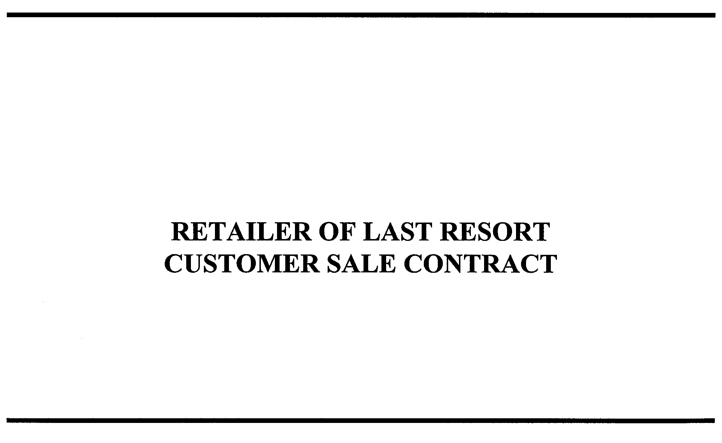
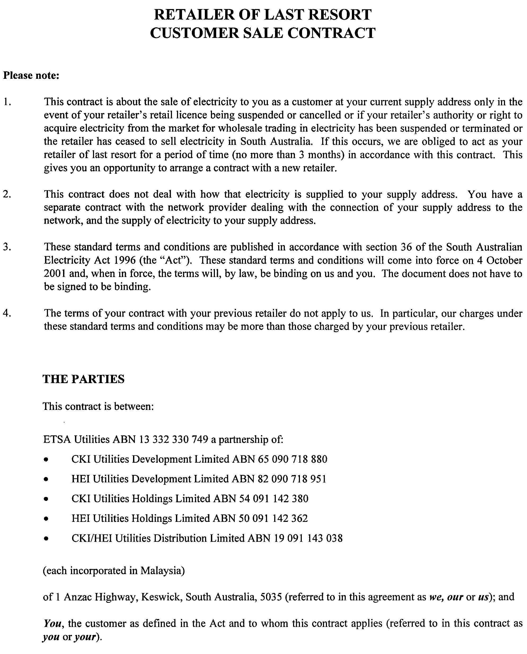
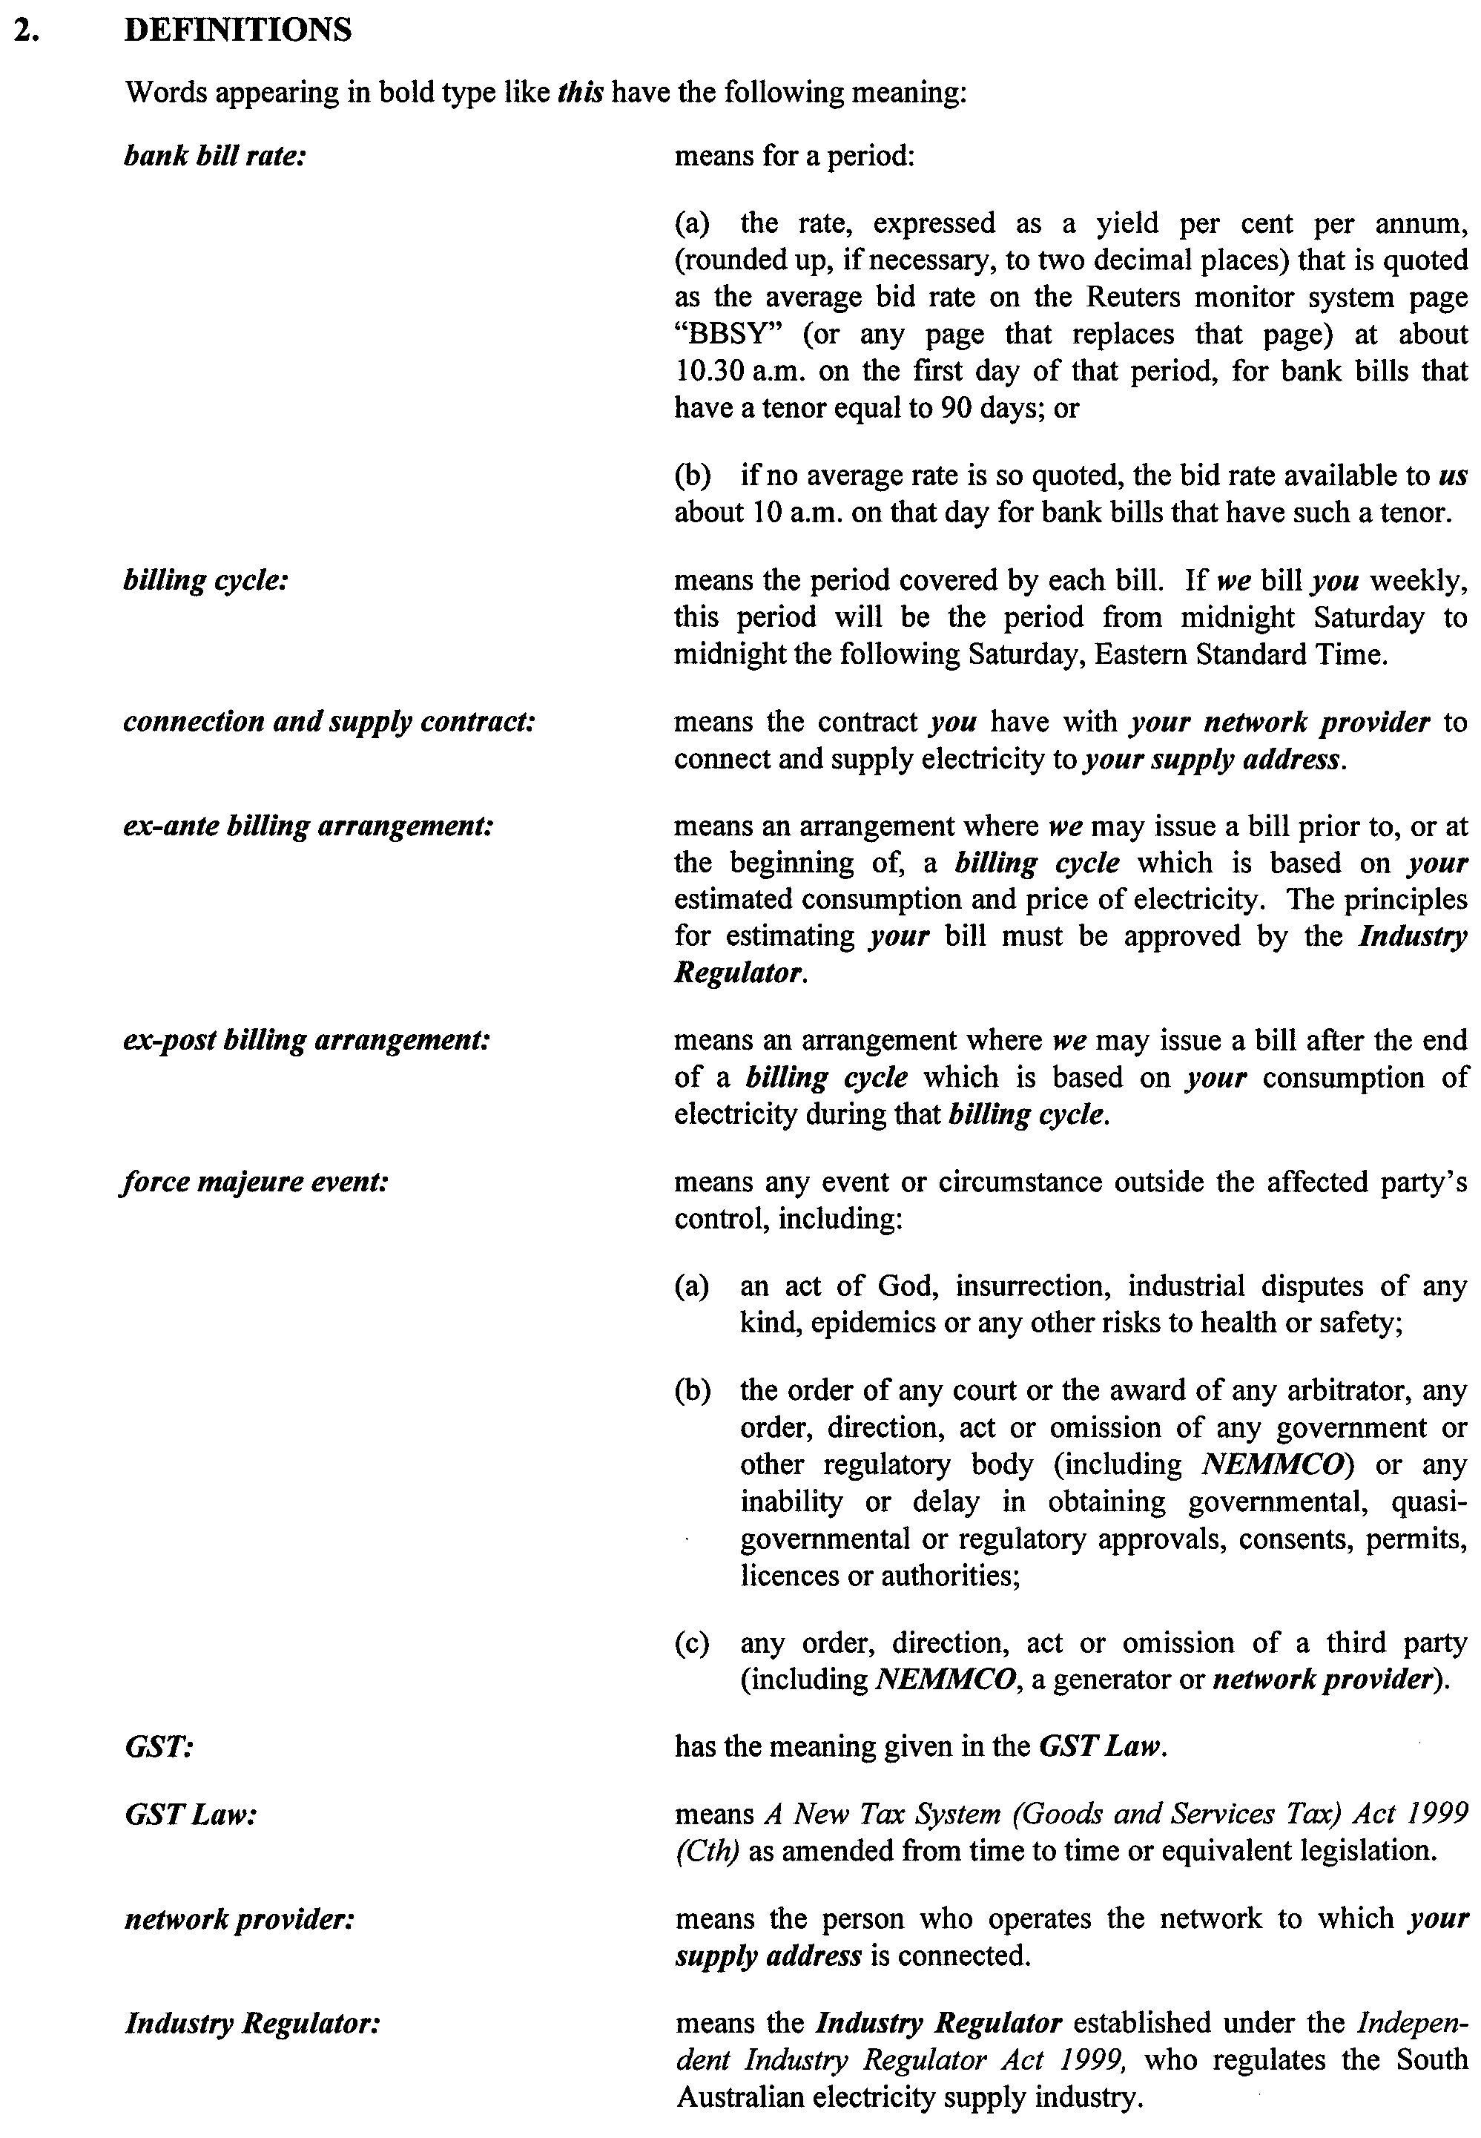
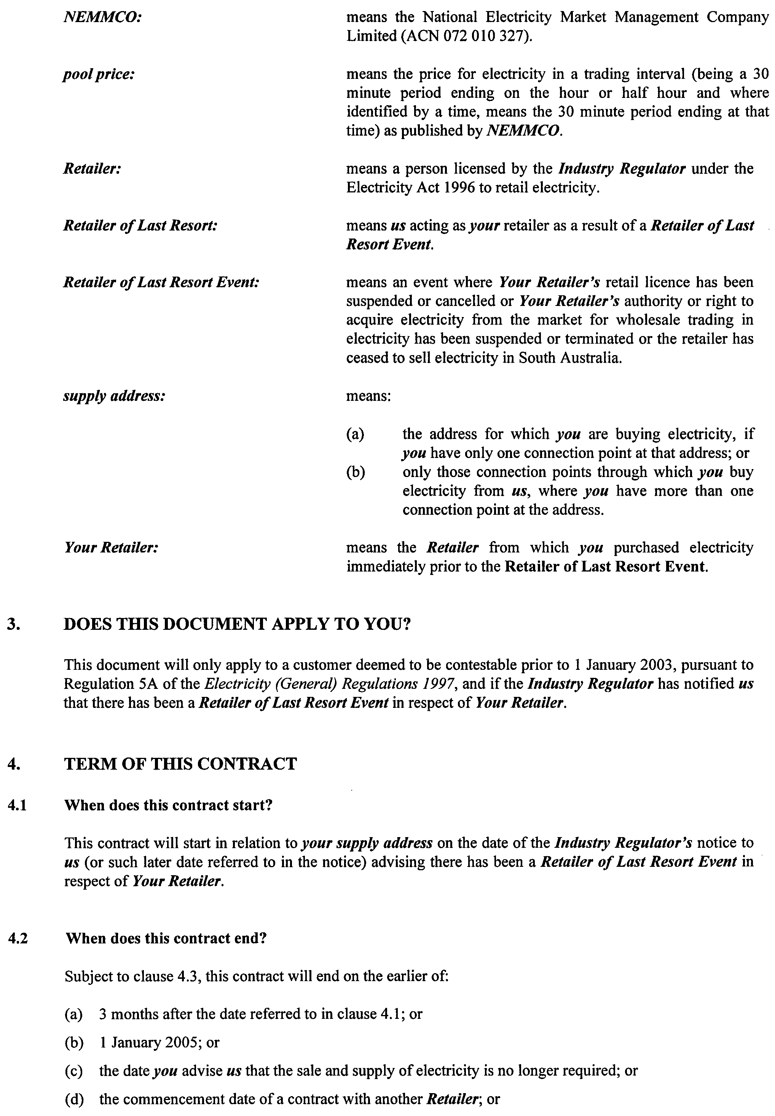
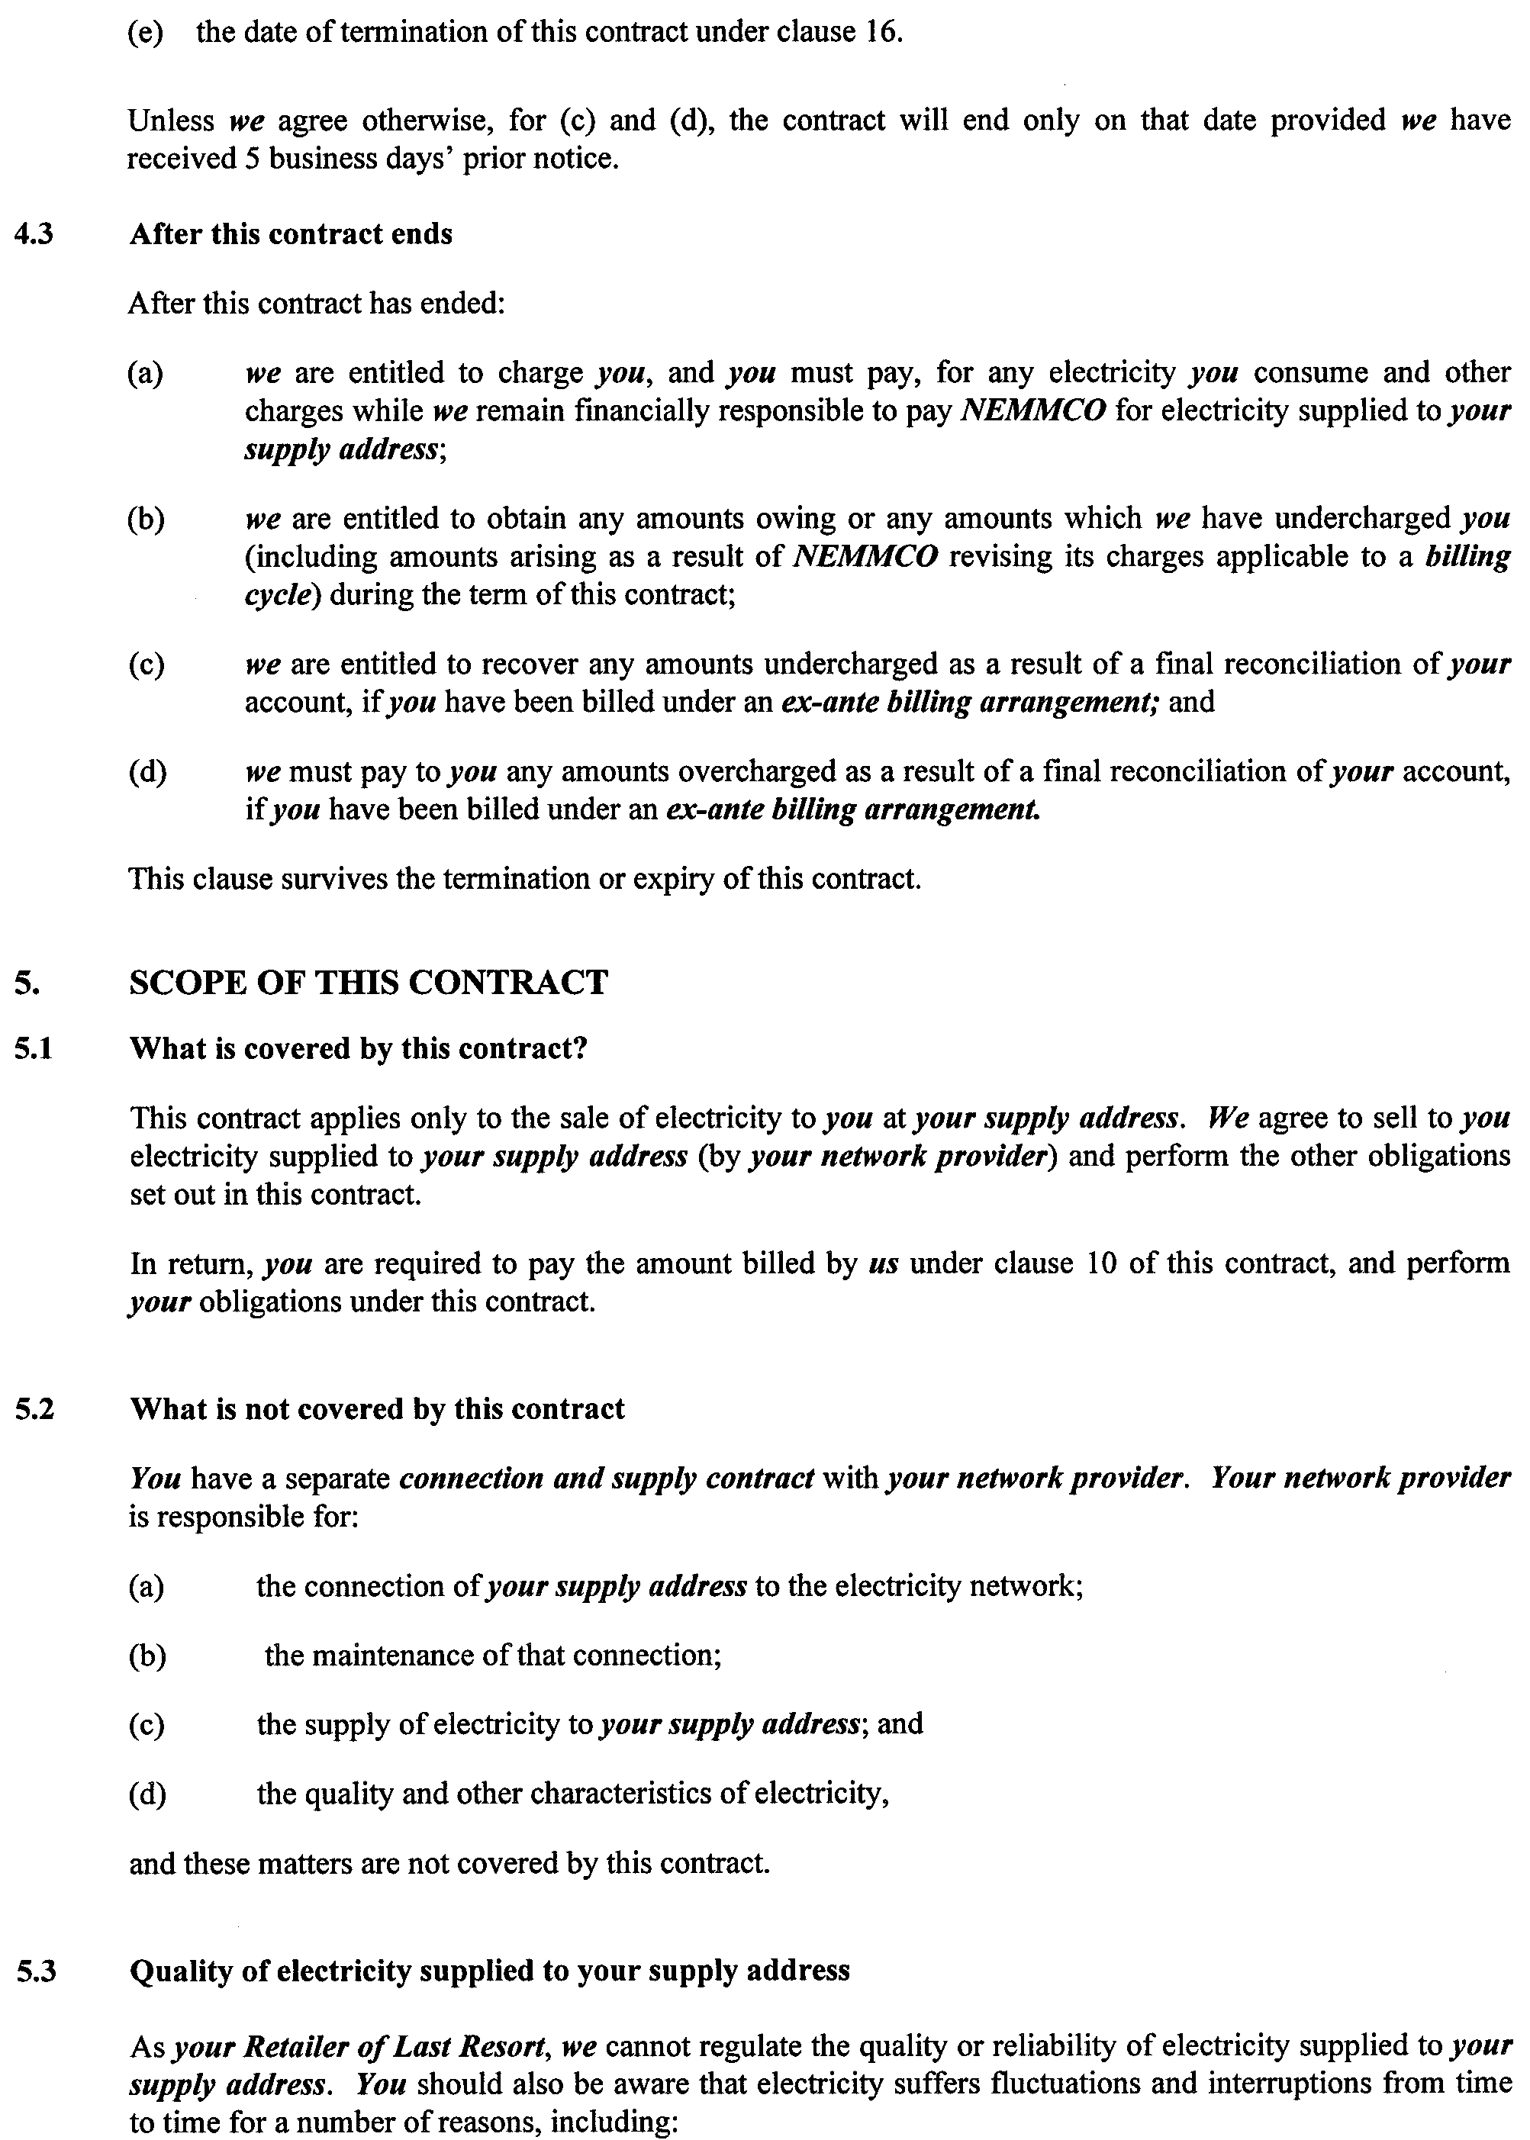
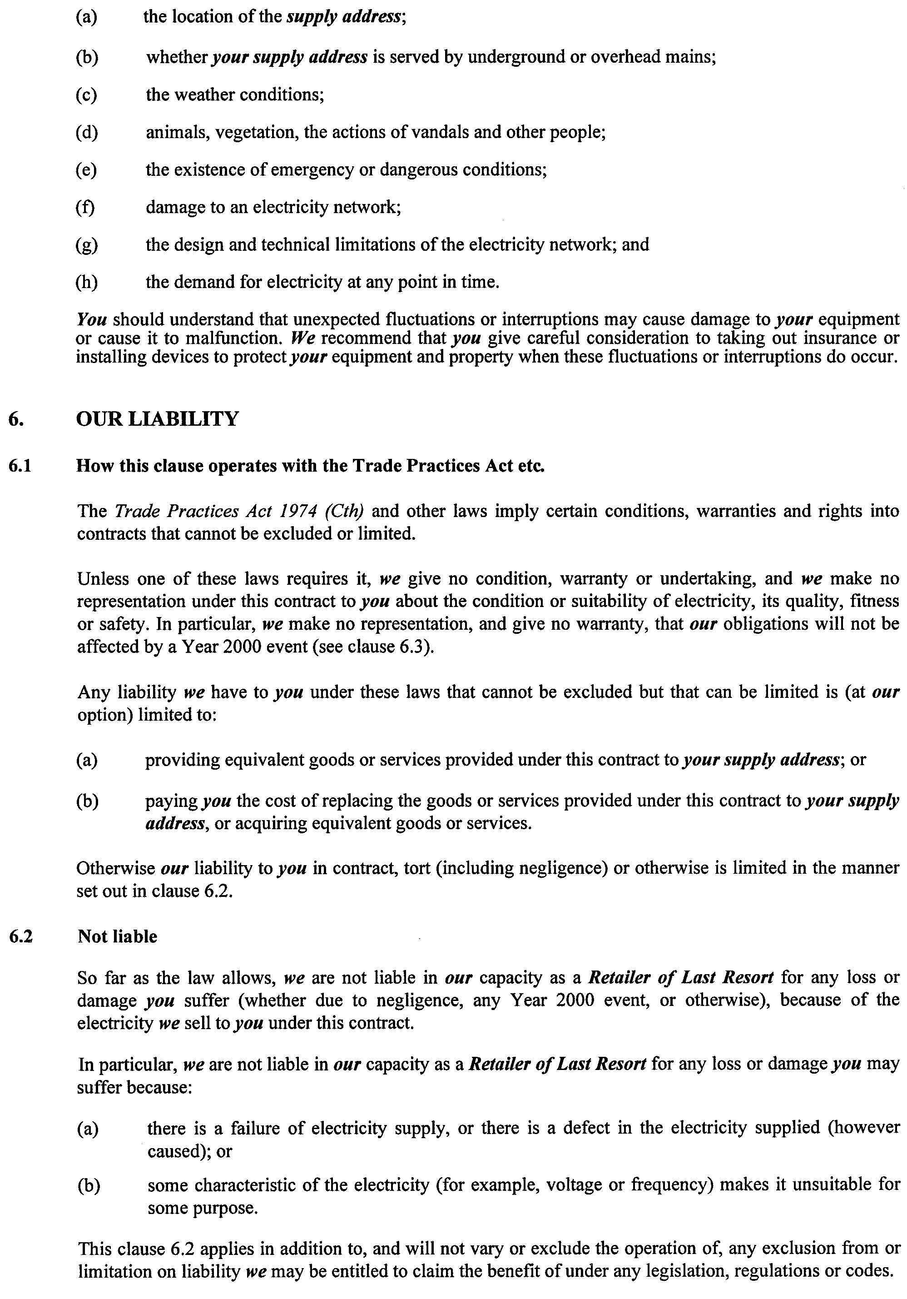
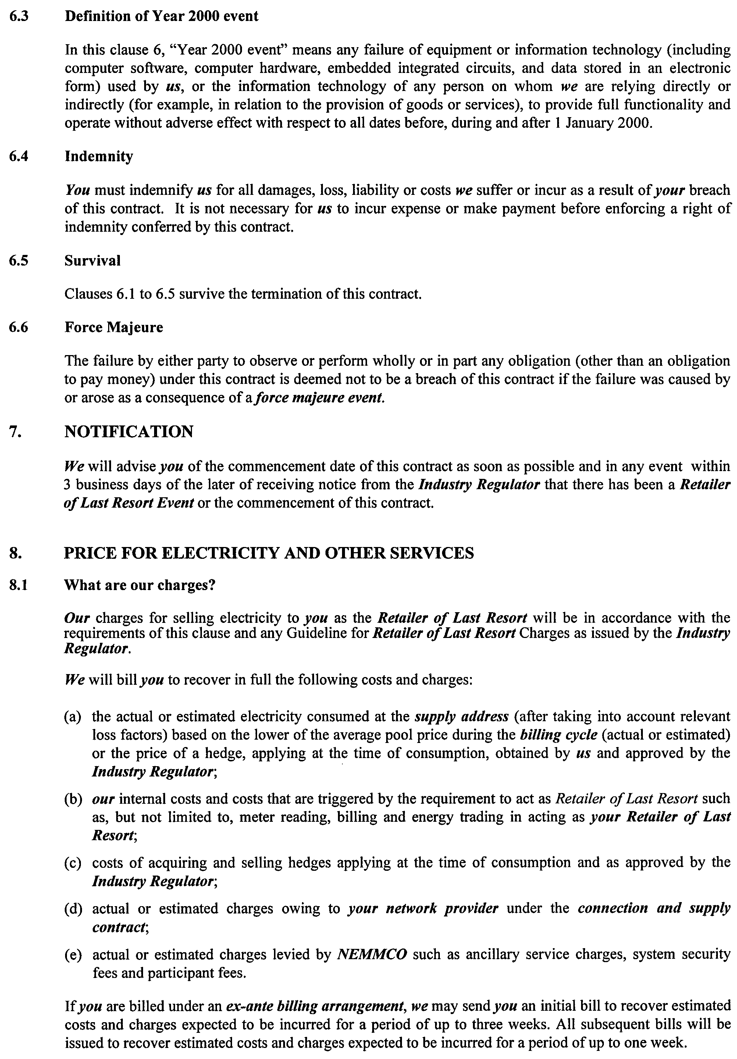
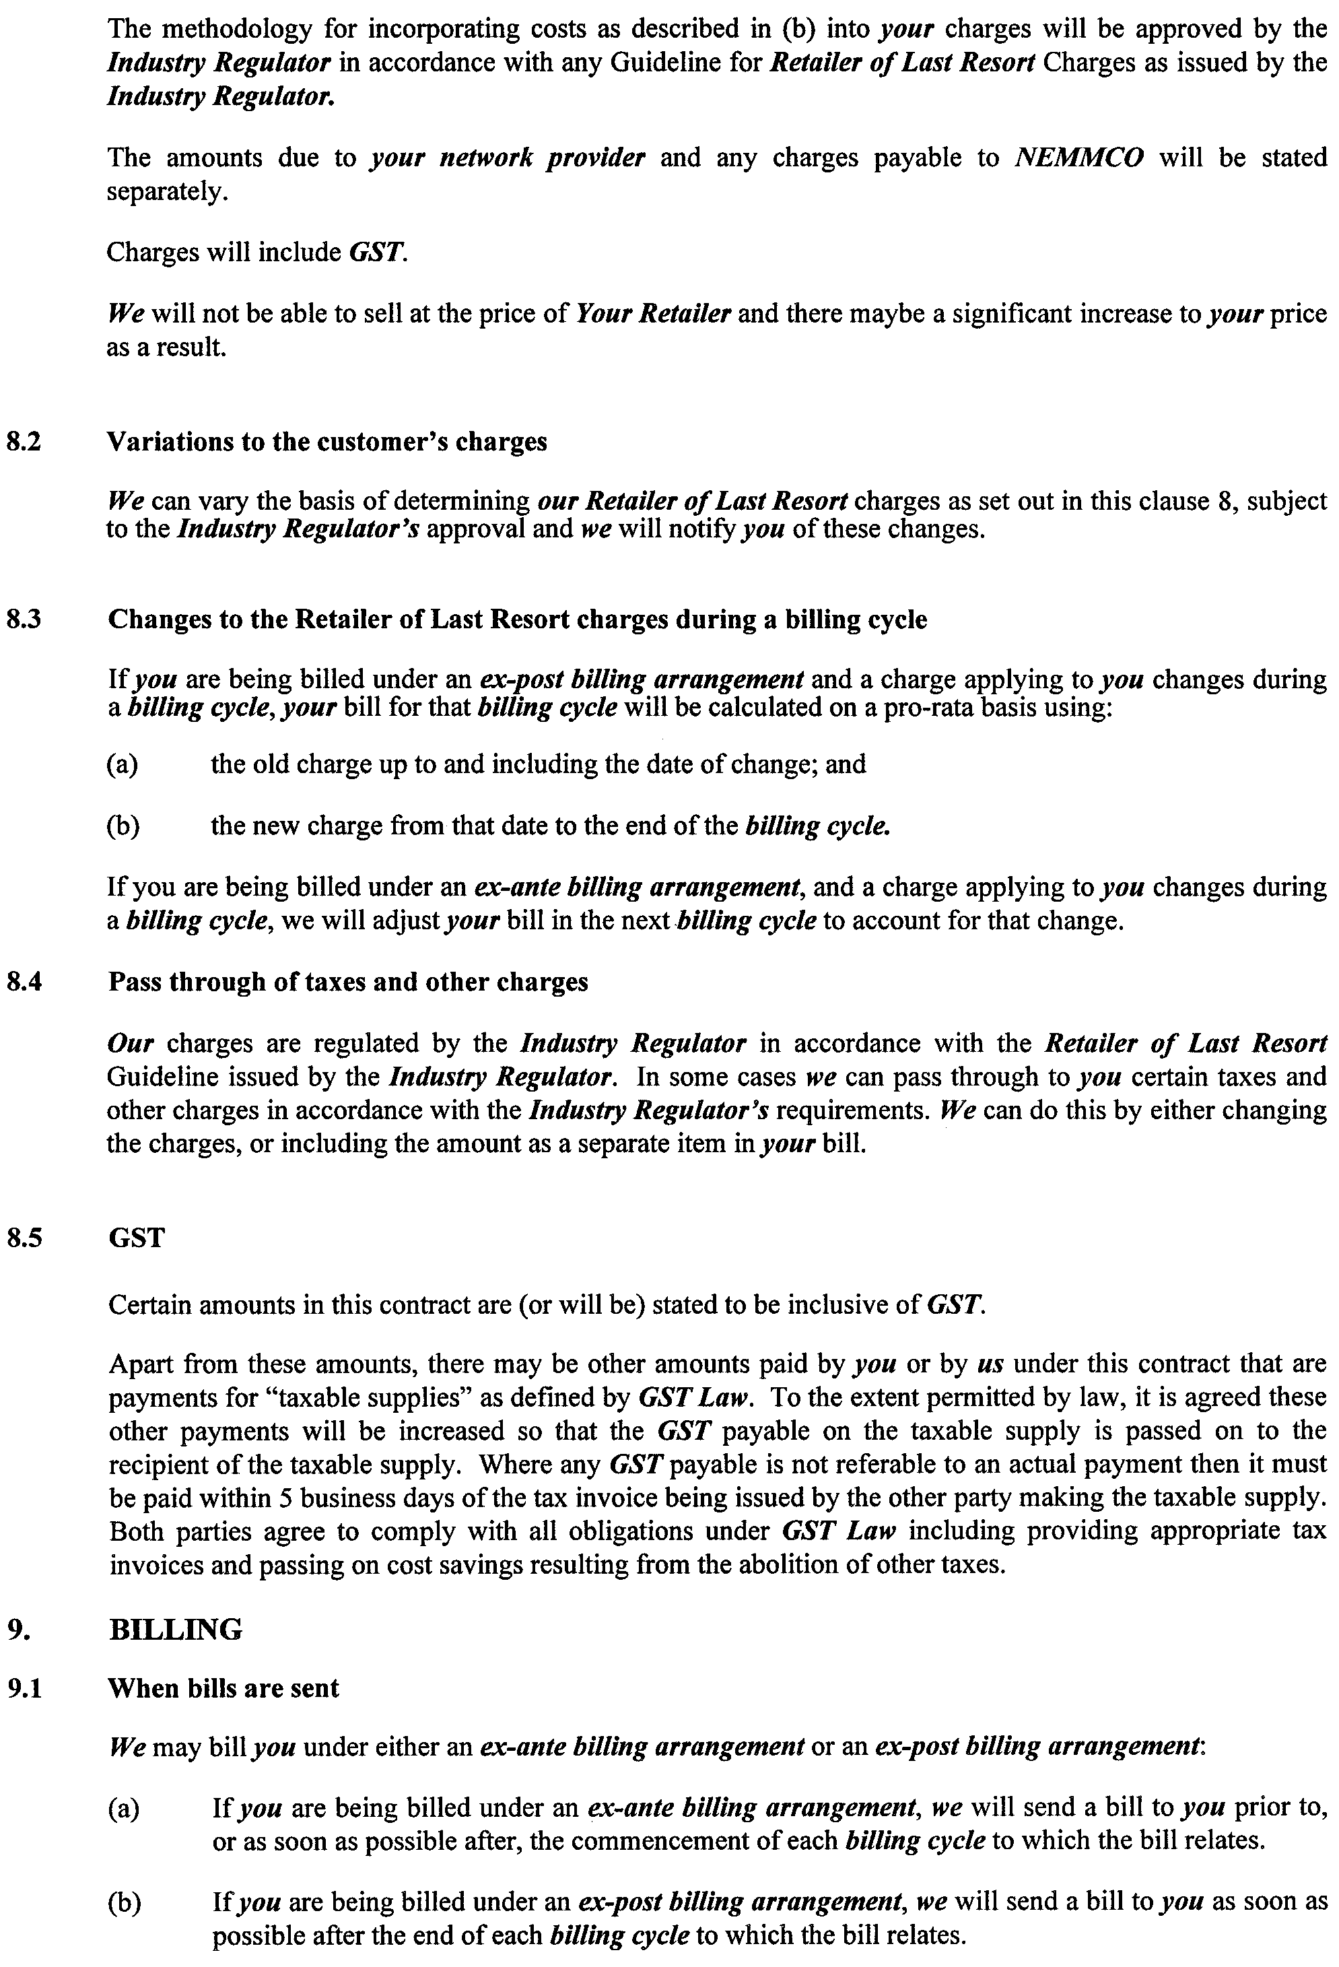
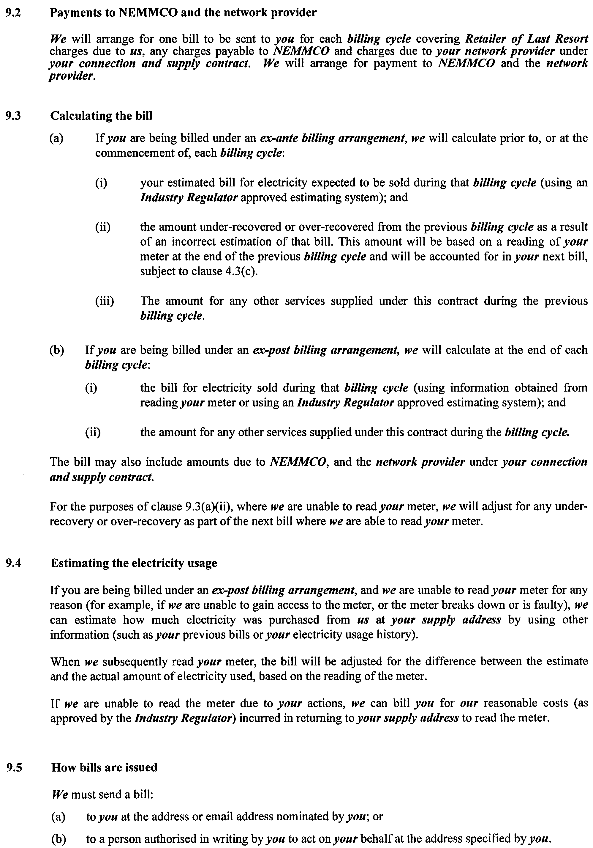
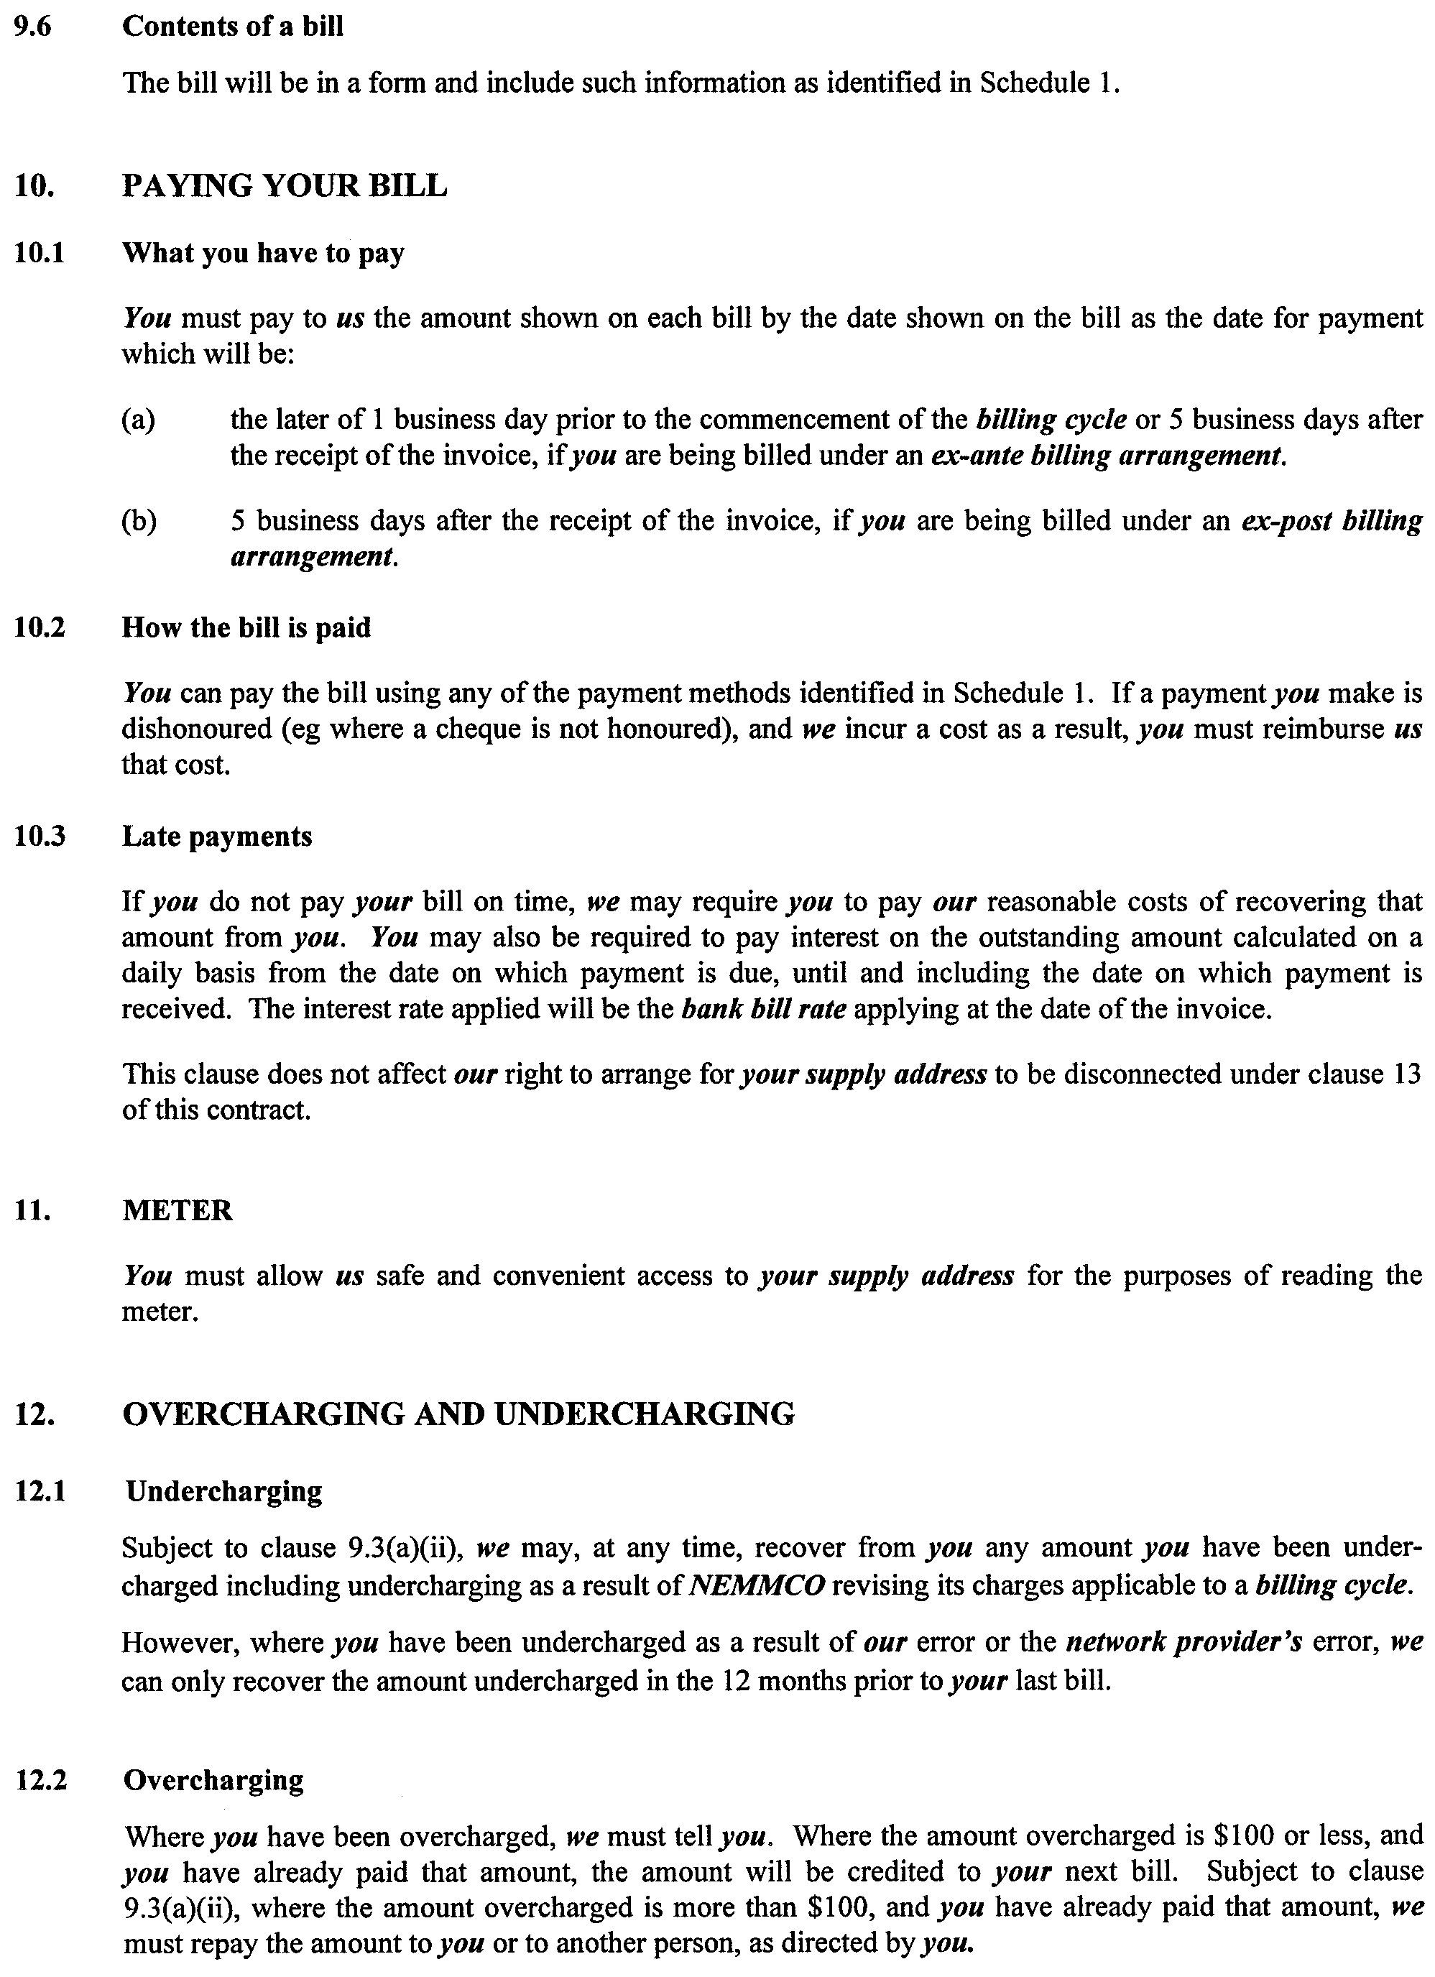
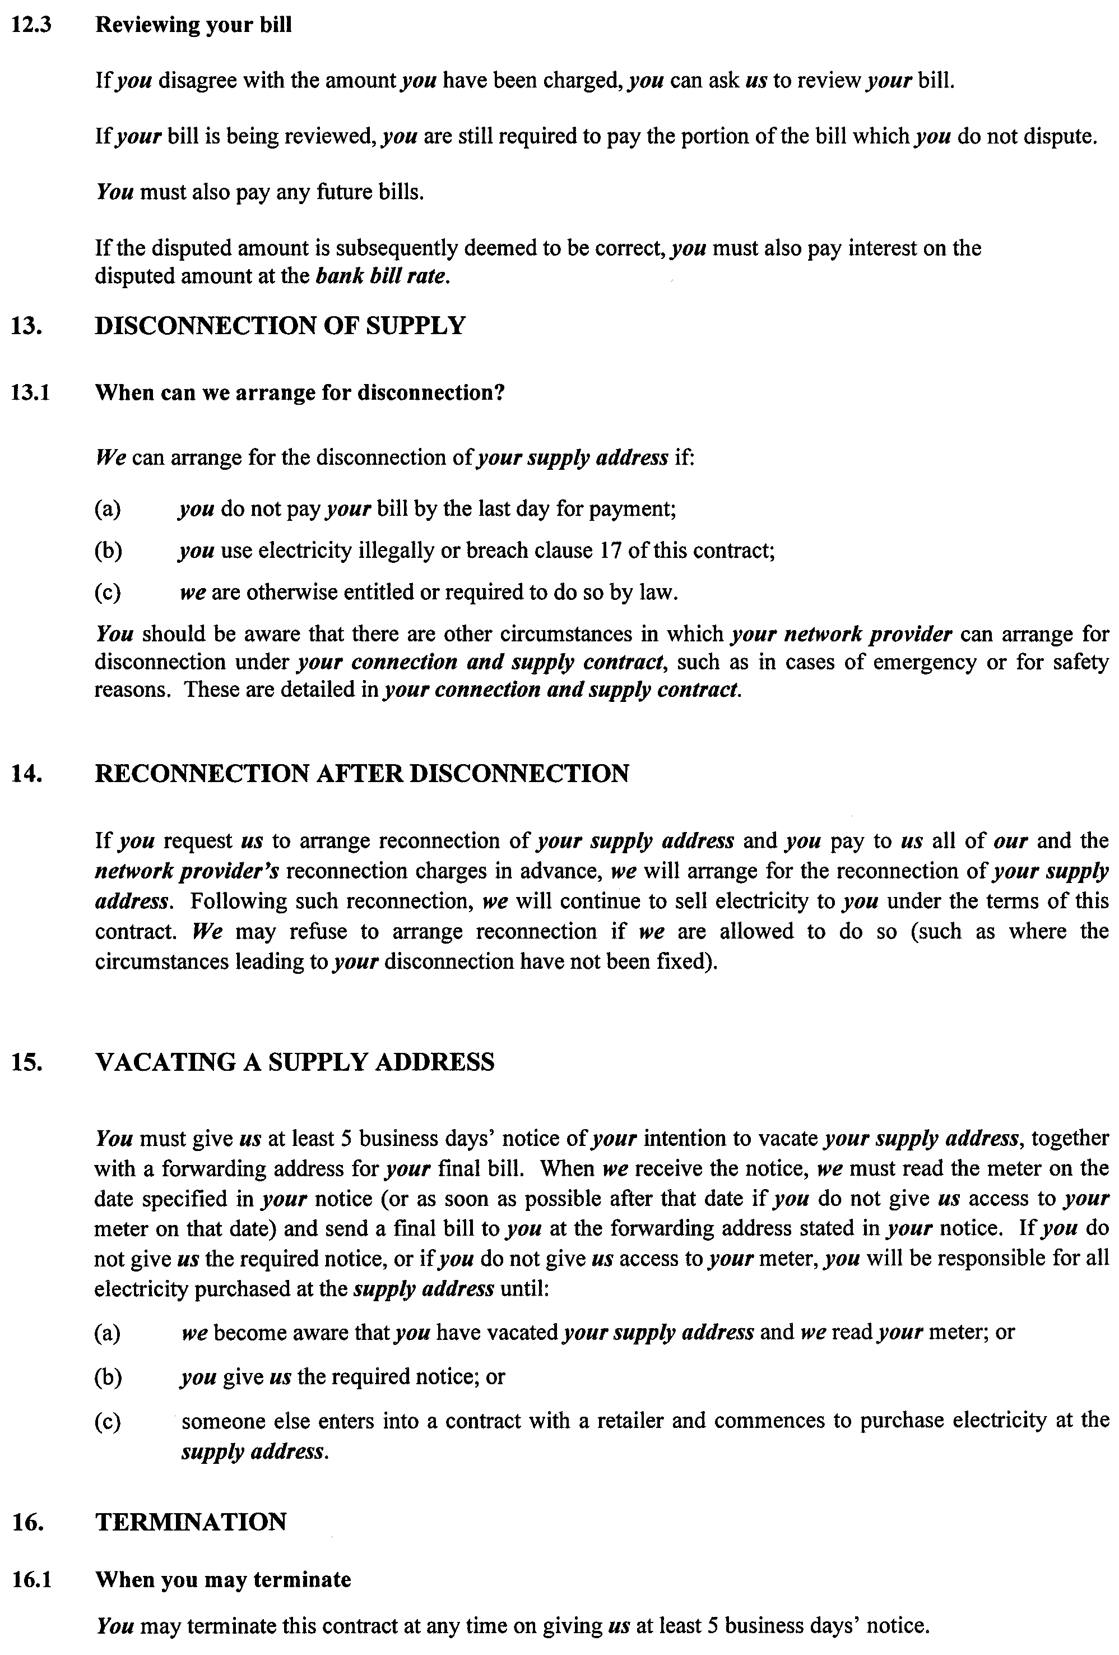
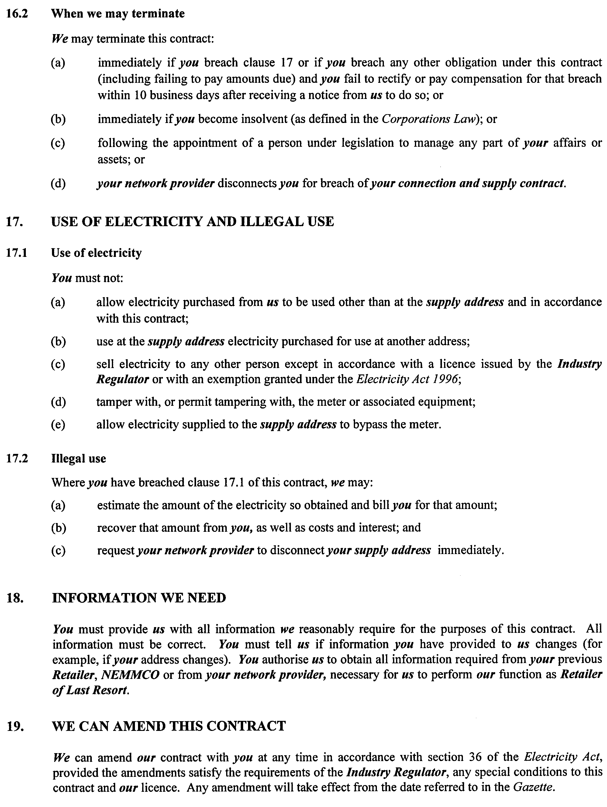
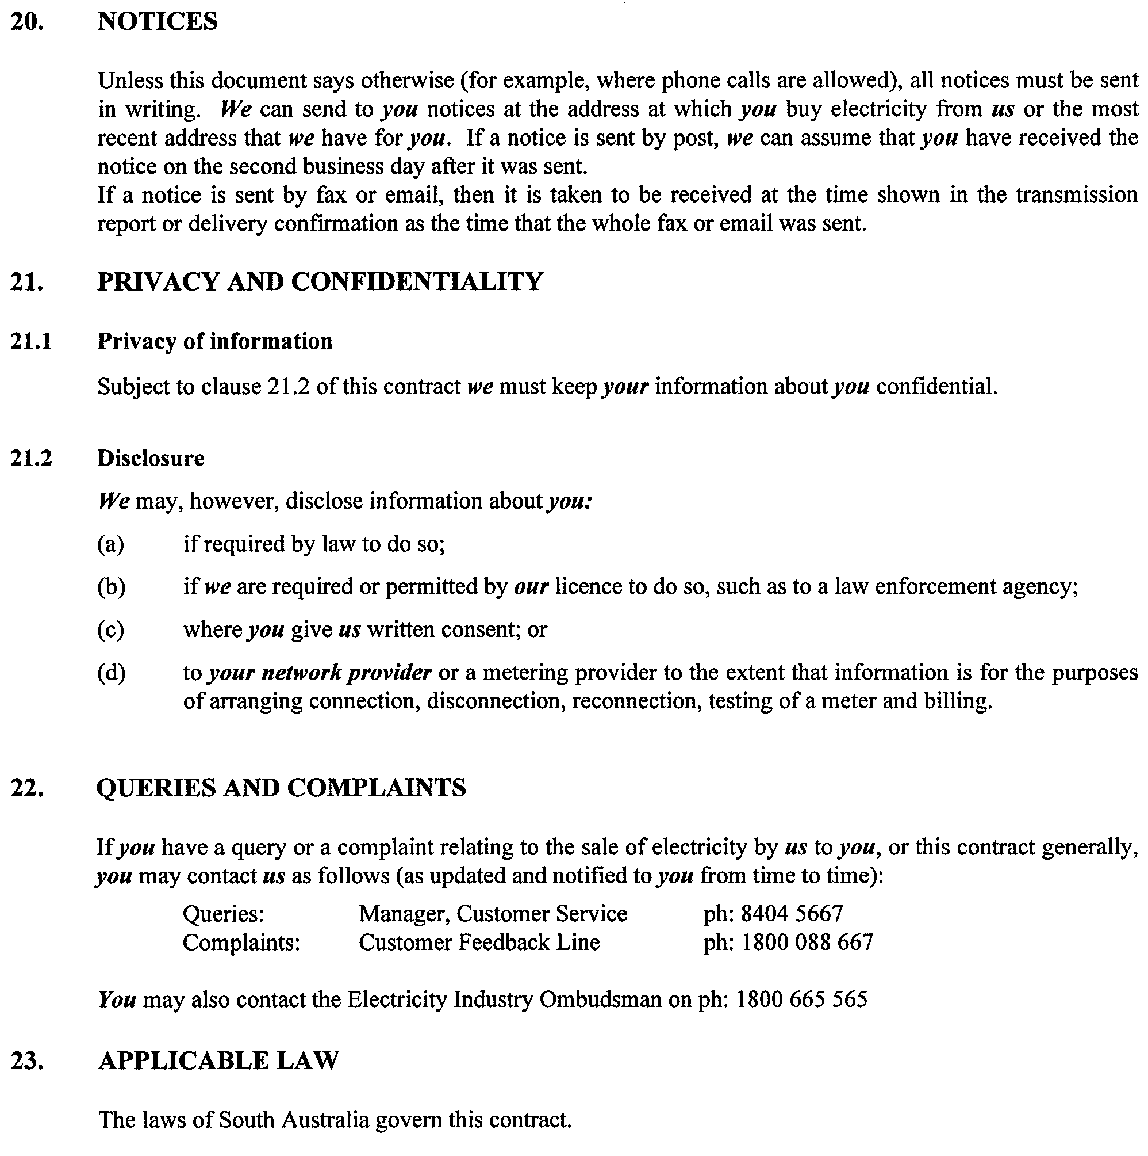
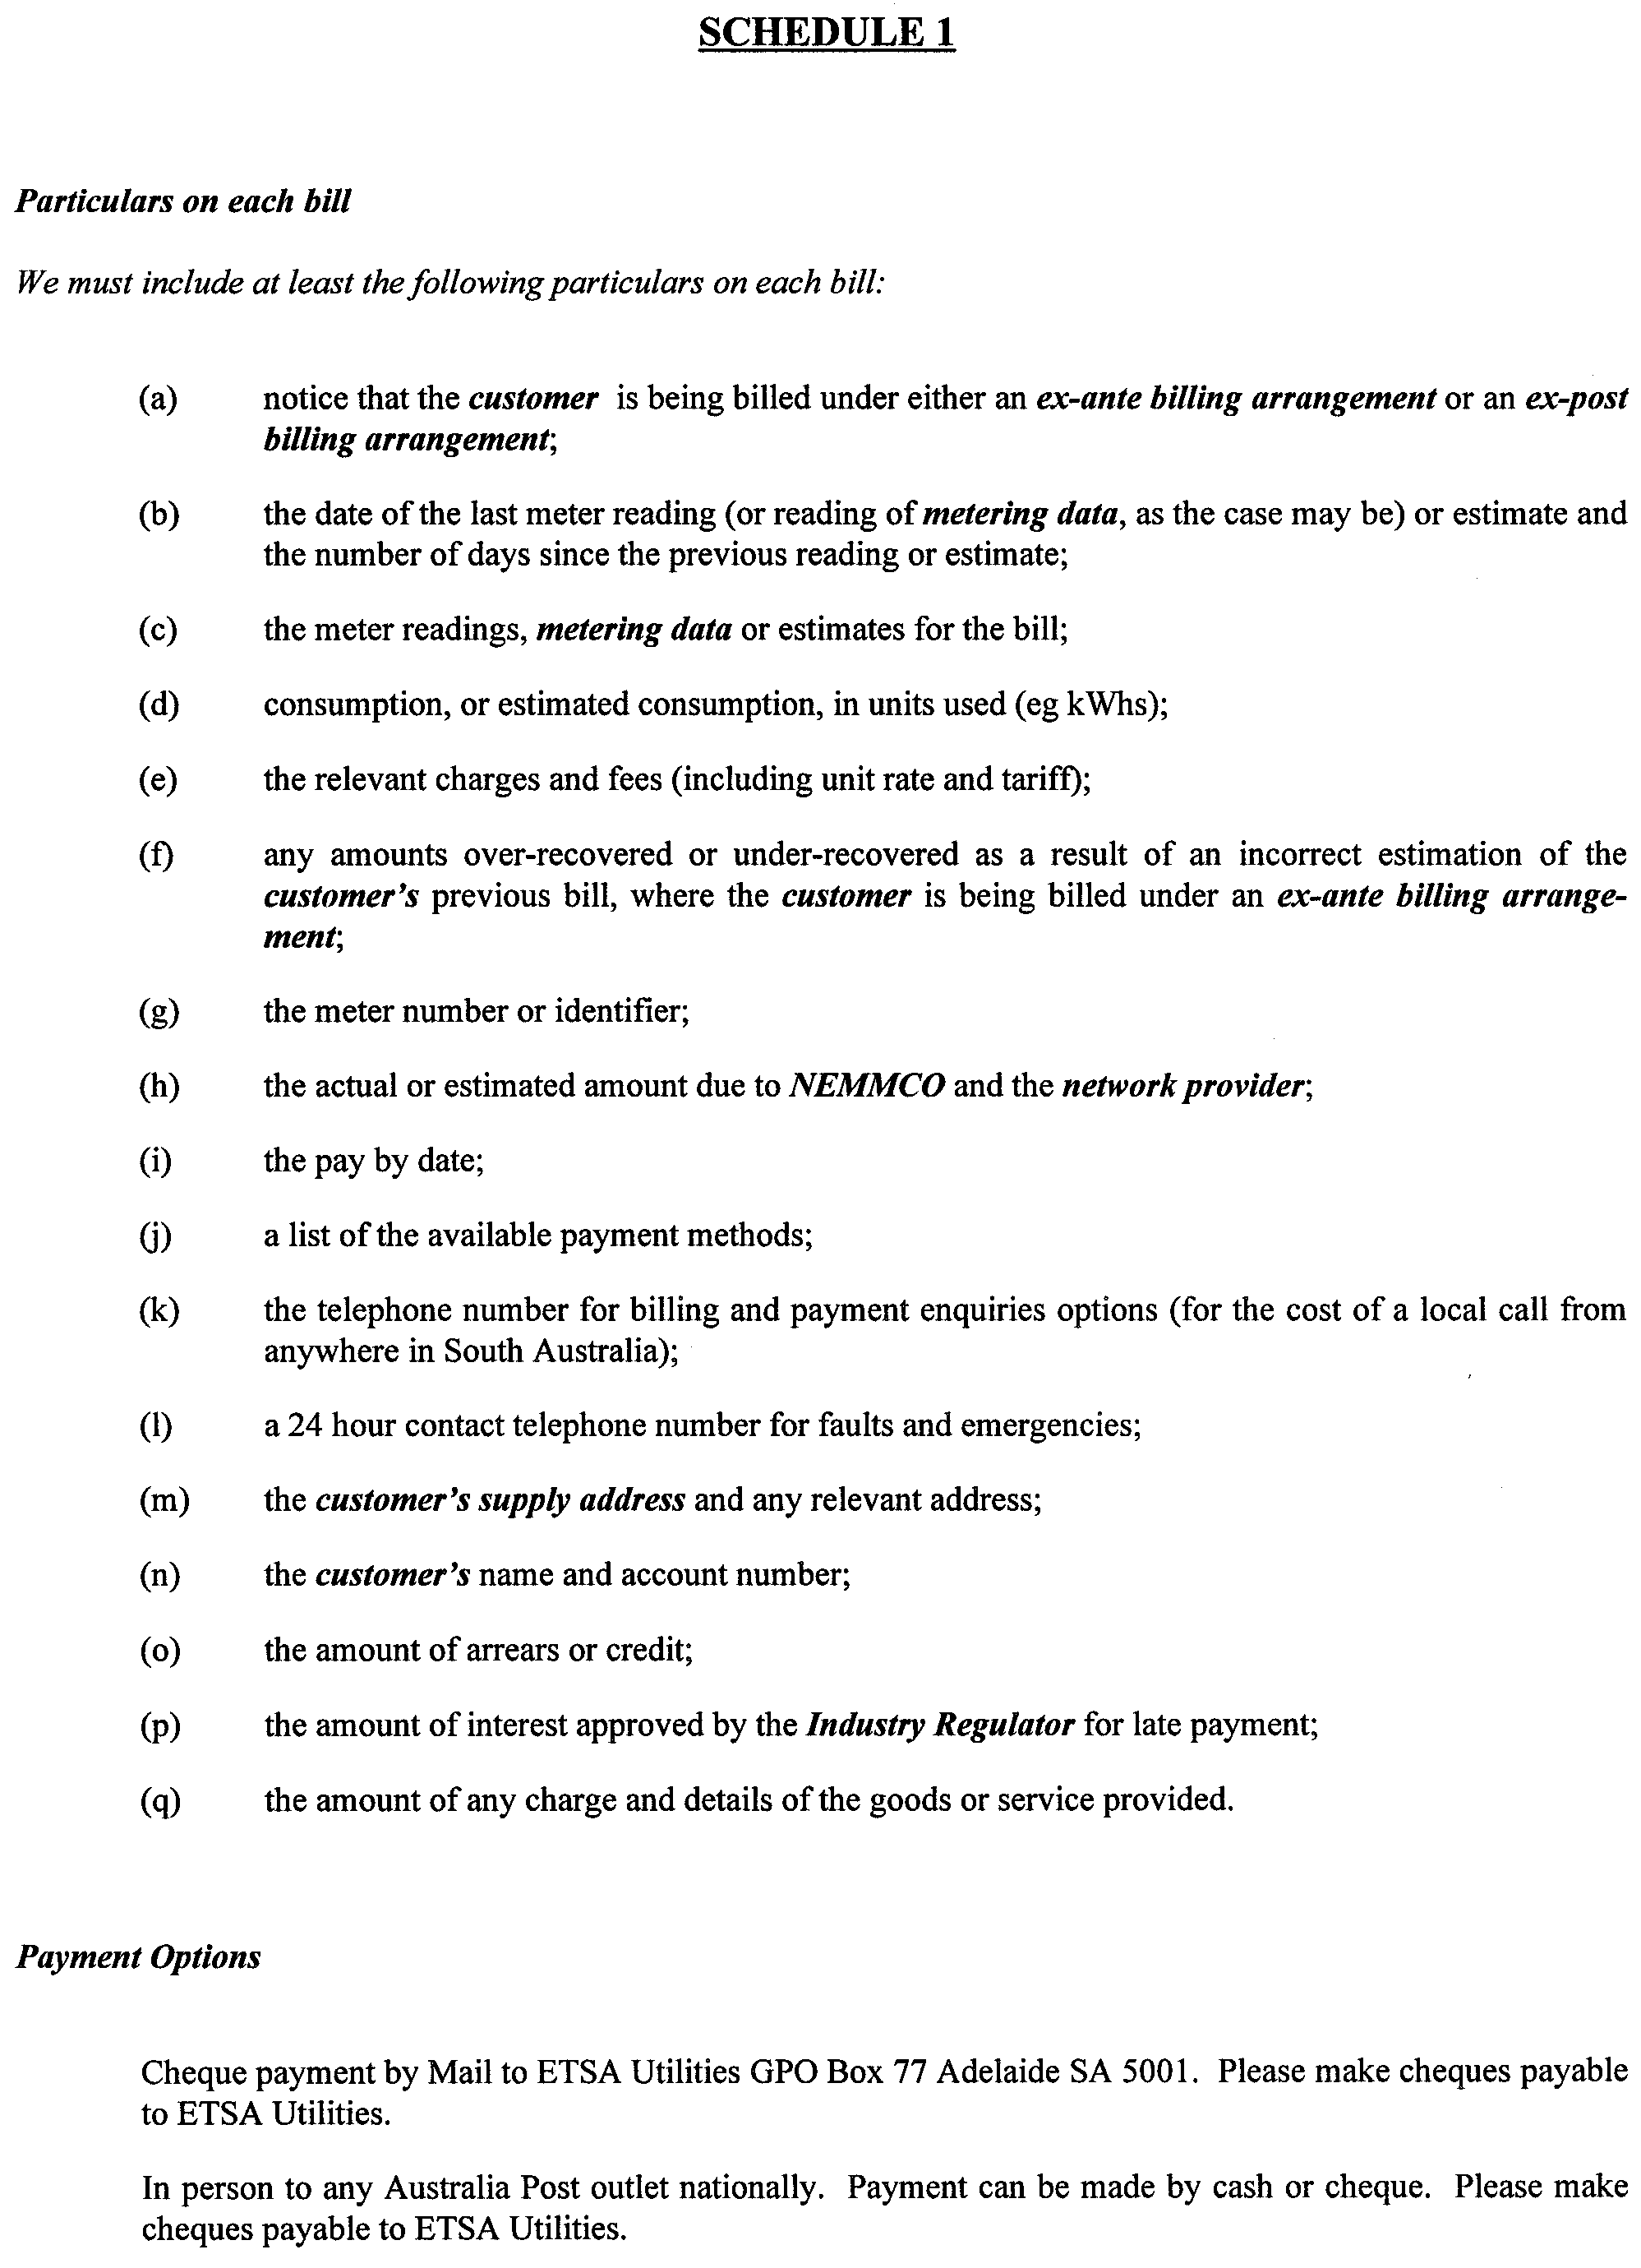
Dated 4 October 2001.
E. Lindner, General Manager, Corporate Affairs

FISHERIES ACT 1982: SECTION 59
TAKE notice that pursuant to section 59 of the Fisheries Act 1982, John Skorpos (hereinafter referred to as the ‘exemption holder’), 42 Hamilton Avenue, Warradale, S.A. 5046, holder of Marine Scalefish Fishery Licence No. M007, is exempt from the provision of Clause 61 of Schedule 1 of the Fisheries (General) Regulations 2000, subject to the conditions specified in Schedule 1, in that the exemption holder shall not be guilty of an offence when taking up to 150 razor fish (Pinna bicolor) in any one day, from South Australian coastal marine waters from the date of gazettal of this notice until 30 June 2002.
Schedule 1
1. All razor fish (Pinna bicolor) taken shall be used for bait only.
2. The total number of razor fish (Pinna bicolor) taken in any one day, shall be no greater than one hundred and fifty.
3. The exemption holder must include all razor fish (Pinna bicolor) taken under this permit on his monthly catch and effort summary provided to the South Australian Research and Development Institute (SARDI).
4. Whilst engaged in the collection activity the exemption holder must have in or about his possession a copy of this notice and produce that notice to a PIRSA Fisheries Compliance Officer forthwith, if and when an officer requests the exemption holder to produce it.
5. The exemption holder shall not contravene or fail to comply with the Fisheries Act 1982, or any regulations made under the Act, except where specifically exempted by this notice.
Dated 27 September 2001.
W. Zacharin, Director of Fisheries

FISHERIES ACT 1982: SECTION 59
TAKE notice that pursuant to section 59 of the Fisheries Act 1982, Rolf Czabayski, 5 Willowbridge Grove, Burnside, S.A. 5066 (hereinafter referred to as the ‘permit holder’) is exempt from Regulation 35C of the Fisheries (General) Regulations 1984, in that the permit holder shall not be guilty of an offence when using berley within the waters specified in Schedule 1 to attract white sharks (Carchardon carcharias) for the purpose of cage viewing only (hereinafter referred to as the ‘permitted activity’), subject to the conditions specified in Schedule 2, for the dates specified in Schedule 3.
Schedule 1
Coastal waters contained within the Neptune Islands Con-servation Park, and the following portions of the Sir Joseph Banks Islands Conservation Park; English and Sibsey Islands.
Note: During Australian Sea Lion breeding periods at Dangerous Reef, permits will not be provided for eight months. This period will begin eight weeks after the appearance of the first pups.
Schedule 2
1. The permit holder must be on board the boat when conducting the permitted activity.
2. All berley used while conducting the permitted activity must consist of fish based products only. All berley (other than fish oil) must be stored below a maximum temperature of 4°C.
3. The permit holder must notify the public by a Notice to Mariners through the Australian Maritime Safety Authority, by public notice in the Adelaide Advertiser at least 24 hours in advance of berleying operations, advising the local coastguard and the Fisheries Compliance Unit on 1800 065 522 at least two hours prior to conducting the permitted activities.
4. The permit holder shall allow an officer of the DEH or nominee to be present on board the boat during the permitted activities if requested and subject to negotiation and availability of space.
5. The permit holder must comply with all instructions (including ceasing to berley if so instructed) given by an officer from DEH.
6. Whilst engaged in the permitted activity, a pennant (approved by DEH) must be flown from the boat so as to be clearly visible.
7. Whilst engaged in the permitted activity the permit holder must have in his/her possession a copy of this notice and produce a copy of the notice if required by a Fisheries Compliance Officer.
8. The permit holder shall not contravene or fail to comply with the Fisheries Act 1982, or any regulations made under the Act, except where specifically exempted by this notice.
9. The permit holder must maintain a log whilst engaged in the permitted activity which includes the date and location, number of passengers, number of hours berleying, number of sharks observed and any other relevant observations or comments. Records must be kept in a form determined by the operators association in conjunction with CSIRO Marine Research Unit and endorsed by the Minister for Environment and Heritage. A copy of the log must be provided to the relevant DEH office within 14 days of each calendar month. Failure to submit a log within the agreed time period may preclude the provision of future permits until such outstanding logs are received by the relevant DEH office.
10. The permit holder must conform to a code of conduct developed by the operators association and endorsed by the Minister for Environment and Heritage.
11. The permit holder will operate in cooperation with and in agreement of any other approved operator at the same location.
12. The permit holder must have public liability insurance to an amount determined by the Minister for Environment and Heritage and ensure vessels are surveyed and staffed as per Department of Transport regulations.
Schedule 3
Dates permitted to berley:
8-11 October 2001
16-19 October 2001
28-30 October 2001
Dated 2 October 2001.
J. Tilley, Acting Regional Manager West

DEPARTMENT OF PRIMARY INDUSTRIES AND RESOURCES SA—FISHERIES DIVISION
NOTICE is hereby given pursuant to section 28 (10) (b) of the Fisheries Act 1982, that the following items have been seized by officers of the Department of Primary Industries, Fisheries Division at Thompsons Beach on 28 June 2001.
Mesh net 50 m in length with 50 mm multi-filament mesh and orange 6 mm ropes with orange floats on float line.
The above items were suspected to have been used or intended to be used, in contravention of the Fisheries Act 1982, and were taken into possession at the northern end of Thompsons Beach.
After the expiration of one month from the date of this notice the items listed above shall, on the order of the Minister of Primary Industries, be forfeited to the Crown and shall be either disposed of by sale or destruction.
The above items may be viewed at the Birkenhead office of the Department of Primary Industries, Fisheries Division.
Dated 25 September 2001.
B. E. Hemming, Manager, Fisheries Compliance

DEPARTMENT OF PRIMARY INDUSTRIES AND RESOURCES SA—FISHERIES DIVISION
NOTICE is hereby given pursuant to section 28 (10) (b) of the Fisheries Act 1982, that the following items have been seized by officers of the Department of Primary Industries, Fisheries Division on 19 August 2001.
A mono-filament white mesh net, with a mesh size of 11 cm, a blue nylon head line with white rubber floats, a blue nylon lead line approximately 180 m in length with a 10 m green rope attached to the head line and two home made anchors attached to the head line.
The above items were suspected to have been used or intended to be used, in contravention of the Fisheries Act 1982, and were taken into possession at the 352 km mark on the River Murray.
After the expiration of one month from the date of this notice the items listed above shall, on the order of the Minister of Primary Industries, be forfeited to the Crown and shall be either disposed of by sale or destruction.
The above items may be viewed at the Loxton office of the Department of Primary Industries and Resources S.A. Fisheries Division.
Dated 26 September 2001.
B. E. Hemming, Manager, Fisheries Compliance

HOUSING IMPROVEMENT ACT 1940
Erratum
IN Government Gazette of 27 September 2001, page 4304, the item in the fifth column of the entry for house at 42 Adelaide Terrace, Pasadena should read 26.7.01, page 2774 not 22.5.01, page 2772.

LAND AND BUSINESS (SALE AND CONVEYANCING) ACT 1994
Exemption
TAKE notice that, pursuant to section 23 (3) of the Land and Business (Sale and Conveyancing) Act 1994, I, Kenneth Trevor Griffin, Minister for Consumer Affairs, do hereby exempt the person named in Schedule 1 from the application of section 23 (2) of the Act in relation to the purchase of the land specified in Schedule 2.
Schedule 1
Kym Nigel Waters, an officer/employee of Mazzeo Real Estate Pty Ltd.
Schedule 2
The whole of the land described in certificate of title register book volume 5079, folio 76, situated at 25 Winterbourne Road, Elizabeth Vale, S.A. 5112.
Dated 4 October 2001.
Signed for and on behalf of the Minister for Consumer Affairs by the Commissioner for Consumer Affairs:
M. D. Bodycoat, Commissioner

LAND AND BUSINESS (SALE AND CONVEYANCING) ACT 1994
Exemption
TAKE notice that, pursuant to section 23 (3) of the Land and Business (Sale and Conveyancing) Act 1994, I, Kenneth Trevor Griffin, Minister for Consumer Affairs, do hereby exempt the person named in Schedule 1 from the application of section 23 (2) of the Act in relation to the purchase of the land specified in Schedule 2.
Schedule 1
Barry Bertram Thompson, an officer/employee of Joelawden Pty Ltd.
Schedule 2
The whole of the land described in certificate of title register book volume 5513, folio 601, situated at 4 The Crescent, Seaford Rise, S.A. 5169.
Dated 4 October 2001.
Signed for and on behalf of the Minister for Consumer Affairs by the Commissioner for Consumer Affairs:
M. D. Bodycoat, Commissioner

LAND AND BUSINESS (SALE AND CONVEYANCING) ACT 1994
Exemption
TAKE notice that, pursuant to section 23 (3) of the Land and Business (Sale and Conveyancing) Act 1994, I, Kenneth Trevor Griffin, Minister for Consumer Affairs, do hereby exempt the person named in Schedule 1 from the application of section 23 (2) of the Act in relation to the purchase of the land specified in Schedule 2.
Schedule 1
Rosalyn Heather Key, an officer/employee of City South Realty Pty Ltd.
Schedule 2
The whole of the land described in certificate of title register book volume 5231, folio 643, situated at 72 Valley View Drive, McLaren Vale, S.A. 5171.
Dated 4 October 2001.
Signed for and on behalf of the Minister for Consumer Affairs by the Commissioner for Consumer Affairs:
M. D. Bodycoat, Commissioner

LAND AND BUSINESS (SALE AND CONVEYANCING) ACT 1994
Exemption
TAKE notice that, pursuant to section 23 (3) of the Land and Business (Sale and Conveyancing) Act 1994, I, Kenneth Trevor Griffin, Minister for Consumer Affairs, do hereby exempt the person named in Schedule 1 from the application of section 23 (2) of the Act in relation to the purchase of the land specified in Schedule 2.
Schedule 1
Colleen Boege, an officer/employee of W. B. Real Estate Pty Ltd.
Schedule 2
The whole of the land described in certificate of title register book volume 5245, folio 876, situated at 40 Karrawirra Close, Craigmore, S.A. 5114.
Dated 4 October 2001.
Signed for and on behalf of the Minister for Consumer Affairs by the Commissioner for Consumer Affairs:
M. D. Bodycoat, Commissioner

LIQUOR LICENSING ACT 1997 AND GAMING MACHINES ACT 1992
Notice of Application
NOTICE is hereby given, pursuant to section 52 of the Liquor Licensing Act 1997 and section 29 of the Gaming Machines Act 1992, that J. G. B. Hotel Pty Ltd (ACN 098 230 141), c/o Piper Alderman, 167 Flinders Street, Adelaide, S.A. 5000, has applied to the Liquor and Gaming Commissioner for the transfer of a Hotel Licence and a Gaming Machine Licence in respect of premises situated at 106 Halifax Street, Adelaide, S.A. 5000 and known as Rob Roy Hotel.
The applications have been set down for hearing on 2 November 2001.
Any person may object to the application by lodging a notice of objection in the prescribed form with the Licensing Authority, and serving a copy of the notice on the applicant at the applicant’s address given above, at least seven days before the hearing date.
Plans in respect of the premises the subject of the application are open to public inspection without fee at the Office of the Liquor and Gaming Commissioner, 9th Floor, East Wing, 50 Grenfell Street, Adelaide, S.A. 5000.
Dated 26 September 2001.
Applicant

LIQUOR LICENSING ACT 1997
Notice of Application
NOTICE is hereby given, pursuant to section 52 (2) (b) of the Liquor Licensing Act 1997, that Roopena Football Club Inc. has applied to the Licensing Authority for an Extended Trading Authorisation in respect of premises situated at Fisk Street, Whyalla Norrie, S.A. 5608 and known as Roopena Football Club.
The application has been set down for hearing on 2 November 2001.
Conditions
The following licence conditions are sought:
• Extended Trading Authorisation sought to authorise the sale of liquor for consumption on the licensed premises each Friday and Saturday between the hours of midnight and 2 a.m. the following day.
• Entertainment Consent is sought during the above hours.
Any person may object to the application by lodging a notice of objection in the prescribed form with the Licensing Authority, and serving a copy of the notice on the applicant at the applicant’s address given above, at least seven days before the hearing date.
Plans in respect of the premises the subject of the application are open to public inspection without fee at the Office of the Liquor and Gaming Commissioner, 9th Floor, East Wing, 50 Grenfell Street, Adelaide, S.A. 5000.
Dated 21 September 2001.
Applicant

LIQUOR LICENSING ACT 1997
Notice of Application
NOTICE is hereby given, pursuant to section 52 (2) (b) of the Liquor Licensing Act 1997, that David Tarr has applied to the Licensing Authority for a Hotel Licence in respect of premises situated at 14 First Street, Beltana, S.A. 5730 and known as Royal Victoria Hotel.
The application has been set down for hearing on 2 November 2001.
Conditions
The following licence conditions are sought:
Extended Trading Authorisation:
Friday, Saturday and Public Holidays: Midnight to 2 a.m. the following morning.
Sunday: 8 a.m. to 11 a.m. and 8 p.m. to midnight.
Entertainment is proposed for the licensed premises during the above hours.
Any person may object to the application by lodging a notice of objection in the prescribed form with the Licensing Authority, and serving a copy of the notice on the applicant at the applicant’s address given above, at least seven days before the hearing date.
Plans in respect of the premises the subject of the application are open to public inspection without fee at the Office of the Liquor and Gaming Commissioner, 9th Floor, East Wing, 50 Grenfell Street, Adelaide, S.A. 5000.
Dated 24 September 2001.
Applicant

LIQUOR LICENSING ACT 1997
Notice of Application
NOTICE is hereby given, pursuant to section 52 (2) (b) of the Liquor Licensing Act 1997, that Robert Gordon Matthews and Anthony John Kozlovic have applied to the Licensing Authority for an Entertainment Consent in respect of premises situated at 110 Flinders Street, Adelaide, S.A. 5000 and known as Flinders Street Wine and Tapas.
The application has been set down for hearing on 2 November 2001.
Conditions
The following licence condition is sought:
Entertainment Consent is sought for area 1 as per plans lodged with the Licensing Authority during the currently approved hours.
Any person may object to the application by lodging a notice of objection in the prescribed form with the Licensing Authority, and serving a copy of the notice on the applicants at the applicants’ address given above, at least seven days before the hearing date.
Plans in respect of the premises the subject of the application are open to public inspection without fee at the Office of the Liquor and Gaming Commissioner, 9th Floor, East Wing, 50 Grenfell Street, Adelaide, S.A. 5000.
Dated 21 September 2001.
Applicants

LIQUOR LICENSING ACT 1997
Notice of Application
NOTICE is hereby given, pursuant to section 52 (2) (b) of the Liquor Licensing Act 1997, that Denial Bay Aquaculture Pty Ltd (as trustee for the Hoffrichter Trust) has applied to the Licensing Authority to vary the conditions of the Restaurant Licence in respect of premises situated at Eyre Highway, Ceduna, S.A. 5690 and known as Ceduna Oyster Bar.
The application has been set down for hearing on 2 November 2001.
Conditions
The following licence conditions are sought:
Monday to Friday, 10.30 a.m. to 6 p.m. (no change)
Saturday, 10.30 a.m. to 6 p.m.
Sunday, 1 p.m. to 6 p.m.
Public Holidays, 10.30 a.m. to 6 p.m.
Any person may object to the application by lodging a notice of objection in the prescribed form with the Licensing Authority, and serving a copy of the notice on the applicant at the applicant’s address given above, at least seven days before the hearing date.
Plans in respect of the premises the subject of the application are open to public inspection without fee at the Office of the Liquor and Gaming Commissioner, 9th Floor, East Wing, 50 Grenfell Street, Adelaide, S.A. 5000.
Dated 23 September 2001.
Applicant

LIQUOR LICENSING ACT 1997
Notice of Application
NOTICE is hereby given, pursuant to section 52 (2) (b) of the Liquor Licensing Act 1997, that Noel George Smith, Heather Noel Smith, Scott Noel Smith and Shane Nicholas Smith have applied to the Licensing Authority for a Producer’s Licence in respect of premises situated at Main North Road, Clare, S.A. 5453 and to be known as Cardinham Estate.
The application has been set down for hearing on 2 November 2001.
Any person may object to the application by lodging a notice of objection in the prescribed form with the Licensing Authority, and serving a copy of the notice on the applicants at the applicants’ address given above, at least seven days before the hearing date.
Plans in respect of the premises the subject of the application are open to public inspection without fee at the Office of the Liquor and Gaming Commissioner, 9th Floor, East Wing, 50 Grenfell Street, Adelaide, S.A. 5000.
Dated 26 September 2001.
Applicants

LIQUOR LICENSING ACT 1997
Notice of Application
NOTICE is hereby given, pursuant to section 52 (2) (b) of the Liquor Licensing Act 1997, that Tricia Danielle Lowndes and Jeffrey Ross Twigden, Yarrowie Hotel, Appila, S.A. 5480 have applied to the Licensing Authority for the transfer of a Hotel Licence in respect of premises situated at Fourth Street, Appila, and known as Yarrowie Hotel.
The application has been set down for hearing on 5 November 2001.
Any person may object to the application by lodging a notice of objection in the prescribed form with the Licensing Authority, and serving a copy of the notice on the applicants at the applicants’ address given above, at least seven days before the hearing date.
Plans in respect of the premises the subject of the application are open to public inspection without fee at the Office of the Liquor and Gaming Commissioner, 9th Floor, East Wing, 50 Grenfell Street, Adelaide, S.A. 5000.
Dated 13 September 2001.
Applicants

LIQUOR LICENSING ACT 1997
Notice of Application
NOTICE is hereby given, pursuant to section 52 (2) (b) of the Liquor Licensing Act 1997, that Kangaroo Island Seaview Motel Pty Ltd (as trustee for the Kism Trust) has applied to the Licensing Authority for the transfer of a Residential Licence in respect of premises situated at Chapman Terrace, Kingscote, S.A. 5223 and known as Ellson’s Seaview Motel.
The application has been set down for hearing on 5 November 2001.
Any person may object to the application by lodging a notice of objection in the prescribed form with the Licensing Authority, and serving a copy of the notice on the applicant at the applicant’s address given above, at least seven days before the hearing date.
Plans in respect of the premises the subject of the application are open to public inspection without fee at the Office of the Liquor and Gaming Commissioner, 9th Floor, East Wing, 50 Grenfell Street, Adelaide, S.A. 5000.
Dated 26 September 2001.
Applicant

LIQUOR LICENSING ACT 1997
Notice of Application
NOTICE is hereby given, pursuant to section 52 (2) (b) of the Liquor Licensing Act 1997, that Vangelis Michael Drakos and Lynette Ann Drakos, 6 Murat Terrace, Ceduna, S.A. 5690 have applied to the Licensing Authority for the transfer of a Restaurant Licence in respect of premises situated at 43 Poynton Street, Ceduna, S.A. 5690 and known as Bill’s Pizza & Pasta.
The application has been set down for hearing on 5 November 2001 at 11 a.m.
Any person may object to the application by lodging a notice of objection in the prescribed form with the Licensing Authority, and serving a copy of the notice on the applicants at the applicants’ address given above, at least seven days before the hearing date.
Plans in respect of the premises the subject of the application are open to public inspection without fee at the Office of the Liquor and Gaming Commissioner, 9th Floor, East Wing, 50 Grenfell Street, Adelaide, S.A. 5000.
Dated 27 September 2001.
Applicants

NATIONAL PARKS AND WILDLIFE ACT 1972
Declaration of Gordon Swamp Sanctuary
I, IAIN EVANS, Minister for Environment and Heritage and Minister of the Crown for the time being administering the National Parks and Wildlife Act 1972, being of the opinion that it is desirable to conserve the animals and plants for which the land depicted as a sanctuary in the schedule hereto is a natural habitat or environment and having received all necessary consents, do hereby declare the said land to be a sanctuary for the purposes of the said Act.
Dated 26 September 2001.
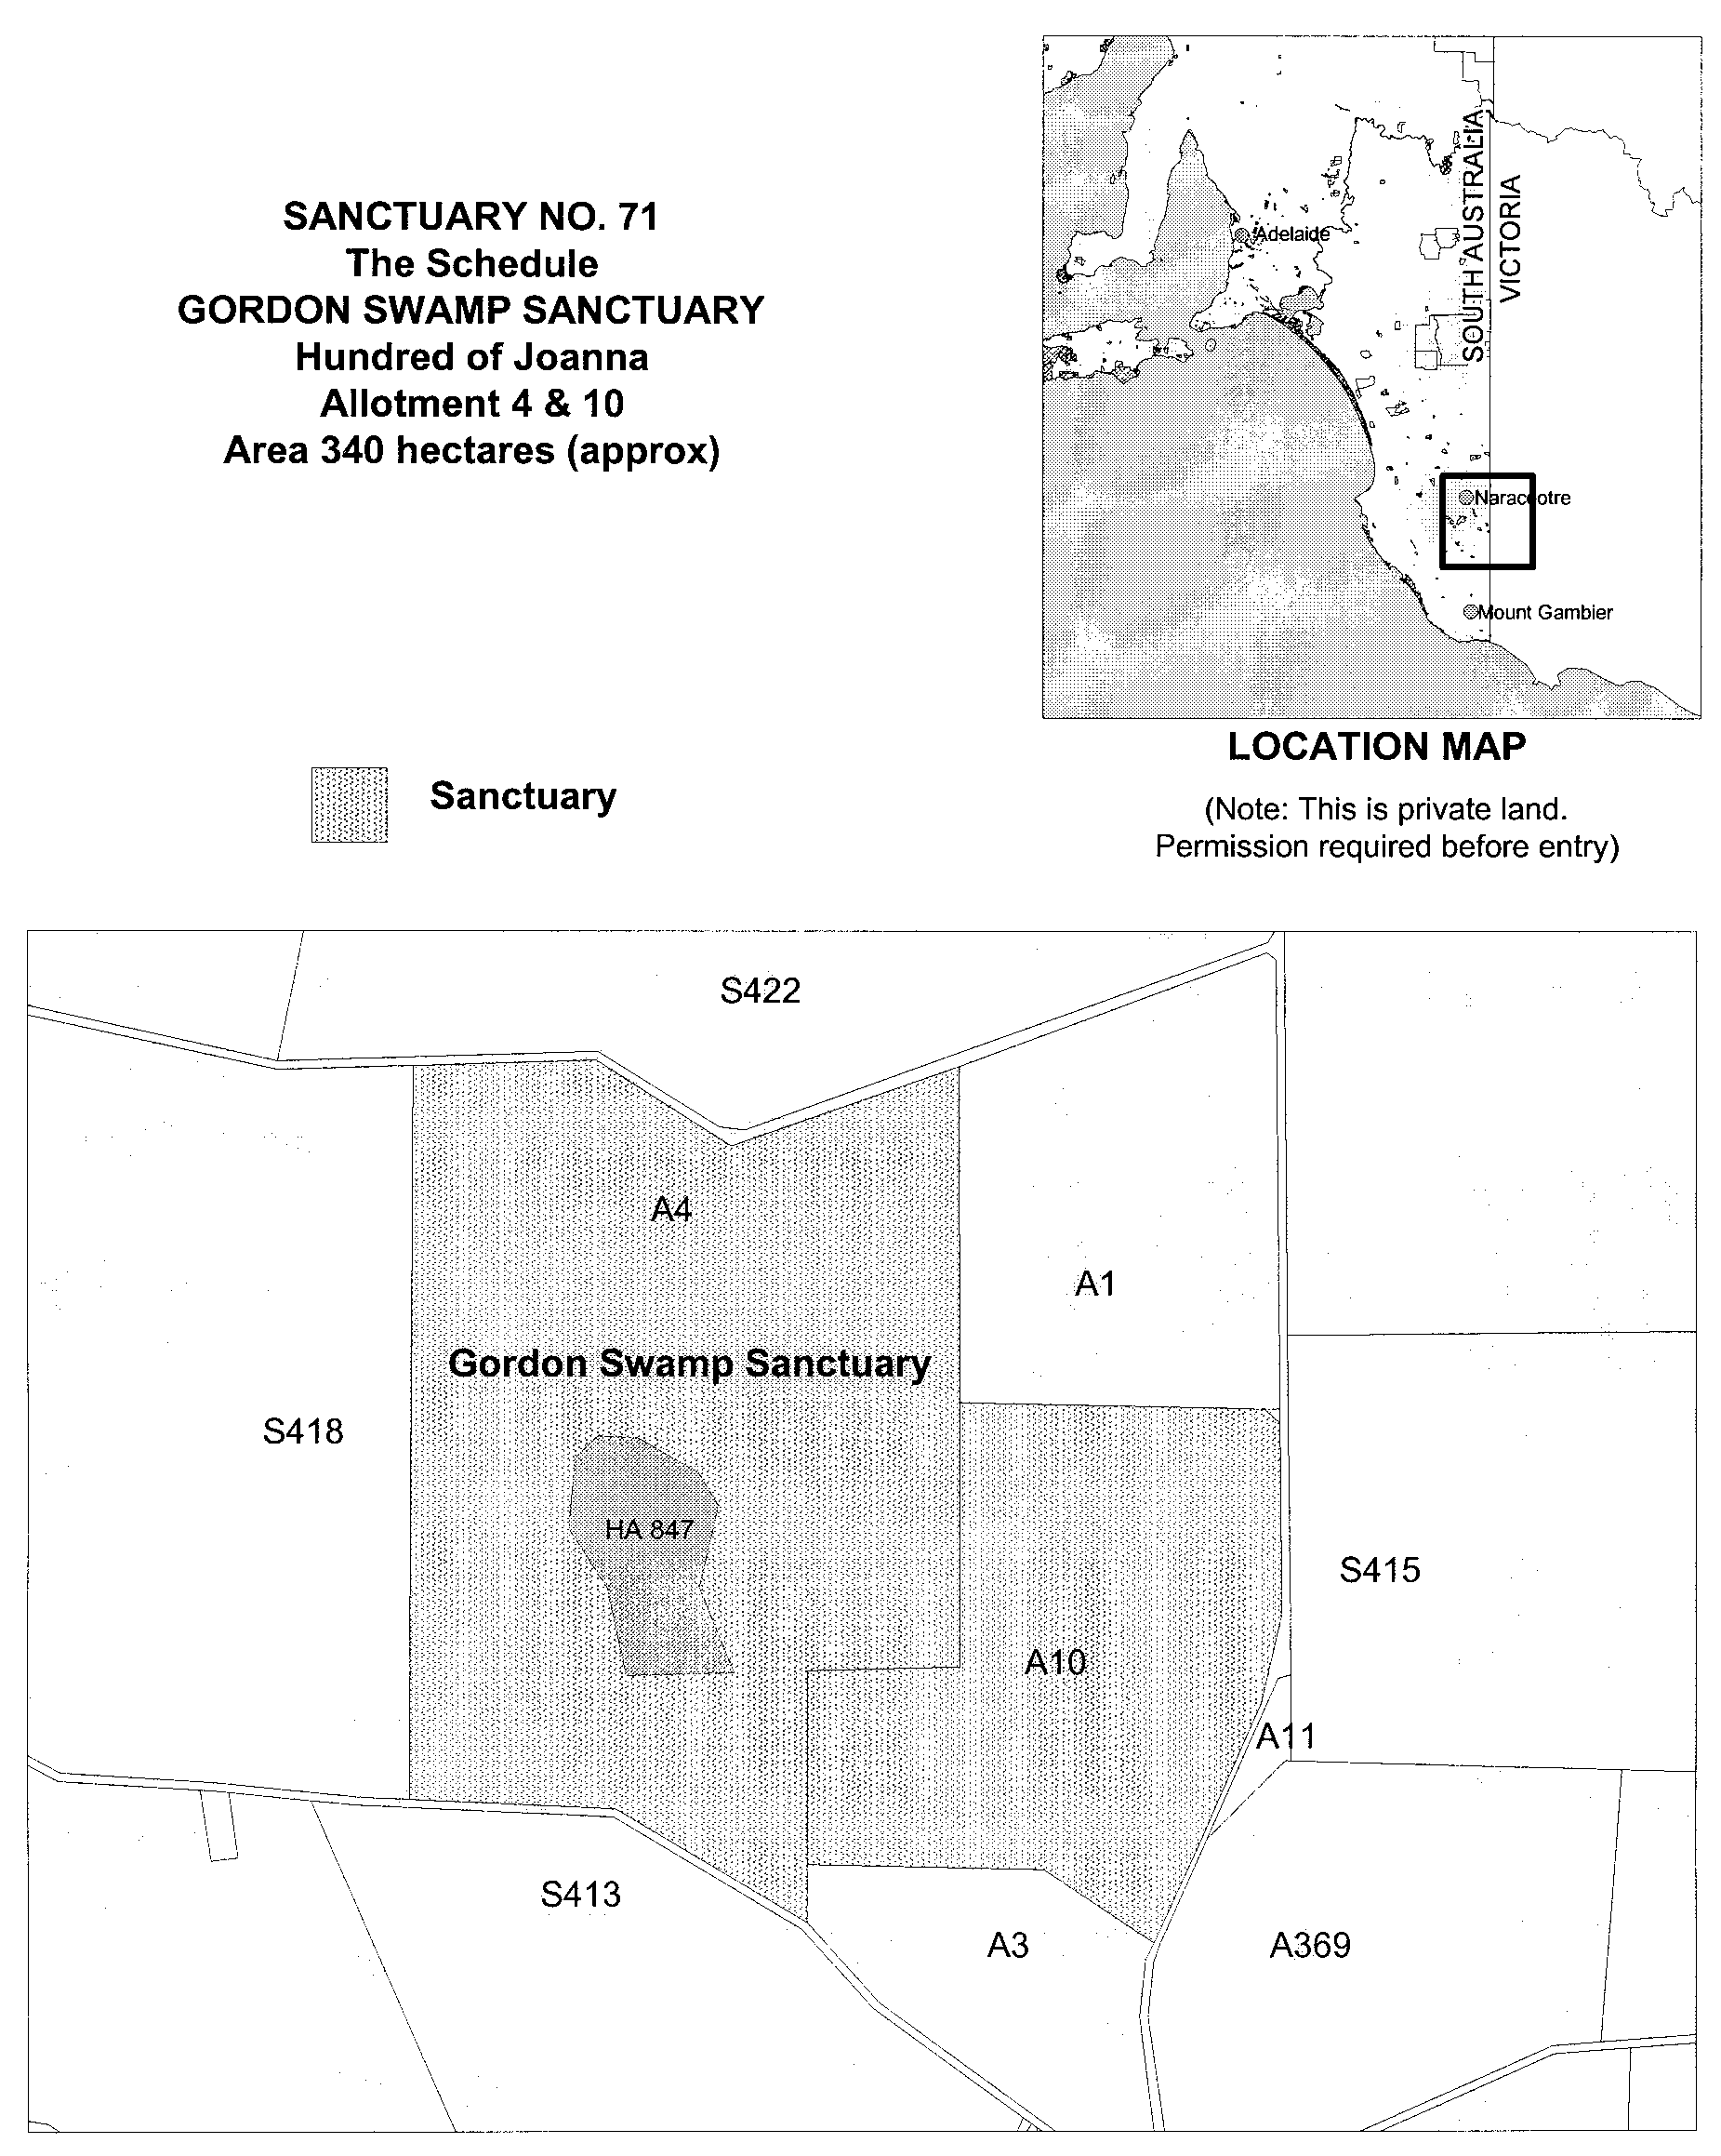

Iain Evans, Minister for Environment and Heritage

NATIONAL PARKS AND WILDLIFE ACT 1972
Declaration of Yarrunga Sanctuary
I, IAIN EVANS, Minister for Environment and Heritage and Minister of the Crown for the time being administering the National Parks and Wildlife Act 1972, being of the opinion that it is desirable to conserve the animals and plants for which the land depicted as a sanctuary in the schedule hereto is a natural habitat or environment and having received all necessary consents, do hereby declare the said land to be a sanctuary for the purposes of the said Act.
Dated 26 September 2001.
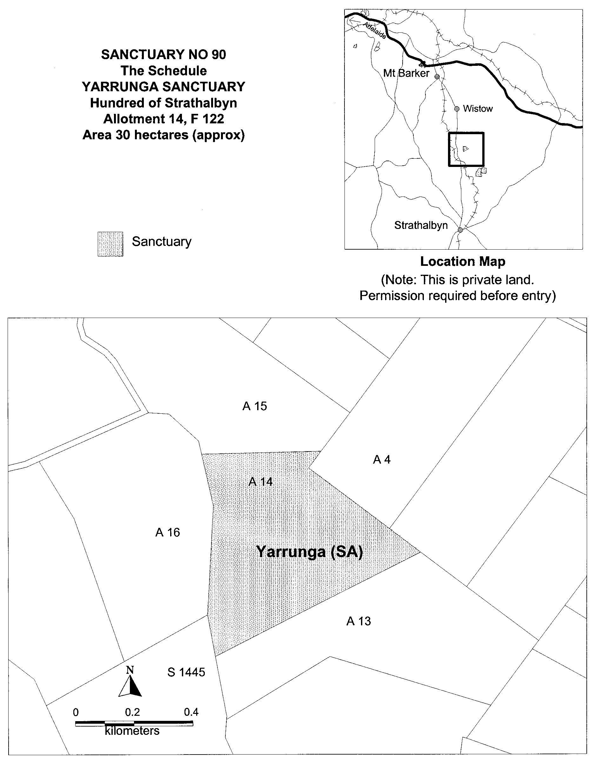

Iain Evans, Minister for Environment and Heritage

NORTHERN ADELAIDE WASTE MANAGEMENT AUTHORITY
Charter
1. CONTINUATION
The Northern Adelaide Waste Management Authority (‘NAWMA’) formerly a controlling authority established under section 200 of the Local Government Act 1934 continues as a regional subsidiary pursuant to section 43 and Schedule 2 of the Local Government Act 1999 (‘the Act’) and section 25 of the Local Government (Implementation) Act 1999.
This Charter governs the affairs of NAWMA and must be reviewed by the Constituent Councils at least once every three years.
2. CONSTITUENT COUNCILS
NAWMA has been established by the City of Playford, the Corporation of the Town of Gawler, and the City of Salisbury (‘the Constituent Councils’), which comprise the Northern Adelaide Region of Local Government (‘the Region’).
The Constituent Councils have resolved to work together to establish NAWMA to facilitate waste management within the Region.
NAWMA is subject to the joint direction of the Constituent Councils.
3. PURPOSE
3.1 NAWMA has been established for the following purposes:
3.1.1 to facilitate and co-ordinate waste management within the Region;
3.1.2 to advise the Constituent Councils regarding the development and implementation of policies designed to improve waste management within the Region;
3.1.3 on behalf of the Constituent Councils to regularly review the Region’s waste management practices and policies;
3.1.4 to co-ordinate and/or undertake research into waste management practices suitable for the Region;
3.2 Where considered desirable by the Board, NAWMA may conduct its activities and achieve its purposes in areas outside the Region.
3.3 NAWMA is not involved in a significant business activity as defined in the Clause 7 Statement prepared under the Competition Principles Agreement of the National Competition Policy.
4. THE BOARD—ROLE AND MEMBERSHIP
4.1 NAWMA will be governed by a Board.
4.2 The Board is responsible for the administration of the affairs of NAWMA. The Board must ensure insofar as it is practicable, that NAWMA observes the objectives set out in this Charter, that information provided to the Constituent Councils is accurate and that Constituent Councils are kept informed of the solvency of NAWMA as well as any material developments which may affect the operating capacity and financial affairs of NAWMA.
4.3 Each of the Constituent Councils will appoint three persons to the Board. One of those persons will be an employee of the Council. Each Constituent Council may also appoint a person who in the opinion of the Council has business skills and corporate governance experience attuned to the purposes of NAWMA.
4.4
4.4.1 Subject to 4.4.2, Members of the Board shall be entitled to a sitting fee as determined by the Board.
4.4.2 Any elected members appointed to the Board are not entitled to a sitting fee by virtue of their allowances paid pursuant to Chapter 5 of the Act. Council employees are not entitled to a sitting fee.
4.5 Constituent Councils shall appoint a deputy for each Council Board member.
4.6 A certificate signed by the Chief Executive Officer of the appointing Constituent Council will be sufficient evidence of appointment.
4.7 There will be a Chairperson of the Board elected by ballot of the Board for a twelve month period.
4.8 The outgoing Chairperson will be eligible for re-election.
4.9 In the absence of the Chairperson the Board will elect a temporary acting Chairperson.
4.10 The Board shall be responsible to review the performance of members of the Board at least annually. The review shall address at least the achievements and any non-success of Board members and produce recommendations for improvement in the ensuing year.
5. TERM OF OFFICE—THE BOARD
5.1 Subject only to the following subclauses, the term of office of each member of the Board will be as determined by the Constituent Council appointing the member.
5.2 The term of office of a member of the Board who is not an elected member ceases upon the appointing Constituent Council providing written notice to the Board, or upon the happening of any other event through which the member would be ineligible to remain as a member of the Board.
(*See Clause 20, Part 2 of Schedule 2)
5.3 The Board may by a two thirds majority vote of the members present (excluding the member subject to this clause) make a recommendation to the Constituent Council responsible for the appointment of the member seeking its approval to terminate the appointment of the member in the event of:
5.3.1 any behaviour of the member which in the opinion of the Board amounts to impropriety;
5.3.2 serious neglect of duty in attending to the responsibilities of a member of the Board;
5.3.3 breach of fiduciary duty to the Board or a Constituent Council;
5.3.4 breach of the duty of confidentiality to the Board and the Constituent Councils;
5.3.5 breach of the conflict of interest rules of the Board; or
5.3.6 any other behaviour which may discredit the Board.
5.4 The Constituent Council which appointed the member whose term of office has become vacant will be responsible to appoint the replacement member.
6. PROCEEDINGS OF THE BOARD
6.1 Subject only to the extent that they are modified by this clause, the proceedings of the Board will be the same as those for committees of Council as defined in Part 2 of Chapter 6 of the Act and in accordance with the Regulations for ‘Other Committees’ comprised in Parts 1, 3 and 4 of the Local Government (Proceedings at Meetings) Regulations 2000.
References in Part 2 of Chapter 6 of the Act to ‘the Chief Executive Officer’ shall be read as if they were references to the Executive Officer of NAWMA and references to ‘the Council’ or ‘the committee’ shall be read as if they were references to NAWMA.
To the extent that this Charter and the Act and its associated Regulations are silent, the Board may determine its own meeting procedures.
6.2 Subject only to the special provisions of this clause, no meeting of the Board will commence until a quorum of members is present and no meeting may continue unless there is a quorum of members present. A quorum of members will comprise five people.
6.3 For the purpose of this clause, the contemporary linking together by a telephone, audio-visual or other instantaneous means (‘telecommunication meeting’) of a number of members of the Board provided that at least a quorum is present, is deemed to constitute a meeting of the Board. Each of the Board members taking part in the telecommunications meeting, must be able to hear and be heard by each of the other Board members present. At the commencement of the meeting, each Board member must announce his/her presence to all other Board members taking part in the meeting. A Board member must not leave a telecommunication meeting by disconnecting his/her telephone, audio visual or other communication equipment, unless that Board member has previously notified the Chairperson of the meeting.
6.4 In the event that there is not a quorum present at two consecutive meetings of the Board, then an extraordinary meeting of the Board may be convened in the same manner as for a special meeting (see Clause 6.1), at which the business which was on the agendas for the two previous but failed meetings may be transacted at the extraordinary meeting of the Board where the requirement for a quorum is that there be at least one member representing each of the Constituent Councils in attendance. Decisions made at such a meeting will be binding on all members of the Board and the Constituent Councils.
6.5 Subject only to any specific requirement of this Charter, all matters for decision at a meeting of the Board will be decided by a simple majority of the members present and entitled to vote on the matter. All members present and entitled to vote on a matter are required to cast a vote. All members are entitled only to a deliberative vote. Board members may not vote by proxy.
6.6 In the event of equality of votes, the Chairperson will not have a casting vote and the matter will be deemed to have lapsed and may at some later time be reconsidered.
6.7 Meetings of the Board will be held at such time and such place as the Board decides subject only to the requirement that there will be at least one meeting in every two calendar months.
6.8 A special meeting of the Board may be held at any time and may be called at the request of the Chairperson or at the written request of three members of the Board representing all of the Constituent Councils.
6.9 Notice of all meetings will be given in accordance with the provisions applicable to a committee meeting under Part 2 of Chapter 6 of the Act and the associated Regulations.
6.10 Meetings of the Board will be open to the public unless the Board so resolves to the contrary.
6.11 All members must keep confidential all documents and any information provided to them for their consideration prior to a meeting of the Board.
6.12 The Board must ensure that accurate written minutes of its proceedings are kept and are produced for verification at the subsequent meeting of the Board.
7. PROPRIETY OF MEMBERS OF THE BOARD
7.1 The principles regarding conflict of interest prescribed in the Act will apply to all members of the Board as if they were elected members of a Council.
7.2 The members of the Board will not be required to comply with Division 2, Chapter 5 (Register of Interests) of the Act.
7.3 The members of the Board will at all times act in accordance with their duties of confidence and confidentiality and individual fiduciary duties including honesty and the exercise of reasonable care and diligence with respect to the Board as required by Part 4, Division 1, Chapter 5 of the Act and Clause 23 of Part 2 of Schedule 2.
8. POWERS
8.1 NAWMA is constituted as a body corporate under the Act and in all things acts through the Board.
8.2 Subject to Clause 8.3 NAWMA has:
8.2.1 the power to acquire, deal with and dispose of real and personal property (wherever situated) and rights in relation to real and personal property;
8.2.2 the power to sue and be sued in its corporate name;
8.2.3 the power to enter into any kind of contract or arrangement;
8.2.4 the power to return surplus revenue to Constituent Councils in such proportions as the Board considers appropriate at the end of any financial year either by way of cash payment or reduction of annual contribution;
8.2.5 the power to set aside surplus revenue for future capital expenditure;
8.2.6 the power to invest funds and in doing so to take into account Part 4 of Chapter 9 of the Act;
8.2.7 the power to do anything else necessary or convenient for, or incidental to, the exercise, performance or discharge of its powers, functions or duties.
8.3 NAWMA may enter into any contract arrangement, or other transaction provided that it is referred to in an approved budget or business plan. Any Contract, arrangement or other transaction which would incur expenditure by NAWMA of in excess of $50 000 and which is not referred to in an approved budget or business plan requires the unanimous approval of the Constituent Councils.
8.4 NAWMA will have a common seal which may be affixed to documents requiring execution under common seal and must be witnessed by the Chairperson of the Board and one other Board member.
8.5 The common seal must not be affixed to a document except to give effect to a resolution of the Board. The Executive Officer will maintain a register which records the resolutions of the Board giving authority to affix the common seal and details of the documents to which the common seal has been affixed with particulars of the persons who witnessed the fixing of the seal and the date.
8.6 The Board may by instrument under seal authorise a person to execute documents on behalf of NAWMA. The Executive Officer will maintain a register of such resolutions and details of any documents executed in this way, together with particulars of the person executing the document.
9. ADMINISTRATIVE MATTERS
9.1 There will be an Executive Officer of NAWMA appointed by the Board on terms and conditions to be determined by the Board.
9.2 The Executive Officer will be responsible to the Board:
9.2.1 to ensure that the policies and lawful decisions of NAWMA are implemented in a timely manner;
9.2.2 for the efficient and effective management of the operations and affairs of NAWMA;
9.2.3 to provide advice and reports to the Board on the exercise and performance of NAWMA’s powers and functions;
9.2.4 to give effect to the principles of human resource management generally applicable within the local government industry.
9.3 The Executive Officer has such powers, functions and duties prescribed by this clause and as determined necessary by the Board from time to time to ensure the efficient and effective management of the operations and affairs of NAWMA.
9.4 The Board may employ other officers and it may authorise the Executive Officer to employ such other officers on its behalf as are required for the efficient and effective management of the operations and affairs of NAWMA.
9.5 The Board may engage professional consultants and it may authorise the Executive Officer to engage professional consultants to provide services to NAWMA to ensure the proper execution of its decisions, the efficient and effective management of the operations and affairs of NAWMA, and for giving effect to the general management objectives and principles of personal management prescribed by this Charter.
10. FINANCIAL CONTRIBUTIONS TO NAWMA
10.1 The Board will be responsible to provide the Constituent Councils with sufficient information for each of them to ascertain the level of and understand the reasons behind the funding required in the following financial year. This will be achieved via the business plan and the annual budget.
10.2 Subject to 10.1 the Board will determine annually the funds required by NAWMA to enable it to function. Subject to the Constituent Councils unanimously approving the annual budget, the Constituent Councils shall contribute the funds requested by the Board in the annual budget. The Board may during any year determine that additional funds are required for the continuing function of NAWMA. The Board must gain agreement from the Constituent Councils regarding the need for additional funds before the Constituent Councils will be obliged to meet any request for additional funds.
10.3 The annual contribution will be paid by each Constituent Council in advance by monthly instalments.
10.4 Additional contributions (if any) will be paid by each Constituent Council in the manner and at the time determined by the Board.
10.5 The Board is accountable to each Constituent Council to ensure that NAWMA functions in accordance with its business plan and approved budgets.
11. BUDGET
11.1 NAWMA must prepare a budget for the forthcoming financial year.
11.2 The budget must:
11.2.1 deal with each principal activity of NAWMA on a separate basis;
11.2.2 be consistent with and account for activities and circumstances referred to in NAWMA’s business plan;
11.2.3 be submitted in draft form to each constituent council for approval before 31 March;
11.2.4 not be adopted until after 31 May but before 30 September;
11.2.5 identify the amount of and the reasons for the financial contributions to be made by each constituent Council to NAWMA.
11.3 NAWMA must provide a copy of its budget to each Constituent Council within five business days after adoption.
11.4 NAWMA must reconsider its budget in accordance with Regulation 7 of the Local Government (Financial Management) Regulations 1999.
(See Clause 25, Part 2, Schedule 2 for the contents of the budget.)
12. BUSINESS PLAN
12.1 NAWMA shall have a rolling business plan in respect of the ensuing three years.
12.2 The business plan must:
12.2.1 state the services to be provided by NAWMA;
12.2.2 identify how NAWMA intends to manage population changes and service delivery;
12.2.3 identify the performance targets which NAWMA is to pursue;
12.2.4 provide a statement of financial and other resources and internal processes that will be required to achieve the performance targets and objectives of NAWMA;
12.2.5 specify the performance measures that are to be used to monitor and assess performance against targets.
12.3 Prior to setting the draft budget each year NAWMA must review the Business Plan in conjunction with the Constituent Councils. The Business Plan must be updated to ensure it presents a plan for the ensuing three years.
(See clause 24, Part 2, Schedule 2 for the content of the Business Plan).
13. SERVICE AGREEMENT
Where required by unanimous agreement of the Constituent Councils, NAWMA will enter into a service agreement with each of the Constituent Councils in a form and upon terms and conditions agreed by the Constituent Councils.
14. ACCOUNTING
NAWMA must ensure that its accounting records, accounts and financial statements are prepared and maintained in accordance with all relevant Australian Accounting Standards.
(See Regulations 8 and 9, Local Government (Financial Management) Regulations 1999 in relation to particular accounting practices).
15. AUDIT
15.1 NAWMA must appoint an auditor.
15.2 NAWMA must provide its audited financial statements to the Chief Executive Officer of each Constituent Council by 30 September.
(See Part 5, Local Government (Financial Management) Regulations 1999 in relation to NAWMA’s audit responsibilities).
15.3 NAWMA is not obliged to establish an audit committee, but may do so if determined by the Board.
(See Clause 30, Part 2, Schedule 2 for the functions of the Audit Committee).
16. FINANCE
16.1 The Board must establish and maintain a bank account with such banking facilities and at a bank to be determined by the Board.
16.2 All cheques to be authorised must be signed by two members of the Board or one member of the Board and the Executive Officer.
16.3 The Executive Officer must act prudently in the handling of all financial transactions for the Board and must provide quarterly financial and corporate reports to the Board and if requested, the Constituent Councils.
16.4 The Board will, at the end of each financial year prepare a schedule of assets and liabilities. In addition, the Board must maintain a record to be known as the ‘Schedule of Constituent Council’s Interests in Net Assets’.
16.5 The ‘Schedule of Constituent Council’s Interests in Net Assets’ will reflect the proportionate contribution each Constituent Council has made to the growth of the net assets of NAWMA having regard to the proportionate contribution to subscriptions. The Schedule when updated by the Board at the end of each financial year will reflect the proportionate contribution of each Constituent Council since the commencement of NAWMA and once accepted by each Constituent Council will be evidence of the agreed proportion of a Constituent Council’s interests in the net assets as at 30 June in that year.
16.6 Where there is any dispute as to the Schedule Clause 21 shall apply.
17. REPORTS AND INFORMATION
17.1 NAWMA must submit its annual report on its work and operations including its audited financial statements, to each Constituent Council before 30 September.
17.2 The Board shall report quarterly and at any other time on written request from a Constituent Council to the Constituent Council on matters being undertaken by NAWMA.
18. ALTERATION TO THE RULES
18.1 This Charter may be amended by unanimous resolution of the Constituent Councils.
18.2 The Executive Officer of NAWMA must ensure that the amended Charter is published in the Gazette.
18.3 Before the Constituent Councils vote on a proposal to alter this Charter they must take into account any recommendations of the Board.
19. WITHDRAWAL OF A CONSTITUENT COUNCIL
19.1 Subject to the approval of the Minister, a Constituent Council may withdraw from NAWMA by giving not less than six months notice of its intention to do so to all other Constituent Councils and the Executive Officer.
19.2 In any event a withdrawal cannot become effective until the 30th day of June following the expiry of the six months in the preceding sub-clause. Until withdrawal becomes effective, the Constituent Council proposing withdrawal from NAWMA will remain liable for all financial contributions in the remaining period and through its members on the Board, the responsibility of ensuring the continued proper conduct of the affairs of NAWMA.
19.3
19.3.1 A withdrawing Council shall indemnify the remaining Councils for all liabilities of NAWMA caused or arising prior to the withdrawal taking effect.
19.3.2 The indemnity shall be in the same proportion as the withdrawing Council’s interest in the net assets of NAWMA calculated as at the date the withdrawal takes effect.
19.4 Upon withdrawal taking effect a Constituent Council will be entitled to be paid not more than 80% of the Constituent Council’s interest in the net assets of NAWMA as determined and agreed under Rule 16. The withdrawing Constituent Council will be entitled to receive that sum by equal quarterly instalments to be paid over a period of two years with the first instalment being due on 1 January following the effective date of withdrawal.
20. ADDITION OF NEW MEMBER
20.1 The Board may consider the addition of a new member to NAWMA.
20.2 The Constituent Councils must resolve unanimously to approve the addition of a new member to NAWMA and must obtain Ministerial approval.
20.3 The Charter shall be amended in accordance with the provisions of this Charter to address any new addition.
21. DISPUTES
21.1 In the event of any dispute or difference between the Constituent Councils concerning the operations or affairs of NAWMA, the Constituent Councils:
21.1.1 will attempt to settle the dispute or difference by negotiating in good faith;
21.1.2 if good faith negotiations do not settle the dispute or difference within one month of the dispute arising then the dispute shall be referred to an expert for determination. The expert shall be a person with the skills and expertise necessary to resolve the dispute and shall be nominated by the President of the Local Government Association of South Australia. The expert is an expert and not an arbitrator. The expert’s determination shall be final and binding on the Constituent Councils. The Constituent Councils shall equally share the costs of the expert.
21.2 If the dispute is unable to be resolved by the expert within six months then any Constituent Council may request the Minister to dissolve NAWMA.
21.3 Notwithstanding the existence of a dispute or difference, the Constituent Councils will continue to meet their obligations to NAWMA.
22. DISSOLUTION OF NAWMA
22.1 NAWMA may be dissolved by the Minister in the circumstances envisaged by Clause 33, Part 2 of Schedule 2.
22.2 In the event of there being net assets upon dissolution and after realisation of all assets and meeting all liabilities, the net assets will be distributed to the then Constituent Councils on the basis of their current interest in the net assets of NAWMA as determined by Clause 16.
22.3 In the event of there being an insolvency of NAWMA at the time of dissolution, the then Constituent Councils will be responsible jointly and severally to pay the liabilities of NAWMA and between themselves in the proportion of their interest in the net assets last determined under Clause 16.
Dated 18 July 2001.
B. King, Chief Executive Officer

GOVERNMENT GAZETTE ADVERTISEMENT RATES

To apply from 1 July 2001

$  Agents, Ceasing to Act as 32.75  Associations:  Incorporation 16.70  Intention of Incorporation 41.25  Transfer of Properties 41.25  Attorney, Appointment of 32.75  Bailiff’s Sale 41.25  Cemetery Curator Appointed 24.50  Companies:  Alteration to Constitution 32.75  Capital, Increase or Decrease of 41.25  Ceasing to Carry on Business 24.50  Declaration of Dividend 24.50  Incorporation 32.75  Lost Share Certificates:  First Name 24.50  Each Subsequent Name 8.40  Meeting Final 27.50  Meeting Final Regarding Liquidator’s Report on  Conduct of Winding Up (equivalent to ‘Final  Meeting’)  First Name 32.75  Each Subsequent Name 8.40  Notices:  Call 41.25  Change of Name 16.70  Creditors 32.75  Creditors Compromise of Arrangement 32.75  Creditors (extraordinary resolution that ‘the Com-pany be wound up voluntarily and that a liquidator be appointed’) 41.25  Release of Liquidator⎯Application⎯Large Ad. 65.50  ⎯Release Granted 41.25  Receiver and Manager Appointed 38.25  Receiver and Manager Ceasing to Act 32.75  Restored Name 31.00  Petition to Supreme Court for Winding Up 57.00  Summons in Action 48.75  Order of Supreme Court for Winding Up Action 32.75  Register of Interests⎯Section 84 (1) Exempt 74.00  Removal of Office 16.70  Proof of Debts 32.75  Sales of Shares and Forfeiture 32.75  Estates:  Assigned 24.50  Deceased Persons⎯Notice to Creditors, etc. 41.25  Each Subsequent Name 8.40  Deceased Persons⎯Closed Estates 24.50  Each Subsequent Estate 1.05  Probate, Selling of 32.75  Public Trustee, each Estate 8.40 |  | $  Firms:  Ceasing to Carry on Business (each insertion) 21.80  Discontinuance Place of Business 21.80  Land⎯Real Property Act:  Intention to Sell, Notice of 41.25  Lost Certificate of Title Notices 41.25  Cancellation, Notice of (Strata Plan) 41.25  Mortgages:  Caveat Lodgment 16.70  Discharge of 17.60  Foreclosures 16.70  Transfer of 16.70  Sublet 8.40  Leases⎯Application for Transfer (2 insertions) each 8.40  Lost Treasury Receipts (3 insertions) each 24.50  Licensing 48.75  Municipal or District Councils:  Annual Financial Statement⎯Forms 1 and 2 462.00  Electricity Supply⎯Forms 19 and 20 327.00  Default in Payment of Rates:  First Name 65.50  Each Subsequent Name 8.40  Noxious Trade 24.50  Partnership, Dissolution of 24.50  Petitions (small) 16.70  Registered Building Societies (from Registrar-  General) 16.70  Register of Unclaimed Moneys⎯First Name 24.50  Each Subsequent Name 8.40  Registers of Members⎯Three pages and over:  Rate per page (in 8pt) 209.00  Rate per page (in 6pt) 276.00  Sale of Land by Public Auction 41.75  Advertisements 2.30  Advertisements, other than those listed are charged at $2.30 per column line, tabular one-third extra.  Notices by Colleges, Universities, Corporations and District Councils to be charged at $2.30 per line.  Where the notice inserted varies significantly in length from that which is usually published a charge of $2.30 per column line will be applied in lieu of advertisement rates listed.  South Australian Government publications are sold on the condition that they will not be reproduced without prior permission from the Government Printer.
All the above prices include GST

GOVERNMENT GAZETTE NOTICES
ALL private advertisements forwarded for publication in the South Australian Government Gazette must be PAID FOR PRIOR TO INSERTION; and all notices, from whatever source, should be legibly written on one side of the paper only and sent to Government Publishing SA so as to be received no later than 4 p.m. Tuesday preceding the day of publication. Phone 8207 1045 or Fax 8207 1040. E-mail: governmentgazette@saugov.sa.gov.au. Send as attachments in Word format and please confirm your transmission with a faxed copy of your document, including the date the notice is to be published and to whom the notice will be charged.

MISCELLANEOUS LEGISLATION AND GOVERNMENT PUBLICATIONS PRICES AS FROM 1 JULY 2001

Acts, Bills, Rules, Parliamentary Papers and Regulations
Pages | Main | Amends | Pages | Main | Amends

1-16 | 1.85 | 0.80 | 497-512 | 27.00 | 26.00
17-32 | 2.60 | 1.65 | 513-528 | 27.75 | 26.50
33-48 | 3.35 | 2.40 | 529-544 | 28.50 | 27.50
49-64 | 4.25 | 3.20 | 545-560 | 29.25 | 28.50
65-80 | 5.00 | 4.10 | 561-576 | 30.00 | 29.25
81-96 | 5.75 | 4.80 | 577-592 | 31.00 | 29.75
97-112 | 6.60 | 5.60 | 593-608 | 31.75 | 30.75
113-128 | 7.40 | 6.45 | 609-624 | 32.50 | 31.75
129-144 | 8.30 | 7.30 | 625-640 | 33.25 | 32.25
145-160 | 9.10 | 8.05 | 641-656 | 34.00 | 33.00
161-176 | 9.95 | 8.90 | 657-672 | 34.50 | 33.75
177-192 | 10.70 | 9.75 | 673-688 | 36.00 | 34.50
193-208 | 11.50 | 10.60 | 689-704 | 36.75 | 35.50
209-224 | 12.30 | 11.30 | 705-720 | 37.25 | 36.50
225-240 | 13.00 | 12.10 | 721-736 | 38.50 | 37.00
241-257 | 13.90 | 12.80 | 737-752 | 39.00 | 38.00
258-272 | 14.80 | 13.60 | 753-768 | 40.00 | 38.50
273-288 | 15.60 | 14.60 | 769-784 | 40.50 | 39.75
289-304 | 16.30 | 15.30 | 785-800 | 41.25 | 40.50
305-320 | 17.10 | 16.10 | 801-816 | 42.00 | 41.00
321-336 | 17.90 | 16.90 | 817-832 | 43.00 | 42.00
337-352 | 18.80 | 17.80 | 833-848 | 43.75 | 42.75
353-368 | 19.60 | 18.60 | 849-864 | 44.50 | 43.50
369-384 | 20.40 | 19.50 | 865-880 | 45.25 | 44.50
385-400 | 21.10 | 20.20 | 881-896 | 45.75 | 45.00
401-416 | 21.90 | 20.90 | 897-912 | 47.25 | 45.75
417-432 | 22.90 | 21.80 | 913-928 | 47.75 | 47.25
433-448 | 23.60 | 22.60 | 929-944 | 48.75 | 47.75
449-464 | 24.50 | 23.40 | 945-960 | 49.50 | 48.25
465-480 | 25.00 | 24.20 | 961-976 | 50.25 | 49.25
481-496 | 26.00 | 24.90 | 977-992 | 51.25 | 49.75

Legislation—Acts, Regulations, etc: $
Subscriptions:
Acts 166.90
All Bills as Laid 398.60
Rules and Regulations 398.60
Parliamentary Papers 398.60
Bound Acts 184.25
Index 89.20
Government Gazette
Copy 4.40
Subscription 220.20
Hansard
Copy 11.90
Subscription—per session (issued weekly) 345.35
Cloth bound—per volume 148.30
Subscription—per session (issued daily) 345.35
Legislation on Disk
Whole Database 2 551.00
Annual Subscription for fortnightly updates 784.30
Individual Act(s) including updates POA
Compendium
Subscriptions:
New Subs 1 513.50
Updates 540.25

(All the above prices include GST)

All Legislation, Government Gazette, Hansard and Legislation on disk are available from:
Counter Sales Information SA (State Government Bookshop)
and Mail Orders: Ground Floor, 77 Grenfell Street, Adelaide, S.A. 5000.
Phone: (08) 8204 1900. Fax: (08) 8204 1909
Online Shop: www.info.sa.gov.au
S.A. Country Customer Free Call: 1800 182 234
TTY (Hearing Impaired): (08) 8204 1923
Subscriptions and Standing Orders:
Phone: (08) 8207 0908, (08) 8207 0910. Fax: (08) 8207 1040
Box 9, Plaza Level, Riverside Centre, North Terrace, Adelaide, S.A. 5000.

REAL PROPERTY ACT NOTICE
WHEREAS the persons named at the foot hereof have each respectively for himself made application to have the land set forth and described before his name at the foot hereof brought under the operation of the Real Property Act: Notice is hereby given that unless caveat be lodged with the Registrar-General by some person having estate or interest in the said lands on or before the expiration of the period herein below for each case specified, the said several pieces of land will be brought under the operation of the said Act as by law directed. Diagrams delineating these parcels of land may be inspected at the Lands Titles Registration Office, Adelaide, and in the offices of the several corporations or district councils in which the lands are situated.

The Schedule
No. of  Applica-  tion | Description of Property |  | Name |  | Residence | Date up to and  inclusive of which  caveat may be  lodged

30942 | Portion of section 1042, Hundred of Adelaide, more particularly delineated as Pieces 716 and 820 in Deposited Plan No. 53418 |  | TransAdelaide |  | Adelaide, S.A. 5000 | 2 November 2001
30943 | Portion of Section 1042, Hundred of Adelaide |  | TransAdelaide |  | Adelaide, S.A. 5000 | 2 November 2001

Dated 2 October 2001, at the Lands Titles Registration Office, Adelaide. J. Zaccaria, Deputy Registrar-General

[Republished]
ROAD TRAFFIC ACT 1961

Exemption from the Fitting of Brakes to Trailers with a Laden mass not Exceeding 6 Tonnes and not Towed at a Speed
Greater than 25 km/h

PURSUANT to the provisions of section 163AA of the Road Traffic Act 1961, and subject to the conditions listed below, I hereby exempt trailers with a Gross Trailer Mass over 750 kilograms from the following provisions of the Road Traffic (Vehicle Standards) Rules 1999:

• Rule 132(1)—Trailer braking requirements;
• Rule 133—Operation of brakes on trailers;
• Rule 19—Compliance with second edition Australian Design Rule 38; and
• Rule 20—Compliance with third edition Australian Design Rule 38.

Conditions:

1. The trailer has a laden mass not exceeding 6 tonnes.

2. The trailer is towed at a speed not exceeding 25 km/h.

3. The trailer complies with all other requirements of the Road Traffic Act 1961 and Regulations.

Definitions:

1. For the purposes of this notice ‘Laden Mass’ means the mass of the trailer and its load borne on the surfaces on which it is standing or stationary when disconnected from the towing vehicle.

2. For the purposes of this notice ‘Gross Trailer Mass’ means the mass of the trailer and its load borne on the surfaces on which it is standing or stationary when connected to the towing vehicle.

This exemption expires at midnight on the 30 June 2003.

T. N. Argent, Executive Director, Transport SA

OUTBACK AREAS COMMUNITY DEVELOPMENT TRUST
Appointment of Authorised Persons
NOTICE is hereby given that the Outback Areas Community Development Trust has appointed Dean Hillary Gollan as Dog and Cat Management Officer, pursuant to sections 27 and 28 of the Dog and Cat Management Act 1995 of South Australia, vide Pyle resigned.
Dated 27 September 2001.
B. McIntosh, Chairman

PETROLEUM ACT 2000
Notice to be Disregarded
IN Government Gazette of 27 September 2001, page 4309, this notice was printed in error and should be disregarded.

ROADS (OPENING AND CLOSING) ACT 1991:
SECTION 24
NOTICE OF CONFIRMATION OF ROAD
PROCESS ORDER
Edwards Street, Bluff Beach
Deposited Plan 56695
BY Road Process Order made on 19 March 2001, the District Council of Yorke Peninsula ordered that:
1. The greater portion of the public road (Edwards Street) north of Davit Drive and adjoining section 229, Hundred of Koolywurtie more particularly delineated and lettered ‘B’ and portion of the land lettered ‘A’, in Preliminary Plan No. PP32/0409 be closed.
2. Vest portion of the land lettered ‘A’ in the Crown.
3. Issue a Certificate of Title to the DISTRICT COUNCIL OF YORKE PENINSULA for the whole of the land subject to closure lettered ‘B’ which land is being retained by the council for merging with the adjoining council owned land.
On 26 March 2001, that order was confirmed by the Minister for Administrative and Information Services conditionally on approval and deposit of the survey plan by the Registrar-General. The condition has now been fulfilled.
Pursuant to section 24 (5) of the Roads (Opening and Closing) Act 1991, NOTICE of the order referred to above and its confirmation is hereby given.
Dated 4 October 2001.
P. M. Kentish, Surveyor-General

WATER MAINS AND SEWERS

Office of the South Australian Water Corporation
Adelaide, 4 October 2001.

WATER MAINS LAID

Notice is hereby given that the following main pipes or parts of main pipes have been laid down by the South Australian Water Corporation in or near the undermentioned water districts and are now available for a constant supply of water to adjacent land.

ADELAIDE WATER DISTRICT

CITY OF MITCHAM
Easement in lot 571, Grand Boulevard, Craigburn Farm. p19
Cresswell Avenue, Craigburn Farm. p19
Easement in lot 572, Cresswell Avenue, Craigburn Farm. p19

CITY OF NORWOOD PAYNEHAM AND ST. PETERS
Lower North East Road, Campbelltown. p29

CITY OF PORT ADELAIDE ENFIELD
Caire Street, Alberton. p23
CITY OF SALISBURY
Shearwater Drive, Mawson Lakes. p17
Cormorant Drive, Mawson Lakes. p17
Mallard Crescent, Mawson Lakes. p17
Sandpiper Chase, Mawson Lakes. p17
Alberta Drive, Burton. p18
Easements in lot 101, Alberta Drive, Burton. p18
Jasper Drive, Burton. p18
Banff Street, Burton. p18
Easement in reserve (lot 1), Downton Avenue, Salisbury North. p22
Woodyates Avenue, Salisbury North. p22

CITY OF TEA TREE GULLY
Dickerson Way, Redwood Park. p2
Tongariro Street, Greenwith. p3 and 4

GOOLWA WATER DISTRICT

DISTRICT OF ALEXANDRINA COUNCIL
Brooking Street, Goolwa. p7
Excelsior Drive, Hindmarsh Island. p12-14
Providence Place, Hindmarsh Island. p14-16 and 20
O’Connell Avenue, Hindmarsh Island. This main is available for connections on application only. p10
Captain Sturt Road, Hindmarsh Island. This main is available for connections on application only. p12
Easement in lots 2028 and 2024, Randell Road, Hindmarsh Island. p12
Arcadia Avenue, Hindmarsh Island. p20 and 21
Easements in lots 794 and 979 Arcadia Avenue and lot 418, Prince Alfred Parade, Hindmarsh Island. p20
Excelsior Parade, Hindmarsh Island. p20
Ariel Court, Hindmarsh Island. p20
Queen Court, Hindmarsh Island. p20
Ventura Place, Hindmarsh Island. p20

WATER MAINS ABANDONED

Notice is hereby given that the undermentioned water mains have been abandoned by the South Australian Water Corporation.

ADELAIDE WATER DISTRICT

CITY OF MITCHAM
Easement in lot 571, Grand Boulevard, Craigburn Farm. p19
Cresswell Avenue, Craigburn Farm. p19
Easement in lot 572, Cresswell Avenue, Craigburn Farm. p19

CITY OF NORWOOD PAYNEHAM AND ST. PETERS
Across Lower North East Road, Campbelltown. p29

CITY OF SALISBURY
Athalie Avenue, Parafield Gardens. p28

CITY OF TEA TREE GULLY
Waterworks land (lot 11), Rifle Range Road, Greenwith. p5

WATER MAINS LAID

Notice is hereby given that the undermentioned water mains have been laid down by the South Australian Water Corporation and are not available for a constant supply of water to adjacent land.

GOOLWA WATER DISTRICT

DISTRICT OF ALEXANDRINA COUNCIL
Hindmarsh Island Bridge, Goolwa. p7
Randell Road, Hindmarsh Island. This main is available for connections on application only for the last 20.6 m. p10-12

OUTSIDE GOOLWA WATER DISTRICT

DISTRICT OF ALEXANDRINA COUNCIL
Hindmarsh Island Bridge and causeway, Goolwa and Hindmarsh Island. p7-9
Randell Road, Hindmarsh Island. p9 and 10

ADDENDUM

Addendum to notice in “Government Gazette” of 16 December 1999.

“WATER MAINS LAID”

“Notice is hereby given that the following main pipes or parts of main pipes have been laid down by the South Australian Water Corporation in or near the undermentioned water districts and are now available for a constant supply of water to adjacent land.”

“ADELAIDE WATER DISTRICT”

“CITY OF PLAYFORD”
“McGilp Road, One Tree Hill. p6”

To this notice add “This main is available for connections on application only. p30”

SEWERS LAID

Notice is hereby given that the following sewers have been laid down by the South Australian Water Corporation in the under-mentioned drainage areas and are now available for house connections.

ADELAIDE DRAINAGE AREA

CITY OF CAMPBELLTOWN
Olive Street, Magill. FB 1097 p50

CITY OF PORT ADELAIDE ENFIELD
Brecon Street, Windsor Gardens. FB 1098 p51 and 52
Caire Street, Alberton. FB 1097 p47

CITY OF PROSPECT
Azalea Street, Prospect. FB 1097 p48

CITY OF SALISBURY
Alana Court, Burton. FB 1098 p48 and 49
Easements in reserve (lot 92) and lot 101, Jasper Drive, Burton. FB 1098 p48-50
Jasper Drive, Burton. FB 1098 p48 and 49
Banff Street, Burton. FB 1098 p48 and 49
Alberta Drive, Burton. FB 1098 p48 and 50
Easement in reserve (lot 1), Downton Avenue, Salisbury North. FB 1097 p46
Woodyates Avenue, Salisbury North. FB 1097 p46
Downton Avenue, Salisbury North. FB 1097 p49

A. Howe, Chief Executive Officer, South Australian Water Corporation.

REGULATIONS UNDER THE LOCAL GOVERNMENT ACT 1999
────
No. 225 of 2001
────
At the Executive Council Office at Adelaide, 4 October 2001

PURSUANT to the Local Government Act 1999 and with the advice and consent of the Executive Council, I make the following regulations.
E. J. NEAL, Governor

PURSUANT to section 10AA(2) of the Subordinate Legislation Act 1978, I certify that, in my opinion, it is necessary or appropriate that the following regulations come into operation as set out below.

DIANA LAIDLAW, Minister for Transport and Urban Planning
───────────────────
SUMMARY OF PROVISIONS

1. Citation
2. Commencement
3. Variation of reg. 13—Rates notice
4. Variation of reg. 16—Register of community land
5. Insertion of reg. 16A
16A. Minor alterations of roads—s. 221
6. Insertion of reg. 18A
18A. By-laws—roads
7. Insertion of reg. 23
23. Variation of Schedule 5—Access to documents
8. Variation of Schedule 1
────────────────────────

Citation
1. The Local Government (General) Regulations 1999 (see Gazette 25 November 1999 p. 2855), as varied, are referred to in these regulations as "the principal regulations".

Commencement
2. These regulations will come into operation on the day on which they are made.

Variation of reg. 13—Rates notice
3. Regulation 13 of the principal regulations is varied by inserting after subregulation (2) the following subregulation:

(3) Subregulation (1)(m) does not apply with respect to a second or subsequent rates notice sent to a ratepayer in a particular financial year where at least 60 days have elapsed since service on the ratepayer of the first rates notice for that financial year.

Variation of reg. 16—Register of community land
4. Regulation 16 of the principal regulations is varied by striking out paragraph (g) and substituting the following paragraph:

(g) the following details concerning any lease or licence granted over the land:

(i) the name of the lessee or licensee; and

(ii) the term of the lease or licence (including information on the term of any extension or renewal stated in the lease or licence); and

(iii) the actual land to which the lease or licence relates (which may be identified by a plan kept in conjunction with the register); and

(iv) the purpose for which the lease or licence has been granted.

Insertion of reg. 16A
5. The following regulation is inserted after regulation 16 of the principal regulations:

Minor alterations of roads—s. 221
16A. (1) Pursuant to section 221(3)(c) of the Act, the installation, maintenance, replacement or removal of a telecommunication subscriber connection is classified as a minor alteration to a road.

(2) In subregulation (1)—

"telecommunication subscriber connection" means any pipes, wires, cables, optical fibre or other material suspended above the ground and used to connect a subscriber to a telecommunications or electronic network, and includes any fixture or fitting directly associated with making such a connection.

Insertion of reg. 18A
6. The following regulation is inserted after regulation 18 of the principal regulations:

By-laws—roads
18A. Pursuant to section 239(1)(g) of the Act, a council is authorised to make by-laws about the use of roads for camping.

Insertion of reg. 23
7. The following regulation is inserted after regulation 22 of the principal regulations:

Variation of Schedule 5—Access to documents
23. Pursuant to section 132(4) of the Act, Schedule 5 of the Act is amended by inserting ", other than the Register of Interests kept for the purposes of Chapter 7 Part 4 Division 2" after "Registers required under this Act or the Local Government (Elections) Act 1999".

Variation of Schedule 1
8. Schedule 1 of the principal regulations is varied—

(a) by striking out from item 5 of Form 3 "discretionary trust" and substituting "testamentary trust";

(b) by striking out from item 8 of Form 4 "discretionary trust" and substituting "testamentary trust";

(c) by striking out from item 4 of Form 5 "discretionary trust" and substituting "testamentary trust";

(d) by striking out from item 7 of Form 6 "discretionary trust" and substituting "testamentary trust".

MLG 7/2001 CS
OLR 3/00 TC2 R. DENNIS, Clerk of the Council

REGULATIONS UNDER THE HARBORS AND NAVIGATION ACT 1993
────
No. 226 of 2001
────
At the Executive Council Office at Adelaide, 4 October 2001

PURSUANT to the Harbors and Navigation Act 1993 and with the advice and consent of the Executive Council, I make the following regulations.
E. J. NEAL, Governor

PURSUANT to section 10AA(2) of the Subordinate Legislation Act 1978, I certify that, in my opinion, it is necessary or appropriate that the following regulations come into operation as set out below.

DIANA LAIDLAW, Minister for Transport and Urban Planning
───────────────────
SUMMARY OF PROVISIONS

1. Citation
2. Commencement
3. Revocation of reg. 7
4. Insertion of reg. 9A
9A. Definition of port: s. 4(1)
5. Variation of reg. 14—Restricted areas: s. 27
6. Substitution of Division
DIVISION 1—PRELIMINARY
15. Interpretation
15A. Approval of CEO under this Part
7. Variation of reg. 16—Obstructions on wharves
8. Variation of reg. 19—Use of rail trolley
9. Variation of reg. 22—Spillage of cargo
10. Variation of reg. 26—Watch officers in harbors
11. Variation of reg. 28-Fuel in vehicles, etc.
12. Variation of reg. 31-Restrictions in certain harbors
13. Variation of reg. 32-Mooring and unmooring of vessels in certain harbors
14. Variation of reg. 33A—Application of Division
15. Variation of reg. 37—Removal of vehicles
16. Insertion of reg. 39A
39A. Interpretation
17. Variation of reg. 129—Speed restrictions
18. Variation of reg. 156—Smoking and use of combustion equipment in hold
19. Variation of reg. 158—Anchors not to be used in certain areas
20. Variation of Schedule 3—Definition of Harbors
21. Insertion of Schedule 3A
SCHEDULE 3A
Ports
────────────────────────

Citation
1. The Harbors and Navigation Regulations 1994 (see Gazette 20 October 1994 p. 987), as varied, are referred to in these regulations as "the principal regulations".

Commencement
2. These regulations will come into operation on the day on which section 3(a) of the Harbors and Navigation (Control of Harbors) Amendment Act 2000 comes into operation.

Revocation of reg. 7
3. Regulation 7 of the principal regulations is revoked.

Insertion of reg. 9A
4. The following regulation is inserted after regulation 9 of the principal regulations:
Definition of port: s. 4(1)
9A. (1) Each area of land and water described in Schedule 3A is constituted as a port.

(2) To avoid doubt, as each port lies within a harbor, a reference in these regulations to a "harbor" extends, unless the contrary is indicated, to a port.

Variation of reg. 14—Restricted areas: s. 27
5. Regulation 14 of the principal regulations is varied by striking out subregulation (4).

Substitution of Division
6. Division 1 of Part 5 of the principal regulations is revoked and the following Division is substituted:

DIVISION 1—PRELIMINARY

Interpretation
15. In this Part (except Divisions 3 and 4)—

"adjacent land" means adjacent land under the care, control and management of the Minister or a port operator;

"contiguous land" means land contiguous to a wharf and under the care, control and management of the Minister or a port operator;

"harbor" means a harbor, or that part of a harbor, under the care, control and management of the Minister or a port operator;

"wharf" means a wharf under the care, control and management of the Minister or a port operator.

Approval of CEO under this Part
15A. The CEO must not grant an approval under this Part in relation to an activity that is to take place within a port unless the port operator has first been consulted.

Variation of reg. 16—Obstructions on wharves
7. Regulation 16 of the principal regulations is varied—

(a) by striking out the penalty provision at the foot of subregulation (1) and substituting the following:

Maximum penalty: $1 250.
Expiation fee: $160.;

(b) by striking out subregulation (3) and substituting the following subregulation:

(3) The cost of taking action under subregulation (2)(b) may be recovered as a debt from the owner of the item by—

(a) if the authorised person was an officer or employee of a port operator (other than the Minister)—the port operator; or

(b) in any other case—the CEO.

Variation of reg. 19—Use of rail trolley
8. Regulation 19 of the principal regulations is varied by inserting in the definition of "trolley" in subregulation (5) "or a port operator" after "the Minister".

Variation of reg. 22—Spillage of cargo
9. Regulation 22 of the principal regulations is varied—

(a) by striking out paragraph (a) of subregulation (1) and substituting the following paragraph:

(a) report the matter to—

(i) if the wharf or contiguous land is within a port—the port operator; or

(ii) in any other case—the CEO; and;

(b) by striking out from subregulation (2) "and the cost of so doing may be recovered by the CEO as a debt from the person in default";

(c) by inserting after subregulation (2) the following subregulation:

(3) The cost of taking action under subregulation (2) may be recovered as a debt from the person in default by—

(a) if the authorised person was an officer or employee of a port operator (other than the Minister)—the port operator; or

(b) in any other case—the CEO.

Variation of reg. 26—Watch officers in harbors
10. Regulation 26 of the principal regulations is varied by inserting in subregulation (1) ", the port operator" after "the CEO" (second occurring).

Variation of reg. 28-Fuel in vehicles, etc.
11. Regulation 28 of the principal regulations is varied by inserting in subregulation (4)(b) "or a port operator" after "Minister".

Variation of reg. 31-Restrictions in certain harbors
12. Regulation 31 of the principal regulations is varied—

(a) by striking out from subregulation (1) "to which this regulation applies";

(b) by inserting after the penalty provision at the foot of subregulation (2) the following:

Expiation fee: $160.;

(c) by striking out subregulations (5) and (6).

Variation of reg. 32-Mooring and unmooring of vessels in certain harbors
13. Regulation 32 of the principal regulations is varied—

(a) by striking out from subregulation (1) "to which this regulation applies";

(b) by striking out subregulations (3) and (4).

Variation of reg. 33A—Application of Division
14. Regulation 33A of the principal regulations is varied by inserting in paragraph (b) "or a port operator" after "Minister".

Variation of reg. 37—Removal of vehicles
15. Regulation 37 of the principal regulations is varied by striking out subregulation (2) and substituting the following subregulation:

(2) The cost of removing the vehicle may be recovered as a debt from the owner of the vehicle or the person who parked the vehicle in contravention of this Division by—

(a) if the authorised person was an officer or employee of a port operator (other than the Minister)—the port operator; or

(b) in any other case—the CEO.

Insertion of reg. 39A
16. The following regulation is inserted in Division 4 of Part 5 of the principal regulations before regulation 40:

Interpretation
39A. In this Division—

"harbor" means a harbor, or that part of a harbor, under the care, control and management of the Minister.

Variation of reg. 129—Speed restrictions
17. Regulation 129 of the principal regulations is varied by striking out subregulation (3).

Variation of reg. 156—Smoking and use of combustion equipment in hold
18. Regulation 156 of the principal regulations is varied by inserting after subregulation (2) the following subregulation:

(3) The CEO must not grant an approval under subregulation (1)(b) in relation to the use of a device within a port unless the port operator has first been consulted.

Variation of reg. 158—Anchors not to be used in certain areas
19. Regulation 158 of the principal regulations is varied by striking out subregulation (2).

Variation of Schedule 3—Definition of Harbors
20. Schedule 3 of the principal regulations is varied by striking out the entry relating to Ardrossan and substituting the following:

Ardrossan—The subjacent land underlying, and adjacent land extending from, the waters, rivers, creeks and inlets to high water mark of that portion of the western coast of Gulf St. Vincent bounded as follows:

Commencing at a point on a line bearing 106°25’ T and distance 1 nautical mile from the intersection of the centre line of the Ardrossan town jetty and high water mark ; then by a line bearing 196°25’ T to its intersection with the BHP jetty line of leads bearing 333°30’ T; then by a line bearing 286°25’ T to its intersection with high water mark; then generally north north easterly along high water mark to a point distant 1 nautical mile north north easterly and radial from the intersection of high water mark and centre line of the Ardrossan town jetty: then by a 1 nautical mile radial line to the point of commencement.

Insertion of Schedule 3A
21. The following Schedule is inserted after Schedule 3 of the principal regulations:
SCHEDULE 3A
Ports

The maps in this Schedule are provided for convenience of reference only

Klein Point—The subjacent land underlying, and adjacent land extending from, the waters, rivers, creeks and inlets to high water mark of that portion of the western coast of Gulf St. Vincent within one nautical mile seaward of the intersection of high water mark and the Klein Point jetty.

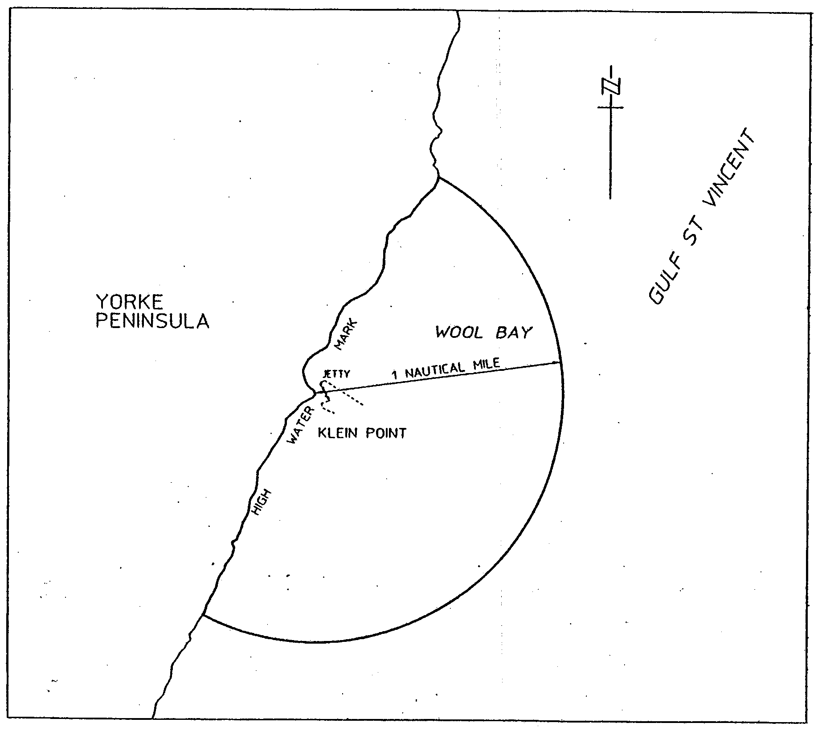

Port Adelaide—The subjacent land underlying, and adjacent land extending from, the waters, rivers, creeks and inlets to high water mark bounded as follows:

Commencing at Point Grey then due west along a line to its intersection with the western boundary of the harbor of Port Adelaide; then generally south south-easterly along the harbor boundary for 3 nautical miles; then along a line due east to its intersection with the south westerly production of the No 4 Leading Lights; then generally north easterly along the production to its intersection with high water mark on the southern face of the Southern Breakwater; then generally north easterly along high water mark to its intersection with south western boundary of Section 694 Hundred of Port Adelaide; then generally north westerly along the aforementioned boundary across the Southern Breakwater to its intersection with high water mark on the northern face of the Southern Breakwater; then generally north easterly along high water mark to the northern extremity of No 4 berth; then generally south easterly along high water mark to its intersection with the production southerly of the high water mark of the western face of the breakwater at the R.S.A.Y.S.; then generally north easterly along the production across the R.S.A.Y.S. Basin; then generally north westerly and north easterly along high water mark to Pelican Point; then generally south easterly and southerly along high water mark to its intersection with a line across the Port Adelaide River perpendicular to the high water mark alignment of No 12 berth commencing at its intersection with a 180 metre radial line from the north west corner of No 17 berth; then generally easterly along afore mentioned perpendicular line across the Port Adelaide River to its intersection with high water mark; then generally north and easterly along high water mark including Nos 2 and 3 docks to its intersection with the Wave Screen in North Arm; then generally northerly along the western face of the Wave Screen and its production to intersect with high water mark on Torrens Island; then generally northerly along high water mark to the point of commencement at Point Grey.

And including-Portion of Section 694 Hundred of Port Adelaide being the area described as easement E on FPX 43068
But excluding—Allotment 5 FP 102960

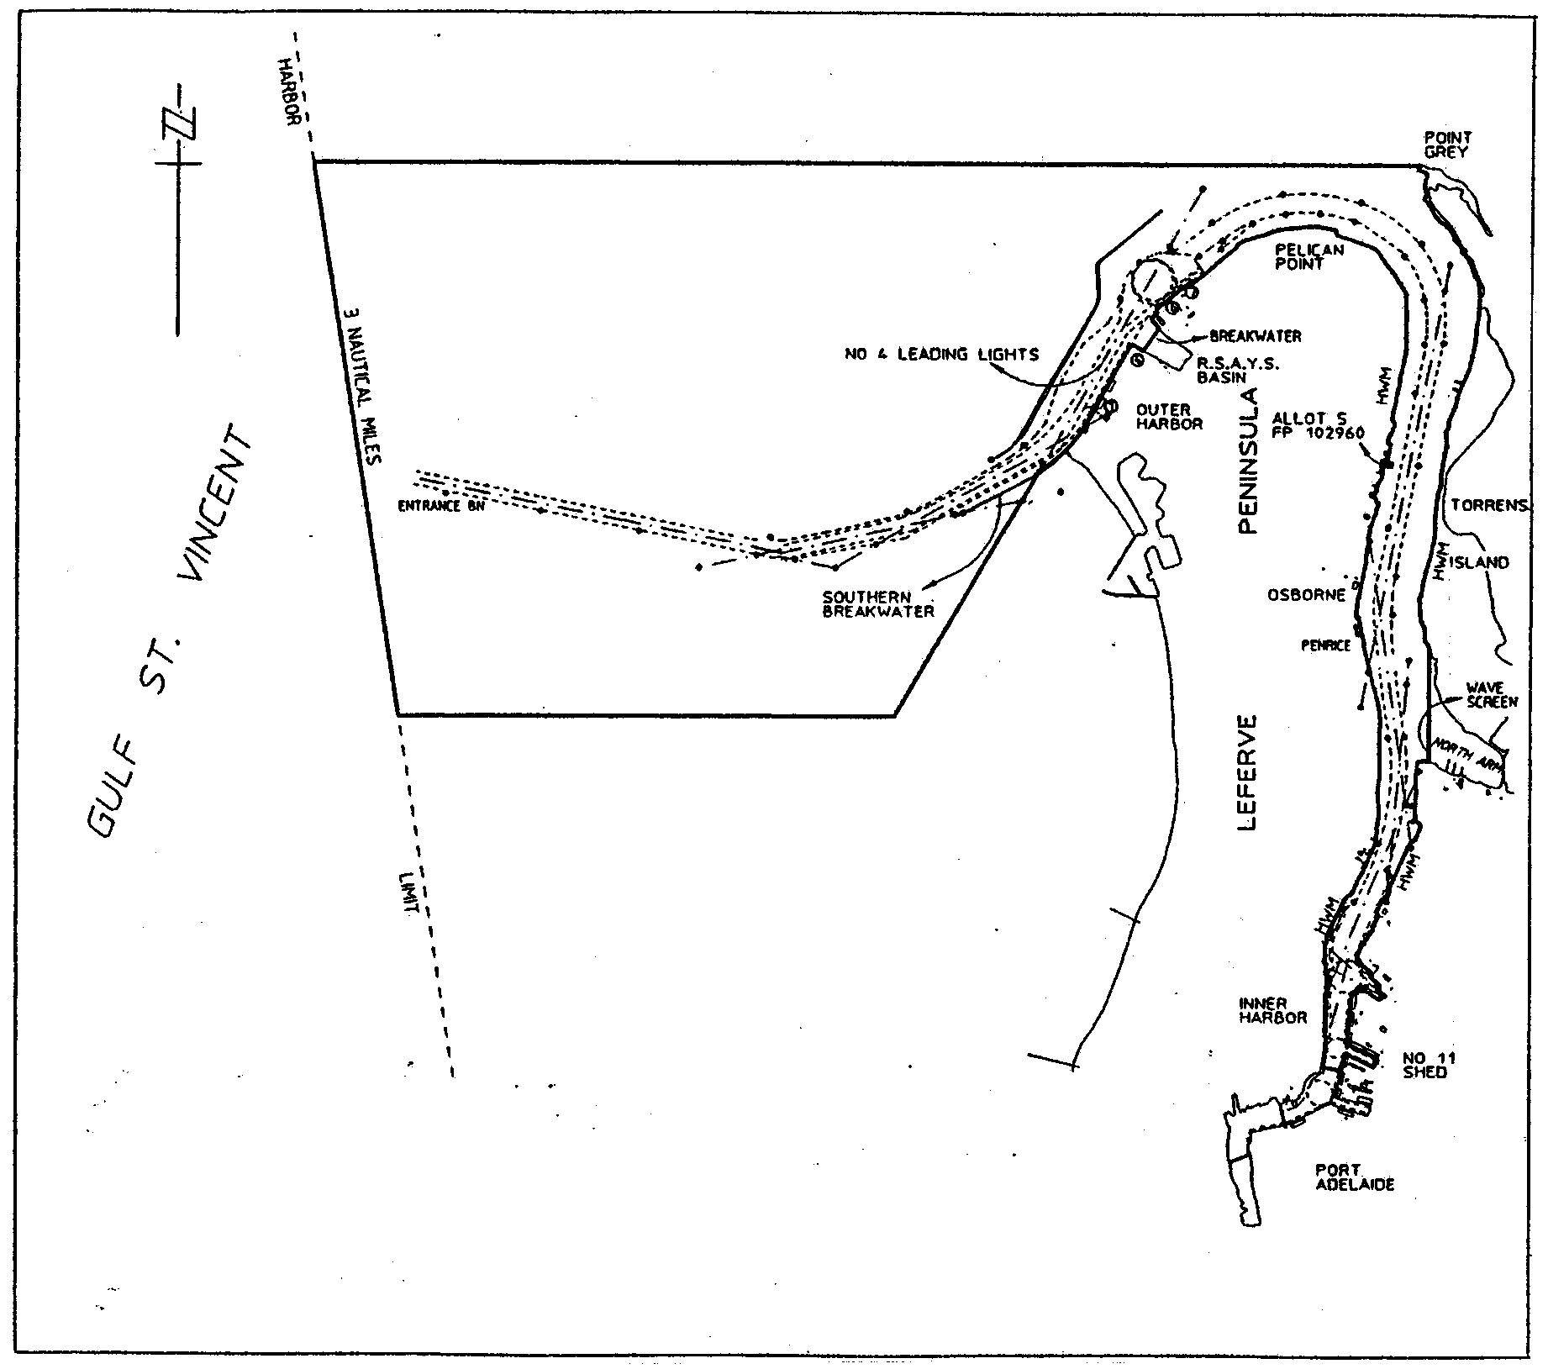

Port Giles—The subjacent land underlying, and adjacent land extending from, the waters, rivers, creeks and inlets to high water mark of that portion of the western coast of Gulf St. Vincent bounded as follows:

Commencing at a point on high water mark one nautical mile due south of the intersection of the centre line of the Port Giles Jetty with high water mark; then by a line bearing due east from high water mark for three nautical miles; then by a line bearing due north for two nautical miles; then by a line bearing due west to high water mark; then generally southerly along high water mark to the point of commencement.

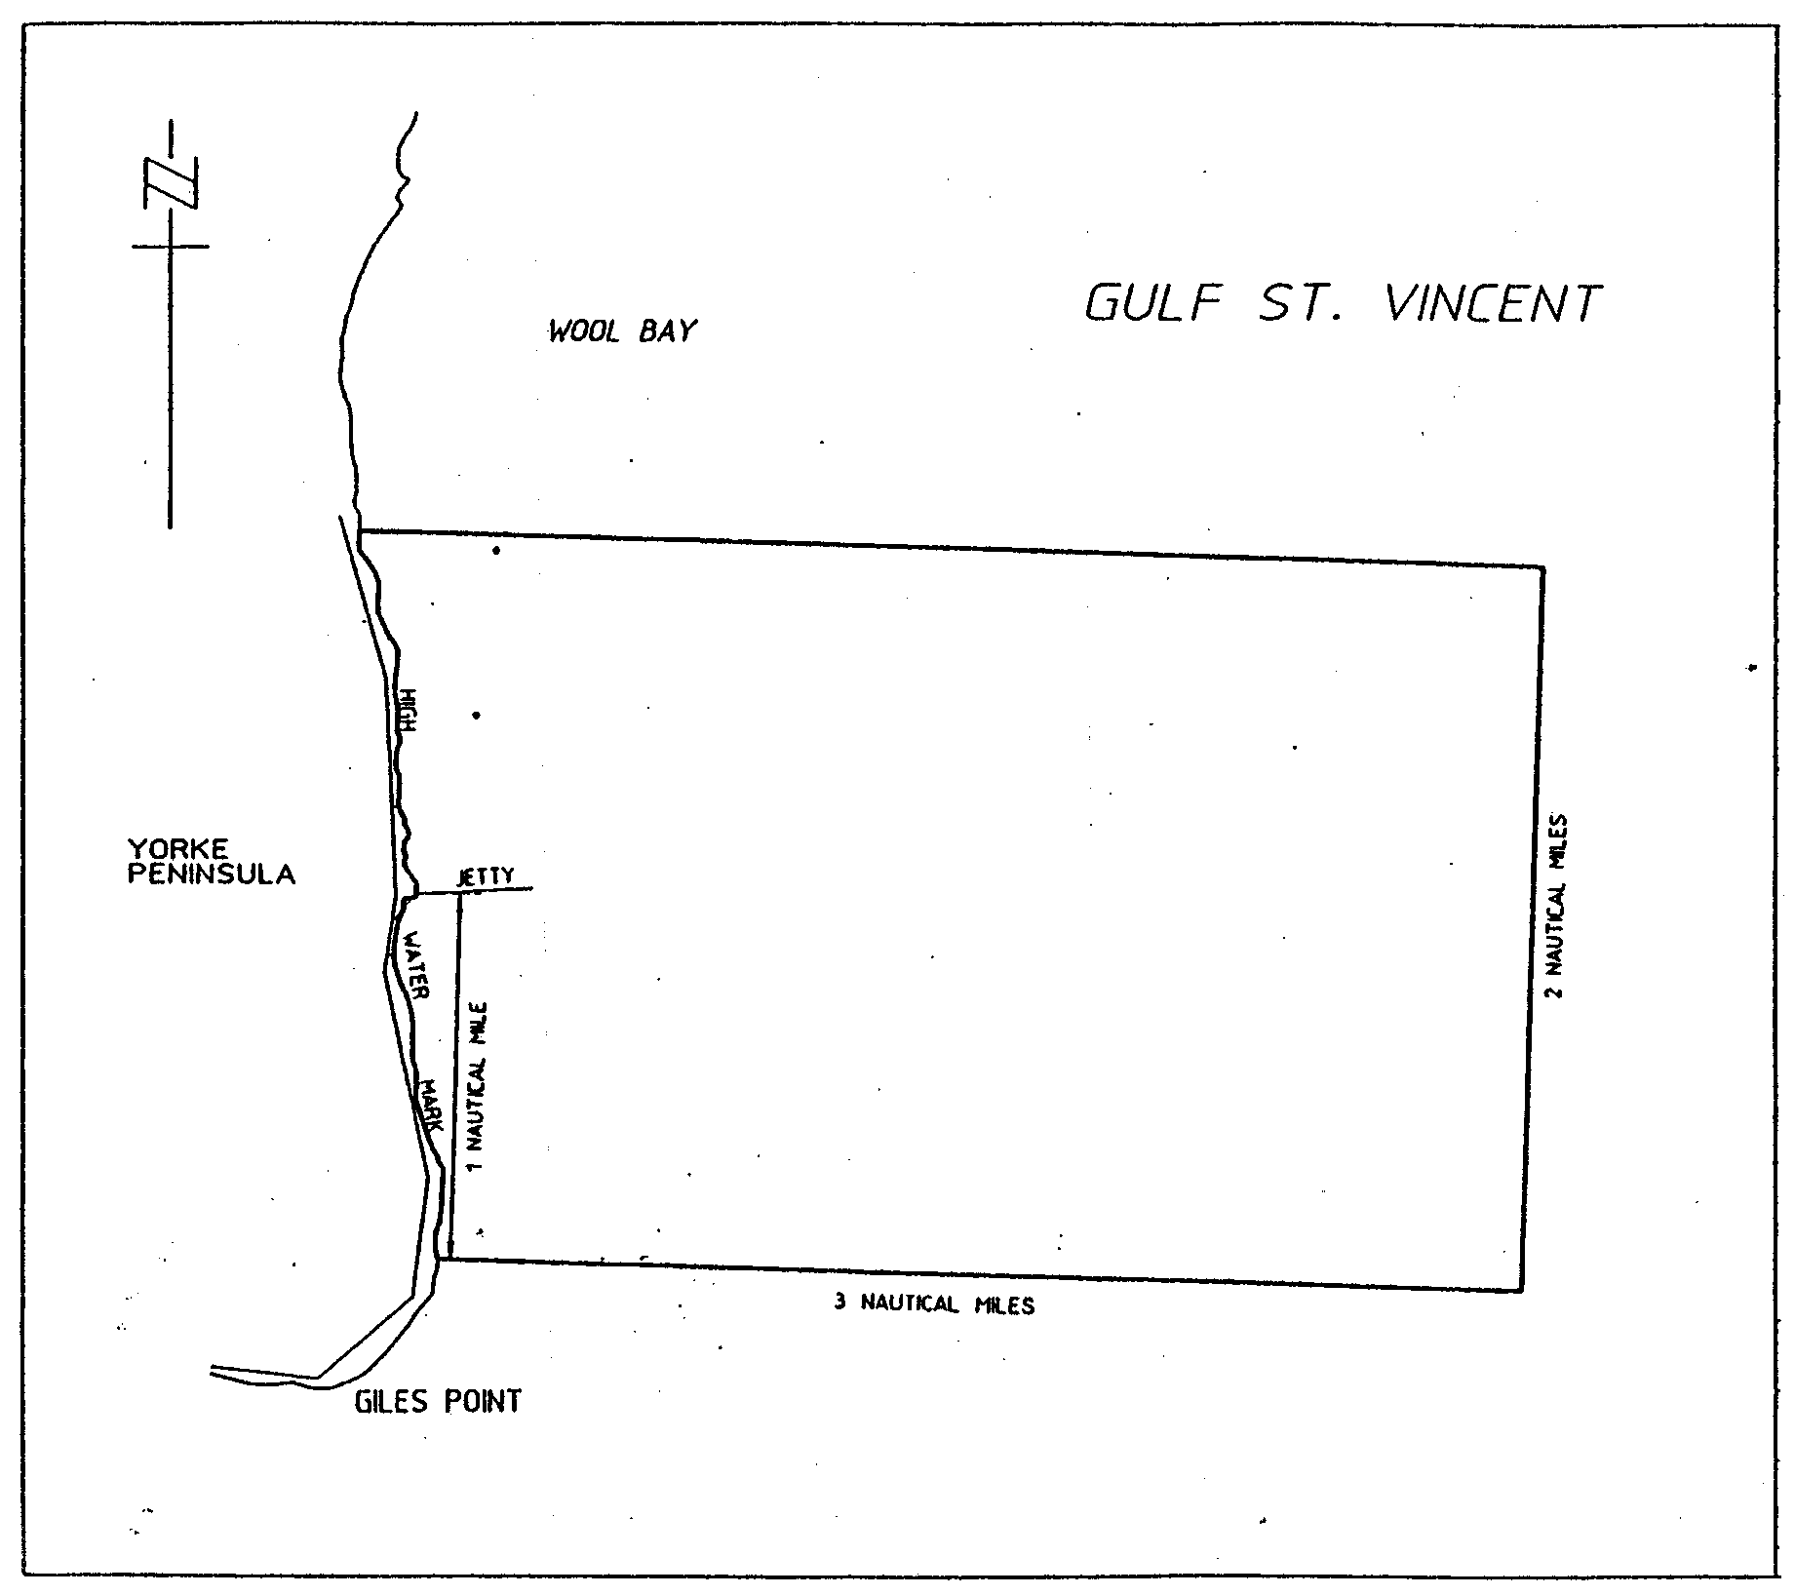

Port Lincoln—The subjacent land underlying, and adjacent land extending from, the waters, rivers, creeks and inlets to high water mark of Port Lincoln bounded as follows:

Commencing at the intersection with high water mark of a line running due north from the north-east corner of King and Porter Streets; then due north along the said line to its intersection with a line 250 metres from and parallel to the port side of the maintained channel; then generally north-easterly by a line 250 metres from and parallel to the port side of the maintained channel to a point adjacent the entrance beacon; then continuing generally north-easterly along the production of that line to its intersection with low water mark; then along low water mark to Point Boston; then due east along a line to its intersection with the eastern boundary of the harbor of Port Lincoln; then generally south-easterly along the harbor boundary for 1.2 nautical miles; then due west along a line for 4.8 nautical miles; then along a line bearing 231°39’T for 1.4 nautical miles; then due south along a line for 2.6 nautical miles; then generally south-easterly along a line to high water mark at Fanny Point; then along a line bearing 68°T or thereabouts to its intersection with high water mark on Boston Island; then along high water mark on Boston Island to Hayden Point; then by a line bearing 63°45’T to its intersection with the eastern boundary of the harbor of Port Lincoln; then generally south-easterly along the harbor boundary for 0.7 nautical miles; then generally south-westerly by a line to high water mark on the northern tip of Grantham Island; then due north along a line to its intersection with high water mark adjacent Section 187 Hundred of Lincoln; then generally north easterly and northerly along high water mark to Billy Lights Point; then by a line generally north-westerly to its intersection with high water mark and the western corner of Allotment 1012, Town of Port Lincoln; then generally northerly and westerly along high water mark to the point of commencement.

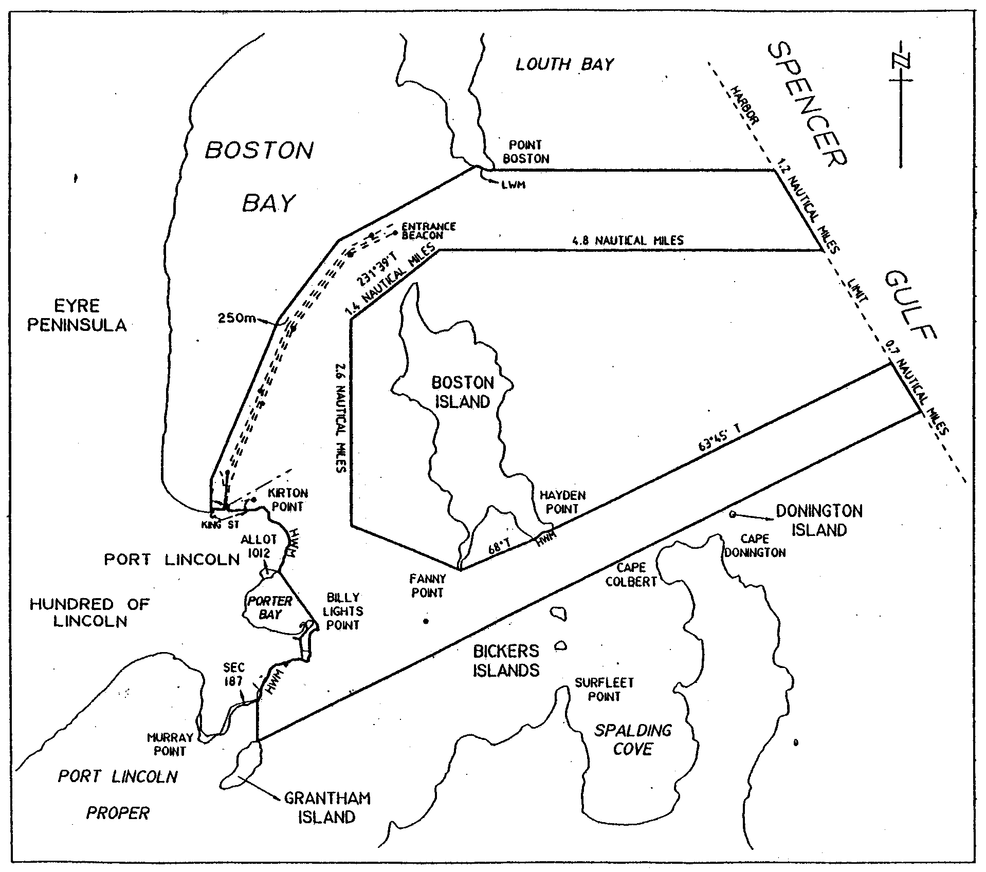

Port Pirie—The subjacent land underlying, and adjacent land extending from, the waters, rivers, creeks and inlets to high water mark in Germein Bay, Spencer Gulf, bounded as follows:

Commencing at a point on a line bearing 282°T and distance 13 nautical miles from Mount Ferguson (Latitude 33°06.34’S, Longitude 138°01.78’E); then generally north-easterly along the north-western harbor boundary to high water mark; then generally south-easterly along a line to the Port Germein jetty light; then generally south-westerly along a line joining No 2 port beacon to the intersection point of a line 250 metres from and parallel to the port side of the maintained channel; then generally southerly and south-easterly by a line 250 metres from and parallel to the port side of the maintained channel to its intersection with high water mark; then generally southerly along high water mark to a point being the prolongation of the southern extremity of No 1 berth Port Pirie across the Port Pirie River; then generally south-westerly across the Port Pirie River along that prolongation to the southern extremity of No 1 berth Port Pirie; then generally north-westerly and northerly along high water mark to the northern extremity of No. 10 berth; then generally westerly along the No.10 berth to its intersection with high water mark; then generally northerly along high water mark to the intersection of a line 250 metres from and parallel to the starboard side of the maintained channel; then generally north and north-westerly by a line 250 metres from and parallel to the starboard side of the maintained channel to a point south-west of the No.17 starboard beacon; then by a line bearing 299°35’T for 1.5 nautical miles; then by a line bearing 345°16’T to the intersection point of a line bearing 264°30’T from No 1 starboard beacon; then by a line bearing 264°30’T to the intersection with the south-western limit of the harbor of Port Pirie; then generally north-westerly along the south-western limit of the harbor of Port Pirie to the point of commencement.

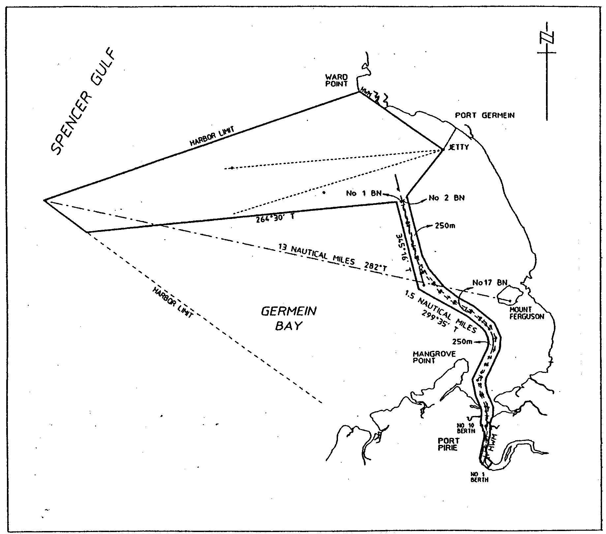

Thevenard—The subjacent land underlying, and adjacent land extending from, the waters, rivers, creeks and inlets to high water mark of Denial Bay, Murat Bay and Bosanquet Bay bounded as follows:

Commencing at a point at the intersection of high water mark and the production south-westerly of the northern western boundary of Section 212 Hundred of Bonython; then generally southerly along high water mark to the south western corner of Section 275 Hundred of Bonython; then generally west south-westerly along a line joining No 25 starboard beacon to the intersection point of a line 250 metres from and parallel to the starboard side of the maintained channel; then by that line bearing 166°34’T for 2 nautical miles; then by a line bearing 264°30’T for 2.4 nautical miles; then by a line bearing 220°T to its intersection with the south-western boundary of the harbor of Thevenard; then generally north-westerly along the harbor boundary to a point 2 nautical miles due south of Cape Beaufort; then by a line bearing 57°T to the intersection with a line bearing 46°T from the Entrance beacon (white sector light); then generally easterly by a line joining No 20 port beacon to the intersection point of a line 250 metres from and parallel to the port side of the maintained channel; then by a series of lines 250 metres from and parallel to the port side of the maintained channel to the intersection point with a line bearing 316°T from Cape Vivonne (white sector light); then by that line bearing 316°T for 1.9 nautical miles; then by a line bearing true north to the intersection point on a line joining Denial Bay jetty and Ceduna jetty; then along the said line generally east south-easterly to the intersection point of a line joining Low Point and the point of commencement; then generally southerly along that line to the point of commencement.

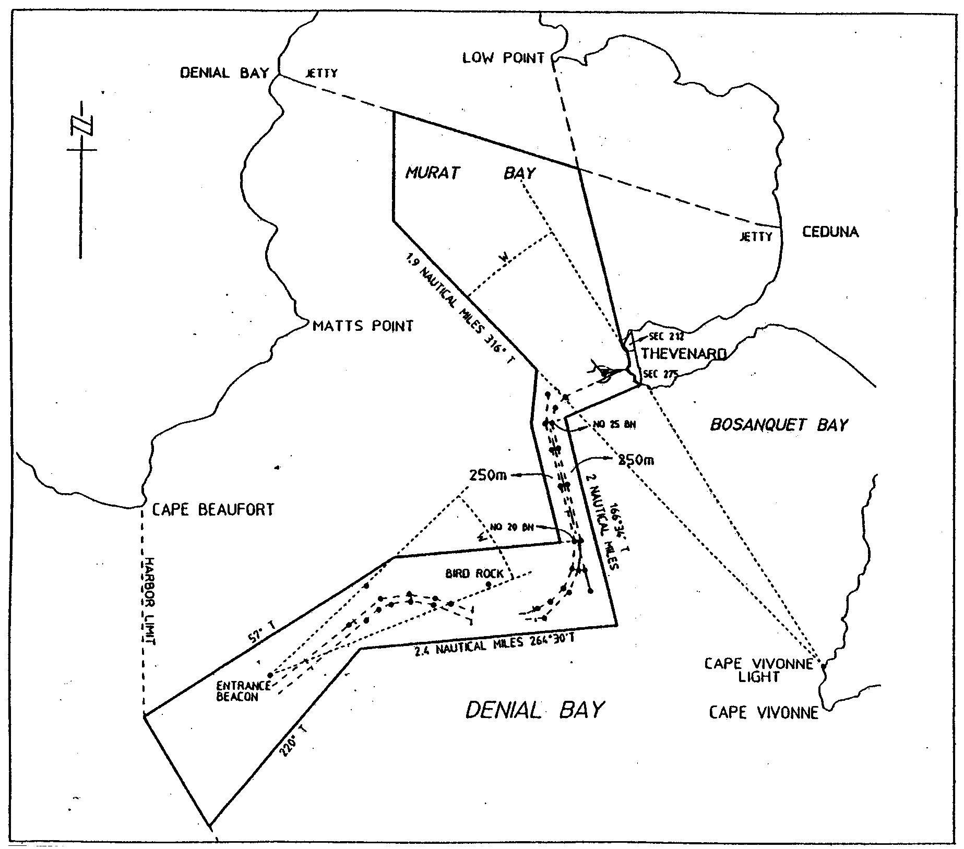

Wallaroo—The subjacent land underlying, and adjacent land extending from, the waters, rivers, creeks and inlets to high water mark of that part of Wallaroo Bay bounded as follows:

Commencing at a point on high water mark intersected by a line 150 metres north east and parallel to the northern face of the shipping pier; then generally north-westerly along a line joining high water mark at the south-west extremity of Point Riley to the intersection with a line being the production generally easterly of a line 250 metres from and parallel to the port side of the maintained channel; then generally westerly along that line to its intersection with western boundary of the harbor of Wallaroo; then generally southerly along the harbor boundary for 0.6 nautical miles; then generally east-south-easterly along a line joining the front lead to the intersection with high water mark; then generally north-easterly along high water mark to the point of commencement.

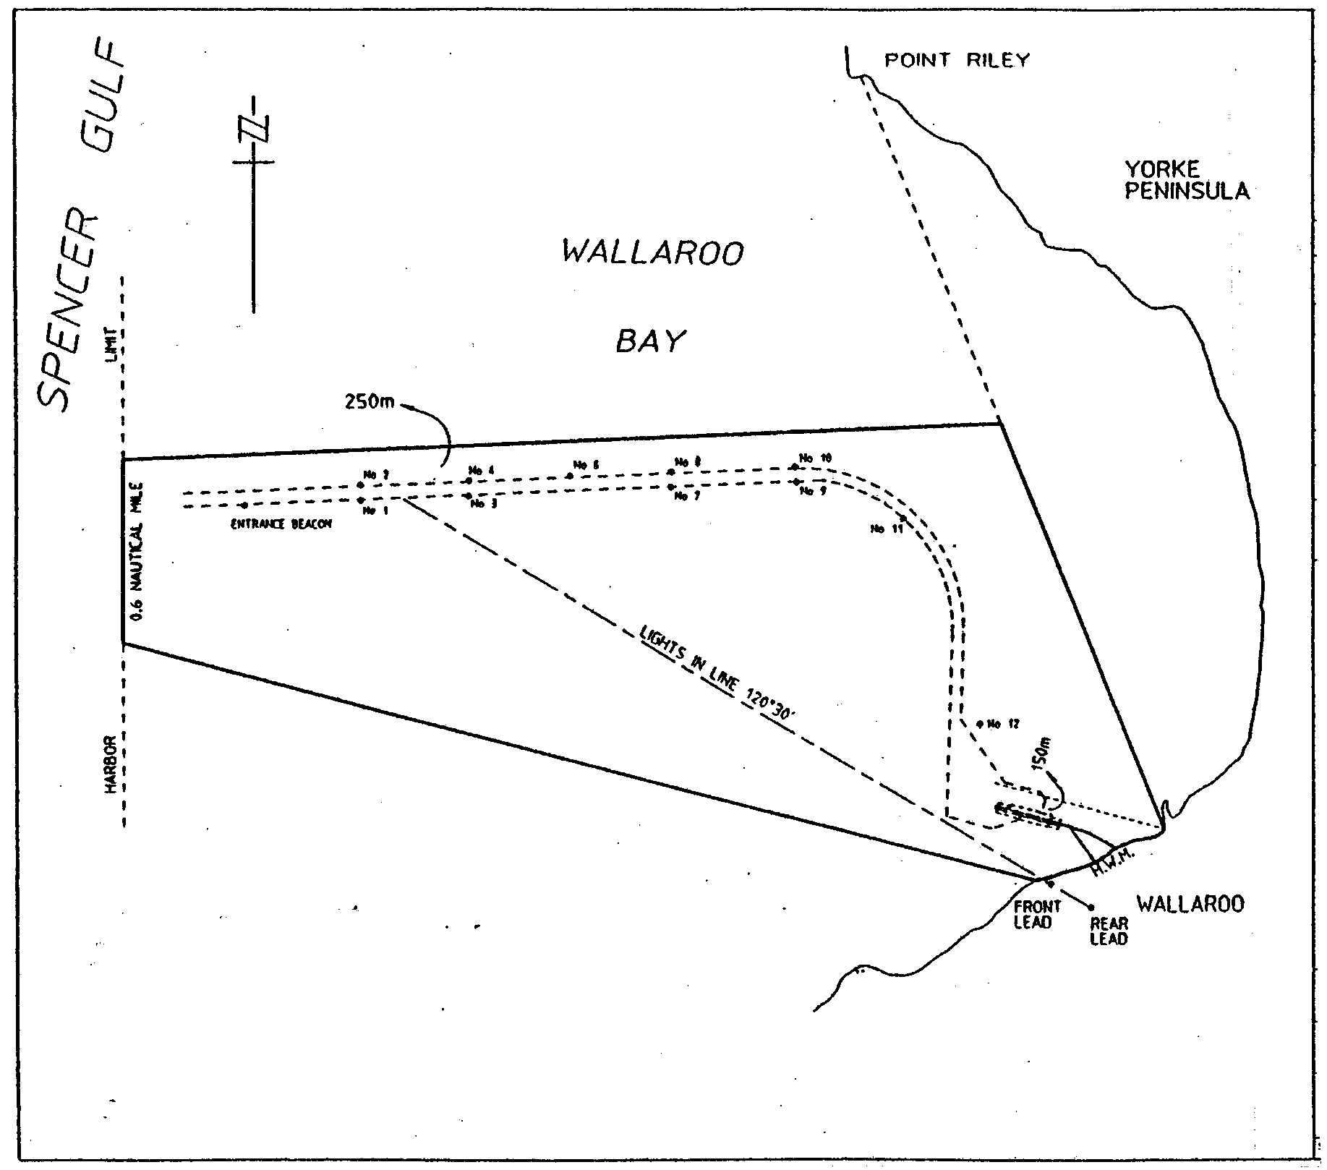

TSA C 2001/08501 R. DENNIS, Clerk of the Council

FAXING COPY?

IF you fax copy to Government Publishing SA for inclusion in the Government Gazette, there is no need to send a Confirmation Copy to us as well.

This creates confusion and may well result in your notice being printed twice.

Please use the following fax number:

Fax transmission: (08) 8207 1040
Phone Inquiries: (08) 8207 1045

Please include a contact person, phone number and order number so that we can phone back with any queries we may have regarding the fax copy.

NOTE: Closing time for lodging new copy (either fax or hard copy) is 4 p.m. on Tuesday preceding the day of publication.

Government Gazette notices can be E-mailed.

The address is:

governmentgazette@saugov.sa.gov.au

Documents should be sent as attachments in Word format.

When sending a document via E-mail, please confirm your transmission with a faxed copy of your document, including the date the notice is to be published.

Fax transmission: (08) 8207 1040
Enquiries: (08) 8207 1045

CITY OF ONKAPARINGA
Draft Plan Amendment Report
Noarlunga (City) Development Plan—Southern Expressway Surplus Land Plan Amendment Report
NOTICE is hereby given that the City of Onkaparinga has prepared a Plan Amendment Report to amend the Noarlunga (City) Development Plan.
The Plan Amendment Report proposes to amend the Noarlunga (City) Development Plan by rezoning the whole of Allotment 11 in Deposited Plan 52072, part section 521, Hundred of Noarlunga from Rural B Zone to Residential Zone and by inserting a Concept Plan, and additional Principles of Develop-ment Control in the Residential Zone to more precisely guide the development of the land.
The draft Plan Amendment Report will be available for public inspection and purchase during office hours at the offices of the City of Onkaparinga from 4 October 2001 to 4 December 2001 located at:
• Noarlunga—Ramsay Place, Noarlunga Centre.
• Willunga—St Peters Terrace, Willunga.
• Happy Valley—The Hub, Aberfoyle Park.
Copies of the Plan Amendment Report can be purchased
from the Council for $5, or viewed on the council website: www.onkaparingacity.com
Council invites written submissions regarding the Plan Amend-ment Report until 4 December 2001.
Written submissions should also clearly indicate whether or not their author (or agent) intends to speak at a public hearing to be held on 12 December 2001 at 7 p.m. at the Reynella Enterprise and Youth Centre, 10 Main South Road, Reynella. All sub-missions should be addressed to the City Manager, City of Onkaparinga, P.O. Box 1, Noarlunga Centre, S.A. 5168.
Copies of all submissions received will be available for inspection by interested persons at the Council offices from 4 December 2001 to 18 December 2001.
Please note that the public hearing may not be held if no submission indicates an interest in speaking at the public hearing.
Dated 4 October 2001.
J. Tate, City Manager

CITY OF PORT LINCOLN
Elector Representation Review
NOTICE is hereby given that as part of the current review a report has been prepared which, following consideration of council, supports the introduction of a council representation of a Mayor and 10 members elected from the whole area.
The proposed representation would take effect as from the general election to be held in 2003.
Any person wishing to make a written submission in relation to this proposal may do so on or before 5 p.m. on Friday, 26 October 2001, by addressing it to the Chief Executive Officer, City of Port Lincoln, P.O. Box 1787, Port Lincoln, S.A. 5606.
Any person providing a submission will be given the oppor-tunity to address the council on their submission.
I. Burfitt, Chief Executive Officer

ALEXANDRINA COUNCIL
Roads (Opening and Closing) Act 1991
Charlotte Street, Port Elliot
NOTICE is hereby given pursuant to section 10 of the Roads (Opening and Closing) Act 1991, that the Alexandrina Council proposes to make a Road Process Order to close, sell and transfer to R. M. and A. M. O’Hare portion of the public road, Charlotte Street between Hutton Street and Railway land shown delineated as ‘A’ on Preliminary Plan No. PP32/0687.
A copy of the plan and a statement of persons affected are available for public inspection at the office of the council, Dawson Street, Goolwa and the Adelaide office of the Surveyor-General during normal office hours.
Any application for easement or objection must be made in writing within 28 days from the date of the publication of this notice to the Council, P.O. Box 21, Goolwa, S.A. 5214 and the Surveyor-General, G.P.O. Box 1354, Adelaide, S.A. 5001 setting out full details. Where a submission is made, the council will give notification of a meeting to deal with the matter.
Dated 4 October 2001.
J. L. Coombe, Chief Executive Officer

DISTRICT COUNCIL OF LOXTON WAIKERIE
Declaration of an area of the State in which a person may operate a gas fire or electric element for cooking purposes in the open air contrary to the terms of a total fire ban
PURSUANT to Regulation 33 (3) of the Country Fires Act 1989, the District Council of Loxton Waikerie declares that persons may operate gas fires or electric elements for cooking purposes in the open air contrary to the terms of a total fire ban at the following places:
• Portion of the Kingston-On-Murray Riverfront extending from the boat ramp up to and including the marina.
• Anzac Crescent Recreation Reserve/Playground, Loxton,
at all times until revoked.
The operation of a gas fire or electric element under this notice is subject to the following conditions:
1. The space immediately around and above the gas fire or electric element must be cleared of all flammable material for a distance of at least 4 m.
2. A person who is able to control the gas fire or electric element must be present at all times while it is lighted or charged.
3. An appropriate agent adequate to extinguish any fire must be at hand.
T. L. Burgemeister, Chief Executive Officer

DISTRICT COUNCIL OF PETERBOROUGH
Appointment
NOTICE is hereby given that the District Council of Peter-borough, at its ordinary meeting held on 17 September 2001, appointed Keith Simmonds to the following positions:
Authorised Officer, pursuant to section 7 of the Public and Environmental Health Act 1987;
Authorised Officer, pursuant to section 8 of the Food Act 1985.
R. Mooney, Chief Executive Officer

DISTRICT COUNCIL OF PETERBOROUGH
Declaration of Public Road
NOTICE is hereby given that pursuant to section 210 of the Local Government Act 1999, at its ordinary meeting held on 21 August 2001, council declared the following road to be a public road with the effective date being 18 June 2001:
Torr Street, Peterborough, between West Terrace and Bridges Street (being allotment 71 in D.P. 971).
R. Mooney, Chief Executive Officer

DISTRICT COUNCIL OF STREAKY BAY
Change of Meeting Venue
NOTICE is hereby given that the normal council meeting, to be held on Wednesday, 17 October 2001, will be in the Haslam Hall commencing at 9.30 a.m.
J. Rumbelow, Acting Executive Officer

DISTRICT COUNCIL OF TATIARA
Temporary Road Closure
NOTICE is hereby given that at meetings held on Tuesday, 14 August and Tuesday, 11 September 2001 council resolved that:
1. That the council exercises the power pursuant to section 33 of the Road Traffic Act 1961 and Clause F of the Instrument of General Approval of the Minister dated 12 March 2001 to:
1.1 Pursuant to section 33 (1) of the Road Traffic Act 1961, declare that the event described below (‘the event’) that is to take place on the road described below (‘the road’) is an event to which section 33 of the Road Traffic Act 1961 applies; and
1.2 Pursuant to section 33 (1) (a) of the Road Traffic Act 1961, make an order directing that the road on which the event is to be held be closed to traffic for the period between 4 p.m. and 10.30 p.m. on 26 October 2001.
Road—Woolshed Street, Bordertown between Farquhar Street and DeCourcey Street. Also Farquhar Street between Woolshed Street and Binnie Street.
Event—Country Arts Concert.
G. W. Piesse, Chief Executive Officer

IN the matter of the estates of the undermentioned deceased persons:
Barter, John Joseph, late of 32 Browning Avenue, Plympton Part, retired musician, who died on 7 July 2001.
Bartsch, Frieda Emma, late of 10 Towers Terrace, Edwardstown, of no occupation, who died on 20 July 2001.
Bown, Gloria Merle, late of 4 Chaplin Avenue, Hillcrest, of no occupation, who died on 17 August 2001.
Budden, Ralph Edward, late of 11 Major Avenue, Marleston, retired supervisor clerk, who died on 9 August 2001.
Bury, George Hubert DeMiller, late of 1-7 Leicester Street, Clearview, retired public servant, who died on 20 July 2001.
Carey, Ernest Frank, late of 285 Goodwood Road, Kings Park, retired labourer, who died on 23 August 2001.
Dabinett, Lawrence Albert, late of 32 Narrung Road, Meningie, retired dairy farmer, who died on 30 July 2001.
Greenham, Judith Ann, late of King George Avenue, North Brighton, of no occupation, who died on 12 July 2001.
Grenfell, James Hilton, late of 59 Ferguson Avenue, Myrtle Bank, retired residential care worker, who died on 23 June 2001.
Griffith, William Irvine, late of 342 Marion Road, North Plympton, retired motor fitter, who died on 26 June 2001.
Jantke, Phyllis, late of 44A Skyline Drive, Flagstaff Hill, of no occupation, who died on 23 August 2001.
Leske, Peter John, late of 120 Commercial Road, Salisbury, packer, who died on 26 June 2000.
Lewis, Cyril Llewellyn, late of 59 Ferguson Avenue, Myrtle Bank, retired bank officer, who died on 3 April 2001.
Locke, Pauline, late of Ral Ral Avenue, Renmark, of no occupation, who died on 7 January 1999.
Loftus, Catherine, late of 1 Kent Street, Hawthorn, of no occupation, who died on 20 August 2001.
Malugani, Annemarie, late of 52 Dunrobin Road, Hove, of no occupation, who died on 25 August 2001.
McAuliffe, John David, late of 18 Cross Road, Myrtle Bank, retired agronomist, who died on 31 July 2001.
Penley, Henry Mervyn, late of 10 Morton Road, Christie Downs, retired maintenance superintendent, who died on 10 July 2001.
Richards, Doreen, late of 5-9 Majors Road, North Moonta, widow, who died on 26 June 2001.
Sheedy, Francis Ernest, late of 470 Churchill Road, Kilburn, retired carpenter, who died on 9 July 2001.
Sims, Elli Alfreda, late of 34 Molesworth Street, North Adelaide, of no occupation, who died on 5 July 2001.
Spicer, Dulcie Victoria, late of 14-22 King William Road, Wayville, retired kitchen hand, who died on 29 July 2001.
Stein, Marianne Irene, late of 21 Dublin Avenue, Salisbury Downs, of no occupation, who died on 15 June 2001.
Triggs, Jean Lilian, late of 17 Verdale Avenue, Linden Park, home duties, who died on 21 August 2001.
Van Poecke, Johanna, late of 25 Sturt Road, Bedford Park, home duties, who died on 11 August 2001.
Watts, Geraldine Hopcroft, late of 15 Rosemary Street, Woodville West, of no occupation, who died on 3 August 2001.
Notice is hereby given pursuant to the Trustee Act 1936, as amended, the Inheritance (Family Provision) Act 1972, and the Family Relationships Act 1975, that all creditors, beneficiaries, and other persons having claims against the said estates are required to send, in writing, to the Public Trustee, 25 Franklin Street, Adelaide, S.A. 5000, full particulars and proof of such claims, on or before 2 November 2001, otherwise they will be excluded from the distribution of the said estate; and notice is also hereby given that all persons who are indebted to the said estates are required to pay the amount of their debts to the Public Trustee or proceedings will be taken for the recovery thereof; and all persons having any property belonging to the said estates are forthwith to deliver the same to the Public Trustee.
Dated 4 October 2001.
J. H. Worrall, Public Trustee

SALE OF PROPERTY
Auction Date: Friday, 26 October 2001 at 11 a.m.
Location: 38 Hender Avenue, Klemzig
NOTICE is hereby given that on the above date at the time and place stated, by virtue of the Warrant of Sale issued out of the Magistrates Court of South Australia, Holden Hill Registry, Action No. 44 of 2001, directed to the Sheriff of South Australia in an action wherein Pauline Causby, is Plaintiff and Joyce Oleny is Defendant, I, Tim Goodes, Sheriff, of the State of South Australia, will by my auctioneers, Griffin Real Estate, make sale of the estate, right, title or interest whatsoever it may be of the defendant Joyce Oleny as the registered proprietor of an estate in fee simple in the following:
That piece of land situated in the area named Klemzig, being 38 Hender Avenue, being the property comprised in certificate of title register book volume 5431, folio 188.
Further particulars from the auctioneers:
Griffin Real Estate
179 King William Road
Hyde Park, S.A. 5061
Telephone 8357 3177

SALE OF PROPERTY
Auction Date: Friday, 19 October 2001 at 10 a.m.
Location: Mason Gray Strange, 370 Torrens Road, Kilkenny, S.A. 5009
NOTICE is hereby given that on the above date at the time and place stated, by virtue of Orders for Sale issued by the Fines Payment Unit of South Australia, Penalty No. EXREG-00-89478/1 and others, are directed to the Sheriff of South Australia in an action wherein William John Forrest is the Defendant, I, Tim Goodes, Sheriff of the State of South Australia, will by my auctioneers, Government Auctions SA make sale of the following:
York 401 Free Weight Home Fitness Centre.

ATTENTION

CUSTOMERS requiring a proof of their notice for inclusion in the Government Gazette, please note that the onus is on you to inform Government Publishing SA of any subsequent corrections by 10 a.m. on Thursday, which is our publication deadline.

For any corrections to your notice please phone 8207 1045 or Fax 8207 1040 before 10 a.m. on Thursday.

If we do not receive any communication by 10 a.m. on Thursday (day of publication) we will presume the notice is correct and will print it as it is.

Remember—the onus is on you to inform us of any corrections necessary to your notice.

NOTE: Closing time for lodging new copy (electronically, fax or hard copy) is 4 p.m. on Tuesday preceding the day of publication. Phone 8207 1045—Fax 8207 1040.
Email: governmentgazette@saugov.sa.gov.au

Printed and published by authority every Thursday by J. D. FERGUSON, Government Printer, South Australia
Price: $4.40, plus postage; to subscribers, $220.20 per annum.
(The above prices are inclusive of GST)

