EXTRAORDINARY GAZETTE



THE SOUTH AUSTRALIAN

GOVERNMENT GAZETTE

PUBLISHED BY AUTHORITY

ALL PUBLIC ACTS appearing in this GAZETTE are to be considered official, and obeyed as such

ADELAIDE, SUNDAY, 14 OCTOBER 2001

REGULATIONS UNDER THE LIQUOR LICENSING ACT 1997
────
No. 227 of 2001
────
At the Executive Council Office at Adelaide, 11 October 2001

PURSUANT to the Liquor Licensing Act 1997 and with the advice and consent of the Executive Council, I make the following regulations.
E. J. NEAL, Governor

PURSUANT to section 10AA(2) of the Subordinate Legislation Act 1978, I certify that, in my opinion, it is necessary or appropriate that the following regulations come into operation as set out below.

K. T. GRIFFIN, Minister for Consumer Affairs
───────────────────
SUMMARY OF PROVISIONS

1. Citation
2. Commencement
3. Variation of Sched. 1—Long Term Dry Areas
4. Variation of Sched. 2—Plans of Long Term Dry Areas

SCHEDULE 1

SCHEDULE 2
───────────────────

Citation
1. The Liquor Licensing (Dry Areas—Long Term) Regulations 1997 (see Gazette 6 November 1997 p. 1217), as varied, are referred to in these regulations as "the principal regulations".

Commencement
2. These regulations will come into operation on 29 October 2001.

Variation of Sched. 1—Long Term Dry Areas
3. Schedule 1 of the principal regulations is varied—

(a) by striking out the item headed "Adelaide—Area 1" and substituting the following item:

Adelaide—Area 1
(see schedule 2: Adelaide—Plan No. 1)

Area | Period | Extent of prohibition
The area in Adelaide bounded as follows:  Commencing at the point at which the prolongation in a straight line of the eastern boundary of West Terrace intersects the northern boundary of North Terrace, then easterly along that boundary of North Terrace to the western boundary of the Skate Park, then northerly, easterly and southerly around the western, northern and eastern boundaries of the Skate Park to the northern boundary of North Terrace, then easterly along that boundary of North Terrace to the eastern boundary of Montefiore Road, then northerly along that boundary of Montefiore Road to the northernmost boundary of Festival Drive, then easterly along that boundary of Festival Drive to the point at which it meets the northernmost boundary of the built structures comprising and adjacent to the Adelaide Convention Centre Complex, Hyatt Hotel and Adelaide Festival Centre, then generally easterly, northerly and easterly along that boundary to the north-eastern corner of the Adelaide Festival Centre built structures, then in a straight line by the shortest route to the north-western corner of Government House, then easterly along the northern boundary of Government House and the prolongation in a straight line of that boundary to the eastern boundary of Kintore Avenue, then northerly along that boundary of Kintore Avenue to the southern boundary of Victoria Drive, then generally easterly along that boundary of Victoria Drive to the western boundary of Frome Road, then in a straight line by the shortest route to the south-western corner of Botanic Park, then generally easterly along the southern boundary of Botanic Park to the point at which it meets the western boundary of the Botanic Gardens, then generally southerly, south-easterly and southerly along the western boundary of the Botanic Gardens to the northern boundary of North Terrace, then easterly along that boundary of North Terrace to the point at which it meets the northerly prolongation in a straight line of the western boundary of East Terrace, then generally southerly and easterly along that prolongation and the western boundary of East Terrace to the northern boundary of South Terrace, then westerly along that boundary of South Terrace to the eastern boundary of West Terrace, then northerly along that boundary of West Terrace (and the prolongation in a straight line of that boundary) to the point of commencement—  (a) excluding the grounds of The University of Adelaide, the University of South Australia and the Institute of Medical and Veterinary Science; and  (b) excluding the Adelaide Festival Centre. | Continuous until 29 October 2002. | The consumption and possession of liquor are prohibited.

(b) by inserting after the item headed "Normanville—Area 1" the following item:

North Adelaide—Area 1
(see schedule 2: North Adelaide—Plan No. 1)

Area | Period | Extent of prohibition
The area in North Adelaide bounded as follows:  Commencing at the point at which the eastern boundary of Mills Terrace intersects the southern boundary of Barton Terrace West, then north-easterly along that boundary of Barton Terrace West to the western boundary of O'Connell Street, then south-easterly along that boundary of O'Connell Street to its intersection with the prolongation in a straight line of the southern boundary of Barton Terrace East, then north-easterly along that boundary of Barton Terrace East to the western boundary of Lefevre Terrace, then south-easterly along that boundary of Lefevre Terrace to its intersection with the prolongation in a straight line of the southern boundary of Kingston Terrace, then north-easterly along that boundary to a point on that boundary that is the shortest distance from the southern boundary of the western end of Kingston Terrace East, then north-westerly in a straight line to the southern boundary of the western end of Kingston Terrace East, then north-easterly along that boundary to the western boundary of Mann Road, then south-easterly along that boundary of Mann Road to the point at which it intersects the prolongation in a straight line of the northern boundary of MacKinnon Parade, then south-westerly, south-easterly, south-westerly and north-westerly along that prolongation and boundary of MacKinnon Parade to the northern boundary of Finniss Street, then south-westerly along that boundary of Finniss Street to the eastern boundary of Frome Road, then north-westerly along that boundary of Frome Road (and the prolongation in a straight line of that boundary) to the northern boundary of Melbourne Street, then in a straight line by the shortest route to the point at which the western boundary of Frome Road meets the western boundary of Sir Edwin Smith Avenue, then south-westerly along that boundary of Sir Edwin Smith Avenue to the northern boundary of Pennington Terrace, then generally north-westerly and westerly along that boundary of Pennington Terrace and Montefiore Hill to the eastern boundary of Strangways Terrace, then north-westerly, south-westerly, north-westerly and south-westerly along that boundary of Strangways Terrace to the eastern boundary of Mills Terrace, then north-westerly, north-easterly, north-westerly, north-easterly, north-westerly, north-easterly and north-westerly along that boundary of Mills Terrace to the point of commencement. | Continuous until 29 October 2002. | The consumption and possession of liquor are prohibited.

Variation of Sched. 2—Plans of Long Term Dry Areas
4. Schedule 2 of the principal regulations is varied—

(a) by inserting after the plan headed "Aberfoyle Park—Plan No. 1" the plan in Schedule 1 of these regulations;

(b) by inserting after the plan headed "Normanville—Plan No. 1" the plan in Schedule 2 of these regulations.

SCHEDULE 1

Adelaide—Plan No. 1

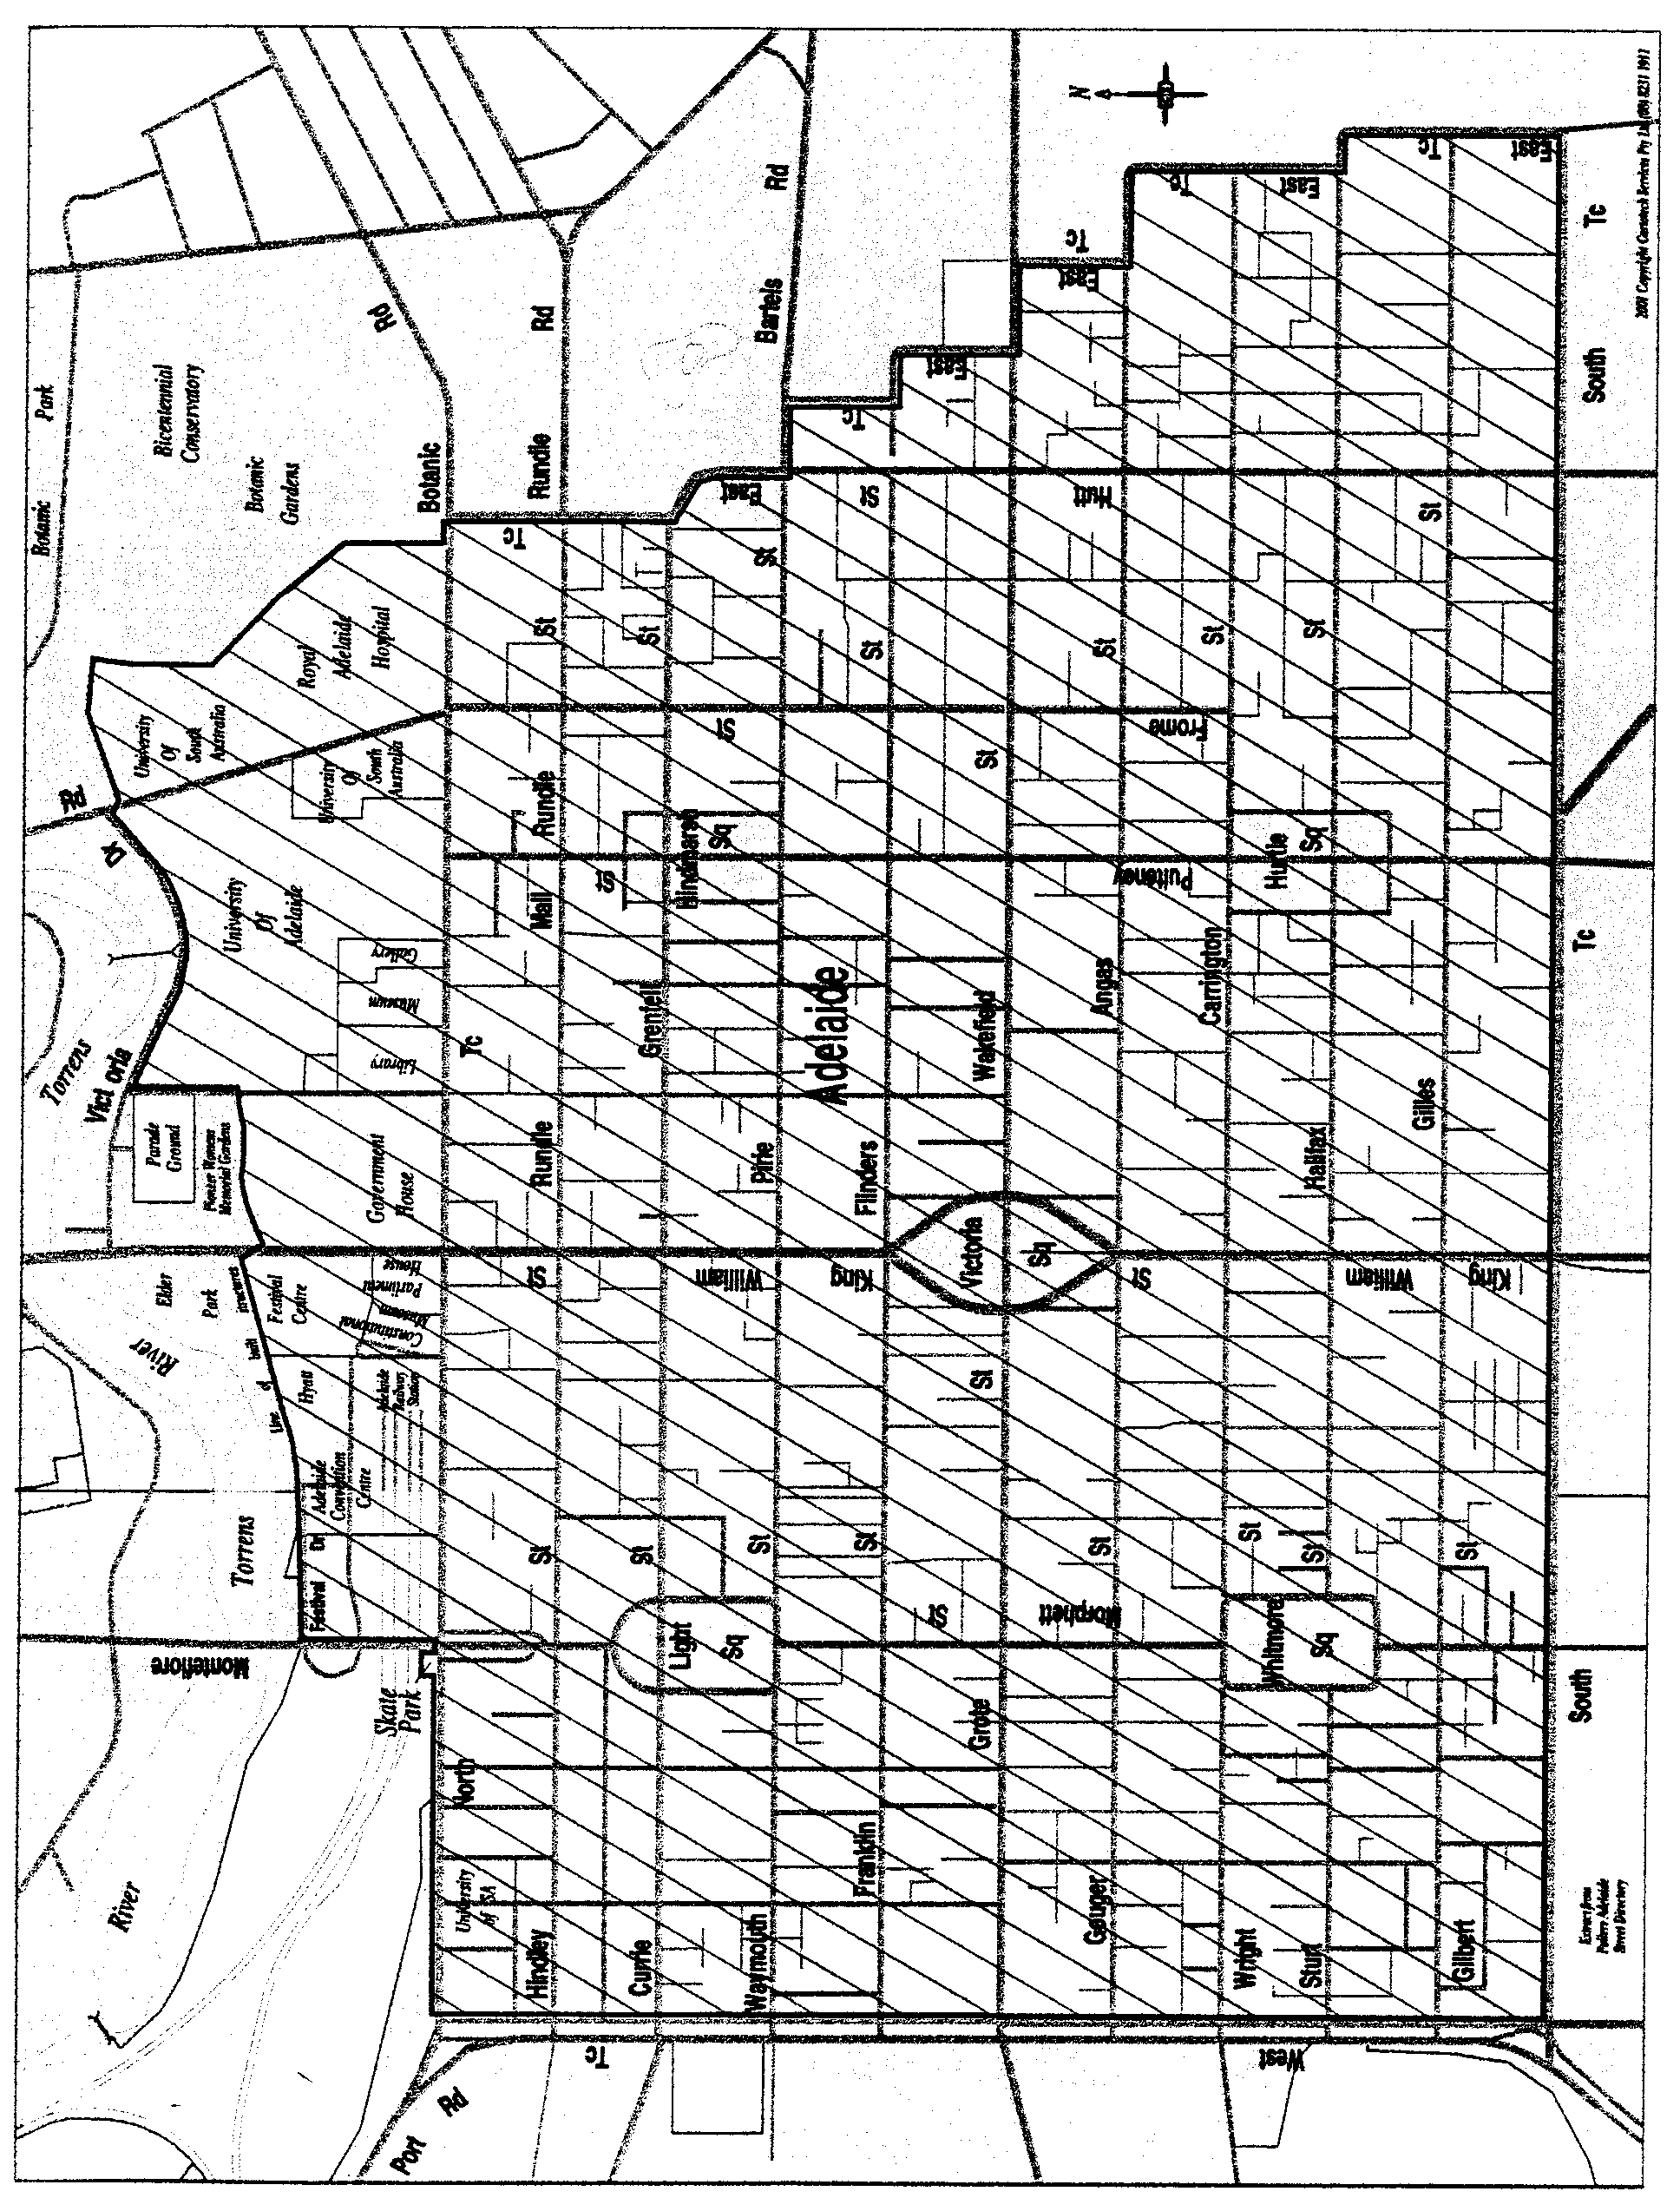

Note: the area does not include—
(a) the grounds of The University of Adelaide, the University of South Australia or the Institute of Medical and Veterinary Science; or
(b) the Adelaide Festival Centre.

SCHEDULE 2

North Adelaide—Plan No. 1

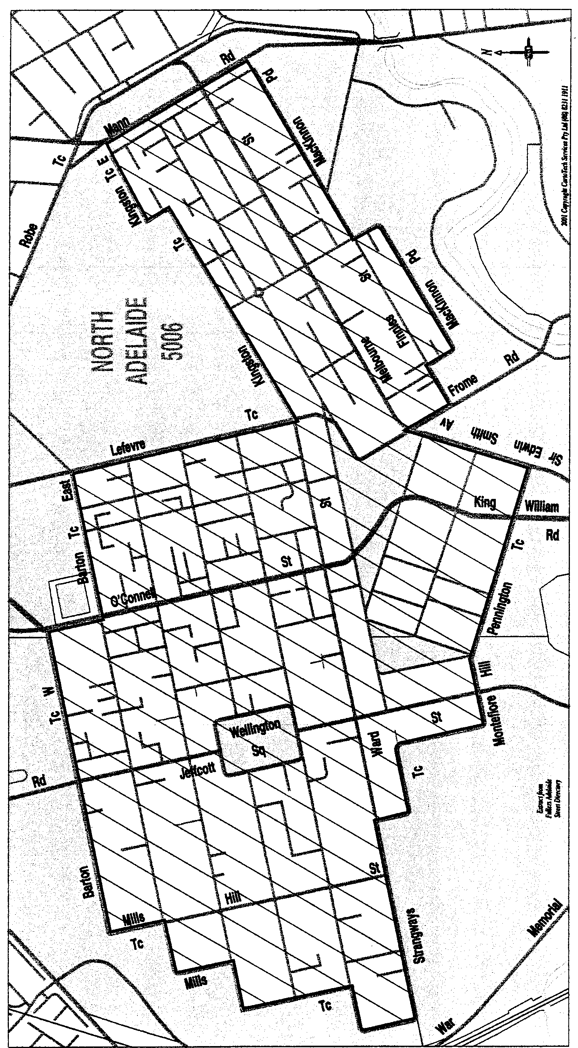

DPC018/01CS SUZANNE CARMAN, Clerk of the Council

J. D. FERGUSON, Government Printer, South Australia

