No. 133 4547

THE SOUTH AUSTRALIAN

GOVERNMENT GAZETTE

PUBLISHED BY AUTHORITY

ALL PUBLIC ACTS appearing in this GAZETTE are to be considered official, and obeyed as such

ADELAIDE, THURSDAY, 18 OCTOBER 2001

CONTENTS

Page
Appointments, Resignations, Etc 4548
Corporations and District Councils—Notices 4611
Country Fires Act 1989—Notice 4549
Environment Protection Agency—Notice 4549
Fisheries Act 1982—Notices 4550
Fruit and Plant Protection Act 1992—Notice 4551
Harbors and Navigation Act 1993—Notices 4551
Land and Business (Sale and Conveyancing) Act 1994—
Erratum 4551
Liquor Licensing Act 1997—Notices 4552
Mining Act 1971—Notices 4556
National Parks and Wildlife Act 1972—Notices 4556
National Parks Regulations 2001—Notice 4557

Page
Petroleum Act 2000—Notice 4558
Prices Act 1948—Notices 4558
Private Advertisements 4612
Proclamations 4548
Public Trustee Office—Administration of Estates 4612
REGULATIONS
Renmark Irrigation Trust Act 1936 (No. 234 of 2001) 4606
Legal Practitioners Act 1981 (No. 235 of 2001) 4607
Building Work Contractors Act 1995 (No. 236 of 2001) 4608
Roads (Opening and Closing) Act 1991—Notice 4560
Road Traffic Act 1961—Notices 4560
Rules of Court 4604
Water Mains and Sewers—Mains Laid, Replaced, Etc. 4605

GOVERNMENT GAZETTE NOTICES
ALL poundkeepers’ and private advertisements forwarded for publication in the South Australian Government Gazette must be PAID FOR PRIOR TO INSERTION; and all notices, from whatever source, should be legibly written on one side of the paper only and sent to Government Publishing SA so as to be received no later
than 4 p.m. on the Tuesday preceding the day of publication. Phone 8207 1045 or Fax 8207 1040. E-mail: governmentgazette@saugov.sa.gov.au. Send as attachments in Word format and please confirm your transmission with a faxed copy of your document, including the date the notice is to be published and to whom the notice will be charged.

PRICES ACT 1948 SECTION 19: DECLARED GOODS
AND SERVICES
Proclamation By The Governor
(l.s.) E. J. Neal
PURSUANT to section 19 of the Prices Act 1948 and with the advice and consent of the Executive Council, I—
(a) revoke all proclamations previously made under that section;
(b) declare the following goods to be declared goods for the purposes of the Act:
(i) bread;
(ii) infant foods;
(c) declare the following services to be declared services for the purposes of the Act:
(i) the carriage of freight by Kangaroo Island Sealink Pty Ltd;
(ii) the recovery and towing at or from the scene of an accident occurring within the declared area of a motor vehicle damaged in the accident;
(iii) the storage of a motor vehicle damaged in an accident occurring within the declared area;
(iv) the quotation for repair of a motor vehicle damaged in an accident occurring within the declared area.
In this proclamation—
“freight” includes a motor vehicle that is—
(a) carrying freight; or
(b) travelling to a place to collect freight; or
(c) on a return journey from a place to which it has carried freight.
“motor vehicle” means a motor vehicle as defined in section 5 of the Motor Vehicles Act 1959 (including a trailer as defined in that section).
In this proclamation the expressions “accident”, “declared area”, “quotation for repair” and “tow” have the same meaning as in the Motor Vehicles Act 1959.
This proclamation will take effect on 18 October 2001.
Given under my hand and the Public Seal of South Australia, at Adelaide, 18 October 2001.
By command,
Mark Brindal, for Premier
OCBACS 003/99

SOUTH AUSTRALIAN HEALTH COMMISSION ACT 1976 SECTION 48(6): DISSOLUTION OF ABORIGINAL HEALTH COUNCIL OF SOUTH AUSTRALIA AND TRANSFER OF THE UNDERTAKING OF THAT INCORPORATED HEALTH CENTRE TO THE ABORIGINAL HEALTH COUNCIL OF SOUTH AUS-TRALIA INCORPORATED
Proclamation By The Governor
(l.s.) E. J. Neal
Preamble
1. The Aboriginal Health Council of South Australia is an incorporated health centre, incorporated under the South Australian Health Commission Act 1976 on 16 September 1981 (see Gazette, 3 September 1981 p. 805; 29 November 1990 p. 1627).
2. The Aboriginal Health Council of South Australia Incor-porated is a body corporate, incorporated under the Associations Incorporation Act 1985 on 18 September 2001.
3. The Minister for Human Services is constituted as a body corporate under the Administrative Arrangements Act 1994 (see Gazette 20 October 1997 p. 1058).
4. The management committee of the incorporated health centre referred to in clause 1 seeks the transfer of the whole of the undertaking of the health centre to the bodies corporate referred to in clauses 2 and 3 and the dissolution of the health centre.
Proclamation
PURSUANT to section 48(6) of the South Australian Health Commission Act 1976 and with the advice and consent of the Executive Council, I—
(a) transfer the whole of the undertaking of the Aboriginal Health Council of South Australia (including all its assets and liabilities, except for such of its records as are subject to the State Records Act 1997) to the Aboriginal Health Council of South Australia Incorporated; and
(b) transfer the records of the Aboriginal Health Council of South Australia that are subject to the State Records Act 1997 to the Minister for Human Services; and
(c) dissolve the Aboriginal Health Council of South Australia.
This proclamation will take effect on 18 October 2001.
Given under my hand and the Public Seal of South Australia, at Adelaide, 18 October 2001.
By command,
Mark Brindal, for Premier
DHSCS 01/32

Department of the Premier and Cabinet
Adelaide, 18 October 2001
HIS Excellency the Governor in Executive Council has been pleased to appoint the undermentioned to the Public and Environ-mental Health Council, pursuant to the provisions of the Public and Environmental Health Act 1987:
Member: (from 28 January 2002 until 27 January 2005)
Brendon John Kearney
Nancy Judith Cromar
Deputy Member: (from 28 January 2002 until 27 January 2005)
Kevin James Buckett (Deputy to Kearney)
Richard Bentham (Deputy to Cromar)
By command,
Mark Brindal, for Premier
DHS 47/00CS

Department of the Premier and Cabinet
Adelaide, 18 October 2001
HIS Excellency the Governor in Executive Council has been pleased to appoint the undermentioned to the South Australian Psychological Board, pursuant to the provisions of the Psycho-logical Practices Act 1973:
Member: (from 18 October 2001 until 19 April 2003)
Radomir Stratil
By command,
Mark Brindal, for Premier
MHS 005/00CS

Department of the Premier and Cabinet
Adelaide, 18 October 2001
HIS Excellency the Governor in Executive Council has been pleased to appoint the undermentioned to the Medical Practit-ioners Professional Conduct Tribunal, pursuant to the provisions of the Medical Practitioners Act 1983:
Deputy Member: (from 18 October 2001 until 22 March 2004)
William Stirling Chapman (Deputy to Wilson)
John Irving Fleming (Deputy to Chessell)
By command,
Mark Brindal, for Premier
MHS 030/004/026CS

Department of the Premier and Cabinet
Adelaide, 18 October 2001
HIS Excellency the Governor in Executive Council has been pleased to appoint the undermentioned to the South Australian Aboriginal Housing Authority Board of Management, pursuant to the provisions of the Housing and Urban Development (Adminis-trative Arrangements) Act 1995:
Member: (from 18 October 2001 until 5 December 2002)
Shereen Rankine
Deputy Member: (from 18 October 2001 until 5 December 2002)
Desmond Hartman (Deputy to Rankine)
By command,
Mark Brindal, for Premier
MHS 006/00CS

Department of the Premier and Cabinet
Adelaide, 18 October 2001
HIS Excellency the Governor in Executive Council has been pleased to appoint Anthony James Besanko as a Judge of the Supreme Court from 18 October 2001, pursuant to the provisions of the Constitution Act 1934 and the Supreme Court Act 1935, and determine pursuant to section 7 (3) (a) of the Oaths Act 1936 that the oaths shall be taken before the Chief Justice of the Supreme Court of South Australia.
By command,
Mark Brindal, for Premier
ATTG 54/93CS

Department of the Premier and Cabinet
Adelaide, 18 October 2001
HIS Excellency the Governor in Executive Council has been pleased to appoint David Wilhelm Schmitz as an Inspector of Mines, pursuant to section 6 of the Mines and Works Inspection Act 1920.
By command,
Mark Brindal, for Premier
MME 0053/01CS

COUNTRY FIRES ACT 1989
Section 35
Fire Danger Season
THE Country Fire Service hereby:
1. Fixes the date of the Fire Danger Season within that part of the State defined as the Adelaide Metropolitan Fire Ban District so as to commence on 1 December 2001 and to end on 30 April 2002.
2. Fixes the date of the Fire Danger Season within that part of the State defined as the Eastern Eyre Peninsula Fire Ban District so as to commence on 1 November 2001 and to end on 15 April 2002.
3. Fixes the date of the Fire Danger Season within that part of the State defined as the Flinders Fire Ban District so as to commence on 1 November 2001 and to end on 15 April 2002.
4. Fixes the date of the Fire Danger Season within that part of the State defined as the Kangaroo Island Fire Ban District so as to commence on 1 December 2001 and to end on 30 April 2002.
5. Fixes the date of the Fire Danger Season within that part of the State defined as the Lower Eyre Peninsula Fire Ban District so as to commence on 1 November 2001 and to end on 15 April 2002.
6. Fixes the date of the Fire Danger Season within that part of the State defined as the Lower South East Fire Ban District so as to commence on 22 November 2001 and to end on 30 April 2002.
7. Fixes the date of the Fire Danger Season within that part of the State defined as the Mid North Fire Ban District so as to commence on 15 November 2001 and to end on 30 April 2002.
8. Fixes the date of the Fire Danger Season within that part of the State defined as the Mount Lofty Ranges Fire Ban District so as to commence on 1 December 2001 and to end on 30 April 2002.
9. Fixes the date of the Fire Danger Season within that part of the State defined as the Murraylands Fire Ban District so as to commence on 15 November 2001 and to end on 15 April 2002.
10. Fixes the date of the Fire Danger Season within that part of the State defined as the North East Pastoral Fire Ban District so as to commence on 1 November 2001 and to end on 31 March 2002.
11. Fixes the date of the Fire Danger Season within that part of the State defined as the North West Pastoral Fire Ban District so as to commence on 1 November 2001 and to end on 31 March 2002.
12. Fixes the date of the Fire Danger Season within that part of the State defined as the Riverland Fire Ban District so as to commence on 15 November 2001 and to end on 15 April 2002.
13. Fixes the date of the Fire Danger Season within that part of the State defined as the Upper South East Fire Ban District so as to commence on 15 November 2001 and to end on 15 April 2002.
14. Fixes the date of the Fire Danger Season within that part of the State defined as the West Coast Fire Ban District so as to commence on 1 November 2001 and to end on 15 April 2002.
15. Fixes the date of the Fire Danger Season within that part of the State defined as the Yorke Peninsula Fire Ban District so as to commence on 15 November 2001 and to end on 30 April 2002.
Dated 18 October 2001.
S. Ellis, Chief Executive Officer

ENVIRONMENT PROTECTION AGENCY
Granting of Exemption
THE Environment Protection Authority has issued to SEM Holdings (S.A.) Pty Ltd an exemption from the Environment Protection (Machine Noise) Policy 1994, with respect to Road Works (Stormwater Drainage Construction) at Payneham Road, St Peters (between Ann Street and Llandower Avenue) between 5 February 2001 and 13 June 2001.
The Environment Protection Authority has issued to Brambles Australia Ltd, 20 George Street, Wingfield an exemption under the Environment Protection Act 1993, to receive certain categories of Listed Waste for the purposes of sorting and packing between 12 August 2001 and 30 September 2001.
The Environment Protection Authority has issued to Hansen Yuncken Pty Ltd an exemption from the Environment Protection (Industrial Noise) Policy 1994, with respect to Construction Noise at Building 10, 28-40 Union Street, Adelaide between 1 February 2001 and 30 November 2001. Excessive noise as a result of construction activity is permitted only between the hours of 7 a.m. and 5 p.m. Monday to Friday inclusive, 8 a.m. and 5 p.m. Saturday and 9 a.m. and 4 p.m. Sunday.
The Environment Protection Authority has issued to the Minister for Administrative and Information Services an exemp-tion from the Environment Protection (Industrial Noise) Policy 1994, to allow noise levels from demolition work at 1 Angas Street, Adelaide to exceed the maximum level permitted for the period from 1 July 2001 until 1 March 2002.
G. C. Sclare, Manager, Licensing and Operations Services

FISHERIES ACT 1982: SECTION 59
TAKE notice that pursuant to section 59 of the Fisheries Act 1982, Rebecca Turner or her agents (hereinafter referred to as the ‘exemption holder’) from Wetland Care Australia, P.O. Box 437, Berri, S.A. 5343 are exempted from the provisions of the Fisheries Act 1982, but only insofar as she may engage in the activities specified in Schedule 1 (hereinafter referred to as the ‘exempted activity’), using the gear specified in Schedule 2, subject to the conditions set out in Schedule 3 from the date of gazettal of this notice until 31 January 2002.
Schedule 1
The collection of native and introduced fish, including those species protected pursuant to section 42 of the Fisheries Act 1982, from the waters of the River Murray including backwaters and anabranches.
Schedule 2
4 x fyke nets (the maximum length of the leader which does not exceed 5 m with a minimum mesh size of 5 mm and a maximum opening of 60 cm).
Schedule 3
1. The specimens collected by the exemption holder are for scientific and research purposes only and may not be sold.
2. All native fish collected pursuant to this notice not required for scientific evaluation must be returned to the water on completion of the study.
3. The exemption holder must provide the Director of Fisheries with a report on the monitoring program by 1 March 2002.
4. Before collecting any specimens pursuant to this notice, the exemption holder must advise the PIRSA Fisheries Compliance Unit on 1800 065 522 with the name of the person who will be conducting the exempted activity, details of the proposed locations and the dates on which the collections are to be made.
5. While engaging in the exempted activity, the exemption holder must be in possession of a copy of this notice. Such notice must be produced to a PIRSA Fisheries Compliance Officer if such an officer requests that it be produced.
6. The exemption holder shall not contravene or fail to comply with the Fisheries Act 1982, or any regulations made under that Act, except where specifically exempted by this notice.
Dated 18 October 2001.
W. Zacharin, Director of Fisheries

FISHERIES ACT 1982: SECTION 59
TAKE notice that pursuant to section 59 of the Fisheries Act 1982, Noel Kemp, Cousin Jack’s Tours and Fishing Charters,
1 Martin Street, Moonta, S.A. 5558 (hereinafter referred to as the ‘principal exemption holder’), and the class of persons specified in Schedule 1 (hereinafter referred to as the ‘other exemption holders’), are exempt from the bag and boat limit provisions of Clauses 66, 77A, 77C and 77D of Schedule 1 of the Fisheries (General) Regulations 2000, if the number of other exemption holders on the permitted boat exceeds six, subject to the conditions specified in Schedule 2, from the date of gazettal of this notice until 30 June 2002, unless varied or revoked earlier.
Schedule 1
Any person or persons who charter the boat CJ Explorer (hereinafter referred to as the ‘permitted boat’) from the principal exemption holder in South Australia, for the purpose of recrea-tional fishing.
Schedule 2
1. The exemption holders may engage in the taking of no more than one half of the daily bag limit (rounded up to nearest whole number if necessary) for each species of fish referred to in Clauses 66, 77A, 77C and 77D of Schedule 1 of the Fisheries (General) Regulations 2000, for each exemption holder on board the permitted boat, excluding the principal exemption holder and assistants.
2. The principal exemption holder shall not use any other boat other than the permitted boat for the purpose of engaging in the exempted activity.
3. The principal exemption holder shall not accept any fish taken by the other exemption holders as all or part of the con-sideration for the charter agreement.
4. While engaged in the exempted activity the principal exemption holder shall have in his possession a copy of this notice. Such notice must be produced to a PIRSA Fisheries Compliance Officer if such an officer requests that it be so produced.
5. The principal exemption holder shall not contravene or fail to comply with the Fisheries Act 1982, or any regulations made under that Act except where specifically exempted by this notice.
6. The principal exemption holder shall not cause, suffer or permit any other exemption holder to contravene or fail to comply with the Fisheries Act 1982, or any regulations made under that Act except where specifically exempted by this notice.
Dated 15 October 2001.
W. Zacharin, Director of Fisheries

FISHERIES ACT 1982: SECTION 59
TAKE notice that, pursuant to section 59 of the Fisheries Act 1982, William J. Marmion (hereinafter referred to as the ‘exemption holder’), 90 Morphett Road, Glengowrie, S.A. 5044, is exempt from section 43 of the Fisheries Act 1982, only insofar as he may take greenlip abalone (Haliotis laevigata) and blacklip abalone (Haliotis rubra) for the purpose of commercial aqua-culture broodstock in the waters specified in Schedule 1 subject to the conditions in Schedule 2 (hereinafter referred to as the ‘exempted activity’).
Schedule 1
South Australian coastal waters between the meridians of longitude 136°30′E and 139°E not including the waters of the Coorong or any other waters inside the Murray Mouth.
Schedule 2
1. The exemption holder may engage in the exempted activity from the date of gazettal of this notice until 30 June 2002.
2. The exemption holder may take a maximum of 100 greenlip abalone (Haliotis laevigata) and 100 blacklip abalone (Haliotis rubra). All abalone taken pursuant to this notice may not be sold or transferred to another party.
3. All abalone taken pursuant to this notice must be delivered to and retained on the registered aquaculture site of landbased aquaculture licence number FT00634.
4. The exempted activity may only be conducted by William J. Marmion and/or the permitted agent of the exemption holder, Neil Henry.
5. The exemption holder shall notify the PIRSA Fisheries Compliance Unit on 1800 065 522 at least 24 hours prior to conducting the exempted activity with the following information:
• details of the boat that will be used to engage in the exempted activity;
• the name of the permitted person(s) who will be con-ducting the exempted activity;
• the intended place and time of launching and retrieval of the nominated boat for that day; and
• the intended area of conducting the exempted activity.
6. The exemption holder of permitted agent must, within 50 m of the point of landing of any abalone taken pursuant to this notice, complete the PIRSA form ‘Abalone Broodstock Collec-tion Statement’. Immediately upon arrival at the exemption holder’s registered aquaculture site, this form must be faxed to PIRSA Fisheries on (08) 8226 2323. Prior to release into the registered aquaculture site, all abalone taken pursuant to this notice must be tagged so as to be clearly identified as wild broodstock.
7. The exemption holder shall record the number of wild broodstock held pursuant to this notice in a register to be maintained at the registered aquaculture site, which must be made available for inspection by a PIRSA Fisheries Compliance Officer upon request.
8. The exemption holder shall provide within 14 days of the completion of the exempted activity a written report on the number of abalone taken (including any mortalities), specific location and their condition, to the Director of Fisheries.
9. PIRSA Fisheries Compliance Unit retains the right for an officer to accompany the fisher at any time during the exempted activity.
10. While engaged in the exempted activity the exemption holder shall carry or have about or near his person a copy of this notice. Such notice must be produced to a PIRSA Fisheries Compliance Officer upon request.
11. The exemption holder shall not contravene or fail to comply with the Fisheries Act 1982, or any regulations made under that Act, except where specifically exempted by this notice.
Dated 15 October 2001.
W. Zacharin, Director of Fisheries

FISHERIES ACT 1982: SECTION 59
TAKE note that the notice made under section 59 of the Fisheries Act 1982, and published in the South Australian Government Gazette on page number 4285, dated 21 September 2001, being the first notice on the page, referring to William J. Marmion and the collection of greenlip abalone and blacklip abalone for brood-stock, is hereby revoked.
Dated 15 October 2001.
W. Zacharin, Director of Fisheries

FRUIT AND PLANT PROTECTION ACT 1992
Notice Concerning the Control of Branched Broomrape
PURSUANT to the Fruit and Plant Protection Act 1992, I, Robert Gerard Kerin, Minister for Primary Industries and Resources, vary the notice under the Act published at page 4260 of the Government Gazette on 20 September 2001, as follows:
1. Paragraph 3 is amended by the addition of the following areas to that portion of the State defined in (1) to be a quarantine area with respect to the disease Branched Broom-rape:
The whole of the land comprised and described in certificate of title volume 5476, folio 165, Hundred of Angus, County of Sturt, South Australia; CL volume 976, folio 49 and CL volume 700, folio 4, Hundred of Forster, County of Albert, South Australia.
Dated 12 October 2001.
Rob Kerin, Minister for Primary Industries and Resources

LAND AND BUSINESS (SALE AND CONVEYANCING) ACT 1994
Erratum
IN Government Gazette of 11 October 2001, page 4451, in all three notices, for M. D. Bodycoat, Commissioner, read M. Bodycoat, Commissioner.

HARBORS AND NAVIGATION ACT 1993
Determination of the State Crewing Committee
THE following determination made on 30 August 2001, by the State Crewing Committee is published pursuant to part 6, section 45 of the Harbors and Navigation Act 1993.
Diana Laidlaw, Minister for Transport and Urban Planning.
V28217

HARBORS AND NAVIGATION ACT 1993
Determination of the State Crewing Committee in respect of the
M.V. ‘Fleurieu Star’
THE following determination is made by the State Crewing Committee pursuant to part 6, section 45 of the Harbors and Navigation Act 1993, in respect of the Fleurieu Star whilst operating within the following limits:
Operational Limits
1. Within 15 nautical miles of the coast of South Australia.
2. Within 30 nautical miles of the coast of South Australia.
Minimum complement
1. One person⎯Master.
2. Two persons—Master and GP (General Purpose Person).
Dive Operations
Two persons—Master and GP (General Purpose Person).
Minimum Qualifications of Crew
Limit 1—Coxswain.
Limit 2—Master—Certificate of Competency as Master V.
GP—General purpose person, an able bodied person not less than 16 years of age with not less than 3 months experience and has successfully completed an approved Elements of Shipboard Safety course.
Note: Either the Master, Coxswain or GP must possess a Certificate of Competency as a Marine Engine Driver Grade 3.
Capt. C. Kavina, Presiding Member, State Crewing Committee.

HARBORS AND NAVIGATION ACT 1993
Schedule of Shipping Charges Pursuant to Section 31
Navigation Services Charge
THE Navigation Services Charge is to recover the costs of providing navigation aids to commercial shipping outside the State’s commercial ports. This will be a charge to vessels on the basis of the number of times the vessel enters State waters from outside those waters and proceeds to an indentured or private port in the State.
Note: Other charging arrangements have been made and apply to the ports of Port Giles, Klein Point, Wallaroo, Port Adelaide, Port Lincoln, Port Pirie and Thevenard.
A basic charge of $913 + $0.10065 cents (GST inclusive) per gross ton per trading voyage within South Australian waters applies.
There is a 25 per cent reduction for each subsequent call of a vessel after the first call and within a six month period from the date of the first call (ie first call 100 per cent, second call 75 per cent, third call 50 per cent, fourth call 25 per cent. For the fifth and subsequent calls within six months of the date of the first call, no further charges will apply).
Alternatively, an option of a one-off up-front payment of 2.3 times the basic charge for unlimited calls by the one vessel in a six month period is available on application made prior to the entry of the vessel in South Australian waters.
Harbor Services Charge
The Harbor Services Charge is a charge to vessels visiting Port Bonython and is to recover the costs of servicing vessels in port and at berths, and is charged at:
$2 458.50 + 0.004565 cents (inclusive of GST) per Gross Registered Ton per hour at berth
Cargo Services Charge
The Cargo Services Charge is to recover the costs of providing the basic port facilities at Ardrossan, Port Bonython and Whyalla (other than OneSteel products), and is charged as follows:
Bulk Cargo—Charge on Imported and Exported Cargo
Whyalla—Lime sand at $0.03663 (inclusive of GST) per tonne of cargo.
Ardrossan—Dolomite and any other raw material at $0.31625 (inclusive of GST) per tonne of cargo:
• Grain (including wheat, barley, oats and all legumes), flour (bulk and bagged) at $0.407 (inclusive of GST) per tonne of cargo.
• Salt $0.319 (inclusive of GST) per tonne of cargo.
Port Bonython—For first million tonnes of product shipped (inclusive of GST):
• Base rate $3.993 per tonne;
• If shipped to an SA port $2.002 per tonne.
For additional tonnes of product shipped (inclusive of GST):
• Base rate $1.859 per tonne;
• If shipped to an SA port $0.935 per tonne.
Note: The charges above for Harbor Services and Cargo Services are the charges that are to apply to vessels or cargoes unless alternative charges have been agreed by negotiation with the Minister for Transport, Urban Planning and the Arts.
Dated 19 September 2001.
Diana Laidlaw, Minister for Transport and Urban Planning

LIQUOR LICENSING ACT 1997 AND GAMING MACHINES ACT 1992
Notice of Application
NOTICE is hereby given, pursuant to section 52 (2) (b) of the Liquor Licensing Act 1997 and section 29 of the Gaming Machines Act 1992, that Lindsey Cove Pty Ltd, (ACN 071 137 221) and MTAJ Consulting Pty Ltd (ACN 098 050 590) c/o Kelly & Co., Solicitors have applied to the Licensing Authority for a Retail Liquor Merchant’s Licence in respect of premises situated at Magill Shopping Centre, 587 Magill Road, Magill S.A. 5072 and known as Magill Fine Wines.
The applications have been set down for hearing on 16 November 2001.
Any person may object to the application by lodging a notice of objection in the prescribed form with the Licensing Authority, and serving a copy of the notice on the applicants at the applicants’ address given above, at least seven days before the hearing date.
Plans in respect of the premises the subject of the application are open to public inspection without fee at the Office of the Liquor and Gaming Commissioner, 9th Floor, East Wing, 50 Grenfell Street, Adelaide, S.A. 5000.
Dated 11 October 2001.
Applicants

LIQUOR LICENSING ACT 1997 AND GAMING MACHINES ACT 1992
Notice of Application
NOTICE is hereby given, pursuant to section 52 of the Liquor Licensing Act 1997 and section 29 of the Gaming Machines Act 1992, that Ron Cunningham Holdings Pty Ltd (ACN 090 034 165), c/o Foreman Mead McGinn, 21 Stephen Street, Mount Barker, S.A. 5251 has applied to the Licensing Authority for the transfer of a Hotel Licence and a Gaming Machine Licence in respect of premises situated at 76 Rundle Street, Kent Town, S.A. 5067 and known as Kent Town Hotel.
The applications has been set down for hearing on 16 November 2001.
Any person may object to the application by lodging a notice of objection in the prescribed form with the Licensing Authority, and serving a copy of the notice on the applicant at the applicant’s address given above, at least seven days before the hearing date.
Plans in respect of the premises the subject of the application are open to public inspection without fee at the Office of the Liquor and Gaming Commissioner, 9th Floor, East Wing, 50 Grenfell Street, Adelaide, S.A. 5000.
Dated 11 October 2001.
Applicant

LIQUOR LICENSING ACT 1997 AND GAMING MACHINES ACT 1992
Notice of Application
NOTICE is hereby given, pursuant to section 52 (2) (b) of the Liquor Licensing Act 1997 and section 29 of the Gaming Machines Act 1992, that G. & T. Hotels Pty Ltd (ACN 098 229 442) c/o Ford McCarthy & Associates, 142 Grange Road, Flinders Park, S.A. 5025 has applied to the Licensing Authority for the transfer of a Hotel Licence and Gaming Machine Licence in respect of premises situated at 1 Warooka Road, Yorketown and known as Yorke Hotel.
The application have been set down for hearing on 16 November 2001.
Any person may object to the application by lodging a notice of objection in the prescribed form with the Licensing Authority, and serving a copy of the notice on the applicant at the applicant’s address given above, at least seven days before the hearing date.
Plans in respect of the premises the subject of the application are open to public inspection without fee at the Office of the Liquor and Gaming Commissioner, 9th Floor, East Wing, 50 Grenfell Street, Adelaide, S.A. 5000.
Dated 5 October 2001.
Applicant

LIQUOR LICENSING ACT 1997
Notice of Application
NOTICE is hereby given, pursuant to section 52 (2) (b) of the Liquor Licensing Act 1997, that Casual Dining Australia Pty Ltd (ACN 098 304 208) has applied to the Licensing Authority for the transfer of a Restaurant Licence held in respect of premises known as Pizza Hut situated at corner Pimpala Road and Booth Avenue, Morphett Vale and to be known as La Porchetta Italian Restaurant.
The application has been set down for hearing on 1 November 2001 at 10 a.m.
Any person may object to the application by lodging a notice of objection in the prescribed form with the Licensing Authority, and serving a copy of the notice on the applicant at the applicant’s address given above, at least seven days before the hearing date.
Plans in respect of the premises the subject of the application are open to public inspection without fee at the Office of the Liquor and Gaming Commissioner, 9th Floor, East Wing, 50 Grenfell Street, Adelaide, S.A. 5000.
Dated 12 October 2001.
Applicant

LIQUOR LICENSING ACT 1997
Notice of Application
NOTICE is hereby given, pursuant to section 52 (2) (b) of the Liquor Licensing Act 1997, that K. J. Beswick Pty Ltd, P. M. J. Investments Pty Ltd and Tiffean Nominees Pty Ltd have applied to the Licensing Authority for a variation to the Extended Trading Authorisation which is in force in respect of premises situated at 345-353 Hancock Road, Fairview Park and known as Blue Gums Hotel.
The application has been set down for hearing on Friday, 16 November 2001 at 9 a.m.
Conditions
The following additional licence conditions are sought:
1. That the licensee be permitted to sell liquor for consumption on the licensed premises from midnight to 2 a.m. the following morning, Monday to Saturday inclusive in respect of Area 1 (Lounge/Dining Room) and Area 2 (Gaming Room).
2. That the current extended trading hours in respect of Sunday to midnight shall remain, as well as Friday to 1 a.m. and Saturday to 1.30 a.m. in the Front Bar.
All entertainment will conclude by midnight on any day.
Any person may object to the application by lodging a notice of objection in the prescribed form with the Licensing Authority, and serving a copy of the notice on the applicants at the applicants’ address given above, at least seven days before the hearing date.
Plans in respect of the premises the subject of the application are open to public inspection without fee at the Office of the Liquor and Gaming Commissioner, 9th Floor, East Wing, 50 Grenfell Street, Adelaide, S.A. 5000.
Dated 12 October 2001.
Applicants

LIQUOR LICENSING ACT 1997
Notice of Application
NOTICE is hereby given, pursuant to section 52 (2) (b) of the Liquor Licensing Act 1997, that Sheedy Vineyards Pty Ltd, c/o Lot 7, Herbig Road, Springton, S.A. 5235 has applied to the Licensing Authority for a Producer’s Licence in respect of premises situated at Glen Eldon, Lot 7, Herbig Road, Springton, S.A. 5235 and known as Glen Eldon Wines.
The application has been set down for hearing on 16 November 2001.
Any person may object to the application by lodging a notice of objection in the prescribed form with the Licensing Authority, and serving a copy of the notice on the applicant at the applicant’s address given above, at least seven days before the hearing date.
Plans in respect of the premises the subject of the application are open to public inspection without fee at the Office of the Liquor and Gaming Commissioner, 9th Floor, East Wing, 50 Grenfell Street, Adelaide, S.A. 5000.
Dated 3 October 2001.
Applicant

LIQUOR LICENSING ACT 1997
Notice of Application
NOTICE is hereby given, pursuant to section 52 (2) (b) of the Liquor Licensing Act 1997, that Adelaide’s Bridgeway Hotel Pty Ltd, c/o Piper Alderman, 167 Flinders Street, Adelaide, S.A. 5000 has applied to the Licensing Authority to vary the conditions of the Hotel Licence in respect of premises situated at 18-24 Bridge Road, Pooraka, S.A. 5095 and known as Bridgeway Hotel.
The application has been set down for hearing on 16 November 2001 at 9 a.m.
Conditions
The following licence conditions are sought to be deleted:
Condition 3—When no extended trading authorisation is in operation the Royal Avenue Car Park shall be locked by the licensee or his servants no later than 12.30 a.m. and remain locked until the opening of trade the following day, but when extended trading authorisation is in operation, such locking shall take place no later than 4.30 a.m. and again not to be opened until the opening of the next day’s trading.
Condition 4—The licensee shall employ six persons in addition to the assistant manager and the licensee himself, three of which persons are to control the said car park and all persons are to ensure that patrons using the hotel leave same and its close environs in a quiet and orderly fashion.
Any person may object to the application by lodging a notice of objection in the prescribed form with the Licensing Authority, and serving a copy of the notice on the applicant at the applicant’s address given above, at least seven days before the hearing date.
Plans in respect of the premises the subject of the application are open to public inspection without fee at the Office of the Liquor and Gaming Commissioner, 9th Floor, East Wing, 50 Grenfell Street, Adelaide, S.A. 5000.
Dated 10 October 2001.
Applicant

LIQUOR LICENSING ACT 1997
Notice of Application
NOTICE is hereby given, pursuant to section 52 (2) (b) of the Liquor Licensing Act 1997, that C. & G. Ital Nominees Pty Ltd, c/o David Watts & Associates, Liquor Licensing Consultants, 1 Cator Street, Glenside, S.A. 5065 has applied to the Licensing Authority for a Special Circumstances Licence in respect of premises situated at 119 Walkerville Terrace, Walkerville, S.A. 5081 and to be known as Classic Caterers.
The application has been set down for hearing on 16 November 2001.
Condition
The following licence condition is sought:
To sell liquor on the licensed premises for consumption at places other than the licensed premises but only at pre-booked functions and with or ancillary to food provided by the licensee (outside catering).
Any person may object to the application by lodging a notice of objection in the prescribed form with the Licensing Authority, and serving a copy of the notice on the applicant at the applicant’s address given above, at least seven days before the hearing date.
Plans in respect of the premises the subject of the application are open to public inspection without fee at the Office of the Liquor and Gaming Commissioner, 9th Floor, East Wing, 50 Grenfell Street, Adelaide, S.A. 5000.
Dated 11 October 2001.
Applicant

LIQUOR LICENSING ACT 1997
Notice of Application
NOTICE is hereby given, pursuant to section 52 (2) (b) of the Liquor Licensing Act 1997, that Topau Pty Ltd (ACN 098 036 714) and F.T.M.E. Pty Ltd (ACN 096 947 198), c/o David Watts & Associates, Liquor Licensing Consultants, 1 Cator Street, Glenside, S.A. 5065, have applied to the Licensing Authority for a Restaurant Licence in respect of premises situated at 189-195 Henley Beach Road, Mile End, S.A. 5022 and to be known as Fasta Pasta Mile End.
The application has been set down for hearing on 16 November 2001.
Any person may object to the application by lodging a notice of objection in the prescribed form with the Licensing Authority, and serving a copy of the notice on the applicants at the applicants’ address given above, at least seven days before the hearing date.
Plans in respect of the premises the subject of the application are open to public inspection without fee at the Office of the Liquor and Gaming Commissioner, 9th Floor, East Wing, 50 Grenfell Street, Adelaide, S.A. 5000.
Applicant

LIQUOR LICENSING ACT 1997
Notice of Application
NOTICE is hereby given, pursuant to section 52 (2) (b) of the Liquor Licensing Act 1997, that Faye Elaine Taylor has applied to the Licensing Authority for a Special Circumstances Licence with Entertainment Consent in respect of premises situated at Lot 14, Wellington Road, Mount Barker, S.A. 5251 and to be known as Lord Nelson Cottage.
The application has been set down for hearing on 16 November 2001.
Conditions
The following licence conditions are sought:
• To sell liquor for consumption on the premises: Monday to Sunday (inclusive) 10 a.m. to midnight.
• Entertainment consent is sought for the entire premises.
Any person may object to the application by lodging a notice of objection in the prescribed form with the Licensing Authority, and serving a copy of the notice on the applicant at the applicant’s address given above, at least seven days before the hearing date.
Plans in respect of the premises the subject of the application are open to public inspection without fee at the Office of the Liquor and Gaming Commissioner, 9th Floor, East Wing, 50 Grenfell Street, Adelaide, S.A. 5000.
Applicant

LIQUOR LICENSING ACT 1997
Notice of Application
NOTICE is hereby given, pursuant to section 52 (2) (b) of the Liquor Licensing Act 1997, that Roger Pike, c/o David Watts & Associates, Liquor Licensing Consultants, 1 Cator Street, Glenside, S.A. 5065 has applied to the Licensing Authority for a Producer’s Licence in respect of premises situated at Lot 1, Edwards Road, Willunga, S.A. 5172 and to be known as Marius Wines.
The application has been set down for hearing on 16 November 2001.
Any person may object to the application by lodging a notice of objection in the prescribed form with the Licensing Authority, and serving a copy of the notice on the applicant at the applicant’s address given above, at least seven days before the hearing date.
Plans in respect of the premises the subject of the application are open to public inspection without fee at the Office of the Liquor and Gaming Commissioner, 9th Floor, East Wing, 50 Grenfell Street, Adelaide, S.A. 5000.
Applicant

LIQUOR LICENSING ACT 1997
Notice of Application
NOTICE is hereby given, pursuant to section 52 (2) (b) of the Liquor Licensing Act 1997, that Equus Consultants Pty Ltd has applied to the Licensing Authority for a Restaurant Licence in respect of premises situated at 91 Hindley Street, Adelaide, S.A. 5000 and to be known as Symphony Cafe.
The application has been set down for hearing on 16 November 2001.
Condition
The following licence condition is sought:
Extended Trading Authorisation: Sunday 8 p.m. to mid-night.
Any person may object to the application by lodging a notice of objection in the prescribed form with the Licensing Authority, and serving a copy of the notice on the applicant at the applicant’s address given above, at least seven days before the hearing date.
Plans in respect of the premises the subject of the application are open to public inspection without fee at the Office of the Liquor and Gaming Commissioner, 9th Floor, East Wing, 50 Grenfell Street, Adelaide, S.A. 5000.
Applicant

LIQUOR LICENSING ACT 1997
Notice of Application
NOTICE is hereby given, pursuant to section 52 (2) (b) of the Liquor Licensing Act 1997, that Clear Detail Pty Ltd, Katema Pty Ltd and Hamish Ramsay have applied to the Licensing Authority for the removal of a Producer’s Licence from premises situated at Naracoorte, S.A. 5271 and known as Koppamurra Wines to Debney’s Road, Norton Summit, S.A. 5136.
The application has been set down for hearing on 16 November 2001.
Any person may object to the application by lodging a notice of objection in the prescribed form with the Licensing Authority, and serving a copy of the notice on the applicants at the applicants’ address given above, at least seven days before the hearing date.
Plans in respect of the premises the subject of the application are open to public inspection without fee at the Office of the Liquor and Gaming Commissioner, 9th Floor, East Wing, 50 Grenfell Street, Adelaide, S.A. 5000.
Dated 9 October 2001.
Applicants

LIQUOR LICENSING ACT 1997
Notice of Application
NOTICE is hereby given, pursuant to section 52 (2) (b) of the Liquor Licensing Act 1997, that Daniel Nell Nominees Pty Ltd (ACN 060 105 759), 82 Halifax Street, Adelaide, S.A. 5000 has applied to the Licensing Authority for a variation to an existing Extended Trading Authorisation in respect of premises situated at 141 Currie Street, Adelaide, S.A. 5000 and known as the Heritage Hotel.
The application has been set down for hearing on 16 November 2001.
Condition
The following variation is sought:
To enable liquor to be sold in Area 3 between the hours of midnight to 5 a.m. Monday through Saturday and Sunday 8 p.m. to 5 a.m. the following day and to increase the seating capacity for the same area to 88 persons.
Any person may object to the application by lodging a notice of objection in the prescribed form with the Licensing Authority, and serving a copy of the notice on the applicant at the applicant’s address given above, at least seven days before the hearing date.
Plans in respect of the premises the subject of the application are open to public inspection without fee at the Office of the Liquor and Gaming Commissioner, 9th Floor, East Wing, 50 Grenfell Street, Adelaide, S.A. 5000.
Dated 9 October 2001.
Applicant

LIQUOR LICENSING ACT 1997
Notice of Application
NOTICE is hereby given, pursuant to section 52 (2) (b) of the Liquor Licensing Act 1997, that Lexie Margaret Bray and Geoffrey Claude Bray have applied to the Licensing Authority for a Retail Liquor Merchant’s Licence in respect of premises situated at 11 The Esplanade, Fowlers Bay, S.A. 5690 and to be known as Fowlers Bay Kiosk and Caravan Park.
The application has been set down for hearing on Friday, 16 November 2001.
Conditions
The following additional licence conditions are sought:
1. Seeking an exemption under section 37 (2) (2) from the requirement that the premises must be devoted entirely to the business conducted under the licence.
2. There shall be no sale or supply of liquor for carry off the premises, other than low alcohol beer as defined in the regulations under the Liquor Licensing Act 1997, to any person that the licensee has reasonable grounds to suspect resides at or is travelling to Maralinga Tjarutja land as declared in the schedule of the Maralinga Tjarutja Land Rights Act, or on the land owned by the Aboriginal Lands Trust and leased to the Yalata Community Incorporated.
Any person may object to the application by lodging a notice of objection in the prescribed form with the Licensing Authority, and serving a copy of the notice on the applicants at the applicants’ address given above, at least seven days before the hearing date.
Plans in respect of the premises the subject of the application are open to public inspection without fee at the Office of the Liquor and Gaming Commissioner, 9th Floor, East Wing, 50 Grenfell Street, Adelaide, S.A. 5000.
Applicants

LIQUOR LICENSING ACT 1997
Notice of Application
NOTICE is hereby given, pursuant to section 52 (2) (b) of the Liquor Licensing Act 1997, that R. H. Binder Pty Ltd has applied to the Licensing Authority for the removal of a Producer’s Licence in respect of premises situated at 94 Langmeil Road, Tanunda and to be situated at Lot 841, Stelzes/Seppeltsfield Road, Stonewell and known as Veritas Winery.
The application has been set down for hearing on 16 November 2001.
Any person may object to the application by lodging a notice of objection in the prescribed form with the Licensing Authority, and serving a copy of the notice on the applicant at the applicant’s address given above, at least seven days before the hearing date.
Plans in respect of the premises the subject of the application are open to public inspection without fee at the Office of the Liquor and Gaming Commissioner, 9th Floor, East Wing, 50 Grenfell Street, Adelaide, S.A. 5000.
Dated 8 October 2001.
Applicant

LIQUOR LICENSING ACT 1997
Notice of Application
NOTICE is hereby given, pursuant to section 52 (2) (b) of the Liquor Licensing Act 1997, that Woolies Liquor Stores Pty Ltd (ACN 007 939 531), 599 Main North Road, Gepps Cross, has applied to the Licensing Authority for the removal of a Retail Liquor Merchant’s Licence from premises situated at Shop 17A and 18 Bay Junction Shopping Centre, Jetty Road, Glenelg to premises situated at Shop 20, Bay Junction Shopping Centre, Jetty Road, Glenelg 5045 and known as Mac’s Liquor.
The application has been set down for hearing on 16 November 2001.
Any person may object to the application by lodging a notice of objection in the prescribed form with the Licensing Authority, and serving a copy of the notice on the applicant at the applicant’s address given above, at least seven days before the hearing date.
Plans in respect of the premises the subject of the application are open to public inspection without fee at the Office of the Liquor and Gaming Commissioner, 9th Floor, East Wing, 50 Grenfell Street, Adelaide, S.A. 5000.
Dated 12 October 2001.
Applicant

LIQUOR LICENSING ACT 1997
Notice of Application
NOTICE is hereby given, pursuant to section 52 (2) (b) of the Liquor Licensing Act 1997, that Gregory Norman Phillips and Lynette Dawn Phillips as trustees for the Anchorage Unit Trust, c/o Fisher Jeffries, SGIC Building, Level 15, 211 Victoria Square, Adelaide S.A. 5000 have applied to the Licensing Authority for the transfer of a Special Circumstances Licence in respect of premises situated at 21 Flinders Street, Victor Harbor, S.A. 5211 and known as Anchorage at Victor Harbor.
The application has been set down for hearing on 16 November 2001 at 9 a.m.
Condition
The applicants also seek the removal of condition numbered 1 on the licence prohibiting the sale or supply of keg beer on tap on the licensed premises.
Any person may object to the application by lodging a notice of objection in the prescribed form with the Licensing Authority, and serving a copy of the notice on the applicants at the applicants’ address given above, at least seven days before the hearing date.
Plans in respect of the premises the subject of the application are open to public inspection without fee at the Office of the Liquor and Gaming Commissioner, 9th Floor, East Wing, 50 Grenfell Street, Adelaide, S.A. 5000.
Applicants

LIQUOR LICENSING ACT 1997
Notice of Application
NOTICE is hereby given, pursuant to section 52 (2) (b) of the Liquor Licensing Act 1997, that Ruffilli Estates Pty Ltd (ACN 087 468 433), 23 Valley View Drive, McLaren Vale, S.A. 5171 has applied to the Licensing Authority for a Producer’s Licence in respect of premises situated at 23 Valley View Drive, McLaren Vale, S.A. 5171.
The application has been set down for hearing on 16 November 2001.
Any person may object to the application by lodging a notice of objection in the prescribed form with the Licensing Authority, and serving a copy of the notice on the applicant at the applicant’s address given above, at least seven days before the hearing date.
Plans in respect of the premises the subject of the application are open to public inspection without fee at the Office of the Liquor and Gaming Commissioner, 9th Floor, East Wing, 50 Grenfell Street, Adelaide, S.A. 5000.
Dated 10 October 2001.
Applicant

LIQUOR LICENSING ACT 1997
Notice of Application
NOTICE is hereby given, pursuant to section 52 (2) (b) of the Liquor Licensing Act 1997, that Paul Jean Field and Viss-vanathan Veeraputran have applied to the Licensing Authority for a Restaurant Licence in respect of premises situated at Shop 3, 61 Tapleys Hill Road, Glenelg North, S.A. 5045 and to be known as Papadams.
The application has been set down for hearing on 16 November 2001.
Any person may object to the application by lodging a notice of objection in the prescribed form with the Licensing Authority, and serving a copy of the notice on the applicants at the applicants’ address given above, at least seven days before the hearing date.
Plans in respect of the premises the subject of the application are open to public inspection without fee at the Office of the Liquor and Gaming Commissioner, 9th Floor, East Wing, 50 Grenfell Street, Adelaide, S.A. 5000.
Dated 10 October 2001.
Applicants

LIQUOR LICENSING ACT 1997
Notice of Application
NOTICE is hereby given, pursuant to section 52 (2) (b) of the Liquor Licensing Act 1997, that Leeroden Pty Ltd, 22 Jade Crescent, Happy Valley, S.A. 5159 has applied to the Licensing Authority for the transfer of a Restaurant Licence in respect of premises situated at Shop 4-6, Mount Barker Road, Aldgate, S.A. 5154 and known as Provender Fodder for Humans and to be known as Cheer’s Cafe.
The application has been set down for hearing on 19 November 2001.
Any person may object to the application by lodging a notice of objection in the prescribed form with the Licensing Authority, and serving a copy of the notice on the applicant at the applicant’s address given above, at least seven days before the hearing date.
Plans in respect of the premises the subject of the application are open to public inspection without fee at the Office of the Liquor and Gaming Commissioner, 9th Floor, East Wing, 50 Grenfell Street, Adelaide, S.A. 5000.
Dated 4 October 2001.
Applicant

MINING ACT 1971
NOTICE is hereby given in accordance with section 35A (1) of the Mining Act 1971, that an application for a mining lease over the undermentioned mineral claim has been received. Details of the proposal may be inspected at the Department of Primary Industries and Resources, Mineral Resources Group, Level 5, 101 Grenfell Street, Adelaide, S.A. 5000:
Applicant: Benito (Ben) Giulio Niutta
Claim No.: 3252
Location: Section 456, Hundred of Barossa, approximately 12 km north-east of Gawler.
Purpose: To mine dolomite
Reference: T2271
A copy of the proposal has been provided to the District Council of Barossa.
Written submissions in relation to the granting of the mining lease are invited to be received at the Department of Primary Industries and Resources, Mineral Resources Group, Level 5, 101 Grenfell Street, Adelaide, S.A. 5000 or G.P.O. Box 1671, Adelaide, S.A. 5001 no later than 2 November 2001.
H. Tyrteos, Acting Mining Registrar

MINING ACT 1971
NOTICE is hereby given in accordance with section 35A (1) of the Mining Act 1971, that an application for a mining lease over the undermentioned mineral claim has been received. Details of the proposal may be inspected at the Department of Primary Industries and Resources, Mineral Resources Group, Level 5, 101 Grenfell Street, Adelaide, S.A. 5000:
Applicant: S. C. Heinrich & Co. Pty Ltd
Claim No.: 3266
Location: Lot 112, Filed Plan 170331, Hundred of Upper Wakefield. Approximately 20 km south of Clare.
Purpose: Excavate sandstone rubble from an open cut pit.
Reference: T2284
A copy of the proposal has been provided to the Clare and Gilbert Valley District Council.
Written submissions in relation to the granting of the mining lease are invited to be received at the Department of Primary Industries and Resources, Mineral Resources Group, Level 5, 101 Grenfell Street, Adelaide, S.A. 5000 or G.P.O. Box 1671, Adelaide, S.A. 5001 no later than 12 November 2001.
H. Tyrteos, Acting Mining Registrar

MINING ACT 1971
NOTICE is hereby given in accordance with section 28 (5) of the Mining Act 1971, that the Minister for Minerals and Energy proposes to grant Exploration Licences over the undermentioned areas:
Applicant: James Francis Allender (33^{1/3}%)
Anthony Frances Greve LeBrun (33^{1/3}%)
Inca Resources Pty Ltd (33^{1/3}%)
Location: Warrakimbo area—Approximately 80 km north-east of Port Augusta, bounded as follows:
Area ‘A’—Commencing at a point being the inter-section of latitude 31°50′S and longitude 138°04′E, thence east to longitude 138°10′E, south to latitude 31°55′S, east to longitude 138°12′E, south to latitude 32°00′S, west to longitude 138°02′E, north to latitude 31°55′S, east to longitude 138°03′E, north to latitude 31°54′S, east to longitude 138°04′E, and north to the point of commencement.
Area ‘B’—Commencing at a point being the inter-section of latitude 31°52′S and longitude 138°39′E, thence east to longitude 138°41′E, south to latitude 32°00′S, west to longitude 138°39′E, and north to the point of commencement.
Area ‘C’—Commencing at a point being the inter-section of latitude 32°01′S and longitude 138°10′E, thence east to longitude 138°14′E, south to latitude 32°06′S, west to longitude 138°12′E, south to latitude 32°08′S, west to longitude 138°10′E, and north to the point of commencement.
All the within latitudes and longitudes are geodetic and expressed in terms of the Australian Geodetic Datum as defined on p. 4984 of Commonwealth Gazette number 84 dated 6 October 1966 (AGD66).
Term: 1 year
Area in km²: 352
Ref: 020/2001
H. Tyrteos, Acting Mining Registrar

NATIONAL PARKS AND WILDLIFE ACT 1972
Ngarkat Complex of Conservation Parks
Draft Management Plan
I, IAIN EVANS, Minister for Environment and Heritage, hereby give notice under the provisions of section 38 of the National Parks and Wildlife Act 1972, that a draft management plan has been proposed for the Ngarkat Complex of Conservation Parks incorporating:
Ngarkat Conservation Park;
Mount Rescue Conservation Park;
Mount Shaugh Conservation Park; and
Scorpion Springs Conservation Park.
Copies of the draft plan may be inspected at or obtained at no cost ($2 postage within South Australia) from The Environment Shop, Ground Floor, SA Water House, 77 Grenfell Street, Adelaide, S.A. 5000 (G.P.O. Box 1047, Adelaide, S.A. 5001), telephone (08) 8204 1910 or, NPWSA Murraylands Regional Office, 28 Vaughan Terrace, Berri, S.A. 5343, telephone (08) 8595 2111 or at:
www.parks.sa.gov.au/management_plans.html#Plan_list
Any person may make representations in connection with the draft management plan during the period up to and including Friday, 25 January 2002.
Written comments should be forwarded to the Regional Manager, Murraylands Regional Office, 28 Vaughan Terrace, Berri, S.A. 5343 or emailed to stokes.ken@saugov.sa.gov.au.
Iain Evans, Minister for Environment and Heritage

NATIONAL PARKS AND WILDLIFE ACT 1972
Lake Newland Conservation Park
Draft Management Plan
I, IAIN EVANS, Minister for Environment and Heritage, hereby give notice under the provisions of section 38 of the National Parks and Wildlife Act 1972, that a draft management plan has been proposed for Lake Newland Conservation Park.
Copies of the draft plan may be inspected at or obtained at no cost ($2 postage within South Australia) from The Environment Shop, Ground Floor, SA Water House, 77 Grenfell Street, Adelaide, S.A. 5000 (G.P.O. Box 1047, Adelaide, S.A. 5001), telephone (08) 8204 1910 or NPWSA West Regional Office, 25 Liverpool Street, Port Lincoln, S.A. 5606 (P.O. Box 22, Port Lincoln, S.A. 5606), telephone (08) 8688 3111 or at:
www.parks.sa.gov.au/management_plans.html#Plan_list
Any person may make representations in connection with the draft management plan during the period up to and including Friday, 25 January 2002.
Written comments should be forwarded to the Regional Manager, West Regional Office, 25 Liverpool Street, Port Lincoln, S.A. 5606, or emailed to allen.ross@saugov.sa.gov.au.
Iain Evans, Minister for Environment and Heritage

NATIONAL PARKS REGULATIONS 2001
National Parks and Wildlife Reserves—Fire Restrictions
PURSUANT to Regulation 16 (1) of the National Parks Regulations 2001, I, Edward Gregory Leaman, the Director of National Parks and Wildlife, impose fire restrictions for National Parks and Wildlife Reserves as listed in schedule 1 below.
The purpose of these fire restrictions is to ensure the safety of visitors using the Reserves, and in the interests of protecting the Reserves and neighbouring properties.
Dated 15 October 2001.
G. Leaman, Director, National Parks and Wildlife

Schedule 1
Eyre and Far West Districts
1. All reserves: All wood fires (or solid fuel fires) are prohibited from 1 November 2001 to 30 April 2002. Gas fires are permitted (except on days of total fire bans). Note: Wood fires are permitted between high water mark and low water mark in the following parks—Lincoln National Park and Coffin Bay National Park, providing the following conditions are applied:
(a) it is not a day of declared total fire ban;
(b) wood has been supplied from outside the park;
(c) an adult is in attendance and;
(d) the fire is extinguished before departure.
Southern Flinders District
2. All reserves: All wood fires (or solid fuel fires) are prohibited from 1 November 2001 to 30 April 2002. Gas fires are permitted (except on days of total fire bans).
Flinders District
3. The following reserves: Flinders Ranges National Park, Gammon Ranges National Park—All wood fires (or solid fuel fires) are prohibited from 1 November 2001 to 31 March 2002. Gas fires are permitted (except on days of total fire bans).
Far North District
4. The following reserves: Witjira National Park, and Innamincka Regional Reserve. All wood fires (or solid fuel fires) are prohibited from 1 November 2001 to 31 March 2002 except for local residential Aboriginal people using traditional use of fires for cooking.
Yorke District
5. All Reserves—All wood fires (or solid fuel fires) are prohibited from 1 November 2001 to 30 April 2002. Gas fires are permitted (except on days of total fire bans).
Kangaroo Island Region
6. The following reserves: Flinders Chase National Park, Kelly Hill Conservation Park, Cape Gantheaume Conservation Park and Seal Bay Conservation Park—All wood fires (or solid fuel fires) are prohibited throughout the year. Gas fires are permitted (except on days of total fire bans).
Fleurieu District
7. The following reserves: Deep Creek Conservation Park, Newland Head Conservation Park and Tolderol Game Reserve—All wood fires (or solid fuel fires) are prohibited from
1 November 2001 to 30 April 2002. Gas fires are permitted (except on days of total fire bans).
Lofty/Barossa District
8. Morialta Conservation Park, Para Wirra Recreation Park, Sandy Creek Conservation Park—All wood fires (or solid fuel fires) are prohibited from 1 November 2001 to 30 April 2002. Gas fires are permitted (except on days of total fire bans).
Cleland Conservation Park
9. All wood fires (or solid fuel fires) are prohibited from
1 November 2001 to 30 April 2002. Gas fires are permitted (except on days of total fire bans).
Sturt District
10. All Reserves—All wood fires (or solid fuel fires) are prohibited from 1 November 2001 to 30 April 2002. Gas fires are permitted (except on days of total fire bans). Belair National Park has a permanent prohibition of all wood fires.
Coorong District, Upper South East and Lower South East District
11. All reserves: All wood fires (or solid fuel fires) are prohibited from 1 November 2001 to 30 April 2002. Please note: Wood fires are permitted between high water mark (HWM) and low water mark (LWM) of foreshore of the following reserves: Piccaninnie Ponds Conservation Park, Little Dip Conservation Park and Coorong National Park, (except on days of total fire bans). Aberdour Conservation Park, Bool Lagoon Game Reserve, Ewens Ponds Conservation Park, Lower Glenelg River Conservation Park, Mount Monster Conservation Park, Piccaninnie Ponds Conservation Park, (above HWM), and Poocher Swamp Game Reserve have permanent prohibition of all wood fires.
Mid North District
12. All reserves: All wood fires (or solid fuel fires) are prohibited from 1 November 2001 to 30 April 2002. Gas fires are permitted (except on days of total fire bans). Spring Gully and Mokota Conservation Parks have permanent prohibition of all wood fires.
Mallee District
13. All reserves: All wood fires (or solid fuel fires) are prohibited from 1 November 2001 to 30 April 2002. Gas fires are permitted (except on days of total fire bans).
Riverland District
14. Murray River National Park, Chowilla Game Reserve, Morgan Conservation Park, Moorook Game Reserve, and Loch Luna Game Reserve. All wood fires (or solid fuel fires) are prohibited from 1 November 2001 to 12 April 2002. Gas fires are permitted (except on days of total fire bans). All remaining reserves: All wood fires (or solid fuel fires) are prohibited from 1 November 2001 to 30 April 2002. Gas fires are permitted (except on days of total fire bans).

PETROLEUM ACT 2000
Statement of Environmental Objectives for New Regulated Activities
PURSUANT to section 104 (1) of the Petroleum Act 2000 (the Act) I, Robert Anthony Laws, Director Petroleum, Office of Minerals and Energy Resources, Department of Primary Industries and Resources SA, delegate of the Minister for Minerals and Energy, pursuant to delegation dated 25 September 2000, gazetted 28 September 2000, do hereby publish the following document as having been approved as a statement of environmental objectives under the Act.
This document is available for public inspection on the Environmental Register section of the Petroleum Group’s web-site (www.petroleum.pir.sa.gov.au) or at the Public Office determined pursuant to section 107 (1) of the Act to be at:
Minerals and Petroleum Centre
Office of Minerals and Energy Resources
Ground Floor
101 Grenfell Street
Adelaide, S.A. 5000
Document:
1. Hallett Lateral Pipeline, Pipeline Licence Extension State-ment of Environmental Objectives October 2001, approved 9 October 2001.
Dated 16 October 2001.
R. A. Laws, Delegate of the Minister for Minerals and Energy Resources

PRICES ACT 1948, SECTION 24: DECLARATION OF MAXIMUM PRICE FOR CARRIAGE OF FREIGHT BY KANGAROO ISLAND SEALINK PTY LTD
Order by Delegate of the Minister for Consumer Affairs
PURSUANT to section 24 of the Prices Act 1948, I, Margaret Thetis Phelps, being a person to whom the Minister for Consumer Affairs has delegated his powers under that section, make the following order.
Citation
1. This order may be cited as Prices Order No. 6726 (S.A.).
Commencement
2. This order will come into operation on the 18th day of October 2001.
Order No. 6725 (S.A.) superseded
3. This order supersedes Prices Order No. 6725 (S.A.) dated 20 March 2001.
Interpretation
4. (1) In this order:
‘freight’ includes a motor vehicle that is—
(a) carrying freight; or
(b) travelling to a place to collect freight; or
(c) on a return journey from a place to which it has carried freight;
‘GST’ means the tax payable under the GST law;
‘GST law’ means:
(a) A New Tax System (Goods and Services Tax) Act 1999 (Commonwealth); and
(b) the related legislation of the Commonwealth dealing with the imposition of a tax on the supply of goods, services and other things;
‘motor vehicle’ means a motor vehicle as defined in section 5 of the Motor Vehicles Act 1959 (including a trailer as defined in that section).
Declaration of maximum price
5. I declare that the maximum price at which the carriage of freight may be supplied by Kangaroo Island Sealink Pty Ltd is $30.13 per linear metre (inclusive of GST component).
Dated the 11th day of October 2001.
M. Phelps, Delegate of the Minister for Consumer Affairs

PRICES ACT 1948, SECTION 12 (2): RECORDS REQUIRED TO BE KEPT IN RELATION TO RECOVERY, TOWING, STORAGE AND QUOTATION FOR REPAIR OF MOTOR VEHICLES DAMAGED IN ACCIDENTS WITHIN THE DECLARED AREA
Notice by Delegate of the Commissioner for Prices
PURSUANT to section 12 (2) of the Prices Act 1948, I, Margaret Thetis Phelps, being a person to whom the Commissioner for Prices has delegated his powers under that section, require persons who in the course of a business supply a declared service to which Prices Order No. 1126 (S.A.) applies to keep, in respect of each service so supplied, a record setting out:
(a) the time and date when the service was ordered; and
(b) the name of the person who ordered the service or other information sufficient to identify that person; and
(c) the number of running kilometres travelled for the purposes of supplying the service; and
(d) the time and date of arrival at the place of storage or repair of the vehicle to which the service relates and of return to the registered premises of the person supplying the service; and
(e) if the work involved in supplying the service was carried out partly during normal hours and partly outside normal hours—details of the work carried out during normal hours and outside normal hours; and
(f) if more that one towtruck was used in supplying the service or more than one person was engaged in supplying the service—the number of towtrucks used or persons engaged; and
(g) how the total charge for supplying the service was calculated.
Words and expressions used in this notice have the same meaning as in Prices Order No. 1126 (S.A.).
This notice will take effect on the day on which Prices Order No. 1126 (S.A.) comes into operation.
Dated the 11th day of October 2001.
M. Phelps, Delegate of the Commissioner for Prices

PRICES ACT 1948, SECTION 24: DECLARATION OF MAXIMUM PRICES FOR RECOVERY, TOWING, STORAGE AND QUOTATION FOR REPAIR OF MOTOR VEHICLES DAMAGED IN ACCIDENTS WITHIN THE DECLARED AREA
Order by Delegate of the Minister for Consumer Affairs
PURSUANT to section 24 of the Prices Act 1948, I, Margaret Thetis Phelps, being a person to whom the Minister for Con-sumer Affairs has delegated his powers under that section, make the following order.
Citation
1. This order may be cited as Prices Order No. 1126 (S.A.).
Commencement
2. This order will come into operation on the 18th day of October 2001.
Order No. 1125 (S.A.) superseded
3. This order supersedes Prices Order No. 1125 (S.A.) (see Gazette 13 July 2000, p. 135).
Interpretation
4. (1) In this order:
‘GST’ means the tax payable under the GST law;
‘GST law’ means:
(a) A New Tax System (Goods and Services Tax) Act 1999 (Commonwealth); and
(b) the related legislation of the Commonwealth deal-ing with the imposition of a tax on the supply of goods, services and other things;
‘motor car’ means a motor vehicle (as defined in section 5 of the Motor Vehicles Act 1959):
(a) designed for the principal purpose of carrying passengers; and
(b) designed to carry not more than eight adult persons (including the driver),
and includes a motor vehicle of the type commonly known as a utility, station sedan or panel van;
‘normal hours’ means the hours between 7.30 a.m. and 5 p.m. on any day other than a Saturday, Sunday or public holiday;
‘prescribed motor vehicle’ means a motor car, motor bike, caravan or trailer;
‘running kilometres’, in relation to the distance travelled for the purposes of supplying a service to which this order applies, means the number of kilometres travelled from the registered premises of the person supplying the service to the scene of the accident, from the scene of the accident to the place of repair or storage of the prescribed motor vehicle to which the services relate and from the place of repair or storage of the vehicle to those registered premises.
(2) In this order the expressions ‘accident’, ‘caravan’, ‘declared area’, ‘motor bike’, ‘quotation for repair’, ‘registered premises’, ‘tow’ ‘towtruck’ and ‘trailer’ have the same meaning as in the Motor Vehicles Act 1959.
Services to Which Order Applies
5. This order applies to the following services:
(a) the recovery and towing at or from the scene of an accident occurring within the declared area of a pres-cribed motor vehicle damaged in the accident;
(b) the storage of a prescribed motor vehicle damaged in an accident occurring within the declared area;
(c) the quotation for repair of a prescribed motor vehicle damaged in an accident occurring within the declared area.
Declaration of Maximum Prices
6. (1) Subject to this clause, I declare that the maximum price (inclusive of GST component) at which a service specified in the first column of the table in the Schedule may be supplied is:
(a) in the case of a service provided during normal hours—the amount specified opposite in the second column of the table;
(b) in the case of a service provided outside normal hours—the amount specified opposite in the third column of the table.
(2) If the work involved in supplying a service to which this order applies is carried out partly during normal hours and partly outside normal hours, the maximum price that may be charged for providing the service must be calculated according to the maximum price specified in the Schedule for providing the service during the time of day at which the work is actually carried out.
(3) If a service to which this order applies is wholly provided between midnight and 7.30 a.m. an additional amount not exceeding $23.30 (inclusive of GST component) may be charged for the service.
(4) The maximum price that may be charged for supplying a service for which the Schedule specifies a maximum price per hour is to be calculated in accordance with the following formula:
B
A = ⎯ × C
10
where—
A is the maximum amount that may be charged for the service;
B is the maximum price per hour for the service specified in the Schedule;
C is the number of complete 6 minute periods spent in providing the service.
(5) If the use of more than one towtruck is necessary to supply a service to which this order applies, the maximum price specified in the Schedule may be charged in respect of each towtruck used in supplying the service.
Order Not to Apply to Supply of Services by Certain Persons
7. This order does not apply in relation to a person who supplies a service referred to in clause 4 while there is in force an order under section 24 of the Prices Act 1948, fixing a maximum price for the supply of that service by that particular person.
Schedule

Service | Maximum  price (normal hours) | Maximum  price (outside normal hours)
1. Recovery of a prescribed motor vehicle at the scene of the accident and towing the vehicle:
• from the scene of the accident to a place of repair or storage; or
• from a place of storage to a place of repair:
— for a distance not exceeding 10 running kilometres | $110.70 | $144.20
— for each running kilometre in excess of 10 running kilometres | $1.75 | $1.75
Note: The above charge includes:
(a) 30 minutes of waiting time or working time at the scene of the accident; and
(b) the use of a power winch, trailer and any other specialised equipment necessary to recover and tow the vehicle.
Waiting time or working time at the scene of the accident in excess of 30 minutes | $88.70 per  hour or part  of an hour | $117.25 per hour or part  of an hour
Waiting time or working time at the scene of the accident where more than one person is engaged to recover the vehicle—for each additional person so engaged | $43.85 per  hour or part  of an hour | $56.35 per  hour or part  of an hour
2. Storage of a prescribed motor vehicle:  • in open locked storage | $9.90 per day | $9.90 per day
• in covered locked storage | $12.60 per day | $12.60 per day
3. Quotation for repair of a prescribed motor vehicle where the estimated cost of repairs:  • does not exceed $1 000 | $2.50 per  each $100 of  the estimated cost or part  of $100 | $2.50 per  each $100 of  the estimated cost or part  of $100

Service | Maximum  price (normal hours) | Maximum  price (outside normal hours)
• exceeds $1 000 but does not exceed $2 000 | $25.15 plus $1.90 per each $100 of the estimated cost  or part of  $100 | $25.15 plus $1.90 per each $100 of the estimated cost  or part of  $100
• exceeds $2 000 | $44.30 plus $6.35 per each $1 000 of the estimated cost  or part of $1 000 up to  an additional maximum charge of  $70 | $44.30 plus $6.35 per each $1 000 of the estimated cost  or part of $1 000 up to  an additional maximum charge of  $70
Dated the 11th day of October 2001.
M. Phelps, Delegate of the Minister for Consumer Affairs

ROADS (OPENING AND CLOSING) ACT 1991:
SECTION 24
NOTICE OF CONFIRMATION OF ROAD
PROCESS ORDER
Ivanovic Court, Woodcroft
Deposited Plan 57896
BY Road Process Order made on 2 August 2001, the City of Onkaparinga ordered that:
1. Portion of the public road (Ivanovic Court) west of Brooks Circuit adjoining allotment 608 in Deposited Plan 36335 more particularly lettered ‘A’ in Preliminary Plan No. PP32/0633 be closed.
2. The whole of the land subject to closure be transferred to PETER DAVID MARSHALL and RAYLENE DIANNE MARSHALL in accordance with agreement for transfer dated 1 August 2001, entered into between the City of Onkaparinga and P. D. Marshall and R. D. Marshall.
On 14 September 2001, that order was confirmed by the Minister for Administrative and Information Services con-ditionally on approval and deposit of the survey plan by the Registrar-General. The condition has now been fulfilled.
Pursuant to section 24 (5) of the Roads (Opening and Closing) Act 1991, NOTICE of the order referred to above and its confirmation is hereby given.
Dated 18 October 2001.
P. M. Kentish, Surveyor-General

ROAD TRAFFIC ACT 1961
Notice of Revocation
PURSUANT to the provisions of section 163AA of the Road Traffic Act 1961, I hereby revoke the notice titled ‘Exemption from the Fitting of Brakes to Trailers with a Laden Mass not Exceeding 6 Tonnes and not Towed at a Speed Greater than 25 km/h’ published in the Government Gazette dated 27 September 2001.
Note: That notice is superseded by the notice titled ‘Exemption from the Fitting of Brakes to Trailers with a Laden Mass not Exceeding 6 Tonnes and not Towed at a Speed Greater than 25 km/h’ republished in the Government Gazette dated 4 October 2001.
T. N. Argent, Executive Director, Transport SA (Authorised delegate of the Minister for Transport and Urban Planning)

ROAD TRAFFIC ACT 1961
Operation of B-Double Vehicles up to 25 m in Length
PURSUANT to the provisions of Section 161A of the Road Traffic Act 1961 and Regulation 35 of the Road Traffic (Miscellaneous) Regulations 1999, I, T. N. Argent, Executive Director, Transport SA, as an authorised delegate of the Minister for Transport and Urban Planning, hereby approve B-Double Vehicles up to an overall length not exceeding 25 m, to operate on routes specified by this Notice and in accordance with the document titled Operation of Medium Combination Vehicles in South Australia, Edition No. 1 (clauses 1-6 and 8-10 only), issued by Transport SA; and
PURSUANT to the provisions of Section 163AA of the Road Traffic Act 1961, I, T. N. Argent, Executive Director, Transport SA, as an authorised delegate of the Minister for Transport and Urban Planning, hereby exempt B-Doubles transporting baled wool from Rule 72 Height of the Road Traffic (Vehicle Standards) Rules 1999.
Both the exemption and approval are subject to the following conditions:
1. Special Conditions
1.1 This Notice and the document titled ‘Operation of Medium Combination Vehicles in South Australia’, Edition 1 (clauses 1-6 and 8-10 only), issued by Transport SA or a legible copy of each shall be carried by the driver of the vehicle at all times when operating under this approval and exemption and be produced when requested by an Inspector appointed under the Road Traffic Act 1961 and/or Motor Vehicles Act 1959, or a Police Officer.
1.2 This Notice can stand alone or can be read in conjunction with an individual permit issued by Transport SA.
1.3 The vehicle is not under ‘Notice of Suspension to Operate as a Medium Combination Vehicle’ issued by the Minister for Transport and Urban Planning.
1.4 When the B-Double is travelling along Main South Road between Cape Jervis and Delamere, the drive axle group of a tandem drive prime mover shall have a mass of not less than 14 tonnes when the B-Double is carrying a load of more than
10 tonnes.
1.5 After disembarking from the ferry at Cape Jervis, the B-Double must allow all other passenger vehicles disembarking from the ferry to proceed towards Myponga before the B-Double proceeds.
2. Definitions
For the purpose of this Notice the following definitions shall apply:
2.1 ‘B-Double’ means a combination consisting of a prime mover towing 2 semi-trailers where the first semi-trailer is connected to the prime mover by a fifth wheel coupling and the second semi-trailer is connected to the first semi-trailer by a fifth wheel coupling.
2.2 ‘Maintenance Management Scheme’ means a scheme that is recognised by Transport SA as meeting the requirement of the maintenance management module (including audit requirements) of the National Heavy Vehicle Accreditation Scheme (NHVAS).
2.3 ‘National Heavy Vehicle Accreditation Scheme’ (NHVAS) means the comprehensive accreditation package developed by the National Road Transport Commission and approved by the Australian Transport Council on 14 November 1997.
2.4 ‘valid National Heavy Vehicle Accreditation Maintenance Module label’ and ‘valid TruckSafe label’ means a label:
(a) issued to an accredited operator (whose accreditation status has not been cancelled or suspended); and
(b) displayed on the nominated vehicle (owned or captured by the operator),
for which the label was originally issued by the accrediting authority.
3. General Conditions
3.1 The vehicles defined herein are operated in accordance with the conditions specified in the document titled ‘Operation of Medium Combination Vehicles in South Australia’ Edition 1, (clauses 1-6, 8-10 only) issued by Transport SA and as amended by this Notice.
3.2 Where a B-Double is carrying dangerous goods on the Adelaide-Crafers Highway the vehicle combination shall be fitted with an approved anti-lock brake system in accordance with Transport SA’s specifications. Refer to Permit Information Bulletin titled ‘B-Double Anti-lock Brake Systems’.
3.3 The gross mass of the vehicle and/or combination does not exceed the gross vehicle and/or gross combination mass limits specified in the document titled ‘Operation of Medium Combination Vehicles in South Australia’, Edition 1 (clauses 1-6 and 8-10 only), issued by Transport SA.
4. Inspection and Maintenance Accreditation Requirements
4.1 All South Australian registered vehicle units (prime movers and semi-trailers) must be either:
(a) inspected and display a current inspection label as detailed in the document titled ‘Operation of Medium Combination Vehicles in South Australia’ Edition 1, issued by Transport SA, or
(b) accredited under a Maintenance Management Scheme and display a valid National Heavy Vehicle Accreditation Maintenance Module label or valid TruckSafe label.
4.2 Vehicles registered in New South Wales, Victoria, Queensland, Western Australia and Australian Capital Territory must comply with specified inspection and accreditation requirements of their home state or territory.
4.3 Vehicles registered in the Northern Territory must display either current South Australian inspection labels or current Northern Territory inspection and rating labels in accordance with the Mutual Recognition Agreement between South Australia and the Northern Territory, or be accredited under a Maintenance Management Scheme and display either a valid National Heavy Vehicle Accreditation Maintenance Module labels or valid TruckSafe labels.
5. Registration Categories
5.1 Vehicles operating under this Notice shall be registered in accordance with the Charge Codes shown in Table 1.
Table 1
Vehicle Configuration Charge Code
Two Axle Prime Mover hauling two semi-trailers  Three Axle Prime Mover hauling two semi-trailers | MP2  MP3
One Axle trailer  Two Axle trailer  Three Axle trailer | T1  T2  T3
Note: A charge code is displayed on the truck and prime mover registration certificate and registration label.

6. Transport of Baled Wool
6.1 Baled wool may be carried subject to the following conditions:
6.1.1 The baled wool shall not be loaded more than four layers high.
6.1.2 The maximum overall vehicle height including the baled wool shall not exceed 4.6 m.
6.1.3 The overall width of all axles or axle groups of the vehicle carrying the load, excluding the front axle or axle group, when measured between two vertical parallel planes located at the outer extremities of the tyres, shall not be less than 2.1 m.
6.1.4 Hauliers operating under provisions of this Notice should be aware that some bridges, signs, overhead wires, trees and signals may not provide sufficient clearance for the passage of a 4.6 m high vehicle.
7. Routes
7.1 B-Double Vehicles up to 25 m in length, operating in accordance with this Notice, shall operate only on the approved routes and in accordance with the additional conditions specified in the maps ‘Route Network for B-Double Vehicles up to 25 m in Length’ as included in this Notice.
7.2 B-Doubles are not permitted to assemble or disassemble along the route, or otherwise deviate from the route unless allowed by this Notice or under an individually issued permit.
7.3 B-Doubles may only stop in parking bays showing a ‘Truck Parking Area’ sign for rest purposes or vehicle checks but not for assembly or disassembly purposes. The sign shall comply with Australian Standard AS 1742.6 service symbol sign S13. The signs display a white ‘P’ and symbolic articulated vehicle on a blue background.
7.4 Approval to operate B-Double Vehicles up to 25 m in length in accordance with the route maps ‘Medium Combination Vehicles Route Network’ included in the document ‘Operation of Medium Combination Vehicles in South Australia’ Edition 1, issued by Transport SA, is revoked.
This Notice is valid from midnight 25 October 2001 and the Notice titled ‘Operation of B-Double Vehicles up to 25 m in Length’ that appeared in the South Australian Government Gazette dated 14 December 2000 is revoked at midnight on 25 October 2001.
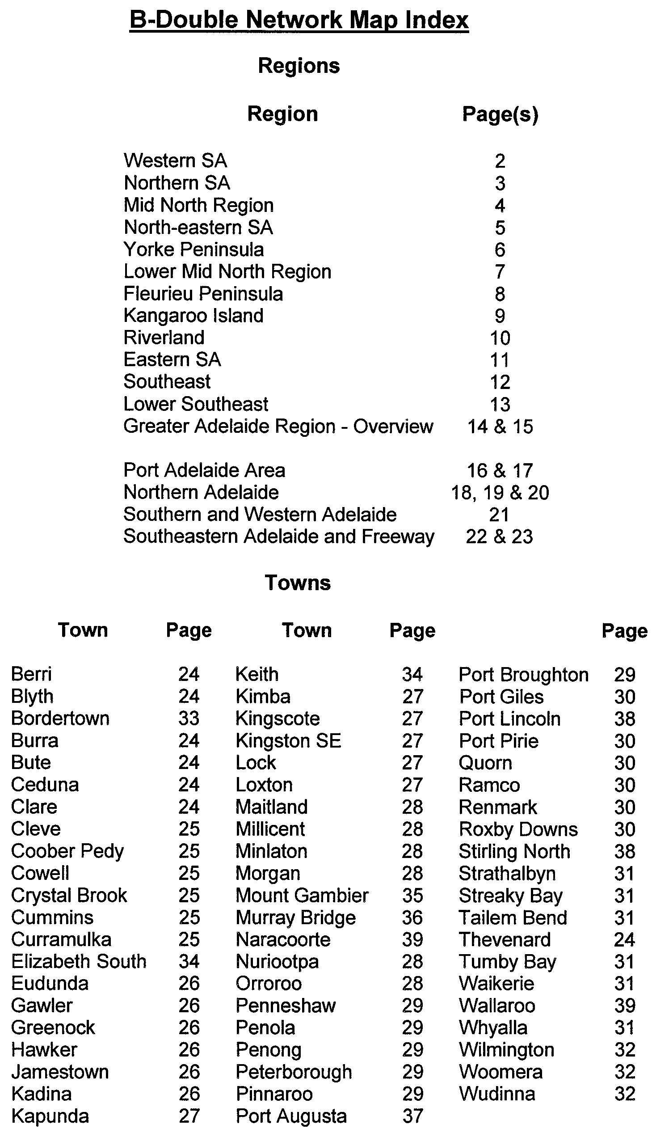
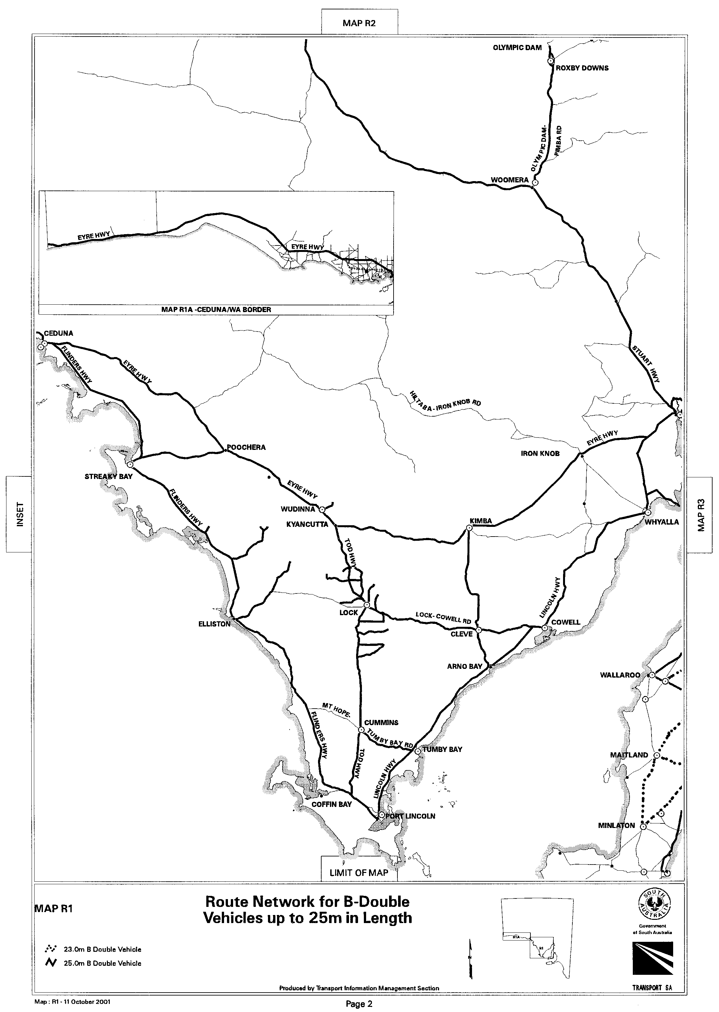
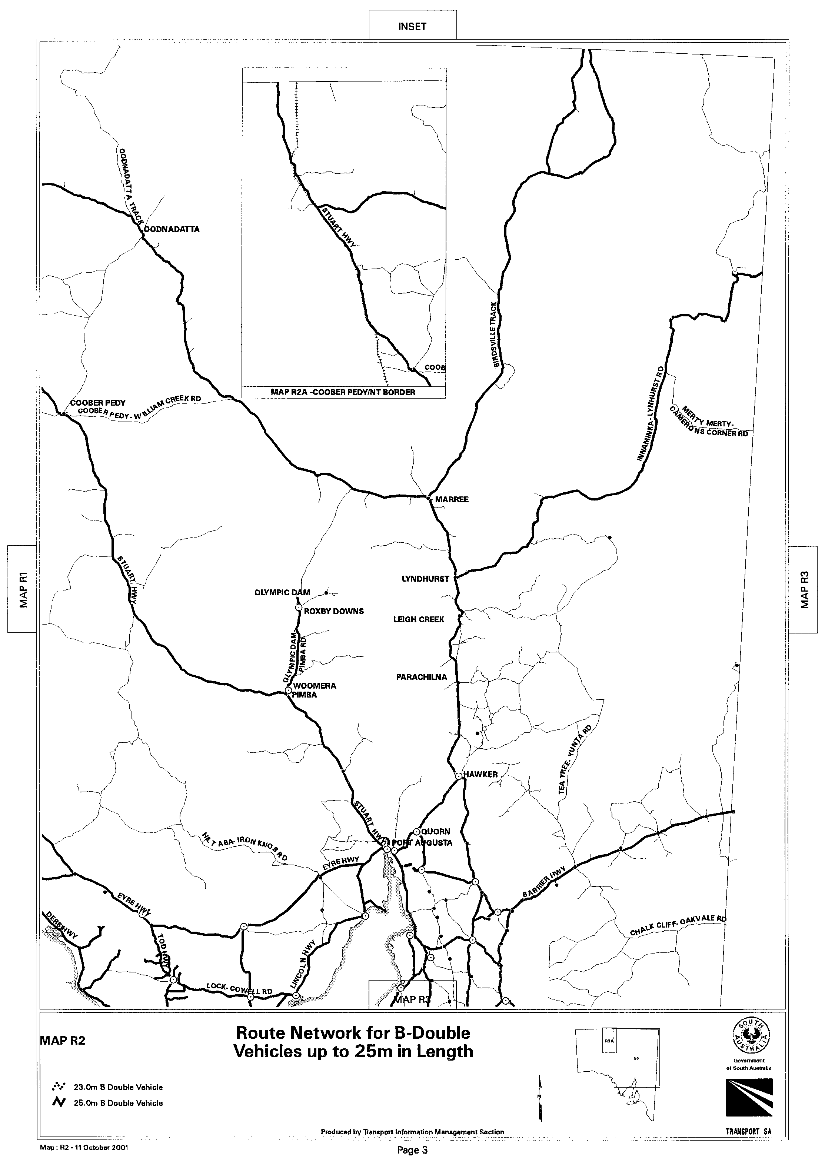
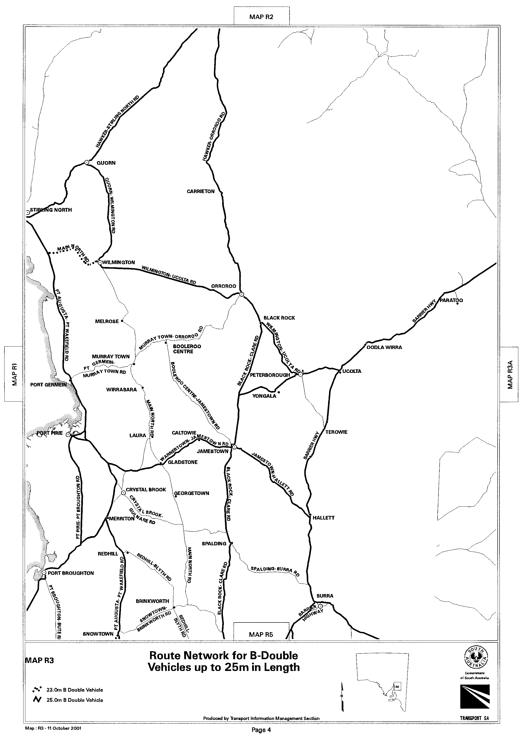
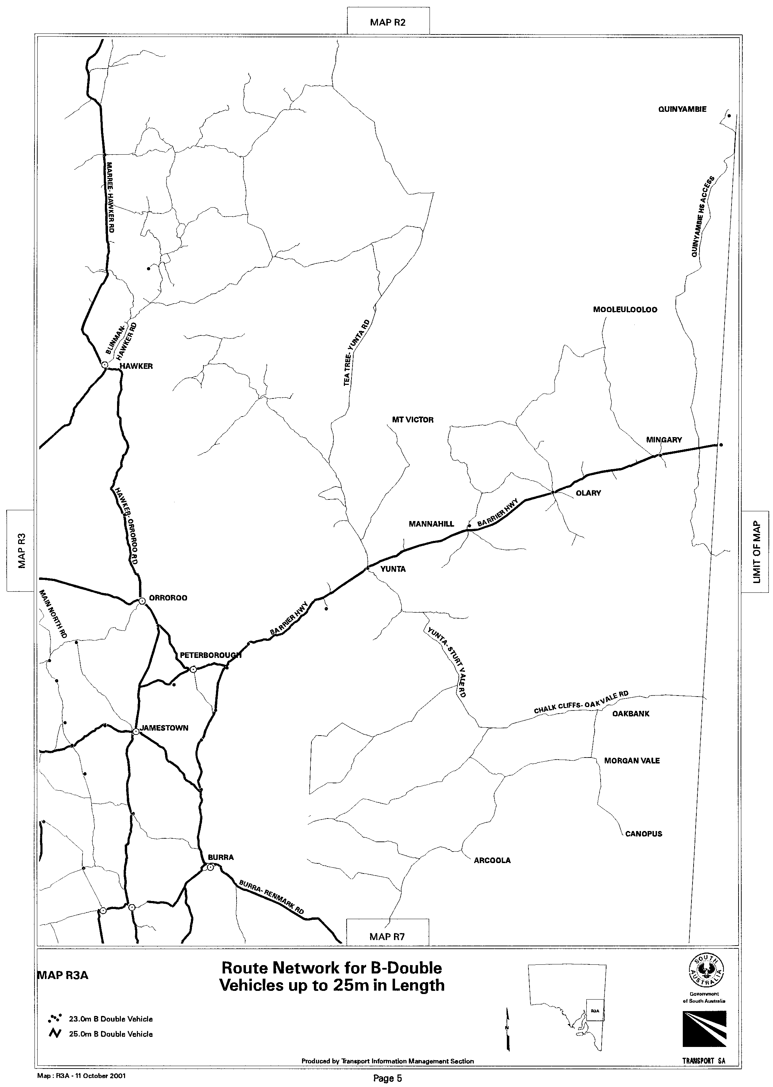
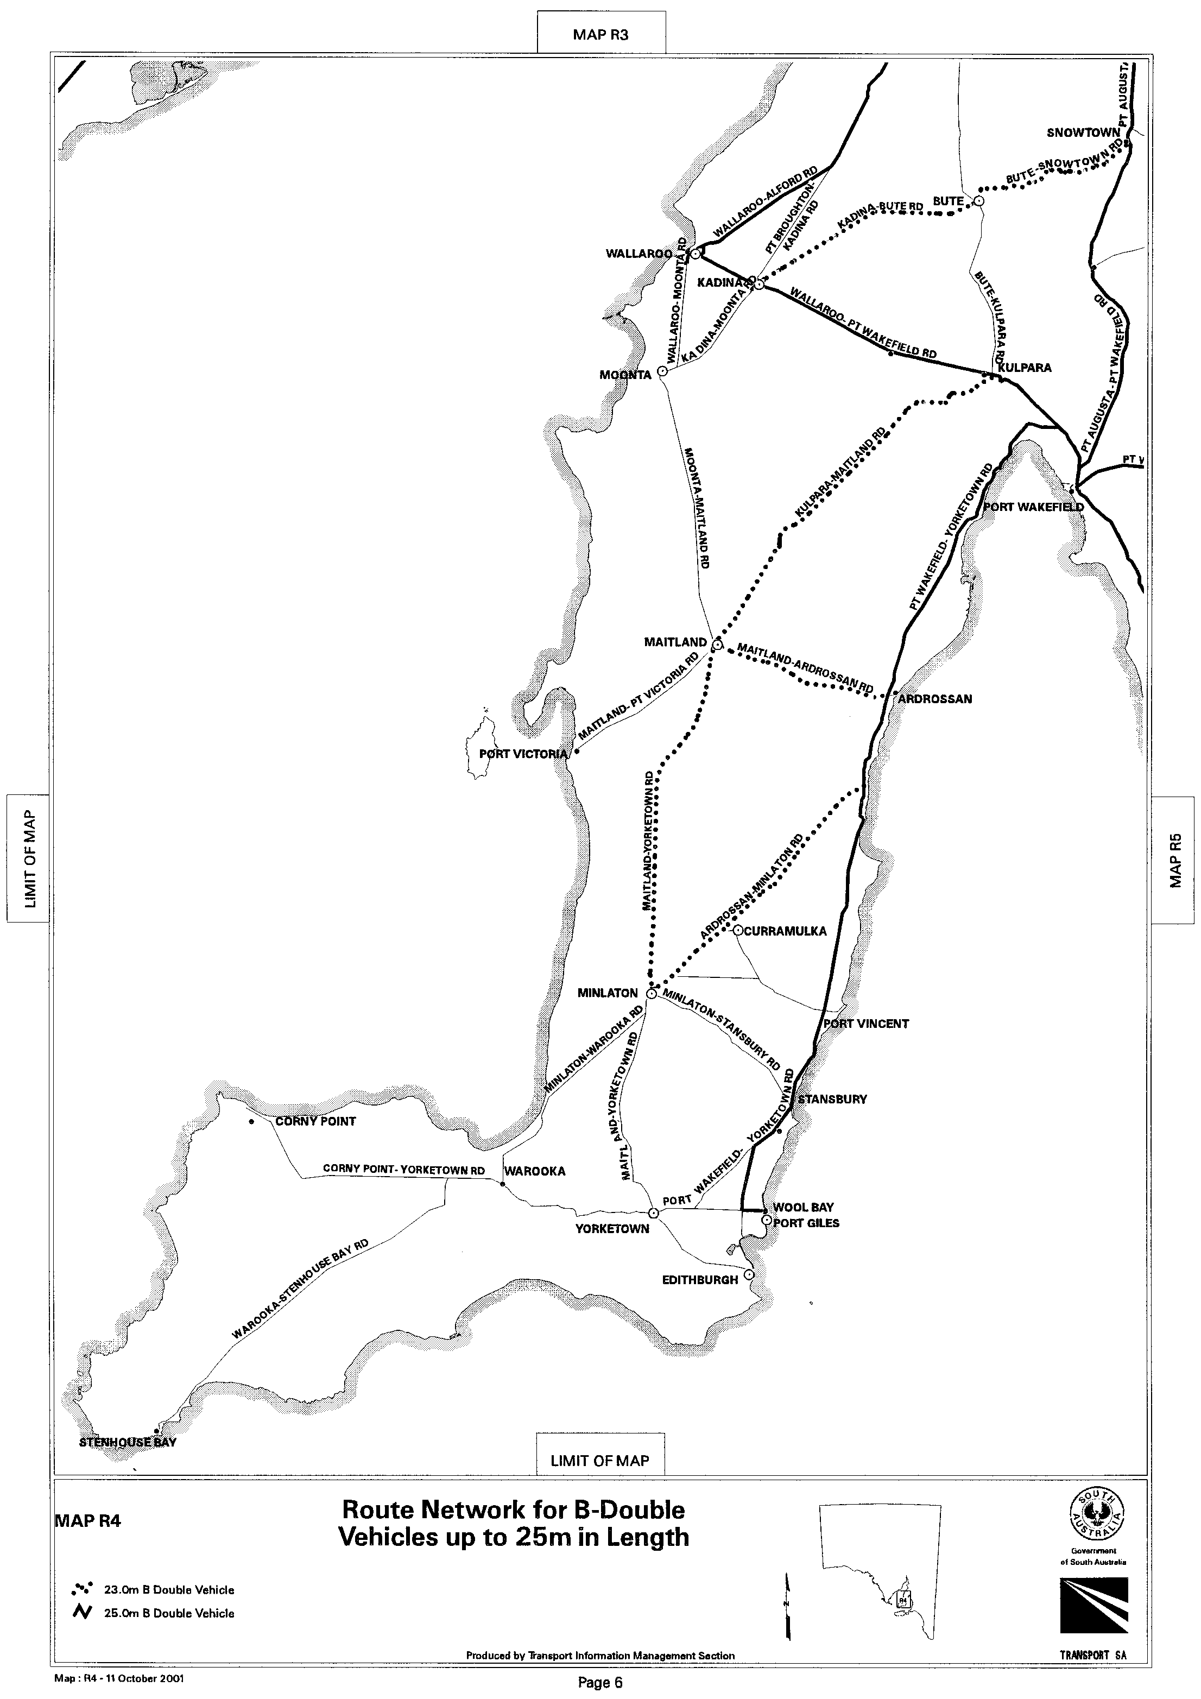
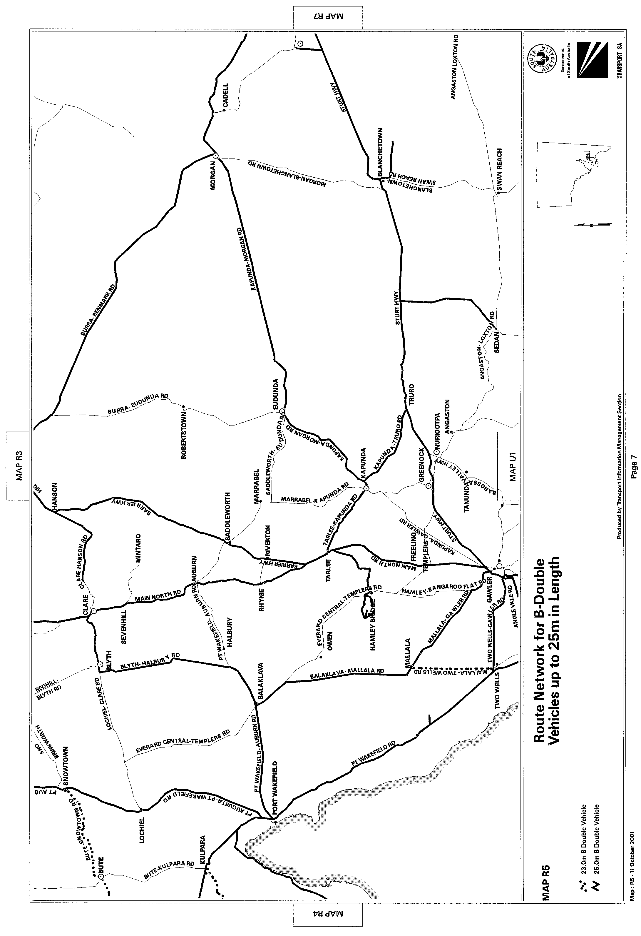
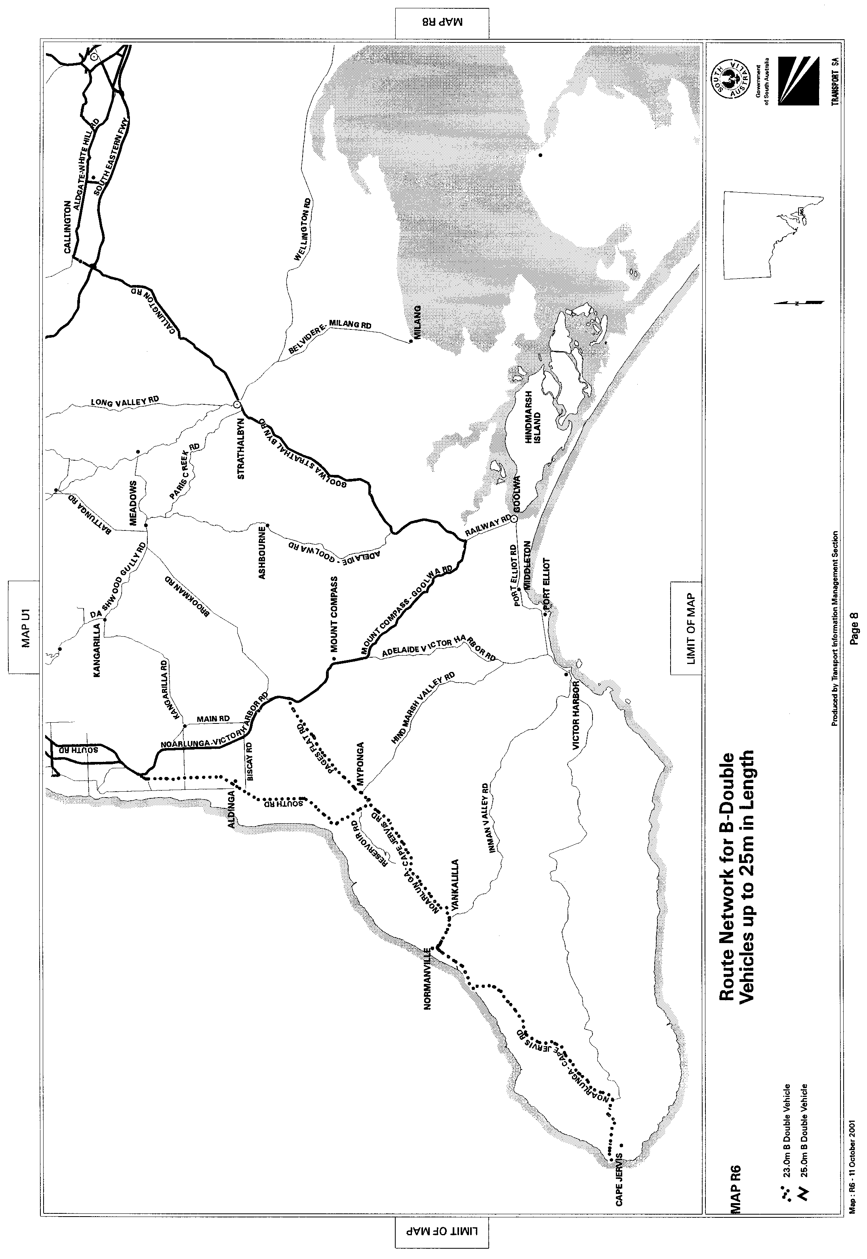
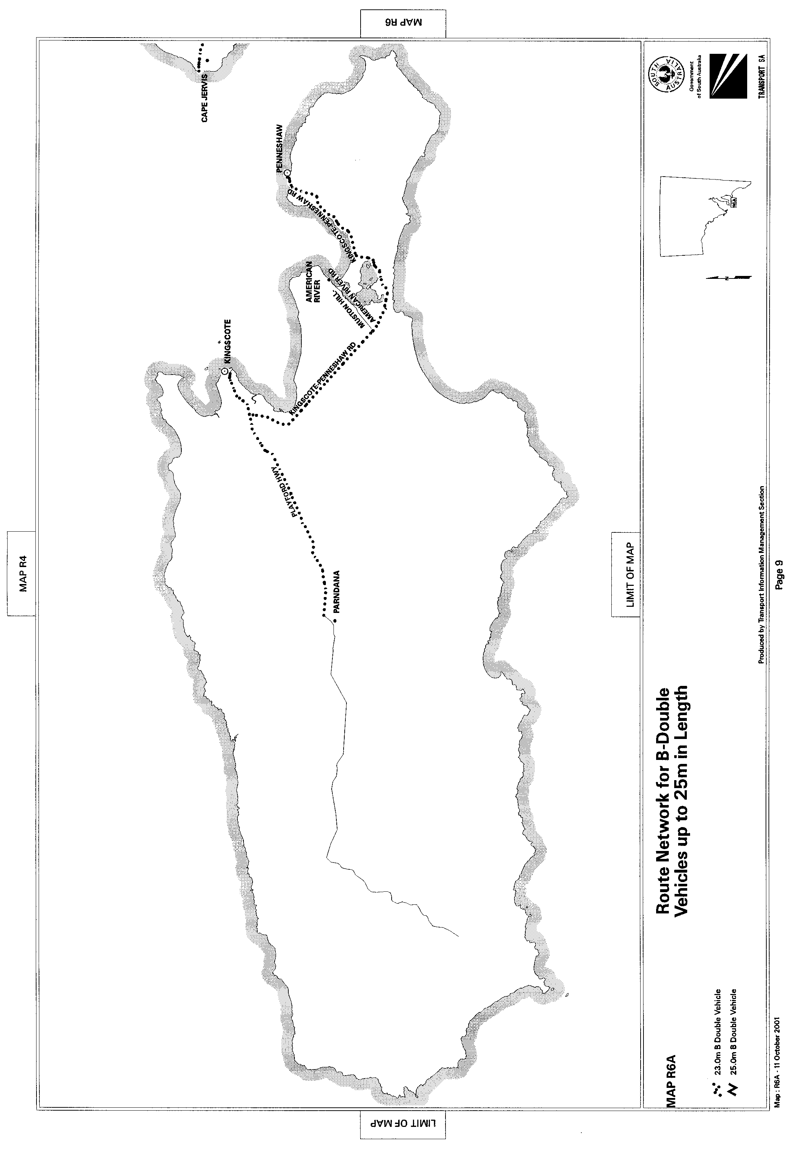
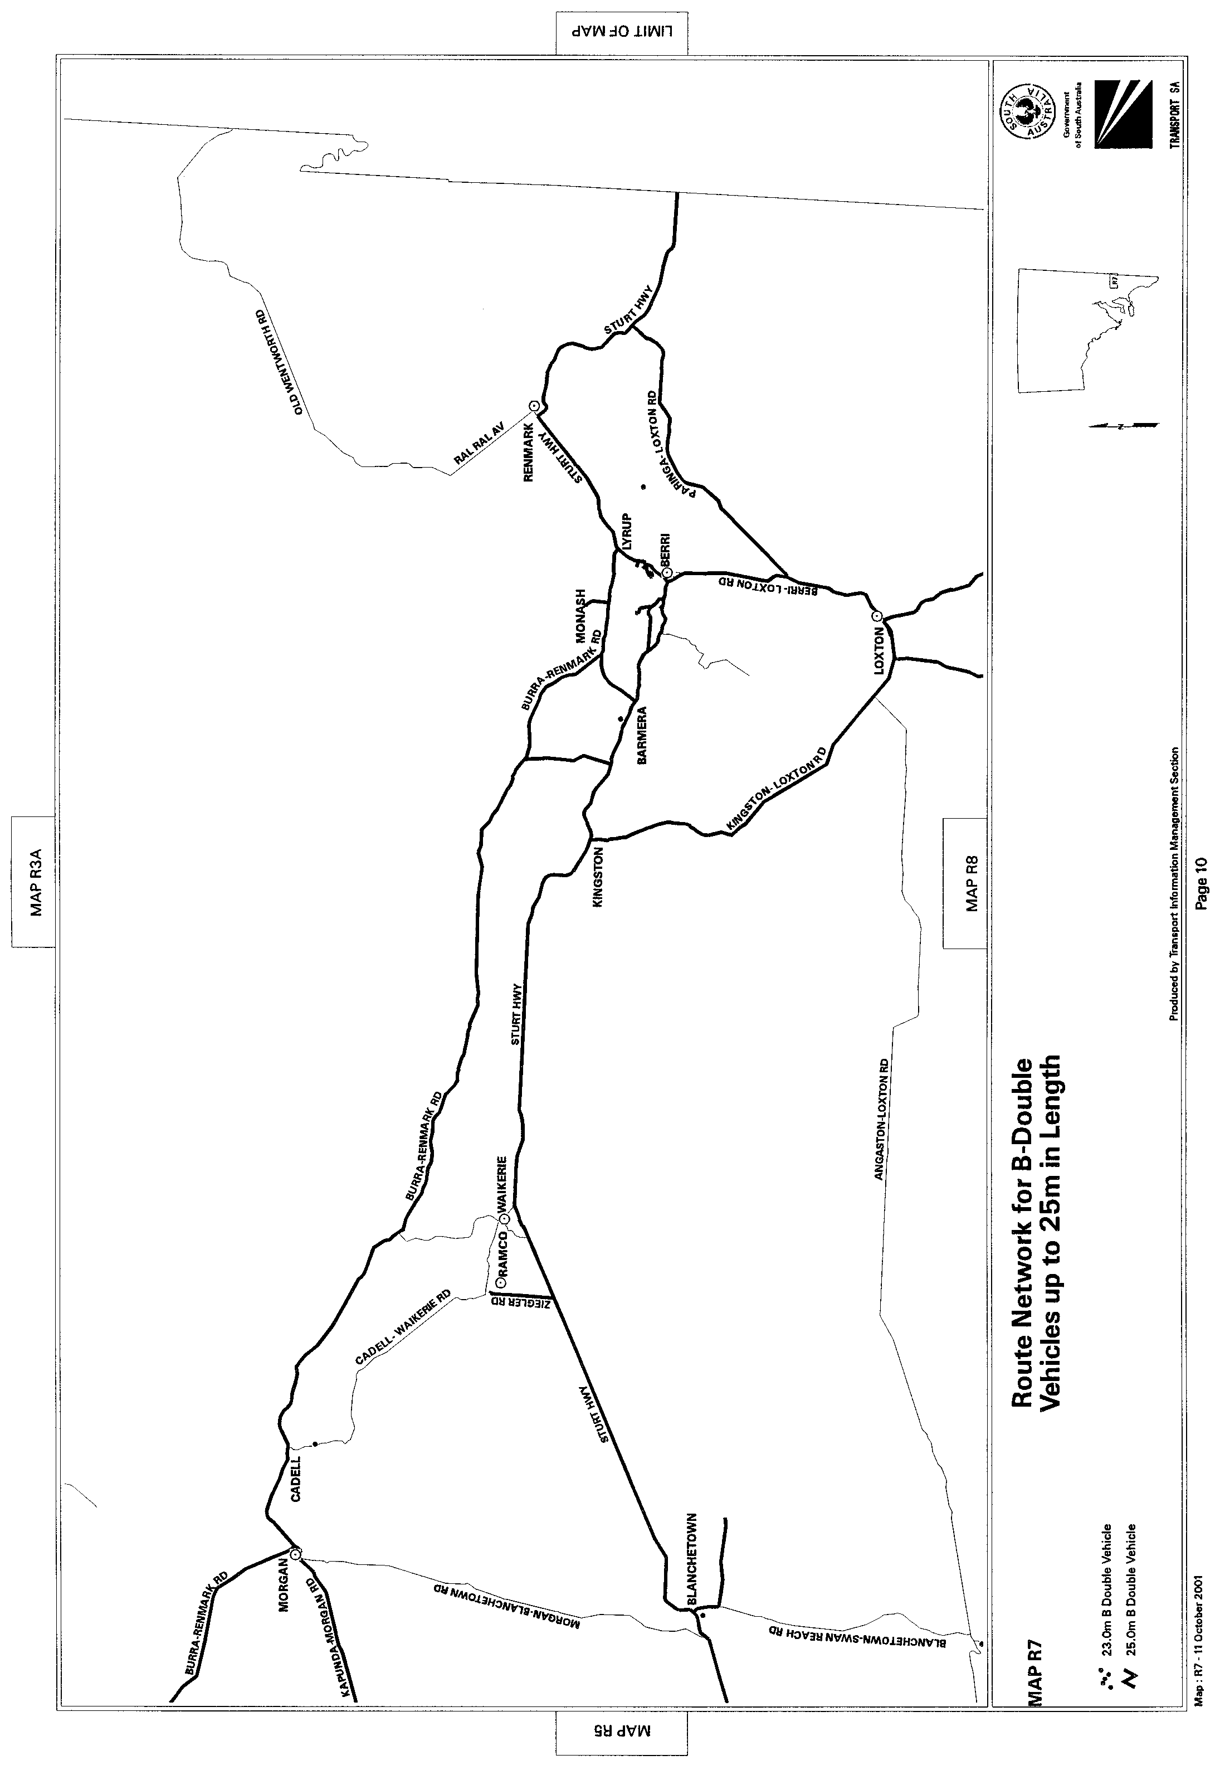
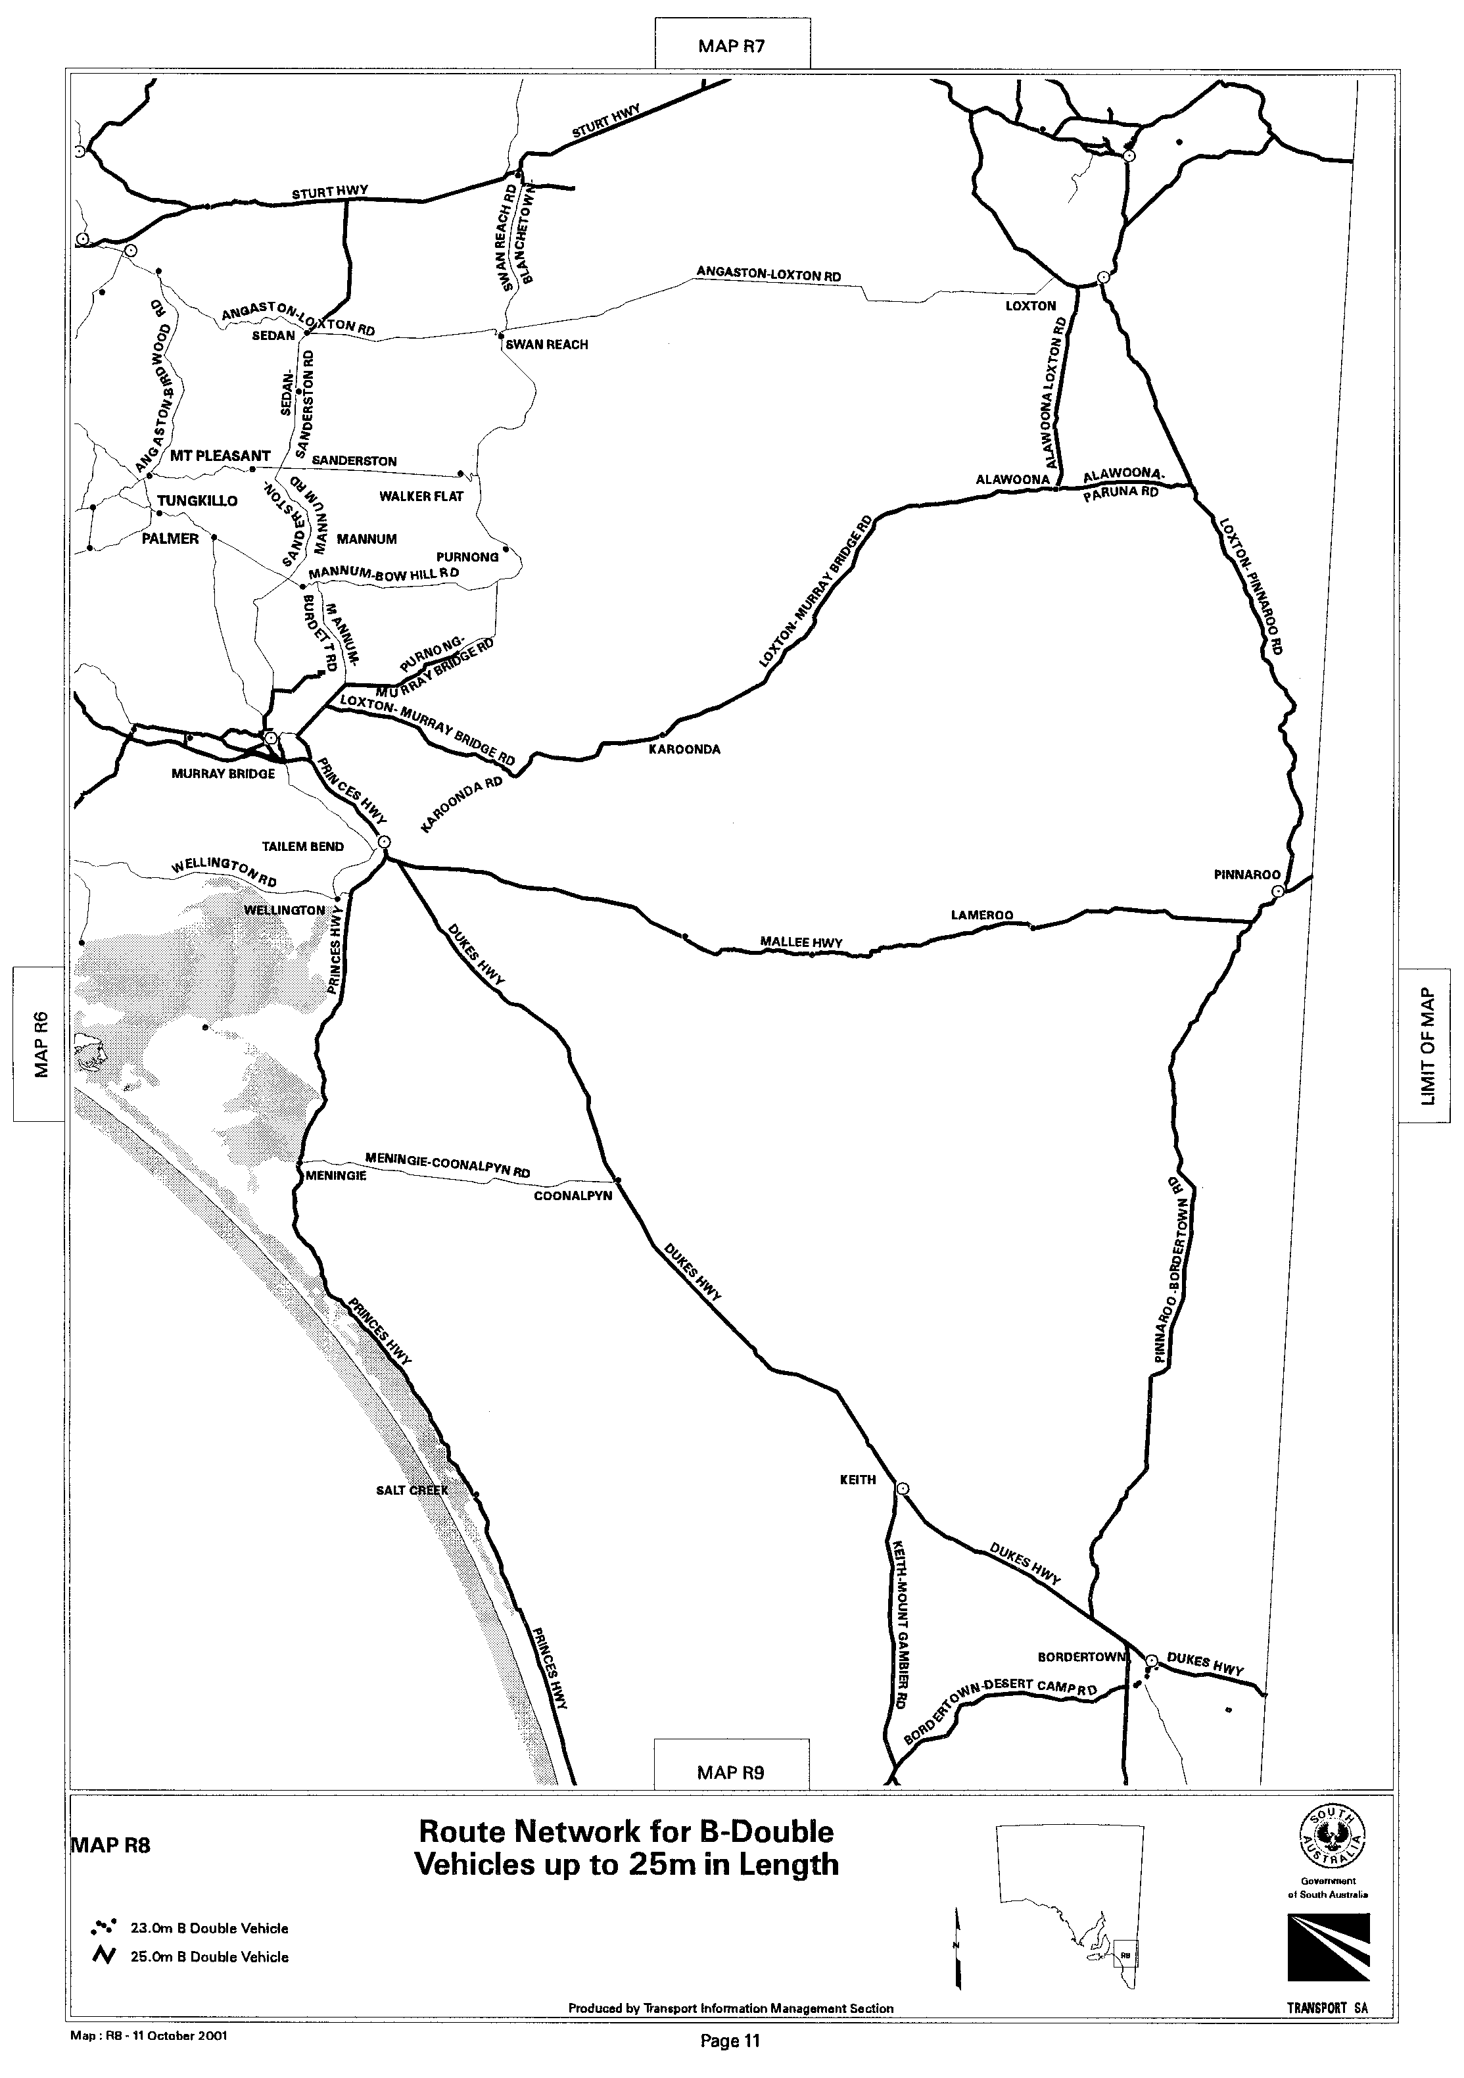
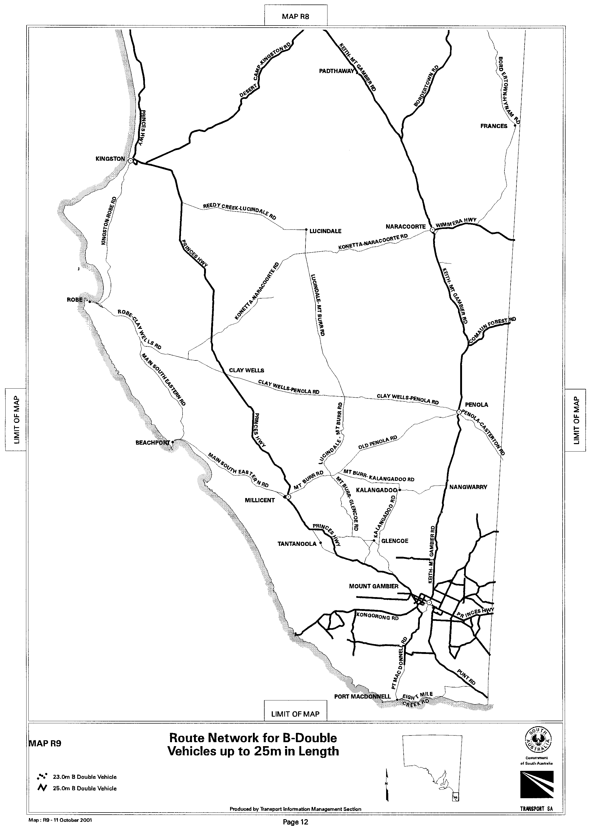
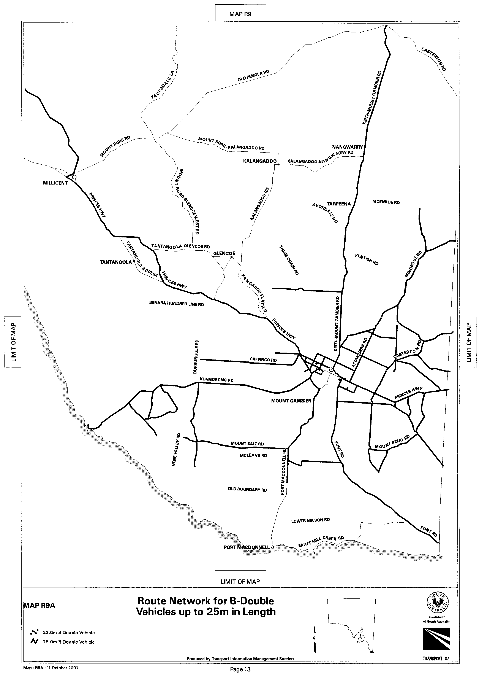
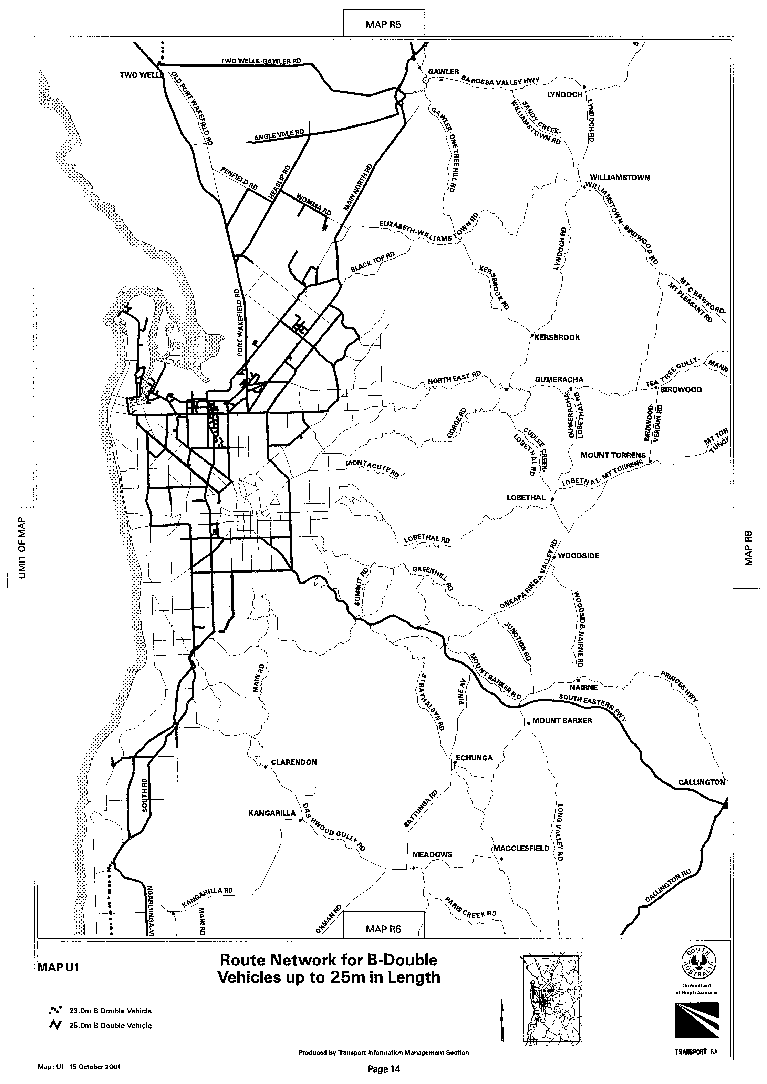
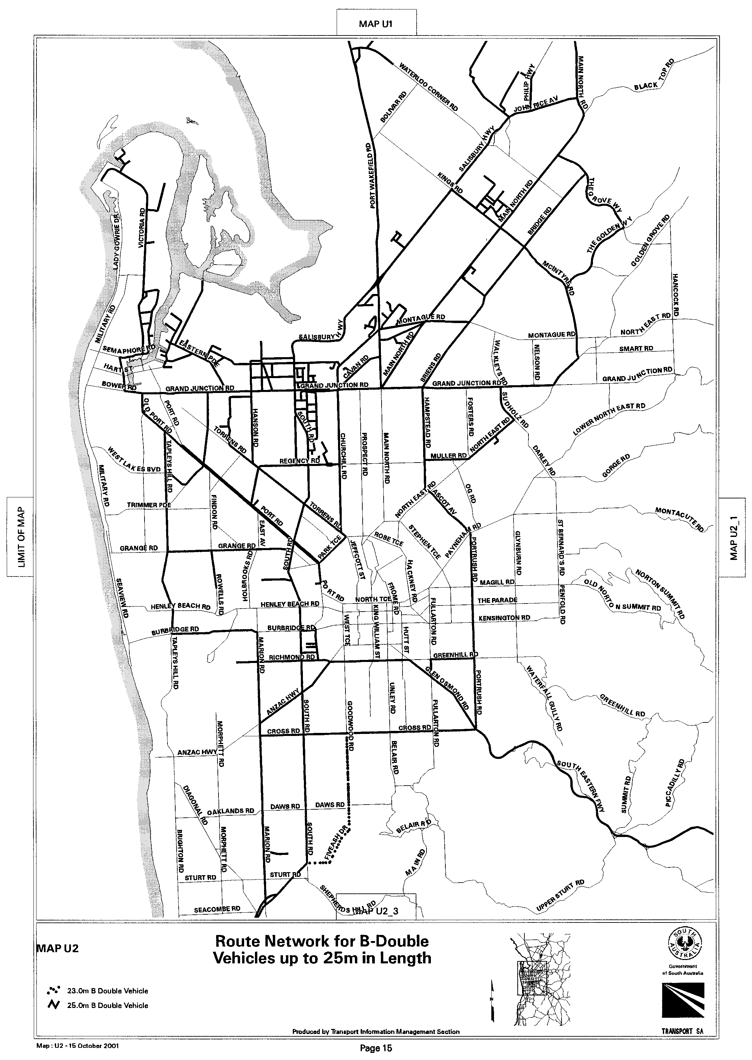
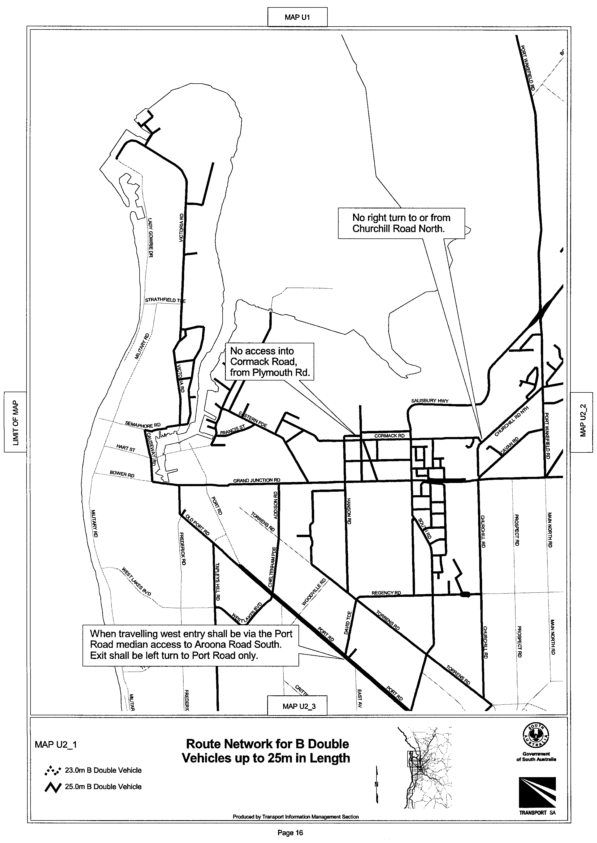
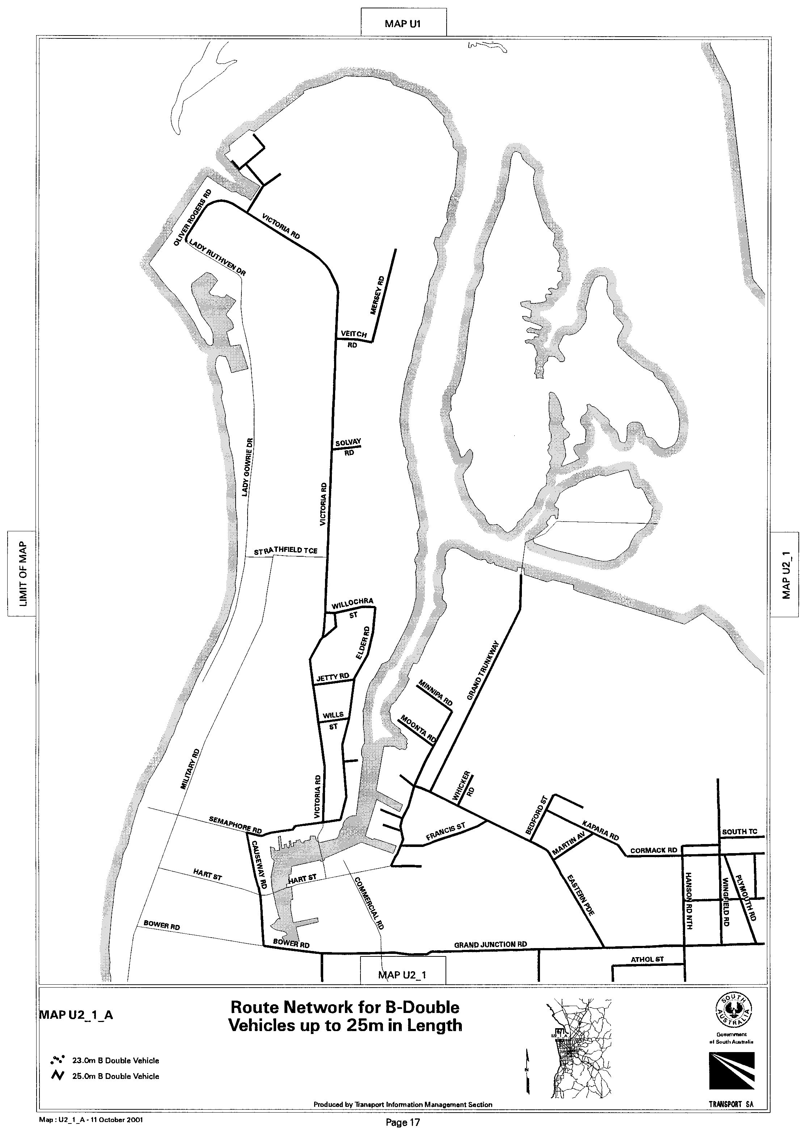
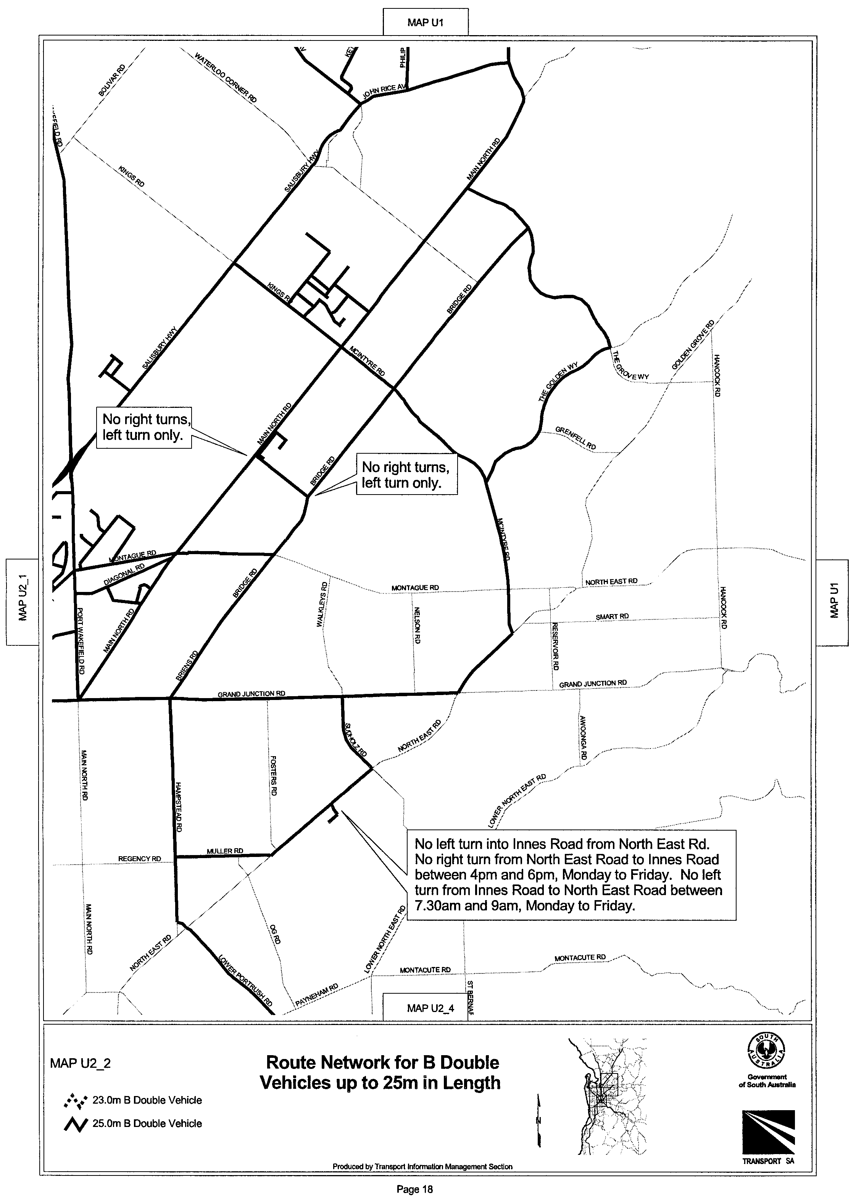
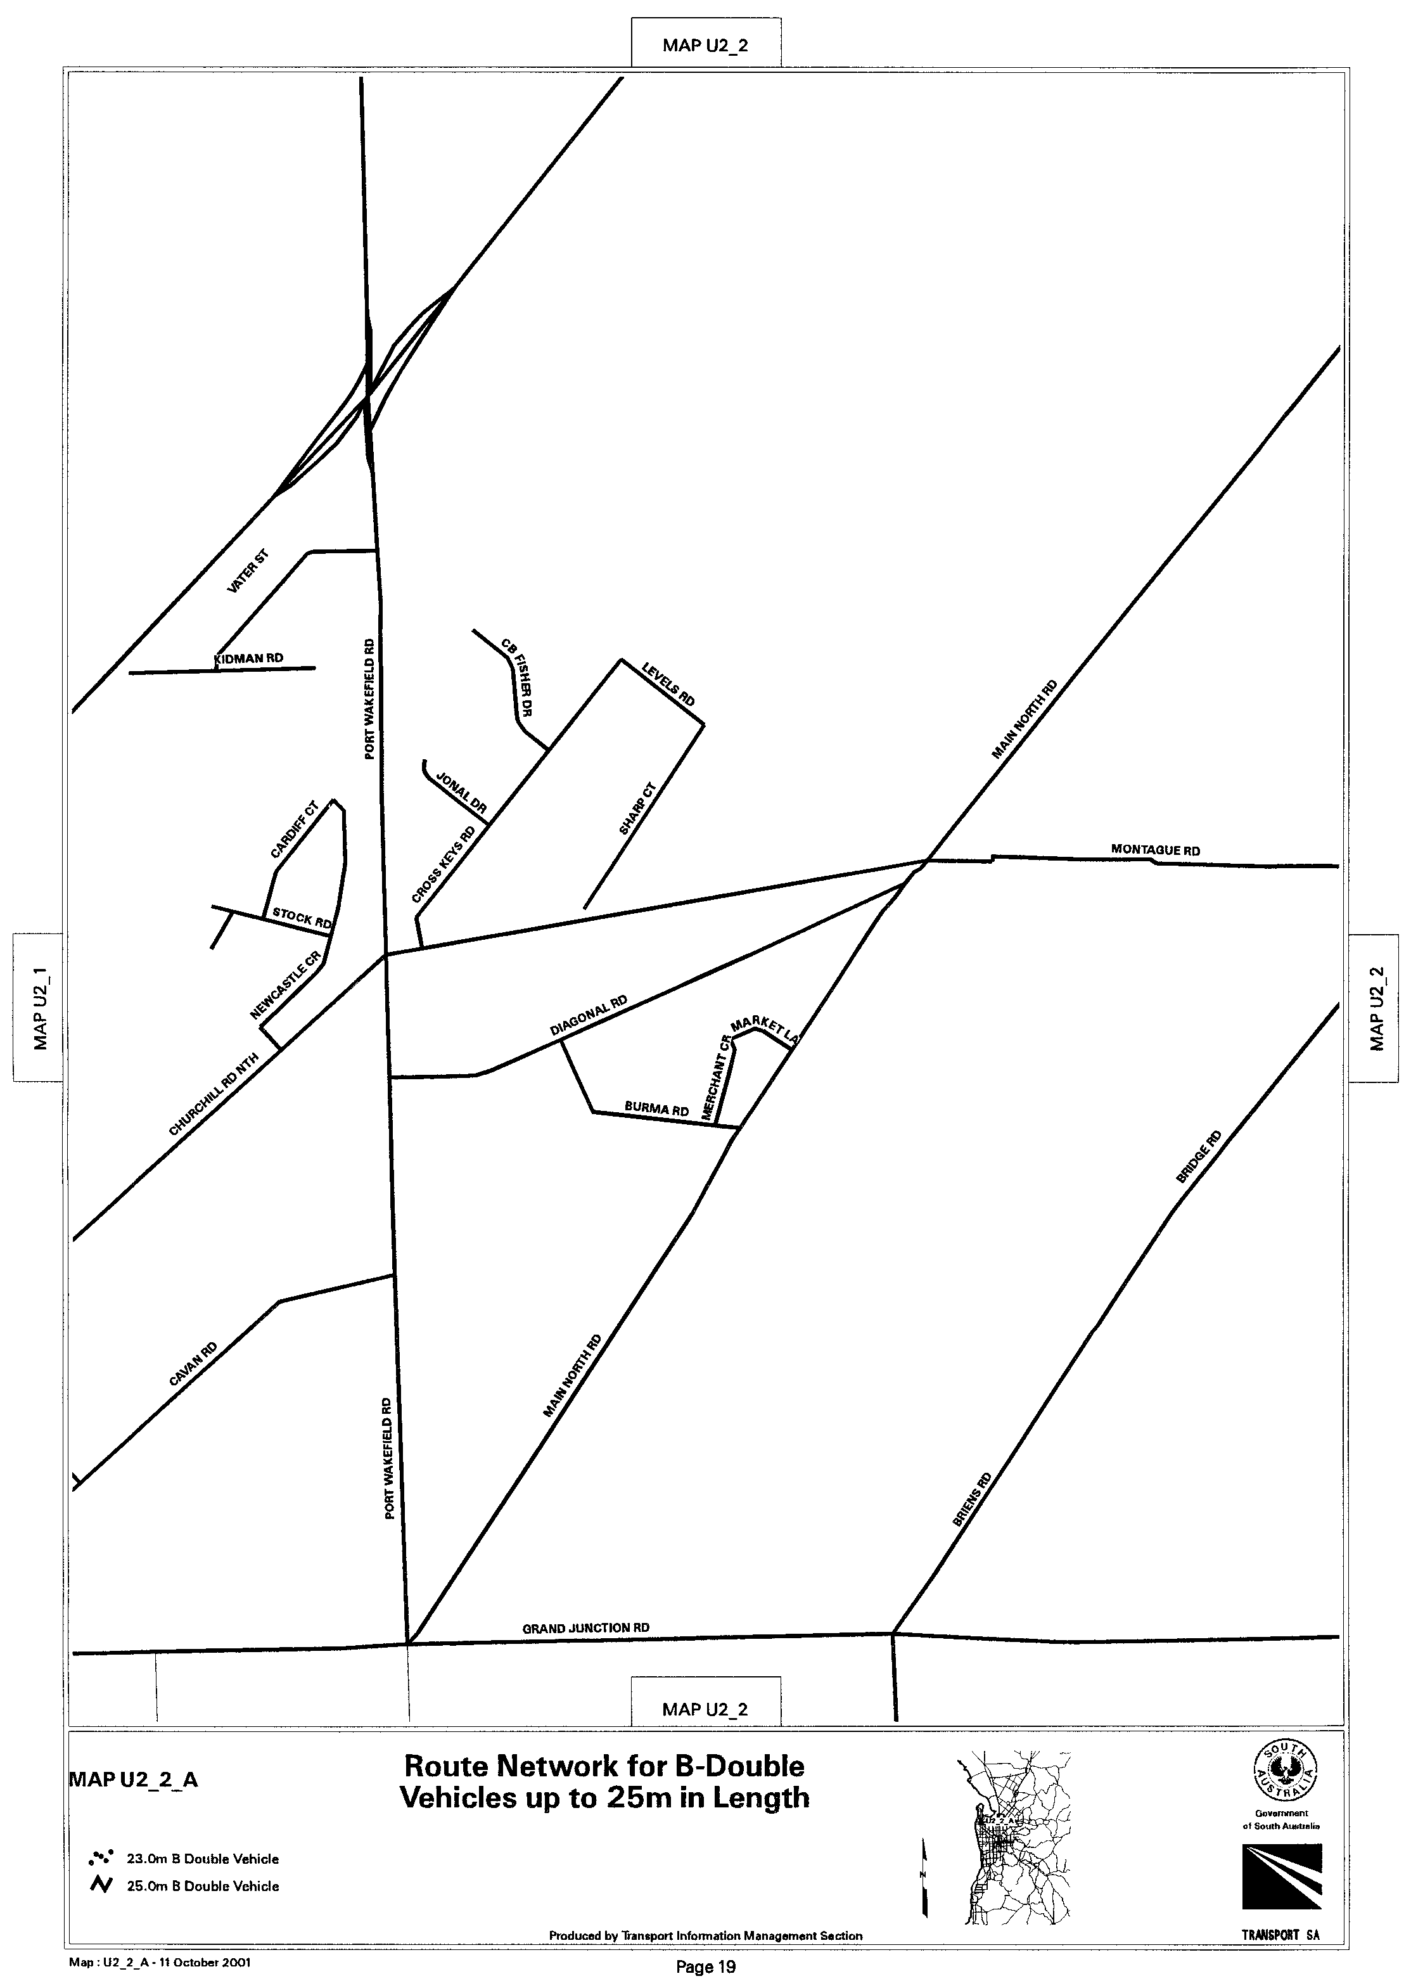
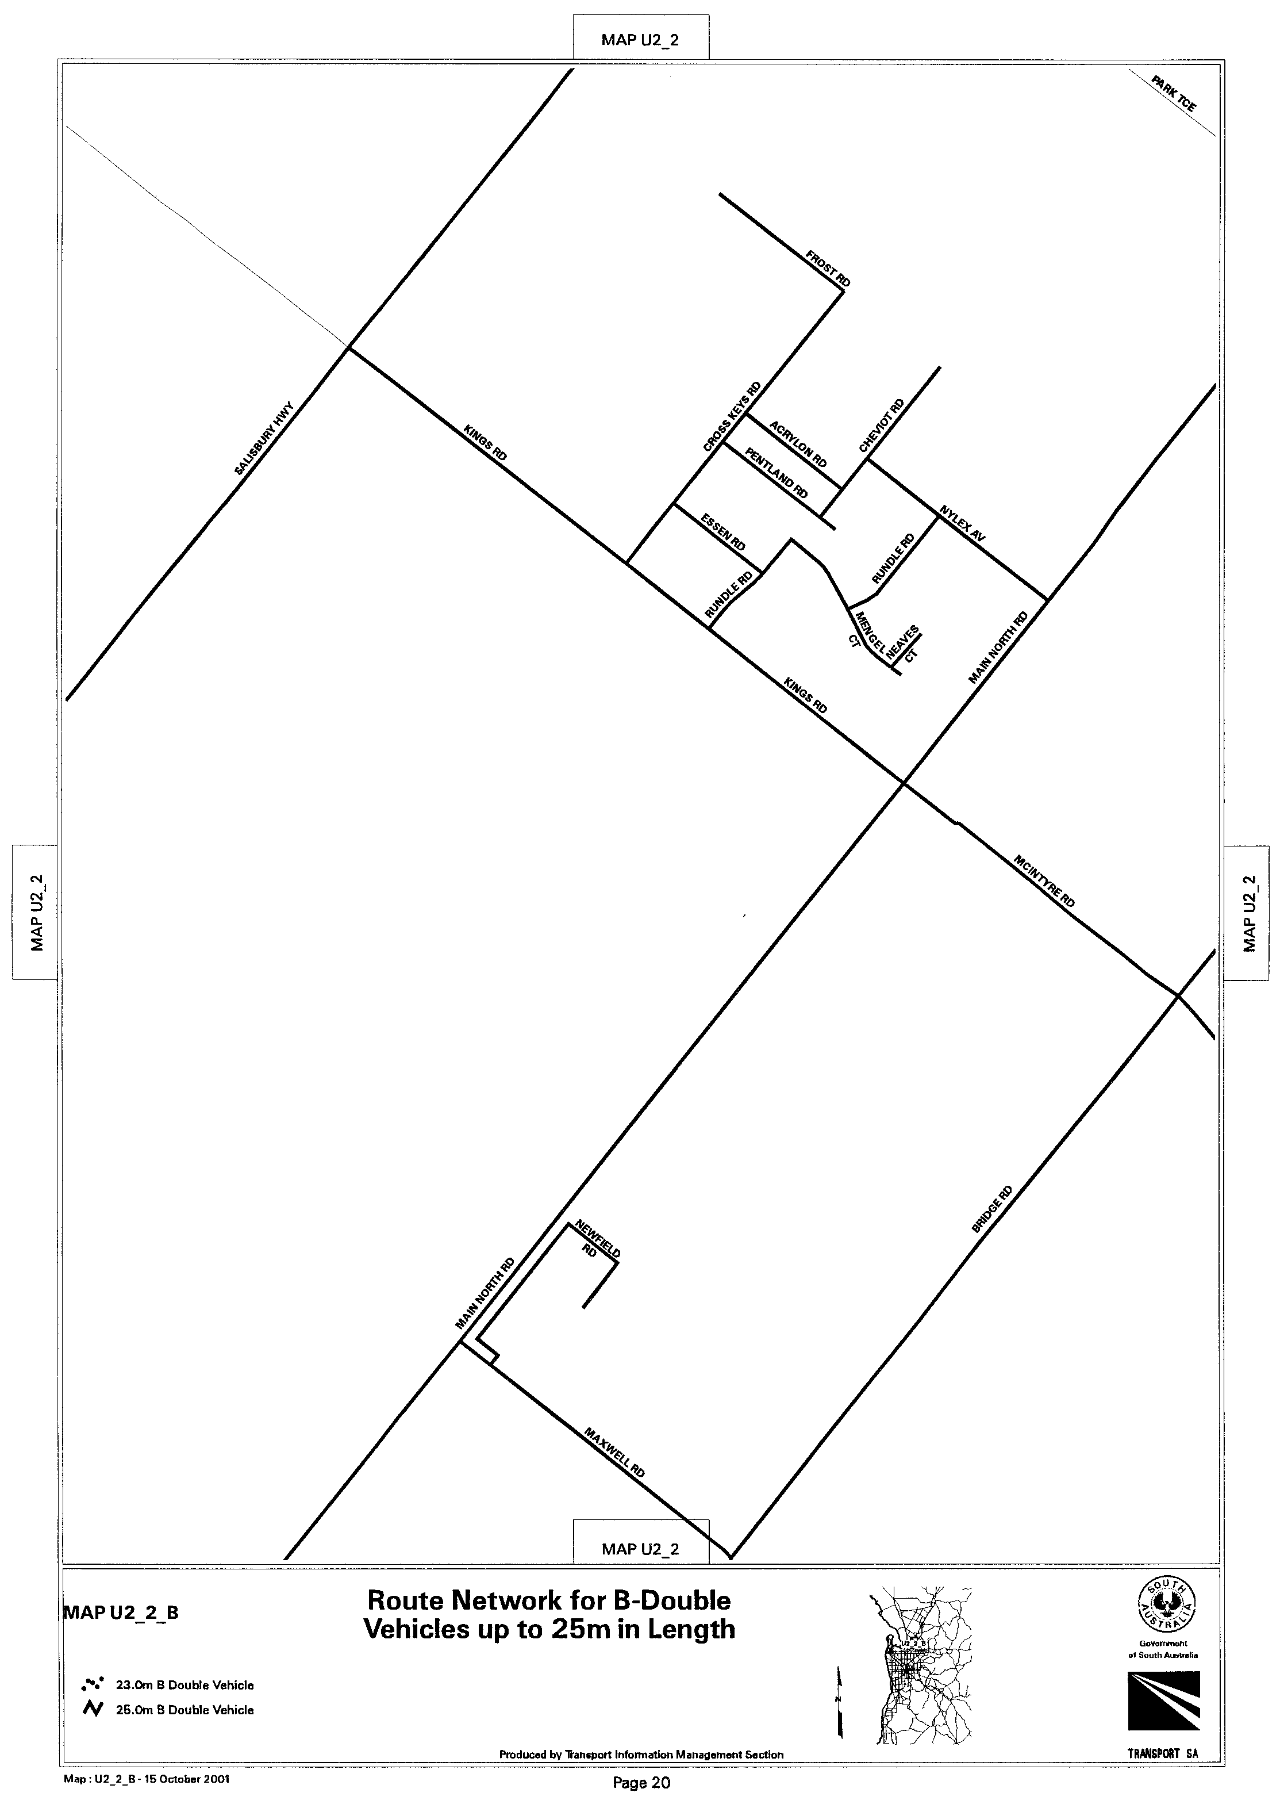
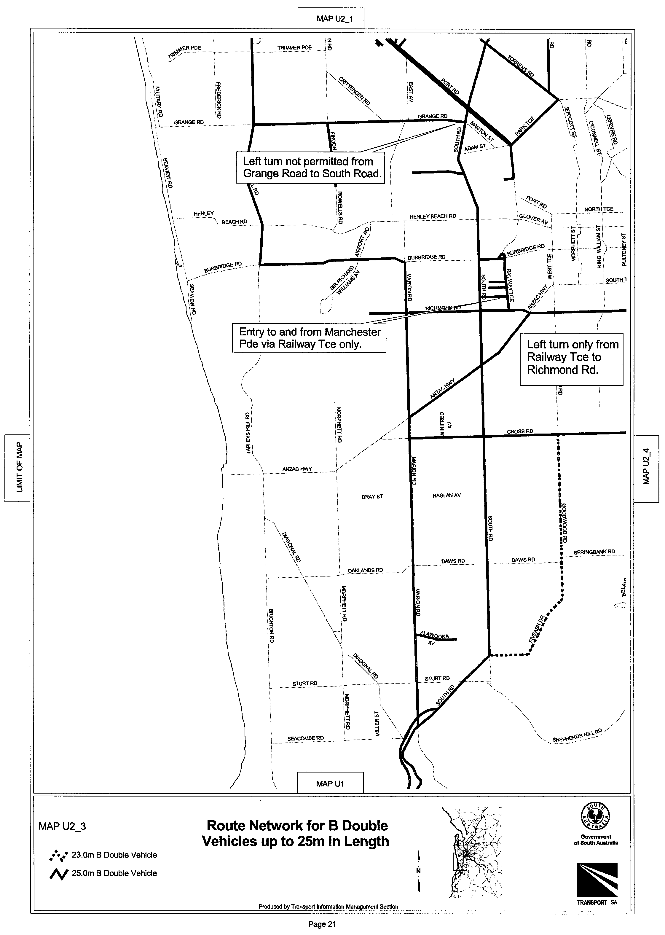
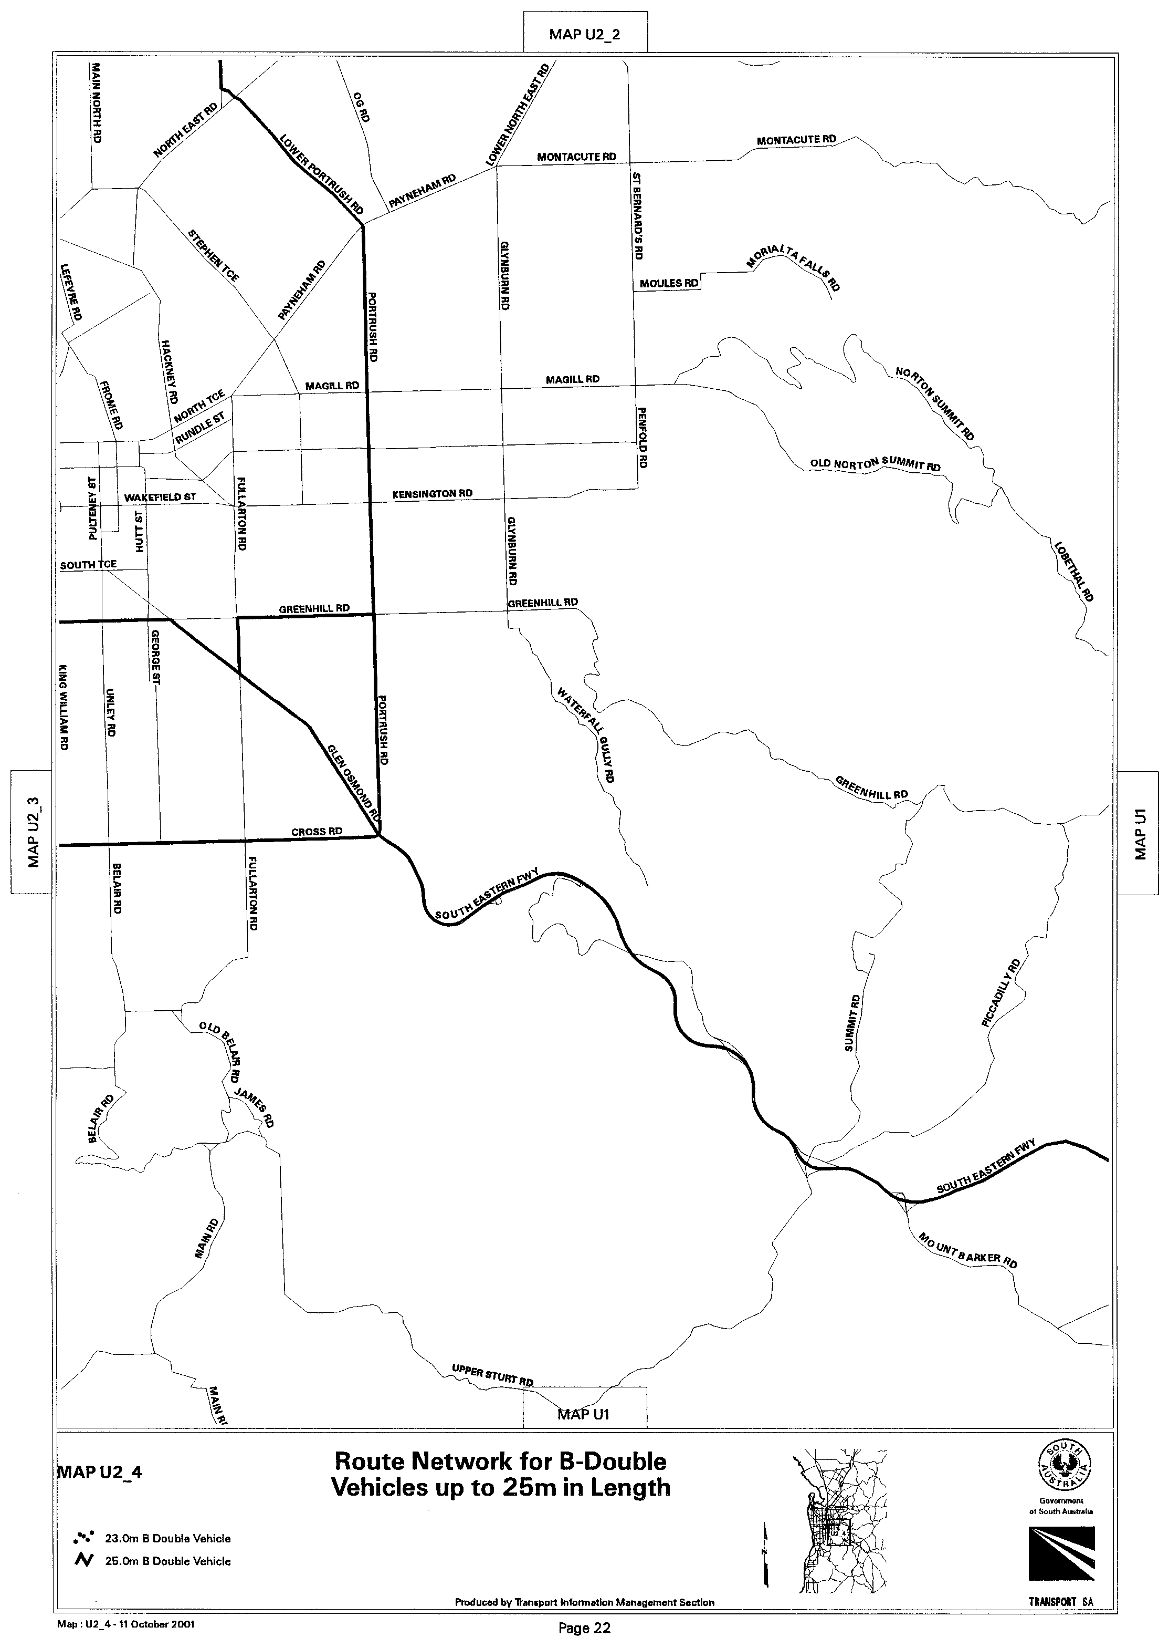
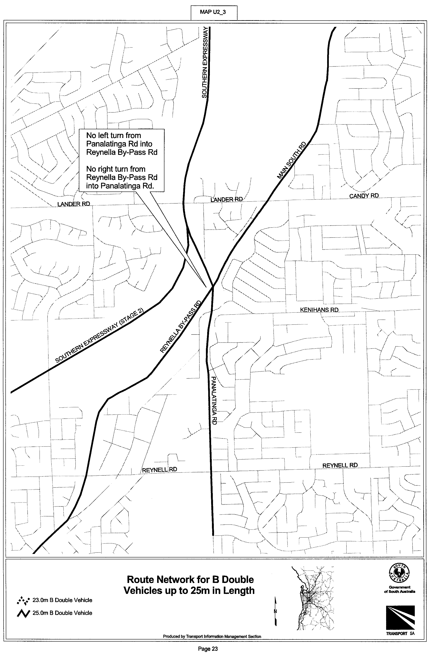
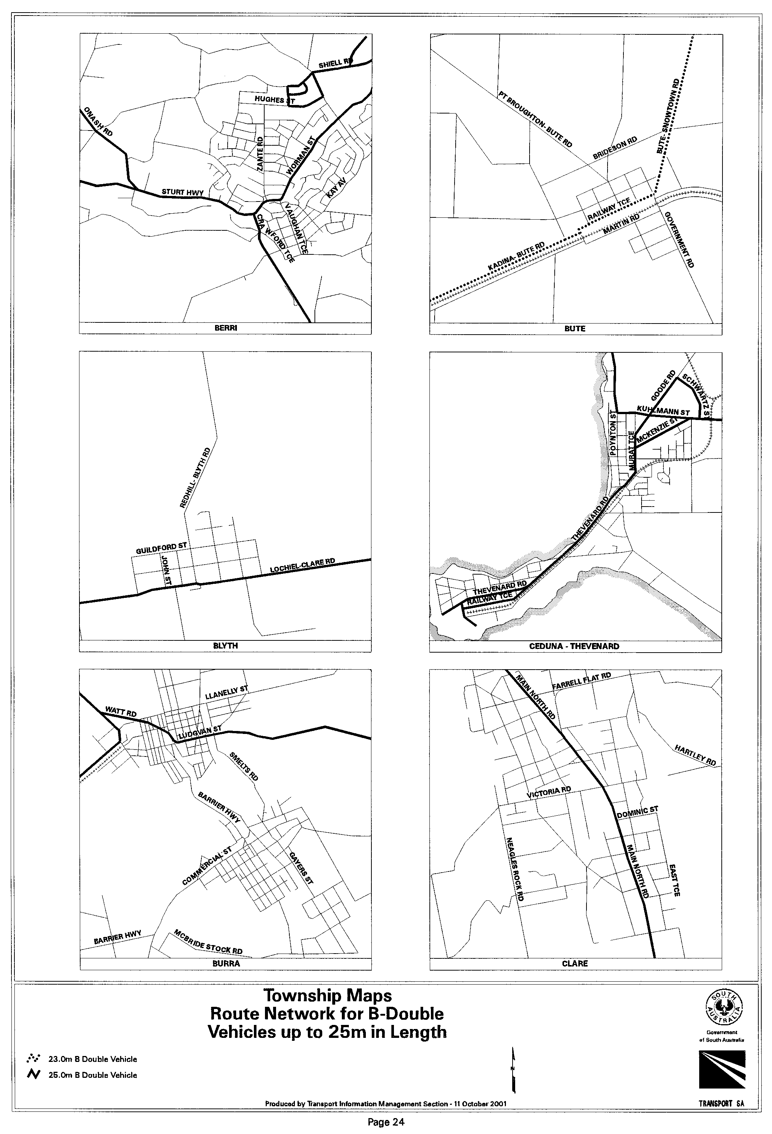
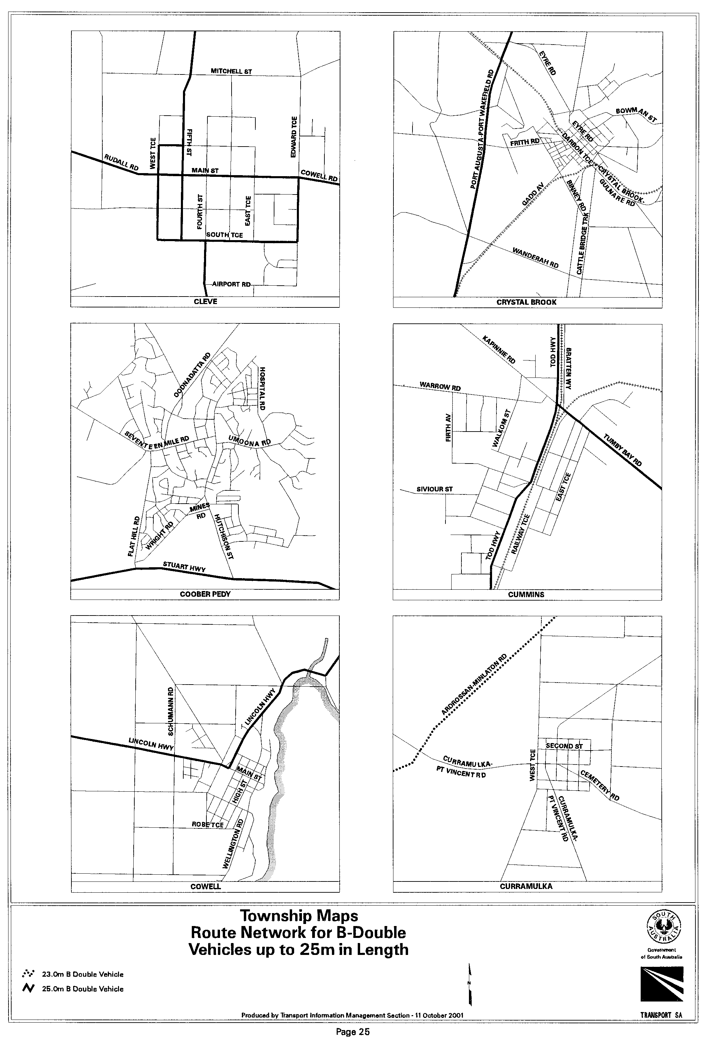
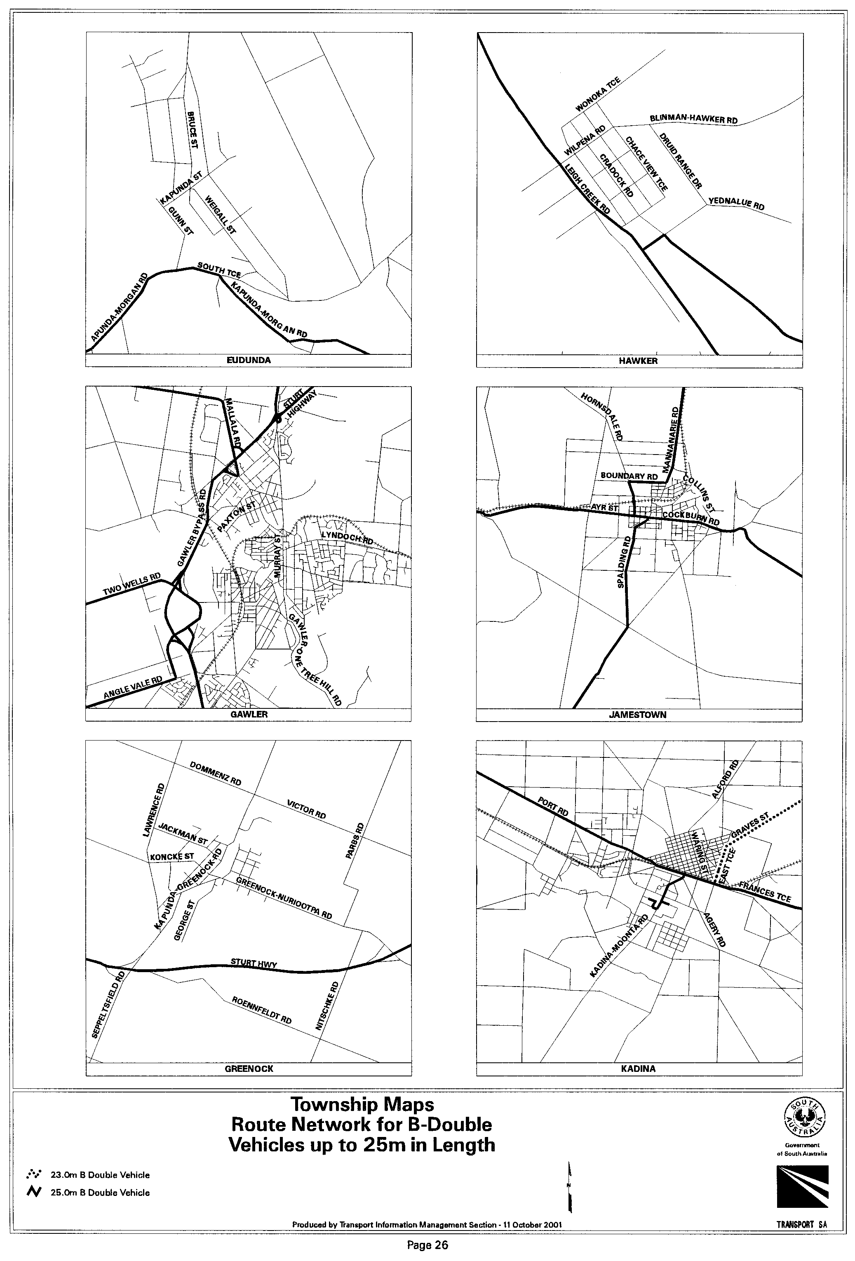
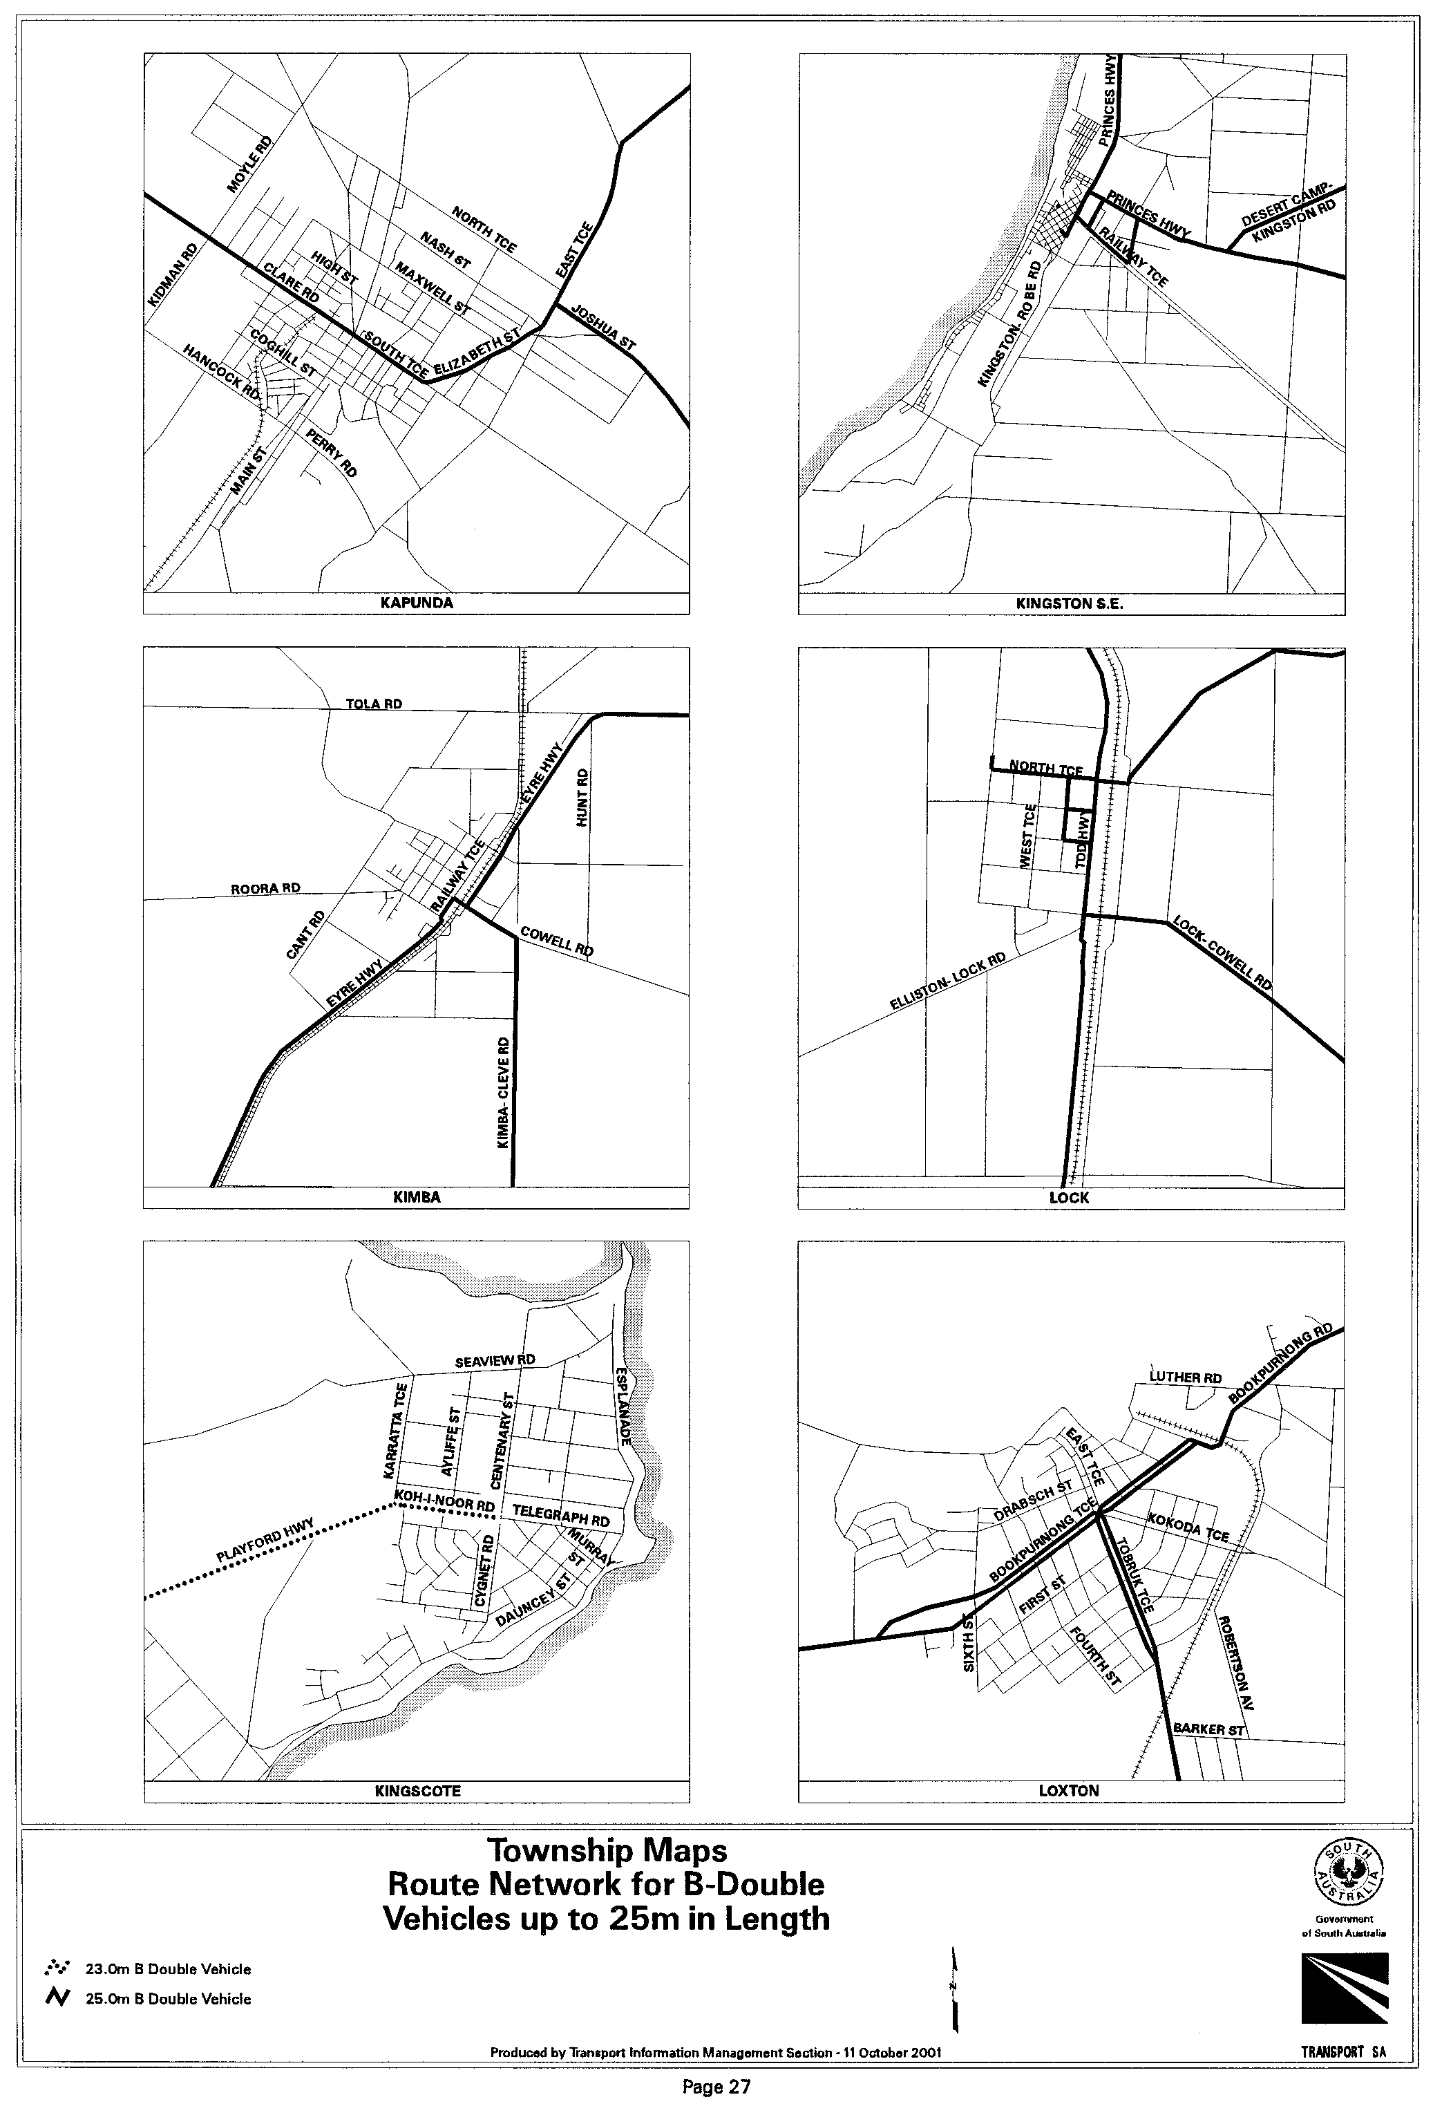
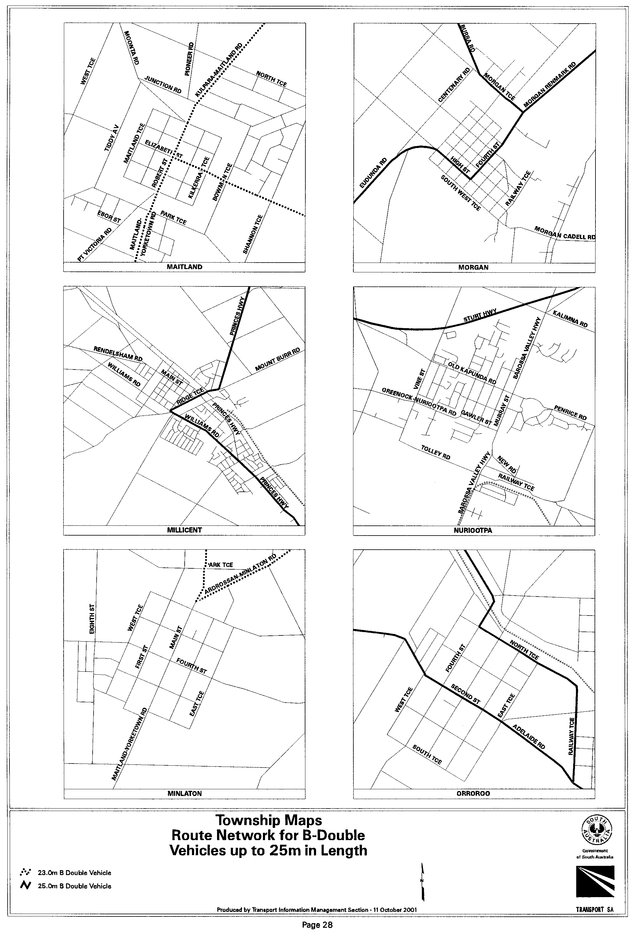
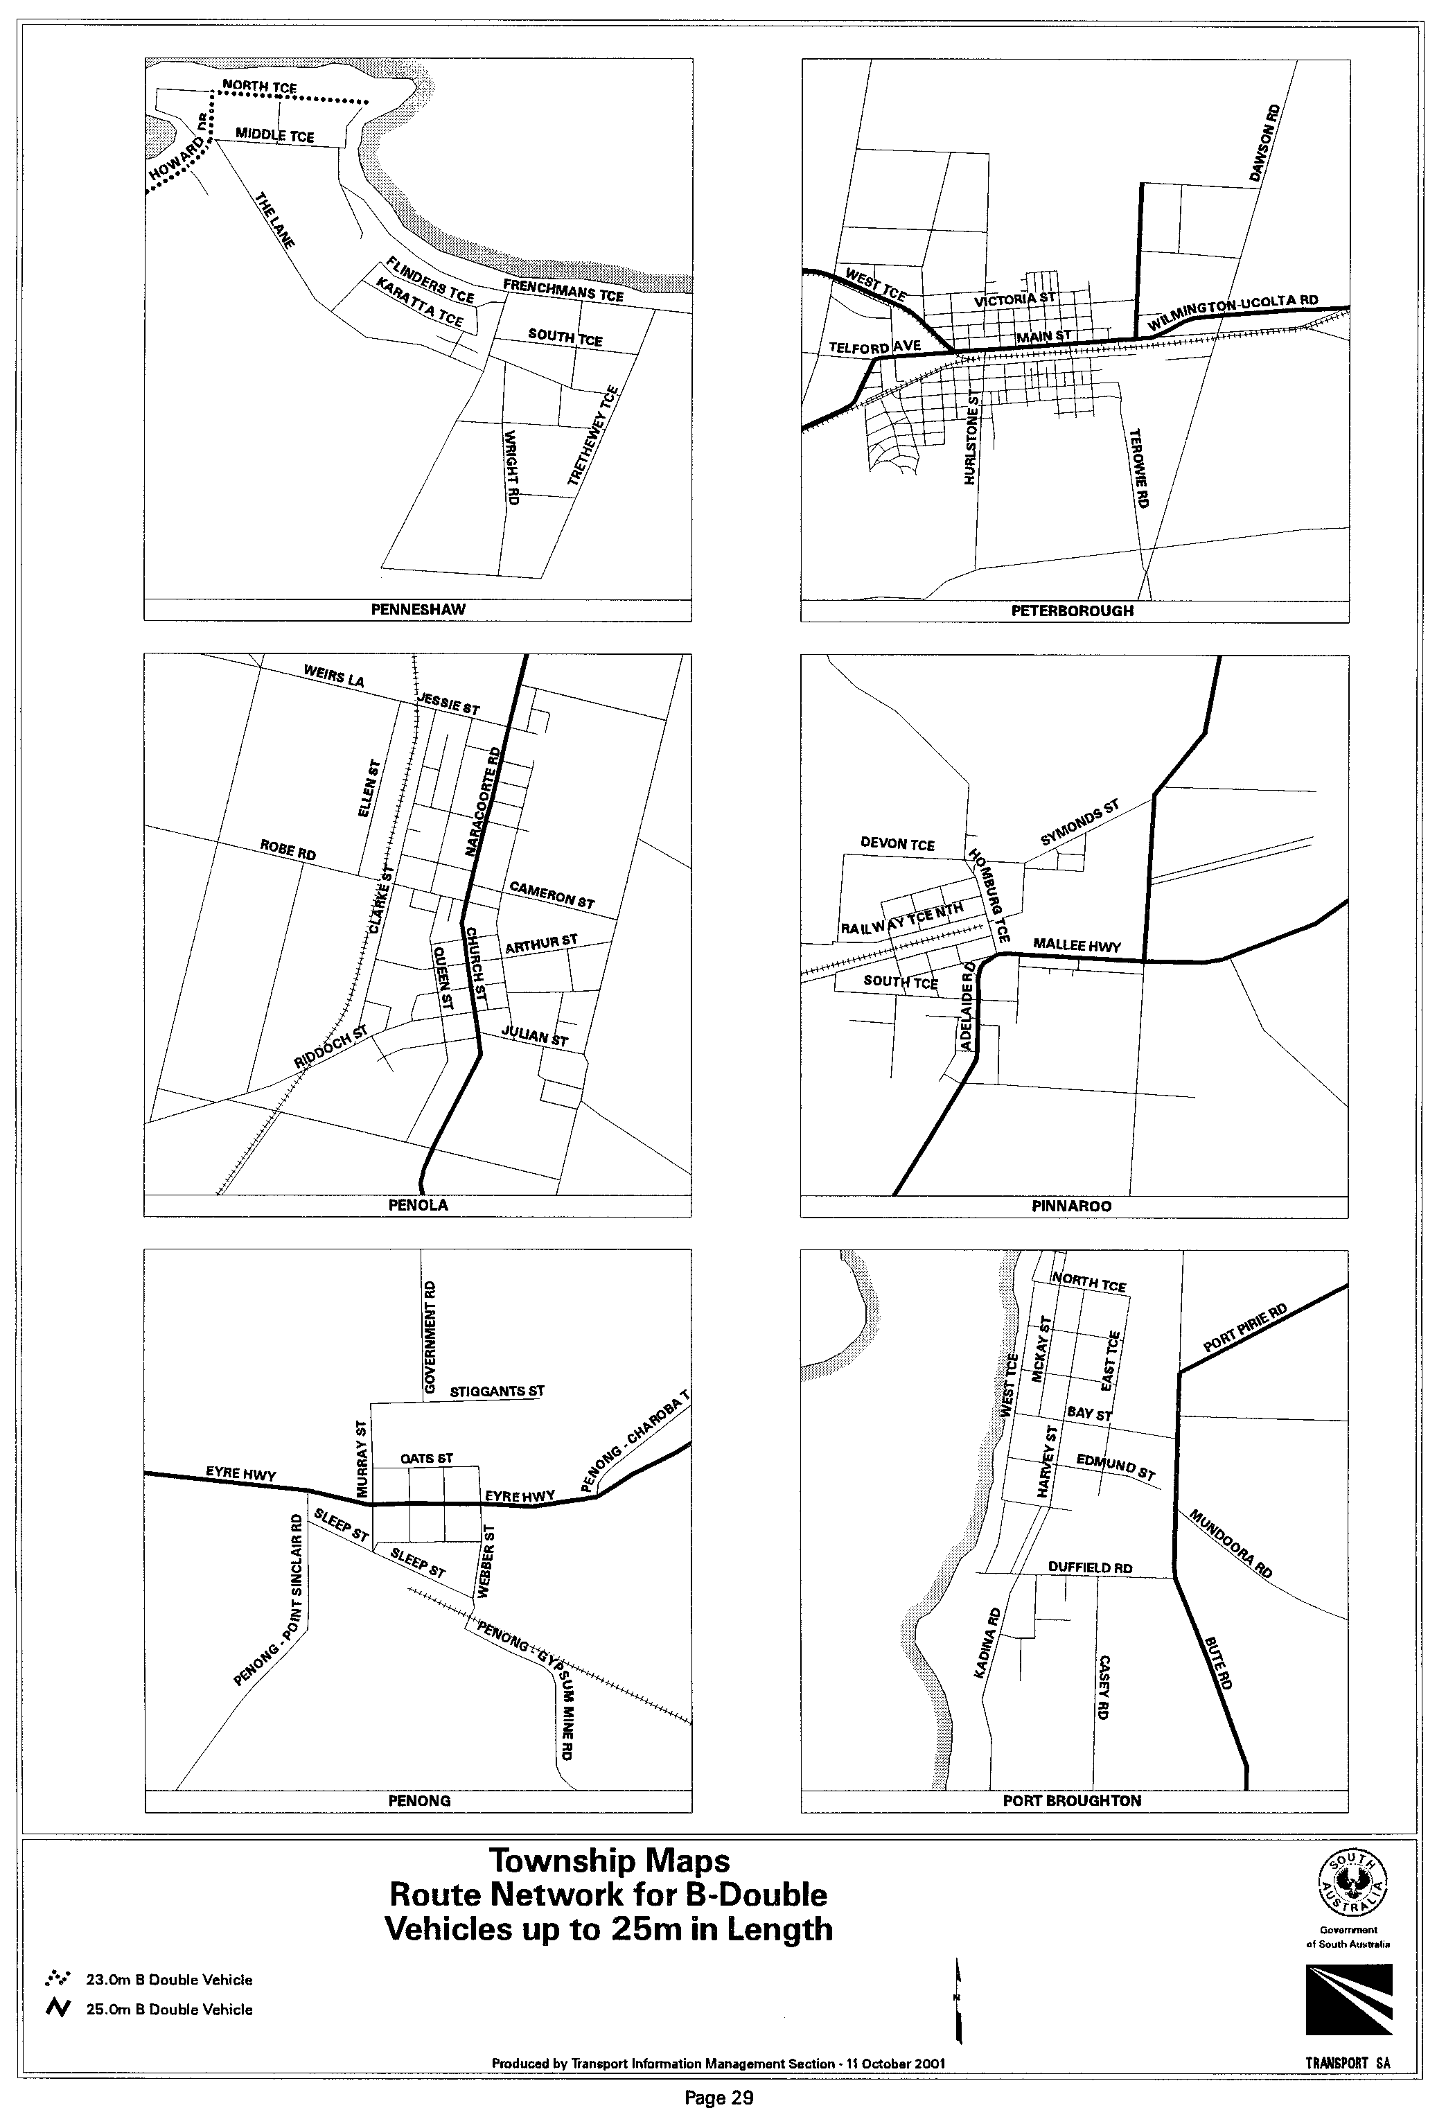
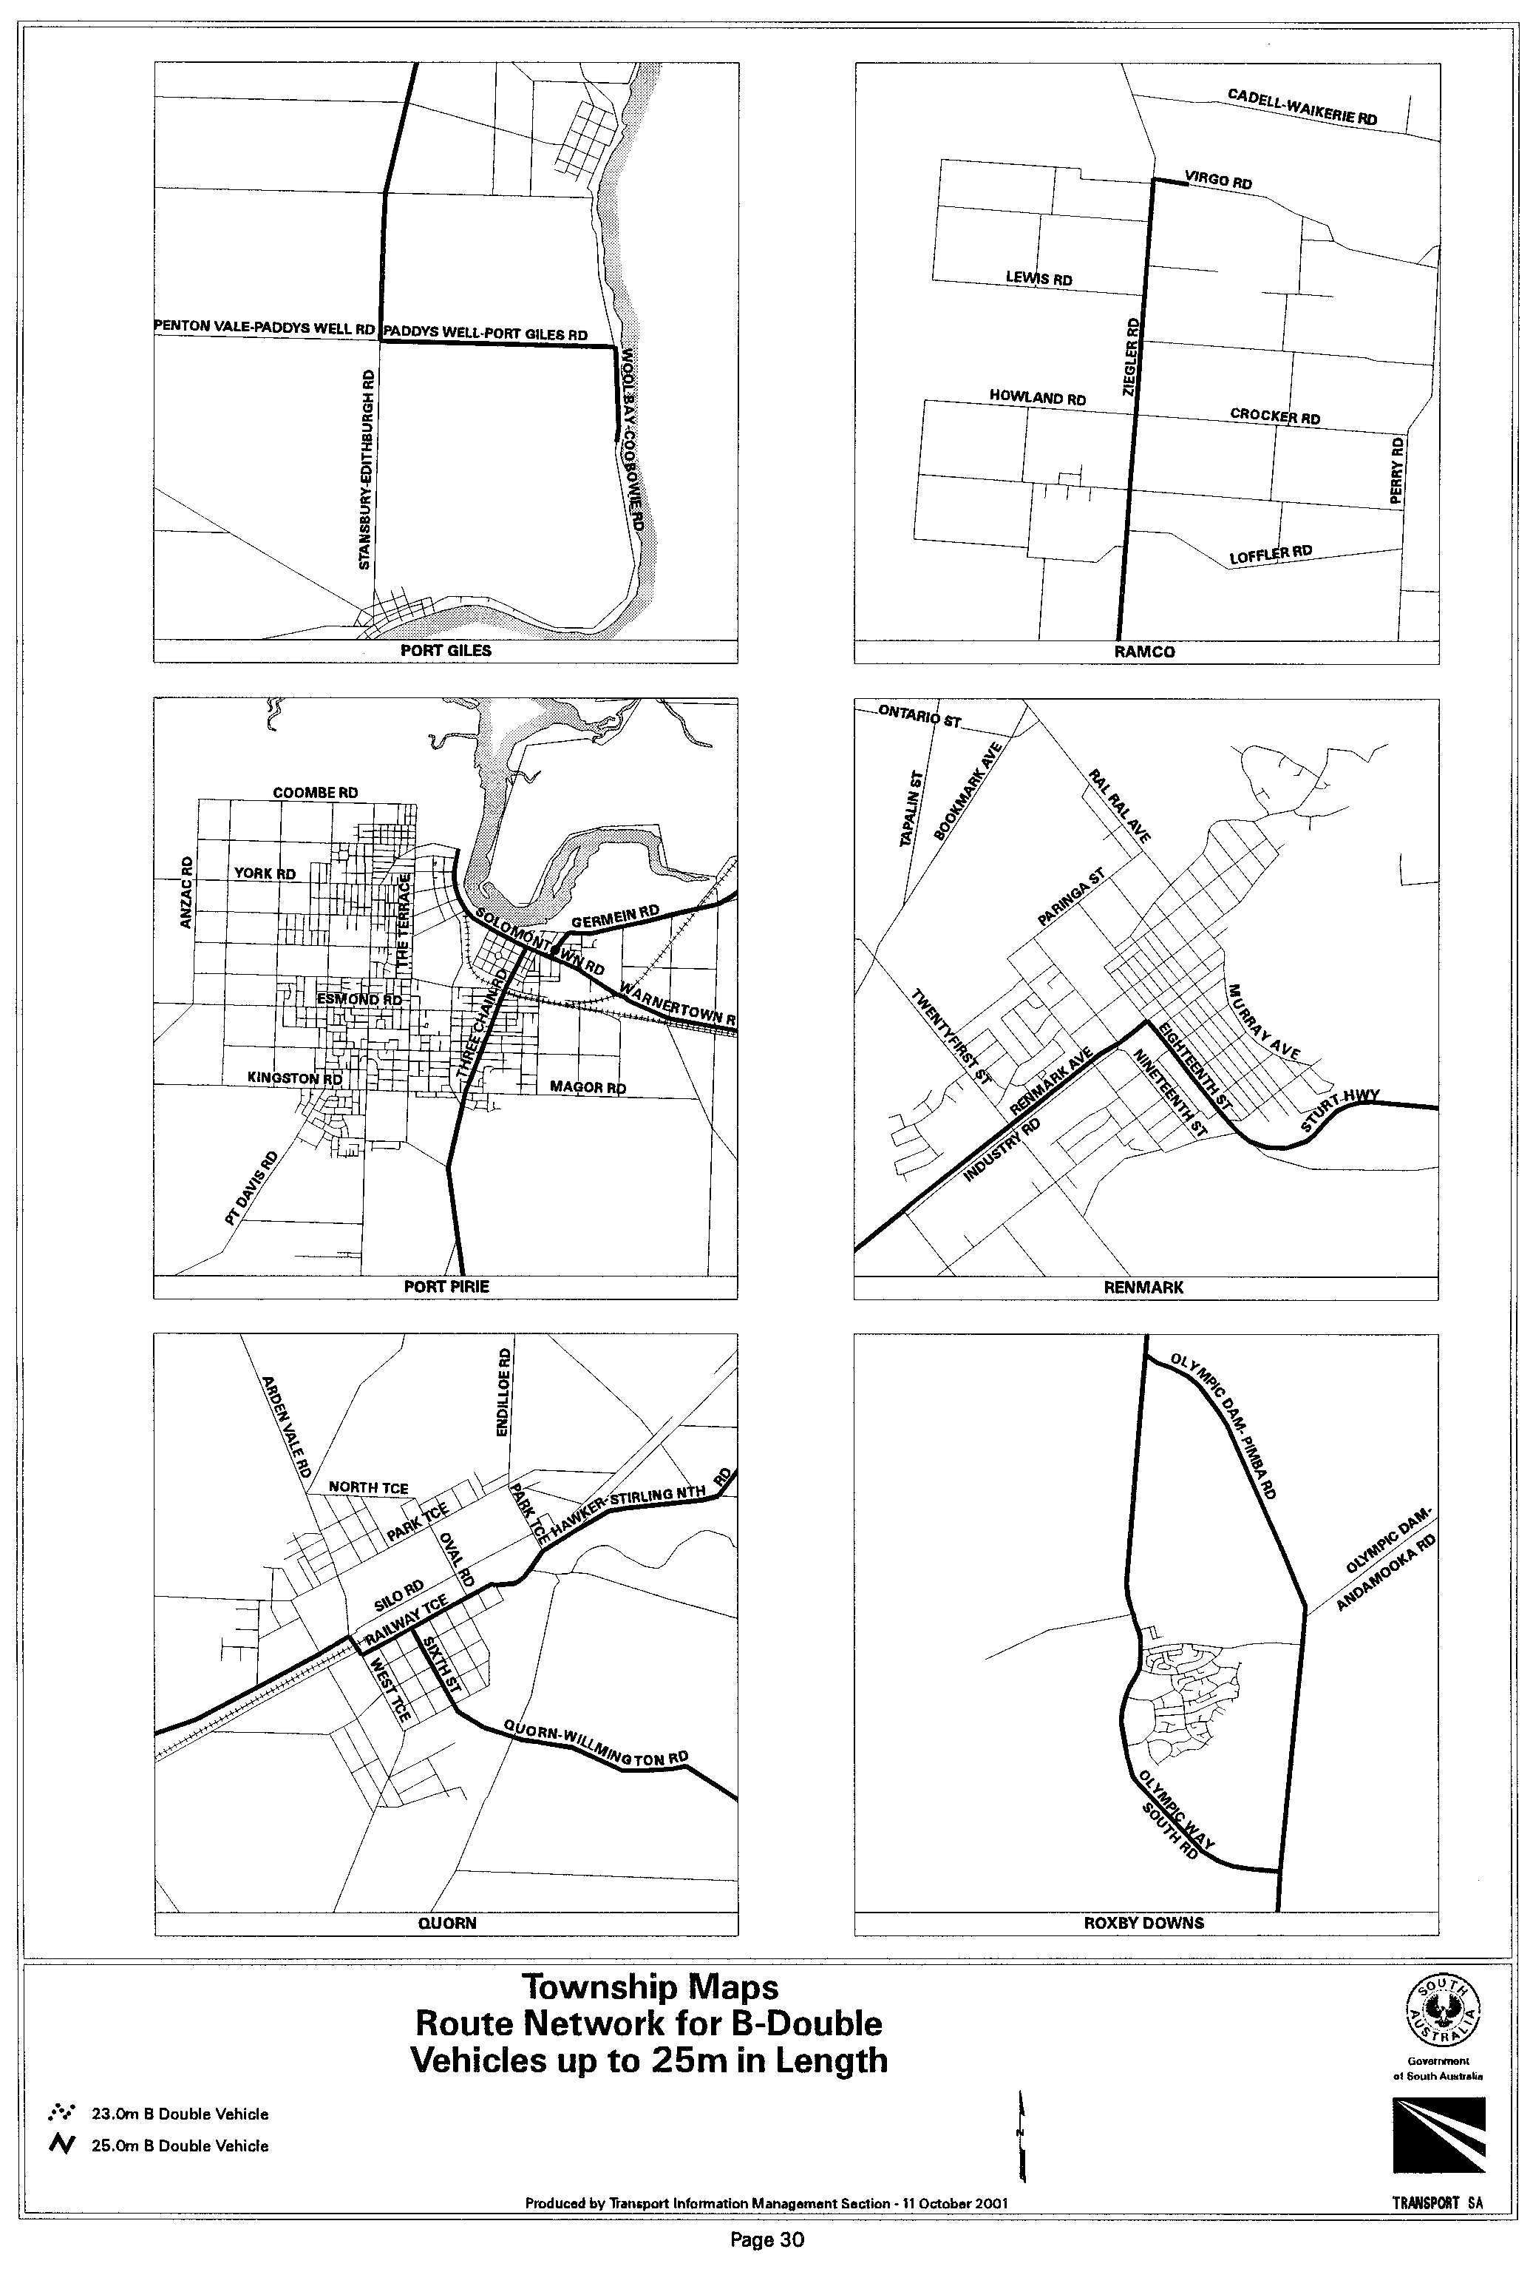
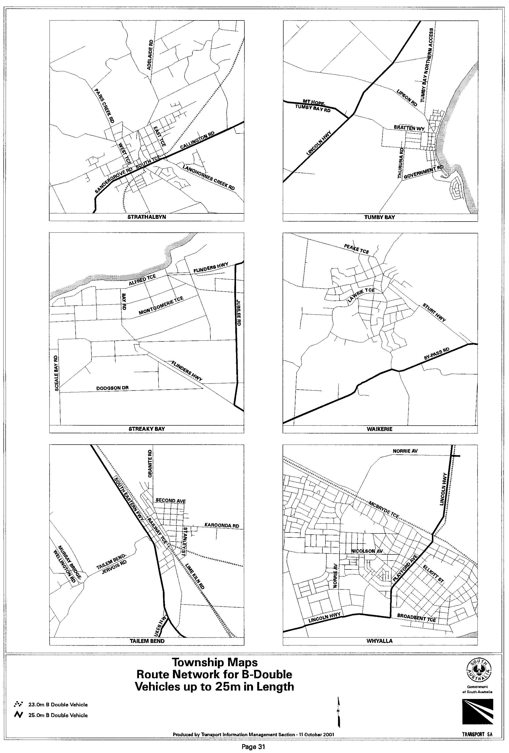
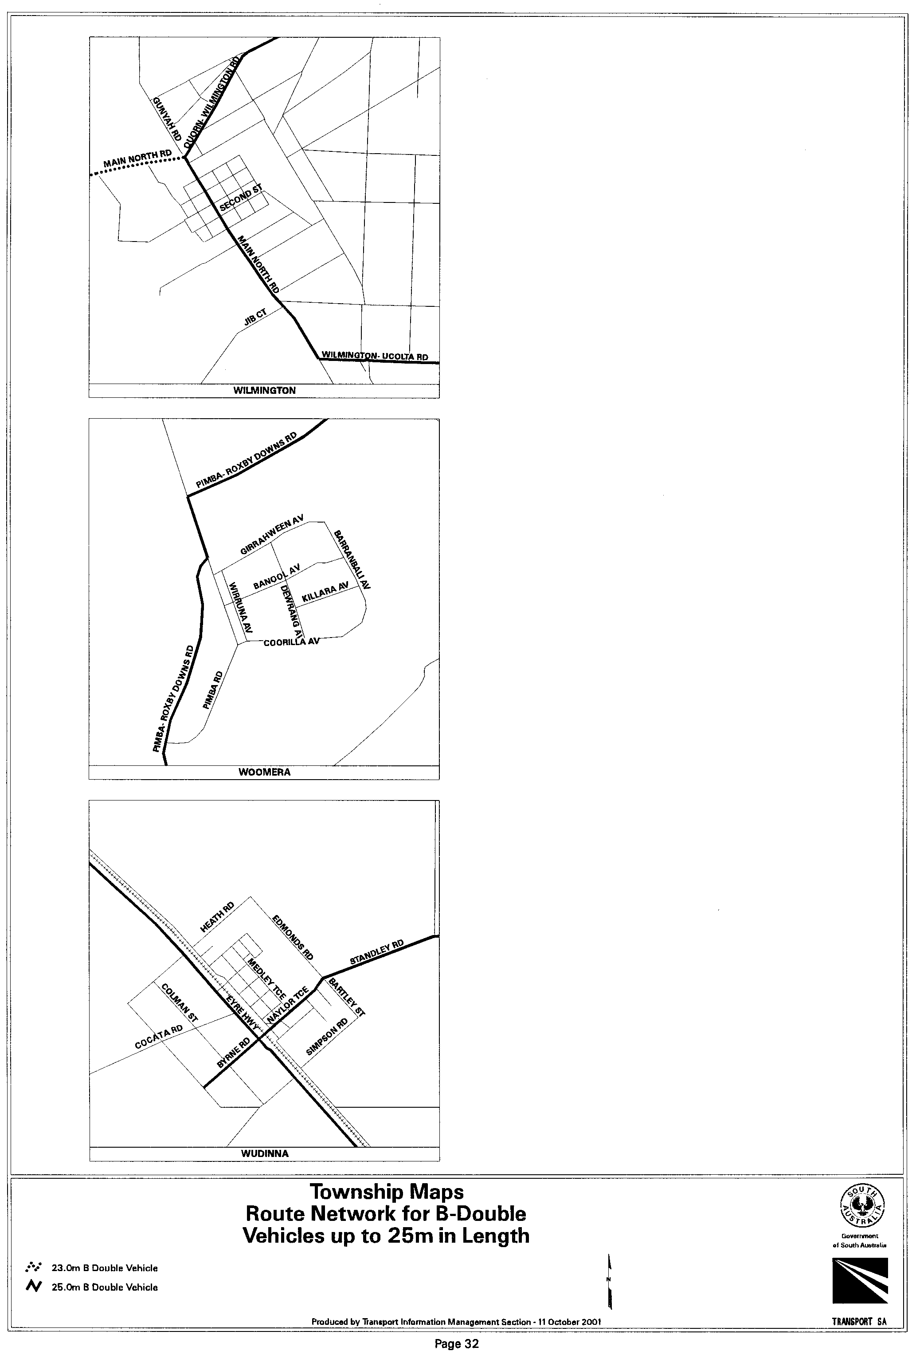
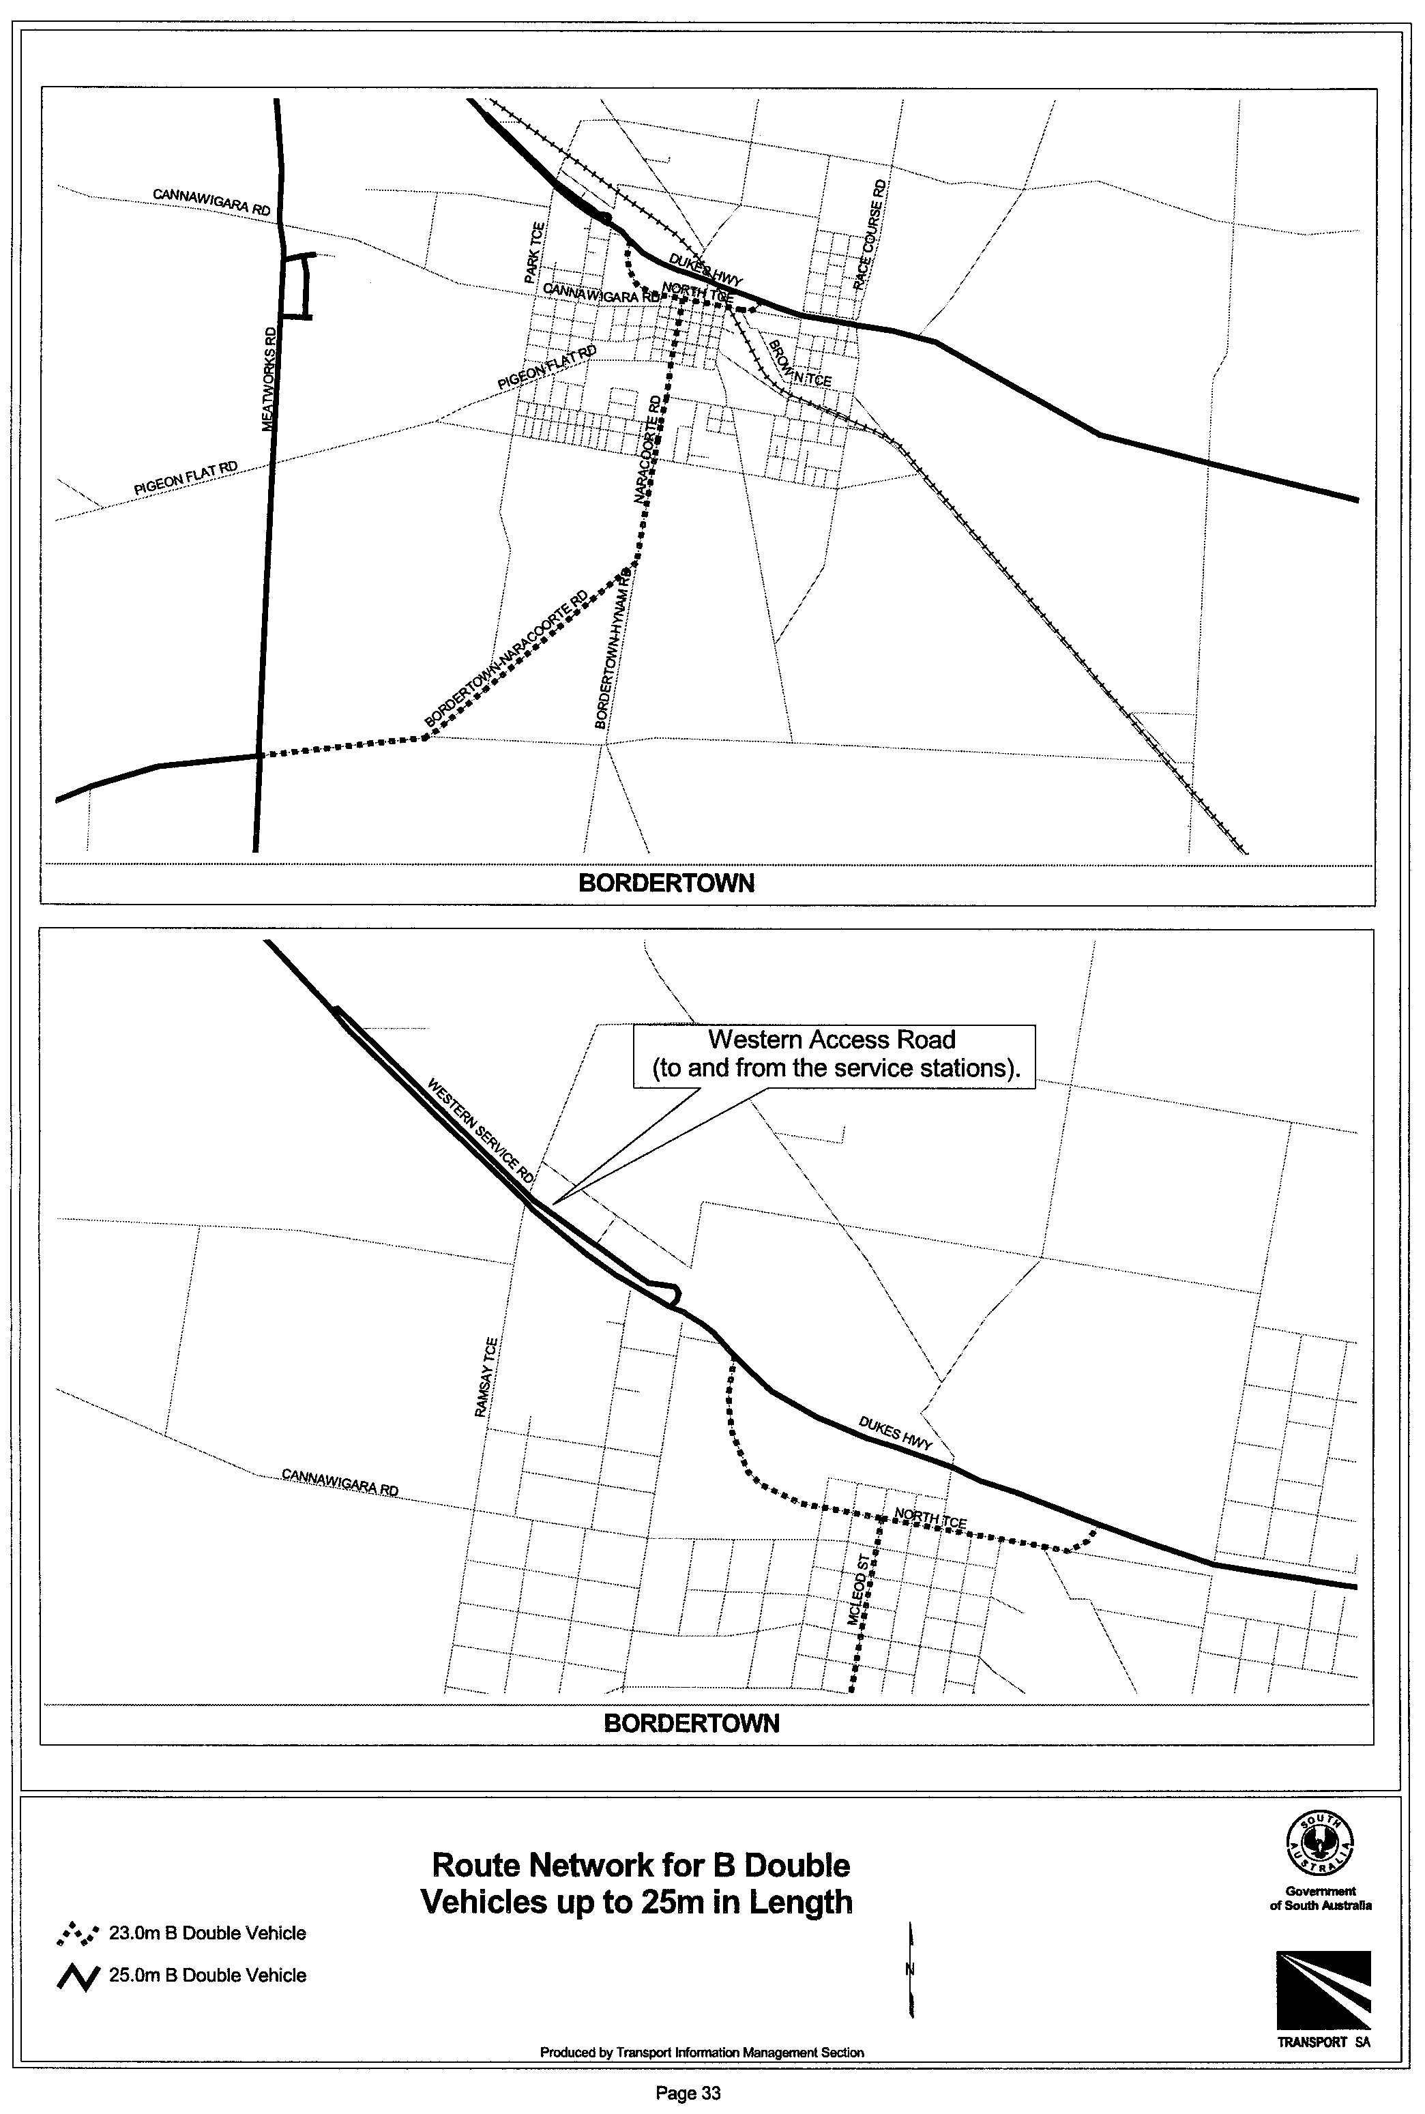
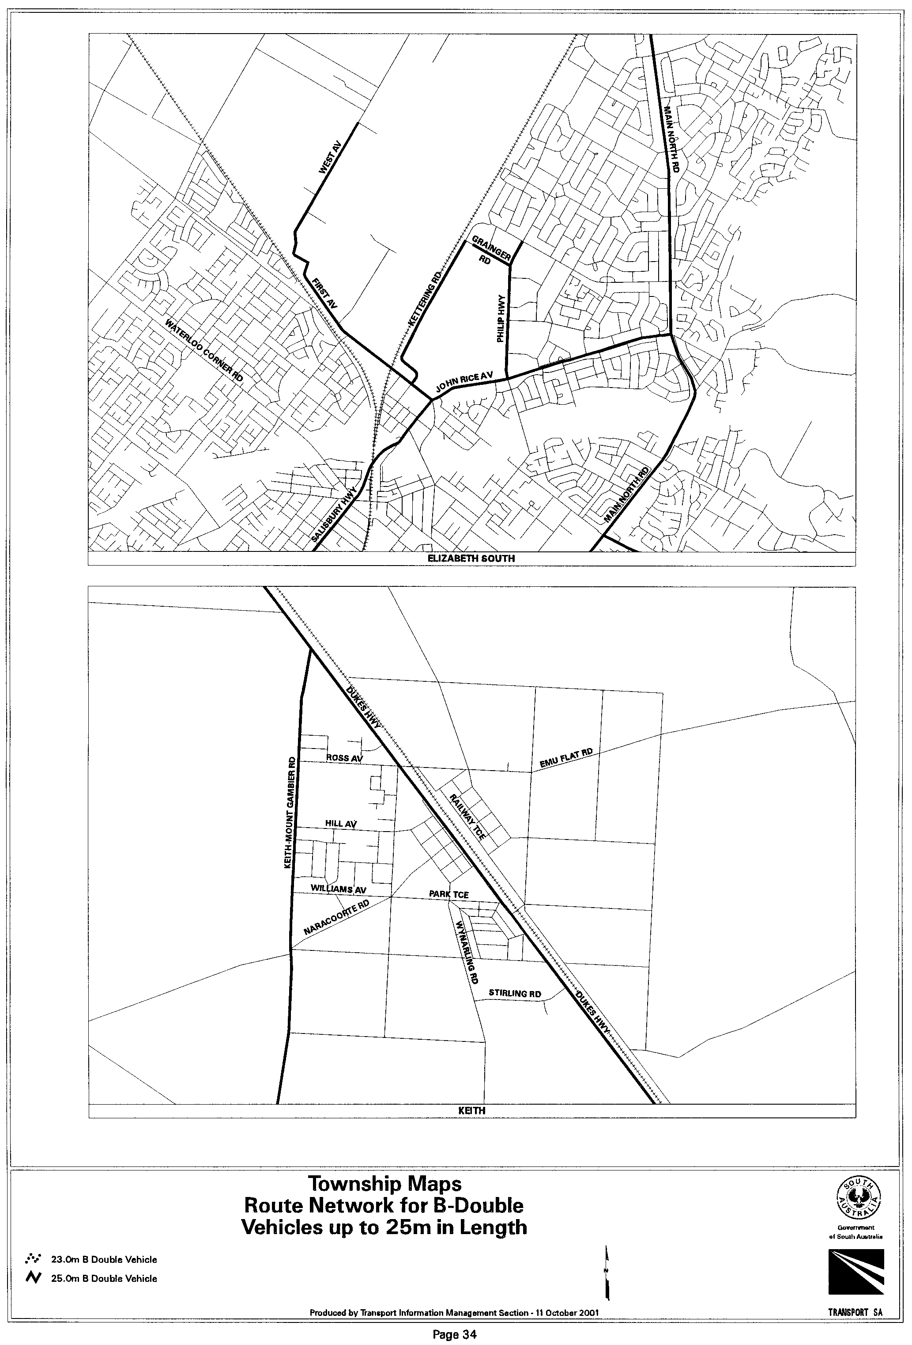
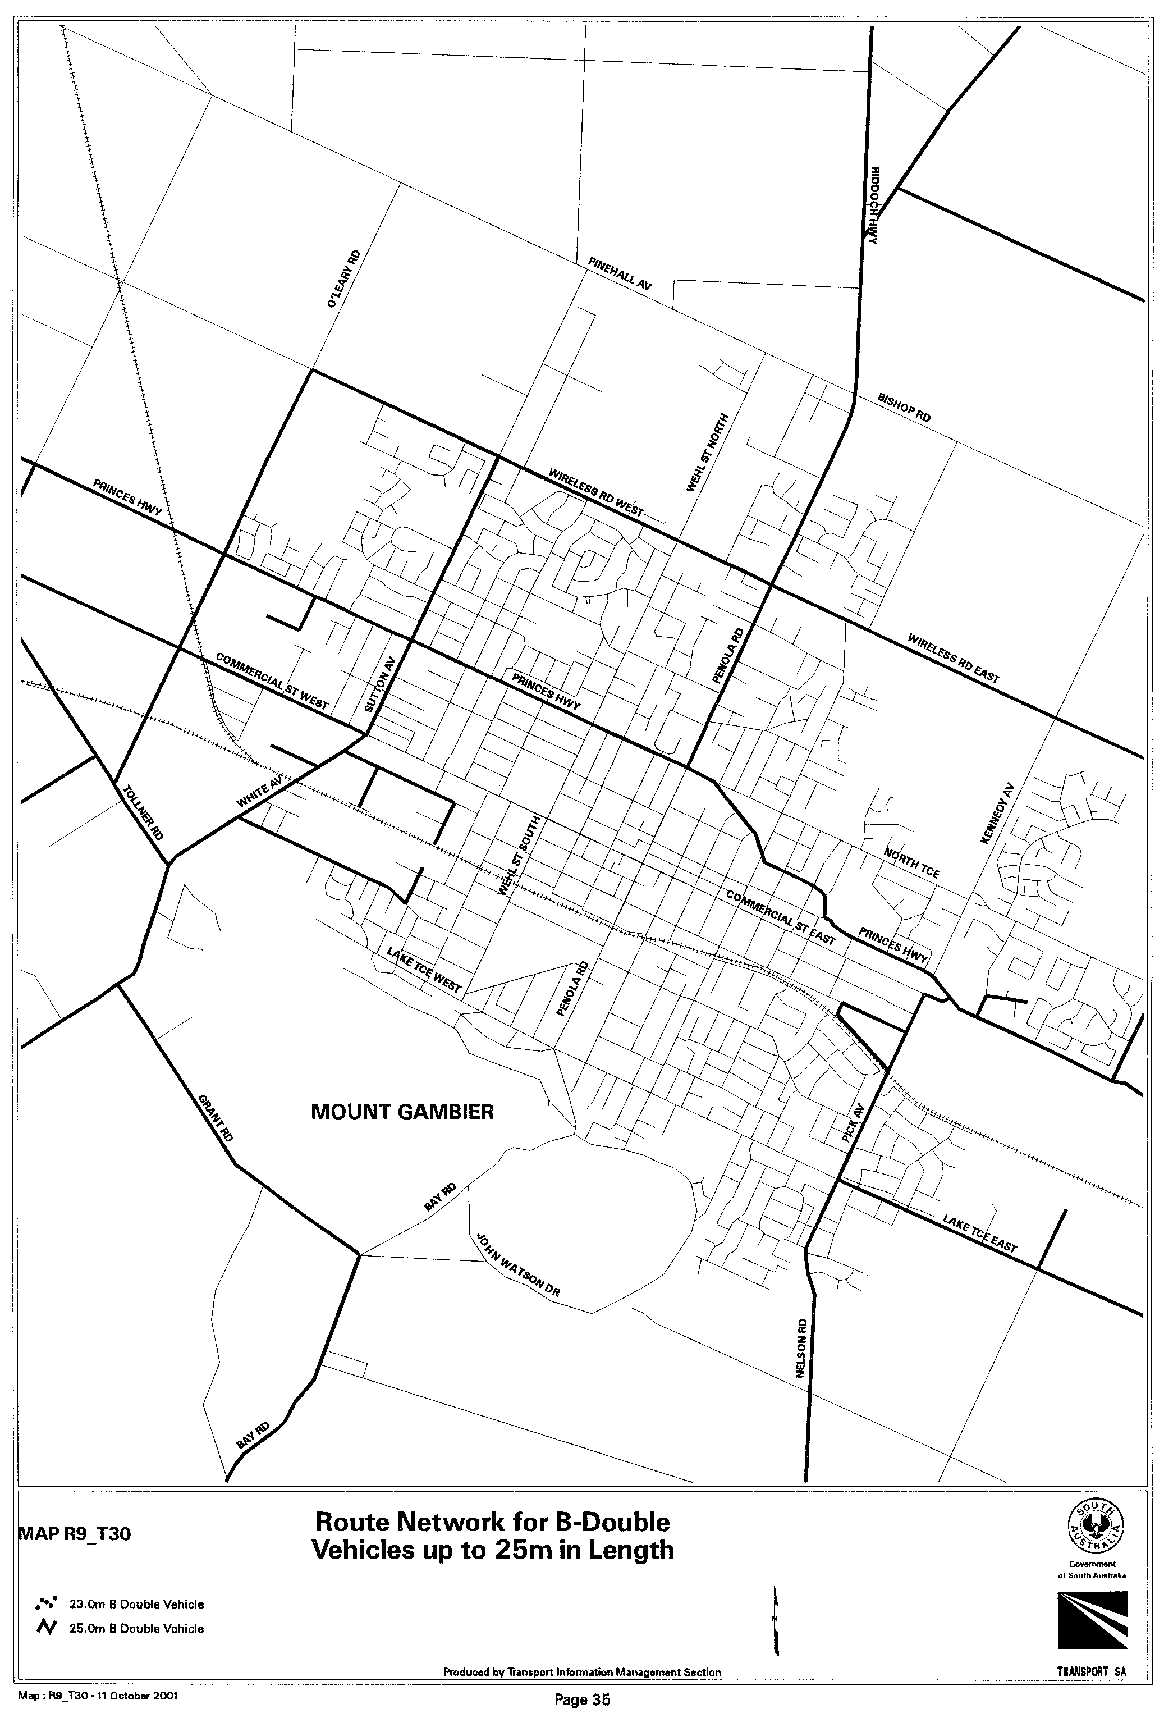
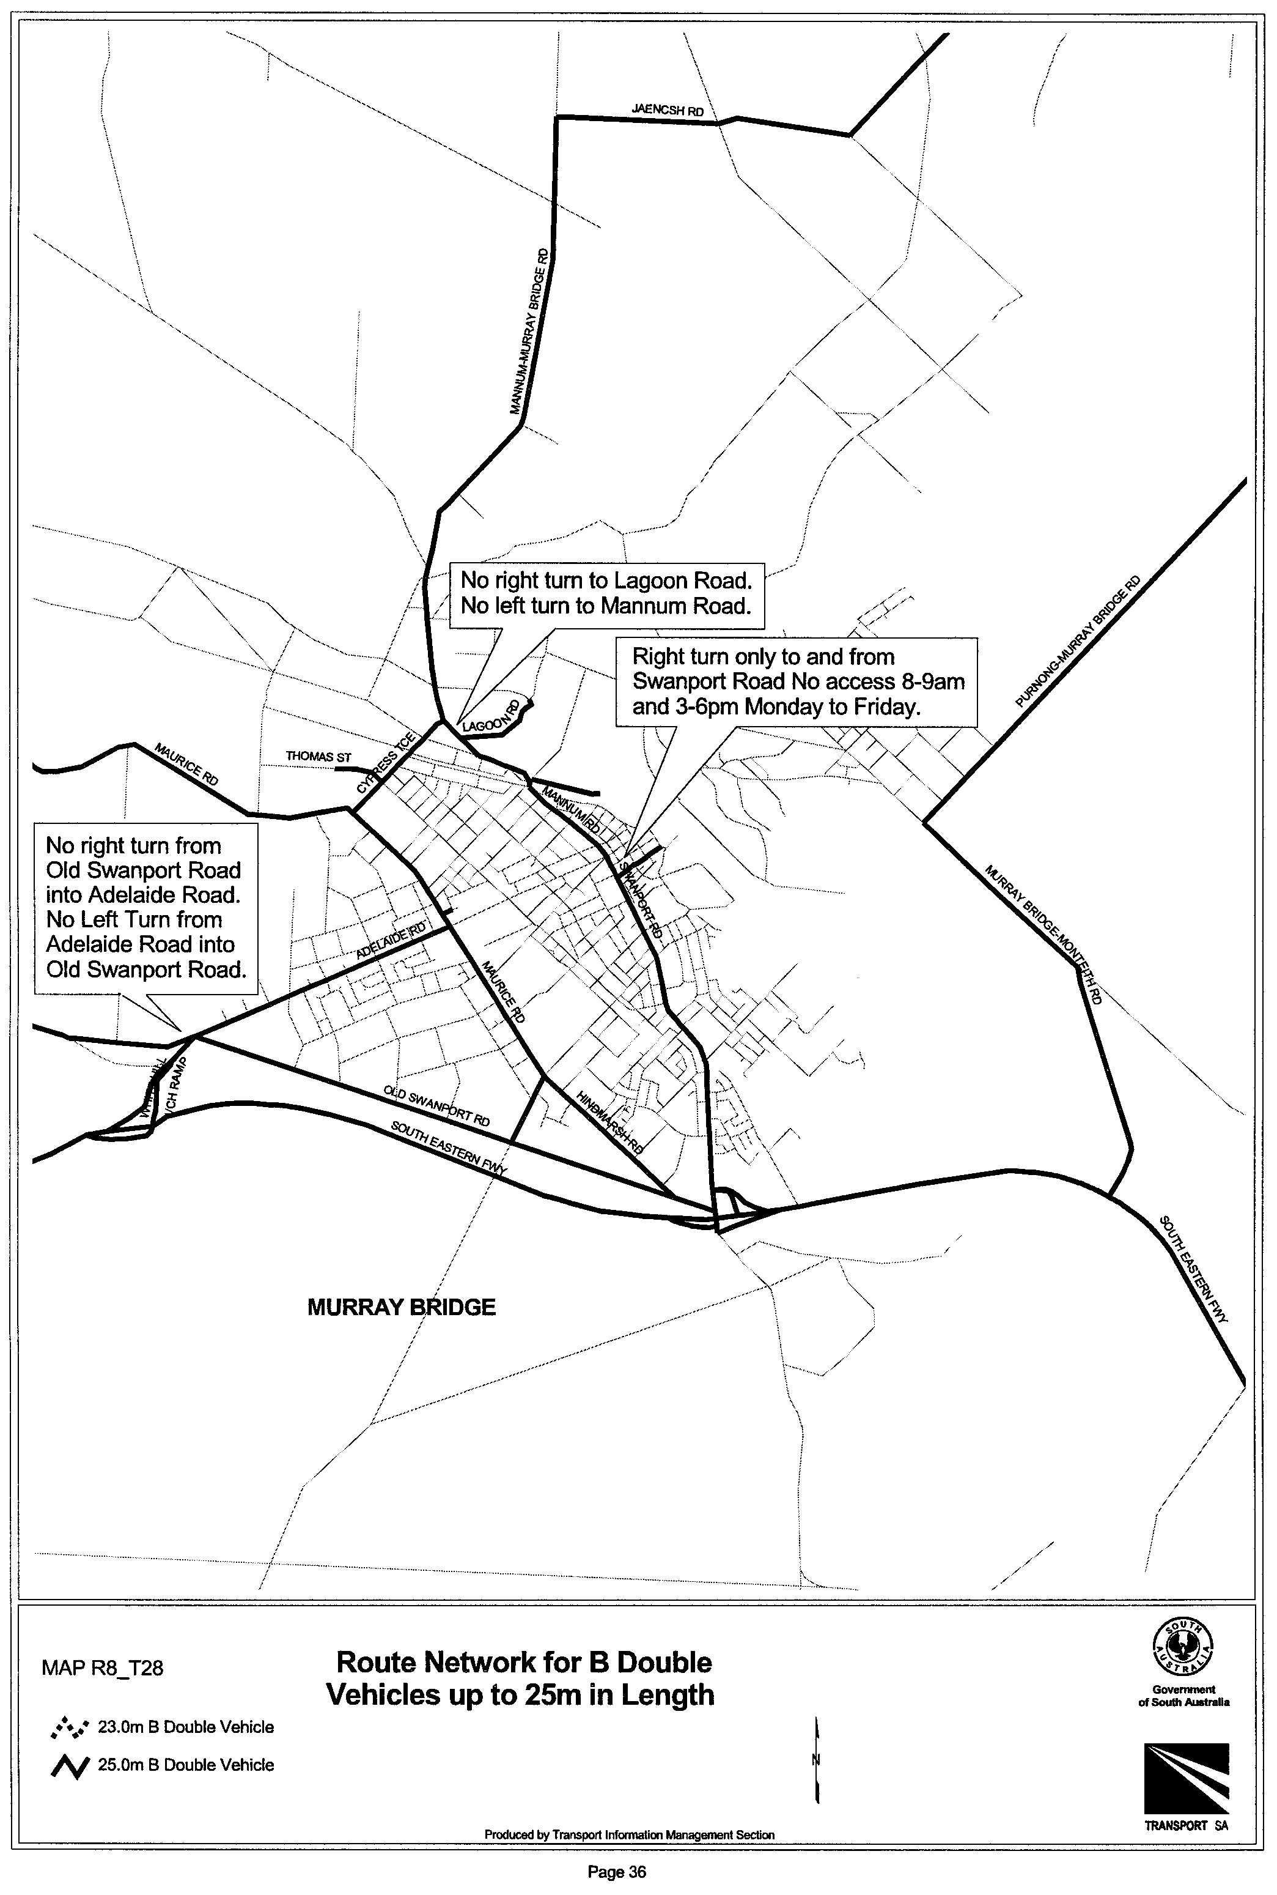
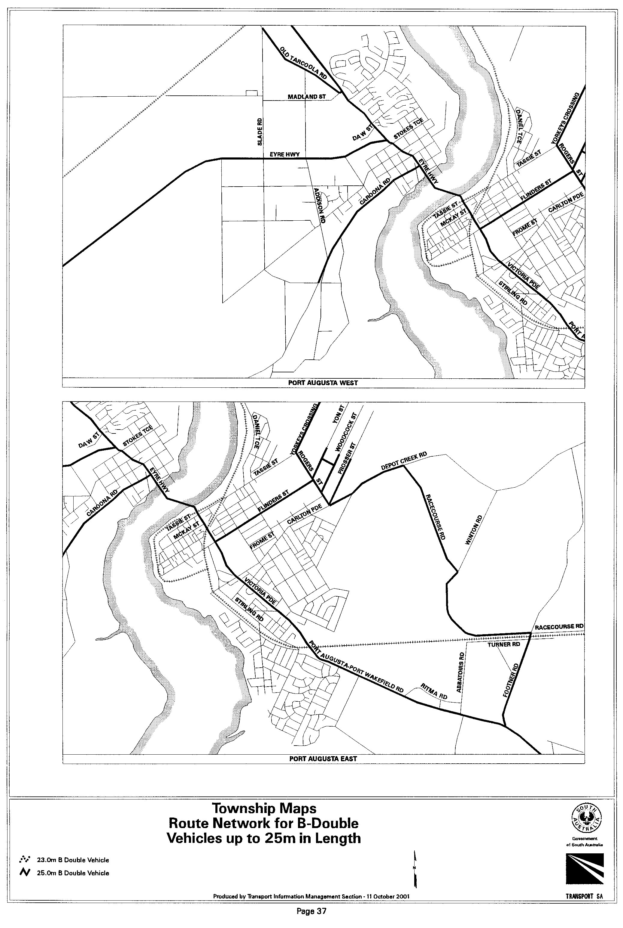
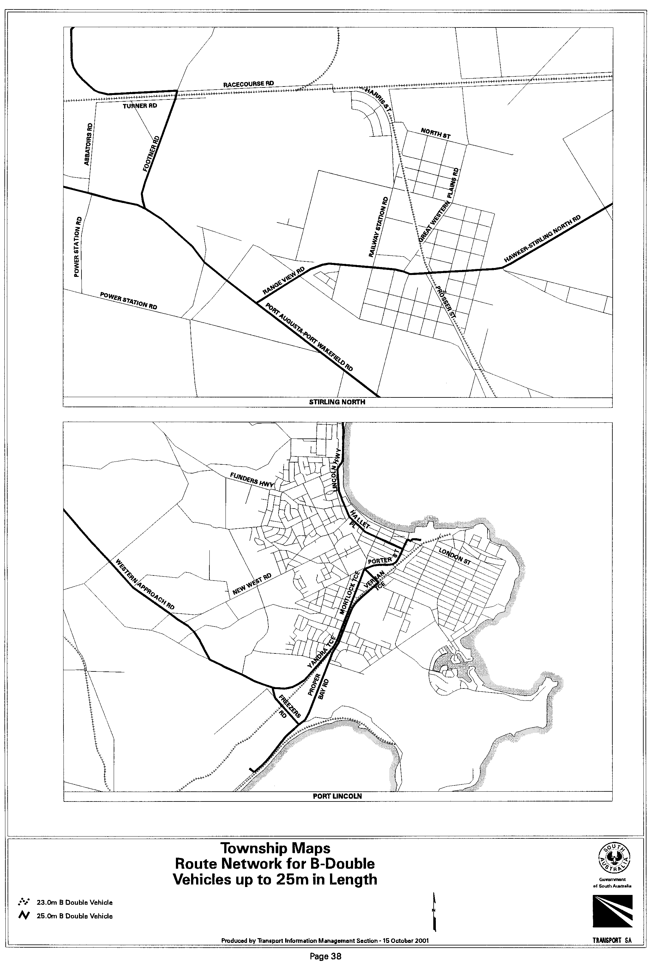

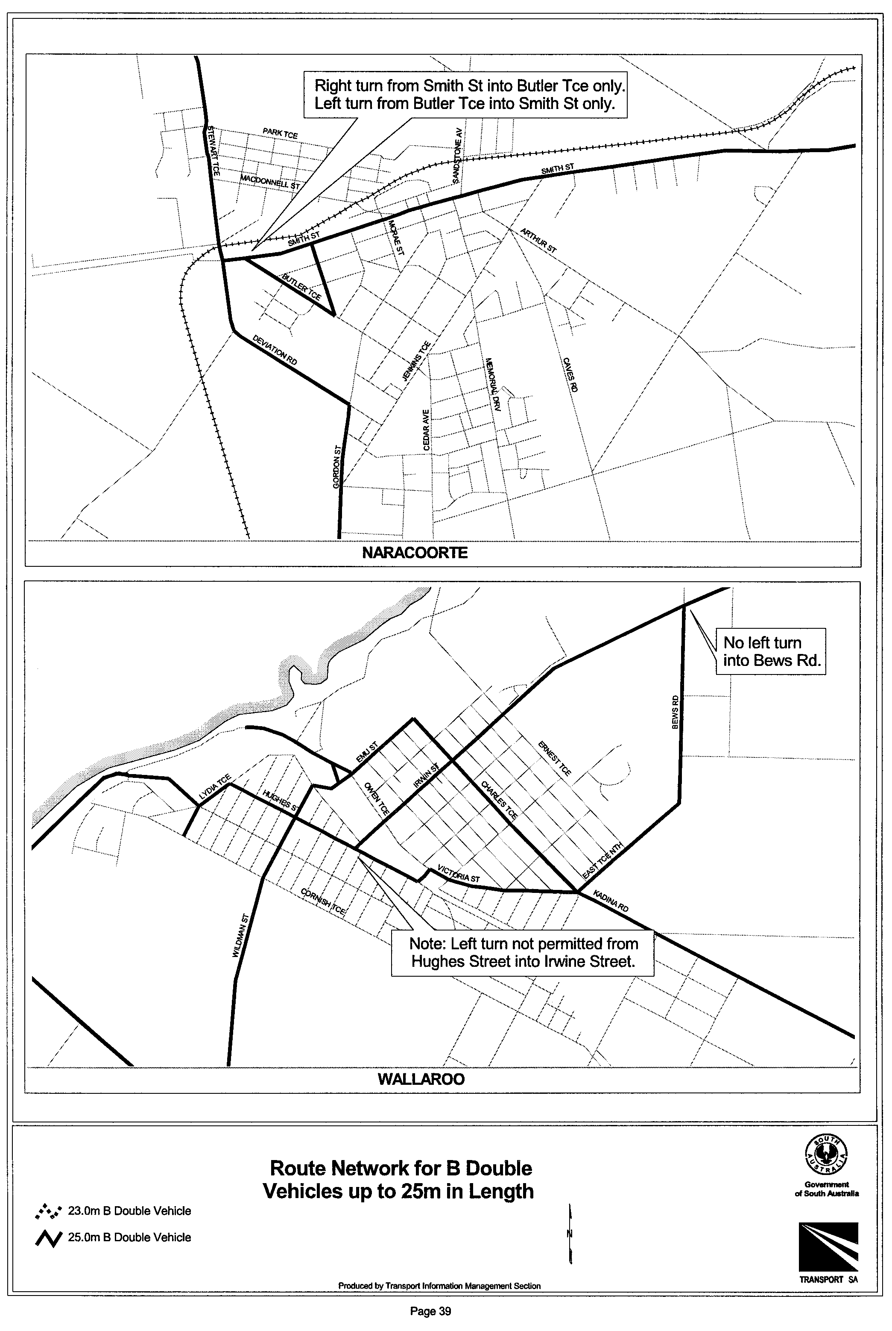
T. N. Argent, Executive Director, Transport SA

GOVERNMENT GAZETTE ADVERTISEMENT RATES

To apply from 1 July 2001

$  Agents, Ceasing to Act as 32.75  Associations:  Incorporation 16.70  Intention of Incorporation 41.25  Transfer of Properties 41.25  Attorney, Appointment of 32.75  Bailiff’s Sale 41.25  Cemetery Curator Appointed 24.50  Companies:  Alteration to Constitution 32.75  Capital, Increase or Decrease of 41.25  Ceasing to Carry on Business 24.50  Declaration of Dividend 24.50  Incorporation 32.75  Lost Share Certificates:  First Name 24.50  Each Subsequent Name 8.40  Meeting Final 27.50  Meeting Final Regarding Liquidator’s Report on  Conduct of Winding Up (equivalent to ‘Final  Meeting’)  First Name 32.75  Each Subsequent Name 8.40  Notices:  Call 41.25  Change of Name 16.70  Creditors 32.75  Creditors Compromise of Arrangement 32.75  Creditors (extraordinary resolution that ‘the Com-pany be wound up voluntarily and that a liquidator be appointed’) 41.25  Release of Liquidator⎯Application⎯Large Ad. 65.50  ⎯Release Granted 41.25  Receiver and Manager Appointed 38.25  Receiver and Manager Ceasing to Act 32.75  Restored Name 31.00  Petition to Supreme Court for Winding Up 57.00  Summons in Action 48.75  Order of Supreme Court for Winding Up Action 32.75  Register of Interests⎯Section 84 (1) Exempt 74.00  Removal of Office 16.70  Proof of Debts 32.75  Sales of Shares and Forfeiture 32.75  Estates:  Assigned 24.50  Deceased Persons⎯Notice to Creditors, etc. 41.25  Each Subsequent Name 8.40  Deceased Persons⎯Closed Estates 24.50  Each Subsequent Estate 1.05  Probate, Selling of 32.75  Public Trustee, each Estate 8.40 |  | $  Firms:  Ceasing to Carry on Business (each insertion) 21.80  Discontinuance Place of Business 21.80  Land⎯Real Property Act:  Intention to Sell, Notice of 41.25  Lost Certificate of Title Notices 41.25  Cancellation, Notice of (Strata Plan) 41.25  Mortgages:  Caveat Lodgment 16.70  Discharge of 17.60  Foreclosures 16.70  Transfer of 16.70  Sublet 8.40  Leases⎯Application for Transfer (2 insertions) each 8.40  Lost Treasury Receipts (3 insertions) each 24.50  Licensing 48.75  Municipal or District Councils:  Annual Financial Statement⎯Forms 1 and 2 462.00  Electricity Supply⎯Forms 19 and 20 327.00  Default in Payment of Rates:  First Name 65.50  Each Subsequent Name 8.40  Noxious Trade 24.50  Partnership, Dissolution of 24.50  Petitions (small) 16.70  Registered Building Societies (from Registrar-  General) 16.70  Register of Unclaimed Moneys⎯First Name 24.50  Each Subsequent Name 8.40  Registers of Members⎯Three pages and over:  Rate per page (in 8pt) 209.00  Rate per page (in 6pt) 276.00  Sale of Land by Public Auction 41.75  Advertisements 2.30  Advertisements, other than those listed are charged at $2.30 per column line, tabular one-third extra.  Notices by Colleges, Universities, Corporations and District Councils to be charged at $2.30 per line.  Where the notice inserted varies significantly in length from that which is usually published a charge of $2.30 per column line will be applied in lieu of advertisement rates listed.  South Australian Government publications are sold on the condition that they will not be reproduced without prior permission from the Government Printer.
All the above prices include GST

GOVERNMENT GAZETTE NOTICES
ALL private advertisements forwarded for publication in the South Australian Government Gazette must be PAID FOR PRIOR TO INSERTION; and all notices, from whatever source, should be legibly written on one side of the paper only and sent to Government Publishing SA so as to be received no later than 4 p.m. Tuesday preceding the day of publication. Phone 8207 1045 or Fax 8207 1040. E-mail: governmentgazette@saugov.sa.gov.au. Send as attachments in Word format and please confirm your transmission with a faxed copy of your document, including the date the notice is to be published and to whom the notice will be charged.

MISCELLANEOUS LEGISLATION AND GOVERNMENT PUBLICATIONS PRICES AS FROM 1 JULY 2001

Acts, Bills, Rules, Parliamentary Papers and Regulations
Pages | Main | Amends | Pages | Main | Amends

1-16 | 1.85 | 0.80 | 497-512 | 27.00 | 26.00
17-32 | 2.60 | 1.65 | 513-528 | 27.75 | 26.50
33-48 | 3.35 | 2.40 | 529-544 | 28.50 | 27.50
49-64 | 4.25 | 3.20 | 545-560 | 29.25 | 28.50
65-80 | 5.00 | 4.10 | 561-576 | 30.00 | 29.25
81-96 | 5.75 | 4.80 | 577-592 | 31.00 | 29.75
97-112 | 6.60 | 5.60 | 593-608 | 31.75 | 30.75
113-128 | 7.40 | 6.45 | 609-624 | 32.50 | 31.75
129-144 | 8.30 | 7.30 | 625-640 | 33.25 | 32.25
145-160 | 9.10 | 8.05 | 641-656 | 34.00 | 33.00
161-176 | 9.95 | 8.90 | 657-672 | 34.50 | 33.75
177-192 | 10.70 | 9.75 | 673-688 | 36.00 | 34.50
193-208 | 11.50 | 10.60 | 689-704 | 36.75 | 35.50
209-224 | 12.30 | 11.30 | 705-720 | 37.25 | 36.50
225-240 | 13.00 | 12.10 | 721-736 | 38.50 | 37.00
241-257 | 13.90 | 12.80 | 737-752 | 39.00 | 38.00
258-272 | 14.80 | 13.60 | 753-768 | 40.00 | 38.50
273-288 | 15.60 | 14.60 | 769-784 | 40.50 | 39.75
289-304 | 16.30 | 15.30 | 785-800 | 41.25 | 40.50
305-320 | 17.10 | 16.10 | 801-816 | 42.00 | 41.00
321-336 | 17.90 | 16.90 | 817-832 | 43.00 | 42.00
337-352 | 18.80 | 17.80 | 833-848 | 43.75 | 42.75
353-368 | 19.60 | 18.60 | 849-864 | 44.50 | 43.50
369-384 | 20.40 | 19.50 | 865-880 | 45.25 | 44.50
385-400 | 21.10 | 20.20 | 881-896 | 45.75 | 45.00
401-416 | 21.90 | 20.90 | 897-912 | 47.25 | 45.75
417-432 | 22.90 | 21.80 | 913-928 | 47.75 | 47.25
433-448 | 23.60 | 22.60 | 929-944 | 48.75 | 47.75
449-464 | 24.50 | 23.40 | 945-960 | 49.50 | 48.25
465-480 | 25.00 | 24.20 | 961-976 | 50.25 | 49.25
481-496 | 26.00 | 24.90 | 977-992 | 51.25 | 49.75

Legislation—Acts, Regulations, etc: $
Subscriptions:
Acts 166.90
All Bills as Laid 398.60
Rules and Regulations 398.60
Parliamentary Papers 398.60
Bound Acts 184.25
Index 89.20
Government Gazette
Copy 4.40
Subscription 220.20
Hansard
Copy 11.90
Subscription—per session (issued weekly) 345.35
Cloth bound—per volume 148.30
Subscription—per session (issued daily) 345.35
Legislation on Disk
Whole Database 2 551.00
Annual Subscription for fortnightly updates 784.30
Individual Act(s) including updates POA
Compendium
Subscriptions:
New Subs 1 513.50
Updates 540.25

(All the above prices include GST)

All Legislation, Government Gazette, Hansard and Legislation on disk are available from:
Counter Sales Information SA (State Government Bookshop)
and Mail Orders: Ground Floor, 77 Grenfell Street, Adelaide, S.A. 5000.
Phone: (08) 8204 1900. Fax: (08) 8204 1909
Online Shop: www.info.sa.gov.au
S.A. Country Customer Free Call: 1800 182 234
TTY (Hearing Impaired): (08) 8204 1923
Subscriptions and Standing Orders:
Phone: (08) 8207 0908, (08) 8207 0910. Fax: (08) 8207 1040
Box 9, Plaza Level, Riverside Centre, North Terrace, Adelaide, S.A. 5000.

RULES OF COURT
Amending the Supreme Court Admission Rules 1999
Amendment No. 2
BY virtue and in pursuance of section 72 of the Supreme Court Act 1935, and all other enabling powers, We, the Judges of the Supreme Court of South Australia, make the following Rules to take effect as amendments to the Supreme Court Admission Rules 1999:
1. The Supreme Court Admission Rules 1999, as amended by these Rules may be cited as the ‘Supreme Court Admission Rules 1999’.
2. Rule 15 (6) is amended by deleting the passage ‘sub-rule (4)’ and substituting the passage ‘sub-rule (5)’.
GIVEN under our hands and the Seal of the Supreme Court of South Australia this 24th day of September 2001.
(l.s.) G. C. PRIOR, ACJ
K. P. DUGGAN, J
E. P. MULLIGHAN, J
H. C. WILLIAMS, J
D. F. WICKS, J
T. A. GRAY, J

WATER MAINS AND SEWERS

Office of the South Australian Water Corporation
Adelaide, 18 October 2001.

WATER MAINS LAID

Notice is hereby given that the following main pipes or parts of main pipes have been laid down by the South Australian Water Corporation in or near the undermentioned water districts and are now available for a constant supply of water to adjacent land.

ADELAIDE WATER DISTRICT

DISTRICT OF ADELAIDE HILLS COUNCIL
Leamington Road, Aldgate. p1

CITY OF ONKAPARINGA
Field Street, McLaren Vale. p29

CITY OF PORT ADELAIDE ENFIELD
Gouger Crescent, Port Adelaide. p20

CITY OF TEA TREE GULLY
Across and in Hancock Road, Golden Grove and Surrey Downs. p19

GOOLWA WATER DISTRICT

DISTRICT OF ALEXANDRINA COUNCIL
Knight Street, Goolwa Beach. p4
Liverpool Road, Goolwa North. p5

PARINGA TOWNSHIP WATER DISTRICT

DISTRICT OF RENMARK PARINGA
Across and in Joyce Avenue, Paringa. p11
Easement in reserve (lot 45), Joyce Avenue, Paringa. p11
Watkins Way, Paringa. p11
Ian Drive, Paringa. p11
Curtis Avenue, Paringa. p11
Eckermann Close, Paringa. p11

PORT ELLIOT WATER DISTRICT

CITY OF VICTOR HARBOR
Strangways Avenue, Hayborough. p3

WATER MAINS LAID

Notice is hereby given that the undermentioned water mains have been laid down by the South Australian Water Corporation and are not available for a constant supply of water to adjacent land.

ADELAIDE WATER DISTRICT

CITY OF ONKAPARINGA
Across St. Matthews Street, Willunga. p21

SEWERS LAID

Notice is hereby given that the following sewers have been laid down by the South Australian Water Corporation in the under-mentioned drainage areas and are now available for house connections.

ADELAIDE DRAINAGE AREA

CITY OF ADELAIDE
Easement in lots 4 and 1, Gilbert Street and lots 3 and 2, Stafford Street, Adelaide. FB 1097 p51

CITY OF MARION
Norfolk Road, Marion. FB 1097 p52
Robert Street, Ascot Park. FB 1097 p53

STIRLING COUNTRY DRAINAGE AREA

DISTRICT OF ADELAIDE HILLS COUNCIL
Easement in lot 2, Strathalbyn Road, Aldgate. FB 1097 p55

A. Howe, Chief Executive Officer, South Australian Water Corporation.

REGULATIONS UNDER THE RENMARK IRRIGATION TRUST ACT 1936
────
No. 234 of 2001
────
At the Executive Council Office at Adelaide, 18 October 2001

PURSUANT to the Renmark Irrigation Trust Act 1936 and with the advice and consent of the Executive Council, I make the following regulations.
E. J. NEAL, Governor

PURSUANT to section 10AA(2) of the Subordinate Legislation Act 1978, I certify that, in my opinion, it is necessary or appropriate that the following regulations come into operation as set out below.

MARK BRINDAL, Minister for Water Resources
───────────────────
SUMMARY OF PROVISIONS

1. Citation
2. Commencement
3. Revocation
4. Capital recovery on subdivision of ratable land
───────────────────

Citation
1. These regulations may be cited as the Renmark Irrigation Trust Capital Recoveries Regulations 2001.

Commencement
2. These regulations come into operation on the day on which they are made.

Revocation
3. The Renmark Irrigation Trust Capital Recoveries Regulations 1985 (see Gazette 11 July 1985 p. 101) are revoked.

Capital recovery on subdivision of ratable land
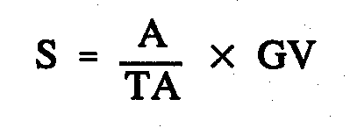 4. The sum of money payable under section 124A of the Renmark Irrigation Trust Act 1936 is calculated in accordance with the following formula:

Where

S is the sum payable

A is the area of the land that will cease to be ratable land

TA is the total area of the ratable land (including the land that will cease to be ratable) in the Renmark Irrigation District

GV is the gross value of the assets of the trust shown in the last balance sheet certified by the trust's auditors.

WR00/0022CS R. DENNIS, Clerk of the Council

REGULATIONS UNDER THE LEGAL PRACTITIONERS ACT 1981
────
No. 235 of 2001
────
At the Executive Council Office at Adelaide, 18 October 2001

PURSUANT to the Legal Practitioners Act 1981 and with the advice and consent of the Executive Council, I make the following regulations.
E. J. NEAL, Governor

PURSUANT to section 10AA(2) of the Subordinate Legislation Act 1978, I certify that, in my opinion, it is necessary or appropriate that the following regulations come into operation as set out below.

K. T. GRIFFIN, Attorney-General
───────────────────
SUMMARY OF PROVISIONS

1. Citation
2. Commencement
3. Variation of Sched. 2—Fees
───────────────────

Citation
1. The Legal Practitioners Regulations 1994 (see Gazette 1 September 1994 p. 636), as varied, are referred to in these regulations as "the principal regulations".

Commencement
2. These regulations come into operation on the day on which they are made.

Variation of Sched. 2—Fees
3. Schedule 2 of the principal regulations is varied by striking out paragraphs (a) and (b) of clause 1(1) and substituting the following paragraphs:

(a) for at least 6 months—

(i) if the certificate is to take effect before 1 January 2002 $254.00 fee
$50.00 levy

(ii) if the certificate is to take effect on or after 1 January 2002 $262.00 fee
$50.00 levy

(b) for less than 6 months—

(i) if the certificate is to take effect before 1 January 2002 $149.00 fee
$25.00 levy

(ii) if the certificate is to take effect on or after 1 January 2002 $154.00 fee
$25.00 levy

CSA 04/00 R. DENNIS, Clerk of the Council

REGULATIONS UNDER THE BUILDING WORK CONTRACTORS ACT 1995
────
No. 236 of 2001
────
At the Executive Council Office at Adelaide, 18 October 2001

PURSUANT to the Building Work Contractors Act 1995 and with the advice and consent of the Executive Council, I make the following regulations.
E. J. NEAL, Governor

PURSUANT to section 10AA(2) of the Subordinate Legislation Act 1978, I certify that, in my opinion, it is necessary or appropriate that the following regulations come into operation as set out below.

K. T. GRIFFIN, Minister for Consumer Affairs
───────────────────
SUMMARY OF PROVISIONS

1. Citation
2. Commencement
3. Variation of Sched. 1—Fees

───────────────────

Citation
1. The Building Work Contractors Regulations 1996 (see Gazette 23 May 1996 p. 2547), as varied, are referred to in these regulations as "the principal regulations".

Commencement
2. These regulations come into operation on the day on which they are made.

Variation of Sched. 1—Fees
3. Schedule 1 of the principal regulations is varied by striking out items 2 and 3 and substituting the following items:

2. Licence fee—payable before the granting of a licence under Part 2 of the Act—

(a) for a natural person for the following kinds of building work (as described in Schedule 2 Part C)—

(i) any building work $ 292

(ii) light commercial/industrial and residential building work $ 292

(iii) residential building work $ 292

(iv) other specified building work $ 145

(b) for a body corporate for the following kinds of building work (as described in Schedule 2 Part C)—

(i) any building work $ 651

(ii) light commercial/industrial and residential building work $ 651

(iii) residential building work $ 651

(iv) other specified building work $ 328

If the period between the grant of the licence and the next date for payment of a fee under section 11 of the Act is less than or more than 12 months, a pro rata adjustment is to be made to the amount of the additional fee by applying the proportion that the length of that period bears to 12 months.

3. Periodic fee for licence (s. 11(2)(a) of the Act):

(a) for a natural person for the following kinds of building work (as described in Schedule 2 Part C)—

(i) any building work $ 292

(ii) light commercial/industrial and residential building work $ 292

(iii) residential building work $ 292

(iv) other specified building work $ 145

(b) for a body corporate for the following kinds of building work (as described in Schedule 2 Part C)—

(i) any building work $ 651

(ii) light commercial/industrial and residential building work $ 651

(iii) residential building work $ 651

(iv) other specified building work $ 328

If the period between a date for payment of a fee under section 11 of the Act and the next date for payment of the fee under that section (as nominated by the Commissioner) is less than or more than 12 months, a pro rata adjustment is to be made to the amount of the fee by applying the proportion that the length of that period bears to 12 months.

OCBA CS 007/01 R. DENNIS, Clerk of the Council

FAXING COPY?

IF you fax copy to Government Publishing SA for inclusion in the Government Gazette, there is no need to send a Confirmation Copy to us as well.

This creates confusion and may well result in your notice being printed twice.

Please use the following fax number:

Fax transmission: (08) 8207 1040
Phone Inquiries: (08) 8207 1045

Please include a contact person, phone number and order number so that we can phone back with any queries we may have regarding the fax copy.

NOTE: Closing time for lodging new copy (either fax or hard copy) is 4 p.m. on Tuesday preceding the day of publication.

Government Gazette notices can be E-mailed.

The address is:

governmentgazette@saugov.sa.gov.au

Documents should be sent as attachments in Word format.

When sending a document via E-mail, please confirm your transmission with a faxed copy of your document, including the date the notice is to be published.

Fax transmission: (08) 8207 1040
Enquiries: (08) 8207 1045

CITY OF VICTOR HARBOR
Exclusion of Land from Classification as Community Land
NOTICE is hereby given pursuant to section 193 (1) and (2) of the Local Government Act 1999, that public comment is being invited on a Council proposal to exclude the following property from classification as Community Land, certificate of title volume 5387, folio 64, lot 702, Adelaide Road, Victor Harbor.
This land is an undeveloped reserve. The exclusion is proposed with a view to exchange of this parcel of land for Lot 49 Agnes Gillespie Drive, Victor Harbor, incorporating the current vehicle access to the Encounter Lutheran School.
Written comments on the exclusion of the land from community classification should be forwarded to:
City Manager
City of Victor Harbor
P.O. Box 11
Victor Harbor, SA. 5211
The closing date for submissions is Friday, 9 November 2001.
G. Maxwell, City Manager

ALEXANDRINA COUNCIL
Roads (Opening and Closing) Act 1991
Riverside Drive and Billabong Road, Goolwa
NOTICE is hereby given that pursuant to section 10 of the Roads (Opening and Closing) Act 1991, the Alexandrina Council hereby gives notice of its intent to implement a Road Process to close and sell to Sabcarol Pty Ltd, 6A Billabong Road, Goolwa certificate of title volume 5118, folio 371 the portions marked ‘A’ and ‘B’. Preliminary Plan No. PP32/0689, Hundred of Goolwa being portion of Public Road, Riverside Drive and Billabong Road, respectively generally situated at Goolwa.
A statement of persons affected by the road process together with a copy of the Preliminary Plan are available for public inspection at the Council Offices, Dawson Street, Goolwa, between the hours of 9 a.m. and 5 p.m. week days only. Copies may also be inspected at the Adelaide Office of the Surveyor-General during normal working hours.
Any person who may wish to object to the proposed road process must lodge with the said council a Notice of Objection within 28 days of the date of this notice.
All objections shall be in writing giving the objector’s full name and address, reasons for the objection and whether the objector wishes to appear in person or be represented at the subsequent meeting when the objection will be determined by council.
An application for an easement shall be in writing giving the full name and address of the person applying for the grant, full details of the nature and location of the requested easement whether it will be in favour of the owner of adjoining or nearby land and if so specify the land to which the easement will be annexed and reasons for the grant of easement.
A copy of any submission must be forwarded to the Surveyor- General in Adelaide.
Dated 8 October 2001.
J. Coombe, Chief Executive Officer

CLARE AND GILBERT VALLEYS COUNCIL
Exclusion of Land from Classification as Community Land
NOTICE is hereby given that the Clare and Gilbert Valleys Council at its meeting held on 15 October 2001, resolved pursuant to section 193 of the Local Government Act 1999, to exclude the following parcels of land from the classification as community land:
• Land situated at Main North Road, Clare, allotment 116, Deposited Plan 33, Hundred of Clare, being the land comprised in certificate of title volume 5232, folio 992.
• Land situated at Main North Road, Clare, allotment 117, Deposited Plan 33, Hundred of Clare, being the land comprised in certificate of title volume 5232, folio 991.
• Land situated at Main North Road, Clare, allotment 7, Filed Plan 7179, Hundred of Clare, being land comprised in certificate of title volume 5232, folio 990.
M. J. Anderson, Chief Executive Officer

DISTRICT COUNCIL OF GRANT
Supplementary Elections for North West Ward and Port MacDonnell Ward
NOMINATIONS are hereby invited and will be received at the Australian Electoral Commission Divisional Office of Barker,
2 Mitchell Street, Mount Gambier, from 25 October 2001 until 12 noon on Thursday, 15 November 2001, from any person eligible to be a candidate for election to the vacancies of:
Councillor for North West Ward (1 vacancy)
Councillor for Port MacDonnell Ward (1 vacancy)
Nomination forms and candidate’s handbooks are available from the Australian Electoral Commission Office at the above address.
A candidate must submit a profile of not more than 150 words with the nomination form.
A candidate photograph of predominantly the head and shoulders, taken within the preceding 12 months, may also be submitted.
A briefing session for prospective candidates will be conducted at 5.30 p.m. on Monday, 29 October 2001 at the District Council of Grant Council Offices, 324 Commercial Street West, Mount Gambier.
If more than the required number of nominations are received for any vacancy, an election will be conducted entirely by postal ballot with the return of the completed ballot papers to reach the Deputy Returning Officer no later than 12 noon on Monday,
17 December 2001.
S. H. Tully, Returning Officer

NARACOORTE LUCINDALE COUNCIL
Change of Council/Committee Meeting Dates
NOTICE is hereby given that at the council meeting held on 25 September 2001, it was resolved that meeting dates for Council/Committee Meetings for November and December 2001, be held on 20 November 2001 and 18 December 2001.
D. L. Beaton, Chief Executive Officer

TATIARA DISTRICT COUNCIL
Renaming of Road
NOTICE is hereby given that at the October meeting council resolved to rename Road 108 that runs between the Riddoch Highway in the Hundred of Willalooka and Rowney Road in the Hundred of Wirrega as McGrice Road.
G. W. Piesse, Chief Executive Officer

TATIARA DISTRICT COUNCIL
Temporary Road Closures
NOTICE is hereby given that the Tatiara District Council at its meeting held on 9 October 2001 passed resolutions making the following orders:
1. That council exercises the power pursuant to section 33 of the Road Traffic Act 1961 and clause F of the Instrument of General Approval of the Minister dated 12 March 2001 to:
1.1 Pursuant to section 33 (1) of the Road Traffic Act 1961, declare that the event described below (‘the Event’) that is to take place on the road described below (‘the Road’) is an event to which section 33 of the Road Traffic Act 1961 applies; and
1.2 Pursuant to section 33 (1) (a) of the Road Traffic Act 1961, make an order directing that the road on which the event is to be held be closed to traffic for the period between 7 a.m. and 4 p.m. on Sunday, 28 October 2001.
Road: Memorial Drive, Padthaway
Event: Opening of Gateway Project
2. That council exercises the power pursuant to section 33 of the Road Traffic Act 1961 and clause F of the Instrument of General Approval of the Minister dated 12 March 2001 to:
2.1 Pursuant to section 33 (1) of the Road Traffic Act 1961, declare that the event described below (‘the Event’) that is to take place on the road described below (‘the Road’) is an event to which section 33 of the Road Traffic Act 1961 applies; and
2.2 Pursuant to section 33 (1) (a) of the Road Traffic Act 1961, make an order directing that the road on which the event is to be held be closed to traffic for the period between 10 a.m. and 1 p.m. on Wednesday, 31 October 2001.
Road: DeCourcey Street, Bordertown, between Scott Street and Dinning Terrace
Event: Elderly Citizens Street March
G. W. Piesse, Chief Executive Officer

IN the matter of the estates of the undermentioned deceased persons:
Cowley, Jessie, late of 90 Foreshore, Arno Bay, home duties, who died on 24 July 2001.
Evans, Patrick Robert, late of 43 Kalgoorlie Avenue, Port Noarlunga South, groundsperson, who died on 13 August 2001.
Graves, Ila Alice, late of 5 Rivett Avenue, Fulham Gardens, of no occupation, who died on 6 September 2001.
Gregg, David Stewart, late of 51 Eighth Avenue, St. Peters, retired welder, who died on 12 August 2001.
Hillier, Geraldine, late of 18 Crozier Road, Victor Harbor, of no occupation, who died on 26 May 2001.
Kyranakis, Anastasia, late of 66 Nelson Road, Valley View, who died on 18 August 2001.
Leonard, Alan James, late of 33 Sylvan Way, Grange, retired watchmaker, who died on 10 August 2001.
Maddern, James, late of 8 Oliver Avenue, Fulham Gardens, retired technical officer, who died on 6 May 2001.
Malone, Edna May, late of 20-36 Gardenia Drive, Parafield Gardens, of no occupation, who died on 1 September 2001.
Phillips, Irene Mavis, late of 20 Norseman Avenue, Westbourne Park, of no occupation, who died on 25 September 2001.
Ryan, Gertrude Charlotte, late of 46 Stuart Road, South Plympton, retired shop assistant, who died on 15 August 2001.
Siegmann, Livingstone, late of South Terrace, Cowell, retired boilermaker, who died on 24 May 2001.
Smith, George Arthur, late of Hawdon Street, Whyalla Norrie, retired general foreman, who died on 20 July 2001.
Stenson, Beryl Jean, late of 7 Victoria Street, Goodwood, of no occupation, who died on 10 September 2001.
Steyn Johanna Petronella Maria, late of 13 The Strand, Port Elliot, of no occupation, who died on 3 August 2001.
Notice is hereby given pursuant to the Trustee Act 1936, as amended, the Inheritance (Family Provision) Act 1972, and the Family Relationships Act 1975, that all creditors, beneficiaries, and other persons having claims against the said estates are required to send, in writing, to the Public Trustee, 25 Franklin Street, Adelaide, S.A. 5000, full particulars and proof of such claims, on or before 16 November 2001, otherwise they will be excluded from the distribution of the said estate; and notice is also hereby given that all persons who are indebted to the said estates are required to pay the amount of their debts to the Public Trustee or proceedings will be taken for the recovery thereof; and all persons having any property belonging to the said estates are forthwith to deliver the same to the Public Trustee.
Dated 18 October 2001.
J. H. Worrall, Public Trustee

IN the matter of the estates of the undermentioned deceased persons:
Fletcher, Winifred, formerly of Unit 119, Hope Valley Lutheran Homes, 125 Grand Junction Road, Hope Valley, late of The Vines Aged Care Facility, 1217 Grand Junction Road, Hope Valley, who died on 19 July 2001.
Schleyer, Bernd Gunther, late of 12 Pearce Court, Golden Grove, who died on 30 July 2001.
Spafford, Sybil Enid, late of Aged Care Hostel, Edmund Street, Port Broughton, who died on 23 August 2001.
Vivian, Gwendoline May, late of Westminster Hostel, 2 Sylvan Way, Grange, who died on 9 July 2001.
Yard, William James, late of 5 Lochside Drive, West Lakes, who died on 1 September 2001.
Notice is hereby given pursuant to the Trustee Act 1936, as amended, the Inheritance (Family Provision) Act 1972-1975 and the Family Relationships Act 1975, that all creditors, bene-ficiaries and other persons having claims against any of the abovenamed estates are directed to send full particulars of such claims to the undersigned on or before 15 November 2001, otherwise they will be excluded from the distribution of the said estates.
Dated 18 October 2001.
National Australia Trustees Limited, (ABN 80 007 350 405), 22-28 King William Street, Adelaide, S.A. 5000.

C.G. & W.A. GALLARD PTY LTD (IN LIQUIDATION)
(ACN 007 949 288)
Notice of Voluntary Liquidation
NOTICE is hereby given that at a general meeting of the above-named company duly convened and held at 43 Coast Road, Terrigal, N.S.W. 2260 on 12 October 2001 the following special resolution was passed:
That the company be wound up as a Members’ Voluntary Liquidation and that the assets of the company may be distributed in whole or part to the members in specie should the liquidator so desire.
Dated 15 October 2001.
A. R. Newman, Liquidator, 269 Wakefield Street, Adelaide, S.A. 5000

ATTENTION

CUSTOMERS requiring a proof of their notice for inclusion in the Government Gazette, please note that the onus is on you to inform Government Publishing SA of any subsequent corrections by 10 a.m. on Thursday, which is our publication deadline.

For any corrections to your notice please phone 8207 1045 or Fax 8207 1040 before 10 a.m. on Thursday.

If we do not receive any communication by 10 a.m. on Thursday (day of publication) we will presume the notice is correct and will print it as it is.

Remember—the onus is on you to inform us of any corrections necessary to your notice.

NOTE: Closing time for lodging new copy (electronically, fax or hard copy) is 4 p.m. on Tuesday preceding the day of publication. Phone 8207 1045—Fax 8207 1040.
Email: governmentgazette@saugov.sa.gov.au

Printed and published by authority every Thursday by J. D. FERGUSON, Government Printer, South Australia
Price: $4.40, plus postage; to subscribers, $220.20 per annum.
(The above prices are inclusive of GST)

