No. 117 4115

THE SOUTH AUSTRALIAN

GOVERNMENT GAZETTE

PUBLISHED BY AUTHORITY

ALL PUBLIC ACTS appearing in this GAZETTE are to be considered official, and obeyed as such

ADELAIDE, THURSDAY, 13 SEPTEMBER 2001

CONTENTS

Page
Ambulance Services Act 1992—Notice 4117
Appointments, Resignations, Etc. 4116
Corporations and District Councils—Notices 4182
Crown Lands Act 1929—Notices 4117
Development Act 1993—Notice 4118
Electoral Act 1985—Notice 4118
Fisheries Act 1982—Notices 4118
Geographical Names Act 1991—Notice 4119
Land and Business (Sale and Conveyancing) Act 1994—
Notices 4119
Liquor Licensing Act 1997—Notices 4120
Mining Act 1971—Notices 4123
Premier and Cabinet, Department of the:
Retention of Title 4117
Private Advertisements 4183
Proclamations 4116
Public Trustee Office—Administration of Estates 4183

Page
Racing Act 1976—Rules 4132
Real Property Act 1886—Notice 4128

REGULATIONS
Building Work Contractors Act 1995
(No. 216 of 2001) 4166
Fisheries Act 1982—
(No. 217 of 2001) 4167
(No. 218 of 2001) 4174
Electricity Act 1996 (No. 219 of 2001) 4180
Roads (Opening and Closing) Act 1991—Notice 4128
Road Traffic Act 1961—Notices 4129
Sale of Property 4184
St John (Discharge of Trusts) Act 1997—Notice 4146
Subordinate Legislation Act 1976—Rules 4130
Workers Rehabilitation and Compensation Act 1986—
Notice 4164

GOVERNMENT GAZETTE NOTICES
ALL poundkeepers’ and private advertisements forwarded for publication in the South Australian Government Gazette must be PAID FOR PRIOR TO INSERTION; and all notices, from whatever source, should be legibly written on one side of the paper only and sent to Government Publishing SA so as to be received no later
than 4 p.m. on the Tuesday preceding the day of publication. Phone 8207 1045 or Fax 8207 1040. E-mail: governmentgazette@saugov.sa.gov.au. Send as attachments in Word format and please confirm your transmission with a faxed copy of your document, including the date the notice is to be published and to whom the notice will be charged.

CROWN LANDS ACT 1929 SECTION 5AA(1)(c): HUNDRED OF YATALA—DEDICATED LAND RESUMED
Proclamation By The Governor
(l.s.) E. J. Neal
Preamble
1. The following land is dedicated for school purposes, not intended for ecclesiastical or denominational purposes (see Gazette 20 August 1945 p. 248):
Town acre 1037, City of Adelaide (in Stanley Street, North Adelaide), Hundred of Yatala, being the whole of the land contained in Certificate of Title Register Book Volume 5714 Folio 811.
2. The registered proprietor of the land has consented to the resumption of the land.
Proclamation
PURSUANT to section 5AA(1)(c) of the Crown Lands Act 1929 and with the advice and consent of the Executive Council, I resume the land defined in the preamble to this proclamation.
Given under my hand and the Public Seal of South Australia, at Adelaide, 13 September 2001.
By command,
Michael Armitage, for Premier
EH 01/0043 CS

NATIONAL PARKS AND WILDLIFE ACT 1972 SECTION 30(2): MARK OLIPHANT CONSERVATION PARK—ALTERATION OF BOUNDARIES
Proclamation By The Governor
(l.s.) E. J. Neal
PURSUANT to section 30(2) of the National Parks and Wildlife Act 1972 and with the advice and consent of the Executive Council, I alter the boundaries of the Mark Oliphant Con-servation Park by adding to that Park the following Crown land:
Allotment 1 of DP 38512, Hundred of Noarlunga, County of Adelaide.
Allotment 5 of FP 151307, Hundred of Noarlunga, County of Adelaide.
Allotment 75 of DP 48386, Hundred of Noarlunga, County of Adelaide.
Given under my hand and the Public Seal of South Australia, at Adelaide, 13 September 2001.
By command,
Michael Armitage, for Premier
EH 01/0042 CS

STATUTES AMENDMENT (GAMBLING REGULATION) ACT 2001 (Act No. 18 of 2001): DAY OF COMMENCE-MENT
Proclamation By The Governor
(l.s.) E. J. Neal
WITH the advice and consent of the Executive Council, I—
(a) fix 1 October 2001 as the day on which the Statutes Amendment (Gambling Regulation) Act 2001 will come into operation; and
(b) suspend the operation of sections 4 to 10 (inclusive), 16 and 54 of that Act until a day to be fixed by subsequent proclamation.
Given under my hand and the Public Seal of South Australia, at Adelaide, 13 September 2001.
By command,
Michael Armitage, for Premier
T&F 01/051 CS

Department of the Premier and Cabinet
Adelaide, 13 September 2001
HIS Excellency the Governor in Executive Council has been pleased to appoint the undermentioned to the Environment Protection Authority, pursuant to the provisions of the Environment Protection Act 1993:
Member: (from 29 September 2001 until 28 September 2004)
Stephen Walsh
Chair: (from 29 September 2001 until 28 September 2004)
Stephen Walsh
By command,
Michael Armitage, for Premier
MEH 0046/01CS

Department of the Premier and Cabinet
Adelaide, 13 September 2001
HIS Excellency the Governor in Executive Council has been pleased to appoint the undermentioned to the Occupational Therapists Registration Board of South Australia, pursuant to the provisions of the Occupational Therapists Act 1974:
Member: (from 13 September 2001 until 28 July 2002)
Anne Louise Morgan
By command,
Michael Armitage, for Premier
MH 030/004/011CS

Department of the Premier and Cabinet
Adelaide, 13 September 2001
HIS Excellency the Governor in Executive Council has been pleased to appoint the undermentioned to the Trade Standards Advisory Council, pursuant to the provisions of section 8 of the Trade Standards Act 1979:
Members: (from 13 September 2001 until 12 September 2004)
Mark Bodycoat
James Edward Harrison
Stirling Griff
David Schomburgk
Jean Carin Hutchinson
Deputy Member: (from 13 September 2001 until 12 September 2004)
Helen Noblet (Deputy to Harrison)
Bruno Cinco (Deputy to Schomburgk)
Presiding Member: (from 13 September 2001 until 12 September 2004)
Mark Bodycoat
By command,
Michael Armitage, for Premier
ATTG 5/96CS

Department of the Premier and Cabinet
Adelaide, 13 September 2001
HIS Excellency the Governor in Executive Council has been pleased to appoint the undermentioned to the Non-Government Schools Registration Board, pursuant to the provisions of the Education Act 1972:
Deputy Member: (from 13 September 2001 until 8 May 2004)
Margaret Linke
Helen Fay O’Brien
Dale Marvyne Wasley
By command,
Michael Armitage, for Premier
MECS 01/01CS

Department of the Premier and Cabinet
Adelaide, 13 September 2001
HIS Excellency the Governor in Executive Council has been pleased to appoint the undermentioned to the Dog Fence Board, pursuant to the provisions of the Dog Fence Act 1946:
Member: (from 13 September 2001 until 18 November 2002)
Mark David Ramsey
By command,
Michael Armitage, for Premier
MPIR 0041/01CS

Department of the Premier and Cabinet
Adelaide, 13 September 2001
HIS Excellency the Governor in Executive Council has been pleased to appoint Richard Geoffrey Green as a full-time Commissioner of the Environment, Resources and Development Court from 2 October 2001, pursuant to section 10 (1) of the Environment, Resources and Development Court Act 1993.
By command,
Michael Armitage, for Premier
CSA 42/01CS

Department of the Premier and Cabinet
Adelaide, 13 September 2001
HIS Excellency the Governor in Executive Council has been pleased to appoint the Honourable Robert Gerard Kerin, MP, Deputy Premier, Minister for Primary Industries and Resources and Minister for Regional Development to be also Acting Premier, Acting Minister for State Development and Acting Minister for Multicultural Affairs for the period 15 September 2001 to 23 September 2001 inclusive, during the absence of the Honourable John Wayne Olsen, MP.
By command,
Michael Armitage, for Premier
DIT 385/001/044CS

Department of the Premier and Cabinet
Adelaide, 6 September 2001
Retention of Title
HIS Excellency the Governor directs it to be notified that he has been pleased to approve retention of the title Honourable by
Mr Trevor Olsson.
By command,
John Olsen, Premier
DPC 427/75 PTAPT2

AMBULANCE SERVICES ACT 1992
Fees and Charges
I, ROBERT BROKENSHIRE, Minister for Police, Correctional Services and Emergency Services, hereby give notice pursuant to section 17 of the Ambulance Services Act 1992, of the following fees to apply for ambulance services:
Per km
rate
$ $
Emergency 1 call out fee 486.00 2.90
Emergency 2 call out fee 350.00 2.90
Elective call out fee 108.30 2.90
Treatment no transport fee 108.30 —
These charges will operate from 1 July 2001.
Dated 30 August 2001.
Robert Brokenshire, Minister for Police, Correctional Services and Emergency Services.

CROWN LANDS ACT 1929: SECTION 5
TAKE NOTICE that pursuant to the Crown Lands Act 1929, I PETER MACLAREN KENTISH, Surveyor-General and Delegate appointed by IAIN EVANS, Minister for Environment and Heritage, Minister of the Crown to whom the administration of the Crown Lands Act 1929 is committed DO HEREBY dedicate the Crown Land defined in The Schedule as Public Roads.
The Schedule
Allotments 33 and 34 of DP 54606, Hundred of Minlacowie, County of Fergusson, being within the district of Yorke Peninsula.
Dated 11 September 2001.
P. M. Kentish, Surveyor-General
DEHAA 10/0892 PT 1

CROWN LANDS ACT 1929: SECTION 5
TAKE NOTICE that pursuant to the Crown Lands Act 1929, I PETER MACLAREN KENTISH, Surveyor-General and Delegate appointed by IAIN EVANS, Minister for Environment and Heritage, Minister of the Crown to whom the administration of the Crown Lands Act 1929 is committed DO HEREBY resume the land defined in The Schedule.
The Schedule
1. Portion of Parklands, section 996, adjacent the town of Millicent, hundred of Mount Muirhead, county of Grey, the proclamation of which, together with other land, was published in the Government Gazette of 9 September 1976 at page 824, The Second Schedule, being portion of the land comprised in Crown Record Volume 5665 Folio 424.
2. Reserve for Caravan purposes, section 1001, hundred of Mount Muirhead, county of Grey, the proclamation of which was published in the Government Gazette of 9 September 1976 at page 824, The Third Schedule, being the land comprised in Crown Record Volume 5665 Folio 425.
Dated 11 September 2001.
P. M. Kentish, Surveyor-General
DEHAA 09/1188

CROWN LANDS ACT 1929: SECTION 5
TAKE NOTICE that pursuant to the Crown Lands Act 1929, I PETER MACLAREN KENTISH, Surveyor-General and Delegate appointed by IAIN EVANS, Minister for Environment and Heritage, Minister of the Crown to whom the administration of the Crown Lands Act 1929 is committed DO HEREBY:
1. Resume the land defined in The First Schedule.
2. Dedicate the Crown Land defined in The Second Schedule as a Community and Public Buildings Reserve and declare that such land shall be under the care, control and manage-ment of the Minister for Government Enterprises.
The First Schedule
Reserve for Public Buildings, allotment 201, Town of Waikerie, Waikerie Irrigation Area, Waikerie Division, Hundred of Waikerie, County of Albert, the proclamation of which was published in the Government Gazette of 10 October 1974 at pages 2590 and 2591, The Fourth Schedule, being the whole of the land comprised in Crown Record Volume 5761 Folio 155.
The Second Schedule
Allotment 201, Town of Waikerie, Hundred of Waikerie, County of Albert, exclusive of all necessary roads, being the whole of the land comprised in Crown Record Volume 5761 Folio 155.
Dated 11 September 2001.
P. M. Kentish, Surveyor-General
DEHAA 11/2383

DEVELOPMENT ACT 1993, SECTION 25(17): DISTRICT COUNCIL OF CEDUNA—CEDUNA (DC) DEVELOP-MENT PLAN—ONSHORE AQUACULTURE AND FAC-ILITIES IN DENIAL BAY PLAN AMENDMENT
Preamble
1. The Development Plan amendment entitled ‘District Council of Ceduna—Ceduna (DC) Development Plan—Onshore Aqua-culture and Facilities in Denial Bay Plan Amendment’ (the Plan Amendment) has been finalised in accordance with the provisions of the Development Act 1993.
2. The Minister for Transport and Urban Planning has decided to approve the Plan Amendment.
Notice
PURSUANT to section 25 of the Development Act 1993, I:
(a) approve the Plan Amendment; and
(b) fix the day on which this notice is published in the Gazette as the day on which the Plan Amendment will come into operation.
Dated 13 September 2001.
Diana Laidlaw, Minister for Transport and Urban Planning
PLN 99/0400

ELECTORAL ACT 1985
Part 6—Registration of Political Parties
NOTICE is hereby given pursuant to section 42 of the Electoral Act 1985, that I have this day registered the following political party:
Name of Party: Stormy Summers Reform Party
Dated 13 September 2001.
S. H. Tully, Electoral Commissioner
SEO 48/2001

FISHERIES ACT 1982: SECTION 53
TAKE note that the licence to farm fish made under section 53 of the Fisheries Act 1982, and published in the South Australian Government Gazette, dated 17 August, on page number 3136, being the second notice on that page, through to page number 3139 and referring to Phillip M. Rogers and Josephine M. Carty is hereby revoked.
Dated 31 August 2001.
I. Nightingale, General Manager Aquaculture, as the Delegate of the Minister for Primary Industries

FISHERIES ACT 1982: SECTION 59
TAKE notice that pursuant to section 59 of the Fisheries Act 1982, David Warland (hereinafter referred to as the ‘exemption holder’) P.O. Box 2236, Port Lincoln, S.A. 5606 is exempt from the Fisheries Act 1982, but only insofar as he shall not be guilty of an offence when engaging in the activities specified in Schedule 1 (hereinafter referred to as the ‘exempted activity’) subject to the conditions specified in Schedule 2 from the waters described in Schedule 3 from the date of gazettal of this notice until 31 August 2002.
Schedule 1
• The collection of not more than 6 short-snouted seahorses (Hippocampus breviceps);
• The collection of not more than 20 pot bellied seahorses (Hippocampus abdominalis) or (Hippocampus bleekeri).
Schedule 2
1. All specimens taken shall be for the establishment of a broodstock culture only and may not be sold.
2. All specimens taken pursuant to this notice must be retained at the site endorsed on land based Aquaculture Licence No. FT00550.
3. Before collecting any specimens pursuant to this notice, the exemption holder must notify PIRSA Fisheries Compliance on 1800 065 522 with details of the proposed location and dates on which collections are to be made.
4. The exemption holder shall provide a written report on the number of animals taken, specific location and their condition to the Director of Fisheries within 7 days of the completion of each collection.
5. No more than 5 short-snouted seahorses (Hippocampus breviceps) shall be collected within 5 km of any one collection site.
6. No more than 5 pot bellied seahorses (Hippocampus abdominalis) or (Hippocampus bleekeri) shall be collected within 5 km of any one collection site.
7. Whilst engaged in the exempted activity the exemption holder must be in possession of a copy of this notice. Such notice must be produced to a PIRSA Fisheries Compliance Officer if such an officer requests that it be produced.
8. The exemption holder shall not contravene or fail to comply with the Fisheries Act 1982, or any regulations made under that Act, except where specifically permitted by this notice.
Schedule 3
South Australian coastal waters of Boston Bay, Port Lincoln and Coffin Bay.
Dated 11 September 2001.
W. Zacharin, Director of Fisheries

FISHERIES ACT 1982: SECTION 59
TAKE notice that Arthur Markellos (hereinafter referred to as the ‘exemption holder’), 4 Sandra Court, Fulham Gardens, S.A. 5024, holder of Marine Scalefish Fishery Licence No. M302, is exempt from the provisions of section 41 of the Fisheries Act 1982, Regulation 5 and Clause 37 of Schedule 1 of the Fisheries (General) Regulations 2000, but only insofar as the exemption holder may use a fish net specified in Schedule 1 for the purpose of trade or business in waters greater than 5 m in depth (hereinafter referred to as the ‘exempted activity’) specified in Schedule 2, subject to the conditions in Schedule 3 from the date of gazettal of this notice until 30 June 2002.
Schedule 1
One floating hauling net or purse seine net not exceeding 600 m in length and 160 meshes in depth, and with a mesh size of not less than 3 cm.
Schedule 2
The waters of Gulf St Vincent and Investigator Strait within blocks 34, 35, 36, 43 and 44 as defined in the South Australian Commercial Fishing Summary Sheets (copy attached).
Schedule 3
1. The exemption holder may only conduct the exempted activity from a boat registered on Marine Scalefish Fishery Licence No. M302.
2. PIRSA Fisheries retains the right for a departmental officer to accompany the fisher at any time while engaged in the exempted activity.
3. The exemption holder must provide separate statistical catch and effort information, in the form of a daily log, with details of fishing conducted pursuant to the exempted activity.
4. Whilst engaged in the exempted activity the exemption holder must have in his possession a copy of this notice and produce a copy of the notice if required by a PIRSA Fisheries Compliance Officer.
5. The exemption holder shall not contravene or fail to comply with the Fisheries Act 1982, or any regulation made under that Act except where specifically exempted by this notice.
Dated 11 September 2001.
W. Zacharin, Director of Fisheries

GEOGRAPHICAL NAMES ACT 1991
Notice of Declaration of Names of Places
NOTICE is hereby given pursuant to section 8 (1) of the Geographical Names Act 1991, that the names of those places set out in The Schedule hereunder shall be the geographical names of those said places.
The Schedule
Name Grid Reference
1:50 000 Mapsheet 6627-4 (Noarlunga)
Port Noarlunga Reef 268800 6107550
Southport Beach 269389 6106162
Tapleys Hill (Slope) 277622 6121678
1:50 000 Mapsheet
Dated 31 August 2001.
P. M. Kentish, Surveyor General

LAND AND BUSINESS (SALE AND CONVEYANCING)
ACT 1994
Exemption
TAKE notice that, pursuant to section 23 (3) of the Land and Business (Sale and Conveyancing) Act 1994, I, Kenneth Trevor Griffin, Minister for Consumer Affairs, do hereby exempt the person named in Schedule 1 from the application of section 23 (2) of the Act in relation to the purchase of the land specified in Schedule 2.
Schedule 1
Zina Sutton, an officer/employee of Brock Real Estate Pty Ltd.
Schedule 2
The whole of the land described in certificate of title register book volume 5015, folio 968, situated at 6 Rosedale Avenue, Wattle Park, S.A. 5066.
Dated 13 September 2001.
Signed for and on behalf of the Minister for Consumer Affairs by the Commissioner for Consumer Affairs:
M. D. Bodycoat, Commissioner

LAND AND BUSINESS (SALE AND CONVEYANCING) ACT 1994
Exemption
TAKE notice that, pursuant to section 23 (3) of the Land and Business (Sale and Conveyancing) Act 1994, I, Kenneth Trevor Griffin, Minister for Consumer Affairs, do hereby exempt the person named in Schedule 1 from the application of section 23 (2) of the Act in relation to the purchase of the land specified in Schedule 2.
Schedule 1
Megan Louise Pain, an officer/employee of H.L. Gebhardt & Associates Pty Ltd.
Schedule 2
The whole of the land described in certificate of title register book volume 5801, folio 756, situated at 178 Commercial Street West, Mount Gambier, S.A. 5290.
Dated 13 September 2001.
Signed for and on behalf of the Minister for Consumer Affairs by the Commissioner for Consumer Affairs:
M. D. Bodycoat, Commissioner

LAND AND BUSINESS (SALE AND CONVEYANCING) ACT 1994
Exemption
TAKE notice that, pursuant to section 23 (3) of the Land and Business (Sale and Conveyancing) Act 1994, I, Kenneth Trevor Griffin, Minister for Consumer Affairs, do hereby exempt the person named in Schedule 1 from the application of section 23 (2) of the Act in relation to the purchase of the land specified in Schedule 2.
Schedule 1
Kym Richard Villis, an officer/employee of Arcus and Tucker Pty Ltd.
Schedule 2
The whole of the land described in certificate of title register book volume 5367, folio 850, situated at section 116, Hundred of Mann.
Dated 13 September 2001.
Signed for and on behalf of the Minister for Consumer Affairs by the Commissioner for Consumer Affairs:
M. D. Bodycoat, Commissioner

LAND AND BUSINESS (SALE AND CONVEYANCING) ACT 1994
Exemption
TAKE notice that, pursuant to section 23 (3) of the Land and Business (Sale and Conveyancing) Act 1994, I, Kenneth Trevor Griffin, Minister for Consumer Affairs, do hereby exempt the person named in Schedule 1 from the application of section 23 (2) of the Act in relation to the purchase of the land specified in Schedule 2.
Schedule 1
Samuel Mark Carter, an officer/employee of Neil Ottoson Real Estate Pty Ltd.
Schedule 2
The whole of the land described in certificate of title register book volume 5707, folio 466, situated at 6 Cameron Street, Kingston, S.E. 5275.
Dated 13 September 2001.
Signed for and on behalf of the Minister for Consumer Affairs by the Commissioner for Consumer Affairs:
M. D. Bodycoat, Commissioner

LAND AND BUSINESS (SALE AND CONVEYANCING) ACT 1994
Exemption
TAKE notice that, pursuant to section 23 (3) of the Land and Business (Sale and Conveyancing) Act 1994, I, Kenneth Trevor Griffin, Minister for Consumer Affairs, do hereby exempt the person named in Schedule 1 from the application of section 23 (2) of the Act in relation to the purchase of the land specified in Schedule 2.
Schedule 1
Lisa Margaret Kovaleff, an officer/employee of H.L. Gebhardt & Associates Pty Ltd.
Schedule 2
The whole of the land described in certificate of title register book volume 5328, folio 439, situated at 20 Westlands Court, Mount Gambier, S.A. 5290.
Dated 13 September 2001.
Signed for and on behalf of the Minister for Consumer Affairs by the Commissioner for Consumer Affairs:
M. D. Bodycoat, Commissioner

LIQUOR LICENSING ACT 1997 AND GAMING MACHINES ACT 1992
Notice of Application
NOTICE is hereby given, pursuant to section 52 of the Liquor Licensing Act 1997 and section 29 of the Gaming Machines Act 1992, that Glenelg Land Agents Pty Ltd, c/o Clelands Solicitors, 208 Carrington Street, Adelide, S.A. 5000 has applied to the Liquor Licensing Commissioner for the transfer of a Liquor Licence and a Gaming Machine Licence in respect of premises situated at 63 Melbourne Street, North Adelaide, S.A. 5006 and known as Lord Melbourne Hotel.
The applications have been set down for hearing on 12 October 2001 at 9 a.m.
Any person may object to the application by lodging a notice of objection in the prescribed form with the Licensing Authority, and serving a copy of the notice on the applicant at the applicant’s address given above, at least seven days before the hearing date.
Plans in respect of the premises the subject of the application are open to public inspection without fee at the Office of the Liquor and Gaming Commissioner, 9th Floor, East Wing, 50 Grenfell Street, Adelaide, S.A. 5000.
Dated 5 September 2001.
Applicant

LIQUOR LICENSING ACT 1997 AND GAMING MACHINES ACT 1992
Notice of Application
NOTICE is hereby given, pursuant to section 52 of the Liquor Licensing Act 1997 and section 29 of the Gaming Machines Act 1992, that Hann Hotel Nominees Pty Ltd, (ACN 097 798 528) has applied to the Liquor and Gaming Commissioner for the transfer of a Hotel Licence and a Gaming Machine Licence in respect of premises situated at 302 Main North Road, Clare and known as Taminga Hotel.
The applications have been set down for hearing on 12 October 2001 at 9 a.m.
Any person may object to the application by lodging a notice of objection in the prescribed form with the Licensing Authority, and serving a copy of the notice on the applicant at the applicant’s address given above, at least seven days before the hearing date.
Plans in respect of the premises the subject of the application are open to public inspection without fee at the Office of the Liquor and Gaming Commissioner, 9th Floor, East Wing, 50 Grenfell Street, Adelaide, S.A. 5000.
Dated 6 September 2001.
Applicant

LIQUOR LICENSING ACT 1997
Notice of Application
NOTICE is hereby given, pursuant to section 52 (2) (b) of the Liquor Licensing Act 1997, that Ann Carol Garvie, Shop 1, 49 Main Street, Hahndorf, S.A. 5245 has applied to the Licensing Authority for the transfer of a Restaurant Licence in respect of premises situated at Shop 1, 49 Main Street, Hahndorf, S.A. 5245 and known as Caffe Casalinga.
The application has been set down for hearing on 15 October 2001 at 11 a.m.
Any person may object to the application by lodging a notice of objection in the prescribed form with the Licensing Authority, and serving a copy of the notice on the applicant at the applicant’s address given above, at least seven days before the hearing date.
Plans in respect of the premises the subject of the application are open to public inspection without fee at the Office of the Liquor and Gaming Commissioner, 9th Floor, East Wing, 50 Grenfell Street, Adelaide, S.A. 5000.
Dated 5 September 2001.
Applicant

LIQUOR LICENSING ACT 1997
Notice of Application
NOTICE is hereby given, pursuant to section 52 (2) (b) of the Liquor Licensing Act 1997, that Sundowner Hospitality Pty Ltd, P.O. Box 2160, Whyalla, S.A. 5609 has applied to the Licensing Authority for a variation to an Extended Trading Authorisation in respect of premises situated at Lincoln Highway, Whyalla, S.A. 5600 and known as Sundowner Hotel.
The application has been set down for hearing on 12 October 2001 at 9 a.m.
Conditions
The following licence conditions are sought:
A variation to the Extended Trading Authorisation for the authorisation for the sale of liquor for consumption on the licensed premises as follows:
Wednesday—midnight to 2 a.m. the following day.
Any person may object to the application by lodging a notice of objection in the prescribed form with the Licensing Authority, and serving a copy of the notice on the applicant at the applicant’s address given above, at least seven days before the hearing date.
Plans in respect of the premises the subject of the application are open to public inspection without fee at the Office of the Liquor and Gaming Commissioner, 9th Floor, East Wing, 50 Grenfell Street, Adelaide, S.A. 5000.
Dated 4 September 2001.
Applicant

LIQUOR LICENSING ACT 1997
Notice of Application
NOTICE is hereby given, pursuant to section 52 (2) (b) of the Liquor Licensing Act 1997, that Collingrove Tennis Club Inc. has applied to the Licensing Authority for a Limited Club Licence in respect of premises situated at 50 Collingrove Avenue, Broadview, S.A. 5083 and to be known as Collingrove Tennis Club.
The application has been set down for hearing on 12 October 2001.
Any person may object to the application by lodging a notice of objection in the prescribed form with the Licensing Authority, and serving a copy of the notice on the applicant at the applicant’s address given above, at least seven days before the hearing date.
Plans in respect of the premises the subject of the application are open to public inspection without fee at the Office of the Liquor and Gaming Commissioner, 9th Floor, East Wing, 50 Grenfell Street, Adelaide, S.A. 5000.
Applicant

LIQUOR LICENSING ACT 1997
Notice of Application
NOTICE is hereby given, pursuant to section 52 (2) (b) of the Liquor Licensing Act 1997, that Milton Holdings Pty Ltd, c/o Wallmans Lawyers, 173 Wakefield Street, Adelaide, S.A. 5000 has applied to the Licensing Authority for a variation to the conditions of the licence in respect of premises situated at 160 Hindley Street, Adelaide, S.A. 5000 and known as Rosemont Hotel and Pokies.
The application has been set down for hearing on 12 October 2001.
Conditions
The following licence conditions are sought:
1. The licensee shall ensure that all external doors and windows are closed whenever live entertainment is being undertaken or a juke box is available for use.
2. The premises will not operate as an entertainment venue, discotheque, dance club or similar style operation.
3. Entertainment will be restricted to:
• background music (whether live or pre-recorded) which is audible to patrons using the dining room and bar area of the hotel—such entertainment will be ancillary to the primary use of these areas of the hotel as a dining/restaurant and bar area;
• music (whether live or pre-recorded) at genuine pre-booked functions (by a third party) as weddings, birthdays and other receptions—the function cannot be pre-booked by the person providing the entertainment.
4. Entertainment must cease on:
Monday to Thursday at 11 p.m.;
Friday and Saturday at 1 a.m. the following day;
Sunday at midnight.
5. The licensee may provide entertainment after the above hours with the written consent of the Adelaide West End Association Inc. and the Baron Town House.
Any person may object to the application by lodging a notice of objection in the prescribed form with the Licensing Authority, and serving a copy of the notice on the applicant at the applicant’s address given above, at least seven days before the hearing date.
Plans in respect of the premises the subject of the application are open to public inspection without fee at the Office of the Liquor and Gaming Commissioner, 9th Floor, East Wing, 50 Grenfell Street, Adelaide, S.A. 5000.
Dated 5 September 2001.
Applicant

LIQUOR LICENSING ACT 1997
Notice of Application
NOTICE is hereby given, pursuant to section 52 (2) (b) of the Liquor Licensing Act 1997, that Largs Bay Returned & Services League Inc., 17 Carnarvon Terrace, Largs North, S.A. 5016 has applied to the Licensing Authority for a variation to an Extended Trading Authorisation in respect of premises situated at 17 Carnarvon Terrace, Largs North, S.A. 5016 and known as Largs Bay Returned & Services League Inc.
The application has been set down for hearing on 12 October 2001 at 9 a.m.
Conditions
The following licence conditions are sought:
1. A variation to the Extended Trading Authorisation for the sale of liquor for consumption on the licensed premises as follows:
Friday and Saturday—midnight to 2 a.m. the following day.
Sunday—8 p.m. to 10 p.m.
2. Entertainment consent is sought during these hours.
Any person may object to the application by lodging a notice of objection in the prescribed form with the Licensing Authority, and serving a copy of the notice on the applicant at the applicant’s address given above, at least seven days before the hearing date.
Plans in respect of the premises the subject of the application are open to public inspection without fee at the Office of the Liquor and Gaming Commissioner, 9th Floor, East Wing, 50 Grenfell Street, Adelaide, S.A. 5000.
Dated 5 September 2001.
Applicant

LIQUOR LICENSING ACT 1997
Notice of Application
NOTICE is hereby given, pursuant to section 52 (2) (b) of the Liquor Licensing Act 1997, Montego Estate Pty Ltd has applied to the Licensing Authority for a Wholesale Liquor Merchant’s Licence in respect of premises situated at 5 Mabel Street, Stirling, S.A. 5152 and known as Montego Estate Pty Ltd.
The application has been set down for hearing on 12 October 2001.
Any person may object to the application by lodging a notice of objection in the prescribed form with the Licensing Authority, and serving a copy of the notice on the applicant at the applicant’s address given above, at least seven days before the hearing date.
Plans in respect of the premises the subject of the application are open to public inspection without fee at the Office of the Liquor and Gaming Commissioner, 9th Floor, East Wing, 50 Grenfell Street, Adelaide, S.A. 5000.
Dated 29 August 2001
Applicant

LIQUOR LICENSING ACT 1997
Notice of Application
NOTICE is hereby given, pursuant to section 52 (2) (b) of the Liquor Licensing Act 1997, Aldo Carlino and Georgia Carlino, 23 Gollop Crescent, Redwood Park, S.A. 5097 have applied to the Licensing Authority for a Restaurant Licence in respect of premises situated at Elizabeth Shopping Centre, Shop 43B Elizabeth Food Court, Main North Road, Elizabeth, S.A. 5112 and to be known as Matilda’s Country Kitchen.
The application has been set down for hearing on 12 October 2001 at 9 a.m.
Any person may object to the application by lodging a notice of objection in the prescribed form with the Licensing Authority, and serving a copy of the notice on the applicants at the applicants’ address given above, at least seven days before the hearing date.
Plans in respect of the premises the subject of the application are open to public inspection without fee at the Office of the Liquor and Gaming Commissioner, 9th Floor, East Wing, 50 Grenfell Street, Adelaide, S.A. 5000.
Dated 6 September 2001.
Applicants

LIQUOR LICENSING ACT 1997
Notice of Application
NOTICE is hereby given, pursuant to section 52 (2) (b) of the Liquor Licensing Act 1997, that Lorne Hill Pty Ltd, 32 Murray Street, Gawler, S.A. 5118, has applied to the Licensing Authority for a variation of the Extended Trading Authorisation, Entertainment Consent and redefinition of licensed area in respect of the premises situated at 32 Murray Street, Gawler, S.A. 5118 and known as Kingsford Hotel.
The application has been set down for hearing on 12 October 2001 at 9 a.m.
Conditions
The following licence conditions are sought:
1. A variation to the extended trading authorisation is sought for the entire premises between the following hours:
Monday to Saturday, midnight to 2 a.m. the following day; Sunday, 8 a.m. to 11 a.m. and 8 p.m. to midnight.
2. Entertainment consent is sought for the entire premises.
3. The licensee is seeking to redefine the licensed area in accordance with the plans lodged with the Office of the Liquor and Gaming Commissioner.
Any person may object to the application by lodging a notice of objection in the prescribed form with the Licensing Authority, and serving a copy of the notice on the applicant at the applicant’s address given above, at least seven days before the hearing date.
Plans in respect of the premises the subject of the application are open to public inspection without fee at the Office of the Liquor and Gaming Commissioner, 9th Floor, East Wing, 50 Grenfell Street, Adelaide, S.A. 5000.
Dated 7 September 2001.
Applicant

LIQUOR LICENSING ACT 1997
Notice of Application
NOTICE is hereby given, pursuant to section 52 (2) (b) of the Liquor Licensing Act 1997, that Johannes Martinus Tabbernalf and Geoffrey Finlayson Payne, P.O. Box 258, Nuriootpa, S.A. 5355 have applied to the Licensing Authority for the transfer of a Residential Licence in respect of premises situated at Princes Highway, Meningie, S.A. 5264 and known as Meningie Waterfront Motel.
The application has been set down for hearing on 15 October 2001 10 a.m.
Any person may object to the application by lodging a notice of objection in the prescribed form with the Licensing Authority, and serving a copy of the notice on the applicants at the applicants’ address given above, at least seven days before the hearing date.
Plans in respect of the premises the subject of the application are open to public inspection without fee at the Office of the Liquor and Gaming Commissioner, 9th Floor, East Wing, 50 Grenfell Street, Adelaide, S.A. 5000.
Dated 3 September 2001.
Applicants

LIQUOR LICENSING ACT 1997
Notice of Application
NOTICE is hereby given, pursuant to section 52 (2) (b) of the Liquor Licensing Act 1997, that Yank Hua and Vicki Hua, c/o Yapp Hau Pehn, Solicitors, 7th Floor, 32 Grenfell Street, Adelaide, S.A. 5000 have applied to the Licensing Authority for the transfer of a Restaurant Licence in respect of premises situated at 590C Lower North East Road, Campbelltown, S.A. 5074 and known as Ginger Lime Restaurant and to be known as Yan Yan Chinese Restaurant.
The application has been set down for hearing on 15 October 2001 at 10.30 a.m.
Any person may object to the application by lodging a notice of objection in the prescribed form with the Licensing Authority, and serving a copy of the notice on the applicants at the applicants’ address given above, at least seven days before the hearing date.
Plans in respect of the premises the subject of the application are open to public inspection without fee at the Office of the Liquor and Gaming Commissioner, 9th Floor, East Wing, 50 Grenfell Street, Adelaide, S.A. 5000.
Dated 3 September 2001.
Applicants

LIQUOR LICENSING ACT 1997
Notice of Application
NOTICE is hereby given, pursuant to section 52 (2) (b) of the Liquor Licensing Act 1997, that Ann Carol Garvie, Shop 1, 49 Main Street, Hahndorf, S.A. 5245 have applied to the Licensing Authority for the transfer of a Restaurant Licence in respect of premises situated at Shop 1, 49 Main Street, Hahndorf, S.A. 5245 and known as Caffe Casalinga.
The application has been set down for hearing on 15 October 2001 at 11 a.m.
Any person may object to the application by lodging a notice of objection in the prescribed form with the Licensing Authority, and serving a copy of the notice on the applicant at the applicant’s address given above, at least seven days before the hearing date.
Plans in respect of the premises the subject of the application are open to public inspection without fee at the Office of the Liquor and Gaming Commissioner, 9th Floor, East Wing, 50 Grenfell Street, Adelaide, S.A. 5000.
Dated 5 September 2001.
Applicant

LIQUOR LICENSING ACT 1997
Notice of Application
NOTICE is hereby given, pursuant to section 52 (2) (b) of the Liquor Licensing Act 1997, that Katalin Kekes and Sandor Kekes, 11 Galaxy Way, Athelstone, S.A. 5076 have applied to the Licensing Authority for the transfer of a Restaurant Licence in respect of premises situated at Shop 7, 1048 Grand Junction Road, Holden Hill, S.A. 5088 and known as Bel Mondo Ristorante.
The application has been set down for hearing on 15 October 2001 at 2 p.m.
Any person may object to the application by lodging a notice of objection in the prescribed form with the Licensing Authority, and serving a copy of the notice on the applicants at the applicants’ address given above, at least seven days before the hearing date.
Plans in respect of the premises the subject of the application are open to public inspection without fee at the Office of the Liquor and Gaming Commissioner, 9th Floor, East Wing, 50 Grenfell Street, Adelaide, S.A. 5000.
Dated 5 September 2001.
Applicants

LIQUOR LICENSING ACT 1997
Notice of Application
NOTICE is hereby given, pursuant to section 52 (2) (b) of the Liquor Licensing Act 1997, that Doc-It Pty Ltd, c/o Foreman Mead McGinn, Solicitors, 21 Stephen Street, Mount Barker, S.A. 5251 has applied to the Licensing Authority for the transfer of a Residential Licence in respect of premises situated at
cnr Hindmarsh and Government Roads, Victor Harbor, S.A. 5211 and known as Bayview Victor Holiday Inn.
The application has been set down for hearing on 15 October 2001 at 11.30 a.m.
Any person may object to the application by lodging a notice of objection in the prescribed form with the Licensing Authority, and serving a copy of the notice on the applicant at the applicant’s address given above, at least seven days before the hearing date.
Plans in respect of the premises the subject of the application are open to public inspection without fee at the Office of the Liquor and Gaming Commissioner, 9th Floor, East Wing, 50 Grenfell Street, Adelaide, S.A. 5000.
Dated 5 September 2001.
Applicant

MINING ACT 1971
NOTICE is hereby given in accordance with section 28 (5) of the Mining Act 1971, that the Minister for Minerals and Energy proposes to grant an Exploration Licence over the under-mentioned area:
Applicant: Eden Creek Pty Ltd
Location: Houghton area—Approximately 25 km north-east of Adelaide, bounded as follows: Commencing at a point being the intersection of latitude 34°38′S and longitude 138°49′E, thence east to longitude 138°51′E, south to latitude 34°39′S, east to longitude 138°52′E, south to latitude 34°50′S, west to longitude 138°50′E, south to latitude 34°52′S, west to longitude 138°48′E, south to latitude 34°53′S, west to longitude 138°45′E, north to latitude 34°48′S, east to longitude 138°46′E, north to latitude 34°47′S, east to longitude 138°47′E, north to latitude 34°42′S, east to longitude 138°48′E, north to latitude 34°41′S, east to longitude 138°49′E, and north to the point of commencement, but excluding Para Wirra Recreation Park, Montacute Conservation Park and areas reserved (see G.G. 2.4.1981, 3.3.1983 and 13.9.1990) all the within latitudes and longitudes being geodetic and expressed in terms of the Australian Geodetic Datum as defined on p. 4984 of Commonwealth Gazette number 84 dated 6 October 1966 (AGD66).
Term: 1 year
Area in km²: 197
Ref: 057/2001
H. Tyrteos, Acting Mining Registrar

MINING ACT 1971
NOTICE is hereby given in accordance with section 28 (5) of the Mining Act 1971, that the Minister for Minerals and Energy proposes to grant an Exploration Licence over the under-mentioned area:
Applicant: Goldstream Mining NL and Bonanza Gold Pty Ltd
Location: Arkaroola area—Approximately 120 km north-east of Leigh Creek, bounded as follows: Commencing at a point being the intersection of latitude 29°46′S and longitude 139°29′E, thence east to longitude 139°30′E, south to latitude 29°50′S, east to longitude 139°35′E, south to latitude 29°51′S, east to longitude 139°41′E, south to latitude 29°52′S, east to longitude 139°42′E, south to latitude 29°54′S, east to longitude 139°44′E, south to latitude 29°57′S, west to longitude 139°43′E, south to latitude 30°00′S, west to longitude 139°42′E, south to latitude 30°01′S, west to longitude 139°41′E, south to latitude 30°02′S, west to longitude 139°40′E, south to latitude 30°03′S, west to longitude 139°38′E, south to latitude 30°05′S, west to longitude 139°36′E, south to latitude 30°06′S, west to longitude 139°34′E, south to latitude 30°07′S, west to longitude 139°33′E, south to latitude 30°11′S, west to longitude 139°32′E, south to latitude 30°15′S, west to longitude 139°28′E, south to latitude 30°17′S, west to longitude 139°27′E, south to latitude 30°21′S, west to longitude 139°26′E, south to latitude 30°25′S, west to the boundary of Gammon Ranges National Park, thence generally north-easterly and north-westerly along the boundary of the said National Park to latitude 30°19′S, east to longitude 139°18′E, north to latitude 30°15′S, east to longitude 139°24′E, north to latitude 30°13′S, east to longitude 139°25′E, north to latitude 30°12′S, east to longitude 139°26′E, north to latitude 30°10′S, west to longitude 139°25′E, south to latitude 30°11′S, west to longitude 139°22′E, south to latitude 30°12′S, west to longitude 139°16′E, south to latitude 30°15′S, west to longitude 139°15′E, north to latitude 30°14′S, west to the boundary of Gammon Ranges National Park, thence generally north-westerly and south-westerly along the boundary of the said National Park to latitude 30°14′S, west to longitude 139°13′E, north to latitude 30°09′S, east to longitude 139°15′E, north to latitude 30°08′S, east to longitude 139°20′E, north to latitude 30°05′S, east to longitude 139°21′E, north to latitude 30°04′S, east to longitude 139°24′E, north to latitude 30°03′S, east to longitude 139°26′E, north to latitude 30°02′S, east to longitude 139°28′E, north to latitude 30°00′S, west to longitude 139°25′E, north to latitude 29°57′S, east to longitude 139°28′E, south to latitude 29°58′S, east to longitude 139°29′E, south to latitude 30°00′S, east to longitude 139°30′E, north to latitude 29°59′S, east to longitude 139°34′E, north to latitude 29°58′S, east to longitude 139°36′E, north to latitude 29°57′S, east to longitude 139°37′E, north to latitude 29°55′S, west to longitude 139°33′E, north to latitude 29°54′S, west to longitude 139°29′E, north to latitude 29°53′S, west to longitude 139°28′E, north to latitude 29°52′S, west to longitude 139°27′E, north to latitude 29°51′S, west to longitude 139°26′E, north to latitude 29°47′S, east to longitude 139°29′E, and north to the point of commencement, all the within latitudes and longitudes being geodetic and expressed in terms of the Australian Geodetic Datum as defined on p. 4984 of Commonwealth Gazette number 84 dated 6 October 1966 (AGD66).
Term: 1 year
Area in km²: 1 242
Ref: 025/2001
H. Tyrteos, Acting Mining Registrar

MINING ACT 1971
NOTICE is hereby given in accordance with section 28 (5) of the Mining Act 1971, that the Minister for Minerals and Energy proposes to grant an Exploration Licence over the under-mentioned area:
Applicant: Eden Creek Pty Ltd
Location: Yankalilla area—Approximately 70 km south of Adelaide, bounded as follows: Commencing at a point being the intersection of latitude 35°24′S and longitude 138°26′E, thence east to longitude 138°30′E, south to latitude 35°28′S, west to longitude 138°28′E, south to
latitude 35°29′S, west to longitude 138°20′E, south to latitude 35°30′S, west to a line parallel to and 800 m inland from highwater mark, Gulf St Vincent (eastern side), thence generally north-easterly along the said parallel line to latitude 35°27′S, east to longitude 138°24′E, north to latitude 35°26′S, east to longitude 138°25′E, north to latitude 35°25′S, east to longitude 138°26′E, and north to the point of commencement, but excluding Myponga Conservation Park and Yulte Conservation Park, all the within latitudes and longitudes being geodetic and expressed in terms of the Australian Geodetic Datum as defined on p. 4984 of Commonwealth Gazette number 84 dated 6 October 1966 (AGD66).
Term: 1 year
Area in km²: 113
Ref: 058/2001
H. Tyrteos, Acting Mining Registrar

MINING ACT 1971
NOTICE is hereby given in accordance with section 28 (5) of the Mining Act 1971, that the Minister for Minerals and Energy proposes to grant an Exploration Licence over the under-mentioned area:
Applicant: Minex (SA) Pty Ltd
Location: Calca area—Immediately south-east of Streaky Bay, bounded as follows: Commencing at a point being the intersection of latitude 32°43′S and longitude 134°31′E, thence east to longitude 134°39′E, south to latitude 32°58′S, west to longitude 134°28′E, south to latitude 33°03′S, west to a line parallel to and 800 m inland from highwater mark, Baird Bay, thence generally northerly, westerly and southerly along the said parallel line to latitude 33°03′S, west to a line parallel to and 800 m inland from highwater mark, Searcy Bay, thence generally north-westerly along the said parallel line to longitude 134°11′E, north to a line parallel to and 800 m inland from highwater mark, Sceale Bay, thence generally northerly along the said parallel line to longitude 134°11′E, north to latitude 32°53′S, west to longitude 134°07′E, north to a line parallel to and 800 m inland from highwater mark, Corvisart Bay, thence generally northerly along the said parallel line to latitude 32°49′S, east to longitude 134°31′E, and north to the point of commencement but excluding Calpatanna Waterhole Conservation Park, all the within latitudes and longitudes being geodetic and expressed in terms of the Australian Geodetic Datum as defined on p. 4984 of Commonwealth Gazette number 84 dated 6 October 1966 (AGD66).
Term: 1 year
Area in km²: 1 061
Ref: 061/2001
H. Tyrteos, Acting Mining Registrar

MINING ACT 1971
NOTICE is hereby given in accordance with section 28 (5) of the Mining Act 1971, that the Minister for Minerals and Energy proposes to grant an Exploration Licence over the under-mentioned area:
Applicant: Mara Pty Ltd
Location: Lake Torrens area—Approximately 100 km north-east of Port Augusta, bounded as follows: Commencing at a point being the intersection of latitude 31°39′S and longitude 138°02′E, thence east to longitude 138°04′E, south to latitude 31°40′S, east to longitude 138°10′E, south to latitude 31°50′S, west to longitude 138°04′E, south to latitude 31°54′S, west to longitude 137°56′E, north to latitude 31°50′S, west to longitude 137°55′E, north to latitude 31°49′S, west to longitude 137°53′E, north to latitude 31°47′S, west to longitude 137°50′E, north to an eastern boundary of Lake Torrens National Park, thence generally northerly and southerly along the
boundary of the said National Park to latitude 31°41′S, east to longitude 137°55′E, north to latitude 31°40′S, east to longitude 138°02′E, and north to the point of com-mencement, all the within latitudes and longitudes being geodetic and expressed in terms of the Australian Geodetic Datum as defined on p. 4984 of Commonwealth Gazette number 84 dated 6 October 1966 (AGD66).
Term: 1 year
Area in km²: 639
Ref: 013/2001
H. Tyrteos, Acting Mining Registrar

MINING ACT 1971
NOTICE is hereby given in accordance with section 28 (5) of the Mining Act 1971, that the Minister for Minerals and Energy proposes to grant an Exploration Licence over the under-mentioned area:
Applicant: Ian, Mark & William Filsell
Location: Mount Grainger area—Approximately 30 km north-east of Peterborough, bounded as follows: Com-mencing at a point being the intersection of latitude 32°42′S and longitude 139°00′E, thence east to longitude 139°10′E, south to latitude 32°55′S, west to longitude 139°00′E, and north to the point of commencement, all the within latitudes and longitudes being geodetic and expressed in terms of the Australian Geodetic Datum as defined on p. 4984 of Commonwealth Gazette number 84 dated 6 October 1966 (AGD66).
Term: 2 years
Area in km²: 375
Ref: 074/2001
H. Tyrteos, Acting Mining Registrar

MINING ACT 1971
NOTICE is hereby given in accordance with section 28 (5) of the Mining Act 1971, that the Minister for Minerals and Energy proposes to grant an Exploration Licence over the under-mentioned area:
Applicant: Adelaide Exploration Ltd
Location: Corrobinnie area—Approximately 120 km east of Streaky Bay, bounded as follows: Commencing at a point being the intersection of latitude 32°47′S and longitude 135°54′E, thence east to longitude 136°06′E, south to latitude 32°51′S, east to longitude 136°14′E, south to latitude 32°53′S, west to longitude 136°10′E, south to a northern boundary of Pinkawillinie Conservation Park, thence generally north-westerly along the boundary of the said Conservation Park to the northern-most corner of section 114, Hundred of Pinkawillinie, thence generally southerly along the western boundaries of section 114, Hundred of Pinkawillinie and section 29, Hundred of Panitya to a southern boundary of Pinkawillinie Con-servation Park, thence generally north-westerly along the boundary of the said Conservation Park to latitude 32°57′S, west to longitude 135°28′E, north to latitude 32°46′S, west to longitude 135°19′E, north to latitude 32°40′S, west to longitude 134°56′E, north to latitude 32°25′S, east to longitude 135°00′E, south to latitude 32°27′S, east to longitude 135°05′E, south to latitude 32°30′S, east to longitude 135°08′E, south to latitude 32°35′S, east to longitude 135°20′E, south to latitude 32°37′S, east to longitude 135°22′E, south to latitude 32°42′S, east to longitude 135°23′E, south to latitude 32°43′S, east to longitude 135°24′E, south to latitude 32°44′S, east to longitude 135°25′E, south to latitude 32°45′S, east to longitude 135°35′E, north to latitude 32°43′S, east to longitude 135°41′E, south to a northern boundary of Pinkawillinie Conservation Park, thence generally easterly and southerly along the boundary of the said Conservation Park to latitude 32°47′S, west to longitude 135°42′E, south to latitude 32°48′S, east to

longitude 135°45′E, south to latitude 32°54′S, east to longitude 135°54′E and north to the point of commencement, but excluding area reserved (see G.G. 5.5.1994), all the within latitudes and longitudes being geodetic and expressed in terms of the Australian Geodetic Datum as defined on p. 4984 of Commonwealth Gazette number 84 dated 6 October 1966 (AGD66).
Term: 2 years
Area in km²: 2 492
Ref: 072/2001
H. Tyrteos, Acting Mining Registrar

MINING ACT 1971
NOTICE is hereby given in accordance with section 28 (5) of the Mining Act 1971, that the Minister for Minerals and Energy proposes to grant an Exploration Licence over the under-mentioned area:
Applicant: Rio Tinto Exploration Pty Ltd
Location: Paling Range area—Approximately 260 km north-west of Tarcoola, bounded as follows: Commencing at a point being the intersection of latitude 29°42′S and longitude 132°00′E, thence east to longitude 132°15′E, south to latitude 29°55′S, west to longitude 132°03′E, south to latitude 30°00′S, west to the eastern boundary of Commonwealth Land (section 400, Out of Hundreds (Ooldea)), thence northerly along the boundary of the said land to latitude 29°45′S, east to longitude 132°00′E and north to the point of commencement, all the within latitudes and longitudes being geodetic and expressed in terms of the Australian Geodetic Datum as defined on p. 4984 of Commonwealth Gazette number 84 dated 6 October 1966 (AGD66).
Term: 1 year
Area in km²: 629
Ref: 064/2000
H. Tyrteos, Acting Mining Registrar

MINING ACT 1971
NOTICE is hereby given in accordance with section 28 (5) of the Mining Act 1971, that the Minister for Minerals and Energy proposes to grant an Exploration Licence over the under-mentioned area:
Applicant: Rio Tinto Exploration Pty Ltd
Location: Barton Range South area—Approximately 200 km north-west of Tarcoola, bounded as follows: Commencing at a point being the intersection of latitude 30°00′S and longitude 132°20′E, thence east to longitude 132°40′E, south to latitude 30°08′S, east to longitude 132°47′E, south to latitude 30°12′S, west to longitude 132°45′E, south to latitude 30°15′S, west to longitude 132°30′E, north to latitude 30°11′S, west to longitude 132°26′E, north to latitude 30°10′S, west to longitude 132°23′E, north to latitude 30°09′S, west to longitude 132°20′E, and north to the point of commencement, all the within latitudes and longitudes being geodetic and expressed in terms of the Australian Geodetic Datum as defined on p. 4984 of Commonwealth Gazette number 84 dated 6 October 1966 (AGD66).
Term: 1 year
Area in km²: 873
Ref: 066/2000
H. Tyrteos, Acting Mining Registrar

GOVERNMENT GAZETTE ADVERTISEMENT RATES

To apply from 1 July 2001

$  Agents, Ceasing to Act as 32.75  Associations:  Incorporation 16.70  Intention of Incorporation 41.25  Transfer of Properties 41.25  Attorney, Appointment of 32.75  Bailiff’s Sale 41.25  Cemetery Curator Appointed 24.50  Companies:  Alteration to Constitution 32.75  Capital, Increase or Decrease of 41.25  Ceasing to Carry on Business 24.50  Declaration of Dividend 24.50  Incorporation 32.75  Lost Share Certificates:  First Name 24.50  Each Subsequent Name 8.40  Meeting Final 27.50  Meeting Final Regarding Liquidator’s Report on  Conduct of Winding Up (equivalent to ‘Final  Meeting’)  First Name 32.75  Each Subsequent Name 8.40  Notices:  Call 41.25  Change of Name 16.70  Creditors 32.75  Creditors Compromise of Arrangement 32.75  Creditors (extraordinary resolution that ‘the Com-pany be wound up voluntarily and that a liquidator be appointed’) 41.25  Release of Liquidator⎯Application⎯Large Ad. 65.50  ⎯Release Granted 41.25  Receiver and Manager Appointed 38.25  Receiver and Manager Ceasing to Act 32.75  Restored Name 31.00  Petition to Supreme Court for Winding Up 57.00  Summons in Action 48.75  Order of Supreme Court for Winding Up Action 32.75  Register of Interests⎯Section 84 (1) Exempt 74.00  Removal of Office 16.70  Proof of Debts 32.75  Sales of Shares and Forfeiture 32.75  Estates:  Assigned 24.50  Deceased Persons⎯Notice to Creditors, etc. 41.25  Each Subsequent Name 8.40  Deceased Persons⎯Closed Estates 24.50  Each Subsequent Estate 1.05  Probate, Selling of 32.75  Public Trustee, each Estate 8.40 |  | $  Firms:  Ceasing to Carry on Business (each insertion) 21.80  Discontinuance Place of Business 21.80  Land⎯Real Property Act:  Intention to Sell, Notice of 41.25  Lost Certificate of Title Notices 41.25  Cancellation, Notice of (Strata Plan) 41.25  Mortgages:  Caveat Lodgment 16.70  Discharge of 17.60  Foreclosures 16.70  Transfer of 16.70  Sublet 8.40  Leases⎯Application for Transfer (2 insertions) each 8.40  Lost Treasury Receipts (3 insertions) each 24.50  Licensing 48.75  Municipal or District Councils:  Annual Financial Statement⎯Forms 1 and 2 462.00  Electricity Supply⎯Forms 19 and 20 327.00  Default in Payment of Rates:  First Name 65.50  Each Subsequent Name 8.40  Noxious Trade 24.50  Partnership, Dissolution of 24.50  Petitions (small) 16.70  Registered Building Societies (from Registrar-  General) 16.70  Register of Unclaimed Moneys⎯First Name 24.50  Each Subsequent Name 8.40  Registers of Members⎯Three pages and over:  Rate per page (in 8pt) 209.00  Rate per page (in 6pt) 276.00  Sale of Land by Public Auction 41.75  Advertisements 2.30  Advertisements, other than those listed are charged at $2.30 per column line, tabular one-third extra.  Notices by Colleges, Universities, Corporations and District Councils to be charged at $2.30 per line.  Where the notice inserted varies significantly in length from that which is usually published a charge of $2.30 per column line will be applied in lieu of advertisement rates listed.  South Australian Government publications are sold on the condition that they will not be reproduced without prior permission from the Government Printer.
All the above prices include GST

GOVERNMENT GAZETTE NOTICES
ALL private advertisements forwarded for publication in the South Australian Government Gazette must be PAID FOR PRIOR TO INSERTION; and all notices, from whatever source, should be legibly written on one side of the paper only and sent to Government Publishing SA so as to be received no later than 4 p.m. Tuesday preceding the day of publication. Phone 8207 1045 or Fax 8207 1040. E-mail: governmentgazette@saugov.sa.gov.au. Send as attachments in Word format and please confirm your transmission with a faxed copy of your document, including the date the notice is to be published and to whom the notice will be charged.

MISCELLANEOUS LEGISLATION AND GOVERNMENT PUBLICATIONS PRICES AS FROM 1 JULY 2001

Acts, Bills, Rules, Parliamentary Papers and Regulations
Pages | Main | Amends | Pages | Main | Amends

1-16 | 1.85 | 0.80 | 497-512 | 27.00 | 26.00
17-32 | 2.60 | 1.65 | 513-528 | 27.75 | 26.50
33-48 | 3.35 | 2.40 | 529-544 | 28.50 | 27.50
49-64 | 4.25 | 3.20 | 545-560 | 29.25 | 28.50
65-80 | 5.00 | 4.10 | 561-576 | 30.00 | 29.25
81-96 | 5.75 | 4.80 | 577-592 | 31.00 | 29.75
97-112 | 6.60 | 5.60 | 593-608 | 31.75 | 30.75
113-128 | 7.40 | 6.45 | 609-624 | 32.50 | 31.75
129-144 | 8.30 | 7.30 | 625-640 | 33.25 | 32.25
145-160 | 9.10 | 8.05 | 641-656 | 34.00 | 33.00
161-176 | 9.95 | 8.90 | 657-672 | 34.50 | 33.75
177-192 | 10.70 | 9.75 | 673-688 | 36.00 | 34.50
193-208 | 11.50 | 10.60 | 689-704 | 36.75 | 35.50
209-224 | 12.30 | 11.30 | 705-720 | 37.25 | 36.50
225-240 | 13.00 | 12.10 | 721-736 | 38.50 | 37.00
241-257 | 13.90 | 12.80 | 737-752 | 39.00 | 38.00
258-272 | 14.80 | 13.60 | 753-768 | 40.00 | 38.50
273-288 | 15.60 | 14.60 | 769-784 | 40.50 | 39.75
289-304 | 16.30 | 15.30 | 785-800 | 41.25 | 40.50
305-320 | 17.10 | 16.10 | 801-816 | 42.00 | 41.00
321-336 | 17.90 | 16.90 | 817-832 | 43.00 | 42.00
337-352 | 18.80 | 17.80 | 833-848 | 43.75 | 42.75
353-368 | 19.60 | 18.60 | 849-864 | 44.50 | 43.50
369-384 | 20.40 | 19.50 | 865-880 | 45.25 | 44.50
385-400 | 21.10 | 20.20 | 881-896 | 45.75 | 45.00
401-416 | 21.90 | 20.90 | 897-912 | 47.25 | 45.75
417-432 | 22.90 | 21.80 | 913-928 | 47.75 | 47.25
433-448 | 23.60 | 22.60 | 929-944 | 48.75 | 47.75
449-464 | 24.50 | 23.40 | 945-960 | 49.50 | 48.25
465-480 | 25.00 | 24.20 | 961-976 | 50.25 | 49.25
481-496 | 26.00 | 24.90 | 977-992 | 51.25 | 49.75

Legislation—Acts, Regulations, etc: $
Subscriptions:
Acts 166.90
All Bills as Laid 398.60
Rules and Regulations 398.60
Parliamentary Papers 398.60
Bound Acts 184.25
Index 89.20
Government Gazette
Copy 4.40
Subscription 220.20
Hansard
Copy 11.90
Subscription—per session (issued weekly) 345.35
Cloth bound—per volume 148.30
Subscription—per session (issued daily) 345.35
Legislation on Disk
Whole Database 2 551.00
Annual Subscription for fortnightly updates 784.30
Individual Act(s) including updates POA
Compendium
Subscriptions:
New Subs 1 513.50
Updates 540.25

(All the above prices include GST)

All Legislation, Government Gazette, Hansard and Legislation on disk are available from:
Counter Sales Information SA (State Government Bookshop)
and Mail Orders: Ground Floor, 77 Grenfell Street, Adelaide, S.A. 5000.
Phone: (08) 8204 1900. Fax: (08) 8204 1909
Online Shop: www.info.sa.gov.au
S.A. Country Customer Free Call: 1800 182 234
TTY (Hearing Impaired): (08) 8204 1923
Subscriptions and Standing Orders:
Phone: (08) 8207 0908, (08) 8207 0910. Fax: (08) 8207 1040
Box 9, Plaza Level, Riverside Centre, North Terrace, Adelaide, S.A. 5000.

REAL PROPERTY ACT NOTICE
WHEREAS the persons named at the foot hereof have each respectively for himself made application to have the land set forth and described before his name at the foot hereof brought under the operation of the Real Property Act: Notice is hereby given that unless caveat be lodged with the Registrar-General by some person having estate or interest in the said lands on or before the expiration of the period herein below for each case specified, the said several pieces of land will be brought under the operation of the said Act as by law directed. Diagrams delineating these parcels of land may be inspected at the Lands Titles Registration Office, Adelaide, and in the offices of the several corporations or district councils in which the lands are situated.

The Schedule
No. of  Applica-  tion | Description of Property |  | Name |  | Residence | Date up to and  inclusive of which  caveat may be  lodged

30968 | Portion of section 2001, Hundred of Kanmantoo in the area named Callington, more particularly described as allotment 93 in filed plan No. 170946 |  | Ronald Arthur Jaensch |  | 2 Riverview Drive, Callington, S.A.  5254 | 12 November 2001
30917 | Portion of town acre 533, City of Adelaide, more particularly delineated as allotment 97 in filed plan No. 208397 |  | John Fotinos and David Fabris |  | c/o P.O. Box 748, North Adelaide,  S.A. 5006 | 12 October 2001

Dated 12 September 2001, at the Lands Titles Registration Office, Adelaide. J. Zaccaria, Deputy Registrar-General

ROADS (OPENING AND CLOSING) ACT 1991:
SECTION 24
NOTICE OF CONFIRMATION OF ROAD
PROCESS ORDER
Hoxton Street, Goodwood
Deposited Plan 57502
BY Road Process Order made on 30 March 2001, The Corporation of the City of Unley ordered that:
1. Portion of the public road (Hoxton Street) adjoining Goodwood Road between allotments 41 and 86 in Filed Plan 10396 more particularly lettered ‘A’ in Preliminary Plan No. PP32/0625 be closed.
2. The whole of the land subject to closure be transferred to RYLES INVESTMENTS PTY LTD in accordance with agreement for transfer dated 27 November 2000, entered into between The Corporation of the City of Unley and Ryles Investments Pty Ltd.
3. The following easements are granted over portion of the land subject to that closure:
Grant to the South Australian Water Corporation ease-ments for water supply and sewerage purposes.
Grant to the Envestra (SA) an easement for gas supply purposes.
On 7 September 2001, that order was confirmed by the Minister for Administrative and Information Services con-ditionally on approval and deposit of the survey plan by the Registrar-General. The condition has now been fulfilled.
Pursuant to section 24(5) of the Roads (Opening and Closing) Act 1991, NOTICE of the order referred to above and its confirmation is hereby given.
Dated 13 September 2001.
P. M. Kentish, Surveyor-General

ROAD TRAFFIC ACT 1961
Exemption for single axle pig trailers to exceed the maximum mass limit of 8.5 tonnes
PURSUANT to Section 163AA of the Road Traffic Act 1961, I hereby exempt pig trailers fitted with a single axle from the maximum mass limit requirement of 8.5 tonnes specified in Schedule 1, Table 1 Mass limits for single axles and axle groups, of the Road Traffic (Mass and Loading Requirements) Regulations 1999:
Subject to the following conditions:
1. The single axle is fitted with dual tyres.
2. That the wheels and tyres fitted to the axle of the vehicle must be of sufficient size and capacity to carry the part of the vehicle’s gross mass transmitted to the ground through the axle.
3. The pig trailer was manufactured prior to 1 December 1999.
4. The mass carried on the pig trailer does not exceed the least of:
4.1 The manufacturer’s specified Aggregate Trailer Mass; or
4.2 The manufacturer’s specified Gross Trailer Mass; or
4.3 The Gross Trailer Mass specified by the Registering Authority; or
4.4 9.0 tonnes.
This exemption expires at midnight on 30 September 2002.
The notice titled ‘Exemption for single axle pig trailers to exceed the maximum mass limit of 8.5 tonnes’ appearing in the South Australian Government Gazette, dated 18 May 2000, is hereby revoked.
T. N. Argent, Executive Director, Transport SA

ROAD TRAFFIC ACT 1961
Exemption for tandem axle pig trailers to exceed the maximum mass limit of 15 tonnes
PURSUANT to Section 163AA of the Road Traffic Act 1961, I hereby exempt pig trailers fitted with a tandem axle group from the maximum mass limit requirement of 15 tonnes specified in Schedule 1, Table 1 Mass limits for single axles and axle groups, of the Road Traffic (Mass and Loading Requirements) Regulations 1999:
Subject to the following conditions:
1. The pig trailer is fitted with a load sharing tandem axle group.
2. Both axles are fitted with dual tyres.
3. The wheels and tyres fitted to an axle of the vehicle must be of sufficient size and capacity to carry the part of the vehicle’s gross mass transmitted to the ground through the axle.
4. The pig trailer was manufactured prior to 1 December 1999.
5. The mass carried on the pig trailer does not exceed the least of:
5.1 The manufacturer’s specified Aggregate Trailer Mass; or
5.2 The manufacturer’s specified Gross Trailer Mass; or
5.3 The Gross Trailer Mass specified by the Registering Authority; or
5.4 16.5 tonnes.
This exemption expires at midnight on 30 September 2002.
The notice titled ‘Exemption for tandem axle pig trailers to exceed the maximum mass limit of 15 tonnes’ appearing in the South Australian Government Gazette, dated 18 May 2000, is hereby revoked.
T. N. Argent, Executive Director, Transport SA

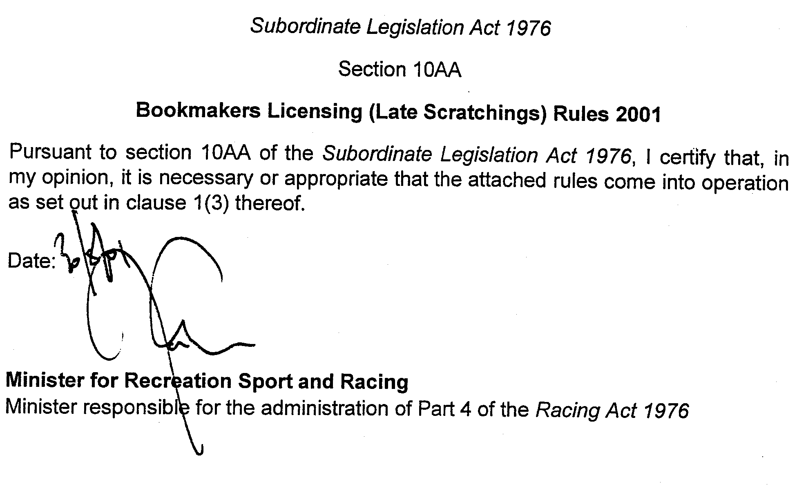
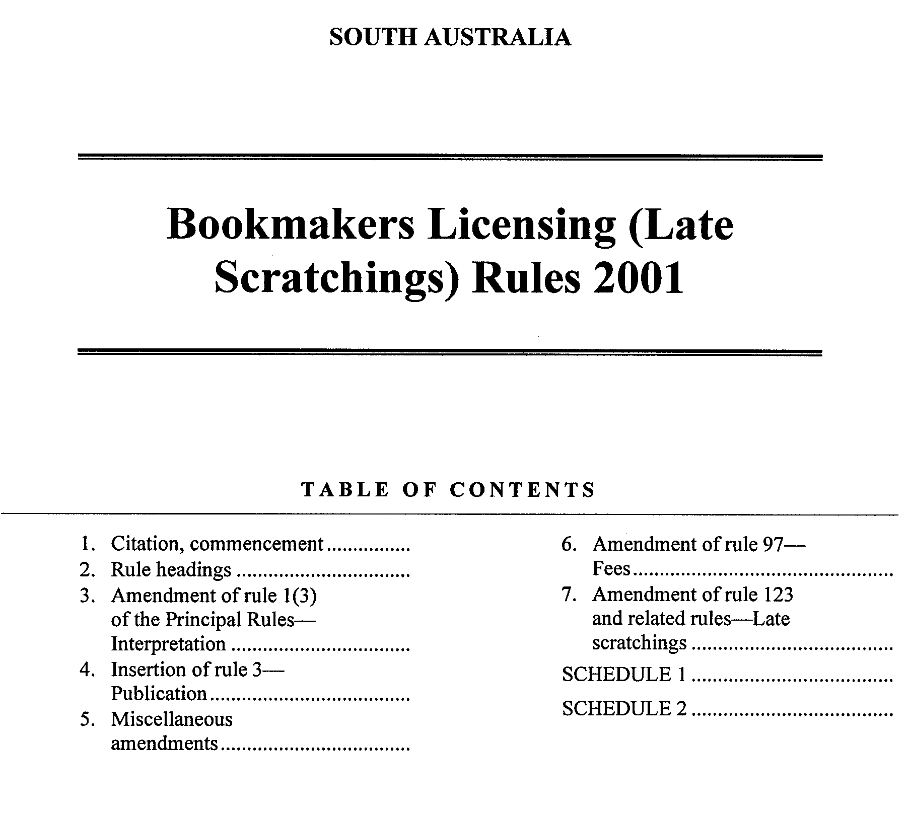
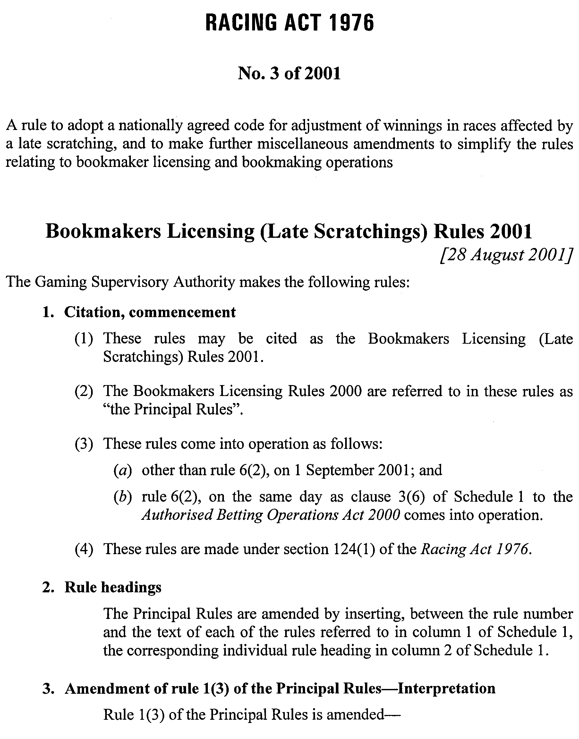
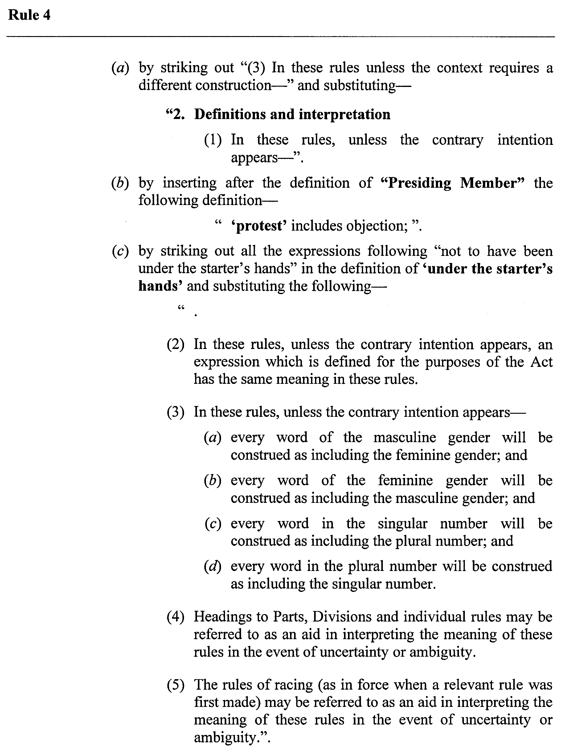
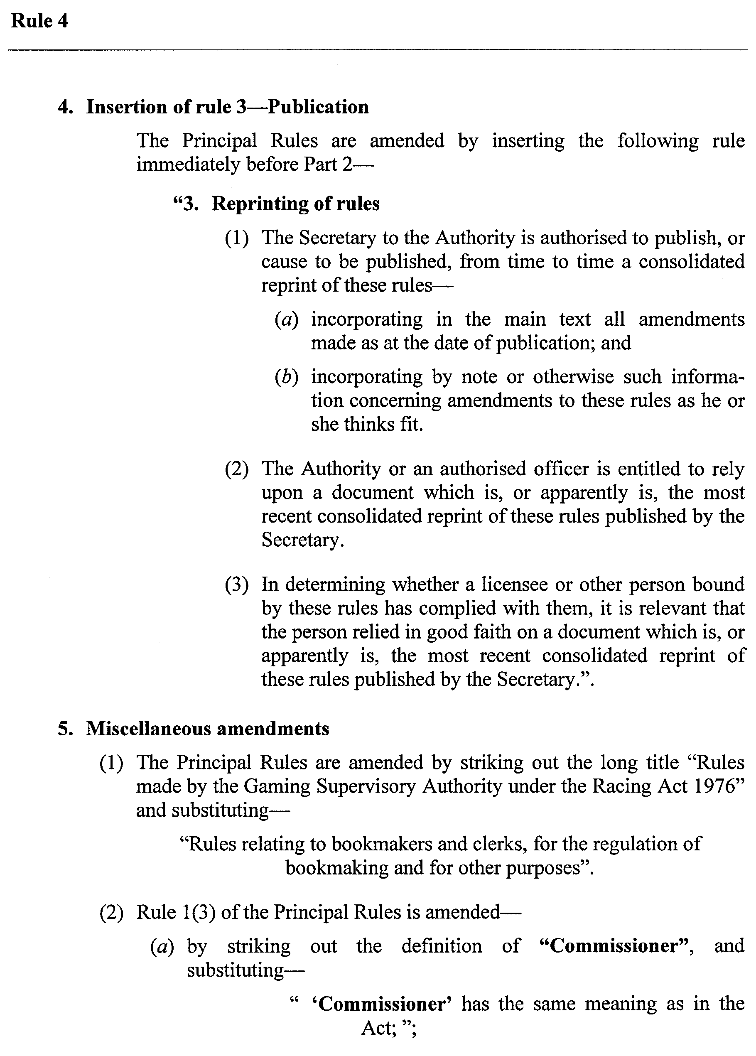
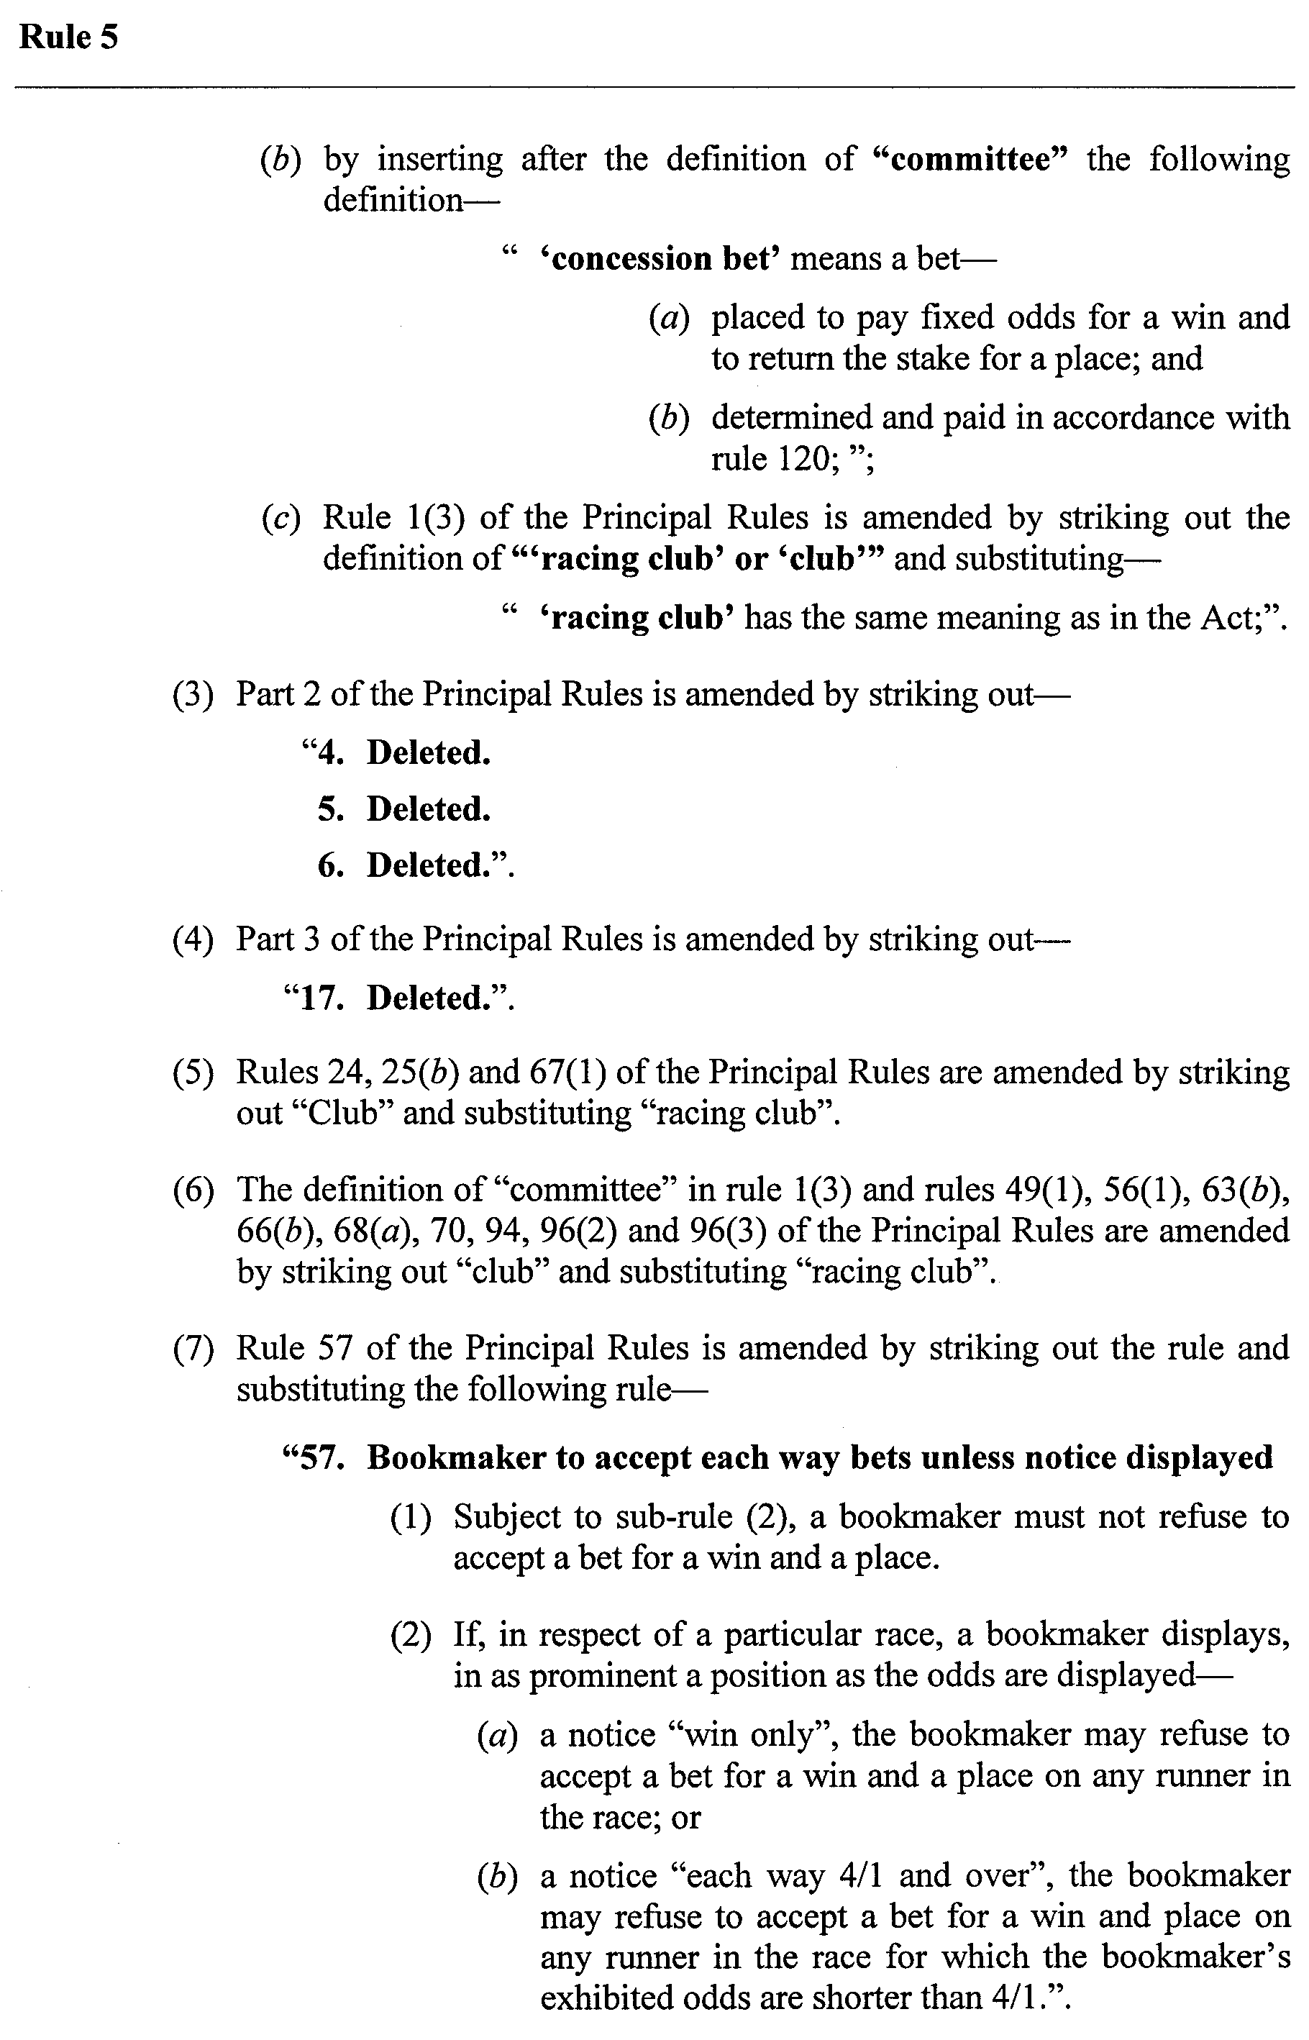
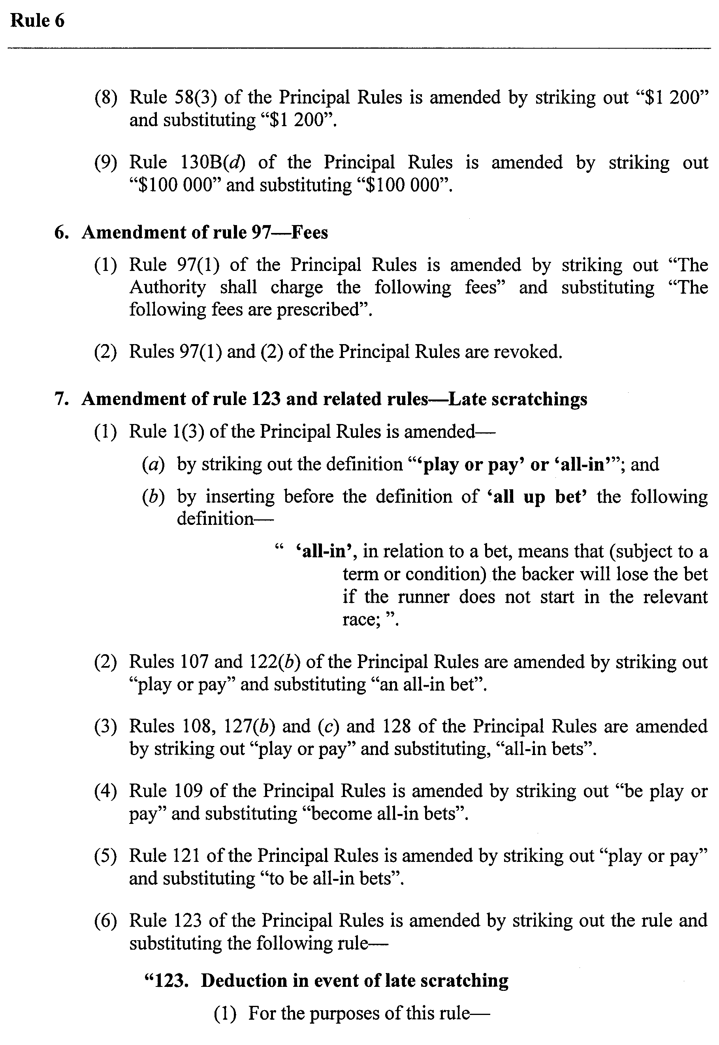
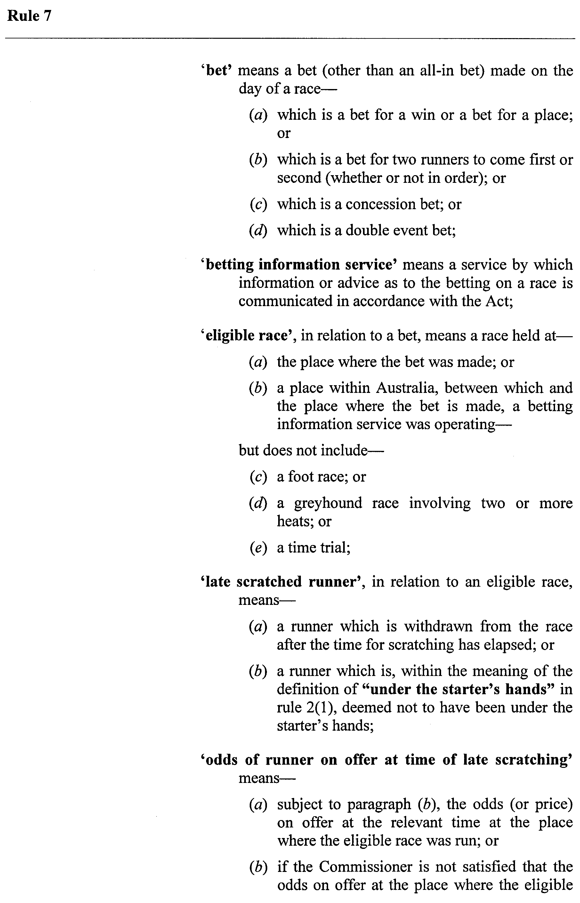
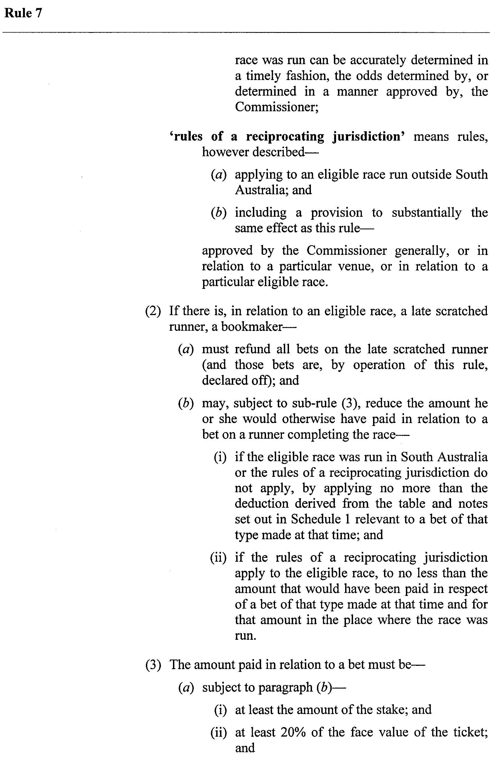
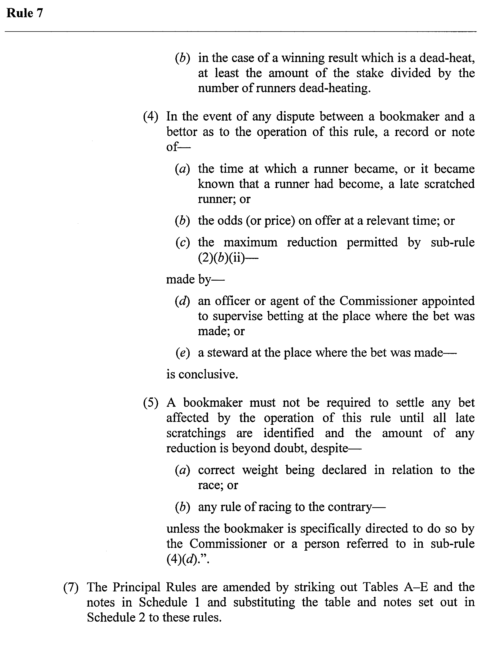
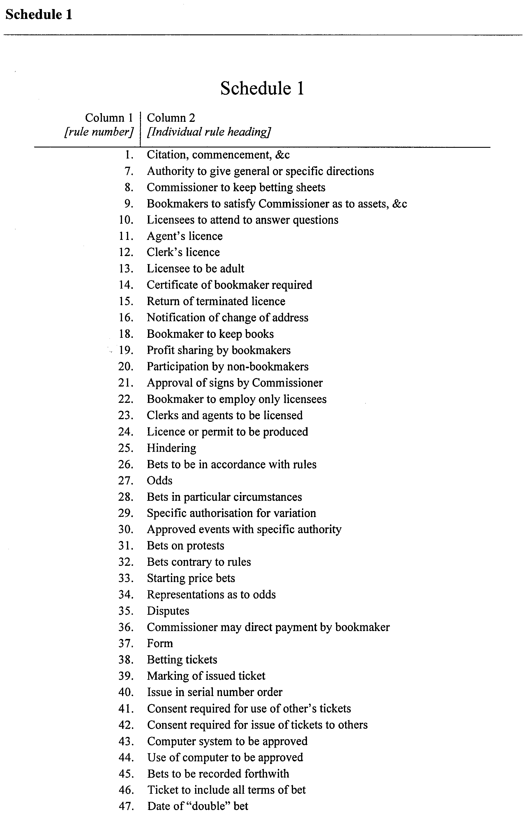
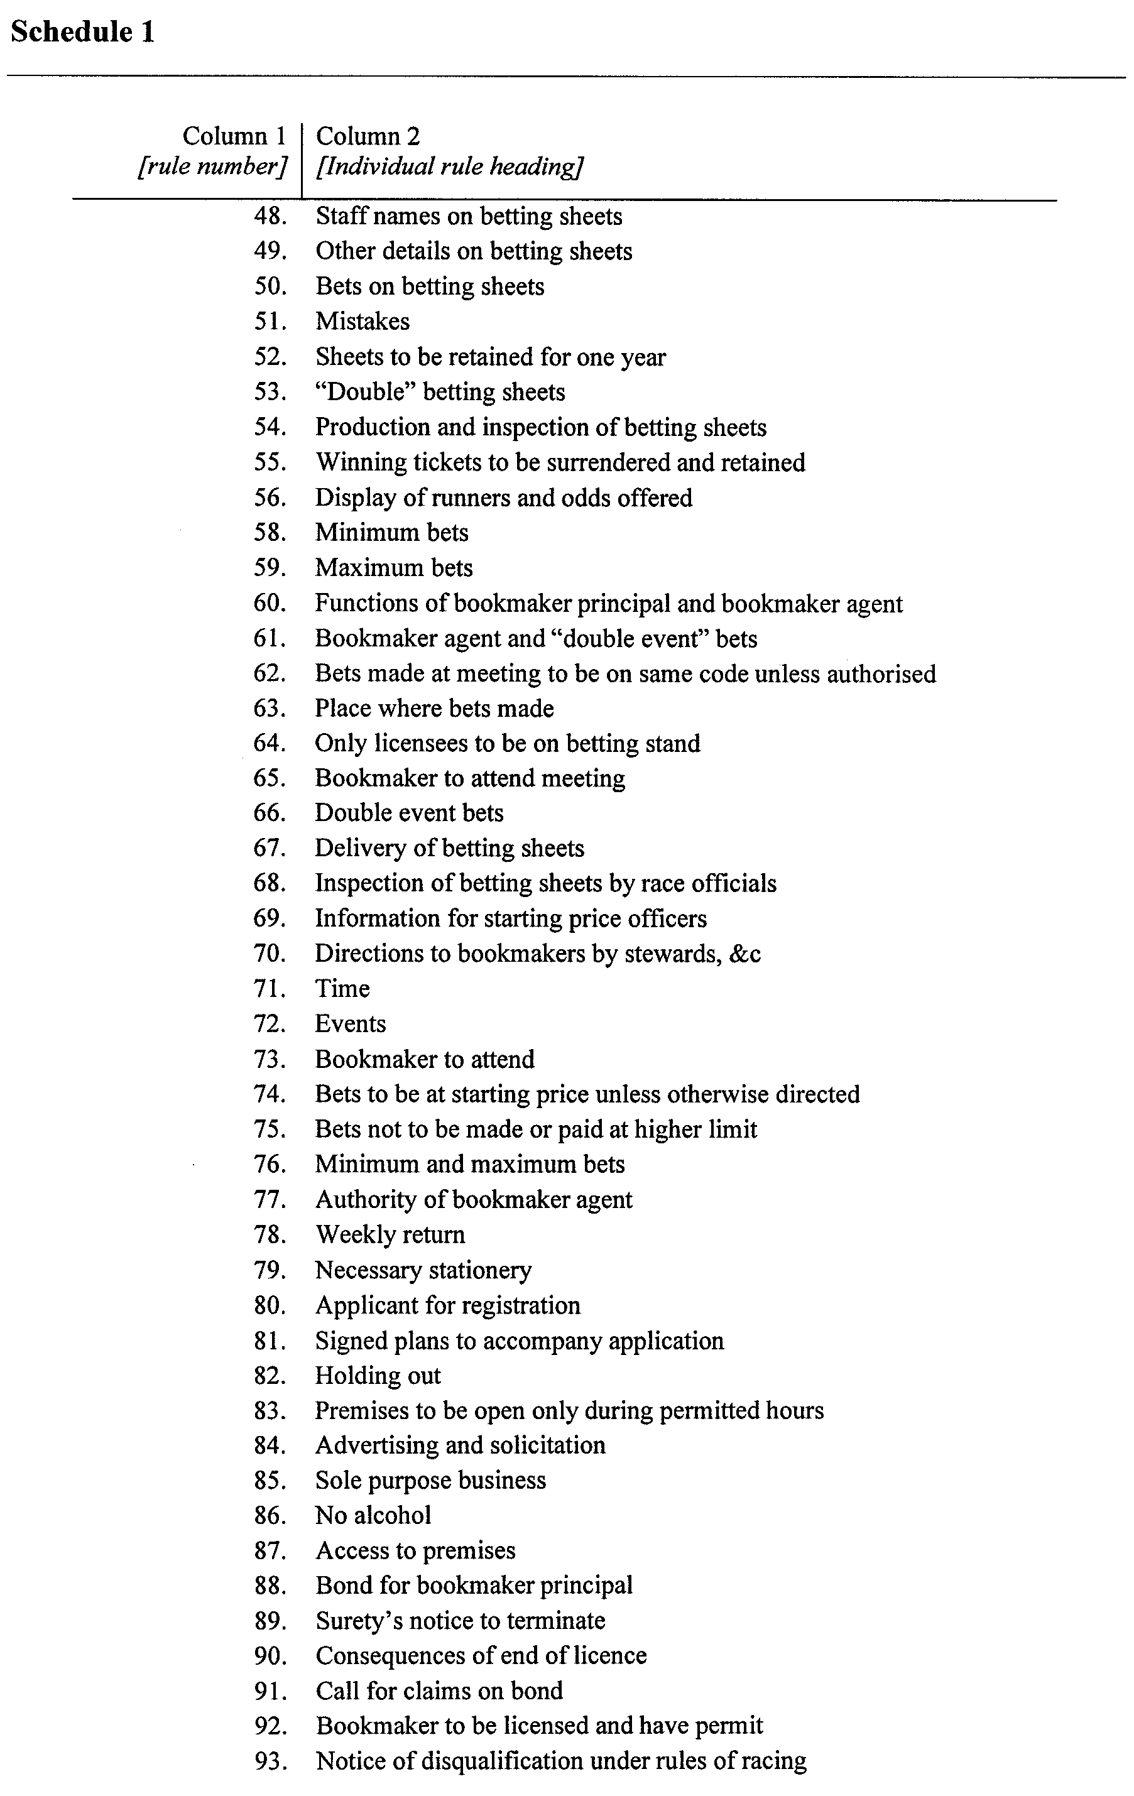
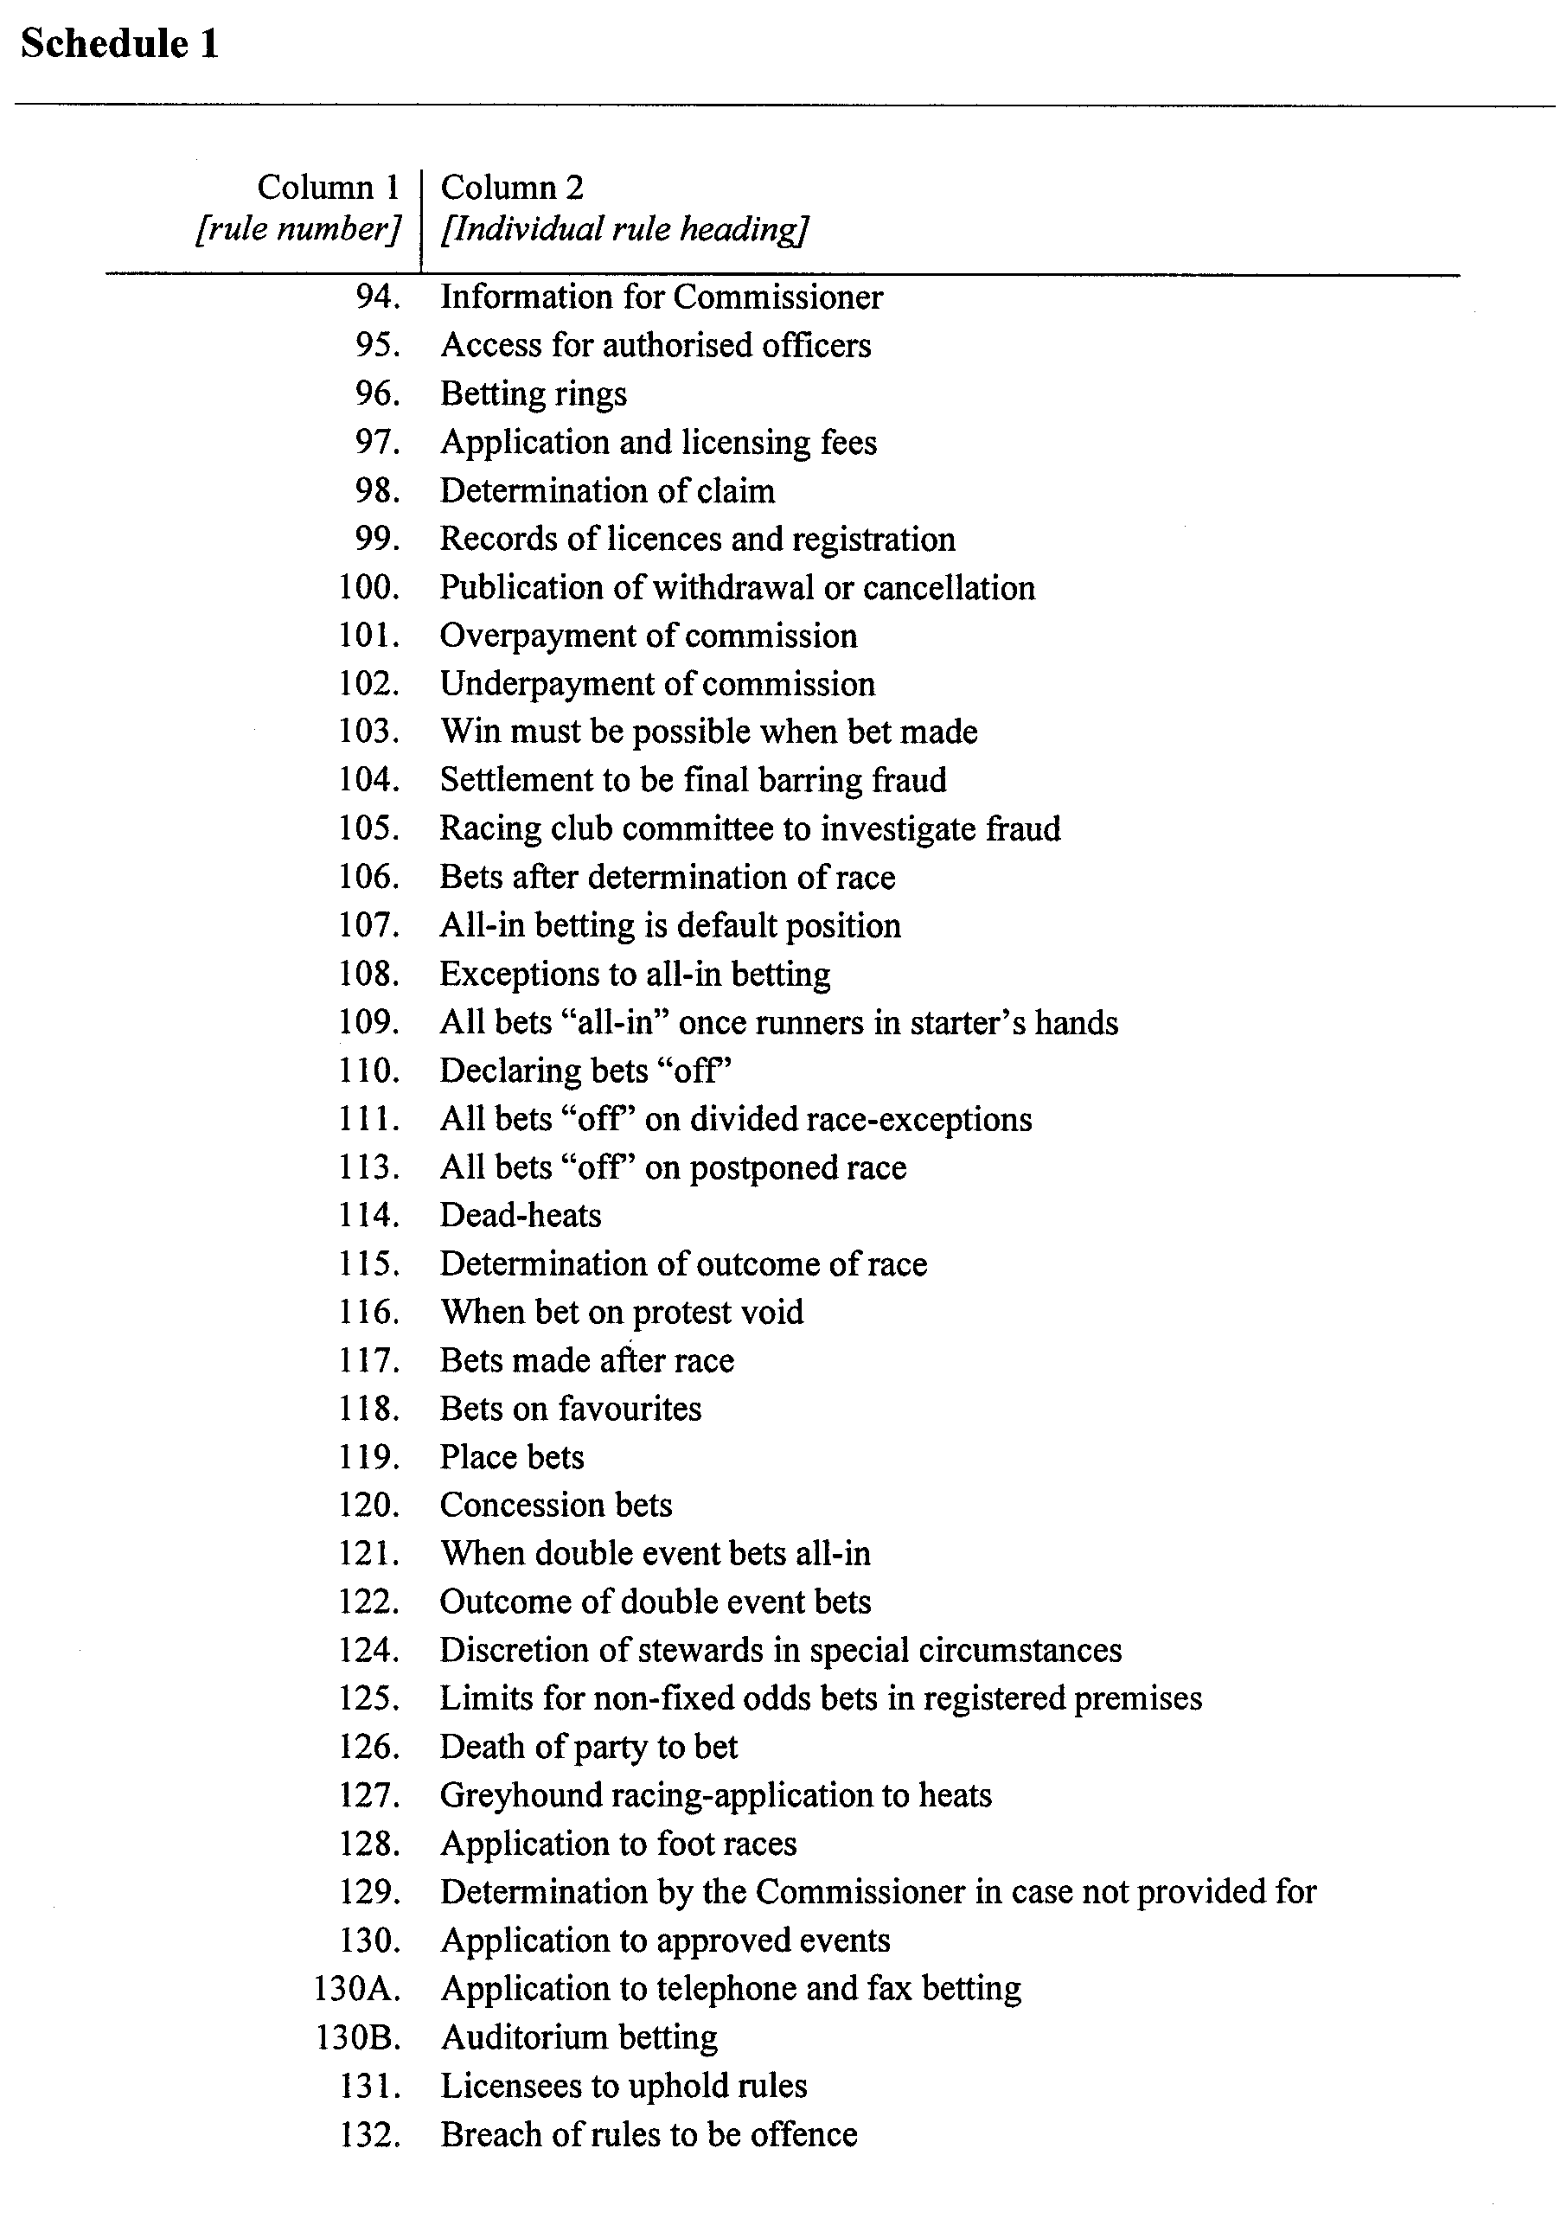
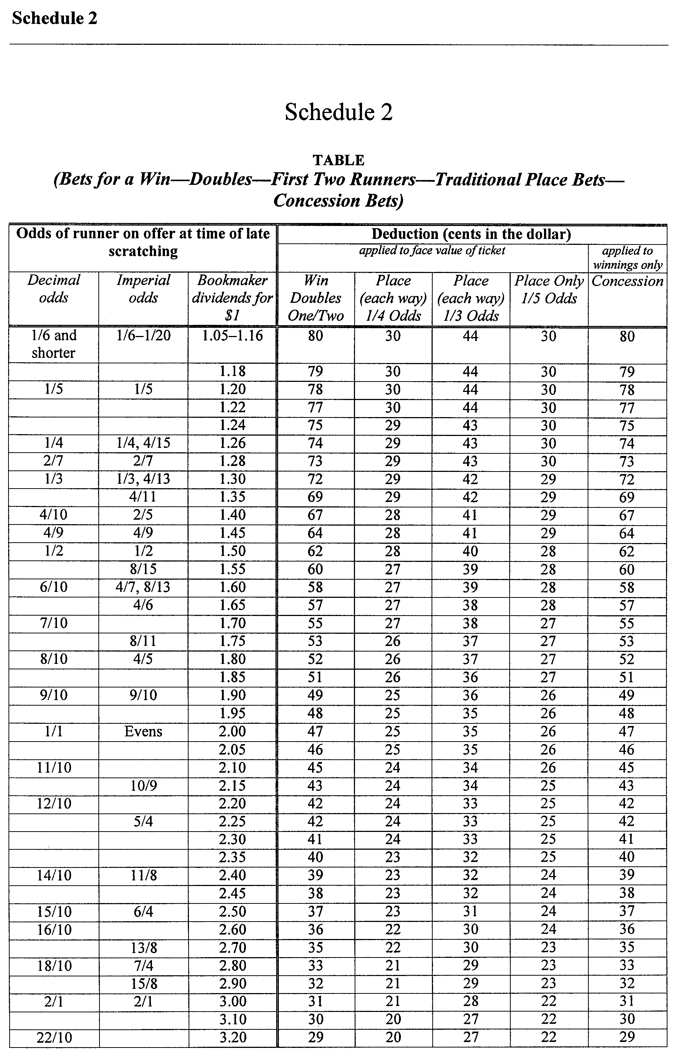
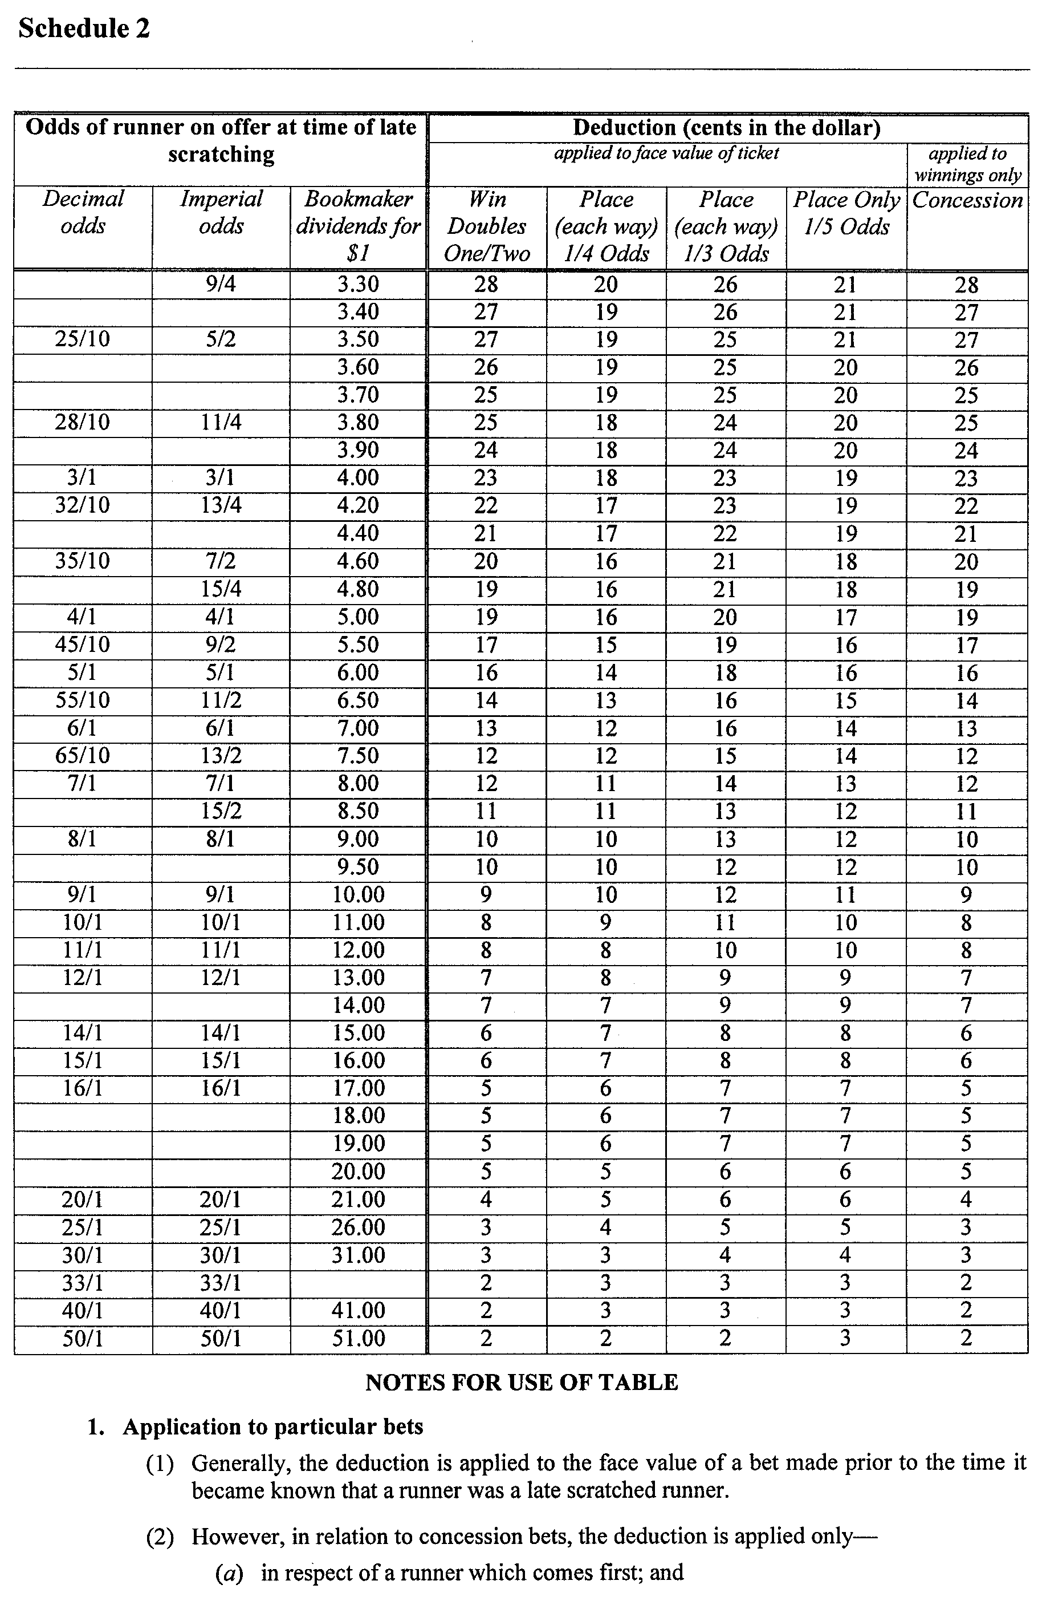

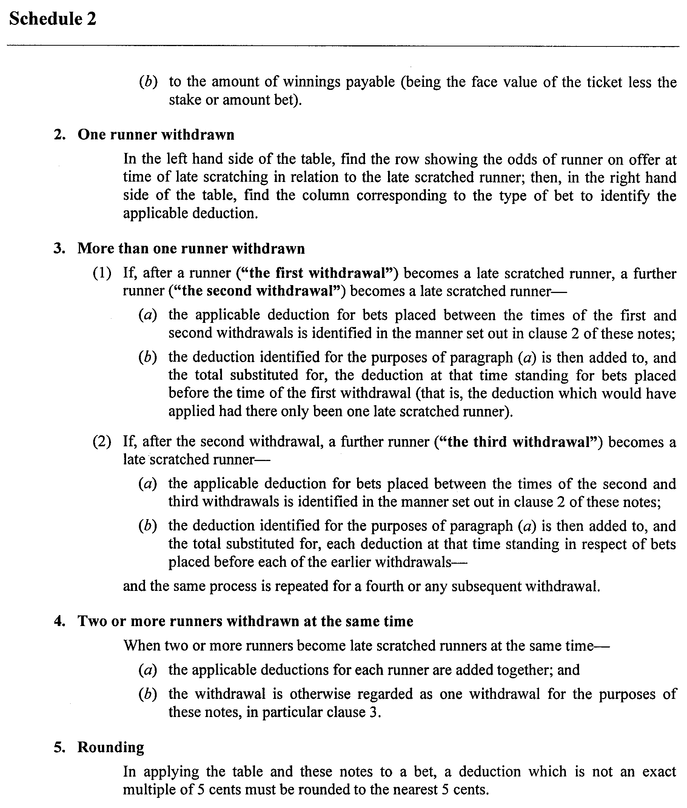

ST JOHN (DISCHARGE OF TRUSTS) ACT 1997

SCHEME FOR APPROVAL BY THE ATTORNEY-GENERAL

I, K. T. GRIFFIN, Attorney-General for the State of South Australia, pursuant to section 3 of the St John (Discharge of Trusts) Act 1997 and after consulting with the Minister for Police, Correctional Services and Emergency Services, St John Ambulance Australia South Australia Inc. and the Priory in Australia of the Most Venerable Order of the Hospital of St John of Jerusalem, the only persons having a proper interest in the matter, do hereby approve, the Scheme for Approval by the Attorney-General attached.

K. T. Griffin, Attorney-General

SOUTH AUSTRALIA

ST JOHN (DISCHARGE OF TRUSTS) ACT 1997

SCHEME FOR APPROVAL BY THE ATTORNEY GENERAL

ST JOHN AMBULANCE AUSTRALIA—SOUTH AUSTRALIA INC (‘St John’), a St John association within the meaning of the St John (Discharge of Trusts) Act 1997 (‘Act’), hereby submits to the Honorable The Attorney General for the State of South Australia, for approval under the Act, the scheme set out in Part 3 of this document (‘Scheme’).
PART 1—PURPOSES OF THE SCHEME
The purposes of the Scheme are:
(a) to allow St John to use and dispose of its freehold land in South Australia, free of certain trust obligations that presently affect, or may presently affect that land;
(b) to give effect to an agreement reached between St John and the Minister for Police, Correctional Services and Emergency Services regarding the immediate disposition of St John’s freehold land and related matters;
(c) to facilitate St John’s final withdrawal from involvement in the provision of ambulance services in South Australia;
(d) to enable SA St John Ambulance Service Inc (‘SAAS’) to carry out its State-wide community service obligations under the Ambulance Services Act 1992 by ensuring its continued right of access to existing metropolitan, regional and rural ambulance facilities; and
(e) to enable St John to continue to carry out its remaining charitable activities by guaranteeing its continued right of access to existing meeting, training and other branch facilities in metropolitan, regional and rural locations.
PART 2—BACKGROUND INFORMATION
1. St John is an association incorporated under the Associations Incorporation Act 1985, for charitable purposes.
2. St John was incorporated to act as the South Australian Council of the Priory in Australia of the Grand Priory of the most Venerable Order of the Hospital of St John of Jerusalem (‘the Priory’).
3. For many years prior to 1993, St John was the sole provider of ambulance services in South Australia.
4. During that period St John, with the help of State government grants and donations and funds raised from the public, acquired:
(a) an ambulance fleet and related equipment; and
(b) acquired or constructed ambulance stations, garages and other ambulance-related facilities (collectively, ‘St John centres’) throughout metropolitan and country South Australia.
5. St John centres were established in some cases on freehold property, in some cases on leased property, and in a few cases on Crown land dedicated for ambulance purposes.
6. From 1993 to the present, the ambulance service previously conducted by St John alone has been conducted by an association jointly owned and controlled by St John Ambulance Australia Inc. and the Government of South Australia. The association was incorporated on 8 January 1993 under the name ‘SA St John Ambulance Service Inc’. It is commonly known by its registered trading name, SA Ambulance Service (‘SAAS’).
7. SAAS was established under the terms of an agreement made on 26 February 1993 between St John, the Priory and the Minister of Health, Family and Community Services for South Australia (‘Joint Venture Agreement’). It succeeded St John as the sole licensed provider of ambulance services in South Australia, with the coming into effect of the Ambulance Services Act 1992, on 1 March 1993.
8. The main purpose of the Joint Venture Agreement, apart of the establishment of SAAS, was to provide for the orderly handover to SAAS of the ambulance service formerly conducted by St John. This involved the transfer of:
(a) employees and their entitlements;
(b) ambulances and other operational equipment; and
(c) certain funds then held and administered by St John,
but did not involve any transfer at that stage of St John’s freehold or leasehold property.
9. Much of the freehold property of St John was then, and is still considered to be subject to undefined charitable trusts. In most cases, the St John freehold property was acquired or improved (or both) with funds that comprised or included grants or donations from the State government, local councils, local hospitals or private individuals. In some cases the land itself was donated.
10. Some of the donated funds used by St John may have been made the subject of express testamentary or inter vivos trust obligations. If that is so, the details are not now known. In most cases, there would not have been any express trust imposed, but trust obligations (for example, the obligation to use the funds for a particular purpose) may have been able to be implied from the circumstances of the donation.
11. St John sought legal advice on this and other issues related to its ability to dispose freely of its property. Appendix A comprises a series of opinions given to St John by Mr HC Williams QC (as he then was) between October 1990 and October 1993.
12. Mr Williams’ opinion of 18 September 1992 considered all of St John’s then freehold and leasehold properties. He distinguished between several categories of property, in each case summarising his view of the status (that is, subject to trust or not) of that category in the following terms:
(1) Properties to which only the Government of South Australia and St John have made a contribution; in such cases my conclusion ... generally is that these properties represent funds which have been dedicated to charitable purposes.
(2) Properties to which the Government, St John and others have contributed; in these cases the question will arise as to the application of funds upon the disposition of the property; in particular there is likely to be an issue as to whether the fund has been dedicated in such a way that it should be treated as a fund which has been specifically committed to the benefit of a particular district.
(3) Properties which are leased or held subject to some form of agreement; in these cases my conclusion generally is that the terms of the lease or agreement will be likely to determine the relevant rights and interests.
(4) Properties held by reason of grace and favour of some other organisation; this situation will be a variant of the preceding sub-paragraph (3).
(5) Properties where the land has been specifically donated by private individuals in such circumstances that it could be inferred that the terms of the trust attaching to the land are particularly restrictive; this situation will be a variation of that outlined in sub-paragraph (2) above.
(6) Properties where a contribution has been made to a community type centre by a user other than St John; this situation is a further variation of sub-paragraph (2) and perhaps a permutation of sub-paragraph (5).
13. As to the difficulty of identifying the particular trust obligations to which individual properties may be subject, Mr Williams said this:
The material set out in the Schedule to this opinion will serve to demonstrate the enormous task which would be involved in seeking to use the processes of the courts to identify the trusts and then to obtain authority to modify those terms to meet the circumstances of each case. My present opinion demonstrates the need for legislative intervention.
14. Mr Williams’ opinion included a schedule giving particulars of the properties he had considered. He said:
... the conclusions to be drawn from the schedule are:
(1) that there is a need for legislation to effect any major adjustment in property rights;
(2) that in the absence of further evidence, the existing property rights are probably as set out in the schedule;
(3) that there are local interests to be taken into account as identified in the schedule. Weight should be given to those local interests in the course of working out any programme of rationalisation;
(4) that in some cases the involvement of some other party (such as the Mothers and Babies Health Association) may require the recognition of that interest in the course of any negotiation.
15. The conclusions reached by Mr Williams are assumed to have been the reason why no attempt was made to deal with the St John real property interests in the context of the Joint Venture Agreement of 1993.
16. The Joint Venture Agreement was seen by both the South Australian Government and St John as the first step in a two-stage process which would result, in due course, in St John’s entire withdrawal from involvement in the operation of the ambulance service in South Australia.
17. In order for this to occur, it was necessary for St John and SAAS (more correctly, the Minister responsible for SAAS) to agree on a final disposition between them of St John’s ambulance-related real property interests. As St John would have a continued interest (for the purposes of its activities other than the ambulance service) in most of the relevant properties, it was accepted by both parties that St John would part with some properties in favour of SAAS, and would retain others.
18. Before St John felt able to agree on any dealings with its land interests, it was necessary to resolve the issues identified by Mr Williams QC.
19. In 1996, the South Australian Government accepted the view, put to it by St John, that legislative intervention was required in order to facilitate dealings with St John properties. The Government passed the St John (Discharge of Trusts) Act 1997 (‘Act’) for this purpose.
20. Agreement has now been reached between St John and the Minister responsible for SAAS, as to the division of St John properties between St John and SAAS. This agreement has been reached in anticipation of St John’s withdrawal from involvement in SAAS, which is intended to occur at the time the agreement is implemented.
21. The subject matter of the agreement falls into three categories of landholding, namely:
(a) land owned in freehold by St John;
(b) land held by St John under a lease or some other form of occupancy agreement; and
(c) Crown land held under the care, control and management of St John.
22. Based on the opinions of Mr Williams QC referred to above, St John believes that:
(a) most, if not all of St John’s freehold land is likely to be subject to charitable trusts of an undefined nature; and
(b) St John’s interest in the land it holds as lessee or licensee is not subject to trust obligations, but only to the obligations expressly set out in the relevant lease or other occupancy agreement.
23. As to land of the type referred to in clause 21 (c) above—while St John is deemed, in relation to Crown land dedicated for a particular purpose, to be a trustee holding the land for that purpose (section 2 (2) of the Act), St John has no reason to believe that it is under any other form of trust obligation in relation to that land.
24. For the reasons set out in clauses 22 and 23 above, St John believes that only its freehold properties are required to be dealt with under this Scheme and the provisions of the Act.
25. The agreement referred to in clause 20 above has been implemented in relation to the other categories of St John property referred to in clause 21.
PART 3—SCHEME PROVISIONS
1. Interpretation
In this part:
‘Act’ means the St John (Discharge of Trusts) Act 1997 as amended;
‘Approval’ means approval of the scheme by the Attorney General under the Act, published in accordance with the Act;
‘Joint Venture Agreement’ means the agreement in writing made on 26 February 1993 between the Minister of Health, Family and Community Services, the Priory and St John;
‘List A Land’ means the properties listed and described in Schedule 1 (List A);
‘List B Land’ means the properties listed and described in Schedule 1 (List B);
‘List C Land’ means the properties listed and described in Schedule 1 (List C);
‘SAAS’ means SA St John Ambulance Service Inc, trading as ‘SA Ambulance Service’;
‘SAAS Leasehold Rights’ means the rights of SAAS as registered lessee under the leases referred to in clause 5(2) of this Part;
‘Scheme’ means this Part of this document, incorporating the Schedules to which it refers, as amended in the course of Approval;
‘Scheme Land’ is a collective reference to the List A Land, the List B Land and the List C Land;
‘St John’ means St John Ambulance Australia—South Australia Inc and, where the context admits or requires, includes each body coming within the term ‘St John association’ as defined in the Act;
‘St John Leasehold Rights’ means the rights of St John as registered lessee under the leases referred to in clause 5 (1) (a) of this Part;
‘St John Licence Rights’ means the rights of St John as licensee under the licenses referred to in clause 5 (1) (b) of this Part; and
‘the Minister’ means the Minister for Police, Correctional Services and Emergency Services.
2. Basis of Submission
(1) This Scheme represents, in part, an agreement reached between St John and the Minister as to the immediate disposition of the Scheme Land.
(2) Under the terms of that agreement, St John may not agree to any amendment to the Scheme without the prior approval of the Minister.
3. Discharge of Trusts of Scheme Land
With effect from the date of Approval, all charitable trusts then affecting St John as owner of any Scheme Land are forever fully discharged.
4. Immediate Disposition of Scheme Land
(1) St John will, on and by force of Approval, convey to SAAS an estate in fee simple in all of the List A Land.
(2) St John will remain the owner of all List B Land and List C Land, subject to SAAS Leasehold Rights.
(3) St John will be free in future to dispose of its interest in all or any of the List B Land and the List C Land, subject only to SAAS Leasehold Rights, as St John sees fit.
5. Scheme Land Use and Occupancy Arrangements
(1) On Approval, SAAS will grant to St John:
(a) a registered lease in the form set out in Part 1 of Schedule 2, in respect of each of the separate premises listed and described in Part 2 of Schedule 2;
(b) a licence in the form set out Part 1 of Schedule 3, in respect of each of the separate premises listed and described in Part 2 of Schedule 3.
(2) On Approval, St John will grant to SAAS a registered lease, in the form set out in Part 1 of Schedule 4, in respect of each of the separate premises listed and described in Part 2 of Schedule 4, in each case for the term, and subject to the special conditions (if any) specified in Part 2 of Schedule 4.
6. Termination of Joint Venture Agreement
(1) Following Approval, the Joint Venture Agreement and all agreements and arrangements ancillary to the Joint Venture Agreement will terminate, and the St John parties will withdraw from any involvement in SAAS in accordance with an agreement to be entered into between the Minister and the St John parties for that purpose.
(2) St John and SAAS will cooperate, and each will take the necessary action (including any necessary amendments to the Rules of SAAS) to give effect to (1).
SCHEDULE 1 – SCHEME LAND

LIST A – PROPERTIES TO BE TRANSFERRED TO SAAS AS FEE SIMPLE OWNER

ID No. | Location | Land Description (Certificate of Title Register Book Volume and Folio Number) | Encumbrances | Comments
A1 | 20 Fourth Street, Cleve, 5640 | 5796/98 | Mining rights reserved to Crown. Otherwise Nil.
A2 | Lincoln Highway, Cowell, 5602 | 5467/319 | Nil.
A3 | 19 Tumby Bay Road, Cummins, 5631 | 5782/312 | Nil. | CAHFS also uses part of this property under an informal arrangement.
A4 | 369 Grange Road, Fulham Gardens, 5024 | 5845/122 | Trust grant for use as an Ambulance Reserve. Otherwise Nil.
A5 | Light Street, Hamley Bridge, 5401 | 5570/711 | Nil.
A6 | 10 Hill Street, Kapunda, 5373 | 5562/406 | Subject to ROW – otherwise Nil.
A7 | Cross Street, Kimba, 5641 | 5543/955 | Nil. | CFS also uses part of this property under an informal arrangement.
A8 | Musgrave Avenue, Lucindale, 5272 | 5636/747 | Nil. | CAHFS also uses part of this property under an informal arrangement.
A9 | Adelaide Road, Mallala, 5502 | 5553/432 | Nil. | CAHFS also uses part of this property under an informal arrangement.
A10 | 346 Sturt Road, Marion, 5043 | 3102/141 | Reservation of coals, mines, minerals and quarries to South Australian Company. Otherwise Nil.
A11 | Ryan Street, Moonta, 5558 | 5792/385 | Nil.
A12 | Government Road, Padthaway, 5271 | 5600/496 | Nil.
A13 | 164 Eighteenth Street, Renmark, 5341 | 5849/114 | Subject to such of the reservations provisions and conditions contained in the original Land Grant Register Book Volume 537 Folio 187 as are still subsisting and capable of taking effect. Otherwise Nil.
A14 | Bremer Drive, Salisbury, 5108 | 5717/371 | Encumbrance No. 4854195 to South Australian Housing Trust. Otherwise Nil.
A15 | Wimbery Street, Tumby Bay, 5605 | 5215/256 | Nil.
A16 | Weaners Street, Yorketown, 5576 | 5397/616 | Nil.

SCHEDULE 1 – SCHEME LAND cont.
LIST B – PROPERTIES TO BE RETAINED BY ST JOHN
ID No. | Location | Land Description (Certificate of Title Register Book Volume and Folio Number) | Encumbrances | Comments
B1 | Aldinga Beach Road, Aldinga, 5173 | 5411/699 | Easement for drainage purposes. Otherwise Nil. | Owned as tenant in common with Country Fire Service (CFS 75/100 parts & St John 25/100 parts).
B2 | War Memorial Drive, Balaklava, 5461 | 5848/118 | Nil
B3 | 155 Main Road, Blackwood, 5051 | 5541/735 | Nil
B4 | Tatiara Terrace, Bordertown, 5268 | 5581/926 | Nil
B5 | Arundel Road, Brighton, 5048 | 5589/768 | Nil
B6 | 324 Main North Road, Clare, 5453 | 5703/413 | Nil
B7 | 35 Brandis Street, Crystal Brook, 5523 | 5781/780 | Nil | CAHFS also uses part of this property under an informal arrangement.
B8 | Elizabeth Way, Elizabeth, 5112 | 5803/250 | Encumbrances Nos 2302912 and 2724354 to South Australian Housing Trust. Otherwise Nil. The SAHT Encumbrances required the building of a St John Centre within a certain period.
B9 | 24 High Street, Gladstone, 5473 | 5647/82 | Nil.
B10 | 6 Tayla Street, Kadina, 5554 | 5539/718 | Nil
B11 | Hill Avenue, Keith, 5267 | 5520/349 | Nil | CAHFS also uses part of this property under an informal arrangement.
B12 | 17 Franklin Street, Kingscote, 5223 | 5291/879 | Subject to easement in favour of the adjoining property overhanging eaves and gutters. Otherwise Nil.
B13 | 2 Agnes Street, Kingston SE, 5275 | 5806/65 | Nil.
B14 | Chandos Terrace, Lameroo, 5302 | 5492/789 | Nil. | CAHFS also uses part of this property under an informal arrangement.
B15 | Post Office Road, Lobethal, 5241 | 5708/121 | Nil.
B16 | Railway Terrace, Manna Hill, 5440 | 5687/327 | Nil.
B17 | Adelaide Road, Mannum, 5238 | 5815/415 | Nil.
B18 | Morgan, 5320 | 5262/285 | Nil.
B19 | Mann Street, Mount Barker, 5251 | 4191/931 | Subject to certain ROW. Certain rights reserved to the Crown under Land Grant Volume 1996 Folio 151. Otherwise Nil. | Local community groups make use of the hall under an informal arrangement.
B20 | Hospital Road, Mount Pleasant, 5235 | 5782/182 & 5485/829 | Nil.
B21 | 26 Flaxmill Road, Noarlunga, 5168 | 5455/478 | Subject to easements to the Australian and Overseas Telecommunications Corporation. Subject to an easement for sewerage purposes. Encumbrance numbers 4075224 and 6387929 to South Australian Housing Trust.
B22 | 180 Tynte Street, North Adelaide, 5006 | 5172/957 | Nil.
B23 | 1 Coke Street, Norwood, 5067 | 5471/190 | Nil.
B24 | Church Street, Penola, 5277 | 5498/340 | Nil.
B25 | 53 Gertrude Street, Port Pirie, 5540 | 5775/498 & 5539/720 | CT Volume 5775 Folio 498 subject to an easement to the Minister for Infrastructure. CT Volume 5539 Folio 720 - Nil.
B26 | 387 Regency Road, Prospect, 5082 | 5800/60 & 5583/839 | Nil.
B27 | 16 Torrens Road, Riverton, 5412 | 5539/719 | Nil. | CFS and SES also use this property.
B28 | 298 Mount Barker Road, Stirling, 5152 | 5487/234 | Nil. | Station known as Aldgate.
B29 | 3 Rankine Street, Strathalbyn, 5277 | 5479/137 | Nil.
B30 | Princes Highway, Tailem Bend, 5260 | 5397/615 | Nil.
B31 | 14 Arthur Street, Unley, 5061 | 5406/108 | Nil.
B32 | Edmund Street, Unley, 5061 | 5297/67, 5668/122, 5837/850 | Certificate of Title Volume 5837 Folio 850 is subject to an easement over portion of the land to Distribution Lessor Corporation for electricity supply purposes. Certificate of Title Volume 5297 Folio 67 and Volume 5668 Folio 122 Nil.
B33 | 11 Acorn Road, Camden Park, (West Torrens) 5038 | 5514/509 | Nil. | Station known as West Torrens.
B34 | Nicholson Avenue, Whyalla, 5600 | 5212/285 & 5212/286 | Nil.
B35 | 9A Bower Street, Woodville, 5011 | 5766/550 | Nil.
B36 | Main Street, Yankalilla, 5203 | 5471/80 | Nil.

SCHEDULE 1 – SCHEME LAND cont.

LIST C – PROPERTIES TO BE RETAINED BY ST JOHN PENDING FURTHER NEGOTIATION
WITH SAAS
ID No. | Location | Land Description (Certificate of Title Register Book Volume and Folio Number) | Encumbrances | Comments
C1 | North Street, Angaston, 5353 | 5594/46, 5716/788 & 5488/816 | Subject to easement and ROW.
C2 | Swanport Road, Murray Bridge, 5253 | 5397/356 & 5704/55 | Nil.
C3 | Torrens Street, Victor Harbor, 5211 | 5814/134 | Nil.

SCHEDULE 2 – LEASEHOLD ARRANGEMENTS FOR LIST A LAND

PART 1 – FORM OF LEASE

(Intentionally Excluded)

SCHEDULE 2 – LEASEHOLD ARRANGEMENTS FOR LIST A LAND contd.

PART 2 – LEASED PREMISES
ID No. | Location | Lessee | Land Description (Certificate of Title Register Book Volume and Folio Number) | Leased Premises Description | Term | Special Conditions
A1 | 20 Fourth Street, Cleve, 5640 | St John | 5796/98 | To be agreed based on current occupancy and use, and lease arrangements documented prior to final Scheme approval. | 40 Years | Nil
A4 | 369 Grange Road, Fulham Gardens, 5024 | " " | 5845/122 | " " | 5 Years | Obligation to vacate when SAAS vacates Camden Park (B33). Continued right of occupation until that occurs.
A9 | Adelaide Road, Mallala, 5502 | " " | 5553/432 | " " " " | 40 Years | Nil
A11 | Ryan Street, Moonta, 5558 | " " | 5792/385 | " " | " " | " "
A13 | 164 Eighteenth Street, Renmark, 5341 | " " | 5849/114 | " " | " " | " "
A14 | Bremer Drive, Salisbury, 5108 | " " | 5717/371 | " " | 5 Years | Obligation to vacate when SAAS vacates Elizabeth (B8). Continued right of occupation until that occurs.
A15 | Wimbery Street, Tumby Bay, 5605 | " " | 5215/256 | " " | 40 Years | Nil

SCHEDULE 3 – OCCUPATION LICENCE ARRANGEMENTS FOR LIST A LAND

PART 1 – FORM OF OCCUPATION LICENCE

(Intentionally Excluded)

SCHEDULE 3 – OCCUPATION LICENCE ARRANGEMENTS FOR LIST A LAND contd.

PART 2 – PREMISES SUBJECT TO LICENCE ARRANGEMENTS
ID No. | Location | Licensee | Land Description (Certificate of Title Register Book Volume and Folio Number) | Licensed Premises Description | Term | Special Conditions
A2 | Lincoln Highway, Cowell, 5602 | St John | 5467/319 | To be agreed based on current occupancy and use, and licence arrangements documented prior to final Scheme approval | Indefinite | Nil
A3 | 19 Tumby Bay Road, Cummins, 5631 | " " | 3953/169 | " " | " " | " "
A6 | 10 Hill Street, Kapunda, 5373 | " " | 5562/406 | " " | " " | " "
A7 | Cross Street, Kimba, 5641 | " " | 5543/955 | " " | " " | " "
A8 | Musgrave Avenue, Lucindale, 5272 | " " | 5636/747 | " " | " " | " "
A12 | Government Road, Padthaway, 5271 | " " | 5600/496 | " " | " " | " "
A16 | Weaners Street, Yorketown, 5576 | " " | 5397/616 | " " | " " | " "

SCHEDULE 4 – LEASEHOLD ARRANGEMENTS FOR LIST B AND C LAND

PART 1 – FORM OF LEASE

(Intentionally Excluded)

SCHEDULE 4 – LEASEHOLD ARRANGEMENTS FOR LIST B AND C LAND contd.

PART 2 – LEASED PREMISES
ID No. | Location | Lessee | Land Description (Certificate of Title Register Book Volume and Folio Number) | Leased Premises Description | Term | Special Conditions
B2 | War Memorial Drive, Balaklava, 5461 | SAAS | 5848/118 | To be agreed based on current use and occupancy, and lease arrangements documented prior to final Scheme approval | 40 | Nil
B4 | Tatiara Terrace, Bordertown, 5268 | " " | 5581/962 | " " | " " | " "
B6 | 324 Main North Road, Clare, 5453 | " " | 5703/413 | " " | " " | " "
B7 | 35 Brandis Street, Crystal Brook, 5523 | " " | 4144/801 | " " | " " | " "
B8 | Elizabeth Way, Elizabeth, 5112 | " " | 5803/250 | " " | 5 Years | " "
B9 | 24 High Street, Gladstone, 5473 | " " | 5647/82 | " " | 40 Years | " "
B10 | 6 Tayla Street, Kadina, 5554 | " " | 5539/718 | " " | " " | " "
B11 | Hill Avenue, Keith, 5267 | " " | 5520/349 | " " | " " | " "
B12 | 17 Franklin Street, Kingscote, 5223 | " " | 5291/879 | " " | " " | " "
B13 | 2 Angas Street, Kingston SE, 5275 | " " | 5806/65 | " " | " " | Nil
B14 | Chandos Terrace, Lameroo, 5302 | " " | 5492/789 | " " | " " | " "
B17 | Adelaide Road, Mannum, 5238 | " " | 5815/415 | " " | " " | " "
B18 | Morgan, 5320 | " " | 5262/285 | " " | " " | " "
B19 | Mann Street, Mount Barker, 5251 | " " | 4191/931 | " " | " " | " "
B20 | Hospital Road, Mount Pleasant, 5235 | " " | 4307/779 & 5485/829 | " " | " " | " "
B21 | 26 Flaxmill Road, Noarlunga, 5168 | " " | 5455/478 | " " | " " | " "
B24 | Church Street, Penola, 5277 | " " | 5498/340 | " " | " " | " "
B25 | 53 Gertrude Street, Port Pirie, 5540 | " " | 5775/498 & 5539/720 | " " | " " | " "
B26 | 387 Regency Road, Prospect, 5082 | " " | 5800/60 & 5583/839 | " " | 5 Years | " "
B28 | 298 Mount Barker Road, Stirling, 5152 | " " | 5487/234 | " " | 40 Years | " "
B29 | 3 Rankine Street, Strathalbyn, 5255 | " " | 5479/137 | " " | " " | " "
B30 | Princes Highway, Tailem Bend, 5260 | " " | 5397/615 | " " | " " | Nil
B33 | 11 Acorn Road, Camden Park, (West Torrens) 5038 | " " | 5514/509 | " " | 5 Years | Nil
B36 | Main Street, Yankalilla, 5203 | " " | 5471/80 | " " | 40 Years | " "
C1 | North Street, Angaston, 5353 | " " | 5594/46 | " " | 5 Years | SAAS has successive 5 year options to renew pending final agreement between the parties as to future disposal of property.
C2 | Swanport Road, Murray Bridge, 5253 | " " | 5397/356 | " " | " " | " "
C3 | Torrens Street, Victor Harbor, 5211 | " " | 5814/134 | " " | " " | " "

NOTE: Whyalla (B34) is not included, as the existing Tenancy Agreement will remain in force according to its terms.
FURTHER NOTE: Unley (B31) is not included, as these premises have recently been vacated by SAAS.

APPENDIX A

OPINIONS

(Intentionally Excluded)

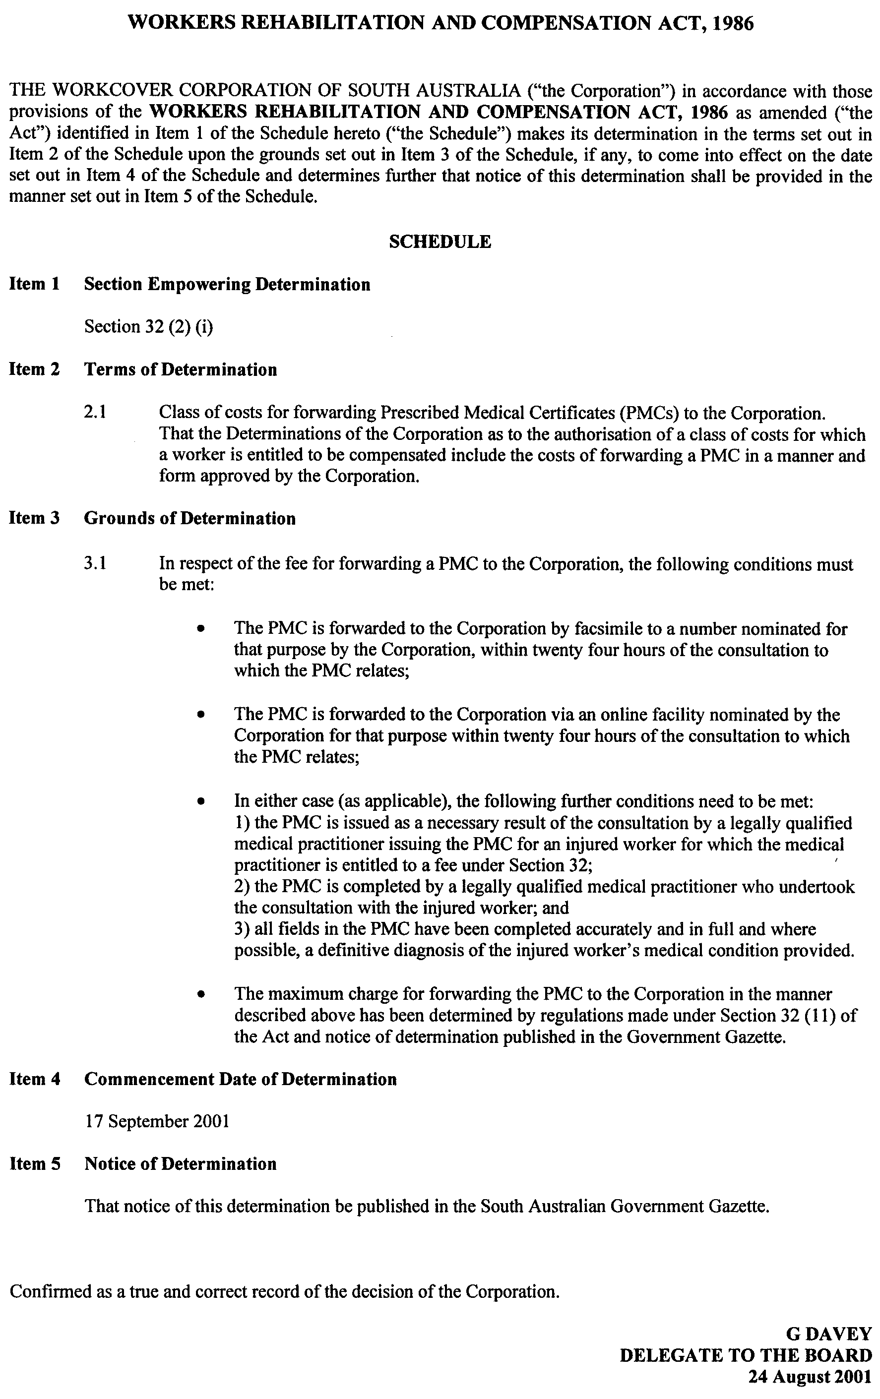



REGULATIONS UNDER THE BUILDING WORK CONTRACTORS ACT 1995
────
No. 216 of 2001
────
At the Executive Council Office at Adelaide, 13 September 2001

PURSUANT to the Building Work Contractors Act 1995 and with the advice and consent of the Executive Council, I make the following regulations.
E. J. NEAL, Governor

PURSUANT to section 10AA(2) of the Subordinate Legislation Act 1978, I certify that, in my opinion, it is necessary or appropriate that the following regulations come into operation as set out below.

K. T. GRIFFIN, Minister for Consumer Affairs
───────────────────
SUMMARY OF PROVISIONS

1. Citation
2. Commencement
3. Variation of reg. 5—Definitions of building work, etc.
───────────────────

Citation
1. The Building Work Contractors Regulations 1996 (see Gazette 23 May 1996 p. 2547), as varied, are referred to in these regulations as "the principal regulations".

Commencement
2. These regulations will come into operation on 15 October 2001.

Variation of reg. 5—Definitions of building work, etc.
3. Regulation 5 of the principal regulations is varied by striking out subregulation (4) and substituting the following subregulations:

(4) For the purposes of paragraph (a) of the definition of "minor domestic building work" in section 3 of the Act, the prescribed sum is—

(a) in respect of a domestic building work contract entered into before 15 October 2001—$5 000;

(b) in respect of a domestic building work contract entered into on or after 15 October 2001—$12 000.

(5) For the purposes of paragraph (b) of the definition of "minor domestic building work" in section 3 of the Act, the prescribed sum is $12 000.

OCBA CS 602/01-008 R. DENNIS, Clerk of the Council

REGULATIONS UNDER THE FISHERIES ACT 1982
────
No. 217 of 2001
────
At the Executive Council Office at Adelaide, 13 September 2001

PURSUANT to the Fisheries Act 1982 and with the advice and consent of the Executive Council, I make the following regulations.
E. J. NEAL, Governor

PURSUANT to section 10AA(2) of the Subordinate Legislation Act 1978, I certify that, in my opinion, it is necessary or appropriate that the following regulations come into operation as set out below.

ROB KERIN, Minister for Primary Industries and Resources
───────────────────
SUMMARY OF PROVISIONS

1. Citation
2. Commencement
3. Variation of reg. 4—Interpretation
4. Variation of reg. 6—Issue of licences
5. Substitution of regs. 14 and 15
14. Blue crab pot entitlement and carriage of crab pots on boats
15. Individual blue crab catch quota system
6. Variation of Sched. 2—Fees
7. Insertion of Sched. 4
SCHEDULE 4
Transitional provisions
───────────────────

Citation
1. The Scheme of Management (Blue Crab Fishery) Regulations 1998 (see Gazette 11 June 1998 p. 2519), as varied, are referred to in these regulations as "the principal regulations".

Commencement
2. (1) Subject to subregulation (2), these regulations will come into operation on 17 September 2001.

(2) Regulation comes into operation on the day on which these regulations are made.

Variation of reg. 4—Interpretation
3. Regulation 4 of the principal regulations is varied—

(a) by striking out the definition of "blue crab net entitlement" in subregulation (1);

(b) by striking out the definition of "crab net" in subregulation (1) and substituting the following definition:

"blue crab quota", in relation to a licence in respect of the Blue Crab Fishery or a marine scalefish fishery and a blue crab fishing zone, means the maximum number of kilograms of blue crab that may be lawfully taken by the holder of the licence in that zone during a licence period, being the product of—

(a) the unit entitlement of that licence in respect of that zone; and

(b) the unit value for that zone and that licence period,

subject to any variation of the blue crab quota of the licence applying during that licence period;;

(c) by striking out the definition of "licence period" in subregulation (1) and substituting the following definitions:

"licence period" means—

(a) the period commencing on 17 September 2001 and ending on 30 June 2002; or

(b) the period of 12 months commencing on 1 July 2002 or on 1 July in any subsequent year;

"marine scalefish fishery" has the same meaning as in the Scheme of Management (Marine Scalefish Fisheries) Regulations 1991;;

(d) by inserting after the definition of "Spencer Gulf Blue Crab Fishing Zone" in subregulation (1) the following definitions:

"unit entitlement", in relation to a licence in respect of the Blue Crab Fishery or a marine scalefish fishery and a blue crab fishing zone, means the number of blue crab units for the time being allocated to the licence in respect of that zone;

"unit value" means the number of kilograms of blue crab determined by the Director to be the value of a blue crab unit for a blue crab fishing zone and a licence period.

Variation of reg. 6—Issue of licences
4. Regulation 6 of the principal regulations is varied—

(a) by striking out subregulation (2) and substituting the following subregulation:

(2) An application for the issue of a licence in respect of the fishery may be made only by a person if he or she holds a licence in respect of a marine scalefish fishery endorsed with a condition imposing a blue crab quota on the licence and the unit entitlement of the licence for the time being is—

(a) in respect of the Gulf St. Vincent Blue Crab Fishing Zone—700 or more blue crab units;

(b) in respect of the Spencer Gulf Blue Crab Fishing Zone—750 or more blue crab units.;

(b) by striking out from subregulation (4)(b)(i) "the Miscellaneous Fishery or Marine Scalefish Fishery" and substituting "a marine scalefish fishery";

(c) by striking out from subregulation (5) "A licence fee payable in respect of a licence" and substituting "Where an application for the issue of a licence is made within three months after the commencement of a licence period commencing on 1 July in any year, the licence fee".

Substitution of regs. 14 and 15
5. Regulations 14 and 15 of the principal regulations are revoked and the following regulations are substituted:

Blue crab pot entitlement and carriage of crab pots on boats
14. (1) In this regulation—

"conversion value" means the number determined by the Director to be the conversion value for a blue crab fishing zone and a licence period.

(2) The Director may impose or vary conditions on licences in respect of the fishery fixing or varying blue crab pot entitlements as follows:

(a) on the issue of a licence in respect of the fishery, the licence must be endorsed with a blue crab pot entitlement calculated in accordance with the formula set out in subregulation (3);

(b) on renewal of a licence in respect of the fishery referred to in Schedule 4 for a term expiring on 30 June 2002, the licence must be endorsed with a blue crab pot entitlement calculated in accordance with the formula set out in subregulation (3);

(c) on the commencement of each licence period, the Director must determine the conversion value for a blue crab fishing zone and the licence period;

(d) on the variation of the unit entitlement of a licence in respect of the fishery, the conditions of the licence must be varied so that the blue crab pot entitlement of the licence, as calculated in accordance with the formula set out in subregulation (3), reflects the variation in the unit entitlement of the licence;

(e) blue crab pot entitlements must not be varied except as provided by this subregulation.

(3) For the purposes of subregulation (2), the formula for calculating the blue crab pot entitlement of a licence is as follows:
$\text{A = }\frac{B}{C}$

where—

A is the blue crab pot entitlement expressed as a whole number (a number having a fraction of half or more being rounded up to the next whole number);

B is the unit entitlement of the licence;

C is the conversion value for the blue crab fishing zone to which the unit entitlement of the licence relates.

(4) The Director may impose conditions on licences in respect of the fishery limiting the number of crab pots that may be carried on boats and otherwise regulating the carrying of crab pots used for fishing activities pursuant to the licences.
Individual blue crab catch quota system
15. (1) The Director may impose or vary conditions on licences in respect of the Blue Crab Fishery or a marine scalefish fishery fixing or varying blue crab quotas as follows:

(a) on the issue of a licence in respect of the Blue Crab Fishery (a "new licence"), the licence must be allocated a number of blue crab units in respect of a blue crab fishing zone equal to the number of blue crab units in respect of that zone that was, immediately prior to the surrender of the licence in respect of a marine scalefish fishery held by the applicant for the new licence, endorsed on the licence in respect of a marine scalefish fishery;

(b) on renewal of a licence in respect of the Blue Crab Fishery referred to in the left column of the table in Schedule 4 for a term expiring on 30 June 2002, the licence must be allocated the number of blue crab units specified opposite in the middle column in respect of the blue crab fishing zone specified opposite in the right column;

(c) during the licence period ending on 30 June 2002, the conditions of each licence in respect of the Blue Crab Fishery referred to in Schedule 4 must be varied so as to reduce the blue crab quota of the licence for that licence period by one kilogram for each kilogram of blue crab taken pursuant to the licence during the period commencing on 1 July 2001 and ending on 16 September 2001 (as recorded on completed CDR books delivered to the Director under regulation 16);

(d) on the commencement of each licence period, the Director must determine the number of kilograms of blue crab that is to be the value of a blue crab unit for a blue crab fishing zone and the licence period;

(e) on application made to the Director by the holders of any two licences in respect of the Blue Crab Fishery endorsed with conditions fixing blue crab quotas on the licences in relation to the same blue crab fishing zone, the conditions of the licences may be varied so as to increase the unit entitlement of one of the licences in respect of that zone and decrease the unit entitlement of the other licence in respect of that zone by a corresponding number of units;

(f) on application made to the Director by the holder of a licence in respect of the Blue Crab Fishery endorsed with a condition fixing a blue crab quota on the licence in relation to a particular blue crab fishing zone (the "first licence") and the holder of a licence in respect of a marine scalefish fishery licence endorsed with a condition fixing a blue crab quota on the licence in relation to the same zone (the "second licence")—

(i) the conditions of the first licence may be varied so as to decrease the unit entitlement under that licence in respect of that zone and the conditions of the second licence may be varied so as to increase the unit entitlement under that licence in respect of that zone by a corresponding number of units; or

(ii) the conditions of the first licence may be varied so as to increase the unit entitlement under that licence in respect of that zone and the conditions of the second licence may be varied so as to decrease the unit entitlement under that licence in respect of that zone by a corresponding number of units;
(g) on application made to the Director by the holder of a licence in respect of the Blue Crab Fishery endorsed with a condition fixing a blue crab quota on the licence in relation to a particular blue crab fishing zone (the "first licence") and the holder of a licence in respect of a marine scalefish fishery not endorsed with a condition fixing a blue crab quota on the licence (the "second licence")—

(i) the conditions of the first licence may be varied so as to decrease the unit entitlement of that licence in respect of that zone; and

(ii) a corresponding number of units may be allocated to the second licence and a condition fixing a blue crab quota on that licence in relation to that zone may be imposed;

(h) the Director may, if the total blue crab catch taken pursuant to a licence in respect of the fishery during a licence period exceeded the blue crab quota of the licence for that licence period, vary the conditions of the licence so as to decrease the quota—

(i) if the catch exceeded the quota by not more than 20 kilograms of blue crab—by one kilogram for each kilogram in excess of the quota; or

(ii) if the catch exceeded the quota by more than 20 kilograms but not more than 50 kilograms of blue crab—by two kilograms for each kilogram in excess of the quota;

(i) any variation of a blue crab quota made under paragraph (h) must be expressed to apply only for the licence period during which the variation is made;

(j) unit entitlements and blue crab quotas must not be varied except as provided by this regulation or the Scheme of Management (Marine Scalefish Fisheries) Regulations 1991.

(2) If—

(a) a court convicts the holder of a licence in respect of the Blue Crab Fishery of an offence of contravening a condition of the licence imposing a blue crab quota on the licence; and

(b) the conduct constituting the offence involved the taking of more than 50 kilograms of blue crab in excess of the quota,

the court must make an order requiring the Director to vary the conditions of the licence so as to reduce the blue crab quota of the licence for three licence periods following the conviction by one kilogram for each kilogram in excess of the quota for the licence period during which the offence was committed.

(3) An application under subregulation (1)(e), (f) or (g) must be made in a manner and form approved by the Director.

(4) If, as a result of a variation of the conditions of a licence in respect of the Blue Crab Fishery under subregulation (1)(e), (f) or (g), the unit entitlement of the licence in respect of a particular blue crab fishing zone falls below the lower limit prescribed by subregulation (5) in relation to that zone, the holder of the licence must not, while the unit entitlement of the licence in respect of that zone remains below that lower limit, take blue crab pursuant to the licence in that zone.

Penalty: Division 6 fine.

(5) For the purposes of subregulation (4), the lower limit is—

(a) in relation to the Gulf St. Vincent Blue Crab Fishing Zone—700 blue crab units;

(b) in relation to the Spencer Gulf Blue Crab Fishing Zone—750 blue crab units.

Variation of Sched. 2—Fees
6. Schedule 2 of the principal regulations is varied by striking out paragraph (c) and substituting the following paragraph:

(c) on application under regulation 15 by the holder of a licence in respect of the fishery to vary the conditions of the licence so as to decrease the unit entitlement of the licence in respect of blue crab and increase the unit entitlement of one or more licences in respect of the fishery or a marine scalefish fishery or so as to result in conditions fixing blue crab quotas being imposed on one or more licences in respect of a marine scalefish fishery—$100 plus a fee of an amount obtained by multiplying $20 by the number of licences the unit entitlements of which are to be increased or on which blue crab quotas are to be imposed (as the case may require).

Insertion of Sched. 4
7. The following Schedule is inserted after Schedule 3 of the principal regulations:

SCHEDULE 4
Transitional provisions

Blue crab units to be allocated to licences
on renewal for term ending on 30 June 2002

Licence  number | Number of blue crab  units to be allocated | Blue crab fishing zone to  which units relate
KO1 | 1761 | Spencer Gulf Blue Crab Fishing Zone
KO2 | 1501 | Spencer Gulf Blue Crab Fishing Zone
KO3 | 1403 | Gulf St. Vincent Blue Crab Fishing Zone
KO4 | 1403 | Gulf St. Vincent Blue Crab Fishing Zone
KO5 | 1241 | Spencer Gulf Blue Crab Fishing Zone
KO6 | 1501 | Spencer Gulf Blue Crab Fishing Zone

Payment of renewal fee by instalments
1. Despite regulation 8(6), where an application to renew a licence in respect of the fishery referred to in the table for a term ending on 30 June 2002 is made before or within three months after the expiry of the licence, the renewal fee specified in Schedule 2 may be paid in one instalment of 50 per cent payable on or before the date of renewal and two instalments of 25 per cent payable on 1 January and 1 April 2002.

MPI 01/0028 CS R. DENNIS, Clerk of the Council

REGULATIONS UNDER THE FISHERIES ACT 1982
────
No. 218 of 2001
────
At the Executive Council Office at Adelaide, 13 September 2001

PURSUANT to the Fisheries Act 1982 and with the advice and consent of the Executive Council, I make the following regulations.
E. J. NEAL, Governor

PURSUANT to section 10AA(2) of the Subordinate Legislation Act 1978, I certify that, in my opinion, it is necessary or appropriate that the following regulations come into operation as set out below.

ROB KERIN, Minister for Primary Industries and Resources
───────────────────
SUMMARY OF PROVISIONS

1. Citation
2. Commencement
3. Variation of reg. 4—Interpretation
4. Variation of reg. 5—Constitution of fisheries
5. Variation of reg. 10C—Certain licence conditions subject to variation only as part of licence amalgamation scheme
6. Substitution of regs. 14A and 14B
14A. Carriage of crab nets on boats
14B. Individual blue crab catch quota system
7. Variation of reg. 14C—Individual pilchard catch quota system
8. Variation of reg. 15A—Catch and disposal records—blue crab
9. Variation of Sched. 2—Fees
10. Insertion of Sched. 4
SCHEDULE 4
Transitional provisions
───────────────────

Citation
1. The Scheme of Management (Marine Scalefish Fisheries) Regulations 1991 (see Gazette 27 June 1991 p. 2187), as varied, are referred to in these regulations as "the principal regulations".

Commencement
2. (1) Subject to subregulation (2), these regulations will come into operation on 17 September 2001.

(2) Regulation comes into operation on the day on which these regulations are made.

Variation of reg. 4—Interpretation
3. Regulation 4 of the principal regulations is varied by striking out the definitions of "blue crab net entitlement", "blue crab pot entitlement", "crab pot" and "licence period" in subregulation (1).

Variation of reg. 5—Constitution of fisheries
4. Regulation 5 of the principal regulations is varied by striking out subregulation (3) and substituting the following subregulation:

(3) The holder of a licence in respect of a marine scalefish fishery must not, for the purpose of trade or business, take blue crab in the waters of a blue crab fishing zone unless the licence is endorsed with a condition fixing a blue crab quota on the licence in relation to that zone.

Penalty: Division 6 fine.

Variation of reg. 10C—Certain licence conditions subject to variation only as part of licence amalgamation scheme
5. Regulation 10C of the principal regulations is varied by inserting "(other than crab nets)" after "devices" wherever occurring.

Substitution of regs. 14A and 14B
6. Regulations 14A and 14B of the principal regulations are revoked and the following regulations are substituted:

Carriage of crab nets on boats
14A. The Director may impose conditions on licences in respect of a marine scalefish fishery limiting the number of crab nets that may be carried on boats and otherwise regulating the carrying of crab nets used for fishing activities pursuant to the licences.

Individual blue crab catch quota system
14B. (1) In this regulation—

"blue crab quota", in relation to a licence in respect of a marine scalefish fishery or the Blue Crab Fishery and a blue crab fishing zone, means the maximum number of kilograms of blue crab that may be lawfully taken by the holder of the licence in that zone during a licence period, being the product of—

(a) the unit entitlement of that licence in respect of that zone; and

(b) the unit value for that zone and that licence period,

subject to any variation of the blue crab quota of the licence applying during that licence period;

"licence period" means—

(a) the period commencing on 17 September 2001 and ending on 30 June 2002; or

(b) the period of 12 months commencing on 1 July 2002 or on 1 July in any subsequent year;

"unit entitlement", in relation to a licence in respect of a marine scalefish fishery or the Blue Crab Fishery and a blue crab fishing zone, means the number of blue crab units for the time being allocated to the licence in respect of that zone;

"unit value" means the number of kilograms of blue crab determined by the Director to be the value of a blue crab unit for a blue crab fishing zone and a licence period.
(2) The Director may impose or vary conditions on licences in respect of a marine scalefish fishery fixing or varying blue crab quotas (and may vary conditions on licences in respect of the Blue Crab Fishery varying blue crab quotas) as follows:

(a) on renewal of a licence in respect of a marine scalefish fishery referred to in the left column of the table in Schedule 4 for a term expiring on 30 June 2002, the licence must be allocated the number of blue crab units specified opposite in the middle column in respect of the blue crab fishing zone specified opposite in the right column;

(b) during the licence period ending on 30 June 2002, the conditions of each licence in respect of a marine scalefish fishery referred to in Schedule 4 must be varied so as to reduce the blue crab quota of the licence for that licence period by one kilogram for each kilogram of blue crab taken pursuant to the licence during the period commencing on 1 July 2001 and ending on 16 September 2001 (as recorded on completed CDR books delivered to the Director under regulation 15A);

(c) on the commencement of each licence period, the Director must determine the number of kilograms of blue crab that is to be the value of a blue crab unit for a blue crab fishing zone and the licence period;

(d) on application made to the Director by the holders of any two licences in respect of a marine scalefish fishery endorsed with conditions fixing blue crab quotas on the licences in relation to the same blue crab fishing zone, the conditions of the licences may be varied so as to increase the unit entitlement of one of the licences in respect of that zone and decrease the unit entitlement of the other licence in respect of that zone by a corresponding number of units;

(e) on application made to the Director by the holder of a licence in respect of a marine scalefish fishery endorsed with a condition fixing a blue crab quota on the licence in relation to a particular blue crab fishing zone (the "first licence") and the holder of another licence in respect of a marine scalefish fishery (being a licence not endorsed with a condition fixing a blue crab quota on the licence (whether at all or in relation to that zone) (the "second licence")—

(i) the conditions of the first licence may be varied so as to decrease the unit entitlement of that licence in respect of that zone; and

(ii) a corresponding number of units may be allocated to the second licence and a condition fixing a blue crab quota on that licence in respect of that zone may be imposed;

(f) on application made to the Director by the holder of a licence in respect of a marine scalefish fishery endorsed with a condition fixing a blue crab quota on the licence in relation to a particular blue crab fishing zone (the "first licence") and the holder of a licence in respect of the Blue Crab Fishery endorsed with a condition fixing a blue crab quota on the licence in respect of the same zone (the "second licence")—

(i) the conditions of the first licence may be varied so as to decrease the unit entitlement under that licence in respect of that zone and the conditions of the second licence may be varied so as to increase the unit entitlement under that licence in respect of that zone by a corresponding number of units; or

(ii) the conditions of the first licence may be varied so as to increase the unit entitlement under that licence in respect of that zone and the conditions of the second licence may be varied so as to decrease the unit entitlement under that licence in respect of that zone by a corresponding number of units;

(g) on application made to the Director by the holder of a licence in respect of the Blue Crab Fishery endorsed with a condition fixing a blue crab quota in respect of a particular blue crab fishing zone (the "first licence") and the holder of a licence in respect of a marine scalefish fishery not endorsed with a condition fixing a blue crab quota on the licence (whether at all or in relation to the same zone) (the "second licence")—

(i) the conditions of the first licence may be varied so as to decrease the unit entitlement of that licence in respect of that zone; and

(ii) a corresponding number of units may be allocated to the second licence and a condition fixing a blue crab quota on that licence in respect of that zone may be imposed;

(h) the Director may, if the total blue crab catch taken pursuant to a licence in respect of a marine scalefish fishery during a licence period exceeded the blue crab quota of the licence for that licence period, vary the conditions of the licence so as to decrease the quota—

(i) if the catch exceeded the quota by not more than 20 kilograms of blue crab—by one kilogram for each kilogram in excess of the quota; or

(ii) if the catch exceeded the quota by more than 20 kilograms but not more than 50 kilograms of blue crab—by two kilograms for each kilogram in excess of the quota;

(i) any variation of a blue crab quota made under paragraph (h) must be expressed to apply only for the licence period during which the variation is made;

(j) unit entitlements and blue crab quotas must not be varied except as provided by this regulation or the Scheme of Management (Blue Crab Fishery) Regulations 1998.

(3) If—

(a) a court convicts the holder of a licence in respect of a marine scalefish fishery of an offence of contravening a condition of the licence imposing a blue crab quota on the licence; and

(b) the conduct constituting the offence involved the taking of more than 50 kilograms of blue crab in excess of the quota,

the court must make an order requiring the Director to vary the conditions of the licence so as to reduce the blue crab quota of the licence for three licence periods following the conviction by one kilogram for each kilogram in excess of the quota for the licence period during which the offence was committed.

(4) An application under subregulation (2)(d), (e), (f) or (g) must be made in a manner and form approved by the Director.

(5) The holder of a licence in respect of a marine scalefish fishery endorsed with a condition fixing a blue crab quota on the licence must not, while the unit entitlement of the licence is less than—

(a) in the case of a licence referred to in Schedule 4—19 blue crab units; or

(b) in any other case—80 blue crab units,

take blue crab pursuant to the licence except in the waters of the State west of longitude 135°E.

Penalty: Division 6 fine.

Variation of reg. 14C—Individual pilchard catch quota system
7. Regulation 14C of the principal regulations is varied by inserting before the definition of "pilchard quota" in subregulation (2) the following definition:

"licence period" means the period of 12 months commencing on 1 July in any year;.

Variation of reg. 15A—Catch and disposal records—blue crab
8. Regulation 15A of the principal regulations is varied by striking out from subregulation (2) "the Marine Scalefish Fishery" and substituting "a marine scalefish fishery".

Variation of Sched. 2—Fees
9. Schedule 2 of the principal regulations is varied—

(a) by striking out from clause 1(a) "the Marine Scalefish Fishery" second occurring and substituting "a marine scalefish fishery";

(b) by striking out paragraph (c) of clause 1 and substituting the following paragraph:

(c) on application under regulation 14B by the holder of a licence in respect of a marine scalefish fishery to vary the conditions of the licence so as to decrease the unit entitlement of the licence in respect of blue crab and increase the unit entitlement under one or more licences in respect of a marine scalefish fishery or the Blue Crab Fishery or so as to result in conditions fixing blue crab quotas being imposed on one or more licences in respect of a marine scalefish fishery—$100 plus a fee of an amount obtained by multiplying $20 by the number of licences the unit entitlements of which are to be increased or on which blue crab quotas are to be imposed (as the case may require);.

Insertion of Sched. 4
10. The following Schedule is inserted after Schedule 3 of the principal regulations:
SCHEDULE 4
Transitional provisions

Blue crab units to be allocated to licences
on renewal for term ending on 30 June 2002

Licence  number | Number of blue crab  units to be allocated | Blue crab fishing zone to  which units relate
B059 | 30 | Gulf St. Vincent Blue Crab Fishing Zone
M012 | 193 | Gulf St. Vincent Blue Crab Fishing Zone
M026 | 84 | Gulf St. Vincent Blue Crab Fishing Zone
M057 | 342 | Spencer Gulf Blue Crab Fishing Zone
M073 | 146 | Gulf St. Vincent Blue Crab Fishing Zone
M084 | 27 | Gulf St. Vincent Blue Crab Fishing Zone
M155 | 27 | Gulf St. Vincent Blue Crab Fishing Zone
M182 | 185 | Gulf St. Vincent Blue Crab Fishing Zone
M189 | 92 | Spencer Gulf Blue Crab Fishing Zone
M216 | 56 | Gulf St. Vincent Blue Crab Fishing Zone
M254 | 36 | Gulf St. Vincent Blue Crab Fishing Zone
M262 | 95 | Gulf St. Vincent Blue Crab Fishing Zone
M281 | 26 | Gulf St. Vincent Blue Crab Fishing Zone
M311 | 21 | Gulf St. Vincent Blue Crab Fishing Zone
M323 | 164 | Gulf St. Vincent Blue Crab Fishing Zone
M335 | 254 | Gulf St. Vincent Blue Crab Fishing Zone
M351 | 21 | Gulf St. Vincent Blue Crab Fishing Zone
M355 | 27 | Gulf. St. Vincent Blue Crab Fishing Zone
M417 | 91 | Spencer Gulf Blue Crab Fishing Zone
M432 | 28 | Gulf St. Vincent Blue Crab Fishing Zone
M461 | 80 | Spencer Gulf Blue Crab Fishing Zone
M492 | 19 | Gulf St. Vincent Blue Crab Fishing Zone

Payment of renewal fee by instalments
1. Despite regulation 8(6), where an application to renew a licence in respect of a marine scalefish fishery referred to in the table for a term ending on 30 June 2002 is made before or within three months after the expiry of the licence, the renewal fee specified in Schedule 2 may be paid in one instalment of 50 per cent payable on or before the date of renewal and two instalments of 25 per cent payable on 1 January and 1 April 2002.

MPI 01/0028 CS R. DENNIS, Clerk of the Council

REGULATIONS UNDER THE ELECTRICITY ACT 1996
────
No. 219 of 2001
────
At the Executive Council Office at Adelaide, 13 September 2001

PURSUANT to the Electricity Act 1996 and with the advice and consent of the Executive Council, I make the following regulations.
E. J. NEAL, Governor

PURSUANT to section 10AA(2) of the Subordinate Legislation Act 1978, I certify that, in my opinion, it is necessary or appropriate that the following regulations come into operation as set out below.

ROB LUCAS, Treasurer
───────────────────
SUMMARY OF PROVISIONS

1. Citation
2. Commencement
3. Variation of reg. 5A—Interpretation—definition of contestable customer
───────────────────

Citation
1. The Electricity (General) Regulations 1997 (see Gazette 26 June 1997 p. 3144), as varied, are referred to in these regulations as "the principal regulations".

Commencement
2. These regulations come into operation on the day on which they are made.

Variation of reg. 5A—Interpretation—definition of contestable customer
3. Regulation 5A of the principal regulations is varied by inserting in subregulation (3)(c) "by a customer" after "application".

T&F 01/049 CS R. DENNIS, Clerk of the Council

FAXING COPY?

IF you fax copy to Government Publishing SA for inclusion in the Government Gazette, there is no need to send a Confirmation Copy to us as well.

This creates confusion and may well result in your notice being printed twice.

Please use the following fax number:

Fax transmission: (08) 8207 1040
Phone Inquiries: (08) 8207 1045

Please include a contact person, phone number and order number so that we can phone back with any queries we may have regarding the fax copy.

NOTE: Closing time for lodging new copy (either fax or hard copy) is 4 p.m. on Tuesday preceding the day of publication.

Government Gazette notices can be E-mailed.

The address is:

governmentgazette@saugov.sa.gov.au

Documents should be sent as attachments in Word format.

When sending a document via E-mail, please confirm your transmission with a faxed copy of your document, including the date the notice is to be published.

Fax transmission: (08) 8207 1040
Enquiries: (08) 8207 1045

CITY OF HOLDFAST BAY
Development Act 1993
Development Plan Review—Public Consultation
NOTICE is hereby given that the City of Holdfast Bay is reviewing its development plan, pursuant to section 30 of the Development Act 1993. The development plan review will determine the appropriateness of the development plan to the council area and its consistency with the State Planning Strategy for Metropolitan Adelaide.
Public consultation for the development plan review will be for a two month period, from Thursday, 13 September 2001 until Friday, 16 November 2001. During this time any interested person is invited to make written submissions on the subject of the development plan review. Any person who makes a written submission in response to this invitation will be given an opportunity to appear personally or by representative before council or a council committee to be heard on their submission.
A Residential Policies Issues Paper will be available for viewing at the City of Holdfast Bay Civic Centre, 24 Jetty Road, Brighton; the Glenelg Customer Service Centre, Cowper Street, Glenelg; and the Brighton and Glenelg Public Libraries. The Issues Paper will be available during normal office hours during the development plan review public consultation period.
Written submissions regarding the Residential Policies Issues Paper and/or any other issue associated with the development plan review must be forwarded to the City of Holdfast Bay no later than 5 p.m. on 16 November 2001. Persons making written submissions should indicate whether they wish to be heard on their submission at a subsequent public hearing and if so, contact details should be provided. All submissions should be addressed to:
Chief Executive Officer
City of Holdfast Bay
24 Jetty Road
Brighton, S.A. 5048
Following the public consultation period, a public hearing will be held, at which time persons who have made a submission will be invited to be heard on their submission. The public hearing will not be held if no submissions are received or no submission makes a request to be heard.
Further information on the development plan review can be obtained by contacting:
Michelle Adams
Development Officer (Policy)
City of Holdfast Bay
Ph: 8229 9989
Dated 13 September 2001.
S. R. Gawler, Chief Executive Officer

CITY OF SALISBURY
Development Plan Review—Draft for Public Consultation
THE City of Salisbury is reviewing its development plan pursuant to section 30 of the Development Act 1993, to determine the appropriateness of the development plan to the council area and its consistency with the planning strategy for Metropolitan Adelaide.
The development plan review will result in:
• the identification of a range of issues that require further investigations leading to changes that are reflected in the development plan;
• it will also assign priorities to the identified issues providing council with a strategic approach to amending the development plan.
An Issues Paper is available for viewing at the City of Salisbury council office. The Issues Paper highlights the main planning issues in Salisbury, relating to residential, industrial, services and facilities, environmental and coastal and other general issues associated with the development plan.
The Issues Paper will be available for comment for a two-month period, from 17 September 2001 until 19 November 2001. A copy of the Issues Paper can be obtained at the council.
Written submissions regarding the development plan review should be forwarded to the City of Salisbury by no later than 19 November 2001. All submissions should be addressed to:
Stephen Hains, City Manager,
City of Salisbury,
12 James Street, Salisbury, S.A. 5108.
Persons making written submissions should also clearly indicate whether they wish to speak at a subsequent public hearing.
Copies of all submissions received will be available for inspection by interested persons at the offices of the City of Salisbury from 20 November 2001 until the date of the public hearing.
A public hearing will be held, commencing at 6.30 p.m. on 26 November 2001, in the City of Salisbury Council Chambers, at which time interested persons are welcome to attend and comment on the development plan and the submissions.
S. Hains, City Manager

CITY OF UNLEY
Notice of Appointment of Members to the Development
Assessment Panel
NOTICE is hereby given that the Corporation of the City of Unley gives notice in accordance with the requirements of section 56A (5) of the Development Act 1993, of the appoint-ment and term of appointment of the following persons as members of the Development Assessment Panel established pursuant to section 56A (1) of the Development Act 1993, on 27 August 2001.
Name  Member Deputy |  | Term of  Appointment
Michael Keenan | — | 1.9.01-31.10.01
Denise A. Tipper | Michael F. Hudson | 1.9.01-31.10.01
James McGowan | Anthony J. Lapidge | 1.9.01-31.10.01
Rufus L. Salaman | Susan A. Tyler | 1.9.01-31.10.01
Richard E. Thorne | Robert B. Birnie | 1.9.01-31.10.01
Angelo Tsirbas | Heather A. Brown | 1.9.01-31.10.01
Leslie R. Birch | Darryl J. Zschorn | 1.9.01-31.10.01
Dated 13 September 2001.
R. J. Green, Chief Executive Officer

THE BAROSSA COUNCIL
Casual Vacancy
NOTICE is hereby given in accordance with section 54 (6) of the Local Government Act 1999, that a vacancy has occurred within the council, due to the resignation of Councillor, Michael Shemmeld.
In accordance with section 6 (2) (b) of the Local Government Act 1999, council has adopted a Supplementary Election Policy which does not require one casual vacancy to be filled until the next general election in May 2003.
J. G. Jones, Chief Executive Officer

REGIONAL COUNCIL OF GOYDER
Roads (Opening and Closing) Act 1991
NOTICE is hereby given, pursuant to section 10 of the Roads (Opening and Closing) Act 1991, that the Regional Council of Goyder proposes to make a Road Process Order to close that portion of the public road separating allotment 107 in Filed Plan 212332 from allotment 108 in Filed Plan 212332 and allotment 344 in Deposited Plan 46215 more particularly delineated and lettered ‘A’ on Preliminary Plan No. PP32/0684. The closed road is to be transferred to C. R. & S. Pty Ltd, P.O. Box 61, Burra, S.A. 5417.
A copy of the plan and a statement of persons affected are available for public inspection at the offices of the Regional Council of Goyder, 1 Market Square, Burra, S.A. 5417 and the Adelaide office of the Surveyor-General during normal office hours.
Any person is entitled to object to the proposed road process, or any person affected by the proposed closure is entitled to apply for an easement to be granted in that person’s favour over the land subject to the proposed closure. Such objection or application for an easement must set out the full name and address of the person making the objection or application and must be fully supported by reasons. Any application for an easement must give full particulars of the nature and location of the easement and where made by a person as the owner of adjoining or nearby land, specify the land to which the easement is to be annexed.
The objection or application for easement or objection must be made in writing to the Regional Council of Goyder, 1 Market Square, Burra, S.A. 5417, within 28 days of this notice and a copy must be forwarded to the Surveyor-General, G.P.O. Box 1354, Adelaide, S.A. 5001. Where a submission is made, the council will give notification of a meeting at which the matter will be considered, so that the person making the submission, or a representative may attend, if so desired.
Dated 12 September 2001.
S. J. Kerrigan, Chief Executive Officer

District Council of Grant
Close of Roll for Supplementary Election
NOTICE is hereby given that due to the resignation of a member of the council, a supplementary election will be necessary to fill the vacancy of Councillor for North West Ward.
The voters roll to conduct this supplementary election will close at 5 p.m. on Friday, 28 September 2001.
Nominations to fill the vacancy will open on Thursday, 25 October 2001 and will be received up until 12 noon on Thursday, 15 November 2001.
The election will be conducted entirely by post with the return of ballot material to reach the Returning Officer no later than 12 noon on Monday, 17 December 2001.
S. H. Tully, Returning Officer

MID MURRAY COUNCIL
Closure of Dairy Creek Bridge
NOTICE is hereby given that at a meeting of council held on 10 September 2001, a resolution was passed in accordance with section 359 of the Local Government Act 1934, as amended, to prohibit all vehicular traffic from the bridge over Dairy Creek on Brinkworth Road, Tungkillo.
The reason for the bridge closure is for traffic safety and to allow the council to carry out repairs to the bridge. The bridge will remain closed from Monday, 17 September 2001, until Tuesday, 23 October 2001. If the repairs are completed sooner the bridge will be opened to traffic as soon as possible.
G. R. Brus, Chief Executive Officer

IN the matter of the estates of the undermentioned deceased persons:
Beattie, Robert William, late of Paines Road, One Tree Hill, of no occupation, who died on 11 July 2001.
Bridge, Pauline Margaret, late of 5 Almond Grove, Brighton, retired stenographer, who died on 19 June 2001.
Carlyon, Eileen Amelia, late of 12 Gothic Road, Bellevue Heights, home duties, who died on 25 July 2001.
Goodall, Marjorie Martha, late of 20 Alpha Road, Prospect, of no occupation, who died on 9 April 2001.
Gordon, Margaret Ethel, late of 9 Matthews Street, Waikerie, retired telephonist, who died on 15 April 2001.
Hriskin, Alex, late of 14 Chapman Street, Rostrevor, retired chairman, who died on 31 July 2001.
Johnston, Brydon John, late of 44 Gawler Street, Woodville West, retired fitter and turner, who died on 29 May 2001.
Kay, Joyce Gertrude, late of 401 Portrush Road, Toorak Gardens, of no occupation, who died on 18 August 2001.
Morris, Getrude Irene Mabel, late of 110 Strathfield Terrace, Largs North, retired nurse, who died on 27 May 2001.
Pasfield, Ada Ellen, late of 2 Jean Street, Oaklands Park, of no occupation, who died on 6 March 2001.
Sharples, John, late of 7 Smith Avenue, Christies Beach, retired textile technologist, who died on 29 July 2001.
Sinclair, Gladys Emmie, late of 150 Adams Road, Craigmore, widow, who died on 16 July 2001.
Slatter, Gladys Catherine, late of West Terrace, Hallett, home duties, who died on 30 June 2001.
Thomson-Dupere, Joan Elizabeth, late of 66 Cungena Avenue, Park Holme, nurse, who died on 25 July 2001.
Tonkin, William Oscar, late of 7 Railway Terrace, Old Reynella, retired recorder, who died on 26 July 2001.
Townsend, Nita Enid, late of 34 Grange Road, West Hindmarsh, of no occupation, who died on 22 July 2001.
Wallace, Robert David, late of 9 Alberta Avenue, Clapham, retired sales representative, who died on 1 May 2001.
Waters, Stella May, late of 430 Morphett Street, Adelaide, of no occupation, who died on 10 July 2001.
Zammit, Doris, late of 206 Sir Donald Bradman Drive, Cowandilla, widow, who died on 11 July 2001.
Notice is hereby given pursuant to the Trustee Act 1936, as amended, the Inheritance (Family Provision) Act 1972, and the Family Relationships Act 1975, that all creditors, beneficiaries, and other persons having claims against the said estates are required to send, in writing, to the Public Trustee, 25 Franklin Street, Adelaide, S.A. 5000, full particulars and proof of such claims, on or before 12 October 2001, otherwise they will be excluded from the distribution of the said estate; and notice is also hereby given that all persons who are indebted to the said estates are required to pay the amount of their debts to the Public Trustee or proceedings will be taken for the recovery thereof; and all persons having any property belonging to the said estates are forthwith to deliver the same to the Public Trustee.
Dated 13 September 2001.
J. H. Worrall, Public Trustee

IN the matter of the estate of the undermentioned deceased person:
Pym, Graham Kingsley, late of 30 Brandreth Street, Tusmore, S.A. 5065, farmer, who died on 9 July 2001.
Notice is hereby given pursuant to the Trustee Act 1936, as amended, the Inheritance (Family Provision) Act 1972-1975 and the Family Relationships Act 1975, that all creditors, bene-ficiaries and other persons having claims against the abovenamed estate are directed to send full particulars of such claims to the undersigned on or before 19 October 2001, otherwise they will be excluded from the distribution of the said estate.
Dated 13 September 2001.
Executor Trustee Australia Limited (ACN 007 869 276), 44 Pirie Street, Adelaide, S.A. 5000.

SOUTH AUSTRALIA—In the Supreme Court. No. 1224 of 2001. In the matter of Diamond Electronic Services Pty Ltd (ACN 056 752 302).
Notice of Winding Up Order
A proceeding for the winding up of Diamond Electronic Services Pty Ltd was commenced by the plaintiff Sequent Pty Ltd (ACN 004 769 653) on 23 August 2001 and will be heard by the Supreme Court of South Australia, 1 Gouger Street, Adelaide, S.A. 5000 at 2.15 p.m. on 18 September 2001. Copies of docu-ments filed may be obtained from the plaintiff’s address for service.
The plaintiff’s address for service is Thomson Playford, 101 Pirie Street, Adelaide, S.A. 5000. Telephone: 8236 1300 or Facsimile: 8232 1961.
Any person intending to appear at the hearing must file a notice of appearance, in accordance with the prescribed form, together with any affidavit on which the person intends to rely, and serve a copy of the notice and any affidavit on the plaintiff at the plaintiff’s address for service at least 3 days before the date fixed for the hearing.
Dated 6 September 2001.
M. J. O’Donnell, Legal Practitioner

SALE OF PROPERTY
Auction Date: Wednesday, 26 September 2001 at 10 a.m.
Location: Government Auctions SA, 47 Transport Avenue, Netley.
NOTICE is hereby given that on the above date at the time and place stated, by virtue of Orders for Sale issued by the Fines Payment Unit of South Australia, Penalty No. EXREG-98-39099/1 and others, are directed to the Sheriff of South Australia in an action wherein Raymond Garth Green is the Defendant, I, Tim Goodes, Sheriff of the State of South Australia, will by my auctioneers, Government Auctions SA, make sale of the following:
Ford Falcon XF sedan
Registration No. VRH 612.

SALE OF PROPERTY
Auction Date: Wednesday, 26 September 2001 at 10 a.m.
Location: Government Auctions SA, 47 Transport Avenue, Netley.
NOTICE is hereby given that on the above date at the time and place stated, by virtue of Orders for Sale issued by the Fines Payment Unit of South Australia, Penalty No. EXREG-99-63112/1 and others, are directed to the Sheriff of South Australia in an action wherein Marta Alicja Harbuzinkska is the Defendant, I, Tim Goodes, Sheriff of the State of South Australia, will by my auctioneers, Government Auctions SA, make sale of the following:
Ford Meteor GL sedan
Registration No. USB 586.

SALE OF PROPERTY
Auction Date: Wednesday, 26 September 2001 at 10 a.m.
Location: Government Auctions SA, 47 Transport Avenue, Netley.
NOTICE is hereby given that on the above date at the time and place stated, by virtue of Orders for Sale issued by the Fines Payment Unit of South Australia, Penalty No. EXREG-99-28303/1 and others, are directed to the Sheriff of South Australia in an action wherein Kylie Nicole Sayers is the Defendant, I, Tim Goodes, Sheriff of the State of South Australia, will by my auctioneers, Government Auctions SA, make sale of the following:
Holden Barina hatch sedan
Registration No. VUP 204.

ATTENTION

CUSTOMERS requiring a proof of their notice for inclusion in the Government Gazette, please note that the onus is on you to inform Government Publishing SA of any subsequent corrections by 10 a.m. on Thursday, which is our publication deadline.

For any corrections to your notice please phone 8207 1045 or Fax 8207 1040 before 10 a.m. on Thursday.

If we do not receive any communication by 10 a.m. on Thursday (day of publication) we will presume the notice is correct and will print it as it is.

Remember—the onus is on you to inform us of any corrections necessary to your notice.

NOTE: Closing time for lodging new copy (electronically, fax or hard copy) is 4 p.m. on Tuesday preceding the day of publication. Phone 8207 1045—Fax 8207 1040.
Email: governmentgazette@saugov.sa.gov.au

Printed and published by authority every Thursday by J. D. FERGUSON, Government Printer, South Australia
Price: $4.40, plus postage; to subscribers, $220.20 per annum.
(The above prices are inclusive of GST)

