No. 120 4211

THE SOUTH AUSTRALIAN

GOVERNMENT GAZETTE

PUBLISHED BY AUTHORITY

ALL PUBLIC ACTS appearing in this GAZETTE are to be considered official, and obeyed as such

ADELAIDE, THURSDAY, 20 SEPTEMBER 2001

CONTENTS

Page
Appointments, Resignations, Etc. 4213
Corporations and District Councils—Notices 4279
Crown Lands Act 1929—Notices 4214
Development Act 1993—Notices 4215
Electoral Act 1985—Notices 4215
Environment, Resources and Development Court
(Native Title)—Rules 2001 4221
Fisheries Act 1982—Notices 4241
Fruit and Plant Protection Act 1992—Notices 4260
Liquor Licensing Act 1997—Notices 4262
Mining Act 1971—Notices 4264
Petroleum Act 2000—Notices 4265
Private Advertisements 4282
Proclamations 4212
Public Trustee Office—Administration of Estates 4282
REGULATION
Harbors and Navigation Act 1993
(No. 220 of 2001) 4275
Roads (Opening and Closing) Act 1991—Notice 4264
Vocational Education, Employment and Training
Act 1994—Contracts of Training 4268
Water Mains and Sewers—Mains Laid, Replaced, Etc 4267

GOVERNMENT GAZETTE NOTICES
ALL poundkeepers’ and private advertisements forwarded for publication in the South Australian Government Gazette must be PAID FOR PRIOR TO INSERTION; and all notices, from whatever source, should be legibly written on one side of the paper only and sent to Government Publishing SA so as to be received no later
than 4 p.m. on the Tuesday preceding the day of publication. Phone 8207 1045 or Fax 8207 1040. E-mail: governmentgazette@saugov.sa.gov.au. Send as attachments in Word format and please confirm your transmission with a faxed copy of your document, including the date the notice is to be published and to whom the notice will be charged.

ADMINISTRATIVE ARRANGEMENTS ACT 1994 SECTION 5: ADMINISTRATION OF SHOP THEFT (ALTER-NATIVE ENFORCEMENT) ACT 2000 COMMITTED TO THE ATTORNEY-GENERAL
Proclamation By The Governor
(l.s.) E. J. Neal
PURSUANT to section 5 of the Administrative Arrangements Act 1994 and with the advice and consent of the Executive Council, I commit the administration of the Shop Theft (Alternative Enforcement) Act 2000 to the Attorney-General.
Given under my hand and the Public Seal of South Australia, at Adelaide, 20 September 2001.
By command,
Diana Laidlaw, for Premier
AGCS 62/99

CLASSIFICATION (PUBLICATIONS, FILMS AND COM-PUTER GAMES) (MISCELLANEOUS) AMENDMENT ACT 2001 (Act No. 29 of 2001): DAY OF COMMENCE-MENT
Proclamation By The Governor
(l.s.) E. J. Neal
WITH the advice and consent of the Executive Council, I fix 4 November 2001 as the day on which the Classification (Publications, Films and Computer Games) (Miscellaneous) Amendment Act 2001 will come into operation.
Given under my hand and the Public Seal of South Australia, at Adelaide, 20 September 2001.
By command,
Diana Laidlaw, for Premier
CSA 43/01

LOCAL GOVERNMENT ACT 1999 SECTION 34(3): CORRECTION OF ERROR IN PROCLAMATION
Proclamation By The Governor
(l.s.) E. J. Neal
Preamble
1. On 21 January 1993 a proclamation was made under the Local Government Act 1934 to alter the boundaries of the District Council of Berri (as it was then known) so as to include certain unincorporated land within the area of the council (see Gazette 21 January 1993 p. 235).
2. I am of the opinion that there was an error in the proclamation referred to in clause 1 because it included land that should not have been incorporated into the area of the council (that land being sections 65 and 114 Hundred of Katarapko).
3. On 1 August 1996 a proclamation was made amalgamating the District Council of Berri and the District Council of Barmera and declaring that the area of the new council would be the whole of the areas of the two councils as defined immediately before the amalgamation (see Gazette 1 August 1996 pp. 220-223).
4. I am of the opinion that, due to the error in the proclamation referred to in clause 1, there is also an error in the proclamation referred to in clause 3.
5. The proclamation referred to in clause 3 continues to have effect and may be taken to have been made in pursuance of the Local Government Act 1999 (see especially section 11 of the Acts Interpretation Act 1915).
Proclamation
PURSUANT to section 34(3) of the Local Government Act 1999 and with the advice and consent of the Executive Council, I vary the proclamation referred to in clause 3 of the preamble by excluding sections 65 and 114 Hundred of Katarapko from the area of The Berri Barmera Council.
I declare that this proclamation will be taken to have effect as from the making of the proclamation referred to in clause 3 of the preamble.
Given under my hand and the Public Seal of South Australia, at Adelaide, 20 September 2001.
By command,
Diana Laidlaw, for Premier
MLG 12/2001
CS OLG 65/01 TC2

MINING ACT 1971 SECTION 73R: HUNDRED OF MAC-CLESFIELD—CORRECTION OF ERROR IN DECLARA-TION OF PRIVATE MINE
Proclamation By The Governor
(l.s.) E. J. Neal
Preamble
1. The following area was declared to be a private mine by proclamation on 22 March 1973 (see Gazette 22 March 1973, p. 1004):
1. Those portions of sections 4483 and 4484, Hundred of Macclesfield, County of Hindmarsh described in certifi-cate of title register book volume 3866, folio 63.
2. That portion of section 5009, Hundred of Macclesfield, County of Hindmarsh described in certificate of title register book volume 3866, folio 64.
2. There is an error in the declaration and it is now intended that the error be corrected.
3. The proprietor of the private mine has requested that the error be corrected.
Proclamation
PURSUANT to section 73R of the Mining Act 1971, being of the opinion that there is an error in the declaration referred to in the preamble and with the advice and consent of the Executive Council, I correct the error by striking out the schedule of the declaration and substituting the following schedule:
Schedule
Allotment 71 of Deposited Plan 16250
Allotment 42 of File Plan 157277
Allotment 98 of File Plan 160275
Allotment 100 of Development Application 580/D061/00
Allotment 102 of Development Application 580/D061/00.
This proclamation will be taken to have had effect as from the making of the declaration referred to in the preamble.
Given under my hand and the Public Seal of South Australia, at Adelaide, 20 September 2001.
By command,
Diana Laidlaw, for Premier
MME 003/2001 CS

SHOP THEFT (ALTERNATIVE ENFORCEMENT) ACT 2000 (Act No. 73 of 2000): DAY OF COMMENCEMENT
Proclamation By The Governor
(l.s.) E. J. Neal
WITH the advice and consent of the Executive Council, I fix 11 November 2001 as the day on which the Shop Theft (Alternative Enforcement) Act 2000 will come into operation.
Given under my hand and the Public Seal of South Australia, at Adelaide, 20 September 2001.
By command,
Diana Laidlaw, for Premier
AGCS 62/99

SHOP TRADING HOURS ACT 1977 SECTION 13: ALTERA-TION OF SHOP TRADING HOURS—DECEMBER 2001
Proclamation By The Governor
(l.s.) E. J. Neal
PURSUANT to section 13 of the Shop Trading Hours Act 1977 and with the advice and consent of the Executive Council—
1. I authorise the opening of all shops (other than those shops the business of which is solely or predominantly the retail sale of boats or motor vehicles) in the Metropolitan Shopping District from 7 p.m. until 9 p.m. on the following days, subject to the conditions set out in the schedule:
Monday, 17 December 2001
Tuesday, 18 December 2001
Wednesday, 19 December 2001
2. I authorise the opening of all shops in the Metropolitan Shopping District from 7 p.m. until 9 p.m. on the following days, subject to the conditions set out in the schedule:
Friday, 21 December 2001
Friday, 28 December 2001
3. I authorise the opening of all shops (other than those shops the business of which is solely or predominantly the retail sale of boats or motor vehicles) in the Central Shopping District, the Glenelg Tourist Precinct and the Metropolitan Shopping District from 9 a.m. until 11 a.m. on Sunday, 23 December 2001, subject to the conditions specified in the schedule.
4. I authorise the opening of all shops (other than those shops the business of which is solely or predominantly the retail sale of boats or motor vehicles) in the Metropolitan Shopping District from 11 a.m. until 5 p.m. on Sunday, 30 December 2001, subject to the conditions specified in the schedule.
5. I require all shops (other than exempt shops) in the Central Shopping District and the Glenelg Tourist Precinct to remain closed from 6 p.m. until 9 p.m. on the following days:
Monday, 24 December 2001
Monday, 31 December 2001
6. I require all shops (other than exempt shops) in the Metropolitan Shopping District to remain closed from 6 p.m. until 7 p.m. on the following days:
Monday, 24 December 2001
Monday, 31 December 2001
Schedule
This proclamation only authorises the opening of a shop if—
(a) all relevant industrial awards, workplace agreements and enter-prise agreements are observed by the shopkeeper and persons employed in the business of the shop during and in relation to the hours specified in this proclamation during which the shop is open; and
(b) subject to an industrial award, workplace agreement or enter-prise agreement to the contrary—a person who is employed in the business of the shop is entitled to refuse to work at the shop during the hours specified in this proclamation unless he or she has agreed with the shopkeeper to work during those hours.
Given under my hand and the Public Seal of South Australia, at Adelaide, 20 September 2001.
By command,
Diana Laidlaw, for Premier
MWR 01/027 CS

SHOP TRADING HOURS ACT 1977 SECTION 13: ALTERA-TION OF SHOP TRADING HOURS—METROPOLITAN SHOPPING DISTRICT—NOVEMBER 2001
Proclamation By The Governor
(l.s.) E. J. Neal
PURSUANT to section 13 of the Shop Trading Hours Act 1977 and with the advice and consent of the Executive Council, I authorise the opening of all shops (other than those shops the business of which is solely or predominantly the retail sale of boats or motor vehicles) in the Metropolitan Shopping District from 11 a.m. until 5 p.m. on Sunday, 25 November 2001, subject to the conditions specified in the schedule.
Schedule
This proclamation only authorises the opening of a shop if—
(a) all relevant industrial awards, workplace agreements and enter-prise agreements are observed by the shopkeeper and persons employed in the business of the shop during and in relation to the hours specified in this proclamation during which the shop is open; and
(b) subject to an industrial award, workplace agreement or enter-prise agreement to the contrary—a person who is employed in the business of the shop is entitled to refuse to work at the shop during the hours specified in this proclamation unless he or she has agreed with the shopkeeper to work during those hours.
Given under my hand and the Public Seal of South Australia, at Adelaide, 20 September 2001.
By command,
Diana Laidlaw, for Premier
MWR 01/027 CS

Department of the Premier and Cabinet
Adelaide, 20 September 2001
HIS Excellency the Governor in Executive Council has been pleased to appoint the undermentioned to the Institute of Medical and Veterinary Science Council, pursuant to the provisions of the Institute of Medical and Veterinary Science Act 1982:
Member: (from 20 September 2001 until 19 September 2004)
Ian Olver
By command,
Diana Laidlaw, for Premier
MHS 03/99CS

Department of the Premier and Cabinet
Adelaide, 20 September 2001
HIS Excellency the Governor in Executive Council has been pleased to appoint the undermentioned to the Residential Tenancies Tribunal, pursuant to the provisions of the Residential Tenancies Act 1995:
Acting Registrar: (from 29 September 2001 until 9 November 2001)
Vincenzo Migliarese
By command,
Diana Laidlaw, for Premier
OCBA 002/93TC1CS

Department of the Premier and Cabinet
Adelaide, 20 September 2001
HIS Excellency the Governor in Executive Council has been pleased to appoint the undermentioned to the Workers Rehabilitation and Compensation Advisory Committee, pursuant to the provisions of the Workers Rehabilitation and Com-pensation Act 1986:
Member: (from 20 September 2001 until 19 September 2003)
Keith Edwin Brown
John Austin Fountain
Josephine Joy Bills
Stephen Kenseley Myatt
Robert Roy Farnham
Joanne Denley
Christopher Desmond White
Joan-Therese Michele Fox
Les Ronald Birch
Presiding member: (from 20 September 2001 until 19 September 2003)
Keith Edwin Brown
By command,
Diana Laidlaw, for Premier
MGE053/01CS

Department of the Premier and Cabinet
Adelaide, 20 September 2001
HIS Excellency the Governor in Executive Council has been pleased to appoint the undermentioned to the State Opera of South Australia Board of Management, pursuant to the provisions of the State Opera of South Australia Act 1976:
Chair: (from 20 September 2001 until 28 February 2004)
Ian John Kowalick
Member: (from 1 October 2001 until 30 September 2004)
Lady Neal
Terence Charles Evans
Deborah Glasgow Morgan
Patricia Lange
Jeanette Sandford-Morgan
By command,
Diana Laidlaw, for Premier
ACD009/94CS

Department of the Premier and Cabinet
Adelaide, 20 September 2001
HIS Excellency the Governor in Executive Council has been pleased to appoint the undermentioned to the State Theatre Company of South Australia Board of Governors, pursuant to the provisions of the State Theatre Company of South Australia Act 1972:
Governor: (from 1 October 2001 until 30 September 2004)
David Gray
Chair: (from 1 October 2001 until 30 September 2004)
David Gray
By command,
Diana Laidlaw, for Premier
ACD003/94CS

Department of the Premier and Cabinet
Adelaide, 20 September 2001
HIS Excellency the Governor in Executive Council has been pleased to appoint the undermentioned to the Independent Gambling Authority, pursuant to the provisions of the Independent Gambling Authority Act 1995:
Member: (from 1 October 2001 until 30 September 2004)
Dale West
Lynette Rasheed
Member: (from 17 December 2001 until 16 December 2004)
Melinda Jane Jeffreys
By command,
Diana Laidlaw, for Premier
TFD055/01CS

Department of the Premier and Cabinet
Adelaide, 20 September 2001
HIS Excellency the Governor in Executive Council has been pleased to appoint the undermentioned to the South Australian Tourism Commission Board, pursuant to the provisions of the South Australian Tourism Commission Act 1993:
Member: (from 20 September 2001 until 19 September 2002)
Roger Anthony Cook
Michael George Angelakis
Peter Hurley
Member: (from 20 September 2001 until 19 September 2003)
Linda Jillian Bowes
Philip James Hoffmann
Richard Hasse Davis
Jane Jeffreys
David James Minear
Chair: (from 20 September 2001 until 19 September 2002)
Roger Anthony Cook
Deputy Chair: (from 20 September 2001 until 19 September 2003)
Phillip James Hoffmann
By command,
Diana Laidlaw, for Premier
MTOR 0014/001CS

Department of the Premier and Cabinet
Adelaide, 20 September 2001
HIS Excellency the Governor in Executive Council has been pleased to appoint certain Australian Forensic Drug Laboratory staff as Analysts as listed, pursuant to the provisions of the Controlled Substances Act 1984:
Catherine Ann Morrice
Aaron Charles Heagney
Donald Pandich
Sasha Vujic
By command,
Diana Laidlaw, for Premier
MHS 24/99CS

CROWN LANDS ACT 1929: SECTION 5
TAKE NOTICE that pursuant to the Crown Lands Act 1929, I PETER MACLAREN KENTISH, Surveyor-General and Delegate appointed by IAIN EVANS, Minister for Environment and Heritage, Minister of the Crown to whom the administration of the Crown Lands Act 1929 is committed DO HEREBY dedicate the Crown Land defined in The Schedule as a Public Road.
The Schedule
Allotment 2268 of DP 57429, Town of Coober Pedy, Out of Hundreds (Coober Pedy), being within the district of Coober Pedy.
Dated 18 September 2001.
P. M. Kentish, Surveyor-General
DENR 4701/1994

CROWN LANDS ACT 1929: SECTION 5
TAKE NOTICE that pursuant to the Crown Lands Act 1929, I PETER MACLAREN KENTISH, Surveyor-General and Delegate appointed by IAIN EVANS, Minister for Environment and Heritage, Minister of the Crown to whom the administration of the Crown Lands Act 1929 is committed DO HEREBY resume the land defined in The Schedule.
The Schedule
Water Conservation Reserve, allotment 59 of Deposited Plan No. 34994, Hundred of Wright, County of Robinson, the notice of which was published in the Government Gazette of 17 March 1994 at pages 740 and 741, The Sixth Schedule, being the whole of the land comprised in Crown Record Volume 5752 Folio 760.
Dated 18 September 2001.
P. M. Kentish, Surveyor-General
DL 2052/1987

ELECTORAL ACT 1985
Part 6—Registration of Political Parties
NOTICE is hereby given pursuant to sections 42 and 43 of the Electoral Act 1985, that I have this day registered the following change of political party name:
New name of Party: SA First—People Before Politics
Former name of Party: SA First
Dated 20 September 2001.
S. H. Tully, Electoral Commissioner
SEO 9/99

ELECTORAL ACT 1985
Part 6—Registration of Political Parties
NOTICE is hereby given pursuant to section 42 of the Electoral Act 1985, that I have this day registered the following political party:
Name of Party: Aboriginal Political Party
Dated 20 September 2001.
S. H. Tully, Electoral Commissioner
SEO 43/2001

DEVELOPMENT ACT 1993, SECTION 25 (17): CITY OF NORWOOD, PAYNEHAM AND ST PETERS—KEN-SINGTON AND NORWOOD (CITY) DEVELOPMENT PLAN—LOCAL HERITAGE PLACES (BUILT HERI-TAGE) REVIEW PLAN AMENDMENT
Preamble
1. The Development Plan amendment entitled ‘City of Norwood, Payneham and St Peters—Kensington and Norwood (City) Development Plan—Local Heritage Places (Built Heritage) Review Plan Amendment’ (the Plan Amendment) has been finalised in accordance with the provisions of the Development Act 1993.
2. The Minister for Transport and Urban Planning has decided to approve the Plan Amendment.
Notice
PURSUANT to section 25 of the Development Act 1993, I:
(a) approve the Plan Amendment; and
(b) fix the day on which this notice is published in the Gazette as the day on which the Plan Amendment will come into operation.
Dated 20 September 2001.
Diana Laidlaw, Minister for Transport and Urban Planning
PLN 00/0377

DEVELOPMENT ACT 1993, SECTION 25 (17): CITY OF ONKAPARINGA—WILLUNGA (DC) (METROPOLITAN) AND NOARLUNGA (CITY) DEVELOPMENT PLANS—AGRICULTURAL AND HORTICULTURAL ANCIL-LARY INDUSTRIAL AREAS PLAN AMENDMENT
Preamble
1. The Development Plan amendment entitled ‘City of Onkaparinga—Willunga (DC) (Metropolitan) and Noarlunga (City) Development Plans—Agricultural and Horticultural Ancil-lary Industrial Areas Plan Amendment’ (the Plan Amendment) has been finalised in accordance with the provisions of the Development Act 1993.
2. The Minister for Transport and Urban Planning has decided to approve the Plan Amendment.
Notice
PURSUANT to section 25 of the Development Act 1993, I:
(a) approve the Plan Amendment; and
(b) fix the day on which this notice is published in the Gazette as the day on which the Plan Amendment will come into operation.
Dated 20 September 2001.
Diana Laidlaw, Minister for Transport and Urban Planning
PLN 99/0194

DEVELOPMENT ACT 1993, SECTION 46 (1)
Preamble
Subsection (1) of section 46 of the Development Act 1993, allows the Minister for Transport and Urban Planning to apply that section to a specified kind of development or project if the Minister is of the opinion that a declaration under that section is appropriate or necessary for the proper assessment of develop-ment or a project of major environmental, social or economic importance.
Notice
PURSUANT to subsection (1) of section 46 of the Development Act 1993, being of the opinion that a declaration under section 46 of the Act is appropriate for the proper assessment of development of major environmental, social and economic importance, I declare that section 46 of the Act applies to any development of a kind specified in Schedule 1.
Dated 19 September 2001.
Diana Laidlaw, Minister for Transport and Urban Planning

Schedule 1
The following kinds of development are specified if under-taken in, or in relation to, the part of the State specified in Schedule 2:
(a) building work;
(b) change in the use of land;
(c) the excavating or filling (or excavation and filling) of land, or the forming of a levee or mound;
(d) any other kind of development,
for the purpose of, or ancillary to, operating a waste transfer station (including the receipt, storage or transfer of waste or the sale of materials).
Schedule 2
The following parts of the State are specified for the purposes of Schedule 1:
The whole of the land comprised in certificates of title volume 5783, folios 41 and 42 being allotments 277 and 278 in DP 54761 in the Hundred of Yatala at Schenker Drive, Royal Park.

DEVELOPMENT ACT 1993: SECTION 46 (1)
Preamble
Section 46 (1) of the Development Act 1993, allows the Minister for Transport and Urban Planning to apply that section to a specified kind of development or project if the Minister is of the opinion that a declaration under that section is appropriate or necessary for the proper assessment of development or a project of major environmental, social or economic importance.
Notice
PURSUANT to section 46 (1) of the Development Act 1993, being of the opinion that a declaration under section 46 of the Act is appropriate for the proper assessment of development of major environmental, social and economic importance, I declare that section 46 of the Act applies to any development of a kind specified in Schedule 1.
Schedule 1
The following kinds of development are specified if undertaken in, or in relation to, the part of the State specified in Schedule 2:
(a) building work;
(b) change in the use of land;
(c) the excavating or filling (or excavation and filling) of land, or the forming of a levee or mound;
(d) any other kind of development,
for the purpose of, or ancillary to, operating a cast metal manufacturing plant (including the management, storage, treatment or disposal of stormwater, waste water, effluent, air emissions or noise emissions).
Schedule 2
The following parts of the State are specified for the purposes of Schedule 1:
(1) The whole of the land comprised in allotments 36, 37, 60-62, 41-43, 200, 46, 47, 56-58, 212 and 214 on section FP2 411, Hundred of Adelaide.
(2) Other land on which it is necessary or desirable to undertake the kinds of development referred to in Schedule 1 for, or in relation to, the management, storage, treatment or disposal of stormwater, waste water, effluent, air emissions or noise emissions caused by, or associated with, the operation of a cast metal manufacturing plant on the land referred to in Clause 1.
*For information purposes, a map is attached to depict the site referred to in Clause 1 of Schedule 2.

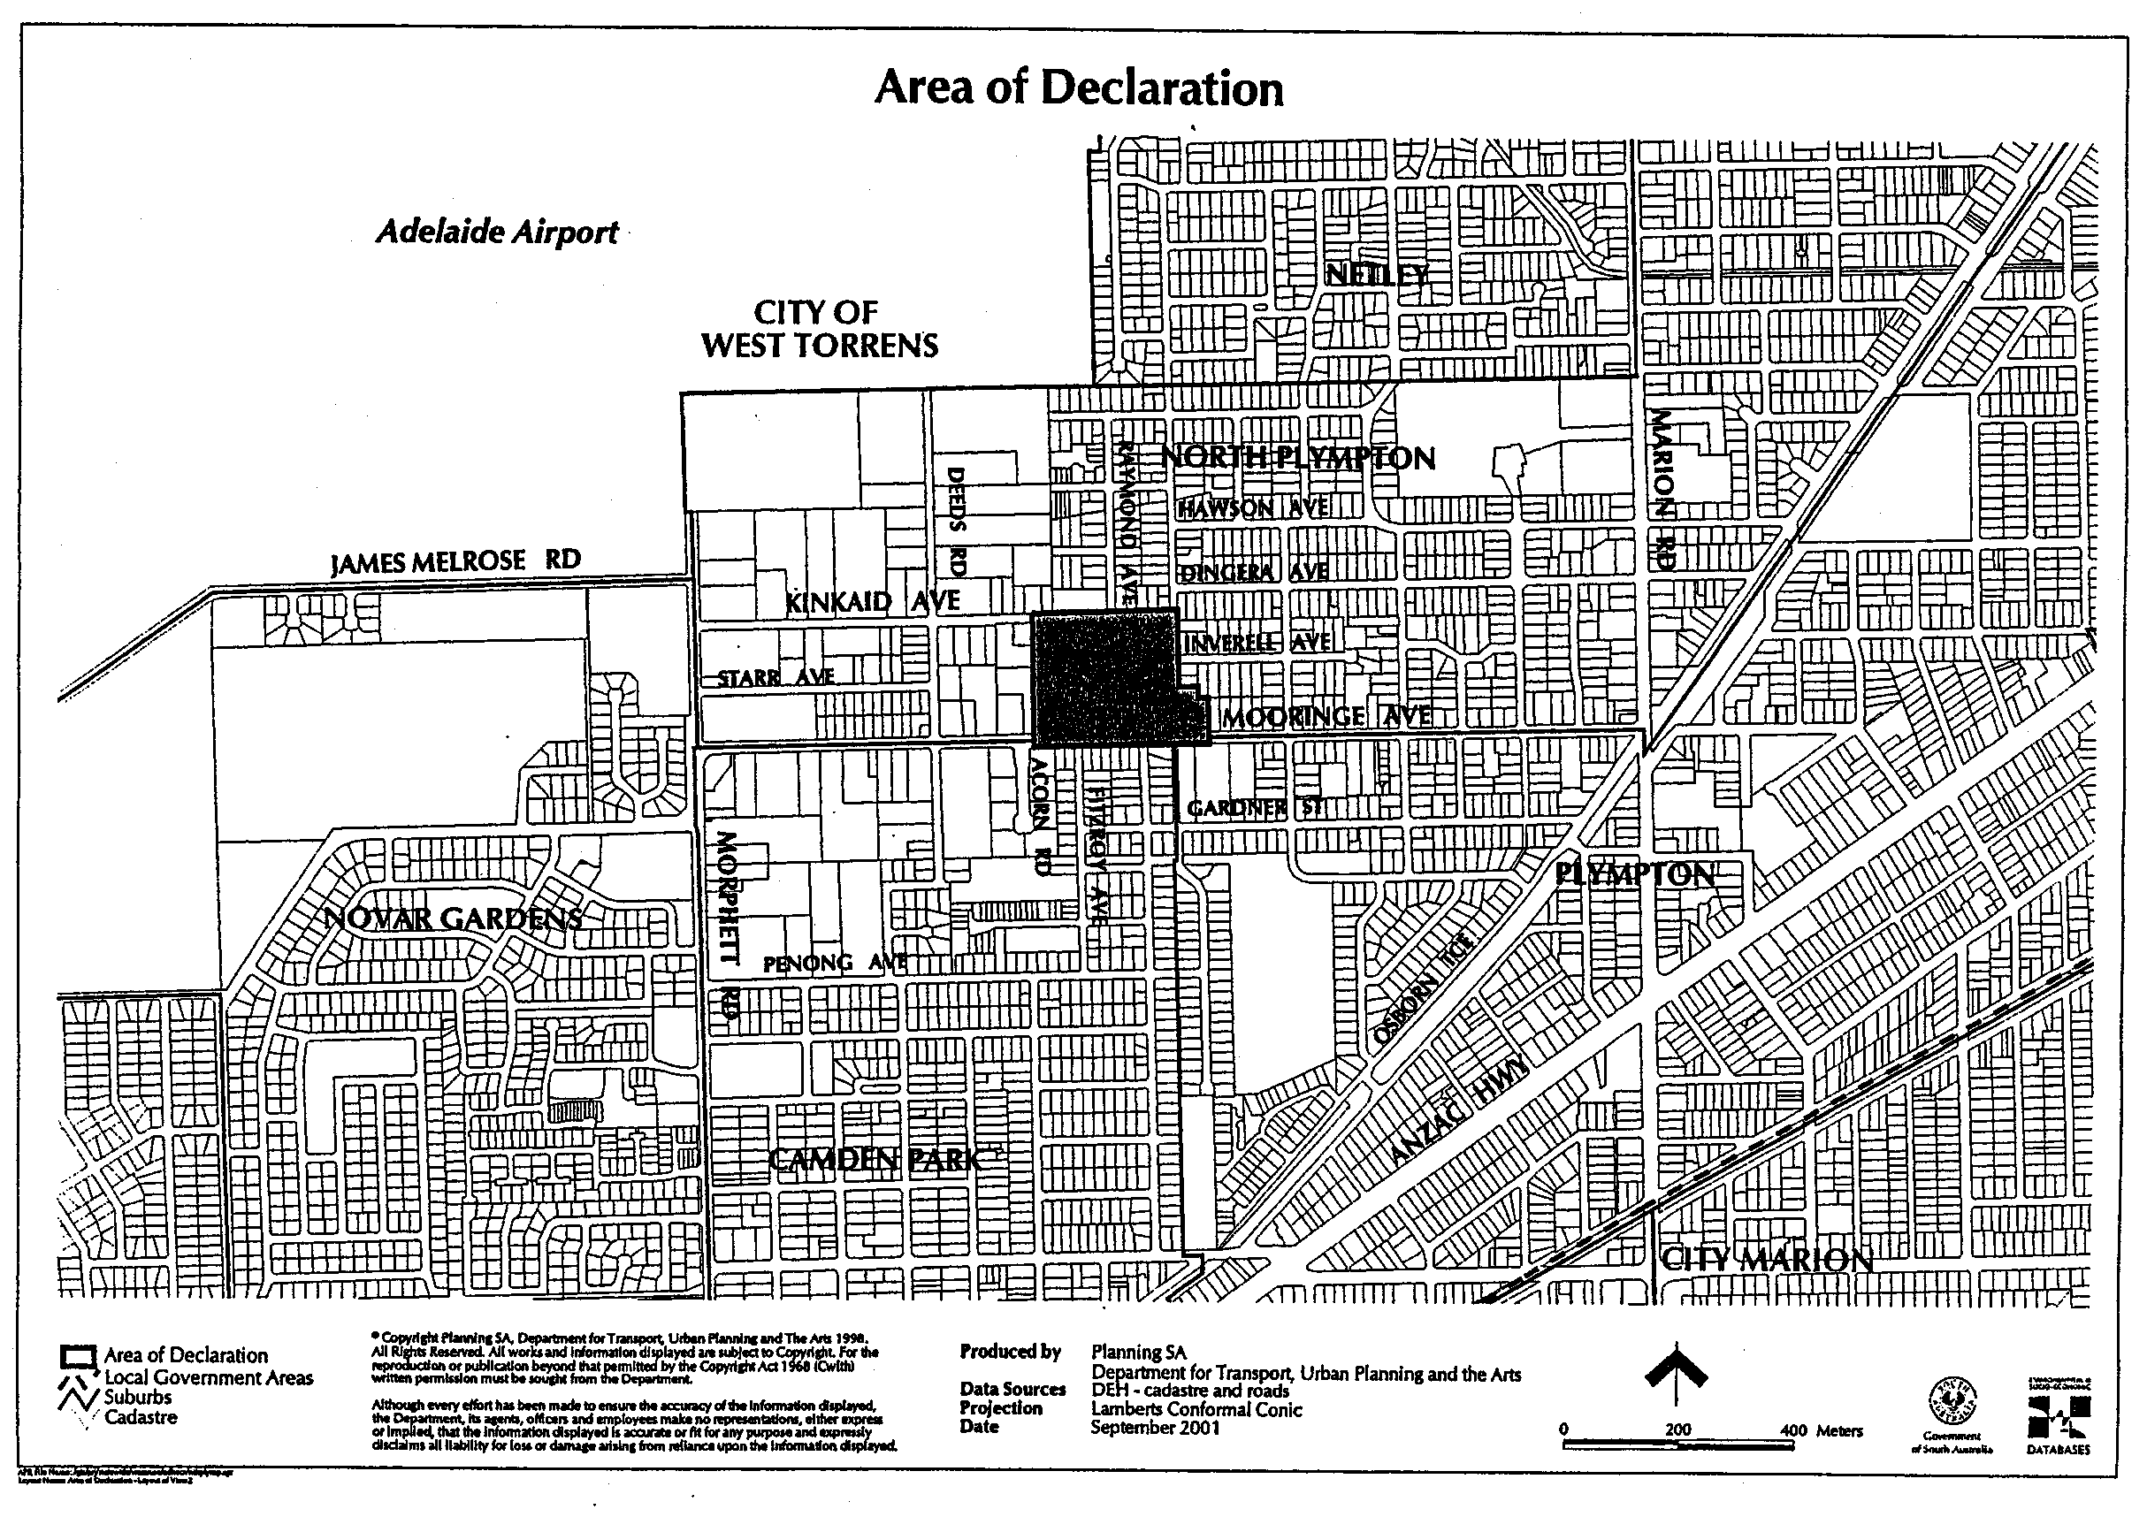
Dated 19 September 2001.
Diana Laidlaw, Minister for Transport and Urban Planning

DEVELOPMENT ACT 1993, SECTION 29 (2) (b): AMENDMENT TO THE BARUNGA WEST (DC) DEVELOPMENT PLAN
Preamble
It is necessary to amend the Barunga West (DC) Development Plan dated 13 April 2000.
Notice
PURSUANT to section 29 (2) (b) of the Development Act 1993, I, Diana Laidlaw, being the Minister administering the Act, amend:
The Barunga West (DC) Development Plan dated 13 April 2000, as follows:
(a) Delete Maps BaW/3, 7, 12 and 13 dated 13 April 2000 and insert the contents of Attachment ‘A’; and
(b) Amend cross-references wherever they appear in the text.
Attachment A
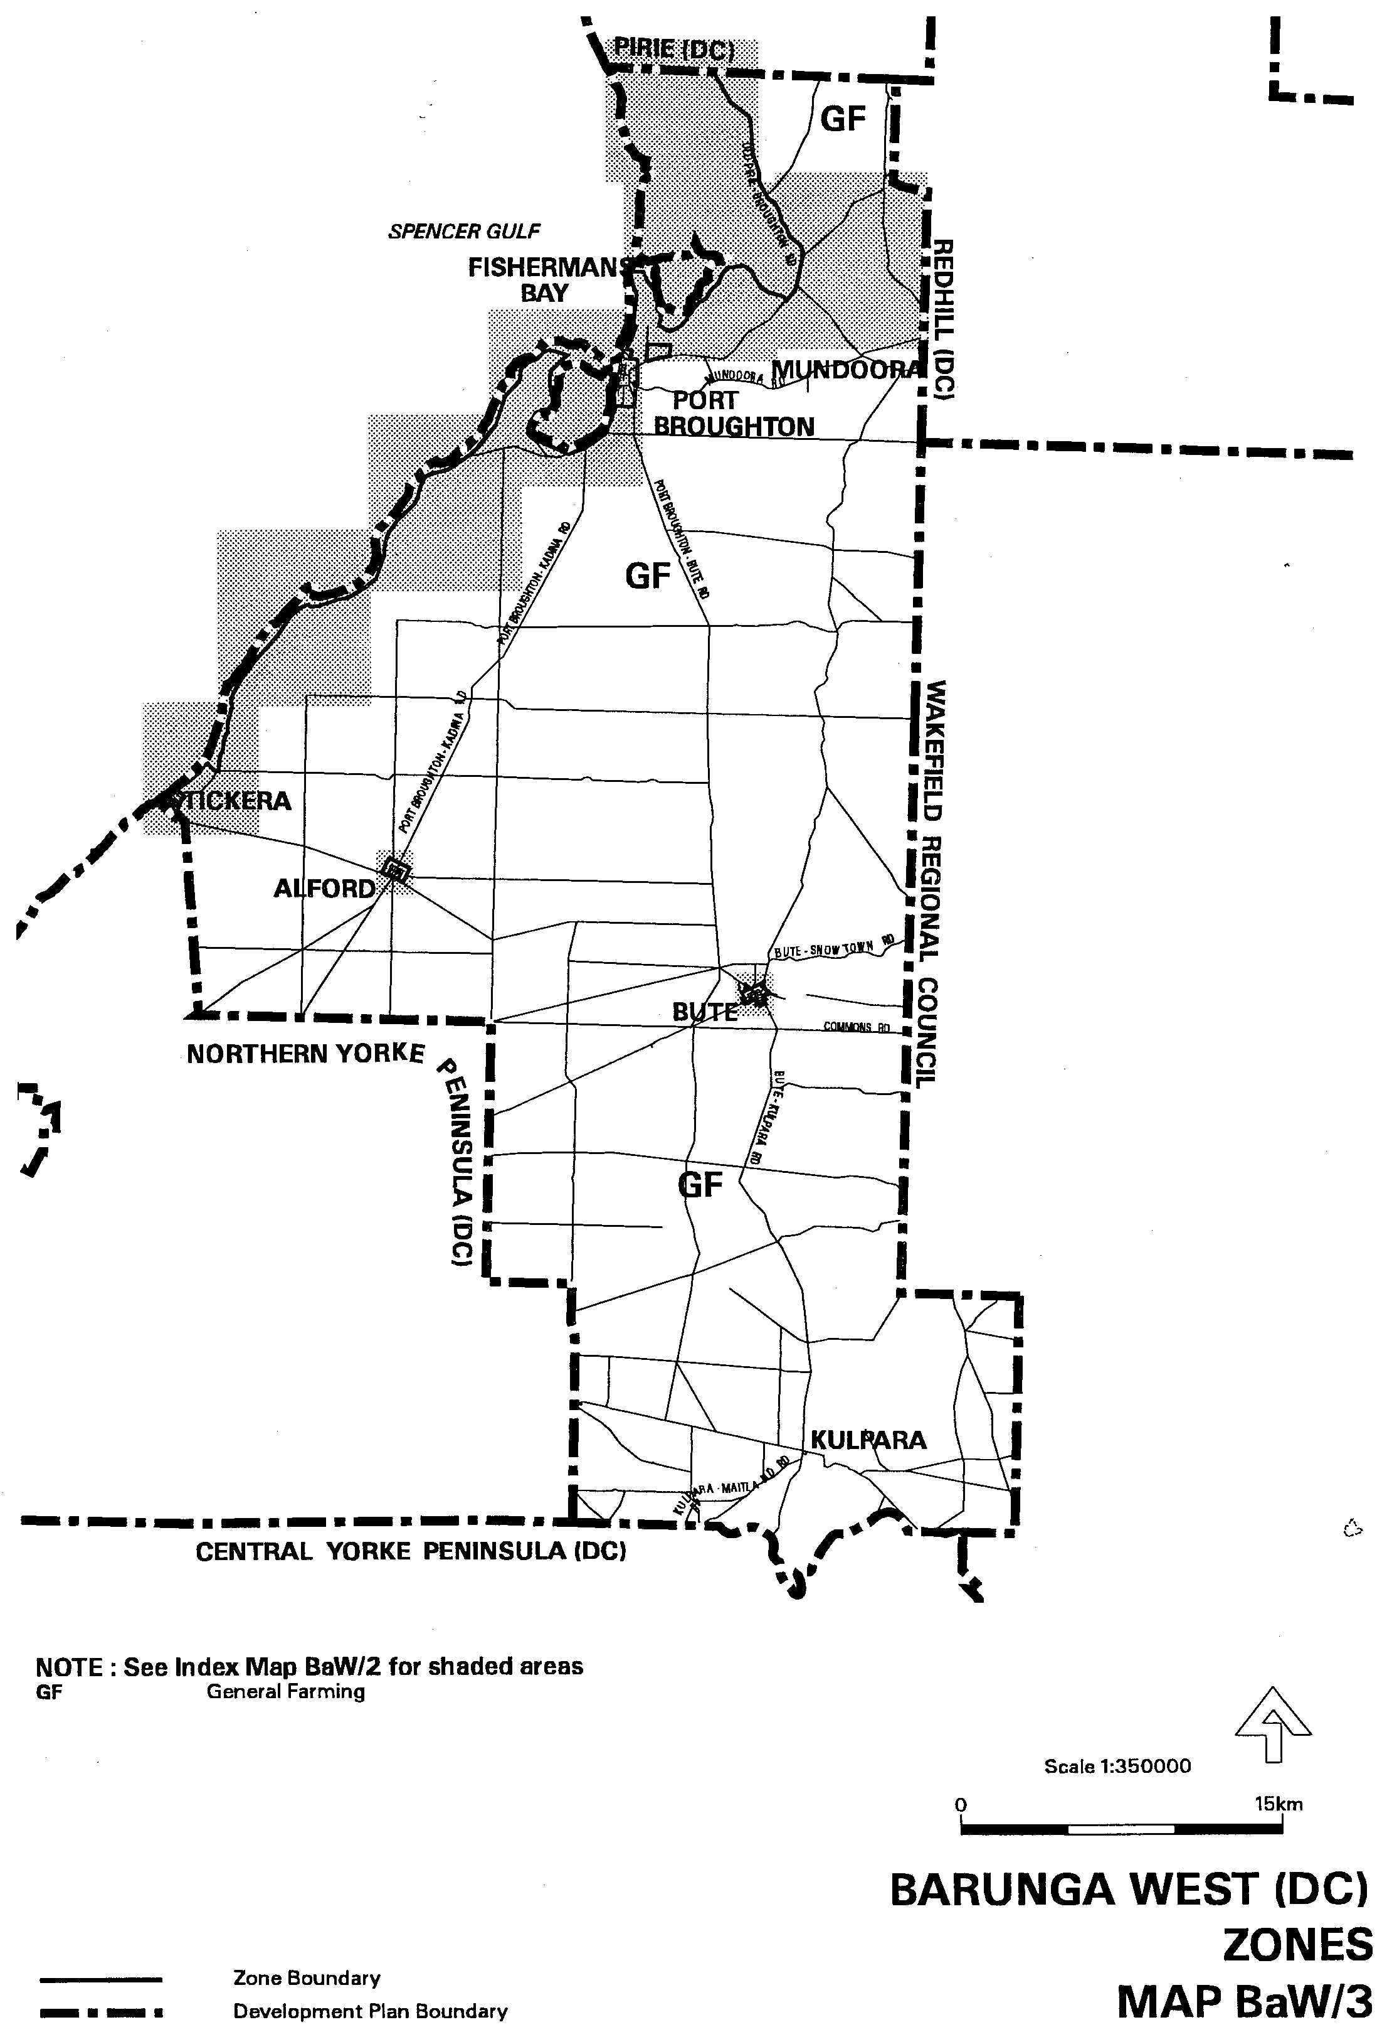
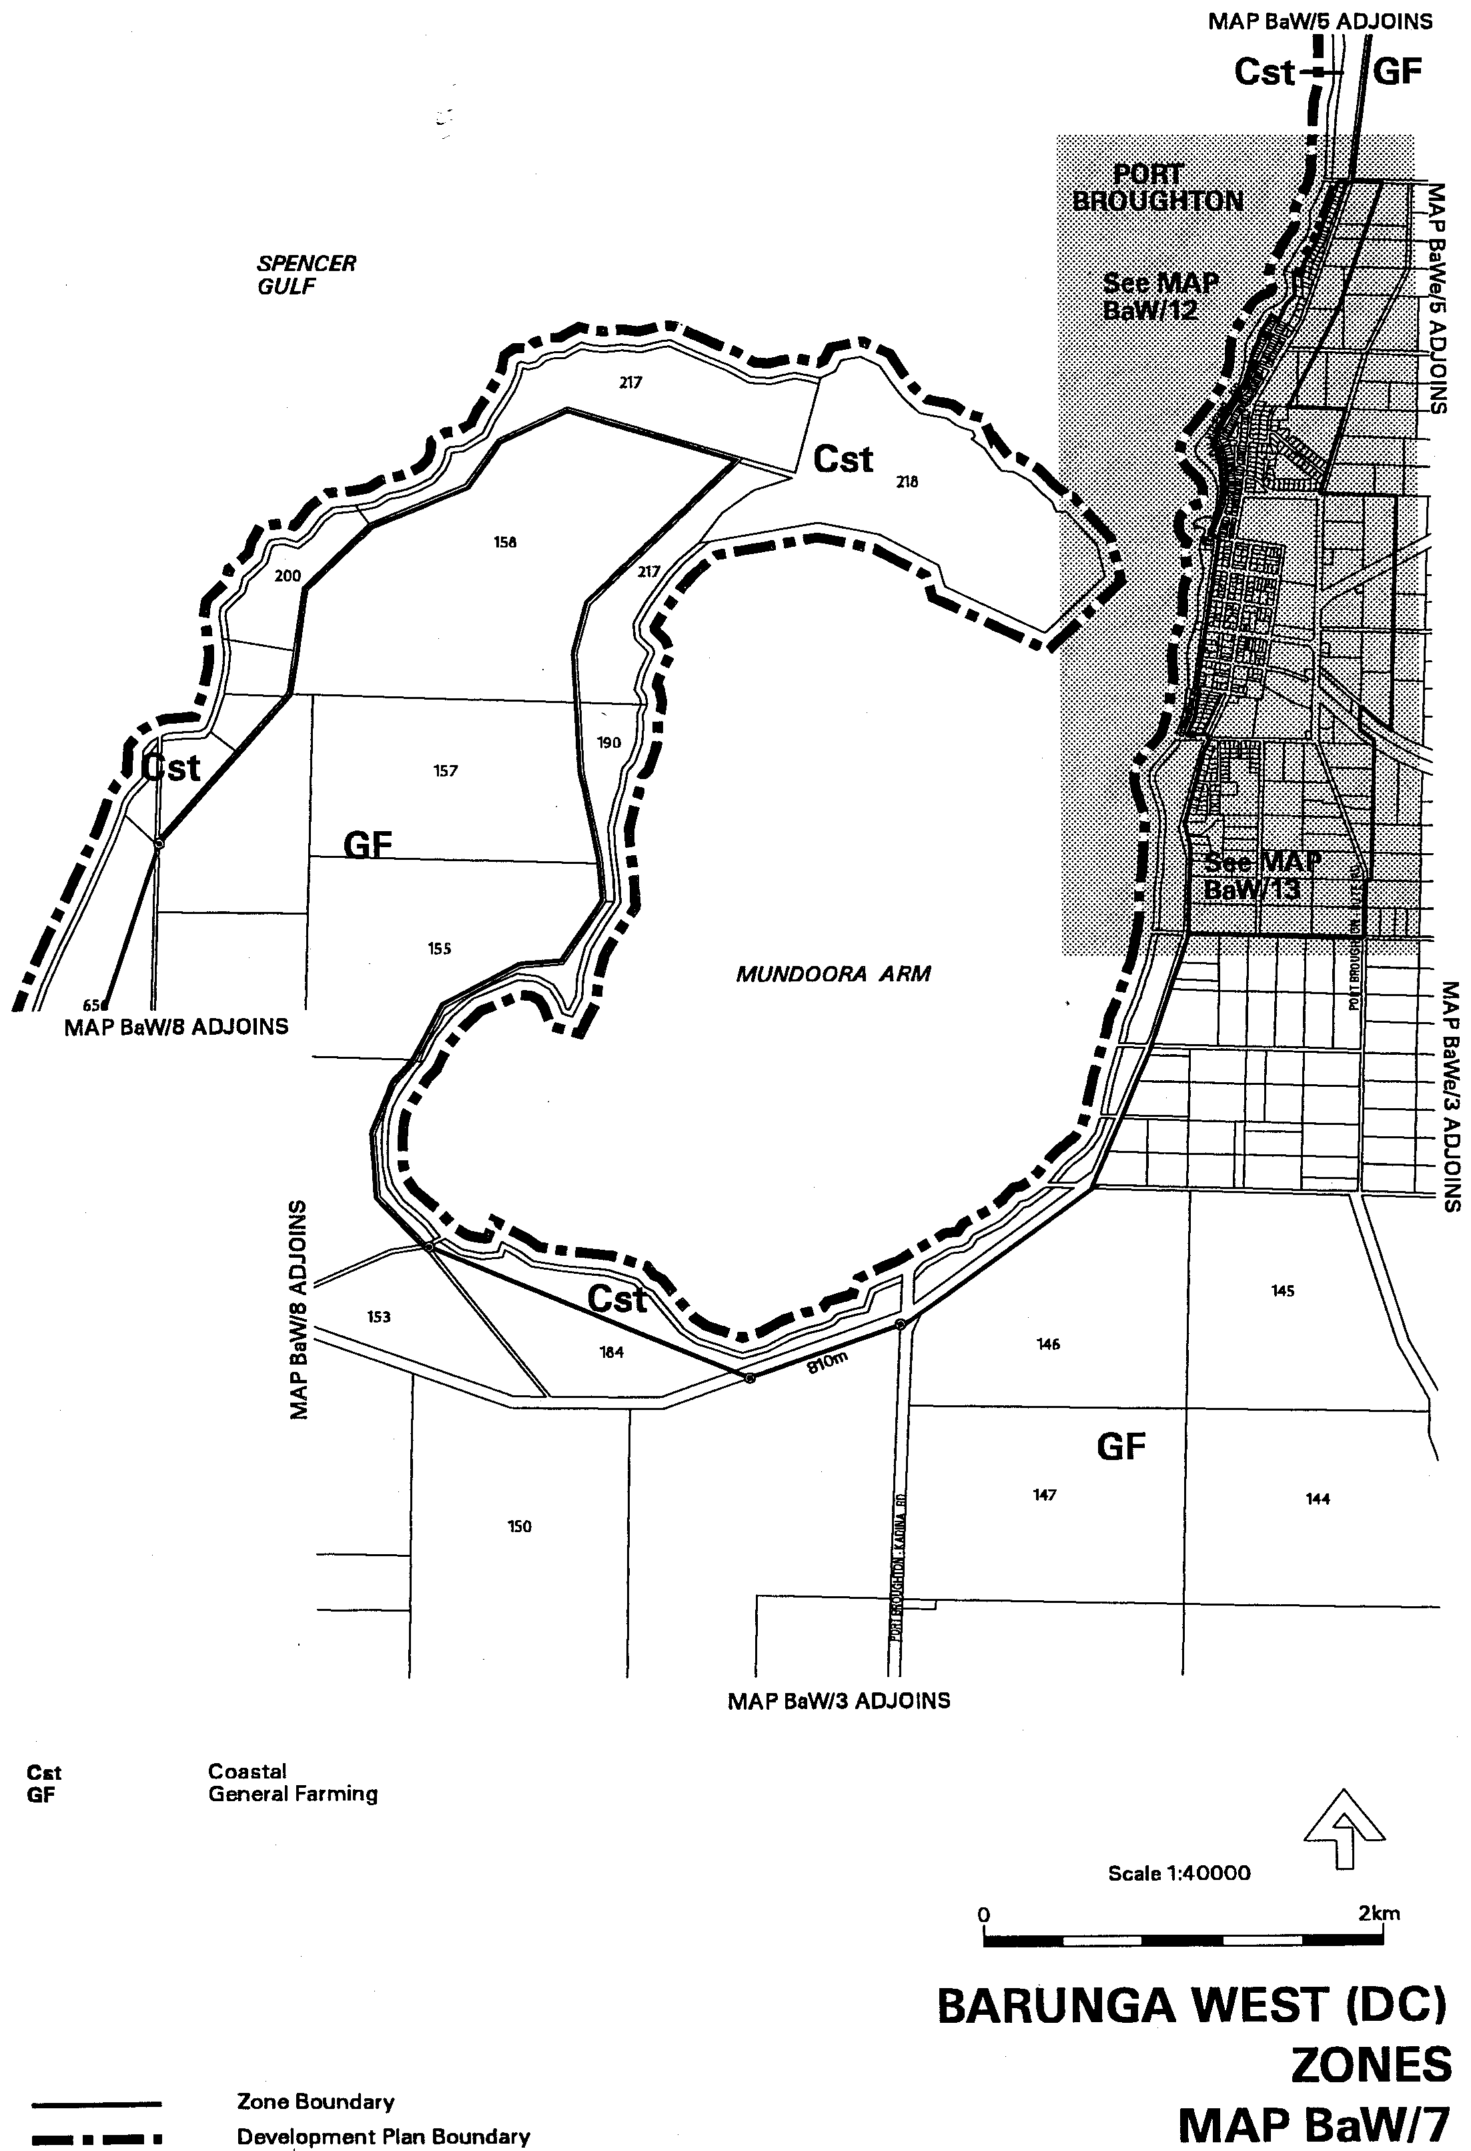
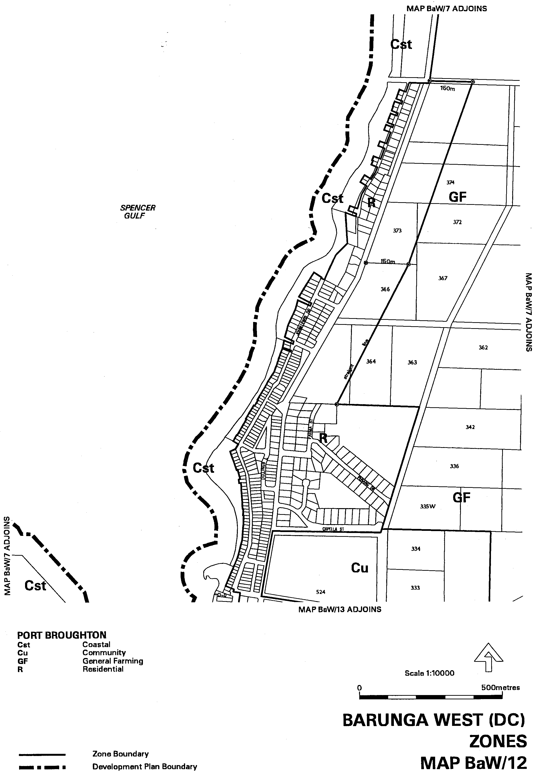
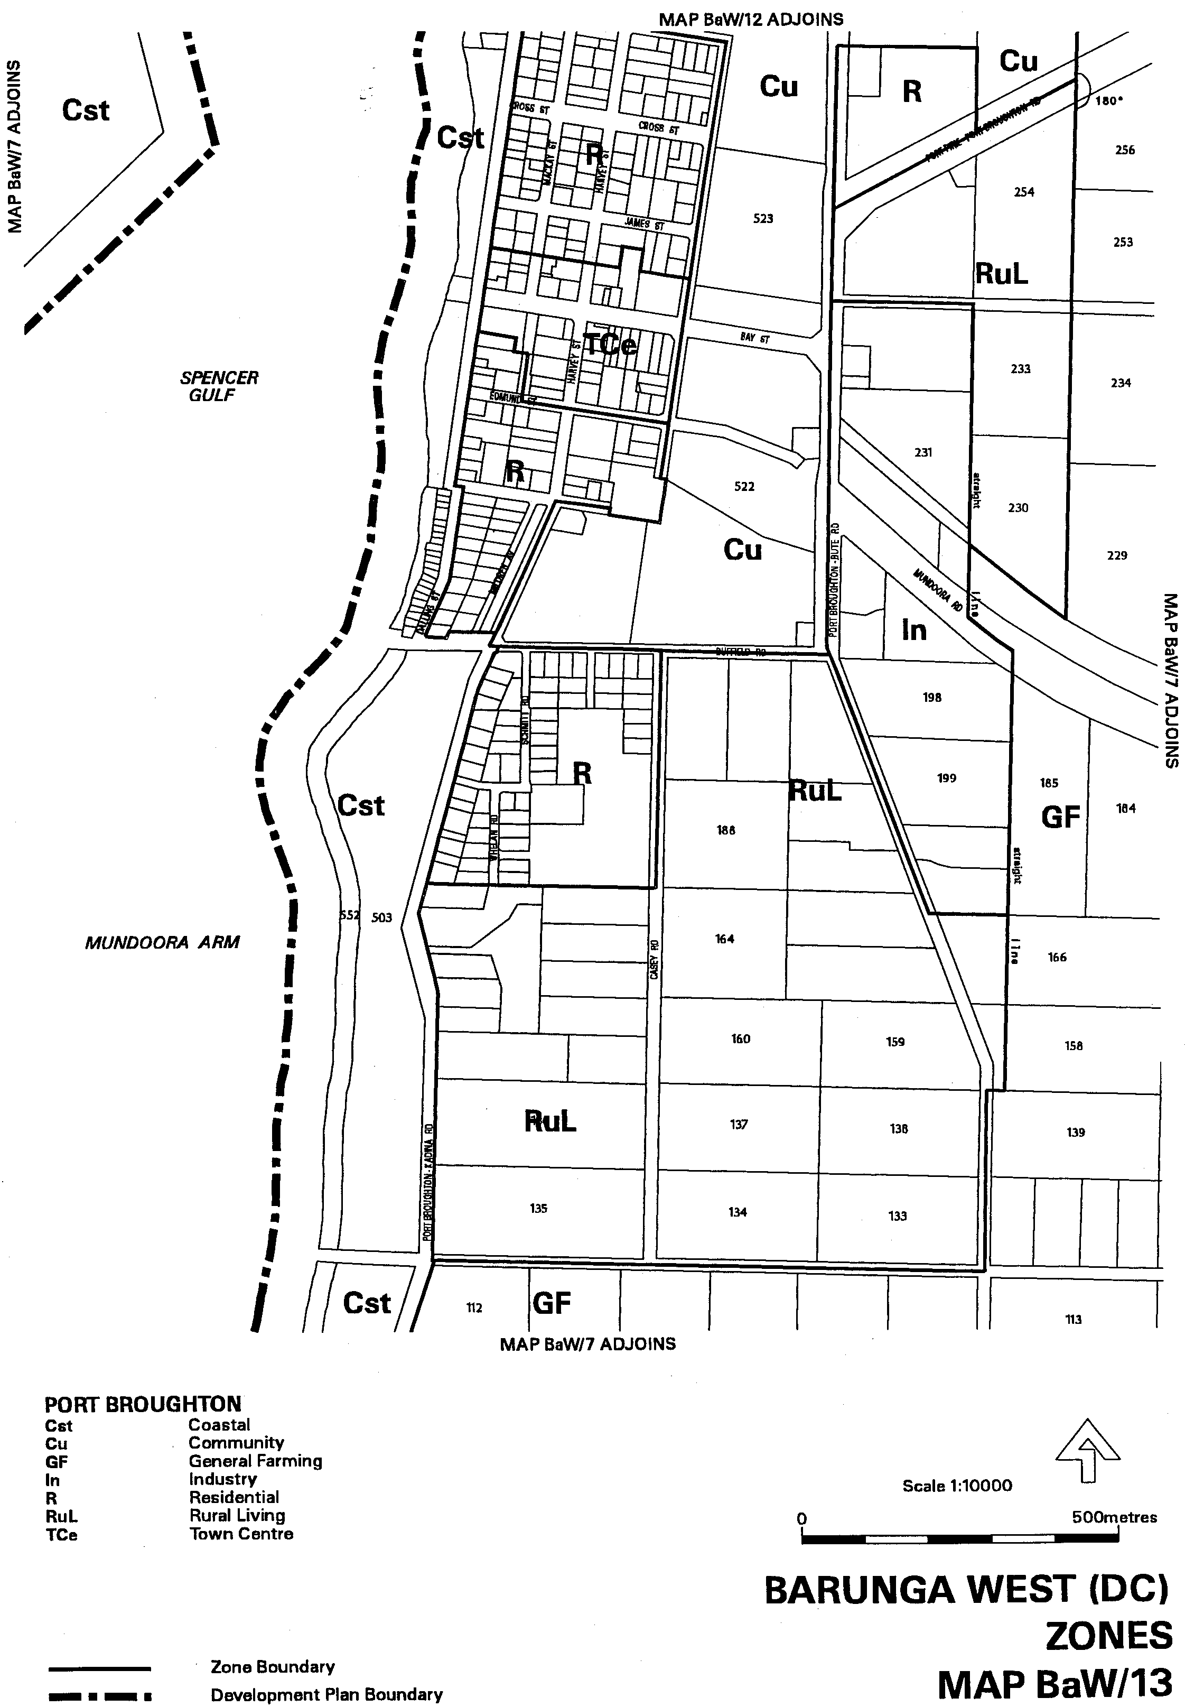
Dated 20 September 2001.
Diana Laidlaw, Minister for Transport and Urban Planning
PLN 01/0315


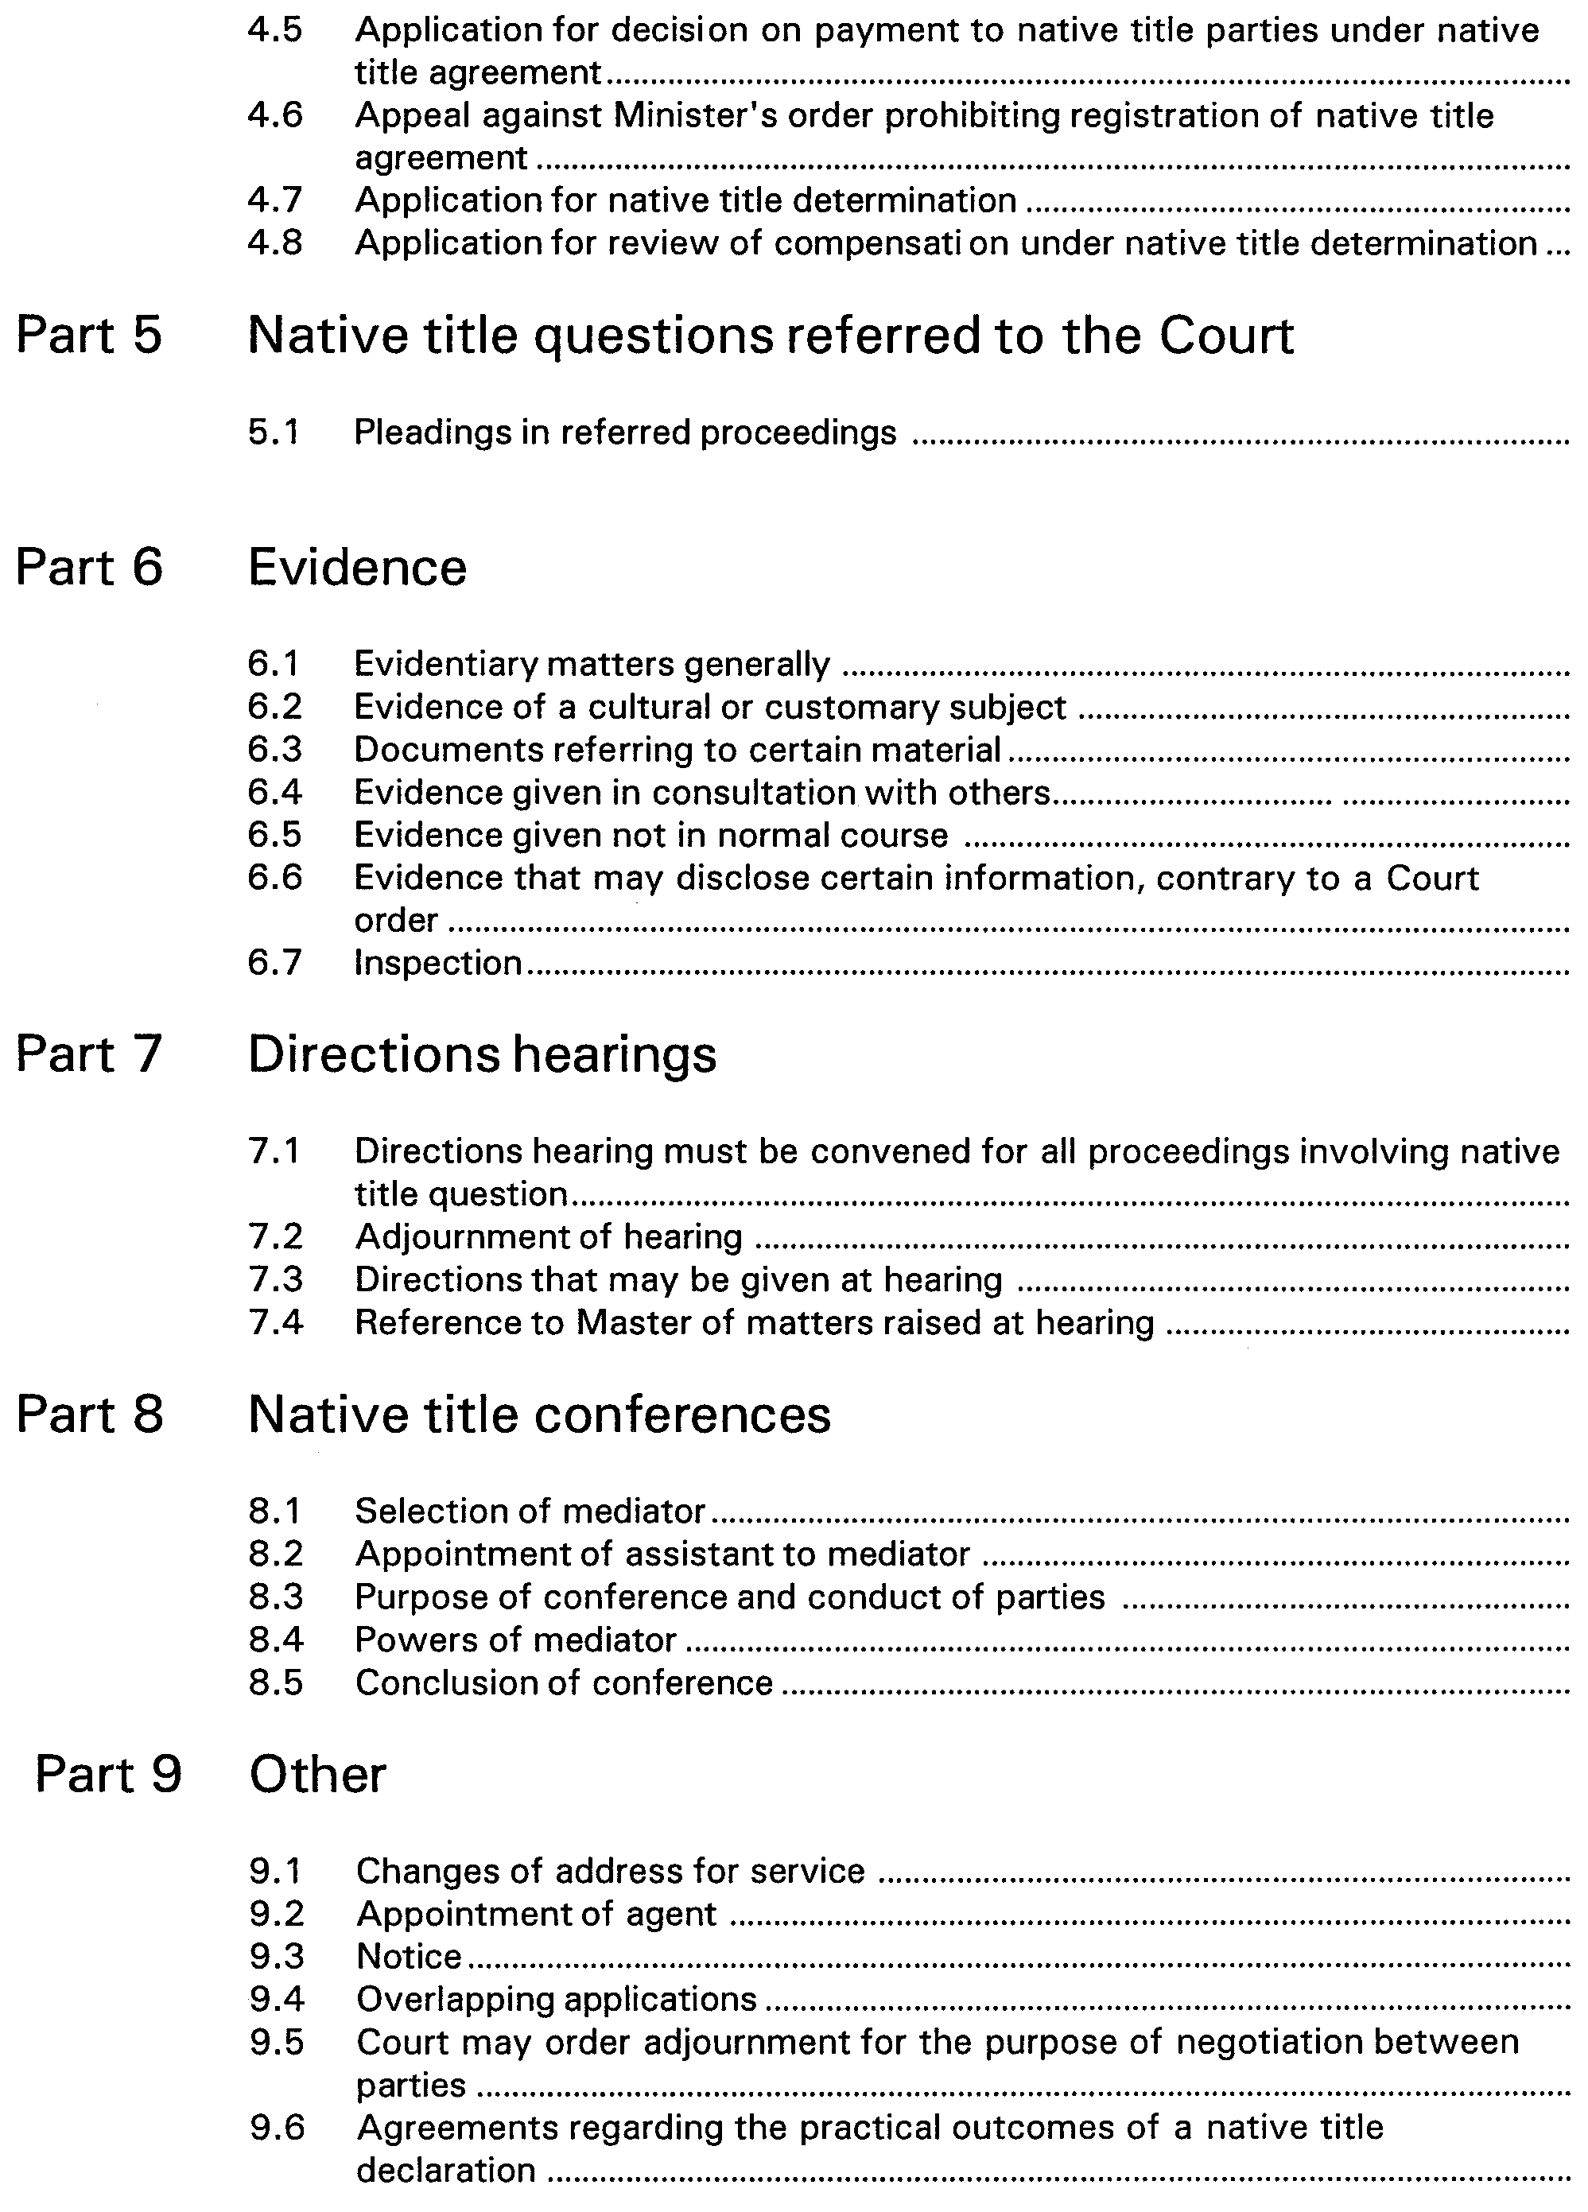
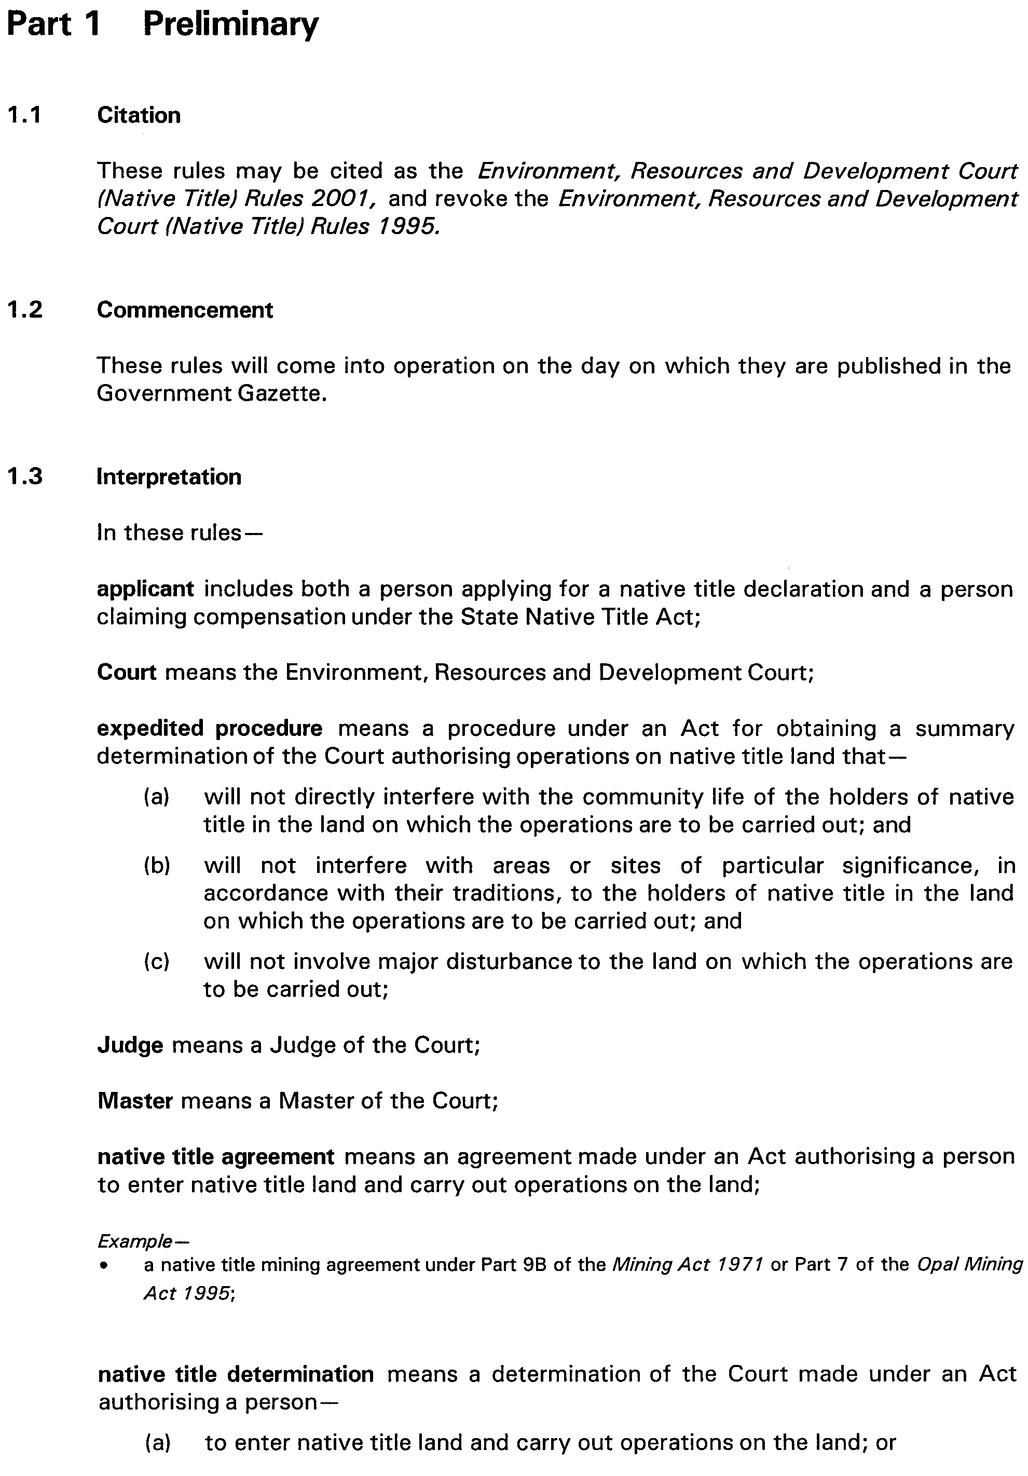





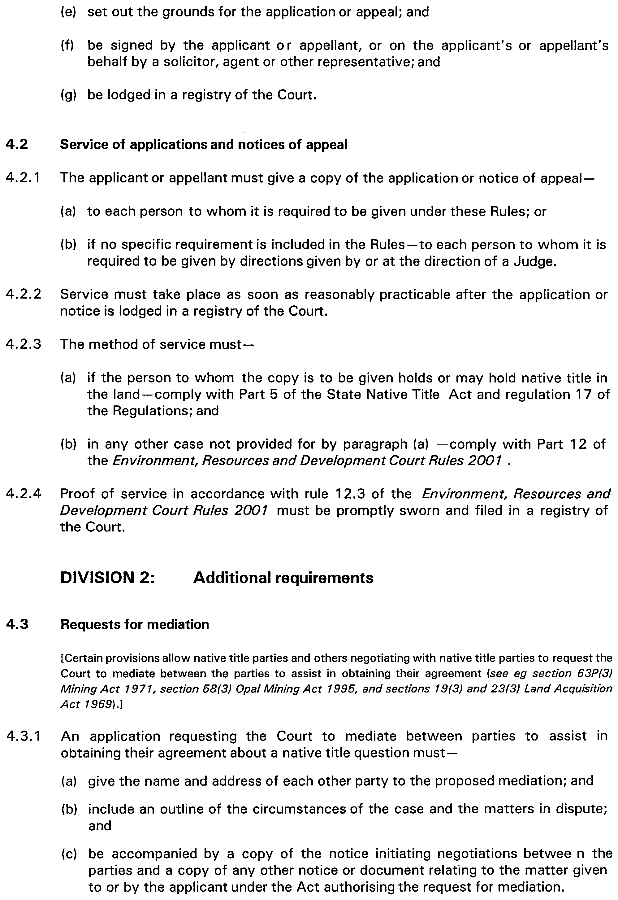
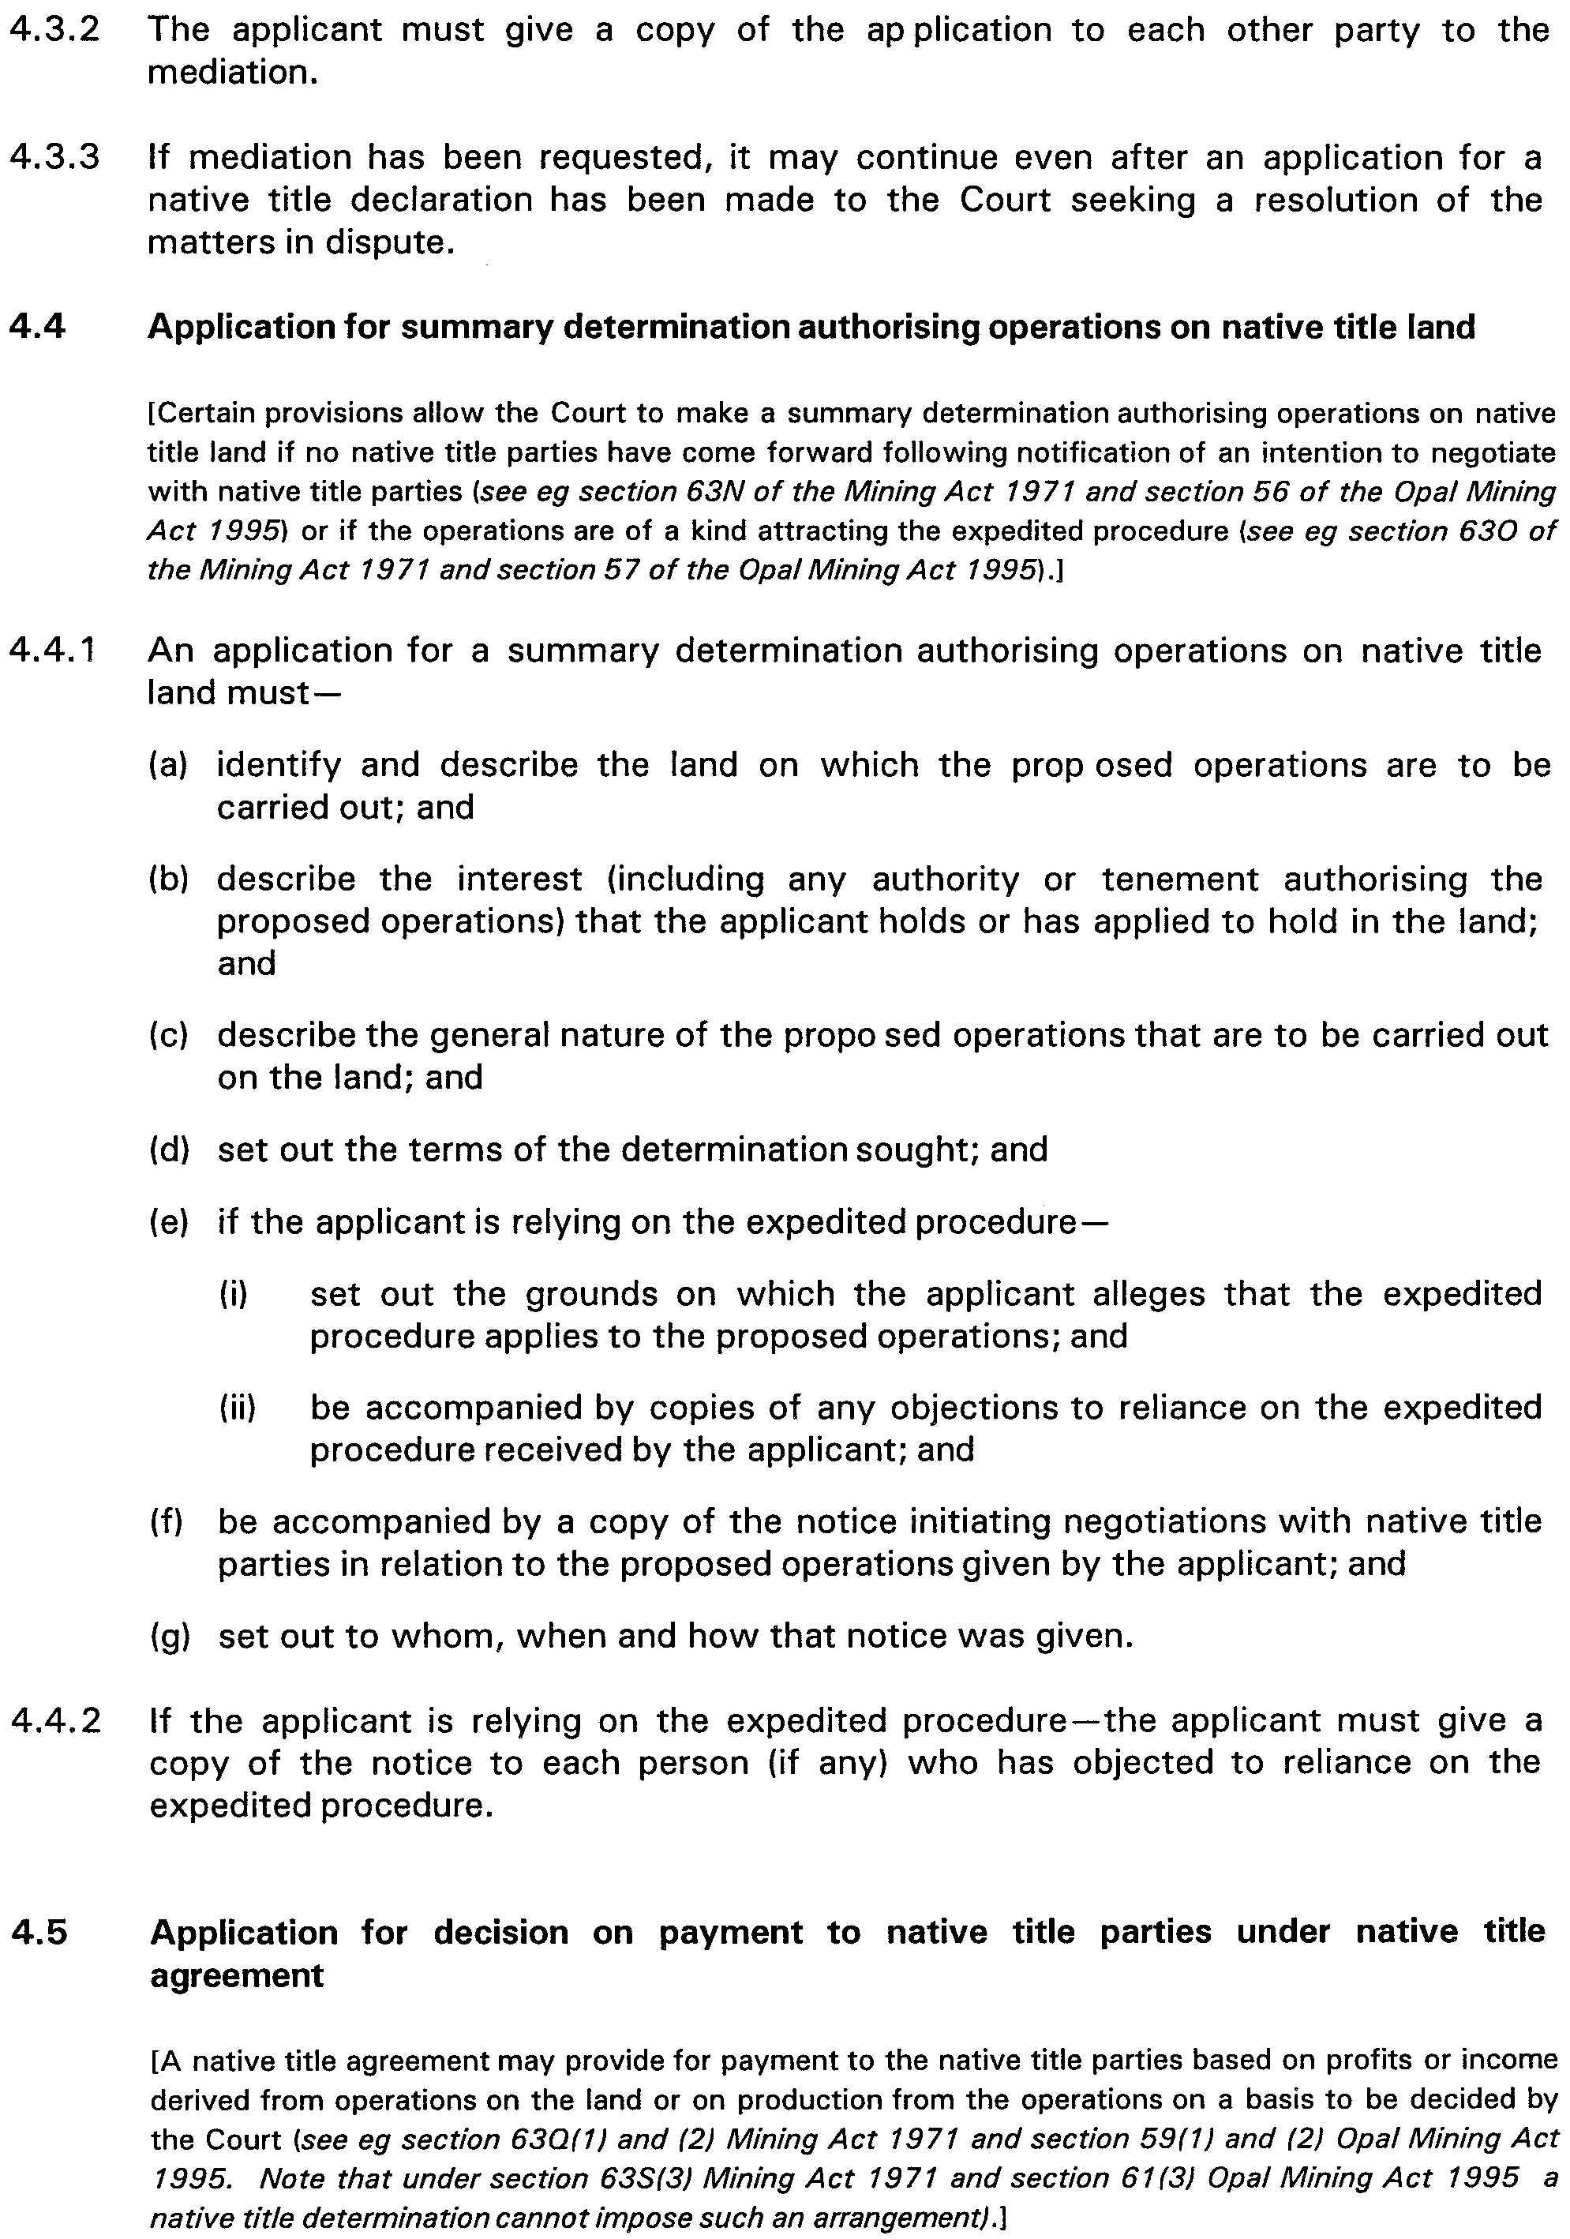
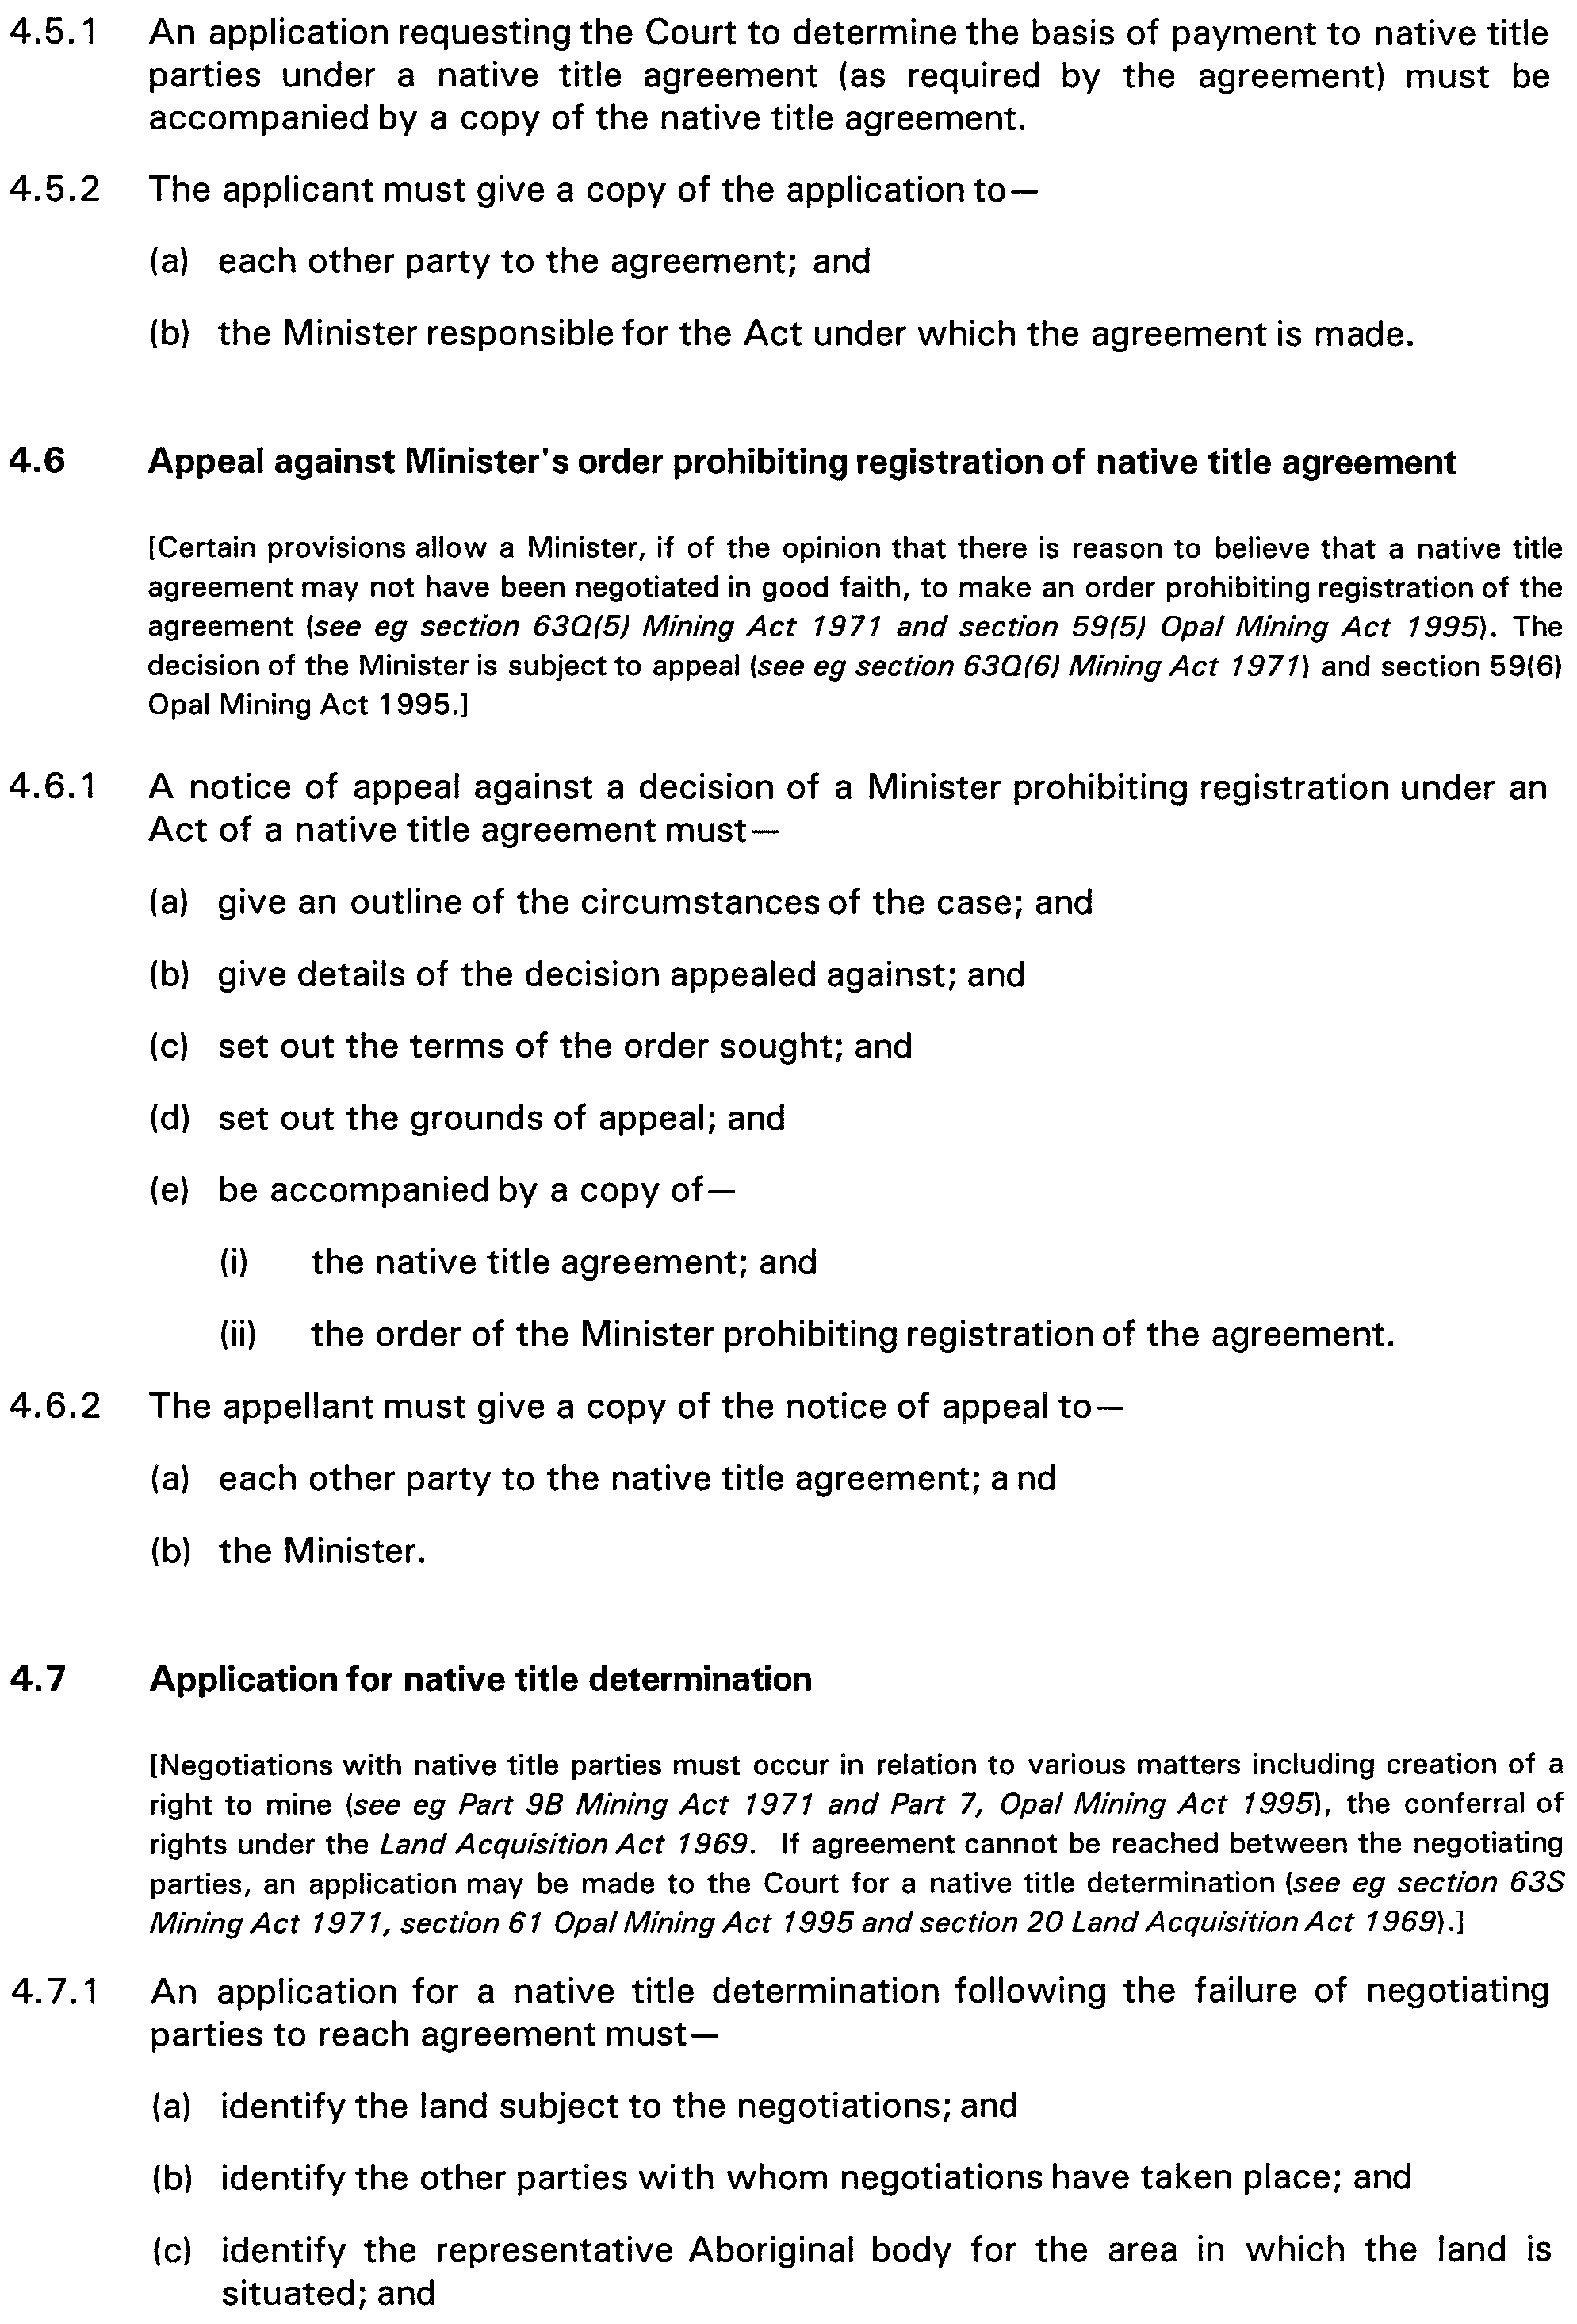

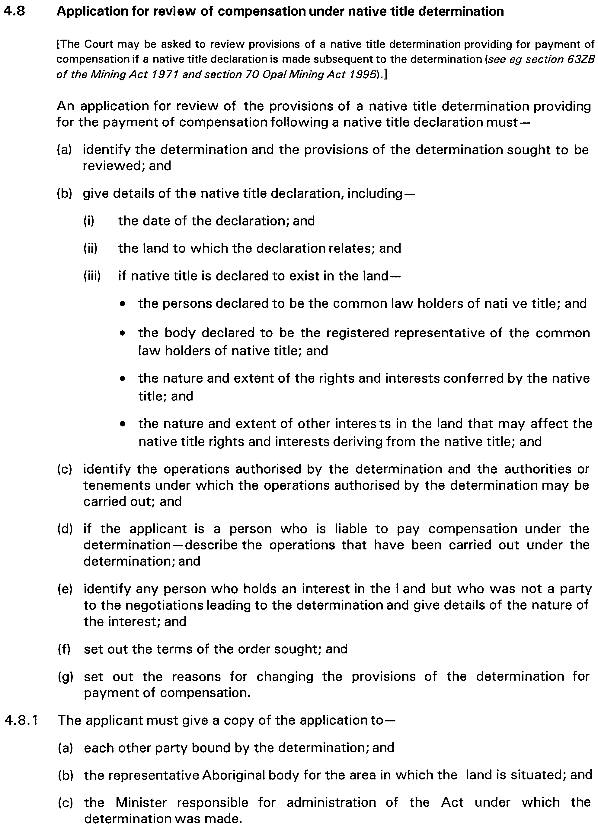
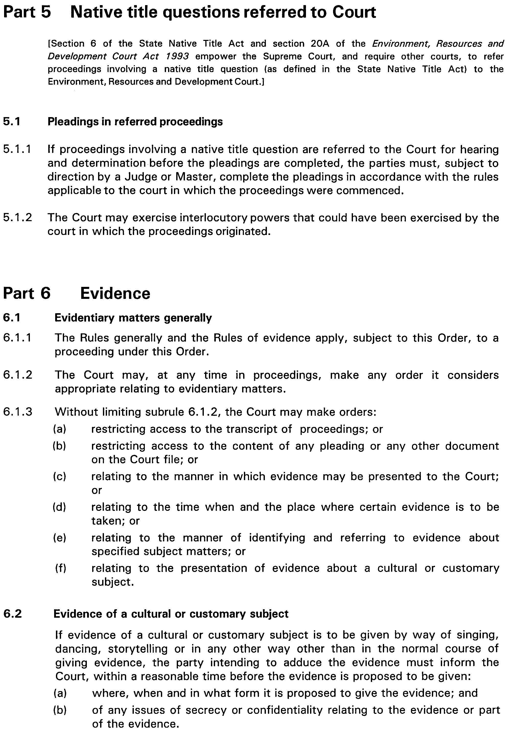
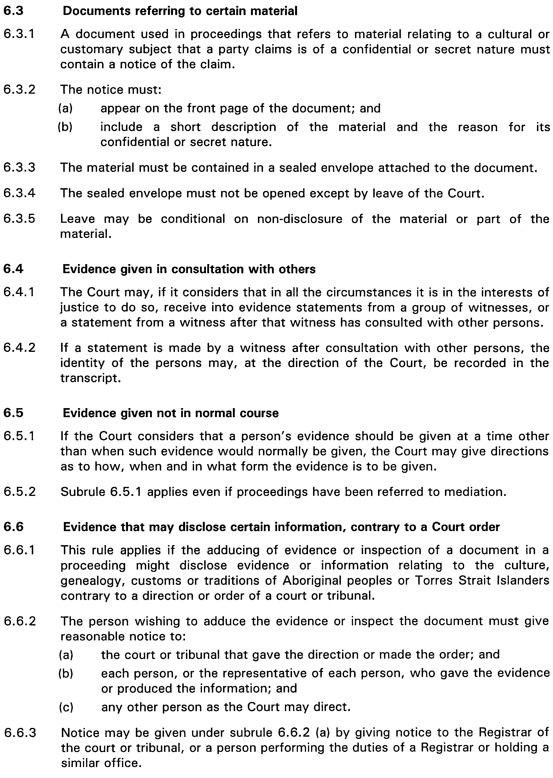
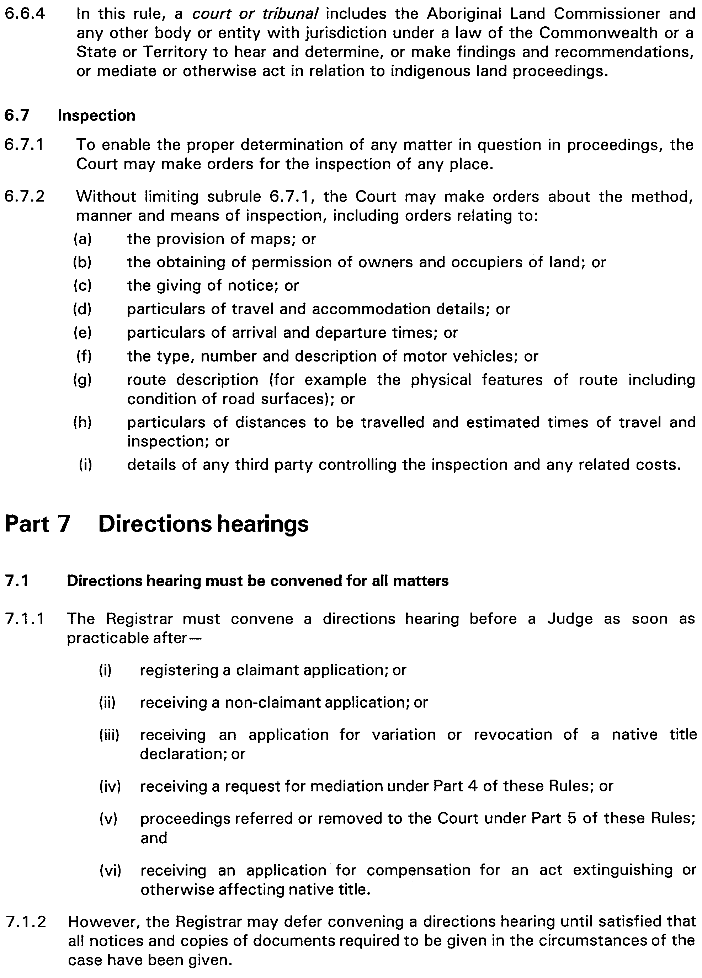
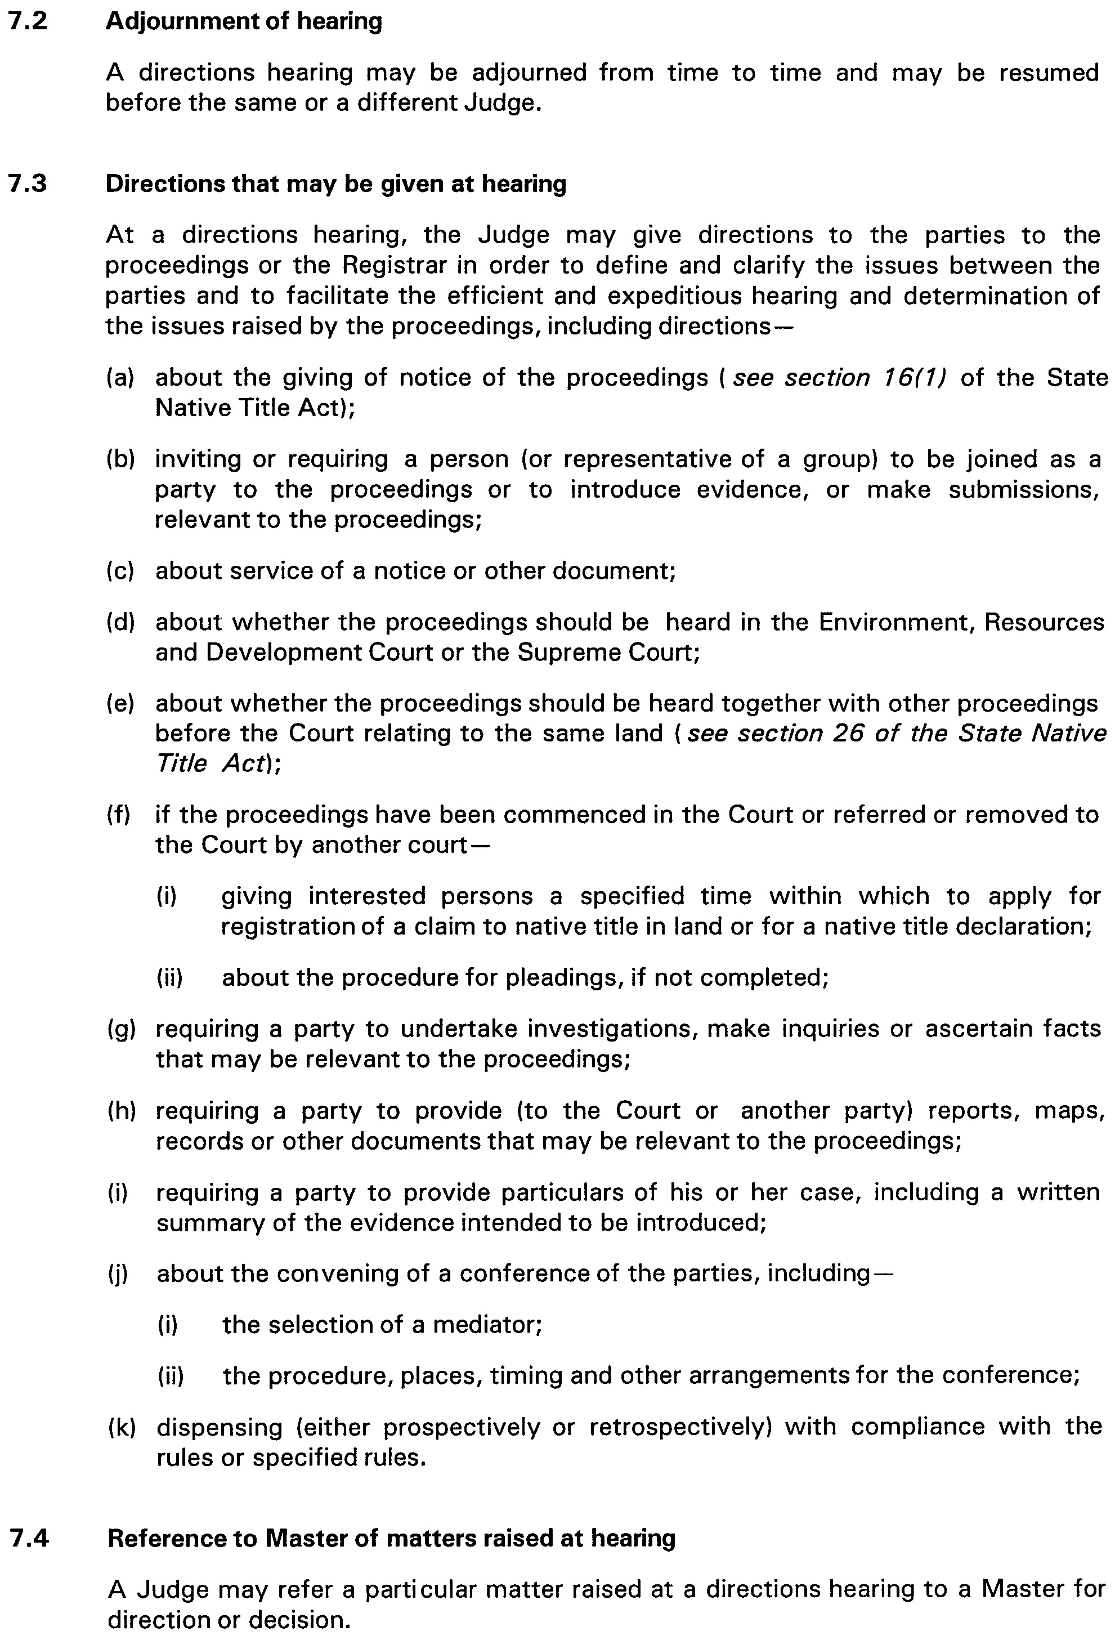
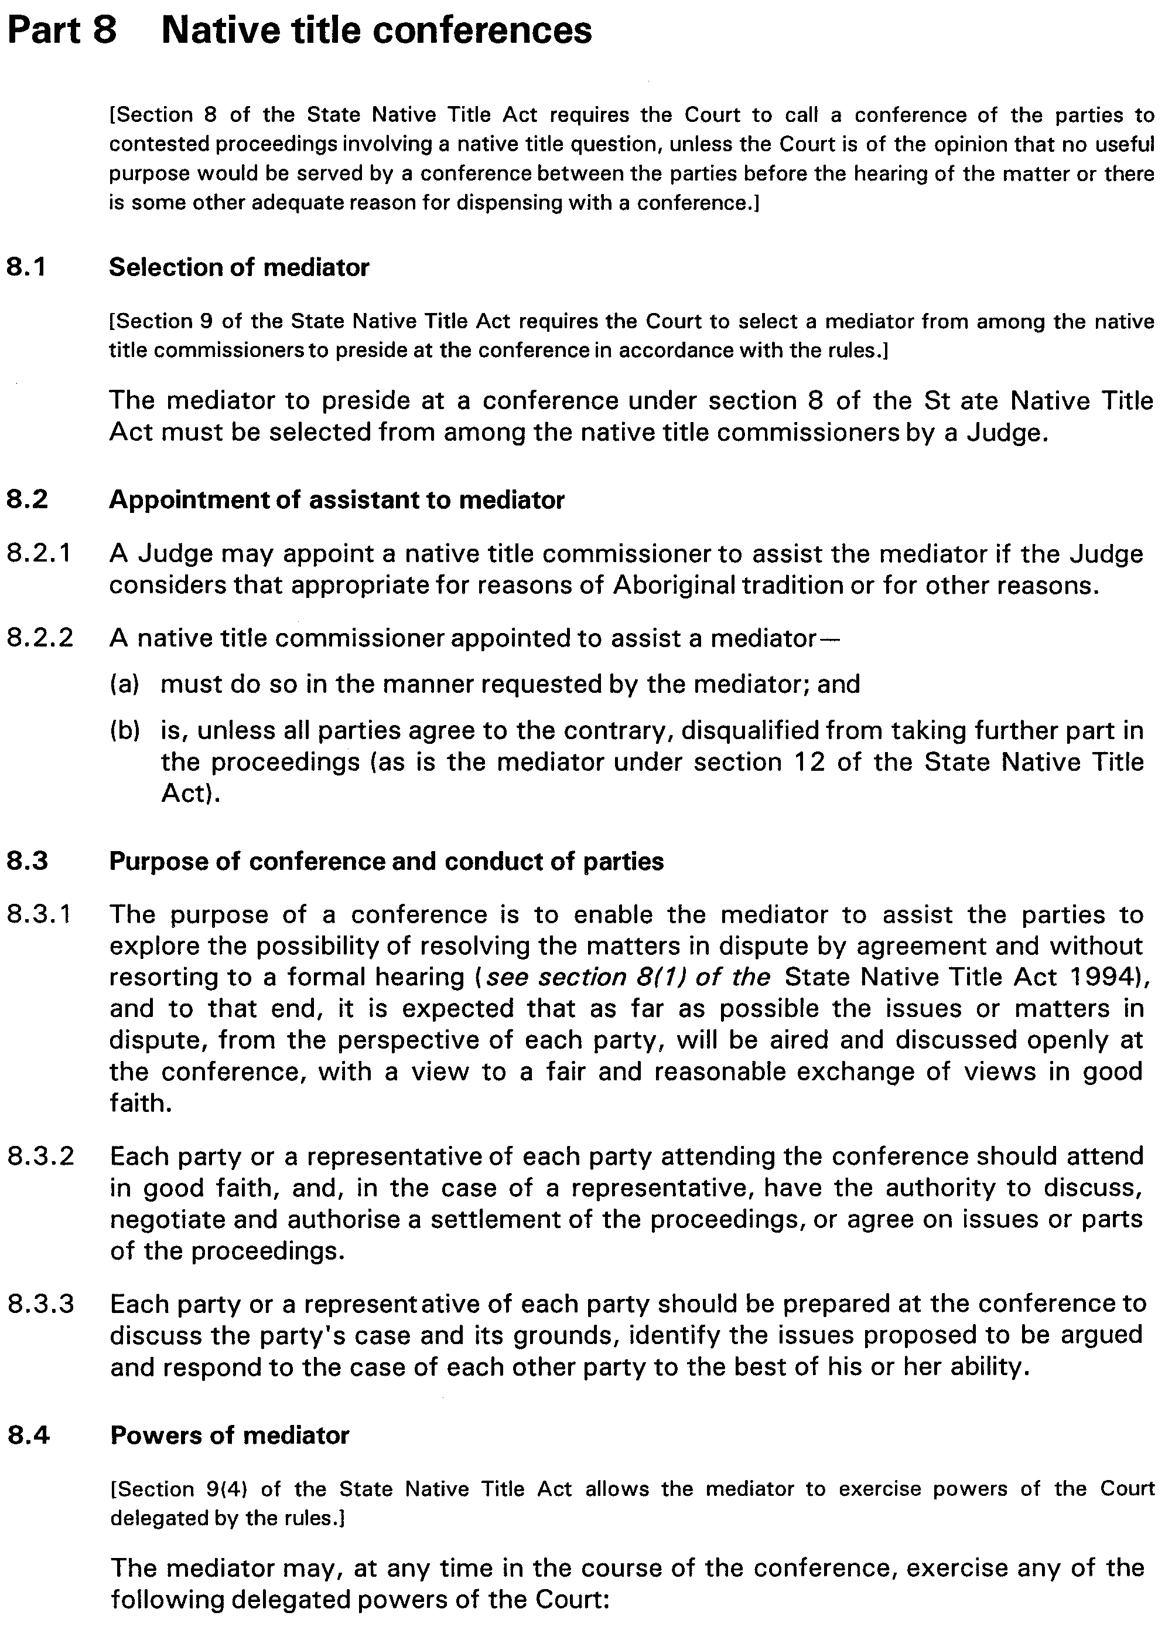
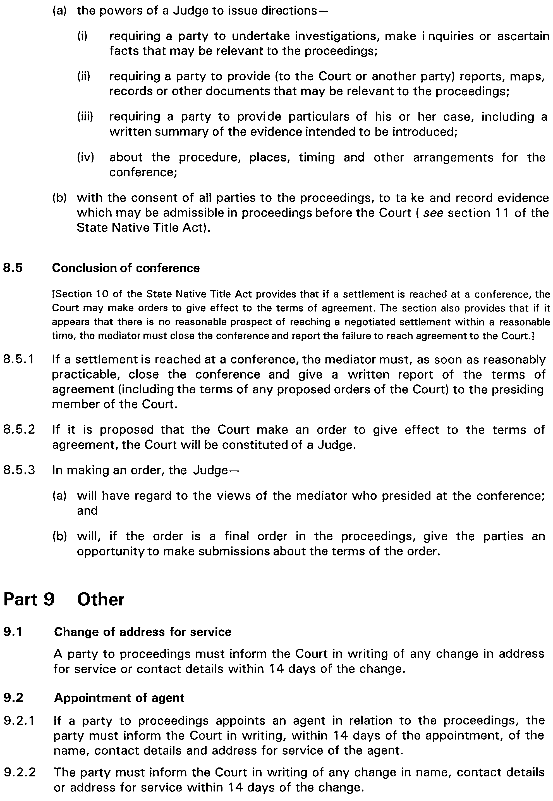
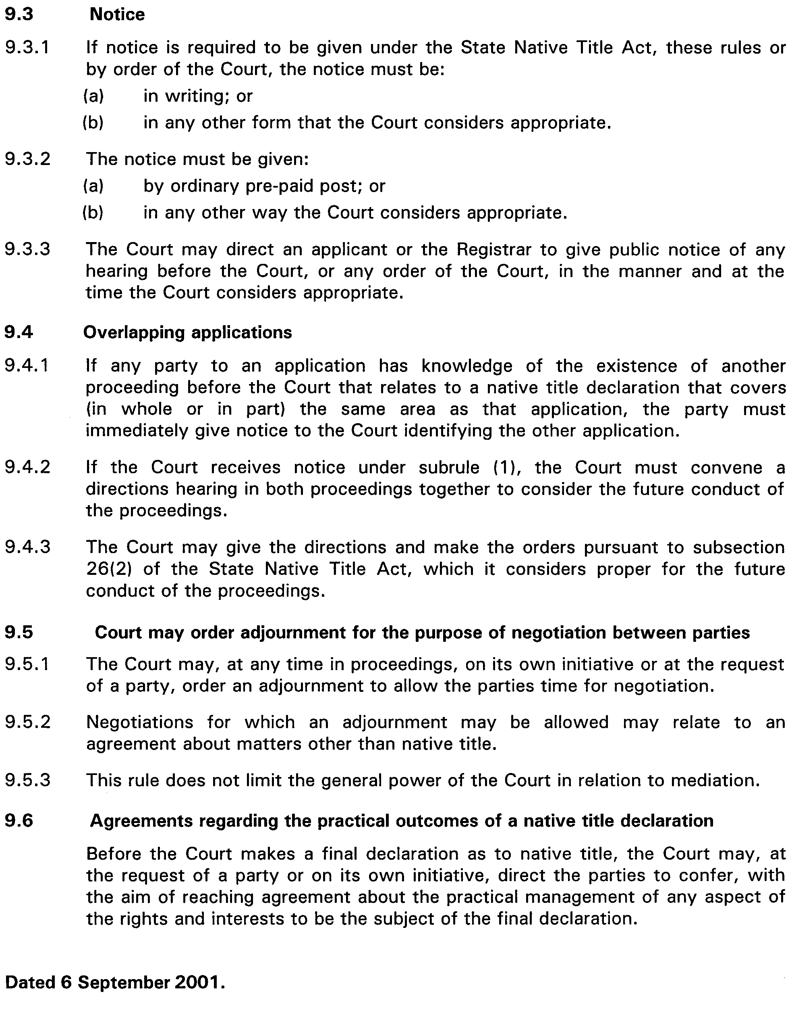


FISHERIES ACT 1982
Marine Tuna Farming Licence FB00005
(Previous Licence No. F607)
Licence to Farm Fish under section 53 of the Fisheries
Act 1982
THE Minister for Primary Industries and Resources (‘the Minister’) hereby grants to:
Navajo Pty Ltd (13006)
2/11 Flinders Highway
Port Lincoln, S.A. 5606
a licence to occupy and use the waters and airspace over the land specified in Item 1 of Schedule 1 of this licence (‘the site’) for the purpose of farming and taking the permitted species (‘the permitted use’) for the period commencing on 1 July 2001 and ending, subject to any earlier termination under this licence, on 30 June 2002 (‘the term’) subject to the following terms and conditions:
Conditions of This Licence
1. Marked-off Areas
1.1 Subject to section 53A of the Fisheries Act 1982, this licence does not entitle the licensee to exclusive rights of entry to and occupation of the site. The rights granted by this licence are exercisable by the licensee in common with any other occupiers of the site from time to time.
1.2 For the purposes of section 53A of the Fisheries Act 1982, the marked-off areas within the site are that area or those areas marked-off or indicated in the manner set out in Item 2 of Schedule 1 of this licence.
2. Permitted Species
The licensee:
2.1 must not farm or introduce any species at the site other than the permitted species referred to in Schedule 2; and
2.2 must not take any wild fish from the site except for recreational purposes.
3. Permitted Use
The licensee must not use the site for any purpose other than the permitted use.
4. Permitted Methods
4.1 The licensee must, in undertaking the permitted use, take all reasonable and practicable measures to prevent or minimise damage to the environment. Without limiting the generality of the foregoing, the licensee:
4.1.1 must not stock the permitted species at a rate greater than that specified in Schedule 2 of this licence;
4.1.2 must not use the anti-fouling chemical tributyltin (TBT) on any equipment used at the site;
4.1.3 must not use any chemical or drug for either therapeutic or prophylactic purpose except with the prior approval of the Minister;
4.1.4 must apply the permitted farming methods set out in Schedule 2 of this licence;
4.1.5 must undertake an environmental monitoring program approved by the Minister and as specified in Clause 4.2;
4.1.6 must not introduce the permitted species to the site before the approval of the environmental monitoring program referred to in 4.1.5 by the Minister;
4.1.7 must comply with the schedule of reporting for the environmental monitoring program as pres-cribed in Schedule 6 and submit the final results of the environmental monitoring program to the Minister 30 days before expiry of the term of this licence;
4.1.8 must implement a management strategy approved by the Minister and as specified in Clause 4.3 to manage interactions with seabirds and marine mammals;
4.1.9 must not introduce the permitted species to the site before approval of the management strategy specified in 4.1.8 by the Minister.
4.2 The licensee must submit a draft environmental moni-toring program to the Minister for approval within 60 days of the grant of the licence by the Minister. The draft environmental monitoring program must include the qualifications and experience of the person(s) designing and undertaking the program and address the matters listed in Schedule 5.
4.3 The licensee must submit a draft strategy for managing interactions with sea birds and marine mammals to the Minister within 60 days of the grant of the licence by the Minister. The draft strategy must identify potential interactions with and risks to sea birds and marine mammals and the measures proposed to minimise inter-actions with and risks to seabirds and marine mammals.
5. Sea Cages
The licensee must immediately inform an officer of PIRSA (Fisheries) on 1800 065 522 or such other officer as the Minister from time to time notifies to the licensee in writing if any marine animal, other than the permitted species, is caught in any sea cage or other farm structure used by the licensee on the site.
6. Location of Sea Cages
The licensee must not erect or use any sea cages in any location on the site where stocked sea cages have been used in the immediately preceding two year period.
7. Marking and Maintaining the Site
The licensee:
7.1 must ensure that the site is maintained in a good, tidy and safe condition to the satisfaction of the Minister;
7.2 must remove and lawfully dispose of any waste or debris on the site as soon as is reasonably practicable and in particular must comply with any guidelines issued from time to time by the Minister in relation to the removal from the site of any unhealthy or dead fish;
7.3 must maintain all buoys, crosses, and markers on the site in good condition and in accordance with the colours specified in Schedule 1 of this licence; and
7.4 must mark the site boundary in accordance with the requirements of the Minister for Transport.
8. Site Inspection and Supervision
The licensee:
8.1 must at all times permit the Minister, his employees, agents or contractors or any employees, agents or con-tractors of the Crown to enter the site for the purposes of inspecting the site, the sea floor and the flora and fauna on or in the vicinity of the site; and
8.2 must comply with all reasonable directions of any such person authorised by the Director of Fisheries to inspect the conduct of the licensee’s activities at the site.
9. Fees and Returns
The licensee:
9.1 must pay to the Minister the licence fee in accordance with Item 1 of Schedule 3 of this licence;
9.2 must on or before 31 January and 31 July during the term, submit to the Minister a return supplying all of the information described in Schedule 4 of this licence.
10. Public Risk Insurance
The licensee must at its own cost during the term maintain in full force and effect in respect of the site and the permitted use a policy of public risk insurance in the joint names of the licensee and the Minister. The limits of public risk must not be less than the amount specified in Item 2 of Schedule 3 of this licence, or such other amount as the Minister may from time to time reasonably require. A policy of insurance or copy thereof or a certificate of insurance must be produced by the licensee to the Minister on written request.
11. Guarantee or Indemnity Scheme
The licensee must either:
11.1 provide a guarantee from its bankers to the amount specified in Item 3 of Schedule 3; or
11.2 contribute to an indemnity scheme established for the aquaculture and fisheries industry and approved by the Minister,
to and in favour of and for the benefit of the Minister by way of security for the due and punctual performance by the licensee of the terms and conditions of this licence and in particular the obligations of the licensee to rehabilitate the site immediately prior to the expiration or sooner determination of the term of this licence. Such guarantee or indemnity scheme must have effect from the date of commencement of the term.
12. No Assignment
The licensee must not assign or sublet or deal in any other way with any interest in this licence.
13. Variation and Cancellation
13.1 The Minister may without prior notice vary or cancel this licence immediately during the term for the purposes of preventing or minimising any damage or threat of damage to the environment. For the purpose of this condition the Minister may have regard to but is not limited by the following considerations:
13.1.1 the results of monitoring undertaken pursuant to Clause 4.1.5;
13.1.2 the results of any other monitoring as may from time to time be carried out; or
13.1.3 such other relevant information within the knowledge of the Minister.
13.2 Subject to and without limiting Condition 13.1, in the event of breach by the licensee of any term or con-dition of this licence, the Minister may:
13.2.1 give to the licensee written notice of such breach and the Minister’s requirements for rectification thereof; or
13.2.2 cancel this licence for failure to comply with such requirements for rectification.
13.3 The Minister may cancel this licence if the licensee is a body corporate, and any of the following occur:
13.3.1 the licensee is unable to pay its debts as and when they fall due or is otherwise insolvent;
13.3.2 an order is made for the winding up or liquidation of the licensee;
13.3.3 the licensee enters into a scheme of arrange-ment, compromise, moratorium or other form of composition with its creditors or any class of its creditors;
13.3.4 a receiver, a manager or a receiver and manager, a company administrator or other insolvency administrator is appointed to the licensee; or
13.3.5 a mortgagee, chargee or other encumbran-cee is appointed over or takes possession of or appoints an agent to take possession of all or any of the licensee’s assets.
13.4 The Minister may cancel this licence if the licensee is an individual, and the licensee:
13.4.1 becomes bankrupt or assigns its estate or enters into a deed of arrangement or other form of composition for the benefit of the licensee’s creditors; or
13.4.2 is convicted of an indictable offence.
13.5 Cancellation of this licence by the Minister shall be without prejudice to any rights, remedies or actions that the Minister may have against the licensee in respect of any antecedent breach by the licensee of the terms and conditions contained in this licence.
Granted by the General Manager Aquaculture, delegate for the purposes of section 53 of the Minister responsible for adminis-tration of the Fisheries Act 1982, on 16 September 2001.
I. Nightingale, General Manager Aquaculture
Schedule 1
Item 1—The Site
Area applicable to this licence:
Licensed Area Licensed
Hectares
AGD 66—Zone 53
587797E 6155738N 20
587445E 6155547N
587697E 6155116N
588045E 6155308N
All sea cages on the site must be marked with a unique sea cage number and the site’s unique ‘FB number’; that is, the licence number. All St Andrew’s crosses must be marked with the site’s unique ‘FB number’; that is the licence number.
Item 2—Marked-off Areas
Marked-off areas must be marked with no less the 8 equally spaced white buoys, each of at least 12 inches in diameter, each positioned no more than 70 m from each relevant sea cage situated on the site.
Schedule 2
Item 1—Permitted Species
The Director of Fisheries has, pursuant to section 50 (2) of the Act, issued a permit for the release of the fish specified in this Schedule.
Snapper (Pagrus auratus)
Southern Bluefin Tuna (Thunnus maccoyii)
Australian Herring (Tommy Ruff) (Arripis georgianus)
Yellowtail King Fish (Seriola lalandi)
Silver Trevally (Pseudocaranx dentex)
Item 2—Permitted Farming Methods
Sea Cages 12
Item 3—Stocking Rates
The maximum weight of fish introduced into the site must not exceed 162 tonnes in total during the term of the licence.
The maximum stocking density of Southern Bluefin Tuna (Thunnus maccoyii) held on the site must not exceed 4 kg/m³ or the maximum stocking rate of other finfish held on the site must not exceed 10 kg/m³.
Item 4—Criteria for Development of Marine Aquaculture Sites
Development must have commenced on the site within 12 months of the licence being issued. The minimum level of development on the site must be 1 cage of 40 m diameter.
Schedule 3
Item 1—Fees
Annual licence fees are payable as prescribed in the licence renewal.
Item 2—Insurance
Ten million dollars ($10 000 000).
Item 3—Guarantee
Ten thousand dollars ($10 000).
Schedule 4
Production Returns
The licensee must submit production returns to the Minister on or before 30 December and 30 June during the term of this licence. The information contained in these returns will be determined by the Minister. These returns must be forwarded to the General Manager Aquaculture SA, 14th Floor, 25 Grenfell Street, Adelaide, S.A. 5000.
Schedule 5
Environmental Monitoring Program
The monitoring program should address the following matters in relation to the permitted use:
Farm Management
Approximate layout of all structures on the site including location, number and size.
Stocking density of the permitted species held on the site.
Dates and numbers of the permitted species stocked and harvesting on the site.
Occurrence of disease incidents in the permitted species on the site.
Benthic Sediments
Redox potential.
Infauna communities including composition and abundance.
Benthic Fauna and Flora
Benthic macro-flora communities including composition and abundance.
Benthic macro-fauna communities including composition and abundance.
METHODOLOGY
Draft Environmental Monitoring Program
The draft environmental monitoring program needs to detail the site layout and sampling sites, including control sites.
Sediment Cores
Sediment cores should be used to assess the infauna com-position and abundance of the sediments. Sediment cores should be 50 mm wide and inserted into the sediments to 150 mm. Samples need to be rinsed through a 1 000 µm mesh. Collection of the cores should be visible on the videos when possible.
Infauna samples must be preserved in Bennett’s solution and stained with Thyloxin-B initially. After sorting the samples should be labelled inside and outside the containers with details of the date of collection, site location, collection method, and the collector’s and identifier’s name. The samples must be preserved in 70% alcohol and kept in storage for two years to allow for auditing or further analysis if required.
Video Transects
Video transects should be used to assess the broad scale changes in sediment consistency, presence of farming waste and the composition and abundance of macro-fauna and macro-flora communities.
Video transects must be collected using equipment capable of producing a clear and well lit image in Hi-8 format for computerised image analysis using a Sony Hi-8 digital camera or equivalent capable of operating at a minimum of 3 lux. The underwater housing must be fitted with a minimum of two 50 W lights. Transects must be at least 150 m long and a transect line marked at 5 m intervals must be visible at all times. The date and ‘live’ time should also be visible. The location and unique number of each transect must be clearly marked on a map that includes details of the site layout. The diver should gently disturb the sediment by hand at the start, middle and end of each transect to reveal the colour of the sediments below the surface.
Report
The environmental monitoring report must contain a synthesis of the data, statistical analysis and interpretation of the results. All raw data and video footage must also be presented to Aquaculture SA in electronic format and hard copy.
The environmental monitoring report must be legible and contain a declaration regarding the authenticity and source of all data and results contained in the report. This declaration must be signed by the licence holder and the person(s) conducting the monitoring program.
The report must include an assessment of the results of the monitoring program against the provisions of the Environment Protection (Marine) Policy 1994, and must be accompanied by all raw data, video footage and diver notes.
Schedule 6
Schedule of Environmental Monitoring Reports
The licensee must submit an environmental monitoring program report and videos within three months of the commence-ment of this licence to the Minister, c/o General Manager Aquaculture SA, 14th Floor, 25 Grenfell Street, G.P.O. Box 1625, Adelaide, S.A. 5000, during the term of this licence.

FISHERIES ACT 1982
Marine Tuna Farming Licence FB00018
Licence to Farm Fish under section 53 of the Fisheries
Act 1982
THE Minister for Primary Industries and Resources (‘the Minister’) hereby grants to:
Australian Tuna Fisheries Pty Ltd (13912)
Blaslov Tuna Farm Pty Ltd
P.O. Box 6
Port Lincoln, S.A. 5606
a licence to occupy and use the waters and airspace over the land specified in Item 1 of Schedule 1 of this licence (‘the site’) for the purpose of farming and taking the permitted species (‘the permitted use’) for the period commencing on 1 July 2001 and ending, subject to any earlier termination under this licence, on 30 June 2002 (‘the term’) subject to the following terms and conditions:
Conditions of This Licence
1. Marked-off Areas
1.1 Subject to section 53A of the Fisheries Act 1982, this licence does not entitle the licensee to exclusive rights of entry to and occupation of the site. The rights granted by this licence are exercisable by the licensee in common with any other occupiers of the site from time to time.
1.2 For the purposes of section 53A of the Fisheries Act 1982, the marked-off areas within the site are that area or those areas marked-off or indicated in the manner set out in Item 2 of Schedule 1 of this licence.
2. Permitted Species
The licensee:
2.1 must not farm or introduce any species at the site other than the permitted species referred to in Schedule 2; and
2.2 must not take any wild fish from the site except for recreational purposes.
3. Permitted Use
The licensee must not use the site for any purpose other than the permitted use.
4. Permitted Methods
4.1 The licensee must, in undertaking the permitted use, take all reasonable and practicable measures to prevent or minimise damage to the environment. Without limiting the generality of the foregoing, the licensee:
4.1.1 must not stock the permitted species at a rate greater than that specified in Schedule 2 of this licence;
4.1.2 must not use the anti-fouling chemical tributyltin (TBT) on any equipment used at the site;
4.1.3 must not use any chemical or drug for either therapeutic or prophylactic purpose except with the prior approval of the Minister;
4.1.4 must apply the permitted farming methods set out in Schedule 2 of this licence;
4.1.5 must undertake an environmental monitoring program approved by the Minister and as specified in Clause 4.2;
4.1.6 must not introduce the permitted species to the site before the approval of the environmental monitoring program referred to in 4.1.5 by the Minister;
4.1.7 must comply with the schedule of reporting for the environmental monitoring program as pres-cribed in Schedule 6 and submit the final results of the environmental monitoring program to the Minister 30 days before expiry of the term of this licence;
4.1.8 must implement a management strategy approved by the Minister and as specified in Clause 4.3 to manage interactions with seabirds and marine mammals;
4.1.9 must not introduce the permitted species to the site before approval of the management strategy specified in 4.1.8 by the Minister.
4.2 The licensee must submit a draft environmental moni-toring program to the Minister for approval within 60 days of the grant of the licence by the Minister. The draft environmental monitoring program must include the qualifications and experience of the person(s) designing and undertaking the program and address the matters listed in Schedule 5.
4.3 The licensee must submit a draft strategy for managing interactions with sea birds and marine mammals to the Minister within 60 days of the grant of the licence by the Minister. The draft strategy must identify potential interactions with and risks to sea birds and marine mammals and the measures proposed to minimise inter-actions with and risks to seabirds and marine mammals.
5. Sea Cages
The licensee must immediately inform an officer of PIRSA (Fisheries) on 1800 065 522 or such other officer as the Minister from time to time notifies to the licensee in writing if any marine animal, other than the permitted species, is caught in any sea cage or other farm structure used by the licensee on the site.
6. Location of Sea Cages
The licensee must not erect or use any sea cages in any location on the site where stocked sea cages have been used in the immediately preceding two year period.
7. Marking and Maintaining the Site
The licensee:
7.1 must ensure that the site is maintained in a good, tidy and safe condition to the satisfaction of the Minister;
7.2 must remove and lawfully dispose of any waste or debris on the site as soon as is reasonably practicable and in particular must comply with any guidelines issued from time to time by the Minister in relation to the removal from the site of any unhealthy or dead fish;
7.3 must maintain all buoys, crosses, and markers on the site in good condition and in accordance with the colours specified in Schedule 1 of this licence; and
7.4 must mark the site boundary in accordance with the requirements of the Minister for Transport.
8. Site Inspection and Supervision
The licensee:
8.1 must at all times permit the Minister, his employees, agents or contractors or any employees, agents or con-tractors of the Crown to enter the site for the purposes of inspecting the site, the sea floor and the flora and fauna on or in the vicinity of the site; and
8.2 must comply with all reasonable directions of any such person authorised by the Director of Fisheries to inspect the conduct of the licensee’s activities at the site.
9. Fees and Returns
The licensee:
9.1 must pay to the Minister the licence fee in accordance with Item 1 of Schedule 3 of this licence;
9.2 must on or before 31 January and 31 July during the term, submit to the Minister a return supplying all of the information described in Schedule 4 of this licence.
10. Public Risk Insurance
The licensee must at its own cost during the term maintain in full force and effect in respect of the site and the permitted use a policy of public risk insurance in the joint names of the licensee and the Minister. The limits of public risk must not be less than the amount specified in Item 2 of Schedule 3 of this licence, or such other amount as the Minister may from time to time reasonably require. A policy of insurance or copy thereof or a certificate of insurance must be produced by the licensee to the Minister on written request.
11. Guarantee or Indemnity Scheme
The licensee must either:
11.1 provide a guarantee from its bankers to the amount specified in Item 3 of Schedule 3; or
11.2 contribute to an indemnity scheme established for the aquaculture and fisheries industry and approved by the Minister,
to and in favour of and for the benefit of the Minister by way of security for the due and punctual performance by the licensee of the terms and conditions of this licence and in particular the obligations of the licensee to rehabilitate the site immediately prior to the expiration or sooner determination of the term of this licence. Such guarantee or indemnity scheme must have effect from the date of commencement of the term.
12. No Assignment
The licensee must not assign or sublet or deal in any other way with any interest in this licence.
13. Variation and Cancellation
13.1 The Minister may without prior notice vary or cancel this licence immediately during the term for the purposes of preventing or minimising any damage or threat of damage to the environment. For the purpose of this condition the Minister may have regard to but is not limited by the following considerations:
13.1.1 the results of monitoring undertaken pursuant to Clause 4.1.5;
13.1.2 the results of any other monitoring as may from time to time be carried out; or
13.1.3 such other relevant information within the knowledge of the Minister.
13.2 Subject to and without limiting Condition 13.1, in the event of breach by the licensee of any term or con-dition of this licence, the Minister may:
13.2.1 give to the licensee written notice of such breach and the Minister’s requirements for rectification thereof; or
13.2.2 cancel this licence for failure to comply with such requirements for rectification.
13.3 The Minister may cancel this licence if the licensee is a body corporate, and any of the following occur:
13.3.1 the licensee is unable to pay its debts as and when they fall due or is otherwise insolvent;
13.3.2 an order is made for the winding up or liquidation of the licensee;
13.3.3 the licensee enters into a scheme of arrange-ment, compromise, moratorium or other form of composition with its creditors or any class of its creditors;
13.3.4 a receiver, a manager or a receiver and manager, a company administrator or other insolvency administrator is appointed to the licensee; or
13.3.5 a mortgagee, chargee or other encumbran-cee is appointed over or takes possession of or appoints an agent to take possession of all or any of the licensee’s assets.
13.4 The Minister may cancel this licence if the licensee is an individual, and the licensee:
13.4.1 becomes bankrupt or assigns its estate or enters into a deed of arrangement or other form of composition for the benefit of the licensee’s creditors; or
13.4.2 is convicted of an indictable offence.
13.5 Cancellation of this licence by the Minister shall be without prejudice to any rights, remedies or actions that the Minister may have against the licensee in respect of any antecedent breach by the licensee of the terms and conditions contained in this licence.
Granted by the General Manager Aquaculture, delegate for the purposes of section 53 of the Minister responsible for adminis-tration of the Fisheries Act 1982, on 16 September 2001.
I. Nightingale, General Manager Aquaculture
Schedule 1
Item 1—The Site
Area applicable to this licence:
Licensed Area Licensed
Hectares
AGD 66—Zone 53
595221E 6173129N 20
595225E 6173628N
594825E 6173632N
594820E 6173133N
All sea cages on the site must be marked with a unique sea cage number and the site’s unique ‘FB number’; that is, the licence number. All St Andrew’s crosses must be marked with the site’s unique ‘FB number’; that is the licence number.
Item 2—Marked-off Areas
Marked-off areas must be marked with no less the 8 equally spaced white buoys, each of at least 12 inches in diameter, each positioned no more than 70 m from each relevant sea cage situated on the site.
Schedule 2
Item 1—Permitted Species
The Director of Fisheries has, pursuant to section 50 (2) of the Act, issued a permit for the release of the fish specified in this Schedule.
Southern Bluefin Tuna (Thunnus maccoyii)
Item 2—Permitted Farming Methods
Sea Cages 7
Item 3—Stocking Rates
The maximum stocking density of Southern Bluefin Tuna (Thunnus maccoyii) must not exceed 4 kg/m³.
The maximum weight of fish introduced into the site must not exceed 300 tonnes in total during the term of the licence.
Item 4—Criteria for Development of Marine Aquaculture Sites
Development must have commenced on the site within 12 months of the licence being issued. The minimum level of development on the site must be 1 cage of 40 m diameter.
Schedule 3
Item 1—Fees
Annual licence fees are payable as prescribed in the licence renewal.
Item 2—Insurance
Ten million dollars ($10 000 000).
Item 3—Guarantee
Ten thousand dollars ($10 000).
Schedule 4
Production Returns
The licensee must submit production returns to the Minister on or before 30 December and 30 June during the term of this licence. The information contained in these returns will be determined by the Minister. These returns must be forwarded to the General Manager Aquaculture SA, 14th Floor, 25 Grenfell Street, Adelaide, S.A. 5000.
Schedule 5
Environmental Monitoring Program
The monitoring program should address the following matters in relation to the permitted use:
Farm Management
Approximate layout of all structures on the site including location, number and size.
Stocking density of the permitted species held on the site.
Dates and numbers of the permitted species stocked and harvesting on the site.
Occurrence of disease incidents in the permitted species on the site.
Benthic Sediments
Redox potential.
Infauna communities including composition and abundance.
Benthic Fauna and Flora
Benthic macro-flora communities including composition and abundance.
Benthic macro-fauna communities including composition and abundance.
METHODOLOGY
Draft Environmental Monitoring Program
The draft environmental monitoring program needs to detail the site layout and sampling sites, including control sites.
Sediment Cores
Sediment cores should be used to assess the infauna com-position and abundance of the sediments. Sediment cores should be 50 mm wide and inserted into the sediments to 150 mm. Samples need to be rinsed through a 1 000 µm mesh. Collection of the cores should be visible on the videos when possible.
Infauna samples must be preserved in Bennett’s solution and stained with Thyloxin-B initially. After sorting the samples should be labelled inside and outside the containers with details of the date of collection, site location, collection method, and the collector’s and identifier’s name. The samples must be preserved in 70% alcohol and kept in storage for two years to allow for auditing or further analysis if required.
Video Transects
Video transects should be used to assess the broad scale changes in sediment consistency, presence of farming waste and the composition and abundance of macro-fauna and macro-flora communities.
Video transects must be collected using equipment capable of producing a clear and well lit image in Hi-8 format for computerised image analysis using a Sony Hi-8 digital camera or equivalent capable of operating at a minimum of 3 lux. The underwater housing must be fitted with a minimum of two 50 W lights. Transects must be at least 150 m long and a transect line marked at 5 m intervals must be visible at all times. The date and ‘live’ time should also be visible. The location and unique number of each transect must be clearly marked on a map that includes details of the site layout. The diver should gently disturb the sediment by hand at the start, middle and end of each transect to reveal the colour of the sediments below the surface.
Report
The environmental monitoring report must contain a synthesis of the data, statistical analysis and interpretation of the results. All raw data and video footage must also be presented to Aquaculture SA in electronic format and hard copy.
The environmental monitoring report must be legible and contain a declaration regarding the authenticity and source of all data and results contained in the report. This declaration must be signed by the licence holder and the person(s) conducting the monitoring program.
The report must include an assessment of the results of the monitoring program against the provisions of the Environment Protection (Marine) Policy 1994, and must be accompanied by all raw data, video footage and diver notes.
Schedule 6
Schedule of Environmental Monitoring Reports
The licensee must submit an environmental monitoring program report and videos within three months of the commence-ment of this licence to the Minister, c/o General Manager Aquaculture SA, 14th Floor, 25 Grenfell Street, G.P.O. Box 1625, Adelaide, S.A. 5000, during the term of this licence.

FISHERIES ACT 1982
Marine Mollusc Farming Licence FM00053
(Previous Licence No. F590)
Licence to Farm Fish under section 53 of the Fisheries
Act 1982
THE Minister for Primary Industries and Resources (‘the Minister’) hereby grants to:
Elizabeth A. Clarke (27965)
Kym L. Clarke (12170)
32 Victoria Crescent
Port Lincoln, S.A. 5606
a licence to occupy and use the waters and airspace over the land specified in Item 1 of Schedule 1 of this licence (‘the site’) for the purpose of farming and taking the permitted species (‘the permitted use’) for the period commencing on 1 July 2001 and ending, subject to any earlier termination under this licence, on 30 June 2002 (‘the term’) subject to the following terms and conditions:
Conditions of This Licence
1. Marked-off Areas
1.1 Subject to section 53A of the Fisheries Act 1982, this licence does not entitle the licensee to exclusive rights of entry to and occupation of the site. The rights granted by this licence are exercisable by the licensee in common with any other occupiers of the site from time to time.
1.2 For the purposes of section 53A of the Fisheries Act 1982, the marked-off areas within the site are that area or those areas marked-off or indicated in the manner set out in Item 2 of Schedule 1 of this licence.
2. Permitted Species
The licensee:
2.1 must not farm or introduce any species at the site other than the permitted species referred to in Schedule 2; and
2.2 must not take any wild fish from the site except for recreational purposes.
3. Permitted Use
The licensee must not use the site for any purpose other than the permitted use.
4. Permitted Methods
4.1 The licensee must, in undertaking the permitted use, take all reasonable and practicable measures to prevent or minimise damage to the environment. Without limiting the generality of the foregoing, the licensee:
4.1.1 must ensure the total length of each unit does not exceed 3 km of longline or 1 km of racking per hectare, and each unit must be at least 5 m from any other unit;
4.1.2 must not use the anti-fouling chemical tributyltin (TBT) on any equipment used at the site;
4.1.3 must not use any chemical or drug for either therapeutic or prophylactic purpose except with the prior approval of the Minister;
4.1.4 must undertake an environmental monitoring program approved by the Minister and as specified in Clause 4.3;
4.1.5 must not introduce the permitted species to the site before the approval of the environmental monitoring program referred to in 4.1.4 by the Minister;
4.1.6 must comply with the schedule of reporting for the environmental monitoring program as pres-cribed in Schedule 6 and submit the final results of the environmental monitoring program to the Minister 30 days before expiry of the term of this licence.
4.2 SASQAP
4.2.1 It is a condition of your licence to farm bivalve molluscs that only shellfish from areas Classified under the South Australian Shellfish Quality Assurance Program (SASQAP) may be sold for human consumption.
4.2.2 The licensee must continue to meet all the regulations required under the Food Standards Code to produce a product safe for human con-sumption.
4.3 The licensee must submit a draft environmental moni-toring program to the Minister for approval within 60 days of the grant of the licence by the Minister. The draft environmental monitoring program must include the qualifications and experience of the person(s) designing and undertaking the program and address the matters listed in Schedule 5.
5. Marking and Maintaining the Site
The licensee:
5.1 must ensure that the site is maintained in a good, tidy and safe condition to the satisfaction of the Minister;
5.2 must remove and lawfully dispose of any waste or debris on the site as soon as is reasonably practicable and in particular must comply with any guidelines issued from time to time by the Minister in relation to the removal from the site of any unhealthy or dead fish;
5.3 must maintain all buoys, crosses, and markers on the site in good condition and in accordance with the colours specified in Schedule 1 of this licence; and
5.4 must mark the site boundary in accordance with the requirements of the Minister for Transport.
6. Site Inspection and Supervision
The licensee:
6.1 must at all times permit the Minister, his employees, agents or contractors or any employees, agents or con-tractors of the Crown to enter the site for the purposes of inspecting the site, the sea floor and the flora and fauna on or in the vicinity of the site; and
6.2 must comply with all reasonable directions of any such person authorised by the Director of Fisheries to inspect the conduct of the licensee’s activities at the site.
7. Fees and Returns
The licensee:
7.1 must pay to the Minister the licence fee in accordance with Item 1 of Schedule 3 of this licence;
7.2 must on or before 31 January and 31 July during the term, submit to the Minister a return supplying all of the information described in Schedule 4 of this licence.
8. Public Risk Insurance
The licensee must at its own cost during the term maintain in full force and effect in respect of the site and the permitted use a policy of public risk insurance in the joint names of the licensee and the Minister. The limits of public risk must not be less than the amount specified in Item 2 of Schedule 3 of this licence, or such other amount as the Minister may from time to time reasonably require. A policy of insurance or copy thereof or a certificate of insurance must be produced by the licensee to the Minister on written request.
9. Guarantee or Indemnity Scheme
The licensee must either:
9.1 provide a guarantee from its bankers to the amount specified in Item 3 of Schedule 3; or
9.2 contribute to an indemnity scheme established for the aquaculture and fisheries industry and approved by the Minister,
to and in favour of and for the benefit of the Minister by way of security for the due and punctual performance by the licensee of the terms and conditions of this licence and in particular the obligations of the licensee to rehabilitate the site immediately prior to the expiration or sooner determination of the term of this licence. Such guarantee or indemnity scheme must have effect from the date of commencement of the term.
10. No Assignment
The licensee must not assign or sublet or deal in any other way with any interest in this licence.
11. Variation and Cancellation
11.1 The Minister may without prior notice vary or cancel this licence immediately during the term for the purposes of preventing or minimising any damage or threat of damage to the environment. For the purpose of this condition the Minister may have regard to but is not limited by the following considerations:
11.1.1 the results of monitoring undertaken pursuant to Clause 4.1.5;
11.1.2 the results of any other monitoring as may from time to time be carried out; or
11.1.3 such other relevant information within the knowledge of the Minister.
11.2 Subject to and without limiting Condition 13.1, in the event of breach by the licensee of any term or con-dition of this licence, the Minister may:
11.2.1 give to the licensee written notice of such breach and the Minister’s requirements for rectification thereof; or
11.2.2 cancel this licence for failure to comply with such requirements for rectification.
11.3 The Minister may cancel this licence if the licensee is a body corporate, and any of the following occur:
11.3.1 the licensee is unable to pay its debts as and when they fall due or is otherwise insolvent;
11.3.2 an order is made for the winding up or liquidation of the licensee;
11.3.3 the licensee enters into a scheme of arrange-ment, compromise, moratorium or other form of composition with its creditors or any class of its creditors;
11.3.4 a receiver, a manager or a receiver and manager, a company administrator or other insolvency administrator is appointed to the licensee; or
11.3.5 a mortgagee, chargee or other encumbran-cee is appointed over or takes possession of or appoints an agent to take possession of all or any of the licensee’s assets.
11.4 The Minister may cancel this licence if the licensee is an individual, and the licensee:
11.4.1 becomes bankrupt or assigns its estate or enters into a deed of arrangement or other form of composition for the benefit of the licensee’s creditors; or
11.4.2 is convicted of an indictable offence.
11.5 Cancellation of this licence by the Minister shall be without prejudice to any rights, remedies or actions that the Minister may have against the licensee in respect of any antecedent breach by the licensee of the terms and conditions contained in this licence.
Granted by the General Manager Aquaculture, delegate for the purposes of section 53 of the Minister responsible for adminis-tration of the Fisheries Act 1982, on 16 September 2001.
I. Nightingale, General Manager Aquaculture
Schedule 1
Item 1—The Site
Area applicable to this licence:
Licensed Area Licensed
Hectares
AGD 66—Zone 53
544210E 6169711N 5
544171E 6169823N
544570E 6169965N
544611E 6169855N
All St Andrew’s crosses must be marked with the site’s unique ‘FM number’; that is the licence number.
Item 2—Marked-off Areas
[Co-ordinates of developed areas within the site to be provided by the licensee].
White buoys of at least 12 inches in diameter must be placed around the whole of the perimeter of the developed areas within the site at a distance of no less than 50 m from one another.
Schedule 2
Item 1—Permitted Species
The Director of Fisheries has, pursuant to section 50 (2) of the Act, issued a permit for the release of the fish specified in this Schedule.
Pacific Oysters (Crassostrea gigas)
Item 2—Permitted Farming Methods
Racks
Longlines
The total length of each unit must not exceed 3 km of longline not less than 3 m apart, or 1 km of racking per hectare, and each unit must be at least 5 m from any other unit.
Item 3—Criteria for Development of Marine Aquaculture Sites
Development must have commenced on the site within 12 months of the licence being issued. The minimum level of development on the site must be:
0.5 ha developed with 1.5 km of BST longline or 0.5 km of racking on the site.
Schedule 3
Item 1—Fees
Annual licence fees are payable as prescribed in the licence renewal.
Item 2—Insurance
Ten million dollars ($10 000 000).
Item 3—Guarantee
Ten thousand dollars ($10 000).
Schedule 4
Production Returns
The licensee must submit production returns to the Minister on or before 30 December and 30 June during the term of this licence. The information contained in these returns will be deter-mined by the Minister. These returns must be forwarded to the General Manager, Aquaculture SA, 14th Floor, 25 Grenfell Street, Adelaide, S.A. 5000.
Schedule 5
Environmental Monitoring Program
MATTERS TO BE ADDRESSED
The monitoring program should address the following matters in relation to the permitted use:
Farm Management
1. Approximate layout of all structures on the site during the term including location, number and size.
2. Growth and condition of the permitted species.
3. Occurrence of disease incidents in the permitted species.
Water Quality
1. Phytoplankton including species composition and abun-dance.
2. Status of the site under the South Australian Shellfish Quality Assurance Program during the term (including closures).
Feral Oysters
Presence and numbers of feral oysters.
Benthic Sediments
Sedimentation through measuring total organic carbon and particle size analysis of sediment samples.
Benthic Fauna and Flora
Benthic macro-flora communities including composition, dis-tribution and abundance.
METHODOLOGY
Video Transects
Video transects should be used to assess broad scale changes in sediment consistency, presence of farming waste and the com-position and abundance of macro-flora communities.
Video transects must be collected using equipment capable of producing a clear and well lit image. Transects must extend across the site, including sections under the development, and extend 50 m out both sides of the site. The location of the video transects must be identified on a map attached to the environ-mental monitoring report. Each transect must be identified on the video with a unique transect number.
Report
The environmental monitoring report must be legible and contain a declaration regarding the authenticity and source of all data and results contained in the report. This declaration must be signed by the licence holder and the person(s) conducting the monitoring program.
The report must include an assessment of the results of the monitoring program against the provisions of the Environment Protection (Marine) Policy 1994, and must be accompanied by all raw data, video footage and diver notes.
Schedule 6
Schedule of Environmental Monitoring Reports
The licensee must submit a final environmental monitoring program report within 12 months of the commencement of this licence to the Minister, c/o General Manager Aquaculture SA, 14th Floor, 25 Grenfell Street, G.P.O. Box 1625, Adelaide, S.A. 5000.

FISHERIES ACT 1982
Marine Mollusc Farming Licence FM00151
(Previous Licence No. F833)
Licence to Farm Fish under section 53 of the Fisheries
Act 1982
THE Minister for Primary Industries and Resources (‘the Minister’) hereby grants to:
Elizabeth A. Clarke (27965)
Kym L. Clarke (12170)
32 Victoria Crescent
Port Lincoln, S.A. 5606
a licence to occupy and use the waters and airspace over the land specified in Item 1 of Schedule 1 of this licence (‘the site’) for the purpose of farming and taking the permitted species (‘the permitted use’) for the period commencing on 1 July 2001 and ending, subject to any earlier termination under this licence, on 30 June 2002 (‘the term’) subject to the following terms and conditions:
Conditions of This Licence
1. Marked-off Areas
1.1 Subject to section 53A of the Fisheries Act 1982, this licence does not entitle the licensee to exclusive rights of entry to and occupation of the site. The rights granted by this licence are exercisable by the licensee in common with any other occupiers of the site from time to time.
1.2 For the purposes of section 53A of the Fisheries Act 1982, the marked-off areas within the site are that area or those areas marked-off or indicated in the manner set out in Item 2 of Schedule 1 of this licence.
2. Permitted Species
The licensee:
2.1 must not farm or introduce any species at the site other than the permitted species referred to in Schedule 2; and
2.2 must not take any wild fish from the site except for recreational purposes.
3. Permitted Use
The licensee must not use the site for any purpose other than the permitted use.
4. Permitted Methods
4.1 The licensee must, in undertaking the permitted use, take all reasonable and practicable measures to prevent or minimise damage to the environment. Without limiting the generality of the foregoing, the licensee:
4.1.1 must ensure the total length of each unit does not exceed 3 km of longline or 1 km of racking per hectare, and each unit must be at least 5 m from any other unit;
4.1.2 must not use the anti-fouling chemical tributyltin (TBT) on any equipment used at the site;
4.1.3 must not use any chemical or drug for either therapeutic or prophylactic purpose except with the prior approval of the Minister;
4.1.4 must undertake an environmental monitoring program approved by the Minister and as specified in Clause 4.3;
4.1.5 must not introduce the permitted species to the site before the approval of the environmental monitoring program referred to in 4.1.4 by the Minister;
4.1.6 must comply with the schedule of reporting for the environmental monitoring program as pres-cribed in Schedule 6 and submit the final results of the environmental monitoring program to the Minister 30 days before expiry of the term of this licence.
4.2 SASQAP
4.2.1 It is a condition of your licence to farm bivalve molluscs that only shellfish from areas Classified under the South Australian Shellfish Quality Assurance Program (SASQAP) may be sold for human consumption.
4.2.2 The licensee must continue to meet all the regulations required under the Food Standards Code to produce a product safe for human con-sumption.
4.3 The licensee must submit a draft environmental moni-toring program to the Minister for approval within 60 days of the grant of the licence by the Minister. The draft environmental monitoring program must include the qualifications and experience of the person(s) designing and undertaking the program and address the matters listed in Schedule 5.
5. Marking and Maintaining the Site
The licensee:
5.1 must ensure that the site is maintained in a good, tidy and safe condition to the satisfaction of the Minister;
5.2 must remove and lawfully dispose of any waste or debris on the site as soon as is reasonably practicable and in particular must comply with any guidelines issued from time to time by the Minister in relation to the removal from the site of any unhealthy or dead fish;
5.3 must maintain all buoys, crosses, and markers on the site in good condition and in accordance with the colours specified in Schedule 1 of this licence; and
5.4 must mark the site boundary in accordance with the requirements of the Minister for Transport.
6. Site Inspection and Supervision
The licensee:
6.1 must at all times permit the Minister, his employees, agents or contractors or any employees, agents or con-tractors of the Crown to enter the site for the purposes of inspecting the site, the sea floor and the flora and fauna on or in the vicinity of the site; and
6.2 must comply with all reasonable directions of any such person authorised by the Director of Fisheries to inspect the conduct of the licensee’s activities at the site.
7. Fees and Returns
The licensee:
7.1 must pay to the Minister the licence fee in accordance with Item 1 of Schedule 3 of this licence;
7.2 must on or before 31 January and 31 July during the term, submit to the Minister a return supplying all of the information described in Schedule 4 of this licence.
8. Public Risk Insurance
The licensee must at its own cost during the term maintain in full force and effect in respect of the site and the permitted use a policy of public risk insurance in the joint names of the licensee and the Minister. The limits of public risk must not be less than the amount specified in Item 2 of Schedule 3 of this licence, or such other amount as the Minister may from time to time reasonably require. A policy of insurance or copy thereof or a certificate of insurance must be produced by the licensee to the Minister on written request.
9. Guarantee or Indemnity Scheme
The licensee must either:
9.1 provide a guarantee from its bankers to the amount specified in Item 3 of Schedule 3; or
9.2 contribute to an indemnity scheme established for the aquaculture and fisheries industry and approved by the Minister,
to and in favour of and for the benefit of the Minister by way of security for the due and punctual performance by the licensee of the terms and conditions of this licence and in particular the obligations of the licensee to rehabilitate the site immediately prior to the expiration or sooner determination of the term of this licence. Such guarantee or indemnity scheme must have effect from the date of commencement of the term.
10. No Assignment
The licensee must not assign or sublet or deal in any other way with any interest in this licence.
11. Variation and Cancellation
11.1 The Minister may without prior notice vary or cancel this licence immediately during the term for the purposes of preventing or minimising any damage or threat of damage to the environment. For the purpose of this condition the Minister may have regard to but is not limited by the following considerations:
11.1.1 the results of monitoring undertaken pursuant to Clause 4.1.5;
11.1.2 the results of any other monitoring as may from time to time be carried out; or
11.1.3 such other relevant information within the knowledge of the Minister.
11.2 Subject to and without limiting Condition 13.1, in the event of breach by the licensee of any term or con-dition of this licence, the Minister may:
11.2.1 give to the licensee written notice of such breach and the Minister’s requirements for rectification thereof; or
11.2.2 cancel this licence for failure to comply with such requirements for rectification.
11.3 The Minister may cancel this licence if the licensee is a body corporate, and any of the following occur:
11.3.1 the licensee is unable to pay its debts as and when they fall due or is otherwise insolvent;
11.3.2 an order is made for the winding up or liquidation of the licensee;
11.3.3 the licensee enters into a scheme of arrange-ment, compromise, moratorium or other form of composition with its creditors or any class of its creditors;
11.3.4 a receiver, a manager or a receiver and manager, a company administrator or other insolvency administrator is appointed to the licensee; or
11.3.5 a mortgagee, chargee or other encumbran-cee is appointed over or takes possession of or appoints an agent to take possession of all or any of the licensee’s assets.
11.4 The Minister may cancel this licence if the licensee is an individual, and the licensee:
11.4.1 becomes bankrupt or assigns its estate or enters into a deed of arrangement or other form of composition for the benefit of the licensee’s creditors; or
11.4.2 is convicted of an indictable offence.
11.5 Cancellation of this licence by the Minister shall be without prejudice to any rights, remedies or actions that the Minister may have against the licensee in respect of any antecedent breach by the licensee of the terms and conditions contained in this licence.
Granted by the General Manager Aquaculture, delegate for the purposes of section 53 of the Minister responsible for adminis-tration of the Fisheries Act 1982, on 16 September 2001.
I. Nightingale, General Manager Aquaculture
Schedule 1
Item 1—The Site
Area applicable to this licence:
Licensed Area Licensed
Hectares
AGD 66—Zone 53
530715E 6177360N 2
530815E 6177399N
530816E 6177200N
530716E 6177161N
All St Andrew’s crosses must be marked with the site’s unique ‘FM number’; that is the licence number.
Item 2—Marked-off Areas
[Co-ordinates of developed areas within the site to be provided by the licensee].
White buoys of at least 12 inches in diameter must be placed around the whole of the perimeter of the developed areas within the site at a distance of no less than 50 m from one another.
Schedule 2
Item 1—Permitted Species
The Director of Fisheries has, pursuant to section 50 (2) of the Act, issued a permit for the release of the fish specified in this Schedule.
Pacific Oysters (Crassostrea gigas)
Item 2—Permitted Farming Methods
Longlines
The total length of each unit must not exceed 3 km of longline not less than 3 m apart, or 1 km of racking per hectare, and each unit must be at least 5 m from any other unit.
Item 3—Criteria for Development of Marine Aquaculture Sites
Development must have commenced on the site within 12 months of the licence being issued. The minimum level of development on the site must be:
0.2 ha developed with 0.6 km of BST longline or 0.2 km of racking on the site.
Schedule 3
Item 1—Fees
Annual licence fees are payable as prescribed in the licence renewal.
Item 2—Insurance
Ten million dollars ($10 000 000).
Item 3—Guarantee
Ten thousand dollars ($10 000).
Schedule 4
Production Returns
The licensee must submit production returns to the Minister on or before 30 December and 30 June during the term of this licence. The information contained in these returns will be deter-mined by the Minister. These returns must be forwarded to the General Manager, Aquaculture SA, 14th Floor, 25 Grenfell Street, Adelaide, S.A. 5000.
Schedule 5
Environmental Monitoring Program
MATTERS TO BE ADDRESSED
The monitoring program should address the following matters in relation to the permitted use:
Farm Management
1. Approximate layout of all structures on the site during the term including location, number and size.
2. Growth and condition of the permitted species.
3. Occurrence of disease incidents in the permitted species.
Water Quality
1. Phytoplankton including species composition and abun-dance.
2. Status of the site under the South Australian Shellfish Quality Assurance Program during the term (including closures).
Feral Oysters
Presence and numbers of feral oysters.
Benthic Sediments
Sedimentation through measuring total organic carbon and particle size analysis of sediment samples.
Benthic Fauna and Flora
Benthic macro-flora communities including composition, dis-tribution and abundance.
METHODOLOGY
Video Transects
Video transects should be used to assess broad scale changes in sediment consistency, presence of farming waste and the com-position and abundance of macro-flora communities.
Video transects must be collected using equipment capable of producing a clear and well lit image. Transects must extend across the site, including sections under the development, and extend 50 m out both sides of the site. The location of the video transects must be identified on a map attached to the environ-mental monitoring report. Each transect must be identified on the video with a unique transect number.
Report
The environmental monitoring report must be legible and contain a declaration regarding the authenticity and source of all data and results contained in the report. This declaration must be signed by the licence holder and the person(s) conducting the monitoring program.
The report must include an assessment of the results of the monitoring program against the provisions of the Environment Protection (Marine) Policy 1994, and must be accompanied by all raw data, video footage and diver notes.
Schedule 6
Schedule of Environmental Monitoring Reports
The licensee must submit a final environmental monitoring program report within 12 months of the commencement of this licence to the Minister, c/o General Manager Aquaculture SA, 14th Floor, 25 Grenfell Street, G.P.O. Box 1625, Adelaide, S.A. 5000.

FISHERIES ACT 1982
Marine Mollusc Farming Licence FM00153
(Previous Licence No. F837)
Licence to Farm Fish under section 53 of the Fisheries
Act 1982
THE Minister for Primary Industries and Resources (‘the Minister’) hereby grants to:
Elizabeth A. Clarke (27965)
Kym L. Clarke (12170)
32 Victoria Crescent
Port Lincoln, S.A. 5606
a licence to occupy and use the waters and airspace over the land specified in Item 1 of Schedule 1 of this licence (‘the site’) for the purpose of farming and taking the permitted species (‘the permitted use’) for the period commencing on 1 July 2001 and ending, subject to any earlier termination under this licence, on 30 June 2002 (‘the term’) subject to the following terms and conditions:
Conditions of This Licence
1. Marked-off Areas
1.1 Subject to section 53A of the Fisheries Act 1982, this licence does not entitle the licensee to exclusive rights of entry to and occupation of the site. The rights granted by this licence are exercisable by the licensee in common with any other occupiers of the site from time to time.
1.2 For the purposes of section 53A of the Fisheries Act 1982, the marked-off areas within the site are that area or those areas marked-off or indicated in the manner set out in Item 2 of Schedule 1 of this licence.
2. Permitted Species
The licensee:
2.1 must not farm or introduce any species at the site other than the permitted species referred to in Schedule 2; and
2.2 must not take any wild fish from the site except for recreational purposes.
3. Permitted Use
The licensee must not use the site for any purpose other than the permitted use.
4. Permitted Methods
4.1 The licensee must, in undertaking the permitted use, take all reasonable and practicable measures to prevent or minimise damage to the environment. Without limiting the generality of the foregoing, the licensee:
4.1.1 must ensure the total length of each unit does not exceed 3 km of longline or 1 km of racking per hectare, and each unit must be at least 5 m from any other unit;
4.1.2 must not use the anti-fouling chemical tributyltin (TBT) on any equipment used at the site;
4.1.3 must not use any chemical or drug for either therapeutic or prophylactic purpose except with the prior approval of the Minister;
4.1.4 must undertake an environmental monitoring program approved by the Minister and as specified in Clause 4.3;
4.1.5 must not introduce the permitted species to the site before the approval of the environmental monitoring program referred to in 4.1.4 by the Minister;
4.1.6 must comply with the schedule of reporting for the environmental monitoring program as pres-cribed in Schedule 6 and submit the final results of the environmental monitoring program to the Minister 30 days before expiry of the term of this licence.
4.2 SASQAP
4.2.1 It is a condition of your licence to farm bivalve molluscs that only shellfish from areas Classified under the South Australian Shellfish Quality Assurance Program (SASQAP) may be sold for human consumption.
4.2.2 The licensee must continue to meet all the regulations required under the Food Standards Code to produce a product safe for human con-sumption.
4.3 The licensee must submit a draft environmental moni-toring program to the Minister for approval within 60 days of the grant of the licence by the Minister. The draft environmental monitoring program must include the qualifications and experience of the person(s) designing and undertaking the program and address the matters listed in Schedule 5.
5. Marking and Maintaining the Site
The licensee:
5.1 must ensure that the site is maintained in a good, tidy and safe condition to the satisfaction of the Minister;
5.2 must remove and lawfully dispose of any waste or debris on the site as soon as is reasonably practicable and in particular must comply with any guidelines issued from time to time by the Minister in relation to the removal from the site of any unhealthy or dead fish;
5.3 must maintain all buoys, crosses, and markers on the site in good condition and in accordance with the colours specified in Schedule 1 of this licence; and
5.4 must mark the site boundary in accordance with the requirements of the Minister for Transport.
6. Site Inspection and Supervision
The licensee:
6.1 must at all times permit the Minister, his employees, agents or contractors or any employees, agents or con-tractors of the Crown to enter the site for the purposes of inspecting the site, the sea floor and the flora and fauna on or in the vicinity of the site; and
6.2 must comply with all reasonable directions of any such person authorised by the Director of Fisheries to inspect the conduct of the licensee’s activities at the site.
7. Fees and Returns
The licensee:
7.1 must pay to the Minister the licence fee in accordance with Item 1 of Schedule 3 of this licence;
7.2 must on or before 31 January and 31 July during the term, submit to the Minister a return supplying all of the information described in Schedule 4 of this licence.
8. Public Risk Insurance
The licensee must at its own cost during the term maintain in full force and effect in respect of the site and the permitted use a policy of public risk insurance in the joint names of the licensee and the Minister. The limits of public risk must not be less than the amount specified in Item 2 of Schedule 3 of this licence, or such other amount as the Minister may from time to time reasonably require. A policy of insurance or copy thereof or a certificate of insurance must be produced by the licensee to the Minister on written request.
9. Guarantee or Indemnity Scheme
The licensee must either:
9.1 provide a guarantee from its bankers to the amount specified in Item 3 of Schedule 3; or
9.2 contribute to an indemnity scheme established for the aquaculture and fisheries industry and approved by the Minister,
to and in favour of and for the benefit of the Minister by way of security for the due and punctual performance by the licensee of the terms and conditions of this licence and in particular the obligations of the licensee to rehabilitate the site immediately prior to the expiration or sooner determination of the term of this licence. Such guarantee or indemnity scheme must have effect from the date of commencement of the term.
10. No Assignment
The licensee must not assign or sublet or deal in any other way with any interest in this licence.
11. Variation and Cancellation
11.1 The Minister may without prior notice vary or cancel this licence immediately during the term for the purposes of preventing or minimising any damage or threat of damage to the environment. For the purpose of this condition the Minister may have regard to but is not limited by the following considerations:
11.1.1 the results of monitoring undertaken pursuant to Clause 4.1.5;
11.1.2 the results of any other monitoring as may from time to time be carried out; or
11.1.3 such other relevant information within the knowledge of the Minister.
11.2 Subject to and without limiting Condition 13.1, in the event of breach by the licensee of any term or con-dition of this licence, the Minister may:
11.2.1 give to the licensee written notice of such breach and the Minister’s requirements for rectification thereof; or
11.2.2 cancel this licence for failure to comply with such requirements for rectification.
11.3 The Minister may cancel this licence if the licensee is a body corporate, and any of the following occur:
11.3.1 the licensee is unable to pay its debts as and when they fall due or is otherwise insolvent;
11.3.2 an order is made for the winding up or liquidation of the licensee;
11.3.3 the licensee enters into a scheme of arrange-ment, compromise, moratorium or other form of composition with its creditors or any class of its creditors;
11.3.4 a receiver, a manager or a receiver and manager, a company administrator or other insolvency administrator is appointed to the licensee; or
11.3.5 a mortgagee, chargee or other encumbran-cee is appointed over or takes possession of or appoints an agent to take possession of all or any of the licensee’s assets.
11.4 The Minister may cancel this licence if the licensee is an individual, and the licensee:
11.4.1 becomes bankrupt or assigns its estate or enters into a deed of arrangement or other form of composition for the benefit of the licensee’s creditors; or
11.4.2 is convicted of an indictable offence.
11.5 Cancellation of this licence by the Minister shall be without prejudice to any rights, remedies or actions that the Minister may have against the licensee in respect of any antecedent breach by the licensee of the terms and conditions contained in this licence.
Granted by the General Manager Aquaculture, delegate for the purposes of section 53 of the Minister responsible for adminis-tration of the Fisheries Act 1982, on 16 September 2001.
I. Nightingale, General Manager Aquaculture
Schedule 1
Item 1—The Site
Area applicable to this licence:
Licensed Area Licensed
Hectare
AGD 66—Zone 53
532746E 6175747N 1
532817E 6175677N
532887E 6175747N
532817E 6175818N
All St Andrew’s crosses must be marked with the site’s unique ‘FM number’; that is the licence number.
Item 2—Marked-off Areas
[Co-ordinates of developed areas within the site to be provided by the licensee].
White buoys of at least 12 inches in diameter must be placed around the whole of the perimeter of the developed areas within the site at a distance of no less than 50 m from one another.
Schedule 2
Item 1—Permitted Species
The Director of Fisheries has, pursuant to section 50 (2) of the Act, issued a permit for the release of the fish specified in this Schedule.
Pacific Oysters (Crassostrea gigas)
Item 2—Permitted Farming Methods
Racks
Longlines
The total length of each unit must not exceed 3 km of longline not less than 3 m apart, or 1 km of racking per hectare, and each unit must be at least 5 m from any other unit.
Item 3—Criteria for Development of Marine Aquaculture Sites
Development must have commenced on the site within 12 months of the licence being issued. The minimum level of development on the site must be:
0.1 ha developed with 0.3 km of BST longline or 0.1 km of racking on the site.
Schedule 3
Item 1—Fees
Annual licence fees are payable as prescribed in the licence renewal.
Item 2—Insurance
Ten million dollars ($10 000 000).
Item 3—Guarantee
Ten thousand dollars ($10 000).
Schedule 4
Production Returns
The licensee must submit production returns to the Minister on or before 30 December and 30 June during the term of this licence. The information contained in these returns will be deter-mined by the Minister. These returns must be forwarded to the General Manager, Aquaculture SA, 14th Floor, 25 Grenfell Street, Adelaide, S.A. 5000.
Schedule 5
Environmental Monitoring Program
MATTERS TO BE ADDRESSED
The monitoring program should address the following matters in relation to the permitted use:
Farm Management
1. Approximate layout of all structures on the site during the term including location, number and size.
2. Growth and condition of the permitted species.
3. Occurrence of disease incidents in the permitted species.
Water Quality
1. Phytoplankton including species composition and abun-dance.
2. Status of the site under the South Australian Shellfish Quality Assurance Program during the term (including closures).
Feral Oysters
Presence and numbers of feral oysters.
Benthic Sediments
Sedimentation through measuring total organic carbon and particle size analysis of sediment samples.
Benthic Fauna and Flora
Benthic macro-flora communities including composition, dis-tribution and abundance.
METHODOLOGY
Video Transects
Video transects should be used to assess broad scale changes in sediment consistency, presence of farming waste and the com-position and abundance of macro-flora communities.
Video transects must be collected using equipment capable of producing a clear and well lit image. Transects must extend across the site, including sections under the development, and extend 50 m out both sides of the site. The location of the video transects must be identified on a map attached to the environ-mental monitoring report. Each transect must be identified on the video with a unique transect number.
Report
The environmental monitoring report must be legible and contain a declaration regarding the authenticity and source of all data and results contained in the report. This declaration must be signed by the licence holder and the person(s) conducting the monitoring program.
The report must include an assessment of the results of the monitoring program against the provisions of the Environment Protection (Marine) Policy 1994, and must be accompanied by all raw data, video footage and diver notes.
Schedule 6
Schedule of Environmental Monitoring Reports
The licensee must submit a final environmental monitoring program report within 12 months of the commencement of this licence to the Minister, c/o General Manager Aquaculture SA, 14th Floor, 25 Grenfell Street, G.P.O. Box 1625, Adelaide, S.A. 5000.

FISHERIES ACT 1982
Marine Mollusc Farming Licence FM00155
(Previous Licence No. F839)
Licence to Farm Fish under section 53 of the Fisheries
Act 1982
THE Minister for Primary Industries and Resources (‘the Minister’) hereby grants to:
Jeffrey R. Swincer (7592)
Maija Swincer (12253)
14 Wellington Road
Cowell, S.A. 5602
a licence to occupy and use the waters and airspace over the land specified in Item 1 of Schedule 1 of this licence (‘the site’) for the purpose of farming and taking the permitted species (‘the permitted use’) for the period commencing on 1 July 2001 and ending, subject to any earlier termination under this licence, on 30 June 2002 (‘the term’) subject to the following terms and conditions:
Conditions of This Licence
1. Marked-off Areas
1.1 Subject to section 53A of the Fisheries Act 1982, this licence does not entitle the licensee to exclusive rights of entry to and occupation of the site. The rights granted by this licence are exercisable by the licensee in common with any other occupiers of the site from time to time.
1.2 For the purposes of section 53A of the Fisheries Act 1982, the marked-off areas within the site are that area or those areas marked-off or indicated in the manner set out in Item 2 of Schedule 1 of this licence.
2. Permitted Species
The licensee:
2.1 must not farm or introduce any species at the site other than the permitted species referred to in Schedule 2; and
2.2 must not take any wild fish from the site except for recreational purposes.
3. Permitted Use
The licensee must not use the site for any purpose other than the permitted use.
4. Permitted Methods
4.1 The licensee must, in undertaking the permitted use, take all reasonable and practicable measures to prevent or minimise damage to the environment. Without limiting the generality of the foregoing, the licensee:
4.1.1 must ensure the total length of each unit does not exceed 3 km of longline or 1 km of racking per hectare, and each unit must be at least 5 m from any other unit;
4.1.2 must not use the anti-fouling chemical tributyltin (TBT) on any equipment used at the site;
4.1.3 must not use any chemical or drug for either therapeutic or prophylactic purpose except with the prior approval of the Minister;
4.1.4 must undertake an environmental monitoring program approved by the Minister and as specified in Clause 4.3;
4.1.5 must not introduce the permitted species to the site before the approval of the environmental monitoring program referred to in 4.1.4 by the Minister;
4.1.6 must comply with the schedule of reporting for the environmental monitoring program as pres-cribed in Schedule 6 and submit the final results of the environmental monitoring program to the Minister 30 days before expiry of the term of this licence.
4.2 SASQAP
4.2.1 It is a condition of your licence to farm bivalve molluscs that only shellfish from areas Classified under the South Australian Shellfish Quality Assurance Program (SASQAP) may be sold for human consumption.
4.2.2 The licensee must continue to meet all the regulations required under the Food Standards Code to produce a product safe for human con-sumption.
4.3 The licensee must submit a draft environmental moni-toring program to the Minister for approval within 60 days of the grant of the licence by the Minister. The draft environmental monitoring program must include the qualifications and experience of the person(s) designing and undertaking the program and address the matters listed in Schedule 5.
5. Marking and Maintaining the Site
The licensee:
5.1 must ensure that the site is maintained in a good, tidy and safe condition to the satisfaction of the Minister;
5.2 must remove and lawfully dispose of any waste or debris on the site as soon as is reasonably practicable and in particular must comply with any guidelines issued from time to time by the Minister in relation to the removal from the site of any unhealthy or dead fish;
5.3 must maintain all buoys, crosses, and markers on the site in good condition and in accordance with the colours specified in Schedule 1 of this licence; and
5.4 must mark the site boundary in accordance with the requirements of the Minister for Transport.
6. Site Inspection and Supervision
The licensee:
6.1 must at all times permit the Minister, his employees, agents or contractors or any employees, agents or con-tractors of the Crown to enter the site for the purposes of inspecting the site, the sea floor and the flora and fauna on or in the vicinity of the site; and
6.2 must comply with all reasonable directions of any such person authorised by the Director of Fisheries to inspect the conduct of the licensee’s activities at the site.
7. Fees and Returns
The licensee:
7.1 must pay to the Minister the licence fee in accordance with Item 1 of Schedule 3 of this licence;
7.2 must on or before 31 January and 31 July during the term, submit to the Minister a return supplying all of the information described in Schedule 4 of this licence.
8. Public Risk Insurance
The licensee must at its own cost during the term maintain in full force and effect in respect of the site and the permitted use a policy of public risk insurance in the joint names of the licensee and the Minister. The limits of public risk must not be less than the amount specified in Item 2 of Schedule 3 of this licence, or such other amount as the Minister may from time to time reasonably require. A policy of insurance or copy thereof or a certificate of insurance must be produced by the licensee to the Minister on written request.
9. Guarantee or Indemnity Scheme
The licensee must either:
9.1 provide a guarantee from its bankers to the amount specified in Item 3 of Schedule 3; or
9.2 contribute to an indemnity scheme established for the aquaculture and fisheries industry and approved by the Minister,
to and in favour of and for the benefit of the Minister by way of security for the due and punctual performance by the licensee of the terms and conditions of this licence and in particular the obligations of the licensee to rehabilitate the site immediately prior to the expiration or sooner determination of the term of this licence. Such guarantee or indemnity scheme must have effect from the date of commencement of the term.
10. No Assignment
The licensee must not assign or sublet or deal in any other way with any interest in this licence.
11. Variation and Cancellation
11.1 The Minister may without prior notice vary or cancel this licence immediately during the term for the purposes of preventing or minimising any damage or threat of damage to the environment. For the purpose of this condition the Minister may have regard to but is not limited by the following considerations:
11.1.1 the results of monitoring undertaken pursuant to Clause 4.1.5;
11.1.2 the results of any other monitoring as may from time to time be carried out; or
11.1.3 such other relevant information within the knowledge of the Minister.
11.2 Subject to and without limiting Condition 13.1, in the event of breach by the licensee of any term or con-dition of this licence, the Minister may:
11.2.1 give to the licensee written notice of such breach and the Minister’s requirements for rectification thereof; or
11.2.2 cancel this licence for failure to comply with such requirements for rectification.
11.3 The Minister may cancel this licence if the licensee is a body corporate, and any of the following occur:
11.3.1 the licensee is unable to pay its debts as and when they fall due or is otherwise insolvent;
11.3.2 an order is made for the winding up or liquidation of the licensee;
11.3.3 the licensee enters into a scheme of arrange-ment, compromise, moratorium or other form of composition with its creditors or any class of its creditors;
11.3.4 a receiver, a manager or a receiver and manager, a company administrator or other insolvency administrator is appointed to the licensee; or
11.3.5 a mortgagee, chargee or other encumbran-cee is appointed over or takes possession of or appoints an agent to take possession of all or any of the licensee’s assets.
11.4 The Minister may cancel this licence if the licensee is an individual, and the licensee:
11.4.1 becomes bankrupt or assigns its estate or enters into a deed of arrangement or other form of composition for the benefit of the licensee’s creditors; or
11.4.2 is convicted of an indictable offence.
11.5 Cancellation of this licence by the Minister shall be without prejudice to any rights, remedies or actions that the Minister may have against the licensee in respect of any antecedent breach by the licensee of the terms and conditions contained in this licence.
Granted by the General Manager Aquaculture, delegate for the purposes of section 53 of the Minister responsible for adminis-tration of the Fisheries Act 1982, on 16 September 2001.
I. Nightingale, General Manager Aquaculture
Schedule 1
Item 1—The Site
Area applicable to this licence:
Licensed Area Licensed
Hectare
AGD 66—Zone 53
532633E 6176143N 1
532703E 6176073N
532774E 6176143N
532703E 6176214N
All St Andrew’s crosses must be marked with the site’s unique ‘FM number’; that is the licence number.
Item 2—Marked-off Areas
[Co-ordinates of developed areas within the site to be provided by the licensee].
White buoys of at least 12 inches in diameter must be placed around the whole of the perimeter of the developed areas within the site at a distance of no less than 50 m from one another.
Schedule 2
Item 1—Permitted Species
The Director of Fisheries has, pursuant to section 50 (2) of the Act, issued a permit for the release of the fish specified in this Schedule.
Native Oysters (Ostrea angasi)
Pacific Oysters (Crassostrea gigas)
Item 2—Permitted Farming Methods
Longlines
The total length of each unit must not exceed 3 km of longline not less than 3 m apart, or 1 km of racking per hectare, and each unit must be at least 5 m from any other unit.
Item 3—Criteria for Development of Marine Aquaculture Sites
Development must have commenced on the site within 12 months of the licence being issued. The minimum level of development on the site must be:
0.1 ha developed with 0.3 km of BST longline or 0.1 km of racking on the site.
Schedule 3
Item 1—Fees
Annual licence fees are payable as prescribed in the licence renewal.
Item 2—Insurance
Ten million dollars ($10 000 000).
Item 3—Guarantee
Ten thousand dollars ($10 000).
Schedule 4
Production Returns
The licensee must submit production returns to the Minister on or before 30 December and 30 June during the term of this licence. The information contained in these returns will be deter-mined by the Minister. These returns must be forwarded to the General Manager, Aquaculture SA, 14th Floor, 25 Grenfell Street, Adelaide, S.A. 5000.
Schedule 5
Environmental Monitoring Program
MATTERS TO BE ADDRESSED
The monitoring program should address the following matters in relation to the permitted use:
Farm Management
1. Approximate layout of all structures on the site during the term including location, number and size.
2. Growth and condition of the permitted species.
3. Occurrence of disease incidents in the permitted species.
Water Quality
1. Phytoplankton including species composition and abun-dance.
2. Status of the site under the South Australian Shellfish Quality Assurance Program during the term (including closures).
Feral Oysters
Presence and numbers of feral oysters.
Benthic Sediments
Sedimentation through measuring total organic carbon and particle size analysis of sediment samples.
Benthic Fauna and Flora
Benthic macro-flora communities including composition, dis-tribution and abundance.
METHODOLOGY
Video Transects
Video transects should be used to assess broad scale changes in sediment consistency, presence of farming waste and the com-position and abundance of macro-flora communities.
Video transects must be collected using equipment capable of producing a clear and well lit image. Transects must extend across the site, including sections under the development, and extend 50 m out both sides of the site. The location of the video transects must be identified on a map attached to the environ-mental monitoring report. Each transect must be identified on the video with a unique transect number.
Report
The environmental monitoring report must be legible and contain a declaration regarding the authenticity and source of all data and results contained in the report. This declaration must be signed by the licence holder and the person(s) conducting the monitoring program.
The report must include an assessment of the results of the monitoring program against the provisions of the Environment Protection (Marine) Policy 1994, and must be accompanied by all raw data, video footage and diver notes.
Schedule 6
Schedule of Environmental Monitoring Reports
The licensee must submit a final environmental monitoring program report within 12 months of the commencement of this licence to the Minister, c/o General Manager Aquaculture SA, 14th Floor, 25 Grenfell Street, G.P.O. Box 1625, Adelaide, S.A. 5000.

FISHERIES ACT 1982
Marine Mollusc (Subtidal) Farming Licence FS00023
(Previous Licence No. FM00318)
Licence to Farm Fish under section 53 of the Fisheries
Act 1982
THE Minister for Primary Industries and Resources (‘the Minister’) hereby grants to:
Kathryn L. Cunningham (14431)
P.O. Box 1254
Port Lincoln, S.A. 5606
a licence to occupy and use the waters and airspace over the land specified in Item 1 of Schedule 1 of this licence (‘the site’) for the purpose of farming and taking the permitted species (‘the permitted use’) for the period commencing on 1 July 2001 and ending, subject to any earlier termination under this licence, on 30 June 2002 (‘the term’) subject to the following terms and conditions:
Conditions of This Licence
1. Marked-off Areas
1.1 Subject to section 53A of the Fisheries Act 1982, this licence does not entitle the licensee to exclusive rights of entry to and occupation of the site. The rights granted by this licence are exercisable by the licensee in common with any other occupiers of the site from time to time.
1.2 For the purposes of section 53A of the Fisheries Act 1982, the marked-off areas within the site are that area or those areas marked-off or indicated in the manner set out in Item 2 of Schedule 1 of this licence.
2. Permitted Species
The licensee:
2.1 must not farm or introduce any species at the site other than the permitted species referred to in Schedule 2; and
2.2 must not take any wild fish from the site except for recreational purposes.
3. Permitted Use
The licensee must not use the site for any purpose other than the permitted use.
4. Permitted Methods
4.1 The licensee must, in undertaking the permitted use, take all reasonable and practicable measures to prevent or minimise damage to the environment. Without limiting the generality of the foregoing, the licensee:
4.1.1 must ensure the total length of each unit does not exceed 3 km of longline or 1 km of racking per hectare, and each unit must be at least 5 m from any other unit;
4.1.2 must not use the anti-fouling chemical tributyltin (TBT) on any equipment used at the site;
4.1.3 must not use any chemical or drug for either therapeutic or prophylactic purpose except with the prior approval of the Minister;
4.1.4 must undertake an environmental monitoring program approved by the Minister and as specified in Clause 4.3;
4.1.5 must not introduce the permitted species to the site before the approval of the environmental monitoring program referred to in 4.1.4 by the Minister;
4.1.6 must comply with the schedule of reporting for the environmental monitoring program as pres-cribed in Schedule 6 and submit the final results of the environmental monitoring program to the Minister 30 days before expiry of the term of this licence.
4.2 SASQAP
4.2.1 It is a condition of your licence to farm bivalve molluscs that only shellfish from areas Classified under the South Australian Shellfish Quality Assurance Program (SASQAP) may be sold for human consumption.
4.2.2 The licensee must continue to meet all the regulations required under the Food Standards Code to produce a product safe for human con-sumption.
4.3 The licensee must submit a draft environmental moni-toring program to the Minister for approval within 60 days of the grant of the licence by the Minister. The draft environmental monitoring program must include the qualifications and experience of the person(s) designing and undertaking the program and address the matters listed in Schedule 5.
5. Marking and Maintaining the Site
The licensee:
5.1 must ensure that the site is maintained in a good, tidy and safe condition to the satisfaction of the Minister;
5.2 must remove and lawfully dispose of any waste or debris on the site as soon as is reasonably practicable and in particular must comply with any guidelines issued from time to time by the Minister in relation to the removal from the site of any unhealthy or dead fish;
5.3 must maintain all buoys, crosses, and markers on the site in good condition and in accordance with the colours specified in Schedule 1 of this licence; and
5.4 must mark the site boundary in accordance with the requirements of the Minister for Transport.
6. Site Inspection and Supervision
The licensee:
6.1 must at all times permit the Minister, his employees, agents or contractors or any employees, agents or con-tractors of the Crown to enter the site for the purposes of inspecting the site, the sea floor and the flora and fauna on or in the vicinity of the site; and
6.2 must comply with all reasonable directions of any such person authorised by the Director of Fisheries to inspect the conduct of the licensee’s activities at the site.
7. Fees and Returns
The licensee:
7.1 must pay to the Minister the licence fee in accordance with Item 1 of Schedule 3 of this licence;
7.2 must on or before 31 January and 31 July during the term, submit to the Minister a return supplying all of the information described in Schedule 4 of this licence.
8. Public Risk Insurance
The licensee must at its own cost during the term maintain in full force and effect in respect of the site and the permitted use a policy of public risk insurance in the joint names of the licensee and the Minister. The limits of public risk must not be less than the amount specified in Item 2 of Schedule 3 of this licence, or such other amount as the Minister may from time to time reasonably require. A policy of insurance or copy thereof or a certificate of insurance must be produced by the licensee to the Minister on written request.
9. Guarantee or Indemnity Scheme
The licensee must either:
9.1 provide a guarantee from its bankers to the amount specified in Item 3 of Schedule 3; or
9.2 contribute to an indemnity scheme established for the aquaculture and fisheries industry and approved by the Minister,
to and in favour of and for the benefit of the Minister by way of security for the due and punctual performance by the licensee of the terms and conditions of this licence and in particular the obligations of the licensee to rehabilitate the site immediately prior to the expiration or sooner determination of the term of this licence. Such guarantee or indemnity scheme must have effect from the date of commencement of the term.
10. No Assignment
The licensee must not assign or sublet or deal in any other way with any interest in this licence.
11. Variation and Cancellation
11.1 The Minister may without prior notice vary or cancel this licence immediately during the term for the purposes of preventing or minimising any damage or threat of damage to the environment. For the purpose of this condition the Minister may have regard to but is not limited by the following considerations:
11.1.1 the results of monitoring undertaken pursuant to Clause 4.1.5;
11.1.2 the results of any other monitoring as may from time to time be carried out; or
11.1.3 such other relevant information within the knowledge of the Minister.
11.2 Subject to and without limiting Condition 13.1, in the event of breach by the licensee of any term or con-dition of this licence, the Minister may:
11.2.1 give to the licensee written notice of such breach and the Minister’s requirements for rectification thereof; or
11.2.2 cancel this licence for failure to comply with such requirements for rectification.
11.3 The Minister may cancel this licence if the licensee is a body corporate, and any of the following occur:
11.3.1 the licensee is unable to pay its debts as and when they fall due or is otherwise insolvent;
11.3.2 an order is made for the winding up or liquidation of the licensee;
11.3.3 the licensee enters into a scheme of arrange-ment, compromise, moratorium or other form of composition with its creditors or any class of its creditors;
11.3.4 a receiver, a manager or a receiver and manager, a company administrator or other insolvency administrator is appointed to the licensee; or
11.3.5 a mortgagee, chargee or other encumbran-cee is appointed over or takes possession of or appoints an agent to take possession of all or any of the licensee’s assets.
11.4 The Minister may cancel this licence if the licensee is an individual, and the licensee:
11.4.1 becomes bankrupt or assigns its estate or enters into a deed of arrangement or other form of composition for the benefit of the licensee’s creditors; or
11.4.2 is convicted of an indictable offence.
11.5 Cancellation of this licence by the Minister shall be without prejudice to any rights, remedies or actions that the Minister may have against the licensee in respect of any antecedent breach by the licensee of the terms and conditions contained in this licence.
Granted by the General Manager Aquaculture, delegate for the purposes of section 53 of the Minister responsible for adminis-tration of the Fisheries Act 1982, on 16 September 2001.
I. Nightingale, General Manager Aquaculture
Schedule 1
Item 1—The Site
Area applicable to this licence:
Licensed Area Licensed
Hectares
AGD 66—Zone 53
588284E 6167343N 20
588288E 6167842N
587888E 6167846N
587888E 6167347N
All St Andrew’s crosses must be marked with the site’s unique ‘FS number’; that is the licence number.
Item 2—Marked-off Areas
[Co-ordinates of developed areas within the site to be provided by the licensee].
White buoys of at least 12 inches in diameter must be placed around the whole of the perimeter of the developed areas within the site at a distance of no less than 50 m from one another.
Schedule 2
Item 1—Permitted Species
The Director of Fisheries has, pursuant to section 50 (2) of the Act, issued a permit for the release of the fish specified in this Schedule.
Blue Mussels (Mytilus edulis)
Item 2—Permitted Farming Methods
Longlines
Mussels
Size (mm) Number per Hectare
3 30 000 000
10 20 000 000
20 16 000 000
30 13 000 000
40 6 000 000
50 4 000 000
60 2 000 000
70 1 500 000
80 1 000 000
90 750 000
100 500 000
Item 3—Criteria for Development of Marine Aquaculture Sites
Development must have commenced on the site within 12 months of the licence being issued. The minimum level of development on the site must be:
2 ha developed with 4 km of growout line on the site.
Schedule 3
Item 1—Fees
Annual licence fees are payable as prescribed in the licence renewal.
Item 2—Insurance
Ten million dollars ($10 000 000).
Item 3—Guarantee
Ten thousand dollars ($10 000).
Schedule 4
Production Returns
The licensee must submit production returns to the Minister on or before 30 December and 30 June during the term of this licence. The information contained in these returns will be deter-mined by the Minister. These returns must be forwarded to the General Manager, Aquaculture SA, 14th Floor, 25 Grenfell Street, Adelaide, S.A. 5000.
Schedule 5
Environmental Monitoring Program
MATTERS TO BE ADDRESSED
The monitoring program should address the following matters in relation to the permitted use:
Farm Management
1. Approximate layout of all structures on the site during the term including location, number and size.
2. Growth and condition of the permitted species.
3. Occurrence of disease incidents in the permitted species.
Water Quality
1. Phytoplankton including species composition and abun-dance.
2. Status of the site under the South Australian Shellfish Quality Assurance Program during the term (including closures).
Benthic Sediments
Sedimentation through measuring total organic carbon and particle size analysis of sediment samples.
Benthic Fauna and Flora
Benthic macro-flora communities including composition, dis-tribution and abundance.
METHODOLOGY
Video Transects
Video transects should be used to assess broad scale changes in sediment consistency, presence of farming waste and the com-position and abundance of macro-flora communities.
Video transects must be collected using equipment capable of producing a clear and well lit image. Transects must extend across the site, including sections under the development, and extend 50 m out both sides of the site. The location of the video transects must be identified on a map attached to the environ-mental monitoring report. Each transect must be identified on the video with a unique transect number.
Report
The environmental monitoring report must be legible and contain a declaration regarding the authenticity and source of all data and results contained in the report. This declaration must be signed by the licence holder and the person(s) conducting the monitoring program.
The report must include an assessment of the results of the monitoring program against the provisions of the Environment Protection (Marine) Policy 1994, and must be accompanied by all raw data, video footage and diver notes.
Schedule 6
Schedule of Environmental Monitoring Reports
The licensee must submit a final environmental monitoring program report within 12 months of the commencement of this licence to the Minister, c/o General Manager Aquaculture SA, 14th Floor, 25 Grenfell Street, G.P.O. Box 1625, Adelaide, S.A. 5000.

FISHERIES ACT 1982: SECTION 53
TAKE note that the licence to farm fish made under section 53 of the Fisheries Act 1982, and published in the South Australian Government Gazette, dated 17 August 2001, on page number 3175, being the second notice on that page, through to page number 3177 and referring to R. P. and L. C. Grove Jones (Marine Farm Development Service) is hereby revoked.
Dated 16 September 2001.
I. Nightingale, General Manager Aquaculture, as the delegate of the Minister for Primary Industries.

FISHERIES ACT 1982: SECTION 53
TAKE note that the licence to farm fish made under section 53 of the Fisheries Act 1982, and published in the South Australian Government Gazette, dated 14 August 2001, on page number 3028, being the first notice on that page, through to page number 3030 and referring to R. P. and L. C. Grove Jones (Marine Farm Development Service) is hereby revoked.
Dated 16 September 2001.
I. Nightingale, General Manager Aquaculture, as the delegate of the Minister for Primary Industries.

FISHERIES ACT 1982: SECTION 53
TAKE note that the licence to farm fish made under section 53 of the Fisheries Act 1982, and published in the South Australian Government Gazette, dated 14 August 2001, on page number 3001, being the first notice on that page, through to page number 3003 and referring to R. P. and L. C. Grove Jones (Marine Farm Development Service) is hereby revoked.
Dated 16 September 2001.
I. Nightingale, General Manager Aquaculture, as the delegate of the Minister for Primary Industries.

FISHERIES ACT 1982: SECTION 53
TAKE note that the licence to farm fish made under section 53 of the Fisheries Act 1982, and published in the South Australian Government Gazette, dated 4 September 2001, on page number 3902, being the third notice on that page, through to page number 3904 and referring to William J. Stenson is hereby revoked.
Dated 16 September 2001.
I. Nightingale, General Manager Aquaculture, as the delegate of the Minister for Primary Industries.

GOVERNMENT GAZETTE ADVERTISEMENT RATES

To apply from 1 July 2001

$  Agents, Ceasing to Act as 32.75  Associations:  Incorporation 16.70  Intention of Incorporation 41.25  Transfer of Properties 41.25  Attorney, Appointment of 32.75  Bailiff’s Sale 41.25  Cemetery Curator Appointed 24.50  Companies:  Alteration to Constitution 32.75  Capital, Increase or Decrease of 41.25  Ceasing to Carry on Business 24.50  Declaration of Dividend 24.50  Incorporation 32.75  Lost Share Certificates:  First Name 24.50  Each Subsequent Name 8.40  Meeting Final 27.50  Meeting Final Regarding Liquidator’s Report on  Conduct of Winding Up (equivalent to ‘Final  Meeting’)  First Name 32.75  Each Subsequent Name 8.40  Notices:  Call 41.25  Change of Name 16.70  Creditors 32.75  Creditors Compromise of Arrangement 32.75  Creditors (extraordinary resolution that ‘the Com-pany be wound up voluntarily and that a liquidator be appointed’) 41.25  Release of Liquidator⎯Application⎯Large Ad. 65.50  ⎯Release Granted 41.25  Receiver and Manager Appointed 38.25  Receiver and Manager Ceasing to Act 32.75  Restored Name 31.00  Petition to Supreme Court for Winding Up 57.00  Summons in Action 48.75  Order of Supreme Court for Winding Up Action 32.75  Register of Interests⎯Section 84 (1) Exempt 74.00  Removal of Office 16.70  Proof of Debts 32.75  Sales of Shares and Forfeiture 32.75  Estates:  Assigned 24.50  Deceased Persons⎯Notice to Creditors, etc. 41.25  Each Subsequent Name 8.40  Deceased Persons⎯Closed Estates 24.50  Each Subsequent Estate 1.05  Probate, Selling of 32.75  Public Trustee, each Estate 8.40 |  | $  Firms:  Ceasing to Carry on Business (each insertion) 21.80  Discontinuance Place of Business 21.80  Land⎯Real Property Act:  Intention to Sell, Notice of 41.25  Lost Certificate of Title Notices 41.25  Cancellation, Notice of (Strata Plan) 41.25  Mortgages:  Caveat Lodgment 16.70  Discharge of 17.60  Foreclosures 16.70  Transfer of 16.70  Sublet 8.40  Leases⎯Application for Transfer (2 insertions) each 8.40  Lost Treasury Receipts (3 insertions) each 24.50  Licensing 48.75  Municipal or District Councils:  Annual Financial Statement⎯Forms 1 and 2 462.00  Electricity Supply⎯Forms 19 and 20 327.00  Default in Payment of Rates:  First Name 65.50  Each Subsequent Name 8.40  Noxious Trade 24.50  Partnership, Dissolution of 24.50  Petitions (small) 16.70  Registered Building Societies (from Registrar-  General) 16.70  Register of Unclaimed Moneys⎯First Name 24.50  Each Subsequent Name 8.40  Registers of Members⎯Three pages and over:  Rate per page (in 8pt) 209.00  Rate per page (in 6pt) 276.00  Sale of Land by Public Auction 41.75  Advertisements 2.30  Advertisements, other than those listed are charged at $2.30 per column line, tabular one-third extra.  Notices by Colleges, Universities, Corporations and District Councils to be charged at $2.30 per line.  Where the notice inserted varies significantly in length from that which is usually published a charge of $2.30 per column line will be applied in lieu of advertisement rates listed.  South Australian Government publications are sold on the condition that they will not be reproduced without prior permission from the Government Printer.
All the above prices include GST

GOVERNMENT GAZETTE NOTICES
ALL private advertisements forwarded for publication in the South Australian Government Gazette must be PAID FOR PRIOR TO INSERTION; and all notices, from whatever source, should be legibly written on one side of the paper only and sent to Government Publishing SA so as to be received no later than 4 p.m. Tuesday preceding the day of publication. Phone 8207 1045 or Fax 8207 1040. E-mail: governmentgazette@saugov.sa.gov.au. Send as attachments in Word format and please confirm your transmission with a faxed copy of your document, including the date the notice is to be published and to whom the notice will be charged.

MISCELLANEOUS LEGISLATION AND GOVERNMENT PUBLICATIONS PRICES AS FROM 1 JULY 2001

Acts, Bills, Rules, Parliamentary Papers and Regulations
Pages | Main | Amends | Pages | Main | Amends

1-16 | 1.85 | 0.80 | 497-512 | 27.00 | 26.00
17-32 | 2.60 | 1.65 | 513-528 | 27.75 | 26.50
33-48 | 3.35 | 2.40 | 529-544 | 28.50 | 27.50
49-64 | 4.25 | 3.20 | 545-560 | 29.25 | 28.50
65-80 | 5.00 | 4.10 | 561-576 | 30.00 | 29.25
81-96 | 5.75 | 4.80 | 577-592 | 31.00 | 29.75
97-112 | 6.60 | 5.60 | 593-608 | 31.75 | 30.75
113-128 | 7.40 | 6.45 | 609-624 | 32.50 | 31.75
129-144 | 8.30 | 7.30 | 625-640 | 33.25 | 32.25
145-160 | 9.10 | 8.05 | 641-656 | 34.00 | 33.00
161-176 | 9.95 | 8.90 | 657-672 | 34.50 | 33.75
177-192 | 10.70 | 9.75 | 673-688 | 36.00 | 34.50
193-208 | 11.50 | 10.60 | 689-704 | 36.75 | 35.50
209-224 | 12.30 | 11.30 | 705-720 | 37.25 | 36.50
225-240 | 13.00 | 12.10 | 721-736 | 38.50 | 37.00
241-257 | 13.90 | 12.80 | 737-752 | 39.00 | 38.00
258-272 | 14.80 | 13.60 | 753-768 | 40.00 | 38.50
273-288 | 15.60 | 14.60 | 769-784 | 40.50 | 39.75
289-304 | 16.30 | 15.30 | 785-800 | 41.25 | 40.50
305-320 | 17.10 | 16.10 | 801-816 | 42.00 | 41.00
321-336 | 17.90 | 16.90 | 817-832 | 43.00 | 42.00
337-352 | 18.80 | 17.80 | 833-848 | 43.75 | 42.75
353-368 | 19.60 | 18.60 | 849-864 | 44.50 | 43.50
369-384 | 20.40 | 19.50 | 865-880 | 45.25 | 44.50
385-400 | 21.10 | 20.20 | 881-896 | 45.75 | 45.00
401-416 | 21.90 | 20.90 | 897-912 | 47.25 | 45.75
417-432 | 22.90 | 21.80 | 913-928 | 47.75 | 47.25
433-448 | 23.60 | 22.60 | 929-944 | 48.75 | 47.75
449-464 | 24.50 | 23.40 | 945-960 | 49.50 | 48.25
465-480 | 25.00 | 24.20 | 961-976 | 50.25 | 49.25
481-496 | 26.00 | 24.90 | 977-992 | 51.25 | 49.75

Legislation—Acts, Regulations, etc: $
Subscriptions:
Acts 166.90
All Bills as Laid 398.60
Rules and Regulations 398.60
Parliamentary Papers 398.60
Bound Acts 184.25
Index 89.20
Government Gazette
Copy 4.40
Subscription 220.20
Hansard
Copy 11.90
Subscription—per session (issued weekly) 345.35
Cloth bound—per volume 148.30
Subscription—per session (issued daily) 345.35
Legislation on Disk
Whole Database 2 551.00
Annual Subscription for fortnightly updates 784.30
Individual Act(s) including updates POA
Compendium
Subscriptions:
New Subs 1 513.50
Updates 540.25

(All the above prices include GST)

All Legislation, Government Gazette, Hansard and Legislation on disk are available from:
Counter Sales Information SA (State Government Bookshop)
and Mail Orders: Ground Floor, 77 Grenfell Street, Adelaide, S.A. 5000.
Phone: (08) 8204 1900. Fax: (08) 8204 1909
Online Shop: www.info.sa.gov.au
S.A. Country Customer Free Call: 1800 182 234
TTY (Hearing Impaired): (08) 8204 1923
Subscriptions and Standing Orders:
Phone: (08) 8207 0908, (08) 8207 0910. Fax: (08) 8207 1040
Box 9, Plaza Level, Riverside Centre, North Terrace, Adelaide, S.A. 5000.

FRUIT AND PLANT PROTECTION ACT 1992
Revocation of Notice Concerning the Control of Branched Broomrape
PURSUANT to the Fruit and Plant Protection Act 1992, I, Robert Gerard Kerin, Minister for Primary Industries and Resources, hereby revoke the notice under the Act published at page 2352 of the Government Gazette of 12 November 1999, and as subsequently varied.
Dated 19 September 2001.
Rob Kerin, Minister for Primary Industries and Resources

FRUIT AND PLANT PROTECTION ACT 1992
Notice Concerning the Control of Branched Broomrape
PURSUANT to the Fruit and Plant Protection Act 1992, I, Robert Gerard Kerin, Minister for Primary Industries and Resources, hereby:
1. Stipulate that for the purposes of this notice:
‘Act’ means the Fruit and Plant Protection Act 1992.
‘inspector’ means an inspector appointed pursuant to section 6 of the Act.
‘soil’ includes road rubble.
‘farm machinery’ means harvesters, tillage equipment, tractors, seeders or other things used in production, transport and storage of farm produce.
‘grain’ means the seed of plants from cultivated crops and includes cereal, pulse, legume and oilseed but excludes native plant seed collected by hand.
‘livestock’ means animals kept or usually kept in a domestic or captive state, including cattle, sheep, horses, goats and pigs.
‘hay’ means conserved fodder made from the dried aerial parts of plants before their grain is harvested.
‘straw’ means the severed, dry, aerial parts of plants after their grain is harvested.
‘horticultural produce’ means fruit and vegetables and includes citrus, pome fruit, stone fruits, onions, potato, and carrots.
2. Declare the following to be a disease for the purposes of the Act:
Common Name Scientific Name
Branched Broomrape Orobanche ramosa
3. Pursuant to section 14 of the Act declare that portion of South Australia defined in (1) below (represented on the attached map) to be a quarantine area with respect to the disease Branched Broomrape:
(1) the total area represented by:
All of that land within the Hundreds of Younghusband and Ettrick, County of Russell, South Australia; and
All of that land within the Hundred of Burdett, County of Russell, South Australia, but excluding all of that land south of Lodden Road and west of Karoonda Road, and all of that land south-west of the Old Princes Highway and all of that land south west of the Princes Highway; and
All of that land within the Hundred of Seymour, County of Russell, South Australia, which is east of the Princes Highway and north of Westbrook Road and which is north of but including CT Volume 5313, Folio 806 and CT Volume 5469, Folio 281; and
All of that land within the Hundred of Hooper, County of Buccleuch, South Australia, which is west of Moorlands Road and west of Arbon Road; and
All of that land within the Hundred of Bowhill, County of Buccleuch, South Australia, which is south and west of Durdin Road and west of Bowhill Road and south of Cockshell Road; and
All of that land within the Hundred of Ridley, County of Sturt, South Australia, which is south of but including CL Volume 1571, Folio 39 and south of Shell Hill Road, including CT Volume 5468, Folio 112 and east of Groth Road and east of but including CT Volume 5597, Folio 643, CT Volume 5453, Folio 669, CT Volume 5813, Folio 810, CL Volume 644, Folio 49, CT Volume 5842, Folio 289 and CL Volume 640, Folio 97; and
All of that land within the Hundred of Mobilong, County of Sturt, South Australia, which is east of Killawarra Road but excluding CT Volume 5632, Folio 587 and CT Volume 5335, Folio 557 and all of that land east of that part of the Mannum Road from the Killawarra and Mannum Road junction to the Mannum Road and Jaensch Road junction, and all of that land north of Jaensch Road, including CR Volume 5759, Folio 648; and
CT Volume 5425, Folio 555, CT Volume 5852, Folio 531, CT Volume 5581, Folio 958, CT Volume 5672, Folio 579 and CT Volume 5567, Folio 493, Hundred of Vincent, County of Buccleuch, South Australia; and
CT Volume 5352, Folio 447 and CT Volume 5430, Folio 86, Hundred of Hooper, County of Buccleuch, South Australia; and
CT Volume 5602, Folio 293, CT Volume 5402, Folio 957 and CT Volume 5204, Folio 344, Hundred of Seymour, County of Russell, South Australia; and
CT Volume 5491, Folio 427, Hundred of Mobilong, County of Sturt, South Australia; and
CL Volume 990, Folio 21, Hundred of Forster, County of Albert, South Australia; and
CT Volume 5607, Folio 26, CT Volume 5467, Folio 351, CT Volume 5467, Folio 352, CT Volume 5554, Folio 585, CT Volume 5640, Folio 220 and CT Volume 5640, Folio 222, Hundred of Angas, County of Sturt, South Australia; and
CT Volume 5262 Folio 553, Hundred of Finniss, County of Sturt, South Australia.
4. Designate the above area as the Branched Broomrape Quarantine Area.
5. Prohibit the removal from the Branched Broomrape Quarantine Area of any farm machinery, grain, hay, horticultural produce, livestock, soil, or straw which does not comply with the Code—Control of Branched Broomrape, approved by the Minister for Primary Industries and Resources.

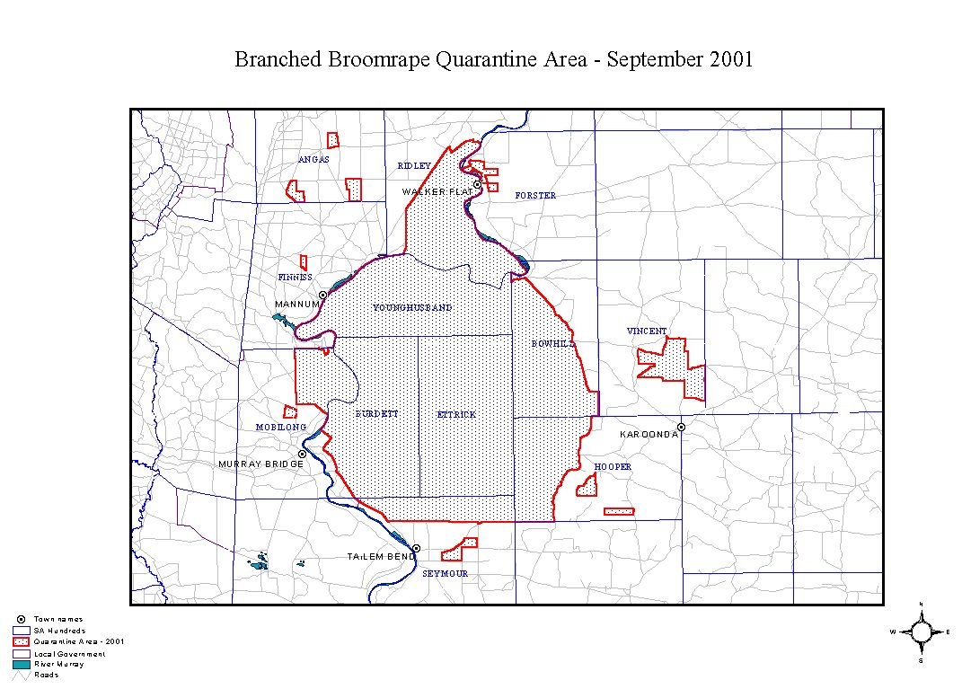

Dated 19 September 2001.
Rob Kerin, Minister for Primary Industries and Resources

LIQUOR LICENSING ACT 1997 AND GAMING MACHINES ACT 1992
Notice of Application
NOTICE is hereby given, pursuant to section 52 of the Liquor Licensing Act 1997 and section 29 of the Gaming Machines Act 1992, that Glenena Pty Ltd (ACN 097 451 191), c/o Piper Alderman, 167 Flinders Street, Adelaide, S.A. 5000 has applied to the Liquor and Gaming Commissioner for the transfer of a Hotel Licence and a Gaming Machine Licence in respect of premises situated at corner of McDouall Stuart Avenue and Ian Street, Whyalla, S.A. 5608 and known as Westland Hotel Motel.
The applications have been set down for hearing on 19 October 2001 at 9 a.m.
Any person may object to the application by lodging a notice of objection in the prescribed form with the Licensing Authority, and serving a copy of the notice on the applicant at the applicant’s address given above, at least seven days before the hearing date.
Plans in respect of the premises the subject of the application are open to public inspection without fee at the Office of the Liquor and Gaming Commissioner, 9th Floor, East Wing, 50 Grenfell Street, Adelaide, S.A. 5000.
Dated 13 September 2001.
Applicant

LIQUOR LICENSING ACT 1997 AND GAMING MACHINES ACT 1992
Notice of Application
NOTICE is hereby given, pursuant to section 52 of the Liquor Licensing Act 1997 and section 29 of the Gaming Machines Act 1992, that Michael Turner & Associates Pty Ltd (ACN 053 165 576), Megapace Pty Ltd (ACN 051 788 722) and Asia Australia Traders Pty Ltd (ACN 061 947 466), c/o Piper Alderman, 167 Flinders Street, Adelaide, S.A. 5000 have applied to the Liquor and Gaming Commissioner for the transfer of a Hotel Licence and a Gaming Machine Licence in respect of premises situated at 247 Gouger Street, Adelaide, S.A. 5000 and known as Directors Hotel.
The applications have been set down for hearing on 12 October 2001 at 9 a.m.
Any person may object to the application by lodging a notice of objection in the prescribed form with the Licensing Authority, and serving a copy of the notice on the applicants at the applicants’ address given above, at least seven days before the hearing date.
Plans in respect of the premises the subject of the application are open to public inspection without fee at the Office of the Liquor and Gaming Commissioner, 9th Floor, East Wing, 50 Grenfell Street, Adelaide, S.A. 5000.
Dated 12 September 2001.
Applicants

LIQUOR LICENSING ACT 1997
Notice of Application
NOTICE is hereby given, pursuant to section 52 (2) (b) of the Liquor Licensing Act 1997, that John Edward Tew, Ryan John Tew and Maria Tew, 1/10 Varram Way, West Lakes Shore, S.A. 5020 have applied to the Licensing Authority for the transfer of a Restaurant Licence in respect of premises situated at 1D Airport Road, Brooklyn Park, S.A. 5071 and known as Nizam’s Indian Curry Bar.
The application has been set down for hearing on 2 October 2001 at 2 p.m.
Any person may object to the application by lodging a notice of objection in the prescribed form with the Licensing Authority, and serving a copy of the notice on the applicants at the applicants’ address given above, at least seven days before the hearing date.
Plans in respect of the premises the subject of the application are open to public inspection without fee at the Office of the Liquor and Gaming Commissioner, 9th Floor, East Wing, 50 Grenfell Street, Adelaide, S.A. 5000.
Dated 11 September 2001.
Applicants

LIQUOR LICENSING ACT 1997
Notice of Application
NOTICE is hereby given, pursuant to section 52 (2) (b) of the Liquor Licensing Act 1997, that Nicolaas Zwiersen, Sonia Zwiersen, Timothy Zwiersen and Damian Zwiersen, P.O. Box 123, Auburn, S.A. 5451 have applied to the Licensing Authority in respect of premises situated at 2 Heans Road, Auburn, S.A. 5451 and to be known as Attunga Vineyard Wines.
The application has been set down for hearing on 19 October 2001 at 9 a.m.
Any person may object to the application by lodging a notice of objection in the prescribed form with the Licensing Authority, and serving a copy of the notice on the applicants at the applicants’ address given above, at least seven days before the hearing date.
Plans in respect of the premises the subject of the application are open to public inspection without fee at the Office of the Liquor and Gaming Commissioner, 9th Floor, East Wing, 50 Grenfell Street, Adelaide, S.A. 5000.
Dated 11 September 2001.
Applicants

LIQUOR LICENSING ACT 1997
Notice of Application
NOTICE is hereby given, pursuant to section 52 (2) (b) of the Liquor Licensing Act 1997, that Umarfado Pty Ltd has applied to the Licensing Authority for a Special Circumstances Licence in respect of premises situated at 287 Diagonal Road, Oaklands Park, S.A. 5046 and to be known as Marion Cultural Centre.
The application has been set down for hearing on 19 October 2001.
Conditions
The following conditions are sought:
• To sell liquor for consumption on the licensed premises between the hours of 7 a.m. and 1 a.m. the following day.
• Entertainment consent is sought.
Any person may object to the application by lodging a notice of objection in the prescribed form with the Licensing Authority, and serving a copy of the notice on the applicant at the applicant’s address given above, at least seven days before the hearing date.
Plans in respect of the premises the subject of the application are open to public inspection without fee at the Office of the Liquor and Gaming Commissioner, 9th Floor, East Wing, 50 Grenfell Street, Adelaide, S.A. 5000.
Applicant

LIQUOR LICENSING ACT 1997
Notice of Application
NOTICE is hereby given, pursuant to section 52 (2) (b) of the Liquor Licensing Act 1997, that Orlando Wyndham Group Pty Ltd (ACN 007 870 046), c/o Piper Alderman, 167 Flinders Street, Adelaide, S.A. 5000 has applied to the Licensing Authority for the transfer of a Special Circumstances Licence in respect of the premises situated at corner Caves Road and Riddoch Highway, Naracoorte, S.A. 5271 and currently known as Heathfield Ridge Wines but to be known as Russet Ridge Winery.
The application has been set down for hearing on 19 October 2001 at 9 a.m.
Condition
The following licence conditions are sought:
Area 1:
• provided that liquor sold, supplied or consumed by way of sample or sold or supplied for consumption off the licensed premises, must either be produced by Orlando Wyndham Group Pty Ltd or, alternatively fermented by or under the direction of Orlando Wyndham Group Pty Ltd (or a related body corporate) and is uniquely Orlando Wyndham Group Pty Ltd (or the related body corporate’s) own product.
Any person may object to the application by lodging a notice of objection in the prescribed form with the Licensing Authority, and serving a copy of the notice on the applicant at the applicant’s address given above, at least seven days before the hearing date.
Plans in respect of the premises the subject of the application are open to public inspection without fee at the Office of the Liquor and Gaming Commissioner, 9th Floor, East Wing, 50 Grenfell Street, Adelaide, S.A. 5000.
Dated 12 September 2001.
Applicant

LIQUOR LICENSING ACT 1997
Notice of Application
NOTICE is hereby given, pursuant to section 52 (2) (b) of the Liquor Licensing Act 1997, that Campbells Cash and Carry Pty Ltd (ACN 000 226 399), c/o Kelly & Co., Level 17, 91 King William Street, Adelaide, S.A. 5000 has applied to the Licensing Authority for a Wholesale Liquor Merchant’s Licence in respect of premises to be situated at Lot 11, corner of Main North Road, Diagonal Road and Levels Road, Pooraka and to be known as Campbells Cash and Carry.
The application has been set down for hearing on 19 October 2001.
Any person may object to the application by lodging a notice of objection in the prescribed form with the Licensing Authority, and serving a copy of the notice on the applicant at the applicant’s address given above, at least seven days before the hearing date.
Plans in respect of the premises the subject of the application are open to public inspection without fee at the Office of the Liquor and Gaming Commissioner, 9th Floor, East Wing, 50 Grenfell Street, Adelaide, S.A. 5000.
Dated 13 September 2001.
Applicant

LIQUOR LICENSING ACT 1997
Notice of Application
NOTICE is hereby given, pursuant to section 52 (2) (b) of the Liquor Licensing Act 1997, that Mewett Pty Ltd (ACN 097 899 619), c/o Piper Alderman, 167 Flinders Street, Adelaide, S.A. 5000 has applied to the Licensing Authority for the transfer of a Hotel Licence in respect of the premises situated at Main Road, Ashbourne, S.A. 5157 and known as The Green Man Inn.
The application has been set down for hearing on 22 October 2001 at 2.30 p.m.
Any person may object to the application by lodging a notice of objection in the prescribed form with the Licensing Authority, and serving a copy of the notice on the applicant at the applicant’s address given above, at least seven days before the hearing date.
Plans in respect of the premises the subject of the application are open to public inspection without fee at the Office of the Liquor and Gaming Commissioner, 9th Floor, East Wing, 50 Grenfell Street, Adelaide, S.A. 5000.
Dated 13 September 2001.
Applicant

LIQUOR LICENSING ACT 1997
Notice of Application
NOTICE is hereby given, pursuant to section 52 (2) (b) of the Liquor Licensing Act 1997, that Pacific Apartments Frome Street Pty Ltd, 88 Frome Street, Adelaide, S.A. 5000 has applied to the Licensing Authority for the transfer of a Residential Licence in respect of premises situated at 88 Frome Street, Adelaide, S.A. 5000 and known as The Adelaide Ritz All-Suites Hotel and to be known as Pacific Apartments on Frome.
The application has been set down for hearing on 22 October 2001 at 11 a.m.
Any person may object to the application by lodging a notice of objection in the prescribed form with the Licensing Authority, and serving a copy of the notice on the applicant at the applicant’s address given above, at least seven days before the hearing date.
Plans in respect of the premises the subject of the application are open to public inspection without fee at the Office of the Liquor and Gaming Commissioner, 9th Floor, East Wing, 50 Grenfell Street, Adelaide, S.A. 5000.
Dated 11 September 2001.
Applicant

LIQUOR LICENSING ACT 1997
Notice of Application
NOTICE is hereby given, pursuant to section 52 (2) (b) of the Liquor Licensing Act 1997, that Kenan Becirovic, 46B King William Street, Adelaide, S.A. 5000 has applied to the Licensing Authority for the transfer of a Restaurant Licence in respect of premises situated at 18A Jetty Road, Glenelg, S.A. 5045 and known as Tandoori Sizzler Indian Restaurant and to be known as Yiros 777 Restaurant.
The application has been set down for hearing on 22 October 2001 at 10 a.m.
Any person may object to the application by lodging a notice of objection in the prescribed form with the Licensing Authority, and serving a copy of the notice on the applicant at the applicant’s address given above, at least seven days before the hearing date.
Plans in respect of the premises the subject of the application are open to public inspection without fee at the Office of the Liquor and Gaming Commissioner, 9th Floor, East Wing, 50 Grenfell Street, Adelaide, S.A. 5000.
Dated 7 September 2001.
Applicant

LIQUOR LICENSING ACT 1997
Notice of Application
NOTICE is hereby given, pursuant to section 52 (2) (b) of the Liquor Licensing Act 1997, that Monika Hein, 223 Flinders Street, Adelaide, S.A. 5000 has applied to the Licensing Authority for the transfer of a Restaurant Licence in respect of premises situated at 223 Flinders Street, Adelaide, S.A. 5000 and known as Vizz Restaurant and to be known as German Restaurant.
The application has been set down for hearing on 22 October 2001 at 10.30 a.m.
Any person may object to the application by lodging a notice of objection in the prescribed form with the Licensing Authority, and serving a copy of the notice on the applicant at the applicant’s address given above, at least seven days before the hearing date.
Plans in respect of the premises the subject of the application are open to public inspection without fee at the Office of the Liquor and Gaming Commissioner, 9th Floor, East Wing, 50 Grenfell Street, Adelaide, S.A. 5000.
Dated 10 September 2001.
Applicant

LIQUOR LICENSING ACT 1997
Notice of Application
NOTICE is hereby given, pursuant to section 52 (2) (b) of the Liquor Licensing Act 1997, that Cleco Nominees No. 293 Pty Ltd (ACN 096 762 319), 116 Greenhill Road, Unley, S.A. 5061 has applied to the Licensing Authority for the transfer of a Hotel Licence in respect of premises situated at 306-312 King William Street, Adelaide, S.A. 5000 and known as Crown & Sceptre Hotel.
The application has been set down for hearing on 23 October 2001.
Any person may object to the application by lodging a notice of objection in the prescribed form with the Licensing Authority, and serving a copy of the notice on the applicant at the applicant’s address given above, at least seven days before the hearing date.
Plans in respect of the premises the subject of the application are open to public inspection without fee at the Office of the Liquor and Gaming Commissioner, 9th Floor, East Wing, 50 Grenfell Street, Adelaide, S.A. 5000.
Applicant

MINING ACT 1971
NOTICE is hereby given in accordance with section 28 (5) of the Mining Act 1971, that the Minister for Minerals and Energy proposes to grant an Exploration Licence over the under-mentioned area:
Applicant: Minex (Aust) Pty Ltd
Location: Alberga River Area—Approximately 45 km north-east of Marla, bounded as follows:
Area ‘A’—Commencing at a point being the intersection of latitude 26°46′S and longitude 134°00′E, thence south to latitude 26°50′S, west to longitude 133°55′E, south to latitude 26°54′S, west to longitude 133°54′E, south to latitude 26°58′S, west to longitude 133°53′E, south to latitude 27°04′S, west to longitude 133°52′E, south to latitude 27°10′S, west to longitude 133°30′E, north to a southern boundary of Pitjantjatjara Lands, thence generally easterly and north-easterly along the boundary of the said Lands to latitude 26°46′S, and east to the point of commencement, but excluding Tarcoola-Alice Springs Railway (see G.G. 13.11.1975).
Area ‘B’—Commencing at a point being the intersection of latitude 26°50′S and longitude 134°12′E, thence east to longitude 134°18′E, south to latitude 26°53′S, east to longitude 134°26′E, south to latitude 26°56′S, east to longitude 134°30′E, north to latitude 26°55′S, east to longitude 134°34′E, north to latitude 26°52′S, east to longitude 134°48′E, south to latitude 26°56′S, west to longitude 134°46′E, south to latitude 26°58′S, west to longitude 134°44′E, south to latitude 27°00′S, west to longitude 134°40′E, south to latitude 27°04′S, west to longitude 134°32′E, north to latitude 27°02′S, west to longitude 134°17′E, north to latitude 27°00′S, west to longitude 134°12′E, and north to the point of commencement.
All the within latitudes and longitudes are geodetic and expressed in terms of the Australian Geodetic Datum as defined on p. 4984 of Commonwealth Gazette number 84 dated 6 October 1966 (AGD66).
Term: 1 year
Area in km²: 1 995
Ref: 063/2001
Dated 20 September 2001.
H Tyrteos, Acting Mining Registrar, Department of Primary Industries and Resources

MINING ACT 1971
NOTICE is hereby given in accordance with section 28 (5) of the Mining Act 1971, that the Minister for Minerals and Energy proposes to grant an Exploration Licence over the under-mentioned area:
Applicant: James F Allender
Location: Lake Labyrinth Area—Approximately 35 km north-east of Tarcoola, bounded as follows: Commencing at a point being the intersection of latitude 30°32′S and longitude 134°50′E, thence east to longitude 135°04′E, south to latitude 30°37′S, west to longitude 135°00′E, south to latitude 30°43′S, west to longitude 134°50′E, and north to the point of commencement, all the within latitudes and longitudes being geodetic and expressed in terms of the Australian Geodetic Datum as defined on p. 4984 of Commonwealth Gazette number 84 dated 6 October 1966 (AGD66).
Term: 1 year
Area in km²: 384
Ref.: 047/2001
Dated 20 September 2001.
H Tyrteos, Acting Mining Registrar, Department of Primary Industries and Resources

ROADS (OPENING AND CLOSING) ACT 1991:
SECTION 24
NOTICE OF CONFIRMATION OF ROAD
PROCESS ORDER
Walpole Road, Paralowie
Deposited Plan 57745
BY Road Process Order made on 5 July 2001, the City of Salisbury ordered that:
1. Portion of the public road (Walpole Road) adjoining Port Wakefield Road and the northern boundary of allotment 164 in Deposited Plan 42193 more particularly lettered ‘A’ in Preliminary Plan No. PP32/0636 be closed.
2. Issue a Certificate of Title to the CITY OF SALISBURY over the whole of the land subject to closure which land is being retained by council to merge with the adjoining council owned land.
3. Grant to the South Australian Water Corporation an easement for water supply purposes over the whole of the land.
On 14 September 2001, that order was confirmed by the Minister for Administrative and Information Services con-ditionally on approval and deposit of the survey plan by the Registrar-General. The condition has now been fulfilled.
Pursuant to section 24(5) of the Roads (Opening and Closing) Act 1991, NOTICE of the order referred to above and its confirmation is hereby given.
Dated 20 September 2001.
P. M. Kentish, Surveyor-General

GRANT OF PRELIMINARY SURVEY LICENCE No. PSL5
Office of Minerals and Energy Resources, Adelaide, 30 August 2001
NOTICE is hereby given that the undermentioned preliminary survey licence has been granted under the provisions of the Petroleum Act 2000, pursuant to delegated powers dated 25 September 2000, Gazetted 28 September 2000, page 2289.
R. A. Laws, Director Petroleum, Office of Minerals and Energy Resources, Delegate of the Minister for Minerals and Energy
No. of  Licence | Licensee | Locality | Date of  Expiry | Area in  km² | Reference

5 | Epic Energy South Australia Pty Ltd |  | Hallett Region | 29 August 2002 | 0.17 | SR.27.2.225
General Description of Pipeline Preliminary Survey Licence Area
Preliminary survey activities are authorised within a 100 m wide corridor whose centre line commences at the Moomba to Adelaide Pipeline and terminates at the proposed meter station near the proposed AGL Hallett Peak Load Power Station Site, as shown on the attached plan.

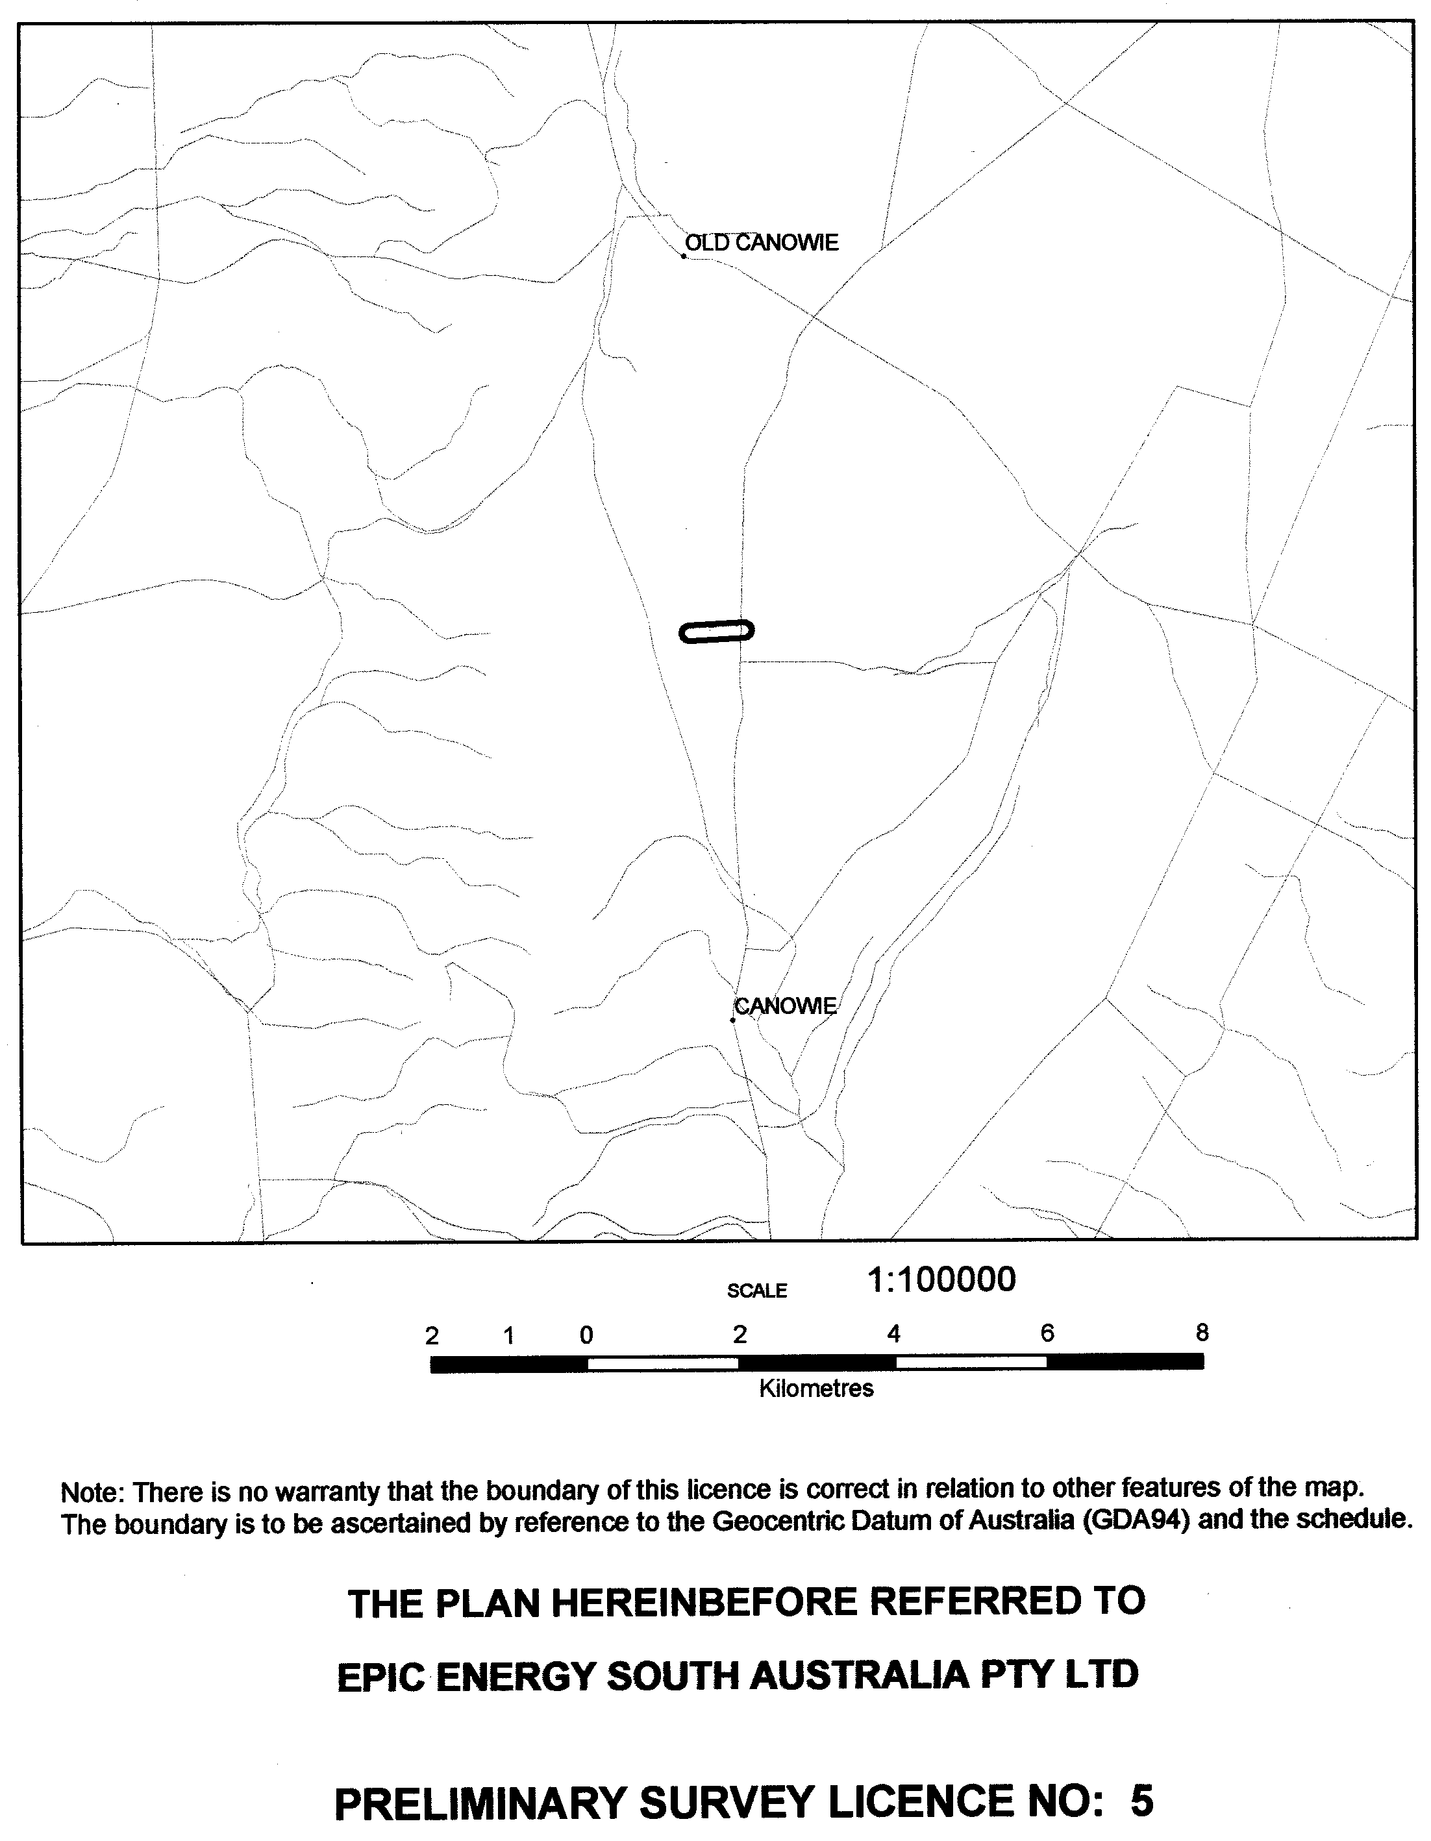
GRANT OF PRELIMINARY SURVEY LICENCE No. PSL6
Office of Minerals and Energy Resources, Adelaide, 29 August 2001
NOTICE is hereby given that the undermentioned preliminary survey licence has been granted under the provisions of the Petroleum Act 2000, pursuant to delegated powers dated 25 September 2000, Gazetted 28 September 2000, page 2289.
R. A. Laws, Director Petroleum, Office of Minerals and Energy Resources, Delegate of the Minister for Minerals and Energy
No. of  Licence | Licensee | Locality | Date of  Expiry | Area in  km² | Reference

6 | GPU GasNet Pty Ltd |  | Proposed Iona to Adelaide Gas Pipeline | 28 August 2002 | 3 564 | SR.28.1.347
General Description of Pipeline Preliminary Survey Licence Area
Preliminary survey activities are authorised in two areas defined as the southern corridor and the northern corridor, as shown on the attached plan.
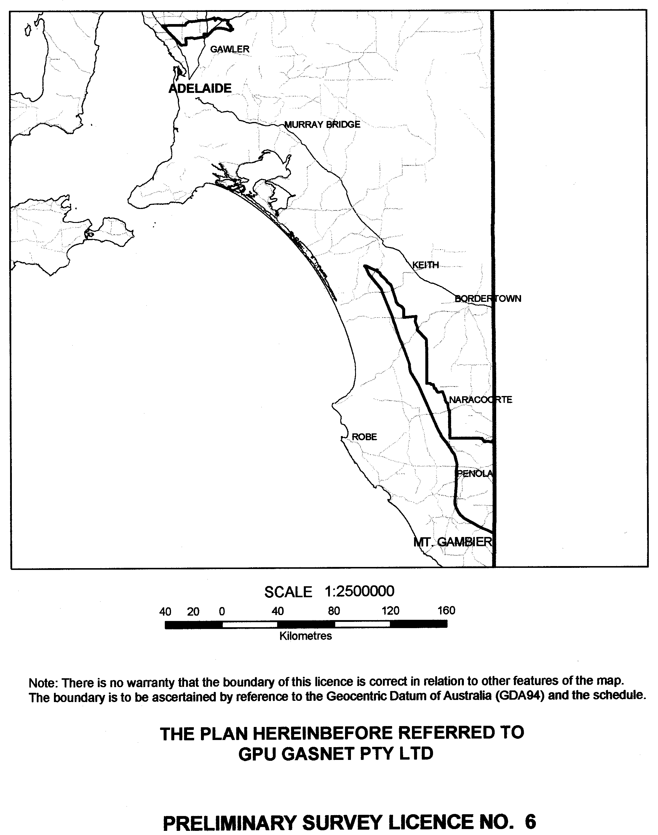

WATER MAINS AND SEWERS

Office of the South Australian Water Corporation
Adelaide, 20 September 2001.

WATER MAINS LAID

Notice is hereby given that the following main pipes or parts of main pipes have been laid down by the South Australian Water Corporation in or near the undermentioned water districts and are now available for a constant supply of water to adjacent land.

ADELAIDE WATER DISTRICT

CITY OF MITCHAM
Easement in lot 573, Grand Boulevard, Craigburn Farm. p10
Grand Boulevard, Craigburn Farm. p10
Appleberry Crescent, Craigburn Farm. p10
Easement in lot 574, Appleberry Crescent, Craigburn Farm. p10

CITY OF NORWOOD, PAYNEHAM AND ST. PETERS
Salisbury Avenue, Royston Park. p9

CITY OF SALISBURY
Mawson Lakes Boulevard, Mawson Lakes. p11 and 12
Easement in reserve (lot 592), Shearwater Drive, Mawson Lakes. p12
Sheaoak Drive, Mawson Lakes. p12
Shearwater Drive, Mawson Lakes. p12
Heron Walk, Mawson Lakes. p12
Gannet Street, Mawson Lakes. p11
Blue Wren Circuit, Mawson Lakes. p11
Easements in lot 538, Gannet Street, Mawson Lakes. p11
Beltana Street, Salisbury. p13
Roper Street, Salisbury. p13
RM Williams Drive, Walkley Heights. p14-16
Easements in lot 500, RM Williams Drive, Walkley Heights. p15 and 16
Homestead Avenue, Walkley Heights. p15
Wright Road, Walkley Heights. p16
Dulkara Road, Walkley Heights. p16

CITY OF WEST TORRENS
Errington Street, North Plympton. p1

BEETALOO COUNTRY LANDS WATER DISTRICT

DISTRICT OF BARUNGA WEST
Melton Pontifex Road, Melton. p7

TOWNSHIP OF CLARE WATER DISTRICT

DISTRICT OF CLARE AND GILBERT VALLEYS COUNCIL
Buchanan Street, Clare. p2

MOONTA WATER DISTRICT

DISTRICT OF THE COPPER COAST
Cambridge Street, Moonta Bay. p4

WALLAROO WATER DISTRICT

DISTRICT OF THE COPPER COAST
William Street, Wallaroo. p5
Thorne Street, Wallaroo. p6

WATER MAINS ABANDONED

Notice is hereby given that the undermentioned water mains have been abandoned by the South Australian Water Corporation.

BEETALOO COUNTRY LANDS WATER DISTRICT

DISTRICT OF BARUNGA WEST
Melton Pontifex Road, Melton. p7

ADDENDA

Addendum to notice in “Government Gazette” of 20 June 1985.

“WATER MAINS LAID”

“Notice is hereby given that the following main pipes or parts of main pipes have been laid down by the South Australian Water Corporation in or near the undermentioned water districts and are now available for a constant supply of water to adjacent land.”

“ENCOUNTER BAY COUNTRY LANDS WATER DISTRICT”

“CITY OF VICTOR HARBOR”
“Fuller Road, Victor Harbor-540.0 m of 100 mm AC main from 80 mm main Waggon Road generally south-westerly to lot 6.”

To this notice add “This main is not available for constant rateable supply.” p8

SEWERS LAID

Notice is hereby given that the following sewers have been laid down by the South Australian Water Corporation in the under-mentioned drainage areas and are now available for house connections.

ADELAIDE DRAINAGE AREA

CITY OF MITCHAM
Grand Boulevard, Craigburn Farm. FB 1098 p41 and 42
Appleberry Crescent, Craigburn Farm. FB 1098 p41 and 42
Easement in lot 573, Grand Boulevard, Craigburn Farm. FB 1098 p41 and 42

CITY OF NORWOOD, PAYNEHAM AND ST. PETERS
Salisbury Avenue, Royston Park. FB 1097 p43

CITY OF SALISBURY
Beltana Street, Salisbury. FB 1098 p43 and 44
Roper Street, Salisbury. FB 1098 p43 and 44
Easement in lot 101, Roper Street, Salisbury. FB 1098 p43 and 44
Wright Road, Walkley Heights. FB 1098 p33, 34 and 38
Easements in lot 500, RM Williams Drive, Walkley Heights. FB 1098 p33-35 and 38,
Easements in lot 501, RM Williams Drive, Walkley Heights. FB 1098 p33, 35, 37 and 40
RM Williams Drive, Walkley Heights. FB 1098 p33 and 35-39
Homestead Avenue, Walkley Heights. FB 1098 p33, 35 and 40
Easements in lot 595, Brookside Drive, Mawson Lakes. FB 1098 p22-24 and 26-28
Blue Wren Circuit, Mawson Lakes. FB 1098 p22, 24, 27 and 31
Easement in reserve (lot 602), Mawson Lakes Bouldevard, Mawson Lakes. FB 1098 p22, 24 and 27
Mawson Lakes Boulevard, Mawson Lakes. FB 1098 p22, 24 and 29
Gannet Street, Mawson Lakes. FB 1098 p22, 24 and 31
Heron Walk, Mawson Lakes. FB 1098 p22, 24 and 32
Shearwater Drive, Mawson Lakes. FB 1098 p22, 24 and 32
Sheaoak Drive, Mawson Lakes. FB 1098 p22, 24 and 31
Easement in lot 592, Shearwater Drive, Mawson Lakes. FB 1098 p22, 25 and 29

CITY OF WEST TORRENS
Errington Street, North Plympton. FB 1097 p42

MOUNT GAMBIER COUNTRY DRAINAGE AREA

CITY OF MOUNT GAMBIER
Waterhouse Street, Mount Gambier. FB 1090 p8

A. Howe, Chief Executive Officer, South Australian Water Corporation

VOCATIONAL EDUCATION, EMPLOYMENT AND TRAINING ACT 1994

PART 4 - CONTRACTS OF TRAINING
Pursuant to the provisions of the Vocational Education, Employment and Training Act (VEET Act) the Accreditation and Registration Council (ARC) gives notice that it has determined the following:

Occupations that Constitute Trades and Other Declared Vocations
The following schedule is additional to:
1. the gazettal of 24 April 1996 (page 2045) | 2. the gazettal of 31 October 1996 (page 1544)
3. the gazettal of 5 December 1996 (page 1818) | 4. the gazettal of 6 February 1997 (page 830)
5. the gazettal of 17 April 1997 (page 1571) | 6. the gazettal of 29 May 1997 (page 2758)
7. the gazettal of 12 June 1997 (page 2984) | 8. the gazettal of 3 July 1997 (page 33)
9. the gazettal of 7 August 1997 (page 311) | 10. the gazettal of 18 December 1997 (page 1677)
11. the gazettal of 22 December 1997 (page 1776) | 12. the gazettal of 23 April 1998 (page 1959)
13. the gazettal of 18 June 1998 (page 2594) | 14. the gazettal of 6 August 1998 (page 339)
15. the gazettal of 24 September (page 990) | 16. the gazettal of 1 October 1998 (page 1038)
17. the gazettal of 15 October 1998 (page 1150) | 18. the gazettal of 12 November 1998 (page 1389)
19. the gazettal of 19 November 1998 (page 1583) | 20. the gazettal of 3 December 1998 (page 1742)
21. the gazettal of 10 December 1998 (page 1870) | 22. the gazettal of 17 December 1998 (page 1954)
23. the gazettal of 23 December 1998 (page 2039) | 24. the gazette of 11 March 1999 (page 1359)
25. the gazettal of 25 March 1999 (page 1480) | 26. the gazette of 1 April 1999 (page 1605) (Errata)
27. the gazettal of 22 April 1999 (page 2219) | 28. the gazettal of 29 April 1999 (page 2381) (Errata)
29. the gazettal of 6 May 1999 (page 2482) | 30. the gazettal of 13 May 1999 (page 2595)
31. the gazettal of 27 May 1999 (Errata) (page 2723) | 32. the gazettal of 17 June 1999 (page 3123)
33. the gazettal of 24 June 1999 (page 3261) | 34. the gazettal of 1 July 1999 (page 22)
35. the gazettal of 29 July 1999 (page 602) | 36. the gazettal of 30 September 1999 (page 1364)
37. the gazettal of 14 October 1999 (page 1973) | 38. the gazettal of 11 November 1999 (page 2327)
39. the gazettal of 6 January 2000 (page 1169) | 40. the gazettal of 30 March 2000 (page 1921)
- the gazettal of 6 April 2000 (page 2047) | - the gazettal of 13 April 2000 (Errata) (page 2167)
- the gazettal of 4 May 2000 (page 2416) | - the gazettal of 18 May 2000 (page 2606) Errata (page 2609)
- the gazettal of 15 June 2000 (page 3282) Errata (page 3285) | - the gazettal of 29 June 2000 (page 3490)
- the gazettal of 6 July 2000 (page 22) Errata (page 24) | - the gazettal of 20 July 2000 (page 267)
- the gazettal of 10 August 2000 (page 467) | - the gazettal of 24 August 2000 (page 643)
- the gazettal of 14 September 2000 (page 2002) | - the gazettal of 12 October 2000 (page 2475) Errata (page 2480)
- the gazettal of 16 November 2000 (page 3208) Errata (page 3211) | - the gazettal of 7 December 2000 (page 3461) Errata (page 3467)
- the gazettal of 15 February 2001 (page 641) Errata (page 647) | 56. the gazettal of 5 April 2001 (page 1561)
57. the gazettal of 19 April 2001 (page 1645) | 58. the gazettal of 31 May 2001 (page 1914) Errata (page 1918)
59. the gazettal of 28 June 2001 (page 2416) | 60. the gazettal of 12 July 2001 (page 2610) (Errata)
61. the gazettal of 19 July 2001 (page 2713) (Errata) | 62. the gazettal of 26 July 2001 (page 2785)
63. the gazettal of 16 August 2001 (page 3091)

which set out the occupations that constitute trades and other declared vocations and the terms and conditions applicable to such declared vocations.

SCHEDULE - DECLARED VOCATIONS, REQUIRED COURSES OF INSTRUCTION AND ASSOCIATED CONDITIONS

Changes to courses and conditions determined by ARC for existing Declared Vocations appear in Bold.

Occupation/Occupation Levels  Declared Vocation  * Trade  # Other than trade | Course code  National / State  and expiry date | Approved Course of Instruction and Stream | Nominal Term of  Contract of  Training | Nominal hours of attendance at approved course | Probationary Period
* Butchering and/or Slaughtering | Endorsed to  31 Dec 01 | Australian Meat Industry Training Package
ARC August 2001 | MTM20300 | Certificate II in Meat Processing (Meat Retailing) | 12 months full time or  24 months part time | 616 hours | 1 month  full time or  1 month  part time
ARC August 2001 | MTM30800 | Certificate III in Meat Processing (Meat Retailing) | 48 months full time or  72 months part time | 954 hours | 3 months  full time or  3 months  part time
 |  | Replacing the following courses of instruction with effect from 20 Sep 01:
March 1999 | 3334  VI2311ABA  31 Dec 01 | Certificate III in Meat Processing (Meat Retailing) | 48 months | 480 hours | 4 months
* Butchering and/or Smallgoods Making | Endorsed to  31 Dec 01 | Australian Meat Industry Training Package
ARC August 2001 | MTM10100 | Certificate I in Meat Processing (Smallgoods) | 12 months full time or  36 months part time | 280 hours | 1 month  full time or  1 month  part time
ARC August 2001 | MTM20200 | Certificate II in Meat Processing (Smallgoods) | 24 months full time or  36 months part time | 560 hours | 2 months  full time or  2 months  part time
ARC August 2001 | MTM20300 | Certificate II in Meat Processing (Meat Retailing) | 12 months full time or  24 months part time | 616 hours | 1 month  full time or  1 month  part time
ARC August 2001 | MTM30700 | Certificate III in Meat Processing (Smallgoods) | 36 months full time or  72 months part time | 920 hours | 3 months  full time or  3 months  part time
ARC August 2001 | MTM30800 | Certificate III in Meat Processing (Meat Retailing) | 48 months full time or  72 months part time | 954 hours | 3 months  full time or  3 months  part time
ARC August 2001 | MTM40100 | Certificate IV in Meat Processing (Leadership) | 24 months full time or  36 months part time | 700 hours | 2 months  full time or  2 months  part time
ARC August 2001 | MTM40300 | Certificate IV in Meat Processing (Quality Assurance) | 36 months full time or  72 months part time | 890-1080 hours | 3 months  full time or  3 months  part time
ARC August 2001 | MTM50100 | Diploma of Meat Processing | 36 months full time or  72 months part time | 860 hours | 3 months  full time or  3 months  part time
ARC August 2001 | MTM60100 | Advanced Diploma of Meat Processing | 48 months full time or  72 months part time | 1250 hours | 3 months  full time or  3 months  part time
 |  | Replacing the following courses of instruction with effect from 20 Sep 01:
March 1999 | 3334  VI2311ABA  CRN  31 Dec 01 | Certificate III in Meat Processing (Meat Retailing) | 48 months | 480 hours | 4 months

* Locksmithing
ARC August 2001 | 20042VIC  31 Dec 04 | Certificate III in Engineering Technology | 48 months | 960 hours | 3 months
# Meat Processing (Abattoirs) |  | Hours shown for this vocation are the maximum for the qualification. In the majority of cases the hours will be less subject to choice of electives
 | Endorsed to  31 Dec 01 | Australian Meat Industry Training Package
ARC August 2001 | MTM20100 | Certificate II in Meat Processing (Abattoirs) | 12 months full time or  36 months part time | 400 hours | 1 month  full time or  1 month  part time
ARC August 2001 | MTM20400 | Certificate II in Meat Processing (Food Services) | 12 months full time or  36 months part time | 400 hours | 1 months  full time or  1 month  part time
ARC August 2001 | MTM30100 | Certificate III in Meat Processing (Boning) | 24 months full time or  36 months part time | 500 hours | 2 months  full time or  2 months  part time
ARC August 2001 | MTM30200 | Certificate III in Meat Processing (Food Services) | 24 months full time or  36 months part time | 550 hours | 2 months  full time or  2 months  part time
ARC December 1998 | MTM30298 | Certificate III in Meat Processing (Laboratory) | 24 months | 570 hours | 2 months
ARC August 2001 | MTM30300 | Certificate III in Meat Processing (Meat Safety) | 24 months full time or  36 months part time | 590 hours | 2 months  full time or  2 months  part time
ARC August 2001 | MTM30400 | Certificate III in Meat Processing (Rendering) | 24 months full time or  36 months part time | 500 hours | 2 months  full time or  2 months  part time
ARC August 2001 | MTM30500 | Certificate III in Meat Processing (Slaughtering) | 24 months full time or  36 months part time | 500 hours | 2 months  full time or  2 months  part time
ARC August 2001 | MTM30600 | Certificate III in Meat Processing (General) | 24 months full time or  36 months part time | 500 hours | 2 months  full time or  2 months  part time
ARC August 2001 | MTM40100 | Certificate IV in Meat Processing (Leadership) | 24 months full time or  36 months part time | 700 hours | 2 months  full time or  2 months  part time
ARC August 2001 | MTM40200 | Certificate IV in Meat Processing (Meat Safety) | 36 months full time or  36 months part time | 1050 hours | 3 months  full time or  3 months  part time
ARC August 2001 | MTM40300 | Certificate IV in Meat Processing (Quality Assurance) | 36 months full time or  72 months part time | 890-1080 hours | 3 months  full time or  3 months  part time
ARC August 2001 | MTM40400 | Certificate IV in Meat Processing (General) | 24 months full time or  36 months part time | 700 hours | 2 months  full time or  2 months  part time
ARC August 2001 | MTM50100 | Diploma of Meat Processing | 36 months full time or  72 months part time | 860 hours | 3 months  full time or  3 months  part time
ARC August 2001 | MTM60100 | Advanced Diploma of Meat Processing | 48 months full time or  72 months part time | 1250 hours | 3 months  full time or  3 months  part time
 |  | Replacing the following courses of instruction with effect from 20 Sep 01:
ARC December 1998 | MTM 20198 | Certificate II in Meat Processing (Abattoirs) | 18 months | 500 hours | 6 weeks
ARC December 1998 | MTM 30198 | Certificate III in Meat Processing (Boning) | 24 months | 500 hours | 2 months
ARC December 1998 | MTM 30398 | Certificate III in Meat Processing (Meat Safety) | 24 months | 610 hours | 2 months
ARC December 1998 | MTM 30498 | Certificate III in Meat Processing (Rendering) | 24 months | 500 hours | 2 months
ARC December 1998 | MTM 30598 | Certificate III in Meat Processing (Slaughtering) | 24 months | 560 hours | 2 months
ARC December 1998 | MTM 40198 | Certificate IV in Meat Processing (Leadership) | 24 months | 510 hours | 2 months
ARC December 1998 | MTM 40298 | Certificate IV in Meat Processing (Meat Safety) | 36 months | 800 hours | 3 months
ARC December 1998 | MTM 40398 | Certificate IV in Meat Processing (Quality Assurance) | 36 months | 820 hours | 3 months
# Meat Processing (Smallgoods Manufacturing) | Endorsed to  31 Dec 01 | Australian Meat Industry Training Package
ARC August 2001 | MTM10100 | Certificate I in Meat Processing (Smallgoods) | 12 months full time or  36 months part time | 280 hours | 1 month  full time or  1 month  part time
ARC August 2001 | MTM20200 | Certificate II in Meat Processing (Smallgoods) | 24 months full time or  36 months part time | 560 hours | 2 months  full time or  2 months  part time
ARC August 2001 | MTM30700 | Certificate III in Meat Processing (Smallgoods) | 36 months full time or  72 months part time | 920 hours | 3 months  full time or  3 months  part time
ARC August 2001 | MTM40100 | Certificate IV in Meat Processing (Leadership) | 24 months full time or  36 months part time | 700 hours | 2 months  full time or  2 months  part time
ARC August 2001 | MTM40300 | Certificate IV in Meat Processing (Quality Assurance) | 36 months full time or  72 months part time | 890-1080 hours | 3 months  full time or  3 months  part time
ARC December 1998 | MTM40598 | Certificate IV in Meat Processing (Smallgoods Manufacturing) | 36 months | 1198 hours | 3 months
ARC August 2001 | MTM50100 | Diploma of Meat Processing | 36 months full time or  72 months part time | 860 hours | 3 months  full time or  3 months  part time
ARC August 2001 | MTM60100 | Advanced Diploma of Meat Processing | 48 months full time or  72 months part time | 1250 hours | 3 months  full time or  3 months  part time
 |  | Replacing the following courses of instruction with effect from 20 Sep 01:
ARC December 1998 | MTM 10198 | Certificate I in Meat Processing (Smallgoods) | 12 months | 218 hours | 1 month
ARC December 1998 | MTM 20298 | Certificate II in Meat Processing (Smallgoods) | 18 months | 488 hours | 6 weeks
ARC December 1998 | MTM 30698 | Certificate III in Meat Processing (Smallgoods Laboratory) | 36 months | 738 hours | 3 months
ARC December 1998 | MTM 30798 | Certificate III in Meat Processing (Smallgoods Manufacturing) | 36 months | 898 hours | 3 months
ARC December 1998 | MTM 40498 | Certificate IV in Meat Processing (Smallgoods Leadership) | 36 months | 758 hours | 3 months
ARC December 1998 | MTM 40698 | Certificate IV in Meat Processing (Smallgoods Quality Assurance) | 36 months | 778 hours | 3 months

* Plastering (Solid and/or Fibrous)
ARC August 2001 | FDR  31 Dec 01 | Certificate III in Fibrous Plastering Wall and Ceiling Fixing | 48 months | 800 hours | 3 months
 |  | Note: No new enrolments – for current students only

REGULATIONS UNDER THE HARBORS AND NAVIGATION ACT 1993
────
No. 220 of 2001
────
At the Executive Council Office at Adelaide, 20 September 2001

PURSUANT to the Harbors and Navigation Act 1993 and with the advice and consent of the Executive Council, I make the following regulations.
E. J. NEAL, Governor

PURSUANT to section 10AA(2) of the Subordinate Legislation Act 1978, I certify that, in my opinion, it is necessary or appropriate that the following regulations come into operation as set out below.

DIANA LAIDLAW, Minister for Transport and Urban Planning
───────────────────
SUMMARY OF PROVISIONS

1. Citation
2. Commencement
3. Substitution of reg. 177
177. Boating Facility Advisory Committee
4. Variation of Sched. 14—Fees
5. Transitional provision relating to the Boating Facility Advisory Committee
───────────────────

Citation
1. The Harbors and Navigation Regulations 1994 (see Gazette 20 October 1994 p. 987), as varied, are referred to in these regulations as "the principal regulations".

Commencement
2. These regulations come into operation on the day on which they are made.

Substitution of reg. 177
3. Regulation 177 of the principal regulations is revoked and the following regulation is substituted:

Boating Facility Advisory Committee
177. (1) The Boating Facility Advisory Committee continues in existence.

(2) The Committee consists of seven or eight members appointed by the Minister, of whom—

(a) one must be a person nominated by the Boating Industry Association of South Australia Inc.;

(b) one must be a person nominated by the South Australian Recreational Boating Council Inc.;

(c) one must be a person nominated by the South Australian Recreational Fishing Advisory Council Inc.;

(d) two must be persons nominated by the South Australian Fishing Industry Council;

(e) one must be a person nominated by the Local Government Association of South Australia.
(3) At least one member of the Committee must be a woman and one a man.

(4) The Minister may appoint a person to be a deputy of a member of the Committee and the deputy may act as a member of the Committee in the absence or during a temporary vacancy in the office of that member.

(5) Where a person is appointed as a member of the Committee on the nomination of a body, a person appointed as his or her deputy must also be appointed on the nomination of that body.

(6) If a body fails to nominate a person within six weeks of a written request to do so from the Minister, the Minister may appoint such person as the Minister thinks fit and that person will be taken to have been duly appointed as a member or deputy member (as the case may require) of the Committee.

(7) A member of the Committee will be appointed for a term not exceeding two years and, at the expiration of a term of appointment, will be eligible for reappointment.

(8) A member of the Committee is entitled to such fees and allowances as may be determined by the Minister.

(9) The Minister may remove a member of the Committee from office on any ground that the Minister considers sufficient.

(10) The office of a member of the Committee becomes vacant if the member—

(a) dies; or

(b) completes a term of office and is not reappointed; or

(c) resigns by written notice to the Minister; or

(d) is removed from office by the Minister under subregulation (9).

(11) An act of the Committee is not invalid by reason only of a vacancy in its membership or a defect in the appointment of a member.

(12) The Minister will appoint one member of the Committee to be the presiding member of the Committee and may appoint one member to be the deputy presiding member.

(13) The presiding member of the Committee or, in his or her absence, the deputy presiding member (if a deputy presiding member has been appointed), will preside at any meetings of the Committee.

(14) Subject to these regulations and the directions of the Minister, the Committee may conduct its business in such manner as it thinks fit.

(15) The functions of the Committee are to advise the Minister on the amounts of the levies imposed by this Part and the application of the funds established under this Part.

Variation of Sched. 14—Fees
4. Schedule 14 of the principal regulations is varied—

(a) by inserting after item 15 in the list of fees relating to Part 8 contained in clause 3 the following item:

15A. For extension of period for which certificate of inspection
remains in force $3.65 per metre;

(b) by striking out from item 32(a) in clause 3 "$28.25 per metre" and substituting "$13.70 per metre";

(c) by striking out from item 32(b) in clause 3 "$29.50 per metre" and substituting "$7.50 per metre".

Transitional provision relating to the Boating Facility Advisory Committee
5. On the commencement of regulation 177 of the principal regulations as substituted by these regulations—

(a) a person who, immediately prior to that commencement, was a member of the Boating Facility Advisory Committee, will be taken to be appointed under that substituted regulation as a member of the Committee for the balance of his or her term of office; and

(b) a person who, immediately prior to that commencement, was a proxy member of the Committee, will be taken to be appointed under that substituted regulation as a deputy member of the Committee; and

(c) the member who, immediately prior to that commencement, was the presiding member of the Committee, will be taken to be appointed under that substituted regulation as the presiding member.

TSA 97/00474 R. DENNIS, Clerk of the Council

FAXING COPY?

IF you fax copy to Government Publishing SA for inclusion in the Government Gazette, there is no need to send a Confirmation Copy to us as well.

This creates confusion and may well result in your notice being printed twice.

Please use the following fax number:

Fax transmission: (08) 8207 1040
Phone Inquiries: (08) 8207 1045

Please include a contact person, phone number and order number so that we can phone back with any queries we may have regarding the fax copy.

NOTE: Closing time for lodging new copy (either fax or hard copy) is 4 p.m. on Tuesday preceding the day of publication.

Government Gazette notices can be E-mailed.

The address is:

governmentgazette@saugov.sa.gov.au

Documents should be sent as attachments in Word format.

When sending a document via E-mail, please confirm your transmission with a faxed copy of your document, including the date the notice is to be published.

Fax transmission: (08) 8207 1040
Enquiries: (08) 8207 1045

CITY OF CHARLES STURT
Nominations Received for Supplementary Election for Councillor
NOTICE is hereby given that at the close of nominations at 12 noon on Thursday, 13 September 2001, the following persons have been accepted as candidates and are listed in the order in which they will appear on the ballot paper.
Councillor for Beverley Ward (one vacancy):
Agius, Edgar
Liang, Larry
Postal Voting
The election will be conducted entirely by postal voting. No polling booth will be open for voting on polling day. Voting is not compulsory.
Voting material will be dispatched by post to every natural person, body corporate and group listed on the voters roll as at roll closure on 31 July 2001.
The mailout will commence on 25 September 2001, with all voting materials to be delivered by 2 October 2001.
A person who has not received voting material and who believes that he or she is entitled to vote should apply to the State Electoral Office on 8401 4323.
A pre-paid addressed envelope for each elector entitlement will be provided. Completed ballot material must be returned to reach the Returning Officer no later than 12 noon on Monday, 15 October 2001.
A ballot box will be provided at the Council Office, 72 Woodville Road, Woodville for electors who wish to personally deliver their completed ballot material during office hours.
Place of Counting Votes
The scrutiny and counting of votes will take place at the City of Charles Sturt, 72 Woodville Road, Woodville as soon as practicable after 12 noon on Monday, 15 October 2001. A provisional declaration will be made at the conclusion of the election count.
Campaign Donations Return
All candidates must forward a campaign donations return to the Council Chief Executive Officer within six weeks after the conclusion of the election.
S. H. Tully, Returning Officer

CITY OF MITCHAM
Mitcham (City) Development Plan—Pasadena
High School (Partial Rezoning) Plan Amendment
Report—Draft for Public Consultation
NOTICE is hereby given that the City of Mitcham has prepared a draft Plan Amendment Report to amend the City of Mitcham Development Plan as it affects part of an area of the Pasadena High School, Daws Road.
The Plan Amendment Report will amend the City of Mitcham Development Plan by rezoning of the western portion of the Daws Road High School grounds from institutional to residential purposes to allow for its subsequent sale for residential development.
The draft Plan Amendment Report and statement will be available for public inspection and purchase ($5) during normal office hours at the Council offices, City of Mitcham, 131 Belair Road, Torrens Park and for public inspection at the Mitcham Library, 154 Belair Road, Hawthorn and the Blackwood Library, 215 Main Road, Blackwood from Monday, 24 September 2001 to Friday, 30 November 2001.
Written submissions regarding the draft amendment will be accepted by the City of Mitcham until Friday, 30 November 2001. The written submission should also clearly indicate whether you will wish to speak at the public hearing on your submission. All submissions should be addressed to the Chief Executive Officer of the City of Mitcham.
Copies of all submissions received will be available for inspection by interested persons at the Council Offices from Monday, 3 December 2001 until the date of the public hearing.
A public hearing will be held at 7.30pm in the Council Chambers, City of Mitcham, 131 Belair Road, Torrens Park on Monday, 10 December, 2001. The public hearing may not be held if no submission indicates an interest in speaking at the public hearing.
Dated 17 September, 2001
R. Malcolm, Chief Executive Officer

THE RURAL CITY OF MURRAY BRIDGE
Temporary Road Closures
NOTICE is hereby given that The Rural City of Murray Bridge at its meeting held on 10 September 2001, passed a resolution making the following order:
That the council exercises the power pursuant to section 33 of the Road Traffic Act 1961, and Clause F of the Instrument of General Approval of the Minister, dated 12 March 2001:
(i) pursuant to section 33 (1) of the Road Traffic Act 1961, declare that the event described below (‘the Event’) that is to take place on the roads described below (‘the Roads’) is an event to which section 33 of the Road Traffic Act 1961 applies; and
(ii) pursuant to section 33 (1) (a) of the Road Traffic Act 1961, make an order directing that the Roads on which the Event is to be held be closed to traffic for the period commencing at 5 p.m. on Thursday, 20 September 2001 and expiring at 4 p.m. on Sunday, 23 September 2001:
Roads:
Olympic Drive, from Wharf Road to Sturt Reserve Road;
Sturt Reserve Road, from the western portion of Joseph Street/Jaensch Road intersection to Jaensch Road at the riverfront;
Cooke Street, from the eastern portion of Murray Street to Jaensch Road;
Jaensch Road, from Mary Terrace to Sturt Reserve Road at the riverfront;
Rachel Street, from the junction of Beatty Terrace to Jaensch Road;
Charles Sturt Drive from Sturt Reserve Road to Jaensch Road;
Event: The Australian International Pedal Prix;
(iii) pursuant to section 33 (1) (b) of the Road Traffic Act 1961, make an order directing that persons taking part in the Event be exempted, in relation to the Roads, from the duty to observe the Australian Road Rules specified in Clause F4 of the Instrument of General Approval of the Minister.
R. J. Foster, Chief Executive Officer

Temporary Road Closure
NOTICE is hereby given that The Rural City of Murray Bridge at its meeting held on 10 September 2001, passed a resolution making the following order:
That the council exercises the power pursuant to section 33 of the Road Traffic Act 1961, and Clause F of the Instrument of General Approval of the Minister dated 12 March 2001 to:
(i) pursuant to section 33 (1) of the Road Traffic Act 1961, declare that the event described below (‘the Event’) that is to take place on the roads described below (‘the Roads’) is an event to which section 33 of the Road Traffic Act 1961 applies; and
(ii) pursuant to section 33 (1) (a) of the Road Traffic Act 1961, make an order directing that the Roads on which the Event is to be held be closed to traffic between noon and 4 p.m. on Tuesday, 25 September 2001:
Roads: The portion of road now known as Murray Cods Drive;
Event: Centenary of Federation celebrations;
(iii) pursuant to section 33 (1) (b) of the Road Traffic Act 1961, make an order directing that persons taking part in the Event be exempted, in relation to the Roads, from the duty to observe the Australian Road Rules specified in Clause F4 of the Instrument of General Approval of the Minister.
R. J. Foster, Chief Executive Officer

CITY OF ONKAPARINGA
Supplementary Election for One Councillor to Represent
South Coast Ward
NOTICE is hereby given that nominations are invited and will be received at the City of Onkaparinga located on Ramsay Place, Noarlunga Centre, Noarlunga from Thursday, 27 September 2001 until 12 noon on Thursday, 18 October 2001, from any person eligible to be a candidate for election to the vacancy.
Nomination forms and candidate’s handbooks are available from the City of Onkaparinga Noarlunga Centre office on Ramsay Place.
A candidate must submit a profile of not more than 150 words with the nomination form.
A candidate photograph of predominantly the head and shoulders, taken within the preceding 12 months, may also be submitted.
A briefing session for prospective candidates will be conducted at 7 p.m. on Thursday, 4 October 2001 at the Seaford Moana Neighbourhood Centre, located on Beechwood Grove, Seaford.
If more than the required number of nominations are received for the vacancy, an election will be conducted entirely by postal ballot with the return of the completed ballot papers to reach the Returning Officer no later than 12 noon on Monday, 19 November 2001.
S. H. Tully, Returning Officer

CITY OF ONKAPARINGA
Review of Elector Representation—Public Consultation
NOTICE is hereby given that pursuant to the provisions of section 12 (5) of the Local Government Act 1999, the council is to carry out a review to determine whether a change of arrangements in respect to elector representation, including ward boundaries and the composition of council is required.
Individual members of the public and groups are invited to provide a written submission to council on their views of the appropriate structure and level of representation for the future of the City of Onkaparinga.
To assist with the preparation of a submission, a discussion
paper has been prepared by Professor Dean Jaensch from
the School of Political and International Studies at
Flinders University on the issues that will be considered as
part of the Review of Elector Representation. A copy of this paper and other relevant documents can be obtained from all Council offices and Libraries, from Council’s Internet site at www.onkaparingacity.com or by telephoning a Council Cus-tomer Service Officer on 8384 0666.
Information sessions to enable the dissemination of information and documents relating to the review will be held as follows:
• Hub Library, Hub Drive, Aberfoyle Park on Wednesday, 3 October 2001 from 7 p.m.;
• Noarlunga Theatre, Ramsay Place, Noarlunga Centre on Monday, 8 October 2001 from 7 p.m.;
• Symonds Reserve Hall, Stewart Avenue, Aldinga Beach on Tuesday, 9 October 2001 from 7 p.m.
For further information, contact Jacqui Vandenbroek on 8384 0598.
All submissions must be received by 5 p.m. on Wednesday, 7 November 2001 and should be addressed to the City Manager, City of Onkaparinga, P.O. Box 1, Noarlunga Centre, S.A. 5168.
Submissions may also be e-mailed to the following address mail@onkaparinga.sa.gov.au
Any person(s) making a written submission will also be invited to appear before a meeting of Council, or a Council committee, to be heard in respect of their submission.
Dated 18 September 2001.
T. Sutcliffe, Acting City Manager

CITY OF PORT AUGUSTA
Supplementary Election for Conwaytown Ward
NOMINATIONS are hereby invited and will be received at the Corporation of the City of Port Augusta located at 4 Mackay Street, Port Augusta from Thursday, 27 September 2001 until 12 noon on Thursday, 18 October 2001, from any person eligible to be a candidate for election to the vacancy.
Nomination forms and candidate’s handbooks are available from the Council Office.
A candidate must submit a profile of not more than 150 words with the nomination form.
A candidate photograph of predominantly the head and shoulders, taken within the preceding 12 months, may also be submitted.
A briefing session for prospective candidates will be conducted at 7 p.m. on Thursday, 4 October 2001 at the Council Chambers, 4 Mackay Street, Port Augusta.
If more than the required number of nominations are received for the vacancy, an election will be conducted entirely by postal ballot with the return of the completed ballot papers to reach the Returning Officer no later than 12 noon on Monday, 19 November 2001
S. H. Tully, Returning Officer

CITY OF PORT LINCOLN
Revocation of Classification as Community Land
NOTICE is hereby given that pursuant to section 194 of the Local Government Act 1999, and with the consent of the Minister for Local Government the City of Port Lincoln being the registered proprietor of the whole of the land comprised in certificate of title register book volume 5539, folio 257, being classified as community land and being land affected by provision of a reservation hereby revoke the classification of the land as community land by resolution made at its ordinary meeting of council held on 17 September 2001.
I. Burfitt, Chief Executive Officer

THE BAROSSA COUNCIL
Exclusion of Land from Classification as Community Land
NOTICE is hereby given that council, at its meeting held on 4 September 2001, having concluded the public consultation process, resolved pursuant to section 193 (1) (a) of the Local Government Act 1999, to exclude the following land from the classification as Community Land.
Property description | Location | C/T Reference
Tanunda Senior Citizens Clubrooms | 150-152 Murray Street, Tanunda (Lots 43, 44 and 45). | 5170/839  5170/840  5170/841
J. G. Jones, Chief Executive Officer

DISTRICT COUNCIL OF FRANKLIN HARBOUR
Temporary Road Closure
NOTICE is hereby given that pursuant to section 359 of the Local Government Act 1934, as amended, the following streets will be closed to vehicular traffic on the dates and times specified, for the Franklin Harbour Centenary of Federation Celebrations:
• On Friday, 21 September 2001, between the hours of 1.30 p.m. and 5 p.m.—The Foreshore Access Road, from the Esplanade to the Boat ramp.
• On Sunday, 23 September 2001, between the hours of 8.30 a.m. and 2 p.m.—Main Street, from the Lincoln Highway intersection to the Esplanade.
B. A. Francis, District Clerk

DISTRICT COUNCIL OF KAROONDA EAST MURRAY
Supplementary Election
NOMINATIONS are hereby invited and will be received a the District Council of Karoonda East Murray located at 11 Railway Terrace, Karoonda, from 27 September 2001 until 12 noon on 18 October 2001, from any person eligible to be a candidate for election to the vacancy.
Nomination forms and candidate’s handbooks are available from 11 Railway Terrace, Karoonda.
A candidate must submit a profile of not more than 150 words with the nomination form.
A candidate photograph of predominantly the head and shoulders, taken within the preceding 12 months, may also be submitted.
A briefing session for prospective candidates will be conducted at 7 p.m. on Monday, 15 October, 2001 at the East Murray Area School.
If more than the required number of nominations are received for the vacancy, an election will be conducted entirely by postal ballot with the return of the completed ballot papers to reach the Returning Officer no later than 12 noon on Monday, 19 November 2001.
S. H. Tully, Returning Officer

DISTRICT COUNCIL OF MALLALA
Supplementary Election for One Councillor to Represent
Mallala Ward
NOTICE is hereby given that nominations are invited and will be received at the District Council of Mallala located at 2A Wasleys Road, Mallala, from Thursday, 27 September 2001 until 12 noon on Thursday, 18 October 2001, from any person eligible to be a candidate for election to the vacancy.
Nomination forms and candidate’s handbooks are available from the District Council of Mallala office, 2A Wasleys Road, Mallala.
A candidate must submit a profile of not more than 150 words with the nomination form.
A candidate photograph of predominantly the head and shoulders, taken within the preceding 12 months, may also be submitted.
A briefing session for prospective candidates will be conducted at 7 p.m. on Wednesday, 10 October 2001, at the Council Chambers, located on Redbank Road, Mallala.
If more than the required number of nominations are received for the vacancy, an election will be conducted entirely by postal ballot with the return of the completed ballot papers to reach the Deputy Returning Officer no later than 12 noon on Monday, 19 November 2001.
S. H. Tully, Returning Officer

District Council of mount Barker
Supplementary Election for North Ward
NOMINATIONS are hereby invited and will be received at the District Council of Mount Barker, located at 23 Mann Street, Mount Barker, from Thursday, 27 September 2001, until 12 noon on Thursday, 18 October 2001, from any person eligible to be a candidate for election to the vacancy.
Nomination forms and candidate’s handbooks are available from the council office.
A candidate must submit a profile of not more than 150 words with the nomination form.
A candidate photograph of predominantly the head and shoulders, taken within the preceding 12 months, may also be submitted.
A briefing session for prospective candidates will be conducted at 7 p.m. on Wednesday, 3 October 2001, at the Council Chambers, 23 Mann Street, Mount Barker.
If more than the required number of nominations are received for the vacancy, an election will be conducted entirely by postal ballot with the return of the completed ballot papers to reach the Returning Officer no later than 12 noon on Monday, 19 November 2001.
S. H. Tully, Returning Officer

DISTRICT COUNCIL OF MOUNT BARKER
Change of Road Names
NOTICE is hereby given that pursuant to section 219 of the Local Government Act 1999, council has resolved the following changes to road names within the District Council of Mount Barker:
The road previously known as Crofton Park Road, Kanmantoo, will be known as Plantation Road.
The road previously known as Edinborough Court, Nairne, will be known as Hough Street (pronounced Hoff).
The unnamed road off Von Doussa Road, Hahndorf, will be known as Storey Road.
The unnamed road 2 km along Mail Road running north to School Bus Road, Harrogate, will be known as Appleton Road.
All the relevant government agencies and emergency services are being notified as are the residents affected by these changes.
Should anyone need further clarification of these name changes, please contact the Customer Service Centre at the District Council of Mount Barker, 23 Mann Street, Mount Barker, S.A. 5251 or phone 8391 1633.
A. Stuart, Chief Executive Officer

ROXBY DOWNS COUNCIL
Temporary Road Closures
NOTICE is hereby given that the Administrator of the Roxby Downs Council on Tuesday, 18 September 2001 made the following orders:
That the Administrator of the council exercises the power vested in the Administrator under the Roxby Downs (Indenture Ratification) Act 1982 and section 33 of the Road Traffic Act 1961, and Clause F of the Instrument of General Approval of the Minister, dated 28 November 1999:
(i) pursuant to section 33 (1) of the Road Traffic Act 1961, declare that the Event described below is to take place on the Road described below is an Event to which section 33 of the Road Traffic Act 1961 applies; and
(ii) pursuant to section 33 (1) (a) of the Road Traffic Act 1961, make an order directing that the Road on which the Event is to be held or any adjacent or adjoining roads specified below can be closed to all traffic except police and emergency vehicles and vehicles involved in the Event for the period commencing at 8.30 a.m. and expiring at 11.30 a.m. on Monday, 22 October 2001:
Road:
Richards Place, Roxby Downs;
Event:
School parade for Federation week;
Adjacent/Adjoining Roads:
Burgoyne Street, Arcoona Street, Norman Place and Tavern Road;
(iii) pursuant to section 33 (1) (b) of the Road Traffic Act 1961, make an order directing that persons taking part in the Event be exempted, in relation to the Road, from the duty to observe the Australian Road Rules specified below subject to any conditions described below and attached to the exemption:
Australian Road Rules Exemption and Conditions
Rule 230: Crossing the road;
Rule 234: Crossing the road on or near a crossing for pedestrians;
Rule 238: Pedestrians travelling along the road.
W. J. Boehm, Administrator

WAKEFIELD REGIONAL COUNCIL
Load Limit on Bridge
NOTICE is hereby given pursuant to section 359 (1) of the Local Government Act 1934, as amended, that at an ordinary meeting held on 12 September 2001, council imposed a 12 tonne gross load limit on the Kybunga Bridge, Kybunga.
P. Barry, Chief Executive Officer

IN the matter of the estates of the undermentioned deceased persons:
Allen, Sylvia Emily, late of 336 Kensington Road, Leabrook, of no occupation, who died on 25 July 2001.
Bishop, Gladys Margaret, late of 11 Regent Street, Pennington, widow, who died on 22 April 2001.
Brooks, Clarice Ivy, late of 54 Woodcroft Drive, Morphett Vale, home duties, who died on 14 July 2001.
Carroll, Kenneth Lionel, late of 38 English Avenue, Clovelly Park, retired mechanic, who died on 19 July 2001.
Chinner, Ivan Clive, late of 10 Box Street, Enfield, retired school teacher, who died on 10 July 2001.
Creeper, Horace Alderman, late of 29 Austral Terrace, Morphettville, retired storeman, who died on 13 May 1995.
Dawes, Dulcie Mavis, late of 47 Balham Avenue, Kingswood, widow, who died on 12 July 2001.
Evans, Leslie Thomas, late of 71 Seaview Road, Port Augusta, retired railway guard, who died on 8 July 2001.
Frandl, Karl Antony, late of 69 Margaret Terrace, Rosewater, fitter and turner, who died on 27 May 2001.
Hearnshaw, Lorna Sarah, late of 21 Foster Street, Parkside, of no occupation, who died on 17 July 2001.
Hogarth, Margaret, late of 1099 Grand Junction Road, Holden Hill, widow, who died on 18 July 2001.
Klose, Medley Martin, late of 16 Gaskin Road, Flinders Park, retired carpenter, who died on 13 July 2001.
Luke, John Dudley, late of 36 Heathersett Drive, Salisbury Park, gardener, who died on 22 May 2001.
Minarelli, Pia, late of 2 Malken Way, Findon, retired child carer, who died on 7 February 1999.
Moore, Thelma Alice, late of 7 Catherine Street, Beulah Park, retired tailoress, who died on 22 June 2001.
Paddick, Robert Joseph, late of Summit Road, Crafers, university lecturer, who died on 12 July 2001.
Pavlich, Ruby Elsie Ellen, late of 4 Sylvan Way, Grange, of no occupation, who died on 27 July 2001.
Pridham, Pamela Muriel, late of 40 Clara Street, Wallaroo, home duties, who died on 19 July 2001.
Riessen, Kenneth John, late of 18 Cross Road, Myrtle Bank, retired administration clerk, who died on 14 July 2001.
Stevens, Janet Fleur, late of 147 Frost Road, Salisbury South, of no occupation, who died on 27 June 2001.
Taylor, Francis Augustine, late of 2 Jean Street, Oaklands Park, retired carrier, who died on 10 August 2001.
White, Olive Jean, late of Walkerville Terrace, Walkerville, of no occupation, who died on 11 July 2001.
Notice is hereby given pursuant to the Trustee Act 1936, as amended, the Inheritance (Family Provision) Act 1972, and the Family Relationships Act 1975, that all creditors, beneficiaries, and other persons having claims against the said estates are required to send, in writing, to the Public Trustee, 25 Franklin Street, Adelaide, S.A. 5000, full particulars and proof of such claims, on or before 19 October 2001, otherwise they will be excluded from the distribution of the said estate; and notice is also hereby given that all persons who are indebted to the said estates are required to pay the amount of their debts to the Public Trustee or proceedings will be taken for the recovery thereof; and all persons having any property belonging to the said estates are forthwith to deliver the same to the Public Trustee.
Dated 20 September 2001.
J. H. Worrall, Public Trustee

ACN 008 217 730 PTY LTD (IN LIQUIDATION)
Formerly known as Festival Hire Pty Ltd
Notice of Winding Up Order and Appointment of Liquidator
NOTICE is hereby given that on 5 September 2001, the Supreme Court of South Australia in proceeding No. 1031 of 2001 ordered the winding up of ACN 008 217 730 Pty Ltd and I, Austin Robert Meerten Taylor was appointed liquidator of the company.
Dated 13 September 2001.
A. R. M. Taylor, Liquidator

ACN 008 269 378 PTY LTD (IN LIQUIDATION)
Formerly known as Robian Industries Pty Ltd
Notice of Winding Up Order and Appointment of Liquidator
NOTICE is hereby given that on 5 September 2001, the Supreme Court of South Australia in proceeding No. 1029 of 2001 ordered the winding up of ACN 008 269 378 Pty Ltd and I, Austin Robert Meerten Taylor was appointed liquidator of the company.
Dated 13 September 2001.
A. R. M. Taylor, Liquidator

ATTENTION

CUSTOMERS requiring a proof of their notice for inclusion in the Government Gazette, please note that the onus is on you to inform Government Publishing SA of any subsequent corrections by 10 a.m. on Thursday, which is our publication deadline.

For any corrections to your notice please phone 8207 1045 or Fax 8207 1040 before 10 a.m. on Thursday.

If we do not receive any communication by 10 a.m. on Thursday (day of publication) we will presume the notice is correct and will print it as it is.

Remember—the onus is on you to inform us of any corrections necessary to your notice.

NOTE: Closing time for lodging new copy (electronically, fax or hard copy) is 4 p.m. on Tuesday preceding the day of publication. Phone 8207 1045—Fax 8207 1040.
Email: governmentgazette@saugov.sa.gov.au

Printed and published by authority every Thursday by J. D. FERGUSON, Government Printer, South Australia
Price: $4.40, plus postage; to subscribers, $220.20 per annum.
(The above prices are inclusive of GST)

