EXTRAORDINARY GAZETTE



THE SOUTH AUSTRALIAN

GOVERNMENT GAZETTE

PUBLISHED BY AUTHORITY

ALL PUBLIC ACTS appearing in this GAZETTE are to be considered official, and obeyed as such

ADELAIDE, FRIDAY, 26 APRIL 2002

CONTENTS
Page
Appointments, Resignations, Etc. 1676
Crown Lands Act 1929—Notices 1676
Rules of Court 1679
Proclamations 1674
REGULATION
Liquor Licensing Act 1997 (No. 22 of 2002) 1709

TAXATION (RECIPROCAL POWERS) ACT 1989 SECTION 3 (3): CORRESPONDING LAWS AND CORRESPONDING COMMISSIONERS
Proclamation By The Governor
(l.s.) Marjorie Jackson-Nelson
PURSUANT to section 3 (3) of the Taxation (Reciprocal Powers) Act 1989 and with the advice and consent of the Executive Council, I—
(a) revoke the proclamation declaring corresponding laws and corresponding commissioners made on 16 December 1999 (see Gazette 16 December 1999 p. 3326);
(b) declare that an Act (as amended from time to time) listed in column 1 of the Schedule is a law corresponding to the South Australian Taxation Act or Acts appearing opposite in column 3;
(c) declare that the corresponding Commissioner in relation to a corresponding law listed in column 1 of the Schedule is the person who, for the time being, is the holder of, or is acting in, the office appearing opposite in column 2.
Schedule
Corresponding Law | Corresponding Commissioner | South Australian Taxation Act
New South Wales
Debits Tax Act 1990 | Chief Commissioner of State Revenue | • Debits Tax Act 1994
Land Tax Act 1956 | Chief Commissioner of State Revenue | • Land Tax Act 1936
Land Tax Management Act 1956 | Chief Commissioner of State Revenue | • Land Tax Act 1936
Premium Property Tax Act 1998 | Chief Commissioner of State Revenue | • Land Tax Act 1936
Pay-roll Tax Act 1971 | Chief Commissioner of State Revenue | • Pay-roll Tax Act 1971
Stamp Duties Act 1920 | Chief Commissioner of State Revenue | • Financial Institutions Duty Act 1983  • Stamp Duties Act 1923
Duties Act 1997 | Chief Commissioner of State Revenue | • Stamp Duties Act 1923
Taxation Administration Act 1996 | Chief Commissioner of State Revenue | • Taxation Administration Act 1996
Victoria
Business Franchise (Tobacco) Act 1974 | Commissioner of State Revenue | • Tobacco Products Regulation Act 1997
Business Franchise (Petroleum Products) Act 1979 | Commissioner of State Revenue | • Petroleum Products Regulation Act 1995
Debits Tax Act 1990 | Commissioner of State Revenue | • Debits Tax Act 1994  • Taxation Administration Act 1996
Duties Act 2000 | Commissioner of State Revenue | • Stamp Duties Act 1923
Financial Institutions Duty Act 1982 | Commissioner of State Revenue | • Financial Institutions Duty Act 1983  • Taxation Administration Act 1996
Land Tax Act 1958 | Commissioner of State Revenue | • Land Tax Act 1936
Pay-roll Tax Act 1971 | Commissioner of State Revenue | • Pay-roll Tax Act 1971
Taxation Administration Act 1997 | Commissioner of State Revenue | • Taxation Administration Act 1996
Queensland
Debits Tax Act 1990 | Commissioner of State Revenue | • Debits Tax Act 1994  • Taxation Administration Act 1996
Duties Act 2001 | Commissioner of State Revenue | • Stamp Duties Act 1923
Land Tax Act 1915 | Assistant Commissioner of Land Tax | • Land Tax Act 1936
Pay-roll Tax Act 1971 | Assistant Commissioner of Pay-roll Tax | • Pay-roll Tax Act 1971
Stamp Act 1894 | Assistant Commissioner of Stamp Duties | • Stamp Duties Act 1923
Taxation Administration Act 2001 | Commissioner of State Revenue | • Taxation Administration Act 1996
Tobacco Products (Licensing) Act 1988 | Assistant Commissioner of Tobacco Products Licensing | • Tobacco Products Regulation Act 1997
Western Australia
Debits Tax Assessment Act 1990 | Commissioner of State Revenue | • Debits Tax Act 1994  • Taxation Administration Act 1996
Financial Institutions Duty Act 1983 | Commissioner of State Revenue | • Financial Institutions Duty Act 1983  • Taxation Administration Act 1996
Land Tax Assessment Act 1976 | Commissioner of State Revenue | • Land Tax Act 1936
Pay-roll Tax Assessment Act 1971 | Commissioner of State Revenue | • Pay-roll Tax Act 1971
Stamp Act 1921 | Commissioner of State Revenue | • Stamp Duties Act 1923
Northern Territory
Business Franchise Act | The Commissioner of Taxes | • Petroleum Products Regulation Act 1995  • Tobacco Products Regulation Act 1997
Debits Tax Act | The Commissioner of Taxes | • Debits Tax Act 1994
Financial Institutions Duty Act | The Commissioner of Taxes | • Financial Institutions Duty Act 1983
Pay-roll Tax Act | The Commissioner of Taxes | • Pay-roll Tax Act 1971
Stamp Duty Act | The Commissioner of Taxes | • Stamp Duties Act 1923
Taxation (Administration) Act | The Commissioner of Taxes | • Stamp Duties Act 1923  • Taxation Administration Act 1996  • Financial Institutions Duty Act 1983
Australian Capital Territory
Tobacco Licensing Act 1984 | Commissioner for Australian Capital Territory Revenue | • Petroleum Products Regulation Act 1995  • Tobacco Products Regulation Act 1997
Financial Institutions Duty Act 1987 | Commissioner for Australian Capital Territory Revenue | • Financial Institutions Duty Act 1983  • Taxation Administration Act 1996
Pay-roll Tax Act 1987 | Commissioner for Australian Capital Territory Revenue | • Pay-roll Tax Act 1971
Duties Act 1999  Duties (Consequential and Transitional Provisions) Act 1999  Stamp Duties and Taxes Act 1987 | Commissioner for Australian Capital Territory Revenue | • Stamp Duties Act 1923
Insurance Levy Act 1998 | Commissioner for Australian Capital Territory Revenue | • Stamp Duties Act 1923
Taxation Administration Act 1999  Taxation Administration (Consequential and Transitional Provisions) Act 1999 | Commissioner for Australian Capital Territory Revenue | • Petroleum Products Regulation Act 1995  • Tobacco Products Regulation Act 1997  • Taxation Administration Act 1996
Debits Tax Act 1997 | Commissioner for Australian Capital Territory Revenue | • Debits Tax Act 1994  • Taxation Administration Act 1996
Tasmania
Debits Duties Act 2001 | The Commissioner of State Revenue | • Debits Tax Act 1994
Duties Act 2001 | The Commissioner of State Revenue | • Stamp Duties Act 1923  • Debits Tax Act 1994
Financial Institutions Duty Act 1986 | The Commissioner of State Revenue | • Financial Institutions Duty Act 1983  • Taxation Administration Act 1996
Land Tax Act 2000 | The Commissioner of State Revenue | • Land Tax Act 1936
Pay-roll Tax Act 1971 | The Commissioner of State Revenue | • Pay-roll Tax Act 1971
Stamp Duties Act 1931 | The Commissioner of Stamp Duties | • Stamp Duties Act 1923  • Debits Tax Act 1994
Taxation Administration Act 1997 | Commissioner of State Revenue | • Taxation Administration Act 1996

Given under my hand and the Public Seal of South Australia, at Adelaide, 26 April 2002.
By command,
J. W. Weatherill, for Premier
T&F 02/005 CS

STATE CLOTHING CORPORATION ACT 1977 SECTION 13: EXPIRY OF ACT
Proclamation By The Governor
(l.s.) Marjorie Jackson-Nelson
PURSUANT to section 13 of the State Clothing Corporation Act 1977 and with the advice and consent of the Executive Council, I fix 27 April 2002 as the day on which the State Clothing Corporation Act 1977 will expire.
Given under my hand and the Public Seal of South Australia, at Adelaide, 26 April 2002.
By command,
J. W. Weatherill, for Premier
MAS 02/022 CS

Department of the Premier and Cabinet
Adelaide, 26 April 2002
HER Excellency the Governor in Executive Council has been pleased to appoint the undermentioned to the Public and Environmental Health Council, pursuant to the provisions of the Public and Environmental Health Act 1987:
Member: (from 26 April 2002 until 25 April 2005)
John Lynton Coombe
Deputy Member: (from 26 April 2002 until 25 April 2005)
David Rowe (Deputy to Coombe)
By command,
J. W. Weatherill, for Premier
MHEA 003/02CS

Department of the Premier and Cabinet
Adelaide, 26 April 2002
HER Excellency the Governor in Executive Council has been pleased to appoint the undermentioned to the River Murray Catchment Water Management Board, pursuant to the provisions of the Water Resources Act 1997:
Member: (from 26 April 2002 until 25 April 2006)
The Honourable David Charles Wotton
Presiding Member: (from 26 April 2002 until 25 April 2006)
The Honourable David Charles Wotton
By command,
J. W. Weatherill, for Premier
MEC 0009/02CS

CROWN LANDS ACT 1929: SECTION 5
TAKE NOTICE that pursuant to the Crown Lands Act 1929, I JOHN HILL, Minister for Environment and Conservation, Minister of the Crown to whom the administration of the Crown Lands Act 1929, is committed DO HEREBY:
1. Resume the land defined in The First Schedule.
2. Dedicate the Crown Land defined in The Second Schedule as a Public Road.
3. Dedicate the Crown Land defined in The Third Schedule as a Conservation and Recreation Reserve and declare that such land shall be under the care, control and management of the City of Victor Harbor.
The First Schedule
Stone Reserve, now numbered as section 756, Hundred of Encounter Bay, the proclamation of which was published in the Government Gazette of 23 December 1897 at page 1799, being the whole of the land comprised in Crown Record Volume 5756 Folio 544.
The Second Schedule
Allotment 22 of DP 58732, Hundred of Encounter Bay, County of Hindmarsh, being within the municipality of Victor Harbor.
The Third Schedule
Allotment 21 of DP 58732, Hundred of Encounter Bay, County of Hindmarsh, exclusive of all necessary roads.
Dated 24 April 2002.
J. Hill, Minister for Environment and Conservation
DEHAA 12/0746

CROWN LANDS ACT 1929: SECTION 5
TAKE NOTICE that pursuant to the Crown Lands Act 1929, I JOHN HILL, Minister for Environment and Conservation, Minister of the Crown to whom the administration of the Crown Lands Act 1929, is committed DO HEREBY:
1. Resume the land defined in The First Schedule.
2. Dedicate the Crown Land defined in The Second Schedule as a Recreation Reserve and declare that such land shall be under the care, control and management of The Corporation of the City of Campbelltown.
The First Schedule
Portion of Recreation Reserve, allotment 1 of Filed Plan No. 4901, Hundred of Adelaide, County of Adelaide, the notice of which, together with other land was published in the Government Gazette of 1 September 1994 at pages 616 and 617, The Second Schedule, being portion of the land contained in Crown Record Volume 5807 Folio 946.
The Second Schedule
Allotment 16 of DP 59153, Hundred of Adelaide, County of Adelaide, exclusive of all necessary roads:
1. Subject nevertheless to an existing easement to the Minister for Infrastructure more particularly described and set forth in Transfer 4429875 over that portion of allotment 16 marked ‘A’ on DP 59153.
2. Together with an existing right of way over the land marked ‘C’ and ‘D’ more particularly set forth in GRO Memorial No. 35 Book 141.
Dated 24 April 2002.
J. Hill, Minister for Environment and Conservation
DEHAA 17/1152

GOVERNMENT GAZETTE ADVERTISEMENT RATES

To apply from 1 July 2001

$  Agents, Ceasing to Act as 32.75  Associations:  Incorporation 16.70  Intention of Incorporation 41.25  Transfer of Properties 41.25  Attorney, Appointment of 32.75  Bailiff’s Sale 41.25  Cemetery Curator Appointed 24.50  Companies:  Alteration to Constitution 32.75  Capital, Increase or Decrease of 41.25  Ceasing to Carry on Business 24.50  Declaration of Dividend 24.50  Incorporation 32.75  Lost Share Certificates:  First Name 24.50  Each Subsequent Name 8.40  Meeting Final 27.50  Meeting Final Regarding Liquidator’s Report on  Conduct of Winding Up (equivalent to ‘Final  Meeting’)  First Name 32.75  Each Subsequent Name 8.40  Notices:  Call 41.25  Change of Name 16.70  Creditors 32.75  Creditors Compromise of Arrangement 32.75  Creditors (extraordinary resolution that ‘the Com-pany be wound up voluntarily and that a liquidator be appointed’) 41.25  Release of Liquidator⎯Application⎯Large Ad. 65.50  ⎯Release Granted 41.25  Receiver and Manager Appointed 38.25  Receiver and Manager Ceasing to Act 32.75  Restored Name 31.00  Petition to Supreme Court for Winding Up 57.00  Summons in Action 48.75  Order of Supreme Court for Winding Up Action 32.75  Register of Interests⎯Section 84 (1) Exempt 74.00  Removal of Office 16.70  Proof of Debts 32.75  Sales of Shares and Forfeiture 32.75  Estates:  Assigned 24.50  Deceased Persons⎯Notice to Creditors, etc. 41.25  Each Subsequent Name 8.40  Deceased Persons⎯Closed Estates 24.50  Each Subsequent Estate 1.05  Probate, Selling of 32.75  Public Trustee, each Estate 8.40 |  | $  Firms:  Ceasing to Carry on Business (each insertion) 21.80  Discontinuance Place of Business 21.80  Land⎯Real Property Act:  Intention to Sell, Notice of 41.25  Lost Certificate of Title Notices 41.25  Cancellation, Notice of (Strata Plan) 41.25  Mortgages:  Caveat Lodgment 16.70  Discharge of 17.60  Foreclosures 16.70  Transfer of 16.70  Sublet 8.40  Leases⎯Application for Transfer (2 insertions) each 8.40  Lost Treasury Receipts (3 insertions) each 24.50  Licensing 48.75  Municipal or District Councils:  Annual Financial Statement⎯Forms 1 and 2 462.00  Electricity Supply⎯Forms 19 and 20 327.00  Default in Payment of Rates:  First Name 65.50  Each Subsequent Name 8.40  Noxious Trade 24.50  Partnership, Dissolution of 24.50  Petitions (small) 16.70  Registered Building Societies (from Registrar-  General) 16.70  Register of Unclaimed Moneys⎯First Name 24.50  Each Subsequent Name 8.40  Registers of Members⎯Three pages and over:  Rate per page (in 8pt) 209.00  Rate per page (in 6pt) 276.00  Sale of Land by Public Auction 41.75  Advertisements 2.30  Advertisements, other than those listed are charged at $2.30 per column line, tabular one-third extra.  Notices by Colleges, Universities, Corporations and District Councils to be charged at $2.30 per line.  Where the notice inserted varies significantly in length from that which is usually published a charge of $2.30 per column line will be applied in lieu of advertisement rates listed.  South Australian Government publications are sold on the condition that they will not be reproduced without prior permission from the Government Printer.
All the above prices include GST

GOVERNMENT GAZETTE NOTICES
ALL private advertisements forwarded for publication in the South Australian Government Gazette must be PAID FOR PRIOR TO INSERTION; and all notices, from whatever source, should be legibly written on one side of the paper only and sent to Government Publishing SA so as to be received no later than 4 p.m. Tuesday preceding the day of publication. Phone 8207 1045 or Fax 8207 1040. E-mail: governmentgazette@saugov.sa.gov.au. Send as attachments in Word format and please confirm your transmission with a faxed copy of your document, including the date the notice is to be published and to whom the notice will be charged.

MISCELLANEOUS LEGISLATION AND GOVERNMENT PUBLICATIONS PRICES AS FROM 1 JULY 2001

Acts, Bills, Rules, Parliamentary Papers and Regulations
Pages | Main | Amends | Pages | Main | Amends

1-16 | 1.85 | 0.80 | 497-512 | 27.00 | 26.00
17-32 | 2.60 | 1.65 | 513-528 | 27.75 | 26.50
33-48 | 3.35 | 2.40 | 529-544 | 28.50 | 27.50
49-64 | 4.25 | 3.20 | 545-560 | 29.25 | 28.50
65-80 | 5.00 | 4.10 | 561-576 | 30.00 | 29.25
81-96 | 5.75 | 4.80 | 577-592 | 31.00 | 29.75
97-112 | 6.60 | 5.60 | 593-608 | 31.75 | 30.75
113-128 | 7.40 | 6.45 | 609-624 | 32.50 | 31.75
129-144 | 8.30 | 7.30 | 625-640 | 33.25 | 32.25
145-160 | 9.10 | 8.05 | 641-656 | 34.00 | 33.00
161-176 | 9.95 | 8.90 | 657-672 | 34.50 | 33.75
177-192 | 10.70 | 9.75 | 673-688 | 36.00 | 34.50
193-208 | 11.50 | 10.60 | 689-704 | 36.75 | 35.50
209-224 | 12.30 | 11.30 | 705-720 | 37.25 | 36.50
225-240 | 13.00 | 12.10 | 721-736 | 38.50 | 37.00
241-257 | 13.90 | 12.80 | 737-752 | 39.00 | 38.00
258-272 | 14.80 | 13.60 | 753-768 | 40.00 | 38.50
273-288 | 15.60 | 14.60 | 769-784 | 40.50 | 39.75
289-304 | 16.30 | 15.30 | 785-800 | 41.25 | 40.50
305-320 | 17.10 | 16.10 | 801-816 | 42.00 | 41.00
321-336 | 17.90 | 16.90 | 817-832 | 43.00 | 42.00
337-352 | 18.80 | 17.80 | 833-848 | 43.75 | 42.75
353-368 | 19.60 | 18.60 | 849-864 | 44.50 | 43.50
369-384 | 20.40 | 19.50 | 865-880 | 45.25 | 44.50
385-400 | 21.10 | 20.20 | 881-896 | 45.75 | 45.00
401-416 | 21.90 | 20.90 | 897-912 | 47.25 | 45.75
417-432 | 22.90 | 21.80 | 913-928 | 47.75 | 47.25
433-448 | 23.60 | 22.60 | 929-944 | 48.75 | 47.75
449-464 | 24.50 | 23.40 | 945-960 | 49.50 | 48.25
465-480 | 25.00 | 24.20 | 961-976 | 50.25 | 49.25
481-496 | 26.00 | 24.90 | 977-992 | 51.25 | 49.75

Legislation—Acts, Regulations, etc: $
Subscriptions:
Acts 166.90
All Bills as Laid 398.60
Rules and Regulations 398.60
Parliamentary Papers 398.60
Bound Acts 184.25
Index 89.20
Government Gazette
Copy 4.40
Subscription 220.20
Hansard
Copy 11.90
Subscription—per session (issued weekly) 345.35
Cloth bound—per volume 148.30
Subscription—per session (issued daily) 345.35
Legislation on Disk
Whole Database 2 551.00
Annual Subscription for fortnightly updates 784.30
Individual Act(s) including updates POA
Compendium
Subscriptions:
New Subs 1 513.50
Updates 540.25
(All the above prices include GST)

All Legislation, Government Gazette, Hansard and Legislation on disk are available from:
Counter Sales Information SA (State Government Bookshop)
and Mail Orders: Ground Floor, 77 Grenfell Street, Adelaide, S.A. 5000.
Phone: (08) 8204 1900. Fax: (08) 8204 1909
Online Shop: www.info.sa.gov.au
S.A. Country Customer Free Call: 1800 182 234
TTY (Hearing Impaired): (08) 8204 1923
Subscriptions and Standing Orders:
Phone: (08) 8207 0908, (08) 8207 0910. Fax: (08) 8207 1040
Box 9, Plaza Level, Riverside Centre, North Terrace, Adelaide, S.A. 5000.

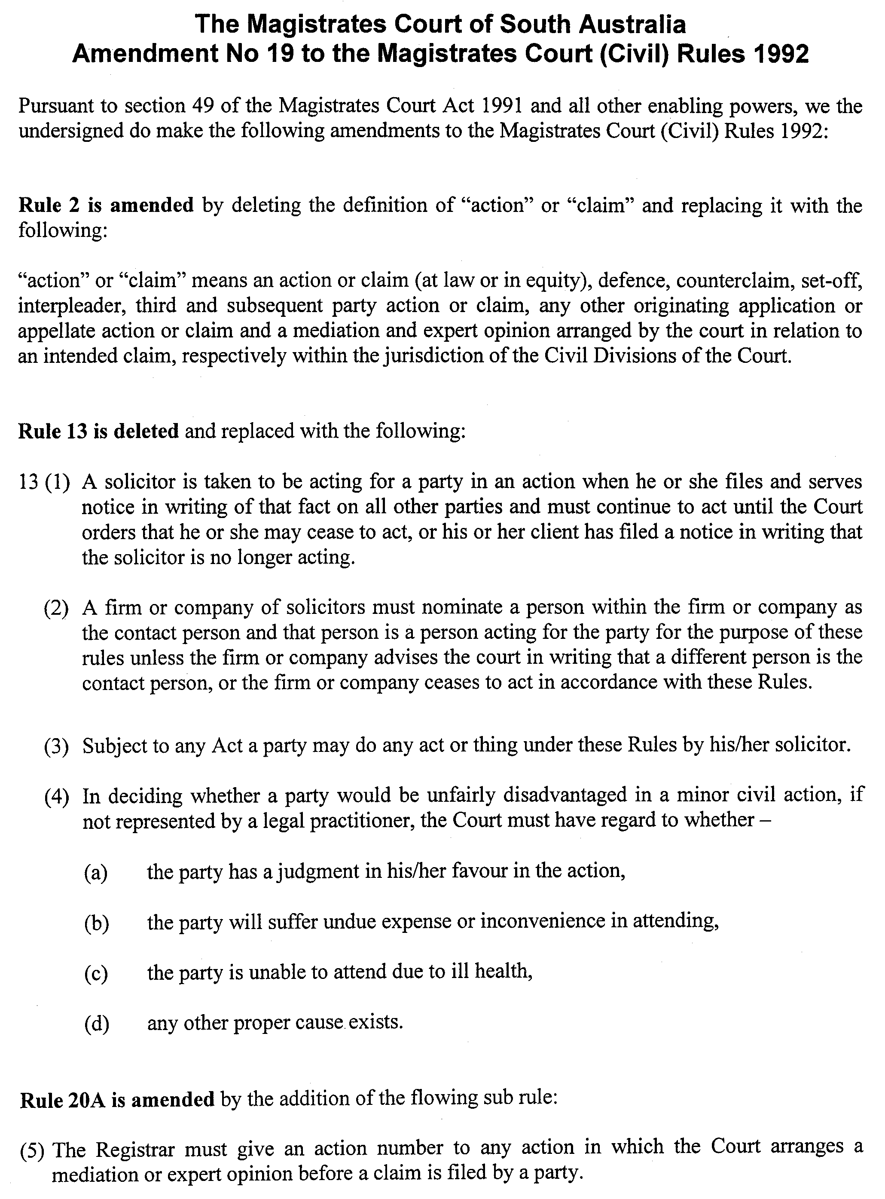
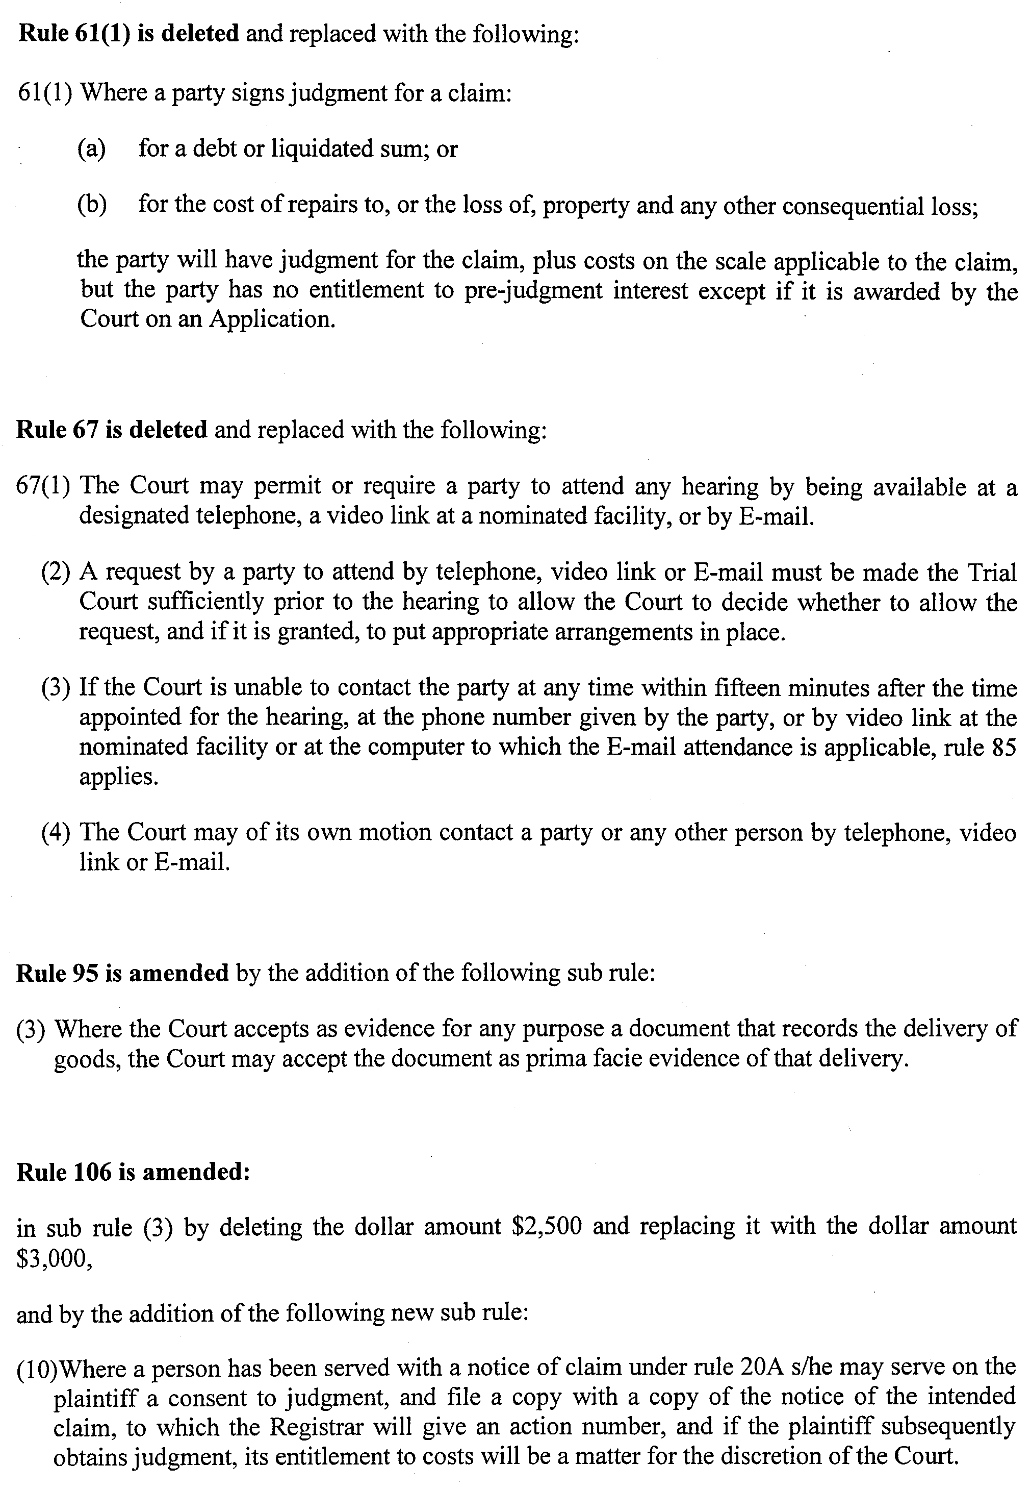
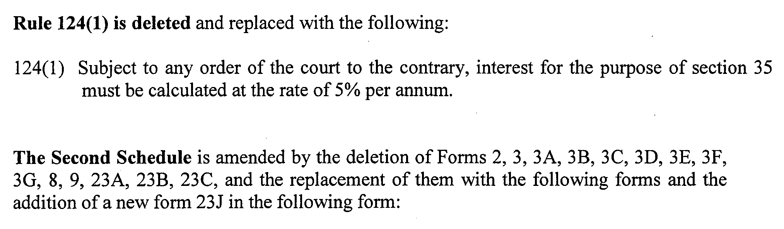
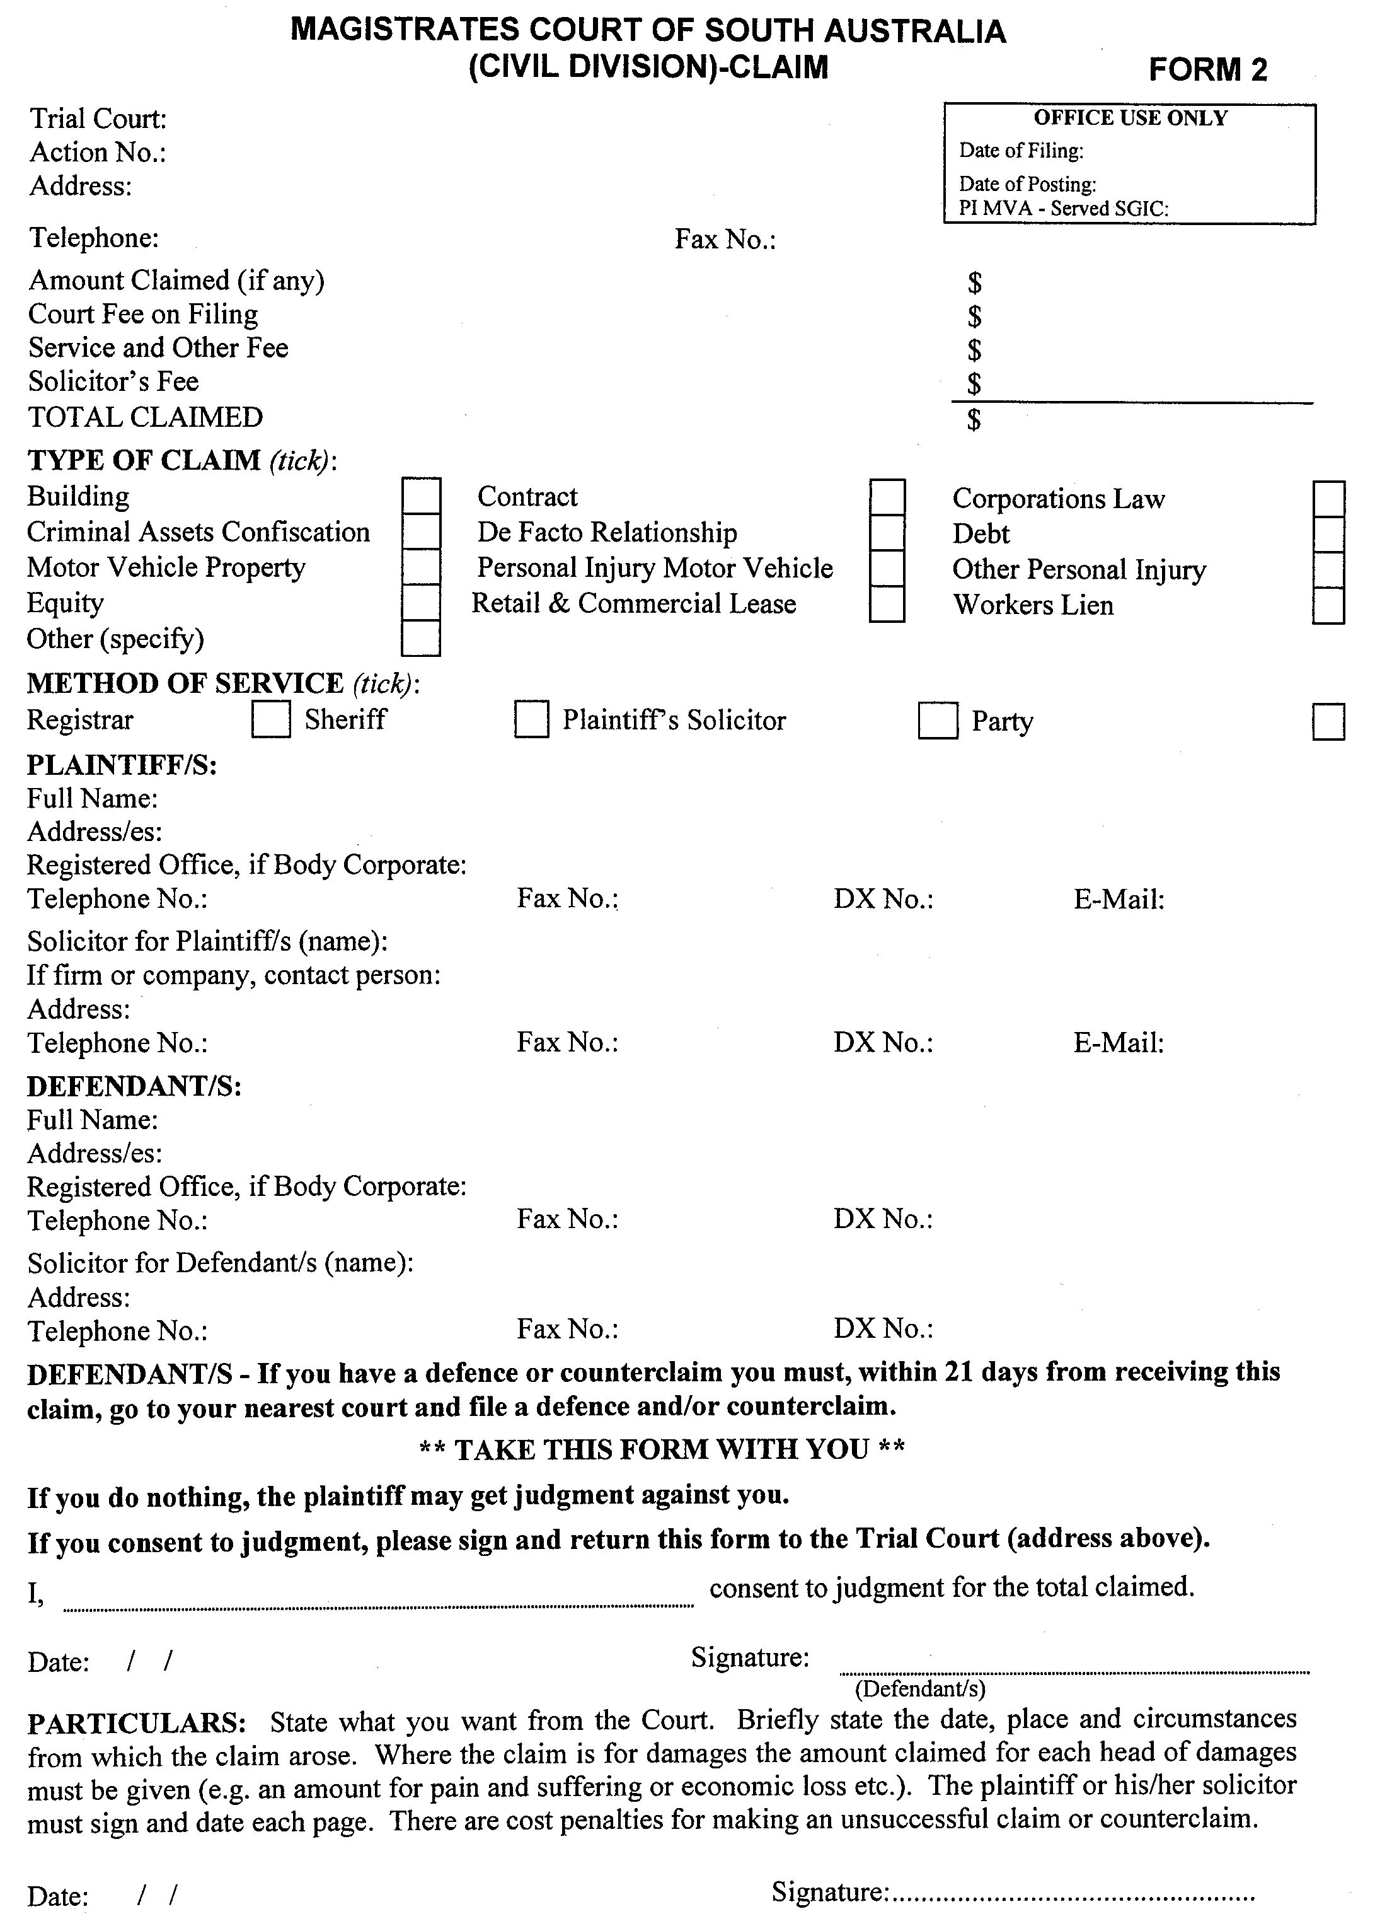
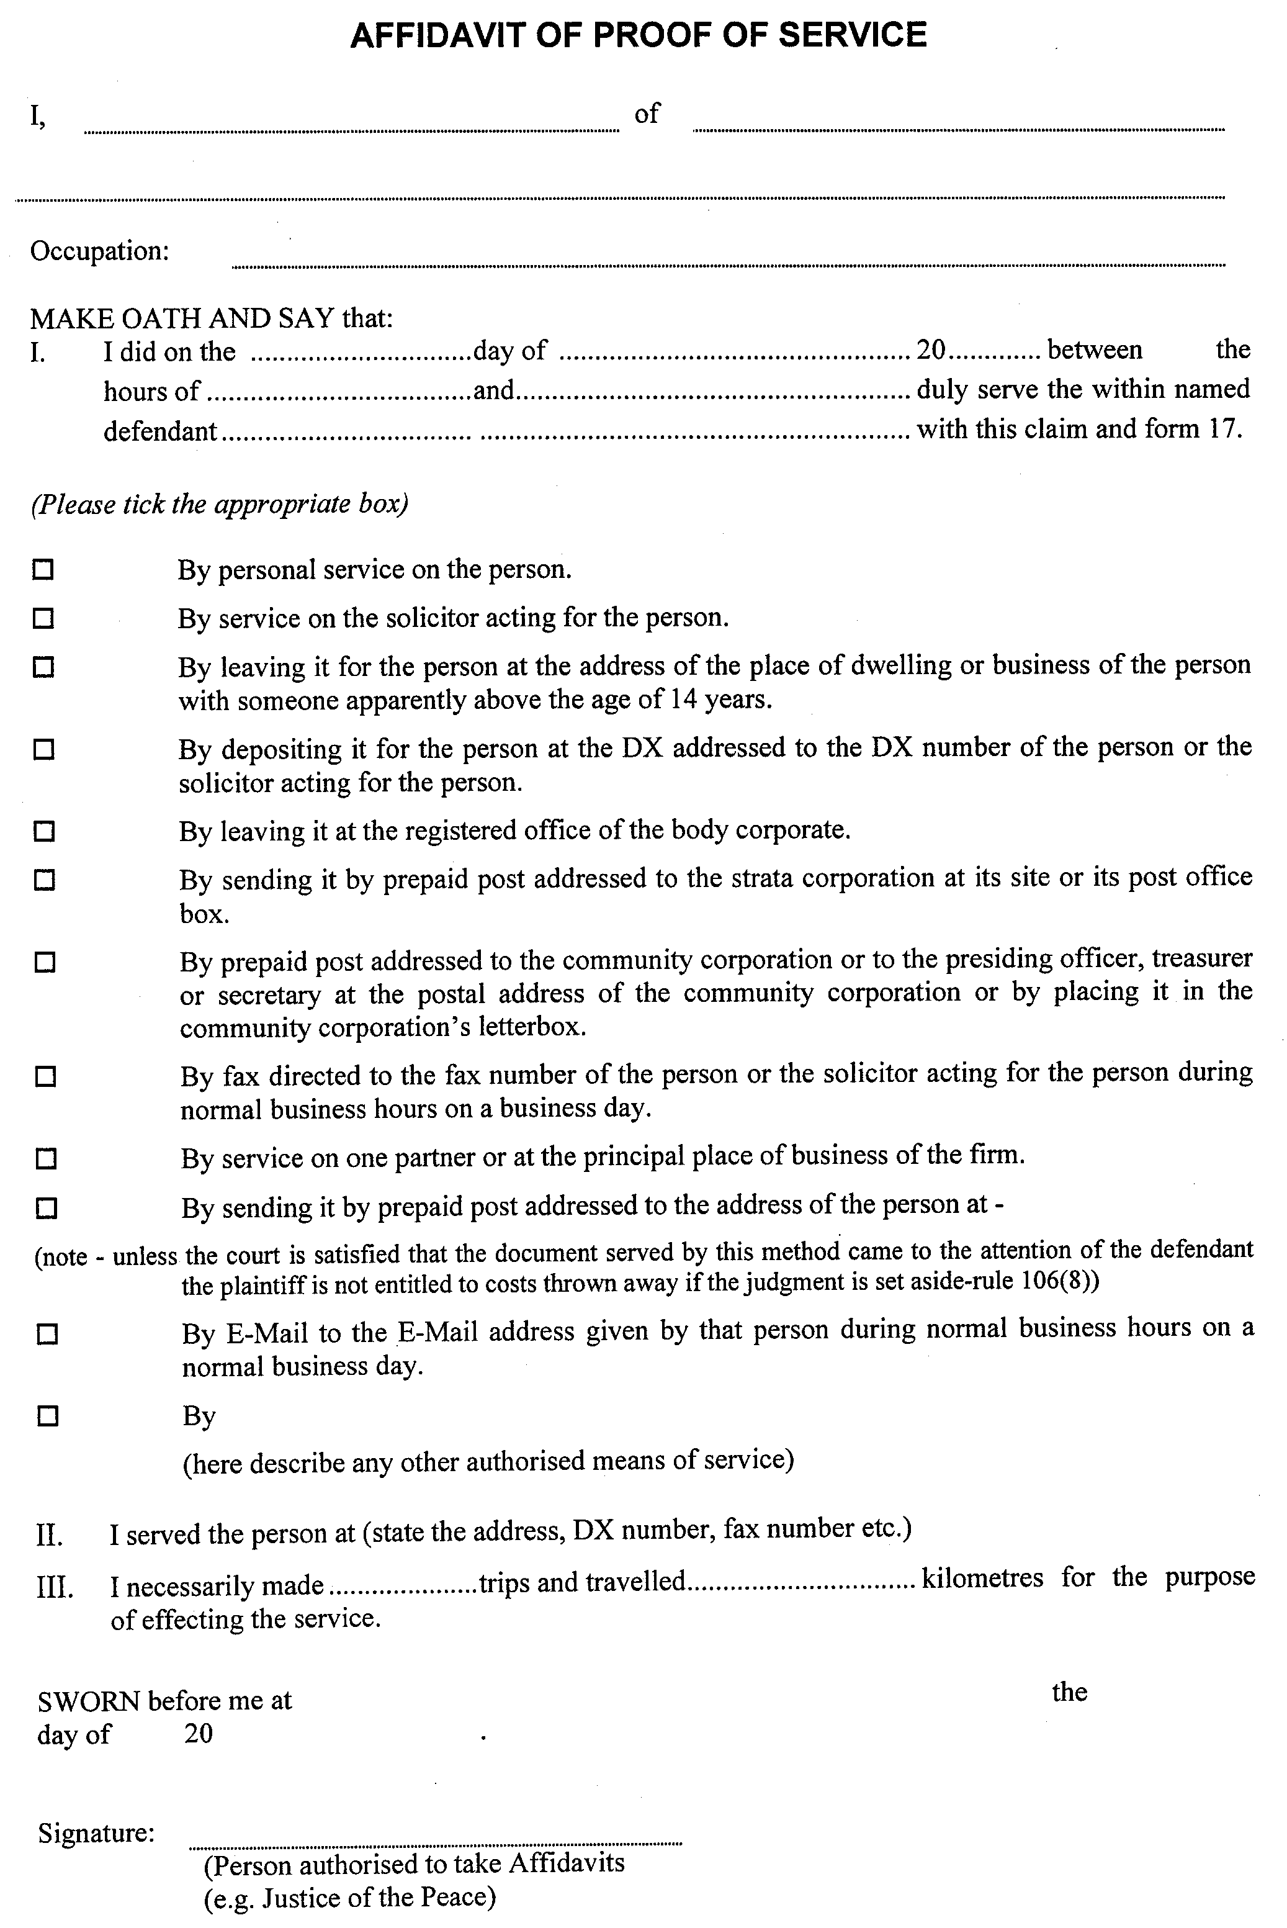
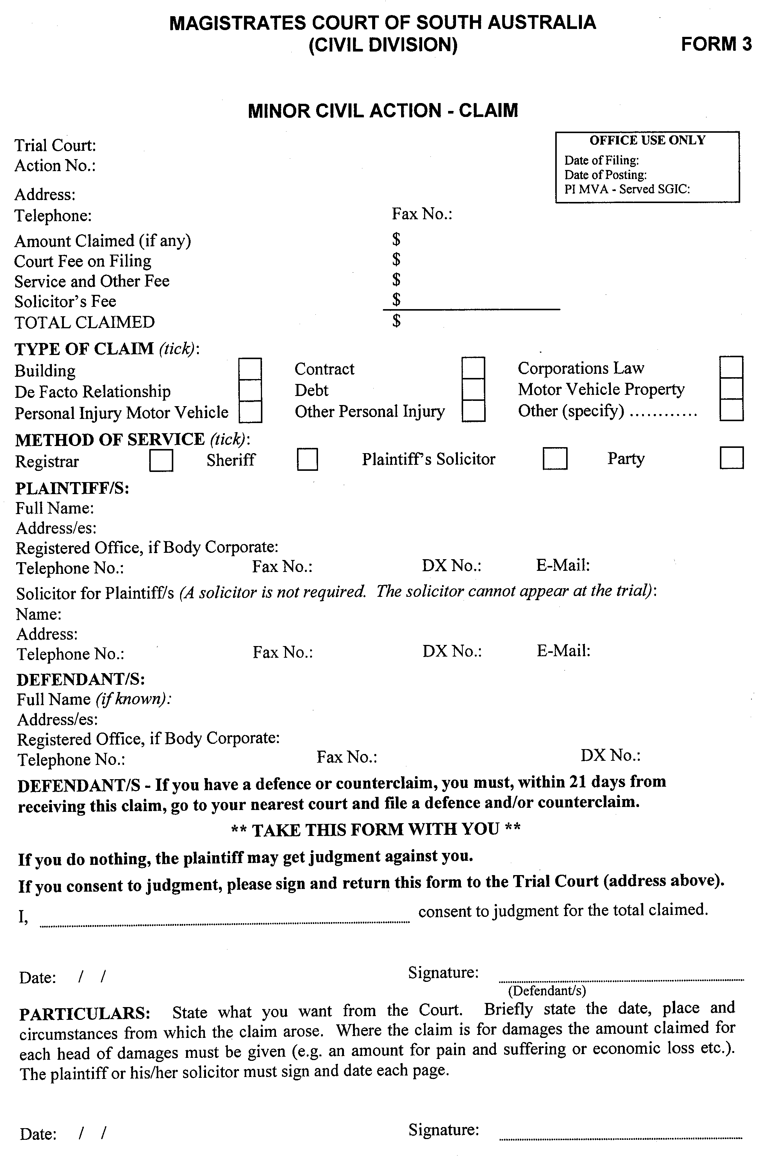
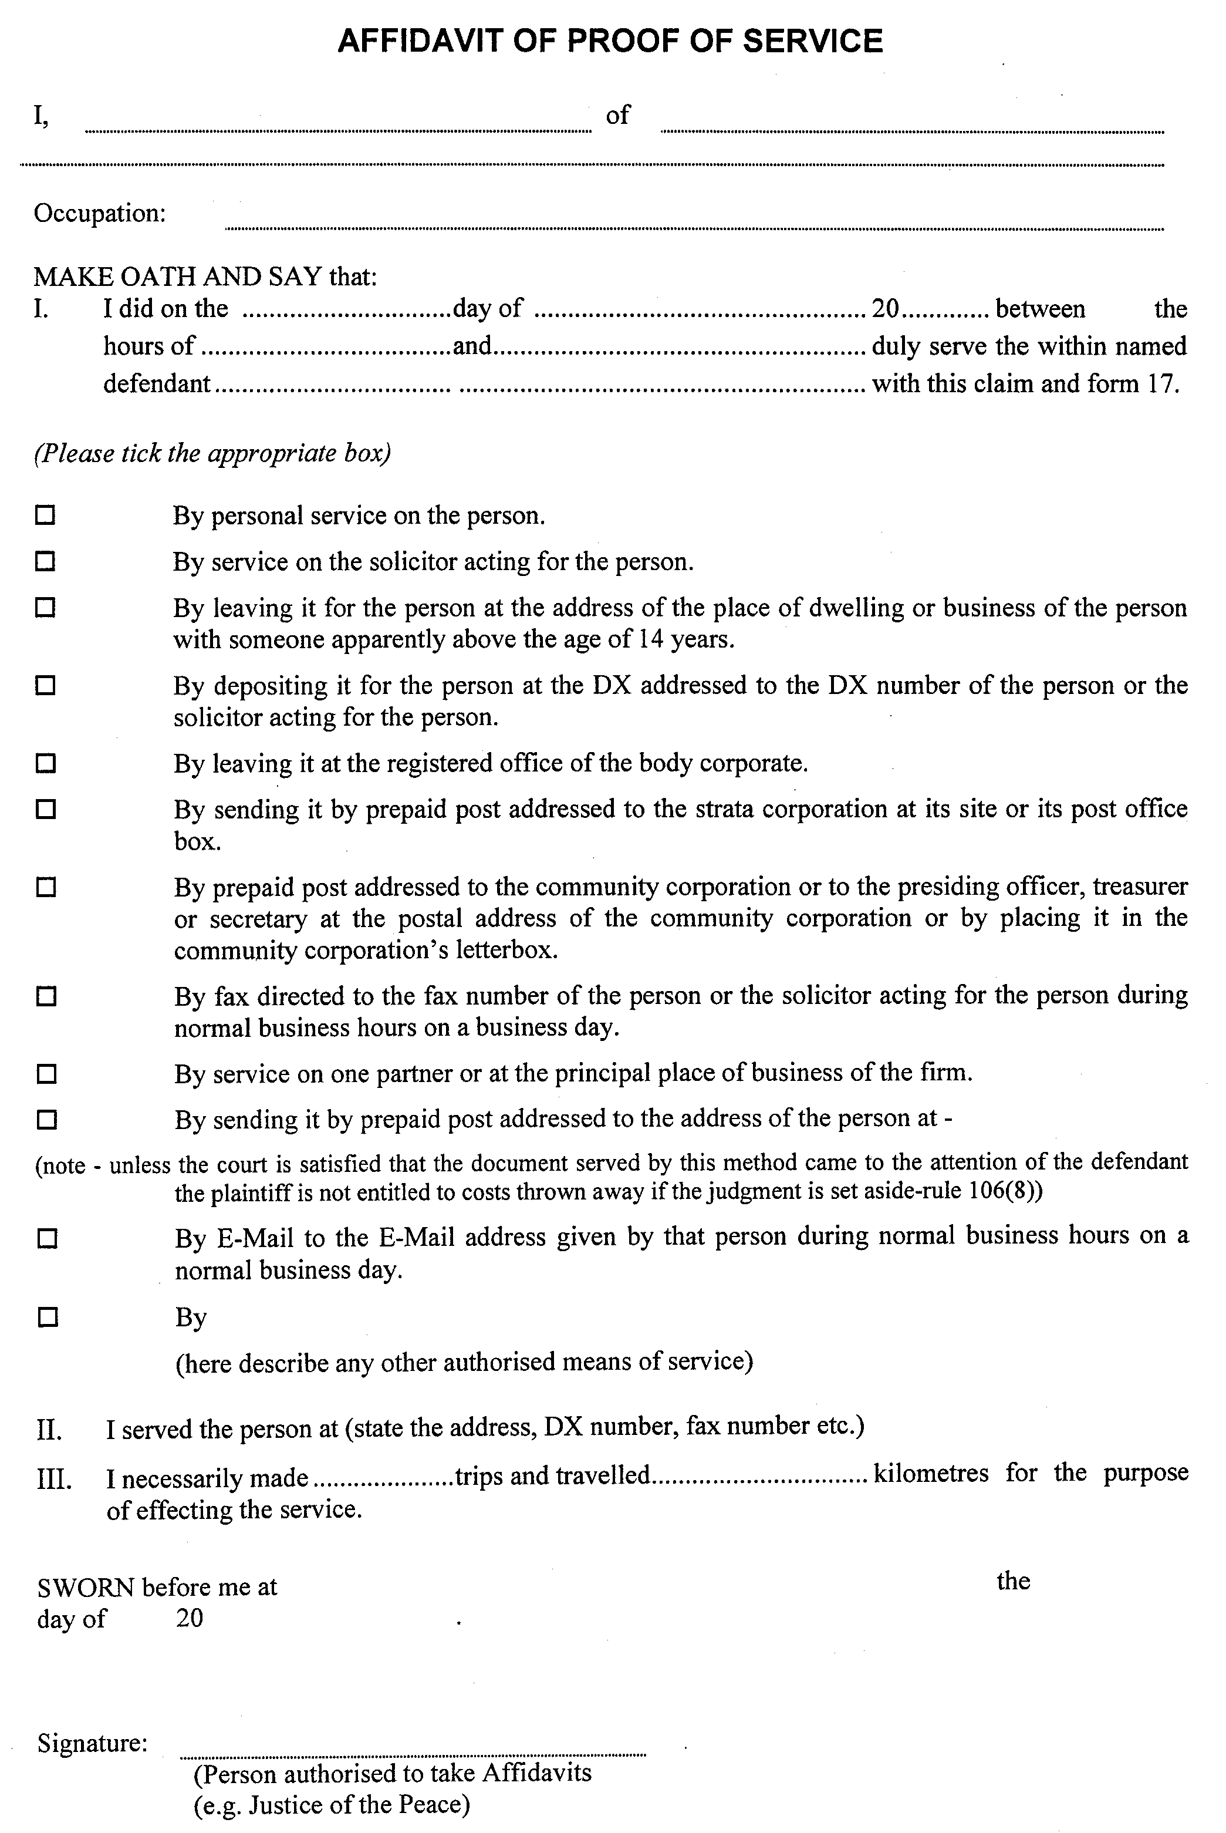
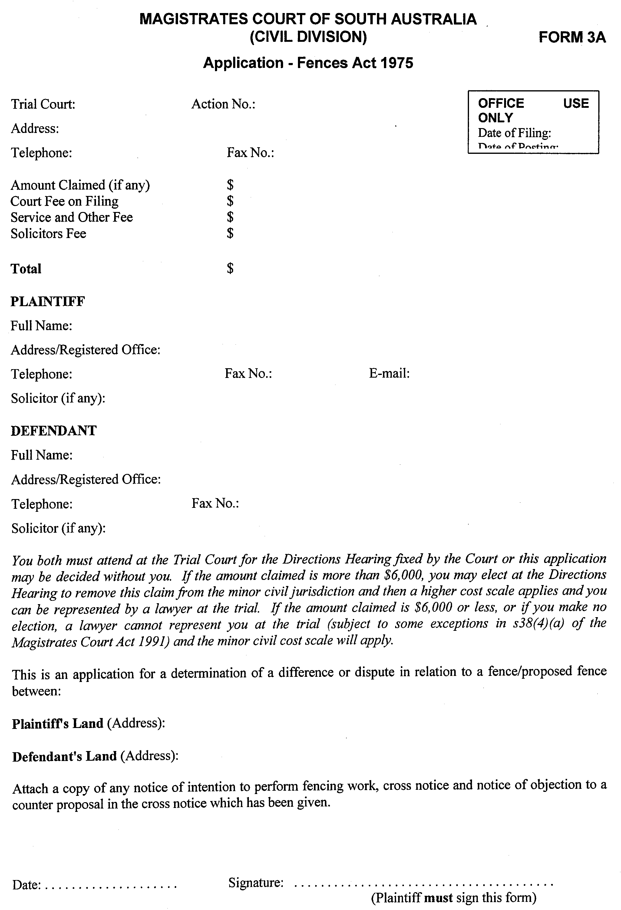
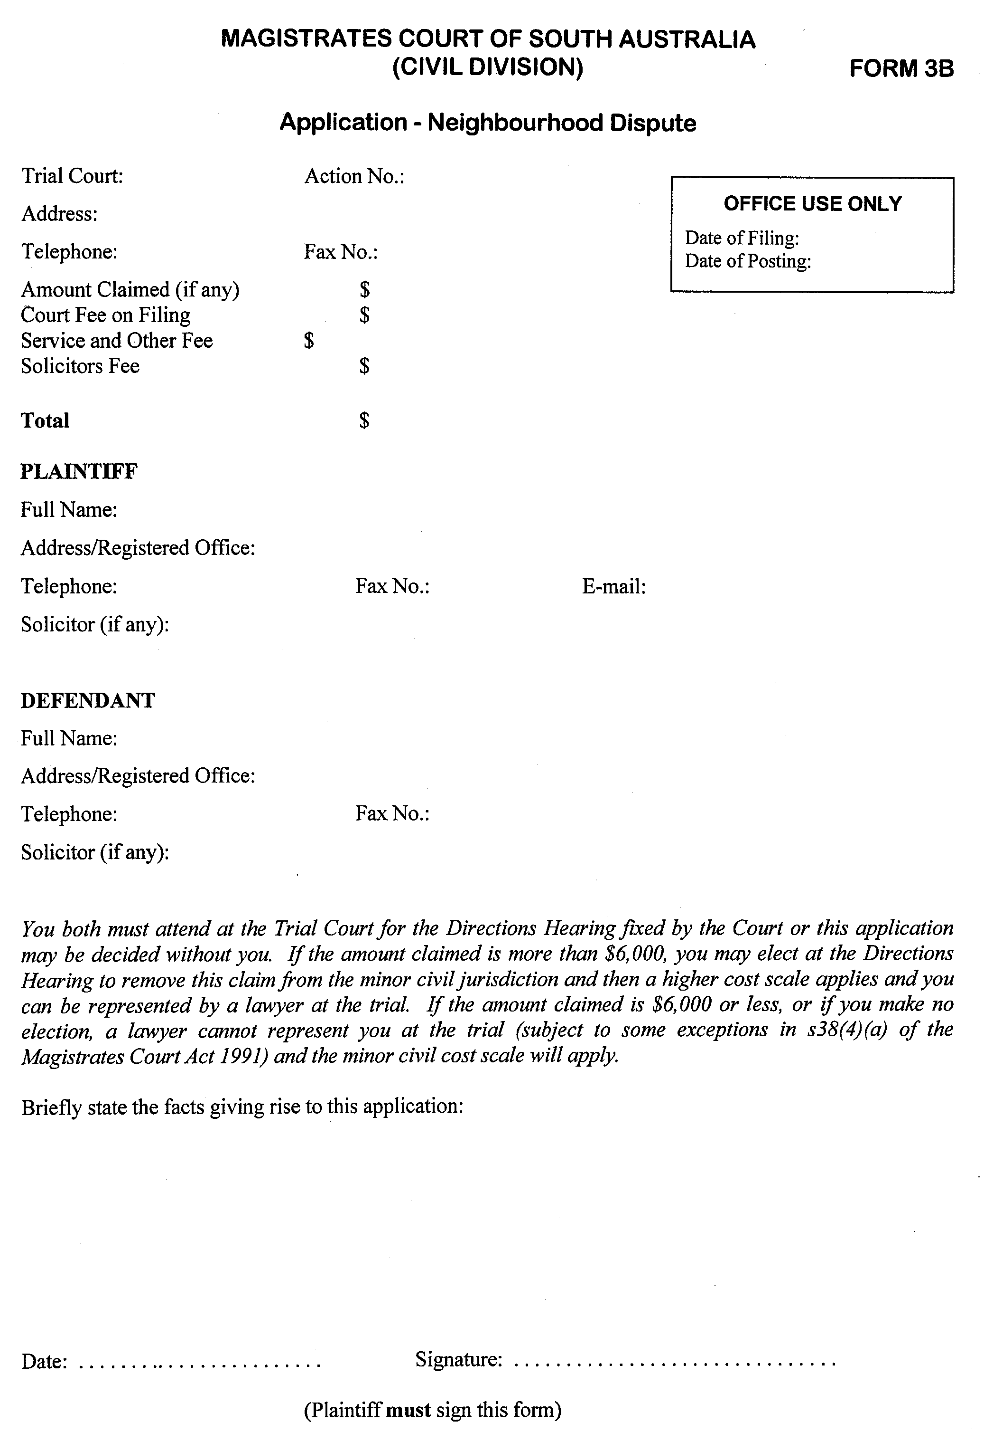
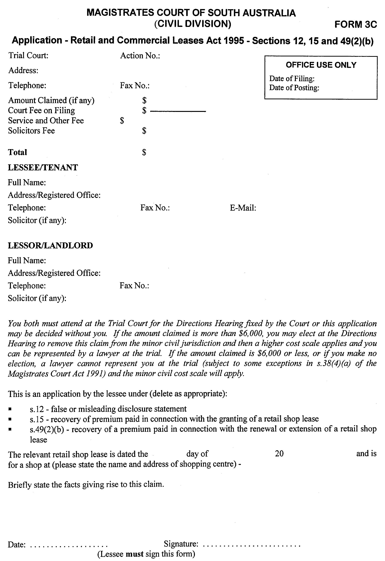
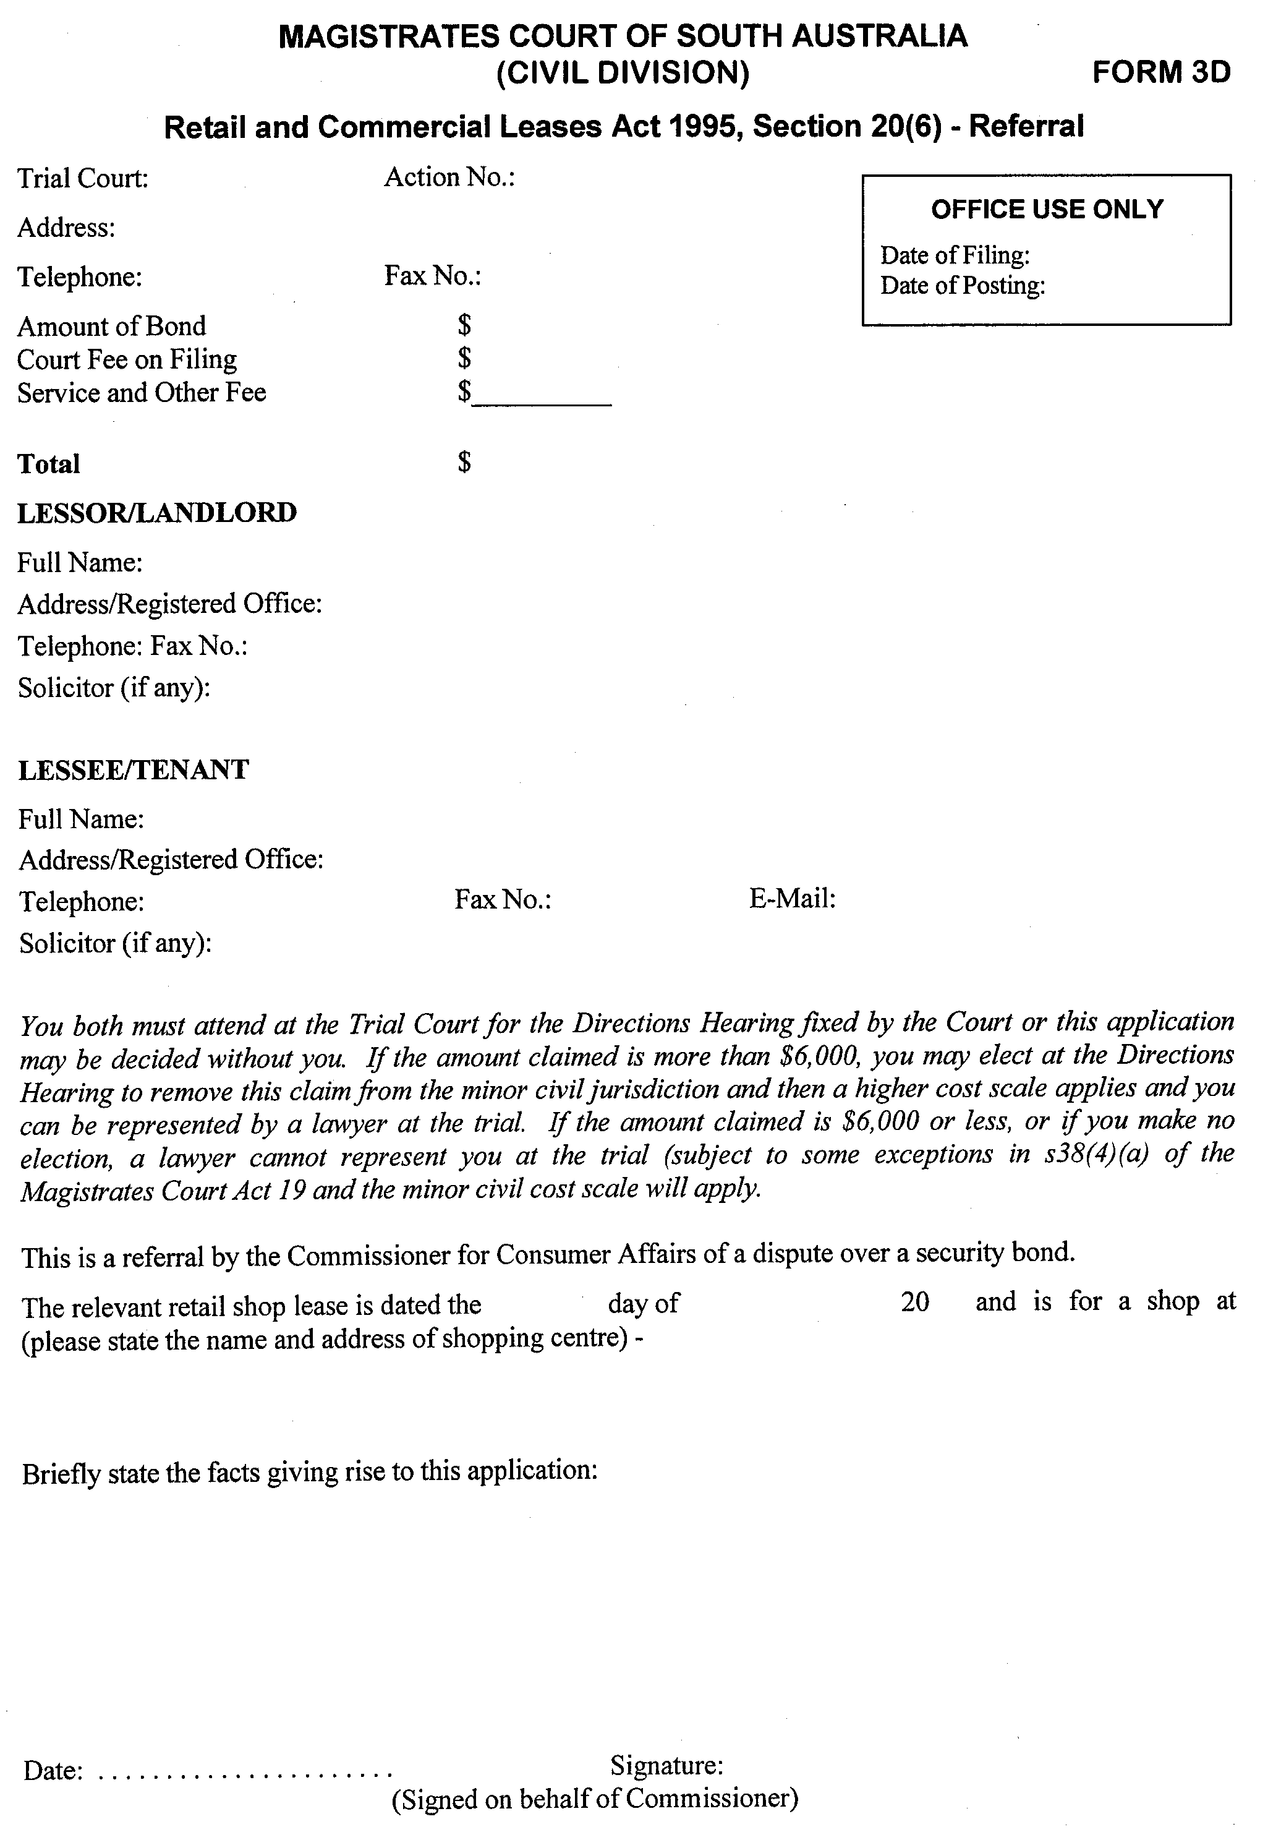
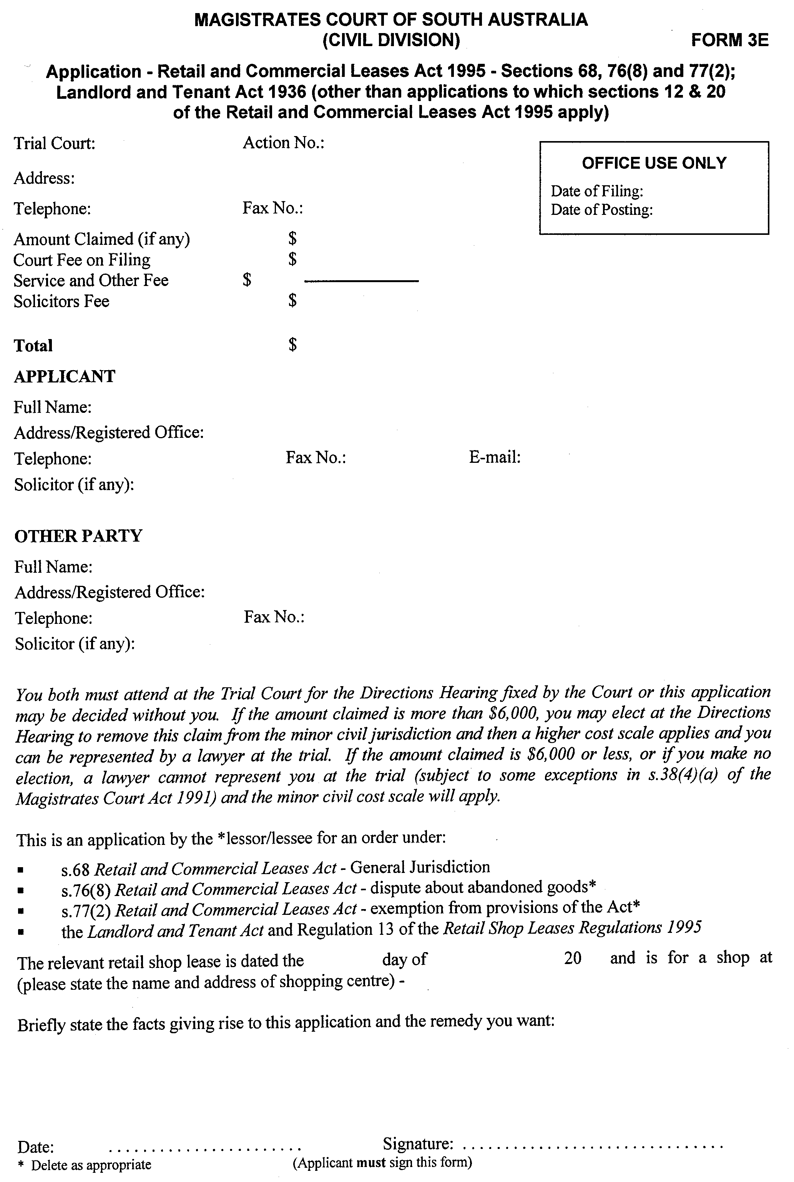
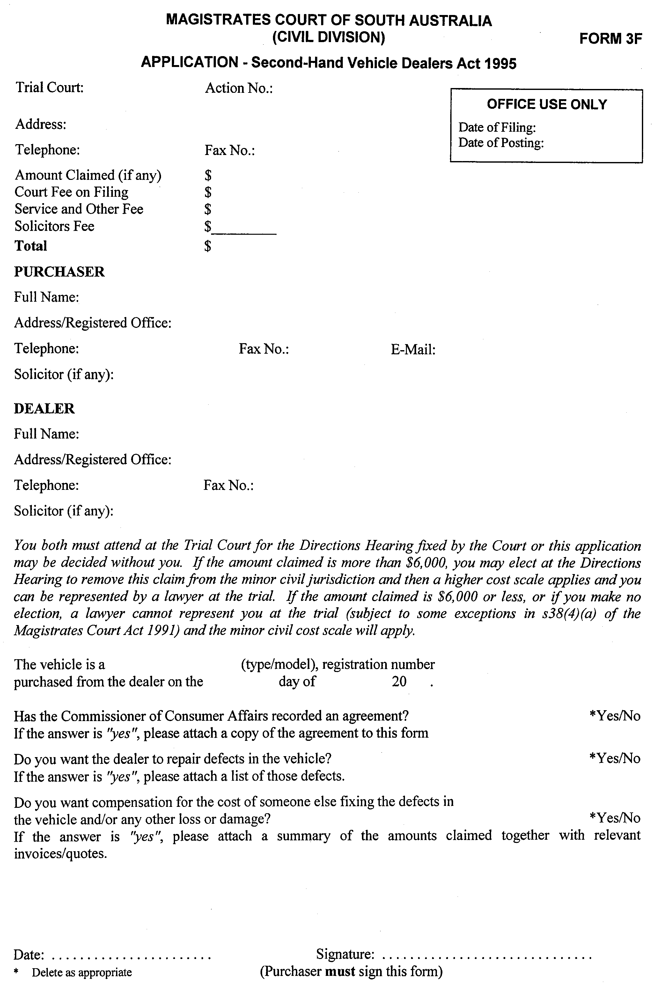
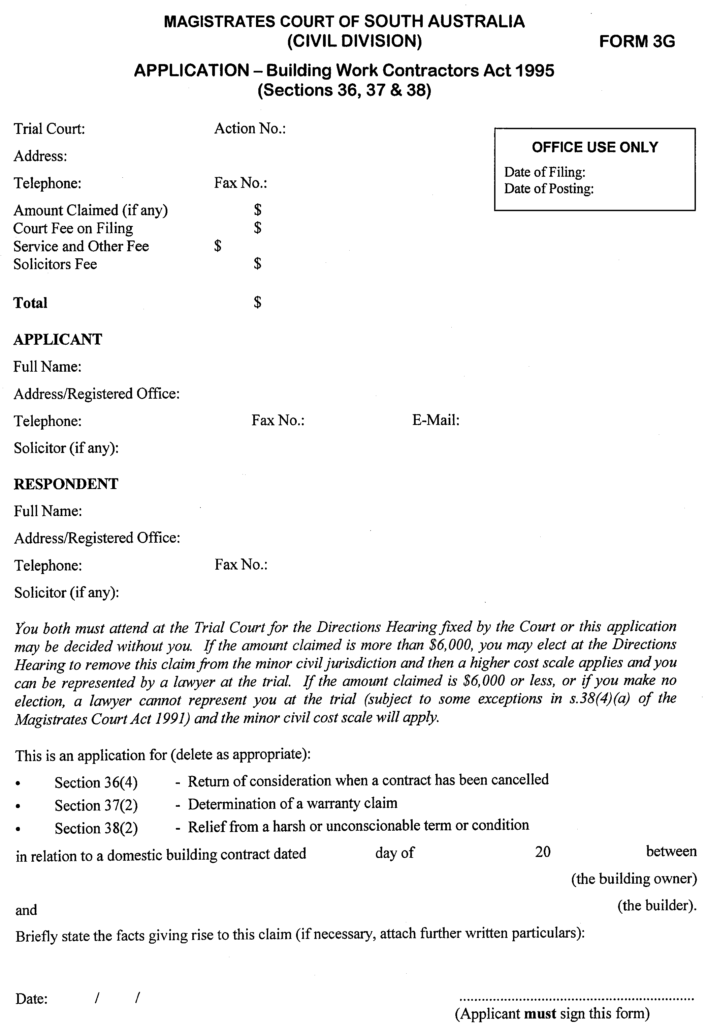
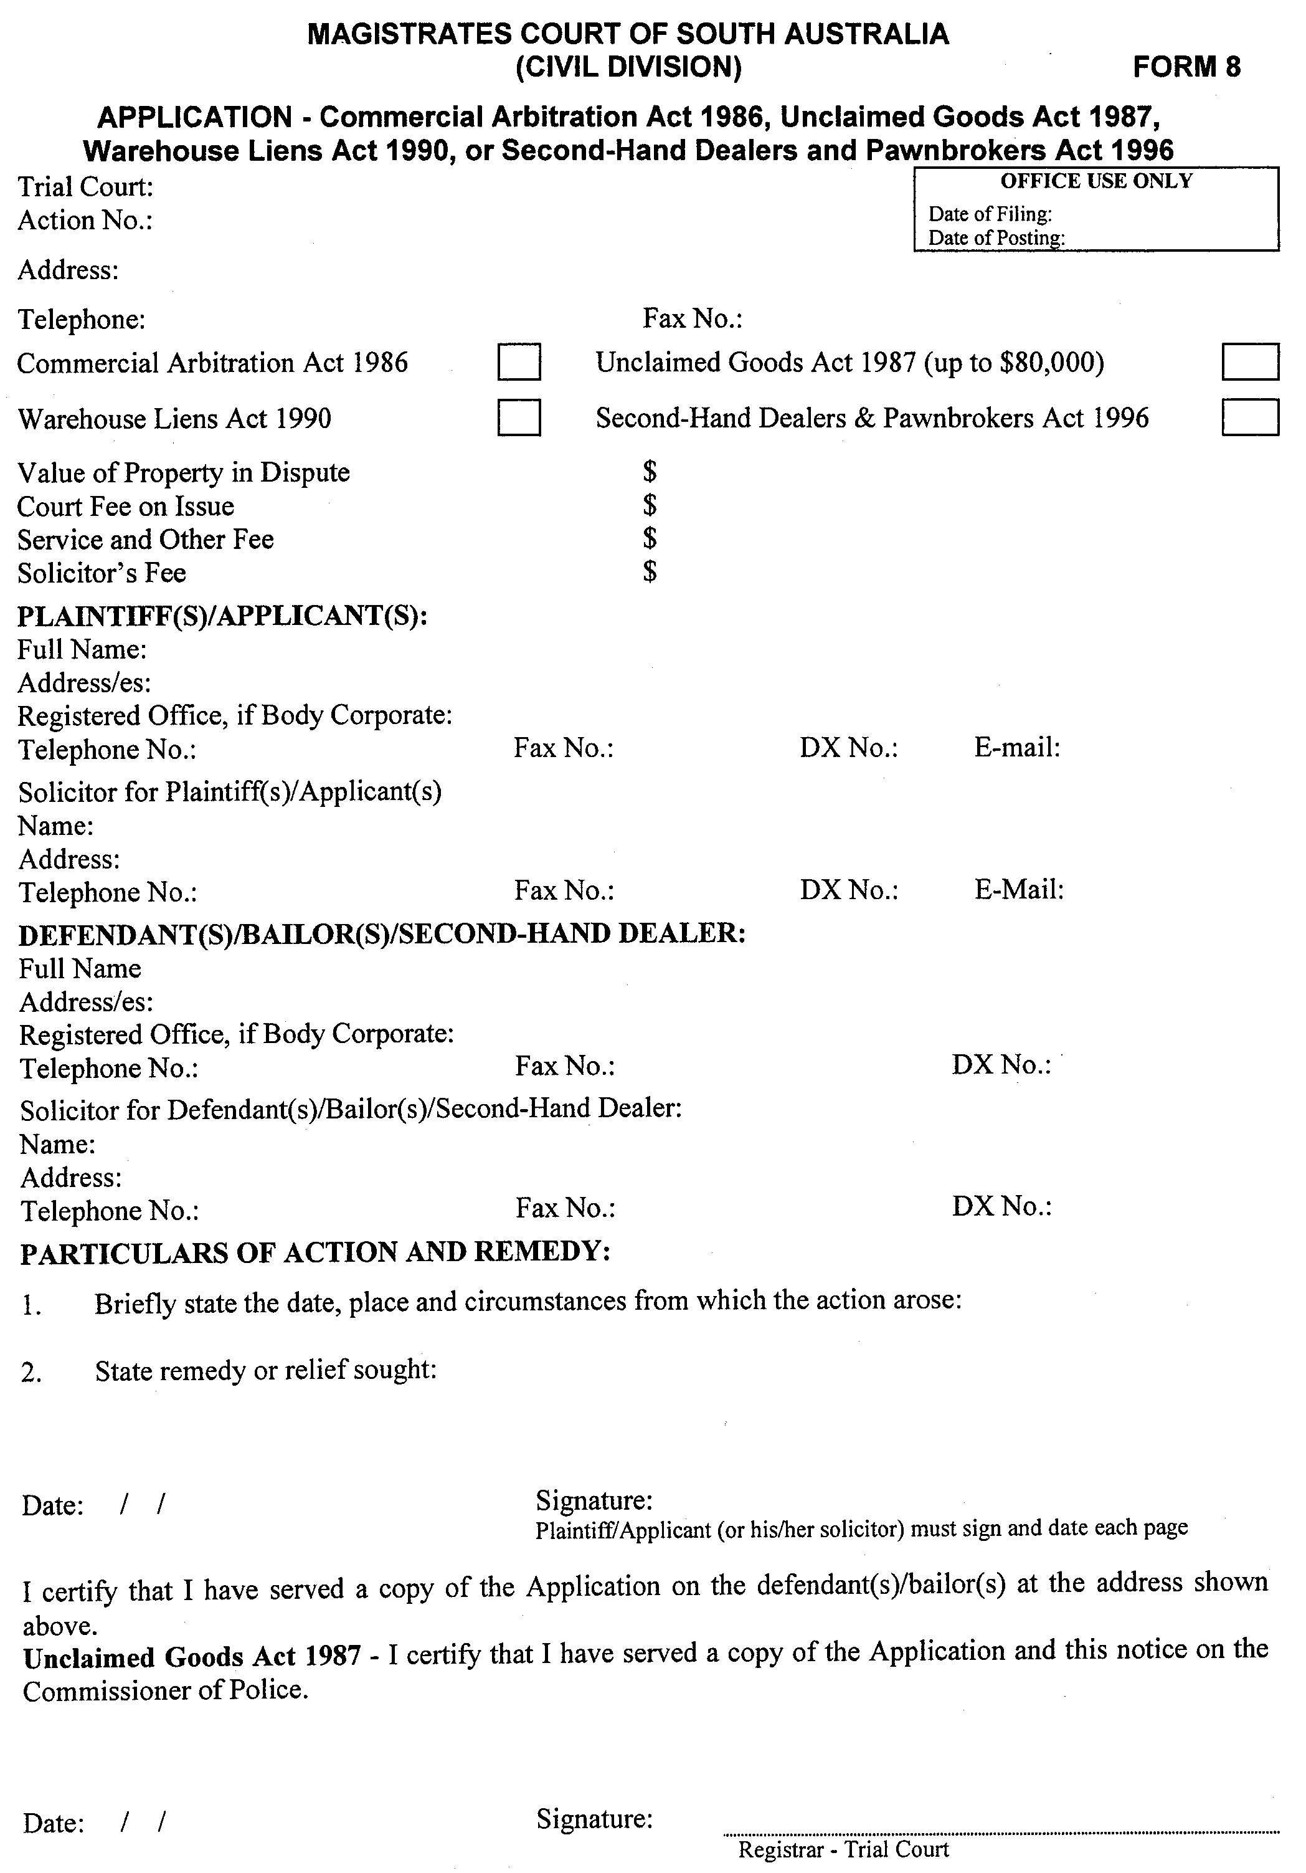
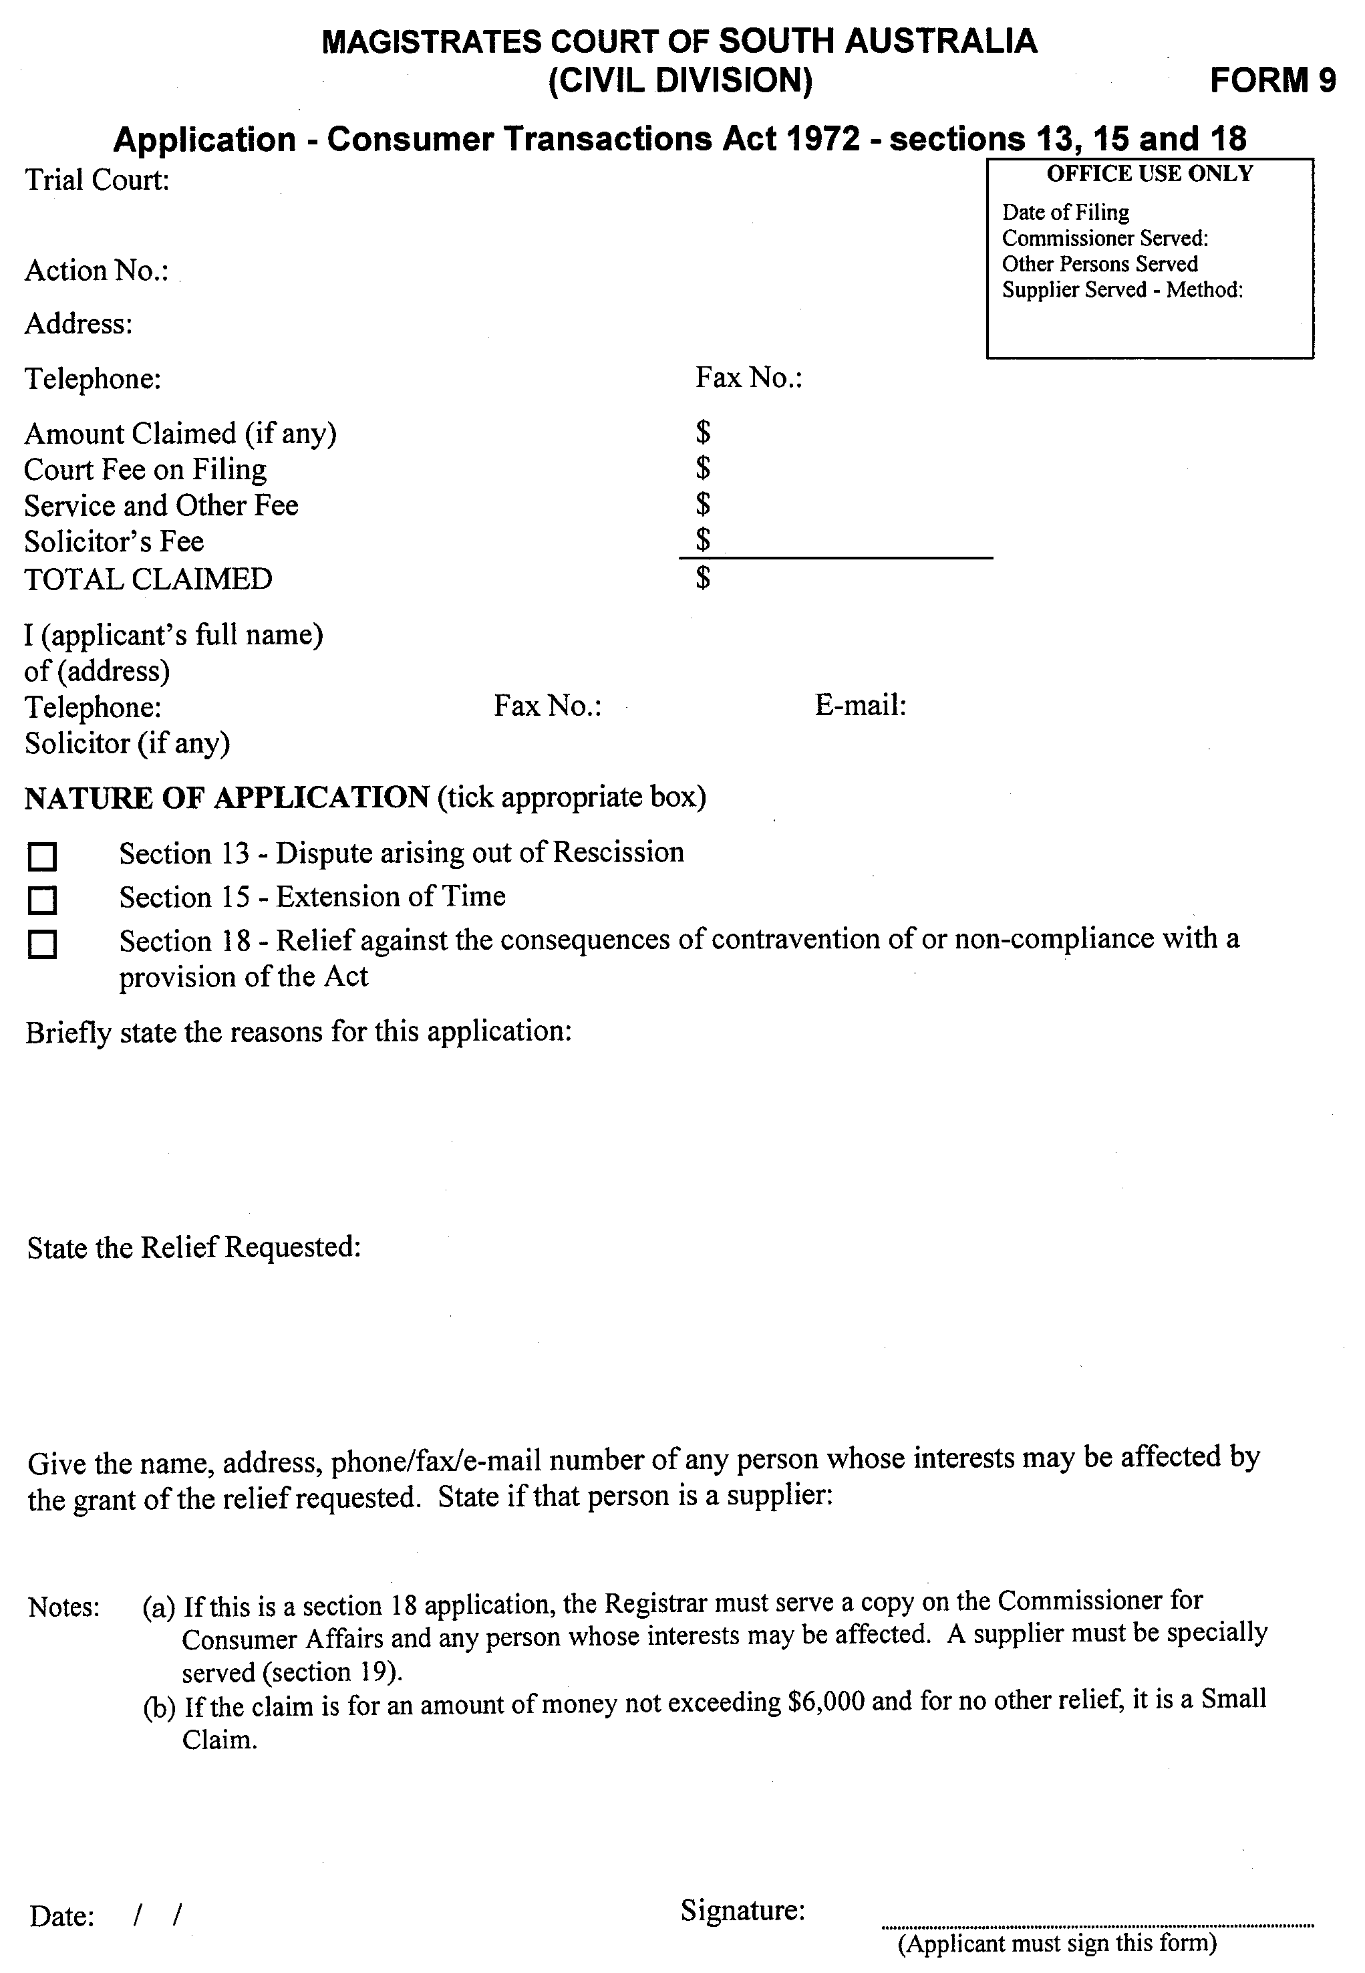
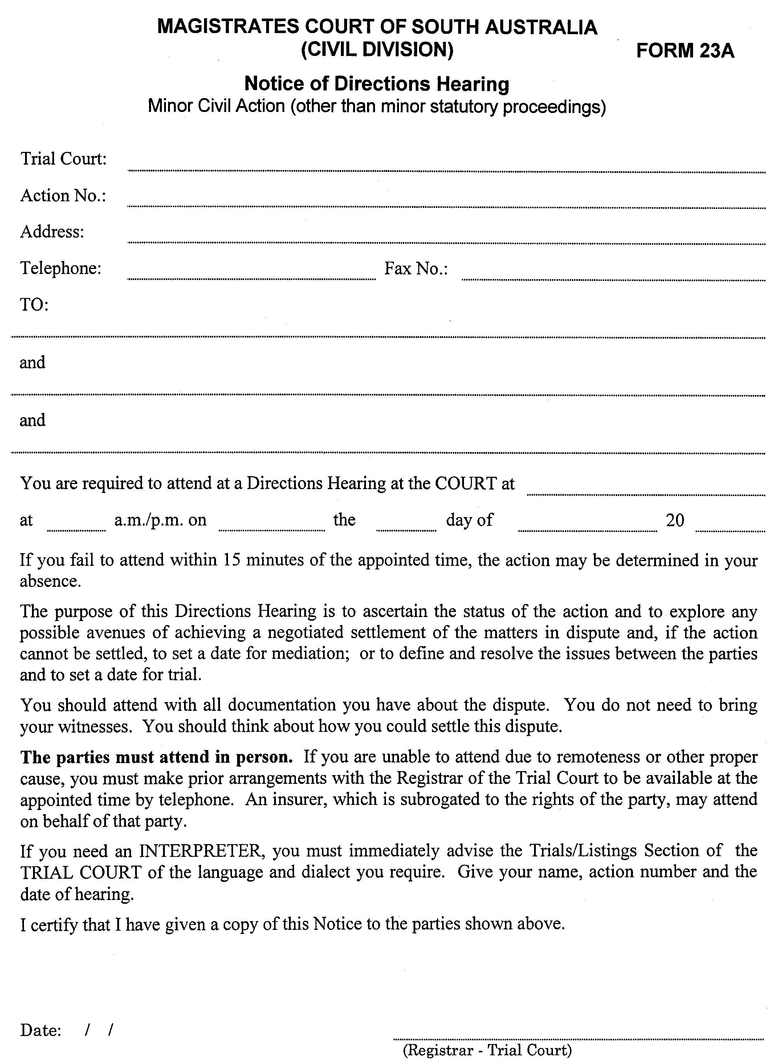
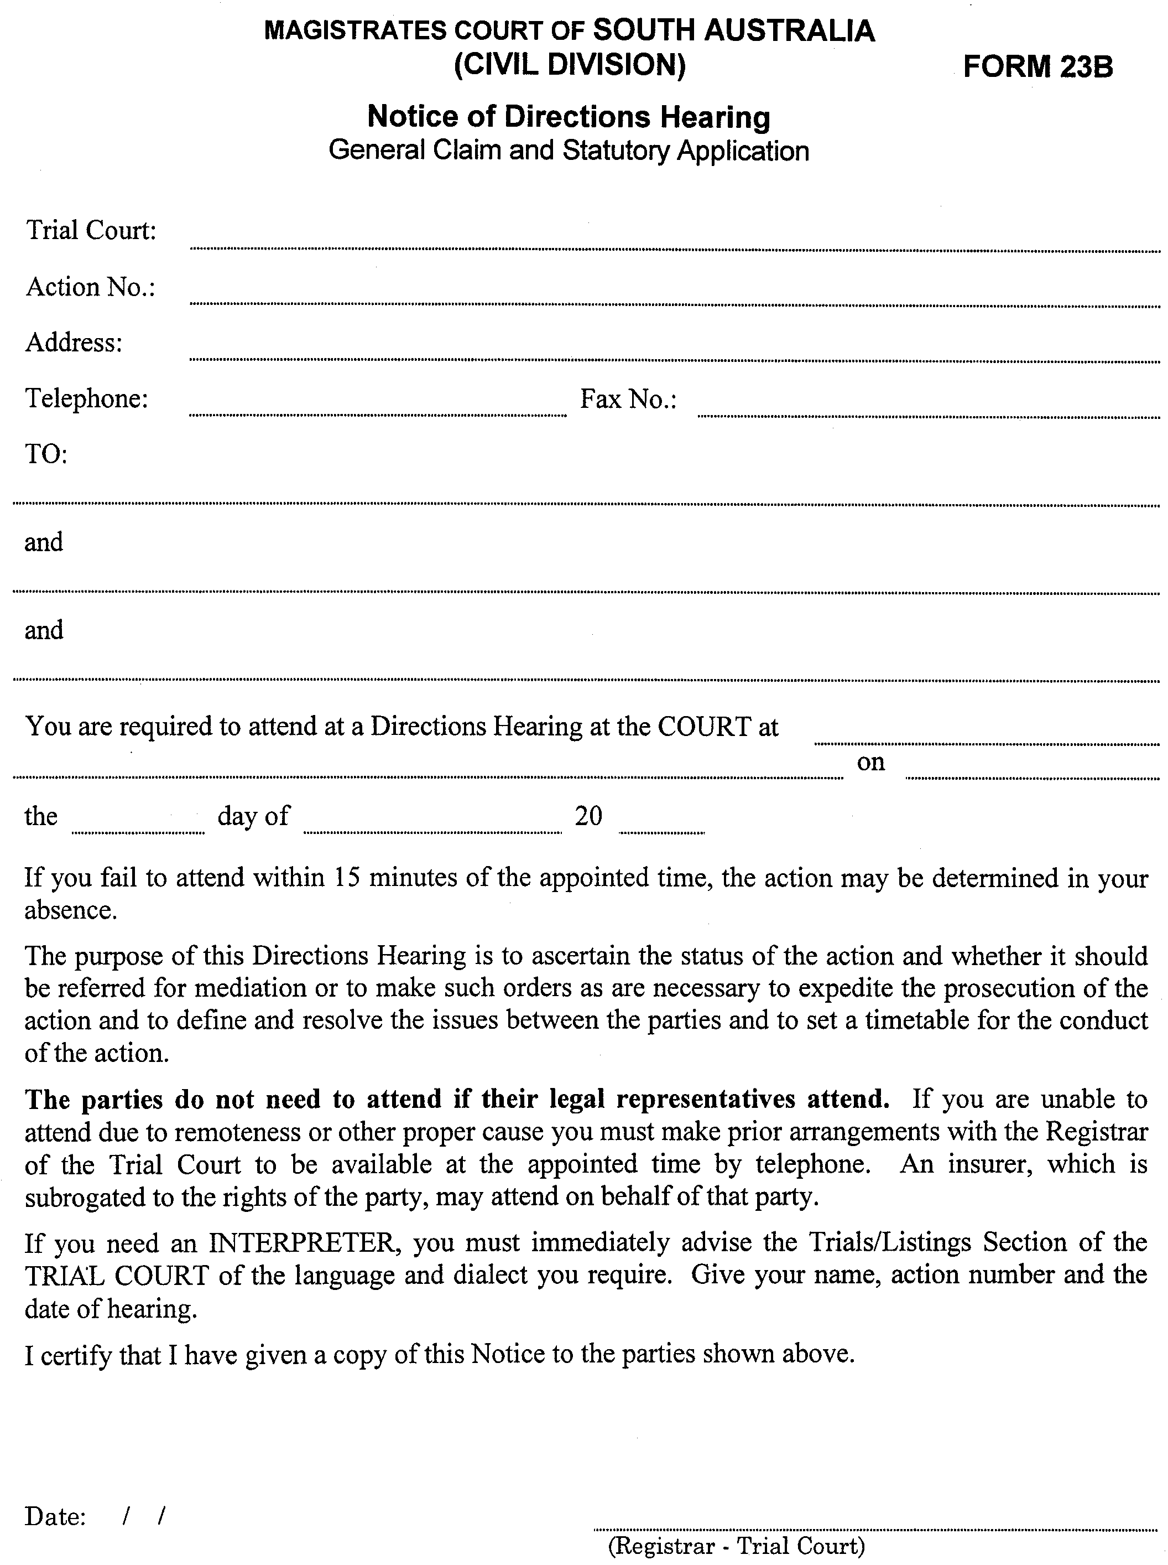
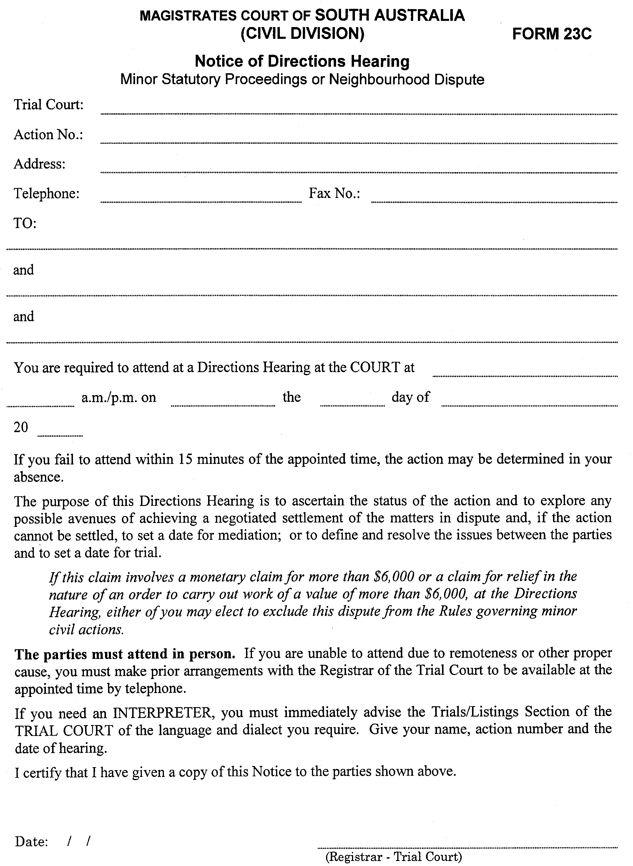
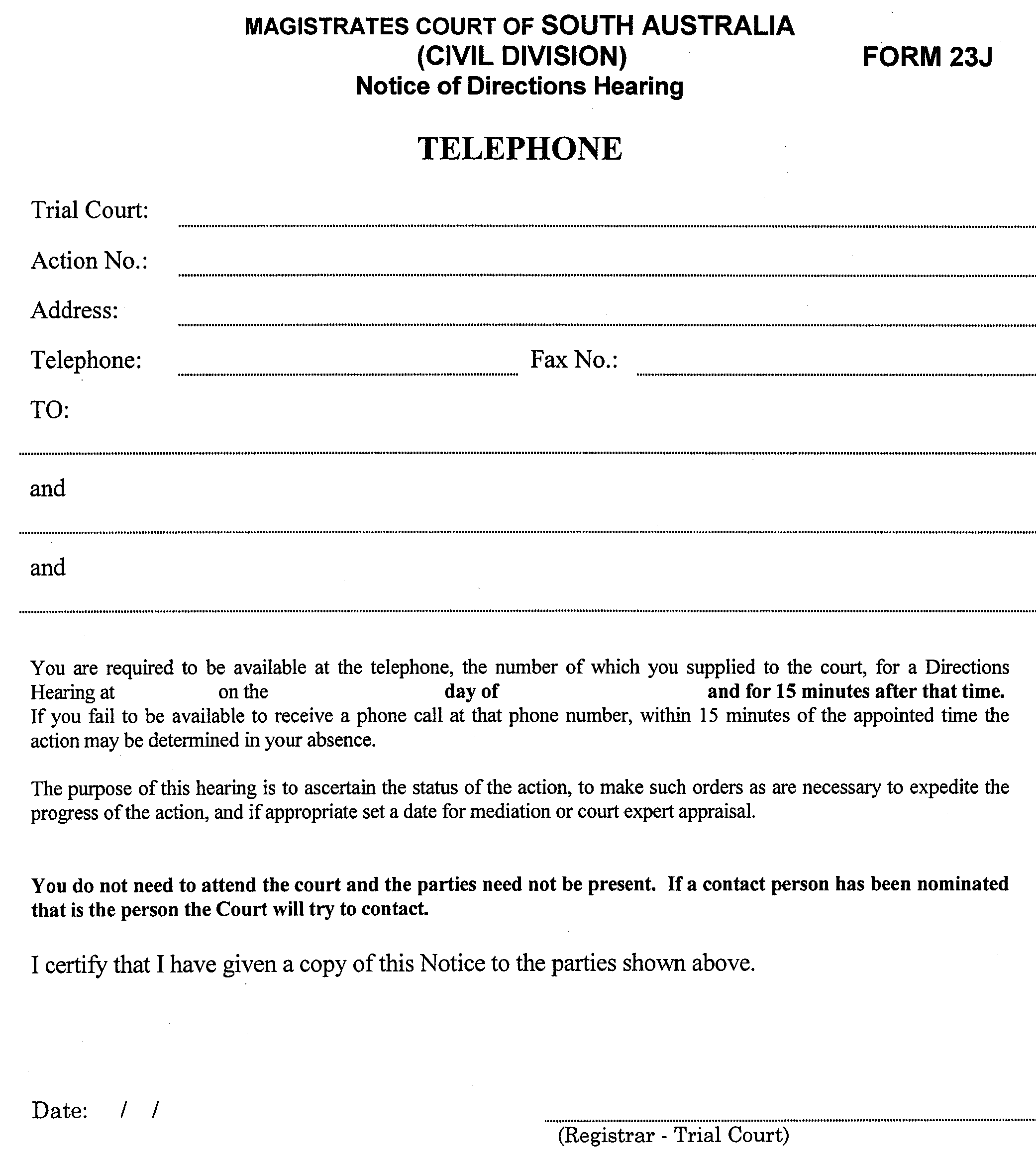
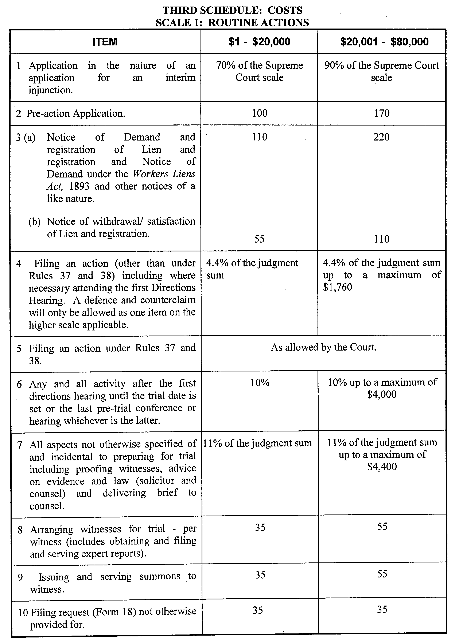
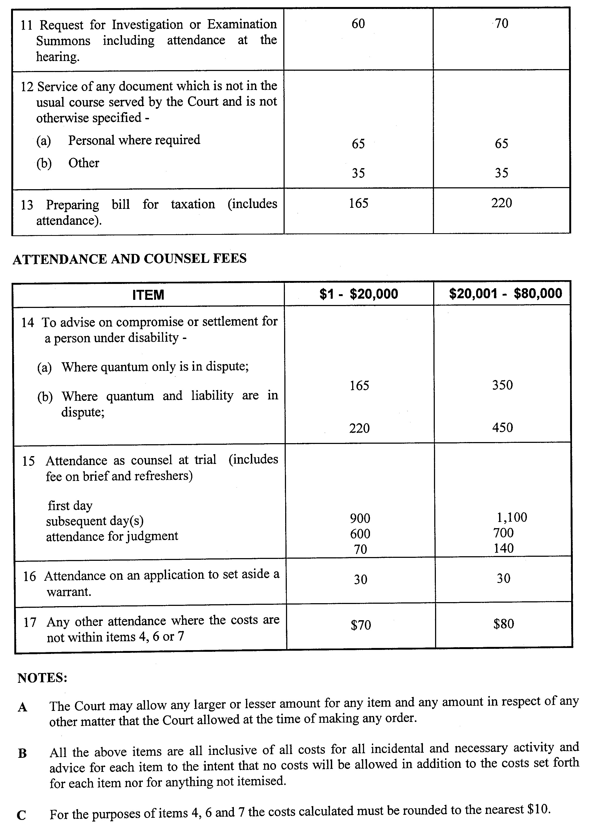
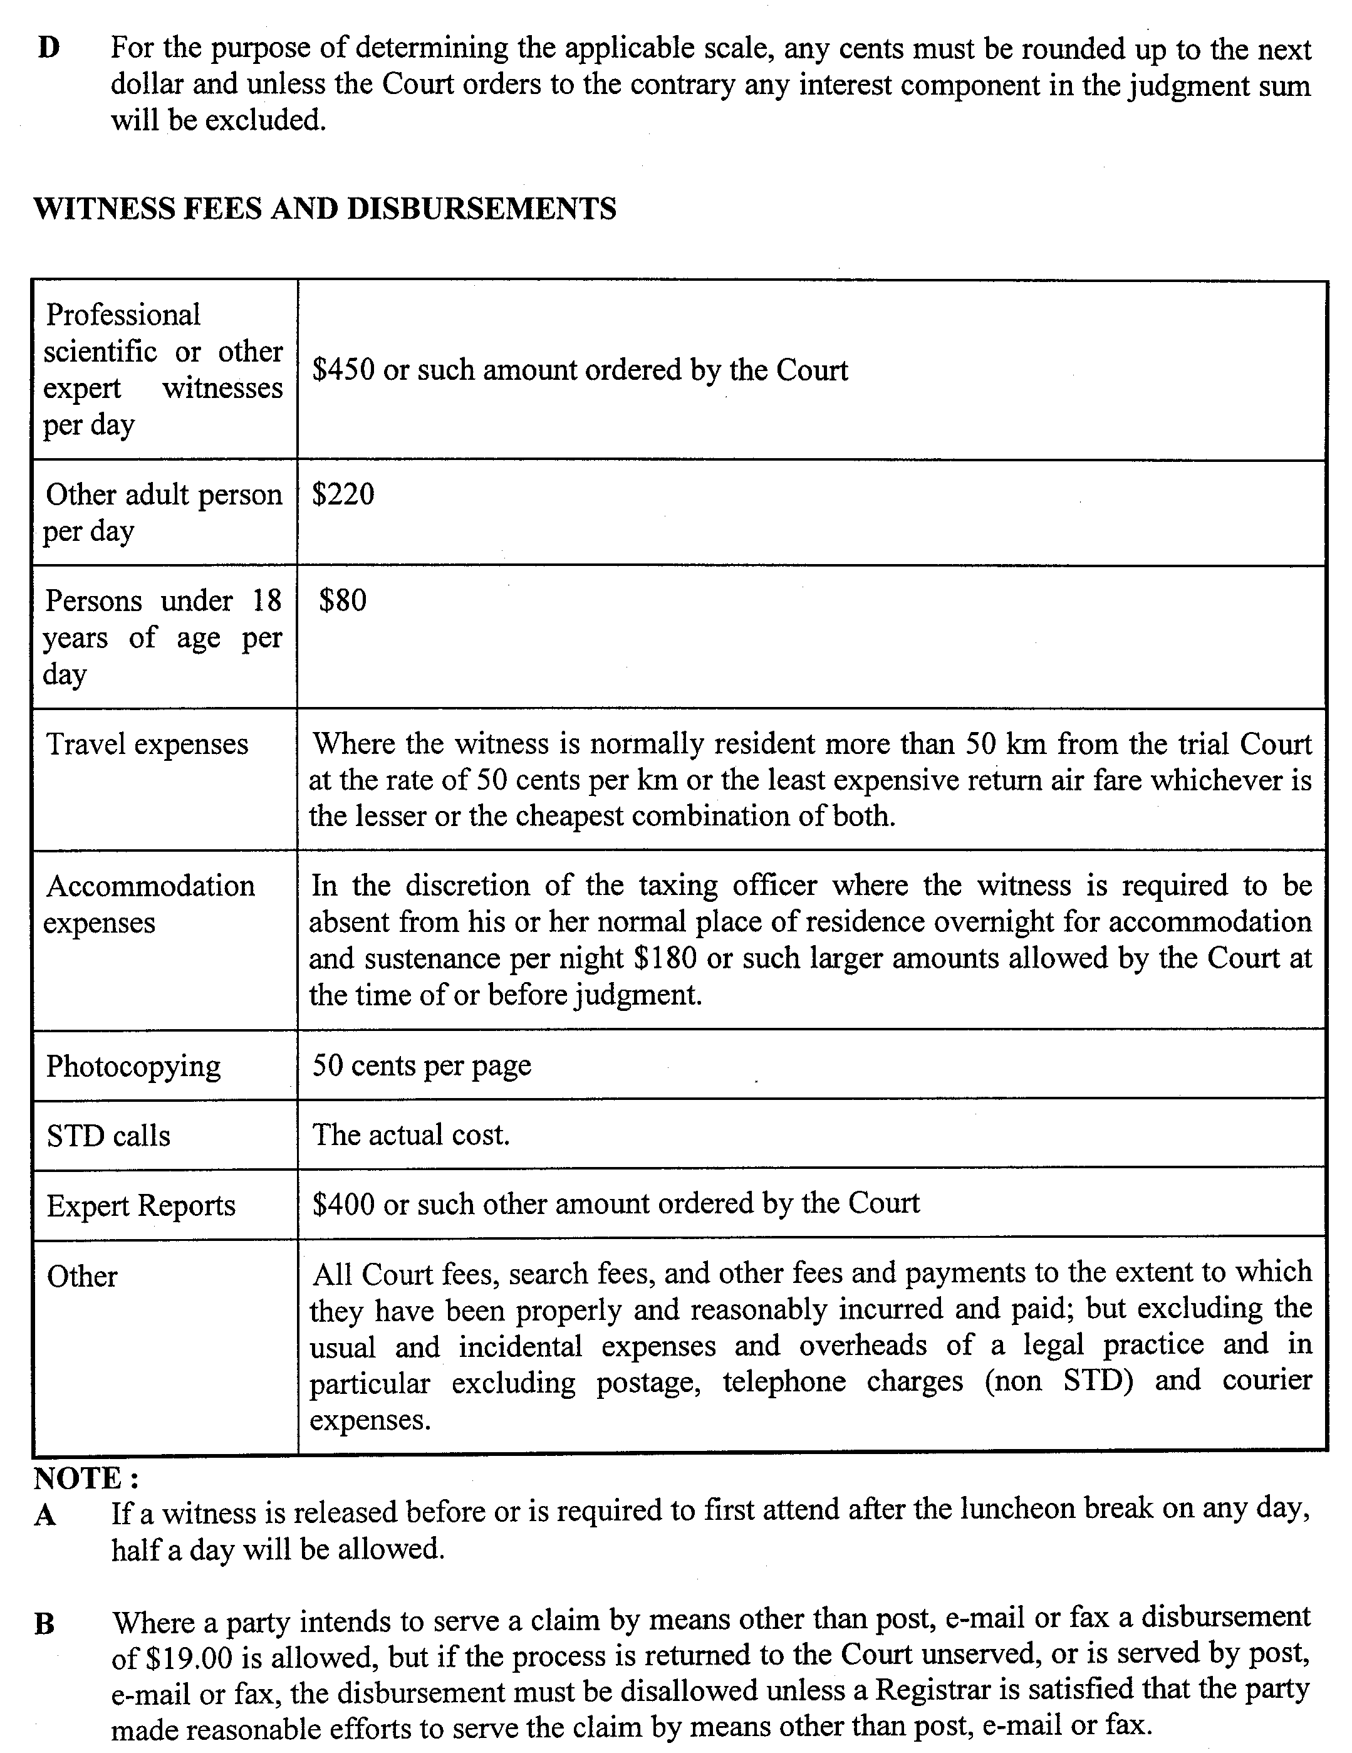
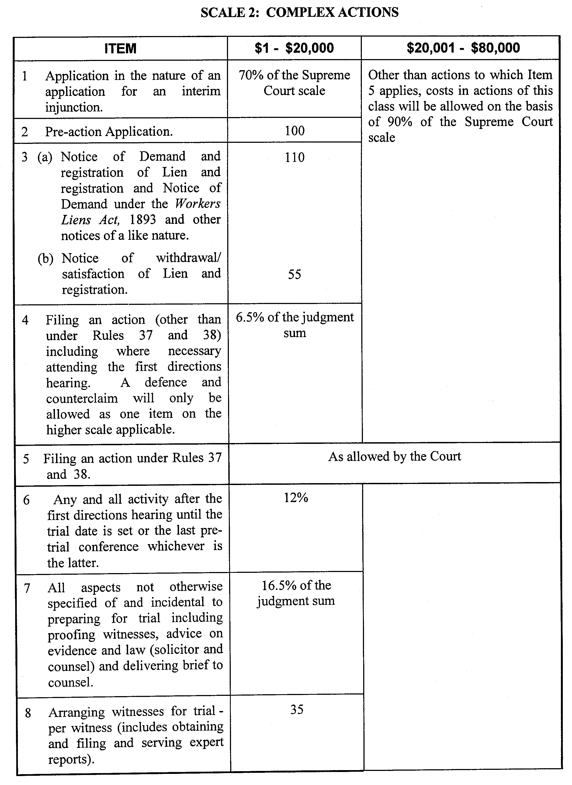
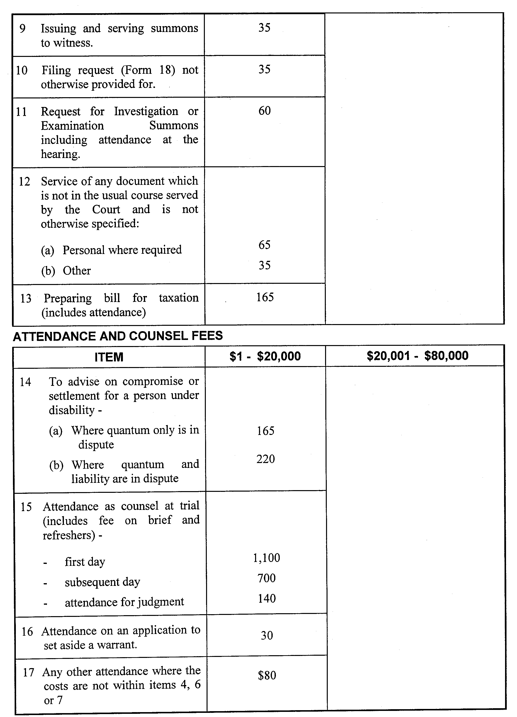
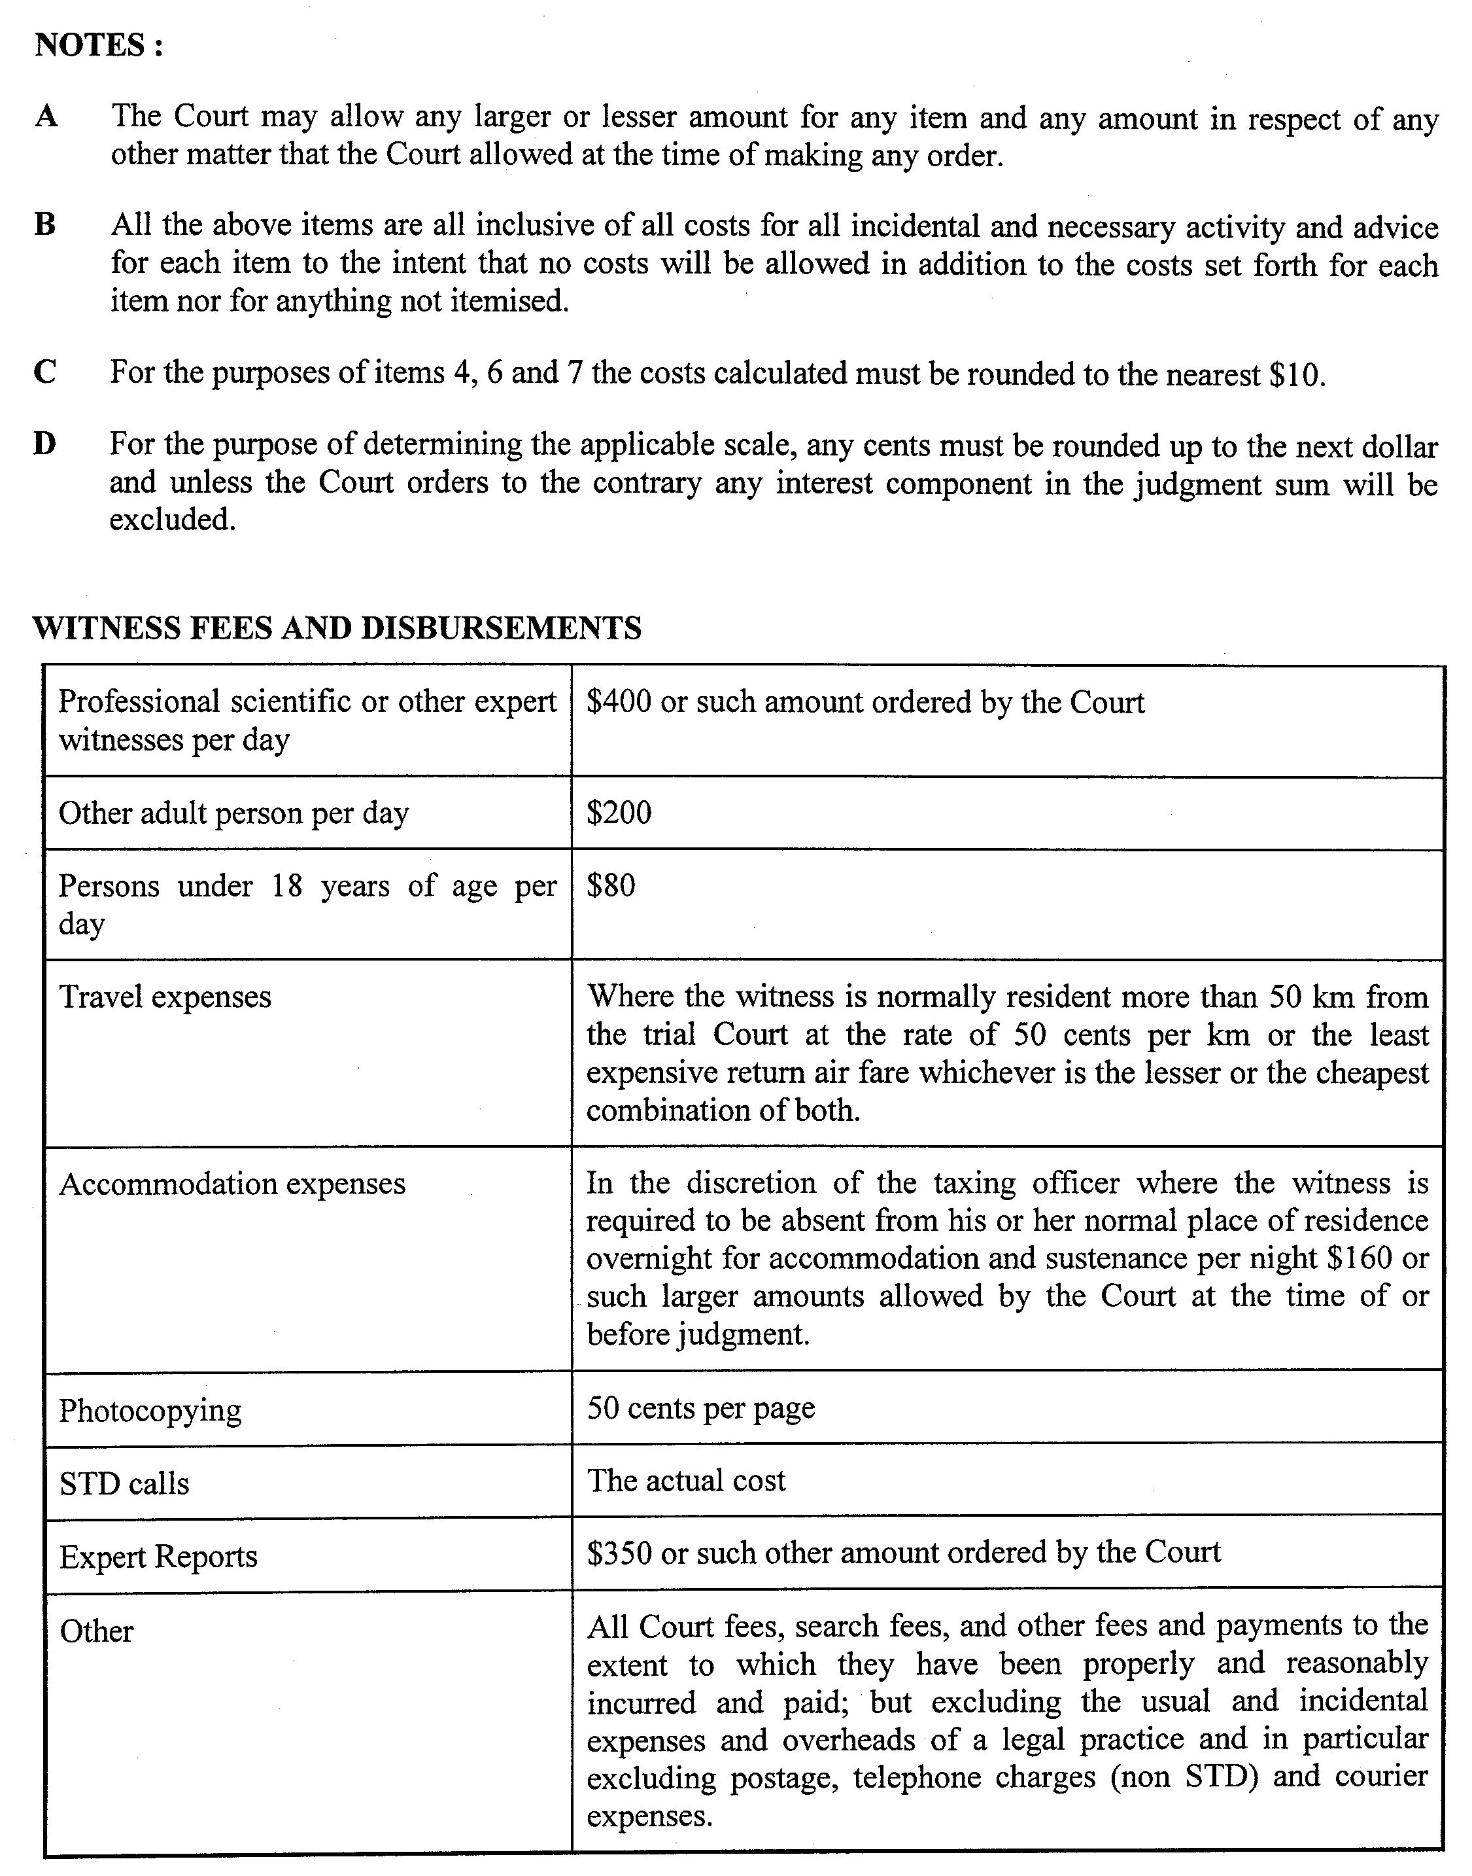
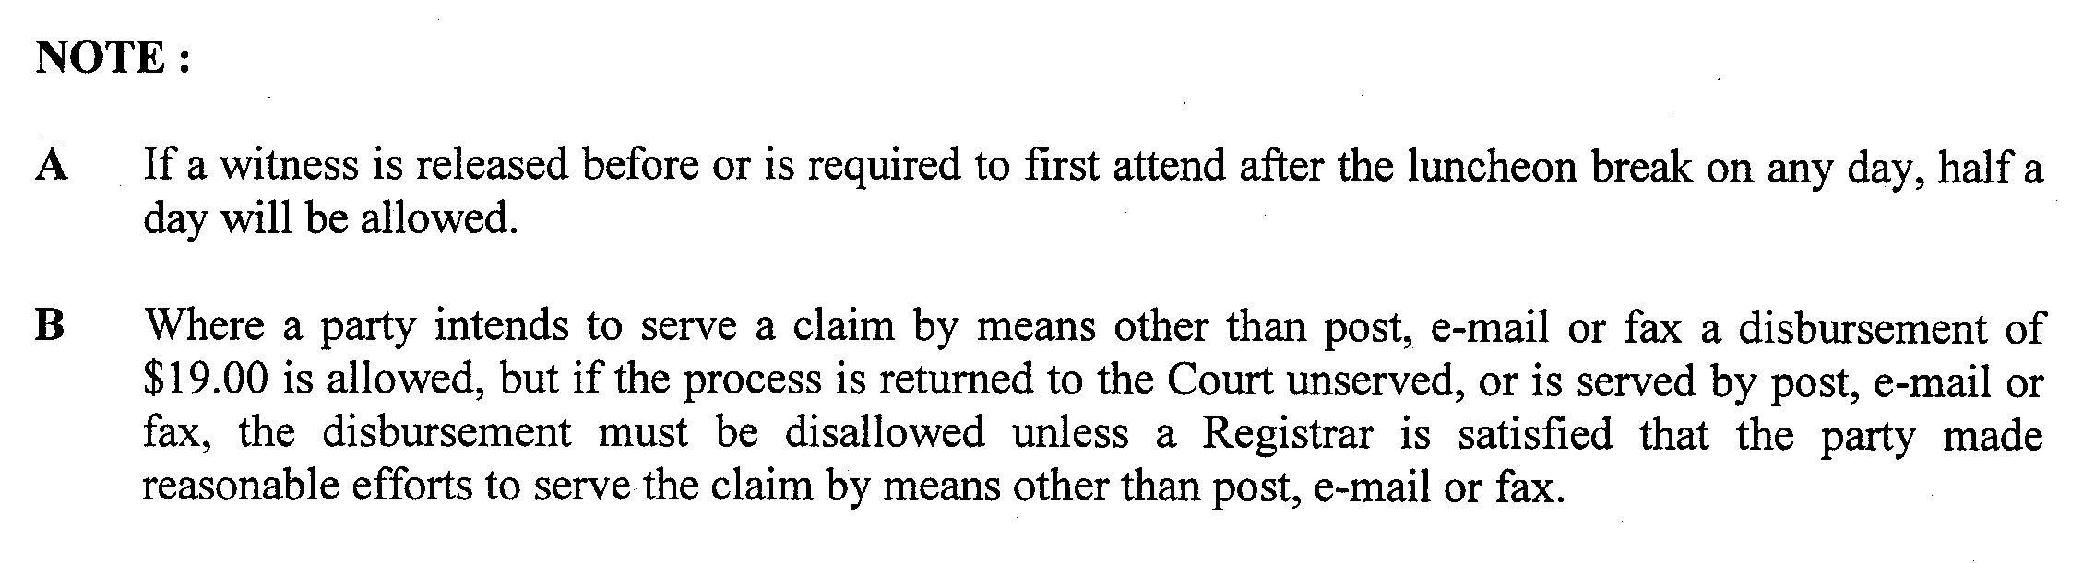
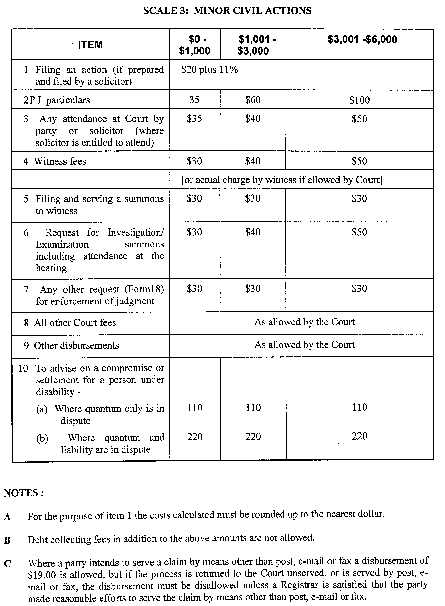
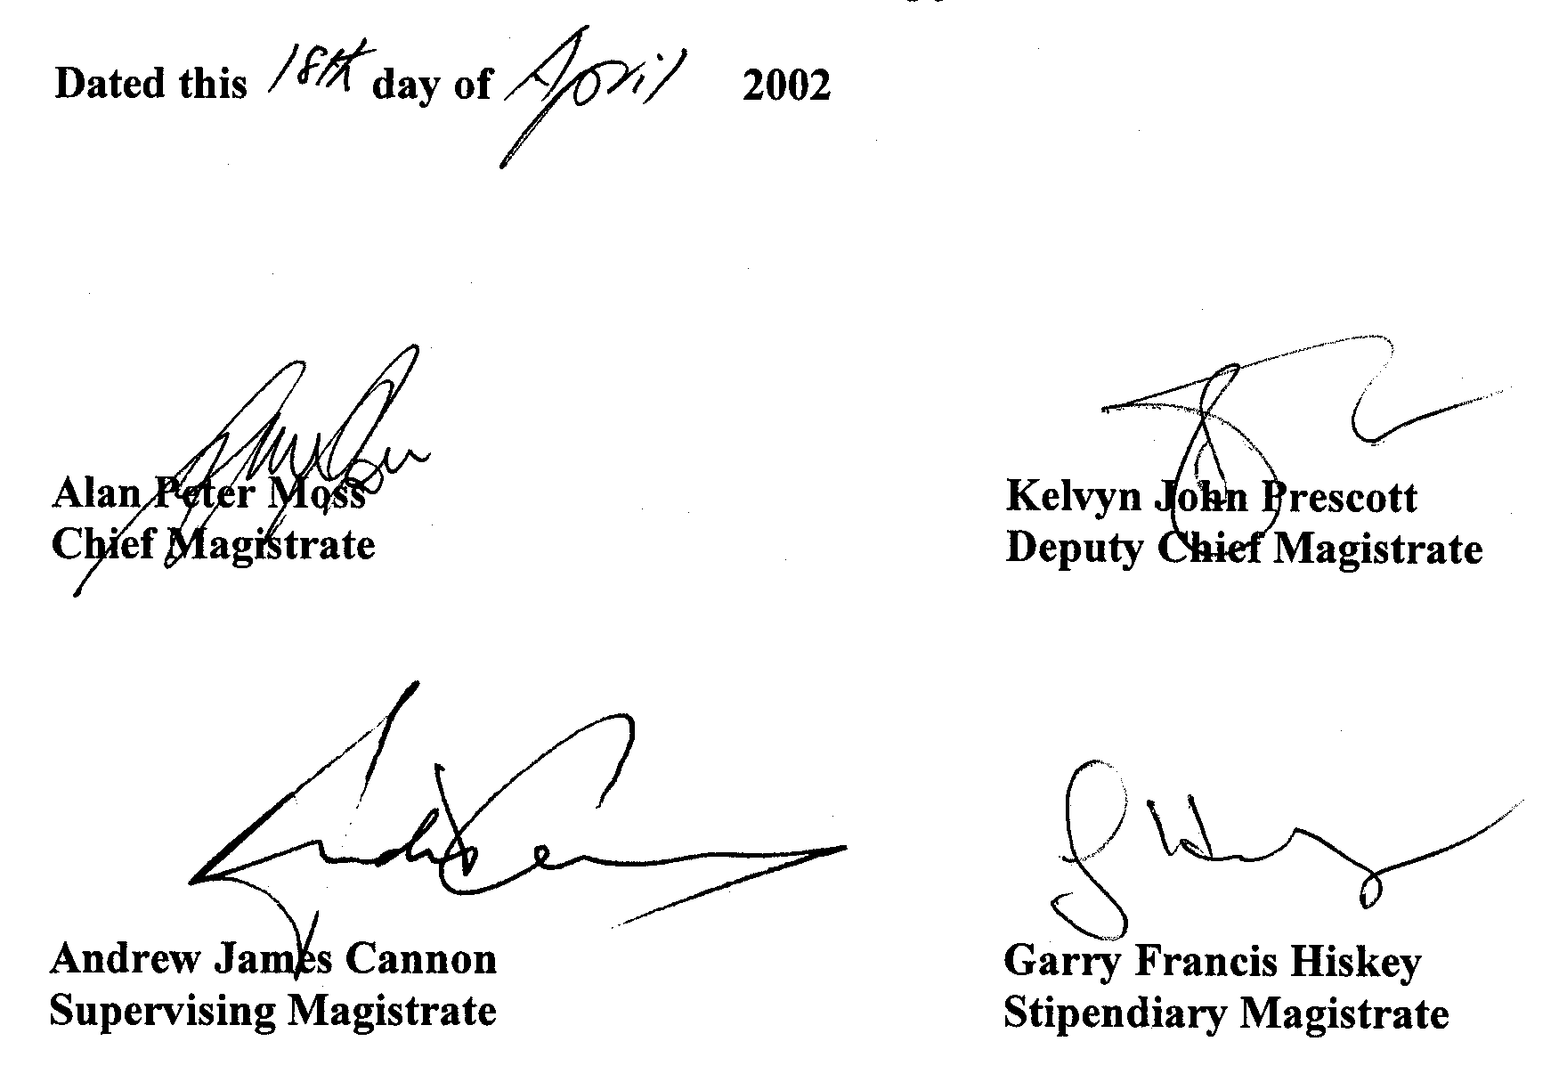
REGULATIONS UNDER THE LIQUOR LICENSING ACT 1997
────
No. 22 of 2002
────
At the Executive Council Office at Adelaide, 26 April 2002

PURSUANT to the Liquor Licensing Act 1997 and with the advice and consent of the Executive Council, I make the following regulations.
MARJORIE JACKSON-NELSON, Governor

PURSUANT to section 10AA(2) of the Subordinate Legislation Act 1978, I certify that, in my opinion, it is necessary or appropriate that the following regulations come into operation as set out below.

M. J. ATKINSON, Minister for Consumer Affairs
───────────────────
SUMMARY OF PROVISIONS

1. Citation
2. Commencement
3. Variation of Sched. 1—Long Term Dry Areas
───────────────────

Citation
1. The Liquor Licensing (Dry Areas—Long Term) Regulations 1997 (see Gazette 6 November 1997 p. 1217), as varied, are referred to in these regulations as "the principal regulations".

Commencement
2. These regulations come into operation on the day on which they are made.

Variation of Sched. 1—Long Term Dry Areas
3. Schedule 1 of the principal regulations is varied—

(a) by striking out from the column headed "Period" in the item headed "Hallett Cove—Area 1" "2002" and substituting "2005";

(b) by striking out from the column headed "Period" in the item headed "Hallett Cove—Area 2" "2002" and substituting "2005";

(c) by striking out from the column headed "Period" in the item headed "Hallett Cove—Area 3" "2002" and substituting "2005";

(d) by striking out from the column headed "Period" in the item headed "Hallett Cove—Area 4" "2002" and substituting "2005";

(e) by striking out from the column headed "Period" in the item headed "Oaklands Park—Area 1" "2002" and substituting "2005".

LLCS10/97 R. D. DE PALMA, Clerk of the Council

BY AUTHORITY: J. FERGUSON, Government Printer, South Australia

