SUPPLEMENTARY GAZETTE



THE SOUTH AUSTRALIAN

GOVERNMENT GAZETTE

PUBLISHED BY AUTHORITY

ALL PUBLIC ACTS appearing in this GAZETTE are to be considered official, and obeyed as such

ADELAIDE, FRIDAY, 30 AUGUST 2002

FISHERIES ACT 1982: SECTION 59
TAKE notice that pursuant to section 59 of the Fisheries Act 1982, Stephen Rufus or persons acting as his authorised agents (hereinafter referred to as the ‘exemption holder’) in his capacity as Chief Executive Officer of Kingston District Council, P.O. Box 321, Kingston, S.E. 5275, is exempt from the provisions of section 34 of the Fisheries Act 1982, but only insofar as the exemption holder shall not be guilty of an offence whilst engaged in the collection of beach-cast seagrass/seaweed and algal material (hereinafter referred to as the ‘exempted activity’) in the waters specified in Schedule 1 (hereinafter referred to as the ‘permitted area’), subject to the conditions specified in Schedule 2, from the date of gazettal of this notice until 30 September 2002, unless varied or revoked earlier.
Schedule 1
A section of the main foreshore beach at Kingston SE between the low water mark and high water mark extending from the Kingston town jetty to the boat ramp opposite Thredgold Avenue, Kingston SE.
Schedule 2
1. Only unattached beach-cast seagrass/seaweed and algae shall be harvested or moved.
2. The method of removal shall not involve the taking of any sand. Sand taken incidental to the harvesting operations is to be returned to the foreshore.
3. No harvesting is to take place within 4 m of the toe of the foredune.
4. While engaged in the exempted activity the exemption holder must be in possession of a copy of this notice and must be produced to a PIRSA Fisheries Compliance Officer if such an officer requests that it be produced.
5. The exemption holder shall not contravene or fail to comply with the Fisheries Act 1982, or any regulations made under that Act, except where specifically permitted by this notice.
Dated 27 August 2002.
W. Zacharin, Director of Fisheries

FISHERIES ACT 1982: SECTION 59
TAKE notice that pursuant to section 59 of the Fisheries Act 1982, Bevan C. Mills or persons acting as his agents (hereinafter referred to as the ‘exemption holder’) of Beachport Sea Products, P.O. Box 217, Beachport, S.A. 5280, is exempted from the provision of section 34 of the Fisheries Act 1982, but only insofar as the exemption holder may engage in the collection and sale of no more than 100 tonnes (wet weight) of drift-cast sea-grass and macroalgae (hereinafter referred to as the ‘exempted activity’) in the waters specified in Schedule 1 (hereinafter referred to as the ‘permitted area’), subject to the conditions specified in Schedule 2, from the date of gazettal of this notice until 30 September 2002, unless revoked earlier by the Director of Fisheries.
Schedule 1
An area of foreshore above the low water line commencing at the Lake George outlet and proceeding in a south-easterly direction for 8 km.
Schedule 2
1. The exemption holder shall use non-mechanical means only to engage in the exempted activity from the permitted area.
2. No equipment used during the exempted activity shall be left within the permitted area at the completion of daily collection activities.
3. No harvesting is to take place within 4 m of the toe of the foredune.
4. No material is to be stored or processed in any way on the foreshore.
5. Only unattached beach-cast seagrass and macroalgae shall be harvested.
6. The exemption holder must provide reports at the end of each month to PIRSA Fisheries, detailing for each species harvested:
• the species harvested;
• the amount harvested;
• the location species are harvested from;
• the length of time taken to collect the species;
• the use of the species harvested.
7. Whilst engaged in the exempted activity the exemption holder must be in possession of a copy of this notice. Such notice must be produced to a PIRSA Fisheries Compliance Officer if such an officer requests that it be produced.
8. The exemption holder shall not contravene or fail to comply with the Fisheries Act 1982, or any regulations made under that Act, except where specifically permitted by this notice.
Dated 27 August 2002.
W. Zacharin, Director of Fisheries

FISHERIES ACT 1982: SECTION 59
TAKE notice that pursuant to section 59 of the Fisheries Act 1982, Bevan Mills of Beachport Sea Products, P.O. Box 217, Beachport, S.A. 5280, or persons acting as his agents (herein-after referred to as the ‘exemption holders’), is exempted from section 34 of the Fisheries Act 1982, but only insofar as to engage in the activities specified in Schedule 1, subject to the conditions in Schedule 2, in the waters specified in Schedule 3 (hereinafter referred to as the ‘permitted area’) from the date of gazettal of this notice until 30 September 2002 unless revoked earlier by the Director of Fisheries.
Schedule 1
The collection of no more than a total of 1 000 litres per month (dry weight 0.5 tonnes) of Macrosystis angustifolia and Ecklonia radiata and no more than 5 000 litres per month of Durvillaea potatorum (dry weight 2.5 tonnes) (hereinafter referred to as the ‘exempted activity’).
Schedule 2
1. The exemption holders shall use non-mechanical means only to engage in the exempted activity from the permitted area.
2. No equipment used during the exempted activity shall be left within the permitted area at the completion of daily collection activities.
3. No harvesting is to take place within 4 m of the toe of the foredune.
4. No material is to be stored or processed in any way on the foreshore.
5. The exemption holders must provide reports at the end of each month to PIRSA Fisheries, detailing for each species harvested:
• the species harvested;
• the amount harvested;
• the vehicles and methods used in the harvested operation;
• access points and areas harvested;
• an estimation of the remaining biomass of each species in the harvest area;
• the length of time taken to collect the species;
• the method used to process the species; and
• the intended use of the species harvested.
6. The exemption holders must comply with any Local Government, State and Commonwealth legislation (including the holding of relevant planning approval) relating to the exempted activity.
7. Whilst engaged in the exempted activity the exemption holders must be in possession of a copy of this notice. Such notice must be produced to a PIRSA Fisheries Compliance Officer if such an officer requests that it be produced.
8. The exemption holders shall not contravene or fail to comply with the Fisheries Act 1982, or any regulations made under that Act, except where specifically permitted by this notice.
Schedule 3
Between the high water mark and the low water mark of the coastal beaches between Margaret Brock reef and Nora Creina (south-east region of South Australia) excluding all aquatic reserves proclaimed under the Fisheries Act 1982, and any beaches adjacent to lands owned and managed by the Minister for Environment and Heritage.
Dated 27 August 2002.
W. Zacharin, Director of Fisheries

FISHERIES ACT 1982: SECTION 59
TAKE notice that pursuant to section 59 of the Fisheries Act 1982, Russell K. Woodward or persons acting as his agents (hereinafter referred to as the ‘exemption holder’) of Seaweed Sales Australia, 6 Kalka Crescent, Pasadena, S.A. 5042, is exempt from section 34 of the Fisheries Act 1982, but only insofar as he is permitted to collect and sell beach-cast seagrass/ seaweed and algae material (hereinafter referred to as the ‘exempted activity’), subject to the conditions specified in Schedule 2, in the waters specified in Schedule 1 (hereinafter referred to as the ‘permitted area’).
Schedule 1
A section of the foreshore within the low water mark and high water mark between Maria Creek outlet to Blackford Drain, Kingston SE.
Schedule 2
1. The exemption holder may engage in the exempted activity from the date of gazettal of this notice until 30 September 2002, unless revoked earlier by the Director of Fisheries.
2. The exemption holder shall access the permitted area via Long Beach Road only.
3. No equipment used during the exempted activity shall be left within the permitted area at the completion of daily collection activities.
4. Only unattached beach-cast seagrass/seaweed and algae shall be harvested.
5. The method of removal shall not involve the taking of any sand. Sand taken incidental to the harvesting operations is to be returned to the foreshore.
6. No harvesting is to take place within 4 m of the toe of the foredune.
7. No material is to be stored or processed in any way on the foreshore.
8. The exemption holder must provide reports at the end of each calendar month to PIRSA Fisheries, detailing for each species harvested:
• the species harvested;
• the amount harvested;
• the length of time taken to collect the species;
• the method used to process the species; and
• the use made of the species harvested.
9. The exemption holder must comply with any Local Govern-ment, State and Commonwealth legislation (including the holding of relevant planning approval) relating to the exempted activity.
10. While engaged in the exempted activity the exemption holder shall carry or have about or near his person a copy of this notice. Such notice must be produced to a PIRSA Fisheries Compliance Officer upon request.
11. The exemption holder shall not contravene or fail to comply with the Fisheries Act 1982, or any regulations made under that Act, except where specifically exempted by this notice.
Dated 27 August 2002.
W. Zacharin, Director of Fisheries

FISHERIES ACT 1982: SECTION 59
TAKE notice that pursuant to section 59 of the Fisheries Act 1982, Jeffrey P. Wait (hereinafter referred to as the ‘exemption holder’), 31 Sir Keith Smith Drive, North Haven, S.A. 5018, holder of Marine Scalefish Fishery Licence No. M492, is exempt from the provisions of Clause 37 of Schedule 1 of the Fisheries (General) Regulations 2000, but only insofar as the exemption holder may use a fish net specified in Schedule 1 for the purpose of trade or business in waters greater than 5 m in depth (hereinafter referred to as the ‘exempted activity’) specified in Schedule 2, subject to the conditions in Schedule 3, from the date of gazettal of this notice until 30 June 2003, unless varied or revoked earlier.
Schedule 1
One floating hauling net or purse seine net not exceeding 600 m in length and 160 meshes in depth, and with a mesh size of not less than 3 cm.
Schedule 2
The waters of Gulf St Vincent and Investigator Strait within blocks 34, 35, 36, 43 and 44 as defined in the South Australian Commercial Fishing Summary Sheets (copy attached).
Schedule 3
1. The exemption holder may only conduct the exempted activity from a boat registered on Marine Scalefish Fishery Licence No. M492.
2. PIRSA fisheries retains the right for a departmental officer or an officer of the South Australian Research and Development Institute to accompany the exemption holder at any time while engaged in the exempted activity.
3. The exemption holder must provide separate statistical catch and effort information, in the form of a daily log, with details of fishing conducted pursuant to the exempted activity.
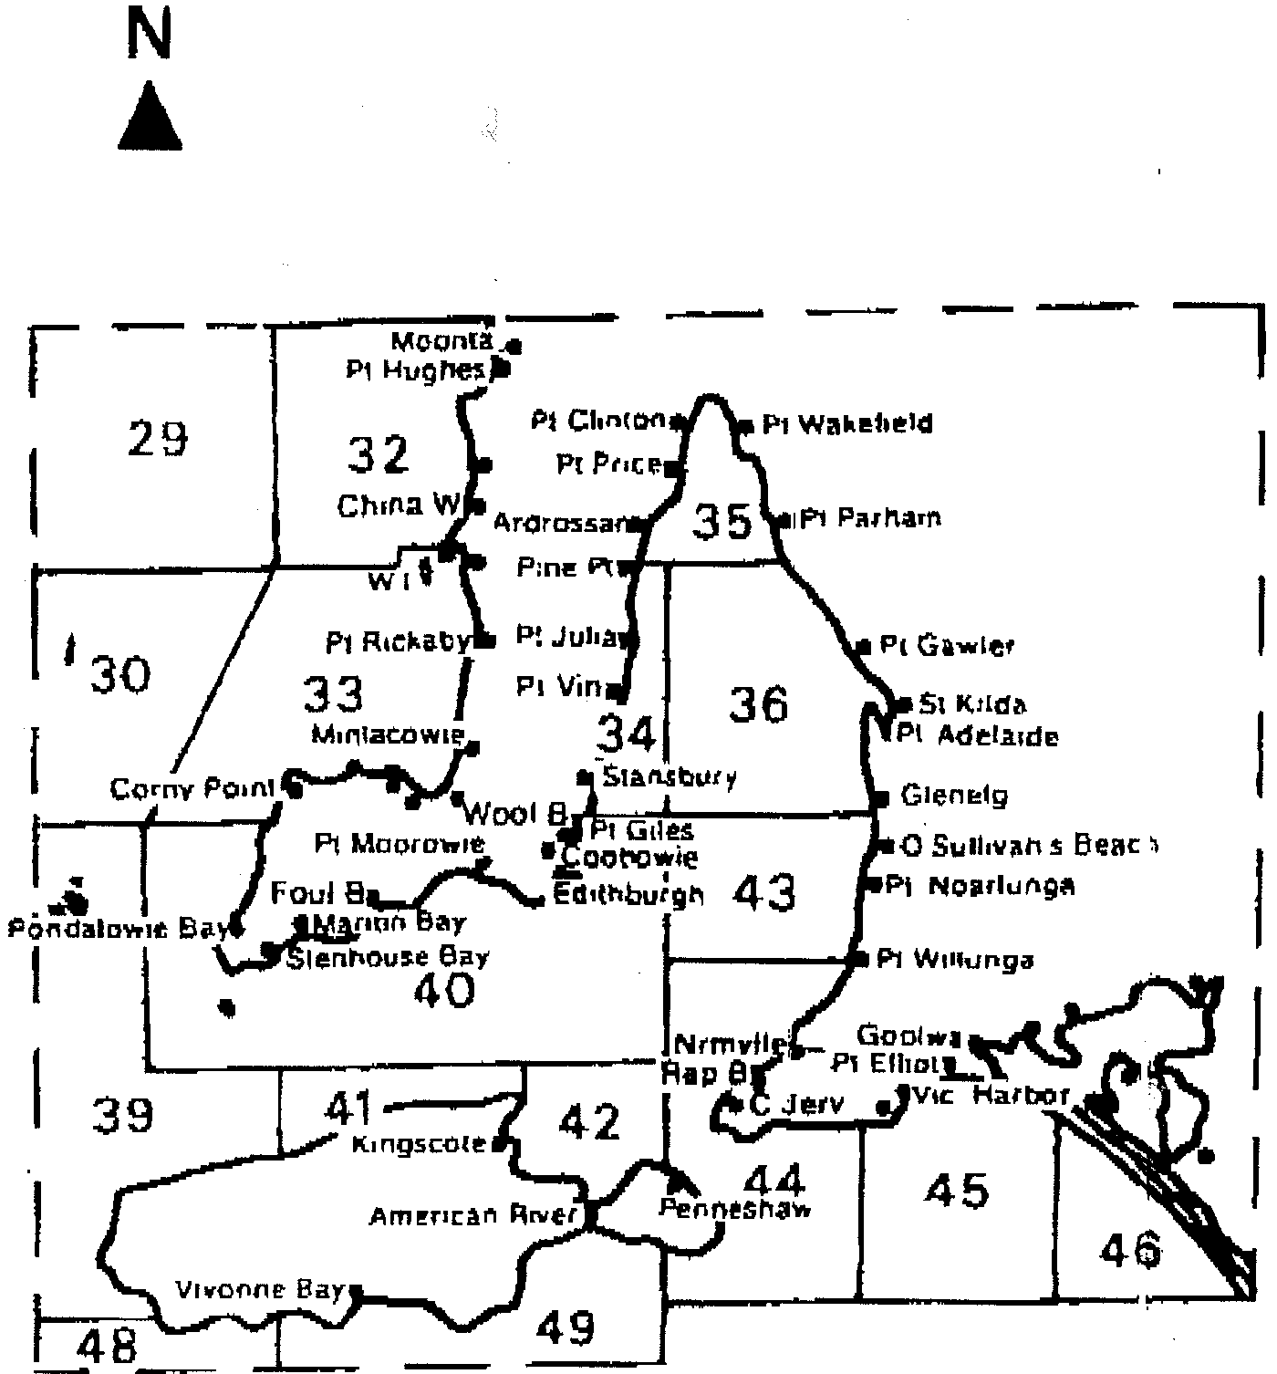
4. Whilst engaged in the exempted activity the exemption holder must have in his possession a copy of this notice and produce a copy of the notice if required by a PIRSA Fisheries Compliance Officer.
5. The exemption holder shall not contravene or fail to comply with the Fisheries Act 1982, or any regulation made under that Act except where specifically exempted by this notice.

Dated 14 August 2002.
W. Zacharin, Director of Fisheries

J. D. FERGUSON, Government Printer, South Australia

