No. 13 419

THE SOUTH AUSTRALIAN

GOVERNMENT GAZETTE

PUBLISHED BY AUTHORITY

ALL PUBLIC ACTS appearing in this GAZETTE are to be considered official, and obeyed as such

ADELAIDE, THURSDAY, 31 JANUARY 2002

CONTENTS

Page
Appointment, Resignation, Etc. 420
Corporations and District Councils—Notices 458
Criminal Law (Forensic Procedures) Act 1998—Erratum 420
Crown Lands Act 1929—Notices 420
Highways Act 1926—Notices 420
Housing Improvement Act 1940—Notices 421
Land and Business (Sale and Conveyancing) Act 1994—
Notice 423
Liquor Licensing Act 1997—Notices 424
Local Government Act 1999—Notices 426
Mining Act 1971—Notices 454
Motor Vehicles Act 1959—Notice 432
National Parks Regulations 2001—Notices 455
Private Advertisements 463
Public Trustee Office—Administration of Estates 463
Renmark Irrigation Trust, The—Notice 455
Roads (Opening and Closing) Act 1991—Notices 455
Road Traffic Act 1961—Notice 456
Sale of Property 464
Transport, Department of—Notices to Mariners 456
Unclaimed Moneys Act 1891—Notices 464

GOVERNMENT GAZETTE NOTICES
ALL poundkeepers’ and private advertisements forwarded for publication in the South Australian Government Gazette must be PAID FOR PRIOR TO INSERTION; and all notices, from whatever source, should be legibly written on one side of the paper only and sent to Government Publishing SA so as to be received no later
than 4 p.m. on the Tuesday preceding the day of publication. Phone 8207 1045 or Fax 8207 1040. E-mail: governmentgazette@saugov.sa.gov.au. Send as attachments in Word format and please confirm your transmission with a faxed copy of your document, including the date the notice is to be published and to whom the notice will be charged.

Department of the Premier and Cabinet
Adelaide, 31 January 2002
HER Excellency the Governor upon the recommendation of and with the advice and consent of the Executive Council do appoint Brian Croser, a member of the National Wine Centre Board, to chair meetings of the board for a period of two months from 1 February 2002, pursuant to section 10 of the National Wine Centre Act 1997 and section 36 of the Acts Interpretation Act 1915.
By command,
Dean Brown, for Premier
DPC 012/98CS

CRIMINAL LAW (FORENSIC PROCEDURES) ACT 1998
Erratum
IN Government Gazette of 24 January 2002, page 356 the incorrect notice was printed. The correct notice is printed herewith: please disregard the previous notice.
The Police Officers appearing below are qualified to carry out forensic procedures of the relevant type pursuant to section 33 of the Criminal Law (Forensic Procedures) Act 1998.
Surname | Given Names | Date Qualified
Ackland | Anthony Lee | 30 November 2001
Bedford | Julian Daniel | 30 November 2001
Dunlevey | Andrew | 30 November 2001
Finlayson | David Roy | 30 November 2001
Gunter | Troy Sean | 30 November 2001
Hamilton | John Leslie | 30 November 2001
Highett | Michael David | 30 November 2001
Keller | Anthea Gayle | 30 November 2001
Pickburn | Michael de Mestre | 30 November 2001
Tamits | Richard John | 30 November 2001
Wedding | Timothy John | 30 November 2001
Dated 30 January 2002.
Robert Brokenshire, Minister for Police

CROWN LANDS ACT 1929: SECTION 5
TAKE NOTICE that pursuant to the Crown Lands Act 1929, I PETER MACLAREN KENTISH, Surveyor-General and Delegate appointed by IAIN EVANS, Minister for Environment and Heritage, Minister of the Crown to whom the administration of the Crown Lands Act 1929 is committed DO HEREBY:
1. Dedicate the Crown Land defined in the The First Schedule as a Conservation and Camping Reserve and declared that such land shall be under the care, control and management of the Narungga Nations Aboriginal Corporation, subject to the following condition: Narungga Nations Aboriginal Corporation becoming an incorporated body.
2. Dedicate the Crown Land defined in the The Second Schedule as a Conservation and Camping Reserve and declared that such land shall be under the care, control and management of the Narungga Nations Aboriginal Corpora-tion, subject to the following conditions:
• A reservation of free and unrestricted public access over the land.
• Narungga Nations Aboriginal Corporation becoming an incorporated body.
The First Schedule
Section 621, Hundred of Melville, County of Fergusson, exclusive of all necessary roads, being the whole of the land comprised in Crown Record Volume 5744 Folio 654.
The Second Schedule
Sections 622, 626 and 627, Hundred of Melville, County of Fergusson, exclusive of all necessary roads, being the whole of the land comprised in Crown Records Volume 5744 Folios 655, 656 and 657.
Dated 29 January 2002.
P. M. Kentish, Surveyor-General
DEHAA 10/1024

CROWN LANDS ACT 1929: SECTION 5
TAKE NOTICE that pursuant to the Crown Lands Act 1929, I PETER MACLAREN KENTISH, Surveyor-General and Delegate appointed by IAIN EVANS, Minister for Environment and Heritage, Minister of the Crown to whom the administration of the Crown Lands Act 1929 is committed DO HEREBY dedicate the Crown Land defined in The Schedule as a Public Road.
The Schedule
Allotment 51 of DP 57660, Hundred of Wallaroo, County of Daly, being within the district of the Copper Coast.
Dated 29 January 2002.
P. M. Kentish, Surveyor-General
DL 1022/1981

HIGHWAYS ACT 1926
Section 26 (4)
I, TREVOR NOEL ARGENT, Commissioner of Highways, with the approval of the Minister for Transport and Urban Planning and pursuant to my powers under section 26 (4) of the Highways Act 1926, do hereby give notice that I revoke the section 26 (3) notice published on 17 January 2002, in Government Gazette
No. 8, page 305, regarding that part of Road Number 03685, known as Redhill-Brinkworth Road, contained within the boundaries of the Wakefield Regional Council.
Dated 25 January 2002.
T. N. Argent, Commissioner of Highways

HIGHWAYS ACT 1926
Section 26 (4)
I, TREVOR NOEL ARGENT, Commissioner of Highways, with the approval of the Minister for Transport and Urban Planning and pursuant to my powers under section 26 (4) of the Highways Act 1926, do hereby give notice that I revoke the section 26 (3) notice published on 17 January 2002, in Government Gazette
No. 8, page 305, regarding that part of Road Number 03685, known as Redhill-Brinkworth Road, contained within the boundaries of the Port Pirie Regional Council.
Dated 25 January 2002.
T. N. Argent, Commissioner of Highways

HOUSING IMPROVEMENT ACT 1940
WHEREAS by notice published in the Government Gazette on the dates mentioned in the following table the South Australian Housing Trust did declare the houses described in the said table to be substandard for the purposes of Part VII of the Housing Improvement Act 1940, the South Australian Housing Trust in the exercise of the powers conferred by the said Part, does hereby fix as the maximum rental per week which shall be payable subject to section 55 of the Residential Tenancies Act 1995, in respect of each house described in the following table the amount shown in the said table opposite the description of such house and this notice shall come into force on the date of this publication in the Gazette.
Address of House | Allotment, Section, etc. | Certificate of Title  Volume Folio | Date and page of Government Gazette in which notice declaring house to be substandard published | Maximum rental per week payable in respect of each house  $

4 Dean Street, Angaston |  | Allotment 1 in Filed Plan 3107, Hundred of Moorooroo | 5502 | 834 |  | 26.11.92, page 1636 | 130.00
46 Burton Road, Athelstone |  | Allotment 92 in Filed Plan 133182, Hundred of Adelaide | 5701 | 755 |  | 29.11.01, page 5222 | 64.00
14 Taylor Street, Brompton |  | Allotment 131 in Deposited Plan 459, Hundred of Yatala | 5605 | 285 |  | 22.12.66, page 2314 | 80.00
48 King Street, Clare |  | Allotments 91 and 92 in Filed Plan 204199, Hundred of Clare | 5398 | 753 |  | 29.7.93, page 715 | 135.00
45 Kent Avenue, Clearview |  | Allotment 97 in Deposited Plan 5453, Hundred of Yatala | 5618 | 296 |  | 24.5.01, page 1868 | 105.00
63 California Street, Collinswood |  | Allotment 1 in Filed Plan 105445, Hundred of Yatala | 5161 | 605 |  | 27.9.01, page 4303 | 130.00
25 North East Road, Collinswood |  | Unit 1 in Strata Plan 4154, Hundred of Yatala | 5020 | 569 |  | 30.5.96, page 2605 | 220.00
16A Churchill Avenue, Glandore |  | Allotment 143 in Deposited Plan 3011, Hundred of Adelaide | 5846 | 302 |  | 29.11.01, page 5222 | 100.00
40 Hampton Street South, Goodwood |  | Allotment 107 in Filed Plan 9510, Hundred of Adelaide | 5333 | 223 |  | 25.10.01, page 4692 | 160.00
Lot 61 Brandis Road, Munno Para West |  | Allotment 61 in Deposited Plan 33421, Hundred of Munno Para | 5061 | 31 |  | 2.2.95, page 207 | 107.00
60 Kadina Road, North Yelta |  | Section 2262, Hundred of Wallaroo | 5432 | 561 |  | 13.7.89 page 87 | 82.00 (House)  45.00 (detached flat)
4 Langsford Street, Port Augusta |  | Allotment 92 in Filed Plan 216867, Hundred of Davenport | 5650 | 891 |  | 27.5.93, page 1784 | 20.00
45 Langsford Street, Port Augusta |  | Allotment 14 in Deposited Plan 2353, Hundred of Davenport | 5784 | 232 |  | 4.5.95, page 1714 | 20.00
1 Wharf Street, Port Augusta |  | Allotment 6 in Deposited Plan 2137, Hundred of Davenport | 5356 | 680 |  | 6.4.78, page 1146 | 100.00
13 Alderman Avenue, Seacombe Gardens |  | Allotment 408 in Deposited Plan 4645, Hundred of Noarlunga | 5274 | 155 |  | 29.11.01, page 5222 | 120.00
11 Anne Street, Stepney |  | Allotment 373 in Filed Plan 17333, Hundred of Adelaide | 5244 | 564 |  | 29.3.79, page 847 | 145.00
6 George Street, Strathalbyn |  | Allotment 16 in Deposited Plan 156, Hundred of Bremer | 5296 | 481 |  | 26.7.01, page 2774 | 140.00

Dated at Adelaide, 31 January 2002. G. Black, General Manager, Housing Trust

HOUSING IMPROVEMENT ACT 1940
WHEREAS by notice published in the Government Gazette on the dates mentioned in the following table the South Australian Housing Trust did declare the houses described in the said table to be substandard for the purposes of Part VII of the Housing Improvement Act 1940, and whereas the South Australian Housing Trust is satisfied that each of the houses described hereunder has ceased to be substandard, notice is hereby given that, in exercise of the powers conferred by the said Part, the South Australian Housing Trust does hereby revoke the said declaration in respect of each house.
Address of House | Allotment, Section, etc. | Certificate of Title  Volume Folio | Date and page of Government Gazette in which notice declaring house to be substandard published

2 Theodore Street, Edwardstown |  | Allotment 27 in Deposited Plan 2195, Hundred of Adelaide | 5304 | 206 |  | 7.5.98, page 2133
24-26 Cameron Street, Gawler |  | Allotment 2 in Filed Plan 104532, Hundred of Mudla Wirra | 5147 | 872 |  | 24.4.69, page 1181
43 Mellor Road, Glanville |  | Allotment 159 in Filed Plan 3144, Hundred of Port Adelaide | 5504 | 945 |  | 15.1.76, page 194
15 Stewart Street, Glanville |  | Allotment 90 in Filed Plan 3144, Hundred of Port Adelaide | 5117 | 898 |  | 13.12.79, page 2248
34 Essex Street South, Goodwood |  | Allotment 1 in Filed Plan 15082, Hundred of Adelaide | 5482 | 474 |  | 17.6.71, page 2934
497 Fullarton Road, Highgate |  | Allotment 100 in Deposited Plan 31248, Hundred of Adelaide | 5072 | 627 |  | 27.9.01, page 4303
10 Roebuck Street, Mile End |  | Allotment 2 in Filed Plan 143930, Hundred of Adelaide | 5497 | 718 |  | 16.11.89, page 1505
2 Pompoota Road, Modbury |  | Allotment 42 in Deposited Plan 6684, Hundred of Yatala | 5196 | 644 |  | 28.11.96, page 1755
74 Fifth Street, Port Pirie West |  | Allotment 112 in Deposited Plan 403, Hundred of Pirie | 5782 | 516 |  | 29.8.96, page 820
56 Webb Street, Queenstown |  | Allotment 92 in Filed Plan 142733, Hundred of Yatala | 5708 | 999 |  | 29.3.01, page 1477
4 Curb Street, Saddleworth |  | Allotment 459 in Filed Plan 168588, Hundred of Saddleworth | 5527 | 386 | ⎫  ⎬ | 30.5.96, page 2605
 |  | Allotment 460 in Filed Plan 168589, Hundred of Saddleworth | 5527 | 387 | ⎭
107 Martins Road, Salisbury Downs |  | Allotment 28 in Filed Plan 113237, Hundred of Yatala | 5612 | 675 |  | 29.11.01, page 5222
21 Cooke Terrace, Tailem Bend |  | Allotment 606 in Deposited Plan 4650, Hundred of Seymour | 5397 | 368 |  | 13.4.89, page 1053
319 Torrens Road, West Croydon |  | Allotment 77 in Deposited Plan 2772, Hundred of Yatala | 5599 | 586 |  | 24.11.94, page 1610

Dated at Adelaide, 31 January 2002. G. Black, General Manager, Housing Trust

HOUSING IMPROVEMENT ACT 1940
NOTICE is hereby given that the South Australian Housing Trust in the exercise of the powers conferred by the Housing Improvement Act 1940, does hereby declare the houses described in the table hereunder to be substandard for the purposes of Part VII of the Housing Improvement Act 1940.
No. of House and Street | Locality | Allotment, Section, etc. | Certificate of Title  Volume Folio

132 Wakefield Street |  | Adelaide | Allotment 778 in Filed Plan 181620, Hundred of Adelaide | 5728 | 653
293-295 Waymouth Street (portion also known as 22 Spencer Street) |  | Adelaide | Allotment 413 in Filed Plan 181255, Hundred of Adelaide | 5789 | 894
33 Sussex Street |  | Alberton | Allotment 13 in Filed Plan 143077, Hundred of Yatala | 5723 | 666
8 Gordon Street |  | Black Forest | Allotment 109 in Deposited Plan 2015, Hundred of Adelaide | 5376 | 131
Unit 2/24 Murray Avenue |  | Clearview | Unit 2 in Strata Plan 6488, Hundred of Yatala | 5013 | 940
43 Sampson Road |  | Elizabeth Grove | Allotment 6 in Deposited Plan 31342, Hundred of Munno Para | 5078 | 108
3 Keystone Avenue |  | Holden Hill | Allotment 48 in Filed Plan 131293, Hundred of Yatala | 5812 | 656
15 Sarah Street |  | Marleston | Allotment 30 in Deposited Plan 865, Hundred of Adelaide | 5776 | 446
34 Showground Road |  | Mount Pleasant | Allotment 669 in Filed Plan 169608, Hundred of Talunga | 5738 | 675
4 West Terrace |  | Port Hughes | Allotment 124 of Town of Port Hughes, Hundred of Wallaroo | 5308 | 721
30 Revell Street |  | Port Pirie West | Allotment 5 in Filed Plan 149562, Hundred of Pirie | 5277 | 405
Lot 6 Greenhill Road (also known as Lot 1 Collins Road) |  | Uraidla | Allotment 1 in Deposited Plan 32998, Hundred of Onkaparinga | 5060 | 846

Dated at Adelaide, 31 January 2002. G. Black, General Manager, Housing Trust

LAND AND BUSINESS (SALE AND CONVEYANCING) ACT 1994
Exemption
TAKE notice that, pursuant to section 23 (3) of the Land and Business (Sale and Conveyancing) Act 1994, I, Robert David Lawson, Minister for Consumer Affairs, do hereby exempt the person named in Schedule 1 from the application of section 23 (2) of the Act in relation to the purchase of the land specified in Schedule 2.
Schedule 1
Kim Maree Irwin, an officer/employee of Living Stone Pty Ltd.
Schedule 2
The whole of the land described in certificate of title register book volume 5033, folio 543, situated at Unit 6, 14-16 Hartman Avenue, Modbury, S.A. 5092.
Dated 31 January 2002.
Signed for and on behalf of the Minister for Consumer Affairs by the Commissioner for Consumer Affairs:
M. Bodycoat, Commissioner

LIQUOR LICENSING ACT 1997 AND GAMING MACHINES ACT 1992
Notice of Application
NOTICE is hereby given, pursuant to section 52 of the Liquor Licensing Act 1997 and section 29 of the Gaming Machines Act 1992, that S. H. Millicent Pty Ltd c/o Richards Commercial Lawyers, Level 4, 185 Victoria Square, Adelaide, S.A. 5000 has applied to the Liquor and Gaming Commissioner for the transfer of a Hotel Licence and a Gaming Machine Licence in respect of premises situated at 72 George Street, Millicent, S.A. 5280 and known as Sportsman Hotel.
The applications have been set down for hearing on 4 March 2002 at 11 a.m.
Conditions
The following licence conditions are sought:
1. To vary the conditions of the licence from:
• The licensee will have not less than 3 security officers on duty at the premises from 11 p.m. on Friday and Saturday nights until at least 30 minutes after the hotel ceases trading.
• The licensee will have not less than 3 security officers on duty at the premises from 11 p.m. on Christmas Eve until 2.30 a.m. on Christmas Day.
2. To vary the conditions to read:
• The licensee will have not less than 1 security officer on duty at the premises from 11 p.m. on Friday and Saturday nights until at least 30 minutes after the hotel ceases trading.
• The licensee will have not less than 1 security office on duty at the premises from 11 p.m. on Christmas Eve until 2.30 a.m. on Christmas Day.
Any person may object to the application by lodging a notice of objection in the prescribed form with the Licensing Authority, and serving a copy of the notice on the applicant at the applicant’s address given above, at least seven days before the hearing date.
Plans in respect of the premises the subject of the application are open to public inspection without fee at the Office of the Liquor and Gaming Commissioner, 9th Floor, East Wing, 50 Grenfell Street, Adelaide, S.A. 5000.
Dated 25 January 2002.
Applicant

LIQUOR LICENSING ACT 1997 AND GAMING MACHINES ACT 1992
Notice of Application
NOTICE is hereby given, pursuant to section 52 of the Liquor Licensing Act 1997 and section 29 of the Gaming Machines Act 1992, that Jimmy Rowes Bar/Cafe Pty Ltd, c/o Griffins Lawyers, Level 14, 26 Flinders Street, Adelaide, S.A. 5000 has applied to the Liquor and Gaming Commissioner for the transfer of a Hotel Licence and a Gaming Machine Licence in respect of premises situated at 141 Currie Street, Adelaide, S.A. 5000 and known as Heritage Hotel and to be known as Jimmy Rowes Bar/Cafe.
The applications have been set down for hearing on 4 March 2002 at 11.30 a.m.
Any person may object to the application by lodging a notice of objection in the prescribed form with the Licensing Authority, and serving a copy of the notice on the applicant at the applicant’s address given above, at least seven days before the hearing date.
Plans in respect of the premises the subject of the application are open to public inspection without fee at the Office of the Liquor and Gaming Commissioner, 9th Floor, East Wing, 50 Grenfell Street, Adelaide, S.A. 5000.
Dated 24 January 2002.
Applicant

LIQUOR LICENSING ACT 1997
Notice of Application
NOTICE is hereby given, pursuant to section 52 (2) (b) of the Liquor Licensing Act 1997, that Cruise Hotels Pty Ltd (ABN 84 052 992 837) has applied to the Licensing Authority for a variation to the Extended Trading Authorisation which is in force in respect of premises situated at Bartley Terrace, West Lakes and known as Leg Trap Hotel.
The application has been set down for hearing on Friday,
1 March 2002 at 9 a.m.
Conditions
The following additional licence conditions are sought:
1. That the licensee be permitted to sell liquor for consumption on the licensed premises in Area 5 (front bar) from 8 p.m. to Midnight each Sunday.
2. That all other days and times previously authorised for extended trading shall remain.
Entertainment may be provided during the additional extended trading hours.
Any person may object to the application by lodging a notice of objection in the prescribed form with the Licensing Authority, and serving a copy of the notice on the applicant at the applicant’s address given above, at least seven days before the hearing date.
Plans in respect of the premises the subject of the application are open to public inspection without fee at the Office of the Liquor and Gaming Commissioner, 9th Floor, East Wing, 50 Grenfell Street, Adelaide, S.A. 5000.
Dated 22 January 2002.
Applicant

LIQUOR LICENSING ACT 1997
Notice of Application
NOTICE is hereby given, pursuant to section 52 (2) (b) of the Liquor Licensing Act 1997, that Kingsbrook SA Pty Ltd (ACN 650 008 207), c/o David Watts & Associates, Liquor Licensing Consultant, 1 Cator Street, Glenside, S.A. 5065 has applied to the Licensing Authority for a Special Circumstances Licence with an Extended Trading Authorisation and Entertainment Consent in respect of premises situated at corner Bevan Street and Frome Street, Currency Creek, S.A. 5214 and known as Kingsbrook.
The application has been set down for hearing on 1 March 2002 at 9 a.m.
Conditions
The following licence conditions are sought:
1. For consumption on the licensed premises:
The licence, including the extended trading authorisation, authorises the licensee to sell and supply liquor on the licensed premises:
• at all times with or ancillary to a meal;
• at all times to persons attending a pre-booked function;
• at all times to a lodger;
• at all times to a person seated at a table (except Good Friday and Christmas Day).
2. For consumption off the licensed premises:
• at all times to a lodger;
• at all times to members of the public, but only liquor produced by the licensee or a related company.
3. Entertainment consent is sought for the whole of the licensed premises.
Any person may object to the application by lodging a notice of objection in the prescribed form with the Licensing Authority, and serving a copy of the notice on the applicant at the applicant’s address given above, at least seven days before the hearing date.
Plans in respect of the premises the subject of the application are open to public inspection without fee at the Office of the Liquor and Gaming Commissioner, 9th Floor, East Wing, 50 Grenfell Street, Adelaide, S.A. 5000.
Dated 23 January 2002.
Applicant

LIQUOR LICENSING ACT 1997
Notice of Application
NOTICE is hereby given, pursuant to section 52 (2) (b) of the Liquor Licensing Act 1997, that McMahons Tavern Pty Ltd (ACN 007 609 396) and M. Steele Investments Pty Ltd (ACN 008 079 696) have applied to the Licensing Authority for a variation to the Extended Trading Authorisation which is in force in respect of premises situated at 540 Port Road, Allenby Gardens and known as Tavern 540.
The application has been set down for hearing on Friday,
1 March 2002 at 9 a.m.
Conditions
The following licence conditions are sought:
1. That the licensees be permitted to sell liquor for consumption on the licensed premises from midnight to 1 a.m. the following morning each Monday to Thursday, inclusive, from midnight to 2 a.m. the following morning each Friday and Saturday, and from 8 a.m. to 9 a.m. and midnight to
1 a.m. the following morning each Sunday.
2. That the extended trading authorisation shall apply to the whole of the licensed premises.
The licensees are currently operating pursuant to an extended trading authorisation until 1 a.m. of the morning following each Friday and Saturday and from 9 a.m. to 11 a.m. and 8 p.m. to midnight each Sunday. There will be no live entertainment on the premises.
Any person may object to the application by lodging a notice of objection in the prescribed form with the Licensing Authority, and serving a copy of the notice on the applicants at the applicants’ address given above, at least seven days before the hearing date.
Plans in respect of the premises the subject of the application are open to public inspection without fee at the Office of the Liquor and Gaming Commissioner, 9th Floor, East Wing, 50 Grenfell Street, Adelaide, S.A. 5000.
Dated 23 January 2002.
Applicants

LIQUOR LICENSING ACT 1997
Notice of Application
NOTICE is hereby given, pursuant to section 52 (2) (b) of the Liquor Licensing Act 1997, that Bridgewater Country Fire Service, 2 Shannon Road, Bridgewater, S.A. 5155 has applied to the Licensing Authority for a Limited Club Licence in respect of premises situated at 2 Shannon Road, Bridgewater and to be known as Bridgewater Country Fire Service.
The application has been set down for hearing on 1 March 2002 at 9 a.m.
Conditions
The following licence conditions are sought:
1. To sell liquor at any time for two hours after the conclusion of any emergency incident.
2. To CFS members and their guests during genuine CFS Social Club Functions at the premises.
Any person may object to the application by lodging a notice of objection in the prescribed form with the Licensing Authority, and serving a copy of the notice on the applicant at the applicant’s address given above, at least seven days before the hearing date.
Plans in respect of the premises the subject of the application are open to public inspection without fee at the Office of the Liquor and Gaming Commissioner, 9th Floor, East Wing, 50 Grenfell Street, Adelaide, S.A. 5000.
Dated 24 January 2002.
Applicant

LIQUOR LICENSING ACT 1997
Notice of Application
NOTICE is hereby given, pursuant to section 52 (2) (b) of the Liquor Licensing Act 1997, that Condo & Son Pty Ltd (ACN 007 653 465), c/o Fisher Jeffries, SGIC Building, Level 15, 211 Victoria Square, Adelaide, S.A. 5000, has applied to the Licensing Authority for a Producer’s Licence in respect of premises situated at 3 Ward Street, Torrensville, S.A. 5031 and to be known as Condo Wines.
The application has been set down for hearing on 1 March 2002 at 9 a.m.
Any person may object to the application by lodging a notice of objection in the prescribed form with the Licensing Authority, and serving a copy of the notice on the applicant at the applicant’s address given above, at least seven days before the hearing date.
Plans in respect of the premises the subject of the application are open to public inspection without fee at the Office of the Liquor and Gaming Commissioner, 9th Floor, East Wing, 50 Grenfell Street, Adelaide, S.A. 5000.
Dated 23 January 2002.
Applicant

LIQUOR LICENSING ACT 1997
Notice of Application
NOTICE is hereby given, pursuant to section 52 (2) (b) of the Liquor Licensing Act 1997, that Kam Fai Wong and Kwai Foon Lau, c/o Judy Koh Solicitor, 23A Payneham Road, College Park, S.A. 5069 have applied to the Licensing Authority for the transfer of a Restaurant Licence in respect of premises situated at 3 Jan Street, Newton, S.A. 5074, known as Golden Palace and to be known as Hong Kong Garden Restaurant.
The application has been set down for hearing on 4 March 2002 at 10 a.m.
Any person may object to the application by lodging a notice of objection in the prescribed form with the Licensing Authority, and serving a copy of the notice on the applicants at the applicants’ address given above, at least seven days before the hearing date.
Plans in respect of the premises the subject of the application are open to public inspection without fee at the Office of the Liquor and Gaming Commissioner, 9th Floor, East Wing, 50 Grenfell Street, Adelaide, S.A. 5000.
Dated 21 January 2002.
Applicants

LOCAL GOVERNMENT ACT 1999
Regulations by the Local Government Superannuation Board

The Local Government Superannuation Board makes the following regulations pursuant to Part 2 of Schedule 1 of the Local Government Act.
The rules constituting the Local Government Superannuation Scheme known as Local Super are amended with effect from 1 March 2002 as follows:

Rule 2(a) is amended by:

deleting the definition of “Final Average Salary” and substituting the following new definition:
“Final Average Salary means:
(i) in respect of a Member who ceased Service on or after 1 March 2002:
(A) in the case of a Member who has been a Member of the Scheme for at least three years – the period-weighted average annual Salary of the Member over the three years immediately preceding the Member’s cessation of Service; and
(B) in the case of a Member who has not been a Member of the Scheme for at least three years – the period-weighted average annual Salary of the Member over the period for which the Member has been a Member of the Scheme;
(ii) in respect of a Member who ceased Service before 1 March 2002 - the average of the Annual Review Salaries as at each of the three previous Annual Review Dates but in relation to a Member in respect of whom there are less than three Annual Review Salaries, Final Average Salary shall be the average of the Member’s Annual Review Salaries since becoming a Member except that where there is no Annual Review Salary in relation to a Member, Final Average Salary will be the Salary at the commencement of the Member’s membership.”

deleting the definition of “Final Salary” and substituting the following new definition:
“Final Salary means:
(i) in respect of a Member who ceased Service or became entitled to a Total and Temporary Disability benefit payment in respect of a period on or after 1 March 2002:
(A) in the case of a Member’s Total and Temporary Disablement – the Member’s annual Salary as at the date each benefit payment is made; and
(B) in the case of a Member ceasing Service for any other reason (including death) – the Member’s annual Salary as at the date of the Member’s cessation of Service; and
(ii) in respect of a Member who ceased Service or became entitled to a Total and Temporary Disability benefit payment in respect of the period before 1 March 2002 – the Member’s Annual Review Salary as at the Annual Review Date immediately before the Member’s death or disablement except that where there is no Annual Review Salary in relation to a Member, Final Salary is the Member’s Salary at the date of death or disablement (as the case may be).”

Rule 28 is amended by:

inserting in each of sub-paragraphs 28(d)(iv)(A) and 28(d)(iv)(B) immediately after the words “Salary equal to the Member’s Salary immediately prior to commencing such leave” the following:
“(including any change to the Member’s Salary since commencement of such leave)”;

inserting in sub-paragraph 28(d)(v)(A) immediately after the words “Salary equal to the Member’s Salary immediately prior to commencing such leave” the following:
“(including any change to the Member’s Salary since commencement of such leave)”.

A new rule 29C is inserted immediately after rule 29B as follows:
“29C. Final Salary and Final Average Salary Definitions

If a Member’s benefit is reduced solely as a consequence of changes to the definitions of Final Salary or Final Average Salary that took effect on 1 March 2002, the Member’s Final Salary or Final Average Salary (as the case may be) must be calculated as if the Member had become entitled to a benefit before 1 March 2002 by applying the former definitions of Final Salary and Final Average Salary to the Member’s Annual Review Salaries.”

Dated 22 January 2002.
Barbara Ryland, Executive Officer

LOCAL GOVERNMENT ACT 1999
Regulations by the Local Government Superannuation Board

The Local Government Superannuation Board makes the following regulations pursuant to Part 2 of Schedule 1 of the Local Government Act.
The rules constituting the Local Government Superannuation Scheme known as Local Super are amended as follows:

Rule 28A is amended by:

deleting the words “immediately before the Member ceased active work” and substituting the following:
“determined by reference to the Salary for the same employment position the Member held immediately before ceasing active work, or if the Member’s Salary was determined pursuant to an individual contract of employment, determined by reference to the Salary set out in that individual contract of employment:”

deleting the words “immediately before ceasing active work” where they appear in rule 28A(c) and substituting the words:
“determined by reference to the Salary for the same employment position the Member held immediately before ceasing active work, or if the Member’s Salary was determined pursuant to an individual contract of employment, determined by reference to the Salary set out in that individual contract of employment”.

A new sub-rule 29C(b) is inserted immediately after sub-rule 29C(a) as follows:
“(b) The Board may report to a Member, including by issuing benefit quotations and annual benefit statements, by using an estimated figure for the Member’s Final Average Salary or Final Salary based on the Members’ Annual Review Salaries notwithstanding that it may differ to the Member’s annual Salary. The Board is not required to collect current annual Salary information for a Member from a Council unless and until a Member has become entitled to payment of his or her benefit from the Scheme.”

Schedule 1 is amended by inserting in appropriate alphabetical order:

under the sub-heading “Salarylink Employers” – the following:
- Adelaide Hills Region Waste Management Authority
- GullyCorp TTG Incorporated

under the sub-heading “Marketlink Employers” – the following:
- Australian Local Government Association
- Bungala Aboriginal Corporation
- Northern Adelaide Business Enterprise Centre Inc.

Schedule III is amended by deleting “Northern Territory Local Government Industry Training and Advisory Board” and substituting:
Ubique Consulting Pty Ltd.

Dated 22 January 2002.
Barbara Ryland, Executive Officer

GOVERNMENT GAZETTE ADVERTISEMENT RATES

To apply from 1 July 2001

$  Agents, Ceasing to Act as 32.75  Associations:  Incorporation 16.70  Intention of Incorporation 41.25  Transfer of Properties 41.25  Attorney, Appointment of 32.75  Bailiff’s Sale 41.25  Cemetery Curator Appointed 24.50  Companies:  Alteration to Constitution 32.75  Capital, Increase or Decrease of 41.25  Ceasing to Carry on Business 24.50  Declaration of Dividend 24.50  Incorporation 32.75  Lost Share Certificates:  First Name 24.50  Each Subsequent Name 8.40  Meeting Final 27.50  Meeting Final Regarding Liquidator’s Report on  Conduct of Winding Up (equivalent to ‘Final  Meeting’)  First Name 32.75  Each Subsequent Name 8.40  Notices:  Call 41.25  Change of Name 16.70  Creditors 32.75  Creditors Compromise of Arrangement 32.75  Creditors (extraordinary resolution that ‘the Com-pany be wound up voluntarily and that a liquidator be appointed’) 41.25  Release of Liquidator⎯Application⎯Large Ad. 65.50  ⎯Release Granted 41.25  Receiver and Manager Appointed 38.25  Receiver and Manager Ceasing to Act 32.75  Restored Name 31.00  Petition to Supreme Court for Winding Up 57.00  Summons in Action 48.75  Order of Supreme Court for Winding Up Action 32.75  Register of Interests⎯Section 84 (1) Exempt 74.00  Removal of Office 16.70  Proof of Debts 32.75  Sales of Shares and Forfeiture 32.75  Estates:  Assigned 24.50  Deceased Persons⎯Notice to Creditors, etc. 41.25  Each Subsequent Name 8.40  Deceased Persons⎯Closed Estates 24.50  Each Subsequent Estate 1.05  Probate, Selling of 32.75  Public Trustee, each Estate 8.40 |  | $  Firms:  Ceasing to Carry on Business (each insertion) 21.80  Discontinuance Place of Business 21.80  Land⎯Real Property Act:  Intention to Sell, Notice of 41.25  Lost Certificate of Title Notices 41.25  Cancellation, Notice of (Strata Plan) 41.25  Mortgages:  Caveat Lodgment 16.70  Discharge of 17.60  Foreclosures 16.70  Transfer of 16.70  Sublet 8.40  Leases⎯Application for Transfer (2 insertions) each 8.40  Lost Treasury Receipts (3 insertions) each 24.50  Licensing 48.75  Municipal or District Councils:  Annual Financial Statement⎯Forms 1 and 2 462.00  Electricity Supply⎯Forms 19 and 20 327.00  Default in Payment of Rates:  First Name 65.50  Each Subsequent Name 8.40  Noxious Trade 24.50  Partnership, Dissolution of 24.50  Petitions (small) 16.70  Registered Building Societies (from Registrar-  General) 16.70  Register of Unclaimed Moneys⎯First Name 24.50  Each Subsequent Name 8.40  Registers of Members⎯Three pages and over:  Rate per page (in 8pt) 209.00  Rate per page (in 6pt) 276.00  Sale of Land by Public Auction 41.75  Advertisements 2.30  Advertisements, other than those listed are charged at $2.30 per column line, tabular one-third extra.  Notices by Colleges, Universities, Corporations and District Councils to be charged at $2.30 per line.  Where the notice inserted varies significantly in length from that which is usually published a charge of $2.30 per column line will be applied in lieu of advertisement rates listed.  South Australian Government publications are sold on the condition that they will not be reproduced without prior permission from the Government Printer.
All the above prices include GST

GOVERNMENT GAZETTE NOTICES
ALL private advertisements forwarded for publication in the South Australian Government Gazette must be PAID FOR PRIOR TO INSERTION; and all notices, from whatever source, should be legibly written on one side of the paper only and sent to Government Publishing SA so as to be received no later than 4 p.m. Tuesday preceding the day of publication. Phone 8207 1045 or Fax 8207 1040. E-mail: governmentgazette@saugov.sa.gov.au. Send as attachments in Word format and please confirm your transmission with a faxed copy of your document, including the date the notice is to be published and to whom the notice will be charged.

MISCELLANEOUS LEGISLATION AND GOVERNMENT PUBLICATIONS PRICES AS FROM 1 JULY 2001

Acts, Bills, Rules, Parliamentary Papers and Regulations
Pages | Main | Amends | Pages | Main | Amends

1-16 | 1.85 | 0.80 | 497-512 | 27.00 | 26.00
17-32 | 2.60 | 1.65 | 513-528 | 27.75 | 26.50
33-48 | 3.35 | 2.40 | 529-544 | 28.50 | 27.50
49-64 | 4.25 | 3.20 | 545-560 | 29.25 | 28.50
65-80 | 5.00 | 4.10 | 561-576 | 30.00 | 29.25
81-96 | 5.75 | 4.80 | 577-592 | 31.00 | 29.75
97-112 | 6.60 | 5.60 | 593-608 | 31.75 | 30.75
113-128 | 7.40 | 6.45 | 609-624 | 32.50 | 31.75
129-144 | 8.30 | 7.30 | 625-640 | 33.25 | 32.25
145-160 | 9.10 | 8.05 | 641-656 | 34.00 | 33.00
161-176 | 9.95 | 8.90 | 657-672 | 34.50 | 33.75
177-192 | 10.70 | 9.75 | 673-688 | 36.00 | 34.50
193-208 | 11.50 | 10.60 | 689-704 | 36.75 | 35.50
209-224 | 12.30 | 11.30 | 705-720 | 37.25 | 36.50
225-240 | 13.00 | 12.10 | 721-736 | 38.50 | 37.00
241-257 | 13.90 | 12.80 | 737-752 | 39.00 | 38.00
258-272 | 14.80 | 13.60 | 753-768 | 40.00 | 38.50
273-288 | 15.60 | 14.60 | 769-784 | 40.50 | 39.75
289-304 | 16.30 | 15.30 | 785-800 | 41.25 | 40.50
305-320 | 17.10 | 16.10 | 801-816 | 42.00 | 41.00
321-336 | 17.90 | 16.90 | 817-832 | 43.00 | 42.00
337-352 | 18.80 | 17.80 | 833-848 | 43.75 | 42.75
353-368 | 19.60 | 18.60 | 849-864 | 44.50 | 43.50
369-384 | 20.40 | 19.50 | 865-880 | 45.25 | 44.50
385-400 | 21.10 | 20.20 | 881-896 | 45.75 | 45.00
401-416 | 21.90 | 20.90 | 897-912 | 47.25 | 45.75
417-432 | 22.90 | 21.80 | 913-928 | 47.75 | 47.25
433-448 | 23.60 | 22.60 | 929-944 | 48.75 | 47.75
449-464 | 24.50 | 23.40 | 945-960 | 49.50 | 48.25
465-480 | 25.00 | 24.20 | 961-976 | 50.25 | 49.25
481-496 | 26.00 | 24.90 | 977-992 | 51.25 | 49.75

Legislation—Acts, Regulations, etc: $
Subscriptions:
Acts 166.90
All Bills as Laid 398.60
Rules and Regulations 398.60
Parliamentary Papers 398.60
Bound Acts 184.25
Index 89.20
Government Gazette
Copy 4.40
Subscription 220.20
Hansard
Copy 11.90
Subscription—per session (issued weekly) 345.35
Cloth bound—per volume 148.30
Subscription—per session (issued daily) 345.35
Legislation on Disk
Whole Database 2 551.00
Annual Subscription for fortnightly updates 784.30
Individual Act(s) including updates POA
Compendium
Subscriptions:
New Subs 1 513.50
Updates 540.25
(All the above prices include GST)

All Legislation, Government Gazette, Hansard and Legislation on disk are available from:
Counter Sales Information SA (State Government Bookshop)
and Mail Orders: Ground Floor, 77 Grenfell Street, Adelaide, S.A. 5000.
Phone: (08) 8204 1900. Fax: (08) 8204 1909
Online Shop: www.info.sa.gov.au
S.A. Country Customer Free Call: 1800 182 234
TTY (Hearing Impaired): (08) 8204 1923
Subscriptions and Standing Orders:
Phone: (08) 8207 0908, (08) 8207 0910. Fax: (08) 8207 1040
Box 9, Plaza Level, Riverside Centre, North Terrace, Adelaide, S.A. 5000.

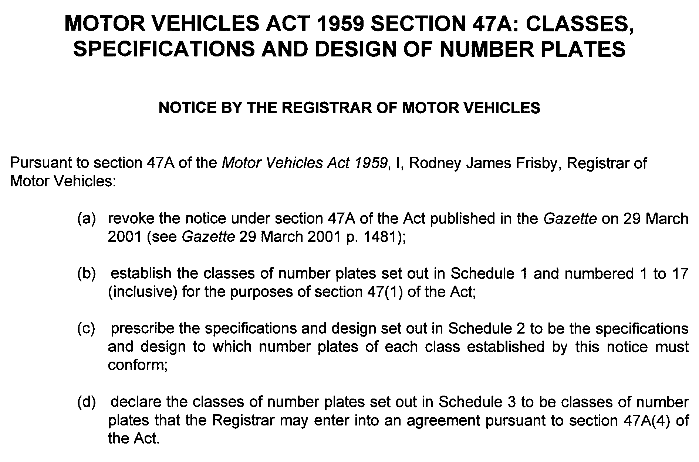
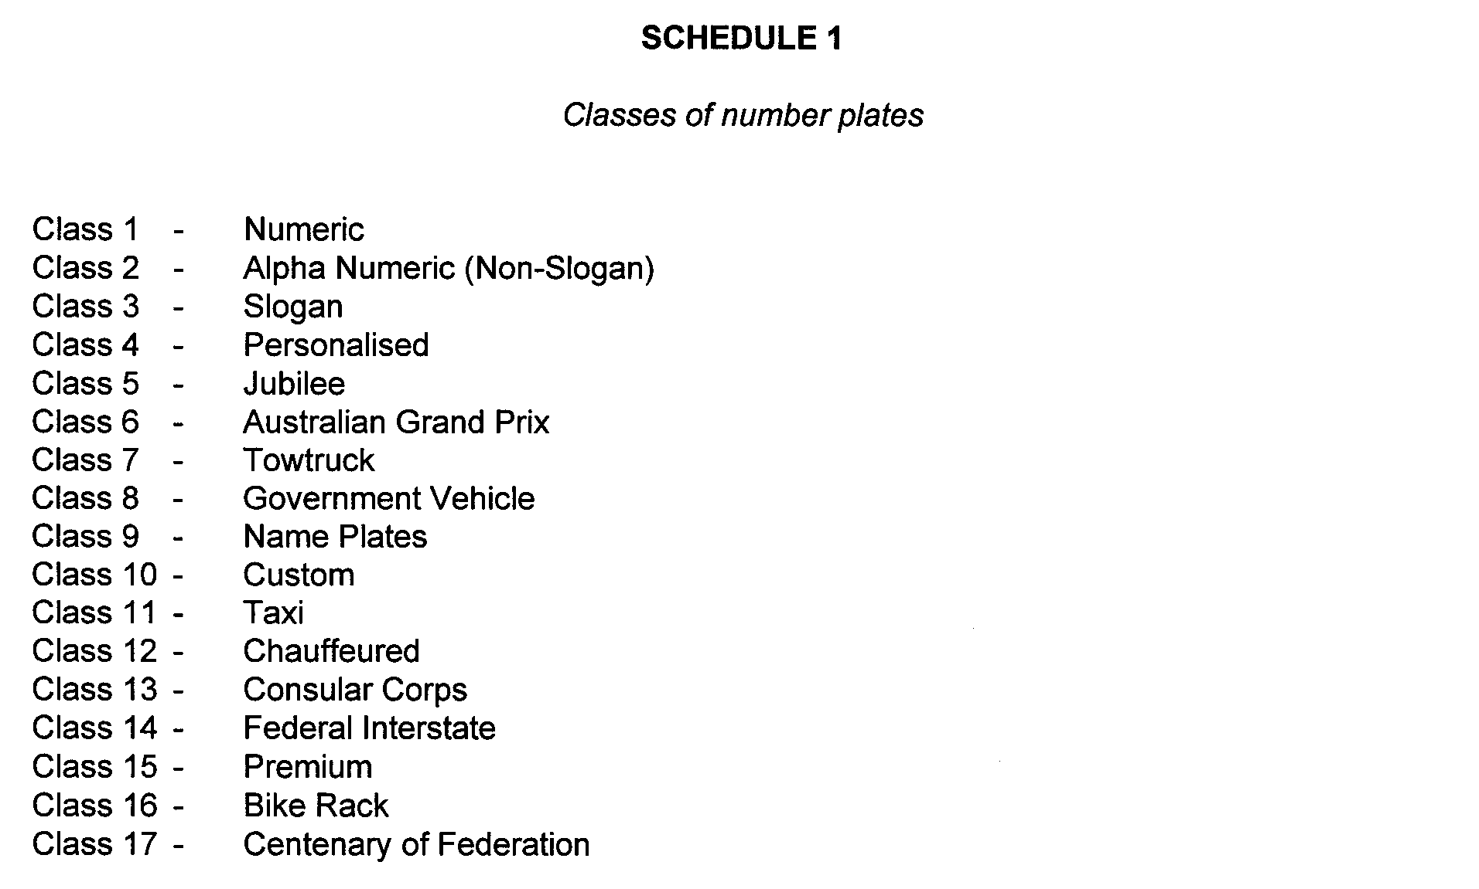


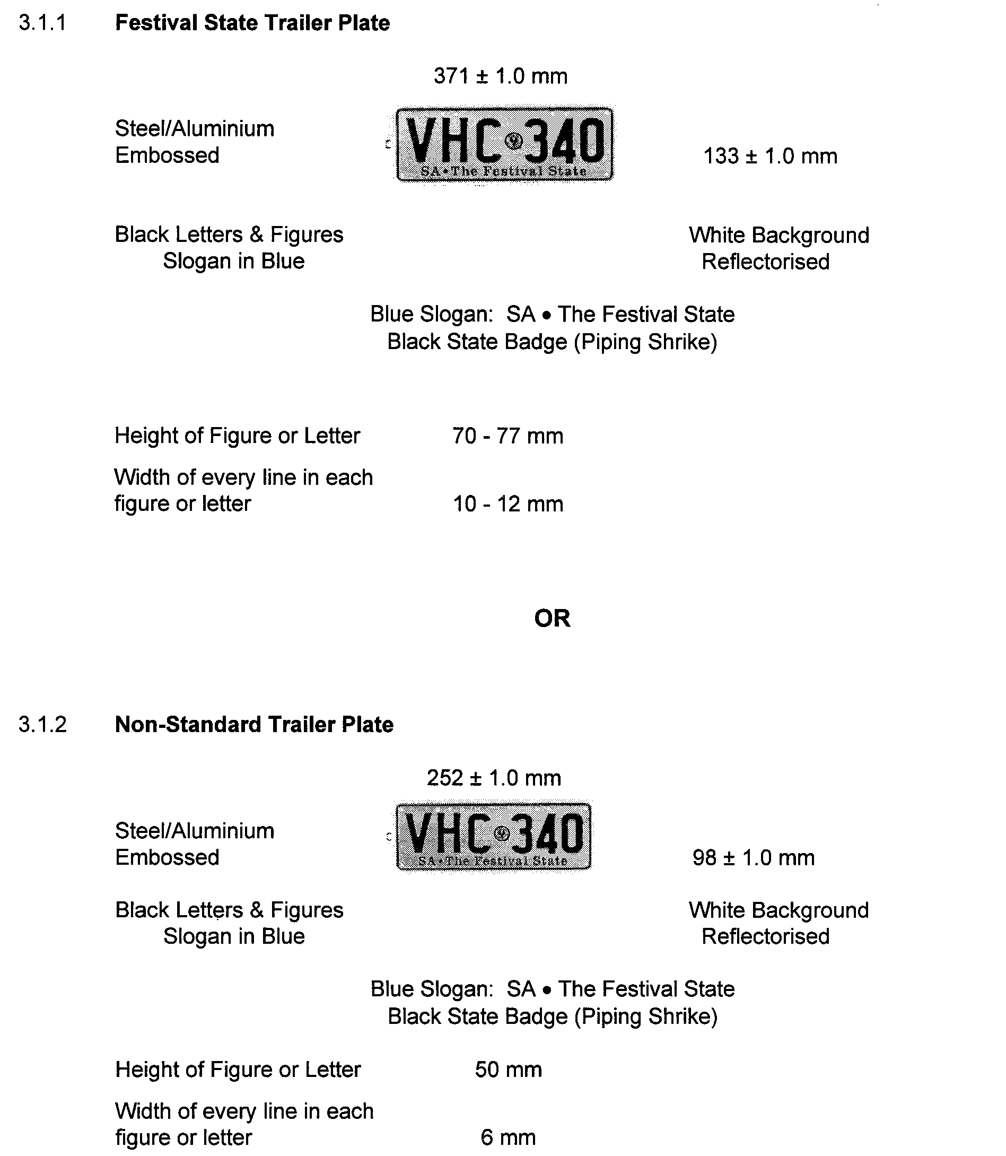

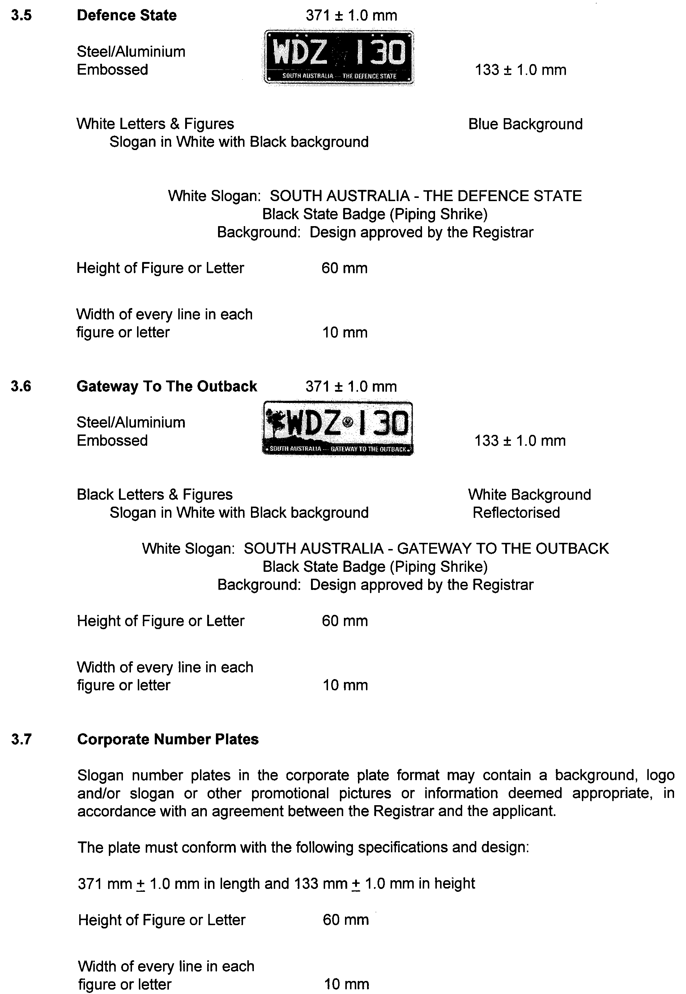





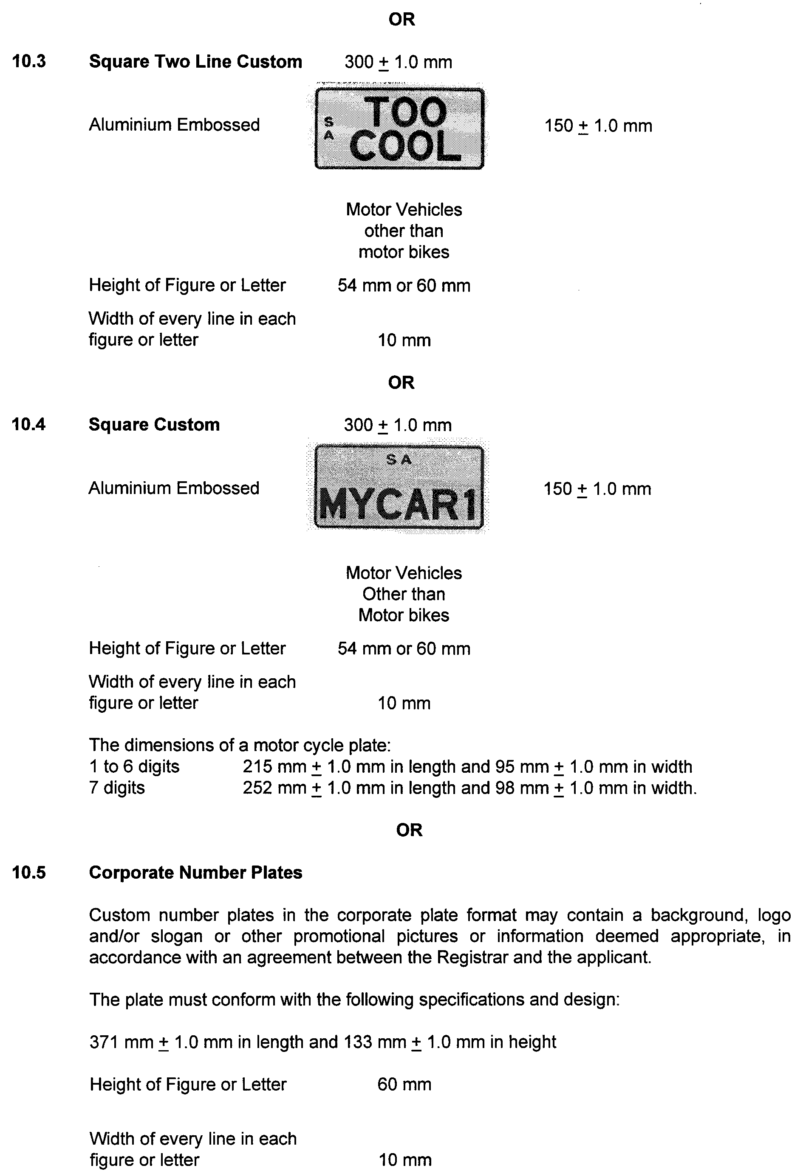



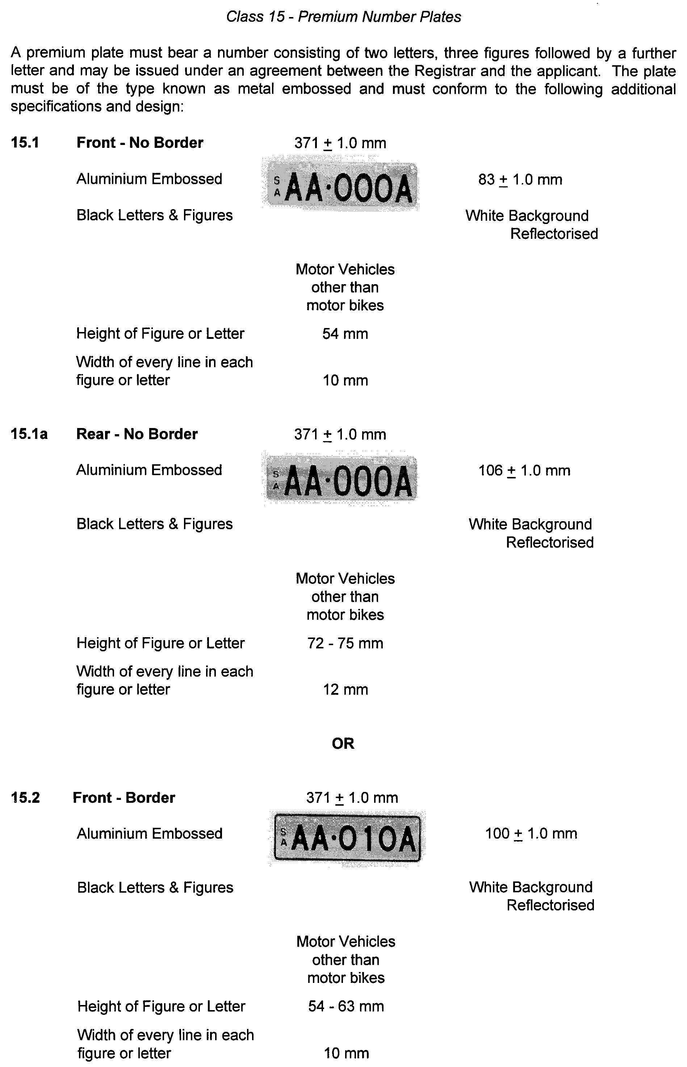
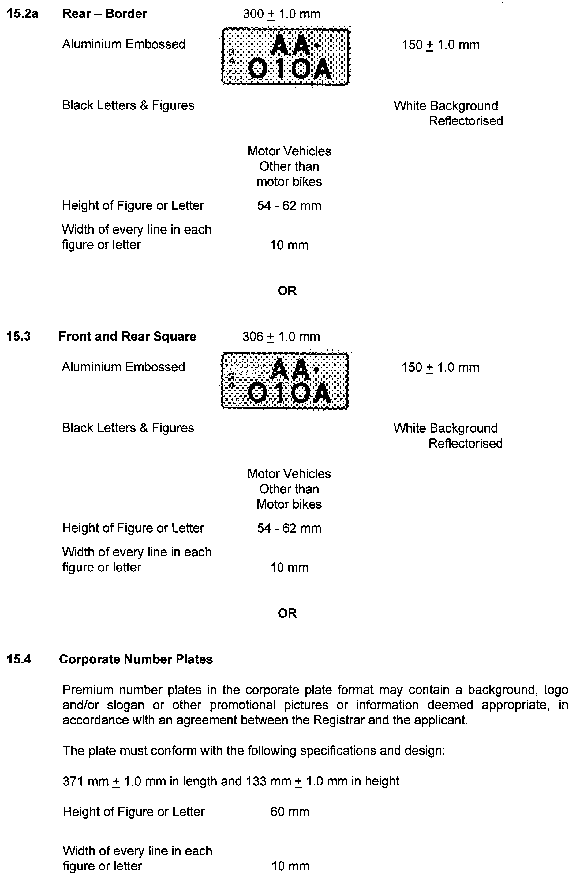
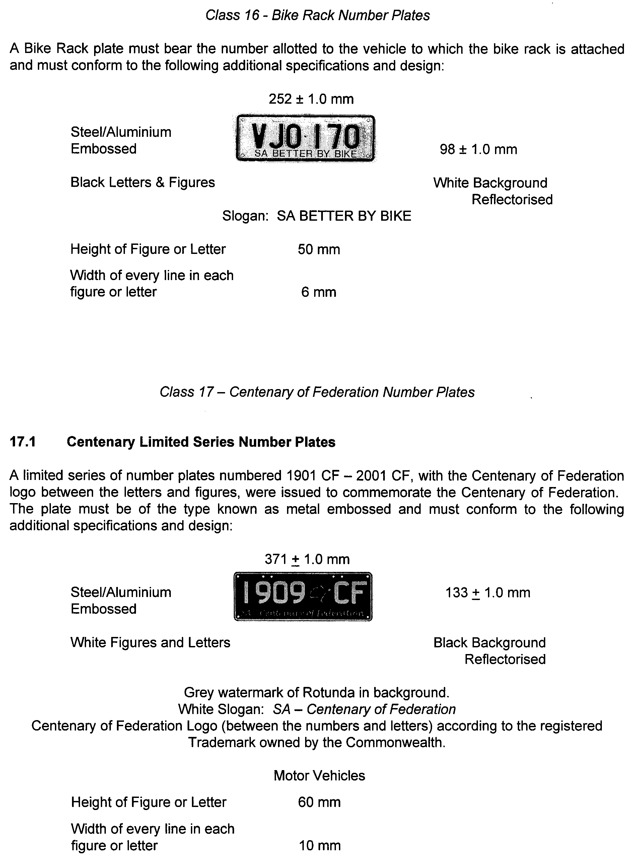
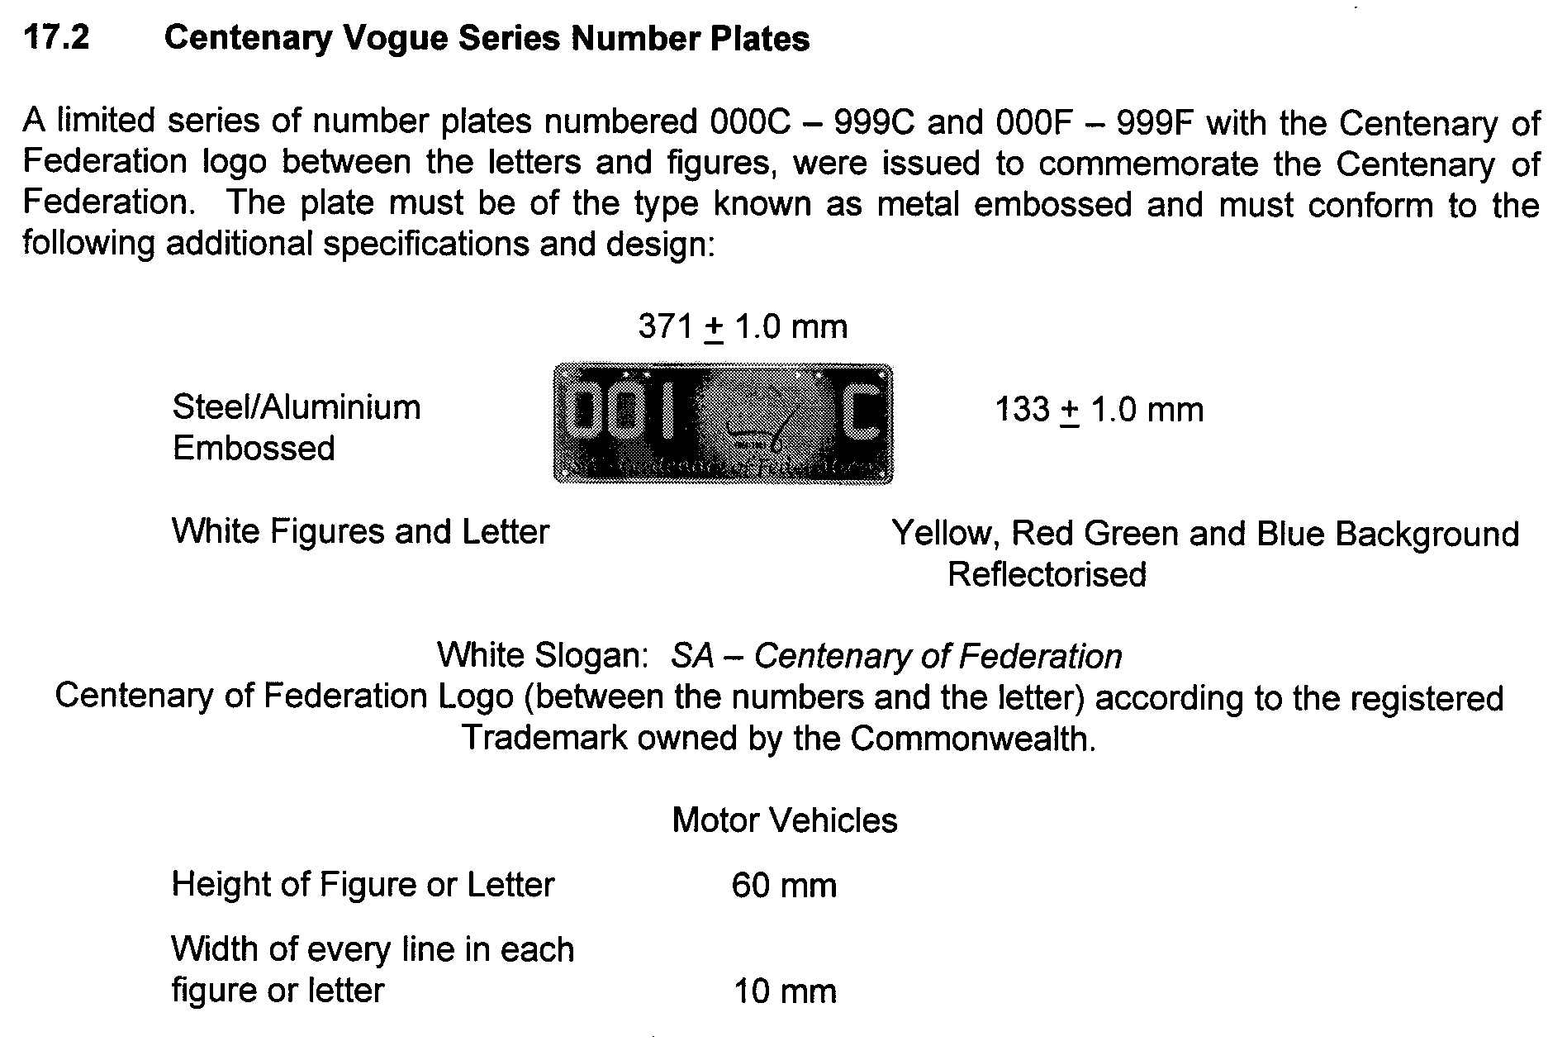
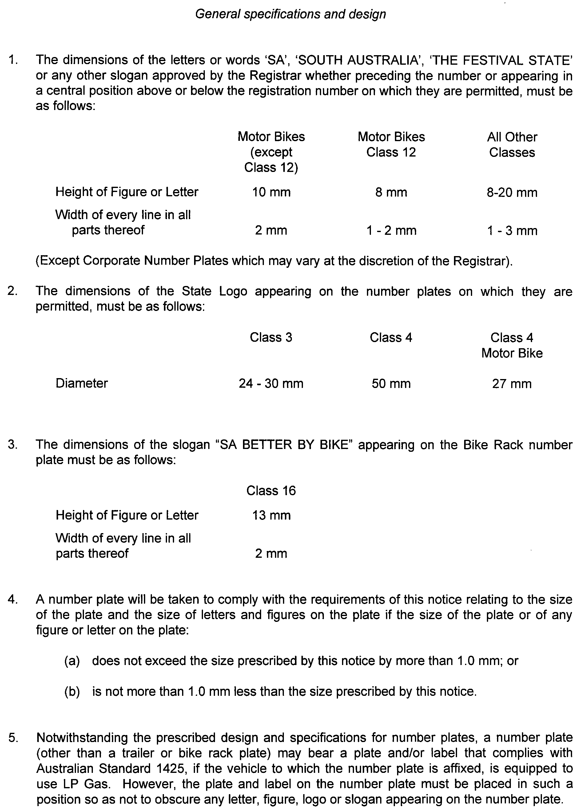
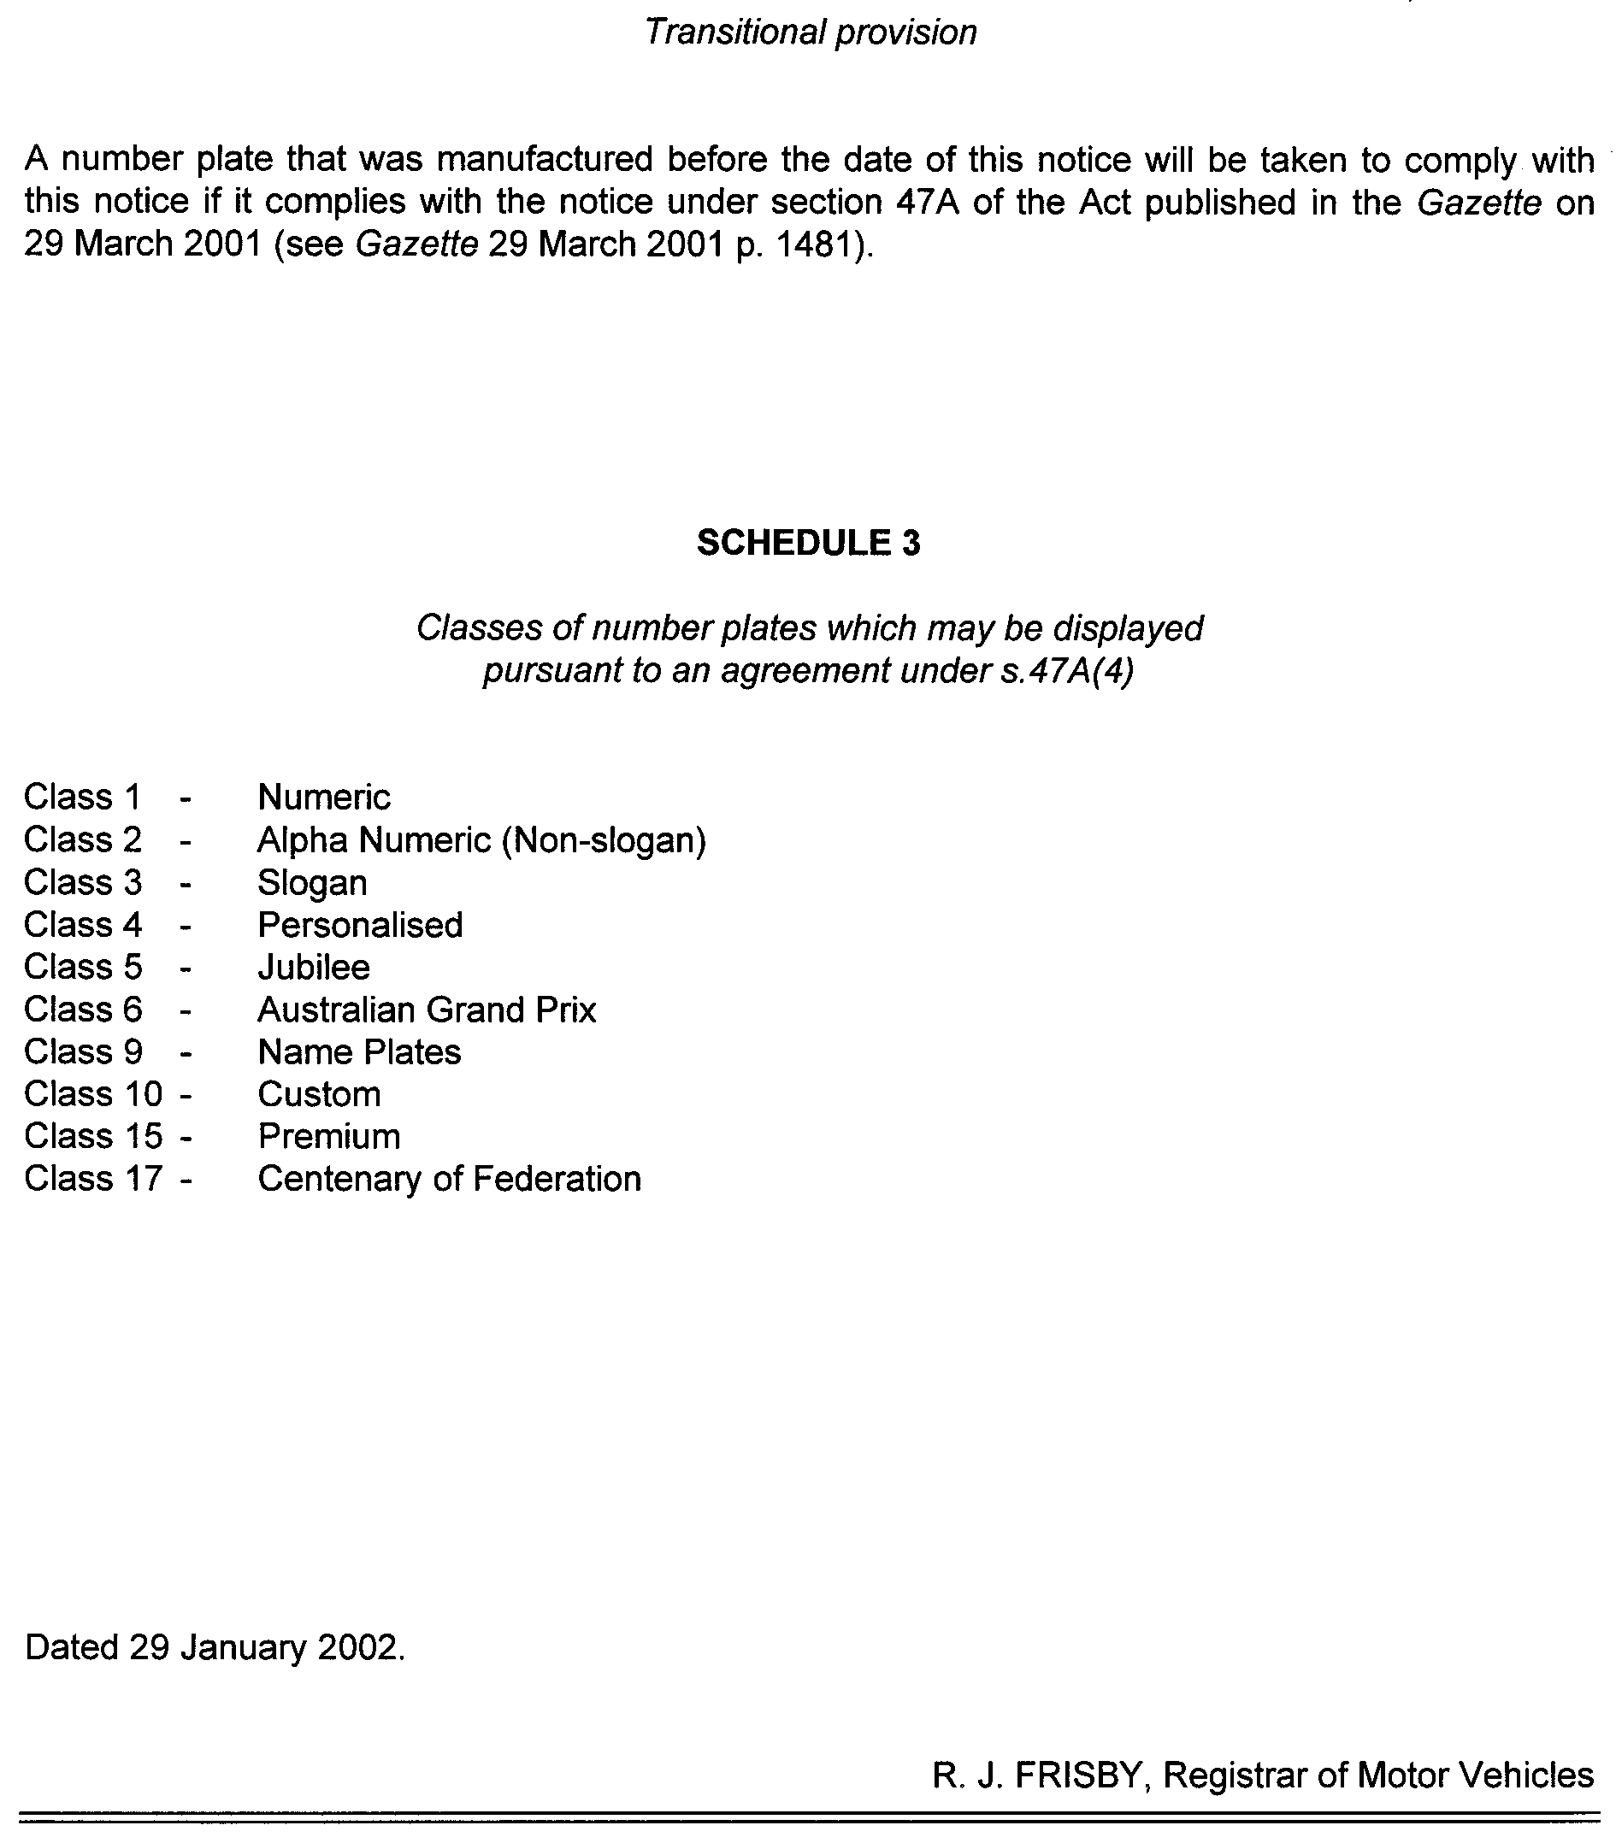

MINING ACT 1971
NOTICE is hereby given in accordance with section 28 (5) of the Mining Act 1971, that the Minister for Minerals and Energy proposes to grant an Exploration Licence over the under-mentioned area:
Applicant: South Australian Coal Corporation Pty Ltd
Location: Robin Rise Area—Approximately 40 km south-west of Coober Pedy, bounded as follows: Commencing at a point being the intersection of latitude 29°18′S and longitude 134°27′E, thence east to longitude 134°37′E, south to latitude 29°19′S, east to longitude 134°45′E, south to latitude 29°29′S, west to longitude 134°44′E, north to latitude 29°28′S, west to longitude 134°42′E, north to latitude 29°27′S, west to longitude 134°41′E, north to latitude 29°26′S, west to longitude 134°35′E, north to latitude 29°22′S, west to longitude 134°30′E, north to latitude 29°19′S, west to longitude 134°27′E, and north to the point of commencement, but excluding Tarcoola-Alice Springs Railway (see GG 13.11.1975) and the surface stratum of the Coober Pedy Precious Stones Field (see GG 18.3.1982), all the within latitudes and longitudes being geodetic and expressed in terms of the Australian Geodetic Datum as defined on p. 4984 of Commonwealth Gazette number 84 dated 6 October 1966 (AGD66).
Term: 1 year
Area in km²: 308
Ref.: 197/2001
Dated 31 January 2002.
H. Tyrteos, Acting Mining Registrar, Department of Primary Industries and Resources

MINING ACT 1971
NOTICE is hereby given in accordance with section 28 (5) of the Mining Act 1971, that the Minister for Minerals and Energy proposes to grant an Exploration Licence over the under-mentioned area:
Applicant: Adelaide Exploration Ltd
Location: The Twins Area—Approximately 120 km south-east of Coober Pedy, bounded as follows: Commencing at a point being the intersection of latitude 29°45′S and longitude 135°25′E, thence east to longitude 135°33′E, south to latitude 29°49′S, east to longitude 135°45′E, south to latitude 30°00′S, west to longitude 135°17′E, north to latitude 29°59′S, east to longitude 135°18′E, north to latitude 29°58′S, east to longitude 135°20′E, north to latitude 29°56′S, east to longitude 135°25′E, and north to the point of commencement, all the within latitudes and longitudes being geodetic and expressed in terms of the Australian Geodetic Datum as defined on p. 4984 of Commonwealth Gazette number 84 dated 6 October 1966 (AGD66).
Term: 1 year
Area in km²: 823
Ref.: 206/2001
Dated 31 January 2002.
H. Tyrteos, Acting Mining Registrar, Department of Primary Industries and Resources

MINING ACT 1971
NOTICE is hereby given in accordance with section 28 (5) of the Mining Act 1971, that the Minister for Minerals and Energy proposes to grant an Exploration Licence over the under-mentioned area:
Applicant: Adelaide Exploration Ltd
Location: Billa Kalina Area—Approximately 90 km north-west of Olympic Dam, bounded as follows: Commencing at a point being the intersection of latitude 29°45′S and longitude 136°05′E, thence east to longitude 136°15′E, south to latitude 29°50′S, east to longitude 136°20′E, south to latitude 29°52′S, east to longitude 136°30′E, south to latitude 30°00′S, west to longitude 136°12′E, north to latitude 29°57′S, west to longitude 135°45′E, north to latitude 29°49′S, east to longitude 135°48′E, south to latitude 29°52′S, east to longitude 136°05′E, and north to the point of commencement, all the within latitudes and longitudes being geodetic and expressed in terms of the Australian Geodetic Datum as defined on p. 4984 of Commonwealth Gazette number 84 dated 6 October 1966 (AGD66).
Term: 1 year
Area in km²: 1 094
Ref.:207/2001
Dated 31 January 2002.
H. Tyrteos, Acting Mining Registrar, Department of Primary Industries and Resources

MINING ACT 1971
NOTICE is hereby given in accordance with section 28 (5) of the Mining Act, 1971, that the Minister for Minerals and Energy proposes to grant an Exploration Licence over the under-mentioned area:
Applicant: Adamus Resources Ltd
Location: Mount Riddoch Area—Approximately 110 km north-west of Olympic Dam, bounded as follows: Commencing at a point being the intersection of latitude 29°23′S and longitude 135°58′E, thence east to longitude 136°10′E, south to latitude 29°45′S, west to longitude 136°05′E, north to latitude 29°33′S, west to longitude 135°58′E, and north to the point of commencement, all the within latitudes and longitudes being geodetic and expressed in terms of the Australian Geodetic Datum as defined on p. 4984 of Commonwealth Gazette number 84 dated October 6, 1966 (AGD66).
Term: 1 year
Area in km²: 537
Ref.: 208/2001
Dated 31 January 2002.
H. Tyrteos, Acting Mining Registrar, Department of Primary Industries and Resources

MINING ACT 1971
NOTICE is hereby given in accordance with section 28 (5) of the Mining Act 1971, that the Minister for Minerals and Energy proposes to grant an Exploration Licence over the under-mentioned area:
Applicant: Perilya Ltd
Location: Codna Hill Area—Approximately 120 km east-south-east of Coober Pedy, bounded as follows: Commencing at a point being the intersection of latitude 29°00′S and longitude 135°55′E, thence east to longitude 136°00′E, south to latitude 29°10′S, east to longitude 136°05′E, south to latitude 29°20′S, east to longitude 136°10′E, south to latitude 29°23′S, west to longitude 135°56′E, north to latitude 29°04′S, west to longitude 135°55′E, and north to the point of commencement, all the within latitudes and longitudes being geodetic and expressed in terms of the Australian Geodetic Datum as defined on p. 4984 of Commonwealth Gazette number 84 dated October 6, 1966 (AGD66).
Term: 1 year
Area in km²: 526
Ref.: 209/2001
Dated 31 January 2002.
H. Tyrteos, Acting Mining Registrar, Department of Primary Industries and Resources

NATIONAL PARKS REGULATIONS 2001
Closure of Dutchman’s Stern Conservation Park
PURSUANT to Regulation 8 (3) (d) of the National Parks Regulations 2001, I, Edward Gregory Leaman, Director of National Parks and Wildlife, close to the public the whole of the Dutchman’s Stern Conservation Park from 6 a.m. on Monday, 11 March 2002 until 6 p.m. on Tuesday, 12 March 2002.
The purpose of this closure is to ensure the safety of the public during a feral animal culling program being conducted in the reserve between those dates.
Dated 31 January 2002.
G. Leaman, Director, National Parks and Wildlife SA

NATIONAL PARKS REGULATIONS 2001
Closure of the Flinders Ranges National Park
PURSUANT to regulation 8 (3) (d) of the National Parks Regulations 2001, I, Gregory Edward Leaman, the Director of National Parks and Wildlife, close to the public the Flinders Ranges National Park from 6 a.m. on Saturday, 9 March 2002 until 6 p.m. on Saturday, 16 March 2002.
The closure period for Wilpena Pound and associated walking trails is from 6 a.m. on Wednesday, 13 March 2002 until 6 p.m. on Friday, 15 March 2002.
The tourist facilities at Wilpena resort will be exempted from the closure.
Please note that during the period of this closure camping is not permitted in the Flinders Ranges National Park (other than at Wilpena).
Internal roads within the Park will be closed to the public, however, the following roads within the Park will be exempted from the closure:
• The Hawker to Blinman Road
• Wilpena to Parachilna/Wirrealpa Road
• Sacred Canyon Road
• Wilpena Road.
Use of Firearms within the Reserve
Pursuant to Regulations 8 (4), 20 (1) and 41 of the National Parks Regulations 2001, I, Edward Gregory Leaman, the Director of National Parks and Wildlife grant permission to members of the Sporting Shooters SA (Hunting and Conservation Branch) permitted by law to carry a firearm to enter and remain in the Flinders Ranges National Park for the purpose of taking feral animals during the period from 6 a.m. on Saturday, 9 March 2002 until 6 p.m. on Saturday, 16 March 2002.
This permission is conditional upon the observance by each of those persons of the requirements of the National Parks and Wildlife Act 1972, the National Parks Regulations 2001, and the Hunting Regulations 1975, including those requiring compliance with the directions, requests, requirements and orders of Wardens.
The purpose of the closure is to ensure the safety of the public during a feral animal culling program being conducted within the reserve during the period indicated.
Dated 31 January 2002.
G. Leaman, Director, National Parks and Wildlife SA

NATIONAL PARKS REGULATIONS 2001
Closure of the Gammon Ranges National Park
PURSUANT to Regulation 8 (3) (d) of the National Parks Regulations 2001, I, Gregory Edward Leaman, the Director of National Parks and Wildlife, close to the public the whole of the Gammon Ranges National Park from:
• 6 a.m. on Saturday, 23 February 2002 until 6 p.m. on Sunday, 3 March 2002;
• 6 a.m. on Saturday, 16 March 2002 until 6 p.m. on Wednesday, 20 March 2002;
• 6 a.m. on Saturday, 1 June 2002 until 6 p.m. on Friday, 7 June 2002;
• 6 a.m. on Saturday, 2 November 2002 until 6 p.m. on Saturday, 10 November 2002.
The internal roads within the Park will be closed to the public, however, the following main public access roads within the Park will be exempted from the closure:
Copley-Balcanoona Road.
Blinman-Balcanoona Road.
Balcanoona-Arkaroola Road.
Balcanoona-Strzlecki Track.
Tourist facilities located at Arkaroola will remain open during the period of closure.
Use of Firearms within the Reserve
Pursuant to Regulations 8 (4), 20 (1) and 41 of the National Parks Regulations, I, Gregory Edward Leaman, the Director of National Parks and Wildlife grant permission to members of the Sporting Shooters SA (Hunting and Conservation Branch) permitted by law to carry a firearm to enter and remain in the Gammon Ranges National Park for the purpose of taking feral animals during the periods stated in this notice when the reserve is closed to the public.
This permission is conditional upon the observance by each of those persons of the requirements of the National Parks and Wildlife Act 1972, the National Parks Regulations 2001, and the Hunting Regulations 1975, including those requiring compliance with the directions, requests, requirements and orders of Wardens.
The purpose of the closure is to ensure the safety of the public during a feral animal culling program being conducted within the reserve during the periods indicated.
Dated 31 January 2002.
G. Leaman, Director, National Parks and Wildlife SA

THE RENMARK IRRIGATION TRUST
Water Rate Assessment
THE Renmark Irrigation Trust has caused to be made an assessment of the rateable land within the District by adopting the previous assessment with, and subject to, certain alterations and additions.
Copies of the assessment are deposited at the office of the Trust and are open for inspection at all reasonable times.
Any person intending to appeal against the assessment may do so in the manner required by the Renmark Irrigation Trust Act 1936-2000 within 21 days from the publication of this notice.
Dated 22 January 2002.
W. D. Morris, Chief Executive Officer

ROADS (OPENING AND CLOSING) ACT 1991:
SECTION 24
NOTICE OF CONFIRMATION OF ROAD
PROCESS ORDER
North Terrace, Blanchetown
Deposited Plan 56067
BY Road Process Order made on 13 November 2000, the Mid Murray Council ordered that:
1. Portion of the public roads (North Terrace) and unnamed public road adjoining allotments 178, 179 and 180, in Town of Blanchetown (respectively) more particularly being portion of the land lettered ‘A’ in Preliminary Plan No. PP32/0478 be closed.
2. The whole of the land subject to closure be transferred to ANDREW ANTHONY THOMAS and RAYLENE DENICE THOMAS in accordance with agreement for transfer dated 16 October 2000, entered into between the Mid Murray Council and A. A. Thomas and R. D. Thomas.
On 2 November 2001, that order was confirmed by the Minister for Administrative and Information Services con-ditionally on approval and deposit of the survey plan by the Registrar-General. The condition has now been fulfilled.
Pursuant to section 24 (5) of the Roads (Opening and Closing) Act 1991, NOTICE of the order referred to above and its confirmation is hereby given.
Dated 31 January 2002.
P. M. Kentish, Surveyor-General

ROADS (OPENING AND CLOSING) ACT 1991:
SECTION 24
NOTICE OF CONFIRMATION OF ROAD
PROCESS ORDER
Acorn Court, Heathfield
Deposited Plan 58728
BY Road Process Order made on 7 December 2001, the Adelaide Hills Council ordered that:
1. Portion of the public road (Acorn Court) adjoining allotment 3 in Deposited Plan 11107 more particularly delineated and lettered ‘A’ in Preliminary Plan No. PP32/0671 be closed.
2. The whole of the land subject to closure be transferred to PAUL ANDRE JOHN MAKIN and ANTHEA LOUISE MAKIN in accordance with agreement for transfer dated 7 December 2001, entered into between the Adelaide Hills Council and P. A. J. Makin and A. L. Makin.
On 18 January 2002, that order was confirmed by the Minister for Administrative and Information Services.
Pursuant to section 24 (5) of the Roads (Opening and Closing) Act 1991, NOTICE of the order referred to above and its confirmation is hereby given.
Dated 31 January 2002.
P. M. Kentish, Surveyor-General

ROADS (OPENING AND CLOSING) ACT 1991:
SECTION 24
NOTICE OF CONFIRMATION OF ROAD
PROCESS ORDER
Parkview Drive, Mawson Lakes
Deposited Plan 58872
BY Road Process Order made on 24 December 2001, the City of Salisbury ordered that:
Portion of allotment 609 in Deposited Plan 50045 more particularly delineated and numbered ‘1’ in Preliminary Plan No. PP32/0679 be opened as road forming a widening of the adjoining road Parkview Drive.
On 18 January 2002, that order was confirmed by the Minister for Administrative and Information Services, conditionally on approval and deposit of the survey plan by the Registrar-General. The condition has now been fulfilled.
Pursuant to section 24 (5) of the Roads (Opening and Closing) Act 1991, NOTICE of the order referred to above and its confirmation is hereby given.
Dated 31 January 2002.
P. M. Kentish, Surveyor-General

ROAD TRAFFIC ACT 1961
Exemption from the Code of Practice for Buses to allow an adult seat to be reduced to 330 mm in depth
PURSUANT to section 163C (1a) of the Road Traffic Act 1961, I hereby exempt buses from sections 163D (3) (b) and 163F (e) of the Act, insofar as they relate to the prescribed requirements of the Road Traffic (Miscellaneous) Regulations 1999, Regula-tion 42 (1) with respect to Clause 7.2 (2) (b) of the Code of Practice for Buses, requiring a seating position intended for use by an adult to have a seat depth of 350 mm.
Subject to the following conditions:
1. The bus was manufactured prior to 1 July 1985; and
2. The seat depth is 330 mm or more.
Note: For the purposes of this notice ‘seat depth’ means the distance measured from the foremost point of the seat squab to the foremost point of its corresponding seat cushion.
H. Levinson, Manager, Road Freight Operation and Regulation Section, Transport SA (Authorised delegate of the Minister for Transport and Urban Planning).

NOTICE TO MARINERS
No. 6 of 2002
South Australia—Gulf of St Vincent—Defence Trials
MARINERS are advised that the Maritime Operations Division of Defence Science and Technology are conducting a buoy-based Radio Telemetry trial from 4 February to 8 February 2002 approximately 5 nautical miles off Normanville throughout the day and night.
Two catamaran type surface buoys tethered together will radiate RF signals to a shore-based station at Normanville in the 2400MHz to 2463MHz frequency band.
The buoys will be located as follows:
Buoy No. 1: Latitude 35°23′14.86″S
Longitude 138°15′17.34″E.
Buoy No. 2: Latitude 35°21′47″S
Longitude 138°17′55″E.
They will be fitted with twin yellow cross marker/radar reflectors and two non-synchronised yellow flashing lights (Fl. 3 secs) by night.
A surface craft One and All will be in attendance with 15 nautical miles of the site for the full trial period.
Mariners are advised to keep well clear of the site when navigating in the area.
Navy Charts affected: Aus 345, 444 and 780.
Adelaide, 22 January 2002.
Diana Laidlaw, Minister for Transport and Urban Planning
TSA 2002/00309

NOTICE TO MARINERS
No. 7 of 2002
South Australia—Port Flinders—Light Established on Wreck
MARINERS are advised that the historic wreck York in approximately WGS position Latitude 33°0.4′S, Longitude 138°0.1′E, has been marked with a yellow St Andrews cross and a flashing white light every 3 seconds.
Mariners are advised to exercise caution when navigating in the area.
Navy Charts affected: Aus 136 and 778.
Publication affected: Australian Pilot Vol. 1 (Seventh Edition, 1992) pages 105 and 106.
Adelaide, 24 January 2002.
Diana Laidlaw, Minister for Transport and Urban Planning
TSA 2002/00309

FAXING COPY?

IF you fax copy to Government Publishing SA for inclusion in the Government Gazette, there is no need to send a Confirmation Copy to us as well.

This creates confusion and may well result in your notice being printed twice.

Please use the following fax number:

Fax transmission: (08) 8207 1040
Phone Inquiries: (08) 8207 1045

Please include a contact person, phone number and order number so that we can phone back with any queries we may have regarding the fax copy.

NOTE: Closing time for lodging new copy (either fax or hard copy) is 4 p.m. on Tuesday preceding the day of publication.

Government Gazette notices can be E-mailed.

The address is:

governmentgazette@saugov.sa.gov.au

Documents should be sent as attachments in Word format.

When sending a document via E-mail, please confirm your transmission with a faxed copy of your document, including the date the notice is to be published.

Fax transmission: (08) 8207 1040
Enquiries: (08) 8207 1045

CITY OF ADELAIDE
Intention of Declaration of Public Road
NOTICE is hereby given, pursuant to section 210 of the Local Government Act 1999, that at a future meeting, council intends to declare the following road to be public road:
The unnamed road in Town Acre 460 delineated as allotments 14 and 15 on Land Titles Office plan DP902 and contained in partially cancelled certificate of title volume 300, folio 147.
If the said road is declared public, then council intends to close and sell part of the said road to an abutting property owner in accordance with provisions of the Roads (Opening and Closing) Act 1991.
Susan Law, Chief Executive Officer

CITY OF ADELIADE
Naming of Roads
NOTICE is hereby given, pursuant to section 219 of the Local Government Act 1999, council has assigned the name Pistrina Court to the private road in the development at 61 to 71 Elizabeth Street and delineated as marked ‘C1’ on Community Plan No. CP21108.

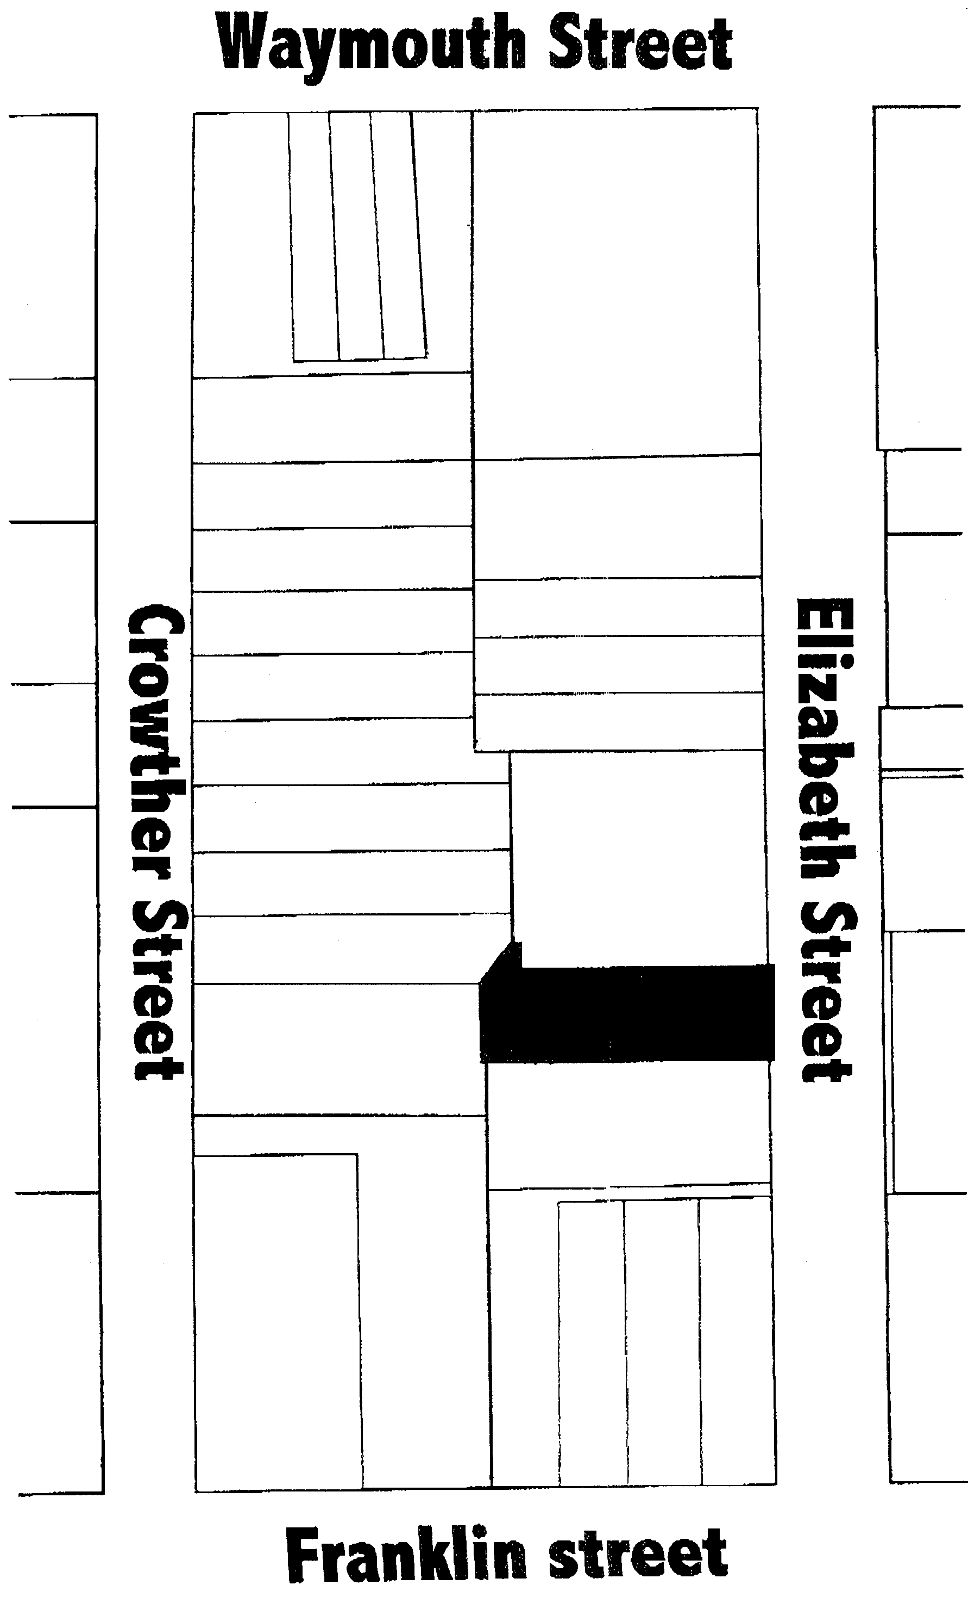
Susan Law, Chief Executive Officer

CITY OF ADELAIDE
Declaration of Public Road
NOTICE is hereby given that pursuant to sections 210 and 219 of the Local Government Act 1999, council at its meeting held on 21 January 2002, declared the following roads to be public roads and declared that the respective names be applied:
(1) Gilles Arcade in town acres 135 and 176, which is delineated as Gilles Arcade in LTO Filed Plan 25189 and is contained in partially cancelled certificate of title volume 358, folio 126.
(2) Munks Place in town acre 925, which is delineated as the land marked ‘A’ on LTO Filed Plan 11242 and contained in partially cancelled certificate of title volume 134, folio 241.
(3) That part of Mansfield Street in town acre 880 contained in certificate of title volume 5754, folio 754.
Susan Law, Chief Executive Officer

CITY OF HOLDFAST BAY
Roads (Opening and Closing) Act 1991
NOTICE is hereby given, in accordance with section 10 of the Roads (Opening and Closing) Act 1991, that the City of Holdfast Bay proposes to make a Road Process Order to close the following road in the Hundred of Noarlunga, being a triangularly shaped portion of Bagshaw Street, Glenelg North situated in and adjoining the north-eastern corner of allotment 69 in Filed Plan 1337 and marked ‘A’ on Preliminary Plan No. 02/0009.
It is proposed that the portion of road to be closed marked ‘A’ be transferred to J. M. and H. K. Henly and merged with said allotment 69 in filed plan 1337.
A preliminary plan of the proposal, and a statement, are available for public inspection at the Holdfast Bay Council office, 24 Jetty Road, Brighton between the hours of 9 a.m. and 4.45 p.m., Monday to Friday or at the Adelaide office of the Surveyor-General during normal office hours.
Any person may object to the proposal (and any adjoining landowner or other person substantially affected by the proposed road closure may apply for an easement relative to the closure). Such objection (or application for an easement) must be made in writing to the City of Holdfast Bay within 28 days of the date of this notice. If a submission is made, the City of Holdfast Bay is required to give notice of the time and place at which a meeting will be held to consider the matter, so that the person making the submission (or a representative) may attend to support the submission, if desired. Any submission must set out the full name and address of the person making the submission, and must be fully supported by reasons (and any application for the grant of an easement must give full particulars of the nature and location of the easement and, where made by a person as the owner of adjoining or nearby land, specify the land to which the easement is to be annexed). A copy of the submission must be forwarded to the Surveyor-General at Adelaide.
Dated 31 January 2002.
S. Gawler, Chief Executive Officer

CITY OF MITCHAM
Roads (Opening and Closing) Act 1991
NOTICE is hereby given, in accordance with section 10 of the Roads (Opening and Closing) Act 1991, that the City of Mitcham proposes to make a Road Process Order to close the following road in the Hundred of Adelaide, being an irregularly-shaped portion of Oakdene Road, Springfield situate along and adjoining the south-western boundaries of allotment 91 in deposited plan 3740 and marked ‘A’ on Preliminary Plan No. 02/0010 leaving the portion of Oakdene Road remaining open a minimum width of 5.5 m.
It is proposed that the portion of road to be closed marked ‘A’ be transferred to M. M. Chia and merged with said allotment 91 in deposited plan 3740.
A preliminary plan of the proposal, and a statement, are available for public inspection at the Mitcham Council office, 131 Belair Road, Torrens Park between the hours of 9 a.m. and 5 p.m., Monday to Friday or at the Adelaide office of the Surveyor-General during normal office hours.
Any person may object to the proposal (and any adjoining landowner or other person substantially affected by the proposed road closure may apply for an easement relative to the closure). Such objection (or application for an easement) must be made in writing to the City of Mitcham within 28 days of the date of this notice. If a submission is made, the City of Mitcham is required to give notice of the time and place at which a meeting will be held to consider the matter, so that the person making the submission (or a representative) may attend to support the submission, if desired. Any submission must set out the full name and address of the person making the submission, and must be fully supported by reasons (and any application for the grant of an easement must give full particulars of the nature and location of the easement and, where made by a person as the owner of adjoining or nearby land, specify the land to which the easement is to be annexed). A copy of the submission must be forwarded to the Surveyor-General at Adelaide.
Dated 31 January 2002.
R. Malcolm, Chief Executive Officer

CITY OF MOUNT GAMBIER
Naming of Road
NOTICE is hereby given that at its meeting held on Tuesday, 22 January 2002 council resolved, pursuant to section 219 of the Local Government Act 1999, to declare the following road names:
• Cunningham Lane (off Cunningham Street)
• Price Lane (off Price Street)
• Moten Lane (off Moten Street)
• Wireless Lane (off Wireless Road East)
Dated 23 January 2002.
G. Muller, Chief Executive Officer

CITY OF MOUNT GAMBIER
Supplementary Election for South East Ward—
Nominations Received
AT the close of nominations at 12 noon on 24 January 2002, the following persons have been accepted as candidates and are listed in the order in which they will appear on the ballot paper.
Councillor for South East Ward (1 vacancy)
Smith, Rick
Dowdell, Allan
White, Mervyn Robert
Postal Voting
The election will be conducted entirely by postal voting. No polling booth will be open for voting on polling day. Voting is not compulsory.
Voting material will be dispatched by post to every natural person, body corporate and group listed on the voters roll as at roll closure on 30 November 2001.
The mailout will commence on 5 February, with all voting materials to be delivered by 11 February 2002.
A person who has not received voting material by 11 February 2002 and who believes that he or she is entitled to vote should apply to the Australian Electoral Commission Divisional Office of Barker on 8723 1197.
A pre-paid addressed envelope for each elector entitlement will be provided. Completed ballot material must be returned to reach the Deputy Returning Officer no later than 12 noon on Monday, 25 February 2002.
A ballot box will be provided at the Council Office, 10 Watson Terrace, Mount Gambier or the Australian Electoral Commission Divisional Office of Barker, 2 Mitchell Street, Mount Gambier for electors who wish to personally deliver their completed ballot material during office hours.
Place of Counting Votes
The scrutiny and counting of votes will take place at the Australian Electoral Commission Office of Barker, 2 Mitchell Street, Mount Gambier as soon as practicable after 12 noon on Monday, 25 February 2002. A provisional declaration will be made at the conclusion of the election count.
Campaign Donations Return
All candidates must forward a campaign donations return to the Council Chief Executive Officer within six weeks after the conclusion of the election.
S. H. Tully, Returning Officer

CITY OF ONKAPARINGA
Road Closure
NOTICE is hereby given that the council of the City of Onkaparinga at its meeting held on 11 December 2001, resolved pursuant to section 359 of the Local Government Act 1934, as amended, to exclude all vehicles other than emergency, public utility, council vehicles and vehicles owned or used by owners of allotment 53 in Deposited Plan 45299 and allotment 12 in Deposited Plan 27223 for farming activities, from Louds Hill Road between a point 800 m south of Hahn Road, to a point 1 100 m north of Range Road West, measured along Louds Hill Road. Pursuant to the council’s resolution suitable barriers and notices will be erected giving effect to this closure.
J. Tate, City Manager

Road Closure
NOTICE is hereby given that the council of the City of Onkaparinga at its meeting held on 18 July 2000, resolved pursuant to section 359 of the Local Government Act 1934, as amended, to exclude motor vehicles other than emergency, public utility and council vehicles, from Trotts Road, McLaren Flat between the western boundary of Bagshaw Road to the eastern boundary of Sandhill Road for a distance of 240 m from the western boundary of Sandhill Road. Pursuant to the council’s resolution suitable barriers and notices will be erected giving effect to this closure.
J. Tate, City Manager

CITY OF PORT ADELAIDE ENFIELD
Exclusion of Land from Classification as Community Land
NOTICE is hereby given that at its meeting held on 19 December 2001, the City of Port Adelaide Enfield resolved that council hereby accepts the ownership of allotment 104 in deposited plan 58561 for road purposes and excludes this allotment from the classification of community land in accordance with secion 193 of the Local Government Act 1999.
Declaration and Naming of a Public Road
Pursuant to the provisions contained within the Local Government Act 1999, the City of Port Adelaide Enfield hereby declares allotment 104 in deposited plan 58561 to be a public road and hereby assigns the name Otway Street to this allotment.
H. J. Wierda, City Manager

CITY OF PORT LINCOLN
Roads (Opening and Closing) Act 1991
NOTICE is hereby given, in accordance with section 10 of the Roads (Opening and Closing) Act 1991, that the City of Port Lincoln proposes to make a Road Process Order to close the following roads in the Hundred of Lincoln, being firstly, an irregularly-shaped strip of King Street, Port Lincoln generally situate adjoining the southern boundaries of allotment 243 in filed plan 179465 and allotment 60 in deposited plan 53037, and secondly, an irregularly-shaped strip of Stevenson Street, Port
Lincoln generally situate dividing piece 92 in filed plan 216361 and section 446 from piece 93 in filed plan 216361, allotment 244 in filed plan 179466 and section 445 and marked ‘A’ and ‘B’ on Preliminary Plan No. 02/0005.
It is proposed that the roads to be closed be transferred to Ausbulk Ltd and the portion marked ‘A’ be merged with said allotment 243 in filed plan 179465 and the portion marked ‘B’ be merged with said allotment 244 in filed plan 179466.
A preliminary plan of the proposal, and a statement, are available for public inspection at the Port Lincoln Council Office, Level 1, Civic Centre, 60 Tasman Terrace, Port Lincoln between the hours of 9 a.m. and 5 p.m., Monday to Friday or at the Adelaide office of the Surveyor-General during normal office hours.
Any person may object to the proposal (and any adjoining landowner or other person substantially affected by the proposed road closure may apply for an easement relative to the closure). Such objection (or application for an easement) must be made in writing to the City of Port Lincoln within 28 days of the date of this notice. If a submission is made, the City of Port Lincoln is required to give notice of the time and place at which a meeting will be held to consider the matter, so that the person making the submission (or a representative) may attend to support the submission, if desired. Any submission must set out the full name and address of the person making the submission, and must be fully supported by reasons (and any application for the grant of an easement must give full particulars of the nature and location of the easement and, where made by a person as the owner of adjoining or nearby land, specify the land to which the easement is to be annexed). A copy of the submission must be forwarded to the Surveyor-General at Adelaide.
Dated 31 January 2002.
I. Burfitt, Chief Executive Officer

TOWN OF GAWLER
Declaration as a Public Road
NOTICE is hereby given that the Corporation of the Town of Gawler resolves pursuant to section 208 of the Local Government Act 1999, that the land contained in application for deposit of a plan of division comprising allotment 2 in Deposited Plan 57681, being portion of the land in certificate of title register book volume 5785, folio 947 is hereby declared a public road.
J. McEachen, Town Manager

CORPORATION OF THE TOWN OF WALKERVILLE
Supplementary Election for Councillor in Walkerville Ward—Nominations Received
AT the close of nominations at 12 noon on Thursday, 24 January 2002, the following persons have been accepted as candidates and are listed in the order in which they will appear on the ballot paper:
Councillor for Walkerville Ward (1 vacancy)
Eady, Patricia
Kneebone, Heidi
Postal Voting
The election will be conducted entirely by postal voting. No polling booth will be open for voting on polling day. Voting is not compulsory.
Voting material will be dispatched by post to every natural person, body corporate and group listed on the voters roll as at roll closure on Friday, 30 November 2001.
The mail out will commence on Tuesday, 5 February 2002, with all voting materials to be delivered by Monday, 11 February 2002.
A person who has not received voting material by Monday, 11 February 2002 and who believes that he or she is entitled to vote should apply to the State Electoral Office on 8401 4351
A pre-paid addressed envelope for each elector entitlement will be provided. Completed ballot material must be returned to reach the Returning Officer no later than 12 noon on Monday, 25 February 2002.
A ballot box will be provided at the Council office, 66 Walkerville Terrace, Gilberton, for electors who wish to personally deliver their completed ballot material during office hours.
Place of Counting Votes
The scrutiny and counting of votes will take place at the Corporation of the Town of Walkerville, 66 Walkerville Terrace, Gilberton, as soon as practicable after 12 noon on Monday, 25 February 2002. A provisional declaration will be made at the conclusion of the election count.
Campaign Donations Return
All candidates must forward a campaign donations return to the Council Chief Executive Officer within six weeks after the conclusion of the election.
S. H. Tully, Returning Officer

ALEXANDRINA COUNCIL
Roads (Opening and Closing) Act 1991
NOTICE is hereby given pursuant to section 10 of the Roads (Opening and Closing) Act 1991, that the Alexandrina Council proposes to make a Road Process Order to close and transfer those portions of public road marked ‘B’ on the Preliminary Plan No. PP02/0003.
Transfer ‘B’ to Laro Investments Pty Ltd and R. & R. Elmes Pty Ltd, c/o 28-30 Finniss Street, North Adelaide, S.A. 5006 and to merge that portion with certificate of title volume 5352, folio 845.
Secondly, the Alexandrina Council also proposes to make a Road Process Order to open a road in exchange for the road closure mentioned above, that portion marked ‘1’ on Preliminary Plan No. PP02/0003, and currently contained within certificate of title volume 5352, folio 845, in the Hundred of Nangkita.
A statement of persons affected by the proposed road process together with a copy of the preliminary plan is available for inspection at the offices of the Alexandrina Council, 16 Dawson Street, Goolwa, during normal office hours. Copies may also be inspected at the Adelaide office of the Surveyor-General, 101 Grenfell Street, Adelaide, S.A. 5000, during normal office hours.
Any person is entitled to object to the proposed road process, or any person affected by the proposed closure is entitled to apply for an easement to be granted in that person’s favour over the land subject to the proposed closure. Such objection or application for an easement must set out the full name and address of the person making the objection or application and must be fully supported by reasons. Any application for an easement must give full particulars of the nature and location of the easement land, where made by a person as the owner of adjoining land or nearby land, specify the land to which the easement is to be annexed.
The objection or application for and easement must be made in writing to the Alexandrina Council, P.O. Box 21, Goolwa, S.A. 5214, within 28 days of this notice, and a copy shall be forwarded to the Adelaide office of the Surveyor-General, G.P.O. Box 1354, Adelaide, S.A. 5001. Where a submission is made, the Alexandrina Council will give notification of a meeting at which the matter will be considered, so that the person making the submission or a representative may attend, if desired.
Dated 31 January 2002.
J. Coombe, Chief Executive

DISTRICT COUNCIL OF BARUNGA WEST
Periodical Review of Electoral Boundaries
NOTICE is hereby given, pursuant to the provisions of section 12 (5) of the Local Government Act 1999, that the District Council of Barunga West is to carry out a review to determine whether a change of arrangement in respect to electoral representation, including ward boundaries and the composition of council, will result in the electors of the area being more adequately and fairly represented.
Information regarding the nature of the periodical review is available at council’s principal office, 15 Bay Street, Port Broughton or by contacting Greg O’Connor on 8635 2107 or 8826 2011.
Interested persons are invited to make written submissions to the Chief Executive Officer, P.O. Box 3, Port Broughton, S.A. 5522 by the close of business on Friday, 22 March 2002.
Any person who makes a written submission will be given the opportunity to appear before council to be heard in respect of their submission.
N. Hand, District Manager

DISTRICT COUNCIL OF FRANKLIN HARBOUR
Supplementary Election for Area Councillor—Nominations Received
NOTICE is hereby given that at the close of nominations at 12 noon on Thursday, 24 January 2002, the following persons have been accepted as candidates and are listed in the order in which they will appear on the ballot paper:
Area Councillor (1 vacancy)
Jackson, Gavin F
Udy, Robert
West, James
Postal Voting
The election will be conducted entirely by postal voting. No polling booth will be open for voting on polling day. Voting is not compulsory.
Voting material will be dispatched by post to every natural person, body corporate and group listed on the voters roll as at roll closure on Friday, 30 November 2001.
The mail out will commence on Tuesday, 5 February 2002, with all voting materials to be delivered by Monday, 11 February 2002.
A person who has not received voting material by Monday, 11 February 2002 and who believes that he or she is entitled to vote should apply to the State Electoral Office on 8401 4351.
A pre-paid addressed envelope for each elector entitlement will be provided. Completed ballot material must be returned to reach the Returning Officer no later than 12 noon on Monday, 25 February 2002.
A ballot box will be provided at the Council Office, 6 Main Street, Cowell, for electors who wish to personally deliver their completed ballot material during office hours.
Place of Counting Votes
The scrutiny and counting of votes will take place at the District Council of Franklin Harbour, 6 Main Street, Cowell, as soon as practicable after 12 noon on Monday, 25 February 2002. A provisional declaration will be made at the conclusion of the election count.
Campaign Donations Return
All candidates must forward a campaign donations return to the Council Chief Executive Officer within six weeks after the conclusion of the election.
S. H. Tully, Returning Officer

DISTRICT COUNCIL OF GRANT
Roads (Opening and Closing) Act 1991
NOTICE is hereby given, pursuant to section 10 of the Roads (Opening and Closing) Act 1991, that the District Council of Grant hereby gives notice of its intent to implement a Road Process Order to:
(i) Close portion of public road, Hundred of MacDonnell and merge with adjoining section 898 held in certificate of title volume 5841, folio 427 in the name of the District Council of Grant more particularly delineated and lettered ‘A’ on Preliminary Plan No. PP02/0002.
(ii) Close portion of public road, Hundred of MacDonnell and merge with adjoining section 898 held in certificate of title volume 5841, folio 427 in the name of the District Council of Grant more particularly delineated and lettered ‘B’ on Preliminary Plan No. PP02/0002.
A statement of persons affected by the road process order, together with a copy of the above drawing is available for inspection at the council offices, 324 Commercial Street, Mount Gambier, between the hours of 9 a.m. and 5 p.m. weekdays only. Copies may also be inspected at the Adelaide office of the Surveyor-General during normal office hours.
Any person who may wish to object to the proposed road process order or any person affected by the proposed road closing who may wish to apply for an easement to be granted in that person’s favour over the land subject to the proposed road closure must lodge with the said council a notice of objection or an application of an easement within 28 days of the date of this notice.
Any objections lodged shall be in writing given the objector’s full name and address, reasons for the objection and whether the objector wishes to appear in person or be represented at the subsequent meeting when the objection will be determined by council. A copy of such objection shall also be forwarded to the Surveyor-General, G.P.O. Box 1354, Adelaide, S.A. 5001.
An application for grant of easement shall be in writing giving full name and address of the person applying for the grant, full details of the nature of the location of the requested easement, whether it will be in favour of the owner of the adjoining or nearby land and if so specify the land to which the easement will be annexed and reasons for the application for grant of easement.
Dated 31 January 2002.
R. Peate, Chief Executive Officer

DISTRICT COUNCIL OF TATIARA
Supplementary Election for East Ward—Nominations Received
AT the close of nominations at 12 noon on Thursday, 24 January 2002, the following persons were accepted as candidates and are listed in the order in which they will appear on the ballot paper:
Councillor for East Ward (1 vacancy)
Sinclair, S. Bruce
Hunt, Karen
Edwards, Jo
Langley, Edward
Postal Voting
The election will be conducted entirely by postal voting. No polling booth will be open for voting on polling day. Voting is not compulsory.
Voting material will be dispatched by post to every natural person, body corporate and group listed on the voters roll as at roll closure on 30 November 2001.
The mailout will commence on 5 February 2002, with all voting materials to be delivered by 11 February 2002.
A person who has not received voting material by 12 February 2002 and who believes that he or she is entitled to vote should apply to the District Council of Tatiara on 8752 1044.
A pre-paid addressed envelope for each elector entitlement will be provided. Completed ballot material must be returned to reach the Deputy Returning Officer no later than 12 noon on Monday, 25 February 2002.
A ballot box will be provided at the Council office, 43 Woolshed Street, Bordertown, for electors who wish to personally deliver their completed ballot material during office hours.
Place of Counting Votes
The scrutiny and counting of votes will take place at the District Council of Tatiara’s Bordertown office as soon as practicable after 12 noon on Monday, 25 February 2002. A provisional declaration will be made at the conclusion of the election count.
Campaign Donations Return
All candidates must forward a campaign donations return to the Council Chief Executive Officer within six weeks after the conclusion of the election.
S. H. Tully, Returning Officer

DISTRICT COUNCIL OF TATIARA
Supplementary Election for West Ward—Nominations Received
AT the close of nominations at 12 noon on Thursday, 24 January 2002, the following persons were accepted as candidates and are listed in the order in which they will appear on the ballot paper:
Councillor for West Ward (1 vacancy)
Lablack, Bruno
Vickery, Richard
Postal Voting
The election will be conducted entirely by postal voting. No polling booth will be open for voting on polling day. Voting is not compulsory.
Voting material will be dispatched by post to every natural person, body corporate and group listed on the voters roll as at roll closure on 30 November 2001.
The mailout will commence on 5 February 2002, with all voting materials to be delivered by 11 February 2002.
A person who has not received voting material by 12 February 2002 and who believes that he or she is entitled to vote should apply to the District Council of Tatiara on 8752 1044.
A pre-paid addressed envelope for each elector entitlement will be provided. Completed ballot material must be returned to reach the Deputy Returning Officer no later than 12 noon on Monday, 25 February 2002.
A ballot box will be provided at the District Council of Tatiara’s two offices, 43 Woolshed Street, Bordertown and 34 Hender Street, Keith, for electors who wish to personally deliver their completed ballot material during office hours.
Place of Counting Votes
The scrutiny and counting of votes will take place at the District Council of Tatiara’s Bordertown office as soon as practicable after 12 noon on Monday, 25 February 2002. A provisional declaration will be made at the conclusion of the election count.
Campaign Donations Return
All candidates must forward a campaign donations return to the Council Chief Executive Officer within six weeks after the conclusion of the election.
S. H. Tully, Returning Officer

WAKEFIELD REGIONAL COUNCIL
Appointment of Authorised Officer
NOTICE is hereby given that at the council’s ordinary meeting held on 23 January 2002, Anthony Leonard Dewar was appointed an authorised officer, pursuant to sections 18 and 19 of the Development Act 1993.
P. J. Barry, Chief Executive Officer

WAKEFIELD REGIONAL COUNCIL
Revocation of Authorised Officer
NOTICE is hereby given that at the council’s ordinary meeting held on 23 January 2002, the authorisation of Michael John Jeffries, pursuant to the Public and Environmental Health Act 1987 was revoked.
P. J. Barry, Chief Executive Officer

WATTLE RANGE COUNCIL
Roads (Opening and Closing) Act 1991
PURSUANT to section 10 of the Roads (Opening and Closing) Act 1991, the Wattle Range Council hereby gives notice of its intent to implement a Road Process Order to:
(i) Close portion of Public Road, Hundred of Nangwarry and merge with adjoining section 41 held in certificate of title volume 5406, folio 830, in the name of Nangwarry Pastoral Company Ltd more particularly delineated and lettered ‘A’ on Preliminary Plan No. PP01/0710.
(ii) Close portion of Public Road, Hundred of Nangwarry and merge with adjoining section 42 held in Certificate of Title Volume 5406, Folio 830, in the name of Nangwarry Pastoral Company Ltd more particularly delineated and lettered ‘B’ on Preliminary Plan No. PP01/0710.
(iii) Close portion of Public Road, Hundred of Nangwarry and merge with adjoining section 44 held in certificate of title volume 5406, folio 830, in the name of Nangwarry Pastoral Company Ltd more particularly delineated and lettered ‘C’ on Preliminary Plan No. PP01/0710.
(iv) Close portion of Public Road, Hundred of Nangwarry and merge with adjoining section 45 held in certificate of title volume 5406, folio 830, in the name of Nangwarry Pastoral Company Ltd more particularly delineated and lettered ‘D’ on Preliminary Plan No. PP01/0710.
(v) Close portion of Public Road, Hundred of Nangwarry and merge with adjoining section 46 held in certificate of title volume 5406, folio 830, in the name of Nangwarry Pastoral Company Ltd more particularly delineated and lettered ‘E’ on Preliminary Plan No. PP01/0710.
A statement of persons affected by the Road Process Order, together with a copy of the above drawing is available for inspection at the Council Offices, George Street, Millicent, S.A. 5280, between the hours of 9 a.m. and 5 p.m. weekdays only. Copies may also be inspected at the Adelaide office of the Surveyor-General during normal office hours.
Any person who may wish to object to the proposed Road Process Order or any person affected by the proposed road closure who may wish to apply for an easement to be granted in that persons favour over the land subject to the proposed road closure must lodge with the said council a Notice of Objection or an Application for an Easement within 28 days of the date of this notice.
Any objections lodged shall be in writing giving the objector’s full name and address, reasons for the objection and whether the objector wishes to appear in person or be represented at the subsequent meeting when the objection will be determined by council. A copy of such objection shall also be forwarded to the Surveyor-General, G.P.O. Box 1354, Adelaide, S.A. 5001.
An Application for Grant of Easement shall be in writing giving the full name and address of the person applying for the grant, full details of the nature of the location of the requested easement, whether it will be in favour of the owner of the adjoining or nearby land and if so specify the land to which the easement will be annexed and reasons for the application for Grant of Easement.
Dated 31 January 2002.
F. Brennan, Chief Executive Officer

IN the matter of the estates of the undermentioned deceased persons:
Asser, Lesley Joyce, late of 8 Fletcher Road, Mount Barker, of no occupation, who died on 3 November 2001.
Bartels, George Cornelis, late of Smart Road, Modbury, retired bookbinder, who died on 8 November 2001.
Byrnes, Andrew, late of 2 Halbury Road, Salisbury, retired stockman, who died on 12 October 2001.
Clarke, Radha, late of 13 Banket Street, Huntfield Heights, retired process worker, who died on 11 November 2001.
Craker, Yvonne Mary, late of 151-153 Tolley Road, St Agnes, retired secretary, who died on 8 December 2001.
Hague, Phyllis Evelyn, late of 40 Winchester Street, Malvern, widow, who died on 28 November 2001.
Hall, Edna Mavis, late of 13 Fitzroy Terrace, Fitzroy, retired farmer, who died on 4 September 2001.
Hanrahan, Leslie James, late of 342 Marion Road, North Plympton, retired cleaner, who died on 7 October 2001.
Harpur, Elvie Rosetta, late of 5 Pitman Avenue, Woodville West, home duties, who died on 13 November 2001.
Haska, Bronislaw, late of 200 Old Mount Barker Road, Aldgate, retired stock controller, who died on 5 December 2001.
Hutchins, Linda Adolphina, late of 77 Seaview Road, Port Augusta, widow, who died on 16 November 2001.
Kirkham, Sarah Dorothy, late of 9 Lorraine Avenue, Clarence Park, retired dressmaker, who died on 29 November 2001.
Leonard, Gwendolyn Jean, late of 12 Harvey Street, Nai1sworth, of no occupation, who died on 16 December 2001.
Liberts, Gerda Maria, late of 20 Alpha Road, Prospect, widow, who died on 18 November 2001.
Lokan, Beryl Bertha, late of 10 Davis Road, Glynde, retired teacher, who died on 16 November 2001.
Malone, Jean, late of Walkerville Terrace, Walkerville, of no occupation, who died on 6 December 2001.
Morgan, Sandra Peggy, late of 11 Ryan Avenue, Aldinga Beach, married woman, who died on 30 October 2001.
Neate, Florence Sarah, late of Everard Street, Largs Bay, married woman, who died on 12 November 2001.
Raftery, Joan Emily, late of 58 York Road, Port Pirie West, widow, who died on 17 October 2001.
Rieschiek, Thelma Getrude, late of 594 Cross Road, South Plympton, home duties, who died on 24 October 2001.
Ritter, Olivia Gabriel, late of 342 Marion Road, North Plympton, of no occupation, who died on 17 November 2001.
Strike, Joyce Gwen, late of 1 Steele Street, Campbelltown, home duties, who died on 30 November 2001.
Tyndall, Yvonne Joy, late of 9 Frances Street, Murray Bridge, home duties, who died on 19 November 2001.
Notice is hereby given pursuant to the Trustee Act 1936, as amended, the Inheritance (Family Provision) Act 1972, and the Family Relationships Act 1975, that all creditors, beneficiaries, and other persons having claims against the said estates are required to send, in writing, to the Public Trustee, 25 Franklin Street, Adelaide 5000, full particulars and proof of such claims, on or before 1 March 2002, otherwise they will be excluded from the distribution of the said estate; and notice is also hereby given that all persons who are indebted to the said estates are required to pay the amount of their debts to the Public Trustee or proceedings will be taken for the recovery thereof; and all persons having any property belonging to the said estates are forthwith to deliver the same to the Public Trustee.
Dated 31 January 2002.
J. H. Worrall, Public Trustee

IN the matter of the estate of the undermentioned deceased person:
Shearing, Rhonda Doreen, late of 2 Wattlebird Drive, High-bury, widow, who died on 15 December 2001.
Notice is hereby given pursuant to the Trustee Act 1936, the Inheritance (Family Provision) Act 1972 and the Family Relationships Act 1975, that all creditors, beneficiaries, and other persons having claims against the above estate are directed to send full particulars and evidence of such claims to the undersigned on or before 4 March 2002, otherwise they will be excluded from the distribution of the said estate; and notice is also hereby given that all persons who are indebted to the above estate are required to pay the amount of their debt to the under-signed or proceedings will be taken for the recovery thereof; and all persons having any property belonging to the said estate are forthwith to deliver the same to the undersigned.
ANZ Executors & Trustee Company Limited (ACN 006 132 332), 530 Collins Street, Melbourne, Vic. 3000.

HILLS & HILLS PTY LTD
(ACN 007 589 246)
Notice of Voluntary Liquidation
NOTICE is hereby given that at a general meeting of the abovenamed company, duly convened and held at 15 Mengel Court, Salisbury South, S.A. 5106 on 21 December 2001, the following special resolution was passed:
That the company be wound up as a Member’s Voluntary Liquidation and that Mark Higgins of Enterprise Accounting and Management, Chartered Accountants, 293 Churchill Road, Prospect, S.A. 5082, be appointed liquidator.
Dated 10 January 2002.
M. Higgins, Liquidator

INSCO PTY LTD (ACN 007 975 662)
Notice of General Meeting of Shareholders
NOTICE is hereby given that the final meeting of shareholders of the abovementioned company will be held as follows:
Date: 7 March 2002
Time: 4 p.m.
Address: c/o Brown Nowak & Co.
596 Anzac Highway
Glenelg East, S.A. 5045
Business
1. That the account showing how the winding up has been conducted and the property of the company disposed of laid before this meeting by the liquidator (together with his explanation thereon) be received and adopted.
2. To adopt the final distribution of the company’s assets and payment of its liabilities.
3. To transact any other business that may be brought forward in accordance with the Company’s Articles of Association.
Dated 25 January 2002.
By order of the Board.
J. S. Wyett, Secretary

SOUTH AUSTRALIA—In the Supreme Court No. 553 of 1998. In the matter of Primo Constructions Pty Limited (ACN 008 151 166) and in the matter of the Corporations Law.
Notice by a Liquidator of His Intention to Seek His Release
Take notice that I, Barrie Malcolm Mansom, First Floor, Menai House, 17 Bagot Street, North Adelaide, S.A. 5006, the liquidator of the abovenamed company, intend to make application to the Supreme Court of South Australia for my release as the liquidator of the abovenamed company.
And take further notice that if you have any objection to the granting of my release you must file at the Supreme Court and also forward to me, within 21 days of the publication in the Gazette of the notice of my intention to apply for a release a notice of objection in the form laid down by the Corporations (South Australia) Rules 1993.
Dated 23 January 2002.
B. M. Mansom, Liquidator
Note: Section 481 of the Corporations Law enacts that an order of the Court releasing a liquidator shall discharge him/her in the administration of the affairs of the company, or otherwise in relation to his or her conduct as liquidator, but any such order may be revoked on proof that it was obtained by fraud or by suppression or by concealment of any material fact.

WARCOMP SERVICES PTY LTD (ACN 007 844 519)
Notice of General Meeting of Shareholders
NOTICE is hereby given that the final meeting of shareholders of the abovementioned company will be held as follows:
Date: 7 March 2002
Time: 4.30 p.m.
Address: c/o Brown Nowak & Co.
596 Anzac Highway
Glenelg East, S.A. 5045
Business
1. That the account showing how the winding up has been conducted and the property of the company disposed of laid before this meeting by the liquidator (together with his explanation thereon) be received and adopted.
2. To adopt the final distribution of the company’s assets and payment of its liabilities.
3. To transact any other business that may be brought forward in accordance with the Company’s Articles of Association.
Dated 25 January 2002.
By order of the Board.
J. S. Wyett, Secretary

SALE OF PROPERTY
Auction Date: Wednesday, 13 February 2002 at 10 a.m.
Location: Government Auctions SA, 47 Transport Avenue, Netley.
NOTICE is hereby given that on the above date at the time and place stated, by virtue of Orders for Sale issued by the Fines Payment Unit of South Australia, Penalty No. EXREG-01-80574/1 and others, are directed to the Sheriff of South Australia in an action wherein Daniel John Best is the Defendant, I, Tim
Goodes, Sheriff of the State of South Australia, will by my auctioneers, Government Auctions SA make sale of the following:
VK Holden Commodore sedan.
Registration Number: UUK 358

SALE OF PROPERTY
Auction Date: Wednesday, 13 February 2002 at 10 a.m.
Location: Government Auctions SA, 47 Transport Avenue, Netley.
NOTICE is hereby given that on the above date at the time and place stated, by virtue of Orders for Sale issued by the Fines Payment Unit of South Australia, Penalty No. EXREG-98-89265/1 and others, are directed to the Sheriff of South Australia in an action wherein Tina Louise Mathews is the Defendant, I, Tim Goodes, Sheriff of the State of South Australia, will by my auctioneers, Government Auctions SA make sale of the following:
1989 Nissan Pulsar Hatch sedan.
Registration Number: VWY 154

UNCLAIMED MONEYS ACT 1891
Register of Unclaimed Moneys held by Wesfarmers Federation Insurance Limited
Name and Address | Amount  $
N. S. Eckerman, 4 Barker Street, Brooklyn Park, S.A. 5032 | 17.85
Wahroonga Estate, P.O. Box 63, Kalangadoo, S.A. 5278 | 21.91
K. Southon, 1/188 Ward Street, North Adelaide, S.A. 5006 | 26.38
T. R. Gurney, P.O. Box 41, Moorlands, S.A. 5301 | 26.71
T. Phillips, 2/113 Glen Osmond Road, Eastwood, S.A. 5063 | 44.41
A. and M. Morena, 25 Dridan Avenue, Renmark, S.A. 5341 | 49.13
R. G. Linke, P.O. Box 223, Moonta, S.A. 5558 | 61.50
D. K. Wundenburg, P.O. Box 2025, Murray Bridge, S.A. 5253 | 65.54
J. C. Gardner, P.O. Box 282, Parkholme, S.A. 5043 | 71.51
D. S. and V. L. Gazzola RMD 4014, Jervois, S.A. 5259 | 75.00
B. E. and M. Braendler, Box 17, Echunga, S.A. 5153 | 81.64
L. D. and S. C. Beinke, Box 5, Kimba, S.A. 5641 | 108.30
A. and M. Fabijan, 18 Barkuna Avenue, Mitchell Park, S.A. 5043 | 127.34
AHMS Gourmet & Fashion 2002, Days Road, Regency Park, S.A. 5010 | 500.00
Finlaysons, G.P.O. Box 1244, Adelaide, S.A. 5001 | 556.60
Telecom Australia MobileNet, 1239 South Road, St Marys, S.A. 5042 | 799.00
C. S. and V. E. Roberts, 126 Semaphore Road, Semaphore, S.A. 5019 | 2 093.42

UNCLAIMED MONEYS ACT 1891
Register of Unclaimed Moneys Held by Bounty Investments Limited over $10 as at January 2002

Name of Owner  on Books |  | Total Amount  Due to  Owner  $ |  | Description of  Unclaimed Moneys |  |  |  | Date of  Last Claim
Greta Carmel Bradley | 24.84 |  |  |  | Dividend on shares | April 1994
 | 26.29 |  |  |  | Dividend on shares | October 1994
 | 27.24 |  |  |  | Dividend on shares | April 1995
 | 31.78 |  |  |  | Dividend on shares | October 1995
John Ronald Doulton | 206.74 |  |  |  | Dividend on shares | April 1994
 | 217.89 |  |  |  | Dividend on shares | October 1994
 | 228.54 |  |  |  | Dividend on shares | April 1995
 | 266.63 |  |  |  | Dividend on shares | October 1995
Stephanie Jeanne Glastonbury | 39.78 |  |  |  | Dividend on shares | October 1994
 | 39.78 |  |  |  | Dividend on shares | April 1995
 | 46.41 |  |  |  | Dividend on shares | October 1995
David Charles Harkin | 104.29 |  |  |  | Dividend on shares | April 1994
 | 110.14 |  |  |  | Dividend on shares | October 1994
 | 115.44 |  |  |  | Dividend on shares | April 1995
 | 134.68 |  |  |  | Dividend on shares | October 1995
Rosemary N. Parsons | 131.76 |  |  |  | Dividend on shares | April 1995
 | 84.70 |  |  |  | Dividend on shares | October1995
Frederick Richard Thiele | 20.23 |  |  |  | Dividend on shares | October 1995

UNCLAIMED MONEYS ACT 1891
Register of Unclaimed Moneys Held by Wakefield Investments (Australia) Limited over $10 as at January 2002

Name of Owner  on Books |  | Total Amount  Due to  Owner  $ |  | Description of  Unclaimed Moneys |  |  |  | Date of  Last Claim
Catherine Jay Madigan | 35.00 |  |  |  | Dividend on shares | September 1995
Rosemary N. Parsons | 60.51 |  |  |  | Dividend on shares | March 1995
 | 16.91 |  |  |  | Dividend on shares | September 1995
Kate Elizabeth Turner | 270.95 |  |  |  | Dividend on shares | March 1994
 | 285.50 |  |  |  | Dividend on shares | September 1994
 | 300.00 |  |  |  | Dividend on shares | March 1995
 | 350.00 |  |  |  | Dividend on shares | September 1995
Joseph Richard Britien Vincent | 10.50 |  |  |  | Dividend on shares | September 1995

UNCLAIMED MONEYS ACT 1891
Register of Unclaimed Moneys Held by Argo Investments Limited over $10 as at January 2002

Name of Owner  on Books |  | Total Amount  Due to  Owner  $ |  | Description of  Unclaimed Moneys |  |  |  | Date of  Last Claim
Abacus Nominees Limited | 877.50 |  |  |  | Dividend on shares | May 1995
John Fletcher Aitchison Esq | 31.44 |  |  |  | Dividend on shares | May 1994
 | 30.36 |  |  |  | Dividend on shares | November 1994
 | 32.89 |  |  |  | Dividend on shares | May 1995
 | 36.21 |  |  |  | Dividend on shares | November 1995
Patricia Mary Blesing | 14.45 |  |  |  | Dividend on shares | May 1994
 | 13.80 |  |  |  | Dividend on shares | November 1994
 | 14.95 |  |  |  | Dividend on shares | May 1995
 | 16.45 |  |  |  | Dividend on shares | November 1995
Box Nominees Limited (in liquidation) <A/C SURP> | 14.17 |  |  |  | Dividend on shares | May 1995
 | 15.60 |  |  |  | Dividend on shares | November 1995
Janette Joy Clonan | 23.86 |  |  |  | Dividend on shares | November 1995
Coastal Nominees Limited <A/C NI> | 22.00 |  |  |  | Dividend on shares | May 1994
 | 21.18 |  |  |  | Dividend on shares | November 1994
 | 25.22 |  |  |  | Dividend on shares | November 1995
John Charles N. Corbin (deceased) | 12.35 |  |  |  | Dividend on shares | May 1994
 | 11.40 |  |  |  | Dividend on shares | November 1994
 | 12.35 |  |  |  | Dividend on shares | May 1995
 | 13.59 |  |  |  | Dividend on shares | November 1995
Name of Owner  on Books |  | Total Amount  Due to  Owner  $ |  | Description of  Unclaimed Moneys |  |  |  | Date of  Last Claim
Miles Andrew Crawley and Helen May Crawley  <A/C The Crawley Superannuation Fund> | 44.27 |  |  |  | Dividend on shares | November 1995
Kendell Daly | 14.13 |  |  |  | Dividend on shares | May 1994
 | 16.12 |  |  |  | Dividend on shares | November 1995
Paule Beaumont Dutch | 72.00 |  |  |  | Dividend on shares | November 1994
Verna Edmonstone (deceased) | 135.85 |  |  |  | Dividend on shares | November 1995
Colin James Edwards and Yvonne Jean Lees | 31.05 |  |  |  | Dividend on shares | May 1994
Correll May Emes | 1 306.37 |  |  |  | Dividend on shares | May 1994
Arthur William Etherington | 23.17 |  |  |  | Dividend on shares | May 1994
 | 22.26 |  |  |  | Dividend on shares | November 1994
 | 24.12 |  |  |  | Dividend on shares | May 1995
 | 26.52 |  |  |  | Dividend on shares | November 1995
Gorton Nominees Limited | 13.59 |  |  |  | Dividend on shares | November 1995
Ibrahim Abdel Hamid | 13.00 |  |  |  | Dividend on shares | May 1995
 | 14.30 |  |  |  | Dividend on shares | November 1995
Nicolle Louise Hancock | 28.60 |  |  |  | Dividend on shares | November 1995
Timothy Stewart Hancock | 28.60 |  |  |  | Dividend on shares | November 1995
John Andrew Hargrave | 64.31 |  |  |  | Dividend on shares | May 1994
 | 62.04 |  |  |  | Dividend on shares | November 1994
 | 67.21 |  |  |  | Dividend on shares | May 1995
 | 73.91 |  |  |  | Dividend on shares | November 1995
Stephanie Dione Hodge | 33.98 |  |  |  | Dividend on shares | May 1994
 | 32.70 |  |  |  | Dividend on shares | November 1994
 | 35.43 |  |  |  | Dividend on shares | May 1995
 | 39.00 |  |  |  | Dividend on shares | November 1995
Adrian Jeffrey Hodgson | 34.91 |  |  |  | Dividend on shares | November 1995
G. M. Hopkin and M. Beamish | 15.62 |  |  |  | Dividend on shares | May 1994
 | 14.88 |  |  |  | Dividend on shares | November 1994
 | 16.12 |  |  |  | Dividend on shares | May 1995
 | 17.75 |  |  |  | Dividend on shares | November 1995
Geoffrey William Hughes Esq | 35.02 |  |  |  | Dividend on shares | May 1994
 | 33.66 |  |  |  | Dividend on shares | November 1994
 | 36.47 |  |  |  | Dividend on shares | May 1995
 | 40.11 |  |  |  | Dividend on shares | November 1995
Louise Marjorie Hurd | 25.05 |  |  |  | Dividend on shares | May 1994
 | 24.00 |  |  |  | Dividend on shares | November 1994
 | 26.00 |  |  |  | Dividend on shares | May 1995
 | 28.60 |  |  |  | Dividend on shares | November 1995
Suzanne Shalom Huston | 10.60 |  |  |  | Dividend on shares | May 1994
 | 10.60 |  |  |  | Dividend on shares | May 1995
 | 11.64 |  |  |  | Dividend on shares | November 1995
Somone Kylie Johns | 16.12 |  |  |  | Dividend on shares | May 1994
 | 14.88 |  |  |  | Dividend on shares | November 1994
 | 16.12 |  |  |  | Dividend on shares | May 1995
 | 17.75 |  |  |  | Dividend on shares | November 1995
Melanie Jane Klose | 21.45 |  |  |  | Dividend on shares | November 1995
Thomas Richard Harman Luce Esq | 13.48 |  |  |  | Dividend on shares | May 1994
 | 12.90 |  |  |  | Dividend on shares | November 1994
 | 13.98 |  |  |  | Dividend on shares | May 1995
 | 15.41 |  |  |  | Dividend on shares | November 1995
Malcolm Allan Mattschoss and Marjoria Ellen Mattschoss | 73.13 |  |  |  | Dividend on shares | May 1995
 | 80.47 |  |  |  | Dividend on shares | November 1995
Julie Ann McEwin and Heather Rosalyn Yates  <A/C Kerry A., Brett L. McEwin, Lachlan I. and Kirsten J. Yates> | 57.20 |  |  |  | Dividend on shares | November 1995
Anne Maree McFarland | 18.00 |  |  |  | Dividend on shares | November 1994
Lewis John Oliver McGill | 14.88 |  |  |  | Dividend on shares | November 1994
 | 16.12 |  |  |  | Dividend on shares | May 1995
 | 17.75 |  |  |  | Dividend on shares | November 1995
Paul Francis McLean | 21.45 |  |  |  | Dividend on shares | May 1994
 | 19.80 |  |  |  | Dividend on shares | November 1994
 | 21.45 |  |  |  | Dividend on shares | May 1995
 | 23.60 |  |  |  | Dividend on shares | November 1995
Anne Marjorie Morton | 488.41 |  |  |  | Dividend on shares | November 1995
Robert Maxwell Neale | 26.78 |  |  |  | Dividend on shares | May 1994
 | 24.72 |  |  |  | Dividend on shares | November 1994
 | 26.78 |  |  |  | Dividend on shares | May 1995
 | 29.45 |  |  |  | Dividend on shares | November 1995
Hamish Oliver | 26.00 |  |  |  | Dividend on shares | May 1995
Annabel Rhodes Parletta | 12.22 |  |  |  | Dividend on shares | May 1994
 | 11.28 |  |  |  | Dividend on shares | November 1994
 | 12.22 |  |  |  | Dividend on shares | May 1995
 | 13.46 |  |  |  | Dividend on shares | November 1995
Prudence Noel Pennefather | 73.76 |  |  |  | Dividend on shares | May 1994
 | 71.22 |  |  |  | Dividend on shares | November 1994
 | 77.16 |  |  |  | Dividend on shares | May 1995
 | 84.89 |  |  |  | Dividend on shares | November 1995
Name of Owner  on Books |  | Total Amount  Due to  Owner  $ |  | Description of  Unclaimed Moneys |  |  |  | Date of  Last Claim
Jean Agnes Prider | 213.92 |  |  |  | Dividend on shares | November 1995
Kate Elizabeth Redway | 12.37 |  |  |  | Dividend on shares | November 1995
Elizabeth Rimmington | 28.58 |  |  |  | Dividend on shares | May 1994
 | 27.72 |  |  |  | Dividend on shares | November 1994
 | 30.03 |  |  |  | Dividend on shares | May 1995
 | 33.02 |  |  |  | Dividend on shares | November 1995
Anna Hellain Russell | 15.43 |  |  |  | Dividend on shares | May 1994
 | 14.70 |  |  |  | Dividend on shares | November 1994
 | 15.93 |  |  |  | Dividend on shares | May 1995
 | 17.55 |  |  |  | Dividend on shares | November 1995
Katherine Marion Simpson | 26.00 |  |  |  | Dividend on sbares | May 1994
Gary Stevens and Jillian Kaye Stevens | 10.60 |  |  |  | Dividend on shares | May 1995
 | 11.64 |  |  |  | Dividend on shares | November 1995
Debbie Tayler | 10.27 |  |  |  | Dividend on shares | May 1995
Kathleen Ruth Tolland | 16.01 |  |  |  | Dividend on shares | May 1994
 | 15.24 |  |  |  | Dividend on shares | November 1994
 | 16.51 |  |  |  | Dividend on shares | May 1995
 | 18.14 |  |  |  | Dividend on shares | November 1995
Gaye Tonkin | 11.98 |  |  |  | Dividend on shares | May 1994
 | 11.52 |  |  |  | Dividend on shares | November 1994
 | 12.48 |  |  |  | Dividend on shares | May 1995
 | 13.72 |  |  |  | Dividend on shares | November 1995
Elwin Arthur Tribe and Mary Pamela Anne Tribe | 12.50 |  |  |  | Dividend on shares | May 1994
 | 12.00 |  |  |  | Dividend on shares | November 1994
 | 13.00 |  |  |  | Dividend on shares | May 1995
 | 14.30 |  |  |  | Dividend on shares | November 1995
Cynthia Joan Turner and Frederick Edward Turner | 16.19 |  |  |  | Dividend on shares | November 1995
Mary Gwyneth Viveash | 39.20 |  |  |  | Dividend on shares | May 1994
 | 37.98 |  |  |  | Dividend on shares | November 1994
 | 41.15 |  |  |  | Dividend on shares | May 1995
 | 45.24 |  |  |  | Dividend on shares | November 1995
Charles Brian Wakefield Esq | 20.18 |  |  |  | Dividend on shares | May 1994
 | 19.50 |  |  |  | Dividend on shares | November 1994
 | 21.13 |  |  |  | Dividend on shares | May 1995
 | 23.27 |  |  |  | Dividend on shares | November 1995
Rosemary Jean Warr | 40.95 |  |  |  | Dividend on shares | May 1994
 | 39.60 |  |  |  | Dividend on shares | November 1994
 | 42.90 |  |  |  | Dividend on shares | May 1995
 | 47.19 |  |  |  | Dividend on shares | November 1995
Cassandra Kiri Watt | 14.30 |  |  |  | Dividend on shares | November 1995
Terry Desmond Webb | 36.60 |  |  |  | Dividend on shares | May 1994
Eleanor Patricia Williams | 24.08 |  |  |  | Dividend on shares | May 1994
 | 23.10 |  |  |  | Dividend on shares | November 1994
 | 25.03 |  |  |  | Dividend on shares | May 1995
 | 27.56 |  |  |  | Dividend on shares | November 1995

UNCLAIMED MONEYS ACT 1891
Register of Unclaimed Moneys held by Bagots Executive & Trustee (ACN 007 869 829) as at 31 December 2000

Name of Owner  on Books | Total Amount  Due to  Owner  $ |  | Description of Unclaimed  Moneys | Date of  Last Claim
Elizabeth E. Hayes | 307.92 |  | Interest in Estate C. F. Main | 1995
Jennifer Kimber | 77.22 |  | Interest in Agency Adelaide Philharmonic Choir Inc. | 1995
M. Latham | 125.38 |  | Interest in Estate S. McBride (deceased) | 1995
M. Latham | 225.37 |  | Interest in Estate S. McBride (deceased) | 1995
William McBride | 225.37 |  | Interest in Estate S. McBride (deceased) | 1995
William McBride | 125.37 |  | Interest in Estate S. McBride (deceased) | 1995
Alison McIntosh | 242.85 |  | Interest in Estate M. G. Johnston | 1995
M. J. Stevenson | 2 036.34 |  | Interest in Estate B. Morris (deceased) | 1995
M. Stringer | 278.99 |  | Interest in Estate H. Bower (deceased) | 1995

UNCLAIMED MONEYS ACT 1891
Register of Unclaimed Moneys held by Tower Trust Limited (ACN 007 869 794) as at 31 December 2001

Name of Owner  on Books | Total Amount  Due to  Owner  $ |  | Description of Unclaimed  Moneys | Date of  Last Claim
Blanche Bourne (Estate) | 24.44 |  | Permanent Nominees Aust. Ltd—Future Funds Trust Dist | 1.2.94
Robert Maurice Morrison | 82.66 |  | Eileen A. Morrison (Estate)—Interest in Estate | 1.3.94
Gaynor Lee Morrison | 82.65 |  | Eileen A. Morrison (Estate)—Interest in Estate | 1.3.94
Kathleen Mary Campbell | 125.27 |  | George T. Goss (Estate)—Interest in Estate | 9.2.94
Veronica Jean Goss | 22.78 |  | George T. Goss (Estate)—Interest in Estate | 9.2.94
June James | 22.78 |  | George T. Goss (Estate)—Interest in Estate | 9.2.94
Jean Terrell | 22.78 |  | George T. Goss (Estate)—Interest in Estate | 9.2.94
Hazel Doreen Conlin | 31.32 |  | George T. Goss (Estate)—Interest in Estate | 9.2.94
Jillian Everett | 22.78 |  | George T. Goss (Estate)—Interest in Estate | 9.2.94
Violet Bray (Estate) | 38.41 |  | Doris Hill (Estate)—Interest in Estate ex Public Trustee | 1.12.94
Susan Mary Fookes | 62.66 |  | Elizabeth R. Cornell (Estate)—Interest in Estate | 1.2.95
Emma Clea Fookes | 535.82 |  | Elizabeth R. Cornell (Estate)—Interest in Estate | 1.2.95

UNCLAIMED MONEYS ACT 1891
Register of Unclaimed Moneys held by Executor Trustee Australia Limited (ACN 007 869 276) as at 31 December 2001

Name of Owner  on Books | Total Amount  Due to  Owner  $ |  | Description of Unclaimed  Moneys | Date of  Last Claim
Paul Allen Yuncken | 360.00 |  | Bridgestone Aust. Ltd—Convertible Unsecured Note | 1.4.94
Angus J. MacGregor | 240.00 |  | Bridgestone Aust. Ltd—Convertible Unsecured Note | 1.4.94
Eddy R. Rosenstraus | 120.00 |  | Bridgestone Aust. Ltd—Convertible Unsecured Note | 1.4.94
Dorothy V. Temple-Smith | 720.00 |  | Bridgestone Aust. Ltd—Convertible Unsecured Note | 1.4.94
Margaretha C. Wheeldon | 48.00 |  | Matthys Loos (Estate)—Interest in Estate | 11.5.94
Evelyn J. Brown (Estate) | 37.11 |  | Permanent Nominees Aust. Ltd—Future Funds Trust Distribution | 16.2.94
E. Lewis (Estate) | 80.20 |  | W. O. Lewis (Estate)—Final Distribution ex Public Trustee | 2.3.94
Invictus Drilling | 34.32 |  | Account Closure | 1.3.94
Margaret Symons | 506.19 |  | Sybil Hall (Estate)—Legacy from Estate | 23.3.95
Supreme Court | 72.60 |  | Normandy Poseion Red—Redemption Pcds 22 shs | 7.6.95

UNCLAIMED MONEYS ACT 1891
Register of Unclaimed Moneys held by IOOF Australian Trustee as at 31 December 2001

Name of Owner  on Books | Total Amount  Due to  Owner  $ |  | Description of Unclaimed  Moneys | Date of  Last Claim
R. Lindsay and Egra Prudence | 86.05 |  | — | 1994
G. A. Eiffe | 296.91 |  | Interest in CF 7 Distribution | 1994
P. W. Campbell | 14.11 |  | Interest in CF 14 | 1994
Grace Selina Dunstan | 430.68 |  | Interest in CF 7 Distribution | 1994
Merle Steer, Unit 5, 70 Malvern Avenue, S.A. | 67.18 |  | Interest in Estate R. J. Steer | 1994
Jean M. Lambert | 83.44 |  | — | 1994
K. E. Lindner | 11.91 |  | — | 1994
V. R. Lymn | 93.73 |  | Interest in G. D. Lymn (Deceased Estate) | 1994
Maddock Lonie and Chisholm | 33.10 |  | Interest in D. L., A. D. and J. L. Chisholm | 1994
Mary T. Oldfield | 1 518.46 |  | Interest in Estate K. G. Oldfield | 1994
VIP Lawnmowing Service, 48 Salisbury Avenue, Morphett Vale | 54.16 |  | Interest in Estate L. Wallace | 1994
L. Wallace | 124.12 |  | Interest in Estate L. Wallace | 1994
Mary T. Oldfield | 194.30 |  | Interest in Estate K. G. Oldfield | 1995
David S. Lewis | 387.68 |  | Interest in Estate F. J. Lewis | 1995
Roma Haeusler | 143.32 |  | Interest in Estate C. J. Follett | 1995
F. J. Goudie | 143.51 |  | — | 1995
J. M. Bartlett | 191.71 |  | Interest in Estate | 1995
National Mutual Life Nominees Ltd | 276.26 |  | Interest in Estate G. Wilson | 1995
W. Hannett | 68.99 |  | — | 1995
Jamieson House Respite | 169.14 |  | Interest in Estate | 1995
Glenda Jenvey | 65.89 |  | Interest in Estate B. J. Warner | 1995
Leslie M. Kalleske | 182.98 |  | AGY L. M. Kalleske | 1995
Lady A. C. Hardy | 482.43 |  | Interest in Estate | 1995
William L. Dawe | 68.94 |  | Interest in Estate B. F. Dawe | 1995

ATTENTION

CUSTOMERS requiring a proof of their notice for inclusion in the Government Gazette, please note that the onus is on you to inform Government Publishing SA of any subsequent corrections by 10 a.m. on Thursday, which is our publication deadline.

For any corrections to your notice please phone 8207 1045 or Fax 8207 1040 before 10 a.m. on Thursday.

If we do not receive any communication by 10 a.m. on Thursday (day of publication) we will presume the notice is correct and will print it as it is.

Remember—the onus is on you to inform us of any corrections necessary to your notice.

NOTE: Closing time for lodging new copy (electronically, fax or hard copy) is 4 p.m. on Tuesday preceding the day of publication. Phone 8207 1045—Fax 8207 1040.
Email: governmentgazette@saugov.sa.gov.au

Printed and published by authority every Thursday by J. D. FERGUSON, Government Printer, South Australia
Price: $4.40, plus postage; to subscribers, $220.20 per annum.
(The above prices are inclusive of GST)

