No. 67 2043

THE SOUTH AUSTRALIAN

GOVERNMENT GAZETTE

PUBLISHED BY AUTHORITY

ALL PUBLIC ACTS appearing in this GAZETTE are to be considered official, and obeyed as such

ADELAIDE, THURSDAY, 6 JUNE 2002

CONTENTS

Page
Appointments, Resignations, Etc. 2049
Authorised Betting Operations Act 2000—Rules 2055
Corporations and District Councils—Notices 2106
Dangerous Substances Act 1979—Notice 2063
Development Act 1993—Notice 2063
Electricity Pricing Order—Tariffs 2050
Explosives Act 1936—Notice 2063
Fisheries Act 1982—Notices 2063
Industrial and Employee Relations Act 1994—Notice 2068
Land and Business (Sale and Conveyancing) Act 1994—
Notice 2069
Liquor Licensing Act 1997—Notices 2069
Mining Act 1971—Notices 2075
National Parks Regulations 2001—Notice 2078
Occupational Health Safety and Welfare Act 1986—Notice 2075

Page
Petroleum Act 2000—Notices 2079, 2081
Proclamation 2044
Public Trustee Office—Administration of Estates 2108
Rail Safety Act 1996—Notice 2080
REGULATIONS
Public Corporations Act 1993 (No. 38 of 2002) 2094
Harbors and Navigation Act 1993 (No. 39 of 2002) 2095
Fisheries Act 1982 (No. 40 of 2002) 2097
Chiropodists Act 1950 (No. 41 of 2002) 2101
Fees Regulation Act 1927 (No. 42 of 2002) 2102
Motor Vehicles Act 1959 (No. 43 of 2002) 2103
Roads (Opening and Closing) Act 1991—Notice 2080
Survey Act 1992—Notice 2082
Transport, Department of—Notice to Mariners 2074
Transport SA—Third Party Insurance Premium Schedule 2092

GOVERNMENT GAZETTE NOTICES
ALL poundkeepers’ and private advertisements forwarded for publication in the South Australian Government Gazette must be PAID FOR PRIOR TO INSERTION; and all notices, from whatever source, should be legibly written on one side of the paper only and sent to Government Publishing SA so as to be received no later
than 4 p.m. on the Tuesday preceding the day of publication. Phone 8207 1045 or Fax 8207 1040. E-mail: governmentgazette@saugov.sa.gov.au. Send as attachments in Word format and please confirm your transmission with a faxed copy of your document, including the date the notice is to be published and to whom the notice will be charged.

HIGHWAYS ACT 1926 SECTION 30A (1) (a): CONTROL OF ACCESS—PORTION OF RN 3500 PORT AUGUSTA-PORT WAKEFIELD ROAD (REDHILL BYPASS), HUNDRED OF REDHILL
Proclamation By The Governor
(l.s.) Marjorie Jackson-Nelson
PURSUANT to section 30A (1) (a) of the Highways Act 1926, on the recommendation of the Commissioner of Highways and with the advice and consent of the Executive Council, I declare—
(a) that the land shaded in grey on the plan in the schedule is a controlled-access road; and
(b) that the routes and means of access by which persons and vehicles may enter or leave the controlled-access road declared in paragraph (a) are as shown on the plan.

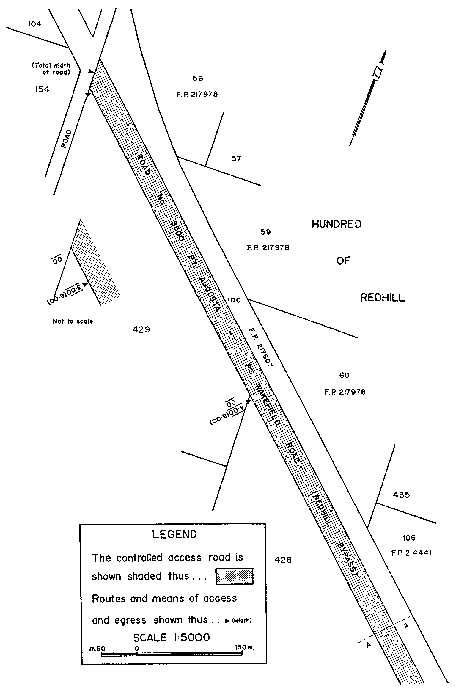
Schedule

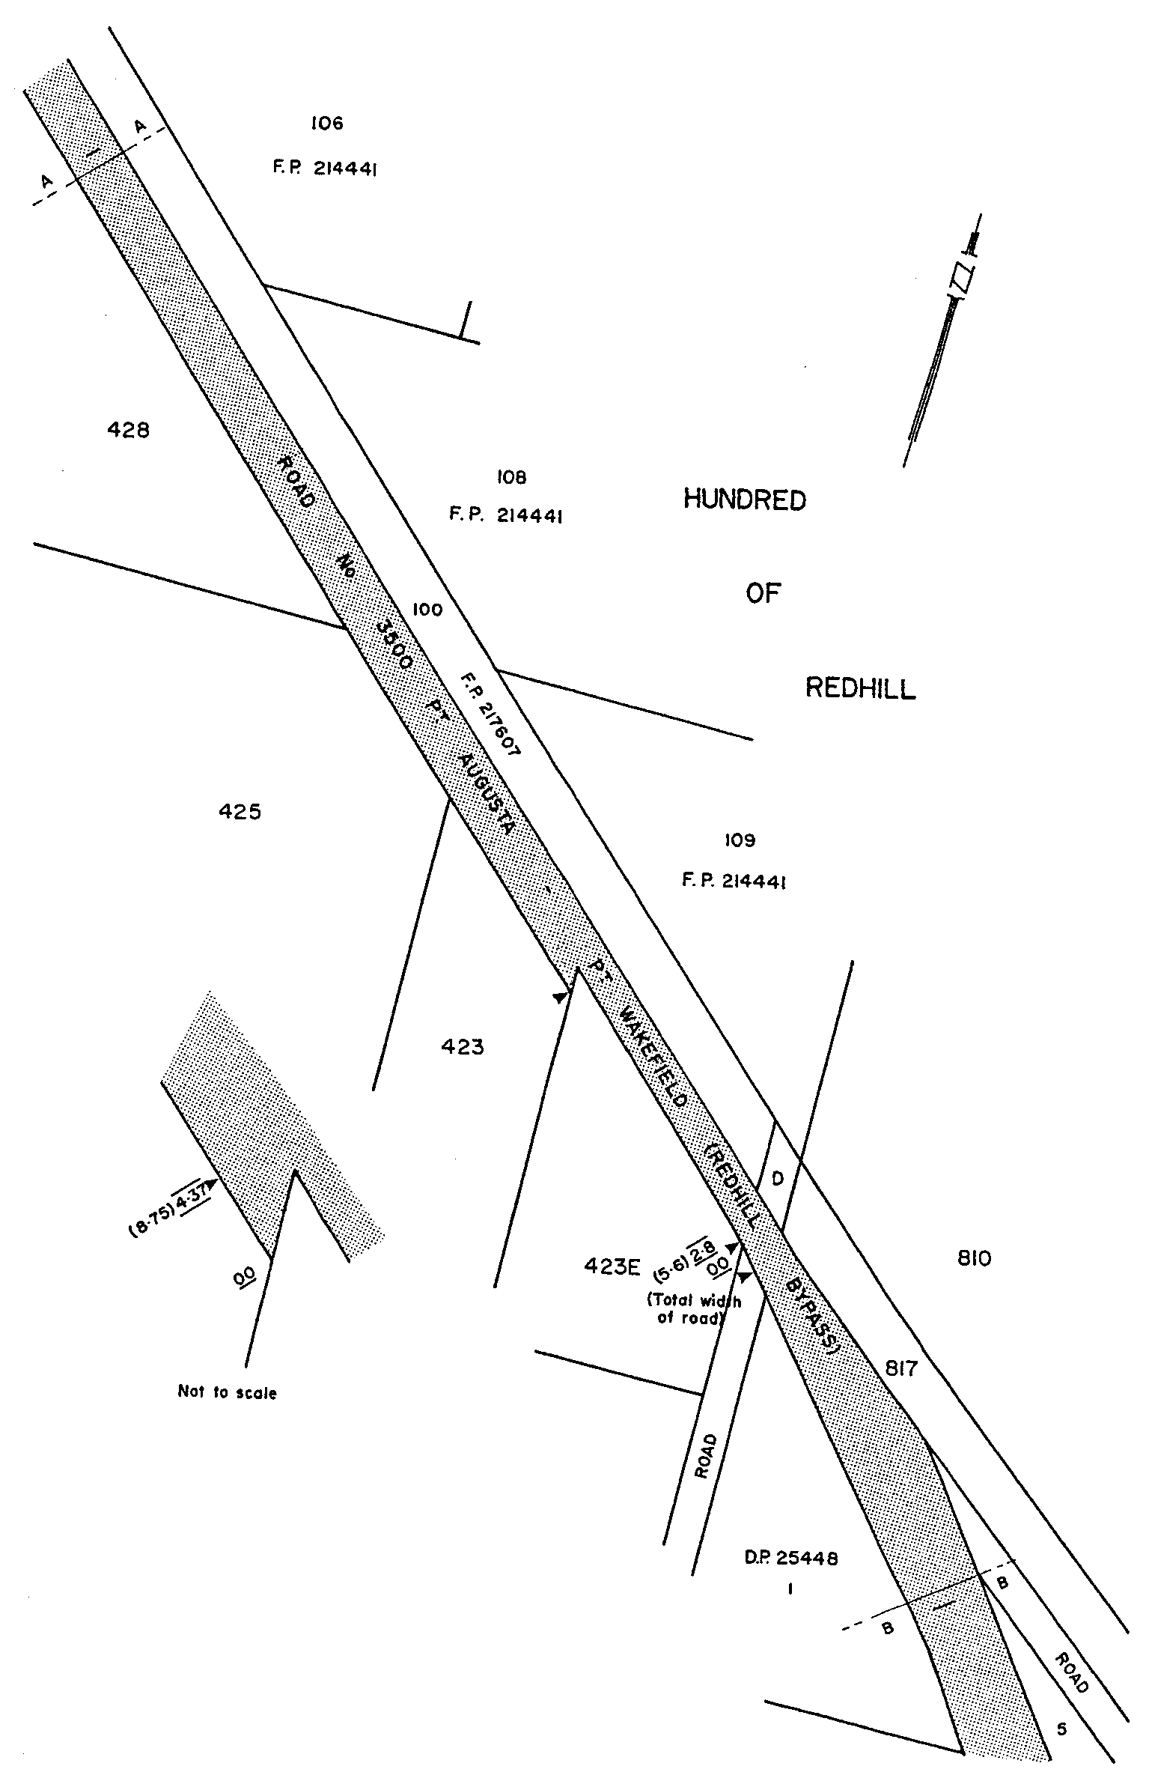
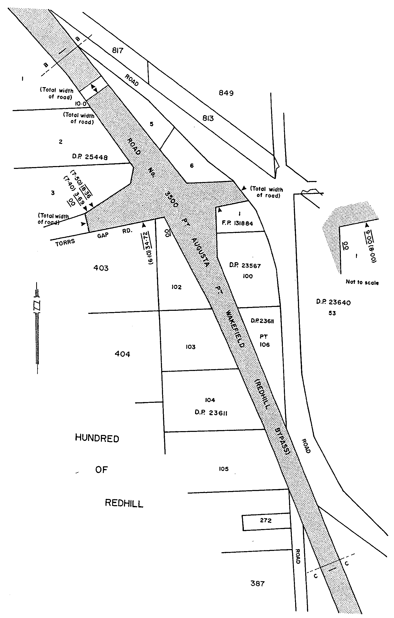
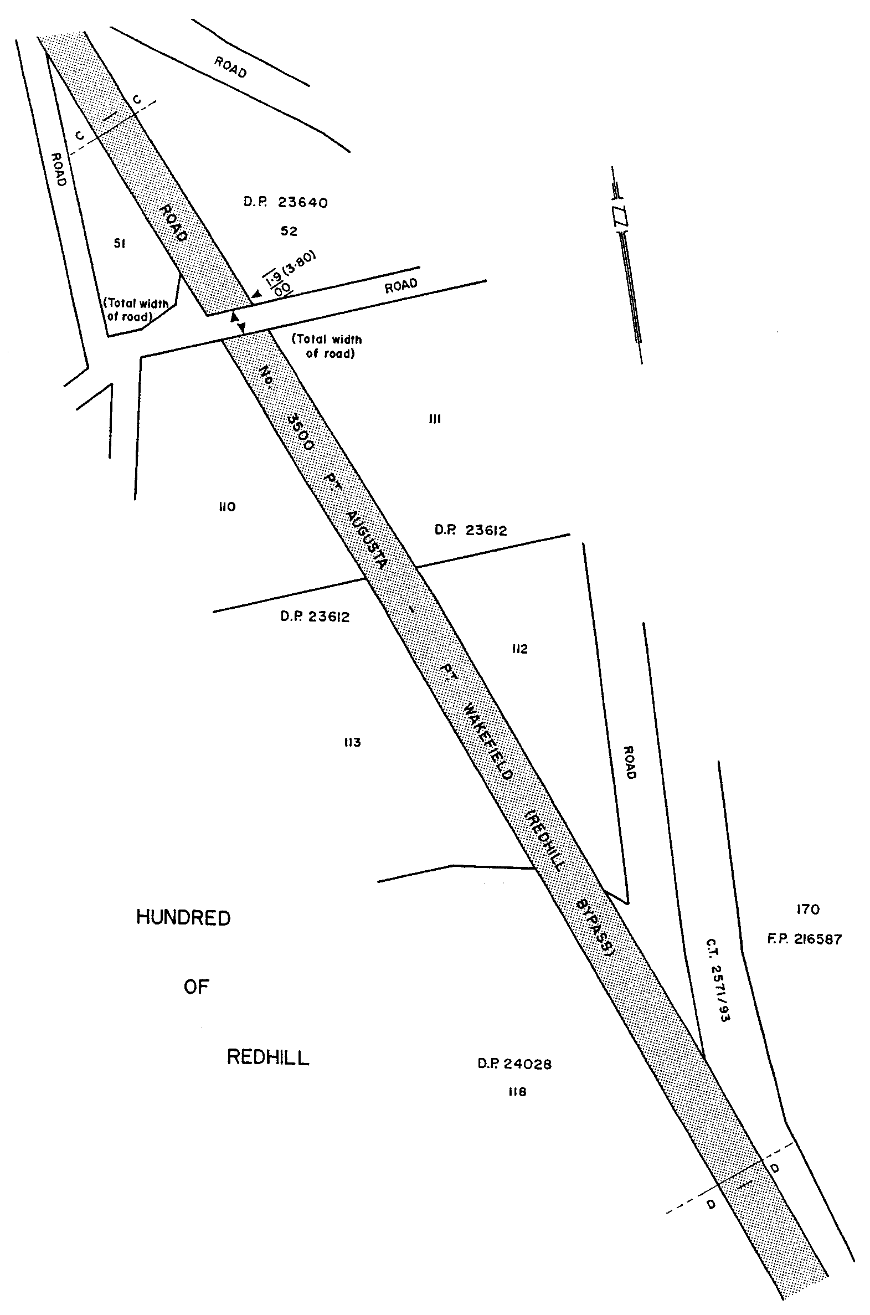

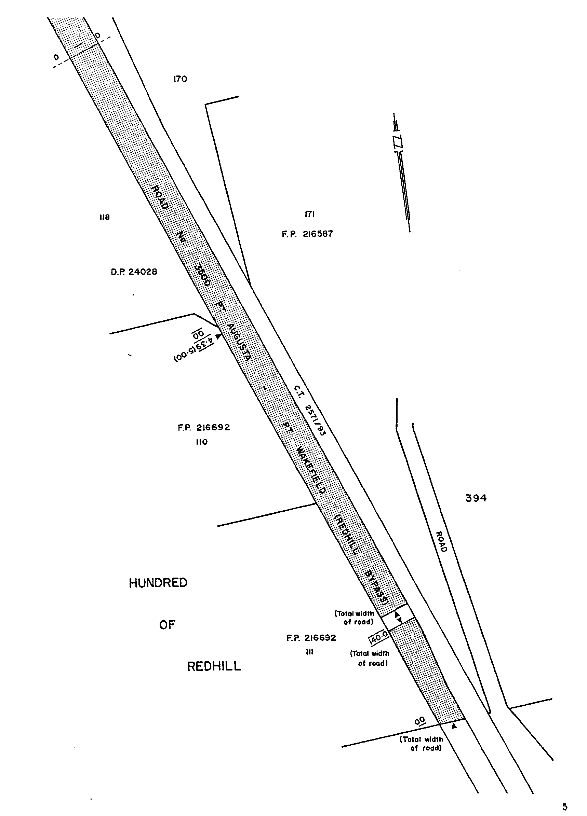
Given under my hand and the Public Seal of South Australia, at Adelaide, 6 June 2002.
By command,
J. W. Weatherill, for Premier
TSAC2001/16519

Department of the Premier and Cabinet
Adelaide, 6 June 2002
HER Excellency the Governor in Executive Council has been pleased to appoint the undermentioned to the South Australian Government Financing Advisory Board, pursuant to the provisions of the Government Financing Authority Act 1982:
Member: (from 9 June 2002 until 8 June 2005)
Claude Long
Barry Ross Brownjohn
Michael John Doyle
By command,
J. W. Weatherill, for Premier
TFD 042/02CS

Department of the Premier and Cabinet
Adelaide, 6 June 2002
HER Excellency the Governor in Executive Council has been pleased to appoint the undermentioned to the South Australian Tourism Commission Board, pursuant to the provisions of the South Australian Tourism Commission Act 1993:
Director: (from 6 June 2002 until 19 September 2003)
Anne Kathryn Skipper
By command,
J. W. Weatherill, for Premier
MTOU 01/02CS

Department of the Premier and Cabinet
Adelaide, 6 June 2002
HER Excellency the Governor in Executive Council has been pleased to appoint the undermentioned to the Arid Areas Catchment Water Management Board, pursuant to the provisions of the Water Resources Act 1997:
Member: (from 6 June 2002 until 5 June 2006):
Ann Sharon Oldfield
Malcolm Mitchell
Ali Ben Kahn
Darren Niejalke
By command,
J. W. Weatherill, for Premier
MEC 0020/02CS

Department of the Premier and Cabinet
Adelaide, 6 June 2002
HER Excellency the Governor in Executive Council has been pleased to appoint Kathryn Errey as Personal Assistant and Aide-de-camp to Her Excellency the Governor commencing on 11 June 2002 and expiring on 10 June 2003, pursuant to the provisions of the Constitution Act 1934.
By command,
J. W. Weatherill, for Premier
DPC 036/97CS

Department of the Premier and Cabinet
Adelaide, 6 June 2002
HER Excellency the Governor in Executive Council has been pleased to appoint the Honourable Kevin Owen Foley, MP, Deputy Premier, Treasurer and Minister for Industry and Trade to be also Acting Premier, Acting Minister for Economic Development, Acting Minister for the Arts and Acting Minister for Volunteers for the period 7 June 2002 to 23 June 2002 inclusive, during the absence of the Honourable Michael David Rann, MP.
By command,
J. W. Weatherill, for Premier
DPC 030/96 PT3CS

Department of the Premier and Cabinet
Adelaide, 6 June 2002
HER Excellency the Governor in Executive Council has been pleased to appoint the people listed as Inspectors of Motor Vehicles, pursuant to section 7 of the Motor Vehicles Act 1959.
Scott Alistair Hewitt
Michael Thomas Ellis
Paul Mark Fanning
Grant Andrew Ireland
By command,
J. W. Weatherill, for Premier
DTRN 03921/97TC1CS

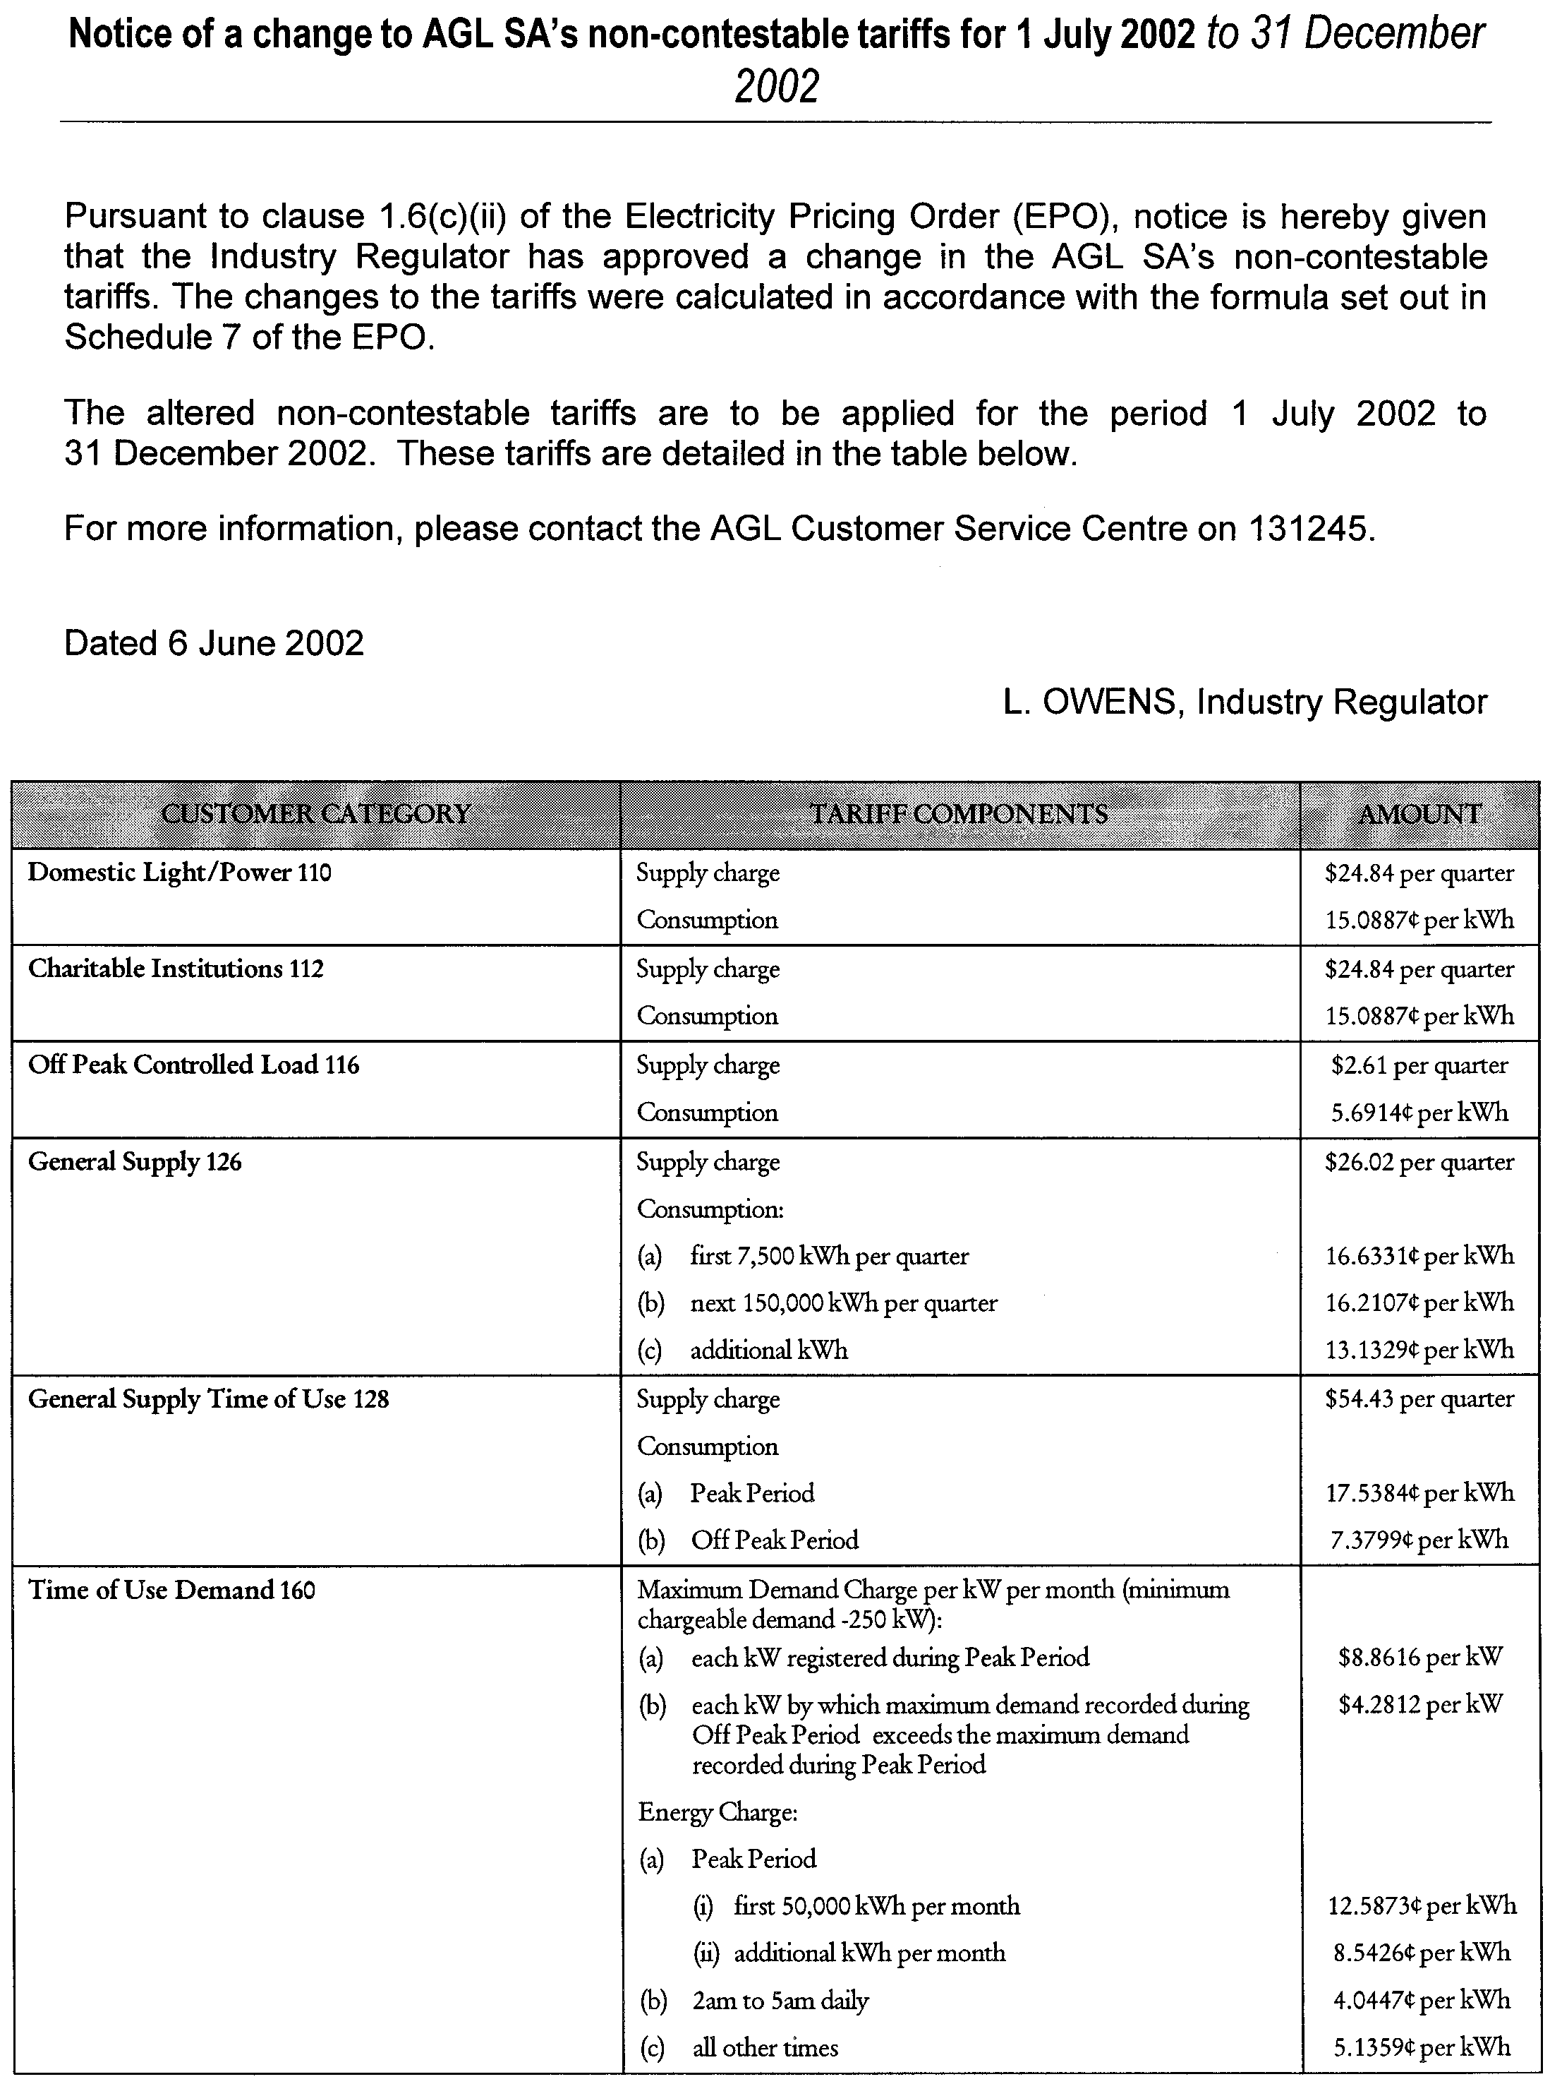
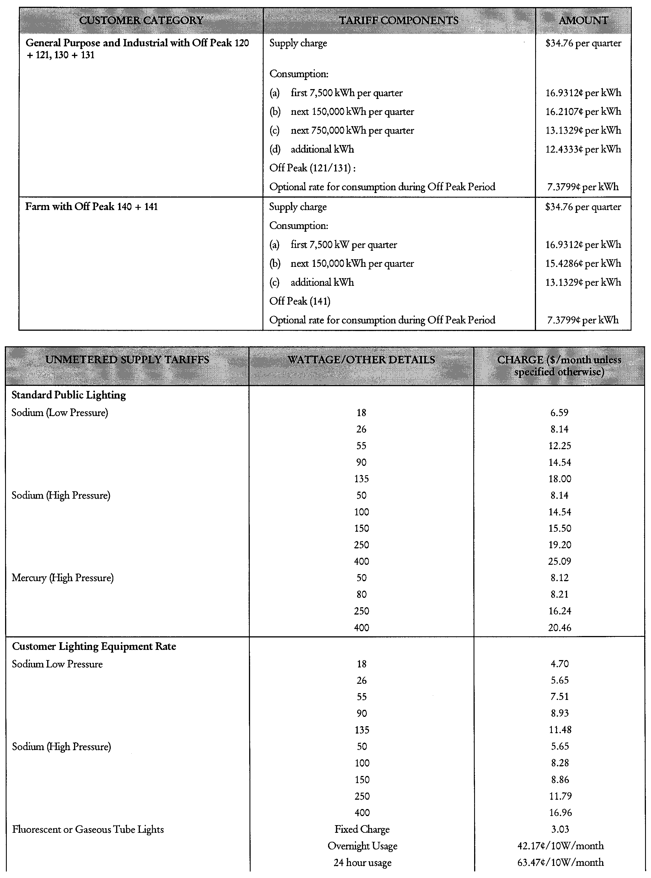
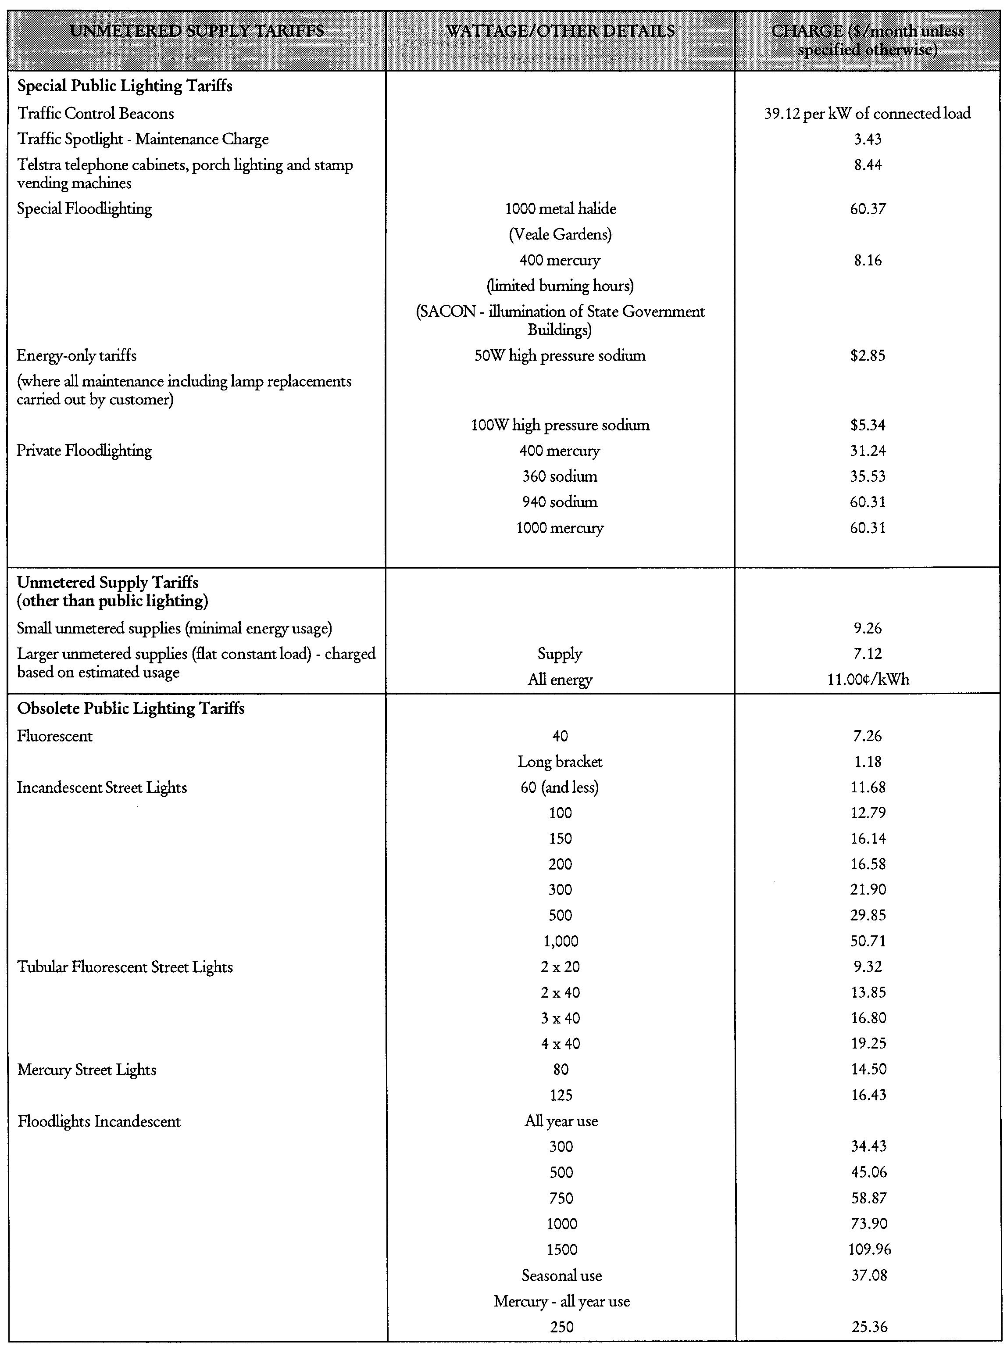
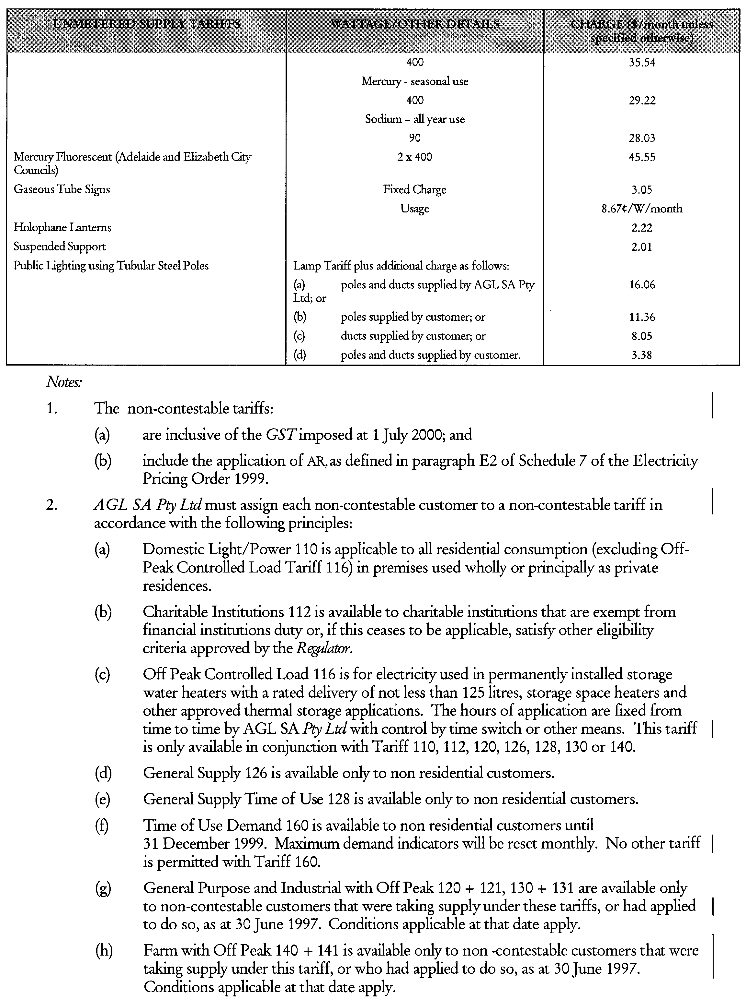
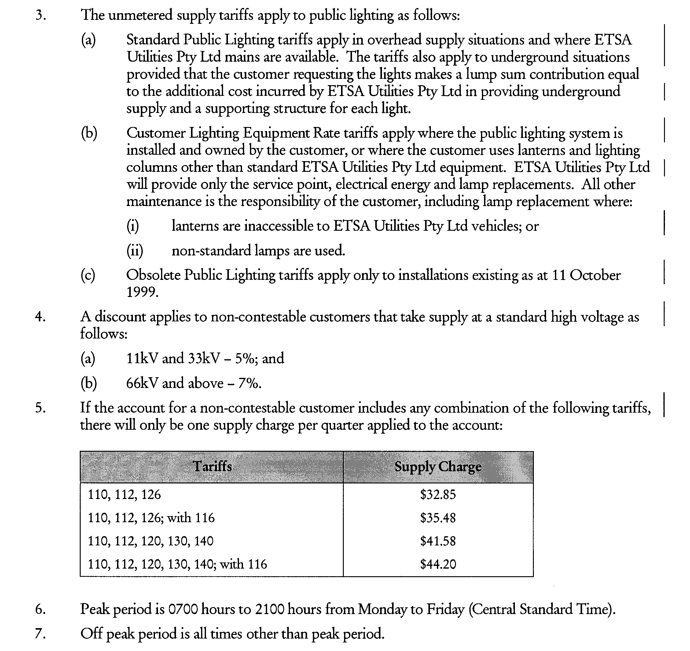

SUBORDINATE LEGISLATION ACT 1976

Section 10AA

Bookmakers Licensing (Agents and Clerks) Rules 2002

PURSUANT to section 10AA of the Subordinate Legislation Act 1976, I certify that, in my opinion, it is necessary or appropriate that the Bookmakers Licensing (Agents and Clerks) Rules 2002 come into operation as set out in Clause 1 (3) thereof.

Dated 1 June 2002.

Kevin Foley, Treasurer, Minister responsible for the
Administration of the Authorised Betting Operations Act 2000

AUTHORISED BETTING OPERATIONS ACT 2000
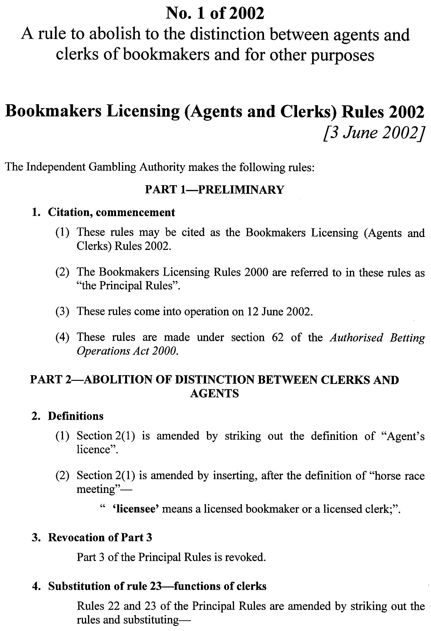
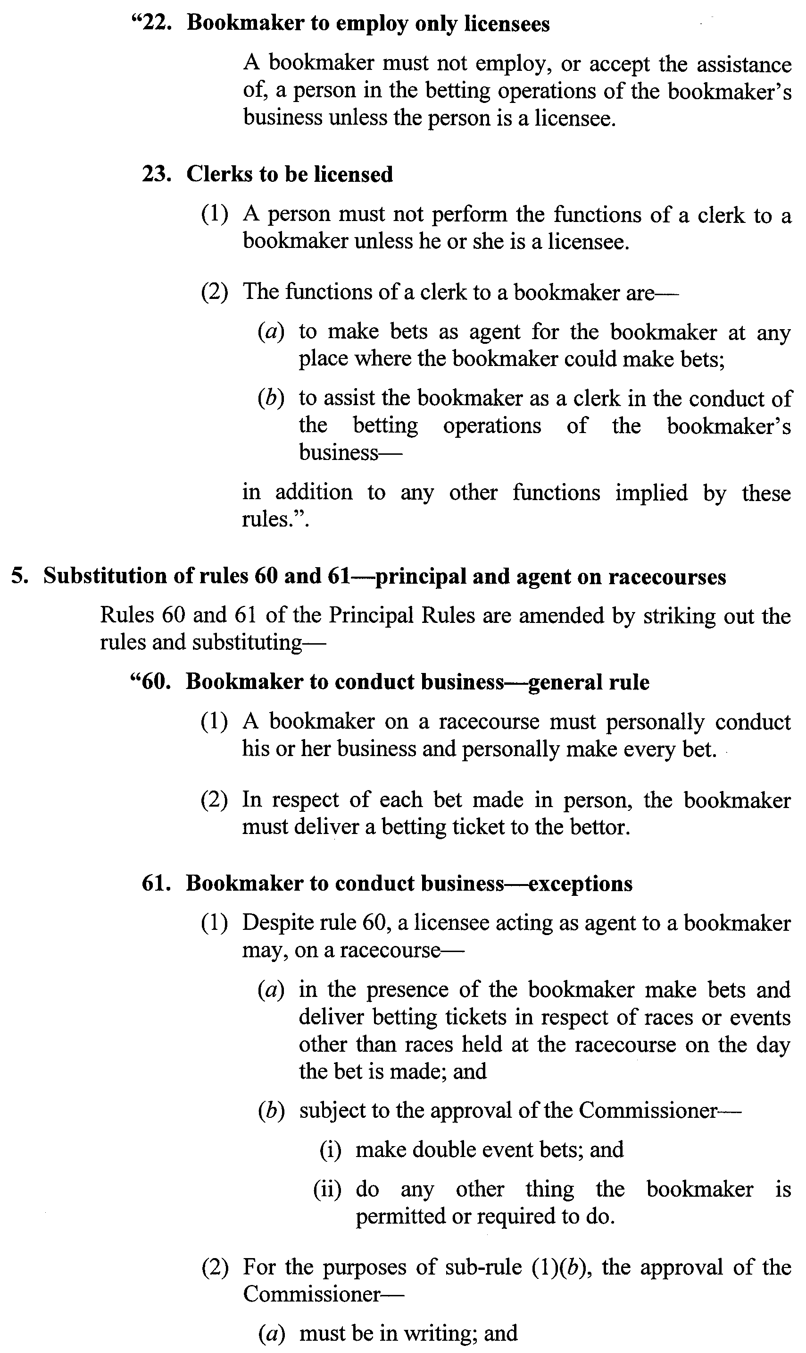
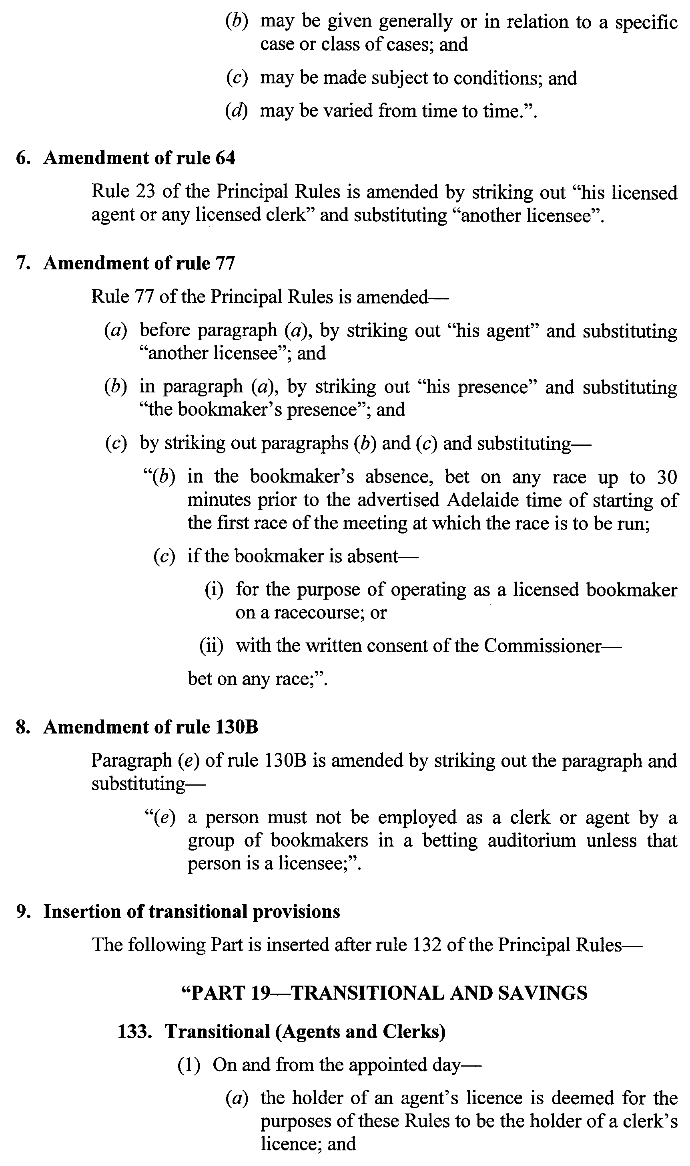
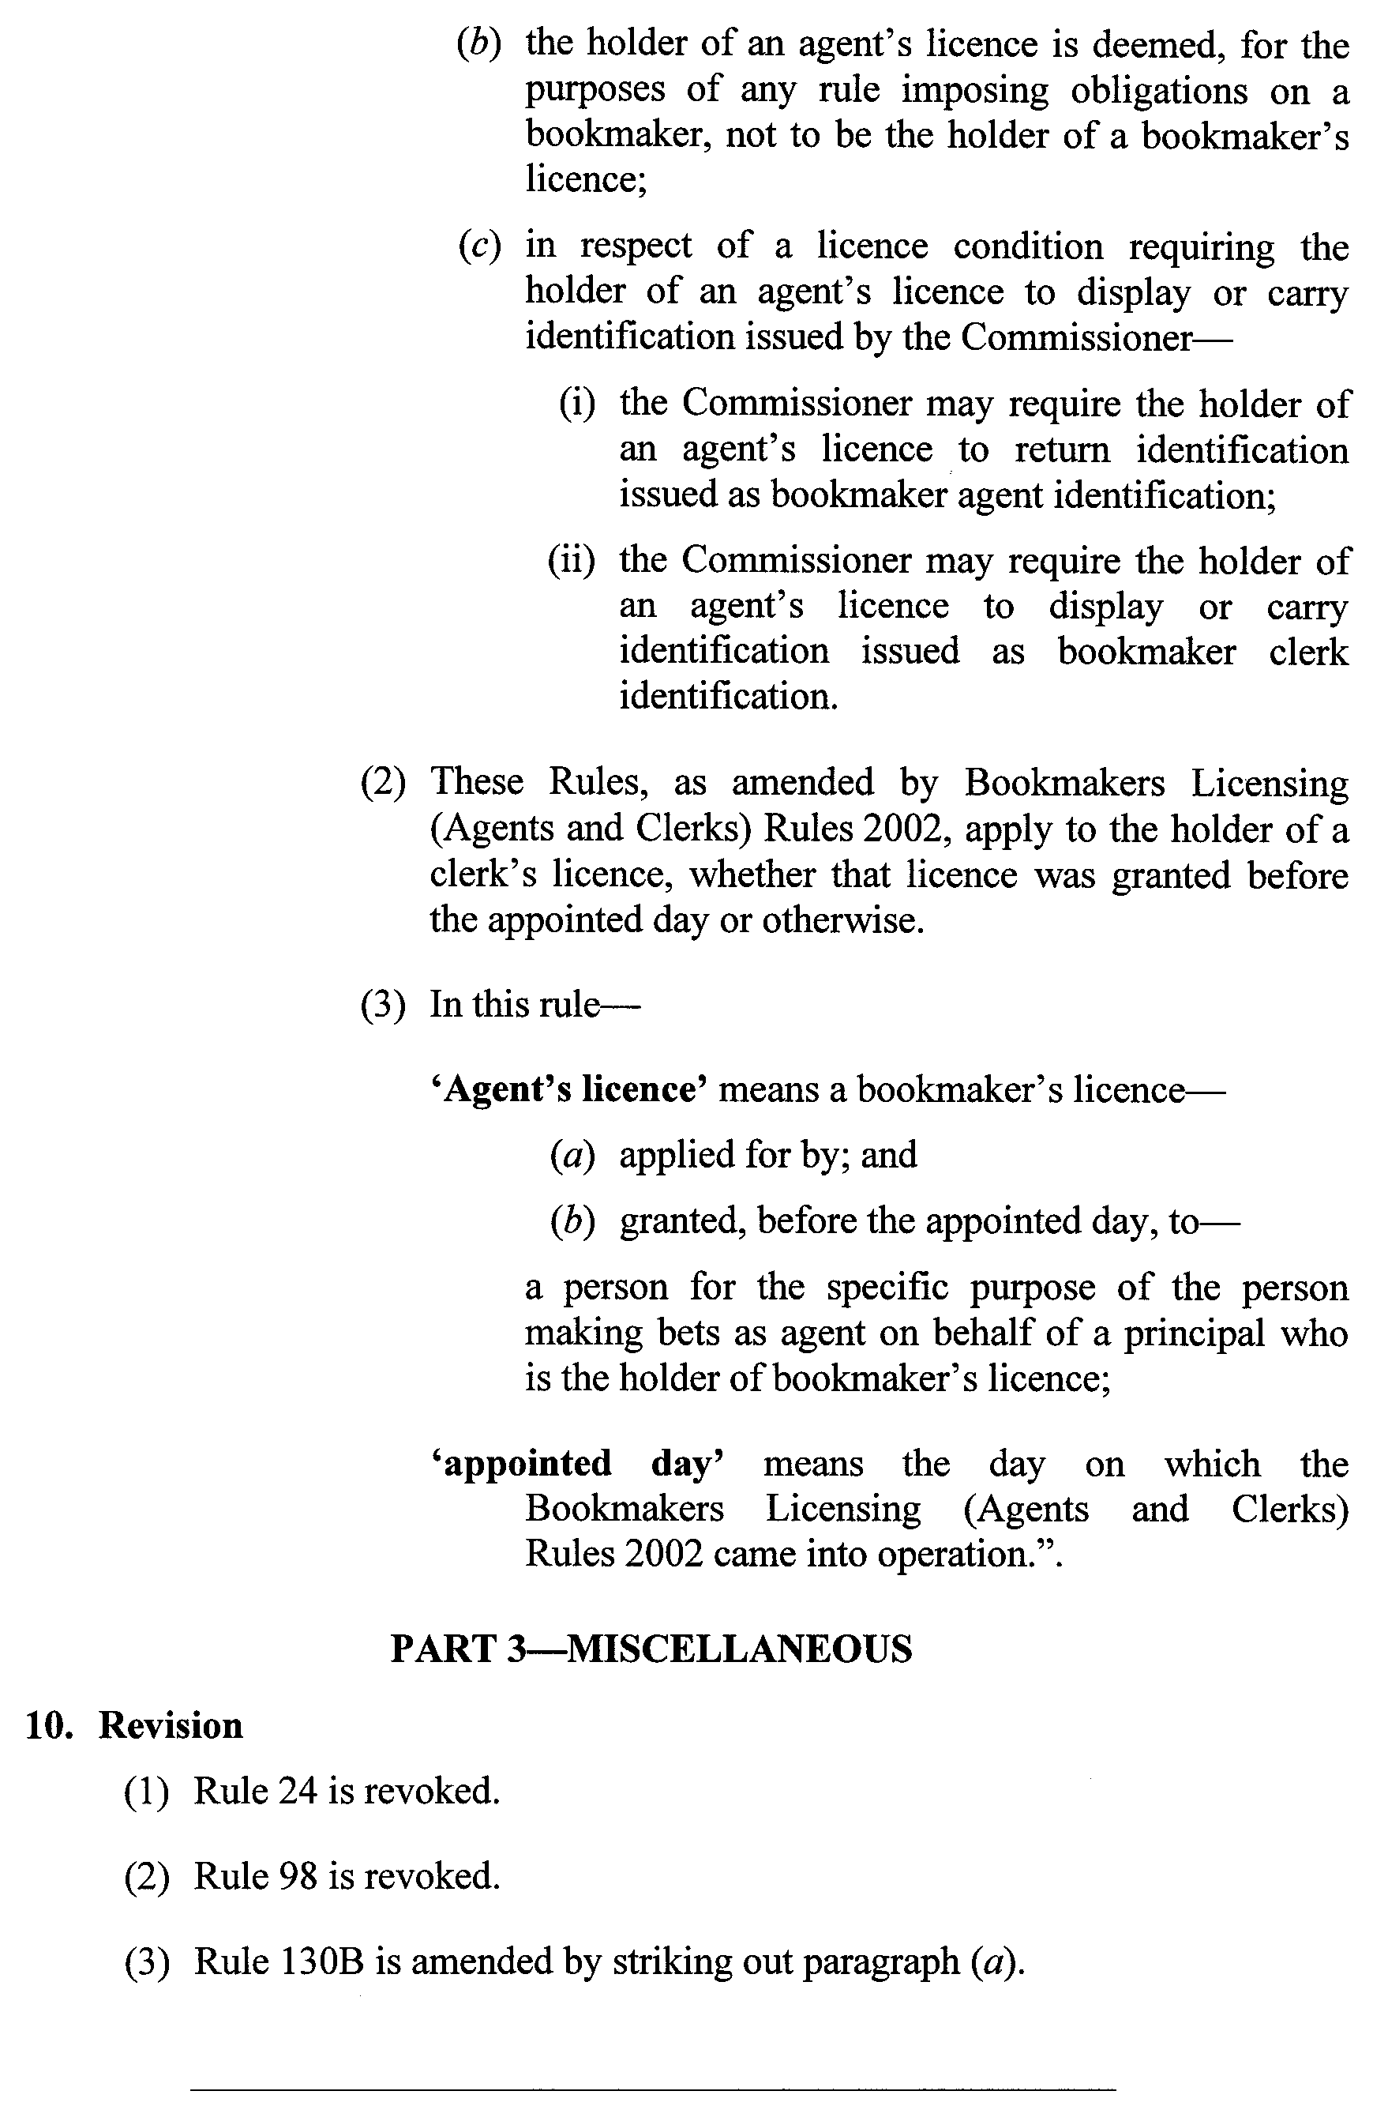
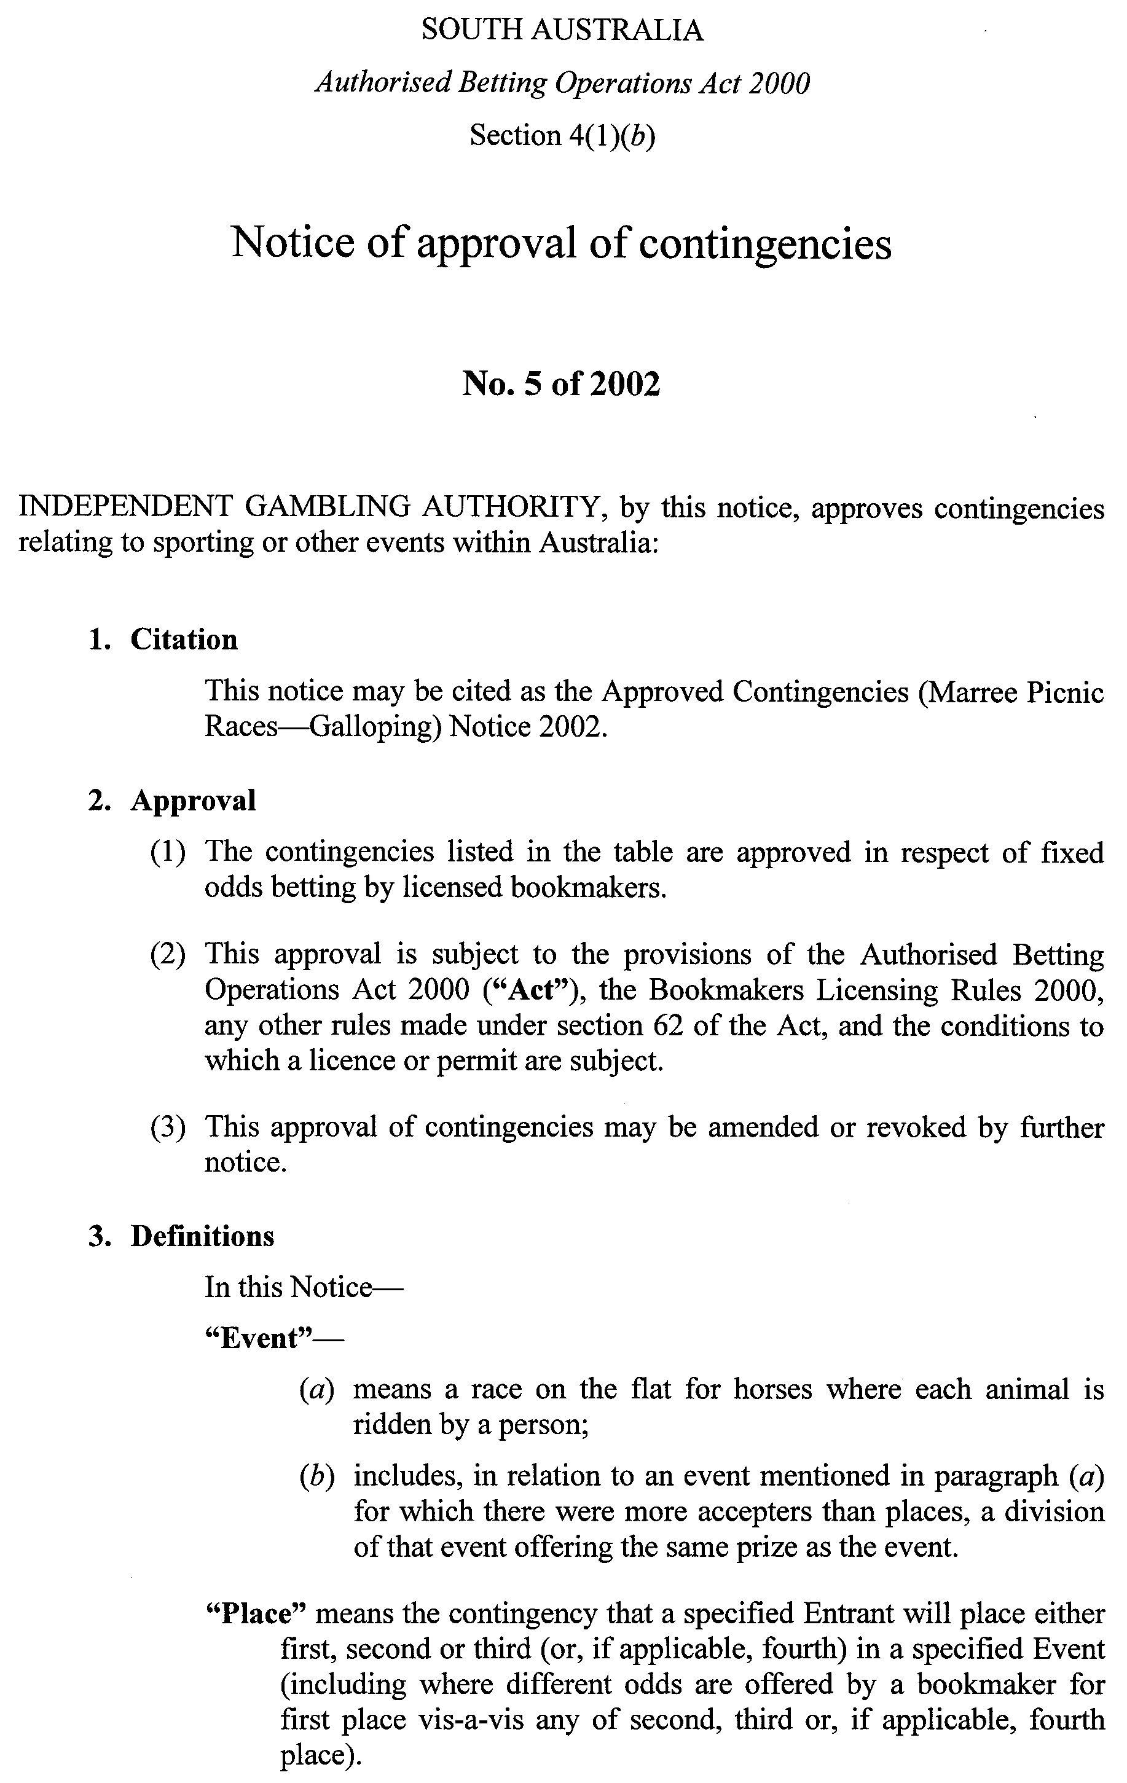
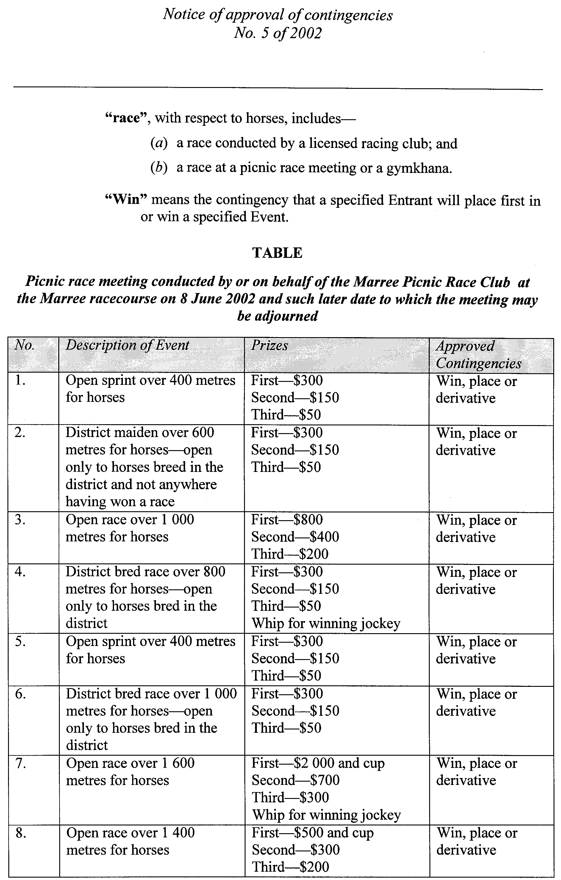
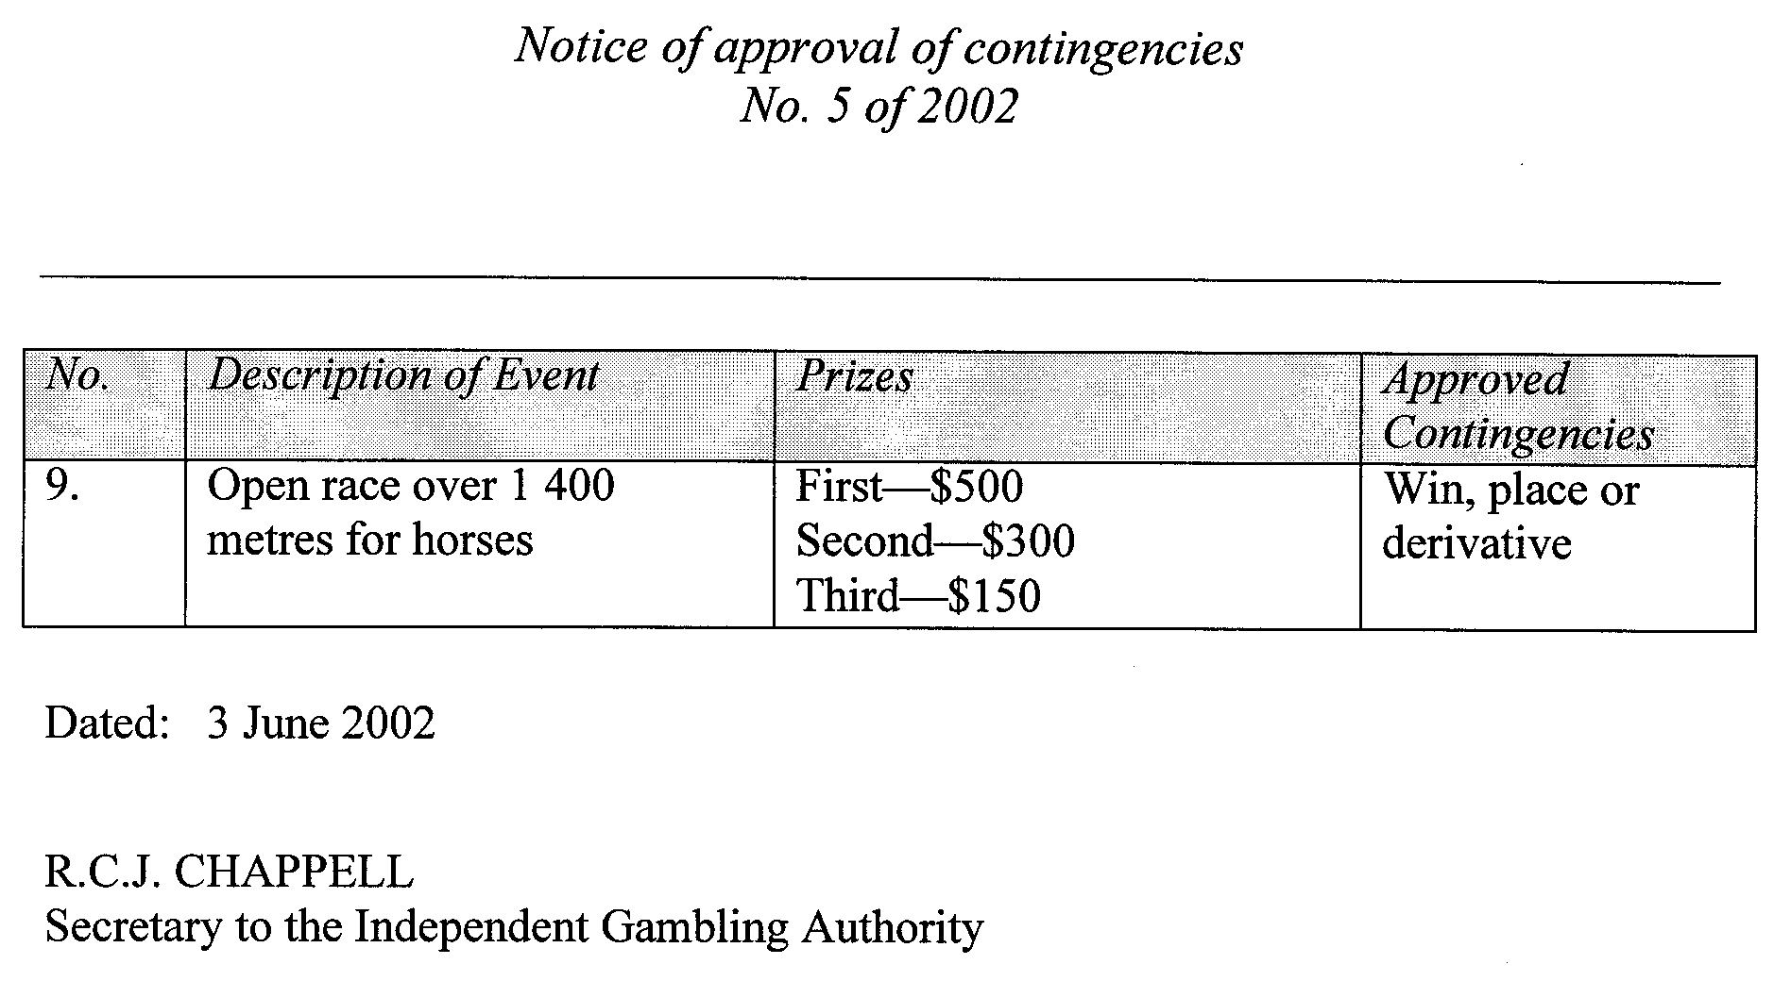

DANGEROUS SUBSTANCES ACT 1979
Appointments
I, MICHAEL JOHN WRIGHT, Minister for Industrial Relations in and for the State of South Australia, hereby appoint the undermentioned Officers as Authorised Officers pursuant to the Dangerous Substances Act 1979:
Carl Jeremy Jonathon Asker
Michelle Heidi Bartsch
Kylie Jane Butterick
Raffaele Calabrese
Alex Carol Campbell
Simon Dale Coad
Antonietta Barbara Colella
Lyn Christine Collins
Stephen Maurice De Musso
Stephen John Dohnt
Timothy Mark Eldridge
Emmy Fonteyn
Leslie Guy
Timothy Allen Harriss
Annette Louise Kappler
Helen Marie Kelly
Simon George Last
Daniel Joseph Lee
Saody Lee
Glenys Judith Litchfield
Timothy Simon Grant Morton
David Michael Randall
Loan Thi Phuong Vu
Yvonne Judith Walter
Dated 8 May 2002.
M. J. Wright, Minister for Industrial Relations

DEVELOPMENT ACT 1993
Alteration to the Building Code of Australia
Preamble
1. The Building Code of Australia as in force from time to time is adopted by the Development Regulations 1993 as part of the Building Rules under the Development Act 1993.
2. The Building Code of Australia has been altered.
3. The Development Act 1993 requires that notice of the alteration must be published before the alteration can take effect.
4. In a notice published in the South Australian Government Gazette of 9 December 1999, notice was provided that the South Australian Addition to Volume 2, Clause SA 2 Energy Efficiency would take effect on a date to be gazetted. The date has not been gazetted.
5. In a notice published in the South Australian Government Gazette of 20 December 2001, notice was provided that the South Australian Addition to Volume 2, Clause SA 2 Energy Efficiency (as varied by Amendment No. 10 to the Building Code of Australia) would take effect on a date to be gazetted. The date has not been gazetted.
6. The South Australian Addition to Volume 2, Clause SA 2 Energy Efficiency was altered further by Amendment No. 11 to the Building Code of Australia. The altered South Australian addition to Volume 2, Clause SA 2, Energy Efficiency will take effect on a date to be gazetted.
Notice
PURSUANT to sections 4 (7) and 108 (7) of the Development Act 1993, notice is given of an alteration to the 1996 Edition of the Building Code of Australia, that alteration being Amendment No. 11, published by the Australian Building Codes Board, as modified by the variations and additions for South Australia contained in the appendix to that Code.
The alterations made by Amendment No. 11 to the Building Code of Australia (other than the alteration to the SA Addition to Volume 2 Clause SA 2 Energy Efficiency) will take effect for the purposes of the Development Act 1993 on 1 July 2002.
The SA Addition Clause SA 2 Energy Efficiency (as varied by Amendment No. 10 and Amendment No. 11 to the Building Code of Australia) will take effect on a date to be gazetted.
Dated 5 June 2002.
J. W. Weatherill, Minister for Urban Development and Planning
PLN/02/0008

EXPLOSIVES ACT 1936
Appointments
I, MICHAEL JOHN WRIGHT, Minister for Industrial Relations in and for the State of South Australia, hereby appoint the undermentioned Officers as Authorised Officers under the Explosives Act 1936, in accordance with my delegated authority under section 9 (1) of the Explosives Act 1936:
Timothy Allen Harriss
Loan Thi Phuong Vu
Deanna Denise Fay Trenham
Dated 8 May 2002.
M. J. Wright, Minister for Industrial Relations

FISHERIES ACT 1982
Marine Mollusc (Subtidal) Farming Licence FS00044
Licence to Farm Fish under section 53 of the Fisheries
Act 1982
THE Minister for Agriculture, Food and Fisheries (‘the Minister’) hereby grants to:
Michael Evenden (14750)
P.O. Box 1245
Port Lincoln, S.A. 5606
a licence to occupy and use the waters and airspace over the land specified in Item 1 of Schedule 1 of this licence (‘the site’) for the purpose of farming and taking the permitted species (‘the permitted use’) for the period commencing on 1 July 2001 and ending, subject to any earlier termination under this licence, on 30 June 2002 (‘the term’) subject to the following terms and conditions:
Conditions of This Licence
1. Marked-off Areas
1.1 Subject to section 53A of the Fisheries Act 1982, this licence does not entitle the licensee to exclusive rights of entry to and occupation of the site. The rights granted by this licence are exercisable by the licensee in common with any other occupiers of the site from time to time.
1.2 For the purposes of section 53A of the Fisheries Act 1982, the marked-off areas within the site are that area or those areas marked-off or indicated in the manner set out in Item 2 of Schedule 1 of this licence.
2. Permitted Species
The licensee:
2.1 must not farm or introduce any species at the site other than the permitted species referred to in Schedule 2; and
2.2 must not take any wild fish from the site except for recreational purposes.
3. Permitted Use
The licensee must not use the site for any purpose other than the permitted use.
4. Permitted Methods
4.1 The licensee must, in undertaking the permitted use, take all reasonable and practicable measures to prevent or minimise damage to the environment. Without limiting the generality of the foregoing, the licensee:
4.1.1 must ensure the total length of each unit does not exceed 3 km of longline or 1 km of racking per hectare, and each unit must be at least 5 m from any other unit;
4.1.2 must not use the anti-fouling chemical tributyltin (TBT) on any equipment used at the site;
4.1.3 must not use any chemical or drug for either therapeutic or prophylactic purpose except with the prior approval of the Minister;
4.1.4 must undertake an environmental monitoring program approved by the Minister and as specified in Clause 4.3;
4.1.5 must not introduce the permitted species to the site before the approval of the environmental monitoring program referred to in 4.1.4 by the Minister;
4.1.6 must comply with the schedule of reporting for the environmental monitoring program as pres-cribed in Schedule 6 and submit the final results of the environmental monitoring program to the Minister 30 days before expiry of the term of this licence.
4.2 SASQAP
4.2.1 It is a condition of your licence to farm bivalve molluscs that only shellfish from areas Classified under the South Australian Shellfish Quality Assurance Program (SASQAP) may be sold for human consumption.
4.2.2 The licensee must continue to meet all the regulations required under the Food Standards Code to produce a product safe for human con-sumption.
4.3 The licensee must submit a draft environmental moni-toring program to the Minister for approval within 60 days of the grant of the licence by the Minister. The draft environmental monitoring program must include the qualifications and experience of the person(s) designing and undertaking the program and address the matters listed in Schedule 5.
5. Marking and Maintaining the Site
The licensee:
5.1 must ensure that the site is maintained in a good, tidy and safe condition to the satisfaction of the Minister;
5.2 must remove and lawfully dispose of any waste or debris on the site as soon as is reasonably practicable and in particular must comply with any guidelines issued from time to time by the Minister in relation to the removal from the site of any unhealthy or dead fish;
5.3 must maintain all buoys, crosses, and markers on the site in good condition and in accordance with the colours specified in Schedule 1 of this licence; and
5.4 must mark the site boundary in accordance with the requirements of the Minister for Transport.
6. Site Inspection and Supervision
The licensee:
6.1 must at all times permit the Minister, his employees, agents or contractors or any employees, agents or con-tractors of the Crown to enter the site for the purposes of inspecting the site, the sea floor and the flora and fauna on or in the vicinity of the site; and
6.2 must comply with all reasonable directions of any such person authorised by the Director of Fisheries to inspect the conduct of the licensee’s activities at the site.
7. Fees and Returns
The licensee:
7.1 must pay to the Minister the licence fee in accordance with Item 1 of Schedule 3 of this licence;
7.2 must on or before 31 January and 31 July during the term, submit to the Minister a return supplying all of the information described in Schedule 4 of this licence.
8. Public Risk Insurance
The licensee must at its own cost during the term maintain in full force and effect in respect of the site and the permitted use a policy of public risk insurance in the joint names of the licensee and the Minister. The limits of public risk must not be less than the amount specified in Item 2 of Schedule 3 of this licence, or such other amount as the Minister may from time to time reasonably require. A policy of insurance or copy thereof or a certificate of insurance must be produced by the licensee to the Minister on written request.
9. Guarantee or Indemnity Scheme
The licensee must either:
9.1 provide a guarantee from its bankers to the amount specified in Item 3 of Schedule 3; or
9.2 contribute to an indemnity scheme established for the aquaculture and fisheries industry and approved by the Minister,
to and in favour of and for the benefit of the Minister by way of security for the due and punctual performance by the licensee of the terms and conditions of this licence and in particular the obligations of the licensee to rehabilitate the site immediately prior to the expiration or sooner determination of the term of this licence. Such guarantee or indemnity scheme must have effect from the date of commencement of the term.
10. No Assignment
The licensee must not assign or sublet or deal in any other way with any interest in this licence.
11. Variation and Cancellation
11.1 The Minister may without prior notice vary or cancel this licence immediately during the term for the purposes of preventing or minimising any damage or threat of damage to the environment. For the purpose of this condition the Minister may have regard to but is not limited by the following considerations:
11.1.1 the results of monitoring undertaken pursuant to Clause 4.1.5;
11.1.2 the results of any other monitoring as may from time to time be carried out; or
11.1.3 such other relevant information within the knowledge of the Minister.
11.2 Subject to and without limiting Condition 13.1, in the event of breach by the licensee of any term or con-dition of this licence, the Minister may:
11.2.1 give to the licensee written notice of such breach and the Minister’s requirements for rectification thereof; or
11.2.2 cancel this licence for failure to comply with such requirements for rectification.
11.3 The Minister may cancel this licence if the licensee is a body corporate, and any of the following occur:
11.3.1 the licensee is unable to pay its debts as and when they fall due or is otherwise insolvent;
11.3.2 an order is made for the winding up or liquidation of the licensee;
11.3.3 the licensee enters into a scheme of arrange-ment, compromise, moratorium or other form of composition with its creditors or any class of its creditors;
11.3.4 a receiver, a manager or a receiver and manager, a company administrator or other insolvency administrator is appointed to the licensee; or
11.3.5 a mortgagee, chargee or other encumbran-cee is appointed over or takes possession of or appoints an agent to take possession of all or any of the licensee’s assets.
11.4 The Minister may cancel this licence if the licensee is an individual, and the licensee:
11.4.1 becomes bankrupt or assigns its estate or enters into a deed of arrangement or other form of composition for the benefit of the licensee’s creditors; or
11.4.2 is convicted of an indictable offence.
11.5 Cancellation of this licence by the Minister shall be without prejudice to any rights, remedies or actions that the Minister may have against the licensee in respect of any antecedent breach by the licensee of the terms and conditions contained in this licence.
Granted by the General Manager Aquaculture, delegate for the purposes of section 53 of the Minister responsible for adminis-tration of the Fisheries Act 1982, on 30 May 2002.
I. Nightingale, General Manager Aquaculture
Schedule 1
Item 1—The Site
Area applicable to this licence:
Licensed Area Licensed
Hectares
AGD 66—Zone 53
594835E 6178780N 10
595235E 6178780N
595235E 6178530N
594835E 6178530N
All St Andrew’s crosses must be marked with the site’s unique ‘FS number’; that is the licence number.
Item 2—Marked-off Areas
[Co-ordinates of developed areas within the site to be provided by the licensee].
White buoys of at least 12 inches in diameter must be placed around the whole of the perimeter of the developed areas within the site at a distance of no less than 50 m from one another.
Schedule 2
Item 1—Permitted Species
The Director of Fisheries has, pursuant to section 50 (2) of the Act, issued a permit for the release of the fish specified in this Schedule.
Blacklip Abalone (Haliotis rubra)
Greenlip Abalone (Haliotis laevigata)
Item 2—Permitted Farming Methods
BST Longlines
The licence holder must source all farm stock from either:
(a) registered South Australian growers or hatcheries; or
(b) wholly from, or the progeny of, wild stocks from South Australian waters.
The licence holder must not stock the site with more than 50 000 individuals of the permitted species at any time. The size of the abalone shell measured at the greatest shell dimension, must not be less than 20 mm in length and must not be greater than 90 mm in length.
The licence holder must maintain a Stock Movement Register which must be kept to immediately record all movements of abalone stock to and from the farm and to be kept regardless of the purpose of the movement of the stock. The Stock Movement Register must be a bound book with consecutively numbered pages, each entry must be recorded in ink in the order of events, each entry must be made immediately below the previous entry and each page must be filled before commencing the next page.
The Stock Movement Register must include the following information:
(a) the time, date and number of stock placed on the site; and
(b) the time, date and number of stock removed form the site.
The licence holder must keep the Stock Movement Register for 12 months from the last entry date. A photocopy of the register for the period from the date of this licence to 30 June 2002 must be forwarded to PIRSA General Manager Aquaculture on or before 14 July 2002. A photocopy of the registers for the period from 1 July 2001 to 30 June 2002 must be forwarded to the General Manager Aquaculture on or before 14 July 2001.
The licence holder must maintain a Mortality Register and record the mortalities of all farm abalone. Mortalities must be physically counted at intervals of no more than three months.
The licence holder must keep the Mortality Register for 12 months from the last entry date. A photocopy of the register for the period from the date of this licence to 30 June 2002 must be forwarded to PIRSA General Manager Aquaculture on or before 14 July 2002. A photocopy of the registers for the period from 1 July 2001 to 30 June 2002 must be forwarded to the General Manager Aquaculture on or before 14 July 2002.
The licence holder must make available all farm registers for inspection by PIRSA Fisheries and Aquaculture Compliance Officers immediately upon being requested by such an officer.
The licence holder must complete a ‘Farmed Abalone Disposal Statement’ and forward this statement to PIRSA Fisheries and Aquaculture Compliance at least 48 hours prior to disposal of farmed stock.
The licence holder must comply with the Fisheries Act 1982 while transporting fish. All fish moved from the site must be moved ‘in shell’.
The licence holder must ensure that no processing occurs at sea and must further ensure that no dead farm fish or waste is deposited at sea.
Item 3—Criteria for Development of Marine Aquaculture Sites
Development must have commenced on the site within 12 months of the licence being issued. The minimum level of development on the site must be:
1 ha developed with 2 km of growout line on the site.
Schedule 3
Item 1—Fees
Annual licence fees are payable as prescribed in the licence renewal.
Item 2—Insurance
Ten million dollars ($10 000 000).
Item 3—Guarantee
Ten thousand dollars ($10 000).
Schedule 4
Production Returns
The licensee must submit production returns to the Minister on or before 30 December and 30 June during the term of this licence. The information contained in these returns will be deter-mined by the Minister. These returns must be forwarded to the General Manager, Aquaculture SA, 14th Floor, 25 Grenfell Street, Adelaide, S.A. 5000.
Schedule 5
Environmental Monitoring Program
MATTERS TO BE ADDRESSED
The monitoring program should address the following matters in relation to the permitted use:
Farm Management
1. Approximate layout of all structures on the site during the term including location, number and size.
2. Growth and condition of the permitted species.
3. Occurrence of disease incidents in the permitted species.
Water Quality
1. Phytoplankton including species composition and abun-dance.
2. Status of the site under the South Australian Shellfish Quality Assurance Program during the term (including closures).
Benthic Sediments
Sedimentation through measuring total organic carbon and particle size analysis of sediment samples.
Benthic Fauna and Flora
Benthic macro-flora communities including composition, dis-tribution and abundance.
METHODOLOGY
Video Transects
Video transects should be used to assess broad scale changes in sediment consistency, presence of farming waste and the com-position and abundance of macro-flora communities.
Video transects must be collected using equipment capable of producing a clear and well lit image. Transects must extend across the site, including sections under the development, and extend 50 m out both sides of the site. The location of the video transects must be identified on a map attached to the environ-mental monitoring report. Each transect must be identified on the video with a unique transect number.
Report
The environmental monitoring report must be legible and contain a declaration regarding the authenticity and source of all data and results contained in the report. This declaration must be signed by the licence holder and the person(s) conducting the monitoring program.
The report must include an assessment of the results of the monitoring program against the provisions of the Environment Protection (Marine) Policy 1994, and must be accompanied by all raw data, video footage and diver notes.
Schedule 6
Schedule of Environmental Monitoring Reports
The licensee must submit a final environmental monitoring program report within 12 months of the commencement of this licence to the Minister, c/o General Manager Aquaculture SA, 14th Floor, 25 Grenfell Street, G.P.O. Box 1625, Adelaide, S.A. 5000.

FISHERIES ACT 1982
Marine Mollusc Farming Licence FM00069
(Previous Licence No. F730)
Licence to Farm Fish under section 53 of the Fisheries
Act 1982
THE Minister for Primary Industries and Resources (‘the Minister’) hereby grants to:
Neville L. Pauley (13104)
P.O. Box 49
Smoky Bay, S.A. 5680
a licence to occupy and use the waters and airspace over the land specified in Item 1 of Schedule 1 of this licence (‘the site’) for the purpose of farming and taking the permitted species (‘the permitted use’) for the period commencing on 1 July 2001 and ending, subject to any earlier termination under this licence, on 30 June 2002 (‘the term’) subject to the following terms and conditions:
Conditions of This Licence
1. Marked-off Areas
1.1 Subject to section 53A of the Fisheries Act 1982, this licence does not entitle the licensee to exclusive rights of entry to and occupation of the site. The rights granted by this licence are exercisable by the licensee in common with any other occupiers of the site from time to time.
1.2 For the purposes of section 53A of the Fisheries Act 1982, the marked-off areas within the site are that area or those areas marked-off or indicated in the manner set out in Item 2 of Schedule 1 of this licence.
2. Permitted Species
The licensee:
2.1 must not farm or introduce any species at the site other than the permitted species referred to in Schedule 2; and
2.2 must not take any wild fish from the site except for recreational purposes.
3. Permitted Use
The licensee must not use the site for any purpose other than the permitted use.
4. Permitted Methods
4.1 The licensee must, in undertaking the permitted use, take all reasonable and practicable measures to prevent or minimise damage to the environment. Without limiting the generality of the foregoing, the licensee:
4.1.1 must ensure the total length of each unit does not exceed 3 km of longline or 1 km of racking per hectare, and each unit must be at least 5 m from any other unit;
4.1.2 must not use the anti-fouling chemical tributyltin (TBT) on any equipment used at the site;
4.1.3 must not use any chemical or drug for either therapeutic or prophylactic purpose except with the prior approval of the Minister;
4.1.4 must undertake an environmental monitoring program approved by the Minister and as specified in Clause 4.3;
4.1.5 must not introduce the permitted species to the site before the approval of the environmental monitoring program referred to in 4.1.4 by the Minister;
4.1.6 must comply with the schedule of reporting for the environmental monitoring program as pres-cribed in Schedule 6 and submit the final results of the environmental monitoring program to the Minister 30 days before expiry of the term of this licence.
4.2 SASQAP
4.2.1 It is a condition of your licence to farm bivalve molluscs that only shellfish from areas Classified under the South Australian Shellfish Quality Assurance Program (SASQAP) may be sold for human consumption.
4.2.2 The licensee must continue to meet all the regulations required under the Food Standards Code to produce a product safe for human con-sumption.
4.3 The licensee must submit a draft environmental moni-toring program to the Minister for approval within 60 days of the grant of the licence by the Minister. The draft environmental monitoring program must include the qualifications and experience of the person(s) designing and undertaking the program and address the matters listed in Schedule 5.
5. Marking and Maintaining the Site
The licensee:
5.1 must ensure that the site is maintained in a good, tidy and safe condition to the satisfaction of the Minister;
5.2 must remove and lawfully dispose of any waste or debris on the site as soon as is reasonably practicable and in particular must comply with any guidelines issued from time to time by the Minister in relation to the removal from the site of any unhealthy or dead fish;
5.3 must maintain all buoys, crosses, and markers on the site in good condition and in accordance with the colours specified in Schedule 1 of this licence; and
5.4 must mark the site boundary in accordance with the requirements of the Minister for Transport.
6. Site Inspection and Supervision
The licensee:
6.1 must at all times permit the Minister, his employees, agents or contractors or any employees, agents or con-tractors of the Crown to enter the site for the purposes of inspecting the site, the sea floor and the flora and fauna on or in the vicinity of the site; and
6.2 must comply with all reasonable directions of any such person authorised by the Director of Fisheries to inspect the conduct of the licensee’s activities at the site.
7. Fees and Returns
The licensee:
7.1 must pay to the Minister the licence fee in accordance with Item 1 of Schedule 3 of this licence;
7.2 must on or before 31 January and 31 July during the term, submit to the Minister a return supplying all of the information described in Schedule 4 of this licence.
8. Public Risk Insurance
The licensee must at its own cost during the term maintain in full force and effect in respect of the site and the permitted use a policy of public risk insurance in the joint names of the licensee and the Minister. The limits of public risk must not be less than the amount specified in Item 2 of Schedule 3 of this licence, or such other amount as the Minister may from time to time reasonably require. A policy of insurance or copy thereof or a certificate of insurance must be produced by the licensee to the Minister on written request.
9. Guarantee or Indemnity Scheme
The licensee must either:
9.1 provide a guarantee from its bankers to the amount specified in Item 3 of Schedule 3; or
9.2 contribute to an indemnity scheme established for the aquaculture and fisheries industry and approved by the Minister,
to and in favour of and for the benefit of the Minister by way of security for the due and punctual performance by the licensee of the terms and conditions of this licence and in particular the obligations of the licensee to rehabilitate the site immediately prior to the expiration or sooner determination of the term of this licence. Such guarantee or indemnity scheme must have effect from the date of commencement of the term.
10. No Assignment
The licensee must not assign or sublet or deal in any other way with any interest in this licence.
11. Variation and Cancellation
11.1 The Minister may without prior notice vary or cancel this licence immediately during the term for the purposes of preventing or minimising any damage or threat of damage to the environment. For the purpose of this condition the Minister may have regard to but is not limited by the following considerations:
11.1.1 the results of monitoring undertaken pursuant to Clause 4.1.5;
11.1.2 the results of any other monitoring as may from time to time be carried out; or
11.1.3 such other relevant information within the knowledge of the Minister.
11.2 Subject to and without limiting Condition 13.1, in the event of breach by the licensee of any term or con-dition of this licence, the Minister may:
11.2.1 give to the licensee written notice of such breach and the Minister’s requirements for rectification thereof; or
11.2.2 cancel this licence for failure to comply with such requirements for rectification.
11.3 The Minister may cancel this licence if the licensee is a body corporate, and any of the following occur:
11.3.1 the licensee is unable to pay its debts as and when they fall due or is otherwise insolvent;
11.3.2 an order is made for the winding up or liquidation of the licensee;
11.3.3 the licensee enters into a scheme of arrange-ment, compromise, moratorium or other form of composition with its creditors or any class of its creditors;
11.3.4 a receiver, a manager or a receiver and manager, a company administrator or other insolvency administrator is appointed to the licensee; or
11.3.5 a mortgagee, chargee or other encumbran-cee is appointed over or takes possession of or appoints an agent to take possession of all or any of the licensee’s assets.
11.4 The Minister may cancel this licence if the licensee is an individual, and the licensee:
11.4.1 becomes bankrupt or assigns its estate or enters into a deed of arrangement or other form of composition for the benefit of the licensee’s creditors; or
11.4.2 is convicted of an indictable offence.
11.5 Cancellation of this licence by the Minister shall be without prejudice to any rights, remedies or actions that the Minister may have against the licensee in respect of any antecedent breach by the licensee of the terms and conditions contained in this licence.
Granted by the General Manager Aquaculture, delegate for the purposes of section 53 of the Minister responsible for adminis-tration of the Fisheries Act 1982, on 30 May 2002.
I. Nightingale, General Manager Aquaculture
Schedule 1
Item 1—The Site
Area applicable to this licence:
Licensed Area Licensed
Hectares
AGD 66—Zone 53
394992E 6416954N 2.25
395045E 6416951N
395014E 6416527N
394962E 6416531N
All St Andrew’s crosses must be marked with the site’s unique ‘FM number’; that is the licence number.
Item 2—Marked-off Areas
[Co-ordinates of developed areas within the site to be provided by the licensee].
White buoys of at least 12 inches in diameter must be placed around the whole of the perimeter of the developed areas within the site at a distance of no less than 50 m from one another.
Schedule 2
Item 1—Permitted Species
The Director of Fisheries has, pursuant to section 50 (2) of the Act, issued a permit for the release of the fish specified in this Schedule.
Pacific Oysters (Crassostrea gigas)
Item 2—Permitted Farming Methods
Longlines
The total length of each unit must not exceed 3 km of longline not less than 3 m apart, or 1 km of racking per hectare, and each unit must be at least 5 m from any other unit.
Item 3—Criteria for Development of Marine Aquaculture Sites
Development must have commenced on the site within 12 months of the licence being issued. The minimum level of development on the site must be:
0.2 ha developed with 0.6 km of BST longline or 0.2 km of racking on the site.
Schedule 3
Item 1—Fees
Annual licence fees are payable as prescribed in the licence renewal.
Item 2—Insurance
Ten million dollars ($10 000 000).
Item 3—Guarantee
Ten thousand dollars ($10 000).
Schedule 4
Production Returns
The licensee must submit production returns to the Minister on or before 30 December and 30 June during the term of this licence. The information contained in these returns will be deter-mined by the Minister. These returns must be forwarded to the General Manager, Aquaculture SA, 14th Floor, 25 Grenfell Street, Adelaide, S.A. 5000.
Schedule 5
Environmental Monitoring Program
MATTERS TO BE ADDRESSED
The monitoring program should address the following matters in relation to the permitted use:
Farm Management
1. Approximate layout of all structures on the site during the term including location, number and size.
2. Growth and condition of the permitted species.
3. Occurrence of disease incidents in the permitted species.
Water Quality
1. Phytoplankton including species composition and abun-dance.
2. Status of the site under the South Australian Shellfish Quality Assurance Program during the term (including closures).
Feral Oysters
Presence and numbers of feral oysters.
Benthic Sediments
Sedimentation through measuring total organic carbon and particle size analysis of sediment samples.
Benthic Fauna and Flora
Benthic macro-flora communities including composition, dis-tribution and abundance.
METHODOLOGY
Video Transects
Video transects should be used to assess broad scale changes in sediment consistency, presence of farming waste and the com-position and abundance of macro-flora communities.
Video transects must be collected using equipment capable of producing a clear and well lit image. Transects must extend across the site, including sections under the development, and extend 50 m out both sides of the site. The location of the video transects must be identified on a map attached to the environ-mental monitoring report. Each transect must be identified on the video with a unique transect number.
Report
The environmental monitoring report must be legible and contain a declaration regarding the authenticity and source of all data and results contained in the report. This declaration must be signed by the licence holder and the person(s) conducting the monitoring program.
The report must include an assessment of the results of the monitoring program against the provisions of the Environment Protection (Marine) Policy 1994, and must be accompanied by all raw data, video footage and diver notes.
Schedule 6
Schedule of Environmental Monitoring Reports
The licensee must submit a final environmental monitoring program report within 12 months of the commencement of this licence to the Minister, c/o General Manager Aquaculture SA, 14th Floor, 25 Grenfell Street, G.P.O. Box 1625, Adelaide, S.A. 5000.

FISHERIES ACT 1982: SECTION 43
TAKE notice that pursuant to section 43 of the Fisheries Act 1982, it is hereby declared that it shall be unlawful for any person to engage in the class of fishing activity specified in Schedule 1, in the area specified in Schedule 2, during the period specified in Schedule 3.
Schedule 1
The act of taking or an act preparatory to or involved in the taking of abalone (Family Haliotidae).
Schedule 2
All the waters of Waterloo Bay (Elliston) contained within the geodesic commencing at the high water mark on the shore of Wellington Point, latitude 33°39.23′S, longitude 134°52.53′E and terminating at the high water mark on the shore at Salmon Point, latitude 33°38.72′S, longitude 134°51.58′E
Schedule 3
From 0001 hours on 1 January 2003 to 2400 hours on 30 June 2003.
Dated 22 May 2002.
W. Zacharin, Director of Fisheries

INDUSTRIAL AND EMPLOYEE RELATIONS ACT 1994
Appointments
I, MICHAEL JOHN WRIGHT, Minister for Industrial Relations in and for the State of South Australia, hereby appoint the undermentioned Officers as Inspectors pursuant to the Industrial and Employee Relations Act 1994:
Michelle Heidi Bartsch
Raffaele Calabrese
Alex Carol Campbell
Simon Dale Coad
Antonietta Barbara Colella
Lyn Christine Collins
Amanda Louise Crane
Stephen Maurice De Musso
Leslie Guy
Timothy Allen Harriss
Daniel Joseph Lee
Glenys Judith Litchfield
Timothy Simon Grant Morton
Loan Thi Phuong Vu
Yvonne Judith Walter
Dated 8 May 2002.
M. J. Wright, Minister for Industrial Relations

LAND AND BUSINESS (SALE AND CONVEYANCING) ACT 1994
Exemption
TAKE notice that, pursuant to section 32 (1) of the Land and Business (Sale and Conveyancing) Act 1994, I, Michael John Atkinson, Minister for Consumer Affairs, do hereby exempt the person named in Schedule 1 from the application of section 23 (1) of the Act in relation to the purchase of the land specified in Schedule 2.
Schedule 1
Kosten Pty Ltd, Registered Agent.
Schedule 2
The whole of the land described in certificate of title register book volume 5399, folio 79, situated at 40 Princes Road, Mount Barker, S.A. 5251.
Dated 23 May 2002.
M. J. Atkinson, Minister for Consumer Affairs

LIQUOR LICENSING ACT 1997
Notice of Application
NOTICE is hereby given, pursuant to section 52 (2) (b) of the Liquor Licensing Act 1997, that Iris Roofing Pty Ltd (as trustee for the Atlas Trust) and Rekas Holdings Pty Ltd (as trustee for the Rekas Family Trust) have applied to the Licensing Authority for the transfer of a Restaurant Licence in respect of premises situated at 91 O’Connell Street, North Adelaide, S.A. 5006 and known as Kouzina Restaurant.
The application has been set down for hearing on 26 June 2002.
Any person may object to the application by lodging a notice of objection in the prescribed form with the Licensing Authority, and serving a copy of the notice on the applicants at the applicants’ address given above, at least seven days before the hearing date.
Plans in respect of the premises the subject of the application are open to public inspection without fee at the Office of the Liquor and Gaming Commissioner, 9th Floor, East Wing, 50 Grenfell Street, Adelaide, S.A. 5000.
Dated 27 May 2002.
Applicants

LIQUOR LICENSING ACT 1997
Notice of Application
NOTICE is hereby given, pursuant to section 52 (2) (b) of the Liquor Licensing Act 1997, that Iris Roofing Pty Ltd (as trustee for the Atlas Trust) and Rekas Holdings Pty Ltd (as trustee for the Rekas Family Trust) have applied to the Licensing Authority for the transfer of the Restaurant Licence in respect of premises situated at 211A The Parade, Norwood, S.A. 5067 and known as Kouzina Greek Kitchen.
The application has been set down for hearing on 26 June 2002.
Any person may object to the application by lodging a notice of objection in the prescribed form with the Licensing Authority, and serving a copy of the notice on the applicants at the applicants’ address given above, at least seven days before the hearing date.
Plans in respect of the premises the subject of the application are open to public inspection without fee at the Office of the Liquor and Gaming Commissioner, 9th Floor, East Wing, 50 Grenfell Street, Adelaide, S.A. 5000.
Dated 27 May 2002.
Applicants

LIQUOR LICENSING ACT 1997
Notice of Application
NOTICE is hereby given, pursuant to section 52 (2) (b) of the Liquor Licensing Act 1997, that Abzed Pty Ltd as trustee for the Daher Family Trust, c/o Donaldson Walsh Lawyers, has applied to the Licensing Authority for the transfer of a Restaurant Licence in respect of premises situated at 46 Exchange Place, Adelaide, S.A. 5000 and known as Rococo Café Bar.
The application has been set down for hearing on 1 July 2002 at 9 a.m.
Any person may object to the application by lodging a notice of objection in the prescribed form with the Licensing Authority, and serving a copy of the notice on the applicant at the applicant’s address given above, at least seven days before the hearing date.
Plans in respect of the premises the subject of the application are open to public inspection without fee at the Office of the Liquor and Gaming Commissioner, 9th Floor, East Wing, 50 Grenfell Street, Adelaide, S.A. 5000.
Dated 31 May 2002.
Applicant

LIQUOR LICENSING ACT 1997
Notice of Application
NOTICE is hereby given, pursuant to section 52 (2) (b) of the Liquor Licensing Act 1997, that Gulf Hotel Holdings Pty Ltd (ACN 097 024 176) and Colin McKee Nominees Pty Ltd (ACN 078 185 681), c/o Piper Alderman, 167 Flinders Street, Adelaide, S.A. 5000 have applied to the Licensing Authority for a variation to the Existing Extended Trading Authorisation in respect of premises situated at corner Forsyth and Farrell Streets, Whyalla, S.A. 5600 and known as Hotel Bay View.
The application has been set down for hearing on 5 July 2002 at 9 a.m.
Conditions
The following licence conditions are sought:
1. That the licensee be permitted to sell liquor for consumption on the licensed premises Monday to Wednesday from midnight to 3 a.m. the following day and any day preceding a Public Holiday, from midnight to 4 a.m. the following day.
2. Extended Trading Authorisation shall apply to the whole of the licensed premises.
3. The existing Entertainment Consent shall not apply to the variation in extended trading hours.
Any person may object to the application by lodging a notice of objection in the prescribed form with the Licensing Authority, and serving a copy of the notice on the applicants at the applicants’ address given above, at least seven days before the hearing date.
Plans in respect of the premises the subject of the application are open to public inspection without fee at the Office of the Liquor and Gaming Commissioner, 9th Floor, East Wing, 50 Grenfell Street, Adelaide, S.A. 5000.
Dated 24 May 2002.
Applicants

LIQUOR LICENSING ACT 1997
Notice of Application
NOTICE is hereby given, pursuant to section 52 (2) (b) of the Liquor Licensing Act 1997, that Gulf Hotel Holdings Pty Ltd (ACN 097 024 176) and Colin McKee Nominees Pty Ltd (ACN 078 185 681), c/o Piper Alderman, 167 Flinders Street, Adelaide, S.A. 5000 have applied to the Licensing Authority for a variation to the Existing Extended Trading Authorisation in respect of premises situated at 22 Moppett Road, Port Pirie, S.A. 5540 and known as Hotel Risdon.
The application has been set down for hearing on 5 July 2002 at 9 a.m.
Conditions
The following licence conditions are sought:
1. That the licensee be permitted to sell liquor for consumption on the licensed premises on Monday from midnight to 3 a.m. the following day (currently 2 a.m.), Tuesday and Wednesday from midnight to 3 a.m. the following day, Thursday to Saturday from midnight to 3 a.m. the following day (currently 2 a.m.), Sunday from 8 a.m. to 11 a.m. (currently 9 a.m.) and any day preceding a Public Holiday, from midnight to 3 a.m. the following day (currently 2 a.m.).
2. That the licensee be permitted to sell liquor for consumption off the licensed premises on Sunday from 8 a.m. to 11 a.m. (currently 10 a.m.).
3. Extended Trading Authorisation shall apply to the whole of the licensed premises.
4. The existing Entertainment Consent shall not apply to the variation in extended trading hours.
Any person may object to the application by lodging a notice of objection in the prescribed form with the Licensing Authority, and serving a copy of the notice on the applicants at the applicants’ address given above, at least seven days before the hearing date.
Plans in respect of the premises the subject of the application are open to public inspection without fee at the Office of the Liquor and Gaming Commissioner, 9th Floor, East Wing, 50 Grenfell Street, Adelaide, S.A. 5000.
Dated 24 May 2002.
Applicants

LIQUOR LICENSING ACT 1997
Notice of Application
NOTICE is hereby given, pursuant to section 52 (2) (b) of the Liquor Licensing Act 1997, that Julie Marie Brocksopp and Peter John Brocksopp have applied to the Licensing Authority for a Producer’s Licence in respect of premises situated at Lot 4 Smith Hill Road, Carrickalinga, S.A. 5204 and to be known as Brocksview Estate.
The application has been set down for hearing on 5 July 2002 at 9 a.m.
Any person may object to the application by lodging a notice of objection in the prescribed form with the Licensing Authority, and serving a copy of the notice on the applicants at the applicants’ address given above, at least seven days before the hearing date.
Plans in respect of the premises the subject of the application are open to public inspection without fee at the Office of the Liquor and Gaming Commissioner, 9th Floor, East Wing, 50 Grenfell Street, Adelaide, S.A. 5000.
Dated 27 May 2002.
Applicants

LIQUOR LICENSING ACT 1997
Notice of Application
NOTICE is hereby given, pursuant to section 52 (2) (b) of the Liquor Licensing Act 1997, that Gulf Hotel Holdings Pty Ltd (ACN 097 024 176) and Colin McKee Nominees Pty Ltd (ACN 078 185 681), c/o Piper Alderman, 167 Flinders Street, Adelaide, S.A. 5000 have applied to the Licensing Authority for a variation to the Existing Extended Authorisation in respect of premises situated at 12 Commercial Road, Port Augusta, S.A. 5700 and known as Exchange Hotel, Port Augusta.
The application has been set down for hearing on 5 July 2002 at 9 a.m.
Conditions
The following licence conditions are sought:
1. That the licensee be permitted to sell liquor for consumption on the licensed premises on Monday to Thursday from midnight to 3 a.m. the following day, Friday to Saturday from midnight to 3 a.m. the following day (currently 2 a.m.), Sunday from 8 a.m. to 11 a.m. and any day preceding a Public Holiday from midnight to 3 a.m. the following day.
2. That the licensee be permitted to sell liquor for consumption off the licensed premises on Sunday from 8 a.m. to 11 a.m. and 8 p.m. to 9 p.m.
3. Extended Trading Authorisation shall apply to the whole of the licensed premises.
4. The existing Entertainment Consent shall not apply to the variation in extended trading hours.
Any person may object to the application by lodging a notice of objection in the prescribed form with the Licensing Authority, and serving a copy of the notice on the applicants at the applicants’ address given above, at least seven days before the hearing date.
Plans in respect of the premises the subject of the application are open to public inspection without fee at the Office of the Liquor and Gaming Commissioner, 9th Floor, East Wing, 50 Grenfell Street, Adelaide, S.A. 5000.
Dated 24 May 2002.
Applicants

LIQUOR LICENSING ACT 1997
Notice of Application
NOTICE is hereby given, pursuant to section 52 (2) (b) of the Liquor Licensing Act 1997, that Gulf Hotel Holdings Pty Ltd (ACN 097 024 176) and Colin McKee Nominees Pty Ltd (ACN 078 185 681), c/o Piper Alderman, 167 Flinders Street, Adelaide, S.A. 5000 have applied to the Licensing Authority for a variation to the Existing Extended Trading Authorisation in respect of premises situated at 4 Tassie Street, Port Augusta, S.A. 5700 and known as Northern Hotel, Port Augusta.
The application has been set down for hearing on 5 July 2002 at 9 a.m.
Conditions
The following licence conditions are sought:
1. That the licensee be permitted to sell liquor for consumption on the licensed premises Monday to Wednesday from midnight to 3 a.m. the following day, Thursday to Saturday from midnight to 3 a.m. the following day (currently 2 a.m.) and any day preceding a Public Holiday, from midnight to 3 a.m. the following day.
2. Extended Trading Authorisation shall apply to the whole of the licensed premises.
3. The existing Entertainment Consent shall not apply to the variation in extended trading hours.
Any person may object to the application by lodging a notice of objection in the prescribed form with the Licensing Authority, and serving a copy of the notice on the applicants at the applicants’ address given above, at least seven days before the hearing date.
Plans in respect of the premises the subject of the application are open to public inspection without fee at the Office of the Liquor and Gaming Commissioner, 9th Floor, East Wing, 50 Grenfell Street, Adelaide, S.A. 5000.
Dated 24 May 2002.
Applicants

LIQUOR LICENSING ACT 1997
Notice of Application
NOTICE is hereby given, pursuant to section 52 (2) (b) of the Liquor Licensing Act 1997, that Adelaide Olympic Junior F.C. Inc. has applied to the Licensing Authority for a Limited Club Licence in respect of premises situated at Park 27B, Park Terrace, Adelaide, S.A. 5000.
The application has been set down for hearing on 5 July 2002.
Condition
The following licence condition is sought:
An Extended Trading Authorisation to authorise the sale of liquor for consumption on the licensed premises between the following hours, 8 a.m. to 11 a.m. Sunday.
Any person may object to the application by lodging a notice of objection in the prescribed form with the Licensing Authority, and serving a copy of the notice on the applicant at the applicant’s address given above, at least seven days before the hearing date.
Plans in respect of the premises the subject of the application are open to public inspection without fee at the Office of the Liquor and Gaming Commissioner, 9th Floor, East Wing, 50 Grenfell Street, Adelaide, S.A. 5000.
Dated 23 May 2002.
Applicant

LIQUOR LICENSING ACT 1997
Notice of Application
NOTICE is hereby given, pursuant to section 52 (2) (b) of the Liquor Licensing Act 1997, that Jadepoint Pty Ltd (ABN 15 096 064 229) has applied to the Licensing Authority for a variation to the Extended Trading Authorisation which is in force in respect of premises situated at 232 The Parade, Norwood, S.A. 5067 and known as Bath Hotel.
The application has been set down for hearing on 5 July 2002 at 9 a.m.
Conditions
The following licence conditions are sought:
1. That the licensee be permitted to sell liquor for consumption on the licensed premises from 2 a.m. to 3 a.m. of the morning following each Friday and Saturday.
2. That the Extended Trading Authorisation shall apply to the areas referred to on the plan held in the Liquor and Gaming Commission as Areas 1 and 2 (Dining Room) and Area 3 (Gaming Room) during the days and times sought in this application and all other days and times previously authorised for extended trading.
The licence condition requiring the Entertainment Consent to cease at midnight on any day shall continue to be in force.
Any person may object to the application by lodging a notice of objection in the prescribed form with the Licensing Authority, and serving a copy of the notice on the applicant at the applicant’s address given above, at least seven days before the hearing date.
Plans in respect of the premises the subject of the application are open to public inspection without fee at the Office of the Liquor and Gaming Commissioner, 9th Floor, East Wing, 50 Grenfell Street, Adelaide, S.A. 5000.
Dated 29 May 2002.
Applicant

LIQUOR LICENSING ACT 1997
Notice of Application
NOTICE is hereby given, pursuant to section 52 (2) (b) of the Liquor Licensing Act 1997, that The Australian Experience Touring Co. Pty Ltd (ABN 75 083 250 266) has applied to the Licensing Authority for a variation to the Extended Trading Authorisation in respect of premises situated at 489 Esplanade, Grange, S.A. 5022 and known as Grange Hotel.
The application has been set down for hearing on 5 July 2002 at 9 a.m.
Conditions
The following licence conditions are sought:
1. That the licensee be permitted to sell liquor for consumption on the licensed premises from 2 a.m. to 3 a.m. of the morning following each Thursday, Friday and Saturday, and from 11 p.m. to midnight each Sunday.
2. That the Extended Trading Authorisation shall apply to the areas referred to on the plan held in the Liquor and Gaming Commission as Areas 1 and 4 (Dining Room) and Area 2 (Gaming Room) during the days and times sought in this application and all other days and times previously authorised for extended trading.
3. It is not intended to provide entertainment during the proposed additional extended trading hours.
Any person may object to the application by lodging a notice of objection in the prescribed form with the Licensing Authority, and serving a copy of the notice on the applicant at the applicant’s address given above, at least seven days before the hearing date.
Plans in respect of the premises the subject of the application are open to public inspection without fee at the Office of the Liquor and Gaming Commissioner, 9th Floor, East Wing, 50 Grenfell Street, Adelaide, S.A. 5000.
Dated 29 May 2002.
Applicant

LIQUOR LICENSING ACT 1997
Notice of Application
NOTICE is hereby given, pursuant to section 52 (2) (b) of the Liquor Licensing Act 1997, that Miandco Pty Ltd has applied to the Licensing Authority for a Wholesale Liquor Merchant’s Licence in respect of premises situated at 31 Railway Terrace, Edwardstown, S.A. 5039 and to be known as Ridgy Didge Wines SA.
The application has been set down for hearing on 5 July 2002.
Any person may object to the application by lodging a notice of objection in the prescribed form with the Licensing Authority, and serving a copy of the notice on the applicant at the applicant’s address given above, at least seven days before the hearing date.
Plans in respect of the premises the subject of the application are open to public inspection without fee at the Office of the Liquor and Gaming Commissioner, 9th Floor, East Wing, 50 Grenfell Street, Adelaide, S.A. 5000.
Dated 30 May 2002.
Applicant

LIQUOR LICENSING ACT 1997
Notice of Application
NOTICE is hereby given, pursuant to section 52 (2) (b) of the Liquor Licensing Act 1997, that Trijad Pty Ltd (ACN 096 379 574), c/o Wallmans Lawyers, 173 Wakefield Street, Adelaide, S.A. 5000 has applied to the Licensing Authority for a Hotel Licence with Extended Trading Authorisation and Entertainment Consent in respect of premises situated at 157 Waymouth Street, Adelaide, S.A. 5000 and known as The Red Room.
The application has been set down for hearing on 5 July 2002.
Conditions
The following licence conditions are sought:
Extended Trading Authorisation (including Entertainment Consent) to apply to the whole of the licensed premises at the following times:
Monday to Saturday, midnight to 5 a.m. the following day; Sunday 8 a.m. to 11 a.m. and 8 p.m. to 5 a.m. the following day for consumption on the licensed premises and 9 p.m. for consumption off the licensed premises; Christmas Day midnight to 2 a.m.
Any person may object to the application by lodging a notice of objection in the prescribed form with the Licensing Authority, and serving a copy of the notice on the applicant at the applicant’s address given above, at least seven days before the hearing date.
Plans in respect of the premises the subject of the application are open to public inspection without fee at the Office of the Liquor and Gaming Commissioner, 9th Floor, East Wing, 50 Grenfell Street, Adelaide, S.A. 5000.
Dated 30 May 2002.
Applicant

LIQUOR LICENSING ACT 1997
Notice of Application
NOTICE is hereby given, pursuant to section 52 (2) (b) of the Liquor Licensing Act 1997, that the History Trust of South Australia has applied to the Licensing Authority for a Redefinition of Licensed Premises, a variation to the Extended Trading Authorisation, a variation to the Conditions of the Licence and an Entertainment Consent in respect of premises situated at Shannon Street, Birdwood, S.A. 5234 known as Museum Souvenir Shop and to be known as National Motor Museum.
The application has been set down for hearing on 5 July 2002 at 9 a.m.
Conditions
The following licence conditions are sought:
• Vary the existing licence to enable the sale and consumption of liquor at special events and pre-booked functions within the museum buildings and/or grounds.
• Extended Trading Authorisation to apply to the whole of the licensed premises during the following hours:
Friday to Saturday—10 a.m. to 4 p.m.
Sunday—9 a.m. to 6 p.m.
Public Holidays—10 a.m. to 4 p.m.
• Entertainment Consent to apply to the whole of the licensed premises.
Any person may object to the application by lodging a notice of objection in the prescribed form with the Licensing Authority, and serving a copy of the notice on the applicant at the applicant’s address given above, at least seven days before the hearing date.
Plans in respect of the premises the subject of the application are open to public inspection without fee at the Office of the Liquor and Gaming Commissioner, 9th Floor, East Wing, 50 Grenfell Street, Adelaide, S.A. 5000.
Dated 30 May 2002.
Applicant

LIQUOR LICENSING ACT 1997
Notice of Application
NOTICE is hereby given, pursuant to section 52 (2) (b) of the Liquor Licensing Act 1997, that Ying-Hui Zheng and Bea-Ying Te have applied to the Licensing Authority for a Wholesale Liquor Merchant’s Licence in respect of premises situated at 78 McDonnell Avenue, West Hindmarsh, S.A. 5007 and to be known as Alexander Wholesale Liquor Distributor.
The application has been set down for hearing on 5 July 2002 at 9 a.m.
Any person may object to the application by lodging a notice of objection in the prescribed form with the Licensing Authority, and serving a copy of the notice on the applicants at the applicants’ address given above, at least seven days before the hearing date.
Plans in respect of the premises the subject of the application are open to public inspection without fee at the Office of the Liquor and Gaming Commissioner, 9th Floor, East Wing, 50 Grenfell Street, Adelaide, S.A. 5000.
Dated 30 May 2002.
Applicants

LIQUOR LICENSING ACT 1997
Notice of Application
NOTICE is hereby given, pursuant to section 52 (2) (b) of the Liquor Licensing Act 1997, that Woolies Liquor Stores Pty Ltd, 599 Main North Road, Gepps Cross, S.A. 5094, c/o Griffins Lawyers, Level 14, 26 Flinders Street, Adelaide, S.A. 5000 has applied to the Licensing Authority for the removal of a Retail Liquor Merchant’s Licence in respect of premises situated at Shop 46, Marden Shopping Complex, Lower Portrush Road, Marden, S.A. 5070 and known as BWS Marden, to be removed to Shop 1, Marden Shopping Complex, Lower Portrush Road, Marden, S.A. 5070 and to be known as BWS Marden.
The application has been set down for hearing on 5 July 2002 at 9 a.m.
Any person may object to the application by lodging a notice of objection in the prescribed form with the Licensing Authority, and serving a copy of the notice on the applicant at the applicant’s address given above, at least seven days before the hearing date.
Plans in respect of the premises the subject of the application are open to public inspection without fee at the Office of the Liquor and Gaming Commissioner, 9th Floor, East Wing, 50 Grenfell Street, Adelaide, S.A. 5000.
Dated 30 May 2002.
Applicant

LIQUOR LICENSING ACT 1997
Notice of Application
NOTICE is hereby given, pursuant to section 52 (2) (b) of the Liquor Licensing Act 1997, that Everfine Trading Company Pty Ltd (A.C.N. 054 966 175), c/o Lee Green, 1-5 Wakefield Street, Kent Town, S.A. 5067 has applied to the Licensing Authority for the transfer of a Restaurant Licence in respect of premises situated at 73 Angas Street, Adelaide and known as the Beijing Restaurant.
The application has been set down for hearing on 8 July 2002 at 10 a.m.
Any person may object to the application by lodging a notice of objection in the prescribed form with the Licensing Authority, and serving a copy of the notice on the applicant at the applicant’s address given above, at least seven days before the hearing date.
Plans in respect of the premises the subject of the application are open to public inspection without fee at the Office of the Liquor and Gaming Commissioner, 9th Floor, East Wing, 50 Grenfell Street, Adelaide, S.A. 5000.
Dated 23 May 2002.
Applicant

LIQUOR LICENSING ACT 1997
Notice of Application
NOTICE is hereby given, pursuant to section 52 (2) (b) of the Liquor Licensing Act 1997, that Modbury Sporting Club Inc. has applied to the Licensing Authority for a Redefinition of Licensed Premises, a variation to the Extended Trading Authorisation and variation to the Entertainment Consent in respect of premises situated at Hazel Grove, Ridgehaven, S.A. 5097 and known as Modbury Sporting Club.
The application has been set down for hearing on 5 July 2002 at 9 a.m.
Conditions
The following licence conditions are sought:
• To redefine licensed premises to include the oval area during Saturday home games only.
• To vary the Extended Trading Authorisation in the indoor areas during the following hours:
Thursday—midnight to 1 a.m.
Friday and Saturday—midnight to 2 a.m.
• Entertainment Consent is to apply to these hours.
Any person may object to the application by lodging a notice of objection in the prescribed form with the Licensing Authority, and serving a copy of the notice on the applicant at the applicant’s address given above, at least seven days before the hearing date.
Plans in respect of the premises the subject of the application are open to public inspection without fee at the Office of the Liquor and Gaming Commissioner, 9th Floor, East Wing, 50 Grenfell Street, Adelaide, S.A. 5000.
Dated 31 May 2002.
Applicant

LIQUOR LICENSING ACT 1997
Notice of Application
NOTICE is hereby given, pursuant to section 52 (2) (b) of the Liquor Licensing Act 1997, that Darren Andrew Shaw and Beverely Anne Ford have applied to the Licensing Authority for the transfer of a Special Circumstances Licence in respect of premises situated at 19 Paringa Avenue, Somerton Park, S.A. 5044 and known as Texas Bull Machine/Blazing Bullocks.
The application has been set down for hearing on 8 July 2002 at 10.30 a.m.
Any person may object to the application by lodging a notice of objection in the prescribed form with the Licensing Authority, and serving a copy of the notice on the applicants at the applicants’ address given above, at least seven days before the hearing date.
Plans in respect of the premises the subject of the application are open to public inspection without fee at the Office of the Liquor and Gaming Commissioner, 9th Floor, East Wing, 50 Grenfell Street, Adelaide, S.A. 5000.
Dated 27 May 2002.
Applicants

LIQUOR LICENSING ACT 1997
Notice of Application
NOTICE is hereby given, pursuant to section 52 (2) (b) of the Liquor Licensing Act 1997, that Richard Witold Zados and Vivienne Sheena Giannias Zados have applied to the Licensing Authority for the transfer of a Residential Licence in respect of premises situated at 80 Main Street, Kapunda, S.A. 5373 and known as Ford House.
The application has been set down for hearing on 8 July 2002 at 11.30 a.m.
Any person may object to the application by lodging a notice of objection in the prescribed form with the Licensing Authority, and serving a copy of the notice on the applicants at the applicants’ address given above, at least seven days before the hearing date.
Plans in respect of the premises the subject of the application are open to public inspection without fee at the Office of the Liquor and Gaming Commissioner, 9th Floor, East Wing, 50 Grenfell Street, Adelaide, S.A. 5000.
Dated 29 May 2002.
Applicants

LIQUOR LICENSING ACT 1997
Notice of Application
NOTICE is hereby given, pursuant to section 52 (2) (b) of the Liquor Licensing Act 1997, that Karmicom Pty Ltd, c/o 23 Craighill Road, St. Georges, S.A. 5064 has applied to the Licensing Authority for the transfer of a Restaurant Licence in respect of premises situated at 6 Cinema Place, Adelaide, S.A. 5000 known as Unicorn Bistro and Noodle Bar and to be known as The Kroffle.
The application has been set down for hearing on 8 July 2002 at 11 a.m.
Conditions
The following licence conditions are sought:
The applicant seeks to include section 34 (1) (c) to vary the following conditions:
• The premises shall be closed to the public from 3 a.m. any morning and not re-open to the public before 7 a.m. any morning.
• No loud speaker in the premises is to be placed closer than 4 m from any entrance to or exit from the premises and at all times any such loud speaker is to be directed away from the entrance to or exit from the premises and into the premises proper.
• Noise emanating from the premises shall not exceed 8dbA above the ambient background noise level when measured in any octave; such measurement to be taken at the boundary of any nearby premises.
and replacing them with the following:
• The serving of alcohol shall cease at 3 a.m. any morning and the premises shall close at 4 a.m. any morning and shall not re-open to the public before 7 a.m. any morning.
• At all times any such loud speaker is to be directed away from the entrance to or exit for the premises and into the premises proper.
• Noise from the premises (including live or recorded entertainment, singing, parton noise or similar) when assessed at the nearest noise sensitive location shall be less than 8dbA above the level of background noise in any octave band of the sound spectrum.
Any person may object to the application by lodging a notice of objection in the prescribed form with the Licensing Authority, and serving a copy of the notice on the applicant at the applicant’s address given above, at least seven days before the hearing date.
Plans in respect of the premises the subject of the application are open to public inspection without fee at the Office of the Liquor and Gaming Commissioner, 9th Floor, East Wing, 50 Grenfell Street, Adelaide, S.A. 5000.
Dated 29 May 2002.
Applicant

LIQUOR LICENSING ACT 1997
Notice of Application
NOTICE is hereby given, pursuant to section 52 (2) (b) of the Liquor Licensing Act 1997, that Li-Sheng Deng, 11 Wheaton Street, South Plympton, S.A. 5038 has applied to the Licensing Authority for the transfer of a Restaurant Licence in respect of premises situated at 3 King Street, Port Lincoln, S.A. 5606 and known as Ming Inn Restaurant.
The application has been set down for hearing on 9 July 2002 at 10 a.m.
Any person may object to the application by lodging a notice of objection in the prescribed form with the Licensing Authority, and serving a copy of the notice on the applicant at the applicant’s address given above, at least seven days before the hearing date.
Plans in respect of the premises the subject of the application are open to public inspection without fee at the Office of the Liquor and Gaming Commissioner, 9th Floor, East Wing, 50 Grenfell Street, Adelaide, S.A. 5000.
Dated 28 May 2002.
Applicant

LIQUOR LICENSING ACT 1997
Notice of Application
NOTICE is hereby given, pursuant to section 52 (2) (b) of the Liquor Licensing Act 1997, that Woolies Liquor Stores Pty Ltd, 599 Main North Road, Gepps Cross, S.A. 5094, c/o Griffins Lawyers, Level 14, 26 Flinders Street, Adelaide, S.A. 5000 has applied to the Licensing Authority for the transfer of a Retail Liquor Merchant’s Licence in respect of premises situated at 976 North East Road, Modbury, S.A. 5092 and known as Harvest Liquor Tea Tree Plaza.
The application has been set down for hearing on 9 July 2002.
Any person may object to the application by lodging a notice of objection in the prescribed form with the Licensing Authority, and serving a copy of the notice on the applicant at the applicant’s address given above, at least seven days before the hearing date.
Plans in respect of the premises the subject of the application are open to public inspection without fee at the Office of the Liquor and Gaming Commissioner, 9th Floor, East Wing, 50 Grenfell Street, Adelaide, S.A. 5000.
Dated 30 May 2002.
Applicant

LIQUOR LICENSING ACT 1997
Notice of Application
NOTICE is hereby given, pursuant to section 52 (2) (b) of the Liquor Licensing Act 1997, that Woolies Liquor Stores Pty Ltd, 599 Main North Road, Gepps Cross, S.A. 5094, c/o Griffins Lawyers, Level 14, 26 Flinders Street, Adelaide, S.A. 5000 has applied to the Licensing Authority for the transfer of a Retail Liquor Merchant’s Licence in respect of premises situated at Shop 121, Westfield Shopping Town Marion, Diagonal Road, Oaklands Park, S.A. 5046 and known as Harvest Liquor Marion.
The application has been set down for hearing on 9 July 2002.
Any person may object to the application by lodging a notice of objection in the prescribed form with the Licensing Authority, and serving a copy of the notice on the applicant at the applicant’s address given above, at least seven days before the hearing date.
Plans in respect of the premises the subject of the application are open to public inspection without fee at the Office of the Liquor and Gaming Commissioner, 9th Floor, East Wing, 50 Grenfell Street, Adelaide, S.A. 5000.
Dated 30 May 2002.
Applicant

NOTICE TO MARINERS
No. 27 of 2002
South Australia—Port Adelaide—Repairs to Birkenhead Bridge
MARINERS are advised that the Birkenhead Bridge will be closed to marine traffic on the following dates for major repairs to be carried out:
(a) Wednesday, 12 June 2002 from 0700 hours to 1900 hours.
The Bridge Bascule Spans will not be able to be opened and there will be diving operations in the Navigational Channel, as such there will be limited access to marine traffic.
Any barge or dive boat in operation to carry out the installation will exhibit the appropriate lights, shapes and flags as required by the International Regulations for the prevention of collision at sea:
(b) Seven day nominal marine closure from 0700 hours on Monday, 24 June 2002, till midnight on Sunday, 30 June 2002.
The Bascule Spans will not be able to be opened under any circumstances. There will be limited access to marine traffic.
Within the marine closure time period stated in (b) above there will be a total bridge closure (vehicular, marine and pedestrian) from 0900 hours on Friday, 28 June to 0700 hours on Saturday, 29 June 2002. During this time there will be no access to marine traffic.
Please contact the Bridge, telephone (08) 8447 5015 after 0700 hours on Saturday, 29 June to ascertain if opening of the Bascule Spans is available.
Navy charts affected: Aus 137.
Adelaide, 30 May 2002.
M. J. Wright, Minister for Transport
TSA 2002/00309

NOTICE TO MARINERS
No. 28 of 2002
South Australia—Gulf of St. Vincent—Port Stanvac
THE temporary mooring buoy at Port Stanvac in position 35°05.942′S 138°27.558′E has been withdrawn with effect from 29 May 2002.
Navy charts affected: Aus 125.
Dated at Adelaide, 31 May 2002.
M. J. Wright, Minister for Transport
TSA 2002/00309

MINING ACT 1971
NOTICE is hereby given in accordance with section 35A (1) of the Mining Act 1971, that an application for a mining lease over the undermentioned mineral claim has been received. Details of the proposal may be inspected at the Department of Primary Industries and Resources, Mineral Resources Group, Level 5, 101 Grenfell Street, Adelaide, S.A. 5000:
Applicant: District Council of Loxton Waikerie
Claim No.: 3270
Location: Allotment 2 of DP 2948, Hundred of Holder approximately 4.5 km south-east of Waikerie.
Purpose: Excavate sand from an open cut pit.
Ref.: T2295
A copy of the proposal has been provided to the District Council of Loxton Waikerie.
Written submissions in relation to the granting of the mining lease are invited to be received at the Department of Primary Industries and Resources, Mineral Resources Group, Level 5, 101 Grenfell Street, Adelaide, S.A. 5000 or G.P.O. Box 1671, Adelaide, S.A. 5001 no later than 28 June 2002.
H. Tyrteos, Acting Mining Registrar

MINING ACT 1971
NOTICE is hereby given in accordance with section 35A (1) of the Mining Act 1971, that an application for a mining lease over the undermentioned mineral claim has been received. Details of the proposal may be inspected at the Department of Primary Industries and Resources, Mineral Resources Group, Level 5, 101 Grenfell Street, Adelaide, S.A. 5000:
Applicant: District Council of Loxton Waikerie
Claim No.: 3272
Location: Allotment 4, DP 18151, Hundred of Pyap approximately 7 km south-west of Loxton.
Purpose: For the recovery of Limestone.
Ref.: T2296
A copy of the proposal has been provided to the District Council of Loxton Waikerie.
Written submissions in relation to the granting of the mining lease are invited to be received at the Department of Primary Industries and Resources, Mineral Resources Group, Level 5, 101 Grenfell Street, Adelaide, S.A. 5000 or G.P.O. Box 1671, Adelaide, S.A. 5001 no later than 28 June 2002.
H. Tyrteos, Acting Mining Registrar

OCCUPATIONAL HEALTH SAFETY AND WELFARE ACT 1986
Appointments
I, MICHAEL JOHN WRIGHT, Minister for Industrial Relations in and for the State of South Australia, hereby appoint the undermentioned Officers as Inspectors pursuant to the Occupational Health Safety and Welfare Act 1986:
Raffaele Calabrese
Alex Carol Campbell
Simon Dale Coad
Antonietta Barbara Colella
Lyn Christine Collins
Amanda Louise Crane
Stephen Maurice De Musso
Leslie Guy
Timothy Allen Harriss
Daniel Joseph Lee
Glenys Judith Litchfield
Timothy Simon Grant Morton
Loan Thi Phuong Vu
Yvonne Judith Walter
Dated 8 May 2002.
M. J. Wright, Minister for Industrial Relations

GOVERNMENT GAZETTE ADVERTISEMENT RATES

To apply from 1 July 2001

$  Agents, Ceasing to Act as 32.75  Associations:  Incorporation 16.70  Intention of Incorporation 41.25  Transfer of Properties 41.25  Attorney, Appointment of 32.75  Bailiff’s Sale 41.25  Cemetery Curator Appointed 24.50  Companies:  Alteration to Constitution 32.75  Capital, Increase or Decrease of 41.25  Ceasing to Carry on Business 24.50  Declaration of Dividend 24.50  Incorporation 32.75  Lost Share Certificates:  First Name 24.50  Each Subsequent Name 8.40  Meeting Final 27.50  Meeting Final Regarding Liquidator’s Report on  Conduct of Winding Up (equivalent to ‘Final  Meeting’)  First Name 32.75  Each Subsequent Name 8.40  Notices:  Call 41.25  Change of Name 16.70  Creditors 32.75  Creditors Compromise of Arrangement 32.75  Creditors (extraordinary resolution that ‘the Com-pany be wound up voluntarily and that a liquidator be appointed’) 41.25  Release of Liquidator⎯Application⎯Large Ad. 65.50  ⎯Release Granted 41.25  Receiver and Manager Appointed 38.25  Receiver and Manager Ceasing to Act 32.75  Restored Name 31.00  Petition to Supreme Court for Winding Up 57.00  Summons in Action 48.75  Order of Supreme Court for Winding Up Action 32.75  Register of Interests⎯Section 84 (1) Exempt 74.00  Removal of Office 16.70  Proof of Debts 32.75  Sales of Shares and Forfeiture 32.75  Estates:  Assigned 24.50  Deceased Persons⎯Notice to Creditors, etc. 41.25  Each Subsequent Name 8.40  Deceased Persons⎯Closed Estates 24.50  Each Subsequent Estate 1.05  Probate, Selling of 32.75  Public Trustee, each Estate 8.40 |  | $  Firms:  Ceasing to Carry on Business (each insertion) 21.80  Discontinuance Place of Business 21.80  Land⎯Real Property Act:  Intention to Sell, Notice of 41.25  Lost Certificate of Title Notices 41.25  Cancellation, Notice of (Strata Plan) 41.25  Mortgages:  Caveat Lodgment 16.70  Discharge of 17.60  Foreclosures 16.70  Transfer of 16.70  Sublet 8.40  Leases⎯Application for Transfer (2 insertions) each 8.40  Lost Treasury Receipts (3 insertions) each 24.50  Licensing 48.75  Municipal or District Councils:  Annual Financial Statement⎯Forms 1 and 2 462.00  Electricity Supply⎯Forms 19 and 20 327.00  Default in Payment of Rates:  First Name 65.50  Each Subsequent Name 8.40  Noxious Trade 24.50  Partnership, Dissolution of 24.50  Petitions (small) 16.70  Registered Building Societies (from Registrar-  General) 16.70  Register of Unclaimed Moneys⎯First Name 24.50  Each Subsequent Name 8.40  Registers of Members⎯Three pages and over:  Rate per page (in 8pt) 209.00  Rate per page (in 6pt) 276.00  Sale of Land by Public Auction 41.75  Advertisements 2.30  Advertisements, other than those listed are charged at $2.30 per column line, tabular one-third extra.  Notices by Colleges, Universities, Corporations and District Councils to be charged at $2.30 per line.  Where the notice inserted varies significantly in length from that which is usually published a charge of $2.30 per column line will be applied in lieu of advertisement rates listed.  South Australian Government publications are sold on the condition that they will not be reproduced without prior permission from the Government Printer.
All the above prices include GST

GOVERNMENT GAZETTE NOTICES
ALL private advertisements forwarded for publication in the South Australian Government Gazette must be PAID FOR PRIOR TO INSERTION; and all notices, from whatever source, should be legibly written on one side of the paper only and sent to Government Publishing SA so as to be received no later than 4 p.m. Tuesday preceding the day of publication. Phone 8207 1045 or Fax 8207 1040. E-mail: governmentgazette@saugov.sa.gov.au. Send as attachments in Word format and please confirm your transmission with a faxed copy of your document, including the date the notice is to be published and to whom the notice will be charged.

MISCELLANEOUS LEGISLATION AND GOVERNMENT PUBLICATIONS PRICES AS FROM 1 JULY 2001

Acts, Bills, Rules, Parliamentary Papers and Regulations
Pages | Main | Amends | Pages | Main | Amends

1-16 | 1.85 | 0.80 | 497-512 | 27.00 | 26.00
17-32 | 2.60 | 1.65 | 513-528 | 27.75 | 26.50
33-48 | 3.35 | 2.40 | 529-544 | 28.50 | 27.50
49-64 | 4.25 | 3.20 | 545-560 | 29.25 | 28.50
65-80 | 5.00 | 4.10 | 561-576 | 30.00 | 29.25
81-96 | 5.75 | 4.80 | 577-592 | 31.00 | 29.75
97-112 | 6.60 | 5.60 | 593-608 | 31.75 | 30.75
113-128 | 7.40 | 6.45 | 609-624 | 32.50 | 31.75
129-144 | 8.30 | 7.30 | 625-640 | 33.25 | 32.25
145-160 | 9.10 | 8.05 | 641-656 | 34.00 | 33.00
161-176 | 9.95 | 8.90 | 657-672 | 34.50 | 33.75
177-192 | 10.70 | 9.75 | 673-688 | 36.00 | 34.50
193-208 | 11.50 | 10.60 | 689-704 | 36.75 | 35.50
209-224 | 12.30 | 11.30 | 705-720 | 37.25 | 36.50
225-240 | 13.00 | 12.10 | 721-736 | 38.50 | 37.00
241-257 | 13.90 | 12.80 | 737-752 | 39.00 | 38.00
258-272 | 14.80 | 13.60 | 753-768 | 40.00 | 38.50
273-288 | 15.60 | 14.60 | 769-784 | 40.50 | 39.75
289-304 | 16.30 | 15.30 | 785-800 | 41.25 | 40.50
305-320 | 17.10 | 16.10 | 801-816 | 42.00 | 41.00
321-336 | 17.90 | 16.90 | 817-832 | 43.00 | 42.00
337-352 | 18.80 | 17.80 | 833-848 | 43.75 | 42.75
353-368 | 19.60 | 18.60 | 849-864 | 44.50 | 43.50
369-384 | 20.40 | 19.50 | 865-880 | 45.25 | 44.50
385-400 | 21.10 | 20.20 | 881-896 | 45.75 | 45.00
401-416 | 21.90 | 20.90 | 897-912 | 47.25 | 45.75
417-432 | 22.90 | 21.80 | 913-928 | 47.75 | 47.25
433-448 | 23.60 | 22.60 | 929-944 | 48.75 | 47.75
449-464 | 24.50 | 23.40 | 945-960 | 49.50 | 48.25
465-480 | 25.00 | 24.20 | 961-976 | 50.25 | 49.25
481-496 | 26.00 | 24.90 | 977-992 | 51.25 | 49.75

Legislation—Acts, Regulations, etc: $
Subscriptions:
Acts 166.90
All Bills as Laid 398.60
Rules and Regulations 398.60
Parliamentary Papers 398.60
Bound Acts 184.25
Index 89.20
Government Gazette
Copy 4.40
Subscription 220.20
Hansard
Copy 11.90
Subscription—per session (issued weekly) 345.35
Cloth bound—per volume 148.30
Subscription—per session (issued daily) 345.35
Legislation on Disk
Whole Database 2 551.00
Annual Subscription for fortnightly updates 784.30
Individual Act(s) including updates POA
Compendium
Subscriptions:
New Subs 1 513.50
Updates 540.25
(All the above prices include GST)

All Legislation, Government Gazette, Hansard and Legislation on disk are available from:
Counter Sales Information SA (State Government Bookshop)
and Mail Orders: Ground Floor, 77 Grenfell Street, Adelaide, S.A. 5000.
Phone: (08) 8204 1900. Fax: (08) 8204 1909
Online Shop: www.info.sa.gov.au
S.A. Country Customer Free Call: 1800 182 234
TTY (Hearing Impaired): (08) 8204 1923
Subscriptions and Standing Orders:
Phone: (08) 8207 0908, (08) 8207 0910. Fax: (08) 8207 1040
Box 9, Plaza Level, Riverside Centre, North Terrace, Adelaide, S.A. 5000.

NATIONAL PARKS REGULATIONS 2001
Opening of the St Marys Peak Walking Trail in the Flinders Ranges National Park
PURSUANT to Regulation 9 (2) of the National Parks Regulations 2001, I, Edward Gregory Leaman, the Director of National Parks and Wildlife, hereby re-open to the public the St Marys Peak Walking Trail in the Flinders Ranges National Park.
The re-opened trail has been re-routed and is from the Tanderra Saddle Junction to St Marys Peak summit in accord with the attached map.
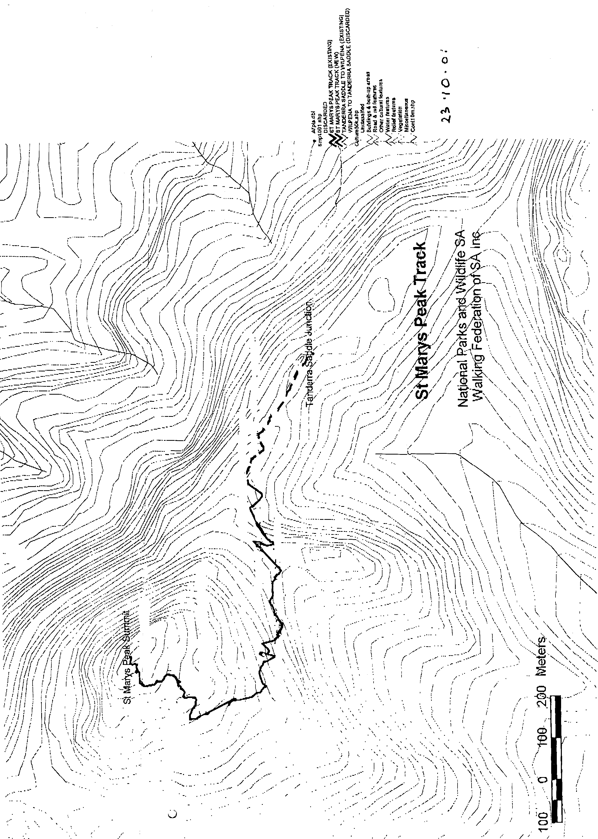
The use of the trail is conditional upon members of the public following the directions designated by signs erected by the National Parks and Wildlife Service of South Australia outlining the path available for public use.
Dated 27 May 2002.

G. Leaman, Director, National Parks and Wildlife SA

CANCELLATION OF PETROLEUM EXPLORATION LICENCE PEL 85
Office of Minerals and Energy Resources, Adelaide, 28 May 2002
NOTICE is hereby given that the abovementioned Petroleum Exploration Licence was cancelled under the provisions of the Petroleum Act 2000, pursuant to delegated powers dated 28 March 2002, gazetted 11 April 2002, page 1573.
B. A. Goldstein, Director Petroleum, Office of Minerals and Energy Resources, Delegate of the Minister for Mineral Resources Development
No. of Licence | Licensee | Locality | Date of Cancellation | Area in km² | Reference
85 | Eoil Pty Ltd | Otway Basin of South Australia | 28 May 2002 | 151 | 27/2/157
Description of Area
All that part of the State of South Australia, bounded as follows: Commencing at a point being the intersection of latitude 36°57′00″S AGD66 and longitude 140°00′00″E AGD66, thence east to longitude 140°06′00″E AGD66, south to latitude 36°58′00″S AGD66, east to longitude 140°07′00″E AGD66, south to latitude 36°59′00″S AGD66, east to longitude 140°14′00″E AGD66, south to latitude 37°01′00″S AGD66, east to longitude 139°58′30″E AGD66, north to latitude 37°00′00″S AGD66, west to longitude 139°55′00″E AGD66, north to latitude 36°57′30″S AGD66, east to longitude 140°00'00″E AGD66 and north to point of commencement.
Area: 151 km² approximately.

RAIL SAFETY ACT 1996
Fees Payable by Accredited Railway Owners and Operators and Owners of Registered Private Railway Sidings
I, MICHAEL JOHN WRIGHT, the Minister for Transport, pursuant to sections 21 and 22 of the said Act, do hereby fix the following fees.
Dated 3 June 2002.
M. J. Wright, Minister for Transport

Effective 1 July 2002
Schedule of Fees
Fees Payable by Accredited Railway Owners and Operators and Owners of Registered Private Railway Sidings
Application Fees
No fee payable.
Annual Fee—Commercial Railway Owners and Operators
An accredited person shall pay annual accreditation fees according to their accreditation category or categories.
A person accredited as both an owner and an operator shall pay an annual fee equal to the total of both the owner and operator annual fee. A person accredited as both a Category 4 owner and a Category 4 operator shall pay a maximum combined annual fee of $5 210.
For temporary accreditation the amount payable shall be based on the estimated annual fee proportionally adjusted on a pro rata basis to reflect the actual number of weeks, or part thereof, that the accreditation will remain in force. A minimum fee of $104 applies for temporary accreditation.
Commercial Railway Owner and Operator Annual Fee:
Accreditation  Category | Owner  Annual Fee  $ | Operator  Annual Fee  $
1 | 28 962 | 28 962
2 | 19 308 | 19 308
3 | 9 654 | 9 654
4  (minimum fee) | 5 210 | 5 210

Annual Fee—Not-for-Profit Heritage/Tourist Owners and Operators
No fee payable.
Annual Fee—Owner of a Registered Private Siding
No fee payable.
Fee for Late Payment of Annual Fees
Where payment of fees is made after the due date, then payment must be accompanied by a late payment fee of 5 per cent of the amount outstanding on the due date.
Commercial Railway Owner and Operator Accreditation Category
Historical information, where available, will be used for the purpose of determining the Accreditation Category. Where historical information is not available, a projected assessment will be used.
Owner Criteria
Track Owned  (Main Line Kilometres) | Accreditation  Category
Greater than 1 000 | 1
Greater than 500 up to 1 000 | 2
Greater than 50 up to 500 | 3
From 0 to 50 and/or passenger or freight terminal/marshalling yard owner, or rail infrastructure maintainer only | 4

Operator Criteria
Train Kilometres Operated  (Main Line) | Accreditation  Category
(including train kilometres operated as a hook-and-pull provider)
Greater than 3 million per annum | 1
Greater than 1 million up to 3 million per annum | 2
Greater than 50 000 up to 1 million per annum | 3
Up to 50 000 per annum, or rolling stock maintainer and/or provider only, or train operator which only contracts other accredited operators to hook-and-pull its trains | 4

ROADS (OPENING AND CLOSING) ACT 1991:
SECTION 24
NOTICE OF CONFIRMATION OF ROAD
PROCESS ORDER
Public Road/Avoca Street, Goolwa
Deposited Plan 59635
BY Road Process Order made on 18 March 2002, the Alexandrina Council ordered that:
1. Portion of the public road adjacent Avoca Street adjoining the western boundary of allotment 71 in Deposited Plan 14 more particularly lettered ‘A’ in Preliminary Plan No. PP01/0704 be closed.
2. The whole of the land subject to closure be transferred to CHRISTIAN EDWIN FOLLAS in accordance with agreement for transfer dated 3 December 2001 entered into between the Alexandrina Council and C. E. Follas.
On 22 May 2002, that order was confirmed by the Minister for Administrative Services conditionally on approval and deposit of the survey plan by the Registrar-General. The condition has now been fulfilled.
Pursuant to section 24 (5) of the Roads (Opening and Closing) Act 1991, NOTICE of the order referred to above and its confirmation is hereby given.
Dated 6 June 2002.
P. M. Kentish, Surveyor-General

GRANT OF SPECULATIVE SURVEY LICENCE SSL 4
Office of Minerals and Energy Resources, Adelaide, 3 May 2002
NOTICE is hereby given that the undermentioned Speculative Survey Licence has been granted under the provisions of the Petroleum Act 2000, pursuant to delegated powers dated 28 March 2002, gazetted 11 April 2002, page 1573.
B. A. Goldstein, Director Petroleum, Office of Minerals and Energy Resources, Delegate of the Minister for Mineral Resources Development
No. of Licence | Licensee | Locality | Date of Expiry | Area in km² | Reference
4 | Origin Energy Resources Limited;  Lakes Oil NL;  Victoria Petroleum NL;  Mirboo Ridge Pty Ltd | Otway Basin of South Australia | 2 May 2003 | 196 | SR 27/2/241
Description of Area
All that part of the State of South Australia, bounded as follows: Commencing at a point being the intersection of latitude 37°40′00″S GDA94 and longitude 140°31′00″E GDA94, thence east to longitude 140°45′00″E GDA94, south to latitude 37°44′00″S GDA94, west to longitude 140°44′00″E GDA94, north to latitude 37°43′00″S GDA94, west to longitude 140°41′00″E GDA94, north to latitude 37°42′30″S AGD66, west to longitude 140°32′30″E AGD66, south to latitude 37°45′30″S AGD66, east to longitude 140°37′30″E AGD66, south to latitude 37°50′00″S GDA94, west to longitude 140°31′00″E GDA94, and north to point of commencement.
Area: 196 km² approximately.

SURVEY ACT 1992
Designated Survey Areas
PURSUANT to section 49 (1) (b) of the Survey Act 1992, I declare that from 6 September 2002:
• designated survey area number 3 is revoked; and
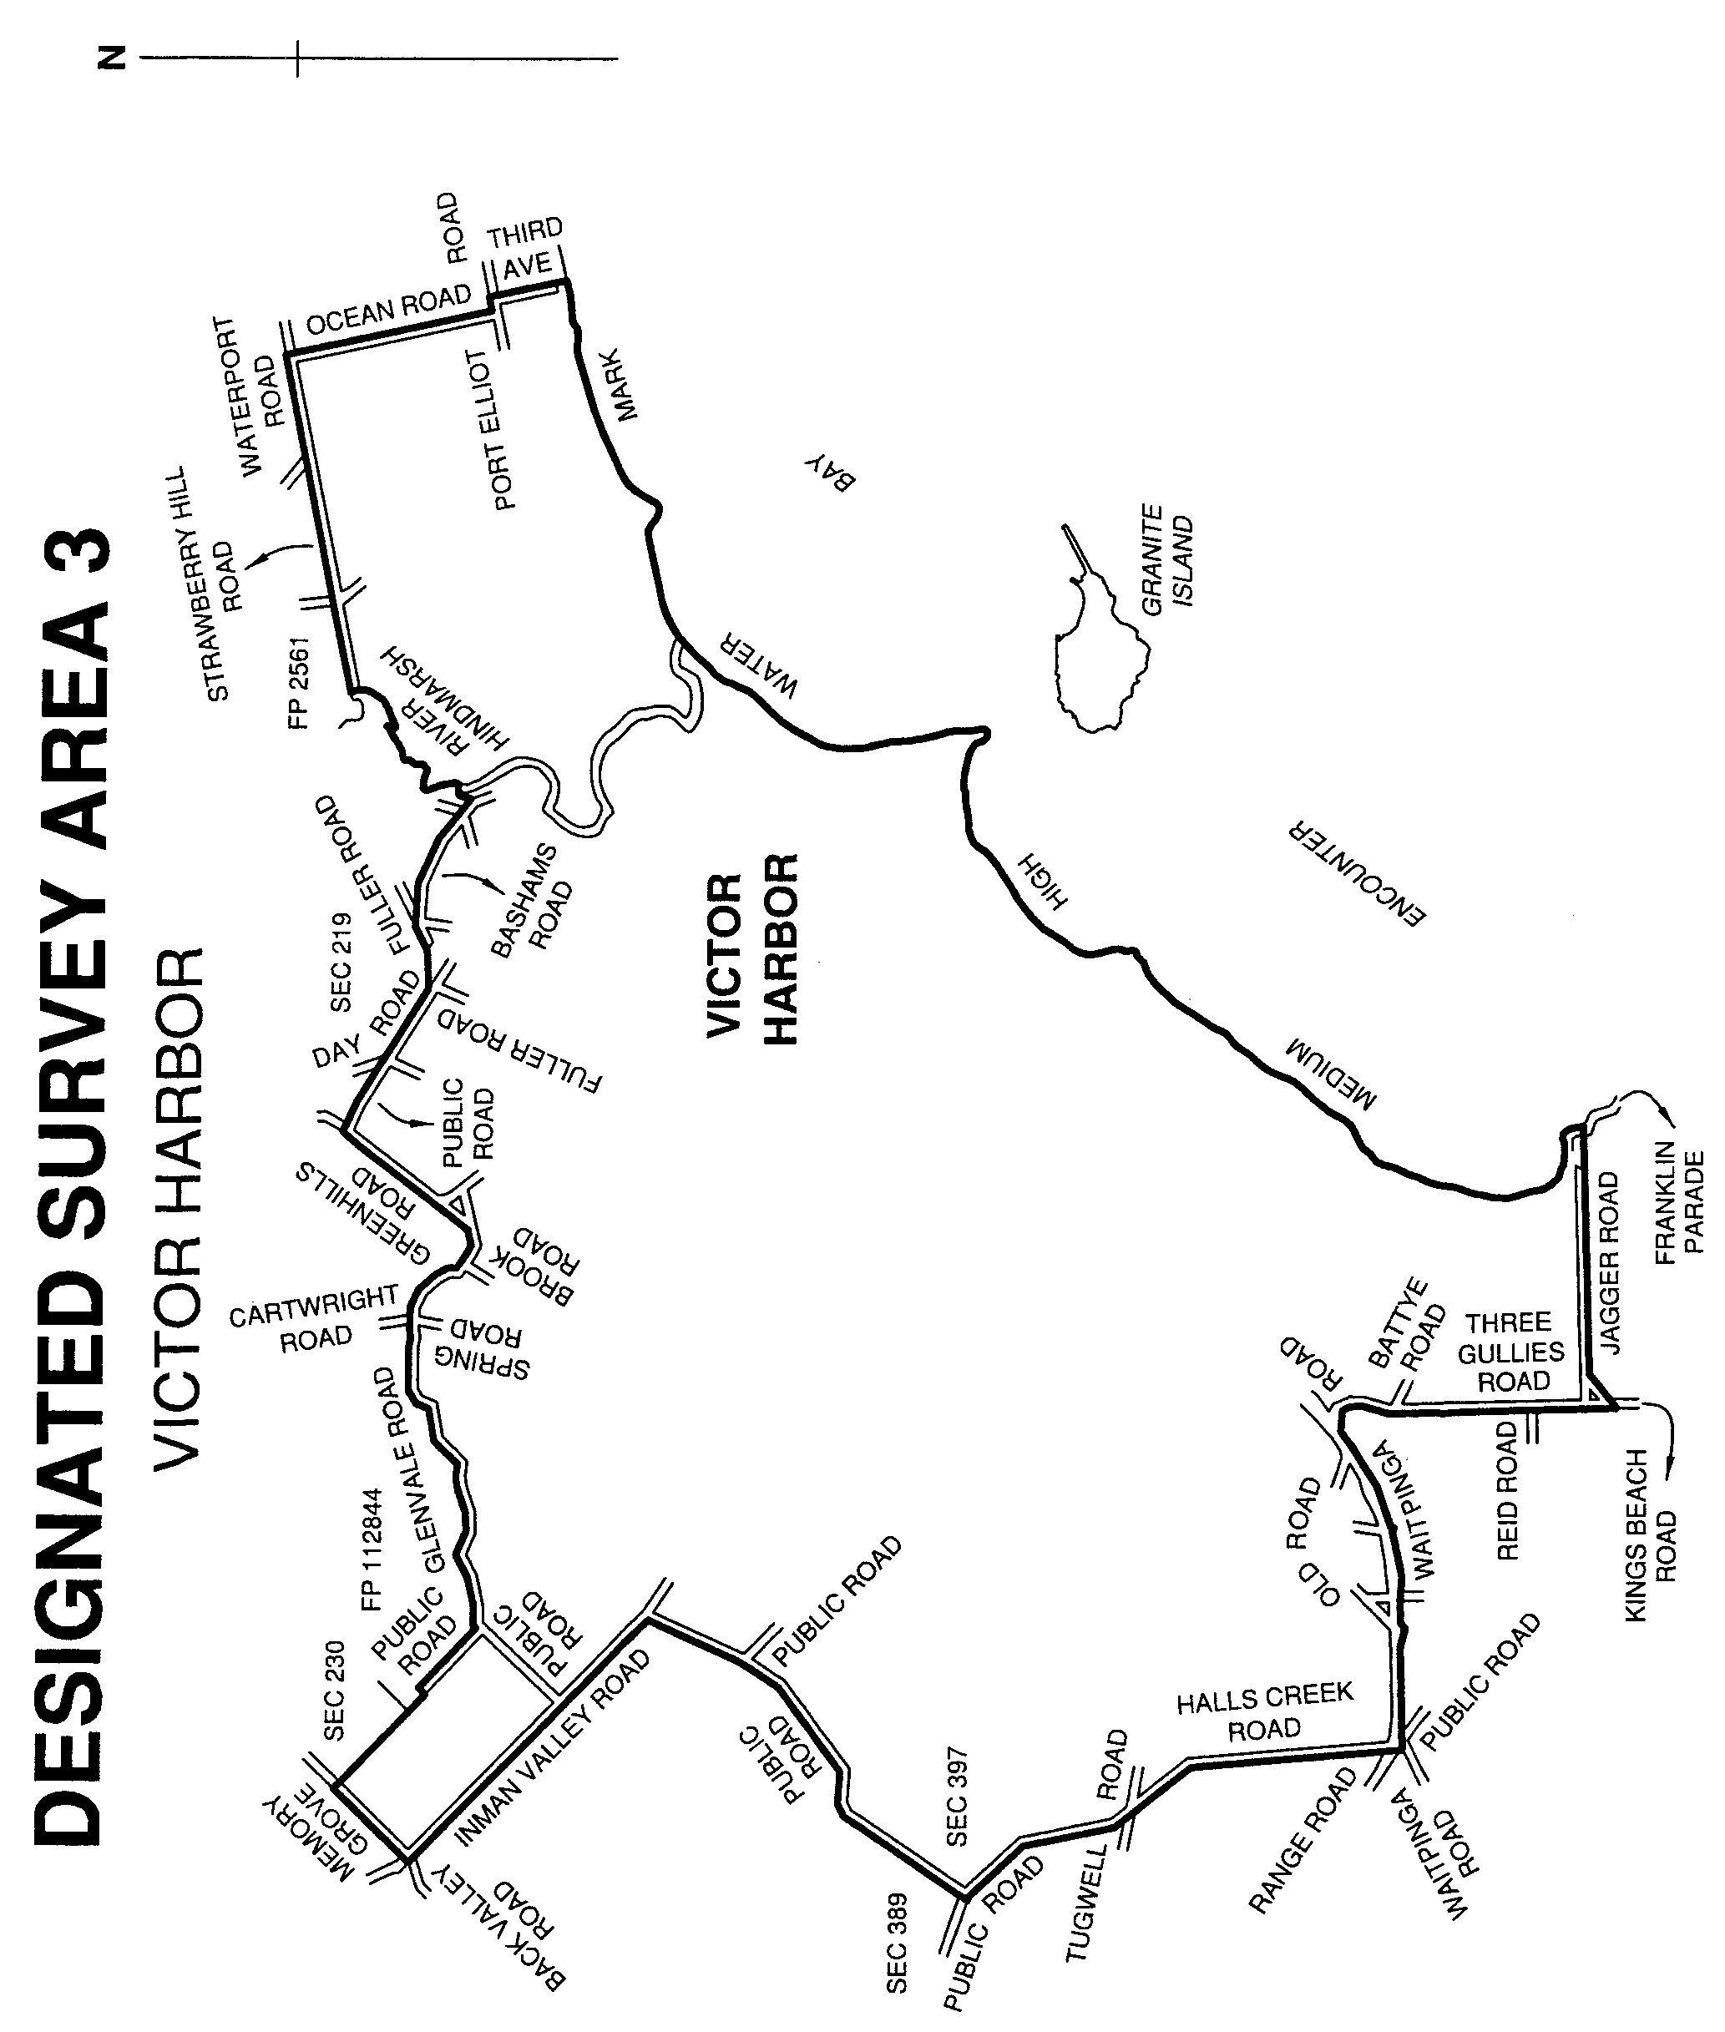
• the following areas of the State, numbered 3, 121, 128, 129, 130, 131, 132, 133, 134 and 135 outlined in black on the following plans, are to be designated survey areas.

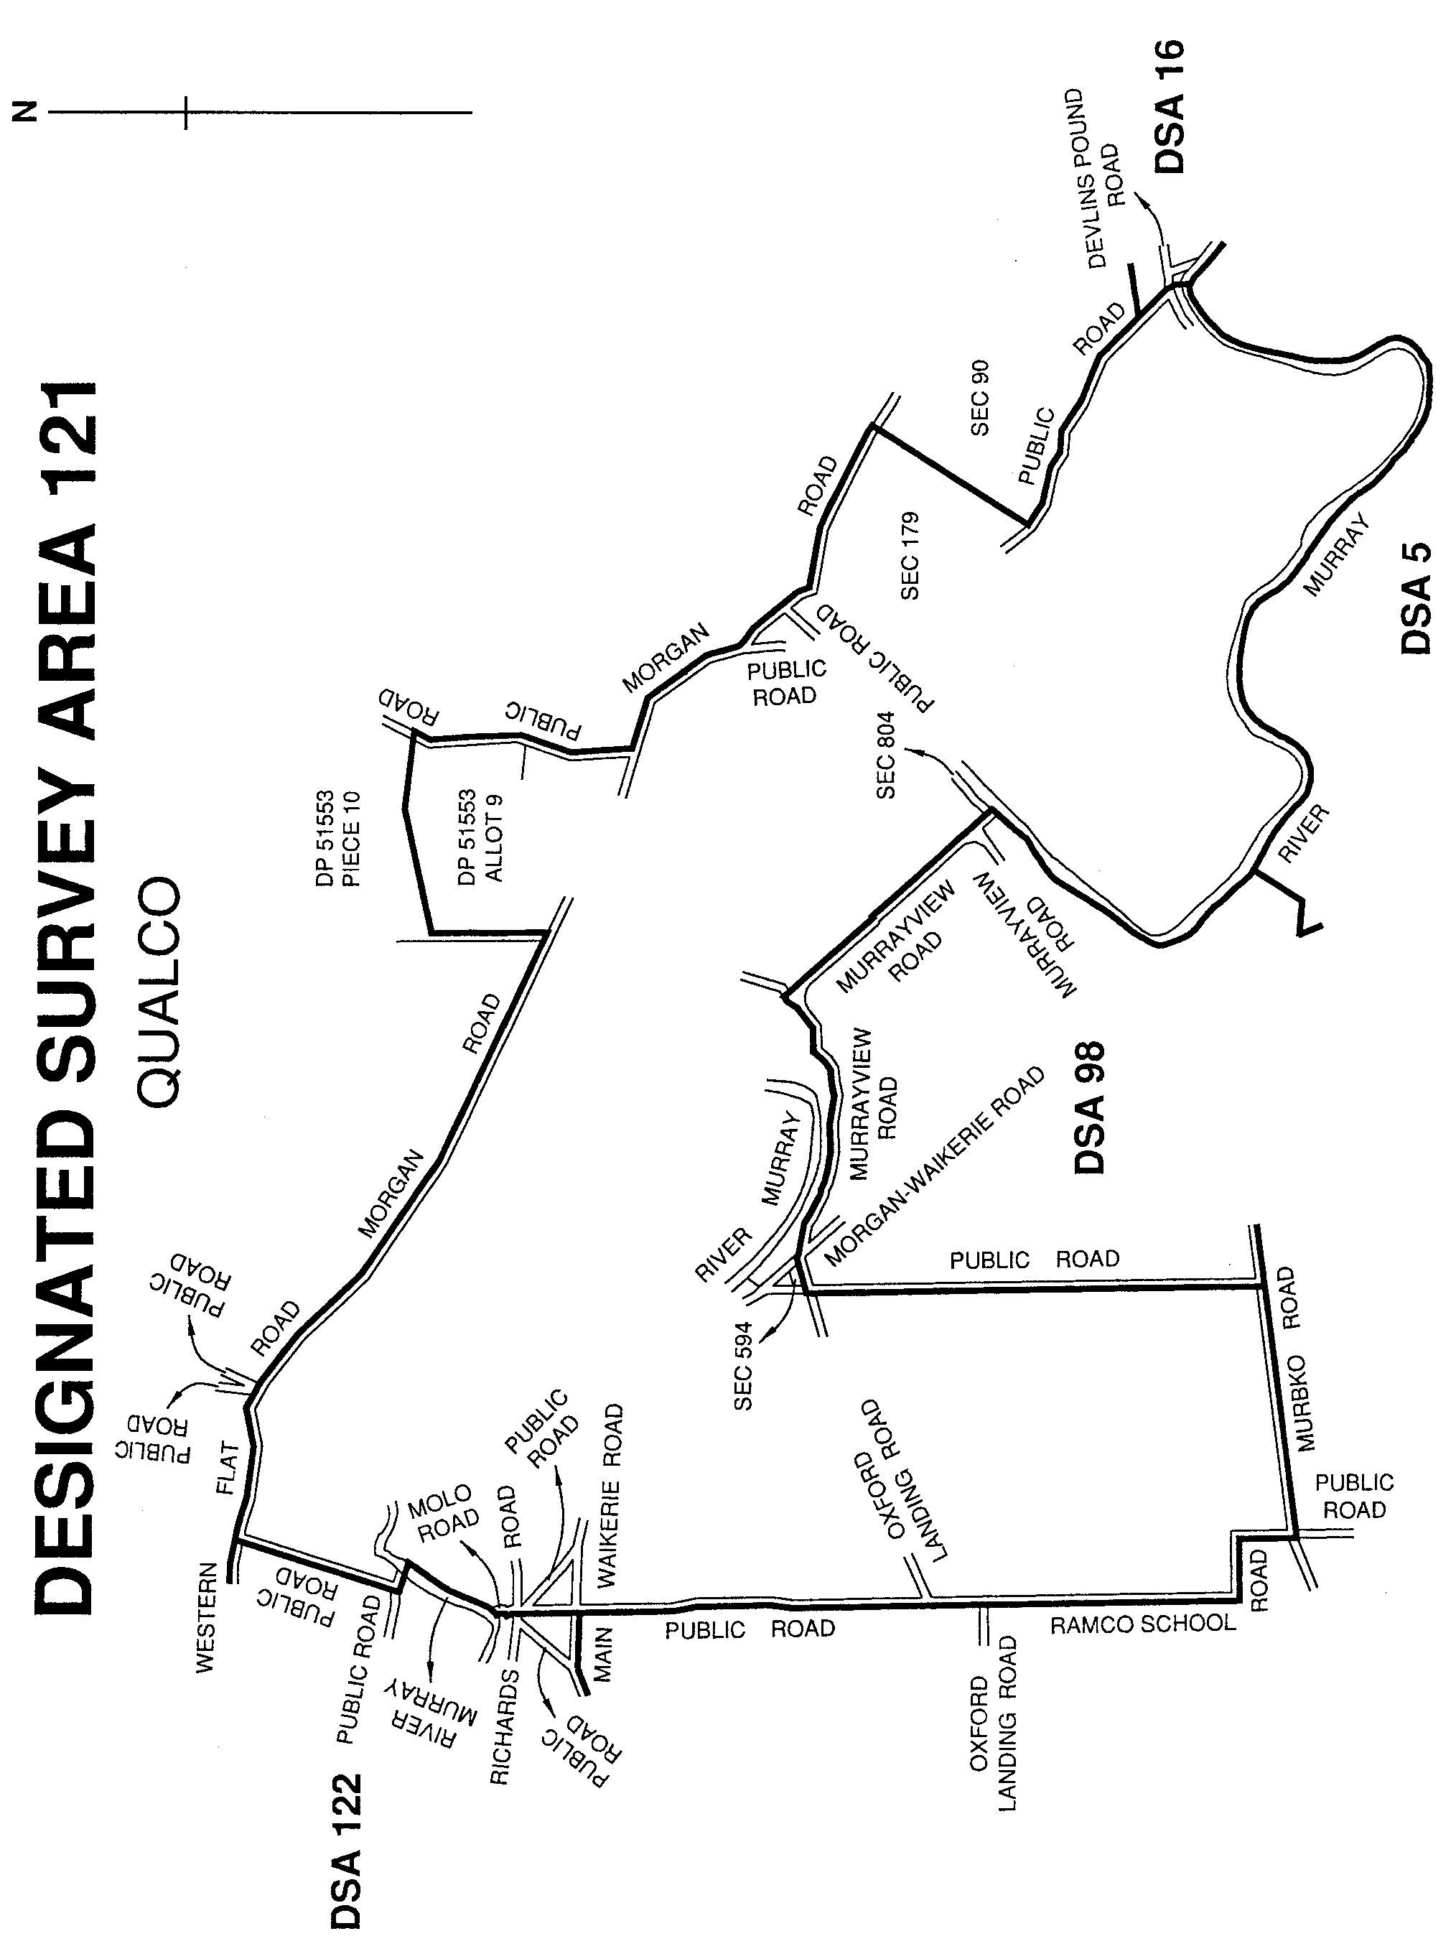
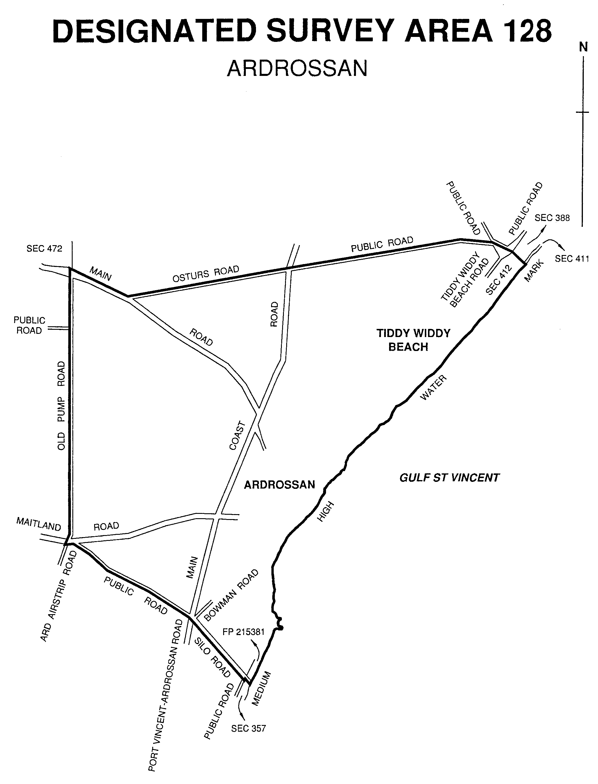

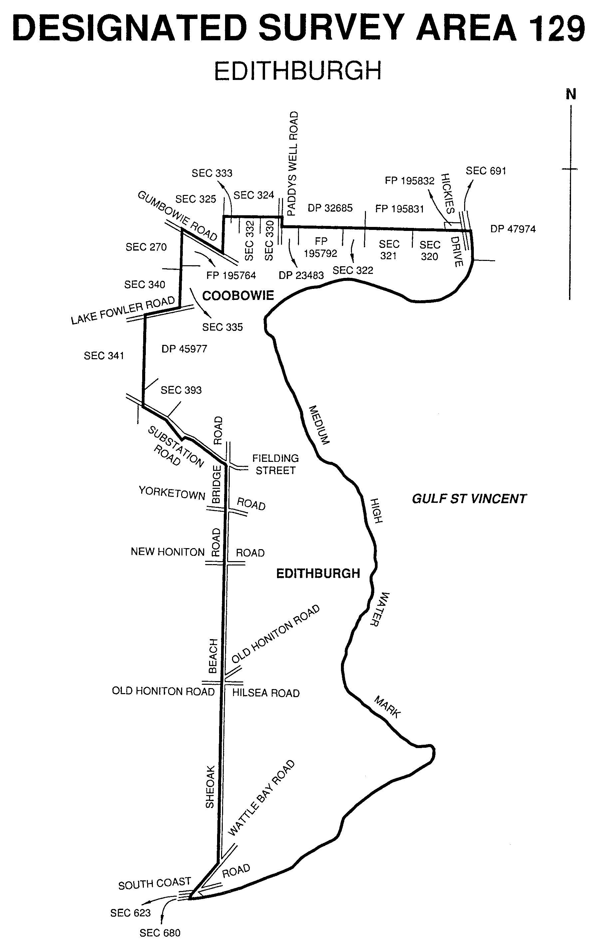
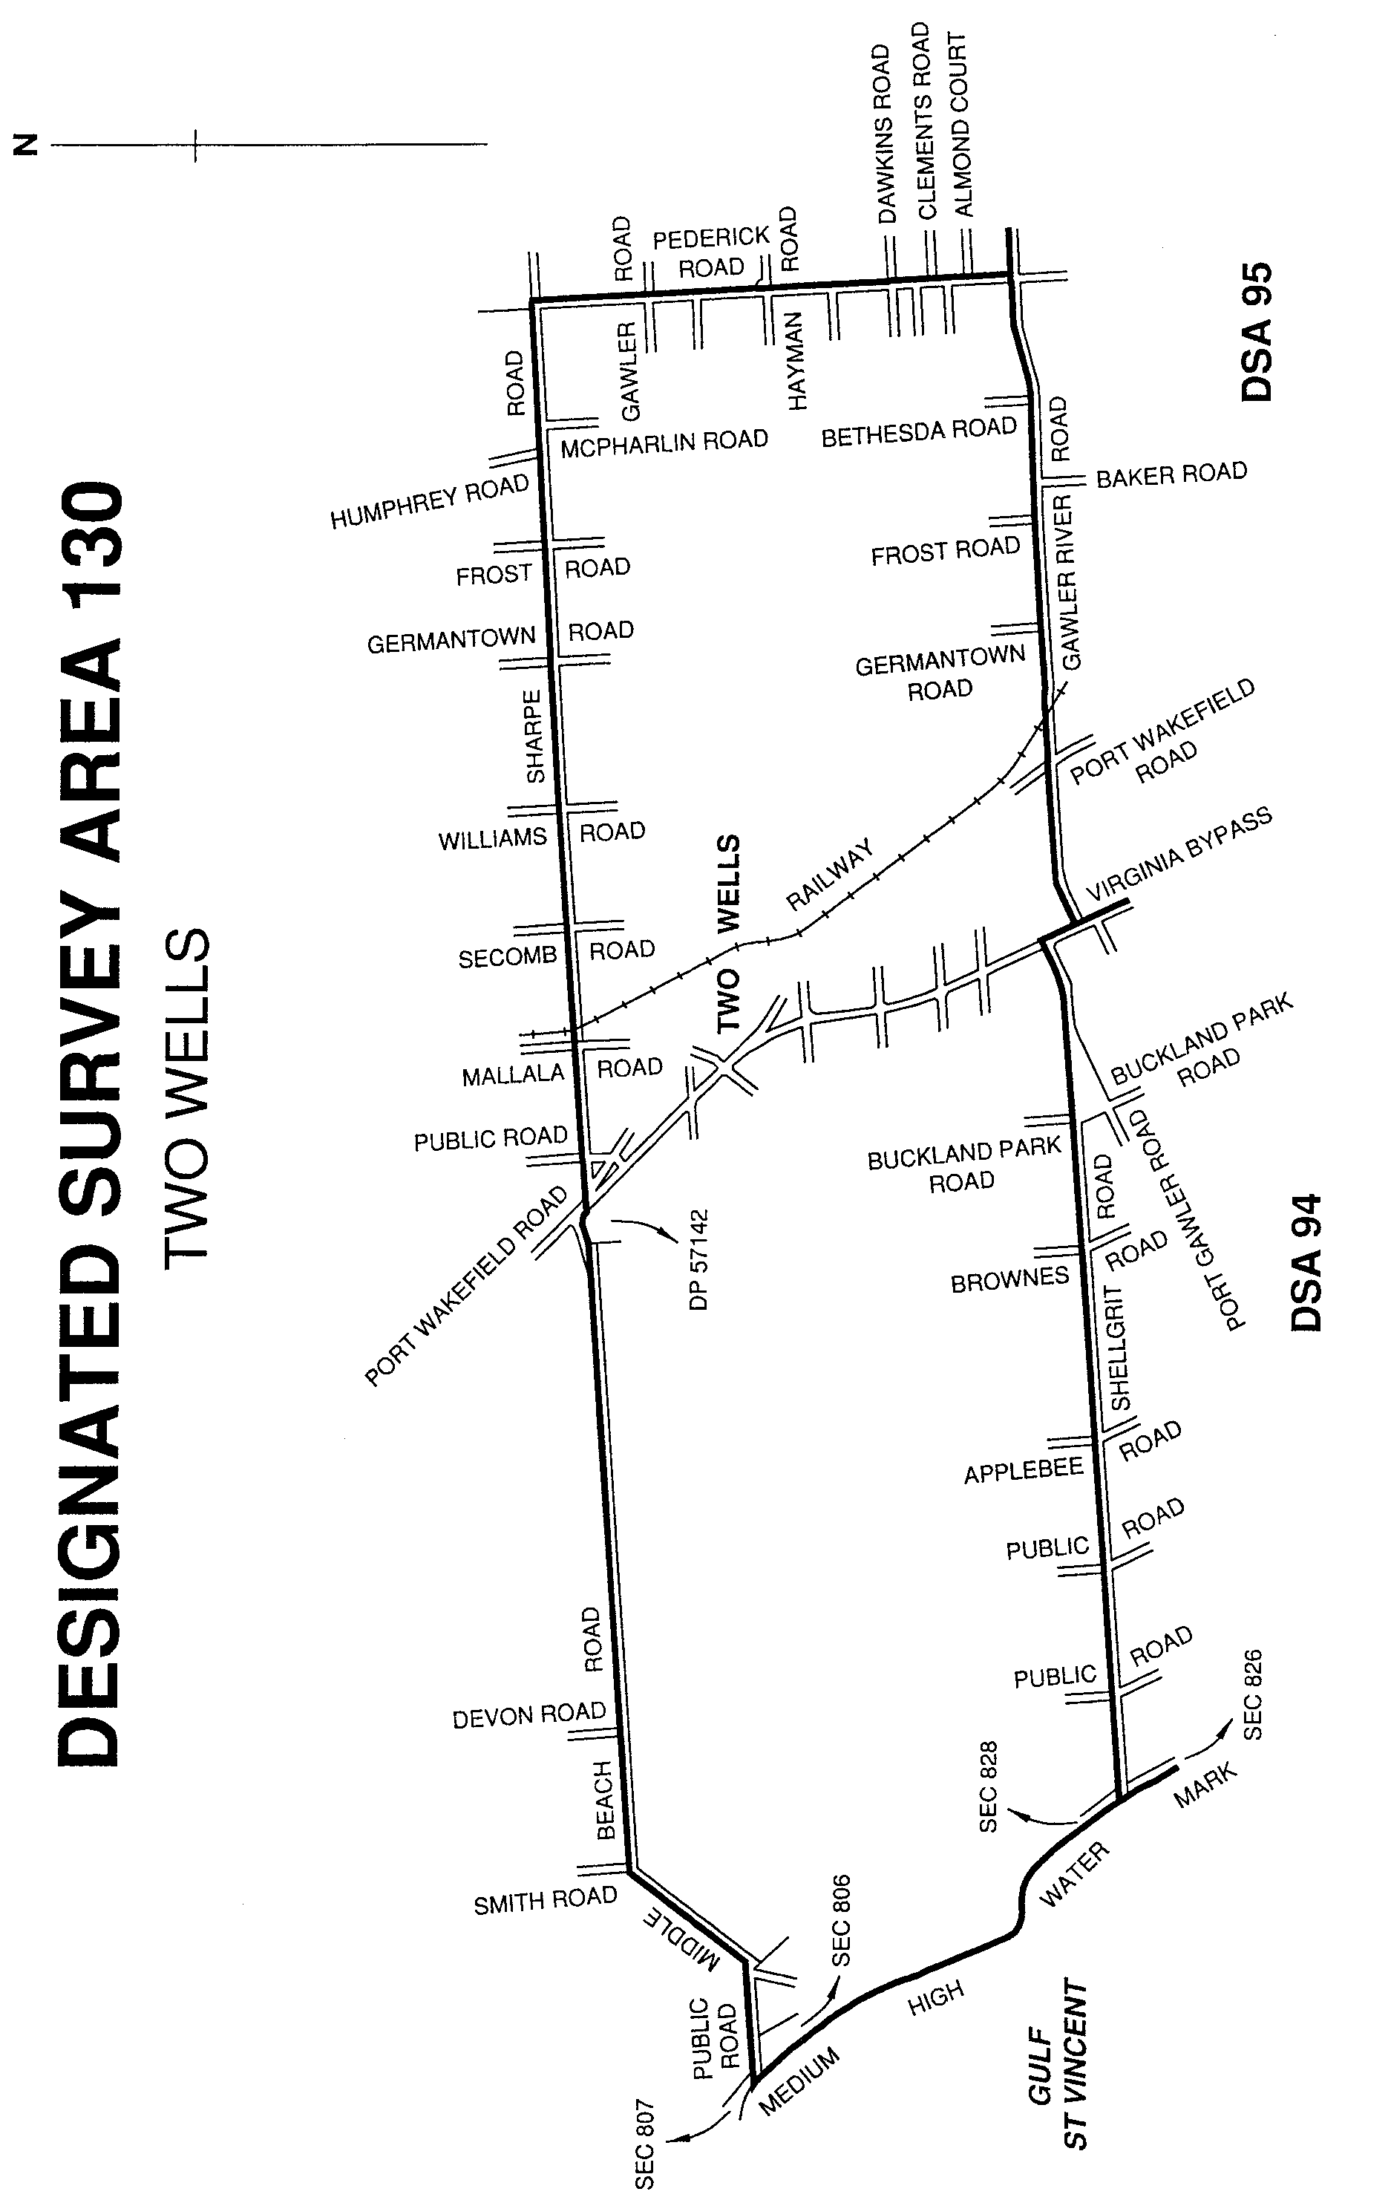
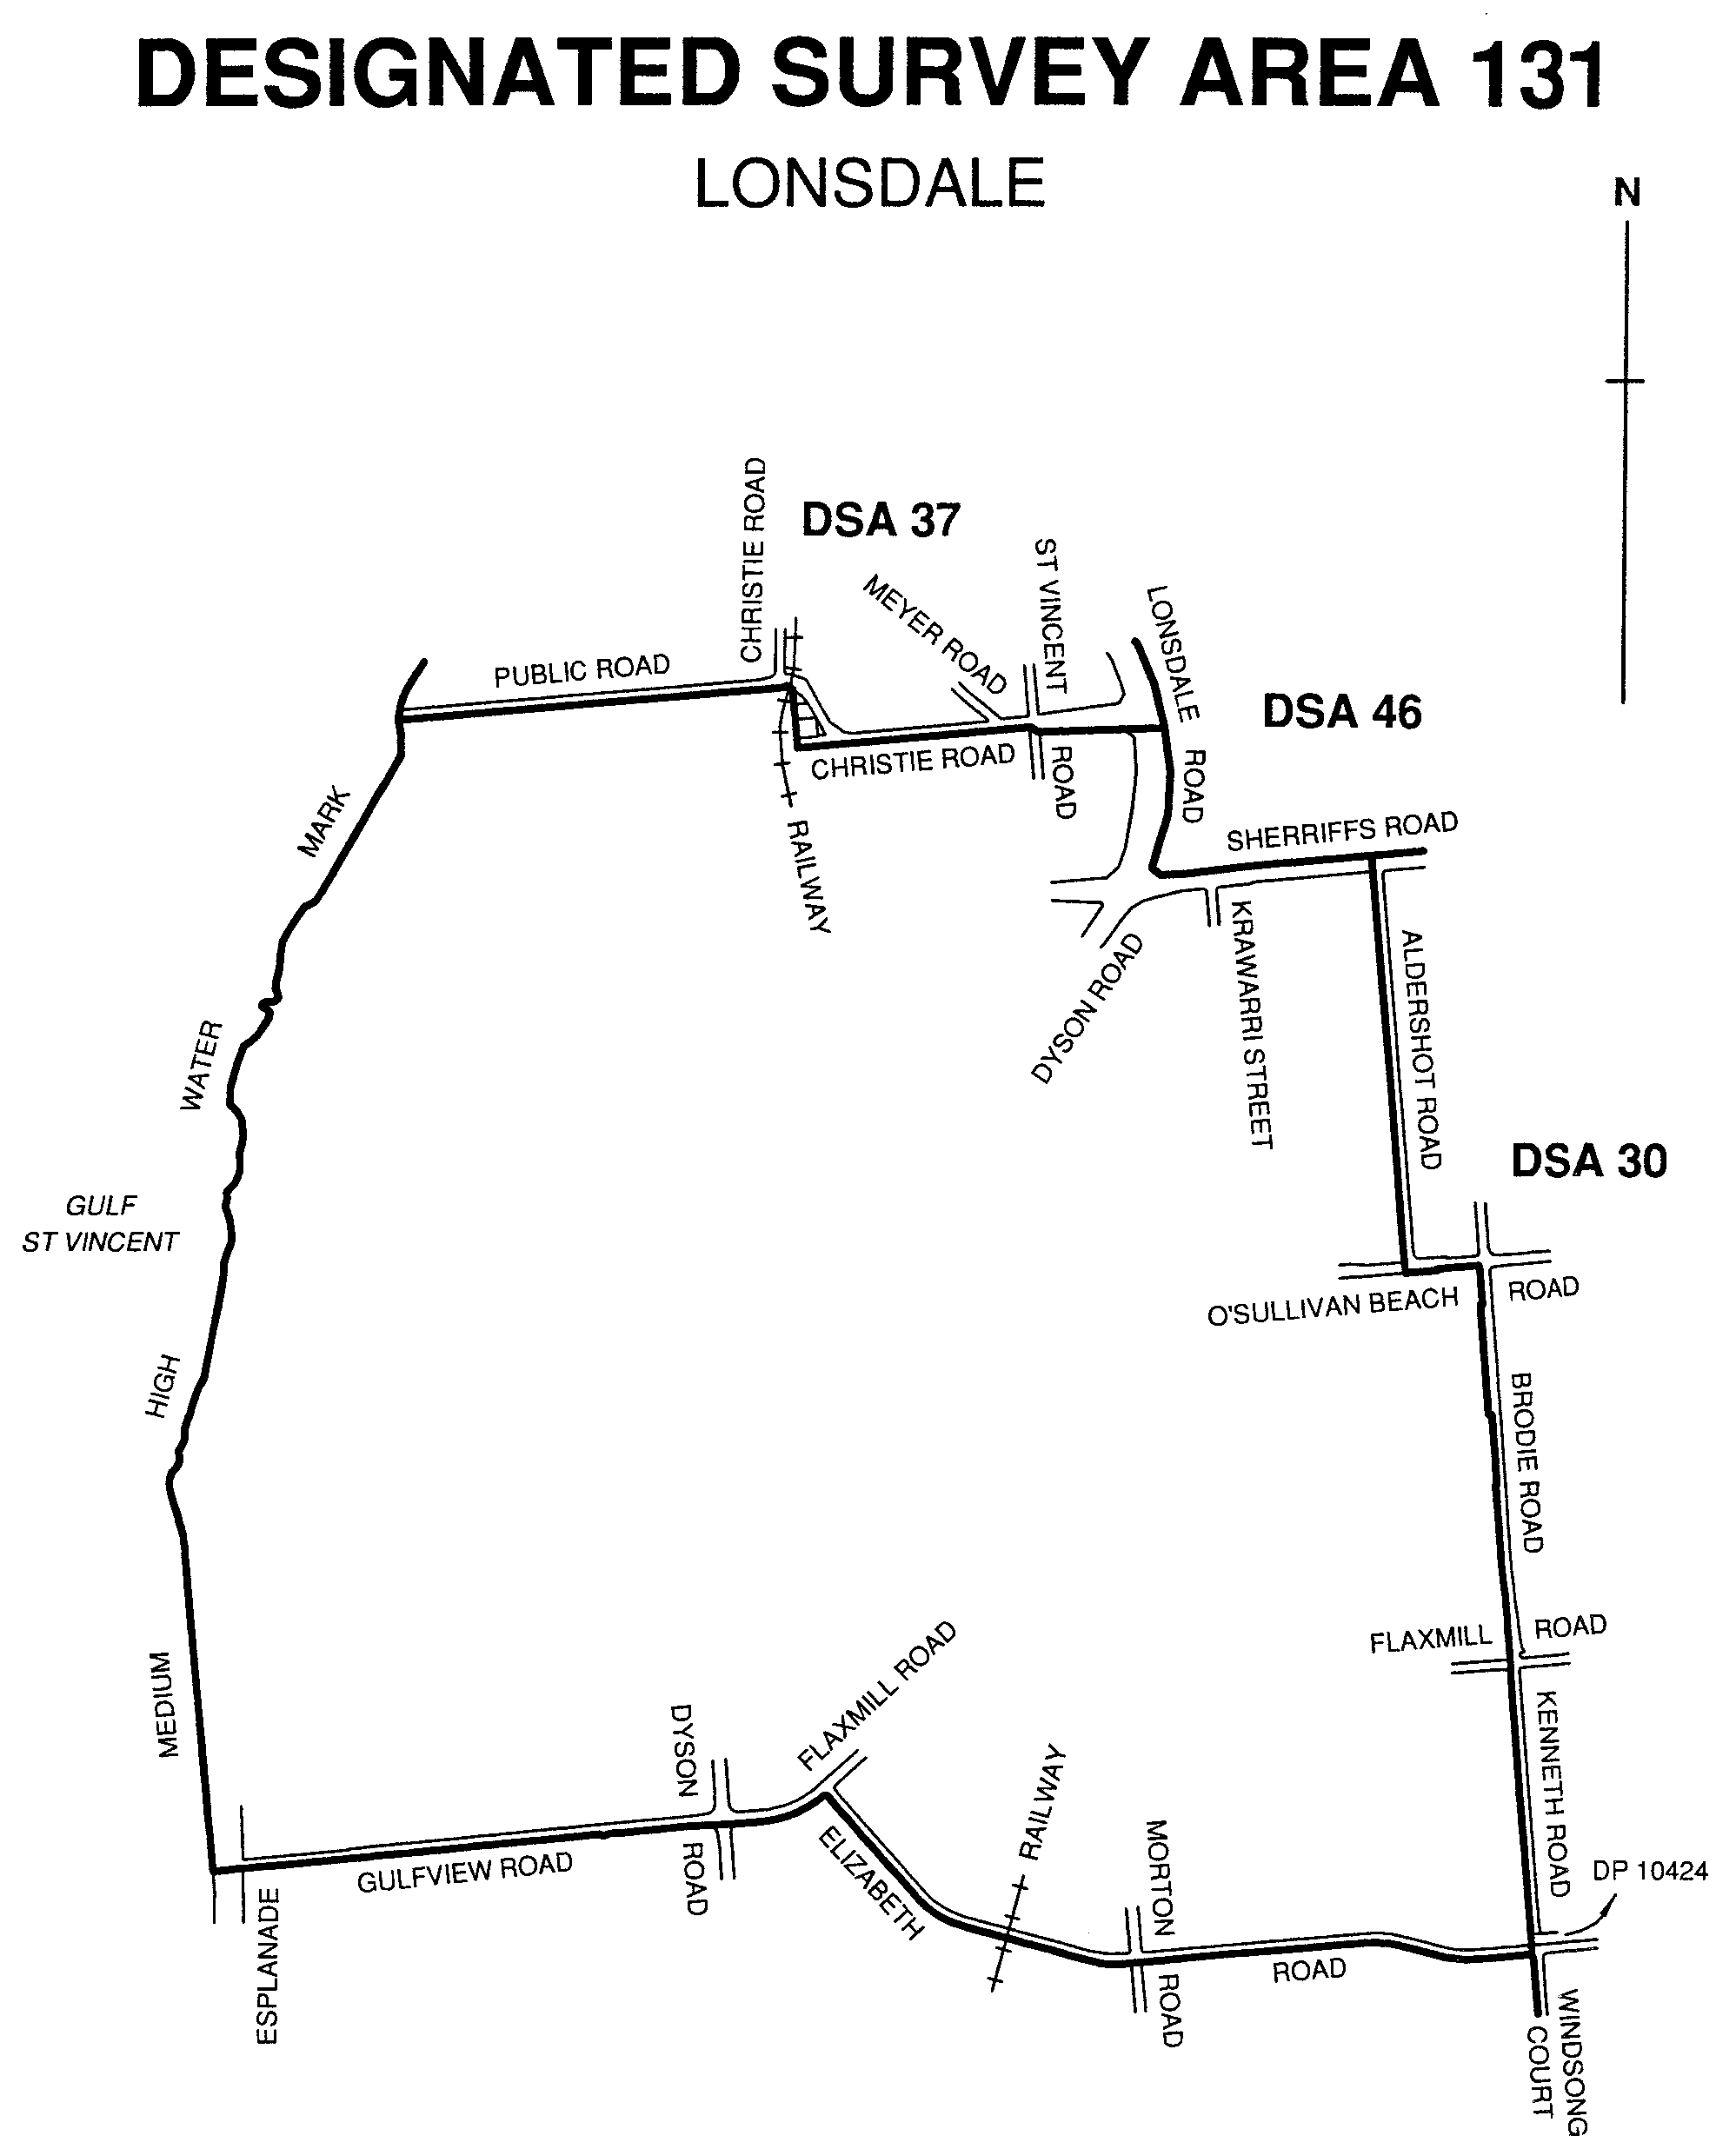
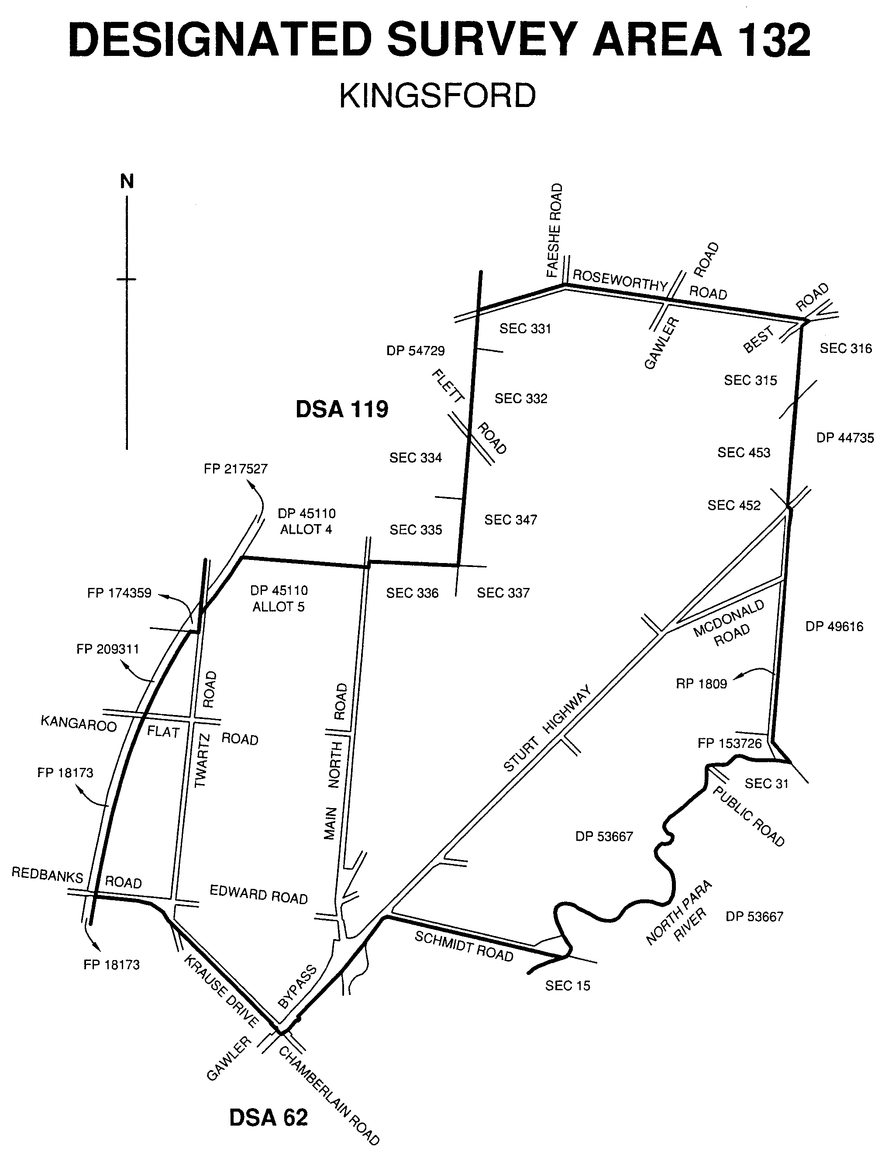
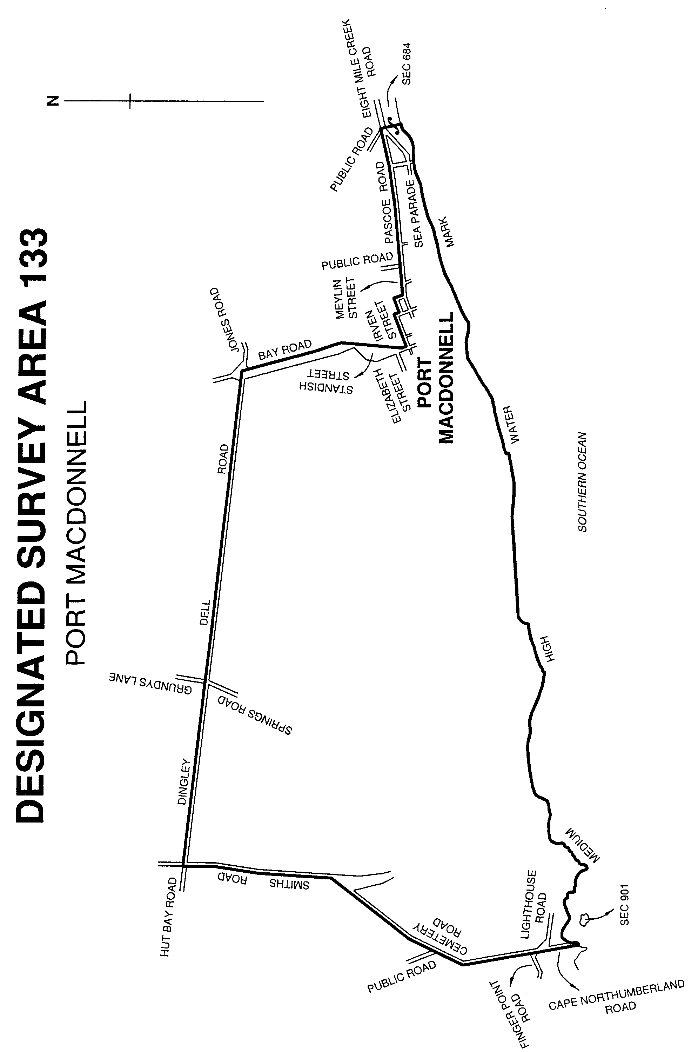
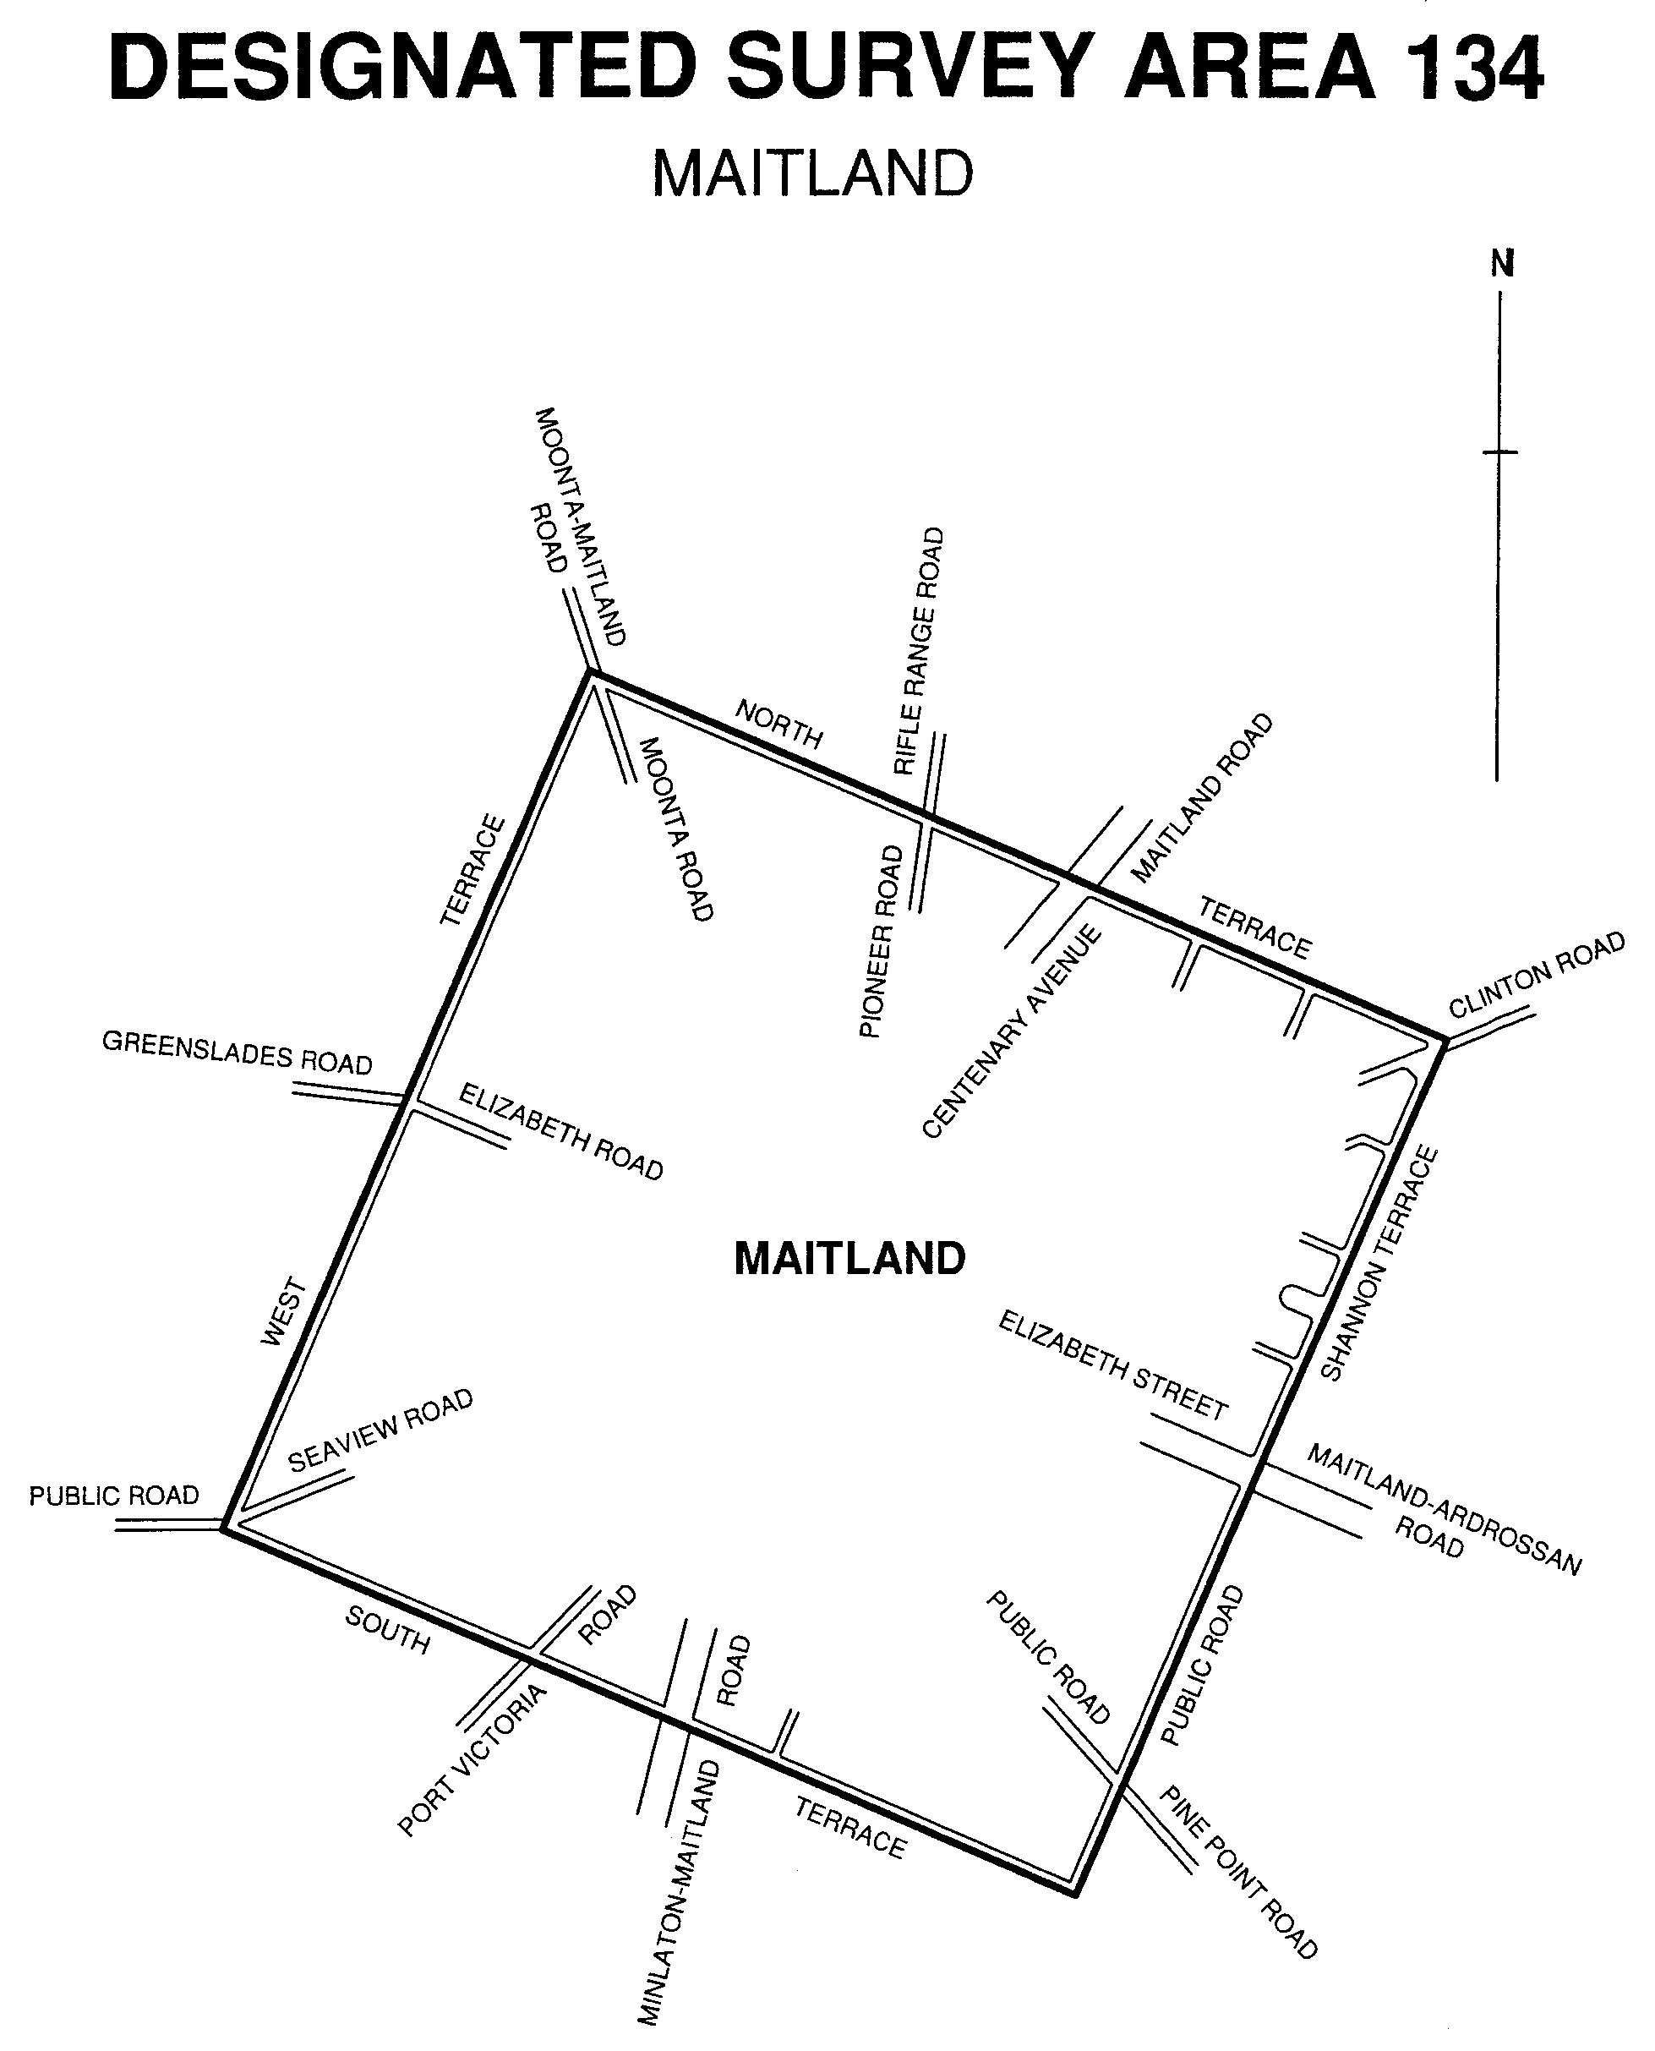

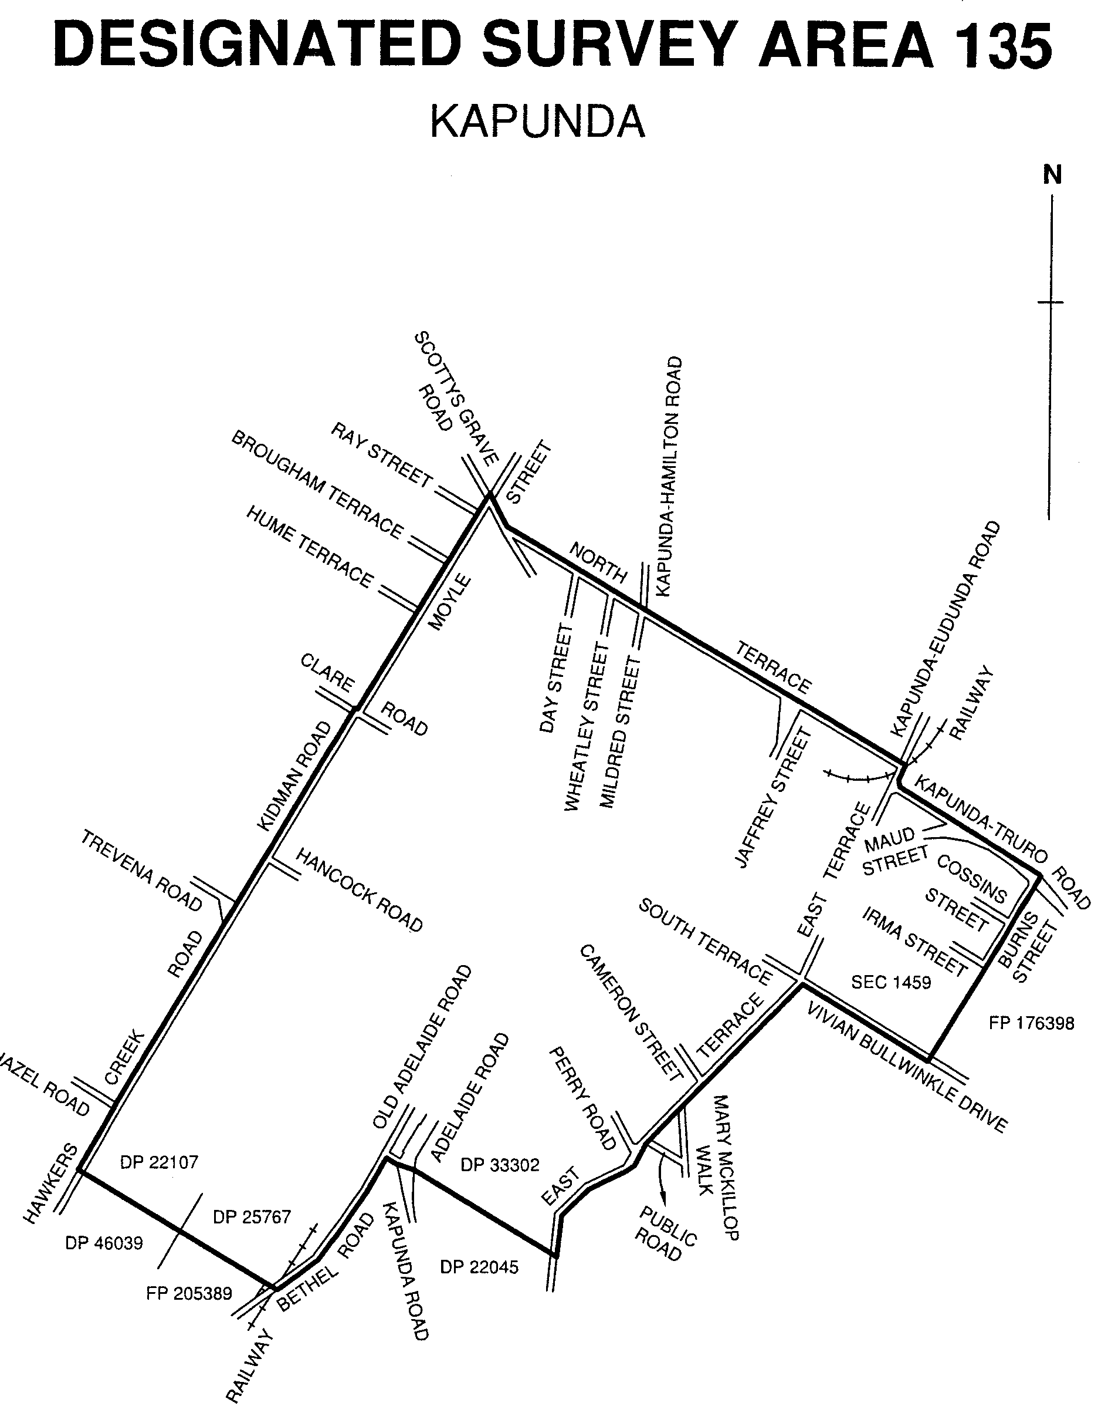
Dated 6 June 2002.
P. Kentish, Surveyor-General

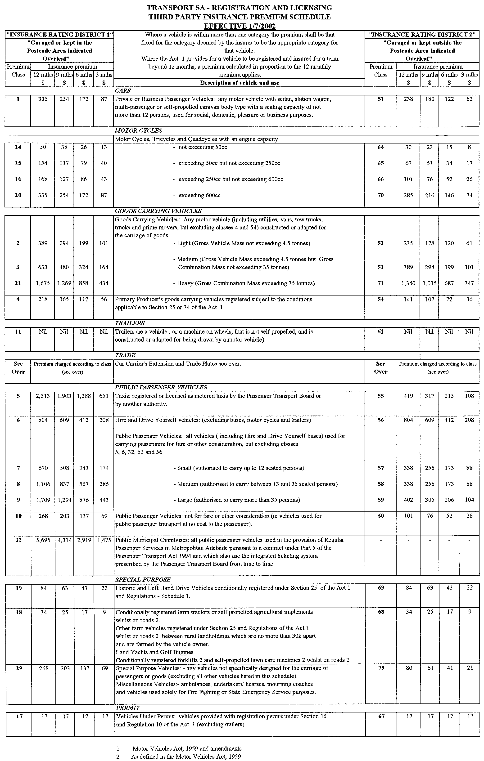
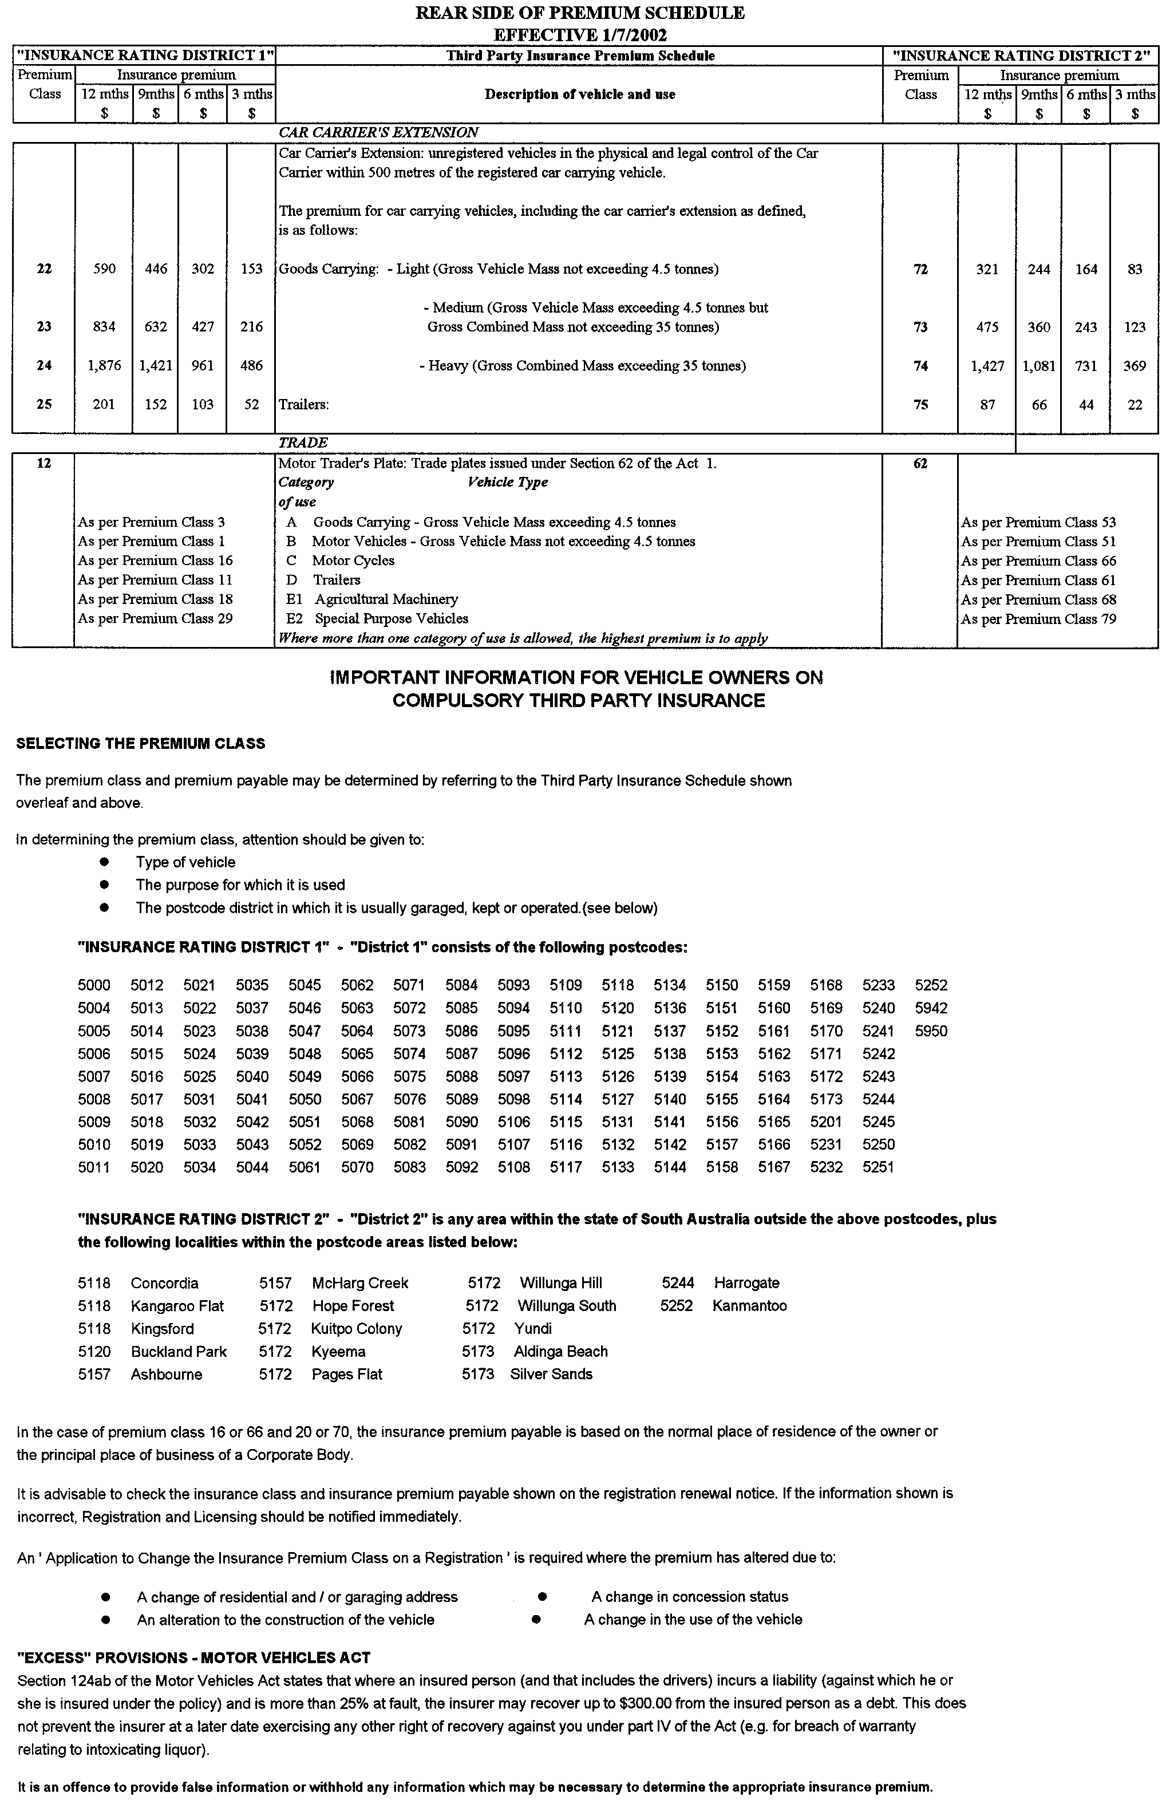
REGULATIONS UNDER THE PUBLIC CORPORATIONS ACT 1993
────
No. 38 of 2002
────
At the Executive Council Office at Adelaide, 6 June 2002

PURSUANT to the Public Corporations Act 1993 and with the advice and consent of the Executive Council, I make the following regulations.
MARJORIE JACKSON-NELSON, Governor

PURSUANT to section 10AA(2) of the Subordinate Legislation Act 1978, I certify that, in my opinion, it is necessary or appropriate that the following regulations come into operation as set out below.

K. FOLEY, Treasurer
───────────────────
SUMMARY OF PROVISIONS

1. Citation
2. Commencement
3. Dissolution and transfer of assets and liabilities of Funds SA Subsidiary Holding Corporation
4. Revocation
───────────────────

Citation
1. These regulations may be cited as the Public Corporations (Funds SA Subsidiary Holding Corporation Dissolution) Regulations 2002.

Commencement
2. These regulations come into operation on the day on which they are made.

Dissolution and transfer of assets and liabilities of Funds SA Subsidiary Holding Corporation
3. (1) Funds SA Subsidiary Holding Corporation established by regulation under the Public Corporations Act 1993 is dissolved.

(2) The assets and liabilities of Funds SA Subsidiary Holding Corporation immediately before its dissolution are transferred to and vested in or attached to Superannuation Funds Management Corporation of South Australia.

Revocation
4. The Public Corporations (Funds SA Subsidiary Holding Corporation) Regulations 1998 (see Gazette 18 June 1998 p. 2607) are revoked.

T&F02/025 CS R. DENNIS, Clerk of the Council

REGULATIONS UNDER THE HARBORS AND NAVIGATION ACT 1993
────
No. 39 of 2002
────
At the Executive Council Office at Adelaide, 6 June 2002

PURSUANT to the Harbors and Navigation Act 1993 and with the advice and consent of the Executive Council, I make the following regulations.
MARJORIE JACKSON-NELSON, Governor

PURSUANT to section 10AA(2) of the Subordinate Legislation Act 1978, I certify that, in my opinion, it is necessary or appropriate that the following regulations come into operation as set out below.

M. J. WRIGHT, Minister for Transport
───────────────────
SUMMARY OF PROVISIONS

1. Citation
2. Commencement
3. Variation of Sched. 3A
───────────────────

Citation
1. The Harbors and Navigation Regulations 1994 (see Gazette 20 October 1994 p. 987), as varied, are referred to in these regulations as "the principal regulations".

Commencement
2. These regulations will come into operation on the day on which they are made.

Variation of Sched. 3A
3. Schedule 3A of the principal regulations is varied by inserting before the entry relating to Klein Point the following entry:

Ardrossan-The subjacent land underlying, and adjacent land extending from, the waters, rivers, creeks and inlets to high water mark of that portion of the western coast of Gulf St. Vincent bounded as follows:

Commencing at a point on high water mark distant 0.5 nautical miles north north-easterly of the centre line of the BHP jetty; then by a line bearing 106°25' T to its intersection with eastern boundary of the harbor of Ardrossan; then by the boundary of the harbor of Ardrossan generally south south-westerly, west north-westerly, north north-easterly (along high water mark) to the point of commencement.

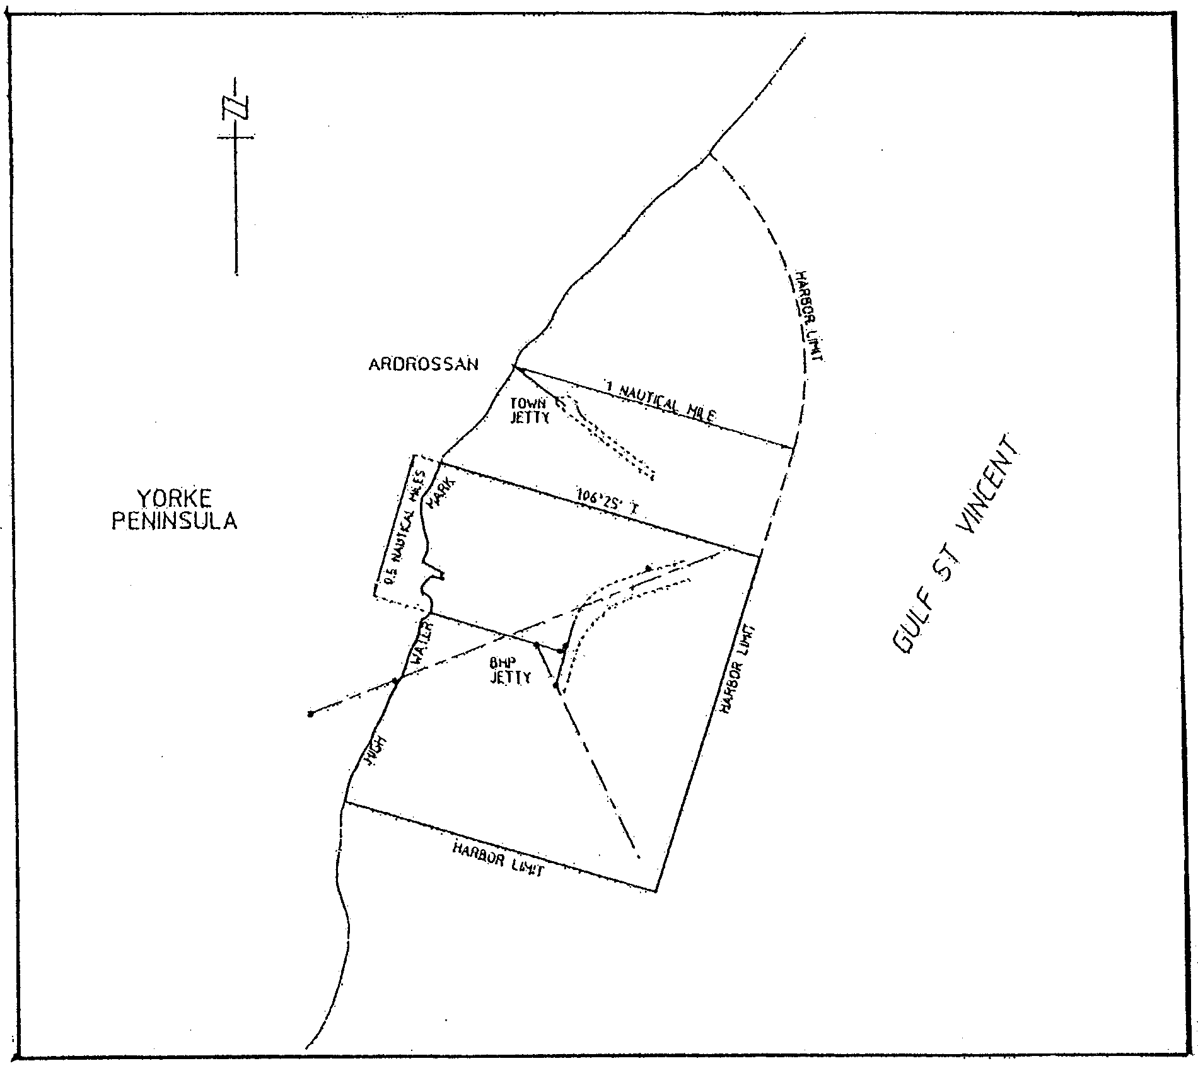

R. DENNIS, Clerk of the Council

REGULATIONS UNDER THE FISHERIES ACT 1982
────
No. 40 of 2002
────
At the Executive Council Office at Adelaide, 6 June 2002

PURSUANT to the Fisheries Act 1982 and with the advice and consent of the Executive Council, I make the following regulations.
MARJORIE JACKSON-NELSON, Governor

PURSUANT to section 10AA(2) of the Subordinate Legislation Act 1978, I certify that, in my opinion, it is necessary or appropriate that the following regulations come into operation as set out below.

PAUL HOLLOWAY, Minister for Agriculture, Food and Fisheries
───────────────────
SUMMARY OF PROVISIONS

1. Citation
2. Commencement
3. Variation of reg. 4—Interpretation
4. Variation of reg. 9—Registration of devices for commercial use
5. Variation of Sched. 1—Fishing activities of a prescribed class for the purposes of s. 41 of the Act
6. Variation of Sched. 2—Areas in which use of fish nets is prohibited (Sched. 1, cl.30)
7. Variation of Sched. 5—Fees (reg. 27)
8. Variation of Sched. 9—Expiation of offences (reg. 32)
───────────────────

Citation
1. The Fisheries (General) Regulations 2000 (see Gazette 31 August 2000 p. 1235), as varied, are referred to in these regulations as "the principal regulations".

Commencement
2. These regulations come into operation on the day on which they are made.

Variation of reg. 4—Interpretation
3. Regulation 4 of the principal regulations is varied—

(a) by striking out from the definition of "permitted device" in subregulation (1) "set line, drum net," and "scallop dredge,";

(b) by striking out from paragraph (b) of the definition of "sand crab pot" in subregulation (1) "400" and substituting "450".

Variation of reg. 9—Registration of devices for commercial use
4. Regulation 9 of the principal regulations is varied—

(a) by striking out subregulation (2) and substituting the following subregulations:

(2) An application for registration of a device to which this regulation applies must be made in writing in a form approved by the Director.

(2a) The Director may not register a device unless the applicant has paid—

(a) the registration fee (if any) specified in Schedule 5; or

(b) the first instalment of the registration fee, in accordance with subregulation (2b).

(2b) A registration fee may be paid by four equal instalments payable on or before the date of grant of registration and 1 October, 1 January and 1 April following the date of grant.

(2c) If an instalment of a registration fee is not paid in full within 21 days after the due date for payment, an additional amount equal to 10 per cent of the amount of the instalment is payable.

(2d) If—

(a) an instalment of a registration fee is not paid in full on or before the due date; or

(b) an additional amount is required to be paid for late payment of an instalment of a registration fee,

the amount unpaid may be recovered from the holder of the licence pursuant to which the registered device may be used or the person who last held the licence as a debt due to the Crown.

Variation of Sched. 1—Fishing activities of a prescribed class for the purposes of s. 41 of the Act
5. Schedule 1 of the principal regulations is varied—

(a) by striking out clause 9;

(b) by striking out paragraph (a) of clause 10;

(c) by striking out paragraph (a) of clause 15;

(d) by striking out clause 16 and substituting the following clause:

16. (1) The taking of fish by an unlicensed person in Lake George by using, at any one time—

(a) more than two mesh nets; or

(b) more than one hand net.

(2) In subclause (1)—

"mesh net" means a mesh net that—

(a) is not more than 75 metres in length; and

(b) has a mesh size of at least 7 centimetres.;

(e) by striking out clauses 52, 104 and 112;

(f) by striking out clauses 118, 119 and 120 and substituting the following clause:

118. (1) The taking of fish by an unlicensed person in a fishing reach—

(a) by trolling; or

(b) by using a device other than a rod and line, hand line, shrimp net, shrimp trap or yabbie pot; or

(c) by using a shrimp trap or yabbie pot that is not set from the shore.

(2) The reference in subclause (1) to a fishing reach does not include a reference to the waters of the reach that are not part of the mainstream of the River Murray.;

(g) by striking out clauses 126, 127 and 128 and substituting the following clause:

126. The taking of scallop (Family Pectinidae) by a licensed person in the waters of the State by using a scallop dredge.;

(h) by striking out from clause 131 "any person" and substituting "a licensed person";

(i) by striking out clause 133;

(j) by striking out from clause 134 "drum net,".

Variation of Sched. 2—Areas in which use of fish nets is prohibited (Sched. 1, cl. 30)
6. Schedule 2 of the principal regulations is varied by striking out the description of waters under the heading "Denial Bay and Smoky Bay" and substituting the following description:

All waters landward of a line defined by the geodesic joining Point Brown (latitude 32°32'35"S, longitude 133°50'50"E) to the southern most point of the Franklin Island group (latitude 32°28'20"S, longitude 133°37'50"E), then to Point Bell (latitude 32°12'31"S, longitude 133°07'36"E) (AGD 66).

Variation of Sched. 5—Fees (reg. 27)
7. Schedule 5 of the principal regulations is varied by striking out clause 8.

Variation of Sched. 9—Expiation of offences (reg. 32)
8. Schedule 9 of the principal regulations is varied—

(a) by striking out the item relating to clause 9 of Schedule 1 of the principal regulations;

(b) by striking out the items relating to clauses 52, 104 and 112 of Schedule 1 of the principal regulations;

(c) by striking out the items relating to clauses 118, 119 and 120 of Schedule 1 of the principal regulations and substituting the following items:

118(1)(a) Taking fish in fishing reach by trolling (recreational) $100

118(1)(b) Taking fish in fishing reach using certain devices (recreational) $100

118(1)(c) Taking fish in fishing reach using shrimp trap or yabbie pot
not set from shore (recreational) $50;

(d) by striking out the items relating to clauses 126, 127 and 128 of Schedule 1 of the principal regulations and substituting the following item:

126 Taking scallop using scallop dredge (commercial) $200;

(e) by inserting after "specifications" in the description of the offence in the item relating to clause 131 of Schedule 1 of the principal regulations "(commercial)";

(f) by striking out the item relating to clause 133 of Schedule 1 of the principal regulations.

MAFF02/0009CS R. DENNIS, Clerk of the Council

REGULATIONS UNDER THE CHIROPODISTS ACT 1950
────
No. 41 of 2002
────
At the Executive Council Office at Adelaide, 6 June 2002

PURSUANT to the Chiropodists Act 1950, on the recommendation of The Chiropody Board of South Australia and with the advice and consent of the Executive Council, I make the following regulations.

MARJORIE JACKSON-NELSON, Governor

PURSUANT to section 10AA(2) of the Subordinate Legislation Act 1978, I certify that, in my opinion, it is necessary or appropriate that the following regulations come into operation as set out below.

LEA STEVENS, Minister for Health
───────────────────
SUMMARY OF PROVISIONS

1. Citation
2. Commencement
3. Variation of reg. 18—Fees
───────────────────

Citation
1. The Chiropodists Regulations 1989 (see Gazette 16 February 1989 p. 475), as varied, are referred to in these regulations as "the principal regulations".

Commencement
2. These regulations will come into operation on 1 July 2002.

Variation of reg. 18—Fees
3. Regulation 18 of the principal regulations is varied by striking out "165.00" twice occurring and substituting, in each case, "170.00".

CAB/MGR/0002 R. DENNIS, Clerk of the Council

REGULATIONS UNDER THE FEES REGULATION ACT 1927
────
No. 42 of 2002
────
At the Executive Council Office at Adelaide, 6 June 2002

PURSUANT to the Fees Regulation Act 1927 and with the advice and consent of the Executive Council, I make the following regulations.
MARJORIE JACKSON-NELSON, Governor
───────────────────
SUMMARY OF PROVISIONS

1. Citation
2. Commencement
3. Variation of reg. 4—Fee payable for Proof of Age Card
───────────────────

Citation
1. The Proof of Age Card Fees Regulations 1996 (see Gazette 30 May 1996 p. 2750) are referred to in these regulations as "the principal regulations".

Commencement
2. These regulations will come into operation in accordance with section 5 of the Fees Regulation Act 1927.

Variation of reg. 4—Fee payable for Proof of Age Card
3. Regulation 4 of the principal regulations is varied by striking out "$20.00" and substituting "$21.00".

CTSA2002/0150T/T1 R. DENNIS, Clerk of the Council

REGULATIONS UNDER THE MOTOR VEHICLES ACT 1959
────
No. 43 of 2002
────
At the Executive Council Office at Adelaide, 6 June 2002

PURSUANT to the Motor Vehicles Act 1959 and with the advice and consent of the Executive Council, I make the following regulations.
MARJORIE JACKSON-NELSON, Governor

PURSUANT to section 10AA(2) of the Subordinate Legislation Act 1978, I certify that, in my opinion, it is necessary or appropriate that the following regulations come into operation as set out below.

M. J. WRIGHT, Minister for Transport
───────────────────
SUMMARY OF PROVISIONS

1. Citation
2. Commencement
3. Variation of Sched. 5—Fees
4. Transitional provision
───────────────────

Citation
1. The Motor Vehicles Regulations 1996 (see Gazette 30 May 1996 p. 2751), as varied, are referred to in these regulations as "the principal regulations".

Commencement
2. These regulations come into operation on the day on which they are made.

Variation of Sched. 5—Fees
3. Schedule 5 of the principal regulations is varied—

(a) by striking out from clause 1 "$10.00" and "$20.00" and substituting, respectively, "$11.00" and "$21.00";

(b) by striking out from clause 2(1)(b)(ii) "$44.00" and substituting "$45.00";

(c) by striking out from clause 2(1)(b)(iii) "$75.00" and substituting "$76.00";

(d) by striking out from clause 2(1)(b)(iv)(A) "$75.00", "$151.00" and "$221.00" and substituting, respectively, "$76.00", "$154.00" and "$226.00";

(e) by striking out from clause 2(1)(b)(iv)(B) "$165.00" and substituting "$169.00";

(f) by striking out from clause 2(1)(b)(iv)(C) "$280.00" and substituting "$287.00";

(g) by striking out from clause 2(1)(b)(v)(A) "$75.00" and substituting "$76.00";

(h) by striking out from clause 2(1)(b)(v)(B) "$151.00" and substituting "$154.00";

(i) by striking out from clause 2(1)(b)(v)(C) "$221.00" and substituting "$226.00";

(j) by striking out from clause 18(1)(a) "$11.00" and substituting "$11.50";

(k) by striking out from clause 18(1)(b) "$11.00" and substituting "$11.50";

(l) by striking out from clause 18(1)(c) "$22.00" and substituting "$23.00";

(m) by striking out from clause 23(b)(i) "$31.00" and substituting "$32.00";

(n) by striking out from clause 23(b)(ii) "$70.00" and substituting "$73.00";

(o) by striking out from clause 24(a)(i) "$76.00" and substituting "$79.00";

(p) by striking out from clause 24(a)(ii) "$67.00" and substituting "$70.00";

(q) by striking out from clause 25(a)(i) "$43.00" and substituting "$44.00";

(r) by striking out from clause 25(b)(i) "$3 725.00" and substituting "$3 880.00";

(s) by striking out from clause 26 "$287.00" and substituting "$299.00";

(t) by striking out from clause 28(a)(i) "$320.00" and substituting "$333.00";

(u) by striking out from clause 28(b)(i) "$475.00" and substituting "$495.00".

Transitional provision
4. (1) The fees prescribed in respect of the issue or renewal of a driver's licence or registration of a motor vehicle by Schedule 5 of the principal regulations, as varied by these regulations, apply where the issue or renewal is to take effect on or after 1 July 2002.

(2) All other fees prescribed by Schedule 5 of the principal regulations, as varied by these regulations, apply from 1 July 2002.

(3) Despite regulation —

(a) the fees prescribed in respect of the issue or renewal of a driver's licence or registration of a motor vehicle by Schedule 5 of the principal regulations, as in force immediately before the commencement of these regulations, continue to apply where the issue or renewal is to take effect before 1 July 2002; and

(b) all other fees prescribed by Schedule 5 of the principal regulations, as in force immediately before the commencement of these regulations, continue to apply until 1 July 2002.

CTSA2002/0150T/T1 R. DENNIS, Clerk of the Council

FAXING COPY?

IF you fax copy to Government Publishing SA for inclusion in the Government Gazette, there is no need to send a Confirmation Copy to us as well.

This creates confusion and may well result in your notice being printed twice.

Please use the following fax number:

Fax transmission: (08) 8207 1040
Phone Inquiries: (08) 8207 1045

Please include a contact person, phone number and order number so that we can phone back with any queries we may have regarding the fax copy.

NOTE: Closing time for lodging new copy (either fax or hard copy) is 4 p.m. on Tuesday preceding the day of publication.

Government Gazette notices can be E-mailed.

The address is:

governmentgazette@saugov.sa.gov.au

Documents should be sent as attachments in Word format.

When sending a document via E-mail, please confirm your transmission with a faxed copy of your document, including the date the notice is to be published.

Fax transmission: (08) 8207 1040
Enquiries: (08) 8207 1045

CITY OF HOLDFAST BAY
Periodical Review of Elector Representation
NOTICE is hereby given that the City of Holdfast Bay has undertaken a review to determine whether a change of arrangements in respect to elector representation, including the ward structure and the composition of council, would result in the electors within the city being more adequately and fairly represented.
Council has prepared a report that details the review process, the public consultation undertaken and the proposal that it considers, should be implemented. Copies of this report are available from the Brighton Civic Centre, 24 Jetty Road, Brighton, Glenelg Customer Service Centre, Cowper Street, Glenelg, from our web site at www.holdfast.sa.gov.au or by contacting Margaret Gregory on telephone 8229 9911.
Pursuant to the provisions of section 12 (9) of the Local Government Act 1999, interested persons are invited to make a written submission in respect to the report. These should be directed to:
Chief Executive Officer
City of Holdfast Bay
P.O. Box 19
Brighton, S.A. 5048
by close of business 5 p.m. on Friday, 28 June 2002.
Any person making a written submission will be invited to appear before council, or a committee thereof, to be heard in respect to their submission.
S. R. Gawler, Chief Executive Officer

CITY OF MARION
Roads (Opening and Closing) Act 1991
Public Road adjacent Abbeville Terrace, Marion
NOTICE is hereby given, pursuant to section 10 of the Roads (Opening and Closing) Act 1991, that the Corporation of the City of Marion proposes to make a Road Process Order to close and transfer to Noel Gregory Swan portion of the unnamed public road south-east of Abbeville Terrace adjoining the north-western boundaries of Allotment 347 in Deposited Plan 3054, shown more particularly delineated and lettered ‘A’ on Preliminary Plan No. PP02/0046.
A copy of the plan and a statement of persons affected are available for public inspection at the offices of the Council, 245 Sturt Road, Sturt and the Adelaide office of the Surveyor-General during normal office hours.
Any application for easement or objection must set out the full name, address and details of the submission and must be fully supported by reasons.
The application for easement or objection must be made in writing to the Council, P.O. Box 21, Oaklands Park, S.A. 5046 within 28 days of this notice and a copy must be forwarded to the Surveyor-General, G.P.O. Box 1354, Adelaide, S.A. 5001. Where a submission is made, the council will give notification of a meeting at which the matter will be considered.
Dated 3 June 2002.
M. Searle, Chief Executive Officer

CITY OF MARION
Roads (Opening and Closing) Act 1991
Public Walkway adjacent to Braeside Avenue and Karoona Crescent, Seacombe Heights
NOTICE is hereby given, pursuant to section 10 of the Roads (Opening and Closing) Act 1991, that the Corporation of the City of Marion proposes to make a Road Process Order to close the unnamed public walkway between Braeside Avenue and Karoona Crescent adjoining allotments 15 and 14 in Deposited Plan 9529 and allotments 26 and 27 in Deposited Plan 9730, more particularly delineated and lettered ‘A’, ‘B’ and ‘C’ (respectively) in Preliminary Plan No. PP02/0047.
Closed road ‘A’ is to be transferred to Hazel Collins, closed road ‘B’ to be transferred to Graham Michael and Beverley May Rawady, and closed road ‘C’ to be transferred to Mark Kenton Storry and Vida Genevieve Jurys.
A copy of the plan and a statement of persons affected are available for public inspection at the offices of the council, 245 Sturt Road, Sturt and the Adelaide office of the Surveyor-General, 101 Grenfell Street, Adelaide, S.A. 5000 during normal office hours.
Any application for easement or objection must set out the full name, address and details of the submission and must be fully supported by reasons.
The application for easement or objection must be made in writing to the Council, P.O. Box 21, Oaklands Park, S.A. 5046 WITHIN 28 DAYS OF THIS NOTICE and a copy must be forwarded to the Surveyor-General, P.O. Box 1354, Adelaide, S.A. 5000. Where a submission is made, the council will give notification of a meeting at which the matter will be considered.
Dated 3 June 2002.
M. Searle, Chief Executive Officer

CITY OF MITCHAM
Exclusion of Land from Classification of Community Land
NOTICE is hereby given that on 28 May 2002, the City of Mitcham resolved, pursuant to section 193 of the Local Government Act 1999, to exclude a portion of land at 386 Goodwood Road, Cumberland Park, being a portion of land (7 m x 7.5 m), being land comprised in certificate of title 5895/813.
R. Malcolm, Chief Executive Officer

THE RURAL CITY OF MURRAY BRIDGE
Renaming of Road
NOTICE is hereby given that at the council meeting held on Monday, 25 March 2002, the following road was resolved as being named, (location coordinates are shown in MGA 94 Zone 54 projection):
That The Rural City of Murray Bridge pursuant to powers contained in the Local Government Act 1999, section 219, hereby declared that the following road from points 6109780 m northerly, 347150 m easterly to 6109900 m northerly, 347800 m easterly be known as Mesisca Road.
Should you require any further information please contact the undersigned during normal office hours.
R. J. Foster, Chief Executive Officer

CITY OF VICTOR HARBOR
Change of Name of the Area
NOTICE is hereby given that pursuant to section 13 (1) (b) (ii) of the Local Government Act 1999, the City of Victor Harbor, at a meeting convened on Monday, 27 May 2002, resolved to alter the name of the council area from District Council of Victor Harbor to City of Victor Harbor.
G. K. Maxwell, City Manager

ALEXANDRINA COUNCIL
Periodical Review of Elector Representation
NOTICE is hereby given that the Alexandrina Council has undertaken a review to determine whether a change of arrangements in respect to elector representation, including the ward structure and the composition of council, would result in the electors within the council area being more adequately and fairly represented.
Council has prepared a report that details the review process, the public consultation undertaken and the proposal that it considers should be implemented. Copies of this report are available from the council offices during normal business hours, or by contacting Craig Whitcher on telephone 8555 7000.
Pursuant to the provisions of section 12 (9) of the Local Government Act 1999, interested persons are invited to make a written submission in respect to the report. These should be directed to:
Chief Executive
Alexandrina Council
P.O. Box 21
Goolwa, S.A. 5214
by close of business 5 p.m. on Friday, 5 July 2002.
Any persons making a written submission will be invited to appear before council, or a committee thereof, to be heard in respect to their submission.
J. Coombe, Chief Executive

THE BAROSSA COUNCIL
Naming of Roads
NOTICE is hereby given that, pursuant to section 219 of the Local Government Act 1999, council on 21 May 2002, resolved that the unnamed government road off Peek Road, Cromer, be named Hannaford Road, the unnamed government road off Rifle Range Road, Tanunda, be named Garrett Road, the unnamed government road off Craneford Road, Eden Valley be named Kroehn Road, the unnamed government road off Heggies Range Road, Eden Valley be named Goodchild Road, the unnamed government road off Lyndoch Valley Road, Lyndoch be named Gerry Semmler Road and the unnamed government road off Craneford Road—opposite Vigars Road, Eden Valley be named Seeliger Road.
J. G. Jones, Chief Executive Officer

CLARE AND GILBERT VALLEYS COUNCIL
Naming of Road
NOTICE is hereby given that pursuant to section 219 (4) of the Local Government Act 1999, council resolved at its meeting held on 22 May 2002 to assign the name Surrey Lane to the road reserve between Main North Road and Pawelski Road, Penwortham and adjacent to Lot 332, FP 169271 and Lot 10 in D51976.
M. A. Goldstone, Chief Executive Officer

DISTRICT COUNCIL OF KIMBA
Periodical Review
NOTICE is hereby given that, pursuant to the provisions of section 12 of the Local Government Act 1999, the District Council of Kimba is undertaking an Elector Representation Review. The review is to determine whether a change of arrangements in respect to elector representation, including the number of Councillors, the structure of wards (if any) and the composition of council would result in electors of the area being more adequately and fairly represented.
Information regarding the nature of the review is available from the Council Office, Cross Street, Kimba or by contacting the undersigned on 8627 2026 during normal office hours
Interested persons are invited to make written submissions by Friday, 19 July 2002 to the Chief Executive Officer, P.O. Box 189, Kimba, S.A. 5641.
An opportunity will be given to any person making written submissions to appear personally or by representative before the council or a council committee to be heard with respect to his or her submission.
S. R. Cheriton, Chief Executive Officer

DISTRICT COUNCIL OF MALLALA
Development Act 1993
Gawler River Flood Plain Flood Mitigation Plan Amendment Report—Draft for Public Consultation
NOTICE is hereby given that the District Council of Mallala has prepared a draft Plan Amendment Report (PAR) to amend the Mallala (DC) Development Plan. The amendment relates to the area designated as the Gawler River Flood Plain Policy Area in
Council’s Development Plan provisions and affects parts of the existing Residential (TW) and Recreation (TW) Zones, Rural Living 2 and Rural Living (Animal Husbandry) Zones, the Horticulture Zone and General Farming Zone in the Lewiston/Two Wells area.
In summary, the draft amendment proposes to:
• Delete repetition and relocate policies from the Outer Metropolitan section of the development plan specifically concerned with the Gawler River Flood Plain to the Gawler River Flood Plain Policy Area.
• Delete repetition and relocate policies specifically concerned with the Gawler River Flood Plain from the council-wide section of the development plan to the Gawler River Flood Plain Policy Area and relevant zones.
• Introduce exemptions (for flood mitigation measures) to policy which presently precludes the development of new buildings or structures on the flood plain.
• Introduce exemptions (for flood mitigation measures) to policy which restricts land division and the creation of new allotments on the flood plain in relevant zones.
• Introduce design techniques for development within the Gawler River Flood Plain.
• Consolidate development policy from the council section of the development plan.
• Consolidate development policy from the outer metropolitan section of the development plan.
• Review the policy wording to provide more focus on water management, particularly flood management.
The draft Plan Amendment Report will be available for inspection during normal office hours at the Council Office, 2A Wasleys Road, Mallala, S.A. 5502 from Thursday, 6 June to Friday, 9 August 2002. A copy of the Plan Amendment Report can be purchased from the council at $10 each.
Written submissions regarding the draft amendment will be accepted by the District Council of Mallala, until 9 August 2002. The written submission should also clearly indicate whether you wish to speak at the public hearing on your submission. All submissions should be addressed to the Chief Executive Officer of the District Council of Mallala, P.O. Box 18, Mallala, S.A. 5502.
Copies of all submissions received will be available for inspection by interested persons at 2A Wasleys Road, Mallala, from 9 August 2002 until the date of the public hearing.
A public hearing will be held at 7.30 p.m. on Monday, 26 August 2002 at the Two Wells Community Centre.
Dated 6 June 2002.
C. Dunlop, Chief Executive Officer

DISTRICT COUNCIL OF RENMARK PARINGA
Temporary Road Closure
NOTICE is hereby given that council at its meeting held on 28 May 2002 passed the following resolution which was supported by a majority of all members of council:
Council resolves that pursuant to section 359 of the Local Government Act 1934, as amended, all vehicles are excluded from Chino Street between Kulkyne Street and Government Road for a period of two months commencing on 14 July 2002 between the hours of 7 a.m. and 5.30 p.m. and that subject to the Road Traffic Act 1961, barricades or other control devices as are necessary to give effect to the resolution, be erected.
B. C. Hurst, Chief Executive Officer

DISTRICT COUNCIL OF TATIARA
Declaration of Separate Rate
NOTICE is hereby given that the District Council of Tatiara at its meeting held on 9 April 2002, resolved, pursuant to section 154 of the Local Government Act 1999, to declare a separate rate on properties benefiting from kerbing and sealing works carried out in Fifth Street, Second Street, Milne Street, Venn Avenue,
Hay Street and Ramsay Terrace, Bordertown. The separate rate is to be charged at $5 per lineal metre on rateable land benefiting from the kerbing and sealing works. Council will provide pensioner concessions on the separate rate.
G. W. Piesse, Chief Executive Officer

DISTRICT COUNCIL OF YANKALILLA
Temporary Road Closure—Sappers Road
NOTICE is hereby given that pursuant to section 359 of the Local Government Act 1934, as amended, all vehicles are excluded from Sappers Road from the point adjacent the south-eastern corner of section 172, Hundred of Yankalilla, extending in a north-westerly direction to a point adjacent the northern corner of section 175, Hundred of Yankalilla, with the exception of vehicles owned by H. Bennett, sections 57, 171 and 175 Sappers Road, Cape Jervis and A. M. Caristo, section 207, Sappers Road, Cape Jervis and contractors working for Tarong Energy, for the construction of the Star Fish Hill Wind Farm, subject to Roger Sweetman placing notice of the restriction in the Government Gazette and Victor Times, and the restriction only being effective where barricades are erected and installed, pursuant to Part 2 of this notice.
Pursuant to section 44 of the Local Government Act 1999, Roger Douglas Sweetman is delegated authority to:
1. Publish notice of this resolution in the Government Gazette and Victor Times.
2. Subject to the Road Traffic Act 1961, to erect/install/remove/replace or arrange for the erection/ installation/removal/replacement of barricades and or other traffic control devices as are necessary to give effect to this resolution provided that upon each and every occasion where the said barricades and or other traffic control devices are to be erected or installed, the officer must give notice 14 days before such erection or installation by:
• arranging for notice to be given to each ratepayer of land abutting Sappers Road; and
• placing a notice at each intersection along Sappers Road.
R. D. Sweetman, Chief Executive Officer

IN the matter of the estates of the undermentioned deceased persons:
Atkins, Henry Edward, late of 55-59 Ferguson Avenue, Myrtle Bank, retired assistant librarian, who died on 16 April 2002.
Attrill, Dudley Caldwell, late of Second Street, Port Pirie West, retired electrician, who died on 20 March 2002.
Barnes, Ronald Alwyn, late of 62 White Crescent, Seacombe Gardens, retired station master, who died on 19 April 2002.
Brown, Edward John, late of 46 Kintore Avenue, Kilburn, of no occupation, who died on 24 June 1999.
Chilver, Wilfred Ernest Samuel, late of 4 Willow Crescent, Campbelltown, retired railway employee, who died on 17 April 2002.
Cronin, Frederick George, late of 8 King Street, Peterborough, retired driver, who died on 27 February 2002.
Davies, Gwenda Muriel, late of 1 Arooma Street, Findon, retired wards maid, who died on 5 April 2002.
Debrowski, Alfons, late of 4 Carlisle Street, Northfield, retired trimmer, who died on 16 November 2001.
Giles, Fay, late of Holder, retired jewellery buyer, who died on 4 March 2002.
Heidemanis, Janis, late of 39 Torrens Street, Victor Harbor, retired carpenter, who died on 13 November 1997.
Jeffery, Zelma Winifred, late of 20 Third Avenue, St Peters, of no occupation, who died on 1 March 2002.
Kurtze, Keith Allan, late of 13 Hughes Street, Whyalla Stuart, retired labourer, who died on 24 April 2002.
McDougall, Marilyn Jeanne, late of 84 Avro Avenue, Hendon, catering assistant, who died on 2 April 2002.
Miller, Gwenda Margaret, late of 47 Balham Avenue, Kingswood, widow, who died on 11 April 2002.
Moore, Edward John, late of Mundoo Channel Drive, Hindmarsh Island, retired toolmaker, who died on 16 February 2002.
Murphy, Audrey Constance, late of 1 Grant Avenue, Gilles Plains, home duties, who died on 19 February 2002.
Payne, Veronica Mary, late of 110 Strathfield Terrace, Largs North, widow, who died on 3 May 2002.
Piercy, Raymond, late of 7 Ralph Street, West Richmond, retired nurse, who died on 10 January 2000.
Webber, Iris Grace Mary Anne, late of Newton Street, Whyalla, widow, who died on 2 December 2001.
Wesley, Frances Jean, late of Grainger Road, Somerton Park, widow, who died on 17 January 2002.
Whateley, William James Anzac, late of 121 Nookamka Terrace, Barmera, retired farmer, who died on 13 December 2001.
Notice is hereby given pursuant to the Trustee Act 1936, as amended, the Inheritance (Family Provision) Act 1972, and the Family Relationships Act 1975, that all creditors, beneficiaries, and other persons having claims against the said estates are required to send, in writing, to the Public Trustee, 25 Franklin Street, Adelaide 5000, full particulars and proof of such claims, on or before 5 July 2002, otherwise they will be excluded from the distribution of the said estate; and notice is also hereby given that all persons who are indebted to the said estates are required to pay the amount of their debts to the Public Trustee or proceedings will be taken for the recovery thereof; and all persons having any property belonging to the said estates are forthwith to deliver the same to the Public Trustee.
Dated 6 June 2002.
C. J. O’Loughlin, Public Trustee

ATTENTION

CUSTOMERS requiring a proof of their notice for inclusion in the Government Gazette, please note that the onus is on you to inform Government Publishing SA of any subsequent corrections by 10 a.m. on Thursday, which is our publication deadline.

For any corrections to your notice please phone 8207 1045 or Fax 8207 1040 before 10 a.m. on Thursday.

If we do not receive any communication by 10 a.m. on Thursday (day of publication) we will presume the notice is correct and will print it as it is.

Remember—the onus is on you to inform us of any corrections necessary to your notice.

NOTE: Closing time for lodging new copy (electronically, fax or hard copy) is 4 p.m. on Tuesday preceding the day of publication. Phone 8207 1045—Fax 8207 1040.
Email: governmentgazette@saugov.sa.gov.au

Printed and published by authority every Thursday by J. D. FERGUSON, Government Printer, South Australia
Price: $4.40, plus postage; to subscribers, $220.20 per annum.
(The above prices are inclusive of GST)

