No. 75 2679

THE SOUTH AUSTRALIAN

GOVERNMENT GAZETTE

PUBLISHED BY AUTHORITY

ALL PUBLIC ACTS appearing in this GAZETTE are to be considered official, and obeyed as such

ADELAIDE, THURSDAY, 27 JUNE 2002

CONTENTS

Page
Appointments, Resignations, Etc. 2682
Associations Incorporation Act 1985—Notice 2697
Brands Act 1933—1st Quarter 2002 2683
Corporations and District Councils—Notices 2762
Crown Lands Act 1929—Notices 2697
Development Act 1993—Notices 2697
Development Regulations 1993—Notice 2698
Dog Fence Act 1946—Erratum 2698
Electricity Pricing Order—Notice 2693
Emergency Services Funding Act 1998—Notice 2682
Equal Opportunity Tribunal—Notice 2698
Fisheries Act 1982—Notices 2698
Geographical Names Act 1991—Notice 2701
Housing Improvement Act 1940—Notices 2710
Land Acquisition Act 1969—Notice 2712
Libraries Board of South Australia—Fees and Charges 2702
Liquor Licensing Act 1997—Notices 2712
Mining Act 1971—Notices 2716
Motor Vehicles Act 1959—Notice 2716
National Electricity (South Australia) Act 1996—
Notices 2716
National Third Party Access Code—Amending
Agreement 2719
Passenger Transport Act 1994—Notices 2728
Petroleum Act 2000—Notice 2724
Private Advertisements 2766
Proclamations 2680
Public Sector Management Act 1995—Notice 2728
Public Trustee Office—Administration of Estates 2765
Renmark Irrigation Trust, The—Notice 2728
Roads (Opening and Closing) Act 1991—Notices 2728

Page
REGULATIONS
Development Act 1993 (No. 130 of 2002) 2733
Medical Practitioners Act 1983 (No. 131 of 2002) 2734
Emergency Services Funding Act 1998—
(No. 132 of 2002) 2735
(No. 133 of 2002) 2737
Superannuation Act 1988 (No. 134 of 2002) 2742
Southern State Superannuation Act 1994
(No. 135 of 2002) 2744
South Australian Health Commission Act 1976
(No. 136 of 2002) 2750
Fisheries Act 1982 (No. 137 of 2002) 2751
Waterworks Act 1932 (No. 138 of 2002) 2752
Sewerage Act 1929 (No. 139 of 2002) 2757
Fees Regulation Act 1927 (No. 140 of 2002) 2759
Native Vegetation Act 1991 (No. 141 of 2002) 2760
Road Traffic Act 1961—Notices 2725
Sale of Property 2766
Sewerage Act 1929—Notices 2724
Soil Conservation and Land Care Act 1989—Notice 2729
South Australian Co-operative and Community Housing
Act 1991—Notice 2729
Transport, Department of—Notices to Mariners 2701
Unclaimed Moneys Act 1891—Notices 2767
Water Mains and Sewers—Mains Laid, Replaced, Etc. 2730
Water Resources Act 1997—Notice 2730
Waterworks Act 1932—Notices 2727
Wine Grapes Industry Act 1991—Notice 2731
WorkCover Corporation Act 1994—Determination 2731
Workers Rehabilitation and Compensation Act 1986—
Determination 2731

GOVERNMENT GAZETTE NOTICES
ALL poundkeepers’ and private advertisements forwarded for publication in the South Australian Government Gazette must be PAID FOR PRIOR TO INSERTION; and all notices, from whatever source, should be legibly written on one side of the paper only and sent to Government Publishing SA so as to be received no later
than 4 p.m. on the Tuesday preceding the day of publication. Phone 8207 1045 or Fax 8207 1040. E-mail: governmentgazette@saugov.sa.gov.au. Send as attachments in Word format and please confirm your transmission with a faxed copy of your document, including the date the notice is to be published and to whom the notice will be charged.

PUBLIC SECTOR MANAGEMENT ACT 1995 SECTION 7: STRUCTURE OF PUBLIC SERVICE
Proclamation By The Governor
(l.s.) Marjorie Jackson-Nelson
PURSUANT to section 7 of the Public Sector Management Act 1995 and with the advice and consent of the Executive Council, I transfer the employees referred to in Column 1 of the Schedule to the administrative unit referred to in Column 2 of the Schedule opposite that reference.
I declare that this proclamation will take effect on 1 July 2002.
Schedule
Transfer of Employees
Column 1 | Column 2
Employees of the Department of the Premier and Cabinet in the South Australian Multicultural Affairs Commission Secretariat or in the Division of Multicultural Affairs | Attorney-General’s Department
Employees of the Emergency Services Administrative Unit in the Office for Volunteers | Department of the Premier and Cabinet
Employees of the Attorney-General's Department in the Workplace Services Branch | Department for Administrative and Information Services
Employees of the Department for Transport, Urban Planning and the Arts in the Office for the Status of Women | Department of Human Services
Employees of the Department of Education, Training and Employment in the Youth Policy, Youth Programs, Active8 and Ausyouth teams in the Office of Employment and Youth | Department of Human Services
Employees of the Department of Education, Training and Employment engaged in work supporting the Ministerial advisory council known as YouthPlus | Department of Human Services
Given under my hand and the Public Seal of South Australia, at Adelaide, 27 June 2002.
By command,
J. D. Lomax-Smith, for Premier
DPC50/96CS

PUBLIC SECTOR MANAGEMENT ACT 1995 SECTION 7: STRUCTURE OF THE PUBLIC SERVICE—ENVIRON-MENT PROTECTION AUTHORITY
Proclamation By The Governor
(l.s.) Marjorie Jackson-Nelson
PURSUANT to section 7 of the Public Sector Management Act 1995 and with the advice and consent of the Executive Council, I—
(a) establish an administrative unit and assign to it the title Environment Protection Authority;
(b) transfer the employees referred to in the Schedule to the Environment Protection Authority.
I declare that this proclamation will take effect on 1 July 2002.
Schedule
Transfer of Employees to Environment Protection Authority
1. Employees of the Department for Environment and Heritage in the division known as the Environment Protection Agency.
2. Employees of the Department of Human Services in the Radiation Protection Branch of the Public and Environmental Health Service.
Given under my hand and the Public Seal of South Australia, at Adelaide, 27 June 2002.
By command,
J. D. Lomax-Smith, for Premier
DPC050/96PT7CS

ADMINISTRATIVE ARRANGEMENTS ACT 1994 SECTION 5: ADMINISTRATION OF RADIATION PROTECTION AND CONTROL ACT 1982 COMMITTED TO THE MINISTER FOR ENVIRONMENT AND CONSER-VATION
Proclamation By The Governor
(l.s.) Marjorie Jackson-Nelson
PURSUANT to section 5 of the Administrative Arrangements Act 1994 and with the advice and consent of the Executive Council, I commit the administration of the Radiation Protection and Control Act 1982 to the Minister for Environment and Conservation.
Given under my hand and the Public Seal of South Australia, at Adelaide, 27 June 2002.
By command,
J. D. Lomax-Smith, for Premier
DPC050/96PT7CS

ADMINISTRATIVE ARRANGEMENTS ACT 1994
SECTION 5: COMMITTAL OF ACTS TO MINISTERS
Proclamation By The Governor
(l.s.) Marjorie Jackson-Nelson
PURSUANT to section 5 of the Administrative Arrangements Act 1994 and with the advice and consent of the Executive Council, I commit—
(a) the administration of the Petroleum Products Subsidy Act 1965 to the Minister for Energy;
(b) the administration of the Ground Water (Qualco-Sunlands) Control Act 2000 and the administration of the Lake Eyre Basin (Intergovernmental Agreement) Act 2001 to the Minister for Environment and Conservation.
Given under my hand and the Public Seal of South Australia, at Adelaide, 27 June 2002.
By command,
J. D. Lomax-Smith, for Premier
DPC050/96CS

PUBLIC SECTOR MANAGEMENT ACT 1995 SECTION 7(2): STRUCTURE OF PUBLIC SERVICE
Proclamation By The Governor
(l.s.) Marjorie Jackson-Nelson
PURSUANT to section 7 (2) of the Public Sector Management Act 1995 and with the advice and consent of the Executive Council, I
(a) alter the title of the Department of Education, Training and Employment to Department of Education and Children's Services;
(b) alter the title of the Department for Transport, Urban Planning and the Arts to Department of Transport and Urban Planning.
I declare that this proclamation will take effect on 1 July 2002.
Given under my hand and the Public Seal of South Australia, at Adelaide, 27 June 2002.
By command,
J. D. Lomax-Smith, for Premier
DPC50/96CS

SOUTHERN STATE SUPERANNUATION (INVALIDITY/ DEATH INSURANCE) AMENDMENT ACT 2001 (Act No. 39 of 2001): DAY OF COMMENCEMENT OF SUSPENDED PROVISIONS
Proclamation By The Governor
(l.s.) Marjorie Jackson-Nelson
WITH the advice and consent of the Executive Council, I fix 1 July 2002 as the day on which the remaining provisions of the Southern State Superannuation (Invalidity/Death Insurance) Amendment Act 2001 will come into operation.
Given under my hand and the Public Seal of South Australia, at Adelaide, 27 June 2002.
By command,
J. D. Lomax-Smith, for Premier
T&F 01/006 CS

SOUTH AUSTRALIAN HEALTH COMMISSION ACT 1976 SECTION 48(5): SOUTHERN DOMICILIARY CARE AND REHABILITATION SERVICE—CHANGE OF NAME
Proclamation By The Governor
(l.s.) Marjorie Jackson-Nelson
Preamble
1. By proclamation under the South Australian Health Commission Act 1976 (see Gazette 21 August 1980 p. 584) an incorporated health centre was established and assigned the name ‘Southern Domiciliary Care and Rehabilitation Service’.
2. The Southern Domiciliary Care and Rehabilitation Service has requested that its name be altered to ‘Metropolitan Domiciliary Care’.
Proclamation
PURSUANT to section 48(5) of the South Australian Health Commission Act 1976 and with the advice and consent of the Executive Council, I alter the name of the incorporated health centre referred to in the preamble to "Metropolitan Domiciliary Care".
This proclamation will take effect on 1 July 2002.
Given under my hand and the Public Seal of South Australia, at Adelaide, 27 June 2002.
By command,
J. D. Lomax-Smith, for Premier
DHSCS02/22

AQUACULTURE ACT 2001 (Act No. 66 of 2001): DAY OF COMMENCEMENT
Proclamation By The Governor
(l.s.) Marjorie Jackson-Nelson
WITH the advice and consent of the Executive Council, I—
(a) fix 1 July 2002 as the day on which the Aquaculture Act 2001 will come into operation; and
(b) suspend the operation of section 49, section 50 and Part 10 Division 4 of that Act until a day or days to be fixed by subsequent proclamation or proclamations.
Given under my hand and the Public Seal of South Australia, at Adelaide, 27 June 2002.
By command,
J. D. Lomax-Smith, for Premier
MAFF 02/0022 CS

ADMINISTRATIVE ARRANGEMENTS ACT 1994 SECTION 5: ADMINISTRATION OF AQUACULTURE ACT 2001 COMMITTED TO THE MINISTER FOR AGRI-CULTURE, FOOD AND FISHERIES
Proclamation By The Governor
(l.s.) Marjorie Jackson-Nelson
PURSUANT to section 5 of the Administrative Arrangements Act 1994 and with the advice and consent of the Executive Council, I commit the administration of the Aquaculture Act 2001 to the Minister for Agriculture, Food and Fisheries.
Given under my hand and the Public Seal of South Australia, at Adelaide, 27 June 2002.
By command,
J. D. Lomax-Smith, for Premier
MAFF 02/0022 CS

Department of the Premier and Cabinet
Adelaide, 27 June 2002
HER Excellency the Governor in Executive Council has been pleased to appoint the undermentioned to the Architects Board of South Australia, pursuant to the provisions of the Architects Act 1939:
Member: (from 27 June 2002 until 22 March 2005)
Judith Mary Carr
Member: (from 27 June 2002 until 22 March 2003)
Lolita Mohyla
By command,
J. D. Lomax-Smith, for Premier
MUDP-PL 00001/02CS

Department of the Premier and Cabinet
Adelaide, 27 June 2002
HER Excellency the Governor in Executive Council has been pleased to appoint the undermentioned to the State Heritage Authority, pursuant to the provisions of the Heritage Act 1993:
Member: (from 27 June 2002 until 26 June 2005)
Roderick Grant Matheson
Ian Gordon Combe George
Virginia Margaret Mehrtens
Iris Iwanicki
Deputy Member: (from 27 June 2002 until 26 June 2005)
Mary Patricia Marsland
Rainer Jozeps
Elizabeth Vines
Presiding Member: (from 27 June 2002 until 26 June 2005)
Roderick Grant Matheson
By command,
J. D. Lomax-Smith, for Premier
MEC 0029/02CS

Department of the Premier and Cabinet
Adelaide, 27 June 2002
HER Excellency the Governor in Executive Council has been pleased to appoint the undermentioned to the Parole Board of South Australia, pursuant to the provisions of the Correctional Services Act 1982:
Deputy Member: (from 27 June 2002 until 26 June 2005)
Robin Macleish Durant
By command,
J. D. Lomax-Smith, for Premier
MCS 0009/02CS

Department of the Premier and Cabinet
Adelaide, 27 June 2002
HER Excellency the Governor in Executive Council has been pleased to appoint the undermentioned to the South Australian Housing Trust Board of Management, pursuant to the provisions of the South Australian Housing Trust Act 1995 and the Housing Improvement Act 1940:
Member: (from 27 June 2002 until 26 June 2004)
Chris White
By command,
J. D. Lomax-Smith, for Premier
MHOU 003/02CS

EMERGENCY SERVICES FUNDING ACT 1998 SECTION 10: DECLARATION OF THE AMOUNT OF THE LEVY UNDER DIVISION 1 OF PART 3
Notice By The Governor
PURSUANT to section 10 of the Emergency Services Funding Act 1998, on the recommendation of the Deputy Premier and Treasurer (being the delegate of the Minister for Emergency Services) and with the advice and consent of the Executive Council, I declare that—
(a) the levy under Division 1 of Part 3 of the Emergency Services Funding Act 1998 for the 2002-2003 financial year comprises—
(i) an amount of 0.1552 cents in respect of each dollar of the value of land subject to assessment; and
(ii) a fixed charge of $50 for each piece, section or aggregation of contiguous or non-contiguous land subject to separate assessment;
(b) the area factors for each of the emergency services areas for the 2002-2003 financial year are as follows:
(i) Regional area 1—0.8;
(ii) Regional area 2—0.5;
(iii) Regional area 3—0.2;
(iv) Regional area 4—1.0;
(c) the land use factors for each of the land uses referred to in section 8 (1) of the Act for the 2002-2003 financial year are as follows:
(i) commercial—1.0;
(ii) industrial—1.33;
(iii) residential—0.4;
(iv) rural—0.3;
(v) all other uses—0.5;
(d) the relevant day for the purposes of section 8 of the Act in respect of the 2002-2003 financial year is 30 June 2002.
The following information is included pursuant to section 10 (6) of the Act:
1. The Deputy Premier and Treasurer has determined under section 10 (4) (a) of the Act that $119.4 million needs to be raised by means of the levy under Division 1 of Part 3 of the Act to fund emergency services in the 2002-2003 financial year, of which $51.7 million (net of remissions) needs to be raised from private and local government property ownerships.
2. The following is a description of the method used for determining the amount referred to in clause 1:
(a) a strategic and business planning process was undertaken to establish a strategic context for assessing amounts to be expended for the kinds of emergency services and other purposes referred to in section 28 (4) of the Emergency Services Funding Act 1998;
(b) the amounts to be expended for emergency services and the amount that needs to be raised by the levy under Division 1 of Part 3 of the Act were derived from existing forward estimates and adjusted to reflect additional iniatives and requirements identified in the strategic and business planning process and, following an assessment of risk, amounts were also included for contingencies in accordance with sound financial management practices.
Given under my hand and the Public Seal of South Australia, at Adelaide, 27 June 2002.
By command,
J. D. Lomax-Smith, for Premier
T&F 02/045 CS


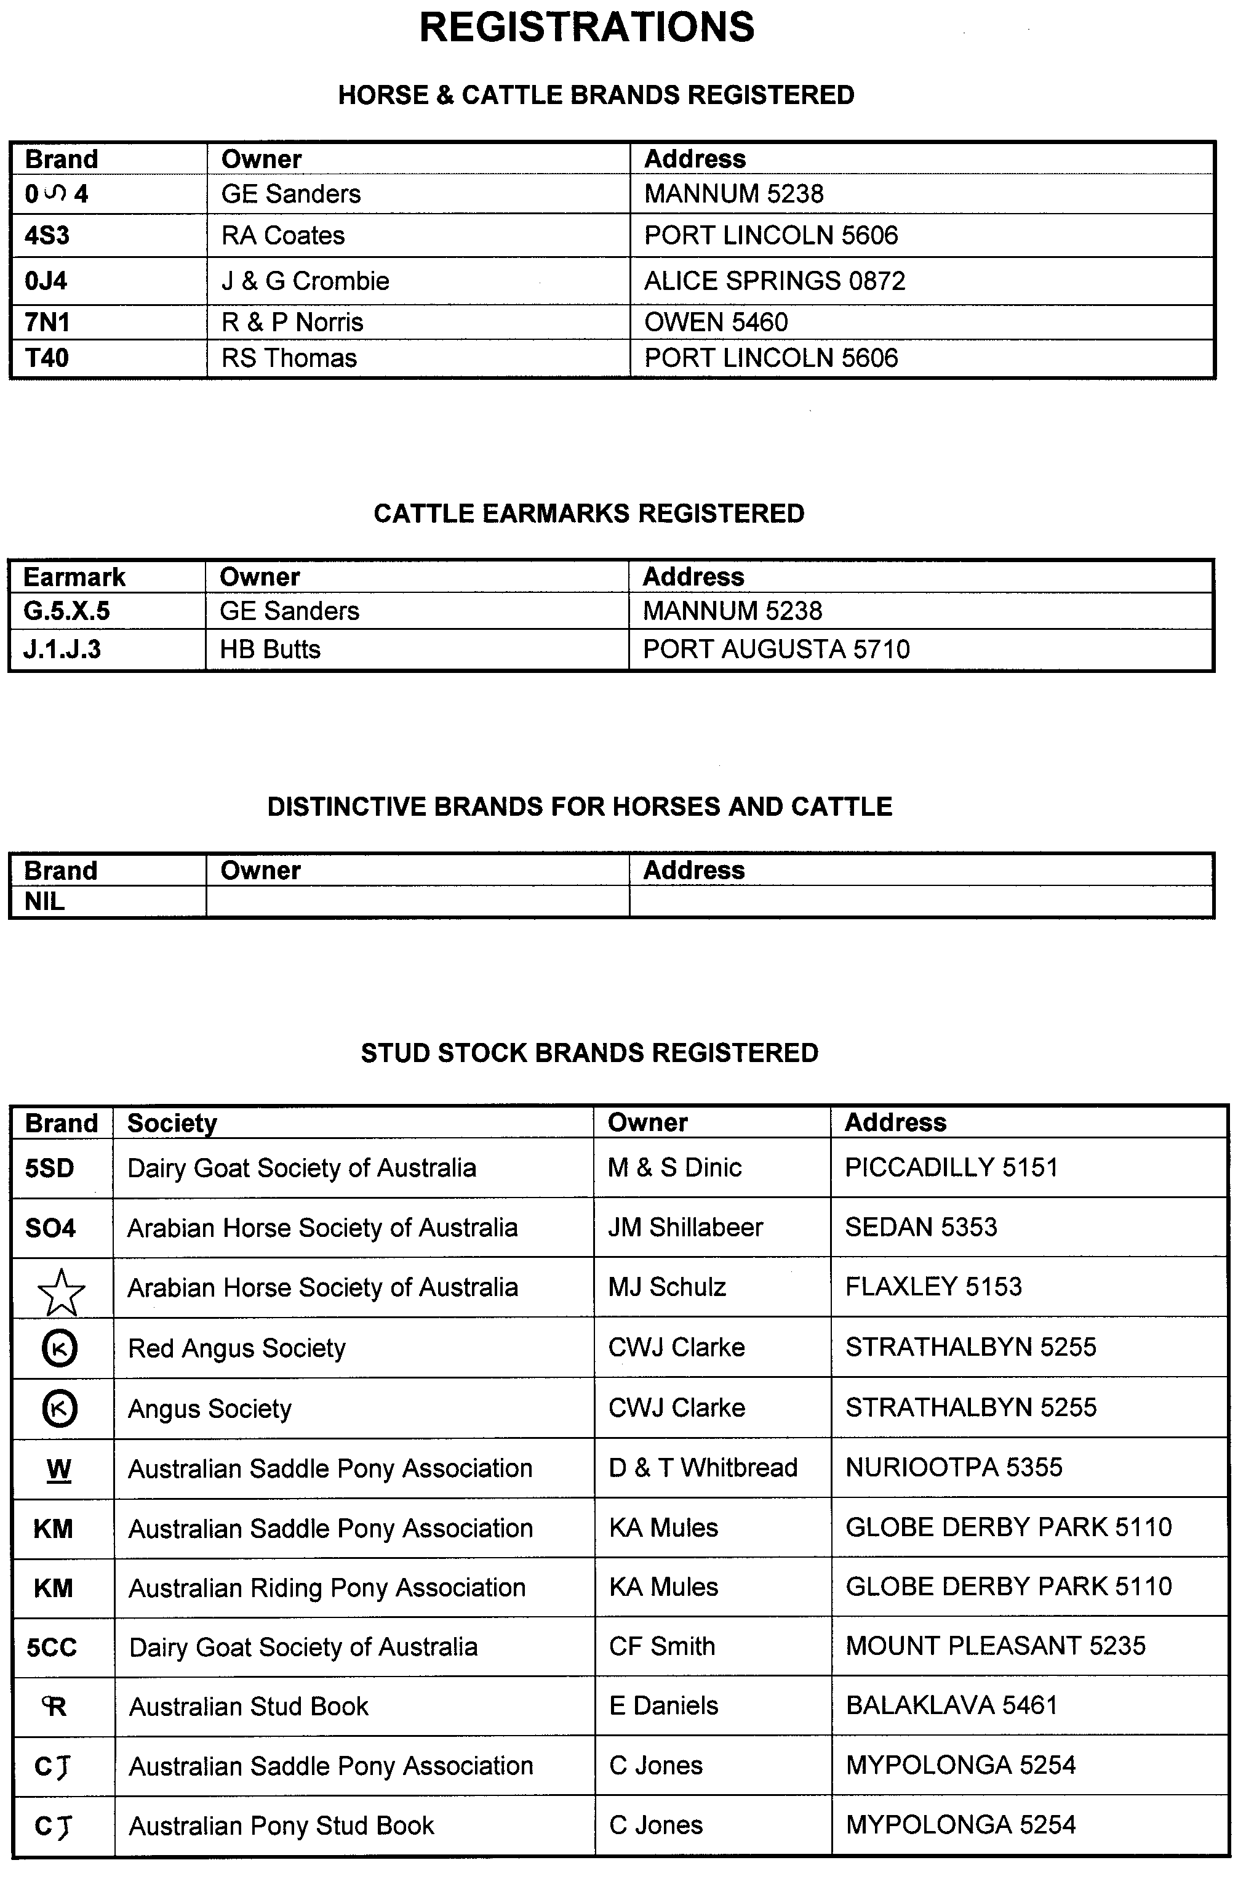
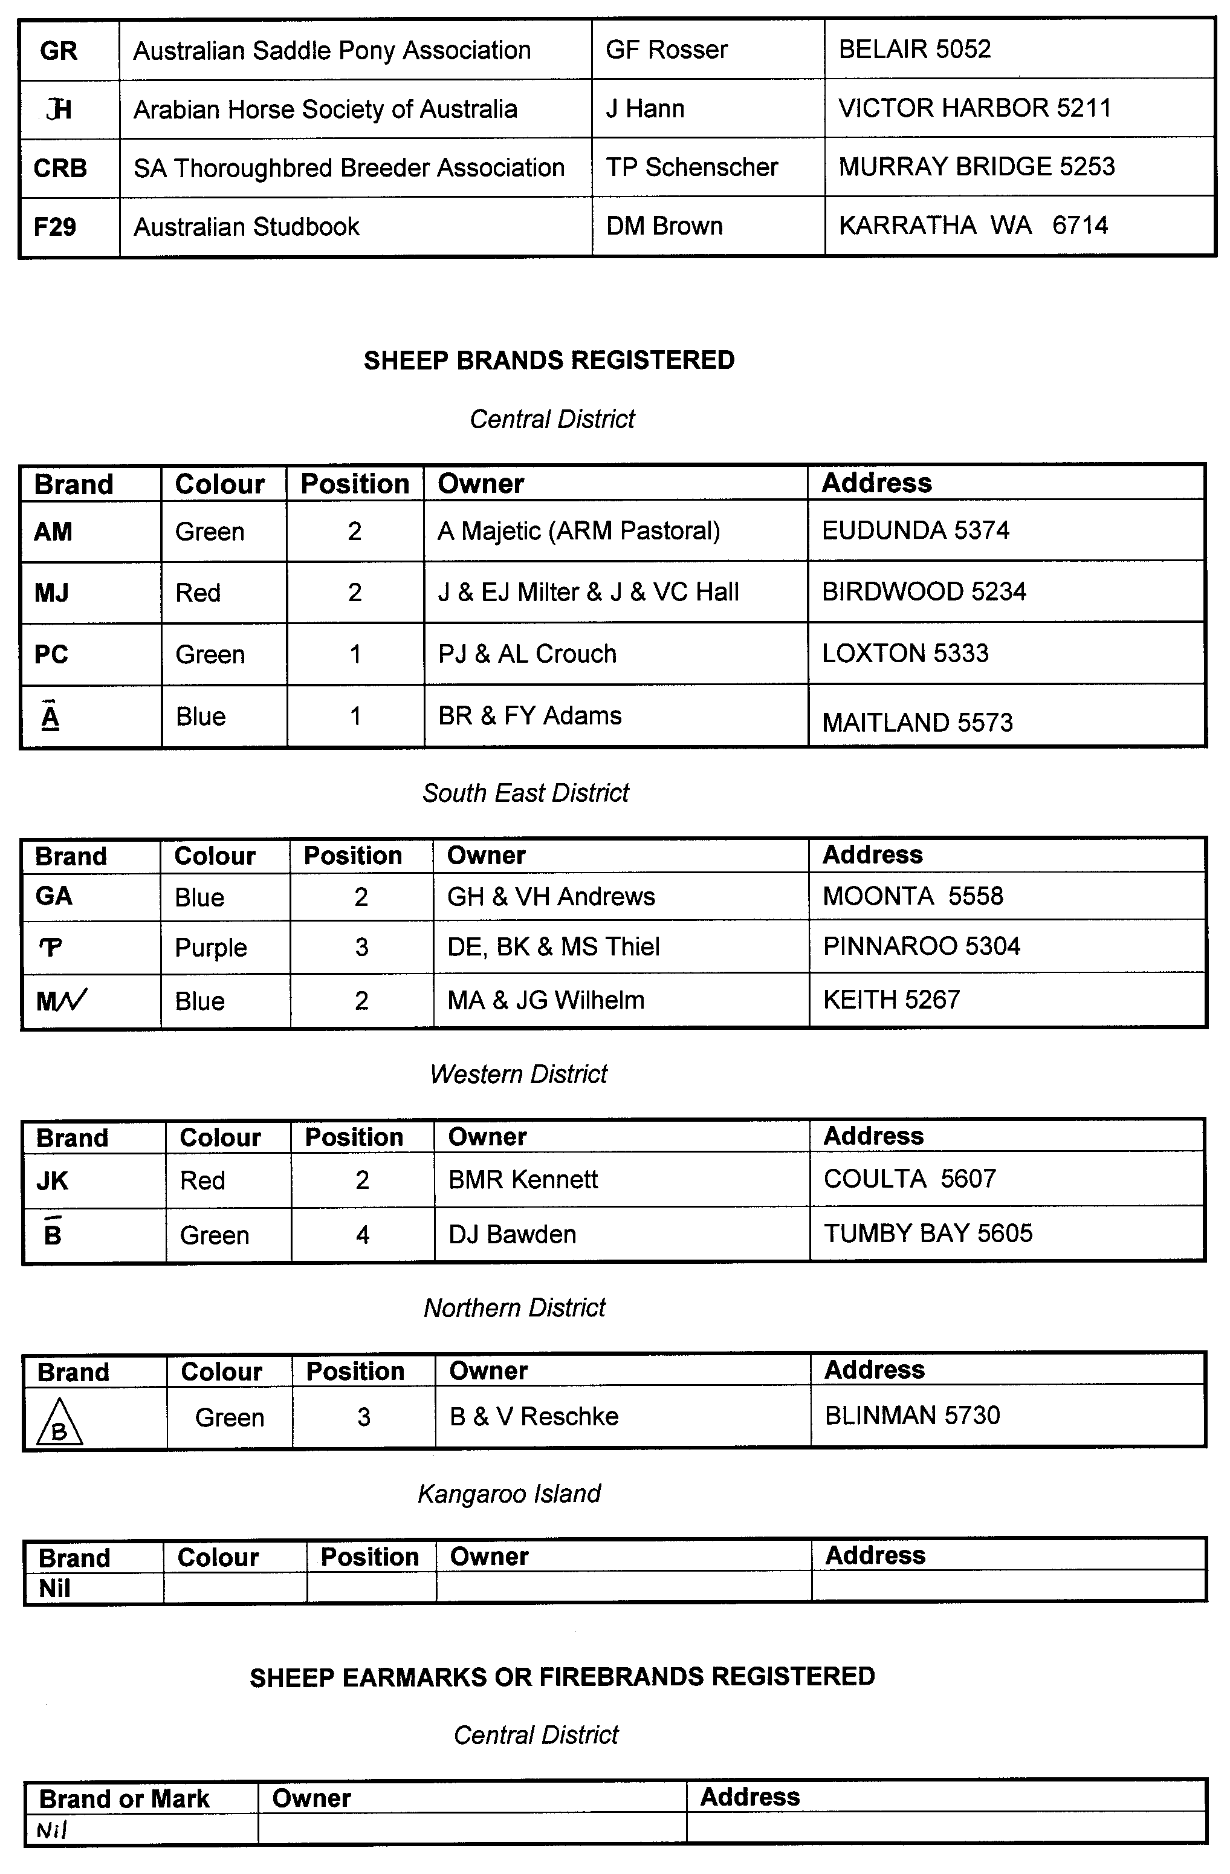
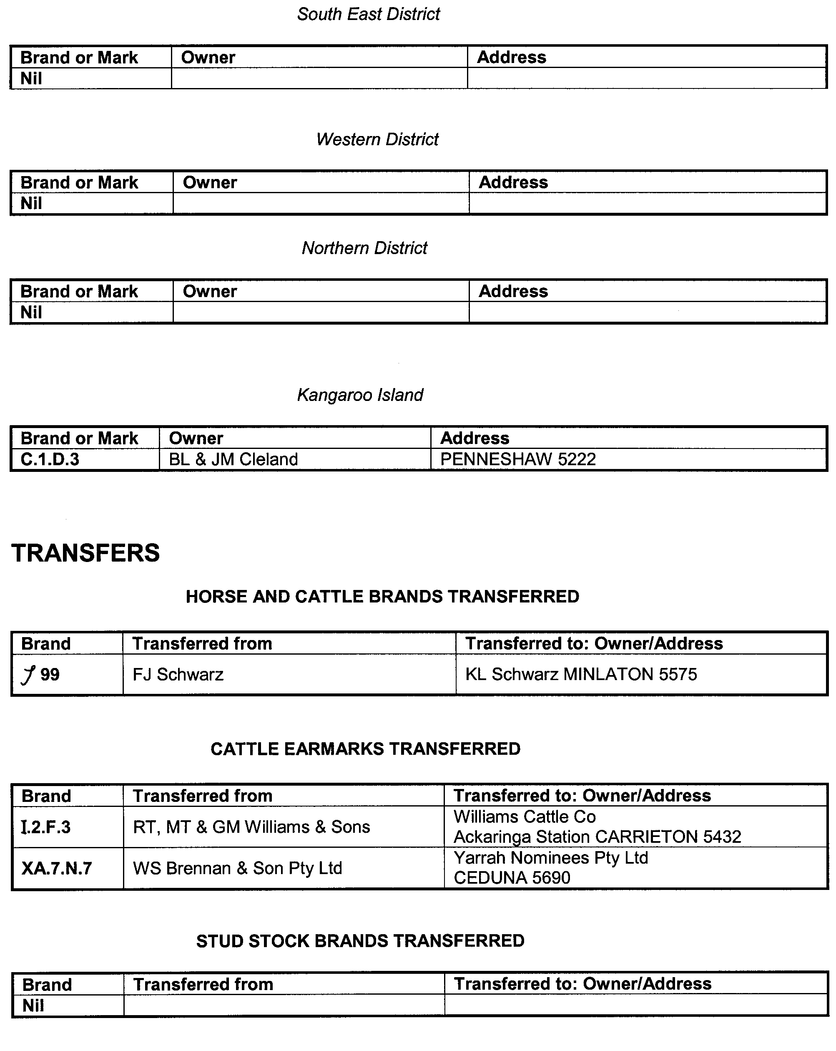
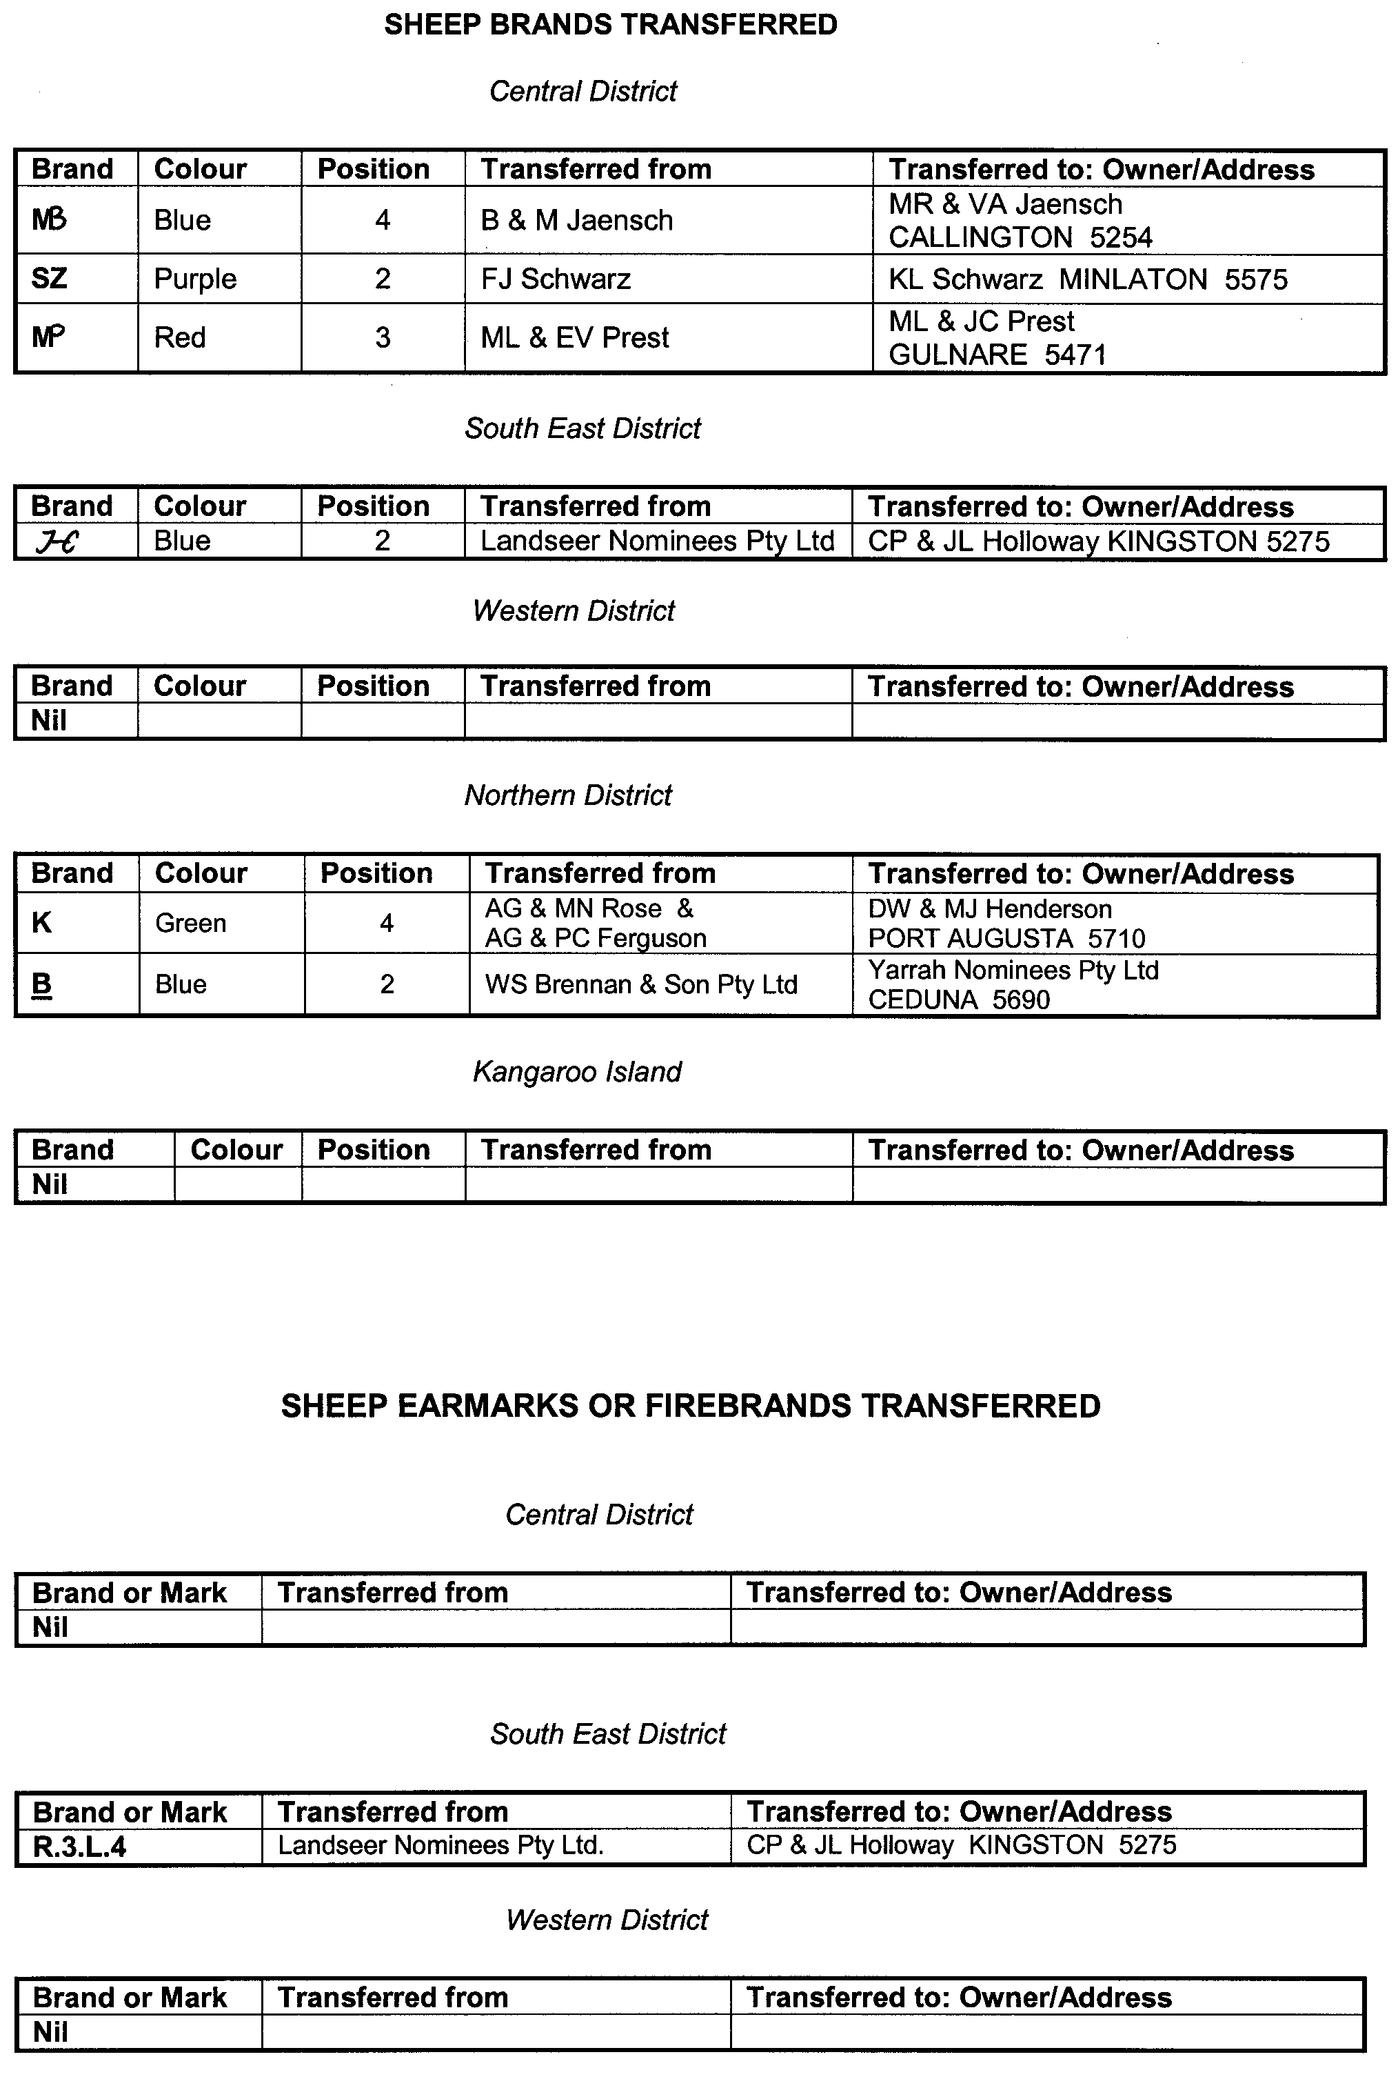


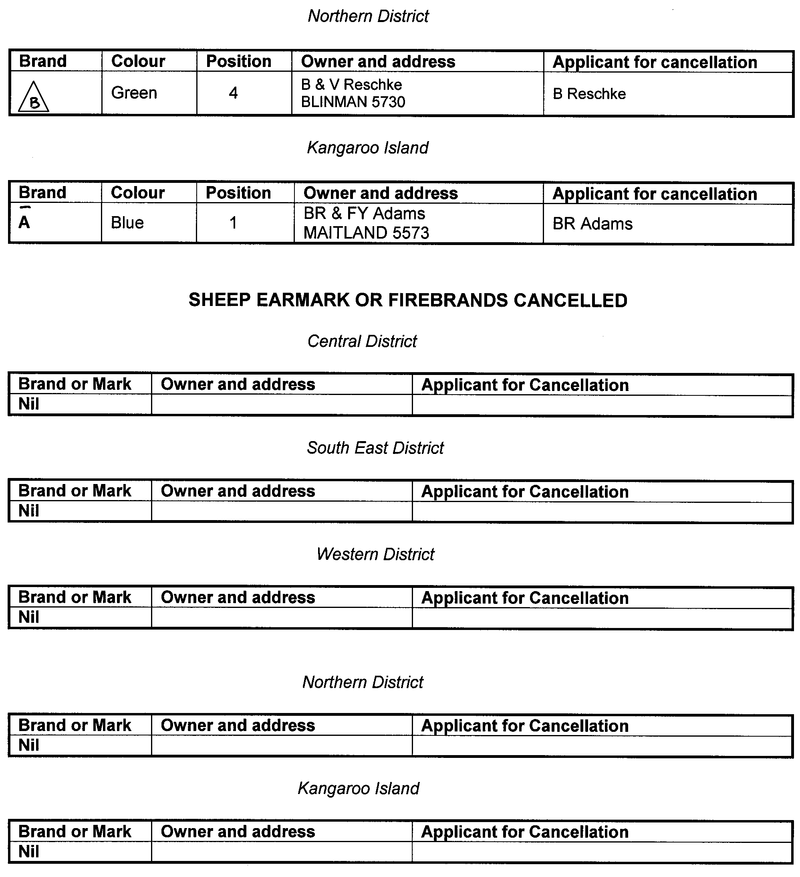

GOVERNMENT GAZETTE ADVERTISEMENT RATES

To apply from 1 July 2002

$  Agents, Ceasing to Act as 34.10  Associations:  Incorporation 17.40  Intention of Incorporation 43.00  Transfer of Properties 43.00  Attorney, Appointment of 34.10  Bailiff’s Sale 43.00  Cemetery Curator Appointed 25.50  Companies:  Alteration to Constitution 34.10  Capital, Increase or Decrease of 43.00  Ceasing to Carry on Business 25.50  Declaration of Dividend 25.50  Incorporation 34.10  Lost Share Certificates:  First Name 25.50  Each Subsequent Name 8.75  Meeting Final 28.75  Meeting Final Regarding Liquidator’s Report on  Conduct of Winding Up (equivalent to ‘Final  Meeting’)  First Name 34.10  Each Subsequent Name 8.75  Notices:  Call 43.00  Change of Name 17.40  Creditors 34.10  Creditors Compromise of Arrangement 34.10  Creditors (extraordinary resolution that ‘the Com-pany be wound up voluntarily and that a liquidator be appointed’) 43.00  Release of Liquidator⎯Application⎯Large Ad. 68.00  ⎯Release Granted 43.00  Receiver and Manager Appointed 39.75  Receiver and Manager Ceasing to Act 34.10  Restored Name 32.25  Petition to Supreme Court for Winding Up 59.50  Summons in Action 51.00  Order of Supreme Court for Winding Up Action 34.10  Register of Interests⎯Section 84 (1) Exempt 77.00  Removal of Office 17.40  Proof of Debts 34.10  Sales of Shares and Forfeiture 34.10  Estates:  Assigned 25.50  Deceased Persons⎯Notice to Creditors, etc. 43.00  Each Subsequent Name 8.75  Deceased Persons⎯Closed Estates 25.50  Each Subsequent Estate 1.10  Probate, Selling of 34.10  Public Trustee, each Estate 8.75 |  | $  Firms:  Ceasing to Carry on Business (each insertion) 22.70  Discontinuance Place of Business 22.70  Land⎯Real Property Act:  Intention to Sell, Notice of 43.00  Lost Certificate of Title Notices 43.00  Cancellation, Notice of (Strata Plan) 43.00  Mortgages:  Caveat Lodgment 17.40  Discharge of 18.30  Foreclosures 17.40  Transfer of 17.40  Sublet 8.75  Leases⎯Application for Transfer (2 insertions) each 8.75  Lost Treasury Receipts (3 insertions) each 25.50  Licensing 51.00  Municipal or District Councils:  Annual Financial Statement⎯Forms 1 and 2 481.00  Electricity Supply⎯Forms 19 and 20 341.00  Default in Payment of Rates:  First Name 68.00  Each Subsequent Name 8.75  Noxious Trade 25.50  Partnership, Dissolution of 25.50  Petitions (small) 17.40  Registered Building Societies (from Registrar-  General) 17.40  Register of Unclaimed Moneys⎯First Name 25.50  Each Subsequent Name 8.75  Registers of Members⎯Three pages and over:  Rate per page (in 8pt) 218.00  Rate per page (in 6pt) 288.00  Sale of Land by Public Auction 43.50  Advertisements 2.40  Advertisements, other than those listed are charged at $2.40 per column line, tabular one-third extra.  Notices by Colleges, Universities, Corporations and District Councils to be charged at $2.40 per line.  Where the notice inserted varies significantly in length from that which is usually published a charge of $2.40 per column line will be applied in lieu of advertisement rates listed.  South Australian Government publications are sold on the condition that they will not be reproduced without prior permission from the Government Printer.
All the above prices include GST

GOVERNMENT GAZETTE NOTICES
ALL private advertisements forwarded for publication in the South Australian Government Gazette must be PAID FOR PRIOR TO INSERTION; and all notices, from whatever source, should be legibly written on one side of the paper only and sent to Government Publishing SA so as to be received no later than 4 p.m. Tuesday preceding the day of publication. Phone 8207 1045 or Fax 8207 1040. E-mail: governmentgazette@saugov.sa.gov.au. Send as attachments in Word format and please confirm your transmission with a faxed copy of your document, including the date the notice is to be published and to whom the notice will be charged.

MISCELLANEOUS LEGISLATION AND GOVERNMENT PUBLICATIONS PRICES AS FROM 1 JULY 2002

Acts, Bills, Rules, Parliamentary Papers and Regulations
Pages | Main | Amends | Pages | Main | Amends

1-16 | 1.95 | 0.85 | 497-512 | 28.10 | 27.00
17-32 | 2.70 | 1.70 | 513-528 | 28.90 | 27.75
33-48 | 3.50 | 2.50 | 529-544 | 29.70 | 28.75
49-64 | 4.45 | 3.35 | 545-560 | 30.50 | 29.75
65-80 | 5.20 | 4.30 | 561-576 | 31.25 | 30.50
81-96 | 6.00 | 5.00 | 577-592 | 32.30 | 31.00
97-112 | 6.90 | 5.85 | 593-608 | 33.10 | 32.00
113-128 | 7.70 | 6.75 | 609-624 | 33.90 | 33.00
129-144 | 8.65 | 7.65 | 625-640 | 34.60 | 33.50
145-160 | 9.50 | 8.50 | 641-656 | 35.40 | 34.50
161-176 | 10.40 | 9.30 | 657-672 | 36.00 | 35.25
177-192 | 11.20 | 10.20 | 673-688 | 37.50 | 36.00
193-208 | 12.00 | 11.10 | 689-704 | 38.30 | 37.00
209-224 | 12.80 | 11.80 | 705-720 | 38.80 | 38.00
225-240 | 13.60 | 12.60 | 721-736 | 40.25 | 38.50
241-257 | 14.50 | 13.30 | 737-752 | 40.75 | 39.75
258-272 | 15.40 | 14.20 | 753-768 | 41.75 | 40.25
273-288 | 16.30 | 15.20 | 769-784 | 42.25 | 41.50
289-304 | 17.00 | 16.00 | 785-800 | 43.00 | 42.25
305-320 | 17.90 | 16.80 | 801-816 | 43.75 | 42.75
321-336 | 18.70 | 17.60 | 817-832 | 44.75 | 43.75
337-352 | 19.60 | 18.60 | 833-848 | 45.75 | 44.50
353-368 | 20.40 | 19.40 | 849-864 | 46.50 | 45.25
369-384 | 21.30 | 20.30 | 865-880 | 47.25 | 46.50
385-400 | 22.00 | 21.10 | 881-896 | 47.75 | 47.00
401-416 | 22.80 | 21.80 | 897-912 | 49.25 | 47.75
417-432 | 23.90 | 22.70 | 913-928 | 49.75 | 49.25
433-448 | 24.60 | 23.60 | 929-944 | 50.50 | 49.75
449-464 | 25.50 | 24.40 | 945-960 | 51.50 | 50.25
465-480 | 26.00 | 25.20 | 961-976 | 52.50 | 51.25
481-496 | 27.10 | 26.00 | 977-992 | 53.50 | 52.00

Legislation—Acts, Regulations, etc: $
Subscriptions:
Acts 174.00
All Bills as Laid 415.00
Rules and Regulations 415.00
Parliamentary Papers 415.00
Bound Acts 192.00
Index 95.50
Government Gazette
Copy 4.55
Subscription 229.00
Hansard
Copy 12.50
Subscription—per session (issued weekly) 360.00
Cloth bound—per volume 154.50
Subscription—per session (issued daily) 360.00
Legislation on Disk
Whole Database 2 659.00
Annual Subscription for fortnightly updates 817.00
Individual Act(s) including updates POA
Compendium
Subscriptions:
New Subs 1 577.00
Updates 556.00
(All the above prices include GST)

All Legislation, Government Gazette, Hansard and Legislation on disk are available from:
Counter Sales Service SA, Government Information Centre
and Mail Orders: Ground Floor, 77 Grenfell Street, Adelaide, S.A. 5000
Phone: 13 23 24 (local call cost), Fax: (08) 8204 1909
TTY (Hearing Impaired): (08) 8204 1923

Online Shop: www.info.sa.gov.au

Subscriptions and Government Publishing SA
Standing Orders: Box 9, Plaza Level, Riverside Centre, North Terrace, Adelaide, S.A. 5000
Phone: (08) 8207 0908, (08) 8207 0910, Fax: (08) 8207 1040

THE ENVIRONMENT SHOP
77 Grenfell Street, Adelaide
The Environment Shop, Ground Floor, SA Water House, 77 Grenfell Street, Adelaide, will be closed for stock take on Friday, 28 June 2002 from 1 p.m.-5 p.m.

E. Miller, Business Support Officer

SERVICE SA GOVERNMENT INFORMATION CENTRE
Located on the Ground Floor, SA Water House, 77 Grenfell Street, Adelaide, will be closed on Friday, 28 June 2002 for annual stock-take.

ONLY Government Gazette sales for 27 June 2002 will be available from SA Water, SA Water House, 77 Grenfell Street, Adelaide from 9 a.m. to 5 p.m. on Friday, 28 June 2002. No other publications can be sold.

Manager, Service SA Government Information Centre

ELECTRICITY PRICING ORDER
Notice of change to ETSA Utilities distribution tariffs from 1 July 2002
PURSUANT to clause 1.6 (c) (ii) of the Electricity Pricing Order (EPO), notice is given that the Industry Regulator has approved changes to ETSA Utilities distribution tariffs, to be applied from 1 July 2002. The changes to the tariffs were calculated in accordance with the formula set out in Schedule 7 of the EPO.
A copy of the altered distribution tariffs and new distribution tariffs may be inspected and/or purchased from Service SA, Ground Floor, SA Water Building, 77 Grenfell Street, Adelaide, S.A. 5000.
ETSA UTILITIES DISTRIBUTION TARIFFS FOR THE YEAR 1 JULY 2002 TO 30 JUNE 2003
Customer Category |  |  | Units | Min Qty. | TUOS incl GST | DUOS incl GST | Total incl GST
Subtransmission (kVA)
(Cust Sub Tr kVA)
 | Supply Rate | $ p.a. |  |  | 4 066.830 | 4 066.830
 | Annual Demand Rate | $/kVA p.a. | 11.5 MVA | 16.969 | 3.971 | 20.940
 | Additional Demand | $/kVA p.a. |  | 1.675 | 3.971 | 5.646
 | Peak Usage Rate | c/kWh |  | 1.092 | 0.188 | 1.280
 | Off-Peak Usage Rate | c/kWh |  | 0.325 | 0.135 | 0.460
Zone Sub-station (kVA)
(Cust Zone S/Stn kVA)
 | Supply Rate | $ p.a. |  |  | 1 738.641 | 1 738.641
 | Annual Demand Rate | $/kVA p.a. | 5.75 MVA | 16.669 | 11.399 | 28.068
 | Additional Demand | $/kVA p.a. |  | 0.000 | 8.280 | 8.280
 | Peak Usage Rate | c/kWh } | 25 GWh | 1.103 | 0.487 | 1.590
 | Off-Peak Usage Rate | c/kWh } |  | 0.335 | 0.365 | 0.700
High Voltage Demand (kVA)
(Cust HV kVA)
 | Supply Rate | $ p.a. |  |  | 1 394.300 | 1 394.300
 | Annual Demand Rate | $/kVA p.a. | 1.15 MVA | 15.648 | 23.826 | 39.474
 | Additional Demand | $/kVA p.a. |  | 0.000 | 11.634 | 11.634
 | Peak Usage Rate | c/kWh |  | 1.134 | 1.066 | 2.200
 | Off-Peak Usage Rate | c/kWh |  | 0.344 | 0.796 | 1.140
High Voltage Obsolete (kVA)
(Cust HV_Obsolete kVA)
 | Supply Rate | $ p.a. |  |  | 1 394.300 | 1 394.300
 | Annual Demand Rate | $/kVA p.a. | 300 kVA | 15.648 | 23.826 | 39.474
 | Additional Demand | $/kVA p.a. |  | 0.000 | 11.634 | 11.634
 | Peak Usage Rate | c/kWh |  | 1.134 | 1.066 | 2.200
 | Off-Peak Usage Rate | c/kWh |  | 0.344 | 0.796 | 1.140
Large Low Voltage Demand (kVA)
(Cust Large LV Demand kVA)
 | Supply Rate | $ p.a. |  |  | 1 394.300 | 1 394.300
 | Annual Demand Rate | $/kVA p.a. | 1.15 MVA | 15.365 | 30.427 | 45.792
 | Additional Demand | $/kVA p.a. |  | 0.000 | 13.488 | 13.488
 | Peak Usage Rate | c/kWh |  | 1.143 | 1.367 | 2.510
 | Off-Peak Usage Rate | c/kWh |  | 0.344 | 0.966 | 1.310
Low Voltage Demand (kVA)
(Cust LV Demand kVA)
 | Supply Rate | $ p.a. |  |  | 1 394.300 | 1 394.300
 | Annual Demand Rate | $/kVA p.a. | 350 kVA | 15.365 | 36.319 | 51.684
 | Additional Demand | $/kVA p.a. |  | 0.000 | 15.222 | 15.222
 | Peak Usage Rate | c/kWh |  | 1.143 | 1.627 | 2.770
 | Off-Peak Usage Rate | c/kWh |  | 0.344 | 1.146 | 1.490

ETSA UTILITIES DISTRIBUTION TARIFFS FOR THE YEAR 1 JULY 2002 TO 30 JUNE 2003
Customer Category |  |  | Units |  | Min Qty. |  | TUOS incl GST |  | DUOS incl GST |  | Total incl GST
Medium Low Voltage Demand (kVA)
(Cust Medium LV Demand kVA)
 | Supply Rate | $ p.a. |  |  |  |  |  | 697.150 |  | 697.150
 | Annual Demand Rate | $/kVA p.a. |  | 120 kVA |  | 14.801 |  | 51.589 |  | 66.390
 | Additional Demand | $/kVA p.a. |  |  |  | 0.000 |  | 19.542 |  | 19.542
 | Peak Usage Rate | c/kWh |  |  |  | 1.143 |  | 2.357 |  | 3.500
 | Off-Peak Usage Rate | c/kWh |  |  |  | 0.344 |  | 1.626 |  | 1.970
Low Voltage Business—2 Rate
(Cust LV Bus 2R)
 | Supply Rate | $ p.a. |  |  |  |  |  | 249.441 |  | 249.441
 | Peak Usage Rate | c/kWh |  |  |  | 2.057 |  | 5.643 |  | 7.700
 | Off-Peak Usage Rate | c/kWh |  |  |  | 0.391 |  | 2.389 |  | 2.780
Low Voltage Business—Single Rate
(Cust LV Bus 1R)
 | Supply Rate | $ p.a. |  |  |  |  |  | 69.350 |  | 69.350
 | Anytime Usage Rate | c/kWh |  |  |  | 1.624 |  | 5.626 |  | 7.250
Low Voltage Residential—Single Rate
(Cust LV Res 1R)
 | Supply Rate | $ p.a. |  |  |  |  |  | 68.182 |  | 68.182
 | Anytime Usage Rate | c/kWh |  |  |  | 1.646 |  | 6.154 |  | 7.800
Low Voltage Off-peak Controlled Load
(Cust LV C Load)
 | Supply Rate | $ p.a. |  |  |  |  |  | 25.039 |  | 25.039
 | Anytime Usage Rate | c/kWh |  |  |  | 0.326 |  | 1.404 |  | 1.730
Low Voltage Unmetered Usage (Overnight Usage)
(Cust LV 12 hr Night)
 | Anytime Usage Rate | c/kWh |  |  |  | 0.729 |  | 3.081 |  | 3.810
Low Voltage Unmetered Usage (24 Hour Usage)
(Cust LV 24 hr Continuous)
 | Anytime Usage Rate | c/kWh |  |  |  | 0.911 |  | 3.359 |  | 4.270
Other Unmetered Usage
(Cust Other)
 | Supply Rate | $ p.a. |  |  |  |  |  | 45.698 |  | 45.698
 | Peak Usage Rate | c/kWh |  |  |  | 1.983 |  | 6.217 |  | 8.200
 | Off-Peak Usage Rate | c/kWh |  |  |  | 0.396 |  | 2.434 |  | 2.830
Obsolete Tariffs
Subtransmission (kW)
(Cust Sub Tr kW)
 | Supply Rate | $ p.a. |  |  |  |  | 4 066.830 |  | 4 066.830
 | Annual Demand Rate | $/kW p.a. | 10 MW |  | 17.722 |  | 4.124 |  | 21.846
 | Additional Demand | $/kW p.a. |  |  | 2.772 |  | 4.122 |  | 6.894
 | Peak Usage Rate | c/kWh |  |  | 1.136 |  | 0.304 |  | 1.440
 | Off-Peak Usage Rate | c/kWh |  |  | 0.354 |  | 0.196 |  | 0.550
Zone Sub-station (kW)
(Cust Zone S/Stn kW)
 | Supply Rate | $ p.a. |  |  |  |  | 1 738.641 |  | 1 738.641
 | Annual Demand Rate | $/kW p.a. | 5 MW |  | 17.409 |  | 10.257 |  | 27.666
 | Additional Demand | $/kW p.a. |  |  | 0.000 |  | 10.254 |  | 10.254
 | Peak Usage Rate | c/kWh } | 25 GWh |  | 1.147 |  | 0.673 |  | 1.820
 | Off-Peak Usage Rate | c/kWh } |  |  | 0.365 |  | 0.485 |  | 0.850

ETSA UTILITIES DISTRIBUTION TARIFFS FOR THE YEAR 1 JULY 2002 TO 30 JUNE 2003
Customer Category |  |  | Units |  | Min Qty. |  | TUOS incl GST |  | DUOS incl GST |  | Total incl GST
High Voltage Demand (kW)
(Cust HV kW)
 | Supply Rate | $ p.a. |  |  |  |  | 1 394.300 |  | 1 394.300
 | Annual Demand Rate | $/kW p.a. | 1 MW |  | 17.305 |  | 22.205 |  | 39.510
 | Additional Demand | $/kW p.a. |  |  | 0.000 |  | 15.960 |  | 15.960
 | Peak Usage Rate | c/kWh |  |  | 1.178 |  | 1.432 |  | 2.610
 | Off-Peak Usage Rate | c/kWh |  |  | 0.375 |  | 1.045 |  | 1.420
High Voltage Obsolete (kW)
(Cust HV_Obsolete kW)
 | Supply Rate | $ p.a. |  |  |  |  | 1 394.300 |  | 1 394.300
 | Annual Demand Rate | $/kW p.a. | 250 kW |  | 17.305 |  | 22.205 |  | 39.510
 | Additional Demand | $/kW p.a. |  |  | 0.000 |  | 15.960 |  | 15.960
 | Peak Usage Rate | c/kWh |  |  | 1.178 |  | 1.432 |  | 2.610
 | Off-Peak Usage Rate | c/kWh |  |  | 0.375 |  | 1.045 |  | 1.420
Large Low Voltage Demand (kW)
(Cust Large LV Demand kW)
 | Supply Rate | $ p.a. |  |  |  |  | 1 394.300 |  | 1 394.300
 | Annual Demand Rate | $/kW p.a. | 1 MW |  | 16.992 |  | 28.236 |  | 45.228
 | Additional Demand | $/kW p.a. |  |  | 0.000 |  | 18.504 |  | 18.504
 | Peak Usage Rate | c/kWh |  |  | 1.189 |  | 1.811 |  | 3.000
 | Off-Peak Usage Rate | c/kWh |  |  | 0.375 |  | 1.265 |  | 1.640
Low Voltage Demand (kW)
(Cust LV Demand kW)
 | Supply Rate | $ p.a. |  |  |  |  | 1 394.300 |  | 1 394.300
 | Annual Demand Rate | $/kW p.a. | 300 kW |  | 16.992 |  | 33.630 |  | 50.622
 | Additional Demand | $/kW p.a. |  |  | 0.000 |  | 20.880 |  | 20.880
 | Peak Usage Rate | c/kWh |  |  | 1.189 |  | 2.151 |  | 3.340
 | Off-Peak Usage Rate | c/kWh |  |  | 0.375 |  | 1.505 |  | 1.880
Medium Low Voltage Demand (kW)
(Cust Medium LV Demand kW)
 | Supply Rate | $ p.a. |  |  |  |  | 697.150 |  | 697.150
 | Annual Demand Rate | $/kW p.a. | 100kW |  | 16.366 |  | 47.588 |  | 63.954
 | Additional Demand | $/kW p.a. |  |  | 0.000 |  | 26.808 |  | 26.808
 | Peak Usage Rate | c/kWh |  |  | 1.189 |  | 3.101 |  | 4.290
 | Off-Peak Usage Rate | c/kWh |  |  | 0.375 |  | 2.125 |  | 2.500

Notes:
1. The distribution tariffs:
(a) are inclusive of the GST imposed as at 1 July 2000; and
(b) include the application of AD_{t} as defined in paragraph E2 of Schedule 7 of the Electricity Pricing Order 1999.
2. ETSA Utilities must assign each Distribution Network User to a distribution tariff in respect of each of its connection points in accordance with the following principles:
(a) A Distribution Network User that has an agreed maximum demand of 250kW or more in respect of a connection point, must be assigned to a distribution tariff that includes a demand component in respect of that connection point.
(b) A Sub-Transmission (kVA) Network User is a Distribution Network User taking supply at 66kV, or at 33kV outside of the Adelaide Metropolitan area. A minimum annual demand of 11.50MVA applies. A type 3 NEM meter or equivalent is required. Customers electing to switch to this tariff from 1 July 2002 must meet or exceed the minimum power factor requirements for their customer installation as set out in Part B of the Distribution Code (generally 0.90 pf).
(c) A Zone Substation (kVA) customer is a Distribution Network User taking supply generally at 11kV from the low voltage transformer terminals. Supply may also be taken at lower voltages that exceed 1kV. A minimum annual demand of 5.75 MVA and a minimum annual usage of 25GWh apply. A type 3 NEM meter or equivalent is required. Customers electing to switch to this tariff from 1 July 2002 must meet or exceed the minimum power factor requirements for their customer installation as set out in Part B of the Distribution Code (generally 0.90 pf).
(d) A High Voltage Demand (kVA) customer is a Distribution Network User taking supply generally at 11kV. Supply may also be taken at lower voltages that exceed 1kV or at 33kV in metropolitan Adelaide. A minimum annual demand of 1.15MVA applies. A type 3 NEM meter or equivalent is required. Customers electing to switch to this tariff from 1 July 2002 must meet or exceed the minimum power factor requirements for their customer installation as set out in Part B of the Distribution Code (generally 0.85 pf).
(e) A High Voltage (kVA) (Obsolete) customer is a Distribution Network User taking supply generally at 11kV. This tariff is available only to Distribution Network Users that were taking supply under the High Voltage Demand (kW) (Obsolete) tariff as at 11 October 1999. Supply may also be taken at lower voltages that exceed 1kV or at 33kV in metropolitan Adelaide. A minimum annual demand of 300kVA applies. A type 3 NEM meter or equivalent is required. Customers electing to switch to this tariff from 1 July 2002 must meet or exceed the minimum power factor requirements for their customer installation as set out in Part B of the Distribution Code (generally 0.85 pf).
(f) A Large Low Voltage Demand (kVA) customer is a Distribution Network User taking supply at less than 1kV and generally from the low voltage distribution transformer terminals. A minimum annual demand of 1.15MVA applies. A type 3 NEM meter or equivalent is required. Customers electing to switch to this tariff from 1 July 2002 must meet or exceed the minimum power factor requirements for their customer installation as set out in Part B of the Distribution Code (generally 0.85 pf).
(g) A Low Voltage Demand (kVA) customer is a Distribution Network User taking supply at less than 1kV and generally from the low voltage distribution transformer terminals. A minimum annual demand of 350kVA applies. A type 3 NEM meter or equivalent is required. Customers electing to switch to this tariff from 1 July 2002 must meet or exceed the minimum power factor requirements for their customer installation as set out in Part B of the Distribution Code (generally 0.85 pf).
(h) A Medium Low Voltage Demand (kVA) customer is a Distribution Network User that is not a residential customer taking supply at less than 1kV and using demand, peak and off-peak metering. A minimum annual demand of 120kVA applies. A type 3 NEM meter or equivalent is required. Customers electing to switch to this tariff from 1 July 2002 must meet or exceed the minimum power factor requirements for their customer installation as set out in Part B of the Distribution Code (generally 0.85 pf).
(i) A Low Voltage Business 2 rate customer is a Distribution Network User that is not a residential customer taking supply at less than 1kV and using peak and off-peak metering.
(j) A Low Voltage Business single rate customer is a Distribution Network User that is not a residential customer taking supply at less than 1kV and using single rate metering.
(k) A Low Voltage Residential single rate customer is a Distribution Network User that is a residential customer taking supply at less than 1kV and using single rate metering.
(l) A Low Voltage Off-peak Controlled Load is use by a Distribution Network User involving a time switch and separate metering where the timing has been set in accordance with ETSA Utilities’ requirements regarding the timing of loads.
(m) Unmetered Overnight Usage supply is defined as overnight use by a Distribution Network User for public lighting.
(n) Unmetered 24 Hour Usage supply is defined as constant 24 hour per day use by a Distribution Network User, typically public phones, traffic lights and telecommunications installations.
(o) Other Unmetered Supply is defined as unmetered use by Distribution Network Users other than public lighting or continuous use.
(p) A Sub-Transmission Network (kW) User is a Distribution Network User taking supply at 66kV, or at 33kV outside of the Adelaide metropolitan area. A minimum annual demand of 10MW applies. This tariff is available only to Distribution Network Users that were taking supply under this tariff as at 30 June 2001
(q) A Zone Substation (kW) customer is a Distribution Network User taking supply generally at 11kV from the low voltage transformer terminals. Supply may also be taken at lower voltages that exceed 1kV. A minimum annual demand of 5MW and a minimum annual usage of 25GWh apply. This tariff is available only to Distribution Network Users that were taking supply under this tariff as at 30 June 2001.
(r) A High Voltage Demand (kW) customer is a Distribution Network User taking supply generally at 11kV. Supply may also be taken at lower voltages that exceed 1kV or at 33kV in metropolitan Adelaide. A minimum annual demand of 1MW applies. This tariff is available only to Distribution Network Users that were taking supply under this tariff as at 30 June 2001.
(s) The High Voltage Demand (kW) (Obsolete) tariff is available only to Distribution Network Users that were taking supply under this tariff as at 11 October 1999. Conditions applicable at that date apply.
(t) A Large Low Voltage Demand (kW) customer is a Distribution Network User taking supply at less than 1kV and generally from the low voltage distribution transformer terminals. A minimum annual demand of 1MW applies. This tariff is available only to Distribution Network Users that were taking supply under this tariff as at 30 June 2001.
(u) A Low Voltage Demand (kW) customer is a Distribution Network User taking supply at less than 1kV and generally from the low voltage distribution transformer terminals. A minimum annual demand of 300kW applies. This tariff is available only to Distribution Network Users that were taking supply under this tariff as at 30 June 2001.
(v) A Medium Low Voltage Demand (kW) customer is a Distribution Network User that is not a residential customer taking supply at less than 1kV and using demand, peak and off-peak metering. A minimum annual demand of 100kW applies. This tariff is available only to Distribution Network Users that were taking supply under this tariff as at 30 June 2001.
3. The supply and demand charges are levied and billed to Distribution Network Users periodically on a pro rata basis.
4. Demand charges are determined on the basis of:
(a) maximum demand (Annual Demand); and
(b) additional maximum demand (Additional Demand),
determined in accordance with paragraph B2 of Schedule 5 of the Electricity Pricing Order.
5. Peak energy is energy consumed on business days between the hours of 0700 and 2100 (Central Standard Time). For Distribution Network Users with metering that does not recognise specific days, peak energy is energy consumed on each day between the hours of 0700 and 2100 (Central Standard Time).
6. Off-peak energy is energy consumed other than peak energy.
L. Owens, Industry Regulator

ASSOCIATIONS INCORPORATION ACT 1985
Deregistration of Associations
NOTICE is hereby given that the Corporate Affairs Commission approves the applications for deregistration received from the associations named below pursuant to section 43A of the Associations Incorporation Act 1985. Deregistration takes effect on the date of publication of this notice:
Yorke Peninsula Caledonian Society Incorporated
Victor Harbor Garden and Floral Society Incorporated
Nyumbani Fund Australia Incorporated
Glenelg Croquet Club Incorporated
Dated 20 June 2002.
B. I. Colquist, A Delegate of the Corporate Affairs Commission

CROWN LANDS ACT 1929: SECTION 5
TAKE NOTICE that pursuant to the Crown Lands Act 1929, I JOHN HILL, Minister for Environment and Conservation, Minister of the Crown to whom the administration of the Crown Lands Act 1929 is committed DO HEREBY:
1. Resume the land defined in The First Schedule.
2. Dedicate the Crown Land defined in The Second Schedule as an Electricity Supply Purposes Reserve and declare that such land shall be under the care, control and management of Transmission Lessor Corporation.
The First Schedule
Land for Electricity Trust of South Australia Purposes, allotment 50 of DP 25261, Hundred of Moonabie, County of York, the notice of which was published in the Government Gazette of 16 May 1991 at page 1607, being the land comprised in Crown Record Volume 5753 Folio 190.
The Second Schedule
Allotment 50 of DP 25261, Hundred of Moonabie, County of York, exclusive of all necessary roads, subject to Transmission Land Lease No. 9061500, and subject to the following clause: “As a reserve for the purposes for which ETSA Corporation could exercise any of the functions conferred on it by the Electricity Corporations Act 1994 as in force immediately prior to 12 December 1999 and declare that such land shall be under the care, control and management of any lessee of that land under a lease granted pursuant to sections 8 or 13 of the Electricity Corporations (Restructuring and Disposal) Act 1999 or if there is no such lessee, Transmission Lessor Corporation.”
Dated 27 June 2002.
J. Hill, Minister for Environment and Conservation
DEHAA 13/0777

CROWN LANDS ACT 1929: SECTION 5
TAKE NOTICE that pursuant to the Crown Lands Act 1929, I JOHN HILL, Minister for Environment and Conservation, Minister of the Crown to whom the administration of the Crown Lands Act 1929 is committed DO HEREBY:
1. Resume the lands defined in The First Schedule.
2. Dedicate the Crown Land defined in The Second Schedule as a Drainage Reserve and declare that such land shall be under the care, control and management of the City of Port Adelaide Enfield.
The First Schedule
1. Drainage Reserve, section 1695, Hundred of Yatala, County of Adelaide, the notice of which was published in the Government Gazette of 8 October 1987 at page 1085, being the land comprised in Crown Record Volume 5753 Folio 971.
2. Portion of Drainage Reserve, allotment 102 of DP 31913, Hundred of Yatala, County of Adelaide, the notice of which together with other land was published in the Government Gazette of 24 October 1991 at page 1121, being portion of the land comprised in Crown Record Volume 5559 Folio 651.
The Second Schedule
Allotments 1005 and 1006 of DP 58412, Hundred of Yatala, County of Adelaide, exclusive of all necessary road, subject nevertheless to an existing easement to Distribution Lessor Corporation (subject to Lease 8889800) for the transmission of electricity by underground cable over that portion of allotment 1005 marked E on DP 58412 vide RLG 8524916.
Dated 27 June 2002.
J. Hill, Minister for Environment and Conservation
DEHAA 17/1102

DEVELOPMENT ACT 1993, SECTION 26 (8): DEMOLITION POLICY PLAN AMENDMENT
Preamble
1. The Development Plan amendment entitled ‘Demolition Policy Plan Amendment’ (the Plan Amendment) has been finalised in accordance with the provisions of the Development Act 1993.
2. The Minister for Urban Development and Planning has decided to approve the Plan Amendment.
Notice
PURSUANT to section 26 of the Development Act 1993, I:
(a) approve the Plan Amendment; and
(b) fix the day on which this notice is published in the Gazette as the day on which the Plan Amendment will come into operation.
Dated 27 June 2002.
J. Weatherill, Minister for Urban Development and Planning
PLN 01/0261

DEVELOPMENT ACT 1993, SECTION 28 (1): DECLARA-TION OF INTERIM OPERATION OF CORPORATION OF THE TOWN OF GAWLER—GAWLER (CT) DEVELOPMENT PLAN—GAWLER RIVERS FLOOD PLAIN PLAN AMENDMENT
Notice
PURSUANT to section 28 (1) of the Development Act 1993, I, the Governor, with the advice and consent of the Executive Council, being of the opinion that it is necessary in the interest of the orderly and proper development of the area affected by the ‘Corporation of the Town of Gawler—Gawler (CT) Development Plan—Gawler Rivers Flood Plain Plan Amendment’ that the Plan Amendment should come into operation without delay, declare that the Plan Amendment will come into operation on an interim basis on 27 June 2002.
Given under my hand at Adelaide, 20 June 2002.
Marjorie Jackson-Nelson, Governor
MFTUP CAB 46/01CS

DEVELOPMENT ACT 1993, SECTION 28 (1): DECLARATION OF INTERIM OPERATION OF CITY OF PLAYFORD—PLAYFORD (CITY) DEVELOPMENT PLAN—HERITAGE PLAN AMENDMENT
Notice
PURSUANT to section 28 (1) of the Development Act 1993, I, the Governor, with the advice and consent of the Executive Council, being of the opinion that it is necessary in the interest of the orderly and proper development of the area affected by the ‘City of Playford—Playford (City) Development Plan—Heritage Plan Amendment’ that the Plan Amendment should come into operation without delay, declare that the Plan Amendment will come into operation on an interim basis on 27 June 2002.
Given under my hand at Adelaide, 20 June 2002.
Marjorie Jackson-Nelson, Governor
MFUDP CPSA 2002/00005CS

DEVELOPMENT ACT 1993
Alteration to the South Australian Housing Code
Preamble
The Development Act 1993 requires that where a Code is adopted by the Regulations, notice of the alteration must be published before the alteration can take effect.
Notice
PURSUANT to sections 4 (7) and 108 (7) of the Development Act 1993, notice is given of an alteration to the 1998 edition of the South Australian Housing Code, which is called up in the South Australian Appendix to Volume Two of the Building Code of Australia 1996 edition, that alteration being Amendment No. 7 as published by Planning SA.
The alterations made by Amendment No. 7 to the South Australian Housing Code will take effect for the purposes of the Development Act 1993 on 1 August 2002.
Dated 22 June 2002.
J. Weatherill, Minister for Urban Development and Planning
PLN 98/0487

DEVELOPMENT REGULATIONS 1993, SCHEDULE 6
Preamble
Schedule 6 of the Development Regulations 1993 refers to a construction index determined by the Minister from time to time and set out in the Schedule of Construction Indices. The con-struction index will be used in the determination of fees payable by applicants seeking assessment against the Building Rules under the Development Act 1993.
Notice
PURSUANT to Schedule 6 of the Development Regulations 1993, I have determined the construction indices in the Schedule for the purposes of Schedule 6 of the Development Regulations 1993.
This notice will come into effect on 1 July 2002.
Schedule
Schedule of 2002 Construction Indices
Building Classes | Construction Indices
Class 1, 2, 4 | 797
Class 3, 5, 6 | 1062
Class 7, 8 | 703
Class 9a & 9c | 1204
Class 9b | 1095
Class 10 | 238
Dated 25 June 2002
J. Weatherill, Minister for Urban Development and Planning
PLN 91/1444
PLAN 2502/91 TC1

DOG FENCE ACT 1946
Erratum
IN Government Gazette of 20 June 2002, page 2451, in the notice relating to Declaration of Rate, delete ‘with the approval of the Minister for Primary Industries and Resources’, and replace ‘with the approval of the Minister for Environment and Conservation’.
M. J. Balharry, Manager, SA Dog Fence Administration

EQUAL OPPORTUNITY TRIBUNAL
No. 91 of 2002
Notice of Exemption
Before Deputy Presiding Officer Anderson
Members Altman and Bachmann
I HEREBY certify that on 8 May 2002, the Equal Opportunity Tribunal of South Australia, on the application of the Department of Human Services made the following orders for exemption:
1. Under the provisions of section 92 of the Equal Opportunity Act 1984 there is granted a three year exemption to the Department or Human Services to appoint only Aboriginal and Torres Strait Islanders to Aboriginal Health Worker positions in South Australia.
2. Notice of the grant of exemption is to be published in the Government Gazette forthwith.
Dated 21 May 2002.
J. Nemcic, for M. Moore, Registrar, Equal Opportunity Tribunal

DEPARTMENT OF PRIMARY INDUSTRIES AND RESOURCES SA—FISHERIES DIVISION
NOTICE is hereby given pursuant to section 28 (10) (b) of the Fisheries Act 1982, that the following items have been seized by officers of the Department of Primary Industries and Resources SA, Fisheries Division:
1 Opera House yabbie net, set from landing in Wellington marina with faded orange braided cord.
The above items were suspected to have been used or intended to be used, in contravention of the Fisheries Act 1982, and were taken into possession at Wellington on 22 March 2002.
After the expiration of one month from the date of this notice the items listed above shall, on the order of the Minister for Primary Industries, be forfeited to the Crown and shall be either disposed of by sale or destruction.
The above items may be viewed at the Birkenhead office of the Department of Primary Industries and Resources SA, Fisheries Division.
Dated 20 June 2002.
M. Lewis, General Manager, Fisheries Services

DEPARTMENT OF PRIMARY INDUSTRIES AND RESOURCES SA—FISHERIES DIVISION
NOTICE is hereby given pursuant to section 28 (10) (b) of the Fisheries Act 1982, that the following items have been seized by officers of the Department of Primary Industries and Resources SA, Fisheries Division:
2 Opera House yabbie nets, set from landing in Wellington marina. Nets tied to white cord joined in centre.
The above items were suspected to have been used or intended to be used, in contravention of the Fisheries Act 1982, and were taken into possession at Wellington on 22 March 2002.
After the expiration of one month from the date of this notice the items listed above shall, on the order of the Minister for Primary Industries, be forfeited to the Crown and shall be either disposed of by sale or destruction.
The above items may be viewed at the Birkenhead office of the Department of Primary Industries and Resources SA, Fisheries Division.
Dated 20 June 2002.
M. Lewis, General Manager, Fisheries Services

DEPARTMENT OF PRIMARY INDUSTRIES AND RESOURCES SA—FISHERIES DIVISION
NOTICE is hereby given pursuant to section 28 (10) (b) of the Fisheries Act 1982, that the following items have been seized by officers of the Department of Primary Industries and Resources SA, Fisheries Division:
1 Opera House yabbie pot, set from landing in Wellington marina and tied with black synthetic cord.
The above items were suspected to have been used or intended to be used, in contravention of the Fisheries Act 1982, and were taken into possession at Wellington on 22 March 2002.
After the expiration of one month from the date of this notice the items listed above shall, on the order of the Minister for Primary Industries, be forfeited to the Crown and shall be either disposed of by sale or destruction.
The above items may be viewed at the Birkenhead office of the Department of Primary Industries and Resources SA, Fisheries Division.
Dated 20 June 2002.
M. Lewis, General Manager, Fisheries Services

DEPARTMENT OF PRIMARY INDUSTRIES AND RESOURCES SA—FISHERIES DIVISION
NOTICE is hereby given pursuant to section 28 (10) (b) of the Fisheries Act 1982, that the following items have been seized by officers of the Department of Primary Industries and Resources SA, Fisheries Division:
1 Opera House yabbie pot, entrance not restricted, silver rope (12.5 metres).
The above items were suspected to have been used or intended to be used, in contravention of the Fisheries Act 1982, and were taken into possession at Wellington (downstream of ferry) on 22 March 2002.
After the expiration of one month from the date of this notice the items listed above shall, on the order of the Minister for Primary Industries, be forfeited to the Crown and shall be either disposed of by sale or destruction.
The above items may be viewed at the Birkenhead office of the Department of Primary Industries and Resources SA, Fisheries Division.
Dated 20 June 2002.
M. Lewis, General Manager, Fisheries Services

DEPARTMENT OF PRIMARY INDUSTRIES AND RESOURCES SA—FISHERIES DIVISION
NOTICE is hereby given pursuant to section 28 (10) (b) of the Fisheries Act 1982, that the following items have been seized by officers of the Department of Primary Industries and Resources SA, Fisheries Division:
1 set line consisting of white cord, line wound onto a yellow 12″ hand reel with 4 hooks and bell.
The above items were suspected to have been used or intended to be used, in contravention of the Fisheries Act 1982, and were taken into possession at Wellington (downstream of ferry) on 22 March 2002.
After the expiration of one month from the date of this notice the items listed above shall, on the order of the Minister for Primary Industries, be forfeited to the Crown and shall be either disposed of by sale or destruction.
The above items may be viewed at the Birkenhead office of the Department of Primary Industries and Resources SA, Fisheries Division.
Dated 20 June 2002.
M. Lewis, General Manager, Fisheries Services

DEPARTMENT OF PRIMARY INDUSTRIES AND RESOURCES SA—FISHERIES DIVISION
NOTICE is hereby given pursuant to section 28 (10) (b) of the Fisheries Act 1982, that the following items have been seized by officers of the Department of Primary Industries and Resources SA, Fisheries Division:
1 shrimp trap with a white plastic bucket and black funnel.
1 hoop net with black mesh.
1 yabbie trap with 1 cm wire mesh.
1 shrimp trap with green shade cloth.
1 set line with black string, several hooks and spooled onto a black plastic spool.
1 wire fish trap (80 cm x 60 cm) with 3 cm mesh.
The above items were suspected to have been used or intended to be used, in contravention of the Fisheries Act 1982, and were taken into possession at the 334 km mark on the River Murray on 14 February 2002.
After the expiration of one month from the date of this notice the items listed above shall, on the order of the Minister for Primary Industries, be forfeited to the Crown and shall be either disposed of by sale or destruction.
The above items may be viewed at the Loxton office of the Department of Primary Industries and Resources SA, Fisheries Division.
Dated 20 June 2002.
M. Lewis, General Manager, Fisheries Services

DEPARTMENT OF PRIMARY INDUSTRIES AND RESOURCES SA—FISHERIES DIVISION
NOTICE is hereby given pursuant to section 28 (10) (b) of the Fisheries Act 1982, that the following items have been seized by officers of the Department of Primary Industries and Resources SA, Fisheries Division:
1 wire mesh shrimp trap (constructed of a metal frame and two entrance funnels) with a length of white rope attached.
The above items were suspected to have been used or intended to be used, in contravention of the Fisheries Act 1982, and were taken into possession at Wongulla on the River Murray on 19 February 2002.
After the expiration of one month from the date of this notice the items listed above shall, on the order of the Minister for Primary Industries, be forfeited to the Crown and shall be either disposed of by sale or destruction.
The above items may be viewed at the Loxton office of the Department of Primary Industries and Resources SA, Fisheries Division.
Dated 20 June 2002.
M. Lewis, General Manager, Fisheries Services

DEPARTMENT OF PRIMARY INDUSTRIES AND RESOURCES SA—FISHERIES DIVISION
NOTICE is hereby given pursuant to section 28 (10) (b) of the Fisheries Act 1982, that the following items have been seized by officers of the Department of Primary Industries and Resources SA, Fisheries Division:
2 black plastic mesh shrimp traps (20 cm x 40 cm, two entrance funnels) with lengths of black cord attached.
1 drum net, contructed from 110 mm cotton mesh, fibreglass hoops (900 mm), 3 metal spacers each 950 mm long), 1 entrance funnel, attached to the bank with a length of blue and yellow rope.
The above items were suspected to have been used or intended to be used, in contravention of the Fisheries Act 1982, and were taken into possession at Akuna Station Wharf on the River Murray at approximately the 415 km mark on 20 February 2002.
After the expiration of one month from the date of this notice the items listed above shall, on the order of the Minister for Primary Industries, be forfeited to the Crown and shall be either disposed of by sale or destruction.
The above items may be viewed at the Loxton office of the Department of Primary Industries and Resources SA, Fisheries Division.
Dated 20 June 2002.
M. Lewis, General Manager, Fisheries Services

DEPARTMENT OF PRIMARY INDUSTRIES AND RESOURCES SA—FISHERIES DIVISION
NOTICE is hereby given pursuant to section 28 (10) (b) of the Fisheries Act 1982, that the following items have been seized by officers of the Department of Primary Industries and Resources SA, Fisheries Division:
1 Opera House yabbie net with green mesh.
The above items were suspected to have been used or intended to be used, in contravention of the Fisheries Act 1982, and were taken into possession at Mannum, (Landing DMH AA 46) on 7 February 2002.
After the expiration of one month from the date of this notice the items listed above shall, on the order of the Minister for Primary Industries, be forfeited to the Crown and shall be either disposed of by sale or destruction.
The above items may be viewed at the Birkenhead office of the Department of Primary Industries and Resources SA, Fisheries Division.
Dated 20 June 2002.
M. Lewis, General Manager, Fisheries Services

DEPARTMENT OF PRIMARY INDUSTRIES AND RESOURCES SA—FISHERIES DIVISION
NOTICE is hereby given pursuant to section 28 (10) (b) of the Fisheries Act 1982, that the following items have been seized by officers of the Department of Primary Industries and Resources SA, Fisheries Division:
1 metal farmed yabbie trap, (550 mm long x 350 mm high x 350 mm wide), covered in 10 mm x 10 mm plastic mesh, 4 entrance funnels, a length of white rope with a metal peg attached.
1 yabbie trap, (600 mm long x 350 mm high x 400 mm wide), constructed from 2 green plastic crates joined together, 4 entrance funnels, with a length of weighted orange cord.
1 green Opera House yabbie pot, with a length of green cord attached.
The above items were suspected to have been used or intended to be used, in contravention of the Fisheries Act 1982, and were taken into possession at Qualco on the River Murray on 20 March 2002.
After the expiration of one month from the date of this notice the items listed above shall, on the order of the Minister for Primary Industries, be forfeited to the Crown and shall be either disposed of by sale or destruction.
The above items may be viewed at the Loxton office of the Department of Primary Industries and Resources SA, Fisheries Division.
Dated 20 June 2002.
M. Lewis, General Manager, Fisheries Services

DEPARTMENT OF PRIMARY INDUSTRIES AND RESOURCES SA—FISHERIES DIVISION
NOTICE is hereby given pursuant to section 28 (10) (b) of the Fisheries Act 1982, that the following items have been seized by officers of the Department of Primary Industries and Resources SA, Fisheries Division:
1 metal framed yabbie trap, (1 250 mm long x 1 030 mm diameter), covered in 50 mm x 50 mm green plastic mesh, 1 entrance funnel, a length of blue and yellow rope with a weight attached and a length of blue rope with a metal peg attached.
1 fish trap, (1 000 mm long x 900 mm diameter), constructed from 2 metal rings with wooden spacers, covered in 50 mm x 50 mm green plastic mesh, 1 entrance funnel, a length of blue and yellow rope with a metal peg attached.
1 metal framed fish trap, (1 000 mm long x 900 mm diameter), covered in 50 mm x 50 mm green plastic mesh, 1 entrance funnel, a length of blue and yellow rope with a metal peg attached and a length of black twine.
1 fish trap, (800 mm long x 900 mm diameter), constructed from 2 plastic poly tube rings with wooden spacers, covered in cotton mesh, 1 entrance funnel, with a length of blue and yellow rope attached.
The above items were suspected to have been used or intended to be used, in contravention of the Fisheries Act 1982, and were taken into possession at Qualco on the River Murray on 20 March 2002.
After the expiration of one month from the date of this notice the items listed above shall, on the order of the Minister for Primary Industries, be forfeited to the Crown and shall be either disposed of by sale or destruction.
The above items may be viewed at the Loxton office of the Department of Primary Industries and Resources SA, Fisheries Division.
Dated 20 June 2002.
M. Lewis, General Manager, Fisheries Services

DEPARTMENT OF PRIMARY INDUSTRIES AND RESOURCES SA—FISHERIES DIVISION
NOTICE is hereby given pursuant to section 28 (10) (b) of the Fisheries Act 1982, that the following items have been seized by officers of the Department of Primary Industries and Resources SA, Fisheries Division:
1 drop net, white float, green rope and green mesh.
1 drop net, white float, yellow rope and purple mesh.
1 drop net, white float, orange rope and green mesh.
1 drop net, white float, orange and black rope and white mesh.
The above items were suspected to have been used or intended to be used, in contravention of the Fisheries Act 1982, and were taken into possession at Port MacDonnell on 14 February 2002.
After the expiration of one month from the date of this notice the items listed above shall, on the order of the Minister for Primary Industries, be forfeited to the Crown and shall be either disposed of by sale or destruction.
The above items may be viewed at the Mt Gambier office of the Department of Primary Industries and Resources SA, Fisheries Division.
Dated 20 June 2002.
M. Lewis, General Manager, Fisheries Services

DEPARTMENT OF PRIMARY INDUSTRIES AND RESOURCES SA—FISHERIES DIVISION
NOTICE is hereby given pursuant to section 28 (10) (b) of the Fisheries Act 1982, that the following items have been seized by officers of the Department of Primary Industries and Resources SA, Fisheries Division:
1 homemade craypot, pyramid in shape with red opening and steel mesh. Rope attached, with a red buoy displaying the numbers L4X.
The above items were suspected to have been used or intended to be used, in contravention of the Fisheries Act 1982, and were taken into possession at Margaret Brock Reef on 22 March 2002.
After the expiration of one month from the date of this notice the items listed above shall, on the order of the Minister for Primary Industries, be forfeited to the Crown and shall be either disposed of by sale or destruction.
The above items may be viewed at the Kingston SE office of the Department of Primary Industries and Resources SA, Fisheries Division.
Dated 20 June 2002.
M. Lewis, General Manager, Fisheries Services

GEOGRAPHICAL NAMES ACT 1991
Notice to Alter the Boundary of a Suburb
NOTICE is hereby given pursuant to Section 11B (4) of the Geographical Names Act 1991 that I, KOS SARNECKIS, Acting Surveyor-General and Delegate appointed by Jay Weatherill, Minister for Administrative Services, Minister of the Crown to whom the administration of the Geographical Names Act 1991 is committed DO HEREBY exclude from the suburb of PARA HILLS and include into the suburb of MODBURY HEIGHTS that area marked (A) on the plan below.
The Plan
Dated 25 June 2002.
K. Sarneckis, Acting Surveyor-General, Department for Administrative and Information Services
DAIS 22-413/01/0482

NOTICE TO MARINERS
No. 32 of 2002
South Australia—Gulf St Vincent—Port Adelaide River—Birkenhead Bridge
TRANSPORT SA advises that the Birkenhead Bridge will be closed to vehicular, marine and pedestrian traffic at various intervals for major upgrading work as indicated below.
Monday, 24 June 2002 from 0700 hours to 1900 hours on Sunday, 30 June 2002 marine traffic will be restricted in the navigation channel but bridge bascule spans will not be able to be opened. Please contact the bridge on telephone (08) 8447 5015 after 0700 hours on Saturday, 29 June 2002 to check if opening of the bascule spans is available.
Monday, 24 June 2002 to Thursday, 27 June 2002 daily from 0900 hours to 1600 hours lane closures for vehicular traffic will be in place for the replacement of road tiles to the bascule span.
Friday, 28 June 2002 from 0900 hours to 0700 hours on Saturday, 29 June 2002 inclusive. Total closure of bridge to all marine, vehicular and pedestrian traffic.
Vehicles will be detoured via Causeway Road and pedrestrian and cycle access will be prohibited throughout this total closure.
Navy charts affected: Aus 137.
Local charts affected: Port Adelaide and Approaches.
Dated 20 June 2002.
M. J. Wright, Minister for Transport
TSA 2001/00309

NOTICE TO MARINERS
No. 30 of 2002
South Australia—Spencer Gulf—Port Augusta—Cultana
Training Area
THE 48 Field Battery will be firing live artillery guns on the Cultana training area at Port Augusta between 29 June 2002 and 30 June 2002.
They will be using high explosives, white phase smoke and illumination rounds.
Mariners are advised to navigate with caution.
Adelaide 17 June 2002.
TSA 2001/00309 M. J. Wright, Minister for Transport

NOTICE TO MARINERS
No. 31 of 2002
South Australia—HF Marine Radio Weather and Safety Services—Changes
MARINERS are advised that the Commonwealth funded Telstra coastal radio stations in Australia will close on 30 June 2002. Between 1 July 2002 and 30 June 2005 new interim arrangements for the provision of weather and marine safety broadcasts will be in place.
From 1 July 2002 Coast Radio Adelaide based at Port Augusta, will provide a 24 hour, 7 days per week service to monitor and respond to distress calls on the following HF frequencies:
4125 kHz, 6215 kHz and 8291 kHz
Coast Radio Adelaide will be part of a national network providing a comprehensive coverage of Australian and South Australian waters.
Navigation warnings will be provided by Coast Radio Adelaide at the scheduled broadcast times of 1327 and 1727 CST each day on 8176 kHz and at other times if of an urgent nature.
From 1 July 2002 the Bureau of Meteorology (BOM) will broadcast weather information, warnings and coastal reports via two new transmitters located at Charleville QLD (VMC) and Wiluna WA (VMW). Broadcast times and frequencies for South Australia will be:
Charleville—0200, 0600, 1000, 1400, 1800, 2200 CST
Frequencies—2201, 4426, 6507, 8176 (kHz) 12365 16546
Wiluna—0300, 0700, 1100, 1500, 1900, 2300 CST
Frequencies—2056, 4149, 6230, 8113 (kHz) 12356 16528
* Italic denotes night-time frequencies (0700 hrs to 1800 hrs).
Bold denotes day-time frequencies (1800 hrs to 0700 hrs).
Mariners are advised that there will be no need to alter existing HF transceivers provided that the above frequencies are carried.
For further information regarding the changes contact any of the following websites:
www.transport.sa.gov.au
www.bom.gov.au/marine
www.amsa.gov.au
TSA 2002/00309 M. J. Wright, Minister for Transport

NOTICE TO MARINERS
No. 33 of 2002
Erratum to Notice 31 of 2002
A NOTICE was placed in the Advertiser on Friday, 21 June 2002 regarding HF marine radio weather and safety services and the following information was stated incorrectly.
Italic denotes night-time frequencies
(0700 hours to 1800 hours)
Bold denotes day-time frequencies
(1800 hours to 0700 hours)
This should have read as follows:
Italic denotes night-time frequencies
(1800 hours to 0700 hours)
Bold denotes day-time frequencies
(0700 hours to 1800 hours)
TSA 2002/00309 M. J. Wright, Minister for Transport

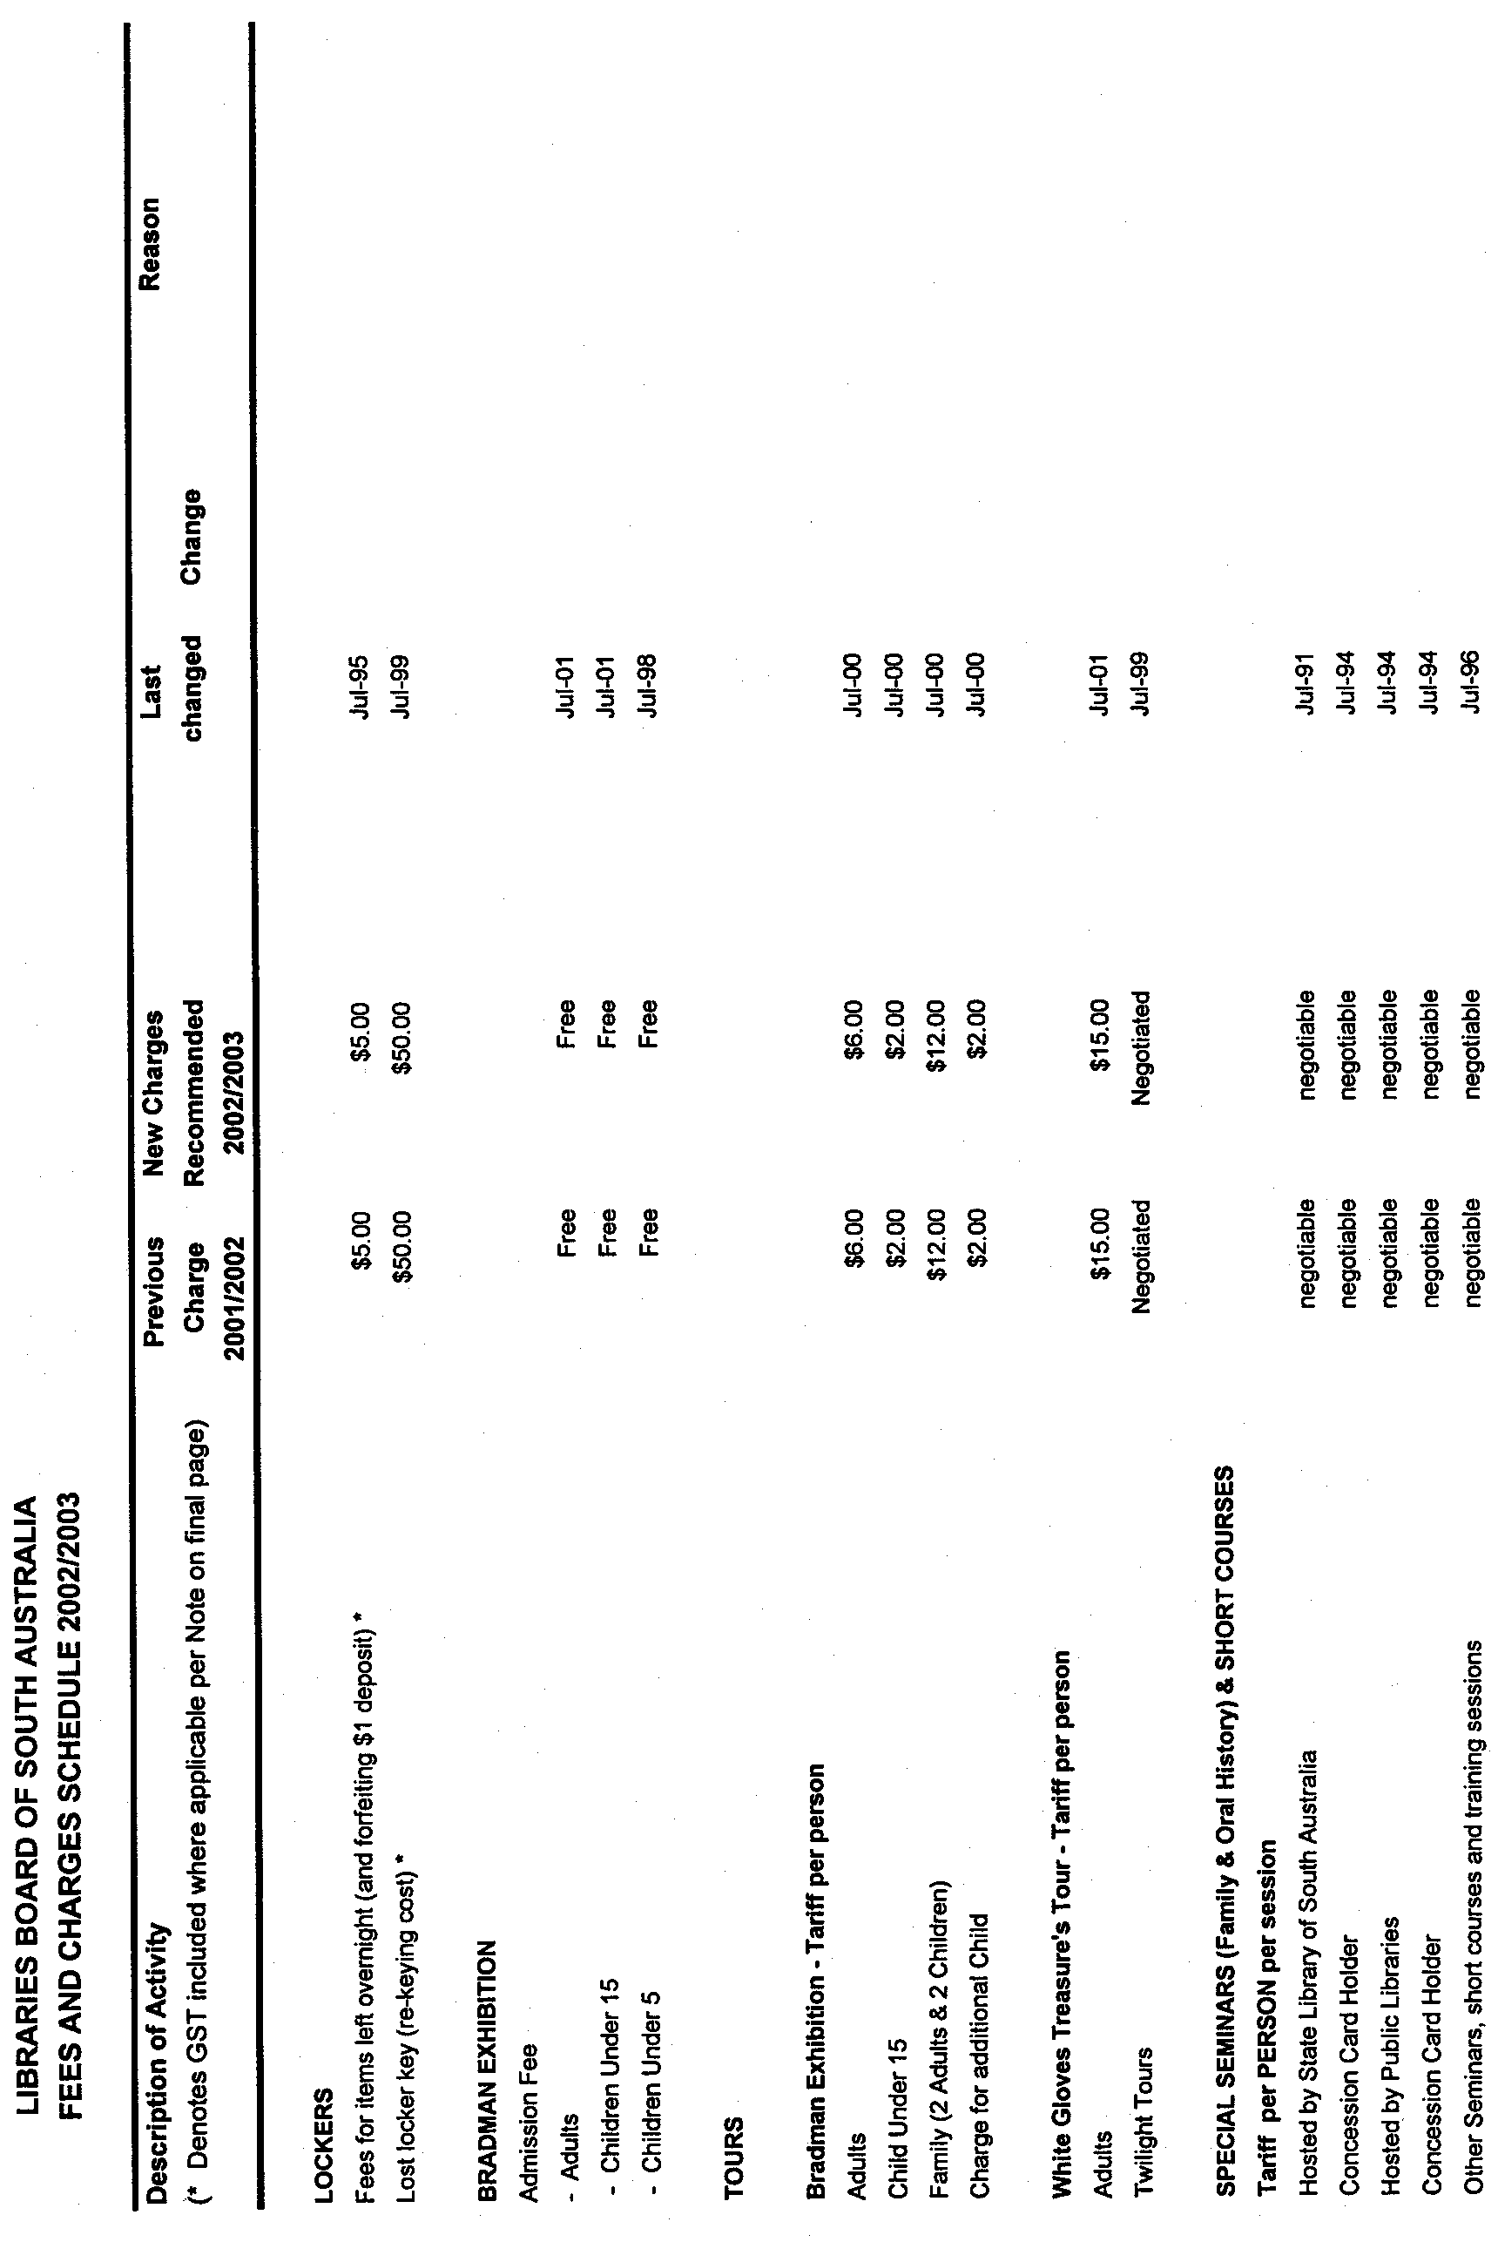
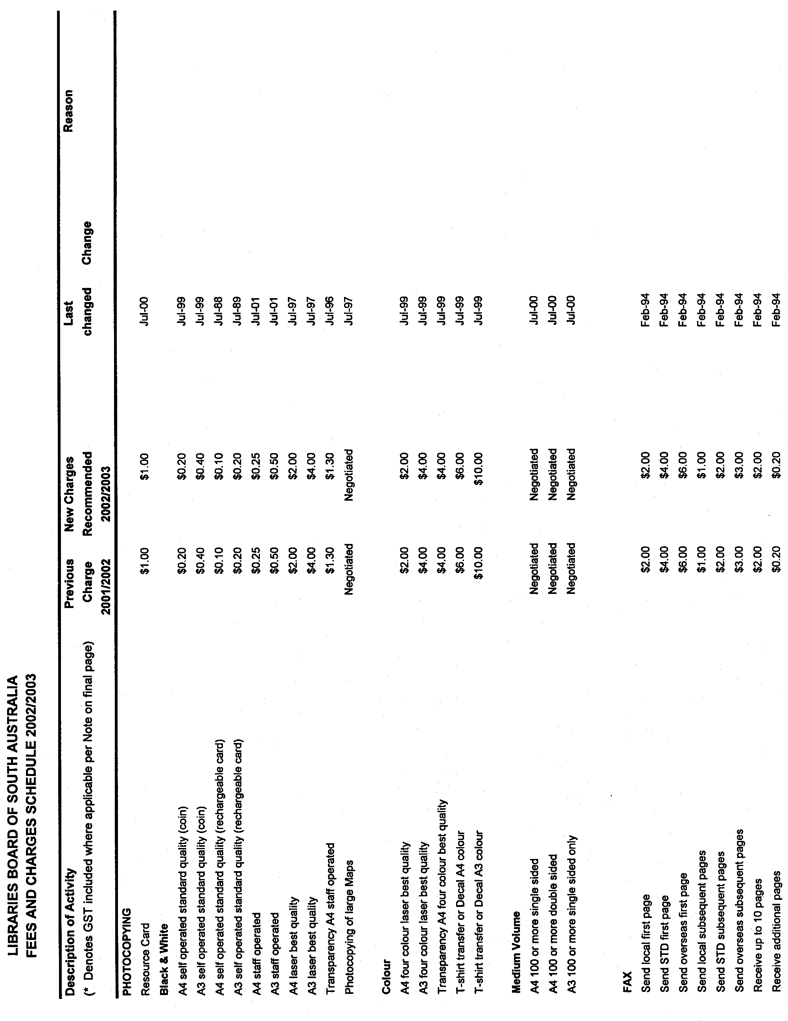
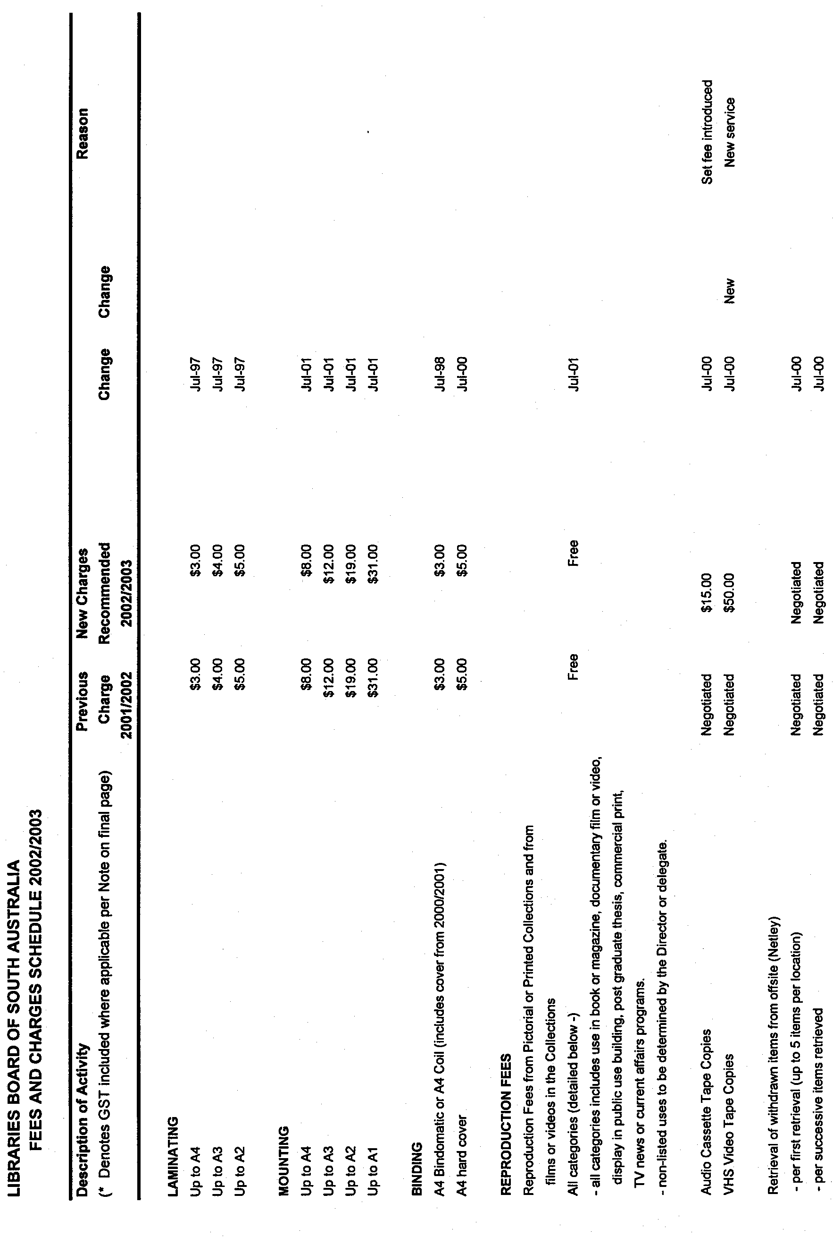
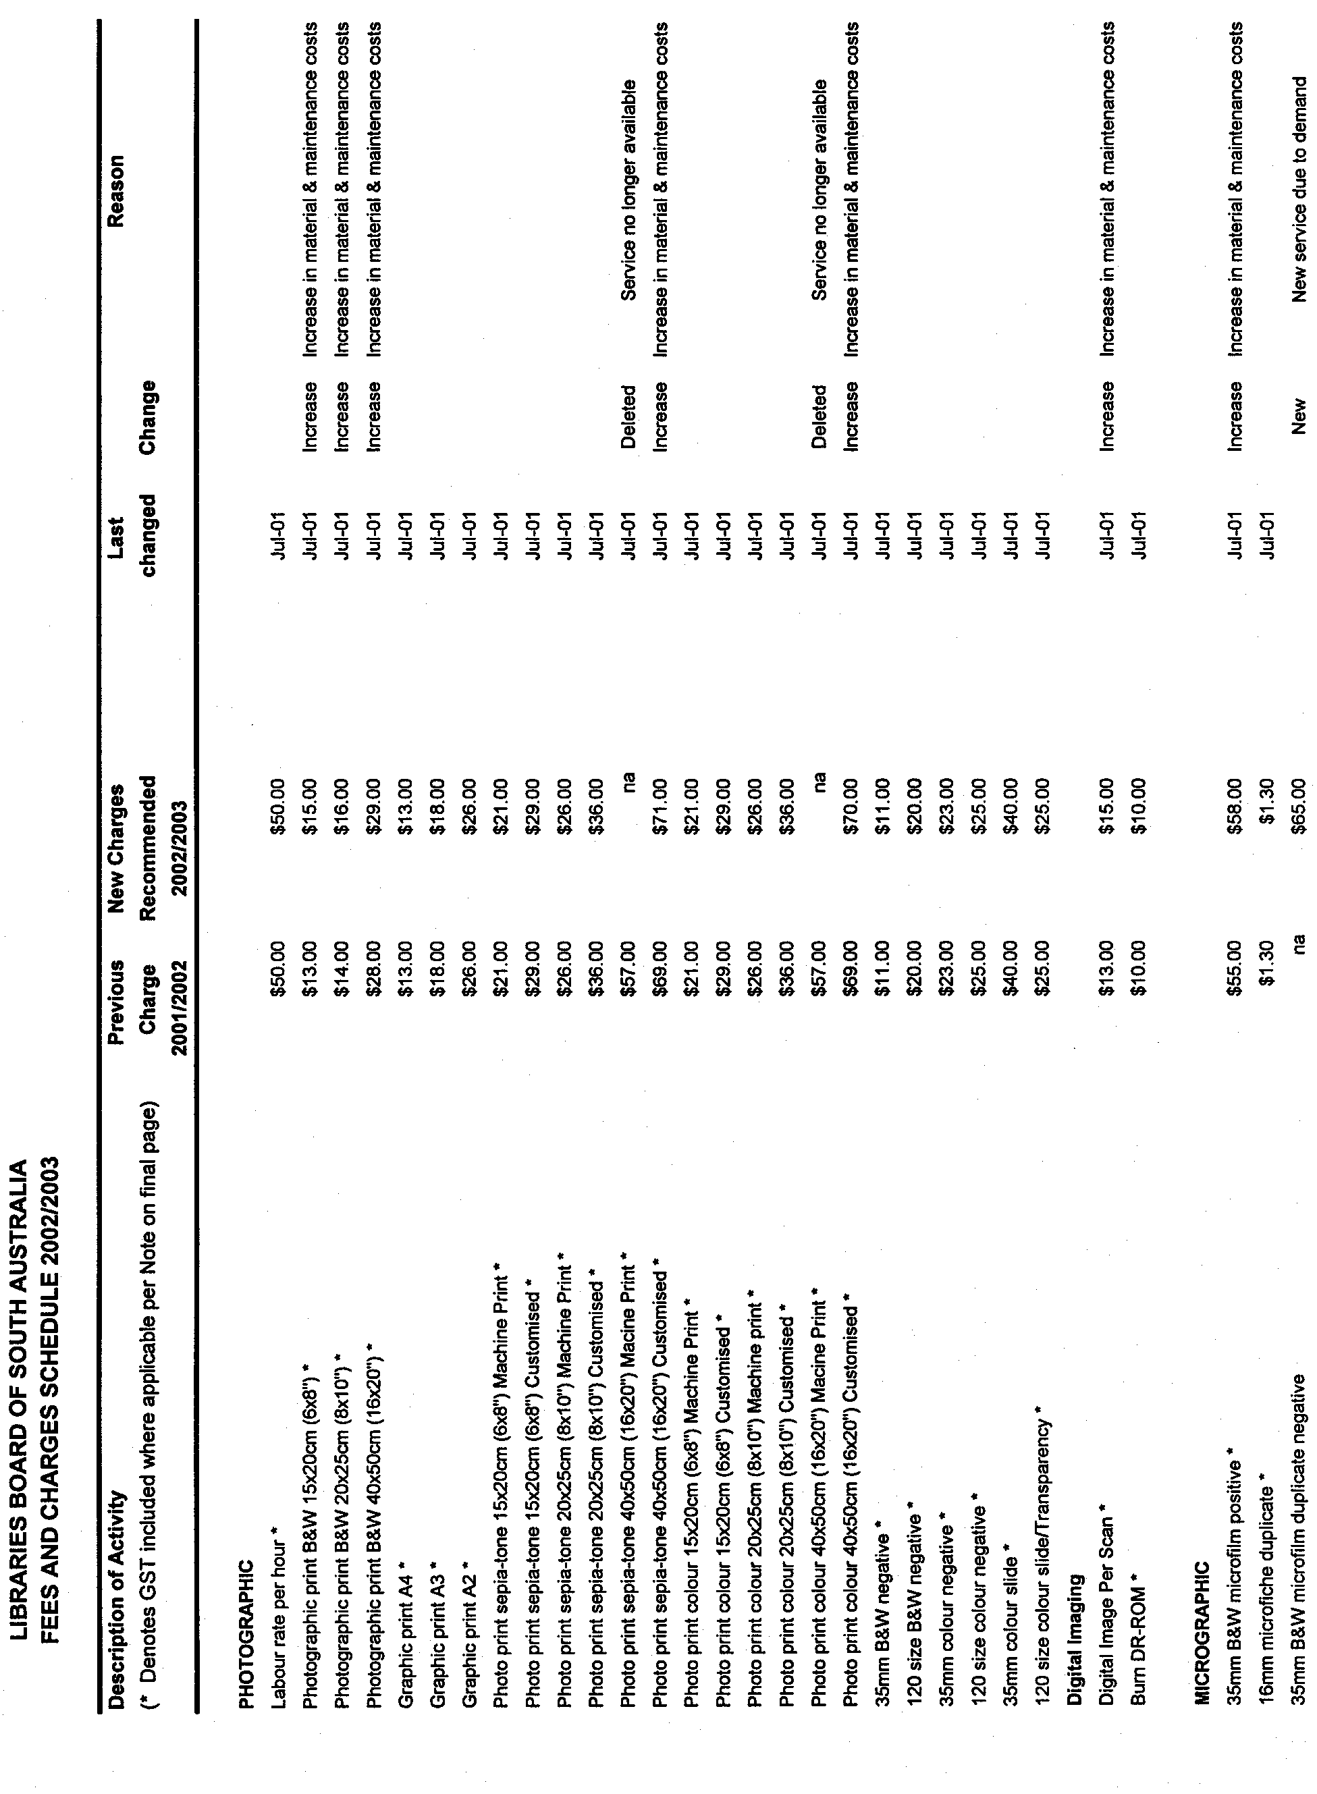
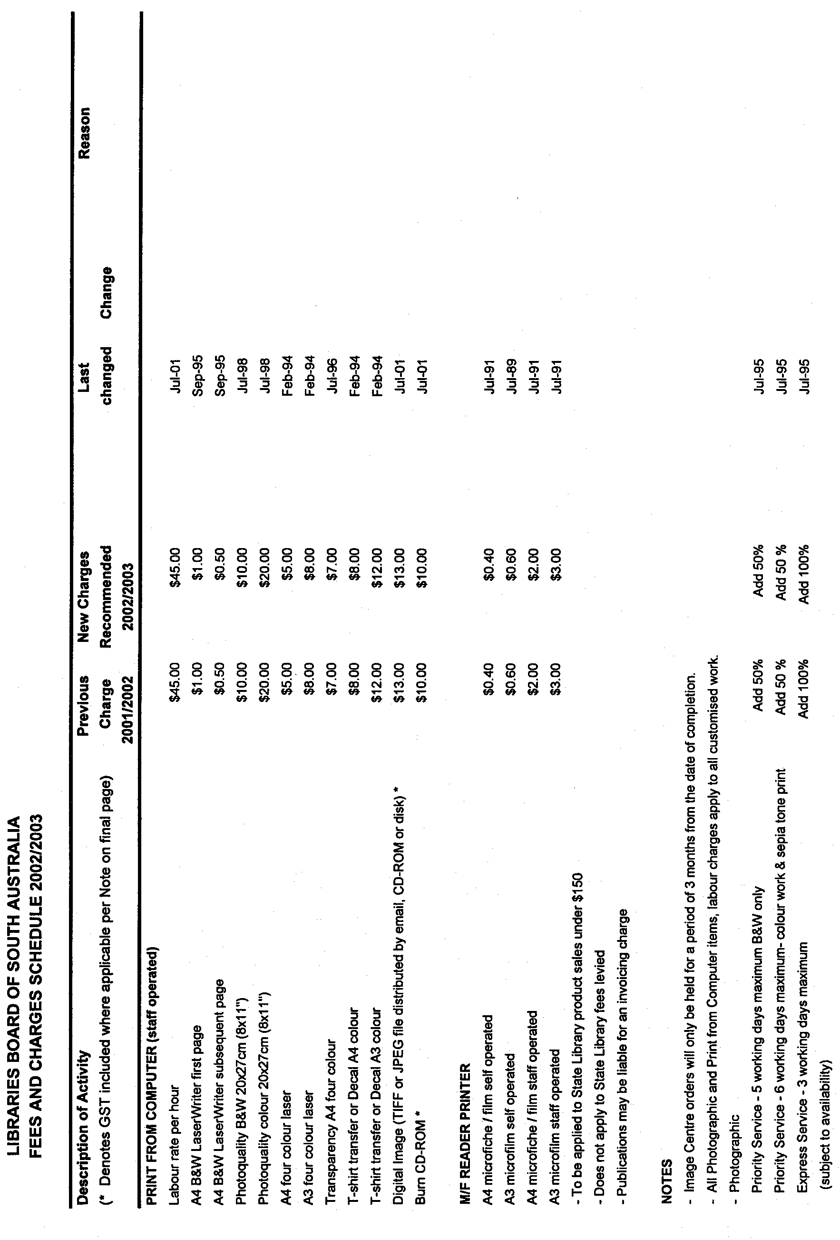
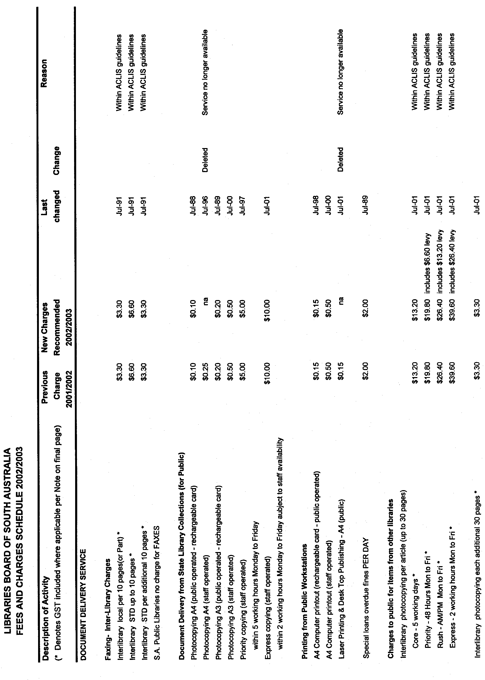
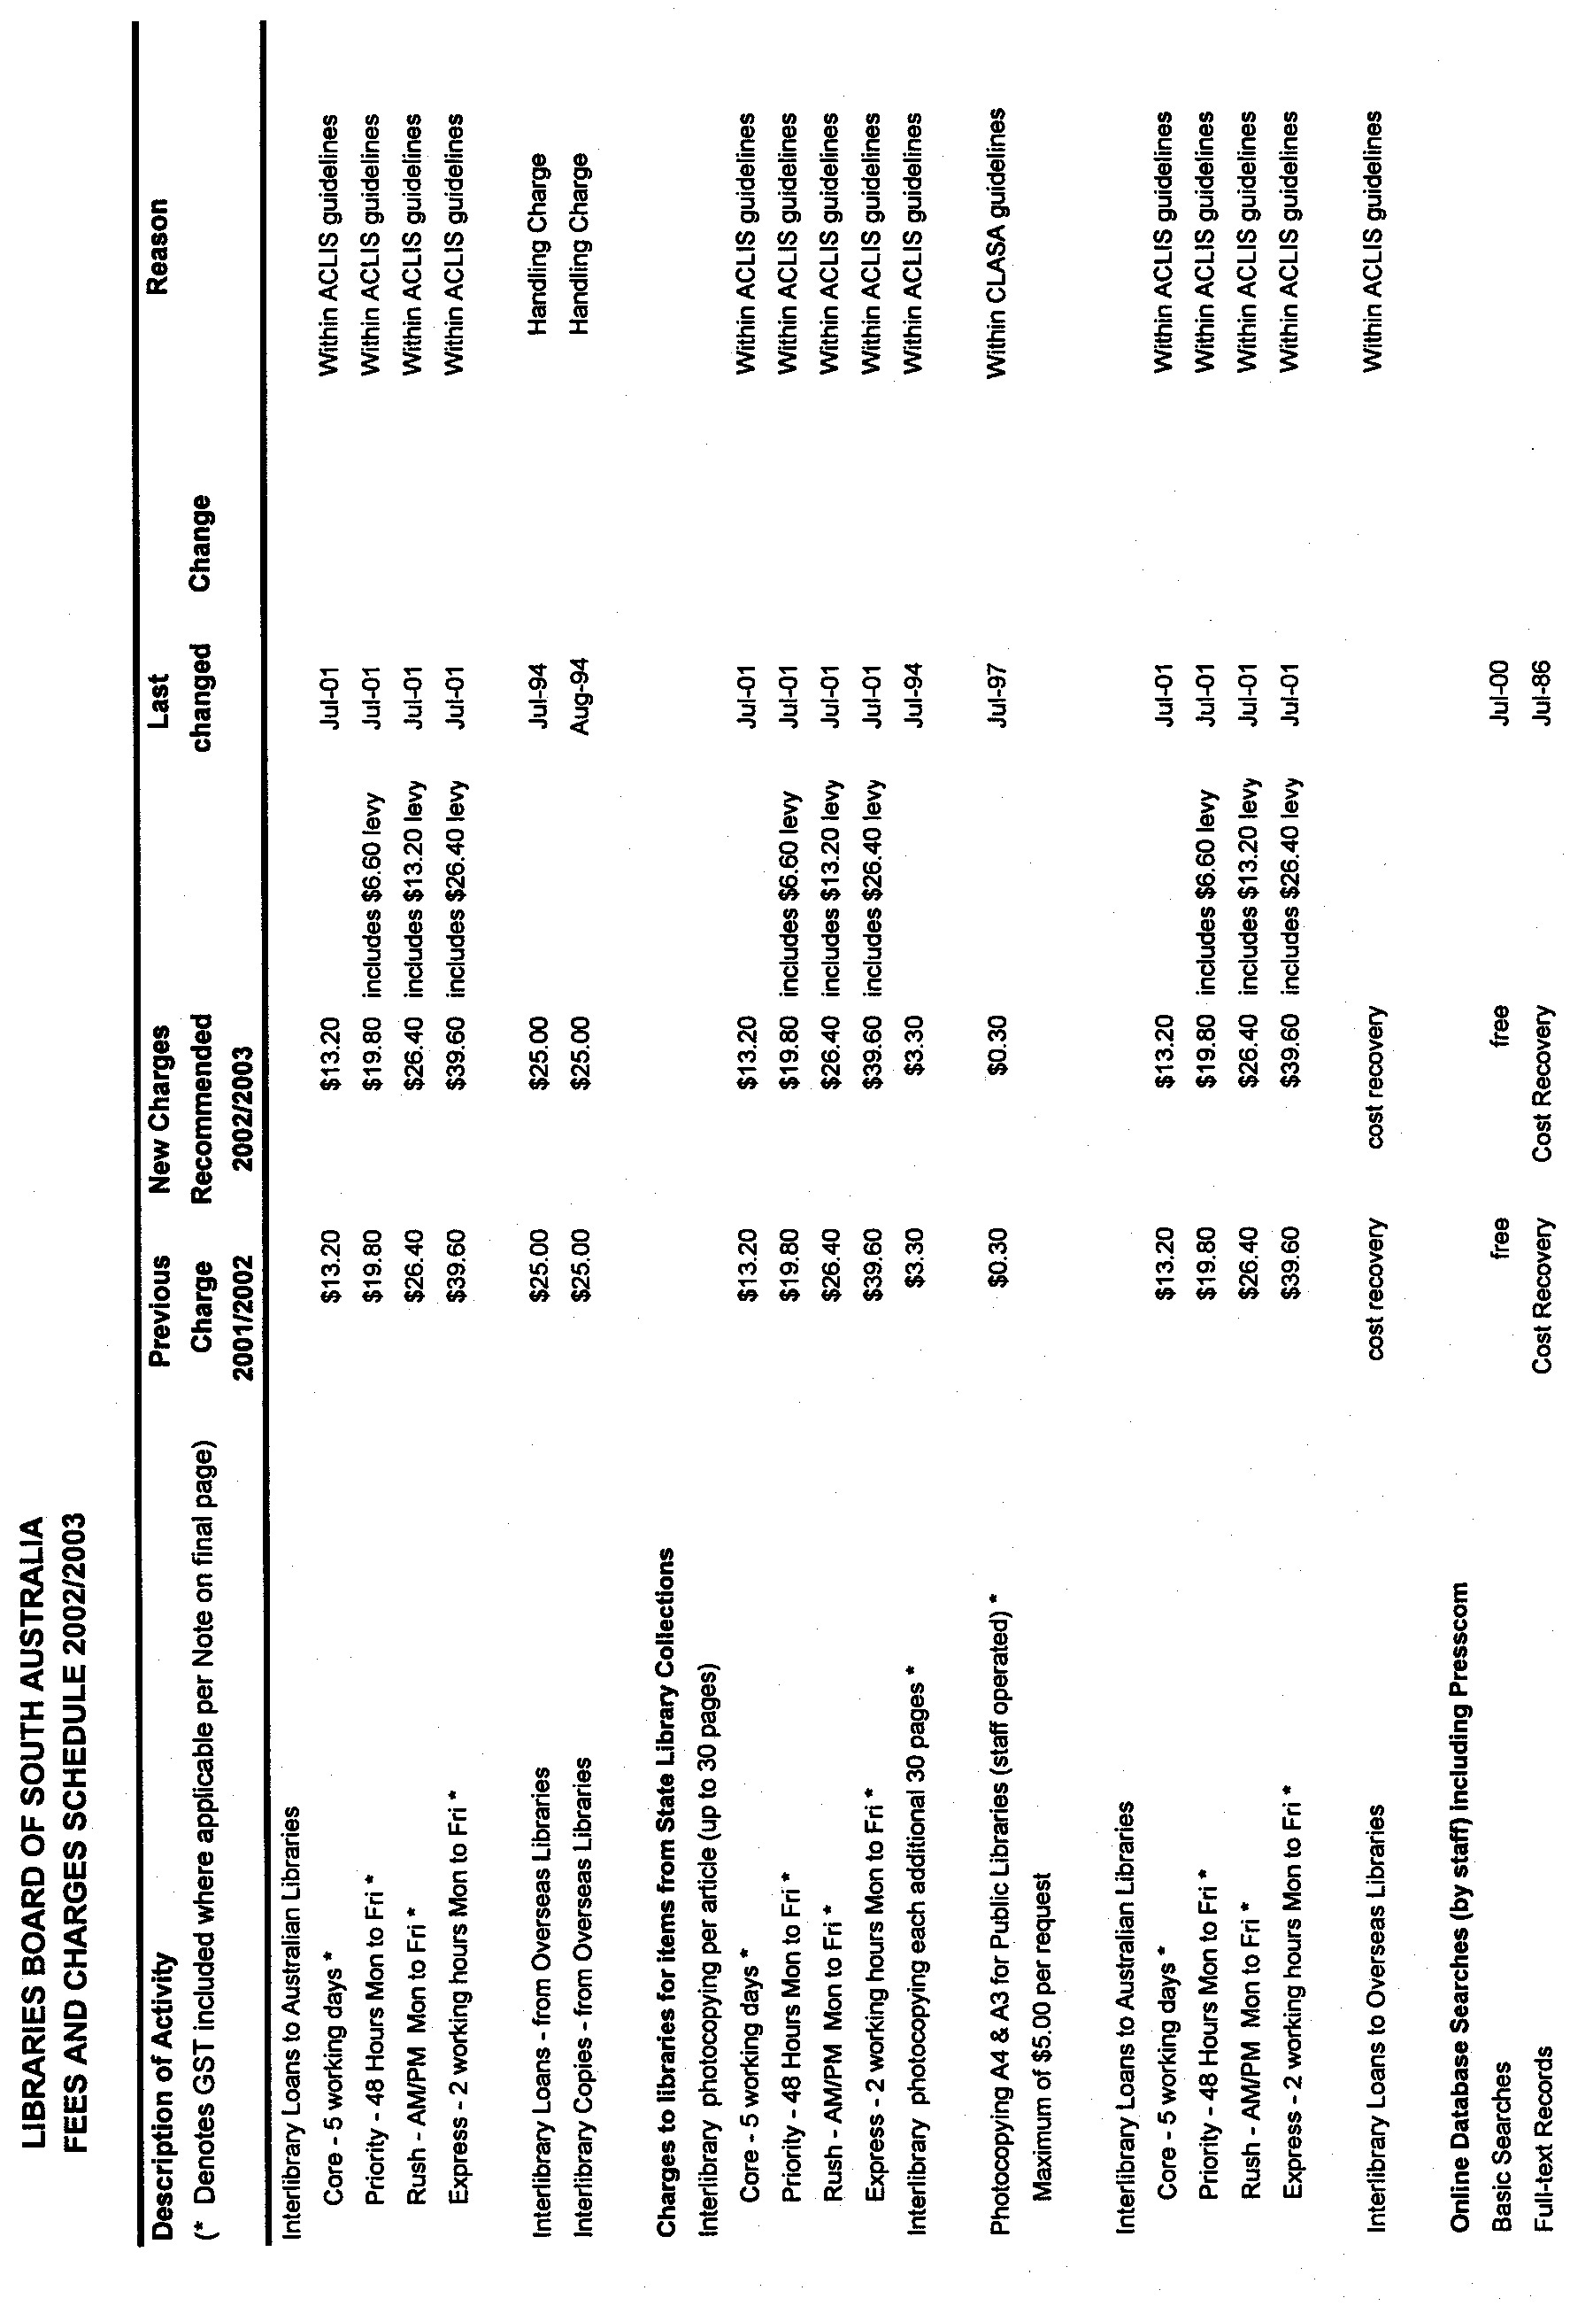

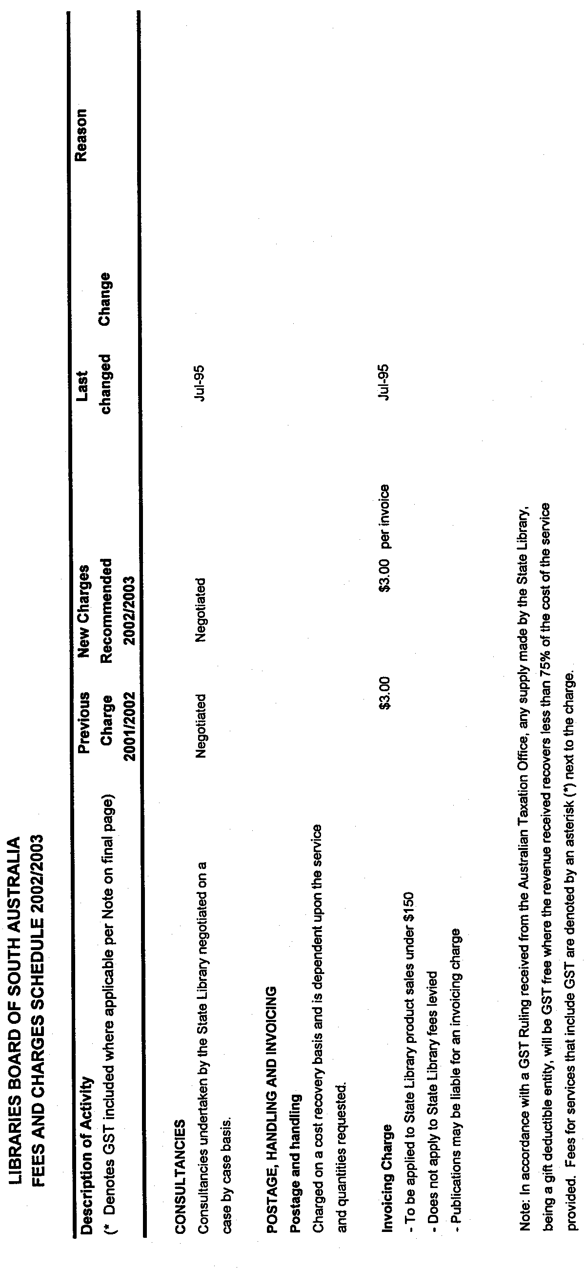

Dated 13 May 2002.B. Halliday, Director State Library of South Australia

HOUSING IMPROVEMENT ACT 1940
NOTICE is hereby given that the South Australian Housing Trust in the exercise of the powers conferred by the Housing Improvement Act 1940, does hereby declare the houses described in the table hereunder to be substandard for the purposes of Part VII of the Housing Improvement Act 1940.
No. of House and Street | Locality | Allotment, Section, etc. | Certificate of Title  Volume Folio

1 Steuart Place |  | North Adelaide | Allotment 7 in Deposited Plan 663, Hundred of Yatala | 5461 | 782
11 Rose Street |  | Ottoway | Allotment 88 in Deposited Plan 1348, Hundred of Port Adelaide | 5155 | 571

Dated at Adelaide, 27 June 2002. H. Fulcher, Acting General Manager, Housing Trust

HOUSING IMPROVEMENT ACT 1940
WHEREAS by notice published in the Government Gazette on the dates mentioned in the following table the South Australian Housing Trust did declare the houses described in the said table to be substandard for the purposes of Part VII of the Housing Improvement Act 1940, the South Australian Housing Trust in the exercise of the powers conferred by the said Part, does hereby fix as the maximum rental per week which shall be payable subject to section 55 of the Residential Tenancies Act 1995, in respect of each house described in the following table the amount shown in the said table opposite the description of such house and this notice shall come into force on the date of this publication in the Gazette.
Address of House | Allotment, Section, etc. | Certificate of Title  Volume Folio | Date and page of Government Gazette in which notice declaring house to be substandard published | Maximum rental per week payable in respect of each house  $

3 Malaga Terrace, Berri |  | Town Allotment No. 183 in the Township of Berri, in the Berri Irrigation Area, County of Hamley | Cro  993 | wn Lease  26 |  | 28.8.97, page 468 | 120.00
8 Gordon Road, Black Forest |  | Allotment 109 in Deposited Plan 2015, Hundred of Adelaide | 5376 | 131 |  | 31.1.01, page 423 | 155.00
Flat 1, 22 Crocker Street, Bordertown |  | Allotment 502 in Filed Plan 204838, Hundred of Tatiara | 5777 | 208 |  | 30.5.96, page 2605 | 90.00
4 Tenth Street, Bowden |  | Allotment 6 in Deposited Plan 418, Hundred of Yatala | 5716 | 248 |  | 7.7.66, page 136 | 85.00
Main House, 120 South Road, Croydon |  | Allotment 57 in Filed Plan 115769, Hundred of Yatala | 5348 | 779 |  | 29.5.86, page 1424 | 140.00
8 Cooper Avenue, Croydon Park |  | Allotment 10 in Deposited Plan 4251, Hundred of Yatala | 5871 | 710 |  | 24.2.94, page 538 | 135.00
8 (Lot 879) Eliza Street, Kalangadoo |  | Allotment 879 in Plan 191441, Hundred of Grey | 5716 | 792 |  | 27.9.01, page 4303 | 95.00
Lot 1, portion of Section 23 Wireless Road East, Mount Gambier |  | Allotment 1 in Filed Plan 14852, Hundred of Gambier | 5156 | 923 |  | 24.8.95, page 508 | 130.00
11 Green Street, Mypolonga, (also known as Lot 11) |  | Allotment 11 in the Town of Mypolonga, Hundred of Mobilong | 5872 | 238 |  | 28.2.02, page 1097 | 110.00
40 Arthur Street, Naracoorte |  | Allotment 196 in Filed Plan 199090, Hundred of Naracoorte | 5677 | 389 |  | 29.7.93, page 715 | 135.00
8 First Street, Orroroo |  | Allotment 5 in Filed Plan 105508, Hundred of Walloway | 5160 | 541 |  | 25.7.96, page 182 | 90.00
175 Fifteenth Street, Renmark |  | Allotment 576 in Filed Plan 177782, Out of Hundreds (Renmark) | 5708 | 316 |  | 30.7.92, page 760 | 120.00
513 Marion Road, South Plympton |  | Allotment 179 in Filed Plan 8989, Hundred of Adelaide | 5290 | 497 |  | 11.10.79, page 971 | 140.00
55 Cornish Terrace, Wallaroo (also known as 55 Cornish Street) |  | Allotment 605 in Filed Plan 189547, Hundred of Wallaroo | 5817 | 198 |  | 24.4.02, page 1651 | 50.00

Dated at Adelaide, 27 June 2002. H. Fulcher, Acting General Manager, Housing Trust

HOUSING IMPROVEMENT ACT 1940
WHEREAS by notice published in the Government Gazette on the dates mentioned in the following table the South Australian Housing Trust did declare the houses described in the said table to be substandard for the purposes of Part VII of the Housing Improvement Act 1940, and whereas the South Australian Housing Trust is satisfied that each of the houses described hereunder has ceased to be substandard, notice is hereby given that, in exercise of the powers conferred by the said Part, the South Australian Housing Trust does hereby revoke the said declaration in respect of each house.
Address of House | Allotment, Section, etc. | Certificate of Title  Volume Folio | Date and page of Government Gazette in which notice declaring house to be substandard published

207 (also known as Lot 3) Mount Barker Road, Aldgate |  | Allotment 3 in Deposited Plan 17549, Hundred of Noarlunga | 5301 | 234 |  | 30.10.80, page 1293
62 Western Drive (also known as Lot 2), Bordertown |  | Allotment 2 in Deposited Plan 41659, Hundred of Tatiara | 5274 | 548 |  | 13.12.90, page 1809
1 Day Terrace, Croydon |  | Allotment 13 in Filed Plan 115825, Hundred of Yatala | 5773 | 753 |  | 28.9.95, page 831
11 Cornwall Street, Lockleys |  | Allotment 67 in Deposited Plan 4605, Hundred of Adelaide | 5094 | 714 |  | 29.5.97, page 2697
A detached brick house with a lean-to at Section 538 Thiele Road, Loveday |  | Sections numbered 538 and 539, in the Cobdogla Irrigation Area, Hundred of Loveday | Cro  1096 | wn Lease  43 |  | 22.11.90, page 1602
3 Kinross Avenue, Lower Mitcham |  | Allotment 5 in Deposited Plan 56546, Hundred of Adelaide | 5845 | 956 |  | 26.8.99, page 959
Flat 1, 615 Magill Road, Magill |  | Allotment 71 in Filed Plan 133822, Hundred of Adelaide | 5811 | 805 |  | 30.5.91, page 1742
House at the rear of 1B St Bernards Road, Magill (corner of Magill Road) |  | Allotment 71 in Filed Plan 133822, Hundred of Adelaide | 5811 | 805 |  | 28.6.90, page 1721
42 Powell Place, Morphett Vale |  | Allotment 127 in Deposited Plan 7597, Hundred of Noarlunga | 5594 | 488 |  | 30.5.02, page 2020
67 Jubilee Highway West, Mount Gambier |  | Allotment 83 in Deposited Plan 1431, Hundred of Blanche | 5172 | 896 |  | 28.6.90, page 1721
14 Oak Street, Mount Gambier |  | Allotment 46 in Deposited Plan 2481, Hundred of Blanche | 5249 | 551 |  | 27.7.89, page 201
Flat 1, 20 Wehl Street North, Mount Gambier |  | Allotment 3 in Deposited Plan 1306, Hundred of Blanche | 5167 | 934 |  | 29.6.89, page 1887
Flat 2, 20 Wehl Street North, Mount Gambier |  | Allotment 3 in Deposited Plan 1306, Hundred of Blanche | 5167 | 934 |  | 29.6.89, page 1887
17 McCoy Street, Naracoorte |  | Allotment 111 in the Town of Naracoorte South, Hundred of Naracoorte | 5834 | 167 |  | 27.7.89, page 201
15 Queen Street, Pennington |  | Allotment 62 in Deposited Plan 1964, Hundred of Yatala | 5527 | 232 |  | 30.10.80, page 1293
57 Russell Street, Rosewater |  | Allotment 52 in Deposited Plan 33949, Hundred of Yatala | 5075 | 574 |  | 24.6.76, page 3224
59 Russell Street, Rosewater |  | Allotment 51 in Deposited Plan 33949, Hundred of Yatala | 5075 | 573 |  | 24.6.76, page 3224
772 Torrens Road, Rosewater |  | Allotment 78 of portion of Section 422, Hundred of Yatala | 575 | 5 |  | 16.7.70, page 253
798 Torrens Road, Rosewater |  | Portion of Allotment 71, Subdivision of Section 422, Hundred of Yatala | 2401 | 120 |  | 26.3.81, page 992
55 Stepney Street, Stepney |  | Allotment 38 in Filed Plan 134789, Hundred of Adelaide | 5641 | 772 |  | 7.9.67, page 1275
11 Tiller Street, Tailem Bend |  | Allotment 657 in Deposited Plan 4650, Hundred of Seymour | 5226 | 122 |  | 13.4.89, page 1053
5 Alton Avenue, Torrens Park |  | Allotment 56 in Deposited Plan 3475, Hundred of Adelaide | 5250 | 779 |  | 29.4.99, page 2375
23 Langham Terrace, Unley |  | Allotment 519 in Filed Plan 15589, Hundred of Adelaide | 5209 | 710 |  | 11.1.96, page 110
Flat 2, 4 Welland Avenue, Welland |  | Allotment 82 in Filed Plan 116394, Hundred of Yatala | 5710 | 185 |  | 30.8.01, Page 3431

Dated at Adelaide, 27 June 2002. H. Fulcher, Acting General Manager, Housing Trust

LAND ACQUISITION ACT 1969
Notice of Acquisition
THE COMMISSIONER OF HIGHWAYS (the ‘Authority’), 33 Warwick Street, Walkerville, S.A. 5081, acquires the following interests in the following land:
Definition of Land Acquired
Comprising the fee simple of that piece of land situated at 356 Portrush Road, Tusmore, S.A. 5065, being the whole of Allotment 105 in the plan lodged in the Registrar-General’s Office and numbered DP 55950 being portion of the land contained in Certificate of Title Volume 5395, Folio 157.
This notice is given under section 16 of the Land Acquisition Act 1969.
Compensation
A person who has or had an interest in the land that is divested or diminished by the acquisition or the enjoyment of which is adversely affected by the acquisition who does not receive an offer of compensation from the Authority may apply to the Authority for compensation.
Inquiries
Inquiries should be directed to:
Charles Bertram
P.O. Box 1
Walkerville, S.A. 5081
Telephone (08) 8343 2453.
Dated 19 June 2002.
The Common Seal of the Commissioner of Highways was hereto affixed by direction of the Commissioner of Highways in the presence of:
D. Woods, Manager, Land Acquisition and Disposal, Transport SA.

LIQUOR LICENSING ACT 1997 AND GAMING MACHINES ACT 1992
Notice of Application
NOTICE is hereby given, pursuant to section 52 of the Liquor Licensing Act 1997 and section 29 of the Gaming Machines Act 1992, that Goolwa Hotels Pty Ltd, c/o Piper Alderman Solicitors, 167 Flinders Street, Adelaide, S.A. 5000 has applied to the Liquor and Gaming Commissioner for the transfer of a Liquor and Gaming Machine Licence in respect of premises situated at 7 Cadell Street, Goolwa, S.A. 5214 and known as Goolwa Hotel.
The applications have been set down for hearing on 30 July 2002 at 10.30 a.m.
Any person may object to the application by lodging a notice of objection in the prescribed form with the Licensing Authority, and serving a copy of the notice on the applicant at the applicant’s address given above, at least seven days before the hearing date.
Plans in respect of the premises the subject of the application are open to public inspection without fee at the Office of the Liquor and Gaming Commissioner, 9th Floor, East Wing, 50 Grenfell Street, Adelaide, S.A. 5000.
Dated 21 June 2002.
Applicant

LIQUOR LICENSING ACT 1997 AND GAMING MACHINES ACT 1992
Notice of Application
NOTICE is hereby given, pursuant to section 52 of the Liquor Licensing Act 1997 and section 29 of the Gaming Machines Act 1992, that Livingstone Hotel Group Pty Ltd, as Trustee of the Livingstone Family Trust, c/o Downs Lawyers, P.O. Box 944,
Mount Gambier, S.A. 5290 has applied to the Liquor and Gaming Commissioner for the transfer of a Liquor and Gaming Machine Licence in respect of premises situated at Bellum Bellum via Mount Gambier, S.A. 5290 and known as Halfway House Hotel.
The applications have been set down for hearing on 29 July 2002 at 11 a.m.
Any person may object to the application by lodging a notice of objection in the prescribed form with the Licensing Authority, and serving a copy of the notice on the applicant at the applicant’s address given above, at least seven days before the hearing date.
Plans in respect of the premises the subject of the application are open to public inspection without fee at the Office of the Liquor and Gaming Commissioner, 9th Floor, East Wing, 50 Grenfell Street, Adelaide, S.A. 5000.
Dated 19 June 2002.
Applicant

LIQUOR LICENSING ACT 1997
Notice of Application
NOTICE is hereby given, pursuant to section 52 (2) (b) of the Liquor Licensing Act 1997, that Hills View Vineyards (SA) Pty Ltd, 42 Crittenden Road, Findon, S.A. 5023 has applied to the Licensing Authority for the removal of a Wholesale Liquor Merchant’s Licence in respect of premises situated at 4 Farr Court, Para Hills West, S.A. 5096 to be situated at 42 Crittenden Road, Findon, S.A. 5023 and known as Hills View Vineyards (SA) Pty Ltd.
The application has been set down for hearing on 26 July 2002 at 9 a.m.
Any person may object to the application by lodging a notice of objection in the prescribed form with the Licensing Authority, and serving a copy of the notice on the applicant at the applicant’s address given above, at least seven days before the hearing date.
Plans in respect of the premises the subject of the application are open to public inspection without fee at the Office of the Liquor and Gaming Commissioner, 9th Floor, East Wing, 50 Grenfell Street, Adelaide, S.A. 5000.
Dated 14 June 2002.
Applicant

LIQUOR LICENSING ACT 1997
Notice of Application
NOTICE is hereby given, pursuant to section 52 (2) (b) of the Liquor Licensing Act 1997, that Katherine Mary Wenk, P.O. Box 103 Verdun, S.A, 5245 has applied to the Licensing Authority for a Producer’s Licence in respect of premises situtated at Sandow Road, Verdun, S.A. 5245 and to be known as Sandow’s End.
The application has been set down for hearing on 26 July 2002 at 9 a.m.
Any person may object to the application by lodging a notice of objection in the prescribed form with the Licensing Authority, and serving a copy of the notice on the applicant at the applicant’s address given above, at least seven days before the hearing date.
Plans in respect of the premises the subject of the application are open to public inspection without fee at the Office of the Liquor and Gaming Commissioner, 9th Floor, East Wing, 50 Grenfell Street, Adelaide, S.A. 5000.
Dated 18 June 2002.
Applicant

LIQUOR LICENSING ACT 1997
Notice of Application
NOTICE is hereby given, pursuant to section 52 (2) (b) of the Liquor Licensing Act 1997, that Massena Vineyards Pty Ltd (ACN 099 344 457), c/o David Watts & Associates, Liquor Licensing Consultants, 1 Cator Street, Glenside, S.A. 5065, has applied to the Licensing Authority for a Producer’s Licence in respect of premises situated at 26 Sturt Street, Angaston, S.A. 5353 and to be known as Massena Vineyards.
The application has been set down for hearing on 26 July 2002 at 9 a.m.
Any person may object to the application by lodging a notice of objection in the prescribed form with the Licensing Authority, and serving a copy of the notice on the applicant at the applicant’s address given above, at least seven days before the hearing date.
Plans in respect of the premises the subject of the application are open to public inspection without fee at the Office of the Liquor and Gaming Commissioner, 9th Floor, East Wing, 50 Grenfell Street, Adelaide, S.A. 5000.
Dated 18 June 2002.
Applicant

LIQUOR LICENSING ACT 1997
Notice of Application
NOTICE is hereby given, pursuant to section 52 (2) (b) of the Liquor Licensing Act 1997, that Arae Pty Ltd (ACN 074 643 575) as trustee for the Yacca Paddock Trust and Janss Pty Ltd, (ACN 007 771 306), as trustee for the Montgomery Trust c/o David Watts & Associates, Liquor Licensing Consultants, 1 Cator Street, Glenside, S.A. 5065, has applied to the Licensing Authority for a Producer’s Licence in respect of premises situated at 3/1 Payneham Road, College Park, S.A. 5069 and to be known as Yacca Paddock Vineyards.
The application has been set down for hearing on 26 July 2002 at 9 a.m.
Any person may object to the application by lodging a notice of objection in the prescribed form with the Licensing Authority, and serving a copy of the notice on the applicants at the applicants’ address given above, at least seven days before the hearing date.
Plans in respect of the premises the subject of the application are open to public inspection without fee at the Office of the Liquor and Gaming Commissioner, 9th Floor, East Wing, 50 Grenfell Street, Adelaide, S.A. 5000.
Dated 18 June 2002.
Applicants

LIQUOR LICENSING ACT 1997
Notice of Application
NOTICE is hereby given, pursuant to section 52 (2) (b) of the Liquor Licensing Act 1997, that Apostolos Lucky Logothetis and Belinda Louise Logothetis, c/o Jack Clarke of Hunt & Hunt Lawyers, have applied to the Licensing Authority for a Restaurant Licence with Entertainment Consent in respect of premises situated at Shops 6 and 7, Topham Mall, Waymouth Street, Adelaide S.A. 5000 and to be known as Cafe Elate.
The application has been set down for hearing on 26 July 2002 at 9 a.m.
Any person may object to the application by lodging a notice of objection in the prescribed form with the Licensing Authority, and serving a copy of the notice on the applicants at the applicants’ address given above, at least seven days before the hearing date.
Plans in respect of the premises the subject of the application are open to public inspection without fee at the Office of the Liquor and Gaming Commissioner, 9th Floor, East Wing, 50 Grenfell Street, Adelaide, S.A. 5000.
Dated 19 June 2002.
Applicants

LIQUOR LICENSING ACT 1997
Notice of Application
NOTICE is hereby given, pursuant to section 52 (2) (b) of the Liquor Licensing Act 1997, that K. J. Beswick Pty Ltd, PMJ Investments Pty Ltd and Tiffean Nominees Pty Ltd, 345-353 Hancock Road, Fairview Park, S.A. 5126 have applied to the Licensing Authority for a variation to Conditions of Licence in respect of premises situated at 345-353 Hancock Road, Fairview Park, S.A. 5126 and known as Glue Gums Hotel.
The application has been set down for hearing on 26 July 2002 at 9 a.m.
Conditions
The following licence condition is sought:
That the licensee be permitted to commence trading at 8.30 am each Monday to Saturday inclusive in lieu of 9 a.m.
Any person may object to the application by lodging a notice of objection in the prescribed form with the Licensing Authority, and serving a copy of the notice on the applicants at the applicants’ address given above, at least seven days before the hearing date.
Plans in respect of the premises the subject of the application are open to public inspection without fee at the Office of the Liquor and Gaming Commissioner, 9th Floor, East Wing, 50 Grenfell Street, Adelaide, S.A. 5000.
Dated 18 June 2002.
Applicants

LIQUOR LICENSING ACT 1997
Notice of Application
NOTICE is hereby given, pursuant to section 52 (2) (b) of the Liquor Licensing Act 1997, that Norman John Williamson, David Arthur Addams Williams and Christopher Hopton Addams Williams have applied to the Licensing Authority for the removal of a Producer’s Licence in respect of premises situated at 11 Alpha Street, Kensington Park, S.A. 5068 and to be situated at 27 Hay Road, Linden Park, S.A. 5065 and known as Llangibby Estate.
The application has been set down for hearing on 26 July 2002.
Any person may object to the application by lodging a notice of objection in the prescribed form with the Licensing Authority, and serving a copy of the notice on the applicants at the applicants’ address given above, at least seven days before the hearing date.
Plans in respect of the premises the subject of the application are open to public inspection without fee at the Office of the Liquor and Gaming Commissioner, 9th Floor, East Wing, 50 Grenfell Street, Adelaide, S.A. 5000.
Dated 20 June 2002.
Applicants

LIQUOR LICENSING ACT 1997
Notice of Application
NOTICE is hereby given, pursuant to section 52 (2) (b) of the Liquor Licensing Act 1997, that Frank Perre has applied to the Licensing Authority for a Producer’s Licence in respect of premises situtated at 1157 Port Wakefield Road, Waterloo Corner, S.A. 5110 and to be known as Frank Perre Wines.
The application has been set down for hearing on 26 July 2002 at 9 a.m.
Any person may object to the application by lodging a notice of objection in the prescribed form with the Licensing Authority, and serving a copy of the notice on the applicant at the applicant’s address given above, at least seven days before the hearing date.
Plans in respect of the premises the subject of the application are open to public inspection without fee at the Office of the Liquor and Gaming Commissioner, 9th Floor, East Wing, 50 Grenfell Street, Adelaide, S.A. 5000.
Dated 21 June 2002.
Applicant

LIQUOR LICENSING ACT 1997
Notice of Application
NOTICE is hereby given, pursuant to section 52 (2) (b) of the Liquor Licensing Act 1997, that Jim, Elizabeth, Antonios and Toula Varvaricos, P.O. Box 196, Virginia, S.A. 5120 have applied to the Licensing Authority for a Producer’s Licence in respect of premises situated at Lot 100 Gawler Road, Virginia, S.A. 5120 and to be known as A.T.J.E. Varvaricos.
The application has been set down for hearing on 26 July 2002 at 9 a.m.
Any person may object to the application by lodging a notice of objection in the prescribed form with the Licensing Authority, and serving a copy of the notice on the applicants at the applicants’ address given above, at least seven days before the hearing date.
Plans in respect of the premises the subject of the application are open to public inspection without fee at the Office of the Liquor and Gaming Commissioner, 9th Floor, East Wing, 50 Grenfell Street, Adelaide, S.A. 5000.
Dated 24 December 2001.
Applicants

LIQUOR LICENSING ACT 1997
Notice of Application
NOTICE is hereby given, pursuant to section 52 (2) (b) of the Liquor Licensing Act 1997, that Grosset Hill Smith Pty Ltd (ACN 099 872 607) c/o Fisher Jeffries, SGIC Building, Level 15, 211 Victoria Square, Adelaide, S.A. 5000 has applied to the Licensing Authority for a Producer’s Licence in respect of premises situtated at Eden Valley Road, Angaston, S.A. 5353.
The application has been set down for hearing on 26 July 2002 at 9 a.m.
Any person may object to the application by lodging a notice of objection in the prescribed form with the Licensing Authority, and serving a copy of the notice on the applicant at the applicant’s address given above, at least seven days before the hearing date.
Plans in respect of the premises the subject of the application are open to public inspection without fee at the Office of the Liquor and Gaming Commissioner, 9th Floor, East Wing, 50 Grenfell Street, Adelaide, S.A. 5000.
Dated 17 June 2002.
Applicant

LIQUOR LICENSING ACT 1997
Notice of Application
NOTICE is hereby given, pursuant to section 52 (2) (b) of the Liquor Licensing Act 1997, that Standish Wine Company Pty Ltd (ACN 095 531 703), c/o David Watts & Associates, Liquor Licensing Consultants, 1 Cator Street, Glenside, S.A. 5065, has applied to the Licensing Authority for a Producer’s Licence in respect of premises situated at 29 Sturt Street, Angaston, S.A. 5353 and to be known as the Standish Wine Company
The application has been set down for hearing on 26 July 2002 at 9 a.m.
Any person may object to the application by lodging a notice of objection in the prescribed form with the Licensing Authority, and serving a copy of the notice on the applicant at the applicant’s address given above, at least seven days before the hearing date.
Plans in respect of the premises the subject of the application are open to public inspection without fee at the Office of the Liquor and Gaming Commissioner, 9th Floor, East Wing, 50 Grenfell Street, Adelaide, S.A. 5000.
Applicant

LIQUOR LICENSING ACT 1997
Notice of Application
NOTICE is hereby given, pursuant to section 52 (2) (b) of the Liquor Licensing Act 1997, that Trevarrick Pty Limited (ACN 100 753 295), has applied to the Licensing Authority for the transfer of a Producer’s Licence in respect of premises situated at Skilly Valley, Sevenhill, via Clare, S.A. 5453 and known as Waninga Wines.
The application has been set down for hearing on 29 July 2002 at 9 a.m.
Any person may object to the application by lodging a notice of objection in the prescribed form with the Licensing Authority, and serving a copy of the notice on the applicant at the applicant’s address given above, at least seven days before the hearing date.
Plans in respect of the premises the subject of the application are open to public inspection without fee at the Office of the Liquor and Gaming Commissioner, 9th Floor, East Wing, 50 Grenfell Street, Adelaide, S.A. 5000.
Applicant

LIQUOR LICENSING ACT 1997
Notice of Application
NOTICE is hereby given, pursuant to section 52 (2) (b) of the Liquor Licensing Act 1997, that Golden Gopuram Hospitality Services Pty Ltd and Surinder Kumar, c/o Ouwens Lawyers, 99 Frome Street, Adelaide, S.A. 5000 have applied to the Licensing Authority for the transfer of a Restaurant Licence in respect of premises situated at 47 O’Connell Street, North Adelaide, S.A. 5006 and known as Tandoori King.
The application has been set down for hearing on 29 July 2002 at 9.30 a.m.
Any person may object to the application by lodging a notice of objection in the prescribed form with the Licensing Authority, and serving a copy of the notice on the applicants at the applicants’ address given above, at least seven days before the hearing date.
Plans in respect of the premises the subject of the application are open to public inspection without fee at the Office of the Liquor and Gaming Commissioner, 9th Floor, East Wing, 50 Grenfell Street, Adelaide, S.A. 5000.
Dated 20 June 2002.
Applicants

LIQUOR LICENSING ACT 1997
Notice of Application
NOTICE is hereby given, pursuant to section 52 (2) (b) of the Liquor Licensing Act 1997, that Tandoori Mahal Indian Restaurant Pty Ltd, c/o Odhavji & Associates, Suite F, 105 Gouger Street, Adelaide, S.A. 5000 has applied to the Licensing Authority for the transfer of a Restaurant Licence in respect of premises situated at Basement, 31-33 Hindley Street, Adelaide, S.A. 5000 and known as Chinatown Restaurant and to be known as Tandoori Mahal Indian Restaurant.
The application has been set down for hearing on 29 July 2002 at 10 a.m.
Any person may object to the application by lodging a notice of objection in the prescribed form with the Licensing Authority, and serving a copy of the notice on the applicant at the applicant’s address given above, at least seven days before the hearing date.
Plans in respect of the premises the subject of the application are open to public inspection without fee at the Office of the Liquor and Gaming Commissioner, 9th Floor, East Wing, 50 Grenfell Street, Adelaide, S.A. 5000.
Dated 17 June 2002.
Applicant

LIQUOR LICENSING ACT 1997
Notice of Application
NOTICE is hereby given, pursuant to section 52 (2) (b) of the Liquor Licensing Act 1997, that Mikann Pty Ltd as trustee for the Mikann Trust and Legends Ink Pty Ltd as trustee for the Legends Ink Trust, have applied to the Licensing Authority for the transfer of a Restaurant Licence in respect of premises situated at First Floor, 36 Rundle Mall, Adelaide, S.A. 5000 and known as Cafe Di Mondo.
The application has been set down for hearing on 29 July 2002 at 10.30 a.m.
Any person may object to the application by lodging a notice of objection in the prescribed form with the Licensing Authority, and serving a copy of the notice on the applicants at the applicants’ address given above, at least seven days before the hearing date.
Plans in respect of the premises the subject of the application are open to public inspection without fee at the Office of the Liquor and Gaming Commissioner, 9th Floor, East Wing, 50 Grenfell Street, Adelaide, S.A. 5000.
Dated 18 June 2002.
Applicants

LIQUOR LICENSING ACT 1997
Notice of Application
NOTICE is hereby given, pursuant to section 52 (2) (b) of the Liquor Licensing Act 1997, that Badenoch Pty Ltd, 287 Diagonal Road, Oaklands Park, S.A. 5046 has applied to the Licensing Authority for the transfer of a Special Circumstances Licence in respect of premises situated at 287 Diagonal Road, Oaklands Park, S.A. 5046 and known as Signature’s Cafe.
The application has been set down for hearing on 29 July 2002 at 11.30 a.m.
Any person may object to the application by lodging a notice of objection in the prescribed form with the Licensing Authority, and serving a copy of the notice on the applicant at the applicant’s address given above, at least seven days before the hearing date.
Plans in respect of the premises the subject of the application are open to public inspection without fee at the Office of the Liquor and Gaming Commissioner, 9th Floor, East Wing, 50 Grenfell Street, Adelaide, S.A. 5000.
Dated 20 June 2002.
Applicant

LIQUOR LICENSING ACT 1997 AND GAMING MACHINES ACT 1992
Notice of Application
NOTICE is hereby given, pursuant to section 52 of the Liquor Licensing Act 1997 and section 29 of the Gaming Machines Act 1992, that Anthony Charles Schmidt, 364 Carrington Street, Adelaide, S.A. 5000 has applied to the Licensing Authority for the transfer of a Hotel and Gaming Licence in respect of premises situated at 9 Manton Street, Hindmarsh, S.A. 5007 and known as Stadium Tavern.
The application has been set down for hearing on 30 July 2002 at 9.30 a.m.
Any person may object to the application by lodging a notice of objection in the prescribed form with the Licensing Authority, and serving a copy of the notice on the applicant at the applicant’s address given above, at least seven days before the hearing date.
Plans in respect of the premises the subject of the application are open to public inspection without fee at the Office of the Liquor and Gaming Commissioner, 9th Floor, East Wing, 50 Grenfell Street, Adelaide, S.A. 5000.
Dated 20 June 2002.
Applicant

LIQUOR LICENSING ACT 1997
Notice of Application
NOTICE is hereby given, pursuant to section 52 (2) (b) of the Liquor Licensing Act 1997, that Nicole Suzanne Ferris has applied to the Licensing Authority for the transfer of a Restaurant Licence in respect of premises situated at 97-101 St Vincent Street, Port Adelaide, S.A. 5015 and known as Portside Saloon Restaurant.
The application has been set down for hearing on 30 July 2002 at 11 a.m.
Any person may object to the application by lodging a notice of objection in the prescribed form with the Licensing Authority, and serving a copy of the notice on the applicant at the applicant’s address given above, at least seven days before the hearing date.
Plans in respect of the premises the subject of the application are open to public inspection without fee at the Office of the Liquor and Gaming Commissioner, 9th Floor, East Wing, 50 Grenfell Street, Adelaide, S.A. 5000.
Dated 20 June 2002.
Applicant

LIQUOR LICENSING ACT 1997
Notice of Application
NOTICE is hereby given, pursuant to section 52 (2) (b) of the Liquor Licensing Act 1997, that J. & A. Reed Pty Ltd, c/o Piper Alderman Solicitors, 167 Flinders Street, Adelaide, S.A. 5000 has applied to the Licensing Authority for the transfer of a Residential Licence in respect of premises situated at 74A Main North Road, Clare, S.A. 5423 and known as Clare Valley Hotel.
The application has been set down for hearing on 30 July 2002 at 10 a.m.
Any person may object to the application by lodging a notice of objection in the prescribed form with the Licensing Authority, and serving a copy of the notice on the applicant at the applicant’s address given above, at least seven days before the hearing date.
Plans in respect of the premises the subject of the application are open to public inspection without fee at the Office of the Liquor and Gaming Commissioner, 9th Floor, East Wing, 50 Grenfell Street, Adelaide, S.A. 5000.
Dated 20 June 2002.
Applicant

MINING ACT 1971
NOTICE is hereby given in accordance with section 28 (5) of the Mining Act 1971, that the Minister for Mineral Resources Development proposes to grant an Exploration Licence over the undermentioned area:
Applicant: ACN 099 477 915 Pty Ltd
Location: Algebullcullia Creek area—Approximately 65 km north-east of Coober Pedy, bounded as follows: Com-mencing at a point being the intersection of latitude 28°25′S and longitude 134°53′E, thence east to longitude 134°59′E, south to latitude 28°31′S, west to longitude 134°53′E, and north to the point of commencement, all the within latitudes and longitudes being geodetic and expressed in terms of the Australian Geodetic Datum as defined on p. 4984 of Commonwealth Gazette number 84 dated 6 October 1966 (AGD66).
Term: 1 year
Area in km²: 108
Ref: 073/2002
H. Tyrteos, Mining Registrar

MINING ACT 1971
NOTICE is hereby given in accordance with section 28 (5) of the Mining Act 1971, that the Minister for Mineral Resources Development proposes to grant an Exploration Licence over the undermentioned area:
Applicant: Colin C. Brooks
Location: Hallett area—Approximately 50 km north of Burra, bounded as follows: Commencing at a point being the intersection of latitude 33°08′S and longitude 138°52′E, thence east to longitude 138°56′E, south to latitude 33°13′S, east to longitude 139°03′E, south to latitude 33°20′S, west to longitude 139°00′E, south to latitude 33°28′S, west to longitude 138°50′E, north to latitude 33°17′S, east to longitude 138°52′E, and north to the point of commencement, all the within latitudes and longitudes being geodetic and expressed in terms of the Australian Geodetic Datum as defined on p. 4984 of Commonwealth Gazette number 84 dated 6 October 1966 (AGD66).
Term: 6 months
Area in km²: 525
Ref: 066/2002
H. Tyrteos, Mining Registrar

MINING ACT 1971
NOTICE is hereby given in accordance with section 28 (5) of the Mining Act 1971, that the Minister for Mineral Resources Development proposes to grant an Exploration Licence over the undermentioned area:
Applicant: Hillview Mining NL
Location: Bullcarkle Dam area—Approximately 40 km east of Kimba, bounded as follows: Commencing at a point being the intersection of latitude 33°10′S and longitude 137°00′E, thence east to longitude 137°01′E, south to latitude 33°16′S, east to longitude 137°02′E, south to latitude 33°20′S, west to longitude 137°01′E, south to latitude 33°25′S, west to longitude 136°52′E, north to latitude 33°24′S, west to longitude 136°49′E, north to latitude 33°07′S, west to the eastern boundary of Lake Gilles Conservation Park, thence generally northerly along the boundary of the said Conservation Park to latitude 33°00′S, east to longitude 137°00′E, and south to the point of commencement, all the within latitudes and longitudes being geodetic and expressed in terms of the Australian Geodetic Datum as defined on p. 4984 of Commonwealth Gazette number 84 dated 6 October 1966 (AGD66).
Term: 1 year
Area in km²: 844
Ref: 163/2001
H. Tyrteos, Mining Registrar

MINING ACT 1971
NOTICE is hereby given in accordance with section 28 (5) of the Mining Act 1971, that the Minister for Mineral Resources Development proposes to grant an Exploration Licence over the undermentioned area:
Applicant: ACN 099 477 915 Pty Ltd
Location: Mulgathing area—Approximately 75 km north-west of Tarcoola, bounded as follows: Commencing at a point being the intersection of latitude 30°11′S and longitude 133°57′E, thence east to longitude 134°03′E, south to latitude 30°17′S, west to longitude 133°57′E, and north to the point of commencement, all the within latitudes and longitudes being geodetic and expressed in terms of the Australian Geodetic Datum as defined on p. 4984 of Commonwealth Gazette number 84 dated 6 October 1966 (AGD66).
Term: 1 year
Area in km²: 107
Ref: 035/2002
H. Tyrteos, Mining Registrar

MINING ACT 1971
NOTICE is hereby given in accordance with section 35A (1) of the Mining Act 1971, that an application for a mining lease over the undermentioned mineral claim has been received. Details of the proposal may be inspected at the Department of Primary Industries and Resources, Mineral Resources Group, Level 5, 101 Grenfell Street, Adelaide, S.A. 5000:
Applicant: Andrew Lyall Bates
Claim Number: 3262
Location: Section 27, Hundred of Roberts, approximately 22 km south-west of Cleve.
Purpose: To excavate gypsum from an open cut pit.
Reference: T2281
A copy of the proposal has been provided to the District Council of Cleve.
Written submissions in relation to the granting of the mining lease are invited to be received at the Department of Primary Industries and Resources, Mineral Resources Group, Level 5, 101 Grenfell Street, Adelaide, S.A. 5000 or G.P.O. Box 1671, Adelaide, S.A. 5001 no later than 12 July 2002.
H. Tyrteos, Mining Registrar

MOTOR VEHICLES ACT 1959
Recognised Historic Motor Vehicle Club
NOTICE is hereby given that the undermentioned club is recognised as an historic motor vehicle club in accordance with Schedule 1, Clause 3 (3) (a) of the Motor Vehicles Regulations, for the purposes of section 25 of the Motor Vehicles Act 1959:
The Stag Owners Club of Australia South Australian Branch (Inc.)
Dated 24 June 2002.
R. J. Frisby, Registrar of Motor Vehicles

NATIONAL ELECTRICITY (SOUTH AUSTRALIA)
ACT 1996
Notice Under Section 6 (2) of The National Electricity Law
Interim Extension of Existing Technical Derogations Code Changes
NOTICE is hereby given pursuant to section 6 (2) of the National Electricity Law, which forms the Schedule to the National Electricity (South Australia) Act 1996, that Chapter 8, Part 1 (Derogations granted to South Australian Generators) is amended, Chapter 8, Part 2, clause 10 (Derogations granted to New South Wales Generators) is amended, and Chapter 8, new Part 6 (Derogations granted to Victorian Market Participants) is inserted.
A copy of the ACCC’s letter dated 5 June 2002 providing authorisation is set out below.
These amendments to the National Electricity Code commence on 27 June 2002.
The amendments referred to above and a copy of the ACCC’s letter dated 5 June 2002 providing authorisation can be viewed on the Internet website of National Electricity Code Administrator Limited (ACN 073 942 775) (‘NECA’) at www.neca.com.au under ‘The Code—Gazette notices’ section of that website.
The National Electricity Code can be viewed on the NECA Internet website at www.neca.com.au and at the offices of NECA and National Electricity Market Management Company Limited (ACN 072 010 327). A list of addresses where the Code can be viewed is available on the NECA website.
Dated 27 June 2002.

ACCC Letter of Authorisation
5 June 2002
Stephen Kelly
Managing Director
National Electricity Code Administrator
Level 4, 41 Currie Street
ADELAIDE, S.A. 5000
Dear Stephen
Determination—Interim Extension of Existing Technical Derogations
I refer to your applications for authorisation (Nos A90821, A90822 and A90823) of an interim extension of certain existing technical derogations to the National Electricity Code which were lodged with the Commission on 15 February 2002.
Please find enclosed a copy of the Commission’s determination in respect of these applications for authorisation. The Commission’s determination outlines its analysis and views on the proposed Code changes. The Commission has granted authorisation to the applications.
In accordance with section 101 of the Trade Practices Act 1974, a person dissatisfied with the Commission’s determination may apply to the Australian Competition Tribunal for a review of the determination. Each application must be lodged on the appropriate form within 21 days of the date of the determination, with the Registrar of the Tribunal. The Tribunal is located in the Office of the Registrar of the Federal Court in each State.
A copy of this letter together with the determination will be placed on the Public Register kept by the Commission.
Yours sincerely,
M. Rawstron, General Manager, Regulatory Affairs—Electricity.

NATIONAL ELECTRICITY (SOUTH AUSTRALIA)
ACT 1996
Notice Under Section 6 (2) of The National Electricity Law and National Electricity Code
Stage 1 of integrating the energy market and network services Code Changes
NOTICE is hereby given pursuant to section 6 (2) of the National Electricity Law, which forms the Schedule to the National Electricity (South Australia) Act 1996; and clause 8.3.9 (d) of the National Electricity Code approved under section 6 of the National Electricity Law, that new clause 3.6.2A is inserted in Chapter 3 and new definitions are inserted in Chapter 10 definitions of the National Electricity Code. Interim authorisation has been granted at this time to allow for the incorporation of the principles for the improved loss factor regime to facilitate the development of, and consultation on, the new methodologies for determining loss factors. These changes will be overwritten by those Code changes in the full stage 1 report into the scope for integrating the energy market and network services if and when those changes receive final authorisation.
These amendments to the National Electricity Code commence on 27 June 2002.
As required by clause 8.3.9 (d) of the National Electricity Code, a copy of the ACCC’s letter granting interim authorisation dated 5 June 2002 is set out below.
The amendments referred to above and a copy of the ACCC’s letter dated 5 June 2002 can be viewed on the Internet website of National Electricity Code Administrator Limited (ACN 073 942 775) (‘NECA’) at www.neca.com.au under ‘The Code—Gazette notices’ section of that website.
The National Electricity Code can be viewed on the NECA Internet website at www.neca.com.au and at the offices of NECA and National Electricity Market Management Company Limited (ACN 072 010 327). A list of addresses where the Code can be viewed is available on the NECA website.
Dated 27 June 2002.

ACCC Letter of Authorisation
5 June 2002
Stephen Kelly
Managing Director
NECA
Level 5, 41 Currie Street
ADELAIDE, S.A. 5000
Dear Stephen
National Electricity Code⎯Applications for Authorisation Nos A90826, A90827 and A90828
I refer to your applications for authorisation of the amend-ments to National Electricity Code, as submitted to the Commis-sion on 27 March 2002, referred to as Stage 1 of integrating the energy market and network services. More particularly, I note your request for interim authorisation.
Pursuant to subsection 91 (2) of the Trade Practices Act (TPA), the Commission hereby grants interim authorisation for the extension of the settlement residue arrangements in clause 3.18 of the Code. The interim authorisation for these provisions is granted from the date of this letter until 31 December 2003 or until final determination is made, whichever occurs earlier.
The Commission also grants interim authorisation to those privisions of the Code changes which:
• introduce the principles for the determination of inter-regional loss factor equations and intra-regional loss factors; and
• require NEMMCO to develop the new methodologies for determining inter-regional loss factor equations and intra-regional loss factors in accordance with these principles.
In particular, the Commission grants interim authorisation for the definitions of ‘marginal electrical loss’ and ‘marginal loss factors’ and the insertion of new clauses 3.6.1 (d), 3.6.2 (d) and (e) and 3.6.2A (b), (c) and (d), as proposed in Stage 1 of integrating the energy market and network services Code changes.
However, the Commission grants interim authorisation subject to the conditions of interim authorisation (C1 to C5) set out below. The conditions of interim authorisation ensure that the calculation of inter-regional loss factor equations and intra-regional loss factors remains unchanged on the implementation of new clauses 3.6.1 (d) and 3.6.2 (d) and (e) and 3.6.2A (b), (c) and (d) into the Code. The conditions of interim authorisation require that new clauses 3.6.1 (d), 3.6.2 (d) and (e) are inserted in new clause 3.6.2A and that clauses 3.6.1 and 3.6.2 will continue in operation unamended as a result of the Commission’s conditions of interim authorisation. Further, condition C2 requires the insertion of the following paragraph in new clause 3.6.2A, to ensure the new principles for the calculation of loss factors do not operate in respect of the calculation of loss factors until such time as the Code is amended to implement the remainder of Stage 1 of integrating the energy market and network services Code changes:

The methodologies prepared by NEMMCO under this clause 3.6.2A for the calculation of inter-regional loss factor equations and intra-regional loss factors do not apply to the calculation of inter-regional loss factor equations and intra-regional loss factors by NEMMCO under clauses 3.6.1 and 3.6.2.
Conditions of interim authorisation:
C1 The provisions of the Code must be amended so that new clauses 3.6.1 (d), 3.6.2 (d) and (e) and 3.6.2A (b), (c) and (d) are inserted in new clause 3.6.2A and any necessary consequential amendments to the numbering of new clause 3.6.2A and/or to cross-referencing must be made. Clauses 3.6.1 and 3.6.2 as in force immediately before the granting of interim authorisation must remain unamended.
C2 The provisions of the Code must be amended to insert a new paragraph in new clause 3.6.2A that reads as follows:
The methodologies prepared by NEMMCO under this clause 3.6.2A for the calculation of inter-regional loss factor equations and intra-regional loss factors do not apply to the calculation of inter-regional loss factor equations and intra-regional loss factors by NEMMCO under clauses 3.6.1 and 3.6.2.
Any necessary consequential amendments to the numbering of new clause 3.6.2A and/or to cross-referencing must be made.
C3 The provisions of the Code must be amended to insert a new paragraph in new clause 3.6.2A that reads as follows:
NEMMCO must determine, publish and maintain, in accordance with Code consultation procedures, a methodology for determination of inter-regional loss factor equations for a financial year, describing inter-regional loss factors between each pair of adjacent regional reference nodes in terms of significant variables.
Any necessary consequential amendments to the numbering of new clause 3.6.2A and/or to cross-referencing must be made:
C4 The provisions of the Code must be amended so that for the purposes of new clause 3.6.2A only the term ‘inter-regional loss factor’ is defined to mean:
a multiplier used to describe the marginal electrical energy losses for electricity transmitted through regulated interconnectors from a regional reference node in one region to the reference node in an adjacent region for a particular time period and a defined range of operating conditions.
Any necessary consequential amendments to the numbering of new clause 3.6.2A and/or to cross-referencing must be made.
C5 The provisions of the Code must be amended so that for the purposes of new clause 3.6.2A only the term ‘intra-regional loss factor’ is defined to mean:
a multiplier used to notionally describe the marginal electrical energy losses for electricity transmitted between a regional reference node and a transmission network connection point in the same region for a defined time period and associated set of operating conditions.
Any necessary consequential amendments to the numbering of new clause 3.6.2A and/or to cross-referencing must be made.
The interim authorisation of clauses 3.6.1 (d), 3.6.2 (d) and (e) and 3.6.2A (b), (c) and (d) in accordance with the conditions C1 to C5 is granted from the date of this letter and will lapse when the final determination is made.
Please note that under subsection 91 (2) of the TPA, the Commission may revoke an interim authorisation at any time.
If you have any queries about any issue raised in this letter, please contact myself on (02) 6243 1249 or Malcolm Beattie on (02) 6243 1172.
Yours sincerely,
M. Rawstron, General Manager, Regulatory Affairs—Electricity.

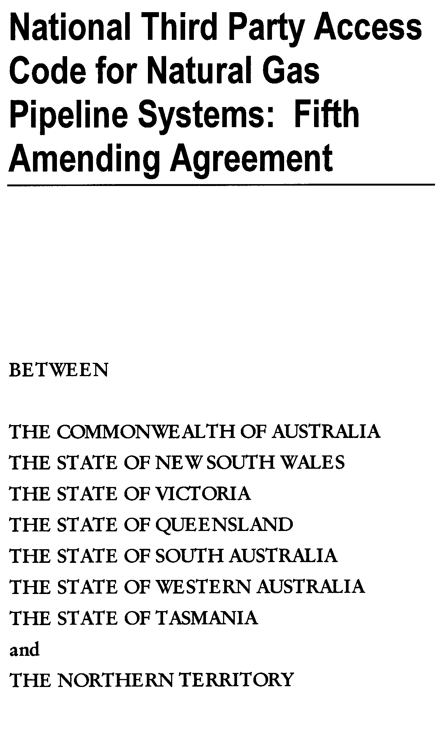
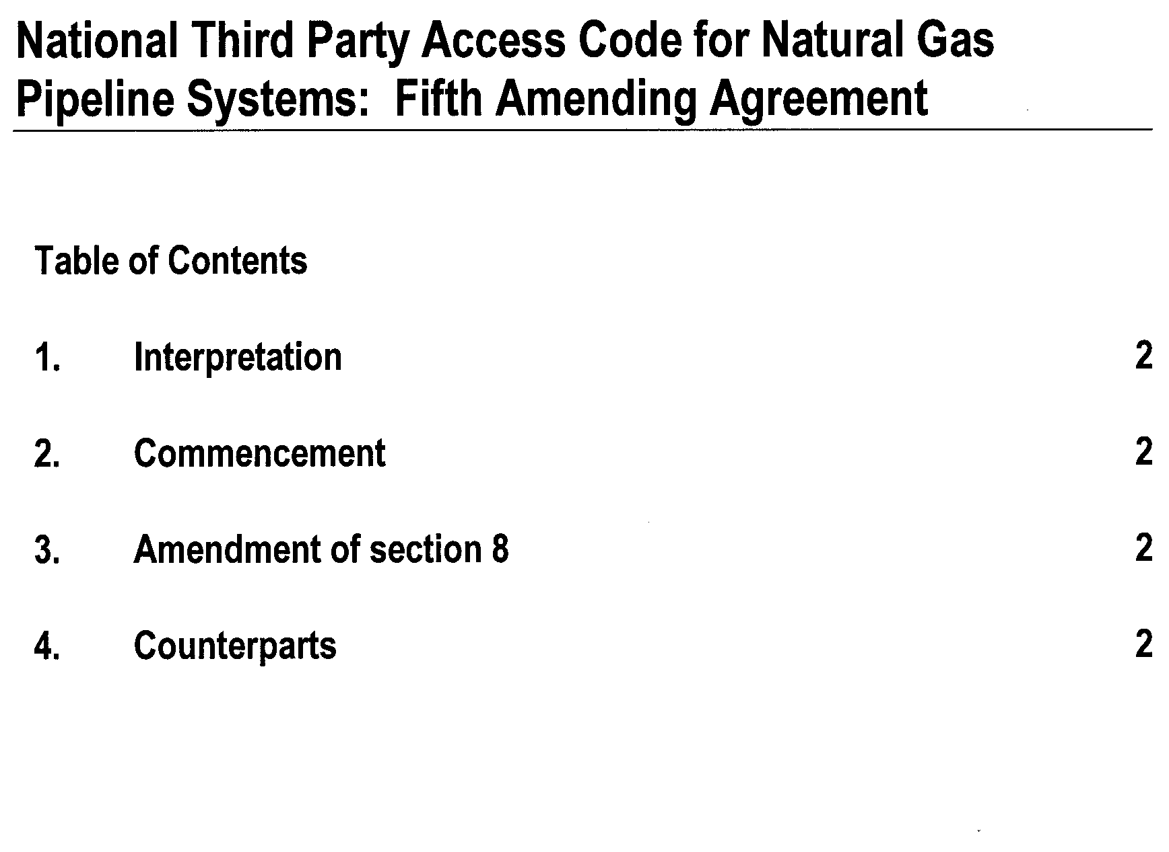
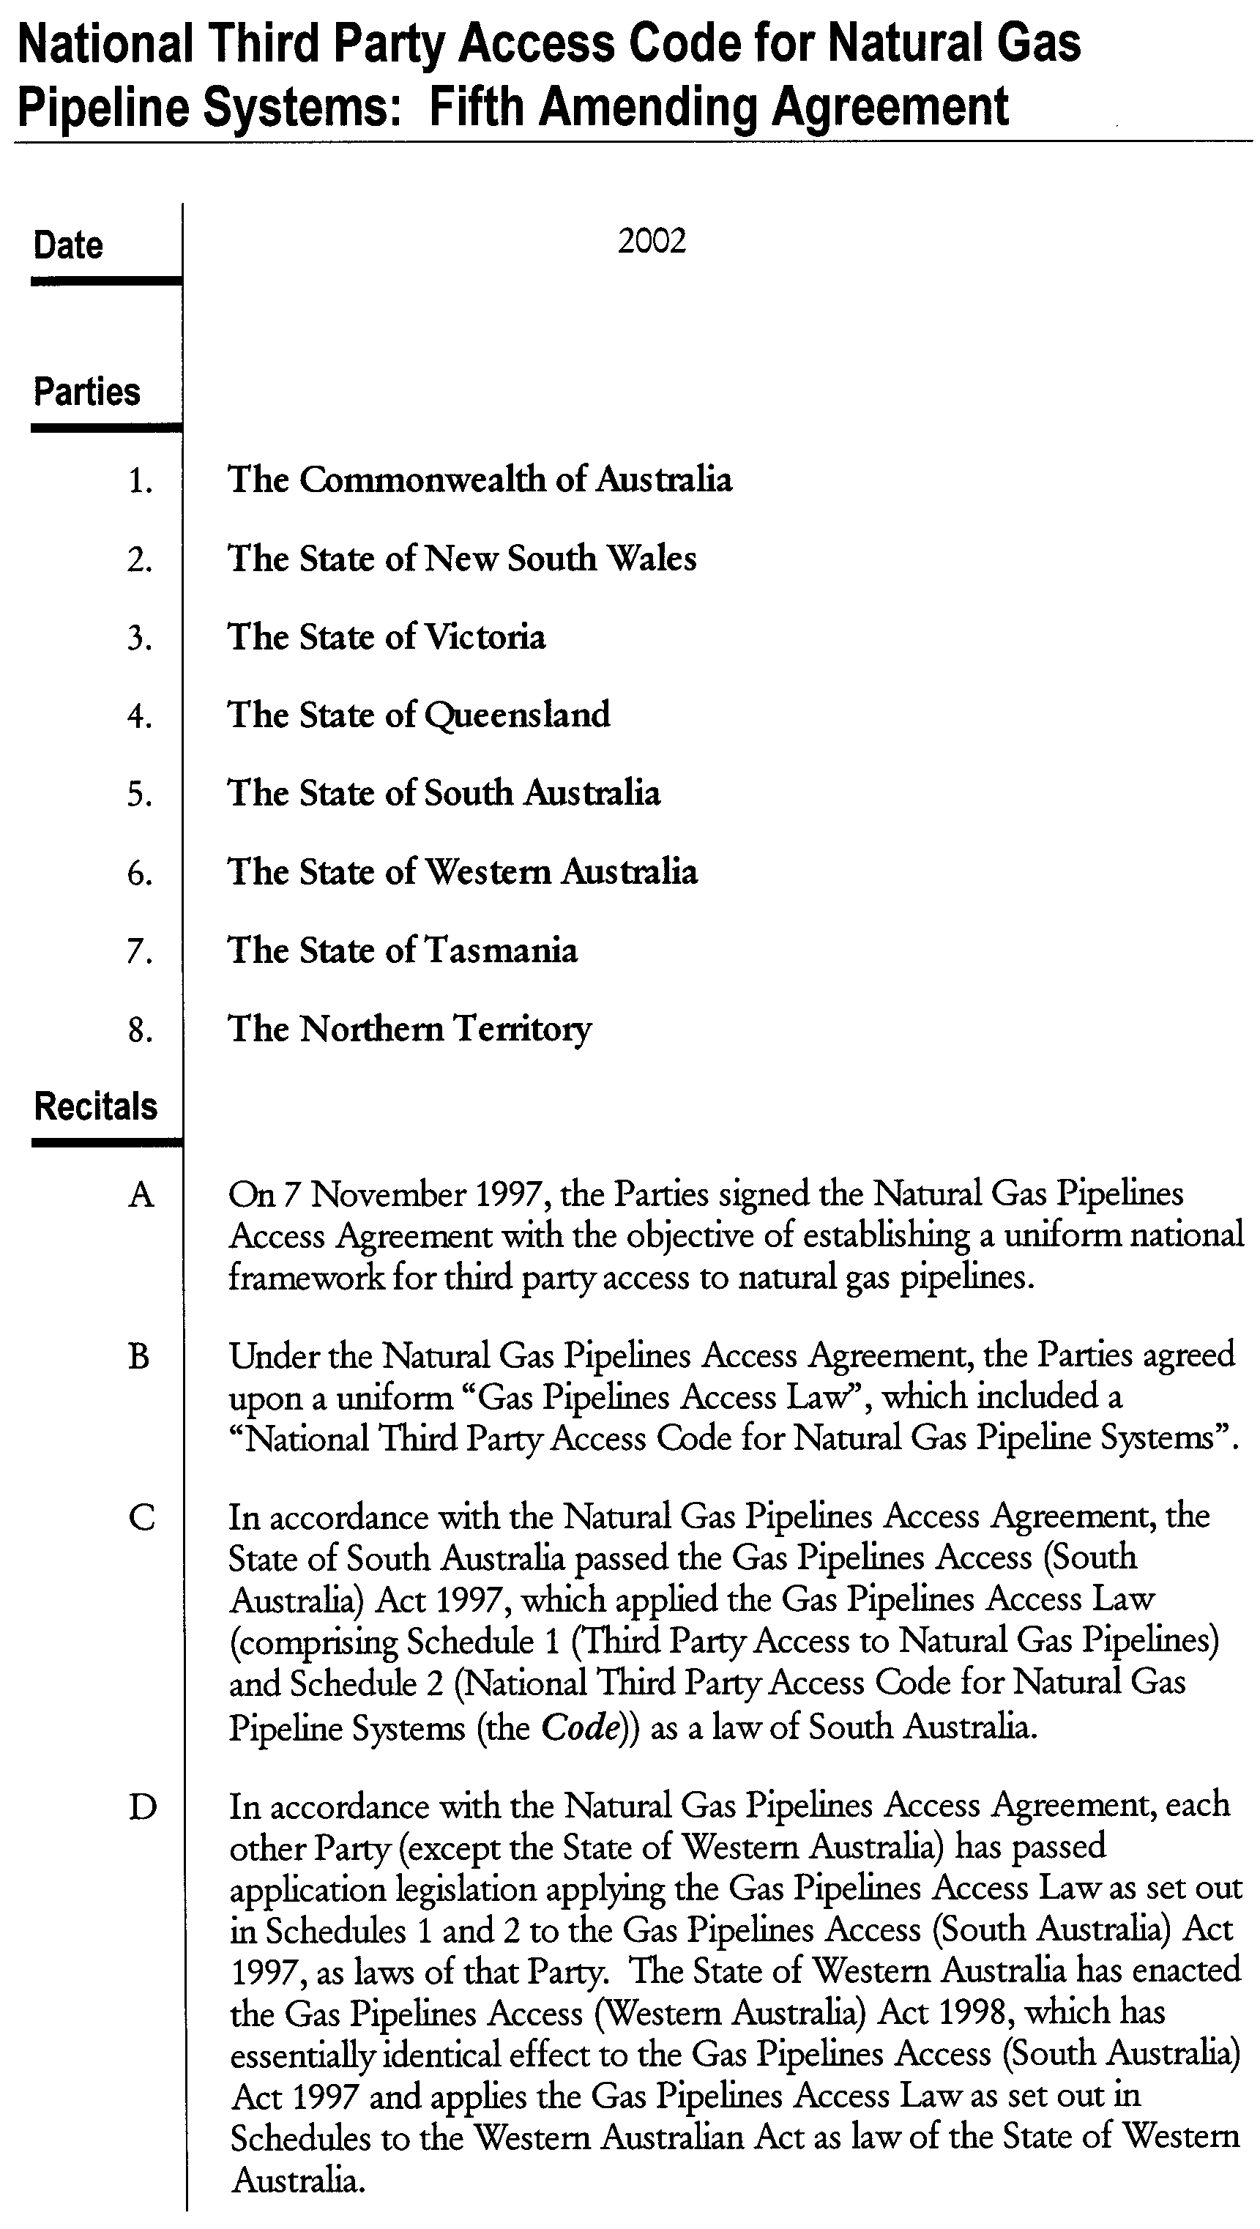
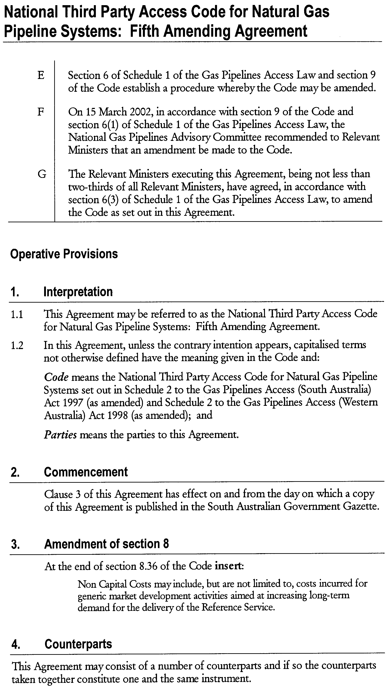

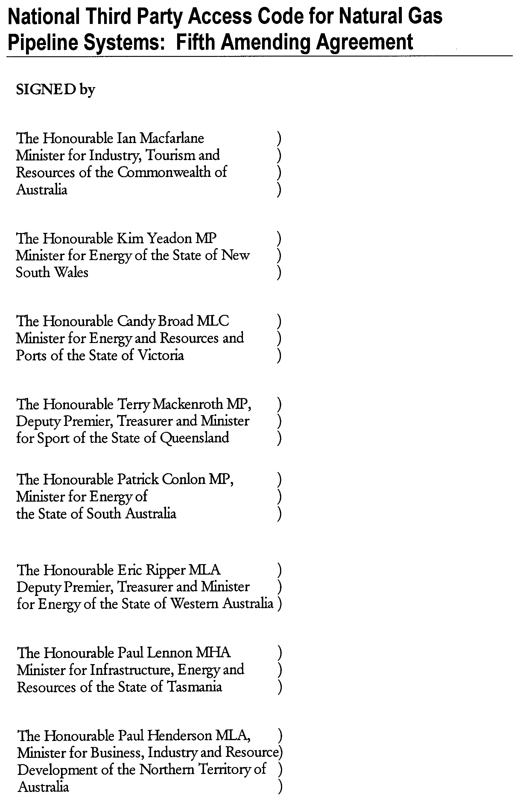

SURRENDER OF PETROLEUM EXPLORATION LICENCE PEL 84
Office of Minerals and Energy Resources, Adelaide, 25 June 2002
NOTICE is hereby given that I have accepted surrender of the abovementioned Petroleum Exploration Licence under the provisions of the Petroleum Act 2000, pursuant to delegated powers dated 28 March 2002, Gazetted 11 April 2002, page 1573.
B. A. Goldstein, Director Petroleum, Office of Minerals and Energy Resources, Delegate of the Minister for Mineral Resources Development
No. of  Licence | Licensee | Locality | Date of  Surrender | Area in  km² | Reference

84 | AWE Petroleum Pty Ltd |  | Otway Basin of South Australia | 22 February 2002 | 581 | 27/2/212

Description of the Area
All that part of the State of South Australia bounded as follows: Commencing at a point being the intersection of latitude 37°08′30″S GDA94 and longitude 140°45′E GDA94, thence east to longitude 140°49′30″E GDA94, south to latitude 37°09′30″S GDA94, east to longitude 140°50′30″E GDA94, south to latitude 37°12′30″S GDA94, east to longitude 140°53′E GDA94, south to latitude 37°14′30″S GDA94, east to longitude 140°55′30″E GDA94, south to latitude 37°15′30″S GDA94, east to the eastern border of the State of South Australia, thence southerly along the border of the said State to latitude 37°42′30″S AGD66, west to longitude 140°55′E AGD66, north to latitude 37°35′S AGD66, west to longitude 140°52′30″E AGD66, south to latitude 37°37′30″S AGD66, west to longitude 140°45′E AGD66, north to latitude 37°35′S AGD66, west to longitude 140°42′30″E AGD66, north to latitude 37°32′30″S AGD66, east to longitude 140°42′40″E GDA94, north to latitude 37°32′S GDA94, east to longitude 140°43′10″E GDA94, south to latitude 37°32′20″S GDA94, east to longitude 140°44′30″E GDA94, south to latitude 37°33′S GDA94, east to longitude 140°50′E GDA94, north to latitude 37°29′10″S GDA94, east to longitude 140°51′E GDA94, north to latitude 37°28′50″S GDA94, east to longitude 140°55′E AGD66, north to latitude 37°22′S AGD66, east to longitude 140°56′E AGD66, north to latitude 37°19′S AGD66, west to longitude 140°49′E AGD66, north to latitude 37°18′S AGD66, west to longitude 140°48′E AGD66, north to latitude 37°16′S AGD66, west to longitude 140°46′E AGD66, north to latitude 37°14′S AGD66, west to longitude 140°43′E AGD66, north to latitude 37°12′S AGD66, west to longitude 140°43′E GDA94, north to latitude 37°11′30″S GDA94, east to longitude 140°45′ GDA94 and north to the point of commencement.
Area: 581 km² approximately.

SEWERAGE ACT 1929
Scales for Calculation of Sewerage Rates
PURSUANT to sections 73 (1) and 75 (1) of the Sewerage Act 1929, and after consultation with the South Australian Water Corporation, I fix the sewerage rates set out in the Schedule in respect of the 2002-2003 financial year.
Schedule
Scale |  | Minimum Sewerage  Rate  $ |  | Land Affected

$0.00220 per dollar of capital value |  | 241 |  | All land in the Adelaide and Aldinga drainage areas
$0.00277 per dollar of capital value |  | 241 |  | All land in all other drainage areas

Dated 26 June 2002.
P. Conlon, Minister for Government Enterprises

SEWERAGE ACT 1929
Charges in Respect of Lands Exempted from Sewerage Rates
PURSUANT to section 65 (2) of the Sewerage Act 1929, and after consultation with the South Australian Water Corporation, I fix the charges set out in the Schedule for the drainage of and removal of sewage in respect of the 2002-2003 financial year.
Schedule
Charge determined according to number of water  closets draining into the sewers |  | Land Affected

$67 per water closet draining into the sewers |  | All land exempted from sewerage rates by section 65 (1)
$91 per water closet draining into the sewers |  | All other land exempted from sewerage rates under other Acts

Dated 26 June 2002.
P. Conlon, Minister for Government Enterprises

ROAD TRAFFIC ACT 1961

Transport of Agricultural Vehicles Carried as a Load

1. Approval

1.1 Pursuant to section 161A of the Road Traffic Act 1961, and Regulation 35 of the Road Traffic (Miscellaneous) Regulations 1999, I hereby approve:

1.1.1 Articulated Motor Vehicles carrying agricultural vehicles which exceed 4.3 m in height and/or 19 m in overall length; and

1.1.2 Rigid Motor Vehicles and Rigid Motor Vehicles towing one trailer carrying agricultural vehicles, which exceed 4.3 m in height

to travel on roads in South Australia subject to the conditions specified in this Notice.

2. Exemption

2.1 Pursuant to section 163AA of the Road Traffic Act 1961, I hereby exempt:

2.1.1 Articulated Motor Vehicles, Rigid Motor Vehicles and Rigid Motor Vehicles towing one trailer carrying agricultural vehicles from the following provisions of the:

(i) Road Traffic (Vehicle Standards) Rules 1999:

• Rule 66 (1)—Width;
• Rule 68 (1)—Length of single trailer in so far as it relates to semi trailers;
• Rule 69 (1) (d)—Length of combinations;
• Rule 70 (1) (b —Rear overhang;
• Rule 72 (1)—Height; and

(ii) Road Traffic (Mass and Loading Requirements) Regulations 1999:

• Schedule 1, Part 2, Regulation 6—Front and side projections, in so far as it relates to side projections; and

subject to the conditions specified in this Notice.

3. Conditions Applying to this Approval and Exemption

3.1 The vehicles described above must operate in accordance with the conditions and limitations specified in the ‘Code of Practice for the Transport of Agricultural Vehicles as Loads’ dated July 2002, issued by Transport SA.

3.2 Except as otherwise specified in this Notice, the Standard Form Conditions prescribed in the Road Traffic (Oversize or Overmass Vehicle Exemptions) Regulations 1999 for the purposes of section 115 of the Road Traffic Act, shall not apply.

3.3 When operating under this Notice, the driver must carry a legible, current and complete copy of the ‘Code of Practice for the Transport of Agricultural Vehicles as Loads’, dated July 2002 issued by Transport SA and produce this document when requested by a Transport SA Inspector appointed under the Road Traffic Act 1961 and/or the Motor Vehicles Act 1959, or a Police Officer.

4. Commencement and Expiry of this Notice

4.1 This Notice is valid from 1 July 2002.

5. Revocation of Previous Notice

5.1 The Notice entitled ‘Transport of Agricultural Vehicles Carried as a Load’ that appeared in the South Australian Government Gazette dated 28 March 2002 is revoked at midnight on 30 June 2002.

T. N. Argent, Executive Director, Transport SA, Authorised delegate for the Minister for Transport

ROAD TRAFFIC ACT 1961

Transporting 2.9 Metre High Containers

1. Approval

1.1 Pursuant to section 161A of the Road Traffic Act 1961, and Regulation 35 of the Road Traffic (Miscellaneous) Regulations 1999, I hereby approve:

1.1.1 Articulated Motor Vehicles, which exceed 4.3 m in height when carrying 2.9 m high containers to operate in South Australia subject to the conditions specified in this Notice.

2. Exemption

2.1 Pursuant to section 163AA of the Road Traffic Act 1961, I hereby exempt:

2.1.1 Articulated Motor Vehicles carrying 2.9 m high containers from the following provisions of the:

(i) Road Traffic (Vehicle Standards) Rules 1999:

• Rule 72 (1)—Height

subject to the conditions specified in this Notice.

3. Conditions Applying to this Approval and Exemption

3.1 The containers shall have a maximum overall height not exceeding 2.9 m.

3.2 The overall height of the vehicle and load shall not exceed 4.6 m.

3.3 The overall width of all axles or axle groups of the vehicle carrying the load, excluding the front axle or front axle group, when measured between two vertical parallel planes located at the outer extremities of the tyres, shall not be less than 2.1 m.

3.4 The conditions set out in this notice apply to the vehicles, loads, routes and times specified, and does not relieve the owner and/or driver of the duty to observe all other provisions of the Road Traffic Act and Regulations.

3.5 The conditions set out in this notice may be overridden by a limitation fixed at any time on a bridge, culvert, causeway road or road ferry.

3.6 When operating under this Notice, the driver must carry a legible, current and complete copy of this Notice and produce this document when requested by a Transport SA Inspector appointed under the Road Traffic Act 1961 and/or the Motor Vehicles Act 1959, or a Police Officer.

3.7 Except as otherwise specified in this Notice, the Standard Form Conditions prescribed in the Road Traffic (Oversize or Overmass Vehicle Exemptions) Regulations 1999 for the purposes of section 115 of the Road Traffic Act 1961, shall not apply.

3.8 This notice shall stand alone. It cannot be used in conjunction with any other exemption, notice or permit.

4. Commencement and Expiry of this Notice

4.1 This Notice is valid from 1 July 2002 and expires at midnight on 31 March 2003.

Explanatory Notes
• Some parts of the road system, such as bridges, overhead services and wires, roadside furniture (signs, traffic lights etc) and vegetation, may not provide sufficient clearance for a vehicle and load travelling under this Notice.
• Section 106 of the Road Traffic Act, Damage to roads and works, requires you to notify the Police, Transport SA or Passenger Transport Board if you cause damage to roads, bridges and culverts, or interfere with roadside furniture.
• If you have caused anything to fall on to the road that may obstruct, damage or cause injury to people or vehicles, Australian Road Rule 293 requires you to remove it or take action to have it removed. Examples include tree branches or damaged traffic signs.
• This concession has been made available to provide time for the transport industry to re-equip with low profile vehicles so that these containers can be carried within an overall vehicle height limit of 4.3 m. This concession has been extended pending the release of a national report relating to a strategy for the management of oversize containers.

T. N. Argent, Executive Director, Transport SA, Authorised delegate for the Minister for Transport

WATERWORKS ACT 1932
Rates and Charges on Commercial Land
PURSUANT to section 65C (1) of the Waterworks Act 1932, and after consultation with the South Australian Water Corporation, I fix the rates and charges set out in the Schedules in respect of the 2002-2003 financial year.
Schedule of Rates
Provision |  | Rate | Class of land affected

Section 65C (1) (c): Rate to be applied to the capital value of commercial land to determine the supply charge |  | $0.00188 per dollar of capital value | All commercial land in the State.
Note: Pursuant to section 65C (1) (d), water rates for the 2002-2003 financial year in respect of commercial land were set in Government Gazette, 6 December 2001 (page 5293).
Schedule of Charges
Provision |  | Charge | Class of land affected

Section 65C (1) (b): Minimum supply charge in respect of commercial land |  | $143 | All commercial land in the State

Dated 26 June 2002.
P. Conlon, Minister for Government Enterprises

WATERWORKS ACT 1932
Annual charge for Additional Services Provided
PURSUANT to section 35 (1c) of the Waterworks Act 1932, and after consultation with the South Australian Water Corporation, I fix, in respect of the 2002-2003 financial year, the annual charge payable by the owner or occupier of the land in respect of any additional service provided to that land at $143 for each additional service.
Dated 26 June 2002.
P. Conlon, Minister for Government Enterprises

WATERWORKS ACT 1932
Lands Exempted from Water Rates
PURSUANT to section 88 (4) of the Waterworks Act 1932, and after consultation with the South Australian Water Corporation, I fix the charges set out in the Schedule in respect of the 2002-2003 financial year.
Schedule
Class of land affected |  | Charge determined according  to the volume of water supplied |  | Fixed Minimum  Charge

All land in the State exempted under section 88 (1) (a) or (b) of the Waterworks Act 1932, and all land that has been acquired or is used for the purpose of a Children’s Services Centre within the meaning of the Children’s Services Act 1985 |  | For each kilolitre supplied up to, and including, 125 kilolitres: $0.30 |  | $130
 |  | For each kilolitre supplied over 125 kilolitres: $0.7275 |  | $130
All other lands in the State exempted from payment of rates |  | For each kilolitre supplied up to, and including, 125 kilolitres: $0.40 |  | $130
All other lands in the State exempted from payment of rates |  | For each kilolitre supplied over 125 kilolitres: $0.97 |  | $130

Dated 26 June 2002.
P. Conlon, Minister for Government Enterprises

PUBLIC SECTOR MANAGEMENT ACT 1995
Equal Opportunity Program
WHEREAS the Premier, being the Minister responsible for the Public Sector Management Act 1995, may publish in the Gazette an equal employment opportunity program designed to ensure that persons of a defined class have equal opportunities in relation to employment in the public sector with persons not of that class, and whereas the Premier may make special provision for persons of a defined class employed in the public sector as effectively as persons not of that class, I, Mike Rann, Premier, do hereby publish the equal opportunity program set out in the Schedule.
The Schedule
South Australian Public Sector Aboriginal Recruitment and Career Development Strategy
OBJECT
To increase the representation of Aboriginal people in the South Australian Public Sector to better reflect their representation in the South Australian population.
SPECIAL PROVISION
Pursuant to section 67 (2) (a) and (b) of the Public Sector Management Act 1995, I make special provisions to achieve the object as follows:
(a) the Department of Education, Training and Employment may seek applications from Aboriginal people residing in South Australia for inclusion on an Aboriginal Register, in accordance with the processes agreed by the Commissioner for Public Employment;
(b) persons on the Aboriginal Register may be provided with temporary employment opportunities in positions for periods up to 12 months duration in public sector agencies in accordance with processes agreed by the Commissioner for Public Employment;
(c) persons on the Aboriginal Register who are not currently employed within the public sector will be eligible to apply for all positions advertised in the Notice of Vacancies, and to compete for such positions on the basis of merit, in accordance with processes agreed by the Commissioner for Public Employment; and
(d) public sector agencies may provide training and development opportunities to Aboriginal employees of the South Australian public sector to assist them to effectively compete on the basis of merit for future positions in the public sector.
Dated 26 June 2002.
Mike Rann, Premier

PASSENGER TRANSPORT ACT 1994
Appointment of Authorised Officers
PURSUANT to section 53 of the Passenger Transport Act 1994 (‘the Act’), I appoint the persons referred to in the Schedule as Authorised Officers under the Act.
Schedule
Adrian Lee
Dated 4 June 2002.
M. J. Wright, Minister for Transport

PASSENGER TRANSPORT ACT 1994
Appointment
NOTICE is hereby given that the following person has been appointed by the Minister for Transport and Urban Planning under section 53 of the Passenger Transport Act 1994, to be an Authorised Officer, under that Act:
Adrian Lee
H. Webster, Executive Director

THE RENMARK IRRIGATION TRUST
Annual Elections 2002
NOTICE is hereby given that at the close of nominations at noon on Monday, 17 June 2002, the following valid nominations were duly received by me:
For the Office of Members:
Richard Humphrey Howie
Christofer Nikou
Timothy John Whetstone
As no more nominations were received than there were vacancies to be filled, I therefore declare the abovenamed ratepayers elected as Members of the Trust for terms of 2 years commencing on the first Saturday in July 2002.
For the Office of Auditor:
Barry Harold Hughes A.C.A.
I therefore declare Barry Harold Hughes duly elected as an Auditor of the Trust for a term of 2 years commencing on the first Monday in September 2002.
W. D. Morris, Returning Officer

ROADS (OPENING AND CLOSING) ACT 1991:
SECTION 24
NOTICE OF CONFIRMATION OF ROAD PROCESS
ORDER
Public Roads, Caroona Creek Conservation Park—Deposited Plan 58696
BY Road Process Order made on 18 December 2001, the Regional Council of Goyder ordered that:
1. The whole of the unnamed public roads adjoining the south-eastern boundary of section 108, the south-eastern and western boundaries of section 63, the western boundaries of sections 109 and 110, the southern boundary of section 64, the western boundary of section 49, the southern boundaries of sections 61 and 60 and the southern and western boundaries of section 59, Hundred of Tomkinson more particularly delineated and lettered ‘A’ in Preliminary Plan No. PP32/0655 be closed.
2. Vest in the Crown the whole of the land subject to closure for constitution as additions to the adjoining Caroona Creek Conservation Park.
On 17 June 2002 that order was confirmed by the Minister for Administrative Services.
Pursuant to section 24 (5) of the Roads (Opening and Closing) Act 1991, notice of the order referred to above and its confirmation is hereby given.
Dated 27 June 2002.
K. Sarneckis, Acting Surveyor-General

ROADS (OPENING AND CLOSING) ACT 1991:
SECTION 24
NOTICE OF CONFIRMATION OF ROAD PROCESS
ORDER
Public Road, Deep Creek Conservation Park
Deposited Plan 58990
BY Road Process Order made on 14 January 2002, the District Council of Yankalilla ordered that:
1. Portion of the unnamed public road adjoining Blowhole Creek Road and the north-eastern boundary of section 32 in the Hundred of Waitpinga more particularly delineated and lettered ‘A’ in Preliminary Plan No. PP32/0676 be closed.
2. Vest in the Crown the whole of the land subject to closure.
On 19 June 2002 that order was confirmed by the Minister for Administrative Services.
Pursuant to section 24 (5) of the Roads (Opening and Closing) Act 1991, notice of the order referred to above and its confirmation is hereby given.
Dated 27 January 2002.
K. Sarneckis, Acting Surveyor-General

ROADS (OPENING AND CLOSING) ACT 1991:
SECTION 24
NOTICE OF CONFIRMATION OF ROAD
PROCESS ORDER
Browns Lane, Port Augusta
Deposited Plan 50347
BY Road Process Order made on 12 May 1998, The Corporation of the City of Port Augusta ordered that:
1. Portion of the public road (Browns Lane) adjoining allotment 24 in Filed Plan 103937 and the whole of the public road north of Flinders Terrace adjoining allotment 370 in Filed Plan 186072 and allotment 380 in Filed Plan 186082 more particularly delineated and lettered ‘A’, ‘B’ and ‘C’ in Preliminary Plan No. 32/0293 be closed.
2. Issue a Certificate of Title to The Corporation of the City of Port Augusta for the whole of the land subject to closure lettered ‘A’ and ‘B’ which land is being retained by Council for Public Purposes.
3. The whole of the land subject to closure lettered ‘C’ be transferred to Comolo Nominees Pty Ltd, Gassi Nominees Pty Ltd, Wistaria Pty Ltd, Stavren Project Management Pty Ltd, Feely Greenfield Investments Pty Ltd, Mictom Investments Pty Ltd, Barese Investments Pty Ltd, Tough Investments Pty Ltd and Arat Nominees Pty Ltd in accordance with agreement for transfer dated 2 April 1998, entered into between The Corporation of the City of Port Augusta and Perks & Associates Pty Ltd.
4. The following easements are granted over portions of the land subject to that closure:
Grant to the South Australian Water Corporation an easement for sewerage purposes.
Grant free and unrestricted rights of way appurtenant to the following Certificates of Title Volume 5360, Folio 433, Volume 5241, Folio 45, Volume 5299, Folio 480, Volume 5795, Folio 931, Volume 5408, Folio 444, Volume 5408, Folio 208, Volume 5521, Folio 106, Volume 3363, Folio 129, Volume 5463, Folio 169, Volume 5140, Folio 727, Volume 5251, Folio 909 and Volume 5251, Folio 910.
On 12 December 1998, that order was confirmed by the Minister for Administrative Services, conditionally on approval and deposit of the survey plan by the Registrar-General. The condition has now been fulfilled.
Pursuant to section 24 (5) of the Roads (Opening and Closing) Act 1991, NOTICE of the order referred to above and its confirmation is hereby given.
Dated 27 June 2002.
K. Sarneckis, Acting Surveyor-General

ROADS (OPENING AND CLOSING) ACT 1991:
SECTION 24
NOTICE OF CONFIRMATION OF ROAD
PROCESS ORDER
Cobby Drive, Modbury Heights
Deposited Plan 59402
BY Road Process Order made on 17 May 2002, the City of Tea Tree Gully ordered that:
1. The whole of the public road (portion of Cobby Drive) east of Hargrave Street adjoining the northern boundaries of allotment 232 (reserve) in Deposited Plan 9754 more particularly delineated and lettered ‘A’ in Preliminary Plan No. 01/0690 be closed.
2. Issue a Certificate of Title to the CITY OF TEA TREE GULLY for the whole of the land subject to closure which land is being retained by Council for Public Purposes.
3. The following easement be granted over portion of the land subject to that closure:
Grant to the Distribution Lessor Corporation an easement for overhead and underground electricity supply purposes.
On 19 June 2002, that order was confirmed by the Minister for Administrative Services, conditionally on approval and deposit of the survey plan by the Registrar-General. The condition has now been fulfilled.
Pursuant to section 24 (5) of the Roads (Opening and Closing) Act 1991, NOTICE of the order referred to above and its confirmation is hereby given.
Dated 27 June 2002.
K. Sarneckis, Acting Surveyor-General

ROADS (OPENING AND CLOSING) ACT 1991:
SECTION 24
NOTICE OF CONFIRMATION OF ROAD
PROCESS ORDER
Caralue Road, Marino
Deposited Plan 58838
BY Road Process Order made on 10 December 2001, The Corporation of the City of Marion ordered that:
1. Portion of the public road (Caralue Road) adjoining allotments 488 and 523 in Deposited Plan 4914 being portion of the land delineated and lettered ‘A’ in Preliminary Plan No. 32/0678 be closed.
2. The whole of the land subject to closure be transferred to JULIENNE LENAIN in accordance with agreement for transfer dated 7 December 2001, entered into between The Corporation of the City of Marion and J. Lenain.
3. The following easements are granted over portions of the land subject to that closure:
Grant to the South Australian Water Corporation an ease-ment for sewerage purposes.
Grant to The Corporation of the City of Marion an easement for drainage purposes.
On 7 May 2002, that order was confirmed by the Minister for Administrative Services.
Pursuant to section 24 (5) of the Roads (Opening and Closing) Act 1991, NOTICE of the order referred to above and its confirmation is hereby given.
Dated 27 June 2002.
K. Sarneckis, Acting Surveyor-General

SOIL CONSERVATION AND LAND CARE ACT 1989
Appointment
I, JOHN HILL, Minister for Environment and Conservation, Minister for the River Murray, Minister for Gambling, Minister for the Southern Suburbs, and Minister Assisting the Premier in the Arts in the State of South Australia to whom the adminis-tration of the Soil Conservation and Land Care Act 1989, has been committed, do hereby appoint the following person as a member of the Kangaroo Island Soil Conservation Board, pursuant to section 24 of the Act until 13 January 2004:
Anthony Harris
Dated 18 June 2002.
J. Hill, Minister for Environment and Conservation

SOUTH AUSTRALIAN CO-OPERATIVE AND COMMUNITY HOUSING ACT 1991
Notification of Election Results
NOTICE is hereby given that pursuant to Regulation 15 (2) of the South Australian Co-operative and Community Housing Act 1991, Dieter Sczesny and Elizabeth McCarthy have been elected as members of the South Australian Community Housing Authority for a two year period until June 2004.
B. Moran, General Manager

WATER MAINS AND SEWERS

Office of the South Australian Water Corporation
Adelaide, 27 June 2002

WATER MAINS LAID

Notice is hereby given that the following main pipes or parts of main pipes have been laid down by the South Australian Water Corporation in or near the undermentioned water districts and are now available for a constant supply of water to adjacent land.

ADELAIDE WATER DISTRICT

DISTRICT OF ADELAIDE HILLS COUNCIL
Jacaranda Drive, Woodside. p8

CITY OF ONKAPARINGA
Sovereign Drive, Woodcroft. p3
Hereford Lane, Woodcroft. p3
Verdant Parade, Woodcroft. p3
Potter Road, Clarendon. p13

GOOLWA WATER DISTRICT

DISTRICT OF ALEXANDRINA COUNCIL
Clark Street, Goolwa. p11

KAPUNDA WATER DISTRICT

LIGHT REGIONAL COUNCIL
Kapunda Street, Kapunda.
This main is available on application on the eastern side only. p12

NURIOOTPA WATER DISTRICT

THE BAROSSA COUNCIL
Golden Way, Nuriootpa. p1
Maple Avenue, Nuriootpa. p1 and 2
Easement in lot 111, Samuel Road, Nuriootpa. p2

PORT VICTOR WATER DISTRICT

CITY OF VICTOR HARBOR
River Road, Victor Harbor. p9
Jolly Street, Victor Harbor. p10

TWO WELLS WATER DISTRICT

DISTRICT OF MALLALA
Chestnut Lane, Two Wells. p4 and 5
Easements in reserve (lot 188), Williams Road, Two Wells. p5
Sable Grove, Two Wells. p5-7

SEWERS LAID

Notice is hereby given that the following sewers have been laid down by the South Australian Water Corporation in the under-mentioned drainage areas and are now available for house connections.

ADELAIDE DRAINAGE AREA

CITY OF ONKAPARINGA
Panalatinga Road, Woodcroft. FB 1105 p9 and 10
Easements in reserve (lot 22) and lot 21, Panalatinga Road, Woodcroft. FB 1105 p9 and 10
Easement in reserve (lot 500) and lots 91-83 and lot 1003, Sovereign Drive, Woodcroft. FB 1105 p9 and 11
Sovereign Drive, Woodcroft. FB 1105 p9 and 10
Hereford Lane, Woodcroft. FB 1105 p9 and 10

HAHNDORF COUNTRY DRAINAGE AREA

DISTRICT OF MOUNT BARKER
Easement in lots 50 and 51, Male Crescent, Hahndorf. FB 1103 p58

STIRLING COUNTRY DRAINAGE AREA

DISTRICT OF ADELAIDE HILLS COUNCIL
Maxton Street, Bridgewater. FB 1103 p57
Mount Barker Road, Aldgate. FB 1104 p60
Public Road between allotment pieces 91 and 92 in LTRO FP171062, Aldgate. FB 1104 p60
Easement in allotment piece 91 in LTRO FP171062, Mount Barker Road, Aldgate. FB 1104 p60

VICTOR HARBOR COUNTRY DRAINAGE AREA

CITY OF VICTOR HARBOR
Battye Road, Encounter Bay. FB 1103 p55
Easement in lots 172-170, Laurie Avenue, Encounter Bay. FB 1103 p56

A. Howe, Chief Executive Officer, South Australian Water Corporation.

WATER RESOURCES ACT 1997
Notice of Assessment of Quantity of Water Taken When Meter Readings Are Not Used—Pursuant to Section 126
I, JOHN DAVID HILL, Minister for Environment and Conservation, hereby declare that the basis of assessment of water use rates and the method by which the assessment of water use where meter readings are not used or when water is taken without licence or authorisation will be as set out in Schedule 1.
Schedule 1
The basis of the assessment of water use will be the estimation of water requirements for a crop.
The method by which the estimation of water requirements for crops will be used is the methodology of Doorenbos and Pruitt (1977), as refined by Allen et al, (1998) and set out in the PIRSA Technical Report No. 263, second edition (‘the Report’). Crop factors will be calculated from Kc (crop coefficient) values from the Food and Agriculture Organisation of the United Nations, Rome Irrigation and Drainage Paper 56 (Allen, Pereira et al, 1998) (‘FAO 56’) and using site specific monthly Kp (pan coefficient) values and average monthly Kg values (bird guard coefficient) set out in the Report.
The methodology incorporates the use of Bureau of Meteorology evaporation data, the application of crop specific factors to evaporation figures to calculate crop evapotranspiration for the crop and location in question, subtraction of effective rainfall and an allowance for leaching for salinity control and irrigation efficiency.
The water requirement calculated by this method is expressed as depth of water required in millimetres for a particular crop grown over a particular season. Depth multiplied by the number of hectares of that crop grown (in each specified season for short season crops), multiplied by 10 gives the volume of water required for each crop in kilolitres.
A copy of each of the Report and FAO 56 is obtained through the GEO Science Library at the Department of Primary Industries and Resources South Australia. The reference number for the Report is ISBN No. 07308-4349-1 and the reference number for FAO 56 is Kinetica/Amicus No. 000020037000 or ISBN No. 92-5-104219-5.
This notice has effect in relation to the financial year commencing on 1 July 2002.
Dated 24 June 2002.
J. Hill, Minister for Environment and Conservation

WINE GRAPES INDUSTRY ACT 1991
Order by Minister
PURSUANT to the Wine Grapes Industry Act 1991, I, Paul Holloway, Minister for Agriculture, Food and Fisheries make the following order applying to wine grapes grown in the Barossa, Clare, Langhorne Creek, McLaren Vale and Riverland regions (as detailed in the schedule) and sold to a processor:
Dated 20 June 2002.
Paul Holloway, Minister for Agriculture, Food and Fisheries

The Schedule
(a) the areas of the District Councils of Berri Barmera, Loxton Waikerie, Mid Murray, Renmark Paringa;
(b) the Hundred of Bowhill in the area of the District Council of Karoonda East Murray;
(c) the Rural City of Murray Bridge;
(d) the Counties of Young and Hamley;
(e) the Hundreds of:
Barossa Belvidere Blyth
Bremer Brinkley Clare
Dutton Freeling Hall
Hanson Hart Jellicoe
Kapunda Kuitpo Milne
Moorooroo Noarlunga Nuriootpa
Stanley Strathalbyn Upper Wakefield Willunga
(Note: the Hundred of Brinkley is in the Rural City of Murray Bridge, so its listing under Heading (e) may be redundant.
Section 6: Terms and Conditions of Payment
1. The following terms and conditions are fixed in respect of wine grapes harvested in 1994 or any subsequent year and are implied in every contract for the sale of such grapes to a processor:
(a) If the grapes are delivered to the processor prior to 1 April in a year, the processor must pay to the producer 33¹/₃ per cent of the total amount payable for the grapes by the end of the month following the month during which the grapes are delivered, 50 per cent of the remaining balance by 30 June in that year and the balance by 30 September in that year.
(b) If the grapes are delivered to the processor on or after 1 April but prior to 1 May in a year, the processor must pay to the producer 33¹/₃ per cent of the total amount payable for the grapes by 31 May in that year, 50 per cent of the remaining balance by 30 June in that year and the balance by 30 September in that year.
(c) If the grapes are delivered to the processor on or after 1 May in a year, the processor must pay to the producer 66²/₃ per cent of the total amount payable for the grapes by 30 June in that year and the balance by 30 September in that year.
(d) If a processor defaults in making a payment within the time fixed above, the processor must pay to the producer an amount equal to interest on any amount remaining in default calculated at the Commonwealth Bank standard overdraft interest rate (as at the beginning of the month during which the default occurred) plus 1 per cent per annum until the following 31 December and thereafter at the Commonwealth Bank standard overdraft interest rate (as at 1 September in the year during which the default occurred) plus 5 per cent per annum.
Application
2. The terms and conditions fixed by this order apply in relation to contracts whether made before or after the publication of this order in the Gazette.
Dated 21 June 2002.
Paul Holloway, Minister for Agriculture, Food and Fisheries

WORKCOVER CORPORATION ACT 1994
WORKERS REHABILITATION AND COMPENSATION
ACT 1986
Determination of Board of WorkCover Corporation of
South Australia
THE Board of the WorkCover Corporation of South Australia determines as follows, pursuant to section 17 of the WorkCover Corporation Act 1994, section 72 of the Workers Rehabilitation and Compensation Act 1986 and all other enabling powers:
1. Citation and Date of commencement.
(1) This determination may be cited as the WorkCover Levy Review Determination 2002.
(2) This determination takes effect on 1 July 2002.
2. Continuation of WorkCover Levy Review Panel. The Work-Cover Levy Review Panel (‘the Panel’) established by the Board’s determination of 29 June 2000 (see South Australian Government Gazette, 29 June 2000, page 3472) is hereby continued.
3. Function and powers under section 72 of Workers Rehabilitation and Compensation Act 1986. The function of the Panel shall be to perform the functions of the Board under section 72 of the Workers Rehabilitation and Compensation Act 1986 (‘the Act’) as delegate of the Board under that section and (subject to the succeeding clauses of this determination) all powers of the Board under that section, other than the power of delegation, are delegated to the Panel for that purpose.
4. Constitution of Panel.
(1) The Panel shall sit comprising four members appointed by the Board consisting of:
(a) a President, who shall be a legal practitioner (wherever in Australia admitted), and who shall decide any questions of law;
(b) a member with expertise in the interests of registered employers;
(c) a member with expertise in the interests of workers; and
(d) a member with expertise in the interests of the Corporation.
(2) Where the anticipated unavailability of appointed members or the anticipated volume of work neces-sitates, deputy members may be appointed by the Board.
(2A) A Deputy President or other Deputy Member has the powers and duties of the position held by the person for whom he or she deputes.
(3) The President may sit alone:
(a) to give directions;
(b) to determine procedural matters;
(c) for the promotion of conciliation;
(d) to seek evidence; or
(e) to dispose of an application on a matter of law involving no disputes of fact and no exercise of discretion,
but (subject to this clause) the Panel shall otherwise sit as a Panel of four.
(4) A decision of a majority of members of the Panel, other than a decision as to a matter of law, shall be the decision of the Panel, but a member not agreeing with a decision of the majority may give reasons for not agreeing.
(4A) In the event of the Panel being equally divided in opinion as to the decision to be made, the Panel’s decision shall be in accordance with the opinion of the President or Deputy President.
(4B) A quorum of the Panel shall be three members, provided that members representing each interest referred to in subclause (1) or (where applicable) deputies thereof have been offered, in the opinion of the President, a reasonable opportunity to sit.
(5) If a member of the Panel becomes unavailable after the commencement of a hearing, the application must be heard again by the Panel properly constituted or (with the concurrence of the parties) adjourned until the absent member becomes available again, unless the decision of the remaining members is unanimous.
(6) However, no hearing may commence or continue with-out the President or a Deputy President.
5. Indemnity of members. Any liability attaching to a member of the Panel for an act or omission by the member, or by the Panel, in good faith and in the exercise or purported exercise of a power or function, or in the discharge or purported exercise of a duty, of the member or the Panel is assumed by the Corporation.
6. Tenure of members.
(1) Members shall be appointed for a term of two years, except in the event of a casual vacancy, where a member may be appointed for two years or for the balance of the term of the former member at the option of the Board.
(2) A deputy of a member shall be appointed for a term specified by the Board in the instrument of appointment, not exceeding the balance of the term of the member for whom the deputy is to depute.
7. Conciliation as condition precedent to jurisdiction.
(1) Upon receipt of any application lodged under section 72 (1) of the Act, the registry of the Panel will forward a copy to the operating unit of the Corporation res-ponsible for the disputed decision, which will recon-sider the decision (disregarding any question of whether the application is out of time) and must inform the Panel and the applicant within 7 days of the result of the reconsideration (and its attitude to any question of an extension of time).
(2) If—
(a) the Corporation, on reconsideration of a disputed decision, confirms the decision; or
(b) the Corporation, on reconsideration of a disputed decision, varies the decision and the applicant expresses dissatisfaction with the variation,
the registry of the Panel must refer the dispute for conciliation by a conciliator who will use his or her best endeavours to bring the applicant and the operating unit of the Corporation that is responsible for the disputed decision to an agreed resolution of the matters referred to in the application, and the Panel may not hear and determine any application unless it is satisfied that conciliation has been attempted and failed or it is satisfied that such attempts have no realistic prospects of success.
(3) If, during the hearing of any matter, it appears to the Panel that there is a realistic prospect of a negotiated outcome being achieved, it may refer the matter back for further conciliation or the Panel may make such other attempts to promote conciliation as it thinks appropriate.
(4) In this clause, ‘conciliation’ includes:
(a) counselling;
(b) mediation;
(c) neutral evaluation;
(d) case appraisal;
(e) conciliation; and
(f) any combination of the above,
and the format of conciliation in any particular case shall be at the discretion of the conciliator in consul-tation with the parties, with the proviso that any con-fidential information provided during conciliation may be withheld from the Panel if the provider of that information requests.
8. Principles of operation of Panel.
(1) The Panel shall be bound by and is hereby directed to follow the principles of natural justice.
(2) Subject to subclause (1), the Panel:
(a) shall act according to equity, good conscience and the substantial merits of the case, without regard to technicalities and legal forms;
(b) is not bound by the rules of evidence, but may inform itself by such means and such material as it thinks fit; and
(c) shall act as expeditiously as the circumstances of a particular case permit.
(3) The Panel must ascertain whether the parties to any proceedings desire to be heard by way of oral evidence or submissions and must in that event give at least 14 days notice of the date, time and place of hearing, but if both parties to particular proceedings wish to have the application determined on the documents the Panel need not hold a hearing but must give the parties at least 14 days notice to make final written submissions before proceeding to make a determination.
(4) If only one party to proceedings desires to present oral evidence or submissions, the Panel must give the other party at least 14 days notice of the hearing and inform that party that there is a danger that at the hearing the Panel may hear things from the first party that the other party will be unable to respond to if it does not attend.
(5) A party may appear in person or (if a body corporate) by any proper officer or may be represented by counsel or by any duly appointed and authorised agent.
(6) A party engaging representation must do so at its own cost.
9. Powers of President of Panel. The President of the Panel, or a Deputy President acting in that office may, while so acting, exercise the powers of, and is hereby appointed as, an authorised officer under the Act. For the purposes of this clause, operating units of the Corporation and its agents are directed to comply with any requirements of the President or Deputy President as though they were subject to section 110 of the Act.
10. Reservation of Board’s discretion to decide. The Panel is required to determine all applications that fail to resolve through reconsideration or at conciliation, unless the Corporation, within 14 days of receipt of any application, advises the Board that the particular dispute is of unusual significance and the Board or its relevant Board Committee, prior to the hearing of the application by the Panel, serves notice on the Panel and the applicant that the Panel is to make a recommendation only and refer the matter to the relevant Board Committee of the Board for:
(a) advice;
(b) exercise by the Board Committee of its delegation by unanimous decision; or
(c) referral by the Board Committee to the Board for its determination.
11. Revocation. The determination of the Board published in the South Australian Government Gazette on 29 June 2000 at page 3472, is revoked from the commencement of this deter-mination.
12. Transitional. Where an application for review lodged before 1 July 2002 is part-heard at that date, the hearing will be completed by the Panel as constituted before that date.
Confirmed as a true and correct record of the decision of the Board.
Dated 14 June 2002.
K. Weir, WorkCover Corporation, Acting Board Chair

REGULATIONS UNDER THE DEVELOPMENT ACT 1993
────
No. 130 of 2002
────
At the Executive Council Office at Adelaide, 27 June 2002

PURSUANT to the Development Act 1993 and with the advice and consent of the Executive Council, I make the following regulations.
MARJORIE JACKSON-NELSON, Governor

PURSUANT to section 10AA(2) of the Subordinate Legislation Act 1978, I certify that, in my opinion, it is necessary or appropriate that the following regulations come into operation as set out below.

J. W. WEATHERILL, Minister for Urban Development and Planning
───────────────────
SUMMARY OF PROVISIONS

1. Citation
2. Commencement
3. Variation of reg. 6A—Significant trees
────────────────────────

Citation
1. The Development Regulations 1993 (see Gazette 27 October 1993 p. 1954), as varied, are referred to in these regulations as "the principal regulations".

Commencement
2. These regulations will come into operation on the day on which they are made.

Variation of reg. 6A—Significant trees
3. Regulation 6A of the principal regulations is varied—

(a) by striking out from subregulation (1)(b) "1 July 2002" and substituting "31 December 2002";

(b) by striking out from subregulation (1)(c) "1 July 2002" and substituting "31 December 2002".

CPSA 00010/02CS R. DENNIS, Clerk of the Council

REGULATIONS UNDER THE MEDICAL PRACTITIONERS ACT 1983
────
No. 131 of 2002
────
At the Executive Council Office at Adelaide, 27 June 2002

PURSUANT to the Medical Practitioners Act 1983 and with the advice and consent of the Executive Council, I make the following regulations.
MARJORIE JACKSON-NELSON, Governor

PURSUANT to section 10AA(2) of the Subordinate Legislation Act 1978, I certify that, in my opinion, it is necessary or appropriate that the following regulations come into operation as set out below.

LEA STEVENS, Minister for Health
───────────────────
SUMMARY OF PROVISIONS

1. Citation
2. Commencement
3. Variation of Sched. 5—Fees
────────────────────────

Citation
1. The Medical Practitioners Regulations 1999 (see Gazette 26 August 1999 p.986), as varied, are referred to in these regulations as "the principal regulations".

Commencement
2. These regulations will come into operation on 1 October 2002.

Variation of Sched. 5—Fees
3. Schedule 5 of the principle regulations is varied—

(a) by striking out from clause 1 "$200" and substituting "$300";

(b) by striking out clause 8 and substituting the following clause:

Annual practice fee for practitioner (other than intern or practitioner over age of 70 years)
8. Annual practice fee for practitioner (other than intern or natural person practitioner
over age of 70 years) for period—
⋅ commencing at any time from 1 October to 31 December (inclusive) in a year
and ending the following 30 September $280
⋅ commencing at any time from 1 January to 31 March (inclusive) in a year and
ending the following 30 September $210
⋅ commencing at any time from 1 April to 30 June (inclusive) in a year and
ending the following 30 September $170
⋅ commencing at any time on or after 1 July in a year and ending the following
30 September $120.

CAB/MGR/0006 R. DENNIS, Clerk of the Council

REGULATIONS UNDER THE EMERGENCY SERVICES FUNDING ACT 1998
────
No. 132 of 2002
────
At the Executive Council Office at Adelaide, 27 June 2002

PURSUANT to the Emergency Services Funding Act 1998, on the recommendation of the Minister for Emergency Services and with the advice and consent of the Executive Council, I make the following regulations.

MARJORIE JACKSON-NELSON, Governor

PURSUANT to section 10AA(2) of the Subordinate Legislation Act 1978, I certify that, in my opinion, it is necessary or appropriate that the following regulations come into operation as set out below.

P. CONLON, Minister for Emergency Services
───────────────────
SUMMARY OF PROVISIONS

1. Citation
2. Commencement
3. Insertion of reg. 7A
7A. Remission for tenants of public housing
4. Variation of reg. 11—Amount of remission
5. Insertion of regs. 27 and 28
27. Remission of levy in respect of tenants of public land
28. Amount of remission
────────────────────────

Citation
1. The Emergency Services Funding (Remissions—Land) Regulations 2000 (see Gazette 29 June 2000 p. 3500), as varied, are referred to in these regulations as "the principal regulations".

Commencement
2. These regulations will come into operation on 1 July 2002.

Insertion of reg. 7A
3. The following regulation is inserted after Regulation 7 of the principal regulations:

Remission for tenants of public housing
7A. (1) Where a person holds residential land from the Crown and is the owner of the land for the purposes of the Act by virtue of paragraph (e) of the definition of "owner" in section 3(1) of the Act, the levy in respect of that land for the 2002/2003 financial year is remitted for the benefit of that person to the extent set out in regulation 11.

(2) However, subregulation (1) does not apply in relation to an owner who holds the land—

(a) under a lease, licence or agreement to purchase under the Crown Lands Act 1929 or the National Parks and Wildlife Act 1972; or

(b) under a residential tenancy agreement (within the meaning of the Residential Tenancies Act 1995).

Variation of reg. 11—Amount of remission
4. Regulation 11 of the principal regulations is varied by inserting in subregulation (1) "and regulation 7A" after "regulation 7".

Insertion of regs. 27 and 28
5. The following regulations are inserted after regulation 26 of the principal regulations:

Remission of levy in respect of tenants of public land
27. (1) Where a person holds land from the Crown that is not residential land and is the owner of that land for the purposes of the Act by virtue of paragraph (e) of the definition of "owner" in section 3(1) of the Act, the levy for the 2002/2003 financial year in respect of that land is remitted for the benefit of that person to the extent set out in regulation 28.

(2) However, subregulation (1) does not apply in relation to an owner who holds the land—

(a) under a lease, licence or agreement to purchase under the Crown Lands Act 1929, the National Parks and Wildlife Act 1972 or the Pastoral Land Management and Conservation Act 1989; or

(b) for the purpose of providing one or more of the following utilities:

(i) electricity;

(ii) water;

(iii) gas;

(iv) telecommunications;

(v) railways.

Amount of remission
28. The amount of the remission under regulation 27 is—

(a) the whole of the component of the levy that is a fixed charge; and

(b) if the component of the levy that is based on the value of the land (taking into account the applicable remissions under these regulations) would, but for this paragraph, be an amount of $20.00 or less—the whole of that component.

T&F02/038CS R. DENNIS, Clerk of the Council

REGULATIONS UNDER THE EMERGENCY SERVICES FUNDING ACT 1998
────
No. 133 of 2002
────
At the Executive Council Office at Adelaide, 27 June 2002

PURSUANT to the Emergency Services Funding Act 1998, on the recommendation of the Minister for Emergency Services and with the advice and consent of the Executive Council, I make the following regulations.

MARJORIE JACKSON-NELSON, Governor

PURSUANT to section 10AA(2) of the Subordinate Legislation Act 1978, I certify that, in my opinion, it is necessary or appropriate that the following regulations come into operation as set out below.

P. CONLON, Minister for Emergency Services
───────────────────
SUMMARY OF PROVISIONS

1. Citation
2. Commencement
3. Variation of reg. 4—Interpretation
4. Variation of reg. 5—Remission of levy
5. Substitution of reg. 6
6. Amount of remission
6. Insertion of Part 2A
PART 2A
REMISSION OF LEVY ON INDUSTRIAL LAND
6A. Remission of levy
6B. Amount of remission
7. Variation of reg. 7—Remission for tenants of Aboriginal Housing Authority
8. Variation of reg. 8—General remission
9. Variation of reg. 9—Further remission in respect of principal place of residence
10. Variation of reg. 11—Amount of remission
11. Variation of reg. 14—Remission of levy
12. Substitution of reg. 15
15. Amount of remission
13. Variation of reg. 16—Remission of levy
14. Variation of reg. 17—Amount of remission
15. Variation of reg. 18—Remission of levy
16. Substitution of reg. 19
19. Amount of remission
17. Variation of reg. 20—Remission of levy
18. Variation of reg. 22—General remission
19. Variation of reg. 23—Remission in respect of land of low value
───────────────────

Citation
1. The Emergency Services Funding (Remissions—Land) Regulations 2000 (see Gazette 29 June 2000 p. 3500), as varied, are referred to in these regulations as "the principal regulations".

Commencement
2. These regulations will come into operation on 1 July 2002.

Variation of reg. 4—Interpretation
3. Regulation 4 of the principal regulations is varied by inserting after the definition of "married couple" the following definition:

"prescribed rate", in relation to a financial year, means the amount declared under section 10 of the Act as the levy, or component of the levy, for that financial year that is payable in respect of each dollar of the value of land;.

Variation of reg. 5—Remission of levy
4. Regulation 5 of the principal regulations is varied by striking out "2001/2002" and substituting "2002/2003".

Substitution of reg. 6
5. Regulation 6 of the principal regulations is revoked and the following regulation is substituted:

Amount of remission
6. The amount of the remission under regulation 5 is determined in accordance with the following formula:
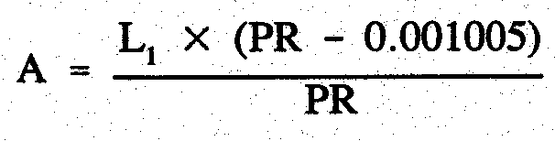
Where—

A is the amount of the remission.

L₁ is the amount of the component of the levy that is based on the value of the land.

PR is the prescribed rate.

Insertion of Part 2A
6. The following Part is inserted after regulation 6 of the principal regulations:

PART 2A
REMISSION OF LEVY ON INDUSTRIAL LAND

Remission of levy
6A. The levy for the 2002/2003 financial year in respect of industrial land is remitted for the benefit of all persons who are liable to pay the levy in respect of that land to the extent set out in regulation 6B.

Amount of remission
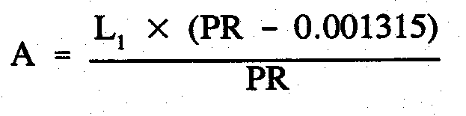
6B. The amount of the remission under regulation 6A is determined in accordance with the following formula:
1
Where—

A is the amount of the remission.

L₁ is the amount of the component of the levy that is based on the value of the land.

PR is the prescribed rate.
Variation of reg. 7—Remission for tenants of Aboriginal Housing Authority
7. Regulation 7 of the principal regulations is varied by striking out "2001/2002" and substituting "2002/2003".

Variation of reg. 8—General remission
8. Regulation 8 of the principal regulations is varied by striking out "2001/2002" and substituting "2002/2003".

Variation of reg. 9—Further remission in respect of principal place of residence
9. Regulation 9(1) of the principal regulations is varied by striking out "2001/2002" and substituting "2002/2003".

Variation of reg. 11—Amount of remission
10. Regulation 11 of the principal regulations is varied by striking out subregulation (2) and substituting the following subregulation:

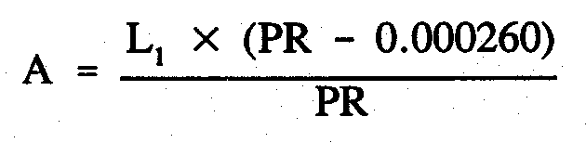
(2) The amount of the remission under regulation 8 is determined in accordance with the following formula:
2
Where—

A is the amount of the remission.

L₁ is the amount of the component of the levy that is based on the value of the land.

PR is the prescribed rate.

Variation of reg. 14—Remission of levy
11. Regulation 14 of the principal regulations is varied by striking out "2001/2002" and substituting "2002/2003".

Substitution of reg. 15
12. Regulation 15 of the principal regulations is revoked and the following regulation is substituted:

Amount of remission
15. (1) The amount of the remission under regulation 14 in respect of rural land situated in Regional area 4 is determined in accordance with the following formula:
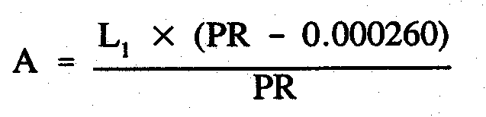
Where—

A is the amount of the remission.

L₁ is the amount of the component of the levy that is based on the value of the land.

PR is the prescribed rate.
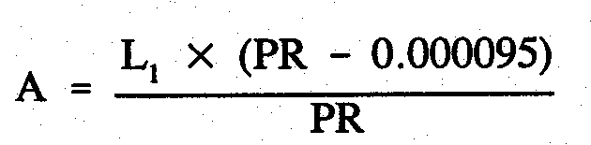
(2) The amount of the remission under regulation 14 in respect of rural land situated in Regional area 1, Regional area 2 or Regional area 3 is determined in accordance with the following formula:

Where—

A is the amount of the remission.

L₁ is the amount of the component of the levy that is based on the value of the land.

PR is the prescribed rate.

Variation of reg. 16—Remission of levy
13. Regulation 16(1) of the principal regulations is varied by striking out "2001/2002" and substituting "2002/2003".

Variation of reg. 17—Amount of remission
14. Regulation 17 of the principal regulations is varied by striking out subregulation (3) and substituting the following subregulation:

(3) The amount of the remission under this subregulation is determined in accordance with the following formula:
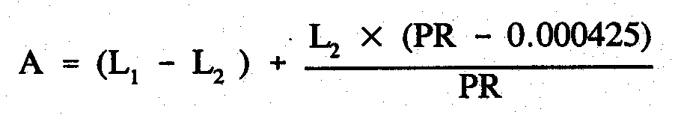
3Where—

A is the amount of the remission.

L₁ is the amount of the component of the levy that is based on the value of the land.

L₂ is the amount that the component of the levy that is based on the value of the land would have been if the value of the land use factor in respect of the land had been one fifth of the value fixed by the Governor's notice under section 10 of the Act.

PR is the prescribed rate.

Variation of reg. 18—Remission of levy
15. Regulation 18 of the principal regulations is varied by striking out "2001/2002" and substituting "2002/2003".

Substitution of reg. 19
16. Regulation 19 of the principal regulations is revoked and the following regulation is substituted:

Amount of remission
19. The amount of the remission under regulation 18 is determined in accordance with the following formula:
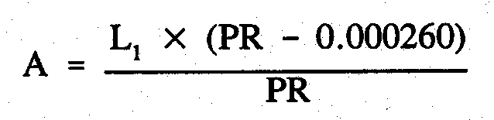
4 Where—

A is the amount of the remission.

L₁ is the amount of the component of the levy that is based on the value of the land.

PR is the prescribed rate.

Variation of reg. 20—Remission of levy
17. Regulation 20 of the principal regulations is varied by striking out "2001/2002" and substituting "2002/2003".

Variation of reg. 22—General remission
18. Regulation 22 of the principal regulations is varied by striking out "2001/2002" and substituting "2002/2003".

Variation of reg. 23—Remission in respect of land of low value
19. Regulation 23 of the principal regulations is varied by striking out "2001/2002" and substituting "2002/2003".

T&F 02/045 CS R. DENNIS, Clerk of the Council

REGULATIONS UNDER THE SUPERANNUATION ACT 1988
────
No. 134 of 2002
────
At the Executive Council Office at Adelaide, 27 June 2002

PURSUANT to the Superannuation Act 1988 and with the advice and consent of the Executive Council, I make the following regulations.
MARJORIE JACKSON-NELSON, Governor

PURSUANT to section 10AA(2) of the Subordinate Legislation Act 1978, I certify that, in my opinion, it is necessary or appropriate that the following regulations come into operation as set out below.

K. FOLEY, Treasurer
───────────────────

SUMMARY OF PROVISIONS

1. Citation
2. Commencement
3. Interpretation
4. Entitlements of Provident Account Section A Contributor
5. Employer component of contribution on transfer of member to State Scheme
6. Modification of Act
───────────────────

Citation
1. These regulations may be cited as the Superannuation (Transfer of Electricity Industry Members) Regulations 2002.

Commencement
2. These regulations are to be taken to have come into operation on 1 July 2001.

Interpretation
3. In these regulations—

"Act" means the Superannuation Act 1988;

"EISS" means the Electricity Industry Superannuation Scheme;

"Section A Contributor" means a contributor to Section A of the Provident Account established in Part V of Division 3 of the Rules of EISS.

Entitlements of Provident Account Section A Contributor
4. (1) A Section A Contributor who is transferred to the State Scheme under clause 5(1) of Schedule 1B of the Act is entitled, on ceasing service, to benefits and options equivalent to those that would have been available to the contributor if he or she had remained in EISS.

(2) The terms and conditions applicable to a Section A Contributor's entitlements after he or she becomes a member of the State Scheme are the same terms and conditions applicable to the contributor's entitlements under EISS immediately prior to his or her transfer to the State Scheme.

Employer component of contribution on transfer of member to State Scheme
5. (1) Where a person who is in receipt of a pension under EISS is transferred to the State Scheme under clause 2(1) of Schedule 1B of the Act, the assessed amount consists of—

(a) a component determined on the basis of the relevant member's contributions and investment earnings on those contributions; and

(b) a component equivalent to the full actuarial value of the employer share of all benefits paid or payable on or after the date of transfer in relation to the person or any other person entitled to a derivative benefit.

(2) In determining the value of benefits paid or payable under subregulation (1), an actuary must take into account—

(a) the amount of any commuted pension paid to the person; and

(b) the total amount of benefits the person is entitled to receive if he or she does not commute the whole or part of his or her pension.

(3) Where a person is transferred from EISS to the State Scheme under clause 3(1) of
Schedule 1B of the Act, an actuary must, in determining the assessed amount, take into account—

(a) the amount of any commuted pension paid to the person; and

(b) the total amount of benefits the person is entitled to receive if he or she does not commute the whole or part of his or her pension.

(4) The contribution to be paid by the Treasurer to the South Australian Superannuation Fund under clause 2(6) of Schedule 1B of the Act does not include the component of the assessed amount referred to in subregulation (1)(b).

(5) In this regulation—

"assessed amount" means the amount to be paid by the Trustee from the Scheme assets to the Treasurer under clause 2(5) or clause 3(9) of Schedule 1B of the Act, as determined by an actuary appointed by the Treasurer.

Modification of Act
6. The Act is modified to the extent necessary to give effect to these regulations.

T&F 02/035CS R. DENNIS, Clerk of the Council

REGULATIONS UNDER THE SOUTHERN STATE SUPERANNUATION ACT 1994
────
No. 135 of 2002
────
At the Executive Council Office at Adelaide, 27 June 2002

PURSUANT to the Southern State Superannuation Act 1994 and with the advice and consent of the Executive Council, I make the following regulations.
MARJORIE JACKSON-NELSON, Governor

PURSUANT to section 10AA(2) of the Subordinate Legislation Act 1978, I certify that, in my opinion, it is necessary or appropriate that the following regulations come into operation as set out below.

K. FOLEY, Treasurer
───────────────────
SUMMARY OF PROVISIONS

1. Citation
2. Commencement
3. Variation of reg. 3—Interpretation
4. Substitution of regs. 6 and 7
6. Conditions authorised for the purposes of section 22(6)
7. Amount of invalidity/death insurance benefits and amount of premiums
5. Revocation of reg. 9
6. Revocation of reg. 12
7. Variation of reg. 13—Notices
8. Insertion of Sched.
SCHEDULE
Invalidity/Death Insurance Benefits
───────────────────

Citation
1. The Southern State Superannuation Regulations 1995 (see Gazette 29 June 1995 p. 3070), as varied, are referred to in these regulations as "the principal regulations".

Commencement
2. These regulations will come into operation on 1 July 2002.

Variation of reg. 3—Interpretation
3. Regulation 3 of the principal regulations is varied by striking out the definition of "the value of the supplementary future service benefit component".

Substitution of regs. 6 and 7
4. Regulations 6 and 7 of the principal regulations are revoked and the following regulations are substituted:

Conditions authorised for the purposes of section 22(6)
6. A condition providing that the value of additional invalidity/death insurance in respect of the member in relation to whom the condition applies is to be reduced, or set at zero, if the member's invalidity or death is caused wholly or partly by—

(a) a pre-existing illness, condition or disability; or

(b) an illness, condition or disability arising out of a pre-existing illness, condition or disability; or

(c) an activity of a prescribed kind,

is an authorised condition for the purposes of section 22(6) of the Act.

Amount of invalidity/death insurance benefits and amount of premiums
7. (1) This regulation fixes the amount of basic and additional invalidity/death insurance benefits and the amount of premiums in respect of those benefits.

(2) A reference in this regulation to Table 1 or Table 2 is a reference to the table so designated in the Schedule.

(3) There will be 2 classes of invalidity/death insurance—

(a) standard insurance cover under Table 1 where—

(i) the value of a unit of cover, as designated in column 2, is determined on the basis of the member's age; and

(ii) the amount of corresponding premium per unit of cover is fixed at the price designated in column 3; or

(b) fixed insurance cover under Table 2 where—

(i) the value of a unit of cover is fixed at the amount designated in column 2; and

(ii) the amount of corresponding premium per unit of cover, as designated in column 3, is determined on the basis of the member's age at the time the insurance cover commences.

(4) Subject to subregulation (7), the amount of basic invalidity/death insurance benefit is—

(a) for a person who is a member immediately before 1 July 2002—

(i) $20 000; or

(ii) 1 unit of standard insurance cover,

whichever is the greater;

(b) for a person who becomes a member on or after 1 July 2002—1 unit of standard insurance cover.

(5) Subject to subregulation (7), the premium for basic invalidity/death insurance is $1 per week.

(6) An applicant for additional invalidity/death insurance may apply for either standard insurance cover or fixed insurance cover.

(7) If a member takes out fixed insurance cover, the member's basic invalidity/death insurance will be taken to be one unit of that cover with an appropriate premium fixed under column 3 of Table 2.

(8) For the purposes of section 22(3) of the Act, all members of the police force and all police cadets must have invalidity/death insurance benefits at least equal in value to five units of standard insurance cover, determined according to their current age (and will be liable for premiums in respect of that insurance in accordance with this regulation).

(9) The aggregate value of units of cover granted to a member employed on a permanent basis must not exceed $500 000 (inclusive of the member's basic cover).

(10) The aggregate value of units of cover granted to a member employed on a casual basis must not exceed $250 000 (inclusive of the member's basic cover).

Revocation of reg. 9
5. Regulation 9 of the principal regulations is revoked.

Revocation of reg. 12
6. Regulation 12 of the principal regulations is revoked.

Variation of reg. 13—Notices
7. Regulation 13 of the principal regulations is varied by inserting after its present contents (now to be designated as subregulation (1)) the following subregulation:

(2) If the employment of a member terminates (or is terminated) in circumstances that will result in—

(a) the member being entitled to a benefit under the Act; or

(b) the member ceasing to be liable with respect to a payment under the Act,

the member's employer at the time of the termination must give the Board written notice of the termination within 14 days after the date of the termination.

Insertion of Sched.
8. The following Schedule is inserted after regulation 13 of the principal regulations:

SCHEDULE
Invalidity/Death Insurance Benefits

Table 1—Standard Insurance Cover

Age last Birthday | One Unit  $ | Cost/Week  $
Up to 34 | 50 000 | 1.00
35 | 48 000 | 1.00
36 | 46 000 | 1.00
37 | 44 000 | 1.00
38 | 42 000 | 1.00
39 | 40 000 | 1.00
40 | 38 000 | 1.00
41 | 36 000 | 1.00
42 | 34 000 | 1.00
43 | 32 000 | 1.00
44 | 30 000 | 1.00
45 | 28 000 | 1.00
46 | 26 000 | 1.00
47 | 24 000 | 1.00
48 | 22 000 | 1.00
49 | 20 000 | 1.00
50 | 18 000 | 1.00
51 | 16 000 | 1.00
52 | 14 000 | 1.00
53 | 12 000 | 1.00
54 | 10 000 | 1.00
55 | 9 000 | 1.00
56 | 8 000 | 1.00
57 | 7 000 | 1.00
58 | 6 000 | 1.00
59 | 5 000 | 1.00

Table 2—Fixed Insurance Cover

Age last  Birthday | One Unit  $ | Cost/week  $
20 and under | 50 000 | 1.10
21 | 50 000 | 1.15
22 | 50 000 | 1.20
23 | 50 000 | 1.25
24 | 50 000 | 1.30
25 | 50 000 | 1.40
26 | 50 000 | 1.50
27 | 50 000 | 1.70
28 | 50 000 | 1.80
29 | 50 000 | 1.90
30 | 50 000 | 2.00
31 | 50 000 | 2.10
32 | 50 000 | 2.30
33 | 50 000 | 2.40
34 | 50 000 | 2.60
35 | 50 000 | 2.70
36 | 50 000 | 2.90
37 | 50 000 | 3.10
38 | 50 000 | 3.30
39 | 50 000 | 3.50
40 | 50 000 | 3.70
41 | 50 000 | 3.90
42 | 50 000 | 4.10
43 | 50 000 | 4.30
44 | 50 000 | 4.60
45 | 50 000 | 4.90
46 | 50 000 | 5.10
47 | 50 000 | 5.40
48 | 50 000 | 5.70
49 | 50 000 | 6.00
50 | 50 000 | 6.30
51 | 50 000 | 6.70
52 | 50 000 | 7.00
53 | 50 000 | 7.40
54 | 50 000 | 7.70
55 | 50 000 | 8.20
56 | 50 000 | 8.60
57 | 50 000 | 9.00
58 | 50 000 | 9.50
59 | 50 000 | 10.10

T&F 02/023 CS R. DENNIS, Clerk of the Council

REGULATIONS UNDER THE SOUTH AUSTRALIAN HEALTH COMMISSION ACT 1976
────
No. 136 of 2002
────
At the Executive Council Office at Adelaide, 27 June 2002

PURSUANT to the South Australian Health Commission Act 1976, on the recommendation of the Minister for Health and with the advice and consent of the Executive Council, I make the following regulations.

MARJORIE JACKSON-NELSON, Governor

PURSUANT to section 10AA(2) of the Subordinate Legislation Act 1978, I certify that, in my opinion, it is necessary or appropriate that the following regulations come into operation as set out below.

LEA STEVENS, Minister for Health
───────────────────
SUMMARY OF PROVISIONS

1. Citation
2. Commencement
3. Variation of Sched.
───────────────────

Citation
1. The Recognized Hospital and Incorporated Health Centre (Medicare Patients) Fees Regulations 1987 (see Gazette 30 July 1987 p. 334), as varied, are referred to in these regulations as "the principal regulations".

Commencement
2. These regulations will come into operation on 1 July 2002.

Variation of Sched.
3. The Schedule of the principal regulations is varied—

(a) by striking out from clause 1(b) "$235" and substituting "$242.00";

(b) by striking out from clause 1(d)(i) "$170" and substituting "$175.00";

(c) by striking out from clause 1(d)(ii) "$194" and substituting "$200.00";

(d) by striking out from clause 1(d)(iii) "$213" and substituting "$219.00";

(e) by striking out from clause 1(d)(iv) "$235" and substituting "$242.00";

(f) by striking out from clause 1(g) "$80.05" and substituting "$82.50".

DHSCS02/20 R. DENNIS, Clerk of the Council

REGULATIONS UNDER THE FISHERIES ACT 1982
────
No. 137 of 2002
────
At the Executive Council Office at Adelaide, 27 June 2002

PURSUANT to the Fisheries Act 1982 and with the advice and consent of the Executive Council, I make the following regulations.
MARJORIE JACKSON-NELSON, Governor

PURSUANT to section 10AA(2) of the Subordinate Legislation Act 1978, I certify that, in my opinion, it is necessary or appropriate that the following regulations come into operation as set out below.

PAUL HOLLOWAY, Minister for Agriculture, Food and Fisheries
───────────────────
SUMMARY OF PROVISIONS

1. Citation
2. Commencement
3. Variation of Sched. 2—Fees
───────────────────

Citation
1. The Scheme of Management (Marine Scalefish Fisheries) Regulations 1991 (see Gazette 27 June 1991 p. 2187), as varied, are referred to in these regulations as "the principal regulations".

Commencement
2. These regulations come into operation on the day on which they are made.

Variation of Sched. 2—Fees
3. Schedule 2 of the principal regulations is varied by striking out from clause 1(a) "giant crab" twice occurring and substituting, in each case, "blue crab".

MAFF02/0023CS R. DENNIS, Clerk of the Council

REGULATIONS UNDER THE WATERWORKS ACT 1932
────
No. 138 of 2002
────
At the Executive Council Office at Adelaide, 27 June 2002

PURSUANT to the Waterworks Act 1932 and with the advice and consent of the Executive Council, I make the following regulations.
MARJORIE JACKSON-NELSON, Governor

PURSUANT to section 10AA(2) of the Subordinate Legislation Act 1978, I certify that, in my opinion, it is necessary or appropriate that the following regulations come into operation as set out below.

P. CONLON, Minister for Government Enterprises
───────────────────
SUMMARY OF PROVISIONS

1. Citation
2. Commencement
3. Variation of reg. 29—Other charges
───────────────────

Citation
1. The Waterworks Regulations 1996 (see Gazette 22 August 1996 p. 702), as varied, are referred to in these regulations as "the principal regulations".

Commencement
2. These regulations will come into operation on 1 July 2002.

Variation of reg. 29—Other charges
3. Regulation 29 of the principal regulations is varied by striking out subregulation (1) and substituting the following subregulation:

(1) Subject to any other provisions of these regulations the following charges are payable to the Corporation:

Standard capital contribution $2 265

Connection charge (this charge includes the charge for installation of a meter):
Nominal diameter $
20 mm 1 425
25 mm 1 910
40 mm 2 965
50 mm 3 570
greater than 50 mm estimated cost quoted
by Corporation
Installation of meter
Nominal diameter of connection $
20 mm 272
25 mm 313
40 mm 635
50 mm 1 160

Relocation of new 20 mm service by 4 metres
or less and installation of meter $
Relocation distance
0.5 metre or less 585
more than 0.5 metre but not more than 1 metre 650
more than 1 metre but not more than 2 metres 720
more than 2 metres but not more than 3 metres 790
more than 3 metres but not more than 4 metres 862

Relocation of new 25 mm service by 4 metres
or less and installation of meter $
Relocation distance
0.5 metre or less 645
more than 0.5 metre but not more than 1 metre 715
more than 1 metre but not more than 2 metres 770
more than 2 metres but not more than 3 metres 850
more than 3 metres but not more than 4 metres 925

Installation of manifold with a meter for
each unit in a strata scheme (this charge
includes the charge for installation of a meter):
Nominal meter diameter on the manifold = 20 mm $
1-4 meters 272 each
5 or more meters 313 each

Connection of fire service communication pipe
Nominal diameter $
100 mm 6 981
150 mm 8 857
greater than 150 mm estimated cost quoted
by Corporation

Installation of additional isolating
valve for fire service:
Nominal diameter $
100 mm 1 912
150 mm 2 551
200 mm 3 149
greater than 200 mm estimated cost quoted
by Corporation

Repair or replace meter
Nominal diameter of connection $
15 mm and 20 mm 214
25 mm 261
32 mm and 40 mm 437
50 mm 697
greater than 50 mm Corporation's costs of
repair or replacement

Repair or replace meter dial box or meter dial
Nominal diameter of connection $
50 mm or less 97.50
greater than 50 mm Corporation's costs of
repair or replacement

Repair or replace fittings other than meters
Nominal diameter of connection $
15 mm and 20 mm 144
25 mm 144
32 mm and 40 mm 230
50 mm 261
greater than 50 mm Corporation's costs of
repair or replacement

Disconnection of a fire service from land $2 160

Disconnection of any other service from main pipe $307

Provision of permanent overhead standpipe and meter
(including connection to main pipe) estimated cost quoted
by Corporation

Relocation of existing 20 mm and 25 mm water
services by 4 metres or less $
Relocation distance
0.5 metre or less 360
more than 0.5 metre but not more than 1 metre 430
more than 1 metre but not more than 2 metres 500
more than 2 metres but not more than 3 metres 585
more than 3 metres but not more than 4 metres 670

Rotation of 20 mm and 25 mm water meters
up to 180 degrees $110

Charge for raising or lowering pipe connecting
land to main pipe
Nominal diameter of connection $
15 mm and 20 mm 345
over 20 mm but not exceeding 50 mm 585
greater than 50 mm estimated cost quoted
by Corporation

Charge for shortening length of pipe connecting
land to main pipe
Nominal diameter of connection $
20 mm and 25 mm 525
32 mm, 40 mm and 50 mm 585
greater than 50 mm estimated cost quoted
by Corporation

Charge to extend length of pipe connecting land
to main pipe estimated cost quoted
by Corporation

Charge to restore water supply following
restriction of supply at meter $41.60

Charge to restore water supply following
restriction of supply at main pipe estimated cost quoted
by Corporation

Charge to restore water supply—where communication
pipe in ground and can be used $299

Charge to provide and install underground
box to cover meter
Nominal diameter $
20 mm and 25 mm 420
32 mm, 40 mm and 50 mm 1 303
greater than 50 mm estimated cost quoted
by Corporation

Charge to test meter at request of consumer $95.00

Charge to read meter at request of consumer $16.60

Charge to provide certificate of rates or
charges unpaid for the purposes of settlement
of land transactions $7.55

Charge for statement of existence or non-existence of
encumbrances in favour of the Corporation or back flow
prevention devices $5.95

Charge for hire of portable hydrant—for each period
of 3 months or part of such a period $47.80

Charge for additional administrative cost in relation
to breach of terms and conditions of hire of hydrant $100.00

Charge for additional administrative cost in
relation to a dishonoured cheque used to pay a
charge or other amount under these regulations $11.00

Charge for additional administrative cost in
relation to a charge or other amount due
under these regulations but not paid by the date for
payment in the notice served on the person liable $6.00

Charge for visit in relation to the non-payment
of a charge or other amount to the land in relation
to which the charge or amount is payable $22.00.

MGE02/006/CS R. DENNIS, Clerk of the Council

REGULATIONS UNDER THE SEWERAGE ACT 1929
────
No. 139 of 2002
────
At the Executive Council Office at Adelaide, 27 June 2002

PURSUANT to the Sewerage Act 1929 and with the advice and consent of the Executive Council, I make the following regulations.
MARJORIE JACKSON-NELSON, Governor

PURSUANT to section 10AA(2) of the Subordinate Legislation Act 1978, I certify that, in my opinion, it is necessary or appropriate that the following regulations come into operation as set out below.

P. CONLON, Minister for Government Enterprises
───────────────────
SUMMARY OF PROVISIONS

1. Citation
2. Commencement
3. Variation of reg. 36—Other charges
───────────────────

Citation
1. The Sewerage Regulations 1996 (see Gazette 22 August 1996 p. 733), as varied, are referred to in these regulations as "the principal regulations".

Commencement
2. These regulations will come into operation on 1 July 2002.

Variation of reg. 36—Other charges
3. Regulation 36 of the principal regulations is varied by striking out subregulation (1) and substituting the following subregulation:

(1) Subject to the other provisions of these regulations the following charges are payable to the Corporation:

Standard capital contribution | $4 438
Installation charge (including connection charge)
Nominal diameter | $
100 mm  150 mm or less (but greater than 100 mm)  greater than 150 mm | 2 370  3 201  estimated cost quoted  by Corporation
Disconnection charge:  Nominal diameter  150 mm or less  greater than 150 mm | $  604  estimated cost quoted  by Corporation
Connection charge:  Nominal diameter  100 mm  150 mm or less (but greater than 100 mm)  greater than 150 mm | $  287  392  estimated cost quoted  by Corporation
Charge to provide certificate of rates or charges unpaid for the purposes of settlement of land transactions | $7.55
Charge for statement of existence or non-existence of easements or other encumbrances in favour of the Corporation | $5.95
Charge for Corporation to consider and determine application for authorisation to discharge trade waste into the undertaking  In relation to commercial land  In relation to industrial land | $  215  396
Charge to check compliance with conditions of authorisation to discharge trade waste into undertaking  In relation to commercial land  In relation to industrial land | $  79.00  96.50
Charge for additional administrative cost in relation to a dishonoured cheque used to pay a charge or other amount under these regulations | $11.00
Charge for additional administrative cost in relation to a charge or other amount due under these regulations but not paid by the date for payment in the notice served on the person liable | $6.00
Charge for visit in relation to the non-payment of a charge or other amount to the land in relation to which the charge or amount is payable | $22.00.

MGE02/006/CS R. DENNIS, Clerk of the Council

REGULATIONS UNDER THE FEES REGULATION ACT 1927
────
No. 140 of 2002
────
At the Executive Council Office at Adelaide, 27 June 2002

PURSUANT to the Fees Regulation Act 1927 and with the advice and consent of the Executive Council, I make the following regulations.
MARJORIE JACKSON-NELSON, Governor

───────────────────
SUMMARY OF PROVISIONS

1. Citation
2. Commencement
3. Substitution of Sched.

SCHEDULE
Fees
───────────────────

Citation
1. The Fees Regulation (Assessment of Requirements—Water and Sewerage) Regulations 1997 (see Gazette 13 May 1997 p. 1820), as varied, are referred to in these regulations as "the principal regulations".

Commencement
2. These regulations will come into effect in accordance with section 5 of the Fees Regulation Act 1927.

Substitution of Sched.
3. The Schedule of the principal regulations is revoked and the following Schedule is substituted:

SCHEDULE
Fees

On the original assessment of the requirements of South Australian Water Corporation where the requirements relate only to the provision of water supply or sewerage services | $236.00
On updating the original or a subsequent assessment where the requirements relate only to the provision of water supply or sewerage services | $67.50

MGE02/006/CS R. DENNIS, Clerk of the Council

REGULATIONS UNDER THE NATIVE VEGETATION ACT 1991
────
No. 141 of 2002
────
At the Executive Council Office at Adelaide, 27 June 2002

PURSUANT to the Native Vegetation Act 1991 and with the advice and consent of the Executive Council, I make the following regulations.
MARJORIE JACKSON-NELSON, Governor

PURSUANT to section 10AA(2) of the Subordinate Legislation Act 1978, I certify that, in my opinion, it is necessary or appropriate that the following regulations come into operation as set out below.

JOHN HILL, Minister for Environment and Conservation
───────────────────
SUMMARY OF PROVISIONS

1. Citation
2. Commencement
3. Variation of reg. 5—Application for consent
───────────────────

Citation
1. The Native Vegetation Regulations 1991 (see Gazette 18 April 1991 p. 1311), as varied, are referred to in these regulations as "the principal regulations".

Commencement
2. These regulations will come into operation on 1 July 2002.

Variation of reg. 5—Application for consent
3. Regulation 5 of the principal regulations is varied—

(a) by striking out from subregulation (1)(c) "$50" and substituting "$400";

(b) by inserting after subregulation (2) the following subregulation:

(3) A fee paid in relation to an application under subregulation (1)(c) must be applied towards the cost of administering the Act in accordance with the directions of the Minister.

EC 02/0032 CS R. DENNIS, Clerk of the Council

FAXING COPY?

IF you fax copy to Government Publishing SA for inclusion in the Government Gazette, there is no need to send a Confirmation Copy to us as well.

This creates confusion and may well result in your notice being printed twice.

Please use the following fax number:

Fax transmission: (08) 8207 1040
Phone Inquiries: (08) 8207 1045

Please include a contact person, phone number and order number so that we can phone back with any queries we may have regarding the fax copy.

NOTE: Closing time for lodging new copy (either fax or hard copy) is 4 p.m. on Tuesday preceding the day of publication.

Government Gazette notices can be E-mailed.

The address is:

governmentgazette@saugov.sa.gov.au

Documents should be sent as attachments in Word format.

When sending a document via E-mail, please confirm your transmission with a faxed copy of your document, including the date the notice is to be published.

Fax transmission: (08) 8207 1040
Enquiries: (08) 8207 1045

CITY OF CHARLES STURT
Adoption of Valuation and Declaration of Rates
NOTICE is hereby given that at its meeting held on 18 June 2002, the council:
1. Adopted the most recent capital valuation of the Valuer-General that is to apply in its area for rating purposes for the 2002-2003 financial year, totalling $9 289 164 980.
2. Declared differential general rates on rateable land within its area as follows:
(a) 0.4113 cents in the dollar on rateable land of Category 1 use;
(b) 0.7954 cents in the dollar on rateable land of Categories 2, 3 and 4 use;
(c) 0.8634 cents in the dollar on rateable land of Categories 5 and 6 use;
(d) 1.1189 cents in the dollar on rateable land of Category 7 use;
(e) 1.0517 cents in the dollar on rateable land of Category 8 use;
(f) 0.7171 cents in the dollar on rateable land of Category 9 use.
3. Declared a minimum rate of $450 for rateable land within its area.
4. Declared separate rates as follows:
In exercise of the powers contained in section 138 of the Water Resources Act 1997 and section 154 of the Local Government Act 1999 and in order to reimburse to the council the amount contributed to:
(a) the River Torrens Catchment Water Management Board for the council’s area, being $970 600, a separate rate of 0.011237 cents in the dollar, based on the capital value of rateable land, on all rateable land within the council’s area in the catchment area of the Board, the capital value of such land comprising $8 645 914 300.
(b) the Patawalonga Catchment Water Management Board for the council’s area, being $15 600, a separate rate of 0.00921 cents in the dollar, based on the capital value of rateable land, on all rateable land within the council’s area in the catchment area of the Board, the capital value of such land comprising $169 688 000.
P. Lockett, Chief Executive Officer

CITY OF MOUNT GAMBIER
Exclusion of Land From Classification as Community Land
NOTICE is hereby given that on 18 June 2002, the City of Mount Gambier resolved pursuant to section 193 of the Local Government Act 1999 to exclude the following land from classification as community land.
CT Number | Description | Location
CT5403/667 | Waste Management Facility (Gambier Contracts) | 3 Eucalypt Drive
CT5455/508 | Residential Property | 3 Lawrence Street
CT5403/669 | Waste Transfer Centre | 5 Eucalypt Drive
CT5403/668 | Waste Management Facility (Cleanaway) | 7 Eucalypt Drive
CT5708/290 | Commercial Building and Land | 9 Penola Road
CT5472/940 | Car Park | Alexander Street
CT5681/242 | Car Park | Commerce Place
CT5488/686 | Car Park | Commerce Place
CT5678/90 | Car Park | Commerce Place
CT5807/14 | Car Park | Commerce Place
CT5662/936 | Car Park | Commerce Place
CT5843/709 | Car Park | Commerce Place
CT5844/15 | Car Park | Commerce Place
CT5811/954 | Car Park | Commerce Place
CT5840/996 | Car Park | Commerce Place
CT Number | Description | Location
CT5477/177 | Commerce Place walkway | Commercial Street West
CT5124/844 | Recreation (Ice House Stadium) | Commercial Street West
CT5727/721 | Council Depot | Commercial Street West
CT5727/722 | Council Depot | Commercial Street West
CT1553/90 | Un-used walkway | Ferrers Street
CT5374/238 | Walkway | Gray Street
CT5784/613 | Car Park | James Street
CT5101/659 | Car Park | James Street
CT5761/637 | Commercial Property | 46 James Street
CT5543/812 | Commercial Property | 48 James Street
CT648/195 | Car Park | James Street
CT648/196 | Car Park | James Street
CT5825/659 | Community, corner Elizabeth Street (north side) | Jane Street
CT5798/310 | Vacant, corner Penola Road (north-west corner) | Jubilee Highway West
CT5717/457 | Car Park | Lawrence Street
CT5790/732 | Vacant, laneway | O’Leary Road
CT5427/997 | Vacant, former landfill | Orchard Road (east side)
CT4047/969 | Vacant, former landfill | Orchard Road (east side)
CT5610/754 | Car Park | Percy Street
CT5757/647 | Car Park | Percy Street
CT5761/21 | Car Park | Percy Street
CT5738/631 | Walkway, unused | Reginald Street
CT5808/209 | Recreation Reserve, Hasings Cunningham Reserve | Shepherdson Road
CT5210/381 | Car Park | Sturt Street
CT5134/241 | Civic Centre | Sturt Street
CT5210/381 | Car Park | Sturt Street
CT5156/901 | Car Park | Watson Terrace
CT5558/66 | Community Theatre | Wehl Street South
CT5863/743 | Vacant Land | Willow Avenue to Mulga Street
CT5810/353 | Rear portion of Corriedale Park | Wireless Road West
Dated 19 June 2002.
G. Muller, Chief Executive Officer

[Republished]
CITY OF NORWOOD, PAYNEHAM AND ST PETERS
Development Act 1993
Significant Trees Plan Amendment Report
Draft for Public Consultation
NOTICE is hereby given that the City of Norwood, Payneham and St Peters has prepared a draft Plan Amendment Report to amend the Kensington and Norwood (City); Payneham (City) and St Peters (CT) Development Plans. The Plan affects various private properties within the suburbs of Norwood, Heathpool, Kent Town, Marryatville, Hackney, College Park and St Peters, and public lands (roads and parks) across the whole of the council area.
The Plan Amendment Report will amend the aforementioned Development Plans by introducing lists of Significant Trees; the effect of this being that tree damaging activity (as defined by the Development Act 1993) can only be lawfully undertaken with the benefit of a Development Approval. These lists expand the range of Significant Trees that currently qualify by virtue of trunk size criteria pursuant to Regulation 6A (1) of the Development Regulations 1993. The Plan amendments also include some policy variations to:
(a) better recognise the need to preserve remnant native vegetation within the River Torrens Linear Park; and
(b) instate tree damaging activity as a type of development that requires merit assessment for the various Historic Conservation Zones in the St Peters (CT) Development Plan (as per other zones in the council area).
Note: the Development Plan amendments proposed by this Plan Amendment Report have been brought into interim operation pursuant to Section 28 (1) of the Development Act 1993 and take effect from the date of this notice.
The draft Plan Amendment Report and statement will be available for public inspection and purchase during normal office hours at the council office, Norwood Town Hall, 175 The Parade, Norwood, S.A. 5067 from 20 June 2002 to 22 August 2002. Copies of the Plan Amendment Report can be purchased from the council at a cost of $10 each. Alternatively, the Plan Amendment Report can be viewed on the Council’s website at www.npsp.sa.gov.au
Written submissions regarding the draft amendment will be accepted by the City of Norwood, Payneham and St Peters until the close of business on 22 August 2002. The written submission should also clearly indicate whether you wish to speak at the public hearing regarding your submission. All submissions should be addressed to the Chief Executive Officer, City of Norwood, Payneham and St Peters, P.O. Box 204, Kent Town, S.A. 5071.
Copies of all submissions received will be available for inspection by interested persons at the council office from 22 August 2002 until the date of the public hearing. A public hearing will be held at 6.30 p.m., on 16 September 2002 at the Council Chambers, Norwood Town Hall, 175 The Parade, Norwood.
The public hearing may not be held if no submission indicates an interest in speaking at the public hearing.
Dated 20 June 2002.
M. Barone, Chief Executive Officer

CITY OF PLAYFORD
Development Act 1993
Playford (City) Development Plan—
Residential Design Plan Amendment Report—
Draft for Public Consultation
THE City of Playford has prepared a draft Plan Amendment Report to amend the Playford (City) Development Plan as it affects:
All residential areas within the City of Playford. In particular, the suburbs within existing R1, R2, Residential, Residential (Munno Para) Zones. These suburbs include Hillbank, Andrews Farm, Smithfield, Smithfield Plains, Munno Para West, all suburbs of Elizabeth, Davoren Park, Blakeview and Craigmore.
The Residential Design Plan Amendment Report will amend the Playford (City) Development Plan by up-dating existing residential policies and zones to better reflect the strategic vision of sustainable development, as well as the regeneration of the City.
The policy changes proposed in the Residential Design Plan Amendment Report:
1. Introduce the Good Residential Design SA performance-based approach, through Council-wide provisions which adapt and implement design principles relating to energy efficiency, amenity (such as consideration of privacy), crime prevention, stormwater drainage and water management, and refine policies to promote better access to services and facilities.
2. Replace existing residential zones with new zones that:
• Introduce residential policies and amend zone boundaries to recognise area characteristics and the focus on regeneration of existing suburbs;
• Introduce policies that manage the interface between agricultural and residential uses;
• Revise lists of complying development (and conditions of complying development); and
• Revise public notification categories.
3. Extend the MOSS (Recreation) zone over a portion of Smiths Creek and defined areas within Hillbank and Craigmore.
4. Delete and incorporate within a residential zone, the Home Industry Zone and McPherson Reserve.
5. Provide greater guidance in the assessment of non-residential uses within Residential Zones.
The draft Residential Design Plan Amendment Report will be available for public inspection during normal office hours at the following locations from Wednesday, 19 June 2002 to Friday, 16 August 2002:
• Elizabeth Service Centre, 1 Prince Charles Walk, Elizabeth.
• Smithfield Service Centre, Warooka Drive, Smithfield.
• Elizabeth Library, 3 Windsor Square, Elizabeth.
• Smithfield Library, Warooka Drive, Smithfield.
Copies of the Residential Design Plan Amendment Report can only be obtained from the Elizabeth and Smithfield Service Centres during normal office hours. The Residential Design Plan Amendment Report can also be viewed on Council’s website: www.playford.sa.gov.au
Written submissions regarding the draft amendment will be accepted by the City of Playford until 5.30 p.m. on Friday, 16 August 2002. The written submission should also clearly indicate whether you wish to speak at the public hearing on your submission.
All submissions should be addressed to:
Policy Planner
City of Playford
Warooka Drive
Smithfield, S.A. 5114.
Copies of all submissions received will be available for inspection by interested persons at the Smithfield Service Centre from Tuesday, 20 August 2002 to Wednesday, 28 August 2002.
A public hearing will be held at 7 p.m. on Wednesday, 28 August 2002, at the Elizabeth Council Chambers, Prince Charles Walk, Elizabeth.
The public hearing may not be held if no submission indicates an interest in speaking at the public hearing.
Dated: 19 June 2002.
T. Jackson, Chief Executive Officer

CORPORATION OF THE TOWN OF GAWLER
Development Act 1993
Gawler Rivers Flood Plain Plan Amendment Report—
Draft for Public Consultation
NOTICE is hereby given that the Town of Gawler has prepared a draft Plan Amendment Report to amend the Gawler (CT) Development Plan. The Plan affects land in proximity of Gawler’s Rivers.
The Plan Amendment Report will amend the Development Plan by:
• introducing policies to take into account the impacts of flooding on development and development on flooding;
• reviewing existing objectives and principles of development control for development within or which may apply in the flood plain areas; and
• introducing new policies to ensure Council has greater control over activities within the flood plain to the extent that is currently defined.
The proposed amendments to the Development Plan are expected to provide:
• improved control over development in the flood plain areas;
• control, over or more particular reference, to activities not currently covered by existing policy; and
• improved public safety.
Note: the Development Plan amendments proposed by this Plan Amendment Report have been brought into interim operation pursuant to section 28 (1) of the Development Act 1993 and take effect from the date of this notice.
The draft Plan Amendment Report will be available for public inspection and purchase during normal office hours at the council office and library, 89 Murray Street Gawler, from 27 June 2002 to 29 August 2002. Copies of the Plan Amendment Report can be purchased from the council at a cost of $10.00 each.
Written submissions regarding the draft amendment will be accepted by the Council until the close of business on 29 August 2002. The written submission should also clearly indicate whether there is a requirement to speak at the public hearing regarding a submission. All submissions should be addressed to the Chief Executive Officer of the Town of Gawler, Box 130, Gawler, S.A. 5118.
Copies of all submissions received will be available for inspection by interested persons at the council office from 29 August 2002 until the date of public hearing. A public hearing will be held at 6.00 p.m. on 23 September 2002 at the Council Chambers, 89 Murray Street, Gawler.
The public hearing may not be held if no submission indicates an interest in speaking at the public hearing.
Dated 27 June 2002.
J. McEachen, Town Manager

ADELAIDE HILLS COUNCIL
Development Act 1993
Development Plan Review—Public Consultation
NOTICE is hereby given that the Adelaide Hills Council is reviewing its Development Plan pursuant to section 30 of the Development Act 1993. The Development Plan Review will determine the appropriateness of the Development Plan to the Council area and its consistency with the Mount Lofty Ranges Strategic Plan.
Public consultation for the Development Plan Review will be for a two month period from Thursday, 27 June 2002 until Tuesday, 27 August 2002. During this time any interested person is invited to make written submissions on the subject of the Development Plan Review. Any person who makes a written submission in response to this invitation will also be given an opportunity to appear personally or by a representative before council or a council committee to be heard on their submission.
A Development Plan Review Introduction Paper entitled ‘Guiding Development in the Adelaide Hills’ will be available for viewing at council’s Woodside, Stirling, Norton Summit and Gumeracha Service Centres. The Introduction Paper and supporting reports will be available during normal office hours throughout the Development Plan Review public consultation period.
Written submissions regarding the Development Plan Review must be forwarded to the Adelaide Hills Council no later than 5 p.m. on Tuesday, 27 August 2002. Persons making written submissions should indicate whether they wish to be heard on their submission at the subsequent public hearing and if so, contact details should be provided. All submissions should be directed to:
The District Planner
Adelaide Hills Council
P.O. Box 44
Woodside, S.A. 5244
A public hearing will be held, commencing at 6.30 p.m. on Monday, 9 September 2002 (or 10 September, if required) at the Adelaide Hills Council, Nairne Road Chambers, at which time interested persons are welcome to attend and comment on the Development Plan Review.
Further information on the Development Plan Review can be obtained by contacting:
Kieron Barnes
Project Planner
Adelaide Hills Council
Ph: 8408 0504
Email: kbarnes@ahc.sa.gov.au
P. Peppin, Chief Executive Officer

DISTRICT COUNCIL OF THE COPPER COAST
Periodical Review of Elector Representation
NOTICE is hereby given that pursuant to the provisions of section 12 (5) of the Local Government Act 1999, that the District Council of the Copper Coast is to carry out a review to determine whether a change of arrangements in respect to elector representation, including ward boundaries and the composition of council, will result in the electors of the area being more adequately and fairly represented.
Information regarding the nature of the public review is available at the Council Office, 51 Taylor Street, Kadina, S.A. 5556 or by contacting Phil Brand on 8821 1600.
Interested persons are invited to make submissions to the Chief Executive Officer, 51 Taylor Street, Kadina, S.A. 5556 by the close of business on Tuesday, 13 August 2002.
Any person who makes a written submission will be afforded an opportunity to appear before council to be heard with respect to their submission.
J. W. Shane, Chief Executive Officer

LIGHT REGIONAL COUNCIL
Revocation of Load Limit—Seppeltsfield Bridge
NOTICE is hereby given that, pursuant to section 359 of the Local Government Act 1934, as amended, council has now revoked the 3 tonne gross load limit imposed on the Seppeltsfield Bridge, Seppeltsfield Road, Seppeltsfield, effective from 19 June 2002.
P. J. Beare, Chief Executive Officer

DISTRICT COUNCIL OF MOUNT BARKER
Assign a Road Name
NOTICE is hereby given that pursuant to section 219 of the Local Government Act 1999, council has resolved to assign a road name within the District of Mount Barker.
A previously un-named government road in Mount Barker between Bald Hill Road and the council boundary with Alexandrina Council to the south will be now known as Valley Road.
All the relevant government agencies and emergency services are being notified as are the residents affected by these changes.
Should anyone need further clarification of these name changes, please contact the Customer Service Centre, District Council of Mount Barker, 23 Mann Street, Mount Barker, S.A. 5251 or telephone 8391 1633.
A. Stuart, Chief Executive Officer

DISTRICT COUNCIL OF MOUNT REMARKABLE
Formal Commencement of Proceedings—Periodical Review of Elector Representation
NOTICE is hereby given that following preliminary con-sideration of elector representation matters, council gives notice that pursuant to the provisions of section 12 (5) of the Local Government Act 1999, the District Council of Mount Remarkable will commence its review to determine whether a change of arrangement in respect of elector representation including ward boundaries and the composition of council will result in the electors of the area being more adequately and fairly represented.
Information relating to the nature of the review and details of some options following the preliminary consideration are available from the District Council of Mount Remarkable, Stuart Street, Melrose during opening hours, 9 a.m. to 4.30 p.m. weekdays, or by telephoning Peter Moore or Phyllis Robinson on 8666 2014.
Interested persons are invited to make written submissions to the Chief Executive Officer, P.O. Box 94, Melrose, S.A. 5483 by the close of business on Friday, 16 August 2002.
Any person who makes a written submission in relation to this notice will be afforded an opportunity to appear before council to be heard with respect to their submission.
P. J. Moore, Chief Executive Officer

NORTHERN AREAS COUNCIL
Periodical Review of Elector Representation
Erratum
NOTICE is hereby given that the notice published in the South Australian Government Gazette, on Thursday, 30 May 2002, page 2032, Periodical Review of Elector Representation, is amended as follows:
The closing date for submissions originally published as Thursday, 11 July 2002 is hereby amended to Friday, 12 July 2002.
P. A. McInerney, Chief Executive Officer

PORT PIRIE REGIONAL COUNCIL
Appointment
NOTICE is hereby given that at a meeting of the Council held on 26 June 2002, Karin Prince was appointed as Environmental Health Officer pursuant to section 7 of the Public and Environmental Health Act 1987 and section 8 of the Food Act 1985.
Dated 27 June 2002.
J. Vucic, Chief Executive Officer

WATTLE RANGE COUNCIL
Periodical Review of Elector Representation
NOTICE is hereby given, pursuant to the provisions of section 12 (9) of the Local Government Act 1999, council, after consulting the electors during its review to determine a change in arrangements with respect to elector representation, has resolved that the following alterations be brought into effect from the next general election to be held in May 2003:
• That the number of councillors be reduced from 11 to 7.
• That the existing four wards be retained with altered boundaries to facilitate the new elector quotas with the following number of councillors per ward—Corcoran 3, Kintore 1, Riddoch 2, Sorby Adams 1.
• The office of Mayor be retained.
A report has been prepared on this proposal and may be inspected at the council offices at Millicent, Beachport and Penola or will be forwarded on request.
Written submissions on the report are invited to be received from interested persons by 5 p.m. on Wednesday, 31 July 2002, and should be directed to the Chief Executive Officer, P.O. Box 27 Millicent, S.A. 5280. Any person making a written submission will be invited to appear before a meeting of council to be heard in respect of their submission.
F. N. Brennan, Chief Executive Officer

DISTRICT COUNCIL OF YANKALILLA
Exclusion of Land from Classification as Community Land
NOTICE is hereby given that the District Council of Yankalilla, at a meeting held on 13 June 2002, resolved pursuant to section 193 of the Local Government Act 1999, to exclude the following parcel of land from classification as community land.
Vacant land—Lady Bay, allotment 7, Filed Plan 19121, Hundred of Yankalilla, Certificate of Title Volume 5474, Folio 928.
R. D. Sweetman, Chief Executive Officer

DISTRICT COUNCIL OF YORKE PENINSULA
Exclusion from Classification as Community Lands
NOTICE is hereby given pursuant to section 193 of the Local Government Act 1999, that at meetings of council as indicated, council resolved that the following lands be excluded from the classification as community land:
3 October 2000:
(1) Burford Estate, Ardrossan, allotments 11, 12, 13, 17, 18, 19, 20, 24, 25, 27, 28, 29, 40, 41, 42, 43, 44 and 45.
(2) Marion Bay subdivision, allotments 1176, 1178, 1180, 1181, 1183, 1184, 1185, 1186, 1190, 1191, 1192, 1199, 1233, 1235, 1236, 1240, 1241, 1242, 1243, 1245, 1248, 1249, 1250, 1251 and 1252.
2 April 2001:
(1) Council residence at allotment 35 Oval Terrace, Warooka.
(2) Council residence at allotment 22 Ynoo Avenue, Maitland.
(3) Part section 13, Hundred of Melville.
2 October 2001:
(1) Council residence at allotment 157 (House No. 1) Main Street, Minlaton.
3 December 2001, portion of allotment 152 Main Road, Port Vincent:
(1) The current Country Fire Service Station and adjacent land, encompassing an area approximately 74 m long by 33 m wide.
(2) The existing residence and yard encompassed by the existing fence surrounding the house and yard.
(3) The existing caravan storage area measuring approximately 136 m long by 24 m wide.
6 May 2002:
(1) Portion of section 155, Hundred of Ramsay.
Pursuant to section 34 (3) of the Local Government (Implementation) Act 1999 the following land also be excluded as community land:
6 March 2000:
(1) Allotment 9 Formby Road, Carribie.
S. P. Griffths, Chief Executive Officer

IN the matter of the estates of the undermentioned deceased persons:
Buxton, Charles Gordon, late of 1 Blamey Avenue, Broadview, retired roofing plumber, who died on 27 May 2002.
Cheyne, William McKenzie, late of 21 Foster Street, Parkside, retired postal clerk, who died on 30 April 2002.
Dolphin, Murdoch William, late of 12 Cook Street, Port Lincoln, retired farmer, who died on 28 April 2002.
Floyd, Arnold Arthur, late of 80 Moseley Street, Glenelg South, retired painter, who died on 7 May 2002.
Marriott, Doris Edith, late of 7 Victoria Street, Goodwood, of no occupation, who died on 4 May 2002.
Porter, Barbara Mary, late of 15 Rosemary Street, Woodville West, of no occupation, who died on 4 May 2002.
Swann, John Gordon, late of 12 Surrey Street, Hawthorndene, retired watchmaker, who died on 17 February 2002.
Todonai, Juliana, late of 71 Stokes Terrace, Port Augusta West, of no occupation, who died on 16 April 2002.
Toseland, Milicent Irene, late of 34 Molesworth Street, North Adelaide, of no occupation, who died on 27 April 2002.
Turner, Troy, late of Benara Road, Mount Gambier, of no occupation, who died on 2 September 2001.
Williams, Richard Thomas, late of Walkerville Terrace, Walkerville, retired line inspector, who died on 18 May 2002.
Notice is hereby given pursuant to the Trustee Act 1936, as amended, the Inheritance (Family Provision) Act 1972, and the Family Relationships Act 1975, that all creditors, beneficiaries, and other persons having claims against the said estates are required to send, in writing, to the Public Trustee, 25 Franklin Street, Adelaide 5000, full particulars and proof of such claims, on or before 26 July 2002, otherwise they will be excluded from the distribution of the said estate; and notice is also hereby given that all persons who are indebted to the said estates are required to pay the amount of their debts to the Public Trustee or proceedings will be taken for the recovery thereof; and all persons having any property belonging to the said estates are forthwith to deliver the same to the Public Trustee.
Dated 27 June 2002.
C. J. O’Loughlin, Public Trustee

IN the matter of the estates of the undermentioned deceased persons:
Chilman, Robert Mostyn, late of 33 Cardinia Street, Mount Gambier, who died on 2 May 2002.
Linden, Willi, formerly of 53 Park Street, Hyde Park, late of St Peters Aged Care Facility, 51 Eighth Avenue, St Peters, who died on 29 April 2002.
Newcombe, Jack, formerly of 28 Brooking Street, Goolwa, late of Victor Harbor Nursing Home, Coral Street, Victor Harbor, who died on 27 April 2002.
Noble, Clyde Arnold, late of 574 Scenic Drive, Napperby, who died on 17 February 2002.
Ostigh, Dino, late of 11 Sexton Street, Goolwa, who died on 24 April 2002.
Owen, Eric, late of Unit 2/45 Robert Street, Moonta, who died on 6 February 2002.
Notice is hereby given pursuant to the Trustee Act 1936, as amended, the Inheritance (Family Provision) Act 1972-1975 and the Family Relationships Act 1975, that all creditors beneficiaries and other persons having claims against any of the abovenamed estates are directed to send full particulars of such claims to the undersigned on or before 25 July 2002, otherwise they will be excluded from the distribution of the said estates.
Dated 27 June 2002.
National Australia Trustees Limited, (ABN 80 007 350 405), 22-28 King William Street, Adelaide, S.A. 5000.

D. A. SHARPE ELECTRICAL CONTRACTING PTY LTD
(ACN 008 290 640)
Notice By a Liquidator of His Intention to Seek His Release
TAKE notice that I, Bruce James Carter, Ferrier Hodgson, Level 6, 81 Flinders Street, Adelaide, S.A. 5000, the liquidator of the abovenamed company, intend to make application to the Supreme Court of South Australia for my release as the liquidator of the abovenamed company.
And take further notice that if you have any objection to the granting of my release you must file at the Supreme Court and also forward to me within 21 days of the publication in the Gazette of the notice of my intention to apply for a release a notice of objection in the form laid down by the Corporations (South Australia) Rules 1993.
Dated 24 June 2002.
B. J. Carter, Liquidator
Note: Section 481 of the Corporations Act enacts that an order of the Court releasing a Liquidator shall discharge him/her in the administration of the affairs of the company, or otherwise in relation to his or her conduct as liquidator, but any such orde3r may be revoked on proof that is was obtained by fraud or by suppression or by concealment of any material fact.

SOUTH AUSTRALIA—In the Supreme Court. No. 684 of 1999. In the matter of Linden Investments (S.A.) Pty Ltd (in liquidation) (ACN 066 918 938) and in the matter of the Corporations Act 2001.
Notice of Release of Liquidator and Dissolution of the Company
Take notice that by order of the Supreme Court of South Australia dated 12 June 2002, I, Austin Robert Meerten Taylor, 67 Greenhill Road, Wayville, S.A. 5034, the liquidator of the abovenamed company was granted my release as liquidator, and that the company be dissolved from that date.
Dated 19 June 2002.
A. R. M. Taylor, Liquidator

SOUTH AUSTRALIA—In the Supreme Court. No. 701 of 1999. In the matter of Natale Investments Pty Ltd (in liquidation) (ACN 073 751 550) and in the matter of the Corporations Act 2001.
Notice of Release of Liquidator and Dissolution of the Company
Take notice that by order of the Supreme Court of South Australia dated 12 June 2002, I, Austin Robert Meerten Taylor, 67 Greenhill Road, Wayville, S.A. 5034, the liquidator of the abovenamed company was granted my release as liquidator, and that the company be dissolved from that date.
Dated 19 June 2002.
A. R. M. Taylor, Liquidator

PURE FRUIT PTY LTD
(ACN 054 822 418)
Notice By a Liquidator of His Intention to Seek His Release
Take notice that I, Bruce James Carter, Ferrier Hodgson, Level 6, 81 Flinders Street, Adelaide, S.A. 5000, the liquidator of the abovenamed company, intend to make application to the Supreme Court of South Australia for my release as the liquidator of the abovenamed company.
And take further notice that if you have any objection to the granting of my release you must file at the Supreme Court and also forward to me within 21 days of the publication in the Gazette of the notice of my intention to apply for a release a notice of objection in the form laid down by the Corporations (South Australia) Rules 1993.
Dated 24 June 2002.
B. J. Carter, Liquidator
Note: Section 481 of the Corporations Act enacts that an order of the Court releasing a Liquidator shall discharge him/her in the administration of the affairs of the company, or otherwise in relation to his or her conduct as liquidator, but any such orde3r may be revoked on proof that is was obtained by fraud or by suppression or by concealment of any material fact.

SALE OF PROPERTY
Auction Date: Wednesday, 3 July 2002 at 10 a.m.
Location: Mason Gray Strange, 370 Torrens Road,
Kilkenny
NOTICE is hereby given that on the above date at the time and place stated, by virtue of Orders for Sale issued by the Fines Payment Unit of South Australia—Penalty No. MCHHL 14608 of 1995 and others, are directed to the Sheriff of South Australia in an action wherein Archangelo Francesca is the Defendant, I, Tim Goodes, Sheriff of the State of South Australia, will by my auctioneers, Government Auctions SA make sale of the following:
1 cement table, 2 planter boxes, 2 plant baskets, 8 statues, 144 figurines, 6 pots, 11 pavers, 5 urns, 4 eagles, 2 lion faces, 4 stands and 1 feature.

UNCLAIMED MONEYS ACT 1891
Register of Unclaimed Moneys held by Big W for S.A. Region

Name of Owner on Books and  Last Known Address |  | Amount Due  to Owner  $ |  | Date when  First Due
Crompton, Shane, 6 Glenloth Drive, Happy Valley, S.A. 5159 |  | 11.40
Thorpe, L., 3/197 Main Road, Blackwood, S.A. 5051 |  | 11.60 | 12.1.99
Robinson, Matthew, 25 East Parkway, Colonel Light Gardens, S.A. 5041 |  | 13.20
Tucker, Sarah, 4 Seppings Court, Flagstaff Hill, S.A. 5159 |  | 13.80
Sobolski, Jade, (Big W 554) Westfields, Torrens Road, Kilkenny, S.A. 5009 |  | 14.50
Wisznewski, K. L., (Big W 553) Westfields, Diagonal Road, Oaklands Park, S.A. 5046 |  | 15.18
Miller, Nicole, 32 Horseshoe Drive, Woodcroft, S.A. 5162 |  | 15.85
Gross, O, (Big W 552) John and Gawler Streets, Salisbury, S.A. 5108 |  | 15.95
Sugars, Theresa, 4 Clyde Road, Hawthorndene, S.A. 5051 |  | 16.50
Burgess, Gary, 35 Jupiter Street, Hallett Cove, S.A. 5158 |  | 16.50
Papagni, A., 12 Taylor Avenue, Salisbury Heights, S.A. 5109 |  | 16.60
Joywer, R. W., (Big W 553) Westfields, Diagonal Road, Oaklands Park, S.A. 5046 |  | 17.35
Sykes, Jessica, 11 Jervois Terrace, Marino, S.A. 5049 |  | 17.65
O’Sullivans M., (Big W 553) Westfields, Diagonal Road, Oaklands Park, S.A. 5046 |  | 17.80
Pallant, Ben, 85 Folkestone Road, Dover Gardens, S.A. 5048 |  | 17.80
Fitzgibbons, R., (Big W 553) Westfields, Diagonal Road, Oaklands Park, S.A. 5046 |  | 17.80
Rothe, Hans, 43 Holder Road, Hove, S.A. 5048 |  | 17.80
Ryan, Katherine, 36 Glendale Avenue, Flagstaff Hill, S.A. 5159 |  | 17.80
Sherrington, Scott, (Big W 553) Westfields, Diagonal Road, Oaklands Park, S.A. 5046 |  | 17.80
Hillman, Peter, 25 Devon Street, Goodwood, S.A. 5034 |  | 18.00
Dallison, David, 8 Strathmore Terrace, Brighton, S.A. 5048 |  | 18.00
Tidswell, A., (Big W 553) Westfields, Diagonal Road, Oaklands Park, S.A. 5046 |  | 18.25
Roberts, R., (Big W 552) John and Gawler Streets, Salisbury, S.A. 5108 |  | 19.05
Angel, K., 20 Inverness Drive, Meadow Spring, W.A. 6210 |  | 20.02
Roberts, C., (Big W 553) Westfields, Diagonal Road, Oaklands Park, S.A. 5046 |  | 20.30
Purchase, S., (Big W 553) Westfields, Diagonal Road, Oaklands Park, S.A. 5046 |  | 20.60
Evenett, L., (Big W 553) Westfields, Diagonal Road, Oaklands Park, S.A. 5046 |  | 20.85
Brightbard, David, 21 Seaforth Avenue, Dover Gardens, S.A. 5048 |  | 22.15
Purcell, T., (Big W 553) Westfields, Diagonal Road, Oaklands Park, S.A. 5046 |  | 22.30
Leonard, Amy, 14 Bentine Street, Para Vista, S.A. 5093 |  | 22.35
Bevan, D., 14 Peppermint Road, Lewiston, S.A. 5501—Cheque cancelled |  | 22.50 | 3.6.00
Schroeder, Paul, 61 Byards Road, Happy Valley, S.A. 5159 |  | 22.75
Turner, (Big W 554) Westfields, Torrens Road, Kilkenny, S.A. 5009 |  | 22.76
Hunter, L., (Big W 553) Westfields, Diagonal Road, Oaklands Park, S.A. 5046 |  | 23.02
Viney, Kerry, 38 Alison Drive, Happy Valley, S.A. 5159 |  | 23.40
Stevenson, A., (Big W 551) Goodwood Road, Cumberland Park, S.A. 5041 |  | 23.45
Fountain, A., 3/30 McInerney Avenue, Mitchell Park, S.A. 5043 |  | 23.70
Tucker, Sarah, 4 Seppings Court, Flagstaff Hill, S.A. 5159 |  | 24.15
No Details (Extra), (Big W 553) Westfields, Diagonal Road, Oaklands Park, S.A. 5046 |  | 24.25
Hicks, T., (Big W 552) John and Gawler Streets, Salisbury, S.A. 5108 |  | 24.30
Kerin, Kylie, 3 Nathan Court, Darlington, S.A. 5047 |  | 24.40
Robin, A., (Big W 551) Goodwood Road, Cumberland Park, S.A. 5041 |  | 24.41
Woodley, Nicholas, 1 Jasmine Avenue, Marion, S.A. 5043 |  | 24.50
Dykstra, Aaron, 30 Doradus Avenue, Hope Valley, S.A. 5090 |  | 24.60
Kennedy, Christopher, 49 The Strand, Reynella, S.A. 5161 |  | 24.65
Loiterton, (Big W 551) Goodwood Road, Cumberland Park, S.A. 5041 |  | 25.00
Fernandez, A., (Big W 553) Westfields, Diagonal Road, Oaklands Park, S.A. 5046 |  | 25.05
Hodgkinson, Kym, 8 Leichardt Avenue, Ingle Farm, S.A. 5098 |  | 26.15
Woodley, Nicholas, 1 Jasmine Avenue, Marion, S.A. 5043 |  | 26.50
Schotte, P., (Big W 552) John and Gawler Streets, Salisbury, S.A. 5108 |  | 27.05
Kelly, S., (Big W 553) Westfields, Diagonal Road, Oaklands Park, S.A. 5046 |  | 27.20
Plush, Dylan, 15 King Street, Brighton, S.A. 5048 |  | 27.35
Dunkley, Breanna, 18 Sargeant Avenue, Darlington, S.A. 5047 |  | 27.85
Randall, Amie, 7 Ayrebank Rise, Aberfoyle Park, S.A. 5159 |  | 28.80
Mitchell, S., No Forwarding Address |  | 29.20 | 8.8.98
Tassone, Amanda, 46 Hughes Street, Woodville, S.A. 5011 |  | 29.60
Turner, Julie, 225 Cross Road, Cumberland Park, S.A. 5041 |  | 30.25
Cumpston, A. J., 20 Avenue Road, Cumberland Park, S.A. 5041 |  | 30.55
Chamings, D., 57 Cowan Street, Angle Park, S.A. 5010 |  | 30.75
Kranz, C. S., 53 Edward Beck Drive, Sheidow Park, S.A. 5158 |  | 31.10
Votino, (Big W 554) Westfields, Torrens Road, Kilkenny, S.A. 5009 |  | 32.07
Hood, Kirsty, 12 Tower Drive, Salisbury East, S.A. 5109 |  | 32.15
Dickinson, Russell, 6 Denby Close, Christie Downs, S.A. 5164 |  | 32.65
Walton, R., No Forwarding Address |  | 33.65 | 1.2.97
Henningsen, Emma-Louise, 25 Montrose Avenue, Para Hills, S.A. 5096 |  | 33.70
Grading, S., (Big W 553) Westfields, Diagonal Road, Oaklands Park, S.A. 5046 |  | 34.00
Wilson, J., (Big W 550) Princess Anne Walk, Elizabeth, S.A. 5112 |  | 34.36
Lipschinski, Kym, 450 Montague Road, Modbury North, S.A. 5092 |  | 34.50
McQueen, Jody-Rae, 14 Marita Street, Morphett Vale, S.A. 5162 |  | 35.00
Jinks, Beth, 6 Westall Court, Sheidow Parsk, S.A. 5158 |  | 35.60
Thompson, M., (Big W 553) Westfields, Diagonal Road, Oaklands Park, S.A. 5046 |  | 36.55
Kendall, Michael, 5/11-12 North Esplanade, Glenelg North, S.A. 5045 |  | 37.95
Marrafioten, (Big W 554) Westfields, Torrens Road, Kilkenny, S.A. 5009 |  | 38.13
Maksimovic, Zoran, 8 Roxanne Avenue, Aberfoyle Park, S.A. 5159 |  | 39.40
Watts, Tom, 11 Meredith Avenue, Glengowrie, S.A. 5044 |  | 39.40
Katsapdukidis, I., (Big W 554) Westfields, Torrens Road, Kilkenny, S.A. 5009 |  | 39.54
Temnoff, Olga, 16 Railway Terrace, Cheltenham, S.A. 5014 |  | 40.60
Windsor, Damien, 22 Osterley Terrace, Seacliff Park, S.A. 5049 |  | 41.20
Dao, M., (Big W 552) John and Gawler Streets, Salisbury, S.A. 5108 |  | 41.35
Romano, Andrew, 7 Warramunda Crescent, Banksia Park, S.A. 5091 |  | 41.40
Cormack, P., (Big W 553) Westfields, Diagonal Road, Oaklands Park, S.A. 5046 |  | 41.60
Burdon, Scott, 4 Gurrs Road, Brighton, S.A. 5048 |  | 43.15
Stephenson, (Big W 551) Goodwood Road, Cumberland Park, S.A. 5041 |  | 43.30
Harding, K., (Big W 554) Westfields, Torrens Road, Kilkenny, S.A. 5009 |  | 44.64
Walker, Carrie, 141 Gloucester Avenue, Belair, S.A. 5052 |  | 45.90
Authers, Debbie, Fairlane Drive, Kangarilla, S.A. 5157 |  | 46.30
Kennedy, Samantha, 47 Armstrong Crescent, Modbury, S.A. 5092 |  | 46.30
Fogarty, T., (Big W 553) Westfields, Diagonal Road, Oaklands Park, S.A. 5046 |  | 46.90
Johnson, Luke, 6 Courageous Avenue, Happy Valley, S.A. 5159 |  | 47.05
Michalopoulas, (Big W 555) Westfields, North East Road, Modbury, S.A. 5092 |  | 49.10
Clarkson, Renee, 22 Balmoral Avenue, North Brighton, S.A. 5048 |  | 49.15
Dignum, Rhiannon, 16 Windebanks Road, Happy Valley, S.A. 5159 |  | 49.20
Thompson, M., (Big W 553) Westfields, Diagonal Road, Oaklands Park, S.A. 5046 |  | 49.40
Nash, K. R., (Big W 553) Westfields, Diagonal Road, Oaklands Park, S.A. 5046 |  | 50.20
Russo, K., No Forwarding Address |  | 53.60 | 8.8.98
Zreika, Lisa, 6 Aldridge Avenue, Plympton Park, S.A. 5038 |  | 53.90
Wajeik, C., (Big W 553) Westfields, Diagonal Road, Oaklands Park, S.A. 5046 |  | 54.40
Turner, Julie, 225 Cross Road, Cumberland Park, S.A. 5041 |  | 55.60
Stevens, Nick, 48 Gladstone Road, Brighton North, S.A. 5048 |  | 56.60
Dickinson, Russell, 6 Denby Close, Christie Downs, S.A. 5164 |  | 57.40
O’Shea, T., (Big W 553) Westfields, Diagonal Road, Oaklands Park, S.A. 5046 |  | 57.70
Smith, I., 225 Cross Road, Cumberland Park, S.A. 5041 |  | 59.45
Wieland, Tracey, 32A Cresdee Road, Campbelltown, S.A. 5074 |  | 61.40
Berry, G., (Big W 553) Westfields, Diagonal Road, Oaklands Park, S.A. 5046 |  | 61.61
Cormack, P., (Big W 553) Westfields, Diagonal Road, Oaklands Park, S.A. 5046 |  | 62.70
Smith, A., 204 Hall Street, Broken Hill, N.S.W. 2880 |  | 63.10
Holland, M., 46 Main Street, Beverley, S.A. 5009 |  | 63.90
Wishart, (Big W 553) Westfields, Diagonal Road, Oaklands Park, S.A. 5046 |  | 65.02
Doherty, David., 27 Mitchell Street, Seaview Downs, S.A. 5049 |  | 65.70
Papadoulis, Kim, 38 Pelham Street, Ethelton, S.A. 5015 |  | 68.30
Kearn, S., (Big W 554) Westfields, Torrens Road, Kilkenny, S.A. 5009 |  | 69.40
Forrest, M., (Big W 553) Westfields, Diagonal Road, Oaklands Park, S.A. 5046 |  | 72.05
Hopkins, L., (Big W 554) Westfields, Torrens Road, Kilkenny, S.A. 5009 |  | 72.51
Annelles, S., (Big W 553) Westfields, Diagonal Road, Oaklands Park, S.A. 5046 |  | 73.70
Forrest, M., (Big W 553) Westfields, Diagonal Road, Oaklands Park, S.A. 5046 |  | 73.75
Cormack, P., (Big W 553) Westfields, Diagonal Road, Oaklands Park, S.A. 5046 |  | 75.60
Patterson, Jason, 34 Miller Street, Seacombe Gardens, S.A. 5047 |  | 77.75
Reszczynski, V., (Big W 550) Princess Anne Walk, Elizabeth, S.A. 5112 |  | 85.74
Thomas, Cameron, 7 Nama Drive, Hawthorndene, S.A. 5051 |  | 93.90
Solly, Clinton, 13 York Street, Happy Valley, S.A. 5159 |  | 94.50
Wadey, Tammy, 22 Casadio Court, Pooraka, S.A. 5095 |  | 97.40
Cooping, (Big W 551) Goodwood Road, Cumberland Park, S.A. 5041 |  | 101.90
Smart, S. L., (Big W 553) Westfields, Diagonal Road, Oaklands Park, S.A. 5046 |  | 106.80
Illingworth, R., (Big W 553) Westfields, Diagonal Road, Oaklands Park, S.A. 5046 |  | 110.35
Jinks, Beth, 6 Westall Way, Sheidow Park, S.A. 5158 |  | 118.25
Dutch, Caroline, 14 Sun Crescent, Happy Valley, S.A. 5159 |  | 121.40
Doblinger, K., (Big W 554) Westfields, Torrens Road, Kilkenny, S.A. 5009 |  | 132.80
Sullivan, T. B. O., (Big W 554) Westfields, Torrens Road, Kilkenny, S.A. 5009 |  | 141.61
Moudall, C., (Big W 553) Westfields, Diagonal Road, Oaklands Park, S.A. 5046 |  | 147.30
Hodgkinson, Kym, 8 Leichardt Avenue, Ingle Farm, S.A. 5098 |  | 160.90
Goodall, P., (Big W 553) Westfields, Diagonal Road, Oaklands Park, S.A. 5046 |  | 215.00
Arthur, Deborah, 12 Milton Street, Bedford Park, S.A. 5042 |  | 264.00
Mountstephen, M. C., (Big W 551) Goodwood Road, Cumberland Park, S.A. 5041 |  | 1 431.30
Total |  | $7 587.67

UNCLAIMED MONEYS ACT 1891
Register of Unclaimed Moneys held by Southcorp Limited—1994 Dividend

Name | Address | Amount  $
Alcock, Helen, William and James | P.O. Box 43, Smithfield, S.A. 5114 | 181.18
Allen, Stephen N. | Unit 6, 135 West Street, Crows Nest, N.S.W. 2065 | 48.52
Bail, Percival J. | Owen Street, Woodville North, S.A. 5011 | 22.78
Barker, Nellie C. B. (deceased) | 111 Elizabeth Street, Sydney, N.S.W. 2000 | 26.74
Basnec, E. L. | — | 69.30
Beale, Jason Peter | 75 Flinders Highway, Port Lincoln, S.A. 5606 | 11.22
Beaumont-Smith, P. M. | — | 33.00
Birt, Arthur F. | 15 Blair Street, Old Erowal Bay, N.S.W. 2540 | 89.10
Black, Roger F. | 483 Magill Road, Tranmere, S.A. 5073 | 53.62
Boase, A. J. | — | 33.00
Bristow, Mark W. | RMB 4635, Euroa, Vic. 3666 | 40.26
Brogan and Pfitzner, T. T. and R. | 28 Restmoral Avenue, Fullarton, S.A. 5063 | 60.40
Brown, F. D. and G. D. | — | 67.65
Brown, W. M. K. | — | 188.51
C. J. Christian Pty Ltd | — | 82.50
Case, Colin Charles | P.O. Box 594, Humpty Doo, N.T. 836 | 107.25
Clifford, Michele L. | 82 Emmett Road, Crafers, S.A. 5152 | 25.24
Cobungra Pty Ltd | — | 82.50
Cocks, B. E. M. (deceased) | — | 72.85
Connolly, Tracy | 19 Connaught Street, Grange, S.A. 5022 | 45.68
Crowley, E. (deceased) | Mundulla, S.A. 5270 | 61.22
Daniel, Rosemary | 20 Beaufort Crescent, Felixstow, S.A. 5070 | 47.86
Davies, Brett | 29 Brallos Avenue, Holsworthy, N.S.W. 2173 | 54.46
Davis, Jane Elizabeth | 9 Wesfield Close, Salisbury Wilts, Great Britain | 54.94
Daw, Felicity Jane | 6 Whistler Avenue, Unley Park, S.A. 5061 | 47.11
Douglas, William J. | Swinside, Coleraine, Vic. 3315 | 80.52
Flavel | — | 49.50
Ford | — | 425.87
Forwood, Samuel J. B. | 123 March Street, Orange, N.S.W. 2800 | 47.52
Francis Stuart Holdings, Pty Ltd | 8 Goodall Street, Hawthorn, Vic. 3122 | 25.24
Freeman Estate, Joseph | Government Buildings, Kalgoorlie, W.A. 6430 | 493.52
Fulton, Frances A. T. | 5 Leon Road, Dalkeith, W.A. 6009 | 26.74
Gates, Dorothy Mary Groves (deceased) | G.P.O. Box 439, Adelaide, S.A. 5001 | 521.32
Geary, Michele Angelique | Unit 1, 4 Girdwood Road, Boronia, Vic. 3155 | 65.09
Gill, B. G. | 23/3-5 Kireep Road, Balwyn, Vic. 3103 | 339.08
Gregor, P. W. | — | 179.85
Harris, Michael Forster | 76 Denison Street, Lewisham, N.S.W. 2049 | 1 320.17
Hiatt, Robert W. P. | 34/297 Edgecliff Road, Woollahra, N.S.W. 2025 | 551.92
Hiatt, Robert and Stuart | 34/297 Edgecliff Road, Woollahra, N.S.W. 2025 | 230.02
Hiatt, Stuart I. P. | 34/297 Edgecliff Road, Woollahra, N.S.W. 2025 | 276.04
Hiatt, Suzanne L. P. | 34/297 Edgecliff Road, Woollahra, N.S.W. 2025 | 919.54
Holmes, Charles A. | 2 Seashell Avenue, Miami Beach, Qld 4215 | 201.30
Holt and Edwards, Arthur and Lennard | P O Box 250, Warwick, Qld 4370 | 161.04
Howeison, L. P. | — | 33.00
Hunt, Margaret Ruth | 71 Watson Avenue, Toorak Gardens, S.A. 5065 | 82.50
Hunt, Stephen B. | 8/28-34 N\Bent Street, Neutral Bay, N.S.W. 2089 | 67.00
Hunt, T. | — | 115.50
Ifould, Melanie Frances | 50 Myola Road, Newport, N.S.W. 2106 | 11.72
Jenkins, P. A. | — | 247.50
Kelly, Adam | Flat 4/1 Sackville Street, Kew, Vic. 3101 | 82.50
Kinnear, A. E. | — | 165.00
Knight, Michael J. | G.P.O. Box 2160, Canberra, A.C.T. 2601 | 17.50
Lardner, Byfieldt and Stephenson | — | 16.50
Leonard, Joanne L. | 30 Racecourse Crescent, Launceston, Tas. 7250 | 86.46
Mattschoss, Malcolm and Marjoria | RMB 799, Nhill, Vic. 3418 | 82.50
McIntosh, Andrew D. | 38 Tudley Road, Ivanhoe, Vic. 3079 | 33.50
Meyers, Fred | Lot 102, Promenade, Empire Bay, N.S.W. 2257 | 41.25
Milton-Hine, Raymond Richard | Unit 3, 233 East Terrace, Adelaide, S.A. 5000 | 78.62
Moore, Brian J. | 4 Windermere Crescent, Brighton, Vic. 3186 | 68.48
Morel Du Boil, Lidia O. L. | 25 Murphy Street, Fulham Gardens, S.A. 5024 | 50.32
Naish, Lee | 885 Park Street, Brunswick West, Vic. 3055 | 412.50
Odlum, Norman (deceased) | 1 Glenelg Lane, Gawler, S.A. 5118 | 25.24
Oldfield, Mary Therese | Mungerannie Station, via Marree, S.A. 5733 | 94.22
O’Loughlin, Paul Anthony | 4 Ross Street, Everard Park, S.A. 5035 | 36.22
Page, G. R. | — | 158.74
Peters, Cassie Joanna | P.O. Box 251, Alberton, S.A. 5014 | 18.81
Pyne and Farr, C. and L. and J. | — | 37.79
Rechelmann, Georg (deceased) | 461 Bourke Street, Melbourne, Vic. 3000 | 144.88
Reed, Alan F. | P.O. Box 1429, Cairns, Qld 4870 | 301.78
Roberg, Kara H. J. | 16 Grandview Road, Glen Iris, Vic. 3146 | 181.50
Rowson, M. J. | — | 27.56
Rundle, G. E. | — | 82.50
Russell, C. S. N. | — | 333.96
Smith, Ian G. | 281 Maroondah Highway, Croydon, Vic. 3136 | 119.62
Stewart, Prudence Jeanette | 1 Puerta Street, Burwood, Vic. 3125 | 165.00
Syme, O. A. | — | 173.25
Tait, J. A. | — | 37.62
Tenukest, Andrew Nicholas | 58 Spruson Street, Neutral Bay, N.S.W. 2089 | 18.82
Top Knotch Pty Ltd | — | 41.25
Van Os, Pamela J. (deceased) | 5 Myora Place, Jindalee, Qld 4074 | 135.30
Walker, William | Woomera, S.A. 5720 | 1 158.80
Walwin, P. C. | — | 1 058.80
Wenlock, I. M. | — | 82.50
Williams, Charlene J. | 122 Hancock Road, St Agnes, S.A. 5097 | 60.40
Zhong, M. G. | — | 107.25
 | Total | $13 815.33

UNCLAIMED MONEYS ACT 1891
Register of Unclaimed Moneys held by Southcorp Limited—1995 Dividend

Name | Address | Amount  $
Alcock, Helen and William and James | P.O. Box 43, Smithfield, S.A. 5114 | 181.18
Alefosio, Lemuelu | 444 Warspite Avenue, Porirua, New Zealand | 21.91
Allen, William David | HQ 1 Div Arty Milpo, Enoggera, Qld 4052 | 49.50
Allert, John Maxwell | 33 Hillcrest Avenue, Kew, Vic. 3101 | 217.97
Archibald, Laurus Elsie | 124 Ward Street, North Adelaide, S.A. 5006 | 20.96
Arrowsmith, Elanor | 18 Logan Street, Canterbury, Vic. 3126 | 33.00
Arrowsmith, Keryn and Ryan | 7 Dudley Street, Canterbury, Vic. 3126 | 66.00
Arrowsmith, Neil | 7 Dudley Road, Canterbury, Vic. 3126 | 33.00
Artner, John | 17 Jeanette Street, Bayswater, Vic. 3153 | 82.50
B. J. McDonald Pty Ltd | 58 High Street, Willunga, S.A. 5172 | 210.46
Bail, Percival J. | Owen Street, Woodville North, S.A. 5011 | 22.78
Barker, Nellie C. B. (deceased) | 111 Elizabeth Street, Sydney, N.S.W. 2000 | 26.74
Barker, Woody Eugene | P.O. Box 230, Snug, Tas. 7054 | 24.75
Beer, Gareth Andrew | 139 Whites Road, Warrnambool, Vic. 3280 | 29.87
Beer, Jeremy Scott | P.O. Box 20, Culcairn, N.S.W. 2660 | 29.87
Beer, Rochelle Joy | 139 Whites Road, Warrnambool, Vic. 3280 | 59.78
Beer, Tamara Lee | P.O. Box 20, Culcairn, Vic. 2660 | 29.87
Bell, Terry Noel | P.O. Box 1816, Alice Springs, N.T. 0871 | 1 558.10
Bevan, Dagmar | P.O. Box 511, Williamstown, S.A. 5351 | 18.72
Bills, R. A. | 2 Wellington Terrace, Fullarton, S.A. 5063 | 25.91
Birt, Arthur F. | 15 Blair Street, Old Erowal Bay, N.S.W. 2540 | 89.10
Bishop, Ian and Wilma<Super A/C> | 140 Mountjoy Parade, Lorne, Vic. 3232 | 82.50
Black, Roger F. | 483 Magill Road, Tranmere, S.A. 5073 | 53.62
Bluett, Andrew | P.O. Box 122, Collaroy, N.S.W. 2091 | 45.82
Bluett, Andrew <Cameron A/C> | P.O. Box 122, Collaroy, N.S.W. 2091 | 44.72
Bluett, Andrew <Harmony A/C> | P.O. Box 122, Collaroy, N.S.W. 2091 | 44.72
Boase, A. J. | — | 33.00
Boler, Jeffrey John | 3/37 Park Street, Narrabeen, N.S.W. 2101 | 54.15
Boyle, Francis Leo and Maureen | 11 Browns Road, Belli Park, Qld 4561 | 82.50
Bristow, Mark W. | RMB 4635, Euroa, Vic. 3666 | 40.26
Brogan and Pfitzner, T. T. and R. | 28 Restmoral Avenue, Fullarton, S.A. 5063 | 60.40
Brookman, Judith Anne | P.O. Box 464, Strathpine, Qld 4500 | 126.47
Brown, Christine | 5A Ridley Park, #06/01 Tanglin Park, Singapore 1024 | 44.18
Brown, Lorna Margaret | 137 Witt Street, Yarrawonga, Vic. 3730 | 100.32
Brown, Rho Helen | 57 Karnak Road, Ashburton, Vic. 3147 | 145.86
Bruce, Alan William | 18 Bournville Street, Floreat, W.A. 6014 | 57.75
Bruce Early and Assoc. Pty Ltd | 107 Douglas Parade, Williamstown, Vic. 3016 | 91.58
Buckley, Graeme John | U2 Mustique, 3456 Main Beach Parade, Surfers Paradise, Qld 4217 | 285.39
Budcape Pty Ltd | 7 Loombah Street, Bilgola Plateau, N.S.W. 2107 | 82.50
Burgess, Peter John | 10 Legacy Court, Modbury North, S.A. 5092 | 17.07
Burrage, Janice Coral | 60 Kororoit Creek Road, Williamstown, Vic. 3016 | 10.37
C. J. Christian Pty Ltd | — | 82.50
Campbell, Alastair Neil | P.O. Box 436, Narrandera, N.S.W. 2700 | 45.79
Carmtone Investments Pty Ltd, <A/C Super Fund> | 1 Everton Road, Faulconbridge, N.S.W. 2776 | 221.65
Chee, Shirley Lorraine | 16 Milton Street, Ascot Vale, Vic. 3032 | 341.91
Cheesman, Tyron Darren | 1 Kertaweeta Avenue, Black Forest, S.A. 5035 | 36.36
Chew, Renee Bee Neo | No. 2, St Martins Drive, Singapore 1025 | 3 448.58
Cicipool Pty Limited | 29A Watts Road, Denistone East, N.S.W. 2112 | 12.11
Clark, Grant McFarlane | c/o 58 Sunshine Avenue, Warradale, S.A. 5046 | 16.83
Clark, Jonathon Harold | 100 Blackburn Road, Blackburn, Vic. 3130 | 170.45
Clifford, Michele L. | 82 Emmett Road, Crafers, S.A. 5152 | 25.24
Coats, Simon Gregory | 23 Lombard Street, North Adelaide, S.A. 5006 | 40.84
Collett, Betty Ann Fotheringham (deceased) | c/o Rutherford, 75 Belair Road, Kingswood, S.A. 5062 | 155.18
Cook, Todd | ‘Echunga’, P.O. Box 169, Hopetoun, Vic. 3396 | 32.53
Cooper, Geoffrey Day Thomas | 12 Northumberland Street, Heathpool, S.A. 5068 | 817.08
Cran, Alison Jane | 29 South Crescent, Northcote, Vic. 3070 | 14.11
Cranstoun Nominees Pty Ltd <Korcha Super Fund> | P.O. Box 299, Stanthorpe, Qld 4380 | 443.85
Crawley, Miles and Helen | 11 Westbury Street, Hackney, S.A. 5069 | 275.06
Crocker, Dean, c/o Levi Strauss | 22F Yebisu 20-3 Yebisu 4-Chome, Shibuya-Ku Tokyo, 150 | 132.24
Crowley, E. (deceased) | Mundulla, S.A. 5270 | 61.22
Cusack, Rebecca Elizabeth | 2 Ferguson Avenue, Balnarring Beach, Vic. 3926 | 34.36
D. O. Smith and Sons Pty Ltd <Bodevi Super Fund A/C> | P.O. Box 6524, Wetherill Park Bde, N.S.W. 2164 | 79.31
D’Orazio, Peter | 56 Farrel Street, Whyalla, S.A. 5600 | 17.14
Daniel, Rosemary | 20 Beaufort Crescent, Felixstow, S.A. 5070 | 47.86
Datta, Mark Preveen Chandra | 10 Snowy Drive, Valley View, S.A. 5093 | 33.00
Davern, Bernard | RSD E541, Claretown, Vic. 3352 | 45.79
Davies, Brett | 29 Brallos Avenue, Holsworthy, N.S.W. 2173 | 54.46
Davis, Jane Elizabeth | 9 Wesfield Close, Salisbury, Wilts, Great Britain | 54.94
Daw, Felicity Jane | 6 Whistler Avenue, Unley Park, S.A. 5061 | 47.11
Dean, Gregory and Stephen | c/o Vantage Fin. Serv., 63 Grey Street, Albany, W.A. 6330 | 148.50
Dennis, Maria Luisa | P.O. Box 118, Dickson, A.C.T. 2602 | 132.00
Depledge, Catherine Alice | Oaklands, Oaklands Junction, Vic. 3063 | 247.50
Diack, Lesley | 20 Ormond Avenue, Magill, S.A. 5072 | 11.06
Dickson, James Lachlan Barr | 3 Winding Way, Belair, S.A. 5052 | 12.08
Dickson, Thelma Kathleen | 13 Mulhalls Road, Macclesfield, Vic. 3782 | 165.00
Dixon, Coral | 29 Mann Road, Pakenham Upper, Vic. 3810 | 126.91
Donald, Ilisaueci Buli | 57 Warmington Street, Paddington, Qld 4064 | 56.11
Dorran Pty Ltd | U9 Optus, corner South and Burbridge Road, Hilton, S.A. 5033 | 450.70
Dudgeon, Anthony Keith | P.O. Box 53, Ashgrove, Qld 4060 | 19.88
Durban Nominees Pty Ltd, c/o Meyrick Webster | G.P.O. Box 2850AA, Melbourne, Vic. 3001 | 254.68
Fahlbusch, Douglas James | 56 Third Avenue, St Peters, S.A. 5069 | 25.41
Fearnley, James and Roland and Lachlan | c/o Mrs Fearnley P.O. Box 307, Nanango, Qld 4615 | 49.67
Fisher, Christopher Gilbert | 460 Muddy Gates Lane, Fiveways, Vic. 3977 | 16.40
Forsythe, Robert | 55 McLean Street, Melville, W.A. 6156 | 26.35
Forwood, Samuel J. B. | 123 March Street, Orange, N.S.W. 2800 | 47.52
Francis Stuart Holdings Pty Ltd | 8 Goodall Street, Hawthorn, Vic. 3122 | 25.24
Fred Briggs and Assoc. Pty Ltd | 65 Canterbury Road, Middle Park, Vic. 3206 | 167.56
Freeman Estate, Joseph | Government Buildings, Kalgoorlie, W.A. 6430 | 493.52
Fulton, Frances A. T. | 5 Leon Road, Dalkeith, W.A. 6009 | 26.74
Gabriel, Robert and Dorothy | 11 Francis Street, Mount Gambier, S.A. 5290 | 169.54
Gaskin, Max and Sandra | 39 Rathmullen Road, Boronia, Vic. 3155 | 134.42
Geary, Michele Angelique | Unit 1, 4 Girdwood Road, Boronia, Vic. 3155 | 130.18
Gematon Nominees Pty Ltd <Super Fund A/C> | P.O. Box 84, Kew, Vic. 3101 | 288.75
Giles, David Kevin | 4/216 Blues Point Road, McMahons Point, N.S.W. 2060 | 46.70
Gill, B. G. | 288 Pilgrim Loop, Fremont, CA 94539 | 339.08
Gilmour, Marshall Bevan | c/o 11 Johns Lane, Hahndorf, S.A. 5245 | 171.27
Glover, Graham and Valerie | 56 Belmont Road, Singapore 1026 | 277.41
Goh, Patricia Siew Ling | 50 Bayshore Road, Apt 2004 Aquam, Singapore 1646 | 390.30
Gorey, Anthony John | Mooroolbark, Moulamein, N.S.W. 2733 | 20.54
Graeme Castleman Investments Pty Ltd | P.O. Box 8081, Gold Coast MC, Bundal, Qld 4217 | 89.10
Graham, Philippa and Thomas | P.O. Box 115, Currie, King Island, Tas. 7256 | 57.41
Green, Anthony David | 5 Morris Street, Tootgarook, Vic. 3941 | 29.81
Green, Janet Grant | 184 Rochford Street, Erskineville, N.S.W. 2043 | 114.35
Griffin, Nicholas Vincent | 7 Glenbervie Road, Toorak, Vic. 3142 | 57.75
Grimwood, Olive Catherine | 3/41 Lauderdale Avenue, Fairlight, N.S.W. 2094 | 141.41
Grindlay, Alan Aitken | P.O. Box 309, Nuriootpa, S.A. 5355 | 90.92
Grljusich, Ian Francis | 6 Campbell Street, Kalgoorlie, W.A. 6430 | 82.50
Grosvenor, Richard Francis | 13 Fallbrook Street, Kenmore, Qld 4069 | 82.50
Gryngras, David<Super Fund A/C> | 267 Hawthorn Road, Caulfield, Vic. 3161 | 165.00
H. Knight Nominee Pty Ltd | P.O. Box 407, Berri, S.A. 5343 | 219.97
Hams, Robyn Dianne | P.O. Box 569, Bourke, N.S.W. 2840 | 56.51
Hanna, David Hales | 35 Seaview Road, Lynton, S.A. 5062 | 176.30
Harrington, Nicholas Colin | 28 Victoria Crescent, Toowong, Qld 4066 | 10.30
Harris, Leon Robert | 30 Cosmelia Way, Parkwood, W.A. 6147 | 30.12
Hawthorne, Betty May | 32 Cooksey Close, Waratah, N.S.W. 2298 | 60.64
Heaton, Maria Anne | P.O. Box 24, Hindmarsh, S.A. 5007 | 12.26
Hedge, Prasad | P.O. Box 63, Macquarie Fields, N.S.W. 2564 | 157.00
Heinz, John Handford | 315 Wendouree Parade, Ballarat, Vic. 3350 | 189.01
Hiatt, Robert W. P. | 34/297 Edgecliff Road, Woollahra, N.S.W. 2025 | 551.92
Hiatt, Robert and Stuart | 34/297 Edgecliff Road, Woollahra, N.S.W. 2025 | 230.02
Hiatt, Stuart I. P. | 34/297 Edgecliff Road, Woollahra, N.S.W. 2025 | 276.04
Hiatt, Suzanne L. P. | 34/297 Edgecliff Road, Woollahra, N.S.W. 2025 | 919.54
Hicks, Stanley (deceased) | 500 Bourke Street, Melbourne, Vic. 3000 | 123.75
Hillyer, Kathleen | 10/61 Hooker Boulevard, Broadbeach, Qld 4218 | 272.25
Hoey, Diana Christine | 18 Ringmer Drive, Burnside, S.A. 5066 | 300.73
Holmes, Charles A. | 2 Seashell Avenue, Miami Beach, Qld 4215 | 201.30
Holmes, Richard James | 3 West Parkway, Colonel Light Gardens, S.A. 5041 | 14.69
Holt and Edwards, Arthur and Lennard | P.O. Box 250, Warwick, Qld 4370 | 161.04
Hopper, Bruce Ronald | P.O. Box 206, Avoca Beach, N.S.W. 2251 | 95.63
Humphries, Sean Hamilton | 5-10A Delhi Street, Adelaide, S.A. 5000 | 28.36
Hunt, Stephen B. | 8/28-34 N\Bent Street, Neutral Bay, N.S.W. 2089 | 67.00
Hutchinson, Peter Maxwell | 3-14-1003 Hijiyama-Cho Minami-Ku, Hiroshia Japan | 300.98
Janetzki, Gary Exec Rj Janetzki | 12 Gowland Street, Broadview, S.A. 5083 | 14.36
Jarman, Andrew Newton | 9 Sussex Street, Henley Beach, S.A. 5022 | 11.72
Jones, Brett Robert | 8 Persic Street, Largs North, S.A. 5016 | 16.50
Joyce, Neville Wayne | P.O. Box 1, Tabubil, Western Province, Papua New Guinea | 148.50
Karrasch, Jeffrey A. and Gabriel | c/o Peninsula Spec. Ctr., George Street, Kippa-Ring, Qld 4020 | 247.50
Kelly, Adam | Flat 4/1 Sackville Street, Kew, Vic. 3101 | 82.50
Kelly, Craig and Diana | P.O. Box 1141, Osborne Park, W.A. 6017 | 247.50
Kendall, William Timothy Vaughan | Watford House, Kentucky Road RMB, 5410 Merricks North, Vic. 3926 | 117.81
Kenyon, Patricia Brenda Anne | 6 Crowther Place, Brighton, Vic. 3186 | 59.40
Ker, Robert Innes | Duntroon Station, Wilcannia, N.S.W. 2836 | 412.50
Knapp, James Joseph | c/o H. L. and A. E. Ayers, G.P.O. Box 186, Adelaide, S.A. 5001 | 1 213.33
Knight, Michael J. | G.P.O. Box 2160, Canberra, A.C.T. 2601 | 17.50
Knowles, Kade | P.O. Box 286, Burnie, Tas. 7320 | 54.43
Kong, Chong-Soon | Afro-Asia Building, 07-05 63 Robinson, Singapore 106 | 247.50
Koshland, Phyllis Ann | 902/187 Liverpool Street, Sydney South, N.S.W. 2000 | 247.50
Kovacs, Brenton Paul | 48 Castlebar Road, Lockleys, S.A. 5032 | 62.87
Lapana, Melagi Toatasi | 21A Astrolabe St Porirua East, Wellington, New Zealand | 21.91
Latto, Rosemary Anna | 14 Dalkeith Road, Nedlands, W.A. 6009 | 105.22
Lee, Kenneth Laurence | 30 Colchester Gardens, Ballajura, W.A. 6066 | 33.00
Le Leu, Brian John | 21 Stuckey Avenue, Underdale, S.A. 5032 | 1 251.61
Lennox, Richard John | 5D Ridley Park, 02-01 Tanglin Road, Singapore 248480 | 74.25
Leonard, Joanne L. | 30 Racecourse Crescent, Launceston, Tas. 7250 | 86.46
Lewis, Margaret Christina | 20-30 Astons Lane, Yarrambat, Vic. 3091 | 165.00
Lim, Shirley Tehin Gi | 22 Namly Garden, Singapore 1026 | 191.48
List, Pauline Ann | 7A Matheson Road, Applecross, W.A. 6153 | 182.84
Lister, Clive R. B., c/o Dahlgren and D. (deceased) | 701 5th Avenue 5800, Seattle 98104-7096, Wash., U.S.A. | 1 237.50
Lomond Park Pty Ltd, c/o Lomond Park Super | Level 13, 309 Kent Street, Sydney, N.S.W. 2000 | 222.75
Ludvigsen, Robert Kym | P.O. Box 545, Ararat, Vic. 3377 | 105.54
MacDonald, Owen Francis | 33 Wakely Crescent, Wantirna South, Vic. 3152 | 115.50
Mactier, Indi Katrina | Barooma Giffard RMB 4370, via Sale, Vic. 3850 | 17.82
Maggs, Scott | 20 Borola Court, Croydon, Vic. 3136 | 44.18
Mason, Annabel Sandra | 3 Aintree Court, Greensborough, Vic. 3088 | 55.75
Matthews, Roslyn | P.O. Box 902, Sandy Bay, Tas. 7006 | 16.50
Mattschoss, Malcolm and Marjoria | RMB 799, Nhill, Vic. 3418 | 165.00
Maxwell, James and Cheryn | P.O. Box 1436, Port Macquarie, N.S.W. 2444 | 412.50
McClements, James | 3B/6 Hampden Street, Paddington, N.S.W. 2021 | 82.50
McCole, Catherine Elizabeth | c/o Mr McCole, 7 Gladstone Street, Fullarton, S.A. 5063 | 33.00
McCooe, Brendan Mary | P.O. Box 19, Manly, N.S.W. 2095 | 893.97
McEniery, Pauline Patricia | 11 Kirkland Avneue, Coorparoo, Qld 4151 | 20.13
McGinlay, Daniel Leslie | 89 Amsterdam Crescent, Salisbury Downs, S.A. 5108 | 10.30
McGinlay, Sean Andrew | 89 Amsterdam Crescent, Salisbury Downs, S.A. 5108 | 10.30
McIlvena, Allen Edward | Unit 23, 50 Adelphi Terrace, Glenelg North, S.A. 5045 | 165.00
McIntosh, Andrew D. | 38 Tudley Road, Ivanhoe, Vic. 3079 | 33.50
McIntyre, James Douglas (deceased) | P.O. Box 454, Broken Hill, N.S.W. 2880 | 37.22
McKay, Elizabeth Jane | 1/13 Shepley Street, Mitchell Park, S.A. 5043 | 98.44
McKenzie, Gary James | c/o G.P.O. Box 1903, Adelaide, S.A. 5001 | 41.25
McMahon, Bradley John | 2/3 Croydon Road, Keswick, S.A. 5035 | 36.14
Meier, Peter D. and Lynette S. | 10 Lindsay Avenue, Murrumbeena, Vic. 3163 | 99.50
Melia, Yvonne | 24 Bay Street, Mordialloc, Vic. 3195 | 82.50
Melvey, Malcolm P. and Pamela J. | 118 Bay Road, Epping, N.S.W. 2121 | 148.50
Menday, Troy David | 22 Waterview Street, Forster, N.S.W. 2428 | 12.38
Miller, Simeon John | 3 Mulberry Street, Loftus, N.S.W. 2232 | 29.84
Mitic, Brett and Aaron | 9 Gillard Drive, Rosslyn Park, S.A. 5072 | 24.75
Moore, Brian J. | 4 Windermere Crescent, Brighton, Vic. 3186 | 68.48
Morgan, Glenda Joan | 34 Brada Crescent, Aranda, A.C.T. 2614 | 30.20
Morgan, Lea Jasmine | 80 Marion Street, Altona North, Vic. 3025 | 19.88
Morel Du Boil, Lidia O. L. | 25 Murphy Street, Fulham Gardens, S.A. 5024 | 50.32
Myall, Ralph | 4 Electra Street, Williamstown, Vic. 3016 | 48.59
Nereid Investments Pty Ltd | 41 Fletcher Street, Woollahra, N.S.W. 2025 | 1 983.55
Newbery, Carole Patricia Maree | <A/C Kellee> 39 Don Road, Healesville, Vic. 3777 | 82.50
Noel Bennet Homes Pty Ltd, c/o Michael Hall | P.O. Box 583, Tamworth, N.S.W. 2340 | 136.13
O’Connell, Florence Margaret | 142 Bayswater Road, Croydon, Vic. 3136 | 30.20
O’Loughlin, Paul Anthony | 4 Ross Street, Everard Park, S.A. 5035 | 36.22
Odlum, Norman (deceased) | 1 Glenelg Lane, Gawler, S.A. 5118 | 25.24
Oldfield, Mary Therese | Mungerannie Station, via Marree, S.A. 5733 | 188.44
Oljey, Robert Clifford | PSC Box 2797, APO AE 09459, Mildenhall AFB, Great Britain | 75.57
Oueik, Kazem | 30 Wilfred Street, Lidcombe, N.S.W. 2141 | 1 792.86
Page, G. R. | — | 158.74
Palmer, Josephine Louise | 9th Floor, 123 Macquarie Street, Sydney, N.S.W. 2000 | 138.02
Parks, Pauline Amanda | Glenmorris, Wakool, N.S.W. 2710 | 82.50
Paterson, Robyn Anne | 23 Regent Street, Port Pirie, S.A. 5540 | 116.41
Paterson, Ross Ian | P.O. Box 423, Panania, N.S.W. 2213 | 48.18
Paton, Athena | P.O. Box 319, Claremont, W.A. 6010 | 291.80
Pearce, Estelle Main | P.O. Box 36, Mount Bryan, S.A. 5418 | 207.41
Pike, Kenneth H., c/o Adamson (deceased) | Bernays Kyle Jones, Box 1046, Southport, Qld 4215 | 282.73
Pollock, Alexander Denton | 129 Country Club Drive, Clifton Springs, Vic. 3222 | 75.41
Pontifex, Rebecca Jane | 28 Rochester Street, Leabrook, S.A. 5068 | 36.47
Poole, Andrea Frances Dawn | 63 Gawler Street, Mount Barker, S.A. 5251 | 50.24
Poole, Wendell Stephen | Allergan Canada 110 Cochrane, Markham L3R 9S1, Ontario, Canada | 147.40
Pourzand, Hossean | U10 Huntington, 59 Mount Street, Perth, W.A. 6000 | 231.00
Quarrel, Max Cameron | c/o Mr Sinclaire, Lot 4, Bellemere Road, Caboolture, Qld 4510 | 24.75
Raes, Anthony Sydney | 56 Smith Street, Balmain, N.S.W. 2041 | 89.10
Rayner, Brenda Jane | 27 Seafield Avenue, Kingswood, S.A. 5062 | 82.75
Rayney, Faith Mary | 179 St Kilda Road, Rivervale, W.A. 6103 | 34.90
Rechelmann, Georg (deceased) | 461 Bourke Street, Melbourne, Vic. 3000 | 144.88
Reed, Alan F. | P.O. Box 1429, Cairns, Qld 4870 | 301.78
Reid, J. | — | 16.50
Reid, Lauren Nicole | 21 Kurrajong Road, Frenchs Forest, N.S.W. 2086 | 16.50
Richards, Michael Patrick | P.O. Box 10606, Kalgoorlie, W.A. 6430 | 102.47
Roberg, Kara H. J. | 16 Grandview Road, Glen Iris, Vic. 3146 | 363.00
Robins, Brenton Lee | 35 Lonsdale Avenue, Moorabbin, Vic. 3189 | 168.14
Roger, Stephen John | 6 Crowther Place, Brighton, Vic. 3186 | 59.40
Roller, Amelia Frances | c/o 4 Ralf Court, Rostrevor, S.A. 5073 | 40.10
Roller, Lucinda Anne Mary | c/o 4 Ralph Court, Rostrevor, S.A. 5073 | 41.17
Ross, Allan Woodrow | 7 Carre Street, Elsternwick, Vic. 3185 | 1 297.73
Rowan, Valentine and Grob, Janet, Megan and Katherine | 16 Toohey Crescent, Adamstown Heights, N.S.W. 2289 | 82.50
Rummery, Austin Harold | P.O. Box 932, Armidale, N.S.W. 2350 | 57.75
Russell, C. S. N. | — | 333.96
Rutt, Celia Meredith | 77A Edward Street, Norwood, S.A. 5067 | 30.20
Ryan, Kevin Bernard | P.O. Box 1026, Carlton, Vic. 3053 | 165.00
Saker, Jane Barbara | 35 April Road, Dianella, W.A. 6062 | 142.73
Salisberry Pty Ltd | P.O. Box 596, Blair Athol, S.A. 5084 | 75.49
Savige, Anthony Peter | 56 Downing Street, Hove, S.A. 5048 | 46.28
Scarman, Grant and Jennifer | 5 Fifeshire Avenue, St Georges, S.A. 5064 | 115.50
Senior, John Macnicol | P.O. Box 4558, Samabula Suva, Fiji | 65.09
Singleton, Sandover and Knowles, Brian, Robert and Reginald | c/o Singleton, 5th Floor, 524 Hay Street, Perth, W.A. 6000 | 569.25
Slamen, Frederick | 54 Forest Road, West Hobart, Tas. 7000 | 41.25
Smith, Douglas Gilbert | Unit 1, 9 Devon Street North, Goodwood, S.A. 5034 | 120.84
Smith, Ian G. | 281 Maroondah Highway, Croydon, Vic. 3136 | 119.62
Smith, May (deceased) | c/o Public Trustee, Box 441, Broken Hill, N.S.W. 2880 | 81.51
Squires, Geoffrey | Mittagong Road, Bowral, N.S.W. 2576 | 97.67
Stanley, Roger Graham | G.P.O. Box 2452, Adelaide, S.A. 5001 | 70.16
Stokes, Zoe Cressida | 102 Waterfall Gully Road, Waterfall Gully, S.A. 5066 | 12.74
Stone, Kenneth Barry | 11 Walter Street, Port Wakefield, S.A. 5550 | 35.71
Summers, Caroline Mary | 18 Angler Street, Noosa Heads, Qld 4567 | 16.50
Swinstead, Gene Wesley | 16 Kadoorie Avenue Kowloon, Hong Kong | 330.00
Swinstead, Susan Mary | 16 Grandview Grove, Prahran, Vic. 3181 | 171.23
Tacitus Quartus Nominees P/L <Staff Super Fund> | P.O. Box 139, Canterbury, Vic. 3126 | 133.22
Tait, J. A. | — | 37.62
Tait, David John | 4 Fifth Street, Nuriootpa, S.A. 5355 | 28.71
Tan, Khay Chye and Shirley | 6 Jalan 17-35 46400 Petaling Jaya, Selangor, Malaysia | 13.12
Tassie, Robert John | 4/3 Sprod Avenue, Toorak Gardens, S.A. 5065 | 12.29
Taulaga, Jason Ioasa | 9 Ascot Drive, Loganholme, Qld 4129 | 21.91
Taylor, Damien Paul | P.O. Box 146, Lock, S.A. 5633 | 12.77
Tenukest, Andrew Nicholas | 58 Spruson Street, Neutral Bay, N.S.W. 2089 | 18.82
Trassyer Pty Limited | Suite 304, 203 New South Head Road, Edgecliff, N.S.W. 2027 | 13.24
Tremethick, H. G. | — | 132.00
Tucker, Alfred Denholm | U24/103 Strangways Terrace, North Adelaide, S.A. 5006 | 173.25
Turner, Annette Mary (deceased) | 53 Wenvoe Street, Devenport, Tas. 7310 | 13.09
Turner, Julian Mark Shaun | Locked Bag 40, Washington EMB, Kingston, A.C.T. 2604 | 41.33
Van Os, Pamela J. (deceased) | 5 Myora Place, Jindalee, Qld 4074 | 135.30
Vaughan, Leslie John | 5 McVey Place, Rooty Hill, N.S.W. 2766 | 28.36
Vine, Trenerry Donald | 4 Rossington Avenue, Myrtle Bank, S.A. 5064 | 11.06
Wade, Lindsay E. and Darrell J. | 2 Cherry Avenue, North Altona, Vic. 3025 | 42.74
Walker, David John | 25 Watson Avenue, Rose Park, S.A. 5067 | 21.44
Walker, William | Woomera, S.A. 5720 | 1 158.80
Walters and Tipton, Michael and Suzanne | 5 Manatee Avenue, Mount Eliza, Vic. 3930 | 49.18
Weaver, Beverley Jean | Unit 6, 15 David Street, Toombul, Qld 4012 | 30.12
Williams, Charlene J. | 122 Hancock Road, St Agnes, S.A. 5097 | 60.40
Williams, Simon Campbell | 8/36 Albion Street, Waverley, N.S.W. 2031 | 49.50
Williams-Saxelby, Christiaan Mark Allan | c/o G.P.O. Box 649, Brisbane, Qld 4001 | 57.75
Williamson, Barry | P.O. Box 626, Lae, Papua New Guinea | 11.72
Wilson, Gary W. and Pauline M. | 1294 North East Road, Tea Tree Gully, S.A. 5091 | 44.80
Wirthensohn, Steven Michael | 20 Beverley Road, McCrae, Vic. 3938 | 18.32
Woinarski, Alada S. Z. G., c/o Coadys (deceased) | c/o 15th Floor, 535 Bourke Street, Melbourne, Vic. 3000 | 551.84
Wong, Chin Lean | 24 Atheldene Drive, Glen Waverley, Vic. 3150 | 188.51
Wood, James | 86 Neill Street, Carlton, Vic. 3053 | 16.50
Woodhouse and Barnard, Belinda and Jeremy | 3 Skyline Rise, Ballajura, W.A. 6066 | 60.75
Wynd, Judith Isobel | 1/29 Main Road, Paynesville, Vic. 3880 | 24.75
You, Poh Seng | 53 Oei Tiong Ham Park, Singapore 1026 | 17.82
Young, Murray | 50 Fruitvale Road, New Lynn, Auckland, New Zealand | 24.15
Zhong, M. G. | — | 107.25
 | Total | $45 886.30

ATTENTION

CUSTOMERS requiring a proof of their notice for inclusion in the Government Gazette, please note that the onus is on you to inform Government Publishing SA of any subsequent corrections by 10 a.m. on Thursday, which is our publication deadline.

For any corrections to your notice please phone 8207 1045 or Fax 8207 1040 before 10 a.m. on Thursday.

If we do not receive any communication by 10 a.m. on Thursday (day of publication) we will presume the notice is correct and will print it as it is.

Remember—the onus is on you to inform us of any corrections necessary to your notice.

NOTE: Closing time for lodging new copy (electronically, fax or hard copy) is 4 p.m. on Tuesday preceding the day of publication. Phone 8207 1045—Fax 8207 1040.
Email: governmentgazette@saugov.sa.gov.au

Printed and published by authority every Thursday by J. D. FERGUSON, Government Printer, South Australia
Price: $4.40, plus postage; to subscribers, $220.20 per annum.
(The above prices are inclusive of GST)

