No. 41 1441

THE SOUTH AUSTRALIAN

GOVERNMENT GAZETTE

PUBLISHED BY AUTHORITY

ALL PUBLIC ACTS appearing in this GAZETTE are to be considered official, and obeyed as such

ADELAIDE, THURSDAY, 28 MARCH 2002

CONTENTS

Page
Appointments, Resignations, Etc. 1443
Authorised Betting Operations Act 2000—Notice 1447
Corporations and District Councils—Notices 1474
Development Act 1993—Notice 1447
Environment Protection Authority—Notice 1447
Fisheries Act 1982—Notices 1447
Harbors and Navigation Act 1993—Notices 1450
Housing Improvement Act 1940—Notices 1451
Land and Business (Sale and Conveyancing) Act 1994—
Notices 1456
Liquor Licensing Act 1997—Notices 1457
Mining Act 1971—Notice 1461
Private Advertisements 1477
Proclamations 1442
Public Trustee Office—Administration of Estates 1476
Radiation Protection and Control Act 1982—Notice 1461
REGULATION
Water Resources Act 1997 (No. 16 of 2002) 1472
Roads (Opening and Closing) Act 1991—Notices 1462
Road Traffic Act 1961—Notices 1463
Sale of Property 1477
Trans-Tasman Mutual Recognition Act 1997—Regulation 1465

GOVERNMENT GAZETTE NOTICES
ALL poundkeepers’ and private advertisements forwarded for publication in the South Australian Government Gazette must be PAID FOR PRIOR TO INSERTION; and all notices, from whatever source, should be legibly written on one side of the paper only and sent to Government Publishing SA so as to be received no later
than 4 p.m. on the Tuesday preceding the day of publication. Phone 8207 1045 or Fax 8207 1040. E-mail: governmentgazette@saugov.sa.gov.au. Send as attachments in Word format and please confirm your transmission with a faxed copy of your document, including the date the notice is to be published and to whom the notice will be charged.

NATIONAL PARKS AND WILDLIFE ACT 1972, SECTION 29 (3): CAPE HART CONSERVATION PARK—DIVISION OF PARK INTO CAPE WILLOUGHBY CON-SERVATION PARK AND LESUEUR CONSERVATION PARK
Proclamation By The Governor’s Deputy
(l.s.) B. Krumins
PURSUANT to section 29 (3) of the National Parks and Wildlife Act 1972 and with the advice and consent of the Executive Council, I—
(a) alter the boundaries of the Cape Hart Conservation Park by adding to that Park the Crown land described in Schedule 1;
(b) divide the whole of the area of the proclaimed Park into two parts, one being the portion of the Park described in schedule 2 and the other being the portion of the Park described in Schedule 3;
(c) assign to the portion referred to in Schedule 2 the name Cape Willoughby Conservation Park;
(d) assign to the portion referred to in schedule 3 the name Lesueur Conservation Park.
In this proclamation—
‘proclaimed Park’ means the Cape Hart Conservation Park as altered by paragraph (a) of this proclamation.
Schedule 1
Sections 374 and 375, Hundred of Dudley, County of Carnarvon.
Allotments 9 and 10 of DP 57663, Hundred of Dudley, County of Carnarvon.
Schedule 2
Section 412, Hundred of Dudley.
Schedule 3
The whole of the proclaimed Park, excluding the land described in Schedule 2.
Given under my hand and the Public Seal of South Australia, at Adelaide, 28 March 2002.
By command,
M. J. Wright, for Premier
EC02/0003 CS

PUBLIC SECTOR MANAGEMENT ACT 1995 SECTION 7: STRUCTURE OF PUBLIC SERVICE—ARTS SA
Proclamation By The Governor’s Deputy
(l.s.) B. Krumins
PURSUANT to section 7 of the Public Sector Management Act 1995 and with the advice and consent of the Executive Council, I—
(a) transfer the employees of the Department for Transport, Urban Planning and the Arts in Arts SA to the Depart-ment of the Premier and Cabinet; and
(b) declare that, for financial accounting and reporting purposes, the transfer of employees from one adminis-trative unit to another administrative unit pursuant to this proclamation, and any associated transfer of functions or duties, will be taken to occur on 1 April 2002.
Given under my hand and the Public Seal of South Australia, at Adelaide, 28 March 2002.
By command,
M. J. Wright, for Premier
DPC 50/96 CS

OATHS ACT 1936 SECTION 33: APPOINTMENT OF MANAGERS TO TAKE DECLARATIONS AND ATTEST THE EXECUTION OF INSTRUMENTS
Proclamation By The Governor’s Deputy
(l.s.) B. Krumins
PURSUANT to section 33 of the Oaths Act 1936 and with the advice and consent of the Executive Council, I appoint the following managers to take declarations and attest the execution of instruments:
Margaret Abdilla of the National Australia Bank
Robyn Gail Auld of the Kalangadoo Australia Post Office
Anthony Bini of the Commonwealth Bank
Phillip John Bowles of the Commonwealth Bank
Peter Bruno of the National Australia Bank
Damian Carl Burgess of the National Australia Bank
Geoffrey Read Carter of the Commonwealth Bank
Catherine Tessa Cason of the National Australia Bank
Terri Ann Dowling of the National Australia Bank
Julian Keith Ellis of the National Australia Bank
Paul Lindsay Evens of the Commonwealth Bank
Paul Bernard Flavel of the Commonwealth Bank
Robert Lynton Fleming of the Aldgate Australia Post Office
Michael Scott Gale of the National Australia Bank
Paul John Gates of the National Australia Bank
Rita Louise Gentilcore of the National Australia Bank
Lynette Fay Green of the National Australia Bank
Alan John Headon of the Wirrabara Australia Post Office
Patrick Whitmore Irwin of the Commonwealth Bank
Ashley David Jennings of the Commonwealth Bank
Julie Michele Lloyd of the Commonwealth Bank
Christine Anne McDonnell of the National Australia Bank
Tina Miller of the Adelaide Bank
Dianne Joan Millsteed of the Commonwealth Bank
Lee Wayne Minuzzo of the National Australia Bank
Hugh Andrew Moore of the National Australia Bank
Sharon Elizabeth Neil of the National Australia Bank
Paul Andrew O’Dea of the National Australia Bank
Stephen John Parker of the National Australia Bank
Andrew Portelli of the National Australia Bank
Joylene Cheryl Potter of the National Australia Bank
Sandra Kaye Sampson of the National Australia Bank
Peter Anthony Scott of the Commonwealth Bank
Sarah Maria Shevlin of the Marden Australia Post Office
Bruce Glen Shrubsole of the National Australia Bank
Ian Kenneth Skene of the National Australia Bank
Joanne Louise Smith of the National Australia Bank
Catherine Angela Stephenson of the National Australia Bank
Sandra Christine Stojko of the National Australia Bank
Gillian Sue Swart of the Commonwealth Bank
Susan Elizabeth Townsend of the Adelaide Bank
Simone Michelle Walters of the National Australia Bank
Sandra Lea Watson of the Adelaide Bank
Anthony John Williams of the National Australia Bank
Michael Paul Williams of the National Australia Bank.
Given under my hand and the Public Seal of South Australia, at Adelaide, 28 March 2002.
By command,
M. J. Wright, for Premier
AGO 0060/02 CS

NATIONAL PARKS AND WILDLIFE ACT 1972 SECTION 30(1): CONSTITUTION OF BAUDIN CONSERVATION PARK
Proclamation By The Governor’s Deputy
(l.s.) B. Krumins
PURSUANT to section 30(1) of the National Parks and Wildlife Act 1972, being of the opinion that the Crown land described in the schedule should be protected and preserved for the purpose of conserving any wildlife and the natural and historic features of the land and with the advice and consent of the Executive Council, I constitute the Crown land described in the schedule as a conservation park and assign to it the name Baudin Conserva-tion Park.
Schedule
Allotment 1 of DP 56735, Hundred of Dudley, County of Carnarvon.
Sections 92, 401 and 519, Hundred of Dudley, County of Carnarvon.
Given under my hand and the Public Seal of South Australia, at Adelaide, 28 March 2002.
By command,
M. J. Wright, for Premier
EC 02/0002CS

MINING ACT 1971 SECTION 73N: HUNDRED OF CUNNINGHAM—REVOCATION OF PRIVATE MINE
Proclamation By The Governor’s Deputy
(l.s.) B. Krumins
Preamble
1. The following area was declared to be a private mine by proclamation on 22 August 1974 (see Gazette 22 August 1974
p. 1392):
That piece of land being section 30E and portion of section 22, Hundred of Cunningham, County of Fergusson, being the whole of the land comprised and described in certificate of title register book volume 3963, folio 157.
2. The Warden’s Court has declared (on 10 October 2001 in Action No. 285 of 2001) that proper grounds exist for revoking the declaration referred to in clause 1.
Proclamation
PURSUANT to section 73N of the Mining Act 1971, on the basis of the declaration of the Warden’s Court referred to in clause 2 of the preamble and with the advice and consent of the Executive Council, I revoke the declaration referred to in clause 1 of the preamble.
Given under my hand and the Public Seal of South Australia, at Adelaide, 28 March 2002.
By command,
M. J. Wright, for Premier
AGD 26/94CS TC2

Department of the Premier and Cabinet
Adelaide, 28 March 2002
HIS Excellency the Governor’s Deputy in Executive Council has been pleased to appoint the undermentioned to the Lotteries Commission of South Australia, pursuant to the provisions of the State Lotteries Act 1966:
Member: (from 1 April 2002 until 31 March 2004)
Hans Jurgen Ohff
Suzanne Mackenzie
Douglas Peter Le Messurier
Presiding Member: (from 1 April 2002 until 31 March 2004):
Hans Jurgen Ohff
By command,
M. J. Wright, for Premier
MGE 0002/02CS

Department of the Premier and Cabinet
Adelaide, 28 March 2002
HIS Excellency the Governor’s Deputy in Executive Council has been pleased to appoint Andrew Bray Wilson to the office of judge of the Environment, Resources and Development Court on an auxiliary basis from 28 March 2002 to 30 June 2002, it being a condition of appointment that the powers and jurisdictions of office should only be exercised during the time or times the actual duties are being undertaken, but at no other time throughout the period of appointment, pursuant to the provisions of the Judicial Administration (Auxiliary Appointments and Powers) Act 1988.
By command,
M. J. Wright, for Premier
ATTG 0062/02CS

Department of the Premier and Cabinet
Adelaide, 28 March 2002
HIS Excellency the Governor’s Deputy in Executive Council has been pleased to appoint Marilyn Thomson Edwards as a Coroner for the period that she is employed as Coordinator, Operations in the State Coroners Office, pursuant to section 11 of the Coroners Act 1975.
By command,
M. J. Wright, for Premier
ATTG 0064/02CS

Department of the Premier and Cabinet
Adelaide, 28 March 2002
HIS Excellency the Governor’s Deputy in Executive Council has removed from office the Justices of the Peace listed, pursuant to section 6 of the Justices of the Peace Act 1991:
Neville Benjamin Abbott
Roy Kitto Abbott
Lancelot Raymond Ackland
Christopher George Adams
Alan Ross Adcock
George Albert Aiken
Samuel Richard Aitchison
Barry John Alderson
Rosalie Allan
Leonard Charles Allen
Richard Thomas Anderson
Phillip Anthony Arscott
Ross Trevor Arthur
Stewart Alexander Ashby
Roy Arthur Bache
Stewart Lindsay Badcock
Raelene Joy Bailey
Alwyne John Bailey
Colin Robert Bainger
Renton Reginald Bailey
Robert Henry Ballard
Rex Goldsmith Barker
Keith Francis Barnden
Roger Edward Barns
Ernest Albert Barr
Robert Aldsworth Barrie
Daryl Kent Barrow
Alan Edward Bartholomaeus
Ronald Charles Bateman
Geoffrey Charles Baumann
Harry John Beauchamp
Graham John Beenham
Coleen Elizabeth Benham
Ian Russell Berry
David James Bettess
Amanda Claire Bettesworth
John Stephen Bigg
George Birchmore
Harold Eric Harry Birkin
James Walter Bishop
Max Herbert Bitter
Graham Herbert Blackwell
Graeme Ion Blakey
Ronald George Bobrige
Colin James Bodey
Jack Boehm
Phyllis Eva Bonython
Blair Eric Both
Edmund Robert Bowden
Bruce Leonard Bowley
John Charles Boyd
Eric Richard Brand
Robert John Brigden
Ian Baines Bruce
Bruce Stuart Bryson
Robert Brecknell
James Charles Brennan
Raymond Keith Brusnahan
Michael Buchalka
Gladys Winifred Buchanan
Linda Maria Burlison
Victor Gardiner Burrow
William Leslie Bush
Sydney George Bushell
Ian Angus Cameron
Doris Maud Cameron
David Charles George Canty
Peter Carman
Anthony George Carr
Eric Carter
Barry Charles Carter
Thomas Mannix Casey
Jennifer Lilian Cashmore
Neil Raymond Caust
Timothy Dean Cavenett
Robert Melville Chant
Colin Barry Chapman
Graham Robson Charlton
Lawrence William Chartres
Ursula Cheesman
Robert George Claridge
Allen Noel Clark
Michael William Clark
Richard Turnbull Clarke
Robert Elliott Clarke
Garnet James Clarke
Cheryl Faye Clay
Dennis Walter Brice Clayson
Elizabeth Eileen Cliff
Debra Cocks
Mary Margaret Cockshell
Nino Colasante
Gordon Alan Collins
Charles Terence Cook
Judith Anne Cook
David John Cookson
Neville Harry Coombe
Sandra Irene Copley
Alfred Vivian Cornelius
John Antonio Costa
George James Coupland
Patricia Joan Couzner
John Graham Cowell
Alan Alfred Crabb
Audrey Jean Cramond
Russell John Craze
Vernon Paul Criddle
Richard Philip Crittall
Judith Margaret Croser
Brian Rooney Crowe
Colin Bayne Cruickshank
Graham Trevor Crunkhorn
Myles Cundy
Isabel May Curtis
Elsa Mary Cuppleditch
Ian Cys
John Elliott Dansie
Henri Albert Thomas Darcy
Allan Leslie Davey
Desmond Terrance Davidson
Tricia Gail Davies
Audrey Eileen Davis
Trevor Wallace Davis
Helena Mary Dawkins
Peter Desmond Dawkins
Ralph Gilbert Dawson
Mennato De Duonni
Robert William Alan Dean
Walter Donald Deery
Jan Den Dekker
Sonia Teresa Di Pardo
Leslie Donald Diercks
Andries Dobber
John Henry Donnelly
Barbara Ann Douglass-Martin
John Drennan
Brian John Duffield
Vicki Joy Duhring
Helen Margaret Dunham
Walter James Dunn
Desmond Alfred Dunning
Ronald Henry George Dunsford
Dorothy Elmore Dunstan
Ann Maud Dwyer
Ronald Bartley Dyer
Graham William Eatts
Vincent Paul Edge
Pamela Graham Edes
Rosemary Elizabeth Edgcumbe
Allen Arthur Edwards
Larisa Tracy Edwards
Anestis Emmanuel Eglezos
Graham William Eglinton
John Leslie Elies
Doreen Barbara Ellershaw
Frank Albert Evans
John Leyworthy Evans
Douglas Arthur Ewen
Murray Frank Ewens
John Richard Excell
Arthur Douglas Farrow
Clarence William Farrow
Mavis Estelle Fathers
Albert Fellowes
Tracee-Lee Fellows
Rosemary Joan Ferguson
Richard Lawrence Ferris
M. C. Fiebig
John Francis Fitzgerald
Terence William Fitzpatrick
E. L. Fleet
Sydney Herbert Foord
Stanley Maxwell Foote
Francis Robert Ford
Raymond John Ford
Murray James Forster
Anthony George Foundas
William Reginald Francis
Douglas Alfred Francis
Geoffrey Ian Fraser
John Daniel Fraser
Noelene Margaret Fraser
Lionel Sydney French
Ellen Jean Fritz
Susan Gail Gackle
Frank Bruno Vincent Galletta
Beverly Avril Galletti
William George Henry Gardner
Harold Charles Garth
Peter Leo Gaughwin
Richard Owen Gellert
Norman Edward Gerlach
Phat Hong Giang
Peter James Gibbs
Alexander Gibson
James Raymond Giddings
Donald John Page Gifford
Lindsay Thomas Gifford
Hugh William Gillespie
Colin Gillett
William Cowan Gillies
George William Goodbody
Antony Cecil Goode
Timothy John Goonan
Leslie Kenneth Gordon
Margery Elizabeth Grant
Huon Albert Gray
Susan Lenore Green
Allan John Griffin
Robert Granville Griffiths
Carmel Mary Grivell
Zeno Grodz
Jack Charlton Guy
Cheryl Kay Haddrick
George Wishart Hall
Warwick Bruce Halliday
Kenneth Walker Halliday
Arthur Hannaford
Philip Norman Hansen
Norman Ronald Hansen
David Barry Hanson
James Ross Harbison
Thomas Dourley Harkins
Michael John Harries
Peter Douglas Harris
Paul Thomas Hart
Anthony Stephen Hartshorne
Bernadette Rose Harte
Desmond Leslie Head
Stephanie Headley
Maurice Mat Healy
Victor Norman Henschke
Melanie Jane Hebberman
Phillip John Heinjus
Vieno Helena Hentula
Corrina Margaret Hibbert
Ann Hiern
John Thomas Hilder
Graham Marvin Hill
Eric Graham Hillam
Edward Gerrard Hodgson
Donald Hoffman
Kenneth William Hoffmann
Peter Edward Hogan
David Charles Hoile
Jean Patricia Hook
Charles Robert Hosking
John Travis Hughes
Ameen Humzy
David Alexander Hunt
George Eric Hunt
James Albert Huppatz
Christopher John Hurford
Thomas John Hurley
Wren Jacobs
Patricia Elaine Jaggers
Eric Roy James
Brian Malvern James
Peter Edward Jarrett
Kalvin Leslie Jarrett
Peter Joseph Jeffery
Denise Gayle Jelfs
Llewellyn Jenkins
Wickham Desmond Jenkins
Grant Andrew Jennings
John Peter Jessop
Darby Richard Johns
Jane Johnson
Murray Clarence Johnson
Roderick Archie Johnson
Allan Ronald Jones
Arthur Keith Jones
Hurtle William Colley Jones
Lynette Susanne Jones
Yvonne Gwenda Kalms
Dudley Gould Kelly
Glenn Kempster
William Kennedy
Dean Leopold Kenny
William Lyall Kerley
Trevor Kenneth Kessell
Alan George Killmier
Raymond Elmo Killmier
Richard Laybourne King
Peter Desmond Gordon Kingston
Roy Suttan Klingberg
Maret Kneebone
Donald Robin Kneebone
Geoffrey Leonard Knighton
Terrence Brian Krieg
Sabapathy Krishnan
Brian Laurence Kuerschner
Allen Walter Kuhlmann
Beryl Joan Lang
William Charles Langcake
John Colton Langsford
Thomas Phillip Lockley Lashmar
Desmond Edward Lattin
Elsie Florence Mabel Lawlor-Smith
Lorraine Brough Lawrence
Jeffrey John Leach
Lloyd Christie Leah
Robert Elliot Leahy
Robert Raymond Leane
Wendy Anne Lee
Susan Kaye Leggett
John Leyland
Dorothy Jean Linnett
Allan Woodrow Linton
Sidney Charles William Lisson
Mignonne Verity Loh
Benita Jean Lohinsky
George Allen Lomax
David Andrew Lonie
John Vivian Lord
Desmond Lancelot Henry Lovelock
Desmond George Loxton
Andrew John Lyle
Agnes Maree Lynch
Reginald Thomas MacDonald
Reginald Thomas MacGowan
Jennifer Anne MacKenzie
John Campbell Manning
Doreen June Manthorpe
William Roe Marchant
Michael George Marinoff
Lisa Margaret Marsh
Bryant Thomas Marshall
Jeffery Burnaford Marshall
Teresa Marshall
Margaret Denise Marshall
Kenneth John Marshall
Gregory George Mason
Peter Mavrogiannis
Maurice Walter McBean
Anthony William McCleane
John Kevin McCusker
Philip Ross McDonald
Ronald McGoran
Andrew Donald McKenzie
Ronda Dawn McKinlay
Ian Leonard McLay
Bruce Hicks McLean
Norman Francis McMinn
Margaret Jean Meertens
James Henry Melbourne
Mauro Mezzino
Reginald William Michael
Jillian Ann Miles
Desmond Everett Miller
Douglas Arnold Miller
Michelle Patrice Mills
David Mills
Patricia Mavis Mills
Donald Douglas Milne
Antonio Icilio Miraglia
Eric Kevin Mitchell
Frank Hope Modra
Donald Reece Moir
Margaret Molland-Humphreys
Keith Henry Monks
Frank Thomas Moore
Brian Derek Morley
Brenda Nance Morony
Keith Willmott Morrison
Ada Heide Rose Lilly Marlene Moseley
Archibald Frank Moss
Meredith Rex Cuffley Moulds
Geoffrey Frank Mudge
Natalie Sharon Mudge
John Sunter Muecke
Jon Dean Mullen
Robert Austral Mullins
Audrey Amy Murray
Garth Ellis Murray
Graham Hope Murray
Peter McBeath Murray
Vincent William Myers
Brian James Nash
Carolyn Margaret Nayda
Kenneth Nelson
Murray Nelson
Raymond Frank Nelson
Roger Neil Nettle
Peter Ross Neumann
Audrey Anne Nicholls
Kelvyn Elmo Nicholls
William James Nixon
Bertram Allan Noble
Michael Anthony Noblet
Tamara Leigh Norman
Vincent Nunn
Ralph Andrew Oakley
William Ivan Oates
Jack Oates
Thomas Patrick O’Connor
Bryan Edward John O’Leary
Cyril Henry O’Malley
Lloyd Reginald Terence O’Neil
Ronald Thomas Orrock
Allan Ernest Osborn
Theodore Laurie Osman
Doris Owers
Norman Eric Paech
Lorna May Paech
Brian George Page
George Douglas Parker
Howard Lindsay Parker
Christopher John Parsons
Sue Parsons
Malcolm Ross Paterson
Janice Gwenllian Pavils
Gustaw Janusz Tadeusz Pawliszyn
Jennifer Rose Pearce
Iola Jean Pearson
Donald George Pedder
Leonard Victor Pemberton
Hazel Doreen Penn
Leslie Horace Perry
Norman Thomas Peterson
John Peters Petherick
Leatrice Shirley Pfitzner
Allan Hamilton Phillips
Michele Lee Phillips
William Arthur Pinnock
Marian Rose Pitt
Allan Porter
Robert Purtle
Robin Mark Prance
Alexander John Rabig
Peter Alexander Ralph
Keith Harry Randall
Valerie Eunice Ratcliffe
Victor Norman Rathjen
Maxwell Allen Rattley
Andrew Hamilton Read
Warren John Read
Barrie Roy Redman
Hedley Malcolm Reynolds
Kenneth Edward Richardson
Lindon Kingsley Richter
William Edgar John Ricketts
Leanne Roberts
Philip Edward Robins
Barbara Anne Rodwell
John Alister Rogers
Sinclair Garrett Rosie
Gordon George Rouse
Judith Ann Rowe
Martin Christopher David Rowe
Hugh Joseph Colin Rowett
Natalie Karen Rowland
Raymond Myles Rowlings
Christopher Alan Ryan
John Angus Ryan
Robert Jeffery Rye
Wayne Percival Sanders
David Frank Sara
Dean Glenister Schell
Ashley Gottlieb Schilling
Berthold Hilton Schultz
Gordon Laurence Schutz
Colin George Tamlin Shearing
James Thomas Sheridan
Neil George Shillabeer
Peter Gordon Shrowder
Robert William Sidebotham
Geoffrey William Simmons
Trevor Raymond Simmonds
Dean Newton Slater
Jack Lawrence Smee
Donald Stanley Smith
Grant Anthony Smith
Albert Eddy Smith
Terence John Souter
Donald Charles Spackman
Lesley Gillian Sparkes
Clifford Henry Spencer
Kevin John Spencer
Jenifer Kay Springbett
Barbara Dernice Springbett
Gerrit Arthur Stafford
Graham Richard Steed
Gerald Ramsay Stephens
Margaret Clare Louisa Stephens
Ross Ormiston Stevens
Robert William Stewart
Gary John Stockman
Roy Vincent Stubberfield
Ian Douglas Summers
Andrew Wesley Sumner
Phillip George Sutherland
Frank Norman Charles Swincer
Tina Tangalidis
Marcus Ward Tapp
Peter Wilfred Taylor
Alban Joseph Teisseire
Karin Mody Terrassin
Andrew Charles Thamm
Paul Erwin Thiele
Donald John Thomas
Judith May Thomas
Lindsay Kevin Thomas
William Glanville Thomas
Albert John Thompson
Alain Harry Thomson
Charles Peter Timmins
Raymond Frank Tonkin
Jeffrey Neil Traeger
Robert Percival Trezise
Bessie Lillian Tuck
Gwenda Betty Tucker
John Morton Lewis Tune
Nita Jean Turner
Trevor George Tucker
Josette Zita Clodagh Utteridge
Alfred Gordon Usher
Sandra Valerio
George Vallo
Kenneth Vaughan
Garry Leonard Velt
Percy Alan Venning
Marie June Verrall
James Michael Walker
Alexander Wallace
David Richard Waller
Peter Campbell Walter
Robert Frank Warby
Catherine Joan Warmington
Leonard Earl Warmington
Barbara Elizabeth Warner
Dorothy Marguerite Washington
Brian James Waters
Wayne Trevor Watts
Alan Ernest Weeks
Rebecca Jane Whelan
Bruce William White
Derrick Sidney White
Alleyne Dennis Wilkin
Leslie Claude Wilkinson
Philip Mark Williams
John Smith Williams
Robert Emlyn Williams
Ian Geoffrey Williams
William Roland Williams
Robert John Williams
William Arthur Willis
Lionel Garland Williss
Melvin Keith Willmott
David John Hannaford Willsmore
Donald Ellis Wilsdon
Ronald Keith Wilson
Andrew Bray Cameron Wilson
Douglas Keith Winter
Robert Dean Withers
Roger Alec Wood
Allan William Woodard
Gertrude Eva Joyce Woods
Robert Dundas Wright
Henry Wright
Craig Anthony Wright
Violet May Wurst
Sonia Jayne Wuttke
Brenton Yard
Keith William York
Gregory Walter Zbierski
Glenn Arthur Zwar
By command,
M. J. Wright, for Premier
ATTG 0057/02CS

Department of the Premier and Cabinet
Adelaide, 21 March 2002
Erratum
AMEND the notice appearing on page 1366 of the Government Gazette of 21 March 2002 by deleting the words ‘has removed’ and substituting the words ‘having accepted the resignation of’ and by inserting after ‘Board’ the words ‘with effect from 25 March 2002, now gives notice of the removal of the said James Robert Porter from the said position from that date,’.

AUTHORISED BETTING OPERATIONS ACT 2000
No. 3 of 2002
Notice of Approval of Contingencies
INDEPENDENT GAMBLING AUTHORITY, by this notice, approves contingencies relating to sporting or other events within or outside Australia for the purposes of betting operations con-ducted under the major betting operations licence:
Citation
1. (1) This notice may be cited as the Approved Contingencies (Further Miscellaneous Amendment) Notice 2002.
(2) This notice amends Notice No. 3 of 2001, in this notice called ‘the Principal Notice’.
Definition of Double—Jockeys Challenge
2. In the definitions in the Principal Notice, for the definition of ‘Double’, substitute:
‘ “Double” means:
(a) except in respect of the Jockeys Challenge contingency, the contingency that a combination of two specified Entrants in two different specified Events will each place first in or win, or win by a specified amount, range or margin (including where a specified Entrant may be given a notional point start or handicap), the respective Entrant’s Event;
(b) in respect of the Jockeys Challenge contingency, the contingency that there will be a particular Jockeys Challenge outcome in respect of one race meeting and a particular Jockeys Challenge outcome in respect of another race meeting.’.
Additional Contingencies—All Approved Sports
3. (1) In Item 1 of the Table in Part 2 of the Principal Notice, after the expression ‘Pick the Result*’ appearing in the column titled ‘Approved Contingencies’, insert:
‘, Lowest Score, Total Match Points*’.
(2) Insert, in the appropriate alphabetical sequence within the definitions in the Principal Notice:
‘ “Lowest Score’ means the contingency that a specified Entrant will score the lowest score in a particular Event relative to any one or more other Entrants.’
‘ “Total Match Points” means the contingency that the sum of the scores of the Entrants in a specified Event will be a specified number, within a specified range or under or over a specified score.’.
Additional Contingencies—Boxing
4. (1) After Item 5 of the Table in Part 2 of the Principal Notice, insert:
‘5A. Boxing Exact result, Pick the Round’.
(2) Insert, in the appropriate alphabetical sequence within the definitions in the Principal Notice:
‘ “Exact result” means the contingency that an Entrant in a boxing Event will win by knock out or by a points decision, or that the result will be a draw.’
‘ “Pick the Round” means the contingency that an Entrant in a boxing Event will win the Event in a specified round or that the result will be a draw.’.
Dated 20 March 2002.
R. C. J. Chappell, Secretary to the Independent Gambling Authority

DEVELOPMENT ACT 1993
Instrument of Delegation
PURSUANT to section 9 of the Administrative Arrangements Act 1994, I, the Minister for the administration of the Develop-ment Act 1993, hereby delegate my responsibility under section 46 (7) of the Development Act 1993, to refer to the Major Development Panel, an application dated 11 January 2002, in relation to the declaration for the Royal Park Waste Transfer Station, to the Minister for Aboriginal Affairs and Reconcilia-tion, Minister for Regional Affairs, Minister for Correctional Services.
J. Weatherill, Minister for Urban Development and Planning

ENVIRONMENT PROTECTION AUTHORITY
Granting of Exemption
THE ENVIRONMENT PROTECTION AUTHORITY has issued to Flinders University Union Inc. an exemption from the Environment Protection (Industrial Noise) Policy 1994 with respect to music events to be held at Flinders University, Bedford Park.
The exemption applies to two events on 9 March 2002 and 1 August 2002 starting no earlier than 5 p.m. and finishing no later than 11 p.m.
At all other times, noise emissions from the concert and entertainment events must comply with the Environment Protection Act 1993 and the Environment Protection (Industrial Noise) Policy 1994.
G. Sclare, Delegate, Environment Protection Authority

FISHERIES ACT 1982: SECTION 43
Direction
TAKE notice that pursuant to section 43(2) of the Fisheries Act 1982 I direct that no person may engage in the taking of fish or any act preparatory to the taking of fish including but not limited to molluscs, crustaceans, aquatic plants and algae from the waters of West Lakes from the date of this notice until 9 April 2002.
Dated 27 March 2002.
J. Presser, Director of Fisheries, Delegate of the Minister for Agriculture, Food and Fisheries

FISHERIES ACT 1982: SECTION 43
Declaration
TAKE notice that pursuant to section 43 of the Fisheries Act 1982 I hereby declare it unlawful for any person to engage in the taking of fish or any act preparatory to the taking of fish including but not limited to molluscs, crustaceans, aquatic plants and algae from the waters of West Lakes from the date of this notice until 9 April 2002.
Dated 27 March 2002.
J. Presser, Director of Fisheries, Delegate of the Minister for Agriculture, Food and Fisheries

FISHERIES ACT 1982: SECTION 59
TAKE notice that, pursuant to section 59 of the Fisheries Act 1982, Gregory J. Bald (30493) and Kathy M. Slagter (30494) (or their agent) (hereinafter referred to as the ‘exemption holder’), Lot 44 Springs Road, S.A. shall not be guilty of an offence when engaging in the activities and to do the acts specified in Schedule 1 subject to the conditions specified in Schedule 2 from the date of gazettal of this exemption until revoked by the Director of Fisheries.
Schedule 1
The importation and release of Brown Trout (Salmo trutta), Rainbow Trout (Oncorhynchus mykiss), Mulloway (Argyrosomus hololepidotus) and Brine Shrimp (Artermia spp.) at sections 19 and 20, Hundred of Haines.
Schedule 2
1. The exemption holder must maintain adequate security arrangements to prevent escapement of fish (ova, fry, or adult) into any South Australian waters.
2. Fish obtained within South Australia for use on the registered fish farm must be obtained from registered fish farmers, licensed fishers or other persons approved by the Director of Fisheries.
3. Fish must not be collected from rivers, streams, lakes or other inland waters of this State unless prior approval for this collection is granted by the Director of Fisheries.
4. The exemption holder must not import any live fish (ova, fry, or adult) into South Australia unless the shipment has certification from an appropriate authority in the State from which they are obtained that they are free from all relevant notifiable diseases listed in Schedule 4 of the Fisheries (Exotic Fish, Fish Farming and Fish Diseases) Regulations 1984.
5. The exemption holder must not contravene or fail to comply with the Fisheries Act 1982 or any regulations made under the Act, except where specifically permitted by this notice.
6. The exemption holder must retain the copy of this permit which has been supplied by the Director of Fisheries, and if requested by a PIRSA Fisheries and Aquaculture Compliance Officer, produce that permit for inspection.
7. The fish farmer must report all notifiable diseases to the General Manager Aquaculture.
8. The fish farmer must monitor farm fish mortalities and notify the General Manager Aquaculture of a mortality rate over 5% in 24 hours.
Dated 28 March 2002.
I. Nightingale, General Manager Aquaculture, as the delegate of the Minister for Agriculture, Food and Fisheries

DEPARTMENT OF PRIMARY INDUSTRIES AND RESOURCES SA—FISHERIES DIVISION
NOTICE is hereby given pursuant to section 28 (10) (b) of the Fisheries Act 1982, that the following items have been seized by officers of the Department of Primary Industries and Resources SA, Fisheries Division:
1 set line that consisted of 111 m of white rope, 3.75 m of wire trace, 1 hook, 1 cool ridge plastic bottle (empty) and 1 Prosobee Soy Infant formula tin (full of fish meat).
The above items were suspected to have been used or intended to be used, in contravention of the Fisheries Act 1982, and were taken into possession at Silversands, Aldinga on 24 February 2002.
After the expiration of one month from the date of this notice the items listed above shall, on the order of the Minister for Primary Industries, be forfeited to the Crown and shall be either disposed of by sale or destruction.
The above items may be viewed at the Birkenhead office of the Department of Primary Industries and Resources SA, Fisheries Division.
Dated 21 March 2002.
P. Stanley, Acting General Manager, Fisheries Services

DEPARTMENT OF PRIMARY INDUSTRIES AND RESOURCES SA—FISHERIES DIVISION
NOTICE is hereby given pursuant to section 28 (10) (b) of the Fisheries Act 1982, that the following items have been seized by officers of the Department of Primary Industries and Resources SA, Fisheries Division:
5 shrimp traps that were set and tied to a pair of pontoons anchored to the bank upstream from Mannum. All traps are cylindrical with an entrance at both ends and made of black plastic mesh. Four of the traps were tied to the pontoons by a length of thin black rope, one with a length of blue and yellow rope.
The above items were suspected to have been used or intended to be used, in contravention of the Fisheries Act 1982, and were taken into possession at Mannum on 27 February 2002.
After the expiration of one month from the date of this notice the items listed above shall, on the order of the Minister for Primary Industries, be forfeited to the Crown and shall be either disposed of by sale or destruction.
The above items may be viewed at the Birkenhead office of the Department of Primary Industries and Resources SA, Fisheries Division.
Dated 21 March 2002.
P. Stanley, Acting General Manager, Fisheries Services

DEPARTMENT OF PRIMARY INDUSTRIES AND RESOURCES SA—FISHERIES DIVISION
NOTICE is hereby given pursuant to section 28 (10) (b) of the Fisheries Act 1982, that the following items have been seized by officers of the Department of Primary Industries and Resources SA, Fisheries Division:
1 shrimp trap that was set and tied to a landing marked AW13 upstrean from Mannum. The trap is cylindrical with an entrance at both ends and made of black plastic mesh and was tied to the landing by a length of thin black rope.
The above items were suspected to have been used or intended to be used, in contravention of the Fisheries Act 1982, and were taken into possession at Mannum on 27 February 2002.
After the expiration of one month from the date of this notice the items listed above shall, on the order of the Minister for Primary Industries, be forfeited to the Crown and shall be either disposed of by sale or destruction.
The above items may be viewed at the Birkenhead office of the Department of Primary Industries and Resources SA, Fisheries Division.
Dated 21 March 2002.
P. Stanley, Acting General Manager, Fisheries Services

DEPARTMENT OF PRIMARY INDUSTRIES AND RESOURCES SA—FISHERIES DIVISION
NOTICE is hereby given pursuant to section 28 (10) (b) of the Fisheries Act 1982, that the following items have been seized by officers of the Department of Primary Industries and Resources SA, Fisheries Division:
1 concertina design shrimp trap that was set and tied to a landing that was not marked upstream from Mannum. The trap has a short piece of blue cord attached which is tied to the landing by a length of blue and yellow rope.
The above items were suspected to have been used or intended to be used, in contravention of the Fisheries Act 1982, and were taken into possession at Mannum on 27 February 2002.
After the expiration of one month from the date of this notice the items listed above shall, on the order of the Minister for Primary Industries, be forfeited to the Crown and shall be either disposed of by sale or destruction.
The above items may be viewed at the Birkenhead office of the Department of Primary Industries and Resources SA, Fisheries Division.
Dated 21 March 2002.
P. Stanley, Acting General Manager, Fisheries Services

DEPARTMENT OF PRIMARY INDUSTRIES AND RESOURCES SA—FISHERIES DIVISION
NOTICE is hereby given pursuant to section 28 (10) (b) of the Fisheries Act 1982, that the following items have been seized by officers of the Department of Primary Industries and Resources SA, Fisheries Division:
1 Opera House yabbie pot that was set and tied to a landing marked RL01077 upstream from Mannum. The trap was tied to a landing by a length of blue and yellow rope.
The above items were suspected to have been used or intended to be used, in contravention of the Fisheries Act 1982, and were taken into possession at Mannum on 27 February 2002.
After the expiration of one month from the date of this notice the items listed above shall, on the order of the Minister for Primary Industries, be forfeited to the Crown and shall be either disposed of by sale or destruction.
The above items may be viewed at the Birkenhead office of the Department of Primary Industries and Resources SA, Fisheries Division.
Dated 21 March 2002.
P. Stanley, Acting General Manager, Fisheries Services

DEPARTMENT OF PRIMARY INDUSTRIES AND RESOURCES SA—FISHERIES DIVISION
NOTICE is hereby given pursuant to section 28 (10) (b) of the Fisheries Act 1982, that the following items have been seized by officers of the Department of Primary Industries and Resources SA, Fisheries Division:
1 unregistered rock lobster pot, metal with stainless steel mesh; red buoy marked ‘F197’; 1 wooden tag; faded orange rope; 2 bait baskets.
The above items were suspected to have been used or intended to be used, in contravention of the Fisheries Act 1982, and were taken into possession at Livingstons Bay on 8 March 2002.
After the expiration of one month from the date of this notice the items listed above shall, on the order of the Minister for Primary Industries, be forfeited to the Crown and shall be either disposed of by sale or destruction.
The above items may be viewed at the Mount Gambier seized gear shed of the Department of Primary Industries and Resources SA, Fisheries Division.
Dated 21 March 2002.
P. Stanley, Acting General Manager Fisheries Services

DEPARTMENT OF PRIMARY INDUSTRIES AND RESOURCES SA—FISHERIES DIVISION
NOTICE is hereby given pursuant to section 28 (10) (b) of the Fisheries Act 1982, that the following items have been seized by officers of the Department of Primary Industries and Resources SA, Fisheries Division:
1 Rock Lobster pot, red net; 1 black bait basket; faded yellow rope; 1 orange plastic tag attached to rope; 1 small faded red buoy with ‘S200’ and 1 red buoy with ‘JR’; 1 Rock Lobster pot, broken red neck; faded orange rope around the neck; 1 black basket; 1 small white buoy with ‘S174’ and 1 orange buoy, attached to faded orange rope.
The above items were suspected to have been used or intended to be used, in contravention of the Fisheries Act 1982, and were taken into possession at Pelican Point on 14 March 2002.
After the expiration of one month from the date of this notice the items listed above shall, on the order of the Minister for Primary Industries, be forfeited to the Crown and shall be either disposed of by sale or destruction.
The above items may be viewed at the Mount Gambier seized gear shed of the Department of Primary Industries and Resources SA, Fisheries Division.
Dated 21 March 2002.
P. Stanley, Acting General Manager Fisheries Services

DEPARTMENT OF PRIMARY INDUSTRIES AND RESOURCES SA—FISHERIES DIVISION
NOTICE is hereby given pursuant to section 28 (10) (b) of the Fisheries Act 1982, that the following items have been seized by officers of the Department of Primary Industries and Resources SA, Fisheries Division:
1 green mesh Opera House yabbie pot (entrances greater than 7.5 cm), with a length of white rope attached.
The above items were suspected to have been used or intended to be used, in contravention of the Fisheries Act 1982, and were taken into possession at the 287 km mark on the River Murray on 12 March 2003.
After the expiration of one month from the date of this notice the items listed above shall, on the order of the Minister for Primary Industries, be forfeited to the Crown and shall be either disposed of by sale or destruction.
The above items may be viewed at the Loxton office of the Department of Primary Industries and Resources SA, Fisheries Division.
Dated 21 March 2002.
P. Stanley, Acting General Manager Fisheries Services

DEPARTMENT OF PRIMARY INDUSTRIES AND RESOURCES SA—FISHERIES DIVISION
NOTICE is hereby given pursuant to section 28 (10) (b) of the Fisheries Act 1982, that the following items have been seized by officers of the Department of Primary Industries and Resources SA, Fisheries Division:
1 wire fish trap (1 800 mm long by 900 mm diameter), constructed from 200 mm by 200 mm² metal mesh, covered in hexagon shaped chook wire, with 1 entrance funnel, attached to the bank with a length of blue and yellow rope.
The above items were suspected to have been used or intended to be used, in contravention of the Fisheries Act 1982, and were taken into possession at the 462 km mark on the River Murray on 14 March 2002.
After the expiration of one month from the date of this notice the items listed above shall, on the order of the Minister for Primary Industries, be forfeited to the Crown and shall be either disposed of by sale or destruction.
The above items may be viewed at the Loxton office of the Department of Primary Industries and Resources SA, Fisheries Division.
Dated 21 March 2002.
P. Stanley, Acting General Manager Fisheries Services

DEPARTMENT OF PRIMARY INDUSTRIES AND RESOURCES SA—FISHERIES DIVISION
NOTICE is hereby given pursuant to section 28 (10) (b) of the Fisheries Act 1982, that the following items have been seized by officers of the Department of Primary Industries and Resources SA, Fisheries Division:
1 fish trap, green and brown plastic mesh 1 000 mm by 700 mm, 1 entrance funnel, green cord attached.
The above items were suspected to have been used or intended to be used, in contravention of the Fisheries Act 1982, and were taken into possession at Yarra Glen (406 km) River Murray on 15 March 2002.
After the expiration of one month from the date of this notice the items listed above shall, on the order of the Minister for Primary Industries, be forfeited to the Crown and shall be either disposed of by sale or destruction.
The above items may be viewed at the Loxton office of the Department of Primary Industries and Resources SA, Fisheries Division.
Dated 21 March 2002.
P. Stanley, Acting General Manager Fisheries Services

HARBORS AND NAVIGATION ACT 1993
Determination of State Crewing Committee
THE following determinations made on 10 December 2001, by the State Crewing Committee are published pursuant to part 6, section 45 of the Harbors and Navigation Act 1993.
Diana Laidlaw, Minister for Transport and Urban Planning.
TSA V20060

HARBORS AND NAVIGATION ACT 1993
Determination of State Crewing Committee in respect of the
M.V. ‘Sharron Lee’
THE following determination is made by the State Crewing Committee pursuant to part 6, section 45 of the Harbors and Navigation Act 1993, in respect of the Sharron Lee whilst operating within the following limits.
Operational Limits
Limit 1—Within the waters of Spencer Gulf, Gulf of St Vincent, Backstairs Passage and Investigator Strait, east of a line drawn from Cape Catastrophe to Cape Borda and west of a line drawn form Cape Willoughby to the Murray Mouth.
Limit 2—Not more than 10 nautical miles from the coastline nor more than twenty nautical miles laterally along the coast from the point of departure when within range of a South Australian OTC seaphone installation.
Minimum complement
Limit 1—Master and GP (general purpose person)
Limit 2—Master
Minimum Qualifications of Crew
Master⎯Certificate of Competency as Master V and GP.
Master—Certificate of Competency as Coxswain.
GP—General purpose person, an able bodied person not less than 16 years of age with not less than 3 months experience and has successfully completed an approved Elements of Shipboard Safety course.
Note: Either the Master or GP must possess a Certificate of Competency as Marine Engine Driver Grade III.
Capt. C. Kavina, Presiding Member, State Crewing Committee.

HARBORS AND NAVIGATION ACT 1993
Determination of State Crewing Committee
THE following determination made on Nevallan’s Pride, by the State Crewing Committee is published pursuant to part 6, section 45 of the Harbors and Navigation Act 1993.
Diana Laidlaw, Minister for Transport and Urban Planning.
TSA V27692

HARBORS AND NAVIGATION ACT 1993
Determination of State Crewing Committee in respect of the
M.V. ‘Nevallan’s Pride’
THE following determination is made by the State Crewing Committee pursuant to part 6, section 45 of the Harbors and Navigation Act 1993, in respect of the Nevallan’s Pride whilst operating within 15 nautical miles of the coast of South Australia.
Minimum complement
Limit 1 Charter—Master.
Limit 2 Diving—Master and GP (general purpose person).
Minimum Qualifications of Crew
Limit 1 Charter⎯Master Coxswain.
Limit 2 Diving— Master and GP (general purpose person).
GP—General purpose person, an able bodied person not less than 16 years of age with not less than 3 months experience and has successfully completed an approved Elements of Shipboard Safety course.
Capt. C. Kavina, Presiding Member, State Crewing Committee.

HARBORS AND NAVIGATION ACT 1993
Determination of State Crewing Committee
THE following determination made on 27 September 2001, by the State Crewing Committee is published pursuant to part 6, section 45 of the Harbors and Navigation Act 1993.
Diana Laidlaw, Minister for Transport and Urban Planning.
TSA V11612

HARBORS AND NAVIGATION ACT 1993
Determination of State Crewing Committee in respect of the
M.V. ‘Starfish’
THE following determination is made by the State Crewing Committee pursuant to part 6, section 45 of the Harbors and Navigation Act 1993, in respect of the Starfish whilst operating within 15 nautical miles of the coast of South Australia.
Minimum complement
One person— Master.
Minimum Qualification of Crew
Master—Certificate of Competency as Coxswain and has successfully completed an approved Elements of Shipboard Safety and Restricted Radiotelephony courses.
Capt. C. Kavina, Presiding Member, State Crewing Committee.

HOUSING IMPROVEMENT ACT 1940
NOTICE is hereby given that the South Australian Housing Trust in the exercise of the powers conferred by the Housing Improvement Act 1940, does hereby declare the houses described in the table hereunder to be substandard for the purposes of Part VII of the Housing Improvement Act 1940.
No. of House and Street | Locality | Allotment, Section, etc. | Certificate of Title  Volume Folio

8 Kingsbury Street |  | Davoren Park | Allotment 6 in Deposited Plan 32850, Hundred of Munno Para | 5059 | 894
13 Hill Street |  | Hamley Bridge | Allotment 19 in Deposited Plan 1694, Hundred of Alma  Allotment 20 in Deposited Plan 1694, Hundred of Alma | 5352  5352 | 113  116
16 Chapman Road |  | Mansfield Park | Allotment 90 in Deposited Plan 4509, Hundred of Yatala | 5178 | 721
5 Lytton Street |  | Quorn | Allotment 28 in Deposited Plan 925, Hundred of Pichi Richi | 5508 | 883

Dated at Adelaide, 28 March 2002. G. Black, General Manager, Housing Trust

HOUSING IMPROVEMENT ACT 1940
WHEREAS by notice published in the Government Gazette on the dates mentioned in the following table the South Australian Housing Trust did declare the houses described in the said table to be substandard for the purposes of Part VII of the Housing Improvement Act 1940, the South Australian Housing Trust in the exercise of the powers conferred by the said Part, does hereby fix as the maximum rental per week which shall be payable subject to section 55 of the Residential Tenancies Act 1995, in respect of each house described in the following table the amount shown in the said table opposite the description of such house and this notice shall come into force on the date of this publication in the Gazette.
Address of House | Allotment, Section, etc. | Certificate of Title  Volume Folio | Date and page of Government Gazette in which notice declaring house to be substandard published | Maximum rental per week payable in respect of each house  $

10 Gray Court, Adelaide |  | Allotment 468 in Filed Plan 182930, Hundred of Adelaide | 5851 | 941 |  | 18.9.41, page 583 | 195.00
18 Oakley Street, Adelaide |  | Allotment 318 in Filed Plan 181160, Hundred of Adelaide | 5662 | 44 |  | 13.1.77, page 68 | 100.00
293-295 Waymouth Street, Adelaide (portion known as 22 Spencer Street) |  | Allotment 413 in Filed Plan 181255, Hundred of Adelaide | 5789 | 894 |  | 31.1.02, page 423 | 210.00
43 Sampson Road, Elizabeth Grove |  | Allotment 6 in Deposited Plan 31342, Hundred of Munno Para | 5078 | 108 |  | 31.1.02, page 423 | 87.00
18 Daly Street, Gawler East |  | Allotment 4 in Deposited Plan 20835, Hundred of Nuriootpa | 5450 | 374 |  | 13.3.69, page 787 | 85.00
24 White Street, Kapunda |  | Allotment 216 in Filed Plan 176288, Hundred of Kapunda | 5861 | 666 |  | 8.11.73, page 2870 | 85.00
4 Chelmsford Avenue, Millswood |  | Allotment 104 in Filed Plan 8740, Hundred of Adelaide | 5147 | 609 |  | 29.11.01, page 5222 | 165.00
34 Showground Road, Mount Pleasant |  | Allotment 669 in Filed Plan 169608, Hundred of Talunga | 5738 | 675 |  | 31.1.02, page 423 | 58.00
34 William Street, Mypolonga (also known as Lots 33 and 34 Hall Street) |  | Allotments 33 and 34 in Town of Mypolonga, Hundred of Mobilong | 5641 | 866 |  | 2.2.95, page 207 | 110.00
4 West Terrace, Port Hughes |  | Allotment 124 Town of Port Hughes, Hundred of Wallaroo | 5308 | 721 |  | 31.01.02, page 423 | 74.00
12 Thomas Street, Port Pirie West |  | Allotment 25 in Deposited Plan 1493, Hundred of Pirie | 5801 | 56 |  | 29.10.92, page 1439 | 75.00
Lot 6 Greenhill Road, Uraidla (also known as Lot 1 Collins Road) |  | Allotment 1 in Deposited Plan 32998, Hundred of Onkaparinga | 5060 | 846 |  | 31.1.02, page 423 | 100.00
19 Elder Street, Wallaroo |  | Allotment 11 in Filed Plan 102264, Hundred of Wallaroo | 5118 | 611 |  | 27.5.94, page 1278 | 100.00

Dated at Adelaide, 28 March 2002. G. Black, General Manager, Housing Trust

HOUSING IMPROVEMENT ACT 1940
WHEREAS by notice published in the Government Gazette on the dates mentioned in the following table the South Australian Housing Trust did declare the houses described in the said table to be substandard for the purposes of Part VII of the Housing Improvement Act 1940, and whereas the South Australian Housing Trust is satisfied that each of the houses described hereunder has ceased to be substandard, notice is hereby given that, in exercise of the powers conferred by the said Part, the South Australian Housing Trust does hereby revoke the said declaration in respect of each house.
Address of House | Allotment, Section, etc. | Certificate of Title  Volume Folio | Date and page of Government Gazette in which notice declaring house to be substandard published

40 Fourth Street, Ardrossan |  | Allotment 1 in Filed Plan 107921, Hundred of Cunningham | 5191 | 221 |  | 29.10.92, page 1437
29 Wodonga Street, Beverley |  | Allotment 47 in Deposited Plan 2014, Hundred of Yatala | 5194 | 312 |  | 28.10.93, page 2118
20 Percy Street, Cheltenham |  | Allotment 36 in Filed Plan 117448, Hundred of Yatala | 5731 | 729 |  | 26.5.94, page 1277
40 George Street, Clarence Park |  | Allotment 314 in Filed Plan 14097, Hundred of Adelaide | 5068 | 508 |  | 5.3.92, page 631
Shack at rear of 9 Henry Street, Croydon |  | Allotment 38 in Deposited Plan 1554, Hundred of Yatala | 5129 | 86 |  | 28.2.74, page 696
10 Fisherton Street, Elizabeth North |  | Allotment 3 in Deposited Plan 31560, Hundred of Munno Para | 5414 | 725 |  | 26.9.96, page 1220
89 Leader Street, Forestville |  | Allotment 249 in Filed Plan 9319, Hundred of Adelaide | 5090 | 187 |  | 16.1.75, page 224
11 Hastings Street, Glenelg South |  | Allotment 1202 in Filed Plan 15389, Hundred of Noarlunga | 5105 | 635 |  | 9.10.69, page 1244
3 Elizabeth Street, Goodwood |  | Allotment 27 in Deposited Plan 871, Hundred of Adelaide | 5210 | 623 |  | 8.9.77, page 709
Unit 2/28, Essex Street North, Goodwood |  | Unit 2 In Strata Plan 5071, Hundred of Adelaide | 5037 | 823 |  | 23.12.93, page 3049
321 Goodwood Road, Kings Park |  | Allotment 200 in Deposited Plan 51360, Hundred of Adelaide | 5630 | 162 |  | 2.2.95, page 207
41 Frederick Street, Maylands |  | Allotment 200 in Deposited Plan 54749, Hundred of Adelaide | 5787 | 997 |  | 22.7.76, page 220
7 Kegworth Road, Melrose Park |  | Allotment 215 in Filed Plan 10246, Hundred of Adelaide | 5839 | 669 |  | 19.8.76, page 605
1A Alexander Street (also known as 6 Caroona Road), Port Augusta West |  | Allotment 9 in Filed Plan 163036, Hundred of Copley | 5302 | 169 |  | 26.8.93, page 989
24 Benny Avenue, Port Noarlunga |  | Allotment 93 in Filed Plan 215838, Hundred of Noarlunga | 5732 | 452 |  | 20.4.00, page 2265
17 Rodda Street, Port Pirie West, (also known as 15-17 Rodda Street) |  | Allotments 121 and 122 in Deposited Plan 1651, Hundred of Pirie | 5713 | 305 |  | 27.8.92, page 970
28 Sixth Street, Port Pirie West |  | Allotment 53 in Deposited Plan 895, Hundred of Pirie | 5118 | 184 |  | 28.7.77, page 263
93 Port Road, Queenstown |  | Allotment 62 in Filed Plan 142503, Hundred of Yatala | 5315 | 205 |  | 30.1.97, page 707
125 Canterbury Road, Victor Harbor (also known as 119-125 Canterbury Road) |  | Allotment 2 in Filed Plan 115003, Hundred of Encounter Bay | 5210 | 321 |  | 30.7.92, page 760
59 Le Hunt Street, Wayville |  | Allotment 1 in Deposited Plan 1907, Hundred of Adelaide | 5669 | 789 |  | 26.5.88, page 1401

Dated at Adelaide, 28 March 2002. G. Black, General Manager, Housing Trust

GOVERNMENT GAZETTE ADVERTISEMENT RATES

To apply from 1 July 2001

$  Agents, Ceasing to Act as 32.75  Associations:  Incorporation 16.70  Intention of Incorporation 41.25  Transfer of Properties 41.25  Attorney, Appointment of 32.75  Bailiff’s Sale 41.25  Cemetery Curator Appointed 24.50  Companies:  Alteration to Constitution 32.75  Capital, Increase or Decrease of 41.25  Ceasing to Carry on Business 24.50  Declaration of Dividend 24.50  Incorporation 32.75  Lost Share Certificates:  First Name 24.50  Each Subsequent Name 8.40  Meeting Final 27.50  Meeting Final Regarding Liquidator’s Report on  Conduct of Winding Up (equivalent to ‘Final  Meeting’)  First Name 32.75  Each Subsequent Name 8.40  Notices:  Call 41.25  Change of Name 16.70  Creditors 32.75  Creditors Compromise of Arrangement 32.75  Creditors (extraordinary resolution that ‘the Com-pany be wound up voluntarily and that a liquidator be appointed’) 41.25  Release of Liquidator⎯Application⎯Large Ad. 65.50  ⎯Release Granted 41.25  Receiver and Manager Appointed 38.25  Receiver and Manager Ceasing to Act 32.75  Restored Name 31.00  Petition to Supreme Court for Winding Up 57.00  Summons in Action 48.75  Order of Supreme Court for Winding Up Action 32.75  Register of Interests⎯Section 84 (1) Exempt 74.00  Removal of Office 16.70  Proof of Debts 32.75  Sales of Shares and Forfeiture 32.75  Estates:  Assigned 24.50  Deceased Persons⎯Notice to Creditors, etc. 41.25  Each Subsequent Name 8.40  Deceased Persons⎯Closed Estates 24.50  Each Subsequent Estate 1.05  Probate, Selling of 32.75  Public Trustee, each Estate 8.40 |  | $  Firms:  Ceasing to Carry on Business (each insertion) 21.80  Discontinuance Place of Business 21.80  Land⎯Real Property Act:  Intention to Sell, Notice of 41.25  Lost Certificate of Title Notices 41.25  Cancellation, Notice of (Strata Plan) 41.25  Mortgages:  Caveat Lodgment 16.70  Discharge of 17.60  Foreclosures 16.70  Transfer of 16.70  Sublet 8.40  Leases⎯Application for Transfer (2 insertions) each 8.40  Lost Treasury Receipts (3 insertions) each 24.50  Licensing 48.75  Municipal or District Councils:  Annual Financial Statement⎯Forms 1 and 2 462.00  Electricity Supply⎯Forms 19 and 20 327.00  Default in Payment of Rates:  First Name 65.50  Each Subsequent Name 8.40  Noxious Trade 24.50  Partnership, Dissolution of 24.50  Petitions (small) 16.70  Registered Building Societies (from Registrar-  General) 16.70  Register of Unclaimed Moneys⎯First Name 24.50  Each Subsequent Name 8.40  Registers of Members⎯Three pages and over:  Rate per page (in 8pt) 209.00  Rate per page (in 6pt) 276.00  Sale of Land by Public Auction 41.75  Advertisements 2.30  Advertisements, other than those listed are charged at $2.30 per column line, tabular one-third extra.  Notices by Colleges, Universities, Corporations and District Councils to be charged at $2.30 per line.  Where the notice inserted varies significantly in length from that which is usually published a charge of $2.30 per column line will be applied in lieu of advertisement rates listed.  South Australian Government publications are sold on the condition that they will not be reproduced without prior permission from the Government Printer.
All the above prices include GST

GOVERNMENT GAZETTE NOTICES
ALL private advertisements forwarded for publication in the South Australian Government Gazette must be PAID FOR PRIOR TO INSERTION; and all notices, from whatever source, should be legibly written on one side of the paper only and sent to Government Publishing SA so as to be received no later than 4 p.m. Tuesday preceding the day of publication. Phone 8207 1045 or Fax 8207 1040. E-mail: governmentgazette@saugov.sa.gov.au. Send as attachments in Word format and please confirm your transmission with a faxed copy of your document, including the date the notice is to be published and to whom the notice will be charged.

MISCELLANEOUS LEGISLATION AND GOVERNMENT PUBLICATIONS PRICES AS FROM 1 JULY 2001

Acts, Bills, Rules, Parliamentary Papers and Regulations
Pages | Main | Amends | Pages | Main | Amends

1-16 | 1.85 | 0.80 | 497-512 | 27.00 | 26.00
17-32 | 2.60 | 1.65 | 513-528 | 27.75 | 26.50
33-48 | 3.35 | 2.40 | 529-544 | 28.50 | 27.50
49-64 | 4.25 | 3.20 | 545-560 | 29.25 | 28.50
65-80 | 5.00 | 4.10 | 561-576 | 30.00 | 29.25
81-96 | 5.75 | 4.80 | 577-592 | 31.00 | 29.75
97-112 | 6.60 | 5.60 | 593-608 | 31.75 | 30.75
113-128 | 7.40 | 6.45 | 609-624 | 32.50 | 31.75
129-144 | 8.30 | 7.30 | 625-640 | 33.25 | 32.25
145-160 | 9.10 | 8.05 | 641-656 | 34.00 | 33.00
161-176 | 9.95 | 8.90 | 657-672 | 34.50 | 33.75
177-192 | 10.70 | 9.75 | 673-688 | 36.00 | 34.50
193-208 | 11.50 | 10.60 | 689-704 | 36.75 | 35.50
209-224 | 12.30 | 11.30 | 705-720 | 37.25 | 36.50
225-240 | 13.00 | 12.10 | 721-736 | 38.50 | 37.00
241-257 | 13.90 | 12.80 | 737-752 | 39.00 | 38.00
258-272 | 14.80 | 13.60 | 753-768 | 40.00 | 38.50
273-288 | 15.60 | 14.60 | 769-784 | 40.50 | 39.75
289-304 | 16.30 | 15.30 | 785-800 | 41.25 | 40.50
305-320 | 17.10 | 16.10 | 801-816 | 42.00 | 41.00
321-336 | 17.90 | 16.90 | 817-832 | 43.00 | 42.00
337-352 | 18.80 | 17.80 | 833-848 | 43.75 | 42.75
353-368 | 19.60 | 18.60 | 849-864 | 44.50 | 43.50
369-384 | 20.40 | 19.50 | 865-880 | 45.25 | 44.50
385-400 | 21.10 | 20.20 | 881-896 | 45.75 | 45.00
401-416 | 21.90 | 20.90 | 897-912 | 47.25 | 45.75
417-432 | 22.90 | 21.80 | 913-928 | 47.75 | 47.25
433-448 | 23.60 | 22.60 | 929-944 | 48.75 | 47.75
449-464 | 24.50 | 23.40 | 945-960 | 49.50 | 48.25
465-480 | 25.00 | 24.20 | 961-976 | 50.25 | 49.25
481-496 | 26.00 | 24.90 | 977-992 | 51.25 | 49.75

Legislation—Acts, Regulations, etc: $
Subscriptions:
Acts 166.90
All Bills as Laid 398.60
Rules and Regulations 398.60
Parliamentary Papers 398.60
Bound Acts 184.25
Index 89.20
Government Gazette
Copy 4.40
Subscription 220.20
Hansard
Copy 11.90
Subscription—per session (issued weekly) 345.35
Cloth bound—per volume 148.30
Subscription—per session (issued daily) 345.35
Legislation on Disk
Whole Database 2 551.00
Annual Subscription for fortnightly updates 784.30
Individual Act(s) including updates POA
Compendium
Subscriptions:
New Subs 1 513.50
Updates 540.25
(All the above prices include GST)

All Legislation, Government Gazette, Hansard and Legislation on disk are available from:
Counter Sales Information SA (State Government Bookshop)
and Mail Orders: Ground Floor, 77 Grenfell Street, Adelaide, S.A. 5000.
Phone: (08) 8204 1900. Fax: (08) 8204 1909
Online Shop: www.info.sa.gov.au
S.A. Country Customer Free Call: 1800 182 234
TTY (Hearing Impaired): (08) 8204 1923
Subscriptions and Standing Orders:
Phone: (08) 8207 0908, (08) 8207 0910. Fax: (08) 8207 1040
Box 9, Plaza Level, Riverside Centre, North Terrace, Adelaide, S.A. 5000.

IMPORTANT NOTICE
Government Gazette Publication

********************

Anzac Day Holiday Week Publishing Information

Government Gazette Notices
Publishing Date: Wednesday, 24 April 2002

Closing date for notices for publication will be
4 p.m. Monday, 22 April 2002

********************

LAND AND BUSINESS (SALE AND CONVEYANCING) ACT 1994
Exemption
TAKE notice that, pursuant to section 23 (3) of the Land and Business (Sale and Conveyancing) Act 1994, I, Michael John Atkinson, Minister for Consumer Affairs, do hereby exempt the person named in Schedule 1 from the application of section 23 (2) of the Act in relation to the purchase of the land specified in Schedule 2.
Schedule 1
Keli Michelle Schrader, an officer/employee of Wardle Co. Pty Ltd.
Schedule 2
The whole of the land described in certificate of title register book volume 5560, folio 394, situated at 8 Read Street, Port Pirie, S.A. 5540.
Dated 28 March 2002.
Signed for and on behalf of the Minister for Consumer Affairs by the Commissioner for Consumer Affairs:
M. Bodycoat, Commissioner

LAND AND BUSINESS (SALE AND CONVEYANCING) ACT 1994
Exemption
TAKE notice that, pursuant to section 23 (3) of the Land and Business (Sale and Conveyancing) Act 1994, I, Michael John Atkinson, Minister for Consumer Affairs, do hereby exempt the person named in Schedule 1 from the application of section 23 (2) of the Act in relation to the purchase of the land specified in Schedule 2.
Schedule 1
Joan Lorraine Zadow, an officer/employee of Boeldate Pty Ltd.
Schedule 2
The whole of the land described in certificate of title register book volume 5223, folio 238, situated at 20 Brownlow Road, Kingscote, S.A. 5223.
Dated 28 March 2002.
Signed for and on behalf of the Minister for Consumer Affairs by the Commissioner for Consumer Affairs:
M. Bodycoat, Commissioner

LAND AND BUSINESS (SALE AND CONVEYANCING) ACT 1994
Exemption
TAKE notice that, pursuant to section 23 (3) of the Land and Business (Sale and Conveyancing) Act 1994, I, Michael John Atkinson, Minister for Consumer Affairs, do hereby exempt the person named in Schedule 1 from the application of section 23 (2) of the Act in relation to the purchase of the land specified in Schedule 2.
Schedule 1
Samantha Nicole Badenoch, an officer/employee of Elders Ltd.
Schedule 2
The whole of the land described in certificate of title register book volume 5327, folio 796, situated at 4 Shorthorn Street, Naracoorte, S.A. 5271.
Dated 28 March 2002.
Signed for and on behalf of the Minister for Consumer Affairs by the Commissioner for Consumer Affairs:
M. Bodycoat, Commissioner

LAND AND BUSINESS (SALE AND CONVEYANCING) ACT 1994
Exemption
TAKE notice that, pursuant to section 23 (3) of the Land and Business (Sale and Conveyancing) Act 1994, I, Michael John Atkinson, Minister for Consumer Affairs, do hereby exempt the person named in Schedule 1 from the application of section 23 (2) of the Act in relation to the purchase of the land specified in Schedule 2.
Schedule 1
John De Michele, an officer/employee of John De Michele Real Estate Pty Ltd.
Schedule 2
The whole of the land described in certificate of title register book volume 5780, folio 852, situated at Lot 230, Adelaide, Road, Murray Bridge, S.A. 5253.
Dated 28 March 2002.
Signed for and on behalf of the Minister for Consumer Affairs by the Commissioner for Consumer Affairs:
M. Bodycoat, Commissioner

LAND AND BUSINESS (SALE AND CONVEYANCING) ACT 1994
Exemption
TAKE notice that, pursuant to section 23 (3) of the Land and Business (Sale and Conveyancing) Act 1994, I, Michael John Atkinson, Minister for Consumer Affairs, do hereby exempt the persons named in Schedule 1 from the application of section 23 (2) of the Act in relation to the purchase of the land specified in Schedule 2.
Schedule 1
Adrian Paul Davis and Wendy Blanche Davis, officers/ employees of Mannum Real Estate Pty Ltd.
Schedule 2
The whole of the land described in certificate of title register book volume 5063, folio 942, situated at Allotment 43, Younghusband Road, Younghusband, S.A. 5238.
Dated 28 March 2002.
Signed for and on behalf of the Minister for Consumer Affairs by the Commissioner for Consumer Affairs:
M. Bodycoat, Commissioner

LAND AND BUSINESS (SALE AND CONVEYANCING) ACT 1994
Exemption
TAKE notice that, pursuant to section 23 (3) of the Land and Business (Sale and Conveyancing) Act 1994, I, Michael John Atkinson, Minister for Consumer Affairs, do hereby exempt the person named in Schedule 1 from the application of section 23 (2) of the Act in relation to the purchase of the land specified in Schedule 2.
Schedule 1
Alan Donald Miller, an officer/employee of Delfin Realty Pty Ltd.
Schedule 2
The whole of the land described in certificate of title register book volume 5851, folio 255, situated at Allotment 1063, Shearwater Drive, Mawson Lakes, S.A. 5095.
Dated 28 March 2002.
Signed for and on behalf of the Minister for Consumer Affairs by the Commissioner for Consumer Affairs:
M. Bodycoat, Commissioner

LAND AND BUSINESS (SALE AND CONVEYANCING) ACT 1994
Exemption
TAKE notice that, pursuant to section 23 (3) of the Land and Business (Sale and Conveyancing) Act 1994, I, Michael John Atkinson, Minister for Consumer Affairs, do hereby exempt the person named in Schedule 1 from the application of section 23 (2) of the Act in relation to the purchase of the land specified in Schedule 2.
Schedule 1
Peter Louis Axon, an officer/employee of Martin Leon Stringer.
Schedule 2
The whole of the land described in certificate of title register book volume 2253, folio 126, situated at 6 Meadow Crescent, Port Pirie, S.A. 5540.
Dated 28 March 2002.
Signed for and on behalf of the Minister for Consumer Affairs by the Commissioner for Consumer Affairs:
M. Bodycoat, Commissioner

LAND AND BUSINESS (SALE AND CONVEYANCING) ACT 1994
Exemption
TAKE notice that, pursuant to section 23 (3) of the Land and Business (Sale and Conveyancing) Act 1994, I, Michael John Atkinson, Minister for Consumer Affairs, do hereby exempt the person named in Schedule 1 from the application of section 23 (2) of the Act in relation to the purchase of the land specified in Schedule 2.
Schedule 1
Ronald Maxwell Bowering, an officer/employee of Leslie Jason Malseed.
Schedule 2
The whole of the land described in certificate of title register book volume 5685, folio 864, situated at 42 Illawong Drive, Mount Gambier, S.A. 5290.
Dated 28 March 2002.
Signed for and on behalf of the Minister for Consumer Affairs by the Commissioner for Consumer Affairs:
M. Bodycoat, Commissioner

LIQUOR LICENSING ACT 1997 AND GAMING MACHINES ACT 1992
Notice of Application
NOTICE is hereby given, pursuant to section 52 of the Liquor Licensing Act 1997 and section 29 of the Gaming Machines Act 1992, that Peter John Robin Staunton and Judith Valerie Staunton, c/o Foreman Mead, 26 Mann Street, Mount Barker S.A. 5251 have applied to the Liquor and Gaming Commissioner for the transfer of a Hotel Licence and a Gaming Machine Licence in respect of premises situated at Main Street, Nairne, S.A. 5252 and known as The District Hotel.
The applications have been set down for hearing on 29 April 2002.
Any person may object to the application by lodging a notice of objection in the prescribed form with the Licensing Authority, and serving a copy of the notice on the applicants at the applicants’ address given above, at least seven days before the hearing date.
Plans in respect of the premises the subject of the application are open to public inspection without fee at the Office of the Liquor and Gaming Commissioner, 9th Floor, East Wing, 50 Grenfell Street, Adelaide, S.A. 5000.
Applicants

LIQUOR LICENSING ACT 1997
Notice of Application
NOTICE is hereby given, pursuant to section 52 (2) (b) of the Liquor Licensing Act 1997, that Laurence James Greenwood, 4 Rubin Street, Hallett Cove, S.A. 5158 has applied to the Licensing Authority for a Direct Sales Licence in respect of premises to be situated at 4 Rubin Street, Hallett Cove, S.A. 5158 and to be known as Personal Presence Wines.
The application has been set down for hearing on 26 April 2002 at 9 a.m.
Any person may object to the application by lodging a notice of objection in the prescribed form with the Licensing Authority, and serving a copy of the notice on the applicant at the applicant’s address given above, at least seven days before the hearing date.
Plans in respect of the premises the subject of the application are open to public inspection without fee at the Office of the Liquor and Gaming Commissioner, 9th Floor, East Wing, 50 Grenfell Street, Adelaide, S.A. 5000.
Dated 15 March 2002.
Applicant

LIQUOR LICENSING ACT 1997
Notice of Application
NOTICE is hereby given, pursuant to section 52 (2) (b) of the Liquor Licensing Act 1997, that Sharian Nominees Pty Ltd and Nazandco Pty Ltd, c/o Ouwens Lawyers, 99 Frome Street, Adelaide, S.A. 5000 have applied to the Licensing Authority to vary the conditions of their licence in respect of premises situated at Shop 4MA, 297 Diagonal Road, Oaklands Park, S.A. 5046 and known as Marion Bowland.
The application has been set down for hearing on 26 April 2002 at 9 a.m.
Conditions
The following licence conditions are sought:
To sell liquor in accordance with section 40 of the Liquor Licensing Act 1997 and any other conditions of this licence in areas 1 and 2.
Monday to Saturday—6 p.m. to midnight.
Sunday—9 a.m. to 11 a.m. and 8 p.m. to 10 p.m.
The sale and supply of liquor for consumption on the licensed premises shall be limited to bona fide registered players and their guests or to persons with or ancillary to a meal provided by the licensee.
There shall be no sale of liquor for consumption off the licensed premises.
Any person may object to the application by lodging a notice of objection in the prescribed form with the Licensing Authority, and serving a copy of the notice on the applicants at the applicants’ address given above, at least seven days before the hearing date.
Plans in respect of the premises the subject of the application are open to public inspection without fee at the Office of the Liquor and Gaming Commissioner, 9th Floor, East Wing, 50 Grenfell Street, Adelaide, S.A. 5000.
Dated 18 March 2002.
Applicants

LIQUOR LICENSING ACT 1997
Notice of Application
NOTICE is hereby given, pursuant to section 52 (2) (b) of the Liquor Licensing Act 1997, that Wine Divine Pty Ltd, c/o Wallmans Solicitors, 173 Wakefield Street, Adelaide, S.A. 5000 has applied to the Licensing Authority for a Special Circumstances Licence in respect of premises situated at Station Road, Adelaide, S.A. 5000 and known as Wine Divine.
The application has been set down for hearing on 26 April 2002 at 9 a.m.
Conditions
The following licence conditions are sought:
The licence authorises the sale, supply and consumption of liquor on the licensed premises at any time by persons attending a pre-booked function or reception during the following hours:
Monday to Sunday—10 a.m. to midnight.
Any person may object to the application by lodging a notice of objection in the prescribed form with the Licensing Authority, and serving a copy of the notice on the applicant at the applicant’s address given above, at least seven days before the hearing date.
Plans in respect of the premises the subject of the application are open to public inspection without fee at the Office of the Liquor and Gaming Commissioner, 9th Floor, East Wing, 50 Grenfell Street, Adelaide, S.A. 5000.
Dated 18 March 2002.
Applicant

LIQUOR LICENSING ACT 1997
Notice of Application
NOTICE is hereby given, pursuant to section 52 (2) (b) of the Liquor Licensing Act 1997, that Wendy Ann Davis, 81 North Terrace, Bordertown, S.A. 5268 has applied to the Licensing Authority for a Restaurant Licence in respect of premises situated at 81 North Terrace, Bordertown, S.A. 5268 and to be known as Morning Loaf Bakery.
The application has been set down for hearing on 26 April 2002 at 9 a.m.
Any person may object to the application by lodging a notice of objection in the prescribed form with the Licensing Authority, and serving a copy of the notice on the applicant at the applicant’s address given above, at least seven days before the hearing date.
Plans in respect of the premises the subject of the application are open to public inspection without fee at the Office of the Liquor and Gaming Commissioner, 9th Floor, East Wing, 50 Grenfell Street, Adelaide, S.A. 5000.
Dated 20 March 2002.
Applicant

LIQUOR LICENSING ACT 1997
Notice of Application
NOTICE is hereby given, pursuant to section 52 (2) (b) of the Liquor Licensing Act 1997, that Feathers Hotel Pty Ltd, 36 George Street, Stepney, S.A. 5069 has applied to the Licensing Authority for the Redefinition of Licensed Premises in respect of premises situated at 516 Glynburn Road, Burnside, S.A. 5066 and known as Feathers Hotel.
The application has been set down for hearing on 26 April 2002 at 9 a.m.
Conditions
The following licence conditions are sought:
To redefine the licensed premises to include the terrace outside area adjacent to the saloon bar during the hotel’s existing trading hours of:
Monday to Wednesday—midday to 1 a.m. the following day.
Thursday to Saturday—midday to 3 a.m. the following day.
Sunday—8 a.m. to 11 a.m. and 8 p.m. to 11 p.m.
Christmas Day—midday to 2 a.m. the following day.
It is not proposed to have entertainment or amplified music in this area.
Any person may object to the application by lodging a notice of objection in the prescribed form with the Licensing Authority, and serving a copy of the notice on the applicant at the
applicant’s address given above, at least seven days before the hearing date.
Plans in respect of the premises the subject of the application are open to public inspection without fee at the Office of the Liquor and Gaming Commissioner, 9th Floor, East Wing, 50 Grenfell Street, Adelaide, S.A. 5000.
Dated 19 March 2002.
Applicant

LIQUOR LICENSING ACT 1997
Notice of Application
NOTICE is hereby given, pursuant to section 52 (2) (b) of the Liquor Licensing Act 1997, that Megan Penna and Rodric Craig Penna, c/o Clelands Solicitors, 208 Carrington Street, Adelaide, S.A. 5000 have applied to the Licensing Authority for the transfer of a Hotel Licence, redefinition of licensed premises, entertainment consent and increase in capacity of hotel in respect of premises situated at Arthurton, S.A. 5572 and known as Arthurton Hotel.
The application has been set down for hearing on 26 April 2002 at 9 a.m.
Conditions
The following licence conditions are sought in the application:
1. To redefine the licensed premises to include the verandah.
2. Seeking entertainment consent for Area 4.
3. Seeking to increase the capacity of the hotel to 200 persons.
Any person may object to the application by lodging a notice of objection in the prescribed form with the Licensing Authority, and serving a copy of the notice on the applicants at the applicants’ address given above, at least seven days before the hearing date.
Plans in respect of the premises the subject of the application are open to public inspection without fee at the Office of the Liquor and Gaming Commissioner, 9th Floor, East Wing, 50 Grenfell Street, Adelaide, S.A. 5000.
Dated 20 March 2002.
Applicants

LIQUOR LICENSING ACT 1997
Notice of Application
NOTICE is hereby given, pursuant to section 52 (2) (b) of the Liquor Licensing Act 1997, that Briden Investments Pty Ltd, c/o Clelands Solicitors, 208 Carrington Street, Adelaide, S.A. 5000 has applied to the Licensing Authority for a variation to extended trading authorisation with entertainment consent in respect of premises situated at 1 Forsyth Street, Whyalla, S.A. 5600 and known as Hotel Spencer.
The application has been set down for hearing on 26 April 2002 at 9 a.m.
Conditions
The following licence conditions are sought in the application:
1. Variation to Extended Trading Authorisation in Area 7 to authorise the sale of liquor for consumption on the licensed premises as follows:
Thursday—midday to 3 a.m. the following day
Friday and Saturday—midday to 4 a.m. the following day
Sunday—8 p.m. to midnight
Christmas Eve—2 a.m. to following morning
2. Entertainment consent is sought during these hours.
3. For consumption off the licensed premises:
Sunday—9 p.m. to midnight
Any person may object to the application by lodging a notice of objection in the prescribed form with the Licensing Authority, and serving a copy of the notice on the applicant at the applicant’s address given above, at least seven days before the hearing date.
Plans in respect of the premises the subject of the application are open to public inspection without fee at the Office of the Liquor and Gaming Commissioner, 9th Floor, East Wing, 50 Grenfell Street, Adelaide, S.A. 5000.
Dated 25 March 2002.
Applicant

LIQUOR LICENSING ACT 1997
Notice of Application
NOTICE is hereby given, pursuant to section 52 (2) (b) of the Liquor Licensing Act 1997, that Rebecca Meakins and John Douglas Meakins, c/o Fisher Jeffries, SGIC Building, Level 15, 211 Victoria Square, Adelaide, S.A. 5000, have applied to the Licensing Authority for a variation to the Entertainment Consent to include Area 6 and Beergarden of the premises situated at 22 Railway Terrace South, Pinnaroo, S.A. 5304 and known as Pinnaroo Hotel.
The application has been set down for hearing on 26 April 2002 at 9 a.m.
Any person may object to the application by lodging a notice of objection in the prescribed form with the Licensing Authority, and serving a copy of the notice on the applicants at the applicants’ address given above, at least seven days before the hearing date.
Plans in respect of the premises the subject of the application are open to public inspection without fee at the Office of the Liquor and Gaming Commissioner, 9th Floor, East Wing, 50 Grenfell Street, Adelaide, S.A. 5000.
Dated 21 March 2002.
Applicants

LIQUOR LICENSING ACT 1997
Notice of Application
NOTICE is hereby given, pursuant to section 52 (2) (b) of the Liquor Licensing Act 1997, that Associazione Nazionale Famiglie Degli Emigrati Inc. has applied to the Licensing Authority for a Limited Club Licence with extended trading authorisation in respect of premises to be situated at 222 Torrens Road, Renown Park, S.A. 5008 and to be known as Associazione Nazionale Famiglie Degli Emigrati Inc.
The application has been set down for hearing on 26 April 2002.
Condition
The following licence condition is sought:
Extended trading authorisation
Sunday—8 a.m. to 11 a.m. and 8 p.m. to midnight
Any person may object to the application by lodging a notice of objection in the prescribed form with the Licensing Authority, and serving a copy of the notice on the applicant at the applicant’s address given above, at least seven days before the hearing date.
Plans in respect of the premises the subject of the application are open to public inspection without fee at the Office of the Liquor and Gaming Commissioner, 9th Floor, East Wing, 50 Grenfell Street, Adelaide, S.A. 5000.
Dated 22 March 2002.
Applicant

LIQUOR LICENSING ACT 1997
Notice of Application
NOTICE is hereby given, pursuant to section 52 (2) (b) of the Liquor Licensing Act 1997, that Patwark Pty Ltd, 5 Discombe Road, Woodside, S.A. 5244, has applied to the Licensing Authority for a Removal of a Producer’s Licence in respect of premises situated at Pfeiffer Road, Woodside, S.A. 5244, to be removed to 5 Discombe Road, Woodside, S.A. 5244 known as New Era Vineyards Pty Ltd and to be known as Onkaparinga Wines.
The application has been set down for hearing on 26 April 2002 at 9 a.m.
Any person may object to the application by lodging a notice of objection in the prescribed form with the Licensing Authority, and serving a copy of the notice on the applicant at the applicant’s address given above, at least seven days before the hearing date.
Plans in respect of the premises the subject of the application are open to public inspection without fee at the Office of the Liquor and Gaming Commissioner, 9th Floor, East Wing, 50 Grenfell Street, Adelaide, S.A. 5000.
Dated 21 March 2002.
Applicant

LIQUOR LICENSING ACT 1997
Notice of Application
NOTICE is hereby given, pursuant to section 52 (2) (b) of the Liquor Licensing Act 1997, that Gregory Thomas Giles and Aileen Dorothy Giles have applied to the Licensing Authority for a Special Circumstances Licence in respect of premises to be situated at 7 Pine Grove, Naracoorte, S.A. 5275 and to be known as Limestone Coast Discovery Tours.
The application has been set down for hearing on 26 April 2002.
Conditions
The following licence conditions are sought:
The applicant seeks to trade Monday to Sunday until 5 a.m. To sell, supply and allow the consumption of liquor to any passenger who is part of a pre-booked function or tour. Also, Dean Alexander Pocock and Debra Leigh Wilkie have applied to the Licensing Authority for the transfer of a Special Circumstances Licence in respect of premises formally situated at 5 Heming Street, Waikerie, S.A. 5330 to be situated at 23 Hilbig Street, Loxton, S.A. 5333 and known as Casey’s Limousines & Hire Service and to be known as Tobruk and Back Loxton Taxis.
Any person may object to the application by lodging a notice of objection in the prescribed form with the Licensing Authority, and serving a copy of the notice on the applicants at the applicants’ address given above, at least seven days before the hearing date.
Plans in respect of the premises the subject of the application are open to public inspection without fee at the Office of the Liquor and Gaming Commissioner, 9th Floor, East Wing, 50 Grenfell Street, Adelaide, S.A. 5000.
Dated 21 March 2002.
Applicants

LIQUOR LICENSING ACT 1997
Notice of Application
NOTICE is hereby given, pursuant to section 52 (2) (b) of the Liquor Licensing Act 1997, that Wai Yee Fok, 26 Cardigan Avenue, Felixstow, S.A. 5070 has applied to the Licensing Authority for the transfer of a Restaurant Licence with a variation to an Extended Trading Authorisation in respect of premises to be situated at Shops 1 and 2, 163-165 Magill Road, Maylands, S.A. 5069, known as We Do Lunch and to be known as New Dynasty Chinese Restaurant.
The application has been set down for hearing on 26 April 2002 at 9 a.m.
Conditions
The following licence conditions are sought:
The applicant seeks the following Extended Trading Authorisation:
Sundays: 8 a.m. to 10 p.m.
Any person may object to the application by lodging a notice of objection in the prescribed form with the Licensing Authority, and serving a copy of the notice on the applicant at the applicant’s address given above, at least seven days before the hearing date.
Plans in respect of the premises the subject of the application are open to public inspection without fee at the Office of the Liquor and Gaming Commissioner, 9th Floor, East Wing, 50 Grenfell Street, Adelaide, S.A. 5000.
Dated 21 March 2002.
Applicant

LIQUOR LICENSING ACT 1997
Notice of Application
NOTICE is hereby given, pursuant to section 52 (2) (b) of the Liquor Licensing Act 1997, that Ross Kolouch and Regina Hockey have applied to the Licensing Authority for a Direct Sales Licence in respect of premises situated at 56 Turners Avenue, Coromandel Valley, S.A. 5051 and to be known as Bacchus Cellarius.
The application has been set down for hearing on 26 April 2002.
Any person may object to the application by lodging a notice of objection in the prescribed form with the Licensing Authority, and serving a copy of the notice on the applicants at the applicants’ address given above, at least seven days before the hearing date.
Plans in respect of the premises the subject of the application are open to public inspection without fee at the Office of the Liquor and Gaming Commissioner, 9th Floor, East Wing, 50 Grenfell Street, Adelaide, S.A. 5000.
Dated 20 March 2002.
Applicants

LIQUOR LICENSING ACT 1997
Notice of Application
NOTICE is hereby given, pursuant to section 52 (2) (b) of the Liquor Licensing Act 1997, that Flaschengeist (Aust.) Pty Ltd, 26 Sunbeam Road, Glynde, S.A. 5070, has applied to the Licensing Authority for a Wholesale Liquor Merchant’s Licence in respect of premises situated at 26 Sunbeam Road, Glynde and to be known as Flaschengeist (Aust.) Pty Ltd.
The application has been set down for hearing on 26 April 2002 at 9 a.m.
Any person may object to the application by lodging a notice of objection in the prescribed form with the Licensing Authority, and serving a copy of the notice on the applicant at the applicant’s address given above, at least seven days before the hearing date.
Plans in respect of the premises the subject of the application are open to public inspection without fee at the Office of the Liquor and Gaming Commissioner, 9th Floor, East Wing, 50 Grenfell Street, Adelaide, S.A. 5000.
Dated 19 March 2002.
Applicant

LIQUOR LICENSING ACT 1997
Notice of Application
NOTICE is hereby given, pursuant to section 52 (2) (b) of the Liquor Licensing Act 1997, that Anne Elizabeth and Brian James Meakins, Lake Plains Road, Langhorne Creek, S.A. 5255 have applied to the Licensing Authority for a Producer’s Licence in respect of premises situated at Lakes Plains Road, Langhorne Creek and to be known as Rusticana Wines.
The application has been set down for hearing on 26 April 2002.
Any person may object to the application by lodging a notice of objection in the prescribed form with the Licensing Authority, and serving a copy of the notice on the applicants at the applicants’ address given above, at least seven days before the hearing date.
Plans in respect of the premises the subject of the application are open to public inspection without fee at the Office of the Liquor and Gaming Commissioner, 9th Floor, East Wing, 50 Grenfell Street, Adelaide, S.A. 5000.
Dated 13 March 2002.
Applicants

LIQUOR LICENSING ACT 1997
Notice of Application
NOTICE is hereby given, pursuant to section 52 (2) (b) of the Liquor Licensing Act 1997, that Bojess Pty Ltd (ACN 099 643 946), c/o Piper Alderman, 167 Flinders Street, Adelaide, S.A. 5000, has applied to the Licensing Authority for the transfer of a Hotel Licence in respect of premises situated at 4 Kingston Street, Burra, S.A. 5417 and known as Kooringa Hotel.
The application has been set down for hearing on 29 April 2002 at 9 a.m.
Any person may object to the application by lodging a notice of objection in the prescribed form with the Licensing Authority, and serving a copy of the notice on the applicant at the applicant’s address given above, at least seven days before the hearing date.
Plans in respect of the premises the subject of the application are open to public inspection without fee at the Office of the Liquor and Gaming Commissioner, 9th Floor, East Wing, 50 Grenfell Street, Adelaide, S.A. 5000.
Dated 21 March 2002.
Applicant

LIQUOR LICENSING ACT 1997
Notice of Application
NOTICE is hereby given, pursuant to section 52 (2) (b) of the Liquor Licensing Act 1997, that Nhu Khoa Trinh has applied to the Licensing Authority for the transfer of a Restaurant Licence in respect of premises situated at 132 Gouger Street, Adelaide and known as Vietnam Palace.
The application has been set down for hearing on 29 April 2002.
Any person may object to the application by lodging a notice of objection in the prescribed form with the Licensing Authority, and serving a copy of the notice on the applicant at the applicant’s address given above, at least seven days before the hearing date.
Plans in respect of the premises the subject of the application are open to public inspection without fee at the Office of the Liquor and Gaming Commissioner, 9th Floor, East Wing, 50 Grenfell Street, Adelaide, S.A. 5000.
Dated 15 March 2002.
Applicant

LIQUOR LICENSING ACT 1997
Notice of Application
NOTICE is hereby given, pursuant to section 52 (2) (b) of the Liquor Licensing Act 1997, that Glenn Allen Wark of The Elms, 110 Homestead Avenue, Walkley Heights, S.A. 5095 has applied to the Licensing Authority for the transfer of a Restaurant Licence in respect of premises situated at 110 Flinders Street, Adelaide, S.A. 5000 and known as Flinders Street Wine & Tapas.
The application has been set down for hearing on 29 April 2002.
Any person may object to the application by lodging a notice of objection in the prescribed form with the Licensing Authority, and serving a copy of the notice on the applicant at the applicant’s address given above, at least seven days before the hearing date.
Plans in respect of the premises the subject of the application are open to public inspection without fee at the Office of the Liquor and Gaming Commissioner, 9th Floor, East Wing, 50 Grenfell Street, Adelaide, S.A. 5000.
Dated 15 March 2002.
Applicant

LIQUOR LICENSING ACT 1997
Notice of Application
NOTICE is hereby given, pursuant to section 52 (2) (b) of the Liquor Licensing Act 1997, that Ista Vist Pty Ltd has applied to the Licensing Authority for the transfer of the Restaurant Licence in respect of premises situated at 474 Anzac Highway, Camden Park, S.A. 5038 known as Arkie’s Family Restaurant and to be known as La Porchetta.
The application has been set down for hearing on 29 April 2002.
Any person may object to the application by lodging a notice of objection in the prescribed form with the Licensing Authority, and serving a copy of the notice on the applicant at the applicant’s address given above, at least seven days before the hearing date.
Plans in respect of the premises the subject of the application are open to public inspection without fee at the Office of the Liquor and Gaming Commissioner, 9th Floor, East Wing, 50 Grenfell Street, Adelaide, S.A. 5000.
Dated 18 March 2002.
Applicant

LIQUOR LICENSING ACT 1997
Notice of Application
NOTICE is hereby given, pursuant to section 52 (2) (b) of the Liquor Licensing Act 1997, that Dean Thomas Robinson and Belinda Lee Robinson, 6 Emilie Street, Nailsworth, S.A. 5083 have applied to the Licensing Authority for the transfer of a Hotel and Gaming Licence in respect of premises situated at Rankine Street, Strathalbyn, S.A. 5522 and known as The Terminus Hotel.
The application has been set down for hearing on 29 April 2002 at 11.30 am.
Any person may object to the application by lodging a notice of objection in the prescribed form with the Licensing Authority, and serving a copy of the notice on the applicants at the applicants’ address given above, at least seven days before the hearing date.
Plans in respect of the premises the subject of the application are open to public inspection without fee at the Office of the Liquor and Gaming Commissioner, 9th Floor, East Wing, 50 Grenfell Street, Adelaide, S.A. 5000.
Dated 20 March 2002.
Applicants

LIQUOR LICENSING ACT 1997
Notice of Application
NOTICE is hereby given, pursuant to section 52 (2) (b) of the Liquor Licensing Act 1997, that Dfalzon Pty Ltd (ACN 093 316 217), c/o David Watts & Associates, Liquor Licensing Consultants, 1 Cator Street, Glenside, S.A. 5065, has applied to the Licensing Authority for the transfer of a Restaurant Licence in respect of premises situated at 1512 South Road, Darlington and known as La Casa Cafe.
The application has been set down for hearing on 30 April 2002 at 10 a.m.
Any person may object to the application by lodging a notice of objection in the prescribed form with the Licensing Authority, and serving a copy of the notice on the applicant at the applicant’s address given above, at least seven days before the hearing date.
Plans in respect of the premises the subject of the application are open to public inspection without fee at the Office of the Liquor and Gaming Commissioner, 9th Floor, East Wing, 50 Grenfell Street, Adelaide, S.A. 5000.
Applicant

MINING ACT 1971
NOTICE is hereby given in accordance with section 35A (1) of the Mining Act 1971, that an application for a mining lease over the undermentioned mineral claim has been received. Details of the proposal may be inspected at the Department of Primary Industries and Resources, Mineral Resources Group, Level 5, 101 Grenfell Street, Adelaide, S.A. 5000:
Applicant: Ausbulk Limited
Claim Number: 3275
Location: In section 34, Hundred of Moseley, approximately 100 km west of Whyalla, 15 km north-east of Kimba.
Purpose: Recovery of Limestone rubble
Reference: T2307
A copy of the proposal has been provided to the District Council of Kimba.
Written submissions in relation to the granting of the mining lease are invited to be received at the Department of Primary Industries and Resources, Mineral Resources Group, Level 5, 101 Grenfell Street, Adelaide, S.A. 5000 or G.P.O. Box 1671, Adelaide, S.A. 5001 no later than 9 April 2002.
H. Tyrteos, Acting Mining Registrar

RADIATION PROTECTION AND CONTROL ACT 1982
Exemption
TAKE notice that Dr Michael Innes Kitchener, MBBS, FRACP, is exempt from the requirement of Regulation 40 of the Ionizing Radiation Regulations 2000, to the extent that he may authorise the treatment with radionuclides of patients suffering from the disorders listed in Column 1 of the Schedule provided that:
(1) the type and maximum activity of the radionuclides to be used in the treatment shall conform to those listed in Column 2 of the Schedule;
(2) authorisation for treatment of malignant disorders shall only be given following consultation with a radiation oncologist;
(3) the treatments shall only be carried out at premises registered under section 29 of the Radiation Protection and Control Act 1982;
(4) the treatment of malignant disorders using I-131 shall only be carried out at the following hospitals: Royal Adelaide Hospital, North Western Adelaide Health Service (TQEH and Lyell McEwin Hospital), Women’s and Children’s Hospital, Flinders Medical Centre and St Andrew’s Hospital; and
(5) the treatment of metastatic breast and small cell lung cancer using Y-90, and the treatment of hepatocellular carcinoma using I-131 shall only be carried out at the North Western Adelaide Health Service (TQEH).
The Schedule
Column 1 |  | Column 2
Hepatocellular carcinoma |  | I-131 | 2.2 GBq
Non-Hodgkins Lymphoma |  | I-131 | 6 GBq
Advanced malignant phaeochromocytoma, neuroblastoma or other endocrine tumours with active uptake |  | I-131 | 5 GBq
Thyroid malignancy |  | I-131 | 5 GBq
Thyrotoxicosis |  | I-131 | 600 MBq
Painful bone metastases |  | Sr-89 | 150 MBq
Painful bone metastases |  | Sm-153 | 5 GBq
Polycythaemia rubra vera |  | P-32 | 200 MBq
Thrombocytosis |  | P-32 | 200 MBq
Rheumatoid arthritis and related diseases |  | Y-90 | 500 MBq

Haemophiliac arthropathy |  | Y-90 | 500 MBq
Metastatic breast and small cell lung  cancer |  | Y-90 | 14 GBq
Primary and secondary hepatic malignancies |  | Y-90 | 10 GBq
The exemption from the requirement of Regulation 41 of the Ionizing Radiation Regulations 2000, granted to Dr Michael Innes Kitchener on 16 November 2000, is hereby revoked.
Dated 21 March 2002.
Prof. B. J. Kearney, Executive Director, Statewide Division, Department of Human Services.

ROADS (OPENING AND CLOSING) ACT 1991
Road Closure—Helps Road, Burton
NOTICE is hereby given, pursuant to section 10 of the Roads (Opening and Closing) Act 1991, that the DEVELOPMENT ASSESSMENT COMMISSION proposes to make a Road Process Order to close and issue a Certificate of Title to the CITY OF SALISBURY for portion of the public road (Helps Road) extending southerly from the Waterloo Corner Road to the south-eastern corner of allotment 2 in Deposited Plan 13902 more particularly delineated and lettered ‘A’ and ‘B’ (res-pectively) in Preliminary Plan No. PP02/0001.
A copy of the plan and a statement of persons affected are available for public inspection at the offices of the City of Salisbury, 8 James Street, Salisbury and the Adelaide office of the Surveyor-General, 101 Grenfell Street, Adelaide during normal office hours.
Any application for easement or objection must set out the full name, address and details of the submission and must be fully supported by reasons.
The application for easement or objection must be made in writing to the Development Assessment Commission, 136 North Terrace, Adelaide, S.A. 5000, WITHIN 28 DAYS OF THIS NOTICE and a copy must be forwarded to the Surveyor-General, G.P.O. Box 1354, Adelaide, S.A. 5000. Where a submission is made, the Development Assessment Commission will give notification of a meeting at which the matter will be considered.
Commission Contact: Michael Walmesley. Phone 8303 0572.
Dated 28 March 2002.
P. M. Kentish, Surveyor-General

ROADS (OPENING AND CLOSING) ACT 1991
Public Road—Poltalloch, Hundred of Malcolm
NOTICE is hereby given, pursuant to section 10 of the Roads (Opening and Closing) Act 1991, that The Coorong District Council proposes to make a Road Process Order to close and vest in the Crown the whole of the unnamed public roads adjoining Poltalloch Road and sections 246 and 247, Hundred of Malcolm and allotments 42 and 41 in Filed Plan 507 shown more particularly delineated and lettered ‘A’ on Preliminary Plan No. PP02/0015.
A copy of the plan and a statement of persons affected are available for public inspection at the offices of the Council, 49 Princes Highway, Meningie, S.A. 5264 and the Adelaide office of the Surveyor-General during normal office hours.
Any application for easement or objection must set out the full name, address and details of the submission and must be fully supported by reasons.
The application for easement or objection must be made in writing to the Council, P.O. Box 28, Meningie, S.A. 5264 WITHIN 28 DAYS OF THE DATE OF THIS NOTICE and a copy must be forwarded to the Surveyor-General, G.P.O. Box 1354, Adelaide, S.A. 5001. Where a submission is made, the Council will give notification of a meeting at which the matter will be considered.
Dated 28 March 2002.
P. M. Kentish, Surveyor-General

ROAD TRAFFIC ACT 1961

Transport of Agricultural Vehicles Carried as a Load

1. Approval

1.1 Pursuant to section 161A of the Road Traffic Act 1961, and Regulation 35 of the Road Traffic (Miscellaneous) Regulations 1999, I hereby approve:

1.1.1 Articulated Motor Vehicles carrying agricultural vehicles which exceed 4.3 m in height and/or 19 m in overall length; and

1.1.2 Rigid Motor Vehicles and Rigid Motor Vehicles towing one trailer carrying agricultural vehicles, which exceed 4.3 m in height,

to travel on roads in South Australia subject to the conditions specified in this Notice.

2. Exemption

2.1 Pursuant to section 163AA of the Road Traffic Act 1961, I hereby exempt:

2.1.1 Articulated Motor Vehicles, Rigid Motor Vehicles and Rigid Motor Vehicles towing one trailer carrying agricultural vehicles from the following provisions of the:

(i) Road Traffic (Vehicle Standards) Rules 1999:

• Rule 66 (1)—Width;
• Rule 68 (1)—Length of single trailer insofar as it relates to semi trailers;
• Rule 69 (1) (d)—Length of combinations;
• Rule 72 (1)—Height;
• Rule 70 (1) (b)—Rear overhang; and

(ii) Road Traffic (Mass and Loading Requirements) Regulations 1999:

• Schedule 1, Part 2, Regulation 6—Front and side projections, insofar as it relates to side projections,

subject to the conditions specified in this Notice.

3. Conditions Applying to this Approval and Exemption

3.1 The vehicles described above must operate in accordance with the conditions and limitations specified in the document titled ‘Transport of Agricultural Vehicles in South Australia’ dated March 2001, issued by Transport SA.

3.2 Except as otherwise specified in this Notice, the Standard Form Conditions prescribed in the Road Traffic (Oversize or Overmass Vehicle Exemptions) Regulations 1999, for the purposes of section 115 of the Road Traffic Act 1961, shall not apply.

3.3 When operating under this Notice, the driver must carry a legible, current and complete copy of the document titled ‘Transport of Agricultural Vehicles in South Australia’, dated March 2001 issued by Transport SA and produce this document when requested by a Transport SA Inspector appointed under the Road Traffic Act 1961 and/or the Motor Vehicles Act 1959, or a Police Officer.

4. Commencement and Expiry of this Notice

4.1 This Notice is valid from 1 April 2002 to midnight on 30 June 2002.

5. Revocation of Previous Notice

5.1 The Notice entitled ‘Approval for the Transport of Agricultural Vehicles Carried as a Load’ that appeared in the South Australian Government Gazette dated 29 March 2001 is revoked at midnight on 31 March 2002.

T. N. Argent, Executive Director, Transport SA, Authorised delegate for the Minister for Transport

ROAD TRAFFIC (DRIVING HOURS) REGULATIONS 1999

Driving Hours and Records for Heavy Trucks carrying live farm animals as their primary load

I HEREBY declare in accordance with the powers contained in Regulation 5 (4) of the Regulations, that the following specified regulations:

• Regulation 19 (1) (b) maximum driving times;
• Regulation 20 (l) (b) maximum work times; and
• Regulation 21 (l) (b) minimum rest times,

with respect to the first of two consecutive Periods 2 (Period 2 as defined in Regulation 18) do not apply to the use of vehicles of the following class, subject to the conditions listed below:

• Heavy trucks (as defined in Regulation 8), carrying live farm animals namely, cattle, sheep, goats or pigs as their primary load whilst undertaking local or non-local work.

Conditions:

1. This declaration applies only in extenuating circumstances, where the welfare of the farm animals is at risk as a result of unforseen delays.

2. Records of the reason for exceeding the regulated hours of driving and working are to be recorded in the drivers log book and presented to an authorised person on request.

(Note: Drivers must be able to demonstrate that their trip schedule would have allowed for completion of the journey within the driving, working and resting hours limits described in the Regulations, had the unforeseen delay not occurred).

3. This declaration is only valid for travel entirely within the State of South Australia.

4. This declaration is only valid so long as the minimum rest times (as stipulated in Regulation 21) of any relevant Period 1 of the Regulations are adhered to.

5. Subject to condition 4, under this declaration the maximum working time of 16 hours, including a maximum driving time of up to 14 hours for the first of two consecutive Periods 2 shall apply in lieu of the limits described in Regulations 19 and 20.

6. Subject to condition 4, under this declaration rest times totalling a minimum of 8 hours, including one continuous period of
6 hours which must be spent away from the vehicle, unless it is equipped with a sleeper berth complying to Australian Design Rule 42, shall apply in lieu of the minimum rest times described in Regulation 21 for the first of two consecutive Periods 2.

7. Subject to condition 4, under this declaration rest times totalling a minimum of 11.5 hours, including one continuous period of 1.5 hours in addition to one continuous period of 6 hours which must be spent away from the vehicle, unless it is equipped with a sleeper berth complying to Australian Design Rule 42, shall apply in lieu of the minimum rest times described in Regulation 21 for the second of two consecutive Periods 2.

8. Regulations 19, 20 and 21 must be adhered to for any relevant Period 2 immediately preceding and following any two consecutive Periods 2 to which this declaration is applied.

9. The maximum driving times, maximum working times and minimum rest times must be complied with in full for any relevant Periods 3 and 4 of the Regulations.

10. This declaration shall take effect from 28 March 2002.

This notice may be varied or revoked by further notice published in the Gazette.

Dated 28 March 2002.

T. N. Argent, Executive Director, Transport SA an authorised delegate for the Minister for Transport

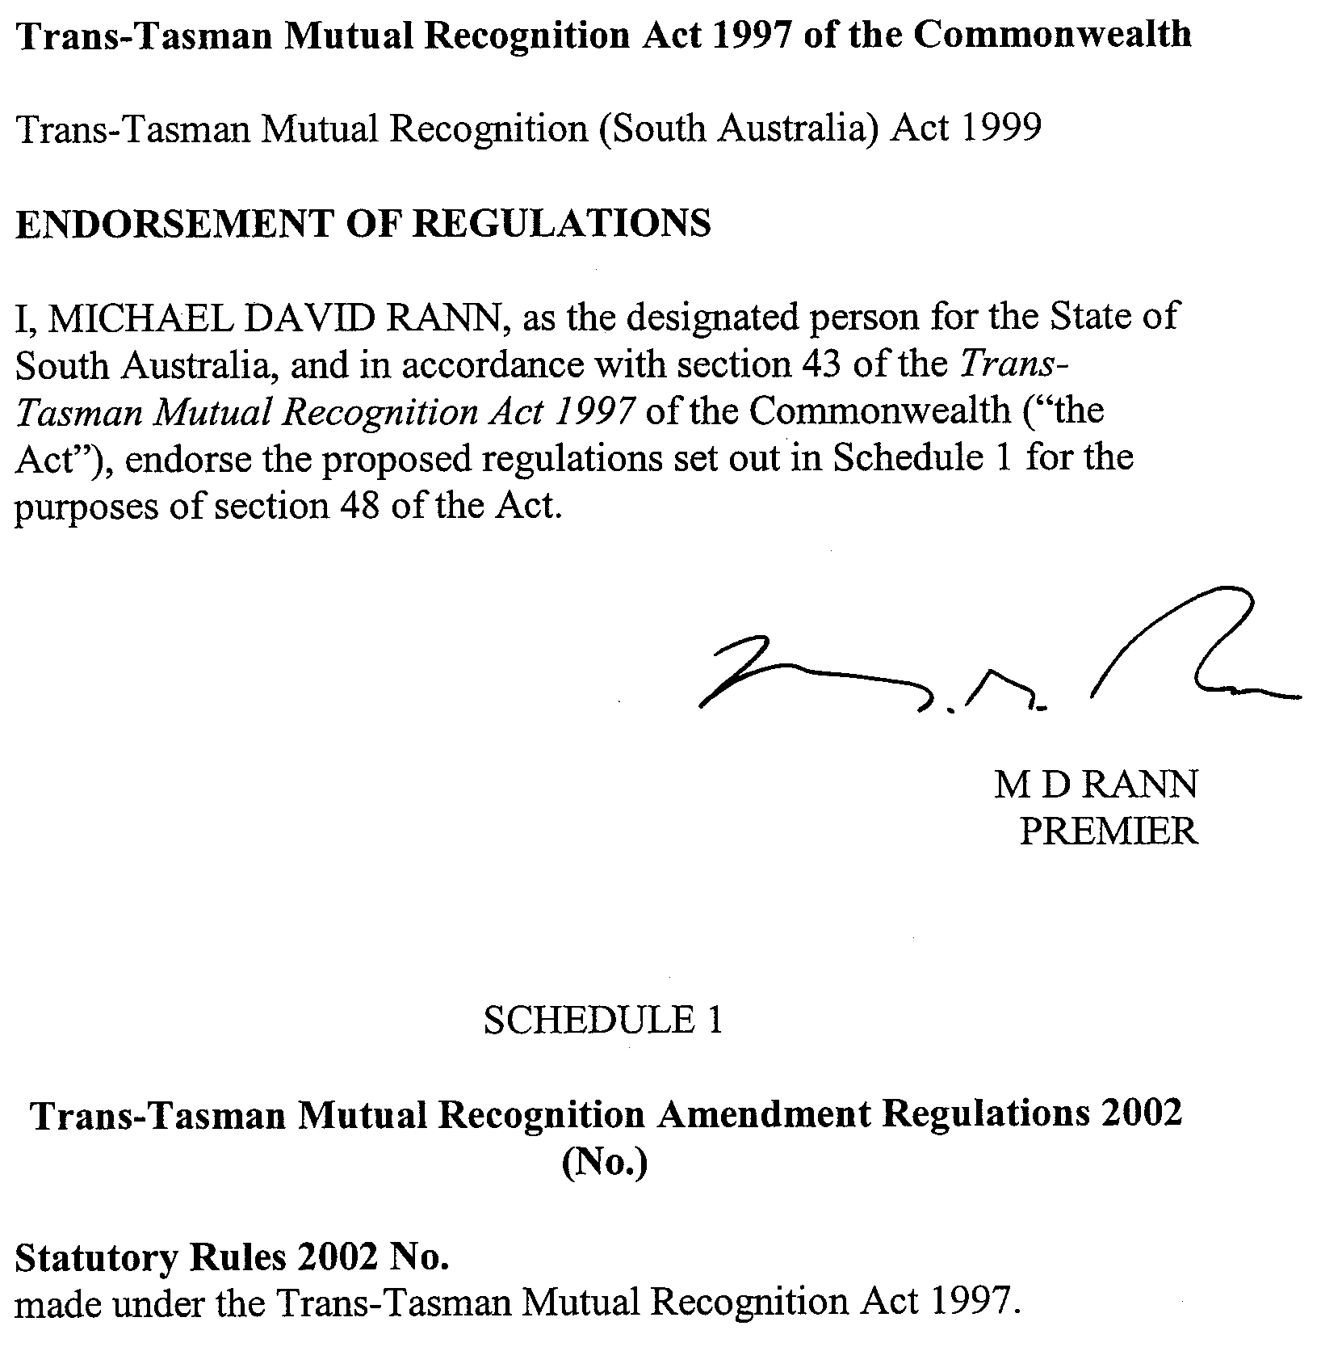
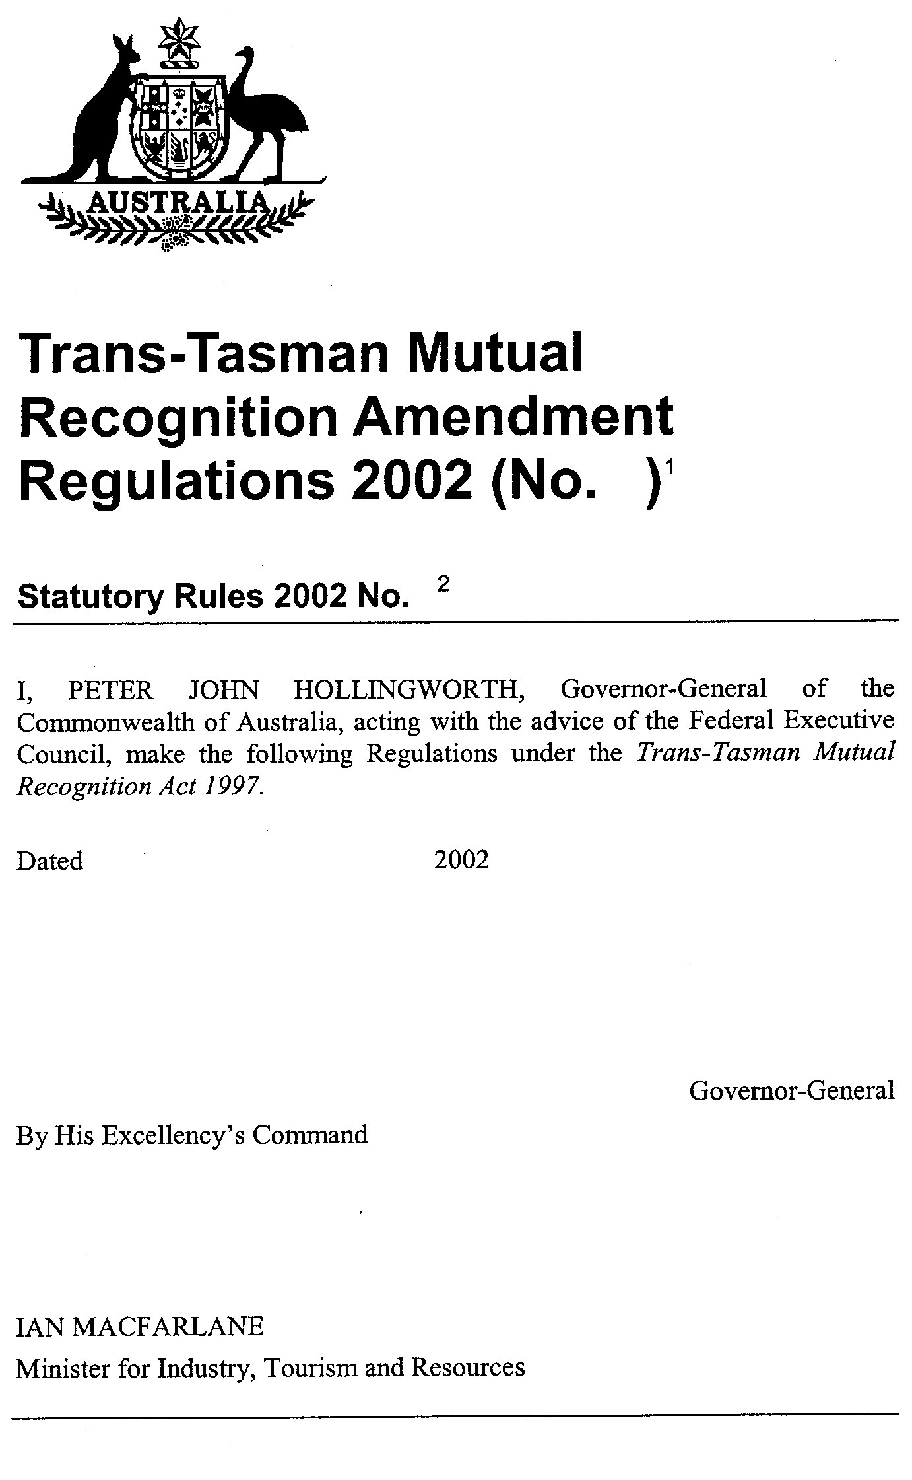
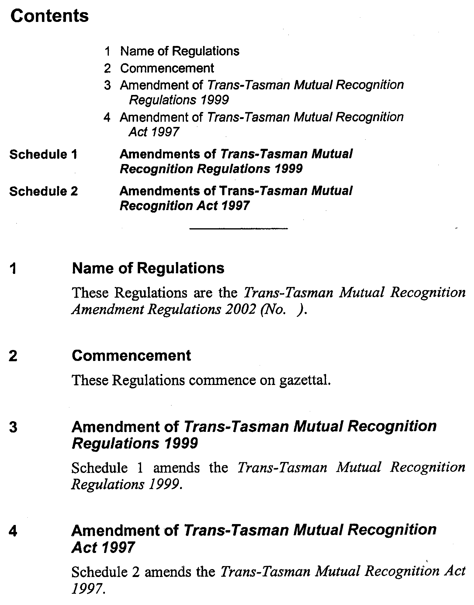
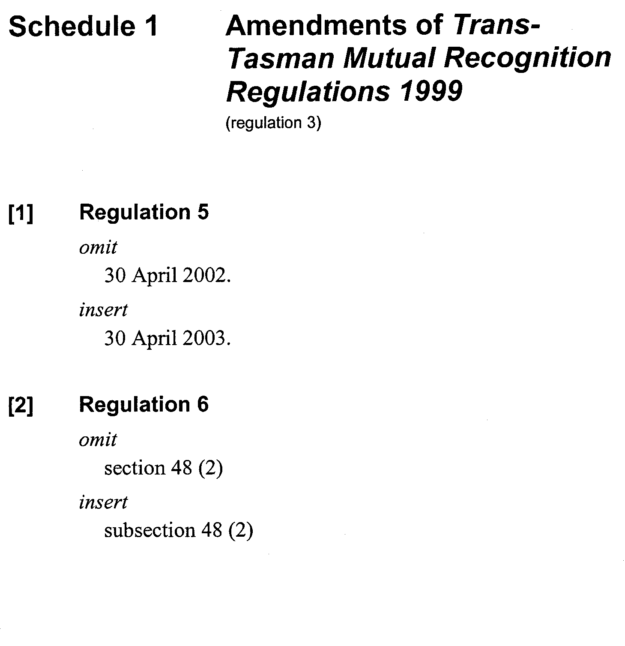
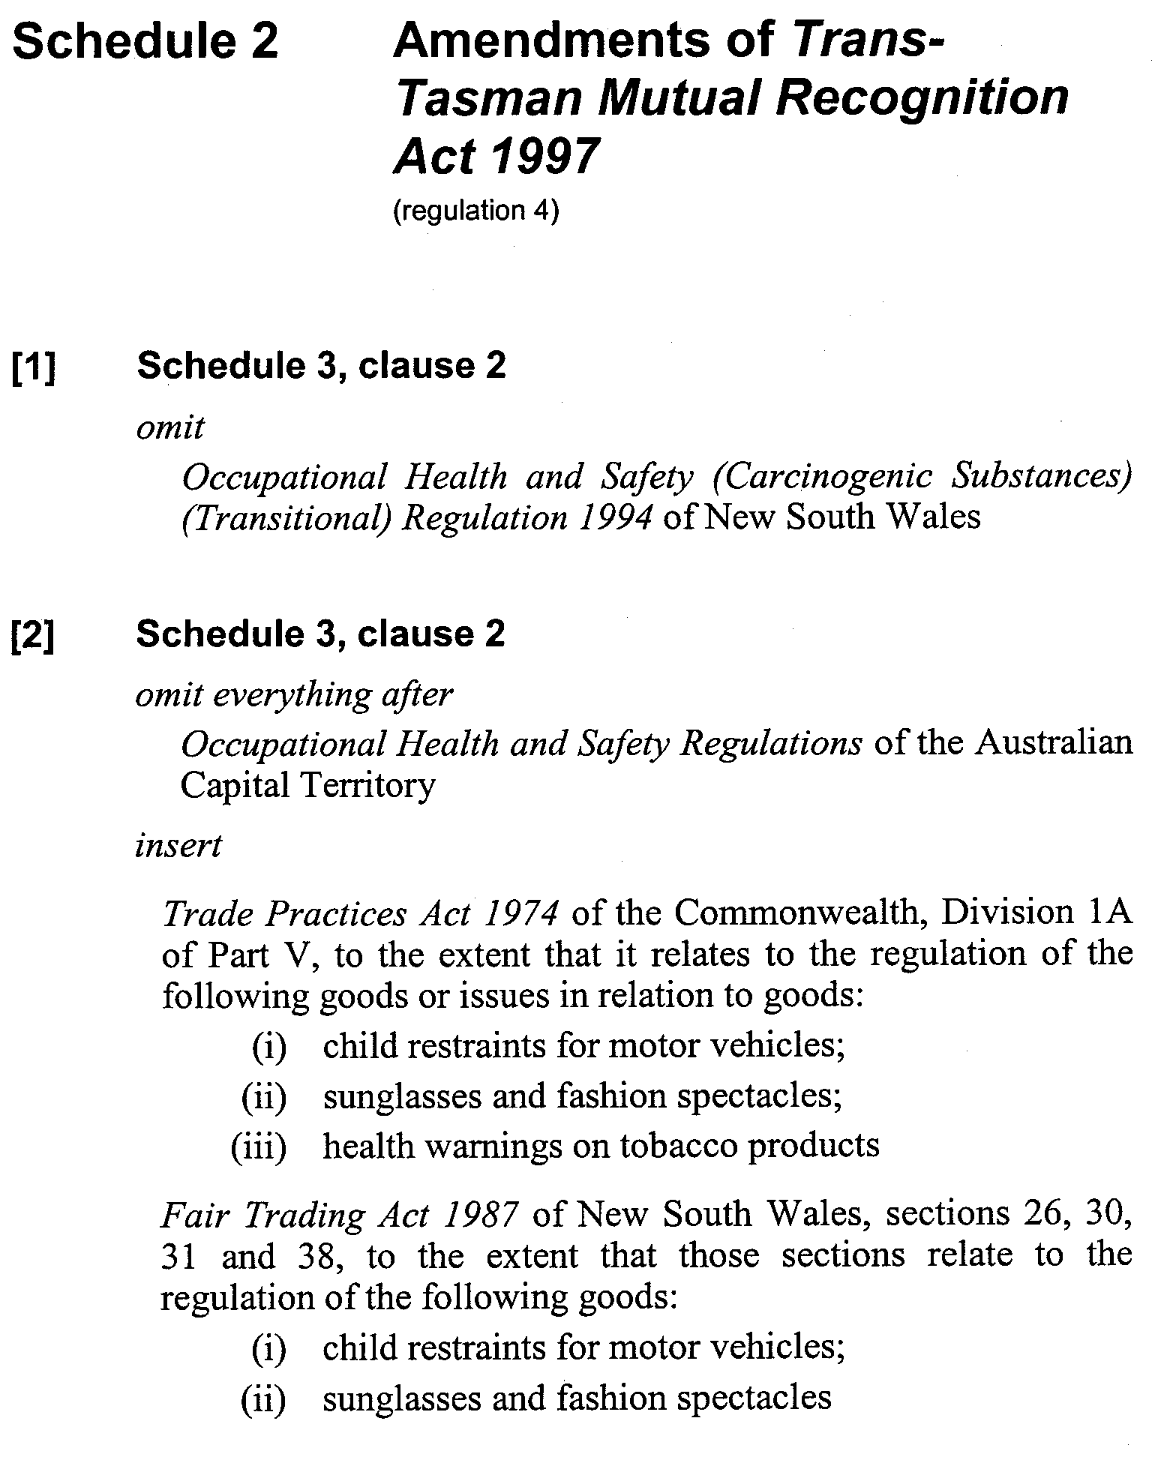
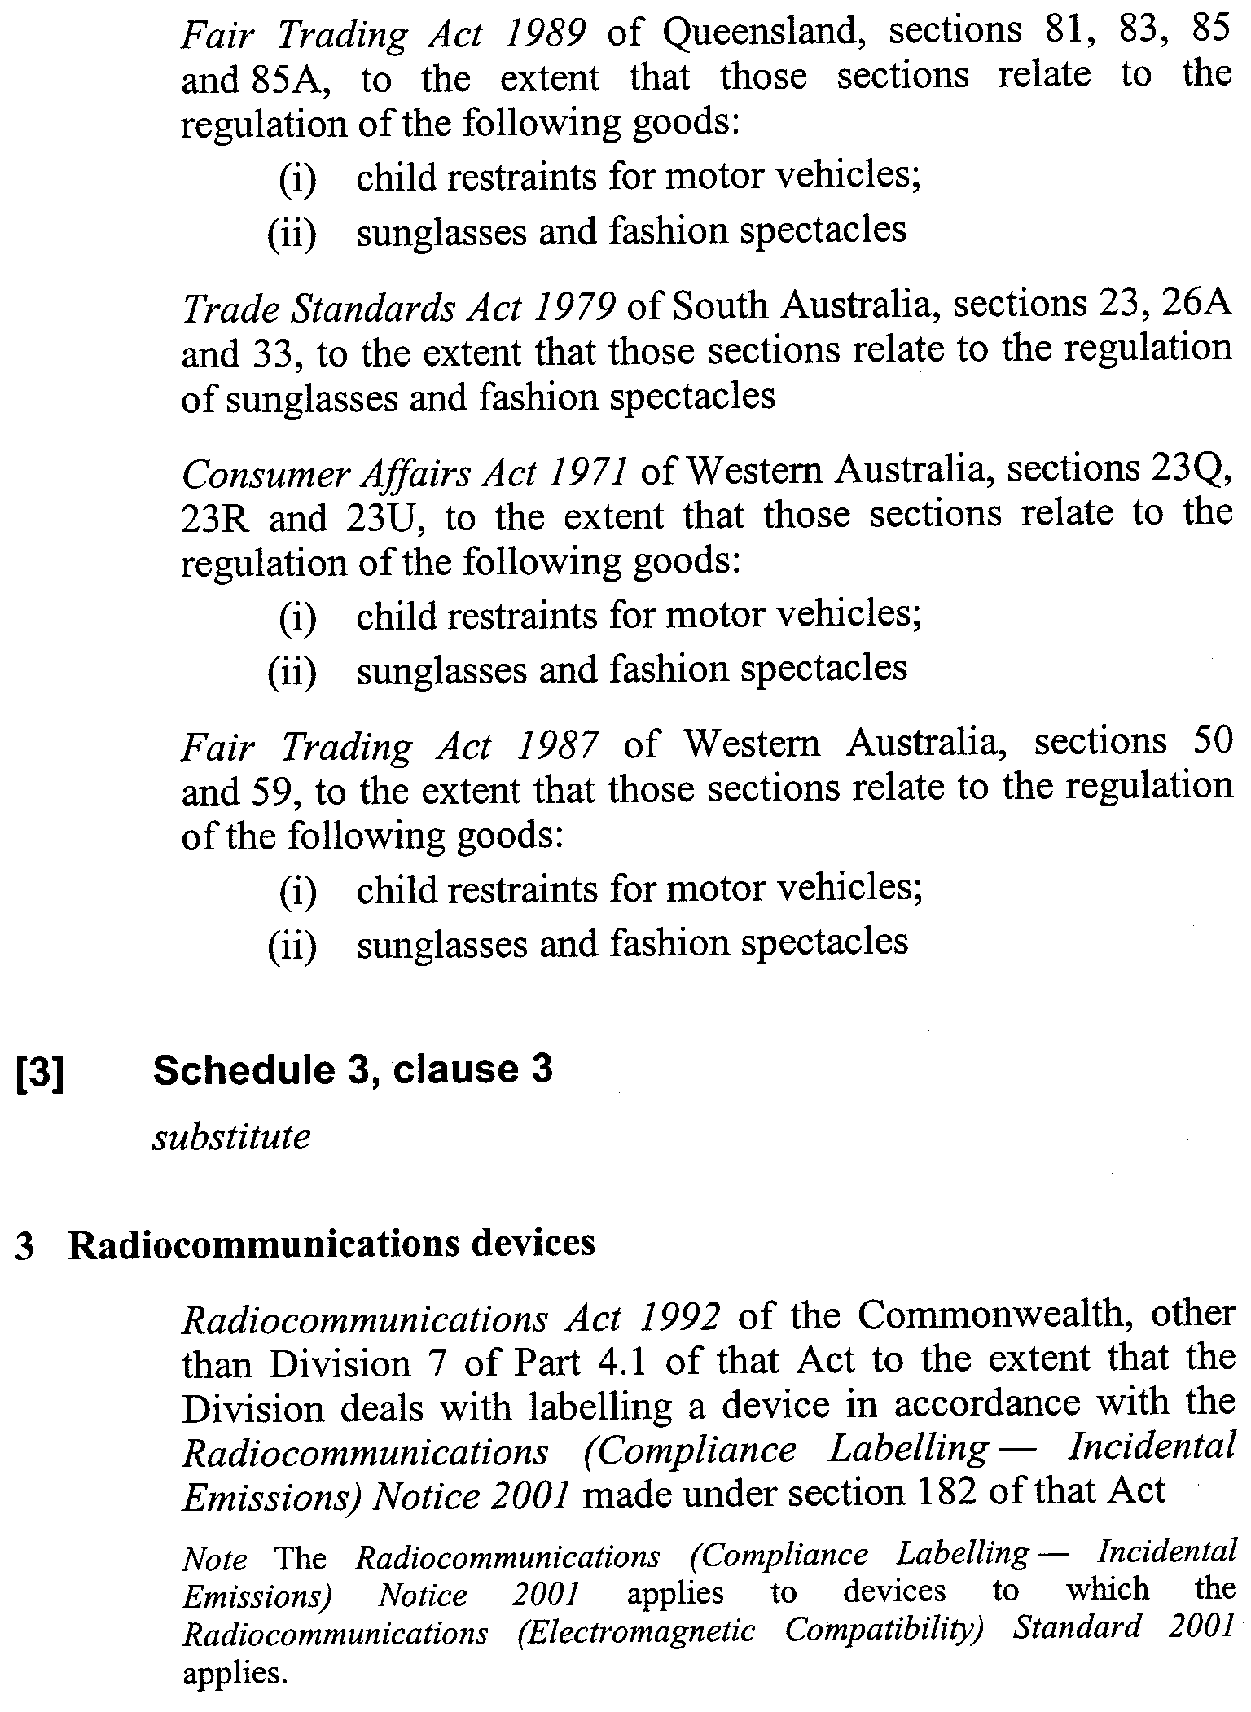
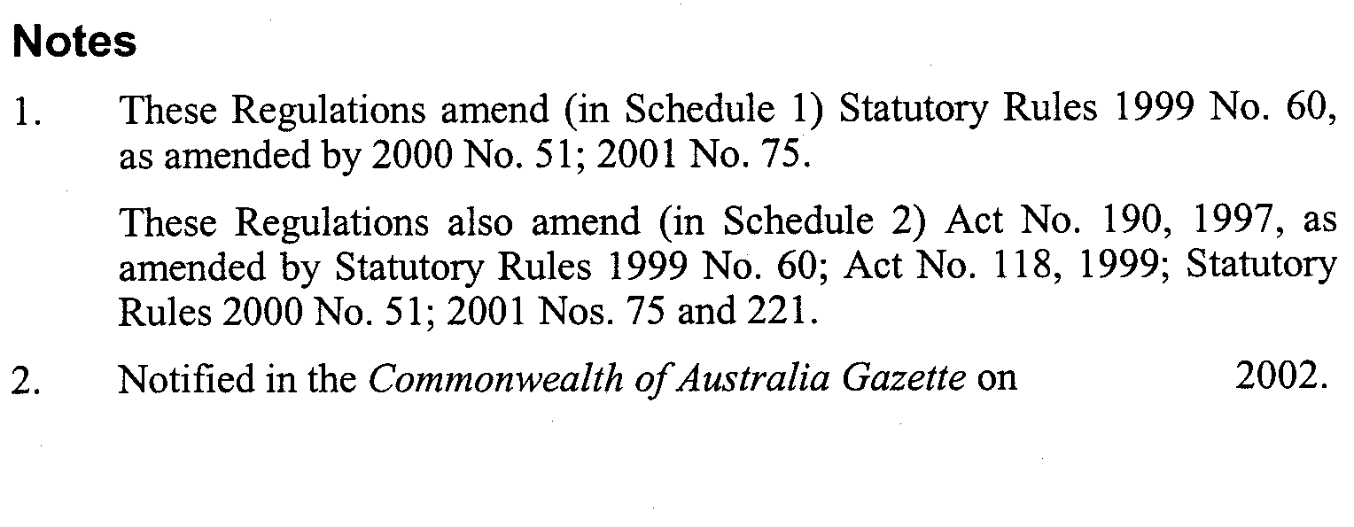

REGULATIONS UNDER THE WATER RESOURCES ACT 1997
────
No. 16 of 2002
────
At the Executive Council Office at Adelaide, 28 March 2002

PURSUANT to the Water Resources Act 1997 and with the advice and consent of the Executive Council, I make the following regulations.
B. KRUMINS, Governor's Deputy

PURSUANT to section 10AA(2) of the Subordinate Legislation Act 1978, I certify that, in my opinion, it is necessary or appropriate that the following regulations come into operation as set out below.

JOHN HILL, Minister for Environment and Conservation
───────────────────
SUMMARY OF PROVISIONS

1. Citation
2. Commencement
3. Variation of reg. 4—Extension of period
────────────────────────

Citation
1. The Water Resources (Extension of Adopted Management Policies) Regulations 1998 (see Gazette 30 June 1998 p. 2771), as varied, are referred to in these regulations as "the principal regulations".

Commencement
2. These regulations come into operation on the day on which they are made.

Variation of reg. 4—Extension of period
3. Regulation 4 of the principal regulations is varied by striking out subregulation (4) and substituting the following subregulation:

(4) The period of one year referred to in clause 2(15)(a) of Schedule 3 of the Act is extended by four years in relation to the management policy in relation to which this subregulation applies so that it remains in force until the expiration of five years after the commencement of the Act.

WRT 0991/02 R. DENNIS, Clerk of the Council

FAXING COPY?

IF you fax copy to Government Publishing SA for inclusion in the Government Gazette, there is no need to send a Confirmation Copy to us as well.

This creates confusion and may well result in your notice being printed twice.

Please use the following fax number:

Fax transmission: (08) 8207 1040
Phone Inquiries: (08) 8207 1045

Please include a contact person, phone number and order number so that we can phone back with any queries we may have regarding the fax copy.

NOTE: Closing time for lodging new copy (either fax or hard copy) is 4 p.m. on Tuesday preceding the day of publication.

Government Gazette notices can be E-mailed.

The address is:

governmentgazette@saugov.sa.gov.au

Documents should be sent as attachments in Word format.

When sending a document via E-mail, please confirm your transmission with a faxed copy of your document, including the date the notice is to be published.

Fax transmission: (08) 8207 1040
Enquiries: (08) 8207 1045

CITY OF ADELAIDE
One Way Traffic
NOTICE is hereby given that the council of the Corporation of the City of Adelaide, at its meeting held on 4 March 2002, adopted the following resolution:
Pursuant to section 359 (1) of the Local Government Act 1999, and section 32 of the Road Traffic Act 1961 all vehicles other than those vehicles indicated in Column 3 below shall be excluded from those roads named in Column 1.
Column 1  Street |  | Column 2  Location |  | Column 3  Class of Vehicles Exempt
Tucker Street |  | Between the north-south section of Tucker and Hutt Streets |  | Those vehicles travelling in an easterly direction from the north-south section of Tucker Street to Hutt Street
 |  |  |  | Those vehicles owned or operated by or on behalf of the City of Adelaide for the purpose of street cleaning and/or maintenance
Dawkins Place |  | Between the north-south section of Tucker and Frome Streets |  | Those vehicles travelling in a westerly direction from the north-south section of Tucker Street to Frome Street
 |  |  |  | Those vehicles owned or operated by or on behalf of the City of Adelaide for the purposes of street cleaning and/or maintenance
One-way traffic conditions will apply in the east-west section of Tucker Street and Dawkins Place as from Monday, 8 April 2002.
Susan Law, Chief Executive Officer

CITY OF ADELAIDE
Notice of Intention to Declare as Public Road
NOTICE is hereby given pursuant to section 210 of the Local Government Act 1999, that at a future meeting council intends to declare the following roads to be public roads:
1. Compton Street in Town Acres 404 and 457, which is delineated as Compton Street (sic) on LTO Deposited Plan 48354.
2. Mill Street in Town Acres 407 and 454, which is delineated as Mill Street on LTO plan C-2989.
3. That part of Coglin Street in Town Acre 406 contained in that part of certificate of title volume 281, folio 153, defined as the Private Road on LTO Deposited Plan 623 and contained within the land labelled Coglin Street on LTO plan C-2989.
4. That part of Coglin Street in Town Acre 455 contained in that part of certificate of title volume 5270, folio 288, defined as Allotment 4 on LTO FP35606.
5. That part of Market Street in Town Acre 405 contained in that part of certificate of title volume 5270, folio 288, identified as Allotment 5 on LTO FP35606.
6. The unnamed road in Town Acres 405, 406 and 455, which is delineated as that part of certificate of title volume 5270, folio 288, defined as Allotment 6 on LTO FP35606.
7. That part of Field Street in Town Acre 403 delineated as marked Private Road on the plan in certificate of title volume 2826, folio 99, which is contained in certificate of title volume 130, folio 60.
8. Hobsons Place in Town Acres 479 and 534, which is delineated as Hobsons Place on LTO plan Deposited Plan 12276.
9. That part of Frew Street in Town Acre 530 contained in certificate of title volume 5819, folio 902.
10 That part of Norman Street in Town Acres 481 and 532 delineated as all of Norman Street on LTO plan Deposited Plan 31837 excluding Certificates of Title Volume 5061, folio 650 and Volume 2521, folio 55, which are already Public.
11. Russell Street in Town Acres 480 and 533, which is delineated as Russell Street on LTO Deposited Plan 12276.
12. Sabiston Lane in Town Acre 478, which is delineated as the land marked Private Road on LTO plan C-1809 excluding the private road in certificate of title volume 5686, folio 294.
13. Sultram Place in Town Acre 534, which is delineated as Sultram Place on LTO Deposited Plan 43820 and includes partially cancelled certificate of title volume 5, folio 138.
Susan Law, Chief Executive Officer

CITY OF MARION
Roads (Opening and Closing) Act 1991
Walkway Raggatt Crescent/Merchant Avenue, Mitchell Park
NOTICE is hereby given pursuant to section 10 of the Roads (Opening and Closing) Act 1991, that the City of Marion proposes to make a Road Process Order to close, and transfer to the South Australian Housing Trust, L. W. and M. M. Corbett and D. J. Gilbertson and F. L. Murphy the whole of the walkway (allotment 265 in DP 7250) shown as ‘A’, ‘B’ and ‘C’ (respectively) on Preliminary Plan No. PP02/0006.
A copy of the plan and statement of persons affected are available for public inspection at the council’s office, 245 Sturt Road, Sturt and the office of the Surveyor-General, 101 Grenfell Street, Adelaide, during normal office hours.
Any application for easement or objections must be made in writing within 28 days from 28 March 2002 to the council at P.O. Box 21, Oaklands Park, S.A. 5046 and the Surveyor-General at G.P.O. Box 1354, Adelaide, S.A. 5001, setting out full details.
Where a submission is made, council will give notification of a meeting to deal with the matter.
Dated 27 March 2002.
M. Searle, Chief Executive Officer

CITY OF PORT LINCOLN
Change of Council Meeting Date
NOTICE is hereby given that the May meeting of council will be held on Tuesday, 21 May 2002 at 7.30 p.m. in the Council Chambers, Level One, Civic Centre, 60 Tasman Terrace, Port Lincoln, in lieu of Monday, 20 May 2002 (Adelaide Cup Public Holiday).
I. Burfitt, Chief Executive Officer

ALEXANDRINA COUNCIL
Change of Council Meeting Dates
NOTICE is hereby given that council resolved at its meeting held on 18 March 2002 to change the April council meetings to Tuesday, 2 April 2002, commencing at 1.30 p.m. and Monday, 22 April 2002, commencing at 4.30 p.m. Both meetings will be held in the Council Chambers, Cadell Street, Goolwa.
J. L. Coombe, Chief Executive

The Barossa Council
Supplementary Election for Area Councillors—Nominations Received
NOTICE is hereby given that at the close of nominations at 12 noon on 21 March 2002, the following persons have been accepted as candidates and are listed in the order in which they will appear on the ballot paper.
Area Councillor (2 vacancies)
Linke, Chris
Biscoe, Patsy
Reynolds, Malcolm
Eidam, Ingrid
Wiese, Joerg
Postal Voting
The election will be conducted entirely by postal voting. No polling booth will be open for voting on polling day. Voting is not compulsory.
Voting material will be dispatched by post to every natural person, body corporate and group listed on the voters roll as at roll closure on 31 January 2002.
The mail out will commence on 2 April, with all voting materials to be delivered by 8 April 2002.
A person who has not received voting material by 8 April 2002 and who believes that he or she is entitled to vote should apply to the State Electoral Office on 8401 4351.
A pre-paid addressed envelope for each elector entitlement will be provided. Completed ballot material must be returned to reach the Returning Officer no later than 12 noon on Monday, 22 April 2002.
A ballot box will be provided at the following Council Offices for electors who wish to personally deliver their completed ballot material during office hours:
1 Washington Street, Angaston;
29 Barossa Valley Way, Lyndoch;
130-132 Melrose Street, Mount Pleasant;
10 Murray Street, Nuriootpa;
79-81 Murray Street, Tanunda.
Place of Counting Votes
The scrutiny and counting of votes will take place at the District Council Office, 1 Washington Street Angaston as soon as practicable after 2.00 p.m. on Monday, 22 April 2002. A provisional declaration will be made at the conclusion of the election count.
Campaign Donations Return
All candidates must forward a campaign donations return to the Council Chief Executive Officer within six weeks after the conclusion of the election.
S. H. Tully, Returning Officer

DISTRICT COUNCIL OF GRANT
Naming of Road
NOTICE is hereby given that pursuant to the powers in section 219 of the Local Government Act 1999, council at the 18 February 2002 meeting resolved to name the new road in the division of section 898, Hundred of MacDonnell as Mariner Court.
R. J. Peate, District Manager

LIGHT REGIONAL COUNCIL
Temporary Road Closure
NOTICE is hereby given that pursuant to section 359 of the Local Government Act 1934, as amended, council resolved that the Seppeltsfield Road Bridge be closed to all through traffic at Seppeltsfield, effective from 5 a.m. on Monday, 8 April 2002 until further notice, for the purpose of reconstruction and upgrading of the Seppeltsfield Road Bridge, including the demolition of the existing bridge structure.
P. J. Beare, Chief Executive Officer

DISTRICT COUNCIL OF MALLALA
Periodical Review of Elector Representation
NOTICE is hereby given that pursuant to the provisions of section 12(5) of the Local Government Act 1999, the District Council of Mallala is to carry out a review to determine whether a change of arrangements in respect to elector representation, including ward boundaries and the composition of council, will result in the electors of the area being more adequately and fairly represented.
Information regarding the nature of the periodical review is available at the council office, or by contacting Colin Dunlop on telephone 8527 2006 or e-mail ceo@mallala.sa.gov.au.
Interested persons are invited to make a written submission to the Chief Executive Officer, P.O. Box 18, Mallala, S.A. 5502, by the close of business on Friday, 10 May 2002.
Any person who makes a written submission will be afforded an opportunity to appear before council, or a committee thereof, to be heard in respect to their submission.
C. Dunlop, Chief Executive Officer

MID MURRAY COUNCIL
Road Closure
NOTICE is hereby given that in accordance with section 10 of the Roads (Opening and Closing) Act 1991 the Mid Murray Council proposes to make a Road Process Order to close the following road:
In the Hundred of Tungkillo, being a strip of Government Road situate dividing allotment 108 in Filed Plan 169857 and piece 50 in Filed Plan 217201 from piece 51 in Filed Plan 217201 and marked ‘A’ and ‘B’ on Preliminary Plan No. PP02/0021.
It is proposed that the portion of road to be closed marked ‘A’ be transferred to Ausbulk Ltd and merged with allotment 100 in Deposited Plan 57160 and that the closed road marked ‘B’ be transferred to the Minister for Transport and Urban Planning and merged with said pieces 50 and 51 in Filed Plan 217201.
A preliminary plan of the proposal, and a statement, are available for public inspection at the Mid Murray Council Office, 49 Adelaide Road, Mannum, S.A. 5238, between the hours of 9 a.m. and 5 p.m., Monday to Friday or at the Adelaide office of the Surveyor-General, during normal office hours.
Any person may object to the proposal (and any adjoining landowner or other person substantially affected by the proposed road closure may apply for an easement relative to the closure).
Such objection (or application for an easement) must be made in writing to the Mid Murray Council within 28 days of the date of this notice. If a submission is made, the Mid Murray Council is required to give notice of the time and place at which a meeting will be held to consider the matter, so that the person making the submission (or a representative) may attend to support the submission, if desired.
Any submission must set out the full name and address of the person making the submission, and must be fully supported by reasons (and any application for the grant of an easement must give full particulars of the nature and location of the easement and where made by a person as the owner of adjoining or nearby land, specify the land to which the easement is to be annexed). A copy of the submission must be forwarded to the Surveyor-General at Adelaide.
Dated 28 March 2002.
G. Brus, Chief Executive Officer

NARACOORTE LUCINDALE COUNCIL
Permits for Burning Off
NOTICE is hereby given that the Bushfire Prevention Committee has authorised the issuing of permits as from Monday, 18 March 2002, subject to satisfactory weather conditions.
The following conditions apply to the issuing of permits for burning off for the 2001-2002 Fire Season:
1. Permits may be issued from 18 March 2002. One permit may be obtained for the entire season. A copy of the permit must be obtained prior to burning off (in person, by fax or mail).
However:
2. Council must be notified of the intent to burn by 10 a.m. on the morning of burning. The following information is required: name, permit number, section/lot, what you are burning (grass or stubble), time of commencement and hectares.
3. Permits will not be issued to burn off on Saturdays, Sundays or Public Holidays.
4. Fires may not be lit before noon and must be extinguished before midnight on the same day.
5. Only grass and stubble may be burnt.
6. No permits will be issued for the burning of timber until after 30 April 2002.
7. Four able-bodied adults must be present at the fire from the time of lighting until it is extinguished.
8. (a) Two powered pumps with a minimum of 800 L of water must be in attendance from the time of lighting until it is extinguished.
(b) In a township area where the area to be burnt is 2 m² or less a reticulated water supply will suffice.
The following are stipulated in the Act and Regulations:
9. A 4 m cleared break to be put around the perimeter of the paddock and all standing trees and fallen timber.
10. The local Brigade Captain or Deputy must be notified each morning of the intent to burn by the permit holder. The Captain will have the right to question or revoke the permit on the day and will have the right to inspect firebreaks at discretion.
11. Neighbours and authorities must be notified in accor-dance with the Act and Regulations.
12. The fire must be lit from the leeward side before being lit on the windward site.
Persons may obtain a permit by contacting the Naracoorte Lucindale Council between 8.30 a.m. and 5 p.m. Monday to Friday—Telephone (08) 8762 2133.
Penalties: Division 6 Fine ($4 000 or 12 months imprison-ment).
The Fire Prevention Officer will carry out random inspections. Where serious breaches of permit conditions are detected prose-cutions may occur.
G. Sanford, Acting Chief Executive Officer

Conditions Prescribed by the Country Fires Regulations 1989
The conditions applicable to any permit issued under the Act for burning off land on any day during the Fire Danger Season other than a day of Total Fire Ban are:
(a) that the land immediately around the relevant land must be cleared of all flammable material to a distance of at least 4 m;
(b) that a sufficient number of persons to control the fire must be present at the site of the fire from the time it is lighted to the time it is completely extinguished;
(c) that the fire must first be lighted from the leeward side of the relevant land to establish a protective break, and then may be lighted from the windward side of the land; and
(d) that the holder of the permit must, not more than seven days, and not less than two hours, before the fire is lighted, give notice of his or her intention to light the fire:
(i) to any person who owns, occupies or is in charge of land adjoining the land holding where the relevant land is situated and who resides within 8 km of the relevant land or, if if is not reasonably practicable to give such a notice, to the person in charge of the nearest police station;
(ii) if the relevant land is inside (or partially inside) a council area—to an officer of the council for that area;
(iii) if the relevant land is within 2 km of a government reserve—to the person in charge of the reserve; and
(iv) —
(A) if the relevant land is within the area of a C.F.S. brigade—to an officer of that brigade;
(B) if the relevant land is within a designated area—to the fire control officer for that area;
(C) if neither subparagraph (A) nor (B) apply—to the Board.
The conditions applicable to any permit issued under the Act for purposes other than Burning Off land other than a day of Total Fire Ban are:
(a) that the space immediately around and above the fire must be cleared of all flammable material to a distance of at least 4 m;
(b) that an appropriate agent adequate to extinguish any escape of fire must be kept at hand;
(c) that a sufficient number of persons to control the fire must be present at the site of the fire from the time it is lighted to the time it is completely extinguished; and
(d) that if the fire is to be lighted within the area of a C.F.S. brigade the holder of the permit must, not more than seven days, and not less than two hours, before the fire is lighted, give notice of their intention to light the fire to an officer of that brigade.
The above conditions apply to a permit issued for any burning on a day of Total Fire Ban, and in addition if a permit authorises the lighting or maintaining of a fire contrary to the terms of a Total Fire Ban, the authorised officer must:
(1) give notice of the issue of the permit to:
(a) the regional officer in whose region the fire will be lighted;
(b) if the fire will be inside (or partially inside) a council area—to an officer of the council for that area; and
(c) if the fire will be within the area of a C.F.S. brigade—to an officer of that brigade (whether personally or by telephone or radio); and
(2) send a copy of the permit to the regional officer and any council to which subparagraph (1) applies.

IN the matter of the estates of the undermentioned deceased persons:
Babich, Emilia, late of 47 Vine Street, Magill, home duties, who died on 11 December 2001.
Bainbridge, Joyce Lillian Kathleen, late of Hazel Grove, Ridgehaven, of no occupation, who died on 16 February 2002.
Barr, Margaret, late of 47 Judd Road, Elizabeth, home duties, who died on 6 January 2002.
Duckford, Dorothy Marion, late of Leighton Avenue, Klemzig, retired clerk, who died on 25 December 2001.
Gordon, Myra Elsie, late of 285 Goodwood Road, Kings Park, of no occupation, who died on 25 January 2002.
Lucas, Kenneth George, late of 42 Margaret Street, North Adelaide, retired parking inspector, who died on 28 January 2002.
McAuley, Stephen Alexander, late of Kooloola Station, near Swan Reach, retired farm hand, who died on 11 November 2001.
Munn, Barbara Ross, late of 11 Addison Road, Hove, home duties, who died on 19 February 2002.
Smith, Ralph Anton, late of 5-9 Majors Road, North Moonta, retired farmer, who died on 5 February 2002.
Standen, Joyce Enid, late of 2 Jelley Street, Woodville, of no occupation, who died on 27 November 2001.
Tanaskovic, Hilda, late of 148 Beulah Road, Norwood, of no occupation, who died on 29 October 2001.
Thackray, John Oswald, late of 53-59 Austral Terrace, Morphettville, retired service manager, who died on 26 January 2002.
Thiry, Albert Desire, late of 20 Alpha Road, Prospect, retired welder, who died on 2 February 2002.
Williams, Ceri Yvonne, late of 4 Esplanade, Cowell, home duties, who died on 26 January 2002.
Notice is hereby given pursuant to the Trustee Act 1936, as amended, the Inheritance (Family Provision) Act 1972, and the Family Relationships Act 1975, that all creditors, beneficiaries, and other persons having claims against the said estates are required to send, in writing, to the Public Trustee, 25 Franklin Street, Adelaide, S.A. 5000, full particulars and proof of such claims, on or before 26 April 2002, otherwise they will be excluded from the distribution of the said estate; and notice is also hereby given that all persons who are indebted to the said estates are required to pay the amount of their debts to the Public Trustee or proceedings will be taken for the recovery thereof; and all persons having any property belonging to the said estates are forthwith to deliver the same to the Public Trustee.
Dated 28 March 2002.
C. J. O’Loughlin, Public Trustee

CG & WA GALLARD PTY LTD (IN LIQUIDATION)
(ACN 007 949 288)
Notice of Final Meeting of Members
NOTICE is hereby given that pursuant to section 509 of the Corporations Law, the final meeting of members of the above-named company will be held at the offices of Basso Newman & Co., 269 Wakefield Street, Adelaide on 30 April 2002 at 10 a.m. for the purpose of laying before the meeting the liquidator’s final account and report and giving any explanation thereof.
Dated 21 March 2002.
A. R. Newman, Liquidator

SOUTH AUSTRALIA—In the Supreme Court. No. 995 of 1998. In the matter of Power Data Systems Pty Ltd (in liquidation) (ACN 007 959 917) and in the matter of the Corporations Law.
Notice of Release of Liquidator and Dissolution of the Company
Take notice that by order of the Supreme Court of South Australia dated 21 March 2002, I, Bruce James Carter of Ferrier Hodgson, Level 6, 81 Flinders Street, Adelaide, S.A. 5000, the liquidator of the abovenamed company, was granted my release as liquidator and the company was dissolved.
Dated 26 March 2002.
B. J. Carter, Liquidator
Note: Section 481 of the Corporations Law enacts that an order of the Court releasing a liquidator shall discharge him/her in the administration of the affairs of the company, or otherwise in relation to his or her conduct as liquidator, but any such order may be revoked on proof that it was obtained by fraud or by suppression or by concealment of any material fact.

SALE OF PROPERTY
Auction Date: Friday, 12 April 2002 at 11 a.m.
Location: 4 Lothian Avenue, Windsor Gardens
NOTICE is hereby given that on the above date at the time and place stated, by virtue of the Warrant of Sale issued out of the District Court of South Australia, in Action No 1130 of 2000, directed to the Sheriff of South Australia in an action wherein Ray White Glynde and others, is the Judgment Creditor and Daniele Valherie is the Judgment Debtor, I, Tim Goodes, Sheriff, of the State of South Australia, will by my auctioneers, Griffin Real Estate, make sale of the estate, right, title or interest whatsoever it may be of the Judgment Debtor Daniele Valherie as the registered proprietor of an estate in fee simple in the following:
That piece of land situated in the area named Windsor Gardens, being 4 Lothian Avenue, being the property comprised in Certificate of Title Register Book Volume 5081 Folio 484.
Further particulars from the auctioneers.
Griffin Real Estate
179 King William Road
Hyde Park, S.A. 5061
Telephone 8357 3177

ATTENTION

CUSTOMERS requiring a proof of their notice for inclusion in the Government Gazette, please note that the onus is on you to inform Government Publishing SA of any subsequent corrections by 10 a.m. on Thursday, which is our publication deadline.

For any corrections to your notice please phone 8207 1045 or Fax 8207 1040 before 10 a.m. on Thursday.

If we do not receive any communication by 10 a.m. on Thursday (day of publication) we will presume the notice is correct and will print it as it is.

Remember—the onus is on you to inform us of any corrections necessary to your notice.

NOTE: Closing time for lodging new copy (electronically, fax or hard copy) is 4 p.m. on Tuesday preceding the day of publication. Phone 8207 1045—Fax 8207 1040.
Email: governmentgazette@saugov.sa.gov.au

Printed and published by authority every Thursday by J. D. FERGUSON, Government Printer, South Australia
Price: $4.40, plus postage; to subscribers, $220.20 per annum.
(The above prices are inclusive of GST)

