No. 60 1883

THE SOUTH AUSTRALIAN

GOVERNMENT GAZETTE

PUBLISHED BY AUTHORITY

ALL PUBLIC ACTS appearing in this GAZETTE are to be considered official, and obeyed as such

ADELAIDE, THURSDAY, 16 MAY 2002

CONTENTS

Page
Appointments, Resignations, Etc. 1884
Children’s Protection Act 1993—Notice 1884
Chiropodists Act 1950—Schedule of Registered
Chiropodists 1884
Corporations and District Councils—Notices 1921
Crown Lands Act 1929—Notices 1886
Geographical Names Act 1991—Notices 1887
Liquor Licensing Act 1997—Notices 1887
Mining Act 1971—Notices 1891
National Electricity (South Australia) Act 1996—
Notice 1892
Pastoral Land Management and Conservation Act 1989—
Notices 1893
Private Advertisements 1923
Proclamation 1884

Page
Public Trustee Office—Administration of Estates 1922
REGULATIONS
Superannuation Act 1988 (No. 29 of 2002) 1917
Southern State Superannuation Act 1994—
(No. 30 of 2002) 1919
Renmark Irrigation Trust Act 1936—Notice 1893
Roads (Opening and Closing) Act 1991—Notices 1897
Road Traffic Act 1961—Notice 1896
Transport, Department of—Notice to Mariners 1897
Vocational Education, Employment and Training Act
1994—Contracts of Training 1913
Water Mains and Sewers—Mains Laid, Replaced, Etc. 1898
Water Resources Act 1997—Notices 1897
Workers Rehabilitation and Compensation Act 1986—
Notices 1899

GOVERNMENT GAZETTE NOTICES
ALL poundkeepers’ and private advertisements forwarded for publication in the South Australian Government Gazette must be PAID FOR PRIOR TO INSERTION; and all notices, from whatever source, should be legibly written on one side of the paper only and sent to Government Publishing SA so as to be received no later
than 4 p.m. on the Tuesday preceding the day of publication. Phone 8207 1045 or Fax 8207 1040. E-mail: governmentgazette@saugov.sa.gov.au. Send as attachments in Word format and please confirm your transmission with a faxed copy of your document, including the date the notice is to be published and to whom the notice will be charged.

AGRICULTURAL CHEMICALS ACT 1955 SECTION 4(3) AND (4): APPLICATION OF SECTIONS 11A, 11B AND 11C
Proclamation By The Governor
(l.s.) Marjorie Jackson-Nelson
PURSUANT to section 4(3) and (4) of the Agricultural Chemicals Act 1955 and with the advice and consent of the Executive Council, I vary the proclamation made under section 4(3) of the Act on 22 December 1988 (see Gazette 22 December 1988 p. 2095), as varied, by inserting ‘Bioresmethrin’ after ‘Binapacryl’ in the Schedule.
Given under my hand and the Public Seal of South Australia, at Adelaide, 16 May 2002.
By command,
J. W. Weatherill, for Premier
MAFF 02/0046 CS

Department of the Premier and Cabinet
Adelaide, 16 May 2002
HER Excellency the Governor in Executive Council has been pleased to nominate Justice John William Perry to deal with matters arising under sections 6 and 18 of the Parliamentary Superannuation Act 1974, pursuant to section 6 (4) and 18 (3) of the Parliamentary Superannuation Act 1974.
By command,
J. W. Weatherill, for Premier
ATTG 00115/02CS

Department of the Premier and Cabinet
Adelaide, 16 May 2002
HER Excellency the Governor in Executive Council has been pleased to appoint Bruno Krumins, Member of the Order of Australia, as Governor’s Deputy of South Australia for a period from 3.50 p.m. on Monday, 20 May 2002 until 9 p.m. on Thursday, 23 May 2002.
By command,
J. W. Weatherill, for Premier

CHILDREN’S PROTECTION ACT 1993
Recognition of Organisation
I, STEPHANIE KEY, Minister for Social Justice for the State of South Australia, hereby declare that the following Aboriginal Organisation be recognised for the purpose of section 5 of the Children’s Protection Act 1993.
Stephanie Key, Minister for Social Justice

SCHEDULE OF REGISTERED CHIROPODISTS AS AT
31 JANUARY 2002
Abimosleh, Ghassan, 4 Cornell Avenue, Valley View 5093
Abrahams, Timothy Wesley, 2A College Street, Glenelg 5045
Adams, Samuel, Port Pirie Regional Health Service, P.O. Box 546, Port Pirie 5440
Agnew, James Nicholas, Section 127, Hundred of Curramulka 5580
Alde, Torben William, 311 Glen Osmond Road, Glenunga 5064
Allen, Stephen Lester, 21 Gault Road, Belair 5052
Armour, Lachlan, Adelaide Podiatry Group, Tea Tree Plus Shopping Centre, North East Road, Modbury 5092
Aslanidis, Hariklia, 93A Semaphore Road, Semaphore 5019
Atkins, Shane, 28 Filmer Avenue, Glengowrie 5044
Baan, Aria Marjo, 37 Auricht Road, Hahndorf 5245
Baker, Tom, 53 Findon Road, Woodville South 5011
Banwell, Helen Ann, 29 North East Road, Collinswood 5081
Barrett, Kathryn Anne, 188 Main North Road, Prospect 5082
Barry, Georgina Isobel, 1/6 Avenue Street, Millswood 5034
Barry, Pauline Winifrede, 60A George Street, Norwood 5067
Bartold, Simon John, 5 The Common, Beaumont 5068
Barwick, Ann Marie, Unit 48, 9 East Terrace, Adelaide 5000
Bennetts, Rosemary Linda, 191 Main Road, McLaren Vale 5171
Bertram, Peter David, 610 South Road, Glandore 5037
Biggs, Kendall Lauren, 8 Domain Commons, Highbury 5089
Bishop, Nicole Anne, 8 Deborah Grove, Modbury North 5092
Blood, Alexandra Marie, 11 Wallace Street, Erindale 5066
Blunden, Diana, 11 Myrtle Street, Prospect 5082
Bowen, Brenton Desmond, 61 The Parade, Norwood 5067
Broadbent, Frank Brooker, 3 East Parkway, Fulham 5024
Brockbank, Robert Penno, 56 Springbank Road, Panorama 5041
Brooks, Jane Louise, 22 Caloronga Street, Wattle Park 5066
Brown, Diana Jacqueline, 34 Thornton Street, Kensington 5068
Browning, Sally, 16 Baru Street, Pooraka 5095
Burns, Andrew Robert, 491A Portrush Road, Glenunga 5064
Burnside, Pod. Serv. Pty Ltd, 1/535 Glynburn Road, Hazelwood Park 5066
Carty, Margaret Mary, 51 Frederick Street, Maylands 5069
Causby, Ryan Scott, Whyalla Hospital & Health Services, Wood Terrace, Whyalla 5600
Chaptini, Alexandra Jane, Bellevue Residential Care Centre, 51 Eve Road, Bellevue Heights 5050
Chard, Elizabeth Helen, 238 Old Northern Road, Castle Hill 2154
Chivell, Marie, Flinders Medical Centre, Bedford Park 5042
Christie, Samuel, Royal Adelaide Hospital, North Terrace, Adelaide 5000
Chu, David Wing-Keung, 15 Powell Street, Magill 5072
Clarke, Melanie Jane, 136 Level 1, Adelaide Arcade, Adelaide 5000
Colak, Phillip Andrew, 4th Floor, 188 North Terrace, Adelaide 5000
Colangelo, Deanne Ray, 3/646 Grange Road, Henley Beach 5022
Copper, Alexander Willem, 168 Halifax Street, Adelaide 5000
Corsalina, Max, 11 Ferris Street, Christies Beach 5165
Coultas, Joel, Flinders Medical Centre, Bedford Park 5042
Cristiano, Carmela, 93A Crozier Ave, Newton 5074
Cullum, Belinda Mary, 5 Edwin Terrace, Gilberton 5081
Daebler, Rebecca Louisa Ross, Murray Mallee Community Health Service, Swanport Road, Murray Bridge 5253
Dale, Jennifer Kaye, 169 Prospect Road, Prospect 5082
Dalli, Alison Mary G., 168 Halifax Street, Adelaide 5000
Daly, Gavin Michael, Adelaide Podiatry Group, Shop 1C, 1020 North East Road, Modbury 5092
Dang, Khanh, Podiatry Dept, Repatriation General Hospital, Daws Road, Daw Park 5041
Dansie, Kathryn Alison, 45 Gurrs Road, Beulah Park 5067
de Sausmarez, Alexander Michael, 3 Tenth Street, Gawler 5118
Deayton, Robert James, Aldgate Health Centre, 212 Mount Barker Road, Aldgate 5154
Deen, Astrid Brigitte, 526 Brighton Road, Brighton 5048
Demasi, Mark David, Adelaide Podiatry Group, 116 Tavwick House, Beach Road, Christies Beach 5165
Dobie, Valerie Christine, Suite 801, Westfield Tower, 297 Diagonal Road, Oaklands Park 5046
Domiati, Myrna, 207 O’Connell Street, North Adelaide 5006
Donlevy, Catherine Anne, 53 Waghorn Street, Ipswich 4305
Douglass, Craig Lawrence, 202 Kensington Road, Marryatville 5068
Drewniak, Tatiana, 83A St Bernards Road, Magill 5072
Dunstone, Margaret Lisa, 1379 South Road, Bedford Park 5042
Durdin, Jenine Bronwyn, 48 Beach Road, Christies Beach 5165
Duval, Penelope Jane, 40 Stanley Street, Leabrook 5068
Edwards, Mardi Louise, 10 Trinity Circuit, Mawson Lakes 5095
Evans, Angela Margaret, Suite 801, Westfield Tower, 297 Diagonal Road, Oaklands Park 5046
Evans, Carmel Simone, Suite 801, Westfield Tower, 297 Diagonal Road, Oaklands Park 5046
Evens, Margaret Dorothy, 200 Belair Road, Hawthorn 5062
Ey, Kellie, 40 Prospect Road, Prospect 5082
Feigl, Thomas Stephen, 1 Ward Street, North Adelaide 5006
Filipiak, Daria, 2 Gorgon Street, Taperoo 5017
Flynn, John Hugh, 372 Brighton Road, Hove 5048
Freeman, Maureen Delia, 188 North Terrace, Adelaide 5000
Gadd, Trevor, 12 Murray Street, Hove 5048
Gaston, Stephanie Kaye, Adelaide Hills Community Health Service, Wellington Road, Mount Barker 5251
Genovese, John Joseph, Podiatry Department, Flinders Medical Centre, Bedford Park 5042
George, Michelle Susan, 1/78 Rose Street, Mile End 5031
Gerrie, Ada, Level 3, 195 North Terrace, Adelaide 5000
Gilbert, David Christopher, 426 Henley Beach Road, Lockleys 5032
Graham, Kristin, 2A College Street, Glenelg 5045
Graske, Patricia, 14 Ridgeland Drive, Teringie 5072
Gunn, Lynne Michelle, 9 Wycombe Way, Glengowrie 5044
Gutte, Jonathon, 212 Mount Barker Road, Aldgate 5154
Halliday, Kaye Frances, 3 Tenth Street, Gawler 5118
Hampton, Wade Anthony, P.O. Box 830, O’Halloran Hill 5158
Harding, Michael Philip, 97-99 Smart Road, Modbury 5092
Harding, Catherine Mary, Fulham Medical Clinic, 576 Tapleys Hill Road, Fulham Gardens 5024
Healey, Rosemary Ruth, 63 Australian Avenue, Clovelly Park 5042
Heard, Mark Leigh, 53 Findon Road, Woodville South 5011
Heinrich, Narelle Margaret, Millicent Community Health Centre, Mount Gambier Road, Millicent 5080
Henke, Sophie, O’Neil Road, Worrolong via Mount Gambier 5290
Hermann, Robert Nikolaus, 174 Hancock Road, Ridgehaven 5097
Hill-Ling, Andrea, 337 Glynburn Road, Kensington Park 5068
Hinton, Nicholas Joseph, 12 Old Sheoak Court, Highbury 5089
Irving, Yolande Marshall, 975 North East Road, Modbury 5092
Jacob, Margaret Iris, Shop 4, The Market Place, 21-27 Main Street, Hahndorf 5245
Jaques, Nicole Renee, Football Park Sports Medicine Clinic, Gate 1, Brebner Drive, West Lakes 5021
Jednnak, Ted, 10/53-59 The Parade, Norwood 5067
Jerram, Christopher, 168 Cudmore Terrace, Henley Beach 5022
Johns, Helen, Phillip Kennedy Centre, Everard Street, Largs Bay 5016
Jolly, James Mark, 2 Sherley Drive, Para Hills 5096
Jones, Bianca, 14 Leahy Street, Nhill 3418
Jones, Sara Louise, Podiatry Department, University of South Australia, North Terrace, Adelaide 5000
Jordan, Elizabeth Karen Lister, 16 Monaco Crescent, Grange 5022
Jordan, Hans Joerg, 16 Monaco Crescent, Grange 5022
Kapetanos, Anthony, 202 Findon Road, Findon 5023
Kapetanos, Katerina, 5 Phillip Street, West Croydon 5008
Karagiannis, Peter Pantelis, 164 Jetty Road, Glenelg 5045
Katropoulos, Arthur, 142 Burbridge Road, Hilton 5033
Katsarelias, Mary, 12 Harrow Road, College Park 5069
Kelly, Benjamin Greg, 6 Buchanan Court, Highbury 5089
Kelly, Kristen Margaret, 7A Helen Street, Mount Gambier 5290
Kemp, Patricia Fay, 63 Rozelle Avenue, Melrose Park 5039
Kemp, Toni Claire, Suite 5, 153 Brebner Drive, West Lakes 5021
Kennedy, Wendy Joy, 14 Selbourne Avenue, Rostrevor 5073
Kennett, Kate, Port Augusta Hospital, Hospital Road, Port Augusta 5700
Keynes, Lynley Joan, 1 Alta Crescent, Stirling 5152
Khizam, Ferial, 90 Kelly Road, Modbury 5092
Klaar, Kirsti, 287D Anzac Highway, Plympton 5038
Koorndyk, Beverley Sue, 43 Aver Avenue, Daw Park 5041
Kotatis, Maria, 1 Dennis Avenue, Newton 5074
Kutcher, William Angus, 5 Scenic Court, Belair 5052
Lappas, Maria, 53 Cudmore Terrace, Marleston 5033
Le Poidevin, Meridy Rachel, 291 The Parade, Beulah Park 5067
Leach, Glenys Patricia, 1B, 25 Wiltshire Street, Salisbury 5108
Learhinan, Stephen James, 54 Clifton Street, Hawthorn 5062
Lekkas, Constantina, Adelaide Podiatry Group, 116 Beach Road, Christies Beach 5165
Lidums, Zinta, 5 Alexandra Avenue, Rose Park 5067
Lilly, Lucinda Jane, 5 Everard Terrace, Forestville 5035
Lindblom, Anthony William, Shop 4A, Welland Plaza, 522 Port Road, Welland 5007
Ling, Jayne Leanne, Podiatry Care, 67 Anzac Highway, Ashford 5035
Lotis, Debbie Despina, 152B Henley Beach Road, Torrensville 5031
Loughry, Catherine Jane, 15 Birksgate Drive, Urrbrae S.A. 5069
Low, Mia Jane, 6 Pavana Avenue, Hallett Cove 5158
Luksza, Gabriella, Portrush Podiatry Clinic, 416 Portrush Road, Linden Park 5065
Lundberg, Bernadette, South East Regional Health Service, P.O. Box 366, Naracoorte 5271
Madden, Shari Leanne, 28 Kingswood Crescent, Lockleys 5032
Mancheff, Lynette Ann, 18 Cottesloe Street, West Beach 5024
Marciniak, Danielle, Podiatry Care, North East Road, Modbury 5092
Marino, Victor, 32 Leeds Avenue, Hope Valley 5090
Marsland, Barrie, 17 Annesley Close, Salisbury Heights 5109
Martin, Michael Ernest, 185 Port Road, Hindmarsh 5007
Martin, Nicole Joy, P.O. Box 8, Minlaton 5575
Martin, Amy Alison, 1 Ward Street, North Adelaide 5006
Martin, Peter John, 11 Penarth Avenue, Beaumont 5066
Mathison, Barbara Catherine, 30 Cooper Place, Beaumont 5066
Mavratzas, Dimitrios, 255 Military Road, West Lakes Shore 5020
Mavrou, Maria, Whyalla Hospital & Health Service, Wood Terrace, Whyalla 5600
McCarthy, Helen Mary, 78 Richmond Road, Westbourne Park 5041
McCormack, Christian James, Shop 10, 171 Glynburn Road, Firle 5070
McGuinness, Susan, 8 Semmens Road, McLaren Vale 5171
McIntosh, Anna Rachel, 7 Aragon Street, Fullarton 5063
McKenzie, Alison Mary, Owen Road, Hamley Bridge 5401
McManus, Kate Louise, 288 Greenhill Road, Glenside 5065
Millar, Iona, Suite 4B, Esmec House, 127 Haydown Road, Elizabeth Vale 5112
Miller, Jacqueline Louise, Southern Domiciliary Care, 670 Marion Road, Park Holme 5043
Miller, Carolyn Frances, 517 Regency Road, Sefton Park 5083
Miller, Brent Leigh John, 9 Verdale Avenue, Linden Park 5065
Minos, Anastasia, Suite 4, Golden Grove Village Shopping Centre, Corner Golden Way and Grove Way, Golden Grove 5125
Morelli, Adrian, 55 Lucas Street, Richmond 5033
Morgan, Natalie Jane, 16 Milne Street, Vale Park 5081
Moyes, Tracey, 18 Jasper Street, Salisbury East 5109
Murphy, Sean Cornelius, 61 The Parade, Norwood 5067
Nankivell, Kim Michelle, 17 Malbanda Avenue, Para Vista 5093
Neeft, Joshua, 4 Flame Court, Teringie 5072
Nestor, Julia Anna, 10 Queen Street, Gawler 5118
Netting, Keith Cameron, 82 Shepherds Hill Road, Bellevue Heights 5050
Newberry, Malcolm Craig, 10 Wehl Street North, Mount Gambier 5290
Nichols, Mark, 7 Pepper Street, Magill 5072
Ninio, Mark Robert, Suite 105, 107 Walker Street, North Sydney 2060
Nixon, Karen, 1/55 Spruance Road, Elizabeth East 5122
Ogston, Stewart McLaren, 1 Dyson Road, Walkerville 5081
Olesen, Barry John, 309 Goodwood Road, Kings Park 5034
Ormond, Kevin Raymond, 191 Hart Street, Glanville 5019
Ottaway, Alan James, Unit 3, 26 Coromandel Parade, Black-wood 5051
Pearson, Paul Robert, 21 Sturt Avenue, Hawthorndene 5051
Penny, Dennis Robert, 21 Sturt Street, Mount Gambier 5290
Perry, Robert Gerard, 10/365 Shepherds Hill Road, Blackwood 5051
Persico, Alojzija Ana, 233 Old South Road, Reynella 5161
Pickering, John Ronald, 314 Glen Osmond Road, Myrtle Bank 5064
Pickering, Ian David, 314 Glen Osmond Road, Myrtle Bank 5064
Pike, Meredith Bronwen, Unit 1, 2A Daws Road, Ascot Park 5043
Pilkington, Dolores Clare, 5 Mizpah Avenue, Unley 5061
Piovesan, Rebecca Ann, Cornwall Street, Berri 5343
Pogas, Kathy, Tanunda Lutheran Home, 27 Bridge Street, Tanunda 5352
Pohlner, Amanda Jane, 1/8 Seaview Road, Victor Harbor 5211
Porcaro, Agostino, Shop 23, Newton Shopping Centre, Corner Montacute Road and Stradbroke Road, Newton 5024
Psaromatis, Con, Tusmore Village Medical Centre, 246 Kensington Road, Leabrook 5068
Ramsey, Dale Somer, Eastern Eyre Community Health & Aged Care, Cleve 5640
Raptopoulos, Eric Aristidis, 246 Kensington Road, Leabrook 5068
Raptopoulos, Natalie, 60 Swaine Avenue, Rose Park 5067
Raybould, Christopher Eric Charles, Adelaide Foot Clinic, 38 Gawler Place, Corner Rundle Mall, Adelaide 5000
Read, Sonia Kaye, Southern Fleurieu Health Service, Harbour View Terrace, Victor Harbor 5211
Reed, Anne Patricia, Masonic Village, Diagonal Road, Somerton Park 5044
Robinson, Anthony Peter, Flinders Medical Centre, Flinders Drive, Bedford Park 5042
Robinson, Genevieve Ann, 14 Johnson Road, Athelstone 5076
Rojc, Danielle Bianca, Helping Hand Aged Care, Molesworth Street, North Adelaide 5006
Roscioli, Domenic, 112 Angas Road, Westbourne Park 5041
Rosenthal, Leonie, 57 Murray Avenue, Renmark 5341
Rossiter, Alan Alexander, 28 Ives Crescent, Victor Harbor 5211
Rowe, Nigel Gordon, 32 Payneham Road, Stepney 5069
Rowlings, Meg-Ann Lewis, Shop 2, 486 Marion Road, Plymp-ton Park 5038
Ruzehaji, Nadia, 41 Symonds Crescent, Modbury North 5092
Safi, Mohammad, Port Pirie Regional Health Service, The Terrace, Port Pirie 5540
Salerno, Angelo, 130 Stephen Terrace, Gilberton 5081
Sanders, Nick, Riverland Community Health Service, Cornwall Street, Berri 5343
Sanderson, Kirsty, 2/51 Stephen Terrace, St Peters 5069
Sarre, Peter Geoffrey, Suite 2, 174 Payneham Road, Evandale 5069
Sas, Nicholas, 6 Davis Street, Bordertown 5268
Scharfbillig, Rolf William, 7 Edwin Avenue, Collinswood 5081
Schiller-Dunn, Linda E-von, Reynella Sports Injury Clinic, 111 Sherriffs Road, Reynella 5161
Scott, Norman Carr, 387 Brighton Road, Hove 5048
Scottney-Turbill, Peter, Hampstead Centre, Hampstead Road, Northfield 5085
Settimio, Antonio, 539 Port Road, West Croydon 5008
Simon, Jodie, 61 The Parade, Norwood 5067
Sleep, Rebecca Louise, 27 George Street, Marion 5043
Smith, Fiona Mary, 150 Thirteenth Street, Mildura 3500
Smith, Peter John, 2 Reynolds Place, Grange 5022
Sparvell, Joy, 140 Coast Road, Moonta Bay 5558
Stefanopoulos, Peter, 175 Trimmer Parade, Seaton 5032
Stone, Rachel, 44B Robertson Street, Naracoorte 5271
Strachan, Bryce, Mount Gambier Community Health Centre, Wehl Street, Mount Gambier 5290
Stratton, Shaun Damien, Adelaide Hills Community Health Service, Wellington Road, Mount Barker 5251
Strobl, Kurt, Port Augusta Hospital & Regional Health Service, Hospital Road, Port Augusta 5700
Sutcliffe, Hayley Tricia, 10 Langdon Avenue, Clarence Park 5034
Swalling, Adam, 202 Kensington Road, Marryatville 5068
Talbot, Michael, Unit 5, 248 Unley Road, Hyde Park 5061
Thiele, Roslyn, 81 Godfrey Terrace, Erindale 5066
Thomas, Andrea, Riverland Community Health Service, Corn-wall Street, Berri 5343
Thompson, Wendy Maree, Scott Avenue, Barmera 5343
Thorn, Karen Lynette, 23 Fairway Avenue, Glenelg North 5045
Tierney, Marlene Mary, 30 Shelley Avenue, Fulham Gardens 5024
Tirri, Ben, 61 The Parade, Norwood 5067
Toh, Christina Elizabeth Su Lin, 3/17 Chetwynd Street, West Beach 5024
Tonkin, Brenda Margaret, Shop 3, 92-94 Unley Road, Unley 5061
Townsend, Paul Derek, 4 Victoria Street, Prospect 5082
Tran, Thuy, Riverland Regional Health Service, Maddern Street, Berri 5343
Tran, Tin, 4 Rosetta Street, Collinswood 5081
Treloar, Geraldine Mavis, 1/535 Glynburn Road, Hazelwood Park 5066
Treloar, Geoffrey John, 1/535 Glynburn Road, Hazelwood Park 5066
Trutwin, Stephen Patrick, 58 Newton Road, Campbelltown 5074
Tsimiklis, Angela, 232 Magill Road, Beulah Park 5067
Tsiolis, Eleni, 136 Seaview Road, Tennyson 5022
Tunbridge, Julie Anne, 13 Angas Street, Port Lincoln 5606
Van der Linden, Catherine Patricia, 35 Gardiner Avenue, Warradale 5046
Van Essen, Andrew Leonard, 169 Prospect Road, Prospect 5082
Varricchio, Peter John, 31 Cortlyne Road, Rostrevor 5073
Veldhoen, Daniel, 106 Sturt Road, Warradale 5046
Venning, Bronwyn Lynn, 2 Elizabeth Street, Tanunda 5352
Villani, Pellegrino, Murray Mallee Community Health Service, Swanport Road, Murray Bridge 5253
Vincent, Alison, 526 Brighton Road, Brighton 5048
Vincent, Julie Clare, Allcare Medical Centre, 161 Edward Street, Melrose Park 5039
Virgara, Francine, 1 Ward Street, North Adelaide 5006
Vithoulkas, Spiro, Tavnick House, 116 Beach Road, Christies Beach 5165
Wade, Paul Warren, 152 Henley Beach Road, Mile End 5031
Walker, Catherine Margaret, Suite 105/107 Walker Street, North Sydney 2060
Walker, Christopher Scott, 70 South Terrace, Adelaide 5000
Walsh, Briony Megan, Unit 5, 4 Broad Street, Marden 5070
Warrick, Fraser Jackson, Morphettville Medical Centre, 1st Floor, 520 Anzac Highway, Glenelg East 5045
Weir, John Leslie, 309 Unley Road, Malvern 5061
Whisson, Kirsten, 13 Fifth Street, Gawler South 5118
Wiadrowski, Sally Anne, 12 Murray Street, Hove 5048
Wiebelt, Christopher Carl, 4 Gozzard Street, Gawler 5118
Williams, Sieglinde, 2 Burwood Avenue, Nailsworth 5083
Wood, Stuart Paul, 21 Norman Street, Port Pirie 5540
Wurcker, Shirley Gai, 50 George Street, Moonta 5558
Zadeh, Susan, 32 McIntyre Road, Salisbury East 5109
Zhirin, Valdamir, 4/60 North East Road, Walkerville 5081
I, James Lyndsay Stewart, hereby certify that the above is a true copy of the Register of Chiropodists kept in accordance with section 22 of the Chiropodists Act 1950.
J. Stewart, Registrar

CROWN LANDS ACT 1929: SECTION 5
TAKE NOTICE that pursuant to the Crown Lands Act 1929, I JOHN HILL, Minister for Environment and Conservation, Minister of the Crown to whom the administration of the Crown Lands Act 1929 is committed DO HEREBY dedicate the Crown Land defined in The Schedule as a Reserve for Open Space Purposes and declare that such land shall be under the care, control and management of the City of Charles Sturt.
The Schedule
Allotment 12 of FP 116024, allotment 13 of FP 116025 and allotment 15 of FP 116027, Hundred of Yatala, County of Adelaide, exclusive of all necessary roads, being the whole of the land comprised in Crown Record Volume 5871 Folio 344.
Dated 16 May 2002.
J. Hill, Minister for Environment and Conservation
DEHAA 17/1179

CROWN LANDS ACT 1929: SECTION 5
TAKE NOTICE that pursuant to the Crown Lands Act 1929, I JOHN HILL, Minister for Environment and Conservation, Minister of the Crown to whom the administration of the Crown Lands Act 1929 is committed DO HEREBY dedicate the Crown Land defined in The Schedule as a Reserve for the purposes of Club Rooms and Administrative Facilities and declare that such land shall be under the care, control and management of the Minister for Health.
The Schedule
Allotment 355 of DP 48652, Hundred of Yatala, County of Adelaide, exclusive of all necessary roads, being the whole of the land comprised in Crown Record Volume 5871 Folio 601, subject nevertheless to:
1. An existing easement for drainage purposes over that portion of allotment 355 marked L on DP 48652 and appurtenant to CR 5547/146.
2. An existing easement to Distribution Lessor Corporation for the transmission of electricity by overhead cable over that portion of allotment 355 marked C on DP 48652.
3. An existing easement to Distribution Lessor Corporation for the transmission of electricity by below ground cable over that portion of allotment 355 marked D on DP 48652.
Dated 16 May 2002.
J. Hill, Minister for Environment and Conservation
DEHAA 17/1184

CROWN LANDS ACT 1929: SECTION 5
TAKE NOTICE that pursuant to the Crown Lands Act 1929, I JOHN HILL, Minister for Environment and Conservation, Minister of the Crown to whom the administration of the Crown Lands Act 1929 is committed DO HEREBY dedicate the Crown Land defined in The Schedule as Public Roads.
The Schedule
Allotments 1 and 2 of DP 52819, Town of Coober Pedy, Out of Hundreds (Coober Pedy), being within the Coober Pedy district.
Dated 16 May 2002.
J. Hill, Minister for Environment and Conservation
DL 5124/1992

GEOGRAPHICAL NAMES ACT 1991
Notice to Alter the Boundary of a Suburb
NOTICE is hereby given pursuant to section 11B (4) of the Geographical Names Act 1991, that I, PETER MACLAREN KENTISH, Surveyor-General and Delegate appointed by Jay Weatherill, Minister for Administrative Services, Minister of the Crown to whom the administration of the Geographical Names Act 1991, is committed DO HEREBY exclude from the suburb of PARA HILLS and include into the suburb of GULFVIEW HEIGHTS that area marked (A) on the plan below:
The Plan
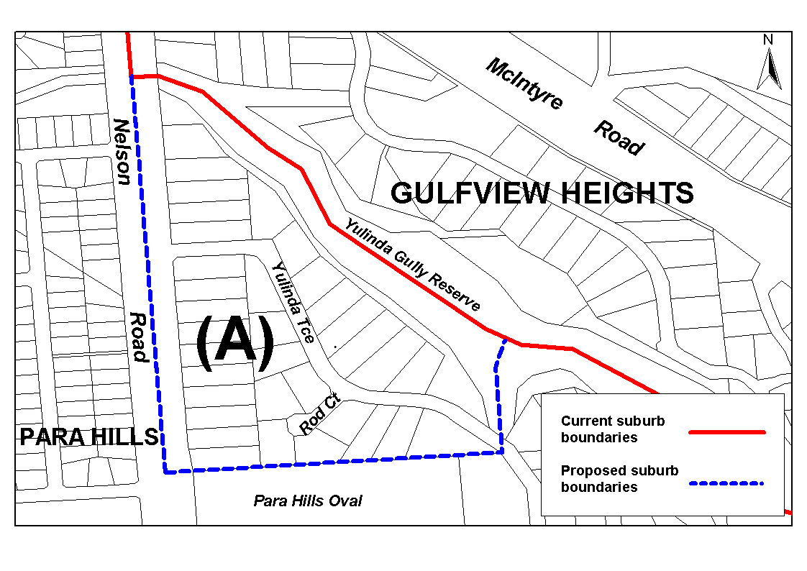
Dated 8 May 2002.
P. M. Kentish, Surveyor-General, Department for Administrative and Information Services
DAIS 22-413/01/0480

GEOGRAPHICAL NAMES ACT 1991
Notice to Assign Boundaries and Names to Places
NOTICE is hereby given pursuant to the provisions of the above Act that I, PETER MACLAREN KENTISH, Surveyor-General and Delegate appointed by Jay Weatherill, Minister for Administrative Services, Minister of the Crown to whom the administration of the Geographical Names Act 1991, is committed DO HEREBY assign the names FLINDERS CHASE, CAPE BORDA, DE MOLE RIVER, WESTERN RIVER, GOSSE, KARATTA, STUN’SAIL BOOM, VIVONNE BAY, NEWLAND, DUNCAN, MIDDLE RIVER, STOKES BAY, CASSINI, PARNDARNA, SEDDON, SEAL BAY, MACGILLIVRAY, BIRCHMORE, KOHINOOR, MENZIES, WISANGER, EMU BAY, NORTH CAPE, BAY OF SHOALS, KINGSCOTE, BROWNLOW K.I., CYGNET RIVER, NEPEAN BAY, HAINES, D’ESTREES BAY, MUSTON, BALLAST HEAD and AMERICAN RIVER to those areas within the Kangaroo Island Council and shown numbered 1 to 33 on Rack Plan 801—Part 2.
Dated 13 May 2002.
P. M. Kentish, Surveyor-General, Department for Administrative and Information Services
04/0068

LIQUOR LICENSING ACT 1997
Notice of Applications
NOTICE is hereby given, pursuant to section 52 of the Liquor Licensing Act 1997, that Vincenzo Vallelonga, Teresa Vallelonga, Ilario Chiera and Ginetta Chiera, c/o Kelly & Co. Lawyers, have applied to the Licensing Authority for the transfer and removal of a Hotel Licence, Extended Trading Authorisation and Entertainment Consent from premises situated at 109 Murray Street, Gawler, S.A. 5118 currently known as Fibber Magee’s to premises situated at 17-19 Murray Street, Gawler, S.A. 5118 incorporating the Gawler Reception Centre (also known as Cafe Nova) and also expanding and to be known as Murrays.
The applications has been set down for hearing on 7 June 2002 at 9 a.m.
Conditions
The following licence conditions are sought:
1. Extended Trading Authorisation for the whole of the licensed premises to enable trading for consumption of liquor on:
Friday and Saturday, midnight to 1.30 a.m. the following day; Sunday, 8 a.m. to 11 a.m. and 8 p.m. to 1.30 a.m. the following day; Public Holidays, midnight to 1.30 a.m. the following day and for consumption off the licensed premises on Sunday, between the hours of 8 a.m. and 11 a.m. and from 8 p.m. to 9 p.m.
2. Entertainment consent to enable amplified live music to be played up to 1 a.m. in the proposed gaming lounge, cafe restaurant and reception hall.
3. Maximum capacity:
Area 1 (existing Cafe Restaurant) 90; Area 2 (existing Beer Garden) 45; Area 3 (existing Alfresco Dining) 35; Area 4 (new Dining Room) 210; Area 5 (new Gaming Room) 80; Area 6 (existing Reception Hall) 120.
Any person may object to the application by lodging a notice of objection in the prescribed form with the Licensing Authority, and serving a copy of the notice on the applicants at the applicants’ address given above, at least seven days before the hearing date.
Plans in respect of the premises the subject of the application are open to public inspection without fee at the Office of the Liquor and Gaming Commissioner, 9th Floor, East Wing, 50 Grenfell Street, Adelaide, S.A. 5000.
Dated 10 May 2002.
Applicants

LIQUOR LICENSING ACT 1997
Notice of Applications
NOTICE is hereby given, pursuant to section 52 of the Liquor Licensing Act 1997, that Mad If We Don’t Pty Ltd, c/o Kelly & Co. Lawyers, has applied to the Licensing Authority for the transfer and removal of a Special Circumstances Licence, Extended Trading Authorisation and Entertainment Consent from premises situated at 17-19 Murray Street, Gawler, S.A. 5118 currently known as the Gawler Reception Centre to premises situated at 109 Murray Street, Gawler, S.A. 5118 and to be known as Fibber Magee’s.
The applications has been set down for hearing on 7 June 2002 at 9 a.m.
Conditions
The following licence conditions are sought:
1. Trading hours for the consumption on the licensed premises on Monday, Tuesday and Wednesday, 5 a.m. to midnight; Thursday, 5 a.m. to 2 a.m. the following day; Friday, 5 a.m. to 2 a.m. the following day; Saturday, 5 a.m. to 2 a.m. the following day; Sunday, 8 a.m. to midnight; Christmas Eve, midnight to 2 a.m. the following day; Christmas Day, 9 a.m. to 11 a.m.
Music is prohibited for the extended trading hours from 1 a.m. on the morning following Thursday, Friday and Saturday and from 10 p.m. on Sunday.
2. Entertainment consent for the areas marked: Area 3 (Dining Room); Area 4 (Dining Room); Area 5 (Lounge Bar); Area 6 (Front Bar); Area 7 (Beer Garden).
3. Designated Area: Dining Areas—Outlined in green on the plan of the premises and shown as Areas 1 to 7.
4. Maximum Capacity: Area 1 (Outdoor Dining) 80; Area 2 (Balcony) 50; Area 3 (Dining Room) 45; Area 4 (Dining Room) 40; Area 5 (Lounge Bar) 30; Area 6 (Front Bar) 50. The overall capacity of the premises shall not exceed 100 persons.
Any person may object to the application by lodging a notice of objection in the prescribed form with the Licensing Authority, and serving a copy of the notice on the applicant at the applicant’s address given above, at least seven days before the hearing date.
Plans in respect of the premises the subject of the application are open to public inspection without fee at the Office of the Liquor and Gaming Commissioner, 9th Floor, East Wing, 50 Grenfell Street, Adelaide, S.A. 5000.
Dated 10 May 2002.
Applicant

LIQUOR LICENSING ACT 1997
Notice of Application
NOTICE is hereby given, pursuant to section 52 (2) (b) of the Liquor Licensing Act 1997, that Mount McKenzie Wine Co. Pty Ltd, P.O. Box 35, Angaston, S.A. 5353, has applied to the Licensing Authority for a removal of a Producer’s Licence in respect of premises situated at Sawpit Gully Road, Mount McKenzie, S.A. 5353 and to be removed to 2 Jasper Street, Hyde Park, S.A. 5061 and known as Mount McKenzie Wine Company.
The application has been set down for hearing on 14 June 2002 at 9 a.m.
Any person may object to the application by lodging a notice of objection in the prescribed form with the Licensing Authority, and serving a copy of the notice on the applicant at the applicant’s address given above, at least seven days before the hearing date.
Plans in respect of the premises the subject of the application are open to public inspection without fee at the Office of the Liquor and Gaming Commissioner, 9th Floor, East Wing, 50 Grenfell Street, Adelaide, S.A. 5000.
Dated 7 May 2002.
Applicant

LIQUOR LICENSING ACT 1997
Notice of Application
NOTICE is hereby given, pursuant to section 52 (2) (b) of the Liquor Licensing Act 1997, that Galipo and Company (ACN 007 953 513) as trustee for the Galipo Family Trust, c/o David Watts & Associates, Liquor Licensing Consultants, 1 Cator Street, Glenside, S.A. 5065, has applied to the Licensing Authority for a Wholesale Liquor Merchant’s Licence in respect of premises situated at Unit 5, Commercial Court, 38 Cavan Road, Dry Creek, S.A. 5094 and to be known as Galipo Food Company.
The application has been set down for hearing on 14 June 2002.
Any person may object to the application by lodging a notice of objection in the prescribed form with the Licensing Authority, and serving a copy of the notice on the applicant at the applicant’s address given above, at least seven days before the hearing date.
Plans in respect of the premises the subject of the application are open to public inspection without fee at the Office of the Liquor and Gaming Commissioner, 9th Floor, East Wing, 50 Grenfell Street, Adelaide, S.A. 5000.
Dated 7 May 2002.
Applicant

LIQUOR LICENSING ACT 1997
Notice of Application
NOTICE is hereby given, pursuant to section 52 (2) (b) of the Liquor Licensing Act 1997, that Mario Cavaiuolo and Antonietta Cavaiuolo, c/o David Watts & Associates, Liquor Licensing Consultants, 1 Cator Street, Glenside, S.A. 5065, have applied to the Licensing Authority for a Producer’s Licence in respect of premises situated at Lot 661, corner Plains Road and Rogers Road, Sellicks Hill, S.A. 5174 and to be known as M. & A. Cavaiuolo.
The application has been set down for hearing on 14 June 2002 at 9 a.m.
Any person may object to the application by lodging a notice of objection in the prescribed form with the Licensing Authority, and serving a copy of the notice on the applicants at the applicants’ address given above, at least seven days before the hearing date.
Plans in respect of the premises the subject of the application are open to public inspection without fee at the Office of the Liquor and Gaming Commissioner, 9th Floor, East Wing, 50 Grenfell Street, Adelaide, S.A. 5000.
Dated 7 May 2002.
Applicants

LIQUOR LICENSING ACT 1997
Notice of Application
NOTICE is hereby given, pursuant to section 52 (2) (b) of the Liquor Licensing Act 1997, that Michael Turner & Associates Pty Ltd, Megapace Pty Ltd and Asia Australia Traders Pty Ltd, have applied to the Licensing Authority for a Variation to the Extended Trading Authorisation and Entertainment Consent in force in respect of premises situated at 247 Gouger Street, Adelaide, S.A. 5000 and known as Directors Hotel.
The application has been set down for hearing on 14 June 2002.
Conditions
The following licence conditions are sought:
Variation to the Extended Trading Authorisation to authorise the sale of liquor for consumption on the licensed premises as follows:
1. Sunday—8 a.m. to 11 a.m. and 8 p.m. to midnight.
2. Entertainment consent is sought during these hours.
Any person may object to the application by lodging a notice of objection in the prescribed form with the Licensing Authority, and serving a copy of the notice on the applicants at the applicants’ address given above, at least seven days before the hearing date.
Plans in respect of the premises the subject of the application are open to public inspection without fee at the Office of the Liquor and Gaming Commissioner, 9th Floor, East Wing, 50 Grenfell Street, Adelaide, S.A. 5000.
Dated 7 May 2002.
Applicants

LIQUOR LICENSING ACT 1997
Notice of Application
NOTICE is hereby given, pursuant to section 52 (2) (b) of the Liquor Licensing Act 1997, that Marquis Philips Pty Ltd, 2 Riviera Court, Pasadena, S.A. 5042, has applied to the Licensing Authority for a Producer’s Licence in respect of premises situated at 2 Riviera Court, Pasadena, S.A. 5042 and to be known as Marquis Philips Pty Ltd.
The application has been set down for hearing on 14 June 2002 at 9 a.m.
Any person may object to the application by lodging a notice of objection in the prescribed form with the Licensing Authority, and serving a copy of the notice on the applicant at the applicant’s address given above, at least seven days before the hearing date.
Plans in respect of the premises the subject of the application are open to public inspection without fee at the Office of the Liquor and Gaming Commissioner, 9th Floor, East Wing, 50 Grenfell Street, Adelaide, S.A. 5000.
Dated 8 May 2002.
Applicant

LIQUOR LICENSING ACT 1997
Notice of Application
NOTICE is hereby given, pursuant to section 52 (2) (b) of the Liquor Licensing Act 1997, that The Grateful Palate Inter-national Pty Ltd, 2 Riviera Court, Pasadena, S.A. 5042, has applied to the Licensing Authority for the removal of a Direct Sales Licence in respect of premises situated at 12 Colley Street, North Adelaide, S.A. 5006, to be removed to 2 Riviera Court, Pasadena, S.A. 5042 and known as The Grateful Palate International Pty Ltd.
The application has been set down for hearing on 14 June 2002 at 9 a.m.
Any person may object to the application by lodging a notice of objection in the prescribed form with the Licensing Authority, and serving a copy of the notice on the applicant at the applicant’s address given above, at least seven days before the hearing date.
Plans in respect of the premises the subject of the application are open to public inspection without fee at the Office of the Liquor and Gaming Commissioner, 9th Floor, East Wing, 50 Grenfell Street, Adelaide, S.A. 5000.
Dated 8 May 2002.
Applicant

LIQUOR LICENSING ACT 1997
Notice of Application
NOTICE is hereby given, pursuant to section 52 (2) (b) of the Liquor Licensing Act 1997, that Philip and Kaylee Philippou, P.O. Box 613, Tanunda, S.A. 5352, have applied to the Licensing Authority for a Producer’s Licence in respect of premises to be situated at Lot 12 Golflinks Road, Rowland Flat, S.A. 5352 and to be known as Philip and Kayleen Philippou.
The application has been set down for hearing on 14 June 2002 at 9 a.m.
Any person may object to the application by lodging a notice of objection in the prescribed form with the Licensing Authority, and serving a copy of the notice on the applicants at the applicants’ address given above, at least seven days before the hearing date.
Plans in respect of the premises the subject of the application are open to public inspection without fee at the Office of the Liquor and Gaming Commissioner, 9th Floor, East Wing, 50 Grenfell Street, Adelaide, S.A. 5000.
Dated 9 May 2002.
Applicants

LIQUOR LICENSING ACT 1997
Notice of Application
NOTICE is hereby given, pursuant to section 52 (2) (b) of the Liquor Licensing Act 1997, that Deviation Road Pty Ltd, c/o Wallmans Solicitors, 173 Wakefield Street, Adelaide, S.A. 5000, has applied to the Licensing Authority for a Direct Sales Licence in respect of premises situated at Deviation Road, Carey Gully, S.A. 5144 and to be known as Deviation Road Pty Ltd.
The application has been set down for hearing on 14 June 2002 at 9 a.m.
Any person may object to the application by lodging a notice of objection in the prescribed form with the Licensing Authority, and serving a copy of the notice on the applicant at the applicant’s address given above, at least seven days before the hearing date.
Plans in respect of the premises the subject of the application are open to public inspection without fee at the Office of the Liquor and Gaming Commissioner, 9th Floor, East Wing, 50 Grenfell Street, Adelaide, S.A. 5000.
Dated 9 May 2002.
Applicant

LIQUOR LICENSING ACT 1997
Notice of Application
NOTICE is hereby given, pursuant to section 52 (2) (b) of the Liquor Licensing Act 1997, that Vietnam Veterans Federation South Australian Branch Inc., has applied to the Licensing Authority for a Limited Club Licence with Extended Trading Authorisation in respect of premises situated at 71A Addison Road, Warradale, S.A. 5046 and to be known as Vietnam Veterans Federation South Australian Branch Inc.
The application has been set down for hearing on 14 June 2002.
Conditions
The following licence condition is sought:
• Extended Trading Authorisation:
Sunday—8 a.m. to 11 a.m. and 8 p.m. to midnight.
Any person may object to the application by lodging a notice of objection in the prescribed form with the Licensing Authority, and serving a copy of the notice on the applicant at the applicant’s address given above, at least seven days before the hearing date.
Plans in respect of the premises the subject of the application are open to public inspection without fee at the Office of the Liquor and Gaming Commissioner, 9th Floor, East Wing, 50 Grenfell Street, Adelaide, S.A. 5000.
Dated 8 May 2002.
Applicant

LIQUOR LICENSING ACT 1997
Notice of Application
NOTICE is hereby given, pursuant to section 52 (2) (b) of the Liquor Licensing Act 1997, that Chateau Barrosa (SA) Pty Ltd, c/o Oliver Portway, Heuzenroeder & Heuzenroeder, has applied to the Licensing Authority for a Special Circumstances Licence with Entertainment Consent in respect of premises situated at Gomersal Road, Lyndoch, S.A. 5351 and known as Chateau Barrossa.
The application has been set down for hearing on 14 June 2002.
Conditions
The following licence conditions are sought:
1. For consumption on the licensed premises between 5 a.m. and midnight, Monday to Saturday and between 11 a.m. and 8 p.m. on Sunday:
• To sell, supply or consume wine produced by the licensee or wine sourced from other winery regions including Barossa Valley.
• To sell, supply or consume beer at organised functions or events.
• To sell or supply wine produced by the licensee or wine sourced from other winery regions including Barossa Valley by way of sample.
2. For consumption off the licensed premises:
• To sell or supply wine produced by the licensee or wine sourced from other winery regions including Barossa Valley at any time through direct sales transactions.
• To sell or supply wine produced by the licensee or wine sourced from other winery regions including Barossa Valley between 5 a.m. and midnight, Monday to Saturday and between 11 a.m. and 8 p.m. on Sunday.
Any person may object to the application by lodging a notice of objection in the prescribed form with the Licensing Authority, and serving a copy of the notice on the applicant at the applicant’s address given above, at least seven days before the hearing date.
Plans in respect of the premises the subject of the application are open to public inspection without fee at the Office of the Liquor and Gaming Commissioner, 9th Floor, East Wing, 50 Grenfell Street, Adelaide, S.A. 5000.
Dated 27 February 2002.
Applicant

LIQUOR LICENSING ACT 1997
Notice of Application
NOTICE is hereby given, pursuant to section 52 (2) (b) of the Liquor Licensing Act 1997, that Robert Roy and Jan Atkinson as trustees for the Robert and Jan Atkinson Family Trust, c/o David Watts & Associates, Liquor Licensing Consultants, 1 Cator Street, Glenside, S.A. 5065 have applied to the Licensing Authority for a Direct Sales Licence in respect of premises situated at 578 The Parade, Auldana, S.A. 5072.
The application has been set down for hearing on 14 June 2002.
Any person may object to the application by lodging a notice of objection in the prescribed form with the Licensing Authority, and serving a copy of the notice on the applicants at the applicants’ address given above, at least seven days before the hearing date.
Plans in respect of the premises the subject of the application are open to public inspection without fee at the Office of the Liquor and Gaming Commissioner, 9th Floor, East Wing, 50 Grenfell Street, Adelaide, S.A. 5000.
Dated 10 May 2002.
Applicants

LIQUOR LICENSING ACT 1997
Notice of Application
NOTICE is hereby given, pursuant to section 52 (2) (b) of the Liquor Licensing Act 1997, that Parker Estates Pty Ltd, 110B Elizabeth Bay Road, Elizabeth Bay, N.S.W. 2011, has applied to the Licensing Authority for the removal of a Wholesale Liquor Merchant’s Licence in respect of premises situated at Penola Road, Coonawarra, S.A. 5263 and to be situated at Lot 11, Main Road, (Riddoch Highway) Coonawarra, S.A. 5263.
The application has been set down for hearing on 14 June 2002 at 9 a.m.
Condition
The following licence condition is sought:
That the licensee be authorised to sell or supply liquor by way of sample for consumption on the licensed premises, pursuant to section 38 (1) (c) of the Liquor Licensing Act 1997.
Any person may object to the application by lodging a notice of objection in the prescribed form with the Licensing Authority, and serving a copy of the notice on the applicant at the applicant’s address given above, at least seven days before the hearing date.
Plans in respect of the premises the subject of the application are open to public inspection without fee at the Office of the Liquor and Gaming Commissioner, 9th Floor, East Wing, 50 Grenfell Street, Adelaide, S.A. 5000.
Applicant

LIQUOR LICENSING ACT 1997
Notice of Application
NOTICE is hereby given, pursuant to section 52 (2) (b) of the Liquor Licensing Act 1997, that Neil D’Sylva and Andrew Argent, 223 Flinders Street, Adelaide, S.A. 5000, have applied to the Licensing Authority for the transfer of a Restaurant Licence and seeking an Extended Trading Authorisation with section 34 (1) (c) and Entertainment Consent in respect of premises situated at 223 Flinders Street, Adelaide, S.A. 5000 and known as German Restaurant.
The application has been set down for hearing on 17 June 2002 at 10 a.m.
Conditions
The following licence conditions are sought:
1. An Extended Trading Authorisation is sought:
Monday to Thursday—Midnight to 5 a.m. the following day.
Friday and Saturday—Midnight to 6 a.m. the following day.
Sunday—8 a.m. to 11 a.m. and 8 p.m. to 5 a.m. the following day.
Public Holidays—8 a.m. to 5 p.m.
2. To allow the licensee to sell liquor on any day except Good Friday and Christmas Day for consumption on the licensed premises by persons.
3. Entertainment consent is sought during normal trading hours and the Extended Trading Authorisation.
Any person may object to the application by lodging a notice of objection in the prescribed form with the Licensing Authority, and serving a copy of the notice on the applicants at the applicants’ address given above, at least seven days before the hearing date.
Plans in respect of the premises the subject of the application are open to public inspection without fee at the Office of the Liquor and Gaming Commissioner, 9th Floor, East Wing, 50 Grenfell Street, Adelaide, S.A. 5000.
Dated 6 May 2002.
Applicants

LIQUOR LICENSING ACT 1997
Notice of Application
NOTICE is hereby given, pursuant to section 52 (2) (b) of the Liquor Licensing Act 1997, that Pichi Richi Railway Hotel Motel Pty Ltd, c/o Foreman Mead Solicitors, 26 Mann Street, Mount Barker, S.A. 5251, has applied to the Licensing Authority for the transfer of a Hotel Licence in respect of premises situated at 18 Railway Terrace, Quorn, S.A. 5433 and known as Criterion Motel-Hotel.
The application has been set down for hearing on 17 June 2002 at 10.30 a.m.
Any person may object to the application by lodging a notice of objection in the prescribed form with the Licensing Authority, and serving a copy of the notice on the applicant at the applicant’s address given above, at least seven days before the hearing date.
Plans in respect of the premises the subject of the application are open to public inspection without fee at the Office of the Liquor and Gaming Commissioner, 9th Floor, East Wing, 50 Grenfell Street, Adelaide, S.A. 5000.
Dated 8 May 2002.
Applicant

LIQUOR LICENSING ACT 1997
Notice of Application
NOTICE is hereby given, pursuant to section 52 (2) (b) of the Liquor Licensing Act 1997, that Anthony David Goss, 278 Mason Street, Wellington, S.A. 5259, has applied to the Licensing Authority for the transfer of a Restaurant Licence in respect of premises situated at 278 Mason Street, Wellington, S.A. 5259 and known as Wellington Courthouse.
The application has been set down for hearing on 17 June 2002 at 11 a.m.
Any person may object to the application by lodging a notice of objection in the prescribed form with the Licensing Authority, and serving a copy of the notice on the applicant at the applicant’s address given above, at least seven days before the hearing date.
Plans in respect of the premises the subject of the application are open to public inspection without fee at the Office of the Liquor and Gaming Commissioner, 9th Floor, East Wing, 50 Grenfell Street, Adelaide, S.A. 5000.
Dated 10 May 2002.
Applicant

LIQUOR LICENSING ACT 1997
Notice of Application
NOTICE is hereby given, pursuant to section 52 (2) (b) of the Liquor Licensing Act 1997, that Veritas Winery Pty Ltd, has applied to the Licensing Authority for the transfer of a Producer’s Licence in respect of premises situated at Seppelts-field Road, Dorrien, S.A. 5352 and known as Veritas Winery.
The application has been set down for hearing on 17 June 2002 at 11.30 a.m.
Any person may object to the application by lodging a notice of objection in the prescribed form with the Licensing Authority, and serving a copy of the notice on the applicant at the applicant’s address given above, at least seven days before the hearing date.
Plans in respect of the premises the subject of the application are open to public inspection without fee at the Office of the Liquor and Gaming Commissioner, 9th Floor, East Wing, 50 Grenfell Street, Adelaide, S.A. 5000.
Dated 10 May 2002.
Applicant

MINING ACT 1971
NOTICE is hereby given in accordance with section 28 (5) of the Mining Act 1971, that the Minister for Mineral Resources Development proposes to grant an Exploration Licence over the undermentioned area:
Applicant: Mara Pty Ltd (50%), Inca Resources Pty Ltd (16%), Anthony Frances Greve LeBrun (16%) and James Fraser Allender (16%)
Location: Warrakimbo Area—Approximately 100 km north-east of Port Augusta, bounded as follows:
Area ‘A’—Commencing at a point being the inter-section of latitude 31°26′S and longitude 138°20′E, thence east to longitude 138°26′E, south to latitude 31°30′S, east to longitude 138°28′E, south to latitude 31°34′S, west to longitude 138°26′E, south to latitude 31°35′S, west to longitude 138°25′E, south to latitude 31°37′S, west to longitude 138°24′E, south to latitude 31°38′S, west to longitude 138°22′E, south to latitude 31°40′S, west to longitude 138°20′E, north to latitude 31°33′S, west to longitude 138°16′E, north to latitude 31°30′S, east to longitude 138°20′E, and north to the point of commencement.
Area ‘B’—Commencing at a point being the inter-section of latitude 31°47′S and longitude 138°12′E, thence east to longitude 138°28′E, south to latitude 31°53′S, west to longitude 138°25′E, south to latitude 31°57′S, west to longitude 138°23′E, north to latitude 31°53′S, west to longitude 138°18′E, south to latitude 31°57′S, west to longitude 138°16′E, south to latitude 32°00′S, west to longitude 138°12′E, north to latitude 31°55′S, west to longitude 138°10′E, north to latitude 31°51′S, east to longitude 138°12′E, and north to the point of commencement.
All the within latitudes and longitudes are geodetic and expressed in terms of the Australian Geodetic Datum as defined on p. 4984 of Commonwealth Gazette number 84 dated 6 October 1966 (AGD66).
Term: 1 year
Area in km²: 701
Ref.: 211/2001
Dated 16 May 2002.
H. Tyrteos, Acting Mining Registrar, Department of Primary Industries and Resources

MINING ACT 1971
NOTICE is hereby given in accordance with section 28 (5) of the Mining Act 1971, that the Minister for Mineral Resources Development proposes to grant Exploration Licences over the undermentioned areas:
Applicant: Taipan X Pty Ltd
Location: Ouldburra Area—Approximately 35 km south-east of Marla, bounded as follows: Commencing at a point being the intersection of latitude 27°27′S and longitude 133°54′E, thence east to longitude 133°58′E, south to latitude 27°33′S, west to longitude 133°54′E, and north to the point of commencement, all the within latitudes and longitudes being geodetic and expressed in terms of the Australian Geodetic Datum as defined on p. 4984 of Commonwealth Gazette number 84 dated 6 October 1966 (AGD66).
Term: 1 year
Area in km²: 73
Ref.: 011/2002
Dated 16 May 2002.
H. Tyrteos, Acting Mining Registrar, Department of Primary Industries and Resources

MINING ACT 1971
NOTICE is hereby given in accordance with section 35A (1) of the Mining Act 1971, that an application for a mining lease over the undermentioned mineral claim has been received. Details of the proposal may be inspected at the Department of Primary Industries and Resources, Mineral Resources Group, Level 5, 101 Grenfell Street, Adelaide, S.A. 5000:
Applicant: Malcolm Bruce Coleman
Claim No.: 3257
Location: Allotment 26 of DP45956, Hundred of Nuriootpa, 7 km south-west of Tanunda
Purpose: Excavate sand from an open cut pit to be used for concrete, trench backfilling and general filling material within the local Barossa district.
Reference: T2275
A copy of the proposal has been provided to the District Council of Light.
Written submissions in relation to the granting of the mining lease are invited to be received at the Department of Primary Industries and Resources, Mineral Resources Group, Level 5, 101 Grenfell Street, Adelaide, S.A. 5000 or G.P.O. Box 1671, Adelaide, S.A. 5001 no later than 7 June 2002.
Dated 16 May 2002.
H. Tyrteos, Acting Mining Registrar, Department of Primary Industries and Resources

MINING ACT 1971
NOTICE is hereby given in accordance with section 35A (1) of the Mining Act 1971, that an application for a mining lease over the undermentioned mineral claim has been received. Details of the proposal may be inspected at the Department of Primary Industries and Resources, Mineral Resources Group, Level 5, 101 Grenfell Street, Adelaide, S.A. 5000:
Applicant: Gambier Earth Movers Pty Ltd
Claim No.: 3265
Location: Section 225, Hundred of Monbulla approximately 15 km west of Penola
Purpose: Recovery of limestone rubble from an open cut pit to be used for concrete, trench backfilling and general filling material within the local Kimba district.
Reference: T2288
A copy of the proposal has been provided to the Wattle Range Council.
Written submissions in relation to the granting of the mining lease are invited to be received at the Department of Primary Industries and Resources, Mineral Resources Group, Level 5, 101 Grenfell Street, Adelaide, S.A. 5000 or G.P.O. Box 1671, Adelaide, S.A. 5001 no later than 3 June 2002.
Dated 16 May 2002.
H. Tyrteos, Acting Mining Registrar, Department of Primary Industries and Resources

NATIONAL ELECTRICITY (SOUTH AUSTRALIA)
ACT 1996
Notice under Section 6 (2) of the National Electricity Law and National Electricity Code—Full Retail Competition—
Mark II Code Changes
NOTICE is hereby given pursuant to section 6 (2) of the National Electricity Law, which forms the Schedule to the National Electricity (South Australia) Act 1996; and clause 8.3.9 (d) of the National Electricity Code approved under section 6 of the National Electricity Law, that clauses 2.11, 6.16.1, 7.4.3, 7.9.2 and Schedule 7.4 of the National Electricity Code are amended, new clauses 3.13.12, 3.19 and 7.2.8 are inserted, and new definitions and amendments to existing definitions are inserted in Chapter 10 definitions of the National Electricity Code.
These amendments to the National Electricity Code commence at the beginning of 16 May 2002.
As required by clause 8.3.9 (d) of the National Electricity Code, a copy of the ACCC’s letter granting authorisation dated 8 May 2002 is set out below.
The amendments referred to above and a copy of the ACCC’s letter dated 8 May 2002 can be viewed on the Internet website of National Electricity Code Administrator Limited (ACN 073 942 775) (‘NECA’) at www.neca.com.au under ‘The Code—Gazette notices’ section of that website.
These amendments to the National Electricity Code were previously the subject of an interim authorisation gazetted in the South Australian Government Gazette on 20 December 2001 and no further changes result from this gazettal.
The National Electricity Code can be viewed on the NECA Internet website at www.neca.com.au and at the offices of NECA and National Electricity Market Management Company Limited (ACN 072 010 327). A list of addresses where the Code can be viewed is available on the NECA website.
Dated 16 May 2002.

ACCC Letter of Authorisation
8 May 2002
Stephen Kelly
Managing Director
National Electricity Code Administrator
Level 4, 41 Currie Street
ADELAIDE, S.A. 5000
Dear Stephen
Applications for Authorisation of National Electricity Code Changes—Full Retail Competition Mark II
On 10 December 2001, the Australian Competition and Consumer Commission (Commission) received applications for authorisation (Nos A90813, A90814 and A90815) of amend-ments to the National Electricity Code (Code), to facilitate the introduction of full retail competition (FRC). The applications were submitted by the National Electricity Code Administrator (NECA), on behalf of the National Electricity Market Manage-ment Company (NEMMCO), under Part VII of the Trade Practices Act 1974 (TPA).
Please find enclosed a copy of the Commission’s deter-mination in respect of these applications for authorisation. The Commission’s determination outlines its analysis and views on the proposed Code changes. The Commission proposes to grant authorisation. The condition of authorisation is outlined in chapter 5 of the determination.
In accordance with s.101 of the Trade Practices Act 1974, a person dissatisfied with the Commission’s determination may apply to the Australian Competition Tribunal for a review of the determination. Each application must be lodged on the approp-riate form within 21 days of the date of the determination, with the Registrar of the Tribunal. The Tribunal is located in the Office of the Registrar of the Federal Court in each State.
A copy of this letter together with the determination will be placed on the Public Register kept by the Commission.
Yours sincerely,
M. Rawstron, General Manager, Regulatory Affairs—Electricity.

RENMARK IRRIGATION TRUST ACT 1936
Renmark Irrigation District
Notice of Letting or Selling Land for Arrears of Rates
THERE is now due, in respect of the land mentioned in the Schedule hereto the sum set opposite to the description of such land in the Schedule, for rates declared by The Renmark Irrigation Trust, for the half years ending as in the Schedule mentioned and the owners of such land are required to take notice that unless the amount so due, together with the costs of and attending this notice, be paid in two months from the first publication of this notice, the said Trust will let the same in manner provided by the Renmark Irrigation Trust Act 1936, or an application will be made by the said Trust to the Supreme Court for an order for the sale of the said land or so much thereof as may be necessary to produce the rates so due and costs as aforesaid, and also the costs of and attending the said application.
Dated 23 April 2002.
W. D. Morris, Secretary

The Schedule
Description of Land by Numbers or Distinguishing Marks of Lots, Sections  and Blocks or other description | Name of Owner or  Reputed Owner (or state  if owner unknown) | Number of  Half Years for which Rates  in arrear | Date of Ending of  last Half Year for which Rates in  arrear | Amount of  Rates
Section Lot 6 in Deposited Plan 18806 of Block E, Renmark Irrigation District, Warrego Street, Renmark. The whole of the land comprised and described in certificate of title register book volume 5464, folio 961 | Brenton Craig Schloithe and Christine Marie Schloithe | 9 | 31 December 2001 | $4 591.58
3/3

PASTORAL LAND MANAGEMENT AND CONSERVATION ACT 1989: SECTION 45
TAKE notice that pursuant to the Pastoral Land Management and Conservation Act 1989, I, John Chappel, Manager, Pastoral Program, Delegate appointed by the Pastoral Board, do hereby dedicate the Pastoral Land defined in The Schedule as a Public Access Route.
The Schedule
Public Access Route No. 15 (K1, Warburton Crossing)—That portion of Pastoral Block 582, Lot 100—D35808 and Lot 2037—D 38061, Out of Hundreds (Gason) situated between MGA Co-ordinates E284000, N6999700 and E237900, N7015000 delineated in pastoral map ‘Clifton Hills’ deposited in the Department of Primary Industries and Resources, SA.
Dated 16 May 2002.
J. Chappel, Manager, Pastoral Program

PASTORAL LAND MANAGEMENT AND CONSERVATION ACT 1989: SECTION 45
TAKE notice that pursuant to the Pastoral Land Management and Conservation Act 1989, I, John Chappel, Manager, Pastoral Program, Delegate appointed by the Pastoral Board, do hereby dedicate the Pastoral Land defined in The Schedule as a Public Access Route.
The Schedule
Public Access Route No. 16 (Walkers Crossing)—That portion of Pastoral Blocks 1178, 757 and Lot 2025—D 35579, Out of Hundreds (Innamincka), and Block 1179, Out of Hundreds (Cordillo) between MGA Co-ordinates E473600, N6929500 and E354500, N7027000 delineated on pastoral map ‘Clifton Hills’ deposited in the Department of Primary Industries and Resources, SA.
Dated 16 May 2002.
J. Chappel, Manager, Pastoral Program

GOVERNMENT GAZETTE ADVERTISEMENT RATES

To apply from 1 July 2001

$  Agents, Ceasing to Act as 32.75  Associations:  Incorporation 16.70  Intention of Incorporation 41.25  Transfer of Properties 41.25  Attorney, Appointment of 32.75  Bailiff’s Sale 41.25  Cemetery Curator Appointed 24.50  Companies:  Alteration to Constitution 32.75  Capital, Increase or Decrease of 41.25  Ceasing to Carry on Business 24.50  Declaration of Dividend 24.50  Incorporation 32.75  Lost Share Certificates:  First Name 24.50  Each Subsequent Name 8.40  Meeting Final 27.50  Meeting Final Regarding Liquidator’s Report on  Conduct of Winding Up (equivalent to ‘Final  Meeting’)  First Name 32.75  Each Subsequent Name 8.40  Notices:  Call 41.25  Change of Name 16.70  Creditors 32.75  Creditors Compromise of Arrangement 32.75  Creditors (extraordinary resolution that ‘the Com-pany be wound up voluntarily and that a liquidator be appointed’) 41.25  Release of Liquidator⎯Application⎯Large Ad. 65.50  ⎯Release Granted 41.25  Receiver and Manager Appointed 38.25  Receiver and Manager Ceasing to Act 32.75  Restored Name 31.00  Petition to Supreme Court for Winding Up 57.00  Summons in Action 48.75  Order of Supreme Court for Winding Up Action 32.75  Register of Interests⎯Section 84 (1) Exempt 74.00  Removal of Office 16.70  Proof of Debts 32.75  Sales of Shares and Forfeiture 32.75  Estates:  Assigned 24.50  Deceased Persons⎯Notice to Creditors, etc. 41.25  Each Subsequent Name 8.40  Deceased Persons⎯Closed Estates 24.50  Each Subsequent Estate 1.05  Probate, Selling of 32.75  Public Trustee, each Estate 8.40 |  | $  Firms:  Ceasing to Carry on Business (each insertion) 21.80  Discontinuance Place of Business 21.80  Land⎯Real Property Act:  Intention to Sell, Notice of 41.25  Lost Certificate of Title Notices 41.25  Cancellation, Notice of (Strata Plan) 41.25  Mortgages:  Caveat Lodgment 16.70  Discharge of 17.60  Foreclosures 16.70  Transfer of 16.70  Sublet 8.40  Leases⎯Application for Transfer (2 insertions) each 8.40  Lost Treasury Receipts (3 insertions) each 24.50  Licensing 48.75  Municipal or District Councils:  Annual Financial Statement⎯Forms 1 and 2 462.00  Electricity Supply⎯Forms 19 and 20 327.00  Default in Payment of Rates:  First Name 65.50  Each Subsequent Name 8.40  Noxious Trade 24.50  Partnership, Dissolution of 24.50  Petitions (small) 16.70  Registered Building Societies (from Registrar-  General) 16.70  Register of Unclaimed Moneys⎯First Name 24.50  Each Subsequent Name 8.40  Registers of Members⎯Three pages and over:  Rate per page (in 8pt) 209.00  Rate per page (in 6pt) 276.00  Sale of Land by Public Auction 41.75  Advertisements 2.30  Advertisements, other than those listed are charged at $2.30 per column line, tabular one-third extra.  Notices by Colleges, Universities, Corporations and District Councils to be charged at $2.30 per line.  Where the notice inserted varies significantly in length from that which is usually published a charge of $2.30 per column line will be applied in lieu of advertisement rates listed.  South Australian Government publications are sold on the condition that they will not be reproduced without prior permission from the Government Printer.
All the above prices include GST

GOVERNMENT GAZETTE NOTICES
ALL private advertisements forwarded for publication in the South Australian Government Gazette must be PAID FOR PRIOR TO INSERTION; and all notices, from whatever source, should be legibly written on one side of the paper only and sent to Government Publishing SA so as to be received no later than 4 p.m. Tuesday preceding the day of publication. Phone 8207 1045 or Fax 8207 1040. E-mail: governmentgazette@saugov.sa.gov.au. Send as attachments in Word format and please confirm your transmission with a faxed copy of your document, including the date the notice is to be published and to whom the notice will be charged.

MISCELLANEOUS LEGISLATION AND GOVERNMENT PUBLICATIONS PRICES AS FROM 1 JULY 2001

Acts, Bills, Rules, Parliamentary Papers and Regulations
Pages | Main | Amends | Pages | Main | Amends

1-16 | 1.85 | 0.80 | 497-512 | 27.00 | 26.00
17-32 | 2.60 | 1.65 | 513-528 | 27.75 | 26.50
33-48 | 3.35 | 2.40 | 529-544 | 28.50 | 27.50
49-64 | 4.25 | 3.20 | 545-560 | 29.25 | 28.50
65-80 | 5.00 | 4.10 | 561-576 | 30.00 | 29.25
81-96 | 5.75 | 4.80 | 577-592 | 31.00 | 29.75
97-112 | 6.60 | 5.60 | 593-608 | 31.75 | 30.75
113-128 | 7.40 | 6.45 | 609-624 | 32.50 | 31.75
129-144 | 8.30 | 7.30 | 625-640 | 33.25 | 32.25
145-160 | 9.10 | 8.05 | 641-656 | 34.00 | 33.00
161-176 | 9.95 | 8.90 | 657-672 | 34.50 | 33.75
177-192 | 10.70 | 9.75 | 673-688 | 36.00 | 34.50
193-208 | 11.50 | 10.60 | 689-704 | 36.75 | 35.50
209-224 | 12.30 | 11.30 | 705-720 | 37.25 | 36.50
225-240 | 13.00 | 12.10 | 721-736 | 38.50 | 37.00
241-257 | 13.90 | 12.80 | 737-752 | 39.00 | 38.00
258-272 | 14.80 | 13.60 | 753-768 | 40.00 | 38.50
273-288 | 15.60 | 14.60 | 769-784 | 40.50 | 39.75
289-304 | 16.30 | 15.30 | 785-800 | 41.25 | 40.50
305-320 | 17.10 | 16.10 | 801-816 | 42.00 | 41.00
321-336 | 17.90 | 16.90 | 817-832 | 43.00 | 42.00
337-352 | 18.80 | 17.80 | 833-848 | 43.75 | 42.75
353-368 | 19.60 | 18.60 | 849-864 | 44.50 | 43.50
369-384 | 20.40 | 19.50 | 865-880 | 45.25 | 44.50
385-400 | 21.10 | 20.20 | 881-896 | 45.75 | 45.00
401-416 | 21.90 | 20.90 | 897-912 | 47.25 | 45.75
417-432 | 22.90 | 21.80 | 913-928 | 47.75 | 47.25
433-448 | 23.60 | 22.60 | 929-944 | 48.75 | 47.75
449-464 | 24.50 | 23.40 | 945-960 | 49.50 | 48.25
465-480 | 25.00 | 24.20 | 961-976 | 50.25 | 49.25
481-496 | 26.00 | 24.90 | 977-992 | 51.25 | 49.75

Legislation—Acts, Regulations, etc: $
Subscriptions:
Acts 166.90
All Bills as Laid 398.60
Rules and Regulations 398.60
Parliamentary Papers 398.60
Bound Acts 184.25
Index 89.20
Government Gazette
Copy 4.40
Subscription 220.20
Hansard
Copy 11.90
Subscription—per session (issued weekly) 345.35
Cloth bound—per volume 148.30
Subscription—per session (issued daily) 345.35
Legislation on Disk
Whole Database 2 551.00
Annual Subscription for fortnightly updates 784.30
Individual Act(s) including updates POA
Compendium
Subscriptions:
New Subs 1 513.50
Updates 540.25
(All the above prices include GST)

All Legislation, Government Gazette, Hansard and Legislation on disk are available from:
Counter Sales Information SA (State Government Bookshop)
and Mail Orders: Ground Floor, 77 Grenfell Street, Adelaide, S.A. 5000.
Phone: (08) 8204 1900. Fax: (08) 8204 1909
Online Shop: www.info.sa.gov.au
S.A. Country Customer Free Call: 1800 182 234
TTY (Hearing Impaired): (08) 8204 1923
Subscriptions and Standing Orders:
Phone: (08) 8207 0908, (08) 8207 0910. Fax: (08) 8207 1040
Box 9, Plaza Level, Riverside Centre, North Terrace, Adelaide, S.A. 5000.

ROAD TRAFFIC ACT 1961
Agricultural Vehicles Driven on Roads
1. Approval
1.1 Pursuant to section 161A of the Road Traffic Act 1961, and Regulation 35 of the Road Traffic (Miscellaneous) Regulations 1999, I hereby approve:
1.1.1 Tractors used for agricultural purposes, agricultural machines, agricultural machines towing agricultural implements and agricultural combinations which exceed 4.3 m in height and when in combination exceed 19 m in length;
to travel on roads in South Australia subject to the conditions specified in this Notice.
2. Exemption
2.1 Pursuant to section 163AA of the Road Traffic Act 1961, I hereby exempt:
2.1.1 Tractors used for agricultural purposes, agricultural machines, agricultural machines towing agricultural implements and agricultural combinations from the following provisions of the:
(i) Road Traffic (Vehicle Standards) Rules 1999:
• Rule 35 (1)—Rear vision mirrors, in so far as it relates to tractors or agricultural machines towing an agricultural implement that exceeds 3.5 m in width;
• Rule 66 (1)—Width;
• Rule 69 (1)(d)—Length of combinations;
• Rule 70 (1)(b)—Rear overhang;
• Rule 72 (1)—Height; and
(ii) Road Traffic (Miscellaneous) Regulations 1999:
• Regulation 20A (1)—Prohibition of towing more than one vehicle;
subject to the conditions specified in this Notice.
3. Conditions Applying to this Approval and Exemption
3.1 The vehicles described above must operate in accordance with the ‘Code of Practice for Oversize or Overmass Agricultural Vehicles’ dated May 2002, issued by Transport SA.
3.2 Except as otherwise specified in this Notice, the Standard Form Conditions prescribed in the Road Traffic (Oversize or Overmass Vehicle Exemptions) Regulations 1999 for the purposes of section 115 of the Road Traffic Act 1961, shall not apply.
3.3 When operating under this Notice, the driver must carry a legible, current and complete copy of the document titled ‘Code of Practice for Oversize or Overmass Agricultural Vehicles’ dated May 2002 issued by Transport SA and produce this document when requested by a Transport SA Inspector appointed under the Road Traffic Act 1961 and/or the Motor Vehicles Act 1959, or a Police Officer.
4. Commencement of this Notice
4.1 This Notice is valid from 1 June 2002.
5. Revocation of Previous Notice
5.1 The Notice entitled ‘Operation of Agricultural Vehicles in South Australia’ that appeared in the South Australian Government Gazette dated 9 September 1999 is revoked at midnight on 31 May 2002.
T. N. Argent, Executive Director, Transport SA, Authorised delegate for the Minister for Transport

ROADS (OPENING AND CLOSING) ACT 1991:
SECTION 24
NOTICE OF CONFIRMATION OF ROAD
PROCESS ORDER
Sturt Highway adjacent to Renmark Caravan Park, Renmark
Deposited Plan 58241
BY Road Process Order made on 30 August 2001, the District Council of Renmark Paringa ordered that:
Portion of section 255 in Renmark Irrigation District Out of Hundreds adjoining Sturt Highway and portion of piece 3 in Deposited Plan 45689 adjoining the south-eastern end of Patey Drive, more particularly delineated and numbered ‘11’ and ‘12’ (respectively) in the Preliminary Plan No. PP32/0266 be opened as road.
On 21 December 2001 that order was confirmed by the Minister for Administrative and Information Services, condition-ally on approval and deposit of the survey plan by the Registrar-General. The condition has now been fulfilled.
Pursuant to section 24(5) of the Roads (Opening and Closing) Act 1991, NOTICE of the order referred to above and its confirmation is hereby given.
Dated 16 May 2002.
P. M. Kentish, Surveyor-General

ROADS (OPENING AND CLOSING) ACT 1991
Road Closure—Main North/Diagonal Roads, Pooraka
NOTICE is hereby given, pursuant to section 10 of the Roads (Opening and Closing) Act 1991, that the DEVELOPMENT ASSESSMENT COMMISSION proposes to make a Road Process Order to close the whole of the public road between Main North and Diagonal Roads adjoining allotment 101 in Filed Plan 24320, more particularly delineated and lettered ‘A’ and ‘C’ in the Preliminary Plan No. PP02/0032.
Closed road lettered ‘C’ to be retained by the City of Salisbury for reserve purposes and closed road lettered ‘A’ to be sold by public tender.
A copy of the plan and a statement of persons affected are available for public inspection at the offices of the City of Salisbury, 12 James Street, Salisbury and the Adelaide office of the Surveyor-General, 101 Grenfell Street, Adelaide during normal office hours.
Any application for easement or objection must set out the full name, address and details of the submission and must be fully supported by reasons.
The application for easement or objection must be made in writing to the Development Assessment Commission, 136 North Terrace, Adelaide, S.A. 5000, WITHIN 28 DAYS OF THIS NOTICE and a copy must be forwarded to the Surveyor-General, P.O. Box 1354, Adelaide, S.A. 5001. Where a submission is made, the Development Assessment Commission will give notification of a meeting at which the matter will be considered.
Commission Contact: Michael Walmesley. Phone 83030572
Dated 16 May 2002.
P. M. Kentish, Surveyor-General

NOTICE TO MARINERS
No. 24 of 2002
South Australia—Gulf of St Vincent—Port Stanvac—Temporary buoy established
NOTICE is hereby given that an orange cylindrical buoy with a flashing white light has been established in position latitude 35°05.942′S, longitude 138°27.558′E, until further notice.
The buoy may be used to hang off the 300 m long SPM floating hose periodically during hose change out. The floating hose is also lit with flashing lights.
All pleasure craft are requested to keep well clear of this position.
Navy charts affected: Aus 125.
Adelaide, 3 May 2002.
M. Wright, Minister of Transport
TSA 2002/00309

NOTICE TO MARINERS
No. 25 of 2002
South Australia—Gulf of St Vincent—Grange Jetty—Aircraft Demonstrations
NOTICE is hereby given that ExecuJet Australia Pty Ltd, will be carrying out CL.415 Amphibious Aircraft demonstrations in an area of water 1 000 metres on either side of the Grange jetty and 2 000 metres to seaward from the shoreline on 27 May 2002 between 1130 and 1500 hours local time.
Mariners are advised to keep well clear of the above areas during times of the demonstration.
Navy charts affected: Aus 781.
Adelaide, 10 May 2002.
M. Wright, Minister of Transport
TSA 2002/00309

WATER RESOURCES ACT 1997
Notice of Authorisation to Take Water for Public Supply
PURSUANT to section 11 of the Water Resources Act 1997,
I, JOHN DAVID HILL, Minister for Environment and Con-servation, hereby authorise SA Water to take 102.8ML of water from the Coffin Bay lens A in the Southern Basins Prescribed Wells Area subject to the condition specified in Schedule A.
Schedule A
No more than 51.4ML may be taken in the financial year ending 30 June 2002 and the balance is to be taken in the financial year ending 30 June 2003.
Dated 1 May 2002.
John Hill, Minister for Environment and Conservation

WATER RESOURCES ACT 1997
Variation of Notice of Restriction of Water Use in The Marne Catchment Area
I, JOHN DAVID HILL, Minister for Environment and Con-servation hereby vary the Second Schedule of the Notice under section 16(1) of the Water Resources Act 1997 published in the Government Gazette on 3 May 2001 at page 1719 by:
• Deleting clause 2.
• Inserting the following clause 3A immediately following clause 3:
‘3A. A person may take water in accordance with the terms of a written authorisation granted by me or my delegate in accordance with the Guidelines.’
• Deleting clause 4 and substituting it with the following clause 4:
‘4. It is a condition of any right to take water granted under this notice or the 1999 notice, whether varied or not, that:
(a) the water is taken only through a meter which accurately measures the quantity of water taken and which is at all times in good working condition; and
(b) that the person or persons with the right to take water will permit any person appointed as an authorised officer under section 87 of the Water Resources Act 1997 to read the meter and inspect the meter at any reasonable time for the purpose of assessing whether the meter is in good condition and is accurately measuring the rate of water taken.’
Dated 9 May 2002.
J. D. Hill, Minister for Environment and Conservation

WATER MAINS AND SEWERS

Office of the South Australian Water Corporation
Adelaide, 16 May 2002.

WATER MAINS LAID

Notice is hereby given that the following main pipes or parts of main pipes have been laid down by the South Australian Water Corporation in or near the undermentioned water district and are now available for a constant supply of water to adjacent land.

ADELAIDE WATER DISTRICT

CITY OF CAMPBELLTOWN
Lower Athelstone Road, Campbelltown. p1
Linear Park Court, Campbelltown. p1

CITY OF CHARLES STURT
Marlborough Street, Henley Beach. p3
Thain Avenue, Findon. p4

WATER MAINS ABANDONED

Notice is hereby given that the undermentioned water mains have been abandoned by the South Australian Water Corporation.

ADELAIDE WATER DISTRICT

CITY OF CAMPBELLTOWN
Lower Athelstone Road, Campbelltown. p1
Linear Park Court, Campbelltown. p1

ADDENDUM

Addendum to notice in “Government Gazette” of 23 May 1968.

“WATER MAINS LAID”

“Notice is hereby given that the following main pipes or parts of main pipes have been laid down by the South Australian Water Corporation in or near the undermentioned water districts and are now available for a constant supply of water to adjacent land.”

“KANGAROO ISLAND COUNTRY LANDS WATER DISTRICT”

“DISTRICT OF KANGAROO ISLAND COUNCIL”

“Waterworks land, section 79, hundred of Duncan, government road south of section 79, through section 78, south-west of sections 77 and 75, south-west, west and through section 74 and south of section 45, hundred of Duncan, south of sections 45, 46, 47 and 48 and through section 49, hundred of Seddon etc.”

To this notice add “This main is not available for constant rateable supply to the allotments comprising pieces 6 and 7 in LTRO FP131851 and pieces 8 and 9 in LTRO FP131852, (section 49, hundred of Seddon). p2”

SEWERS LAID

Notice is hereby given that the following sewers have been laid down by the South Australian Water Corporation in the under-mentioned drainage area and are now available for house connections.

ADELAIDE DRAINAGE AREA

CITY OF CHARLES STURT
Beach Street, Grange. FB 1103 p45
Thain Avenue, Findon. FB 1103 p46

CITY OF WEST TORRENS
Carlton Parade, Torrensville. FB 1103 p47

A. Howe, Chief Executive Officer, South Australian Water Corporation

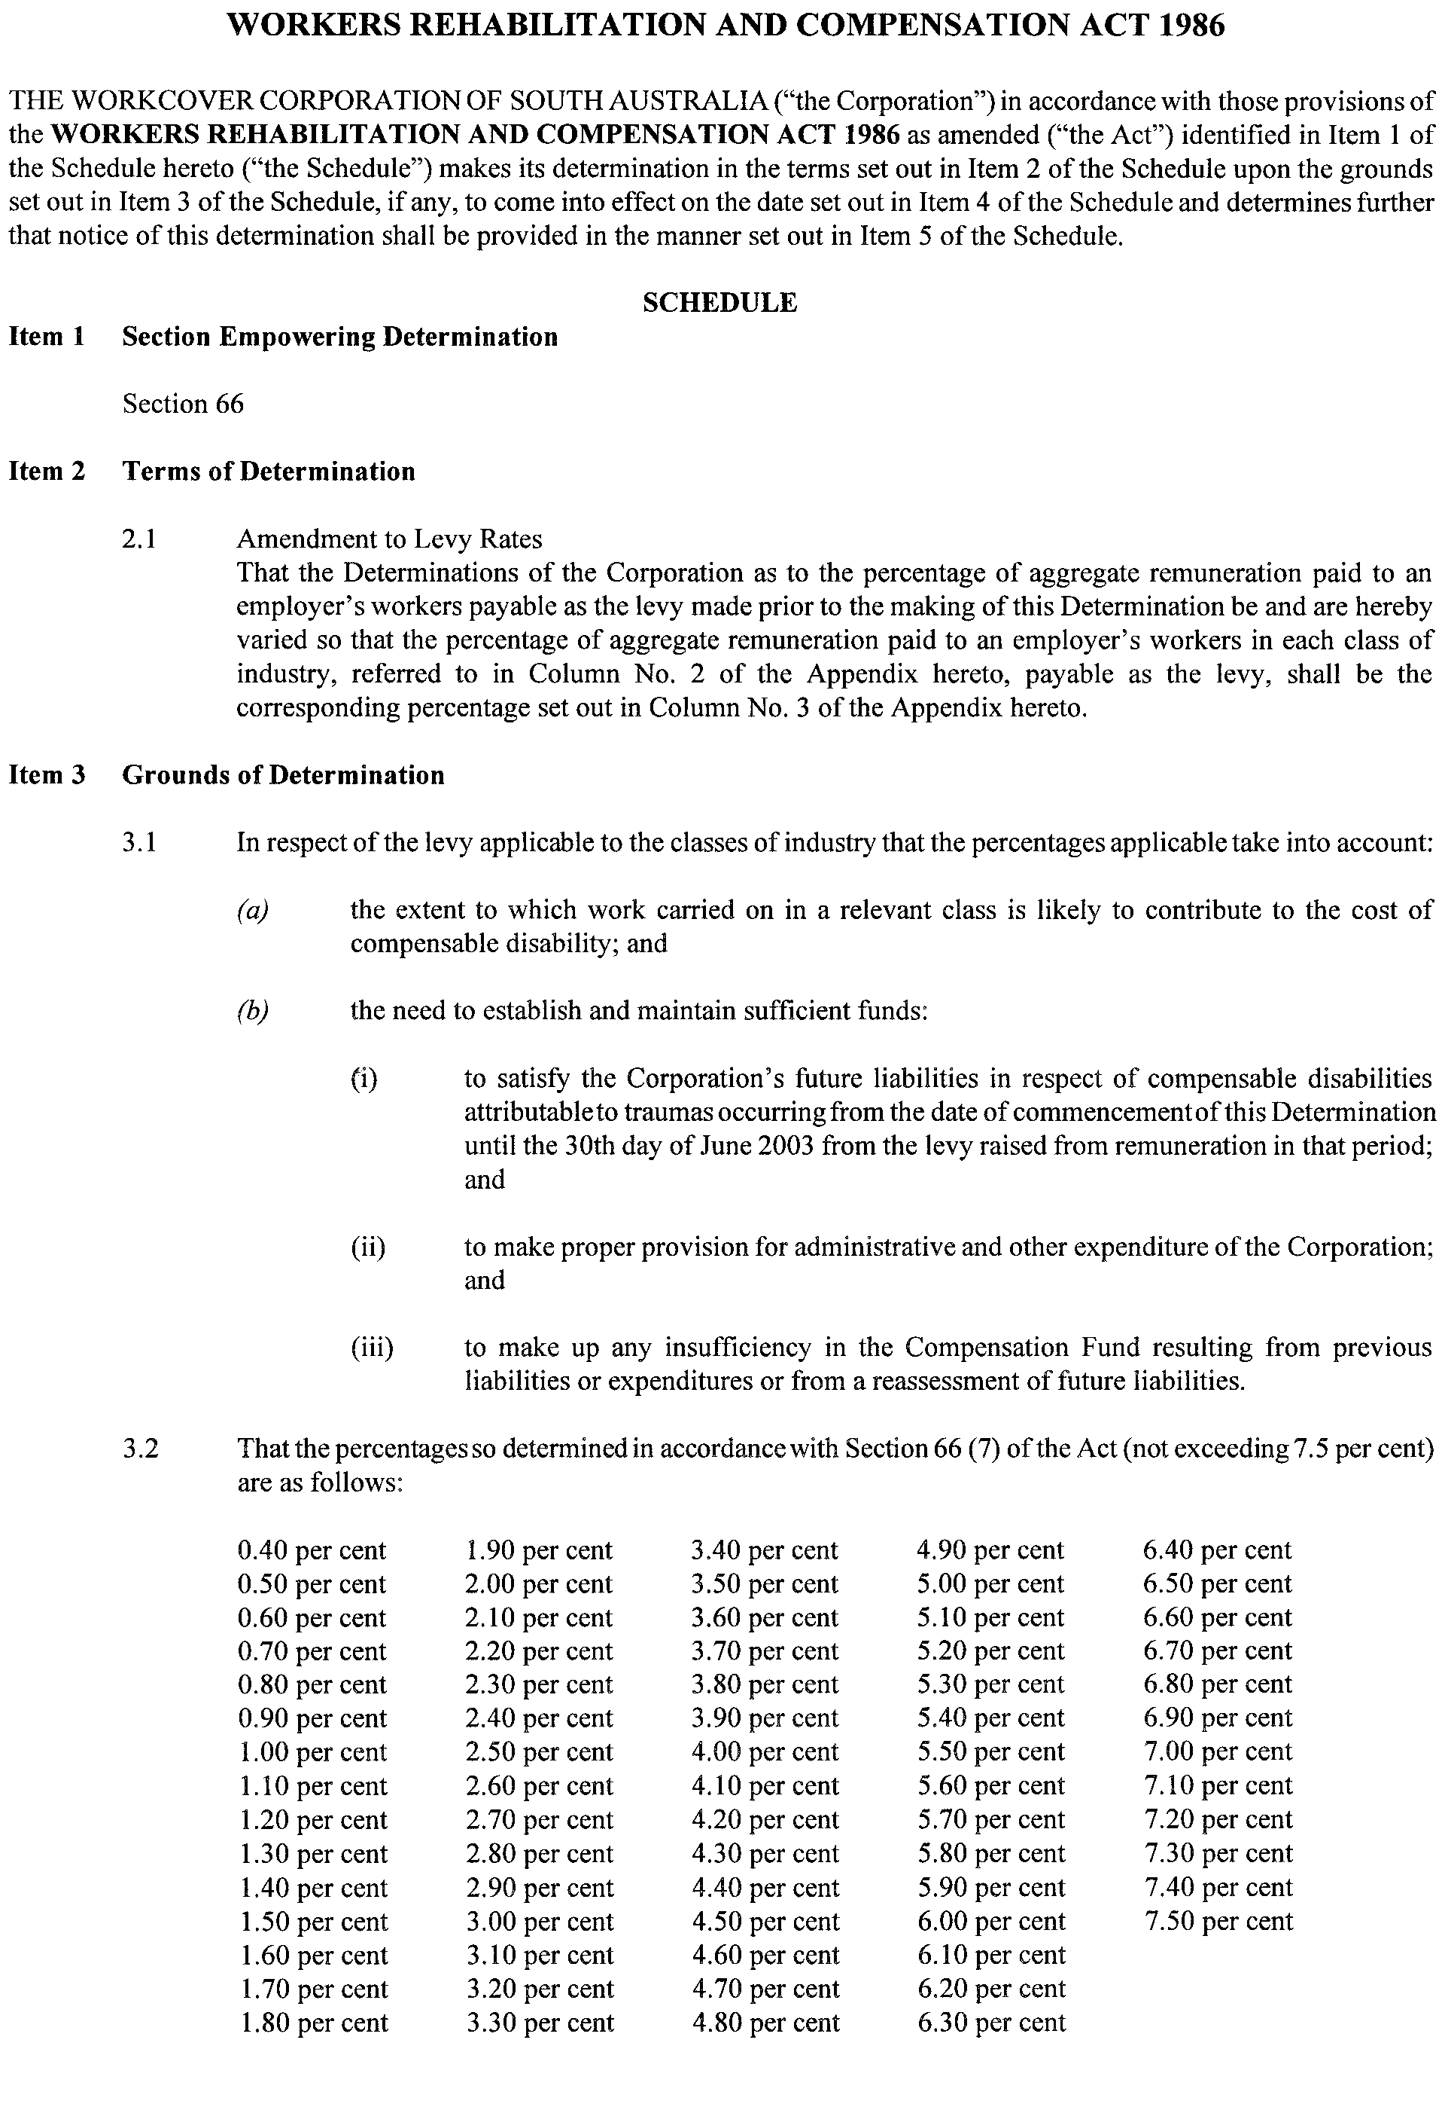
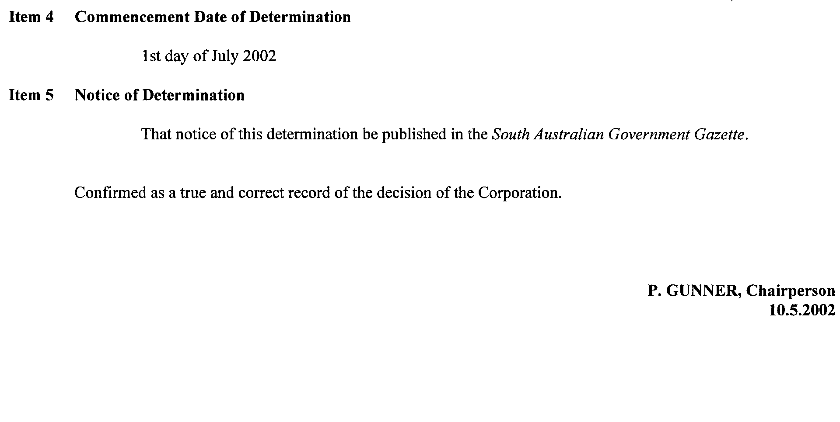
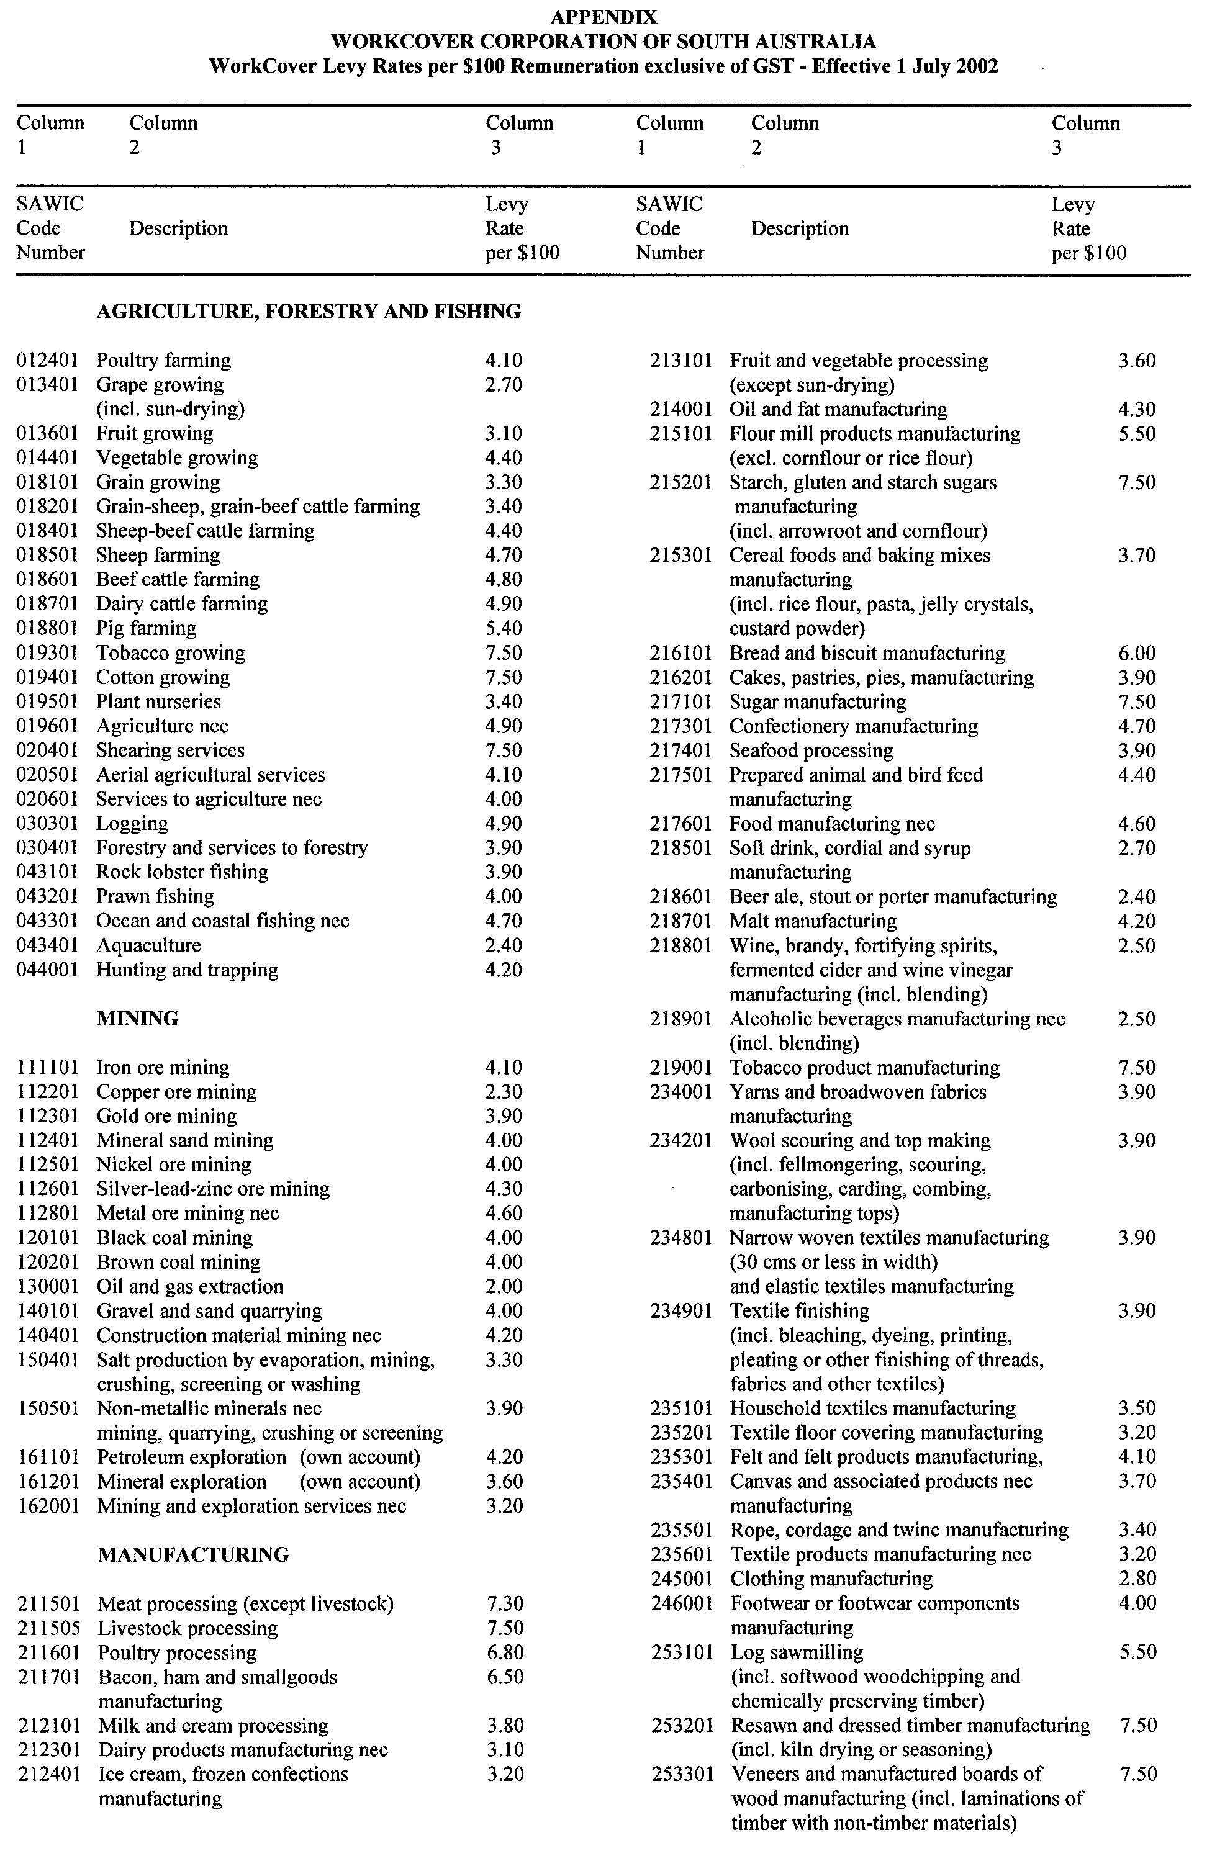
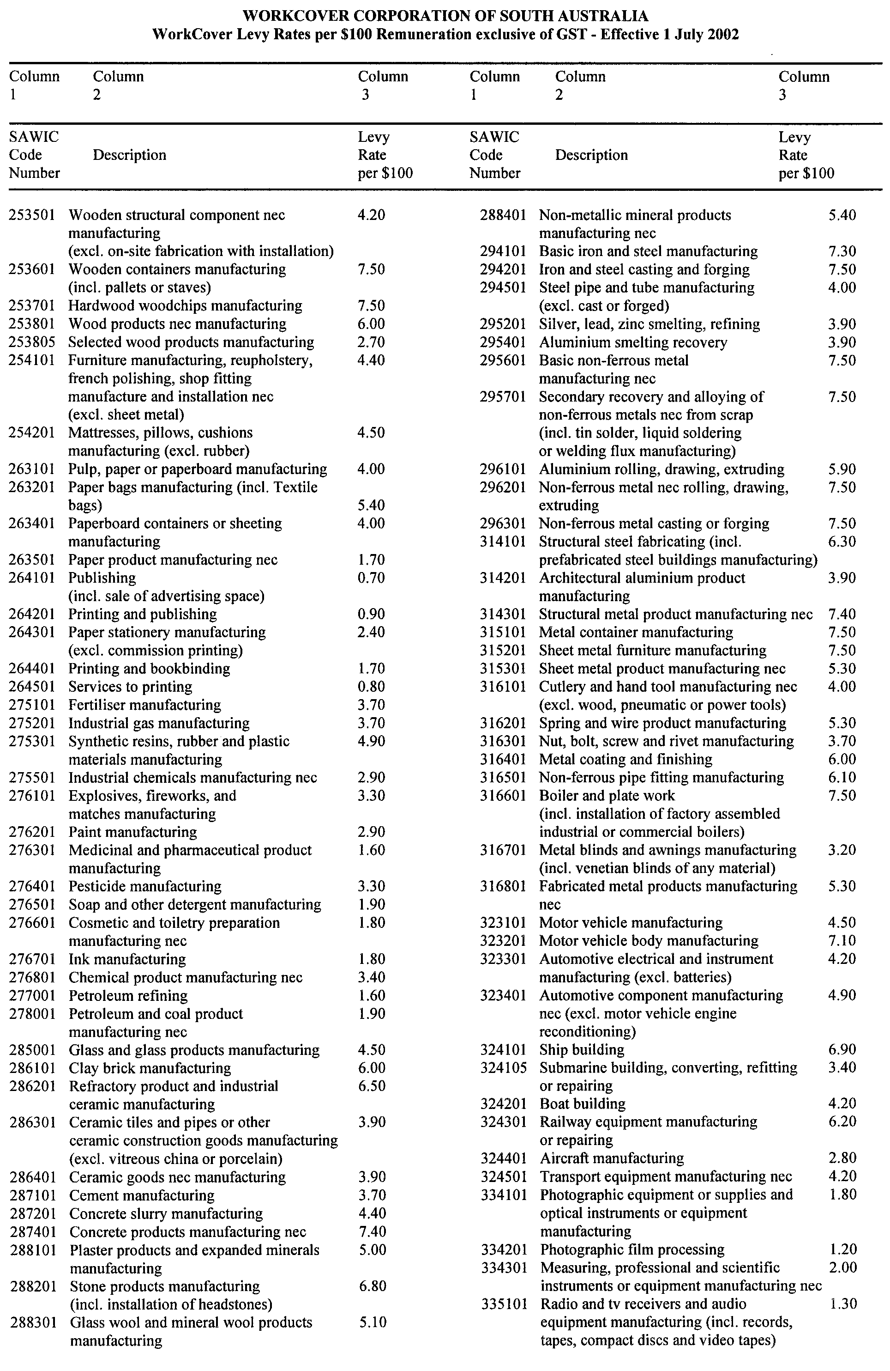
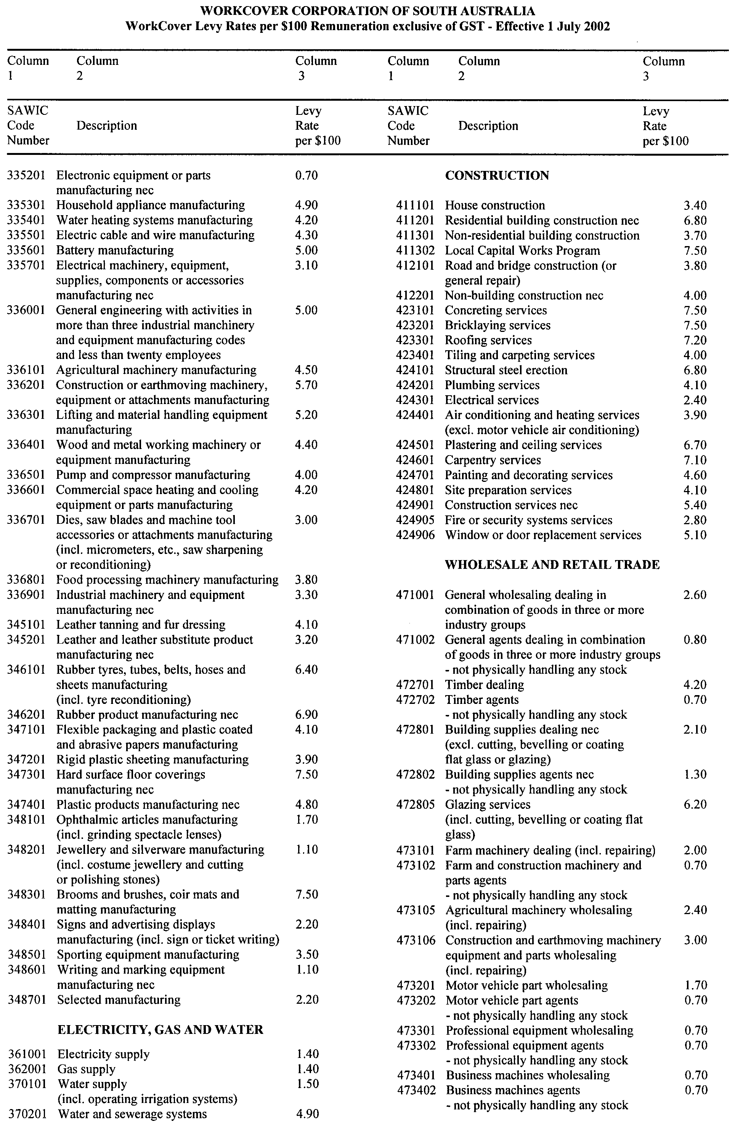
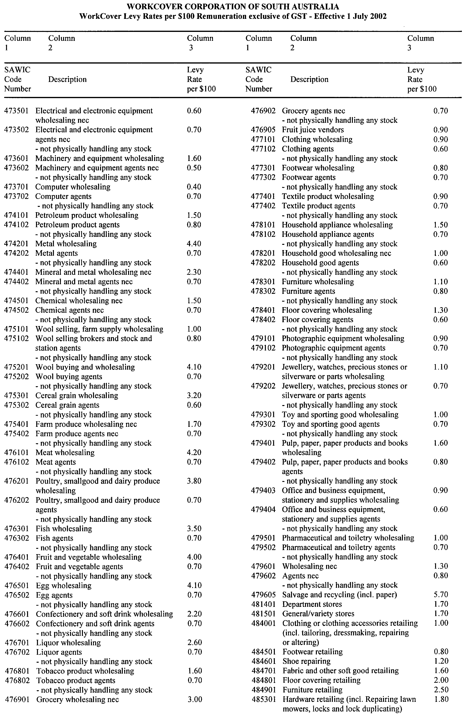
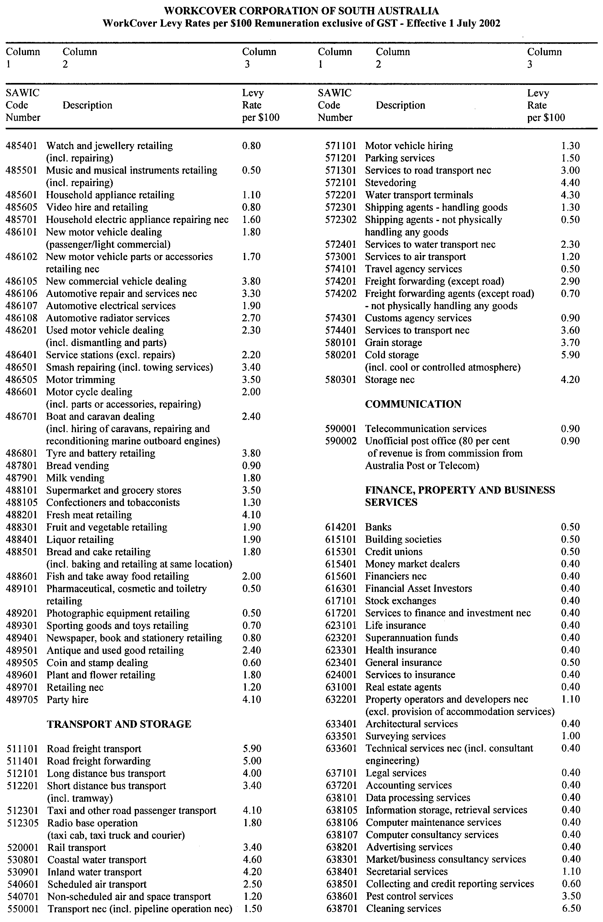
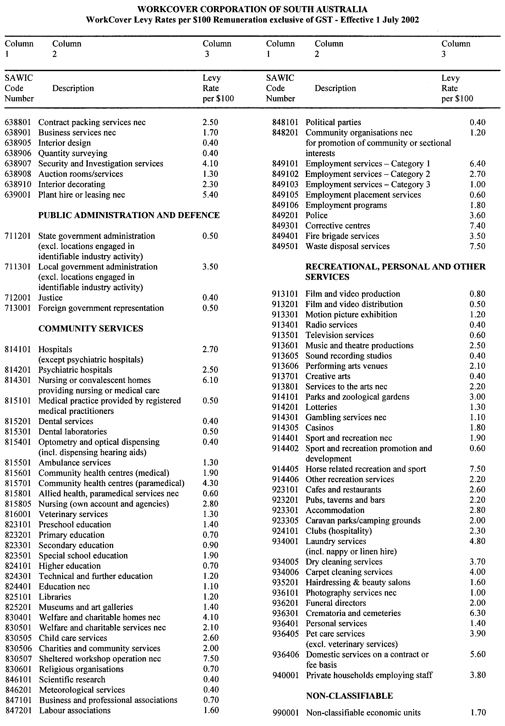


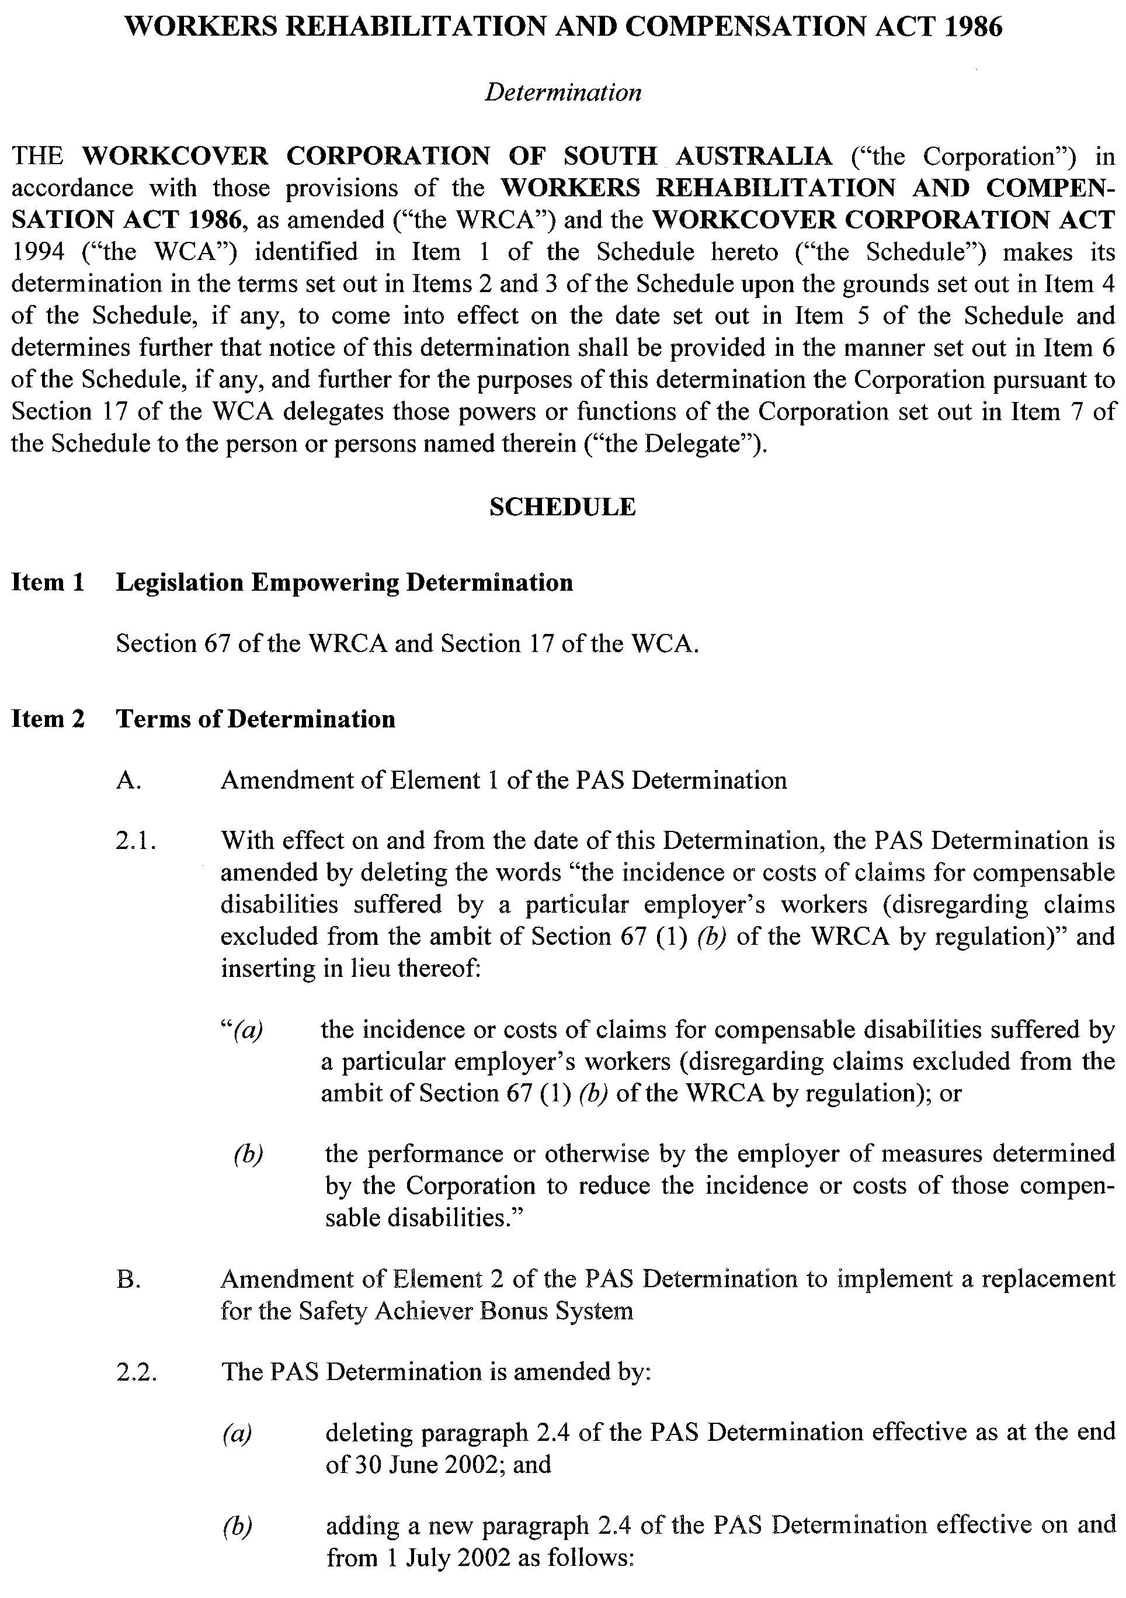
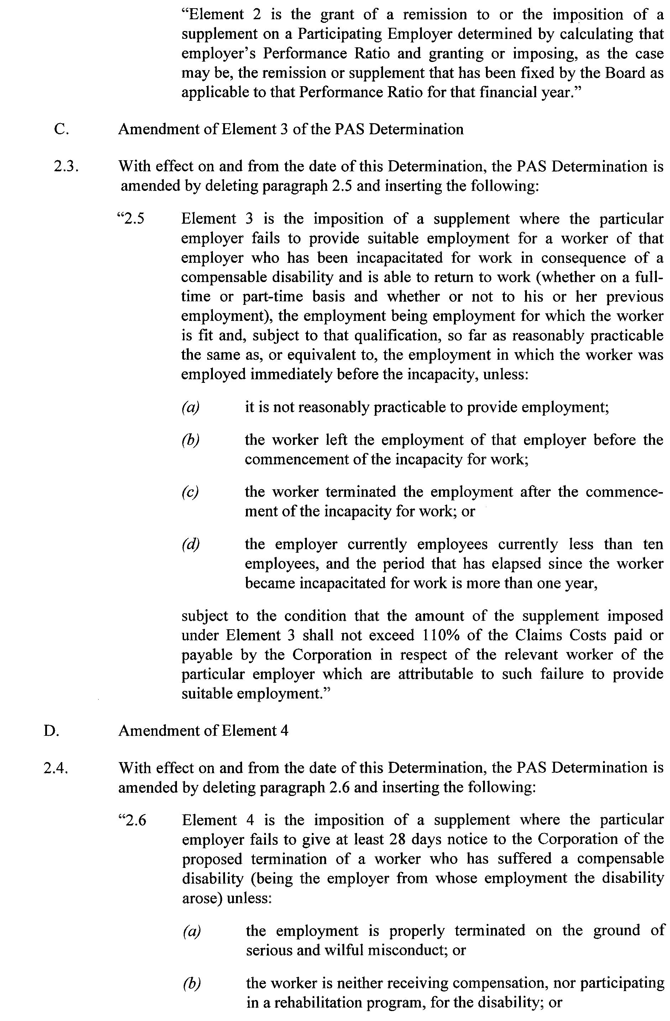
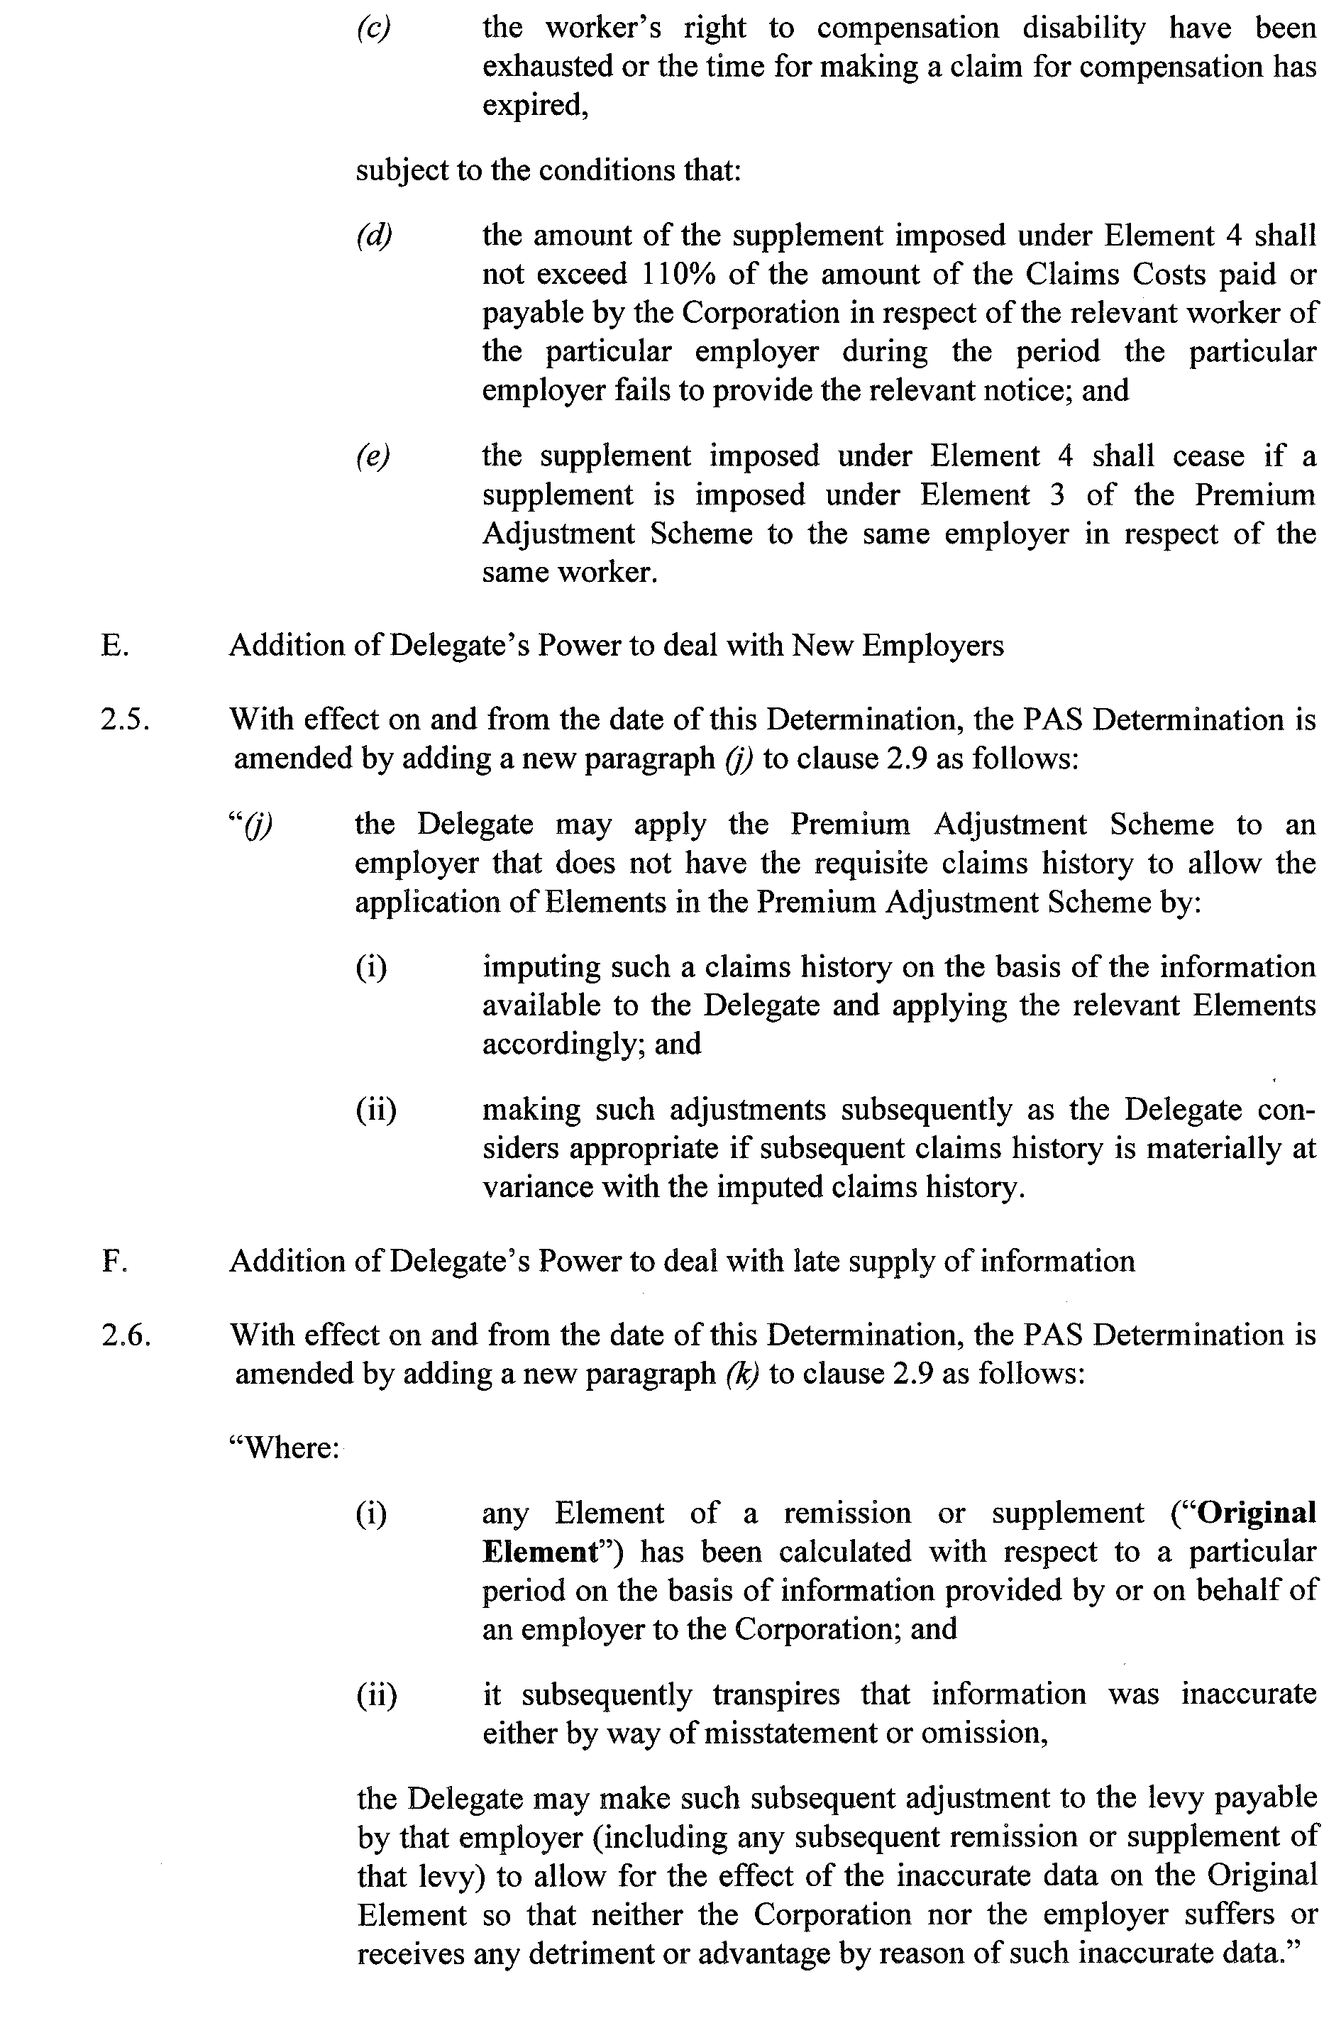
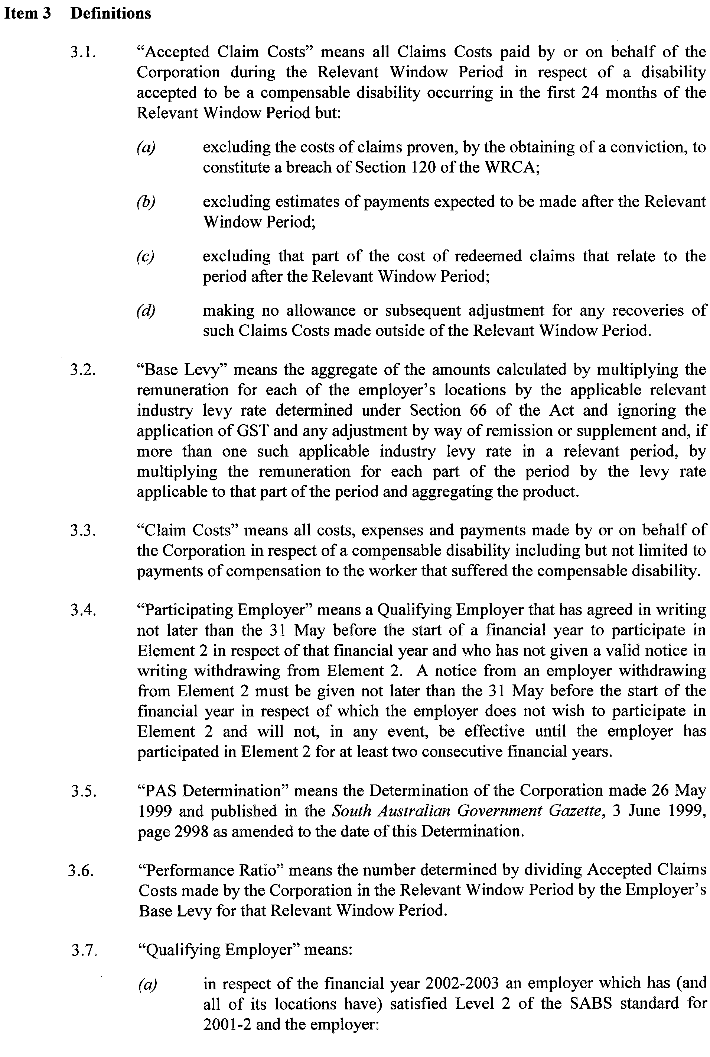
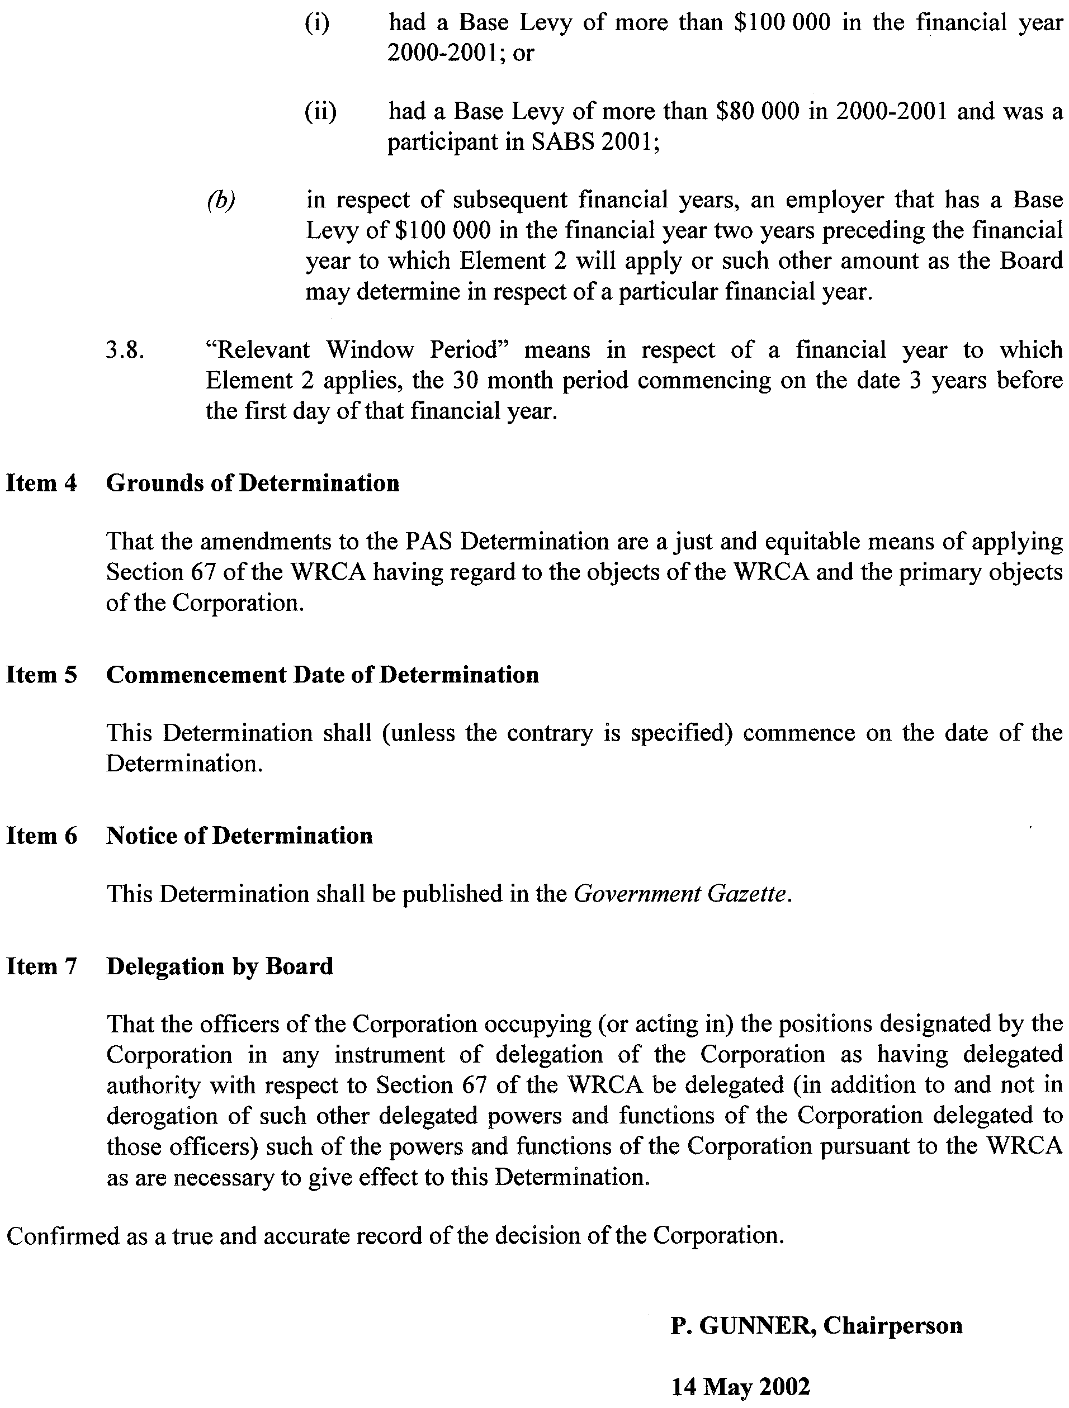

VOCATIONAL EDUCATION, EMPLOYMENT AND TRAINING ACT 1994

PART 4 - CONTRACTS OF TRAINING
Pursuant to the provisions of the Vocational Education, Employment and Training Act (VEET Act),
the Accreditation and Registration Council (ARC) gives notice that it has determined the following:

Occupations that Constitute Trades and Other Declared Vocations
The following schedule is additional to the gazettals of:
1. 24 April 1996 (pg 2045) | 29. 6 May 1999 (pg 2482) | 57. 19 April 2001 (pg 1645)
2. 31 October 1996 (pg 1544) | 30. 13 May 1999 (pg 2595) | 58. 31 May 2001 (pg 1914)
3. 5 December 1996 (pg 1818) | 31. 27 May 1999 (Errata) (pg 2723) | 59. 28 June 2001 (pg 2416)
4. 6 February 1997 (pg 830) | 32. 17 June 1999 (pg 3123) | 60. 12 July 2001 (Errata) (pg 2610)
5. 17 April 1997 (pg 1571) | 33. 24 June 1999 (pg 3261) | 61. 19 July 2001 (Errata) (pg 2713)
6. 29 May 1997 (pg 2758) | 34. 1 July 1999 (pg 22) | 62. 26 July 2001 (pg 2785)
7. 12 June 1997 (pg 2984) | 35. 29 July 1999 (pg 602) | 63. 16 August 2001 (pg 3091)
8. 3 July 1997 (pg 33) | 36. 30 September 1999 (pg 1364) | 64. 20 September 2001 (pg 4268)
9. 7 August 1997 (pg 311) | 37. 14 October 1999 (pg 1973) | 65. 27 September 2001 (pg 4316)
10. 18 December 1997 (pg 1677) | 38. 11 November 1999 (pg 2327) | 66. 11 October 2001 (Errata) (pg 4466)
11. 22 December 1997 (pg 1776) | 39. 6 January 2000 (pg 1169) | 67. 15 November 2001 (pg 5041)
12. 23 April 1998 (pg 1959) | 40. 30 March 2000 (pg 1921) | 68. 29 November 2001 (pg 5227)
13. 18 June 1998 (pg 2594) | 41. 6 April 2000 (pg 2047) | 69. 13 December 2001 (pg 5385)
14. 6 August 1998 (pg 339) | 42. 13 April 2000 (Errata) (pg 2167) | 70. 20 December 2001 (Errata) (pg 5646)
15. 24 September 1998 (pg 990) | 43. 4 May 2000 (pg 2416) | 71. 10 January 2002 (pg 19) Errata (pg 20)
16. 1 October 1998 (pg 1038) | 44. 18 May 2000 (pg 2606) Errata (pg 2609) | 72. 14 February 2002 (pg 861) Errata (pg 869)
17. 15 October 1998 (pg 1150) | 45. 15 June 2000 (pg 3282) Errata (pg 3285) | 73. 14 March 2002 (pg 1329)
18. 12 November 1998 (pg 1389) | 46. 29 June 2000 (pg 3490) | 74. 11 April 2002 (pg 1579)
19. 19 November 1998 (pg 1583) | 47. 6 July 2000 (pg 22) Errata (pg 24) | 75. 18 April 2002 (pg 1613)
20. 3 December 1998 (pg 1742) | 48. 20 July 2000 (pg 267) | 76. 24 April 2002 (pg 1665) Errata (pg 1666)
21. 10 December 1998 (pg 1870) | 49. 10 August 2000 (pg 467) | 77. 2 May 2002 (Errata) (pg 1809)
22. 17 December 1998 (pg 1954) | 50. 24 August 2000 (pg 643) | 78. 9 May 2002 (Errata) (pg 1852)
23. 23 December 1998 (pg 2039) | 51. 14 September 2000 (pg 2002)
24. 11 March 1999 (pg 1359) | 52. 12 October 2000 (pg 2475) Errata (pg 2480)
25. 25 March 1999 (pg 1480) | 53. 16 November 2000 (pg 3208) Errata (pg 3211)
26. 1 April 1999 (Errata) (pg 1605) | 54. 7 December 2000 (pg 3461) Errata (pg 3467)
27. 22 April 1999 (pg 2219) | 55. 15 February 2001 (pg 641) Errata (pg 647)
28. 29 April 1999 (Errata) (pg 2381) | 56. 5 April 2001 (pg 1561)
which set out the occupations that constitute trades and other declared vocations and the terms and conditions applicable to
such declared vocations.

SCHEDULE - DECLARED VOCATIONS, REQUIRED COURSES OF INSTRUCTION AND ASSOCIATED CONDITIONS

Changes to courses and conditions determined by ARC for existing Declared Vocations appear in Bold.

Occupation/Occupation Levels  Declared Vocation  * Trade  # Other than trade | Course code  National / State  and expiry date | Approved Course of Instruction and Stream |  | Nominal Term of  Contract of  Training |  | Nominal hours  of attendance  at approved course |  | Probationary Period
# Customer Servicing (General Retail) |  | Retail Training Package
ARC July 1998 | WRR10197 | Certificate I in Retail Operations | exit point
ARC July 1998 | WRR20197 | Certificate II in Retail Operations (Level 2) | 12 months |  | 375 hours |  | 1 month
ARC July 1998 | WRR30197 | Certificate III in Retail Operations (Level 3) | 12 months |  | 279 hours |  | 1 month
 |  | Note: Completion of Certificate II (WRR20197) is a prerequisite for entry to Certificate III
ARC July 2000 | WRR40197 | Certificate IV in Retail Management | 12 months |  | 332 hours |  | 2 months
 |  | A pre-requisite for the above Certificate is successful completion of Certificate III in Retail Operations – National Code WRR30197
 |  | OR
ARC July 2000 | WRR40197  Incorporating  WRR30197 | Certificate IV in Retail Management  Incorporating  Certificate III in Retail Operations | 24 months |  | 611 hours |  | 2 months
 |  | Certificate III and Certificate IV in Retail Operations should be nested together over 24 months with a consecutive 12 month exit period for both certificates. A three month lay period should be allowed between exit at Certificate III and commencement of Certificate IV.
 |  | As has been agreed nationally, employees who are undertaking this traineeship shall be covered by the terms of the Retail Industry (SA) Award as opposed to any additional provision under the Training Wage Provisions Schedule of the Award.
 |  | Wholesale Training Package
ARC May 2002 | WRW20101 | Certificate II in Wholesale Operations | 12 months |  | 367 hours |  | 1 month
ARC May 2002 | WRW30101 | Certificate III in Wholesale Operations | 24 months |  | 646 hours |  | 2 months
ARC May 2002 | WRW40101 | Certificate IV in Wholesale Management | 36 months |  | 1084 hours |  | 3 months
 |  | Woolworths Supermarkets Enterprise Training Package
ARC December 1999 | ZWA20199 | Certificate II in Woolworths Store Operations | 12 months (36 months part time) |  | 384 hours |  | 1 month (3 months part time)
ARC December 1999 | ZWA20299 | Certificate II in Woolworths Bakery Retail | 12 months (36 months part time) |  | 384 hours |  | 1 month (3 months part time)
ARC December 1999 | ZWA20399 | Certificate II in Woolworths Meat Retail | 12 months (36 months part time) |  | 388 hours |  | 1 month (3 months part time)
ARC December 1999 | ZWA30199 | Certificate III in Woolworths Store Operations | 24 months (36 months part time) |  | 294 hours |  | 1 month (3 months part time)
ARC December 1999 | ZWA30299 | Certificate III in Woolworths Fresh Food Operations | 24 months (36 months part time) |  | 390 hours |  | 1 month (3 months part time)
ARC December 1999 | ZWA30499 | Certificate III in Woolworths Bakery Retail | 24 months (36 months part time) |  | 294 hours |  | 1 month (3 months part time)
ARC December 1999 | ZWA30599 | Certificate III in Woolworths Meat Retail | 24 months (36 months part time) |  | 296 hours |  | 1 month (3 months part time)
ARC December 1999 | ZWA40399 | Certificate IV in Woolworths Bakery Retail | 36 months (72 months part time) |  | 343 hours |  | 3 months
ARC December 1999 | ZWA40499 | Certificate IV in Woolworths Meat Retail | 36 months (72 months part time) |  | 335 hours |  | 3 months
 |  | Floristry Training Package
ARC December 1999 | WRF20199A | Certificate II in Floristry | 12 months |  | 457 hours |  | 1 month
ARC December 1999 | WRF30199A | Certificate III in Floristry | 36 months |  | 730 hours |  | 3 months
ARC April 1997 | 3341  VI2211AEA  31 Dec 02 | Certificate II in Furnishing (Product Knowledge Traineeship)  (Level 2) | 12 months |  | 398 hours |  | 1 month
ARC June 1999 | 10479VIC  VI2211ASB  30 June 02 | Certificate II in Food Retail – McDonald’s | 12 months |  | 417 hours |  | 1 month
 | 10478VIC  VI2211AIB  30 June 02 | The Certificate I in Food Retail – McDonald’s is identified as an exit point and should be issued to trainees who meet the requirements for Certificate I but who exit prior to completing Certificate II level.
ARC March 2001 | 21033VIC  30 June 05 | Certificate II in Direct Sales | 12 months full time or 36 months part time |  | 240 hours |  | 1 month full time or 2 months part time
ARC March 2001 | 21034VIC  30 June 05 | Certificate III in Direct Sales  (Certificate II in Direct Sales is a pre-requisite for this Certificate) | 12 months full time or 36 months part time |  | 360 hours |  | 2 months full time or 4 months part time
ARC March 2001 | 21035VIC  30 June 05 | Certificate IV in Direct Sales Management  (Certificate III in Direct Sales is a pre-requisite for this Certificate) | 24 months full time or 36 months part time |  | 490 hours |  | 3 month full time or 6 months part time
 |  | Certificate in Direct Sales II, III and IV - as has been agreed nationally, employees who are undertaking this traineeship shall be covered by the terms of the Retail Industry (SA) Award.

REGULATIONS UNDER THE SUPERANNUATION ACT 1988
────
No. 29 of 2002
────
At the Executive Council Office at Adelaide, 16 May 2002

PURSUANT to the Superannuation Act 1988 and with the advice and consent of the Executive Council, I make the following regulations.
MARJORIE JACKSON-NELSON, Governor

PURSUANT to section 10AA(2) of the Subordinate Legislation Act 1978, I certify that, in my opinion, it is necessary or appropriate that the following regulations come into operation as set out below.

K. FOLEY, Treasurer
───────────────────
SUMMARY OF PROVISIONS

1. Citation
2. Commencement
3. Variation of reg. 27—Prescription of enterprise agreements
4. Variation of reg. 31—Prescribed authorities, etc.
───────────────────

Citation
1. The Superannuation Regulations 2001 (see Gazette 28 June 2001 p. 2455), as varied, are referred to in these regulations as "the principal regulations".

Commencement
2. These regulations come into operation on the day on which they are made.

Variation of reg. 27—Prescription of enterprise agreements
3. Regulation 27 of the principal regulations is varied—

(a) by inserting before paragraph (a) the following paragraph:

(aa) Adelaide Festival Centre, Professional and Administration Agreement 2001;;

(b) by inserting after paragraph (i) the following paragraph:

(ia) SA Water Corporation Enterprise Agreement 2001;;

(c) by inserting after paragraph (j) the following paragraphs:

(ja) TransAdelaide Infrastructure Certified Agreement 2001;

(jb) TransAdelaide Maintenance Certified Agreement 2001;

(jc) TransAdelaide Operations Certified Agreement 2001;

(jd) TransAdelaide Salaried, Professional and Technical Employees Certified Agreement 2001;.

Variation of reg. 31—Prescribed authorities, etc.
4. Regulation 31 of the principal regulations is varied by inserting "The Ombudsman" after "Murray-Darling Basin Commission".

T&F02/022CS R. DENNIS, Clerk of the Council

REGULATIONS UNDER THE SOUTHERN STATE SUPERANNUATION ACT 1994
────
No. 30 of 2002
────
At the Executive Council Office at Adelaide, 16 May 2002

PURSUANT to the Southern State Superannuation Act 1994 and with the advice and consent of the Executive Council, I make the following regulations.
MARJORIE JACKSON-NELSON, Governor

PURSUANT to section 10AA(2) of the Subordinate Legislation Act 1978, I certify that, in my opinion, it is necessary or appropriate that the following regulations come into operation as set out below.

K. FOLEY, Treasurer
───────────────────
SUMMARY OF PROVISIONS

1. Citation
2. Commencement
3. Variation of reg. 3A—Prescription of enterprise agreements
───────────────────

Citation
1. The Southern State Superannuation Regulations 1995 (see Gazette 29 June 1995 p. 3070), as varied, are referred to in these regulations as "the principal regulations".

Commencement
2. These regulations come into operation on the day on which they are made.

Variation of reg. 3A—Prescription of enterprise agreements
3. Regulation 3A of the principal regulations is varied—

(a) by inserting before paragraph (a) the following paragraph:

(aa) Adelaide Festival Centre, Professional and Administration Agreement 2001;;

(b) by inserting after paragraph (h) the following paragraph:

(ha) SA Water Corporation Enterprise Agreement 2001;;

(c) by inserting after paragraph (i) the following paragraphs:

(j) South Australia Police Enterprise Agreement 2001;

(k) TransAdelaide Infrastructure Certified Agreement 2001;

(l) TransAdelaide Maintenance Certified Agreement 2001;

(m) TransAdelaide Operations Certified Agreement 2001;

(n) TransAdelaide Salaried, Professional and Technical Employees Certified Agreement 2001.

T&F02/022CS R. DENNIS, Clerk of the Council

FAXING COPY?

IF you fax copy to Government Publishing SA for inclusion in the Government Gazette, there is no need to send a Confirmation Copy to us as well.

This creates confusion and may well result in your notice being printed twice.

Please use the following fax number:

Fax transmission: (08) 8207 1040
Phone Inquiries: (08) 8207 1045

Please include a contact person, phone number and order number so that we can phone back with any queries we may have regarding the fax copy.

NOTE: Closing time for lodging new copy (either fax or hard copy) is 4 p.m. on Tuesday preceding the day of publication.

Government Gazette notices can be E-mailed.

The address is:

governmentgazette@saugov.sa.gov.au

Documents should be sent as attachments in Word format.

When sending a document via E-mail, please confirm your transmission with a faxed copy of your document, including the date the notice is to be published.

Fax transmission: (08) 8207 1040
Enquiries: (08) 8207 1045

CITY OF PROSPECT
Periodical Review of Elector Representation
NOTICE is hereby given that the Council of the City of Prospect has now completed the periodical review of its composition and elector representation as required under the provisions of section 12 (4) of the Local Government Act 1999.
A full copy of the review and report is available at the Civic Centre, 128 Prospect Road, Prospect during normal office hours.
Pursuant to section 12 (13) (a) of the said Act, the Electoral Commissioner has certified that the review undertaken by council satisfies the requirements of section 12 and may therefore now be put into effect as from the day of the first general election held after the expiration of five months from the publication of this notice.
The review representation arrangements are as follows:
• Five wards will be retained, however a minor adjustment to the ward boundaries between Nailsworth and Kingston Ward (see The Schedule and Plan below) will be made to ensure a balance of elector representation.
• Retaining a Mayor elected at large.
• Retaining two Ward Councillors for each of the five wards providing a total of 10 Councillors.
• Cease to have three Area Councillors (previously Alder-men).
The effect of this review is that upon the conclusion of the next periodical election to be held in May 2003 there will be 11 elected members representing approximately 15 800 electors.
Council wishes to thank those interested persons who lodged written submissions and addressed the council during the com-munity consultation phases of the review.
The Schedule
Alter and adjust the boundaries of Nailsworth Ward and Kingston Ward of the City of Prospect by severing from the said Nailsworth Ward that portion of the Hundred of Yatala, County of Adelaide, more particularly delineated on the plan published herewith and marked (A) and annexing same to the said Kingston Ward:
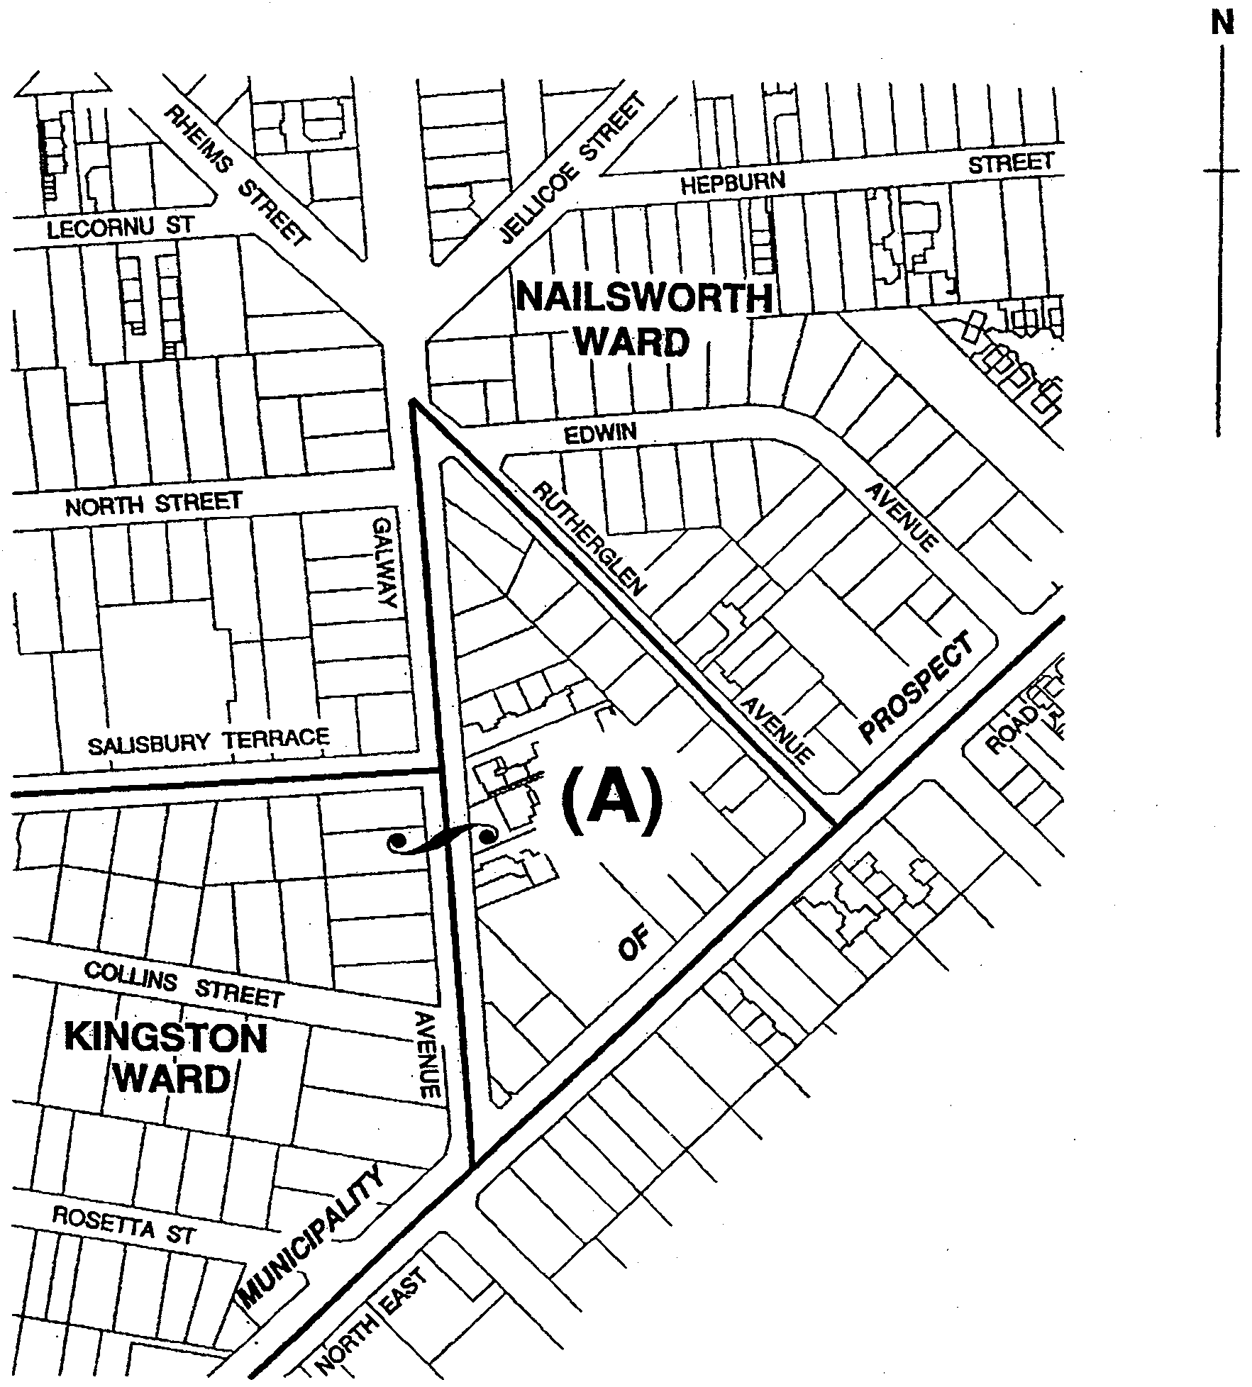
M. Llewellyn-Smith, City Manager

CITY OF PROSPECT
Exclusion of Land from Classification as Community Land
NOTICE is hereby given that on 30 October 2001, council resolved pursuant to section 193 (1) (a) of the Local Government Act 1999, having conducted the public consultation process, that the following land be excluded from the classification as Community Land:
• The Civic Centre site including the Council Offices, Town Hall and the Vine Street Community Hall—CT’s 5473/585, 5564/118, 5590/136, 5736/540 and 5839/708.
• The Council Depot site at 82 Johns Road, Prospect—CT’s 3800/29, 3840/145, 3800/29, 3870/144, 5576/393 and 5820/95.
• The Landscaped Road Reserve on the north-west corner of Main North Road/Regency Road—CT 3771/110.
• The Landscaped Road Reserve on the south-west corner of Main North Road/Regency Road—CT 5798/936.
• The Council Plant Nursery adjacent to the Memorial Gardens Reserve—CT 5792/763.
M. Llewellyn-Smith, Chief Executive Officer

CITY OF WHYALLA
Periodical Review
NOTICE is hereby given that the Corporation of the City of Whyalla, in accordance with the requirements of section 12 (4) of the Local Government Act 1999, has reviewed its composition and elector representation arrangements.
Pursuant to section 12 (13) (a) of the said Act, the Electoral Commissioner has certified that the review undertaken by council satisfies the requirements of section 12 and may therefore now be put into effect as from the day of the first general election held after the expiration of five months from the publication of this notice.
The revised representation arrangements are as follows:
1 Mayor
10 Area Councillors (at large representation).
No wards will apply to the council area.
D. Knox, City Manager

ALEXANDRINA COUNCIL
Change of Council Meeting Date and Venue
NOTICE is hereby given that the council resolved at its meeting held on 22 April 2002, to change the date for the scheduled 20 May 2002 council meeting to Tuesday, 21 May 2002, commenc-ing at 4.30 p.m. and that this meeting be held in the Council Chambers, Colman Terrace, Strathalbyn.
J. L. Coombe, Chief Executive

ALEXANDRINA COUNCIL
Notice to Declare Private Road as Public Road
NOTICE is hereby given that pursuant to section 210 of the Local Government Act 1999, it is Alexandrina Council’s inten-tion to declare the private laneway between Lot 4 of Filed Plan 5838 and Lot A of Road Plan 5840 within the township of Strathalbyn as a public road for the purpose of closure and sale of the laneway to the Strathalbyn Bowling Club Inc. by way of the Roads (Opening and Closing) Act 1991.
J. L. Coombe, Chief Executive

THE BERRI BARMERA COUNCIL
Roads (Opening and Closing) Act 1991
Old Sturt Highway, Berri
NOTICE is hereby given pursuant to section 10 of the Roads (Opening and Closing) Act 1991, that The Berri Barmera Council proposes to make a Road Process Order to close, sell and transfer to Panorama Park Stud Pty Ltd the portion of Sturt Highway adjoining section 946, Berri Irrigation Area, shown marked ‘A’ on Preliminary Plan No. 02/0029.
A copy of the plan and statement of persons affected are available for public inspection at Council’s Office, 19 Wilson Street, Berri, S.A. 5343 and the office of the Surveyor-General, 101 Grenfell Street, Adelaide, S.A. 5000 during normal office hours.
Any application for easement or objections must be made in writing within 28 days from 17 May 2002, to the Council, P.O. Box 229, Berri, S.A. 5343 and the Surveyor-General, G.P.O. Box 1354, Adelaide, S.A. 5001, setting out full details. Where a submission is made, council will give notification of a meeting to deal with the matter.
Dated 16 May 2002.
M. J. Hurley, Chief Executive Officer

THE BERRI BARMERA COUNCIL
Roads (Opening and Closing) Act 1991
Old Sturt Highway, adjacent Greek Orthodox Church, Berri
NOTICE is hereby given pursuant to section 10 of the Roads (Opening and Closing) Act 1991, that The Berri Barmera Council proposes to make a Road Process Order to close, sell and transfer to the Greek Orthodox Community of Berri the portion of Sturt Highway adjoining allotment 100 in Deposited Plan 32427, shown marked ‘B’ on Preliminary Plan No. 02/0027.
A copy of the plan and statement of persons affected are available for public inspection at Council’s Office, 19 Wilson Street, Berri, S.A. 5343 and the office of the Surveyor-General, 101 Grenfell Street, Adelaide, S.A. 5000 during normal office hours.
Any application for easement or objections must be made in writing within 28 days from 17 May 2002, to the Council, P.O. Box 229, Berri, S.A. 5343 and the Surveyor-General, G.P.O. Box 1354, Adelaide, S.A. 5001, setting out full details. Where a submission is made, council will give notification of a meeting to deal with the matter.
Dated 16 May 2002.
M. J. Hurley, Chief Executive Officer

THE BERRI BARMERA COUNCIL
Naming of Roads
NOTICE is hereby given that pursuant to section 219 of the Local Government Act 1999, council has passed a resolution to assign the following names to various unnamed roads within its council district:
Harris Road, Monash, between Trenaman and McKay Roads;
Migga Road, Winkie, off Lower Winkie Road;
VonBertouch Road, Winkie, between Hunt and Bullpit Roads;
Marks Road, Barmera, behind Cocksedge Road;
Drogemuller Road, Cobdogla, between Sturt Highway and Shueard Road;
Walsh Road, Cobdogla, between Mudge Street and Spiller Road.
A resolution to this effect was passed at the council meeting of 23 April 2002.
M. J. Hurley, Chief Executive Officer

CLARE & GILBERT VALLEYS COUNCIL
Alteration to Meeting Time
NOTICE is hereby given that the council meeting to be held on 22 May 2002, will commence at 7 p.m. in lieu of 8 p.m.
M. A. Goldstone, Chief Executive Officer

DISTRICT COUNCIL OF YORKE PENINSULA
Roads (Opening and Closing) Act 1991
Portion of East Terrace, Ardrossan
NOTICE is hereby given, pursuant to section 10 of the Roads (Opening and Closing) Act 1991, that the District Council of Yorke Peninsula proposes to make a Road Process Order to close that portion of public road adjacent to Allotment 120 in FP 197491 and Allotment 121 in FP 197492 (being portion of East Terrace, Ardrossan), more particularly delineated and marked ‘A’ and ‘B’ in Preliminary Plan No. PP02/0038. The portion marked ‘A’ is to be transferred to the adjacent owner and merged with Allotment 121 in FP 197492 held in certificate of title 5707/980 and the portion marked ‘B’ is to be added to section 393, Hundred of Cunningham, held in Crown Record 5338/49, which land is dedicated under the Crown Lands Act 1929 for parkland purposes.
A copy of the preliminary plan and statement of persons affected is available for public inspection at the Council Office, 8 Elizabeth Street, Maitland, S.A. 5573, or at the Adelaide office of the Surveyor-General during normal office hours.
Any person affected may object to the proposed road process, or apply for an easement to be granted in the person’s favour over land subject to the proposed road closure. Such objection, or application for an easement, must set out the full name and address of the person, and reason for making the objection or application. Any application for an easement must give full particulars of the nature and location of the easement and, where made by a person as the owner of adjoining or nearby land, specify the land to which the easement is to be annexed.
An objection, or application for an easement, must be lodged in writing to the District Council of Yorke Peninsula, 8 Elizabeth Street, Maitland, S.A. 5573, and a copy lodged with the Surveyor-General, Department of Administrative and Information Services, G.P.O. Box 1354, Adelaide, S.A. 5001, within 28 days of this notice.
Where an objection, or application for an easement is made, the council will give notification of a meeting at which the matter will be considered, so that the person making the objection or application may attend, if desired, personally or by a representative.
Dated 6 May 2002.
S. Griffiths, Chief Executive Officer

IN the matter of the estates of the undermentioned deceased persons:
Bamford, Sylvia, late of 38 Tolley Road, Hope Valley, home duties, who died on 26 February 2002.
Chester, Bascomb Elliott, late of 9 West Terrace, Kimba, retired tramway employee, who died on 22 March 2002.
Coombe, Lilian Katharine, late of Grainger Road, Somerton Park, widow, who died on 17 January 2002.
Cossich, Jean Kingsbury, late of 9 Winchester Street, St Peters, of no occupation, who died on 30 March 2002.
Dodd, Elaine Beatrice, late of 51 Eighth Avenue, St Peters, of no occupation, who died on 3 February 2002.
Donlan, Brian Leslie, late of 3 Glen Avenue, Tranmere, retired postman, who died on 3 February 2002.
Doust, Elsie Ethel, late of 17-19 Cornhill Road, Victor Harbor, of no occupation, who died on 12 February 2002.
Ferguson, Eric Anzac, late of 39 Queens Avenue, Mount Gambier, widow, who died on 11 January 2002.
Howley, Francis Joseph, late of 336 Marion Road, North Plympton, of no occupation, who died on 27 February 2002.
King, Arthur Walter Leslie, late of Bellevue Court, Gawler East, retired leading hand painter, who died on 27 February 2002.
King, Gladys Dorothy Celestine, late of 7 Railway Terrace, Old Reynella, of no occupation, who died on 8 March 2002.
Malone, Mary Clare, late of 36 Cheltenham Street, Highgate, home duties, who died on 7 March 2002.
Maytum, Kathleen Winnifred, late of 336 Kensington Road, Leabrook, retired primary school teacher, who died on 15 April 2002.
McKenzie, Kenneth Malcolm, late of 39 Finniss Street, Marion, retired clerical officer, who died on 25 March 2002.
Owers, Bruce William, late of Andrews Road, Penfield, retired waterside worker, who died on 30 January 2002.
Payne, Colin James, late of 35 Dutchman Drive, Hallett Cove, commission agent, who died on 20 March 2002.
Peckham, Henry Joseph, late of 57 Mullers Road, Hampstead Gardens, retired engine driver, who died on 31 December 2001.
Reid, Violet Ellen, late of 4 Sylvan Way, Grange, widow, who died on 16 April 2002.
Richman, Rebecca Mabel, late of 15-17 Brighton Road, Glenelg, of no occupation, who died on 12 November 2001.
Roberts, Graham John, late of 60 Whalers Road, Encounter Bay, retired farmer, who died on 12 March 2002.
Rule, Doreen Winifred, late of 18 McHarg Road, Happy Valley, retired school teacher, who died on 26 January 2002.
Sharples, Noreen Lillian Wilhelmina, late of 7 Railway Terrace, Old Reynella, of no occupation, who died on 20 March 2002.
Smallacombe, Ella Alice, late of 157 Beulah Road, Norwood, of no occupation, who died on 13 March 2002.
Smith, Edith Mary, late of Walkerville Terrace, Walkerville, of no occupation, who died on 17 March 2002.
Thompson, David Edwin, late of 55-59 Ferguson Avenue, Myrtle Bank, of no occupation, who died on 14 April 2002.
Thompson, Grace Lillian, late of 2 Scott Street, Firle, widow, who died on 17 November 2001.
Thompson, Leonard Arthur, late of 2A Second Avenue, Glenelg East, retired dentist, who died on 26 December 2001.
Wicks, Ida Mary, late of 29 Austral Terrace, Morphettville, of no occupation, who died on 19 March 2002.
Wood, Nancy Ada Jane, late of 6 Ellis Street, Enfield, widow, who died on 7 March 2002.
Notice is hereby given pursuant to the Trustee Act 1936, as amended, the Inheritance (Family Provision) Act 1972, and the Family Relationships Act 1975, that all creditors, beneficiaries, and other persons having claims against the said estates are required to send, in writing, to the Public Trustee, 25 Franklin Street, Adelaide 5000, full particulars and proof of such claims, on or before 14 June 2002, otherwise they will be excluded from the distribution of the said estate; and notice is also hereby given that all persons who are indebted to the said estates are required to pay the amount of their debts to the Public Trustee or proceedings will be taken for the recovery thereof; and all persons having any property belonging to the said estates are forthwith to deliver the same to the Public Trustee.
Dated 16 May 2002.
C. J. O’Loughlin, Public Trustee

IN the matter of the estates of the undermentioned deceased persons:
Parkinson, Vera May, late of Alan Tinsley Hostel, 50 Woodcroft Drive, Morphett Vale, widow, who died on 28 February 2002.
Heynen, Johanna Paulina Maria, late of 17 Hawaii Court, West Lakes, married woman, who died on 2 April 2002.
Notice is hereby given pursuant to the Trustee Act 1936, the Inheritance (Family Provision) Act 1972 and the Family Relationships Act 1975, that all creditors, beneficiaries and other persons having claims against either of the above estates are directed to send full particulars and evidence of such claims to the undersigned on or before 17 June 2002, otherwise they will be excluded from the distribution of the estate; and notice is also hereby given that all persons who are indebted to either of the above estates are required to pay the amount of their debt to the undersigned or proceedings will be taken for the recovery thereof; and all persons having any property belonging to either of the said estates are forthwith to deliver the same to the undersigned.
ANZ Executors & Trustee Company Limited (ACN 006 132 332), 530 Collins Street, Melbourne, Victoria 3000.

SOUTH AUSTRALIA—In the Supreme Court. No. 683 of 1999. In the matter of Anneleigh Investments Pty Ltd (in liquidation) (ACN 076 806 543) and in the matter of the Corporations Act 2001.
Notice by a Liquidator of His Intention to Seek His Release
Take notice that I, Austin Robert Meerten Taylor, c/o Grant Thornton, 67 Greenhill Road, Wayville, S.A. 5034, the liquidator of the abovenamed company, intend to make application to the Supreme Court of South Australia for my release as the liquidator of the abovenamed company.
And take further notice that if you have any objection to the granting of my release you must file at the Supreme Court and also forward to me, within 21 days of the publication in the Gazette of the notice of my intention to apply for a release a notice of objection in the form laid down by the Corporations (South Australia) Rules 1993. A summary of my receipts and payments as liquidator is available from my office.
Dated 13 May 2002.
A. R. M. Taylor, Liquidator
Note: Section 481 (3) of the Corporations Act 2001 enacts that an order of the Court releasing a liquidator shall discharge him/her in the administration of the affairs of the company, or otherwise in relation to his or her conduct as liquidator, but any such order may be revoked on proof that it was obtained by fraud or by suppression or by concealment of any material fact.

CASADEI AUSTRALIA PTY LTD
(ACN 007 929 982)
Appointment
TAKE notice that I, Robert Cesana was on 2 April 2002 appointed, pursuant to Registered Charge No. 561029, as a Controller (other than a receiver and managing controller) to the assets and undertaking of Casadei Australia Pty Ltd (ACN 007 929 982).
Dated 2 April 2002.
R. Cesana

CASADEI AUSTRALIA PTY LTD
(ACN 007 929 982)
Appointment
TAKE notice that on 2 April 2002, a Controller (other than a receiver or managing controller) has been appointed, pursuant to Registered Charge No. 561029, to the assets and undertaking of Casadei Australia Pty Ltd (ACN 007 929 982) by Robert Cesana Nominees Pty Ltd (ACN 007 905 482) and Beverley Joy Cesana.
Dated 2 April 2002.
B. J. Cesana
Robert Cesana Nominees Pty Ltd

ATTENTION

CUSTOMERS requiring a proof of their notice for inclusion in the Government Gazette, please note that the onus is on you to inform Government Publishing SA of any subsequent corrections by 10 a.m. on Thursday, which is our publication deadline.

For any corrections to your notice please phone 8207 1045 or Fax 8207 1040 before 10 a.m. on Thursday.

If we do not receive any communication by 10 a.m. on Thursday (day of publication) we will presume the notice is correct and will print it as it is.

Remember—the onus is on you to inform us of any corrections necessary to your notice.

NOTE: Closing time for lodging new copy (electronically, fax or hard copy) is 4 p.m. on Tuesday preceding the day of publication. Phone 8207 1045—Fax 8207 1040.
Email: governmentgazette@saugov.sa.gov.au

Printed and published by authority every Thursday by J. D. FERGUSON, Government Printer, South Australia
Price: $4.40, plus postage; to subscribers, $220.20 per annum.
(The above prices are inclusive of GST)

