No. 62 1927

THE SOUTH AUSTRALIAN

GOVERNMENT GAZETTE

PUBLISHED BY AUTHORITY

ALL PUBLIC ACTS appearing in this GAZETTE are to be considered official, and obeyed as such

ADELAIDE, THURSDAY, 23 MAY 2002

CONTENTS

Page
Appointments, Resignations, Etc. 1928
Brands Act 1933—Notices 1929
Children’s Protection Act 1993—Notice 1951
Corporations and District Councils—Notices 1988
Development Act 1993—Notices 1951
Electricity Corporations (Restructuring and Disposal)
Act 1999—Notices 1951
Equal Opportunity Act 1984—Notices 1952
Fisheries Act 1982—Notices 1952
Harbors and Navigation Act 1993—Notices 1953
Land Acquisition Act 1969—Notice 1954
Land and Business (Sale and Conveyancing) Act
1994—Notices 1954
Liquor Licensing Act 1997—Notices 1955
Mining Act 1971—Notices 1960
Port Augusta Circuit Court—Notice 1961
Private Advertisements 1990
Page
Proclamation 1928
Public Trustee Office—Administration of Estates 1989
Radiation Protection and Control Act 1982—Notice 1962

REGULATIONS
Fees Regulation Act 1927 (No. 31 of 2002) 1970
Road Traffic Act 1961 (No. 32 of 2002) 1971
Harbors and Navigation Act 1993 (No. 33 of 2002) 1974
Liquor Licensing Act 1997 (No. 34 of 2002) 1977
City of Adelaide Act 1998 (No. 35 of 2002) 1982
Local Government (Elections) Act 1999—
(No. 36 of 2002) 1984
Liquor Licensing Act 1997 (No. 37 of 2002) 1986
Roads (Opening and Closing) Act 1991—Notice 1962
Road Traffic Act 1961—Notice 1928
Rules of Court—Notices 1966
Valuation of Land Act 1971—Notice 1963

GOVERNMENT GAZETTE NOTICES
ALL poundkeepers’ and private advertisements forwarded for publication in the South Australian Government Gazette must be PAID FOR PRIOR TO INSERTION; and all notices, from whatever source, should be legibly written on one side of the paper only and sent to Government Publishing SA so as to be received no later
than 4 p.m. on the Tuesday preceding the day of publication. Phone 8207 1045 or Fax 8207 1040. E-mail: governmentgazette@saugov.sa.gov.au. Send as attachments in Word format and please confirm your transmission with a faxed copy of your document, including the date the notice is to be published and to whom the notice will be charged.

STATUTES AMENDMENT (TRANSPORT PORTFOLIO) ACT 2001 (Act No. 17 of 2001): DAY OF COMMENCE-MENT OF SUSPENDED PROVISIONS
Proclamation By The Governor’s Deputy
(l.s.) Bruno Krumins
WITH the advice and consent of the Executive Council, I fix 27 May 2002 as the day on which sections 5 to 9 (inclusive), 17 to 23 (inclusive) and 26 of the Statutes Amendment (Transport Portfolio) Act 2001 will come into operation.
Given under my hand and the Public Seal of South Australia, at Adelaide, 23 May 2002.
By command,
J. D. Lomax-Smith, for Premier
C99/07291/T1

Department of the Premier and Cabinet
Adelaide, 23 May 2002
HIS Excellency the Governor’s Deputy in Executive Council has been pleased to appoint the undermentioned to the Onkaparinga Catchment Water Management Board, pursuant to the provisions of the Water Resources Act 1997:
Member: (from 23 May 2002 until 22 May 2006)
Debra Kay Just
Cyril Frederick Wear
Anita Aspinall
By command,
J. D. Lomax-Smith, for Premier
MEC 0017/02 CS

Department of the Premier and Cabinet
Adelaide, 23 May 2002
HIS Excellency the Governor’s Deputy in Executive Council has been pleased to appoint the undermentioned to the South East Catchment Water Management Board, pursuant to the provisions of the Water Resources Act 1997:
Member: (from 23 May 2002 until 22 May 2006)
James Leonard Osborne
Graham Ronald Kaye
Maureen Aronda Andrews
Dianne Ashby
Presiding Member: (from 23 May 2002 until 22 May 2006)
James Leonard Osborne
By command,
J. D. Lomax-Smith, for Premier
MEC 0016/02 CS

Department of the Premier and Cabinet
Adelaide, 23 May 2002
HIS Excellency the Governor’s Deputy in Executive Council has been pleased to appoint the undermentioned to the Carrick Hill Trust, pursuant to the provisions of the Carrick Hill Trust Act 1985:
Member: (from 23 May 2002 until 30 April 2005)
Fiona Adler
Robert Hill-Ling
Ivan Brooks
Susan O’Connor
Chair: (from 23 May 2002 until 30 April 2005)
Fiona Adler
Deputy Chair: (from 23 May 2002 until 30 April 2005)
Robert Hill-Ling
By command,
J. D. Lomax-Smith, for Premier
MART 00005/2002 CS

Department of the Premier and Cabinet
Adelaide, 23 May 2002
HIS Excellency the Governor’s Deputy in Executive Council has been pleased to appoint the undermentioned to the Art Gallery Board, pursuant to the provisions of the Art Gallery Act 1939:
Member: (from 22 July 2002 until 21 July 2006)
Michael Abbott
Member: (from 23 May 2002 until 22 May 2005)
Adam Wynn
Chair: (from 22 July 2002 until 21 July 2006)
Michael Abbott
By command,
J. D. Lomax-Smith, for Premier
MART 00007/2002 CS

Department of the Premier and Cabinet
Adelaide, 23 May 2002
HIS Excellency the Governor’s Deputy in Executive Council has been pleased to appoint Grant Douglas Belchamber as a Member of the Economic Development Advisory Board from 23 May 2002 until 10 April 2005, pursuant to section 68 of the Constitution Act 1934.
By command,
J. D. Lomax-Smith, for Premier
DPC 050/96 CS Pt7

APPOINTMENTS TO THE AQUACULTURE ADVISORY COMMITTEE
WHEREAS, pursuant to section 14C(1) of the Acts Interpretation Act 1915, it is expedient that the power to appoint members of the Aquaculture Advisory Committee expressed to be conferred by sections 65 and 66 of the Aquaculture Act 2001 be exercised before those sections come into operation:
I, the Governor’s Deputy, upon the recommendation of and with the advice and consent of the Executive Council, do appoint the people listed below to the Aquaculture Advisory Committee for a term of twelve months with effect from 23 May 2002:
Members:
Richard Stevens
Bruce Zippel
Brian Jeffriess
Michael Whillas
Hagen Stehr
Anthony Cheshire
Michelle Grady
Garth Heynen
Ian Nightingale
Peter Dolan
Presiding Member:
Richard Stevens
Dated 23 May 2002.
Bruno Krumins, Governor’s Deputy

ROAD TRAFFIC ACT 1961, SECTION 47H (1) (a): APPRO-VAL OF APPARATUS AS BREATH ANALYSING INSTRUMENTS
Notice By The Governor’s Deputy
PURSUANT to section 47H (1) (a) of the Road Traffic Act 1961 and with the advice and consent of the Executive Council, I approve apparatus of the following kind as breath analysing instruments:
Dräger Alcotest 7110 Mk V
This notice will take effect on 27 May 2002.
Dated 23 May 2002.
Bruno Krumins, Governor’s Deputy
TSA C97/04395/T2

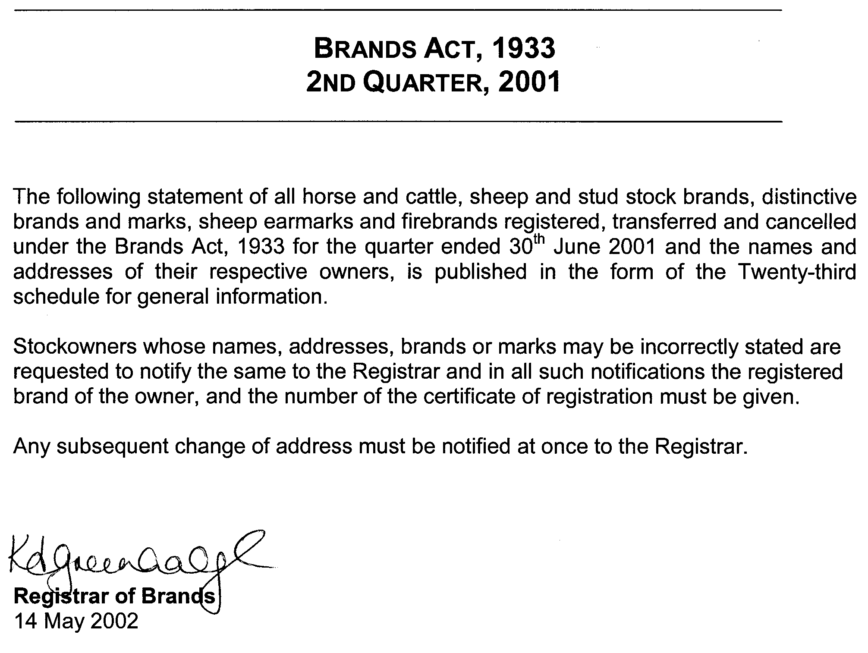
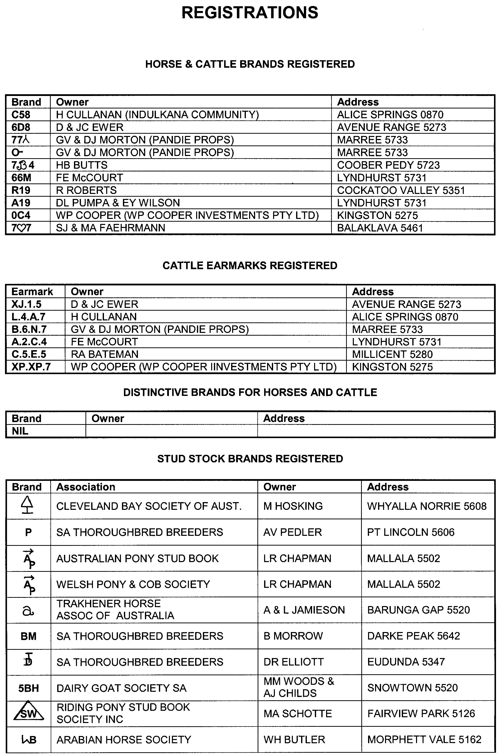
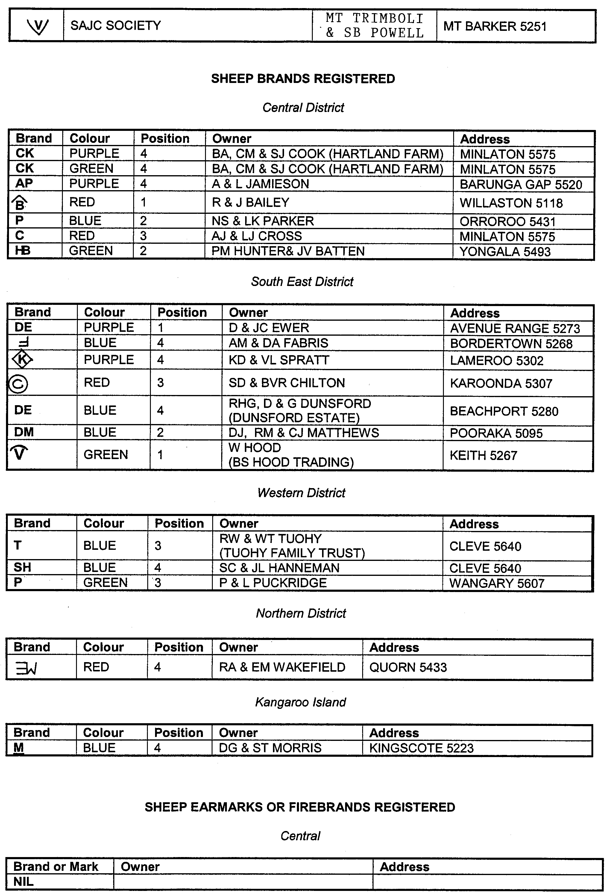
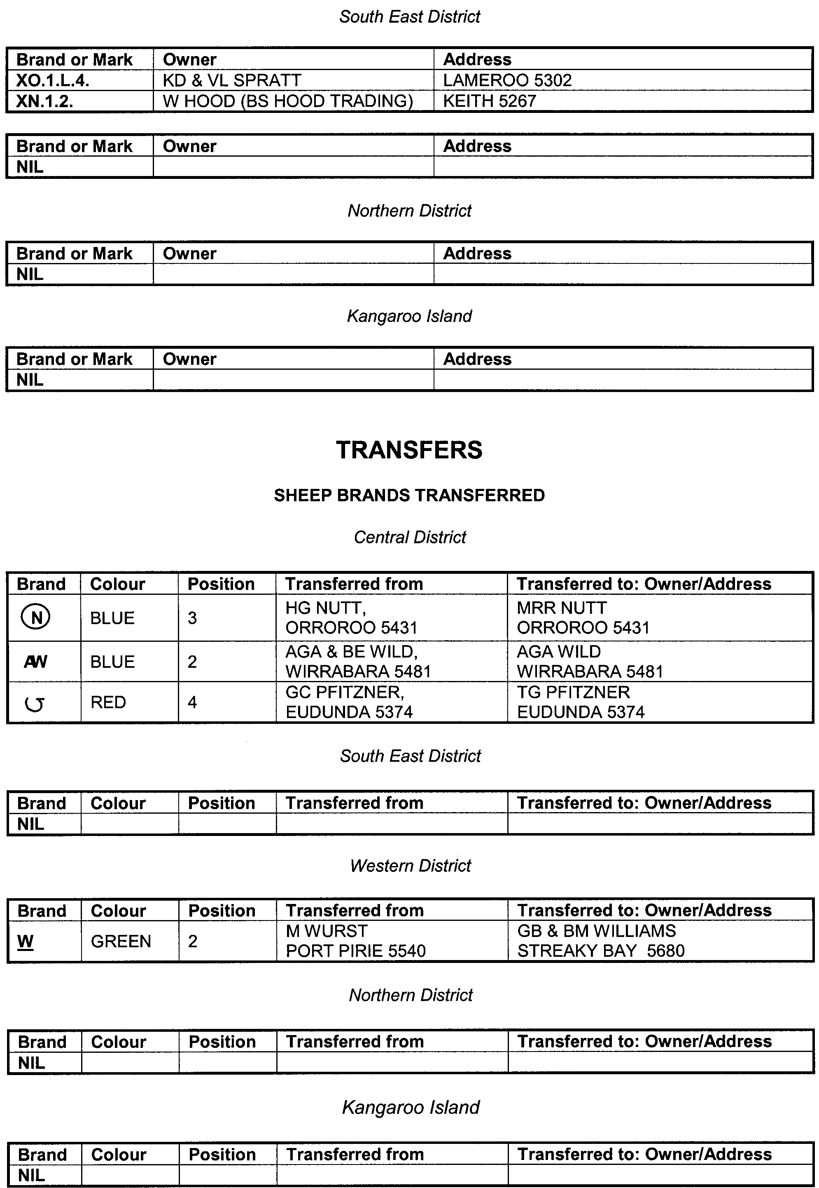
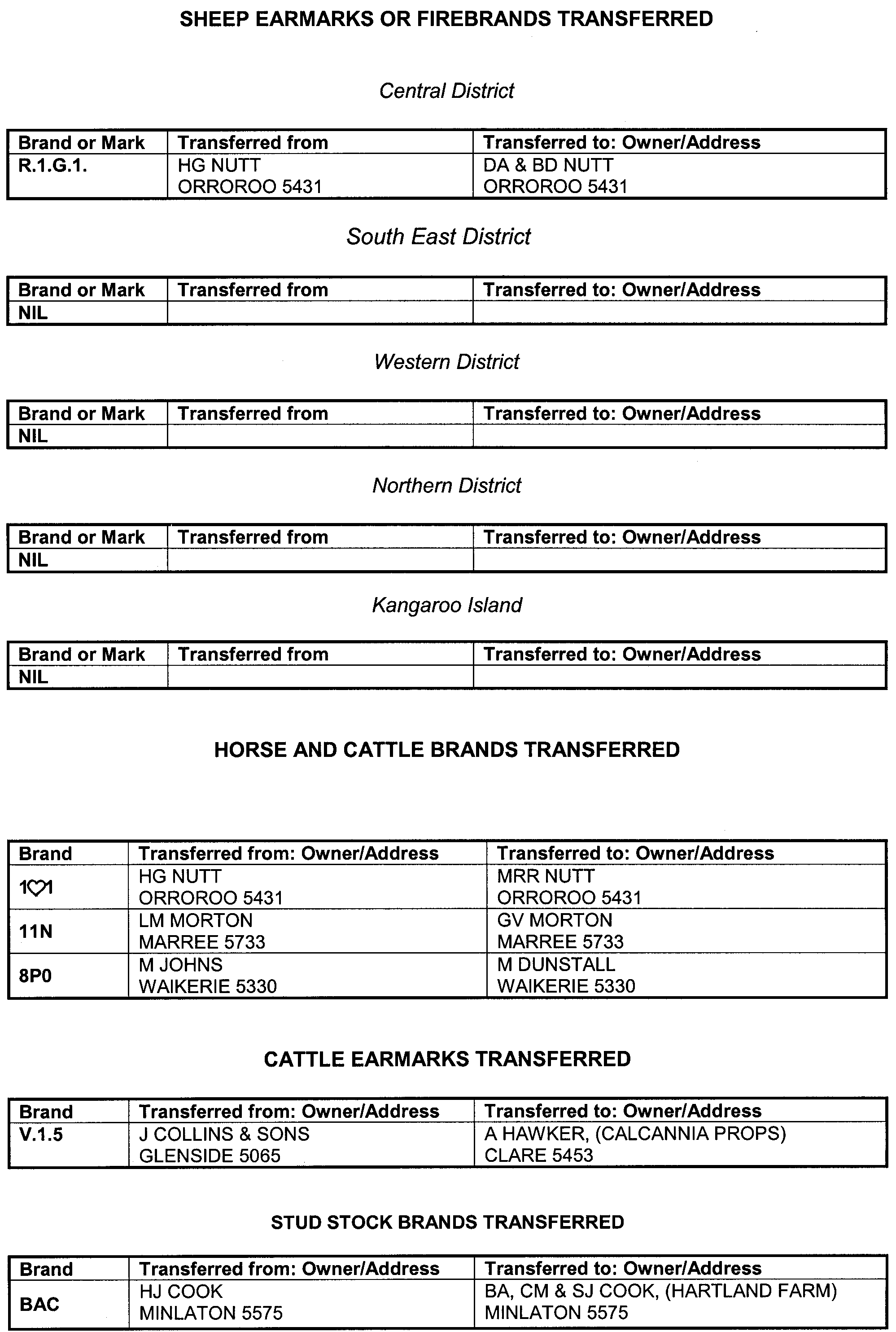
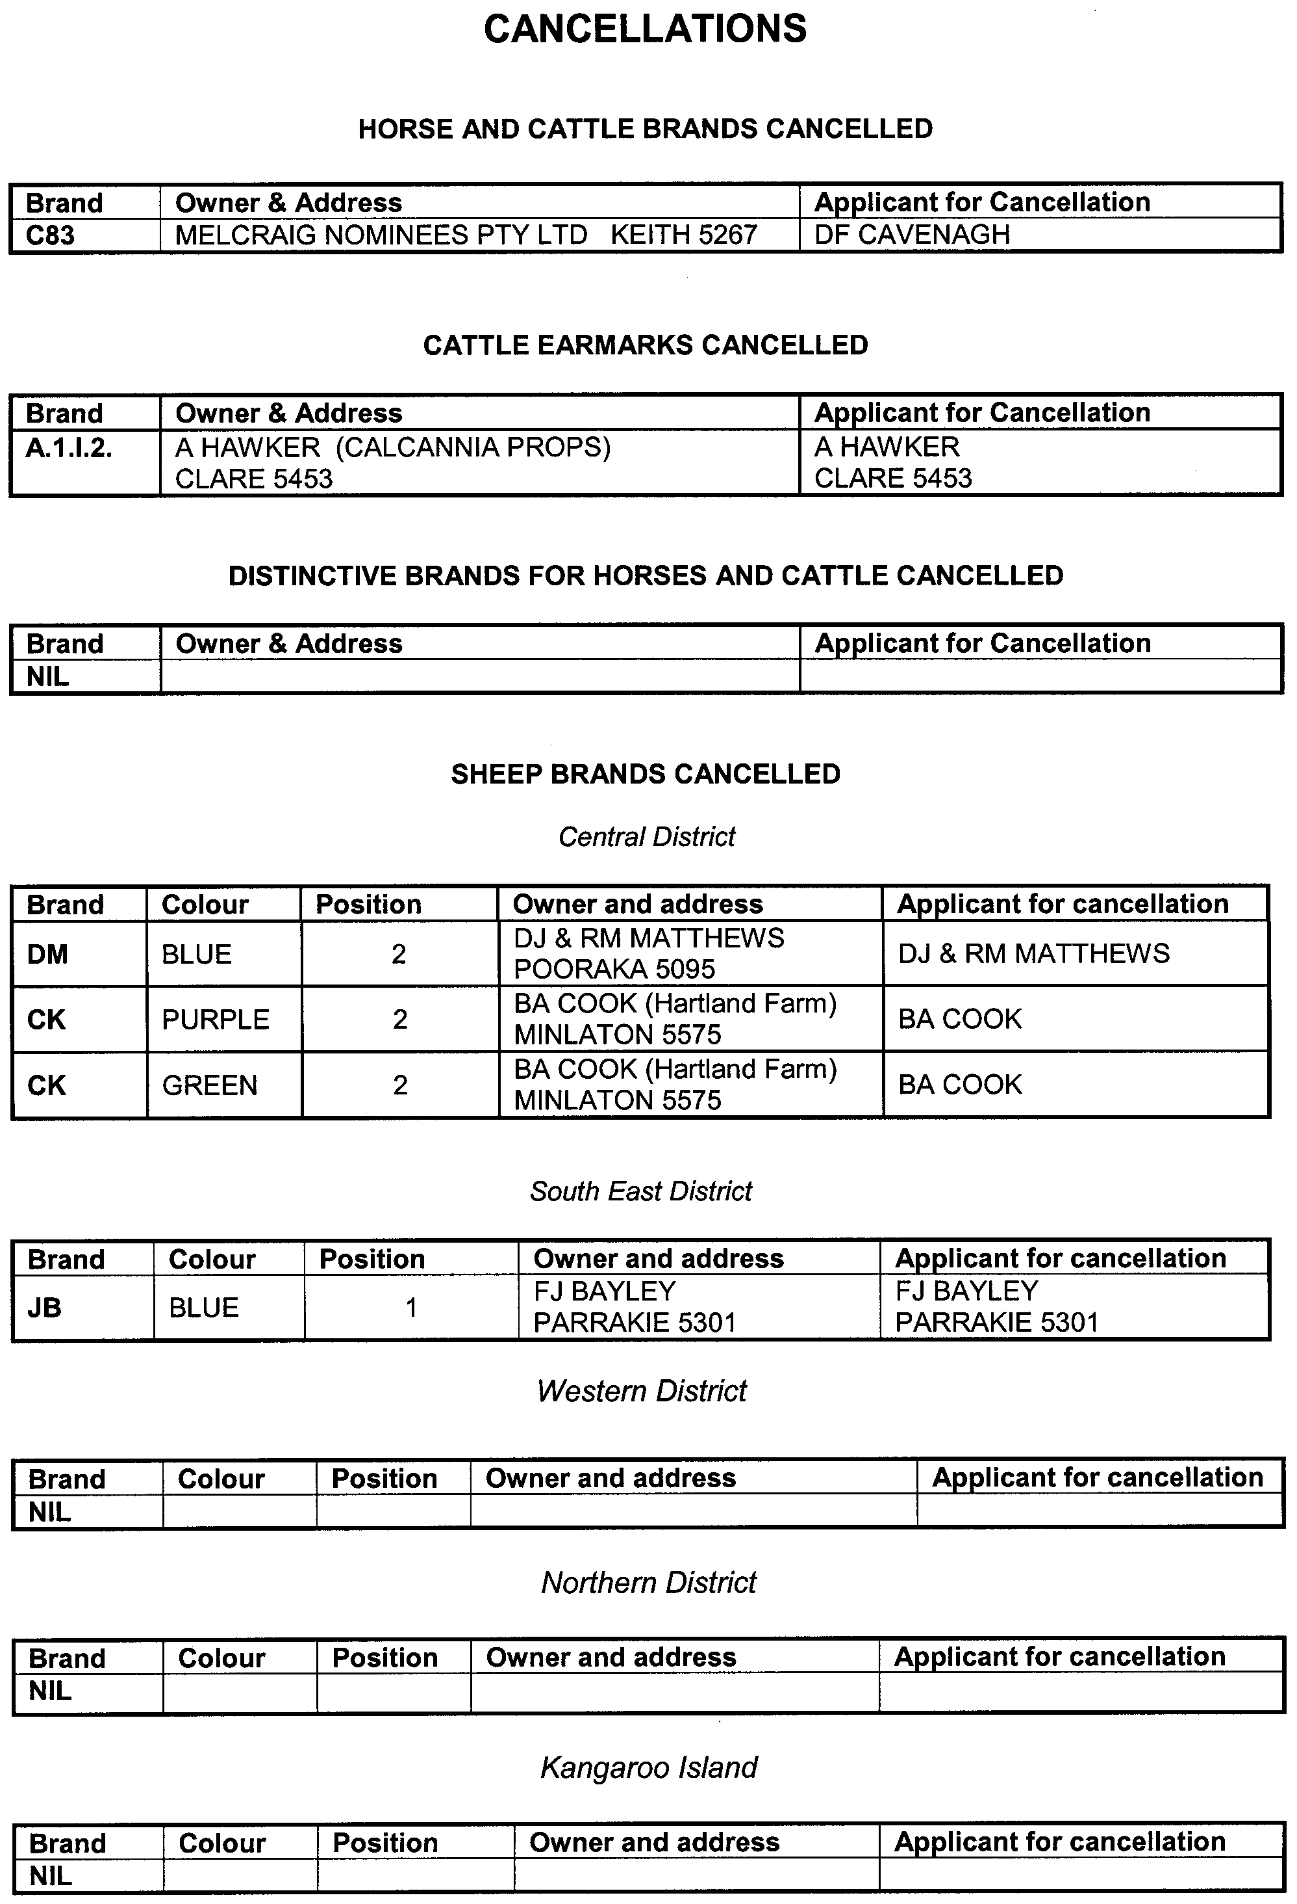
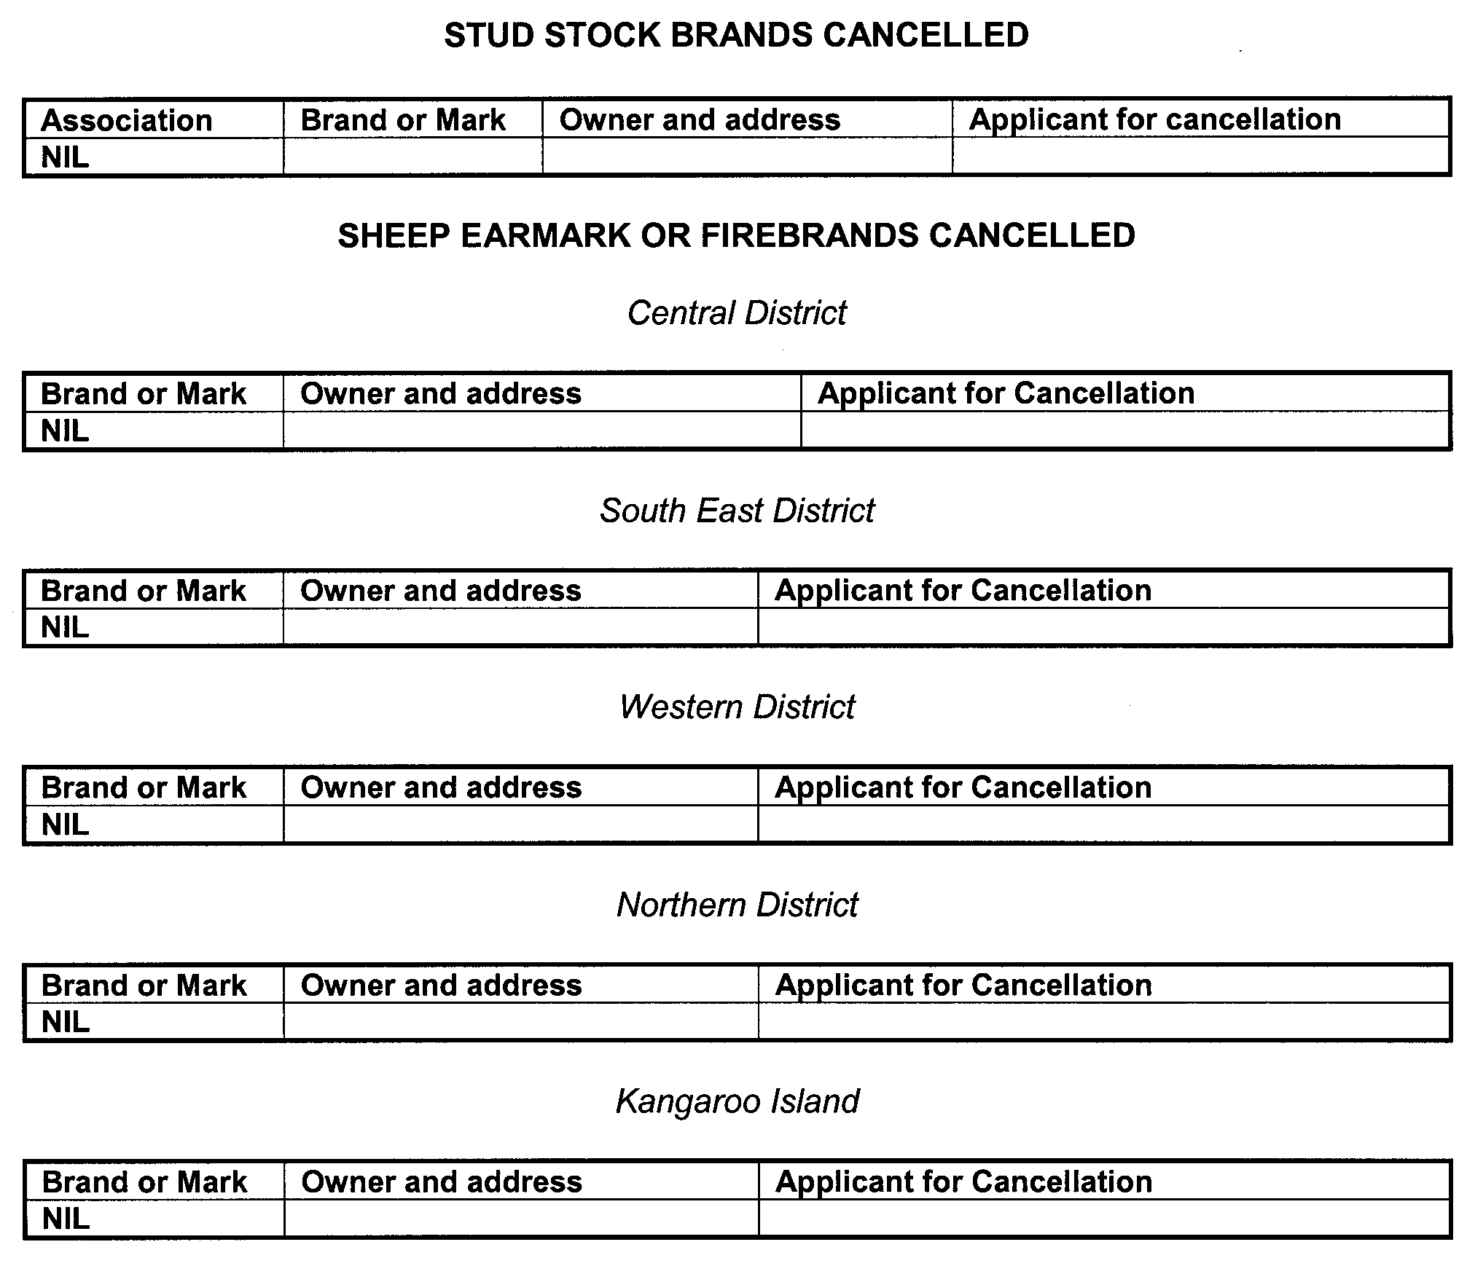

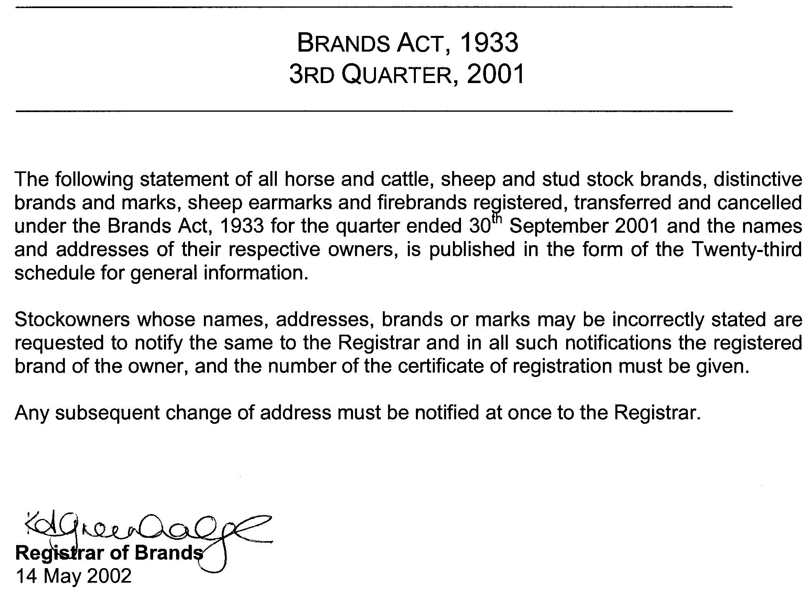
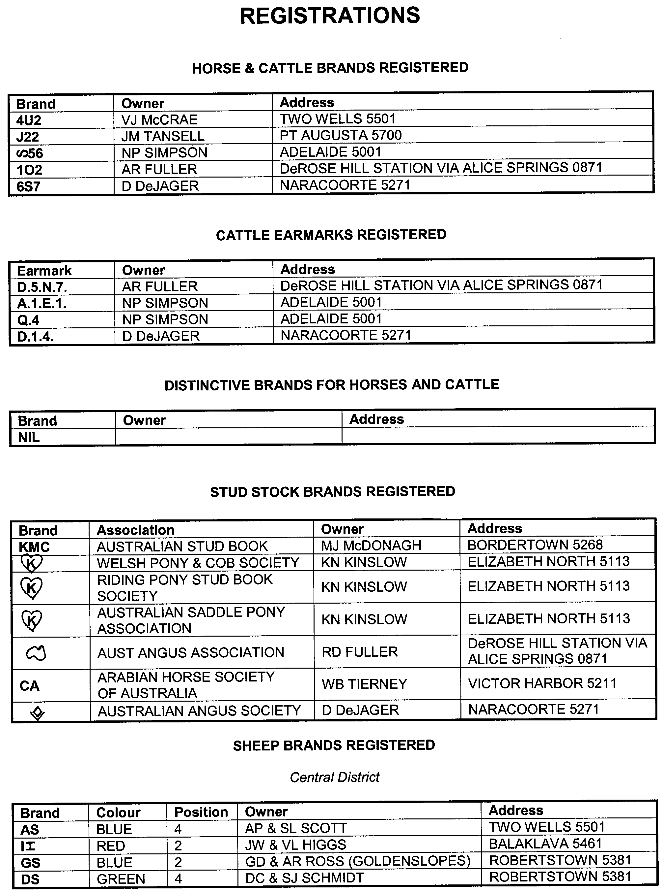
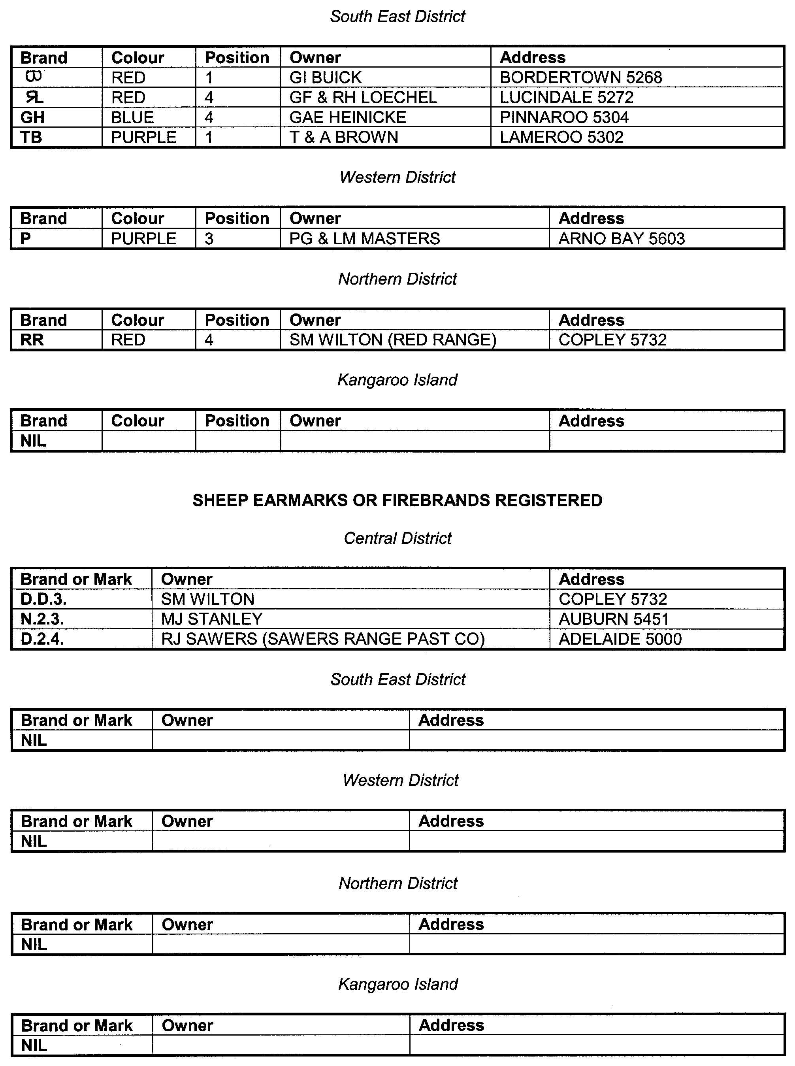
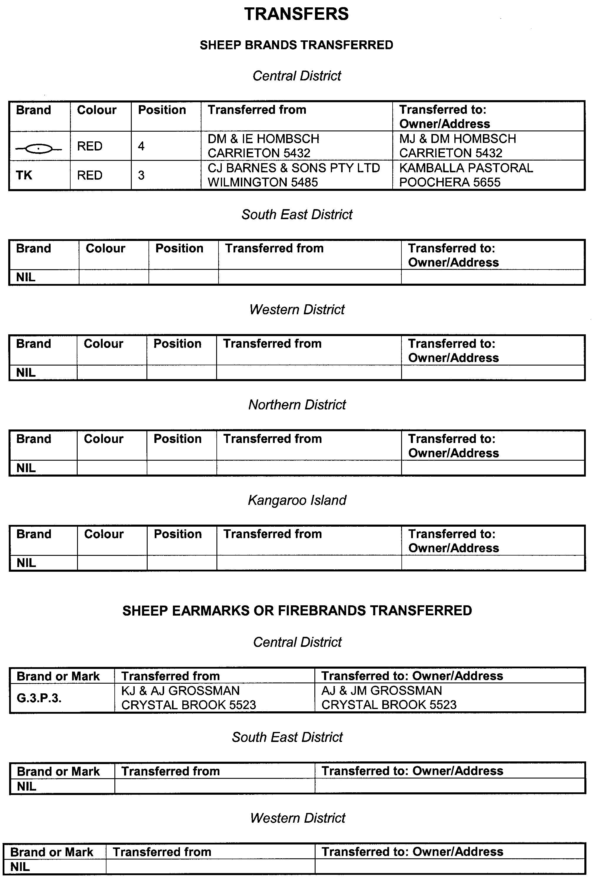
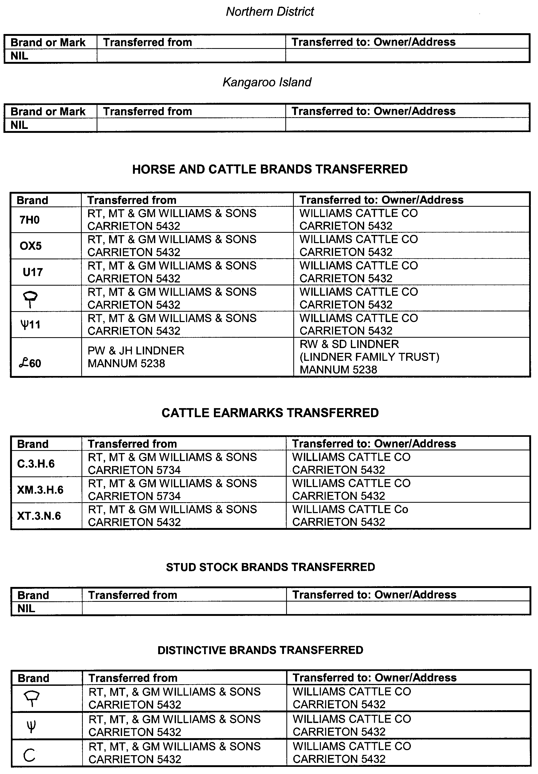
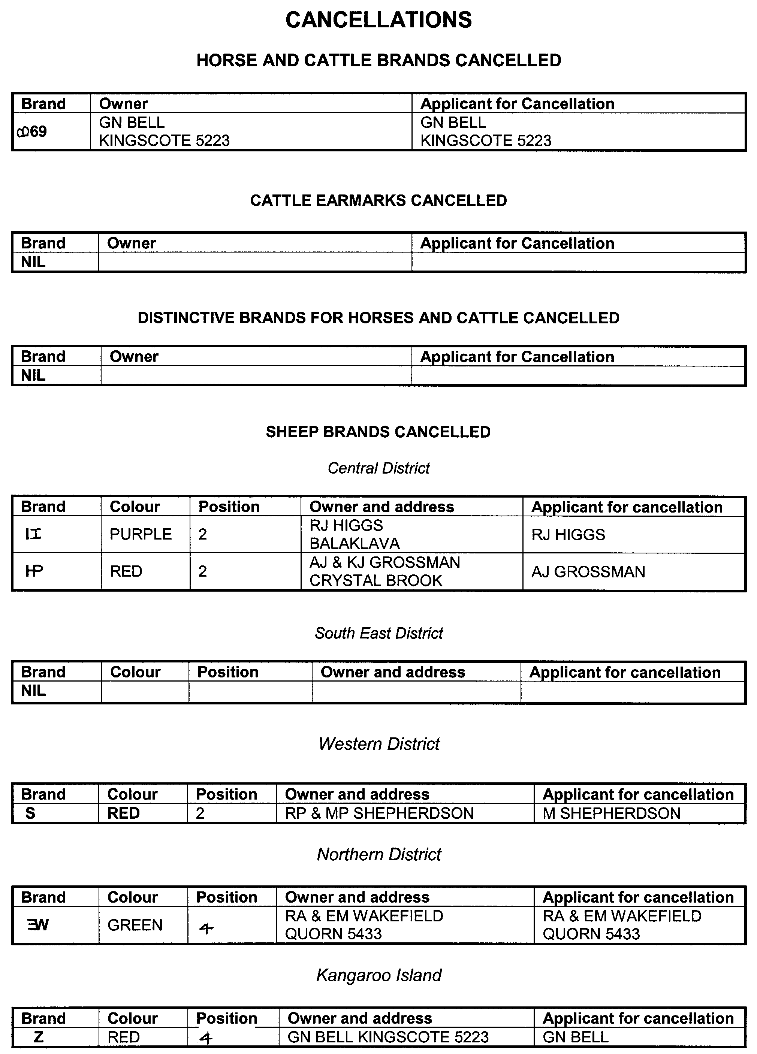


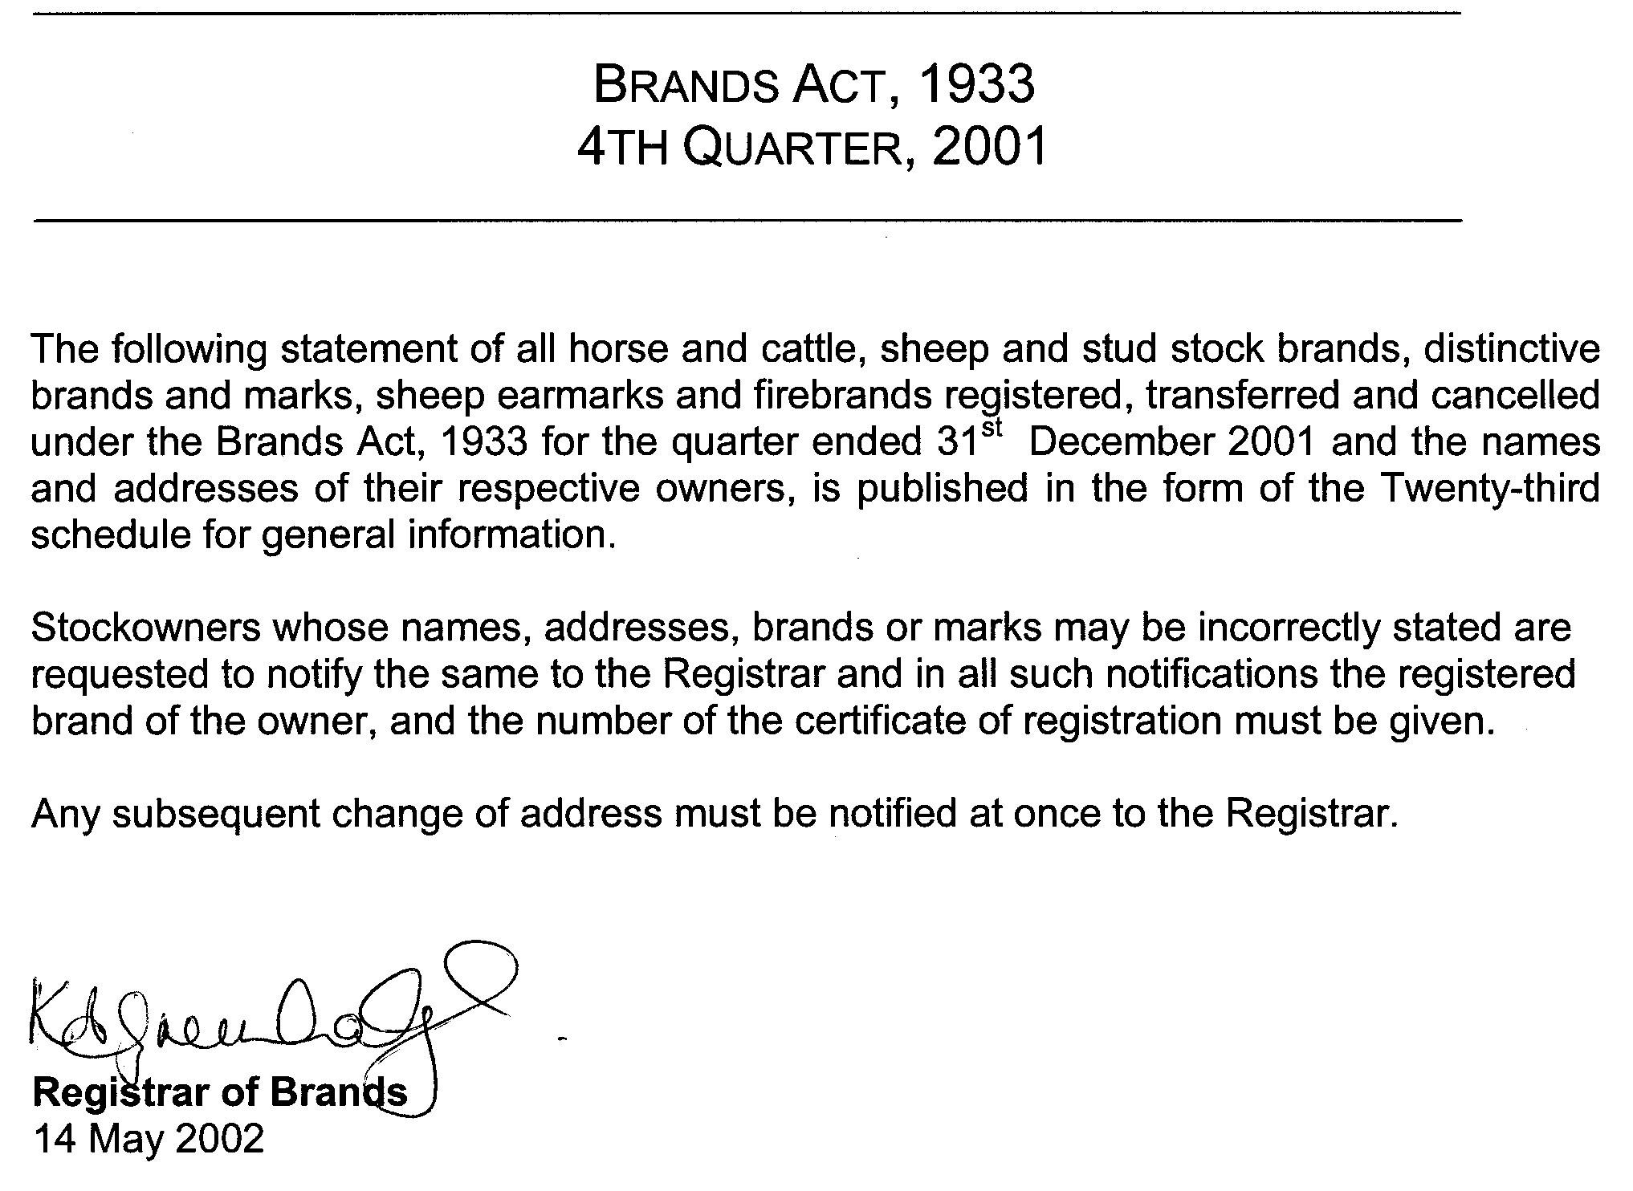
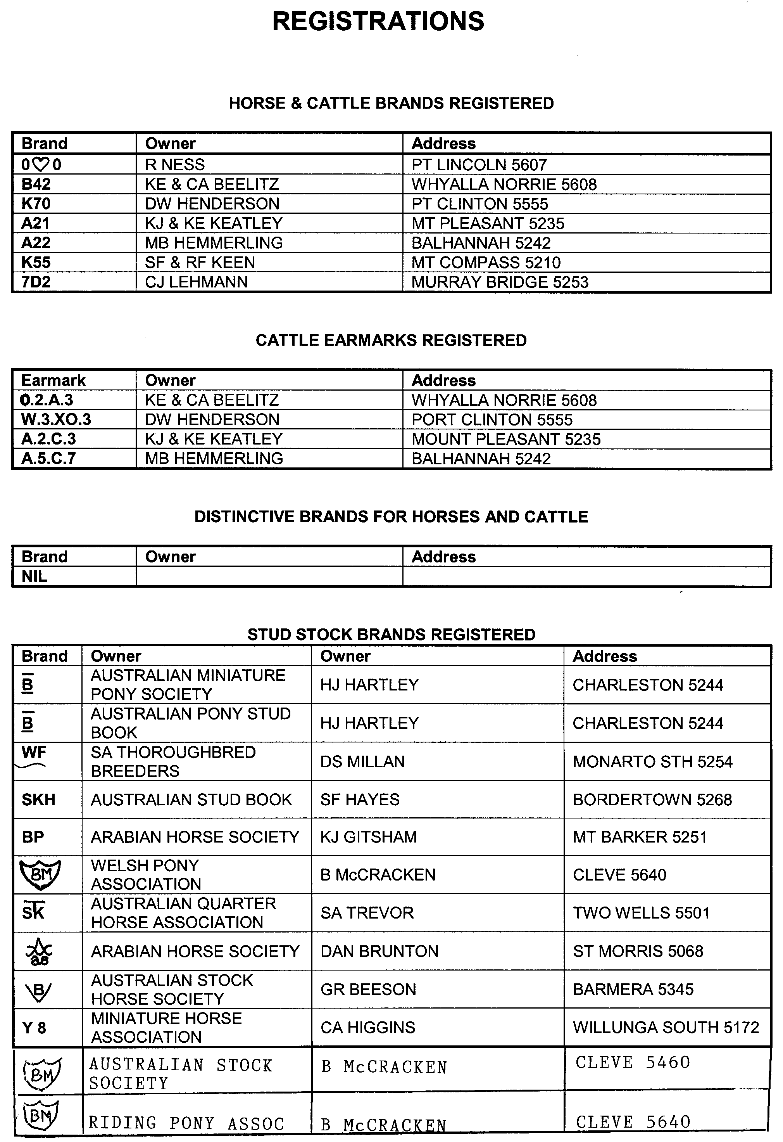
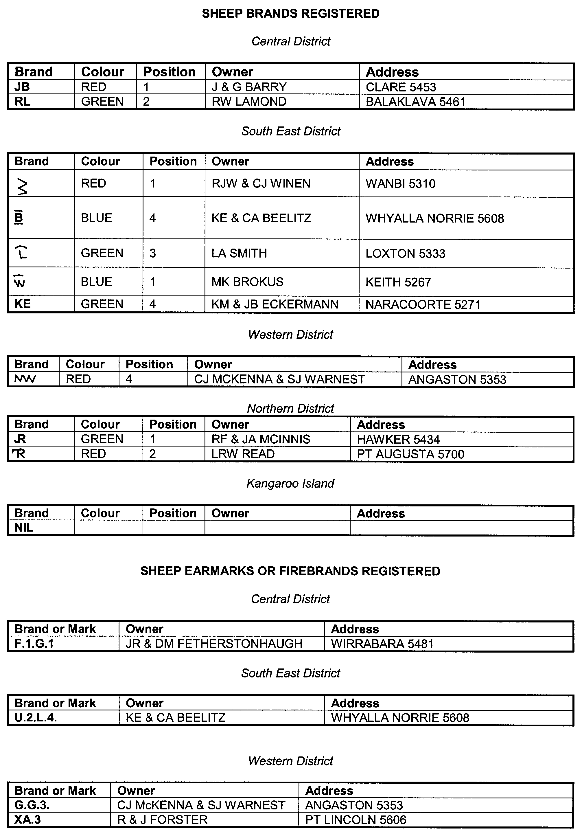
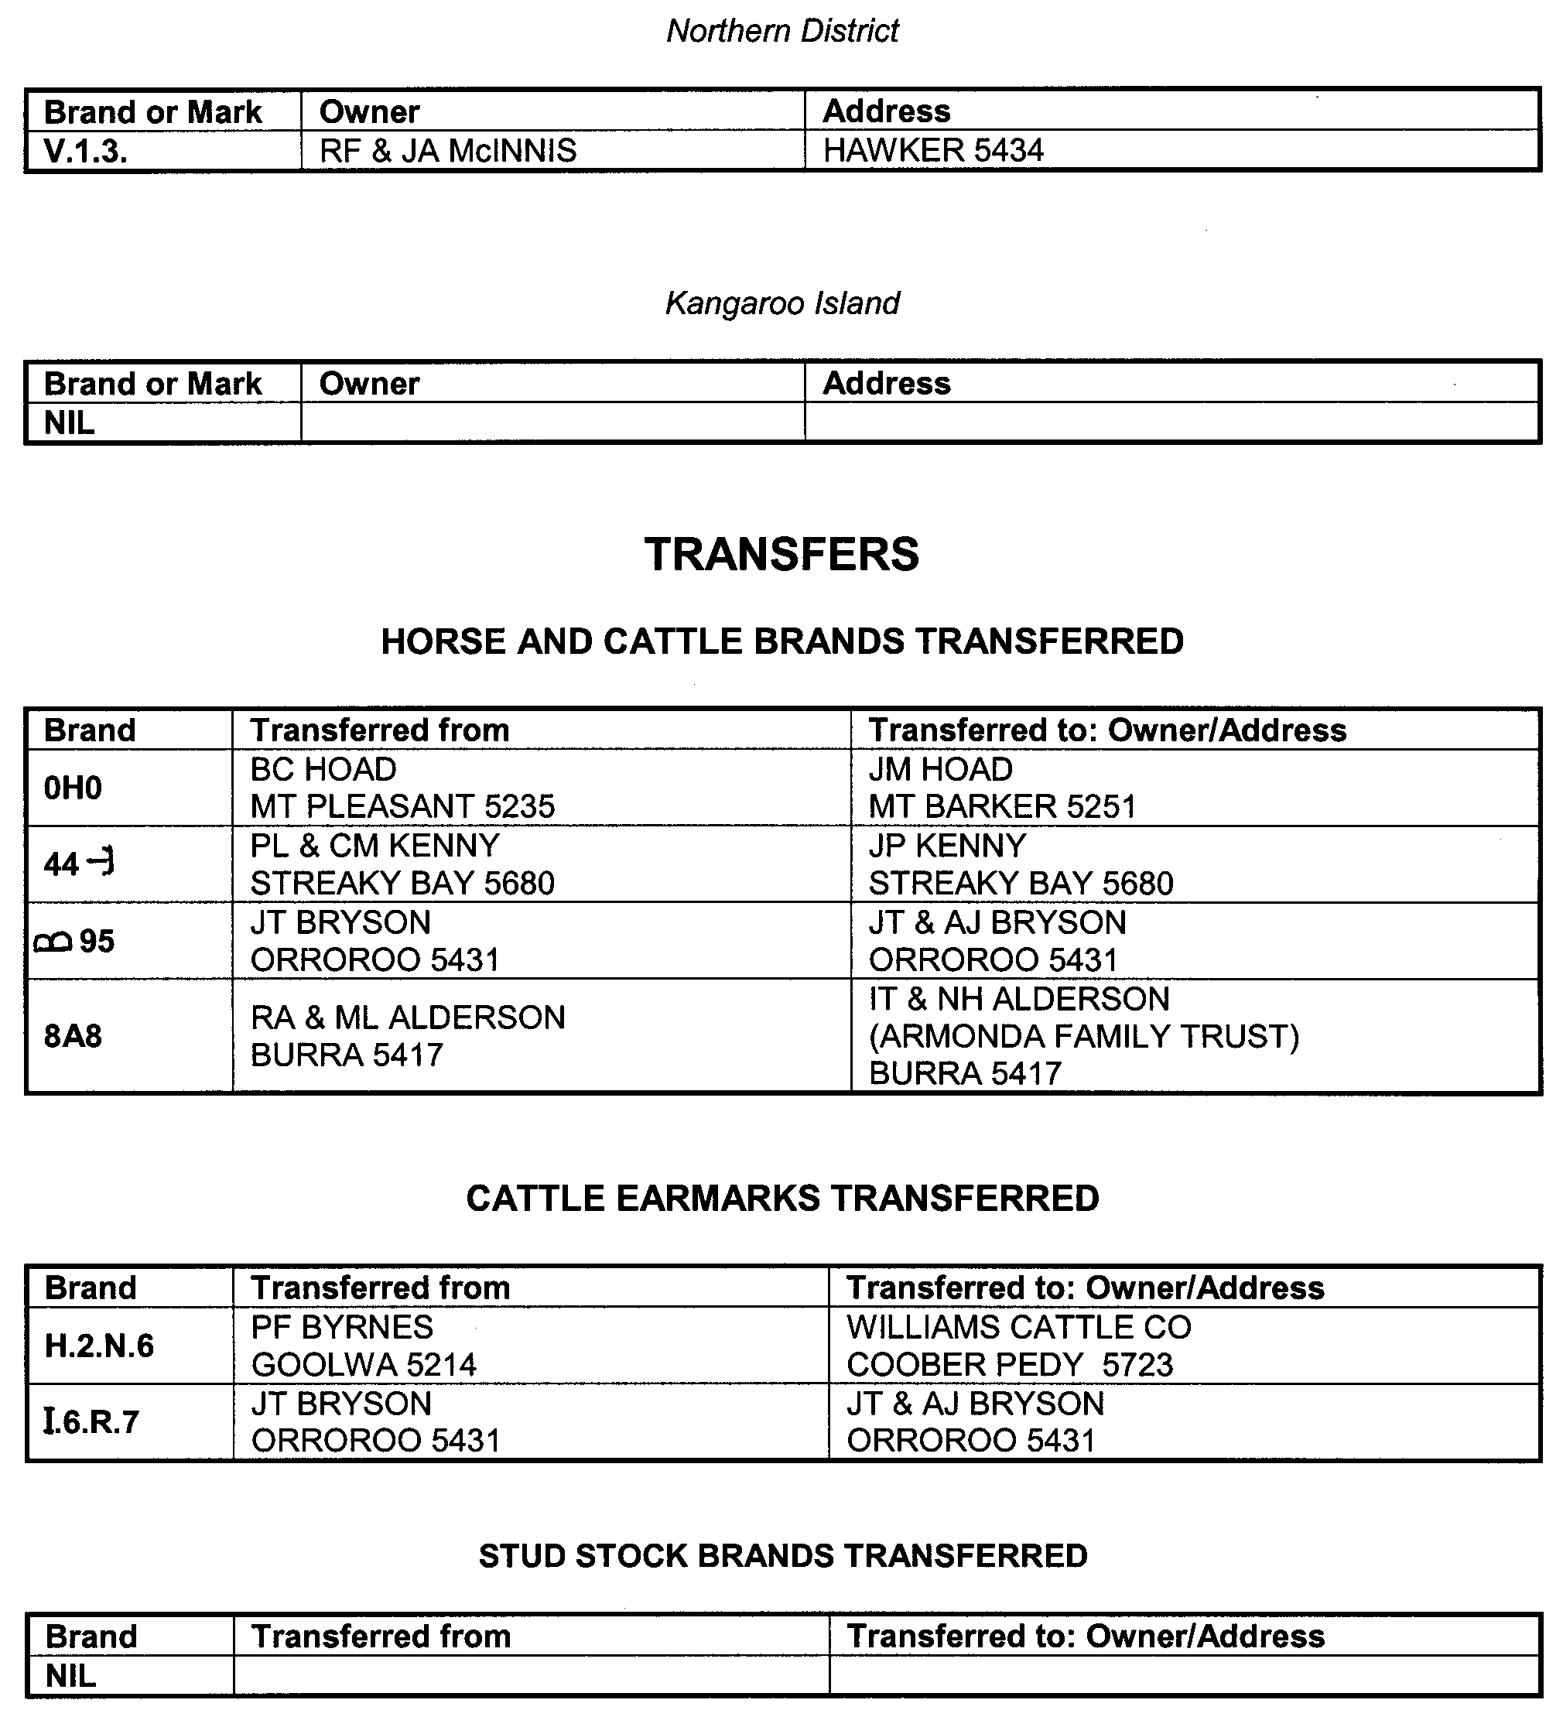
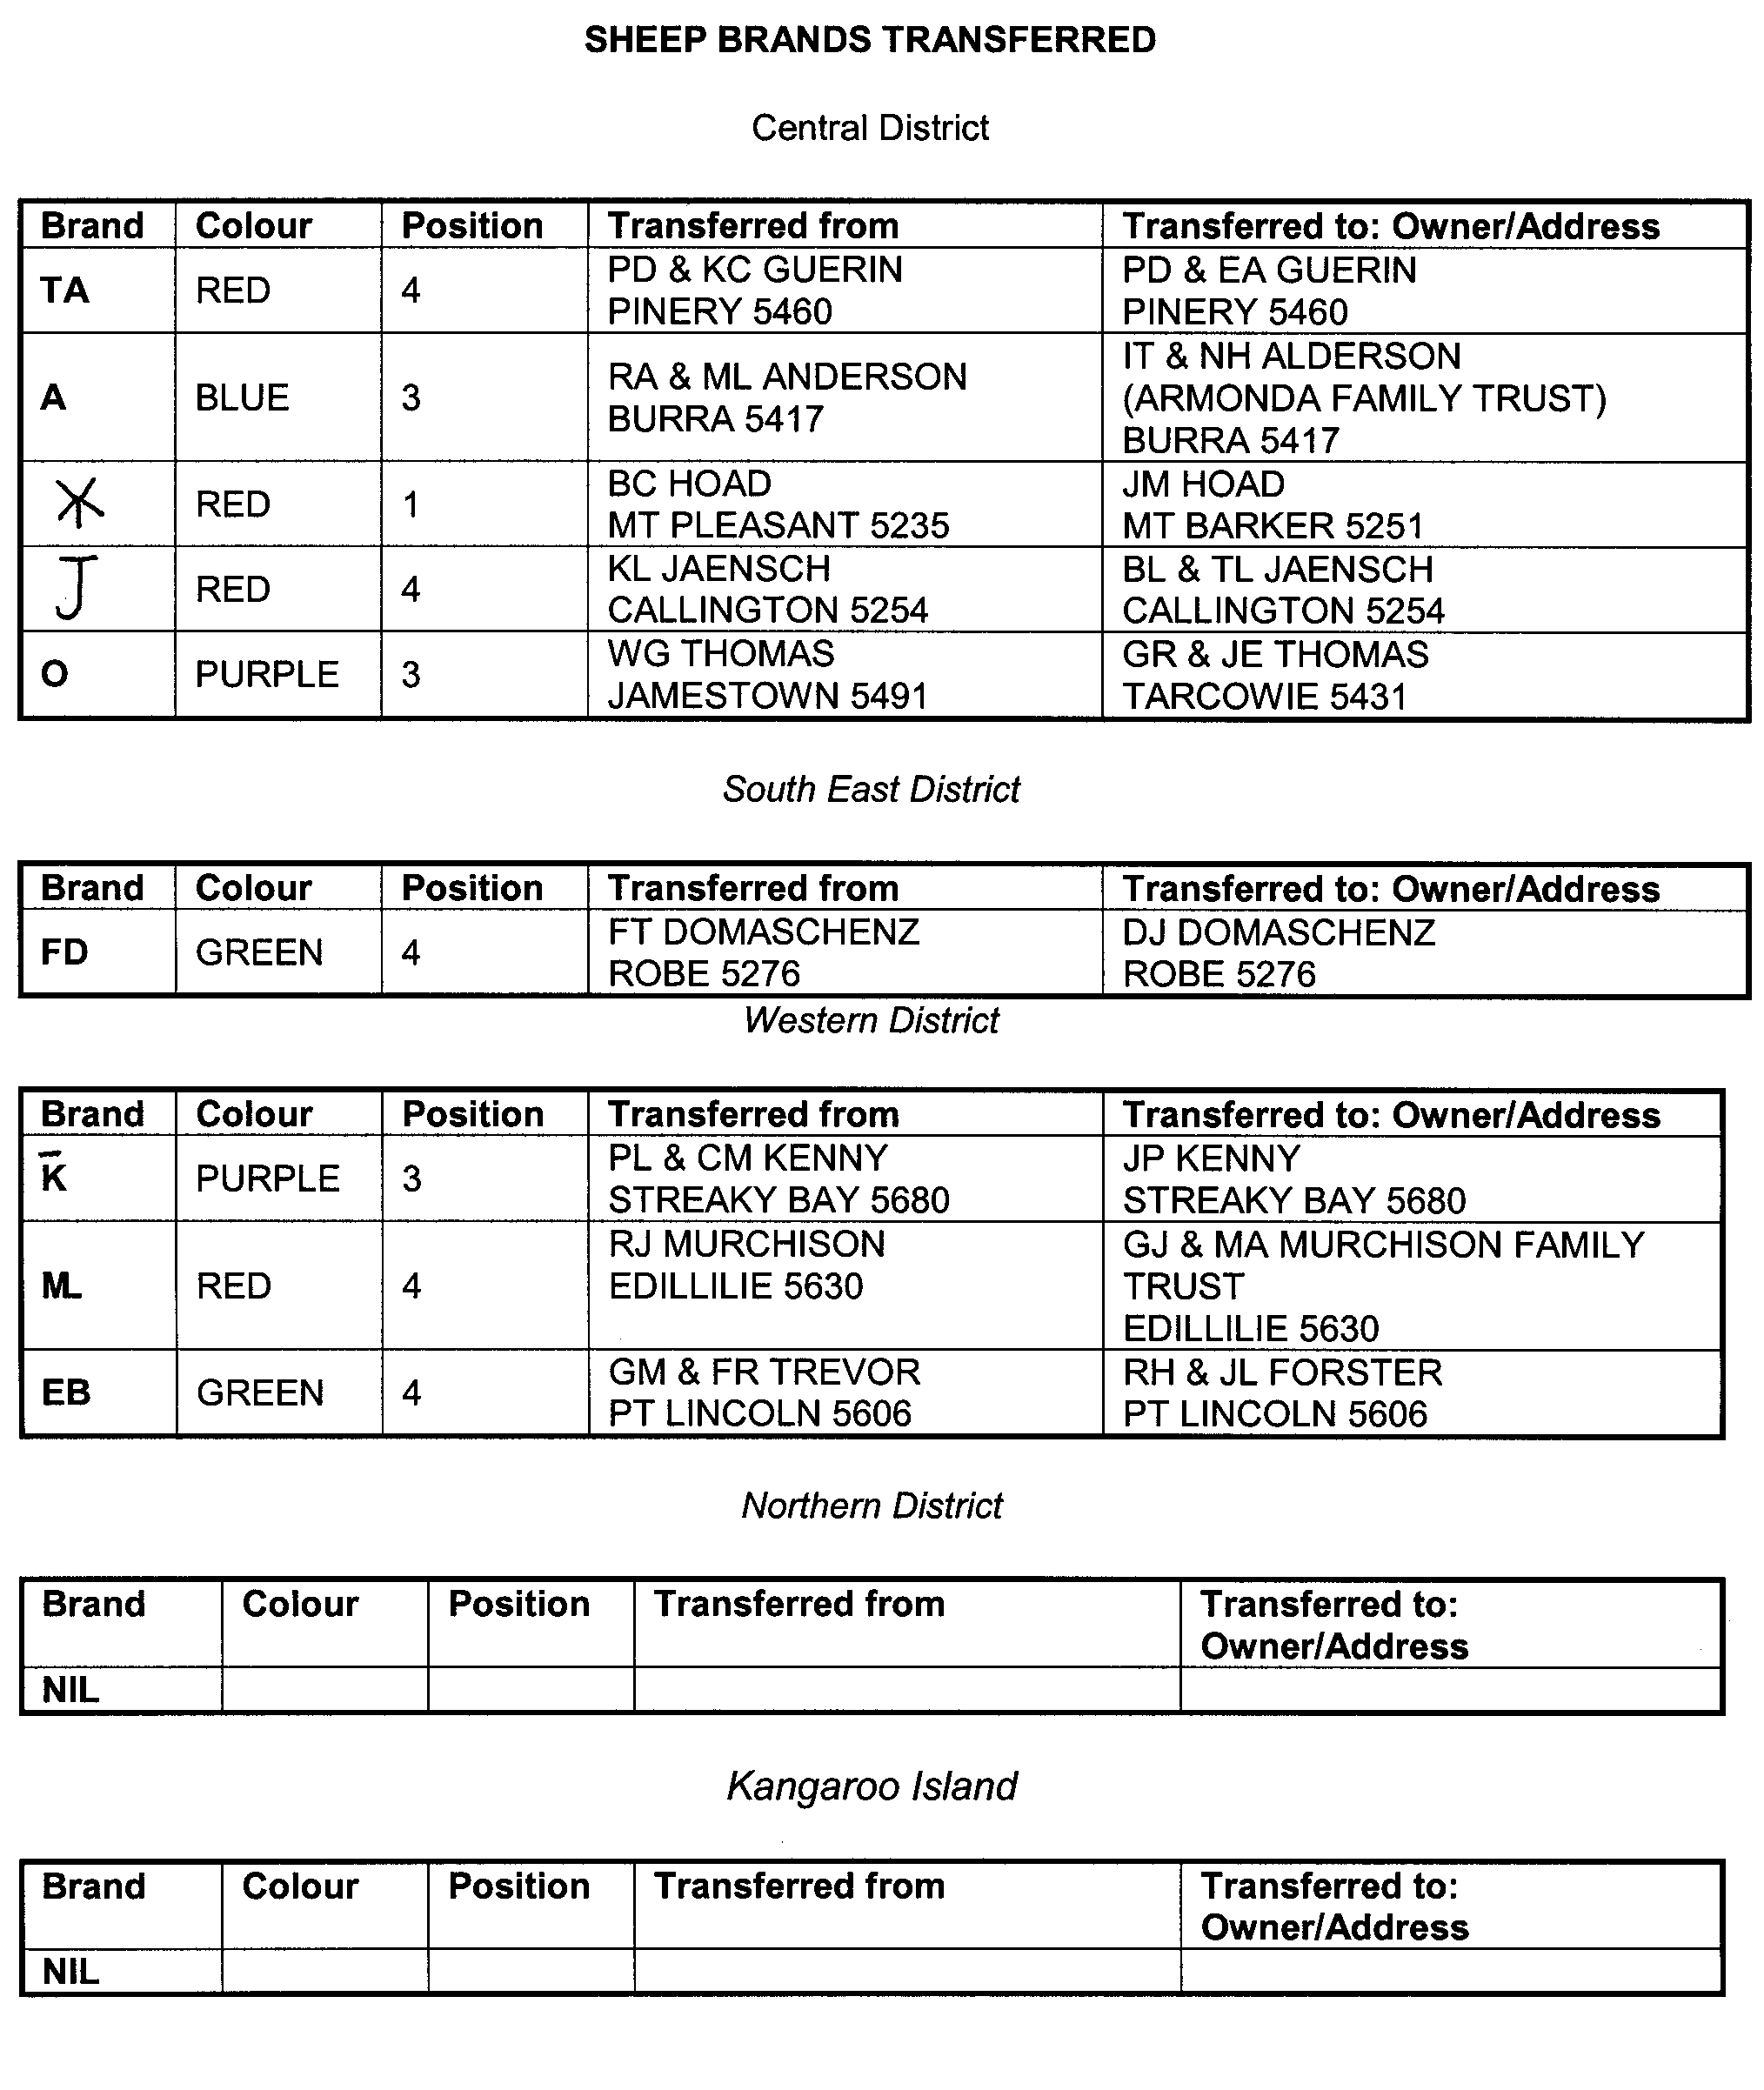
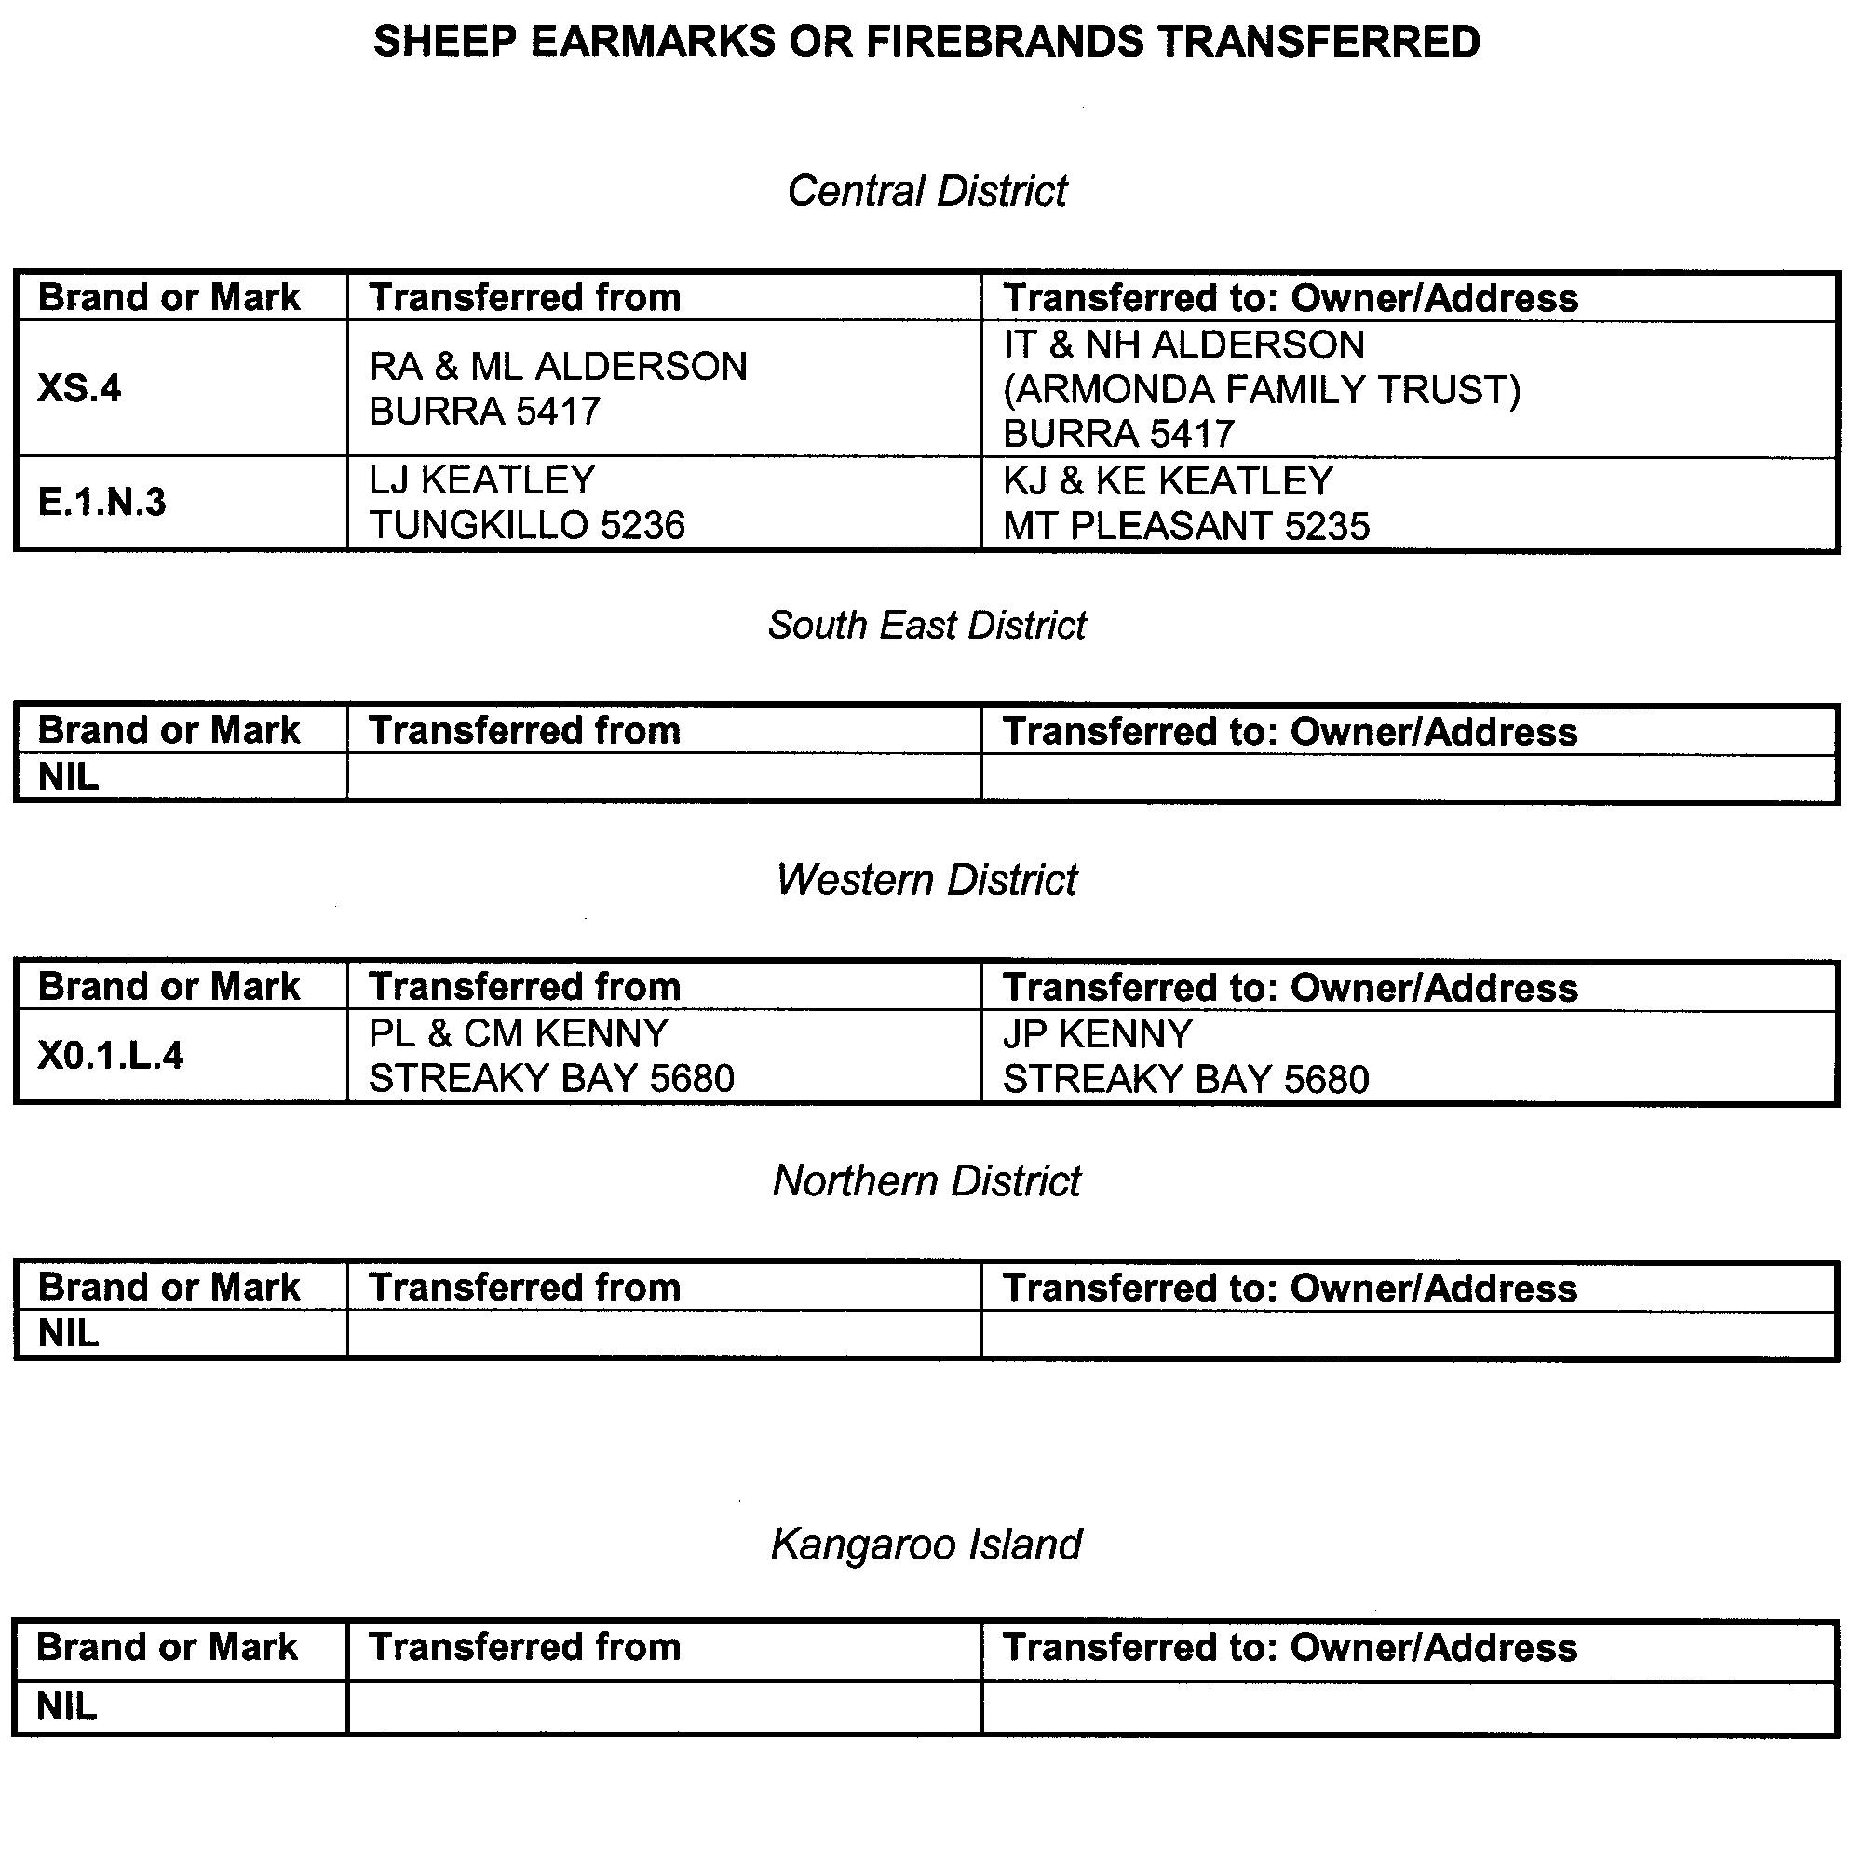
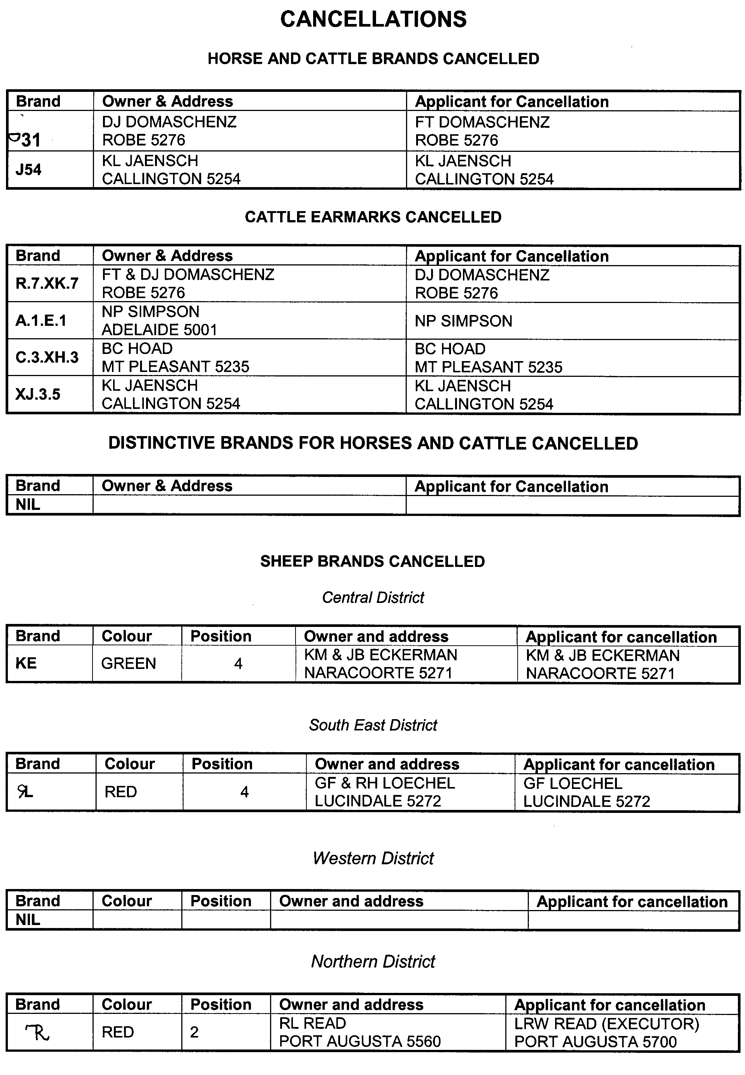
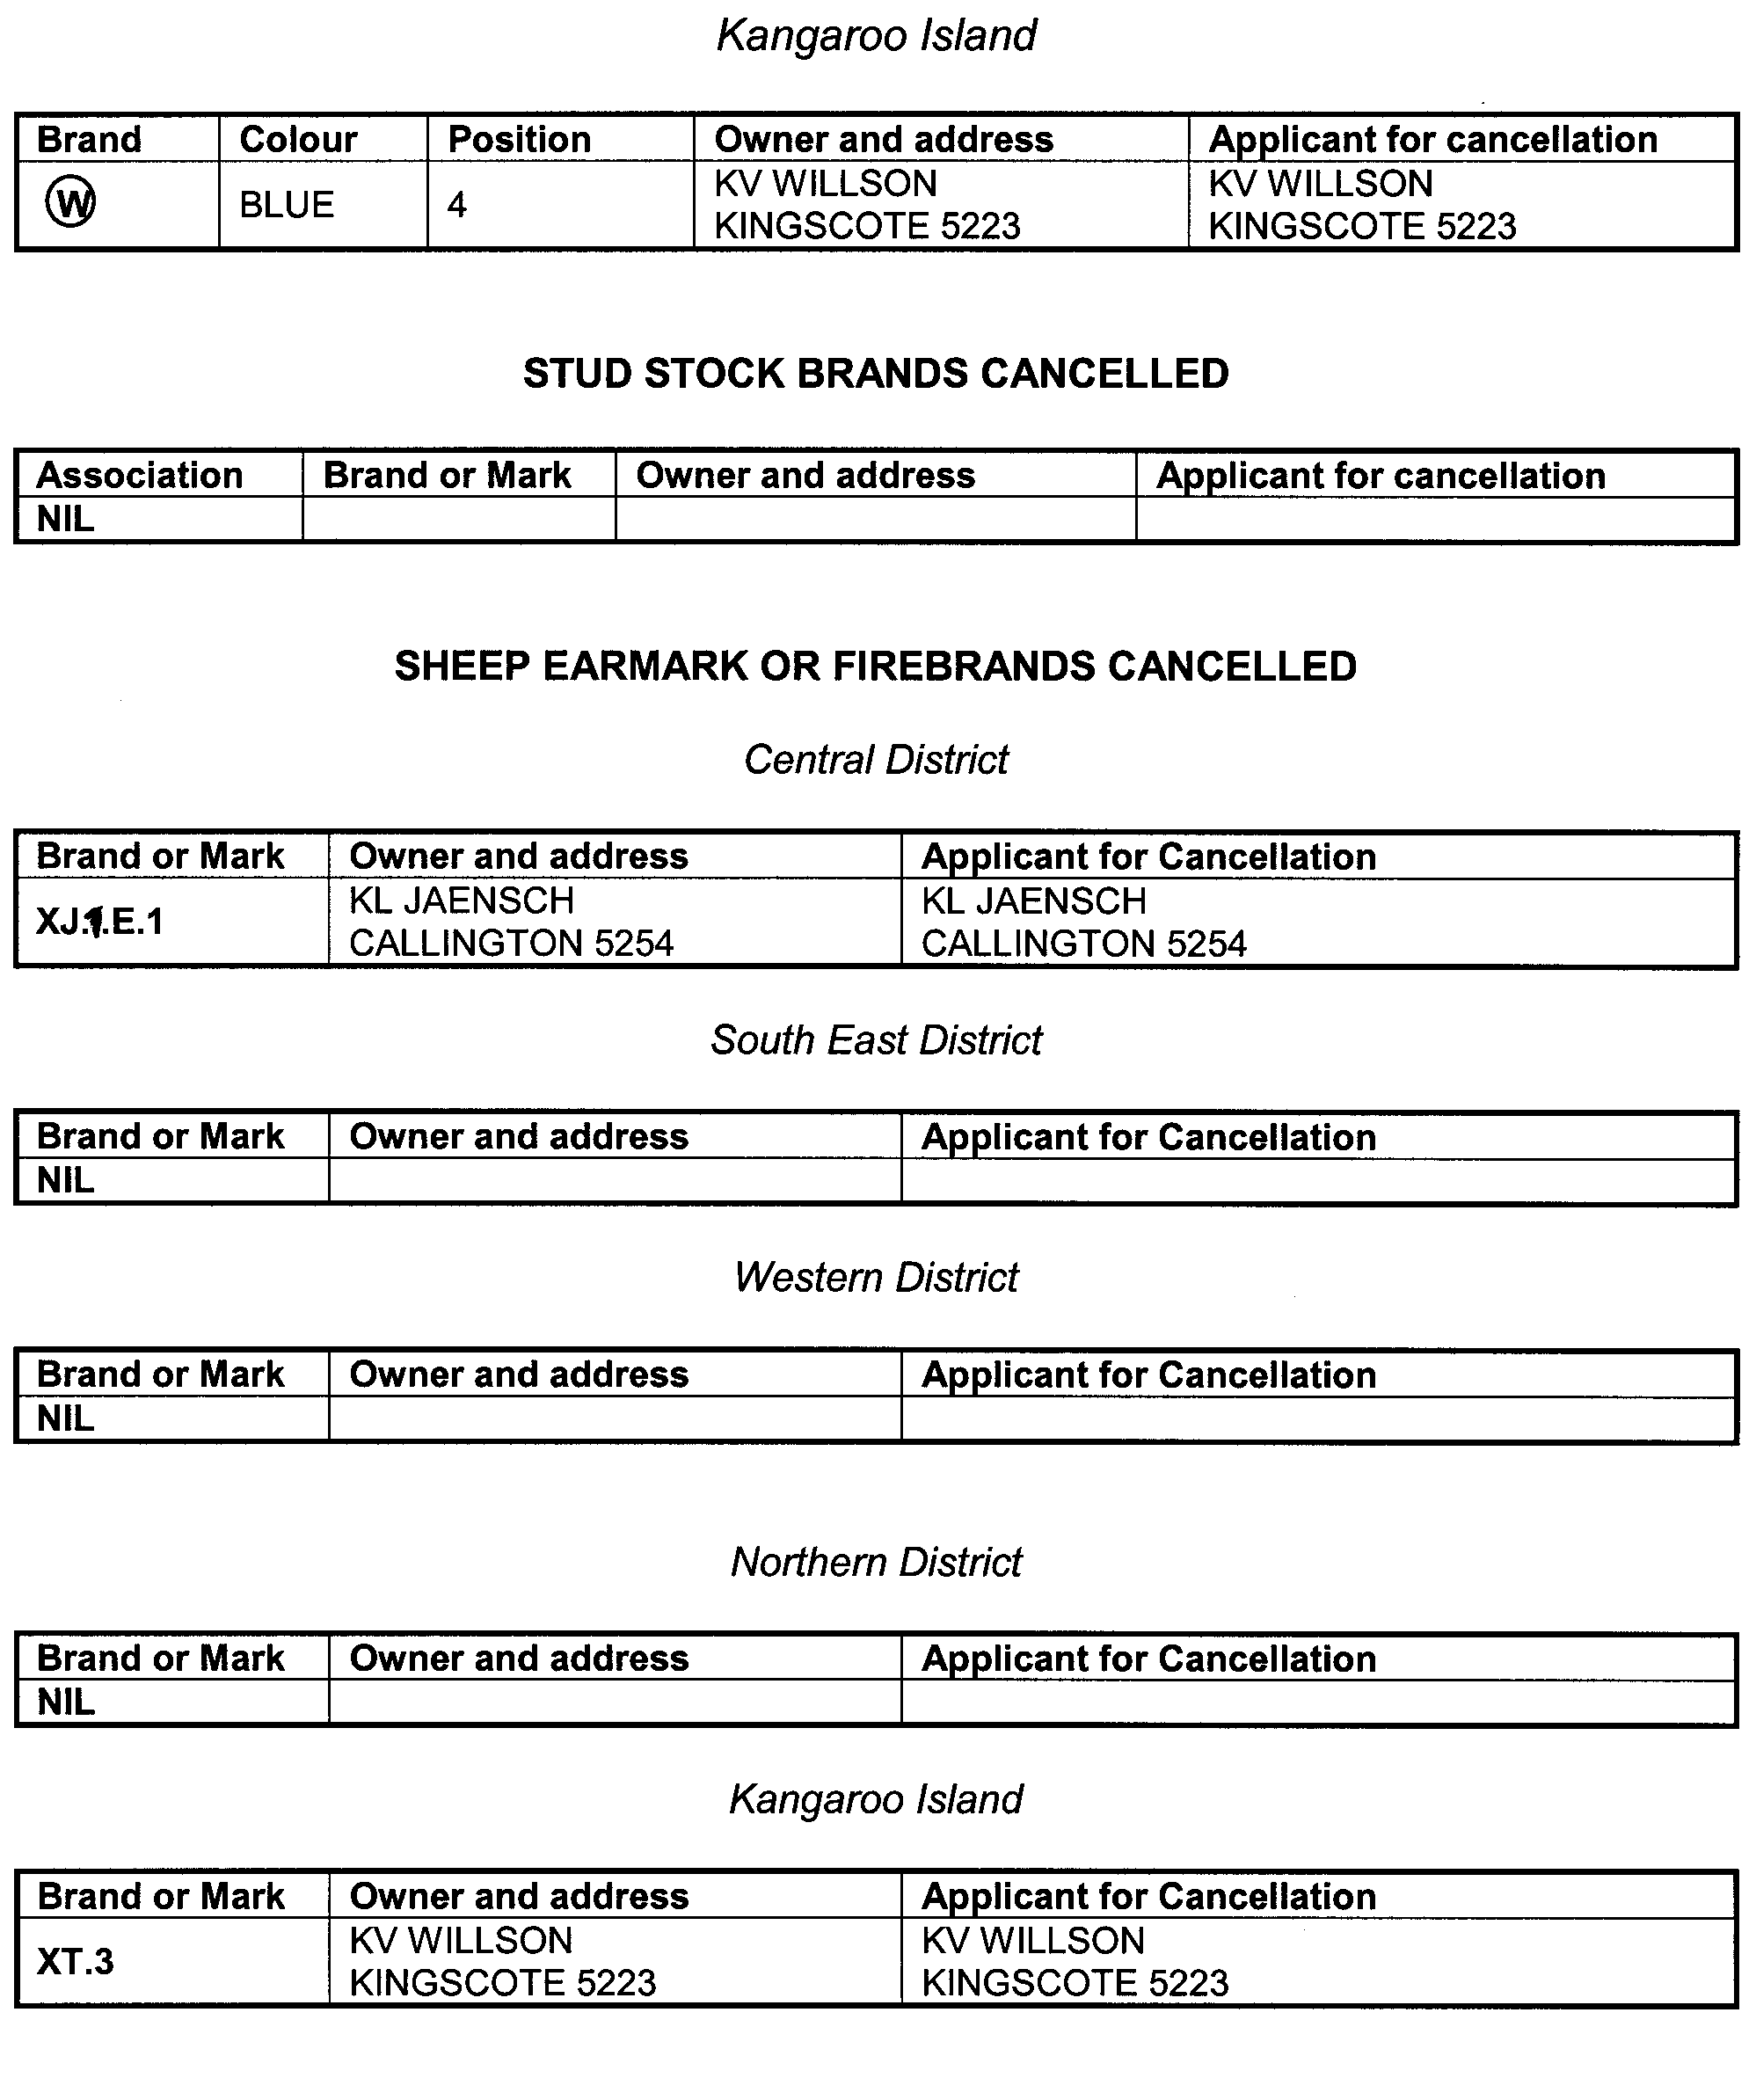

CHILDREN’S PROTECTION ACT 1993
Recognition of Organisation
I, STEPHANIE KEY, Minister for Social Justice for the State of South Australia, hereby declare that the following Aboriginal Organisation be recognised for the purpose of section 5 of the Children’s Protection Act 1993, which is the Port Lincoln Aboriginal Health Service Incorporated.
Stephanie Key, Minister for Social Justice

DEVELOPMENT ACT 1993
Alteration to the South Australian Housing Code
Preamble
The Development Act 1993, requires that where a Code is adopted by the Regulations, notice of the alteration must be published before the alteration can take effect.
Notice
PURSUANT to section 108 (7) of the Development Act 1993, notice is given of an alteration to the South Australian Housing Code 1998, which is called up in the South Australian Appendix to Volume Two of the Building Code of Australia 1996 edition, that alteration being Amendment No. 6 as published by Planning SA.
The alterations made by Amendment No. 6 to the South Australian Housing Code will take effect for the purpose of the Development Act 1993 on 1 July 2002.
Dated 15 May 2002.
J. W. Weatherill, Minister for Urban Development and Planning

DEVELOPMENT ACT 1993
Notice under Section 50 (6)
1. The contributions in respect of open space under section 50 (5) of the Development Act 1993 are:
land within Metropolitan Adelaide $1 785;
land outside Metropolitan Adelaide $820,
for each allotment that does not exceed one hectare in area.
2. The Valuer-General has advised that the average variation in the market value of land in the year that ended on 30 June 2001 were:
land within Metropolitan Adelaide—an increase of 2.40%; and
land outside Metropolitan Adelaide—an increase of 1.27%.
3. On and after 1 June 2002, the contributions in respect of open space under section 50 (5) of the Development Act 1993, shall be as follows:
land within Metropolitan area $1 830;
land outside Metropolitan area $830,
for each new allotment that does not exceed one hectare in area.
Dated 8 May 2002.
J. W. Weatherill, Minister for Urban Development and Planning

DEVELOPMENT ACT 1993: SECTION 46 (1)
Notice
Preamble
Section 46 (1) of the Development Act 1993, allows the Minister for Urban Development and Planning to apply that section to a specified kind of development or project if the Minister is of the opinion that a declaration under that section is appropriate of necessary for the proper assessment of development or a project of major environmental, social or economic importance.
Notice
PURSUANT to section 46 (1) of the Development Act 1993, being of the opinion that a declaration under section 46 of the Act is appropriate for the proper assessment of development of major environmental, social and economic importance, I declare that section 46 of the Act applies to any development of a kind specified in Schedule 1.
Dated 21 May 2002.
J. W. Weatherill, Minister for Urban Development and Planning

Schedule 1
The following kinds of development are specified if undertaken in, or in relation to, that part of the State specified in Schedule 2:
(a) building work;
(b) change in use of land;
(c) the excavating or filling (or excavation and filling) of land, or the forming of a levee or mound higher than 3 m;
(d) any other kind of development, excluding demolition,
for the purpose of, or ancillary to, establishing or operating an organic waste treatment and recycling research facility.
Schedule 2
The following parts of the State are specified for the purposes of Schedule 1:
1. The whole of the land comprised in certificate of title register book volume 5148, folios 136 and 611 and in certificate of title register book volume 5147, folio 113.
2. Other land on which it is necessary or desirable to undertake the kinds of development referred to in Schedule 1 for or related to the management, storage, treatment or disposal of stormwater, waste water or effluent caused by or associated with, the establishment or operation of an organic waste treatment facility on the land referred to in Clause 1.
J. W. Weatherill, Minister for Urban Development and Planning

ELECTRICITY CORPORATIONS (RESTRUCTURING AND DISPOSAL) ACT 1999
I, KEVIN OWEN FOLEY, M.P., Treasurer of South Australia (the ‘Treasurer’) hereby give notice, pursuant to Clause 1 of Schedule 3 to the Electricity Corporations (Restructuring and Disposal) Act 1999, that Clauses (i), (s), and (t) of Part 4 of Schedule 3 to the Electricity Corporations (Restructuring and Disposal) Act 1999, shall come into operation on 30 June 2002.
Dated 21 May 2002.
K. Foley, Treasurer
The Common Seal of the Treasurer was hereunto affixed by authority of the Treasurer and in the presence of:
K. Worden, Witness

ELECTRICITY CORPORATIONS (RESTRUCTURING AND DISPOSAL) ACT 1999
I, KEVIN OWEN FOLEY, M.P., Treasurer of South Australia (the ‘Treasurer’) hereby give notice, pursuant to Clause 1 of Schedule 3 to the Electricity Corporations (Restructuring and Disposal) Act 1999, that Part 4 of Schedule 3 to the Electricity Corporations (Restructuring and Disposal) Act 1999, shall come into operation on 29 May 2002, with the operation of the following Clauses of Part 4 suspended until a date fixed by subsequent notice; clauses (a), (b), (c), (d), (e), (f), (h), (i), (j), (k), (l), (m), (p), (r), (s), (t), (u), (y) and (zc).
Dated 21 May 2002.
K. Foley, Treasurer
The Common Seal of the Treasurer was hereunto affixed by authority of the Treasurer and in the presence of:
K. Worden, Witness

EQUAL OPPORTUNITY TRlBUNAL
No. 97 of 2002
Notice of Exemption
Before Deputy Presiding Officer Anderson
Members Bachmann and Altman
I HEREBY certify that on 17 April 2002, the Equal Opportunity Tribunal of South Australia, on the application of Bernina Pty Ltd made the following orders for exemption:
Pursuant to section 92 of the Equal Opportunity Act 1984, the Tribunal grants an exemption to the applicant for a period of three years to enable it to lawfully discriminate in favour of males:
1. In advertising for male dance instructors; and
2. In the course of appointing persons to carry out dance instruction, to the extent that bookings for female tuition justify it.
Dated 9 May 2002.
J. Nemcic for M. Moore, Registrar, Equal Opportunity Tribunal

EQUAL OPPORTUNITY TRIBUNAL
No. 64 of 2002
Notice of Exemption
Before Deputy Presiding Officer Herriman
Members Steuart and Shetliffe
I HEREBY certify that on 3 April 2002, the Equal Opportunity Tribunal of South Australia, on the application of Eblen Subaru made the following orders:
That pursuant to section 92 of the Equal Opportunity Act 1984, the application for exemption from the requirements of sections 29 and 30 of that Act be:
1. Granted for a period of three years insofar as it relates to the applicant’s proposal to advertise employment vacancies for females to undertake the work of salespersons in the division of the applicant’s business selling new and used vehicles.
2. Refused insofar as it relates to the applicant’s proposal to advertise employment vacancies for females to undertake the work of salespersons in the Service and Spare Parts and Accessories divisions of its business.
Dated 9 May 2002.
J. Nemcic for M. Moore, Registrar, Equal Opportunity Tribunal

FISHERIES ACT 1982: SECTION 59
TAKE notice that, pursuant to section 59 of the Fisheries Act 1982, South Australia Mariculture Pty Ltd or their agents (hereinafter referred to as the ‘exemption holder’), P.O. Box 2260, Port Lincoln, S.A. 5606 are exempt from section 41 of the Fisheries Act 1982, but only insofar as they may take greenlip abalone (Haliotis laevigata) for the purpose of aquaculture broodstock (hereinafter referred to as the ‘exempted activity’) in the waters specified in Schedule 1 subject to the conditions in Schedule 2.
Schedule 1
South Australian coastal waters south and east of a line drawn due south through Point Brown (latitude 32°32.6′S, longitude 133°50.8′E) and west of the meridian of longitude 136°30′E.
Schedule 2
1. The exemption holder may engage in the exempted activity from the date of gazettal of this notice until 30 June 2003, unless varied or revoked earlier.
2. The exemption holder may take a maximum of 200 greenlip abalone (Haliotis laevigata). All abalone taken pursuant to this notice may not be sold or transferred to another party.
3. All abalone taken pursuant to this notice must be delivered to and retained on the registered aquaculture site of landbased Aquaculture Licence No. FT00423.
4. The exempted activity may only be conducted by Jim Morrison, Doug Graske, Daryl Evans, Craig Hughes, Craig Marshall and/or Paula Norton.
5. The exemption holder shall notify the PIRSA Fisheries Compliance Unit on 1800 065 522 at least 24 hours prior to conducting the exempted activity with the following information:
• details of the boat that will be used to engage in the exempted activity;
• the name of the person who will be conducting the exempted activity;
• the intended place and time of launching and retrieval of the nominated boat for that day; and
• the intended area of conducting the exempted activity.
6. The exemption holder must, within 50 m of the point of landing of any abalone taken pursuant to this notice, complete the PIRSA Fisheries form ‘Abalone Broodstock Collection Statement’. Immediately upon arrival at the exemption holders registered aquaculture site, this form must be faxed to PIRSA Fisheries on (08) 8347 6150. Prior to release into the registered aquaculture site, all abalone taken pursuant to this notice must be tagged so as to be clearly identified as wild broodstock.
7. The exemption holder shall record the number of wild broodstock held pursuant to this notice in a register to be maintained at the registered aquaculture site, which must be made available for inspection by a PIRSA Fisheries Compliance Officer upon request.
8. PIRSA Fisheries Compliance Unit retains the right for a Departmental Officer to accompany the exemption holder at any time during the exempted activity.
9. While engaged in the exempted activity the exemption holder shall carry or have about or near his person a copy of this notice. Such notice must be produced to a PIRSA Fisheries Compliance Officer upon request.
10. The exemption holder shall not contravene or fail to comply with the Fisheries Act 1982, or any regulations made under that Act, except where specifically exempted by this notice.
Dated 17 May 2002.
W. Zacharin, Director of Fisheries

FISHERIES ACT 1982: SECTION 59
TAKE notice that pursuant to section 59 of the Fisheries Act 1982, Terry Scott (hereinafter referred to as the ‘exemption holder’), P.O., Coffin Bay, S.A. 5607 is exempt from section 34 of the Fisheries Act 1982, but only insofar as he may take sea urchins (Family Echinometridae) (hereinafter referred to as the ‘exempted activity’) subject to the conditions in Schedule 1 for the purposes of trade or business, from the date of gazettal of this notice until 31 December 2002, unless varied or revoked earlier.
Schedule 1
1. Fish may only be taken from coastal waters of the State including the waters of Coffin Bay.
2. The exemption holder (or his nominated replacement) and two other people may take fish pursuant to this notice. The people assisting the exemption holder must, at all times whilst conducting the exempted activity, remain within 50 m of the exemption holder. Fish may only be taken by hand.
3. The exemption holder may authorise a person to act on his behalf in conducting the exempted activity for a maximum of 21 days in any one financial year. The exemption holder must make this nomination prior to the nominated person commencing or conducting acts preparatory to commencing the exempted activity by telephoning the PIRSA Fisheries Compliance Unit on 1800 065 522 and provide the following information:
• the full name of the nominated person; and
• the residential address of the nominated person.
4. The exemption holder must provide the Director of Fisheries statistical catch and effort information (including zero returns if no fishing operations have been conducted), in the form of a daily log as provided, within 15 days of the completion of each calendar month.
5. The exemption holder shall notify the PIRSA Fisheries Compliance Unit on 1800 065 522 at least one hour prior to conducting the exempted activity with the following information:
• details of the boat that will be used to engage in the exempted activity;
• the intended area of conducting the exempted activity;
• the intended place and time of launching and retrieval of the nominated boat for that day; and
• the name of the diver (if any) who will be assisting the exemption holder.
6. PIRSA Fisheries retains the right for a Departmental Officer to accompany the exemption holder at any time whilst conducting the exempted activity.
7. The exemption holder or his nominated replacement or assistants must not conduct any other fishing activity whilst undertaking the exempted activity.
8. While engaged in the exempted activity the exemption holder (or his nominated replacement) shall carry or have about or near his person a copy of this notice. Such notice must be produced to a PIRSA Fisheries Compliance Officer upon request.
9. The exemption holder (or his nominated replacement) shall not contravene or fail to comply with the Fisheries Act 1982, or any regulations made under that Act, except where specifically exempted by this notice.
Dated 17 May 2002.
W. Zacharin, Director of Fisheries

FISHERIES ACT 1982: SECTION 53
TAKE note that the licence FM00404 to farm fish made under section 53 of the Fisheries Act 1982, and published in the South Australian Government Gazette, dated 28 November 2001, on page number 5108, being the second notice on that page, through to page number 5182 and referring to Geoffrey M. Octoman and Colleen D. Octoman is hereby revoked.
Dated 11 April 2002.
I. Nightingale, General Manager Aquaculture, as the delegate of the Minister for Agri-culture, Food and Fisheries

HARBORS AND NAVIGATION ACT 1993
Determination of the State Crewing Committee
THE following determination made on 24 April 2002, by the State Crewing Committee is published pursuant to part 6, section 45 of the Harbors and Navigation Act 1993.
Michael Wright, Minister for Transport
TSA V28330

HARBORS AND NAVIGATION ACT 1993
Determination of the State Crewing Committee in respect of the
M.V. ‘The Edge’
THE following determination is made by the State Crewing Committee pursuant to part 6, section 45 of the Harbors and Navigation Act 1993, in respect of the The Edge whilst operating within the following limits.
Operational Limits
1. Within 15 nautical miles of the coast of South Australia.
2. Within 30 nautical miles of the coast of South Australia.
Minimum complement
1. One person—Coxwain.
2. Two persons—Master V and GP (General Purpose Person).
Minimum Qualifications of Crew
1. Coxswain—and has successfully completed Elements of Shipboard Safety and Restricted Radiotelephony Courses.
2. Master—Certificate of Competency as Master Class V.
GP—General purpose person, an able bodied person not less than 16 years of age with not less than 3 months experience and has successfully completed an approved Elements of Shipboard Safety Course.
Note: Either the Master or GP must possess a Certificate of Competency as Marine Engine Driver Grade III.
Capt. C. Kavina, Presiding Member, State Crewing Committee

HARBORS AND NAVIGATION ACT 1993
Determination of the State Crewing Committee
THE following determination made on 27 April 2000, by the State Crewing Committee is published pursuant to part 6, section 45 of the Harbors and Navigation Act 1993.
Michael Wright, Minister for Transport
TSA V20409

HARBORS AND NAVIGATION ACT 1993
Determination of the State Crewing Committee in respect of the
M.V. ‘Port Princess’
THE following determination is made by the State Crewing Committee pursuant to part 6, section 45 of the Harbors and Navigation Act 1993, in respect of the Port Princess whilst operating within the Port River to Outer Harbor.
Further to the determination by the State Crewing Committee of this vessel as published in the Government Gazette on 24 November 1997, the following additional minimum complements have been determined.
Minimum complement
For 101-150 passengers:
Five persons—Master and four GP’s (General Purpose Persons).
For 151-200 passengers:
Six persons—Master and five GP’s (General Purpose Persons).
Minimum Qualifications of Crew
Master—Certificate of Competency as Master Class 5.
GP—General purpose person, an able bodied person not less than 16 years of age with not less than 3 months experience and has successfully completed an approved Elements of Shipboard Safety Course.
Note: Either the Master or one GP must possess a Certificate of Competency as Marine Engine Driver Grade III.
Capt. C. Kavina, Presiding Member, State Crewing Committee

HARBORS AND NAVIGATION ACT 1993
Determination of the State Crewing Committee
THE following determination made on 10 December 2001, by the State Crewing Committee is published pursuant to part 6, section 45 of the Harbors and Navigation Act 1993.
Michael Wright, Minister for Transport
TSA V11032

HARBORS AND NAVIGATION ACT 1993
Determination of the State Crewing Committee in respect of the
M.V. ‘Miss Kristina’
THE following determination is made by the State Crewing Committee pursuant to part 6, section 45 of the Harbors and Navigation Act 1993, in respect of the Miss Kristina whilst operating within the waters of Spencer Gulf, Gulf of St Vincent, Investigator Strait and Backstairs passage, east of a line drawn from Cape Willoughby to the Murray Mouth.
Minimum complement
Limit 1—15 nautical miles
Limit 2—15 nautical miles
Limit 3—Master V and GP
Minimum Qualifications of Crew
1. Certificate of Competency as Coxswain.
2. Certificate of Competency as Coxswain and GP.
3. Certificate of Competency as Master V and GP.
GP—General purpose person, an able bodied person not less than 16 years of age with not less than 3 months experience and has successfully completed an approved Elements of Shipboard Safety Course.
Note: For limit 3 either the Master or GP must possess a Certificate of Competency as Marine Engine Driver Grade III.
Capt. C. Kavina, Presiding Member, State Crewing Committee

LAND ACQUISITION ACT 1969
Notice of Acquisition
THE COMMISSIONER OF HIGHWAYS (the Authority), 33 Warwick Street, Walkerville, S.A. 5081, acquires the following interests in the following land:
Comprising the fee simple of that piece of land situated adjacent Gawler Two Wells Road, Ward Belt, being portion of the land contained in certificate of title register book volume 5309, folio 337 and being the whole of the land numbered allotment 101 lodged in the Land Titles Office and numbered DP 58856.
This notice is given under section 16 of the Land Acquisition Act 1969.
Compensation
A person who has or had an interest in the land that is divested or diminished by the acquisition or the enjoyment of which is adversely affected by the acquisition who does not receive an offer of compensation from the Authority may apply to the Authority for compensation.
Inquiries
Inquiries should be directed to:
Brian O’Callaghan
P.O. Box 1
Walkerville, S.A. 5081
Telephone: (08) 8343 2423
Dated 15 May 2002.
The Common Seal of the Commissioner of Highways was hereto affixed by direction of the Commissioner of Highways in the presence of:
D. Woods, Manager, Land Acquisition and Disposal, Transport SA

LAND AND BUSINESS (SALE AND CONVEYANCING) ACT 1994
Exemption
TAKE notice that, pursuant to section 23 (3) of the Land and Business (Sale and Conveyancing) Act 1994, I, Michael John Atkinson, Minister for Consumer Affairs, do hereby exempt the person named in Schedule 1 from the application of section 23 (2) of the Act in relation to the purchase of the land specified in Schedule 2.
Schedule 1
Maree Thompson, an officer/employee of Wesfarmers Land-mark Ltd.
Schedule 2
The whole of the land described in certificate of title register book volume 5700, folio 359, situated at 7 Suttontown Road, Mount Gambier, S.A. 5290.
Dated 23 May 2002.
Signed for and on behalf of the Minister for Consumer Affairs by the Commissioner for Consumer Affairs:
M. Bodycoat, Commissioner

LAND AND BUSINESS (SALE AND CONVEYANCING) ACT 1994
Exemption
TAKE notice that, pursuant to section 23 (3) of the Land and Business (Sale and Conveyancing) Act 1994, I, Michael John Atkinson, Minister for Consumer Affairs, do hereby exempt the person named in Schedule 1 from the application of section 23 (2) of the Act in relation to the purchase of the land specified in Schedule 2.
Schedule 1
Luisa Falciglia, an officer/employee of Robin Turner & Associates Pty Ltd.
Schedule 2
The whole of the land described in certificate of title register book volume 5621, folio 589, situated at 9 Illman Crescent, Aldinga Beach, S.A. 5173.
Dated 23 May 2002.
Signed for and on behalf of the Minister for Consumer Affairs by the Commissioner for Consumer Affairs:
M. Bodycoat, Commissioner

LAND AND BUSINESS (SALE AND CONVEYANCING) ACT 1994
Exemption
TAKE notice that, pursuant to section 23 (3) of the Land and Business (Sale and Conveyancing) Act 1994, I, Michael John Atkinson, Minister for Consumer Affairs, do hereby exempt the person named in Schedule 1 from the application of section 23 (2) of the Act in relation to the purchase of the land specified in Schedule 2.
Schedule 1
Gail Anne Copley, an officer/employee of Melnata Pty Ltd.
Schedule 2
The whole of the land described in certificate of title register book volume 4047, folio 826, situated at Section 152, Woodvale Road, Yankalilla, S.A. 5203.
Dated 23 May 2002.
Signed for and on behalf of the Minister for Consumer Affairs by the Commissioner for Consumer Affairs:
M. Bodycoat, Commissioner

LAND AND BUSINESS (SALE AND CONVEYANCING) ACT 1994
Exemption
TAKE notice that, pursuant to section 23 (3) of the Land and Business (Sale and Conveyancing) Act 1994, I, Michael John Atkinson, Minister for Consumer Affairs, do hereby exempt the person named in Schedule 1 from the application of section 23 (2) of the Act in relation to the purchase of the land specified in Schedule 2.
Schedule 1
Nichole Helen Harding, an officer/employee of Leslie Jason Malseed.
Schedule 2
The whole of the land described in certificate of title register book volume 5574, folio 797, situated at 103 Wireless Road West, Mount Gambier, S.A. 5290.
Dated 23 May 2002.
Signed for and on behalf of the Minister for Consumer Affairs by the Commissioner for Consumer Affairs:
M. Bodycoat, Commissioner

LAND AND BUSINESS (SALE AND CONVEYANCING) ACT 1994
Exemption
TAKE notice that, pursuant to section 23 (3) of the Land and Business (Sale and Conveyancing) Act 1994, I, Michael John Atkinson, Minister for Consumer Affairs, do hereby exempt the person named in Schedule 1 from the application of section 23 (2) of the Act in relation to the purchase of the land specified in Schedule 2.
Schedule 1
Nicolas John Pilbeam, an officer/employee of Playford Real Estate Pty Ltd.
Schedule 2
The whole of the land described in certificate of title register book volume 5076, folio 121, situated at 7 Gooronga Drive, Craigmore, S.A. 5114.
Dated 23 May 2002.
Signed for and on behalf of the Minister for Consumer Affairs by the Commissioner for Consumer Affairs:
M. Bodycoat, Commissioner

LAND AND BUSINESS (SALE AND CONVEYANCING) ACT 1994
Exemption
TAKE notice that, pursuant to section 23 (3) of the Land and Business (Sale and Conveyancing) Act 1994, I, Michael John Atkinson, Minister for Consumer Affairs, do hereby exempt the person named in Schedule 1 from the application of section 23 (2) of the Act in relation to the purchase of the land specified in Schedule 2.
Schedule 1
Maxine Joy Richardson, an officer/employee of Leslie Jason Malseed.
Schedule 2
The whole of the land described in certificate of title register book volume 5655, folio 750, situated at 83 Lake Terrace East, Mount Gambier, S.A. 5290.
Dated 23 May 2002.
Signed for and on behalf of the Minister for Consumer Affairs by the Commissioner for Consumer Affairs:
M. Bodycoat, Commissioner

LAND AND BUSINESS (SALE AND CONVEYANCING) ACT 1994
Exemption
TAKE notice that, pursuant to section 23 (3) of the Land and Business (Sale and Conveyancing) Act 1994, I, Michael John Atkinson, Minister for Consumer Affairs, do hereby exempt the person named in Schedule 1 from the application of section 23 (2) of the Act in relation to the purchase of the land specified in Schedule 2.
Schedule 1
Christine Phan Thu Huong, an officer/employee of Ray McGrath (Woodville) Pty Ltd.
Schedule 2
The whole of the land described in certificate of title register book volume 5770, folio 22, situated at 10 Forrest Street, Blair Athol, S.A. 5084.
Dated 23 May 2002.
Signed for and on behalf of the Minister for Consumer Affairs by the Commissioner for Consumer Affairs:
M. Bodycoat, Commissioner

LIQUOR LICENSING ACT 1997 AND GAMING MACHINES ACT 1992
Notice of Applications
NOTICE is hereby given, pursuant to section 52 of the Liquor Licensing Act 1997 and section 29 of the Gaming Machines Act 1992, that Jewel River Pty Ltd (ACN 069 189 699), c/o Piper Alderman, 167 Flinders Street, Adelaide, S.A. 5000, has applied to the Liquor and Licensing Commissioner for the transfer of a Hotel Licence and the Gaming Machine Licence in respect of the premises situated at 36 North East Road, Walkerville, S.A. 5081 and known as Walker’s Arms Hotel.
The applications have been set down for hearing on 25 June 2002 at 10 a.m.
Any person may object to the application by lodging a notice of objection in the prescribed form with the Licensing Authority, and serving a copy of the notice on the applicant at the applicant’s address given above, at least seven days before the hearing date.
Plans in respect of the premises the subject of the application are open to public inspection without fee at the Office of the Liquor and Gaming Commissioner, 9th Floor, East Wing, 50 Grenfell Street, Adelaide, S.A. 5000.
Dated 16 May 2002.
Applicant

LIQUOR LICENSING ACT 1997
Notice of Application
NOTICE is hereby given, pursuant to section 52 (2) (b) of the Liquor Licensing Act 1997, that South Coast Social Club Inc., P.O. Box 280, Morphett Vale, S.A. 5162, has applied to the Licensing Authority to Redefine the Licensed Area and apply for an Extended Trading Authorisation in respect of premises situated at Wilfred Taylor Reserve, Morphett Vale, S.A. 5162 and known as South Coast Social Club.
The application has been set down for hearing on 21 June 2002 at 9 a.m.
Conditions
The following licence conditions are sought:
To redefine the licensed premises to include the outside courtyard area.
The current extended trading authorisation of:
Friday, midnight to 12.30 a.m. the following day;
Saturday, midnight to 1 a.m. the following day, to apply to the proposed redefined courtyard area.
Any person may object to the application by lodging a notice of objection in the prescribed form with the Licensing Authority, and serving a copy of the notice on the applicant at the applicant’s address given above, at least seven days before the hearing date.
Plans in respect of the premises the subject of the application are open to public inspection without fee at the Office of the Liquor and Gaming Commissioner, 9th Floor, East Wing, 50 Grenfell Street, Adelaide, S.A. 5000.
Dated 10 May 2002.
Applicant

LIQUOR LICENSING ACT 1997
Notice of Application
NOTICE is hereby given, pursuant to section 52 (2) (b) of the Liquor Licensing Act 1997, that Renata Conti, P.O. Box 280, Lewiston, S.A. 5120, has applied to the Licensing Authority for a Producer’s Licence in respect of premises situated at 101 Johns Road, Lewiston, S.A. 5120 and to be known as Gawler River Grove.
The application has been set down for hearing on 21 June 2002 at 9 a.m.
Any person may object to the application by lodging a notice of objection in the prescribed form with the Licensing Authority, and serving a copy of the notice on the applicant at the applicant’s address given above, at least seven days before the hearing date.
Plans in respect of the premises the subject of the application are open to public inspection without fee at the Office of the Liquor and Gaming Commissioner, 9th Floor, East Wing, 50 Grenfell Street, Adelaide, S.A. 5000.
Dated 15 May 2002.
Applicant

LIQUOR LICENSING ACT 1997
Notice of Application
NOTICE is hereby given, pursuant to section 52 (2) (b) of the Liquor Licensing Act 1997, that The Temple Club Star Pty Ltd, 123 Gouger Street, Adelaide, S.A. 5000, has applied to the Licensing Authority for the transfer of an Entertainment Venue Licence in respect of premises situated at 123 Gouger Street, Adelaide, S.A. 5000 and known as The Loft.
The application has been set down for hearing on 21 June 2002 at 9 a.m.
Any person may object to the application by lodging a notice of objection in the prescribed form with the Licensing Authority, and serving a copy of the notice on the applicant at the applicant’s address given above, at least seven days before the hearing date.
Plans in respect of the premises the subject of the application are open to public inspection without fee at the Office of the Liquor and Gaming Commissioner, 9th Floor, East Wing, 50 Grenfell Street, Adelaide, S.A. 5000.
Dated 10 May 2002.
Applicant

LIQUOR LICENSING ACT 1997
Notice of Application
NOTICE is hereby given, pursuant to section 52 (2) (b) of the Liquor Licensing Act 1997, that Australian Touch Association Inc., Office B, 20 Greenhill Road, Wayville, S.A. 5034, has applied to the Licensing Authority for a Limited Club Licence in respect of premises situated at Park 17, Greenhill Road, Eastwood, S.A. 5063 and to be known as City Touch Club.
The application has been set down for hearing on 21 June 2002 at 9 a.m.
Any person may object to the application by lodging a notice of objection in the prescribed form with the Licensing Authority, and serving a copy of the notice on the applicant at the applicant’s address given above, at least seven days before the hearing date.
Plans in respect of the premises the subject of the application are open to public inspection without fee at the Office of the Liquor and Gaming Commissioner, 9th Floor, East Wing, 50 Grenfell Street, Adelaide, S.A. 5000.
Dated 13 May 2002.
Applicant

LIQUOR LICENSING ACT 1997
Notice of Application
NOTICE is hereby given, pursuant to section 52 (2) (b) of the Liquor Licensing Act 1997, that Hugh Maxwell Reimers, corner Kapunda and Dommenz Roads, Greenock, S.A. 5360, has applied to the Licensing Authority for a Producer’s Licence in respect of premises situated at corner Kapunda and Dommenz Roads, Greenock, S.A. 5360 and to be known as Hugh Reimers.
The application has been set down for hearing on 21 June 2002 at 9 a.m.
Any person may object to the application by lodging a notice of objection in the prescribed form with the Licensing Authority, and serving a copy of the notice on the applicant at the applicant’s address given above, at least seven days before the hearing date.
Plans in respect of the premises the subject of the application are open to public inspection without fee at the Office of the Liquor and Gaming Commissioner, 9th Floor, East Wing, 50 Grenfell Street, Adelaide, S.A. 5000.
Dated 13 May 2002.
Applicant

LIQUOR LICENSING ACT 1997
Notice of Application
NOTICE is hereby given, pursuant to section 52 (2) (b) of the Liquor Licensing Act 1997, that Peter Kenneth Swaffer, P.O. Box 653, Plympton, S.A. 5038, has applied to the Licensing Authority for the removal of a Wholesale Liquor Merchant’s Licence in respect of premises situated at 74 Broadmeadow Drive, Flagstaff Hill, S.A. 5159 to be removed to 314 Gilles Street, Adelaide, S.A. 5000 and known as Termcom.
The application has been set down for hearing on 21 June 2002 at 9 a.m.
Any person may object to the application by lodging a notice of objection in the prescribed form with the Licensing Authority, and serving a copy of the notice on the applicant at the applicant’s address given above, at least seven days before the hearing date.
Plans in respect of the premises the subject of the application are open to public inspection without fee at the Office of the Liquor and Gaming Commissioner, 9th Floor, East Wing, 50 Grenfell Street, Adelaide, S.A. 5000.
Dated 14 May 2002.
Applicant

LIQUOR LICENSING ACT 1997
Notice of Application
NOTICE is hereby given, pursuant to section 52 (2) (b) of the Liquor Licensing Act 1997, that Katandra Pty Ltd (ACN 008 166 925), c/o David Watts & Associates, Liquor Licensing Consultants, 1 Cator Street, Glenside, S.A. 5065, has applied to the Licensing Authority for a Producer’s Licence in respect of premises situated at corner McMurtrie and Hunt Roads, McLaren Vale, S.A. 5171 and known as Katandra Pty Ltd.
The application has been set down for hearing on 21 June 2002 at 9 a.m.
Any person may object to the application by lodging a notice of objection in the prescribed form with the Licensing Authority, and serving a copy of the notice on the applicant at the applicant’s address given above, at least seven days before the hearing date.
Plans in respect of the premises the subject of the application are open to public inspection without fee at the Office of the Liquor and Gaming Commissioner, 9th Floor, East Wing, 50 Grenfell Street, Adelaide, S.A. 5000.
Dated 14 May 2002.
Applicant

LIQUOR LICENSING ACT 1997
Notice of Application
NOTICE is hereby given, pursuant to section 52 (2) (b) of the Liquor Licensing Act 1997, that Domenic Antonio Barbaro and Francesco Barbaro, c/o David Watts & Associates, Liquor Licensing Consultants, 1 Cator Street, Glenside, S.A. 5065, have applied to the Licensing Authority for a Producer’s Licence in respect of premises situated at 44 Griggs Drive, Athelstone, S.A. 5076.
The application has been set down for hearing on 21 June 2002 at 9 a.m.
Any person may object to the application by lodging a notice of objection in the prescribed form with the Licensing Authority, and serving a copy of the notice on the applicants at the applicants’ address given above, at least seven days before the hearing date.
Plans in respect of the premises the subject of the application are open to public inspection without fee at the Office of the Liquor and Gaming Commissioner, 9th Floor, East Wing, 50 Grenfell Street, Adelaide, S.A. 5000.
Dated 14 May 2002.
Applicants

LIQUOR LICENSING ACT 1997
Notice of Application
NOTICE is hereby given, pursuant to section 52 (2) (b) of the Liquor Licensing Act 1997, that Billiards & Snooker Association of South Australia Inc., has applied to the Licensing Authority for a Redefinition of the Licensed Premises, Variation to Extended Trading Authorisation and Variation to Entertainment Consent in respect of premises situated at 176 Pulteney Street, Adelaide, S.A. 5000 and known as Billiards & Snooker Association of South Australia.
The application has been set down for hearing on 21 June 2002 at 9 a.m.
Conditions
The following licence conditions are sought:
Redefinition of the Licensing Premises to extend the ground floor area.
That the current Extended Trading Authorisation and Entertainment Consent apply to the abovementioned area.
Any person may object to the application by lodging a notice of objection in the prescribed form with the Licensing Authority, and serving a copy of the notice on the applicant at the applicant’s address given above, at least seven days before the hearing date.
Plans in respect of the premises the subject of the application are open to public inspection without fee at the Office of the Liquor and Gaming Commissioner, 9th Floor, East Wing, 50 Grenfell Street, Adelaide, S.A. 5000.
Dated 14 May 2002.
Applicant

LIQUOR LICENSING ACT 1997
Notice of Application
NOTICE is hereby given, pursuant to section 52 (2) (b) of the Liquor Licensing Act 1997, that East End Cellars Pty Ltd (ACN 079 300 468) as trustee for the East End Cellars Unit Trust, c/o David Watts & Associates, Liquor Licensing Consultants, 1 Cator Street, Glenside, S.A. 5065, has applied to the Licensing Authority for a Wholesale Liquor Merchant’s Licence in respect of premises situated at 1 Tilleys Hill Road, Brown Hill Creek, S.A. 5062 and to be known as East End Cellars Wholesale.
The application has been set down for hearing on 21 June 2002 at 9 a.m.
Any person may object to the application by lodging a notice of objection in the prescribed form with the Licensing Authority, and serving a copy of the notice on the applicant at the applicant’s address given above, at least seven days before the hearing date.
Plans in respect of the premises the subject of the application are open to public inspection without fee at the Office of the Liquor and Gaming Commissioner, 9th Floor, East Wing, 50 Grenfell Street, Adelaide, S.A. 5000.
Dated 14 May 2002.
Applicant

LIQUOR LICENSING ACT 1997
Notice of Application
NOTICE is hereby given, pursuant to section 52 (2) (b) of the Liquor Licensing Act 1997, that Rose Marie Conti, c/o David Watts & Associates, 1 Cator Street, Glenside, S.A. 5065, has applied to the Licensing Authority for a Producer’s Licence in respect of premises situated at 37 Pederick Road, Lewiston, S.A. 5501 and to be known as Euca Estate.
The application has been set down for hearing on 21 June 2002 at 9 a.m.
Any person may object to the application by lodging a notice of objection in the prescribed form with the Licensing Authority, and serving a copy of the notice on the applicant at the applicant’s address given above, at least seven days before the hearing date.
Plans in respect of the premises the subject of the application are open to public inspection without fee at the Office of the Liquor and Gaming Commissioner, 9th Floor, East Wing, 50 Grenfell Street, Adelaide, S.A. 5000.
Dated 16 May 2002.
Applicant

LIQUOR LICENSING ACT 1997
Notice of Application
NOTICE is hereby given, pursuant to section 52 (2) (b) of the Liquor Licensing Act 1997, that Andrew Samuel Cottell and Joy Marilyn Carlisle, c/o Foreman Mead, 26 Mann Street, Mount Barker, S.A. 5251, have applied to the Licensing Authority for a Producer’s Licence in respect of premises situated at Parish Hill Road, Uraidla, S.A. 5142 and to be known as Parish Hill Wines.
The application has been set down for hearing on 21 June 2002 at 9 a.m.
Any person may object to the application by lodging a notice of objection in the prescribed form with the Licensing Authority, and serving a copy of the notice on the applicants at the applicants’ address given above, at least seven days before the hearing date.
Plans in respect of the premises the subject of the application are open to public inspection without fee at the Office of the Liquor and Gaming Commissioner, 9th Floor, East Wing, 50 Grenfell Street, Adelaide, S.A. 5000.
Dated 14 May 2002.
Applicants

LIQUOR LICENSING ACT 1997
Notice of Application
NOTICE is hereby given, pursuant to section 52 (2) (b) of the Liquor Licensing Act 1997, that South Australian Jockey Club Inc., c/o Max Basheer, Duncan Basheer Hannon Barristers & Solicitors, has applied to the Licensing Authority for a Redefinition of Licensed Premises, Variation to Extended Trading Authorisation, Variation to Entertainment Consent and Variation to Conditions of Licence in respect of premises situated at Morphettville Racecourse, Morphettville, S.A. 5043 and known as Morphettville Racecourse.
The application has been set down for hearing on 21 June 2002 at 9 a.m.
Conditions
The following licence conditions are sought:
1. Redefinition of the licensed premises to include the additional areas as shown on plan lodged with the application.
2. That the current Extended Trading Authorisation and Entertainment Consent apply to the abovementioned additional areas.
3. In respect of consumption on the licensed premises delete concluding 2 hours after the starting time of the last race and insert 3½ hours in lieu.
Any person may object to the application by lodging a notice of objection in the prescribed form with the Licensing Authority, and serving a copy of the notice on the applicant at the applicant’s address given above, at least seven days before the hearing date.
Plans in respect of the premises the subject of the application are open to public inspection without fee at the Office of the Liquor and Gaming Commissioner, 9th Floor, East Wing, 50 Grenfell Street, Adelaide, S.A. 5000.
Dated 16 May 2002.
Applicant

LIQUOR LICENSING ACT 1997
Notice of Application
NOTICE is hereby given, pursuant to section 52 (2) (b) of the Liquor Licensing Act 1997, that Hahndorf Vineyards Pty Ltd, P.O. Box 318, Hahndorf, S.A. 5245, has applied to the Licensing Authority for a Producer’s Licence in respect of premises situated at Lot 1 Paech Brothers Road, Hahndorf, S.A. 5245 and to be known as Hahndorf Vineyards.
The application has been set down for hearing on 21 June 2002 at 9 a.m.
Any person may object to the application by lodging a notice of objection in the prescribed form with the Licensing Authority, and serving a copy of the notice on the applicant at the applicant’s address given above, at least seven days before the hearing date.
Plans in respect of the premises the subject of the application are open to public inspection without fee at the Office of the Liquor and Gaming Commissioner, 9th Floor, East Wing, 50 Grenfell Street, Adelaide, S.A. 5000.
Dated 16 May 2002.
Applicant

LIQUOR LICENSING ACT 1997
Notice of Application
NOTICE is hereby given, pursuant to section 52 (2) (b) of the Liquor Licensing Act 1997, that Woolies Liquor Stores Pty Ltd, 599 Main North Road, Gepps Cross, S.A. 5094, c/o Griffins Lawyers, 26 Flinders Street, Adelaide, S.A. 5000, has applied to the Licensing Authority for the removal of a Retail Liquor Merchant’s Licence in respect of premises situated at White Street, Waikerie, S.A. 5330 and to be removed to Shop 1, Woolworths Supermarket Centre, Goodchild Street, Waikerie, S.A. 5330 and known as Clark’s Colonial Cellars—Waikerie and to be known as Woolworths Liquor, Waikerie.
The application has been set down for hearing on 21 June 2002 at 9 a.m.
Any person may object to the application by lodging a notice of objection in the prescribed form with the Licensing Authority, and serving a copy of the notice on the applicant at the applicant’s address given above, at least seven days before the hearing date.
Plans in respect of the premises the subject of the application are open to public inspection without fee at the Office of the Liquor and Gaming Commissioner, 9th Floor, East Wing, 50 Grenfell Street, Adelaide, S.A. 5000.
Dated 17 May 2002.
Applicant

LIQUOR LICENSING ACT 1997
Notice of Application
NOTICE is hereby given, pursuant to section 52 (2) (b) of the Liquor Licensing Act 1997, that Ewinexchange Ltd, has applied to the Licensing Authority for the removal of the Producer’s Licence from premises situated at Level 2, 170 Greenhill Road, Parkside, S.A. 5063 and known as Horlin-Smith Wine Estates to 214 Greenhill Road, Eastwood, S.A. 5063.
The application has been set down for hearing on 21 June 2002.
Any person may object to the application by lodging a notice of objection in the prescribed form with the Licensing Authority, and serving a copy of the notice on the applicant at the applicant’s address given above, at least seven days before the hearing date.
Plans in respect of the premises the subject of the application are open to public inspection without fee at the Office of the Liquor and Gaming Commissioner, 9th Floor, East Wing, 50 Grenfell Street, Adelaide, S.A. 5000.
Dated 10 May 2002.
Applicant

LIQUOR LICENSING ACT 1997
Notice of Application
NOTICE is hereby given, pursuant to section 52 (2) (b) of the Liquor Licensing Act 1997, that Phillip Jeffrey Christiansen, c/o Southern Vales Legal, 169 Main Road, McLaren Vale, S.A. 5171, has applied to the Licensing Authority for the removal of the licence in respect of the premises situated at 3 Valleyview Drive, McLaren Vale, S.A. 5171 to Lot 17 Foggo Road, McLaren Flat, S.A. 5171 and known as Longwood Wines.
The application has been set down for hearing on 21 June 2002 at 9 a.m.
Any person may object to the application by lodging a notice of objection in the prescribed form with the Licensing Authority, and serving a copy of the notice on the applicant at the applicant’s address given above, at least seven days before the hearing date.
Plans in respect of the premises the subject of the application are open to public inspection without fee at the Office of the Liquor and Gaming Commissioner, 9th Floor, East Wing, 50 Grenfell Street, Adelaide, S.A. 5000.
Dated 16 May 2002.
Applicant

LIQUOR LICENSING ACT 1997
Notice of Application
NOTICE is hereby given, pursuant to section 52 (2) (b) of the Liquor Licensing Act 1997, that Mark Howard Leach and Heather Louise Povey-Leach, c/o Paul Edwards of Carrington Conveyancers, have applied to the Licensing Authority for the transfer of a Hotel Licence in respect of premises situated at 10 South Terrace, Booborowie, S.A. 5417 and known as Booborowie Hotel.
The application has been set down for hearing on 24 June 2002 at 9.30 a.m.
Any person may object to the application by lodging a notice of objection in the prescribed form with the Licensing Authority, and serving a copy of the notice on the applicants at the applicants’ address given above, at least seven days before the hearing date.
Plans in respect of the premises the subject of the application are open to public inspection without fee at the Office of the Liquor and Gaming Commissioner, 9th Floor, East Wing, 50 Grenfell Street, Adelaide, S.A. 5000.
Dated 14 May 2002.
Applicants

LIQUOR LICENSING ACT 1997
Notice of Application
NOTICE is hereby given, pursuant to section 52 (2) (b) of the Liquor Licensing Act 1997, that Michael Francis Morrissey and Catherine Janet Morrissey, c/o Barratt Lindquist, 162 Halifax Street, Adelaide, S.A. 5000, have applied to the Licensing Authority for the transfer of a Retail Liquor Merchant’s Licence in respect of premises situated at sections 688 and 689, East Front Road, Grulunga via Mannum, S.A. 5238 and known as Younghusband Bottle Shop.
The application has been set down for hearing on 24 June 2002 at 10 a.m.
Any person may object to the application by lodging a notice of objection in the prescribed form with the Licensing Authority, and serving a copy of the notice on the applicants at the applicants’ address given above, at least seven days before the hearing date.
Plans in respect of the premises the subject of the application are open to public inspection without fee at the Office of the Liquor and Gaming Commissioner, 9th Floor, East Wing, 50 Grenfell Street, Adelaide, S.A. 5000.
Dated 15 May 2002.
Applicants

LIQUOR LICENSING ACT 1997
Notice of Application
NOTICE is hereby given, pursuant to section 52 (2) (b) of the Liquor Licensing Act 1997, that Glenys Lesley Smith, c/o Kelly & Co. Lawyers, has applied to the Licensing Authority for the transfer of an Hotel Licence in respect of premises situated at Railway Parade, Mount Bryan, S.A. 5418 and known as Mount Bryan Hotel.
The application has been set down for hearing on 24 June 2002.
Any person may object to the application by lodging a notice of objection in the prescribed form with the Licensing Authority, and serving a copy of the notice on the applicant at the applicant’s address given above, at least seven days before the hearing date.
Plans in respect of the premises the subject of the application are open to public inspection without fee at the Office of the Liquor and Gaming Commissioner, 9th Floor, East Wing, 50 Grenfell Street, Adelaide, S.A. 5000.
Dated 15 May 2002.
Applicant

LIQUOR LICENSING ACT 1997
Notice of Application
NOTICE is hereby given, pursuant to section 52 (2) (b) of the Liquor Licensing Act 1997, that Mapo Korea Restaurant Pty Ltd, has applied to the Licensing Authority for the transfer of a Restaurant Licence in respect of premises situated at 113-113A Gouger Street, Adelaide, S.A. 5000 and known as Georg’s Restaurant and to be known as Mapo.
The application has been set down for hearing on 24 June 2002 at 10.30 a.m.
Any person may object to the application by lodging a notice of objection in the prescribed form with the Licensing Authority, and serving a copy of the notice on the applicant at the applicant’s address given above, at least seven days before the hearing date.
Plans in respect of the premises the subject of the application are open to public inspection without fee at the Office of the Liquor and Gaming Commissioner, 9th Floor, East Wing, 50 Grenfell Street, Adelaide, S.A. 5000.
Dated 16 May 2002.
Applicant

LIQUOR LICENSING ACT 1997
Notice of Application
NOTICE is hereby given, pursuant to section 52 (2) (b) of the Liquor Licensing Act 1997, that Dinh Haun Vu and Thi Nhan Nguyen, have applied to the Licensing Authority for the transfer of a Restaurant Licence in respect of premises situated at 85 Gouger Street, Adelaide, S.A. 5000 and known as Thang Long Vietnamese Restaurant and to be known as Thang Long Viet Thai Restaurant and to be known as Thang Long Viet Thai Restaurant.
The application has been set down for hearing on 24 June 2002 at 11 a.m.
Any person may object to the application by lodging a notice of objection in the prescribed form with the Licensing Authority, and serving a copy of the notice on the applicants at the applicants’ address given above, at least seven days before the hearing date.
Plans in respect of the premises the subject of the application are open to public inspection without fee at the Office of the Liquor and Gaming Commissioner, 9th Floor, East Wing, 50 Grenfell Street, Adelaide, S.A. 5000.
Dated 16 May 2002.
Applicants

LIQUOR LICENSING ACT 1997 AND GAMING MACHINES ACT 1992
Notice of Applications
NOTICE is hereby given, pursuant to section 52 of the Liquor Licensing Act 1997 and section 29 of the Gaming Machines Act 1992, that Patricia Kay Wills and Michael John Wills, c/o Foreman Mead, 26 Mann Street, Mount Barker, S.A. 5251, have applied to the Liquor and Gaming Commissioner for the transfer of a Hotel Licence and a Gaming Machine Licence in respect of premises situated at 15 Railway Terrace, Quorn, S.A. 5433 and known as Transcontinental Hotel.
The applications have been set down for hearing on 24 June 2002.
Any person may object to the application by lodging a notice of objection in the prescribed form with the Licensing Authority, and serving a copy of the notice on the applicants at the applicants’ address given above, at least seven days before the hearing date.
Plans in respect of the premises the subject of the application are open to public inspection without fee at the Office of the Liquor and Gaming Commissioner, 9th Floor, East Wing, 50 Grenfell Street, Adelaide, S.A. 5000.
Dated 15 May 2002.
Applicants

LIQUOR LICENSING ACT 1997 AND GAMING MACHINES ACT 1992
Notice of Applications
NOTICE is hereby given, pursuant to section 52 of the Liquor Licensing Act 1997 and section 29 of the Gaming Machines Act 1992, that Vinad Pty Ltd (ACN 085 608 724), Foreman Mead, 26 Mann Street, Mount Barker, S.A. 5251, has applied to the Liquor and Gaming Commissioner for the transfer of a Hotel Licence and a Gaming Machine Licence in respect of premises situated at 51 High Street, Willunga, S.A. 5172 and known as Old Bush Inn.
The applications have been set down for hearing on 24 June 2002.
Any person may object to the application by lodging a notice of objection in the prescribed form with the Licensing Authority, and serving a copy of the notice on the applicant at the applicant’s address given above, at least seven days before the hearing date.
Plans in respect of the premises the subject of the application are open to public inspection without fee at the Office of the Liquor and Gaming Commissioner, 9th Floor, East Wing, 50 Grenfell Street, Adelaide, S.A. 5000.
Dated 15 May 2002.
Applicant

MINING ACT 1971
NOTICE is hereby given in accordance with section 28 (5) of the Mining Act 1971, that the Minister for Mineral Resources Development proposes to grant an Exploration Licence over the undermentioned area:
Applicant: Southern Cross Resources Australia Pty Ltd
Location: Katchiwilleroo Dam area—Approximately 100 km north-north-west of Olary, bounded as follows: Com-mencing at a point being the intersection of latitude 31°08′S and longitude 139°50′E, thence east to longitude 140°00′E, south to latitude 31°14′S, west to longitude 139°55′E, south to latitude 31°35′S, west to longitude 139°53′E, south to latitude 31°43′S, west to longitude 139°39′E, north to latitude 31°34′S, east to longitude 139°43′E, north to latitude 31°29′S, east to longitude 139°46′E, north to latitude 31°25′S, east to longitude 139°50′E, and north to the point of commencement, all the within latitudes and longitudes being geodetic and expressed in terms of the Australian Geodetic Datum as defined on p. 4984 of Commonwealth Gazette No. 84 dated 6 October 1966 (AGD66).
Term: 1 year
Area in km²: 991
Ref.: 049/2002
H. Tyrteos, Acting Mining Registrar, Department of Primary Industries and Resources

MINING ACT 1971
NOTICE is hereby given in accordance with section 28 (5) of the Mining Act 1971, that the Minister for Mineral Resources Development proposes to grant Exploration Licences over the undermentioned areas:
Applicant: Amona Mining and Exploration Pty Ltd (25%), Grant Koch (25%), Iestyn G. Broomfield (25%) and Colin Gatehouse (25%)
Location: Pandappa area—Approximately 35 km south-east of Peterborough, bounded as follows: Commencing at a point being the intersection of latitude 33°00′S and longitude 139°07′E, thence east to longitude 139°15′E, south to latitude 33°15′S, west to longitude 139°03′E, north to latitude 33°07′S, east to longitude 139°07′E, and north to the point of commencement, but excluding Pandappa Conservation Park, all the within latitudes and longitudes being geodetic and expressed in terms of the Australian Geodetic Datum as defined on p. 4984 of Commonwealth Gazette No. 84 dated 6 October 1966 (AGD66).
Term: 1 year
Area in km²: 426
Ref.: 032/2002
H. Tyrteos, Acting Mining Registrar, Department of Primary Industries and Resources

MINING ACT 1971
NOTICE is hereby given in accordance with section 28 (5) of the Mining Act 1971, that the Minister for Mineral Resources Development proposes to grant an Exploration Licence over the undermentioned area:
Applicant: Adelaide Exploration Ltd
Location: Olary area—Immediately south-east of Olary, bounded as follows: Commencing at a point being the intersection of latitude 32°21′S and longitude 140°28′E, thence east to longitude 140°33′E, south to latitude 32°26′S, east to longitude 140°39′E, south to latitude 32°42′S, west to longitude 140°34′E, south to latitude 32°49′S, west to longitude 140°25′E, north to latitude 32°45′S, west to longitude 140°18′E, north to latitude 32°44′S, east to longitude 140°19′E, north to latitude 32°43′S, east to longitude 140°21′E, north to latitude 32°42′S, east to longitude 140°22′E, north to latitude 32°38′S, east to longitude 140°26′E, north to latitude 32°28′S, east to longitude 140°28′E, and north to the point of commencement, all the within latitudes and longitudes being geodetic and expressed in terms of the Australian Geodetic Datum as defined on p. 4984 of Commonwealth Gazette No. 84 dated 6 October 1966 (AGD66).
Term: 1 year
Area in km²: 939
Ref.: 065/2002
H. Tyrteos, Acting Mining Registrar, Department of Primary Industries and Resources

MINING ACT 1971
NOTICE is hereby given in accordance with section 28 (5) of the Mining Act 1971, that the Minister for Mineral Resources Development proposes to grant Exploration Licences over the undermentioned areas:
Applicant: Adelaide Exploration Ltd (90%) and Olliver Geological Services Ltd (10%)
Location: Verran area—Approximately 60 km west of Cowell, bounded as follows:
Area ‘A’—Commencing at a point being the inter-section of latitude 33°35′S and longitude 136°18′E, thence east to longitude 136°23′E, south to latitude 33°37′S, east to longitude 136°30′E, south to latitude 33°38′S, west to longitude 136°27′E, south to latitude 33°39′S, west to longitude 136°23′E, south to latitude 33°41′S, east to longitude 136°30′E, south to latitude 33°49′S, west to longitude 136°22′E, north to latitude 33°45′S, west to longitude 136°20′E, south to latitude 33°46′S, west to longitude 136°18′E, north to latitude 33°41′S, east to longitude 136°19′E, north to latitude 33°40′S, east to longitude 136°20′E, north to latitude 33°37′S, west to longitude 136°18′E, and north to the point of commencement.
Area ‘B’—Commencing at a point being the inter-section of latitude 33°51′S and longitude 136°20′E, thence east to longitude 136°22′E, south to latitude 33°52′S, east to longitude 136°23′E, south to latitude 33°54′S, west to longitude 136°22′E, north to latitude 33°53′S, west to longitude 136°21′E, north to latitude 33°52′S, west to longitude 136°20′E, and north to the point of commencement.
Area ‘C’—Commencing at a point being the inter-section of latitude 33°53′S and longitude 136°27′E, thence east to longitude 136°30′E, south to latitude 33°56′S, west to longitude 136°29′E, south to a line parallel to and 800 m inland from highwater mark, Spencer Gulf (western side), thence generally south-westerly along the said parallel line to latitude 34°00′S, west to longitude 136°17′E, north to latitude 33°58′S, east to longitude 136°21′E, north to latitude 33°57′S, east to longitude 136°26′E, north to latitude 33°56′S, east to longitude 136°27′E, and north to the point of commencement.
All the within latitudes and longitudes are geodetic and expressed in terms of the Australian Geodetic Datum as defined on p. 4984 of Commonwealth Gazette No. 84 dated 6 October 1966 (AGD66).
Term: 1 year
Area in km²: 469
Ref.: 023/2002
H. Tyrteos, Acting Mining Registrar, Department of Primary Industries and Resources

PORT AUGUSTA CIRCUIT COURT
The Combined Sittings of The Supreme and District Courts of South Australia
Sheriff’s Office, Adelaide, 16 May 2002
IN pursuance of a precept from the Supreme Court and the District Court to me directed, I do hereby give notice that the said Court will sit as a Court of Oyer and Terminer and General Gaol Delivery at the Courthouse at Port Augusta on the day and time undermentioned and all parties bound to prosecute and give evidence and all jurors summoned and all others having business at the said Court are required to attend the sittings thereof and the order of such business will be unless a Judge otherwise orders as follows:
Monday, 3 June 2002 at 10 a.m. on the first day of the sittings the only business taken will be the arraignment of prisoners in gaol and the passing of sentences on prisoners in gaol committed for sentence; the surrender of prisoners on bail committed for sentence; the surrender of persons in response to ex officio informations or of persons on bail and committed for trial who have signified their intentions to plead guilty and the passing of sentences for all matters listed for disposition by the District Court.
Matters listed for disposition before the Supreme Court will be listed for a date to be fixed.
Juries will be summoned for Wednesday, 5 June 2002 and persons will be tried on this and subsequent days of the sittings.
Prisoners in HM Gaol and on bail for sentence and for trial at the sittings of the Port Augusta Courthouse, commencing Monday, 3 June 2002.
District Court
Darke, Brett Edward |  | Larceny; false pretences; Attempting to dissuade a witness | Bail
Colson, Clinton John |  | Serious criminal trespass in a non-residential building | Bail
Bailey, Michelle Audrey |  | Creating risk of bodily harm (5); Drive with prescribed alcohol concentration; Drive with excess blood alcohol .150; failing to comply with direction—Alcotest/breath analysis; resist police | Bail
Gilmartin, Martin |  | Unlawful sexual intercourse with a person under 12; Inciting a child to commit an indecent act; Unlawful sexual intercourse (4) | Bail
Timperson, Richard Murray |  | Causing death by dangerous driving | Bail
Taylor, Philip John |  | Fraudulent conversion (24) | Bail
Moore, Paul Charles |  | Non-aggravated serious criminal trespass (non-residential); Producing a controlled substance | Bail
Lebois, Brenton Mark |  | Assault with intent to rape; Indecent assault; Assault occasioning actual bodily harm | Gaol
Ploderer, Stephen |  | Possessing cocaine for sale | Bail
Baldin, Kristal Rose |  | Possessing cocaine for sale | Bail
Wingfield, Glen |  | Assault occasioning actual bodily harm; Threatening life | Bail
Wanganeen, Grant Andrew |  | Armed robbery | Gaol
Barlow, Brett Albert |  | Possessing amphetamine for purpose of sale | Gaol
Peacey, Emma Kristen |  | Taking part in the sale of amphetamine | Bail
Schreiner, Volker |  | Taking part in the sale of amphetamine (6); Unlawful wounding | Gaol
Barlow, Brett Albert |  | Taking part in the sale of amphetamine | Gaol
Nicholls, Troy Matthew |  | Unlawful sexual intercourse | Bail
Schmidt, Stuart John |  | Incest | Bail
Heller, Aaron Marc |  | Aggravated serious criminal trespass—residence occupied; Commit common assault on member of own family; Fail to comply  domestic/foreign violence restraining order | Bail
Velicki, David |  | Causing bodily harm by dangerous driving | Bail
Madigan, Steven Jeffrey |  | Rape | Bail
Winter, Michael Johann |  | Unlawful sexual intercourse; indecent assault | Bail
Stevens, Mark Ian Albert |  | Robbery in company | Gaol
Eason, Gregory Charles |  | Producing cannabis | Bail
Williams, Ronald Maxwell |  | Threatening life | Bail
Power, Bradley Craig |  | Rape | Gaol
Starkey, Harold Joseph |  | Aggravated serious criminal trespass—residence occupied; Common assault on person other than family member | Bail
Starkey, James Neil |  | Aggravated serious criminal trespass—residence occupied; Common assault on person other than family member | Bail
Starkey, Craig Dennis |  | Aggravated serious criminal trespass—residence occupied; Common assault on person other than family member | Bail
Lazic, Melanie Dawn |  | Non-aggravated serious criminal trespass (place of residence); Larceny; False pretences (3) | Bail
Diepgrond, James |  | Unlawful sexual intercourse with a person under 12 (4); Gross indecency | Bail
Longobardi, Peter John |  | Threatening life; Commit common assault on member of own family; Damaging property | Bail
W |  | Rape; Administered amphetamine (2) | Bail
Ogar, Christopher John |  | False imprisonment; Common assault on person other than family member; Resist police | Bail
Magor, Troy John |  | Aggravated serious criminal trespass—residence occupied | Bail
Arbon, Timothy Donald |  | Criminal trespass in a place of residence; Aggravated serious criminal trespass in a place of residence; Common assault; Common assault on person other than family member | Bail
Marino, David Larry |  | Criminal trespass in a place of residence; Aggravated serious criminal trespass in a place of residence; Common assault; Common assault on person other than family member | Bail
Bemrose, Kenneth |  | Threatening life | Bail
Hayward, Barry |  | Supplying morphine | Bail
Anderson, Robert Shayne |  | Commit common assault on member of own family; Threatening life; Resist police (3); Threaten to cause harm (2) | Gaol
Thiele, Corey Wayne |  | Rape | Bail
Tiller, Michael John |  | Application to vary a condition of a bond | Bail
Colson, Clinton John |  | Interfere with a witness; Common assault on person other than family member; Fail to comply with bail agreement | Bail
Moore, Paul Charles |  | Larceny | Bail
Prisoners on bail must surrender at 10 a.m. on the day appointed for the respective trials. If they do not appear when called upon their recognizances and those of their bail will be estreated and a bench warrant issued forthwith.
By order of the Court,
W. T. Goodes, Sheriff

RADIATION PROTECTION AND CONTROL ACT 1982
Exemption under Section 44
PURSUANT to section 44 of the Radiation Protection and Control Act 1982, I, Brendon J. Kearney, Executive Director of the Statewide Division of the Department of Human Services, being a person to whom the powers of the Minister under that section have been delegated under the Act, exempt persons licensed to operate apparatus in accordance with section 31 of the Act from the requirement of Regulation 110 of the Ionizing Radiation Regulations 2000, to the extent that they may manually process, or cause, suffer or permit any other person to manually process intra-oral films provided that the films are processed in accordance with a method approved by the Radiation Section.
Dated 16 May 2002.
B. J. Kearney, Delegate of the Minister for Health

ROADS (OPENING AND CLOSING) ACT 1991:
SECTION 24
NOTICE OF CONFIRMATION OF ROAD PROCESS ORDER
Silo Access Road, Ardrossan
Deposited Plan 59518
BY Road Process Order made on 4 April 2002, the District Council of Yorke Peninsula ordered that:
1. Portion of the public road (Silo Access Road) adjoining the eastern boundary of Allotment 96 in Filed Plan 215377 more particularly delineated as portion of the land lettered ‘C’ in Preliminary Plan No. PP32/0669 be closed.
2. The whole of the land subject to closure be transferred to AUSBULK LTD. in accordance with agreement for transfer dated 31 January 2002 entered into between the District Council of Yorke Peninsula and Ausbulk Ltd.
On 14 May 2002 that order was confirmed by the Minister for Administrative Services conditionally on approval and deposit of the survey plan by the Registrar-General. That condition has now been fulfilled.
Pursuant to section 24 (5) of the Roads (Opening and Closing) Act 1991, NOTICE of the order referred to above and its confirmation is hereby given.
Dated 23 May 2002.
P. M. Kentish, Surveyor-General

VALUATION OF LAND ACT 1971
Notice of General Valuation
PURSUANT to the Valuation of Land Act 1971, notice is hereby given that within the following Local Government Areas I have made a general valuation of all land subject to the general valuation. The values are assigned as at 1 January 2002:
L.G.A. Local Government Areas
No.
0200 Adelaide
0300 Adelaide Hills 1
0400 Port Adelaide Enfield 1
0500 Prospect
0600 Port Adelaide Enfield 2
0710 Metropolitan UIA
0800 Mitcham
0900 Unley
1000 Marion
1200 Holdfast Bay
1300 Onkaparinga 1
1400 Onkaparinga 2
1500 Norwood Payneham St Peters 1
1600 Norwood Payneham St Peters 2
1700 Campbelltown
1800 Burnside
1900 Norwood Payneham St Peters 3
2000 Walkerville
2100 West Torrens
2500 Charles Sturt
2600 Yankalilla
2800 Tea Tree Gully
2910 Playford 1
3030 Wakefield 1
3050 Copper Coast 1
3120 Mallala
3130 Light
3200 Playford 2
3300 Adelaide Hills 2
3410 Copper Coast 2
3430 Barunga West 1
3530 Port Pirie 3
3540 Port Pirie 1
3550 Port Pirie 2
3720 Wakefield 2
3820 Grant 1
3840 Mount Gambier
4000 Tatiara
4150 Murray Bridge
4230 Goyder 1
4240 Goyder 2
4310 Clare & Gilbert Valleys 1
4320 Clare & Gilbert Valleys 2
4400 Salisbury
4530 Victor Harbor
4540 Alexandrina 1
4610 Yorke Peninsula 1
4710 Adelaide Hills 3
4820 Orroroo Carrieton 1
4830 Flinders Ranges 1
4900 Gawler
5010 Peterborough 1
5020 Orroroo Carrieton 2
5030 Peterborough 2
5120 Coorong 1
5130 Karoonda East Murray
5210 Kangaroo Island 1
5230 Kangaroo Island 2
5410 Yorke Peninsula 2
5420 Yorke Peninsula 3
5430 Yorke Peninsula 4
5500 Loxton Waikerie 1
5630 Adelaide Hills 4
5700 Coorong 2
5800 Mount Barker
5910 Loxton Waikerie 2
6400 Kingston
6600 Port Augusta
6710 Naracoorte Lucindale 1
6720 Naracoorte Lucindale 2
6801 Northern UIA
6802 Eyre UIA
6803 Riverland UIA
6804 Yorke UIA
6805 Lower North UIA
6806 Southern UIA
6807 South East UIA
6910 Coober Pedy
6920 Roxby Downs
7100 Mid Murray
7210 Southern Mallee 1
7220 Southern Mallee 2
7310 Grant 2
7400 Flinders Ranges 2
7530 Renmark Paringa
7550 Loxton Waikerie 3
7560 Berri Barmera
7610 Northern Areas 1
7630 Northern Areas 2
7710 Alexandrina 2
7830 Streaky Bay
7840 Ceduna
8000 Coorong 3
8210 Naracoorte Lucindale 3
8220 Robe
8300 Mount Remarkable
8400 Wattle Range 1
8500 Whyalla
8600 Onkaparinga 3
8710 Northern Areas 3
8920 Wattle Range 2
8930 Wattle Range 3
9000 Kimba
9250 Tumby Bay
9260 Cleve
9270 Le Hunte
9280 Franklin Harbour
9340 Port Lincoln
9350 Lower Eyre Peninsula
9360 Elliston
9420 Barunga West 2
9680 Clare & Gilbert Valleys 3
9690 Barossa
9810 Goyder 3
9820 Goyder 4
These values will come into force from 1 July 2002.
Dated 20 May 2002.
N. A. Bray, Valuer-General
CL 110/93

GOVERNMENT GAZETTE ADVERTISEMENT RATES

To apply from 1 July 2001

$  Agents, Ceasing to Act as 32.75  Associations:  Incorporation 16.70  Intention of Incorporation 41.25  Transfer of Properties 41.25  Attorney, Appointment of 32.75  Bailiff’s Sale 41.25  Cemetery Curator Appointed 24.50  Companies:  Alteration to Constitution 32.75  Capital, Increase or Decrease of 41.25  Ceasing to Carry on Business 24.50  Declaration of Dividend 24.50  Incorporation 32.75  Lost Share Certificates:  First Name 24.50  Each Subsequent Name 8.40  Meeting Final 27.50  Meeting Final Regarding Liquidator’s Report on  Conduct of Winding Up (equivalent to ‘Final  Meeting’)  First Name 32.75  Each Subsequent Name 8.40  Notices:  Call 41.25  Change of Name 16.70  Creditors 32.75  Creditors Compromise of Arrangement 32.75  Creditors (extraordinary resolution that ‘the Com-pany be wound up voluntarily and that a liquidator be appointed’) 41.25  Release of Liquidator⎯Application⎯Large Ad. 65.50  ⎯Release Granted 41.25  Receiver and Manager Appointed 38.25  Receiver and Manager Ceasing to Act 32.75  Restored Name 31.00  Petition to Supreme Court for Winding Up 57.00  Summons in Action 48.75  Order of Supreme Court for Winding Up Action 32.75  Register of Interests⎯Section 84 (1) Exempt 74.00  Removal of Office 16.70  Proof of Debts 32.75  Sales of Shares and Forfeiture 32.75  Estates:  Assigned 24.50  Deceased Persons⎯Notice to Creditors, etc. 41.25  Each Subsequent Name 8.40  Deceased Persons⎯Closed Estates 24.50  Each Subsequent Estate 1.05  Probate, Selling of 32.75  Public Trustee, each Estate 8.40 |  | $  Firms:  Ceasing to Carry on Business (each insertion) 21.80  Discontinuance Place of Business 21.80  Land⎯Real Property Act:  Intention to Sell, Notice of 41.25  Lost Certificate of Title Notices 41.25  Cancellation, Notice of (Strata Plan) 41.25  Mortgages:  Caveat Lodgment 16.70  Discharge of 17.60  Foreclosures 16.70  Transfer of 16.70  Sublet 8.40  Leases⎯Application for Transfer (2 insertions) each 8.40  Lost Treasury Receipts (3 insertions) each 24.50  Licensing 48.75  Municipal or District Councils:  Annual Financial Statement⎯Forms 1 and 2 462.00  Electricity Supply⎯Forms 19 and 20 327.00  Default in Payment of Rates:  First Name 65.50  Each Subsequent Name 8.40  Noxious Trade 24.50  Partnership, Dissolution of 24.50  Petitions (small) 16.70  Registered Building Societies (from Registrar-  General) 16.70  Register of Unclaimed Moneys⎯First Name 24.50  Each Subsequent Name 8.40  Registers of Members⎯Three pages and over:  Rate per page (in 8pt) 209.00  Rate per page (in 6pt) 276.00  Sale of Land by Public Auction 41.75  Advertisements 2.30  Advertisements, other than those listed are charged at $2.30 per column line, tabular one-third extra.  Notices by Colleges, Universities, Corporations and District Councils to be charged at $2.30 per line.  Where the notice inserted varies significantly in length from that which is usually published a charge of $2.30 per column line will be applied in lieu of advertisement rates listed.  South Australian Government publications are sold on the condition that they will not be reproduced without prior permission from the Government Printer.
All the above prices include GST

GOVERNMENT GAZETTE NOTICES
ALL private advertisements forwarded for publication in the South Australian Government Gazette must be PAID FOR PRIOR TO INSERTION; and all notices, from whatever source, should be legibly written on one side of the paper only and sent to Government Publishing SA so as to be received no later than 4 p.m. Tuesday preceding the day of publication. Phone 8207 1045 or Fax 8207 1040. E-mail: governmentgazette@saugov.sa.gov.au. Send as attachments in Word format and please confirm your transmission with a faxed copy of your document, including the date the notice is to be published and to whom the notice will be charged.

MISCELLANEOUS LEGISLATION AND GOVERNMENT PUBLICATIONS PRICES AS FROM 1 JULY 2001

Acts, Bills, Rules, Parliamentary Papers and Regulations
Pages | Main | Amends | Pages | Main | Amends

1-16 | 1.85 | 0.80 | 497-512 | 27.00 | 26.00
17-32 | 2.60 | 1.65 | 513-528 | 27.75 | 26.50
33-48 | 3.35 | 2.40 | 529-544 | 28.50 | 27.50
49-64 | 4.25 | 3.20 | 545-560 | 29.25 | 28.50
65-80 | 5.00 | 4.10 | 561-576 | 30.00 | 29.25
81-96 | 5.75 | 4.80 | 577-592 | 31.00 | 29.75
97-112 | 6.60 | 5.60 | 593-608 | 31.75 | 30.75
113-128 | 7.40 | 6.45 | 609-624 | 32.50 | 31.75
129-144 | 8.30 | 7.30 | 625-640 | 33.25 | 32.25
145-160 | 9.10 | 8.05 | 641-656 | 34.00 | 33.00
161-176 | 9.95 | 8.90 | 657-672 | 34.50 | 33.75
177-192 | 10.70 | 9.75 | 673-688 | 36.00 | 34.50
193-208 | 11.50 | 10.60 | 689-704 | 36.75 | 35.50
209-224 | 12.30 | 11.30 | 705-720 | 37.25 | 36.50
225-240 | 13.00 | 12.10 | 721-736 | 38.50 | 37.00
241-257 | 13.90 | 12.80 | 737-752 | 39.00 | 38.00
258-272 | 14.80 | 13.60 | 753-768 | 40.00 | 38.50
273-288 | 15.60 | 14.60 | 769-784 | 40.50 | 39.75
289-304 | 16.30 | 15.30 | 785-800 | 41.25 | 40.50
305-320 | 17.10 | 16.10 | 801-816 | 42.00 | 41.00
321-336 | 17.90 | 16.90 | 817-832 | 43.00 | 42.00
337-352 | 18.80 | 17.80 | 833-848 | 43.75 | 42.75
353-368 | 19.60 | 18.60 | 849-864 | 44.50 | 43.50
369-384 | 20.40 | 19.50 | 865-880 | 45.25 | 44.50
385-400 | 21.10 | 20.20 | 881-896 | 45.75 | 45.00
401-416 | 21.90 | 20.90 | 897-912 | 47.25 | 45.75
417-432 | 22.90 | 21.80 | 913-928 | 47.75 | 47.25
433-448 | 23.60 | 22.60 | 929-944 | 48.75 | 47.75
449-464 | 24.50 | 23.40 | 945-960 | 49.50 | 48.25
465-480 | 25.00 | 24.20 | 961-976 | 50.25 | 49.25
481-496 | 26.00 | 24.90 | 977-992 | 51.25 | 49.75

Legislation—Acts, Regulations, etc: $
Subscriptions:
Acts 166.90
All Bills as Laid 398.60
Rules and Regulations 398.60
Parliamentary Papers 398.60
Bound Acts 184.25
Index 89.20
Government Gazette
Copy 4.40
Subscription 220.20
Hansard
Copy 11.90
Subscription—per session (issued weekly) 345.35
Cloth bound—per volume 148.30
Subscription—per session (issued daily) 345.35
Legislation on Disk
Whole Database 2 551.00
Annual Subscription for fortnightly updates 784.30
Individual Act(s) including updates POA
Compendium
Subscriptions:
New Subs 1 513.50
Updates 540.25
(All the above prices include GST)

All Legislation, Government Gazette, Hansard and Legislation on disk are available from:
Counter Sales Information SA (State Government Bookshop)
and Mail Orders: Ground Floor, 77 Grenfell Street, Adelaide, S.A. 5000.
Phone: (08) 8204 1900. Fax: (08) 8204 1909
Online Shop: www.info.sa.gov.au
S.A. Country Customer Free Call: 1800 182 234
TTY (Hearing Impaired): (08) 8204 1923
Subscriptions and Standing Orders:
Phone: (08) 8207 0908, (08) 8207 0910. Fax: (08) 8207 1040
Box 9, Plaza Level, Riverside Centre, North Terrace, Adelaide, S.A. 5000.

RULES OF COURT
Amending the Supreme Court Criminal Rules 1992
Amendment No. 14 to the Supreme Court
Criminal Rules
BY virtue and in pursuance of section 72 of the Supreme Court Act 1935, and all other enabling powers, We, Judges of the Supreme Court of South Australia, make the following Rules to take effect as amendments to the Supreme Court Criminal Rules 1992, as amended:
1. These Rules may be cited as the ‘Supreme Court Criminal Rules 1992, Amendment No. 14’.
2. The Supreme Court Criminal Rules 1992, as amended, by these Rules may be cited as the ‘Supreme Court Criminal Rules 1992’.
3. That Form 3 be amended to include in the introduction the following:
‘Part D is to be completed where section 8 (2) of the Criminal Law (Legal Representation) Act 2001, applies to the proceedings.’
GIVEN under our hands and the Seal of the Supreme Court of South Australia this 29th day of April 2002.
(l.s.) J. DOYLE, CJ
G. C. PRIOR, J
J. W. PERRY, J
K. P. DUGGAN, J
B. T. LANDER, J
H. C. WILLIAMS, J
D. J. BLEBY, J
D. F. WICKS, J
BRIAN MARTIN, J
T. A. GRAY, J
A. BESANKO, J

RULES OF COURT
Amending the Supreme Court Rules 1987
Amendment No. 86 to the Supreme Court Rules
BY virtue and in pursuance of section 72 of the Supreme Court Act 1935, and all other enabling powers, We, the Judges of the Supreme Court of South Australia, make the following Rules to take effect as amendments to the Supreme Court Rules 1987, as amended:
1. These Rules may be cited as the ‘Supreme Court Rules 1987, Amendment No. 86’.
2. The Supreme Court Rules 1987, as amended, by these Rules may be cited as the ‘Supreme Court Rules 1987’.
3. Rule 101.01 is amended by:
(a) deleting subparagraph (4) and inserting in lieu thereof:
‘(4) The Court may in any proceeding exercise its powers and dis-cretions as to costs at any stage of the proceeding and after the conclusion of the proceeding.’
(b) by adding after subparagraph (5) the following:
‘(6) Where the Court makes an order in any proceeding for the payment of costs the Court may require that the costs be paid forthwith notwithstanding that the proceeding is not concluded.
(7) An order for costs of an interlocutory proceeding shall not, unless the Court otherwise orders, entitle a party to have a bill of costs taxed until the principal proceeding in which the interlocutory order was made is concluded or further order.’
4. Form 1A is amended by adding after DX [insert number] the following:
‘e-mail [insert details]’
GIVEN under our hands and the Seal of the Supreme Court of South Australia this 29th day of April 2002.
(l.s.) J. DOYLE, CJ
G. C. PRIOR, J
J. W. PERRY, J
K. P. DUGGAN, J
B. T. LANDER, J
H. C. WILLIAMS, J
D. J. BLEBY, J
D. F. WICKS, J
BRIAN MARTIN, J
T. A. GRAY, J
A. BESANKO, J

RULES OF COURT
Amending the Supreme Court Admission
Rules 1999
Amendment No. 3
BY virtue and in pursuance of section 72 of the Supreme Court Act 1935, as amended, and of all other enabling powers, We, the Judges of the Supreme Court of South Australia, hereby make the following Rules to take effect as amendments to the Supreme Court Admission Rules 1999, as amended:
1. These Rules may be cited as the ‘Supreme Court Admission Rules 1999, Amendment No. 3’.
2. The Supreme Court Admission Rules 1999, as amended, by these Rules may be cited as the ‘Supreme Court Admission Rules 1999’.
3. The following Rule is inserted immediately after Rule 4:
‘4A. (1) Where in these Rules reference is made to documents being lodged with the Board, such documents may be sent by prepaid post or delivered to the Board care of the Legal Practitioners’ Registry, Law Society House, 124 Waymouth Street, Adelaide in the State or to such other address (if any) as may from time to time be designated in writing by the Board.
(2) Where a document is sent by prepaid post in accordance with sub-rule (1), the document will be deemed to have been lodged at the time at which the document would be delivered in the ordinary course of post, unless the contrary is proved.’
4. Rule 6 (b) is amended by deleting the word ‘twenty-one’ and substituting the figures ‘28’.
5. Rule 9 is amended by inserting immediately after the words ‘Any person may’, the following passage:
‘, within 7 days of the publication of the notice in The Advertiser newspaper lodged by the applicant in accordance with Rule 6 (b) (vii),’.
6. Rule 10 (3) is amended by deleting the figures ‘14’ and substituting the figure ‘7’.
GIVEN under our hands and the Seal of the Supreme Court of South Australia this 29th day of April 2002.
(l.s.) J. DOYLE, CJ
G. C. PRIOR, J
J. W. PERRY, J
K. P. DUGGAN, J
B. T. LANDER, J
H. C. WILLIAMS, J
D. J. BLEBY, J
D. F. WICKS, J
BRIAN MARTIN, J
T. A. GRAY, J
A. BESANKO, J

RULES OF COURT
Amending the District Court Rules 1992
Amendment No. 36 of the District Court Rules
BY virtue and in pursuance of section 51 of the District Court Act 1991, and all other powers us thereunto enabling, We, Terence Anthony Worthington, Chief Judge, and Robert Martin Lunn and Peter Anthony John Herriman, Judges of the District Court of South Australia, do hereby make the following Rules of Court:
1. These Rules may be cited as the ‘District Court Rules 1992, Amendment
No. 36.’
2. The District Court Rules 1992, as amended, by these Rules, may be cited as the ‘District Court Rules 1992’.
3. That Form 3 in Part IV be amended to include in the introduction the following:
‘Part D is to be completed where section 8 (2) of the Criminal Law (Legal Representation) Act 2001, applies to the proceedings.’
Dated 19 April 2002.
T. A. Worthington, Chief Judge
R. M. Lunn, Judge
P. A. J. Herriman, Judge

REGULATIONS UNDER THE FEES REGULATION ACT 1927
────
No. 31 of 2002
────
At the Executive Council Office at Adelaide, 23 May 2002

PURSUANT to the Fees Regulation Act 1927 and with the advice and consent of the Executive Council, I make the following regulations.
BRUNO KRUMINS, Governor's Deputy
───────────────────
SUMMARY OF PROVISIONS

1. Citation
2. Commencement
3. Variation of reg. 2—Interpretation
4. Revocation of reg. 3
───────────────────

Citation
1. The Fees Regulation (Education) Regulations 1990 (see Gazette 12 July 1990 p. 285), as varied, are referred to in these regulations as "the principal regulations".

Commencement
2. These regulations will come into operation in accordance with section 5 of the Fees Regulation Act 1927.

Variation of reg. 2—Interpretation
3. Regulation 2 of the principal regulations is varied—

(a) by striking out the definition of "Government school" from subregulation (1);

(b) by striking out subregulation (2).

Revocation of reg. 3
4. Regulation 3 of the principal regulations is revoked.

MECCS08/02CS R. DENNIS, Clerk of the Council

REGULATIONS UNDER THE ROAD TRAFFIC ACT 1961
────
No. 32 of 2002
────
At the Executive Council Office at Adelaide, 23 May 2002

PURSUANT to the Road Traffic Act 1961 and with the advice and consent of the Executive Council, I make the following regulations.
BRUNO KRUMINS, Governor's Deputy

PURSUANT to section 10AA(2) of the Subordinate Legislation Act 1978, I certify that, in my opinion, it is necessary or appropriate that the following regulations come into operation as set out below.

M. J. WRIGHT, Minister for Transport
───────────────────
SUMMARY OF PROVISIONS

1. Citation
2. Commencement
3. Insertion of regs. 8A and 8B
8A. Conduct of breath analysis
8B. Oral advice on refusal or failure to comply with alcotest or breath analysis direction
4. Insertion of Sched. 1AA
SCHEDULE 1AA
Prescribed Oral Advice (Section 47E(4)(ab))
───────────────────

Citation
1. The Road Traffic (Miscellaneous) Regulations 1999 (see Gazette 25 November 1999 p. 2690), as varied, are referred to in these regulations as "the principal regulations".

Commencement
2. These regulations will come into operation on 27 May 2002.

Insertion of regs. 8A and 8B
3. The following regulations are inserted after regulation 8 of the principal regulations:

Conduct of breath analysis
8A. (1) Pursuant to section 47E(2e), where a person submits to a breath analysis, the breath analysis must be conducted in the following manner:

(a) the person must provide two separate samples of breath for analysis; and

(b) each sample must be provided in accordance with the directions of the operator of the breath analysing instrument and must consist of not less than one litre of breath; and

(c) there must be an interval of not less than two minutes and not more than 10 minutes between the provision of the samples.

(2) Despite subregulation (1)—

(a) if, on analysing a sample of breath, the breath analysing instrument indicates an error in the analysis of the sample—

(i) that sample, or, if that sample was the second sample provided, both samples, must be disregarded; and

(ii) the person may be required to provide two further samples of breath for analysis using a different instrument (and such samples must be provided in accordance with subregulation (1)(b) and (c)); or

(b) if, on analysing a sample of breath, the breath analysing instrument indicates the presence of alcohol in the mouth of the person—

(i) that sample, or, if that sample was the second sample provided, both samples, must be disregarded; and

(ii) the person may be required to provide two further samples of breath for analysis (and such samples must be provided in accordance with subregulation (1)(b) and (c)); or

(c) if, on analysing two samples of breath, the breath analysing instrument indicates that the reading obtained on analysis of the second sample was more than 15% higher or lower than the reading obtained on analysis of the first sample—

(i) those samples must be disregarded; and

(ii) the person may be required to provide two further samples of breath for analysis (and such samples must be provided in accordance with subregulation (1)(b) and (c)); or

(d) if, for any reason, a second sample of breath is not provided within 10 minutes of the provision of the first sample—

(i) the first sample is to be disregarded; and

(ii) the person may be required to provide two further samples of breath for analysis (and such samples must be provided in accordance with subregulation (1)(b) and (c)).

(3) Where a person submits to a breath analysis, the result of the breath analysis will, for the purposes of the Road Traffic Act 1961 and any other Act, be taken to be the reading produced by the breath analysing instrument, on analysis of the samples of breath provided by the person in accordance with this regulation, that indicates the lower concentration of alcohol in the person's breath (not taking into account any samples that, in accordance with this regulation, are to be disregarded).

Oral advice on refusal or failure to comply with alcotest or breath analysis direction
8B. The prescribed oral advice for the purposes of section 47E(4)(ab) is set out in Schedule 1AA.

Insertion of Sched. 1AA
4. The following Schedule is inserted after regulation 47 of the principal regulations:

SCHEDULE 1AA
Prescribed Oral Advice (Section 47E(4)(ab))

ROAD TRAFFIC ACT 1961

ORAL ADVICE ON REFUSAL OR FAILURE TO COMPLY WITH ALCOTEST OR
BREATH ANALYSIS DIRECTION: SECTION 47E(4)(ab)

It is a criminal offence to refuse or fail to provide a breath sample without good cause. You could be fined and lose your licence for 12 months or more.

It is a defence if you have some physical or medical condition that prevents you from providing a breath sample, but only if you ask for a sample of your blood to be taken instead or can show that your condition also prevents the taking of blood.

If you want a blood sample taken because of your condition, you should ask for that and the police will help you to have the sample taken at Government expense.

C99/07291/T1 R. DENNIS, Clerk of the Council

REGULATIONS UNDER THE HARBORS AND NAVIGATION ACT 1993
────
No. 33 of 2002
────
At the Executive Council Office at Adelaide, 23 May 2002

PURSUANT to the Harbors and Navigation Act 1993 and with the advice and consent of the Executive Council, I make the following regulations.
BRUNO KRUMINS, Governor's Deputy

PURSUANT to section 10AA(2) of the Subordinate Legislation Act 1978, I certify that, in my opinion, it is necessary or appropriate that the following regulations come into operation as set out below.

M. J. WRIGHT, Minister for Transport
───────────────────
SUMMARY OF PROVISIONS

1. Citation
2. Commencement
3. Insertion of regs. 3A and 3B
3A. Conduct of breath analysis
3B. Oral advice on refusal or failure to comply with alcotest or breath analysis direction
4. Insertion of Sched. 1AA
SCHEDULE 1AA
Prescribed Oral Advice (Section 71(4)(b))
───────────────────

Citation
1. The Harbors and Navigation (Breath Analysis and Blood Test) Regulations 1997 (see Gazette 4 December 1997 p. 1533) are referred to in these regulations as "the principal regulations".

Commencement
2. These regulations will come into operation on 27 May 2002.

Insertion of regs. 3A and 3B
3. The following regulations are inserted after regulation 3 of the principal regulations:

Conduct of breath analysis
3A. (1) Pursuant to section 71(3a) of the Act, where a person submits to a breath analysis, the breath analysis must be conducted in the following manner:

(a) the person must provide two separate samples of breath for analysis; and

(b) each sample must be provided in accordance with the directions of the operator of the breath analysing instrument and must consist of not less than one litre of breath; and

(c) there must be an interval of not less than two minutes and not more than 10 minutes between the provision of the samples.

(2) Despite subregulation (1)—

(a) if, on analysing a sample of breath, the breath analysing instrument indicates an error in the analysis of the sample—

(i) that sample, or, if that sample was the second sample provided, both samples, must be disregarded; and

(ii) the person may be required to provide two further samples of breath for analysis using a different instrument (and such samples must be provided in accordance with subregulation (1)(b) and (c)); or

(b) if, on analysing a sample of breath, the breath analysing instrument indicates the presence of alcohol in the mouth of the person—

(i) that sample, or, if that sample was the second sample provided, both samples, must be disregarded; and

(ii) the person may be required to provide two further samples of breath for analysis (and such samples must be provided in accordance with subregulation (1)(b) and (c)); or

(c) if, on analysing two samples of breath, the breath analysing instrument indicates that the reading obtained on analysis of the second sample was more than 15% higher or lower than the reading obtained on analysis of the first sample—

(i) those samples must be disregarded; and

(ii) the person may be required to provide two further samples of breath for analysis (and such samples must be provided in accordance with subregulation (1)(b) and (c)); or

(d) if, for any reason, a second sample of breath is not provided within 10 minutes of the provision of the first sample—

(i) the first sample is to be disregarded; and

(ii) the person may be required to provide two further samples of breath for analysis (and such samples must be provided in accordance with subregulation (1)(b) and (c)).

(3) Where a person submits to a breath analysis, the result of the breath analysis will, for the purposes of the Harbors and Navigation Act 1993 and any other Act, be taken to be the reading produced by the breath analysing instrument, on analysis of the samples of breath provided by the person in accordance with this regulation, that indicates the lower concentration of alcohol in the person's breath (not taking into account any samples that, in accordance with this regulation, are to be disregarded).

Oral advice on refusal or failure to comply with alcotest or breath analysis direction
3B. The prescribed oral advice for the purposes of section 71(4)(b) is set out in Schedule 1AA.

Insertion of Sched. 1AA
4. The following Schedule is inserted after regulation 8 of the principal regulations:

SCHEDULE 1AA
Prescribed Oral Advice (Section 71(4)(b))

HARBORS AND NAVIGATION ACT 1993

ORAL ADVICE ON REFUSAL OR FAILURE TO COMPLY WITH ALCOTEST OR
BREATH ANALYSIS DIRECTION: SECTION 71(4)(b)

It is a criminal offence to refuse or fail to provide a breath sample without good cause. The penalty for this offence is a fine.

It is a defence if you have some physical or medical condition that prevents you from providing a breath sample, but only if you ask for a sample of your blood to be taken instead or can show that your condition also prevents the taking of blood.

If you want a blood sample taken because of your condition, you should ask for that and an authorised person will help you to have the sample taken at Government expense.

C99/07291/T1 R. DENNIS, Clerk of the Council

REGULATIONS UNDER THE LIQUOR LICENSING ACT 1997
────
No. 34 of 2002
────
At the Executive Council Office at Adelaide, 23 May 2002

PURSUANT to the Liquor Licensing Act 1997 and with the advice and consent of the Executive Council, I make the following regulations.
BRUNO KRUMINS, Governor's Deputy

PURSUANT to section 10AA(2) of the Subordinate Legislation Act 1978, I certify that, in my opinion, it is necessary or appropriate that the following regulations come into operation as set out below.

M. J. ATKINSON, Minister for Consumer Affairs
───────────────────
SUMMARY OF PROVISIONS

1. Citation
2. Commencement
3. Variation of Sched. 1—Long Term Dry Areas
4. Variation of Sched. 2—Plans of Long Term Dry Areas
───────────────────

Citation
1. The Liquor Licensing (Dry Areas—Long Term) Regulations 1997 (see Gazette 6 November 1997 p. 1217), as varied, are referred to in these regulations as "the principal regulations".

Commencement
2. These regulations come into operation on the day on which they are made.

Variation of Sched. 1—Long Term Dry Areas
3. Schedule 1 of the principal regulations is varied by inserting after the item headed "Kadina—Area 1" the following items:

Mannum—Area 1
(see schedule 2: Mannum—Plan No. 1)
Area | Period | Extent of prohibition
The area in Mannum known as the Mannum Showground (Lot 124 North Terrace, Mannum), being the area bounded on the north-east by North Terrace, on the north-west and west by Boronia Street, on the south-west by Douglas Street and on the south-east by Hardy Street, but excluding the area owned by the Mannum Football Club Inc (Lot 126 Boronia Street, Mannum). | From 11 p.m. on each day to 8 a.m. on the following day, until 8 a.m. on 23 May 2003. | The consumption and possession of liquor are prohibited.

Mannum—Area 2
(there is no plan for this area)
Area | Period | Extent of prohibition
Anna Street between Randell Street and William Street.  The stairway (generally known as "the Golden Stairs") between Anna Street and Randell Street, adjacent to Shearer's Carpark.  Randell Street (and Purnong Road) between William Street and River Road. | From 11 p.m. on each day to 8 a.m. on the following day, until 8 a.m. on 23 May 2003. | The consumption and possession of liquor are prohibited.
Mannum—Area 3
(there is no plan for this area)
Area | Period | Extent of prohibition
The carpark in Mannum (generally known as Shearer's Carpark) situated between Randell Street and Anna Street, being Lots 33 and 34 Deposited Plan No. 1091, Hundred of Finniss and Lot 435 of File Plan 208811, Hundred of Finniss. | From 11 p.m. on each day to 8 a.m. on the following day, until 8 a.m. on 23 May 2003. | The consumption and possession of liquor are prohibited.
Mannum—Area 4
(see schedule 2: Mannum—Plan No. 2, Area "A")
Area | Period | Extent of prohibition
The area in Mannum known as Mary Ann Reserve (together with abutting land and structures), being the area bounded on the north-east by Wattle Street, on the north-west by River Lane, on the south-west by the north-eastern boundary of Certificate of Title Volume 5799 Folio 318 (24 River Lane) and on the south-east by the River Murray, together with the whole of any wharf or other structure projecting from that area into the River. | From 11 p.m. on each day to 8 a.m. on the following day, until 8 a.m. on 23 May 2003. | The consumption and possession of liquor are prohibited.

Mannum—Area 5
(see schedule 2: Mannum—Plan No. 2, Area "B")
Area | Period | Extent of prohibition
The area in Mannum known as Arnold Park, situated between Randell Street and the River Murray adjacent to the south-western boundary of River Road, being Lot 93 File Plan 213066, Hundred of Finniss. | From 11 p.m. on each day to 8 a.m. on the following day, until 8 a.m. on 23 May 2003. | The consumption and possession of liquor are prohibited.

Variation of Sched. 2—Plans of Long Term Dry Areas
4. Schedule 2 of the principal regulations is varied by inserting after the plan headed "Kadina—Plan No. 1" the following plans:

Mannum—Plan No. 1

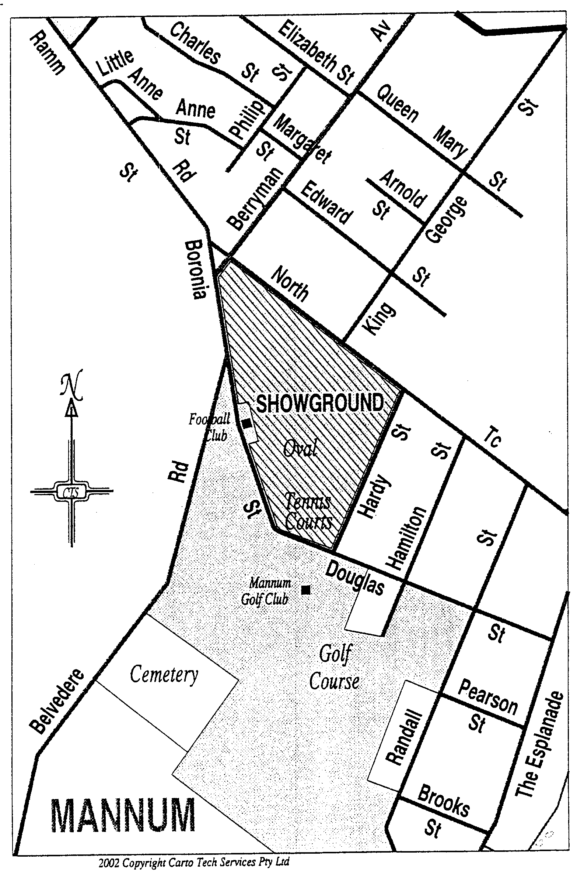

Mannum—Plan No. 2

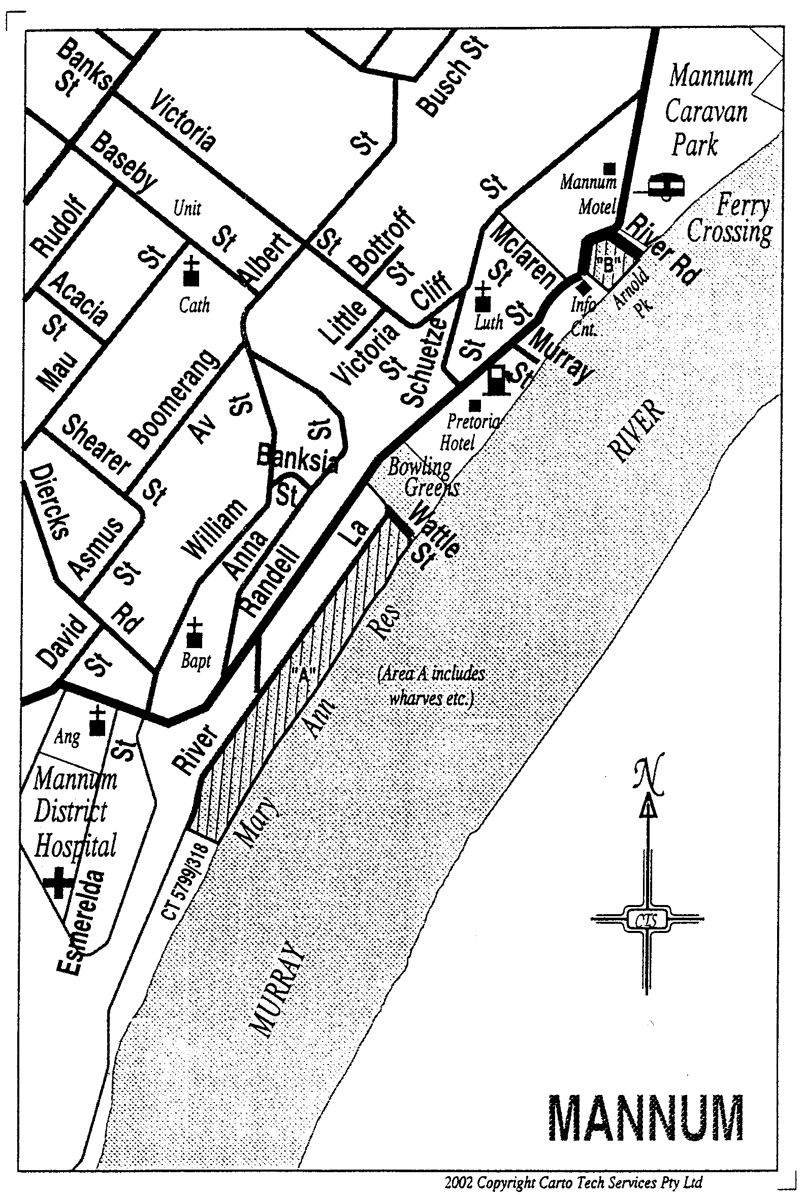

OLGC1/2002 R. DENNIS, Clerk of the Council

REGULATIONS UNDER THE CITY OF ADELAIDE ACT 1998
────
No. 35 of 2002
────
At the Executive Council Office at Adelaide, 23 May 2002

PURSUANT to the City of Adelaide Act 1998 and with the advice and consent of the Executive Council, I make the following regulations.
BRUNO KRUMINS, Governor's Deputy

PURSUANT to section 10AA(2) of the Subordinate Legislation Act 1978, I certify that, in my opinion, it is necessary or appropriate that the following regulations come into operation as set out below.

J. W. WEATHERILL, Minister for Local Government
───────────────────
SUMMARY OF PROVISIONS

1. Citation
2. Commencement
3. Variation of reg. 5—Nominations
4. Variation of Schedule
FORM 7
───────────────────

Citation
1. The City of Adelaide (Elections and Polls) Regulations 1998 (see Gazette 8 October 1998 p. 1076), as varied, are referred to in these regulations as "the principal regulations".

Commencement
2. These regulations will come into operation one month after the day on which they are made.

Variation of reg. 5—Nominations
3. Regulation 5 of the principal regulations is varied by striking out from subregulation (3f)(a) "in black and white format and".

Variation of Schedule
4. The Schedule of the principal regulations is varied—

(a) by striking out from paragraph (a) of note 2 in Form 2 "in black and white and";

(b) by striking out from paragraph (a) of note 2 in Form 3 "in black and white format and";

(c) by striking out from paragraph (a) of note 2 in Form 4 "in black and white format and";

(d) by striking out Form 7 and substituting the following form:

FORM 7

IMPORTANT—This declaration form must be signed by you or your vote WILL NOT BE VALID.
DO NOT tear off the declaration flap below. To ensure vote confidentiality the envelope will not be opened until the flap has been removed by the Returning Officer and ALL of the envelopes have been rearranged.

I hereby declare that—
A the ballot paper/s which I have placed in this envelope contain my vote and that I have not already voted in this election or poll in any other capacity AND
B I am of or above the age of 18 years AND |  | C I,..................................................  (Print Surname)  ....................................................  (Print Given Names)
Name and address |  | am the person named opposite  OR  am the person authorised by the body corporate or group named opposite to vote on its behalf, and I am an officer of the body corporate, a member of the group, or an officer of a body corporate which is a member of the group.  Please complete date of birth and sign below
Date of Birth........./........./.........

Sign here.....................................

MLG 16/2001 CS R. DENNIS, Clerk of the Council

REGULATIONS UNDER THE LOCAL GOVERNMENT (ELECTIONS) ACT 1999
────
No. 36 of 2002
────
At the Executive Council Office at Adelaide, 23 May 2002

PURSUANT to the Local Government (Elections) Act 1999 and with the advice and consent of the Executive Council, I make the following regulations.
BRUNO KRUMINS, Governor's Deputy

PURSUANT to section 10AA(2) of the Subordinate Legislation Act 1978, I certify that, in my opinion, it is necessary or appropriate that the following regulations come into operation as set out below.

J. W. WEATHERILL, Minister for Local Government
───────────────────
SUMMARY OF PROVISIONS

1. Citation
2. Commencement
3. Variation of reg. 7—Nominations
4. Variation of Schedule
FORM 11
───────────────────

Citation
1. The Local Government (Elections) Regulations 1999 (see Gazette 25 November 1999 p. 2800) are referred to in these regulations as "the principal regulations".

Commencement
2. These regulations will come into operation one month after the day on which they are made.

Variation of reg. 7—Nominations
3. Regulation 7 of the principal regulations is varied by striking out from subregulation (8)(a) "in black and white format and".

Variation of Schedule
4. The Schedule of the principal regulations is varied—

(a) by striking out from paragraph (a) of note 2 in Form 3 "in black and white and";

(b) by striking out from paragraph (a) of note 2 in Form 4 "in black and white format and";

(c) by striking out from paragraph (a) of note 2 in Form 5 "in black and white format and";

(d) by striking out Form 11 and substituting the following form:

FORM 11

IMPORTANT—This declaration form must be signed by you or your vote WILL NOT BE VALID.
DO NOT tear off the declaration flap below. To ensure vote confidentiality the envelope will not be opened until the flap has been removed by the Returning Officer and ALL of the envelopes have been rearranged.

I hereby declare that—
A the ballot paper/s which I have placed in this envelope contain my vote and that I have not already voted in this election or poll in the capacity in which I am voting AND
B I am of or above the age of 18 years AND |  | C I,..................................................  (Print Surname)  ....................................................  (Print Given Names)
Name and address |  | am the person named opposite  OR  am the person authorised by the body corporate or group named opposite to vote on its behalf, and I am an officer of the body corporate, a member of the group, or an officer of a body corporate which is a member of the group.  Please complete date of birth and sign below
Date of Birth........./........./.........

Sign here.....................................

MLG16/2001CS R. DENNIS, Clerk of the Council

REGULATIONS UNDER THE LIQUOR LICENSING ACT 1997
────
No. 37 of 2002
────
At the Executive Council Office at Adelaide, 23 May 2002

PURSUANT to the Liquor Licensing Act 1997 and with the advice and consent of the Executive Council, I make the following regulations.
BRUNO KRUMINS, Governor's Deputy

PURSUANT to section 10AA(2) of the Subordinate Legislation Act 1978, I certify that, in my opinion, it is necessary or appropriate that the following regulations come into operation as set out below.

M. J. ATKINSON, Minister for Consumer Affairs
───────────────────
SUMMARY OF PROVISIONS

1. Citation
2. Commencement
3. Variation of reg. 8—Cases where licence is not required
───────────────────
Citation
1. The Liquor Licensing (General) Regulations 1997 (see Gazette 25 September 1997 p. 913), as varied, are referred to in these regulations as "the principal regulations".

Commencement
2. These regulations come into operation on the day on which they are made.

Variation of reg. 8—Cases where licence is not required
3. Regulation 8 of the principal regulations is varied by inserting in subregulation (2)(j) "Lucindale Area School," before "Nuriootpa High School".

OLGC 2/2002 R. DENNIS, Clerk of the Council

FAXING COPY?

IF you fax copy to Government Publishing SA for inclusion in the Government Gazette, there is no need to send a Confirmation Copy to us as well.

This creates confusion and may well result in your notice being printed twice.

Please use the following fax number:

Fax transmission: (08) 8207 1040
Phone Inquiries: (08) 8207 1045

Please include a contact person, phone number and order number so that we can phone back with any queries we may have regarding the fax copy.

NOTE: Closing time for lodging new copy (either fax or hard copy) is 4 p.m. on Tuesday preceding the day of publication.

Government Gazette notices can be E-mailed.

The address is:

governmentgazette@saugov.sa.gov.au

Documents should be sent as attachments in Word format.

When sending a document via E-mail, please confirm your transmission with a faxed copy of your document, including the date the notice is to be published.

Fax transmission: (08) 8207 1040
Enquiries: (08) 8207 1045

CITY OF HOLDFAST BAY
Roads (Opening and Closing) Act 1991
Road Closure
NOTICE is hereby given that in accordance with section 10 of the Roads (Opening and Closing) Act 1991, the City of Holdfast Bay proposes to make a Road Process Order to close the following road:
In the Hundred of Noarlunga, being a strip of Bristol Place, Glenelg South situate in Filed Plan 14344 dividing allotment 91 from allotments 83 and 84 and marked ‘A’ on Preliminary Plan No. PP02/0034.
It is proposed that the portion of road to be closed marked ‘A’ be transferred to P. M. Ryan and merged with said allotment 83 in Filed Plan 14344.
A preliminary plan of the proposal, and a statement, are available for public inspection at the Holdfast Bay Council Office, 24 Jetty Road, Brighton between the hours of 9 a.m. and 4.45 p.m., Monday to Friday or at the Adelaide office of the Surveyor-General during normal office hours.
Any person may object to the proposal (and any adjoining landowner or other person substantially affected by the proposed road closure may apply for an easement relative to the closure). Such objection (or application for an easement) must be made in writing to the City of Holdfast Bay within 28 days of the date of this notice.
If a submission is made, the City of Holdfast Bay is required to give notice of the time and place at which a meeting will be held to consider the matter, so that the person making the submission (or a representative) may attend to support the submission, if desired.
Any submission must set out the full name and address of the person making the submission, and must be fully supported by reasons (and any application for the grant of an easement must give full particulars of the nature and location of the easement and, where made by a person as the owner of adjoining or nearby land, specify the land to which the easement is to be annexed). A copy of the submission must be forwarded to the Surveyor-General at Adelaide.
Dated 23 May 2002.
S. Gawler, Chief Executive Officer

CITY OF MITCHAM
Roads (Opening and Closing) Act 1991
Road Closure
NOTICE is hereby given that in accordance with section 10 of the Roads (Opening and Closing) Act 1991, the City of Mitcham proposes to make a Road Process Order to close the following road:
In the Hundred of Adelaide, being an irregularly-shaped portion of Toohey Crescent, Pasadena situate in and adjoining the southern corner of allotment 9 in Filed Plan 854 and marked ‘A’ on Preliminary Plan No. PP02/0035.
It is proposed that the portion of road to be closed marked ‘A’ be transferred to A. Caruso and merged with said allotment 9 in Filed Plan 854 subject to an easement over portion in favour of City of Mitcham for drainage purposes.
A preliminary plan of the proposal, and a statement, are available for public inspection at the Mitcham Council Office, 131 Belair Road, Torrens Park between the hours of 9 a.m. and 5 p.m., Monday to Friday or at the Adelaide office of the Surveyor-General during normal office hours.
Any person may object to the proposal (and any adjoining landowner or other person substantially affected by the proposed road closure may apply for an easement relative to the closure). Such objection (or application for an easement) must be made in writing to the City of Mitcham within 28 days of the date of this notice.
If a submission is made, the City of Mitcham is required to give notice of the time and place at which a meeting will be held to consider the matter, so that the person making the submission (or a representative) may attend to support the submission, if desired.
Any submission must set out the full name and address of the person making the submission, and must be fully supported by reasons (and any application for the grant of an easement must give full particulars of the nature and location of the easement and, where made by a person as the owner of adjoining or nearby land, specify the land to which the easement is to be annexed). A copy of the submission must be forwarded to the Surveyor-General at Adelaide.
Dated 23 May 2002.
R. Malcolm, Chief Executive Officer

THE RURAL CITY OF MURRAY BRIDGE
Naming of Stonewall Park, Wellington
NOTICE is hereby given that pursuant to section 219 (4) of the Local Government Act 1999, council resolved at its meeting held on 26 November 2001, to name the portion of road reserve at Wellington bounded by Langhorne Creek Road, Old Punt Road and Tolmer Street, ‘Stonewall Park’.
R. J. Foster, Chief Executive Officer

CITY OF ONKAPARINGA
Roads (Opening and Closing) Act 1991
Road Closure
NOTICE is hereby given that in accordance with section 10 of the Roads (Opening and Closing) Act 1991, the City of Onkaparinga proposes to make a Road Process Order to close the following road:
In the Hundred of Noarlunga, being a strip of Peach Street, Reynella situate dividing allotments 154 and 155 from allot-ments 152 and 153 in Deposited Plan 582 and marked ‘A’ on Preliminary Plan No. PP02/0036.
It is proposed that the portion of road to be closed marked ‘A’ be transferred to Walnut Grove Estate Pty Ltd and merged with said allotments 153 and 155 in Deposited Plan 582.
A preliminary plan of the proposal, and a statement, are available for public inspection at the Onkaparinga Council Office, Ramsay Place, Noarlunga Centre between the hours of 8.30 a.m. and 5 p.m., Monday to Friday or at the Adelaide office of the Surveyor-General during normal office hours.
Any person may object to the proposal (and any adjoining landowner or other person substantially affected by the proposed road closure may apply for an easement relative to the closure). Such objection (or application for an easement) must be made in writing to the City of Onkaparinga within 28 days of the date of this notice.
If a submission is made, the City of Onkaparinga is required to give notice of the time and place at which a meeting will be held to consider the matter, so that the person making the submission (or a representative) may attend to support the submission, if desired.
Any submission must set out the full name and address of the person making the submission, and must be fully supported by reason (and any application for the grant of an easement must give full particulars of the nature and location of the easement and, where made by a person as the owner of adjoining or nearby land, specify the land to which the easement is to be annexed). A copy of the submission must be forwarded to the Surveyor-General at Adelaide.
Dated 23 May 2002.
J. Tate, Chief Executive Officer

CITY OF VICTOR HARBOR
Declaration of Public Road
NOTICE is hereby given that the City of Victor Harbor passed the following resolution:
Resolved that the land contained in Form RTC Application for Deposit of Plan of Division transferring from Lloyd James Hutchinson, P.O. Box 32, Victor Harbor, S.A. 5211 to the City of Victor Harbor, P.O. Box 11, Victor Harbor, S.A. 5211 and dated 14 May 2002 and comprising portion of the land contained in certificate of title register book volume 5442, folios 749 and 751 and known as Allotments 52 and 53 in Deposited Plan No. 58904 and is hereby declared to be a Reserve and a public road respectively, pursuant to section 208 of the Local Government Act 1999.
The Common Seal of the City of Victor Harbor was hereunto affixed in the presence of:
(l.s.) J. W. Crompton, Mayor
G. K. Maxwell, District Manager

THE BAROSSA COUNCIL
Declaration of Public Road
NOTICE is hereby given, pursuant to section 210 of the Local Government Act 1999, that at a meeting of The Barossa Council held on 19 February 2002, the following lands were declared to be public roads:
Allotments b51 and 53 comprised in Lands Titles Registra-tion Office, Filed Plan No. 42471.
J. Jones, Chief Executive Officer

DISTRICT COUNCIL OF BARUNGA WEST
Periodical Review of Electoral Boundaries
NOTICE is hereby given that pursuant to the provisions of section 12 (9) of the Local Government Act 1999, the District Council of Barunga West is required to carry out a review to determine whether a change of arrangements in respect to electoral representation, including ward boundaries and the composition of council, will result in the electors of the area being more adequately and fairly represented.
That report has now been completed and copies are available at the Port Broughton Office, Bay Street, Port Broughton or 15 Railway Terrace, Bute and interested persons are invited to make written submissions to the Chief Executive Officer, P.O. Box 3, Port Broughton, S.A. 5522 by the close of business on Friday, 21 June 2002.
Any person who makes a written submission will be given the opportunity to appear before council to be heard in respect to his/her submission.
N. Hand, District Manager

KANGAROO ISLAND COUNCIL
Periodical Review of Elector Representation
NOTICE is hereby given that pursuant to the provisions of section 12 (5) of the Local Government Act 1999, the council is carrying out a review to determine whether a change, with respect to elector representation including ward boundaries and the composition of council, will result in the electors of the area being more adequately and fairly represented.
Information regarding this review is available from the Council Office, 43 Dauncey Street, Kingscote or by contacting Richard Semler on 8553 2015 during office hours.
Any person wishing to make a written submission in relation to the review may do so on or before 5 p.m. on Friday, 12 July 2002. Submissions should be directed to the Chief Executive Officer, Kangaroo Island Council, P.O. Box 121, Kingscote, S.A. 5223.
Any person making a written submission will be given the opportunity to address council on their submission.
R. Rattray, Chief Executive Officer

DISTRICT COUNCIL OF RENMARK PARINGA
Periodical Review of Elector Representation
Erratum
NOTICE is hereby given that the notice published on 2 May 2002, page 1827, of the South Australian Government Gazette is amended as follows:
The closing date for submissions, originally published as Wednesday, 22 May 2002 is hereby amended to Monday, 27 May 2002.
B. C. Hurst, Chief Executive Officer

IN the matter of the estates of the undermentioned deceased persons:
Bansemer, Ellen Dawn, late of 36 Jetty Road, Brighton, home duties, who died on 26 March 2002.
Bowen, Robert, late of 137 Settlement Road, Cowes, Phillip Island, Victoria, retired accountant, who died on 5 January 1999.
Broderick, Christopher John, late of 100 Richards Drive, Morphett Vale, retired horticulturist, who died on 8 March 2002.
Gates, Mervyn Jose, late of 342 Marion Road, North Plympton, retired driver, who died on 8 March 2002.
Leesue, Mabel Gwendoline, late of 82 Williams Road, Millicent, of no occupation, who died on 29 March 2002.
Lindblom, Mary Ann, late of 342 Marion Road, North Plympton, of no occupation, who died on 31 December 2001.
Morris, Stephen David, late of 84 Reservoir Road, Modbury, retired shop keeper, who died on 3 April 2002.
Pearson, Iris Winifred, late of 1215 Grand Junction Road, Hope Valley, home duties, who died on 11 March 2002.
Powell, Ailsa Isabel, late of 192 Bower Road, Semaphore Park, home duties, who died on 23 March 2002.
Rieger, William Albert Herbert, late of 24-34 Avenue Road, Glynde, retired hardware store manager, who died on 19 March 2002.
Shaw, Hessie McDowall, late of 52 Dunrobin Road, Hove, widow, who died on 5 December 2001.
Tucknott, Anthony Harry, late of 1006 Dana Street, Ballarat, Victoria, carpenter’s labourer, who died on 29 October 1966.
Walker, Roma Edith, late of 35 Hulbert Street, Hove, retired dressmaker, who died on 27 March 2002.
Notice is hereby given pursuant to the Trustee Act 1936, as amended, the Inheritance (Family Provision) Act 1972, and the Family Relationships Act 1975, that all creditors, beneficiaries, and other persons having claims against the said estates are required to send, in writing, to the Public Trustee, 25 Franklin Street, Adelaide 5000, full particulars and proof of such claims, on or before 21 June 2002, otherwise they will be excluded from the distribution of the said estate; and notice is also hereby given that all persons who are indebted to the said estates are required to pay the amount of their debts to the Public Trustee or proceedings will be taken for the recovery thereof; and all persons having any property belonging to the said estates are forthwith to deliver the same to the Public Trustee.
Dated 23 May 2002.
C. J. O’Loughlin, Public Trustee

IN the matter of the estate of the undermentioned deceased person:
Barr, Audrey May, late of Wesley House Nursing Home, 324 Military Road, Semaphore, formerly of 17 Edward Street, Norwood, who died on 13 July 2001.
Notice is hereby given pursuant to the Trustee Act 1936 as amended, the Inheritance (Family Provision) Act 1972-1975 and the Family Relationships Act 1975 that all creditors beneficiaries and other persons having claims against the abovenamed estate are directed to send full particulars of such claims to the undersigned on or before 14 June 2002 otherwise they will be excluded from the distribution of the said estate.
Perpetual Trustees S.A. Limited (ACN 008 273 916), c/o Ground Floor, 39 Hunter Street, Sydney, N.S.W. 2000.

SOUTH AUSTRALIA—In the Supreme Court. No. 1716 of 1997. In the matter of Absolute Aim Pty Ltd (ACN 008 192 470) and in the matter of the Corporations Act.
Notice by a Liquidator of His Intention to Seek His Release
Take notice that I, Bruce James Carter of Ferrier Hodgson, Level 6, 81 Flinders Street, Adelaide, S.A. 5000, the liquidator of the abovenamed company, intend to make application to the Supreme Court of South Australia for my release as liquidator and dissolution of the abovenamed company. And take further notice that if you have any objection to the granting of my release you must file at the Supreme Court and also forward to my within 21 days of the publication in the Gazette of the notice of my intention to apply for a release a notice of objection in the form laid down by the Corporations (South Australia) Rules 1993.
Dated 16 May 2002.
B. J. Carter, Liquidator
Note: Section 481 of the Corporations Act enacts that an order of the Court releasing a liquidator shall discharge him/her in the administration of the affairs of the company, or otherwise in relation to his or her conduct as liquidator, but any such order may be revoked on proof that it was obtained by fraud or by suppression or by concealment of any material fact.

SOUTH AUSTRALIA—In the Supreme Court. No. 309 of 1997. In the matter of Riverina Produce Echuca Pty Limited (ACN 060 461 529) and in the matter of the Corporations Law.
Notice of Release of Liquidator
Take notice that by an order of the Supreme Court of South Australia, dated 10 May 2002, I, Peter Ian Macks, 10th Floor, 26 Flinders Street, Adelaide, S.A. 5000, the liquidator of the abovenamed company was granted my release as liquidator.
Dated 16 May 2002.
P. I. Macks, Liquidator

ATTENTION

CUSTOMERS requiring a proof of their notice for inclusion in the Government Gazette, please note that the onus is on you to inform Government Publishing SA of any subsequent corrections by 10 a.m. on Thursday, which is our publication deadline.

For any corrections to your notice please phone 8207 1045 or Fax 8207 1040 before 10 a.m. on Thursday.

If we do not receive any communication by 10 a.m. on Thursday (day of publication) we will presume the notice is correct and will print it as it is.

Remember—the onus is on you to inform us of any corrections necessary to your notice.

NOTE: Closing time for lodging new copy (electronically, fax or hard copy) is 4 p.m. on Tuesday preceding the day of publication. Phone 8207 1045—Fax 8207 1040.
Email: governmentgazette@saugov.sa.gov.au

Printed and published by authority every Thursday by J. D. FERGUSON, Government Printer, South Australia
Price: $4.40, plus postage; to subscribers, $220.20 per annum.
(The above prices are inclusive of GST)

