No. 64 1995

THE SOUTH AUSTRALIAN

GOVERNMENT GAZETTE

PUBLISHED BY AUTHORITY

ALL PUBLIC ACTS appearing in this GAZETTE are to be considered official, and obeyed as such

ADELAIDE, THURSDAY, 30 MAY 2002

CONTENTS

Page
Corporations and District Councils—Notices 2030
Crown Lands Act 1929—Notice 1996
Development Act 1993—Notices 1996
Fisheries Act 1982—Notices 2018
Housing Improvement Act 1940—Notices 2020
Liquor Licensing Act 1997—Notices 2022
Mining Act 1971—Notices 2024
Partnership Act 1891—Notice 2033
Petroleum Act 2000—Notice 2026
Proclamation 1996
Proof of Sunrise and Sunset Act 1923—Almanac 2027
Partnership Act 1891—Notice 2033
Public Trustee Office—Administration of Estates 2033
Roads (Opening and Closing) Act 1991—Notice 2025
Road Traffic Act 1961—Notice 2026
State Emergency Service Act 1987—Notice 2028
Transport, Department of—Notice to Mariners 2025
Unclaimed Moneys Act 1891—Notice 2034
Water Mains and Sewers—Mains Laid, Replaced, Etc. 2028

GOVERNMENT GAZETTE NOTICES
ALL poundkeepers’ and private advertisements forwarded for publication in the South Australian Government Gazette must be PAID FOR PRIOR TO INSERTION; and all notices, from whatever source, should be legibly written on one side of the paper only and sent to Government Publishing SA so as to be received no later
than 4 p.m. on the Tuesday preceding the day of publication. Phone 8207 1045 or Fax 8207 1040. E-mail: governmentgazette@saugov.sa.gov.au. Send as attachments in Word format and please confirm your transmission with a faxed copy of your document, including the date the notice is to be published and to whom the notice will be charged.

STATUTES AMENDMENT (GAMBLING REGULATION) ACT 2001 (Act No. 18 of 2001): DAY OF COMMENCEMENT OF SUSPENDED PROVISION
Proclamation By The Governor
(l.s.) Marjorie Jackson-Nelson
WITH the advice and consent of the Executive Council, I fix 1 June 2002 as the day on which section 16 of the Statutes Amendment (Gambling Regulation) Act 2001 will come into operation.
Given under my hand and the Public Seal of South Australia, at Adelaide, 30 May 2002.
By command,
J. W. Weatherill, for Premier
GAMB02/0002CS

CROWN LANDS ACT 1929: SECTION 5
TAKE notice that pursuant to the Crown Lands Act 1929, I JOHN HILL, Minister for Environment and Conservation, Minister of the Crown to whom the administration of the Crown Lands Act 1929 is committed DO HEREBY:
1. Resume the land defined in The First Schedule.
2. Dedicate the Crown Land defined in The Second Schedule as a Public Road.
The First Schedule
Stone Reserve, now numbered as section 391, Hundred of Comaum, the proclamation of which was published in the Government Gazette, 21 August 1890 at pages 430 and 431, Hundred of Comaum, Stone Reserve No. 3, being the land comprised in Crown Record Volume 5608 Folio 743.
The Second Schedule
Allotment 103 of DP 59236, Hundred of Comaum, County of Robe, being within the Wattle Range district.
Dated 30 May 2002.
John Hill, Minister for Environment and Conservation
DEHAA 09/1549

DEVELOPMENT ACT 1993, NOTICE UNDER SECTION 25(17): DISTRICT COUNCIL OF MALLALA—MALLALA (DC) DEVELOPMENT PLAN—LEWISTON/ TWO WELLS, GAWLER RIVER AND ENVIRONS AND TOWNSHIPS PLAN AMENDMENT
Preamble
1. The Development Plan Amendment entitled ‘District Council of Mallala—Mallala (DC) Development Plan—Lewiston/Two Wells, Gawler River and Environs and Townships Plan Amendment’ (the Plan Amendment) has been finalised in accordance with the provisions of the Development Act 1993.
2. The Minister for Transport and Urban Planning has decided to approve the Plan Amendment.
PURSUANT to section 25 of the Development Act 1993, I—
(a) approve the Plan Amendment; and
(b) fix the day on which this notice is published in the Gazette as the day on which the Plan Amendment will come into operation.
Dated 30 May 2002.
J. W. Weatherill, Minister for Urban Development and Planning
PLN/96/0655

DEVELOPMENT ACT 1993, NOTICE UNDER SECTION 25 (17): THE BAROSSA COUNCIL—ANGASTON (DC), BAROSSA (DC), TANUNDA (DC) AND MOUNT PLEASANT (DC) DEVELOPMENT PLANS—GENERAL PLAN AMENDMENT
Preamble
1. The Development Plan Amendment entitled ‘The Barossa Council—Angaston (DC), Barossa (DC), Tanunda (DC) and Mount Pleasant (DC) Development Plans—General Plan Amendment’ (the Plan Amendment) has been finalised in accordance with the provisions of the Development Act 1993.
2. The Minister for Urban Development and Planning has decided to approve the Plan Amendment.
PURSUANT to section 25 of the Development Act 1993, I—
(a) approve the Plan Amendment; and
(b) fix the day on which this notice is published in the Gazette as the day on which the Plan Amendment will come into operation.
Dated 30 May 2002.
J. W. Weatherill, Minister for Urban Development and Planning
PLN/98/0737

DEVELOPMENT ACT 1993: SECTION 46(4)
Preamble
1. On 15 July 1999 the Minister for Transport and Urban Planning made a declaration under section 46(1) of the Development Act 1993 relating to certain specified kinds of development (see Gazette 15 July 1999 pages 240 and 241).
2. The declaration has been subsequently varied.
3. I have decided to make another variation to the declaration referred to in Clause 1.
Notice
PURSUANT to section 46(4) of the Development Act 1993, I further vary the declaration referred to in Clause 1 of the preamble:
(a) by striking out from subparagraph (i) of paragraph (a) of Schedule 1 ‘a hotel’ and substituting ‘a hotel or hotels’;
(b) by inserting after paragraph (f) of Schedule 1 the following paragraph:
(fa) the construction or alteration of a balcony or verandah over the footpath on the southern side of sections 1470, 1542 and 1611 shown on the map in Schedule 2;
(c) by inserting in paragraph (k) of Schedule 1, (fa) after (f).
Dated 30 May 2002.
J. W. Weatherill, Minister for Urban Development and Planning

DEVELOPMENT ACT 1993, SECTION 29(2)(b) AMENDMENT TO MARION (CITY) DEVELOPMENT PLAN AND NOARLUNGA (CITY) DEVELOPMENT PLAN
Preamble
It is necessary to amend the Marion (City) Development Plan dated 20 September 2001 and the Noarlunga (City) Development Plan dated 22 November 2001.
Notice
PURSUANT to section 29(2)(b) of the Development Act 1993, I, Jay Weatherill M.P., being the Minister administering the Act, amend:
Noarlunga (City) Development Plan dated 22 November 2001:
(a) Delete the contents of the Residential (Field River Valley) Zone appearing on pages 82 and 83;
(b) Delete the contents of the Landscape (Buffer) Zone appearing on pages 205 and 206;
(c) Replace Maps No. 1 (Overlay 1), No. 1 (Overlay 1) Enlargement A, No. 1 (Overlay 3). No. 3, No. 4 and No. 42; with the contents of Attachment A.
Marion (City) Development Plan dated 20 September 2001:
(a) Replace the contents of the Residential (Field River Valley) Zone appearing on pages 88 to 91, with the contents of Attachment B;
(b) Immediately following the Rural B Zone material insert the contents of Attachment C; and
(c) Replace Maps Mar/1, Mar/1 (Overlay 1) Part A, Mar/1 (Overlay 1) Part B, Mar/1 (Overlay 2) and Mar/16; with the contents of Attachment D.
Dated 30 May 2002.
J. W. Weatherill, Minister For Urban Development and Planning
PLN/99/0336
PLN/99/0381
ATTACHMENT A
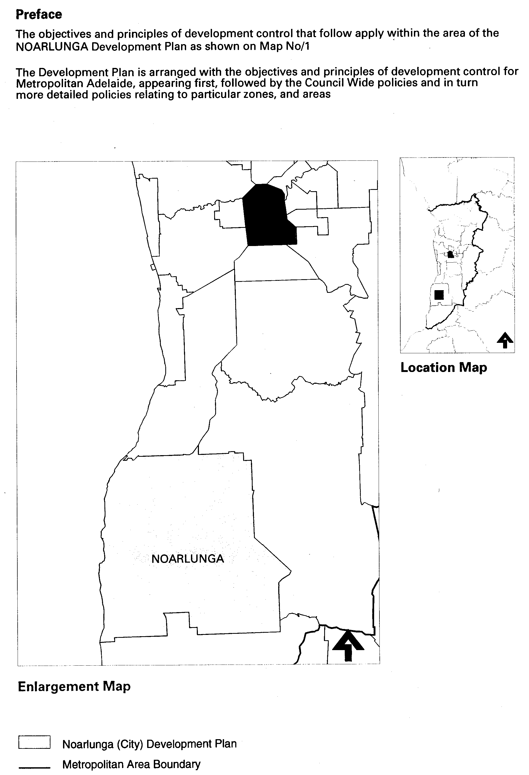
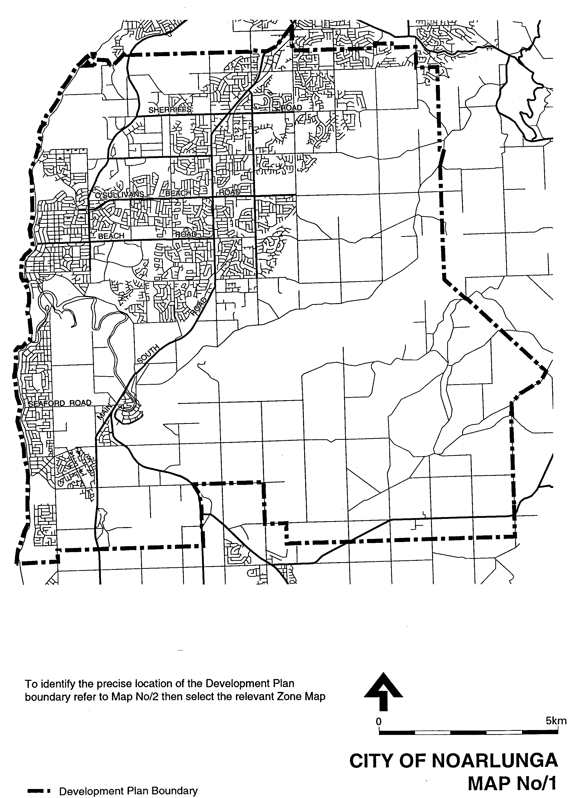
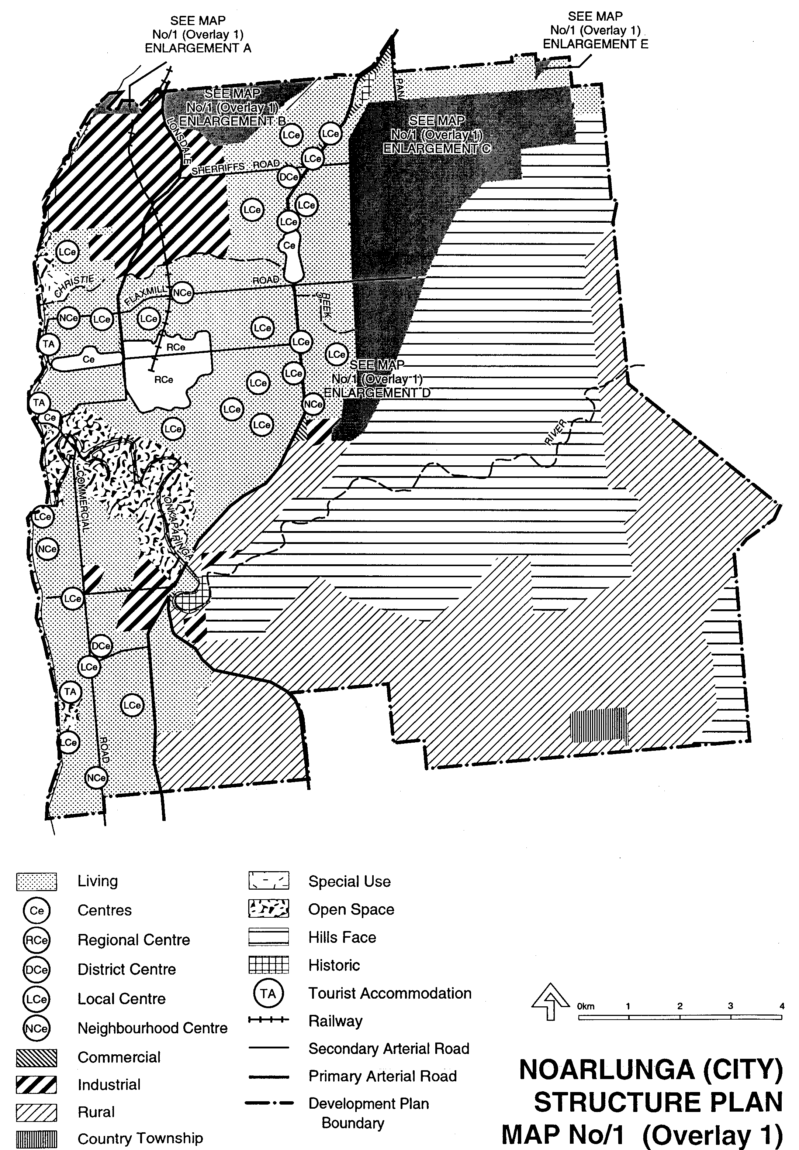
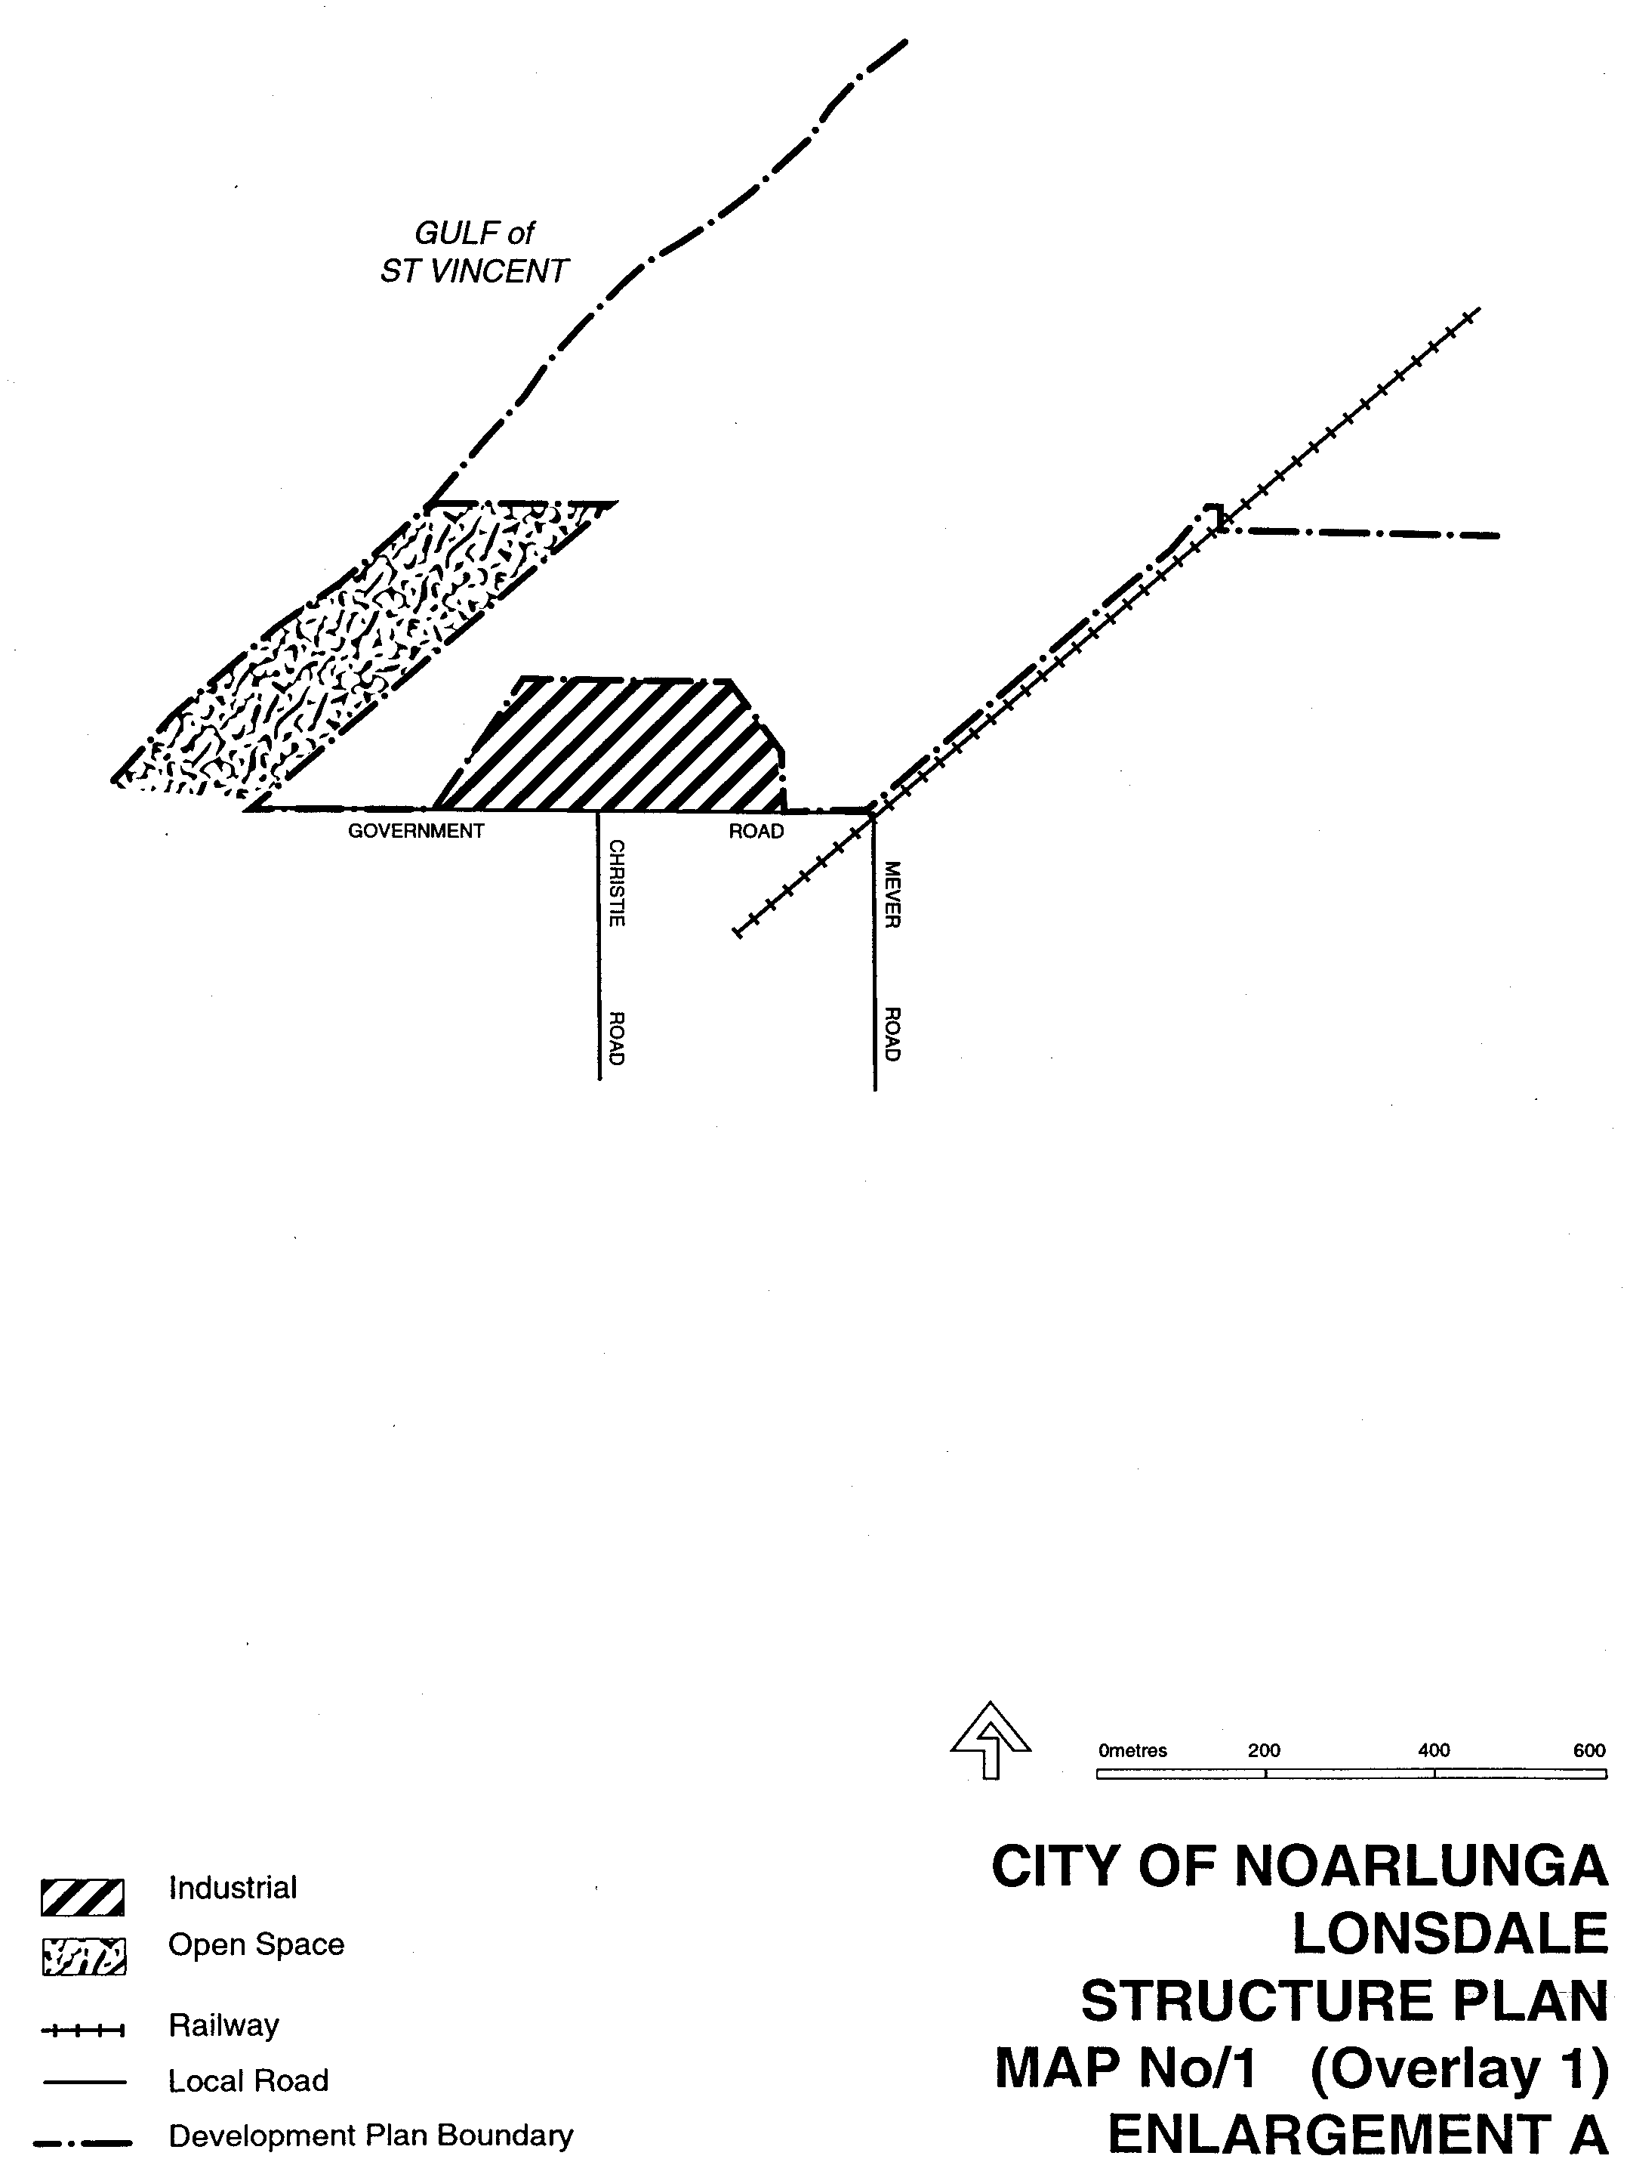
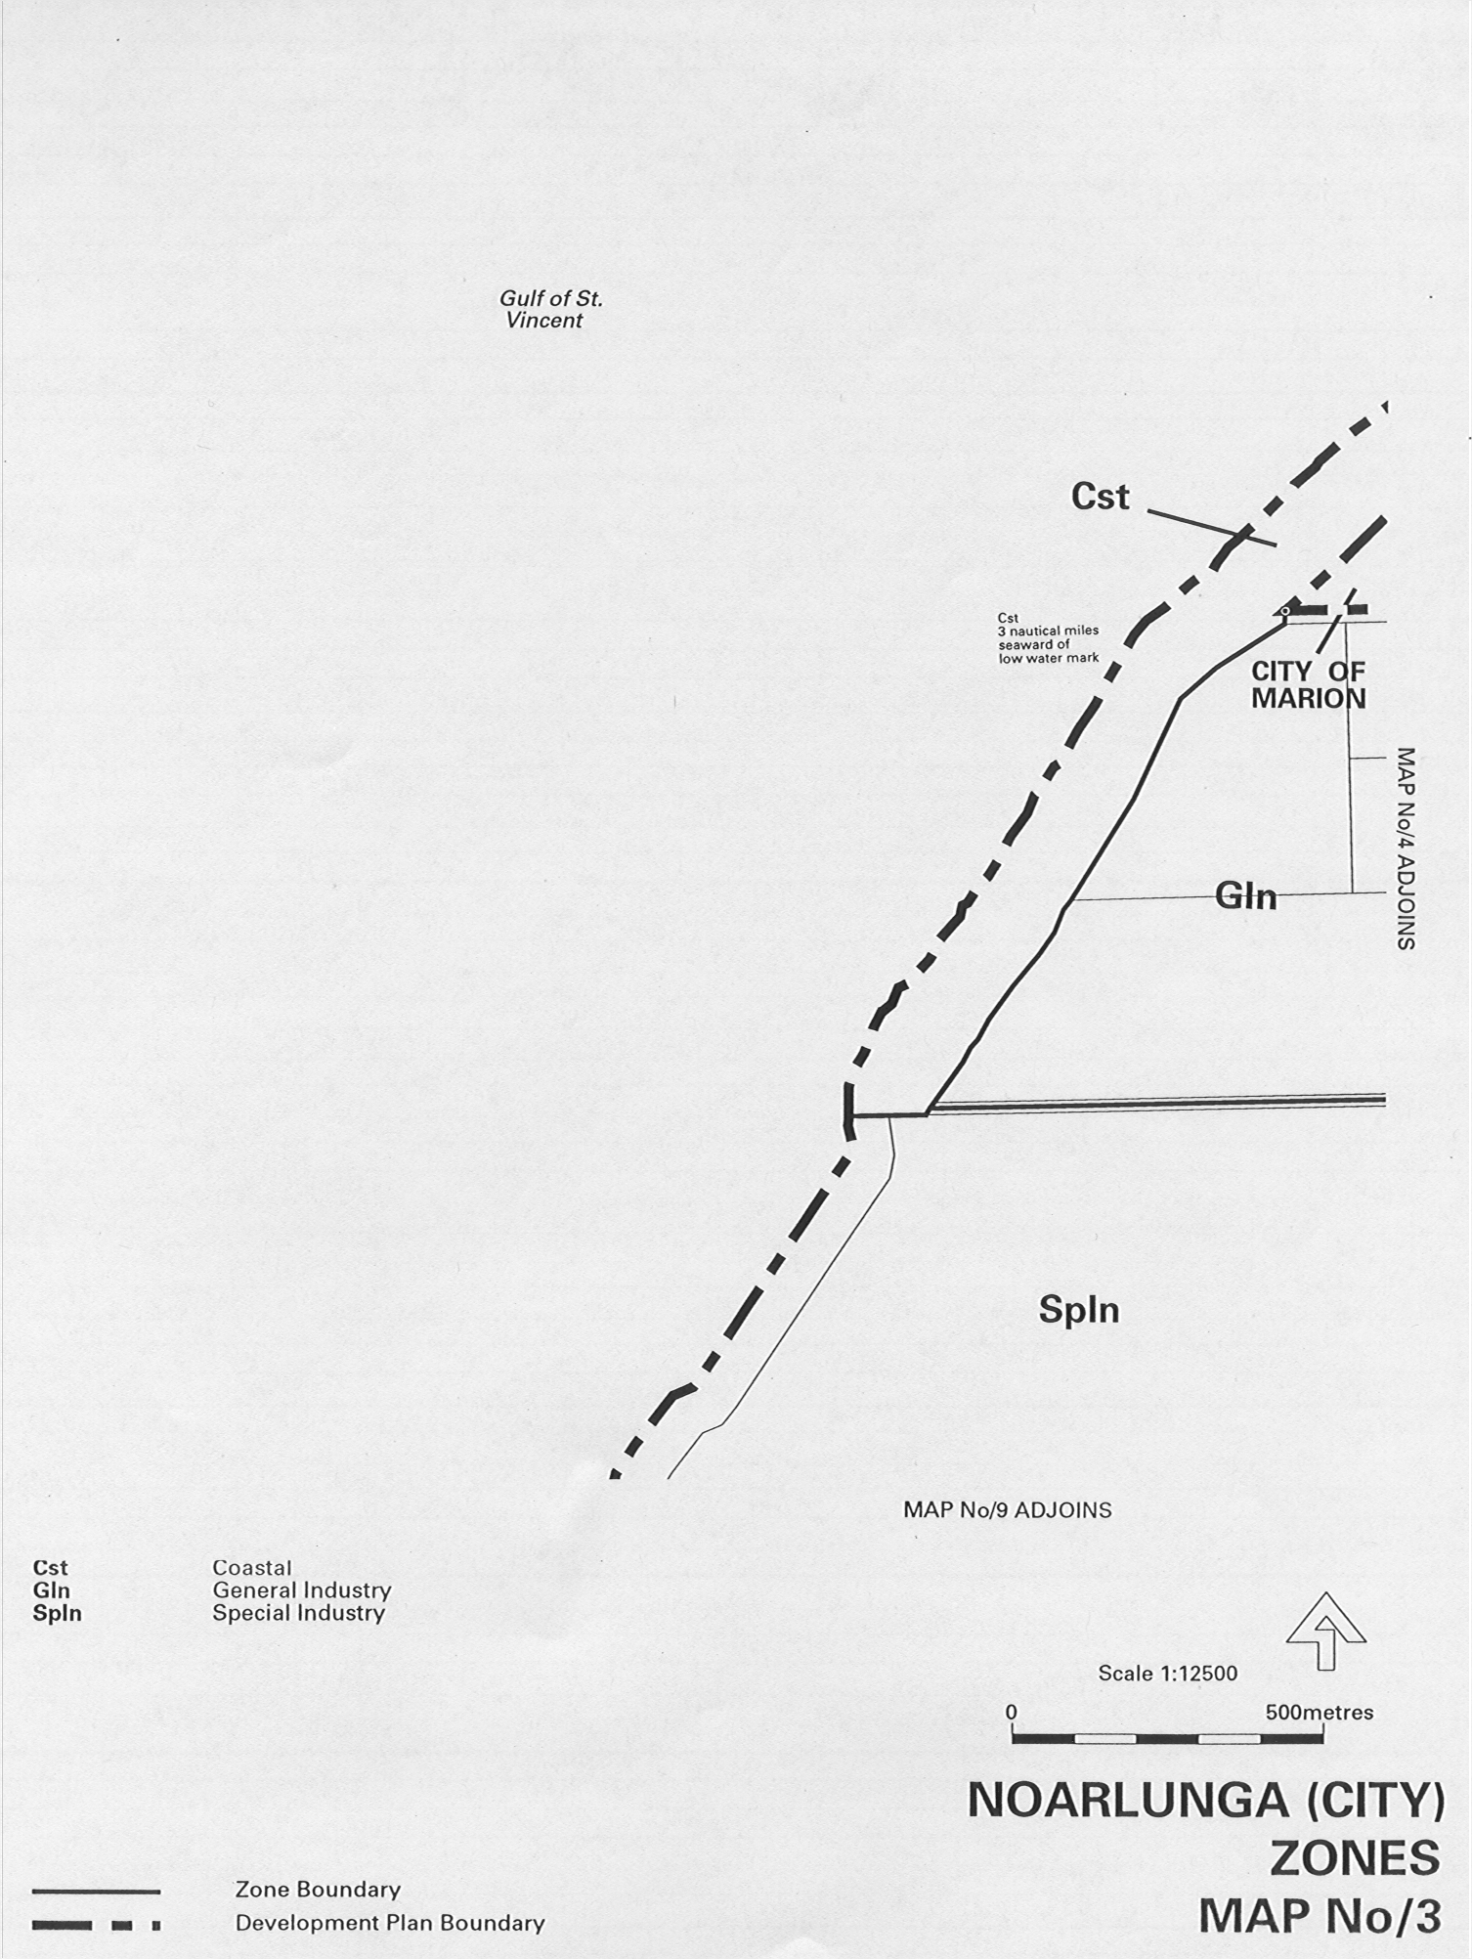
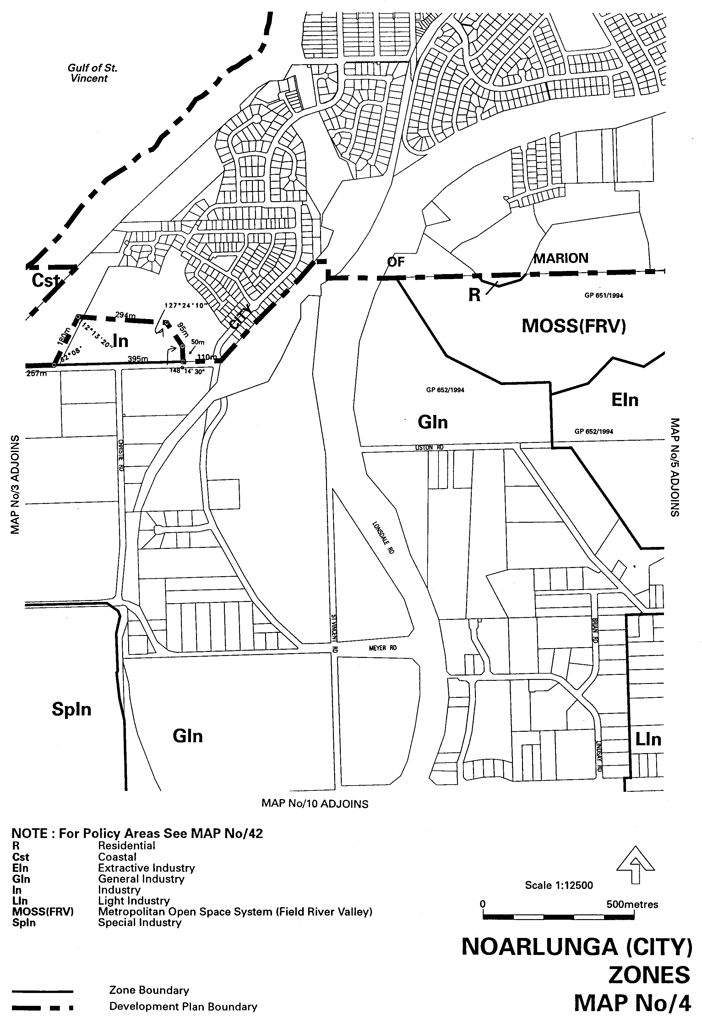
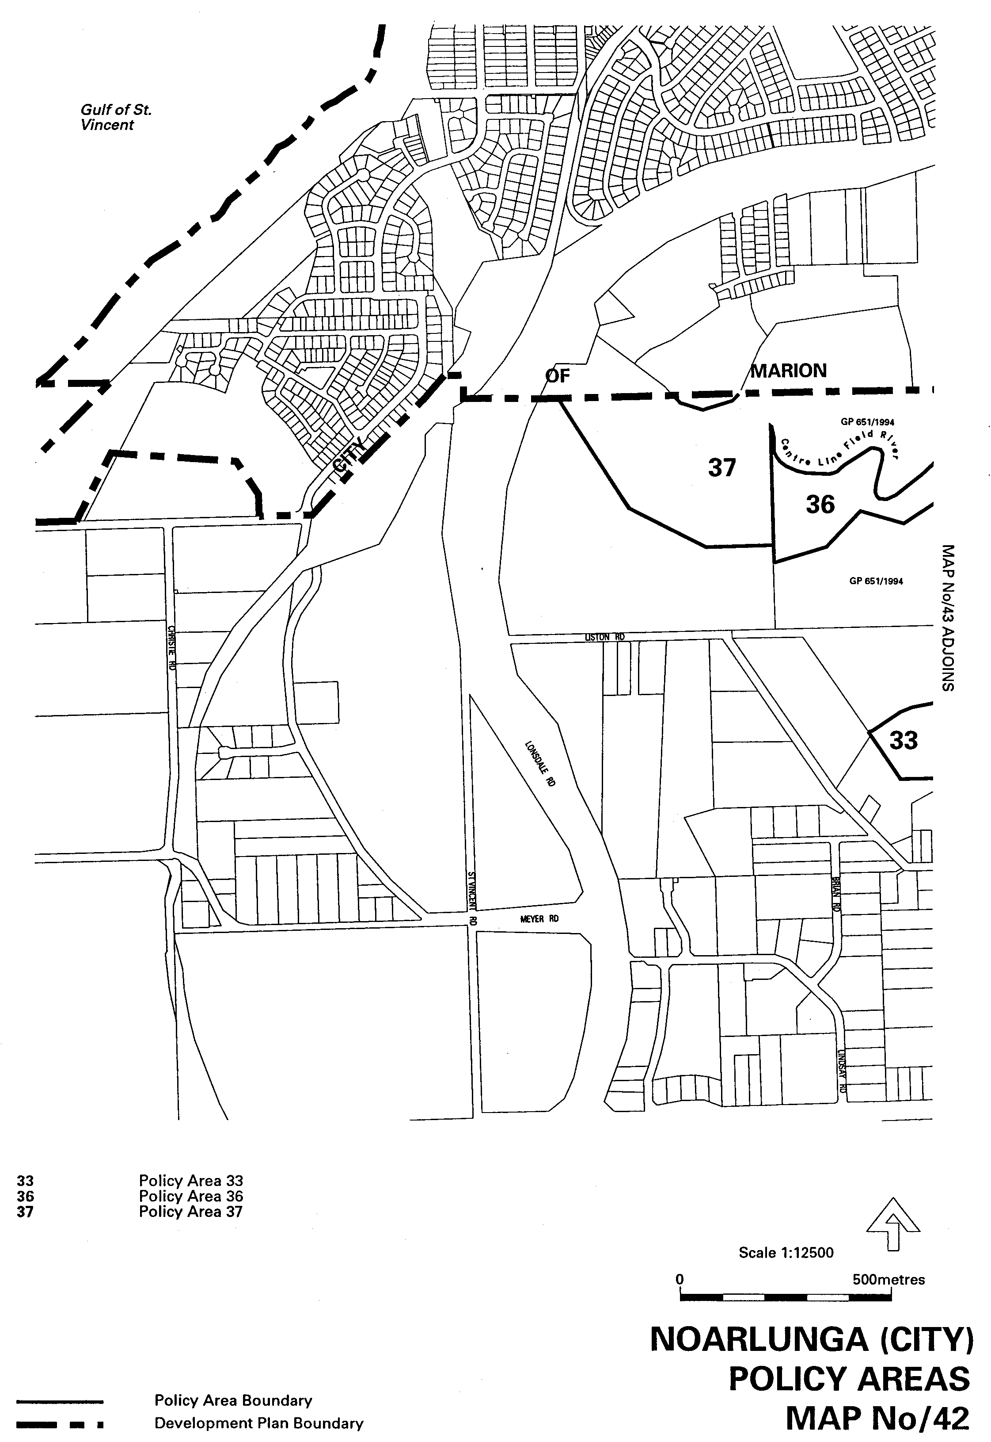
ATTACHMENT B
RESIDENTIAL (FIELD RIVER VALLEY) ZONE
Introduction
The objectives and principles of development control apply in the Residential (Field River Valley) Zone shown on Map Mar/16. They are additional to those expressed for the whole of the council area.
OBJECTIVES
Objective 1: A zone accommodating dwellings of various styles.
Objective 2: A high standard of residential amenity and a pleasant living environment.
Objective 3: Land division which:
(a) contains a range of allotment sizes suitable for different types of dwellings; and
(b) promotes innovation in design and layout.
Objective 4: A zone containing a number of dwellings appropriate to the capacity of the adjoining road system.
Development potential of the zone should be limited to approximately 350 dwellings.
PRINCIPLES OF DEVELOPMENT CONTROL
1. Development should be in accordance with the Structure Plan shown on Map Mar/1 (Overlay 1) Enlargement B.
2. Development should proceed in an orderly and continuous sequence, from the northern portion adjacent to St Vincent Avenue.
3. Access to Field River Valley residential area should be from St Vincent Avenue, as shown on Map Mar/1 (Overlay 1) Enlargement B and Meyer Road.
4. Access to development within D3657/500, D43657/502 and the northern portion of D43657/504 should be facilitated by a grade separated crossing which links into Meyer Road shown in the Structure Plan, Map Mar/1 (Overlay 1) Enlargement B.
5. Allotments should be orientated so that dwellings can be sited on them:
(a) to gain maximum advantage of coastal views; and
(b) minimize the amount of cut and fill on the land.
6. Development should provide a range of dwelling types and should comprise:
(a) a high standard of building design and site layout;
(b) a development potential commensurate with the capacity of the adjoining road system;
(c) a high standard of residential amenity; and
(d) buildings which are of a height and bulk which will not have a significant detrimental effect on the amenity of adjoining residents.
7. Development should provide for:
(a) a reserve within a minimum width of 30 metres on each side of the Field River, in order to establish a link from the upper Field River to the sea, as shown on Map Mar/1 (Overlay 1 Enlargement B; and
(b) a coastal reserve as shown on Map Mar/1 (Overlay 1) Enlargement B in order to protect geological features and to preserve the amenity of the coastline.
8. Development should not be undertaken where it will create or aggravate cliff erosion nor where it would be placed at risk by such erosion, unless suitable measures are taken to minimize that impact.
9. Development should provide for a range of allotment sizes, in order to facilitate housing mix.
10. Development should provide for pedestrian and cycle links to Hallett Cove.
11. Development should make suitable provision for the safe and efficient disposal of all waste, including effluent, stormwater and hard rubbish.
12. Development should incorporate a stormwater management scheme that:
(a) encourage on-site water harvesting to maintain garden and lawn areas;
(b) provides sufficient land in drainage reserves and floodways for the construction of appropriate structural controls, such as flow retardation basins, wet retention basins, wetlands and trash racks;
(c) maintains the volume and rate of run-off from newly-developed areas at levels as near as possible to those which existed prior to the development;
(d) takes into consideration the impacts the development will have on existing watercourses and downstream storm water control facilities;
(e) includes an engineering design which aims to preserve rather than eliminate natural, drainage systems; and
(f) avoids discharge into the marine environment.
13. Development should be set-back a suitable distance from the cliffs to minimize impact on the coastal landscape.
14. Sufficient cliff top reserve should be provided to allow for pedestrian access between private property and the cliff edge.
15. The following kinds of development are complying in the Residential (Field River Valley) Zone subject to compliance with the conditions comprising, where applicable:
(a) no building will be erected, altered or added top, nearer that eight meters to the existing boundary of a road, or the boundary of any land shown as being required for road widening on the Plan deposited under the provisions of the Metropolitan Adelaide Road Widening Plan Act, 1972 to 1976;and
(b) the conditions prescribed in Table Mar/1:
Detached Dwelling
Domestic Outbuilding
Non-complying Development
16. The following kinds of development are non-complying in the Residential (Field River Valley) Zone:
Abattoir
Advertisement or Advertising Display:
(a) on a site wholly for residential purposes; or
(b) that have any part greater than 4.5 metres in height above natural ground surface level or are internally or externally illuminated, move, rotate, flash, or incorporate an animated display or running lights
Amusement Machine Centre
Amusement Park
Auction Room
Bowling Alley
Builder’s Yard
Cemetery
Concert Hall
Dwellings beyond a total of 350 dwellings
Fun Fair
Horse Keeping
Industry
Junk Yard
Motor Repair Station
Motor Showroom
Office
Public Service Depot
Rail Transport Terminal
Shop or group of shops with a gross leasable area greater than 200 square metres
Service Trade Premises
Skating Rink
Special Industry
Store
Timber Yard
Transmitting Station
Used Car Yard
Warehouse

ATTACHMENT C
LANDSCAPE (BUFFER) ZONE
Introduction
The objectives, proposal and principles of development control apply in the Landscape (Buffer) Zone shown on Map Mar/16. They are additional to those expressed for the whole of the council area.
OBJECTIVES
Objective 1: A zone which provides spatial, visual and auditory separation between incompatible land uses.
Objective 2: A zone which integrates landscaped screening techniques with usable open space for recreational purposes.
The Landscaper (Buffer) Zone provides an opportunity to create a usable green belt area which will separate the existing general areas of Lonsdale from residential growth south from Hallett Cove.
Furthermore, the zone will improve the aesthetics of a prominent entry vista to the City of Noarlunga thereb7y ensuing a high degree of residential amenity for the locality which it abuts.
Portion of the land in the zone adjacent to the coast is a large “break-away” area of natural erosion similar to that in the Hallett Cove Conservation Park and it has scientific value. It needs to be protected from any induced erosion.
The Landscape (Buffer) Zone should develop as a densely planted but functional open space assessable to workers and residents alike.
PROPOSAL
Council proposes to negotiate with the major land holders to ensure that an appropriate landscape design, layout and maintenance scheme is instigated and achieved expediently, with special attention being given to the interface between the southern boundary of the zone and the Industry Zone.
PRINCIPLES OF DEVELOPMENT CONTROL
1. Development undertaken in the Landscape (Buffer) Zone should primarily comprise active and passive recreation faculties, integrated with but secondary to landscaper buffer treatment.
2. Buildings constructed for community uses within the zone should be located on the northern edge of the zone adjacent to the Residential (Field River Valley) Zone.
3. Development undertaken within the zone should not hinder access to or use of recreation faculties located within the zone.
4. No development is complying absolutely or conditionally in the Landscape (Buffer) Zone.
Non-complying Development
5. The following kinds of development are non-complying in the Residential (Field River Valley) Zone:
Abattoir Dog Track
Amusement Machine Centre Drive-in Theatre
Auction Room Dwelling
Bank Education Establishment
Billiard Saloon Fuel Depot
Bowling Alley Fun Fair
Builder’s Yard Gas Holder
Bus Depot General Industry
Bus Station Group Dwelling
Caravan Park Hospital
Concert Hall Hotel
Consulting Room Intensive Animal Keeping
Crematorium Junk Yard
Detached Dwelling
Landfill that constitutes solid waste disposal required to be licensed as a waste depot under the Environment Protection Act 1993
Light Industry Residential Club
Major Public Service Depot Residential Flat Building
Minor Public Service Depot Restaurant
Motel Row Dwelling
Motor Race Track Semi-detached Dwelling
Motor Repair Station Service Industry
Motor Showroom Service Reservoir
Multiple Dwelling Service Trade Premises
Nursing Home Shop
Office Special Industry
Petrol Filling Station Store
Post Office Theatre
Pre-school Timber Yard
Prescribed Mining Operation Used Car Yard
Private Hotel Warehouse
Refuse Destructor Waterworks

ATTACHMENT D
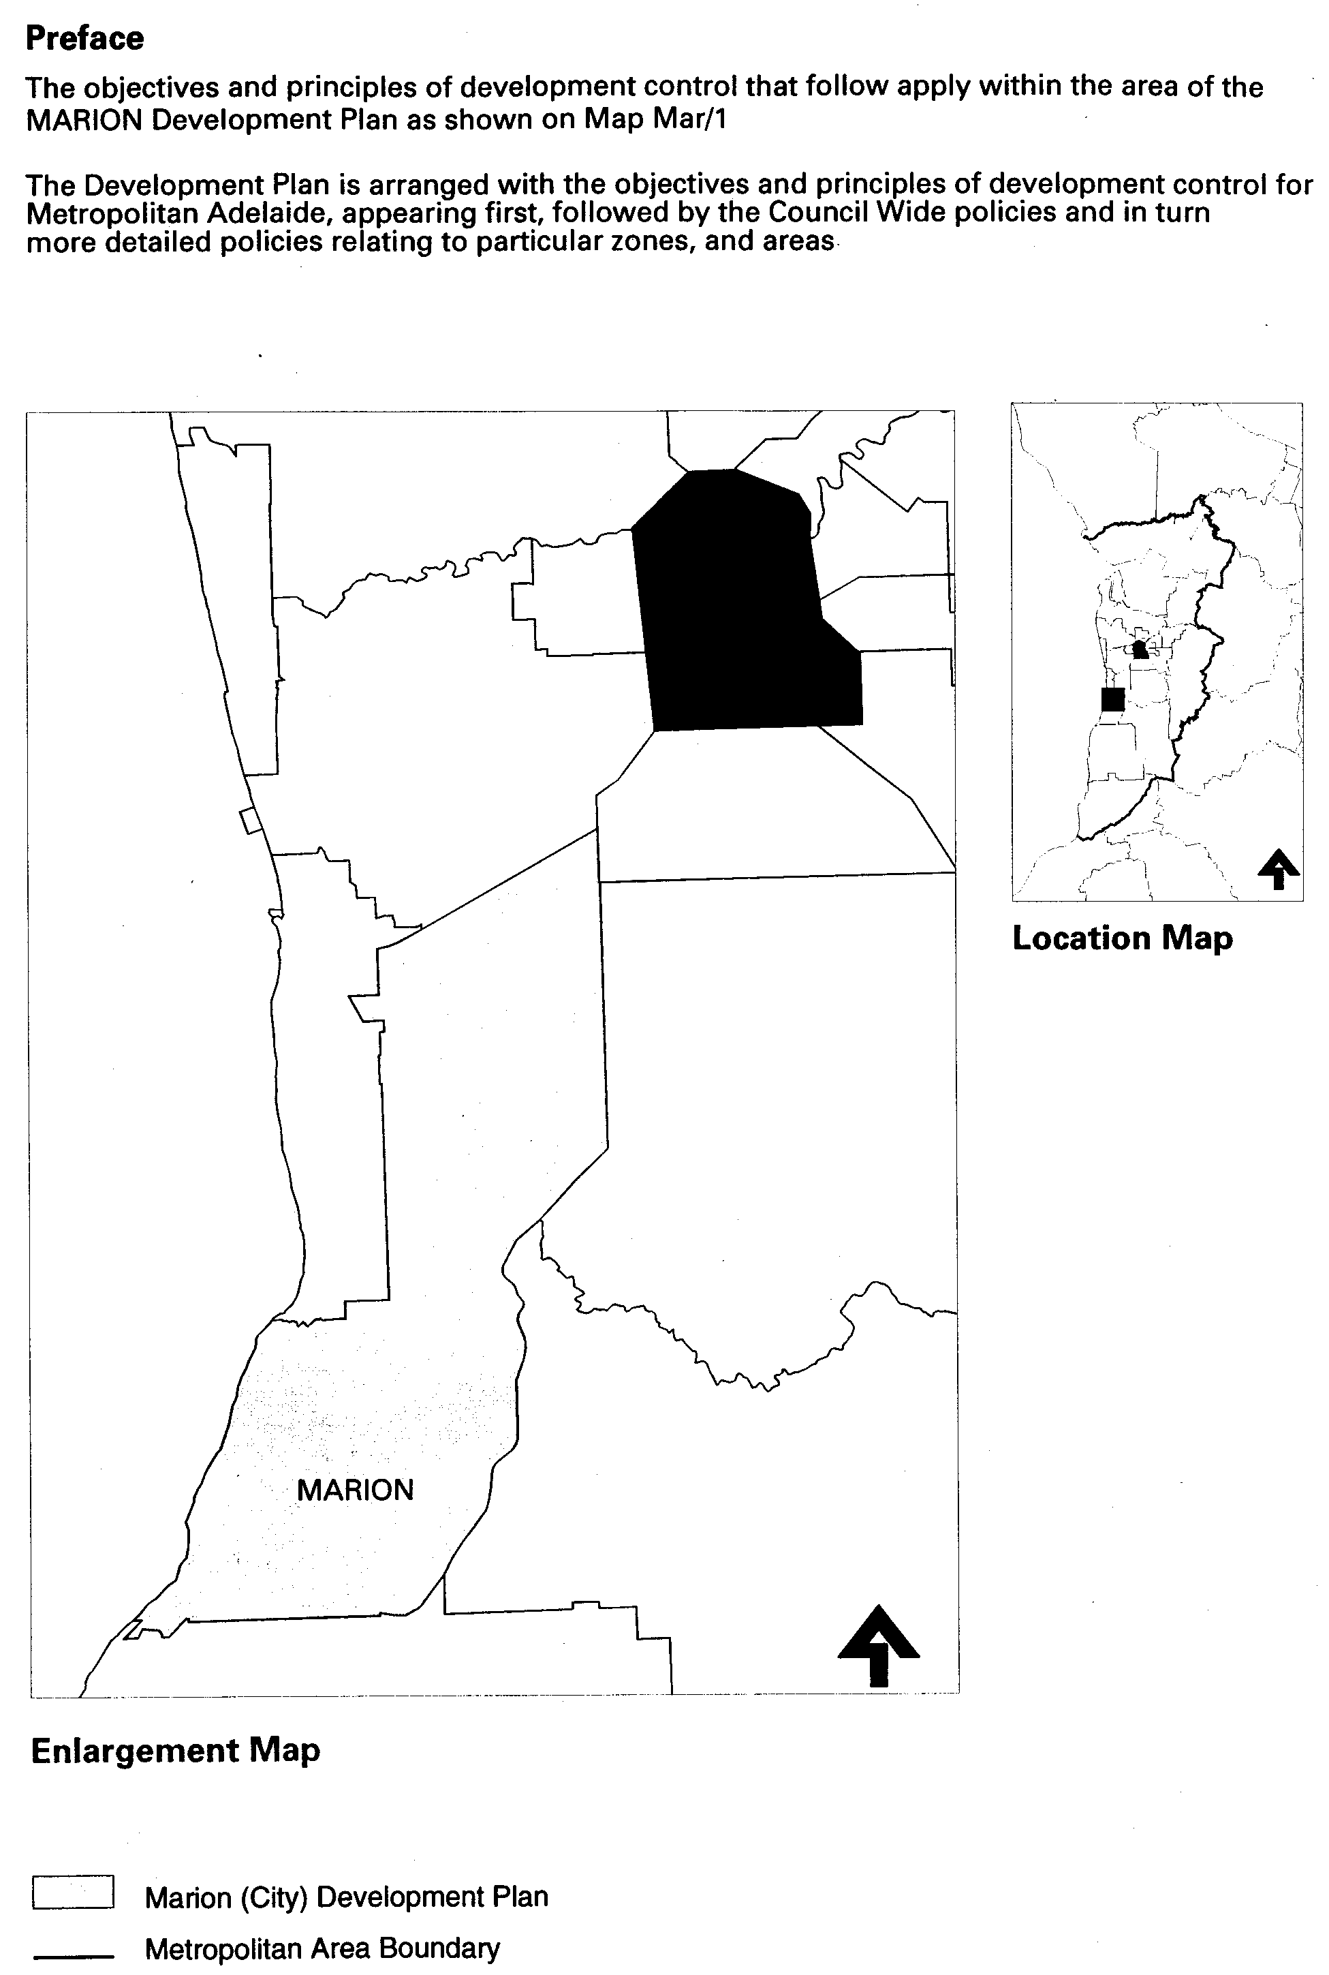
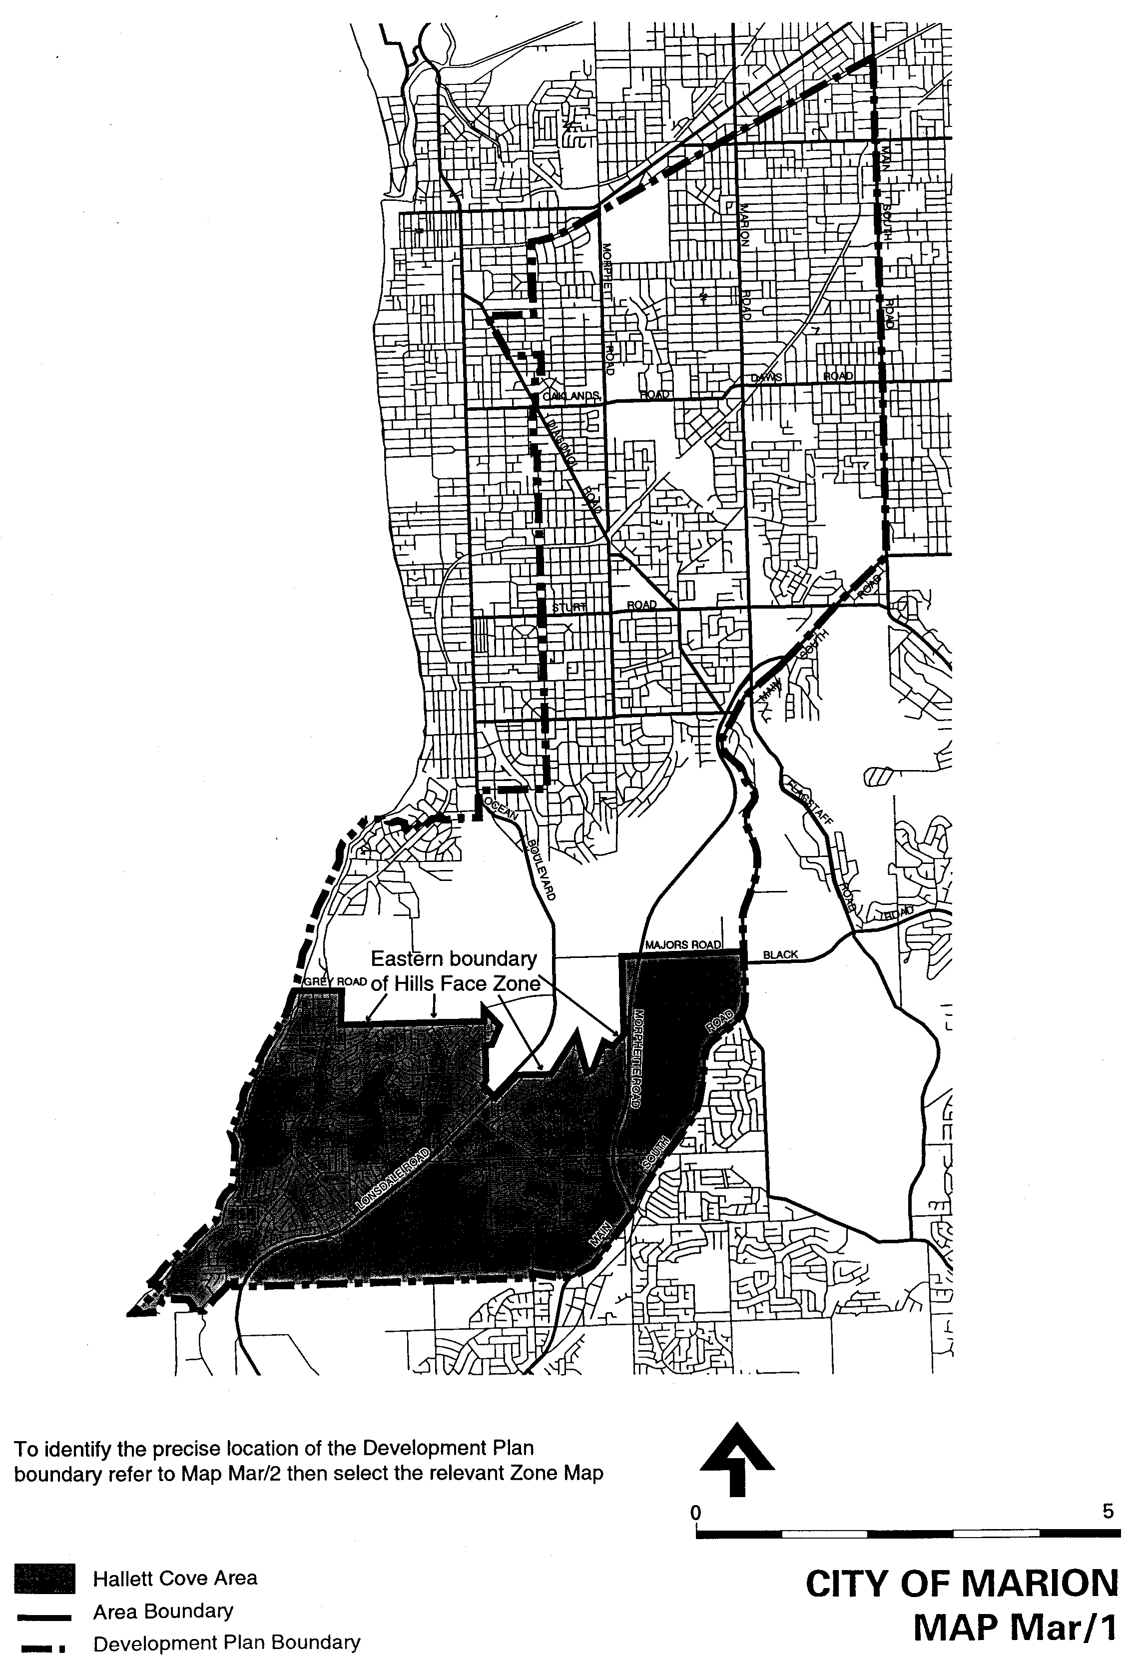
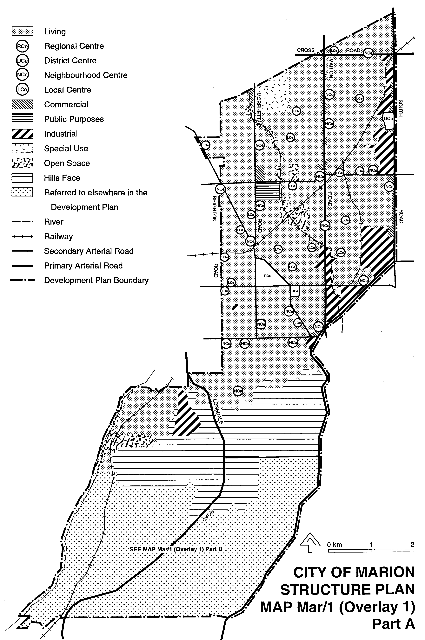
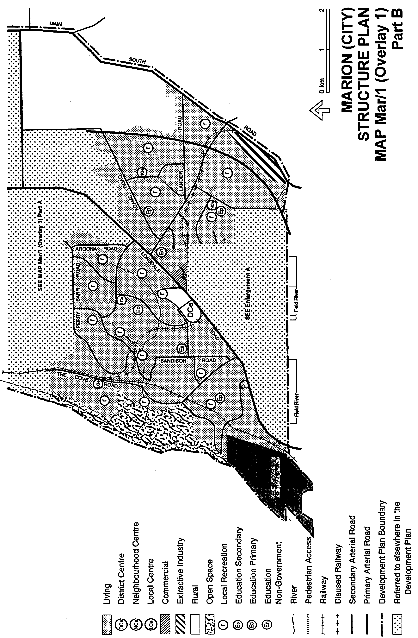
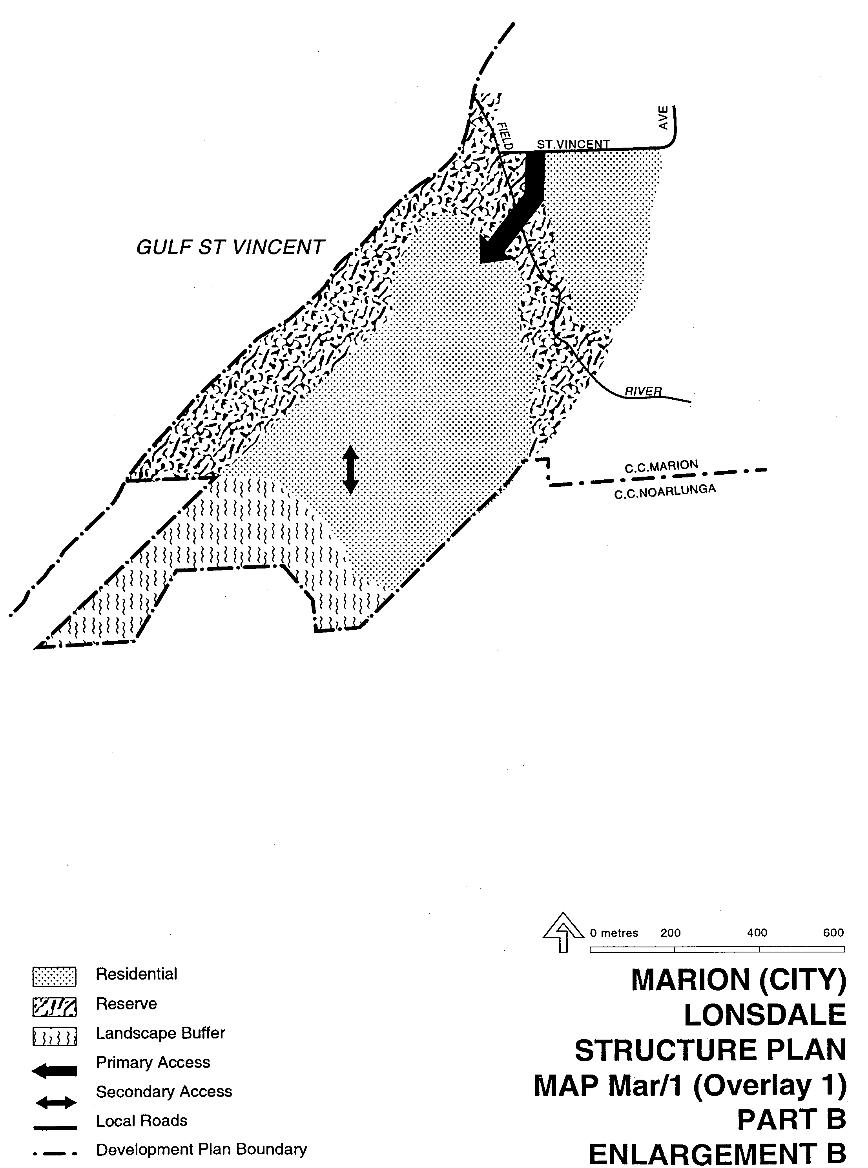
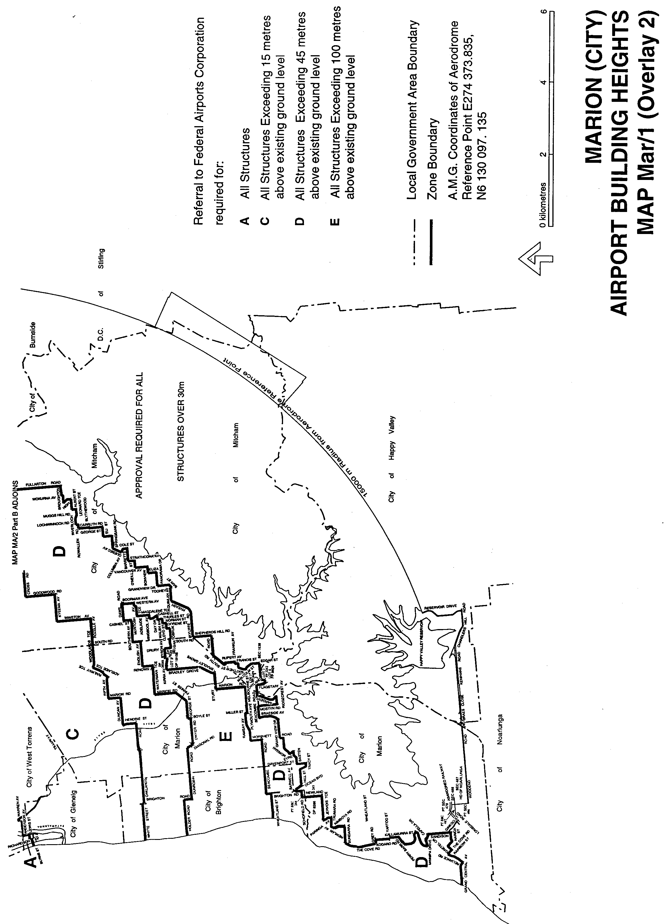
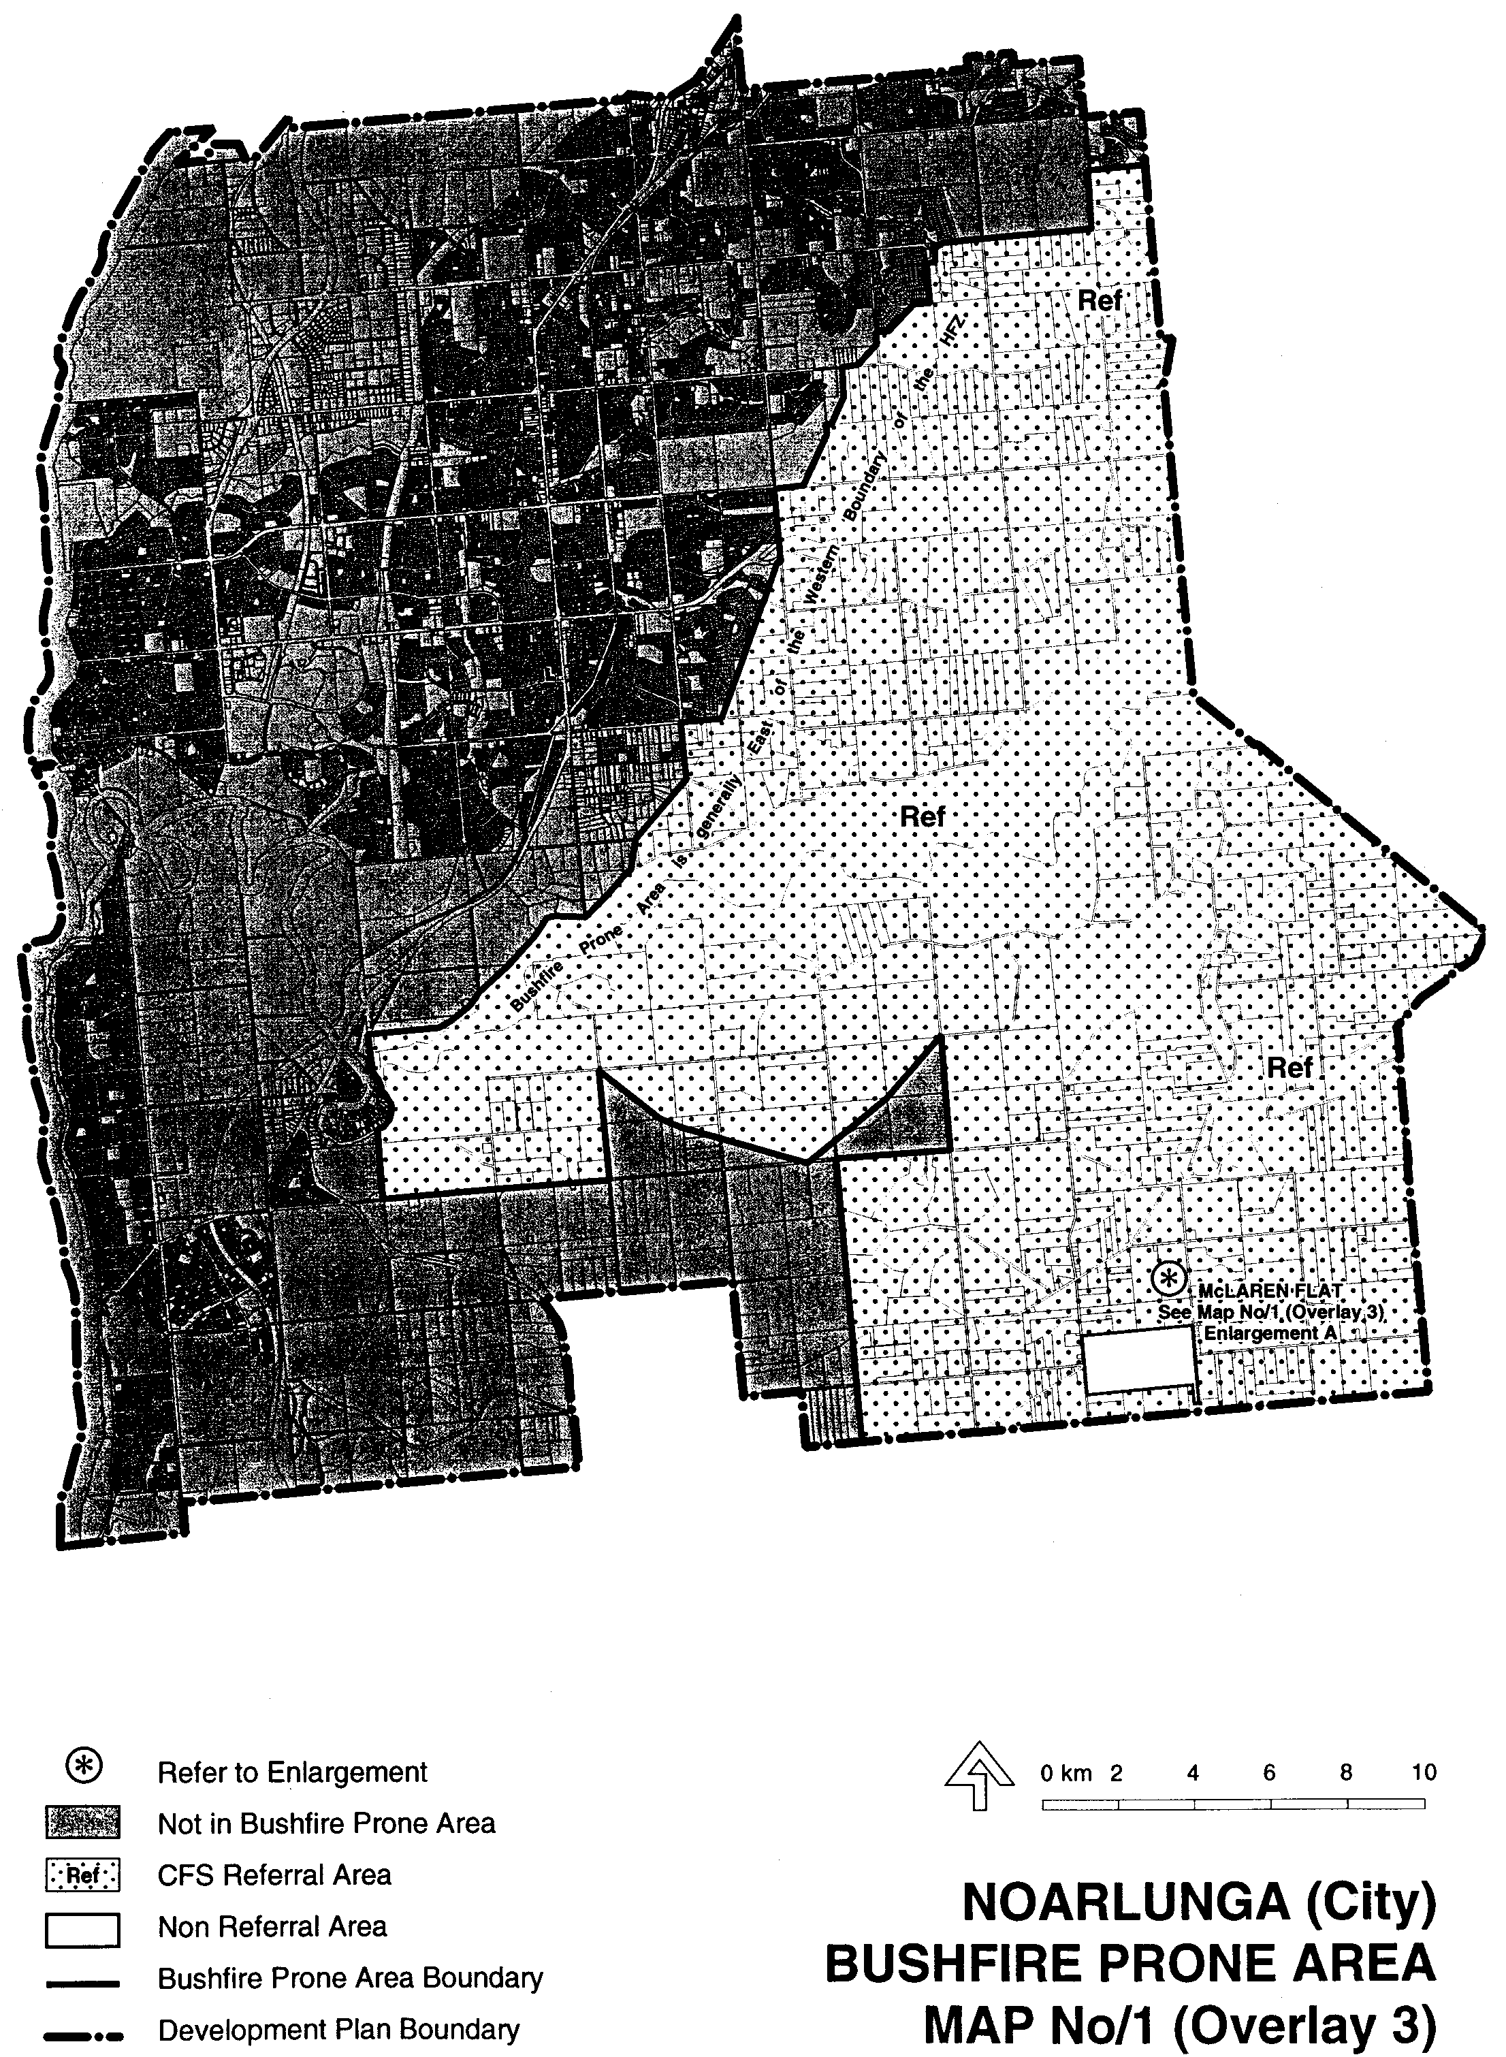
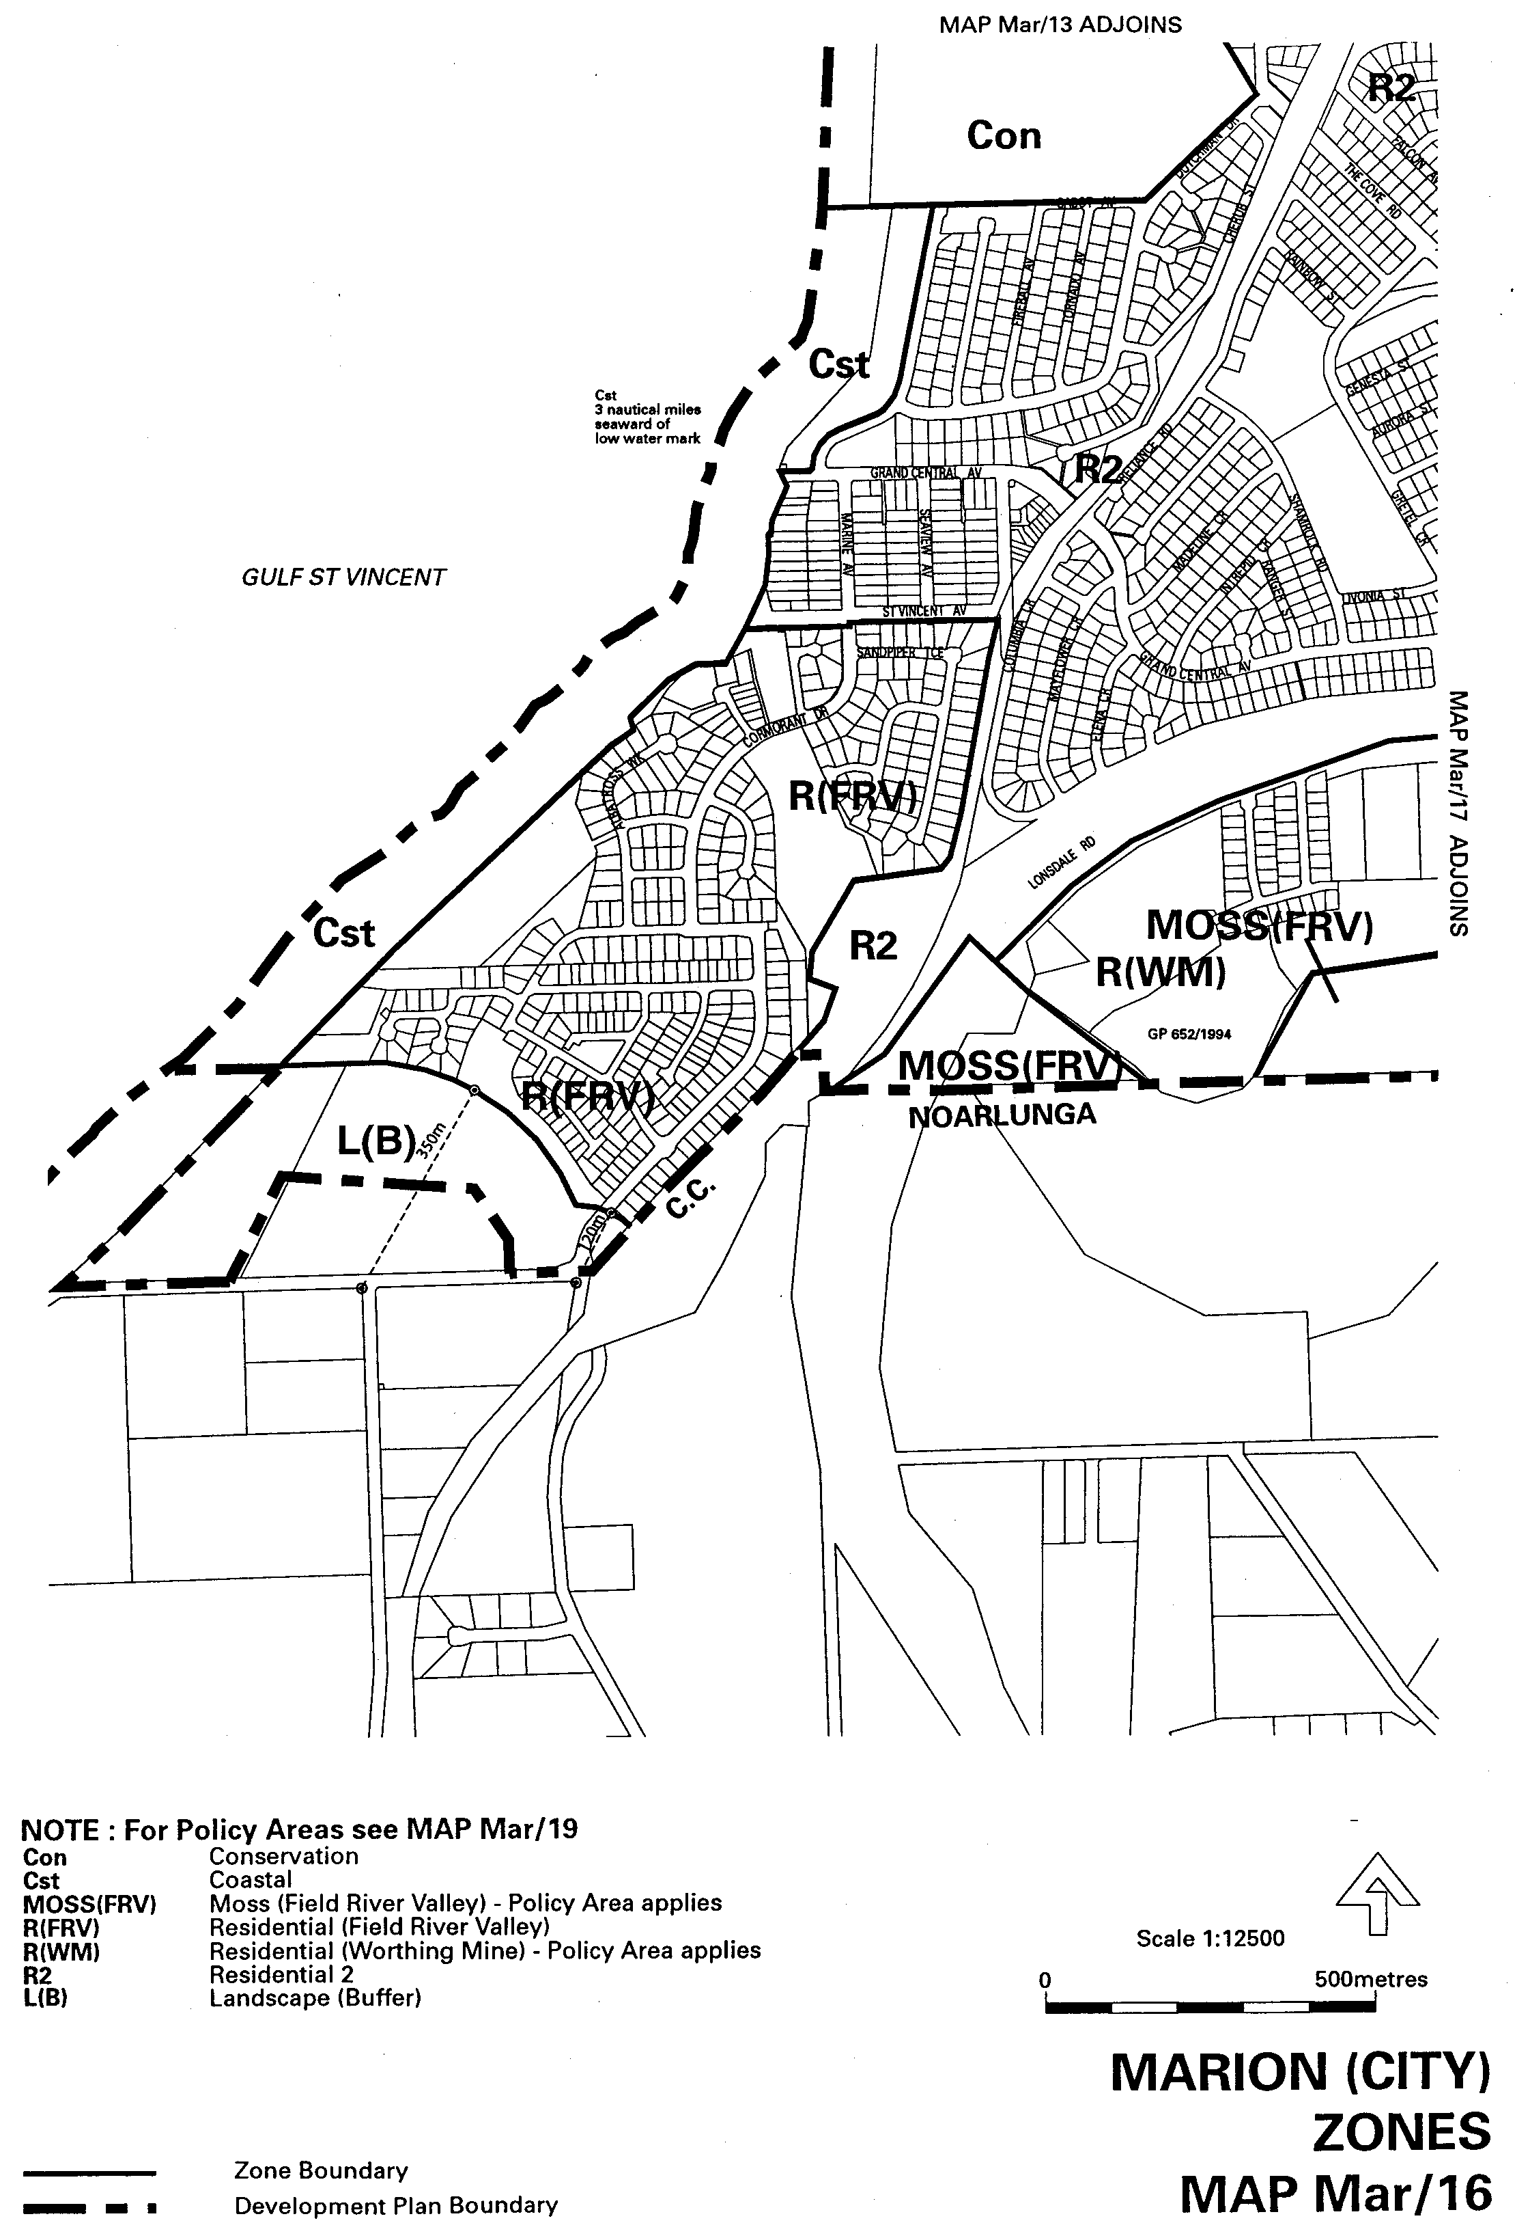
GOVERNMENT GAZETTE ADVERTISEMENT RATES

To apply from 1 July 2001

$  Agents, Ceasing to Act as 32.75  Associations:  Incorporation 16.70  Intention of Incorporation 41.25  Transfer of Properties 41.25  Attorney, Appointment of 32.75  Bailiff’s Sale 41.25  Cemetery Curator Appointed 24.50  Companies:  Alteration to Constitution 32.75  Capital, Increase or Decrease of 41.25  Ceasing to Carry on Business 24.50  Declaration of Dividend 24.50  Incorporation 32.75  Lost Share Certificates:  First Name 24.50  Each Subsequent Name 8.40  Meeting Final 27.50  Meeting Final Regarding Liquidator’s Report on  Conduct of Winding Up (equivalent to ‘Final  Meeting’)  First Name 32.75  Each Subsequent Name 8.40  Notices:  Call 41.25  Change of Name 16.70  Creditors 32.75  Creditors Compromise of Arrangement 32.75  Creditors (extraordinary resolution that ‘the Com-pany be wound up voluntarily and that a liquidator be appointed’) 41.25  Release of Liquidator⎯Application⎯Large Ad. 65.50  ⎯Release Granted 41.25  Receiver and Manager Appointed 38.25  Receiver and Manager Ceasing to Act 32.75  Restored Name 31.00  Petition to Supreme Court for Winding Up 57.00  Summons in Action 48.75  Order of Supreme Court for Winding Up Action 32.75  Register of Interests⎯Section 84 (1) Exempt 74.00  Removal of Office 16.70  Proof of Debts 32.75  Sales of Shares and Forfeiture 32.75  Estates:  Assigned 24.50  Deceased Persons⎯Notice to Creditors, etc. 41.25  Each Subsequent Name 8.40  Deceased Persons⎯Closed Estates 24.50  Each Subsequent Estate 1.05  Probate, Selling of 32.75  Public Trustee, each Estate 8.40 |  | $  Firms:  Ceasing to Carry on Business (each insertion) 21.80  Discontinuance Place of Business 21.80  Land⎯Real Property Act:  Intention to Sell, Notice of 41.25  Lost Certificate of Title Notices 41.25  Cancellation, Notice of (Strata Plan) 41.25  Mortgages:  Caveat Lodgment 16.70  Discharge of 17.60  Foreclosures 16.70  Transfer of 16.70  Sublet 8.40  Leases⎯Application for Transfer (2 insertions) each 8.40  Lost Treasury Receipts (3 insertions) each 24.50  Licensing 48.75  Municipal or District Councils:  Annual Financial Statement⎯Forms 1 and 2 462.00  Electricity Supply⎯Forms 19 and 20 327.00  Default in Payment of Rates:  First Name 65.50  Each Subsequent Name 8.40  Noxious Trade 24.50  Partnership, Dissolution of 24.50  Petitions (small) 16.70  Registered Building Societies (from Registrar-  General) 16.70  Register of Unclaimed Moneys⎯First Name 24.50  Each Subsequent Name 8.40  Registers of Members⎯Three pages and over:  Rate per page (in 8pt) 209.00  Rate per page (in 6pt) 276.00  Sale of Land by Public Auction 41.75  Advertisements 2.30  Advertisements, other than those listed are charged at $2.30 per column line, tabular one-third extra.  Notices by Colleges, Universities, Corporations and District Councils to be charged at $2.30 per line.  Where the notice inserted varies significantly in length from that which is usually published a charge of $2.30 per column line will be applied in lieu of advertisement rates listed.  South Australian Government publications are sold on the condition that they will not be reproduced without prior permission from the Government Printer.
All the above prices include GST

GOVERNMENT GAZETTE NOTICES
ALL private advertisements forwarded for publication in the South Australian Government Gazette must be PAID FOR PRIOR TO INSERTION; and all notices, from whatever source, should be legibly written on one side of the paper only and sent to Government Publishing SA so as to be received no later than 4 p.m. Tuesday preceding the day of publication. Phone 8207 1045 or Fax 8207 1040. E-mail: governmentgazette@saugov.sa.gov.au. Send as attachments in Word format and please confirm your transmission with a faxed copy of your document, including the date the notice is to be published and to whom the notice will be charged.

MISCELLANEOUS LEGISLATION AND GOVERNMENT PUBLICATIONS PRICES AS FROM 1 JULY 2001

Acts, Bills, Rules, Parliamentary Papers and Regulations
Pages | Main | Amends | Pages | Main | Amends

1-16 | 1.85 | 0.80 | 497-512 | 27.00 | 26.00
17-32 | 2.60 | 1.65 | 513-528 | 27.75 | 26.50
33-48 | 3.35 | 2.40 | 529-544 | 28.50 | 27.50
49-64 | 4.25 | 3.20 | 545-560 | 29.25 | 28.50
65-80 | 5.00 | 4.10 | 561-576 | 30.00 | 29.25
81-96 | 5.75 | 4.80 | 577-592 | 31.00 | 29.75
97-112 | 6.60 | 5.60 | 593-608 | 31.75 | 30.75
113-128 | 7.40 | 6.45 | 609-624 | 32.50 | 31.75
129-144 | 8.30 | 7.30 | 625-640 | 33.25 | 32.25
145-160 | 9.10 | 8.05 | 641-656 | 34.00 | 33.00
161-176 | 9.95 | 8.90 | 657-672 | 34.50 | 33.75
177-192 | 10.70 | 9.75 | 673-688 | 36.00 | 34.50
193-208 | 11.50 | 10.60 | 689-704 | 36.75 | 35.50
209-224 | 12.30 | 11.30 | 705-720 | 37.25 | 36.50
225-240 | 13.00 | 12.10 | 721-736 | 38.50 | 37.00
241-257 | 13.90 | 12.80 | 737-752 | 39.00 | 38.00
258-272 | 14.80 | 13.60 | 753-768 | 40.00 | 38.50
273-288 | 15.60 | 14.60 | 769-784 | 40.50 | 39.75
289-304 | 16.30 | 15.30 | 785-800 | 41.25 | 40.50
305-320 | 17.10 | 16.10 | 801-816 | 42.00 | 41.00
321-336 | 17.90 | 16.90 | 817-832 | 43.00 | 42.00
337-352 | 18.80 | 17.80 | 833-848 | 43.75 | 42.75
353-368 | 19.60 | 18.60 | 849-864 | 44.50 | 43.50
369-384 | 20.40 | 19.50 | 865-880 | 45.25 | 44.50
385-400 | 21.10 | 20.20 | 881-896 | 45.75 | 45.00
401-416 | 21.90 | 20.90 | 897-912 | 47.25 | 45.75
417-432 | 22.90 | 21.80 | 913-928 | 47.75 | 47.25
433-448 | 23.60 | 22.60 | 929-944 | 48.75 | 47.75
449-464 | 24.50 | 23.40 | 945-960 | 49.50 | 48.25
465-480 | 25.00 | 24.20 | 961-976 | 50.25 | 49.25
481-496 | 26.00 | 24.90 | 977-992 | 51.25 | 49.75

Legislation—Acts, Regulations, etc: $
Subscriptions:
Acts 166.90
All Bills as Laid 398.60
Rules and Regulations 398.60
Parliamentary Papers 398.60
Bound Acts 184.25
Index 89.20
Government Gazette
Copy 4.40
Subscription 220.20
Hansard
Copy 11.90
Subscription—per session (issued weekly) 345.35
Cloth bound—per volume 148.30
Subscription—per session (issued daily) 345.35
Legislation on Disk
Whole Database 2 551.00
Annual Subscription for fortnightly updates 784.30
Individual Act(s) including updates POA
Compendium
Subscriptions:
New Subs 1 513.50
Updates 540.25
(All the above prices include GST)

All Legislation, Government Gazette, Hansard and Legislation on disk are available from:
Counter Sales Information SA (State Government Bookshop)
and Mail Orders: Ground Floor, 77 Grenfell Street, Adelaide, S.A. 5000.
Phone: (08) 8204 1900. Fax: (08) 8204 1909
Online Shop: www.info.sa.gov.au
S.A. Country Customer Free Call: 1800 182 234
TTY (Hearing Impaired): (08) 8204 1923
Subscriptions and Standing Orders:
Phone: (08) 8207 0908, (08) 8207 0910. Fax: (08) 8207 1040
Box 9, Plaza Level, Riverside Centre, North Terrace, Adelaide, S.A. 5000.

DEPARTMENT OF PRIMARY INDUSTRIES AND RESOURCES SA—FISHERIES DIVISION
NOTICE is hereby given pursuant to section 28 (10) of the Fisheries Act 1982, that the following items have been seized by officers of the Department of Primary Industries and Resources SA, Fisheries Division:
1 purple mesh shrimp trap with 2 entrance funnels, with a length of blue cord attached.
1 wire fish trap, constructed from a metal frame 800 mm x 800 mm x 1 200 mm, covered with hexagon-shaped chook mesh wire with 1 entrance funnel and 2 lengths of blue rope attached to the top and bottom of the device, plus 1 metal peg and horse-shoe weight.
The above items were suspected to have been used or intended to be used, in contravention of the Fisheries Act 1982, and were taken into possession at Qualco Hut on the River Murray on 19 March 2002.
After the expiration of one month from the date of this notice the items listed above shall, on the order of the Minister for Primary Industries, be forfeited to the Crown and shall be either disposed of by sale or destruction.
The above items may be viewed at the Loxton office of the Department of Primary Industries and Resources SA, Fisheries Division.
Dated 27 May 2002.
M. Lewis, General Manager Fisheries Services

DEPARTMENT OF PRIMARY INDUSTRIES AND RESOURCES SA—FISHERIES DIVISION
NOTICE is hereby given pursuant to section 28 (10) of the Fisheries Act 1982, that the following items have been seized by officers of the Department of Primary Industries and Resources SA, Fisheries Division:
2 yabbie traps, constructed from 20 L white buckets with lids attached 400 mm x 300 mm diameter and 2 entrance funnels, one with a length of white cord attached and the second with a length of orange rope attached.
The above items were suspected to have been used or intended to be used, in contravention of the Fisheries Act 1982, and were taken into possession at the 359 km mark on the River Murray on 19 March 2002.
After the expiration of one month from the date of this notice the items listed above shall, on the order of the Minister for Primary Industries, be forfeited to the Crown and shall be either disposed of by sale or destruction.
The above items may be viewed at the Loxton office of the Department of Primary Industries and Resources SA, Fisheries Division.
Dated 27 May 2002.
M. Lewis, General Manager Fisheries Services

DEPARTMENT OF PRIMARY INDUSTRIES AND RESOURCES SA—FISHERIES DIVISION
NOTICE is hereby given pursuant to section 28 (10) of the Fisheries Act 1982, that the following items have been seized by officers of the Department of Primary Industries and Resources SA, Fisheries Division:
1 wire fish trap constructed from hexagon-shaped wire mesh 800 mm diameter x 1 100 mm in length and 1 entrance funnel, with a length of blue and yellow rope attached.
The above items were suspected to have been used or intended to be used, in contravention of the Fisheries Act 1982, and were taken into possession at opposite Chowilla Homestead on the River Murray on 3 April 2002.
After the expiration of one month from the date of this notice the items listed above shall, on the order of the Minister for Primary Industries, be forfeited to the Crown and shall be either disposed of by sale or destruction.
The above items may be viewed at the Loxton office of the Department of Primary Industries and Resources SA, Fisheries Division.
Dated 27 May 2002.
M. Lewis, General Manager Fisheries Services

DEPARTMENT OF PRIMARY INDUSTRIES AND RESOURCES SA—FISHERIES DIVISION
NOTICE is hereby given pursuant to section 28 (10) of the Fisheries Act 1982, that the following items have been seized by officers of the Department of Primary Industries and Resources SA, Fisheries Division:
1 yabbie trap, constructed from a blue 20 L chemical drum with 3 entrance funnels and a length of orange rope attached.
1 yabbie trap, constructed from a white 20 L chemical drum, 4 entrance funnels a length of black rope attached.
2 fish corfs, constructed from white 20 L chemical drums, with a length of black string attached.
The above items were suspected to have been used or intended to be used, in contravention of the Fisheries Act 1982, and were taken into possession at Qualco Hut on the River Murray on 19 March 2002.
After the expiration of one month from the date of this notice the items listed above shall, on the order of the Minister for Primary Industries, be forfeited to the Crown and shall be either disposed of by sale or destruction.
The above items may be viewed at the Loxton office of the Department of Primary Industries and Resources SA, Fisheries Division.
Dated 27 May 2002.
M. Lewis, General Manager Fisheries Services

DEPARTMENT OF PRIMARY INDUSTRIES AND RESOURCES SA—FISHERIES DIVISION
NOTICE is hereby given pursuant to section 28 (10) of the Fisheries Act 1982, that the following items have been seized by officers of the Department of Primary Industries and Resources SA, Fisheries Division:
2 green mesh Opera House style yabbie pots, with 2 entrance funnels, one with a length of orange cord attached and the second with a length of black and white string attached.
The above items were suspected to have been used or intended to be used, in contravention of the Fisheries Act 1982, and were taken into possession at Swan Reach (Jetty 719) on the River Murray at the 242 km mark.
After the expiration of one month from the date of this notice the items listed above shall, on the order of the Minister for Primary Industries, be forfeited to the Crown and shall be either disposed of by sale or destruction.
The above items may be viewed at the Loxton office of the Department of Primary Industries and Resources SA, Fisheries Division.
Dated 27 May 2002.
M. Lewis, General Manager Fisheries Services

DEPARTMENT OF PRIMARY INDUSTRIES AND RESOURCES SA—FISHERIES DIVISION
NOTICE is hereby given pursuant to section 28 (10) of the Fisheries Act 1982, that the following items have been seized by officers of the Department of Primary Industries and Resources SA, Fisheries Division:
1 green mesh Opera House style yabbie pot, with 2 entrance funnels and a length of blue rope attached.
The above items were suspected to have been used or intended to be used, in contravention of the Fisheries Act 1982, and were taken into possession at Swan Reach (Jetty 719) on the River Murray at the 242 km mark on 5 April 2002.
After the expiration of one month from the date of this notice the items listed above shall, on the order of the Minister for Primary Industries, be forfeited to the Crown and shall be either disposed of by sale or destruction.
The above items may be viewed at the Loxton office of the Department of Primary Industries and Resources SA, Fisheries Division.
Dated 27 May 2002.
M. Lewis, General Manager Fisheries Services

DEPARTMENT OF PRIMARY INDUSTRIES AND RESOURCES SA—FISHERIES DIVISION
NOTICE is hereby given pursuant to section 28 (10) of the Fisheries Act 1982, that the following items have been seized by officers of the Department of Primary Industries and Resources SA, Fisheries Division:
1 yabbie trap (200 mm long x 450 mm wide x 250 mm high) constructed from a metal frame covered by green shade cloth with 2 entrance funnels and a length of white and green cord attached.
The above items were suspected to have been used or intended to be used, in contravention of the Fisheries Act 1982, and were taken into possession at Paringa Sandbar on the River Murray at the 561 km mark on 28 March 2002.
After the expiration of one month from the date of this notice the items listed above shall, on the order of the Minister for Primary Industries, be forfeited to the Crown and shall be either disposed of by sale or destruction.
The above items may be viewed at the Loxton office of the Department of Primary Industries and Resources SA, Fisheries Division.
Dated 27 May 2002.
M. Lewis, General Manager Fisheries Services

DEPARTMENT OF PRIMARY INDUSTRIES AND RESOURCES SA—FISHERIES DIVISION
NOTICE is hereby given pursuant to section 28 (10) of the Fisheries Act 1982, that the following items have been seized by officers of the Department of Primary Industries and Resources SA, Fisheries Division:
1 framed white cotton mesh drum net with no wings attached, 900 mm diameter x 800 mm length and 1 entrance funnel, with a length of white rope attached.
The above items were suspected to have been used or intended to be used, in contravention of the Fisheries Act 1982, and were taken into possession at Ral Ral Creek approximately 500 m downstream of the Goolwa Street Boat Ramp on 6 April 2002.
After the expiration of one month from the date of this notice the items listed above shall, on the order of the Minister for Primary Industries, be forfeited to the Crown and shall be either disposed of by sale or destruction.
The above items may be viewed at the Loxton office of the Department of Primary Industries and Resources SA, Fisheries Division.
Dated 27 May 2002.
M. Lewis, General Manager Fisheries Services

DEPARTMENT OF PRIMARY INDUSTRIES AND RESOURCES SA—FISHERIES DIVISION
NOTICE is hereby given pursuant to section 28 (10) of the Fisheries Act 1982, that the following items have been seized by officers of the Department of Primary Industries and Resources SA, Fisheries Division:
1 wire fish trap constructed from hexagon-shaped wire mesh, 900 mm diameter x 1 100 mm height with a flat base and 1 entrance funnel, with a length of green rope attached.
The above items were suspected to have been used or intended to be used, in contravention of the Fisheries Act 1982, and were taken into possession at the 608 km mark on the River Murray on 12 April 2002.
After the expiration of one month from the date of this notice the items listed above shall, on the order of the Minister for Primary Industries, be forfeited to the Crown and shall be either disposed of by sale or destruction.
The above items may be viewed at the Loxton office of the Department of Primary Industries and Resources SA, Fisheries Division.
Dated 27 May 2002.
M. Lewis, General Manager Fisheries Services

DEPARTMENT OF PRIMARY INDUSTRIES AND RESOURCES SA—FISHERIES DIVISION
NOTICE is hereby given pursuant to section 28 (10) of the Fisheries Act 1982, that the following items have been seized by officers of the Department of Primary Industries and Resources SA, Fisheries Division:
1 shrimp trap constructed from purple mesh with ploy tube spacers, 250 mm x 400 mm, 2 entrance funnels, with a length of black weighted cord attached, 1 green mesh Opera House style yabbie pot, with a length of blue and yellow rope attached, section of mesh net, approximately 5 m in length.
The above items were suspected to have been used or intended to be used, in contravention of the Fisheries Act 1982, and were taken into possession at the 357 km mark on the River Murray on 19 March 2002.
After the expiration of one month from the date of this notice the items listed above shall, on the order of the Minister for Primary Industries, be forfeited to the Crown and shall be either disposed of by sale or destruction.
The above items may be viewed at the Loxton office of the Department of Primary Industries and Resources SA, Fisheries Division.
Dated 27 May 2002.
M. Lewis, General Manager Fisheries Services

HOUSING IMPROVEMENT ACT 1940
WHEREAS by notice published in the Government Gazette on the dates mentioned in the following table the South Australian Housing Trust did declare the houses described in the said table to be substandard for the purposes of Part VII of the Housing Improvement Act 1940, the South Australian Housing Trust in the exercise of the powers conferred by the said Part, does hereby fix as the maximum rental per week which shall be payable subject to section 55 of the Residential Tenancies Act 1995, in respect of each house described in the following table the amount shown in the said table opposite the description of such house and this notice shall come into force on the date of this publication in the Gazette.
Address of House | Allotment, Section, etc. | Certificate of Title  Volume Folio | Date and page of Government Gazette in which notice declaring house to be substandard published | Maximum rental per week payable in respect of each house  $

132 Wakefield Street, Adelaide (132-136 Wakefield Street) |  | Allotment 778 in Filed Plan 181620, Hundred of Adelaide | 5728 | 653 |  | 31.1.02, page 423 | 155.00
Unit 2/24 Murray Avenue, Clearview |  | Unit 2 in Strata Plan 6488, Hundred of Yatala | 5870 | 837 |  | 31.1.02, page 423 | 70.00
13 Blight Street, Davoren Park |  | Allotment 1 in Deposited Plan 50863, Hundred of Munno Para | 5622 | 125 |  | 28.2.02, page 1097 | 92.00
8 Kingsbury Street, Davoren Park |  | Allotment 6 in Deposited Plan 32850, Hundred of Munno Para | 5059 | 894 |  | 28.3.02, page 1451 | 97.00
13 Hill Street, Hamley Bridge | ⎧  ⎪  ⎨  ⎪  ⎩ | Allotment 19 in Deposited Plan 1694, Hundred of Alma  Allotment 20 in Deposited Plan 1694, Hundred of Alma | 5352  5352 | 113  116 | ⎫  ⎩  ⎧  ⎭ | 28.3.02, page 1451 | 130.00
3 Keystone Avenue, Holden Hill |  | Allotment 48 in Filed Plan 131293, Hundred of Yatala | 5812 | 656 |  | 31.1.02, page 423 | 95.00
6 North Terrace, Littlehampton (also known as 6 Princes Highway and  6 Main Road) |  | Allotment 100 in Deposited Plan 54715, Hundred of Macclesfield | 5806 | 884 |  | 27.11.75, page 2964 | 150.00
19 Herbert Street, Plympton Park |  | Allotment 125 in Deposited Plan 777, Hundred of Adelaide | 5510 | 495 |  | 6.1.00, page 4 | 140.00
64 Royal Avenue, Pooraka |  | Allotment 26 in Deposited Plan 6835, Hundred of Yatala | 5285 | 246 |  | 26.10.00, page 2812 | 110.00
5 Lytton Street, Quorn |  | Allotment 28 in Deposited Plan 925, Hundred of Pichi Richi | 5508 | 883 |  | 28.3.02, page 1451 | 75.00
19 Joslin Street, Wayville |  | Allotment 41 in Filed Plan 10397, Hundred of Adelaide | 5159 | 181 |  | 28.2.02, page 1097 | 197.00
Flat 1 (front), 51 Radstock Street, Woodville Park |  | Allotment 40 in Deposited Plan 2009, Hundred of Yatala | 5837 | 250 |  | 8.11.79, page 1187 | 75.00
Flat 2 (rear), 51 Radstock Street, Woodville Park |  | Allotment 40 in Deposited Plan 2009, Hundred of Yatala | 5837 | 250 |  | 8.11.79, page 1187 | 65.00
48 Kintore Street, Thebarton |  | Allotment 189 in Filed Plan 6531, Hundred of Adelaide | 5840 | 211 |  | 11.2.88, page 359 | 110.00

Dated at Adelaide, 30 May 2002. G. Black, General Manager, Housing Trust

HOUSING IMPROVEMENT ACT 1940
NOTICE is hereby given that the South Australian Housing Trust in the exercise of the powers conferred by the Housing Improvement Act 1940, does hereby declare the houses described in the table hereunder to be substandard for the purposes of Part VII of the Housing Improvement Act 1940.
No. of House and Street | Locality | Allotment, Section, etc. | Certificate of Title  Volume Folio

2 Emerald Road |  | Morphett Vale | Allotment 38 in Deposited Plan 6879, Hundred of Noarlunga | 5336 | 781
42 Powell Place |  | Morphett Vale | Allotment 127 in Deposited Plan 7597, Hundred of Noarlunga | 5594 | 488
Lot 3 Government Road |  | Murbko Flat via  Morgan | Allotment 3 in Deposited Plan 26359, Hundred of Eba | 5429 | 316
6 Keirana Avenue |  | Port Noarlunga | Allotment 1181 in Deposited Plan 4941, Hundred of Noarlunga | 5200 | 941

Dated at Adelaide, 30 May 2002. G. Black, General Manager, Housing Trust

HOUSING IMPROVEMENT ACT 1940
WHEREAS by notice published in the Government Gazette on the dates mentioned in the following table the South Australian Housing Trust did declare the houses described in the said table to be substandard for the purposes of Part VII of the Housing Improvement Act 1940, and whereas the South Australian Housing Trust is satisfied that each of the houses described hereunder has ceased to be substandard, notice is hereby given that, in exercise of the powers conferred by the said Part, the South Australian Housing Trust does hereby revoke the said declaration in respect of each house.
Address of House | Allotment, Section, etc. | Certificate of Title  Volume Folio | Date and page of Government Gazette in which notice declaring house to be substandard published

33 Hobsons Place, Adelaide |  | Allotment 429 in Filed Plan 182891, Hundred of Adelaide | 5520 | 883 |  | 7.7.77, page 58
22 Wright Court, Adelaide |  | Allotment 674 in Filed Plan 183136, Hundred of Adelaide | 5843 | 180 |  | 25.9.41, page 639
24 Wright Court, Adelaide |  | Allotment 4 in Filed Plan 142955, Hundred of Adelaide | 5263 | 732 |  | 25.9.41, page 639
10 Rowe Terrace, Ardrossan |  | Allotment 12 in Deposited Plan 1822, Hundred of Cunningham | 5527 | 813 |  | 11.10.90, page 1175
28 Rowe Terrace, Ardrossan |  | Allotment 46 in Deposited Plan 1822, Hundred of Cunningham | 5402 | 915 |  | 25.1.90, page 235
99 Railway Terrace, Ascot Park |  | Lot 1 in Community Plan 21234, Hundred of Adelaide | 5870 | 84 |  | 15.12.88, page 2038
400 Anzac Highway, Camden Park |  | Allotment 28 in Filed Plan 7390, Hundred of Adelaide | 5402 | 280 |  | 3.8.95, page 351
9 Marker Street, Enfield |  | Allotment 58 in Deposited Plan 4685, Hundred of Yatala | 5593 | 261 |  | 30.11.00, page 3362
5 Mary Street, Ethelton | ⎧  ⎭  ⎫  ⎩ | Allotment 100 in Filed Plan 3161, Hundred of Port Adelaide  Allotment 101 in Filed Plan 3161, Hundred of Port Adelaide | 5510  5510 | 490  491 | ⎫  ⎩  ⎧  ⎭ | 24.1.85, page 204
8 Young Street, Exeter |  | Allotment 1 in Deposited Plan 45657, Hundred of Port Adelaide | 5364 | 288 |  | 26.3.87, page 731
Ground floor flat at rear of 118/118B Jetty Road, (off Cowper Street), Glenelg |  | Allotment 81 in Filed Plan 6535, Hundred of Noarlunga | 5368 | 922 |  | 2.5.96, page 2402
2 Castres Street, Glynde |  | Allotment 71 in Deposited Plan 59187, Hundred of Adelaide | 5328 | 313 |  | 30.11.95, page 1513
Flat at rear of main house at 17A Grayson Street, Kilkenny |  | Allotment 10 in Filed Plan 15913, Hundred of Yatala | 5360 | 272 |  | 11.10.90, page 1175
23 Wheelton Street, Kingscote K.I. |  | Allotment 95 in Deposited Plan 1807, Hundred of Menzies | 5793 | 622 |  | 29.8.96, page 820
16 Chapman Road, Mansfield Park |  | Allotment 90 in Deposited Plan 4509, Hundred of Yatala | 5178 | 721 |  | 28.3.02, page 1451
15 Sarah Street, Marleston |  | Allotment 30 in Deposited Plan 865, Hundred of Adelaide | 5776 | 446 |  | 31.1.02, page 423
83 Gladstone Road, Mile End |  | Allotment 2 in Deposited Plan 37784, Hundred of Adelaide | 5153 | 703 |  | 13.1.77, page 68
36 Mi Mi Road, Mylor |  | Allotment 6 in Filed Plan 108104, Hundred of Noarlunga | 5191 | 71 |  | 4.1.01, page 13
248 Smith Street, Naracoorte |  | Allotment 11 in Deposited Plan 4130, Hundred of Naracoorte | 5675 | 593 |  | 14.11.85, page 1519
64 Graves Street, Newton |  | Allotment 11 in Deposited Plan 26057, Hundred of Adelaide | 5379 | 703 |  | 28.2.02, page 1097
225 Montacute Road, Newton | ⎧  ⎭  ⎫  ⎩ | Allotment 55 in Deposited Plan 58739, Hundred of Adelaide  Allotment 58 in Deposited Plan 58739, Hundred of Adelaide | 5870  5870 | 755  758 | ⎫  ⎩  ⎧  ⎭ | 2.3.95, page 752
72A Margaret Street, North Adelaide |  | Allotment 330 in Filed Plan 183602, Hundred of Yatala | 5728 | 477 |  | 25.1.96, page 828
54 Boothby Street, Panorama |  | Allotment 41 in Deposited Plan 3317, Hundred of Adelaide | 5246 | 115 |  | 28.10.99, page 2107
19 Esmond Road, Port Pirie | ⎧  ⎭  ⎫  ⎩ | Allotment 24 in Deposited Plan 1646, Hundred of Pirie  Allotment 415 in Filed Plan 189357, Hundred of Pirie | 5699  5827 | 219  989 | ⎫  ⎩  ⎧  ⎭ | 7.7.77, page 58
Flat 1/43 Farrant Street, Prospect |  | Allotment comprising pieces 1 and 2 in Deposited Plan 55331, Hundred of Yatala | 5845 | 943 |  | 8.2.83, page 364
Flat 2/43 Farrant Street, Prospect |  | Allotment comprising pieces 1 and 2 in Deposited Plan 55331, Hundred of Yatala | 5845 | 943 |  | 8.2.83, page 364
25 Eighth Street, Quorn |  | Allotment 254, Town of Quorn, Hundred of Pichi Richi | 5628 | 675 |  | 24.1.80, page 173
2 Wynyard Place, Redwood Park |  | Allotment 74 in Deposited Plan 6765, Hundred of Yatala | 5120 | 343 |  | 28.1.93, page 485
85 Sixteenth Street, Renmark |  | Allotments 91 and 92 in Filed Plan 203735, Out of Hundreds (Renmark) | 5371 | 29 |  | 24.5.79, page 1509
5 Ann Street, Rosewater |  | Allotments 36 and 37 in Deposited Plan 463, Hundred of Port Adelaide | 5841 | 192 |  | 8.10.70, page 1518
Front flat, 8 Percy Street, Semaphore |  | Allotments 90 and 113 in Filed Plan 2754, Hundred of Port Adelaide | 5512 | 681 |  | 12.2.76, page 646
Rear flat, 9 Percy Street, Semaphore |  | Allotments 90 and 113 in Filed Plan 2754, Hundred of Port Adelaide | 5512 | 681 |  | 12.2.76, page 646
57 Stepney Street, Stepney |  | Allotment 38 in Filed Plan 134789, Hundred of Adelaide | 5641 | 772 |  | 7.9.67, page 1275
53 Palmerston Road, Unley |  | Allotment 85 in Filed Plan 13432, Hundred of Adelaide | 5227 | 440 |  | 27.2.97, page 1054
26 Yeltana Avenue, Wattle Park |  | Allotment 43 in Filed Plan 141904, Hundred of Adelaide | 5391 | 208 |  | 26.10.00, page 2812
4 Jeanette Street, Woodville Park |  | Allotment 51 in Filed Plan 123645, Hundred of Yatala | 5498 | 651 |  | 28.7.94, page 182

Dated at Adelaide, 30 May 2002. G. Black, General Manager, Housing Trust

LIQUOR LICENSING ACT 1997 AND GAMING MACHINES ACT 1992
Notice of Applications
NOTICE is hereby given, pursuant to section 52 of the Liquor Licensing Act 1997 and section 29 of the Gaming Machines Act 1992, that Mundie Nominees Pty Ltd (ACN 100 603 469), c/o Piper Alderman, 167 Flinders Street, Adelaide, S.A. 5000 has applied to the Liquor and Gaming Commissioner for the transfer of the Hotel Licence and the Gaming Machine Licence in respect of the premises situated at 9 Railway Terrace South, Pinnaroo, S.A. 5304 and known as Golden Grain Hotel.
The applications have been set down for hearing on 27 June 2002 at 10.30 a.m.
Any person may object to the application by lodging a notice of objection in the prescribed form with the Licensing Authority, and serving a copy of the notice on the applicant at the applicant’s address given above, at least seven days before the hearing date.
Plans in respect of the premises the subject of the application are open to public inspection without fee at the Office of the Liquor and Gaming Commissioner, 9th Floor, East Wing, 50 Grenfell Street, Adelaide, S.A. 5000.
Dated 23 May 2002.
Applicant

LIQUOR LICENSING ACT 1997 AND GAMING MACHINES ACT 1992
Notice of Applications
NOTICE is hereby given, pursuant to section 52 (2) (b) of the Liquor Licensing Act 1997, and section 29 of the Gaming Machines Act 1992, that Flinders Bar and Bistro Pty Ltd as trustee for Flinders Bar and Bistro Unit Trust, c/o Kelly & Co. Lawyers has applied to the Liquor and Gaming Commissioner for the transfer of the Hotel and the Gaming Machine Licence in respect of premises situated at 57 Flinders Street, Adelaide, S.A. 5000 and known as Earl’s Tavern.
The applications have been set down for hearing on 2 July 2002 at 10 a.m.
Any person may object to the application by lodging a notice of objection in the prescribed form with the Licensing Authority, and serving a copy of the notice on the applicant at the applicant’s address given above, at least seven days before the hearing date.
Plans in respect of the premises the subject of the application are open to public inspection without fee at the Office of the Liquor and Gaming Commissioner, 9th Floor, East Wing, 50 Grenfell Street, Adelaide, S.A. 5000.
Applicant

LIQUOR LICENSING ACT 1997
Notice of Application
NOTICE is hereby given, pursuant to section 52 (2) (b) of the Liquor Licensing Act 1997, that Flaschengeist (Aust) Pty Ltd, 26 Sunbeam Road, Glynde, S.A. 5070 has applied to the Licensing Authority for a Producer’s Licence in respect of premises situated at 26 Sunbeam Road, Glynde, S.A. 5070 and to be known as Flaschengeist (Aust) Pty Ltd.
The application has been set down for hearing on 21 June 2002 at 9 a.m.
Any person may object to the application by lodging a notice of objection in the prescribed form with the Licensing Authority, and serving a copy of the notice on the applicant at the applicant’s address given above, at least seven days before the hearing date.
Plans in respect of the premises the subject of the application are open to public inspection without fee at the Office of the Liquor and Gaming Commissioner, 9th Floor, East Wing, 50 Grenfell Street, Adelaide, S.A. 5000.
Dated 23 May 2002.
Applicant

LIQUOR LICENSING ACT 1997
Notice of Application
NOTICE is hereby given, pursuant to section 52 (2) (b) of the Liquor Licensing Act 1997, that Brett Victor Naglost and Garry Robert Penney have applied to the Licensing Authority for a Direct Sales Licence in respect of premises situated at 170 Raglan Avenue, South Plympton, S.A. 5038 and to be known as B. & G. Liquor Merchants.
The application has been set down for hearing on 28 June 2002 at 9 a.m.
Any person may object to the application by lodging a notice of objection in the prescribed form with the Licensing Authority, and serving a copy of the notice on the applicants at the applicants’ address given above, at least seven days before the hearing date.
Plans in respect of the premises the subject of the application are open to public inspection without fee at the Office of the Liquor and Gaming Commissioner, 9th Floor, East Wing, 50 Grenfell Street, Adelaide, S.A. 5000.
Dated 22 May 2002.
Applicants

LIQUOR LICENSING ACT 1997
Notice of Application
NOTICE is hereby given, pursuant to section 52 (2) (b) of the Liquor Licensing Act 1997, that Moana Surf Lifesaving Club Inc. has applied to the Licensing Authority for a Redefinition of Licensed Premises, Variation to Extended Trading Authorisation and Variation to Entertainment Consent in respect of premises situated at Esplanade, Moana, S.A. 5169 and known as Moana Surf Lifesaving Club.
The application has been set down for hearing on 21 June 2002 at 9 a.m.
Conditions
The following licence conditions are sought:
1. Redefinition of licensed premises to include garage, meeting room, outside paved court area and outside decking.
2. Extended Trading Authorisation to apply to abovementioned areas.
3. Entertainment consent to apply to garage and meeting room.
Any person may object to the application by lodging a notice of objection in the prescribed form with the Licensing Authority, and serving a copy of the notice on the applicant at the applicant’s address given above, at least seven days before the hearing date.
Plans in respect of the premises the subject of the application are open to public inspection without fee at the Office of the Liquor and Gaming Commissioner, 9th Floor, East Wing, 50 Grenfell Street, Adelaide, S.A. 5000.
Dated 23 May 2002.
Applicant

LIQUOR LICENSING ACT 1997
Notice of Application
NOTICE is hereby given, pursuant to section 52 (2) (b) of the Liquor Licensing Act 1997, that the Barossa Brewing Company Pty Ltd (ACN 084 321 853) has applied to the Licensing Authority for a Producer’s Licence in respect of premises situated at Seppeltsfield Road, Marananga, S.A. 5355.
The application has been set down for hearing on 28 June 2002.
Any person may object to the application by lodging a notice of objection in the prescribed form with the Licensing Authority, and serving a copy of the notice on the applicant at the applicant’s address given above, at least seven days before the hearing date.
Plans in respect of the premises the subject of the application are open to public inspection without fee at the Office of the Liquor and Gaming Commissioner, 9th Floor, East Wing, 50 Grenfell Street, Adelaide, S.A. 5000.
Dated 17 May 2002.
Applicant

LIQUOR LICENSING ACT 1997
Notice of Application
NOTICE is hereby given, pursuant to section 52 (2) (b) of the Liquor Licensing Act 1997, that Leeroden Pty Ltd has applied to the Licensing Authority for a Redefinition of Licensed Premises and Variation to Extended Trading Authorisation in respect of premises situated at Shops 4-6, 220 Mount Barker Road, Aldgate, S.A. 5154 and known as Cheers Café.
The application has been set down for hearing on 28 June 2002 at 9 a.m.
Conditions
The following licence conditons are sought:
1. Redefinition of the licensed premises to include Shop 4.
2. That the current Extended Trading Authorisation apply to the abovementioned area.
Any person may object to the application by lodging a notice of objection in the prescribed form with the Licensing Authority, and serving a copy of the notice on the applicant at the applicant’s address given above, at least seven days before the hearing date.
Plans in respect of the premises the subject of the application are open to public inspection without fee at the Office of the Liquor and Gaming Commissioner, 9th Floor, East Wing, 50 Grenfell Street, Adelaide, S.A. 5000.
Dated 23 May 2002.
Applicant

LIQUOR LICENSING ACT 1997
Notice of Application
NOTICE is hereby given, pursuant to section 52 (2) (b) of the Liquor Licensing Act 1997, that Frederick Piechnick and Christine Carol Piechnick have applied to the Licensing Authority for a Variation to the Extended Trading Authorisation and Entertainment Consent which is in force in respect of premises situated at Sturt Highway, Paringa and known as Paringa Hotel.
The application has been set down for hearing on 28 June 2002 at 9 a.m.
Conditions
The following license conditions are sought:
1. That the licensee be permitted to sell liquor for consumption on the licensed premises from midnight to 2 a.m. the following morning each Wednesday and Thursday.
2. That the Extended Trading Authorisation shall apply to the areas referred to on the plan held in the Liquor and Gaming Commission as Areas 1, 2, 3, 4, 5 and 7 during the days and times sought in this application and all other days and times previously authorised for extended trading.
3. That entertainment be authorised in respect of Area 4 (Front Bar) for karaoke and occasional light band music which will continue during the extended trading hours.
Any person may object to the application by lodging a notice of objection in the prescribed form with the Licensing Authority, and serving a copy of the notice on the applicants at the applicants’ address given above, at least seven days before the hearing date.
Plans in respect of the premises the subject of the application are open to public inspection without fee at the Office of the Liquor and Gaming Commissioner, 9th Floor, East Wing, 50 Grenfell Street, Adelaide, S.A. 5000.
Dated 21 May 2002.
Applicants

LIQUOR LICENSING ACT 1997
Notice of Application
NOTICE is hereby given, pursuant to section 52 (2) (b) of the Liquor Licensing Act 1997, that B. H. Liang Pty Ltd as trustee for the Ting Qiang Liang Family Trust has applied to the Licensing Authority for the transfer of a Restaurant Licence in respect of premises situated at 524 Goodwood Road, Daw Park, S.A. 5041 and known as Muntin Restaurant.
The application has been set down for hearing on 1 July 2002 at 9.30 a.m.
Any person may object to the application by lodging a notice of objection in the prescribed form with the Licensing Authority, and serving a copy of the notice on the applicant at the applicant’s address given above, at least seven days before the hearing date.
Plans in respect of the premises the subject of the application are open to public inspection without fee at the Office of the Liquor and Gaming Commissioner, 9th Floor, East Wing, 50 Grenfell Street, Adelaide, S.A. 5000.
Dated 23 May 2002.
Applicant

LIQUOR LICENSING ACT 1997
Notice of Application
NOTICE is hereby given, pursuant to section 52 (2) (b) of the Liquor Licensing Act 1997, that Dawn Elizabeth Hitch, c/o Bail & Robazza, 196 Hutt Street, Adelaide, S.A. 5000, has applied to the Licensing Authority for a transfer of Hotel Licence with an Extended Trading Authorisation and Redefinition of Licensed Premises in respect of premises situated at Tin Line Road, Murraytown, S.A. 5481 and known as Murraytown Hotel.
The application has been set down for hearing on 1 July 2002 at 10 a.m.
Conditions
The following licence conditions are sought:
1. An Extended Trading Authorisation: Monday to Wednesday, midnight to 1 a.m. the following day; Thursday to Saturday, midnight to 2 a.m. the following day; Sunday, 8 a.m. to 11 a.m. and 8 p.m. to 1 a.m. the following day.
2. To redefine the licensed premises to include vacant land at the rear of the premises as part of the licensed premises, as per the plan lodged with the Liquor and Gaming Commission and to redefine a storeroom into a designated dining area.
Any person may object to the application by lodging a notice of objection in the prescribed form with the Licensing Authority, and serving a copy of the notice on the applicant at the applicant’s address given above, at least seven days before the hearing date.
Plans in respect of the premises the subject of the application are open to public inspection without fee at the Office of the Liquor and Gaming Commissioner, 9th Floor, East Wing, 50 Grenfell Street, Adelaide, S.A. 5000.
Dated 21 May 2002.
Applicant

LIQUOR LICENSING ACT 1997
Notice of Application
NOTICE is hereby given, pursuant to section 52 (2) (b) of the Liquor Licensing Act 1997, that Ju Wei Lui and Ai Ru Gao, 28 Sommerset Avenue, Cumberland Park, S.A. 5041 have applied to the Licensing Authority for the transfer of a Restaurant Licence in respect of premises situated at 152 Goodwood Road, Goodwood, S.A. 5034 and known as Peacock Room Chinese Restaurant.
The application has been set down for hearing on 1 July 2002 at 10.30 a.m.
Any person may object to the application by lodging a notice of objection in the prescribed form with the Licensing Authority, and serving a copy of the notice on the applicants at the applicants’ address given above, at least seven days before the hearing date.
Plans in respect of the premises the subject of the application are open to public inspection without fee at the Office of the Liquor and Gaming Commissioner, 9th Floor, East Wing, 50 Grenfell Street, Adelaide, S.A. 5000.
Dated 23 May 2002.
Applicants

LIQUOR LICENSING ACT 1997
Notice of Application
NOTICE is hereby given, pursuant to section 52 (2) (b) of the Liquor Licensing Act 1997, that St Remy Pty Ltd (ACN 062 007 292), c/o Wallmans Lawyers, 173 Wakefield Street, Adelaide, S.A. 5000 has applied to the Licensing Authority for the transfer of a Restaurant Licence in respect of premises situated at 157-159 Melbourne Street, North Adelaide, S.A. 5006 and known as The Store 157.
The application has been set down for hearing on 1 July 2002.
Any person may object to the application by lodging a notice of objection in the prescribed form with the Licensing Authority, and serving a copy of the notice on the applicant at the applicant’s address given above, at least seven days before the hearing date.
Plans in respect of the premises the subject of the application are open to public inspection without fee at the Office of the Liquor and Gaming Commissioner, 9th Floor, East Wing, 50 Grenfell Street, Adelaide, S.A. 5000.
Dated 23 May 2002.
Applicant

LIQUOR LICENSING ACT 1997
Notice of Application
NOTICE is hereby given, pursuant to section 52 (2) (b) of the Liquor Licensing Act 1997, that Melissa Joyce Hodge, c/o Foreman Mead, 26 Mann Street, Mount Barker, S.A. 5251 has applied to the Licensing Authority for the transfer of a Hotel Licence in respect of premises situated at 1 Main Road, Marrabel, S.A. 5413 and known as Marrabel Hotel.
The application has been set down for hearing on 1 July 2002 at 11.30 a.m.
Any person may object to the application by lodging a notice of objection in the prescribed form with the Licensing Authority, and serving a copy of the notice on the applicant at the applicant’s address given above, at least seven days before the hearing date.
Plans in respect of the premises the subject of the application are open to public inspection without fee at the Office of the Liquor and Gaming Commissioner, 9th Floor, East Wing, 50 Grenfell Street, Adelaide, S.A. 5000.
Dated 21 May 2002.
Applicant

MINING ACT 1971
NOTICE is hereby given in accordance with section 28 (5) of the Mining Act 1971, that the Minister for Mineral Resources Development proposes to grant an Exploration Licence over the undermentioned area:
Applicant: Helix Resources Limited
Location: Hiltaba Area—Approximately 100 km north-east of Streaky Bay, bounded as follows: Commencing at a point being the intersection of latitude 32°02′S and longitude 135°00′E, thence east to longitude 135°10′E, south to latitude 32°15′S, west to longitude 135°00′E, and north to the point of commencement, all the within latitudes and longitudes being geodetic and expressed in terms of the Australian Geodetic Datum as defined on p. 4984 of Commonwealth Gazette number 84 dated 6 October 1966 (AGD66).
Term: 1 year
Area in km²: 377
Ref.: 027/2002
Dated 30 May 2002.
H. Tyrteos, Acting Mining Registrar, Department of Primary Industries and Resources

MINING ACT 1971
NOTICE is hereby given in accordance with section 28 (5) of the Mining Act 1971, that the Minister for Mineral Resources Development proposes to grant an Exploration Licence over the undermentioned area:
Applicant: Ian Robert Filsell (33¹/₃%) Mark Andrew Filsell (33¹/₃%) Robert John Burke (33¹/₃%)
Location: Oulnina Area—Approximately 60 km south-west of Olary, bounded as follows: Commencing at a point being the intersection of latitude 32°28′S and longitude 139°38′E, thence east to longitude 139°51′E, south to latitude 32°33′S, west to longitude 139°38′E, and north to the point of commencement, all the within latitudes and longitudes being geodetic and expressed in terms of the Australian Geodetic Datum as defined on p. 4984 of Commonwealth Gazette number 84 dated 6 October 1966 (AGD66).
Term: 1 year
Area in km²: 130
Ref: 038/2002
Dated 30 May 2002.
H. Tyrteos, Acting Mining Registrar, Department of Primary Industries and Resources

MINING ACT 1971
NOTICE is hereby given in accordance with section 28 (5) of the Mining Act 1971, that the Minister for Mineral Resources Development proposes to grant an Exploration Licence over the undermentioned area:
Applicant: Planet Gas Ltd
Location: Pekina Area—Approximately 50 km North-North-West of Peterborough, bounded as follows: Commencing at a point being the intersection of latitude 32°20′S and longitude 138°39′E, thence east to longitude 138°50′E, south to latitude 32°30′S, west to longitude 138°44′E, south to latitude 32°36′S, east to longitude 138°46′E, south to latitude 32°50′S, west to longitude 138°34′E, north to latitude 32°37′S, east to longitude 138°39′E, and north to the point of commencement, all the within latitudes and longitudes being geodetic and expressed in terms of the Australian Geodetic Datum as defined on p. 4984 of Commonwealth Gazette number 84 dated 6 October 1966 (AGD66).
Term: 1 year
Area in km²: 876
Ref.: 048/2002
Dated 30 May 2002.
H. Tyrteos, Acting Mining Registrar, Department of Primary Industries and Resources

NOTICE TO MARINERS
No. 26 of 2002
South Australia—Gulf of St. Vincent—Investigator Strait
Defence Trials
MARITIME operations Division of Defence, Science and Technology are conducting a buoy based Radio Telemetry trial in the local waters of the Investigator Strait from 3 June to 14 June 2002.
The trials comprise laying of cables and electronic canisters and tethering 2 catamaran type surface buoys to the sea floor, approximately 5 nautical miles off Cape Borda in 100 m depth of water. The buoys will radiate RF signals to a shore based site based at Cape Borda in the 2400 MHz to 2463 MHz frequency band.
The buoys will be located as follows:
Buoy No. 1: 35°42′20″S, 136°31′34″E.
Buoy No. 2: 35°40′20″S, 136°35′00″E.
They will be fitted with twin yellow cross/marker reflectors and 2 non synchronised yellow flashing lights flashing 4-6 seconds.
A surface craft MRV Ngerin will be used as a buoy tender as well as a deployment and recovery vessel and will remain in attendance at the trial site for the full trial period.
Mariners are advised to keep well clear of the site when navigating in the area.
Navy charts affected: Aus 343, 345, 346 and 444.
Dated 22 May 2002.
M. J. Wright, Minister for Transport
TSA 2002/00309

ROADS (OPENING AND CLOSING) ACT 1991:
SECTION 24
NOTICE OF CONFIRMATION OF ROAD
PROCESS ORDER
Walkway/Crusade Court, Hallett Cove
Deposited Plan 58100
BY Road Process Order made on 5 September 2001, The Corporation of the City of Marion ordered that:
1. The whole of the public road (walkway) between Gledsdale Road and Crusade Court more particularly lettered ‘A’ in Preliminary Plan No. PP 32/0598 be closed.
2. The whole of the land subject to closure be transferred to Daryl Neil Dawe and Leeanne Joy Dawe in accordance with agreement for transfer dated 4 September 2001 entered into between The Corporation of the City of Marion and D. N. Dawe and L. J. Dawe.
3. The following easement be granted over the land subject to that closure.
Grant to the Distribution Lessor Corporation an easement for underground electricity supply purposes over the whole of the land.
On 24 April 2002 that order was confirmed by the Minister for Administrative Services conditionally on approval and deposit of the survey plan by the Registrar-General. The condition has now been fulfilled.
Pursuant to section 24(5) of the Roads (Opening and Closing) Act 1991, notice of the order referred to above and its confirmation is hereby given.
Dated 30 May 2002.
P. M. Kentish, Surveyor-General

PETROLEUM ACT 2000
Cancellation of Petroleum Exploration Licence PEL 75
Office of Minerals and Energy Resources, Adelaide, 23 May 2002
NOTICE is hereby given that the abovementioned Petroleum Exploration Licence was cancelled under the provisions of the Petroleum Act 2000, pursuant to delegated powers dated 28 March 2002, Gazetted 11 April 2002, page 1573.
B. A. Goldstein, Director Petroleum, Office of Minerals and Energy Resources, Delegate of the Minister for Mineral Resources Development
No of Licence | Licensee | Locality | Date of Cancellation | Area in km² | Reference
75 | Strike Oil NL | Otway Basin of South Australia | 23 May 2002 | 937 | 27/2/152
Description of Area
All that part of the State of South Australia, bounded as follows: Commencing at a point being the intersection of latitude 37°19′00″S and longitude 139°54′30″E, thence east to longitude 139°59′00″E, south to latitude 37°20′00″S, east to longitude 140°03′30″E, south to latitude 37°25′00″S, east to longitude 140°05′00″E, south to latitude 37°26′00″S, east to longitude 140°22′30″E, south to latitude 37°32′00″S, west to longitude 140°20′00″E, south to latitude 37°37′30″S, east to longitude 140°30′00″E, south to latitude 37°40′00″S, west to longitude 140°27′30″E, south to latitude 37°44′00″S, west to longitude 140°24′00″E, north to latitude 37°42′00″S, west to a line being Low Water Mark (Lowest Astronomical Tide), Southern Ocean, thence generally north-westerly along the said Low Water Mark Line to latitude 37°16′00″S, east to longitude 139°54′30″E, and south to the point of commencement.
All the within latitudes and longitudes are geodetic and expressed in terms of the Australian Geodetic Datum (AGD66) as defined on p. 4984 of Commonwealth Gazette number 84 dated 6 October 1966.
Area: 937km² approximately.

ROAD TRAFFIC ACT 1961
Revocation of Operation of B-Double Vehicles up to 25m in Length, Notice dated 22 March 2001
PURSUANT to the provisions of section 161A of the Road Traffic Act 1961 and Regulation 35 of the Road Traffic (Miscellaneous) Regulations 1999, I, T. N. Argent, Executive Director, Transport SA, as an authorised delegate of the Minister for Transport, hereby revoke the notice titled ‘Operation of B-Double Vehicles up to 25m’ in length dated 22 March 2001. This notice is replaced with the notice titled ‘Operation of B-Double Vehicles up to 25m in Length’ that appeared in the South Australian Government Gazette dated 2 May 2002.
T. N. Argent Executive Director, Transport SA

PROOF OF SUNRISE AND SUNSET ACT 1923—ALMANAC FOR JULY, AUGUST AND SEPTEMBER 2002
PURSUANT to the requirements of the Proof of Sunrise and Sunset Act 1923, I, Trevor Noel Argent, Commissioner of Highways, at the direction of the Honourable the Minister for Transport, Urban Planning and the Arts, publish in the schedule hereto an almanac setting out the times of sunrise and sunset on every day for the three calendar months of July, August and September 2002.
Dated at Adelaide, 23 May 2002.
T. N. Argent, Comissioner of Highways
97/03263

The Schedule
Times of sunrise and sunset during the months of July, August and September 2002.
Month | July |  | August |  |  | September
Date | Sunrise  a.m. | Sunset  p.m. |  | Sunrise  a.m. | Sunset  p.m. |  | Sunrise  a.m. | Sunset  p.m.

1  2  3  4  5  6  7  8  9  10  11  12  13  14  15  16  17  18  19  20  21  22  23  24  25  26  27  28  29  30  31 | 7.25  7.25  7.25  7.24  7.24  7.24  7.24  7.24  7.24  7.24  7.23  7.23  7.22  7.22  7.22  7.21  7.21  7.21  7.20  7.20  7.19  7.18  7.18  7.17  7.16  7.15  7.15  7.14  7.13  7.12  7.12 | 5.15  5.16  5.16  5.17  5.17  5.18  5.18  5.19  5.19  5.20  5.20  5.21  5.21  5.22  5.23  5.23  5.24  5.25  5.25  5.26  5.26  5.27  5.28  5.28  5.29  5.30  5.31  5.31  5.32  5.33  5.34 | 7.11  7.10  7.09  7.08  7.07  7.06  7.05  7.04  7.03  7.02  7.01  7.00  6.59  6.58  6.57  6.56  6.54  6.53  6.52  6.51  6.49  6.48  6.47  6.46  6.44  6.43  6.42  6.41  6.39  6.38  6.37 | 5.34  5.35  5.36  5.37  5.37  5.38  5.39  5.40  5.40  5.41  5.42  5.43  5.43  5.44  5.45  5.46  5.46  5.47  5.48  5.49  5.49  5.50  5.51  5.52  5.52  5.53  5.54  5.55  5.55  5.56  5.57 | 6.36  6.34  6.33  6.32  6.30  6.29  6.27  6.26  6.25  6.23  6.22  6.21  6.19  6.18  6.16  6.15  6.13  6.12  6.10  6.09  6.07  6.06  6.04  6.03  6.02  6.00  5.59  5.58  5.56  5.55 | 5.57  5.58  5.58  5.59  6.00  6.00  6.01  6.02  6.03  6.03  6.04  6.05  6.06  6.06  6.07  6.08  6.09  6.09  6.10  6.11  6.12  6.12  6.13  6.14  6.15  6.15  6.16  6.17  6.18  6.18

WATER MAINS AND SEWERS

Office of the South Australian Water Corporation
Adelaide, 30 May 2002

WATER MAINS LAID

Notice is hereby given that the following main pipes or parts of main pipes have been laid down by the South Australian Water Corporation in or near the undermentioned water district and are now available for a constant supply of water to adjacent land.

ADELAIDE WATER DISTRICT

CITY OF ADELAIDE
Easement in lot 91, Childers Street, North Adelaide. p2

CITY OF PLAYFORD
Lancelot Street, Blakeview. p5
Queens Court, Blakeview. p5
Regent Grove, Blakeview. p5
Moir Street, Smithfield. p8
Anne Street, Smithfield. p8

CITY OF SALISBURY
Rochester Drive, Salisbury Heights. p4

CITY OF TEA TREE GULLY
Sundowner Court, Golden Grove. p1
Royal Gala Court, Golden Grove. p1
Merlot Court, Wynn Vale. p3
Easements in Common Property in LTRO Community Plan 21160, Merlot Court, Wynn Vale. p3

SEWERS LAID

Notice is hereby given that the following sewers have been laid down by the South Australian Water Corporation in the undermentioned drainage area and are now available for house connections.

ADELAIDE DRAINAGE AREA

CITY OF ADELAIDE
Easements in lot 91, Childers Street, North Adelaide. FB 1104 p55

CITY OF BURNSIDE
Easement in lot 32, Finniss Terrace, Burnside. FB 1103 p53

CORPORATE TOWN OF GAWLER
Queen Street, Gawler. FB 1103 p48

CITY OF NORWOOD PAYNEHAM AND ST PETERS
Easement in lot 10, Alfred Street, Norwood. FB 1103 p49

CITY OF PLAYFORD
Queens Court, Golden Grove. FB 1104 p58 and 59
Regent Grove, Golden Grove. FB 1104 p58 and 59
Lancelot Street, Golden Grove. FB 1104 p58 and 59
Easement in lot 102, Arthur Street, Golden Grove. FB 1104 p58 and 59

CITY OF PORT ADELAIDE ENFIELD
Cormack Road, Wingfield. FB 1103 p51

CITY OF SALISBURY
Pioneer Court, Salisbury Heights. FB 1104 p54
Easements in lot 6, Pioneer Court, Salisbury Heights. FB 1104 p54
Rochester Drive, Salisbury Heights. FB 1104 p54

CITY OF TEA TREE GULLY
Easements in Common Property in LTRO Community Plan 21160, Merlot Court, Wynn Vale. FB 1104 p53
Merlot Court, Wynn Vale. FB 1104 p53
Royal Gala Court, Golden Grove. FB 1104 p56 and 57
Easement in lot 302, Sundowner Court, Golden Grove. FB 1104 p56 and 57

SEWERS ABANDONED

Notice is hereby given that the undermentioned sewers have been abandoned by the South Australian Water Corporation.

ADELAIDE DRAINAGE AREA

CITY OF WEST TORRENS
Dennis Drive, West Beach—100 mm PVC pumping main. FB 1103 p50
Easements in lots 3 and 2, Dennis Drive, West Beach - 100 mm PVC pumping main. FB 1103 p50
Easement in lot 78, Atlantic Avenue, West Beach—100 mm PVC pumping main. FB 1103 p50

A. Howe, Chief Executive Officer, South Australian Water Corporation

STATE EMERGENCY SERVICE ACT 1987
Registration of State Emergency Service Unit
NOTICE is hereby given that pursuant to section 9 (1) of the State Emergency Service Act 1987, the following unit is registered as an State Emergency Service Unit:
Riverland Headquarters SES Unit.
Dated 23 May 2002.
B. F. Lancaster, Director

FAXING COPY?

IF you fax copy to Government Publishing SA for inclusion in the Government Gazette, there is no need to send a Confirmation Copy to us as well.

This creates confusion and may well result in your notice being printed twice.

Please use the following fax number:

Fax transmission: (08) 8207 1040
Phone Inquiries: (08) 8207 1045

Please include a contact person, phone number and order number so that we can phone back with any queries we may have regarding the fax copy.

NOTE: Closing time for lodging new copy (either fax or hard copy) is 4 p.m. on Tuesday preceding the day of publication.

Government Gazette notices can be E-mailed.

The address is:

governmentgazette@saugov.sa.gov.au

Documents should be sent as attachments in Word format.

When sending a document via E-mail, please confirm your transmission with a faxed copy of your document, including the date the notice is to be published.

Fax transmission: (08) 8207 1040
Enquiries: (08) 8207 1045

CITY OF ONKAPARINGA
Result of Supplementary Election for One Councillor to Represent South Coast Ward conducted on 21 May 2002
Quota: 2 098
Candidates | First  Preference  Votes |  | Result after Distribution  of Preferences
Taylor, Jane | 1 081 |  | Elected
Moss, Fred | 402
Aldridge, Jim | 980
Chamberlain, Rosemary | 327
Ronaldson, Leslie Ann | 385
Macmichael, Andrew | 413
Rabbett, Graham | 606
Informal | 29
Total | 4 223
S. H. Tully, Returning Officer

CITY OF ONKAPARINGA
Review of Elector Representation—Public Consultation
NOTICE is hereby given pursuant to the provisions of section 12 (9) of the Local Government Act 1999, that the second and final phase of public consultation relating to the Review of Elector Representation for the City of Onkaparinga is now underway. Members of the public and groups are invited to provide written comments or submissions to council on their views of the proposals for the future structure of wards and elected representatives which have been selected for consultation.
The final structure, once approved would become effective at the next Periodical Elections in May 2002.
An information pack containing a report which details the background to the Elector Representation Review, the process followed by council to date and the three proposals for the future representation of electors has been prepared. Information packs will be available from Wednesday, 29 May 2002 from all council offices and libraries from council’s internet site at www.onkaparingacity.com or by telephoning a Council Customer Service Officer on 8384 0666.
Information sessions to enable the dissemination of information and documents relating to the Review will be held as follows:
• Hub Library, Hub Drive, Aberfoyle Park on Tuesday, 11 June 2002 from 7 p.m.
• Civic Area at Council’s Noarlunga Office, Ramsay Place, Noarlunga Centre on Wednesday, 12 June 2002 from 7 p.m.
• The Willunga Hub, Corner St Peters Terrace, Willunga on Thursday, 13 June from 7 p.m.
For further information, contact Jacqui Vandenbroek on 8384 0598.
All submissions must be received by 5 p.m. on Wednesday, 26 June 2002 and should be addressed to City Manager, City of Onkaparinga, P.O. Box 1, Noarlunga Centre, S.A. 5168.
Submissions may also be e-mailed to the following address:
mail@onkaparinga.sa.gov.au
Any person making a written submission will also be invited to appear before a meeting of the City of Onkaparinga Representation Review Public Submissions Group to be heard in respect of their submission.
J. Tate, City Manager

CITY OF PORT ADELAIDE ENFIELD
Elector Representation Review
NOTICE is hereby given that pursuant to the provisions of section 12 (5) of the Local Government Act 1999, the City of Port Adelaide Enfield is to carry out a review to determine whether a change of arrangements in respect to elector
representation, including ward boundaries and the composition of the council, will result in the electors of the area being more adequately and fairly represented.
Information regarding the nature of the review is available at the Principal Office of the Council, 163 St Vincent Street, Port Adelaide, S.A. 5013 and the Council Customer Service Centres located at:
• Enfield Library—Council Office, Kensington Crescent, Enfield;
• Greenacres Library—Council Office, 2 Fosters Road, Greenacres;
• Parks Library—Council Office, Cowan Street, Angle Park;
• Port Adelaide Library, Church Street, Port Adelaide; or
• Semaphore Library, Semaphore Road, Semaphore.
Council has prepared a Community Consultation Information Paper relating to the Review that can be accessed on council's web page located at http://www.portenf.sa.gov.au/___. or by telephoning Raelene MacKellar on 8405 6957 or email rmackell@portenf.sa.gov.au
Interested persons are invited to make a written submission to the review. Written submissions must be received by close of business on Friday, 15 July 2002, and should be addressed to:
The Chief Executive Officer
Elector Representation Review
City of Port Adelaide Enfield
163 St Vincent Street
Port Adelaide, S.A. 5013
Any person who makes a written submission will be invited to appear personally or by representation to be heard by the council or committee thereof in respect to the submission.
Dated 30 May 2002.
H. Wierda, Chief Executive Officer

CITY OF VICTOR HARBOR
Periodical Review
NOTICE is hereby given that the City of Victor Harbor, in accordance with the requirements of section 12 (4) of the Local Government Act 1999, has reviewed its composition and elector representation arrangements.
Pursuant to section 12 (13) (a) of the said Act, the Electoral Commissioner has certified that the review undertaken by council satisfies the requirements of section 12 and may therefore now be put into effect as from the day of the first general election held after the expiration of five months from the publication of this notice.
The representation arrangements are unchanged as follows:
One Mayor
Ten Area Councillors (at large representation)
No wards will apply to the council area.
G. Maxwell, City Manager

CITY OF VICTOR HARBOR
Revocation of Land from Classification as Community Land
NOTICE is hereby given pursuant to section 194 (2) of the Local Government Act 1999, that public comment is being invited on a council proposal to revoke the following property from Classification as Community Land, pursuant to section 194 (1):
C.T. Vol. 5387 Folio 64, Lot 702 in Deposited Plan 22894, Adelaide Road, Victor Harbor.
This land is an undeveloped reserve. The revocation is proposed with a view to exchange of this parcel of land for portion of Allotment 49 in Deposited Plan 22894 and portion of Allotment 1004 in Deposited Plan 26066, Agnes Gillespie Drive, Victor Harbor, incorporating the current vehicle access to the Encounter Lutheran School.
Exclusion of Land from Classification as Community Land
Notice is hereby given pursuant to section 193 (2) of the Local Government Act 1999, that public comment is being invited on a Council proposal to exclude the following property from classification as Community Land, pursuant to section 193 (1):
C.T. Vol. 5683 Folio 482, Allotment 92 in Filed Plan 207138, 38-44 Maude Street, Victor Harbor.
This land is predominantly vacant but contains the remains of a derelict building. The revocation is proposed with a view to exchange portion of this land with portion of Allotment 4 in Deposited Plan 269 and portion of Allotment 91 in Filed Plan 207137, Mayfield Terrace, Victor Harbor to provide for development of a drainage basin and wetlands.
Written comments on the revocation/exclusion of either of these two parcels of land from community classification should be forwarded to:
City Manager
City of Victor Harbor
P.O. Box 11
Victor Harbor, S.A. 5211.
Closing date for submissions is Friday, 28 June 2002.
G. Maxwell, City Manager

REGIONAL COUNCIL OF GOYDER
Declaration of Public Road
NOTICE is hereby given that at its meeting held on Tuesday, 21 May 2002, the Regional Council of Goyder resolved that, pursuant to the powers contained in section 208 of the Local Government Act 1999, that portion of land adjacent to Allotment 128 in Filed Plan 206543, Allotment 289 in Filed Plan 186801, Allotment 99 in Filed Plan 206305, Allotment 500 in Deposited Plan 1672 and Allotment 294 in Filed Plan 186806 and referred to as Howard Street, be declared a public road.
S. J. Kerrigan, Chief Executive Officer

DISTRICT COUNCIL OF KAROONDA EAST MURRAY
Periodical Review of Elector Representation
NOTICE is hereby given that the District Council of Karoonda East Murray has undertaken a review to determine whether a change of arrangements in respect to elector representation, including ward structure and the composition of council, would result in the electors within the council area being more adequately and fairly represented.
Council has prepared a report which provides information relevant to the review process to date, and the various alternative proposals which are being considered by council. Copies of this report are available from the Council Offices, 11 Railway Terrace, Karoonda, S.A. 5037 during normal business hours, or by contacting Peter Smithson on 8578 1004.
Pursuant to the provisions of section 12 (9) of the Local Government Act 1999, interested persons are invited to make a written submission in respect to the report. Submissions should be directed to:
The District Clerk
District Council of Karoonda East Murray
P.O. Box 58
Karoonda, S.A. 5307,
by the close of business on Friday, 28 June 2002.
Any person who makes a written submission will be given the opportunity to address the council on their submission.
P. Smithson, District Clerk

LIGHT REGIONAL COUNCIL
Exclusion of Land Classified as Community Land
NOTICE is hereby given that at a meeting of council held on 21 May 2002, the following motion was passed:
That pursuant to section 193 of the Local Government Act 1999, the portion of Allotment 870 in Filed Plan 173961 at Stonewell Road, Marananga, described as Allotment 701 in State Surveys Drawing No. 0212301 be excluded from the classification as Community Land and that this land be purchased by council for the purpose of road construction.
P. J. Beare, Chief Executive Officer

Mid Murray Council
Result of Supplementary Election for Councillor of Randell Ward conducted on 21 May 2002
Quota: 528
Candidates | First  preference  votes | Result after distribution of preferences
Coory, Michael | 461
Rowe, Christine | 593 | Elected
Informal | 3
Total | 1 057
S. H. Tully, Returning Officer

NARACOORTE LUCINDALE COUNCIL
Roads (Opening and Closing) Act 1991
NOTICE is hereby given that pursuant to section 10 of the Roads (Opening and Closing) Act 1991, the Naracoorte Lucindale Council hereby gives notice of its intent to implement a Road Process Order to:
(i) close portion of Public Road, Hundred of Naracoorte and merge with pieces 100 and 101 in DP 57551 held in certificate of title volume 5866, folio 214 in the name of Graincorp Operations Ltd more particularly delineated and lettered ‘A’ on Preliminary Plan No. PP02/0023;
(ii) close portion of Public Road, Hundred of Naracoorte and merge with pieces 102 and 103 in DP 57551 held in certificate of title volume 5866, folio 213 in the name of James Gray Kelly more particularly delineated and lettered ‘B’ on Preliminary Plan No. PP02/0023.
A statement of persons affected by the Road Process Order, together with a copy of the above drawing is available for inspection at the Council Offices, DeGaris Place, Naracoorte, S.A. 5271 between the hours of 9 a.m. and 5 p.m. weekdays only. Copies may also be inspected at the Adelaide office of the Surveyor-General during normal office hours.
Any person who may wish to object to the proposed Road Process Order or any person affected by the proposed road closing who may wish to apply for an easement to be granted in that person’s favour over the land subject to the proposed road closing must lodge with the said council a notice of objection or an application for an easement within 28 days of the date of this notice.
Any objections lodged shall be in writing giving the objector’s full name and address, reasons for the objection and whether the objector wishes to appear in person or be represented at the subsequent meeting when the objection will be determined by council. A copy of such objection shall also be forwarded to the Surveyor-General, G.P.O. Box 1354, Adelaide, S.A. 5001.
An application for grant of easement shall be in writing giving full name and address of the person applying for the grant, full details of the nature of the location of the requested easement, whether it will be in favour of the owner of the adjoining or nearby land and if so specify the land to which the easement will be annexed and reasons for the application for grant of easement.
Dated 30 May 2002.
R. Ashenden, Senior Building Development Officer

NARACOORTE LUCINDALE COUNCIL
Result of Supplementary Election for One Councillor to Represent Naracoorte Ward
Quota: 1 095
First Preference | Votes | After Distribution  of Preferences
Davies, Joseph | 333
Cummings, Patrick | 120
Pomery, William T. | 406
Jared, Ashley | 1 330 | Elected
D. I. Smith, Deputy Returning Officer

NORTHERN AREAS COUNCIL
Periodical Review of Elector Representation
NOTICE is hereby given that pursuant to the provisions of section 12 (5) of the Local Government Act 1999, that the council is to carry out a review to determine whether a change of arrangements in respect to elector representation, including ward boundaries and the composition of council. This will result in the election of the council being more adequately and fairly represented.
Information regarding the nature of the periodical review is available from 94 Ayr Street, Jamestown, S.A. 5491 during opening hours or by contacting Bernadette Semler or Bernadette McCarthy on telephone (08) 8664 1139.
Written submissions are invited from interested persons from Thursday, 30 May 2002 and should be directed to the Chief Executive Officer, P.O. Box 120, Jamestown, S.A. 5491, or delivered to 94 Ayr Street, Jamestown, S.A. 5491, to be received by 5 p.m. on Thursday, 11 July 2002.
Any person making a written submission will be also invited to appear before a meeting of council, or a council committee, to be heard in respect of their submission.
P. McInerney, Chief Executive Officer

DISTRICT COUNCIL OF RENMARK PARINGA
Erratum
Declaration of Public Road
IN the South Australian Government Gazette, dated 9 December 1999, page 3306, and being the fifth notice appearing, Deposited Plan 46661 should read 58065.
R. Wood, Deputy Chief Executive Officer

DISTRICT COUNCIL OF STREAKY BAY
Appointment
NOTICE is hereby given that at a meeting held on Tuesday, 21 May 2002, council appointed James Heinz Lange as a Dog and Cat Management Officer, pursuant to section 27 of the Dog and Cat Management Act 1995.
J. Rumbelow, Acting Chief Executive Officer

DISTRICT COUNCIL OF TUMBY BAY
Exclusion from Classification as Community Land
NOTICE is hereby given pursuant to section 193 (H) of the Local Government Act 1999, that at a meeting of council held on 13 March 2002, council resolved that Allotment 100 contained in Development Application 923/D008/02 be excluded from the classification as community land.
E. A. Roberts, District Clerk

CLARE & GILBERT VALLEYS COUNCIL
Naming of Road
NOTICE is hereby given that at its meeting held on 22 May 2002, council resolved, pursuant to section 219 of the Local Government Act 1999, to assign the name Surrey Lane to the un-named road in Penwortham, which links the Main North Road at the north-west corner of Lot 36, D20 to Pawelski Road at the south-western corner of Lot 10, D51976.
M. A. Goldstone, Chief Executive Officer

DISTRICT COUNCIL OF YORKE PENINSULA
Roads (Opening and Closing) Act 1991
Portion of Centenary Avenue, Maitland
NOTICE is hereby given, pursuant to section 10 of the Roads (Opening and Closing) Act 1991, that the District Council of Yorke Peninsula proposes to make a Road Process Order to close a portion of public road adjacent to the eastern boundary of section 138, Hundred of Maitland (being portion of Centenary Avenue, Maitland), more particularly delineated and marked ‘A’ in Preliminary Plan No. PP02/0045. The portion marked ‘A’ is to be transferred to the adjacent owner and merged with section 138 held in certificate of title 5835/816.
A copy of the Preliminary Plan and statement of persons affected is available for public inspection at the Council Office, 8 Elizabeth Street, Maitland, S.A. 5573 or at the Adelaide office of the Surveyor-General, during normal office hours.
Any person affected may object to the proposed road process, or apply for an easement to be granted in the person’s favour over land subject to the proposed road closure. Such objection, or application for an easement, must set out the full name and address of the person, and reason for making the objection or application. Any application for an easement must give full particulars of the nature and location of the easement and, where made by a person as the owner of adjoining or nearby land, specify the land to which the easement is to be annexed.
An objection, or application for an easement, must be lodged in writing to the District Council of Yorke Peninsula, 8 Elizabeth Street, Maitland, S.A. 5573 and a copy lodged with the Surveyor-General, Department of Administrative and Informa-tion Services, G.P.O. Box 1354, Adelaide, S.A. 5001, within 28 days of this notice.
Where an objection or application for an easement is made, the council will give notification of a meeting at which the matter will be considered, so that the person making the objection or application may attend, if desired, personally or by a representative.
S. Griffiths, Chief Executive Officer

IN the matter of the estates of the undermentioned deceased persons:
Allen, Alfred James, late of 328 Fullarton Road, Fullarton, of no occupation, who died on 23 January 2002.
Allen, Heather Joan, late of Grand Junction Road, Oakden, of no occupation, who died on 16 February 2002.
Broad, Eunice Winifred, late of 37 Cross Road, Kingswood, of no occupation, who died on 26 February 2002.
Byrne, Eileen, late of 6 Hampton Street North, Goodwood, retired secretary, who died on 5 April 2002.
Edwards, Harry, late of 60 States Road, Morphett Vale, retired sales administration officer, who died on 19 April 2002.
Ellis, Reta Eileen, late of 24-34 Avenue Road, Glynde, retired manageress, who died on 27 March 2002.
Godfrey, Betty Ilma, late of 15 Aldridge Terrace, Marleston, retired manageress, who died on 7 April 2002.
Grant, Frederick William, late of 21 Water Street, Semaphore, retired waterside worker, who died on 12 April 2002.
Grierson, John Hill, late of 14 Tarton Road, Holden Hill, retired electrical fitter, who died on 12 March 2002.
Hann, Kevin Frederick, late of 14 Alexander Crescent, Hackham, retired driver, who died on 18 April 2002.
Jones, Alan Kevin, late of 59 Main Street, Yankalilla, retired forestry supervisor, who died on 10 January 2002.
Kowalenko, Anastasia, late of 172 Trimmer Parade, Seaton, of no occupation, who died on 14 March 2002.
Maio, Domenico, late of 6 Dean Street, Prospect, of no occupation, who died on 21 February 2002.
McCaffrey, Lilian May, late of 10 Morton Road, Christie Downs, of no occupation, who died on 3 March 2002.
McDermott, John William Charles, late of 24 Crighton Avenue, Royal Park, retired factory foreman, who died on 10 April 2002.
Oram, Reginald Robert, late of 65 Wandana Terrace, Taperoo, retired production control officer, who died on 30 September 2001.
Pike, Ethel Margaret, late of 51 Kauri Parade, Seacliff, widow, who died on 28 April 2002.
Reed, Margaret Anne Theresa, late of 21 Foster Street, Parkside, of no occupation, who died on 29 March 2002.
Sharp, Vreneli Anna, late of 50 Gulfview Road, Christies Beach, of no occupation, who died on 30 January 2002.
Smith, Barbara Mary, late of 14-22 King William Road, Wayville, of no occupation, who died on 23 March 2002.
Thomas, Keith Middlemore, late of 28 Glengarry Avenue, Glenalta, retired pilot, who died on 16 December 2001.
Williams, Edna Ethel, late of 17 Barker Avenue, South Plympton, of no occupation, who died on 18 March 2002.
Winkler, Mavis Thelma, late of 4 Sando Avenue, Tranmere, of no occupation, who died on 22 March 2002.
Yates, Charles Alfred, late of 69 New West Road, Port Lincoln, retired carpenter, who died on 12 April 2002.
Notice is hereby given pursuant to the Trustee Act 1936, as amended, the Inheritance (Family Provision) Act 1972, and the Family Relationships Act 1975, that all creditors, beneficiaries, and other persons having claims against the said estates are required to send, in writing, to the Public Trustee, 25 Franklin Street, Adelaide 5000, full particulars and proof of such claims, on or before 28 June 2002, otherwise they will be excluded from the distribution of the said estate; and notice is also hereby given that all persons who are indebted to the said estates are required to pay the amount of their debts to the Public Trustee or proceedings will be taken for the recovery thereof; and all persons having any property belonging to the said estates are forthwith to deliver the same to the Public Trustee.
Dated 30 May 2002.
C. J. O’Loughlin, Public Trustee

PARTNERSHIP ACT 1891
Change in Constitution of Partnership
NOTICE is hereby given that Craig Scott Marston and Simone Elizabeth Taylor-Marston ceased to be members of the partnership trading under the style and name of Petals Plus as from 15 May 2002 and they shall not be responsible for any debts or liabilities incurred in the name of the partnership or by the other partners after that date.
Dated 15 May 2002.
C. S. Marston
S. E. Taylor-Marston

UNCLAIMED MONEYS ACT 1891
Register of Unclaimed Moneys Exceeding $10.01 held by Esanda Finance Corporation Limited as at 14 January 2002.

Name of Owner  on Books |  | Amount  of Money  $ |  | Description of  Money |  |  | Date Payable to Owner
Adelaide Investment Services, Kathy Sandford, Level 3, 169 Pirie Street, ADELAIDE, S.A. 5000 | 125.00 |  |  |  | Brokerage | 7.12.95
Arthur, Frank (deceased), 29 Derlanger Avenue, COLLINSWOOD, S.A. 5081 | 54.75 |  |  |  | Principal and Interest | 30.4.95
Birbeck, Ronald Roy, P.O. Box 25, PORT VICTORIA, S.A. 5573 | 73.39 |  |  |  | Principal and Interest | 30.12.95
Birbeck, Ronald Roy, P.O. Box 25, PORT VICTORIA, S.A. 5573 | 72.47 |  |  |  | Principal and Interest | 30.9.95
Birbeck, Ronald Roy, P.O. Box 25, PORT VICTORIA, S.A. 5573 | 75.89 |  |  |  | Principal and Interest | 30.6.95
Birbeck, Ronald Roy, P.O. Box 25, PORT VICTORIA, S.A. 5573 | 77.77 |  |  |  | Principal and Interest | 30.3.95
Birbeck, Ronald Roy, P.O. Box 25, PORT VICTORIA, S.A. 5573 | 67.67 |  |  |  | Principal and Interest | 30.12.94
Birbeck, Ronald Roy, P.O. Box 25, PORT VICTORIA, S.A. 5573 | 61.12 |  |  |  | Principal and Interest | 30.9.94
Birbeck, Ronald Roy, P.O. Box 25, PORT VICTORIA, S.A. 5573 | 58.87 |  |  |  | Principal and Interest | 30.3.94
Blanks, Jeremy Reynolds, 20 Muggs Hill Road, TORRENS PARK, S.A. 5062 | 14.50 |  |  |  | Principal and Interest | 31.10.94
Bradley, Myrtle (deceased), c/o Public Trustee, G.P.O. Box 1138, ADELAIDE, S.A. 5001 | 98.75 |  |  |  | Principal and Interest | 31.10.94
Brooks, John C., 28/148 Beulah Road, NORWOOD, S.A. 5067 | 70.88 |  |  |  | Principal and Interest | 6.5.95
Brooks, Stella M., 28/148 Beulah Road, NORWOOD, S.A. 5067 | 70.88 |  |  |  | Principal and Interest | 30.4.95
Brudek, Adela, 322 Cross Road, CLARENCE PARK, S.A. 5034 | 15.82 |  |  |  | Principal and Interest | 6.1.95
Burton, Anne Ellen (deceased), c/o P. Burton, 35 Cheltenham Street, HIGHGATE, S.A. 5063 | 6 000.00 |  |  |  | Principal and Interest | 26.9.94
Burton, Anne Ellen (deceased), c/o P. Burton, 35 Cheltenham Street, HIGHGATE, S.A. 5063 | 146.63 |  |  |  | Principal and Interest | 26.9.94
Cain, Teresa Dawn, c/o Post Office, MYPOLONGA, S.A. 5254 | 189.00 |  |  |  | Principal and Interest | 21.12.95
Charles, Ian Clifford (deceased), 31 Alison Street, GLENELG NORTH, S.A. 5045 | 76.50 |  |  |  | Principal and Interest | 7.10.95
Collins, Ana Pantleona, P.O. Box 6, KATHERINE, N.T. 0850 | 12.22 |  |  |  | Principal and Interest | 15.10.94
Court & Co., First Floor, 64 Greenhill Road, WAYVILLE, S.A. 5034 | 162.50 |  |  |  | Brokerage | 14.12.95
Crane, Margaret Ella (deceased), c/o Butler & Butler, 14-16 Coral Street, VICTOR HARBOR, S.A. 5211 | 200.58 |  |  |  | Principal and Interest | 1.9.94
Crane, Margaret Ella (deceased), c/o Butler & Butler, 14-16 Coral Street, VICTOR HARBOR, S.A. 5211 | 32.89 |  |  |  | Principal and Interest | 1.9.94
Czaplinski, Angie, 111 Beovich Road, INGLE FARM, S.A. 5098 | 14.49 |  |  |  | Principal and Interest | 4.10.95
Czaplinski, Angie, 111 Beovich Road, INGLE FARM, S.A. 5098 | 12.22 |  |  |  | Principal and Interest | 4.10.94
Davies-Hewitt, Neta Evelyn, P.O. Box 120, VICTOR HARBOR, S.A. 5211 | 131.03 |  |  |  | Principal and Interest | 21.6.95
Davis, Narelle Louise, 39 Bona Vista Road, BAYSWATER, VIC.  3153 | 300.00 |  |  |  | Principal | 31.7.94
Field, Mary Patricia, c/o F. R. Field, 136 Old Mount Barker Road, STIRLING, S.A. 5152 | 77.50 |  |  |  | Principal and Interest | 26.1.94
Frith, Nevill Freeman, P.O. Box 38, CRYSTAL BROOK, S.A. 5523 | 168.00 |  |  |  | Principal and Interest | 28.5.94
Glenelg Baseball Club Inc, P.O. Box 51, GLENELG, S.A. 5045 | 26.91 |  |  |  | Principal and Interest | 13.10.95
Gregory, Barbara (deceased), c/o Genders & Partners, G.P.O. Box 1593, ADELAIDE, S.A. 5000 | 412.60 |  |  |  | Principal and Interest | 29.8.94
Grummet, Macgregor Charles, P.O. Box 105, LOXTON, S.A. 5333 | 51.50 |  |  |  | Principal and Interest | 19.11.94
Gunn, Carnie Maree, 14/46 Calytrix Road, KARAMA, N.T. 0812 | 26.25 |  |  |  | Principal and Interest | 12.11.94
Harder, Damon Christian, Post Office, EDILLILIE, S.A. 5630 | 18.67 |  |  |  | Principal and Interest | 29.3.95
Harper, Ada Toleman (deceased), c/o Scales & Partners, P.O. Box 6575, Halifax Street, ADELAIDE, S.A. 5000 | 66.00 |  |  |  | Principal and Interest | 17.12.94
Hastings, Cyril Ronald (deceased), c/o Brown Aston & Hamilton, P.O. Box 175, MOUNT GAMBIER, S.A. 5290 | 69.50 |  |  |  | Principal and Interest | 18.1.95
Hester, Shirley Christine, 6 Marty Grove, KLEMZIG, S.A. 5087 | 80.00 |  |  |  | Principal and Interest | 17.7.95
Hobba, Phyllis Dulcie (deceased), c/o W. L. Hobba, 71/38 Taylors Road, ABERFOYLE PARK, S.A. 5159 | 25.42 |  |  |  | Principal and Interest | 26.9.94
Hodge, Rita May, Flat 11/3 Tod Street, GLENELG NORTH, S.A. 5045 | 214.50 |  |  |  | Principal and Interest | 4.7.95
Hughes, Pamela May, 10 Stott Place, STIRLING, S.A. 5152 | 2 077.55 |  |  |  | Principal | 8.4.95
Hunt, Laurence August, 10 Enterprise Road, ELIZABETH EAST, S.A. 5112 | 29.43 |  |  |  | Principal and Interest | 28.3.94
Hutchinson, Maxine Jill (deceased), c/o Steven A. Hutchinson, 17 Kensington Crescent, ENFIELD, S.A. 5085 | 84.38 |  |  |  | Principal and Interest | 6.10.95
Jackson, Eric, REDHILL, S.A. 5521 | 71.50 |  |  |  | Principal and Interest | 12.7.95
Jackson, Enoch Peter (deceased), c/o O’Briens Solicitors, Riverview Drive, BERRI, S.A. 5343 | 30.75 |  |  |  | Principal and Interest | 10.8.94
Karnkendi Conference Centre, c/o 7 Shepherdson Road, MOUNT GAMBIER, S.A. 5290 | 93.75 |  |  |  | Principal and Interest | 23.6.95
Kitchener, Margery Louise, Room 11, Clayton Church Homes, 148 Beulah Road, NORWOOD, S.A. 5067 | 14.11 |  |  |  | Principal and Interest | 16.2.95
Kitchener, Margery Louise, Room 11, Clayton Church Homes, 148 Beulah Road, NORWOOD, S.A. 5067 | 14.00 |  |  |  | Principal and Interest | 7.2.95
Laidlaw, Doris Barbara, 14/13 Moseley Street, GLENELG, S.A. 5045 | 81.25 |  |  |  | Principal and Interest | 13.9.94
Laidlaw, Doris Barbara, 14/13 Moseley Street, GLENELG, S.A. 5045 | 13.50 |  |  |  | Principal and Interest | 15.6.94
Laidlaw, Doris Barbara, 14/13 Moseley Street, GLENELG, S.A. 5045 | 81.25 |  |  |  | Principal and Interest | 13.6.94
Laidlaw, Doris Barbara, 14/13 Moseley Street, GLENELG, S.A. 5045 | 20.63 |  |  |  | Principal and Interest | 20.5.94
Laidlaw, Doris Barbara, 14/13 Moseley Street, GLENELG, S.A. 5045 | 38.25 |  |  |  | Principal and Interest | 15.4.94
Laidlaw, Doris Barbara, 14/13 Moseley Street, GLENELG, S.A. 5045 | 13.50 |  |  |  | Principal and Interest | 15.3.94
Laidlaw, Doris Barbara, 14/13 Moseley Street, GLENELG, S.A. 5045 | 81.25 |  |  |  | Principal and Interest | 13.3.94
Laidlaw, Doris Barbara, 14/13 Moseley Street, GLENELG, S.A. 5045 | 20.63 |  |  |  | Principal and Interest | 20.2.94
Laidlaw, Doris Barbara, 14/13 Moseley Street, GLENELG, S.A. 5045 | 38.25 |  |  |  | Principal and Interest | 15.1.94
Laidlaw, Doris Barbara, 14/13 Moseley Street, GLENELG, S.A. 5045 | 5 000.00 |  |  |  | Principal | 13.9.94
Laidlaw, Doris Barbara, 14/13 Moseley Street, GLENELG, S.A. 5045 | 1 000.00 |  |  |  | Principal | 15.6.94
Laidlaw, Doris Barbara, 14/13 Moseley Street, GLENELG, S.A. 5045 | 1 000.00 |  |  |  | Principal | 20.5.94
Laidlaw, Doris Barbara, 14/13 Moseley Street, GLENELG, S.A. 5045 | 1 700.00 |  |  |  | Principal | 15.4.94
Lloyd, Judith Anne, 15 Fife Avenue, TORRENS PARK, S.A. 5062 | 13 643.10 |  |  |  | Principal | 27.1.95
McCallum, Gwendoline Ethel (deceased), c/o Von Doussas, 225 Main Road, BLACKWOOD, S.A. 5051 | 82.50 |  |  |  | Principal and Interest | 28.2.95
McCallum, Gwendoline Ethel (deceased), c/o Von Doussas, 225 Main Road, BLACKWOOD, S.A. 5051 | 257.50 |  |  |  | Principal and Interest | 17.2.95
Millsteed, Kerry Margaret, Unit 11, 8/20 Wakefield Street, KENT TOWN, S.A. 5067 | 77.40 |  |  |  | Principal and Interest | 23.6.94
Millsteed, Kerry Margaret, Unit 11, 8/20 Wakefield Street, KENT TOWN, S.A. 5067 | 1 000.00 |  |  |  | Principal | 23.6.94
Murray, Douglas Gordon (deceased)), c/o Elizabeth A. Francis, 24 Lewis Street, BRIGHTON, S.A. 5048 | 52.50 |  |  |  | Principal and Interest | 19.9.95
Norman, Blanche Eleanor (deceased), c/o Norman Waterhouse, G.P.O. Box 639, ADELAIDE, S.A. 5001 | 77.50 |  |  |  | Principal and Interest | 15.11.95
Northern Territory Football League, c/o Russle Ruehland, P.O. Box 567, NIGHTCLIFF, N.T. 0810 | 362.33 |  |  |  | Principal and Interest | 16.10.95
O’Brien, Michael Geoffrey, 23 Mawson Road, SALISBURY, S.A. 5108 | 319.46 |  |  |  | Principal and Interest | 4.11.94
O’Brien, Michael Geoffrey, 23 Mawson Road, SALISBURY, S.A. 5108 | 2 081.50 |  |  |  | Principal | 4.11.94
Parker, Washington, G.P.O. Box 9, WATERVALE, S.A. 5452 | 15.50 |  |  |  | Principal and Interest | 12.9.94
Pembroke Financial Planners, Phillip Middleton, 245 Fullarton Road, EASTWOOD, S.A. 5063 | 75.00 |  |  |  | Brokerage | 7.9.95
Pike, Stanley Gordon, 32 Albion Avenue, GLANDORE, S.A. 5037 | 101.25 |  |  |  | Principal and Interest | 7.12.95
Robins Harris (Elizabeth) Pty Ltd, 23 Philip Highway, ELIZABETH, S.A. 5034 | 87.50 |  |  |  | Brokerage | 18.8.94
Rowe, Veronica Mary, 3/22 Mills Street, CLARENCE PARK, S.A. 5034 | 117.00 |  |  |  | Principal and Interest | 23.5.95
Rowe, Veronica Mary, 3/22 Mills Street, CLARENCE PARK, S.A. 5034 | 58.50 |  |  |  | Principal and Interest | 20.5.95
Simpson, David Lionel, P.O. Box 1026, GAWLER, S.A. 5118 | 63.25 |  |  |  | Principal and Interest | 27.11.95
Simpson, David Lionel, P.O. Box 1026, GAWLER, S.A. 5118 | 63.25 |  |  |  | Principal and Interest | 27.11.94
Simpson, David Lionel , P.O. Box 1026, GAWLER, S.A. 5118 | 1 100.00 |  |  |  | Principal | 27.11.95
Smith, Ailsa Joy, 49 Inverness Avenue, ST GEORGES, S.A. 5064 | 195.84 |  |  |  | Principal and Interest | 15.8.94
Stanton, Mary Mona, Ms M. M. Stanton, c/o B. Stanton, 1 George Street, VALE PARK, S.A. 5081 | 18.64 |  |  |  | Principal and Interest | 30.4.95
Stanton, Mary Mona, Ms M. M. Stanton, c/o B. Stanton, 1 George Street, VALE PARK, S.A. 5081 | 11.49 |  |  |  | Principal and Interest | 30.10.94
Stapleton, Julie Nicolette Ross, G.P.O. Box 1106, ADELAIDE, S.A. 5001 | 225.00 |  |  |  | Principal and Interest | 20.3.94
Statton, Peter William, P.O. Box 294, PARKHOLME, S.A. 5048 | 75.99 |  |  |  | Principal and Interest | 1.3.95
Statton, Peter William, P.O. Box 294, PARKHOLME, S.A. 5048 | 63.41 |  |  |  | Principal and Interest | 1.12.94
Statton, Peter William, P.O. Box 294, PARKHOLME, S.A. 5048 | 61.12 |  |  |  | Principal and Interest | 1.9.94
Tavener, Robert John, 7 Parkgate Place, UPPER STURT, S.A. 5156 | 22.03 |  |  |  | Principal and Interest | 1.9.95
Thomas, Tanya Lorraine, P.O. Box 39, PINNAROO, S.A. 5304 | 35.00 |  |  |  | Principal and Interest | 10.1.96
Wall, Thomas Welbourn (deceased), c/o David Allan Swain, 87 Sir John Marks Drive, Delfin Island, WEST LAKES, S.A. 5021 | 37.00 |  |  |  | Principal and Interest | 15.5.94
Webb, Kathryn Ann, 13 Hammond Street, CLARENCE PARK, S.A. 5034 | 153.48 |  |  |  | Principal and Interest | 7.11.94
Webb, Kathryn Ann, 13 Hammond Street, CLARENCE PARK, S.A. 5034 | 1 000.00 |  |  |  | Principal | 7.11.94
Weckert, Dora Ernstine E. (deceased), c/o Trevor G. Weckert, 18 Catherine Street, CLAPHAM, S.A. 5062 | 37.00 |  |  |  | Principal and Interest | 4.11.94
Weller, Pauline B., 82/4 Moore Street, PASADENA, S.A. 5042 | 18.50 |  |  |  | Principal and Interest | 28.11.94
Wigram, James Sven (deceased), c/o Public Trustee, G.P.O. Box 1338, ADELAIDE, S.A. 5001 | 24.75 |  |  |  | Principal and Interest | 20.11.95
Williams, Colin Henry (deceased), c/o Austrust, G.P.O. Box 772, MOUNT GAMBIER, S.A. 5290 | 57.50 |  |  |  | Principal and Interest | 15.2.95
Worby, Lawrence Arthur, c/o Austrust Ltd, G.P.O. Box 546, ADELAIDE, S.A. 5001 | 46.25 |  |  |  | Principal and Interest | 15.9.95
Worby, Lawrence Arthur, c/o Austrust Ltd, G.P.O. Box 546, ADELAIDE, S.A. 5001 | 19.00 |  |  |  | Principal and Interest | 15.8.95
Worby, Lawrence Arthur, c/o Austrust Ltd, G.P.O. Box 546, ADELAIDE, S.A. 5001 | 48.60 |  |  |  | Principal and Interest | 7.7.95
Worby, Lawrence Arthur, c/o Austrust Ltd, G.P.O. Box 546, ADELAIDE, S.A. 5001 | 19.00 |  |  |  | Principal and Interest | 15.5.95
Worby, Lawrence Arthur, c/o Austrust Ltd, G.P.O. Box 546, ADELAIDE, S.A. 5001 | 48.60 |  |  |  | Principal and Interest | 7.4.95
TOTAL | 42 809.89

ATTENTION

CUSTOMERS requiring a proof of their notice for inclusion in the Government Gazette, please note that the onus is on you to inform Government Publishing SA of any subsequent corrections by 10 a.m. on Thursday, which is our publication deadline.

For any corrections to your notice please phone 8207 1045 or Fax 8207 1040 before 10 a.m. on Thursday.

If we do not receive any communication by 10 a.m. on Thursday (day of publication) we will presume the notice is correct and will print it as it is.

Remember—the onus is on you to inform us of any corrections necessary to your notice.

NOTE: Closing time for lodging new copy (electronically, fax or hard copy) is 4 p.m. on Tuesday preceding the day of publication. Phone 8207 1045—Fax 8207 1040.
Email: governmentgazette@saugov.sa.gov.au

Printed and published by authority every Thursday by J. D. FERGUSON, Government Printer, South Australia
Price: $4.40, plus postage; to subscribers, $220.20 per annum.
(The above prices are inclusive of GST)

