No. 114 3843

THE SOUTH AUSTRALIAN

GOVERNMENT GAZETTE

PUBLISHED BY AUTHORITY

ALL PUBLIC ACTS appearing in this GAZETTE are to be considered official, and obeyed as such

ADELAIDE, THURSDAY, 17 OCTOBER 2002

CONTENTS

Page
Appointments, Resignations, Etc. 3846
Building Work Contractors Act 1995—Notices 3846
Corporations and District Councils—Notices 3877
Country Fires Act 1989—Notice 3846
Crown Lands Act 1929—Notice 3847
Development Act 1993—Notice 3847
Electoral Act 1985—Notice 3848
Land and Business (Sale and Conveyancing) Act 1994—
Notice 3848
Liquor Licensing Act 1997—Notices 3848
National Parks Regulations 2001—Notices 3850
Private Advertisements 3880
Proclamations 3844
Proof of Sunrise and Sunset Act 1923—Almanac 3854
Public Trustee Office—Administration of Estates 3880
REGULATIONS
Fisheries Act 1982 (No. 193 of 2002) 3871
Development Act 1993 (No. 194 of 2002) 3872
Fees Regulation Act 1927 (No. 195 of 2002) 3874
Roads (Opening and Closing) Act 1991—Notices 3851
Sale of Property 3881
Sewerage Act 1929—Notice 3855
Transport, Department of—Notice to Mariners 3867
Water Mains and Sewers—Mains Laid, Replaced, Etc 3867
Waterworks Act 1932—Notices 3868
Wheat Marketing Act 1989—Notices 3870

GOVERNMENT GAZETTE NOTICES
ALL poundkeepers’ and private advertisements forwarded for publication in the South Australian Government Gazette must be PAID FOR PRIOR TO INSERTION; and all notices, from whatever source, should be legibly written on one side of the paper only and sent to Government Publishing SA so as to be received no later
than 4 p.m. on the Tuesday preceding the day of publication. Phone 8207 1045 or Fax 8207 1040. E-mail: governmentgazette@saugov.sa.gov.au. Send as attachments in Word format and please confirm your transmission with a faxed copy of your document, including the date the notice is to be published and to whom the notice will be charged.

ADMINISTRATIVE ARRANGEMENTS ACT 1994 SECTION 5: ADMINISTRATION OF ACTS COMMITTED TO THE MINISTER ASSISTING IN GOVERNMENT ENTER-PRISES
Proclamation By The Governor
(l.s.) Marjorie Jackson-Nelson
PURSUANT to section 5 of the Administrative Arrangements Act 1994 and with the advice and consent of the Executive Council, I commit the administration of the South Australian Ports (Dis-posal of Maritime Assets) Act 2000 and the Maritime Services (Access) Act 2000 to the Minister Assisting in Government Enterprises.
Given under my hand and the Public Seal of South Australia, at Adelaide, 17 October 2002.
By command,
J. W. Weatherill, for Premier
MGE 02/021 CS

FORESTRY ACT 1950 SECTION 3 (3): DECLARATION OF LAND TO BE FOREST RESERVE, SOUTHERN HILLS FOREST DISTRICT
Proclamation By The Governor
(l.s.) Marjorie Jackson-Nelson
Preamble
The following Crown land is required as forest reserve and is intended to form part of the Southern Hills Forest District:
Piece 1 of Plan No. DP 49618, Hundred of Kuitpo, County of Adelaide, accepted for deposit in the Lands Titles Registration Office at Adelaide;
Lot 1 Deposited Plan No. 49551, Hundred of Kuitpo, County of Adelaide.
Proclamation
PURSUANT to section 3 (3) of the Forestry Act 1950 and with the advice and consent of the Executive Council, I vary the proclamation declaring a forest reserve made under the Act on 19 March 1992 (see Gazette 19 March 1992 p. 877), as varied, by striking out from paragraph (d) of clause 1 of the Schedule of that proclamation “Piece 2 and Lots 3, 4 and 5 of Plan No. DP 49618 accepted for deposit in the Department for Administrative and Information Services at Adelaide” and substituting “Pieces 1 and 2 and Lots 3, 4 and 5 of Plan No. DP 49618 accepted for deposit in the Lands Titles Registration Office at Adelaide, Lot 1 Deposited Plan 49551”.
Given under my hand and the Public Seal of South Australia, at Adelaide, 17 October 2002.
By command,
J. W. Weatherill, for Premier
MGE 02/023CS

NATIONAL PARKS AND WILDLIFE ACT 1972 SECTION 43: CONTINUATION AND ACQUISITION OF RIGHTS OF PROSPECTING AND MINING IN LAKE FROME CONSERVATION PARK
Proclamation By The Governor
(l.s.) Marjorie Jackson-Nelson
Preamble
The Crown land described in the schedule is, by another proclamation made on this day, constituted as a conservation park under section 30 (1) of the National Parks and Wildlife Act 1972 and assigned the name Lake Frome Conservation Park.
It is intended that, by this proclamation, certain existing and future rights of entry, prospecting, exploration or mining be preserved in relation to the land constituting the conservation park.
Proclamation
PURSUANT to section 43 of the National Parks and Wildlife Act 1972 and with the advice and consent of the Executive Council, I declare, in relation to the land in the schedule constituting the Lake Frome Conservation Park, as follows:
1. Subject to clause 3, existing rights of entry, prospecting, exploration or mining under the Petroleum Act 2000 may continue to be exercised in respect of the land constituting the conservation park.
2. Subject to clause 3, rights of entry, prospecting, exploration or mining may, with the approval of the Minister for Mineral Resources Development and the Minister for Environment and Conservation, be acquired pursuant to the Petroleum Act 2000 in respect of the land constituting the conservation park.
3. A person in whom rights of entry, prospecting, exploration or mining are vested pursuant to the Petroleum Act 2000 (whether those rights were acquired before or after the making of this proclamation) must not exercise those rights in respect of the land constituting the conservation park unless the person complies with the following conditions:
(a) no work, other than geophysical activities conducted without the use of vehicles, may be carried out on the surface of the land of the park in the exercise of those rights;
(b) geophysical activities may only be carried out on the surface of the land of the park in the exercise of those rights with the prior written approval of the Minister for Mineral Resources Development and the Minister for Environment and Conservation and in accordance with any directions given under paragraph (e);
(c) if work to be carried out in relation to the land of the park in the exercise of those rights is a regulated activity within the meaning of the Petroleum Act 2000, the person must ensure that—
(i) the work is not carried out until a statement of environmental objectives in relation to the activity that has been approved under that Act has also been approved by the Minister for Environment and Conservation; and
(ii) the work is carried out in accordance with the statement as so approved;
(d) if any work to be carried out in relation to the land of the park in the exercise of those rights has not previously been authorised (whether under paragraph (b) or by inclusion in an approved statement of environmental objectives referred to in paragraph (c) or otherwise), the person must give at least 3 months notice of that proposed work to the Minister for Mineral Resources Development and the Minister for Environment and Conservation and supply each Minister with such information in relation to the proposed work as the Minister may require;
(e) if directions are agreed upon by the Minister for Mineral Resources Development and the Minister for Environment and Conservation and given to the person in writing in relation to—
(i) carrying out work in relation to the land of the park in a manner that minimises damage to the land (including vegetation or wildlife on the land) and the environment generally; or
(ii) preserving objects, structures or sites of his-torical, scientific or cultural interest; or
(iii) rehabilitating the land (including vegetation or wildlife on the land) on completion of the work; or
(iv) (where the work is being carried out in exercise of rights acquired after the making of this proclamation) prohibiting or restricting access to any specified part of the land that the Ministers believe would suffer significant detriment as a result of carrying out the work,
(being directions that do not reduce or otherwise detract from any requirement in respect of any of those matters contained in an approved statement of environ-mental objectives referred to in paragraph (c)), the person must comply with those directions in carrying out the work;
(f) if a plan of management is in operation under section 38 of the National Parks and Wildlife Act 1972 in respect of the land, the person must have regard to the provisions of the plan of management;
(g) in addition to complying with the other requirements of this proclamation, the person—
(i) must take such steps as are reasonably necessary to ensure that objects, structures and sites of historical, scientific or cultural interest and any vegetation or wildlife on the land are not unduly affected by any work; and
(ii) must ensure that no vehicles are used on the surface of the land and that any movement over the surface is undertaken on foot in a manner that minimises damage to the land (including vegetation or wildlife on the land); and
(iii) must maintain all work areas in a clean and tidy condition; and
(iv) must, upon the completion of any work, obliterate or remove all installations and structures (other than installations and structures designated by the Minister for Mineral Resources Development and the Minister for Environment and Conservation as suitable for retention) used exclusively for the purposes of that work;
(h) if no direction has been given by the Minister for Mineral Resources Development and the Minister for Environment and Conservation under paragraph (e) (iii), the person must (in addition to complying with any approved statement of environmental objectives referred to in paragraph (c)) rehabilitate the land (including vegetation or wildlife on the land) on completion of the work to the satisfaction of the Minister for Environment and Conservation.
4. If—
(a) the Minister for Mineral Resources Development and the Minister for Environment and Conservation cannot agree as to whether—
(i) approval should be granted or refused under clause 2 or 3 (b); or
(ii) a direction should be given under clause 3 (e); or
(b) the Minister for Environment and Conservation does not approve a statement of environmental objectives referred to in clause 3 (c),
the Governor may, with the advice and consent of the Executive Council—
(c) grant or refuse the necessary approval under clause 2 or 3 (b); or
(d) give a direction in writing under clause 3 (e); or
(e) grant or refuse the necessary approval under clause 3 (c).
5. In this proclamation—
“geophysical activities”, in relation to land, means any investigation of the land by seismic, geochemical, geometric, ground magnetic, electrical, gravitational or soil sampling means (or by such other means as may be approved by the Minister for Environment and Conserva-tion), but does not include—
(a) exploratory drilling; or
(b) mining; or
(c) the construction of camps or structures; or
(d) the laying of pipes.
Schedule
Allotment 78 of DP 34788, Hundred of Rivoli Bay, County of Grey.
Given under my hand and the Public Seal of South Australia, at Adelaide, 17 October 2002.
By command,
J. W. Weatherill, for Premier
EC 02/0007CS

NATIONAL PARKS AND WILDLIFE ACT 1972 SECTION
30 (1): CONSTITUTION OF LAKE FROME CONSERVA-TION PARK
Proclamation By The Governor
(l.s.) Marjorie Jackson-Nelson
PURSUANT to section 30 (1) of the National Parks and Wildlife Act 1972, being of the opinion that the Crown land described in the schedule should be protected and preserved for the purpose of conserving any wildlife and the natural features of the land and with the advice and consent of the Executive Council, I constitute the Crown land described in the schedule as a conservation park and assign to it the name Lake Frome Conservation Park.
Schedule
Allotment 78 of DP 34788, Hundred of Rivoli Bay, County of Grey.
Given under my hand and the Public Seal of South Australia, at Adelaide, 17 October 2002.
By command,
J. W. Weatherill, for Premier
EC 02/0007CS

PRICES (PROHIBITION ON RETURN OF UNSOLD BREAD) AMENDMENT ACT 2002 (Act No. 12 of 2002): DAY OF COMMENCEMENT
Proclamation By The Governor
(l.s.) Marjorie Jackson-Nelson
WITH the advice and consent of the Executive Council, I fix 17 October 2002 as the day on which the Prices (Prohibition on Return of Unsold Bread) Amendment Act 2002 will come into operation.
Given under my hand and the Public Seal of South Australia, at Adelaide, 17 October 2002.
By command,
J. W. Weatherill, for Premier
OCBA CS 011/02

SHOP TRADING HOURS ACT 1977 SECTION 11: ABOLITION OF JAMESTOWN SHOPPING DISTRICT
Proclamation By The Governor
(l.s.) Marjorie Jackson-Nelson
PURSUANT to section 11 of the Shop Trading Hours Act 1977, on the application of the Northern Areas Council made in accordance with section 12 of that Act and with the advice and consent of the Executive Council, I abolish the Jamestown Shopping District.
Given under my hand and the Public Seal of South Australia, at Adelaide, 17 October 2002.
By command,
J. W. Weatherill, for Premier
MIR 02/023

YOUTH COURT ACT 1993 SECTION 9 (10): DESIGNATION OF MAGISTRATE—VARIATION OF PROCLAMATION
Proclamation By The Governor
(l.s.) Marjorie Jackson-Nelson
PURSUANT to section 9 (10) of the Youth Court Act 1993 and with the advice and consent of the Executive Council, I vary the proclamation made on 11 December 1997 relating to the designation of Patricia Ann Rowe as a Magistrate of the Youth Court of South Australia (see Gazette 11 December 1997
p. 1602) by striking out from clause 3 “five years” and sub-stituting “8 years, 11 months and 13 days”.
Given under my hand and the Public Seal of South Australia, at Adelaide, 17 October 2002.
By command,
J. W. Weatherill, for Premier
AGO 0334/02 CS

Department of the Premier and Cabinet
Adelaide, 17 October 2002
HER Excellency the Governor in Executive Council has been pleased to appoint the undermentioned to the South Australian Motor Sport Board, pursuant to the provisions of the South Australian Motor Sport Act 1984:
Member: (from 17 October 2002 until 2 May 2003)
Judith Mary Christine Brine
By command,
J. W. Weatherill, for Premier
TFD 100/02CS

Department of the Premier and Cabinet
Adelaide, 17 October 2002
HER Excellency the Governor in Executive Council has been pleased to appoint Leslie Trevor Olsson to the position of External Auditor of the Anti-Corruption Branch of the South Australia Police, in accord with the Directions under the Police Act 1998 issued 29 July 1999, pursuant to section 68 of the Constitution Act 1934.
By command,
J. W. Weatherill, for Premier
MPOL 007/02CS

BUILDING WORK CONTRACTORS ACT 1995
Exemption
TAKE notice that, pursuant to section 45 of the Building Work Contractors Act 1995, I, Michael John Atkinson, Minister for Consumer Affairs, do hereby exempt the licensee named in Schedule 1 from the application of Division 3 of Part 5 of the above Act in relation to domestic building work described in Schedule 2 and subject to the conditions specified in Schedule 3.
Schedule 1
Garry B. Fox trading as G. B. and F. A. Fox, G 10184.
Schedule 2
Domestic building work performed by the licensee pursuant to a building work contract with M. and M. Ashby to construct a dwelling on the property described as 12 The Esplanade, Nene Valley.
Schedule 3
The licensee must cause an amendment to the building work contract referred to in Schedule 2, such that M. and M. Ashby are entitled to retain a sum equivalent to five per cent of the value of the contract for the period of three months following completion, as security against defects in the work.
Dated 21 September 2002.
M. J. Atkinson, Minister for Consumer Affairs
Ref: 610/02-00322

BUILDING WORK CONTRACTORS ACT 1995
Exemption
TAKE notice that, pursuant to section 45 of the Building Work Contractors Act 1995, I, Michael John Atkinson, Minister for Consumer Affairs, do hereby exempt the licensee named in Schedule 1 from the application of Division 3 of Part 5 of the above Act in relation to domestic building work described in Schedule 2 and subject to the conditions specified in Schedule 3.
Schedule 1
Garry B. Fox trading as G. B. and F. A. Fox, G 10184.
Schedule 2
Domestic building work performed by the licensee pursuant to a building work contract with Carol Allen for alterations to an existing property described as 43 Laurel Terrace, Robe.
Schedule 3
The licensee must cause an amendment to the building work contract referred to in Schedule 2, such that Carol Allen is entitled to retain a sum equivalent to five per cent of the value of the contract for the period of three months following completion, as security against defects in the work.
Dated 21 September 2002.
M. J. Atkinson, Minister for Consumer Affairs
Ref: 610/02-00322

COUNTRY FIRES ACT 1989
Section 35
Fire Danger Season
THE Country Fire Service hereby:
1. Fixes the date of the Fire Danger Season within the part of the State defined as the Adelaide Metropolitan Fire Ban District so as to commence on 1 December 2002 and to end on 30 April 2003.
2. Fixes the date of the Fire Danger Season within the part of the State defined as the Eastern Eyre Peninsula Fire Ban District so as to commence on 1 November 2002 and to end on 15 April 2003.
3. Fixes the date of the Fire Danger Season within the part of the State defined as the Flinders Fire Ban District so as to commence on 1 November 2002 and to end on 15 April 2003.
4. Fixes the date of the Fire Danger Season within the part of the State defined as the Kangaroo Island Fire Ban District so as to commence on 1 December 2002 and to end on 30 April 2003.
5. Fixes the date of the Fire Danger Season within the part of the State defined as the Lower Eyre Peninsula Fire Ban District so as to commence on 1 November 2002 and to end on 15 April 2003.
6. Fixes the date of the Fire Danger Season within the part of the State defined as the Lower South East Fire Ban District so as to commence on 22 November 2002 and to end on 30 April 2003.
7. Fixes the date of the Fire Danger Season within the part of the State defined as the Mid North Fire Ban District so as to commence on 15 November 2002 and to end on 30 April 2003.
8. Fixes the date of the Fire Danger Season within the part of the State defined as the Mount Lofty Ranges Fire Ban District so as to commence on 1 November 2002 and to end on 30 April 2003.
9. Fixes the date of the Fire Danger Season within the part of the State defined as the Murraylands Fire Ban District so as to commence on 15 November 2002 and to end on 15 April 2003.
10. Fixes the date of the Fire Danger Season within the part of the State defined as the North East Pastoral Fire Ban District so as to commence on 1 November 2002 and to end on 31 March 2003.
11. Fixes the date of the Fire Danger Season within the part of the State defined as the North West Pastoral Fire Ban District so as to commence on 1 November 2002 and to end on 31 March 2003.
12. Fixes the date of the Fire Danger Season within the part of the State defined as the Riverland Fire Ban District so as to commence on 15 November 2002 and to end on 15 April 2003.
13. Fixes the date of the Fire Danger Season within the part of the State defined as the Upper South East Fire Ban District so as to commence on 15 November 2002 and to end on 15 April 2003.
14. Fixes the date of the Fire Danger Season within the part of the State defined as the West Coast Fire Ban District so as to commence on 1 November 2002 and to end on 15 April 2003.
15. Fixes the date of the Fire Danger Season within the part of the State defined as the Yorke Peninsula Fire Ban District so as to commence on 15 November 2002 and to end on 30 April 2003.
E. Ferguson, Chief Executive Officer

CROWN LANDS ACT 1929: SECTION 5
TAKE NOTICE that pursuant to the Crown Lands Act 1929, I, JOHN HILL, Minister for Environment and Conservation, Minister of the Crown to whom the administration of the Crown Lands Act 1929 is committed DO HEREBY resume the land defined in The Schedule.
The Schedule
Canunda Conservation Reserve, allotment 78 of DP 34788, Hundred of Rivoli Bay, County of Grey, the notice of which was published in the Government Gazette of 14 February 2002 at page 825, being the whole of the land comprised in Crown Record Volume 5772 Folio 805.
Dated 17 October 2002.
J. Hill, Minister for Environment and Conservation
DEH 09/1922

DEVELOPMENT ACT 1993, SECTION 48: DECISION BY THE DEVELOPMENT ASSESSMENT COMMISSION AS DELEGATE OF THE GOVERNOR
Varied Conditions of Development Authorisation
Preamble
1. The Governor, by a decision made on 29 January 1998 and published in the Gazette of that date at pages 320-321 granted development authorisation under section 48 of the Development Act 1993, for the development of a waste management facility in the form of a solid waste landfill in the area of the District Council of Mallala. That development authorisation was subject to the 9 conditions attached to the authorisation.
2. By a notice published in the Gazette of the same date at page 321 the Governor acting under section 48 (8) of the Development Act 1998, delegated the power under section 48 (7) of that Act to revoke or vary the conditions of that development authorisation to the Development Assessment Commission.
3. Integrated Waste Services Pty Ltd, the person having the benefit of the development authorisation has applied for the variation of the conditions of that development authorisation.
Varied Conditions
The Development Assessment Commission, pursuant to section 48 (7) of the Development Act 1993, varies the conditions of the development authorisation described in paragraph 1 of the Schedule by substituting the following conditions for the conditions attached to that authorisation:
1. The work must be carried out as shown on the plans in the application (Figures 3.1 to 3.9) and supporting documen-tation in the Development Application, except as varied by these conditions.
2. Subject to conditions 3, 4 and 5, all waste received for disposal at the facility must be shredded and baled.
3. Unbaled green waste or unbaled construction or demo-lition waste of appropriate particle sizes may by placed and compacted in any voids unavoidably occurring between bales and the inclined surface of the cells in which those bales are placed to the reasonable satisfaction of the Environment Protection Authority (‘the EPA’) and in accordance with any applicable requirements of a relevant environmental authori-sation.
4. Waste materials received for disposal at the facility need not be shredded before baling where shredding of those materials is not required for the purpose of producing bales of a density and structural integrity that satisfy the applicable requirements of any relevant environmental authorisation.
5. Non-friable asbestos waste must not be shredded or baled but must be disposed of in accordance with the applicable requirements of any relevant environmental authorisation.
6. All perimeter plantings must be started as early as practicable after the date of this authorisation to achieve maximum amelioration of visual impacts.
7. Screening by suitable plantings where adequate natural screening is not provided, must be provided for the perimeter fence, all built structures, stockpiles and internal roads (where practicable) using suitable species in accordance with the Vegetation Management and Revegetation Plan proposed as part of the Landfill Environmental Management Plan (LEMP).
8. All firebreaks and external drainage channels must be located on the inner edge of the vegetation screen and existing stands of native vegetation. In the event that drainage channels are required to be located close to the site boundary, their redesign to form low-lying wetland/saltmarsh communities as part of the vegetation screen must be undertaken and imple-mented to the satisfaction of the EPA.
9. A leachate monitoring bore must be installed within each cell to assist with leachate management, particularly if leachate circulation is incorporated in the Landfill Environmental Management Plan (LEMP).
10. No Listed Waste as prescribed in Schedule 1, Part B of the Environment Protection Act 1993, other than asbestos bound in a cement matrix or otherwise treated to the require-ments of the EPA, may be disposed of.
11. The proponent must pay all reasonable costs of the detailed design and construction of any public roadworks made necessary by this development. Such works may include the opening and associated left turn deceleration lane from Port Wakefield Road, and the upgrading of the entrance to balefill junction to the satisfaction of the Commissioner of Highways.
12. The proponent must seal (two coat spray seal) the internal site access road for a minimum of 520 m from the nearest residence.
13. The applicant must prepare a Vegetation Management and Revegetation Plan (which may be included in the LEMP) to the reasonable satisfaction of the Development Assessment Commission and must implement that Plan once it has been approved by the Development Assessment Commission.
Notes to the Applicant:
1. To provide additional screening and wildlife habitat the following options could be investigated by the proponent, council, community and local landowners:
• revegetation of the road reserve along Prime Beach Road, in conjunction with the District Council of Mallala and the community;
• revegetation of the road reserve along Port Wakefield Road, in conjunction with the Department of Transport and Urban Planning (Transport SA) to further reduce views from the eastern direction;
• plantings on private property along fence lines adjoining the site, in conjunction with landowners and the community.
2. All sedimentation basins, evaporation ponds, and surface water drainage channels should be suitably located, designed and managed to ensure native vegetation (especially low-lying salt-marsh communities) is not adversely affected by construction activities or groundwater mounding and, if possible, the ecological value enhanced.
3. A comprehensive Pest Plant and Animal Management Plan must be implemented prior to landfill operations commencing, to ensure the site is free of as many pest species as possible from the onset and adequate monitoring and follow-up control should occur, as discussed in the Assessment Report.
4. Whilst not totally within the control of the proponent, monitoring and control programs to reduce the risk of disease transmission between activities in the area may ideally be prepared by adopting a district approach, in co-ordination with the Adelaide Plains Animal and Plant Control Board, Department of Primary Industries and Resources and landowners.
5. To minimise and control any onsite soil erosion (particularly of stockpiled material), a Soil Erosion and Drainage Management Plan (SEDMP) as described in the Environment Protection Agency’s ‘Stormwater Pollution Prevention Codes of Practice’, must be prepared and approved as part of the LEMP, before the site becomes operational.
6. As part of the LEMP, a Surface Water Management Plan must be prepared by the proponent to the satisfaction of the EPA prior to receipt of any waste. The plan should address the collection and management of all on-site surface water (including any contaminated runoff originating from roadways, carparks and hardstands, the vehicle workshop or wheel washing facility) and management of all surface water flows entering the site from land external to the site, in particular to ensure their final discharge does not impact adversely on any downstream wetlands.
7. A monitoring program must be established to record levels of coastal flooding in the western section of the site and, if results indicate a significant risk, a review process be undertaken (ideally through any relevant local community consultative committee) to determine whether to proceed with Stage 9.
8. If blasting is required to remove any of the Ripon Calcrete, explosion vibration characteristics and monitoring requirements must be determined in consultation with the Environment Protection Authority and District Council of Mallala, prior to commencement.
9. The Environment Protection Agency must be provided with all additional data concerning the site geology as it becomes available, as this could necessitate minor changes to landfill design or method of operation and the installation of additional groundwater monitoring bores.
10. To enable detailed design of the proposed groundwater protection system, to determine the minimum depth at which the landfill cells should be based and to enable detailed design of the surface water management system; further investigation of groundwater levels and behaviour on the site must be undertaken prior to finalisation of the detailed design of the landfill and preparation of management plans.
11. As part of the LEMP, a detailed Groundwater and Leachate Management Plan must be prepared by the proponent to the satisfaction of the Environment Protection Authority, prior to receipt of any waste. The Plan must demonstrate how the method of hydraulic containment proposed can be practically achieved. Further hydrogeological investigations must be carried out prior to the commencement of any landfill construction in order to fully define the dewatering and groundwater disposal require-ments and to provide details of how the cells can be dewatered and constructed for full hydraulic containment of leachate. In particular, monitoring of watertable levels must commence immediately after the granting of the development authorisation in order that the magnitude of seasonal fluctuations can be fully established prior to construction of the landfill. The Plan may provide for staging of leachate and groundwater management works which may be required as a result of the staging of waste disposal activities upon the site, and should include contingency measures to be implemented in the event of any failure of the leachate management system.
12. A more sustainable after-use for the site that will encourage the regeneration and rehabilitation of natural com-munities must be considered during future post closure planning.
13. If appropriate with the desired end use to be determined in more detail at a later stage, the entire landform may be planted with appropriate types of native vegetation cover.
14. Determination of interim and post closure land uses of the site, proposed to be undertaken in association with any relevant local community consultative committee, must be undertaken as required by the Environment Protection Authority as part of the LEMP.
I. Iwanicki, Deputy Presiding Member, Development Assessment Commission.

ELECTORAL ACT 1985
Part 6—Registration of Political Parties
NOTICE is hereby given that I have this day deregistered the following political party:
Democratic Socialist Electoral League
Dated 17 October 2002.
SEO 109/97
Steve Tully, Electoral Commissioner

LAND AND BUSINESS (SALE AND CONVEYANCING) ACT 1994
Exemption
TAKE notice that, pursuant to section 23 (3) of the Land and Business (Sale and Conveyancing) Act 1994, I, Michael John Atkinson, Minister for Consumer Affairs, do hereby exempt the person named in Schedule 1 from the application of section 23 (2) of the Act in relation to the purchase of the land specified in Schedule 2.
Schedule 1
Kane Bradley Schubert, an officer/employee of Elders Ltd.
Schedule 2
The whole of the land described in certificate of title register book volume 5686, folio 143, situated at 41 East Terrace, Cleve, S.A. 5640.
Dated 17 October 2002.
Signed for and on behalf of the Minister for Consumer Affairs by the Commissioner for Consumer Affairs:
M. Bodycoat, Commissioner

LIQUOR LICENSING ACT 1997 AND GAMING MACHINES ACT 1992
Notice of Application
NOTICE is hereby given, pursuant to section 52 of the Liquor Licensing Act 1997 and section 29 of the Gaming Machines Act 1992, that Nedd Golding, c/o Paul A. Richardson Solicitors, 252 Angas Street, Adelaide, S.A. 5000 has applied to the Liquor and Gaming Commissioner for the transfer of a Hotel Licence and a Gaming Machine Licence in respect of premises situated at Main North Road, Sevenhill, S.A. 5453 and known as Sevenhill Hotel.
The applications have been set down for hearing on 18 November 2002 at 10 a.m.
Any person may object to the application by lodging a notice of objection in the prescribed form with the Licensing Authority, and serving a copy of the notice on the applicant at the applicant’s address given above, at least seven days before the hearing date.
Plans in respect of the premises the subject of the application are open to public inspection without fee at the Office of the Liquor and Gaming Commissioner, 9th Floor, East Wing, 50 Grenfell Street, Adelaide, S.A. 5000.
Dated 10 October 2002.
Applicant

LIQUOR LICENSING ACT 1997
Notice of Application
NOTICE is hereby given, pursuant to section 52 (2) (b) of the Liquor Licensing Act 1997, that Tipbell Pty Ltd (ACN 102 240 460), 328 Flinders Street, Melbourne, Vic. 3000, has applied to the Licensing Authority for the transfer of a Residential Licence in respect of premises situated at 12 Currie Street, Adelaide, S.A. 5000 and known as Country Inn and Suites.
The application has been set down for hearing on 12 November 2002 at 9.30 a.m.
Any person may object to the application by lodging a notice of objection in the prescribed form with the Licensing Authority, and serving a copy of the notice on the applicant at the applicant’s address given above, on or before 11 November 2002.
Plans in respect of the premises the subject of the application are open to public inspection without fee at the Office of the Liquor and Gaming Commissioner, 9th Floor, East Wing, 50 Grenfell Street, Adelaide, S.A. 5000.
Dated 11 October 2002.
Applicant

LIQUOR LICENSING ACT 1997
Notice of Application
NOTICE is hereby given, pursuant to section 52 (2) (b) of the Liquor Licensing Act 1997, that Playford City Soccer & Community Club Inc, P.O. Box 16 Elizabeth, S.A. 5112, has applied to the Licensing Authority for the transfer of a Special Circumstances Licence in respect of premises situated at Barfield Crescent, Elizabeth West, S.A. 5112 and known as Playford Patriots.
The application has been set down for hearing on 14 November 2002 at 10.30 a.m.
Any person may object to the application by lodging a notice of objection in the prescribed form with the Licensing Authority, and serving a copy of the notice on the applicant at the applicant’s address given above, on or before 13 November 2002.
Plans in respect of the premises the subject of the application are open to public inspection without fee at the Office of the Liquor and Gaming Commissioner, 9th Floor, East Wing, 50 Grenfell Street, Adelaide, S.A. 5000.
Dated 14 October 2002.
Applicant

LIQUOR LICENSING ACT 1997
Notice of Application
NOTICE is hereby given, pursuant to section 52 (2) (b) of the Liquor Licensing Act 1997, that Ronald Richard Sieber and Valmai Jean Sieber have applied to the Licensing Authority for a Producer’s Licence in respect of premises situated at Redlands, Sieber Road, Tanunda, S.A. 5352 and to be known as Sieber Wines.
The application has been set down for hearing on 15 November 2002.
Any person may object to the application by lodging a notice of objection in the prescribed form with the Licensing Authority, and serving a copy of the notice on the applicants at the applicants’ address given above, at least seven days before the hearing date.
Plans in respect of the premises the subject of the application are open to public inspection without fee at the Office of the Liquor and Gaming Commissioner, 9th Floor, East Wing, 50 Grenfell Street, Adelaide, S.A. 5000.
Dated 24 September 2002.
Applicants

LIQUOR LICENSING ACT 1997
Notice of Application
NOTICE is hereby given, pursuant to section 52 (2) (b) of the Liquor Licensing Act 1997, that Darryl George Wade has applied to the Licensing Authority for a Producer’s Licence in respect of premises situated at Lot 25 Chowilla Street, Renmark, S.A. 5341 and to be known as Possum Way.
The application has been set down for hearing on 15 November 2002 at 9 a.m.
Any person may object to the application by lodging a notice of objection in the prescribed form with the Licensing Authority, and serving a copy of the notice on the applicant at the applicant’s address given above, at least seven days before the hearing date.
Plans in respect of the premises the subject of the application are open to public inspection without fee at the Office of the Liquor and Gaming Commissioner, 9th Floor, East Wing, 50 Grenfell Street, Adelaide, S.A. 5000.
Dated 9 October 2002.
Applicant

LIQUOR LICENSING ACT 1997
Notice of Application
NOTICE is hereby given, pursuant to section 52 (2) (b) of the Liquor Licensing Act 1997, that Broomore Pty Ltd has applied to the Licensing Authority for a Producer’s Licence in respect of premises situated at Lot 2 DP 55528, Hundred of Dudley, Kangaroo Island, Penneshaw, S.A. 5222 and to be known as Sunset Winery, Kangaroo Island.
The application has been set down for hearing on 15 November 2002 at 9 a.m.
Any person may object to the application by lodging a notice of objection in the prescribed form with the Licensing Authority, and serving a copy of the notice on the applicant at the applicant’s address given above, at least seven days before the hearing date.
Plans in respect of the premises the subject of the application are open to public inspection without fee at the Office of the Liquor and Gaming Commissioner, 9th Floor, East Wing, 50 Grenfell Street, Adelaide, S.A. 5000.
Dated 9 October 2002.
Applicant

LIQUOR LICENSING ACT 1997
Notice of Application
NOTICE is hereby given, pursuant to section 52 (2) (b) of the Liquor Licensing Act 1997, that Wicked Holdings Pty Ltd, c/o David Watts & Associates, 1 Cator Street, Glenside, S.A. 5065 has applied to the Licensing Authority for a Producer’s Licence in respect of premises situated at 1 Cator Street, Glenside, S.A. 5065.
The application has been set down for hearing on 15 November 2002 at 9 a.m.
Any person may object to the application by lodging a notice of objection in the prescribed form with the Licensing Authority, and serving a copy of the notice on the applicant at the applicant’s address given above, at least seven days before the hearing date.
Plans in respect of the premises the subject of the application are open to public inspection without fee at the Office of the Liquor and Gaming Commissioner, 9th Floor, East Wing, 50 Grenfell Street, Adelaide, S.A. 5000.
Dated 9 October 2002.
Applicant

LIQUOR LICENSING ACT 1997
Notice of Application
NOTICE is hereby given, pursuant to section 52 (2) (b) of the Liquor Licensing Act 1997, that F. P. Christies Beach Pty Ltd, c/o David Watts & Associates, 1 Cator Street, Glenside, S.A. 5065 has applied to the Licensing Authority for a Restaurant Licence in respect of premises situated at 76 Beach Road, Christies Beach, S.A. 5165 and to be known as Fasta Pasta Christies Beach.
The application has been set down for hearing on 15 November 2002 at 9 a.m.
Any person may object to the application by lodging a notice of objection in the prescribed form with the Licensing Authority, and serving a copy of the notice on the applicant at the applicant’s address given above, at least seven days before the hearing date.
Plans in respect of the premises the subject of the application are open to public inspection without fee at the Office of the Liquor and Gaming Commissioner, 9th Floor, East Wing, 50 Grenfell Street, Adelaide, S.A. 5000.
Dated 9 October 2002.
Applicant

LIQUOR LICENSING ACT 1997
Notice of Application
NOTICE is hereby given, pursuant to section 52 (2) (b) of the Liquor Licensing Act 1997, that Bowang Nominees Pty Ltd, c/o Kelly & Co., Level 17, Santos House, 91 King William Street, Adelaide, S.A. 5000 has applied to the Licensing Authority for the transfer of a Hotel Licence in respect of premises situated at Miller Street Springton, S.A. 5235 and known as Springton Hotel.
The application has been set down for hearing on 18 November 2002 at 9.30 a.m.
Any person may object to the application by lodging a notice of objection in the prescribed form with the Licensing Authority, and serving a copy of the notice on the applicant at the applicant’s address given above, at least seven days before the hearing date.
Plans in respect of the premises the subject of the application are open to public inspection without fee at the Office of the Liquor and Gaming Commissioner, 9th Floor, East Wing, 50 Grenfell Street, Adelaide, S.A. 5000.
Dated 11 October 2002.
Applicant

LIQUOR LICENSING ACT 1997
Notice of Application
NOTICE is hereby given, pursuant to section 52 (2) (b) of the Liquor Licensing Act 1997, that Ngoc-Son Chau and A-Tam Chuong, c/o Camatta Lempens Solicitors, 1st Floor, 345 King William Street, Adealide, S.A. 5000 have applied to the Licensing Authority for the transfer of a Restaurant Licence in respect of premises situated at Shops 3 and 4, 34 and 36 Main North Road Smithfield, S.A. 5116 and known as Queen Bee Chinese Restaurant.
The application has been set down for hearing on 18 November 2002 at 10.30 a.m.
Any person may object to the application by lodging a notice of objection in the prescribed form with the Licensing Authority, and serving a copy of the notice on the applicants at the applicants’ address given above, at least seven days before the hearing date.
Plans in respect of the premises the subject of the application are open to public inspection without fee at the Office of the Liquor and Gaming Commissioner, 9th Floor, East Wing, 50 Grenfell Street, Adelaide, S.A. 5000.
Dated 10 October 2002.
Applicants

LIQUOR LICENSING ACT 1997
Notice of Application
NOTICE is hereby given, pursuant to section 52 (2) (b) of the Liquor Licensing Act 1997, that Truong Phuc Australia Pty Ltd, (ACN 098 540 384), 403 Torrens Road, Kilkenny, S.A. has applied to the Licensing Authority for the transfer of a Restaurant Licence in respect of premises situated at 135 Melbourne Street, North Adelaide, S.A. 5006 and known as Halong Vietnamese Restaurant.
The application has been set down for hearing on 18 November 2002 at 11 a.m.
Any person may object to the application by lodging a notice of objection in the prescribed form with the Licensing Authority, and serving a copy of the notice on the applicant at the applicant’s address given above, at least seven days before the hearing date.
Plans in respect of the premises the subject of the application are open to public inspection without fee at the Office of the Liquor and Gaming Commissioner, 9th Floor, East Wing, 50 Grenfell Street, Adelaide, S.A. 5000.
Dated 10 October 2002.
Applicant

LIQUOR LICENSING ACT 1997
Notice of Application
NOTICE is hereby given, pursuant to section 52 (2) (b) of the Liquor Licensing Act 1997, that Australian Dance Theatre has applied to the Licensing Authority for the transfer of a Special Circum-stance Licence in respect of premises situated at 126 Belair Road, Hawthorn, S.A. 5062 and known as Wonderland Ballroom.
The application has been set down for hearing on 18 November 2002 at 11.30 a.m.
Any person may object to the application by lodging a notice of objection in the prescribed form with the Licensing Authority, and serving a copy of the notice on the applicant at the applicant’s address given above, at least seven days before the hearing date.
Plans in respect of the premises the subject of the application are open to public inspection without fee at the Office of the Liquor and Gaming Commissioner, 9th Floor, East Wing, 50 Grenfell Street, Adelaide, S.A. 5000.
Dated 11 October 2002.
Applicant

NATIONAL PARKS REGULATIONS 2001
Closure of the Flinders Ranges National Park
PURSUANT to regulation 8 (3) (d) of the National Parks Regulations 2001, I, Edward Gregory Leaman, the Director of National Parks and Wildlife, close to the public the whole of the Flinders Ranges National Park, excluding Wilpena Pound Tourist Facilities, from 6 a.m. on Tuesday, 10 December 2002 until 6 p.m. on Wednesday, 11 December 2002.
Please note that during the period of this closure:
No camping is permitted in the Flinders Ranges National Park (other than at Wilpena and Dingley Dell campgounds).
No access is permitted to Bunyeroo Gorge.
No access is permitted to Brachina Gorge.
No access is permitted to Aroona Valley.
No access is permitted to Wiliawillina Gorge.
No access is permitted into Wilpena Pound beyond the campground and tourist facilities.
The internal roads within the park will be closed to the public, however, the following roads within the park will be exempted from the closure:
The Hawker to Blinman, Wilpena and Wirrealpa Roads.
The purpose of the closure is to ensure the safety of the public during a feral animal-culling program within the reserve during the periods indicated.
Dated 7 October 2002.
E. G. Leaman, Director, National Parks and Wildlife

NATIONAL PARKS REGULATIONS 2001
Closure of the Gammon Ranges National Park
PURSUANT to regulation 8 (3) (d) of the National Parks Regulations 2001, I, Edward Gregory Leaman, the Director of National Parks and Wildlife, close to the public the whole of the Gammon Ranges National Park other than tourist facilities located at Arkaroola from 6 a.m. on Thursday, 12 December until 6 p.m. on Friday, 13 December 2002.
The internal roads within the park will be closed to the public, however, the following main public access roads within the park will be exempted from the closure:
The main road connecting Copley-Nepabunna-Balcanoona
The main road connecting Yunta-Arkaroola
The main road connecting Arkaroola-Umberatana
The purpose of the closure is to ensure the safety of the public during a feral animal-culling program within the reserve during the periods indicated.
Dated 7 October 2002.
E. G. Leaman, Director, National Parks and Wildlife

ROADS (OPENING AND CLOSING) ACT 1991:
SECTION 24
NOTICE OF CONFIRMATION OF ROAD
PROCESS ORDER
Reids Road, Dernancourt
Deposited Plan 60083
BY Road Process Order made on 8 July 2002, the City of Tea Tree Gully ordered that:
1. The whole of the public road (Reids Road) between Mahogany Avenue and the River Torrens adjoining piece 11 (reserve) in Filed Plan 40167, more particularly delineated and lettered ‘A’ in Preliminary Plan No. 02/0028 be closed.
2. Issue a Certificate of Title to the CITY OF TEA TREE GULLY for the whole of the land subject to closure which land is being retained by Council to merge with adjoining Council land for public purposes.
3. The following easements are granted over the road closed by this Order:
Grant to the Distribution Lessor Corporation an easement for overhead electricity supply purposes over portion of the land.
Grant to Envestra (SA) Limited an easement for gas supply purposes over portion of the land.
On 16 August 2002 that order was confirmed by the Minister for Administrative Services, conditionally on approval and deposit of the survey plan by the Registrar-General. The condition has now been fulfilled.
Pursuant to section 24(5) of the Roads (Opening and Closing) Act 1991, NOTICE of the order referred to above and its confirmation is hereby given.
Dated 17 October 2002.
P. M. Kentish, Surveyor-General

ROADS (OPENING AND CLOSING) ACT 1991
Issue of Certificate of Title
NOTICE is hereby given pursuant to section 37 (1) of the Roads (Opening and Closing) Act 1991 that:
WHEREAS it is considered that GEORGE WARREN was entitled to a Certificate of Title over the closed road numbered ‘1’ in Road Plan 2045B and the closed road lettered ‘B’ in Road Plan 2715 in exchange for portion of section 975, Hundred of Barossa, opened as road in Road Plan No. 2045A, deposited in the Office of the Surveyor-General at Adelaide vide notices of confirmation of road orders published in the Government Gazette of 6 November 1856 at page 992, 8 June 1871 at pages 860 and 861 and 4 October 1855 at page 748 (respectively):
AND whereas no Certificate of Title was issued in respect of the said closed road and the said GEORGE WARREN is believed to be dead or unknown:
AND whereas application is made by NEVILLE CHARLES EICHLER and PATRICIA EICHLER, P.O. Box 205, Lyn-doch, S.A. 5351 for the issue of a Certificate of Title over the said closed road by virtue of possession:
AND whereas I am satisfied that the applicants are in possession of the said closed road and that there is apparently no other known person entitled to possession thereof.
TAKE NOTICE that unless objection by any person claiming any interest in the said land is made in writing to me within one month from the date of this notice, I propose to issue a Certificate of Title for the said land to the said applicants.
Objections should be addressed to the Surveyor-General, Department for Administrative and Information Services, G.P.O. Box 1354, Adelaide, S.A. 5001.
Dated 17 October 2002.
P. M. Kentish, Surveyor-General
DAIS 02/0083

GOVERNMENT GAZETTE ADVERTISEMENT RATES

To apply from 1 July 2002

$  Agents, Ceasing to Act as 34.10  Associations:  Incorporation 17.40  Intention of Incorporation 43.00  Transfer of Properties 43.00  Attorney, Appointment of 34.10  Bailiff’s Sale 43.00  Cemetery Curator Appointed 25.50  Companies:  Alteration to Constitution 34.10  Capital, Increase or Decrease of 43.00  Ceasing to Carry on Business 25.50  Declaration of Dividend 25.50  Incorporation 34.10  Lost Share Certificates:  First Name 25.50  Each Subsequent Name 8.75  Meeting Final 28.75  Meeting Final Regarding Liquidator’s Report on  Conduct of Winding Up (equivalent to ‘Final  Meeting’)  First Name 34.10  Each Subsequent Name 8.75  Notices:  Call 43.00  Change of Name 17.40  Creditors 34.10  Creditors Compromise of Arrangement 34.10  Creditors (extraordinary resolution that ‘the Com-pany be wound up voluntarily and that a liquidator be appointed’) 43.00  Release of Liquidator⎯Application⎯Large Ad. 68.00  ⎯Release Granted 43.00  Receiver and Manager Appointed 39.75  Receiver and Manager Ceasing to Act 34.10  Restored Name 32.25  Petition to Supreme Court for Winding Up 59.50  Summons in Action 51.00  Order of Supreme Court for Winding Up Action 34.10  Register of Interests⎯Section 84 (1) Exempt 77.00  Removal of Office 17.40  Proof of Debts 34.10  Sales of Shares and Forfeiture 34.10  Estates:  Assigned 25.50  Deceased Persons⎯Notice to Creditors, etc. 43.00  Each Subsequent Name 8.75  Deceased Persons⎯Closed Estates 25.50  Each Subsequent Estate 1.10  Probate, Selling of 34.10  Public Trustee, each Estate 8.75 |  | $  Firms:  Ceasing to Carry on Business (each insertion) 22.70  Discontinuance Place of Business 22.70  Land⎯Real Property Act:  Intention to Sell, Notice of 43.00  Lost Certificate of Title Notices 43.00  Cancellation, Notice of (Strata Plan) 43.00  Mortgages:  Caveat Lodgment 17.40  Discharge of 18.30  Foreclosures 17.40  Transfer of 17.40  Sublet 8.75  Leases⎯Application for Transfer (2 insertions) each 8.75  Lost Treasury Receipts (3 insertions) each 25.50  Licensing 51.00  Municipal or District Councils:  Annual Financial Statement⎯Forms 1 and 2 481.00  Electricity Supply⎯Forms 19 and 20 341.00  Default in Payment of Rates:  First Name 68.00  Each Subsequent Name 8.75  Noxious Trade 25.50  Partnership, Dissolution of 25.50  Petitions (small) 17.40  Registered Building Societies (from Registrar-  General) 17.40  Register of Unclaimed Moneys⎯First Name 25.50  Each Subsequent Name 8.75  Registers of Members⎯Three pages and over:  Rate per page (in 8pt) 218.00  Rate per page (in 6pt) 288.00  Sale of Land by Public Auction 43.50  Advertisements 2.40  Advertisements, other than those listed are charged at $2.40 per column line, tabular one-third extra.  Notices by Colleges, Universities, Corporations and District Councils to be charged at $2.40 per line.  Where the notice inserted varies significantly in length from that which is usually published a charge of $2.40 per column line will be applied in lieu of advertisement rates listed.  South Australian Government publications are sold on the condition that they will not be reproduced without prior permission from the Government Printer.
All the above prices include GST

GOVERNMENT GAZETTE NOTICES
ALL private advertisements forwarded for publication in the South Australian Government Gazette must be PAID FOR PRIOR TO INSERTION; and all notices, from whatever source, should be legibly written on one side of the paper only and sent to Government Publishing SA so as to be received no later than 4 p.m. Tuesday preceding the day of publication. Phone 8207 1045 or Fax 8207 1040. E-mail: governmentgazette@saugov.sa.gov.au. Send as attachments in Word format and please confirm your transmission with a faxed copy of your document, including the date the notice is to be published and to whom the notice will be charged.

MISCELLANEOUS LEGISLATION AND GOVERNMENT PUBLICATIONS PRICES AS FROM 1 JULY 2002

Acts, Bills, Rules, Parliamentary Papers and Regulations
Pages | Main | Amends | Pages | Main | Amends

1-16 | 1.95 | 0.85 | 497-512 | 28.10 | 27.00
17-32 | 2.70 | 1.70 | 513-528 | 28.90 | 27.75
33-48 | 3.50 | 2.50 | 529-544 | 29.70 | 28.75
49-64 | 4.45 | 3.35 | 545-560 | 30.50 | 29.75
65-80 | 5.20 | 4.30 | 561-576 | 31.25 | 30.50
81-96 | 6.00 | 5.00 | 577-592 | 32.30 | 31.00
97-112 | 6.90 | 5.85 | 593-608 | 33.10 | 32.00
113-128 | 7.70 | 6.75 | 609-624 | 33.90 | 33.00
129-144 | 8.65 | 7.65 | 625-640 | 34.60 | 33.50
145-160 | 9.50 | 8.50 | 641-656 | 35.40 | 34.50
161-176 | 10.40 | 9.30 | 657-672 | 36.00 | 35.25
177-192 | 11.20 | 10.20 | 673-688 | 37.50 | 36.00
193-208 | 12.00 | 11.10 | 689-704 | 38.30 | 37.00
209-224 | 12.80 | 11.80 | 705-720 | 38.80 | 38.00
225-240 | 13.60 | 12.60 | 721-736 | 40.25 | 38.50
241-257 | 14.50 | 13.30 | 737-752 | 40.75 | 39.75
258-272 | 15.40 | 14.20 | 753-768 | 41.75 | 40.25
273-288 | 16.30 | 15.20 | 769-784 | 42.25 | 41.50
289-304 | 17.00 | 16.00 | 785-800 | 43.00 | 42.25
305-320 | 17.90 | 16.80 | 801-816 | 43.75 | 42.75
321-336 | 18.70 | 17.60 | 817-832 | 44.75 | 43.75
337-352 | 19.60 | 18.60 | 833-848 | 45.75 | 44.50
353-368 | 20.40 | 19.40 | 849-864 | 46.50 | 45.25
369-384 | 21.30 | 20.30 | 865-880 | 47.25 | 46.50
385-400 | 22.00 | 21.10 | 881-896 | 47.75 | 47.00
401-416 | 22.80 | 21.80 | 897-912 | 49.25 | 47.75
417-432 | 23.90 | 22.70 | 913-928 | 49.75 | 49.25
433-448 | 24.60 | 23.60 | 929-944 | 50.50 | 49.75
449-464 | 25.50 | 24.40 | 945-960 | 51.50 | 50.25
465-480 | 26.00 | 25.20 | 961-976 | 52.50 | 51.25
481-496 | 27.10 | 26.00 | 977-992 | 53.50 | 52.00

Legislation—Acts, Regulations, etc: $
Subscriptions:
Acts 174.00
All Bills as Laid 415.00
Rules and Regulations 415.00
Parliamentary Papers 415.00
Bound Acts 192.00
Index 95.50
Government Gazette
Copy 4.55
Subscription 229.00
Hansard
Copy 12.50
Subscription—per session (issued weekly) 360.00
Cloth bound—per volume 154.50
Subscription—per session (issued daily) 360.00
Legislation on Disk
Whole Database 2 659.00
Annual Subscription for fortnightly updates 817.00
Individual Act(s) including updates POA
Compendium
Subscriptions:
New Subs 1 577.00
Updates 556.00
(All the above prices include GST)

All Legislation, Government Gazette, Hansard and Legislation on disk are available from:
Counter Sales Service SA, Government Information Centre
and Mail Orders: Ground Floor, 77 Grenfell Street, Adelaide, S.A. 5000
Phone: 13 23 24 (local call cost), Fax: (08) 8204 1909
TTY (Hearing Impaired): (08) 8204 1923

Online Shop: www.info.sa.gov.au

Subscriptions and Government Publishing SA
Standing Orders: Box 9, Plaza Level, Riverside Centre, North Terrace, Adelaide, S.A. 5000
Phone: (08) 8207 0908, (08) 8207 0910, Fax: (08) 8207 1040

PROOF OF SUNRISE AND SUNSET ACT 1923—ALMANAC FOR JANUARY, FEBRUARY AND MARCH 2003
PURSUANT to the requirements of the Proof of Sunrise and Sunset Act 1923, I, Trevor Noel Argent, Commissioner of Highways, at the direction of the Honourable the Minister for Transport and Urban Planning, publish in the Schedule hereto an almanac setting out the times of sunrise and sunset on every day for the three calendar months of January, February and March 2003
Dated at Adelaide, 14 October 2002.
T. N. Argent, Comissioner of Highways
97/03263

The Schedule
Times of sunrise and sunset during the months of January, February and March 2003.
Month | January |  | February |  |  | March
Date | Sunrise  a.m. | Sunset  p.m. |  | Sunrise  a.m. | Sunset  p.m. |  | Sunrise  a.m. | Sunset  p.m.

1  2  3  4  5  6  7  8  9  10  11  12  13  14  15  16  17  18  19  20  21  22  23  24  25  26  27  28  29  30  31 | 6.05  6.06  6.07  6.08  6.08  6.09  6.10  6.11  6.12  6.13  6.14  6.15  6.16  6.17  6.18  6.19  6.20  6.21  6.22  6.23  6.24  6.25  6.26  6.27  6.28  6.29  6.30  6.31  6.32  6.33  6.34 | 8.33  8.33  8.33  8.34  8.34  8.34  8.34  8.34  8.34  8.34  8.34  8.34  8.33  8.33  8.33  8.33  8.32  8.32  8.32  8.31  8.31  8.30  8.30  8.29  8.29  8.28  8.27  8.27  8.26  8.25  8.24 | 6.35  6.36  6.37  6.38  6.39  6.40  6.41  6.42  6.43  6.44  6.45  6.46  6.47  6.48  6.49  6.50  6.51  6.52  6.53  6.54  6.55  6.56  6.57  6.58  6.59  7.00  7.01  7.02 | 8.24  8.23  8.22  8.21  8.20  8.19  8.18  8.17  8.17  8.16  8.15  8.14  8.13  8.11  8.10  8.09  8.08  8.07  8.06  8.05  8.04  8.02  8.01  8.00  7.59  7.57  7.56  7.55 | 7.03  7.03  7.04  7.05  7.06  7.07  7.08  7.09  7.10  7.10  7.11  7.12  7.13  7.14  7.15  7.16  7.17  7.17  7.18  7.19  7.20  7.20  7.21  7.22  7.23  7.23  7.24  7.25  7.26  6.27  6.28 | 7.54  7.52  7.51  7.50  7.49  7.47  7.46  7.45  7.43  7.42  7.40  7.39  7.38  7.36  7.35  7.34  7.32  7.31  7.29  7.28  7.27  7.25  7.24  7.23  7.21  7.20  7.18  7.17  7.16  6.14  6.13

Note: Under the Daylight Saving Act 1971 all times up to and including 30 March 2003, have been corrected to South Australian Summer Time.

SEWERAGE ACT 1929
Addition of Land to Adelaide Drainage Area
PURSUANT to section 18 of the Sewerage Act 1929, the South Australian Water Corporation:
(a) adds to the Adelaide Drainage Area the land shown on plans 1 to 12 inclusive in the schedule; and
(b) declares that this notice has effect from the commencement of the financial year in which it is published in the Gazette.
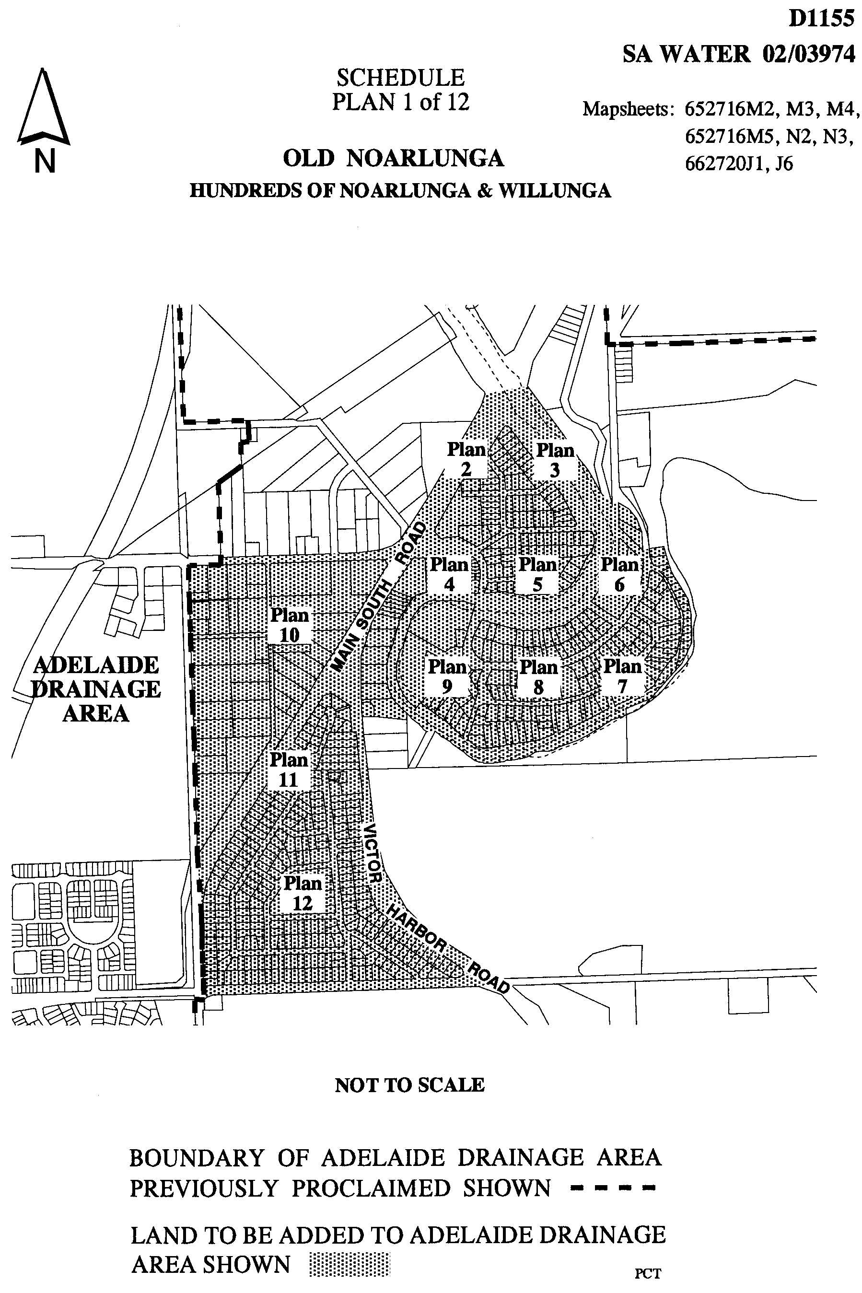
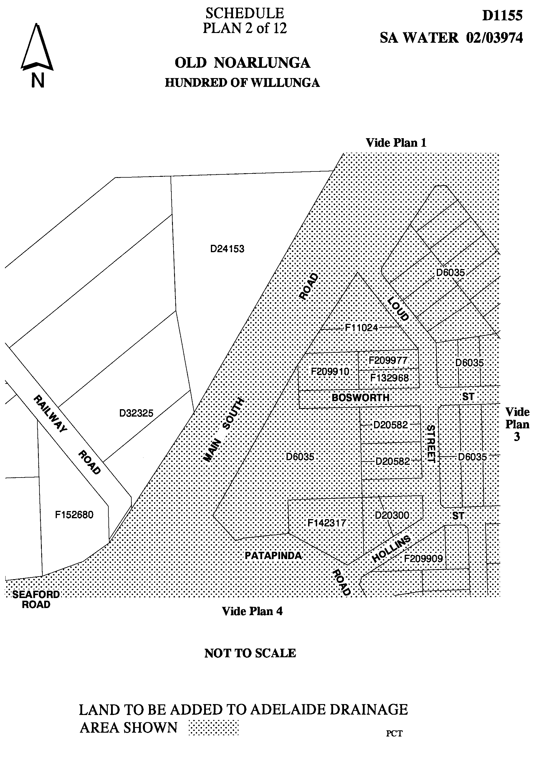
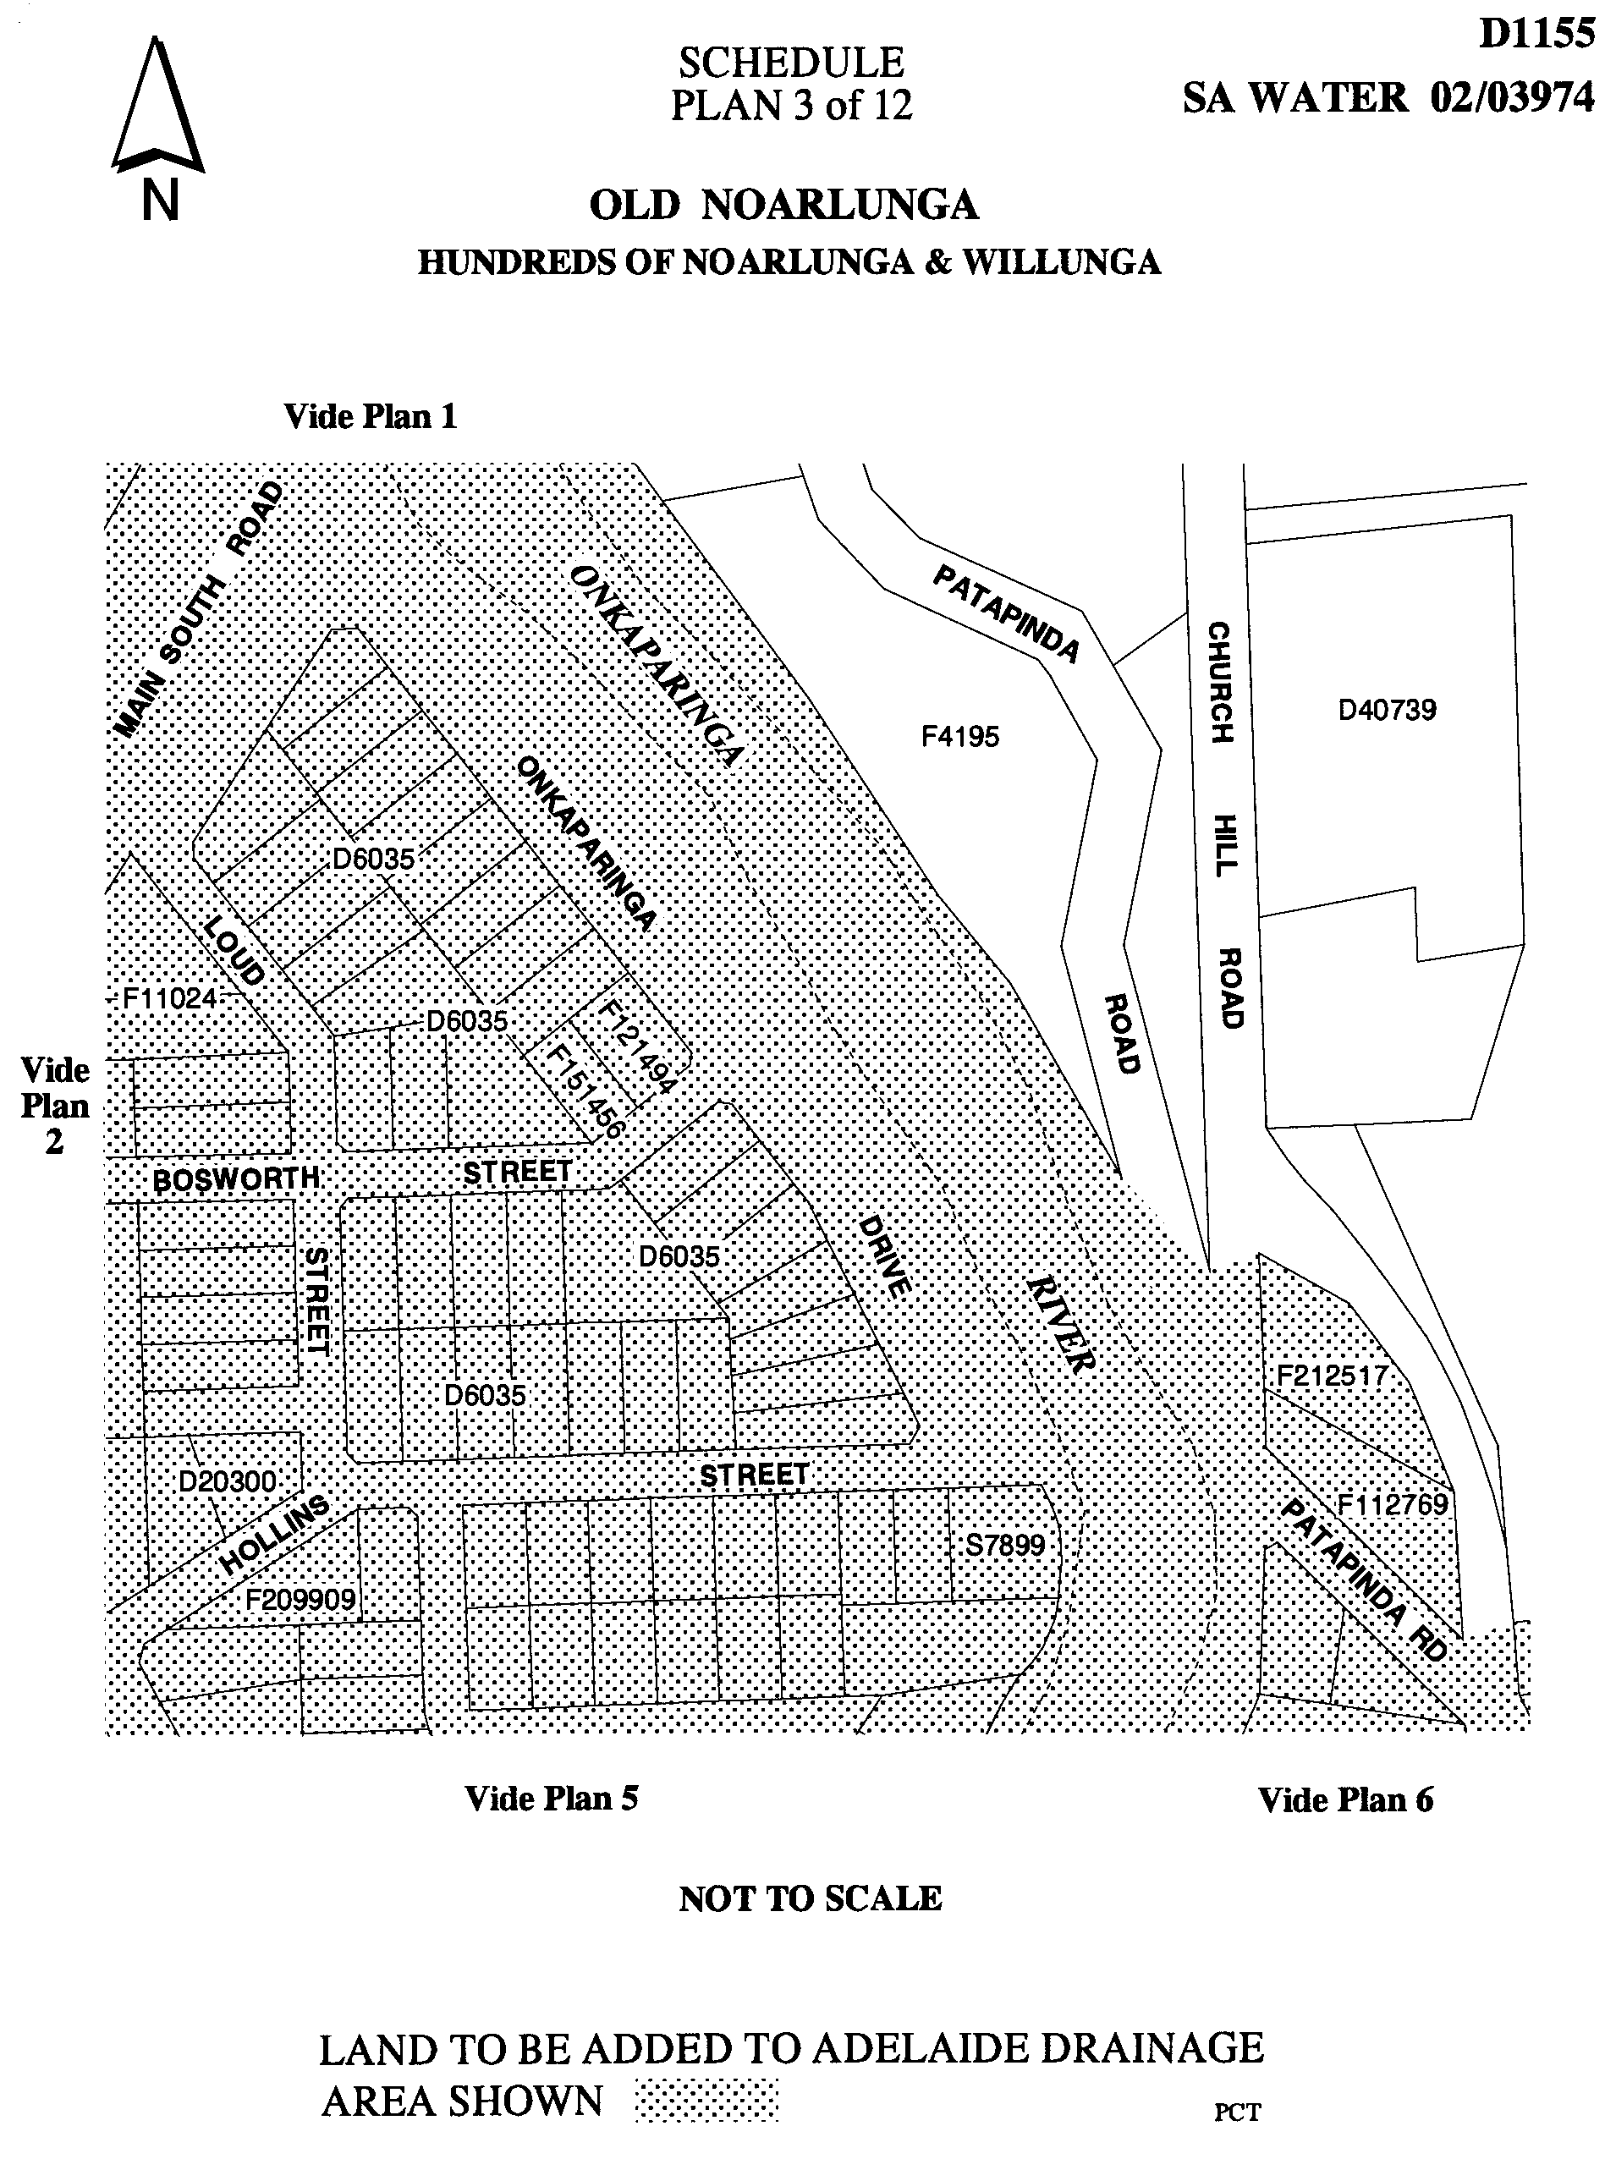
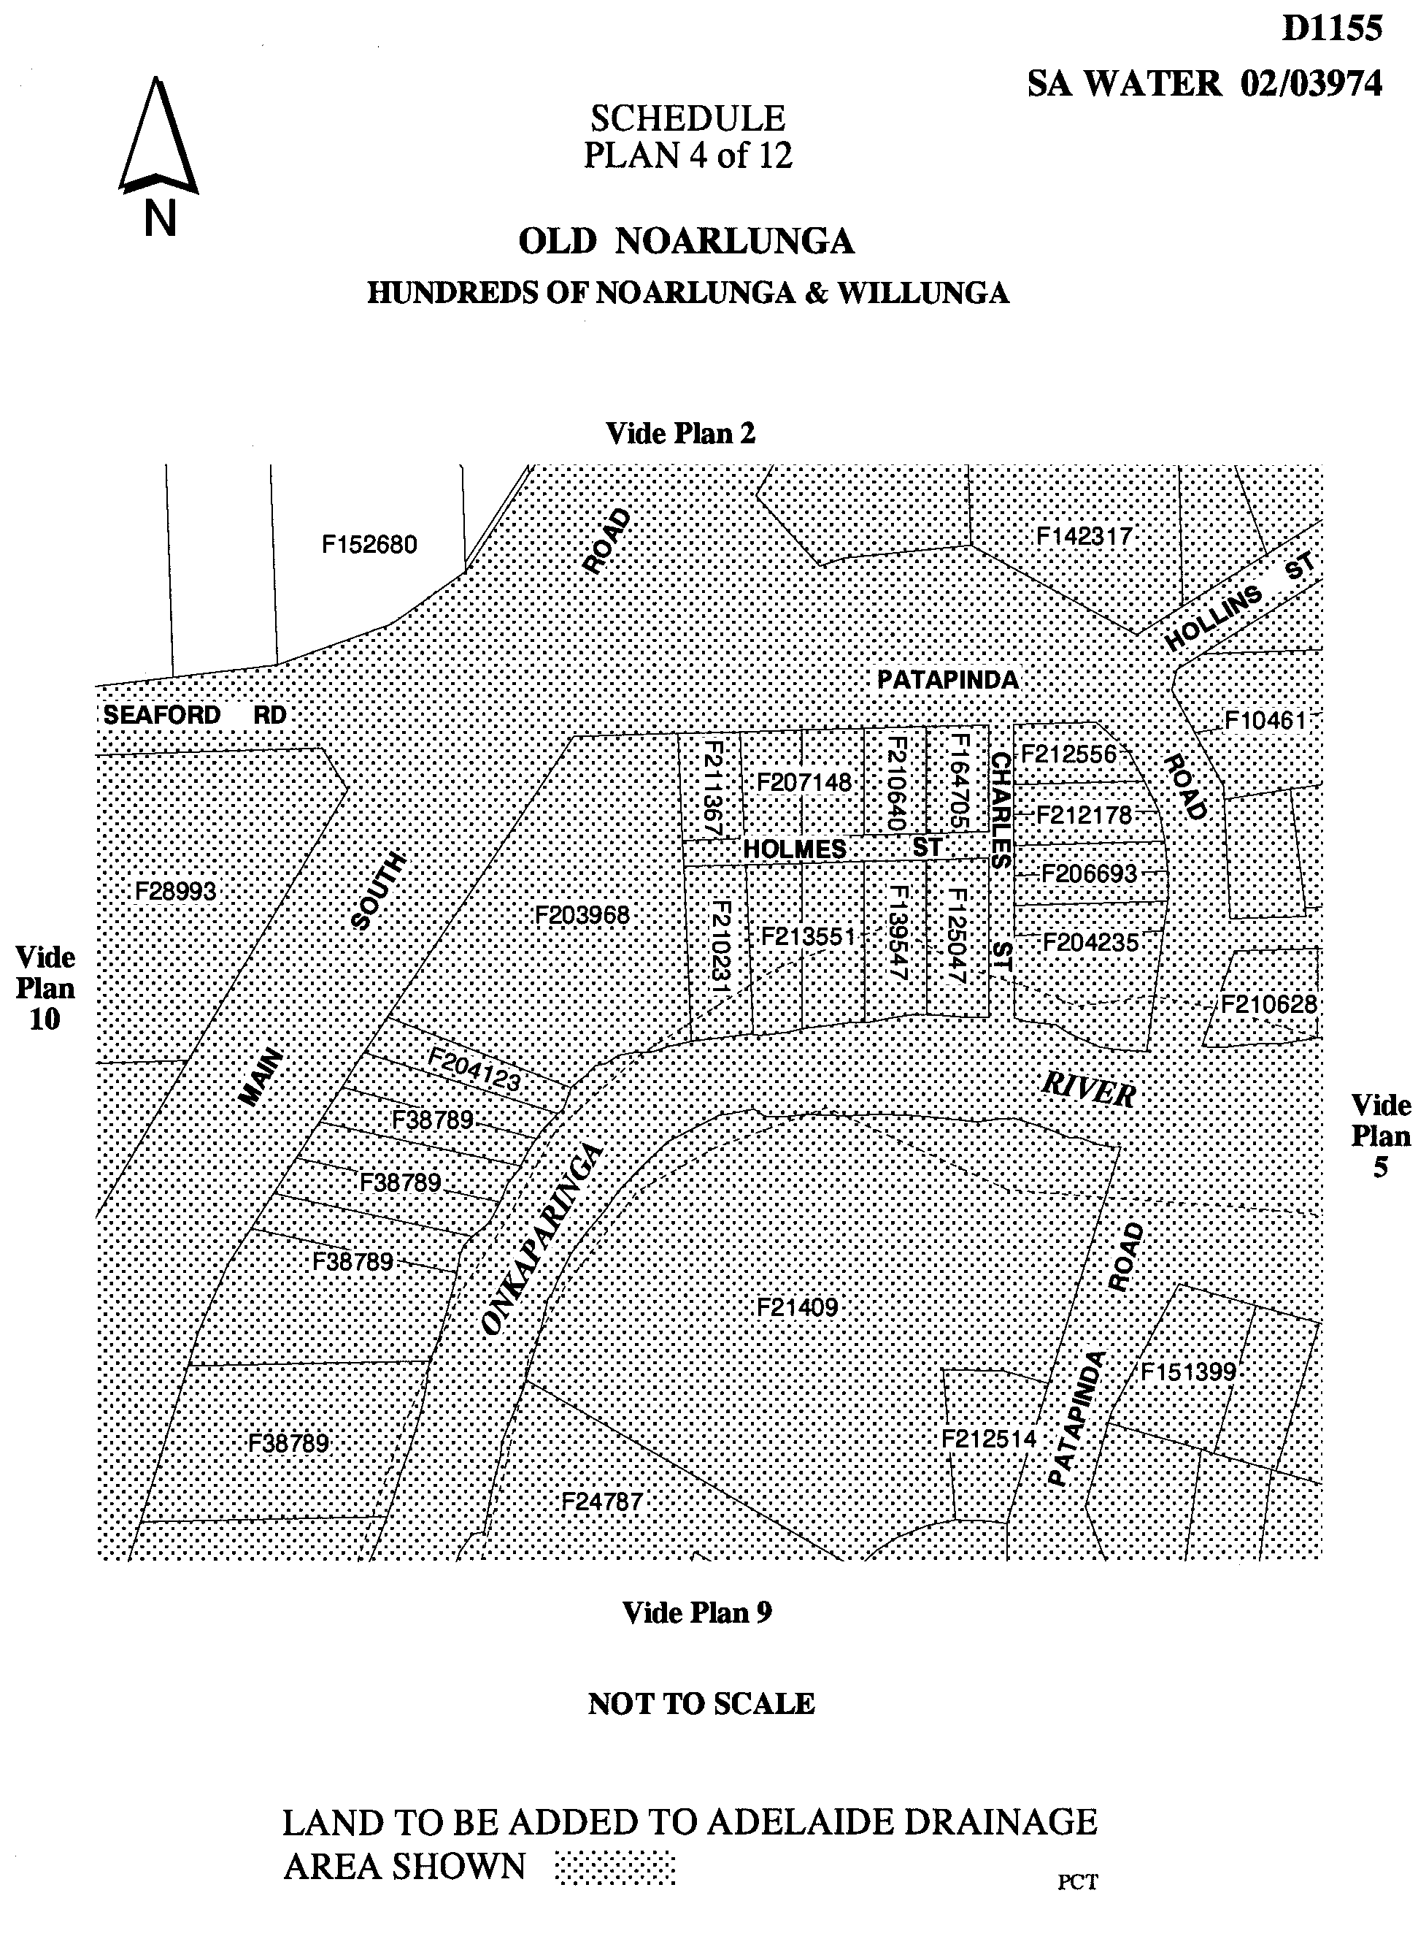
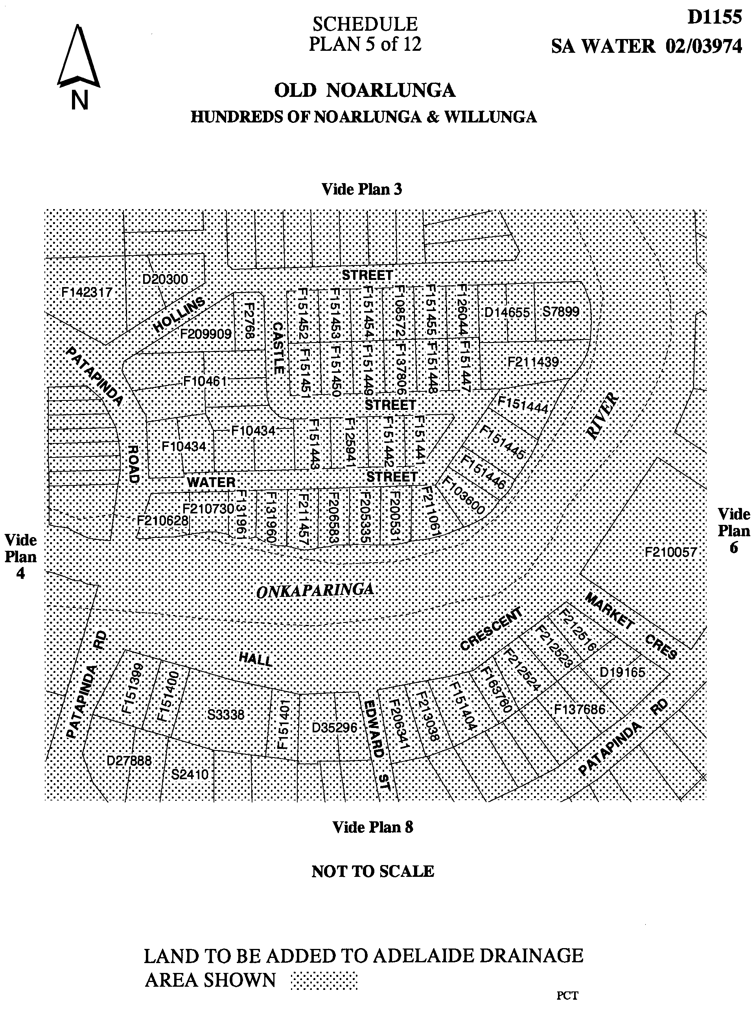
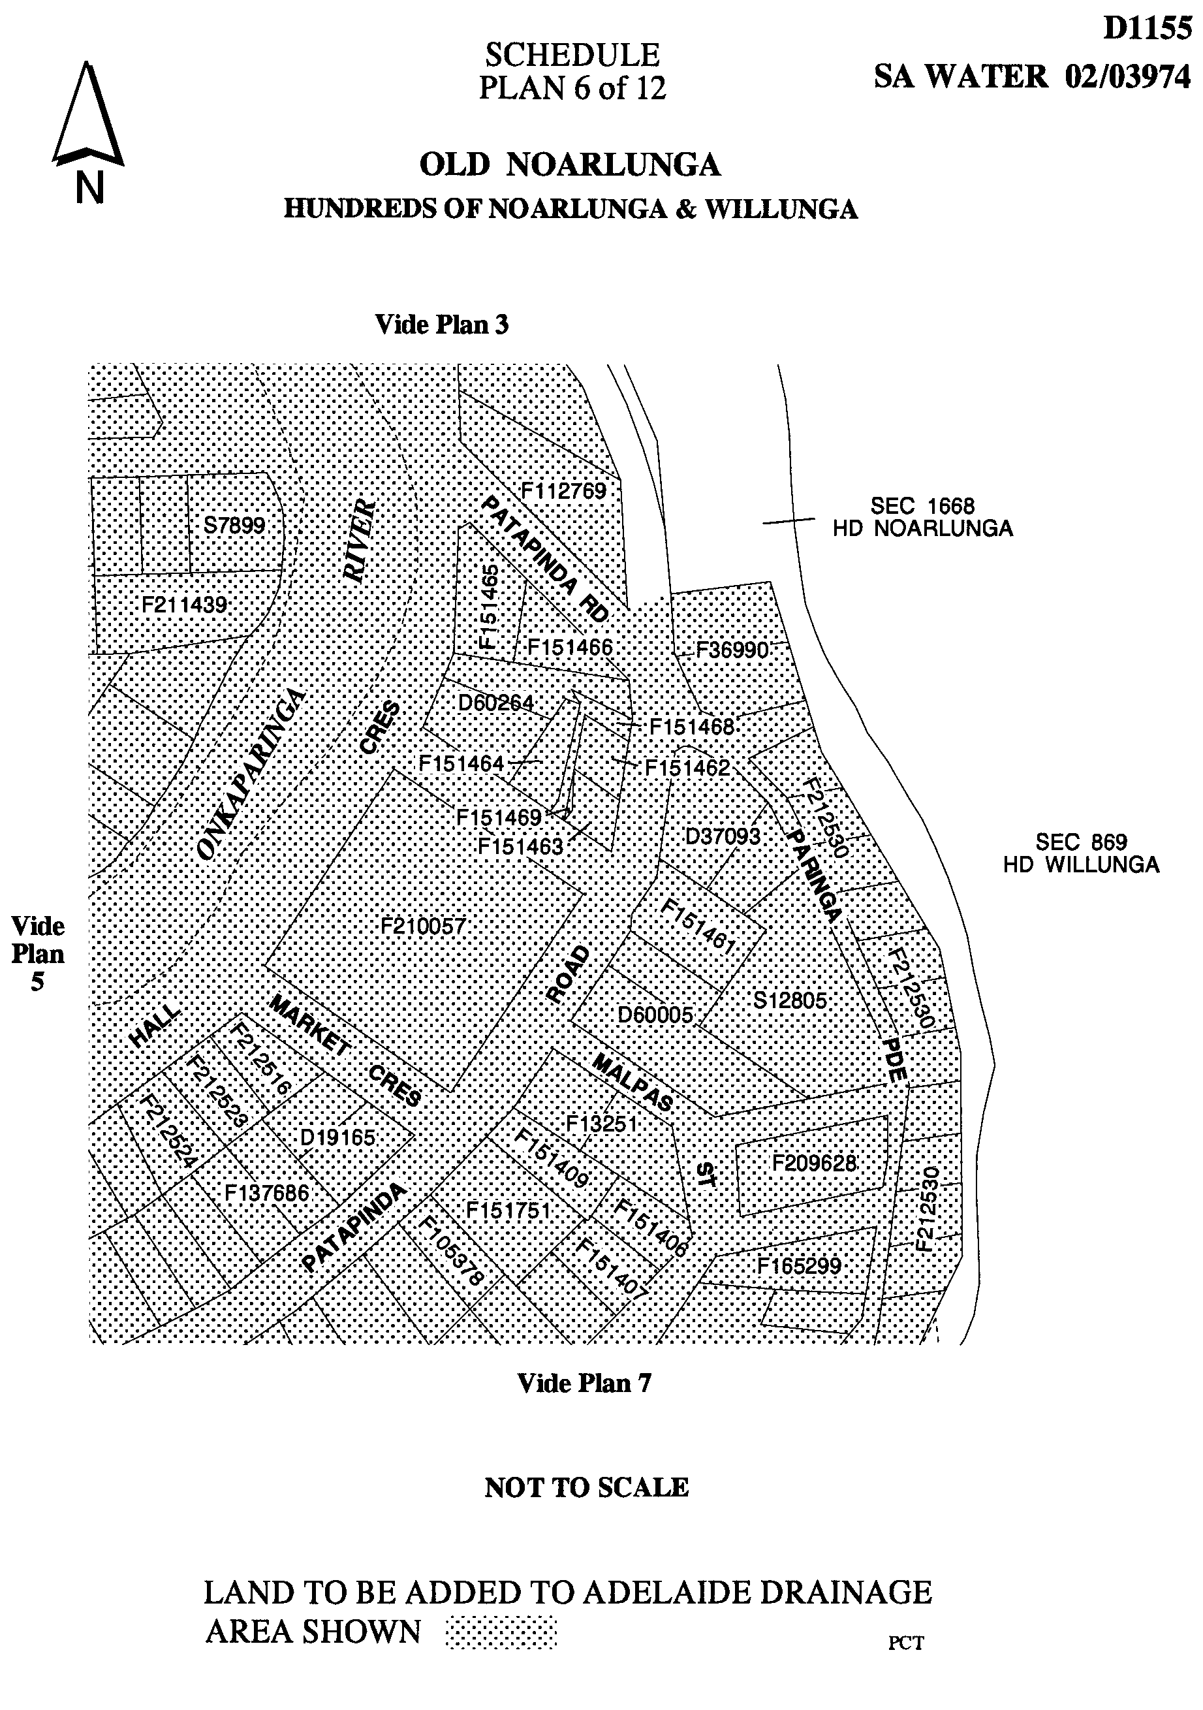
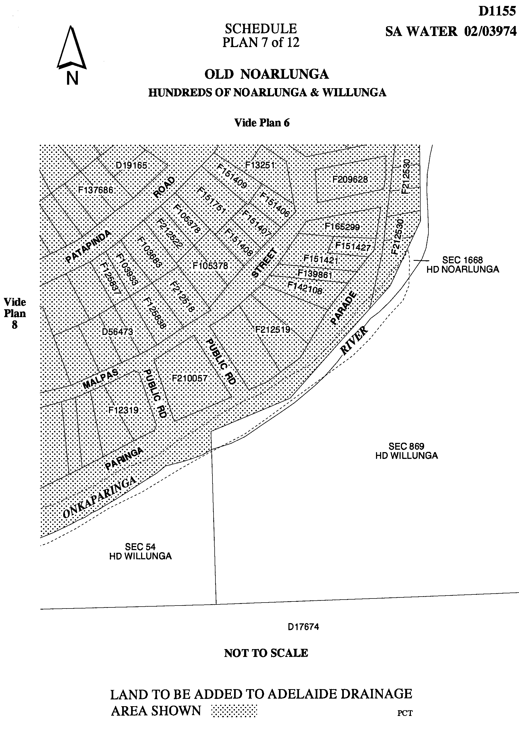
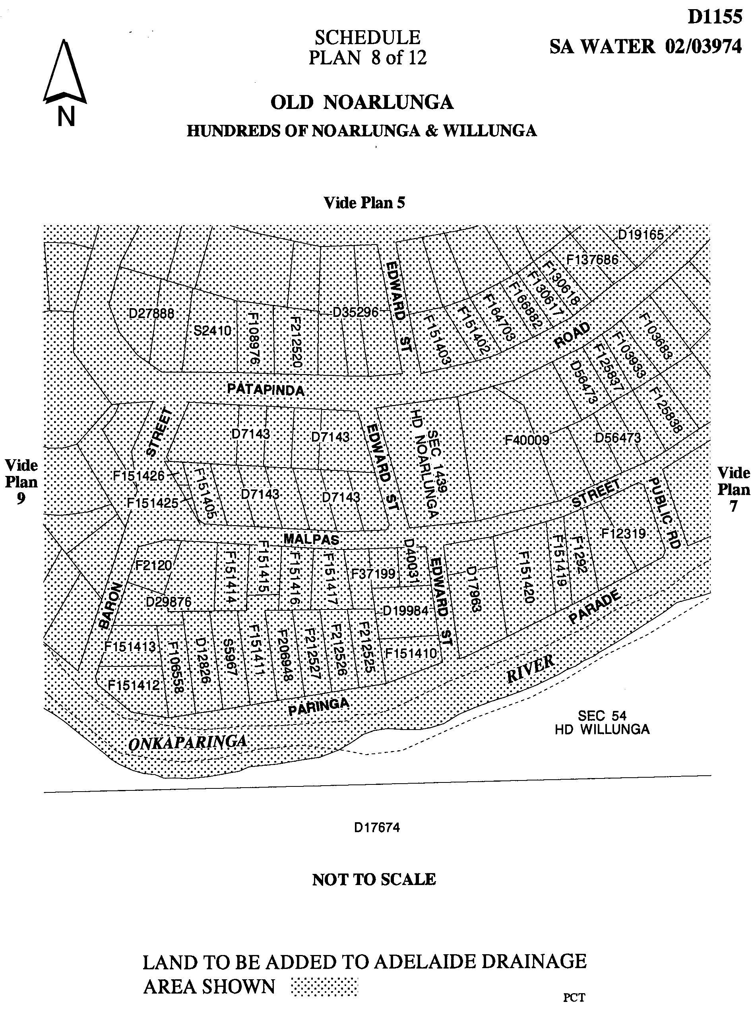
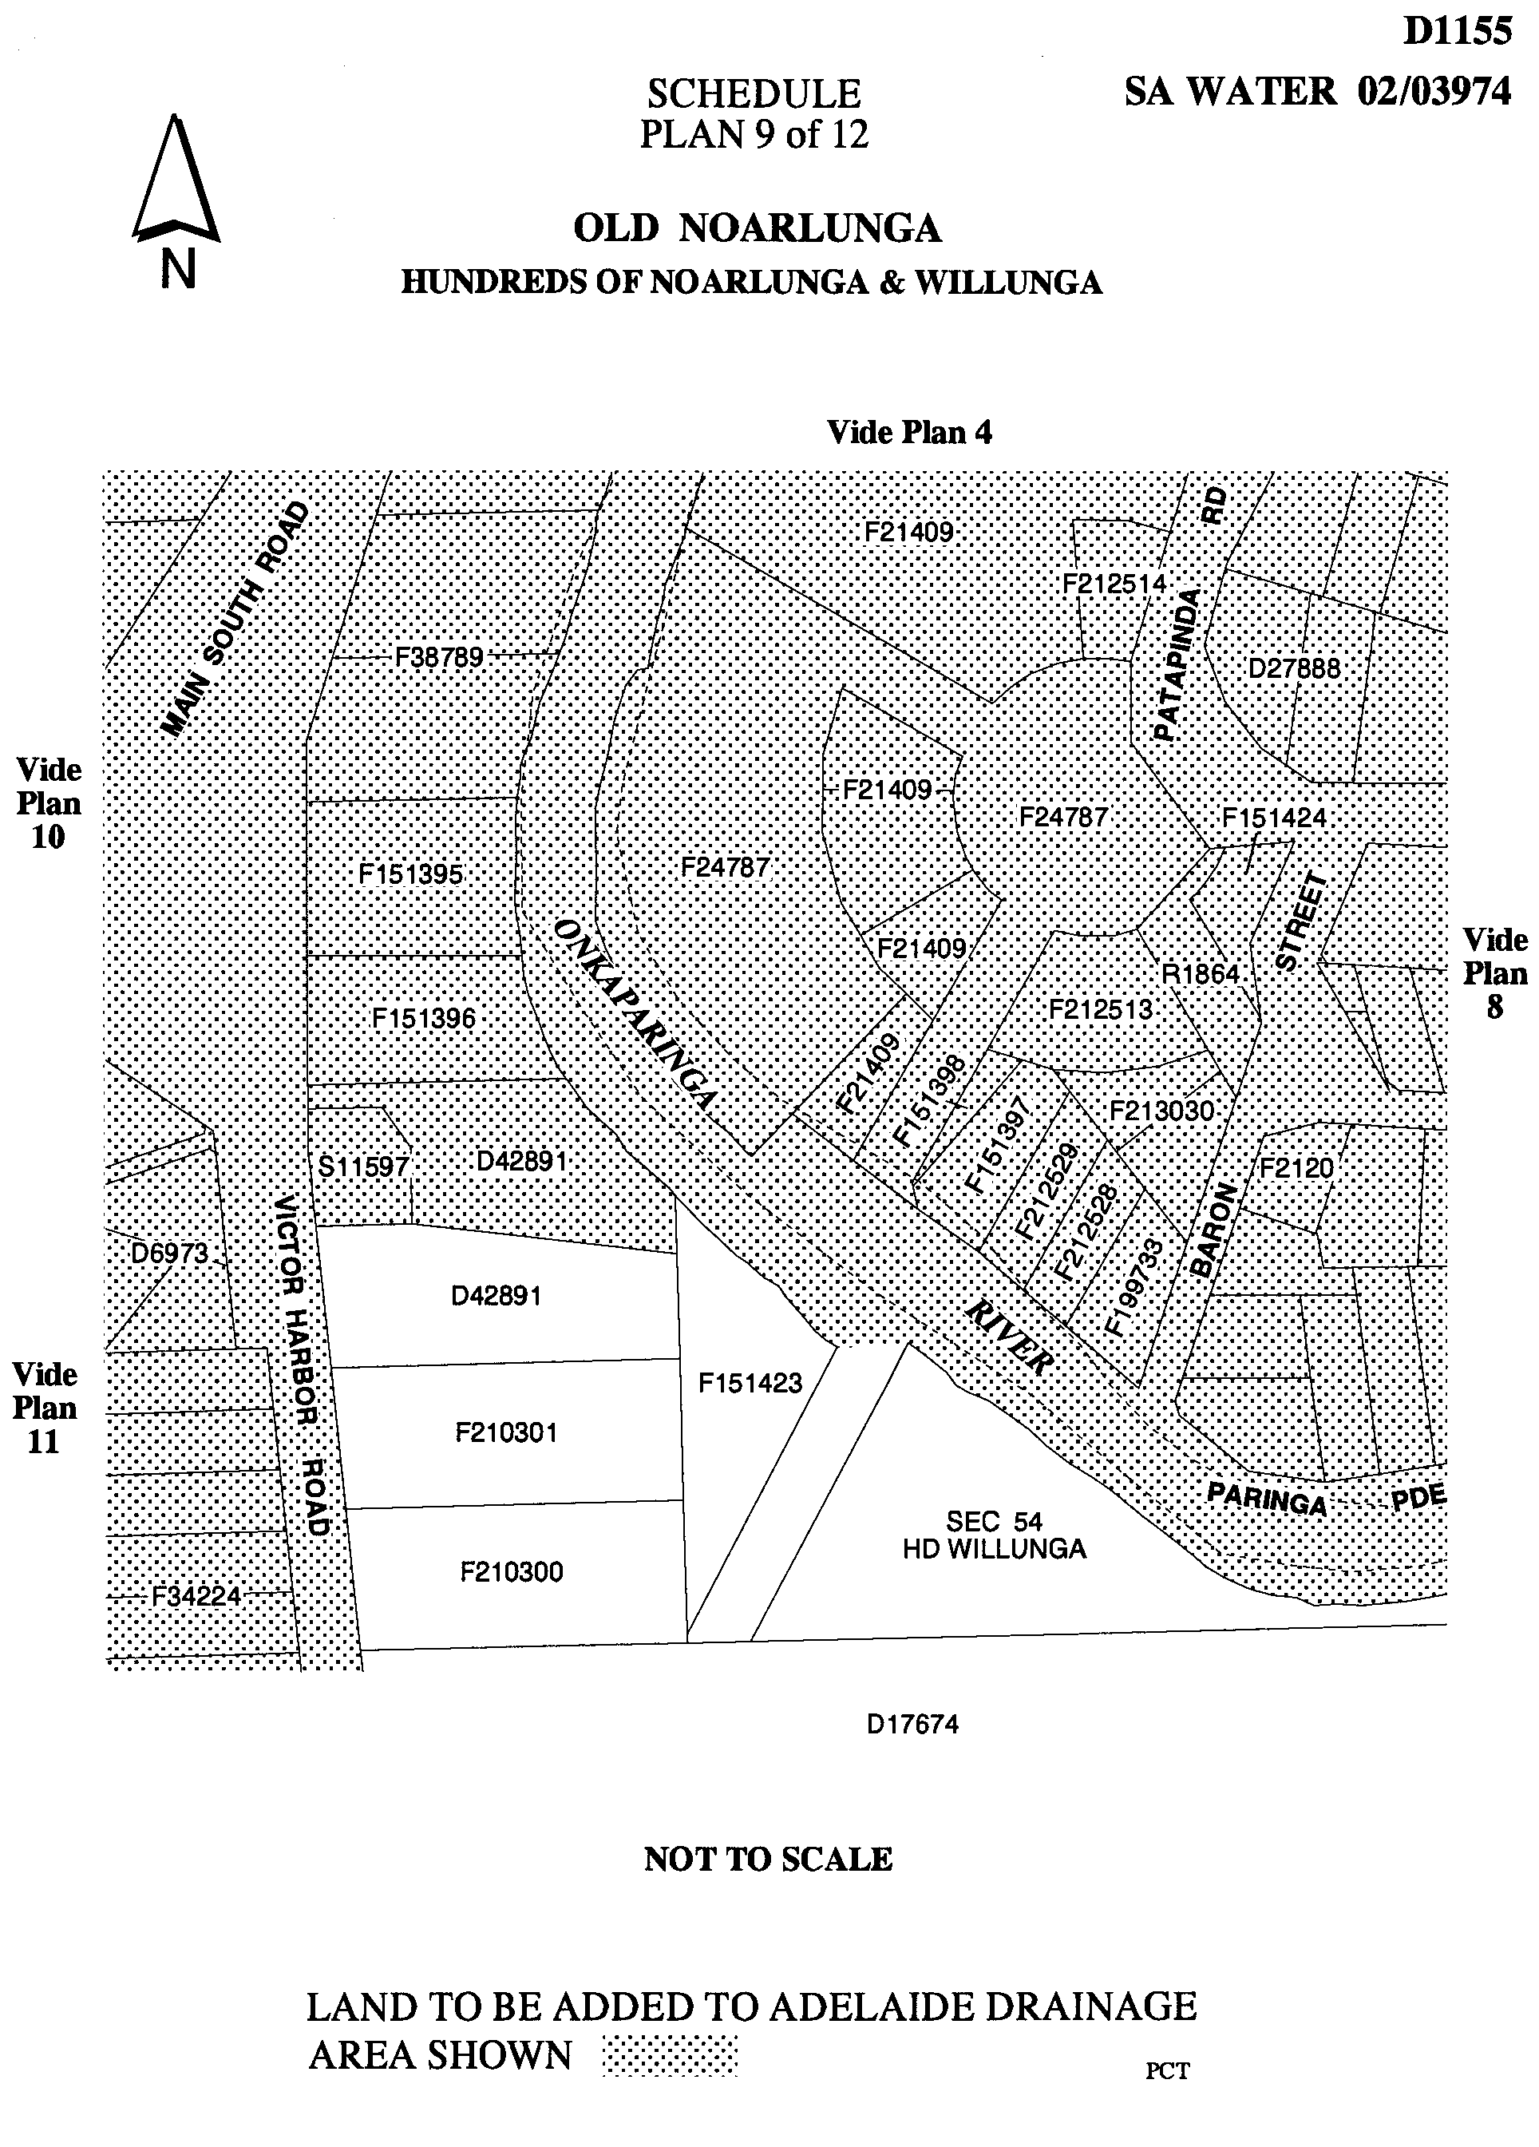
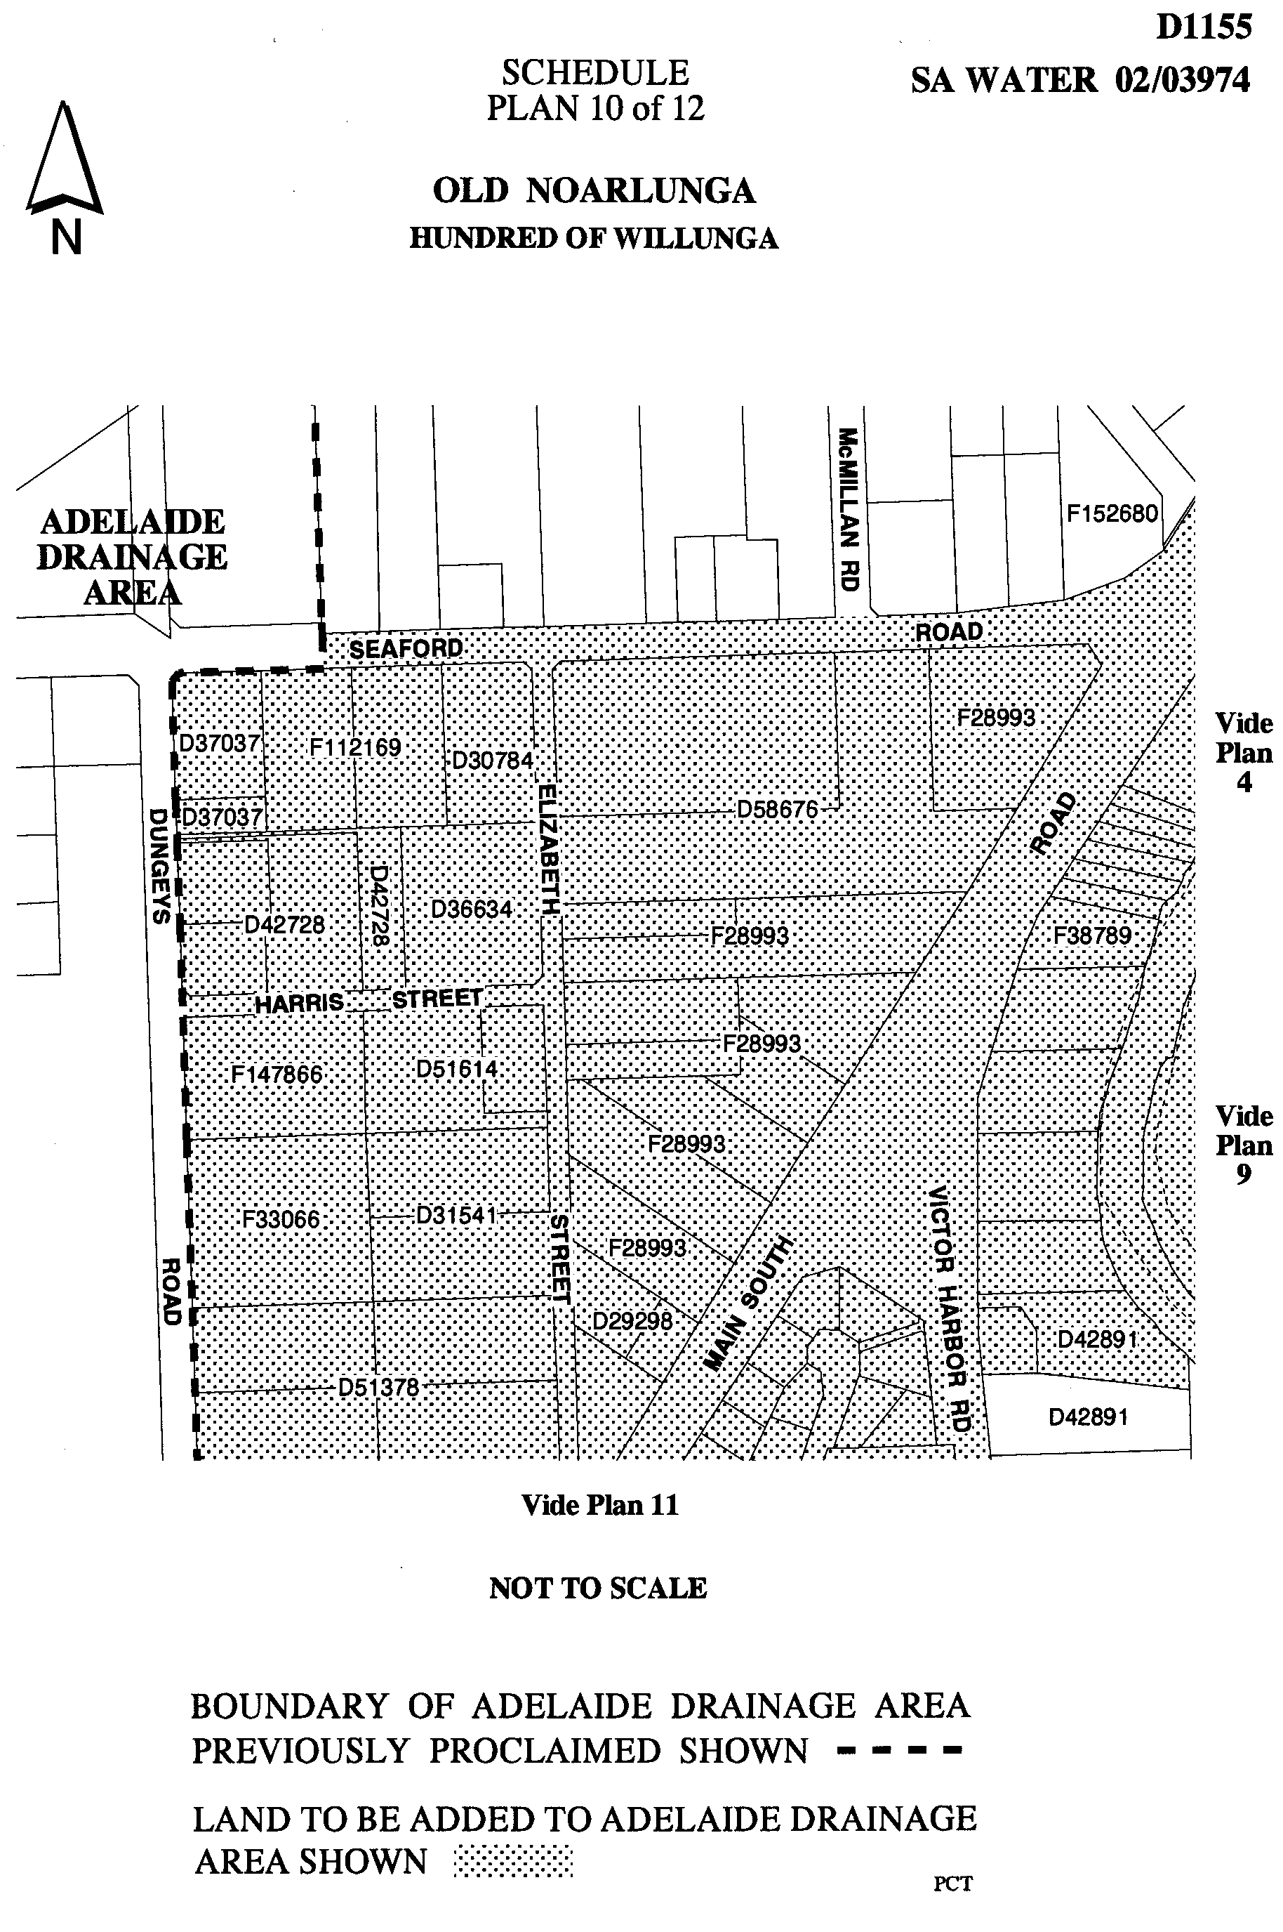
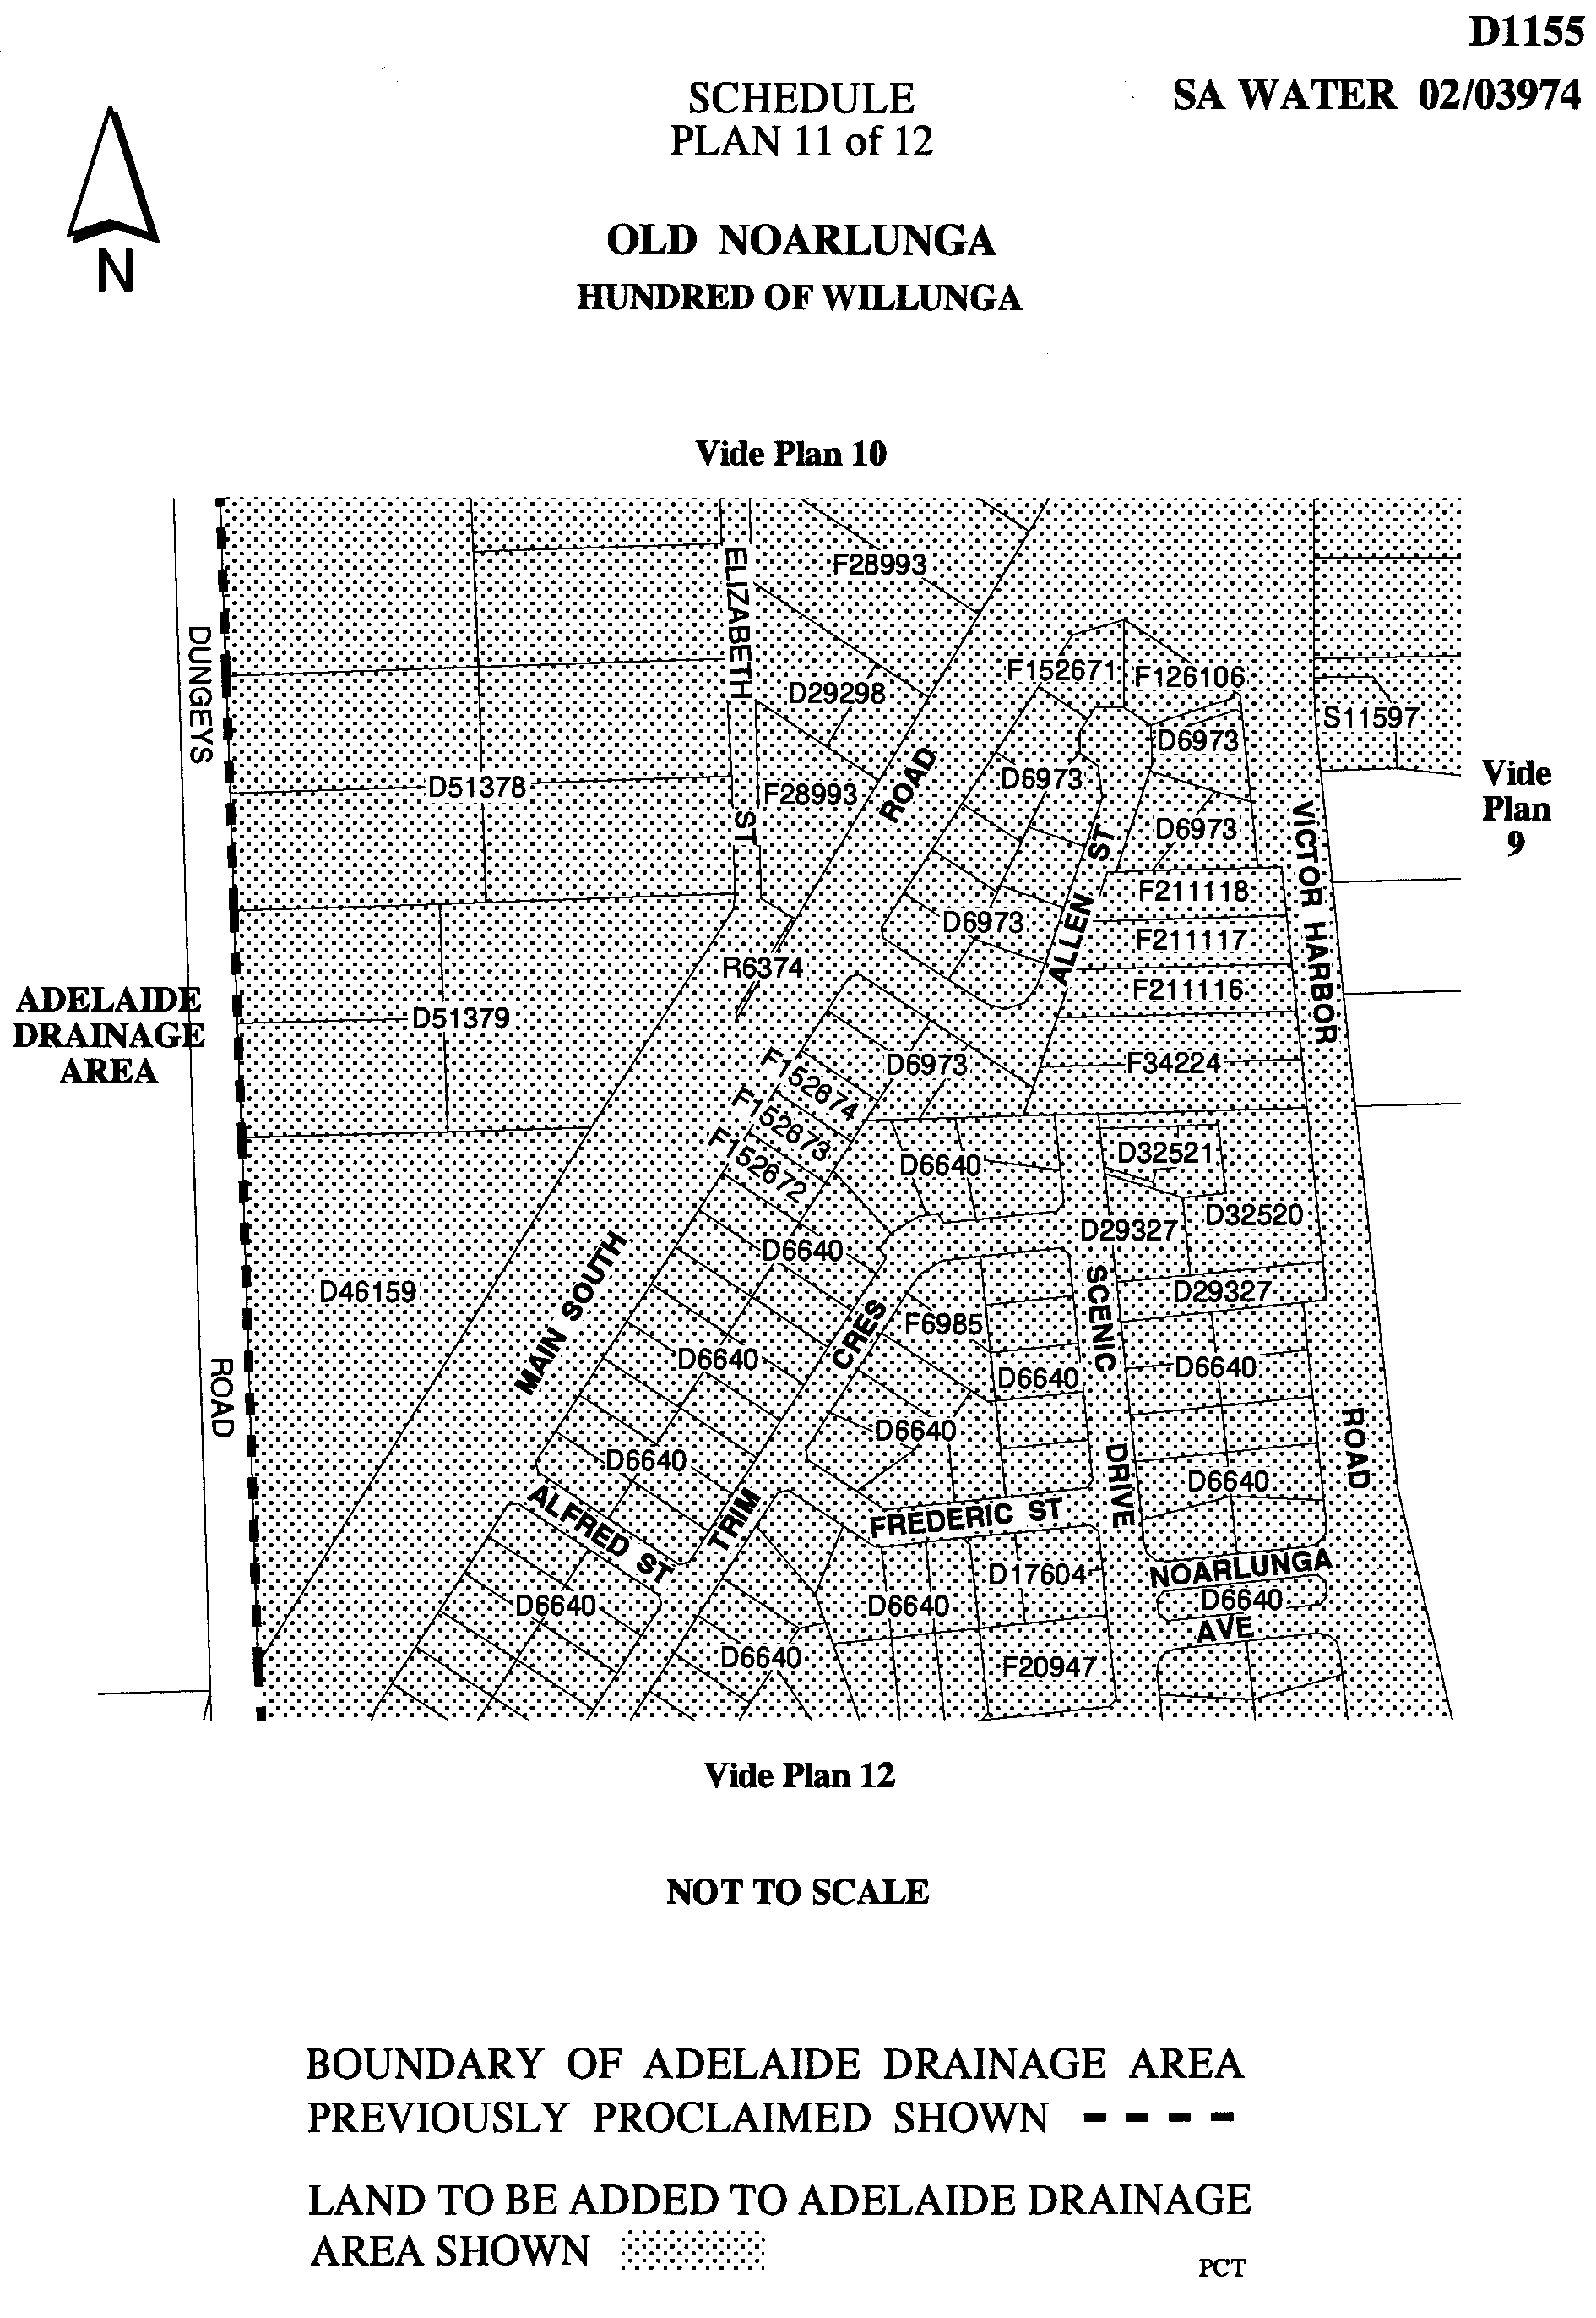
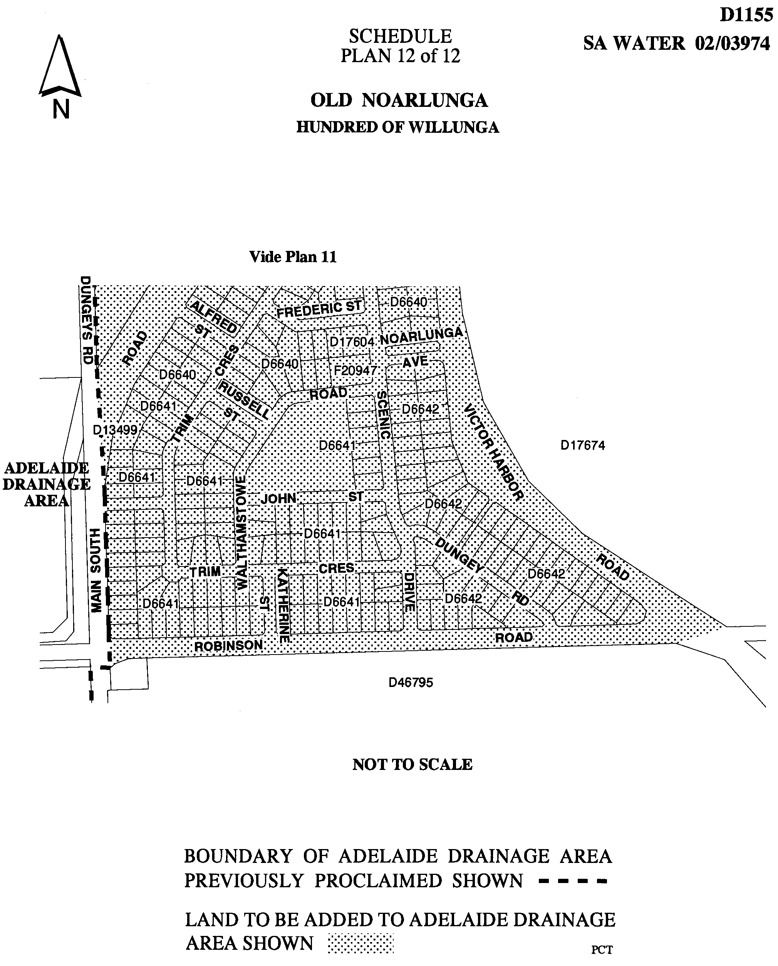
Dated 9 October 2002.
Signed for and on behalf of the South Australian Water Corporation by a person duly authorised so to do:
A. Popplewell, General Manager Shared Services
In the presence of:
D. G. Eggers, Acting Team Leader Rating
SAWATER 02/03974 D1155

NOTICE TO MARINERS
No. 51 of 2002
South Australia—Gulf St Vincent—Port Adelaide River—Outer Harbor—No. 10 Port Hand Channel Beacon Missing—Temporary Buoy Placed
MARINERS are advised that No. 10 Port Hand Channel Beacon Fl.R.4s) is missing and a temporary pink spherical unlit marker buoy has been placed in the approximate location (WGS 84 co-ordinates Latitude 34°45′55.572″S, Longitude 138°29′21.768″E) marking the port hand edge of the channel. This buoy will be in place until further notice.
Mariners are advised to proceed with caution in the vicinity of this mark.
Navy chart affected: Aus 137
Local Chart: Port Adelaide and Approaches
Publications affected: Australia Pilot Vol. 1, (Seventh Edition, 1992), page 128, Admiralty List of Lights and Fog Signals, Volume K (2000 Edition) No. 2059.8.
Adelaide, 14 October 2002.
M. Wright, Minister for Transport
FP 2001/1439

WATER MAINS AND SEWERS

Office of the South Australian Water Corporation
Adelaide, 17 October 2002

WATER MAINS LAID

Notice is hereby given that the following main pipes or parts of main pipes have been laid down by the South Australian Water Corporation in or near the undermentioned water districts and are now available for a constant supply of water to adjacent land.

ADELAIDE WATER DISTRICT

CITY OF CHARLES STURT
Baudin Avenue, Flinders Park. p8

CITY OF NORWOOD PAYNEHAM & ST PETERS
Scott Street, Glynde. p9

CITY OF TEA TREE GULLY
Across and in Surrey Farm Drive, Golden Grove. p1
Easement in reserve (lot 515), Surrey Farm Drive, Golden Grove. p1
Caradoc Court, Golden Grove. p1

MOUNT GAMBIER WATER DISTRICT

CITY OF MOUNT GAMBIER
Red Oak Place, Mount Gambier. p2
Callahan Place, Mount Gambier. p3
Arlington Terrace, Mount Gambier. p3

NARACOORTE WATER DISTRICT

NARACOORTE LUCINDALE COUNCIL
Cedar Avenue, Naracoorte. This main is available on the east side by application only. p4

PORT LINCOLN WATER DISTRICT

CITY OF PORT LINCOLN
Robertson Road, Port Lincoln. p6

ROBE WATER DISTRICT

DISTRICT COUNCIL OF ROBE
De Guichen Drive, Robe. p18
Baudin Place, Robe. p18

SWAN REACH WATER DISTRICT

MID MURRAY COUNCIL
Nildottie Road, Swan Reach. p7

WARREN COUNTRY LANDS WATER DISTRICT

BAROSSA COUNCIL
South Terrace, north of lot 46 in LTRO FP 155061, hundred of Barossa. p13 and 17
Easements in section 988, hundred of Barossa. p13-15
Coppermine Road, hundred of Barossa. p15-17
Easements in allotment piece 2 in LTRO DP 43872, Coppermine Road, hundred of Barossa. p16

WATER MAINS ABANDONED

Notice is hereby given that the undermentioned water mains have been abandoned by the South Australian Water Corporation.

MOUNT GAMBIER WATER DISTRICT

CITY OF MOUNT GAMBIER
Red Oak Place, Mount Gambier. p2

WARREN COUNTRY LANDS WATER DISTRICT

BAROSSA COUNCIL
South Terrace, north of lot 46 in LTRO FP 155061, hundred of Barossa. p13 and 17

WATER MAINS LAID

Notice is hereby given that the undermentioned water mains have been laid down by the South Australian Water Corporation and are not available for a constant supply of water to adjacent land.

MOOROOK COUNTRY LANDS WATER DISTRICT

DISTRICT COUNCIL OF LOXTON WAIKERIE
Mary Starr Drive, Waikerie. p5
Matthews Street, Waikerie. p5
Marks Terrace, Waikerie. p5

SEWERS LAID

Notice is hereby given that the following sewers have been laid down by the South Australian Water Corporation in the under-mentioned drainage areas and are now available for house connections.

ADELAIDE DRAINAGE AREA

CITY OF BURNSIDE
Eden Avenue, Kensington Park. FB 1106 p50

CAMPBELLTOWN CITY COUNCIL
Arthur Street, Tranmere. FB 1106 p51

CITY OF CHARLES STURT
Fourth Avenue, Seaton. FB 1106 p47
Baudin Avenue, Flinders Park. FB 1106 p49

CITY OF NORWOOD PAYNEHAM & ST PETERS
Scott Street, Glynde. FB 1106 p52

CITY OF ONKAPARINGA
Main South Road, Old Noarlunga. FB 1108 p1, 2, 5, 8 and
10-12
Loud Street, Old Noarlunga. FB 1108 p1, 2, 5, 7 and 11
Hollins Street, Old Noarlunga. FB 1108 p1, 2, 6, 7, 11 and 14
Patapinda Road, Old Noarlunga. FB 1108 p1, 2, 6, 9, 11 and 16
Victor Harbor Road, Old Noarlunga. FB 1108 p1, 2, 10 and 12
Bosworth Street, Old Noarlunga. FB 1108 p1, 2, 6, 7, 13 and 14
Onkaparinga Drive, Old Noarlunga. FB 1108 p1, 2, 5, 7, 14 and 15
Easement in common property and unit subsidiary 3 in LTRO SP 7899, Hollins Street, Old Noarlunga. FB 1108 p1, 2, 7 and 15
Public road south of lot 22 in LTRO DP 20582, Old Noarlunga. FB 1108 p1, 2, 6, 7 and 14
Easement in lot 18 in LTRO DP 6035, Bosworth Street, Old Noarlunga. FB 1108 p1, 2, 6 and 14
Charles Street, Old Noarlunga. FB 1108 p1, 2, 6, 8 and 13
Holmes Street, Old Noarlunga. FB 1108 p1, 2, 8 and 13
Castle Street, Old Noarlunga. FB 1108 p1, 2, 7, 9 and 15
Water Street, Old Noarlunga. FB 1108 p1, 2, 7, 9, 13 and 15
Easement in lot 13 in LTRO FP 10461, Castle Street, and lot 14 in LTRO FP 10461, Patapinda Road, Old Noarlunga. FB 1108 p1, 2, 7 and 13

CITY OF PORT ADELAIDE ENFIELD
Lyons Road, Holden Hill. FB 1107 p58
Aberdeen Avenue, Holden Hill. FB 1107 p58
Gaelic Avenue, Holden Hill. FB 1107 p58
Swanson Avenue, Gilles Plains. FB 1107 p58

CITY OF WEST TORRENS
Douglas Street, Lockleys. FB 1106 p48

MOUNT GAMBIER COUNTRY DRAINAGE AREA

CITY OF MOUNT GAMBIER
Red Oak Place, Mount Gambier. FB 1090 p41 and 42
Callahan Place, Mount Gambier. FB 1090 p43 and 44
Arlington Terrace, Mount Gambier. FB 1090 p43 and 44
Allan Drive, Mount Gambier. FB 1090 p13 and 14
Easement in lot 302 in LTRO DP 58713, Graham Road, Mount Gambier. FB 1090 p13 and 14

SEWERS ABANDONED

Notice is hereby given that the undermentioned sewers have been abandoned by the South Australian Water Corporation.

ADELAIDE DRAINAGE AREA

CITY OF PORT ADELAIDE ENFIELD
Aberdeen Avenue, Holden Hill. FB 1107 p58
Gaelic Avenue, Holden Hill. FB 1107 p58

SEWERS LAID

Notice is hereby given that the undermentioned sewers have been laid down by the South Australian Water Corporation and are not available for house connections.

ADELAIDE DRAINAGE AREA

CITY OF ONKAPARINGA
Seaford Road, Old Noarlunga. FB 1108 p1, 2, 8 and 11
Across and in Main South Road, Seaford Meadows and Old Noarlunga—150 mm DICL and 150 mm PVC pumping main. FB 1108 p1, 2, 5, 6, 18 and 20

OUTSIDE ADELAIDE DRAINAGE AREA

CITY OF ONKAPARINGA
Railway Road, Seaford Meadows—150 mm PVC pumping main. FB 1108 p1-4, 6 and 19-21

A. Howe, Chief Executive Officer, South Australian Water Corporation.

WATERWORKS ACT 1932
Removal of Land from Blue Lake Country Lands Water District and Addition to Mount Gambier Water District
PURSUANT to section 6 of the Waterworks Act 1932, the South Australian Water Corporation:
(a) removes from the Blue Lake Country Lands Water District and adds to the Mount Gambier Water District all the land contained in allotments 1 and 2 in Deposited Plan 58378; and
(b) declares that this notice has effect from the commencement of the financial year in which it is published in the Gazette.
Dated 9 October 2002.
Signed for and on behalf of the South Australian Water Corporation by a person duly authorised so to do:
A. Popplewell, General Manager Shared Services
In the presence of:
D. G. Eggers, Acting Team Leader Rating
SAWATER 02/03973 W1154

WATERWORKS ACT 1932
Removal of Land from Strathalbyn Water District and Addition to Strathalbyn Country Lands Water District
PURSUANT to section 6 of the Waterworks Act 1932, the South Australian Water Corporation:
(a) removes from the Strathalbyn Water District and adds to the Strathalbyn Country Lands Water District the land shown on the plan in the schedule; and
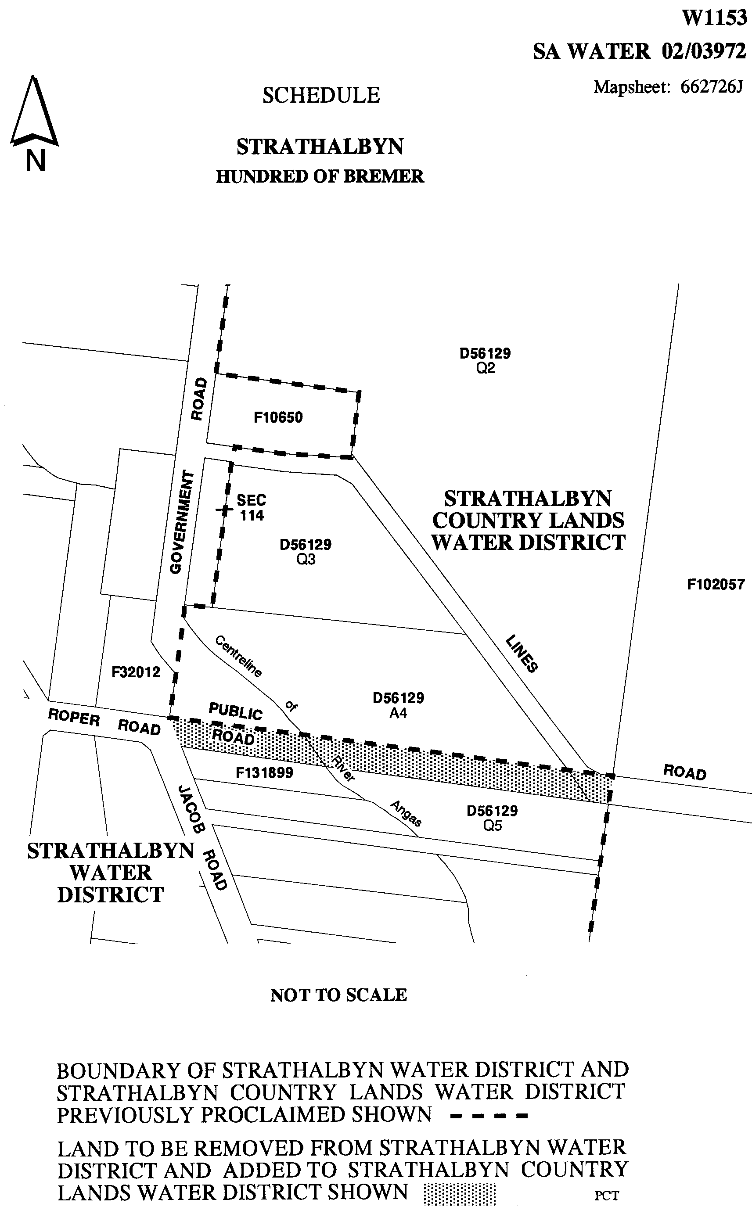
(b) declares that this notice has effect from the commencement of the financial year in which it is published in the Gazette.

Dated 9 October 2002.
Signed for and on behalf of the South Australian Water Corporation by a person duly authorised so to do:
A. Popplewell, General Manager Shared Services
In the presence of:
D. G. Eggers, Acting Team Leader Rating
SAWATER 02/03972 W1153

WHEAT MARKETING ACT 1989
Deductions for South Australian Farmers Federation (SAFF) Grains Council
PURSUANT to section 10 of the Wheat Marketing Act 1989, I, Paul Holloway, Minister for Agriculture, Food and Fisheries, make the following notice concerning grain for the season 2002-2003:
1. There shall be deductions for the purposes of supporting activities of the SAFF Grains Council from the proceeds of all grain for the season.
2. The prescribed rate for such deductions shall be 3 cents per tonne.
3. Any grain grower not wishing to have such deductions made from his or her grain proceeds must signify that desire by 31 August 2003.
4. A written request to the above effect should be forwarded to the Minister for Agriculture, Food and Fisheries, G.P.O. Box 1671, Adelaide, S.A. 5001 by the stipulated date.
Dated 6 October 2002.
P. Holloway, Minister for Agriculture, Food and Fisheries

WHEAT MARKETING ACT 1989
Deductions for Grains Research
PURSUANT to section 10 of the Wheat Marketing Act 1989, I, Paul Holloway, Minister for Agriculture, Food and Fisheries, make the following notice concerning grain for the season 2002-2003:
1. There shall be deductions for the purposes of research from the proceeds of all grain for the season.
2. The prescribed rate for such deductions shall be 12 cents per tonne.
3. Any grain grower not wishing to have such deductions made from his or her grain proceeds must signify that desire by 31 August 2003.
4. A written request to the above effect should be forwarded to the Minister for Agriculture, Food and Fisheries, G.P.O. Box 1671, Adelaide, S.A. 5001 by the stipulated date.
Dated 6 October 2002.
P. Holloway, Minister for Agriculture, Food and Fisheries

REGULATIONS UNDER THE FISHERIES ACT 1982
────
No. 193 of 2002
────
At the Executive Council Office at Adelaide, 17 October 2002

PURSUANT to the Fisheries Act 1982 and with the advice and consent of the Executive Council, I make the following regulations.
MARJORIE JACKSON-NELSON, Governor
───────────────────
SUMMARY OF PROVISIONS

1. Citation
2. Commencement
3. Variation of Sched. 1—Fish prescribed for the River Fishery
────────────────────────

Citation
1. The Scheme of Management (River Fishery) Regulations 1991 (see Gazette 27 June 1991 p. 2197), as varied, are referred to in these regulations as "the principal regulations".

Commencement
2. These regulations will come into operation on 1 July 2003.

Variation of Sched. 1—Fish prescribed for the River Fishery
3. Schedule 1 of the principal regulations is varied by striking out "Murray cod (Maccullochella peeli)" and "Perch, golden (callop) (Macquaria ambigua)".

MAFF 02/0059 CS R. DENNIS, Clerk of the Council

REGULATIONS UNDER THE DEVELOPMENT ACT 1993
────
No. 194 of 2002
────
At the Executive Council Office at Adelaide, 17 October 2002

PURSUANT to the Development Act 1993 and with the advice and consent of the Executive Council, I make the following regulations.
MARJORIE JACKSON-NELSON, Governor

PURSUANT to section 10AA(2) of the Subordinate Legislation Act 1978, I certify that, in my opinion, it is necessary or appropriate that the following regulations come into operation as set out below.

J. W. WEATHERILL, Minister for Urban Development and Planning
───────────────────
SUMMARY OF PROVISIONS

1. Citation
2. Commencement
3. Variation of Sched. 2
4. Variation of Sched. 8
5. Variation of Sched. 14

────────────────────────

Citation
1. The Development Regulations 1993 (see Gazette 27 October 1993 p. 1954), as varied, are referred to in these regulations as "the principal regulations".

Commencement
2. These regulations come into operation on the day on which they are made.

Variation of Sched. 2
3. Schedule 2 of the principal regulations is varied by inserting after clause 1 the following clause:

1A. (1) Any excavation or filling (or excavating and filling) of land within the area of a council specified in the schedule to this clause which involves the excavating or filling (or excavating and filling) of a volume of material which exceeds 50 cubic metres in total, but not including the excavating or filling (or excavating and filling) of land—

(a) incidental to the ploughing or tilling of land for the purpose of agriculture; or

(b) incidental to the installation, repair or maintenance of any underground services; or

(c) on or within a public road or public road reserve; or

(d) in the event of an emergency in order—

(i) to protect life or property; or

(ii) to protect the environment where authority to undertake the activity is given by or under another Act; or

(e) in pursuance of a licence granted under Division 2 of Part 3 of the South Eastern Water Conservation and Drainage Act 1992.

(2) This clause will expire on 1 October 2004.

SCHEDULE

The Coorong District Council
Kingston District Council
Naracoorte Lucindale Council
The District Council of Tatiara

Variation of Sched. 8
4. Schedule 8 of the principal regulations is varied by inserting after item 18 the following item:

19. Excavation or filling of land in Upper South East

(1) A. Development within the ambit of clause 1A of schedule 2.

B. The South Eastern Water Conservation and Drainage Board.

C. Six weeks.

D. Direction.

(2) This item will expire on 1 October 2004.

Variation of Sched. 14
5. Schedule 14 of the principal regulations is varied by inserting after clause 2 the following clause:

3. (1) Any works or other activities undertaken by a State agency for the purposes of water management works under or in connection with the Upper South East Project are excluded from the provisions of section 49 of the Act.

(2) In this clause—

"State agency" has the same meaning as in section 49 of the Act;

"Upper South East Project" means the scheme of that name referred to in section 34A of the South Eastern Australian Water Conservation and Drainage Act 1992;

"water management works" has the same meaning as in the South Eastern Water Conservation and Drainage Act 1992.

(3) This clause will expire on 1 October 2004.

CPSA2002/00021 R. DENNIS, Clerk of the Council

REGULATIONS UNDER THE FEES REGULATION ACT 1927
────
No. 195 of 2002
────
At the Executive Council Office at Adelaide, 17 October 2002

PURSUANT to the Fees Regulation Act 1927 and with the advice and consent of the Executive Council, I make the following regulations.
MARJORIE JACKSON-NELSON, Governor
───────────────────
SUMMARY OF PROVISIONS

1. Citation
2. Commencement
3. Variation of reg. 2—Interpretation
4. Insertion of reg. 3
3. Fees for full fee paying overseas students
5. Insertion of Schedule
SCHEDULE
Fees for Full Fee Paying Overseas Students
────────────────────────

Citation
1. The Fees Regulation (Education) Regulations 1990 (see Gazette 12 July 1990 p. 285), as varied, are referred to in these regulations as "the principal regulations".

Commencement
2. These regulations will come into operation in accordance with section 5 of the Fees Regulation Act 1927.

Variation of reg. 2—Interpretation
3. Regulation 2 of the principal regulations is varied—

(a) by inserting after the definition of "authority" in subregulation (1) the following definition:

"Government school" has the same meaning as in the Education Act 1972;;

(b) by inserting after subregulation (1) the following subregulation:

(2) For the purposes of these regulations, a student is to be regarded as a full fee paying overseas student if—

(a) the student holds a temporary visa in force under the Migration Act 1958 of the Commonwealth; and

(b) the Commonwealth and the State disregard the student (or a class of students to which that student belongs) when calculating the amount of any assistance to the school at which the student is enrolled.

Insertion of reg. 3
4. The following regulation is inserted after regulation 2 of the principal regulations:

Fees for full fee paying overseas students
3. (1) The fees set out in the Schedule are payable, as specified in the Schedule, by a full fee paying overseas student for tuition at a Government school.

(2) The Minister may waive, reduce or remit the payment of the whole or any part of a fee payable under this regulation.

Insertion of Schedule
5. The following Schedule is inserted after regulation 4 of the principal regulations:

SCHEDULE
Fees for Full Fee Paying Overseas Students

Type of tuition | Fee for tuition during the year 2002 (per annum) | Fee for tuition during the year 2003 or a subsequent year (per annum)
For tuition at primary level | $7 500 | $7 500
For tuition at secondary level:  ⋅ intensive secondary English course  ⋅ years 8 - 12 | $9 500  $8 500 | $9 500  $9 500
For tuition only in a single subject course | $900 | $900

Note:
If a full fee paying overseas student receives tuition at a Government school for part only of a year, the Minister may, under regulation 3(2), waive, reduce or remit the whole or any part of the fee in respect of that year.

MECS 21/02 CS R. DENNIS, Clerk of the Council

FAXING COPY?

IF you fax copy to Government Publishing SA for inclusion in the Government Gazette, there is no need to send a Confirmation Copy to us as well.

This creates confusion and may well result in your notice being printed twice.

Please use the following fax number:

Fax transmission: (08) 8207 1040
Phone Inquiries: (08) 8207 1045

Please include a contact person, phone number and order number so that we can phone back with any queries we may have regarding the fax copy.

NOTE: Closing time for lodging new copy (either fax or hard copy) is 4 p.m. on Tuesday preceding the day of publication.

Government Gazette notices can be E-mailed.

The address is:

governmentgazette@saugov.sa.gov.au

Documents should be sent as attachments in Word format.

When sending a document via E-mail, please confirm your transmission with a faxed copy of your document, including the date the notice is to be published.

Fax transmission: (08) 8207 1040
Enquiries: (08) 8207 1045

CITY OF BURNSIDE
Supplementary Election for Councillor for Kensington
Gardens and Magill Ward
NOMINATIONS are hereby invited and will be received at the City of Burnside Civic Centre located at 401 Greenhill Road, Tusmore, S.A. 5065, from 24 October until 12 noon on Thursday, 14 November 2002, from any person eligible to be a candidate for election to the vacancy.
Nomination forms and candidate’s handbooks are available from the Civic Centre.
A candidate must submit a profile of not more than 150 words with the nomination form.
A candidate photograph of predominantly the head and shoulders, taken within the preceding 12 months, may also be submitted.
A briefing session for prospective candidates will be conducted at 7 p.m. on Tuesday, 29 October 2002 at the Civic Centre Atrium, 401 Greenhill Road, Tusmore.
If more than the required number of nominations are received for the vacancy, an election will be conducted entirely by postal ballot with the return of the completed ballot papers to reach the Returning Officer no later than 12 noon on Monday, 16 December 2002.
Steve Tully, Returning Officer

CITY OF CAMPBELLTOWN
By-law Made under the Local Government Act 1999
By-law No. 2—Moveable Signs
TO set standards for moveable signs on streets and roads and to provide conditions for, and the placement of, such signs.
Definitions
1. In this by-law:
(1) ‘footpath area’ means that part of a street or road between the property boundary of the street or road and the edge of the carriageway on the same side as that boundary; and
(2) ‘moveable sign’ has the same meaning as in the Local Government Act 1999.
Construction
2. A moveable sign displayed on a public street or road shall:
(1) be of a kind known as an ‘A’ Frame or Sandwich Board sign, an ‘inverted “T”’ sign, or a flat sign;
(2) be well constructed and maintained in good condition so as not to present a hazard to any member of the public;
(3) be of strong construction so as to be stable when in position and to be able to keep its position in adverse weather conditions with no sharp or jagged edges or corners;
(4) not be unsightly or offensive in appearance or content;
(5) not contain flashing parts;
(6) be constructed of timber, metal, plastic or plastic coated cardboard, or a mixture of such materials;
(7) not be more than 1 200 mm high, 800 mm wide and 800 mm deep;
(8) not have a display area exceeding 1 m² in total or, if the sign is two-sided, 1 m² on each side;
(9) be stable when in position;
(10) in the case of an ‘A’ Frame or Sandwich Board sign:
(a) be hinged or joined at the top;
(b) be of such construction that sides shall be securely fixed or locked in position when erected.
(11) in the case of an ‘inverted “T”’ sign, contain no struts or supports that run between the display area and the base of the sign.
Position
3. A moveable sign shall only be positioned on a public street or road on the footpath area at least 500 mm from the kerb subject to the following conditions:
(1) where there is no kerb to define the footpath, a setback of 500 mm from the edge of the carriageway is required;
(2) in the case of a flat sign, the message of which only contains newspaper headlines and the name of a news-paper, the sign must be resting against the business to which it relates;
(3) there must be no less than 1 200 mm distance between the sign and any structure, fixed object, tree, bush or plant (including another moveable sign);
(4) the sign must not be placed on a sealed part of any footpath area, unless the sealed part is wide enough to contain the sign and still leave a clear thoroughfare at least 1 200 mm wide;
(5) the sign must not be within 10 000 mm of the corner of a street or road;
(6) the sign must be adjacent to the premises of the business to which it relates.
Restrictions
4. A moveable sign shall:
(1) display material which advertises a business being con-ducted on commercial premises adjacent to the sign, or the products available from that business;
(2) be limited to one per business;
(3) only be displayed when the business is open;
(4) be securely fixed in position such that it cannot be blown over or swept away;
(5) not be in such a position or in such circumstances that the safety of any user of the street or road is at risk;
(6) not be displayed during the hours of darkness unless it is clearly visible;
(7) not to be displayed on a median strip, traffic island or on a carriageway of a street or road.
Exceptions
5. (1) Paragraph 3 (6) and paragraph 4 (1) do not apply to a moveable sign which is used:
(a) to advertise a garage sale taking place from residential premises;
(b) as a directional sign to an event run by an incorporated association or a charitable body.
(2) Paragraphs 4 (1), (2) and (3) do not apply to a flat sign, the message of which only contains newspaper headlines and the name of a newspaper.
Application
6. This by-law does not apply if:
(1) the moveable sign is placed pursuant to an authorisation under another Act; or
(2) the moveable sign is designed to direct people to the open inspection of any land or building that is available for purchase or lease; or
(3) the moveable sign is related to a Local Government, State or Commonwealth election and is displayed during the period commencing on the issue of the writ or writs for the election and ending at the close of polls on polling days.
Construction
7. This by-law is subject to any Act of Parliament and regulations made thereunder.
The foregoing by-law was duly made and passed at a meeting of the Corporation of the City of Campbelltown held on 8 October 2002, by an absolute majority of the Members for the time being constituting the council, there being at least two-thirds of the members present.
P. Vlatko, Chief Executive Officer

CITY OF PORT ADELAIDE ENFIELD
Change of Name of Portions of Public Roads—Assignment of a Name for a Public Road
NOTICE is hereby given that pursuant to section 219 (1) of the Local Government Act 1999, that the names of portions of certain public roads in Ferryden Park are changed and a public road in Ferryden Park is assigned a name, as detailed below:
• Portion of Gainsborough Avenue, Ferryden Park is assigned the street name McEllister Court.
• Portions of Constable Street, Ferryden Park are renamed as Reynolds Street.
• Portion of Constable Street, Ferryden Park is renamed as McRostie Street.
• Portion of Romney Avenue, Ferryden Park is renamed as McRostie Street.
• New portion of road between Reynolds Street and McRostie Street, Ferryden Park is assigned the street name Reynolds Street.
• The street name of Sutherland Road, Ferryden Park for new portion of road between McRostie Street and Coker Street, Ferryden Park as shown in previous plans for Development No. 040/D168/01 is renamed as McRostie Street.
Plans which delineate the area of public roads which are subject to the change of street names and assignment of street names, are available for inspection at the Council’s Principal Office, 163 St Vincent Street, Port Adelaide, S.A. 5015, between 9 a.m. and 5 p.m. weekdays.
H. J. Wierda, City Manager

CITY OF PORT ADELAIDE ENFIELD
Local Government Act 1934
Prohibition of Traffic or Closure of Streets or Roads
NOTICE is hereby given pursuant to section 359 of the Local Government Act 1934, as amended, that the portion of the laneway that lies between the prolongation southerly of the eastern rear boundary of 4 Evans Street, Rosewater and an imaginary line 1 m parallel and to the west of the said line be excluded to motor vehicle traffic as approved by a resolution of council at its meeting held on 22 May 2002.
H. J. Wierda, City Manager

CITY OF PORT AUGUSTA
Periodical Review of Elector Representation
NOTICE is hereby given that pursuant to the provisions of section 12 (9) of the Local Government Act 1999, the City of Port Augusta is to carry out a review to determine whether a change of arrangements in respect to elector representation, including ward boundaries and the composition of council, will result in the electors of the area being more adequately and fairly represented.
A report (REPA3367) entitled Elector Representation Review (2nd Stage), stated that the council’s initial position was that the composition of the council should be the Mayor plus 7 members in a no ward structure. After considering public submissions on this report, the council decided at its meeting held on 9 September 2002 that the composition shall be the Mayor plus 9 members in a no ward structure.
Unfortunately, the advertisement inviting public submissions did not appear in The Advertiser, therefore the initial process has been deemed to have failed, and public submissions are being called for again.
The initial report (REPA3367) is again available from council’s display board (adjacent to cashier’s box) in the Civic Centre, the Public Library or on the council’s web-site (www.portaugusta.sa.gov.au) under the button ‘The Council’, and sub-heading ‘Council Documents’.
Interested persons are invited to make written submissions in relation to the report (REPA3367) to the Chief Executive Officer, Attention—Geoff Botten, P.O. Box 1704, Port Augusta, S.A. 5700 or by email to (jroberts@portaugusta.sa.gov.au) by the close of business on Friday, 15 November 2002. Information regarding the nature of the periodical review can be obtained from Geoff Botten on 8641 9100 during office hours (9 a.m.-5 p.m.).
Any person who makes a written submission will be afforded an opportunity to appear before council, or a committee thereof, to be heard in respect to their submission, if so requested in their submission.
J. Stephens, City Manager

CITY OF VICTOR HARBOR
Revocation of Land from Classification as Community Land
NOTICE is hereby given that council at its meeting held on 15 October 2002 resolved to revoke the following vacant land from classification as Community Land pursuant to section 194 of the Local Government Act 1999:
Certificate of Title Volume 5387 Folio 64 Lot 702 in Deposited Plan 22894 Adelaide Road, Victor Harbor.
G. Maxwell, City Manager

TOWN OF GAWLER
Community Land
NOTICE is hereby given that pursuant to section 193 (4) (a) of the Local Government Act 1999, council at its meeting held on 27 August 2002, resolved that the area known as the Baker’s Reserve Car Park situated at Reid Street, Gawler (Certificate of Title 4136/374) be excluded from the classification of community land. Only the area with a current use of car park will be excluded upon purchase with the remainder classified as community land.
D. Diprose, Acting Town Manager

ALEXANDRINA COUNCIL
Change of Council Meeting Date
NOTICE is hereby given, that the Alexandrina Council resolved at its meeting held on Tuesday, 8 October 2002, to change the date of the Council Meeting scheduled for Monday, 21 October 2002, to Monday, 28 October 2002, and that this meeting be held in the Alexandrina Council Chambers, Cadell Street, Goolwa, commencing at 4.30 pm.
J. L Coombe, Chief Executive

BERRI BARMERA COUNCIL
Exclusion of Land from Classification as Community Land
NOTICE is hereby given that pursuant to section 193 of the Local Government Act 1999, the Berri Barmera Council resolved to exclude the following land from the classification as community land:

Parcel | Address | Title
Meeting held on 22 January 2002:
B2/14 | 19 Coneybeer Street, Berri | CT 5575/503
B2/15 | 19 Wilson Street, Berri | CT 5803/793
B2/16 | Wilson Street, Berri | CT 1163/24
B2/17 | Denny Street, Berri | CT 5348/128
B2/19 | Riverview Drive, Berri | CL 1030/5
B2/22 | Gilbert Street, Berri | CT 5414/356
B2/36 | 4 Knight Street, Berri | CT 5599/365
B2/46 | Riverview Drive, Berri | CT 5534/73
B6/1 | Brown Road, Berri Irrigation Area | CL 1223/23
B10/1 | Chilton Road, Berri | CL 581/87
B10/7 | Riverview Drive, Berri | CT 5488/460
B12/1 | Minnus Road, Berri Irrigation Area | CL 1420/38
B12/2 | Moritz Road, Berri Irrigation Area | CL 653/25
B12/3 | Moritz Road, Berri Irrigation Area | CL 653/26
B18/1 | Henwood Road, Berri Irrigation Area | CL 690/17
B18/4 | Neilson Road, Monash | CT 5541/448
COB1/9 | Spiller Road, Cobdogla | CL 1115/44
COB5/2 | McDonald Road, Cobdogla Irrigation Area | CT 5825/491
COB12/39 | Barwell Avenue, Barmera | CT 1686/114
COB12/40 | Corner Barwell Avenue and Pascoe Terrace, Barmera | CT 5660/226
COB12/41 | Off Sturt Avenue, Barmera | CT 5672/8
COB12/42 | Barwell Avenue, Barmera | CT 5660/200
COB12/48 | 3A Barwell Avenue, Barmera | CT 5660/566
COB13/2 | Scott Avenue, Barmera | CT 5487/765
COB13/27 | Appleton Street, Barmera | CT 5371/736
PAR3/1 | Across Murray River | CL 1637/31
Meeting held on 27 August 2002:
B1/6 | McGregor Street, Berri | CT 5386/470
B1/7 | McGregor Street, Berri | CT 5386/471
B1/8 | McGregor Street, Berri | CT 5386/472
B1/9 | McGregor Street, Berri | CT 5386/473
B1/10 | McGregor Street, Berri | CT 5386/474
B1/11 | McGregor Street, Berri | CT 5378/586
B1/13 | R. L. Gambling Road, Berri | CT 5386/476
B1/14 | R. L. Gambling Road, Berri | CT 5378/585
B1/16 | R. L. Gambling Road, Berri | CT 5378/584
M. Hurley, Chief Executive Officer

DISTRICT COUNCIL OF COOBER PEDY
Aerodrome Fees Act 1998
Aerodrome Fees
NOTICE is hereby given that pursuant to the Aerodrome Fees Act 1998, the District Council of Coober Pedy hereby advises that at a special meeting of council held on 2 September 2002, the Arrival and Departure Fees at the Coober Pedy Airport were fixed as follows and are effective from Monday, 21 October 2002:
Landing Fees
All aircraft except Regular Passenger Transport:
$7.70 per 1 000 kg landing only
$7.70 minimum fee
$8.80 helicopters per landing
Passenger Fees
Regular Passenger Transport/Charter Fees:
Arrival Fees $9.90 per person
Departure Fees $9.90 per person
Note: all fees are GST inclusive.
T. McLeod, Chief Executive Officer

DISTRICT COUNCIL OF FRANKLIN HARBOUR
Development Act 1993
General Plan Amendment Report Prepared by the Council—
Draft for Public Consultation
NOTICE is hereby given that the District Council of Franklin Harbour has, pursuant to section 24 of the Development Act 1993, prepared a draft Plan Amendment Report to amend the DC Franklin Harbour Development Plan.
The Plan Amendment Report will amend the District Council of Franklin Harbour Development Plan by:
• Inclusion of a general objective in the plan which recognises the importance of aquaculture to the district.
• Modification to the Coastal Zone policies relating to Oyster Cultivation to ensure the long-term sustainable operation of the industry and to ensure that the Develop-ment Plan is consistent with the Aquaculture Management Plan.
• The addition of policy to prevent the establishment of culture of other filter feeders including mussels in the harbour, concurrently with oyster cultivation.
• The designation of two areas as zones for the accommodation of land-based aquaculture facilities.
• The inclusion of proposals and policy in the plan for the creation of a boating channel and mooring basin to aid the operation of oyster growers.
• Extending the boundaries of the Commercial Zone and Industrial Zone to enable the expansion of the jade processing industry and other potential industries.
• Creating a zone to enable the establishment of a fish processing activity.
• Modifying the provisions of the Residential Zone and the Rural Living Zone to enable a broader range of activities to aid enterprise creation in the town.
• Making changes to the Residential Zone provisions where they relate to the effluent treatment lagoon and relocation of a fuel depot, as these statements are now not necessary.
• Including provisions in the Residential Zone concerning the ongoing viable operation of commercial bulk handling operations.
• Amalgamating the Rural and Urban Coastal Zone.
• Modifying the boundaries of the Coastal Zone to exclude the Cowell Jade motel.
• Creating a Special Use Zone to accommodate the cemetery and the landfill facility.
• Modifying the Rural Zone policies in relation to land division and establishment of housing and also to recognise the commercial bulk handling operations in the zone.
• Establishing a Commercial (Bulk Handling) Zone to define land currently occupied by AusBulk and inclusion of Bulk Handling operations as a Category 2 development. (Notification to adjacent owners only with no appeal rights).
• Adding provisions to the Coastal Zone to accommodate the possible development of the Cowell to Wallaroo ferry service enabling the creation of tourist accommodation, depot and service functions.
• Incorporating region-wide policies within the body of the Franklin Harbour Development Plan to avoid duplication of provisions.
• Adding complying types of uses in zones where those uses are envisaged as appropriate in a zone.
• Assigning public notification categories for most zones.
Copies of the draft Plan Amendment Report will be available for public inspection and purchase during normal office hours at the Council Office, Main Street, Cowell.
The draft Plan Amendment Report will be on display from Monday, 21 October 2002 until Monday, 23 December 2002.
Written submissions regarding the draft Plan Amendment Report should be submitted no later than 5 p.m. on Monday, 23 December 2002. All submissions should be addressed to Bruce Francis, District Clerk, District Council of Franklin Harbour, P.O. Box 71, Cowell, S.A. 5602 and should clearly indicate whether you wish to be heard in support of your submission.
Copies of all submissions will be available for inspection by interested persons at the District Council of Franklin Harbour offices, Main Street, Cowell from 2 January 2003.
A public hearing will be held on Wednesday, 15 January 2003 at the Council Offices, Main Street, Cowell at which time interested persons may appear to be heard in relation to the draft Plan Amendment Report and the submissions. The public hearing will not be held if no submissions are received or if no submission makes a request to be heard.
Dated 17 October 2002.
B. Francis, District Clerk

KANGAROO ISLAND COUNCIL
Local Government Act 1999
Exclusion of Land from Classification as Community Land
NOTICE is hereby given that the Kangaroo Island Council at its meeting held on 9 October 2002, resolved that the whole of the land described comprised in certificates of title register book:
Volume | Folio
5203 | 399
3235 | 043
5487 | 392
5502 | 890
5502 | 889
5555 | 293
5756 | 674
4402 | 954
be excluded from the community land classification pursuant to section 193 (4) of the Act.
Pursuant to section 193 (6) of the Act the Kangaroo Island Council hereby gives notice of the exclusion.
R. Rattray, Chief Executive Officer

MID MURRAY COUNCIL
Resolution Excluding Land from Classification as
Community Land
NOTICE is hereby given that on 14 October 2002, the Mid Murray Council resolved, pursuant to section 193 (4) of the Local Government Act 1999, to exclude the following land from classification as Community Land:
(1) Allotment 14 in Deposited Plan 49, Hundred of Jellicoe, Certificate of Title Volume 5444 Folio 906 which is vacant land.
(2) The 121 m² portion of road reserve marked ‘A’ on Preliminary Plan No. 01/0706 which council intends to close and is vacant land.
G. R. Brus, Chief Executive Officer

DISTRICT COUNCIL OF YANKILILLA
Temporary Road Closure
NOTICE is hereby given that council pursuant to section 359 of the Local Government Act 1934, as amended, all vehicles will be excluded from Cheeseman Street, Normanville, between the intersection of Cheeseman Street, and Main Street and Cheeseman Street and Herbert Street between the hours of 11 a.m. and 7 p.m. on Saturday, 16 November, 2002.
R. D. Sweetman, Chief Executive Officer

IN the matter of the estates of the undermentioned deceased persons:
Allens, Kira, late of 1217 Grand Junction Road, Hope Valley, of no occupation, who died on 26 August 2002.
Birrell, Kathleen Gordon, late of 5 Franklin Terrace, Mount Gambier, home duties, who died on 4 September 2002.
Bowden, Effie Myrtle, late of 59 George Street, Paradise, of no occupation, who died on 5 June 2002.
Boyle, Margaret, late of 10 Morton Road, Christie Downs, of no occupation, who died on 29 August 2002.
Cox, Beatrix Dora, late of 336 Kensington Road, Leabrook, of no occupation, who died on 26 August 2002.
Cronin, Mabel, late of 56 High Street, Grange, of no occu-pation, who died on 8 August 2002.
Dickinson, Jessie Elizabeth, late of 125 Haydown Road, Elizabeth Vale, home duties, who died on 22 July 2002.
Freeling, Allan James Charles, late of 5-9 Majors Road, North Moonta, retired fitter, who died on 8 September 2002.
Grimm, Colin Morris, late of 23 Heurich Terrace, Whyalla Norrie. retired electrical fitter, who died on 16 August 2002.
Gripton, Jack, late of 57 Yorktown Road, Elizabeth Park, retired school teacher, who died on 5 August 2002.
Heinemann, Vera May, late of 2-14 Murray Avenue, Magill, widow, who died on 4 September 2002.
Jackman, Brian Hudson, late of 40 Chopin Road, Somerton Park, retired fitter and turner, who died on 29 July 2002.
Kirk, David Stephen, late of 18 Park Lake Drive, Wynn Vale, retired crane driver, who died on 2 September 2002.
Lloyd, Harold James, late of 29 Austral Terrace, Morphett-ville, of no occupation, who died on 27 May 2002.
Maier, Johann Bernhard, late of 34 Edwards Street, Brighton, retired shopkeeper, who died on 25 May 2000.
McDonald, Sarah Ann, late of 8 Barrington Avenue, Semaphore South, retired nurse, who died on 9 August 2002.
Revill, Pierre Ernest, late of 18 Trott Grove, Oaklands Park, retired technical officer, who died on 28 August 2002.
Ryan, Leo Morris, late of 84 Main Street, Beverley, retired bus operator, who died on 20 August 2002.
Saunders, Hamlet Charles, late of 150 Adams Road, Craigmore, retired technical officer, who died on 3 September 2002.
Watts, Ruth Adelaide, late of 5 Mitchell Street, Hyde Park, retired store assistant, who died on 12 September 2002.
Wigzell, Murray Harold, late of 30 Mitcham Avenue, Lower Mitcham, retired gardener, who died on 31 August 2002.
Notice is hereby given pursuant to the Trustee Act 1936, as amended, the Inheritance (Family Provision) Act 1972, and the Family Relationships Act 1975, that all creditors, beneficiaries, and other persons having claims against the said estates are required to send, in writing, to the Public Trustee, 25 Franklin Street, Adelaide, S.A. 5000, full particulars and proof of such claims, on or before 15 November 2002, otherwise they will be excluded from the distribution of the said estate; and notice is also hereby given that all persons who are indebted to the said estates are required to pay the amount of their debts to the Public Trustee or proceedings will be taken for the recovery thereof; and all persons having any property belonging to the said estates are forthwith to deliver the same to the Public Trustee.
Dated 17 October 2002.
C. J. O’Loughlin, Public Trustee

SOUTH AUSTRALIA—In the Supreme Court. No. 1764 of 1996. In the matter of Point Pearce Community Council Incor-porated (in liquidation) and in the matter of the Corporations Law.
Notice of Release of Liquidator and Dissolution of Entity
Take notice that by order of the Supreme Court of South Australia dated 20 September 2002, I, Austin Robert Meerten Taylor, 67 Greenhill Road, Wayville, S.A. 5034, the liquidator of the abovenamed entity was granted my release as liquidator and the abovenamed entity was dissolved on that date.
Dated 6 October 2002.
A. R. M. Taylor, Liquidator

SOUTH AUSTRALIA—In the Supreme Court. No. 1624 of 1999. In the matter of Pot Belly Sales (1986) Pty Ltd (in liquidation) (ACN 008 915 062) and in the matter of the Corporations Law.
Notice of Release of Liquidator and Dissolution of Company
Take notice that by order of the Supreme Court of South Australia dated 24 September 2002, I, Austin Robert Meerten Taylor, 67 Greenhill Road, Wayville, S.A. 5034, the liquidator of the abovenamed company was granted my release as liquidator and that the company be dissolved from the date of the order.
Dated 3 October 2002.
A. R. M. Taylor, Liquidator

SALE OF PROPERTY
Auction Date: Wednesday, 6 November at 10 a.m.
Location: Government Auctions SA, 47 Transport Avenue, Netley.
NOTICE is hereby given that on the above date at the time and place stated, by virtue of Orders for Sale issued by the Fines Payment Unit of South Australia, Penalty No. EXREG-01- 77405/1 and others, are directed to the Sheriff of South Australia in an action wherein Pam Harms is the Defendant, I, Tim Goodes, Sheriff of the State of South Australia, will by my auctioneers, Government Auctions SA make sale of the following:
Ford Festiva
Registration No. VRL 470.

ATTENTION

CUSTOMERS requiring a proof of their notice for inclusion in the Government Gazette, please note that the onus is on you to inform Government Publishing SA of any subsequent corrections by 10 a.m. on Thursday, which is our publication deadline.

For any corrections to your notice please phone 8207 1045 or Fax 8207 1040 before 10 a.m. on Thursday.

If we do not receive any communication by 10 a.m. on Thursday (day of publication) we will presume the notice is correct and will print it as it is.

Remember—the onus is on you to inform us of any corrections necessary to your notice.

NOTE: Closing time for lodging new copy (electronically, fax or hard copy) is 4 p.m. on Tuesday preceding the day of publication. Phone 8207 1045—Fax 8207 1040.
Email: governmentgazette@saugov.sa.gov.au

Printed and published by authority every Thursday by J. D. FERGUSON, Government Printer, South Australia
Price: $4.55, plus postage; to subscribers, $229.00 per annum.
(The above prices are inclusive of GST)

