No. 117 3887

THE SOUTH AUSTRALIAN

GOVERNMENT GAZETTE

PUBLISHED BY AUTHORITY

ALL PUBLIC ACTS appearing in this GAZETTE are to be considered official, and obeyed as such

ADELAIDE, THURSDAY, 24 OCTOBER 2002

CONTENTS

Page
Appointments, Resignations, Etc. 3888
Authorised Betting Operations Act 2000—Rules 3901
Corporations and District Councils—Notices 3938
Criminal Law (Forensic Procedures) Act 1998—Notice 3888
Development Act 1993—Notices 3888
Environment Protection Authority—Notice 3889
Essential Services Commission Act 2002—Notice 3889
Geographical Names Act 1991—Notice 3889
Housing Improvement Act 1940—Notices 3892
Land and Business (Sale and Conveyancing) Act 1994—
Notice 3894
Liquor Licensing Act 1997—Notices 3894
Mining Act 1971—Notices 3894
Mount Gambier Circuit Court—Notice 3897

Page
National Parks Regulations 2001—Notices 3898
Private Advertisement 3940
Public and Environmental Health Act 1987—Notice 3888
Public Trustee Office—Administration of Estates 3939
REGULATIONS
Public Corporations Act 1993—
(No. 196 of 2002) 3924
(No. 198 of 2002) 3935
Controlled Substances Act 1984 (No. 197 of 2002) 3933
Authorised Betting Operations Act 2000
(No. 199 of 2002) 3936
Rules of Court 3900
Unclaimed Moneys Act 1891—Notices 3941
Water Resources Act 1997—Notice 3923

GOVERNMENT GAZETTE NOTICES
ALL poundkeepers’ and private advertisements forwarded for publication in the South Australian Government Gazette must be PAID FOR PRIOR TO INSERTION; and all notices, from whatever source, should be legibly written on one side of the paper only and sent to Government Publishing SA so as to be received no later
than 4 p.m. on the Tuesday preceding the day of publication. Phone 8207 1045 or Fax 8207 1040. E-mail: governmentgazette@saugov.sa.gov.au. Send as attachments in Word format and please confirm your transmission with a faxed copy of your document, including the date the notice is to be published and to whom the notice will be charged.

Department of the Premier and Cabinet
Adelaide, 24 October 2002
HIS Excellency the Governor’s Deputy in Executive Council has been pleased to approve the changes set out below to the list of persons and groups authorised to access confidential information, pursuant to the section 42A of the Public and Environmental Health Act 1987.
By command,
J. D. Lomax-Smith, for Premier
DHS 47/02CS

PUBLIC AND ENVIRONMENTAL HEALTH ACT 1987:
SECTION 42A
Authorisation of Access to Confidential Information
Authorisation by the Governor’s Deputy
PURSUANT to section 42A of the Public and Environmental Health Act 1987 and with the advice and consent of the Executive Council, I authorise the persons listed below to have access to confidential information for the purpose of monitoring public health, investigating public health problems, or assessing and improving the quality of public health in the State, in accordance with that section.
Additions:
• Director, Epidemiology Branch
• Clinical Epidemiologist, Epidemiology Branch
• Senior Medical Consultant, Pregnancy Outcome Unit, Epidemiology Branch
• Medical Officer, Manager, Cancer Registry, Epidemiology Branch
• Epidemiologist, Manager, Injury Surveillance and Control Unit, Epidemiology Branch
• Epidemiologist, Manager, Health Statistics Unit, Epidemiology Branch

Department of the Premier and Cabinet
Adelaide, 24 October 2002
HIS Excellency the Governor’s Deputy in Executive Council has removed from office the Justices of the Peace listed, pursuant to section 6 of the Justices of the Peace Act 1991.
Madeline Victoria Marie Agius
John Arthur Beaumont
Garynom Brown
Sally Ann Cooke
Jennifer Kay Dungey
Stephen Douglas Eitzen
David Michael Jardine
Geoffrey Alan McCulloch
Ronald William Nankivell
Dianne Elizabeth Need
John Sydney Stephen
Rodney William Stockley
By command,
J. D. Lomax-Smith, for Premier
ATTG 0057/02CS

CRIMINAL LAW (FORENSIC PROCEDURES) ACT 1998
Forensic Procedures
NOTICE is hereby given that the Police Officers appearing below are qualified to carry out a forensic procedure namely the taking of a sample by buccal swab, pursuant to section 33 of the Criminal Law (Forensic Procedures) Act 1998 as at 29 May 2002.
Surname | Christian Names | Date Qualified
Desanctis | Filippo | 2.8.02
Griffits | Malcolm John | 23.8.02
Ostendorf | Ronny | 2.8.02
Lukosius | Peter | 28.8.02
White | Andrew John | 9.8.02
Zimmermann | Bernadette Helen | 23.8.02
Hill | Malcolm Ashleigh | 28.8.02
Mulders | Darren John | 23.8.02
Sachse | Rex Barry | 23.8.02
Broughton | Steven Michael | 23.8.02
Harrison | Sean Brendan | 16.9.02
Pain | Robert George | 16.9.02
Edmonds | David James | 16.9.02
Hansberry | Gerald Mark | 29.8.02
Thomas | David Anthony Charles | 29.8.02
Morgan | Mariane Fay | 29.8.02
Husdell | Kym Robert | 29.8.02
Newman | Katherine Anne | 29.8.02
Bruce | Andrew Peter | 29.8.02
Brown | Peter David | 29.8.02
Waller | Adam James | 29.8.02
Fielden | Greg Samuel | 29.8.02
Barbalet | Laurence | 29.8.02
Pfeiffer | Craig Rodney | 17.9.02
Schapel | Peter James | 17.9.02
Payne | Christopher John | 17.9.02
Randall | Lionel Christopher | 17.9.02
Harding | Robert Peter James | 24.9.02
Tuohy | Michael Robert | 24.9.02
Crowther | Keith Martin | 24.9.02
Dated 21 October 2002.
Patrick Conlon, Minister for Police

DEVELOPMENT ACT 1993, SECTION 25 (17): CITY OF SALISBURY—SALISBURY EAST POLICY AREA PLAN AMENDMENT
Preamble
1. The Development Plan amendment entitled ‘City of Salisbury—Salisbury East Policy Area Plan Amendment’ (the Plan Amendment) has been finalised in accordance with the provisions of the Development Act 1993.
2. The Minister for Urban Development and Planning has decided to approve the Plan Amendment.
Notice
PURSUANT to section 25 of the Development Act 1993, I—
(a) approve the Plan Amendment; and
(b) fix the day on which this notice is published in the Gazette as the day on which the Plan Amendment will come into operation.
Dated 24 October 2002.
J. Weatherill, Minister for Urban Development and Planning
PLN 99/0071

DEVELOPMENT ACT 1993, SECTION 25 (17): DISTRICT COUNCIL OF CLEVE—GENERAL PLAN AMENDMENT
Preamble
1. The Development Plan amendment entitled ‘District Council of Cleve—General Plan Amendment’ (the Plan Amendment) has been finalised in accordance with the provisions of the Develop-ment Act 1993.
2. The Minister for Urban Development and Planning has decided to approve the Plan Amendment.
Notice
PURSUANT to section 25 of the Development Act 1993, I—
(a) approve the Plan Amendment; and
(b) fix the day on which this notice is published in the Gazette as the day on which the Plan Amendment will come into operation.
Dated 24 October 2002.
J. Weatherill, Minister for Urban Development and Planning
PLN 99/0153

ENVIRONMENT PROTECTION AUTHORITY
Exemption
THE ENVIRONMENT PROTECTION AUTHORITY has issued to St Francis of Assisi Feste Committee an exemption from the Environment Protection (Industrial Noise) Policy 1994, with respect to religious festivals at St Francis of Assisi Church, Newton Road, Newton, on the following dates:
6 October 2002
17 November 2002
26 January 2003
16 March 2003
27 April 2003
All entertainment including encores shall cease by 11 p.m.,
and
12 January 2003
6 April 2003
28 September 2003
All entertainment including encores shall cease by midnight.
At all other times, noise emissions from the festival must comply with the Environment Protection Act 1993 and the Environment Protection (Industrial Noise) Policy 1994.
G. C. Sclare, Delegate, Environment Protection Authority

ESSENTIAL SERVICES COMMISSION ACT 2002
Electricity Marketing Code
NOTICE is hereby given that:
1. Pursuant to section 28(1) of the Essential Services Commission Act 2002, the Essential Services Commission has made the Electricity Marketing Code to apply to the electricity supply industry, a regulated industry under the Electricity Act 1996, to have effect on and from 1 November 2002.
2. A copy of the Electricity Marketing Code may be inspected or obtained from the Essential Services Commission, 8th Floor, 50 Pirie Street, Adelaide and is also available at (www.escosa.sa.gov.au).
3. Queries in relation to the Electricity Marketing Code may be directed to the Essential Services Commission, 8th Floor, 50 Pirie Street, Adelaide. Telephone (08) 8463 4444 or Freecall 1800 633 592.
Dated 16 October 2002.
Execution
The seal of the Essential Services Commission was affixed with due authority by the Chairperson of the Essential Services Commission.
` L. W. Owens, Chairperson, Essential Services Commission

GEOGRAPHICAL NAMES ACT 1991
Notice to Alter the Boundary of a Suburb
NOTICE is hereby given pursuant to the provisions of the above Act that I, PETER MACLAREN KENTISH, Surveyor-General and Delegate appointed by Jay Weatherill, Minister for Administrative Services, Minister of the Crown to whom the administration of the Geographical Names Act 1991 is committed DO HEREBY:
1. Exclude from the suburb of WELLAND and include in the suburb of ALLENBY GARDENS the areas marked (A) and (C) on Plan 1 and Enlargement Plan 1A of Rack Plan 892.
2. Exclude from ALLENBY GARDENS and include in the suburb of WELLAND the area marked (B) on Plan 1 and Enlargement Plan 1A of Rack Plan 892.
3. Exclude from the suburb of ROSEWATER and include in the suburb of PENNINGTON the area marked (A) on Plan 2 of Rack Plan 892.
4. Exclude from the suburb of CROYDON and include in the suburb of WEST CROYDON the areas marked (A) and (C) on Plan 3 of Rack Plan 892.
5. Exclude from the suburb of WEST CROYDON and include in the suburb of CROYDON the area marked (B) on Plan 3 of Rack Plan 892.
6. Exclude from the suburb of WEST HINDMARSH and include in the suburb of WELLAND the area marked (A) on Plan 4 of Rack Plan 892.
7. Exclude from the suburb of SEMAPHORE PARK and include in the suburb of WEST LAKES SHORE the area marked (A) on Plan 5 of Rack Plan 892.
Dated 17 October 2002.
P. M. Kentish, Surveyor-General
DAIS.22-413/02/0019
DAIS.22-413/02/0020
DAIS.22-413/02/0021
DAIS.22-413/02/0022
DAIS.22-413/02/0023

GOVERNMENT GAZETTE ADVERTISEMENT RATES

To apply from 1 July 2002

$  Agents, Ceasing to Act as 34.10  Associations:  Incorporation 17.40  Intention of Incorporation 43.00  Transfer of Properties 43.00  Attorney, Appointment of 34.10  Bailiff’s Sale 43.00  Cemetery Curator Appointed 25.50  Companies:  Alteration to Constitution 34.10  Capital, Increase or Decrease of 43.00  Ceasing to Carry on Business 25.50  Declaration of Dividend 25.50  Incorporation 34.10  Lost Share Certificates:  First Name 25.50  Each Subsequent Name 8.75  Meeting Final 28.75  Meeting Final Regarding Liquidator’s Report on  Conduct of Winding Up (equivalent to ‘Final  Meeting’)  First Name 34.10  Each Subsequent Name 8.75  Notices:  Call 43.00  Change of Name 17.40  Creditors 34.10  Creditors Compromise of Arrangement 34.10  Creditors (extraordinary resolution that ‘the Com-pany be wound up voluntarily and that a liquidator be appointed’) 43.00  Release of Liquidator⎯Application⎯Large Ad. 68.00  ⎯Release Granted 43.00  Receiver and Manager Appointed 39.75  Receiver and Manager Ceasing to Act 34.10  Restored Name 32.25  Petition to Supreme Court for Winding Up 59.50  Summons in Action 51.00  Order of Supreme Court for Winding Up Action 34.10  Register of Interests⎯Section 84 (1) Exempt 77.00  Removal of Office 17.40  Proof of Debts 34.10  Sales of Shares and Forfeiture 34.10  Estates:  Assigned 25.50  Deceased Persons⎯Notice to Creditors, etc. 43.00  Each Subsequent Name 8.75  Deceased Persons⎯Closed Estates 25.50  Each Subsequent Estate 1.10  Probate, Selling of 34.10  Public Trustee, each Estate 8.75 |  | $  Firms:  Ceasing to Carry on Business (each insertion) 22.70  Discontinuance Place of Business 22.70  Land⎯Real Property Act:  Intention to Sell, Notice of 43.00  Lost Certificate of Title Notices 43.00  Cancellation, Notice of (Strata Plan) 43.00  Mortgages:  Caveat Lodgment 17.40  Discharge of 18.30  Foreclosures 17.40  Transfer of 17.40  Sublet 8.75  Leases⎯Application for Transfer (2 insertions) each 8.75  Lost Treasury Receipts (3 insertions) each 25.50  Licensing 51.00  Municipal or District Councils:  Annual Financial Statement⎯Forms 1 and 2 481.00  Electricity Supply⎯Forms 19 and 20 341.00  Default in Payment of Rates:  First Name 68.00  Each Subsequent Name 8.75  Noxious Trade 25.50  Partnership, Dissolution of 25.50  Petitions (small) 17.40  Registered Building Societies (from Registrar-  General) 17.40  Register of Unclaimed Moneys⎯First Name 25.50  Each Subsequent Name 8.75  Registers of Members⎯Three pages and over:  Rate per page (in 8pt) 218.00  Rate per page (in 6pt) 288.00  Sale of Land by Public Auction 43.50  Advertisements 2.40  Advertisements, other than those listed are charged at $2.40 per column line, tabular one-third extra.  Notices by Colleges, Universities, Corporations and District Councils to be charged at $2.40 per line.  Where the notice inserted varies significantly in length from that which is usually published a charge of $2.40 per column line will be applied in lieu of advertisement rates listed.  South Australian Government publications are sold on the condition that they will not be reproduced without prior permission from the Government Printer.
All the above prices include GST

GOVERNMENT GAZETTE NOTICES
ALL private advertisements forwarded for publication in the South Australian Government Gazette must be PAID FOR PRIOR TO INSERTION; and all notices, from whatever source, should be legibly written on one side of the paper only and sent to Government Publishing SA so as to be received no later than 4 p.m. Tuesday preceding the day of publication. Phone 8207 1045 or Fax 8207 1040. E-mail: governmentgazette@saugov.sa.gov.au. Send as attachments in Word format and please confirm your transmission with a faxed copy of your document, including the date the notice is to be published and to whom the notice will be charged.

MISCELLANEOUS LEGISLATION AND GOVERNMENT PUBLICATIONS PRICES AS FROM 1 JULY 2002

Acts, Bills, Rules, Parliamentary Papers and Regulations
Pages | Main | Amends | Pages | Main | Amends

1-16 | 1.95 | 0.85 | 497-512 | 28.10 | 27.00
17-32 | 2.70 | 1.70 | 513-528 | 28.90 | 27.75
33-48 | 3.50 | 2.50 | 529-544 | 29.70 | 28.75
49-64 | 4.45 | 3.35 | 545-560 | 30.50 | 29.75
65-80 | 5.20 | 4.30 | 561-576 | 31.25 | 30.50
81-96 | 6.00 | 5.00 | 577-592 | 32.30 | 31.00
97-112 | 6.90 | 5.85 | 593-608 | 33.10 | 32.00
113-128 | 7.70 | 6.75 | 609-624 | 33.90 | 33.00
129-144 | 8.65 | 7.65 | 625-640 | 34.60 | 33.50
145-160 | 9.50 | 8.50 | 641-656 | 35.40 | 34.50
161-176 | 10.40 | 9.30 | 657-672 | 36.00 | 35.25
177-192 | 11.20 | 10.20 | 673-688 | 37.50 | 36.00
193-208 | 12.00 | 11.10 | 689-704 | 38.30 | 37.00
209-224 | 12.80 | 11.80 | 705-720 | 38.80 | 38.00
225-240 | 13.60 | 12.60 | 721-736 | 40.25 | 38.50
241-257 | 14.50 | 13.30 | 737-752 | 40.75 | 39.75
258-272 | 15.40 | 14.20 | 753-768 | 41.75 | 40.25
273-288 | 16.30 | 15.20 | 769-784 | 42.25 | 41.50
289-304 | 17.00 | 16.00 | 785-800 | 43.00 | 42.25
305-320 | 17.90 | 16.80 | 801-816 | 43.75 | 42.75
321-336 | 18.70 | 17.60 | 817-832 | 44.75 | 43.75
337-352 | 19.60 | 18.60 | 833-848 | 45.75 | 44.50
353-368 | 20.40 | 19.40 | 849-864 | 46.50 | 45.25
369-384 | 21.30 | 20.30 | 865-880 | 47.25 | 46.50
385-400 | 22.00 | 21.10 | 881-896 | 47.75 | 47.00
401-416 | 22.80 | 21.80 | 897-912 | 49.25 | 47.75
417-432 | 23.90 | 22.70 | 913-928 | 49.75 | 49.25
433-448 | 24.60 | 23.60 | 929-944 | 50.50 | 49.75
449-464 | 25.50 | 24.40 | 945-960 | 51.50 | 50.25
465-480 | 26.00 | 25.20 | 961-976 | 52.50 | 51.25
481-496 | 27.10 | 26.00 | 977-992 | 53.50 | 52.00

Legislation—Acts, Regulations, etc: $
Subscriptions:
Acts 174.00
All Bills as Laid 415.00
Rules and Regulations 415.00
Parliamentary Papers 415.00
Bound Acts 192.00
Index 95.50
Government Gazette
Copy 4.55
Subscription 229.00
Hansard
Copy 12.50
Subscription—per session (issued weekly) 360.00
Cloth bound—per volume 154.50
Subscription—per session (issued daily) 360.00
Legislation on Disk
Whole Database 2 659.00
Annual Subscription for fortnightly updates 817.00
Individual Act(s) including updates POA
Compendium
Subscriptions:
New Subs 1 577.00
Updates 556.00
(All the above prices include GST)

All Legislation, Government Gazette, Hansard and Legislation on disk are available from:
Counter Sales Service SA, Government Information Centre
and Mail Orders: Ground Floor, 77 Grenfell Street, Adelaide, S.A. 5000
Phone: 13 23 24 (local call cost), Fax: (08) 8204 1909
TTY (Hearing Impaired): (08) 8204 1923

Online Shop: www.info.sa.gov.au

Subscriptions and Government Publishing SA
Standing Orders: Box 9, Plaza Level, Riverside Centre, North Terrace, Adelaide, S.A. 5000
Phone: (08) 8207 0908, (08) 8207 0910, Fax: (08) 8207 1040

HOUSING IMPROVEMENT ACT 1940
WHEREAS by notice published in the Government Gazette on the dates mentioned in the following table the South Australian Housing Trust did declare the houses described in the said table to be substandard for the purposes of Part VII of the Housing Improvement Act 1940, and whereas the South Australian Housing Trust is satisfied that each of the houses described hereunder has ceased to be substandard, notice is hereby given that, in exercise of the powers conferred by the said Part, the South Australian Housing Trust does hereby revoke the said declaration in respect of each house.
Address of House | Allotment, Section, etc. | Certificate of Title  Volume Folio | Date and page of Government Gazette in which notice declaring house to be substandard published

8 Gordon Road, Black Forest |  | Allotment 109 in Deposited Plan 2015, Hundred of Adelaide | 5376 | 131 |  | 31.1.02, page 423
Flat at rear of shop, Lot 79 Port Wakefield Road, Dublin |  | Portion of Allotment 835, Hundred of Dublin | 5437 | 909 |  | 24.10.91, page 1178
10 Ranger Street, Elizabeth Park |  | Allotment 170 in Deposited Plan 6629, Hundred of Munno Para | 5266 | 138 |  | 30.10.97, page 1113
19 Bayly Street, Hendon |  | Allotment 95 in Filed Plan 217023, Hundred of Yatala | 5645 | 894 |  | 7.11.74, page 3054
3 Keystone Avenue, Holden Hill |  | Allotment 48 in Filed Plan 131293, Hundred of Yatala | 5812 | 656 |  | 31.1.02, page 423
Lot 2 Gratwick Road, Loxton |  | Allotment 2 in Deposited Plan 23479, Hundred of Bookpurnong | 5412 | 151 |  | 13.7.89, page 87
Lot 566 Fairweather Road, Loxton North |  | Section 566, Hundred of Gordon | Cro  1197 | wn Lease  46 |  | 30.1.86, page 231
133 Paruna Road, Loxton |  | Allotment 852 in Filed Plan 178058, Hundred of Bookpurnong | 5548 | 367 |  | 12.12.85, page 1866
4 West Street, Port Hughes |  | Allotment 124, Hundred of Wallaroo | 5308 | 721 |  | 31.1.02, page 423

Dated at Adelaide, 24 October 2002. H. Fulcher, Acting General Manager, Housing Trust

HOUSING IMPROVEMENT ACT 1940
NOTICE is hereby given that the South Australian Housing Trust in the exercise of the powers conferred by the Housing Improvement Act 1940, does hereby declare the houses described in the table hereunder to be substandard for the purposes of Part VII of the Housing Improvement Act 1940.
No. of House and Street | Locality | Allotment, Section, etc. | Certificate of Title  Volume Folio

27 Kentish Road |  | Elizabeth Downs | Allotment 52 in Deposited Plan 7078, Hundred of Munno Para | 5264 | 980
50 Pertwood Road |  | Elizabeth North | Allotment 100 in Deposited Plan 27640, Hundred of Munno Para | 5191 | 745
184 Woodford Road |  | Elizabeth North | Allotment 790 in Deposited Plan 6447, Hundred of Munno Para | 5263 | 489
40 Fourteenth Street |  | Gawler South | Allotment 23 in Filed Plan 154324, Hundred of Mudla Wirra | 5601 | 351
Section 378 Garrett Road |  | Glossop | Allotment 378 Berri Irrigation Area, County of Hamley | Cro  1233 | wn Lease  33
Lot 38 Coats Crescent |  | Golden Heights (Waikerie) | Allotment 38 in Deposited Plan 7326, Hundred of Waikerie | 5233 | 251
80 Avenue Road |  | Highgate | Allotment 21 in Filed Plan 14662, Hundred of Adelaide | 5827 | 700
41A High Street |  | Kensington | Allotment 97 in Filed Plan 139077, Hundred of Adelaide  Allotment 98 in Filed Plan 139078, Hundred of Adelaide | 5697  5853 | 542  173
144A Gover Street, (Unit 1/144 Gover Street) |  | North Adelaide | Unit 1 in Strata Plan 11559, Hundred of Yatala | 5053 | 151
27 Cairns Street |  | Norwood | Allotments 6 and 12 in Deposited Plan 2120, Hundred of Adelaide | 5257 | 937
65 Alfred Street |  | Parkside | Allotment 380 in Filed Plan 14666, Hundred of Adelaide | 5153 | 16
Unit 2/5 Stevens Street |  | Seaton | Allotment 93 in Deposited Plan 3249, Hundred of Yatala | 5176 | 987
8 Stockwell Road |  | Stockwell | Allotment 30 in Deposited Plan 59475, Hundred of Moorooroo | 5877 | 172

Dated at Adelaide, 24 October 2002. H. Fulcher, Acting General Manager, Housing Trust

HOUSING IMPROVEMENT ACT 1940
WHEREAS by notice published in the Government Gazette on the dates mentioned in the following table the South Australian Housing Trust did declare the houses described in the said table to be substandard for the purposes of Part VII of the Housing Improvement Act 1940, the South Australian Housing Trust in the exercise of the powers conferred by the said Part, does hereby fix as the maximum rental per week which shall be payable subject to section 55 of the Residential Tenancies Act 1995, in respect of each house described in the following table the amount shown in the said table opposite the description of such house and this notice shall come into force on the date of this publication in the Gazette.
Address of House | Allotment, Section, etc. | Certificate of Title  Volume Folio | Date and page of Government Gazette in which notice declaring house to be substandard published | Maximum rental per week payable in respect of each house  $

1 First Street, Ardrossan |  | Allotment 860 in Filed Plan 197421, Hundred of Cunningham  Allotment 857 in Filed Plan 197418, Hundred of Cunningham | 5374  5374 | 457  230 | ⎫  ⎪  ⎩  ⎧  ⎪  ⎭ | 29.10.92, page 1437 | 112
Section 133S, Hundred of Cunningham, Ardrossan |  | Section 133S, Hundred of Cunningham | 5268 | 514 |  | 28.11.96, page 1755 | 50
Section 409 Yorketown Road, Edithburgh |  | Section 409, Hundred of Melville | 5172 | 90 |  | 29.8.02, page 3220 | 95
17 West Street, Kapunda |  | Allotment 1 in Filed Plan 107437, Hundred of Kapunda | 5184 | 488 |  | 28.5.81, page 1563 | 77
Unit 2/1 Cranbrook Avenue, Millswood |  | Allotment 78 in Filed Plan 9175, Hundred of Adelaide  Allotment 79 in Filed Plan 9175, Hundred of Adelaide | 5593  5794 | 679  442 | ⎫  ⎩  ⎧  ⎭ | 29.8.02, page 3220 | 160
933 North East Road, Modbury |  | Allotment 100 in Filed Plan 2500, Hundred of Yatala | 5495 | 660 |  | 29.8.02, page 3220 | 110
Unit 2/13 Gulf Street, Moonta Bay |  | Allotment 141 in Deposited Plan 6064, Hundred of Wallaroo | 5134 | 745 |  | 3.2.00, page 714 | 90
39 Edward Street, Port Wakefield |  | Allotment 153 in Filed Plan 175473, Hundred of Inkerman | 5860 | 789 |  | 25.3.93, page 1082 | 65
9 Monmouth Street, Ridleyton |  | Allotment 85 of sub-division of Section 371 | 5616 | 953 |  | 30.3.95, page 1141 | 140
61A Palm Avenue, Royal Park |  | Allotments 298 and 308 in Deposited Plan 1040, Hundred of Yatala | 5506 | 719 |  | 7.5.98, page 2133 | 85

Dated at Adelaide, 24 October 2002. H. Fulcher, Acting General Manager, Housing Trust

MINING ACT 1971
NOTICE is hereby given in accordance with section 28 (5) of the Mining Act 1971, that the Minister for Mineral Resources Development proposes to grant an Exploration Licence over the undermentioned area:
Applicant: RMG Services Pty Ltd
Location: Lake Gairdner area—Approximately 70 km south-west of Woomera.
Term: 1 year
Area in km²: 2 450
Ref: 185/2001
Plan and co-ordinates can be found on the PIRSA Sarig website: http://www.minerals.pir.sa.gov.au/sarig or by phoning Mineral Tenements on (08) 8463 3103.
H. Tyrteos, Mining Registrar

MINING ACT 1971
NOTICE is hereby given in accordance with section 28 (5) of the Mining Act 1971, that the Minister for Mineral Resources Development proposes to grant an Exploration Licence over the undermentioned area:
Applicant: Anglogold Australia Ltd
Location: Koolcutta area—Approximately 60 km west of Port Augusta.
Term: 1 year
Area in km²: 329
Ref: 056/2002
Plan and co-ordinates can be found on the PIRSA Sarig website: http://www.minerals.pir.sa.gov.au/sarig or by phoning Mineral Tenements on (08) 8463 3103.
H. Tyrteos, Mining Registrar

MINING ACT 1971
NOTICE is hereby given in accordance with section 35A (1) of the Mining Act 1971, that applications for three mining leases over the undermentioned mineral claims have been received. Details of the proposals may be inspected at the Department of Primary Industries and Resources, Mineral Resources Group, Level 5, 101 Grenfell Street, Adelaide, S.A. 5000:
Applicant: Southern Titanium NL
Claim Numbers: 3323–3338
Location: Sections 6, 7, 8, 23, 32, 33, 34, 101, 152, Hundred of Mindarie;
Sections 2, 3, 21, 22, 26, 43, 44, Hundred of Chesson;
Sections 24, 25, 32, 36, 44, 70, 88, 89, 91, 127, Hundred of Bandon and Allotments 11 and 91, Hundred of Bandon.
Purpose: To mine heavy mineral sands from an open cut pit.
Reference: T2340, T2341, T2342.
Copies of the proposals have been provided to the Karoonda East Murray Council.
Written submissions in relation to the granting of the mining leases are invited to be received at the Department of Primary Industries and Resources, Mineral Resources Group, Level 5, 101 Grenfell Street, Adelaide, S.A. 5000 or G.P.O. Box 1671, Adelaide, S.A. 5001 no later than 29 November 2002.
H. Tyrteos, Mining Registrar

MINING ACT 1971
NOTICE is hereby given in accordance with section 53 (2) of the Mining Act 1971, that three applications for miscellaneous purpose licences have been received. Details of the proposals may be inspected at the Department of Primary Industries and Resources, Mineral Resources Group, Level 5, 101 Grenfell Street, Adelaide, S.A. 5000:
Applicant: Southern Titanium NL
Location: Sections 24, 25, 32, 88, Hundred of Bandon;
Sections 22, 23, 24, 25, 43, Hundred of Chesson;
Sections 6, 7, 101, Hundred of Mindarie.
Purposes: The provision of access to relocate the mining plant between the Mercunda North and Lone Pine North Mining Leases. (Mine Plant Access Routes 1 & 2).
The provision of power, water and the access road infrastructure to the proposed mining operations on the Mercunda North Mining Lease. (Services Routes 1 & 2).
The development of a Mineral Separation Plant to process heavy mineral.
Reference: T2343, T2344, T2345.
Copies of the proposals have been provided to the Karoonda East Murray Council.
Written submissions in relation to the granting of the miscellaneous purposes licences are invited to be received at the Department of Primary Industries and Resources, Mineral Resources Group, Level 5, 101 Grenfell Street, Adelaide, S.A. 5000 or G.P.O. Box 1671, Adelaide, S.A. 5001 no later than 29 November 2002.
H. Tyrteos, Mining Registrar

LAND AND BUSINESS (SALE AND CONVEYANCING) ACT 1994
Exemption
TAKE notice that, pursuant to section 23 (3) of the Land and Business (Sale and Conveyancing) Act 1994, I, Michael John Atkinson, Minister for Consumer Affairs, do hereby exempt the person named in Schedule 1 from the application of section 23 (2) of the Act in relation to the purchase of the land specified in Schedule 2.
Schedule 1
Margaret Jean Rodis, an officer/employee of D. M. Fimmell Pty Ltd.
Schedule 2
The whole of the land described in certificate of title register book volume 5526, folio 344, situated at 77 Lake Terrace East, Mount Gambier, S.A. 5290.
Dated 24 October 2002.
Signed for and on behalf of the Minister for Consumer Affairs by the Commissioner for Consumer Affairs:
M. Bodycoat, Commissioner

LIQUOR LICENSING ACT 1997
Notice of Application
NOTICE is hereby given, pursuant to section 52 (2) (b) of the Liquor Licensing Act 1997, that Esteri Import Export Pty Ltd, (ACN 099 918 617), c/o David Watts & Associates, 1 Cator Street, Glenside, S.A. 5065, has applied to the Licensing Authority for the transfer of a Restaurant Licence in respect of premises situated at 77 Unley Road, Parkside, S.A. 5062 and known as the La Casalinga Restaurant.
The application has been set down for hearing on 7 November 2002 at 11.30 a.m.
Any person may object to the application by lodging a notice of objection in the prescribed form with the Licensing Authority, and serving a copy of the notice on the applicant at the applicant’s address given above, at least seven days before the hearing date.
Plans in respect of the premises the subject of the application are open to public inspection without fee at the Office of the Liquor and Gaming Commissioner, 9th Floor, East Wing, 50 Grenfell Street, Adelaide, S.A. 5000.
Dated 18 October 2002.
Applicant

LIQUOR LICENSING ACT 1997
Notice of Application
NOTICE is hereby given, pursuant to section 52 (2) (b) of the Liquor Licensing Act 1997, that Padthaway Football & Cricket Club Inc. has applied to the Licensing Authority for the Redefinition of the Licensed Premises and Variation to Extended Trading Authorisation in respect of the premises situated at corner Keith Road and Riddoch Highway, Padthaway, S.A. 5271 and known as Padthaway Football and Cricket Club.
The application has been set down for hearing on 22 November 2002 at 9 a.m.
Conditions
The following licence conditions are sought:
1. Redefinition of the licensed premises to include the beer garden.
2. That the current Extended Trading Authorisation apply to the abovementioned area.
Any person may object to the application by lodging a notice of objection in the prescribed form with the Licensing Authority, and serving a copy of the notice on the applicant at the applicant’s address given above, at least seven days before the hearing date.
Plans in respect of the premises the subject of the application are open to public inspection without fee at the Office of the Liquor and Gaming Commissioner, 9th Floor, East Wing, 50 Grenfell Street, Adelaide, S.A. 5000.
Dated 17 October 2002.
Applicant

LIQUOR LICENSING ACT 1997
Notice of Application
NOTICE is hereby given, pursuant to section 52 (2) (b) of the Liquor Licensing Act 1997, that Portlin No. 4 Pty Ltd has applied to the Licensing Authority for a Variation to Extended Trading Authorisation in respect of the premises situated at 51 South Road, Thebarton, S.A. 5031 and known as West Thebarton Hotel.
The application has been set down for hearing on 22 November 2002 at 9 a.m.
Conditions
The following licence conditions are sought:
Variation to the Extended Trading Authorisation to authorise the sale of liquor for consumption on the licensed premises as follows:
Monday to Saturday, midnight to 4 a.m. the following day, currently 3 a.m.;
Sunday, preceding a Public Holiday, midnight to 4 a.m. the following day.
Any person may object to the application by lodging a notice of objection in the prescribed form with the Licensing Authority, and serving a copy of the notice on the applicant at the applicant’s address given above, at least seven days before the hearing date.
Plans in respect of the premises the subject of the application are open to public inspection without fee at the Office of the Liquor and Gaming Commissioner, 9th Floor, East Wing, 50 Grenfell Street, Adelaide, S.A. 5000.
Dated 17 October 2002.
Applicant

LIQUOR LICENSING ACT 1997
Notice of Application
NOTICE is hereby given, pursuant to section 52 (2) (b) of the Liquor Licensing Act 1997, that the Veterans’ Tennis Association of South Australia Inc. has applied to the Licensing Authority for a Limited Club Licence with Extended Trading Authorisation in respect of the premises situated at Park No. 20, South Parklands, Adelaide, S.A. 5000 and to be known as the Veterans’ Tennis Association of South Australia.
The application has been set down for hearing on 22 November 2002 at 9 a.m.
Conditions
The following licence conditions are sought:
1. Extended Trading Authorisation:
Monday to Saturday—midnight to 1 a.m. the following day.
Sunday—9 a.m. to 11 a.m. and 8 p.m. to midnight.
Sunday preceding a Public Holiday—midnight to 1 a.m. the following day.
2. Licence will only operate form 1 October to 31 March each year.
Any person may object to the application by lodging a notice of objection in the prescribed form with the Licensing Authority, and serving a copy of the notice on the applicant at the applicant’s address given above, at least seven days before the hearing date.
Plans in respect of the premises the subject of the application are open to public inspection without fee at the Office of the Liquor and Gaming Commissioner, 9th Floor, East Wing, 50 Grenfell Street, Adelaide, S.A. 5000.
Dated 17 October 2002.
Applicant

LIQUOR LICENSING ACT 1997
Notice of Application
NOTICE is hereby given, pursuant to section 52 (2) (b) of the Liquor Licensing Act 1997, that Knighton Pty Ltd, c/o Kelly & Co. Lawyers, Level 17, 91 King William Street, Adelaide, S.A. 5000 has applied to the Licensing Authority for a Redefinition of the Licensed Premises, variation of Entertainment Consent and variation to the Extended Trading Hours in respect of the premises situated at 17 Adelaide Road, Mount Barker, S.A. 5251 and known as Auchendarroch Hotel.
The application has been set down for hearing on 22 November 2002 at 9 a.m.
Conditions
The following licence conditions are sought:
1. The applicant seeks to redefine the licensed area to include the upstairs upper hall, the Belvedere Room, north verandah/balcony and the ground floor outdoor terrace area on the northern side of the premises and ground floor verandah as depicted in the plan lodged.
2. The Extended Trading Authorisation that currently applies to the premises is sought for the redefined areas.
3. Entertainment Consent is sought for the upper hall, Belvedere Room and outdoor terrace area.
Any person may object to the application by lodging a notice of objection in the prescribed form with the Licensing Authority, and serving a copy of the notice on the applicant at the applicant’s address given above, at least seven days before the hearing date.
Plans in respect of the premises the subject of the application are open to public inspection without fee at the Office of the Liquor and Gaming Commissioner, 9th Floor, East Wing, 50 Grenfell Street, Adelaide, S.A. 5000.
Dated 21 October 2002.
Applicant

LIQUOR LICENSING ACT 1997
Notice of Application
NOTICE is hereby given, pursuant to section 52 (2) (b) of the Liquor Licensing Act 1997, that K & P (SA) Pty Ltd, c/o Moody Rossi & Co Solicitors, 7th Floor, 185 Victoria Square, Adelaide, S.A. 5000 has applied to the Licensing Authority for a Restaurant Licence with an Extended Trading Authorisation and section 34 (1) (c) in respect of premises situated at corner St. Bernards and Magill Roads, Magill, S.A. 5072 and to be known as Red Rock Noodle Bar & Restaurant—Magill.
The application has been set down for hearing on 22 November 2002 at 9 a.m.
Conditions
The following licence conditions are sought:
1. An Extended Trading Authorisation is sought for the following hours:
Sunday—8 p.m. to 11 p.m.
2. To allow the licensee to see liquor on any day except Good Friday and Christmas Day for consumption on the licensed premises by persons:
(a) seated at a table; or
(b) attending a function at which food is provided.
Any person may object to the application by lodging a notice of objection in the prescribed form with the Licensing Authority, and serving a copy of the notice on the applicant at the applicant’s address given above, at least seven days before the hearing date.
Plans in respect of the premises the subject of the application are open to public inspection without fee at the Office of the Liquor and Gaming Commissioner, 9th Floor, East Wing, 50 Grenfell Street, Adelaide, S.A. 5000.
Dated 16 October 2002.
Applicant

LIQUOR LICENSING ACT 1997
Notice of Application
NOTICE is hereby given, pursuant to section 52 (2) (b) of the Liquor Licensing Act 1997, that K. J. Beswick Pty Ltd, P. M. J. Investments Pty Ltd and Tiffean Nominees Pty Ltd have applied to the Licensing Authority for a variation of the Extended Trading Authorisation and the conditions of the licence in respect of the premises situated at 341 Hancock Road, Fairview Park, S.A. 5126 and known Blue Gums Hotel.
The application has been set down for hearing on 22 November 2002 at 9 a.m.
Conditions
The following licence conditions are sought:
1. Sell liquor for consumption in the area referred to as area 5 on the plan held in the Liquor and Gaming Commission (i.e. the enclosed outdoor area) each Monday to Saturday inclusive from midnight to 2 a.m. the following morning, and from 8 a.m. to 11 a.m. and 8 p.m. to midnight each Sunday (except when Christmas falls on a Sunday). These extended trading hours are currently in force in respect of the Gaming Room and Bistro (i.e. area 1 and area 2).
2. Delete the following conditions from the licence:
• The licensee shall employ a security officer to patrol the hotel premises (including the carpark) on:
(a) every night the licensee trades pursuant to the Extended Trading Authorisation;
(b) every Thursday night;
(c) every night the licensee conducts large organised functions on the licensed premises.
• Such patrols shall take place on those nights between the hours of 11 p.m. and the conclusion of a period of 45 minutes after liquor trading on the licensed premises on those nights is required by the hotel and the late night permit to cease.
• The licensee shall not at any time advertise or conduct on the licensed premises a discotheque nor advertise the playing of ‘disco-style’ music.
• Disco-style music shall not be played on the licensed premises at any time except by way of background music or during organised functions (including fashion parades, wedding receptions, birthday receptions, birthday parties, club functions and the like) at the request of the persons organising the function.
Any person may object to the application by lodging a notice of objection in the prescribed form with the Licensing Authority, and serving a copy of the notice on the applicants at the applicants’ address given above, at least seven days before the hearing date.
Plans in respect of the premises the subject of the application are open to public inspection without fee at the Office of the Liquor and Gaming Commissioner, 9th Floor, East Wing, 50 Grenfell Street, Adelaide, S.A. 5000.
Dated 16 October 2002.
Applicants

LIQUOR LICENSING ACT 1997
Notice of Application
NOTICE is hereby given, pursuant to section 52 (2) (b) of the Liquor Licensing Act 1997, that Kazcorp Investments Pty Ltd as trustee for Kasimatis Trading Trust has applied to the Licensing Authority for the transfer of an Entertainment Venue Licence and variation to Conditions of Licence in respect of the premises situated at 20 Waymouth Street, Adelaide, S.A. 5000 known as Zesti and to be known as Georges on Waymouth.
The application has been set down for hearing on 22 November 2002 at 9 a.m.
Conditions
The following licence conditions are sought:
Variation to condition 6 from:
‘No person shall consume liquor or be seated at tables on the footpath outside of the premises from 6 p.m. onwards on any day or 8 p.m. onwards during daylight saving.’
To read:
‘No person shall consume liquor or be seated at tables on the footpath outside of the premises from 11 p.m. on any day.’
Any person may object to the application by lodging a notice of objection in the prescribed form with the Licensing Authority, and serving a copy of the notice on the applicant at the applicant’s address given above, at least seven days before the hearing date.
Plans in respect of the premises the subject of the application are open to public inspection without fee at the Office of the Liquor and Gaming Commissioner, 9th Floor, East Wing, 50 Grenfell Street, Adelaide, S.A. 5000.
Dated 21 October 2002.
Applicant

LIQUOR LICENSING ACT 1997
Notice of Application
NOTICE is hereby given, pursuant to section 52 (2) (b) of the Liquor Licensing Act 1997, that Burnside Village Expresso Bar Pty Ltd, c/o 10 O’Connell Street, North Adelaide, S.A. 5006 has applied to the Licensing Authority for the transfer of a Restaurant Licence in respect of the premises situated at Burnside Village Centre, Shop K01, Glenside, S.A. 5065 and known as Cibo Expresso Burnside Village.
The application has been set down for hearing on 25 November 2002 at 9.30 a.m.
Any person may object to the application by lodging a notice of objection in the prescribed form with the Licensing Authority, and serving a copy of the notice on the applicant at the applicant’s address given above, at least seven days before the hearing date.
Plans in respect of the premises the subject of the application are open to public inspection without fee at the Office of the Liquor and Gaming Commissioner, 9th Floor, East Wing, 50 Grenfell Street, Adelaide, S.A. 5000.
Dated 16 October 2002.
Applicant

LIQUOR LICENSING ACT 1997
Notice of Application
NOTICE is hereby given, pursuant to section 52 (2) (b) of the Liquor Licensing Act 1997, that G. A. Stokes & Co. Pty Ltd has applied to the Licensing Authority for the transfer of a Special Circumstances Licence in respect of premises situated at 199 North Terrace, Adelaide, S.A. 5000 and known as Dreamers Bar and to be known as No Liezz.
The application has been set down for hearing on 25 November 2002 at 10 a.m.
Any person may object to the application by lodging a notice of objection in the prescribed form with the Licensing Authority, and serving a copy of the notice on the applicant at the applicant’s address given above, at least seven days before the hearing date.
Plans in respect of the premises the subject of the application are open to public inspection without fee at the Office of the Liquor and Gaming Commissioner, 9th Floor, East Wing, 50 Grenfell Street, Adelaide, S.A. 5000.
Dated 14 October 2002.
Applicant

LIQUOR LICENSING ACT 1997
Notice of Application
NOTICE is hereby given, pursuant to section 52 (2) (b) of the Liquor Licensing Act 1997, that David and Zaklina Connell, 21 Pinecrest Court, Mount Gambier, S.A. 5290 have applied to the Licensing Authority for the transfer of a Residential Licence in respect of premises situated at 180 Jubilee Highway East, Mount Gambier, S.A. 5290 and known as Jubilee Motor Inn.
The application has been set down for hearing on 25 November 2002 at 11 a.m.
Any person may object to the application by lodging a notice of objection in the prescribed form with the Licensing Authority, and serving a copy of the notice on the applicants at the applicants’ address given above, at least seven days before the hearing date.
Plans in respect of the premises the subject of the application are open to public inspection without fee at the Office of the Liquor and Gaming Commissioner, 9th Floor, East Wing, 50 Grenfell Street, Adelaide, S.A. 5000.
Dated 17 October 2002.
Applicants

LIQUOR LICENSING ACT 1997 AND GAMING MACHINES ACT 1992
Notice of Application
NOTICE is hereby given, pursuant to section 52 of the Liquor Licensing Act 1997 and section 29 of the Gaming Machines Act 1992, that The Glanville Wharf Hotel Pty Ltd, c/o David Hopkins, O’Loughlins Lawyers, has applied to the Licensing Authority for the transfer of a Hotel and Gaming Machine Licence in respect of the premises situated at 50-52 Causeway Road, Glanville, S.A. 5015 known as the Wee Irish Pub and to be known as The Glanville Wharf Hotel.
The applications have been set down for hearing on 25 November 2002 at 11.30 a.m.
Any person may object to the application by lodging a notice of objection in the prescribed form with the Licensing Authority, and serving a copy of the notice on the applicant at the applicant’s address given above, at least seven days before the hearing date.
Plans in respect of the premises the subject of the application are open to public inspection without fee at the Office of the Liquor and Gaming Commissioner, 9th Floor, East Wing, 50 Grenfell Street, Adelaide, S.A. 5000.
Dated 18 October 2002.
Applicant

MOUNT GAMBIER CIRCUIT COURT
The Combined Sittings of the Supreme and District Courts of South Australia
Sheriff’s Office, Adelaide, 16 October 2002
IN pursuance of a precept from the Supreme Court and the District Court to me directed, I do hereby give notice that the said court will sit as a Court of Oyer and Terminer and General Gaol Delivery at the Courthouse at Mount Gambier on the day and time undermentioned and all parties bound to prosecute and give evidence and all jurors summoned and all others having business at the said Court are required to attend the sittings thereof and the order of such business will be unless a Judge otherwise orders as follows:
Monday, 4 November 2002, at 10 a.m. on the first day of the sittings the only business taken will be the arraignment of prisoners in gaol and the passing of sentences on prisoners in gaol committed for sentence; the surrender of prisoners on bail committed for sentence; the surrender of persons in response to ex officio informations or of persons on bail and committed for trial who have signified their intentions to plead guilty and the passing of sentences for all matters listed for disposition by the District Court.
Matters listed for disposition before the Supreme Court will be listed for a date to be fixed.
Juries will be summoned for Tuesday, 5 November 2002, and persons will be tried on this and subsequent days of the sittings.
Prisoners in HM Gaol and on bail for sentence and for trial at the sittings of the Mount Gambier Courthouse, commencing on Monday, 4 November 2002.
District Court
Haydon, Ronald James |  | Application for order for taking buccal swab | In gaol
Alvey, Robert Frederick |  | Aggravated serious criminal trespass in a place of residence; larceny; damaging property | On bail
Campbell, Dianne Joyce |  | Selling a controlled substance (2); taking part in the sale of a controlled substance | On bail
Campbell, Robert Maxwell |  | Taking part in the supply of a controlled substance (2); selling a controlled substance (2); possessing a controlled substance for sale; unlawful possession | On bail
Clark, David Anthony |  | Manufacturing a controlled substance; producing a controlled substance | On bail
Flynn, Lynette Fay |  | Manufacturing a controlled substance; producing a controlled substance | On bail
Lofthouse, Gerald Alan |  | Non-aggravated serious criminal trespass (place of residence); larceny | In gaol
P. |  | Unlawful sexual intercourse with a person under 12 (4) | In gaol
Trew, Peter |  | Unlawful sexual intercourse with a person under 12 | On bail
Walter, Timothy Dale |  | Rape (2) | On bail
Warnock, Kathryn Alma |  | Selling morphine | On bail
Prisoners on bail must surrender at 10 a.m. of the day appointed for their respective trials. If they do not appear when called upon their recognizances and those of their bail will be estreated and a bench warrant will be issued forthwith.
By order of the Court,
W. T. M. Goodes, Sheriff

NATIONAL PARKS REGULATIONS 2001
National Parks and Wildlife Reserves—Fire Restrictions
PURSUANT to Regulation 16 (1) of the National Parks Regulations 2001, I, Edward Gregory Leaman, the Director of National Parks and Wildlife SA, impose fire restrictions for National Parks and Wildlife Reserves as listed in Schedule 1 below.
The purpose of these fire restrictions is to ensure the safety of visitors using the Reserves, and in the interests of protecting the Reserves and neighbouring properties.
Dated 18 October 2002.
G. Leaman, Director, National Parks and Wildlife SA

Schedule 1
Eyre and Far West Districts
1. All reserves: All wood fires or solid fuel fires are prohibited from 1 November 2002 to 30 April 2003. Gas fires are permitted other than on days of total fire bans. Note: Wood fires are permitted between high water mark and low water mark in the following parks—Lincoln National Park and Coffin Bay National Park, providing the following conditions are applied:
(a) it is not a day of a declared total fire ban;
(b) wood has been supplied from outside the park;
(c) an adult is in attendance; and
(d) the fire is extinguished before departure.
Southern Flinders District
2. Mount Remarkable National Park, The Dutchmans Stern Conservation Park, Mount Brown Conservation Park, Telowie Gorge Conservation Park—Year-round ban on wood fires in reserves except for Mambray Creek Campground in Mount Remarkable National Park where wood fires are allowed in fire places from 1 May to 31 October. Other reserves—All wood fires or solid fuel fires are prohibited from 1 November 2002 to 30 April 2003. Gas fires are permitted other than on days of total fire bans.
Flinders District
3. The following reserves: Flinders Ranges National Park, Gammon Ranges National Park—All wood fires or solid fuel fires are prohibited from 1 November 2002 to 31 March 2003. Gas fires are permitted other than on days of total fire bans.
Outback Region
4. The following reserve: Witjira National Park, Lake Eyre National Park, Simpson Desert Conservation Park, Simpson Desert Regional Reserve and Innamincka Regional Reserve. All wood fires or solid fuel fires are prohibited from 1 November 2002 to 31 March 2003, other than for aboriginal people using traditional use of fires for cooking.
Yorke District
5. All Reserves: All wood fires or solid fuel fires are prohibited from 1 November 2002 to 30 April 2003. Gas fires are permitted other than on days of total fire bans.
Kangaroo Island Region
6. All Reserves: All wood fires or solid fuel fires are prohibited throughout the year. Gas fires are permitted other than on days of total fire bans.
Fleurieu District
7. Newland Head Conservation Park: Has as a total ban on wood fires all year round. All other reserves—All wood fires or solid fuel fires are prohibited from 1 November 2002 to 30 April 2003. Gas fires are permitted other than on days of total fire bans.
Lofty/Barossa District
8. All wood fires or solid fuel fires within District reserves are prohibited throughout the year. Gas fires are permitted within Morialta Conservation Park, Black Hill Conservation Park, Para Wirra Recreation Park and Sandy Creek Conservation Park in designated areas other than on days of total fire bans.
Cleland Conservation Park
9. All wood fires or solid fuel fires are prohibited from 1 November 2002 to 30 April 2003. Gas fires are permitted other than on days of total fire bans.
Sturt District
10. All Reserves: All wood fires or solid fuel fires are prohibited from 1 November 2002 to 30 April 2003. Gas fires are permitted other than on days of total fire bans. Belair National Park has a permanent prohibition of all wood fires.
Coorong and Lakes District, Upper South East and Lower
South East District
11. All reserves: All wood fires or solid fuel fires are prohibited from 1 November 2002 to 30 April 2003. Wood fires are permitted between high water mark and low water mark of foreshore of the following reserves: Piccaninnie Ponds Conservation Park, Little Dip Conservation Park and Coorong National Park, other than on days of total fire bans.
Aberdour Conservation Park, Bool Lagoon Game Reserve, Ewens Ponds Conservation Park, Lower Glenelg River Conser-vation Park, Mount Monster Conservation Park, Piccaninnie Ponds Conservation Park, above high water mark, and Poocher Swamp Game Reserve have a permanent prohibition of all wood fires.
Mid North District
12. All reserves: All wood fires or solid fuel fires are prohibited from 1 November 2002 to 30 April 2003. Gas fires are permitted other than on days of total fire bans.
Spring Gully and Mokota Conservation Parks have a per-manent prohibition of all wood fires.
Mallee District
13. All reserves: All wood fires or solid fuel fires are prohibited from 1 November 2002 to 30 April 2003. Gas fires are permitted other than on days of total fire bans.
Riverland District
14. Murray River National Park, Chowilla Game Reserve, Morgan Conservation Park, Moorook Game Reserve and Loch Luna Game Reserve. All wood fires or solid fuel fires are prohibited from 1 November 2002 to 12 April 2003. Gas fires are permitted other than on days of total fire bans.
All remaining reserves: All wood fires or solid fuel fires are prohibited from 1 November 2002 to 30 April 2003. Gas fires are permitted other than on days of total fire bans.

NATIONAL PARKS REGULATIONS 2001
Closure of Granite Island Recreation Park
PURSUANT to Regulations 8 (3) (a), (c) and (d) of the National Parks Regulations 2001, I, Edward Gregory Leaman, the Director of National Parks and Wildlife SA, close to the public the whole of Granite Island Recreation Park during the following times and periods:
From 22.30 hours on Friday, 22 November 2002 until
05.30 hours on Saturday, 23 November 2002.
The purpose of the abovementioned closure is that during the period of closure the staff necessary to patrol the reserve are unavailable, and it is in the interest of public safety to close the reserve during that period.
Permission to enter and remain in the Reserve
Pursuant to Regulations 8 (4) and 41 of the National Parks Regulations 2001, I, Edward Gregory Leaman, the Director of National Parks and Wildlife SA, grant permission to persons undertaking legitimate recreational and commercial fishing activities to enter and remain in the area between the causeway and the screw pile jetty on Granite Island Recreation Park during the abovementioned times.
Pursuant to Regulations 8 (4) and 41 of the National Parks Regulations 2001, I, Edward Gregory Leaman, the Director of National Parks and Wildlife SA, grant permission to the lessee and employees of the Granite Island Nature Park, undertaking duties connected with employment, to enter and remain in the Granite Island Recreation Park during the abovementioned times.
This permission is conditional upon the observance by each of those persons of the requirements of the National Parks and Wildlife Act 1972 and the National Parks Regulations 2001, including those requiring compliance with the directions, requests, requirements and orders of a warden.
Dated 18 October 2002.
E. G. Leaman, Director National Parks and Wildlife SA

RULES OF COURT
Amending the District Court Rules 1992
Amendment No. 39 of the District Court Rules
BY virtue and in pursuance of Section 51 of the District Court Act 1991, and all other powers us thereunto enabling, We, Terence Anthony Worthington, Chief Judge, and Robert Martin Lunn and Peter Anthony John Herriman, Judges of the District Court of South Australia, do hereby make the following Rules of Court:
1. These Rules may be cited as the “District Court Rules 1992, Amendment No. 39”.
2. The District Court Rules 1992, as amended, by these Rules, may be cited as the “District Court Rules 1992”.
3. That the Rule which was referred to as Rule 128.08 in paragraph 10 (b) of District Court Rules 1992 Amendment No. 38 be renumbered to be Rule 128.06.
4. That Rule IV-11.01 be amended by after “Rules 1987” inserting “, but excluding the amendment to Rule 81 made by the Supreme Court Rules Amendment No. 87,”.
Dated 9 October 2002.

T. A. WORTHINGTON, CJ
R. M. LUNN, J
P. A. J. HERRIMAN, J

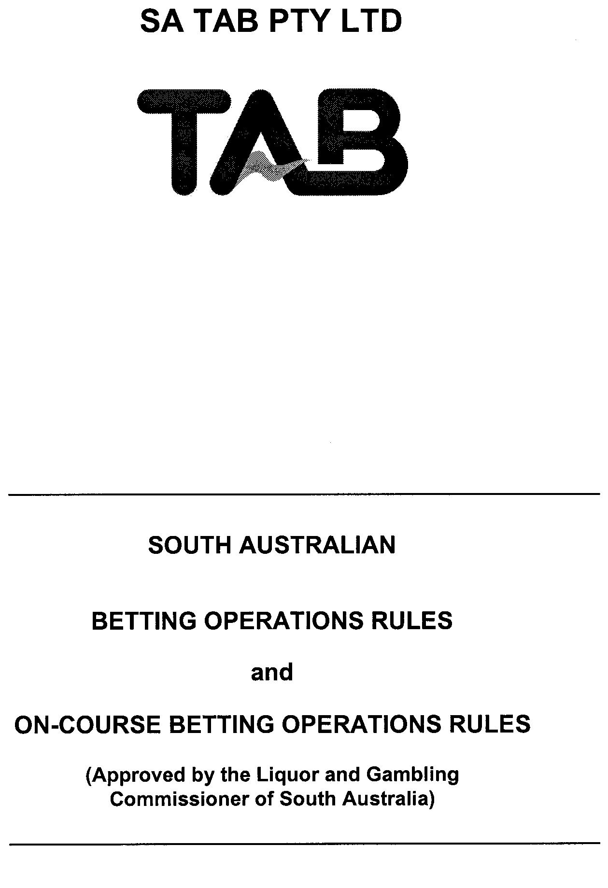
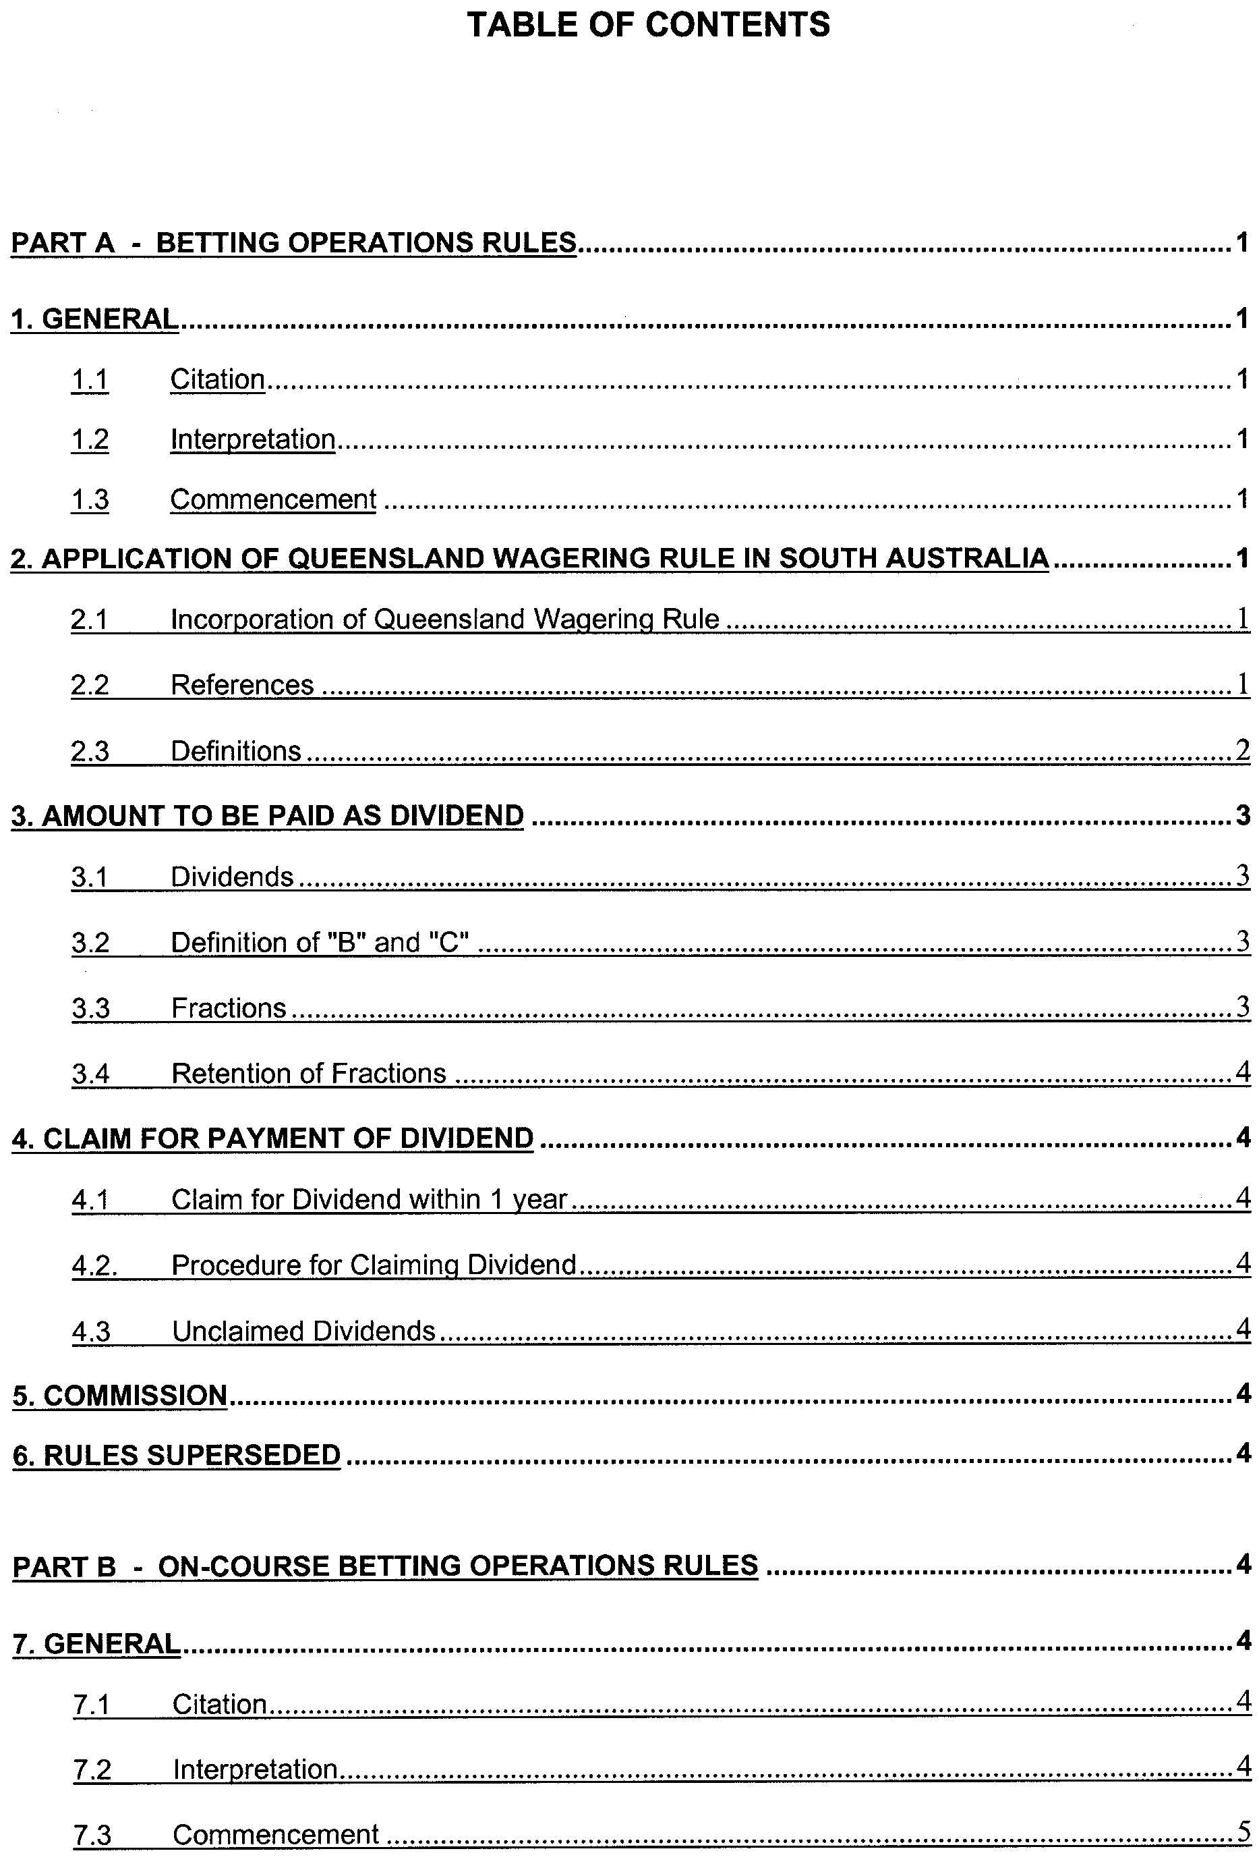
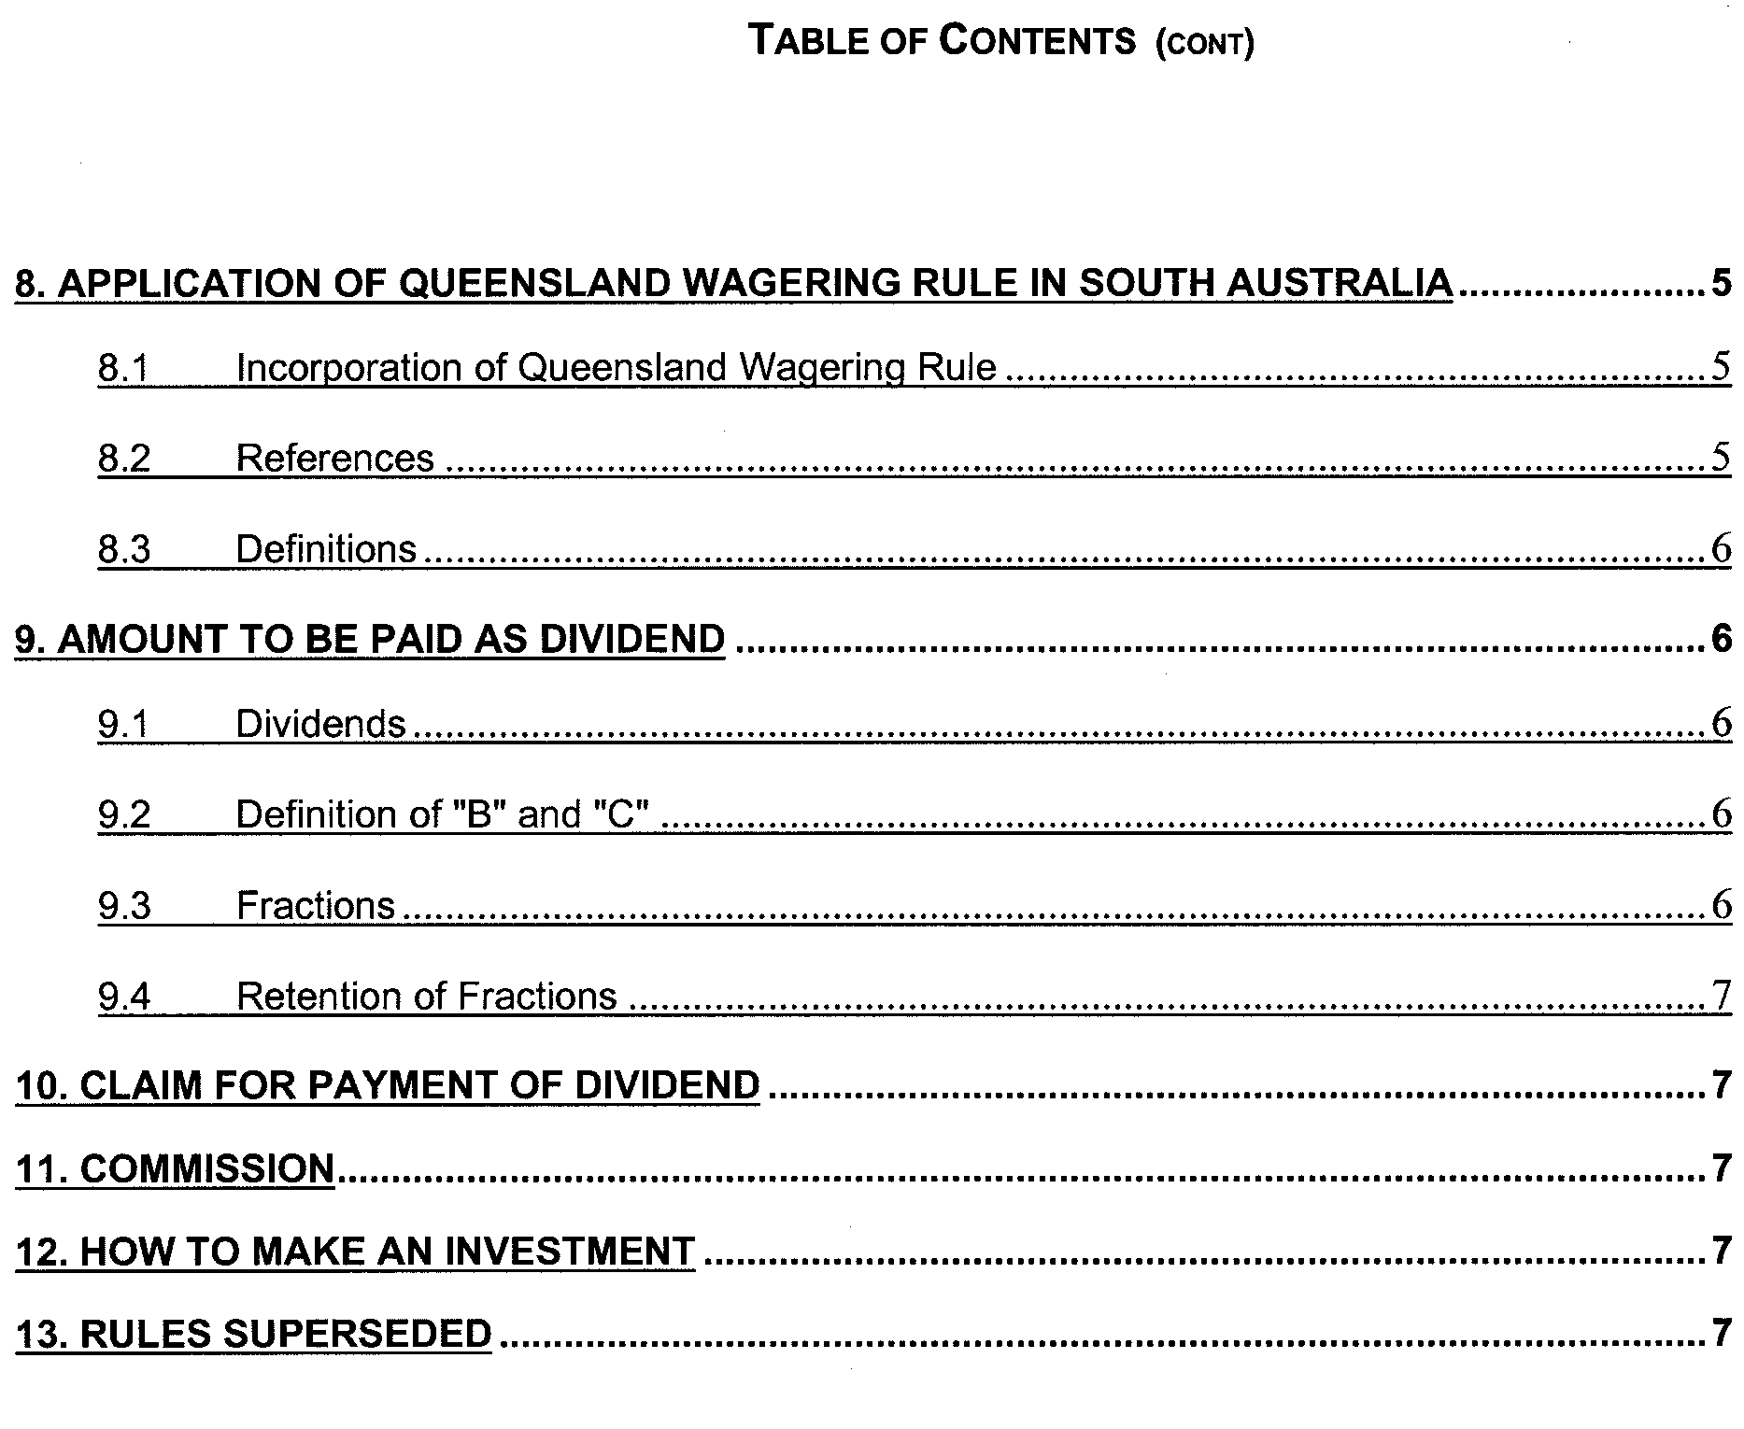
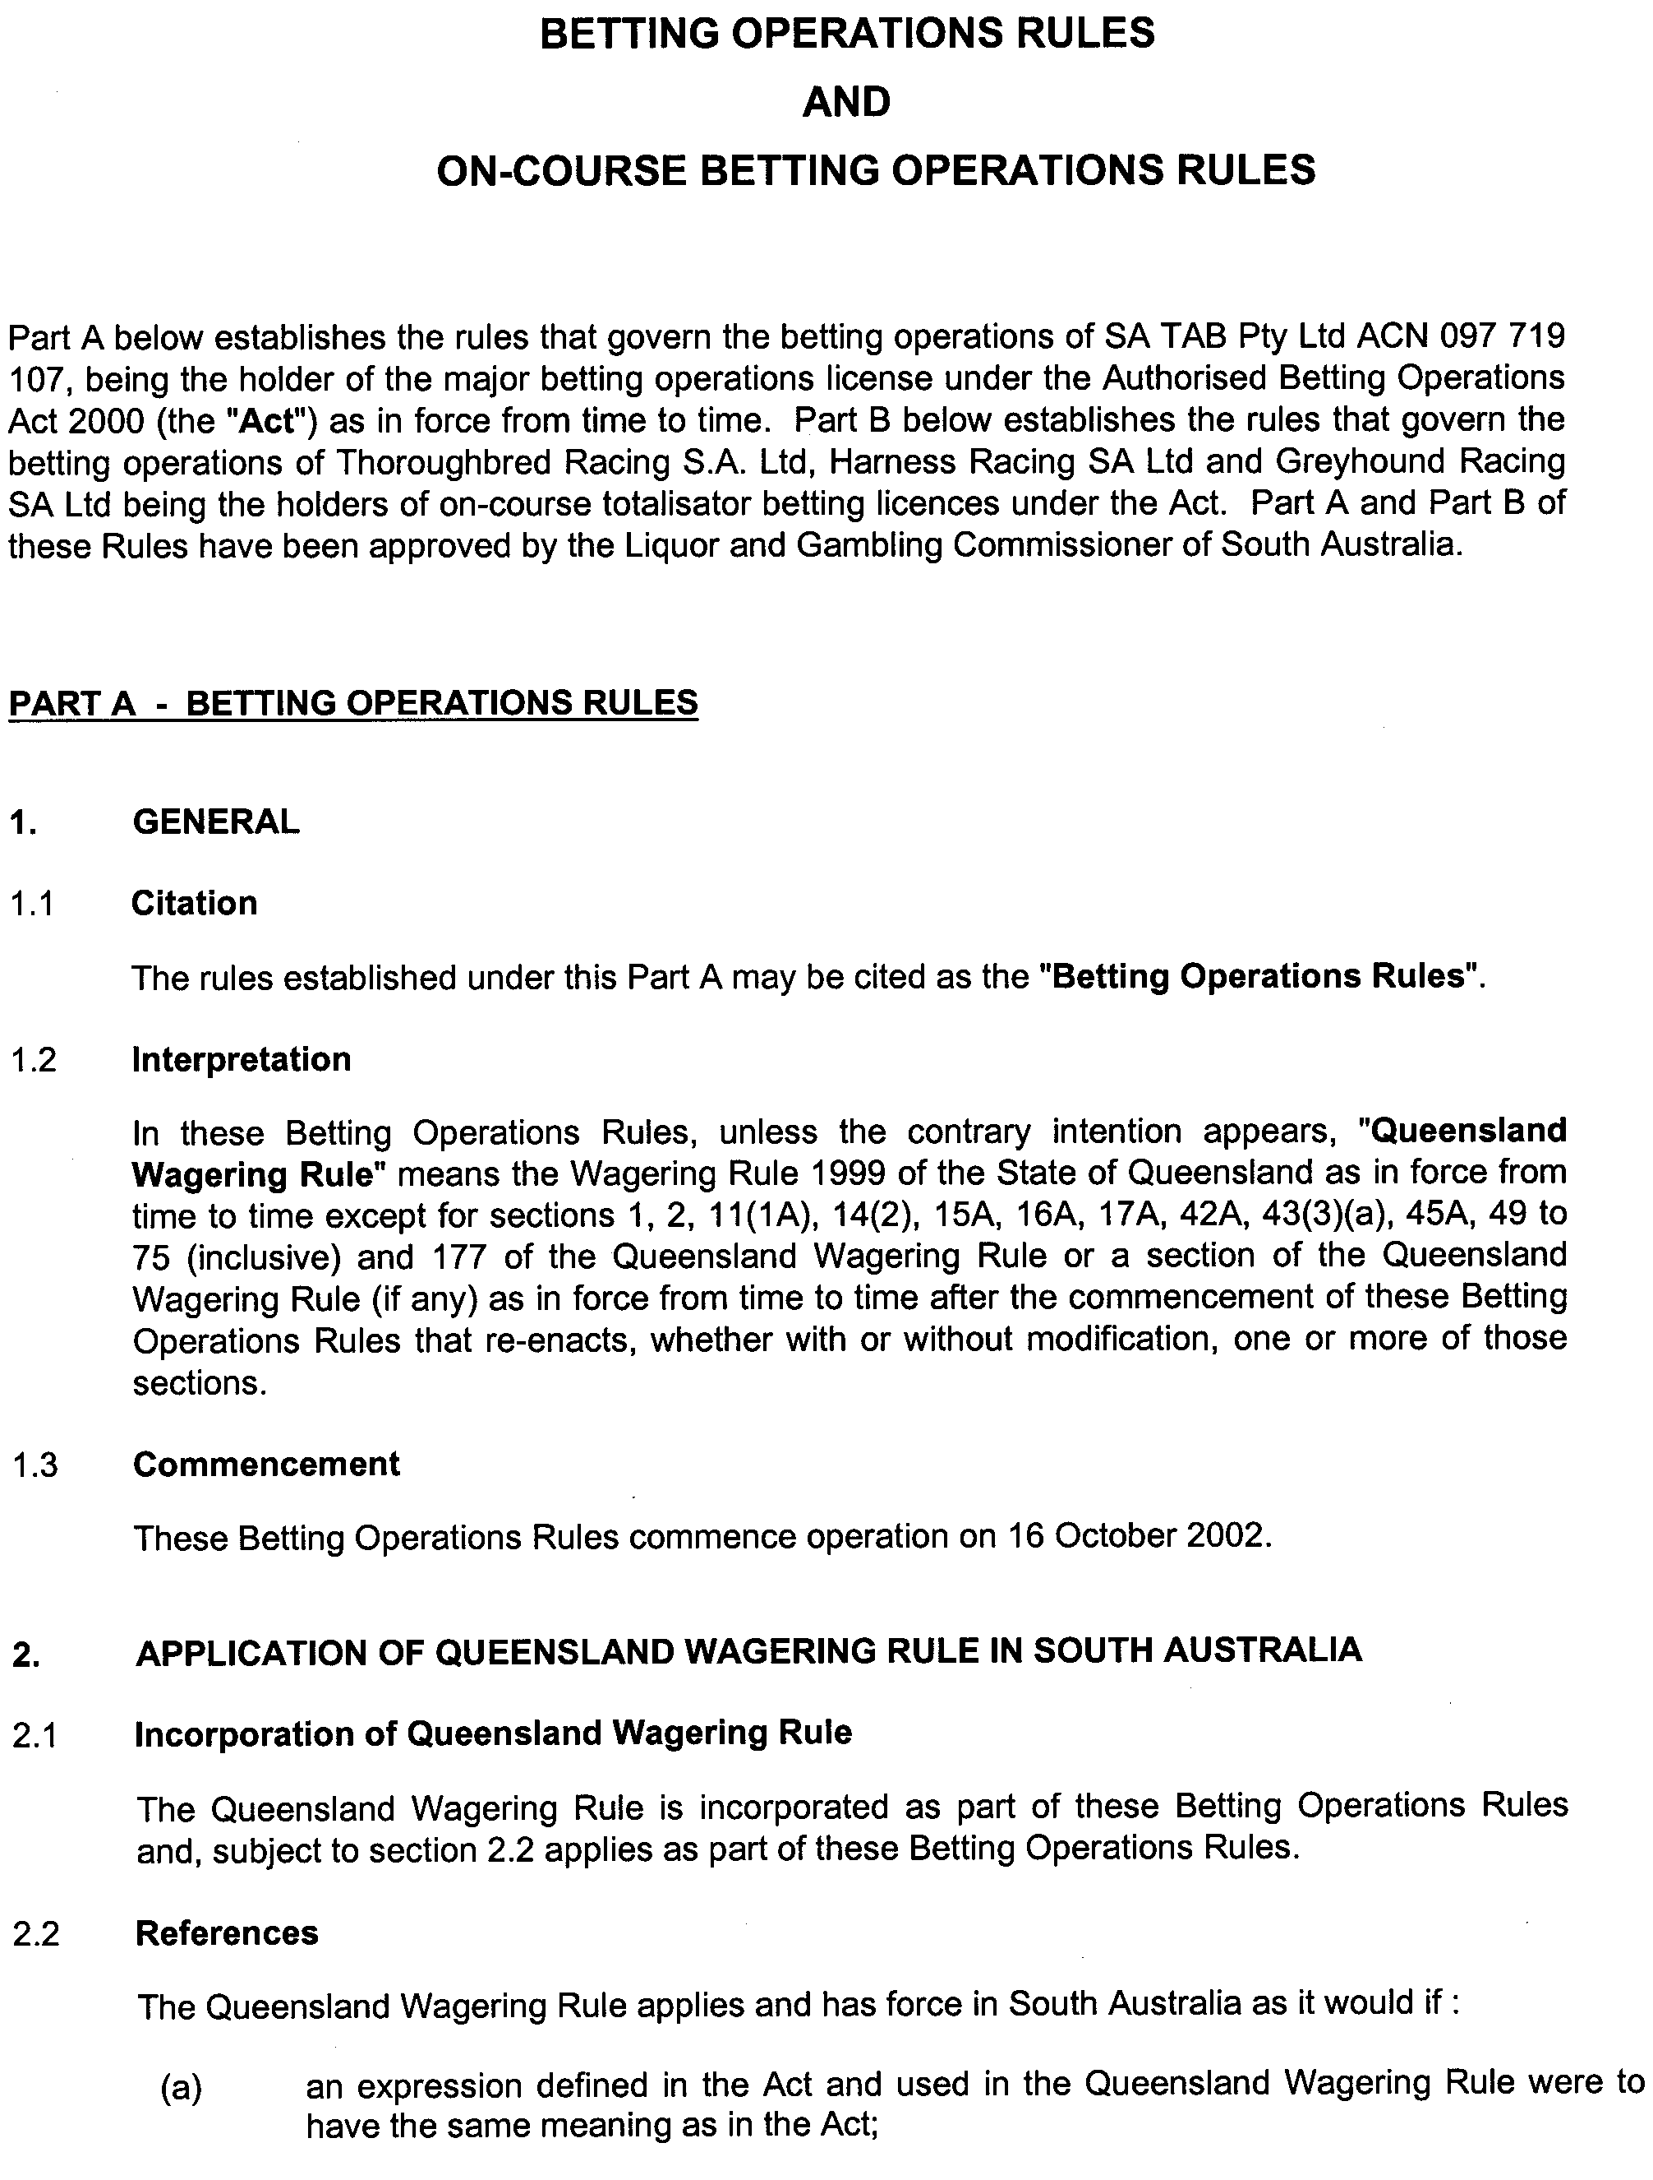
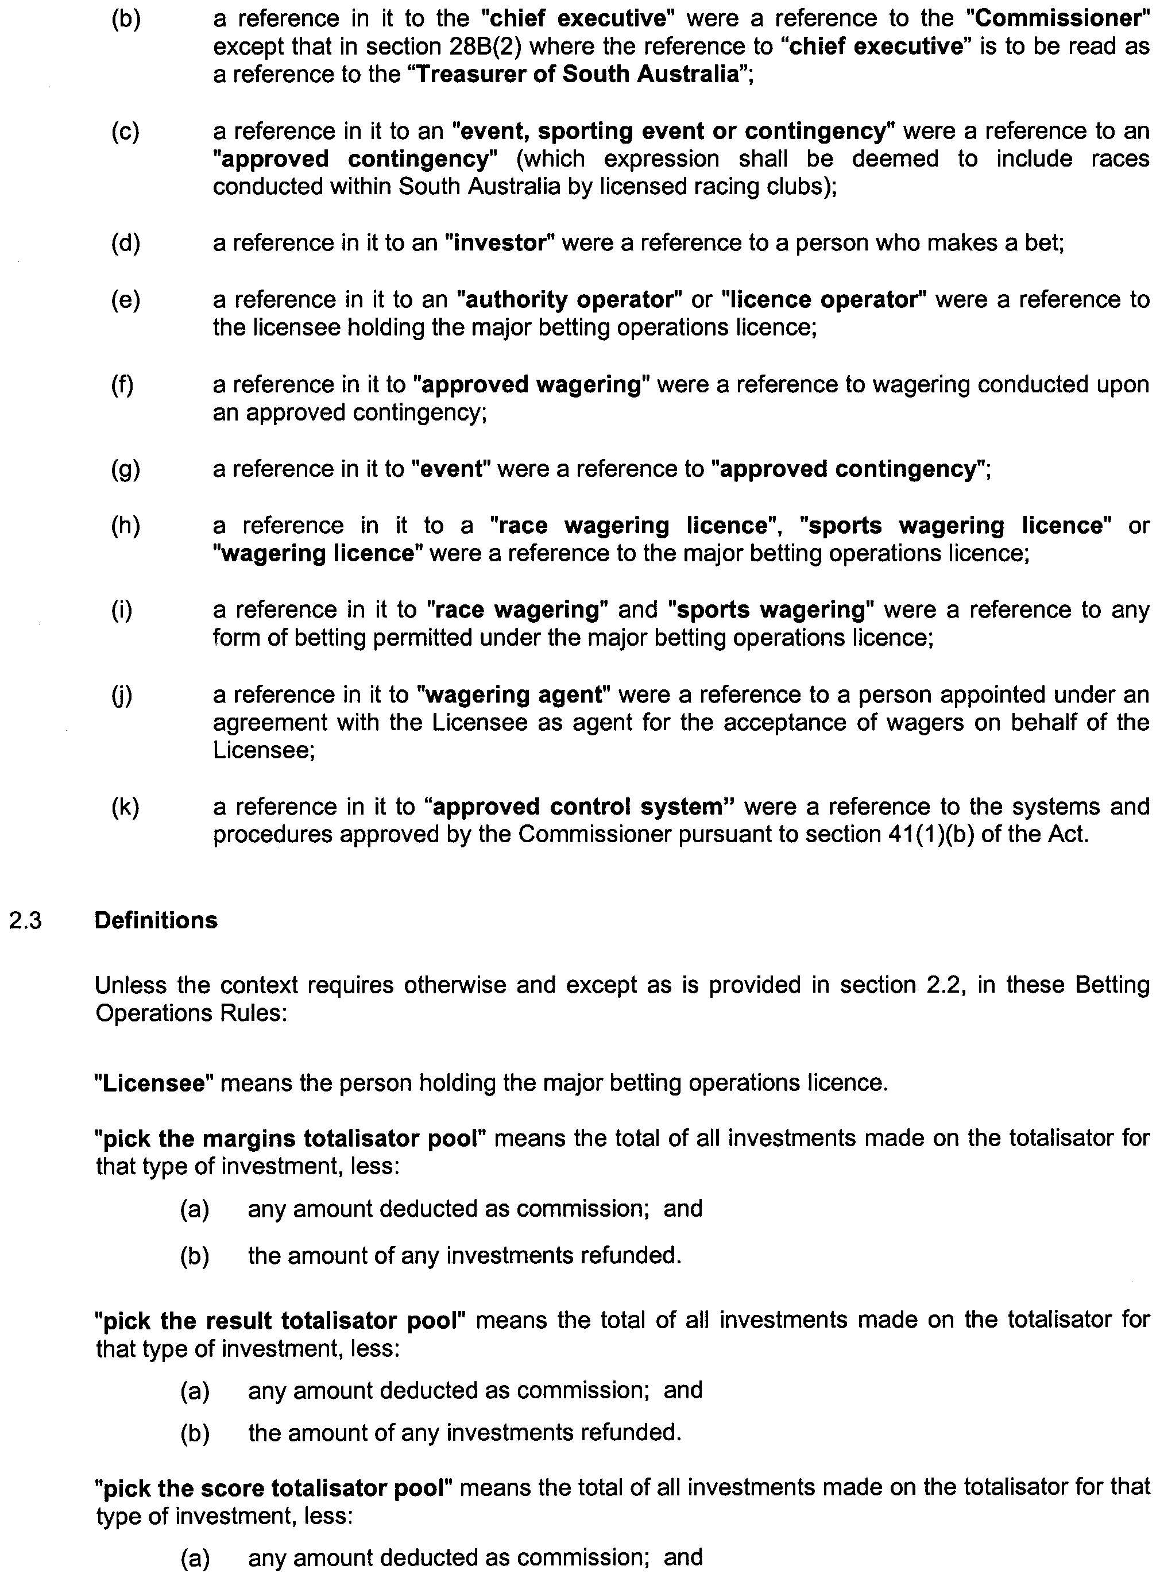
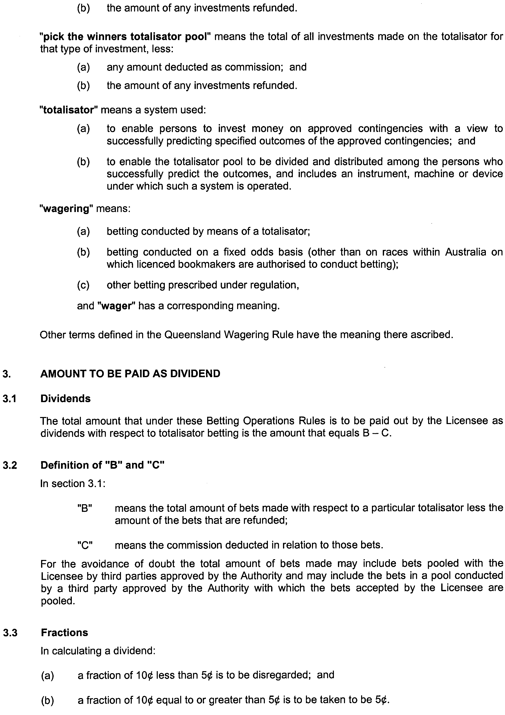
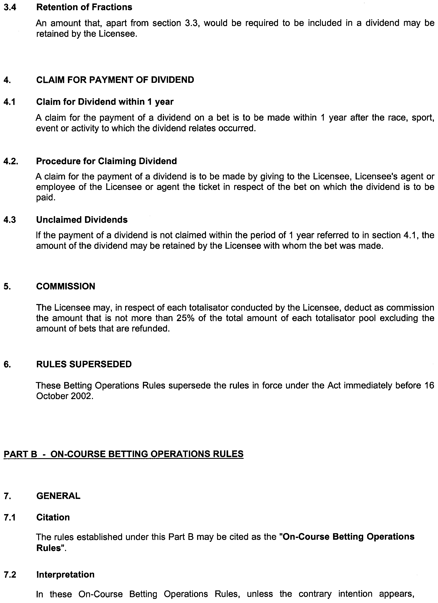
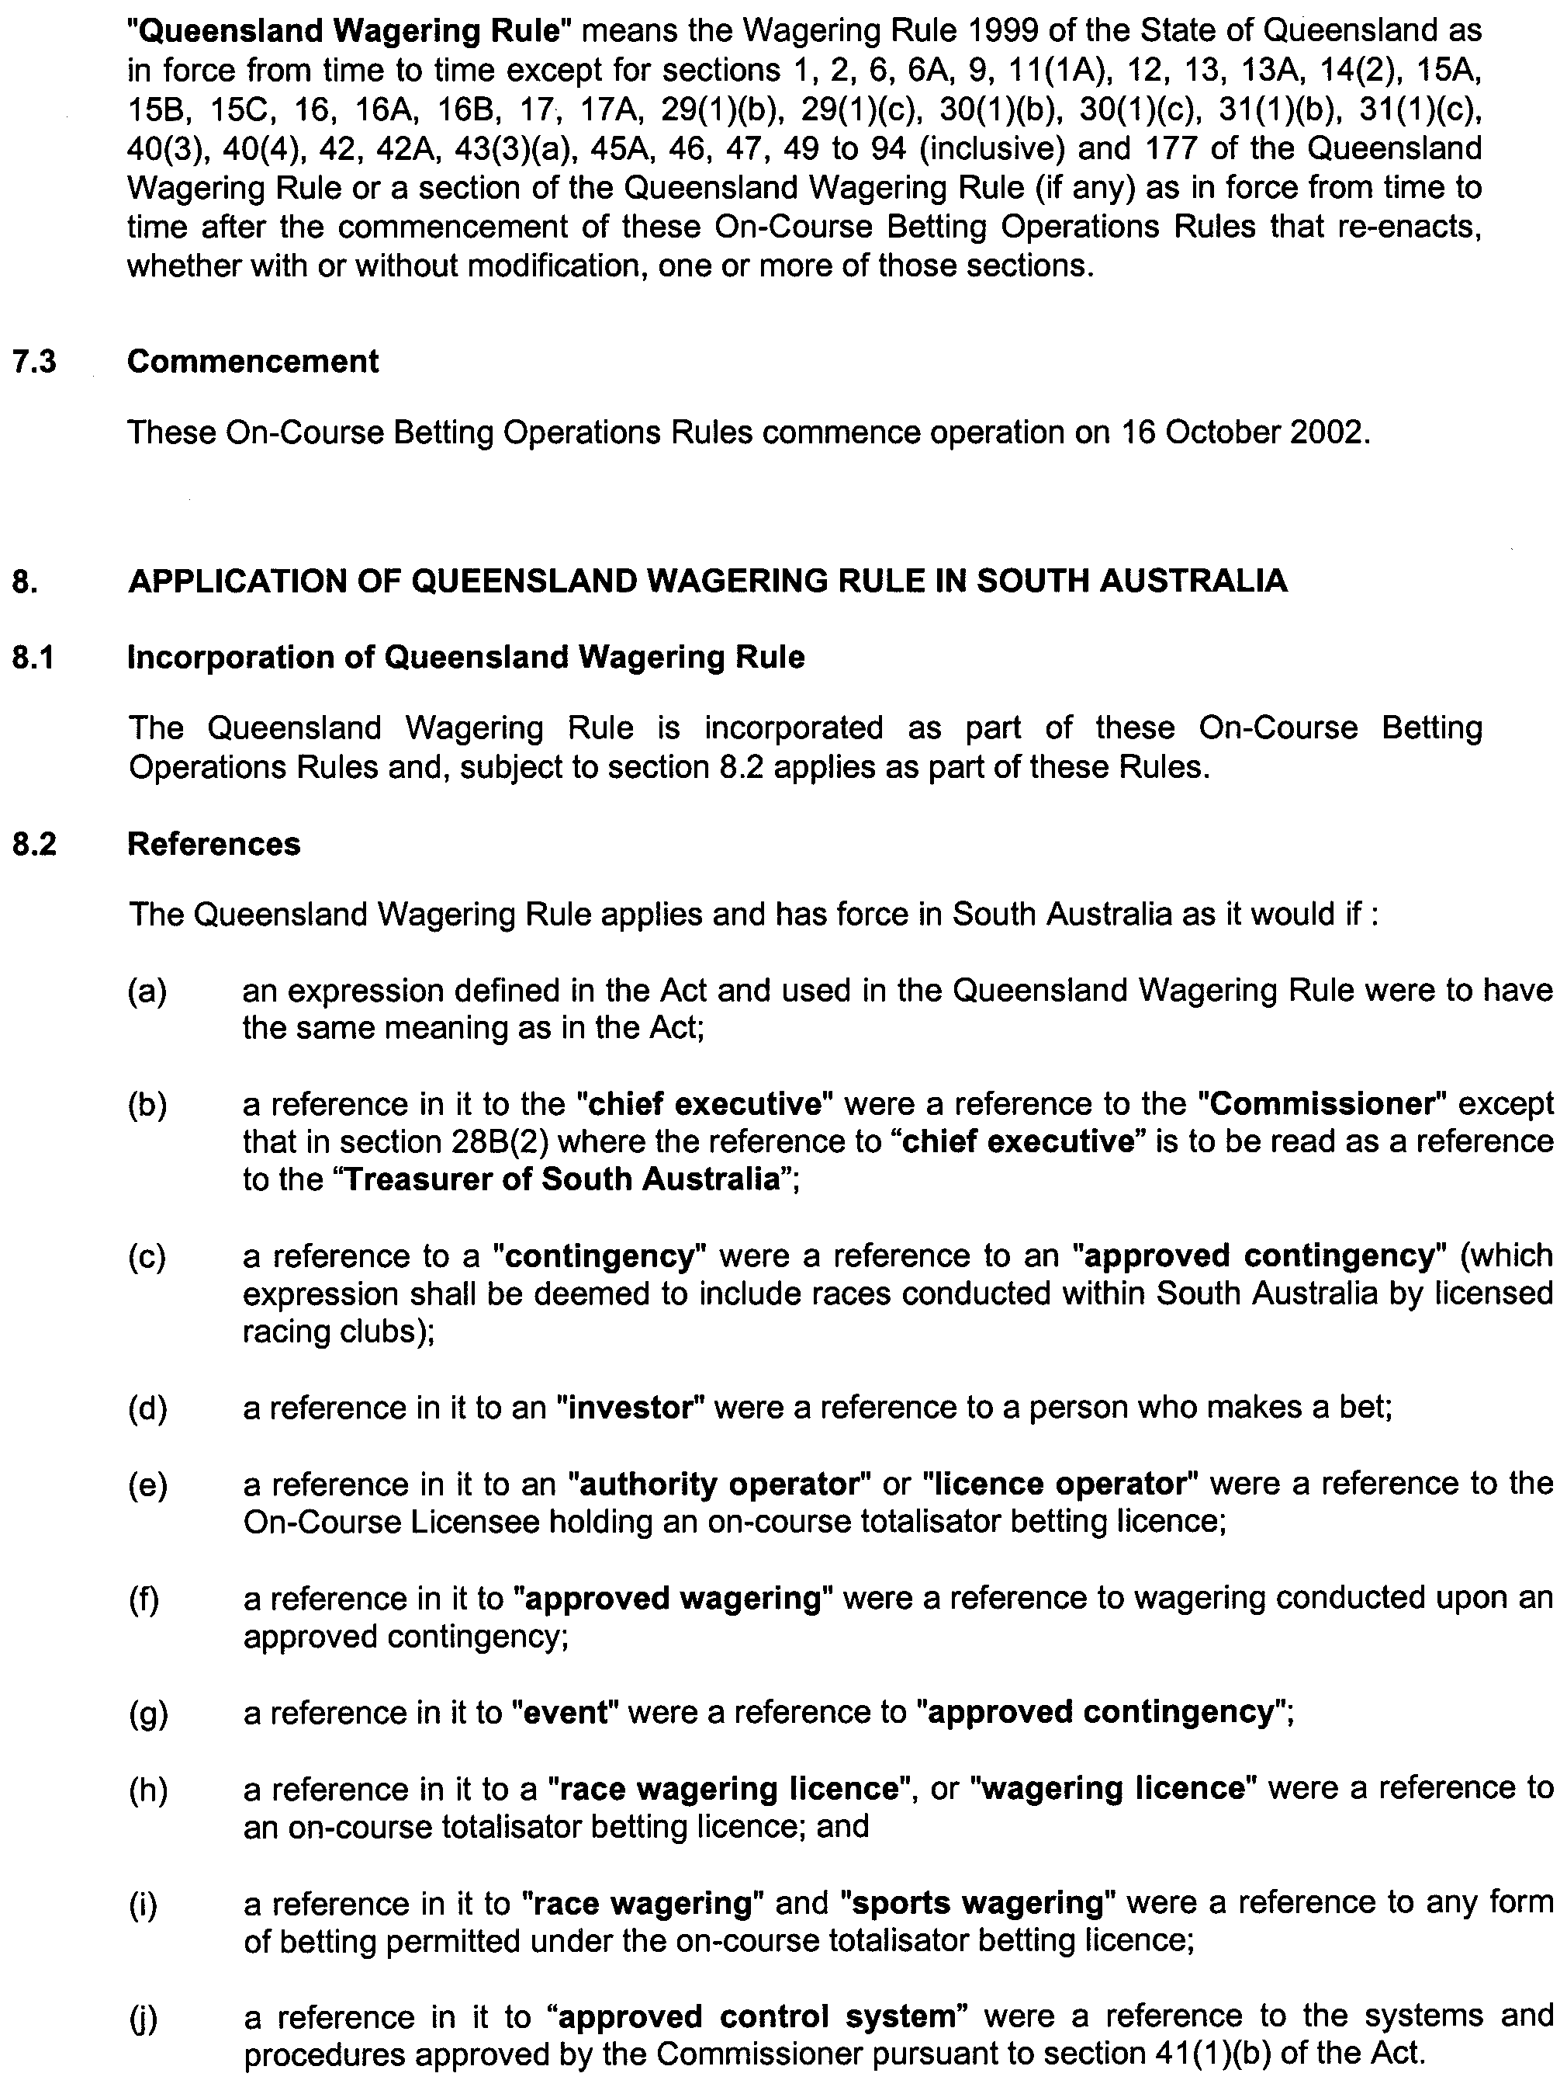
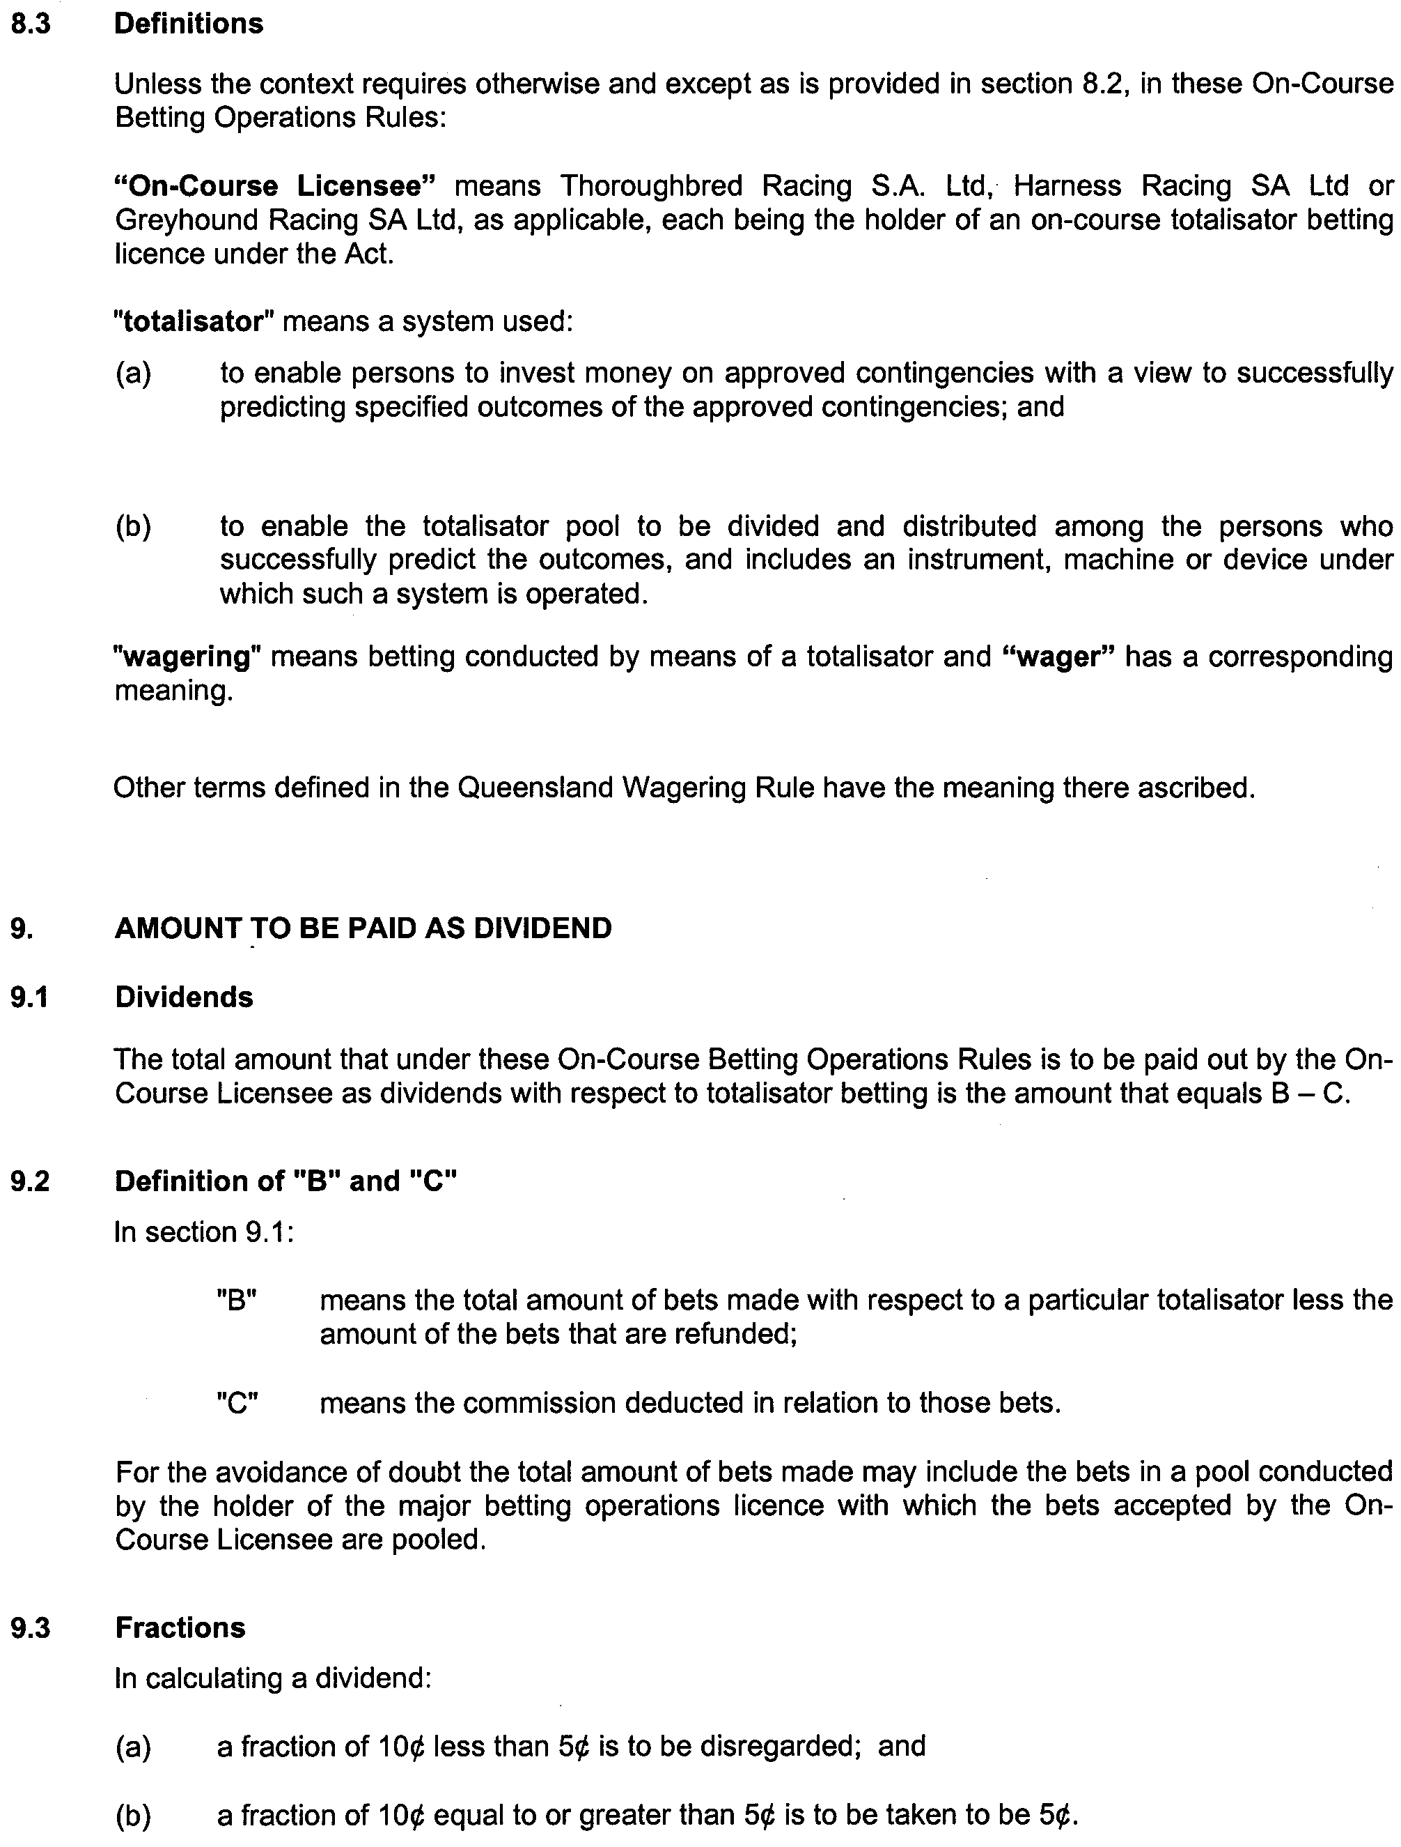
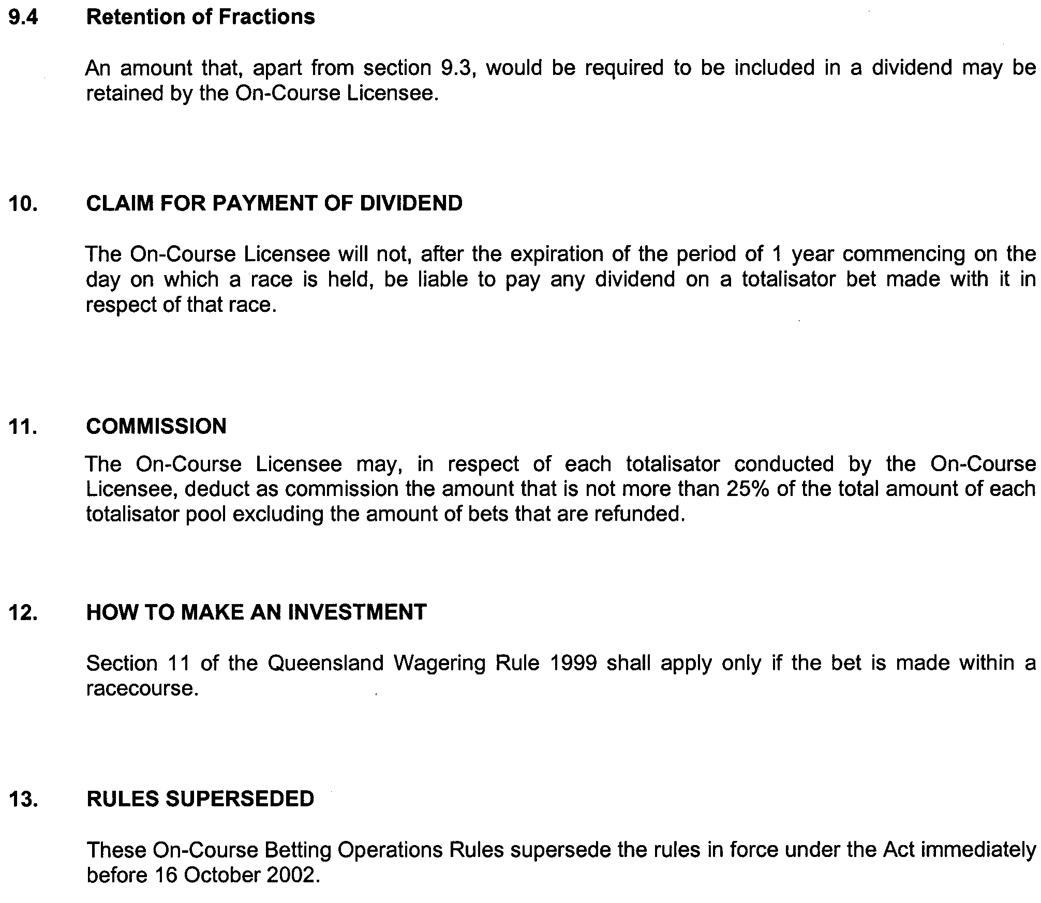

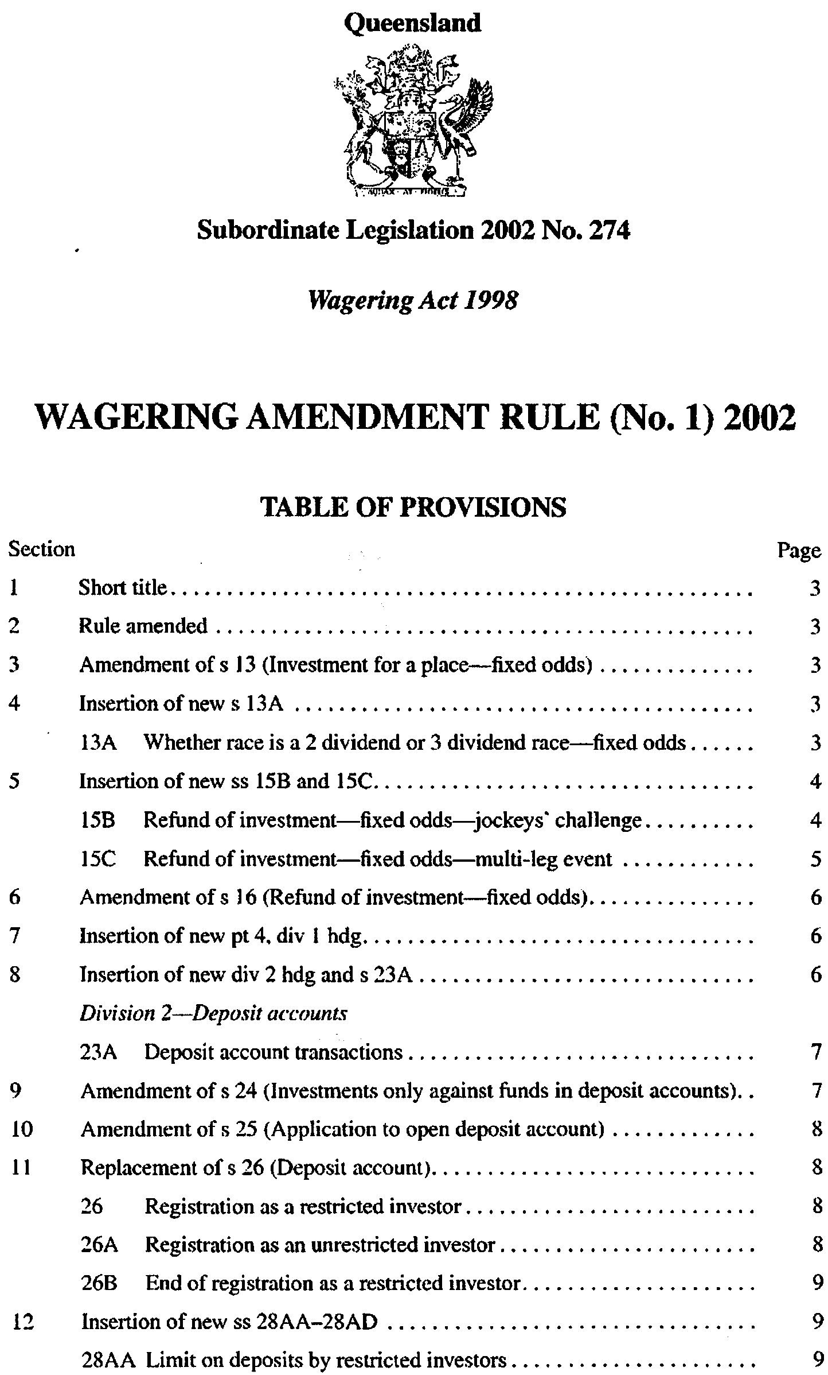
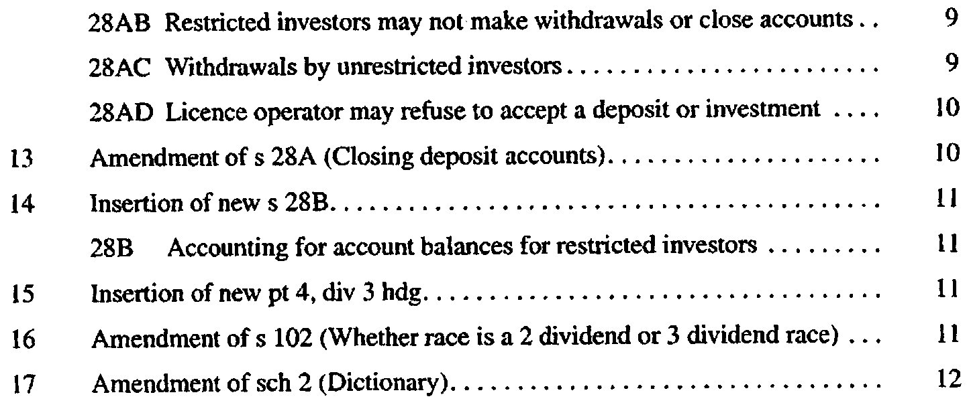
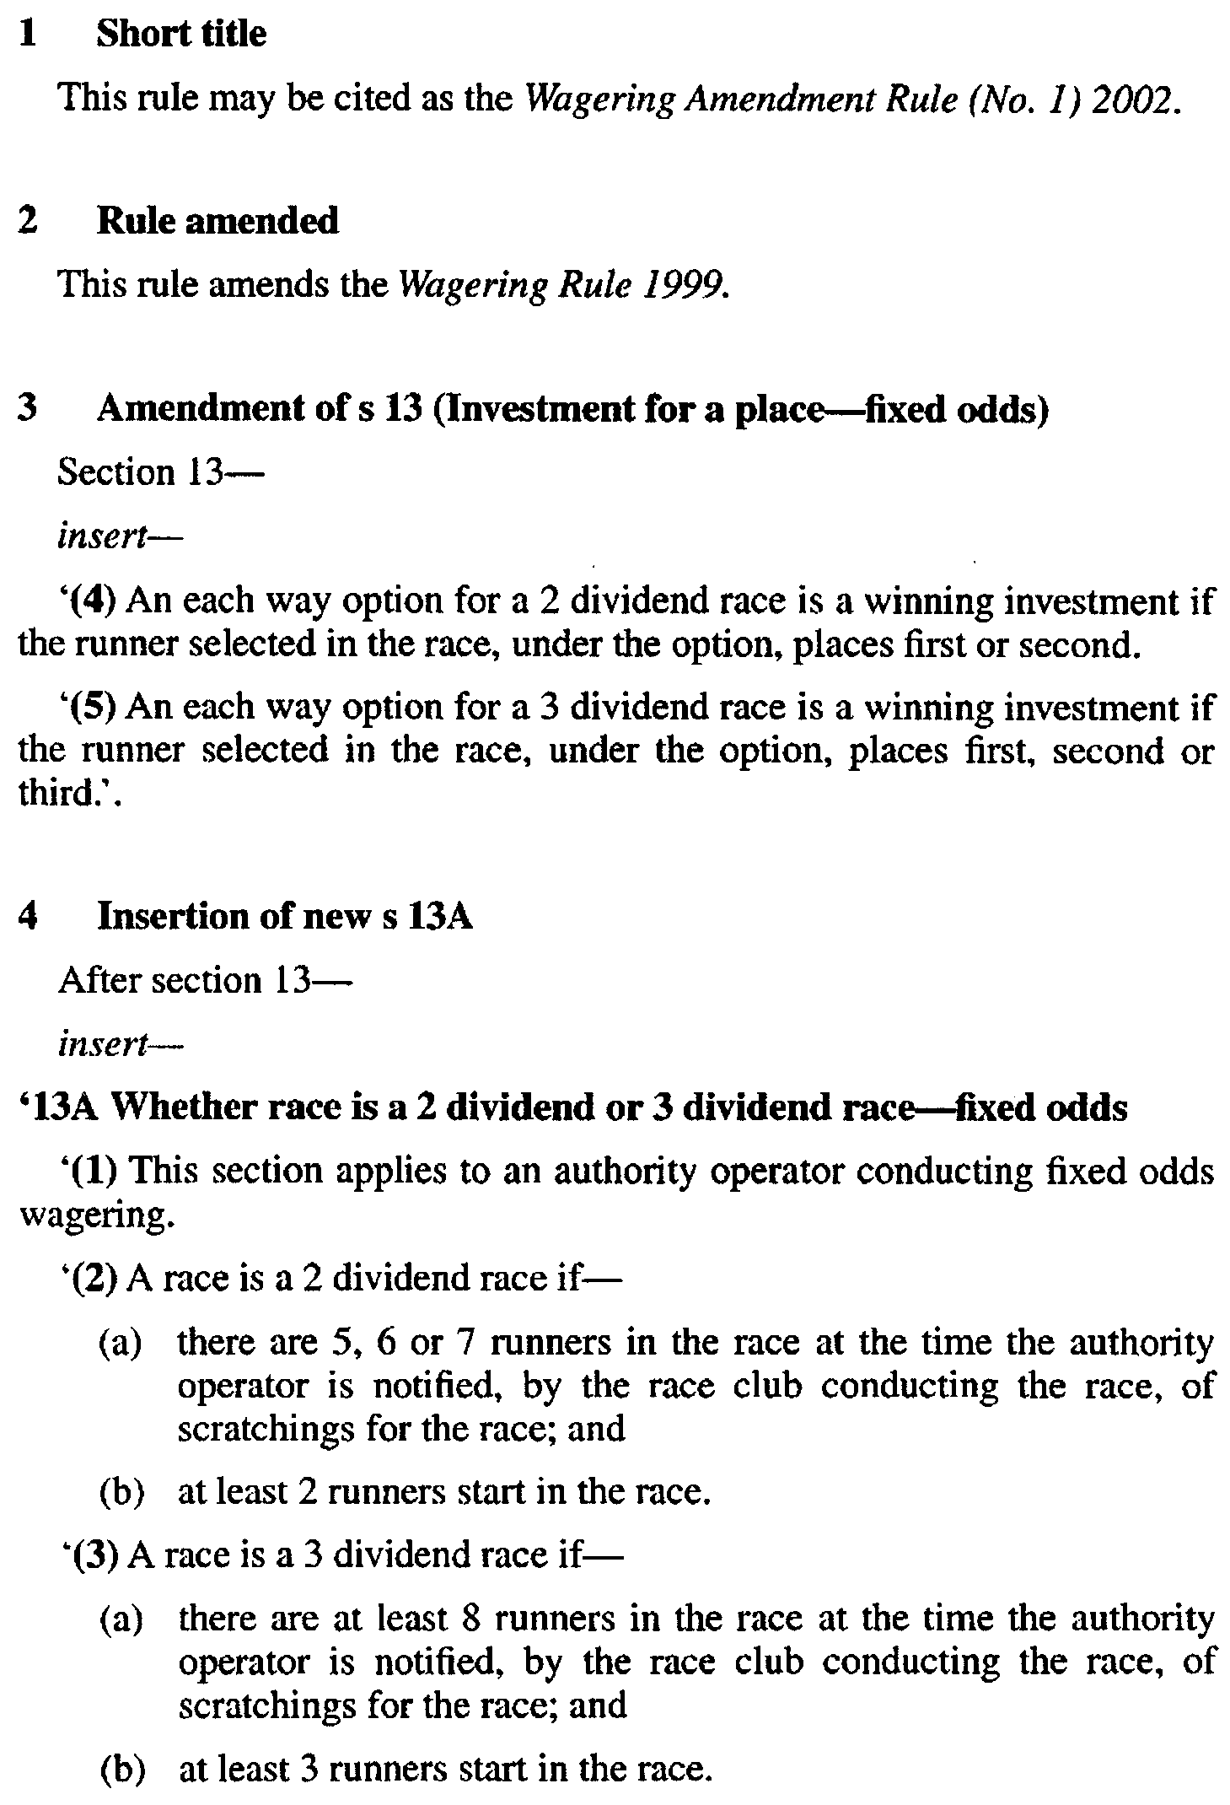
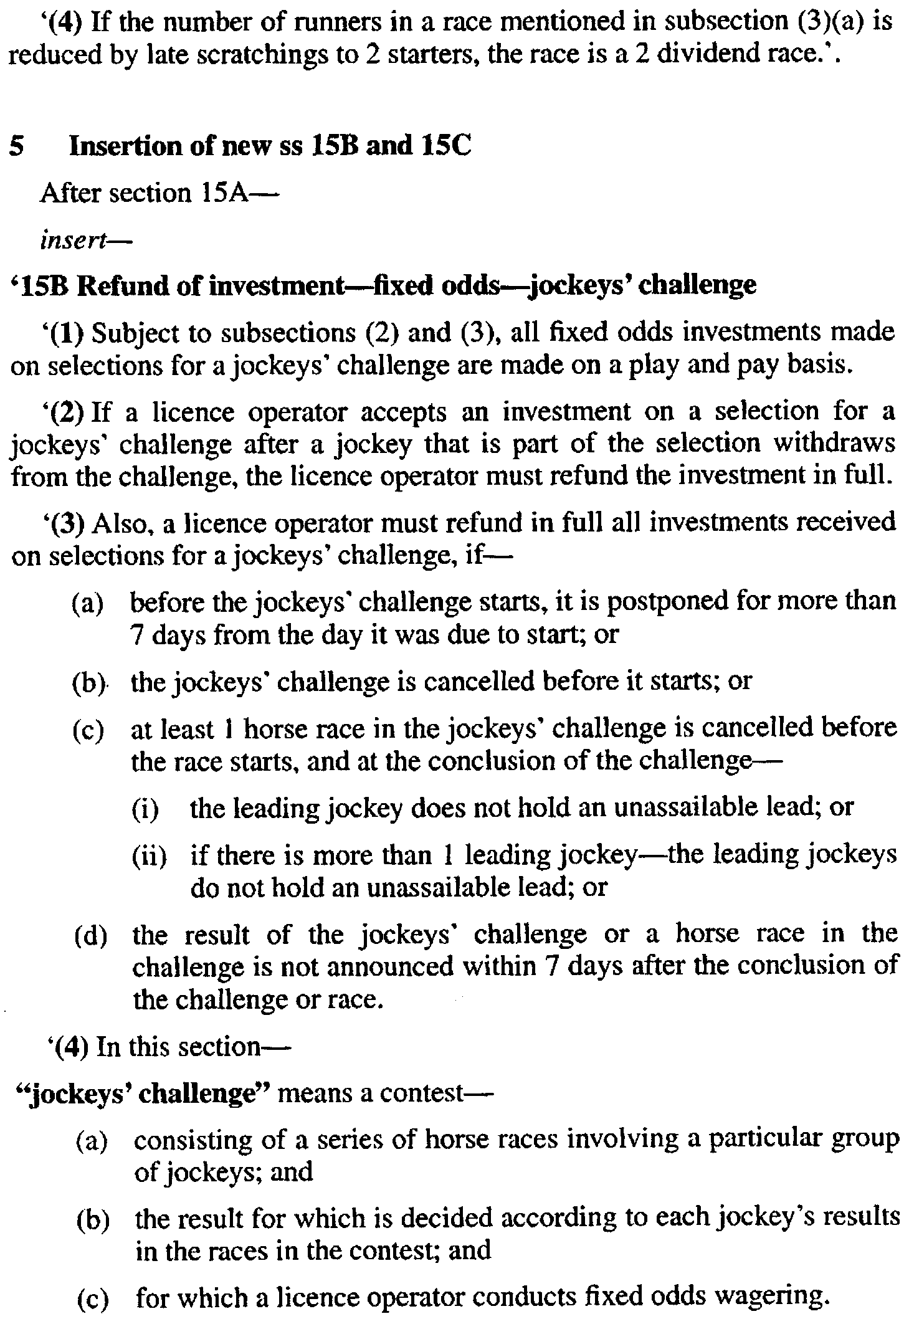
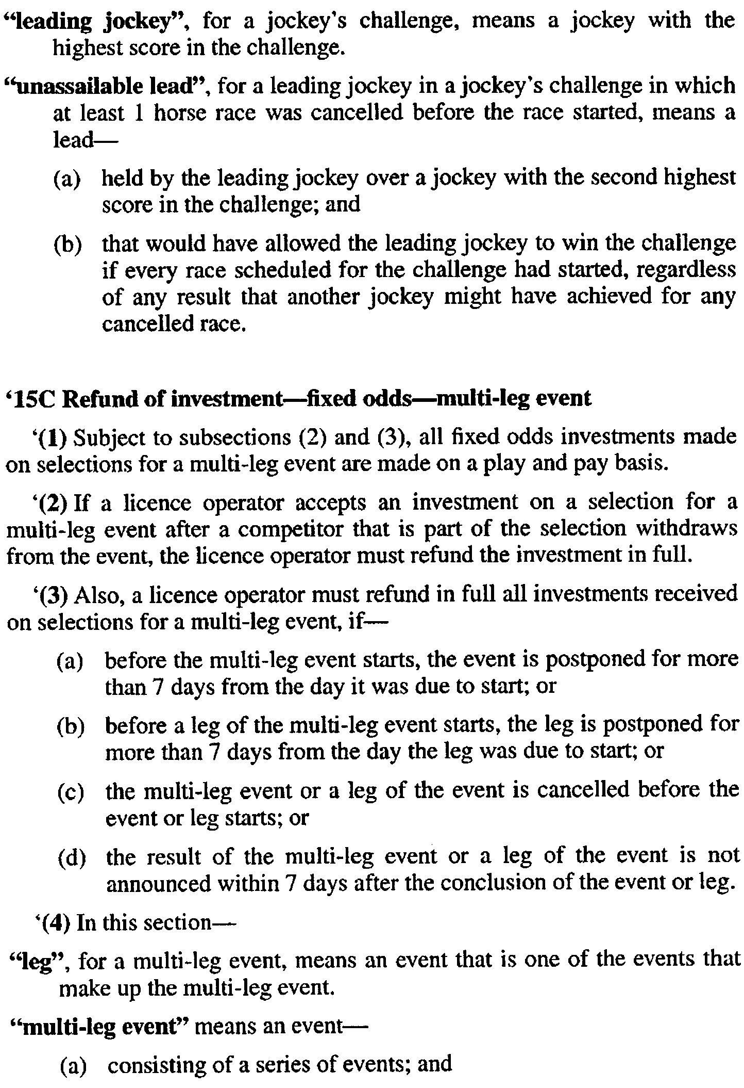
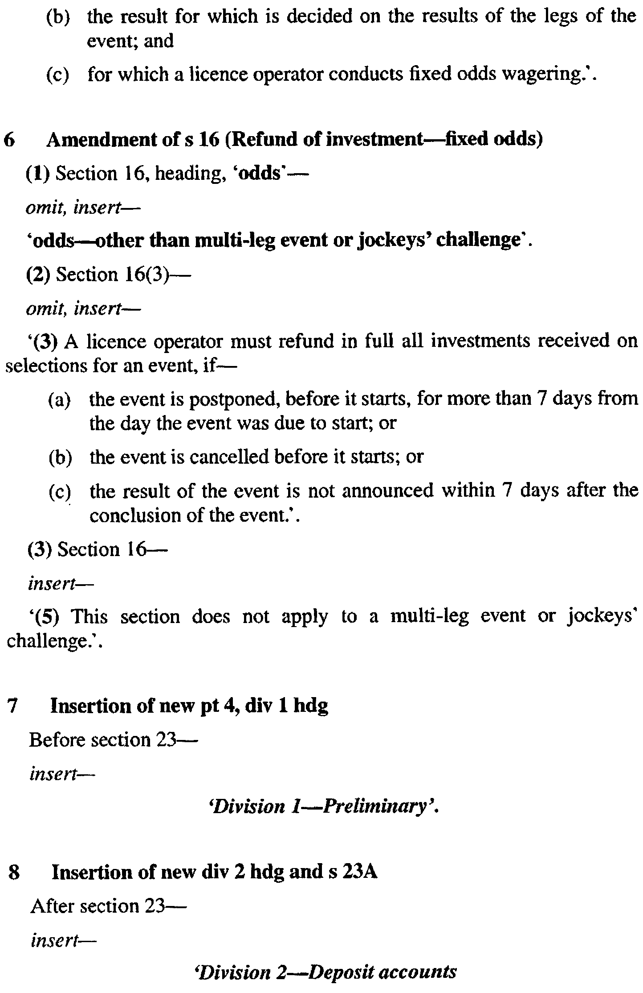
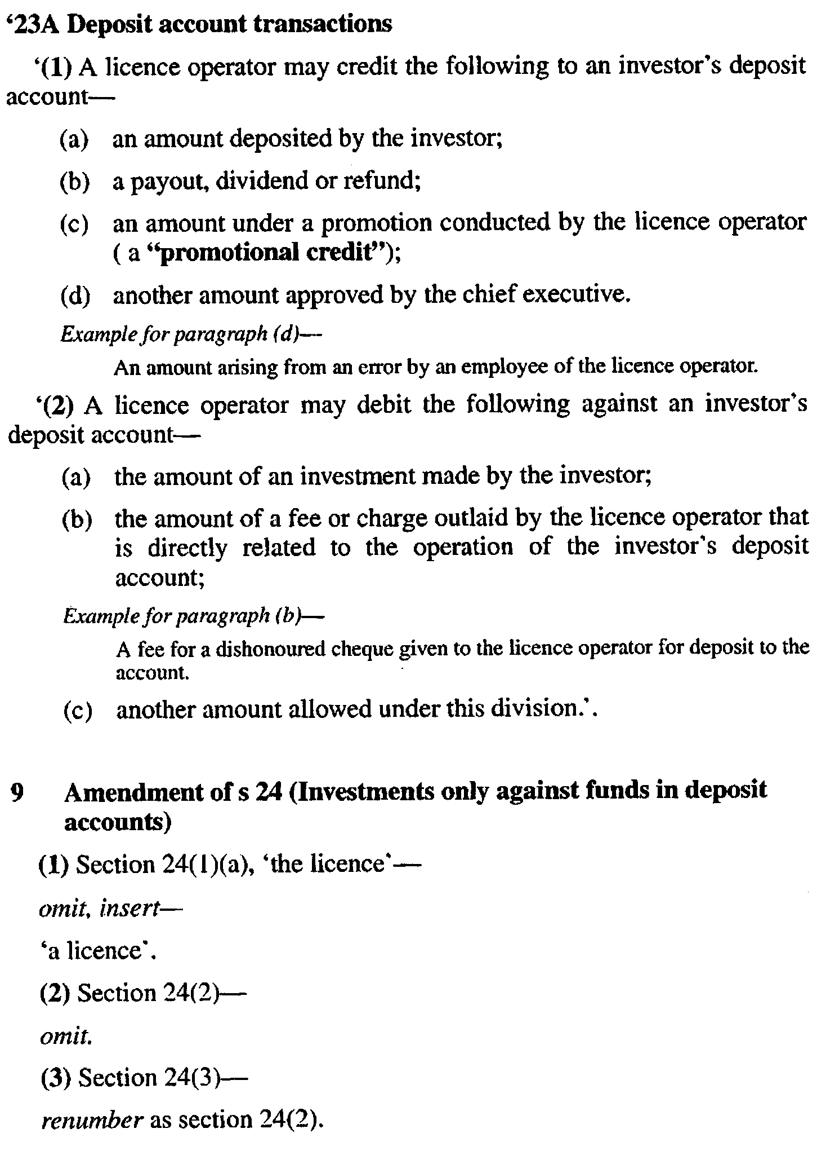
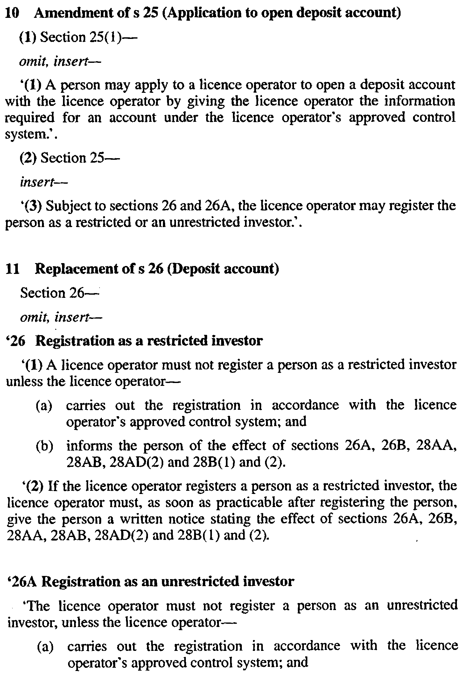
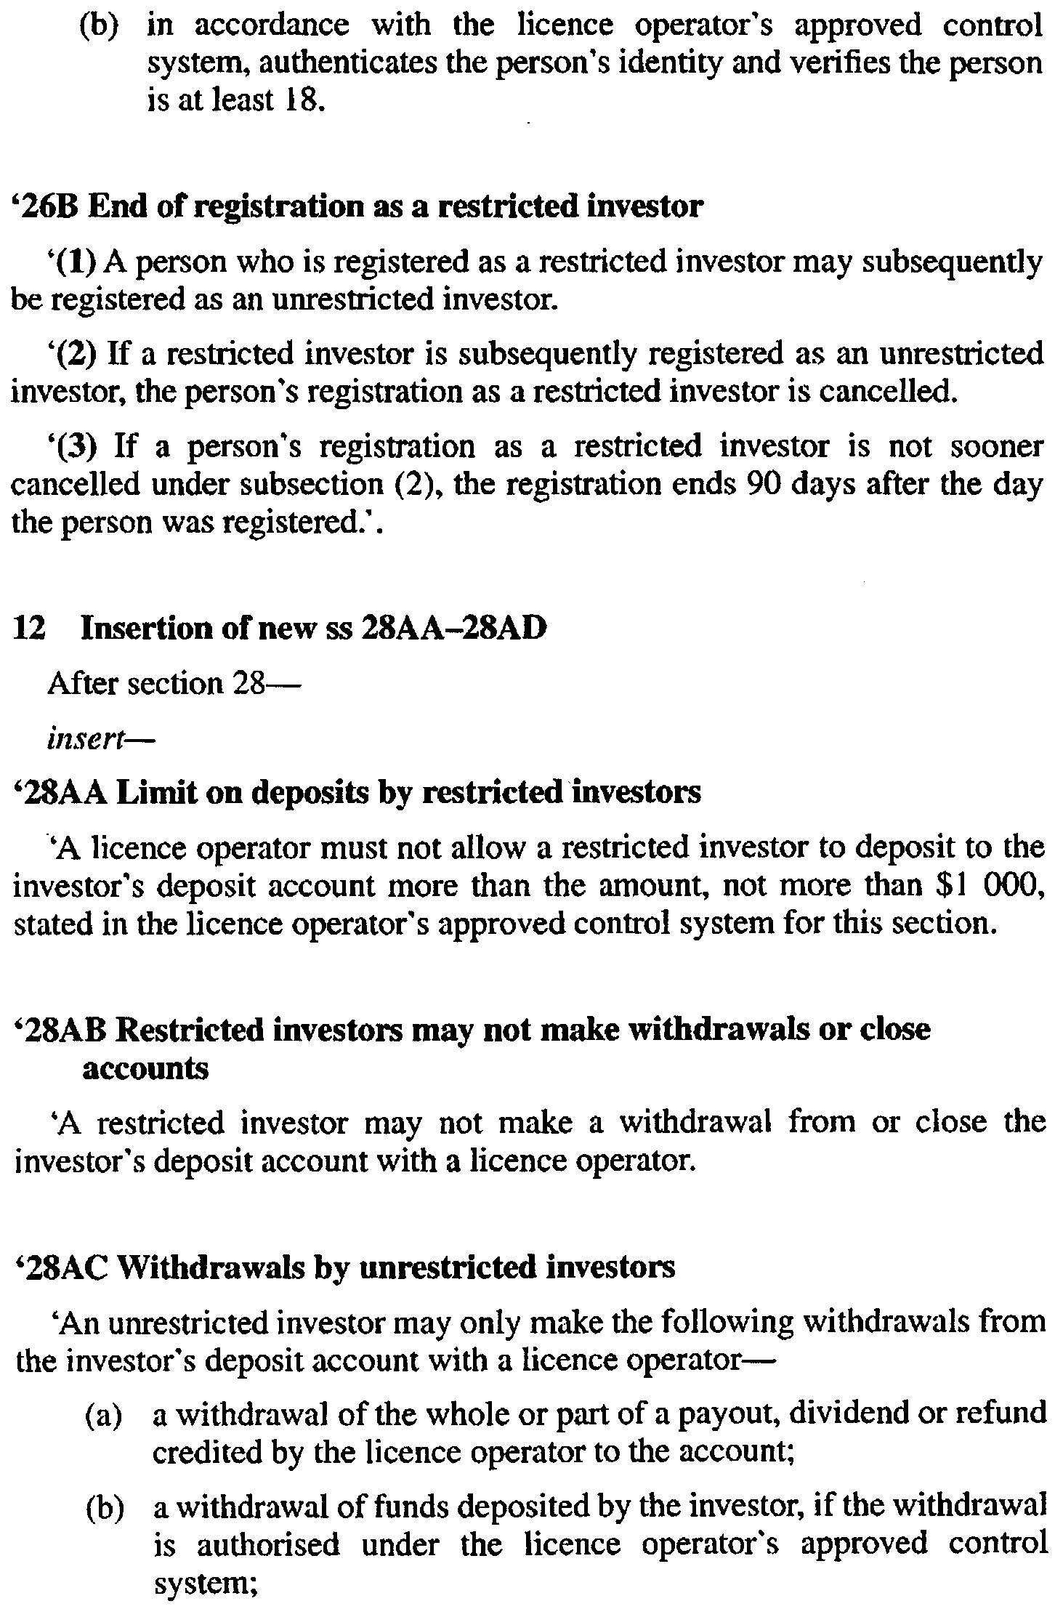
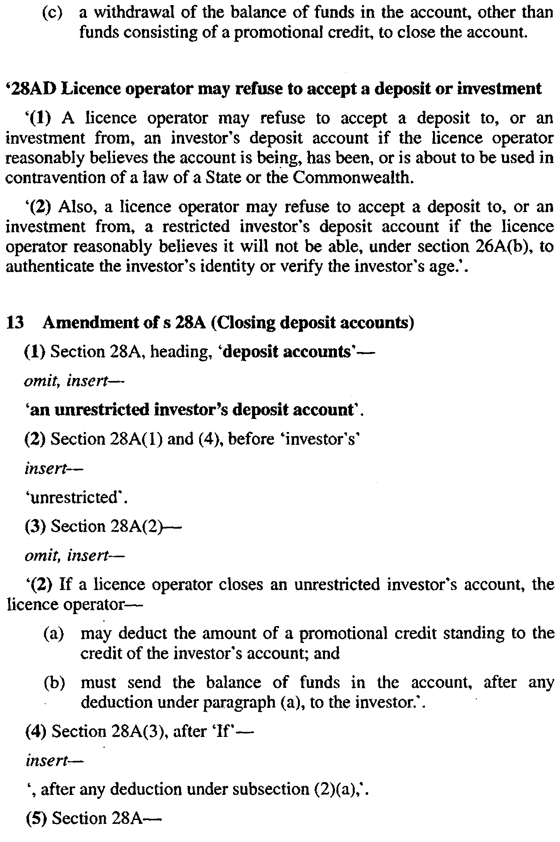
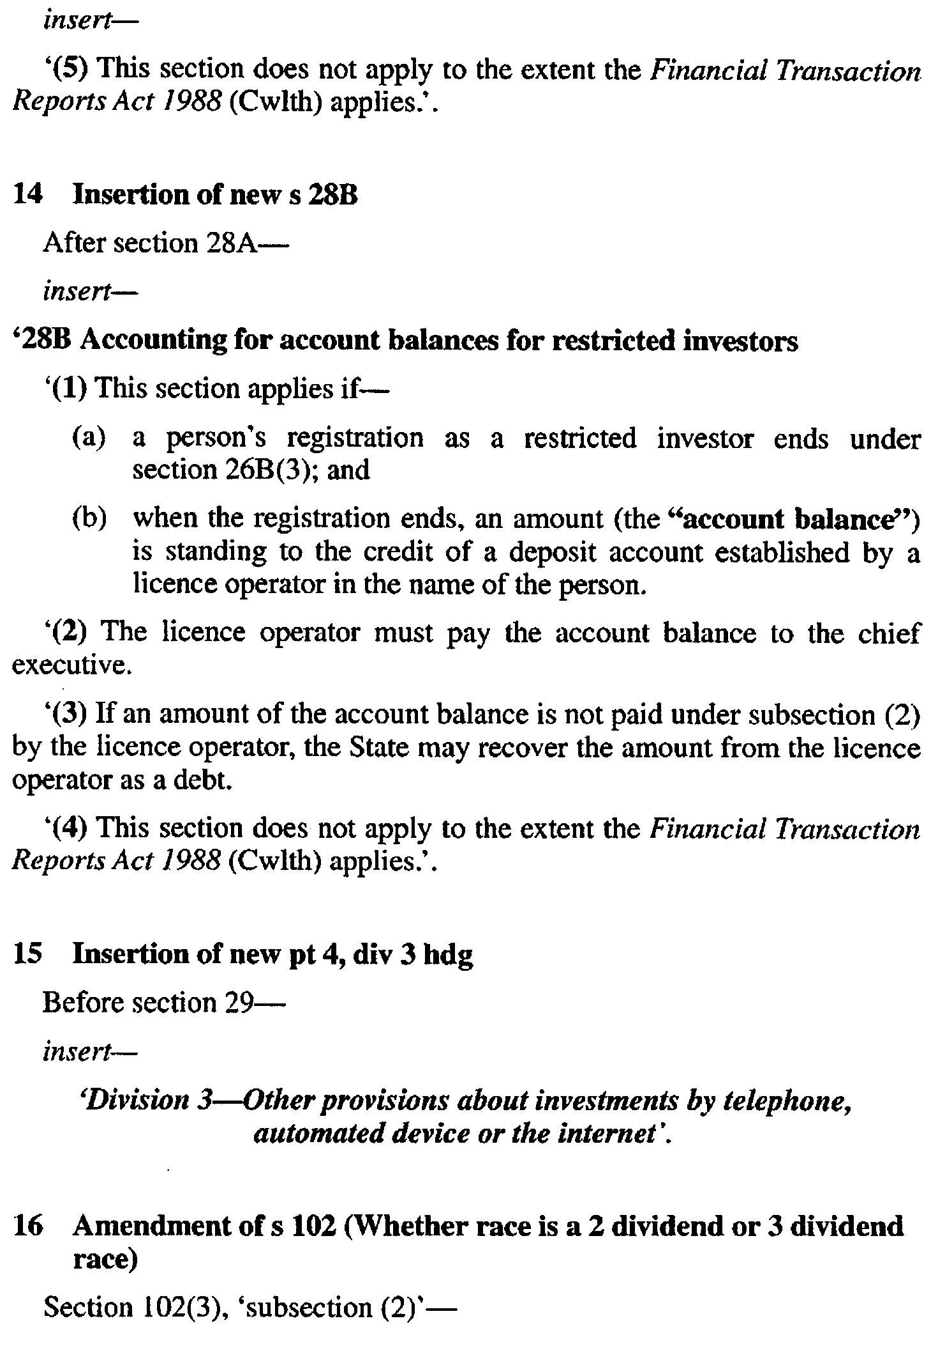
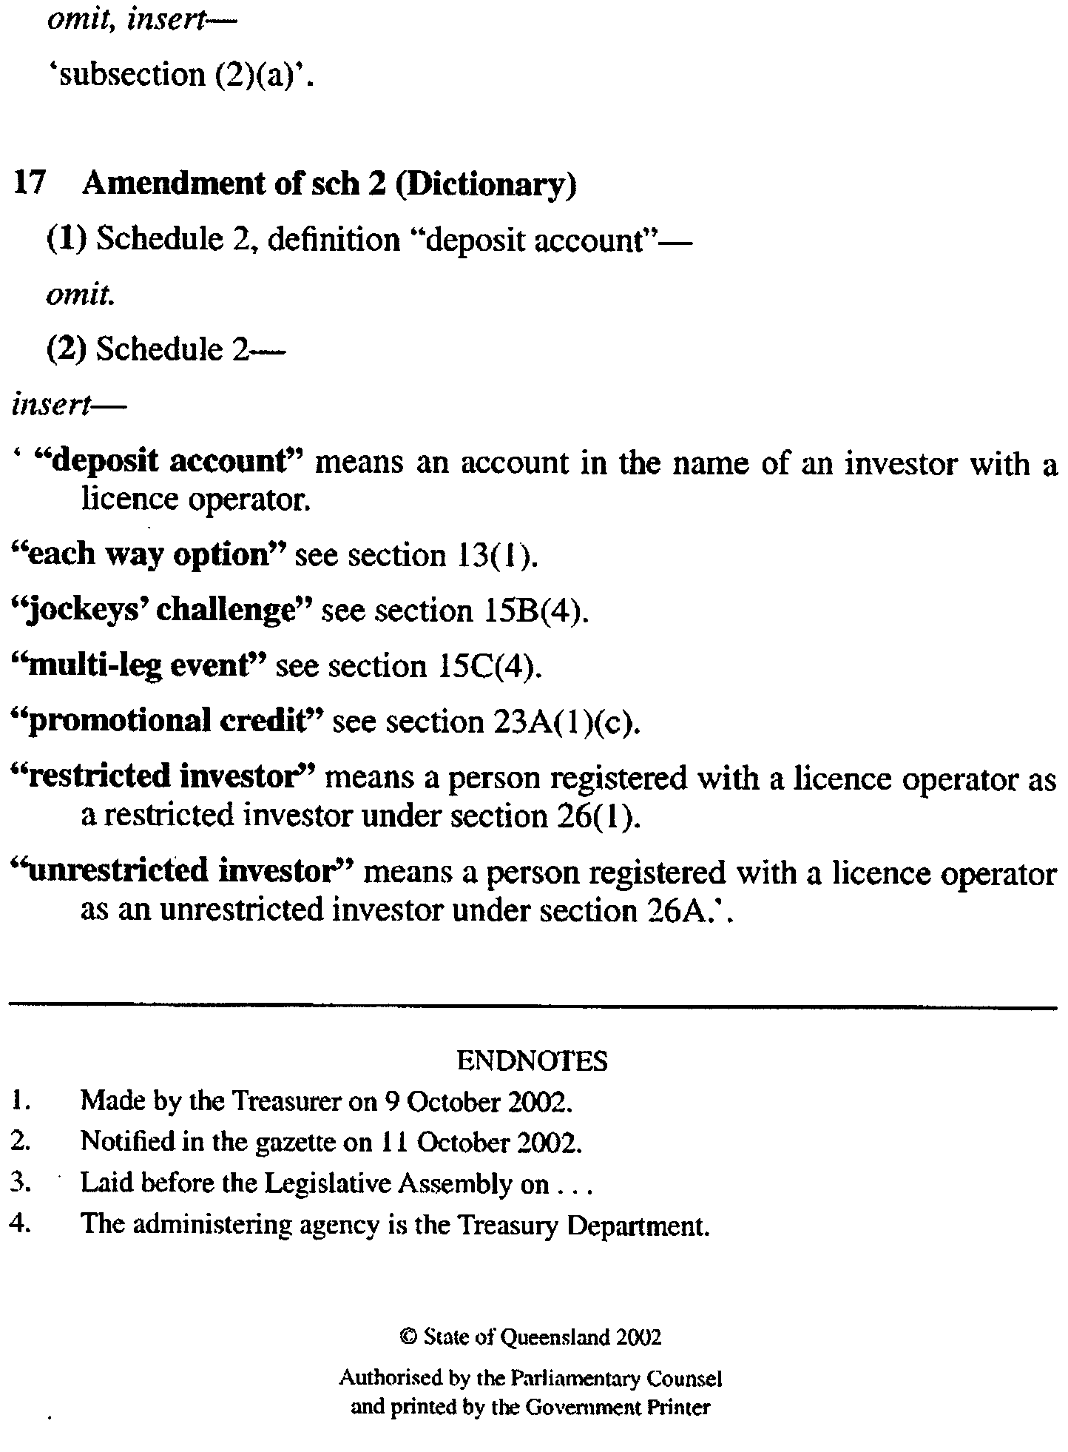

WATER RESOURCES ACT 1997
Notice of Restriction on Water Use in the Tintinara-Coonalpyn Area
PURSUANT to section 16 (1) of the Water Resources Act 1997, I, John David Hill, Minister for Environment and Conservation, being of the opinion that the rate at which water is being taken from wells obtaining access to the upper unconfined aquifer in the Murray Group Formation and the lower confined aquifer in the Renmark Beds (‘the wells’) in the area described in Schedule 1 (‘the area’) is such that:
(a) there is a risk that the available water will not be sufficient to meet future demand; and
(b) it is likely to affect the quality of water in the underground aquifers,
hereby prohibit the taking of water from ‘the wells’ subject to the exceptions specified in Schedule 2.
Schedule 1
The Hundreds of Livingston, Carcuma, Coneybeer, Lewis, Richards, Coombe, Archibald, Makin, and McCallum.
Schedule 2
1. A person authorised in writing by either the Minister for Environment and Heritage, or the Minister for Water Resources, or delegate pursuant to any of the following notices:
(a) notice of Restriction of Water Use in the Tintinara-Coonalpyn Area published in the Government Gazette on 30 December 1998 at page 2089 (‘the 1998 Notice’);
(b) notice of Restriction of Water Use in the Tintinara-Coonalpyn Area published in the Government Gazette on 23 December 1999 at page 3856 (‘the 1999 Notice’); or
(c) notice of Variation to the Notice of Restriction in the Tintinara-Coonalpyn Area published in the Government Gazette on 1 June 2000 at page 2904 (‘the 2000 Notice of Variation’); or
(d) notice of Restriction of Water Use in the Tintinara-Coonalpyn Area published in the Government Gazette on 21 December 2001 at page 5645 (‘the 2001 Notice’),
may take water at the same rate or volume, for the same purpose and subject to the same conditions as are endorsed on that authorisation.
2. Any authorisation to take water in the area may be varied by further written authorisation issued by me or my delegate in accordance with The Guidelines for Authorisation in the Tintinara-Coonalpyn Area dated 16 December 1999, signed by the Minister for Environment and Heritage and approved by me.
3. This prohibition does not apply to the taking of water pursuant to section 7 (5) of the Act for domestic purposes or watering stock (other than stock subject to intensive farming) or to taking of water for firefighting, public road making, or reticulating supplies of potable water for townships in the area.
This notice will remain in effect until 30 April 2003, unless earlier varied or revoked.
Dated 3 October 2002.
John Hill, Minister for Environment and Conservation

REGULATIONS UNDER THE PUBLIC CORPORATIONS ACT 1993
────
No. 196 of 2002
────
At the Executive Council Office at Adelaide, 24 October 2002

PURSUANT to the Public Corporations Act 1993 and with the advice and consent of the Executive Council, I make the following regulations.
BRUNO KRUMINS, Governor's Deputy

PURSUANT to section 10AA(2) of the Subordinate Legislation Act 1978, I certify that, in my opinion, it is necessary or appropriate that the following regulations come into operation as set out below.

KEVIN FOLEY, Treasurer
───────────────────
SUMMARY OF PROVISIONS

PART 1
PRELIMINARY

1. Citation
2. Commencement
3. Interpretation

PART 2
APPLICATION TO MINISTER

4. Application of Act to Minister

PART 3
ADELAIDE INTERNATIONAL FILM FESTIVAL

DIVISION 1—ESTABLISHMENT AND CONSTITUTION OF SUBSIDIARY

5. Establishment of subsidiary (s. 24)
6. Establishment of board
7. Composition of board
8. Conditions of membership
9. Vacancies or defects in appointment of directors
10. Remuneration
11. Proceedings
12. Disclosure

DIVISION 2—FUNCTIONS AND PERFORMANCE

13. Functions of subsidiary
14. Charter
15. Performance statement
16. Subsidiary companies
17. Indirect or joint operations by subsidiary

DIVISION 3—FINANCIAL AND RELATED MATTERS

18. Internal audit
19. Quarterly reports
20. Loans, etc., require approval
21. Provision of information
22. Common seal and execution of documents
23. Annual report
────────────────────────

PART 1
PRELIMINARY

Citation
1. These regulations may be cited as the Public Corporations (Adelaide International Film Festival) Regulations 2002.

Commencement
2. These regulations come into operation on the day on which they are made.

Interpretation
3. In these regulations, unless the contrary intention appears—

"Act" means the Public Corporations Act 1993;

"board" means the board of directors established as the governing body of the subsidiary under Part 3;

"director" means a person appointed or holding office as a member of the board under Part 3;

"Minister" means the Minister for the Arts;

"the subsidiary" means the Adelaide International Film Festival established under Part 3.

PART 2
APPLICATION TO MINISTER

Application of Act to Minister
4. The following provisions of the Act apply to the Minister:

(a) Part 1 (Preliminary);

(b) section 24 (Formation of subsidiary by regulation);

(c) section 25 (Dissolution of subsidiary established by regulation);

(d) the schedule (Provisions applicable to subsidiaries), other than clause 12.

PART 3
ADELAIDE INTERNATIONAL FILM FESTIVAL

DIVISION 1—ESTABLISHMENT AND CONSTITUTION OF SUBSIDIARY

Establishment of subsidiary (s. 24)
5. (1) The Adelaide International Film Festival is established as a subsidiary of the Minister.

(2) The subsidiary—

(a) is a body corporate; and

(b) has perpetual succession and a common seal; and

(c) is capable of suing and being sued in its corporate name.

Establishment of board
6. (1) A board of directors is established as the governing body of the subsidiary.

(2) Anything done by the board in the administration of the subsidiary's affairs is binding on the subsidiary.

Composition of board
7. (1) The board consists of the number of directors appointed by the Minister (not being more than eight) for the time being holding office as members of the board.

(2) One director will be appointed by the Minister to chair meetings of the board.

(3) The Minister may appoint a director to be the deputy of the director appointed to chair the board and the deputy may perform or exercise the functions and powers of that director in his or her absence.

(4) On the office of a director becoming vacant, a person may be appointed in accordance with this regulation to the vacant office.

(5) The Minister may appoint a suitable person to be deputy of a member of the board during any period of absence of the member (and any reference to a director in these regulations will be taken to include, unless the contrary intention appears, a reference to a deputy while acting as a member of the board).

Conditions of membership
8. (1) A director will be appointed for a term, not exceeding three years, specified in the instrument of appointment and, at the expiration of a term of appointment, will be eligible for reappointment.

(2) The office of a director becomes vacant if the director—

(a) dies; or

(b) completes a term of office and is not reappointed; or

(c) resigns by written notice to the Minister; or

(d) becomes bankrupt or applies to take the benefit of a law for the relief of insolvent debtors; or

(e) is convicted of an indictable offence; or

(f) is removed from office by the Minister by written notice.

Vacancies or defects in appointment of directors
9. An act of the board is not invalid by reason only of a vacancy in its membership or a defect in the appointment of a director.

Remuneration
10. A director is entitled to be paid from the funds of the subsidiary such remuneration, allowances and expenses as may be determined by the Minister.

Proceedings
11. (1) A quorum of the board consists of one half of the total number of members (ignoring any resulting fraction) plus one.

(2) The director appointed to chair the board will preside at meetings of the board at which he or she is present.

(3) If the director appointed to chair the board is absent from a meeting of the board—

(a) if another director has been appointed as that director's deputy and is present at the meeting—the deputy; or

(b) in any other case—a director chosen by the directors present at the meeting,

will preside.

(4) A decision carried by a majority of the votes cast by directors at a meeting is a decision of the board.

(5) Each director present at a meeting of the board has one vote on a question arising for decision and, if the votes are equal, the director presiding at the meeting may exercise a casting vote.

(6) A telephone or video conference between directors will, for the purposes of this regulation, be taken to be a meeting of the board at which the participating directors are present if—

(a) notice of the conference is given to all directors in the manner determined by the board for that purpose; and

(b) each participating director is capable of communicating with every other participating director during the conference.

(7) A proposed resolution of the board becomes a valid decision of the board despite the fact that it is not voted on at a meeting of the board if—

(a) notice of the proposed resolution is given to all directors in accordance with procedures determined by the board; and

(b) a majority of the directors express their concurrence in the proposed resolution by letter, telex or facsimile transmission, or other written communication setting out the terms of the resolution.

(8) The board must cause accurate minutes to be kept of its proceedings.

(9) A person authorised in writing by the Minister may attend (but not participate in) a meeting of the board and may have access to papers provided to directors for the purpose of the meeting.

(10) If the board considers that a matter dealt with at a meeting attended by a representative of the Minister should be treated as confidential, the board may advise the Minister of that opinion giving the reason for the opinion and the Minister may, subject to subregulation (11), act on that advice as the Minister thinks fit.

(11) If the Minister is satisfied on the basis of the board's advice under subregulation (10) that the subsidiary owes a duty of confidence in respect of a matter, the Minister must ensure the observance of that duty in respect of the matter, but this subregulation does not prevent a disclosure as required in the proper performance of ministerial functions or duties.

(12) Subject to these regulations, the board may determine its own procedures.

Disclosure
12. (1) Where the subsidiary discloses to the Minister in pursuance of the Act or these regulations a matter in respect of which the subsidiary owes a duty of confidence, the subsidiary must give notice in writing of the disclosure to the person to whom the duty is owed.

(2) A director of the subsidiary does not commit any breach of duty by reporting a matter relating to the affairs of the subsidiary to the Minister.

DIVISION 2—FUNCTIONS AND PERFORMANCE

Functions of subsidiary
13. (1) The subsidiary's functions are limited to the following:

(a) to develop, manage, market, promote and present a biennial film festival that will be recognised internationally;

(b) to establish and conduct special events programs that celebrate screen culture and encourage broad public interest and participation in the festival and the film industry more generally;

(c) to establish and conduct a variety of public forums and events to encourage and promote dialogue with key local, national and international screen practitioners including directors, screen writers, producers, cinematographers, designers and actors;

(d) to establish and conduct a comprehensive program of workshops involving key local, national and international screen practitioners in order to facilitate the exchange of experience, knowledge and skills and contribute to the development of screen practitioners;

(e) to contribute to the development of the screen industry and film audiences by promoting cutting edge developments in screen culture through the festival and other initiatives;

(f) to determine and present screen awards in conjunction with the festival;
(g) to commission screen products for the festival in conjunction with the South Australian Film Corporation and with any other body in addition to the Corporation, as appropriate;

(h) to enter into contracts or other forms of agreement connected with the development, management, marketing, promotion, presentation and delivery of the festival, including, but not limited to, contracts of employment and contracts for the lease, hire or construction of venues and other facilities for the festival;

(i) to enter into contracts and other forms of agreement for the hire, freight, distribution and screening of screen products;

(j) to acquire, develop, hold, enhance, deal with or dispose of intellectual property;

(k) to make charges for admission to any forum, workshop, presentation, screening or other event;

(l) to perform or exercise incidental functions or powers;

(m) to carry out other functions conferred on the subsidiary by the Minister.

(2) The subsidiary must obtain the approval of the Minister before it makes a material change to its policy direction or budget.

Charter
14. (1) The Minister must prepare a charter for the subsidiary.

(2) The charter must address—

(a) the nature and scope of the subsidiary's operations;

(b) the subsidiary's obligations to report on its operations;

(c) the form and contents of the subsidiary's accounts and financial statements;

(d) any accounting, internal auditing or financial systems or practices to be established or observed by the subsidiary;

(e) the acquisition or disposal of capital or assets.

(3) The charter may deal with any other matter not specifically referred to in subregulation (2).

(4) The charter must be reviewed by the Minister at the end of each financial year.

(5) The Minister may amend the charter at any time.

(6) The charter, or an amendment to the charter, comes into force and is binding on the subsidiary on a day specified in the charter or amendment (but without affecting any contractual obligations previously incurred by the subsidiary).

(7) On the charter or an amendment to the charter coming into force, the Minister must, within 12 sitting days, have copies of the charter, or the charter in its amended form, laid before both Houses of Parliament.

Performance statement
15. (1) The Minister must, when preparing the charter for the subsidiary, also prepare, after consultation with the subsidiary, a performance statement setting the various performance targets that the subsidiary is to pursue in the coming financial year or other period specified in the statement and dealing with such other matters as the Minister considers appropriate.

(2) The Minister must, after consultation with the subsidiary, review the performance statement when reviewing the subsidiary's charter.

(3) The Minister may, after consultation with the subsidiary amend the performance statement at any time.

Subsidiary companies
16. (1) The subsidiary must not, without the approval of the Minister—

(a) form a subsidiary company; or

(b) acquire, or enter into any arrangement under which it will at a future time or would on the happening of some contingency hold, relevant interests in shares in a corporation such that the corporation becomes a subsidiary of the subsidiary.

(2) The Minister may, as a condition of approval under this section, or by direction, require the subsidiary to take steps to include in a subsidiary corporation's constitution such provisions as the Minister considers appropriate—

(a) imposing limitations on the nature or scope of the corporation's operations; or

(b) imposing other controls or practices,

consistent with those applicable to the subsidiary.

Indirect or joint operations by subsidiary
17. The subsidiary must not, without the approval of the Treasurer, establish a trust scheme or a partnership or other scheme or arrangement for sharing of profits or joint venture with another person or undertake any operations or transactions pursuant to such a scheme or arrangement.

DIVISION 3—FINANCIAL AND RELATED MATTERS

Internal audit
18. The subsidiary must establish and maintain effective internal auditing of its operations.

Quarterly reports
19. The subsidiary must report to the Minister on the subsidiary's financial position on a quarterly basis.

Loans, etc., require approval
20. (1) The subsidiary must not lend or advance to any person any money, securities or property without the prior written approval of the Treasurer.

(2) The subsidiary must not undertake commercial borrowings without the prior written approval of the Treasurer.

Provision of information
21. (1) The subsidiary must, at the request in writing of the Minister, furnish the Minister with such information or records in the possession or control of the subsidiary as the Minister may require in such manner and form as the Minister may require.

(2) If a record in the possession or control of the subsidiary is furnished to the Minister under this regulation, the Minister may make, retain and deal with copies of the record as the Minister thinks fit.

(3) If the board considers that information or a record furnished under this regulation contains matters that should be treated as confidential, the board may advise the Minister of that opinion giving the reason for the opinion and the Minister may, subject to subregulation (4), act on that advice as the Minister thinks fit.

(4) If the Minister is satisfied on the basis of the board's advice under subregulation (3) that the subsidiary owes a duty of confidence in respect of a matter, the Minister must ensure the observance of that duty in respect of the matter, but this subregulation does not prevent a disclosure as required in the proper performance of ministerial functions or duties.

Common seal and execution of documents
22. (1) The common seal of the subsidiary must not be affixed to a document except in pursuance of a decision of the board, and the affixing of the seal must be attested by the signatures of two directors.

(2) The board may, by instrument under the common seal of the subsidiary, authorise a director, an employee of the subsidiary (whether nominated by name or by office or title) or any other person to execute documents on behalf of the subsidiary subject to limitations (if any) specified in the instrument of authority.

(3) Without limiting subregulation (2), an authority may be given so as to authorise two or more persons to execute documents jointly on behalf of the subsidiary.

(4) A document is duly executed by the subsidiary if—

(a) the common seal of the subsidiary is affixed to the document in accordance with this regulation; or

(b) the document is signed on behalf of the subsidiary by a person or persons in accordance with authority conferred under this regulation.

Annual report
23. (1) The subsidiary must, within three months after the end of each financial year, deliver to the Minister a report on the operations of the subsidiary during that financial year.

(2) The Minister must cause a copy of the report to be laid before both Houses of Parliament within 12 sitting days after receipt of the report.

ASA CAB 010/02 R. DENNIS, Clerk of the Council

REGULATIONS UNDER THE CONTROLLED SUBSTANCES ACT 1984
────
No. 197 of 2002
────
At the Executive Council Office at Adelaide, 24 October 2002

PURSUANT to the Controlled Substances Act 1984 and with the advice and consent of the Executive Council, I make the following regulations.
BRUNO KRUMINS, Governor's Deputy

PURSUANT to section 10AA(2) of the Subordinate Legislation Act 1978, I certify that, in my opinion, it is necessary or appropriate that the following regulations come into operation as set out below.

LEA STEVENS, Minister for Health
───────────────────
SUMMARY OF PROVISIONS

1. Citation
2. Commencement
3. Amendment of Sched. A
4. Amendment of Sched. G
────────────────────────

Citation
1. The Controlled Substances (Poisons) Regulations 1996 (see Gazette 4 January 1996 p. 36), as varied, are referred to in these regulations as "the principal regulations".

Commencement
2. These regulations come into operation on the day on which they are made.

Amendment of Sched. A
3. Schedule A of the principal regulations is varied—

(a) by inserting the following paragraph after paragraph (g) of clause 2:

(ga) by the entry in schedule 2 relating to PSEUDOEPHEDRINE being struck out and the following entry being substituted:

PSEUDOEPHEDRINE in preparations (other than preparations for stimulant, appetite suppression or weight-control purposes), with a recommended daily dose of 240 mg or less of pseudoephedrine:

(a) in undivided preparations containing 60 mg or less of pseudoephedrine per recommended dose; or

(b) when in combination with other therapeutically active substances; or

(c) in slow release preparations.;;

(b) by inserting the following paragraph after paragraph (h) of clause 2:

(ha) by inserting the following entry alphabetically in schedule 3:

PSEUDOEPHEDRINE in preparations (other than preparations for stimulant, appetite suppression or weight-control purposes), with a recommended daily dose of 240 mg or less of pseudoephedrine, where pseudoephedrine is the only therapeutically active substance in divided preparations containing 60 mg or less of pseudoephedrine per recommended dose in a pack containing 30 or less dosage units, except in slow release preparations.;;

(c) by inserting the following paragraph after paragraph (m) of clause 2:

(ma) by the entry in schedule 4 relating to PSEUDOEPHEDRINE being struck out and the following entry being substituted:

PSEUDOEPHEDRINE except when included in schedule 2 or 3;.

Amendment of Sched. G
4. Schedule G of the principal regulations is varied by inserting alphabetically the following item:

Pseudoephedrine.

DHSCS02/42 R. DENNIS, Clerk of the Council

REGULATIONS UNDER THE PUBLIC CORPORATIONS ACT 1993
────
No. 198 of 2002
────
At the Executive Council Office at Adelaide, 24 October 2002

PURSUANT to the Public Corporations Act 1993 and with the advice and consent of the Executive Council, I make the following regulations.
BRUNO KRUMINS, Governor's Deputy

PURSUANT to section 10AA(2) of the Subordinate Legislation Act 1978, I certify that, in my opinion, it is necessary or appropriate that the following regulations come into operation as set out below.

KEVIN FOLEY, Treasurer
───────────────────
SUMMARY OF PROVISIONS

1. Citation
2. Commencement
3. Variation of reg. 7—Composition of board
────────────────────────

Citation
1. The Public Corporations (Bio Innovation SA) Regulations 2001 (see Gazette 14 June 2001 p. 2252), as varied, are referred to in these regulations as "the principal regulations".

Commencement
2. These regulations come into operation on the day on which they are made.

Variation of reg. 7—Composition of board
3. Regulation 7 of the principal regulations is varied by striking out from subregulation (1) "five members" and substituting "not more than eight members".

MSIE 04/02 CS R. DENNIS, Clerk of the Council

REGULATIONS UNDER THE AUTHORISED BETTING OPERATIONS ACT 2000
────
No. 199 of 2002
────
At the Executive Council Office at Adelaide, 24 October 2002

PURSUANT to the Authorised Betting Operations Act 2000 and with the advice and consent of the Executive Council, I make the following regulations.
BRUNO KRUMINS, Governor's Deputy

PURSUANT to section 10AA(2) of the Subordinate Legislation Act 1978, I certify that, in my opinion, it is necessary or appropriate that the following regulations come into operation as set out below.

JOHN HILL, Minister for Gambling
───────────────────
SUMMARY OF PROVISIONS

1. Citation
2. Commencement
3. Amendment of reg. 7—Liability of licensed racing club to pay duty
────────────────────────

Citation
1. The Authorised Betting Operations Regulations 2001 (see Gazette 6 December 2001 p. 5302), as varied, are referred to in these regulations as "the principal regulations".

Commencement
2. These regulations come into operation on the day on which they are made.

Amendment of reg. 7—Liability of licensed racing club to pay duty
3. Regulation 7 of the principal regulations is varied by striking out subregulation (3) and substituting the following subregulation:

(3) For each day on which the racing club did not conduct a race meeting, the amount of duty is—

(a) the amount of duty that would be payable for that day by a licensed racing club that held a race meeting on that day if all totalisator bets made on race results on that day with the licensed racing club that did not hold a race meeting and all totalisator bets made on the same race results with licensed racing clubs that held race meetings had been made with it; less

(b) the sum of the amounts of duty payable on the same race results by the licensed racing clubs that held race meetings on that day.

T&F02/0060CS R. DENNIS, Clerk of the Council

FAXING COPY?

IF you fax copy to Government Publishing SA for inclusion in the Government Gazette, there is no need to send a Confirmation Copy to us as well.

This creates confusion and may well result in your notice being printed twice.

Please use the following fax number:

Fax transmission: (08) 8207 1040
Phone Inquiries: (08) 8207 1045

Please include a contact person, phone number and order number so that we can phone back with any queries we may have regarding the fax copy.

NOTE: Closing time for lodging new copy (either fax or hard copy) is 4 p.m. on Tuesday preceding the day of publication.

Government Gazette notices can be E-mailed.

The address is:

governmentgazette@saugov.sa.gov.au

Documents should be sent as attachments in Word format.

When sending a document via E-mail, please confirm your transmission with a faxed copy of your document, including the date the notice is to be published.

Fax transmission: (08) 8207 1040
Enquiries: (08) 8207 1045

CITY OF MOUNT GAMBIER
Supplementary Election for Mayor
NOMINATIONS are hereby invited and will be received at the Australian Electoral Commission Divisional Office of Barker located at 2 Mitchell Street, Mount Gambier, from Thursday, 24 October 2002 until 12 noon Thursday, 14 November 2002, from any person eligible to be a candidate for election to the vacancy.
Nomination forms and candidate’s handbooks are available from Australian Electoral Commission Divisional Office of Barker, 2 Mitchell Street, Mount Gambier.
A candidate must submit a profile of not more than 150 words with the nomination form.
A candidate photograph of predominantly the head and shoulders, taken within the preceding 12 months, may also be submitted.
A briefing session for prospective candidates will be conducted at 5.30 p.m. on Tuesday, 29 October 2002 at the City of Mount Gambier, Civic Centre, 10 Watson Terrace, Mount Gambier.
If more than the required number of nominations are received for the vacancy, an election will be conducted entirely by postal ballot with the return of the completed ballot papers to reach the Deputy Returning Officer no later than 12 noon on Monday, 16 December 2002.
Steve Tully, Returning Officer

DISTRICT COUNCIL OF FRANKLIN HARBOUR
Supplementary Election for Area Councillor
NOMINATIONS are hereby invited and will be received at the District Council of Franklin Harbour located at 6 Main Street, Cowell, from Thursday, 24 October 2002 until 12 noon Thursday, 14 November 2002, from any person eligible to be a candidate for election to the vacancy.
Nomination forms and candidate’s handbooks are available from 6 Main Street, Cowell.
A candidate must submit a profile of not more than 150 words with the nomination form.
A candidate photograph of predominantly the head and shoulders, taken within the preceding 12 months, may also be submitted.
A briefing session for prospective candidates will be conducted at 8 p.m. on Monday, 28 October 2002 at the District Council of Franklin Harbour, 6 Main Street, Cowell.
If more than the required number of nominations are received for the vacancy, an election will be conducted entirely by postal ballot with the return of the completed ballot papers to reach the Returning Officer no later than 12 noon on Monday, 16 December 2002.
Steve Tully, Returning Officer

CITY OF SALISBURY
Notice of Exclusion of Land from Classification as
Community Land
NOTICE is hereby given that pursuant to section 193 (4) of the Local Government Act 1999, the City of Salisbury resolved at its meeting held on 25 February 2002, that land shown as piece marked ‘A’ in Preliminary Plan No. 01/0697, being Quarry Road, Gulfview Heights be excluded from classification as community land. Pursuant to section 193 (6) the council hereby gives notice of its resolution.
S. Hains, City Manager

THE RURAL CITY OF MURRAY BRIDGE
Supplementary Election for Councillor for Monarto Ward—Nominations Received
AT the close of nominations, 12 noon, Thursday, 17 October 2002, the following persons have been accepted as candidates and are listed in the order in which they will appear on the ballot paper:
Councillor for Monarto Ward (one vacancy)
Cheeseman, Wayne D.
Williams, Mike
Nelsen, Peter Morris
Postal Voting
The election will be conducted entirely by postal voting. No polling booth will be open for voting on polling day. Voting is not compulsory.
Voting material will be dispatched by post to every natural person, body corporate and group listed on the voters roll as at roll closure on Friday, 30 August 2002.
The mailout will commence on Tuesday, 29 October 2002 with all voting materials to be delivered by Monday, 4 November 2002.
A person who has not received voting material by Monday,
4 November 2002 and who believes that he or she is entitled to vote should apply to the Rural City of Murray Bridge on 8539 1103.
A pre-paid addressed envelope for each elector entitlement will be provided. Completed ballot material must be returned to reach the Deputy Returning Officer no later than 12 noon on Monday, 18 November 2002.
A ballot box will be provided at the Council Office, 2 Seventh Street, Murray Bridge for electors who wish to personally deliver their completed ballot material during office hours.
Place of Counting Votes
The scrutiny and counting of votes will take place at the Rural City of Murray Bridge, 2 Seventh Street, Murray Bridge as soon as practicable after 12.30 p.m. on Monday, 18 November 2002. A provisional declaration will be made at the conclusion of the election count.
Campaign Donations Return
All candidates must forward a campaign donations return to the Council Chief Executive Officer within six weeks after the conclusion of the election.
Steve Tully, Returning Officer

DISTRICT COUNCIL OF GRANT
Review of Elector Representation
NOTICE is hereby given that the District Council of Grant, in accordance with the requirements of section 12 of the Local Government Act 1999, has reviewed its composition and elector representation arrangements.
Pursuant to section 12 (13) (a) of the said Act, the Electoral Commissioner has certified that the review undertaken by council satisfies the requirements of section 12 and may therefore now be put into effect as from the day of the first general election held after the expiration of five months from the publication of this notice.
The representation arrangements are as follows:
• A Mayor and 9 Councillors.
• Three Wards, being Central (7 Councillors), Port Mac-Donnell and Tarpeena Wards (one Councillor each).
R. J. Peate, Chief Executive Officer

DISTRICT COUNCIL OF KIMBA
Periodical Review
NOTICE is hereby given that the District Council of Kimba has reviewed its elector representation arrangements in accordance with the provisions of section 12 of the Local Government Act 1999.
Pursuant to section 12 (13) (a) of the Local Government Act 1999, the Electoral Commissioner has certified that the periodical review has complied with the requirements of section 12 of the said Act. The review recommended that the status quo remain, i.e. seven Councillors including a Chairman and no wards. No written submissions were received during the review process and a copy of the review report is available at the council office.
S. R. Cheriton, Chief Executive Officer

LIGHT REGIONAL COUNCIL
Exclusion of Land from Classification as Community Land
NOTICE is hereby given that at a meeting of council held on 15 October 2002 the following motion was passed:
That pursuant to section 193 of the Local Government Act 1999, the portion of allotment 1 in Filed Plan 111850 at Stonewell Road, Stone Well, described as Public Road, Allotment 705 in State Surveys Drawing No. 0219401-39-31 be excluded from the Classification as Community Land and that this land be acquired by council for the purpose of road construction.
P. J. Beare, Chief Executive Officer

LIGHT REGIONAL COUNCIL
Exclusion of Land Classified as Community Land
NOTICE is hereby given that at a meeting of council held on 15 October 2002 the following motion was passed:
That pursuant to section 193 of the Local Government Act 1999, portion of Allotment 2 in Deposited Plan 18362, at Stonewell Road, Marananga, described as Public Road, Allotment 703 in State Surveys Drawing No. 0219401-39-31, be excluded from the classification as Community Land and that this land be acquired by Council for the purpose of road construction.
P. J. Beare, Chief Executive Officer

DISTRICT COUNCIL OF LOXTON WAIKERIE
Periodical Review
NOTICE is hereby given that the District Council of Loxton Waikerie, in accordance with the requirements of section 12 (4) of the Local Government Act 1999, has reviewed its composition and elector representation arrangements.
Pursuant to section 12 (13) (a) of the said Act, the Electoral Commissioner has certified that the review undertaken by council satisfies the requirements of section 12 and may therefore now be put into effect as from the day of the first general election held after the expiration of five months from the publication of this notice.
The revised representation arrangements are as follows:
Retain the position of Mayor;
Retain the present membership of 12 Councillors;
The council area will not be divided into wards, thereby requiring all members to represent the council area as a whole;
Retain the status of a District Council; and
Retain the name of the District Council of Loxton Waikerie.
T. L. Burgemeister, District Manager

district council of streaky bay
Supplementary Election for Eyre Ward
Nominations Received
NOTICE is hereby given that at the close of nominations at
12 noon on Thursday, 17 October 2002, the following persons have been accepted as candidates and are listed in the order in which they will appear on the ballot paper:
Councillor for Eyre Ward (1 Vacancy):
Gosling, Phillip
Cotton, Karen
Baker, Lisa
Hull, Geoff
Postal Voting
The election will be conducted entirely by postal voting. No polling booth will be open for voting on polling day. Voting is not compulsory.
Voting material will be dispatched by post to every natural person, body corporate and group listed on the voters roll as at roll closure on Friday, 30 August 2002.
The mailout will commence on 29 October 2002, with all voting materials to be delivered by 4 November 2002.
A person who has not received voting material by 4 November 2002 and who believes that he or she is entitled to vote should apply to the District Council of Streaky Bay, 29 Alfred Terrace, Streaky Bay on 8626 1001.
A pre-paid addressed envelope for each elector entitlement will be provided. Completed ballot material must be returned to reach the Deputy Returning Officer no later than 12 noon on Monday, 18 November 2002.
A ballot box will be provided at the Council Office, 29 Alfred Terrace, Streaky Bay, for electors who wish to personally deliver their completed ballot material during office hours.
Place of Counting Votes
The scrutiny and counting of votes will take place at the District Council of Streaky Bay Council Chambers, 29 Alfred Terrace, Streaky Bay as soon as practicable after 2 p.m. on Monday, 18 November 2002. A provisional declaration will be made at the conclusion of the election count.
Campaign Donations Return
All candidates must forward a campaign donations return to the Council Chief Executive Officer within six weeks after the conclusion of the election.
Steve Tully, Returning Officer

IN the matter of the estates of the undermentioned deceased persons:
Allen, Phyllis Evelyn, late of 56 High Street, Grange, of no occupation, who died on 16 August 2002.
Bock, Joachim Carl Heinz, late of 459 Esplanade, Grange, retired machinist, who died on 28 June 2002.
Bollmeyer, Kyra Alice, late of 17 Robsart Street, Parkside, widow, who died on 6 September 2002.
Dooland, Joyce Elizabeth, late of 9 Austral Avenue, Linden Park, widow, who died on 6 August 2002.
Forster, May Mary, late of 10 Gowland Street, Broadview, home duties, who died on 12 September 2002.
Gage, Margaret Helen Cooper, late of 51 Eve Road, Bellevue Heights, widow, who died on 10 August 2002.
Hall, John Lawrence, late of 16 Crozier Terrace, Oaklands Park, retired lawn contractor, who died on 1 August 2002.
Hill, Jane Elizabeth, late of 98 Nunyah Avenue, Morphett-ville, retired nurse assistant, who died on 31 July 2002.
Johnston, Thelma Rose, late of 43 High Street, Strathalbyn, of no occupation , who died on 2 October 1997.
Masterson, William, late of 13 Fitzroy Terrace, Fitzroy, of no occupation, who died on 6 July 2002.

May, Eric Hugh, late of 34 Norman Terrace, Everard Park, retired panelbeater, who died on 23 August 2002.
Nottle, Marjorie Lillian, late of Walkerville Terrace, Walkerville, of no occupation, who died on 3 August 2002.
O’Leary, Pauline Mary, late of 130 Seaview Road, Henley Beach South, family day care worker, who died on 25 July 2002.
Oliver, Violet Emily, late of 342 Marion Road, North Plympton, of no occupation, who died on 18 September 2002.
Pasculli, Caterina, late of 22 Norman Street, Port Pirie, widow, who died on 9 July 2002.
Rogers, Anthony Edwin Tolley, late of 29 Austral Terrace, Morphettville, of no occupation, who died on 4 July 2002.
Sagala, Tadeusz, late of 119 Strathfield Terrace, Taperoo, retired shopkeeper, who died on 15 August 2002.
Schultz, Shirley Yvonne, late of 28 Amber Avenue, Clearview, home duties, who died on 9 September 2002.
Shannahan, Kathleen Mary, late of 206 Sir Donald Bradman Drive, Cowandilla, widow, who died on 18 August 2002.
Simon, Margaret Patricia, late of 77 Sydenham Road, Norwood, retired receptionist, who died on 23 July 2002.
Trezise, Myrtle Gwen, late of 470 Churchill Road, Kilburn, retired telephonist, who died on 6 August 2002.
Whitmore, Albert Ernest, late of 121 Nookamka Terrace, Barmera, retired accountant, who died on 26 July 2002.
Notice is hereby given pursuant to the Trustee Act 1936, as amended, the Inheritance (Family Provision) Act 1972, and the Family Relationships Act 1975, that all creditors, beneficiaries, and other persons having claims against the said estates are required to send, in writing, to the Public Trustee, 25 Franklin Street, Adelaide, S.A. 5000, full particulars and proof of such claims, on or before 22 November 2002, otherwise they will be excluded from the distribution of the said estate; and notice is also hereby given that all persons who are indebted to the said estates are required to pay the amount of their debts to the Public Trustee or proceedings will be taken for the recovery thereof; and all persons having any property belonging to the said estates are forthwith to deliver the same to the Public Trustee.
Dated 24 October 2002.
C. J. O’Loughlin, Public Trustee

ESTATE OF WILLIAM JAMES COTT (deceased)
TAKE notice that after the expiration of eight days, application will be made in the Registry of the Supreme Court of South Australia in its Testamentary Causes Jurisdiction for the sealing of Probate of the Will of the estate of William James Cott formerly of 11 Gay Street, Blackburn North, Victoria but late of Amaroo Private Nursing Home, 294-296 Maroondah Highway, Ringwood, Victoria, retired telecommunications technician (deceased), granted by the Supreme Court of Victoria at Melbourne on 9 April 2002.
C. J. O’Loughlin, Public Trustee, Attorney for the State Trustees Limited in the State of Victoria

UNCLAIMED MONEYS ACT 1891
Register of Unclaimed Moneys held by Normandy Limited (formerly Normandy Poseidon Limited)
Dividends paid 30 September 1995

Name and Address |  | Total  $ |  | Payment  Account | Date
Celtic Energy Consultants Aust. Pty Ltd, 6/16 Cranbrook Road, Rose Bay, N.S.W. 2029 |  | 28.30 |  | N008 | 30.9.95
John G. Irvine (deceased), 28 Dunns Terrace, Scarborough, Qld 4020 |  | 11.00 |  | N008 | 30.9.95
Laurel Y. O’Toole (deceased), c/o David Bednall, G.P.O. Box 431, Adelaide, S.A. 5001 |  | 13.75 |  | N008 | 30.9.95
Andrea Pitt, 2 Norman Avenue, South Yarra, Vic. 3141 |  | 39.60 |  | N008 | 30.9.95
John Montrose Tilbrook, 6 Toorak Avenue, Toorak, Vic. 3142 |  | 41.25 |  | N008 | 30.9.95
 | $133.90

UNCLAIMED MONEYS ACT 1891
Register of Unclaimed Moneys held by Normandy Mining Limited (formerly PosGold Limited)

Name and Address |  | Total  $ |  | Reference  No. | Date
Vin Acton, <Superannuation Fund A/C>, 1202 Highgate, 127 Kent Street, Sydney, N.S.W. 2000 |  | 225.00 |  | PG09A | 6.4.95
Pamela M. Adair, 869 New South Head Road, Rose Bay, N.S.W. 2029 |  | 10.00 |  | PG-10 | 3.10.95
Pamela M. Adair, 869 New South Head Road, Rose Bay, N.S.W. 2029 |  | 10.00 |  | PG-09 | 6.4.95
Edmund Philip Adcock (deceased), The Hollies, 65 Green Street, Chorleywood, Rickmansworth Herts, WD3 5QS, U.K. |  | 23.50 |  | PG-09 | 6.4.95
Sheikh Rayaz Uddin Ahmed, Residence Le Pre De L’Ours, 118 Route De Florissant, 1206 Geneva, Switzerland |  | 33.85 |  | PG-09 | 6.4.95
Yeo Ah Tee, c/o Minsoon Motors Sdn Bhd, 66 Jalan Kilang, Malacca West, Malaysia |  | 28.75 |  | PG-10 | 3.10.95
Yeo Ah Tee, c/o Minsoon Motors Sdn Bhd, 66 Jalan Kilang, Malacca West, Malaysia |  | 28.75 |  | PG-09 | 6.4.95
Sybil Winefrid Ainsworth (deceased), c/o Poole Alcock & Co., 13 Crewe Road, Alsager, Stoke-on-Trent, ST7 2EW, U.K. |  | 41.70 |  | PG10P | 3.10.95
Albert Airey, 3 Birch Brae, Silvertonhill Hamilton, Strathclyde, ML3 7LJ, U.K. |  | 19.20 |  | PG-09 | 6.4.95
Arthur Akers, 2 Saddlewood Avenue, Manchester, M19 1QN, U.K. |  | 10.00 |  | PG-09 | 6.4.95
Aljean Nominees Pty Ltd, G.P.O. Box 2505V, Melbourne, Vic. 3001 |  | 150.00 |  | PG09A | 6.4.95
Michael John Allen, 156A Westbury Road, Westbury-on-Trym, Bristol, U.K. |  | 31.00 |  | PG-09 | 6.4.95
William G. Anderson, 18 Carson Court, Lisburn, Co. Antrim, BT28 2PY, Northern Ireland, U.K. |  | 13.20 |  | PG-09 | 6.4.95
Barry David Andrews, Heritage Court Motel, 346 Thames Highway, Oamau, N.Z. |  | 20.00 |  | PG-09 | 6.4.95
Barry David Andrews, Heritage Court Motel, 346 Thames Highway, Oamau, N.Z. |  | 20.00 |  | PG-10 | 3.10.95
Valda Mary Antonio, Unit 226, 1 Heritage Cove, Maylands, W.A. 6051 |  | 56.95 |  | PG-09 | 6.4.95
Ronald Arculli, 703 Princes Building, Hong Kong |  | 20.00 |  | PG-09 | 6.4.95
Ronald Arculli, 703 Princes Building, Hong Kong |  | 20.00 |  | PG-10 | 3.10.95
Valerie Eileen Arculli, c/o Lufthansa German Airlines, Realty Building, 27th Floor, 71 Des Voeux Road, Central, Hong Kong |  | 20.00 |  | PG-10 | 3.10.95
Valerie Eileen Arculli, c/o Lufthansa German Airlines, Realty Building, 27th Floor, 71 Des Voeux Road, Central, Hong Kong |  | 20.00 |  | PG-09 | 6.4.95
Audrey Arlaud, ‘Westbury’, 49 Kalimna Drive, Mornington, Vic. 3931 |  | 25.00 |  | PG-10 | 3.10.95
Audrey Arlaud, ‘Westbury’, 49 Kalimna Drive, Mornington, Vic. 3931 |  | 25.00 |  | PG-09 | 6.4.95
Leonie Fay Armstrong, 192 Doncaster Road, North Balwyn, Vic. 3104 |  | 13.15 |  | PG-10 | 3.10.95
Leonie Fay Armstrong, 192 Doncaster Road, North Balwyn, Vic. 3104 |  | 13.15 |  | PG-09 | 6.4.95
Michal Jane Armstrong, 85 Pasir Panjang Hill, Singapore 0511 |  | 25.00 |  | PG-10 | 3.10.95
Michal Jane Armstrong, 85 Pasir Panjang Hill, Singapore 0511 |  | 25.00 |  | PG-09 | 6.4.95
Maxwell Henry Arnold, 10 Stoke Street, Mount Pleasant, W.A. 6153 |  | 17.40 |  | PG-10 | 3.10.95
Bernard Au, Bangunan Ming 15-01, Jalan Bukit Nanas, P.O. Box 10455, Kuala Lumpur 50714, Malaysia |  | 405.65 |  | PG-09 | 6.4.95
Vincent Clement Bagley, c/o J. Michelmore & Co. Pty Ltd, River Street, Mackay, Qld 4740 |  | 37.50 |  | PG-09 | 6.4.95
Vincent Clement Bagley, c/o J. Michelmore & Co. Pty Ltd, River Street, Mackay, Qld 4740 |  | 37.50 |  | PG-10 | 3.10.95
Margaret M. Baker, c/o Baker & Heazlewood, 200 Riley Street, Darlinghurst, N.S.W. 2010 |  | 10.00 |  | PG-10 | 3.10.95
Margaret M. Baker, c/o Baker & Heazlewood, 200 Riley Street, Darlinghurst, N.S.W. 2010 |  | 10.00 |  | PG-09 | 6.4.95
Kathleen D. Ball, 40 South Hill Road, Bromley, Kent, U.K. |  | 11.85 |  | PG-09 | 6.4.95
Henry Harrison Ballantyne (deceased), c/o Gillespie Gifford & Brown, Royal Bank Buildings, 133 King Street, Castle Douglas DG7 1NA, U.K. |  | 16.75 |  | PG10P | 3.10.95
Ballas Nominees Private Limited, 30 Raffles Place, 07-00 Caltex House, Singapore 048622 |  | 82.95 |  | PG-09 | 6.4.95
Margaret Barber, Yuulong, RSD 136 Scotsburn via Ballarat, Vic. 3352 |  | 14.25 |  | PG-09 | 6.4.95
Lyn Barker, 1/4 Holt Street, Double Bay, N.S.W. 2028 |  | 25.00 |  | PG-10 | 3.10.95
Lyn Barker, 1/4 Holt Street, Double Bay, N.S.W. 2028 |  | 25.00 |  | PG-09 | 6.4.95
Wilson Barr, P.O. Box 220, Kew, Vic. 3101 |  | 89.05 |  | PG-09 | 6.4.95
Wilson Barr, P.O. Box 220, Kew, Vic. 3101 |  | 89.05 |  | PG-10 | 3.10.95
Michael G. Barry and Kenneth L. Lacey, P.O. Box 336, South Melbourne, Vic. 3205 |  | 10.00 |  | PG-09 | 6.4.95
Michael G. Barry and Kenneth L. Lacey, P.O. Box 336, South Melbourne, Vic. 3205 |  | 10.00 |  | PG-10 | 3.10.95
Deborah Bassett, 6 Park Avenue, Chatswood, N.S.W. 2067 |  | 25.15 |  | PG-09 | 6.4.95
Roger Vernon Baynes, 77 Lochside Drive, West Lakes, S.A. 5021 |  | 12.50 |  | PG-09 | 6.4.95
Roger Vernon Baynes, 77 Lochside Drive, West Lakes, S.A. 5021 |  | 12.50 |  | PG-10 | 3.10.95
Ernestine M. Beamish, Ghleanncarn, Castlelyons, Co. Cork, Eire |  | 12.50 |  | PG-09 | 6.4.95
Ernestine M. Beamish, Ghleanncarn, Castlelyons, Co. Cork, Eire |  | 12.50 |  | PG-10 | 3.10.95
Ann Bell, Old Malling Farmhouse Cottage, South Malling, Lewes, Sussex BN7 2DY, U.K. |  | 62.00 |  | PG-09 | 6.4.95
Jessie Bell, 58 Capel Street, Young, N.S.W. 2594 |  | 16.00 |  | PG-10 | 3.10.95
Jessie Bell, 58 Capel Street, Young, N.S.W. 2594 |  | 16.00 |  | PG-09 | 6.4.95
Kathleen J. Bellotti (deceased), c/o Mackellar Crain & Barnett, 11th Floor, Park House, 187 Macquarie Street, Sydney, N.S.W. 2000 |  | 42.65 |  | PG-09 | 6.4.95
Kathleen J. Bellotti (deceased), c/o Mackellar Crain & Barnett, 11th Floor, Park House, 187 Macquarie Street, Sydney, N.S.W. 2000 |  | 42.65 |  | PG-10 | 3.10.95
June Rosalie Benson, 2/4 Airlie Street, Claremont, W.A. 6010 |  | 33.90 |  | PG-09 | 6.4.95
Mollie Berwick, 44 Stokenchurch Street, London, SW6 3TR, U.K. |  | 52.15 |  | PG10P | 3.10.95
Janet R. Bethke, 104 Richardson Street, Albert Park, Vic. 3206 |  | 10.00 |  | PG-09 | 6.4.95
Janet R. Bethke, 104 Richardson Street, Albert Park, Vic. 3206 |  | 10.00 |  | PG-10 | 3.10.95
Donald Betts (deceased), 44 Griffiths Street, Oak Flats, N.S.W. 2529 |  | 22.10 |  | PG-09 | 6.4.95
Donald Betts (deceased), 44 Griffiths Street, Oak Flats, N.S.W. 2529 |  | 22.10 |  | PG-10 | 3.10.95
Betty’s Clothing Pty Ltd, 54 Lexton Road, Box Hill North, Vic. 3129 |  | 312.50 |  | PG-09 | 6.4.95
Betty’s Clothing Pty Ltd, 54 Lexton Road, Box Hill North, Vic. 3129 |  | 312.50 |  | PG-10 | 3.10.95
John Bird, 18 Cardew Street, Melville, W.A. 6156 |  | 10.00 |  | PG-09 | 6.4.95
John Bird, 18 Cardew Street, Melville, W.A. 6156 |  | 10.00 |  | PG-10 | 3.10.95
James R. Black and Ian W. Kortlang, HQ3 Task Force, Lavarack Barracks, Townsville, Qld 4810 |  | 10.00 |  | PG-10 | 3.10.95
James R. Black and Ian W. Kortlang, HQ3 Task Force, Lavarack Barracks, Townsville, Qld 4810 |  | 10.00 |  | PG-09 | 6.4.95
Paul Bomford, c/o Aust. Mines & Metals Assoc. (Inc.), 9th Floor, 155 Castle-reagh Street, Sydney, N.S.W. 2000 |  | 10.50 |  | PG-09 | 6.4.95
Paul Bomford, c/o Aust. Mines & Metals Assoc. (Inc.), 9th Floor, 155 Castle-reagh Street, Sydney, N.S.W. 2000 |  | 10.50 |  | PG-10 | 3.10.95
Jerry E. Bossardt, 519 Franklin Street, Prescott, Arizona 86301, U.S.A. |  | 10.00 |  | PG-10 | 3.10.95
Jerry E. Bossardt, 519 Franklin Street, Prescott, Arizona 86301, U.S.A. |  | 10.00 |  | PG-09 | 6.4.95
Alan George Botting, 14 Cross Street, Fullarton, S.A. 5063 |  | 20.80 |  | PG-10 | 3.10.95
Christoffel J. Boucher, 6 Dorset Avenue, Norwood Green, Southall, Middlesex, U.K. |  | 14.20 |  | PG-09 | 6.4.95
Christoffel J. Boucher, 6 Dorset Avenue, Norwood Green, Southall, Middlesex, U.K. |  | 14.20 |  | PG10P | 3.10.95
David W. D. Bowers, 3 Bardolph Court, Bentleigh, Vic. 3204 |  | 50.00 |  | PG-10 | 3.10.95
David W. D. Bowers, 3 Bardolph Court, Bentleigh, Vic. 3204 |  | 50.00 |  | PG-09 | 6.4.95
John C. Boyle, 19 George Street, Dover Heights, N.S.W. 2030 |  | 17.80 |  | PG-10 | 3.10.95
John C. Boyle, 19 George Street, Dover Heights, N.S.W. 2030 |  | 17.80 |  | PG-09 | 6.4.95
Margaret M. Boyle, 5 Talbot Crescent, Kooyong, Vic. 3144 |  | 25.00 |  | PG-09 | 6.4.95
Margaret M. Boyle, 5 Talbot Crescent, Kooyong, Vic. 3144 |  | 25.00 |  | PG-10 | 3.10.95
Raymond James Brackley, 24 The Drive, Uxbridge, Middlesex, UB10 8AF, U.K. |  | 32.95 |  | PG-09 | 6.4.95
Dennis J. Brady, 21 Pridham Street, Prahran, Vic. 3181 |  | 12.50 |  | PG-10 | 3.10.95
Dennis J. Brady, 21 Pridham Street, Prahran, Vic. 3181 |  | 12.50 |  | PG-09 | 6.4.95
James Brady, Frankston Road, Dandenong, Vic. 3175 |  | 10.00 |  | PG-10 | 3.10.95
James Brady, Frankston Road, Dandenong, Vic. 3175 |  | 10.00 |  | PG-09 | 6.4.95
John Brittain, 150-14 Villiage Road, Jamacia, New York 11435 U.S.A. |  | 12.50 |  | PG-10 | 3.10.95
John Brittain, 150-14 Villiage Road, Jamacia, New York 11435 U.S.A. |  | 12.50 |  | PG-09 | 6.4.95
Anthony Alec Brown, c/o Essex County Council, Treasurers Department, P.O. Box 4 County Hall, Chelmsford, CM1 1JZ, U.K. |  | 59.75 |  | PG-09 | 6.4.95
Meredith Clare L. Brown, 79 Fullers Road, Chatswood, N.S.W. 2067 |  | 12.50 |  | PG-10 | 3.10.95
Meredith Clare L. Brown, 79 Fullers Road, Chatswood, N.S.W. 2067 |  | 12.50 |  | PG-09 | 6.4.95
Charles Stewart Browne, 91 Clifford Road, New Barnet, Hertfordshire, U.K. |  | 10.00 |  | PG-09 | 6.4.95
Charles Stewart Browne, 91 Clifford Road, New Barnet, Hertfordshire, U.K. |  | 10.00 |  | PG10P | 3.10.95
Gary Bruce, 50 Dawson Street, Cooks Hill, N.S.W. 2300 |  | 10.00 |  | PG-10 | 3.10.95
Gary Bruce, 50 Dawson Street, Cooks Hill, N.S.W. 2300 |  | 10.00 |  | PG-09 | 6.4.95
Veronica Buchanan, 4/9 Drovers Way, Lindfield, N.S.W. 2070 |  | 52.25 |  | PG-09 | 6.4.95
John Roger Bullock and Ralph Albert Frank Bullock, 6 Highfield Road, Oakley, Bedfordshire, U.K. |  | 46.50 |  | PG-09 | 6.4.95
Ian Douglas Hamilton-Burke Bellisle, 167 Quarry Street, Woolton, Liverpool, L25 6DY U.K. |  | 11.85 |  | PG-09 | 6.4.95
Jack Burkinshaw, 470 Burncross Road, Chapeltown, Sheffield, U.K. |  | 10.00 |  | PG10P | 3.10.95
Jack Burkinshaw, 470 Burncross Road, Chapeltown, Sheffield, U.K. |  | 10.00 |  | PG-09 | 6.4.95
Donald Porter Burnett, 12 Regency Court, Mickle Trafford, Chester, CH2 4QH, U.K. |  | 13.25 |  | PG-09 | 6.4.95
Joan Burr, 119 Crescent Drive, Petts Wood, Orpington, Kent, BR5 1BA, U.K. |  | 15.45 |  | PG-09 | 6.4.95
John Alfred Burrows, 13 Ochil Gardens, Dunning, Perthshire, PH2 0SR, U.K. |  | 10.90 |  | PG-09 | 6.4.95
Michael Butler, 8 Duncan Avenue, Beaumont, S.A. 5066 |  | 10.00 |  | PG-09 | 6.4.95
Michael Butler, 8 Duncan Avenue, Beaumont, S.A. 5066 |  | 10.00 |  | PG-10 | 3.10.95
Ines J. Caligaris, P.O. Box 5205, Cairns, Qld 4870 |  | 38.00 |  | PG-09 | 6.4.95
Neville Case and Alan Bauer, P.O. Box 217, Bowen, Qld 4805 |  | 10.00 |  | PG-10 | 3.10.95
Neville Case and Alan Bauer, P.O. Box 217, Bowen, Qld 4805 |  | 10.00 |  | PG-09 | 6.4.95
Dymphna A. Casey, 8 Short Street, Gosford, N.S.W. 2250 |  | 10.00 |  | PG-10 | 3.10.95
Dymphna A. Casey, 8 Short Street, Gosford, N.S.W. 2250 |  | 10.00 |  | PG-09 | 6.4.95
Jill Ann Cassidy, 7 Polo Close, Willetton, W.A. 6155 |  | 23.15 |  | PG-09 | 6.4.95
Noel Lawrence Catlin, 12 Bunya Street, Noranda, W.A. 6062 |  | 50.00 |  | PG-10 | 3.10.95
Noel Lawrence Catlin, 12 Bunya Street, Noranda, W.A. 6062 |  | 50.00 |  | PG-09 | 6.4.95
Helen Loraine Cawley, 6 Sprod Avenue, Toorak Gardens, S.A. 5065 |  | 10.00 |  | PG-10 | 3.10.95
Helen Loraine Cawley, 6 Sprod Avenue, Toorak Gardens, S.A. 5065 |  | 10.00 |  | PG-09 | 6.4.95
Maxine Anne Chapman, P.O. Box 95, North Fremantle, W.A. 6159 |  | 31.25 |  | PG-09 | 6.4.95
Maxine Anne Chapman, P.O. Box 95, North Fremantle, W.A. 6159 |  | 31.25 |  | PG-10 | 3.10.95
Patrick W. Chapman (deceased), c/o Julian Henry & Company, 175 Pitt Street, Sydney, N.S.W. 2000 |  | 12.50 |  | PG-09 | 6.4.95
Patrick W. Chapman (deceased), c/o Julian Henry & Company, 175 Pitt Street, Sydney, N.S.W. 2000 |  | 12.50 |  | PG-10 | 3.10.95
Keat Mooi Cheh, 97 Jalan Berhannudin, Helmi Dua, Taman Tun Dr Ismail, 60000 Kuala Lumpur |  | 109.05 |  | PG-10 | 3.10.95
Cheryl F. Cherry, Apartment 14, Panorama, 42-52 Terrace Road, Perth, W.A. 6000 |  | 21.35 |  | PG-09 | 6.4.95
Cheryl F. Cherry, Apartment 14, Panorama, 42-52 Terrace Road, Perth, W.A. 6000 |  | 21.35 |  | PG-10 | 3.10.95
Harry Leonard Chester (deceased), 37 Todd Avenue, Como, W.A. 6152 |  | 20.80 |  | PG-10 | 3.10.95
John Charles Herbert Chown, 23 Bowthorpe Close, Ipswich, Suffolk 1PI 3PZ, U.K. |  | 14.25 |  | PG09A | 6.4.95
Elsie Alberta Christie, c/o ANZ Bank, Allendale Square, 77 St Georges Terrace, Perth, W.A. 6000 |  | 17.40 |  | PG-10 | 3.10.95
Elsie Alberta Christie, c/o ANZ Bank, Allendale Square, 77 St Georges Terrace, Perth, W.A. 6000 |  | 17.40 |  | PG-09 | 6.4.95
Samuel Thomas Christie, 21 Glenwood Crescent, Kidman Park, S.A. 5025 |  | 15.00 |  | PG-10 | 3.10.95
Samuel Thomas Christie, 21 Glenwood Crescent, Kidman Park, S.A. 5025 |  | 15.00 |  | PG-09 | 6.4.95
William A. Christie Esq, 10/3 Baxter Avenue, Kogarah, N.S.W. 2217 |  | 21.35 |  | PG-10 | 3.10.95
William A. Christie Esq, 10/3 Baxter Avenue, Kogarah, N.S.W. 2217 |  | 21.35 |  | PG-09 | 6.4.95
Wye-Man Chua, 10 Linhope Street, St Marylebone, London, NW1 6ES, U.K. |  | 58.75 |  | PG-09 | 6.4.95
Gary Mark Clancy, G.P.O. Box 504, Sydney, N.S.W. 2001 |  | 100.00 |  | PG09A | 6.4.95
Gertrude Winifred Clarke, 19 Captain Cook Avenue, Flinders Park, S.A. 5025 |  | 10.00 |  | PG09A | 6.4.95
Thomas Coady, 8 Dennison Road, Bodmin, Cornwall, PL31 2HA, U.K. |  | 11.25 |  | PG-09 | 6.4.95
Thomas Coady, 8 Dennison Road, Bodmin, Cornwall, PL31 2HA, U.K. |  | 11.25 |  | PG10P | 3.10.95
Kenneth Henry Gordon Coales, 11 Beaulieu Close, Champion Hill, London, SE5 8BA, U.K. |  | 12.60 |  | PG-09 | 6.4.95
Cobar Investments Pty Limited, 137 Stuart Street, Blakehurst, N.S.W. 2221 |  | 25.00 |  | PG-10 | 3.10.95
Cobar Investments Pty Limited, 137 Stuart Street, Blakehurst, N.S.W. 2221 |  | 25.00 |  | PG-09 | 6.4.95
Roberta Gertrude Collins (deceased), c/o Bruce & Stewart Lawyers, Level 2, 299 Elizabeth Street, Sydney, N.S.W. 2000 |  | 150.00 |  | PG-09 | 6.4.95
Roberta Gertrude Collins (deceased), c/o Bruce & Stewart Lawyers, Level 2, 299 Elizabeth Street, Sydney, N.S.W. 2000 |  | 150.00 |  | PG-10 | 3.10.95
Steven Harcourt Collins, 44 Heather Street, Wheeler Heights, N.S.W. 2097 |  | 75.00 |  | PG-10 | 3.10.95
Coltrade (Manx) Ltd, P.O. Box 518, Industriestr 12, CH 8212 Neuhausen, Switzerland |  | 50.00 |  | PG-09 | 6.4.95
Coltrade (Manx) Ltd, P.O. Box 518, Industriestr 12, CH 8212 Neuhausen, Switzerland |  | 50.00 |  | PG-10 | 3.10.95
Paul Francis Connery, No. 1 McElhone Place, Surry Hills, N.S.W. 2010 |  | 40.00 |  | PG-10 | 3.10.95
Paul Francis Connery, No. 1 McElhone Place, Surry Hills, N.S.W. 2010 |  | 40.00 |  | PG-09 | 6.4.95
Sheila Maria Conway (deceased), c/o Casula & Kelso, 259 Oxford Street, Paddington, N.S.W. 2021 |  | 30.10 |  | PG09A | 6.4.95
John Corban, c/o John Derek for Men, 315-316 Crown Gateway, Wollongong, N.S.W. 2500 |  | 35.00 |  | PG-09 | 6.4.95
John Corban, c/o John Derek for Men, 315-316 Crown Gateway, Wollongong, N.S.W. 2500 |  | 35.00 |  | PG-10 | 3.10.95
Ruby M. Cornish, 5 Jellicoe Street, Broadview, S.A. 5083 |  | 85.70 |  | PG-10 | 3.10.95
John Everard Cotes, The Shieling, 9 Almoners Barn, Durham DH1 3TZ, U.K. |  | 10.40 |  | PG09A | 6.4.95
Brian E. Cotterill, 13 Underne Avenue, Southgate London N14, U.K. |  | 10.00 |  | PG-09 | 6.4.95
Graham Tilney Cotton, G.P.O. Box 693, Adelaide, S.A. 5001 |  | 50.00 |  | PG-10 | 3.10.95
Anne Marie Craddock, c/o NSS, P.O. Box 7156, Hutt Street, Adelaide, S.A. 5000 |  | 14.00 |  | PG-10 | 3.10.95
Anne Marie Craddock, c/o NSS, P.O. Box 7156, Hutt Street, Adelaide, S.A. 5000 |  | 14.00 |  | PG-09 | 6.4.95
Patricia Ann Crawshaw, c/o Bank of New Zealand, P.O. Box 5068, Papanui, Christchurch, N.Z. |  | 39.10 |  | PG-10 | 3.10.95
Patricia Ann Crawshaw, c/o Bank of New Zealand, P.O. Box 5068, Papanui, Christchurch, N.Z. |  | 39.10 |  | PG-09 | 6.4.95
Hazel E. Creaser and Olive B. Creaser, 39 St Vincent Place, Albert Park, Vic. 3206 |  | 10.00 |  | PG-10 | 3.10.95
Hazel E. Creaser and Olive B. Creaser, 39 St Vincent Place, Albert Park, Vic. 3206 |  | 10.00 |  | PG-09 | 6.4.95
Eric W. Cronk Esq, 19 Kokoda Road, Mount Isa, Qld 4825 |  | 50.00 |  | PG-10 | 3.10.95
Daubeny Francis Crowe, c/o NSS, P.O. Box 7156, Hutt Street, Adelaide, S.A. 5000 |  | 17.50 |  | PG-09 | 6.4.95
Daubeny Francis Crowe, c/o NSS, P.O. Box 7156, Hutt Street, Adelaide, S.A. 5000 |  | 17.50 |  | PG-10 | 3.10.95
George Thomas Cumines, 83 Tweedmouth Avenue, Rosebery, N.S.W. 2018 |  | 20.85 |  | PG-10 | 3.10.95
Nicholas Cuthbertson, 25 Wellington Street, Glandore, S.A. 5037 |  | 25.00 |  | PG-10 | 3.10.95
Nicholas Cuthbertson, 25 Wellington Street, Glandore, S.A. 5037 |  | 25.00 |  | PG-09 | 6.4.95
Mervyn Charles Cutten, 52 McKenzie Street, Wembley, W.A. 6014 |  | 36.95 |  | PG-09 | 6.4.95
Mervyn Charles Cutten, 52 McKenzie Street, Wembley, W.A. 6014 |  | 36.95 |  | PG-10 | 3.10.95
James Edward Dagless, 56 Heathside, Hounslow, Middlesex TW4 5NN, U.K. |  | 50.10 |  | PG10P | 3.10.95
Bernard V. Daley (deceased) and Phyllis J. Daley and Patrick J. Daley, Ravenshoe Road, Millaa Millaa, Qld 4886 |  | 100.00 |  | PG-09 | 6.4.95
Joseph M. Daley Junior, Flat 39, Burnside Estate, South Bay Road, Hong Kong |  | 50.00 |  | PG-09 | 6.4.95
Joseph M. Daley Junior, Flat 39, Burnside Estate, South Bay Road, Hong Kong |  | 50.00 |  | PG-10 | 3.10.95
Davco Nominees Limited, 46-50 Tabernacle Street, London EC2A 4SJ, U.K. |  | 14.45 |  | PG-09 | 6.4.95
Jennifer A. Davey, 70 Park Street, South Yarra, Vic. 3141 |  | 10.00 |  | PG-10 | 3.10.95
Jennifer A. Davey, 70 Park Street, South Yarra, Vic. 3141 |  | 10.00 |  | PG-09 | 6.4.95
John Craig Davey, 22 Joslin Street, Wayville, S.A. 5034 |  | 50.00 |  | PG-10 | 3.10.95
Lynnette Davies, 71 Barnstaple Road, Five Dock, N.S.W. 2046 |  | 10.00 |  | PG-09 | 6.4.95
Lynnette Davies, 71 Barnstaple Road, Five Dock, N.S.W. 2046 |  | 10.00 |  | PG-10 | 3.10.95
Susan M. Daw, 87 Bank Street, North Sydney, N.S.W. 2060 |  | 10.00 |  | PG-09 | 6.4.95
Susan M. Daw, 87 Bank Street, North Sydney, N.S.W. 2060 |  | 10.00 |  | PG-10 | 3.10.95
Shirley C. Dearing, 100 Penfold Road, Wattle Park, S.A. 5066 |  | 15.00 |  | PG-09 | 6.4.95
Shirley C. Dearing, 100 Penfold Road, Wattle Park, S.A. 5066 |  | 15.00 |  | PG-10 | 3.10.95
Betty May Deed (deceased), c/o Webb Stagg Tonkin & Spark, P.O. Box 241, Greensborough, Vic. 3088 |  | 23.55 |  | PG-09 | 6.4.95
Betty May Deed (deceased), c/o Webb Stagg Tonkin & Spark, P.O. Box 241, Greensborough, Vic. 3088 |  | 23.55 |  | PG-10 | 3.10.95
Terence D. Delaney, 2501 Gold Coast Highway, Mermaid Beach, Qld 4218 |  | 20.00 |  | PG-10 | 3.10.95
Terence D. Delaney, 2501 Gold Coast Highway, Mermaid Beach, Qld 4218 |  | 20.00 |  | PG-09 | 6.4.95
Samuel E. O. Dell, c/o Post Office, Dunwich, Qld 4183 |  | 10.00 |  | PG-10 | 3.10.95
Samuel E. O. Dell, c/o Post Office, Dunwich, Qld 4183 |  | 10.00 |  | PG-09 | 6.4.95
Paul Dethridge, 443 Little Collins Street, Melbourne, Vic. 3000 |  | 18.75 |  | PG-09 | 6.4.95
Paul Dethridge, 443 Little Collins Street, Melbourne, Vic. 3000 |  | 18.75 |  | PG-10 | 3.10.95
Allan David Deuchar, c/o W. McGrath, 112 Hotham Street, East Melbourne, Vic. 3002 |  | 280.35 |  | PG-09 | 6.4.95
Allan David Deuchar, c/o W. McGrath, 112 Hotham Street, East Melbourne, Vic. 3002 |  | 280.35 |  | PG-10 | 3.10.95
Navnitlal D. Dhabuwala, 31 The Crossway, Luton Beds, LU1 5LZ, U.K. |  | 53.75 |  | PG-09 | 6.4.95
Balram Dialdas, P.O. Box 61, Gibraltar |  | 35.40 |  | PG-10 | 3.10.95
Balram Dialdas, P.O. Box 61, Gibraltar |  | 35.40 |  | PG-09 | 6.4.95
James Alan Dickinson and Margaret Blanche Copestick, 9 Priory Road, Newcastle-under-Lyme, Staffordshire, England, U.K. |  | 10.65 |  | PG-09 | 6.4.95
James Alan Dickinson and Margaret Blanche Copestick, 9 Priory Road, Newcastle-under-Lyme, Staffordshire, England, U.K. |  | 10.65 |  | PG10P | 3.10.95
Anne E. Donnelly, 42 Kingsfordsmith Drive, Berkeley Vale, N.S.W. 2259 |  | 10.00 |  | PG-09 | 6.4.95
Anne E. Donnelly, 42 Kingsfordsmith Drive, Berkeley Vale, N.S.W. 2259 |  | 10.00 |  | PG-10 | 3.10.95
Raymond James Donnelly, 8 Newtonlea Avenue, Newton Mearns, Glasgow, G77 5QA, U.K. |  | 119.10 |  | PG-09 | 6.4.95
Chris Dounis, Argent Hotel, Argent Street, Broken Hill, N.S.W. 2880 |  | 16.60 |  | PG-09 | 6.4.95
Chris Dounis, Argent Hotel, Argent Street, Broken Hill, N.S.W. 2880 |  | 16.60 |  | PG-10 | 3.10.95
John Graeme Dowding, Kilkenny Inn Hotel, 584 Lonsdale Street, Melbourne, Vic. 3000 |  | 25.00 |  | PG-09 | 6.4.95
John Graeme Dowding, Kilkenny Inn Hotel, 584 Lonsdale Street, Melbourne, Vic. 3000 |  | 25.00 |  | PG-10 | 3.10.95
John S. Dredge, Lot 1, Distillery Road, Beenleigh, Qld 4207 |  | 20.00 |  | PG-09 | 6.4.95
John S. Dredge, Lot 1, Distillery Road, Beenleigh, Qld 4207 |  | 20.00 |  | PG-10 | 3.10.95
Margaret Joyce Driscoll, Jon Arawa Hay and Antony Friend Hay, c/o Ja Hay, 5 Kieran Court, Cranbrook, Qld 4814 |  | 50.00 |  | PG-10 | 3.10.95
Leonie Dubois, 9/94 Alfred Street, Milsons Point, N.S.W. 2061 |  | 30.00 |  | PG-09 | 6.4.95
Leonie Dubois, 9/94 Alfred Street, Milsons Point, N.S.W. 2061 |  | 30.00 |  | PG-10 | 3.10.95
Gladys Victoria Dunlop, Unit 4, 380 St Kilda Street, Brighton, Vic. 3186 |  | 10.00 |  | PG-09 | 6.4.95
Gladys Victoria Dunlop, Unit 4, 380 St Kilda Street, Brighton, Vic. 3186 |  | 10.00 |  | PG-10 | 3.10.95
Noel L. Dunstan (deceased), c/o James Hopper, P.O. Box 172, Deepdene MDC, Vic. 3103 |  | 24.45 |  | PG-09 | 6.4.95
Charles Thomas Dyson, Unit 5, Mayfiar, 3 Park Avenue, Crawley, W.A. 6009 |  | 129.30 |  | PG-09 | 6.4.95
David Victor Dyson, 31 Hayfield Way, Duncraig, W.A. 6023 |  | 12.45 |  | PG-10 | 3.10.95
David Victor Dyson, 31 Hayfield Way, Duncraig, W.A. 6023 |  | 12.45 |  | PG-09 | 6.4.95
Verna Rae Dyster, Unit 1, 28 North Street, Hectorville, S.A. 5073 |  | 10.40 |  | PG-10 | 3.10.95
Verna Rae Dyster, Unit 1, 28 North Street, Hectorville, S.A. 5073 |  | 10.40 |  | PG-09 | 6.4.95
Guy Eady, 5 Risk Road, Remuera, Auckland, N.Z. |  | 25.00 |  | PG-10 | 3.10.95
Guy Eady, 5 Risk Road, Remuera, Auckland, N.Z. |  | 25.00 |  | PG-09 | 6.4.95
Jean M. Eales, 57 St Leonard Street, Coorparoo, Qld 4151 |  | 12.50 |  | PG-09 | 6.4.95
Jean M. Eales, 57 St Leonard Street, Coorparoo, Qld 4151 |  | 12.50 |  | PG-10 | 3.10.95
Earlsdown Proprietary Limited, 480 St Kilda Road, Melbourne, Vic. 3004 |  | 14.40 |  | PG-09 | 6.4.95
Earlsdown Proprietary Limited, 480 St Kilda Road, Melbourne, Vic. 3004 |  | 14.40 |  | PG-10 | 3.10.95
Edelweiff Pty Ltd, 94 George Street, Singleton, N.S.W. 2330 |  | 290.00 |  | PG-09 | 6.4.95
Edelweiff Pty Ltd, 94 George Street, Singleton, N.S.W. 2330 |  | 290.00 |  | PG-10 | 3.10.95
Thomas Edgington, 1306 Warwick Road, Knowle, Solihull, West Midlands, B93 9LQ, U.K. |  | 62.55 |  | PG-09 | 6.4.95
Alice Joyce Edmonds, 2 Larne Avenue, Donvale, Vic. 3111 |  | 25.00 |  | PG-09 | 6.4.95
Alice Joyce Edmonds, 2 Larne Avenue, Donvale, Vic. 3111 |  | 25.00 |  | PG-10 | 3.10.95
Christopher Edward Eley, Brummel Stables, Hanley Swan, Worcester WR8 0DN, U.K. |  | 10.40 |  | PG-09 | 6.4.95
Christopher Edward Eley, Brummel Stables, Hanley Swan, Worcester WR8 0DN, U.K. |  | 10.40 |  | PG10P | 3.10.95
Barry Bruce Elphick, P.O. Box 53, Marrickville, N.S.W. 2204 |  | 34.75 |  | PG-10 | 3.10.95
Barry Bruce Elphick, P.O. Box 53, Marrickville, N.S.W. 2204 |  | 34.75 |  | PG-09 | 6.4.95
John Engsig, 8 Ellalong Road, Cremorne, N.S.W. 2090 |  | 15.00 |  | PG-10 | 3.10.95
John Exarhakos Esq, 21 Peel Street, Windsor, Vic. 3181 |  | 10.00 |  | PG-09 | 6.4.95
John Exarhakos Esq, 21 Peel Street, Windsor, Vic. 3181 |  | 10.00 |  | PG-10 | 3.10.95
Noel Fahey, c/o NSS, P.O. Box 7156, Hutt Street, Adelaide, S.A. 5000 |  | 11.35 |  | PG-10 | 3.10.95
Noel Fahey, c/o NSS, P.O. Box 7156, Hutt Street, Adelaide, S.A. 5000 |  | 11.35 |  | PG-09 | 6.4.95
Cecil M. Fairman, P.O. Box 182, South Yarra, Vic. 3141 |  | 22.50 |  | PG-10 | 3.10.95
Cecil M. Fairman, P.O. Box 182, South Yarra, Vic. 3141 |  | 22.50 |  | PG-09 | 6.4.95
Sybil Emma Ethel Farmer, Flat 5/1 Washington Street, Toorak, Vic. 3142 |  | 40.15 |  | PG-09 | 6.4.95
Sybil Emma Ethel Farmer, Flat 5/1 Washington Street, Toorak, Vic. 3142 |  | 40.15 |  | PG-10 | 3.10.95
Theo Fatseas and Nick Tzannes, 197 Conadilly Street, Gunnedah, N.S.W. 2380 |  | 10.00 |  | PG-09 | 6.4.95
Theo Fatseas and Nick Tzannes, 197 Conadilly Street, Gunnedah, N.S.W. 2380 |  | 10.00 |  | PG-10 | 3.10.95
Dinah Feiner, 28 Mayflower Lodge, Regents Park Road, Finchley, London N3 3HU, U.K. |  | 15.45 |  | PG-09 | 6.4.95
Giovanni E. N. Ferrari and Enid H. Ferrari, P.O. Box 247, Alice Springs, N.T. 0820 |  | 20.00 |  | PG-09 | 6.4.95
Giovanni E. N. Ferrari and Enid H. Ferrari, P.O. Box 247, Alice Springs, N.T. 0820 |  | 20.00 |  | PG-10 | 3.10.95
James Fields, 37 Charles Street, Stuart Park, N.T. 0820 |  | 25.00 |  | PG-10 | 3.10.95
James Fields, 37 Charles Street, Stuart Park, N.T. 0820 |  | 25.00 |  | PG-09 | 6.4.95
Pamela J. Fischl, P.O. Box 406, Double Bay, N.S.W. 2028 |  | 10.00 |  | PG-09 | 6.4.95
Pamela J. Fischl, P.O. Box 406, Double Bay, N.S.W. 2028 |  | 10.00 |  | PG-10 | 3.10.95
Rinaldo Fissore Esq, P.O. Box 755, Ingham, Qld 4850 |  | 10.00 |  | PG-09 | 6.4.95
Rinaldo Fissore Esq, P.O. Box 755, Ingham, Qld 4850 |  | 10.00 |  | PG-10 | 3.10.95
Thomas D. S. Fleming, P.O. Box 6483, Wellington, N.Z. |  | 10.00 |  | PG-09 | 6.4.95
Thomas D. S. Fleming, P.O. Box 6483, Wellington, N.Z. |  | 10.00 |  | PG-10 | 3.10.95
Robert Flood and Josephus Jacob, 194 Little Lonsdale Street, Melbourne, Vic. 3000 |  | 10.00 |  | PG-10 | 3.10.95
Robert Flood and Josephus Jacob, 194 Little Lonsdale Street, Melbourne, Vic. 3000 |  | 10.00 |  | PG-09 | 6.4.95
Marilyn Fooks, 157 Murrumbeena Road, Murrumbeena, Vic. 3163 |  | 50.00 |  | PG-09 | 6.4.95
Marilyn Fooks, 157 Murrumbeena Road, Murrumbeena, Vic. 3163 |  | 50.00 |  | PG-10 | 3.10.95
Elizabeth Agnes Forbes, 94 Main Street, Milngavie Glasgow, U.K. |  | 10.85 |  | PG10P | 3.10.95
Elizabeth Agnes Forbes, 94 Main Street, Milngavie Glasgow, U.K. |  | 10.85 |  | PG-09 | 6.4.95
Lilian Ford, 101 Burney Drive, Loughton, Essex, IG10 2DY U.K. |  | 15.00 |  | PG-09 | 6.4.95
Lilian Ford, 101 Burney Drive, Loughton, Essex, IG10 2DY U.K. |  | 15.00 |  | PG10P | 3.10.95
Victor Alexander Forknall, 202 Rosebery Street, Inglewood, W.A. 6052 |  | 20.80 |  | PG-09 | 6.4.95
Victor Alexander Forknall, 202 Rosebery Street, Inglewood, W.A. 6052 |  | 20.80 |  | PG-10 | 3.10.95
Muriel Estelle Francis, 9 Brand Court, Beaconsfield, Qld 4740 |  | 11.95 |  | PG-09 | 6.4.95
Muriel Estelle Francis, 9 Brand Court, Beaconsfield, Qld 4740 |  | 11.95 |  | PG-10 | 3.10.95
Frasers Nominees Pty Ltd, 10 Collyer Quay, 27-01 Ocean Building, Singapore 0104 |  | 10.45 |  | PG-09 | 6.4.95
Jeannette R. Frederick, c/o NSS, P.O. Box 7156, Hutt Street, Adelaide, S.A. 5000 |  | 40.00 |  | PG-09 | 6.4.95
Jeannette R. Frederick, c/o NSS, P.O. Box 7156, Hutt Street, Adelaide, S.A. 5000 |  | 40.00 |  | PG-10 | 3.10.95
Marguerite E. Freeman, 10 La Scala Court, Isle of Capri, Surfers Paradise, Qld 4217 |  | 22.10 |  | PG-09 | 6.4.95
Geoffrey Frugtnit, Queensland Region Department of Aviation, P.O. Box 600, Fortitude Valley, Qld 4006 |  | 30.00 |  | PG-10 | 3.10.95
Geoffrey Frugtnit, Queensland Region Department of Aviation, P.O. Box 600, Fortitude Valley, Qld 4006 |  | 30.00 |  | PG-09 | 6.4.95
Deborah Ann Fusca, 47 Victoria Avenue, McLeod West, Vic. 3085 |  | 35.00 |  | PG-10 | 3.10.95
Janette Gair, 37 Sheltland Heights Road, San Remo, Vic. 3925 |  | 10.15 |  | PG-10 | 3.10.95
Ching Lim Gan, 111 Jalan Hujan Gerimis 2, Taman Oug, 58200 Kuala Lumpur, Malaysia |  | 50.00 |  | PG-10 | 3.10.95
Monica Mary Garrett, 23 Harcourt Street, Weetangera, A.C.T. 2614 |  | 24.90 |  | PG-10 | 3.10.95
Marjorie Helena Gayford (deceased), RMB 254 Baldivis Road, Baldivis, W.A. 6171 |  | 16.30 |  | PG-09 | 6.4.95
Marjorie Helena Gayford (deceased), RMB 254 Baldivis Road, Baldivis, W.A. 6171 |  | 16.30 |  | PG-10 | 3.10.95
Peter Charles Gaylor, The Firs, 113 Coach Road, Sleights, Whitby, North Yorkshire, U.K. |  | 40.40 |  | PG-09 | 6.4.95
Pasquale Gencarelli Esq, 443 Brunswick Street, North Fitzroy, Vic. 3068 |  | 20.00 |  | PG-09 | 6.4.95
Pasquale Gencarelli Esq, 443 Brunswick Street, North Fitzroy, Vic. 3068 |  | 20.00 |  | PG-10 | 3.10.95
Nicholas Geroukos, c/o P.O. Box 177, East Kew, Vic. 3102 |  | 100.00 |  | PG-10 | 3.10.95
Frederick Raymond Gibson, 22 Bushwood Road, Kew Green, Richmond, Surrey, U.K. |  | 31.00 |  | PG-09 | 6.4.95
Frederick Raymond Gibson, 22 Bushwood Road, Kew Green, Richmond, Surrey, U.K. |  | 31.00 |  | PG10P | 3.10.95
Ernest C. Giles, 102 Augusta Street, Glenelg East, S.A. 5045 |  | 10.00 |  | PG-09 | 6.4.95
Ernest C. Giles, 102 Augusta Street, Glenelg East, S.A. 5045 |  | 10.00 |  | PG-10 | 3.10.95
Michael John Gilmour, c/o P.O. Box 248, Geelong, Vic. 3220 |  | 10.00 |  | PG-09 | 6.4.95
Michael John Gilmour, c/o P.O. Box 248, Geelong, Vic. 3220 |  | 10.00 |  | PG-10 | 3.10.95
Winifred Elsie Gilroy, P.O. Box 1162, Nambour, Qld 4560 |  | 30.00 |  | PG-09 | 6.4.95
Winifred Elsie Gilroy, P.O. Box 1162, Nambour, Qld 4560 |  | 30.00 |  | PG-10 | 3.10.95
Henri-Albert Girard, Avant-Poste 21, CH 1005 Lausanne, Switzerland |  | 10.00 |  | PG-09 | 6.4.95
Henri-Albert Girard, Avant-Poste 21, CH 1005 Lausanne, Switzerland |  | 10.00 |  | PG-10 | 3.10.95
Jack Gletsos, c/o NSS, P.O. Box 7156, Hutt Street, Adelaide, S.A. 5000 |  | 80.00 |  | PG-09 | 6.4.95
Jack Gletsos, c/o NSS, P.O. Box 7156, Hutt Street, Adelaide, S.A. 5000 |  | 80.00 |  | PG-10 | 3.10.95
Carmela Glinert, 3 Mersham Drive, London, NW9 9PP, U.K. |  | 10.00 |  | PG-09 | 6.4.95
Rubin Gloria, P.O. Box 701368, San Antonio, TX 78270-1368, U.S.A. |  | 10.00 |  | PG-09 | 6.4.95
Rubin Gloria, P.O. Box 701368, San Antonio, TX 78270-1368, U.S.A. |  | 10.00 |  | PG-10 | 3.10.95
Jacqueline Goddard (deceased), c/o Barrads Solicitors, P.O. Box 173, Woden, A.C.T. 2606 |  | 10.00 |  | PG-10 | 3.10.95
Jacqueline Goddard (deceased), c/o Barrads Solicitors, P.O. Box 173, Woden, A.C.T. 2606 |  | 10.00 |  | PG-09 | 6.4.95
William John Goldsmith, 501 Footscray Road, New Eltham, London, U.K. |  | 18.60 |  | PG-09 | 6.4.95
Robert Reeve Goldsworthy, 6 Goode Street, Chadstone, Vic. 3148 |  | 24.80 |  | PG-10 | 3.10.95
Robert Reeve Goldsworthy, 6 Goode Street, Chadstone, Vic. 3148 |  | 24.80 |  | PG-09 | 6.4.95
Phillip Goodwach and Raie Goodwach <A/C Philraie, Nominees Pty Ltd>, 5 Springfield Avenue, East St Kilda, Vic. 3182 |  | 100.00 |  | PG-10 | 3.10.95
Dr Raie Freda Goodwach, 5 Springfield Avenue, St Kilda East, Vic. 3183 |  | 100.00 |  | PG-10 | 3.10.95
Ethel F. Goulden, c/o NSS, P.O. Box 7156, Hutt Street, Adelaide, S.A. 5001 |  | 10.00 |  | PG-10 | 3.10.95
Ethel F. Goulden, c/o NSS, P.O. Box 7156, Hutt Street, Adelaide, S.A. 5001 |  | 10.00 |  | PG-09 | 6.4.95
Cecilia Dorothy Grahame and Geoffrey James Aldridge, 3 Ventnor Avenue, Mount Pleasant, W.A. 6153 |  | 10.00 |  | PG-10 | 3.10.95
Cecilia Dorothy Grahame and Geoffrey James Aldridge, 3 Ventnor Avenue, Mount Pleasant, W.A. 6153 |  | 10.00 |  | PG-09 | 6.4.95
John Lionel Gray, 2169 Moore Park Road, Centennial Park, N.S.W. 2021 |  | 12.95 |  | PG-10 | 3.10.95
Glen Dunbar Grindlay, 7/62 Eric Street, Como, W.A. 6152 |  | 100.00 |  | PG-10 | 3.10.95
Elsie G. Gunn (deceased), c/o St Margaret’s Convalescent, Hospital, 65 Military Road, Semaphore South, S.A. 5019 |  | 25.00 |  | PG-10 | 3.10.95
Elsie G. Gunn (deceased), c/o St Margaret’s Convalescent, Hospital, 65 Military Road, Semaphore South, S.A. 5019 |  | 25.00 |  | PG-09 | 6.4.95
Thomas Edward Gunter (deceased), c/o Rigby Golding & Company, 57 Staines Road West, Sunbury Cross, Sunbury-on-Thames, Middlesex, TW16 7AU |  | 13.00 |  | PG-09 | 6.4.95
Robert George Gussey Esq, 17 Nethercote Drive, Mount Waverley, Vic. 3149 |  | 15.00 |  | PG-10 | 3.10.95
Robert George Gussey Esq, 17 Nethercote Drive, Mount Waverley, Vic. 3149 |  | 15.00 |  | PG-09 | 6.4.95
Geoffrey Alan Guyett, 1 Taft Close, Dandenong North, Vic. 3175 |  | 40.50 |  | PG-09 | 6.4.95
Geoffrey Alan Guyett, 1 Taft Close, Dandenong North, Vic. 3175 |  | 40.50 |  | PG-10 | 3.10.95
Patricia Jean Haas, Lot 6, Homestead Road, Berwick, Vic. 3806 |  | 10.00 |  | PG-10 | 3.10.95
Patricia Jean Haas, Lot 6, Homestead Road, Berwick, Vic. 3806 |  | 10.00 |  | PG-09 | 6.4.95
Alan Hadley, 31 Sandringham Street, Mansfield, Qld 4122 |  | 100.00 |  | PG-10 | 3.10.95
Alan Hadley, 31 Sandringham Street, Mansfield, Qld 4122 |  | 100.00 |  | PG-09 | 6.4.95
Bessie Hallett (deceased), Hethersett Hall, Hethersett, Norwich, Norfolk, NR9 3AP, U.K. |  | 50.15 |  | PG10P | 3.10.95
Bessie Hallett (deceased), Hethersett Hall, Hethersett, Norwich, Norfolk, NR9 3AP, U.K. |  | 50.15 |  | PG-09 | 6.4.95
John E. Halpin, 52 Ruatoka Court, Burpengary, Qld 4505 |  | 29.50 |  | PG-10 | 3.10.95
John E. Halpin, 52 Ruatoka Court, Burpengary, Qld 4505 |  | 29.50 |  | PG-09 | 6.4.95
Leonard Ambrose Hancock, 9/21 The Esplanade, Geelong, Vic. 3220 |  | 17.40 |  | PG-09 | 6.4.95
Joy A. Hann, 28 Castres Street, Glynde, S.A. 5070 |  | 20.00 |  | PG-09 | 6.4.95
Joy A. Hann, 28 Castres Street, Glynde, S.A. 5070 |  | 20.00 |  | PG-10 | 3.10.95
Selin Asher Hanoon, 16 Eastville Avenue, London NW11 0HD, U.K. |  | 41.55 |  | PG-09 | 6.4.95
Frank Latimer Harper and Dawn Marguerite Harper (deceased), c/o Le Masurier James & Chinn, P.O. Box No. 16/29 Broad Street, St Helier, Jersey, JE4 8NL, Channel Islands |  | 15.85 |  | PG-09 | 6.4.95
Frank Latimer Harper and Dawn Marguerite Harper (deceased), c/o Le Masurier James & Chinn, P.O. Box No. 16/29 Broad Street, St Helier, Jersey, JE4 8NL, Channel Islands |  | 15.85 |  | PG-10 | 3.10.95
Michael Denis Hartey, 27 Glandon Drive, Cheadle Hulme, Cheadle, Cheshire, U.K. |  | 46.50 |  | PG-09 | 6.4.95
Olga Brenda Hartstone, 9 Omana Avenue Epsom, Auckland 3, N.Z. |  | 25.00 |  | PG-10 | 3.10.95
Olga Brenda Hartstone, 9 Omana Avenue Epsom, Auckland 3, N.Z. |  | 25.00 |  | PG-09 | 6.4.95
Jill Margaret Harvey, 18 Gainsford Avenue, Clacton-on-Sea, Essex, CO15 5AT, U.K. |  | 13.95 |  | PG-09 | 6.4.95
Michael George Harvey, c/o NSS, P.O. Box 7156, Hutt Street, Adelaide, S.A. 5000 |  | 15.00 |  | PG-10 | 3.10.95
Michael George Harvey, c/o NSS, P.O. Box 7156, Hutt Street, Adelaide, S.A. 5000 |  | 15.00 |  | PG-09 | 6.4.95
Faye Margaret Hayward and Margaret Ann Dixon, 23 Fisher Terrace, Fulham Gardens, S.A. 5024 |  | 50.00 |  | PG-09 | 6.4.95
Faye Margaret Hayward and Margaret Ann Dixon, 23 Fisher Terrace, Fulham Gardens, S.A. 5024 |  | 50.00 |  | PG-10 | 3.10.95
Thomas B. Heaton and Phillip W. Morgan, 53 Crimple Meadows, Pannal, Harrogate, North Yorkshire, U.K. |  | 17.60 |  | PG-09 | 6.4.95
Kenneth Frederick Heaver, 2 Cromwell Crescent, London SW5 9QN, U.K. |  | 162.65 |  | PG-09 | 6.4.95
Douglas Graham Heimann, 9 Torokina Avenue, Clarinda, Vic. 3169 |  | 15.00 |  | PG-10 | 3.10.95
Douglas Graham Heimann, 9 Torokina Avenue, Clarinda, Vic. 3169 |  | 15.00 |  | PG-09 | 6.4.95
Ian John Henley, 3 Dawn Avenue, Chester Hill, N.S.W. 2162 |  | 40.90 |  | PG-09 | 6.4.95
John A. Hewitt, P.O. Box 101, Gaborone, Botswana |  | 20.00 |  | PG-10 | 3.10.95
John A. Hewitt, P.O. Box 101, Gaborone, Botswana |  | 20.00 |  | PG-09 | 6.4.95
Patrick Frederick James Hewitt, 4 Streatley Road, Upper Sundon Nr Luton, Bedfordshire, U.K. |  | 25.00 |  | PG-09 | 6.4.95
Geoffrey Ronald Hiatt, 4/12 Clifton Road, Clifton Beach, Qld 4879 |  | 100.00 |  | PG-10 | 3.10.95
William Paris Hiatt, Unit 34, Victoria Gardens, 297 Edgecliff Road, Woollahra, N.S.W. 2025 |  | 17.40 |  | PG-10 | 3.10.95
Roy Charles Hilliard, c/o Artist Services Pty Ltd, 4/312 St Kilda Road, Melbourne, Vic. 3004 |  | 250.00 |  | PG-10 | 3.10.95
Albert Arthur Hillyer, 15 Rose Croft Close, Lancing, West Sussex, BN15 9HL, U.K. |  | 33.90 |  | PG-09 | 6.4.95
Pin Son Ho, 808 Bank of East Asia Building, Des Voeux Road, Central, Hong Kong |  | 50.00 |  | PG-09 | 6.4.95
Pin Son Ho, 808 Bank of East Asia Building, Des Voeux Road, Central, Hong Kong |  | 50.00 |  | PG-10 | 3.10.95
Peter S. Hobbs, Melpomene, King Street, East Doncaster, Vic. 3109 |  | 38.65 |  | PG-09 | 6.4.95
Peter S. Hobbs, Melpomene, King Street, East Doncaster, Vic. 3109 |  | 38.65 |  | PG-10 | 3.10.95
Geoffrey R. Holderhead Esq, No. 5 Squadron Electrical Section, RAAF Base, Canberra, A.C.T. 2600 |  | 10.00 |  | PG-10 | 3.10.95
Geoffrey R. Holderhead Esq, No. 5 Squadron Electrical Section, RAAF Base, Canberra, A.C.T. 2600 |  | 10.00 |  | PG-09 | 6.4.95
William Clem Hollingsworth, (deceased), c/o Kenneth J. Ferguson and Associates, P.O. Box 7083, Cloisters Square, W.A. 6850 |  | 23.15 |  | PG-10 | 3.10.95
Robert John Barrie H. Holme, 3 The Courtlands, Palace Gardens Terrace, London W8, U.K. |  | 20.10 |  | PG-09 | 6.4.95
Joyce Mary Hood, 24 Duriehill Road, Edzell Angus, Scotland, DD9 7TP, U.K. |  | 13.85 |  | PG10P | 3.10.95
Norman Percy Horseman Esq, P.O. Box 217, Bowen, Qld 4805 |  | 10.00 |  | PG-09 | 6.4.95
Norman Percy Horseman Esq, P.O. Box 217, Bowen, Qld 4805 |  | 10.00 |  | PG-10 | 3.10.95
John Hosking, 39 Stanley Crescent, Mount Martha, Vic. 3934 |  | 22.20 |  | PG-10 | 3.10.95
Lindon Barrie Howard, P.O. Box 8057, Bargara, Qld 4670 |  | 87.30 |  | PG-10 | 3.10.95
Felix Placid Hunt (deceased), c/o Felix B. Winston, 500 Waltower Building, 823 Walnut Street, Kansas City, Missouri 64106, U.S.A. |  | 25.00 |  | PG-10 | 3.10.95
Felix Placid Hunt (deceased), c/o Felix B. Winston, 500 Waltower Building, 823 Walnut Street, Kansas City, Missouri 64106, U.S.A. |  | 25.00 |  | PG-09 | 6.4.95
Koh Seng Hwi Esq, 140 Jalan Temenggeng, Malacca, Malaysia |  | 10.00 |  | PG-09 | 6.4.95
Koh Seng Hwi Esq, 140 Jalan Temenggeng, Malacca, Malaysia |  | 10.00 |  | PG-10 | 3.10.95
Ruth Hyde, 21 Point Hill, London, SE10, U.K. |  | 10.00 |  | PG10P | 3.10.95
Ruth Hyde, 21 Point Hill, London, SE10, U.K. |  | 10.00 |  | PG-09 | 6.4.95
J. A. Bradley Holdings Pty Ltd, 22-24 Coromandel Place, Adelaide, S.A. 5000 |  | 50.00 |  | PG-09 | 6.4.95
J. A. Bradley Holdings Pty Ltd, 22-24 Coromandel Place, Adelaide, S.A. 5000 |  | 50.00 |  | PG-10 | 3.10.95
Lindsay James Jackson, c/o R. Nowel, 7 Renda Court, Narre Warren North, Vic. 3804 |  | 20.80 |  | PG-10 | 3.10.95
Lindsay James Jackson, c/o R. Nowel, 7 Renda Court, Narre Warren North, Vic. 3804 |  | 20.80 |  | PG-09 | 6.4.95
John Gerard James, P.O. Box 679, Aitkenvale, Qld 4814 |  | 12.20 |  | PG-10 | 3.10.95
John Gerard James, P.O. Box 679, Aitkenvale, Qld 4814 |  | 12.20 |  | PG-09 | 6.4.95
Ronald Anthony Jarman, 17 Stainecross Avenue, Crossland Moor, Huddersfield, HD4 5HZ, U.K. |  | 15.85 |  | PG-09 | 6.4.95
Eric H. Jenman, The Garden House, Turners Green Road, Wadhurst, Sussex, U.K. |  | 30.00 |  | PG-09 | 6.4.95
Eric H. Jenman, The Garden House, Turners Green Road, Wadhurst, Sussex, U.K. |  | 30.00 |  | PG10P | 3.10.95
Thomas Edmund Jennings, 25 Walter Way, Hamersley, W.A. 6022 |  | 10.40 |  | PG-10 | 3.10.95
Rhonda Gail Jessop, 73 Thomson Street, Darlinghurst, N.S.W. 2010 |  | 20.00 |  | PG-09 | 6.4.95
Rhonda Gail Jessop, 73 Thomson Street, Darlinghurst, N.S.W. 2010 |  | 20.00 |  | PG-10 | 3.10.95
Andrew Johnson, 11 Curtain Place, Wanniassa, A.C.T. 2903 |  | 16.35 |  | PG-10 | 3.10.95
Ian Johnson and Sue Johnson, 7 Melaleuca Court, Tura Beach, N.S.W. 2548 |  | 10.00 |  | PG-10 | 3.10.95
Ian Johnson and Sue Johnson, 7 Melaleuca Court, Tura Beach, N.S.W. 2548 |  | 10.00 |  | PG-09 | 6.4.95
Martin Phillip Johnson, P.O. Box 464, Albury, N.S.W. 2640 |  | 100.00 |  | PG-10 | 3.10.95
Westan Gordon Johnson, 53 Wimmera Street, Stawell, Vic. 3380 |  | 35.00 |  | PG-10 | 3.10.95
Garrett Jones Esq, c/o Daily Mirror, Kippax Street, Sydney, N.S.W. 2000 |  | 10.00 |  | PG-09 | 6.4.95
Garrett Jones Esq, c/o Daily Mirror, Kippax Street, Sydney, N.S.W. 2000 |  | 10.00 |  | PG-10 | 3.10.95
Laurence Adrian G. Jones, Flat E 2/F Blk 1, Royal Peninsula, 8 Hung Lai Road, Hung Hom, Kowloon, Hong Kong |  | 31.25 |  | PG-10 | 3.10.95
Laurence Adrian G. Jones, Flat E 2/F Blk 1, Royal Peninsula, 8 Hung Lai Road, Hung Hom, Kowloon, Hong Kong |  | 31.25 |  | PG-09 | 6.4.95
Lorna D. Jones (deceased), c/o M. E. Price, Flat 14, 123 Millswyn Street, South Yarra, Vic. 3141 |  | 20.75 |  | PG-09 | 6.4.95
Lorna D. Jones (deceased), c/o M. E. Price, Flat 14, 123 Millswyn Street, South Yarra, Vic. 3141 |  | 20.75 |  | PG-10 | 3.10.95
Paul Jones Esq, Unit 8, 118 Alison Road, Randwick, N.S.W. 2031 |  | 10.00 |  | PG-09 | 6.4.95
Paul Jones Esq, Unit 8, 118 Alison Road, Randwick, N.S.W. 2031 |  | 10.00 |  | PG-10 | 3.10.95
Jugram Pty Limited, P.O. Box 54, Vaucluse, N.S.W. 2030 |  | 30.00 |  | PG-09 | 6.4.95
Jugram Pty Limited, P.O. Box 54, Vaucluse, N.S.W. 2030 |  | 30.00 |  | PG-10 | 3.10.95
Solomon Kaplan, 883 High Street, East Kew, Vic. 3102 |  | 10.00 |  | PG-10 | 3.10.95
Solomon Kaplan, 883 High Street, East Kew, Vic. 3102 |  | 10.00 |  | PG-09 | 6.4.95
Hassan Karim, 41 Iverna Court, Wrights Lane, London, W8 6TR, U.K. |  | 171.00 |  | PG10P | 3.10.95
Murugasu Kathiravel, Block 140, 06-252, Potong Pasir Avenue 3, Singapore 350140 |  | 35.30 |  | PG-09 | 6.4.95
Merle Charlene Linda Kattouw, P.O. Box 162, St Kilda West, Vic. 3182 |  | 10.00 |  | PG-10 | 3.10.95
Merle Charlene Linda Kattouw, P.O. Box 162, St Kilda West, Vic. 3182 |  | 10.00 |  | PG-09 | 6.4.95
Eric Kaylock (deceased), c/o NSS, P.O. Box 7156, Hutt Street, Adelaide, S.A. 5000 |  | 12.50 |  | PG-10 | 3.10.95
Eric Kaylock (deceased), c/o NSS, P.O. Box 7156, Hutt Street, Adelaide, S.A. 5000 |  | 12.50 |  | PG-09 | 6.4.95
Ellen Kelly, c/o NSS, 100 Hutt Street, Adelaide, S.A. 5000 |  | 15.65 |  | PG-09 | 6.4.95
Ellen Kelly, c/o NSS, 100 Hutt Street, Adelaide, S.A. 5000 |  | 15.65 |  | PG-10 | 3.10.95
Kathleen Olive Kennedy, c/o P.O. Box 3421, Darwin, N.T. 0801 |  | 50.00 |  | PG-10 | 3.10.95
Kathleen Olive Kennedy, c/o P.O. Box 3421, Darwin, N.T. 0801 |  | 50.00 |  | PG-09 | 6.4.95
Mervyn D. Kennedy, P.O. Box 200, Shepparton, Vic. 3630 |  | 10.00 |  | PG-10 | 3.10.95
Mervyn D. Kennedy, P.O. Box 200, Shepparton, Vic. 3630 |  | 10.00 |  | PG-09 | 6.4.95
Keston Pty Ltd, c/o Deloitte PBS, G.P.O. Box 78B, Melbourne, Vic. 3001 |  | 250.00 |  | PG09A | 6.4.95
Francis Kerry Keysell, Ashridge Trull, Taunton, Somerset, TA3 7HA, U.K. |  | 15.00 |  | PG-09 | 6.4.95
Francis Kerry Keysell, Ashridge Trull, Taunton, Somerset, TA3 7HA, U.K. |  | 15.00 |  | PG10P | 3.10.95
Irvine T. Killeen, P.O. Box 732, Maroochydore, Qld 4558 |  | 23.55 |  | PG-09 | 6.4.95
Irvine T. Killeen, P.O. Box 732, Maroochydore, Qld 4558 |  | 23.55 |  | PG-10 | 3.10.95
James Victor Kimpton, 197 Cotham Road, Kew, Vic. 3101 |  | 19.35 |  | PG-10 | 3.10.95
Sybil M. Kirkpatrick, 71 Wood Street, Manly, N.S.W. 2095 |  | 20.00 |  | PG-10 | 3.10.95
Sybil M. Kirkpatrick, 71 Wood Street, Manly, N.S.W. 2095 |  | 20.00 |  | PG-09 | 6.4.95
John M. Klemm Esq, 186 Hare Street, Echuca, Vic. 3564 |  | 10.00 |  | PG-09 | 6.4.95
John M. Klemm Esq, 186 Hare Street, Echuca, Vic. 3564 |  | 10.00 |  | PG-10 | 3.10.95
Richard John Klingberg and James Robert Klingberg, c/o 1 Murray Terrace, Loxton, S.A. 5333 |  | 12.50 |  | PG-09 | 6.4.95
Willy Rudolf Kofler, P.O. Box 14610, Nairobi, Kenya |  | 74.95 |  | PG-10 | 3.10.95
Cunera Elizabeth M. Kontor, 33 Helena Crescent, Thornlie, W.A. 6108 |  | 10.30 |  | PG-09 | 6.4.95
Cunera Elizabeth M. Kontor, 33 Helena Crescent, Thornlie, W.A. 6108 |  | 10.30 |  | PG-10 | 3.10.95
Dr Iving Korman, No. 1 Yacht Street, South Port, Gold Coast, Qld 4215 |  | 10.00 |  | PG-09 | 6.4.95
Motel Korman Esq, 7 Maxwell Court, Toorak, Vic. 3142 |  | 20.00 |  | PG-09 | 6.4.95
Motel Korman Esq, 7 Maxwell Court, Toorak, Vic. 3142 |  | 20.00 |  | PG-10 | 3.10.95
Alfia Lal, 27 Trist Street, Watsonia, Vic. 3087 |  | 12.50 |  | PG-09 | 6.4.95
Alfia Lal, 27 Trist Street, Watsonia, Vic. 3087 |  | 12.50 |  | PG-10 | 3.10.95
Heather J. Lambert, 6 Lawrence Avenue, Gawler, S.A. 5118 |  | 12.50 |  | PG-09 | 6.4.95
Heather J. Lambert, 6 Lawrence Avenue, Gawler, S.A. 5118 |  | 12.50 |  | PG-10 | 3.10.95
Robert B. Lang Esq, Box 77, Laura, S.A. 5480 |  | 16.60 |  | PG-09 | 6.4.95
Christopher R. Langmaid, 9 Crystal Rise, Heath, Cardiff, CF14 4HP, U.K. |  | 15.45 |  | PG-09 | 6.4.95
Esther Lastick, 11 Flanders Mansions, Flanders Road, Chiswick, W4 1NE, U.K. |  | 20.80 |  | PG-09 | 6.4.95
Thomas Laverty (deceased), c/o NSS, P.O. Box 7156, Hutt Street, Adelaide, S.A. 5000 |  | 15.45 |  | PG-09 | 6.4.95
Beatrice Lawrence, G.P.O. Box 253, Sydney, N.S.W. 2001 |  | 50.00 |  | PG-09 | 6.4.95
Beatrice Lawrence, G.P.O. Box 253, Sydney, N.S.W. 2001 |  | 50.00 |  | PG-10 | 3.10.95
Antony T. Lawton, Frances Creek, via Pine Creek, N.T. 0847 |  | 25.00 |  | PG-09 | 6.4.95
Antony T. Lawton, Frances Creek, via Pine Creek, N.T. 0847 |  | 25.00 |  | PG-10 | 3.10.95
Gladys M. Ledson, Flat 1, Mowat Court, 33 Scarisbrick New Road, Southport, Merseyside, PR8 6QF, U.K. |  | 10.00 |  | PG-09 | 6.4.95
Allen Chor Wah Lee, 46 Jalan 44/38A, Taman Sri Bintang, Kepong 52100, Kuala Lumpur, Malaysia |  | 40.90 |  | PG-10 | 3.10.95
Gerard M. Lee, 11 Jones Street, Highgate Hill, Qld 4101 |  | 12.50 |  | PG-09 | 6.4.95
Gerard M. Lee, 11 Jones Street, Highgate Hill, Qld 4101 |  | 12.50 |  | PG-10 | 3.10.95
Lee Hong Choon & Sons Sdn Bho, 32 Beach Street, Penang, Malaysia |  | 523.60 |  | PG-10 | 3.10.95
Patrick Lee Esq, 8/62 Dudley Street, Coogee, N.S.W. 2034 |  | 10.00 |  | PG-10 | 3.10.95
Patrick Lee Esq, 8/62 Dudley Street, Coogee, N.S.W. 2034 |  | 10.00 |  | PG-09 | 6.4.95
William H. Lee (deceased), c/o Chattertons, 28 Wide Bargate, Boston, Lincoln-shire, PE21 6RT, U.K. |  | 10.00 |  | PG10P | 3.10.95
William H. Lee (deceased), c/o Chattertons, 28 Wide Bargate, Boston, Lincoln-shire, PE21 6RT, U.K. |  | 10.00 |  | PG-09 | 6.4.95
Dr Robert D. B. Leicester, 160 Tucker Road, Bentleigh, Vic. 3204 |  | 15.00 |  | PG-09 | 6.4.95
Dr Robert D. B. Leicester, 160 Tucker Road, Bentleigh, Vic. 3204 |  | 15.00 |  | PG-10 | 3.10.95
Anthony Miles Leniston, Whitwells Farm, Frimley Green, Surrey,U.K. |  | 10.00 |  | PG-09 | 6.4.95
Anthony Miles Leniston, Whitwells Farm, Frimley Green, Surrey, U.K. |  | 10.00 |  | PG10P | 3.10.95
Foon Woh Leong, 26 Jalan SS14/4B, Subang Jaya 47500 PJ, Selangor, Malaysia |  | 50.00 |  | PG-10 | 3.10.95
Annette Levin, 12 Radnor Court, Kenton Lane, Kenton, Middlesex, U.K. |  | 10.30 |  | PG-09 | 6.4.95
Solomon Levin (deceased), 12 Radnor Court, Kenton Lane, Kenton, Middlesex, U.K. |  | 12.20 |  | PG10P | 3.10.95
Solomon Levin (deceased), 12 Radnor Court, Kenton Lane, Kenton, Middlesex, U.K. |  | 12.20 |  | PG-09 | 6.4.95
Paul Courtney Lewis, 34 Hatchlands, Redhill, Surrey, RH1 6AT U.K. |  | 20.00 |  | PG-09 | 6.4.95
Paul Courtney Lewis, 34 Hatchlands, Redhill, Surrey, RH1 6AT U.K. |  | 20.00 |  | PG10P | 3.10.95
Lim and Tan Nominees (Pte) Ltd, 12-04/09 Ocean Building, 10 Collyer Quay, Singapore 0104 |  | 3 500.00 |  | PG-09 | 6.4.95
Ho-Kee Lim and Evangeline Lim, c/o Union Bank of Switzerland, 80 Raffles Place, 36-00, Uob Plaza 1, Singapore 0104 |  | 1 500.00 |  | PG-09 | 6.4.95
Lim Nominees Limited, c/o Hoblyn Dix Maurice & Anderson, The Stock Exchange, London, EC2, U.K. |  | 90.00 |  | PG-09 | 6.4.95
Lim Nominees Limited, c/o Hoblyn Dix Maurice & Anderson, The Stock Exchange, London, EC2, U.K. |  | 90.00 |  | PG10P | 3.10.95
Gavin F. Lloyd (deceased), 45 Penzance Street, Glenelg, S.A. 5045 |  | 12.50 |  | PG-09 | 6.4.95
Gavin F. Lloyd (deceased), 45 Penzance Street, Glenelg, S.A. 5045 |  | 12.50 |  | PG-10 | 3.10.95
Tak S. Lo Esq, c/o R. F. K. Radcliffe, 13th Floor, Jardine House, Hong Kong |  | 10.00 |  | PG-09 | 6.4.95
Tak S. Lo Esq, c/o R. F. K. Radcliffe, 13th Floor, Jardine House, Hong Kong |  | 10.00 |  | PG-10 | 3.10.95
John Kenneth Long, 1500 Stanley Street, Drummond Court Apartments, Montreal PQ, Canada |  | 50.00 |  | PG-09 | 6.4.95
John Kenneth Long, 1500 Stanley Street, Drummond Court Apartments, Montreal PQ, Canada |  | 50.00 |  | PG-10 | 3.10.95
Kim Y. Louey and Kaye Y. Wong, 90 Atkinson Street, Oakleigh, Vic. 3166 |  | 12.00 |  | PG-10 | 3.10.95
Kim Y. Louey and Kaye Y. Wong, 90 Atkinson Street, Oakleigh, Vic. 3166 |  | 12.00 |  | PG-09 | 6.4.95
L. R. Davis Transport Pty Ltd, 617 Spencer Street, West Melbourne, Vic. 3003 |  | 50.00 |  | PG-09 | 6.4.95
L. R. Davis Transport Pty Ltd, 617 Spencer Street, West Melbourne, Vic. 3003 |  | 50.00 |  | PG-10 | 3.10.95
Wan Lung Lui, Room 922, 149 Java Road, North Point, Hong Kong |  | 17.40 |  | PG-09 | 6.4.95
Wan Lung Lui, Room 922, 149 Java Road, North Point, Hong Kong |  | 17.40 |  | PG-10 | 3.10.95
Peter Thomas Lyon, Little Swallowhurst, Bootle Millom, Cumbria, LA19 5XZ, U.K. |  | 54.30 |  | PG-09 | 6.4.95
Robert Alexander Lyon, 10 Love Avenue, Strathalbyn, S.A. 5255 |  | 10.00 |  | PG-09 | 6.4.95
William MacKenzie, 7 Loxwood Avenue, Cambridge Park, N.S.W. 2747 |  | 15.35 |  | PG-10 | 3.10.95
William MacKenzie, 7 Loxwood Avenue, Cambridge Park, N.S.W. 2747 |  | 15.35 |  | PG-09 | 6.4.95
Elizabeth M. MacPherson, corner Cottage, 6B Green Lane Burnham, Bucking-hamshire, SL1 8DR, U.K. |  | 12.95 |  | PG-09 | 6.4.95
Diane Elizabeth Magnus, 3144 Coogee Street, Wanneroo, W.A. 6065 |  | 12.50 |  | PG-09 | 6.4.95
Diane Elizabeth Magnus, 3144 Coogee Street, Wanneroo, W.A. 6065 |  | 12.50 |  | PG-10 | 3.10.95
Sydney G. Maidment and John C. Ferguson, 81 Angas Street, Adelaide, S.A. 5000 |  | 15.00 |  | PG-09 | 6.4.95
Sydney G. Maidment and John C. Ferguson, 81 Angas Street, Adelaide, S.A. 5000 |  | 15.00 |  | PG-10 | 3.10.95
William Mallet Esq, Apartment 62, 46 Stubbs Road, Hong Kong |  | 30.00 |  | PG-09 | 6.4.95
William Mallet Esq, Apartment 62, 46 Stubbs Road, Hong Kong |  | 30.00 |  | PG-10 | 3.10.95
David Marcel, c/o Afco Agencies, Denmoss House, 9 Greenland Street, London, NW1 0NJ, U.K. |  | 11.15 |  | PG-09 | 6.4.95
David Marcel, c/o Afco Agencies, Denmoss House, 9 Greenland Street, London, NW1 0NJ, U.K. |  | 11.15 |  | PG10P | 3.10.95
Maureen Martin, 28 Kallaroo Place, Kallaroo, W.A. 6025 |  | 15.45 |  | PG-10 | 3.10.95
Maureen Martin, 28 Kallaroo Place, Kallaroo, W.A. 6025 |  | 15.45 |  | PG-09 | 6.4.95
David Geoffrey Mason, Southburgh Manor, Thetford, Norfolk, U.K. |  | 11.85 |  | PG10P | 3.10.95
David Geoffrey Mason, Southburgh Manor, Thetford, Norfolk, U.K. |  | 11.85 |  | PG-09 | 6.4.95
Timothy Noel McCarthy, c/o Creditors Office, J. O’Connor & Co., The Stock Exchange, London, EC2N 1HP, U.K. |  | 10.00 |  | PG-09 | 6.4.95
Timothy Noel McCarthy, c/o Creditors Office, J. O’Connor & Co., The Stock Exchange, London, EC2N 1HP, U.K. |  | 10.00 |  | PG10P | 3.10.95
Aidan McChesney Esq, 142 Iveragh Road, Whitehall, Dublin 9 Eire |  | 20.00 |  | PG-10 | 3.10.95
Reginald Ian McDonald, 94 Killarney Street, Kalgoorlie, W.A. 6430 |  | 10.80 |  | PG-10 | 3.10.95
Susan Jane McEwen, 10 Ailsa Street, Fullarton, S.A. 5063 |  | 10.00 |  | PG-10 | 3.10.95
Susan Jane McEwen, 10 Ailsa Street, Fullarton, S.A. 5063 |  | 10.00 |  | PG-09 | 6.4.95
Thomas C. McHale, 123 Hamilton Road, Moorooka, Qld 4105 |  | 10.00 |  | PG-10 | 3.10.95
Thomas C. McHale, 123 Hamilton Road, Moorooka, Qld 4105 |  | 10.00 |  | PG-09 | 6.4.95
Ian James McKendrick, 2 Blyth Road, Clare, S.A. 5453 |  | 41.20 |  | PG-09 | 6.4.95
Francis James McKenna, 117 Second Avenue, Mount Lawley, W.A. 6050 |  | 20.00 |  | PG-09 | 6.4.95
Francis James McKenna, 117 Second Avenue, Mount Lawley, W.A. 6050 |  | 20.00 |  | PG-10 | 3.10.95
Geoffrey F. McKenzie and Rene G. McKenzie, P.O. Box 479, Port Vila, Vanuatu |  | 20.00 |  | PG-10 | 3.10.95
Cyril M. McLeese and Stanley Marsh, c/o P.O. Box 109, Gordonvale, Qld 4865 |  | 10.00 |  | PG-09 | 6.4.95
Cyril M. McLeese and Stanley Marsh, c/o P.O. Box 109, Gordonvale, Qld 4865 |  | 10.00 |  | PG-10 | 3.10.95
George McMeechan, Flat 2, 56 Arthur Street, Fairfield, Vic. 3078 |  | 125.15 |  | PG-10 | 3.10.95
Peter James McMillan and Philip John Roberts, corner Derby and Stanley Streets, Auburn, N.S.W. 2144 |  | 10.00 |  | PG-09 | 6.4.95
Peter James McMillan and Philip John Roberts, corner Derby and Stanley Streets, Auburn, N.S.W. 2144 |  | 10.00 |  | PG-10 | 3.10.95
Francis L. McNeill, 27 Boston Road, Lalor, Vic. 3075 |  | 17.80 |  | PG-10 | 3.10.95
Robert C. McQueen, 7 Deirhton Street, Charters Towers, Qld 4820 |  | 25.00 |  | PG-09 | 6.4.95
Robert C. McQueen, 7 Deirhton Street, Charters Towers, Qld 4820 |  | 25.00 |  | PG-10 | 3.10.95
Willi Peter Meier, 1 Burnett Street, St Kilda, Vic. 3182 |  | 10.00 |  | PG-10 | 3.10.95
Willi Peter Meier, 1 Burnett Street, St Kilda, Vic. 3182 |  | 10.00 |  | PG-09 | 6.4.95
Marcia Rowan Mellor, Little Woodmillar Road, Gayndah, Qld 4625 |  | 46.85 |  | PG-10 | 3.10.95
Claire Alice Mercer, 4/37 Britannia Road, Mount Hawthorn, W.A. 6016 |  | 21.95 |  | PG-09 | 6.4.95
K. Merchant, Flat 1, 76 Queensgate, London, SW7, U.K. |  | 20.00 |  | PG-09 | 6.4.95
K. Merchant, Flat 1, 76 Queensgate, London, SW7, U.K. |  | 20.00 |  | PG10P | 3.10.95
Brian Anthony Meredith and Margaret Rose Meredith, The Grange Upper Swainswick, Bath, BA1 8AD, U.K. |  | 44.40 |  | PG-09 | 6.4.95
Harriett Mary Merritt (deceased), c/o Forth & Co., 89 High Street, Yarm, Stockton-on-Tees, TS15 9BG, U.K. |  | 15.45 |  | PG09A | 6.4.95
John Meyer Senior, 7 Kyogle Place, Frenchs Forest, N.S.W. 2086 |  | 200.00 |  | PG-09 | 6.4.95
Joseph Miele and James A. Sutherland, Rose Villa, Hopeman Elgin, Morayshire, U.K. |  | 10.00 |  | PG-09 | 6.4.95
Joseph Miele and James A. Sutherland, Rose Villa, Hopeman Elgin, Morayshire, U.K. |  | 10.00 |  | PG10P | 3.10.95
Joan Miles, Roadside Delivery, Melton South, Vic. 3338 |  | 125.00 |  | PG-09 | 6.4.95
Rita Beryl Milman, 10 Broomleaf Road, Farnham, Surrey, GU9 8DG, U.K. |  | 14.85 |  | PG-09 | 6.4.95
Denise A. Moffat, c/o H. Byron Moore Day & Journeaux, 257 Collins Street, Melbourne, Vic. 3000 |  | 20.70 |  | PG-10 | 3.10.95
Denise A. Moffat, c/o H. Byron Moore Day & Journeaux, 257 Collins Street, Melbourne, Vic. 3000 |  | 20.70 |  | PG-09 | 6.4.95
Jessie G. Moore (deceased), c/o D. G. Moore, 86A Grant Street, Cottesloe, W.A. 6011 |  | 10.30 |  | PG-10 | 3.10.95
James Robert Morgan, Box 304, P.O. Katherine, N.T. 0850 |  | 18.75 |  | PG-09 | 6.4.95
James Robert Morgan, Box 304, P.O. Katherine, N.T. 0850 |  | 18.75 |  | PG-10 | 3.10.95
Joseph Morgan, ‘Oakleaze’, 58 Chenies Avenue, Little Chalfont, Buckingham-shire, HP6 6PW U.K. |  | 11.45 |  | PG-09 | 6.4.95
Kathleen Edith M. Morrisby (deceased), c/o O’Dea & O’Dea, P.O. Box 472, West Perth, W.A. 6005 |  | 10.90 |  | PG-09 | 6.4.95
Kathleen Edith M. Morrisby (deceased), c/o O’Dea & O’Dea, P.O. Box 472, West Perth, W.A. 6005 |  | 10.90 |  | PG-10 | 3.10.95
Patrick Michael Morrissey, 3 Renown Avenue, Claremont, W.A. 6010 |  | 24.45 |  | PG-09 | 6.4.95
Timothy Duncan Mortimer, 19 Elizabeth Street, Mt Isa, Qld 4825 |  | 27.65 |  | PG-09 | 6.4.95
Timothy Duncan Mortimer, 19 Elizabeth Street, Mt Isa, Qld 4825 |  | 27.65 |  | PG-10 | 3.10.95
Geoffrey Jackson Morton (deceased), 5 Glensanda Court, Montpellier Spa Road, Cheltenham, GL50 1UF, U.K. |  | 12.55 |  | PG-09 | 6.4.95
Bruce K. Mulder, 117 Myall Street, Oatley, N.S.W. 2223 |  | 10.00 |  | PG-10 | 3.10.95
Bruce K. Mulder, 117 Myall Street, Oatley, N.S.W. 2223 |  | 10.00 |  | PG-09 | 6.4.95
Joyce Irene Mulder, 117 Myall Street, Oatley, N.S.W. 2223 |  | 10.00 |  | PG-10 | 3.10.95
Joyce Irene Mulder, 117 Myall Street, Oatley, N.S.W. 2223 |  | 10.00 |  | PG-09 | 6.4.95
Flight Lieutenant George Mullinger, 3 Oakwood Road, Highcliff, Christchurch, Hants, U.K. |  | 15.00 |  | PG-09 | 6.4.95
Flight Lieutenant George Mullinger, 3 Oakwood Road, Highcliff, Christchurch, Hants, U.K. |  | 15.00 |  | PG10P | 3.10.95
Bradley William Murphy, 13 Boyd Place, Barden Ridge, N.S.W. 2234 |  | 15.20 |  | PG-09 | 6.4.95
Michael Patrick Murphy, Lake Lodge, Glanmire Co. Cork, Ireland |  | 10.00 |  | PG-10 | 3.10.95
Michael Patrick Murphy, Lake Lodge, Glanmire Co. Cork, Ireland |  | 10.00 |  | PG-09 | 6.4.95
Noel Edward Joseph Murphy (deceased), c/o Keith Hercules & Sons, Suite 3, First Floor, 456 St Kilda Road, Melbourne, Vic. 3004 |  | 36.35 |  | PG-09 | 6.4.95
Noel Edward Joseph Murphy (deceased), c/o Keith Hercules & Sons, Suite 3, First Floor, 456 St Kilda Road, Melbourne, Vic. 3004 |  | 36.35 |  | PG-10 | 3.10.95
Helen Murray, Westlands, Jurby Road, Ramsey, Isle of Man |  | 10.30 |  | PG-09 | 6.4.95
Helen Murray, Westlands, Jurby Road, Ramsey, Isle of Man |  | 10.30 |  | PG10P | 3.10.95
Raymond Thomas Murray, c/o National Shareholder, Services Pty Limited, 100 Hutt Street, Adelaide, S.A. 5000 |  | 15.00 |  | PG-09 | 6.4.95
Raymond Thomas Murray, c/o National Shareholder, Services Pty Limited, 100 Hutt Street, Adelaide, S.A. 5000 |  | 15.00 |  | PG-10 | 3.10.95
Andrew Donald Nairn, c/o NSS, P.O. Box 7156, Hutt Street, S.A. 5000 |  | 25.00 |  | PG-09 | 6.4.95
Andrew Donald Nairn, c/o NSS, P.O. Box 7156, Hutt Street, S.A. 5000 |  | 25.00 |  | PG-10 | 3.10.95
Robert J. Nankervis (deceased) and Leslie J. Williams, 201 Jasper Road, Bentleigh, Vic. 3204 |  | 23.55 |  | PG-10 | 3.10.95
Richard Dale Nelson, 24/1 Buffalo Court, Darwin, N.T. 0801 |  | 50.00 |  | PG-09 | 6.4.95
Richard Dale Nelson, 24/1 Buffalo Court, Darwin, N.T. 0801 |  | 50.00 |  | PG-10 | 3.10.95
Joseph Ng Esq, c/o Jackson Wain Hong Kong Ltd, 1617 Central Building, Hong Kong |  | 30.00 |  | PG-09 | 6.4.95
Joseph Ng Esq, c/o Jackson Wain Hong Kong Ltd, 1617 Central Building, Hong Kong |  | 30.00 |  | PG-10 | 3.10.95
Barry I. Nicholls, c/o D. Anderson, Unit 1, 56 Miskin Street, Toowong, Qld 4066 |  | 20.00 |  | PG-09 | 6.4.95
Barry I. Nicholls, c/o D. Anderson, Unit 1, 56 Miskin Street, Toowong, Qld 4066 |  | 20.00 |  | PG-10 | 3.10.95
Terence Daniel Noone, 20 Napier Street, Paddington, N.S.W. 2021 |  | 12.50 |  | PG-10 | 3.10.95
Terence Daniel Noone, 20 Napier Street, Paddington, N.S.W. 2021 |  | 12.50 |  | PG-09 | 6.4.95
Northern and Midland Nominees, Limited <Htylb003 A/C>, Royal Liver Building, Pier Head, Liverpool, L3 1NY, U.K. |  | 50.00 |  | PG10P | 3.10.95
Bozena Novy, c/o Salvation Army Weeroona, Senior Citizens Residence, 400 Waverley Road, East Malvern, Vic. 3145 |  | 30.00 |  | PG-09 | 6.4.95
Martin Nuttall, 3 Harcus Court, Malak, N.T. 0812 |  | 45.00 |  | PG09A | 6.4.95
Deidre Kay Oakley, P.O. Box 846, Katherine, N.T. 0850 |  | 11.85 |  | PG-09 | 6.4.95
Josephine T. O’Donoghue, 4 Benwerrin Road, Mont Albert, Vic. 3127 |  | 10.00 |  | PG-10 | 3.10.95
Josephine T. O’Donoghue, 4 Benwerrin Road, Mont Albert, Vic. 3127 |  | 10.00 |  | PG-09 | 6.4.95
George William Oliver, High Barns, Longhorsley, Morpeth, U.K. |  | 22.10 |  | PG-09 | 6.4.95
Helen Olivestone, 1 Queen’s Close, Edgware, Middlesex, HA8 7PU, U.K. |  | 16.75 |  | PG-09 | 6.4.95
Diana Ong, 88 Belford Road, East Kew, Vic. 3102 |  | 20.00 |  | PG-10 | 3.10.95
Albert L. O’Shaughnessy Esq, G.P.O. Box 110, Crystal Brook, S.A. 5523 |  | 85.60 |  | PG-10 | 3.10.95
Albert L. O’Shaughnessy Esq, G.P.O. Box 110, Crystal Brook, S.A. 5523 |  | 85.60 |  | PG-09 | 6.4.95
Vince A. K. Page, 66 Regent Street, Shepparton, Vic. 3630 |  | 12.50 |  | PG-10 | 3.10.95
Vince A. K. Page, 66 Regent Street, Shepparton, Vic. 3630 |  | 12.50 |  | PG-09 | 6.4.95
Gaston Pannecoucke, Galerie Du Centre, Rue Des Fripiers 15-17, 1000 Bruxelles, Belgium |  | 50.00 |  | PG-10 | 3.10.95
Gaston Pannecoucke, Galerie Du Centre, Rue Des Fripiers 15-17, 1000 Bruxelles, Belgium |  | 50.00 |  | PG-09 | 6.4.95
Norman Douglas Parkes, 8 Vista Court, Somerville, Vic. 3912 |  | 56.75 |  | PG-09 | 6.4.95
Ashwinkumar R. Patel and Vipinchandra Patel, Raojibhai, 1004 Uxbridge Road, Hayes, Middlesex, U.K. |  | 281.65 |  | PG-09 | 6.4.95
Bhanukumar Prabhubhai Patel, 5 Benskin Walk, Beaumont Leys, Leicester, LE4 9QS, U.K. |  | 58.15 |  | PG-09 | 6.4.95
Hasmuxh Gordonbhai Patel, 10 Bramber Road, North Finchley, London, N12 9DG, U.K. |  | 27.70 |  | PG-09 | 6.4.95
Naunidhrai Maganbhai Patel, c/o R. M. Patel, 77 Kendal Road, London, NW10 1JE, U.K. |  | 10.55 |  | PG-09 | 6.4.95
Pabhuabhai G. Patel, 5 Benskin Walk, Beaumont Leys, Leicester, LE4 9QD, U.K. |  | 40.70 |  | PG-09 | 6.4.95
Marion M. Paterson, Flat 4, 125 Warrigal Road, Mentone, Vic. 3194 |  | 25.00 |  | PG-10 | 3.10.95
Marion M. Paterson, Flat 4, 125 Warrigal Road, Mentone, Vic. 3194 |  | 25.00 |  | PG-09 | 6.4.95
Peter Nigel Pattinson, Pinedale, Low Park Lane, Endmoor near Kendal, Cumbria, LA8 OEH, U.K. |  | 11.75 |  | PG-09 | 6.4.95
Khodarahm H. Payman, c/o A. Payman, 11 Struan Street, Toorak, Vic. 3142 |  | 125.00 |  | PG-10 | 3.10.95
Khodarahm H. Payman, c/o A. Payman, 11 Struan Street, Toorak, Vic. 3142 |  | 125.00 |  | PG-09 | 6.4.95
Robert John Pearson (deceased) and Thelma Veronica Pearson, 4 Weaver Court, Noranda, W.A. 6062 |  | 31.20 |  | PG-10 | 3.10.95
George Stanley Peart, 6 Bolinda Street, Bentleigh, Vic. 3204 |  | 15.45 |  | PG-10 | 3.10.95
Alfred C. Pell, ‘Montara’, Hansonville, Vic. 3675 |  | 10.00 |  | PG-09 | 6.4.95
Alfred C. Pell, ‘Montara’, Hansonville, Vic. 3675 |  | 10.00 |  | PG-10 | 3.10.95
Gavin Percy and Rita M. Percy, 10 West Mains Road, Edinburgh, U.K. |  | 11.80 |  | PG-09 | 6.4.95
Gavin Percy and Rita M. Percy, 10 West Mains Road, Edinburgh, U.K. |  | 11.80 |  | PG10P | 3.10.95
Lionel F. Pereira, c/o Barclays Bank Ltd, 35 Nottinghill Gate, London, W11, U.K. |  | 10.00 |  | PG-09 | 6.4.95
Lionel F. Pereira, c/o Barclays Bank Ltd, 35 Nottinghill Gate, London, W11, U.K. |  | 10.00 |  | PG10P | 3.10.95
Robert Eric Pettit, 4-16 Upper Esplanade, Bunbury, W.A. 6230 |  | 50.00 |  | PG-09 | 6.4.95
Robert Eric Pettit, 4-16 Upper Esplanade, Bunbury, W.A. 6230 |  | 50.00 |  | PG-10 | 3.10.95
Ruth Phan, 26 Rue De Pontoise, Batiment A3, 78100 St Germain-En-Laye, France |  | 36.35 |  | PG-10 | 3.10.95
Ruth Phan, 26 Rue De Pontoise, Batiment A3, 78100 St Germain-En-Laye, France |  | 36.35 |  | PG-09 | 6.4.95
Vera Pick, 11 Snowdon Avenue, Caulfield, Vic. 3162 |  | 10.00 |  | PG-10 | 3.10.95
Vera Pick, 11 Snowdon Avenue, Caulfield, Vic. 3162 |  | 10.00 |  | PG-09 | 6.4.95
John Reginald Pilling, The Flint House, Clifton-on-Teme, Worcestershire, U.K. |  | 30.00 |  | PG10P | 3.10.95
John Reginald Pilling, The Flint House, Clifton-on-Teme, Worcestershire, U.K. |  | 30.00 |  | PG-09 | 6.4.95
Aileen D. Piper, 16 Wicks Road, North Ryde, N.S.W. 2113 |  | 25.00 |  | PG-09 | 6.4.95
Aileen D. Piper, 16 Wicks Road, North Ryde, N.S.W. 2113 |  | 25.00 |  | PG-10 | 3.10.95
Frank Platt, Kenneth Utton and Norbert Kelly, 30 Lindale Avenue, Chadderton, Lancashire, U.K. |  | 15.00 |  | PG-09 | 6.4.95
Frank Platt, Kenneth Utton and Norbert Kelly, 30 Lindale Avenue, Chadderton, Lancashire, U.K. |  | 15.00 |  | PG10P | 3.10.95
Poni Pty Ltd, Suite 4, 73 Outram Street, West Perth, W.A. 6005 |  | 50.00 |  | PG-10 | 3.10.95
Francis A. G. Poole Esq, c/o Jackson Smith and Knights Jessop, 39/41 New Broad Street, London, EC2, U.K. |  | 20.00 |  | PG-09 | 6.4.95
Francis A. G. Poole Esq, c/o Jackson Smith and Knights Jessop, 39/41 New Broad Street, London, EC2, U.K. |  | 20.00 |  | PG10P | 3.10.95
Maureen Poppy, 1 Epping Glade, Chingford, London, E4 7PQ, U.K. |  | 10.05 |  | PG-09 | 6.4.95
Timothy Ronald Power, The Crags School Road, Waldringfield, Nr Woodbridge Suffolk, U.K. |  | 12.70 |  | PG-09 | 6.4.95
Prata Limited, P.O. Box 61, Gibraltar |  | 16.20 |  | PG-10 | 3.10.95
Prata Limited, P.O. Box 61, Gibraltar |  | 16.20 |  | PG-09 | 6.4.95
Kevin W. Prouse Esq, 8 Bent Street, Bentleigh, Vic. 3204 |  | 41.20 |  | PG-09 | 6.4.95
Kevin W. Prouse Esq, 8 Bent Street, Bentleigh, Vic. 3204 |  | 41.20 |  | PG-10 | 3.10.95
John Pulverenti, P.O. Box 360, Atherton, Qld 4883 |  | 20.00 |  | PG-10 | 3.10.95
John Pulverenti, P.O. Box 360, Atherton, Qld 4883 |  | 20.00 |  | PG-09 | 6.4.95
Raymond Pye, Min-Y-Nant, Trallong, Brecon, Powys, LD3 8HF, U.K. |  | 12.80 |  | PG-09 | 6.4.95
Leslie Allen Quinn, P.O. Box 908, Tennant Creek, N.T. 0860 |  | 15.00 |  | PG-09 | 6.4.95
Leslie Allen Quinn, P.O. Box 908, Tennant Creek, N.T. 0860 |  | 15.00 |  | PG-10 | 3.10.95
Mary B. Quinn, Conneyburrow Road, Lifford, Co. Donegal, Eire |  | 25.00 |  | PG-09 | 6.4.95
Mary B. Quinn, Conneyburrow Road, Lifford, Co. Donegal, Eire |  | 25.00 |  | PG-10 | 3.10.95
Harvey Stewart Radden, 178 North Terrace, Adelaide, S.A. 5000 |  | 50.00 |  | PG-09 | 6.4.95
Harvey Stewart Radden, 178 North Terrace, Adelaide, S.A. 5000 |  | 50.00 |  | PG-10 | 3.10.95
Charles H. Randell, 64A Woodlands, Hartshill, Nuneaton, Warwickshire, U.K. |  | 15.45 |  | PG-09 | 6.4.95
Denis Bernard W. Rawlins, 29 Tudor Hill, Sutton Coldfield, West Midlands, B73 6BD, U.K. |  | 31.20 |  | PG-09 | 6.4.95
Arthur George Read (deceased), Barclays Bank Plc, Personal Division, P.O. Box 6, 107 Commercial Road, Portsmouth, PO1 1BT, U.K. |  | 11.40 |  | PG10P | 3.10.95
Arthur George Read (deceased), Barclays Bank Plc, Personal Division, P.O. Box 6, 107 Commercial Road, Portsmouth, PO1 1BT, U.K. |  | 11.40 |  | PG-09 | 6.4.95
George Redman, Burn Brae, Smeaton, Vic. 3364 |  | 18.75 |  | PG-09 | 6.4.95
George Redman, Burn Brae, Smeaton, Vic. 3364 |  | 18.75 |  | PG-10 | 3.10.95
William Redman, Smeaton, Vic. 3364 |  | 15.60 |  | PG-10 | 3.10.95
William Redman, Smeaton, Vic. 3364 |  | 15.60 |  | PG-09 | 6.4.95
Reynolds (Nominees) Pty. Limited, G.P.O. Box 4237, Sydney, N.S.W. 2001 |  | 618.15 |  | PG-10 | 3.10.95
Alexander Norman Rhind, 1078 Waterworks Road, The Gap, Qld 4061 |  | 25.00 |  | PG-10 | 3.10.95
Alexander Norman Rhind, 1078 Waterworks Road, The Gap, Qld 4061 |  | 25.00 |  | PG-09 | 6.4.95
Bruce C. Richardson, c/o Boothroyd Iverson & Co., 112 Hawthorn Road, Caulfield, Vic. 3162 |  | 30.00 |  | PG-09 | 6.4.95
Bruce C. Richardson, c/o Boothroyd Iverson & Co., 112 Hawthorn Road, Caulfield, Vic. 3162 |  | 30.00 |  | PG-10 | 3.10.95
John W. Riley Esq, 11 Olveston Avenue, Beverley, S.A. 5009 |  | 16.60 |  | PG-09 | 6.4.95
John W. Riley Esq, 11 Olveston Avenue, Beverley, S.A. 5009 |  | 16.60 |  | PG-10 | 3.10.95
Graham Keith Robinson (deceased), c/o T.H. Walker & Co., P.O. Box 114, Forestville, N.S.W. 2087 |  | 25.00 |  | PG-09 | 6.4.95
Marius Arthur Robinson, DMR US ID, 65-6048015 A/C 5000 |  | 650.00 |  | PG09A | 6.4.95
Michael Edward Roblou, 9 Grasmere Way, Byfleet, Surrey KT14 7BU, U.K. |  | 10.05 |  | PG-09 | 6.4.95
Robselk Holdings Pty Limited, c/o Bradfield Martin, Chartered Accountants, P.O. Box 139, Rockdale, N.S.W. 2216 |  | 100.00 |  | PG-09 | 6.4.95
Robselk Holdings Pty Limited, c/o Bradfield Martin, Chartered Accountants, P.O. Box 139, Rockdale, N.S.W. 2216 |  | 100.00 |  | PG-10 | 3.10.95
Reginald Raffray Rogers, Att Tom Williams, c/o Lloyds Bank Limited, 8 Eastcheap, London, 3C3M IAR, U.K. |  | 10.00 |  | PG-09 | 6.4.95
Roy Lionel Rogers, 8 Reserve Road, Beaumaris, Vic. 3193 |  | 68.20 |  | PG-09 | 6.4.95
Peter James Rogerson, c/o NSS, P.O. Box 7156, Hutt Street, Adelaide, S.A. 5000 |  | 11.50 |  | PG-10 | 3.10.95
Peter James Rogerson, c/o NSS, P.O. Box 7156, Hutt Street, Adelaide, S.A. 5000 |  | 11.50 |  | PG-09 | 6.4.95
David Ronaldson, 23 Hassell Crescent, Bullcreek, W.A. 6149 |  | 29.35 |  | PG-10 | 3.10.95
Eric Freeth Roper (deceased), c/o Kirpal Singh & Company, 65 Chulia Street, 30-04 OCBC Centre, Singapore 0104 |  | 511.10 |  | PG-09 | 6.4.95
Eric Freeth Roper (deceased), c/o Kirpal Singh & Company, 65 Chulia Street, 30-04 OCBC Centre, Singapore 0104 |  | 511.10 |  | PG-10 | 3.10.95
Gwendoline Rose, 120 Stagsden Road, Bromham, Bedford, U.K. |  | 10.00 |  | PG10P | 3.10.95
Gwendoline Rose, 120 Stagsden Road, Bromham, Bedford, U.K. |  | 10.00 |  | PG-09 | 6.4.95
John Ross (deceased), c/o Ian C. Griffiths, P.O. Box 325, Caloundra, Qld 4551 |  | 10.00 |  | PG-10 | 3.10.95
John Ross (deceased), c/o Ian C. Griffiths, P.O. Box 325, Caloundra, Qld 4551 |  | 10.00 |  | PG-09 | 6.4.95
Robert A. Ross (deceased), c/o Bond & Bond Solicitors, P.O. Box 40, Eastwood, N.S.W. 2122 |  | 15.00 |  | PG-09 | 6.4.95
Alan David Rosser, Michaelstone House, 105 Cyncoed Road, Cardiff, Wales, U.K. |  | 22.60 |  | PG-09 | 6.4.95
Alexander Charles Rossi Esq, 119 Palmerston Street, Carlton, Vic. 3053 |  | 20.00 |  | PG-09 | 6.4.95
Alexander Charles Rossi Esq, 119 Palmerston Street, Carlton, Vic. 3053 |  | 20.00 |  | PG-10 | 3.10.95
Nigel Rostovsky, c/o Godfreys, 2462 Gold Coast Highway, Mermaid Beach, Qld 4218 |  | 15.00 |  | PG-10 | 3.10.95
Nigel Rostovsky, c/o Godfreys, 2462 Gold Coast Highway, Mermaid Beach, Qld 4218 |  | 15.00 |  | PG-09 | 6.4.95
Florence Jean M. Rowden, Bracken Cottage, Vale Down, Lydford, Okehampton EX20 5BB, U.K. |  | 13.30 |  | PG-09 | 6.4.95
Helen Marguerite Rowe, 27 Fairview Gardens, Waterford, W.A. 6152 |  | 13.85 |  | PG-10 | 3.10.95
Helen Marguerite Rowe, 27 Fairview Gardens, Waterford, W.A. 6152 |  | 13.85 |  | PG-09 | 6.4.95
Sidney Leonard Ruffe, 22 Thompson Crescent, Clontarf, Qld 4019 |  | 17.40 |  | PG-09 | 6.4.95
Sidney Leonard Ruffe, 22 Thompson Crescent, Clontarf, Qld 4019 |  | 17.40 |  | PG-10 | 3.10.95
Paulette Michelle Ryan, 5/2 Jumpers, Rosia Road, Gibraltar |  | 20.80 |  | PG-10 | 3.10.95
Paulette Michelle Ryan, 5/2 Jumpers, Rosia Road, Gibraltar |  | 20.80 |  | PG-09 | 6.4.95
Christopher J. Rynne, 9 Lungatevere Mich Langelo, Rome, Italy |  | 62.50 |  | PG-09 | 6.4.95
Christopher J. Rynne, 9 Lungatevere Mich Langelo, Rome, Italy |  | 62.50 |  | PG-10 | 3.10.95
Maurice Neville Saggers, 2 Girton Court, off Russells Ride, Cheshunt, Hertford-shire, EN8 8UE, U.K. |  | 12.50 |  | PG-09 | 6.4.95
Maurice Neville Saggers, 2 Girton Court, off Russells Ride, Cheshunt, Hertford-shire, EN8 8UE, U.K. |  | 12.50 |  | PG10P | 3.10.95
Dennis M. Savill, c/o 162 Johnston Street, Southport, Qld 4215 |  | 40.00 |  | PG-10 | 3.10.95
Dennis M. Savill, c/o 162 Johnston Street, Southport, Qld 4215 |  | 40.00 |  | PG-09 | 6.4.95
Petrus Jacob Schuiringa and Kathleen Mary Schuiringa, P.O. Box 1118, Sunnybank Hills, Qld 4109 |  | 21.80 |  | PG-10 | 3.10.95
Panayiotis Selevos, Thikis 31A, 55133 Calamaria, Thessaloniki, Greece |  | 11.35 |  | PG-10 | 3.10.95
Natguneswary Senthinathan, 4 Mellington Avenue, East Didsbury, Manchester, M20 0NJ, U.K. |  | 19.60 |  | PG-09 | 6.4.95
Norman J. Shankly (deceased), c/o N. J. Shankly & Shankly, 406 Lonsdale Street, Melbourne, Vic. 3000 |  | 12.50 |  | PG-09 | 6.4.95
Norman J. Shankly (deceased), c/o N. J. Shankly & Shankly, 406 Lonsdale Street, Melbourne, Vic. 3000 |  | 12.50 |  | PG-10 | 3.10.95
Share Dealers, W.A. Pty Limited, c/o D. A. Evans Corporate Affairs Office, 285 Atkinson, G.P.O. Box W2072, Perth, W.A. 6001 |  | 10.00 |  | PG-09 | 6.4.95
Share Dealers, W.A. Pty Limited, c/o D. A. Evans Corporate Affairs Office, 285 Atkinson, G.P.O. Box W2072, Perth, W.A. 6001 |  | 10.00 |  | PG-10 | 3.10.95
Michael John Sharry, c/o Mahonys, Attention Roberts, 85 Queen Street, Melbourne, Vic. 3000 |  | 25.00 |  | PG-09 | 6.4.95
Michael John Sharry, c/o Mahonys, Attention Roberts, 85 Queen Street, Melbourne, Vic. 3000 |  | 25.00 |  | PG-10 | 3.10.95
Alan Gordon Shepherd, 346 Carrington Street, Adelaide, S.A. 5000 |  | 50.00 |  | PG-10 | 3.10.95
Alan Gordon Shepherd, 346 Carrington Street, Adelaide, S.A. 5000 |  | 50.00 |  | PG-09 | 6.4.95
William George Sherlock, 87 Great Goodwin Drive, Bushy Hill, Medrow, Guildford, Surrey, U.K. |  | 10.30 |  | PG-09 | 6.4.95
Mabel Sherratt (deceased), 15 The Homestead, Baddeley Green, Stoke-on-Trent, ST2 7NR, U.K. |  | 10.00 |  | PG10P | 3.10.95
Mabel Sherratt (deceased), 15 The Homestead, Baddeley Green, Stoke-on-Trent, ST2 7NR, U.K. |  | 10.00 |  | PG-09 | 6.4.95
Mary Gwyneth Shiner, Culver House, Culver Hill, Amberley, Gloucestershire, GL5 5BN, U.K. |  | 16.90 |  | PG-09 | 6.4.95
Joane H. Shorland, 4 Closeburn Avenue, Windsor, Vic. 3181 |  | 10.00 |  | PG-10 | 3.10.95
Joane H. Shorland, 4 Closeburn Avenue, Windsor, Vic. 3181 |  | 10.00 |  | PG-09 | 6.4.95
Phillip Zalman Shulman Esq, 490 Swan Street, Richmond, Vic. 3121 |  | 10.00 |  | PG-09 | 6.4.95
Phillip Zalman Shulman Esq, 490 Swan Street, Richmond, Vic. 3121 |  | 10.00 |  | PG-10 | 3.10.95
Henry Ian H. Simmons, Glengariff, Buckeridge Road, Teignmouth, Devon, TQ14 8NX, U.K. |  | 12.55 |  | PG-09 | 6.4.95
Rodney W. Simpson Esq, Flat 2, 145 Gailey Road, Taringa, Qld 4066 |  | 10.00 |  | PG-09 | 6.4.95
Rodney W. Simpson Esq, Flat 2, 145 Gailey Road, Taringa, Qld 4066 |  | 10.00 |  | PG-10 | 3.10.95
Jogindra Singh, 24 Radbourne Avenue, Ealing, London, W5 4XD, U.K. |  | 13.15 |  | PG-09 | 6.4.95
Chun-Hung Siu, 29-31 Village Road, 24/Fl Flat B, Happy Valley, Hong Kong |  | 12.50 |  | PG-10 | 3.10.95
Chun-Hung Siu, 29-31 Village Road, 24/Fl Flat B, Happy Valley, Hong Kong |  | 12.50 |  | PG-09 | 6.4.95
Adrian John Smallacombe, 5/41 Meron Street, Southport, Qld 4215 |  | 75.40 |  | PG-09 | 6.4.95
Adrian Maxwell Smith, R.M.B. 2195, Skipton, Vic. 3361 |  | 13.55 |  | PG-09 | 6.4.95
Lois Smith, 9 Daniel Street, Attadale, W.A. 6156 |  | 18.80 |  | PG-09 | 6.4.95
Lois Smith, 9 Daniel Street, Attadale, W.A. 6156 |  | 18.80 |  | PG-10 | 3.10.95
Wallace W. B. Smith Esq, 37 Mars Street, Coorparoo, Qld 4151 |  | 62.50 |  | PG-10 | 3.10.95
Wallace W. B. Smith Esq, 37 Mars Street, Coorparoo, Qld 4151 |  | 62.50 |  | PG-09 | 6.4.95
Peter Arie Snel, c/o Cutten & Harvey, Box 3421, P.O. Darwin, N.T. 0801 |  | 10.00 |  | PG-09 | 6.4.95
Peter Arie Snel, c/o Cutten & Harvey, Box 3421, P.O. Darwin, N.T. 0801 |  | 10.00 |  | PG-10 | 3.10.95
Patricia Ann Somogyi, 10 Long Crescent, Dysart, Qld 4745 |  | 25.00 |  | PG-09 | 6.4.95
Patricia Ann Somogyi, 10 Long Crescent, Dysart, Qld 4745 |  | 25.00 |  | PG-10 | 3.10.95
Joseph J. Sonego and Annette N. Sonego, c/o NSS, P.O. Box 7156, Hutt Street, Adelaide, S.A. 5000 |  | 16.60 |  | PG-09 | 6.4.95
Joseph J. Sonego and Annette N. Sonego, c/o NSS, P.O. Box 7156, Hutt Street, Adelaide, S.A. 5000 |  | 16.60 |  | PG-10 | 3.10.95
Soon Theams Nominees, Sdn Berhad, 1st Floor, No. 2, Penang Street, Penang, Malaysia |  | 25.00 |  | PG-10 | 3.10.95
Judith Kaye Spriggs, P.O. Box 643, Virginia, S.A. 5120 |  | 20.00 |  | PG-10 | 3.10.95
John C. Spruce Esq, 24/4 Mitchell Road, Darling Point, N.S.W. 2027 |  | 40.00 |  | PG-09 | 6.4.95
John C. Spruce Esq, 24/4 Mitchell Road, Darling Point, N.S.W. 2027 |  | 40.00 |  | PG-10 | 3.10.95
Rose P. Stanbury, 3 Langham Terrace, Unley, S.A. 5061 |  | 10.00 |  | PG-10 | 3.10.95
Rose P. Stanbury, 3 Langham Terrace, Unley, S.A. 5061 |  | 10.00 |  | PG-09 | 6.4.95
Peter James Stanger, 34 Steeple Chase, Thorpe Marriott, Norwich, NR8 6YR, U.K. |  | 13.35 |  | PG-09 | 6.4.95
Wilton A. Stansfield, P.O. Box 1210, Boroko, PNG |  | 15.00 |  | PG-09 | 6.4.95
Wilton A. Stansfield, P.O. Box 1210, Boroko, PNG |  | 15.00 |  | PG-10 | 3.10.95
Mark Kenneth Stapleton, 64 Hovell Street, Cootamundra, N.S.W. 2590 |  | 27.20 |  | PG-09 | 6.4.95
Mark Kenneth Stapleton, 64 Hovell Street, Cootamundra, N.S.W. 2590 |  | 27.20 |  | PG-10 | 3.10.95
Stasys Pty Ltd, 53 The Boulevarde, North Balwyn, Vic. 3104 |  | 70.00 |  | PG-10 | 3.10.95
Samuel Duncan Steel Esq, 2 Morley Road, Farnham, Surrey, GU9 8LY, England |  | 94.30 |  | PG-09 | 6.4.95
Ruth Sten, 86B Victoria Road, Bellevue Hill, N.S.W. 2023 |  | 100.00 |  | PG-09 | 6.4.95
Alan Jarvis Stephens, Barclays Bank Plc, 50 Fore Street, Saltash, Cornwall, PL12 6JN, U.K. |  | 19.60 |  | PG10P | 3.10.95
Robert Stewart, Ingleneuk, 27 Prospect Hill, Whitby, Yorkshire, U.K. |  | 15.00 |  | PG-09 | 6.4.95
Olive V. Stimson, c/o C. A. Anderson Esq, 8 North Street, Mount Lawley, W.A. 6050 |  | 21.35 |  | PG-09 | 6.4.95
Olive V. Stimson, c/o C. A. Anderson Esq, 8 North Street, Mount Lawley, W.A. 6050 |  | 21.35 |  | PG-10 | 3.10.95
Dawn Stone, 94 Hindley Street, Adelaide, S.A. 5000 |  | 10.00 |  | PG-09 | 6.4.95
Dawn Stone, 94 Hindley Street, Adelaide, S.A. 5000 |  | 10.00 |  | PG-10 | 3.10.95
Strand Nominees Limited #4, HANR Account, c/o Coutts & Co., Securities Department, 25 London Bridge, ST SE1 9SG, U.K. |  | 43.60 |  | PG-09 | 6.4.95
Jack Stuart, 24A Greenhill Avenue, Castlemaine, Vic. 3450 |  | 13.85 |  | PG-10 | 3.10.95
David Warren Sturge, 70 London Road, Horndean, Hampshire, PO8 OBX, U.K. |  | 10.90 |  | PG-09 | 6.4.95
Denis Julius Sultan (deceased), c/o Bates Wells & Braithwaite, 27 Friars Street, Sudbury, Suffolk, CO10 6AD, U.K. |  | 17.40 |  | PG-09 | 6.4.95
Shi Ren Sun, 2/33 Fulton Street, East St Kilda, Vic. 3183 |  | 50.00 |  | PG-09 | 6.4.95
Shi Ren Sun, 2/33 Fulton Street, East St Kilda, Vic. 3183 |  | 50.00 |  | PG-10 | 3.10.95
Raymond Sung, 1541-2 Union House, Hong Kong |  | 100.00 |  | PG-10 | 3.10.95
Raymond Sung, 1541-2 Union House, Hong Kong |  | 100.00 |  | PG-09 | 6.4.95
Diana Jayne Surry, c/o Mayfield & Associates Ltd, 208 Hing Fat House, 8-10 Duddell Street, Hong Kong |  | 10.00 |  | PG-10 | 3.10.95
Diana Jayne Surry, c/o Mayfield & Associates Ltd, 208 Hing Fat House, 8-10 Duddell Street, Hong Kong |  | 10.00 |  | PG-09 | 6.4.95
Jacqueline F. Sutherland, 13 Bailey Close, Meadowfarm Lane, Horsham, West Sussex, RH12 5QR |  | 16.15 |  | PG-09 | 6.4.95
William Swaney, Ashley Manor, Hall Lane, Ashley, Market Harborough, LE16 8HE, U.K. |  | 27.20 |  | PG10P | 3.10.95
Andrew John Sweeney, P.O. Box 392, Paddington, Qld 4064 |  | 40.05 |  | PG-10 | 3.10.95
Margaret Jean Tabe, 1/20 Franklin Road, Doncaster East, Vic. 3109 |  | 95.00 |  | PG-10 | 3.10.95
George S. Taylor, David C. Finlay and Robert F. Garton, 18 Grosvenor Street, Middle Brighton, Vic. 3186 |  | 10.00 |  | PG-09 | 6.4.95
George S. Taylor, David C. Finlay and Robert F. Garton, 18 Grosvenor Street, Middle Brighton, Vic. 3186 |  | 10.00 |  | PG-10 | 3.10.95
Peter Trevarthen Taylor, ‘Coombe Hayes’, 38 Coombe Valley Road, Preston Weymouth, Dorset, DT3 6NL, U.K. |  | 11.75 |  | PG-09 | 6.4.95
Ricardo M. Taylor Esq, 201 Princes Building, Hong Kong |  | 50.00 |  | PG-10 | 3.10.95
Ricardo M. Taylor Esq, 201 Princes Building, Hong Kong |  | 50.00 |  | PG-09 | 6.4.95
Graeme John Thomas, Glencoe, S.A. 5291 |  | 25.00 |  | PG-10 | 3.10.95
Graeme John Thomas, Glencoe, S.A. 5291 |  | 25.00 |  | PG-09 | 6.4.95
Steven Lindsay Thomas and Heather Margaret Donaldson, Unit 4/9 Lambert Street, Kangaroo Point, Brisbane, Qld 4169 |  | 15.45 |  | PG-10 | 3.10.95
Steven Lindsay Thomas and Heather Margaret Donaldson, Unit 4/9 Lambert Street, Kangaroo Point, Brisbane, Qld 4169 |  | 15.45 |  | PG-09 | 6.4.95
Thomas Naunton Thomas, 5/7 Bariston Avenue, Cremorne, N.S.W. 2090 |  | 50.00 |  | PG-10 | 3.10.95
Vincent J. Thompson, 24 Parer Place, Scullin, A.C.T. 2614 |  | 10.00 |  | PG-10 | 3.10.95
Vincent J. Thompson, 24 Parer Place, Scullin, A.C.T. 2614 |  | 10.00 |  | PG-09 | 6.4.95
Thong & Kay Hian Nominees, (Tempatan) Sdn Bhd, Wisma Sri Pinang, Level 6, 60 Green Hall, 10200 Penang, Malaysia |  | 322.70 |  | PG-10 | 3.10.95
James Thornton, 5 Thirsk Avenue, St Annes, Lancashire, FY8 3QT, U.K. |  | 15.45 |  | PG09A | 6.4.95
Iris Tierney, Thompson Street, P.O. Box 73, Tennant Creek, N.T. 0860 |  | 17.15 |  | PG-10 | 3.10.95
Iris Tierney, Thompson Street, P.O. Box 73, Tennant Creek, N.T. 0860 |  | 17.15 |  | PG-09 | 6.4.95
Thomas Edward Timbrell, West Ridge, 4 Oakhurst Rise, Charlton Kings, Cheltenham, Gloucestershire, GL52 6JU, U.K. |  | 31.20 |  | PG-09 | 6.4.95
Peter Leonard Tisdall (deceased) and Eva Margaret Tisdall, 92 Stubbington Lane, Stubbington, Fareham Hants, U.K. |  | 24.10 |  | PG-09 | 6.4.95
Diana Valerie Toller, Orchard House, Kingston Lisle, Wantage, Oxfordshire, OX12 9QL, U.K. |  | 15.45 |  | PG-09 | 6.4.95
Emily Gertrude Tong, 19 Lizanne Street, Boondall, Qld 4034 |  | 20.00 |  | PG-10 | 3.10.95
Emily Gertrude Tong, 19 Lizanne Street, Boondall, Qld 4034 |  | 20.00 |  | PG-09 | 6.4.95
Domenica Toni, 5 Canute Road, Southampton Hants, England |  | 15.00 |  | PG10P | 3.10.95
Domenica Toni, 5 Canute Road, Southampton Hants, England |  | 15.00 |  | PG-09 | 6.4.95
Turnbull Krishnan Pty Ltd, 291 George Street, Sydney, N.S.W. 2000 |  | 15.00 |  | PG-10 | 3.10.95
Turnbull Krishnan Pty Ltd, 291 George Street, Sydney, N.S.W. 2000 |  | 15.00 |  | PG-09 | 6.4.95
Raymond C. Turnbull, 3/54 Ridgewood Road, Algester, Qld 4115 |  | 10.00 |  | PG-10 | 3.10.95
Raymond C. Turnbull, 3/54 Ridgewood Road, Algester, Qld 4115 |  | 10.00 |  | PG-09 | 6.4.95
Jacqueline A. Turner, 54 Stanley Street, Bulleen, Vic. 3105 |  | 10.00 |  | PG-10 | 3.10.95
Jacqueline A. Turner, 54 Stanley Street, Bulleen, Vic. 3105 |  | 10.00 |  | PG-09 | 6.4.95
Ruth Tuxworth, 12 Seale Street, Fanny Bay, Darwin, N.T. 0800 |  | 10.00 |  | PG-10 | 3.10.95
Ruth Tuxworth, 12 Seale Street, Fanny Bay, Darwin, N.T. 0800 |  | 10.00 |  | PG-09 | 6.4.95
Kanta Vaid, 30 Pebworth Road, Harrow, Middlesex, HA1 3UD, U.K. |  | 41.90 |  | PG-09 | 6.4.95
Robin Vial, ‘North Dale’, Moulamein, N.S.W. 2733 |  | 18.15 |  | PG-10 | 3.10.95
Lisa Stephanie Macalpine Vodra, Unit 15, Glenhurst Gardens, 11 Yarranabbe Road, Darling Point, N.S.W. 2027 |  | 15.00 |  | PG-10 | 3.10.95
Lisa Stephanie Macalpine Vodra, Unit 15, Glenhurst Gardens, 11 Yarranabbe Road, Darling Point, N.S.W. 2027 |  | 15.00 |  | PG-09 | 6.4.95
John Vryonis Esq, 29 Clark Street, Prahran, Vic. 3181 |  | 10.00 |  | PG-09 | 6.4.95
John Vryonis Esq, 29 Clark Street, Prahran, Vic. 3181 |  | 10.00 |  | PG-10 | 3.10.95
W. A. & E. M. Byrne Pty Ltd, P.O. Box 558, Collins Street, Melbourne, Vic. 3000 |  | 45.45 |  | PG-09 | 6.4.95
W. A. & E. M. Byrne Pty Ltd, P.O. Box 558, Collins Street, Melbourne, Vic. 3000 |  | 45.45 |  | PG-10 | 3.10.95
Lynette J. Waddington, 13 Monash Grove, South Blackburn, Vic. 3130 |  | 29.50 |  | PG-09 | 6.4.95
David Lees Wallwork, 4 Henley Close, Rawdon, Leeds, LS19 6QB, U.K. |  | 18.60 |  | PG-09 | 6.4.95
Michael Ali H. B. Walter, Department of Sociology, University of Singapore, Bukit Timah Road, Singapore 10 |  | 20.00 |  | PG-10 | 3.10.95
Michael Ali H. B. Walter, Department of Sociology, University of Singapore, Bukit Timah Road, Singapore 10 |  | 20.00 |  | PG-09 | 6.4.95
Wayne Yiu Wing Wan, 18 Gardon Rise, Gwelup, W.A. 6018 |  | 150.00 |  | PG-10 | 3.10.95
Rodney John Ward, 1 Aberdeen Grove, Northcote, Vic. 3070 |  | 10.00 |  | PG-10 | 3.10.95
Rodney John Ward, 1 Aberdeen Grove, Northcote, Vic. 3070 |  | 10.00 |  | PG-09 | 6.4.95
Marjorie F. Wardlaw, 10 Thomas Street, Hornsby, N.S.W. 2077 |  | 12.50 |  | PG-10 | 3.10.95
Marjorie F. Wardlaw, 10 Thomas Street, Hornsby, N.S.W. 2077 |  | 12.50 |  | PG-09 | 6.4.95
Donald A. Watkins Esq, 22 Miller Street, Kingsgrove, N.S.W. 2208 |  | 12.50 |  | PG-09 | 6.4.95
Donald A. Watkins Esq, 22 Miller Street, Kingsgrove, N.S.W. 2208 |  | 12.50 |  | PG-10 | 3.10.95
Landon J. Watt, 5 Hamilton Avenue, Surfers Paradise, Qld 4217 |  | 10.00 |  | PG-09 | 6.4.95
Landon J. Watt, 5 Hamilton Avenue, Surfers Paradise, Qld 4217 |  | 10.00 |  | PG-10 | 3.10.95
Helen F. M. Webb, 3 Cedar Grove, Highton, Vic. 3216 |  | 12.50 |  | PG-10 | 3.10.95
Helen F. M. Webb, 3 Cedar Grove, Highton, Vic. 3216 |  | 12.50 |  | PG-09 | 6.4.95
John F. H. Welch Esq, c/o Hong Kong & Shanghai Banking Corporation, P.O. Box 64, Hong Kong |  | 10.00 |  | PG-10 | 3.10.95
Keith Arnold Weymouth, 5 The Triangle, Whiteparish, Wiltshire, SP5 2RT, U.K. |  | 28.45 |  | PG-09 | 6.4.95
Michael Thomas Wheaton, c/o 96 High Street, Honiton, Devon, EX14 8JW, U.K. |  | 15.25 |  | PG-09 | 6.4.95
Michael Thomas Wheaton, c/o 96 High Street, Honiton, Devon, EX14 8JW, U.K. |  | 15.25 |  | PG10P | 3.10.95
Lois Ellen White, The Gables, Clapton, Crewkerne, Somerset, TA18 8PS, U.K. |  | 20.80 |  | PG-09 | 6.4.95
David Ian Whyte Esq, Flat 2, Barton Friars, Barton Close, Chigwell, Essex, IG7 6LJ, U.K. |  | 10.00 |  | PG-09 | 6.4.95
David Ian Whyte Esq, Flat 2, Barton Friars, Barton Close, Chigwell, Essex, IG7 6LJ, U.K. |  | 10.00 |  | PG10P | 3.10.95
Sylvia M. Wickenden (deceased), c/o Barratt Lindquist, 162 Halifax Street, Adelaide, S.A. 5000 |  | 16.60 |  | PG-10 | 3.10.95
Sylvia M. Wickenden (deceased), c/o Barratt Lindquist, 162 Halifax Street, Adelaide, S.A. 5000 |  | 16.60 |  | PG-09 | 6.4.95
Arthur Ernest Wiggins (deceased), Wisteria Cottage, 16 Wolfs Row, Limpsfield, Oxted, Surrey, RH8 0EB, U.K. |  | 148.50 |  | PG10P | 3.10.95
Susan Wilcocks, P.O. Box 578, Mount Isa, Qld 4825 |  | 15.00 |  | PG-10 | 3.10.95
Susan Wilcocks, P.O. Box 578, Mount Isa, Qld 4825 |  | 15.00 |  | PG-09 | 6.4.95
Anthony Edward Wilding, 17 Central Drive, Onchan, IM3 1ES, Isle of Man |  | 17.40 |  | PG10P | 3.10.95
Willbro Nominees Limited, P.O. Box 515, 6 Broadgate, London, EC2M 2RP, U.K. |  | 51.15 |  | PG10P | 3.10.95
Cecil F. Williams Esq, 15 Moore Street, Liverpool, N.S.W. 2170 |  | 20.00 |  | PG-09 | 6.4.95
Cecil F. Williams Esq, 15 Moore Street, Liverpool, N.S.W. 2170 |  | 20.00 |  | PG-10 | 3.10.95
Moira Williams, Newholme, Queens Road, Craig-Y-Don, Llandudno, LL30 1VE, North Wales, U.K. |  | 10.80 |  | PG-09 | 6.4.95
Moira Williams, Newholme, Queens Road, Craig-Y-Don, Llandudno, LL30 1VE, North Wales, U.K. |  | 10.80 |  | PG10P | 3.10.95
Rodney Michael Williams, c/o K. M. P. Bunge, 9th Floor, 150 South Bridge Road, Singapore, SGP |  | 100.00 |  | PG-10 | 3.10.95
Marie Francoise Wilson, 20 Fairfax Place, London, NW5 4EH, U.K. |  | 109.05 |  | PG-09 | 6.4.95
Walter H. Winter, Nattai Lodge, 2-4 Leopold Street, Mittagong, N.S.W. 2575 |  | 66.60 |  | PG-09 | 6.4.95
Walter H. Winter, Nattai Lodge, 2-4 Leopold Street, Mittagong, N.S.W. 2575 |  | 66.60 |  | PG-10 | 3.10.95
Kenneth John Wiseman, 24 Tarn Road, Thornton, Blackpool, FY5 5AX, U.K. |  | 10.55 |  | PG-09 | 6.4.95
Alada S. Z. Woinarsk, Gorran, Unit 2, 180 Church Street, Brighton, Vic. 3186 |  | 16.25 |  | PG-10 | 3.10.95
Jacobis Hendricus Wolters, 18A Fourth Street, Tranmere, S.A. 5073 |  | 10.30 |  | PG-09 | 6.4.95
Jacobis Hendricus Wolters, 18A Fourth Street, Tranmere, S.A. 5073 |  | 10.30 |  | PG-10 | 3.10.95
Timothy Choi Tim Wong and Michael Choi Meen Wong, c/o P.O. Box 353, Goodna, Qld 4300 |  | 50.00 |  | PG-09 | 6.4.95
Timothy Choi Tim Wong and Michael Choi Meen Wong, c/o P.O. Box 353, Goodna, Qld 4300 |  | 50.00 |  | PG-10 | 3.10.95
Lesley Wood, 34 Hill Street, Bega, N.S.W. 2550 |  | 35.00 |  | PG-09 | 6.4.95
Lesley Wood, 34 Hill Street, Bega, N.S.W. 2550 |  | 35.00 |  | PG-10 | 3.10.95
Ian S. Woodside, M/S 918, Toowoomba Mail Centre, Qld 4352 |  | 26.55 |  | PG-09 | 6.4.95
Ian S. Woodside, M/S 918, Toowoomba Mail Centre, Qld 4352 |  | 26.55 |  | PG-10 | 3.10.95
Martin Peter Wright, 21 Kendall Street, Elwood, Vic. 3134 |  | 30.45 |  | PG-09 | 6.4.95
Martin Peter Wright, 21 Kendall Street, Elwood, Vic. 3134 |  | 30.45 |  | PG-10 | 3.10.95
Barbara W. Wymond (deceased), c/o Molomby & Molomby, Solicitors & Notaries, 575 Bourke Street, Melbourne, Vic. 3000 |  | 15.00 |  | PG-09 | 6.4.95
Alma Isabella Yarad, 15/197 President Avenue, Kogarah, N.S.W. 2211 |  | 10.00 |  | PG-09 | 6.4.95
Alma Isabella Yarad, 15/197 President Avenue, Kogarah, N.S.W. 2211 |  | 10.00 |  | PG-10 | 3.10.95
John Patrick Yerbury, 43 Spencer Road, London, W4, U.K. |  | 20.80 |  | PG-09 | 6.4.95
Hok Sin Yeung, c/o H. M. Yeung, 7 Maughan Parade, Balwyn North, Vic. 3104 |  | 40.00 |  | PG-09 | 6.4.95
Hok Sin Yeung, c/o H. M. Yeung, 7 Maughan Parade, Balwyn North, Vic. 3104 |  | 40.00 |  | PG-10 | 3.10.95
Thomas Michael Young, Unit 4, No. 31, George Street, Norwood, S.A. 5067 |  | 335.00 |  | PG-09 | 6.4.95
Peter Zinovieff, c/o National Shareholder Services, 289 Flinders Street, Adelaide, S.A. 5000 |  | 75.00 |  | PG-09 | 6.4.95
Peter Zinovieff, c/o National Shareholder Services, 289 Flinders Street, Adelaide, S.A. 5000 |  | 75.00 |  | PG10P | 3.10.95
Ivor Zneimer, Arden Cottage, Oakhill Avenue, Pinner, Middlesex, U.K. |  | 15.45 |  | PG-09 | 6.4.95
 | $33 402.90

UNCLAIMED MONEYS ACT 1891
Register of Unclaimed Moneys held by Normandy NFM Limited (formerly North Flinders Mines Limited)
Dividends paid 24 March 1995 and 21 September 1995

Name and Address |  | Total  $ |  | Cheque No. | Date
Michael Henson Bancroft ACA, 83 Harestone Valley Road, Caterham, Surrey, U.K. |  | 15.00 |  | 933150 | 24.3.95
Michael Henson Bancroft ACA, 83 Harestone Valley Road, Caterham, Surrey, U.K. |  | 25.00 |  | 403393 | 21.9.95
John Arnaud Adams, 18 Emsworth Road, Barkingside, Ilford, Essex, U.K. |  | 30.00 |  | 933151 | 24.3.95
John Arnaud Adams, 18 Emsworth Road, Barkingside, Ilford, Essex, U.K. |  | 50.00 |  | 403394 | 21.9.95
Dimitrios Akkouris, 55 Selwyn Street, Paddington, N.S.W. 2021 |  | 29.50 |  | 933152 | 24.3.95
Dimitrios Akkouris, 55 Selwyn Street, Paddington, N.S.W. 2021 |  | 50.00 |  | 403395 | 21.9.95
John Albanis, 28 Gordon Grove, Malvern, Vic. 3144 |  | 15.00 |  | 933153 | 24.3.95
John Albanis, 28 Gordon Grove, Malvern, Vic. 3144 |  | 25.00 |  | 403396 | 21.9.95
Dimitros Alexopoulos, 8 Cumming Street, Adelaide, S.A. 5000 |  | 117.10 |  | 933155 | 24.3.95
Dimitros Alexopoulos, 8 Cumming Street, Adelaide, S.A. 5000 |  | 200.00 |  | 403398 | 21.9.95
Kenneth Mervyn Allen, 3 Tothill Avenue, St Judes, Plymouth PL4 8PH, U.K. |  | 15.00 |  | 933156 | 24.3.95
Kenneth Mervyn Allen, 3 Tothill Avenue, St Judes, Plymouth PL4 8PH, U.K. |  | 25.00 |  | 403399 | 21.9.95
Rina Altobelli, c/o NSS, P.O. Box 7156, Hutt Street, Adelaide, S.A. 5000 |  | 55.00 |  | 403400 | 21.9.95
Rina Altobelli, c/o NSS, P.O. Box 7156, Hutt Street, Adelaide, S.A. 5000 |  | 32.50 |  | 933158 | 24.3.95
Vivienne Anagnostopoulos, 29A Wetherby Mansions, Earls Court Square, London, SW5, U.K. |  | 25.00 |  | 403401 | 21.9.95
Vivienne Anagnostopoulos, 29A Wetherby Mansions, Earls Court Square, London, SW5, U.K. |  | 15.00 |  | 933159 | 24.3.95
Jean Aileen Anderson, 8 Martin Avenue, Fitzroy, S.A. 5082 |  | 32.50 |  | 933162 | 24.3.95
Jean Aileen Anderson, 8 Martin Avenue, Fitzroy, S.A. 5082 |  | 55.00 |  | 403404 | 21.9.95
Janis Andzans and Anna Andzans, 32 Chute House, Stockwell Park Road, London, SW9 ODW, U.K. |  | 15.00 |  | 933163 | 24.3.95
Janis Andzans and Anna Andzans, 32 Chute House, Stockwell Park Road, London, SW9 ODW, U.K. |  | 25.00 |  | 403405 | 21.9.95
Bernard Stuart Apter, Flat 6, 55 Elm Street, Park Gardens, London, SW10, U.K. |  | 15.00 |  | 933165 | 24.3.95
Bernard Stuart Apter, Flat 6, 55 Elm Street, Park Gardens, London, SW10, U.K. |  | 25.00 |  | 403407 | 21.9.95
Arkaba Holdings Limited, P.O. Box 25, Eastwood, S.A. 5063 |  | 44.05 |  | 933167 | 24.3.95
Arkaba Holdings Limited, P.O. Box 25, Eastwood, S.A. 5063 |  | 75.00 |  | 403409 | 21.9.95
Raymond Harold Clark, Meyrick Arms, 122 Falcon Road, London, SW11, U.K. |  | 50.00 |  | 403071 | 21.9.95
Raymond Harold Clark, Meyrick Arms, 122 Falcon Road, London, SW11, U.K. |  | 30.00 |  | 932759 | 24.3.95
Sydney Wallace Authwaite, c/o Capital & Countries Aust. Pty Ltd, 459 Little Collins Street, Melbourne Vic. 3000 |  | 100.00 |  | 403411 | 21.9.95
Sydney Wallace Authwaite, c/o Capital & Countries Aust. Pty Ltd, 459 Little Collins Street, Melbourne Vic. 3000 |  | 58.55 |  | 933169 | 24.3.95
Stanley Baldwin, c/o 88 Tottenham Court Road, London, W1, U.K. |  | 30.00 |  | 933170 | 24.3.95
Stanley Baldwin, c/o 88 Tottenham Court Road, London, W1, U.K. |  | 50.00 |  | 403412 | 21.9.95
Wing Commander George, Nicholson Bales, c/o Bales Travel Limited, 17 Coventry Street, London, W1, U.K. |  | 120.00 |  | 933171 | 24.3.95
Wing Commander George, Nicholson Bales, c/o Bales Travel Limited, 17 Coventry Street, London, W1, U.K. |  | 200.00 |  | 403413 | 21.9.95
Ian James Ballantyne, Mannerstone House, Blackness Linlithgow, West Lothian, EH49 7ND, U.K. |  | 15.00 |  | 933172 | 24.3.95
Ian James Ballantyne, Mannerstone House, Blackness Linlithgow, West Lothian, EH49 7ND, U.K. |  | 25.00 |  | 403414 | 21.9.95
James Methven Barclay, 8 Kingswood Gardens, Kingswell, Aberdeen, Scotland, ABI 8PE |  | 30.00 |  | 933173 | 24.3.95
James Methven Barclay, 8 Kingswood Gardens, Kingswell, Aberdeen, Scotland, ABI 8PE |  | 50.00 |  | 403415 | 21.9.95
John Hirst Barker, c/o Monsanto Chemicals Ltd, 10/18 Victoria Street, London, SW1, U.K. |  | 15.00 |  | 933174 | 24.3.95
John Hirst Barker, c/o Monsanto Chemicals Ltd, 10/18 Victoria Street, London, SW1, U.K. |  | 25.00 |  | 403416 | 21.9.95
David Barrington, 23 Lower Clampton Road, London, ES ONS, U.K. |  | 15.00 |  | 933175 | 24.3.95
David Barrington, 23 Lower Clampton Road, London, ES ONS, U.K. |  | 25.00 |  | 403417 | 21.9.95
Dr Peter Desmond Bastian, 27 North East Road, Collinswood, S.A. 5081 |  | 100.00 |  | 402450 | 21.9.95
Dr Peter Desmond Bastian, 27 North East Road, Collinswood, S.A. 5081 |  | 58.55 |  | 930172 | 24.3.95
Dr Peter Desmond Bastian, 10 Richards Terrace, Goodwood, S.A. 5034 |  | 50.00 |  | 403420 | 21.9.95
Dr Peter Desmond Bastian, 10 Richards Terrace, Goodwood, S.A. 5034 |  | 29.50 |  | 933178 | 24.3.95
Robert Eugene Baucom, Unit 12, 205 Alma Road, Balaclava, Vic. 3183 |  | 650.00 |  | 403421 | 21.9.95
Robert Eugene Baucom, Unit 12, 205 Alma Road, Balaclava, Vic. 3183 |  | 380.80 |  | 933179 | 24.3.95
Estate Joseph Reginald Beaumont, 8 Inglewood Avenue, Birkby Road, Hudders-field, Yorkshire, HD2 2DS, U.K. |  | 15.00 |  | 933180 | 24.3.95
Estate Joseph Reginald Beaumont, 8 Inglewood Avenue, Birkby Road, Hudders-field, Yorkshire, HD2 2DS, U.K. |  | 25.00 |  | 403422 | 21.9.95
John Simon Benabo, Flat 2, Weymouth Street, London, W1, U.K. |  | 30.00 |  | 933182 | 24.3.95
John Simon Benabo, Flat 2, Weymouth Street, London, W1, U.K. |  | 50.00 |  | 403424 | 21.9.95
Anne Bennett, 69 Walton Crescent, Abbotsford, N.S.W. 2046 |  | 58.55 |  | 933183 | 24.3.95
Anne Bennett, 69 Walton Crescent, Abbotsford, N.S.W. 2046 |  | 100.00 |  | 403425 | 21.9.95
John Hubert Ernest Berry and Susan Jacqueline Berry, West Field, The Hough, Wilmslow, Cheshire, U.K. |  | 30.00 |  | 932726 | 24.3.95
John Hubert Ernest Berry and Susan Jacqueline Berry, West Field, The Hough, Wilmslow, Cheshire, U.K. |  | 50.00 |  | 403037 | 21.9.95
Jan Bertosz, 312 Tusculum Street, Potts Point, N.S.W. 2011 |  | 29.50 |  | 933184 | 24.3.95
Jan Bertosz, 312 Tusculum Street, Potts Point, N.S.W. 2011 |  | 50.00 |  | 403426 | 21.9.95
Stephen Michael Bickler, 11 The Polygon Avenue Road, London, NW8, U.K. |  | 15.00 |  | 933185 | 24.3.95
Stephen Michael Bickler, 11 The Polygon Avenue Road, London, NW8, U.K. |  | 25.00 |  | 403427 | 21.9.95
Arthur Kenneth Bier, c/o Alcoa International, St Georges Building, Hong Kong |  | 88.65 |  | 933186 | 24.3.95
Arthur Kenneth Bier, c/o Alcoa International, St Georges Building, Hong Kong |  | 150.00 |  | 403428 | 21.9.95
Arthur Kenneth Bier, c/o Alcoa International, St Georges Building, Hong Kong |  | 30.00 |  | 933187 | 24.3.95
Arthur Kenneth Bier, c/o Alcoa International, St Georges Building, Hong Kong |  | 50.00 |  | 403429 | 21.9.95
Ernest George Billham, c/o Messrs Gasquet Metcalfe and Walton, Arundel House, 13/15 Arundel Street, London, EC2, U.K. |  | 50.00 |  | 403430 | 21.9.95
Ernest George Billham, c/o Messrs Gasquet Metcalfe and Walton, Arundel House, 13/15 Arundel Street, London, EC2, U.K. |  | 30.00 |  | 933188 | 24.3.95
Jessie Lilian Caroline Binks, 9 The Glade, Woodford Green, Essex, U.K. |  | 30.00 |  | 932731 | 24.3.95
Jessie Lilian Caroline Binks, 9 The Glade, Woodford Green, Essex, U.K. |  | 50.00 |  | 403042 | 21.9.95
Gay Bjercke, Ulvenvegen 29, 3420 Lierskogen, Norway |  | 62.50 |  | 403355 | 21.9.95
Gay Bjercke, Ulvenvegen 29, 3420 Lierskogen, Norway |  | 37.50 |  | 933078 | 24.3.95
Myer Black, 157 Kilby Road, E. Kew, Vic. 3102 |  | 100.00 |  | 403431 | 21.9.95
Myer Black, 157 Kilby Road, E. Kew, Vic. 3102 |  | 58.55 |  | 933189 | 24.3.95
Herbert Norman Bladon, 1 Gull Court, 142 Surf Parade, Broad Beach, Qld 4217 |  | 58.55 |  | 933190 | 24.3.95
Herbert Norman Bladon, 1 Gull Court, 142 Surf Parade, Broad Beach, Qld 4217 |  | 100.00 |  | 403432 | 21.9.95
Jack Bareilly Bloy, 88 Seymour Street, London, W2, U.K. |  | 120.00 |  | 933192 | 24.3.95
Jack Bareilly Bloy, 88 Seymour Street, London, W2, U.K. |  | 200.00 |  | 403434 | 21.9.95
Israel Bock, 55 Hope Street, South Yarra, Vic. 3141 |  | 32.50 |  | 930251 | 24.3.95
Peter James Boddington, 168 Chandos Road, London, E15, U.K. |  | 15.00 |  | 933193 | 24.3.95
Peter James Boddington, 168 Chandos Road, London, E15, U.K. |  | 25.00 |  | 403435 | 21.9.95
Sheila Mary Boyce, c/o Bank of Scotland, 140 Kensington High Street, London, W8, U.K. |  | 60.00 |  | 933195 | 24.3.95
Sheila Mary Boyce, c/o Bank of Scotland, 140 Kensington High Street, London, W8, U.K. |  | 100.00 |  | 403437 | 21.9.95
Douglas Charles Antony Bramall, Nidderdale, Killinghall, Harrogate, U.K. |  | 33.00 |  | 932740 | 24.3.95
Douglas Charles Antony Bramall, Nidderdale, Killinghall, Harrogate, U.K. |  | 55.00 |  | 403051 | 21.9.95
Keith William Branchflower, 67 Wood Street, Taunton, Somerset, U.K. |  | 25.00 |  | 403440 | 21.9.95
Keith William Branchflower, 67 Wood Street, Taunton, Somerset, U.K. |  | 15.00 |  | 933198 | 24.3.95
Edwin Brandler (deceased), c/o A. Kramer & Co. Solicitors, 32A Weymouth Street, London, W1N 4LU, U.K. |  | 25.00 |  | 418456 | 21.9.95
Maureen Nora Breen and Leo Albert Power, 13 Martin Street, Springvale South, Vic. 3172 |  | 15.00 |  | 933542 | 24.3.95
Maureen Nora Breen and Leo Albert Power, 13 Martin Street, Springvale South, Vic. 3172 |  | 25.00 |  | 403779 | 21.9.95
Dr Christopher Bridge, 445-447 Mitcham Road, Mitcham Vic. 3132 |  | 15.00 |  | 404235 | 24.3.95
Dr Christopher Bridge, 445-447 Mitcham Road, Mitcham Vic. 3132 |  | 25.00 |  | 404235 | 21.9.95
Janet Kathleen Brimage, Flat 24, 13 Esplanade, Glenelg, S.A. 5045 |  | 29.50 |  | 933201 | 24.3.95
Janet Kathleen Brimage, Flat 24, 13 Esplanade, Glenelg, S.A. 5045 |  | 50.00 |  | 403443 | 21.9.95
Roland Brown, 2 Mann Street, Hastings, U.K. |  | 60.00 |  | 933204 | 24.3.95
Roland Brown, 2 Mann Street, Hastings, U.K. |  | 100.00 |  | 403446 | 21.9.95
Ernest Bert Bryant, 286 Koornang Road, Carnegie, Vic. 3163 |  | 58.55 |  | 933205 | 24.3.95
Ernest Bert Bryant, 286 Koornang Road, Carnegie, Vic. 3163 |  | 100.00 |  | 403447 | 21.9.95
Muriel Isabella Bryce, 3 Gateshaw Cottages, Kelso, Scotland, U.K. |  | 22.50 |  | 932747 | 24.3.95
Joan Bariemore Buckingham, 772 Old Northern Road, Dural, N.S.W. 2158 |  | 58.55 |  | 930324 | 24.3.95
Bunting Warburg Inc., Suite 3000, 130 Adelaide Street West, Toronto, Ontario, M5H 3V4, Canada |  | 100.00 |  | 402993 | 21.9.95
John James Burns and Margaret Alice Burns, 12 Powell Street, South Yarra, Vic. 3141 |  | 15.00 |  | 933206 | 24.3.95
John James Burns and Margaret Alice Burns, 12 Powell Street, South Yarra, Vic. 3141 |  | 25.00 |  | 403448 | 21.9.95
Muriel Adelaide Burrows, 58 Nevill Road, Rottingdean, Sussex, U.K. |  | 50.00 |  | 403450 | 21.9.95
Muriel Adelaide Burrows, 58 Nevill Road, Rottingdean, Sussex, U.K. |  | 30.00 |  | 933208 | 24.3.95
Clyde Thomas Messine, Campbell, 196 McDonald Street, Kalgoorlie, W.A. 6430 |  | 50.00 |  | 403451 | 21.9.95
Clyde Thomas Messine, Campbell, 196 McDonald Street, Kalgoorlie, W.A. 6430 |  | 29.50 |  | 933209 | 24.3.95
Michael Henry Campbell, 38B Inveroran Drive, Bearsden Glasgow, Scotland |  | 30.00 |  | 933210 | 24.3.95
Michael Henry Campbell, 38B Inveroran Drive, Bearsden Glasgow, Scotland |  | 50.00 |  | 403452 | 21.9.95
Victor Casassas, 51 The Avenue, Hatch End, Middlesex, U.K. |  | 15.00 |  | 933212 | 24.3.95
Victor Casassas, 51 The Avenue, Hatch End, Middlesex, U.K. |  | 25.00 |  | 403454 | 21.9.95
Victor Casassas, 51 The Avenue, Hatch End, Middlesex, U.K. |  | 15.00 |  | 933213 | 24.3.95
Victor Casassas, 51 The Avenue, Hatch End, Middlesex, U.K. |  | 25.00 |  | 403455 | 21.9.95
Tak Wai Chan, 12 Perking Road, Jardines Lookout, Hong Kong |  | 147.75 |  | 933216 | 24.3.95
Tak Wai Chan, 12 Perking Road, Jardines Lookout, Hong Kong |  | 250.00 |  | 403458 | 21.9.95
Adrian Brisbane Chen, 33 Queenstown Road, London, SW8, U.K. |  | 15.00 |  | 932756 | 24.3.95
Adrian Brisbane Chen, 33 Queenstown Road, London, SW8, U.K. |  | 25.00 |  | 403068 | 21.9.95
Ping Yut Chow, c/o The Chartered Bank, 4 Des Veoux Road, Hong Kong |  | 250.00 |  | 403460 | 21.9.95
Ping Yut Chow, c/o The Chartered Bank, 4 Des Veoux Road, Hong Kong |  | 147.75 |  | 933218 | 24.3.95
Kok Hwa Chua, Box 219LT, G.P.O., Melbourne, Vic. 3000 |  | 50.00 |  | 403461 | 21.9.95
Kok Hwa Chua, Box 219LT, G.P.O., Melbourne, Vic. 3000 |  | 29.50 |  | 933219 | 24.3.95
Cherie Sui Fan Chung, 6 Harbour Village Drive, Gulf Harbour, Whangaparaoa, N.Z. |  | 96.04 |  | 31878 | 24.3.95
David Samuel Clarke and Lynette Mary Clarke, 3 Theresa Avenue, Oakleigh, Vic. 3166 |  | 29.50 |  | 933221 | 24.3.95
David Samuel Clarke and Lynette Mary Clarke, 3 Theresa Avenue, Oakleigh, Vic. 3166 |  | 50.00 |  | 403463 | 21.9.95
Jessie Cunningham Clarke, 58 Auburn Road, Hawthorn, Vic. 3122 |  | 15.00 |  | 933222 | 24.3.95
Jessie Cunningham Clarke, 58 Auburn Road, Hawthorn, Vic. 3122 |  | 25.00 |  | 403464 | 21.9.95
Penelope Coles, 99 Middle Head Road, Mosman, N.S.W. 2088 |  | 44.05 |  | 933226 | 24.3.95
Penelope Coles, 99 Middle Head Road, Mosman, N.S.W. 2088 |  | 75.00 |  | 403468 | 21.9.95
Beatrice Edith Collins, 46 Hilltop Road, Whiteleafe, Surrey, U.K. |  | 15.00 |  | 933227 | 24.3.95
Beatrice Edith Collins, 46 Hilltop Road, Whiteleafe, Surrey, U.K. |  | 25.00 |  | 403469 | 21.9.95
Doreen Shirley Collins, 88 Cazenove Road, London, N16, U.K. |  | 25.00 |  | 403470 | 21.9.95
Doreen Shirley Collins, 88 Cazenove Road, London, N16, U.K. |  | 15.00 |  | 933228 | 24.3.95
Colonial Mining Co. Ltd, 56 Dudley Street, West Melbourne, Vic. 3003 |  | 50.00 |  | 403471 | 21.9.95
Colonial Mining Co. Ltd, 56 Dudley Street, West Melbourne, Vic. 3003 |  | 29.50 |  | 933229 | 24.3.95
Max Cominos, 32 Sturdee Street, Linden Park, S.A. 5065 |  | 29.50 |  | 933230 | 24.3.95
Max Cominos, 32 Sturdee Street, Linden Park, S.A. 5065 |  | 50.00 |  | 403472 | 21.9.95
Corot Limited, The Rest, Rue De Maupertuis, St Clements, Jersey, Channel Islands |  | 22.50 |  | 933231 | 24.3.95
Corot Limited, The Rest, Rue De Maupertuis, St Clements, Jersey, Channel Islands |  | 37.50 |  | 403473 | 21.9.95
Cougar Holdings Pty Ltd, P.O. Box 162, Applecross, W.A. 6153 |  | 300.00 |  | 402849 | 21.9.95
Norman Courtney, 35 Hyde Park Gate, London, SW7, U.K. |  | 22.50 |  | 932774 | 24.3.95
Norman Courtney, 35 Hyde Park Gate, London, SW7, U.K. |  | 37.50 |  | 403086 | 21.9.95
Theodore Millis Coventry, Porthbean Coverack, Helston, Cornwall, U.K. |  | 37.20 |  | 932775 | 24.3.95
Theodore Millis Coventry, Porthbean Coverack, Helston, Cornwall, U.K. |  | 62.00 |  | 403087 | 21.9.95
Sheila Gwyneth Meredith Cox, Sandymount, Blackrock, Dundalk, Co. Louth, U.K. |  | 105.00 |  | 933233 | 24.3.95
Sheila Gwyneth Meredith Cox, Sandymount, Blackrock, Dundalk, Co. Louth, U.K. |  | 175.00 |  | 403475 | 21.9.95
Peter Charles Craddock, 36 Park Crescent, Elstruis, Hurts, U.K. |  | 15.00 |  | 933234 | 24.3.95
Peter Charles Craddock, 36 Park Crescent, Elstruis, Hurts, U.K. |  | 25.00 |  | 403476 | 21.9.95
William Hall C. Crocket, Hirsel Cottage, Yetholm, Kelso, Roxburghshire, Scotland, U.K. |  | 15.00 |  | 933237 | 24.3.95
William Hall C. Crocket, Hirsel Cottage, Yetholm, Kelso, Roxburghshire, Scotland, U.K. |  | 25.00 |  | 403479 | 21.9.95
John Crooks, 3 Ashley Court, Linlithgow, Scotland, U.K. |  | 25.00 |  | 403480 | 21.9.95
John Crooks, 3 Ashley Court, Linlithgow, Scotland, U.K. |  | 15.00 |  | 933238 | 24.3.95
Rosa Daniels, Westminster Bank Limited, 522 London Road, Westcliffe-on-Sea, Essex, U.K. |  | 148.87 |  | 933241 | 24.3.95
Rosa Daniels, Westminster Bank Limited, 522 London Road, Westcliffe-on-Sea, Essex, U.K. |  | 250.00 |  | 403483 | 21.9.95
Sheila Mary Davis, Melton Hall, Newdigate, Surrey, U.K. |  | 15.00 |  | 933242 | 24.3.95
Sheila Mary Davis, Melton Hall, Newdigate, Surrey, U.K. |  | 25.00 |  | 403484 | 21.9.95
Anne Deamer Sunnydean, Oakly Green, Windsor, Berkshire, U.K. |  | 30.00 |  | 933244 | 24.3.95
Anne Deamer Sunnydean, Oakly Green, Windsor, Berkshire, U.K. |  | 50.00 |  | 403486 | 21.9.95
Ivor Denfield, 70 Woodland, Golders Green, London, NW11, U.K. |  | 15.00 |  | 932792 | 24.3.95
Ivor Denfield, 70 Woodland, Golders Green, London, NW11, U.K. |  | 25.00 |  | 403103 | 21.9.95
Francis Jacob Joseph De Ramer, Vine Cottage, Gilridge, Edenbridge Kent, U.K. |  | 15.00 |  | 933246 | 24.3.95
Francis Jacob Joseph De Ramer, Vine Cottage, Gilridge, Edenbridge Kent, U.K. |  | 25.00 |  | 403488 | 21.9.95
Asdrubel Pinto Deulyssea, 6 Monaro Crescent, Red Hill, A.C.T. 2603 |  | 409.85 |  | 933247 | 24.3.95
Asdrubel Pinto Deulyssea, 6 Monaro Crescent, Red Hill, A.C.T. 2603 |  | 700.00 |  | 403489 | 21.9.95
Asdrubal Pinto Deulyssea and Daisy Deulyssea, 6 Monaro Crescent, Red Hill, A.C.T. 2603 |  | 100.00 |  | 403490 | 21.9.95
Asdrubal Pinto Deulyssea and Daisy Deulyssea, 6 Monaro Crescent, Red Hill, A.C.T. 2603 |  | 58.55 |  | 933248 | 24.3.95
Ian Campbell Dick Thornhill, 27 Lilybank Avenue, Muirhead/Chryston, Glasgow, G69 9EW, Scotland, U.K. |  | 25.00 |  | 403491 | 21.9.95
Ian Campbell Dick Thornhill, 27 Lilybank Avenue, Muirhead/Chryston, Glasgow, G69 9EW, Scotland, U.K. |  | 15.00 |  | 933249 | 24.3.95
Estate late Jeffrey Dickinson, c/o Simpson Duxbury, 15 Sunbridge Road, Bradford BD1 2BD, U.K. |  | 15.00 |  | 932794 | 24.3.95
Jack Goodman and Norma Dillon, G.P.O. Box 513, Sydney, N.S.W. 2001 |  | 88.05 |  | 933250 | 24.3.95
Jack Goodman and Norma Dillon, G.P.O. Box 513, Sydney, N.S.W. 2001 |  | 150.00 |  | 403492 | 21.9.95
Consuelito Dimond, 8 Downland Drive, Southgate West, Crawley, Sussex, U.K. |  | 15.00 |  | 933251 | 24.3.95
Consuelito Dimond, 8 Downland Drive, Southgate West, Crawley, Sussex, U.K. |  | 25.00 |  | 403493 | 21.9.95
Domlontrust Nominees Limited, 31 St Pauls Churchyard, London, EC4, U.K. |  | 45.00 |  | 933252 | 24.3.95
Domlontrust Nominees Limited, 31 St Pauls Churchyard, London, EC4, U.K. |  | 75.00 |  | 403494 | 21.9.95
Leslie Alfred Doughty, 112 Mather Road, Mt Eliza, Vic. 3930 |  | 29.50 |  | 933253 | 24.3.95
Leslie Alfred Doughty, 112 Mather Road, Mt Eliza, Vic. 3930 |  | 50.00 |  | 403495 | 21.9.95
Rosemary Downard, Unit 2, 4 Wattle Avenue, Glenhuntly, Vic. 3163 |  | 30.00 |  | 933256 | 24.3.95
Rosemary Downard, Unit 2, 4 Wattle Avenue, Glenhuntly, Vic. 3163 |  | 50.00 |  | 403498 | 21.9.95
Estate late Cynthia Ethel Drew, c/o 33 Hilton Road, Springwood, N.S.W. 2777 |  | 29.50 |  | 930645 | 24.3.95
Estate late Cynthia Ethel Drew, c/o 33 Hilton Road, Springwood, N.S.W. 2777 |  | 50.00 |  | 400445 | 21.9.95
Antonius Francescus Maria Drieman, P.O. Box 140, Berowra, N.S.W. 2081 |  | 58.55 |  | 930647 | 24.3.95
Patrick Duffy, 92 Hampden Road, Lakemba, N.S.W. 2195 |  | 25.00 |  | 403501 | 21.9.95
Patrick Duffy, 92 Hampden Road, Lakemba, N.S.W. 2195 |  | 15.00 |  | 933259 | 24.3.95
Kypros Economides, c/o Bank of Cyprus, 23/24 Margret Street, London, W11, U.K. |  | 105.00 |  | 933261 | 24.3.95
Kypros Economides, c/o Bank of Cyprus, 23/24 Margret Street, London, W11, U.K. |  | 175.00 |  | 403503 | 21.9.95
Beverley Edelstein, Flat 11, 3 Wando Grove, East St Kilda, Vic. 3182 |  | 29.50 |  | 933262 | 24.3.95
Beverley Edelstein, Flat 11, 3 Wando Grove, East St Kilda, Vic. 3182 |  | 50.00 |  | 403504 | 21.9.95
Edward Sent Investments Pty Ltd, 90 Holmes Street, Brunswick, Vic. 3056 |  | 29.50 |  | 933263 | 24.3.95
Edward Sent Investments Pty Ltd, 90 Holmes Street, Brunswick, Vic. 3056 |  | 50.00 |  | 403505 | 21.9.95
Barry James Edwards, 5 Usher Road, Bow, London, E3, U.K. |  | 90.00 |  | 933264 | 24.3.95
Barry James Edwards, 5 Usher Road, Bow, London, E3, U.K. |  | 150.00 |  | 403506 | 21.9.95
Raymond James Edwards, 1/10 Munroe Avenue, Carnegie, Vic. 3163 |  | 29.50 |  | 933265 | 24.3.95
Raymond James Edwards, 1/10 Munroe Avenue, Carnegie, Vic. 3163 |  | 50.00 |  | 403507 | 21.9.95
Richard Bettington Edwards, 4/113 Darling Point Road, Darling Point, N.S.W. 2027 |  | 29.50 |  | 933266 | 24.3.95
Richard Bettington Edwards, 4/113 Darling Point Road, Darling Point, N.S.W. 2027 |  | 50.00 |  | 403508 | 21.9.95
Paul Efstathiou, 7 Elizabeth Street, Sydney, N.S.W. 2000 |  | 29.50 |  | 933267 | 24.3.95
Paul Efstathiou, 7 Elizabeth Street, Sydney, N.S.W. 2000 |  | 50.00 |  | 403509 | 21.9.95
Mary Gertrude Elliott, 49 Warwick Road, Coulsdon, Surrey, U.K. |  | 25.00 |  | 403510 | 21.9.95
Mary Gertrude Elliott, 49 Warwick Road, Coulsdon, Surrey, U.K. |  | 15.00 |  | 933268 | 24.3.95
Julie Adele Ellis, 25 Centre Road, East Brighton, Vic. 3187 |  | 55.00 |  | 403511 | 21.9.95
Julie Adele Ellis, 25 Centre Road, East Brighton, Vic. 3187 |  | 32.50 |  | 933269 | 24.3.95
Mitsuko Endoo, 18-2-1 Nakadai, Narita-Shi, Chiba Prefecture, Japan |  | 297.75 |  | 933270 | 24.3.95
Mitsuko Endoo, 18-2-1 Nakadai, Narita-Shi, Chiba Prefecture, Japan |  | 500.00 |  | 403512 | 21.9.95
May Evans, P.O. Box 496, Manunewa, Auckland, N.Z. |  | 30.00 |  | 933271 | 24.3.95
May Evans, P.O. Box 496, Manunewa, Auckland, N.Z. |  | 50.00 |  | 403513 | 21.9.95
Michael Morton-Evans, 16 Iverna Court, London, W8, U.K. |  | 45.00 |  | 933272 | 24.3.95
Michael Morton-Evans, 16 Iverna Court, London, W8, U.K. |  | 75.00 |  | 403514 | 21.9.95
Harold Eyles (deceased), c/o Whitemans Solicitors, 33/37 Brunswick Road, Gloucester, GL1 1JQ, U.K. |  | 15.00 |  | 933273 | 24.3.95
Fagg Investment Club, c/o M. Frankel, 4 Glen Eira Road, Elsternwick, Vic. 3185 |  | 29.50 |  | 933275 | 24.3.95
Fagg Investment Club, c/o M. Frankel, 4 Glen Eira Road, Elsternwick, Vic. 3185 |  | 50.00 |  | 403516 | 21.9.95
Nona Vena Fargus, Box 1919R, G.P.O., Melbourne, Vic. 3001 |  | 29.50 |  | 933276 | 24.3.95
Nona Vena Fargus, Box 1919R, G.P.O., Melbourne, Vic. 3001 |  | 50.00 |  | 403517 | 21.9.95
Peter Faros and Stella Faros, 21 Park Street, Peakhurst, N.S.W. 2210 |  | 50.00 |  | 400315 | 21.9.95
Sheila Barbara Farr, Pantwilkin Farm, Aberthin, Cowbridge, Glamorgan, Wales, U.K. |  | 15.00 |  | 933277 | 24.3.95
Sheila Barbara Farr, Pantwilkin Farm, Aberthin, Cowbridge, Glamorgan, Wales, U.K. |  | 25.00 |  | 403518 | 21.9.95
Bernard Farrell, c/o 5 Warruga Crescent, Berowra Heights, N.S.W. 2082 |  | 15.00 |  | 933278 | 24.3.95
Bernard Farrell, c/o 5 Warruga Crescent, Berowra Heights, N.S.W. 2082 |  | 25.00 |  | 403519 | 21.9.95
Marie Federmann, 9 Sneyd Road, London, SW2, U.K. |  | 60.00 |  | 932810 | 24.3.95
Marie Federmann, 9 Sneyd Road, London, SW2, U.K. |  | 100.00 |  | 403121 | 21.9.95
Maria Feldman, 7/9A Tennyson Street, Elwood, Vic. 3184 |  | 25.00 |  | 403520 | 21.9.95
Maria Feldman, 7/9A Tennyson Street, Elwood, Vic. 3184 |  | 15.00 |  | 933279 | 24.3.95
Jim Feng, 19 The Tower, Riverview Apartments, 300-306 Burns Bay Road, Sydney, N.S.W. 2000 |  | 88.05 |  | 933280 | 24.3.95
Jim Feng, 19 The Tower, Riverview Apartments, 300-306 Burns Bay Road, Sydney, N.S.W. 2000 |  | 150.00 |  | 403521 | 21.9.95
Sydna Phoebe Adelaide Ferguson, 10/260 St Kilda Street, Brighton, Vic. 3186 |  | 29.50 |  | 933281 | 24.3.95
Sydna Phoebe Adelaide Ferguson, 10/260 St Kilda Street, Brighton, Vic. 3186 |  | 50.00 |  | 403522 | 21.9.95
Rienzi Felix Moritz, Fernando, 56 Cerditon Hill, London, NW6, U.K. |  | 30.00 |  | 933282 | 24.3.95
Rienzi Felix Moritz, Fernando, 56 Cerditon Hill, London, NW6, U.K. |  | 50.00 |  | 403523 | 21.9.95
Gertrude Isabelle Fewster, 53 Whitehall Street, Footscray, Vic. 3011 |  | 58.55 |  | 933284 | 24.3.95
Gertrude Isabelle Fewster, 53 Whitehall Street, Footscray, Vic. 3011 |  | 100.00 |  | 403525 | 21.9.95
Patrick Fitzgerald, Box 110, Post Office, Katherine, N.T. 0850 |  | 27.50 |  | 400022 | 21.9.95
Margaret Evelyn Fitzpatrick, Address Unknown |  | 64.55 |  | 933287 | 24.3.95
Margaret Evelyn Fitzpatrick, Address Unknown |  | 110.00 |  | 403528 | 21.9.95
Tan Ai Fong, 169A Hillcrest Road, Singapore |  | 50.00 |  | 403530 | 21.9.95
Tan Ai Fong, 169A Hillcrest Road, Singapore |  | 30.00 |  | 933289 | 24.3.95
Ronald Forman and Alan Forman, Chapel Hill, Lincoln, U.K. |  | 225.00 |  | 403129 | 21.9.95
Estate Marguerite Kathleen Fox, Flat 3/56 Lansdowne Place, Hove 2, Sussex, U.K. |  | 30.00 |  | 933290 | 24.3.95
Estate Marguerite Kathleen Fox, Flat 3/56 Lansdowne Place, Hove 2, Sussex, U.K. |  | 50.00 |  | 403531 | 21.9.95
Sheila Fox (deceased), Rauf Hyman Partnership, 773 High Road, London, N12 8LA, U.K. |  | 15.00 |  | 403953 | 24.3.95
Sheila Fox (deceased), Rauf Hyman Partnership, 773 High Road, London, N12 8LA, U.K. |  | 25.00 |  | 403953 | 21.9.95
David Freedman, 22 Holmfield Avenue, London, NW4 2LN, U.K. |  | 60.00 |  | 933293 | 24.3.95
Jack Philip Freeman, Unit 1, 520 Glen Eira Road, Caulfield Vic. 3162 |  | 39.60 |  | 930812 | 24.3.95
Erika Funk, Flat B, 14 Selwyn Street, Elsternwick, Vic. 3185 |  | 29.50 |  | 933298 | 24.3.95
Erika Funk, Flat B, 14 Selwyn Street, Elsternwick, Vic. 3185 |  | 50.00 |  | 403538 | 21.9.95
Kenrick Gajadharsingh, Address Unknown |  | 15.00 |  | 933300 | 24.3.95
Kenrick Gajadharsingh, Address Unknown |  | 25.00 |  | 403540 | 21.9.95
Frank Galinsky, 125 Laleham Road, Staines, Middlesex, U.K. |  | 30.00 |  | 933301 | 24.3.95
Frank Galinsky, 125 Laleham Road, Staines, Middlesex, U.K. |  | 50.00 |  | 403541 | 21.9.95
Margaret Emma Gardner, Address Unknown |  | 15.00 |  | 933302 | 24.3.95
Margaret Emma Gardner, Address Unknown |  | 25.00 |  | 403542 | 21.9.95
Julie Rae Garreffa, 18 Hickford Street, Reservoir, Vic. 3073 |  | 25.00 |  | 400650 | 21.9.95
Julie Rae Garreffa, 18 Hickford Street, Reservoir, Vic. 3073 |  | 15.00 |  | 930842 | 24.3.95
Anne Gersch, 40 Eagle Lane, Wanstead, London, E18, U.K. |  | 15.00 |  | 933303 | 24.3.95
Anne Gersch, 40 Eagle Lane, Wanstead, London, E18, U.K. |  | 25.00 |  | 403543 | 21.9.95
Doris Forbes Gibson, Elfin Lilybank Street, Friock Heim, Abroath Angus, Scotland, U.K. |  | 45.00 |  | 933304 | 24.3.95
Doris Forbes Gibson, Elfin Lilybank Street, Friock Heim, Abroath Angus, Scotland, U.K. |  | 75.00 |  | 403544 | 21.9.95
Norman James Devereux and Herbert Charles Gilbert, c/o Morton Bros, 97 Gresham Street, London, EC2, U.K. |  | 75.00 |  | 933305 | 24.3.95
Norman James Devereux and Herbert Charles Gilbert, c/o Morton Bros, 97 Gresham Street, London, EC2, U.K. |  | 125.00 |  | 403545 | 21.9.95
Norman James Devereux and Herbert Charles Gilbert, c/o Morton Bros, 97 Gresham Street, London, EC2, U.K. |  | 45.00 |  | 933306 | 24.3.95
Norman James Devereux and Herbert Charles Gilbert, c/o Morton Bros, 97 Gresham Street, London, EC2, U.K. |  | 75.00 |  | 403546 | 21.9.95
Joan Margaret Gill, 1 Wood Street, Jerilderie, N.S.W. 2716 |  | 15.00 |  | 933307 | 24.3.95
Joan Margaret Gill, 1 Wood Street, Jerilderie, N.S.W. 2716 |  | 25.00 |  | 403547 | 21.9.95
Harold Givney, Box 73, P.O. Earlwood, N.S.W. 2206 |  | 29.50 |  | 933309 | 24.3.95
Harold Givney, Box 73, P.O. Earlwood, N.S.W. 2206 |  | 50.00 |  | 403549 | 21.9.95
Sylvia Joyce E. Glover, The Firs, Baschurch, Nr Shewsbury, Shropshire, U.K. |  | 100.00 |  | 403140 | 21.9.95
Sylvia Joyce E. Glover, The Firs, Baschurch, Nr Shewsbury, Shropshire, U.K. |  | 60.00 |  | 932829 | 24.3.95
Clive Colman Goldwater, ‘Avons Pride’, 21 Courtleigh Avenue, Hadley Wood, Hertfordshire, U.K. |  | 15.00 |  | 933311 | 24.3.95
Clive Colman Goldwater, ‘Avons Pride’, 21 Courtleigh Avenue, Hadley Wood, Hertfordshire, U.K. |  | 25.00 |  | 403551 | 21.9.95
Mollie Goldwater, 71 Manor Road, Bournemouth, Dorset, BH1 3HN, U.K. |  | 33.00 |  | 932833 | 24.3.95
Mollie Goldwater, 71 Manor Road, Bournemouth, Dorset, BH1 3HN, U.K. |  | 55.00 |  | 403144 | 21.9.95
David Martin Golten, 11 Cied-Yr-Ynn, Rhiwbina, Cardiff, Glamorgan, U.K. |  | 45.00 |  | 933313 | 24.3.95
David Martin Golten, 11 Cied-Yr-Ynn, Rhiwbina, Cardiff, Glamorgan, U.K. |  | 75.00 |  | 403553 | 21.9.95
Stephen William Goodwin, 38 Churnet Valley Road, Kingsley Holt, Stoke-on-Trent, Staffordshire, U.K. |  | 15.00 |  | 933314 | 24.3.95
Stephen William Goodwin, 38 Churnet Valley Road, Kingsley Holt, Stoke-on-Trent, Staffordshire, U.K. |  | 25.00 |  | 403554 | 21.9.95
Gordon Jobe Co. Pty Ltd, MacLeay Regis, MacLeay Street, Potts Point, N.S.W. 2011 |  | 15.00 |  | 933317 | 24.3.95
Gordon Jobe Co. Pty Ltd, MacLeay Regis, MacLeay Street, Potts Point, N.S.W. 2011 |  | 25.00 |  | 403557 | 21.9.95
Andrew Hopkin Grafton, St Albans House, Wood Street, London, EC2, U.K. |  | 15.00 |  | 933320 | 24.3.95
Andrew Hopkin Grafton, St Albans House, Wood Street, London, EC2, U.K. |  | 25.00 |  | 403560 | 21.9.95
Paul Graves, 72 Dersingham Avenue, London, E12, U.K. |  | 15.00 |  | 933321 | 24.3.95
Paul Graves, 72 Dersingham Avenue, London, E12, U.K. |  | 25.00 |  | 403561 | 21.9.95
Leonard Claud Green, 24 Kelburne Road, Cowley, Oxford, U.K. |  | 15.00 |  | 933323 | 24.3.95
Leonard Claud Green, 24 Kelburne Road, Cowley, Oxford, U.K. |  | 25.00 |  | 403563 | 21.9.95
Greenwell Overseas Noltd, 2 Finch Lane, London, EC3, U.K. |  | 15.00 |  | 933324 | 24.3.95
Greenwell Overseas Noltd, 2 Finch Lane, London, EC3, U.K. |  | 25.00 |  | 403564 | 21.9.95
David John Gregory, Abu Dhabi Def. Force Sea Wing, P.O. Box 309, Abu Dhabi, United Arab Emirat |  | 591.00 |  | 932694 | 24.3.95
David John Gregory, Abu Dhabi Def. Force Sea Wing, P.O. Box 309, Abu Dhabi, United Arab Emirat |  | 1 000.00 |  | 402985 | 21.9.95
Estate Mervyn Robinson Grier, Address Unknown |  | 60.00 |  | 933325 | 24.3.95
Estate Mervyn Robinson Grier, Address Unknown |  | 100.00 |  | 403565 | 21.9.95
Israel Gross, 63 Drumalbyn Road, Bellevue Hill, N.S.W. 2023 |  | 97.05 |  | 933326 | 24.3.95
Israel Gross, 63 Drumalbyn Road, Bellevue Hill, N.S.W. 2023 |  | 165.00 |  | 403566 | 21.9.95
Grosvenor Trust Limited, Hotel De France La Plaiderie, St Peter Port, Guernsey, Channel Islands, U.K. |  | 886.50 |  | 933327 | 24.3.95
Grosvenor Trust Limited, Hotel De France La Plaiderie, St Peter Port, Guernsey, Channel Islands, U.K. |  | 1 500.00 |  | 403567 | 21.9.95
John Michael Wynne Haddock, 3 Wellington Court, Knightsbridge, London, SW1, U.K. |  | 15.00 |  | 933329 | 24.3.95
John Michael Wynne Haddock, 3 Wellington Court, Knightsbridge, London, SW1, U.K. |  | 25.00 |  | 403569 | 21.9.95
Mabel Hagger and Ronald Lambert and John McInnemy and Ronald Mathison, c/o M. Hagger, 255 Bourke Street, Melbourne, Vic. 3000 |  | 29.50 |  | 933330 | 24.3.95
Mabel Hagger and Ronald Lambert and John McInnemy and Ronald Mathison, c/o M. Hagger, 255 Bourke Street, Melbourne, Vic. 3000 |  | 50.00 |  | 403570 | 21.9.95
Norman Clifton Haines, c/o NSS, 100 Hutt Street, Adelaide, S.A. 5000 |  | 15.00 |  | 933331 | 24.3.95
Norman Clifton Haines, c/o NSS, 100 Hutt Street, Adelaide, S.A. 5000 |  | 25.00 |  | 403571 | 21.9.95
Madeleine Florence Hale, Address Unknown |  | 30.00 |  | 933333 | 24.3.95
Madeleine Florence Hale, Address Unknown |  | 50.00 |  | 403573 | 21.9.95
John Michael Hall, 1 Blandford Road, Bedford Park, Chiswick W6, U.K. |  | 30.00 |  | 933334 | 24.3.95
John Michael Hall, 1 Blandford Road, Bedford Park, Chiswick W6, U.K. |  | 50.00 |  | 403574 | 21.9.95
Peter David Hall, c/o D. L. Stuitje, 1/92 Cooper Street, Maroubra, N.S.W. 2035 |  | 29.50 |  | 933335 | 24.3.95
Peter David Hall, c/o D. L. Stuitje, 1/92 Cooper Street, Maroubra, N.S.W. 2035 |  | 50.00 |  | 403575 | 21.9.95
Peter David Hall, Boyce Road, Maroubra, N.S.W. 2035 |  | 29.50 |  | 933336 | 24.3.95
Peter David Hall, Boyce Road, Maroubra, N.S.W. 2035 |  | 50.00 |  | 403576 | 21.9.95
William Fairbairn Hall, 2 Bross Street, Toorak, Vic. 3142 |  | 29.50 |  | 933337 | 24.3.95
William Fairbairn Hall, 2 Bross Street, Toorak, Vic. 3142 |  | 50.00 |  | 403577 | 21.9.95
Francis Jeremy Hallion, 9/272 Anzac Highway, Plympton, S.A. 5038 |  | 15.00 |  | 933338 | 24.3.95
Francis Jeremy Hallion, 9/272 Anzac Highway, Plympton, S.A. 5038 |  | 25.00 |  | 403578 | 21.9.95
Roger Hambleton, 2 St Andrews Place, Cardiff, Glamorgan, U.K. |  | 30.00 |  | 933339 | 24.3.95
Roger Hambleton, 2 St Andrews Place, Cardiff, Glamorgan, U.K. |  | 50.00 |  | 403579 | 21.9.95
Percy James Harding, Station Road, Launton, Nr Bicester, U.K. |  | 15.00 |  | 932841 | 24.3.95
Edith Sophie Harris, c/o NSS, P.O. Box 7156, Hutt Street, Adelaide, S.A. 5000 |  | 33.00 |  | 933343 | 24.3.95
Edith Sophie Harris, c/o NSS, P.O. Box 7156, Hutt Street, Adelaide, S.A. 5000 |  | 55.00 |  | 403583 | 21.9.95
Esme Elizabeth Harris, 28 Lansdowne Road, East St Kilda, Vic. 3183 |  | 29.50 |  | 933344 | 24.3.95
Esme Elizabeth Harris, 28 Lansdowne Road, East St Kilda, Vic. 3183 |  | 50.00 |  | 403584 | 21.9.95
Mary Anne Harris, 28 Lansdowne Road, East St Kilda, Vic. 3182 |  | 29.50 |  | 933345 | 24.3.95
Mary Anne Harris, 28 Lansdowne Road, East St Kilda, Vic. 3182 |  | 50.00 |  | 403585 | 21.9.95
Richard Edgar Harrison, Box 25, P.O. Epping, N.S.W. 2121 |  | 15.00 |  | 933346 | 24.3.95
Richard Edgar Harrison, Box 25, P.O. Epping, N.S.W. 2121 |  | 25.00 |  | 403586 | 21.9.95
James Rodney Hatfield, St James House, Castle Hedingham, Essex, U.K. |  | 15.00 |  | 932845 | 24.3.95
Robert John Hawke, 1 Dixon Street, Clarence Park, S.A. 5034 |  | 29.50 |  | 933347 | 24.3.95
Robert John Hawke, 1 Dixon Street, Clarence Park, S.A. 5034 |  | 50.00 |  | 403587 | 21.9.95
Peter Hawthorn and Raymond Joseph I. Burger, Faupel Bros Road, 67 Clerkenwell Road, London, EC1, U.K. |  | 15.00 |  | 933348 | 24.3.95
Peter Hawthorn and Raymond Joseph I. Burger, Faupel Bros Road, 67 Clerkenwell Road, London, EC1, U.K. |  | 25.00 |  | 403588 | 21.9.95
Robin Anne Hayes, 63 Boundary Street, Darlinghurst, N.S.W. 2010 |  | 15.00 |  | 933351 | 24.3.95
Robin Anne Hayes, 63 Boundary Street, Darlinghurst, N.S.W. 2010 |  | 25.00 |  | 403591 | 21.9.95
Estate late Jeffrey Roy Heddle, c/o P. M. Heddle, 3/Lot 101, Thomas Street, Aldinga Beach, S.A. 5173 |  | 29.50 |  | 933353 | 24.3.95
Estate late Jeffrey Roy Heddle, c/o P. M. Heddle, 3/Lot 101, Thomas Street, Aldinga Beach, S.A. 5173 |  | 50.00 |  | 403593 | 21.9.95
Stephan Manas Heghoyan, 46 Grosvenor Road, London, W4, U.K. |  | 15.00 |  | 933355 | 24.3.95
Stephan Manas Heghoyan, 46 Grosvenor Road, London, W4, U.K. |  | 25.00 |  | 403595 | 21.9.95
Ian John Henley, 1/54-58 Solander Street, Monterey, N.S.W. 2162 |  | 200.00 |  | 400313 | 21.9.95
Ian John Henley, 1/54-58 Solander Street, Monterey, N.S.W. 2162 |  | 117.10 |  | 931056 | 24.3.95
William Hepenstall, 62 Marian Crescent, Templeogue, Dublin 14 Eire |  | 179.84 |  | 933057 | 24.3.95
Jacques Heyman, Avenue Des Albatros 10, 1150 Brussels, Belgium |  | 132.00 |  | 932695 | 24.3.95
Jacques Heyman, Avenue Des Albatros 10, 1150 Brussels, Belgium |  | 220.00 |  | 403009 | 21.9.95
Jacques Heymans, Avenue Des Albatros 10, 1150 Brussels, Belgium |  | 880.00 |  | 403010 | 21.9.95
Jacques Heymans, Avenue Des Albatros 10, 1150 Brussels, Belgium |  | 524.04 |  | 932696 | 24.3.95
Derek Ernest Taylor Hicken, 15 Tott View Road, Lower Willington, Sussex, U.K. |  | 45.00 |  | 933356 | 24.3.95
Derek Ernest Taylor Hicken, 15 Tott View Road, Lower Willington, Sussex, U.K. |  | 75.00 |  | 403596 | 21.9.95
Mervyn Wright Hicks, c/o ANZ Bank Ltd, 39 Elizabeth Street, Melbourne, Vic. 3000 |  | 88.05 |  | 933357 | 24.3.95
Mervyn Wright Hicks, c/o ANZ Bank Ltd, 39 Elizabeth Street, Melbourne, Vic. 3000 |  | 150.00 |  | 403597 | 21.9.95
Joyce Clayson Hinds, Flat 4, 62 Westbourne Terrace, London, W2, U.K. |  | 133.99 |  | 933358 | 24.3.95
Joyce Clayson Hinds, Flat 4, 62 Westbourne Terrace, London, W2, U.K. |  | 225.00 |  | 403598 | 21.9.95
Daryl William Hiser, 1/62 Russell Street, Eastwood, N.S.W. 2112 |  | 15.00 |  | 933360 | 24.3.95
Daryl William Hiser, 1/62 Russell Street, Eastwood, N.S.W. 2112 |  | 25.00 |  | 403600 | 21.9.95
Alexander Hitter, 1/23 Allison Road, Elsternwick, Vic. 3185 |  | 15.00 |  | 22931 | 24.3.95
Dennis Norman Dale Hoddy, c/o NSS, 100 Hutt Street, Adelaide, S.A. 5000 |  | 16.50 |  | 933361 | 24.3.95
Dennis Norman Dale Hoddy, c/o NSS, 100 Hutt Street, Adelaide, S.A. 5000 |  | 27.50 |  | 403601 | 21.9.95
Ethel Mary Hodgkins, Tregarthen Carbis Bay, St Ives, Cornwall, U.K. |  | 45.00 |  | 933362 | 24.3.95
Ethel Mary Hodgkins, Tregarthen Carbis Bay, St Ives, Cornwall, U.K. |  | 75.00 |  | 403602 | 21.9.95
Hodman Nominees Limited, 11th Floor, The Stock Exchange, London, EC2, U.K. |  | 15.00 |  | 933363 | 24.3.95
Hodman Nominees Limited, 11th Floor, The Stock Exchange, London, EC2, U.K. |  | 25.00 |  | 403603 | 21.9.95
Vyvyan Peter Woolfenden, Brian Holden Milestone, Gibb Lane, Mellor, Cheshire, U.K. |  | 30.00 |  | 933364 | 24.3.95
Vyvyan Peter Woolfenden, Brian Holden, Milestone, Gibb Lane, Mellor, Cheshire, U.K. |  | 50.00 |  | 403604 | 21.9.95
Bruce Charles Hollingsworth, 392 Fulham Road, London, SW6, U.K. |  | 45.00 |  | 933365 | 24.3.95
Bruce Charles Hollingsworth, 392 Fulham Road, London, SW6, U.K. |  | 75.00 |  | 403605 | 21.9.95
Leonard Farrow Hollows, 9 Westbury Court, Bournemouth Road, Parkstone, Poole, Dorset, U.K. |  | 30.00 |  | 933367 | 24.3.95
Leonard Farrow Hollows, 9 Westbury Court, Bournemouth Road, Parkstone, Poole, Dorset, U.K. |  | 50.00 |  | 403607 | 21.9.95
William Patrick White Holm, 17 Gladstone Road, Fakenham, Norfolk, U.K. |  | 15.00 |  | 933368 | 24.3.95
William Patrick White Holm, 17 Gladstone Road, Fakenham, Norfolk, U.K. |  | 25.00 |  | 403608 | 21.9.95
Frederick George Holt, 37 Devereux Road, London, SW11, U.K. |  | 15.00 |  | 933369 | 24.3.95
Frederick George Holt, 37 Devereux Road, London, SW11, U.K. |  | 25.00 |  | 403609 | 21.9.95
Neville Ross Homes, 31 Nimmo Street, Middle Park, Vic. 3206 |  | 29.50 |  | 933370 | 24.3.95
Neville Ross Homes, 31 Nimmo Street, Middle Park, Vic. 3206 |  | 50.00 |  | 403610 | 21.9.95
Tan Keok Hong, No. 13, Jalan Chermat, Singapore 19 |  | 50.00 |  | 402950 | 21.9.95
Tan Keok Hong, No. 13, Jalan Chermat, Singapore 19 |  | 30.00 |  | 933106 | 24.3.95
Bryan John Hooper, 48 Mighell Avenue, Redbridge, Essex, U.K. |  | 30.00 |  | 933371 | 24.3.95
Bryan John Hooper, 48 Mighell Avenue, Redbridge, Essex, U.K. |  | 50.00 |  | 403611 | 21.9.95
Horne Investments Pty Ltd, 13 Horne Street, Elsternwick, Vic. 3185 |  | 44.05 |  | 933372 | 24.3.95
Horne Investments Pty Ltd, 13 Horne Street, Elsternwick, Vic. 3185 |  | 75.00 |  | 403612 | 21.9.95
Susan Mary Howe, Pt Pearce, S.A. 5573 |  | 15.00 |  | 933373 | 24.3.95
Susan Mary Howe, Pt Pearce, S.A. 5573 |  | 25.00 |  | 403613 | 21.9.95
Rodney Charles Hudson, Newland Hall Farm, Newland Lane, Exhall, Coventry, U.K. |  | 45.00 |  | 933374 | 24.3.95
Rodney Charles Hudson, Newland Hall Farm, Newland Lane, Exhall, Coventry, U.K. |  | 75.00 |  | 403614 | 21.9.95
Leslie David Hughes, 1 Caloroga Street, Wattle Park, S.A. 5066 |  | 64.55 |  | 933375 | 24.3.95
Leslie David Hughes, 1 Caloroga Street, Wattle Park, S.A. 5066 |  | 110.00 |  | 403615 | 21.9.95
John David Hunter, 5 Winnington Close, Finchley, London, NS, U.K. |  | 267.97 |  | 933377 | 24.3.95
John David Hunter, 5 Winnington Close, Finchley, London, NS, U.K. |  | 450.00 |  | 403617 | 21.9.95
Norman Clark Hunter, 12 Grandview Road, Thundersley, Essex, U.K. |  | 30.00 |  | 933378 | 24.3.95
Norman Clark Hunter, 12 Grandview Road, Thundersley, Essex, U.K. |  | 50.00 |  | 403618 | 21.9.95
James Brown Hutchison and Gay Rosemary Hutchison, c/o 1 Nilpena Avenue, Parkholme, S.A. 5043 |  | 29.50 |  | 933379 | 24.3.95
James Brown Hutchison and Gay Rosemary Hutchison, c/o 1 Nilpena Avenue, Parkholme, S.A. 5043 |  | 50.00 |  | 403619 | 21.9.95
Iapine Pty Limited, 10/99 Totterdell Street, Belconnen, A.C.T. 2617 |  | 250.00 |  | 400418 | 21.9.95
Nicholas David Caldicott Ingram, c/o Mercantile Bank Ltd, Kuam Tan, Malasysia |  | 30.00 |  | 933380 | 24.3.95
Nicholas David Caldicott Ingram, c/o Mercantile Bank Ltd, Kuam Tan, Malasysia |  | 50.00 |  | 403620 | 21.9.95
Rose Itzinger, 146 Stamford Hill, London, N16, U.K. |  | 15.00 |  | 932860 | 24.3.95
Rose Itzinger, 146 Stamford Hill, London, N16, U.K. |  | 25.00 |  | 403167 | 21.9.95
William Ralph Coleman Ivens, Windyridge, Leamington Close, Derby, U.K. |  | 30.00 |  | 933381 | 24.3.95
William Ralph Coleman Ivens, Windyridge, Leamington Close, Derby, U.K. |  | 50.00 |  | 403621 | 21.9.95
Lubusei Jakubovic, 49 Orrong Crescent, North Caulfield, Vic. 3161 |  | 15.00 |  | 933382 | 24.3.95
Lubusei Jakubovic, 49 Orrong Crescent, North Caulfield, Vic. 3161 |  | 25.00 |  | 403622 | 21.9.95
Lancelot Earl James (deceased), c/o Wroth Wall Solicitor, P.O. Box 646, Mullumbimby, N.S.W. 2482 |  | 58.55 |  | 404248 | 24.3.95
Lancelot Earl James (deceased), c/o Wroth Wall Solicitor, P.O. Box 646, Mullumbimby, N.S.W. 2482 |  | 100.00 |  | 404248 | 21.9.95
David George Jeffrey, ‘The Downs’, Hurdle Way, Compton Down, Winchester Hants, U.K. |  | 25.00 |  | 403171 | 21.9.95
David George Jeffrey, ‘The Downs’, Hurdle Way, Compton Down, Winchester Hants, U.K. |  | 15.00 |  | 932865 | 24.3.95
James Eric Johnson, 36 Fifth Avenue, St Peters, S.A. 5069 |  | 439.35 |  | 933385 | 24.3.95
James Eric Johnson, 36 Fifth Avenue, St Peters, S.A. 5069 |  | 750.00 |  | 403625 | 21.9.95
Malcolm Keith Johnson, 4B Jukes Way, Wembley, W.A. 6014 |  | 37.00 |  | 933386 | 24.3.95
Malcolm Keith Johnson, 4B Jukes Way, Wembley, W.A. 6014 |  | 62.50 |  | 403626 | 21.9.95
Peter Bernard Johnson, 33 Carrington Street, Inglewood, W.A. 6052 |  | 58.55 |  | 933387 | 24.3.95
Peter Bernard Johnson, 33 Carrington Street, Inglewood, W.A. 6052 |  | 100.00 |  | 403627 | 21.9.95
Frank Johnston, Address Unknown |  | 29.50 |  | 933388 | 24.3.95
Frank Johnston, Address Unknown |  | 50.00 |  | 403628 | 21.9.95
Grant Cailos Jonathan, 37 Thornber Street, Unley Park, S.A. 5061 |  | 58.55 |  | 933390 | 24.3.95
Grant Cailos Jonathan, 37 Thornber Street, Unley Park, S.A. 5061 |  | 100.00 |  | 403630 | 21.9.95
Alan Jones, 21 (1F) Stanley Village Road, Stanley, Hong Kong |  | 118.20 |  | 933046 | 24.3.95
Elizabeth Rosalie Hesketh Jones, 113 Castlenau, London, SW13, U.K. |  | 15.00 |  | 932870 | 24.3.95
Elizabeth Rosalie Hesketh Jones, 113 Castlenau, London, SW13, U.K. |  | 25.00 |  | 403176 | 21.9.95
Erica Lloyd-Jones, 271 Kings Road, Chelsea, London, SW3, U.K. |  | 15.00 |  | 933391 | 24.3.95
Erica Lloyd-Jones, 271 Kings Road, Chelsea, London, SW3, U.K. |  | 25.00 |  | 403631 | 21.9.95
Robert Michael Jones, 39 Llys Aneirin, Garden Village, Gorseinon, Swansea, Wales |  | 148.87 |  | 933392 | 24.3.95
Robert Michael Jones, 39 Llys Aneirin, Garden Village, Gorseinon, Swansea, Wales |  | 250.00 |  | 403632 | 21.9.95
Joy Mac Pty Ltd, 255 Charman Road, Cheltenham, Vic. 3192 |  | 29.50 |  | 933393 | 24.3.95
Joy Mac Pty Ltd, 255 Charman Road, Cheltenham, Vic. 3192 |  | 50.00 |  | 403633 | 21.9.95
J. P. Barnsley Pty Ltd, P.O. Box 11, Brighton, S.A. 5048 |  | 150.00 |  | 931246 | 24.3.95
Athanasios Karabatsas, 14 Aberdeen Street, Pascoe Vale South, Vic. 3044 |  | 146.60 |  | 933394 | 24.3.95
Athanasios Karabatsas, 14 Aberdeen Street, Pascoe Vale South, Vic. 3044 |  | 250.00 |  | 403634 | 21.9.95
Norman Frank Keenan, c/o Bank of Montreal 9, Waterloo Place, London, SW1, U.K. |  | 90.00 |  | 933395 | 24.3.95
Norman Frank Keenan, c/o Bank of Montreal 9, Waterloo Place, London, SW1, U.K. |  | 150.00 |  | 403635 | 21.9.95
Linda Keleman, 2 Carlton Street, Waverley, N.S.W. 2024 |  | 29.50 |  | 933396 | 24.3.95
Linda Keleman, 2 Carlton Street, Waverley, N.S.W. 2024 |  | 50.00 |  | 403636 | 21.9.95
Nick Kenos, 337 High Street, Preston, Vic. 3072 |  | 15.00 |  | 933398 | 24.3.95
Nick Kenos, 337 High Street, Preston, Vic. 3072 |  | 25.00 |  | 403638 | 21.9.95
Annette Kenrick, 5/29 Pine Avenue, Elwood, Vic. 3184 |  | 15.00 |  | 933399 | 24.3.95
Annette Kenrick, 5/29 Pine Avenue, Elwood, Vic. 3184 |  | 25.00 |  | 403639 | 21.9.95
Lola Shirley Kenrick, 20 Fordwych Court, London, NW2, U.K. |  | 60.00 |  | 933400 | 24.3.95
Lola Shirley Kenrick, 20 Fordwych Court, London, NW2, U.K. |  | 100.00 |  | 403640 | 21.9.95
Jack Oliver Keppell, P.O. Box 38, Bright, Vic. 3741 |  | 44.40 |  | 931282 | 24.3.95
Mohsen Abdel Khalek, 12 Salamlek Street, Garden City, Cairo |  | 147.75 |  | 932710 | 24.3.95
Mir Mazharuddin Khan, c/o Barclays Bank Ltd, 451 Oxford Street, London, W1, U.K. |  | 30.00 |  | 933402 | 24.3.95
Mir Mazharuddin Khan, c/o Barclays Bank Ltd, 451 Oxford Street, London, W1, U.K. |  | 50.00 |  | 403642 | 21.9.95
Edward Brooke and Fred Kierce, P.O. Box 170, Richmond, Vic. 3121 |  | 29.50 |  | 933403 | 24.3.95
Edward Brooke and Fred Kierce, P.O. Box 170, Richmond, Vic. 3121 |  | 50.00 |  | 403643 | 21.9.95
Richard Gordon Klaebe, c/o 40 Woods Street, Laverton, Vic. 3028 |  | 15.00 |  | 933406 | 24.3.95
Richard Gordon Klaebe, c/o 40 Woods Street, Laverton, Vic. 3028 |  | 25.00 |  | 403646 | 21.9.95
Sendor Koves and Justina Koves, Flat 8, 41 Nepean Highway, Elsternwick, Vic. 3185 |  | 58.55 |  | 933409 | 24.3.95
Sendor Koves and Justina Koves, Flat 8, 41 Nepean Highway, Elsternwick, Vic. 3185 |  | 100.00 |  | 403649 | 21.9.95
Andrew Anthoney Kowalski, 66 Chesterhill Road, Chester Hill, N.S.W. 2162 |  | 15.00 |  | 933410 | 24.3.95
Andrew Anthoney Kowalski, 66 Chesterhill Road, Chester Hill, N.S.W. 2162 |  | 25.00 |  | 403650 | 21.9.95
Chong Shing Kwong, 545 Alexandra House, Hong Kong |  | 88.65 |  | 933411 | 24.3.95
Chong Shing Kwong, 545 Alexandra House, Hong Kong |  | 150.00 |  | 403651 | 21.9.95
Freda Kyme, 22 Harbord Road, Oxford, OX2 8L4, U.K. |  | 15.00 |  | 932880 | 24.3.95
William Henry Kyme, 22 Harbord Road, Oxford, OX2 8L4, U.K. |  | 15.00 |  | 932881 | 24.3.95
Kit Cheong Lai, No. 338, Springfield Drive East, Richmond BC, V7E 148, Canada |  | 90.00 |  | 933412 | 24.3.95
Kit Cheong Lai, No. 338, Springfield Drive East, Richmond BC, V7E 148, Canada |  | 150.00 |  | 403652 | 21.9.95
Kit Cheong Lai, No. 338, Springfield Drive East, Richmond BC, V7E 1YB, Canada |  | 60.00 |  | 933413 | 24.3.95
Kit Cheong Lai, No. 338, Springfield Drive East, Richmond BC, V7E 1YB, Canada |  | 100.00 |  | 403653 | 21.9.95
Vivien Margaret Lake, Tiaira, Ruxley Ridge, Claygate, Surrey 1070 OH4, U.K. |  | 148.87 |  | 933414 | 24.3.95
Vivien Margaret Lake, Tiaira, Ruxley Ridge, Claygate, Surrey 1070 OH4, U.K. |  | 250.00 |  | 403654 | 21.9.95
Shyam Lal, 5 Milton Road, Hanwell, London, W7, U.K. |  | 90.00 |  | 933415 | 24.3.95
Shyam Lal, 5 Milton Road, Hanwell, London, W7, U.K. |  | 150.00 |  | 403655 | 21.9.95
Shyam Lal and Harbhajan S. Dosanjh and Sumer Singh Clavhan, 5 Milton Road, Hanwell London, W7 |  | 90.00 |  | 933416 | 24.3.95
Shyam Lal and Harbhajan S. Dosanjh and Sumer Singh Clavhan, 5 Milton Road, Hanwell London, W7 |  | 150.00 |  | 403656 | 21.9.95
David Howard Lamb, 17 Market Square, Bishops Stortford, Hertfordshire, CM23 3XL, U.K. |  | 15.00 |  | 933417 | 24.3.95
David Howard Lamb, 17 Market Square, Bishops Stortford, Hertfordshire, CM23 3XL, U.K. |  | 25.00 |  | 403657 | 21.9.95
Frederick Lamb, 17 Market Square, Bishops Stortford, Hertfordshire, CM23 3XL, U.K. |  | 30.00 |  | 933418 | 24.3.95
Frederick Lamb, 17 Market Square, Bishops Stortford, Hertfordshire, CM23 3XL, U.K. |  | 50.00 |  | 403658 | 21.9.95
Vera Sumpton Lamb, Address Unknown |  | 29.50 |  | 933419 | 24.3.95
Vera Sumpton Lamb, Address Unknown |  | 50.00 |  | 403659 | 21.9.95
Woon Si Lau, 21 San Wei Street, 5th Floor, Flat A, Hung Hom Lowloon, Hong Kong |  | 60.00 |  | 933421 | 24.3.95
Woon Si Lau, 21 San Wei Street, 5th Floor, Flat A, Hung Hom Lowloon, Hong Kong |  | 100.00 |  | 403661 | 21.9.95
Percy Layzell, 24 Stradbroke Grove, Buckhurst Hill, Essex, U.K. |  | 15.00 |  | 933422 | 24.3.95
Percy Layzell, 24 Stradbroke Grove, Buckhurst Hill, Essex, U.K. |  | 25.00 |  | 403662 | 21.9.95
Cyrilene Leahy, 66 Morehampton Road, Dublin, Eire |  | 90.00 |  | 933423 | 24.3.95
Cyrilene Leahy, 66 Morehampton Road, Dublin, Eire |  | 150.00 |  | 403663 | 21.9.95
Elizabeth Lederman, Flat 4, 1st Floor, 46 Lansell Road, Toorak, Vic. 3142 |  | 15.00 |  | 933424 | 24.3.95
Elizabeth Lederman, Flat 4, 1st Floor, 46 Lansell Road, Toorak, Vic. 3142 |  | 25.00 |  | 403664 | 21.9.95
Wing Tak Lee, Tai Wing Metal Factory, 12 Portland House, Ma Tau Wei Road, Kowloon, Hong Kong |  | 60.00 |  | 933426 | 24.3.95
Wing Tak Lee, Tai Wing Metal Factory, 12 Portland House, Ma Tau Wei Road, Kowloon, Hong Kong |  | 100.00 |  | 403666 | 21.9.95
Ernest Leipziger, 15 Thompson Street, Abbotsford, Vic. 3067 |  | 58.55 |  | 933427 | 24.3.95
Ernest Leipziger, 15 Thompson Street, Abbotsford, Vic. 3067 |  | 100.00 |  | 403667 | 21.9.95
Lemke Invest Pty Ltd, 13 Horne Street, Elsternwick, Vic. 3185 |  | 44.05 |  | 933428 | 24.3.95
Lemke Invest Pty Ltd, 13 Horne Street, Elsternwick, Vic. 3185 |  | 75.00 |  | 403668 | 21.9.95
Roger Phillip Lewis, 2 Hawk Esley Close, Walegrave Park, Twickenham |  | 163.76 |  | 933430 | 24.3.95
Roger Phillip Lewis, 2 Hawk Esley Close, Walegrave Park, Twickenham |  | 275.00 |  | 403670 | 21.9.95
Thomas John Linnane, 46000 Petaling Jaya, Selangor, Malaysia |  | 33.00 |  | 933431 | 24.3.95
Thomas John Linnane, 46000 Petaling Jaya, Selangor, Malaysia |  | 55.00 |  | 403671 | 21.9.95
Geoffrey David Lockwood and Anthony James Grebert, 16 Winston Street, Glen Waverley, Vic. 3150 |  | 15.00 |  | 933322 | 24.3.95
Geoffrey David Lockwood and Anthony James Grebert, 16 Winston Street, Glen Waverley, Vic. 3150 |  | 25.00 |  | 403562 | 21.9.95
Antonio Losada, 62 Hamilton Avenue, Christchurch 4, N.Z. |  | 288.22 |  | 933433 | 24.3.95
Antonio Losada, 62 Hamilton Avenue, Christchurch 4, N.Z. |  | 484.00 |  | 403673 | 21.9.95
Shirley Lowther, c/o Biochemistry Department, Monash University, Clayton, Vic. 3168 |  | 50.00 |  | 401163 | 21.9.95
Shirley Lowther, c/o Biochemistry Department, Monash University, Clayton, Vic. 3168 |  | 29.50 |  | 931459 | 24.3.95
Peter Alexander Lucas, 95 Harp Road, East Kew, Vic. 3102 |  | 29.50 |  | 931462 | 24.3.95
Peter Alexander Lucas, 95 Harp Road, East Kew, Vic. 3102 |  | 50.00 |  | 400723 | 21.9.95
Robert Lynch, c/o 5AD, King William Street, Adelaide, S.A. 5000 |  | 29.50 |  | 933435 | 24.3.95
Robert Lynch, c/o 5AD, King William Street, Adelaide, S.A. 5000 |  | 50.00 |  | 403675 | 21.9.95
John James Lyons, 556 Old Bath Road, Longford, Middlesex, U.K. |  | 30.00 |  | 933436 | 24.3.95
John James Lyons, 556 Old Bath Road, Longford, Middlesex, U.K. |  | 50.00 |  | 403676 | 21.9.95
Lorna Anne Lyons, Ashwood House Stud, Marton, Nr Rugby, Warwickshire, U.K. |  | 72.00 |  | 933437 | 24.3.95
Lorna Anne Lyons, Ashwood House Stud, Marton, Nr Rugby, Warwickshire, U.K. |  | 120.00 |  | 403677 | 21.9.95
M. & G. Browne Pty Limited, Box 37, P.O. Hunters Hill, N.S.W. 2110 |  | 29.50 |  | 933438 | 24.3.95
M. & G. Browne Pty Limited, Box 37, P.O. Hunters Hill, N.S.W. 2110 |  | 50.00 |  | 403678 | 21.9.95
Stanley MacArtney, 12 Sternhold Avenue, Streatham Hill, London, SW2, U.K. |  | 30.00 |  | 933439 | 24.3.95
Stanley MacArtney, 12 Sternhold Avenue, Streatham Hill, London, SW2, U.K. |  | 50.00 |  | 403679 | 21.9.95
Christiane M. MacKaczek, 15 Dillon Street, Lowry Bay, Eastbourne, Wellington, N.Z. |  | 30.00 |  | 933091 | 24.3.95
Douglas Alexander Hay, MacKenzie Barr-Na-Muic, 70 Spulan Bank Road, Edinburgh 13, Scotland |  | 60.00 |  | 933440 | 24.3.95
Douglas Alexander Hay, MacKenzie Barr-Na-Muic, 70 Spulan Bank Road, Edinburgh 13, Scotland |  | 100.00 |  | 403680 | 21.9.95
James MacKenzie, 187 Gannon Road, Caringbah, N.S.W. 2229 |  | 15.00 |  | 933441 | 24.3.95
James MacKenzie, 187 Gannon Road, Caringbah, N.S.W. 2229 |  | 25.00 |  | 403681 | 21.9.95
John Alexander MacKenzie, 42 The Loaning, Alloway, Ayr, Scotland |  | 30.00 |  | 933442 | 24.3.95
John Alexander MacKenzie, 42 The Loaning, Alloway, Ayr, Scotland |  | 50.00 |  | 403682 | 21.9.95
Lady Camilla Mackeson, 11 Whiteheads Grove, London, SW3, U.K. |  | 50.00 |  | 403204 | 21.9.95
Lady Camilla Mackeson, 11 Whiteheads Grove, London, SW3, U.K. |  | 30.00 |  | 932899 | 24.3.95
William MacMillan MacLeod, c/o The Chartered Bank Ltd, 38 Bishopsgate, London, EC2, U.K. |  | 50.00 |  | 403683 | 21.9.95
William MacMillan MacLeod, c/o The Chartered Bank Ltd, 38 Bishopsgate, London, EC2, U.K. |  | 30.00 |  | 933444 | 24.3.95
William Donald MacPherson, Burnside Strontian, Argyll, Scotland, U.K. |  | 50.00 |  | 403685 | 21.9.95
William Donald MacPherson, Burnside Strontian, Argyll, Scotland, U.K. |  | 30.00 |  | 933446 | 24.3.95
John Maher, 38 Peel Street, Windsor, Vic. 3181 |  | 25.00 |  | 403686 | 21.9.95
John Maher, 38 Peel Street, Windsor, Vic. 3181 |  | 15.00 |  | 933447 | 24.3.95
Michael Anthony Maher, 9 Dawkins Avenue, Seaton Park, S.A. 5023 |  | 50.00 |  | 403687 | 21.9.95
Michael Anthony Maher, 9 Dawkins Avenue, Seaton Park, S.A. 5023 |  | 29.50 |  | 933448 | 24.3.95
Patrick John Maindonald, c/o B. A. Garnsey, P.O. Box 14, Waterloo, N.S.W. 2017 |  | 29.50 |  | 931490 | 24.3.95
Patrick John Maindonald, c/o B. A. Garnsey, P.O. Box 14, Waterloo, N.S.W. 2017 |  | 50.00 |  | 403690 | 21.9.95
Wajeeh Dah Khan Mandozai, 8 Somali Road, London, NW2 3RL, U.K. |  | 30.00 |  | 932903 | 24.3.95
Wajeeh Dah Khan Mandozai, 8 Somali Road, London, NW2 3RL, U.K. |  | 50.00 |  | 403208 | 21.9.95
Douglas John Mann, 53 St Swithans Road, Bournemouth, Hants, U.K. |  | 15.00 |  | 933451 | 24.3.95
Douglas John Mann, 53 St Swithans Road, Bournemouth, Hants, U.K. |  | 25.00 |  | 403691 | 21.9.95
Geoffrey Louis Manthorp, Apartado 94, Fuengirola, Malaga, Spain |  | 60.00 |  | 933453 | 24.3.95
Geoffrey Louis Manthorp, Apartado 94, Fuengirola, Malaga, Spain |  | 100.00 |  | 403693 | 21.9.95
Theodore William Mapperson, c/o Acorn Investment Service, 282-284 Collins Street, Melbourne, Vic. 3000 |  | 29.50 |  | 933454 | 24.3.95
Theodore William Mapperson, c/o Acorn Investment Service, 282-284 Collins Street, Melbourne, Vic. 3000 |  | 50.00 |  | 403694 | 21.9.95
Sylvia Marcus, c/o Roland Walton & Co., Yorkshire House, 14 Spring Street, Sydney, N.S.W. 2000 |  | 29.50 |  | 933456 | 24.3.95
Sylvia Marcus, c/o Roland Walton & Co., Yorkshire House, 14 Spring Street, Sydney, N.S.W. 2000 |  | 50.00 |  | 403696 | 21.9.95
Dennis Marsden, 1 Buildford Street, Hebden Bridge, Yorkshire, U.K. |  | 30.00 |  | 933457 | 24.3.95
Dennis Marsden, 1 Buildford Street, Hebden Bridge, Yorkshire, U.K. |  | 50.00 |  | 403697 | 21.9.95
Paula May Martin and Frances Janet Turner, 10 Richmond Park, Northam, Bideford, Devon EX39 1ER, U.K. |  | 15.00 |  | 22959 | 24.3.95
Paula May Martin and Frances Janet Turner, 10 Richmond Park, Northam, Bideford, Devon EX39 1ER, U.K. |  | 25.00 |  | 22959 | 21.9.95
Robert Martin Maslinski, The Garden House, Bengeo, Hertford, U.K. |  | 15.00 |  | 933458 | 24.3.95
Robert Martin Maslinski, The Garden House, Bengeo, Hertford, U.K. |  | 25.00 |  | 403698 | 21.9.95
Golda Mass, 4A Oak Street, Elsternwick, Vic. 3185 |  | 29.50 |  | 933459 | 24.3.95
Golda Mass, 4A Oak Street, Elsternwick, Vic. 3185 |  | 50.00 |  | 403699 | 21.9.95
Dr Walter Robert McAinsh, Blairston, Bothwell, Lanarkshire, U.K. |  | 30.00 |  | 933460 | 24.3.95
Dr Walter Robert McAinsh, Blairston, Bothwell, Lanarkshire, U.K. |  | 50.00 |  | 403700 | 21.9.95
Christina McArthur, 8 Hunter, Airdrie, Lanarkshire, Scotland, U.K. |  | 30.00 |  | 933462 | 24.3.95
Christina McArthur, 8 Hunter, Airdrie, Lanarkshire, Scotland, U.K. |  | 50.00 |  | 403702 | 21.9.95
Peter Finlay Myles and Patrick McCabe, 134 Templeville Drive, Terenure, Dublin 6 Eire |  | 132.00 |  | 933463 | 24.3.95
Peter Finlay Myles and Patrick McCabe, 134 Templeville Drive, Terenure, Dublin 6 Eire |  | 220.00 |  | 403703 | 21.9.95
Kenneth Langlands McCallum, 41 Springfield Road, Bishopbriggs Glasgow, Scotland, U.K. |  | 15.00 |  | 933464 | 24.3.95
Kenneth Langlands McCallum, 41 Springfield Road, Bishopbriggs Glasgow, Scotland, U.K. |  | 25.00 |  | 403704 | 21.9.95
Mary Geraldine McCluskey, 7 Prince of Wales Terrace, Ballsbridge, Dublin 4, Ireland |  | 15.00 |  | 933058 | 24.3.95
Mary Geraldine McCluskey, 7 Prince of Wales Terrace, Ballsbridge, Dublin 4, Ireland |  | 25.00 |  | 403348 | 21.9.95
Brenda McDonald, 5 Menner Court, North Scarborough, W.A. 6019 |  | 29.50 |  | 933466 | 24.3.95
Brenda McDonald, 5 Menner Court, North Scarborough, W.A. 6019 |  | 50.00 |  | 403706 | 21.9.95
Alexander McGregor, 3 New Park Place, Mastrick, Aberdeen AB2 5PX, Scotland |  | 74.00 |  | 403221 | 21.9.95
Alexander McGregor, 3 New Park Place, Mastrick, Aberdeen AB2 5PX, Scotland |  | 44.40 |  | 932916 | 24.3.95
Robert Bruce McKenzie, 4 Scenic Drive, Manurewa, Auckland, N.Z. |  | 18.00 |  | 933468 | 24.3.95
Robert Bruce McKenzie, 4 Scenic Drive, Manurewa, Auckland, N.Z. |  | 30.00 |  | 403708 | 21.9.95
Arthur John McKewan, Address Unknown |  | 148.87 |  | 933469 | 24.3.95
Arthur John McKewan, Address Unknown |  | 250.00 |  | 403709 | 21.9.95
Ronald David McKinnon, 51 Hereford Road, Feltham, Middlesex, U.K. |  | 15.00 |  | 933470 | 24.3.95
Ronald David McKinnon, 51 Hereford Road, Feltham, Middlesex, U.K. |  | 25.00 |  | 403710 | 21.9.95
Brigg David McQueen, c/o NSS, P.O. Box 7156, Hutt Street, Adelaide, S.A. 5000 |  | 30.00 |  | 933472 | 24.3.95
Brigg David McQueen, c/o NSS, P.O. Box 7156, Hutt Street, Adelaide, S.A. 5000 |  | 50.00 |  | 403712 | 21.9.95
Elizabeth McQueen, Rachanside Broughton, Pebbles-Shire, By Biggar, U.K. |  | 30.00 |  | 933473 | 24.3.95
Elizabeth McQueen, Rachanside Broughton, Pebbles-Shire, By Biggar, U.K. |  | 50.00 |  | 403713 | 21.9.95
Mediaction Retirement Fund Pty Ltd, Address Unknown |  | 29.50 |  | 933474 | 24.3.95
Mediaction Retirement Fund Pty Ltd, Address Unknown |  | 50.00 |  | 403714 | 21.9.95
Medication Retirement Fund Pty Ltd, 171 Victoria Parade, Fitzroy, Vic. 3065 |  | 29.50 |  | 933475 | 24.3.95
Medication Retirement Fund Pty Ltd, 171 Victoria Parade, Fitzroy, Vic. 3065 |  | 50.00 |  | 403715 | 21.9.95
Fay Meierowitz, c/o 2 St Aubins Avenue, Caulfield, Vic. 3162 |  | 29.50 |  | 933476 | 24.3.95
Fay Meierowitz, c/o 2 St Aubins Avenue, Caulfield, Vic. 3162 |  | 50.00 |  | 403716 | 21.9.95
Julian Merfield, Flat 15, 57 Darling Street, South Yarra, Vic. 3141 |  | 29.50 |  | 933478 | 24.3.95
Julian Merfield, Flat 15, 57 Darling Street, South Yarra, Vic. 3141 |  | 50.00 |  | 403718 | 21.9.95
Cyril Arthur Middleton, 16A Singlewell Road, Gravesend, Kent, U.K. |  | 42.00 |  | 933481 | 24.3.95
Cyril Arthur Middleton, 16A Singlewell Road, Gravesend, Kent, U.K. |  | 70.00 |  | 403721 | 21.9.95
Matthew Miller, 15 Western Way Pyrford, Nr Woking, Surrey, U.K. |  | 30.00 |  | 933483 | 24.3.95
Matthew Miller, 15 Western Way Pyrford, Nr Woking, Surrey, U.K. |  | 50.00 |  | 403723 | 21.9.95
Michael Miller, Flat 12, 200 Wattletree Road, Malvern, Vic. 3144 |  | 44.05 |  | 933484 | 24.3.95
Michael Miller, Flat 12, 200 Wattletree Road, Malvern, Vic. 3144 |  | 75.00 |  | 403724 | 21.9.95
Warren Malcolm Mills, 13 Denning Avenue, Hawthorn, S.A. 5062 |  | 29.50 |  | 933485 | 24.3.95
Warren Malcolm Mills, 13 Denning Avenue, Hawthorn, S.A. 5062 |  | 50.00 |  | 403725 | 21.9.95
James Forrest Minter, 63 Murphy Street, South Yarra, Vic. 3141 |  | 88.05 |  | 933487 | 24.3.95
James Forrest Minter, 63 Murphy Street, South Yarra, Vic. 3141 |  | 150.00 |  | 403727 | 21.9.95
Jack Mirjam, 19 Melby Avenue, East St Kilda, Vic. 3183 |  | 29.50 |  | 933488 | 24.3.95
Jack Mirjam, 19 Melby Avenue, East St Kilda, Vic. 3183 |  | 50.00 |  | 403728 | 21.9.95
Khaliq Mirza, 60 Parkland, Darras Hall, Ponteland, U.K. |  | 25.00 |  | 403233 | 21.9.95
Khaliq Mirza, 60 Parkland, Darras Hall, Ponteland, U.K. |  | 15.00 |  | 932929 | 24.3.95
Henry Arthur Lawrence, Vernon Mitchell, c/o Rippard Larvin and Rippard, Tax Biex, Malta |  | 15.00 |  | 933489 | 24.3.95
Henry Arthur Lawrence, Vernon Mitchell, c/o Rippard Larvin and Rippard, Tax Biex, Malta |  | 25.00 |  | 403729 | 21.9.95
Richard Stephen Cosmo, Monkhouse, Robin House, Stratton Chase, Chalfront Street, Giles, Buckinghamshire, U.K. |  | 15.00 |  | 933493 | 24.3.95
Richard Stephen Cosmo, Monkhouse, Robin House, Stratton Chase, Chalfront Street, Giles, Buckinghamshire, U.K. |  | 25.00 |  | 403733 | 21.9.95
Anthony Mooney and James Thomas Goss, 65 East Hill, London, SW18, U.K. |  | 15.00 |  | 932836 | 24.3.95
Anthony Mooney and James Thomas Goss, 65 East Hill, London, SW18, U.K. |  | 25.00 |  | 403147 | 21.9.95
Brian James Moore, 15 Berkeley Court, Mount Eliza, Vic. 3930 |  | 50.00 |  | 403734 | 21.9.95
Brian James Moore, 15 Berkeley Court, Mount Eliza, Vic. 3930 |  | 29.50 |  | 933495 | 24.3.95
Hetty Morley, 21 Alders Road, Edeware, Middlesex, U.K. |  | 50.00 |  | 403737 | 21.9.95
Hetty Morley, 21 Alders Road, Edeware, Middlesex, U.K. |  | 30.00 |  | 933499 | 24.3.95
Morris Wigram & Co. Noltd, Account Pttf, 10 Chesterfield Street, London, W1, U.K. |  | 60.00 |  | 933500 | 24.3.95
Morris Wigram & Co. Noltd, Account Pttf, 10 Chesterfield Street, London, W1, U.K. |  | 100.00 |  | 403738 | 21.9.95
Morris Wigram & Co. Noltd, Account Pttf, 10 Chesterfield Street, London, W1, U.K. |  | 30.00 |  | 933501 | 24.3.95
Morris Wigram & Co. Noltd, Account Pttf, 10 Chesterfield Street, London, W1, U.K. |  | 50.00 |  | 403739 | 21.9.95
Harold Spencer Holloway, National Westminster Bank Ltd, 3 Market Place, Loughborough, Leicestershire, U.K. |  | 15.00 |  | 933366 | 24.3.95
Harold Spencer Holloway, National Westminster Bank Ltd, 3 Market Place, Loughborough, Leicestershire, U.K. |  | 25.00 |  | 403606 | 21.9.95
William David Mudd, Field End South, Tehidy, Cambourne, Cornwall, U.K. |  | 25.00 |  | 403740 | 21.9.95
William David Mudd, Field End South, Tehidy, Cambourne, Cornwall, U.K. |  | 15.00 |  | 933502 | 24.3.95
Theodore Daniel Mulcahy, 18 Weeks Way, Bull Creek, W.A. 6155 |  | 25.00 |  | 403741 | 21.9.95
Theodore Daniel Mulcahy, 18 Weeks Way, Bull Creek, W.A. 6155 |  | 15.00 |  | 933503 | 24.3.95
Murray & Phelan Limited, c/o National Australia Bank, P.O. Box 5120, North Rockhampton, Qld 4701 |  | 25.00 |  | 403742 | 21.9.95
Murray & Phelan Limited, c/o National Australia Bank, P.O. Box 5120, North Rockhampton, Qld 4701 |  | 15.00 |  | 933504 | 24.3.95
Gwenda Christina Murray, 1117 Hoddle Street, East Melbourne, Vic. 3002 |  | 50.00 |  | 403743 | 21.9.95
Gwenda Christina Murray, 1117 Hoddle Street, East Melbourne, Vic. 3002 |  | 29.50 |  | 933505 | 24.3.95
M. W. Payne Liability Agencies, Pty Ltd, 43-51 Queen Street, Melbourne, Vic. 3000 |  | 100.00 |  | 403744 | 21.9.95
M. W. Payne Liability Agencies, Pty Ltd, 43-51 Queen Street, Melbourne, Vic. 3000 |  | 58.55 |  | 933506 | 24.3.95
John Myatt, 143 Wavertree Road, London, SW2, U.K. |  | 25.00 |  | 403244 | 21.9.95
John Myatt, 143 Wavertree Road, London, SW2, U.K. |  | 15.00 |  | 932939 | 24.3.95
John Edwin Myatt, 143 Watertree Road, Brixton, London, SW2, U.K. |  | 15.00 |  | 932940 | 24.3.95
John Edwin Myatt, 143 Watertree Road, Brixton, London, SW2, U.K. |  | 25.00 |  | 403245 | 21.9.95
Katharine Nathan, c/o Bank of New South Wales, 29 Threadneedle Street, London, EC2, U.K. |  | 100.00 |  | 403745 | 21.9.95
Katharine Nathan, c/o Bank of New South Wales, 29 Threadneedle Street, London, EC2, U.K. |  | 60.00 |  | 933507 | 24.3.95
Neasor Investments Limited, c/o Budd Martin & Co., 9/10 West Centre, St Helier, Jersey, Channel Island |  | 55.00 |  | 403746 | 21.9.95
Neasor Investments Limited, c/o Budd Martin & Co., 9/10 West Centre, St Helier, Jersey, Channel Island |  | 33.00 |  | 933508 | 24.3.95
James Nicholas, 539 Blende Street, Broken Hill, N.S.W. 2880 |  | 29.50 |  | 933511 | 24.3.95
James Nicholas, 539 Blende Street, Broken Hill, N.S.W. 2880 |  | 50.00 |  | 403749 | 21.9.95
Josephine Catherine Nicholas, 68 North Terrace, Kent Town, S.A. 5067 |  | 100.00 |  | 403750 | 21.9.95
Josephine Catherine Nicholas, 68 North Terrace, Kent Town, S.A. 5067 |  | 58.55 |  | 933512 | 24.3.95
Voula Nicholas, c/o NSS, P.O. Box 7156, Hutt Street, Adelaide, S.A. 5000 |  | 50.00 |  | 403751 | 21.9.95
Voula Nicholas, c/o NSS, P.O. Box 7156, Hutt Street, Adelaide, S.A. 5000 |  | 29.50 |  | 933513 | 24.3.95
Nigel Davenport Limited, The Coach House, Hampstead Hill Gardens, London, NW3, U.K. |  | 25.00 |  | 403752 | 21.9.95
Nigel Davenport Limited, The Coach House, Hampstead Hill Gardens, London, NW3, U.K. |  | 15.00 |  | 933514 | 24.3.95
Charles Colin, Ruck-Nightingale, Elm Cottage, Station Road, Reading, Berkshire, U.K. |  | 25.00 |  | 403753 | 21.9.95
Charles Colin, Ruck-Nightingale, Elm Cottage, Station Road, Reading, Berkshire, U.K. |  | 15.00 |  | 933515 | 24.3.95
John Nimmo, 49 Mount Avenue, Kilmarnock, Scotland, U.K. |  | 75.00 |  | 403754 | 21.9.95
John Nimmo, 49 Mount Avenue, Kilmarnock, Scotland, U.K. |  | 45.00 |  | 933516 | 24.3.95
Estate late Alexander Norris, c/o Marion Norris, 7 Argyle Avenue, Stirling, Stirlingshire, Scotland |  | 55.00 |  | 403755 | 21.9.95
Estate late Alexander Norris, c/o Marion Norris, 7 Argyle Avenue, Stirling, Stirlingshire, Scotland |  | 33.00 |  | 933517 | 24.3.95
Estate late Alexander Norris, 7 Argyle Avenue, Stirling, Stirlingshire, Scotland |  | 82.50 |  | 403756 | 21.9.95
Estate late Alexander Norris, 7 Argyle Avenue, Stirling, Stirlingshire, Scotland |  | 49.50 |  | 933518 | 24.3.95
Stephen George Norris, 69 Goodwood Street, Hendra, Qld 4011 |  | 25.00 |  | 401553 | 21.9.95
James Notaras (deceased), 14 Doon Kune Street, Beverly Hill, N.S.W. 2209 |  | 15.00 |  | 931786 | 24.3.95
Malcolm Allan Novack, c/o Susan Novell Limited, 6 Brook Street, Hanover Square, London, W1 |  | 50.00 |  | 403757 | 21.9.95
Malcolm Allan Novack, c/o Susan Novell Limited, 6 Brook Street, Hanover Square, London, W1 |  | 30.00 |  | 933519 | 24.3.95
Graham Jefferson Nunn, 3 Marine Parade, Seacliff, S.A. 5049 |  | 58.55 |  | 933520 | 24.3.95
Graham Jefferson Nunn, 3 Marine Parade, Seacliff, S.A. 5049 |  | 100.00 |  | 403758 | 21.9.95
Francis Lionel Oakley, No. 1 Queen Mary Close, Hampshire, GU13 8QR, U.K. |  | 60.00 |  | 933521 | 24.3.95
Francis Lionel Oakley, No. 1 Queen Mary Close, Hampshire, GU13 8QR, U.K. |  | 100.00 |  | 403759 | 21.9.95
Mary O’Connor, Ballinaltig Castlecor, Mallow, Co. Cork, Eire |  | 50.00 |  | 403349 | 21.9.95
Rev Michael Patrick O’Connor, c/o Midland Bank Limited, Cross Roads, Golders Green, London, NW11, U.K. |  | 25.00 |  | 403760 | 21.9.95
Rev Michael Patrick O’Connor, c/o Midland Bank Limited, Cross Roads, Golders Green, London, NW11, U.K. |  | 15.00 |  | 933522 | 24.3.95
Richard O’Connor, c/o Dr Steevens Hospital, Steevens Lane, Dublin 8, Eire |  | 25.00 |  | 403761 | 21.9.95
Richard O’Connor, c/o Dr Steevens Hospital, Steevens Lane, Dublin 8, Eire |  | 15.00 |  | 933523 | 24.3.95
James Groves O’Donohue, 295 Hawken Drive, St Lucia, Qld 4067 |  | 27.50 |  | 403762 | 21.9.95
James Groves O’Donohue, 295 Hawken Drive, St Lucia, Qld 4067 |  | 16.50 |  | 933524 | 24.3.95
Ethel Osborne, 97 Coast Road, Heaton, Newcastle-on-Tyne 7, U.K. |  | 50.00 |  | 403764 | 21.9.95
Ethel Osborne, 97 Coast Road, Heaton, Newcastle-on-Tyne 7, U.K. |  | 30.00 |  | 933526 | 24.3.95
Lalchand Partabrai Hargunani, 13 Woodridge Way, Northwood, Middlesex HA6 2BE, U.K. |  | 33.00 |  | 404093 | 24.3.95
Lalchand Partabrai Hargunani, 13 Woodridge Way, Northwood, Middlesex HA6 2BE, U.K. |  | 55.00 |  | 404093 | 21.9.95
Ramanlal Kuverji Patel, 1125 Greenland Drive, Statesville, North Carolina, NC 28677, U.S.A. |  | 75.00 |  | 403000 | 21.9.95
Ramanlal Kuverji Patel, 1125 Greenland Drive, Statesville, North Carolina, NC 28677, U.S.A. |  | 45.00 |  | 933139 | 24.3.95
Gavin Percy and Rita Mauricia Percy, 10 West Mains Road, Edinburgh EH9 3BQ, Scotland, U.K. |  | 30.00 |  | 933531 | 24.3.95
Gavin Percy and Rita Mauricia Percy, 10 West Mains Road, Edinburgh EH9 3BQ, Scotland, U.K. |  | 50.00 |  | 403768 | 21.9.95
Peter Lam Pty Ltd, P.O. Box 1011, Boroko, TPNG |  | 500.00 |  | 403770 | 21.9.95
Peter Lam Pty Ltd, P.O. Box 1011, Boroko, TPNG |  | 297.75 |  | 933533 | 24.3.95
Lt Col Frank Joseph Phelan and Gayle Marie Phelan, 13815 Cypress VLG CRCL, Tampa, Florida 33624, U.S.A. |  | 15.00 |  | 933141 | 24.3.95
Lt Col Frank Joseph Phelan and Gayle Marie Phelan, 13815 Cypress VLG CRCL, Tampa, Florida 33624, U.S.A. |  | 25.00 |  | 403002 | 21.9.95
Malcolm John Phillips and Alice Louise Phillips, 317 McLeod Drive, Cocoa, Florida 32922, U.S.A. |  | 15.00 |  | 933142 | 24.3.95
Malcolm John Phillips and Alice Louise Phillips, 317 McLeod Drive, Cocoa, Florida 32922, U.S.A. |  | 25.00 |  | 403003 | 21.9.95
Rosalind Harriet Phillips, The Moorings Hotel, Burnham Ovary, King’s Lynn, Norfolk, U.K. |  | 500.00 |  | 403771 | 21.9.95
Rosalind Harriet Phillips, The Moorings Hotel, Burnham Ovary, King’s Lynn, Norfolk, U.K. |  | 297.75 |  | 933534 | 24.3.95
Bernard Polayes, Ajax East Ltd, 4th Floor, 52-54 Hoi Yuen Road, Kwun Tong, Kowloon, Hong Kong |  | 150.00 |  | 403773 | 21.9.95
Bernard Polayes, Ajax East Ltd, 4th Floor, 52-54 Hoi Yuen Road, Kwun Tong, Kowloon, Hong Kong |  | 88.65 |  | 933536 | 24.3.95
Stanley Edwin Pond, Flat 7, 52 Henley Beach Road, Henley Beach, S.A. 5022 |  | 150.00 |  | 403774 | 21.9.95
Stanley Edwin Pond, Flat 7, 52 Henley Beach Road, Henley Beach, S.A. 5022 |  | 88.05 |  | 933537 | 24.3.95
Stanley Edwin Pond, Flat 7, 52 Henley Beach Road, Henley Beach, S.A. 5022 |  | 50.00 |  | 403775 | 21.9.95
Stanley Edwin Pond, Flat 7, 52 Henley Beach Road, Henley Beach, S.A. 5022 |  | 29.50 |  | 933538 | 24.3.95
Clive William Porritt, c/o NSS, P.O. Box 7156, Hutt Street, Adelaide, S.A. 5000 |  | 50.00 |  | 403776 | 21.9.95
Clive William Porritt, c/o NSS, P.O. Box 7156, Hutt Street, Adelaide, S.A. 5000 |  | 29.50 |  | 933539 | 24.3.95
Raymond Poulter, 42/313 Beaconsfield Parade, West St Kilda, Vic. 3182 |  | 58.55 |  | 933540 | 24.3.95
Raymond Poulter, 42/313 Beaconsfield Parade, West St Kilda, Vic. 3182 |  | 100.00 |  | 403777 | 21.9.95
Flora Estelle Prouse, P.O. Box 64, Darwin, N.T. 0800 |  | 100.00 |  | 403780 | 21.9.95
Flora Estelle Prouse, P.O. Box 64, Darwin, N.T. 0800 |  | 58.55 |  | 933543 | 24.3.95
Robert Hulme Pullen, 68 Eliot Vale, Blackheath, London, SE3, U.K. |  | 50.00 |  | 403781 | 21.9.95
Robert Hulme Pullen, 68 Eliot Vale, Blackheath, London, SE3, U.K. |  | 30.00 |  | 933544 | 24.3.95
Estella Rabin, 63 Woodcock Dell Avenue, Harrow, Middlesex, U.K. |  | 110.00 |  | 403783 | 21.9.95
Estella Rabin, 63 Woodcock Dell Avenue, Harrow, Middlesex, U.K. |  | 66.00 |  | 933546 | 24.3.95
Jane Rabin, 12 Heathfield, Littleton Road N2, U.K. |  | 25.00 |  | 403260 | 21.9.95
Jane Rabin, 12 Heathfield, Littleton Road N2, U.K. |  | 15.00 |  | 932955 | 24.3.95
Joan Dorothy Ramsden, c/o National Shareholder, Services Pty Ltd, P.O. Box 7156, Hutt Street, Adelaide, S.A. 5000 |  | 50.00 |  | 403785 | 21.9.95
Joan Dorothy Ramsden, c/o National Shareholder, Services Pty Ltd, P.O. Box 7156, Hutt Street, Adelaide, S.A. 5000 |  | 30.00 |  | 933549 | 24.3.95
Colin Rayner, c/o P.O. Box 622, West Perth, W.A. 6005 |  | 70.55 |  | 933551 | 24.3.95
Colin Rayner, c/o P.O. Box 622, West Perth, W.A. 6005 |  | 120.00 |  | 403787 | 21.9.95
Christopher Herbert Reeves, Laverock House, Mealbank, Kendal Westmorland, U.K. |  | 45.00 |  | 933552 | 24.3.95
Christopher Herbert Reeves, Laverock House, Mealbank, Kendal Westmorland, U.K. |  | 75.00 |  | 403788 | 21.9.95
Arthur Renshaw and Lorna Agnes Renshaw, 310 Leyland Lane, Leyland, Lancashire, U.K. |  | 25.00 |  | 403790 | 21.9.95
Arthur Renshaw and Lorna Agnes Renshaw, 310 Leyland Lane, Leyland, Lancashire, U.K. |  | 15.00 |  | 933554 | 24.3.95
Riberia Investments Pty Ltd, c/o Flagstaff Hotel, 54 Dudley Street, West Melbourne, Vic. 3003 |  | 100.00 |  | 403791 | 21.9.95
Riberia Investments Pty Ltd, c/o Flagstaff Hotel, 54 Dudley Street, West Melbourne, Vic. 3003 |  | 58.55 |  | 933555 | 24.3.95
Bruce Campbell Richardson, Suite 7, 67 Queens Road, Melbourne, Vic. 3004 |  | 500.00 |  | 403792 | 21.9.95
Bruce Campbell Richardson, Suite 7, 67 Queens Road, Melbourne, Vic. 3004 |  | 292.75 |  | 933556 | 24.3.95
Bruce Campbell Richardson, Suite 7, 67 Queens Road, Melbourne, Vic. 3004 |  | 250.00 |  | 403793 | 21.9.95
Bruce Campbell Richardson, Suite 7, 67 Queens Road, Melbourne, Vic. 3004 |  | 146.60 |  | 933557 | 24.3.95
Graham Derek Richardson, c/o NSS, P.O. Box 7156, Hutt Street, Adelaide, S.A. 5000 |  | 25.00 |  | 403794 | 21.9.95
Graham Derek Richardson, c/o NSS, P.O. Box 7156, Hutt Street, Adelaide, S.A. 5000 |  | 15.00 |  | 933558 | 24.3.95
Eileen Winifred Roach, 58 Meane Street, South Yarra, Vic. 3141 |  | 150.00 |  | 403795 | 21.9.95
Eileen Winifred Roach, 58 Meane Street, South Yarra, Vic. 3141 |  | 88.05 |  | 933559 | 24.3.95
Willy Robart, Woluwelaan Ioba, 1920—Diegem, Belgium |  | 75.00 |  | 933560 | 24.3.95
Willy Robart, Woluwelaan Ioba, 1920—Diegem, Belgium |  | 125.00 |  | 403796 | 21.9.95
Timothy John Knight Roberts, 2 Manor Road, Steetly, Sutton, Coldfield, Warwickshire, U.K. |  | 15.00 |  | 933562 | 24.3.95
Timothy John Knight Roberts, 2 Manor Road, Steetly, Sutton, Coldfield, Warwickshire, U.K. |  | 25.00 |  | 403798 | 21.9.95
Chris Anthony Robins, 57/6 Francis Street, Randwick, N.S.W. 2031 |  | 25.00 |  | 403800 | 21.9.95
Chris Anthony Robins, 57/6 Francis Street, Randwick, N.S.W. 2031 |  | 15.00 |  | 933564 | 24.3.95
Gordon Robinson, 17 Durant Avenue, Morphett Vale, S.A. 5162 |  | 50.00 |  | 403801 | 21.9.95
Gordon Robinson, 17 Durant Avenue, Morphett Vale, S.A. 5162 |  | 29.50 |  | 933565 | 24.3.95
John Henry Wilson Rogers, Bryncoch Mountain Road, Trimsaran Cydweli, Cyfed SA17 4EU |  | 15.00 |  | 932966 | 24.3.95
John Henry Wilson Rogers, Bryncoch Mountain Road, Trimsaran Cydweli, Cyfed SA17 4EU |  | 25.00 |  | 403268 | 21.9.95
Michael John Rogers, 41 King Street, Twickenham, Middlesex, U.K. |  | 50.00 |  | 403803 | 21.9.95
Michael John Rogers, 41 King Street, Twickenham, Middlesex, U.K. |  | 30.00 |  | 933567 | 24.3.95
Pieter Ros, Box 323, Post Office, Millicent, S.A. 5280 |  | 50.00 |  | 403804 | 21.9.95
Pieter Ros, Box 323, Post Office, Millicent, S.A. 5280 |  | 29.50 |  | 933568 | 24.3.95
Robert Vincent Rushbrooke, 15 Copthall Avenue, London, EC2, U.K. |  | 60.00 |  | 933570 | 24.3.95
Robert Vincent Rushbrooke, 15 Copthall Avenue, London, EC2, U.K. |  | 100.00 |  | 403806 | 21.9.95
Cecil Henry Rutherford, 15015 22nd Street, Edmonton Alberta, Canada T5Y 2A1 |  | 15.00 |  | 933571 | 24.3.95
Cecil Henry Rutherford, 15015 22nd Street, Edmonton Alberta, Canada T5Y 2A1 |  | 25.00 |  | 403807 | 21.9.95
John Ryan, Gregory Westcott, Terence Aldridge and Colin Goff, c/o P.O. Box 23, Eidsvold, Qld 4627 |  | 29.50 |  | 933573 | 24.3.95
John Ryan, Gregory Westcott, Terence Aldridge and Colin Goff, c/o P.O. Box 23, Eidsvold, Qld 4627 |  | 50.00 |  | 403809 | 21.9.95
William Patrick Ryan, 13 Horne Street, Elsternwick, Vic. 3185 |  | 75.00 |  | 403810 | 21.9.95
William Patrick Ryan, 13 Horne Street, Elsternwick, Vic. 3185 |  | 44.05 |  | 933574 | 24.3.95
Ryberia Investments Pty Ltd, c/o J. T. Ross, Flagstaff Hotel, 84 Dudley Street, West Melbourne, Vic. 3003 |  | 100.00 |  | 403811 | 21.9.95
Ryberia Investments Pty Ltd, c/o J. T. Ross, Flagstaff Hotel, 84 Dudley Street, West Melbourne, Vic. 3003 |  | 58.55 |  | 933575 | 24.3.95
Victor Saffer, 58 Chambers Lane, Willesden, London, NW10, U.K. |  | 50.00 |  | 403813 | 21.9.95
Victor Saffer, 58 Chambers Lane, Willesden, London, NW10, U.K. |  | 30.00 |  | 933577 | 24.3.95
Susan Sahhar, Flat 2, 24 South Hampton Street, Footscray, Vic. 3011 |  | 25.00 |  | 403814 | 21.9.95
Susan Sahhar, Flat 2, 24 South Hampton Street, Footscray, Vic. 3011 |  | 15.00 |  | 933578 | 24.3.95
Man-Mohan Sakhuja, c/o National Westminster, Bank Limited, Margaret Street Branch, 69 Margaret Street London, W1, U.K. |  | 100.00 |  | 403815 | 21.9.95
Man-Mohan Sakhuja, c/o National Westminster, Bank Limited, Margaret Street Branch, 69 Margaret Street London, W1, U.K. |  | 60.00 |  | 933579 | 24.3.95
Doreen Stewart Sales, 89 St Ronans Drive, Peterculter, Aberdeen Scotland, U.K. |  | 15.00 |  | 933580 | 24.3.95
Doreen Stewart Sales, 89 St Ronans Drive, Peterculter, Aberdeen Scotland, U.K. |  | 25.00 |  | 403816 | 21.9.95
Angela Marie Sanders, Flat 1, 53 Gray Street, East Melbourne, Vic. 3000 |  | 58.55 |  | 933581 | 24.3.95
Angela Marie Sanders, Flat 1, 53 Gray Street, East Melbourne, Vic. 3000 |  | 100.00 |  | 403817 | 21.9.95
Estate late Nicholas Sansey, c/o Peter Sansey, 419 Smith Street, Woolongong, N.S.W. 2500 |  | 25.00 |  | 403820 | 21.9.95
Estate late Nicholas Sansey, c/o Peter Sansey, 419 Smith Street, Woolongong, N.S.W. 2500 |  | 15.00 |  | 933584 | 24.3.95
Ernest Raymond Schofield, Flat 6, 32 Dwyer Street, Clifton Hill, Vic. 3068 |  | 25.00 |  | 403821 | 21.9.95
Ernest Raymond Schofield, Flat 6, 32 Dwyer Street, Clifton Hill, Vic. 3068 |  | 15.00 |  | 933585 | 24.3.95
Deborah Scott, 98 Park Street, South Yarra, Vic. 3141 |  | 250.00 |  | 403822 | 21.9.95
Deborah Scott, 98 Park Street, South Yarra, Vic. 3141 |  | 146.60 |  | 933586 | 24.3.95
Elizabeth Ann Scott, 6 Creel Court, North Berwick, East Lothian, U.K. |  | 25.00 |  | 403271 | 21.9.95
Elizabeth Ann Scott, 6 Creel Court, North Berwick, East Lothian, U.K. |  | 15.00 |  | 932969 | 24.3.95
Peter Scott, 135 Ludstone Street, Hampton, Vic. 3188 |  | 25.00 |  | 403823 | 21.9.95
Peter Scott, 135 Ludstone Street, Hampton, Vic. 3188 |  | 15.00 |  | 933587 | 24.3.95
Mun Cheng Seck, 14-853 Appt 175, Yishun Avenue 7, Singapore 2776 |  | 15.00 |  | 933116 | 24.3.95
Michael Edward Sexton, c/o G.P.O. Box 433, Brisbane, Qld 4001 |  | 47.05 |  | 404040 | 24.3.95
Michael Edward Sexton, c/o G.P.O. Box 433, Brisbane, Qld 4001 |  | 80.00 |  | 404040 | 21.9.95
Miriam Sharpe, David Mandi and Leon Velik Exors, Estate Jack Sharp (deceased), c/o Yarn Traders Pty Ltd, 258 Flinders Street, Melbourne, Vic. 3000 |  | 687.00 |  | 400513 | 21.9.95
Reginald Adrian Berkley Sheffield, Flat 4, 85 Holland Park, London, W11, U.K. |  | 30.00 |  | 933591 | 24.3.95
Reginald Adrian Berkley Sheffield, Flat 4, 85 Holland Park, London, W11, U.K. |  | 50.00 |  | 403827 | 21.9.95
Sherlock Homes Pty Ltd, 206 Hutt Street, Adelaide, S.A. 5000 |  | 205.15 |  | 933593 | 24.3.95
Sherlock Homes Pty Ltd, 206 Hutt Street, Adelaide, S.A. 5000 |  | 350.00 |  | 403829 | 21.9.95
Susanna Shiu, 301 Edinburgh House, Hong Kong |  | 100.00 |  | 403830 | 21.9.95
Susanna Shiu, 301 Edinburgh House, Hong Kong |  | 60.00 |  | 933594 | 24.3.95
Phyllis Amanda Hailes-Sibley, Unit 2, 71 Ruthven Street, Harlaxton, Qld 4350 |  | 15.00 |  | 932198 | 24.3.95
Gavin Silverthorn, Winnowsty House, Winnowsty Lane, Lincoln, U.K. |  | 25.00 |  | 403832 | 21.9.95
Gavin Silverthorn, Winnowsty House, Winnowsty Lane, Lincoln, U.K. |  | 15.00 |  | 933596 | 24.3.95
Robert Sinclair, 340 Spencer Street, Melbourne, Vic. 3000 |  | 50.00 |  | 403833 | 21.9.95
Robert Sinclair, 340 Spencer Street, Melbourne, Vic. 3000 |  | 29.50 |  | 933597 | 24.3.95
Sixtybonds Limited, 75 Stamford House, Stamford New Road, Altrincham, Cheshire, U.K. |  | 50.00 |  | 403834 | 21.9.95
Sixtybonds Limited, 75 Stamford House, Stamford New Road, Altrincham, Cheshire, U.K. |  | 30.00 |  | 933598 | 24.3.95
Grace Shirley Skelton, 98 Fulton Road, Blackburn South, Vic. 3130 |  | 25.00 |  | 403835 | 21.9.95
Grace Shirley Skelton, 98 Fulton Road, Blackburn South, Vic. 3130 |  | 15.00 |  | 933599 | 24.3.95
Sarah Ethel Smail, 22 Lammermoor Terrace, Edinburgh EN16, Scotland, U.K. |  | 33.00 |  | 933600 | 24.3.95
Sarah Ethel Smail, 22 Lammermoor Terrace, Edinburgh EN16, Scotland, U.K. |  | 55.00 |  | 403836 | 21.9.95
Frederick John Smart, 12 Cornwall Mansions, Allsop Place, London, NW1, U.K. |  | 33.00 |  | 932981 | 24.3.95
Frederick John Smart, 12 Cornwall Mansions, Allsop Place, London, NW1, U.K. |  | 55.00 |  | 403283 | 21.9.95
Annie Margaret Smillie, 3 Bellevale Avenue, Ayr, Scotland KA7 2RP, U.K. |  | 15.00 |  | 933202 | 24.3.95
Annie Margaret Smillie, 3 Bellevale Avenue, Ayr, Scotland KA7 2RP, U.K. |  | 25.00 |  | 403444 | 21.9.95
Dennis Smith, T. Old Barn, Field Lane, Aberford, Leeds, U.K. |  | 15.00 |  | 932983 | 24.3.95
Dennis Smith, T. Old Barn, Field Lane, Aberford, Leeds, U.K. |  | 25.00 |  | 403285 | 21.9.95
Glen Smith, Flat 15, 27 Lewisham Road, Windsor, Vic. 3181 |  | 15.00 |  | 933602 | 24.3.95
Glen Smith, Flat 15, 27 Lewisham Road, Windsor, Vic. 3181 |  | 25.00 |  | 403838 | 21.9.95
Lorraine Melva Smith, 2 Kookaburra Crescent, Hawthorndene, S.A. 5051 |  | 58.55 |  | 933603 | 24.3.95
Lorraine Melva Smith, 2 Kookaburra Crescent, Hawthorndene, S.A. 5051 |  | 100.00 |  | 403839 | 21.9.95
Martin Wesley-Smith, 21 William Street, Hawthorn, S.A. 5062 |  | 50.00 |  | 403840 | 21.9.95
Martin Wesley-Smith, 21 William Street, Hawthorn, S.A. 5062 |  | 29.50 |  | 933604 | 24.3.95
William Edward Smith, 28 Clara Street, Leicester, U.K. |  | 75.00 |  | 403841 | 21.9.95
William Edward Smith, 28 Clara Street, Leicester, U.K. |  | 45.00 |  | 933605 | 24.3.95
Dr James St John-Smythe, 10 Pembroke Road, Mitcham, Surrey, CR4 2LJ, U.K. |  | 30.00 |  | 932986 | 24.3.95
Karin Stahl, 10 Seacombe Crescent, Seacombe Heights, S.A. 5047 |  | 50.00 |  | 403844 | 21.9.95
Karin Stahl, 10 Seacombe Crescent, Seacombe Heights, S.A. 5047 |  | 29.50 |  | 933608 | 24.3.95
Rupert Vivian Stanbury, Southmead House, Weston Road, Wilmslow, Cheshire, U.K. |  | 25.00 |  | 403845 | 21.9.95
Rupert Vivian Stanbury, Southmead House, Weston Road, Wilmslow, Cheshire, U.K. |  | 15.00 |  | 933609 | 24.3.95
Christopher Reginald Stanger, 138 Summer Road, Thames Ditton, Surrey, England |  | 50.00 |  | 403291 | 21.9.95
Stanor Investments Pty Limited, 209 Deepwater Road, Castlecove, N.S.W. 2069 |  | 15.00 |  | 933610 | 24.3.95
Stanor Investments Pty Limited, 209 Deepwater Road, Castlecove, N.S.W. 2069 |  | 25.00 |  | 403846 | 21.9.95
Sydney Lionel P. Stansall, Flat 4, Carnaby House, Eton Road, Frinton-on-Sea, Essex, U.K. |  | 15.00 |  | 933611 | 24.3.95
Sydney Lionel P. Stansall, Flat 4, Carnaby House, Eton Road, Frinton-on-Sea, Essex, U.K. |  | 25.00 |  | 403847 | 21.9.95
Peter Steudler, 26 Everard Terrace, Forestville, S.A. 5035 |  | 58.55 |  | 933612 | 24.3.95
Peter Steudler, 26 Everard Terrace, Forestville, S.A. 5035 |  | 100.00 |  | 403848 | 21.9.95
Peter Royston Stevens and Vivienne Stevens, 8 Robert Adam Street, London, W1, U.K. |  | 15.00 |  | 933613 | 24.3.95
Peter Royston Stevens and Vivienne Stevens, 8 Robert Adam Street, London, W1, U.K. |  | 25.00 |  | 403849 | 21.9.95
Colleen Robyn Stone, c/o Gutman and Martin, 19 Glen Eira Road, Ripponlea, Vic. 3182 |  | 198.00 |  | 403851 | 21.9.95
Colleen Robyn Stone, c/o Gutman and Martin, 19 Glen Eira Road, Ripponlea, Vic. 3182 |  | 116.40 |  | 933615 | 24.3.95
Stoop & Co. Capital House, 22 City Road, London, EC1Y 2AJ |  | 62.50 |  | 403852 | 21.9.95
Stoop & Co. Capital House, 22 City Road, London, EC1Y 2AJ |  | 37.50 |  | 933617 | 24.3.95
Jill Storey, 154 Narrabeen Park Parade, Mona Vale, N.S.W. 2103 |  | 25.00 |  | 403853 | 21.9.95
Jill Storey, 154 Narrabeen Park Parade, Mona Vale, N.S.W. 2103 |  | 15.00 |  | 933618 | 24.3.95
Bruce Leslie Strange and Leonard Frederick Keogh, 33 Amber Grove, Mount Waverley, Vic. 3149 |  | 15.00 |  | 933401 | 24.3.95
Bruce Leslie Strange and Leonard Frederick Keogh, 33 Amber Grove, Mount Waverley, Vic. 3149 |  | 25.00 |  | 403641 | 21.9.95
Dorothy Chalk Sultowska, 6 Bower Court, Gladstone Park, Tullamarine, Vic. 3043 |  | 88.05 |  | 933620 | 24.3.95
Dorothy Chalk Sultowska, 6 Bower Court, Gladstone Park, Tullamarine, Vic. 3043 |  | 150.00 |  | 403855 | 21.9.95
Susan Novell Limited, 6 Brook Street, Hanover Square, London, W1, U.K. |  | 30.00 |  | 933621 | 24.3.95
Susan Novell Limited, 6 Brook Street, Hanover Square, London, W1, U.K. |  | 50.00 |  | 403856 | 21.9.95
Robert Sutton, 57 George Street, Portman Square, London, W1, U.K. |  | 565.72 |  | 933622 | 24.3.95
Robert Sutton, 57 George Street, Portman Square, London, W1, U.K. |  | 950.00 |  | 403857 | 21.9.95
Robert Sutton, 57 George Street, Portman Square, London, W1, U.K. 3105 |  | 267.97 |  | 933623 | 24.3.95
Robert Sutton, 57 George Street, Portman Square, London, W1, U.K. 3105 |  | 450.00 |  | 403858 | 21.9.95
William Thomas Swift, 16 Witchwood Crescent, East Burwood, Vic. 3151 |  | 50.00 |  | 403860 | 21.9.95
William Thomas Swift, 16 Witchwood Crescent, East Burwood, Vic. 3151 |  | 29.50 |  | 933625 | 24.3.95
Hugo Szepesi, 2 Eamon Court, Kew, Vic. 3101 |  | 500.00 |  | 403862 | 21.9.95
Hugo Szepesi, 2 Eamon Court, Kew, Vic. 3101 |  | 300.00 |  | 933627 | 24.3.95
Ilse Ruth Sznicer, Flat 9, 99 Kooyong Road, Armadale, Vic. 3143 |  | 25.00 |  | 403863 | 21.9.95
Ilse Ruth Sznicer, Flat 9, 99 Kooyong Road, Armadale, Vic. 3143 |  | 15.00 |  | 933628 | 24.3.95
Dr Zofia Szymanska, 850 Biesterfield Road, Elk Grove Village, IL 60007, U.S.A. |  | 120.00 |  | 404103 | 24.3.95
Dora Tan, 17 Hamilton Gordon Court, Josephs Road, Guildford GUI 1EW, Surry, U.K. |  | 10.00 |  | 403302 | 21.9.95
Keok Hong Tan, 387-E Block 117, Lorong One, Toa Payoh, Singapore 12 |  | 30.00 |  | 933121 | 24.3.95
Keok Hong Tan, 387-E Block 117, Lorong One, Toa Payoh, Singapore 12 |  | 50.00 |  | 402964 | 21.9.95
Siu Tong Tang, Address Unknown |  | 29.50 |  | 933630 | 24.3.95
Siu Tong Tang, Address Unknown |  | 50.00 |  | 403865 | 21.9.95
Carol Ann Bentley Taylor, Briar Knowl Firth, Castle Farm House, Over Wallop, Stockbridge Hants, U.K. |  | 15.00 |  | 933003 | 24.3.95
Carol Ann Bentley Taylor, Briar Knowl Firth, Castle Farm House, Over Wallop, Stockbridge Hants, U.K. |  | 25.00 |  | 403303 | 21.9.95
Edward Taylor, 29 Nuns Orchard, Histon, Cambridgeshire, U.K. |  | 60.00 |  | 933631 | 24.3.95
Edward Taylor, 29 Nuns Orchard, Histon, Cambridgeshire, U.K. |  | 100.00 |  | 403866 | 21.9.95
Chue Sing Teoh, 11 Lorong Air Terjun, 10350 Penang, Malaysia |  | 55.00 |  | 402942 | 21.9.95
Chue Sing Teoh, 11 Lorong Air Terjun, 10350 Penang, Malaysia |  | 33.00 |  | 933075 | 24.3.95
Ming Liang Teoh, 11 Lorong Air Terjun, 10350 Penang, Malaysia |  | 27.50 |  | 402943 | 21.9.95
Ming Liang Teoh, 11 Lorong Air Terjun, 10350 Penang, Malaysia |  | 16.50 |  | 933076 | 24.3.95
Frances Timpson, 36 Hawthorne Crescent Grove, Nr Wantage, Berkshire, U.K. |  | 25.00 |  | 403871 | 21.9.95
Frances Timpson, 36 Hawthorne Crescent Grove, Nr Wantage, Berkshire, U.K. |  | 15.00 |  | 933636 | 24.3.95
Ronald Henry Treadway, 14 Kenner Street, Elizabeth Downs, S.A. 5113 |  | 50.00 |  | 403872 | 21.9.95
Ronald Henry Treadway, 14 Kenner Street, Elizabeth Downs, S.A. 5113 |  | 29.50 |  | 933637 | 24.3.95
Michael Triesman, The North House, 81 Dartmouth Park Hill, London, NW5 1JE, U.K. |  | 30.00 |  | 106248 | 24.3.95
Michael Triesman, The North House, 81 Dartmouth Park Hill, London, NW5 1JE, U.K. |  | 50.00 |  | 106248 | 21.9.95
Harry Tsagournos, 72 Carlisle Court, Oakleigh, Vic. 3166 |  | 100.00 |  | 403873 | 21.9.95
Harry Tsagournos, 72 Carlisle Court, Oakleigh, Vic. 3166 |  | 58.55 |  | 933638 | 24.3.95
George Tsimbrakis, c/o Moschakis, National Bank, Hindley Street, Adelaide, S.A. 5000 |  | 250.00 |  | 403874 | 21.9.95
George Tsimbrakis, c/o Moschakis, National Bank, Hindley Street, Adelaide, S.A. 5000 |  | 146.60 |  | 933639 | 24.3.95
Kathleen Mary Tuck, Flat 15/4 Bristol Place, Glenelg, S.A. 5045 |  | 15.00 |  | 933640 | 24.3.95
Kathleen Mary Tuck, Flat 15/4 Bristol Place, Glenelg, S.A. 5045 |  | 25.00 |  | 403875 | 21.9.95
Albert John Tucker, Darwin House, South Wootton, Kings Lynn, U.K. |  | 15.00 |  | 933641 | 24.3.95
Albert John Tucker, Darwin House, South Wootton, Kings Lynn, U.K. |  | 25.00 |  | 403876 | 21.9.95
Norbert Roth Tucker and Virginia Tucker, c/o Odeco, 186 Russell Street, Melbourne, Vic. 3000 |  | 146.60 |  | 933642 | 24.3.95
Norbert Roth Tucker and Virginia Tucker, c/o Odeco, 186 Russell Street, Melbourne, Vic. 3000 |  | 250.00 |  | 403877 | 21.9.95
Robert Turner, Captain R. Turner, 4 Windermere Avenue, Novar Gardens, S.A. 5040 |  | 66.00 |  | 933643 | 24.3.95
Robert Turner, Captain R. Turner, 4 Windermere Avenue, Novar Gardens, S.A. 5040 |  | 110.00 |  | 403878 | 21.9.95
Estate Helen Gladys Tyrrell, c/o Donald Race and Newton, 4 Nicholas Street, Burnley BB11 2AG, U.K. |  | 90.00 |  | 933644 | 24.3.95
Estate Helen Gladys Tyrrell, c/o Donald Race and Newton, 4 Nicholas Street, Burnley BB11 2AG, U.K. |  | 150.00 |  | 403879 | 21.9.95
Joan Elizabeth Underwood, Flat 5, 32 Margaret Street, North Adelaide, S.A. 5006 |  | 250.00 |  | 403880 | 21.9.95
Joan Elizabeth Underwood, Flat 5, 32 Margaret Street, North Adelaide, S.A. 5006 |  | 146.60 |  | 933645 | 24.3.95
Teuntje Van Vessem, Flakkay House, Cobham, Surrey, U.K. |  | 25.00 |  | 403882 | 21.9.95
Teuntje Van Vessem, Flakkay House, Cobham, Surrey, U.K. |  | 15.00 |  | 933647 | 24.3.95
Craven Vaughan, 10 Linwood, Sawbridgeworth, Hertfordshire, U.K. |  | 50.00 |  | 403883 | 21.9.95
Craven Vaughan, 10 Linwood, Sawbridgeworth, Hertfordshire, U.K. |  | 30.00 |  | 933648 | 24.3.95
Vault Nominees Ltd, 55/61 Moorgate, London, EC5, U.K. |  | 25.00 |  | 403884 | 21.9.95
Vault Nominees Ltd, 55/61 Moorgate, London, EC5, U.K. |  | 15.00 |  | 933649 | 24.3.95
Robert Virtue, West Sivermills Lane, Henderson Row, Edinburgh EH3 5BD, Scotland |  | 15.00 |  | 933652 | 24.3.95
Robert Virtue, West Sivermills Lane, Henderson Row, Edinburgh EH3 5BD, Scotland |  | 25.00 |  | 403887 | 21.9.95
Merilyn Ainsworth Waghorn, 28 Alice Street, Croydon, Vic. 3136 |  | 29.50 |  | 933653 | 24.3.95
Merilyn Ainsworth Waghorn, 28 Alice Street, Croydon, Vic. 3136 |  | 50.00 |  | 403888 | 21.9.95
Anthony Howard Walker, Address Unknown |  | 15.00 |  | 933654 | 24.3.95
Anthony Howard Walker, Address Unknown |  | 25.00 |  | 403889 | 21.9.95
Trudy Walkerdem, Flat 16, 34 Mill Point Road, South Perth, W.A. 6151 |  | 100.00 |  | 403892 | 21.9.95
Trudy Walkerdem, Flat 16, 34 Mill Point Road, South Perth, W.A. 6151 |  | 58.55 |  | 933657 | 24.3.95
Nora Cecilia Walsh, 27 McKenzie Road, Elizabeth Downs, S.A. 5113 |  | 58.55 |  | 932525 | 24.3.95
David Edward Ward, Wheel House Lodge Park, Claverly, Nr Wolverhampton WV5 7DP, U.K. |  | 25.00 |  | 403324 | 21.9.95
David Edward Ward, Wheel House Lodge Park, Claverly, Nr Wolverhampton WV5 7DP, U.K. |  | 15.00 |  | 933025 | 24.3.95
Alexandra Mary Barnes, Warley, 7 Tomewin Street, Currumbin, Qld 4223 |  | 100.00 |  | 401674 | 21.9.95
Raymond Thomas John Warley, 7 Tomewin Street, Currumbin, Qld 4223 |  | 100.00 |  | 401675 | 21.9.95
Carole Watson, 324 St Georges Road, North Fitzroy, Vic. 3068 |  | 37.00 |  | 933660 | 24.3.95
Carole Watson, 324 St Georges Road, North Fitzroy, Vic. 3068 |  | 62.50 |  | 403895 | 21.9.95
Edith Mary Watts, 152 Chatsworth Court, Pembroke Road, London, W8, U.K. |  | 75.00 |  | 933661 | 24.3.95
Edith Mary Watts, 152 Chatsworth Court, Pembroke Road, London, W8, U.K. |  | 125.00 |  | 403896 | 21.9.95
Nutron Weaver, c/o Ingram Contractors Aust., P.O. Box 146C, Melbourne, Vic. 3001 |  | 58.55 |  | 933662 | 24.3.95
Nutron Weaver, c/o Ingram Contractors Aust., P.O. Box 146C, Melbourne, Vic. 3001 |  | 100.00 |  | 403897 | 21.9.95
Deryk Leo Mark Webb, 15 Melissa Place, Farm Cove, Pakuranga, N.Z. |  | 38.50 |  | 402933 | 21.9.95
Deryk Leo Mark Webb, 15 Melissa Place, Farm Cove, Pakuranga, N.Z. |  | 23.10 |  | 933097 | 24.3.95
Alfred Barry Weir, Address Unknown |  | 29.50 |  | 933664 | 24.3.95
Alfred Barry Weir, Address Unknown |  | 50.00 |  | 403899 | 21.9.95
Sally White, 21 Bromide Street, Broken Hill, N.S.W. 2880 |  | 50.00 |  | 403903 | 21.9.95
Sally White, 21 Bromide Street, Broken Hill, N.S.W. 2880 |  | 29.50 |  | 933668 | 24.3.95
Wicarr Nominees Limited, Garrard House, 31 Gresham Street, London, EC2, U.K. |  | 30.00 |  | 933670 | 24.3.95
Wicarr Nominees Limited, Garrard House, 31 Gresham Street, London, EC2, U.K. |  | 50.00 |  | 403905 | 21.9.95
Mary Ethel Charlotte Wicks, c/o Lloyds Bank Ltd, Coxs & Kings Branch 6, Pall Mall, London, SW1, U.K. |  | 60.00 |  | 933671 | 24.3.95
Mary Ethel Charlotte Wicks, c/o Lloyds Bank Ltd, Coxs & Kings Branch 6, Pall Mall, London, SW1, U.K. |  | 100.00 |  | 403906 | 21.9.95
Mark Williams, c/o G.P.O. Box 4251, Darwin, N.T. 0801 |  | 29.50 |  | 933672 | 24.3.95
Mark Williams, c/o G.P.O. Box 4251, Darwin, N.T. 0801 |  | 50.00 |  | 403907 | 21.9.95
Michael David R. Williams, Harold Norman Williams, c/o H. N. Williams, Cavendish House, Brighton Road |  | 148.87 |  | 933674 | 24.3.95
Michael David R. Williams, Harold Norman Williams, c/o H. N. Williams, Cavendish House, Brighton Road |  | 250.00 |  | 403908 | 21.9.95
Estate Thomas Howell Williams, c/o 91 Auckland Avenue, Auckland Park, Johannesburg, South Africa |  | 150.00 |  | 403910 | 21.9.95
Estate Thomas Howell Williams, c/o 91 Auckland Avenue, Auckland Park, Johannesburg, South Africa |  | 88.65 |  | 933676 | 24.3.95
Estate Thomas Howell Williams, c/o 91 Auckland Avenue, Auckland Park, Johannesburg, South Africa |  | 150.00 |  | 403911 | 21.9.95
Estate Thomas Howell Williams, c/o 91 Auckland Avenue, Auckland Park, Johannesburg, South Africa |  | 88.65 |  | 933677 | 24.3.95
Arnold Williamson, Flat 5, 12 Kings Gardens, Hove, Sussex, U.K. |  | 25.00 |  | 403912 | 21.9.95
Arnold Williamson, Flat 5, 12 Kings Gardens, Hove, Sussex, U.K. |  | 15.00 |  | 933678 | 24.3.95
Dr John Lindsay Wilson, 101 Woodsford Square, London, W14 |  | 30.00 |  | 933035 | 24.3.95
Dr John Lindsay Wilson, 101 Woodsford Square, London, W14 |  | 50.00 |  | 403336 | 21.9.95
Nigel Stanley Wilson, Camas Inas, Acharacle, Argyll, Scotland, U.K. |  | 100.00 |  | 403913 | 21.9.95
Nigel Stanley Wilson, Camas Inas, Acharacle, Argyll, Scotland, U.K. |  | 60.00 |  | 933679 | 24.3.95
Michael Frederick Winter, c/o Legal Department, Central Government Office, Hong Kong |  | 147.75 |  | 933680 | 24.3.95
Michael Frederick Winter, c/o Legal Department, Central Government Office, Hong Kong |  | 250.00 |  | 403914 | 21.9.95
W. J. O’Neil Pty Ltd, 30 Spring Street, Preston, Vic. 3072 |  | 117.10 |  | 933681 | 24.3.95
W. J. O’Neil Pty Ltd, 30 Spring Street, Preston, Vic. 3072 |  | 200.00 |  | 403915 | 21.9.95
Thomas John Wood, Burnhall Coldingham, Eyemouth, Berkwickshire, Scotland, U.K. |  | 30.00 |  | 933682 | 24.3.95
Thomas John Wood, Burnhall Coldingham, Eyemouth, Berkwickshire, Scotland, U.K. |  | 50.00 |  | 403916 | 21.9.95
Harley Millard Wright, F3/2 Callanish Road, Burwood, Vic. 3125 |  | 117.10 |  | 933685 | 24.3.95
Harley Millard Wright, F3/2 Callanish Road, Burwood, Vic. 3125 |  | 200.00 |  | 403919 | 21.9.95
Michael John Wring, 40 Balmoral Road, Bristol 6, U.K. |  | 200.00 |  | 403920 | 21.9.95
Michael John Wring, 40 Balmoral Road, Bristol 6, U.K. |  | 120.00 |  | 933686 | 24.3.95
Teik Leong Yeap, c/o Ban Hin Lee Bank, Circular Road, Singapore |  | 150.00 |  | 403921 | 21.9.95
Teik Leong Yeap, c/o Ban Hin Lee Bank, Circular Road, Singapore |  | 90.00 |  | 933687 | 24.3.95
Yoorami Investments Limited, c/o Lionel A. McFadyen & Co., P.O. Box 161, Port Moresby, Papua New Guinea |  | 150.00 |  | 403922 | 21.9.95
Yoorami Investments Limited, c/o Lionel A. McFadyen & Co., P.O. Box 161, Port Moresby, Papua New Guinea |  | 90.00 |  | 933688 | 24.3.95
Kenneth Robert Young, 29 Milroy Street, East Brighton, Vic. 3187 |  | 29.50 |  | 404030 | 24.3.95
Kenneth Robert Young, 29 Milroy Street, East Brighton, Vic. 3187 |  | 50.00 |  | 404030 | 21.9.95
George Zanthos, 147 Northern Road, Heidelberg, Vic. 3081 |  | 15.00 |  | 933690 | 24.3.95
George Zanthos, 147 Northern Road, Heidelberg, Vic. 3081 |  | 25.00 |  | 403924 | 21.9.95
 | $65 521.95

ATTENTION

CUSTOMERS requiring a proof of their notice for inclusion in the Government Gazette, please note that the onus is on you to inform Government Publishing SA of any subsequent corrections by 10 a.m. on Thursday, which is our publication deadline.

For any corrections to your notice please phone 8207 1045 or Fax 8207 1040 before 10 a.m. on Thursday.

If we do not receive any communication by 10 a.m. on Thursday (day of publication) we will presume the notice is correct and will print it as it is.

Remember—the onus is on you to inform us of any corrections necessary to your notice.

NOTE: Closing time for lodging new copy (electronically, fax or hard copy) is 4 p.m. on Tuesday preceding the day of publication. Phone 8207 1045—Fax 8207 1040.
Email: governmentgazette@saugov.sa.gov.au

Printed and published by authority every Thursday by J. D. FERGUSON, Government Printer, South Australia
Price: $4.55, plus postage; to subscribers, $229.00 per annum.
(The above prices are inclusive of GST)

