No. 120 3977

THE SOUTH AUSTRALIAN

GOVERNMENT GAZETTE

PUBLISHED BY AUTHORITY

ALL PUBLIC ACTS appearing in this GAZETTE are to be considered official, and obeyed as such

ADELAIDE, THURSDAY, 31 OCTOBER 2002

CONTENTS

Page
Acts Assented To 3978
Appointments, Resignations, Etc. 3978
Corporations and District Councils—Notices 4014
Development Act 1993—Notices 3979
Essential Services Commission Act 2002—Notice 3980
Fisheries Act 1982—Notices 3980
Geographical Names Act 1991—Notices 3980
Land Acquisition Act 1969-1972—Notice 3988
Land and Business (Sale and Conveyancing) Act 1994—
Notices 3981
Liquor Licensing Act 1997—Notices 3982
Local Government Act 1999—Notice 3991
Mining Act 1971—Notices 3985
National Electricity (South Australia) Act 1996—
Notice 3996
National Parks Regulations 2001—Notices 3996
Petroleum Act 2000—Notice 3994

Page
Primary Industries and Resources South Australia—
Notice 3997
Proclamations 3978
Public Trustee Office—Administration of Estates 4017
Real Property Act 1886—Notice 3995
REGULATIONS
Veterinary Surgeons Act 1985 (No. 201 of 2002) 4001
Aquaculture Act 2001 (No. 202 of 2002) 4003
Fisheries Act 1982—
(No. 203 of 2002) 4008
(No. 204 of 2002) 4009
Freedom of Information Act 1991 (No. 205 of 2002) 4011
Liquor Licensing Act 1997 (No. 206 of 2002) 4012
Roads (Opening and Closing) Act 1991—Notice 3997
Transport, Department of—Notices to Mariners 3998
Water Mains and Sewers—Mains Laid, Replaced, Etc. 3998
Wilderness Protection Act 1992—Notice 4000

GOVERNMENT GAZETTE NOTICES
ALL poundkeepers’ and private advertisements forwarded for publication in the South Australian Government Gazette must be PAID FOR PRIOR TO INSERTION; and all notices, from whatever source, should be legibly written on one side of the paper only and sent to Government Publishing SA so as to be received no later
than 4 p.m. on the Tuesday preceding the day of publication. Phone 8207 1045 or Fax 8207 1040. E-mail: governmentgazette@saugov.sa.gov.au. Send as attachments in Word format and please confirm your transmission with a faxed copy of your document, including the date the notice is to be published and to whom the notice will be charged.

Department of the Premier and Cabinet
Adelaide, 31 October 2002
HER Excellency the Governor directs it to be notified for general information that she has in the name and on behalf of Her Majesty The Queen, this day assented to the undermentioned Acts passed by the Legislative Council and House of Assembly in Parliament assembled, viz.:
No. 22 of 2002—Gas Pipelines Access (South Australia) (Reviews) Amendment Act 2002. An Act to amend the Gas Pipelines Access (South Australia) Act 1997.
No. 23 of 2002—Legal Services Commission (Miscel-laneous) Amendment Act 2002. An Act to amend the Legal Services Commission Act 1977.
No. 24 of 2002—Statutes Amendment (Bushfires) Act 2002. An Act to amend the Criminal Law Consolidation Act 1935 and the Criminal Law (Sentencing) Act 1988.
No. 25 of 2002—Co-operatives (Miscellaneous) Amendment Act 2002. An Act to amend the Co-operatives Act 1997.
No. 26 of 2002—Criminal Law Consolidation (Offences of Dishonesty) Amendment Act 2002. An Act to amend the Criminal Law Consolidation Act 1935; to repeal the Secret Commissions Act 1920; and to make related amendments to other Acts.
By command,
J. W. Weatherill, for Premier
DPC 02/0586

Department of the Premier and Cabinet
Adelaide, 31 October 2002
HER Excellency the Governor in Executive Council has been pleased to appoint the undermentioned to the Board of the Botanic Gardens and State Herbarium, pursuant to the provisions of the Botanic Gardens and State Herbarium Act 1978:
Member: (from 31 October 2002 until 30 June 2006)
Karen Porter
By command,
J. W. Weatherill, for Premier
MEC 0071/02CS

Department of the Premier and Cabinet
Adelaide, 31 October 2002
HER Excellency the Governor in Executive Council has been pleased to appoint the people listed as Justices of the Peace for South Australia, pursuant to section 4 of the Justices of the Peace Act 1991:
Edgar Agius
Stuart Malcolm Aldous
Jane Maria Ashby
Malcolm Allen Black
David Charles Bowden
Kathryn Louise Buckby
Kam Leung Chiu
Harley Stewart Doyle
David Allan Jeffs
Yu Tang Han
Assunta Grazia Knight
Verity June MaCauley
Carmine Marino
Peter Brian Sampson
Aileen Bernadette Shannon
Mahen Singh
Beth Annette Styles
By command,
J. W. Weatherill, for Premier
ATTG 0046/02CS

AQUACULTURE ACT 2001 (Act No. 66 of 2001):
DAY OF COMMENCEMENT OF SUSPENDED PROVISIONS
Proclamation By The Governor
(l.s.) Marjorie Jackson-Nelson
WITH the advice and consent of the Executive Council, I fix 11 November 2002 as the day on which the remaining provisions of the Aquaculture Act 2001 will come into operation.
Given under my hand and the Public Seal of South Australia, at Adelaide, 31 October 2002.
By command,
J. W. Weatherill, for Premier
MAFF 02/0045CS

FORESTRY ACT 1950 SECTION 3(3): MOUNT BURR FOREST DISTRICT—LAND CEASING TO BE FOREST RESERVE
Proclamation By The Governor
(l.s.) Marjorie Jackson-Nelson
Preamble
1. The following land is forest reserve under the Forestry Act 1950 (see proclamation, Gazette 19 March 1992 p. 877, as varied) and forms part of the Mount Burr Forest District:
Lot 100 Filed Plan No. 34196, Hundred of Hindmarsh, County of Grey.
2. It is intended that this land cease to be forest reserve.
Proclamation
PURSUANT to section 3 (3) of the Forestry Act 1950 and with the advice and consent of the Executive Council, I vary the proclamation referred to in the preamble by striking out from clause 7 (a) (i) of the Schedule of that proclamation ‘, Lot 100 Filed Plan 34196’.
Given under my hand and the Public Seal of South Australia, at Adelaide, 31 October 2002.
By command,
J. W. Weatherill, for Premier
MGE 02/026 CS

OATHS ACT 1936 SECTION 33: APPOINTMENT OF MANAGERS TO TAKE DECLARATIONS AND ATTEST THE EXECUTION OF INSTRUMENTS
Proclamation By The Governor
(l.s.) Marjorie Jackson-Nelson
PURSUANT to section 33 of the Oaths Act 1936 and with the advice and consent of the Executive Council, I appoint the following managers to take declarations and attest the execution of instruments:

Diane Fay Barber of the ANZ Bank
Grant John Challis of the Commonwealth Bank
Terri Ann Dowling of the Commonwealth Bank
Julie Karen O’Dea of the National Australia Bank
Julianne Rae Oehm of BankSA
Sally Jane Rusby of the National Australia Bank
David James Stanton of the National Australia Bank
Heidi Marie Trussell of the Commonwealth Bank
Melissa Anne Wake of the National Australia Bank.
Given under my hand and the Public Seal of South Australia, at Adelaide, 31 October 2002.
By command,
J. W. Weatherill, for Premier
AGO 0060/02 CS

PLANNING ACT 1982 SECTION 62 (4): REVOCATION OF OPEN SPACE PROCLAMATION BY THE GOVERNOR
Proclamation By The Governor
(l.s.) Marjorie Jackson-Nelson
Preamble
1. On 6 November 1958 the division of certain land in the Hundred of Adelaide was, by proclamation under the Town Planning Act 1929, prohibited in order to preserve the land for open space (see Gazette 6 November 1958 p. 1253).
2. Section 21 of the Statutes Repeal and Amendment (Development) Act 1993 provides that a proclamation made under the Town Planning Act 1929 continues in force and effect as if the Planning Act 1982 had not been repealed, and that the Planning Act 1982 continues to apply in relation to the proclamation (see also the Schedule to the Planning Act 1982).
3. It is now desirable to revoke the prohibition insofar as it affects certain land.
Proclamation
PURSUANT to section 62 (4) of the Planning Act 1982 and with the advice and consent of the Executive Council, I revoke the prohibition imposed by the proclamation referred to in clause 1 of the preamble insofar as it affects the land specified in the Schedule.
Schedule
The land contained in part of Certificate of Title Register Book Volume 5413 Folio 66 (being allotment 19 in Deposited Plan 30835).
Given under my hand and the Public Seal of South Australia, at Adelaide, 31 October 2002.
By command,
J. W. Weatherill, for Premier
CPSA 2002/00029

SHOP TRADING HOURS ACT 1977 SECTION 13: AUTHORISATION TO OPEN SHOP DURING SPECI-FIED HOURS—DAVID JONES AT WEST LAKES AND DAVID JONES AT OAKLANDS PARK
Proclamation By The Governor
(l.s.) Marjorie Jackson-Nelson
PURSUANT to section 13 of the Shop Trading Hours Act 1977 and with the advice and consent of the Executive Council, I authorise the opening of—
(a) the shop known as David Jones, located at the West Lakes Shopping Centre, The Boulevard, West Lakes from 7 p.m. until 9 p.m. on Tuesday, 12 November 2002, subject to the conditions in the Schedule;
(b) the shop known as David Jones, located at the Marion Shopping Centre, Diagonal Road, Oaklands Park from 7 p.m. until 9 p.m. on Tuesday, 26 November 2002, subject to the conditions in the Schedule.
Schedule
This proclamation only authorises the opening of the shops if—
(a) the shop keeper ensures that the only persons allowed to enter or remain in the shop during the hours specified in this proclamation (other than persons employed in the business of the shop during those hours) are persons who are the holders of a David Jones account; and
(b) all relevant industrial awards, workplace agreements and enterprise agreements are observed by the shopkeeper and persons employed in the business of the shop during and in relation to the hours specified in this proclamation during which the shop is open; and
(c) subject to an industrial award, workplace agreement or enterprise agreement to the contrary—a person who is employed in the business of the shop is entitled to refuse to work at the shop during the hours specified in this proclamation unless he or she has agreed with the shopkeeper to work during those hours.
Given under my hand and the Public Seal of South Australia, at Adelaide, 31 October 2002.
By command,
J. W. Weatherill, for Premier
MIR 02/026

SHOP TRADING HOURS ACT 1977 SECTION 13: ALTERATION OF SHOP TRADING HOURS—PORT LINCOLN SHOPPING DISTRICT—NOVEMBER 2002
Proclamation By The Governor
(l.s.) Marjorie Jackson-Nelson
PURSUANT to section 13 of the Shop Trading Hours Act 1977 and with the advice and consent of the Executive Council, I authorise the opening of all shops in the Port Lincoln Shopping District from 11 a.m. until 5 p.m. on Sunday, 24 November 2002, subject to the conditions specified in the Schedule.
Schedule
This proclamation only authorises the opening of the shop if—
(a) all relevant industrial awards, workplace agreements and enterprise agreements are observed by the shopkeeper and persons employed in the business of the shop during and in relation to the hours specified in this proclamation during which the shop is open; and
(b) subject to an industrial award, workplace agreement or enterprise agreement to the contrary—a person who is employed in the business of the shop is entitled to refuse to work at the shop during the hours specified in this proclamation unless he or she has agreed with the shopkeeper to work during those hours.
Given under my hand and the Public Seal of South Australia, at Adelaide, 31 October 2002.
By command,
J. W. Weatherill, for Premier
MIR 02/028 CS

STATUTES AMENDMENT (BUSHFIRES) ACT 2002
(Act No. 24 of 2002): DAY OF COMMENCEMENT
Proclamation By The Governor
(l.s.) Marjorie Jackson-Nelson
WITH the advice and consent of the Executive Council, I fix 31 October 2002 as the day on which the Statutes Amendment (Bushfires) Act 2002 will come into operation.
Given under my hand and the Public Seal of South Australia, at Adelaide, 31 October 2002.
By command,
J. W. Weatherill, for Premier
AGO 0370/02 CS

DEVELOPMENT ACT 1993, SECTION 28 (1): DECLARA-TION OF INTERIM OPERATION OF CITY OF CHARLES STURT—CITY OF HINDMARSH AND WOODVILLE AND CITY OF HENLEY AND GRANGE DEVELOPMENT PLANS—COASTAL STRIP PLAN AMENDMENT
Notice
PURSUANT to section 28 (1) of the Development Act 1993, I, the Governor’s Deputy, with the advice and consent of the Executive Council, being of the opinion that it is necessary in the interest of the orderly and proper development of the area affected by the ‘City of Charles Sturt—City of Hindmarsh and Woodville and City of Henley and Grange Development Plans—Coastal Strip Plan Amendment’ that the Plan Amendment should come into operation without delay, declare that the Plan Amendment will come into operation on an interim basis on 31 October 2002.
Given under my hand at Adelaide, 24 October 2002.
Bruno Krumins, Governor’s Deputy
MFUDP CAB CPSA 2002/00030CS

DEVELOPMENT ACT 1993 SECTION 48 (2) (a)
Notice By The Governor
Preamble
1. Pursuant to subsection (1) of section 46 of the Development Act 1993, being of the opinion that a declaration was appropriate for the proper assessment of development of major environmental, social and economic importance, the Minister for Urban Development and Planning declared that section 46 of the Act applied to a proposed solid waste landfill facility at Allendale Road, Kalbeeba (see Gazette 11 July 2002 at p.2851).
2. A development application for the proposed solid waste landfill facility was lodged on 13 August 2002 and is subject to the processes set out in Division 2 of Part 4 of the Development Act 1993.
3. I have decided to indicate pursuant to section 48 (2) (a) of the Development Act 1993 that I will not, in relation to the application referred to in clause 2, grant a development authori-sation for development within the ambit of the declaration.
Notice
PURSUANT to section 48 (2) (a) of the Development Act 1993 and with the advice and consent of the Executive Council, I indicate that I will not, in relation to the application referred to in clause 2 of the preamble, grant a development authorisation for development within the ambit of the declaration referred to in the preamble.
Given under my hand at Adelaide 31 October 2002.
Marjorie Jackson-Nelson, Governor

ESSENTIAL SERVICES COMMISSION ACT 2002
Electricity Consumer Transfer and Consent Code
NOTICE is hereby given that:
1. Pursuant to section 28 (1) of the Essential Services Commission Act 2002, the Essential Services Commission has made the Electricity Consumer Transfer and Consent Code to apply to the electricity supply industry, a regulated industry under the Electricity Act 1996, to have effect on and from 1 November 2002.
2. A copy of the Electricity Consumer Transfer and Consent Code may be inspected or obtained from the Essential Services Commission, 8th Floor, 50 Pirie Street, Adelaide and is also available at www.escosa.sa.gov.au.
3. Queries in relation to the Electricity Consumer Transfer and Consent Code may be directed to the Essential Services Commission, 8th Floor, 50 Pirie Street, Adelaide. Telephone (08) 8463 4444 or Freecall 1800 633 592.
Execution
The seal of the Essential Services Commission was affixed with due authority by the Chairperson of the Essential Services Commission.
Dated 28 October 2002.
L. W. Owens, Chairperson, Essential Services Commission

DEPARTMENT OF PRIMARY INDUSTRIES AND RESOURCES SA—FISHERIES DIVISION
NOTICE is hereby given pursuant to section 28 (10) of the Fisheries Act 1982, that the following items have been seized by officers of the Department of Primary Industries and Resources SA, Fisheries Division:
1 mesh net, 21 m in length was found tied to the outer end of the jetty adjacent to the pumping station at Milang. The net which had a 10 cm mesh was slung on a faded orange nylon rope used for a buoyant line with one net cork attached and a dark grey lead rope used for the lead line.
The above items were suspected to have been used or intended to be used, in contravention of the Fisheries Act 1982, and were taken into possession at Milang, South Australia on 29 September 2002.
After the expiration of one month from the date of this notice the items listed above shall, on the order of the Minister for Primary Industries, be forfeited to the Crown and shall be either disposed of by sale or destruction.
The above items may be viewed at the Birkenhead office of the Department of Primary Industries and Resources SA, Fisheries Division.
Dated 28 October 2002.
M. Lewis, General Manager Fisheries Services

DEPARTMENT OF PRIMARY INDUSTRIES AND RESOURCES SA—FISHERIES DIVISION
NOTICE is hereby given pursuant to section 28 (10) of the Fisheries Act 1982, that the following items have been seized by officers of the Department of Primary Industries and Resources SA, Fisheries Division:
1 Opera House yabbie trap that did not have the entrance funnels restricted to 7.5 cm was found attached to a pole on the western bank by a short length of white braided cord.
The above items were suspected to have been used or intended to be used, in contravention of the Fisheries Act 1982, and were taken into possession at Mannum on 10 September 2002.
After the expiration of one month from the date of this notice the items listed above shall, on the order of the Minister for Primary Industries, be forfeited to the Crown and shall be either disposed of by sale or destruction.
The above items may be viewed at the Birkenhead office of the Department of Primary Industries and Resources SA, Fisheries Division.
Dated 28 October 2002.
M. Lewis, General Manager Fisheries Services

GEOGRAPHICAL NAMES ACT 1991
Notice of Declaration of Names of Places
NOTICE is hereby given pursuant to section 8(1) of the Geographical Names Act 1991, that the names of those places set out in The Schedule hereunder shall be the geographical names of those said places.
The Schedule

NAME MGA94 GRID REFERENCE

1:50 000 Mapsheet 6427-4 & PT 1 (Edithburgh)
TROUBRIDGE SHOALS 752797 6110010
HUNGRY POINT 751162 6110978
TROUBRIDGE ISLAND 757729 6110272
MARRON REEF 757112 6106712
SULTANA POINT 751162 6110978
GILES POINT 751625 6118742
1:100 000 Mapsheet 6838 (Moolawanta)
MAIURRU MITHA VAMBATA (Hill) 371722 6713677
(Dual named with Mount Hopless)
AKURRA VADNHI (Hill) 360123 6684578
(Dual named with Mount Fitton)
KURNUWARNDA (Spring) 399120 6711076
(Dual named with Mulligan Springs)
1:50 000 Mapsheet 6627-1 (Echunga)
MOUNT DENNIS 302942 6106461
1:250 000 Mapsheet (Pandie Pandie)
CLORDIA WATERHOLE 300800 7054500
1:50 000 Mapsheet 6630-4 (Spalding)
GUM CREEK 291470 6266838
1:50 000 Mapsheet 6731-1 (Ucocola)
PINE CREEK 350516 6320625
NOTE: Words shown in parentheses are not part of the name.
Dated 23 October 2002.
P. M. Kentish, Surveyor-General, Department for Administrative and Information Services

GEOGRAPHICAL NAMES ACT 1991
Notice of Intention to Assign Names and Boundaries to Places
NOTICE is hereby given pursuant to the provisions of the above Act, that the Minister for Administrative and Information Services seeks public comment on a proposal to assign the names ROSEDALE, CONCORDIA, KALBEEBA, SANDY CREEK, COCKATOO VALLEY, LYNDOCH, WILLIAMSTOWN, ALTONA, ROWLAND FLAT, KRONDORF, BETHANY, TANUNDA, VINE VALE, NURIOOTPA, LIGHT PASS, STOCKWELL, MOCULTA, PENRICE, ANGASTON, TRURO, PEWSEY VALE, FLAXMAN VALLEY, MOUNT MCKENZIE, EDEN VALLEY, TAUNTON, SPRINGTON, MOUNT CRAWFORD, CROMER, MOUNT PLEASANT and BAROSSA GOLDFIELDS to those areas within The Barossa Council and shown numbered 1 to 30 on Rack Plan 863.
Copies of Rack Plan 863 can be viewed at the office of the Surveyor-General, 101 Grenfell Street, Adelaide, S.A. 5000 or at the offices of The Barossa Council.
Submissions in writing regarding this proposal may be lodged with the Secretary, Geographical Names Advisory Committee, Third Floor, 50 Grenfell Street, Adelaide, S.A. 5000, (G.P.O. Box 1354, Adelaide, S.A. 5001) within one month of the publication of this notice.
Dated 10 October 2002.
P. M. Kentish, Surveyor-General, Department for Administrative and Information Services
04/0178

LAND AND BUSINESS (SALE AND CONVEYANCING) ACT 1994
Exemption
TAKE notice that, pursuant to section 23 (3) of the Land and Business (Sale and Conveyancing) Act 1994, I, Michael John Atkinson, Minister for Consumer Affairs, do hereby exempt the person named in Schedule 1 from the application of section 23 (2) of the Act in relation to the purchase of the land specified in Schedule 2.
Schedule 1
Walter Lee, an officer/employee of Elders Ltd.
Schedule 2
The whole of the land described in certificate of title register book volume 5411, folio 301, situated at 4 and 6 Pilton Street, Port Augusta, S.A. 5700.
Dated 31 October 2002.
Signed for and on behalf of the Minister for Consumer Affairs by the Commissioner for Consumer Affairs:
M. Bodycoat, Commissioner

LAND AND BUSINESS (SALE AND CONVEYANCING) ACT 1994
Exemption
TAKE notice that, pursuant to section 23 (3) of the Land and Business (Sale and Conveyancing) Act 1994, I, Michael John Atkinson, Minister for Consumer Affairs, do hereby exempt the person named in Schedule 1 from the application of section 23 (2) of the Act in relation to the purchase of the land specified in Schedule 2.
Schedule 1
Walter Lee, an officer/employee of Elders Ltd.
Schedule 2
The whole of the land described in certificate of title register book volume 5349, folio 967, situated at 14 and 16 Abernethy Street, Port Augusta, S.A. 5700.
Dated 31 October 2002.
Signed for and on behalf of the Minister for Consumer Affairs by the Commissioner for Consumer Affairs:
M. Bodycoat, Commissioner

LAND AND BUSINESS (SALE AND CONVEYANCING) ACT 1994
Exemption
TAKE notice that, pursuant to section 23 (3) of the Land and Business (Sale and Conveyancing) Act 1994, I, Michael John Atkinson, Minister for Consumer Affairs, do hereby exempt the person named in Schedule 1 from the application of section 23 (2) of the Act in relation to the purchase of the land specified in Schedule 2.
Schedule 1
Peter Maxwell Hughes, an officer/employee of Mervyn James Pallant.
Schedule 2
The whole of the land described in certificate of title register book volume 5009, folio 837, situated at Unit 4, 2 Amiens Place, Port Lincoln, S.A. 5606.
Dated 31 October 2002.
Signed for and on behalf of the Minister for Consumer Affairs by the Commissioner for Consumer Affairs:
M. Bodycoat, Commissioner

LAND AND BUSINESS (SALE AND CONVEYANCING) ACT 1994
Exemption
TAKE notice that, pursuant to section 23 (3) of the Land and Business (Sale and Conveyancing) Act 1994, I, Michael John Atkinson, Minister for Consumer Affairs, do hereby exempt the person named in Schedule 1 from the application of section 23 (2) of the Act in relation to the purchase of the land specified in Schedule 2.
Schedule 1
Ellen Greenan, an officer/employee of Kin Real Estate Pty Ltd.
Schedule 2
The whole of the land described in certificate of title register book volume 5270, folio 863, situated at 31 Kent Drive, Victor Harbor, S.A. 5211.
Dated 31 October 2002.
Signed for and on behalf of the Minister for Consumer Affairs by the Commissioner for Consumer Affairs:
M. Bodycoat, Commissioner

LIQUOR LICENSING ACT 1997 AND GAMING MACHINES ACT 1992
Notice of Application
NOTICE is hereby given, pursuant to section 52 of the Liquor Licensing Act 1997 and section 29 of the Gaming Machines Act 1992, that Gunabee Pty Ltd (ACN 102 521 602), c/o Wallmans Lawyers, 173 Wakefield Street, Adelaide, S.A. 5000 has applied to the Liquor and Gaming Commissioner for the transfer of a Hotel Licence and a Gaming Machine Licence in respect of premises situated at Melrose Street, Mount Pleasant, S.A. 5235 and known as Talunga Hotel.
The applications have been set down for hearing on 29 November 2002 at 9 a.m.
Conditions
The following licence conditions are sought:
1. A redefinition of the licensed premises to include the outdoor areas in accordance with plans lodged with the application, including the currently approved hours for Extended Trading Authorisation.
2. Seeking entertainment consent in Area 4 of the licensed premises, including the currently approved Extended Trading Authorisation.
Any person may object to the application by lodging a notice of objection in the prescribed form with the Licensing Authority, and serving a copy of the notice on the applicant at the applicant’s address given above, at least seven days before the hearing date.
Plans in respect of the premises the subject of the application are open to public inspection without fee at the Office of the Liquor and Gaming Commissioner, 9th Floor, East Wing, 50 Grenfell Street, Adelaide, S.A. 5000.
Dated 24 October 2002.
Applicant

LIQUOR LICENSING ACT 1997
Notice of Application
NOTICE is hereby given, pursuant to section 52 (2) (b) of the Liquor Licensing Act 1997, that Sorcha Holdings Pty Ltd (ACN 102 585 044) has applied to the Liquor and Gaming Commissioner for the transfer of a Special Circumstances Licence in respect of the premises situated at 60 Bridge Street, Kensington, S.A. 5068 and known as Rising Sun Inn.
The application has been set down for hearing on 28 November 2002 at 10 a.m.
Any person may object to the application by lodging a notice of objection in the prescribed form with the Licensing Authority, and serving a copy of the notice on the applicant at the applicant’s address given above, at least seven days before the hearing date.
Plans in respect of the premises the subject of the application are open to public inspection without fee at the Office of the Liquor and Gaming Commissioner, 9th Floor, East Wing, 50 Grenfell Street, Adelaide, S.A. 5000.
Applicant

LIQUOR LICENSING ACT 1997
Notice of Application
NOTICE is hereby given, pursuant to section 52 (2) (b) of the Liquor Licensing Act 1997, that the North Adelaide Football Club Inc., c/o Griffins Lawyers, 14th Floor, 26 Flinders Street, Adelaide, S.A. 5000 has applied to the Licensing Authority for a Club Licence with an Extended Trading Authorisation and Entertainment Consent and section 36 (l) (1) in respect of the premises situated at 43 Menzies Crescent, Prospect, S.A. 5082 and known as the North Adelaide Football Club.
The application has been set down for hearing on 29 November 2002 at 9 a.m.
Conditions
The following licence conditions are sought:
1. An Extended Trading Authorisation is sought as follows:
Friday: Midnight to 1 a.m. the following day.
Saturday: Midnight to 2 a.m. the following day.
Sunday: 8 a.m. to 11 a.m. and 8 p.m. to 10 p.m.
Public Holidays: 10 a.m. to 1 a.m. the following day except for Good Friday and Christmas Day.
New Year’s Eve: Midnight to 2 a.m. the following day.
2. Entertainment consent is sought during normal hours and extended trading hours.
3. Under section 36 (l) (1) to sell liquor on the licensed premises on any day except Good Friday and Christmas Day to a member of the club for consumption off the licensed premises.
Any person may object to the application by lodging a notice of objection in the prescribed form with the Licensing Authority, and serving a copy of the notice on the applicant at the applicant’s address given above, at least seven days before the hearing date.
Plans in respect of the premises the subject of the application are open to public inspection without fee at the Office of the Liquor and Gaming Commissioner, 9th Floor, East Wing, 50 Grenfell Street, Adelaide, S.A. 5000.
Dated 18 October 2002.
Applicant

LIQUOR LICENSING ACT 1997
Notice of Application
NOTICE is hereby given, pursuant to section 52 (2) (b) of the Liquor Licensing Act 1997, that P. & J. Hurley Pty Ltd (ACN 008 003 736) has applied to the Licensing Authority for a Variation of the Conditions of the Entertainment Consent in respect of premises situated at 180 Henley Beach Road, Mile End and known as Hotel Royal.
The application has been set down for hearing on Friday, 29 November 2002 at 9 a.m.
Conditions
The following licence conditions are sought:
Approval is being sought to conduct similar entertainment in the Front Bar to that which is currently provided in the Cock ‘n’ Bull Bar.
Any person may object to the application by lodging a notice of objection in the prescribed form with the Licensing Authority, and serving a copy of the notice on the applicant at the applicant’s address given above, at least seven days before the hearing date.
Plans in respect of the premises the subject of the application are open to public inspection without fee at the Office of the Liquor and Gaming Commissioner, 9th Floor, East Wing, 50 Grenfell Street, Adelaide, S.A. 5000.
Dated 23 October 2002.
Applicant

LIQUOR LICENSING ACT 1997
Notice of Application
NOTICE is hereby given, pursuant to section 52 (2) (b) of the Liquor Licensing Act 1997, that Ballande Australia Pty Ltd has applied to the Liquor and Gaming Commissioner for a Wholesale Liquor Merchant’s Licence in respect of the premises situated at Suite 34, 283-287 Sir Donald Bradman Drive, Brooklyn Park, S.A. 5032 and to be known as The National Liquor Company.
The application has been set down for hearing on 29 November 2002.
Any person may object to the application by lodging a notice of objection in the prescribed form with the Licensing Authority, and serving a copy of the notice on the applicant at the applicant’s address given above, at least seven days before the hearing date.
Plans in respect of the premises the subject of the application are open to public inspection without fee at the Office of the Liquor and Gaming Commissioner, 9th Floor, East Wing, 50 Grenfell Street, Adelaide, S.A. 5000.
Dated 24 October 2002.
Applicant

LIQUOR LICENSING ACT 1997
Notice of Application
NOTICE is hereby given, pursuant to section 52 (2) (b) of the Liquor Licensing Act 1997, that Caledonian Hotel (Robe) Pty Ltd, c/o Wallmans Lawyers, 173 Wakefield Street, Adelaide, S.A. 5000 has applied to the Licensing Authority for a Variation to the Extended Trading Authorisation and Entertainment Consent in respect of the premises situated at Victoria Street, Robe, S.A. 5276 and known as Caledonian Inn.
The application has been set down for hearing on 29 November 2002.
Conditions
The following licence conditions are sought:
1. Variation to the Extended Trading Authorisation to apply to the whole of the licensed premises at the following times:
(a) Monday to Saturday, midnight to 1.30 a.m. the following day;
(b) Sunday, 8 a.m. to 11 a.m. and 8 p.m. to 1.30 a.m. the following day;
(c) Christmas Day, midnight to 2 a.m. the following day.
2. Entertainment Consent is sought to apply to Area 3 during the above hours.
Any person may object to the application by lodging a notice of objection in the prescribed form with the Licensing Authority, and serving a copy of the notice on the applicant at the applicant’s address given above, at least seven days before the hearing date.
Plans in respect of the premises the subject of the application are open to public inspection without fee at the Office of the Liquor and Gaming Commissioner, 9th Floor, East Wing, 50 Grenfell Street, Adelaide, S.A. 5000.
Dated 24 October 2002.
Applicant

LIQUOR LICENSING ACT 1997
Notice of Application
NOTICE is hereby given, pursuant to section 52 (2) (b) of the Liquor Licensing Act 1997, that Christmas Hill Pty Ltd (ACN 007 534 821), c/o Wallmans Lawyers, 173 Wakefield Street, Adelaide, S.A. 5000 has applied to the Licensing Authority for the removal of a Producer’s Licence from premises situated at 24B Tudor Street, Dulwich, S.A. 5065 to premises situated at Lot 12 in Deposited Plan 21468, Hundred of Kuitpo.
The application has been set down for hearing on 29 November 2002 at 9 a.m.
Any person may object to the application by lodging a notice of objection in the prescribed form with the Licensing Authority, and serving a copy of the notice on the applicant at the applicant’s address given above, at least seven days before the hearing date.
Plans in respect of the premises the subject of the application are open to public inspection without fee at the Office of the Liquor and Gaming Commissioner, 9th Floor, East Wing, 50 Grenfell Street, Adelaide, S.A. 5000.
Dated 24 October 2002.
Applicant

LIQUOR LICENSING ACT 1997
Notice of Application
NOTICE is hereby given, pursuant to section 52 (2) (b) of the Liquor Licensing Act 1997, that Darren Ian Lay and Jannine Ann Lay, P.O. Box 3246, Port Adelaide, S.A. 5015, have applied to the Licensing Authority for a Restaurant Licence with section 34 (1) (c) Authorisation, Entertainment Consent and Extended Trading Authorisation in respect of premises to be situated at 1 McLaren Parade, Port Adelaide, S.A. 5015 and to be known as Shelcaf.
The application has been set down for hearing on 29 November 2002 at 9 a.m.
Conditions
The following licence conditions are sought:
• Extended Trading Authorisation to apply to the whole of the premises:
Wednesday to Saturday: Midnight to 2 a.m. the follow-ing day.
Sunday: 8 a.m. to 11 a.m. and 8 p.m. to midnight the following day.
• Entertainment Consent is sought in the areas shown on the plan lodged with this office. The entertainment is to con-sist of a duet and/or three piece Jazz style or similar entertainers. For the purposes of providing background music.
• The Entertainment Consent is to apply to the above hours.
Any person may object to the application by lodging a notice of objection in the prescribed form with the Licensing Authority, and serving a copy of the notice on the applicants at the applicants’ address given above, at least seven days before the hearing date.
Plans in respect of the premises the subject of the application are open to public inspection without fee at the Office of the Liquor and Gaming Commissioner, 9th Floor, East Wing, 50 Grenfell Street, Adelaide, S.A. 5000.
Dated 25 October 2002.
Applicant

LIQUOR LICENSING ACT 1997
Notice of Application
NOTICE is hereby given, pursuant to section 52 (2) (b) of the Liquor Licensing Act 1997, that Tartan Pty Ltd, c/o Australian Hotels Association, 4th Floor, 60 Hindmarsh Square, Adelaide, S.A. 5000 has applied to the Licensing Authority for alterations and redefinition of Licensed Premises, a variation to the Extended Trading Authorisation and variation to the Entertainment Consent in respect of premises situated at 647 North East Road, Gilles Plains, S.A. 5086 and known as Highlander Hotel.
The application has been set down for hearing on 29 November 2002 at 9 a.m.
Conditions
The following licence conditions are sought:
1. The alterations involve enlarging the areas referred to on the plan held by the Liquor and Gaming Commission as Areas 1, 2 and 3 to create a new dining area with mezzanine, lounge bar and gaming area, and the creation of an Alfresco dining area to be accessed from the new dining area and lounge bar. It is proposed to construct 13 new accommodation units.
2. Approval is sought to vary the Extended Trading Authorisation to include the new Alfresco dining area during the days and times currently authorised for extended trading as follows:
Thursday to Saturday: Midnight to 2 a.m. the following day.
Sunday: 8 a.m. to 11 a.m. and 8 p.m. to midnight.
Christmas Day: Midnight to 2 a.m.
The Entertainment Consent which currently applies to Areas 1, 2 and 3 is also to apply to the Front Bar.
Any person may object to the application by lodging a notice of objection in the prescribed form with the Licensing Authority, and serving a copy of the notice on the applicant at the applicant’s address given above, at least seven days before the hearing date.
Plans in respect of the premises the subject of the application are open to public inspection without fee at the Office of the Liquor and Gaming Commissioner, 9th Floor, East Wing, 50 Grenfell Street, Adelaide, S.A. 5000.
Dated 23 October 2002.
Applicant

LIQUOR LICENSING ACT 1997
Notice of Application
NOTICE is hereby given, pursuant to section 52 (2) (b) of the Liquor Licensing Act 1997, that B. L. & L. S. Buscombe Pty Ltd, c/o Wallmans Lawyers, 173 Wakefield Street, Adelaide, S.A. 5000 has applied to the Licensing Authority for a Variation to the Extended Trading Authorisation and Entertainment Consent in respect of the premises situated at Munday Terrace, Robe, S.A. 5276 and known as Robe Hotel.
The application has been set down for hearing on 29 November 2002 at 9 a.m.
Conditions
The following licence conditions are sought:
1. Variation to Extended Trading Authorisation to apply to the whole of the licensed premises at the following times:
- Monday to Saturday midnight to 1.30 a.m. the following day;
- Sunday, 8 a.m. to 11 a.m. and 8 p.m. to 1.30 a.m. the following day.
2. Entertainment Consent is sought to apply to Area 2 during the above hours.
Any person may object to the application by lodging a notice of objection in the prescribed form with the Licensing Authority, and serving a copy of the notice on the applicant at the applicant’s address given above, at least seven days before the hearing date.
Plans in respect of the premises the subject of the application are open to public inspection without fee at the Office of the Liquor and Gaming Commissioner, 9th Floor, East Wing, 50 Grenfell Street, Adelaide, S.A. 5000.
Dated 24 October 2002.
Applicant

LIQUOR LICENSING ACT 1997
Notice of Application
NOTICE is hereby given, pursuant to section 52 (2) (b) of the Liquor Licensing Act 1997, that Albert Ross O’Brien and Shelley O’Brien, c/o Kelly & Co., Solicitors, Level 17, Santos House, 91 King William Street, Adelaide, S.A. 5000 has applied to the Licensing Authority for the transfer of a Hotel and Gaming Machine Licence in respect of the premises situated at Morundie Street, Truro, S.A. 5356 and known as Truro Hotel.
The application has been set down for hearing on 2 December 2002 at 10 a.m.
Any person may object to the application by lodging a notice of objection in the prescribed form with the Licensing Authority, and serving a copy of the notice on the applicants at the applicants’ address given above, at least seven days before the hearing date.
Plans in respect of the premises the subject of the application are open to public inspection without fee at the Office of the Liquor and Gaming Commissioner, 9th Floor, East Wing, 50 Grenfell Street, Adelaide, S.A. 5000.
Dated 21 October 2002.
Applicants

LIQUOR LICENSING ACT 1997
Notice of Application
NOTICE is hereby given, pursuant to section 52 (2) (b) of the Liquor Licensing Act 1997, that Annabel Mary Irving and Mark Eric Anders, c/o Fred Moller, have applied to the Licensing Authority for the transfer of a Hotel and Gaming Machine Licence in respect of the premises situated at 52 Railway Terrace East, Snowtown, S.A. 5520 and known as Snowtown Hotel.
The application has been set down for hearing on 2 December 2002 at 10.30 a.m.
Any person may object to the application by lodging a notice of objection in the prescribed form with the Licensing Authority, and serving a copy of the notice on the applicants at the applicants’ address given above, at least seven days before the hearing date.
Plans in respect of the premises the subject of the application are open to public inspection without fee at the Office of the Liquor and Gaming Commissioner, 9th Floor, East Wing, 50 Grenfell Street, Adelaide, S.A. 5000.
Dated 22 October 2002.
Applicants

LIQUOR LICENSING ACT 1997
Notice of Application
NOTICE is hereby given, pursuant to section 52 (2) (b) of the Liquor Licensing Act 1997, that John Anh Tham Du and Catherine Hui Si Chow have applied to the Licensing Authority for the transfer of a Restaurant Licence in respect of premises situated at 61A Edward Street, Norwood, S.A. 5067 and known as Lemon Tree Gourmet.
The application has been set down for hearing on 2 December 2002.
Any person may object to the application by lodging a notice of objection in the prescribed form with the Licensing Authority, and serving a copy of the notice on the applicants at the applicants’ address given above, at least seven days before the hearing date.
Plans in respect of the premises the subject of the application are open to public inspection without fee at the Office of the Liquor and Gaming Commissioner, 9th Floor, East Wing, 50 Grenfell Street, Adelaide, S.A. 5000.
Dated 23 October 2002.
Applicants

LIQUOR LICENSING ACT 1997 AND GAMING MACHINES ACT 1992
Notice of Application
NOTICE is hereby given, pursuant to section 52 of the Liquor Licensing Act 1997 and section 29 of the Gaming Machines Act 1992, that Peter Warbanoff Holdings Pty Ltd (ACN 074 401 826) and Purdey Vale Pty Ltd (ACN 082 482 586) have applied to the Liquor and Gaming Commissioner for the transfer of a Hotel Licence and a Gaming Machine Licence in respect of premises situated at Bartley Terrace, West Lakes, S.A. 5021 and known as Leg Trap Hotel.
The applications have been set down for hearing on 2 December 2002 at 11.30 a.m.
Any person may object to the application by lodging a notice of objection in the prescribed form with the Licensing Authority, and serving a copy of the notice on the applicants at the applicants’ address given above, at least seven days before the hearing date.
Plans in respect of the premises the subject of the application are open to public inspection without fee at the Office of the Liquor and Gaming Commissioner, 9th Floor, East Wing, 50 Grenfell Street, Adelaide, S.A. 5000.
Dated 24 October 2002.
Applicants

LIQUOR LICENSING ACT 1997
Notice of Application
NOTICE is hereby given, pursuant to section 52 (2) (b) of the Liquor Licensing Act 1997, that Hu’s Enterprise Pty Ltd (ACN 090 034 156), 128 Kensington Road, Toorak Gardens, S.A. 5065 has applied to the Licensing Authority for the transfer of a Restaurant Licence in respect of premises situated at 153 Unley Road, Unley, S.A. 5061 and known as Indochina Restaurant.
The application has been set down for hearing on 3 December at 9 a.m.
Any person may object to the application by lodging a notice of objection in the prescribed form with the Licensing Authority, and serving a copy of the notice on the applicant at the applicant’s address given above, at least seven days before the hearing date.
Plans in respect of the premises the subject of the application are open to public inspection without fee at the Office of the Liquor and Gaming Commissioner, 9th Floor, East Wing, 50 Grenfell Street, Adelaide, S.A. 5000.
Applicant

MINING ACT 1971
NOTICE is hereby given in accordance with section 28 (5) of the Mining Act 1971, that the Minister for Mineral Resources Development proposes to grant an Exploration Licence over the undermentioned area:
Applicant: Flinders Diamonds Ltd
Location: Leigh Creek Area
Term: 1 year
Area in km²: 11
File Ref: 124/02
Plan and co-ordinates can be found on the PIRSA Sarig website: http://www.minerals.pir.sa.gov.au/sarig or by phoning Mineral Tenements on (08) 8463 3103.
H. Tyrteos, Mining Registrar

MINING ACT 1971
NOTICE is hereby given in accordance with section 28 (5) of the Mining Act 1971, that the Minister for Mineral Resources Development proposes to grant an Exploration Licence over the undermentioned area:
Applicant: Southern Titanium NL
Location: Loveday area—Approximately 15 km north-west of Loxton.
Term: 1 year
Area in km²: 60
File Ref: 106/02
Plan and co-ordinates can be found on the PIRSA Sarig website: http://www.minerals.pir.sa.gov.au/sarig or by phoning Mineral Tenements on (08) 8463 3103.
H. Tyrteos, Mining Registrar

MINING ACT 1971
NOTICE is hereby given in accordance with section 28 (5) of the Mining Act 1971, that the Minister for Mineral Resources Development proposes to grant an Exploration Licence over the undermentioned area:
Applicant: South Australian Iron Ore Group Pty Ltd
Location: Pondooma area—Appoximately 60 km south-west of Whyalla.
Term: 1 year
Area in km²: 103
File Ref: 107/02
Plan and co-ordinates can be found on the PIRSA Sarig website: http://www.minerals.pir.sa.gov.au/sarig or by phoning Mineral Tenements on (08) 8463 3103.
H. Tyrteos, Mining Registrar

MINING ACT 1971
NOTICE is hereby given in accordance with section 28 (5) of the Mining Act 1971, that the Minister for Mineral Resources Development proposes to grant an Exploration Licence over the undermentioned area:
Applicant: Helix Resources Ltd
Location: Bosanquet area—Approximately 30 km south-west of Kimba.
Term: 1 year
Area in km²: 164
File Ref: 103/02
Plan and co-ordinates can be found on the PIRSA Sarig website: http://www.minerals.pir.sa.gov.au/sarig or by phoning Mineral Tenements on (08) 8463 3103.
H. Tyrteos, Mining Registrar

GOVERNMENT GAZETTE ADVERTISEMENT RATES

To apply from 1 July 2002

$  Agents, Ceasing to Act as 34.10  Associations:  Incorporation 17.40  Intention of Incorporation 43.00  Transfer of Properties 43.00  Attorney, Appointment of 34.10  Bailiff’s Sale 43.00  Cemetery Curator Appointed 25.50  Companies:  Alteration to Constitution 34.10  Capital, Increase or Decrease of 43.00  Ceasing to Carry on Business 25.50  Declaration of Dividend 25.50  Incorporation 34.10  Lost Share Certificates:  First Name 25.50  Each Subsequent Name 8.75  Meeting Final 28.75  Meeting Final Regarding Liquidator’s Report on  Conduct of Winding Up (equivalent to ‘Final  Meeting’)  First Name 34.10  Each Subsequent Name 8.75  Notices:  Call 43.00  Change of Name 17.40  Creditors 34.10  Creditors Compromise of Arrangement 34.10  Creditors (extraordinary resolution that ‘the Com-pany be wound up voluntarily and that a liquidator be appointed’) 43.00  Release of Liquidator⎯Application⎯Large Ad. 68.00  ⎯Release Granted 43.00  Receiver and Manager Appointed 39.75  Receiver and Manager Ceasing to Act 34.10  Restored Name 32.25  Petition to Supreme Court for Winding Up 59.50  Summons in Action 51.00  Order of Supreme Court for Winding Up Action 34.10  Register of Interests⎯Section 84 (1) Exempt 77.00  Removal of Office 17.40  Proof of Debts 34.10  Sales of Shares and Forfeiture 34.10  Estates:  Assigned 25.50  Deceased Persons⎯Notice to Creditors, etc. 43.00  Each Subsequent Name 8.75  Deceased Persons⎯Closed Estates 25.50  Each Subsequent Estate 1.10  Probate, Selling of 34.10  Public Trustee, each Estate 8.75 |  | $  Firms:  Ceasing to Carry on Business (each insertion) 22.70  Discontinuance Place of Business 22.70  Land⎯Real Property Act:  Intention to Sell, Notice of 43.00  Lost Certificate of Title Notices 43.00  Cancellation, Notice of (Strata Plan) 43.00  Mortgages:  Caveat Lodgment 17.40  Discharge of 18.30  Foreclosures 17.40  Transfer of 17.40  Sublet 8.75  Leases⎯Application for Transfer (2 insertions) each 8.75  Lost Treasury Receipts (3 insertions) each 25.50  Licensing 51.00  Municipal or District Councils:  Annual Financial Statement⎯Forms 1 and 2 481.00  Electricity Supply⎯Forms 19 and 20 341.00  Default in Payment of Rates:  First Name 68.00  Each Subsequent Name 8.75  Noxious Trade 25.50  Partnership, Dissolution of 25.50  Petitions (small) 17.40  Registered Building Societies (from Registrar-  General) 17.40  Register of Unclaimed Moneys⎯First Name 25.50  Each Subsequent Name 8.75  Registers of Members⎯Three pages and over:  Rate per page (in 8pt) 218.00  Rate per page (in 6pt) 288.00  Sale of Land by Public Auction 43.50  Advertisements 2.40  Advertisements, other than those listed are charged at $2.40 per column line, tabular one-third extra.  Notices by Colleges, Universities, Corporations and District Councils to be charged at $2.40 per line.  Where the notice inserted varies significantly in length from that which is usually published a charge of $2.40 per column line will be applied in lieu of advertisement rates listed.  South Australian Government publications are sold on the condition that they will not be reproduced without prior permission from the Government Printer.
All the above prices include GST

GOVERNMENT GAZETTE NOTICES
ALL private advertisements forwarded for publication in the South Australian Government Gazette must be PAID FOR PRIOR TO INSERTION; and all notices, from whatever source, should be legibly written on one side of the paper only and sent to Government Publishing SA so as to be received no later than 4 p.m. Tuesday preceding the day of publication. Phone 8207 1045 or Fax 8207 1040. E-mail: governmentgazette@saugov.sa.gov.au. Send as attachments in Word format and please confirm your transmission with a faxed copy of your document, including the date the notice is to be published and to whom the notice will be charged.

MISCELLANEOUS LEGISLATION AND GOVERNMENT PUBLICATIONS PRICES AS FROM 1 JULY 2002

Acts, Bills, Rules, Parliamentary Papers and Regulations
Pages | Main | Amends | Pages | Main | Amends

1-16 | 1.95 | 0.85 | 497-512 | 28.10 | 27.00
17-32 | 2.70 | 1.70 | 513-528 | 28.90 | 27.75
33-48 | 3.50 | 2.50 | 529-544 | 29.70 | 28.75
49-64 | 4.45 | 3.35 | 545-560 | 30.50 | 29.75
65-80 | 5.20 | 4.30 | 561-576 | 31.25 | 30.50
81-96 | 6.00 | 5.00 | 577-592 | 32.30 | 31.00
97-112 | 6.90 | 5.85 | 593-608 | 33.10 | 32.00
113-128 | 7.70 | 6.75 | 609-624 | 33.90 | 33.00
129-144 | 8.65 | 7.65 | 625-640 | 34.60 | 33.50
145-160 | 9.50 | 8.50 | 641-656 | 35.40 | 34.50
161-176 | 10.40 | 9.30 | 657-672 | 36.00 | 35.25
177-192 | 11.20 | 10.20 | 673-688 | 37.50 | 36.00
193-208 | 12.00 | 11.10 | 689-704 | 38.30 | 37.00
209-224 | 12.80 | 11.80 | 705-720 | 38.80 | 38.00
225-240 | 13.60 | 12.60 | 721-736 | 40.25 | 38.50
241-257 | 14.50 | 13.30 | 737-752 | 40.75 | 39.75
258-272 | 15.40 | 14.20 | 753-768 | 41.75 | 40.25
273-288 | 16.30 | 15.20 | 769-784 | 42.25 | 41.50
289-304 | 17.00 | 16.00 | 785-800 | 43.00 | 42.25
305-320 | 17.90 | 16.80 | 801-816 | 43.75 | 42.75
321-336 | 18.70 | 17.60 | 817-832 | 44.75 | 43.75
337-352 | 19.60 | 18.60 | 833-848 | 45.75 | 44.50
353-368 | 20.40 | 19.40 | 849-864 | 46.50 | 45.25
369-384 | 21.30 | 20.30 | 865-880 | 47.25 | 46.50
385-400 | 22.00 | 21.10 | 881-896 | 47.75 | 47.00
401-416 | 22.80 | 21.80 | 897-912 | 49.25 | 47.75
417-432 | 23.90 | 22.70 | 913-928 | 49.75 | 49.25
433-448 | 24.60 | 23.60 | 929-944 | 50.50 | 49.75
449-464 | 25.50 | 24.40 | 945-960 | 51.50 | 50.25
465-480 | 26.00 | 25.20 | 961-976 | 52.50 | 51.25
481-496 | 27.10 | 26.00 | 977-992 | 53.50 | 52.00

Legislation—Acts, Regulations, etc: $
Subscriptions:
Acts 174.00
All Bills as Laid 415.00
Rules and Regulations 415.00
Parliamentary Papers 415.00
Bound Acts 192.00
Index 95.50
Government Gazette
Copy 4.55
Subscription 229.00
Hansard
Copy 12.50
Subscription—per session (issued weekly) 360.00
Cloth bound—per volume 154.50
Subscription—per session (issued daily) 360.00
Legislation on Disk
Whole Database 2 659.00
Annual Subscription for fortnightly updates 817.00
Individual Act(s) including updates POA
Compendium
Subscriptions:
New Subs 1 577.00
Updates 556.00
(All the above prices include GST)

All Legislation, Government Gazette, Hansard and Legislation on disk are available from:
Counter Sales Service SA, Government Information Centre
and Mail Orders: Ground Floor, 77 Grenfell Street, Adelaide, S.A. 5000
Phone: 13 23 24 (local call cost), Fax: (08) 8204 1909
TTY (Hearing Impaired): (08) 8204 1923

Online Shop: www.info.sa.gov.au

Subscriptions and Government Publishing SA
Standing Orders: Box 9, Plaza Level, Riverside Centre, North Terrace, Adelaide, S.A. 5000
Phone: (08) 8207 0908, (08) 8207 0910, Fax: (08) 8207 1040

LAND ACQUISITION ACT 1969
(Section 16)
TO: W. Draper and Sons Co. Pty Ltd
Hill Avenue, Keith, S.A. 5267 as Registered Proprietor; and
TO: Martin Philip Hann & Carolyn Anne Hann
RMB 1039, Penola, S.A. 5277
As Lessee vide Lease No. 8957362
Notice of Acquisition
SOUTH EAST AUSTRALIA GAS PTY LTD (ABN 73 096 437 900), Level 13, 1 King William Street, Adelaide, S.A. 5000, in its own capacity and as agent of:
OE SEA Gas SPV2 Pty Ltd (ACN 095 483 453); and
OE SEA Gas SPV3 Pty Ltd (ACN 095 483 462),
all c/o Level 13, 1 King William Street, Adelaide, S.A. 5000;
ANP SEA Gas SPV2 Pty Ltd (ACN 099 332 368); and
ANP SEA Gas SPV3 Pty Ltd (ACN 099 332 395),
all c/o Level 37, Rialto North Tower, 525 Collins Street, Melbourne, Vic. 3000;
TXU SEA Gas SPV1 Pty Ltd (ACN 095 483 444); and
TXU SEA Gas SPV2 Pty Ltd (ACN 099 332 331),
all c/o Level 33, 385 Bourke Street, Melbourne, Vic. 3000, as partners in the SEA Gas Partnership (‘the Partners’) (together referred to as (‘the Authority’)) acquires the following interests in the following land:
A Right of Way and Easement over that piece of land being portion of the land comprised and described in Certificate of Title Register Book Volume 5725, Folio 820, the location of which is marked ‘Q’ on FP 43914—a copy of which is annexed hereto.
Extent of Interest Vested in the Authority:
(1) A full and unrestricted right and liberty for the Authority from time to time and at all times hereafter to enter and exit from the Easement Land with or without motor vehicles engines, plant and equipment and to remain on the Easement Land for any of the following purposes:
(a) to clear any vegetation or obstruction on the Easement Land;
(b) to make surveys;
(c) to dig, excavate and break the soil of the Easement Land;
(d) to install, operate, maintain, repair, alter, inspect, remove or remove and replace a pipeline or pipelines and to use such pipeline or pipelines to carry, convey and transport natural and artificial gas, oil and other gaseous or liquid hydrocarbons and products or by-products of these substances (‘gas supply purposes’).
(2) The registered proprietor of the Easement Land shall not and shall not permit any other person without the prior written consent of the Authority (which will not be unreasonably withheld or delayed) to:
(a) excavate, dig, drill, grade or change the contour of the Easement Land;
(b) construct or erect any building or other permanent structure on the Easement Land;
(c) plant or cultivate trees on the Easement Land;
(d) carry out blasting on or within 500 m of the Easement Land;
(e) conduct any activity which constitutes a nuisance or hindrance to the exercise by the Grantee of its rights under the Easement.
(3) (a) The Pipeline shall remain the property of the Authority despite the degree of annexation (if any) of the pipeline to the Easement Land; and
(b) The Authority may at any time remove the pipeline or elements of the pipeline from the Easement Land and will reinstate any damage done to the Easement Land caused by that removal.
This notice is given under section 16 of the Land Acquisition Act 1969.
Compensation
A person who has or had an interest in the land that is divested or diminished by the acquisition or the enjoyment of which is adversely affected by the acquisition who does not receive an offer of compensation from the Authority may apply to the Authority for compensation.
Inquiries
Inquiries should be directed to:
The Manager
Maloney Field Services
Level 1, 212 Pirie Street
Adelaide, S.A. 5000
Phone: (08) 8227 0933
Fax: (08) 8227 0955
Dated 29 October 2002.
Executed by:  South East Australia Gas Pty Ltd (ACN 096 437 900)  Pursuant to Power of Attorney dated 29.10.02. Registered No. 9452993  OE SEA Gas SPV2 Pty Ltd (ACN 095 483 453)  Pursuant to Power of Attorney dated 29.10.02. Registered No. 9452994  OE SEA Gas SPV3 Pty Ltd (ACN 095 483 462)  Pursuant to Power of Attorney dated 29.10.02. Registered No. 9452995  ANP SEA Gas SPV2 Pty Ltd (ACN 099 332 368)  Pursuant to Power of Attorney dated 29.10.02. Registered No. 9452996  ANP SEA Gas SPV3 Pty Ltd (ACN 099 332 395)  Pursuant to Power of Attorney dated 29.10.02. Registered No. 9452997  TXU SEA Gas SPV1 Pty Ltd (ACN 095 483 444)  Pursuant to Power of Attorney dated 29.10.02. Registered No. 9452998  TXU SEA Gas SPV2 Pty Ltd (ACN 099 332 331)  Pursuant to Power of Attorney dated 29.10.02. Registered No. 9452999  by their attorney Andrew John Wauchope, Level 13, 1 King William Street, Adelaide, S.A. 5000  in the presence of an independent adult witness who either knows the attorney personally or who has been given satisfactory proof as to their identity. | ⎫  ⎪  ⎪  ⎪  ⎪  ⎪  ⎪  ⎪  ⎪  ⎪  ⎪  ⎩  ⎧  ⎪  ⎪  ⎪  ⎪  ⎪  ⎪  ⎪  ⎪  ⎪  ⎪  ⎭ | (Signed)  Andrew John Wauchope who states that he has received no notice of revocation of his Power of Attorney
Witness sign: (Signed)
Witness Full Name (print): LOUISE IRENE MUNRO
Address: c/o Level 2, 122 Frome Street, Adelaide, S.A. 5000
Daytime Phone No: (08) 8227 2655
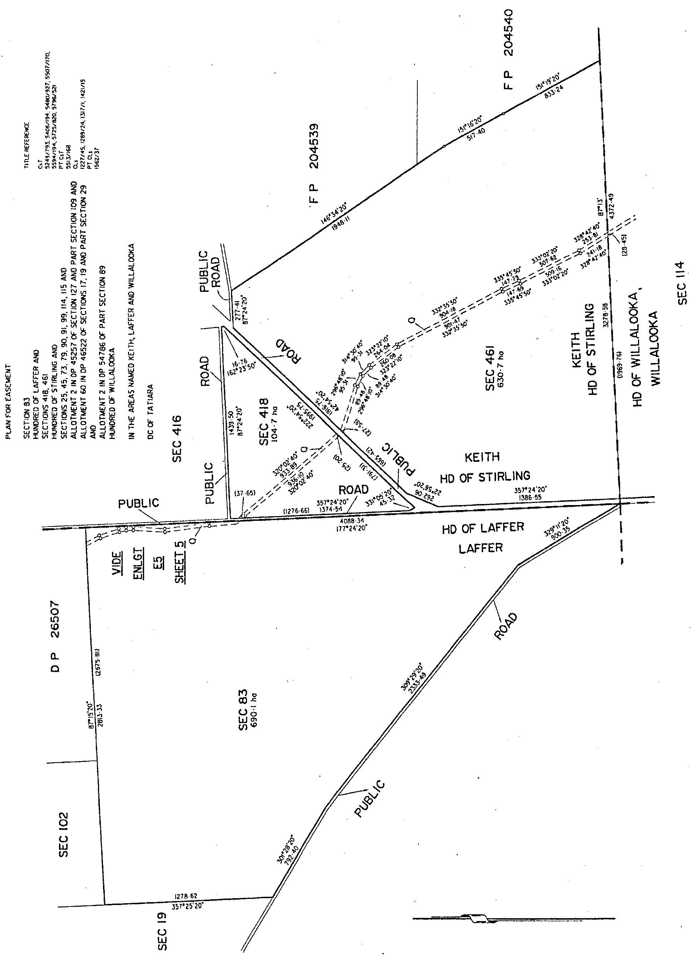
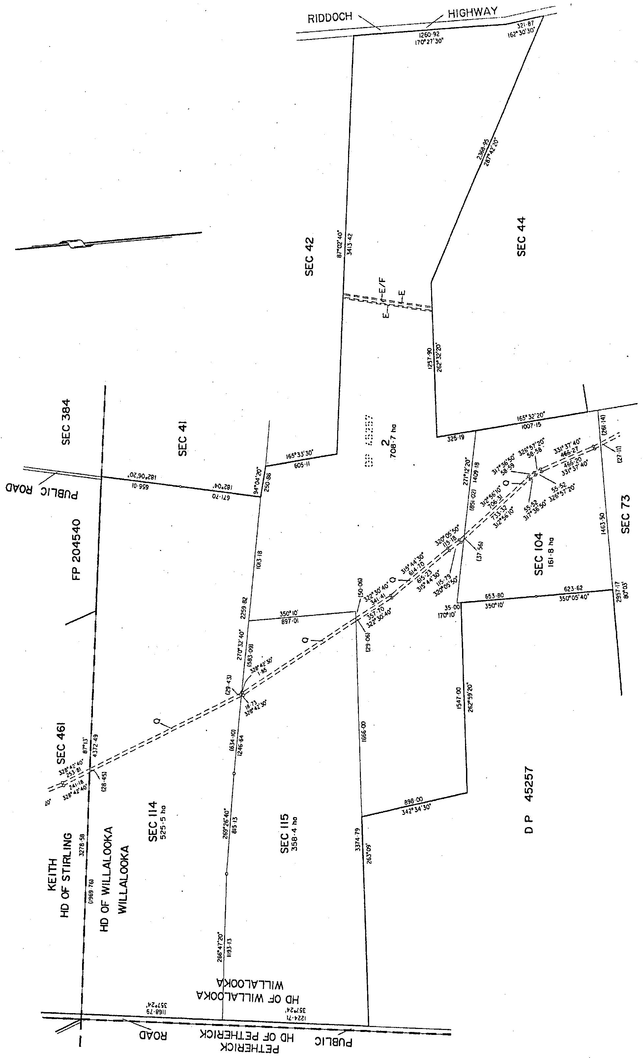

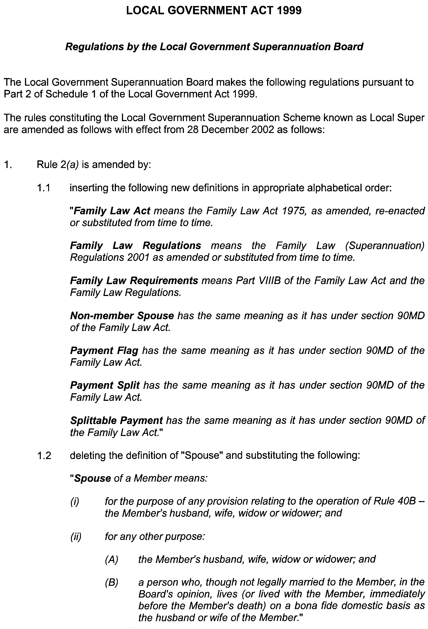
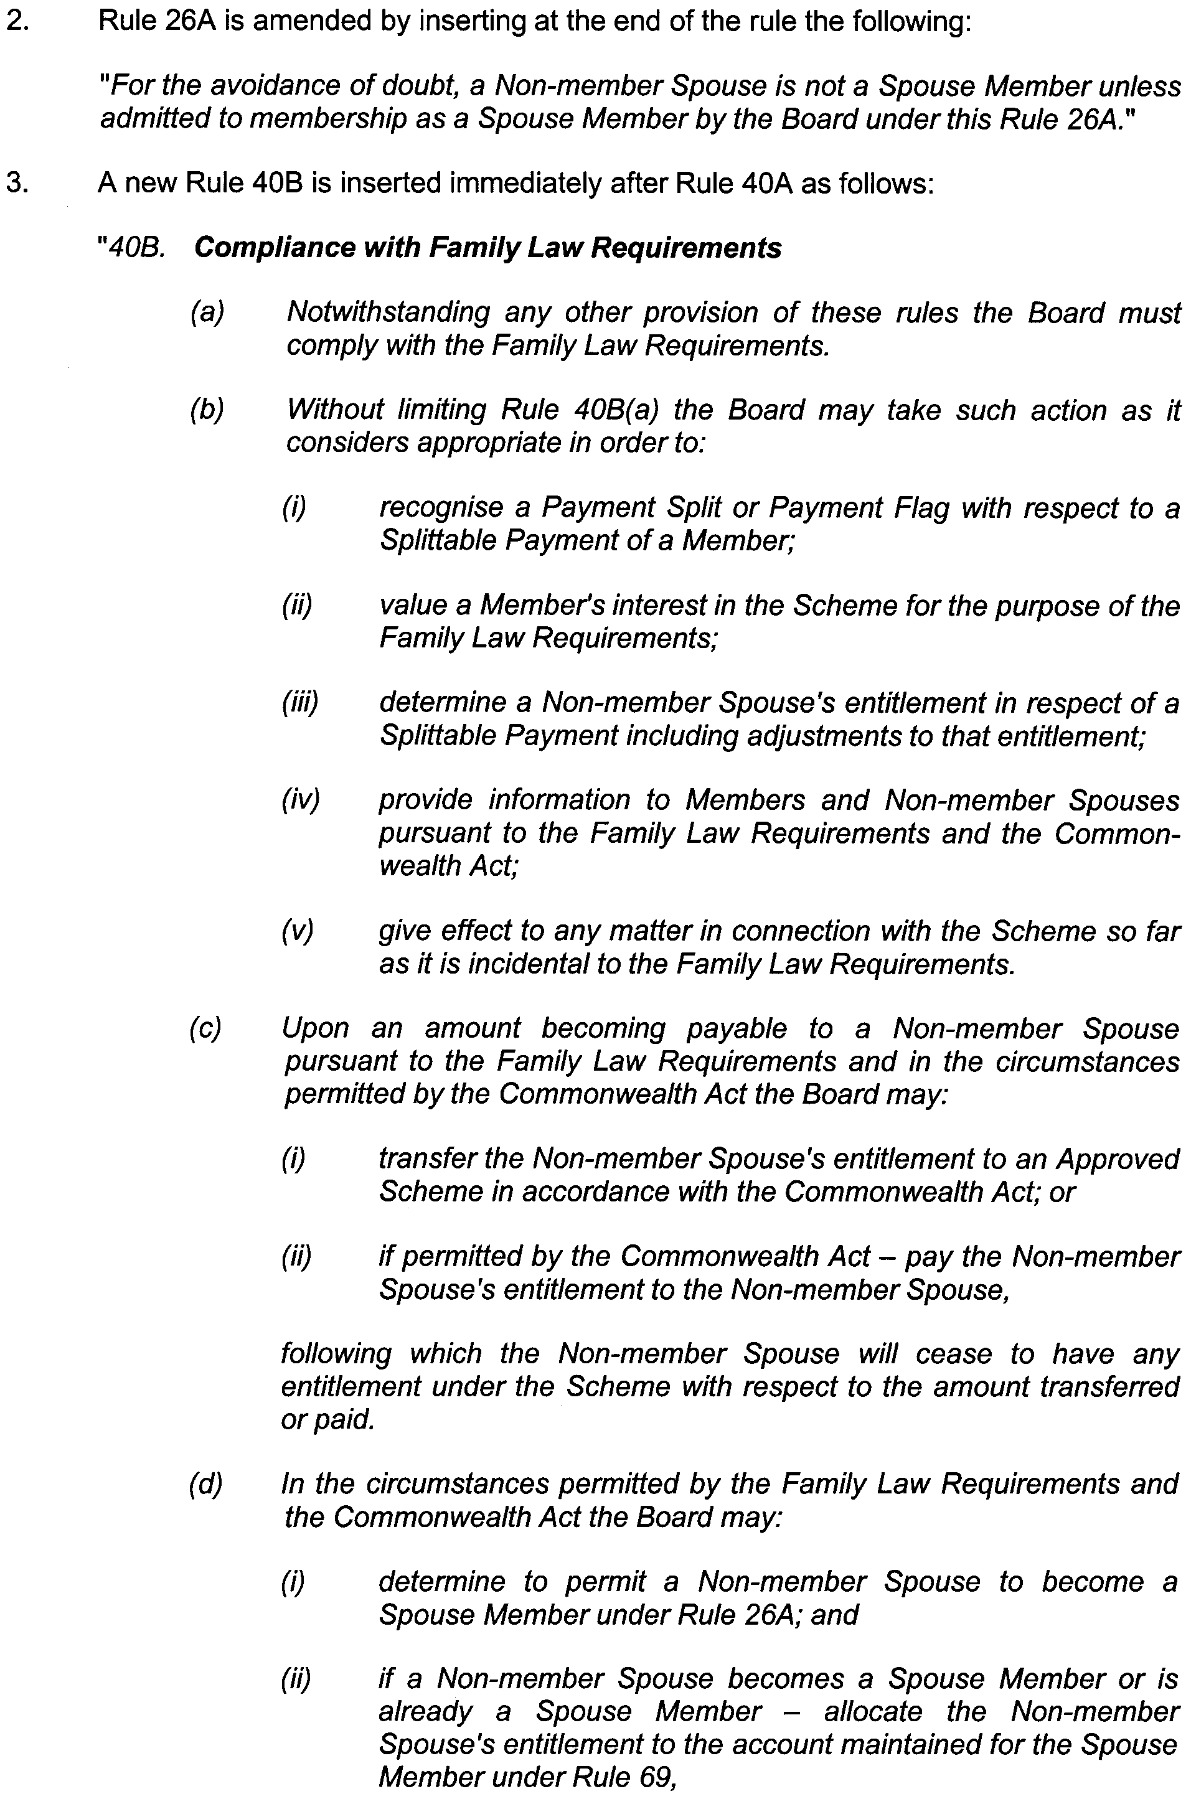
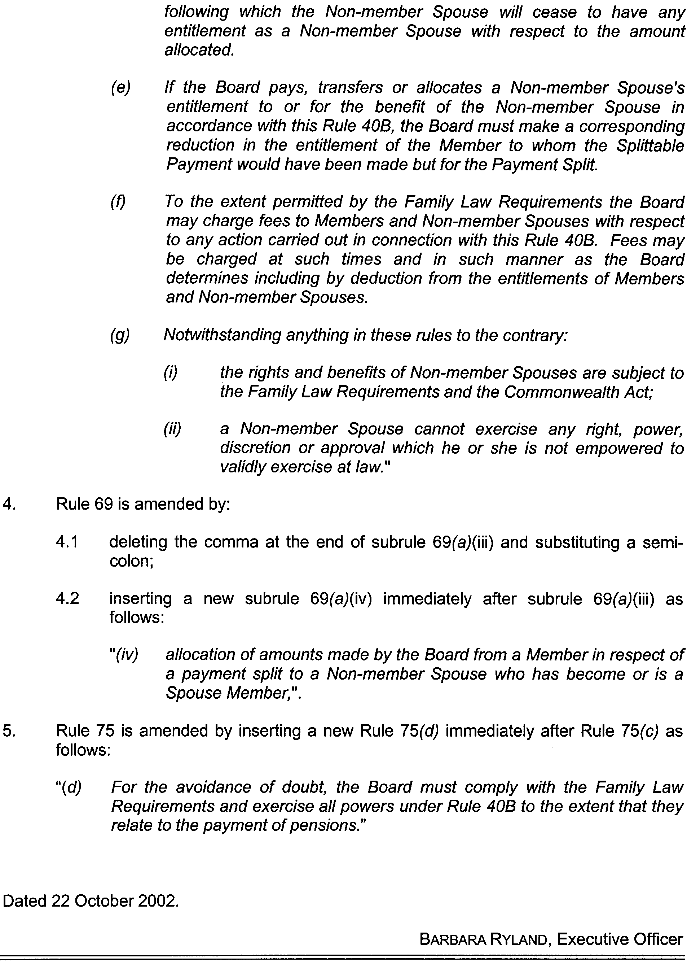

GRANT OF PETROLEUM EXPLORATION LICENCE PEL 102
Office of Minerals and Energy Resources, Adelaide, 25 October 2002
NOTICE is hereby given that the undermentioned Petroleum Exploration Licence has been granted under the provisions of the Petroleum Act 2000, pursuant to delegated powers dated 28 March 2002, Gazetted 11 April 2002, page 1573.
B. A. Goldstein, Director Petroleum, Office of Minerals and Energy Resources, Delegate of the Minister for Mineral Resources Development
No. of  Licence | Licensee | Locality | Date of  Expiry | Area in  km² | Reference

102 | Stuart Petroleum Ltd |  | Cooper Basin of South Australia | 23 October 2007 | 650 | 27/2/182

Description of the Area
All that part of the State of South Australia bounded as follows: Commencing at a point being the intersection of latitude 27°10′00″S AGD66 and longitude 140°30′00″E AGD66, thence east to longitude 140°40′00″E AGD66, south to latitude 27°15′00″S AGD66, east to longitude 140°45′00″E AGD66, south to latitude 27°32′10″S AGD66, west to longitude 140°44′40″E AGD66, south to latitude 27°32′20″S AGD66, west to longitude 140°44′30″E AGD66, south to latitude 27°32′40″S AGD66, east to longitude 140°44′40″E AGD66, south to latitude 27°32′50″S AGD66, east to longitude 140°45′00″E AGD66, south to latitude 27°33′20″S AGD66, west to longitude 140°42′00″E AGD66, south to latitude 27°33′30″S AGD66, west to longitude 140°41′30″E AGD66, south to latitude 27°34′30″S AGD66, west to longitude 140°40′30″E AGD66, south to latitude 27°35′00″S AGD66, west to longitude 140°38′30″E AGD66, south to latitude 27°35′30″S AGD66, west to longitude 140°38′00″E AGD66, south to latitude 27°36′00″S AGD66, west to longitude 140°35′00″E AGD66, north to latitude 27°35′20″S AGD66, east to longitude 140°35′20″E AGD66, south to latitude 27°35′25″S AGD66, east to longitude 140°35′45″E AGD66, south to latitude 27°35′35″S AGD66, east to longitude 140°36′05″E AGD66, south to latitude 27°35′40″S AGD66, east to longitude 140°36′10″E AGD66, south to latitude 27°35′45″S AGD66, east to longitude 140°37′15″E AGD66, north to latitude 27°35′40″S AGD66, east to longitude 140°37′25″E AGD66, north to latitude 27°35′35″S AGD66, east to longitude 140°37′35″E AGD66, north to latitude 27°35′10″S AGD66, east to longitude 140°37′50″E AGD66, north to latitude 27°35′00″S AGD66, east to longitude 140°38′10″E AGD66, north to latitude 27°34′50″S AGD66, east to longitude 140°38′30″E AGD66, north to latitude 27°34′40″S AGD66, east to longitude 140°38′50″E AGD66, north to latitude 27°34′35″S AGD66, east to longitude 140°39′00″E AGD66, south to latitude 27°34′40″S AGD66, east to longitude 140°39′05″E AGD66, south to latitude 27°34′50″S AGD66, east to longitude 140°39′20″E AGD66, north to latitude 27°34′45″S AGD66, east to longitude 140°39′25″E AGD66, north to latitude 27°34′40″S AGD66, east to longitude 140°39′40″E AGD66, north to latitude 27°34′35″S AGD66, east to longitude 140°39′50″E AGD66, north to latitude 27°34′30″S AGD66, east to longitude 140°40′20″E AGD66, north to latitude 27°34′20″S AGD66, east to longitude 140°40′40″E AGD66, north to latitude 27°34′10″S AGD66, east to longitude 140°41′00″E AGD66, north to latitude 27°34′00″S AGD66, east to longitude 140°41′10″E AGD66, north to latitude 27°33′40″S AGD66, east to longitude 140°41′20″E AGD66, north to latitude 27°33′20″S AGD66, east to longitude 140°41′30″E AGD66, north to latitude 27°32′50″S AGD66, east to longitude 140°41′40″E AGD66, north to latitude 27°32′20″S AGD66, east to longitude 140°41′50″E AGD66, north to latitude 27°32′00″S AGD66, east to longitude 140°42′00″E AGD66, north to latitude 27°31′50″S AGD66, east to longitude 140°42′10″E AGD66, north to latitude 27°31′40″S AGD66, east to longitude 140°42′20″E AGD66, north to latitude 27°30′30″S AGD66, west to longitude 140°42′10″E AGD66, north to latitude 27°30′10″S AGD66, west to longitude 140°41′00″E AGD66, south to latitude 27°30′20″S AGD66, west to longitude 140°40′50″E AGD66, south to latitude 27°30′30″S AGD66, west to longitude 140°40′40″E AGD66, south to latitude 27°30′40″S AGD66, west to longitude 140°40′30″E AGD66, south to latitude 27°30′50″S AGD66, west to longitude 140°40′20″E AGD66, south to latitude 27°31′00″S AGD66, west to longitude 140°40′10″E AGD66, south to latitude 27°31′10″S AGD66, west to longitude 140°39′10″E AGD66, south to latitude 27°31′30″S AGD66, west to longitude 140°38′50″E AGD66, south to latitude 27°31′50″S AGD66, west to longitude 140°38′30″E AGD66, south to latitude 27°32′10″S AGD66, west to longitude 140°37′40″E AGD66, north to latitude 27°31′40″S AGD66, east to longitude 140°38′10″E AGD66, north to latitude 27°31′20″S AGD66, east to longitude 140°38′30″E AGD66, north to latitude 27°31′10″S AGD66, east to longitude 140°38′50″E AGD66, north to latitude 27°31′00″S AGD66, east to longitude 140°39′10″E AGD66, north to latitude 27°30′50″S AGD66, east to longitude 140°39′30″E AGD66, north to latitude 27°30′30″S AGD66, east to longitude 140°39′50″E AGD66, north to latitude 27°30′10″S AGD66, east to longitude 140°40′10″E AGD66, north to latitude 27°29′50″S AGD66, east to longitude 140°40′30″E AGD66, north to latitude 27°29′30″S AGD66, east to longitude 140°40′40″E AGD66, north to latitude 27°28′40″S AGD66, east to longitude 140°40′50″E AGD66, north to latitude 27°28′20″S AGD66, east to longitude 140°41′00″E AGD66, north to latitude 27°28′00″S AGD66, east to longitude 140°41′10″E AGD66, north to latitude 27°27′30″S AGD66, east to longitude 140°41′20″E AGD66, north to latitude 27°27′20″S AGD66, east to longitude 140°41′40″E AGD66, north to latitude 27°27′00″S AGD66, east to longitude 140°42′10″E AGD66, north to latitude 27°26′40″S AGD66, east to longitude 140°42′20″E AGD66, north to latitude 27°26′20″S AGD66, east to longitude 140°42′30″E AGD66, north to latitude 27°26′00″S AGD66, east to longitude 140°42′50″E AGD66, north to latitude 27°25′40″S AGD66, east to longitude 140°43′10″E AGD66, north to latitude 27°25′20″S AGD66, east to longitude 140°43′20″E AGD66, north to latitude 27°25′00″S Clarke1858, east to longitude 140°43′40″E AGD66, north to latitude 27°24′50″S AGD66, east to longitude 140°44′00″E AGD66, north to latitude 27°24′40″S AGD66, east to longitude 140°44′20″E AGD66, north to latitude 27°24′20″S AGD66, east to longitude 140°44′40″E AGD66, north to latitude 27°23′50″S AGD66, east to longitude 140°44′50″E AGD66, north to latitude 27°23′30″S AGD66, west to longitude 140°44′20″E AGD66, south to latitude 27°23′40″S AGD66, west to longitude 140°44′00″E AGD66, south to latitude 27°24′00″S AGD66, west to longitude 140°43′50″E AGD66, south to latitude 27°24′10″S AGD66, west to longitude 140°43′40″E AGD66, south to latitude 27°24′20″S AGD66, west to longitude 140°43′20″E AGD66, south to latitude 27°24′30″S AGD66, west to longitude 140°43′10″E AGD66, south to latitude 27°24′50″S AGD66, west to longitude 140°43′00″E AGD66, south to latitude 27°25′00″S Clarke1858, west to longitude 140°42′40″E AGD66, south to latitude 27°25′20″S AGD66, west to longitude 140°42′20″E AGD66, south to latitude 27°25′40″S AGD66, west to longitude 140°42′00″E AGD66, south to latitude 27°25′50″S AGD66, west to longitude 140°41′50″E AGD66, south to latitude 27°26′00″S AGD66, west to longitude 140°41′40″E AGD66, south to latitude 27°26′10″S AGD66, west to longitude 140°41′30″E AGD66, south to latitude 27°26′20″S AGD66, west to longitude 140°41′20″E AGD66, south to latitude 27°26′30″S AGD66, west to longitude 140°41′00″E AGD66, south to latitude 27°26′40″S AGD66, west to longitude 140°40′50″E AGD66, south to latitude 27°26′50″S AGD66, west to longitude 140°40′40″E AGD66, south to latitude 27°27′00″S AGD66, west to longitude 140°40′20″E AGD66, south to latitude 27°27′10″S AGD66, west to longitude 140°40′10″E AGD66, south to latitude 27°27′30″S AGD66, west to longitude 140°40′00″E AGD66, south to latitude 27°27′40″S AGD66, west to longitude 140°39′50″E AGD66, south to latitude 27°27′50″S AGD66, west to longitude 140°39′30″E AGD66, south to latitude 27°28′10″S AGD66, west to longitude 140°39′00″E AGD66, south to latitude 27°28′40″S AGD66, west to longitude 140°38′40″E AGD66, south to latitude 27°29′00″S AGD66, west to longitude 140°38′20″E AGD66, south to latitude 27°29′20″S AGD66, west to longitude 140°38′10″E AGD66, south to latitude 27°29′30″S AGD66, west to longitude 140°37′40″E AGD66, south to latitude 27°29′50″S AGD66, west to longitude 140°37′10″E AGD66, south to latitude 27°30′10″S AGD66, west to longitude 140°36′40″E AGD66, south to latitude 27°30′20″S AGD66, west to longitude 140°36′20″E AGD66, south to latitude 27°30′40″S AGD66, west to longitude 140°36′00″E AGD66, south to latitude 27°30′50″S AGD66, west to longitude 140°35′50″E AGD66, south to latitude 27°31′00″S AGD66, west to longitude 140°35′40″E AGD66, south to latitude 27°31′10″S AGD66, west to longitude 140°35′30″E AGD66, south to latitude 27°31′20″S AGD66, west to longitude 140°35′10″E AGD66, south to latitude 27°31′30″S AGD66, west to longitude 140°35′00″E AGD66, north to latitude 27°20′00″S AGD66, west to longitude 140°30′00″E AGD66, north to latitude 27°13′40″S AGD66, east to longitude 140°31′40″E AGD66, north to latitude 27°13′00″S AGD66, east to longitude 140°32′20″E AGD66, north to latitude 27°12′10″S AGD66, west to longitude 140°31′40″E AGD66, north to latitude 27°11′50″S AGD66, west to longitude 140°31′00″E AGD66, north to latitude 27°11′30″S AGD66, west to longitude 140°30′40″E AGD66, north to latitude 27°11′10″S AGD66, west to longitude 140°30′20″E AGD66, north to latitude 27°10′50″S AGD66, west to longitude 140°30′00″E AGD66, and north to point of commencement, but excluding the areas bounded as follows:
Commencing at a point being the intersection of latitude 27°13′30″S AGD66 and longitude 140°35′10″E AGD66, thence east to longitude 140°37′00″E AGD66, south to latitude 27°14′20″S AGD66, west to longitude 140°36′40″E AGD66, south to latitude 27°14′30″S AGD66, west to longitude 140°36′10″E AGD66, south to latitude 27°14′50″S AGD66, west to longitude 140°35′50″E AGD66, south to latitude 27°15′00″S AGD66, west to longitude 140°35′40″E AGD66, south to latitude 27°15′10″S AGD66, west to longitude 140°35′30″E AGD66, south to latitude 27°15′30″S AGD66, west to longitude 140°35′20″E AGD66, south to latitude 27°15′40″S AGD66, west to longitude 140°34′20″E AGD66, north to latitude 27°14′50″S AGD66, east to longitude 140°34′30″E AGD66, north to latitude 27°14′30″S AGD66, east to longitude 140°35′00″E AGD66, north to latitude 27°14′20″S AGD66, east to longitude 140°35′10″E AGD66, and north to point of commencement.
and
Commencing at a point being the intersection of latitude 27°15′50″S AGD66 and longitude 140°38′20″E AGD66, thence east to longitude 140°39′40″E AGD66, south to latitude 27°17′30″S AGD66, west to longitude 140°39′30″E AGD66, south to latitude 27°17′40″S AGD66, west to longitude 140°39′10″E AGD66, south to latitude 27°18′00″S AGD66, west to longitude 140°38′20″E AGD66, south to latitude 27°18′20″S AGD66, west to longitude 140°38′10″E AGD66, south to latitude 27°18′30″S AGD66, west to longitude 140°37′50″E AGD66, south to latitude 27°18′40″S AGD66, west to longitude 140°37′30″E AGD66, south to latitude 27°19′50″S AGD66, west to longitude 140°36′00″E AGD66, north to latitude 27°19′40″S AGD66, west to longitude 140°35′20″E AGD66, north to latitude 27°19′30″S AGD66, west to longitude 140°35′00″E AGD66, north to latitude 27°19′10″S AGD66, west to longitude 140°34′50″E AGD66, north to latitude 27°17′50″S AGD66, east to longitude 140°36′00″E AGD66, north to latitude 27°16′40″S AGD66, east to longitude 140°37′10″E AGD66, north to latitude 27°16′30″S AGD66, east to longitude 140°37′20″E AGD66, north to latitude 27°16′20″S AGD66, east to longitude 140°37′30″E AGD66, north to latitude 27°16′10″S AGD66, east to longitude 140°38′00″E AGD66, north to latitude 27°16′00″S AGD66, east to longitude 140°38′20″E AGD66, and north to point of commencement.
Area: 650 km² approximately.

REAL PROPERTY ACT NOTICE
WHEREAS the persons named at the foot hereof have each respectively for himself made application to have the land set forth and described before his name at the foot hereof brought under the operation of the Real Property Act: Notice is hereby given that unless caveat be lodged with the Registrar-General by some person having estate or interest in the said lands on or before the expiration of the period herein below for each case specified, the said several pieces of land will be brought under the operation of the said Act as by law directed. Diagrams delineating these parcels of land may be inspected at the Lands Titles Registration Office, Adelaide, and in the offices of the several corporations or district councils in which the lands are situated.

The Schedule
No. of  Applica-  tion | Description of Property |  | Name |  | Residence | Date up to and  inclusive of which  caveat may be  lodged

30935 | Portion of Section 224, Hundred of Adelaide being more particularly pieces 703 and 803 in Deposited Plan No. 53414 |  | TransAdelaide |  | Adelaide, S.A. 5000 | 2 December 2002

Dated 31 October 2002, at the Lands Titles Registration Office, Adelaide. J. Zaccaria, Deputy Registrar-General

NATIONAL ELECTRICITY (SOUTH AUSTRALIA)
ACT 1996
Notice Under Section 6 (2) of the National Electricity Law And National Electricity Code
Review of Directions in the NEM Code Changes
NOTICE is hereby given pursuant to section 6 (2) of the National Electricity Law, which forms the Schedule to the National Electricity (South Australia) Act 1996 and Clause 8.3.9 (d) of the National Electricity Code approved under section 6 of the National Electricity Law, that the following changes have been made in the National Electricity Code:
(1) amendments to Clauses 3.8.1, 3.8.14, 3.9.1, 3.9.2, 3.9.3, 3.9.4, 3.12.1, 3.12.8, 3.12.10, 3.12.11, 3.13.6, 3.15.6, 3.15.8 and 3.15.9; new Clauses 3.12.11A, 3.13.6A, 3.13.6B, 3.15.7, 3.15.7A, 3.15.7B and 3.15.10C inserted and Clauses 3.12.2, 3.12.3, 3.12.4, 3.12.6, 3.12.7, 3.12.9 and 3.15.10A deleted in Chapter 3;
(2) amendments to Clauses 4.1.1, 4.2.7, 4.3.1, 4.8.4 (title only), 4.8.5, 4.8.6, 4.8.7, 4.8.9, 4.9.6 and 4.10.2, new Clauses 4.8.5A and 4.8.5B inserted and Clauses 4.8.8 and 4.8.9A deleted in Chapter 4;
(3) amendments to Clauses 5.2.4 and 5.2.5 in Chapter 5;
(4) Part 5 deleted in Derogations (Chapter 8); and
(5) amendments to definitions and new definitions inserted in Chapter 10.
These changes to the National Electricity Code commence on 9 December 2002 except for the amendment to Clause 3.9.3 which will commence on 30 March 2003.
As required by Clause 8.3.9 (d) of the National Electricity Code, a copy of the ACCC’s letter granting final authorisation dated 4 October 2002 is set out below.
The amendments referred to above and a copy of the ACCC’s letter dated 4 October 2002 can be viewed on the Internet website of National Electricity Code Administrator Limited (ACN 073 942 775) (‘NECA’) at www.neca.com.au under ‘The Code—Gazette notices’ section of that website.
The National Electricity Code can be viewed on the NECA Internet website at www.neca.com.au and at the offices of NECA and National Electricity Market Management Company Limited (ACN 072 010 327). A list of addresses where the Code can be viewed is available on the NECA website.
Dated 31 October 2002.

ACCC Letter of Authorisation
4 October 2002
Stephen Kelly
Managing Director
National Electricity Code Administrator Limited
Level 5, 41 Currie Street
ADELAIDE, S.A. 5000
Dear Stephen
Determination—Review of Directions in the NEM Code Changes
On 18 February 2002, the Australian Competition and Con-sumer Commission (Commission) received applications for authorisation (A90818, A90819 and A90820) of amendments to the National Electricity Code (Code). These applications were submitted by the National Electricity Code Administrator (NECA), under Part VII of the Trades Practices Act 1974 (TPA). The Code changes implement the conclusions and recom-mendations of a joint NECA/NEMMCO review of directions in the National Electricity Market (NEM).
Please find enclosed a copy of the Commission’s deter-mination in respect of these applications for authorisation. The Commission’s determination outlines its analysis and views on the proposed Code changes. The Commission has granted authorisation, conditional upon a number of amendments to the proposed Code changes being made. The conditions of authorisation are outlined in Chapter 5 of the determination.
In accordance with s.101 of the TPA, a person dissatisfied with the Commission’s determination may apply to the Australian Competition Tribunal for a review of the determination. Each application must be lodged on the appropriate form within 21 days of the date of the determination, with the Registrar of the Tribunal. The Tribunal is located in the Office of the Registrar of the Federal Court in each State.
A copy of this letter together with the determination will be placed on the Public Register kept by the Commission.
If you have any queries or require further information please call Mrs Maxine Helmling on (02) 6243 1246.
Yours sincerely,
S. Roberts, General Manager Acting, Regulatory Affairs—Electricity.

NATIONAL PARKS REGULATIONS 2001
Closure of the Innamincka Regional Reserve
PURSUANT to Regulation 8 (3) (d) of the National Parks Regulations 2001, I, Edward Gregory Leaman, the Director of National Parks and Wildlife, close to the public part of Innamincka Regional Reserve National Park from 6 a.m. on Monday, 4 November 2002 until 6 p.m. on Wednesday, 13 November 2002.
The area to be closed is:
All land in a 10 km corridor along the Coongie track from the Cordillo Downs road to Coongie Lake.
All land in a 5 km corridor either side of Cooper Creek from Burkes waterhole east to the Queensland Border.
The remainder of the reserve shall remain open during this time.
Travel on Road Transport maintained public roads will be unaffected by the closure.
The purpose of this closure is to ensure the safety of the public during the feral animal culling program within the reserve during that period.
Dated 21 October 2002.
E. G Leaman, Director, National Parks and Wildlife

NATIONAL PARKS REGULATIONS 2001
National Parks and Wildlife Reserves—Fire Restrictions
PURSUANT to regulation 16 (1) of the National Parks Regulations 2001, I, Edward Gregory Leaman, the Director of National Parks and Wildlife, impose fire restrictions for National Parks and Wildlife Reserves as listed in schedule 1 below.
The purpose of these fire restrictions is to ensure the safety of visitors using the reserves, and in the interests of protecting the reserves and neighbouring properties.
Dated 18 October 2002.
G. Leaman, Director, National Parks and Wildlife

Schedule 1
1. EYRE AND FAR WEST DISTRICTS
All reserves: All wood fires or solid fuel fires are prohibited from 1 November 2002 to 30 April 2003. Gas fires are permitted other than on days of total fire bans. Note: Wood fires are permitted between high water mark and low water mark in the following parks: Lincoln National Park and Coffin Bay National Park, providing the following conditions are applied: (a) it is not a day of a declared total fire ban; (b) wood has been supplied from outside the park; (c) an adult is in attendance and (d) the fire is extinguished before departure.
2. SOUTHERN FLINDERS DISTRICT
Mount Remarkable National Park, The Dutchmans Stern Conservation Park, Mount Brown Conservation Park, Telowie Gorge Conservation Park—Year-round ban on wood fires in reserves except for Mambray Creek Campground in Mount Remarkable National Park where wood fires are allowed in fire places from 1 May to 31 October. Other reserves—All wood fires or solid fuel fires are prohibited from 1 November 2002 to 30 April 2003. Gas fires are permitted other than on days of total fire bans.
3. FLINDERS DISTRICT
The following reserves: Flinders Ranges National Park, Gammon Ranges National Park—All wood fires or solid fuel fires are prohibited from 1 November 2002 to 31 March 2003. Gas fires are permitted other than on days of total fire bans.
4. GAWLER RANGES DISTRICT
All reserves—All wood fires or solid fuel fires are prohibited from 1 November 2002 to 15 April 2003. Gas fires are permitted on days other than on days of total fire bans.
5. OUTBACK REGION
The following reserves: Witjira National Park, Lake Eyre National Park, Simpson Desert Conservation Park, Simpson Desert Regional Reserve and Innamincka Regional Reserve. All wood fires or solid fuel fires are prohibited from 1 November 2002 to 31 March 2003 other than for aboriginal people using traditional use of fires for cooking.
6. YORKE DISTRICT
All Reserves—All wood fires or solid fuel fires are prohibited from 1 November 2002 to 30 April 2003. Gas fires are permitted other than on days of total fire bans.
7. KANGAROO ISLAND REGION
All Reserves—All wood fires or solid fuel fires are prohibited throughout the year. Gas fires are permitted other than on days of total fire bans.
8. FLEURIEU DISTRICT
Newland Head Conservation Park—Has as a total ban on wood fires all year round. All other reserves—All wood fires or solid fuel fires are prohibited from 1 November 2002 to 30 April 2003. Gas fires are permitted other than on days of total fire bans.
9. LOFTY/BAROSSA DISTRICT
All wood fires or solid fuel fires within District reserves are prohibited throughout the year. Gas fires are permitted within Morialta Conservation Park, Black Hill Con-servation Park, Para Wirra Recreation Park and Sandy Creek Conservation Park in designated areas other than on days of total fire bans.
10. CLELAND CONSERVATION PARK
All wood fires or solid fuel fires are prohibited from
1 November 2002 to 30 April 2003. Gas fires are permitted other than on days of total fire bans.
11. STURT DISTRICT
All Reserves—All wood fires or solid fuel fires are prohibited from 1 November 2002 to 30 April 2003. Gas fires are permitted other than on days of total fire bans. Belair National Park has a permanent prohibition of all wood fires.
12. COORONG AND LAKES DISTRICT, UPPER SOUTH EAST AND LOWER SOUTH EAST DISTRICT
All reserves: All wood fires or solid fuel fires are prohibited from 1 November 2002 to 30 April 2003. Wood fires are permitted between high water mark and low water mark of the foreshore of the following reserves: Piccaninnie Ponds Conservation Park, Little Dip Conservation Park and Coorong National Park, other than on days of total fire bans.
Aberdour Conservation Park, Bool Lagoon Game Reserve, Ewens Ponds Conservation Park, Lower Glenelg River Conservation Park, Mount Monster Conservation Park, Piccaninnie Ponds Conservation Park, above high water mark, and Poocher Swamp Game Reserve have permanent prohibition of all wood fires.
13. MID NORTH DISTRICT
All reserves: All wood fires or solid fuel fires are prohibited from 1 November 2002 to 30 April 2003. Gas fires are permitted other than on days of total fire bans.
Spring Gully and Mokota Conservation Parks have permanent prohibition of all wood fires.
14. MALLEE DISTRICT
All reserves: All wood fires or solid fuel fires are prohibited from 1 November 2002 to 30 April 2003. Gas fires are permitted other than on days of total fire bans.
15. RIVERLAND DISTRICT
Murray River National Park, Chowilla Game Reserve, Morgan Conservation Park, Moorook Game Reserve, and Loch Luna Game Reserve. All wood fires or solid fuel fires are prohibited from 1 November 2002 to 12 April 2003. Gas fires are permitted other than on days of total fire bans.
All remaining reserves: All wood fires or solid fuel fires are prohibited from 1 November 2002 to 30 April 2003. Gas fires are permitted other than on days of total fire bans.

PRIMARY INDUSTRIES AND RESOURCES SOUTH AUSTRALIA
Lower Eyre Peninsula—Draft Aquaculture Policy
PURSUANT to section 12 of the Aquaculture Act 2001 notice is hereby given that the Minister for Agriculture, Food and Fisheries has released an aquaculture policy for the Lower Eyre Peninsula for public consultation.
The policy will establish the Boston Bay Aquaculture Zone, the Offshore Lincoln Aquaculture Zone, Louth Aquaculture Zone and Lincoln Aquaculture Exclusion Zone within the Lincoln Policy Area.
Copies of the Lower Eyre Peninsula Draft Policy are available from PIRSA Aquaculture, 14th Floor, 25 Grenfell Street, Adelaide, S.A. 5000, on the internet at:
www.pir.sa.gov.au/aquaculture
by telephoning (08) 8226 0314 or by faxing (08) 8226 0330.
Written submissions in relation to the draft policy are invited from the public and should be made to Greg Ryan, PIRSA Aquaculture, G.P.O. Box 1625, Adelaide, S.A. 5001. Sub-missions must be received by 5 p.m. on Friday, 10 January 2003.
Dated 29 October 2002.
P. Holloway, Minister for Agriculture, Food and Fisheries

ROADS (OPENING AND CLOSING) ACT 1991
Pridham Boulevard, Aldinga
NOTICE is hereby given, pursuant to section 10 of the Roads (Opening and Closing) Act 1991, that the Development Assessment Commission proposes to make a Road Process Order to:
1. Open as roads portion of piece 9 in Deposited Plan 22798 shown numbered ‘1’ in Preliminary Plan 02/0078, forming a road re-alignment.
2. Close and transfer to Genetic Fund Pty Ltd in exchange for the road opening described above, portions of the public road (Pridham Boulevard), south of Quinliven Road and between pieces 8 and 9 in Deposited Plan 22798 shown lettered ‘A’ and ‘B’ in Preliminary Plan 02/0078.
A copy of the plan and a statement of persons affected are available for public inspection at the offices of the City of Onkaparinga, Ramsay Place, Noarlunga Centre, S.A. 5168 and the Adelaide office of the Surveyor-General during normal office hours.
Any application for easement or objection must be made in writing to the Development Assessment Commission, 136 North Terrace, Adelaide, S.A. 5000 WITHIN 28 DAYS OF THE DATE OF THIS NOTICE and a copy must be forwarded to the Surveyor-General, G.P.O. Box 1354, Adelaide, S.A. 5001. Where a submission is made, the Development Assessment Commission will give notification of a meeting at which the matter will be considered.
Commission contact: Phil Cooper, phone 8303 0747.
Dated 31 October 2002.
P. M. Kentish, Surveyor-General

NOTICE TO MARINERS
No. 50 of 2002
South Australia—Gulf St Vincent—Development of Recreational Diving Site—Timing and route for towed voyage from Port Adelaide and scuttling of former man of war H.M.A.S. Hobart—Establishment of temporary moorings—Declaration and marking of temporary exclusion zone—Establishment of Isolated
Danger Mark
MARINERS are advised that on or about 29 October 2002, the de-commissioned man of war H.M.A.S. Hobart will proceed under tow of the motor tug Warren from the Outer Harbour at Port Adelaide to the scuttling site off Wirrina Cove in position:
Latitude 35°28.9′S, longitude 138°09.5′E
The route taken will take the vessel clear of the main shipping lanes and will proceed approximately along a course of 197° True, as designated hereunder:
From: Latitude 34°49.0S′, longitude 138°24.0′E
To: Latitude 35°28.9S′, longitude 138°09.5′E
The vessel will display the appropriate International Collision Regulation Signals throughout the voyage and whilst at the mooring.
A temporary mooring, marked with a buoy flashing white every 5 seconds has been established at this location. The vessel will then be moored whilst preparations are made for scuttling.
An exclusion zone of 1 km radius from the scuttling site, pursuant to section 26 of the Harbors and Navigation Act 1993, will be in force for a period of 2 weeks. This site will be marked by unlit buoys and will be monitored by units of the South Australian Police Water Response Unit and Transport SA Marine Group personnel. Persons other than those authorised are prohibited from entering the area at all times from Tuesday, 29 October 2002 to Friday, 15 November 2002.
An isolated danger mark Gp. Fl (2) white every 10 seconds and topmark of two black balls will be installed after the Hobart has been scuttled.
Two red pyrotechnic rocket parachute flares will be displayed at the site five and one minutes respectively prior to scuttling.
Navy charts affected: Aus 444 and 780.
Adelaide, 24 October 2002.
M. Wright, Minister for Transport
TSA 2002/00309

NOTICE TO MARINERS
No. 51 of 2002
South Australia—Gulf St Vincent—Port Vincent—
Yachting Buoys Laid
MARINERS are advised that the following unlit buoy markers off Port Vincent will be set from 13 October 2002 until 21 April 2003.
The colour and approximate positions of these buoys in WGS 84 co-ordinates are as follows:
2 vertical black buoys:
Latitude 34°46.39′S, longitude 137°52.33′E
Latitude 34°46.28′S, longitude 137°52.98′E
1 vertical black buoys
Latitude 34°45.62′S, longitude 137°51.80′E
2 vertical black buoys:
Latitude 34°46.10′S, longitude 137°51.80′E
1 vertical black buoy:
Latitude 34°46.61′S, longitude 137°51.80′E
2 horizontal black and yellow check buoys:
Latitude 34°46.61′S, longitude 137°51.80′E
Navy charts affected: Aus 345, 444, 780 and 781.
Publications affected: Australia Pilot Volume 1 (Seventh Edition 1992) page 133.
Adelaide, 26 October 2002.
M. Wright, Minister for Transport
TSA F 2002/00309

WATER MAINS AND SEWERS

Office of the South Australian Water Corporation
Adelaide, 31 October 2002

WATER MAINS LAID

Notice is hereby given that the following main pipes or parts of main pipes have been laid down by the South Australian Water Corporation in or near the undermentioned water districts and are now available for a constant supply of water to adjacent land.

ADELAIDE WATER DISTRICT

CITY OF BURNSIDE
Portrush Road, Tusmore and Linden Park. p3, 5-7 and 9
Stirling Street, Tusmore. p3
Bakewell Street, Tusmore. p3 and 6
Across and in Greenhill Road, Tusmore. p3 and 8
Oban Street, Beulah Park. p10

THE CORPORATION OF THE TOWN OF GAWLER
Sheriff Street, Evanston Park. p20
Coleman Parade, Evanston Park. p20 and 21
Bagot Court, Evanston Park. p20
Rogers Court, Evanston Park. p20
Keane Court, Evanston Park. p20
Withers Circuit, Evanston Park. p21
Ames Drive, Evanston Park. p21
Greaves Court, Evanston Park. p21

CITY OF NORWOOD PAYNEHAM & ST PETERS
Portrush Road, Marryatville and Heathpool. p3-5
Hewitt Avenue, Marryatville. p3 and 4
Rothbury Avenue, Heathpool. p3 and 5

CITY OF ONKAPARINGA
Lindsay Road, Lonsdale. p18 and 19
Trizolpic Court, Lonsdale. p18

CITY OF PORT ADELAIDE ENFIELD
Anaconda Drive, North Haven. p11
Cullford Avenue, Klemzig. p13
Second Avenue, Klemzig. p13
Ford Street, Ottoway. p14
Blakeney Road, Ottoway. p14
Rosewater Terrace, Ottoway. p14

CITY OF SALISBURY
Richard Avenue, Pooraka. p16
Easement in reserve (lot 24), Pratt Avenue, Pooraka. p16
Across Pratt Avenue, Pooraka. p16

CITY OF WEST TORRENS
Birmingham Street, Mile End South. p12

BAROSSA COUNTRY LANDS WATER DISTRICT

BAROSSA COUNCIL
Easement in lot 42, Kakatoe Crescent, Cockatoo Valley. p15
Across Kakatoe Crescent, Cockatoo Valley. p15
Easement in lot 48, Kakatoe Crescent, Cockatoo Valley. p15

PORT LINCOLN WATER DISTRICT

CITY OF PORT LINCOLN
Tennant Street, Port Lincoln. p1
Tasman Terrace, Port Lincoln. p2

WATER MAINS ABANDONED

Notice is hereby given that the undermentioned water mains have been abandoned by the South Australian Water Corporation.

ADELAIDE WATER DISTRICT

CITY OF BURNSIDE
Portrush Road, Tusmore and Linden Park. p3, 5-7 and 9
Stirling Street, Tusmore. p3
Bakewell Street, Tusmore. p3 and 6
Greenhill Road, Tusmore. p3 and 8
Oban Street, Beulah Park. p10

CITY OF NORWOOD PAYNEHAM & ST PETERS
Portrush Road, Marryatville and Heathpool. p3-5
Hewitt Avenue, Marryatville. p3 and 4
Rothbury Avenue, Heathpool. p3 and 5

CITY OF PORT ADELAIDE ENFIELD
Anaconda Drive, North Haven. p11
Cullford Avenue, Klemzig. p13
Second Avenue, Klemzig. p13
Ford Street, Ottoway. p14
Blakeney Road, Ottoway. p14
Rosewater Terrace, Ottoway. p14

CITY OF WEST TORRENS
Birmingham Street, Mile End South. p12

BAROSSA COUNTRY LANDS WATER DISTRICT

BAROSSA COUNCIL
Easement in lot 42, Kakatoe Crescent, Cockatoo Valley. p15
Across Kakatoe Crescent, Cockatoo Valley. p15
Easement in lot 48, Kakatoe Crescent, Cockatoo Valley. p15

PORT LINCOLN WATER DISTRICT

CITY OF PORT LINCOLN
Tasman Terrace, Port Lincoln. p2

ADDENDA

Addenda to notice in “Government Gazette” of 17 October 2002.

“WATER MAINS LAID”

“Notice is hereby given that the following main pipes or parts of main pipes have been laid down by the South Australian Water Corporation in or near the undermentioned water districts and are now available for a constant supply of water to adjacent land.”

“WARREN COUNTRY LANDS WATER DISTRICT”

“BAROSSA COUNCIL”
“South Terrace, north of lot 46 in LTRO FP 155061, hundred of Barossa. p13 and 17”
“Easements in section 988, hundred of Barossa. p13-15”
“Coppermine Road, hundred of Barossa. p15-17”
“Easements in allotment piece 2 in LTRO DP 43872, Copper-mine Road, hundred of Barossa. p16”

To these notices add “This main is available on application only.”

SEWERS LAID

Notice is hereby given that the following sewers have been laid down by the South Australian Water Corporation in the under-mentioned drainage areas and are now available for house connections.

ADELAIDE DRAINAGE AREA

CITY OF BURNSIDE
Coolibah Avenue, Kensington Gardens. FB 1106 p58

CITY OF CHARLES STURT
Croydon Avenue, West Croydon. FB 1106 p57

CITY OF ONKAPARINGA
Lindsay Road, Lonsdale. FB 1108 p25 and 26
Trizolpic Court, Lonsdale. FB 1108 p25 and 26
Easement in lots 32 and 31, Lindsay Road, Lonsdale. FB 1108 p25 and 26
Sewerage land (lot 33), Trizolpic Court, Lonsdale. FB 1108 p25, 26 and 28
Easements in lots 25-23, Trizolpic Court, Lonsdale. FB 1108 p25, 27 and 28

CITY OF PORT ADELAIDE ENFIELD
Princes Road, Greenacres. FB 1106 p59
Orlando Street, Hampstead Gardens. FB 1106 p60

CITY OF SALISBURY
Easement in reserve (lot 24), Pratt Avenue, Pooraka. FB 1108 p22
Richard Avenue, Pooraka. FB 1108 p22

CITY OF TEA TREE GULLY
Doreen Street, St Agnes. FB 1109 p1

ALDINGA DRAINAGE AREA

CITY OF ONKAPARINGA
Standfield Road, Aldinga Beach. FB 1106 p36 and 53

PORT LINCOLN COUNTRY DRAINAGE AREA

CITY OF PORT LINCOLN
Marine Avenue, Port Lincoln. FB 1106 p54
Tennant Street, Port Lincoln. FB 1106 p55
Easement in lots 20,19,1,16 and 15, Minnipa Avenue, Port Lincoln. FB 1106 p56

SEWERS ABANDONED

Notice is hereby given that the undermentioned sewer has been abandoned by the South Australian Water Corporation.

ADELAIDE DRAINAGE AREA

CITY OF BURNSIDE
Coolibah Avenue, Kensington Gardens. FB 1106 p58

SEWERS LAID

Notice is hereby given that the undermentioned sewers have been laid down by the South Australian Water Corporation and are not available for house connections.

ADELAIDE DRAINAGE AREA

CITY OF ONKAPARINGA
Lindsay Road, Lonsdale—150 mm PVC pumping main. FB 1108 p25 and 27
Trizolpic Court, Lonsdale—150 mm PVC pumping main. FB 1108 p25 and 27
Sewerage land (lot 33), Trizolpic Court, Lonsdale—150 mm PVC pumping main. FB 1108 p25, 27 and 28

A. Howe, Chief Executive Officer, South Australian Water Corporation.

WILDERNESS PROTECTION ACT 1992
Inspection and Purchase of Annual Report 2001-2002
I, JOHN HILL, Minister for Environment and Conservation, hereby give notice under provisions of section 7 of the Wilderness Protection Act 1992, that copies of the Annual Report for 2001-2002 are available for inspection or purchase at The Environment Shop, 77 Grenfell Street, Adelaide, S.A. 5000 (phone 8204 1910).
Dated 3 October 2002.
J. Hill, Minister for Environment and Conservation

REGULATIONS UNDER THE VETERINARY SURGEONS ACT 1985
────
No. 201 of 2002
────
At the Executive Council Office at Adelaide, 31 October 2002

PURSUANT to the Veterinary Surgeons Act 1985, on the recommendation of the Veterinary Surgeons Board and with the advice and consent of the Executive Council, I make the following regulations.

MARJORIE JACKSON-NELSON, Governor

PURSUANT to section 10AA(2) of the Subordinate Legislation Act 1978, I certify that, in my opinion, it is necessary or appropriate that the following regulations come into operation as set out below.

PAUL HOLLOWAY, Minister for Agriculture, Food and Fisheries
───────────────────
SUMMARY OF PROVISIONS

1. Citation
2. Commencement
3. Variation of reg. 9—Prescribed fee for permit (section 38 of Act)
4. Variation of reg. 11—Prescribed registration, reinstatement, annual practice fees (section 40 of Act)
────────────────────────

Citation
1. The Veterinary Surgeons Regulations 2002 (see Gazette 29 August 2002 p. 3283) are referred to in these regulations as "the principal regulations".

Commencement
2. These regulations come into operation on 1 January 2003.

Variation of reg. 9—Prescribed fee for permit (section 38 of Act)
3. Regulation 9 of the principal regulations is varied by striking out "$175.00" and substituting "$200.00".

Variation of reg. 11—Prescribed registration, reinstatement, annual practice fees (section 40 of Act)
4. Regulation 11 of the principal regulations is varied—

(a) by striking out from subregulation (1)(a)(i) "$50.00" and substituting "$85.00";

(b) by striking out from subregulation (1)(a)(ii) "$300.00" and substituting "$350.00";

(c) by striking out from subregulation (1)(c)(i) "$175.00" and substituting "$200.00";

(d) by striking out from subregulation (1)(c)(ii)(A) "$175.00" and substituting "$200.00";

(e) by striking out from subregulation (1)(c)(ii)(B) "$145.00" and substituting "$170.00";

(f) by striking out from subregulation (1)(c)(ii)(C) "$125.00" and substituting "$150.00";

(g) by striking out from subregulation (1)(c)(ii)(D) "$95.00" and substituting "$120.00";

(h) by striking out from subregulation (1)(d)(i) "$95.00" and substituting "$120.00";

(i) by striking out from subregulation (1)(d)(ii)(A) "$95.00" and substituting "$120.00";

(j) by striking out from subregulation (1)(d)(ii)(B) "$75.00" and substituting "$100.00";

(k) by striking out from subregulation (1)(d)(ii)(C) "$65.00" and substituting "$90.00";

(l) by striking out from subregulation (1)(d)(ii)(D) "$45.00" and substituting "$70.00".

MAFF 02/0062CS R. DENNIS, Clerk of the Council

REGULATIONS UNDER THE AQUACULTURE ACT 2001
────
No. 202 of 2002
────
At the Executive Council Office at Adelaide, 31 October 2002

PURSUANT to the Aquaculture Act 2001 and with the advice and consent of the Executive Council, I make the following regulations.
MARJORIE JACKSON-NELSON, Governor

PURSUANT to section 10AA(2) of the Subordinate Legislation Act 1978, I certify that, in my opinion, it is necessary or appropriate that the following regulations come into operation as set out below.

PAUL HOLLOWAY, Minister for Agriculture, Food and Fisheries
───────────────────
SUMMARY OF PROVISIONS

1. Citation
2. Commencement
3. Interpretation
4. Bodies to which draft aquaculture policies must be referred (s. 12(4)(a))
5. Transfer of production leases (s. 39(2))
6. Period within which EPA to respond to referred matter (s. 59(3))
7. Aquaculture Resource Management Fund—percentage of fees (s. 79(3))
8. Defect in application
9. Records to be maintained by licence holder
10. Periodic returns
11. Fees
12. Offences

SCHEDULE
Fees
───────────────────

Citation
1. These regulations may be cited as the Aquaculture Regulations 2002.

Commencement
2. These regulations will come into operation on 11 November 2002.

Interpretation
3. In these regulations, unless the contrary intention appears—

"Act" means the Aquaculture Act 2001;

"Fund" means the Aquaculture Resource Management Fund established under section 79 of the Act;

"zone" means an aquaculture zone, a prospective aquaculture zone, an aquaculture exclusion zone or an aquaculture emergency zone.

Bodies to which draft aquaculture policies must be referred (s. 12(4)(a))
4. The following bodies are prescribed as bodies to which a draft aquaculture policy and related report must be referred under section 12(4)(a) of the Act:

(a) Aboriginal and Torres Strait Islander Commission; and

(b) Aboriginal Legal Rights Movement Incorporated; and

(c) Coast Protection Board; and

(d) Conservation Council of South Australia Incorporated; and

(e) Department for Environment and Heritage; and

(f) Department of Human Services; and

(g) Department of the Premier and Cabinet; and

(h) Department of Primary Industries and Resources; and

(i) Department of Transport and Urban Planning; and

(j) Department of Water, Land and Biodiversity Conservation; and

(k) Division of State Aboriginal Affairs in the Department for Administrative and Information Services; and

(l) Environment Protection Authority; and

(m) Local Government Association of South Australia; and

(n) Minister to whom the administration of the Harbors and Navigation Act 1993 is committed; and

(o) Office of Local Government; and

(p) Office of Regional Development; and

(q) Seafood Council SA; and

(r) SA Fishing Industry Council Incorporated; and

(s) South Australian Aquaculture Council; and

(t) South Australian Recreational Fishing Advisory Council; and

(u) South Australian Tourism Commission; and

(v) if the policy is expressed to apply only in relation to one or more zones or areas—

(i) any Aboriginal group registered under the Native Title (South Australia) Act 1994 as holders of, or claimants to, native title in a region comprising or forming part of a zone or area to which the policy applies; and

(ii) any person holding an aquaculture licence or aquaculture lease in respect of a region comprising or forming part of a zone or area to which the policy applies; and
(iii) any catchment water management board (within the meaning of the Water Resources Act 1997) responsible for a region comprising or forming part of a zone or area to which the policy applies; and

(iv) any local government authority responsible for a region comprising, forming part of or adjoining a zone or area to which the policy applies; and

(w) if the policy is not expressed to apply only in relation to one or more zones or areas—

(i) all catchment water management boards (within the meaning of the Water Resources Act 1997); and

(ii) all local government authorities.

Transfer of production leases (s. 39(2))
5. Written notice to the Minister of transfer of a production lease under section 39 of the Act must include the following:

(a) the full name, address and telephone number of the transferor and transferee; and

(b) the number of the production lease.

Period within which EPA to respond to referred matter (s. 59(3))
6. For the purposes of section 59(3) of the Act, the prescribed period is 6 weeks.

Aquaculture Resource Management Fund—percentage of fees (s. 79(3))
7. For the purposes of section 79(3) of the Act—

(a) the prescribed percentage of fees (other than expiation fees) paid under the Act is 100 percent; and

(b) the prescribed percentage of penalties recovered in respect of offences against the Act is 100 percent.

Defect in application
8. (1) The Minister may request an applicant to remedy any defect or deficiency in an application or accompanying document or information required by or under the Act or these regulations.

(2) If an applicant in relation to whom a request has been made under subregulation (1) fails to comply with the request within 3 months of the request having been made, the Minister may refuse the application.

Records to be maintained by licence holder
9. (1) An aquaculture licence holder must maintain a stock register.

(2) A stock register must contain—

(a) in respect of each live aquatic organism supplied to the licence holder—

(i) the date on which the aquatic organism was received by the licence holder; and

(ii) the name and address of the person who supplied the aquatic organism to the licence holder; and

(iii) a copy of health certification provided to the licence holder in relation to the aquatic organism; and

(b) in respect of each live aquatic organism supplied by the licence holder to another person—

(i) the date on which the aquatic organism was supplied to the other person; and

(ii) the name and address of the person to whom the aquatic organism was supplied; and

(iii) a copy of health certification provided by the licence holder in relation to the aquatic organism; and

(c) in respect of each aquatic organism kept by the licence holder—details of any prophylactic or therapeutic treatment administered to the aquatic organism by the licence holder or any other person, including—

(i) the reason for the treatment; and

(ii) the dates on which the treatment was administered; and

(iii) the name (including any trade or patent name) of any substance used as part of the treatment.

(3) Records maintained under this regulation must be retained for 2 years from the date of the making of the record.

(4) An aquaculture licence holder must, at the request of a fisheries officer, produce the stock register for inspection by the fisheries officer.

(5) A fisheries officer may make copies of, or take extracts from, a stock register produced for inspection under this regulation.

Periodic returns
10. An aquaculture licence holder must, on or before 31 January and 31 July in each year, furnish to the Minister a periodic return containing such information as the Minister requires in the manner and form determined by the Minister.

Fees
11. (1) The fees set out in the Schedule are prescribed for the purposes of the Act.

(2) The Minister may waive or refund a fee (or part of a fee) payable under the Act or these regulations if satisfied it is appropriate to do so in a particular case.

Offences
12. (1) A person who contravenes or fails to comply with a provision of these regulations is guilty of an offence.

(2) A person who is guilty of an offence against these regulations is liable to a fine not exceeding $5 000.

SCHEDULE
Fees

1. Application for aquaculture licence (s. 49) $100.00

2. Application to vary conditions of aquaculture licence (s. 52) $100.00

3. Application for renewal of aquaculture licence (s. 53) no fee

4. Application to transfer aquaculture licence (s. 55) $350.00

MAFF 02/0026 CS R. DENNIS, Clerk of the Council

REGULATIONS UNDER THE FISHERIES ACT 1982
────
No. 203 of 2002
────
At the Executive Council Office at Adelaide, 31 October 2002

PURSUANT to the Fisheries Act 1982 and with the advice and consent of the Executive Council, I make the following regulations.
MARJORIE JACKSON-NELSON, Governor

PURSUANT to section 10AA(2) of the Subordinate Legislation Act 1978, I certify that, in my opinion, it is necessary or appropriate that the following regulations come into operation as set out below.

PAUL HOLLOWAY, Minister for Agriculture, Food and Fisheries
───────────────────
SUMMARY OF PROVISIONS

1. Citation
2. Commencement
3. Variation of reg. 4—Interpretation
────────────────────────

Citation
1. The Fisheries (General) Regulations 2000 (see Gazette 31 August 2000 p. 1235), as varied, are referred to in these regulations as "the principal regulations".

Commencement
2. These regulations come into operation on the day on which they are made.

Variation of reg. 4—Interpretation
3. Regulation 4 of the principal regulations is varied by inserting after the definition of "Coorong coastal waters" in subregulation (1) the following definition:

"corf" includes any floating or submerged holding box or container;.

MAFF 02/0033 CS R. DENNIS, Clerk of the Council

REGULATIONS UNDER THE FISHERIES ACT 1982
────
No. 204 of 2002
────
At the Executive Council Office at Adelaide, 31 October 2002

PURSUANT to the Fisheries Act 1982 and with the advice and consent of the Executive Council, I make the following regulations.
MARJORIE JACKSON-NELSON, Governor

PURSUANT to section 10AA(2) of the Subordinate Legislation Act 1978, I certify that, in my opinion, it is necessary or appropriate that the following regulations come into operation as set out below.

PAUL HOLLOWAY, Minister for Agriculture, Food and Fisheries
───────────────────
SUMMARY OF PROVISIONS

1. Citation
2. Commencement
3. Variation of reg. 14—Rock lobster pot entitlement
────────────────────────

Citation
1. The Scheme of Management (Rock Lobster Fisheries) Regulations 1991 (see Gazette 27 June 1991 p. 2143), as varied, are referred to in these regulations as "the principal regulations".

Commencement
2. These regulations come into operation on the day on which they are made.

Variation of reg. 14—Rock lobster pot entitlement
3. Regulation 14 of the principal regulations is varied—

(a) by striking out from subregulation (1)(a)(i) "60" and substituting "70";

(b) by striking out paragraph (e) of subregulation (1) and substituting the following paragraphs:

(e) a variation must not be made as referred to in paragraph (d) if it would result in the entitlement under one of the licences exceeding the upper limit referred to in paragraph (a);

(ea) a variation must not be made as referred to in paragraph (d) if it would result in the entitlement under one of the licences falling below the lower limit referred to in paragraph (a) unless—

(i) the variation is expressed to apply only until the expiry of the licence; or

(ii) —

(A) the licence is surrendered to the Director; and

(B) if any boat registered by endorsement on that licence is the subject of, is registered by endorsement on, or is otherwise referred to in, a licence, permit, authority or other entitlement to take fish granted under the Commonwealth Act or the laws of another State or Territory (other than a prescribed Victorian licence)—that other licence, permit, authority or entitlement is also surrendered;;

(c) by striking out paragraph (h) of subregulation (1).

MAFF 02/0033 CS R. DENNIS, Clerk of the Council

REGULATIONS UNDER THE FREEDOM OF INFORMATION ACT 1991
────
No. 205 of 2002
────
At the Executive Council Office at Adelaide, 31 October 2002

PURSUANT to the Freedom of Information Act 1991 and with the advice and consent of the Executive Council, I make the following regulations.
MARJORIE JACKSON-NELSON, Governor

PURSUANT to section 10AA(2) of the Subordinate Legislation Act 1978, I certify that, in my opinion, it is necessary or appropriate that the following regulations come into operation as set out below.

J. W. WEATHERILL, Minister for Administrative Services
───────────────────
SUMMARY OF PROVISIONS

1. Citation
2. Commencement
3. Variation of reg. 5—Exempt agencies
────────────────────────

Citation
1. The Freedom of Information (Exempt Agency) Regulations 1993 (see Gazette 21 January 1993 p. 409), as varied, are referred to in these regulations as "the principal regulations".

Commencement
2. These regulations come into operation on the day on which they are made.

Variation of reg. 5—Exempt agencies
3. Regulation 5 of the principal regulations is varied by striking out paragraph (ba) and substituting the following paragraph:

(ba) the Essential Services Commission established under the Essential Services Commission Act 2002;.

T&F 02/103CS R. DENNIS, Clerk of the Council

REGULATIONS UNDER THE LIQUOR LICENSING ACT 1997
────
No. 206 of 2002
────
At the Executive Council Office at Adelaide, 31 October 2002

PURSUANT to the Liquor Licensing Act 1997 and with the advice and consent of the Executive Council, I make the following regulations.
MARJORIE JACKSON-NELSON, Governor

PURSUANT to section 10AA(2) of the Subordinate Legislation Act 1978, I certify that, in my opinion, it is necessary or appropriate that the following regulations come into operation as set out below.

M. J. ATKINSON, Minister for Consumer Affairs
───────────────────
SUMMARY OF PROVISIONS

1. Citation
2. Commencement
3. Variation of Sched. 1—Long Term Dry Areas
────────────────────────

Citation
1. The Liquor Licensing (Dry Areas—Long Term) Regulations 1997 (see Gazette 6 November 1997 p. 1217), as varied, are referred to in these regulations as "the principal regulations".

Commencement
2. These regulations come into operation on the day on which they are made.

Variation of Sched. 1—Long Term Dry Areas
3. Schedule 1 of the principal regulations is varied—

(a) by striking out from the column headed "Period" in the item headed "Adelaide—Area 1" "2002" and substituting "2003";

(b) by striking out from the column headed "Period" in the item headed "North Adelaide—Area 1" "2002" and substituting "2003".

OLGC6/2002 R. DENNIS, Clerk of the Council

FAXING COPY?

IF you fax copy to Government Publishing SA for inclusion in the Government Gazette, there is no need to send a Confirmation Copy to us as well.

This creates confusion and may well result in your notice being printed twice.

Please use the following fax number:

Fax transmission: (08) 8207 1040
Phone Inquiries: (08) 8207 1045

Please include a contact person, phone number and order number so that we can phone back with any queries we may have regarding the fax copy.

NOTE: Closing time for lodging new copy (either fax or hard copy) is 4 p.m. on Tuesday preceding the day of publication.

Government Gazette notices can be E-mailed.

The address is:

governmentgazette@saugov.sa.gov.au

Documents should be sent as attachments in Word format.

When sending a document via E-mail, please confirm your transmission with a faxed copy of your document, including the date the notice is to be published.

Fax transmission: (08) 8207 1040
Enquiries: (08) 8207 1045

CITY OF ADELAIDE
Naming of Roads
NOTICE is hereby given pursuant to section 219 of the Local Government Act 1999, that council has assigned the names Vicars Lane, Veale Lane, Richardson Lane, Bubb Lane, Mudie Lane to the new private lanes in Town Acres 563, 564, 603, 604 and 605 as shown on the following plan.
The Plan
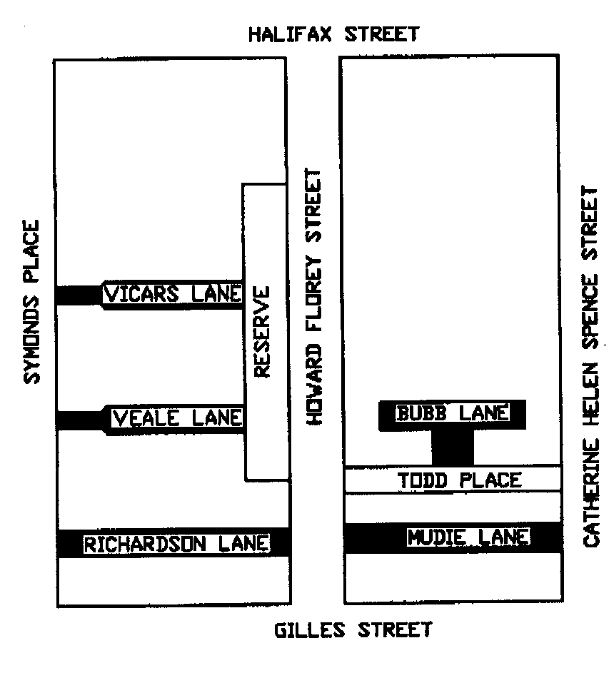
Susan Law, Chief Executive Officer

CITY OF CHARLES STURT
Development Act 1993
Hindmarsh and Woodville (City) Development Plan
Henley and Grange (City) Development Plan—Coastal Strip Plan Amendment Report—Draft for Public Consultation
NOTICE is hereby given that the City of Charles Sturt has prepared a draft Plan Amendment Report (PAR) to amend the Hindmarsh and Woodville (City) Development Plan and Henley and Grange (City) Development Plan.
The Coastal Strip PAR affects land in suburbs near to the beach throughout the Council area.
The Coastal Strip PAR proposes to amend the Development Plans to provide better policies to guide the design of new housing development in a manner that achieves both public and private design outcomes sought in the PAR. In particular, the PAR seeks to address the following issues in an integrated manner for new housing within the Coastal Strip:
• provisions of Good Residential Design SA;
• vehicle access to arterial roads;
• maintenance of on-street car parking;
• Seaview Road streetscape;
• Building appearance, scale, height and design.
The draft PAR and statement will be available for inspection and purchase ($5 per copy) from 31 October 2002 to 17 January 2003, during opening hours at the Council Office, 72 Woodville Road, Woodville, Civic Library, West Lakes Library, Henley Library, Findon Library and Hindmarsh Library. The draft PAR may also be inspected on www.charlessturt.sa.gov.au.
Written submissions regarding the draft PAR will be accepted by the City of Charles Sturt until 5 p.m. on 17 January 2003. All submissions should be addressed to the Chief Executive, City of Charles Sturt, P.O. Box 1, Woodville, S.A. 5011.
Copies of all submissions received will be available for inspection by interested persons at the Civic Centre, 72 Wood-ville Road from 20 January 2003, until the conclusion of the public hearing.
A public hearing will be held on Wednesday, 29 January 2003, commencing at 5 p.m. until 9.30 p.m. in Meeting Room CC1, Civic Centre, 72 Woodville Road, Woodville. The hearing will continue on Thursday, 30 January 2003 if necessary. Persons wishing to be heard at the public hearing are requested to indicate their intention in their submission. Interested persons may be heard in relation to the Coastal Strip PAR and/or the submissions. The public hearing may not be held if no sub-mission indicates an interest in speaking at the public hearing.
Dated 31 October 2002.
P. Lockett, Chief Executive

CITY OF MARION
Change of Name of Public Road
NOTICE is hereby given that the council of the City of Marion at its meeting held on 24 September 2002, resolved pursuant to section 219 (1) of the Local Government Act 1999, that a certain public road, being Anna Drive, Hallett Cove be changed to Annabelle Drive, Hallett Cove.
A plan which delineates the public road which is subject to the change of street name, together with a copy of the council’s resolution is available for inspection at the council’s principal office, 245 Sturt Road, Marion, S.A., during the hours of 8.30 a.m. and 5 p.m. week days.
M. Searle, Chief Executive Officer

CITY OF VICTOR HARBOR
Roads (Opening and Closing) Act 1991
Greenhills Road and Hawke Road, Lower Inman Valley
NOTICE is hereby given that pursuant to section 10 of the Roads (Opening and Closing) Act 1991 the City of Victor Harbor intends to implement a Road Process Order to open and close the following roads in the Hundred of Encounter Bay:
1. Open as road portion of section 740 to form a realignment of Greenhills Road more particularly shown as ‘1’ on Preliminary Plan No. 02/0092.
2. Close the portions of Greenhills Road no longer required as a result of the new road opening adjoining sections 484 and 485, lettered ‘A’ and ‘B’ (respectively) and close portion of Hawke Road adjoining section 470 and lettered ‘C’ on Preliminary Plan No. 02/0092.
Closed Road ‘A’ is to be transferred to D. A. & S. M. Ewen and merged with section 484.
Closed Road ‘B’ is to be transferred to J. W. & L. B. Swincer and merged with section 485.
Closed Road ‘C’ is to merge with section 470 and vest in the Crown.
A statement of persons affected by the road process together with a copy of the preliminary plan is available for public inspection at the offices of the City of Victor Harbor, Bay Road, Victor Harbor and at the Adelaide Offices of the Surveyor-General during normal office hours.
Any person who may wish to object to the proposed road process, or any person who may wish to apply for an easement to be granted in that person’s favour over the land subject to the proposed closure must lodge with the said council a notice of objection or an application for easement within 28 days of the date of this publication of this notice.
All objections shall be in writing stating the objector’s full name and address and the reasons for the objection and whether the objector wishes to appear in person or be represented at a meeting convened by the council for the determination of objections.
An application for easement shall be in writing stating the applicant’s full name and address, the reasons for the application for the grant of easement, full details of the nature and location of the easement applied for and whether the easement will be in favour of adjoining or nearby land, and if so, specifying the land to which the easement will be annexed.
Where a submission is made the council will give notification of a meeting at which the mater will be considered so that the person making the submission or their representative may attend if desired.
A copy of any notice of application shall, at the same time it is lodged with the council be forwarded to the Adelaide office of the Surveyor-General.
Dated 28 October 2002.
G. Maxwell, City Manager

BERRI BARMERA COUNCIL
Periodical Review
NOTICE is hereby given that the Berri Barmera Council in accordance with the requirements of section 12 (4) of the Local Government Act 1999, has reviewed its composition and elector representation arrangements.
Pursuant to section 12 (13) (a) of the said Act, the Electoral Commissioner has certified that the review undertaken by council satisfies the requirements of section 12 and may therefore now be put into effect as from the day of the first general election held after the expiration of five months from the publication of this notice.
The revised representation arrangements are as follows:
Retain the status quo of a Mayor and 10 Councillors; and
The council area will not be divided into wards, thereby requiring all members to represent the council area as a whole.
M. J. Hurley, Chief Executive Officer

CLARE AND GILBERT VALLEYS COUNCIL
Exclusion of Land from Classification as Community Land
NOTICE is hereby given that the Clare and Gilbert Valleys Council at its meeting held on 16 September 2002, resolved pursuant to section 193 of the Local Government Act 1999, to exclude the following parcels of land from classification as community land:
Watervale
1. Portion of the land comprised in certificate of title volume 5790, folio 84, being allotment 290 in Filed Plan No. 169229 in the Hundred of Upper Wakefield and known as Lot 290, Quelltaler Road, Watervale.
The portion is defined as:
North (rear)—10 m from CFS shed (to drain boundary);
South—to Quelltaler Road;
East—50 m from front of shed;
West—40 m to road boundary.
Saddleworth
2. (1) The whole of the land comprised in certificate of title volume 5474, folio 299, being allotment 51 in Filed Plan No. 16471 in the Hundred of Saddleworth and known as Lot 51, Charles Street, Saddleworth.
(2) The whole of the land comprised in certificate of title volume 5474, folio 298, being allotment 52 in Filed Plan No. 16471 in the Hundred of Saddleworth and known as Lot 52, Belvidere Road, Saddleworth.
Waterloo
3. The whole of the land comprised in certificate of title volume 5787, folio 570 being allotments 15 and 16 in Deposited Plan No. 153 in the Hundred of Waterloo and known as Lots 15 and 16, Sydney Street, Waterloo.
Mintaro
4. Portion of the land comprised in certificate of title volume 5807, folio 723, being allotment 328 in Filed Plan No. 169267 in the Hundred of Upper Wakefield and known as Lot 328, Burra Road, Mintaro.
The portion is defined as:
North—8 m from shed to Netball Court;
South—24.5 m from shed (edge of carpark);
East—30.0 m from shed and land for septic tank;
West—8 m from shed (road boundary).
Clare
5. The whole of the land comprised in certificate of title volume 5841, folio 123, being allotment 3 in Filed Plan No. 18480 in the Hundred of Clare and known as Lot 3, Lennon Street, Clare.
Marrabel
6. The whole of the land comprised in certificate of title volume 5673, folio 308, being allotment 4 in Deposited Plan No. 5331 in the Hundred of Waterloo and known as Lot 4, Main Road, Marrabel.
Manoora
7. The whole of the land comprised in certificate of title volume 5692, folio 808, being allotment 18 in Deposited Plan No. 285 in the Hundred of Saddleworth and known as Lot 18, John Street, Manoora.
Tarlee
8. The whole of the land comprised in certificate of title volume 5571, folio 892, being allotment 114 in Deposited Plan No. 251 in the Hundred of Gilbert and known as Lot 114, corner Gilbert Street and Craig Street, Tarlee.
Rhynie
9. The whole of the land comprised in certificate of title volume 5676, folio 773, being allotment 336 in Filed Plan No. 175656 in the Hundred of Alma and known as Lot 336, Saltersprings Road, Rhynie.
M. A. Goldstone, Chief Executive Officer

DISTRICT COUNCIL OF ELLISTON
Appointment
NOTICE is hereby given that Hayden Manhood has been appointed Acting Chief Executive Officer effective from 11 November 2002 until 15 November 2002 and 2 December 2002 until 31 January 2003 vide D. Hitchcock on leave.
D. E. Hitchcock, Chief Executive Officer

LIGHT REGIONAL COUNCIL
Change of Road Name
NOTICE is hereby given that pursuant to section 219 of the Local Government Act 1999, Light Regional Council, at its meeting held on 15 August 2000, passed a resolution to change the name of the public road in the Hundred of Kapunda, presently named Invermay Road, to rename this road Old Anlaby Road. This road is situated within the areas named Bagot Well, Allendale North and Hamilton and divides section 198 from section 11, traverses through section 7600 and divides sections 1581, 1580, 16, 15 and 277 from sections 36, 12, 276 and 279.
P. J. Beare, Chief Executive Officer

LIGHT REGIONAL COUNCIL
Change of Road Name
NOTICE is hereby given that pursuant to section 219 of the Local Government Act 1999, Light Regional Council, at its meeting held on 15 August 2000, passed a resolution to change the name of portion of the public road in the Hundred of Kapunda, presently named Grey Hill Road, to rename this road River Road. This road is situated within the areas named Bagot Well and Hansborough and divides sections 1253 to 1258 inclusive from sections 281, 283, 319 and 320.
P. J. Beare, Chief Executive Officer

MID MURRAY COUNCIL
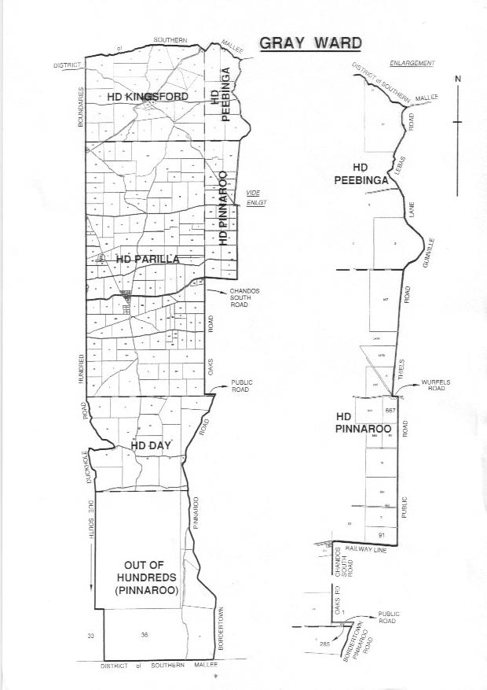Declaration of Public Road
PURSUANT to section 208 of the Local Government Act 1999, the Mid Murray Council resolved at its meeting held on 14 October 2002, that the land, being allotments 4, 5 and 9 in Deposited Plan 57740, is hereby declared to be a public road.
G. Brus, Chief Executive

DISTRICT COUNCIL OF PETERBOROUGH
Periodical Review
NOTICE is hereby given that the District Council of Peterborough has reviewed its elector representation arrange-ments in accordance with the provisions of section 12 of the Local Government Act 1999.
Pursuant to section 12 (13) (a) of the Local Government Act 1999, the Electoral Commission has certified that the periodical review has complied with the requirements of section 12 of the said Act. The review recommended that the status quo remain, i.e. 8 Councillors and a Mayor and no wards. No written submissions were received during the review process and a copy of the review report is available at the Council office.
T. D. Barnes, Chief Executive Officer

PORT PIRIE REGIONAL COUNCIL
Declaration of Public Streets and Roads
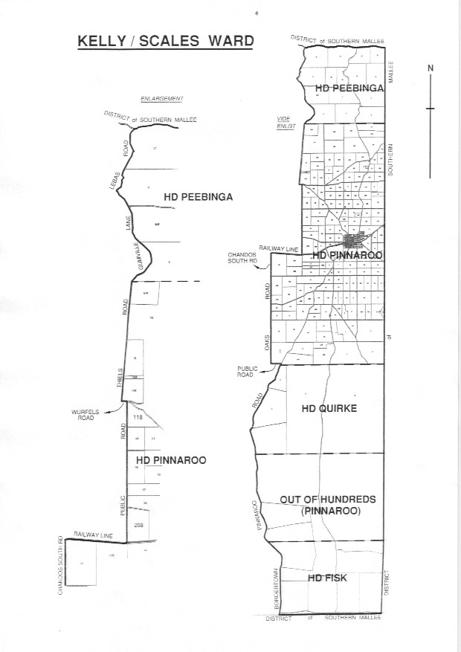
NOTICE is hereby given that the Port Pirie Regional Council at its meeting held on 25 September 2002, resolved pursuant to the powers contained in section 208 of the Local Government Act 1999, that all of the land laid out as streets and roads as originally delineated in Deposited Plan 1667, Hundred of Pirie, be declared public roads, excluding those roads previously closed or declared public.
J. Vucic, Chief Executive Officer

SOUTHERN MALLEE DISTRICT COUNCIL
Periodical Review
NOTICE is hereby given that the Southern Mallee District Council has reviewed its elector representation arrangements in accordance with the provisions of section 12 of the Local Government Act 1999.
Pursuant to section 12 (13) (a) of the Local Government Act 1999, the Electoral Commissioner has certified that the Periodical Review has complied with the requirements of section 12 of the said Act. The revised representation arrangements take effect as from the day of the first general election held after the expiration of five months from the publication of this notice.
The revised representation arrangements are as follows:
• Councillors reduced from 10 to 9.
• Ward numbers reduced from 5 to 4 with the boundaries of Kelly Ward, Gray Ward and Scales Ward of the Southern Mallee District Council being altered and adjusted to form two new wards to be known as Gray Ward and Kelly/ Scales Ward defined in the First and Second Schedules respectively.
The First Schedule
Gray Ward: Comprising the whole of the Hundred of Parilla, and portions of the Hundreds of Kingsford, Peebinga, Pinnaroo, Day and Quirke, County of Chandos, and portion of Out of Hundreds (Pinnaroo), more particularly delineated on the plan published herewith.
The Second Schedule
Kelly/Scales Ward: Comprising portions of the Hundreds of Peebinga, Pinnaroo, Quirke and Fisk, County of Chandos, and portion of Out of Hundreds (Pinnaroo), more particularly delineated on the plan published herewith.

P. Wood, Chief Executive Officer

DISTRICT COUNCIL OF TUMBY BAY
Appointment
NOTICE is hereby given that at a meeting of council held on 14 October 2002, Roger Pepworth was appointed as an authorised person pursuant to section 260 of the Local Government Act 1999 to carry out the powers under section 261 of the Act.
E. A. Roberts, District Clerk

WAKEFIELD REGIONAL COUNCIL
Wakefield Regional Council Development Plan Industry (Bowmans) Plan Amendment Report for Public Consultation
THE Wakefield Regional Council has prepared a draft Plan Amendment Report to amend the Wakefield Regional Council Development Plan as it affects the area situated in the locality of Bowmans.
The Plan Amendment Report will amend the Wakefield Regional Council Development Plan by creating a new specific-purpose zone covering certain land at Bowmans south of the main Balaklava-Port Wakefield Road for the purpose of facilitating future industrial development.
This new zone is to be called the Industry (Bowmans) Zone and will introduce a policy framework which expressly promotes economic development, especially in value-adding industries linked with rural commodities.
The draft Plan Amendment Report and statement will be available for public inspection and purchase during normal office hours at the Wakefield Regional Council Office, 10 Edith Terrace, Balaklava from Wednesday, 30 October 2002 to Friday, 10 January 2003.
A copy of the Plan Amendment Report can be purchased from the council at $5 each or downloaded free of charge from the council’s website at www.wakefieldrc.sa.gov.au.
Written submissions regarding the draft amendment will be accepted by the Wakefield Regional Council until the close of business on Friday, 10 January 2003. The written submission should also clearly indicate whether you wish to speak at the public hearing on your submission. All submissions should be addressed to the Chief Executive Officer of the Wakefield Regional Council, P.O. Box 167, Balaklava, S.A. 5461.
Copies of all submissions received will be available for inspection by interested persons at the Council Office, 10 Edith Terrace, Balaklava from Monday, 13 January 2003 until the date of the public hearing.
A public hearing will be held at 5.30 p.m. at the Wakefield Regional Council Chambers, 10 Edith Terrace, Balaklava on Wednesday, 22 January 2003. The public hearing may not be held if no submission indicates an interest in speaking at the public hearing.
Dated 30 October 2002.
P. Barry, Chief Executive Officer

IN the matter of the estates of the undermentioned deceased persons:
Cabot, Florence Violet, late of 82 Williams Road, Millicent, home duties, who died on 26 August 2002.
Davis, Edward Sydney Malines, late of 86 Oaklands Road, Glengowrie, retired maintenance worker, who died on 5 August 2002.
Evangelista, Eliza Jean, late of 13 Dunedin Street, Dover Gardens, home duties, who died on 17 September 2002.
Glasson, Jack D’arcy, late of 157 Beulah Road, Norwood, retired sales supervisor, who died on 21 August 2002.
Gourlay, Leslie Clive, late of 23 Peters Street, Whyalla Playford, fitter and turner, who died on 4 June 2002.
Horne, Phyllis Edna, late of 157 Beulah Road, Norwood, widow, who died on 27 August 2002.
Houlgrave, Violet Madeline, late of 63-71 Labrina Avenue, Prospect, of no occupation, who died on 8 September 2002.
Hughes, Harry, late of 557 Main North Road, Elizabeth North, retired patrol inspector, who died on 20 August 2002.
Johns, Mavis Gwendoline, late of Hazel Grove, Ridgehaven, of no occupation, who died on 4 September 2002.
King, Dudley Thomas, late of 35 Jollytown Road, Lyndoch, retired labourer, who died on 6 August 2002.
Morley, Iris Maud, late of 121 Nookamka Terrace, Barmera, of no occupation, who died on 19 July 2002.
Peddey, Basil John, late of 36 Hudson Avenue, Croydon Park, retired cook, who died on 17 August 2002.
Roberts, William Francis Earl, late of 80 Moseley Street, Glenelg South, retired shop assistant, who died on 7 September 2002.
Turner, Gwendoline Rebecca, late of 67 Windsor Grove, Klemzig, retired dress maker, who died on 16 August 2002.
Walter, Joyce Patricia, late of 550 Portrush Road, Glen Osmond, married woman, who died on 9 September 2002.
Williams, Gordon Clyde, late of 2 Miller Street, Prospect, retired painter, who died on 28 June 2002.
Notice is hereby given pursuant to the Trustee Act 1936, as amended, the Inheritance (Family Provision) Act 1972, and the Family Relationships Act 1975, that all creditors, beneficiaries, and other persons having claims against the said estates are required to send, in writing, to the Public Trustee, 25 Franklin Street, Adelaide, S.A. 5000, full particulars and proof of such claims, on or before 29 November 2002, otherwise they will be excluded from the distribution of the said estate; and notice is also hereby given that all persons who are indebted to the said estates are required to pay the amount of their debts to the Public Trustee or proceedings will be taken for the recovery thereof; and all persons having any property belonging to the said estates are forthwith to deliver the same to the Public Trustee.
Dated 31 October 2002.
C. J. O’Loughlin, Public Trustee

ATTENTION

CUSTOMERS requiring a proof of their notice for inclusion in the Government Gazette, please note that the onus is on you to inform Government Publishing SA of any subsequent corrections by 10 a.m. on Thursday, which is our publication deadline.

For any corrections to your notice please phone 8207 1045 or Fax 8207 1040 before 10 a.m. on Thursday.

If we do not receive any communication by 10 a.m. on Thursday (day of publication) we will presume the notice is correct and will print it as it is.

Remember—the onus is on you to inform us of any corrections necessary to your notice.

NOTE: Closing time for lodging new copy (electronically, fax or hard copy) is 4 p.m. on Tuesday preceding the day of publication. Phone 8207 1045—Fax 8207 1040.
Email: governmentgazette@saugov.sa.gov.au

Printed and published by authority every Thursday by J. D. FERGUSON, Government Printer, South Australia
Price: $4.55, plus postage; to subscribers, $229.00 per annum.
(The above prices are inclusive of GST)

