No. 99 3335

THE SOUTH AUSTRALIAN

GOVERNMENT GAZETTE

PUBLISHED BY AUTHORITY

ALL PUBLIC ACTS appearing in this GAZETTE are to be considered official, and obeyed as such

ADELAIDE, THURSDAY, 5 SEPTEMBER 2002

CONTENTS

Page
Acts Assented To 3336
Appointments, Resignations, Etc. 3338
Agricultural Chemicals Act 1955—Notice 3339
Authorised Betting Operations Act 2000—Notices 3339
Corporations and District Councils—Notices 3374
Development Act 1993—Notice 3355
Electoral Act 1985—Notice 3355
Geographical Names Act 1991—Corrigendum 3355
Land Acquisition Act 1969—Notices 3356
Land and Business (Sale and Conveyancing) Act 1994—
Notices 3355
Legislative Council—Disallowance 3362
Liquor Licensing Act 1997—Notices 3362
Local Government Act 1999—Notices 3365
Mining Act 1971—Notices 3368
Petroleum Act 2000—Notice 3370
Primary Industries and Resources—Corrigendum 3370
Private Advertisement 3377
Proclamations 3336
Public Trustee Office—Administration of Estates 3376
Roads (Opening and Closing) Act 1991—Notice 3370
Road Traffic Act 1961—Notice 3370
Transport, Department of—Notices to Mariners 3370
Water Mains and Sewers—Mains Laid, Replaced, Etc 3371

GOVERNMENT GAZETTE NOTICES
ALL poundkeepers’ and private advertisements forwarded for publication in the South Australian Government Gazette must be PAID FOR PRIOR TO INSERTION; and all notices, from whatever source, should be legibly written on one side of the paper only and sent to Government Publishing SA so as to be received no later
than 4 p.m. on the Tuesday preceding the day of publication. Phone 8207 1045 or Fax 8207 1040. E-mail: governmentgazette@saugov.sa.gov.au. Send as attachments in Word format and please confirm your transmission with a faxed copy of your document, including the date the notice is to be published and to whom the notice will be charged.

Department of the Premier and Cabinet
Adelaide, 5 September 2002
HER Excellency the Governor directs it to be notified for general information that she has in the name and on behalf of Her Majesty The Queen, this day assented to the undermentioned Acts passed by the Legislative Council and House of Assembly in Parliament assembled, viz.:
No. 10 of 2002—Fisheries (Contravention of Corresponding Laws) Amendment Act 2002. An Act to amend the Fisheries Act 1982.
No. 11 of 2002—Fisheries (Validation of Administrative Acts) Act 2002. An Act to validate certain administrative acts and payments.
No. 12 of 2002—Prices (Prohibition on Return of Unsold Bread) Amendment Act 2002. An Act to amend the Prices Act 1948.
No. 13 of 2002—Air Transport (Route Licensing—Passenger Services) Act 2002. An Act to establish a licensing system for regular passenger air services on declared routes between airports in the State; and for other purposes.
No. 14 of 2002—Essential Services Commission Act 2002. An Act to establish the Essential Services Commission; to repeal the Independent Industry Regulator Act 1999; to amend the Local Government Act 1999 and the Maritime Services (Access) Act 2000; and for other purposes.
No. 15 of 2002—Stamp Duties (Rental Business and Con-veyance Rates) Amendment Act 2002. An Act to amend the Stamp Duties Act 1923.
No. 16 of 2002—Statutes Amendment (Structured Settle-ments) Act 2002. An Act to amend the District Court Act 1991, the Magistrates Court Act 1991 and the Supreme Court Act 1935.
By command,
J. W. Weatherill, for Premier
DPC 97/0415

ADMINISTRATIVE ARRANGEMENTS ACT 1994 SECTION 5: ADMINISTRATION OF AUTHORISED BETTING OPERATIONS ACT 2000, LOTTERY AND GAMING ACT 1936 AND COLLECTIONS FOR CHARITABLE PURPOSES ACT 1939 COMMITTED TO THE MINISTER FOR GAMBLING
Proclamation By The Governor
(l.s.) Marjorie Jackson-Nelson
PURSUANT to section 5 of the Administrative Arrangements Act 1994 and with the advice and consent of the Executive Council, I commit the administration of the Authorised Betting Operations Act 2000, the Lottery and Gaming Act 1936 and the Collections for Charitable Purposes Act 1939 to the Minister for Gambling.
Given under my hand and the Public Seal of South Australia, at Adelaide, 5 September 2002.
By command,
J. W. Weatherill, for Premier
T&F 02/080CS

HIGHWAYS ACT 1926 SECTION 27AA: CLOSURE OF PORTION OF SOUTH EASTERN FREEWAY AT CRAFERS INTERCHANGE, HUNDRED OF ADELAIDE
Proclamation By The Governor
(l.s.) Marjorie Jackson-Nelson
PURSUANT to section 27AA of the Highways Act 1926, on the recommendation of the Commissioner of Highways made pursuant to that section and with the advice and consent of the Executive Council, I close that portion of the South Eastern Freeway delineated as allotment 1 in Lands Titles Registration Office Filed Plan No. 43519.
Given under my hand and the Public Seal of South Australia, at Adelaide, 5 September 2002.
By command,
J. W. Weatherill, for Premier
TSA 2001/01751

OATHS ACT 1936 SECTION 33(1): APPOINTMENT OF MEMBERS OF THE POLICE FORCE TO TAKE DECLARATIONS AND ATTEST THE EXECUTION OF INSTRUMENTS
Proclamation By The Governor
(l.s.) Marjorie Jackson-Nelson
PURSUANT to section 33(1) of the Oaths Act 1936 and with the advice and consent of the Executive Council, I appoint the following members of South Australia Police to take declarations and attest the execution of instruments:
Inspector Anthony Alexander Fioravanti
Inspector Martin John Jeffrey
Inspector Graham John Martin
Inspector Paul Calman Maschgan.
Given under my hand and the Public Seal of South Australia, at Adelaide, 5 September 2002.
By command,
J. W. Weatherill, for Premier
AGO 0278/02CS

SHOP TRADING HOURS ACT 1977 SECTION 13: AUTHORISATION TO OPEN SHOP DURING SPECIFIED HOURS—BIG W AT GAWLER
Proclamation By The Governor
(l.s.) Marjorie Jackson-Nelson
PURSUANT to section 13 of the Shop Trading Hours Act 1977 and with the advice and consent of the Executive Council, I authorise the opening of the shop known as Big W, located at 2 Commercial Lane, Gawler ("the shop") from 7 p.m. until 9 p.m. on Friday, 13 September 2002, subject to the conditions specified in the Schedule.
Schedule
This proclamation only authorises the opening of the shop if—
(a) the shop keeper ensures that the only persons allowed to enter or remain in the shop during the hours specified in this proclamation (other than persons employed in the business of the shop during those hours) are persons who hold a Woolworths Limited staff discount card, the immediate families of those persons, and by special invitation, the suppliers, builders, technicians and contractors of the shop; and
(b) all relevant industrial awards, workplace agreements and enterprise agreements are observed by the shopkeeper and persons employed in the business of the shop during and in relation to the hours specified in this proclamation during which the shop is open; and
(c) subject to an industrial award, workplace agreement or enterprise agreement to the contrary—a person who is employed in the business of the shop is entitled to refuse to work at the shop during the hours specified in this proclamation unless he or she has agreed with the shopkeeper to work during those hours.
Given under my hand and the Public Seal of South Australia, at Adelaide, 5 September 2002.
By command,
J. W. Weatherill, for Premier
MIR 02/020 CS

PUBLIC SECTOR MANAGEMENT ACT 1995 SECTION 71: EXTENSION OF CLAUSES 8, 9, 10, 11, 12 AND 13 OF SCHEDULE 2 TO PUBLIC SECTOR EMPLOYEES COVERED BY THE FIREFIGHTING INDUSTRY EMPLOYEES AWARD 1993
Proclamation By The Governor
(l.s.) Marjorie Jackson-Nelson
PURSUANT to section 71 of the Public Sector Management Act 1995 and with the advice and consent of the Executive Council, I extend the operation of clauses 8, 9, 10, 11, 12 and 13 of Schedule 2 of that Act (the "relevant clauses") to public sector employees covered by the Firefighting Industry Employees Award 1993 (or its successor) (the "specified class"), subject to the following modifications:
(a) the following subclause is inserted after subclause (1) of clause 8:
(1a) The following provisions apply in relation to a public sector employee covered by the Firefighting Industry Employees Award 1993 (or its successor):
(a) if, immediately prior to the commencement of this subclause, the employee was entitled to any long service leave under the Long Service Leave Act 1987, that long service leave entitle-ment will be taken to be the employee's accrued long service leave entitlement under this clause;
(b) however, despite paragraph (a)—
(i) if the employee’s 16th year of effective service, or a subsequent year of effective service, commenced prior to 1 January 2002 but ends on or after that date, the employee is, in respect of that year, entitled (instead of the amount to which he or she would otherwise be entitled under paragraph (a)) to an amount determined in accordance with the following formula:
where—
E is the number of days leave to which the employee is entitled (any remaining fraction of half or more of one day being regarded as one day);
D is the number of days in the period commencing on (and including) the day on which the 16th or subsequent year of effective service, as the case requires, of the employee com-menced and concluding on (and including) 31 December 2001;
(ii) if the employee’s 16th year of effective service, or a subsequent year of effective service, commenced or commences on or after 1 January 2002, the employee is entitled—
(A) in respect of that year (instead of the amount to which he or she would otherwise be entitled under paragraph (a)); and
(B) in respect of each subsequent year of effective service,
to 15 days of long service leave.;
(b) for the purpose of applying the relevant clauses (as modified by paragraph (a)) to employees in the specified class—
(i) all references in those clauses to "effective service" are to be read as references to—
(A) service (within the meaning of the Long Service Leave Act 1987) of the employee in a public sector agency, or with another organisation where such service has been previously recognised by the Chief Officer of the South Australian Metropolitan Fire Service for the purpose of determining long service leave entitlements, occurring before the making of this proclamation; and
(B) service of the employee in the public sector occurring after the making of this proclamation that is recognised, in accordance with directions issued by the Commissioner, as a period of effective service;
(ii) all references in those clauses to an "employee" are to be read as including reference to employees in the specified class;
(iii) all references in those clauses to the "Chief Executive of the administrative unit in which the employee is employed" or "Chief Executive" are, in relation to employees in the specified class, to be read as references to the Chief Officer of the South Australian Metropolitan Fire Service;
(iv) all references in those clauses to an "executive" are to be read as references to an employee in the specified class recognised, in accordance with directions issued by the Commissioner, as an executive.
Given under my hand and the Public Seal of South Australia, at Adelaide, 5 September 2002.
By command,
$\text{E = }\frac{\text{9D}}{\text{365}}\text{ + }\frac{\text{15 }(\text{365 - D})}{\text{365}}$J. W. Weatherill, for Premier
02/0337

SOUTH AUSTRALIAN PORTS (DISPOSAL OF MARITIME ASSETS) ACT 2000 SECTIONS 15(4) AND 16(1): DISSOLUTION OF SOUTH AUSTRALIAN PORTS CORPORATION AND REPEAL OF SOUTH AUSTRA-LIAN PORTS CORPORATION ACT 1994
Proclamation By The Governor
(l.s.) Marjorie Jackson-Nelson
PURSUANT to sections 15(4) and 16(1) of the South Australian Ports (Disposal of Maritime Assets) Act 2000 and with the advice and consent of the Executive Council, I—
(a) dissolve the South Australian Ports Corporation; and
(b) fix 5 September 2002 as the date on which the South Australian Ports Corporation Act 1994 will be repealed.
Given under my hand and the Public Seal of South Australia, at Adelaide, 5 September 2002.
By command,
J. W. Weatherill, for Premier
MGE 02/015 CS

Department of the Premier and Cabinet
Adelaide, 5 September 2002
HER Excellency the Governor in Executive Council has been pleased to appoint the undermentioned to the Guardianship Board, pursuant to the provisions of the Guardianship and Administration Act 1993:
Section 8 (2) Panel Member: (from 5 September 2002 until 4 September 2005)
Raymond Olson
Judith Helen Worrall
By command,
J. W. Weatherill, for Premier
MSJ 0991/02CS

Department of the Premier and Cabinet
Adelaide, 5 September 2002
HER Excellency the Governor in Executive Council has been pleased to appoint the undermentioned to the Development Policy Advisory Committee, pursuant to the provisions of the Develop-ment Act 1993:
Member: (from 5 September 2002 until 30 June 2003)
Grant Pember
By command,
J. W. Weatherill, for Premier
DTUP-PL 00017/2002CS

Department of the Premier and Cabinet
Adelaide, 5 September 2002
HER Excellency the Governor in Executive Council has been pleased to appoint the undermentioned to the South Australian Tourism Commission Board, pursuant to the provisions of the South Australian Tourism Commission Act 1993:
Director: (from 20 September 2002 until 19 September 2003)
Philip James Hoffmann
Francene Connor
Jane James
Peter Hurley
Chair: (from 20 September 2002 until 19 September 2003)
Philip James Hoffmann
Deputy Chair: (from 20 September 2002 until 19 September 2003)
Anne Kathryn Skipper
By command,
J. W. Weatherill, for Premier
MTOR 04/02CS

Department of the Premier and Cabinet
Adelaide, 5 September 2002
HER Excellency the Governor in Executive Council has revoked the appointment of the Honourable Paul Holloway, MLC as Acting Minister for Energy for the period from 9 September 2002 to 13 September 2002 inclusive, during the absence of the Honourable Patrick Frederick Conlon, MP.
By command,
J. W. Weatherill, for Premier
MAFF 0053/02CS

Department of the Premier and Cabinet
Adelaide, 5 September 2002
HER Excellency the Governor in Executive Council has been pleased to appoint the Honourable Michael John Atkinson, MP, Attorney-General, Minister for Justice, Minister for Consumer Affairs and Minister for Multicultural Affairs to be also Acting Minister for Agriculture, Food and Fisheries, Acting Minister for Mineral Resources Development and Acting Minister for Energy for the period 9 September 2002 to 13 September 2002, inclusive, during the absence of the Honourable Paul Holloway, MLC and the Honourable Patrick Frederick Conlon, MP.
By command,
J. W. Weatherill, for Premier
MAFF 0053/02CS

Department of the Premier and Cabinet
Adelaide, 5 September 2002
HER Excellency the Governor in Executive Council has been pleased to appoint the Honourable Michael David Rann, MP, Premier, Minister for Economic Development, Minister for the Arts and Minister for Volunteers to be also Acting Minister for Tourism, Acting Minister for Small Business, Acting Minister for Science and Information Economy and Acting Minister for Employment, Training and Further Education for the period 10 September 2002 to 12 September 2002 inclusive, during the absence of the Honourable Jane Diane Lomax-Smith, MP.
By command,
J. W. Weatherill, for Premier
MTOR 08/02CS

Department of the Premier and Cabinet
Adelaide, 5 September 2002
HER Excellency the Governor in Executive Council has been pleased to appoint the people listed as Justices of the Peace for South Australia, pursuant to section 4 of the Justices of the Peace Act 1991:
Scott Gibson Bradley
Charles Terence Cook
Lynette Dibben
Warrick Arthur Dillon
Douglas Harold Fletcher
Sotirios Gardounis
Robert Nickolas Jenkins
Frank Alyn Jewell
George Richard Kozminski
Gary John Leverington
Monte Craig Leverington
Brenton Leigh Mart
Jed Thomas Richards
Melissa May Stewart
Tolley Iven Wasylenko
Vicki Wilson
By command,
J. W. Weatherill, for Premier
ATTG 0046/02CS

Department of the Premier and Cabinet
Adelaide, 5 September 2002
HER Excellency the Governor in Executive Council has removed from office the Justices of the Peace listed, pursuant to section 6 of the Justices of the Peace Act 1991:
Sandra Kaye Bethley
Allan Timothy Evans
Ann Flower
Graham Robert Garrett
Darren James Gray
Anthony Francis Halman
John Douglas Harper
Alexander John Hathaway
Patrick Terrance Holland
Jeffrey Charles Johnson
Leslie Samuel Keller
Sheila Joan McCreanor
Karen Ruth Sheridan
Mark Andrew Sickerdick
John Bertram Stafford
Robert Stirling Todd
By command,
J. W. Weatherill, for Premier
ATTG 0057/02CS

AGRICULTURAL CHEMICALS ACT 1955
Declaration that the Use of Certain Agricultural Chemicals
for a Particular Purpose is Not Authorised
PURSUANT to section 11A of the Agricultural Chemicals Act 1955, I make the following declaration concerning the use of agricultural chemicals:
In relation to an agricultural chemical listed in Column A of the Schedule, a purpose listed in Column B of the Schedule is not an authorised purpose for that chemical.
Schedule
Column A Column B
(a) Bioresmethrin Insecticide on grain
(b) Ethylene Dibromide Soil fumigant
Notices in relation to the use of agricultural chemicals have also been made on 12 November 1992 (see Gazette 12 November 1992, page 1513) and on 22 June 1995 (see Gazette 22 June 1995, page 2940).
Dated 14 August 2002.
P. Holloway, Minister for Agriculture, Food and Fisheries.

AUTHORISED BETTING OPERATIONS ACT 2000
No. 7 of 2002
Notice of Approval of Contingencies
THE INDEPENDENT GAMBLING AUTHORITY, by this notice, approves contingencies relating to sporting or other events within Australia:
Citation
1. This notice may be cited as the Approved Contingencies (Beltana Picnic Races—Galloping) Notice 2002.
Approval
2. (1) The contingencies listed in the table are approved in respect of fixed odds betting by licensed bookmakers.
(2) This approval is subject to the provisions of the Authorised Betting Operations Act 2000 (‘the Act’), the Bookmakers Licensing Rules 2000, any other rules made under section 62 of the Act, and the conditions to which a licence or permit are subject.
(3) This approval of contingencies may be amended or revoked by further notice.
Definitions
3. In this notice:
‘Event’:
(a) means a race on the flat for horses where each animal is ridden by a person;
(b) includes, in relation to an event mentioned in paragraph (a) for which there were more accepters than places, a division of that event offering the same prize as the event.
‘Place’ means the contingency that a specified Entrant will place either first, second or third (or, if applicable, fourth) in a specified Event (including where different odds are offered by a bookmaker for first place vis-a-vis any of second, third or, if applicable, fourth place).
‘Win’ means the contingency that a specified Entrant will place first in or win a specified Event.
Table
Picnic race meeting conducted by or on behalf of the Beltana Sport and Social Progress Association Incorporated at
Beltana on 14 September 2002 and any later date to
which the meeting may be adjourned
No. | Description of Event | Prizes | Approved  Contingencies
1. | Open race over 1 200 m for horses | First—$540  Second—$270  Third—$90 | Win, place or derivative
2. | Open race over 1 000 m for horses | First—$540  Second—$270  Third—$90 | Win, place or derivative
3. | Open race over 1 000 m for horses | First—$600  Second—$300  Third—$100 | Win, place or derivative
4. | Open race over 1 500 m for horses | First—$600  Second—$300  Third—$100 | Win, place or derivative
5. | Open race over 1 500 m for horses | First—$1 400 plus cup  Second—$400  Third—$200 | Win, place or derivative
Dated 29 August 2002.
R. C. J. Chappell, Secretary to the Independent Gambling Authority

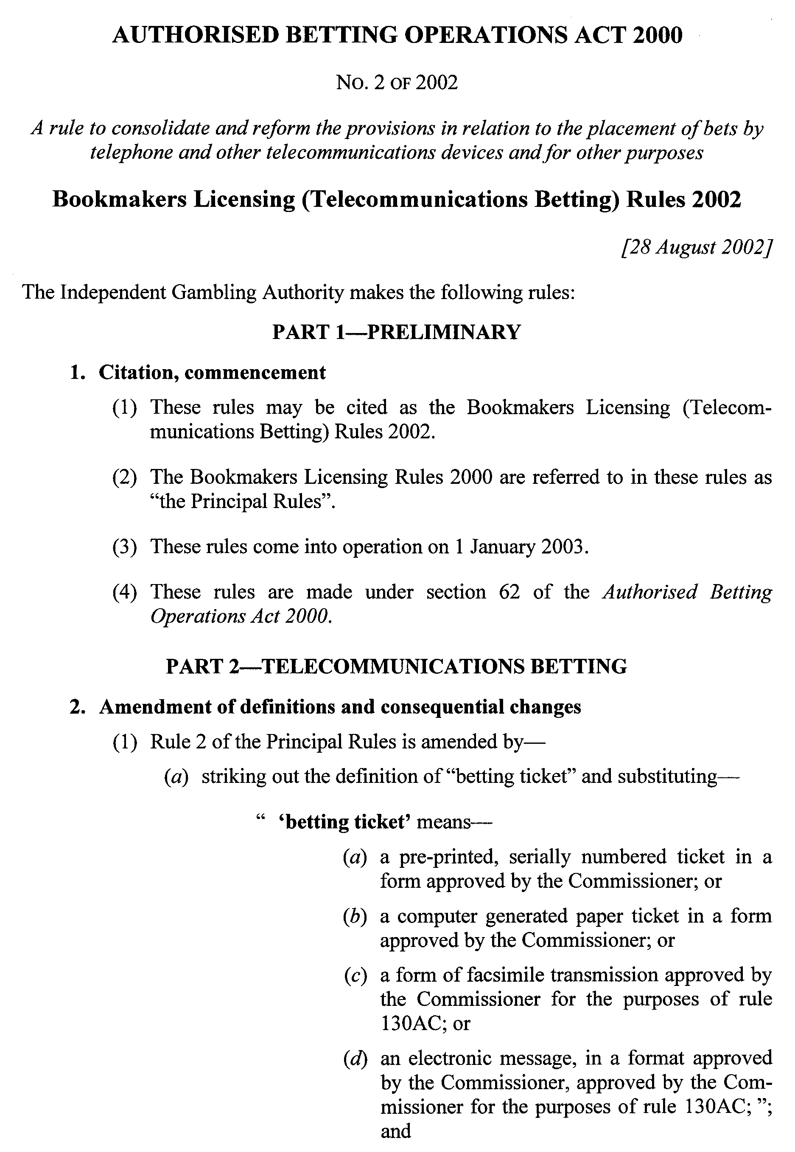
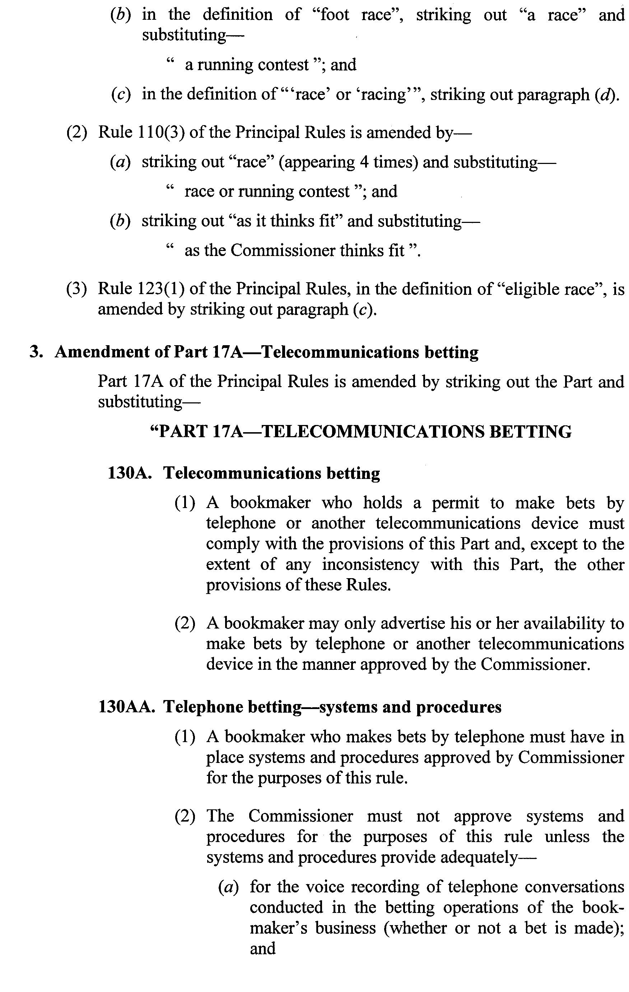
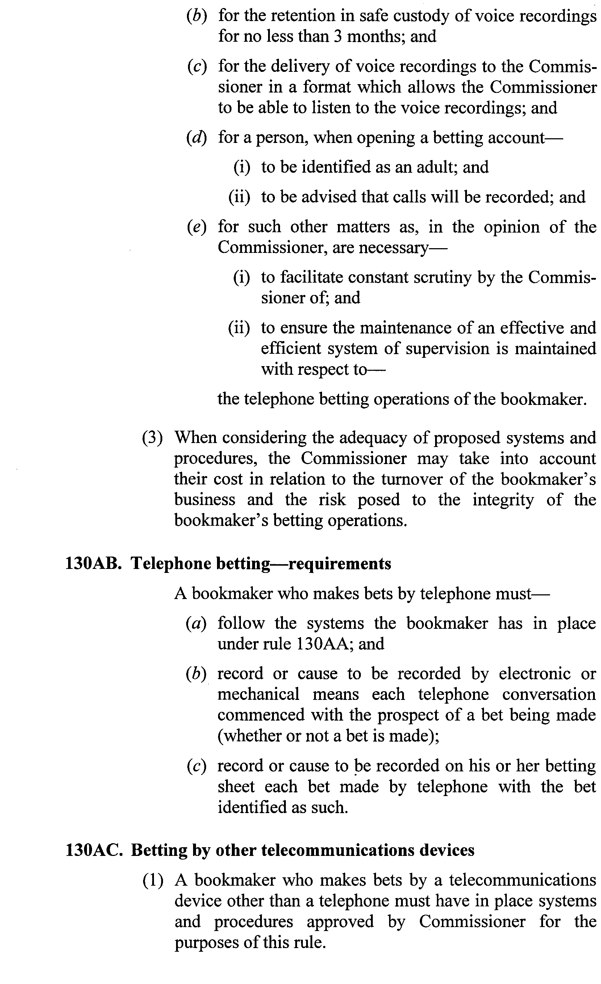
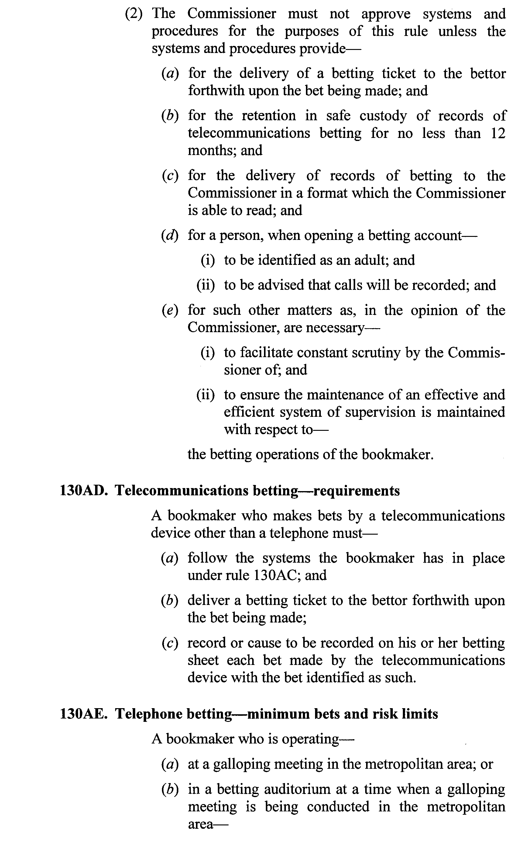
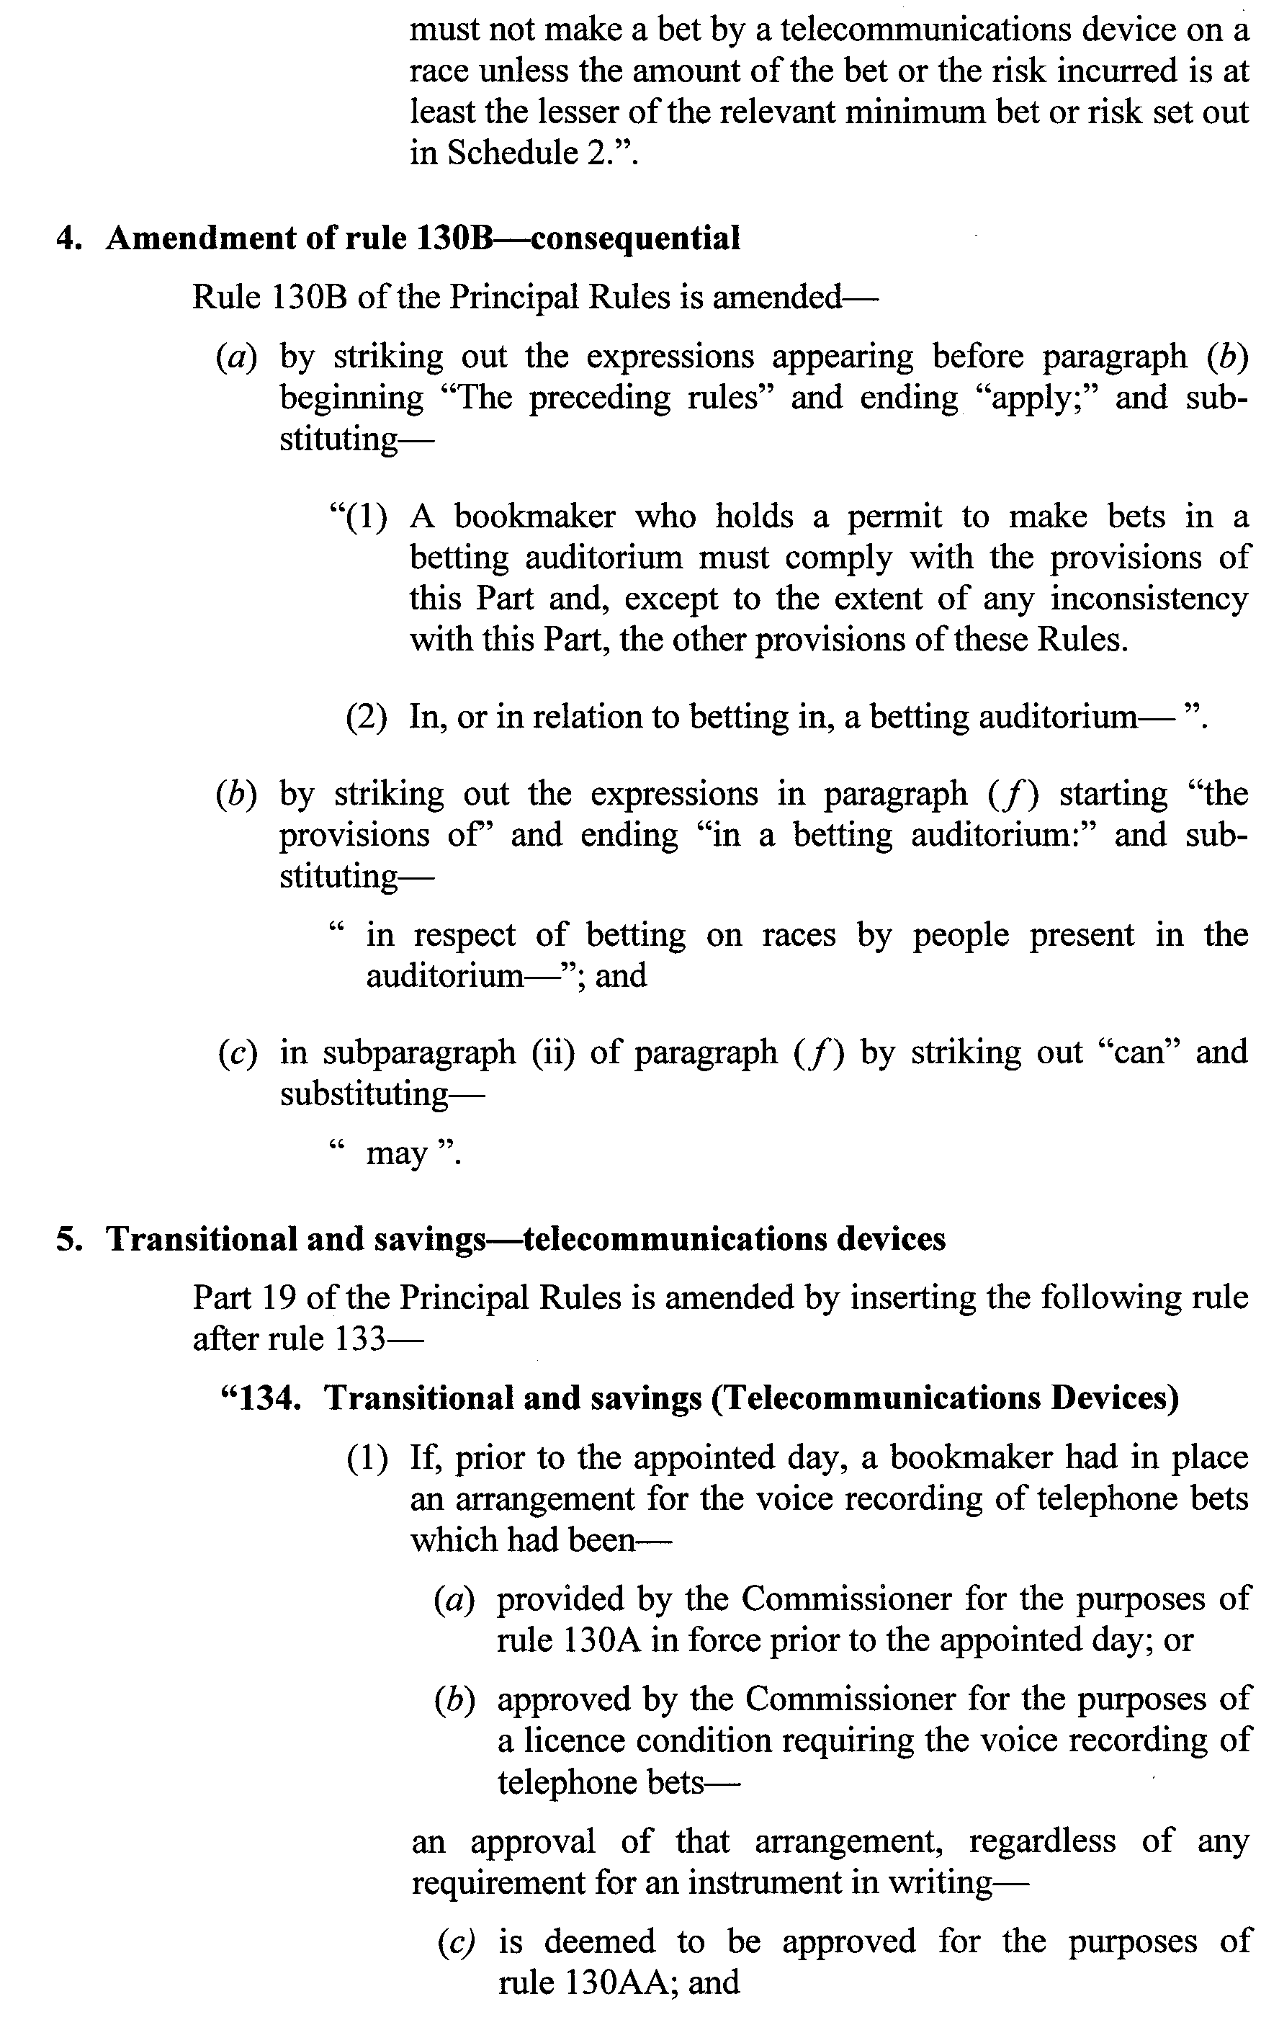
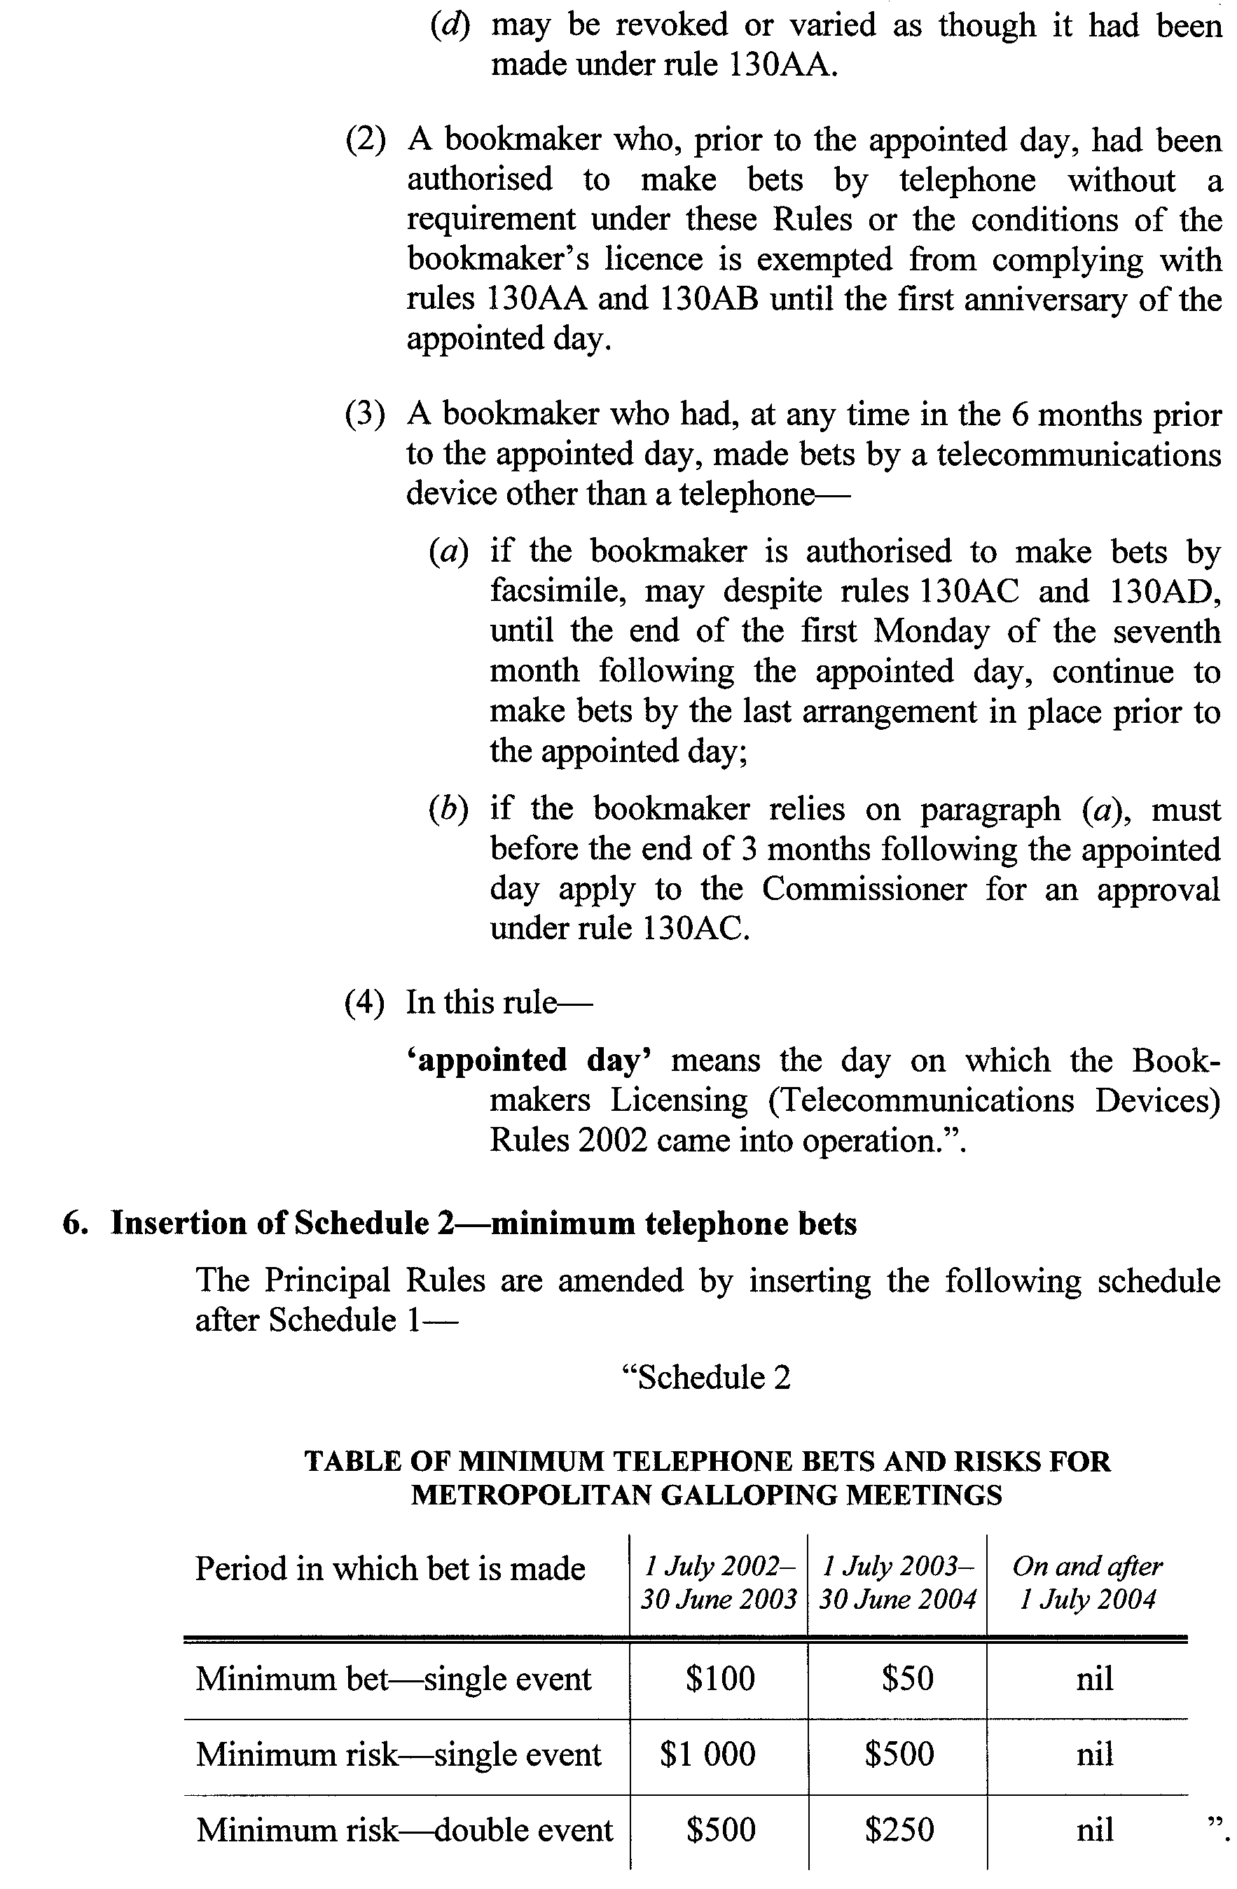
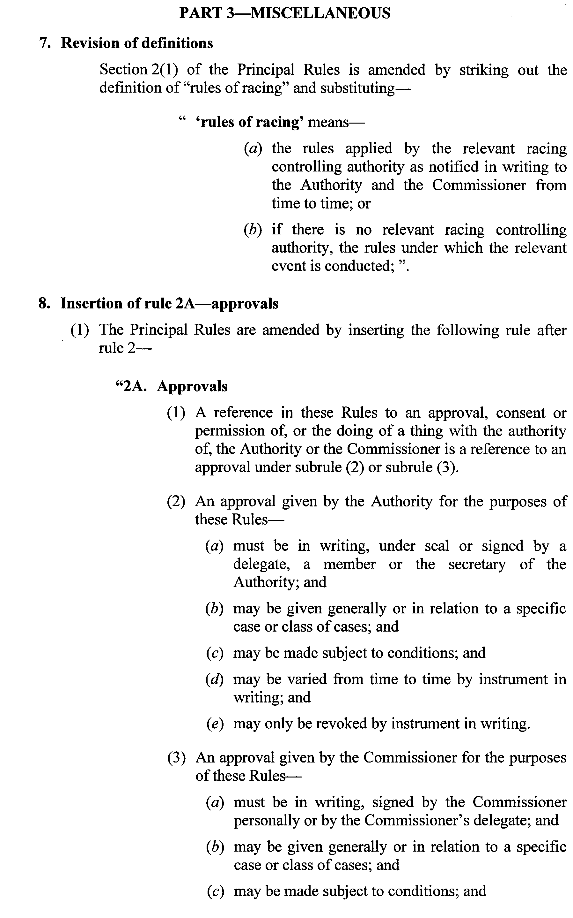

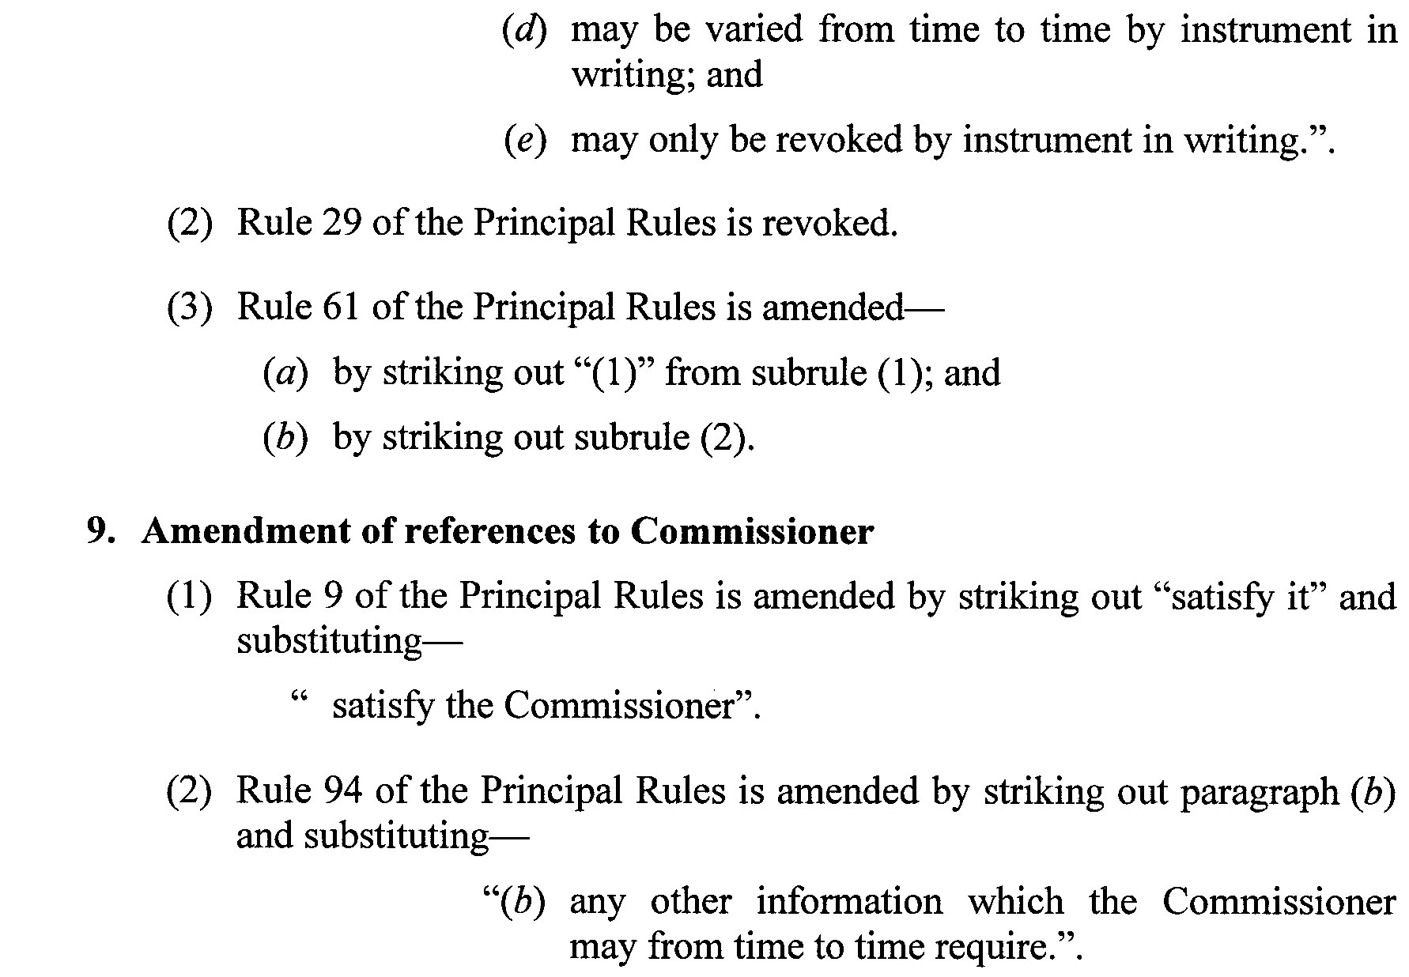
Dated 29 August 2002.
R. C. J. Chappell, Secretary to the Independent Gambling Authority

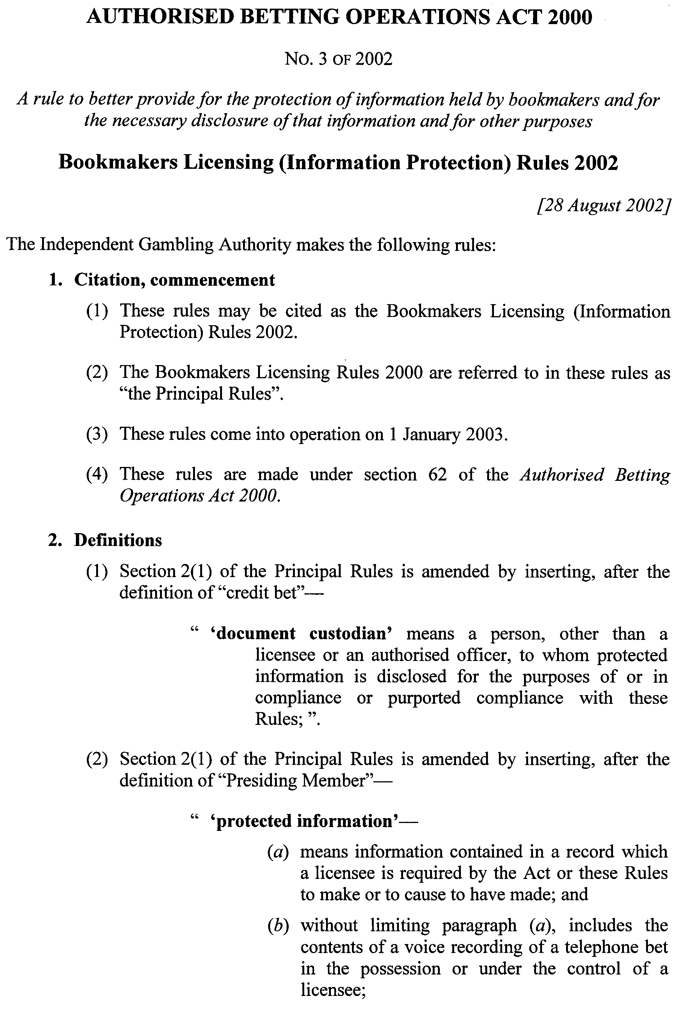
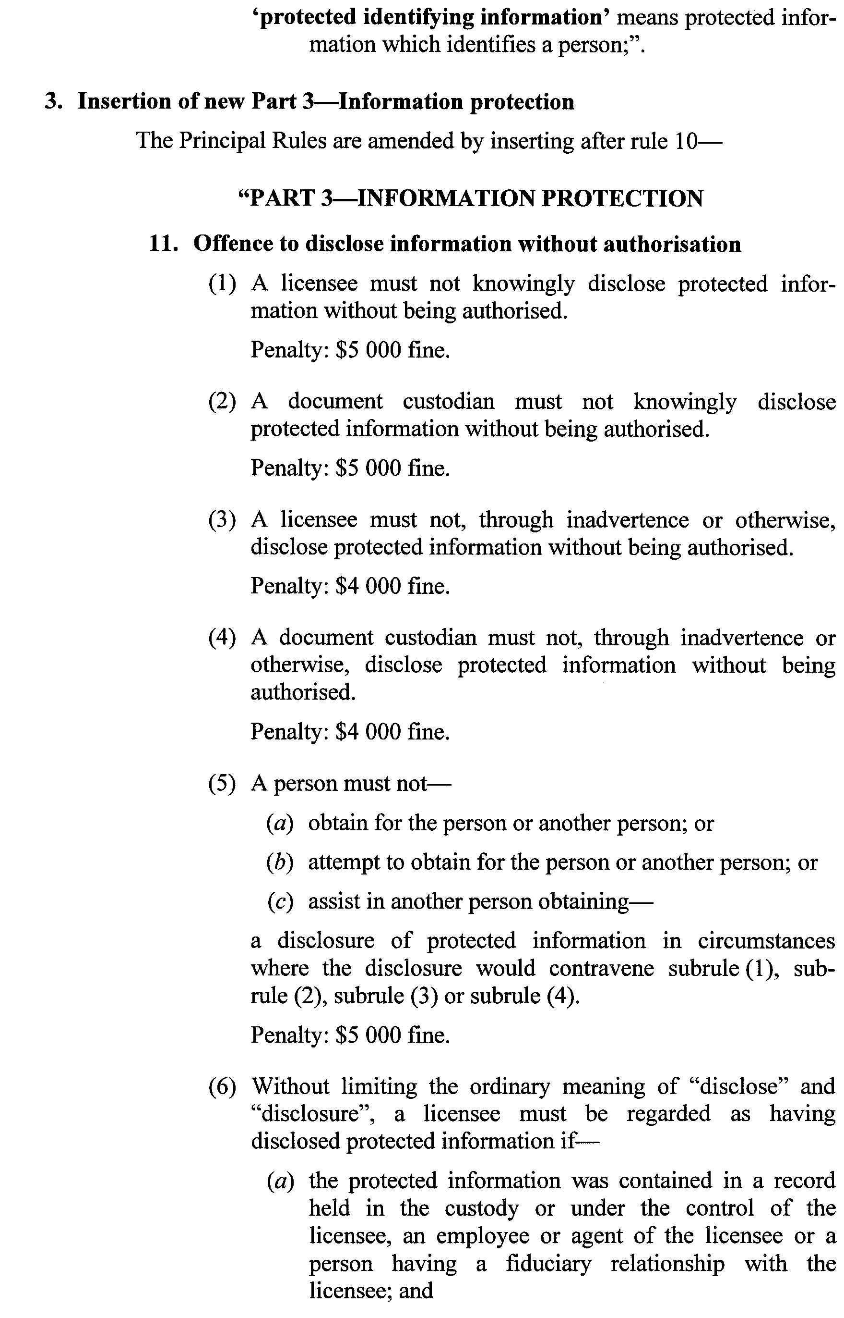
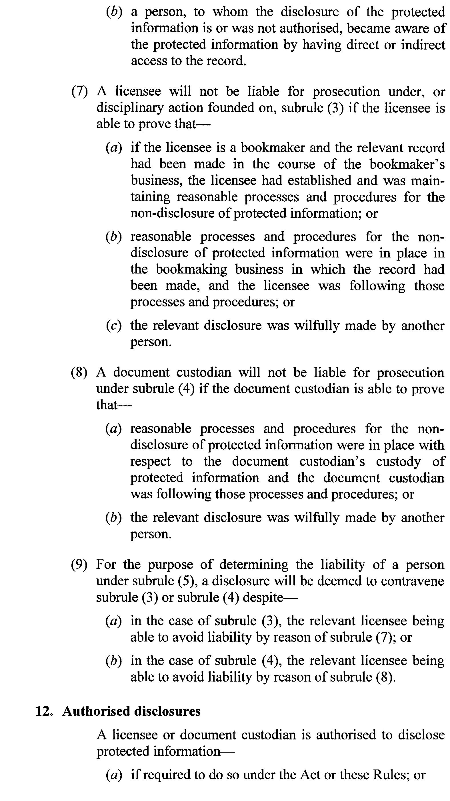
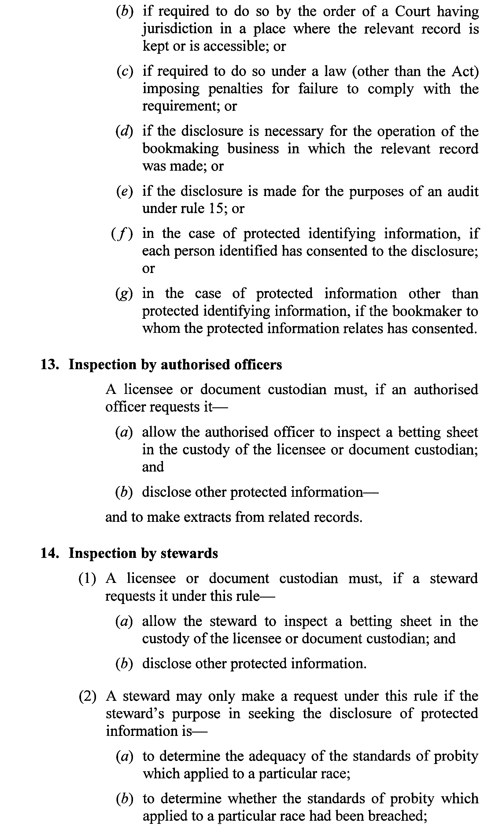
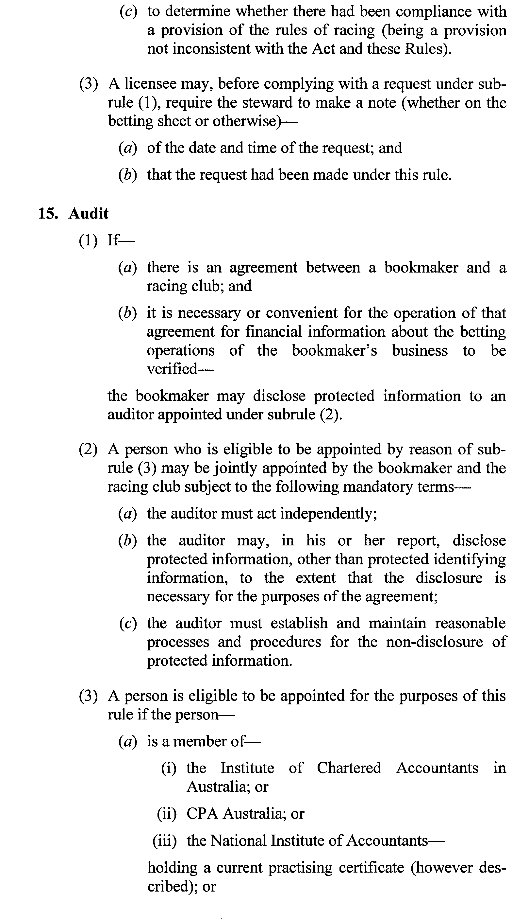
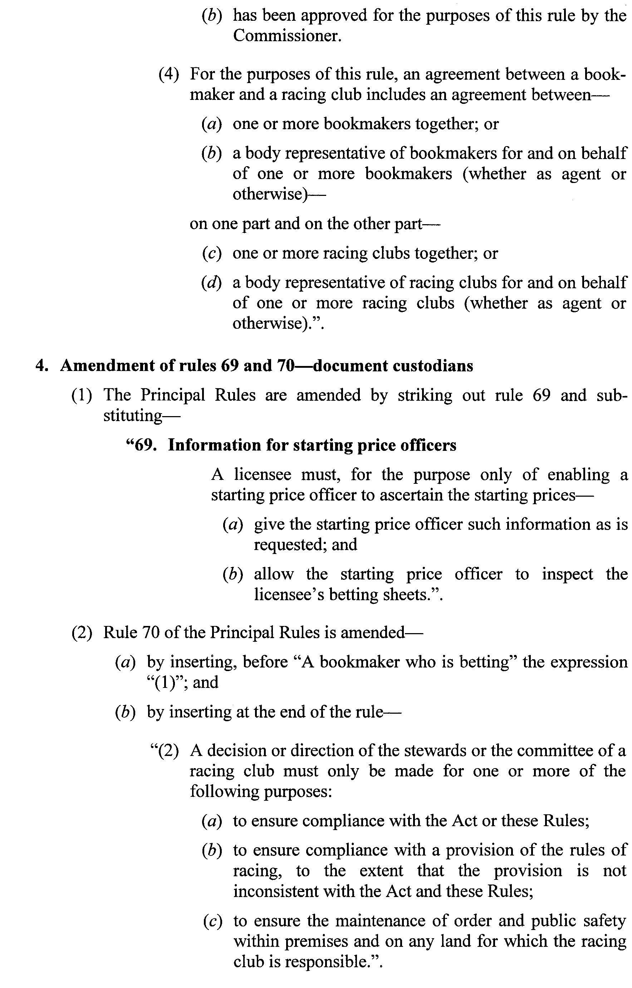

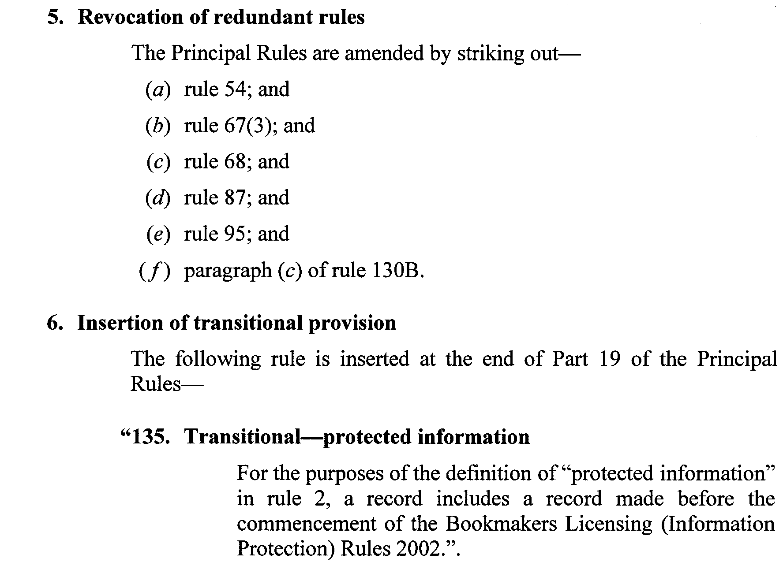
Dated 29 August 2002.
R. C. J. Chappell, Secretary to the Independent Gambling Authority

DEVELOPMENT ACT 1993, SECTION 25 (17): CITY OF TEA TREE GULLY—TEA TREE GULLY (CITY) DEVELOPMENT PLAN—CITY WIDE MISCELLAN-EOUS PLAN AMENDMENT
Preamble
1. The Development Plan amendment entitled ‘City of Tea Tree Gully—Tea Tree Gully (City) Development Plan—City Wide Miscellaneous Plan Amendment’ (the Plan Amendment) has been finalised in accordance with the provisions of the Development Act 1993.
2. The Minister for Urban Development and Planning has decided to approve the Plan Amendment.
Notice
PURSUANT to section 25 of the Development Act 1993, I—
(a) approve the Plan Amendment; and
(b) fix the day on which this notice is published in the Gazette as the day on which the Plan Amendment will come into operation.
Dated 5 September 2002.
Jay Weatherill, Minister for Urban Development and Planning
PLN 00/0197

ELECTORAL ACT 1985
Registration of Political Parties
NOTICE is hereby given pursuant to section 42 of the Electoral Act 1985, that I have this day registered an additional abbreviation of party name for the following political party:
Name of Party: Australian Greens S.A.
Current Abbreviation of Party Name: Australian Greens
Additional Abbreviation of Party Name: The Greens
Dated 5 September 2002.
S. H. Tully, Electoral Commissioner
SEO 113/97

GEOGRAPHICAL NAMES ACT 1991
Notice to Alter the Boundary of a Place
Corrigendum
IN Government Gazette of 22 August 2002, page 1305, first notice appearing in the second column, the diagram incorrectly showed the suburb name of BOWDEN on the plan and should have shown BROMPTON as per the plan below:
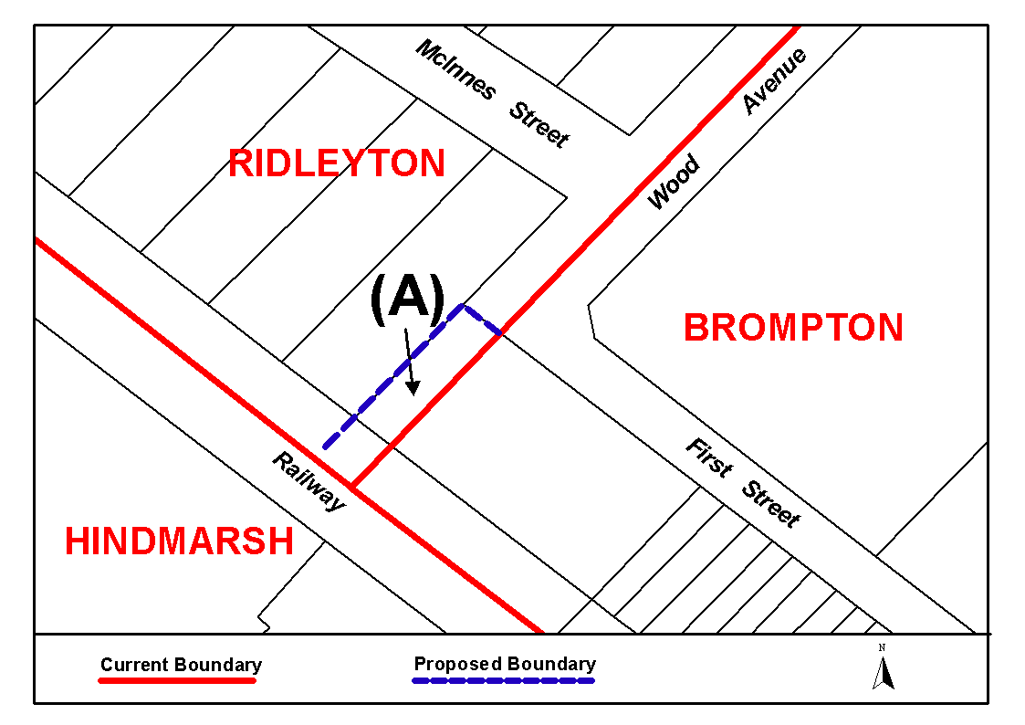
Dated 29 August 2002.
P. M. Kentish, Surveyor-General
DAIS 22-413/02/0006

LAND AND BUSINESS (SALE AND CONVEYANCING) ACT 1994
Exemption
TAKE notice that, pursuant to section 23 (3) of the Land and Business (Sale and Conveyancing) Act 1994, I, Michael John Atkinson, Minister for Consumer Affairs, do hereby exempt the person named in Schedule 1 from the application of section 23 (2) of the Act in relation to the purchase of the land specified in Schedule 2.
Schedule 1
John Joseph Muscat, an officer/employee of Phil McMahon Real Estate Pty Ltd.
Schedule 2
The whole of the land described in certificate of title register book volume 5043, folio 723, situated at 4/10 Third Avenue, Glenelg East, S.A. 5045.
Dated 5 September 2002.
Signed for and on behalf of the Minister for Consumer Affairs by the Commissioner for Consumer Affairs:
M. Bodycoat, Commissioner

LAND AND BUSINESS (SALE AND CONVEYANCING) ACT 1994
Exemption
TAKE notice that, pursuant to section 23 (3) of the Land and Business (Sale and Conveyancing) Act 1994, I, Michael John Atkinson, Minister for Consumer Affairs, do hereby exempt the person named in Schedule 1 from the application of section 23 (2) of the Act in relation to the purchase of the land specified in Schedule 2.
Schedule 1
Graham Edward Margrie, an officer/employee of Tea Tree Gully Estates Pty Ltd.
Schedule 2
The whole of the land described in certificate of title register book volume 5301, folio 708, situated at 5 Aurama Street, Holden Hill, S.A. 5088.
Dated 5 September 2002.
Signed for and on behalf of the Minister for Consumer Affairs by the Commissioner for Consumer Affairs:
M. Bodycoat, Commissioner

LAND AND BUSINESS (SALE AND CONVEYANCING) ACT 1994
Exemption
TAKE notice that, pursuant to section 23 (3) of the Land and Business (Sale and Conveyancing) Act 1994, I, Michael John Atkinson, Minister for Consumer Affairs, do hereby exempt the person named in Schedule 1 from the application of section 23 (2) of the Act in relation to the purchase of the land specified in Schedule 2.
Schedule 1
Alexandra Kate Rutherford, an officer/employee of Peter Economou Real Estate Pty Ltd.
Schedule 2
The whole of the land described in certificate of title register book volume 5510, folio 629, situated at 28A Weller Street, Goodwood, S.A. 5034.
Dated 5 September 2002.
Signed for and on behalf of the Minister for Consumer Affairs by the Commissioner for Consumer Affairs:
M. Bodycoat, Commissioner

LAND ACQUISITION ACT 1969
(Section 16)
Notice of Acquisition
TARONG ENERGY CORPORATION LIMITED (ACN 078 848 736) (the ‘Authority’), of Level 10, AMP Place, 10 Eagle Street, Brisbane, Queensland 4000, acquires the following interests in the following land:
Definition of Land
A right of way and easement in the terms set out below over the land situated in the Hundred of Yankalilla being portion of the land comprised in Certificates of Title Register Book Volume 5814, Folio 278 and Volume 5827, Folio 208 and being portion of Allotment 12 in Deposited Plan 54781 and section 1513 respectively and which said land (hereinafter called ‘the subject land’) is the land marked ‘G’ in Lands Titles Office Filed Plan No. 44031.
Extent of Interest Vested in the Authority
Tarong Energy Corporation Limited (‘Tarong’) may for purposes of and incidental to the construction, operation, main-tenance and repair of:
(a) an overhead cable or overhead cables for the trans-mission of electricity and data associated with that purpose;
(b) pursuant to section 48A of the Electricity Act 1996 equipment for the transmission of telecommuni-cations signals; and
(c) associated works;
(1) Construct on the subject land equipment (and associated structural works) for transforming, controlling and transmitting electricity;
(2) Erect on the subject land poles, towers (or both) and install on them and suspend between them, overhead conductors, cables and other equipment;
(3) Erect on the subject land antennae (and supports) associated with telecommunications and data trans-mission equipment and protective housing;
(4) For the purposes of exercising the rights under para-graphs (1), (2) and (3), Tarong may, at its own cost:
(a) exercise those rights either itself or by its agents, lessees or licensees or by any of their respective employees agents or contractors;
(b) enter the subject land either with or without vehicles, machines or other equipment;
(c) excavate the land and conduct building works;
(d) install access gates (including in the owner’s fences) and security fences;
(e) inspect, repair and replace any of Tarong’s equipment;
(f) transmit electricity;
(g) conduct telecommunications networks;
(h) send, receive and relay data and telecommuni-cations signals; and
(i) do anything else that is reasonably necessary or incidental for Tarong to exercise its rights under those paragraphs.
This notice is given under section 16 of the Land Acquisition Act 1969.
Compensation
A person who has or had an interest in the land that is divested or diminished by the acquisition or the enjoyment of which is adversely affected by the acquisition who does not receive an offer of compensation from the Authority may apply to the Authority for compensation.
Inquiries
Inquiries should be directed to:
David Evans of Tarong Energy Corporation Limited,
Level 10, AMP Place, 10 Eagle Street
Brisbane, Queensland 4000
Telephone: (07) 3228 4148
Dated 5 September 2002.
The Common Seal of TARONG ENERGY CORPORATION LIMITED (ACN 078 848 736) was affixed in the presence of and is attested by:
C. F. O’Meara, Company Secretary
K. H. Dredge, Director

LAND ACQUISITION ACT 1969
(Section 16)
Notice of Acquisition
TARONG ENERGY CORPORATION LIMITED (ACN 078 848 736) (the ‘Authority’), of Level 10, AMP Place, 10 Eagle Street, Brisbane, Queensland 4000, acquires the following interests in the following land:
Definition of Land
A right of way and easement in the terms set out below over the land situated in the Hundred of Yankalilla being portion of the land comprised in Certificate of Title Register Book Volume 5388, Folio 453 and being portion of Allotment 3 in Deposited Plan 45885 and which said land (hereinafter called ‘the subject land’) is the land marked ‘C’ in Lands Titles Office Filed Plan No. 44028.
Extent of Interest Vested in the Authority
Tarong Energy Corporation Limited (‘Tarong’) may for purposes of and incidental to the construction, operation, main-tenance and repair of:
(a) an overhead cable or overhead cables for the trans-mission of electricity and data associated with that purpose;
(b) pursuant to section 48A of the Electricity Act 1996 equipment for the transmission of telecommuni-cations signals; and
(c) associated works;
(1) Construct on the subject land equipment (and associated structural works) for transforming, controlling and transmitting electricity;
(2) Erect on the subject land poles, towers (or both) and install on them and suspend between them, overhead conductors, cables and other equipment;
(3) Erect on the subject land antennae (and supports) associated with telecommunications and data trans-mission equipment and protective housing;
(4) For the purposes of exercising the rights under para-graphs (1), (2) and (3), Tarong may, at its own cost:
(a) exercise those rights either itself or by its agents, lessees or licensees or by any of their respective employees agents or contractors;
(b) enter the subject land either with or without vehicles, machines or other equipment;
(c) excavate the land and conduct building works;
(d) install access gates (including in the owner’s fences) and security fences;
(e) inspect, repair and replace any of Tarong’s equip-ment;
(f) transmit electricity;
(g) conduct telecommunications networks;
(h) send, receive and relay data and telecommuni-cations signals; and
(i) do anything else that is reasonably necessary or incidental for Tarong to exercise its rights under those paragraphs.
This notice is given under section 16 of the Land Acquisition Act 1969.
Compensation
A person who has or had an interest in the land that is divested or diminished by the acquisition or the enjoyment of which is adversely affected by the acquisition who does not receive an offer of compensation from the Authority may apply to the Authority for compensation.
Inquiries
Inquiries should be directed to:
David Evans of Tarong Energy Corporation Limited,
Level 10, AMP Place, 10 Eagle Street
Brisbane, Queensland 4000
Telephone: (07) 3228 4148
Dated 5 September 2002.
The Common Seal of TARONG ENERGY CORPORATION LIMITED (ACN 078 848 736) was affixed in the presence of and is attested by:
C. F. O’Meara, Company Secretary
K. H. Dredge, Director

LAND ACQUISITION ACT 1969
(Section 16)
Notice of Acquisition
TARONG ENERGY CORPORATION LIMITED (ACN 078 848 736) (the ‘Authority’), of Level 10, AMP Place, 10 Eagle Street, Brisbane, Queensland 4000, acquires the following interests in the following land:
Definition of Land
A right of way and easement in the terms set out below over the land situated in the Hundred of Yankalilla being portion of the land comprised in Certificates of Title Register Book Volume 5797, Folio 308 and Volume 1759, Folio 59 and being portion of Allotment 423 in Filed Plan 165142 and Allotment 428 in Filed Plan 165147 respectively and which said land (hereinafter called ‘the subject land’) is the land marked ‘D’ in Lands Titles Office Filed Plan No. 44009.
Extent of Interest Vested in the Authority
Tarong Energy Corporation Limited (‘Tarong’) may for purposes of and incidental to the construction, operation, main-tenance and repair of:
(a) an overhead cable or overhead cables for the transmission of electricity and data associated with that purpose;
(b) pursuant to section 48A of the Electricity Act 1996 equipment for the transmission of telecommuni-cations signals; and
(c) associated works;
(1) Construct on the subject land equipment (and associated structural works) for transforming, controlling and transmitting electricity;
(2) Erect on the subject land poles, towers (or both) and install on them and suspend between them, overhead conductors, cables and other equipment;
(3) Erect on the subject land antennae (and supports) associated with telecommunications and data trans-mission equipment and protective housing;
(4) For the purposes of exercising the rights under para-graphs (1), (2) and (3), Tarong may, at its own cost:
(a) exercise those rights either itself or by its agents, lessees or licensees or by any of their respective employees agents or contractors;
(b) enter the subject land either with or without vehicles, machines or other equipment;
(c) excavate the land and conduct building works;
(d) install access gates (including in the owner’s fences) and security fences;
(e) inspect, repair and replace any of Tarong’s equip-ment;
(f) transmit electricity;
(g) conduct telecommunications networks;
(h) send, receive and relay data and telecommuni-cations signals; and
(i) do anything else that is reasonably necessary or incidental for Tarong to exercise its rights under those paragraphs.
This notice is given under section 16 of the Land Acquisition Act 1969.
Compensation
A person who has or had an interest in the land that is divested or diminished by the acquisition or the enjoyment of which is adversely affected by the acquisition who does not receive an offer of compensation from the Authority may apply to the Authority for compensation.
Inquiries
Inquiries should be directed to:
David Evans of Tarong Energy Corporation Limited,
Level 10, AMP Place, 10 Eagle Street
Brisbane, Queensland 4000
Telephone: (07) 3228 4148
Dated 5 September 2002.
The Common Seal of TARONG ENERGY CORPORATION LIMITED (ACN 078 848 736) was affixed in the presence of and is attested by:
C. F. O’Meara, Company Secretary
K. H. Dredge, Director

LAND ACQUISITION ACT 1969
(Section 16)
Notice of Acquisition
TARONG ENERGY CORPORATION LIMITED (ACN 078 848 736) (the ‘Authority’), of Level 10, AMP Place, 10 Eagle Street, Brisbane, Queensland 4000, acquires the following interests in the following land:
Definition of Land
A right of way and easement in the terms set out below over the land situated in the Hundred of Yankalilla being portion of the land comprised in Certificate of Title Register Book Volume 5445, Folio 177 and being portion of Allotment 1 in Deposited Plan 20570 and which said land (hereinafter called ‘the subject land’) is the land marked ‘G’ in Lands Titles Office Filed Plan No. 44031.
Extent of Interest Vested in the Authority
Tarong Energy Corporation Limited (‘Tarong’) may for purposes of and incidental to the construction, operation, maintenance and repair of:
(a) an overhead cable or overhead cables for the trans-mission of electricity and data associated with that purpose;
(b) pursuant to section 48A of the Electricity Act 1996 equipment for the transmission of telecommuni-cations signals; and
(c) associated works;
(1) Suspend overhead conductors, cables and other equip-ment above the subject land;
(2) For the purposes of exercising the rights under paragraphs (1), (2) and (3), Tarong may, at its own cost;
(3) exercise those rights either itself or by its agents, lessees or licensees or by any of their respective employees agents or contractors;
(4) enter the subject land either with or without vehicles, machines or other equipment:
(a) excavate the land and conduct building works;
(b) install access gates (including in the owner’s fences) and security fences;
(c) inspect, repair and replace any of Tarong’s equip-ment;
(d) transmit electricity;
(e) conduct telecommunications networks;
(f) send, receive and relay data and telecommuni-cations signals; and
(g) do anything else that is reasonably necessary or incidental for Tarong to exercise its rights under those paragraphs.
This notice is given under section 16 of the Land Acquisition Act 1969.
Compensation
A person who has or had an interest in the land that is divested or diminished by the acquisition or the enjoyment of which is adversely affected by the acquisition who does not receive an offer of compensation from the Authority may apply to the Authority for compensation.
Inquiries
Inquiries should be directed to:
David Evans of Tarong Energy Corporation Limited,
Level 10, AMP Place, 10 Eagle Street,
Brisbane, Queensland 4000
Telephone: (07) 3228 4148
Dated 5 September 2002.
The Common Seal of TARONG ENERGY CORPORATION LIMITED (ACN 078 848 736) was affixed in the presence of and is attested by:
C. F. O’Meara, Company Secretary
K. H. Dredge, Director

LAND ACQUISITION ACT 1969
(Section 16)
Notice of Acquisition
TARONG ENERGY CORPORATION LIMITED (ACN 078 848 736) (the ‘Authority’), of Level 10, AMP Place, 10 Eagle Street, Brisbane, Queensland 4000, acquires the following interests in the following land:
Definition of Land
A right of way and easement in the terms set out below over the land situated in the Hundred of Yankalilla being portion of the land comprised in Certificate of Title Register Book Volume 5501 Folio 107 and being portion of section 1042 and which said land (hereinafter called ‘the subject land’) is the land marked ‘D’ in Lands Titles Office Filed Plan No. 44009.
Extent of Interest Vested in the Authority
Tarong Energy Corporation Limited (‘Tarong’) may for purposes of and incidental to the construction, operation, main-tenance and repair of:
(a) an overhead cable or overhead cables for the transmission of electricity and data associated with that purpose;
(b) pursuant to section 48A of the Electricity Act 1996 equipment for the transmission of telecommuni-cations signals; and
(c) associated works;
(1) Construct on the subject land equipment (and associated structural works) for transforming, controlling and transmitting electricity;
(2) Erect on the subject land poles, towers (or both) and install on them and suspend between them, overhead conductors, cables and other equipment;
(3) Erect on the subject land antennae (and supports) associated with telecommunications and data trans-mission equipment and protective housing;
(4) For the purposes of exercising the rights under para-graphs (1), (2) and (3), Tarong may, at its own cost:
(a) exercise those rights either itself or by its agents, lessees or licensees or by any of their respective employees agents or contractors;
(b) enter the subject land either with or without vehicles, machines or other equipment;
(c) excavate the land and conduct building works;
(d) install access gates (including in the owner’s fences) and security fences;
(e) inspect, repair and replace any of Tarong’s equip-ment;
(f) transmit electricity;
(g) conduct telecommunications networks;
(h) send, receive and relay data and telecommuni-cations signals; and
(i) do anything else that is reasonably necessary or incidental for Tarong to exercise its rights under those paragraphs.
This notice is given under section 16 of the Land Acquisition Act 1969.
Compensation
A person who has or had an interest in the land that is divested or diminished by the acquisition or the enjoyment of which is adversely affected by the acquisition who does not receive an offer of compensation from the Authority may apply to the Authority for compensation.
Inquiries
Inquiries should be directed to:
David Evans of Tarong Energy Corporation Limited,
Level 10, AMP Place, 10 Eagle Street
Brisbane, Queensland 4000
Telephone: (07) 3228 4148
Dated 5 September 2002.
The Common Seal of TARONG ENERGY CORPORATION LIMITED (ACN 078 848 736) was affixed in the presence of and is attested by:
C. F. O’Meara, Company Secretary
K. H. Dredge, Director

LAND ACQUISITION ACT 1969
(Section 16)
Notice of Acquisition
TARONG ENERGY CORPORATION LIMITED (ACN 078 848 736) (the ‘Authority’), of Level 10, AMP Place, 10 Eagle Street, Brisbane, Queensland 4000, acquires the following interests in the following land:
Definition of Land
A right of way and easement in the terms set out below over the land situated in the Hundred of Yankalilla being portion of the land comprised in Certificate of Title Register Book Volume 5387, Folio 947 and being portion of Allotment 15 in Filed Plan 19120 and which said land (hereinafter called ‘the subject land’) is the land marked ‘E’ in Lands Titles Office Filed Plan No. 44010.
Extent of Interest Vested in the Authority
Tarong Energy Corporation Limited (‘Tarong’) may for purposes of and incidental to the construction, operation, main-tenance and repair of:
(a) an overhead cable or overhead cables for the trans-mission of electricity and data associated with that purpose;
(b) pursuant to section 48A of the Electricity Act 1996 equipment for the transmission of telecommuni-cations signals; and
(c) associated works;
(1) Construct on the subject land equipment (and associated structural works) for transforming, controlling and transmitting electricity;
(2) Erect on the subject land poles, towers (or both) and install on them and suspend between them, overhead conductors, cables and other equipment;
(3) Erect on the subject land antennae (and supports) associated with telecommunications and data trans-mission equipment and protective housing;
(4) For the purposes of exercising the rights under para-graphs (1), (2) and (3), Tarong may, at its own cost:
(a) exercise those rights either itself or by its agents, lessees or licensees or by any of their respective employees agents or contractors;
(b) enter the subject land either with or without vehicles, machines or other equipment;
(c) excavate the land and conduct building works;
(d) install access gates (including in the owner’s fences) and security fences;
(e) inspect, repair and replace any of Tarong’s equip-ment;
(f) transmit electricity;
(h) conduct telecommunications networks;
(i) send, receive and relay data and telecommuni-cations signals; and
(j) do anything else that is reasonably necessary or incidental for Tarong to exercise its rights under those paragraphs.
This notice is given under section 16 of the Land Acquisition Act 1969.
Compensation
A person who has or had an interest in the land that is divested or diminished by the acquisition or the enjoyment of which is adversely affected by the acquisition who does not receive an offer of compensation from the Authority may apply to the Authority for compensation.
Inquiries
Inquiries should be directed to:
David Evans of Tarong Energy Corporation Limited,
Level 10, AMP Place, 10 Eagle Street
Brisbane, Queensland 4000
Telephone: (07) 3228 4148
Dated 5 September 2002.
The Common Seal of TARONG ENERGY CORPORATION LIMITED (ACN 078 848 736) was affixed in the presence of and is attested by:
C. F. O’Meara, Company Secretary
K. H. Dredge, Director

LAND ACQUISITION ACT 1969
(Section 16)
Notice of Acquisition
TARONG ENERGY CORPORATION LIMITED (ACN 078 848 736) (the ‘Authority’), of Level 10, AMP Place, 10 Eagle Street, Brisbane, Queensland 4000, acquires the following interests in the following land:
Definition of Land
A right of way and easement in the terms set out below over the land situated in the Hundred of Yankalilla being portion of the land comprised in Certificate of Title Register Book Volume 5239, Folio 926 and being portion of Allotment 14 in Filed Plan 19120 which said land (hereinafter called ‘the subject land’) is the land marked ‘E’ in Lands Titles Office Filed Plan No. 44010.
Extent of Interest Vested in the Authority
Tarong Energy Corporation Limited (‘Tarong’) may for purposes of and incidental to the construction, operation, main-tenance and repair of:
(a) an overhead cable or overhead cables for the transmission of electricity and data associated with that purpose;
(b) pursuant to section 48A of the Electricity Act 1996 equipment for the transmission of telecommuni-cations signals; and
(c) associated works;
(1) Construct on the subject land equipment (and associated structural works) for transforming, controlling and transmitting electricity;
(2) Erect on the subject land poles, towers (or both) and install on them and suspend between them, overhead conductors, cables and other equipment;
(3) Erect on the subject land antennae (and supports) associated with telecommunications and data trans-mission equipment and protective housing;
(4) For the purposes of exercising the rights under para-graphs (1), (2) and (3), Tarong may, at its own cost:
(a) exercise those rights either itself or by its agents, lessees or licensees or by any of their respective employees agents or contractors;
(b) enter the subject land either with or without vehicles, machines or other equipment;
(c) excavate the land and conduct building works;
(d) install access gates (including in the owner’s fences) and security fences;
(e) inspect, repair and replace any of Tarong’s equipment;
(f) transmit electricity;
(g) conduct telecommunications networks;
(h) send, receive and relay data and telecommuni-cations signals; and
(i) do anything else that is reasonably necessary or incidental for Tarong to exercise its rights under those paragraphs.
This notice is given under section 16 of the Land Acquisition Act 1969.
Compensation
A person who has or had an interest in the land that is divested or diminished by the acquisition or the enjoyment of which is adversely affected by the acquisition who does not receive an offer of compensation from the Authority may apply to the Authority for compensation.
Inquiries
Inquiries should be directed to:
David Evans of Tarong Energy Corporation Limited
Level 10, AMP Place, 10 Eagle Street
Brisbane, Queensland 4000
Telephone: (07) 3228 4148
Dated 5 September 2002.
The Common Seal of TARONG ENERGY CORPORATION LIMITED (ACN 078 848 736) was affixed in the presence of and is attested by:
C. F. O’Meara, Company Secretary
K. H. Dredge, Director

LAND ACQUISITION ACT 1969
(Section 16)
Notice of Acquisition
TARONG ENERGY CORPORATION LIMITED (ACN 078 848 736) (the ‘Authority’), of Level 10, AMP Place, 10 Eagle Street, Brisbane, Queensland 4000, acquires the following interests in the following land:
Definition of Land
A right of way and easement in the terms set out below over the land situated in the Hundred of Yankalilla being portion of the land comprised in Certificate of Title Register Book Volume 5293, Folio 258 and being portion of section 1499 and Allotment 15 in Deposited Plan 40844 and which said land (hereinafter called ‘the subject land’) is the land marked ‘B’ in Lands Titles Office Filed Plan No. 44029.
Extent of Interest Vested in the Authority
Tarong Energy Corporation Limited (‘Tarong’) may for purposes of and incidental to the construction, operation, main-tenance and repair of:
(a) an overhead cable or overhead cables for the trans-mission of electricity and data associated with that purpose;
(b) pursuant to section 48A of the Electricity Act 1996 equipment for the transmission of telecommuni-cations signals; and
(c) associated works;
(1) Construct on the subject land equipment (and associated structural works) for transforming, controlling and transmitting electricity;
(2) Erect on the subject land poles, towers (or both) and install on them and suspend between them, overhead conductors, cables and other equipment;
(3) Erect on the subject land antennae (and supports) associated with telecommunications and data trans-mission equipment and protective housing;
(4) For the purposes of exercising the rights under para-graphs (1), (2) and (3), Tarong may, at its own cost:
(a) exercise those rights either itself or by its agents, lessees or licensees or by any of their respective employees agents or contractors;
(b) enter the subject land either with or without vehicles, machines or other equipment;
(c) excavate the land and conduct building works;
(d) install access gates (including in the owner’s fences) and security fences;
(e) inspect, repair and replace any of Tarong’s equip-ment;
(f) transmit electricity;
(h) conduct telecommunications networks;
(i) send, receive and relay data and telecommuni-cations signals; and
(j) do anything else that is reasonably necessary or incidental for Tarong to exercise its rights under those paragraphs.
This notice is given under section 16 of the Land Acquisition Act 1969.
Compensation
A person who has or had an interest in the land that is divested or diminished by the acquisition or the enjoyment of which is adversely affected by the acquisition who does not receive an offer of compensation from the Authority may apply to the Authority for compensation.
Inquiries
Inquiries should be directed to:
David Evans of Tarong Energy Corporation Limited,
Level 10, AMP Place, 10 Eagle Street
Brisbane, Queensland 4000
Telephone: (07) 3228 4148
Dated 5 September 2002.
The Common Seal of TARONG ENERGY CORPORATION LIMITED (ACN 078 848 736) was affixed in the presence of and is attested by:
C. F. O’Meara, Company Secretary
K. H. Dredge, Director

LAND ACQUISITION ACT 1969
(section 16)
(This form is to be used for any acquisition other than an acquisition of native title land for the purpose of conferring proprietary rights or interest on a person other than the Crown or an instrumentality of the Crown)
TO: Garry Thomas Loughhead
Lot 363, Goldfields Road, Cockatoo Valley, S.A. 5351, as a Registered Proprietor.
TO: Rosemarie Loughhead
Lot 363, Goldfields Road, Cockatoo Valley, S.A. 5351, as a Registered Proprietor.
TO: Savings & Loans Credit Union (SA) Limited
Securities Department, G.P.O. Box 463, Adelaide, S.A. 5001, as Mortgagee vide Mortgage No. 8514395.
TO: Minister for Infrastructure
c/o SA Water Corporation, G.P.O. Box 1039, Adelaide, S.A. 5001, as holder of Easement No. 2119081.
Notice of Acquisition
SOUTH EAST AUSTRALIA GAS PTY LTD (ABN 73 096 437 900), Level 13, 1 King William Street, Adelaide, S.A. 5000, as agent of:
OE SEA Gas SPV1 Pty Ltd (ACN 095 483 444);
OE SEA Gas SPV2 Pty Ltd (ACN 095 483 453); and
OE SEA Gas SPV3 Pty Ltd (ACN 095 483 462);
all c/o Level 13, 1 King William Street, Adelaide, S.A. 5000, and:
ANP SEA Gas SPV1 Pty Ltd (ACN 099 332 331);
ANP SEA Gas SPV2 Pty Ltd (ACN 099 332 368); and
ANP SEA Gas SPV3 Pty Ltd (ACN 099 332 395);
all c/o Level 37, Rialto North Tower, 525 Collins Street, Melbourne, Vic. 3000, as partners in the SEA Gas Partnership (‘the Partners’) together referred to as (‘the Authority’) acquires the following interests in the following land:
A right of way and easement over that piece of land being portion of the land comprised and described in certificate of title register book volume 5558, folio 250, the location of which is marked ‘Q’ on FP 44180—a copy of which is annexed hereto.
Extent of Interest Vested in the Authority:
(1) A full and unrestricted right and liberty for the Authority from time to time and at all times hereafter to enter and exit from the easement land with or without motor vehicles engines, plant and equipment and to remain on the easement land for any of the following purposes:
(a) to clear any vegetation or obstruction on the easement land;
(b) to make surveys;
(c) to dig, excavate and break the soil of the easement land;
(d) to install, operate, maintain, repair, alter, inspect, remove or remove and replace a pipeline or pipelines and to use such pipeline or pipelines to carry, convey and transport natural and artificial gas, oil and other gaseous or liquid hydrocarbons and products or by-products of these substances (‘gas supply purposes’).
(2) The registered proprietor of the easement land shall not and shall not permit any other person without the prior written consent of the Authority (which will not be unreasonably withheld or delayed) to:
(a) excavate, dig, drill, grade or change the contour of the easement land;
(b) construct or erect any building or other permanent structure on the easement land;
(c) plant or cultivate trees on the easement land;
(d) carry out blasting on or within 500 m of the easement land;
(e) conduct any activity which constitutes a nuisance or hindrance to the exercise by the grantee of its rights under the easement.
(3) (a) The pipeline shall remain the property of the Authority despite the degree of annexation (if any) of the pipeline to the easement land; and
(b) The Authority may at any time remove the pipeline or elements of the pipeline from the easement land and will reinstate any damage done to the easement land caused by that removal.
This notice is given under section 16 of the Land Acquisition Act 1969.
Compensation
A person who has or had an interest in the land that is divested or diminished by the acquisition or the enjoyment of which is adversely affected by the acquisition who does not receive an offer of compensation from the Authority may apply to the Authority for compensation.
Inquiries
Inquiries should be directed to:
The Manager
Maloney Field Services
Level 1, 212 Pirie Street
Adelaide, S.A. 5000
Phone: (08) 8227 0933
Fax: (08) 8227 0955
Dated 30 August 2002.
Signed by Andrew John Wauchope, Level 13, 1 King William Street, Adelaide, S.A. 5000.  As attorney for South East Australia Gas Pty Limited under Power of Attorney dated 9 May 2002 registered No. 9333481 in the presence of an independent adult witness who either knows the attorney personally or who has been given satisfactory proof as to their identity. | ⎫  ⎪  ⎪  ⎪  ⎪  ⎪  ⎩  ⎧  ⎪  ⎪  ⎪  ⎪  ⎪  ⎭ | South East Australia Gas Pty Limited by its attorney who states that he has received no notice of revocation of his Power of Attorney.  (Signed)  Louise Irene Munro,  c/o Level 2,  122 Frome Street, Adelaide, S.A. 5000  Phone (08) 8227 2655
Witness sign:
Witness Full Name (print):
Address:

Daytime Phone No.:

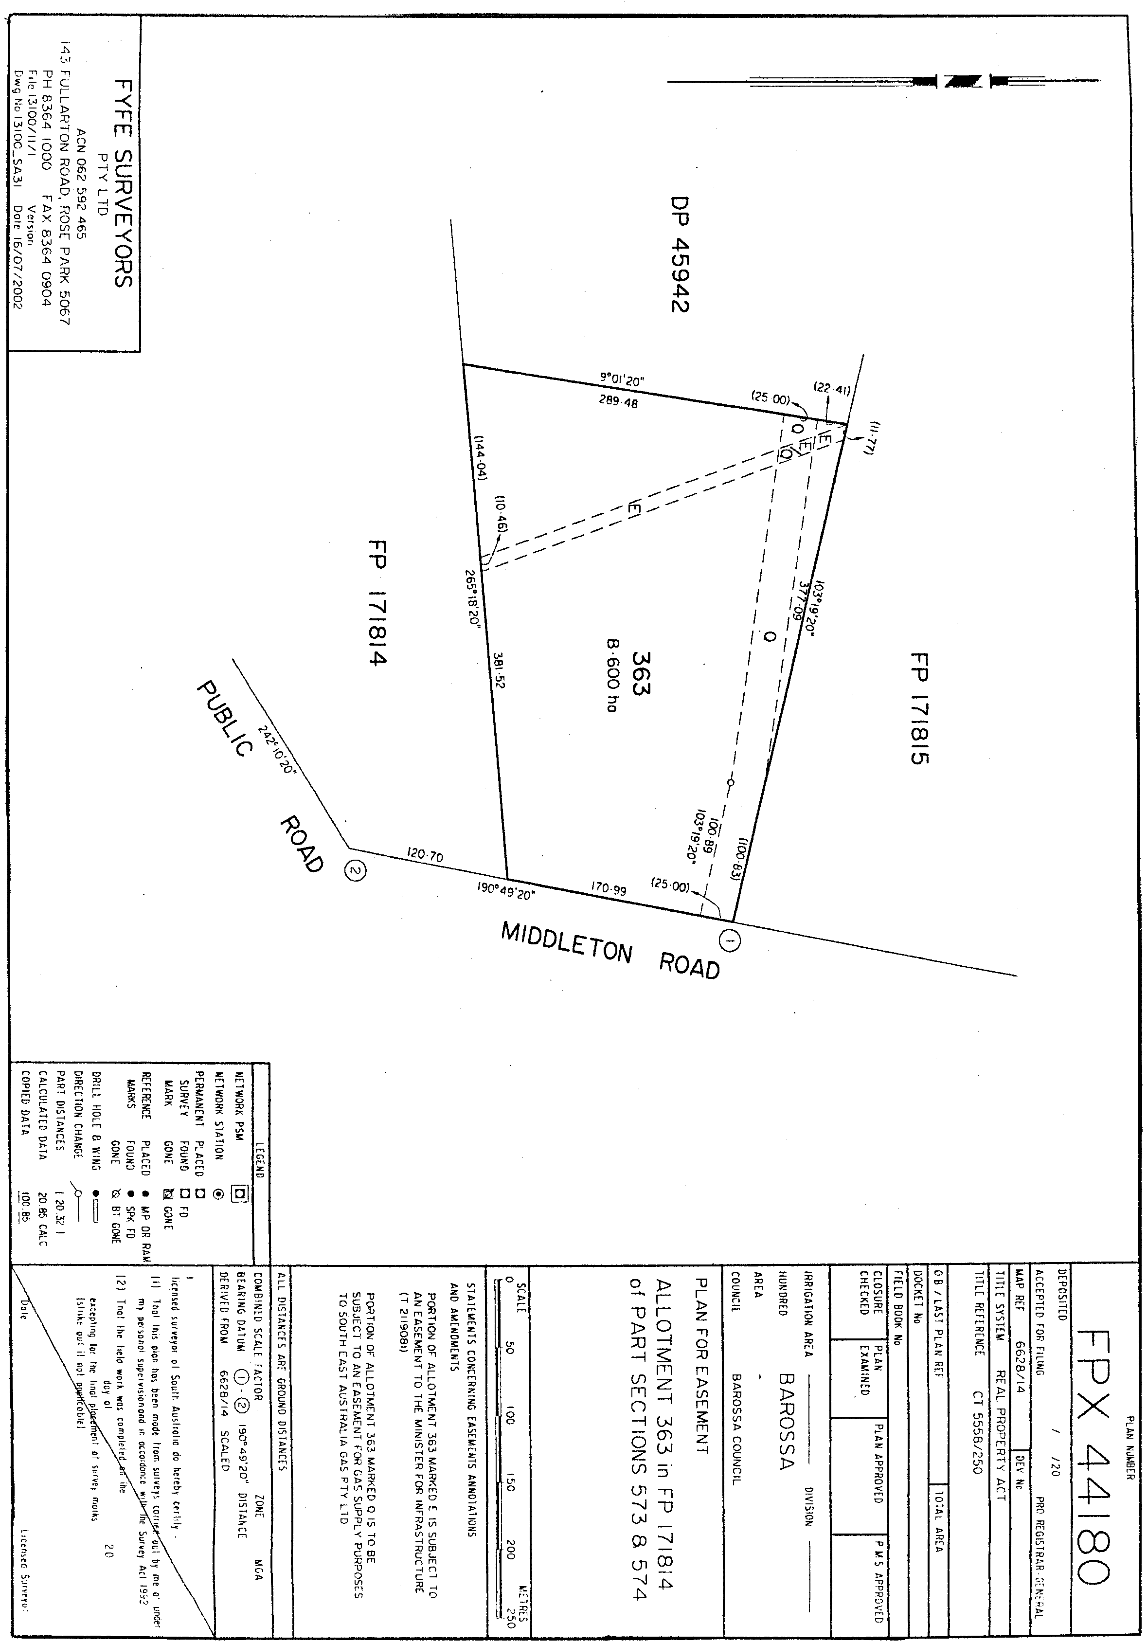

Legislative Council, 29 August 2002
FORWARDED to the Honourable the Premier the following Resolution, passed by the Legislative Council on 29 August 2002:
That the Regulations under the Fisheries Act 1982 concerning Fishing Activities, made on 20 June 2002 and laid on the Table of this Council on 9 July 2002, be disallowed.
J. M. Davis, Clerk

LIQUOR LICENSING ACT 1997 AND GAMING MACHINES ACT 1992
Notice of Application
NOTICE is hereby given, pursuant to section 52 of the Liquor Licensing Act 1997 and section 29 of the Gaming Machines Act 1992, that Brock (Australia) Pty Ltd, c/o Wallmans Lawyers, 173 Wakefield Street, Adelaide, S.A. 5000 has applied to the Licensing Authority for the transfer of a Hotel Licence and Gaming Machine Licence in respect of the premises situated at Lot 56, Scott Road, Kersbrook, S.A. 5231 and known as Kersbrook Tavern.
The applications have been set down for hearing on 8 October 2002 at 10 a.m.
Any person may object to the application by lodging a notice of objection in the prescribed form with the Licensing Authority, and serving a copy of the notice on the applicant at the applicant’s address given above, at least seven days before the hearing date.
Plans in respect of the premises the subject of the application are open to public inspection without fee at the Office of the Liquor and Gaming Commissioner, 9th Floor, East Wing, 50 Grenfell Street, Adelaide, S.A. 5000.
Dated 26 August 2002.
Applicant

LIQUOR LICENSING ACT 1997
Notice of Application
NOTICE is hereby given, pursuant to section 52 (2) (b) of the Liquor Licensing Act 1997, that Le Diva Pty Ltd (ACN 101 417 770) has applied to the Licensing Authority for the transfer of a Restaurant Licence in respect of premises situated at 261 Gouger Street, Adelaide, S.A. 5000 and known as La Sing.
The application has been set down for hearing on 26 September 2002.
Any person may object to the application by lodging a notice of objection in the prescribed form with the Licensing Authority, and serving a copy of the notice on the applicant at the applicant’s address given above, at least seven days before the hearing date.
Plans in respect of the premises the subject of the application are open to public inspection without fee at the Office of the Liquor and Gaming Commissioner, 9th Floor, East Wing, 50 Grenfell Street, Adelaide, S.A. 5000.
Dated 15 August 2002.
Applicant

LIQUOR LICENSING ACT 1997
Notice of Application
NOTICE is hereby given, pursuant to section 52 (2) (b) of the Liquor Licensing Act 1997, that Justin Michael Lane and Emma Lane have applied to the Licensing Authority for a Producer’s Licence in respect of premises situated at 8 St Johns Terrace, Willunga, S.A. 5172 and to be known as Viottolo.
The application has been set down for hearing on 4 October 2002.
Any person may object to the application by lodging a notice of objection in the prescribed form with the Licensing Authority, and serving a copy of the notice on the applicants at the applicants’ address given above, at least seven days before the hearing date.
Plans in respect of the premises the subject of the application are open to public inspection without fee at the Office of the Liquor and Gaming Commissioner, 9th Floor, East Wing, 50 Grenfell Street, Adelaide, S.A. 5000.
Dated 21 August 2002.
Applicants

LIQUOR LICENSING ACT 1997
Notice of Application
NOTICE is hereby given, pursuant to section 52 (2) (b) of the Liquor Licensing Act 1997, that Gazcol Sports Pty Ltd (ACN 099 108 844) has applied to the Licensing Authority for a Special Circumstances Licence in respect of premises situated at 325 Sturt Road, Bedford Park, S.A. 5042 and known as Roselands Tennis World.
The application has been set down for hearing on 4 October 2002.
Conditions
The following licence conditions are sought:
To sell liquor for consumption on the licensed premises each day between 10 a.m. and midnight.
Entertainment consent is sought.
Any person may object to the application by lodging a notice of objection in the prescribed form with the Licensing Authority, and serving a copy of the notice on the applicant at the applicant’s address given above, at least seven days before the hearing date.
Plans in respect of the premises the subject of the application are open to public inspection without fee at the Office of the Liquor and Gaming Commissioner, 9th Floor, East Wing, 50 Grenfell Street, Adelaide, S.A. 5000.
Dated 26 August 2002.
Applicant

LIQUOR LICENSING ACT 1997
Notice of Application
NOTICE is hereby given, pursuant to section 52 (2) (b) of the Liquor Licensing Act 1997, that Pacific Marine & Motors Pty Ltd, 172 Tapleys Hill Road, Royal Park, S.A. 5014 has applied to the Licensing Authority for a Restaurant Licence in respect of premises situated at 8 Tapleys Hill Road, Royal Park and to be known as Pacific Marine.
The application has been set down for hearing on 4 October 2002 at 9 a.m.
Any person may object to the application by lodging a notice of objection in the prescribed form with the Licensing Authority, and serving a copy of the notice on the applicant at the applicant’s address given above, at least seven days before the hearing date.
Plans in respect of the premises the subject of the application are open to public inspection without fee at the Office of the Liquor and Gaming Commissioner, 9th Floor, East Wing, 50 Grenfell Street, Adelaide, S.A. 5000.
Dated 27 August 2002.
Applicant

LIQUOR LICENSING ACT 1997
Notice of Application
NOTICE is hereby given, pursuant to section 52 (2) (b) of the Liquor Licensing Act 1997, that Kenneth John and Hazel Ann Taylor have applied to the Licensing Authority for a Producer’s Licence in respect of premises situated at Lot 2, 289 Culley Road, Sellicks Hill, S.A. 5174 and to be known as Ravenor Park Estate.
The application has been set down for hearing on 4 October 2002.
Any person may object to the application by lodging a notice of objection in the prescribed form with the Licensing Authority, and serving a copy of the notice on the applicants at the applicants’ address given above, at least seven days before the hearing date.
Plans in respect of the premises the subject of the application are open to public inspection without fee at the Office of the Liquor and Gaming Commissioner, 9th Floor, East Wing, 50 Grenfell Street, Adelaide, S.A. 5000.
Dated 7 August 2002.
Applicants

LIQUOR LICENSING ACT 1997
Notice of Application
NOTICE is hereby given, pursuant to section 52 (2) (b) of the Liquor Licensing Act 1997, that Blue Smoke Pty Ltd as trustee for the Derek Zappia Family Trust, Grantley Souter Pty Ltd as Trustee for the Grantley Souter Family Trust and Levi Domino Pty Ltd as trustee for the Domino Family Trust, c/o Sydney Maidment of Sydney G. Maidment Lawyers have applied to the Licensing Authority for a Special Circumstances Licence with an Extended Trading Authorisation in respect of premises situated at 272 Rundle Street, Adelaide, S.A. 5000 and to be known as Fumo Blu Cigar Lounge.
The application has been set down for hearing on 4 October 2002 at 9 a.m.
Conditions
The following licence conditions are sought:
• Hours sought:
Monday to Tuesday: 7 a.m. to 2 a.m. the following day;
Wednesday to Sunday: 7 a.m. to 4 a.m. the following day;
Good Friday: Only with or ancillary to a genuine meal provided by the licensee.
• No minor is to be on the licensed premises between midnight on any day and 4 a.m. on the day following unless that minor is in the company of an adult guardian or adult spouse of the minor. Guardian in relation to a minor means a parent (including a step-parent) or legal guardian of the minor.
Any person may object to the application by lodging a notice of objection in the prescribed form with the Licensing Authority, and serving a copy of the notice on the applicants at the applicants’ address given above, at least seven days before the hearing date.
Plans in respect of the premises the subject of the application are open to public inspection without fee at the Office of the Liquor and Gaming Commissioner, 9th Floor, East Wing, 50 Grenfell Street, Adelaide, S.A. 5000.
Dated 29 August 2002.
Applicants

LIQUOR LICENSING ACT 1997
Notice of Application
NOTICE is hereby given, pursuant to section 52 (2) (b) of the Liquor Licensing Act 1997, that Whale Coast Wines Pty Ltd, 15 Pridmore Road, Glen Osmond, S.A. 5064 has applied to the Licensing Authority for a Producer’s Licence in respect of the premises situated at Glewford Gully Road, Middleton, S.A. 5213 and to be known as Whale Coast Wines.
The application has been set down for hearing on 4 October 2002 at 9 a.m.
Any person may object to the application by lodging a notice of objection in the prescribed form with the Licensing Authority, and serving a copy of the notice on the applicant at the applicant’s address given above, at least seven days before the hearing date.
Plans in respect of the premises the subject of the application are open to public inspection without fee at the Office of the Liquor and Gaming Commissioner, 9th Floor, East Wing, 50 Grenfell Street, Adelaide, S.A. 5000.
Dated 28 August 2002.
Applicant

LIQUOR LICENSING ACT 1997
Notice of Application
NOTICE is hereby given, pursuant to section 52 (2) (b) of the Liquor Licensing Act 1997, that David John Hall has applied to the Licensing Authority for a Producer’s Licence in respect of the premises situated a 8 Martin Avenue, Fitzroy, S.A. 5082 and to be known as Avon Brae Estate.
The application has been set down for hearing on 4 October 2002 at 9 a.m.
Any person may object to the application by lodging a notice of objection in the prescribed form with the Licensing Authority, and serving a copy of the notice on the applicant at the applicant’s address given above, at least seven days before the hearing date.
Plans in respect of the premises the subject of the application are open to public inspection without fee at the Office of the Liquor and Gaming Commissioner, 9th Floor, East Wing, 50 Grenfell Street, Adelaide, S.A. 5000.
Dated 29 August 2002.
Applicant

LIQUOR LICENSING ACT 1997
Notice of Application
NOTICE is hereby given, pursuant to section 52 (2) (b) of the Liquor Licensing Act 1997, that Paragenesis Pty Ltd, c/o Fardone & Co. Solicitors, 1st Floor, 125C The Parade, Norwood, S.A. 5067 has applied to the Licensing Authority for the transfer of an Entertainment Venue Licence and Variation to Conditions of Licence in respect of the premises situated at 26 Blyth Street, Adelaide, S.A. 5000 and known as Proscenium.
The application has been set down for hearing on 4 October 2002 at 9 a.m.
Conditions
The following licence conditions are sought:
1. To delete condition 1 as follows: The licence shall operate from Monday to Saturday each week which will apply from no earlier than 9 p.m. or if live entertainment is not immediately being provided at that time then from no more than 30 minutes prior to the commencement of the provision of that live entertainment until 30 minutes subsequent to the cessation of the provision of live entertainment on the premises provided that the latest hour during which this licence authorises sale and consumption of liquor on the premises shall be 5 a.m. Monday to Saturday.
Any person may object to the application by lodging a notice of objection in the prescribed form with the Licensing Authority, and serving a copy of the notice on the applicant at the applicant’s address given above, at least seven days before the hearing date.
Plans in respect of the premises the subject of the application are open to public inspection without fee at the Office of the Liquor and Gaming Commissioner, 9th Floor, East Wing, 50 Grenfell Street, Adelaide, S.A. 5000.
Dated 29 August 2002.
Applicant

LIQUOR LICENSING ACT 1997
Notice of Application
NOTICE is hereby given, pursuant to section 52 (2) (b) of the Liquor Licensing Act 1997, that Berri Hotel Inc, c/o Tim O’Brien, O’Brien’s Solicitors has applied to the Licensing Authority for an Extension to the Trading Area and Variation to Extended Trading Authorisation in respect of the premises situated at Riverview Drive, Berri, S.A. 5343 and known as Berri Hotel.
The application has been set down for hearing on 4 October 2002 at 9 a.m.
Conditions
The following licence conditions are sought:
An extension to the licensed area to include the cafe in the new tourist centre across Riverview Drive;
Hours sought in the new area:
Monday to Sunday, 10 a.m. to midnight.
Any person may object to the application by lodging a notice of objection in the prescribed form with the Licensing Authority, and serving a copy of the notice on the applicant at the applicant’s address given above, at least seven days before the hearing date.
Plans in respect of the premises the subject of the application are open to public inspection without fee at the Office of the Liquor and Gaming Commissioner, 9th Floor, East Wing, 50 Grenfell Street, Adelaide, S.A. 5000.
Dated 29 August 2002.
Applicant

LIQUOR LICENSING ACT 1997
Notice of Application
NOTICE is hereby given, pursuant to section 52 (2) (b) of the Liquor Licensing Act 1997, that Jade View Inn Pty Ltd, 28 Lakeside Circuit, Northgate, S.A. 5085 has applied to the Licensing Authority for a Restaurant Licence in respect of premises situated at Shop 3-4, 297 Payneham Road, Royston Park, S.A. 5070 and to be known as Jade View Inn Chinese Restaurant.
The application has been set down for hearing on 4 October 2002 at 9 a.m.
Any person may object to the application by lodging a notice of objection in the prescribed form with the Licensing Authority, and serving a copy of the notice on the applicant at the applicant’s address given above, at least seven days before the hearing date.
Plans in respect of the premises the subject of the application are open to public inspection without fee at the Office of the Liquor and Gaming Commissioner, 9th Floor, East Wing, 50 Grenfell Street, Adelaide, S.A. 5000.
Dated 27 August 2002.
Applicant

LIQUOR LICENSING ACT 1997
Notice of Application
NOTICE is hereby given, pursuant to section 52 (2) (b) of the Liquor Licensing Act 1997, that Tim Adams Wines Pty Ltd (ACN 008 008 053) has applied to the Licensing Authority for the transfer of a Producer’s Licence in respect of premises situated at Warenda Road, Clare, S.A. 5453 and known as Tim Adams Wines.
The application has been set down for hearing on 8 October 2002.
Any person may object to the application by lodging a notice of objection in the prescribed form with the Licensing Authority, and serving a copy of the notice on the applicant at the applicant’s address given above, at least seven days before the hearing date.
Plans in respect of the premises the subject of the application are open to public inspection without fee at the Office of the Liquor and Gaming Commissioner, 9th Floor, East Wing, 50 Grenfell Street, Adelaide, S.A. 5000.
Dated 21 August 2002.
Applicant

LIQUOR LICENSING ACT 1997
Notice of Application
NOTICE is hereby given, pursuant to section 52 (2) (b) of the Liquor Licensing Act 1997, that Janine Helen Green and Deborah Lilian Green have applied to the Licensing Authority for the transfer of a Restaurant Licence in respect of premises situated at 25 Main Street, Hahndorf, S.A. 5245 and known as Cottage Kitchen.
The application has been set down for hearing on 8 October 2002.
Any person may object to the application by lodging a notice of objection in the prescribed form with the Licensing Authority, and serving a copy of the notice on the applicants at the applicants’ address given above, at least seven days before the hearing date.
Plans in respect of the premises the subject of the application are open to public inspection without fee at the Office of the Liquor and Gaming Commissioner, 9th Floor, East Wing, 50 Grenfell Street, Adelaide, S.A. 5000.
Dated 29 August 2002.
Applicants

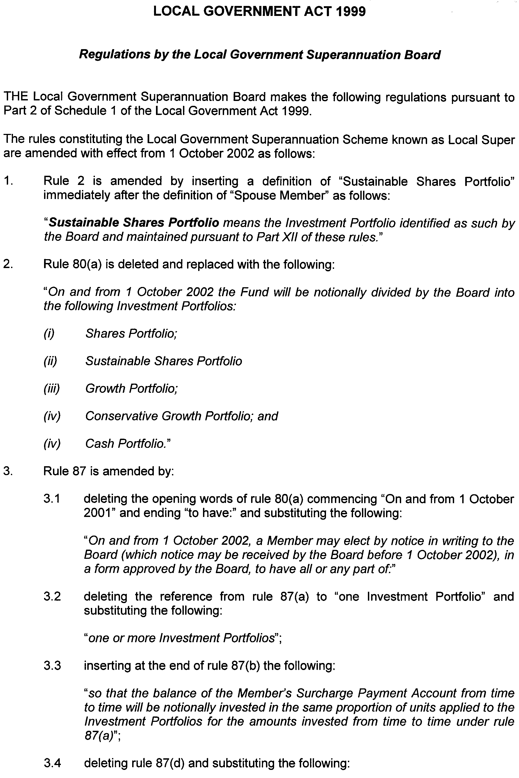
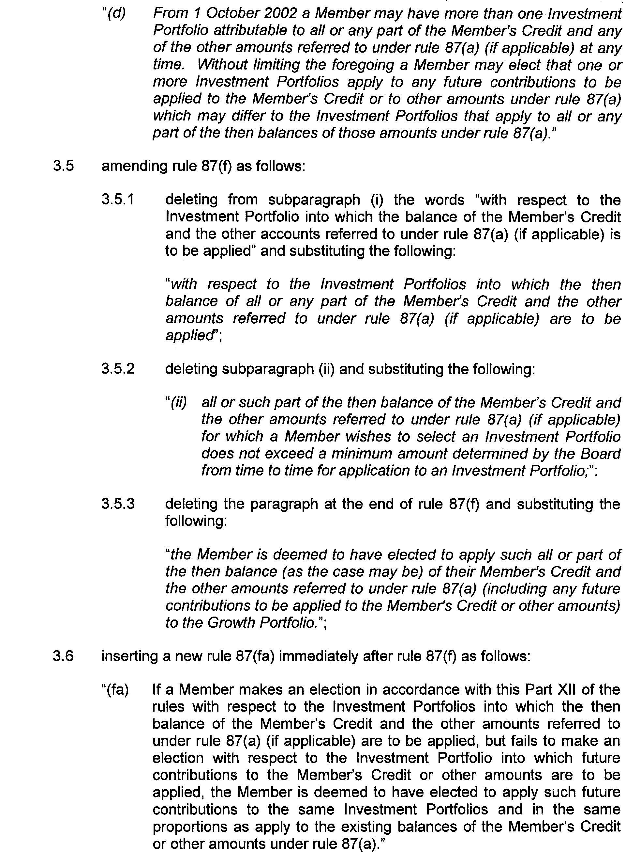

Dated 27 August 2002.
Barbara Ryland, Executive Officer

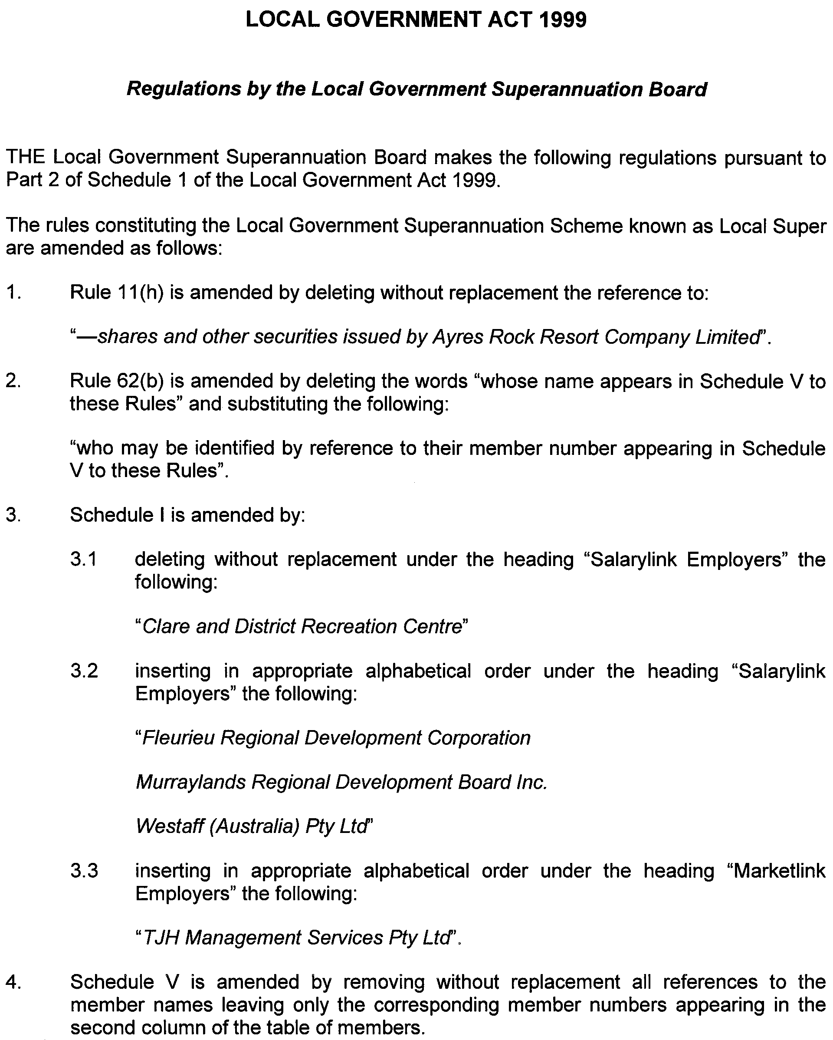

Dated 27 August 2002.
Barbara Ryland, Executive Officer

MINING ACT 1971
NOTICE is hereby given in accordance with section 28 (5) of the Mining Act 1971, that the Minister for Mineral Resources Development proposes to grant an Exploration Licence over the undermentioned area:
Applicant: Redport Ltd and Australon Ltd
Location: Commonwealth Hill area—Approximately 100 km north of Tarcoola, bounded as follows: Commencing at a point being the intersection of latitude 29°46′S and longitude 134°20′E, thence east to longitude 134°30′E, south to latitude 29°47′S, east to longitude 134°34′E, south to latitude 29°55′S, west to longitude 134°20′E, and north to the point of commencement, but excluding the Tarcoola-Alice Springs Railway (see GG 13.11.1975), all the within latitudes and longitudes being geodetic and expressed in terms of the Australian Geodetic Datum as defined on p. 4984 of Commonwealth Gazette number 84 dated 6 October 1966 (AGD66).
Term: 1 year
Area in km²: 363
Ref: 120/2002
H. Tyrteos, Mining Registrar, Department of Primary Industries and Resources

MINING ACT 1971
NOTICE is hereby given in accordance with section 28 (5) of the Mining Act 1971, that the Minister for Mineral Resources Development proposes to grant an Exploration Licence over the undermentioned area:
Applicant: South Australian Iron Ore Group Pty Ltd
Location: Kimba Gap area—Approximately 45 km west of Whyalla, bounded as follows: Commencing at a point being the intersection of latitude 33°02′S and longitude 137°02′E, thence east to longitude 137°06′E, south to latitude 33°09′S, west to longitude 137°05′E, south to latitude 33°10′S, west to longitude 137°00′E, north to latitude 33°07′S, east to longitude 137°02′E, and north to the point of commencement, all the within latitudes and longitudes being geodetic and expressed in terms of the Australian Geodetic Datum as defined on p. 4984 of Commonwealth Gazette number 84 dated October 6, 1966 (AGD66).
Term: 1 year
Area in km²: 106
Ref: 95/2002
H. Tyrteos, Mining Registrar, Department of Primary Industries and Resources

MINING ACT 1971
NOTICE is hereby given in accordance with section 28 (5) of the Mining Act 1971, that the Minister for Mineral Resources Development proposes to grant an Exploration Licence over the undermentioned area.
Applicant: PlatSearch NL
Location: Lake Frome area—Approximately 180 km east of Leigh Creek, bounded as follows: Commencing at a point being the intersection of latitude 30°22′S and longitude 140°26′E, thence east to longitude 140°28′E, south to latitude 30°29′S, west to longitude 140°27′E, south to latitude 30°32′S, east to longitude 140°30′E, south to latitude 30°34′S, west to longitude 140°26′E, south to latitude 30°38′S, east to longitude 140°29′E, south to latitude 30°40′S, west to longitude 140°27′E, south to latitude 30°48′S, west to longitude 140°24′E, north to latitude 30°45′S, east to longitude 140°25′E, north to latitude 30°39′S, west to longitude 140°21′E, south to latitude 30°40′S, west to longitude 140°17′E, north to latitude 30°34′S, east to longitude 140°24′E, north to latitude 30°24′S, east to longitude 140°26′E, and north to the point of commencement, all the within latitudes and longitudes being geodetic and expressed in terms of the Australian Geodetic Datum as defined on p. 4984 of Commonwealth Gazette number 84 dated 6 October 1966 (AGD66).
Term: 1 year
Area in km²: 331
Ref: 60/2002
H. Tyrteos, Mining Registrar, Department of Primary Industries and Resources

MINING ACT 1971
NOTICE is hereby given in accordance with section 28 (5) of the Mining Act 1971, that the Minister for Mineral Resources Development proposes to grant an Exploration Licence over the undermentioned area.
Applicant: Gunson Resources Ltd
Location: Mount Moseley area—Approximately 50 km south of Woomera, bounded as follows: Commencing at a point being the intersection of latitude 31°29′S and longitude 136°50′E, thence east to longitude 137°00′E, south to latitude 31°50′S, west to longitude 136°50′E, and north to the point of commencement, all the within latitudes and longitudes being geodetic and expressed in terms of the Australian Geodetic Datum as defined on p. 4984 of Commonwealth Gazette number 84 dated 6 October 1966 (AGD66).
Term: 1 year
Area in km²: 613
Ref: 90/2002
H. Tyrteos, Mining Registrar, Department of Primary Industries and Resources

MINING ACT 1971
NOTICE is hereby given in accordance with section 28 (5) of the Mining Act 1971, that the Minister for Mineral Resources Development proposes to grant an Exploration Licence over the undermentioned area.
Applicant: Relode Ltd
Location: Nullarbor area—Approximately 160 km WNW of Nullarbor, bounded as follows: Commencing at a point being the intersection of latitude 31°05′S and longitude 129°08′E, thence east to longitude 129°20′E, south to latitude 31°18′S, west to longitude 129°08′E, and north to the point of commencement, all the within latitudes and longitudes being geodetic and expressed in terms of the Australian Geodetic Datum as defined on p. 4984 of Commonwealth Gazette number 84 dated October 6, 1966 (AGD66).
Term: 1 year
Area in km²: 458
Ref: 42/2002
H. Tyrteos, Mining Registrar, Department of Primary Industries and Resources

MINING ACT 1971
NOTICE is hereby given in accordance with section 28 (5) of the Mining Act 1971, that the Minister for Mineral Resources Development proposes to grant an Exploration Licence over the undermentioned area.
Applicant: Relode Ltd
Location: Ifould Lake area—Approximately 45 km south of Ooldea, bounded as follows: Commencing at a point being the intersection of latitude 30°42′S and longitude 131°59′E, thence east to longitude 132°02′E, south to latitude 30°46′S, east to longitude 132°04′E, south to latitude 30°58′S, east to longitude 132°14′E, south to latitude 31°00′S, west to longitude 131°44′E, north to latitude 30°45′S, east to longitude 131°59′E, and north to the point of commencement, all the within latitudes and longitudes being geodetic and expressed in terms of the Australian Geodetic Datum as defined on p. 4984 of Commonwealth Gazette number 84 dated 6 October 1966 (AGD66).
Term: 1 year
Area in km²: 921
Ref: 157/2001
H. Tyrteos, Mining Registrar, Department of Primary Industries and Resources

MINING ACT 1971
NOTICE is hereby given in accordance with section 28 (5) of the Mining Act 1971, that the Minister for Mineral Resources Development proposes to grant an Exploration Licence over the undermentioned area.
Applicant: Relode Ltd
Location: South Maralinga area—Approximately 20 km south-east and south-west of Ooldea, bounded as follows:
Area A—Commencing at a point being the intersection of latitude 30°33′S and longitude 131°30′E, thence east to longitude 131°42′E, south to latitude 30°37′S, east to longitude 131°45′E, south to latitude 30°45′S, west to longitude 131°30′E, and north to the point of commencement.
Area B—Commencing at a point being the intersection of latitude 30°35′S and longitude 131°59′E, thence east to longitude 132°00′E, south to latitude 30°42′S, west to longitude 131°59′E, and north to the point of commencement.
All the within latitudes and longitudes are geodetic and expressed in terms of the Australian Geodetic Datum as defined on p. 4984 of Commonwealth Gazette number 84 dated 6 October 1966 (AGD66).
Term: 1 year
Area in km²: 516
Ref: 156/2001
H. Tyrteos, Mining Registrar, Department of Primary Industries and Resources

MINING ACT 1971
NOTICE is hereby given in accordance with section 28 (5) of the Mining Act 1971, that the Minister for Mineral Resources Development proposes to grant an Exploration Licence over the undermentioned area.
Applicant: Relode Ltd
Location: Nullarbor area—Approximately 320 km west of Tarcoola, bounded as follows: Commencing at a point being the intersection of latitude 30°45′S and longitude 131°00′E, thence east to longitude 131°45′E, south to latitude 31°00′S, west to longitude 131°00′E, and north to the point of commencement, all the within latitudes and longitudes being geodetic and expressed in terms of the Australian Geodetic Datum as defined on p. 4984 of Commonwealth Gazette number 84 dated 6 October 1966 (AGD66).
Term: 1 year
Area in km²: 1 991
Ref: 154/2001
H. Tyrteos, Mining Registrar, Department of Primary Industries and Resources

MINING ACT 1971
NOTICE is hereby given in accordance with section 28 (5) of the Mining Act, 1971, that the Minister for Mineral Resources Development proposes to grant an Exploration Licence over the undermentioned area.
Applicant: Relode Ltd
Location: South-west Ooldea area—Approximately 320 km west of Tarcoola, bounded as follows: Commencing at a point being the intersection of latitude 30°33′S and longitude 131°19′E, thence east to longitude 131°30′E, south to latitude 30°45′S, west to longitude 131°00′E, north to the northern boundary of Nullarbor Regional Reserve, thence generally north-easterly along the boundary of the said Regional Reserve to longitude 131°19′E, and south to the point of commencement, all the within latitudes and longitudes being geodetic and expressed in terms of the Australian Geodetic Datum as defined on p. 4984 of Commonwealth Gazette number 84 dated 6 October 1966 (AGD66).
Term: 1 year
Area in km²: 1 134
Ref: 153/2001
H. Tyrteos, Mining Registrar, Department of Primary Industries and Resources

MINING ACT 1971
NOTICE is hereby given in accordance with section 28 (5) of the Mining Act 1971, that the Minister for Mineral Resources Development proposes to grant an Exploration Licence over the undermentioned area.
Applicant: Aquila Resources Ltd
Location: Lake Gilles area—Approximately 15 km north of Kimba, bounded as follows: Commencing at a point being the intersection of latitude 32°49′S and longitude 136°14′E, thence east to longitude 136°26′E, south to latitude 32°53′S, east to longitude 136°28′E, south to latitude 32°58′S, east to longitude 136°38′E, north to latitude 32°55′S, west to longitude 136°35′E, north to latitude 32°52′S, east to a western boundary of Lake Gilles Conservation Park, thence generally south-westerly and southerly along the boundary of the said Conservation Park to latitude 33°06′S, west to longitude 136°20′E, north to latitude 32°53′S, west to longitude 136°14′E, and north to the point of commencement, all the within latitudes and longitudes being geodetic and expressed in terms of the Australian Geodetic Datum as defined on p. 4984 of Commonwealth Gazette number 84 dated 6 October 1966 (AGD66).
Term: 1 year
Area in km²: 740
Ref: 18/2002
H. Tyrteos, Mining Registrar, Department of Primary Industries and Resources

MINING ACT 1971
NOTICE is hereby given in accordance with section 28 (5) of the Mining Act 1971, that the Minister for Mineral Resources Development proposes to grant an Exploration Licence over the undermentioned area.
Applicant: Aquila SA Pty Ltd
Location: Eurilla Dam area—Approximately 80 km west of Whyalla, bounded as follows: Commencing at a point being the intersection of latitude 32°40′S and longitude 136°35′E, thence east to longitude 136°40′E, south to latitude 32°45′S, east to longitude 136°42′E, south to latitude 32°52′S, west to longitude 136°35′E, and north to the point of commencement, all the within latitudes and longitudes being geodetic and expressed in terms of the Australian Geodetic Datum as defined on p. 4984 of Commonwealth Gazette number 84 dated 6 October 1966 (AGD66).
Term: 1 year
Area in km²: 213
Ref: 92/2002
H. Tyrteos, Mining Registrar, Department of Primary Industries and Resources

NOTICE TO MARINERS
No. 42 of 2002
South Australia—South End—Vessel Capsized off Cape Buffon
A 14 m white timber vessel Marcel has capsized amongst rocks in approximate position 400 m south off Cape Buffon (South-end). The vessel cannot be salvaged and due to heavy seas and swell is progressively breaking up resulting in floating debris.
The debris poses a potential hazard to vessels operating in the vicinity and mariners are advised to exercise caution when navigating in the area.
Navy charts affected: Aus 127 and 348.
Publication affected: Australia Pilot Vol. 1, Seventh Edition 1992, pages 141-142.
Adelaide 28 August 2002.
M. Wright, Minister for Transport
TSA 2002/00309

NOTICE TO MARINERS
No. 43 of 2002
South Australia—Inner Port Adelaide River—Temporary Placement of Screen
PIRSA will be placing a semi-pervious screen for the removal of Coulerpa taxifolia in the Port River between Bower Road and 50 m north of Jervois Bridge. The initial operation will commence on 8 September 2002 for a period of 3 months. The upper end of the screen will be approximately 150 mm above the water surface, marked with yellow St Andrews crosses and will be moved around progressively.
Mariners are advised to exercise caution when manoeuvring in the vicinity.
Navy charts affected: Aus 137.
Adelaide 3 September 2002.
M. Wright, Minister for Transport
TSA 2002/00309

PETROLEUM ACT 2000
Statement of Environmental Objectives for Existing Regulated Activities
PURSUANT to section 6 (1) of the Schedule and 134 (1) of the Petroleum Act 2000 (the Act) I, Barry Alan Goldstein, Director Petroleum, Office of Minerals and Energy Resources, Department of Primary Industries and Resources SA, Delegate of the Minister for Mineral Resources Development, pursuant to Delegation dated 28 March 2002, Gazetted 11 April 2002, do hereby vary item 4 of the gazette notice dated 8 October 2001, page 4464, to read as follows:
Document:
1. Origin Energy alternative arrangements approved on 22 September 2000 under Regulation 18 (2) of the Petroleum Regulations 1989 for Production and Processing of Petroleum and Associated Activities in the Otway Basin of South Australia. This is subject to review and assessment in accordance with the requirements of Part 12 of the Petroleum Act 2000 by 31 December 2002.
This document is available for public inspection on the Environmental Register section of the Petroleum Group’s web-site (www.petroleum.pir.sa.gov.au) or at the Public Office determined pursuant to section 107 (1) of the Act to be at:
Minerals and Petroleum Centre
Office of Minerals and Energy Resources
Ground Floor
101 Grenfell Street
Adelaide, S.A. 5000
Dated 3 September 2002.
B. A. Goldstein, Delegate of the Minister for Mineral Resources Development

PRIMARY INDUSTRIES AND RESOURCES
SOUTH AUSTRALIA
Draft Amendment to the Lower Eyre Peninsula and Spencer Gulf Aquaculture Management Plans
Corrigendum
IN Government Gazette of 15 August 2002, page 3062 the date in the last line of the notice was incorrectly stated as being 19 September 2002. This date should read 16 October 2002.

ROADS (OPENING AND CLOSING) ACT 1991:
SECTION 24
NOTICE OF CONFIRMATION OF ROAD
PROCESS ORDER
Park Way, Mawson Lakes
Deposited Plan 60260
BY Road Process Order made on 28 June 2002, The Development Assessment Commission ordered that:
1. Portions of the public road (the western side of Park Way) between Mawson Lakes Boulevard and Fourth Avenue, more particularly delineated and lettered ‘A’, ‘B’, ‘C’ and ‘D’ (respectively) in Preliminary Plan No. 01/0695 be closed.
2. The whole of the land subject to closure be transferred to the LAND MANAGEMENT CORPORATION in accordance with agreement for transfer dated 14 June 2002 entered into between the City of Salisbury and the Land Management Corporation.
3. The following easements are granted over portion of the land subject to that closure:
Grant to Envestra (SA) Limited an easement for gas supply purposes.
Grant to the South Australian Water Corporation an easement for sewerage purposes.
On 26 August 2002 that order was confirmed by the Minister for Administrative Services conditionally on approval and deposit of the survey plan by the Registrar-General. The condition has now been fulfilled.
Pursuant to section 24 (5) of the Roads (Opening and Closing) Act 1991, NOTICE of the order referred to above and its confirmation is hereby given.
Dated 5 September 2002.
P. M. Kentish, Surveyor-General

ROAD TRAFFIC ACT 1961
Notice of Exemption
Road Traffic (Road Rules—Ancillary and Miscellaneous Provisions) Regulations 1999—Regulation 7
I, MICHAEL WRIGHT, Minister for Transport, grant the following exemption pursuant to Regulation 7 of the Road Traffic (Road Rules—Ancillary and Miscellaneous Provisions) Regulations 1999.
I exempt drivers of vehicles travelling on the South Eastern Freeway from the provisions of Rule 177 (Stopping on Freeway) provided:
(a) The vehicle stops wholly within a vehicle lay-by on the Freeway which has been specifically set aside and designated by sign for that purpose; and
(b) The vehicle is not stopped for a period longer than, or for a purpose contrary to, that stipulated by sign; and
(c) Drivers and/or passengers do not move beyond the constructed area of the lay-by or beyond any fencing, kerb or line which separates the road related area and road adjacent to that lay-by; and
(d) The driver must remain with the vehicle at all times whilst it is parked in a lay-by.
This exemption revokes and replaces the exemption notice issued on 28 March 2000, and is effective immediately.
All other provisions contained in the Road Traffic Act 1961 and the Australian Road Rules 1999 continue to have full force and effect.
Dated 29 August 2002.
M. Wright, Minister for Transport

WATER MAINS AND SEWERS

Office of the South Australian Water Corporation
Adelaide, 5 September 2002

WATER MAINS LAID

Notice is hereby given that the following main pipes or parts of main pipes have been laid down by the South Australian Water Corporation in or near the undermentioned water districts and are now available for a constant supply of water to adjacent land.

ADELAIDE WATER DISTRICT

CITY OF BURNSIDE
Thomas Place, Rose Park. p20

THE DISTRICT COUNCIL OF MOUNT BARKER
Schaefer Court, Mount Barker. p17
Lady Bute Drive, Mount Barker. p16 and 17
Lambert Court, Mount Barker. p17
Easement in allotment piece 3013 in LTRO DP 58101, Lambert Court, Mount Barker. p17

CITY OF ONKAPARINGA
Aubrey Drive, Willunga. p12
Evelyn Sturt Drive, Willunga. p12
Cowper Court, Willunga. p12
Milford Avenue, Sellicks Beach. p13
Easement in allotment piece 2002 in LTRO DP 58827, Milford Avenue, Sellicks Beach. p13

CITY OF PORT ADELAIDE ENFIELD
Navigator Drive, Northgate. p1, 3 and 4
The Promenade, Northgate. p1 and 2
Balmain Drive, Northgate. p3 and 4
Paxton Avenue, Northgate. p3
Charlick Square, Northgate. p3
The Provence, Northgate. p3 and 4
Chaffey Common, Northgate. p4
Liberty Grove, Ferryden Park. p6
Campbell Street, Ferryden Park. p7

CITY OF SALISBURY
Across and in Trinity Circuit, Mawson Lakes. p8 and 9
Hamilton Place, Mawson Lakes. p8
Glen Court, Mawson Lakes. p9
Easement in lot 554 in LTRO DP 54946, Glen Court, Mawson Lakes. p9
Emerald Street, Mawson Lakes. p9
Brunswick Place, Mawson Lakes. p8 and 9
Easements in private road (lot 1 in LTRO DP 54946), Brunswick Place, Mawson Lakes. p8 and 9
Across and in The Strand, Mawson Lakes. p8 and 9

CITY OF TEA TREE GULLY
Gransden Parade, Greenwith. p14
Silveracre Pass, Greenwith. p14

GOOLWA WATER DISTRICT

ALEXANDRINA COUNCIL
Easements in lot 100 in LTRO DP 58603, Ferguson Road, Goolwa Beach. p15
Sumner Street, Goolwa. p22

KADINA WATER DISTRICT

DISTRICT COUNCIL OF THE COPPER COAST
Russack Road, Kadina. p33
Right of way (known as No. 4 Lane), south of lots 1 and 2 in LTRO FP 17180, Kadina. p34
Sixth Street, Kadina. p34

KINGSCOTE WATER DISTRICT

KANGAROO ISLAND COUNCIL
Dutton Street, Kingscote. p26

MIDDLETON WATER DISTRICT

ALEXANDRINA COUNCIL
Miami Boulevard, Middleton. p23

MOONTA WATER DISTRICT

DISTRICT COUNCIL OF THE COPPER COAST
Moonta Road, Moonta Bay. p18

PORT ELLIOT WATER DISTRICT

ALEXANDRINA COUNCIL
Elliot Street, Port Elliot. p25

CITY OF VICTOR HARBOR
Coromandel Drive, McCracken. p5
Riverway Court, McCracken. p5
Palm Court, McCracken. p5

STANSBURY WATER DISTRICT

DISTRICT COUNCIL OF YORKE PENINSULA
Dalrymple Terrace, Stansbury. p31

STRATHALBYN WATER DISTRICT

ALEXANDRINA COUNCIL
Ashbourne Road, Strathalbyn. p24
Edward Street, Strathalbyn. p28

WAKEFIELD WATER DISTRICT

WAKEFIELD REGIONAL COUNCIL
Johnson Street, Port Wakefield. p10
Across and in White Street, Port Wakefield. p10
Korreng Court, Port Wakefield. p10 and 11

WOOL BAY WATER DISTRICT

DISTRICT COUNCIL OF YORKE PENINSULA
West Terrace, Wool Bay. p32

WATER MAINS ABANDONED

Notice is hereby given that the undermentioned water mains have been abandoned by the South Australian Water Corporation.

ADELAIDE WATER DISTRICT

CITY OF PORT ADELAIDE ENFIELD
Across and in Liberty Grove, Ferryden Park. p6
Easement in reserve (lot 641), Liberty Grove, Ferryden Park. p6

KADINA WATER DISTRICT

DISTRICT COUNCIL OF THE COPPER COAST
Right of way (known as No. 4 Lane), south of lots 1 and 2 in LTRO FP 17180, Kadina. p34

PORT ELLIOT WATER DISTRICT

ALEXANDRINA COUNCIL
Elliot Street, Port Elliot. p25

STRATHALBYN WATER DISTRICT

ALEXANDRINA COUNCIL
Ashbourne Road, Strathalbyn. p24

SEWERS LAID

Notice is hereby given that the following sewers have been laid down by the South Australian Water Corporation in the under-mentioned drainage areas and are now available for house connections.

ADELAIDE DRAINAGE AREA

CITY OF PORT ADELAIDE ENFIELD
Paxton Avenue, Northgate. FB 1105 p57 and 59
Balmain Drive, Northgate. FB 1105 p57 and 59 and FB 1107 p14 and 15
Navigator Drive, Northgate. FB 1105 p57-59
The Promenade, Northgate. FB 1105 p58 and 60
The Provence, Northgate. FB 1107 p14 and 15
Chaffey Common, Northgate. FB 1107 p14 and 15
Jarrat Road, Ferryden Park. FB 1107 p10 and 11
Longford Crescent, Ferryden Park. FB 1107 p10 and 11
Whittle Court, Ferryden Park. FB 1107 p10 and 11
Thompson Court, Ferryden Park. FB 1107 p10 and 11
Pine Street, Woodville Gardens. FB 1107 p29 and 30
Campbell Street, Woodville Gardens and Ferryden Park. FB 1107 p29 and 30
York Terrace, Ferryden Park. FB 1107 p29 and 30

CITY OF SALISBURY
Cormorant Way, Mawson Lakes. FB 1107 p18
Gannet Street, Mawson Lakes. FB 1107 p18

CORPORATION OF THE TOWN OF WALKERVILLE
Across Tonkin Street, Vale Park. FB 1107 p13
Easement in lot 10 in LTRO FP 127644, Tonkin Street, Vale Park. FB 1107 p13

MOUNT GAMBIER COUNTRY DRAINAGE AREA

CITY OF MOUNT GAMBIER
Sunnyside Drive, Mount Gambier. FB 1090 p33

PORT PIRIE COUNTRY DRAINAGE AREA

PORT PIRIE REGIONAL COUNCIL
Parham Street, Port Pirie South. FB 1106 p19
Flett Street, Risdon Park. FB 1106 p21

STIRLING COUNTRY DRAINAGE AREA

ADELAIDE HILLS COUNCIL
Mount Barker Road, Bridgewater. FB 1106 p30

VICTOR HARBOR COUNTRY DRAINAGE AREA

CITY OF VICTOR HARBOR
Easements in lot 8, Coromandel Drive and lot 21, Riverway Court, McCracken. FB 1107 p26 and 27
Riverway Court, McCracken. FB 1107 p26-28
Coromandel Drive, McCracken. FB 1107 p26 and 27
Palm Court, McCracken. FB 1107 p26 and 28
Easement in allotment piece 212 in LTRO DP 58490, Coromandel Drive, McCracken. FB 1107 p26 and 27
Dodson Road, Encounter Bay. FB 1106 p28

WHYALLA COUNTRY DRAINAGE AREA

THE CORPORATION OF THE CITY OF WHYALLA
Taylor Street, Whyalla Stuart. FB 1106 p20

SEWERS ABANDONED

Notice is hereby given that the undermentioned sewer has been abandoned by the South Australian Water Corporation.

ADELAIDE DRAINAGE AREA

CITY OF PORT ADELAIDE ENFIELD
Meadowbank Terrace, Northgate. FB 1105 p58

A. Howe, Chief Executive Officer, South Australian Water Corporation.

FAXING COPY?

IF you fax copy to Government Publishing SA for inclusion in the Government Gazette, there is no need to send a Confirmation Copy to us as well.

This creates confusion and may well result in your notice being printed twice.

Please use the following fax number:

Fax transmission: (08) 8207 1040
Phone Inquiries: (08) 8207 1045

Please include a contact person, phone number and order number so that we can phone back with any queries we may have regarding the fax copy.

NOTE: Closing time for lodging new copy (either fax or hard copy) is 4 p.m. on Tuesday preceding the day of publication.

Government Gazette notices can be E-mailed.

The address is:

governmentgazette@saugov.sa.gov.au

Documents should be sent as attachments in Word format.

When sending a document via E-mail, please confirm your transmission with a faxed copy of your document, including the date the notice is to be published.

Fax transmission: (08) 8207 1040
Enquiries: (08) 8207 1045

CITY OF BURNSIDE
Resignation of Councillor
NOTICE is hereby given in accordance with section 54 (6) of the Local Government Act 1999, that a vacancy has occurred in the office of Councillor for Kensington Gardens and Magill Ward, due to the resignation of Councillor Gregory John Waller, to take effect from 29 August 2002.
P. Dinning, Acting Chief Executive Officer

CITY OF MITCHAM
Renaming of Portion of Road
NOTICE is hereby given that at the council meeting held on Tuesday, 27 August 2002, the City of Mitcham resolved to rename that portion of Edgecumbe Parade, Hawthorndene, east of its intersection with Hewitt Avenue, to Lois Lane.
R. Malcolm, Chief Executive Officer

CITY OF MOUNT GAMBIER
Periodical Review
NOTICE is hereby given that the City of Mount Gambier has reviewed its composition and elector representation arrange-ments, in accordance with the provisions of section 12 (4) of the Local Government Act 1999.
Pursuant to section 12 (13) (a) of the said Act, the Electoral Commissioner has certified that the review undertaken by council satisfies the requirements of section 12, and may therefore be put into effect as from the day of the first general election held after the expiration of five months from the publication of this notice.
The revised representation arrangements are as follows:
The council of the City of Mount Gambier is to comprise the Mayor (as the principal member) and 10 ward councillors.
Unite North West Ward and South West Ward to form one ward then to be known as West Ward.
Unite North East Ward and South East Ward to form one ward then to be known as East Ward.
Dated 5 September 2002.
G. Muller, Chief Executive Officer

CITY OF PORT ADELAIDE ENFIELD
Development Act 1993
Residential Development and Minor Amendments Plan Amendment Report—Draft for Public and Agency Consultation
NOTICE is hereby given that the City of Port Adelaide Enfield has prepared a draft Plan Amendment Report to amend the Development Plan as it affects land within the Council area.
The Plan Amendment Report intends to amend Council’s current planning policies regarding residential development to better reflect contemporary development standards and community expectations.
A draft Plan Amendment Report and Statement are available for public inspection during normal office hours at Planning SA, Level 5, 136 North Terrace, Adelaide; Enfield Library—Council Office, Kensington Crescent, Enfield; Greenacres Library—Council Office, 2 Fosters Road, Greenacres; Parks Library—Council Office, Cowan Street, Angle Park; Port Adelaide Library, Church Street, Port Adelaide; or Semaphore Library, Semaphore Road, Semaphore.
Plans can also be viewed on Council’s web-site at www.portenf.sa.gov.au or viewed/purchased from the City of Port Adelaide Enfield during normal business hours at 163 St Vincent Street, Port Adelaide. The Plan will be on display from Thursday, 5 September 2002 until Friday, 15 November 2002 and can be purchased for $22 a copy.
Persons interested in making submissions regarding the draft amendment for consideration by Council should do so by 5 p.m. on Friday, 15 November 2002. All submissions should be addressed to the Chief Executive Officer, City of Port Adelaide Enfield, P.O. Box 110, Port Adelaide, S.A. 5015 and should clearly indicate whether you wish to be heard in support of your submission.
Submissions received will be available for inspection at the Council offices, 163 St Vincent Street, Port Adelaide from Wednesday, 20 November to Monday, 25 November 2002.
A public hearing will commence at the City of Port Adelaide Enfield Council Chamber, 62 Commercial Road, Port Adelaide at 7 p.m. on Tuesday, 26 November 2002 provided that at least one submission indicates an interest in being heard by Council. All interested persons are welcome to attend and give their opinion on the Plan Amendment Report and their submission.
Dated 5 September 2002.
H. Wierda, Chief Executive Officer

ADELAIDE HILLS COUNCIL
Exclusion from Classification of Community Land
NOTICE is hereby given that the Adelaide Hills Council at its meeting held on 25 June 2002, resolved to exclude the Gumeracha Works Depot, comprised in certificate of title 5842/972, from the classification of community land. Further, at the meeting held on 27 August 2002, it was resolved to exclude the land situated at 6 Mill Road, Lobethal and comprised in certificate of title 5549/241 from the said classification in pursuance of section 193 of the Local Government Act 1999.
Grant of Lease
Notice is also given that, on 26 February 2002, council approved of the lease of the Woodside Recreation Grounds to the Woodside Recreation Ground Committee Inc. of the land com-prising allotment 66 in Deposited Plan 47990; allotment 21 in Deposited Plan 17960 and allotment 33 in Deposited Plan 18093 and, in addition, at its meeting held on 27 August 2002, the land comprising allotment 44 in Filed Plan 156579; portion of allotment 84 in Filed Plan 156619; allotment 85 in Filed Plan 156620; allotment 5 in Filed Plan 156640; allotment 93 in Deposited Plan 10668; allotment 107 in Deposited Plan 10853; all for a period of 21 years in accordance with the objectives set out in the relevant management plan.
P. Peppin, Chief Executive Officer

ALEXANDRINA COUNCIL
Properties to be Excluded from the Definition of Community Land
NOTICE is hereby given that specific properties owned by or under the care, control and management of Alexandrina Council have been identified by Council for Exclusion from the Definition of Community Land, pursuant to section 193 (Chapter 11, Division 3) of the Local Government Act 1999, are listed on council’s web-site at www.alexandrina.sa.gov.au or are available at the council offices and libraries or by contacting Jo Smith on 8555 7043 and are the subject of Council’s Public Consultation Policy.
Written submissions relating to the proposed listing of council properties for Exclusion from the Definition of Community Land should be directed to the Chief Executive, Alexandrina Council, P.O. Box 21, Goolwa, S.A. 5214 to be received no later than the close of business on Friday, 11 October 2002.
Any person making a written submission will have the opportunity to be heard by council or a committee formed for this purpose prior to council adopting a listing of properties that are to be Excluded from the Definition of Community Land.
J. L. Coombe, Chief Executive Officer

ALEXANDRINA COUNCIL
Declaration of Public Road
NOTICE is hereby given that Alexandrina Council has declared the private laneway between Lot 4 of Filed Plan 583 and Lot 8 of Road Plan 5840 within the township of Strathalbyn to be a public road, pursuant to section 210 of the Local Government Act 1999.
J. L. Coombe, Chief Executive Officer

BERRI BARMERA COUNCIL
Periodical Representation Review
NOTICE is hereby given that the Berri Barmera Council in accordance with the requirements of section 12 of the Local Government Act 1999 has reviewed its composition and elector representation arrangements.
At the council meeting held on 27 August 2002 council resolved by motion to retain the membership of council at one Mayor and ten Councillors, all of whom would be elected by the electors of the whole area of the council.
M. J. Hurley, Chief Executive Officer

DISTRICT COUNCIL OF THE COPPER COAST
Periodical Review of Elector Representation
NOTICE is hereby given that the District Council of the Copper Coast has undertaken a review to determine whether a change of arrangement in respect to elector representation, including the ward structure and the composition of council, would result in the electors within the council area being more adequately and fairly represented.
Council has prepared a report that details the review process, the public consultation undertaken and the proposal that it considers should be implemented. Copies of this report are available from the council offices during normal business hours, or by contacting Phil Brand on telephone 8828 0832.
Pursuant to the provisions of section 12 (9) of the Local Government Act 1999, interested persons are invited to make a written submission in respect to the report. These should be directed to the Chief Executive Officer, District Council of the Copper Coast, 51 Taylor Street, Kadina, S.A. 5554, by the close of business at 5 p.m. on Tuesday, 8 October 2002.
Any person who makes a written submission will be afforded an opportunity to appear before council to be heard with respect to their submission.
J. W. Shane, Chief Executive Officer

DISTRICT COUNCIL OF ELLISTON
Exclusion of Community Land
NOTICE is hereby given that pursuant to section 193 (1) (a) of the Local Government Act 1999, and having conducted the public consultation process, that the following land in council’s ownership, care and management be excluded from the classifi-cation of community land:
Vacant land, lot 26, part section 55, Hundred of McLachlan, certificate of title 5552/925.
Erratum—Water Catchment Levy
Notice is hereby given that pursuant to the provisions of section 138 of the Water Resources Act 1997 and section 154 of the Local Government Act 1999, council at its meeting held on 23 August 2002, declared a separate rate, being a fixed water levy of $28.27 on all rateable properties in the council area, vide the incorrect amount of $25.08 declared previously.
D. E. Hitchcock, Chief Executive Officer

KANGAROO ISLAND COUNCIL
Development Act 1993
Kangaroo Island General Plan Amendment Report (PAR)—
Draft for Public Exhibition and Agency Consultation
NOTICE is hereby given that the Kangaroo Island Council has prepared a draft Plan Amendment Report to amend the Kingscote (DC) and Dudley (DC) Development Plans.
The purpose of the Plan Amendment Report (PAR) is to consolidate the two existing Development Plans into one island-wide Development Plan.
The PAR consolidates both the Kingscote (DC) and Dudley (DC) Development Plans in order to allow the council to have one cohesive planning document to guide and control existing and future development. The PAR affects the whole area contained within the area of the Kangaroo Island Council. The PAR will update the policies relating to Kangaroo Island which are currently covered by the Dudley (DC) and Kingscote (DC) Development Plans.
The draft PAR will be available for public inspection at the Kingscote Library, Council Offices, Dauncey Street, Kingscote; Parndana Community Hall; American River General Store and the Penneshaw Town Hall from Thursday, 5 September 2002 to Friday, 8 November 2002. Copies of the PAR can be purchased at the Council Offices for $20 each.
Written submissions regarding the draft amendment will be accepted by the Kangaroo Island Council until 5 p.m. on Friday, 8 November 2002. All submissions should be addressed to Patrick Mitchell, Planning Officer, P.O. Box 121, Kingscote, S.A. 5223. (Note: Submissions should indicate whether you wish to be heard at the public hearing on 28 November 2002). Copies of all written submissions received will be available for inspection by interested persons at the council offices from Monday, 11 November 2002 to Thursday, 28 November 2002.
Community Information Sessions relating to the PAR will be held as follows:
• Monday, 21 October 2002 at the Kingscote Town Hall from 7.30 p.m.
• Tuesday, 22 October 2002 at the Parndana Town Hall from 7.30 p.m.
• Wednesday, 23 October 2002 at the Penneshaw Town Hall from 7.30 p.m.
• Thursday, 24 October 2002 at the American River Town Hall from 7.30 p.m.
A public hearing will be held on Thursday, 28 November 2002 from 7.30 p.m. at the Kingscote Town Hall, to enable people to speak to council’s committee in relation to the PAR and submissions.
For further information, contact Patrick Mitchell, Planning Officer, on 8553 2015.
Dated 5 September 2002.
R. Rattray, Chief Executive Officer

CITY OF VICTOR HARBOR
Change of Road Name
NOTICE is hereby given pursuant to section 219 of the Local Government Act 1999, that at its meeting held on 26 August 2002, council resolved that the name of that portion of the unformed public road, between Adelaide Road and the Hindmarsh River adjacent to and south of allotment 2 in FP2561, shown on some maps as Waterport Road be recorded as unknown.
G. Maxwell, City Manager

CITY OF VICTOR HARBOR
Declaration of Public Road
Erratum
IN Government Gazette of 4 April 2002, page 1533, Declaration of Public Road, the land was incorrectly described. The correct description of the land is as follows:
The following land is hereby declared to be a public road pursuant to section 208 of the Local Government Act 1999. Allotment 132 in Deposited Plan 59246 (being portion of the land contained in certificate of title register book volume 5467 folio 674).
G. Maxwell, City Manager

DISTRICT COUNCIL OF LE HUNTE
Appointment of Authorised Officer
NOTICE is hereby given that David Michael Thompson has been appointed as an authorised officer pursuant to the following acts:
Local Government Act 1999—Section 260 (1).
Public and Environmental Health Act 1987—Section 7 (1).
Food Act 1985—Section 8 (2).
Development Act 1993—Section 18 (1).
Environment Protection Act 1993—Section 85 (3) (for the purposes of enforcement of the Environment Protection (Burning Policy) Act 1994.
Impounding Act 1920—Section 14.
Dog and Cat Management Act 1995—Section 27 (1) (Dog Management Officer).
All authorisations and delegations are revoked regarding Harcourt Wordsworth.
A. F. McGuire, Chief Executive Officer

DISTRICT COUNCIL OF MOUNT REMARKABLE
Periodical Review
NOTICE is hereby given that, pursuant to the provisions of section 12 of the Local Government Act 1999, the District Council of Mount Remarkable is required to undertake an Elector Representation Review. The review is to determine whether a change of arrangements in respect to elector representation, including the number of councillors, the structure of wards and the composition of council would result in electors of the area being more adequately and fairly represented.
Council has prepared a report that details the review process, the public consultation undertaken and the proposal that it considers, should be implemented. Copies of this report are available from the Council Office, Stuart Street, Melrose, S.A. 5483 or by contacting the undersigned on 8666 2014 during normal office hours.
Pursuant to the provisions of section 12 (9) of the Local Government Act 1999, interested persons are invited to make a written submission in respect to the report. These should be directed to the Chief Executive Officer, P.O. Box 94, Melrose, S.A. 5483 by 5 p.m. on Friday, 27 September 2002.
An opportunity will be given to any person making written submissions to appear personally or by representative before the council to be heard with respect to their submission.
P. J. Moore, Chief Executive Officer

NARACOORTE LUCINDALE COUNCIL
Exclusion of Community Land
NOTICE is hereby given that council, at its meeting held on 27 August 2002, carried the following resolution:
Pursuant to section 193 of the Local Government Act 1999, council resolved to exclude the following parcels of land from classification as community land, having concluded its public consultation process:
• Allotment 2, Conmurra, certificate of title volume 5330, folio 605.
• Allotment 15, Main Street, Avenue Range, certificate of title volume 5379, folio 880.
• Allotment 91, Town of Frances, certificate of title volume 2211, folio 190.
D. Hovenden, Chief Executive Officer

DISTRICT COUNCIL OF TATIARA
Roads (Opening and Closing) Act 1991
Road Closure—Synotts Road Laffer and Petherick
NOTICE is hereby given, pursuant to section 10 of the Roads (Opening and Closing) Act 1991, that the District Council of Tatiara proposes to make a Road Process Order to close and transfer portions of Synotts Road adjoining sections 28, 22 and 21 in the Hundred of Laffer, shown more particularly delineated and lettered ‘A’, ‘B’ and ‘C’ respectively on the Preliminary Plan No. PP02/0076.
Closed road ‘A’ is to be transferred to James Anderson Darling and merged with the adjoining section 28 in the Hundred of Laffer and section 4 in the Hundred of Petherick to form one allotment.
Closed roads ‘B’ and ‘C’ are to be transferred to James Anderson Darling and merged with pieces 51 and 50 respectively in Filed Plan 217344.
A copy of the plan and a statement of persons affected are available for public inspection at the Keith office of the Council, 34 Hender Street, Keith, S.A. 5267 and at the Adelaide office of the Surveyor-General during normal working hours.
Any application for easement or objection must set out the full name, address and details of the submission and must be fully supported by reasons.
The application for easement or objection must be made in writing to the Council, P.O. Box 346, Bordertown, S.A. 5268 within 28 days of this notice and a copy must be forwarded to the Surveyor-General, G.P.O. Box 1354, Adelaide, S.A. 5001. Where a submission is made, the Council will give notification of a meeting at which time the matter will be considered.
Dated 22 August 2002.
R. Harkness, Acting Chief Executive Officer

IN the matter of the estates of the undermentioned deceased persons:
Anderson, Kathleen Vera, late of 53 Swanport Road, Murray Bridge, retired clerk, who died on 3 July 2002.
Barker, Mary, late of 9 Luhrs Road, Payneham, of no occu-pation, who died on 1 July 2002.
Carter, Raymond Dudley, late of 88-94 Robert Street, West Croydon, retired production superintendent, who died on 27 May 2002.
Cott, Elisabeth, late of 2 Hume Street, Mansfield Park, of no occupation, who died on 6 July 2002.
Graham, Helena Henrietta Wilhelmina, late of 38 Nairne Road, Woodside, of no occupation, who died on 30 May 2002.
Hatchard, Malcolm Ernest, late of 3A Bickford Street, Rich-mond, of no occupation, who died on 2 May 2002.
Hill, Phyllis Lillian, late of 26 River Road, Port Noarlunga, of no occupation, who died on 29 June 2002.
Isted, Maxwell Howard, late of 34 Jade Crescent, Happy Valley, retired train controller, who died on 20 June 2002.
Johnson, Florence Merle, late of 58 Buxton Street, North Adelaide, retired sales assistant, who died on 4 June 2002.
Kimber, Thomas Robert Spencer, late of 254-266 Greenhill Road, Glenside, retired bank officer, who died on 22 May 2002.
Kirkbride, Frank Clarence, late of 86 Oaklands Road, Glen-gowrie, retired public servant, who died on 5 July 2001.
O’Malley, Marjorie Olive, late of 342 Marion Road, North Plympton, of no occupation, who died on 29 June 2002.
Owen, George Albert Edward, late of 56 High Street, Grange, retired accountant, who died on 23 June 2002.
Parnell, Gladys Stella, late of 50 Gulfview Road, Christies Beach, widow, who died on 7 July 2002.
Randell, Geoffrey Algernon, late of 26 Gloucester Street, Prospect, retired furnace operator, who died on 24 March 2002.
Smallacombe, Honor Catherine Mary, late of 10 Liberton Avenue, Croydon Park, widow, who died on 13 July 2002.
Strike, William John, late of 1 Steele Street, Campbelltown, retired security officer, who died on 6 April 2002.
Sweeney, Kenneth Neville, late of 17 McArthur Avenue, Ros-trevor, retired State Manager, who died on 20 July 2002.
Taylor, Alice Catherine, late of 18 Cudmore Terrace, Marles-ton, of no occupation, who died on 25 June 2002.
Uzun, George, late of 5-7 Fussell Place, Alberton, retired process worker, who died on 28 June 2002.
Walsh, Marjorie Joyce, late of 193 Findon Road, Findon, of no occupation, who died on 6 July 2002.
Weatherburn, Mossop, late of 20 Third Avenue, St Peters, retired carpenter, who died on 18 December 2001.
Wickham-Pflaum, Alma Jessie, late of 51 Eve Road, Bellevue Heights, of no occupation, who died on 11 July 2002.
Williams, Jil Lillian, late of 18B Goodenough Street, Mile End, retired stenographer, who died on 19 July 2002.
Wilson, Marion Esther Doreen, late of 226 Fullarton Road, Glenside, of no occupation, who died on 2 June 2002.
Wright, Walter Robert, late of 35 Hulbert Street, Hove, retired fitter and turner, who died on 21 July 2002.
Notice is hereby given pursuant to the Trustee Act 1936, as amended, the Inheritance (Family Provision) Act 1972, and the Family Relationships Act 1975, that all creditors, beneficiaries, and other persons having claims against the said estates are required to send, in writing, to the Public Trustee, 25 Franklin Street, Adelaide, S.A. 5000, full particulars and proof of such claims, on or before 4 October 2002, otherwise they will be excluded from the distribution of the said estate; and notice is also hereby given that all persons who are indebted to the said estates are required to pay the amount of their debts to the Public Trustee or proceedings will be taken for the recovery thereof; and all persons having any property belonging to the said estates are forthwith to deliver the same to the Public Trustee.
Dated 5 September 2002.
C. J. O’Loughlin, Public Trustee

CO-OPERATIVES ACT 1997
Notice of Intention to Declare a First and Final Dividend
NATIONWIDE TRANSPORT GROUP PURCHASING CO-OPERATIVE SOCIETY LIMITED (in liquidation) (ARBN 009 474 088). A first and final dividend is to be declared on 4 November 2002, for the Society.
Creditors whose debts or claims have not already been admitted are required on or before 4 October 2002, formally to prove their debts or claims. If they do not, they will be excluded from the benefit of the dividend.
Dated 4 September 2002.
R. G. Freer, Liquidator, Freer Parker & Associates, 40 Sturt Street, Adelaide, S.A. 5000

ATTENTION

CUSTOMERS requiring a proof of their notice for inclusion in the Government Gazette, please note that the onus is on you to inform Government Publishing SA of any subsequent corrections by 10 a.m. on Thursday, which is our publication deadline.

For any corrections to your notice please phone 8207 1045 or Fax 8207 1040 before 10 a.m. on Thursday.

If we do not receive any communication by 10 a.m. on Thursday (day of publication) we will presume the notice is correct and will print it as it is.

Remember—the onus is on you to inform us of any corrections necessary to your notice.

NOTE: Closing time for lodging new copy (electronically, fax or hard copy) is 4 p.m. on Tuesday preceding the day of publication. Phone 8207 1045—Fax 8207 1040.
Email: governmentgazette@saugov.sa.gov.au

Printed and published by authority every Thursday by J. D. FERGUSON, Government Printer, South Australia
Price: $4.55, plus postage; to subscribers, $229.00 per annum.
(The above prices are inclusive of GST)

