No. 101 3383

THE SOUTH AUSTRALIAN

GOVERNMENT GAZETTE

PUBLISHED BY AUTHORITY

ALL PUBLIC ACTS appearing in this GAZETTE are to be considered official, and obeyed as such

ADELAIDE, THURSDAY, 12 SEPTEMBER 2002

CONTENTS

Page
Acts Assented To 3384
Appointments, Resignations, Etc. 3393
Building Work Contractors Act 1995—Notice 3394
Controlled Substances Act 1994—Notice 3394
Corporations and District Councils—Notices 3422
Crown Lands Act 1929—Notices 3395
Development Act 1993—Notice 3395
Fisheries Act 1982—Notices 3395
Juries (Remuneration for Jury Service) Regulations 2002—
Notice 3402
Land and Business (Sale and Conveyancing) Act 1994—
Notices 3399
Liquor Licensing Act 1997—Notices 3403
Mining Act 1971—Notices 3409
Oaths Act 1936—Notice 3411
Page
Passenger Transport Act 1994—Notice 3411
Petroleum Act 2000—Notice 3411
Proclamations 3384
Public Trustee Office—Administration of Estates 3428

REGULATIONS
Aquaculture Act 2001 (No. 181 of 2002) 3418
Criminal Law (Forensic Procedures) Act 1998—
(No. 182 of 2002) 3420
Roads (Opening and Closing) Act 1991—Notices 3412
Sale of Property 3428
Transport, Department of—Notice to Mariners 3412
Vocational Education, Employment and Training Act
1994—Contracts of Training 3414
Water Resources Act 1997—Notice 3413

GOVERNMENT GAZETTE NOTICES
ALL poundkeepers’ and private advertisements forwarded for publication in the South Australian Government Gazette must be PAID FOR PRIOR TO INSERTION; and all notices, from whatever source, should be legibly written on one side of the paper only and sent to Government Publishing SA so as to be received no later
than 4 p.m. on the Tuesday preceding the day of publication. Phone 8207 1045 or Fax 8207 1040. E-mail: governmentgazette@saugov.sa.gov.au. Send as attachments in Word format and please confirm your transmission with a faxed copy of your document, including the date the notice is to be published and to whom the notice will be charged.

Department of the Premier and Cabinet
Adelaide, 12 September 2002
HER Excellency the Governor directs it to be notified for general information that she has in the name and on behalf of Her Majesty The Queen, this day assented to the undermentioned Acts passed by the Legislative Council and House of Assembly in Parliament assembled, viz.:
No. 17 of 2002—Statutes Amendment (Third Party Bodily Injury Insurance) Act 2002. An Act to amend the Motor Accident Commission Act 1992 and the Motor Vehicles Act 1959.
No. 18 of 2002—Appropriation Act 2002. An Act for the appropriation of money from the Consolidated Account for the year ending on 30 June 2003 and for other purposes.
No. 19 of 2002—Electricity (Miscellaneous) Amendment Act 2002. An Act to amend the Electricity Act 1996.
No. 20 of 2002—Recreational Services (Limitation of Liability) Act 2002. An Act to provide for limitation of liability of providers of recreational services; and for other purposes.
No. 21 of 2002—Wrongs (Liability and Damages for Personal Injury) Amendment Act 2002. An Act to amend the Wrongs Act 1936.
By command,
J. D. Hill, for Premier
DPC 97/0415

ADMINISTRATIVE ARRANGEMENTS ACT 1994 SECTION 5: ADMINISTRATION OF ESSENTIAL SERVICES COMMISSION ACT 2002 COMMITTED TO THE TREASURER
Proclamation By The Governor
(l.s.) Marjorie Jackson-Nelson
PURSUANT to section 5 of the Administrative Arrangements Act 1994 and with the advice and consent of the Executive Council, I commit the administration of the Essential Services Commission Act 2002 to the Treasurer.
Given under my hand and the Public Seal of South Australia, at Adelaide, 12 September 2002.
By command,
J. D. Hill, for Premier
T&F 02/043 CS PT 0002

ADMINISTRATIVE ARRANGEMENTS ACT 1994 SECTION 7 (1) (b): TRANSFER OF CERTAIN ASSETS, RIGHTS AND LIABILITIES TO THE SOUTH AUSTRALIAN FORESTRY CORPORATION
Proclamation By The Governor
(l.s.) Marjorie Jackson-Nelson
Preamble
1. On 13 March 1997, the Green Triangle Treefarm Project Agreement was entered into by the Minister for Primary Industries and Nippon Paper Treefarm Australia Pty Ltd, Mitsui Plantation Development (Australia) Pty Ltd and MCA Afforestation Pty Ltd.
2. A related Green Triangle Treefarm Project Deed of Agreement (the Related Agreement) was entered into on 29 June 2000 by the Minister for Government Enterprises and Nippon Paper Treefarm Australia Pty Ltd, Mitsui Plantation Development (Australia) Pty Ltd and MCA Afforestation Pty Ltd.
3. Both Agreements contemplate that the parties are to enter into agreements with tree growers (Grower Agreements) in a form provided for in the relevant Agreement.
4. It is intended that the assets, rights and liabilities attributable to any of the Agreements or Grower Agreements referred to above (as amended), that are now vested in or attached to the Minister for Government Enterprises be transferred to the South Australian Forestry Corporation.
Proclamation
PURSUANT to section 7 (1) (b) of the Administrative Arrangements Act 1994 and with the advice and consent of the Executive Council, I transfer the assets, rights and liabilities attributable to any of the following agreements (as amended) referred to in the preamble that are vested in or attached to the Minister for Government Enterprises to the South Australian Forestry Corporation:
(a) the Green Triangle Treefarm Project Agreement;
(b) the Related Agreement;
(c) a Grower Agreement.
Given under my hand and the Public Seal of South Australia, at Adelaide, 12 September 2002.
By command,
J. D. Hill, for Premier
MGE 02/014

ELECTRICITY ACT 1996 SECTION 36AA: APPLICATION OF SECTION TO AGL SOUTH AUSTRALIA PTY LTD
Proclamation By The Governor
(l.s.) Marjorie Jackson-Nelson
PURSUANT to section 36AA of the Electricity Act 1996 and with the advice and consent of the Executive Council, I declare that that section applies to AGL South Australia Pty Ltd (ACN 091 105 092).
Given under my hand and the Public Seal of South Australia, at Adelaide, 12 September 2002.
By command,
J. D. Hill, for Premier
MEN 02/007 CS

ELECTRICITY (MISCELLANEOUS) AMENDMENT ACT 2002 (Act No. 19 of 2002): DAY OF COMMENCEMENT
Proclamation By The Governor
(l.s.) Marjorie Jackson-Nelson
WITH the advice and consent of the Executive Council, I—
(a) fix 12 September 2002 as the day on which the Electricity (Miscellaneous) Amendment Act 2002, other than a provision referred to in paragraph (b) or (c), will come into operation;
(b) fix 1 January 2003 as the day on which the following provisions of the Electricity (Miscellaneous) Amendment Act 2002 will come into operation:
section 3 (c), (d), and (f)
section 7
section 8
section 9
section 10 (a), (b) and (d)
section 11 (a), (b), (c), (d) and (f)
section 12
section 17
section 19
section 20
section 21
section 24 (b)
section 25;
(c) suspend the operation of section 10 (c) and section 11 (e) of the Electricity (Miscellaneous) Amendment Act 2002 until a day to be fixed by subsequent proclamation.
Given under my hand and the Public Seal of South Australia, at Adelaide, 12 September 2002.
By command,
J. D. Hill, for Premier
MEN 02/0001

HIGHWAYS ACT 1926 SECTION 30A (1): CESSATION OF CONTROL OF ACCESS AND CONTROL OF ACCESS—SOUTH EAST HIGHWAY AND MOUNT OSMOND ROAD, HUNDRED OF ADELAIDE
Proclamation By The Governor
(l.s.) Marjorie Jackson-Nelson
Preamble
1. On 27 August 1964 a portion of Main South-Eastern Road No. 1 in the Hundred of Adelaide was declared by proclamation to be a controlled-access road (see Gazette 27 August 1964 pp. 548; 549).
2. On 9 October 1986 a portion of Road No. 4500 South East Highway in the Hundred of Adelaide was declared by proclamation to be a controlled-access road (see Gazette 9 October 1986 p. 1302).
3. On 20 November 1986 another portion of Road No. 4500 South East Highway in the Hundred of Adelaide was declared by proclamation to be a controlled-access road (see Gazette 20 November 1986 p. 1638).
4. On 5 February 1987 a portion of Mount Osmond Road in the Hundred of Adelaide was declared by proclamation to be a controlled-access road (see Gazette 5 February 1987 p. 248).
5. It is now intended that the portions of Road No. 4500 South East Highway and Mount Osmond Road referred to in clauses 2, 3 and 4 cease to be controlled-access roads.
6. It is also intended that a portion of Road No. 4500 South East Highway in the Hundred of Adelaide, which includes a part of the portion of road referred to in clause 1, be declared to be a controlled-access road.
7. For the purposes of the new declaration of a controlled-access road referred to in clause 6 it is intended that the part of the controlled-access road referred to in clause 1 that is to be included in the new controlled-access road ceases to be part of the controlled-access road referred to in clause 1.
Proclamation
PURSUANT to section 30A (1) of the Highways Act 1926, on the recommendation of the Commissioner of Highways and with the advice and consent of the Executive Council, I declare—
(a) that the controlled-access roads referred to in clauses 2, 3 and 4 of the preamble cease to be controlled-access roads; and
(b) that that part of the controlled-access road referred to in clause 1 of the preamble that extends generally north-westerly from a straight line across that road connecting the north-eastern corner (abutting Road No. 4500 South East Highway) of allotment 1 of Deposited Plan No. 59887, Hundred of Adelaide, and the north-western corner (abutting Road No. 4500 South East Highway) of allotment 84 of Filed Plan No. 129638, Hundred of Adelaide, ceases to be part of that controlled-access road; and
(c) that the land shaded in grey on the plan in the Schedule of this proclamation is a controlled-access road; and
(d) that the routes and means of access by which persons and vehicles may enter or leave the controlled-access road declared in paragraph (c) are as shown on the plan.
Schedule
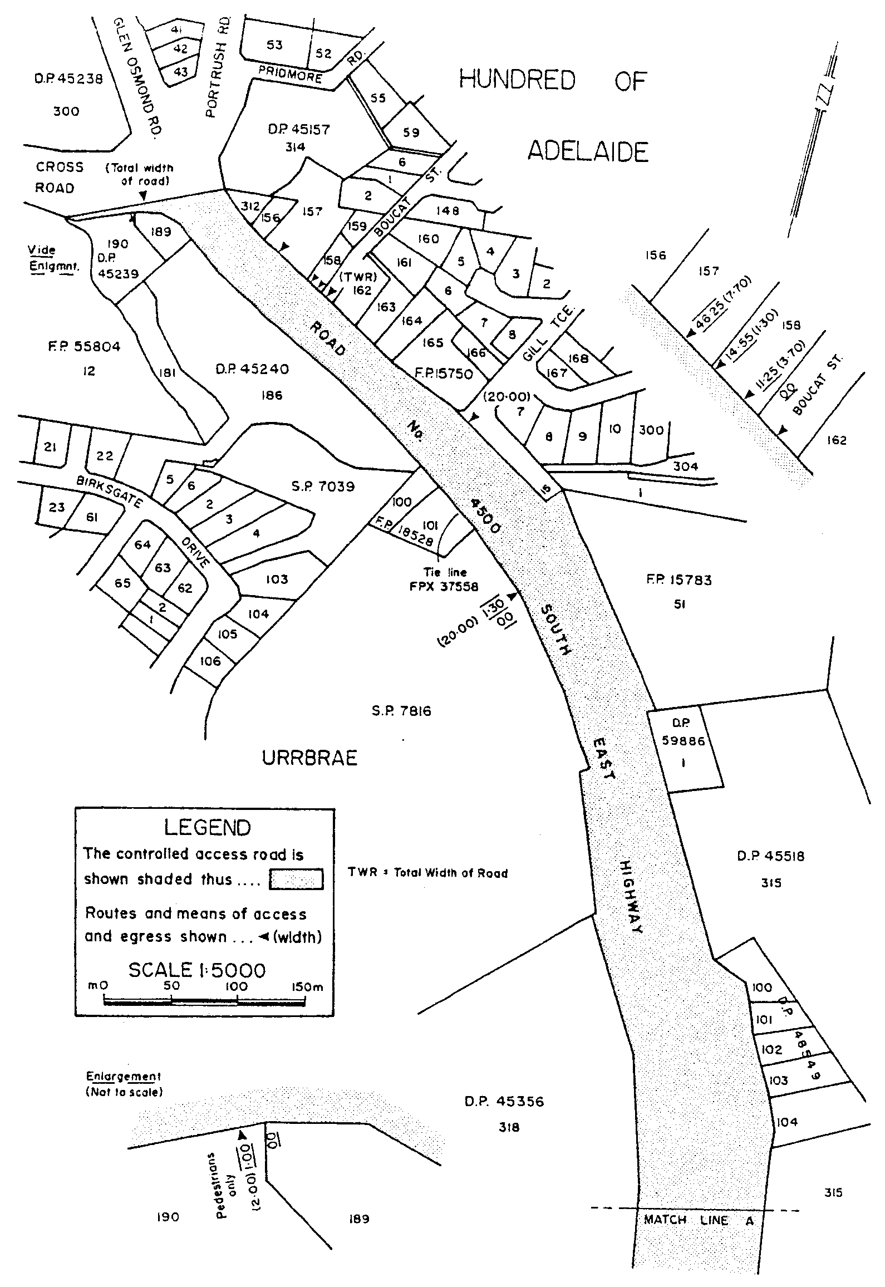
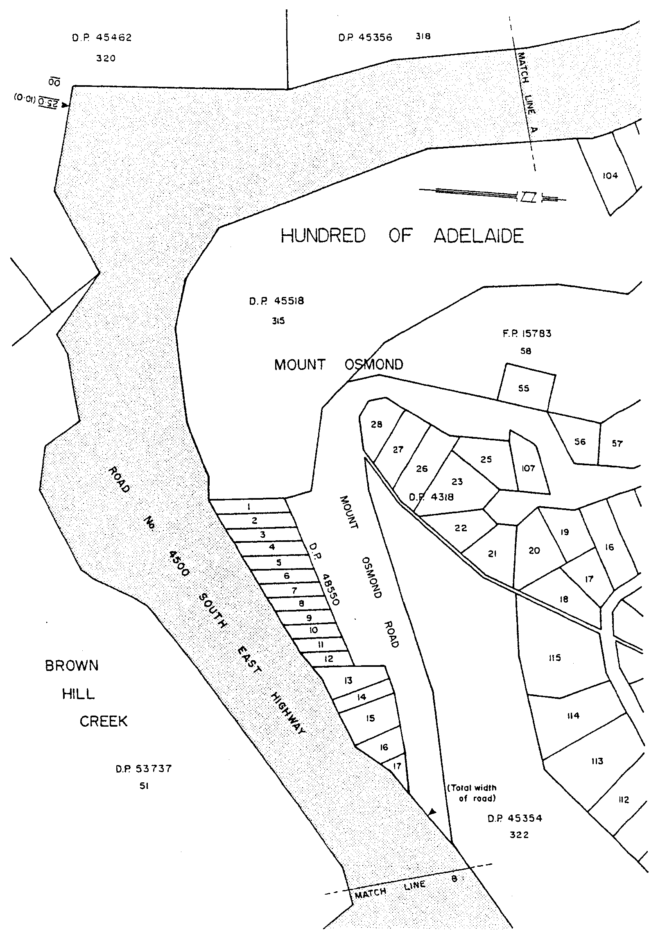
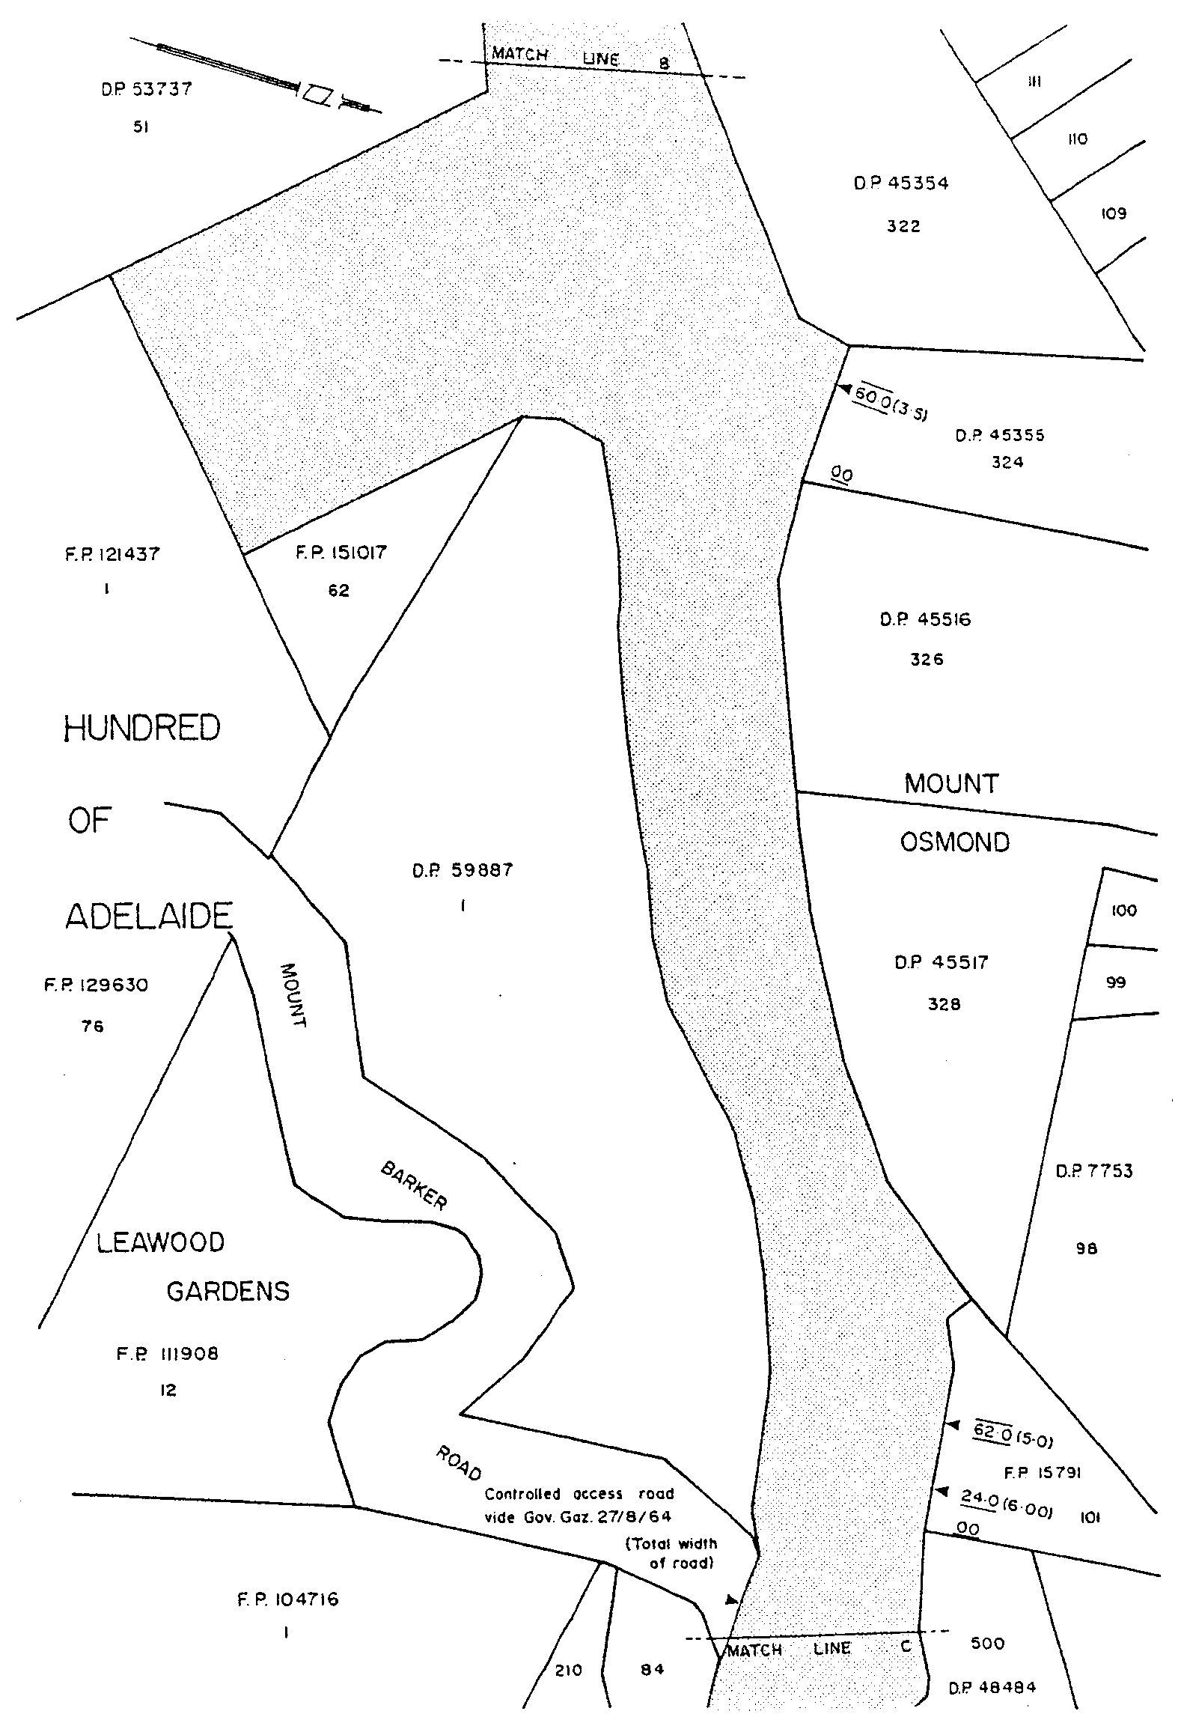
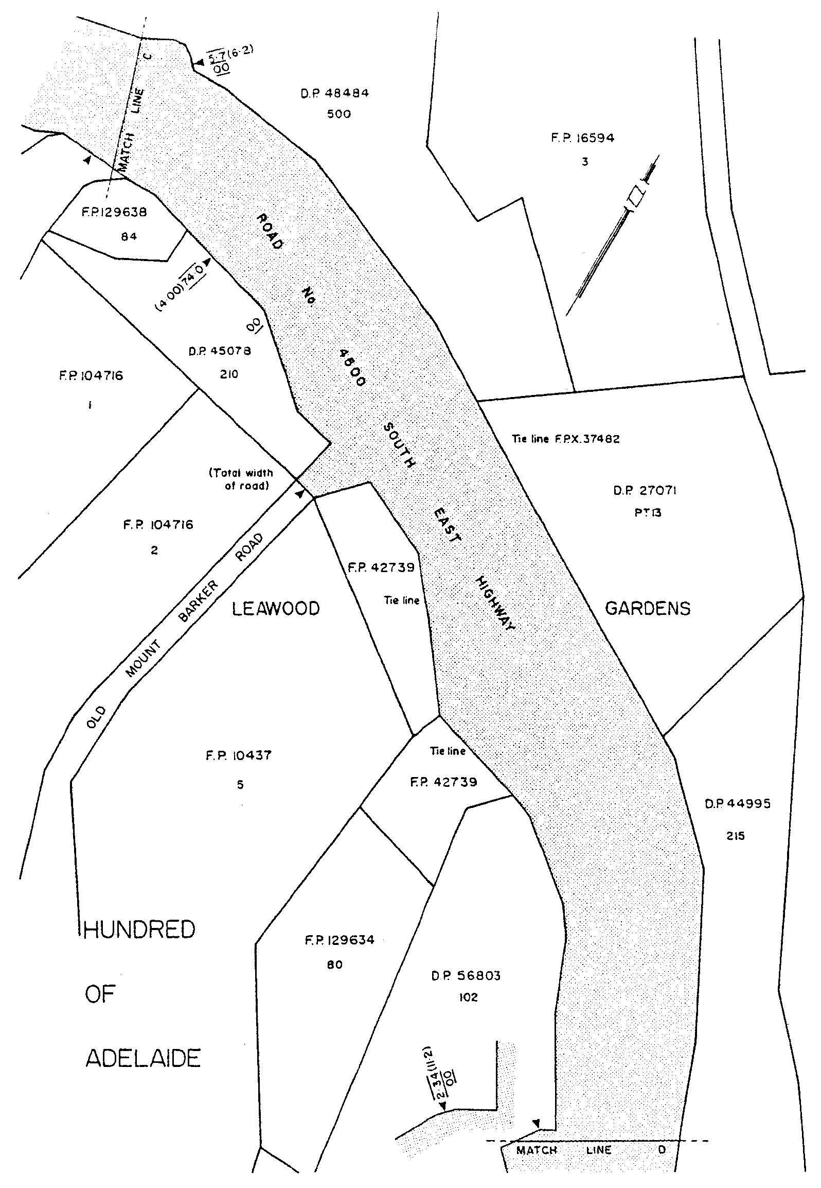
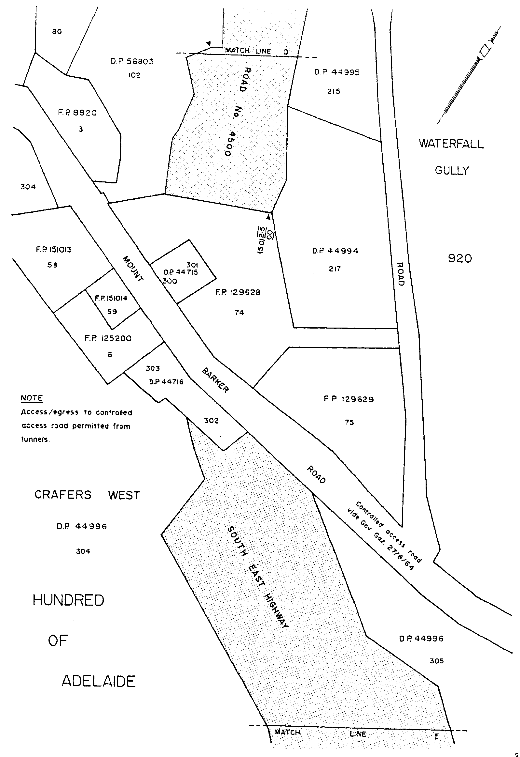
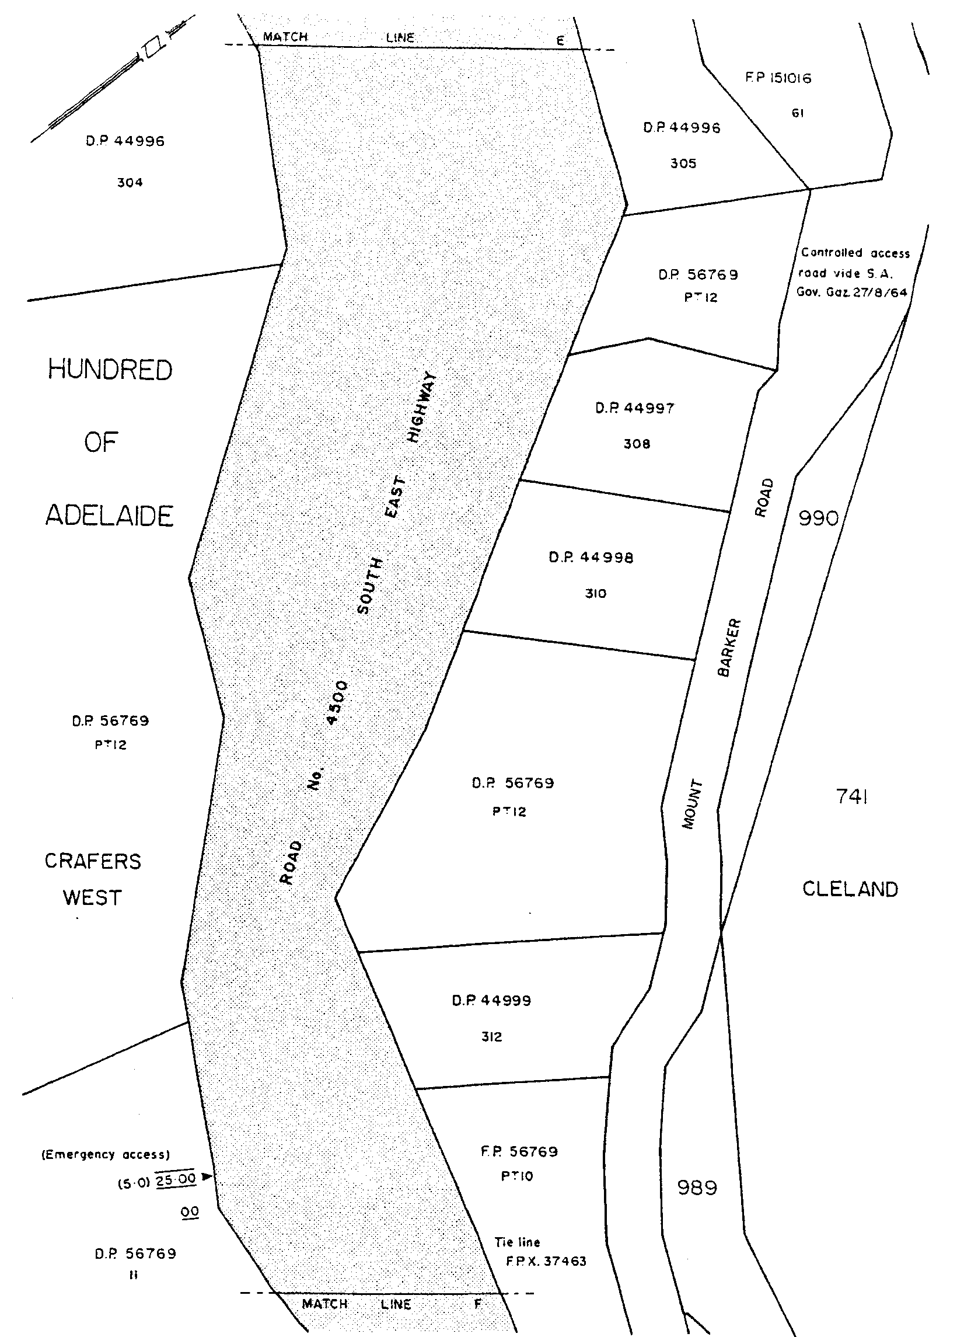
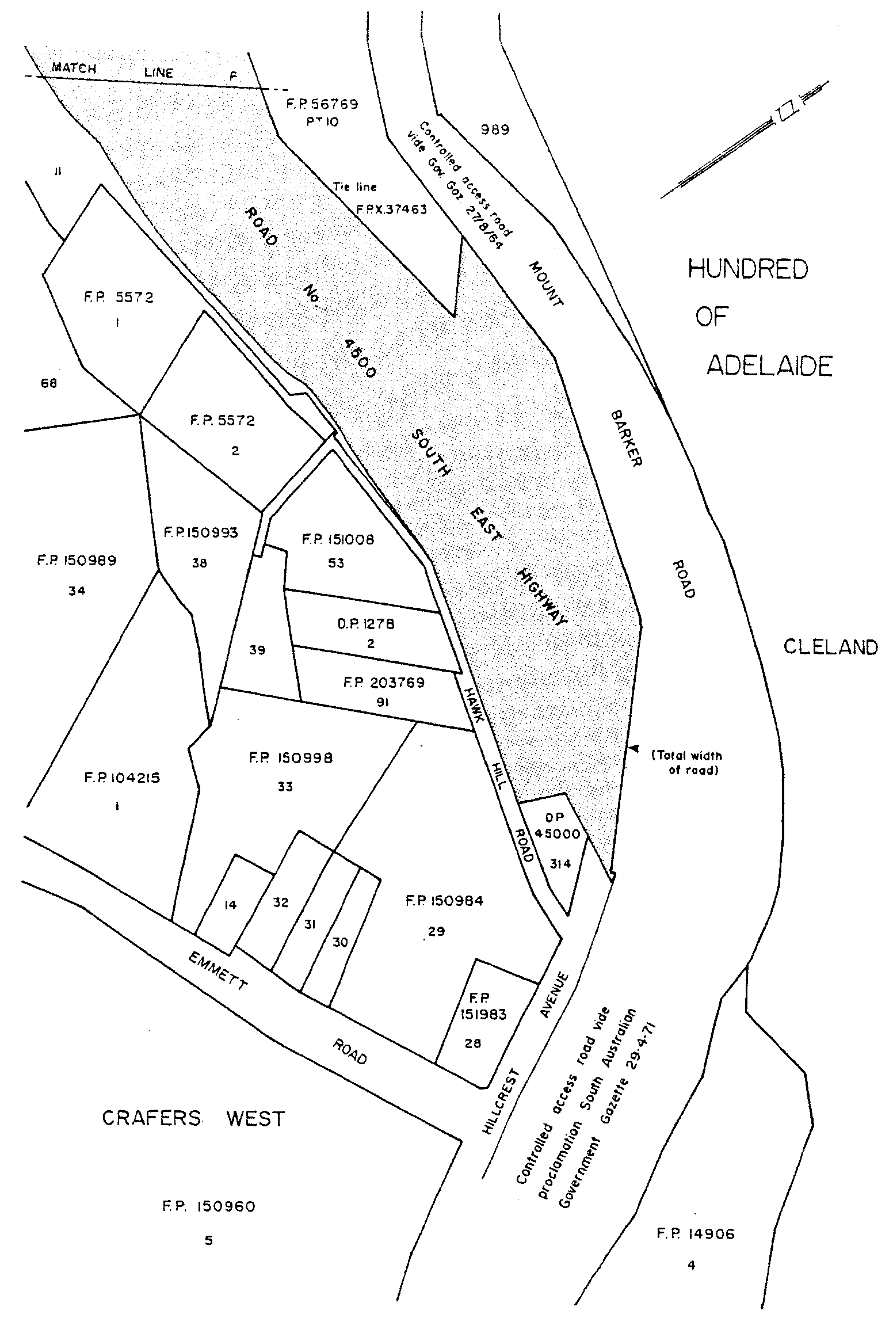

Given under my hand and the Public Seal of South Australia, at Adelaide, 12 September 2002.
By command,
J. D. Hill, for Premier
CTSA 2002/06873

ESSENTIAL SERVICES COMMISSION ACT 2002
(Act No. 14 of 2002): DAY OF COMMENCEMENT
Proclamation By The Governor
(l.s.) Marjorie Jackson-Nelson
WITH the advice and consent of the Executive Council, I—
(a) fix 12 September 2002 as the day on which the Essential Services Commission Act 2002, other than section 9, will come into operation;
(b) fix 1 March 2003 as the day on which section 9 of the Essential Services Commission Act 2002 will come into operation.
Given under my hand and the Public Seal of South Australia, at Adelaide, 12 September 2002.
By command,
J. D. Hill, for Premier
T&F 02/043 CS PT 0002

PUBLIC SECTOR MANAGEMENT ACT 1995 SECTION 7—DEPARTMENT OF FURTHER EDUCATION, EMPLOY-MENT, SCIENCE AND TECHNOLOGY
Proclamation By The Governor
(l.s.) Marjorie Jackson-Nelson
PURSUANT to section 7 of the Public Sector Management Act 1995 and with the advice and consent of the Executive Council, I—
(a) alter the title of the Department of Employment, Further Education, Science and Small Business to the Department of Further Education, Employment, Science and Technology;
(b) transfer the employees in the Department for Adminis-trative and Information Services in the Information Economy Policy Office to the Department of Further Education, Employment, Science and Technology;
(c) declare that, for financial accounting and reporting purposes, the transfer of employees under paragraph (b), and any associated transfer of functions and duties, will be taken to occur on 1 October 2002.
Given under my hand and the Public Seal of South Australia, at Adelaide, 12 September 2002.
By command,
J. D. Hill, for Premier
DPC 030/02CS

PUBLIC SECTOR MANAGEMENT ACT 1995 SECTION 7: STRUCTURE OF THE PUBLIC SERVICE—OFFICE OF ECONOMIC DEVELOPMENT
Proclamation By The Governor
(l.s.) Marjorie Jackson-Nelson
PURSUANT to section 7 of the Public Sector Management Act 1995 and with the advice and consent of the Executive Council, I—
(a) establish an administrative unit and assign to it the title Office of Economic Development;
(b) abolish the Department of Industry and Trade;
(c) transfer the employees referred to in the Schedule to the Office of Economic Development;
(d) declare that, for financial accounting and reporting purposes, the transfer of employees of the Department of Primary Industries and Resources to the Office of Economic Development pursuant to this proclamation, and any associated transfer of functions and duties, will be taken to occur on 1 October 2002.
Schedule
All employees of the Department of Industry and Trade.
Employees of the Department of Primary Industries and Resources in the Office of Regional Development.
Given under my hand and the Public Seal of South Australia, at Adelaide, 12 September 2002.
By command,
J. D. Hill, for Premier
DPC 50/96PT7CS
DPC 50/96PT9CS

YOUTH COURT ACT 1993 SECTION 9 (10): DESIGNATION OF SENIOR JUDGE—VARIATION OF PROCLAMATION
Proclamation By The Governor
(l.s.) Marjorie Jackson-Nelson
PURSUANT to section 9 (10) of the Youth Court Act 1993 and with the advice and consent of the Executive Council, I vary the proclamation made on 1 August 2002 relating to the designation of Alan Peter Moss as the Senior Judge of the Youth Court of South Australia (see Gazette 1 August 2002 p. 2968)—
(a) by striking out from clause 1 ‘five’ and substituting ‘ten’;
(b) by striking out from clause 3 ‘of five years’;
(c) by inserting in clause 3 ‘and expiring on 4 August 2012’ after ‘5 August 2002’.
Given under my hand and the Public Seal of South Australia, at Adelaide, 12 September 2002.
By command,
J. D. Hill, for Premier
AGO 0259/02CS

Department of the Premier and Cabinet
Adelaide, 12 September 2002
HER Excellency the Governor in Executive Council has been pleased to appoint the undermentioned to the South Australian Council on Reproductive Technology, pursuant to the provisions of the Reproductive Technology Act 1988:
Member: (from 12 September 2002 until 23 December 2003)
Susan Priest
Deputy Member: (from 12 September 2002 until 23 December 2003)
Lorraine Read (Deputy to Priest)
John Henry Chandler (Deputy to Woolcock)
By command,
J. D. Hill, for Premier
MHEA-MGR 0009CS

Department of the Premier and Cabinet
Adelaide, 12 September 2002
HER Excellency the Governor in Executive Council has been pleased to appoint the undermentioned to the Aboriginal Lands Trust, pursuant to the provisions of the Aboriginal Lands Trust Act 1966:
Chairman: (from 12 September 2002 until 11 September 2005)
George Tongerie
Member: (from 12 September 2002 until 11 September 2005)
Kingsley Abdulla
George Cooley
Ian Devon Johnson
Reg Dodd
Christine Lennon
Irene McKenzie
Peter Rigney
Haydn John Davey
Elaine Newchurch
George Reid
Alan Dodd
Deputy Member: (from 12 September 2002 until 11 September 2005)
Timothy Abdulla (Deputy to Abdulla)
Maureen Williams (Deputy to Cooley)
Denise Linda Wilton (Deputy to Johnson)
Timothy Strangways (Deputy to Dodd)
Anthony Smith (Deputy to Lennon)
Damien Marlowe (Deputy to McKenzie)
Henry James Rankine (Deputy to Rigney)
Barry Johncock (Deputy to Davey)
Irene Dorothy Agius (Deputy to Newchurch)
Bernard Porta (Deputy to Reid)
By command,
J. D. Hill, for Premier
MAAR 0004/02CS

Department of the Premier and Cabinet
Adelaide, 12 September 2002
HER Excellency the Governor in Executive Council has been pleased to appoint the undermentioned to the Boundary Adjustment Facilitation Panel, pursuant to the provisions of the Local Government Act 1999:
Panel Member: (from 12 September 2002 until 30 June 2004)
Rosemary Anne Clancy
Leslie Birch
John Legoe
Ann Irving
Chair: (from 12 September 2002 until 30 June 2004)
Rosemary Anne Clancy
By command,
J. D. Hill, for Premier
MLG 0013/2002CS

Department of the Premier and Cabinet
Adelaide, 12 September 2002
HER Excellency the Governor in Executive Council has been pleased to appoint Gregory John Black to the position of Chief Executive, Department of Further Education, Employment, Science and Technology, for a term of five years commencing on 16 September 2002, pursuant to Part 4 of the Public Sector Management Act 1995.
By command,
J. D. Hill, for Premier
DPC 030/02CS

Department of the Premier and Cabinet
Adelaide, 12 September 2002
HER Excellency the Governor in Executive Council has been pleased to appoint the Honourable Michael David Rann, Premier, MP, Minister for Economic Development, Minister for the Arts and Minister for Volunteers to be also Acting Attorney-General, Acting Minister for Justice, Acting Minister for Consumer Affairs and Acting Minister for Multicultural Affairs for the period 28 September 2002 to 11 October 2002, inclusive, during the absence of the Honourable Michael John Atkinson, MP.
By command,
J. D. Hill, for Premier
ATTG 0319/02CS

BUILDING WORK CONTRACTORS ACT 1995
Exemption
TAKE notice that, pursuant to section 45 of the Building Work Contractors Act 1995, I, Michael John Atkinson, Minister for Consumer Affairs, do hereby exempt the licensee named in Schedule 1 from the application of Division 3 of Part 5 of the above Act in relation to domestic building work described in Schedule 2 and subject to the conditions specified in Schedule 3.
Schedule 1
Distinctive Homes Pty Ltd, BLD 10420.
Schedule 2
Work performed by the licensee to construct a retirement village at the property described as Lots 2 to 4 inclusive, Lot 14, a portion of Lot 18 and Lot 19, Anzac Highway, Morphettville.
Schedule 3
The licensee must not transfer its interests in the dwellings during the statutory warranty period without the consent of the Commissioner for Consumer Affairs.
Dated 3 September 2002.
M. J. Atkinson, Minister for Consumer Affairs
Ref: 610/02-00325

CONTROLLED SUBSTANCES ACT 1994
Prohibition
TAKE notice that on 28 August 2002, the Minister for Health made an order, pursuant to section 57 (1) of the Controlled Substances Act 1984, in respect of:
Cheryl Marie Anderson
6 Paltarra Grove
Aberfoyle Park, S.A. 5159
prohibiting Cheryl Anderson from supplying, administering or having possession of any prescription drug being a drug of dependence or benzodiazepine.
This Order does not apply to any prescription drug being a drug of dependence or benzodiazepine lawfully supplied or prescribed for Cheryl Anderson by another medical practitioner or dentist.
K. Evans, Director, Drug Programs and Population Strategies Branch, operating under delegated authority, pursuant to the Controlled Sustances Act 1984, acting for and on behalf of the Minister for Health.

CROWN LANDS ACT 1929: SECTION 5
TAKE NOTICE that pursuant to the Crown Lands Act 1929, I, JOHN HILL, Minister for Environment and Conservation, Minister of the Crown to whom the administration of the Crown Lands Act 1929, is committed DO HEREBY dedicate the Crown Land defined in The Schedule as a Public Road.
The Schedule
Allotments 2275 and 2276 of DP 59910, Town of Coober Pedy, Out of Hundreds (Coober Pedy), being within the district of Coober Pedy.
Dated 12 September 2002.
J. Hill, Minister for Environment and Conservation
DL 5094/1992

CROWN LANDS ACT 1929: SECTION 5
TAKE NOTICE that pursuant to the Crown Lands Act 1929, I, JOHN HILL, Minister for Environment and Conservation, Minister of the Crown to whom the administration of the Crown Lands Act 1929 is committed DO HEREBY dedicate the Crown Land defined in The Schedule as a Public Pleasure Reserve and declare that such land shall be under the care, control and management of the City of Mount Gambier, subject to the following conditions:
(a) The City of Mount Gambier must not undertake or permit any activity, work or scheme of development which will affect the site as a volcanic feature or harm or destroy the geological features set out in 4.2.1 of the June 1988 Mount Gambier Lakes Area Management Plan, or other archaeological features identified in the future; and
(b) The City of Mount Gambier must not assign, lease or permit to be subleased any part of the dedicated land without the prior written consent of the Minister for Environment and Conservation.
The Schedule
Section 591, Hundred of Blanche, County of Grey, exclusive of all necessary roads.
Dated 12 September 2002.
J. Hill, Minister for Environment and Conservation
DENR 2506/1995

DEVELOPMENT ACT 1993, SECTION 28 (1): DECLAR-ATION OF INTERIM OPERATION OF LAND NOT WITHIN A COUNCIL AREA (COASTAL WATERS) DEVELOPMENT PLAN—LOWER EYRE PENINSULA AQUACULTURE PLAN AMENDMENT
Notice
PURSUANT to section 28 (1) of the Development Act 1993, I, the Governor, with the advice and consent of the Executive Council, being of the opinion that it is necessary in the interest of the orderly and proper development of the area affected by the ‘Land Not Within a Council Area (Coastal Waters) Development Plan—Lower Eyre Peninsula Aquaculture Plan Amendment’ that the plan amendment should come into operation without delay, declare that the plan amendment will come into operation on an interim basis on 12 September 2002.
Given under my hand at Adelaide, 5 September 2002.
By command,
Marjorie Jackson-Nelson, Governor
MFUDP CAB CPSA 2002/00025CS

DEPARTMENT OF PRIMARY INDUSTRIES AND RESOURCES SA—FISHERIES DIVISION
NOTICE is hereby given pursuant to section 28 (10) (b) of the Fisheries Act 1982, that the following items have been seized by officers of the Department of Primary Industries and Resources SA, Fisheries Division:
1 wire fish trap constructed from hexagon shaped wire 40 mm mesh, 1 150 mm diameter by 1 000 mm long, 1 entrance funnel with a length of white braided rope attached.
The above items were suspected to have been used or intended to be used, in contravention of the Fisheries Act 1982, and were taken into possession at Slaney Creek on 16 August 2002.
After the expiration of one month from the date of this notice the items listed above shall, on the order of the Minister for Primary Industries, be forfeited to the Crown and shall be either disposed of by sale or destruction.
The above items may be viewed at the Loxton office of the Department of Primary Industries and Resources SA, Fisheries Division.
Dated 6 September 2002.
M. Lewis, General Manager Fisheries Services

DEPARTMENT OF PRIMARY INDUSTRIES AND RESOURCES SA—FISHERIES DIVISION
NOTICE is hereby given pursuant to section 28 (10) (b) of the Fisheries Act 1982, that the following items have been seized by officers of the Department of Primary Industries and Resources SA, Fisheries Division:
1 framed cotton mesh drum net, 1 100 mm diameter by 1 600 mm long, 1 entrance funnel with a length of white rope attached.
The above items were suspected to have been used or intended to be used, in contravention of the Fisheries Act 1982, and were taken into possession at Pike River (approximately 10 m down-stream of the Letton Road Ferry) on 28 August 2002.
After the expiration of one month from the date of this notice the items listed above shall, on the order of the Minister for Primary Industries, be forfeited to the Crown and shall be either disposed of by sale or destruction.
The above items may be viewed at the Loxton office of the Department of Primary Industries and Resources SA, Fisheries Division.
Dated 6 September 2002.
M. Lewis, General Manager Fisheries Services

DEPARTMENT OF PRIMARY INDUSTRIES AND RESOURCES SA—FISHERIES DIVISION
NOTICE is hereby given pursuant to section 28 (10) (b) of the Fisheries Act 1982, that the following items have been seized by officers of the Department of Primary Industries and Resources SA, Fisheries Division:
1 wire fish trap constructed from hexagon shaped wire mesh, 900 mm diameter by 1 100 mm long, 1 entrance funnel with a length of green string attached.
The above items were suspected to have been used or intended to be used, in contravention of the Fisheries Act 1982, and were taken into possession at Ral Ral Creek on 18 August 2002.
After the expiration of one month from the date of this notice the items listed above shall, on the order of the Minister for Primary Industries, be forfeited to the Crown and shall be either disposed of by sale or destruction.
The above items may be viewed at the Loxton office of the Department of Primary Industries and Resources SA, Fisheries Division.
Dated 6 September 2002.
M. Lewis, General Manager Fisheries Services

DEPARTMENT OF PRIMARY INDUSTRIES AND RESOURCES SA—FISHERIES DIVISION
NOTICE is hereby given pursuant to section 28 (10) (b) of the Fisheries Act 1982, that the following items have been seized by officers of the Department of Primary Industries and Resources SA, Fisheries Division:
1 wire fish trap with 7 cm mesh (1 200 mm long by 600 mm diameter), 1 entrance funnel, 1 wooden stake as a weight, black cord attached.
1 wire fish trap with 7 cm mesh (1 100 mm long by 900 mm diameter), 1 entrance funnel (with metal ring), aqua cord attached.
The above items were suspected to have been used or intended to be used, in contravention of the Fisheries Act 1982, and were taken into possession at Rumpagunya Creek on 3 August 2002.
After the expiration of one month from the date of this notice the items listed above shall, on the order of the Minister for Primary Industries, be forfeited to the Crown and shall be either disposed of by sale or destruction.
The above items may be viewed at the Loxton office of the Department of Primary Industries and Resources SA, Fisheries Division.
Dated 6 September 2002.
M. Lewis, General Manager Fisheries Services

DEPARTMENT OF PRIMARY INDUSTRIES AND RESOURCES SA—FISHERIES DIVISION
NOTICE is hereby given pursuant to section 28 (10) (b) of the Fisheries Act 1982, that the following items have been seized by officers of the Department of Primary Industries and Resources SA, Fisheries Division:
2 wire fish traps constructed from 7 cm chook mesh (1 000 mm long by 750 mm diameter) and (1 100 mm long by 900 mm diameter), 1 entrance funnel on each, with a length of black cord attached to each.
The above items were suspected to have been used or intended to be used, in contravention of the Fisheries Act 1982, and were taken into possession at Tanyaca Creek on 31 August 2002.
After the expiration of one month from the date of this notice the items listed above shall, on the order of the Minister for Primary Industries, be forfeited to the Crown and shall be either disposed of by sale or destruction.
The above items may be viewed at the Loxton office of the Department of Primary Industries and Resources SA, Fisheries Division.
Dated 6 September 2002.
M. Lewis, General Manager Fisheries Services

DEPARTMENT OF PRIMARY INDUSTRIES AND RESOURCES SA—FISHERIES DIVISION
NOTICE is hereby given pursuant to section 28 (10) (b) of the Fisheries Act 1982, that the following items have been seized by officers of the Department of Primary Industries and Resources SA, Fisheries Division:
1 wire fish trap with 7 cm chook mesh (1 100 mm long by 600 mm diameter), 2 entrance funnels, wooden stake as weight, black rope attached.
The above items were suspected to have been used or intended to be used, in contravention of the Fisheries Act 1982, and were taken into possession at the junction of Rumpagunya Creek and Tanyaca Creek on 31 August 2002.
After the expiration of one month from the date of this notice the items listed above shall, on the order of the Minister for Primary Industries, be forfeited to the Crown and shall be either disposed of by sale or destruction.
The above items may be viewed at the Loxton office of the Department of Primary Industries and Resources SA, Fisheries Division.
Dated 6 September 2002.
M. Lewis, General Manager Fisheries Services

FISHERIES ACT 1982: SECTION 59
TAKE notice that pursuant to section 59 of the Fisheries Act 1982, Rolf Czabayski, 5 Willowbridge Grove, Burnside, S.A. 5066, (hereinafter referred to as the ‘exemption holder’) is exempt from Regulation 24 (1) of the Fisheries (General) Regulations 2000, in that the exemption holder shall not be guilty of an offence only insofar as being permitted to use blood, bone, meat offal or skin of an animal as berley within the waters specified in Schedule 1 to attract white sharks (Carchardon carcharias) for the purpose of cage viewing only (hereinafter referred to as the ‘permitted activity’), subject to the conditions specified in Schedule 2, for the dates specified in Schedule 3, until this exemption is varied or revoked.
Schedule 1
Coastal waters contained within the Neptune Islands Conservation Park, and the following portions of the Sir Joseph Banks Islands Conservation Park:
• Sibsey Island.
• English island.
Note: Berleying is not currently permitted at Dangerous Reef.
Schedule 2
1. The exemption holder must be on board the boat when conducting the permitted activity.
2. All berley used while conducting the permitted activity must consist of fish based products only. All berley (other than fish oil) must be stored below a maximum temperature of 4°C.
3. The exemption holder must, at least 24 hours prior to conducting the permitted activities, both notify the public by a Notice to Mariners through the Australian Maritime Safety Authority, and inform the local coastguard and the Fisheries Compliance Unit on 1800 065 522.
4. The exemption holder must allow an officer of the Department for Environment and Heritage (DEH) or Fisheries Officer or nominee to be present on board the boat during the permitted activity if requested, subject to negotiation and availability of space.
5. The exemption holder must comply with all instructions (including ceasing to berley if so instructed) given by an officer from DEH or Fisheries Officer.
6. Whilst engaged in the permitted activity, a pennant (approved by DEH) must be flown from the boat so as to be clearly visible.
7. Whilst engaged in the permitted activity one of the exemption holders must have in his possession a copy of this notice and produce a copy of the notice if required by a Fisheries Officer.
8. The exemption holder shall not contravene or fail to comply with the Fisheries Act 1982, or any regulations made under the Act, except where specifically exempted by this notice.
9. The exemption holder must maintain a log whilst engaged in the permitted activity which includes the date and location, number of passengers, number of hours berleying, number of sharks observed and any other relevant observations or comments. Records must be kept in a form determined by the operators association in conjunction with CSIRO Marine Research Unit and endorsed by the Minister for Environment and Heritage. A copy of the log must be provided to the relevant DEH office within 14 days of the end of each calender month.
10. The exemption holder must conform to a code of conduct developed by the operators association and endorsed by the Minister for Environment and Conservation.
11. The exemption holder will operate in co-operation with and in agreement of any other approved operator at the same location.
12. The exemption holder must have public liability insurance to an amount determined by the Minister for Environment and Conservation and ensure vessels are surveyed and staffed as per Department of Transport regulations.
Schedule 3
Dates permitted to berley:
3 to 4 July 2002
9 to 12 July 2002
19 to 23 August 2002
5 to 8 September 2002
10 to 15 September 2002
28 to 30 September 2002
1 October 2002
Dated 4 September 2002.
W. Zacharin, Director of Fisheries

FISHERIES ACT 1982: SECTION 59
TAKE notice that pursuant to section 59 of the Fisheries Act 1982, Brett Williams (hereinafter referred to as the ‘exemption holder’), of Williams Seafood, P.O. Box 182, Port MacDonnell, S.A. 5291, is exempt from sections 34 and 41 of the Fisheries Act 1982, but only insofar as he may take sea urchins (Family Echinometridae) (hereinafter referred to as the ‘exempted activity’) subject to the conditions in Schedule 1 for the purposes of trade or business.
Schedule 1
1. The exemption holder may engage in the exempted activity from the date of gazettal of this notice until 31 December 2002, unless varied or revoked earlier.
2. Fish may be taken from coastal waters of the State excluding the waters of Coffin Bay south of latitude 34°30.30′S.
3. The exemption holder may authorise a person to act on his behalf in conducting the exempted activity for a maximum of 21 days in any one financial year (the nominated person). The exemption holder must make this nomination prior to the nominated person commencing or conducting acts preparatory to commencing the exempted activity by telephoning the PIRSA Fisheries Compliance Unit on 1800 065 522 and provide the following information:
• the full name of the nominated person; and
• the residential address of the nominated person.
4. The exemption holder (or the nominated person) and two other people (assistants) may engage in the exempted activity at any one time. The people assisting the exemption holder must, at all times whilst conducting the exempted activity, remain within 50 m of the exemption holder. Sea urchins may only be taken by hand.
5. The exemption holder must provide the Director of Fisheries statistical catch and effort information (including zero returns if no fishing operations have been conducted), in the form of a daily log as provided, within 15 days of the completion of each calender month.
6. The exemption holder shall notify the PIRSA Fisheries Compliance Unit on 1800 065 522 at least one hour prior to conducting the exempted activity with the following information:
• details of the boat that will be used to engage in the exempted activity;
• the intended area of conducting the exempted activity;
• the intended place and time of launching and retrieval of the nominated boat for that day; and
• the name of the assistants (if any) who will be assisting the exemption holder or the nominated person.
7. PIRSA Fisheries retains the right for a departmental officer to accompany the exemption holder or nominated person at any time whilst conducting the exempted activity.
8. While engaged in the exempted activity the exemption holder (or the nominated person) shall carry or have about or near his person a copy of this notice. Such notice must be produced to a PIRSA Fisheries Compliance Officer upon request.
9. The exemption holder shall not contravene or fail to comply with the Fisheries Act 1982, or any regulations made under that Act, except where specifically exempted by this notice.
Dated 27 August 2002.
W. Zacharin, Director of Fisheries

FISHERIES ACT 1982: SECTION 59
TAKE notice that pursuant to section 59 of the Fisheries Act 1982, Stephen Wright (hereinafter referred to as the ‘exemption holder’), ESD, Lot 7, Murray Road, Inglewood, S.A. 5133, is exempt from section 34 of the Fisheries Act 1982, but only insofar as he may take sea urchins (Family Echinometridae) (hereinafter referred to as the ‘exempted activity’) subject to the conditions in Schedule 1 for the purposes of trade or business, from the date of the gazettal notice until 31 December 2002, unless varied or revoked earlier.
Schedule 1
1. Fish may be taken from coastal waters of the State excluding the waters of Coffin Bay south of latitude 34°30.30′S.
2. The exemption holder may authorise a person to act on his behalf in conducting the exempted activity for a maximum of 21 days in any one financial year (the nominated person). The exemption holder must make this nomination prior to the nominated person commencing or conducting acts preparatory to commencing the exempted activity by telephoning the PIRSA Fisheries Compliance Unit on 1800 065 522 and provide the following information:
• the full name of the nominated person; and
• the residential address of the nominated person.
3. The exemption holder (or the nominated person) and two other people (assistants) may engage in the exempted activity at any one time. The people assisting the exemption holder must, at all times whilst conducting the exempted activity, remain within 50 m of the exemption holder. Sea urchins may only be taken by hand.
4. The exemption holder must provide the Director of Fisheries statistical catch and effort information (including zero returns if no fishing operations have been conducted), in the form of a daily log as provided, within 15 days of the completion of each calender month.
5. The exemption holder shall notify the PIRSA Fisheries Compliance Unit on 1800 065 522 at least one hour prior to conducting the exempted activity with the following information:
• details of the boat that will be used to engage in the exempted activity;
• the intended area of conducting the exempted activity;
• the intended place and time of launching and retrieval of the nominated boat for that day; and
• the name of the assistants (if any) who will be assisting the exemption holder or the nominated person.
6. PIRSA Fisheries retains the right for a departmental officer to accompany the exemption holder or the nominated person at any time whilst conducting the exempted activity.
7. The exemption holder or his nominated replacement or assistants must not conduct any other fishing activity whilst undertaking the exempted activity.
8. While engaged in the exempted activity the exemption holder (or the nominated person) shall carry or have about or near his person a copy of this notice. Such notice must be produced to a PIRSA Fisheries Compliance Officer upon request.
9. The exemption holder shall not contravene or fail to comply with the Fisheries Act 1982, or any regulations made under that Act, except where specifically exempted by this notice.
Dated 27 August 2002.
W. Zacharin, Direcror of Fisheries

FISHERIES ACT 1982: SECTION 59
TAKE notice that, pursuant to section 59 of the Fisheries Act 1982, Doug Graske (hereinafter referred to as the ‘exemption holder’), P.O. Box 1781, Port Lincoln, S.A. 5606, is exempt from the Fisheries Act 1982, but only insofar as the exemption holder may take greenlip abalone (Haliotis leavigata) in South Australian coastal waters subject to the conditions in Schedule 1 (hereinafter referred to as the ‘exempted activity’) from the date of the gazettal of this notice until 28 February 2003, unless varied or revoked earlier.
Schedule 1
1. The exemption holder may take a maximum of 150 greenlip abalone (Haliotis leavigata). All abalone taken pursuant to this notice must be transferred to the South Australian Research and Development Institute.
2. The exempted activity may only be conducted by Doug Graske.
3. The exemption holder shall notify the PIRSA Fisheries Compliance Unit on 1800 065 522 at least 24 hours prior to conducting the exempted activity with the following information:
• details of the boat that will be used to engage in the exempted activity;
• the intended place and time of launching and retrieval of the nominated boat for that day; and
• the intended area of conducting the exempted activity.
4. PIRSA Fisheries retains the right for a departmental officer to accompany the exemption holder at any time during the exempted activity.
5. While engaged in the exempted activity the exemption holder shall carry or have about or near his person a copy of this notice. Such notice must be produced to a PIRSA Fisheries Compliance Officer upon request.
6. The exemption holder shall not contravene or fail to comply with the Fisheries Act 1982, or any regulations made under that Act, except where specifically exempted by this notice.
Dated 2 September 2002.
W. Zacharin, Director of Fisheries

FISHERIES ACT 1982: SECTION 59
TAKE notice that, pursuant to section 59 of the Fisheries Act 1982, Michael G. Jolly, P.O. Box 54, Goolwa, S.A. 5214 (hereinafter referred to as the ‘exemption holder’), holder of Marine Scalefish Fishery Licence No. M236, is exempt from the provisions of Regulation 15 (2) of the Scheme of Management (Marine Scalefish Fisheries) Regulations 1991, but only insofar as the exemption holder shall not be guilty of an offence when permitting more than two persons to act as his agents when taking cockles (Suborder Teledonta) for trade or business from the shore (hereinafter referred to as the ‘exempted activity’), subject to the conditions specified in Schedule 1, from the date of gazettal of this notice until 30 June 2003, unless varied or revoked earlier.
Schedule 1
1. The exemption holder may use no more than nine persons acting as his agents at any one time where the exemption holder is at the same time also engaged on the shore in a fishing activity involved with the taking of cockles (Suborder Teledonta) for trade or business.
2. The exemption holder must be within 500 m of all agents conducting fishing activities pursuant to this exemption.
3. While engaged in the exempted activity, the exemption holder shall carry or have about or near his person, a copy of this notice. Such notice must be produced to a PIRSA Fisheries Compliance Officer upon request.
4. The exemption holder shall not contravene or fail to comply with the Fisheries Act 1982, or any regulation made under that Act, except where specifically exempted by this notice.
Dated 4 September 2002.
W. Zacharin, Director of Fisheries

FISHERIES ACT 1982: SECTION 59
TAKE notice that, pursuant to section 59 of the Fisheries Act 1982, Streaky Bay Aquaculture Pty Ltd (hereinafter referred to as the ‘exemption holder’), c/o P.O. Box 206, Streaky Bay, S.A. 5603, is exempt from sections 34 and 41 of the Fisheries Act 1982, but only insofar as it may take greenlip abalone (Haliotis laevigata) and blacklip abalone (Haliotis rubra) for the purpose of aquaculture broodstock (hereinafter referred to as the ‘exempted activity’) in the waters specified in Schedule 1, subject to the conditions in Schedule 2.
Schedule 1
South Australian coastal waters south and east of a line drawn due south through Point Brown (latitude 32°32.6′S, longitude 133°50.8′E) and west of the meridian of longitude 136°30′E.
Schedule 2
1. The exemption holder may take a maximum of 200 greenlip abalone (Haliotis laevigata) and 200 blacklip abalone (Haliotis rubra). All abalone taken pursuant to this notice may not be sold or transferred to another party.
2. All abalone taken pursuant to this notice must be delivered to and retained on the registered aquaculture site of landbased Aquaculture Licence No. FT00652.
3. The exemption holder may engage in the exempted activity from the date of gazettal of this notice until 30 June 2003, unless varied or revoked earlier.
4. The exempted activity may only be conducted by Martin Loipersberger, Dion Edmunds, Damon Edmunds or Jason McEvoy.
5. The exemption holder shall notify the PIRSA Fisheries Compliance Unit on 1800 065 522 at least 24 hours prior to conducting the exempted activity with the following information:
• details of the boat that will be used to engage in the exempted activity;
• the name of the person who will be conducting the exempted activity;
• the intended place and time of launching and retrieval of the nominated boat for that day; and
• the intended area of conducting the exempted activity.
6. The exemption holder must, within 50 m of the point of landing of any abalone taken pursuant to this notice, complete the PIRSA Fisheries form ‘Abalone Broodstock Collection Statement’. Immediately upon arrival at the exemption holders registered aquaculture site, this form must be faxed to PIRSA Fisheries on (08) 8347 6150. Prior to release into the registered aquaculture site, all abalone taken pursuant to this notice must be tagged so as to be clearly identified as wild broodstock.
7. The exemption holder shall record the number of wild broodstock held pursuant to this notice in a register to be maintained at the registered aquaculture site, which must be made available for inspection by a PIRSA Fisheries Compliance Officer upon request.
8. PIRSA Fisheries Compliance Unit retains the right for a departmental officer to accompany the exemption holder at any time during the exempted activity.
9. While engaged in the exempted activity the exemption holder shall carry or have about or near his person a copy of this notice. Such notice must be produced to a PIRSA Fisheries Compliance Officer upon request.
10. The exemption holder shall not contravene or fail to comply with the Fisheries Act 1982, or any regulations made under that Act, except where specifically exempted by this notice.
Dated 5 September 2002.
W. Zacharin, Director of Fisheries

FISHERIES ACT 1982: SECTION 43
TAKE notice that pursuant to section 43 (1) of the Fisheries Act 1982, it is hereby unlawful for the period specified in Schedule 2 for any licensed person who is the holder of a licence in the Marine Scalefish, Lakes and Coorong or Rock Lobster fisheries to take school or gummy shark from waters specified in Schedule 1.
Schedule 1
All waters within the limits of the State and all waters adjacent to the State that are within the Australian Fishing Zone.
Schedule 2
From 00:00 hours on 9 September 2002 to 00:00 hours on
31 December 2002 inclusive, unless this notice is revoked earlier.
Dated 5 September 2002.
W. Zacharin, Director of Fisheries

LAND AND BUSINESS (SALE AND CONVEYANCING) ACT 1994
Exemption
TAKE notice that, pursuant to section 23 (3) of the Land and Business (Sale and Conveyancing) Act 1994, I, Michael John Atkinson, Minister for Consumer Affairs, do hereby exempt the person named in Schedule 1 from the application of section 23 (2) of the Act in relation to the purchase of the land specified in Schedule 2.
Schedule 1
Lesley Ann Mullen, an officer/employee of Kies Real Estate Pty Ltd.
Schedule 2
The whole of the land described in certificate of title register book volume 5202, folio 841, situated at 53 Causby Crescent, Willaston, S.A. 5118.
Dated 12 September 2002.
Signed for and on behalf of the Minister for Consumer Affairs by the Commissioner for Consumer Affairs:
M. Bodycoat, Commissioner

LAND AND BUSINESS (SALE AND CONVEYANCING) ACT 1994
Exemption
TAKE notice that, pursuant to section 23 (3) of the Land and Business (Sale and Conveyancing) Act 1994, I, Michael John Atkinson, Minister for Consumer Affairs, do hereby exempt the person named in Schedule 1 from the application of section 23 (2) of the Act in relation to the purchase of the land specified in Schedule 2.
Schedule 1
Felicity Jean Burton, an officer/employee of Elders Ltd.
Schedule 2
The whole of the land described in certificate of title register book volume 5250, folio 747, situated at 3 Lindsay Street, Whyalla Norrie, S.A. 5608.
Dated 12 September 2002.
Signed for and on behalf of the Minister for Consumer Affairs by the Commissioner for Consumer Affairs:
M. Bodycoat, Commissioner

LAND AND BUSINESS (SALE AND CONVEYANCING) ACT 1994
Exemption
TAKE notice that, pursuant to section 23 (3) of the Land and Business (Sale and Conveyancing) Act 1994, I, Michael John Atkinson, Minister for Consumer Affairs, do hereby exempt the person named in Schedule 1 from the application of section 23 (2) of the Act in relation to the purchase of the land specified in Schedule 2.
Schedule 1
Felicity Jean Burton, an officer/employee of Elders Ltd.
Schedule 2
The whole of the land described in certificate of title register book volume 5429, folio 583, situated at 29 Millowick Street, Whyalla Stuart, S.A. 5608.
Dated 12 September 2002.
Signed for and on behalf of the Minister for Consumer Affairs by the Commissioner for Consumer Affairs:
M. Bodycoat, Commissioner

GOVERNMENT GAZETTE ADVERTISEMENT RATES

To apply from 1 July 2002

$  Agents, Ceasing to Act as 34.10  Associations:  Incorporation 17.40  Intention of Incorporation 43.00  Transfer of Properties 43.00  Attorney, Appointment of 34.10  Bailiff’s Sale 43.00  Cemetery Curator Appointed 25.50  Companies:  Alteration to Constitution 34.10  Capital, Increase or Decrease of 43.00  Ceasing to Carry on Business 25.50  Declaration of Dividend 25.50  Incorporation 34.10  Lost Share Certificates:  First Name 25.50  Each Subsequent Name 8.75  Meeting Final 28.75  Meeting Final Regarding Liquidator’s Report on  Conduct of Winding Up (equivalent to ‘Final  Meeting’)  First Name 34.10  Each Subsequent Name 8.75  Notices:  Call 43.00  Change of Name 17.40  Creditors 34.10  Creditors Compromise of Arrangement 34.10  Creditors (extraordinary resolution that ‘the Com-pany be wound up voluntarily and that a liquidator be appointed’) 43.00  Release of Liquidator⎯Application⎯Large Ad. 68.00  ⎯Release Granted 43.00  Receiver and Manager Appointed 39.75  Receiver and Manager Ceasing to Act 34.10  Restored Name 32.25  Petition to Supreme Court for Winding Up 59.50  Summons in Action 51.00  Order of Supreme Court for Winding Up Action 34.10  Register of Interests⎯Section 84 (1) Exempt 77.00  Removal of Office 17.40  Proof of Debts 34.10  Sales of Shares and Forfeiture 34.10  Estates:  Assigned 25.50  Deceased Persons⎯Notice to Creditors, etc. 43.00  Each Subsequent Name 8.75  Deceased Persons⎯Closed Estates 25.50  Each Subsequent Estate 1.10  Probate, Selling of 34.10  Public Trustee, each Estate 8.75 |  | $  Firms:  Ceasing to Carry on Business (each insertion) 22.70  Discontinuance Place of Business 22.70  Land⎯Real Property Act:  Intention to Sell, Notice of 43.00  Lost Certificate of Title Notices 43.00  Cancellation, Notice of (Strata Plan) 43.00  Mortgages:  Caveat Lodgment 17.40  Discharge of 18.30  Foreclosures 17.40  Transfer of 17.40  Sublet 8.75  Leases⎯Application for Transfer (2 insertions) each 8.75  Lost Treasury Receipts (3 insertions) each 25.50  Licensing 51.00  Municipal or District Councils:  Annual Financial Statement⎯Forms 1 and 2 481.00  Electricity Supply⎯Forms 19 and 20 341.00  Default in Payment of Rates:  First Name 68.00  Each Subsequent Name 8.75  Noxious Trade 25.50  Partnership, Dissolution of 25.50  Petitions (small) 17.40  Registered Building Societies (from Registrar-  General) 17.40  Register of Unclaimed Moneys⎯First Name 25.50  Each Subsequent Name 8.75  Registers of Members⎯Three pages and over:  Rate per page (in 8pt) 218.00  Rate per page (in 6pt) 288.00  Sale of Land by Public Auction 43.50  Advertisements 2.40  Advertisements, other than those listed are charged at $2.40 per column line, tabular one-third extra.  Notices by Colleges, Universities, Corporations and District Councils to be charged at $2.40 per line.  Where the notice inserted varies significantly in length from that which is usually published a charge of $2.40 per column line will be applied in lieu of advertisement rates listed.  South Australian Government publications are sold on the condition that they will not be reproduced without prior permission from the Government Printer.
All the above prices include GST

GOVERNMENT GAZETTE NOTICES
ALL private advertisements forwarded for publication in the South Australian Government Gazette must be PAID FOR PRIOR TO INSERTION; and all notices, from whatever source, should be legibly written on one side of the paper only and sent to Government Publishing SA so as to be received no later than 4 p.m. Tuesday preceding the day of publication. Phone 8207 1045 or Fax 8207 1040. E-mail: governmentgazette@saugov.sa.gov.au. Send as attachments in Word format and please confirm your transmission with a faxed copy of your document, including the date the notice is to be published and to whom the notice will be charged.

MISCELLANEOUS LEGISLATION AND GOVERNMENT PUBLICATIONS PRICES AS FROM 1 JULY 2002

Acts, Bills, Rules, Parliamentary Papers and Regulations
Pages | Main | Amends | Pages | Main | Amends

1-16 | 1.95 | 0.85 | 497-512 | 28.10 | 27.00
17-32 | 2.70 | 1.70 | 513-528 | 28.90 | 27.75
33-48 | 3.50 | 2.50 | 529-544 | 29.70 | 28.75
49-64 | 4.45 | 3.35 | 545-560 | 30.50 | 29.75
65-80 | 5.20 | 4.30 | 561-576 | 31.25 | 30.50
81-96 | 6.00 | 5.00 | 577-592 | 32.30 | 31.00
97-112 | 6.90 | 5.85 | 593-608 | 33.10 | 32.00
113-128 | 7.70 | 6.75 | 609-624 | 33.90 | 33.00
129-144 | 8.65 | 7.65 | 625-640 | 34.60 | 33.50
145-160 | 9.50 | 8.50 | 641-656 | 35.40 | 34.50
161-176 | 10.40 | 9.30 | 657-672 | 36.00 | 35.25
177-192 | 11.20 | 10.20 | 673-688 | 37.50 | 36.00
193-208 | 12.00 | 11.10 | 689-704 | 38.30 | 37.00
209-224 | 12.80 | 11.80 | 705-720 | 38.80 | 38.00
225-240 | 13.60 | 12.60 | 721-736 | 40.25 | 38.50
241-257 | 14.50 | 13.30 | 737-752 | 40.75 | 39.75
258-272 | 15.40 | 14.20 | 753-768 | 41.75 | 40.25
273-288 | 16.30 | 15.20 | 769-784 | 42.25 | 41.50
289-304 | 17.00 | 16.00 | 785-800 | 43.00 | 42.25
305-320 | 17.90 | 16.80 | 801-816 | 43.75 | 42.75
321-336 | 18.70 | 17.60 | 817-832 | 44.75 | 43.75
337-352 | 19.60 | 18.60 | 833-848 | 45.75 | 44.50
353-368 | 20.40 | 19.40 | 849-864 | 46.50 | 45.25
369-384 | 21.30 | 20.30 | 865-880 | 47.25 | 46.50
385-400 | 22.00 | 21.10 | 881-896 | 47.75 | 47.00
401-416 | 22.80 | 21.80 | 897-912 | 49.25 | 47.75
417-432 | 23.90 | 22.70 | 913-928 | 49.75 | 49.25
433-448 | 24.60 | 23.60 | 929-944 | 50.50 | 49.75
449-464 | 25.50 | 24.40 | 945-960 | 51.50 | 50.25
465-480 | 26.00 | 25.20 | 961-976 | 52.50 | 51.25
481-496 | 27.10 | 26.00 | 977-992 | 53.50 | 52.00

Legislation—Acts, Regulations, etc: $
Subscriptions:
Acts 174.00
All Bills as Laid 415.00
Rules and Regulations 415.00
Parliamentary Papers 415.00
Bound Acts 192.00
Index 95.50
Government Gazette
Copy 4.55
Subscription 229.00
Hansard
Copy 12.50
Subscription—per session (issued weekly) 360.00
Cloth bound—per volume 154.50
Subscription—per session (issued daily) 360.00
Legislation on Disk
Whole Database 2 659.00
Annual Subscription for fortnightly updates 817.00
Individual Act(s) including updates POA
Compendium
Subscriptions:
New Subs 1 577.00
Updates 556.00
(All the above prices include GST)

All Legislation, Government Gazette, Hansard and Legislation on disk are available from:
Counter Sales Service SA, Government Information Centre
and Mail Orders: Ground Floor, 77 Grenfell Street, Adelaide, S.A. 5000
Phone: 13 23 24 (local call cost), Fax: (08) 8204 1909
TTY (Hearing Impaired): (08) 8204 1923

Online Shop: www.info.sa.gov.au

Subscriptions and Government Publishing SA
Standing Orders: Box 9, Plaza Level, Riverside Centre, North Terrace, Adelaide, S.A. 5000
Phone: (08) 8207 0908, (08) 8207 0910, Fax: (08) 8207 1040

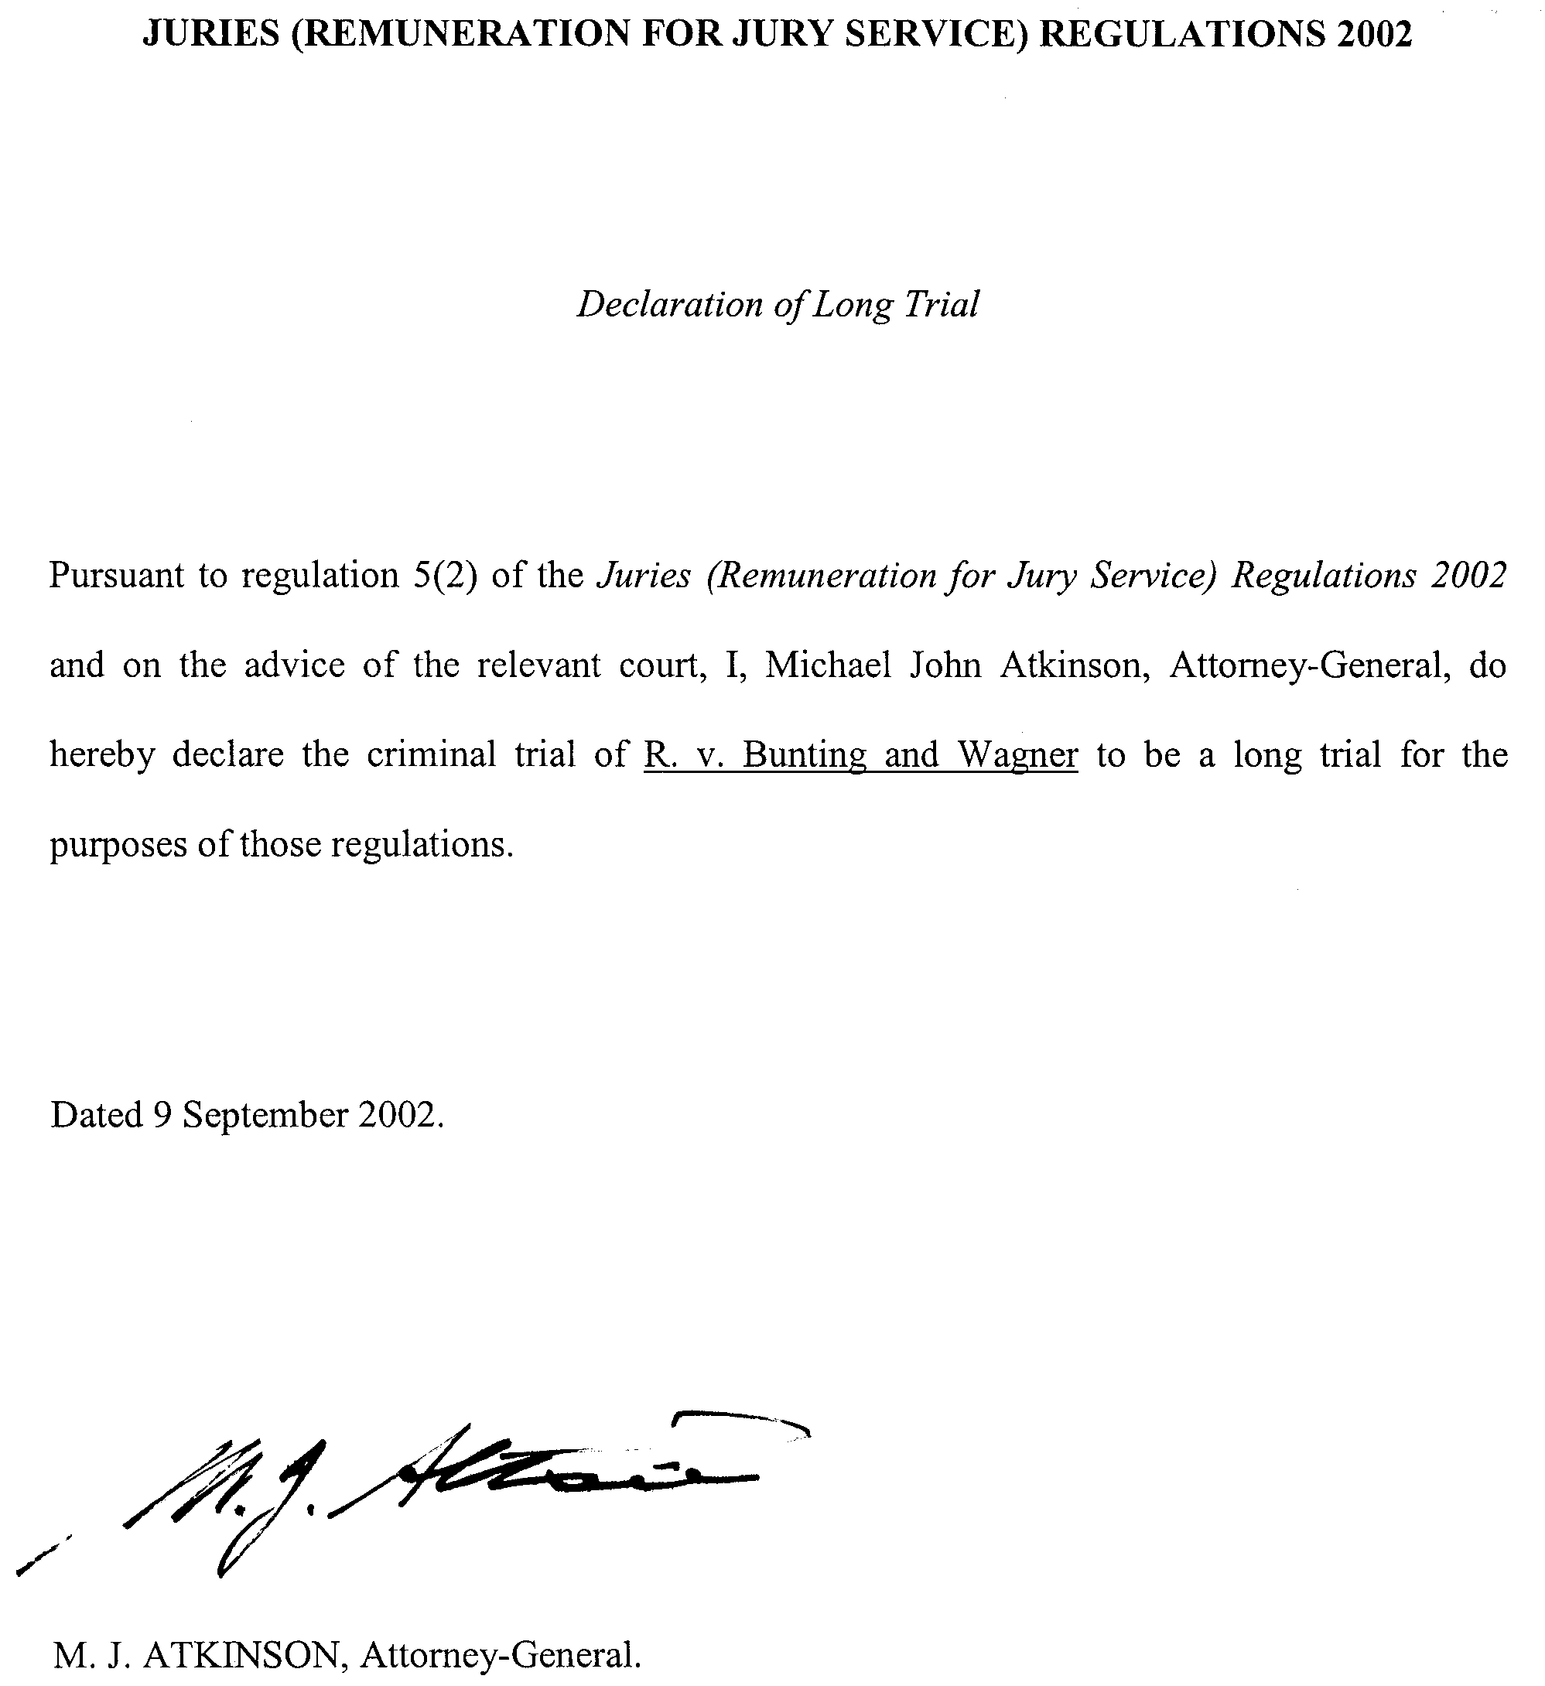

LIQUOR LICENSING ACT 1997
Notice of Application
NOTICE is hereby given, pursuant to section 52 (2) (b) of the Liquor Licensing Act 1997, that Nobuyoshi Suzuki has applied to the Licensing Authority for the transfer of a Restaurant Licence in respect of premises situated at 373 Glen Osmond Road, Glen Osmond, S.A. 5064, known as Commodore Restaurant and to be known as Seafood Restaurant Suzuki.
The application has been set down for hearing on 14 October 2002.
Any person may object to the application by lodging a notice of objection in the prescribed form with the Licensing Authority, and serving a copy of the notice on the applicant at the applicant’s address given above, at least seven days before the hearing date.
Plans in respect of the premises the subject of the application are open to public inspection without fee at the Office of the Liquor and Gaming Commissioner, 9th Floor, East Wing, 50 Grenfell Street, Adelaide, S.A. 5000.
Dated 3 September 2002.
Applicant

LIQUOR LICENSING ACT 1997
Notice of Application
NOTICE is hereby given, pursuant to section 52 (2) (b) of the Liquor Licensing Act 1997, that Eyria Investments Pty Ltd (ACN 008 021 823) has applied to the Licensing Authority for the transfer of a Restaurant Licence in respect of premises situated at 12 Tasman Terrace, Port Lincoln, S.A. 5606 and known as Moretons on the Bay.
The application has been set down for hearing on 14 October 2002.
Any person may object to the application by lodging a notice of objection in the prescribed form with the Licensing Authority, and serving a copy of the notice on the applicant at the applicant’s address given above, at least seven days before the hearing date.
Plans in respect of the premises the subject of the application are open to public inspection without fee at the Office of the Liquor and Gaming Commissioner, 9th Floor, East Wing, 50 Grenfell Street, Adelaide, S.A. 5000.
Dated 5 September 2002.
Applicant

LIQUOR LICENSING ACT 1997
Notice of Application
NOTICE is hereby given, pursuant to section 52 (2) (b) of the Liquor Licensing Act 1997, that Silenus Pty Ltd as trustee for the Barreau Sundowner Trust, c/o Piper Alderman, 167 Flinders Street, Adelaide, S.A. 5000 has applied to the Licensing Authority for the transfer of a Hotel and Gaming Licence in respect of premises situated at Lincoln Highway, Whyalla, S.A. 5600 and known as Sundowner Motel Hotel.
The application has been set down for hearing on 14 October 2002 at 11.30 a.m.
Any person may object to the application by lodging a notice of objection in the prescribed form with the Licensing Authority, and serving a copy of the notice on the applicant at the applicant’s address given above, at least seven days before the hearing date.
Plans in respect of the premises the subject of the application are open to public inspection without fee at the Office of the Liquor and Gaming Commissioner, 9th Floor, East Wing, 50 Grenfell Street, Adelaide, S.A. 5000.
Dated 5 September 2002.
Applicant

LIQUOR LICENSING ACT 1997
Notice of Application
NOTICE is hereby given, pursuant to section 52 (2) (b) of the Liquor Licensing Act 1997, that Crestview Pty Ltd, 49 Fraser Avenue, Happy Valley, S.A. 5159 has applied to the Licensing Authority for the transfer of a Retail Liquor Merchant’s Licence in respect of premises situated at 49 Fraser Avenue, Happy Valley, known as Wine Australia and to be known as Beresford Wines.
The application has been set down for hearing on 14 October 2002 at 10 a.m.
Any person may object to the application by lodging a notice of objection in the prescribed form with the Licensing Authority, and serving a copy of the notice on the applicant at the applicant’s address given above, at least seven days before the hearing date.
Plans in respect of the premises the subject of the application are open to public inspection without fee at the Office of the Liquor and Gaming Commissioner, 9th Floor, East Wing, 50 Grenfell Street, Adelaide, S.A. 5000.
Dated 3 September 2002.
Applicant

LIQUOR LICENSING ACT 1997
Notice of Application
NOTICE is hereby given, pursuant to section 52 (2) (b) of the Liquor Licensing Act 1997, that the Whyalla Hockey Association Inc. has applied to the Licensing Authority for an Extended Trading Authorisation and Entertainment Consent in respect of the premises situated at Searle Street, Whyalla, S.A. 5608 and known as Whyalla Hockey Park.
The application has been set down for hearing on 11 October 2002 at 9 a.m.
Conditions
The following licence conditions are sought:
• Extended Trading Authorisation:
Monday to Saturday: Midnight to 1 a.m. the following day.
Sunday: 10 a.m. to noon.
• Entertainment Consent.
Any person may object to the application by lodging a notice of objection in the prescribed form with the Licensing Authority, and serving a copy of the notice on the applicant at the applicant’s address given above, at least seven days before the hearing date.
Plans in respect of the premises the subject of the application are open to public inspection without fee at the Office of the Liquor and Gaming Commissioner, 9th Floor, East Wing, 50 Grenfell Street, Adelaide, S.A. 5000.
Dated 9 September 2002.
Applicant

LIQUOR LICENSING ACT 1997
Notice of Application
NOTICE is hereby given, pursuant to section 52 (2) (b) of the Liquor Licensing Act 1997, that Vitis V. Trading Pty Ltd, c/o Andrew Williams of Finlaysons Solicitors, has applied to the Licensing Authority for the removal of a Producer’s Licence and removal of a Wholesale Liquor Merchant’s Licence in respect of premises situated at Floor 3, 45 King William Street, Adelaide, S.A. 5000, to be situated at Floor 10, 80 King William Street, Adelaide, S.A. 5000 and known as Vitis V. Trading Pty Ltd.
The applications have been set down for hearing on 11 October 2002 at 9 a.m.
Any person may object to the application by lodging a notice of objection in the prescribed form with the Licensing Authority, and serving a copy of the notice on the applicant at the applicant’s address given above, at least seven days before the hearing date.
Plans in respect of the premises the subject of the application are open to public inspection without fee at the Office of the Liquor and Gaming Commissioner, 9th Floor, East Wing, 50 Grenfell Street, Adelaide, S.A. 5000.
Dated 5 September 2002.
Applicant

LIQUOR LICENSING ACT 1997
Notice of Application
NOTICE is hereby given, pursuant to section 52 (2) (b) of the Liquor Licensing Act 1997, that Alberto Lim Pty Ltd (ACN 101 413 138) has applied to the Licensing Authority for a Restaurant Licence with Extended Trading Authorisation in respect of premises situated at 150B King William Road, Hyde Park, S.A. 5061 and to be known as Soba Noodle Box.
The application has been set down for hearing on 11 October 2002.
Conditions
The following licence conditions are sought:
The licence authorises the licensee to sell liquor on any day except Good Friday and Christmas Day for consumption on the licensed premises by persons:
(a) seated at a table; or
(b) attending a function at which food is provided.
Extended Trading Authorisation:
Sunday: 8 a.m. to 11 a.m. and 8 p.m. to midnight.
Any person may object to the application by lodging a notice of objection in the prescribed form with the Licensing Authority, and serving a copy of the notice on the applicant at the applicant’s address given above, at least seven days before the hearing date.
Plans in respect of the premises the subject of the application are open to public inspection without fee at the Office of the Liquor and Gaming Commissioner, 9th Floor, East Wing, 50 Grenfell Street, Adelaide, S.A. 5000.
Dated 3 September 2002.
Applicant

LIQUOR LICENSING ACT 1997
Notice of Application
NOTICE is hereby given, pursuant to section 52 (2) (b) of the Liquor Licensing Act 1997, that SAJA Trading Pty Ltd has applied to the Licensing Authority for a Restaurant Licence with Entertainment Consent and Extended Trading Authorisation in respect of premises situated at 63 Jetty Road, Brighton, S.A. 5048 and to be known as Medusa’s Taverna.
The application has been set down for hearing on 11 October 2002.
Conditions
The following licence conditions are sought:
The licence authorises the licensee to sell liquor on any day except Good Friday and Christmas Day for consumption on the licensed premises by persons:
(a) seated at a table; or
(b) attending a function at which food is provided.
Extended Trading Authorisation:
Friday and Saturday: Midnight to 2 a.m. the following day;
Sunday: 8 a.m. to 11 a.m. and 8 p.m. to 2 a.m. the following day;
Public Holidays: Midnight to 2 a.m. the following day.
Entertainment Consent is sought.
Any person may object to the application by lodging a notice of objection in the prescribed form with the Licensing Authority, and serving a copy of the notice on the applicant at the applicant’s address given above, at least seven days before the hearing date.
Plans in respect of the premises the subject of the application are open to public inspection without fee at the Office of the Liquor and Gaming Commissioner, 9th Floor, East Wing, 50 Grenfell Street, Adelaide, S.A. 5000.
Dated 5 September 2002.
Applicant

LIQUOR LICENSING ACT 1997
Notice of Application
NOTICE is hereby given, pursuant to section 52 (2) (b) of the Liquor Licensing Act 1997, that Non Stop Investments Pty Ltd, c/o Malcolm Szeto & Co., 122 Frome Street, Adelaide, S.A. 5000 has applied to the Licensing Authority for the transfer of a Special Circumstances Licence and a variation to the licence conditions in respect of premises situated at 142 Hindley Street, Adelaide, S.A. 5000, known as City Billiard Room and to be known as Non Stop Karaoke Cafe.
The application has been set down for hearing on 11 October 2002 at 9 a.m.
Conditions
The following licence conditions are sought:
To amend licence condition 1.15 which reads:
The licence is subject to a condition that liquor will only be sold or supplied to or be consumed by persons about to, who are in the process of, or who have played a cue sport at the licensed premises or persons accompanying those persons,
to read as follows:
The licence is subject to a condition that liquor will only be sold or supplied to or be consumed by persons about to, who are in the process of, or who have participated in karaoke activities whether actively or passively at the licensed premises or persons about to, who are in the process of, or who have played a cue sport at the licensed premises, or persons accompanying those persons at the licensed premises,
to vary the trading current trading hours to:
Monday to Thursday: 3 p.m. to 1 a.m. the following day;
Friday: 3 p.m. to 3 a.m. the following day;
Saturday: Noon to 3 a.m. the following day;
Sunday: Noon to 1 a.m. the following day,
currently commences trade at 6 p.m. daily.
Any person may object to the application by lodging a notice of objection in the prescribed form with the Licensing Authority, and serving a copy of the notice on the applicant at the applicant’s address given above, at least seven days before the hearing date.
Plans in respect of the premises the subject of the application are open to public inspection without fee at the Office of the Liquor and Gaming Commissioner, 9th Floor, East Wing, 50 Grenfell Street, Adelaide, S.A. 5000.
Dated 6 September 2002.
Applicant

LIQUOR LICENSING ACT 1997
Notice of Application
NOTICE is hereby given, pursuant to section 52 (2) (b) of the Liquor Licensing Act 1997, that Kimba Community Hotel Motel Ltd (ACN 007 533 280), has applied to the Licensing Authority to redefine the licensed area to include a proposed new bottle shop, dining room and beer garden in respect of premises situated at High Street, Kimba and known as Kimba Hotel.
The application has been set down for hearing on Friday, 11 October 2002 at 9 a.m.
Conditions
The following licence conditions are sought:
Application has also been made to vary the conditions of the Entertainment Consent to include the new dining room and beer garden, and for the Extended Trading Authorisation to include all of the new public areas.
The Extended Trading Authorisation is sought to be varied by including the front bar and beer garden each Monday to Saturday inclusive, to 2 a.m. the following morning, and deleting the following condition:
The Extended Trading Authorisation shall be utilised on no more than 12 occasions each year in Area 5 if on a Wednesday, Thursday, Friday or Saturday. The licensee shall give written notice to the District Council of Kimba and the local police 24 hours prior to, or 24 hours after, utilising extended trading on any of those occasions. If prior notice is not given in respect of a Friday or Saturday extension, written notice shall be given on the first business day thereafter.
Any person may object to the application by lodging a notice of objection in the prescribed form with the Licensing Authority, and serving a copy of the notice on the applicant at the applicant’s address given above, at least seven days before the hearing date.
Plans in respect of the premises the subject of the application are open to public inspection without fee at the Office of the Liquor and Gaming Commissioner, 9th Floor, East Wing, 50 Grenfell Street, Adelaide, S.A. 5000.
Dated 9 September 2002.
Applicant

LIQUOR LICENSING ACT 1997
Notice of Application
NOTICE is hereby given, pursuant to section 52 (2) (b) of the Liquor Licensing Act 1997, that Santalini Wines Pty Ltd (ABN 84 097 678 129), c/o T. R. & K. Groom, 85A Angas Street, Adelaide, S.A. 5000 has applied to the Licensing Authority for a Producer’s Licence in respect of premises situated at Lot 205, Perre Drive, Craigmore, S.A. 5114 and to be known as Santalini Wines.
The application has been set down for hearing on 11 October 2002 at 9 a.m.
Any person may object to the application by lodging a notice of objection in the prescribed form with the Licensing Authority, and serving a copy of the notice on the applicant at the applicant’s address given above, at least seven days before the hearing date.
Plans in respect of the premises the subject of the application are open to public inspection without fee at the Office of the Liquor and Gaming Commissioner, 9th Floor, East Wing, 50 Grenfell Street, Adelaide, S.A. 5000.
Dated 5 September 2002.
Applicant

LIQUOR LICENSING ACT 1997
Notice of Application
NOTICE is hereby given, pursuant to section 52 (2) (b) of the Liquor Licensing Act 1997, that Provine Pty Ltd has applied to the Licensing Authority for the transfer of a Restaurant Licence, redefinition of the licensed premises, variation to the Extended Trading Authorisation and variation to Entertainment Consent in respect of the premises situated at corner Hutchinson Street and The Crescent, Mount Barker, S.A. 5251, known as Harrogate Cafe and to be known as the Vinery Cafe.
The application has been set down for hearing on 11 October 2002 at 9 a.m.
Conditions
The following licence conditions are sought:
(1) Redefinition of the licensed premises to extend the outside area.
(2) That the current Extended Trading Authorisation and Entertainment Consent apply to the abovementioned area.
Any person may object to the application by lodging a notice of objection in the prescribed form with the Licensing Authority, and serving a copy of the notice on the applicant at the applicant’s address given above, at least seven days before the hearing date.
Plans in respect of the premises the subject of the application are open to public inspection without fee at the Office of the Liquor and Gaming Commissioner, 9th Floor, East Wing, 50 Grenfell Street, Adelaide, S.A. 5000.
Dated 5 September 2002.
Applicant

LIQUOR LICENSING ACT 1997
Notice of Application
NOTICE is hereby given, pursuant to section 52 (2) (b) of the Liquor Licensing Act 1997, that Woop Woop Wines Pty Ltd, c/o David Watts & Associates, Liquor Licensing Consultants, 1 Cator Street, Glenside, S.A. 5065, has applied to the Licensing Authority for a Wholesale Liquor Merchant’s Licence in respect of premises situated at Lot 100, Main Road, McLaren Vale, S.A. 5171.
The application has been set down for hearing on 11 October 2002.
Any person may object to the application by lodging a notice of objection in the prescribed form with the Licensing Authority, and serving a copy of the notice on the applicant at the applicant’s address given above, at least seven days before the hearing date.
Plans in respect of the premises the subject of the application are open to public inspection without fee at the Office of the Liquor and Gaming Commissioner, 9th Floor, East Wing, 50 Grenfell Street, Adelaide, S.A. 5000.
Dated 5 September 2002.
Applicant

LIQUOR LICENSING ACT 1997
Notice of Application
NOTICE is hereby given, pursuant to section 52 (2) (b) of the Liquor Licensing Act 1997, that Moonta Football Club Inc., P.O. Box 141, Moonta, S.A. 5558 has applied to the Licensing Authority for a variation to the Extended Trading Authorisation and Entertainment Consent in respect of premises situated at Milne Terrace, Moonta, and known as Moonta Football Club.
The application has been set down for hearing on 11 October 2002 at 9 a.m.
Conditions
The following licence conditions are sought:
A variation to the existing Extended Trading Authorisation is sought to include the following times:
Saturday: Midnight to 1 a.m. the following day;
Sunday: 10 a.m. to 11 a.m. and 8 p.m. to midnight.
The current Entertainment Consent is to apply to these hours.
Any person may object to the application by lodging a notice of objection in the prescribed form with the Licensing Authority, and serving a copy of the notice on the applicant at the applicant’s address given above, at least seven days before the hearing date.
Plans in respect of the premises the subject of the application are open to public inspection without fee at the Office of the Liquor and Gaming Commissioner, 9th Floor, East Wing, 50 Grenfell Street, Adelaide, S.A. 5000.
Dated 5 September 2002.
Applicant

LIQUOR LICENSING ACT 1997
Notice of Application
NOTICE is hereby given, pursuant to section 52 (2) (b) of the Liquor Licensing Act 1997, that Tightrope (Glenelg) Pty Ltd, c/o Grope Hamilton Budini, Old Farmers Trustee Building, 15 Bentham Street, Adelaide, S.A. 5000 has applied to the Licensing Authority for a variation to Conditions of Licence in respect of premises situated at R 13/14 Marina Pier, Holdfast Shores, Glenelg, S.A. 5045, known as Boardwalk on Marina and to be known as Marina Bistro.
The application has been set down for hearing on 11 October 2002 at 9 a.m.
Conditions
The following licence conditions are sought:
That the Entertainment Consent currently pertaining to the above restaurant licence be varied as follows:
• by deleting from the Entertainment Consent the words ‘restricted to large screen television and juke box only’,
and substituting the following:
• ‘large screen television and juke box, and/or live music of a light jazz style to be provided by electronic keyboard, drums, acoustic upright bass and occasionally a guest vocalist’.
Any person may object to the application by lodging a notice of objection in the prescribed form with the Licensing Authority, and serving a copy of the notice on the applicant at the applicant’s address given above, at least seven days before the hearing date.
Plans in respect of the premises the subject of the application are open to public inspection without fee at the Office of the Liquor and Gaming Commissioner, 9th Floor, East Wing, 50 Grenfell Street, Adelaide, S.A. 5000.
Dated 4 September 2002.
Applicant

LIQUOR LICENSING ACT 1997
Notice of Application
NOTICE is hereby given, pursuant to section 52 (2) (b) of the Liquor Licensing Act 1997, that Olympic Employee Plan Pty Ltd, c/o Patsouris & Associates, 82 Halifax Street, Adelaide, S.A. 5000 has applied to the Licensing Authority for a variation to an Extended Trading Authorisation and variation to the Entertainment Consent in respect of premises situated at South Road, Darlington, S.A. 5047 and known as Flagstaff Hotel.
The application has been set down for hearing on 11 October 2002 at 9 a.m.
Conditions
The following licence conditions are sought:
Variation to Extended Trading Authorisation:
Sunday: 8 a.m. to 11 a.m. and 8 p.m. to 3 a.m. the following day.
The current Entertainment Consent is to apply during these hours.
Any person may object to the application by lodging a notice of objection in the prescribed form with the Licensing Authority, and serving a copy of the notice on the applicant at the applicant’s address given above, at least seven days before the hearing date.
Plans in respect of the premises the subject of the application are open to public inspection without fee at the Office of the Liquor and Gaming Commissioner, 9th Floor, East Wing, 50 Grenfell Street, Adelaide, S.A. 5000.
Dated 4 September 2002.
Applicant

LIQUOR LICENSING ACT 1997
Notice of Application
NOTICE is hereby given, pursuant to section 52 (2) (b) of the Liquor Licensing Act 1997, that Kellyvale (No. 87) Pty Ltd and Lamb Spit Restaurant Pty Ltd, c/o Patsouris & Associates, 82 Halifax Street, Adelaide, S.A. 5000 have applied to the Licensing Authority for a variation to an Extended Trading Authorisation and variation to the Entertainment Consent in respect of premises situated at 58 Grand Junction Road, Rosewater, S.A. 5013 and known as Rosewater Hotel.
The application has been set down for hearing on 11 October 2002 at 9 a.m.
Conditions
The following licence conditions are sought:
Variation to Extended Trading Authorisation:
Sunday: 8 a.m. to 11 a.m. and 8 p.m. to 3 a.m. the following day.
The current Entertainment Consent is to apply during these hours.
Any person may object to the application by lodging a notice of objection in the prescribed form with the Licensing Authority, and serving a copy of the notice on the applicants at the applicants’ address given above, at least seven days before the hearing date.
Plans in respect of the premises the subject of the application are open to public inspection without fee at the Office of the Liquor and Gaming Commissioner, 9th Floor, East Wing, 50 Grenfell Street, Adelaide, S.A. 5000.
Dated 4 September 2002.
Applicants

LIQUOR LICENSING ACT 1997
Notice of Application
NOTICE is hereby given, pursuant to section 52 (2) (b) of the Liquor Licensing Act 1997, that Australian Hotel & Gaming (Management) Pty Ltd, c/o Kell & Co. Lawyers, Santos Building, Level 17, 19 King William Street, Adelaide, S.A. 5000 has applied to the Licensing Authority for a variation to an Extended Trading Authorisation and Entertainment Consent for Area 4 in respect of premises situated at 152 Semaphore Road, Exeter, S.A. 5019 and known as Exeter Hotel.
The application has been set down for hearing on 11 October 2002 at 9 a.m.
Conditions
The following licence conditions are sought:
Variation to an Extended Trading Authorisation for all areas of the hotel as follows:
Sunday: 8 a.m. to 11 a.m. and 8 p.m. to midnight;
Monday to Wednesday: Midnight to 2 a.m. the following day;
Thursday to Saturday: Midnight to 3 a.m. the following day.
Entertainment Consent is sought for Area 4 as shown on the plans held at the office of the Liquor and Gaming Commissioner.
Any person may object to the application by lodging a notice of objection in the prescribed form with the Licensing Authority, and serving a copy of the notice on the applicant at the applicant’s address given above, at least seven days before the hearing date.
Plans in respect of the premises the subject of the application are open to public inspection without fee at the Office of the Liquor and Gaming Commissioner, 9th Floor, East Wing, 50 Grenfell Street, Adelaide, S.A. 5000.
Dated 4 September 2002.
Applicant

LIQUOR LICENSING ACT 1997
Notice of Application
NOTICE is hereby given, pursuant to section 52 (2) (b) of the Liquor Licensing Act 1997, that Votraint No. 1363 Pty Ltd, c/o Rhonda Hare or Kiersten Mulligan of Blake Dawson Waldron Lawyers, has applied to the Licensing Authority for the transfer of a Producer’s Licence in respect of premises situated at Sand Road, McLaren Vale, S.A. 5171 and known as Haselgrove Wines.
The application has been set down for hearing on 1 October 2002 at 9 a.m.
Any person may object to the application by lodging a notice of objection in the prescribed form with the Licensing Authority, and serving a copy of the notice on the applicant at the applicant’s address given above, at least seven days before the hearing date.
Plans in respect of the premises the subject of the application are open to public inspection without fee at the Office of the Liquor and Gaming Commissioner, 9th Floor, East Wing, 50 Grenfell Street, Adelaide, S.A. 5000.
Dated 9 September 2002.
Applicant

LIQUOR LICENSING ACT 1997
Notice of Application
NOTICE is hereby given, pursuant to section 52 (2) (b) of the Liquor Licensing Act 1997, that Pollifrone Pty Ltd (ACN 072 507 558), has applied to the Licensing Authority for a Producer’s Licence in respect of premises situated at Lot 2, Curtis Road, Munno Para West, S.A. 5115 and to be known as Petherton Estate.
The application has been set down for hearing on 11 October 2002.
Any person may object to the application by lodging a notice of objection in the prescribed form with the Licensing Authority, and serving a copy of the notice on the applicant at the applicant’s address given above, at least seven days before the hearing date.
Plans in respect of the premises the subject of the application are open to public inspection without fee at the Office of the Liquor and Gaming Commissioner, 9th Floor, East Wing, 50 Grenfell Street, Adelaide, S.A. 5000.
Dated 12 August 2002.
Applicant

LIQUOR LICENSING ACT 1997
Notice of Application
NOTICE is hereby given, pursuant to section 52 (2) (b) of the Liquor Licensing Act 1997, that Killibinbin Pty Ltd, c/o David Watts & Associates, 1 Cator Street, Glenside, S.A. 5065 has applied to the Licensing Authority for the removal of a Producer’s Licence in respect of premises situated at 82 West Street, Torrensville, S.A. 5031 and to be removed to section 30, Foggot Road, McLaren Vale, S.A. 5171 and known as Killibinbin.
The application has been set down for hearing on 11 October 2002 at 9 a.m.
Any person may object to the application by lodging a notice of objection in the prescribed form with the Licensing Authority, and serving a copy of the notice on the applicant at the applicant’s address given above, at least seven days before the hearing date.
Plans in respect of the premises the subject of the application are open to public inspection without fee at the Office of the Liquor and Gaming Commissioner, 9th Floor, East Wing, 50 Grenfell Street, Adelaide, S.A. 5000.
Dated 30 August 2002.
Applicant

LIQUOR LICENSING ACT 1997
Notice of Application
NOTICE is hereby given, pursuant to section 52 (2) (b) of the Liquor Licensing Act 1997, that Erinka Pty Ltd (ACN 007 550 049), has applied to the Licensing Authority for a Wholesale Liquor Merchant’s Licence in respect of premises situated at Mappinga Road, Woodside, S.A. 5244.
The application has been set down for hearing on 11 October 2002.
Any person may object to the application by lodging a notice of objection in the prescribed form with the Licensing Authority, and serving a copy of the notice on the applicant at the applicant’s address given above, at least seven days before the hearing date.
Plans in respect of the premises the subject of the application are open to public inspection without fee at the Office of the Liquor and Gaming Commissioner, 9th Floor, East Wing, 50 Grenfell Street, Adelaide, S.A. 5000.
Dated 30 August 2002.
Applicant

LIQUOR LICENSING ACT 1997
Notice of Application
NOTICE is hereby given, pursuant to section 52 (2) (b) of the Liquor Licensing Act 1997, that Joel Thomas Amos, John Arthur Amos and Geraldine Francis Amos have applied to the Licensing Authority for a Producer’s Licence in respect of premises situated at Lot 5, Sherriff Road, Maslins Beach, S.A. 5170 and to be known as Ochre Vale Vineyards.
The application has been set down for hearing on 11 October 2002 at 9 a.m.
Any person may object to the application by lodging a notice of objection in the prescribed form with the Licensing Authority, and serving a copy of the notice on the applicants at the applicants’ address given above, at least seven days before the hearing date.
Plans in respect of the premises the subject of the application are open to public inspection without fee at the Office of the Liquor and Gaming Commissioner, 9th Floor, East Wing, 50 Grenfell Street, Adelaide, S.A. 5000.
Dated 3 September 2002.
Applicants

LIQUOR LICENSING ACT 1997
Notice of Application
NOTICE is hereby given, pursuant to section 52 (2) (b) of the Liquor Licensing Act 1997, that Kevin Hoskin Wines Pty Ltd, 16 Braunack Avenue, Tanunda, S.A. 5352 has applied to the Licensing Authority for a Producer’s Licence in respect of premises to be situated at 16 Braunack Avenue, Tanunda, and to be known as Graduate Wines.
The application has been set down for hearing on 11 October 2002 at 9 a.m.
Any person may object to the application by lodging a notice of objection in the prescribed form with the Licensing Authority, and serving a copy of the notice on the applicant at the applicant’s address given above, at least seven days before the hearing date.
Plans in respect of the premises the subject of the application are open to public inspection without fee at the Office of the Liquor and Gaming Commissioner, 9th Floor, East Wing, 50 Grenfell Street, Adelaide, S.A. 5000.
Dated 3 September 2002.
Applicant

LIQUOR LICENSING ACT 1997
Notice of Application
NOTICE is hereby given, pursuant to section 52 (2) (b) of the Liquor Licensing Act 1997, that Olympic Employee Plan Pty Ltd, 82 Halifax Street, Adelaide, S.A. 5000 has applied to the Licensing Authority for a variation to the Extended Trading Authorisation and Entertainment Consent in respect of premises situated at 273 Churchill Road, Prospect, S.A. 5082 and known as the Reepham Hotel.
The application has been set down for hearing on 11 October 2002 at 9 a.m.
Conditions
The following licence conditions are sought:
A variation to the existing Extended Trading Authorisation is sought with respect to the following times:
Sunday: 8 a.m. to 11 a.m. and 8 p.m. to 3 a.m. the following day.
The current Entertainment Consent is to apply to these hours.
Any person may object to the application by lodging a notice of objection in the prescribed form with the Licensing Authority, and serving a copy of the notice on the applicant at the applicant’s address given above, at least seven days before the hearing date.
Plans in respect of the premises the subject of the application are open to public inspection without fee at the Office of the Liquor and Gaming Commissioner, 9th Floor, East Wing, 50 Grenfell Street, Adelaide, S.A. 5000.
Dated 4 September 2002.
Applicant

LIQUOR LICENSING ACT 1997
Notice of Application
NOTICE is hereby given, pursuant to section 52 (2) (b) of the Liquor Licensing Act 1997, that Boathouse Osborne Pty Ltd, 82 Halifax Street, Adelaide, S.A. 5000 has applied to the Licensing Authority for a variation to the Extended Trading Authorisation and Entertainment Consent in respect of premises situated at 481-483 Victoria Road, Taperoo, S.A. 5017 and known as the Boathouse Tavern Osborne.
The application has been set down for hearing on 11 October 2002 at 9 a.m.
Conditions
The following licence conditions are sought:
A variation to the existing Extended Trading Authorisation is sought with respect to the following times:
Sunday: 8 a.m. to 11 a.m. and 8 p.m. to 3 a.m. the following day.
The current Entertainment Consent is to apply to these hours.
Any person may object to the application by lodging a notice of objection in the prescribed form with the Licensing Authority, and serving a copy of the notice on the applicant at the applicant’s address given above, at least seven days before the hearing date.
Plans in respect of the premises the subject of the application are open to public inspection without fee at the Office of the Liquor and Gaming Commissioner, 9th Floor, East Wing, 50 Grenfell Street, Adelaide, S.A. 5000.
Dated 4 September 2002.
Applicant

LIQUOR LICENSING ACT 1997
Notice of Application
NOTICE is hereby given, pursuant to section 52 (2) (b) of the Liquor Licensing Act 1997, that P. D. & D. L. Heward Pty Ltd, c/o Peter Fisher of Peter Fisher Lawyers has applied to the Licensing Authority for the removal of a Retail Liquor Merchant’s Licence in respect of premises situated at Lot 164, The Esplanade, Aldinga Beach, S.A. 5173 and to be situated at Shop 21, Aldinga Beach Shopping Centre, Pridham Boulevard, Aldinga Beach, and known as Aldinga Beach Cellars.
The application has been set down for hearing on 11 October 2002 at 9 a.m.
Any person may object to the application by lodging a notice of objection in the prescribed form with the Licensing Authority, and serving a copy of the notice on the applicant at the applicant’s address given above, at least seven days before the hearing date.
Plans in respect of the premises the subject of the application are open to public inspection without fee at the Office of the Liquor and Gaming Commissioner, 9th Floor, East Wing, 50 Grenfell Street, Adelaide, S.A. 5000.
Dated 4 September 2002.
Applicant

LIQUOR LICENSING ACT 1997 AND GAMING MACHINES ACT 1992
Notice of Application
NOTICE is hereby given, pursuant to section 52 of the Liquor Licensing Act 1997 and section 29 of the Gaming Machines Act 1992, that John Upham Holdings Pty Ltd has applied to the Liquor and Gaming Commissioner for the transfer of a Hotel Licence and a Gaming Machine Licence in respect of premises situated at 110 Grenfell Street, Adelaide, S.A. 5000 and known as Players Hotel.
The applications have been set down for hearing on 27 September 2002 at 10 a.m.
Any person may object to the application by lodging a notice of objection in the prescribed form with the Licensing Authority, and serving a copy of the notice on the applicant at the applicant’s address given above, at least seven days before the hearing date.
Plans in respect of the premises the subject of the application are open to public inspection without fee at the Office of the Liquor and Gaming Commissioner, 9th Floor, East Wing, 50 Grenfell Street, Adelaide, S.A. 5000.
Applicant

LIQUOR LICENSING ACT 1997 AND GAMING MACHINES ACT 1992
Notice of Application
NOTICE is hereby given, pursuant to section 52 of the Liquor Licensing Act 1997 and section 29 of the Gaming Machines Act 1992, that Mischa Nominees Pty Ltd (ACN 101 882 473), c/o Piper Alderman, 167 Flinders Street, Adelaide, S.A. 5000 has applied to the Liquor and Gaming Commissioner for the transfer of a Hotel Licence and a Gaming Machine Licence in respect of premises situated at Flinders Highway, Port Kenny, S.A. 5671 and known as Port Kenny Hotel.
The applications have been set down for hearing on 4 October 2002.
Any person may object to the application by lodging a notice of objection in the prescribed form with the Licensing Authority, and serving a copy of the notice on the applicant at the applicant’s address given above, on or before 3 October 2002.
Plans in respect of the premises the subject of the application are open to public inspection without fee at the Office of the Liquor and Gaming Commissioner, 9th Floor, East Wing, 50 Grenfell Street, Adelaide, S.A. 5000.
Dated 4 September 2002.
Applicant

MINING ACT 1971
NOTICE is hereby given in accordance with section 35A (1) of the Mining Act 1971, that an application for a mining lease over the undermentioned mineral claim has been received. Details of the proposal may be inspected at the Department of Primary Industries and Resources, Mineral Resources Group, Level 5, 101 Grenfell Street, Adelaide, S.A. 5000:
Applicant: Dominion Gold Operations Pty Ltd
Location: Allotment 2, DP 28565, Out of Hundred (Coober Pedy), on Mobella Station (Commonwealth Hill), 490 km north-west of Port Augusta.
Purpose: For the development of a saline borefield, for gold processing at the adjoining Challenger Mine.
Reference: T2351
He, Minister for Minerals and Energy is required to have regard to any representations received from owners of the land (including native title holders) to which the application relates and/or any interested members of the public in determining the application or in fixing the conditions to be attached to the licence if granted.
Written submissions in relation to the granting of the mining lease are invited to be received at the Department of Primary Industries and Resources, Mineral Resources Group, Level 5, 101 Grenfell Street, Adelaide, S.A. 5000 or G.P.O. Box 1671, Adelaide, S.A. 5001 no later than 27 September 2002.
Dated 12 September 2002.
H. Tyrteos, Mining Registrar

MINING ACT 1971
NOTICE is hereby given in accordance with section 28 (5) of the Mining Act 1971, that the Minister for Mineral Resources Development proposes to grant an Exploration Licence over the undermentioned area:
Applicant: Hillview Mining NL
Location: Jims Hill area—Approximately 50 km east of Kingoonya, bounded as follows: Commencing at a point being the intersection of latitude 30°40′S and longitude 135°41′E, thence east to longitude 136°08′E, south to latitude 31°11′S, west to longitude 136°00′E, south to latitude 31°14′S, west to longitude 135°40′E, north to latitude 31°08′S, east to longitude 135°45′E, north to latitude 31°07′S, east to longitude 135°51′E, north to latitude 30°57′S, west to longitude 135°41′E, and north to the point of commencement, but excluding Common-wealth Land, all the within latitudes and longitudes being geodetic and expressed in terms of the Australian Geodetic Datum as defined on p. 4984 of Commonwealth Gazette number 84 dated 6 October 1966 (AGD66).
Term: 1 year
Area in km²: 2 339
Ref: 160/2001
Dated 12 September 2002.
H. Tyrteos, Mining Registrar, Department of Primary Industries and Resources

MINING ACT 1971
NOTICE is hereby given in accordance with section 28 (5) of the Mining Act 1971, that the Minister for Mineral Resources Development proposes to grant an Exploration Licence over the undermentioned area:
Applicant: Terramin Australia Ltd
Location: National Trig Station area—Approximately 110 km west of Coober Pedy, bounded as follows: Commencing at a point being the intersection of latitude 28°56′S and longitude 133°42′E, thence east to longitude 133°47′E, south to latitude 29°14′S, west to longitude 133°21′E, north to latitude 29°00′S, east to longitude 133°42′E, and north to the point of commencement, all the within latitudes and longitudes being geodetic and expressed in terms of the Australian Geodetic Datum as defined on p. 4984 of Commonwealth Gazette number 84 dated 6 October 1966 (AGD66).
Term: 1 year
Area in km²: 1 150
Ref: 4/2002
Dated 12 September 2002.
H. Tyrteos, Mining Registrar, Department of Primary Industries and Resources

MINING ACT 1971
NOTICE is hereby given in accordance with section 28 (5) of the Mining Act 1971, that the Minister for Mineral Resources Development proposes to grant an Exploration Licence over the undermentioned area:
Applicant: Bullion Minerals Ltd
Location: Rounsevell Hill area—Approximately 40 km north-west of Tarcoola, bounded as follows: Commencing at a point being the intersection of latitude 30°00′S and longitude 134°11′E, thence east to longitude 134°22′E, south to latitude 30°06′S, east to longitude 134°25′E, south to latitude 30°08′S, east to longitude 134°26′E, south to latitude 30°13′S, west to longitude 134°24′E, south to latitude 30°20′S, west to longitude 134°22′E, south to latitude 30°30′S, east to longitude 134°25′E, south to latitude 30°37′S, west to longitude 134°18′E, north to latitude 30°33′S, east to longitude 134°20′E, north to latitude 30°30′S, west to longitude 134°15′E, south to latitude 30°38′S, west to longitude 134°14′E, south to latitude 30°40′S, west to longitude 134°10′E, north to latitude 30°39′S, west to longitude 134°00′E, south to latitude 30°42′S, east to longitude 134°04′E, south to latitude 30°43′S, east to longitude 134°07′E, south to latitude 30°45′S, west to longitude 134°05′E, south to a northern boundary of Yellabinna Regional Reserve, thence generally westerly along the boundary of the said Regional Reserve to longitude 133°52′E, north to latitude 30°40′S, east to longitude 133°57′E, north to latitude 30°37′S, east to longitude 134°05′E, north to latitude 30°34′S, east to longitude 134°12′E, north to latitude 30°26′S, east to longitude 134°16′E, north to latitude 30°16′S, east to longitude 134°20′E, north to latitude 30°13′S, west to longitude 134°19′E, north to latitude 30°07′S, west to longitude 134°18′E, north to latitude 30°04′S, west to longitude 134°16′E, north to latitude 30°03′S, west to longitude 134°13′E, south to latitude 30°05′S, west to longitude 134°11′E, and north to the point of commencement, all the within latitudes and longitudes being geodetic and expressed in terms of the Australian Geodetic Datum as defined on p. 4984 of Commonwealth Gazette number 84 dated 6 October 1966 (AGD66).
Term: 1 year
Area in km²: 1 353
Ref: 94/2002
Dated 12 September 2002.
H. Tyrteos, Mining Registrar, Department of Primary Industries and Resources

MINING ACT 1971
NOTICE is hereby given in accordance with section 28 (5) of the Mining Act 1971, that the Minister for Mineral Resources Development proposes to grant an Exploration Licence over the undermentioned area:
Applicant: Minex (SA) Pty Ltd
Location: Carrapateena area—approximately 80 km east of Woomera, bounded as follows: Commencing at a point being the intersection of latitude 31°00′S and longitude 137°50′E, thence south to latitude 31°20′S, west to a western boundary of Lake Torrens National Park, thence generally north-westerly along the boundary of the said National Park to latitude 31°15′S, west to longitude 137°36′E, north to latitude 31°08′S, west to a southern boundary of Lake Torrens National Park, thence generally westerly, northerly, easterly and northerly along the boundary of the said National Park to latitude 31°00′S, and east to the point of commencement, all the within latitudes and longitudes being geodetic and expressed in terms of the Australian Geodetic Datum as defined on p. 4984 of Commonwealth Gazette number 84 dated
6 October 1966 (AGD66).
Term: 1 year
Area in km²: 641
Ref: 16/2002
Dated 12 September 2002.
H. Tyrteos, Mining Registrar, Department of Primary Industries and Resources

MINING ACT 1971
NOTICE is hereby given in accordance with section 28 (5) of the Mining Act 1971, that the Minister for Mineral Resources Development proposes to grant an Exploration Licence over the undermentioned area:
Applicant: Yardarino Ltd
Location: Pimba area—Approximately 200 km north-west of Port Augusta, bounded as follows: Commencing at a point being the intersection of latitude 31°07′S and longitude 136°28′E, thence east to longitude 136°30′E, south to latitude 31°11′S, east to longitude 136°33′E, south to latitude 31°12′S, east to longitude 136°36′E, south to latitude 31°18′S, west to longitude 136°28′E, and north to the point of commencement, all the within latitudes and longitudes being geodetic and expressed in terms of the Australian Geodetic Datum as defined on p. 4984 of Commonwealth Gazette number 84 dated 6 October 1966 (AGD66).
Term: 1 year
Area in km²: 179
Ref: 86/2002
Dated 12 September 2002.
H. Tyrteos, Mining Registrar, Department of Primary Industries and Resources

MINING ACT 1971
NOTICE is hereby given in accordance with section 28 (5) of the Mining Act 1971, that the Minister for Mineral Resources Development proposes to grant an Exploration Licence over the undermentioned area:
Applicant: Hillview Mining NL
Location: Lake Gilles area—Approximately 100 km south-west of Port Augusta, bounded as follows: Commencing at a point being the intersection of latitude 32°36′S and longitude 136°59′E, thence east to longitude 137°01′E, south to latitude 32°48′S, west to longitude 136°55′E, north to latitude 32°45′S, west to longitude 136°44′E, north to latitude 32°40′S, east to longitude 136°59′E, and north to the point of commencement, all the within latitudes and longitudes being geodetic and expressed in terms of the Australian Geodetic Datum as defined on p. 4984 of Commonwealth Gazette number 84 dated
6 October 1966 (AGD66).
Term: 1 year
Area in km²: 320
Ref: 164/2001
Dated 12 September 2002.
H. Tyrteos, Mining Registrar, Department of Primary Industries and Resources

MINING ACT 1971
NOTICE is hereby given in accordance with section 28 (5) of the Mining Act 1971, that the Minister for Mineral Resources Development proposes to grant an Exploration Licence over the undermentioned area:
Applicant: Hillview Mining NL
Location: Gaiger Bluff area—Approximately 50 km west of Leigh Creek, bounded as follows: Commencing at a point being the intersection of latitude 30°22′S and longitude 137°38′E, thence south to an eastern boundary of Lake Torrens National Park, thence generally south-easterly along the boundary of the said National Park to latitude 30°30′S, east to longitude 137°50′E, south to latitude 30°43′S, east to longitude 138°07′E, south to latitude 31°00′S, west to longitude 137°50′E, north to latitude 30°50′S, west to longitude 137°45′E, north to latitude 30°40′S, west to longitude 137°35′E, north to latitude 30°30′S, west to a western boundary of Lake Torrens National Park, thence generally north-westerly along the boundary of the said National Park to latitude 30°29′S, west to longitude 137°18′E, north to latitude 30°25′S, east to a western boundary of Lake Torrens National Park, thence generally north-westerly and south-easterly along the boundary of the said National Park to latitude 30°20′S, east to longitude 137°45′E, south to latitude 30°22′S and west to the point of commencement, all the within latitudes and longitudes being geodetic and expressed in terms of the Australian Geodetic Datum as defined on p. 4984 of Commonwealth Gazette number 84 dated
6 October 1966 (AGD66).
Term: 1 year
Area in km²: 2 362
Ref: 161/2001
Dated 12 September 2002.
H. Tyrteos, Mining Registrar, Department of Primary Industries and Resources

OATHS ACT 1936: SECTION 33
Termination of Appointment
PURSUANT to subsection (3) of section 33 of the Oaths Act 1936, I give notice of the termination of appointment of the following managers to take declarations and attest the execution of instruments under that section:
Sandra Lea Watson of the Adelaide Bank
Wayne Ambler of the Adelaide Bank
Phil John Othams of the Adelaide Bank
Heather Karen Jones of the Adelaide Bank
Craig Andrew Biggs of the Adelaide Bank
Marie Angela Porton of the Adelaide Bank
Kerry Lee Jacobs of BankSA
Sara Kirten of BankSA
Sonia Elizabeth Ferrari of BankSA
Grant Andrew Morgan of BankSA
Telma Lidia Martignago of BankSA
Carolyn Jane Musarella of BankSA
Paul Desmond Naughton of BankSA
Dean Barry Hill of BankSA
Leanne Pola of the Commonwealth Bank
Paul Francis O’Callaghan of the Commonwealth Bank
Karen Julie Penfold of the Commonwealth Bank
Paul Francis Bevan of the Commonwealth Bank
Paul Graham Bindig of the Commonwealth Bank
Darren Craig Riddle of the Commonwealth Bank
Raymond Vincent McMahon of the Commonwealth Bank
Catherine Tessa Carson of the National Australia Bank
Michael Scott Gale of the National Australia Bank
Terri Ann Dowling of the National Australia Bank
Sharon Elizabeth Neil of the National Australia Bank
Ian Watts of BT Portfolio Service
Dated 31 August 2002.
M. J. Atkinson, Attorney-General
AGO 0315/02 CS

PASSENGER TRANSPORT ACT 1994
Appointments
NOTICE is hereby given that the following persons have been appointed by the Minister for Transport and Urban Planning under section 53 of the Passenger Transport Act 1994, to be Authorised Officers under the Act:
Peter Gray
David Littler
H. Webster, Executive Director, Passenger Transport Board

GRANT OF EXPLORATION LICENCE No. PEL 83
Corrigendum
Office of Minerals and Energy Resources, Adelaide, 6 September 2002
NOTICE is hereby given that the area of the undermentioned Exploration Licence was incorrectly described in Gazette No. 31 dated 22 March 2001, Page 996. Details of the licence, granted under the provisions of the Petroleum Act 2000, pursuant to delegated powers dated 25 September 2000, Gazetted 28 September 2000, page 2289 are as follows:
B. A. Goldstein, Director Petroleum, Office of Minerals and Energy Resources, Delegate of the Minister for Mineral Resources Development
No. of  Licence | Licensees | Locality | Date of  Expiry | Area in  km² | Reference

83 | Origin Energy Resources Ltd and Beach Oil & Gas Pty Ltd |  | Otway Basin of South Australia | 14 March 2006 | 413 | 27/2/210

Description of the Area
All that part of the State of South Australia, bounded as follows: commencing at a point being the intersection of latitude 37°09′30″S GDA94 and longitude 140°20′E GDA94, thence east to longitude 140°28′E GDA94, south to latitude 37°12′S GDA94, east to longitude 140°32′30″E AGD66, south to latitude 37°15′S AGD66, west to longitude 140°32′30″E GDA94, south to latitude 37°19′S GDA94, east to longitude 140°33′40″E GDA94, south to latitude 37°19′50″S GDA94, east to longitude 140°34′50″E GDA94, south to latitude 37°21′40″S GDA94, east to longitude 140°37′50″E GDA94, north to latitude 37°19′50″S GDA94, east to longitude 140°40′E GDA94, south to latitude 37°21′20″S GDA94, east to longitude 140°41′40″E GDA94, south to latitude 37°22′20″S GDA94, east to longitude 140°45′E GDA94, south to latitude 37°24′50″S GDA94, west to longitude 140°40′40″E GDA94, south to latitude 37°25′20″S GDA94, west to longitude 140°35′10″E GDA94, south to latitude 37°26′40″S GDA94, east to longitude 140°36′10″E GDA94, south to latitude 37°27′30″S GDA94, east to longitude 140°36′50″E GDA94, south to latitude 37°28′10″S GDA94, east to longitude 140°37′30″E GDA94, south to latitude 37°29′S GDA94, east to longitude 140°38′40″E GDA94, south to latitude 37°29′50″S GDA94, east to longitude 140°41′E GDA94, south to latitude 37°30′20″S GDA94, east to longitude 140°42′40″E GDA94, south to latitude 37°32′30″S AGD66, west to longitude 140°40′E AGD66 north to latitude 37°30′30″S AGD66, west to longitude 140°37′30″E AGD66, north to latitude 37°30′S AGD66, west to longitude 140°32′30″E AGD66, north to latitude 37°27′30″S AGD66, west to longitude 140°30′E AGD66, north to latitude 37°25′S AGD66, east to longitude 140°32′30″E AGD66, north to latitude 37°20′S AGD66, west to longitude 140°30′E AGD66, north to latitude 37°15′S AGD66, west to longitude 140°20′E AGD66, north to latitude 37°10′S AGD66, west to longitude 140°20′E GDA94 and north to the point of commencement.
All the within latitudes and longitudes are expressed in terms of the following datums:
GDA94—Geocentric Datum of Australia
AGD66—Australian Geodetic Datum as defined on p. 4984 of Commonwealth Gazette number 84 dated 6 October 1966.
Area: 413 km² approximately.

ROADS (OPENING AND CLOSING) ACT 1991:
SECTION 24
NOTICE OF CONFIRMATION OF ROAD
PROCESS ORDER
Walkway—Raggatt Crescent/Merchant Avenue, Mitchell Park
Deposited Plan 60306
BY Road Process Order made on 26 July 2002, The Corporation of the City of Marion ordered that:
1. The whole of the public road (walkway) between Raggatt Crescent and Merchant Avenue adjoining allotments 102, 85 and 86 in Deposited Plan 7250 more particularly delineated and lettered ‘A’ and ‘B’ and ‘C’ (respectively) in Preliminary Plan No. 02/0006 be closed.
2. Transfer the whole of the land subject to closure lettered ‘A’ to the SOUTH AUSTRALIAN HOUSING TRUST in accordance with agreement for transfer dated 26 July 2002 entered into between The Corporation of the City of Marion and the South Australian Housing Trust.
3. Transfer the whole of the land subject to closure lettered ‘B’ to LESLIE WILLIAM CORBETT and MARGARET MARY CORBETT in accordance with agreement for transfer dated 26 July 2002 entered into between The Corporation of the City of Marion and L. W. Corbett and M. M. Corbett.
4. Transfer the whole of the land subject to closure lettered ‘C’ to DANIEL JAMES GILBERTSON and FRANCINE LOUISE MURPHY in accordance with agreement for transfer dated 26 July 2002 entered into between The Corporation of the City of Marion and D. J. Gilbertson and F. L. Murphy.
On 3 September 2002 that order was confirmed by the Minister for Administrative Services.
Pursuant to section 24 (5) of the Roads (Opening and Closing) Act 1991, NOTICE of the order referred to above and its confirmation is hereby given.
Dated 12 September 2002.
P. M. Kentish, Surveyor-General

ROADS (OPENING AND CLOSING) ACT 1991:
SECTION 24
NOTICE OF CONFIRMATION OF ROAD
PROCESS ORDER
Bracken Road, Stirling
Deposited Plan 59615
BY Road Process Order made on 7 June 2002, the Adelaide Hills Council ordered that:
1. Portion of public road (the northern end of Bracken Road) adjoining allotments 17, 16 and 15 in Deposited Plan 2806 more particularly delineated and lettered ‘A’ and ‘B’ and ‘C’ (respectively) in Preliminary Plan No. 32/0677 be closed.
2. Transfer the whole of the land subject to closure lettered ‘A’ to RODNEY DEAN HEARNE and ANGELA JANE HEARNE in accordance with agreement for transfer dated 19 August 2001 entered into between the Adelaide Hills Council and C. J. Hearne.
3. Transfer the whole of the land subject to closure lettered ‘B’ to MAVIS LEONIE GOODMAN in accordance with agreement for transfer dated 19 August 2001 entered into between the Adelaide Hills Council and M. L. Goodman.
4. Transfer the whole of the land subject to closure lettered ‘C’ to PETER ELLIOT BRUMMITT and BARBARA MEREDITH BRUMMITT in accordance with agreement for transfer dated 19 August 2001 entered into between the Adelaide Hills Council and P. E. Brummitt and B. M. Brummitt.
5. The following easement be granted over the land subject to that closure:
Grant to P. and C. J. Hearne an easement for water supply purposes over portion of closed road which easement is annexed to the following land: allotment 73 in Filed Plan 158419.
On 3 September 2002 that order was confirmed by the Minister for Administrative Services.
Pursuant to section 24 (5) of the Roads (Opening and Closing) Act 1991, NOTICE of the order referred to above and its confirmation is hereby given.
Dated 12 September 2002.
P. M. Kentish, Surveyor-General

ROADS (OPENING AND CLOSING) ACT 1991:
SECTION 24
NOTICE OF CONFIRMATION OF ROAD
PROCESS ORDER
Walkway—Ness Street/Bradford Road, Goolwa Beach
Deposited Plan 59765
BY Road Process Order made on 24 May 2002, the Alexandrina Council ordered that:
1. The whole of the road (walkway) between Ness Street and Bradford Road adjoining the northern boundaries of allotments 867 and 843 in the Deposited Plan 6597 more particularly lettered ‘A’ and ‘B’ (respectively) in Preliminary Plan No. 01/0698 be closed.
2. The whole of the land lettered subject to closure lettered ‘A’ be transferred to GEORGE ROUFOS in accordance with agreement for transfer dated 20 November 2001, entered into between the Alexandrina Council and G. Roufos.
3. The whole of the land lettered subject to closure lettered ‘B’ be transferred to SARINA CENTOFANTI, BRUNO CENTOFANTI, NICHOLAS PAUL CENTOFANTI and MICHAEL JOSEPH CENTOFANTI in accordance with agreement for transfer dated 20 November 2001, entered into between the Alexandrina Council and S. Centofanti, B. Centofanti, N. P. Centofanti and M. J. Centofanti.
On 22 July 2002 that order was confirmed by the Minister for Administrative Services conditionally on approval and deposit of the survey plan by the Registrar-General. The condition has now been fulfilled.
Pursuant to section 24 (5) of the Roads (Opening and Closing) Act 1991, NOTICE of the order referred to above and its confirmation is hereby given.
Dated 12 September 2002.
P. M. Kentish, Surveyor-General

NOTICE TO MARINERS
No. 44 of 2002
South Australia—Port Adelaide River—Temporary Closure
to Birkenhead Bridge
MARINERS are advised that the bridge will be closed to all Marine traffic on Wednesday, 25 September 2002, from 0630 hours to 1900 hours to allow for repairs to be carried out to the bridge.
Navy charts affected: Aus 137.
Adelaide, 9 September 2002.
M. Wright, Minister for Transport
TSA 2002/00309

WATER RESOURCES ACT 1997
Notice of Restriction on the Taking of Water in the Greenock Creek Catchment Area
PURSUANT to section 16 of the Water Resources Act 1997, I, John David Hill, Minister for Environment and Conservation, being of the opinion that in the area bounded by the bold line on GRO Plan No. 1 of 1999 (‘the defined area’):
• the rate at which surface water is being taken is having a serious effect on Greenock Creek, a watercourse that depends on surface water for replenishment; and
• the rate at which watercourse water is being taken is such there is a risk that the available water will not be sufficient to meet future demand,
hereby prohibit the taking of water from watercourses and surface water in the defined area, subject to the exceptions specified in Schedule 1.
Schedule 1
1. A person authorised in writing by the Minister for Water Resources or delegate pursuant to the notice published in the Government Gazette on 11 February 1999, may take water at the same rate or volume, for the same purpose and subject to the same conditions as endorsed on that authorisation.
2. Any authorisation to take water from watercourses and surface water in the ‘defined area’ may be varied by further written authorisation issued by me or my delegate in accordance with the Guidelines for Authorisation in the Greenock Creek Catchment Area dated 10 August 2000 and signed by the Minister for Water Resources and approved by me.
3. This prohibition does not apply to the taking of water pursuant to section 7 (5) of the Act for domestic purposes or watering stock (other than stock subject to intensive farming) or to taking of water for firefighting, road making or reticulating supplies of potable water for townships in the ‘defined area’.
The period of this restriction will commence at the expiration of seven days from the publication of this notice in the Government Gazette or newspaper (whichever is the later).
This notice will remain in force for two years unless earlier varied or revoked.
Dated 9 September 2002.
J. Hill, Minister for Environment and Conservation

VOCATIONAL EDUCATION, EMPLOYMENT AND TRAINING ACT 1994

PART 4 - CONTRACTS OF TRAINING
Pursuant to the provisions of the Vocational Education, Employment and Training Act (VEET Act),
the Accreditation and Registration Council (ARC) gives notice that it has determined the following:

Occupations that Constitute Trades and Other Declared Vocations
The following schedule is additional to the gazettals of:
1. 24 April 1996 (pg 2045) | 29. 6 May 1999 (pg 2482) | 57. 19 April 2001 (pg 1645)
2. 31 October 1996 (pg 1544) | 30. 13 May 1999 (pg 2595) | 58. 31 May 2001 (pg 1914)
3. 5 December 1996 (pg 1818) | 31. 27 May 1999 (Errata) (pg 2723) | 59. 28 June 2001 (pg 2416)
4. 6 February 1997 (pg 830) | 32. 17 June 1999 (pg 3123) | 60. 12 July 2001 (Errata) (pg 2610)
5. 17 April 1997 (pg 1571) | 33. 24 June 1999 (pg 3261) | 61. 19 July 2001 (Errata) (pg 2713)
6. 29 May 1997 (pg 2758) | 34. 1 July 1999 (pg 22) | 62. 26 July 2001 (pg 2785)
7. 12 June 1997 (pg 2984) | 35. 29 July 1999 (pg 602) | 63. 16 August 2001 (pg 3091)
8. 3 July 1997 (pg 33) | 36. 30 September 1999 (pg 1364) | 64. 20 September 2001 (pg 4268)
9. 7 August 1997 (pg 311) | 37. 14 October 1999 (pg 1973) | 65. 27 September 2001 (pg 4316)
10. 18 December 1997 (pg 1677) | 38. 11 November 1999 (pg 2327) | 66. 11 October 2001 (Errata) (pg 4466)
11. 22 December 1997 (pg 1776) | 39. 6 January 2000 (pg 1169) | 67. 15 November 2001 (pg 5041)
12. 23 April 1998 (pg 1959) | 40. 30 March 2000 (pg 1921) | 68. 29 November 2001 (pg 5227)
13. 18 June 1998 (pg 2594) | 41. 6 April 2000 (pg 2047) | 69. 13 December 2001 (pg 5385)
14. 6 August 1998 (pg 339) | 42. 13 April 2000 (Errata) (pg 2167) | 70. 20 December 2001 (Errata) (pg 5646)
15. 24 September 1998 (pg 990) | 43. 4 May 2000 (pg 2416) | 71. 10 January 2002 (pg 19) Errata (pg 20)
16. 1 October 1998 (pg 1038) | 44. 18 May 2000 (pg 2606) Errata (pg 2609) | 72. 14 February 2002 (pg 861) Errata (pg 869)
17. 15 October 1998 (pg 1150) | 45. 15 June 2000 (pg 3282) Errata (pg 3285) | 73. 14 March 2002 (pg 1329)
18. 12 November 1998 (pg 1389) | 46. 29 June 2000 (pg 3490) | 74. 11 April 2002 (pg 1579)
19. 19 November 1998 (pg 1583) | 47. 6 July 2000 (pg 22) Errata (pg 24) | 75. 18 April 2002 (pg 1613)
20. 3 December 1998 (pg 1742) | 48. 20 July 2000 (pg 267) | 76. 24 April 2002 (pg 1665) Errata (pg 1666)
21. 10 December 1998 (pg 1870) | 49. 10 August 2000 (pg 467) | 77. 2 May 2002 (Errata) (pg 1809)
22. 17 December 1998 (pg 1954) | 50. 24 August 2000 (pg 643) | 78. 9 May 2002 (Errata) (pg 1852)
23. 23 December 1998 (pg 2039) | 51. 14 September 2000 (pg 2002) | 79. 16 May 2002 (pg 1913)
24. 11 March 1999 (pg 1359) | 52. 12 October 2000 (pg 2475) Errata (pg 2480) | 80. 13 June 2002 (pg 2134)
25. 25 March 1999 (pg 1480) | 53. 16 November 2000 (pg 3208) Errata (pg 3211) | 81. 11 July 2002 (pg 2869)
26. 1 April 1999 (Errata) (pg 1605) | 54. 7 December 2000 (pg 3461) Errata (pg 3467) | 82. 15 August 2002 (pg 3066)
27. 22 April 1999 (pg 2219) | 55. 15 February 2001 (pg 641) Errata (pg 647)
28. 29 April 1999 (Errata) (pg 2381) | 56. 5 April 2001 (pg 1561)
which set out the occupations that constitute trades and other declared vocations and the terms and conditions applicable to
such declared vocations.

SCHEDULE - DECLARED VOCATIONS, REQUIRED COURSES OF INSTRUCTION AND ASSOCIATED CONDITIONS

Changes to courses and conditions determined by ARC for existing Declared Vocations appear in Bold.

Occupation/Occupation Levels  Declared Vocation  * Trade  # Other than trade | Course code  National / State  and expiry date |  | Approved Course of Instruction and Stream | Nominal Term of  Contract of  Training | Nominal hours  of attendance  at approved course | Probationary Period
# Drilling |  |  | Drilling Training Package
ARC June 1999 |  | DRT20198 | Certificate II in Drilling (Environmental) | 12 months | 345 hours | 1 month
ARC June 1999 |  | DRT30198 | Certificate III in Drilling (Environmental) | 24 months | 637 hours | 2 months
ARC June 1999 |  | DRT20298 | Certificate II in Drilling (Foundation/Construction) | 12 months | 305 hours | 1 month
ARC June 1999 |  | DRT30298 | Certificate III in Drilling (Foundation/Construction) | 24 months | 565 hours | 2 months
ARC June 1999 |  | DRT20398 | Certificate II in Drilling (Geotechnical) | 12 months | 345 hours | 1 month
ARC June 1999 |  | DRT30398 | Certificate III in Drilling (Geotechnical) | 24 months | 637 hours | 2 months
ARC June 1999 |  | DRT20498 | Certificate II in Drilling (Mineral Exploration) | 12 months | 345 hours | 1 month
ARC June 1999 |  | DRT30498 | Certificate III in Drilling (Mineral Exploration) | 24 months | 597 hours | 2 months
ARC September 2002 |  | DRT30698 | Certificate III in Drilling (Oil and Gas, Onshore) | 24 months | 580 hours | 2 months
ARC June 1999 |  | DRT20798 | Certificate II in Drilling (Seismic) | 12 months | 265 hours | 1 month
ARC June 1999 |  | DRT30798 | Certificate III in Drilling (Seismic) | 24 months | 597 hours | 2 months
ARC June 1999 |  | DRT20898 | Certificate II in Drilling (Waterwell) | 12 months | 345 hours | 1 month
ARC June 1999 |  | DRT30898 | Certificate III in Drilling (Waterwell) | 24 months | 697 hours | 2 months
ARC June 1999 |  | DRT20998 | Certificate II in Drilling (Blast Hole) | 12 months | 365 hours | 1 month
ARC June 1999 |  | DRT30998 | Certificate III in Drilling (Blast Hole) | 24 months | 645 hours | 2 months

Errata

- In the Government Gazette of 13 December 2001, the information appearing on page 5396 incorrectly stated the course code of two certificates
relating to the Declared Vocation of Forest Products Operators, as follows:

- FPI20699 – Certificate III in Forest and Forest Products (Timber Merchandising) – 24 months – 386-996 hours – 2 months
- FPI20899 – Certificate IV in Forest and Forest Products (Timber Merchandising) – 36 months – 440-1190 hours – 3 months

Correction should now appear as:

- FPI30599 – Certificate III in Forest and Forest Products (Timber Merchandising) – 24 months – 386-996 hours – 2 months
- FPI40599 – Certificate IV in Forest and Forest Products (Timber Merchandising) – 36 months – 440-1190 hours – 3 months

Occupation/Occupation Levels  Declared Vocation  * Trade  # Other than trade | Course code  National / State  and expiry date | Approved Course of Instruction and Stream | Nominal Term of  Contract of  Training | Nominal hours  of attendance  at approved course | Probationary Period
# Forest Products Operators |  | Forest and Forest Products Training Package
ARC December 2001 | FPI20399 | Certificate II in Forest and Forest Products (Harvesting) | 12 months | 316-740 hours | 1 month
ARC December 2001 | FPI30399 | Certificate III in Forest and Forest Products (Harvesting) | 24 months | 680-1575 hours | 2 months
ARC December 2001 | FPI40399 | Certificate IV in Forest and Forest Products (Harvesting) | 36 months | 410-1260 hours | 3 months
ARC December 2001 | FPI20699 | Certificate II in Forest and Forest Products (Sawmilling and Processing) | 12 months | 262-700 hours | 1 month
ARC December 2001 | FPI30699 | Certificate III in Forest and Forest Products (Sawmilling and Processing) | 24 months | 405-1140 hours | 2 months
ARC December 2001 | FPI40699 | Certificate IV in Forest and Forest Products (Sawmilling and Processing) | 36 months | 430-1190 hours | 3 months
ARC December 2001 | FPI20499 | Certificate II in Forest and Forest Products (Timber Manufactured Products) | 12 months | 260-641 hours | 1 month
ARC December 2001 | FPI30499 | Certificate III in Forest and Forest Products (Timber Manufactured Products) | 24 months | 410-1025 hours | 2 months
ARC December 2001 | FPI40499 | Certificate IV in Forest and Forest Products (Timber Manufactured Products) | 36 months | 440-1190 hours | 3 months
ARC December 2001 | FPI20599 | Certificate II in Forest and Forest Products (Timber Merchandising) | 12 months | 284-696 hours | 1 month
ARC December 2001 | FPI30599 | Certificate III in Forest and Forest Products (Timber Merchandising) | 24 months | 386-996 hours | 2 months
ARC December 2001 | FPI40599 | Certificate IV in Forest and Forest Products (Timber Merchandising) | 36 months | 440-1190 hours | 3 months
ARC April 2000 | FPI20199 | Certificate II in Forest and Forest Products (Forest Growing and Management) | 12 months full time or 24 months part time | 345 hours full time or 724 hours part time | 1 month full time or 2 months part time
ARC April 2000 | FPI30199 | Certificate III in Forest and Forest Products (Forest Growing and Management) | 24 months | 877 hours | 2 months
ARC April 2000 | FPI40199 | Certificate IV in Forest and Forest Products (Forest Growing and Management) | 24 months | 1290 hours | 2 months
ARC April 2000 | FPI50199 | Diploma of Forest and Forest Products (Forest Growing and Management) | 36 months | 1913 hours | 3 months
ARC April 2000 | FPI20299 | Certificate II in Forest and Forest Products (Wood Panel Products) | 12 months | 600 hours | 1 month
ARC April 2000 | FPI30299 | Certificate III in Forest and Forest Products (Wood Panel Products) | 24 months | 630 hours | 2 months
ARC April 2000 | FPI40299 | Certificate IV in Forest and Forest Products (Wood Panel Products) | 24 months | 710 hours | 2 months
ARC April 2000 | FPI50299 | Diploma of Forest and Forest Products (Wood Panel Products) | 36 months | 1135 hours | 3 months

REGULATIONS UNDER THE AQUACULTURE ACT 2001
────
No. 181 of 2002
────
At the Executive Council Office at Adelaide, 12 September 2002

PURSUANT to the Aquaculture Act 2001 and with the advice and consent of the Executive Council, I make the following regulations.
MARJORIE JACKSON-NELSON, Governor

PURSUANT to section 10AA(2) of the Subordinate Legislation Act 1978, I certify that, in my opinion, it is necessary or appropriate that the following regulations come into operation as set out below.

PAUL HOLLOWAY, Minister for Agriculture, Food and Fisheries
───────────────────
SUMMARY OF PROVISIONS

1. Citation
2. Commencement
3. Interpretation
4. Periodic fee payable by licensee
───────────────────────

Citation
1. These regulations may be cited as the Aquaculture (Fees) Regulations 2002.

Commencement
2. These regulations come into operation on the day on which they are made.

Interpretation
3. In these regulations—

"Act" means the Aquaculture Act 2001;

"licence" means an aquaculture licence, and "licensee" has a corresponding meaning;

"tuna" means southern bluefin tuna (Thunnus maccoyii).

Periodic fee payable by licensee
4. (1) A licensee must, twice in the 2002/2003 financial year before the dates fixed for that purpose by the Minister by written notice given to the licensee, pay to the Minister a fee of the following amount:

(a) in respect of a licence authorising the farming of tuna in an area the subject of an aquaculture lease—the amount obtained by multiplying $426.80 by the number of hectares in the area; or

(b) in respect of a licence authorising the farming of finfish (other than tuna) in an area the subject of an aquaculture lease—the amount obtained by multiplying $47.30 by the number of hectares in the area; or

(c) in respect of a licence authorising the farming of molluscs in an inter-tidal area the subject of an aquaculture lease—the amount obtained by multiplying $222.20 by the number of hectares in the area; or

(d) in respect of a licence authorising the farming of molluscs in a sub-tidal area the subject of an aquaculture lease—the amount obtained by multiplying $215.60 by the number of hectares in the area; or

(e) in any other case—$110.

(2) A fee payable to the Minister under this regulation may be recovered by the Minister by action in a court of competent jurisdiction as a debt due to the Minister.

MAFF0024/02CS R. DENNIS, Clerk of the Council

REGULATIONS UNDER THE CRIMINAL LAW (FORENSIC PROCEDURES) ACT 1998
────
No. 182 of 2002
────
At the Executive Council Office at Adelaide, 12 September 2002

PURSUANT to the Criminal Law (Forensic Procedures) Act 1998 and with the advice and consent of the Executive Council, I make the following regulations.
MARJORIE JACKSON-NELSON, Governor

PURSUANT to section 10AA(2) of the Subordinate Legislation Act 1978, I certify that, in my opinion, it is necessary or appropriate that the following regulations come into operation as set out below.

M. J. ATKINSON, Attorney-General
───────────────────
SUMMARY OF PROVISIONS

1. Citation
2. Commencement
3. Insertion of reg. 4A
4A. Interstate arrangements
────────────────────────

Citation
1. The Criminal Law (Forensic Procedures) Regulations 1999 (see Gazette 15 July 1999 p 321) are referred to in these regulations as "the principal regulations".

Commencement
2. These regulations come into operation on the day on which they are made.

Insertion of reg. 4A
3. The following regulation is inserted in the principal regulations after regulation 4:

Interstate arrangements
4A. (1) The Minister may enter into an arrangement with the Minister responsible for the administration of a corresponding law for either or both of the following:

(a) the disclosure of information under section 47(1)(i) of the Act for the purposes of a criminal investigation in the jurisdiction of the corresponding law;

(b) the disclosure of information obtained through the conduct of forensic procedures under a corresponding law for the purposes of a criminal investigation in this State.

(2) Information may only be given or received under such an arrangement if the suspected offence to which the criminal investigation relates is an indictable offence in this State or the jurisdiction of the corresponding law (as the case requires).

AGO 0324/02 CS R. DENNIS, Clerk of the Council

FAXING COPY?

IF you fax copy to Government Publishing SA for inclusion in the Government Gazette, there is no need to send a Confirmation Copy to us as well.

This creates confusion and may well result in your notice being printed twice.

Please use the following fax number:

Fax transmission: (08) 8207 1040
Phone Inquiries: (08) 8207 1045

Please include a contact person, phone number and order number so that we can phone back with any queries we may have regarding the fax copy.

NOTE: Closing time for lodging new copy (either fax or hard copy) is 4 p.m. on Tuesday preceding the day of publication.

Government Gazette notices can be E-mailed.

The address is:

governmentgazette@saugov.sa.gov.au

Documents should be sent as attachments in Word format.

When sending a document via E-mail, please confirm your transmission with a faxed copy of your document, including the date the notice is to be published.

Fax transmission: (08) 8207 1040
Enquiries: (08) 8207 1045

City of Burnside
Close of Roll for Supplementary Election
NOTICE is hereby given that due to the resignation of a member of the Council, a supplementary election will be necessary to fill the vacancy of Councillor for Kensington Gardens and Magill Ward for the City of Burnside.
The voters roll to conduct this supplementary election will close at 5 p.m. on Monday, 30 September 2002.
Nominations to fill the vacancy will open on Thursday, 24 October 2002 and will be received up until 12 noon on Thursday, 14 November 2002.
The election will be conducted entirely by post with the return of ballot material to reach the Returning Officer no later than 12 noon on Monday, 16 December 2002.
Steve Tully, Returning Officer

CITY OF CAMPBELLTOWN
By-law Made Under the Local Government Act 1999
By-law No. 1—Permits and Penalties
TO provide for a permit system and continuing penalties in council by-laws, to clarify the construction of such by-laws, and to repeal by-laws.
A. All previous by-laws made or adopted by the council, prior to the date this by-law is made, are hereby repealed effective from the day on which this by-law comes into operation.
Permits
1. (1) In any by-law of the council, unless the contrary intention is clearly indicated, the word ‘permission’ means the permission of the council given in writing.
(2) The council may attach such conditions to a grant of permission as it thinks fit, and may vary or revoke such conditions or impose new conditions by notice in writing to the permit holder.
(3) Any permit holder shall comply with every such condition.
(4) The council may revoke such grant of permission at any time by notice in writing to the permit holder.
Offences and penalties
2. (1) Any person who commits a breach of any by-law of the council shall be guilty of an offence and shall be liable to a maximum penalty being the maximum penalty referred to in the Local Government Act 1999, that may be fixed by by-law for any breach of a by-law.
(2) Any person who commits a breach of any by-law of the council of a continuing nature shall be guilty of an offence and, in addition to any other penalty that may be imposed, shall be liable to a further penalty for every day on which the offence is continued, such penalty being the maximum amount referred to in the Local Government Act 1934 and/or Local Government Act 1999, which may be prescribed by by-law for offences of a continuing nature.
Construction
3. Every by-law of the council shall be subject to any Act of Parliament and Regulations made thereunder.
The foregoing by-law was duly made and passed at a meeting of the Corporation of the City of Campbelltown held on
2 September 2002, by an absolute majority of the members for the time being constituting the council, there being at least two-thirds of the members present.
P. Vlatko, Chief Executive Officer

CITY OF CAMPBELLTOWN
By-law Made Under the Local Government Act 1999
By-law No. 3—Roads
FOR the management of roads vested in or under the control of the council.
Definitions
1. In this by-law:
(1) ‘authorised person’ means a person appointed an authorised person pursuant to section 260 of the Local Government Act 1999;
(2) ‘electoral matter’ has the same meaning as in the Electoral Act 1995 provided that such electoral matter is not capable of causing physical damage or injury to any person within its immediate vicinity;
(3) ‘Emergency Vehicle’ has the same meaning as in the Australian Road Rules 1999 and the Road Traffic (Road Rules—Ancillary and Miscellaneous Provisions) Regu-lations 1999;
(4) ‘road’ has the same meaning as in the Local Government Act 1999.
Activities Requiring Permission
2. No person shall without permission on any road:
Repairs to Vehicles
(1) perform the work of repairing, washing, painting, panel-beating or other work of any nature on or to any vehicle, provided that this paragraph shall not extend to running repairs in the case of breakdown;
Donations
(2) ask for or receive or indicate that he or she desires a donation of money or any other thing;
Preaching
(3) preach or harangue;
Amplification
(4) use an amplifier or other device whether mechanical or electrical for the purpose of amplifying sound or broadcasting announcements or advertisements;
Horses, cattle or sheep
(5) ride, lead or drive any horse, cattle, camel or sheep, on any street or road in those areas that the council has designated by resolution;
Camping
(6) camp or remain overnight.
Posting of Bills
3. No person shall, without the council’s permission, post any bills, advertisements or other papers or items on a building or structure on a road except for any electoral matter posted on a building or structure with the authority of a candidate during the course of a Federal, State or Local Government election or Referendum.
Public Exhibitions and Displays
4. No person shall, without the council’s permission, allow any public exhibition or display to occur on a road.
Removal of Animals and Persons
5. (1) If any animal is found on part of a road in breach of a by-law any person in charge of the animal shall immediately remove it from that part on the request of any authorised person.
(2) An authorised person may direct any person who is considered to be committing or has committed a breach of this by-law to leave that part of the road. Failure to comply with that direction forthwith is a breach of this by-law.
Exemptions
6. The restrictions in this by-law do not apply to any police officer, council officer or employee acting in the course and within the scope of that person’s normal duties, or to a contractor while performing work for the council and while acting under the supervision of a council officer, or an emergency worker when driving an Emergency Vehicle in an emergency situation.
Construction
7. This by-law is subject to any Act of Parliament and Regulations made thereunder.
Applications of Paragraphs
8. Paragraph 2. (5) of this by-law shall apply only in such portion or portions of the area as the council may by resolution direct in accordance with section 246 (3) (e) of the Local Government Act 1999.
The foregoing by-law was duly made and passed at a meeting of the Corporation of the City of Campbelltown held on
2 September 2002, by an absolute majority of the members for the time being constituting the council, there being at least two-thirds of the members present.
P. Vlatko, Chief Executive Officer

CITY OF CAMPBELLTOWN
By-law Made Under the Local Government Act 1999
By-law No. 4—Local Government Land
FOR the management of all land vested in or under the control of the council.
Definitions
1. In this by-law:
(1) ‘authorised person’ means a person appointed an authorised person pursuant to section 260 of the Local Government Act 1999;
(2) ‘electoral matter’ has the same meaning as in the Electoral Act 1995, provided that such electoral matter is not capable of causing physical damage or injury to any person within its immediate vicinity;
(3) ‘Emergency Vehicle’ has the same meaning as in the Australian Road Rules 1999 and the Road Traffic (Road Rules) Ancillary and Miscellaneous Provisions Regu-lations 1999;
(4) ‘liquor’ has the same meaning as defined in the Liquor Licensing Act 1997;
(5) ‘local government land’ means all land vested in or under the control of the council (except streets and roads);
(6) ‘open container’ means a container which:
(a) after the contents thereof have been sealed at the time of manufacture and:
(i) being a bottle, has had its cap, cork or top removed (whether or not it has since been replaced);
(ii) being a can, it has been opened or punctured;
(iii) being a cask, has had its tap placed in a position to allow it to be used;
(iv) being any form of container, it has been opened, broken, punctured or manipulated in such a way as to allow access to the contents thereof; or
(b) is a flask, glass or mug or other container used for drinking purposes;
(7) ‘vehicle’ has the same meaning as in the Australian Road Rules 1999.
Activities requiring permission
2. No person shall without permission, which shall be given in writing by the council, on any local government land:
Vehicles generally
(1) being the driver of a vehicle, fail to obey the indications given by any sign erected by or with the authority of the council, for regulating traffic or indicating the direction or route to be followed by traffic on that land;
(2) drive or propel a vehicle on any part thereof where the council has excluded vehicles generally (or of that class) pursuant to section 359 of the Local Government Act 1934;
Trading
(3) carry on the business of selling or offering or exposing for sale any goods, merchandise, commodity, article or thing; or
(4) set up a van or other vehicle or stall or other structure, tray, carpet or device for the purpose of buying or selling any goods, merchandise, commodity, article or thing;
Overhanging Articles
(5) suspend or hang any article or thing from any building, verandah, pergola, post or other structure where it might present a nuisance or danger to any person using local government land;
Entertainers
(6) sing, busk or play any recording or upon any musical instrument so as to appear to be for the purpose of entertaining other persons;
Donations
(7) ask for or receive or indicate that he or she desires a donation of money or any other thing;
Preaching
(8) preach or harangue;
Distribute
(9) give out or distribute to any bystander or passer-by any handbill, book, notice, or other printed matter, provided that this restriction shall not apply to any handbill or leaflet given out or distributed by or with the authority of a candidate during the course of a Federal, State or Local Government Election or to a handbill or leaflet given out or distributed during the course and for the purpose of a Referendum;
Handbills on Cars
(10) place or put on any vehicle any handbill, advertisement, notice or printed matter except for any electoral matter posted on a vehicle with the authority of a candidate during the course of a Federal, State or Local Govern-ment election or Referendum;
Amplification
(11) use an amplifier or other device whether mechanical or electrical for the purpose of amplifying sound or broad-casting announcements;
Removing Soil etc.,
(12) carry away or remove any soil, clay, gravel, sand, timber, stones, pebbles or any part of the land;
Depositing Soil
(13) deposit any soil, clay, gravel, sand, timber, stones, pebbles or any other matter on the land;
Digging soil
(14) dig the soil to collect worms, grubs or insects;
Rubbish
(15) throw, cast, place deposit or leave any rubbish or refuse of any kind whatsoever, except in any refuse containers provided for that purpose;
Picking fruit etc.
(16) pick fruit, nuts seeds or berries from any trees or bushes thereon;
Games
(17) (a) participate in any game, recreation or amusement which involves the use of a ball missile or other object which by the use thereof may cause or be likely to cause injury or discomfort to any person being on or in the vicinity of that land or detract from or be likely to detract from another person’s lawful use and enjoyment of that land;
(b) play any organised competition sport, as distinct from organised social play, in accordance with paragraph 7 of this by-law;
Athletic and ball sports
(18) (a) to which this subparagraph applies, in accordance with paragraph 7 of this by-law, promote, organise or take part in any organised athletic sport;
(b) to which this subparagraph applies, in accordance with paragraph 7 of this by-law, play or practice the game of golf;
Smoking
(19) smoke tobacco or any other substance in any building or part thereof;
Closed Lands
(20) enter or remain on any part of local government land:
(a) at any time during which the council has declared that the part shall be closed to the public, and which is indicated by a sign adjacent to the entrance to that part;
(b) where the land is enclosed with fences and/or walls, and gates have been closed and locked; or
(c) where admission charges are payable, for that person to enter that part without paying those charges;
Tents
(21) erect any tent or other structure of calico, canvass, plastic or similar material;
Camping
(22) camp or remain overnight;
Fauna
(23) (a) take, interfere with or disturb any animal or bird or the eggs or young of any animal or bird;
(b) disturb, interfere with or damage any burrow, nest or habitat of any animal or bird; or
(c) use, possess or have control of any device for the purpose of killing or capturing any animal or bird;
Flora
(24) (a) take, uproot or damage any plant;
(b) remove, take or disturb any soil, stone, wood, timber or bark;
(c) collect or take any dead wood or timber for the purpose of using the same to make or maintain a fire; or
(d) ride or drive any vehicle or animal or run, stand or walk on any flowerbed or garden plot;
Animals
(25) (a) allow any stock to stray into or depasture therein;
(b) allow any animal to damage any flower bed, garden plot, tree, lawn or other item or place;
Fires
(26) light any fire except:
(a) in a place provided by the council for that purpose; or
(b) in a portable barbeque, as long as the barbeque is used in an area that is clear of flammable material;
Fireworks
(27) use, discharge or explode any fireworks;
Swimming
(28) swim or bathe in any pond or lake;
Bridge jumping
(29) jump or dive from any bridge;
Toilets
(30) in any public convenience:
(a) urinate other than in a urinal or pan or defecate other than in a pan set apart for that purpose;
(b) smoke tobacco or any other substance;
(c) deposit anything in a pan, urinal or drain that is likely to cause a blockage;
(d) use it for a purpose for which it was not designed or constructed;
(e) enter any toilet that is set aside for use of the opposite sex except:
(i) where a child under the age of five years is accompanied by an adult person; and/or
(ii) to provide assistance to a disabled person;
Cemeteries
(31) comprising a cemetery:
(a) bury or inter any human or animal remains;
(b) erect any memorial;
No liquor
(32) (a) consume, carry or be in possession or charge of any liquor between the hours of 9 p.m. on any day and 9 a.m. on the day immediately following (provided the land constitutes a park or reserve) save and except on premises in respect of which a licence is in force pursuant to the Liquor Licensing Act 1997;
(b) excepting sealed containers, consume, carry, be in possession or charge of any liquor in an open con-tainer between the hours of 9 p.m. on any day and 9 a.m. on the day immediately following (provided the land constitutes a park or reserve) save and except on premises in respect of which a licence is in force pursuant to the Liquor Licensing Act 1997;
Use of boats and boat ramps
(33) (a) use or launch a boat or other object in any body of water;
(b) launch or retrieve a boat other than from a boat ramp constructed for that purpose;
(c) allow any vehicle to remain stationary on any boat ramp longer than is necessary to launch or retrieve a boat;
(d) drive or propel any vehicle on such a ramp or thoroughfare at a speed greater than 25 km/h;
(e) hire out a boat on or from any part of a body of water;
Horses, cattle or sheep
(34) send, drive, lead, ride or take any horse, cattle, camel or sheep or permit any horse, cattle, camel or sheep to be sent, driven, led, ridden or taken;
(35) allow any horse, cattle, camel or sheep to be let loose or left unattended.
Posting of bills
3. No person shall without the council’s permission post any bills, advertisements or other papers or items on a building or structure on local government land or other public place except for any electoral matter posted on a building or structure with the authority of a candidate during the course of a Federal, State or Local Government election or Referendum.
Prohibited activities
4. No person shall on any local government land:
Use of equipment
(1) use any form of equipment or property belonging to the council other than in the manner and for the purpose for which it was designed or set aside;
Repairs to vehicles
(2) perform the work of repairing, washing, painting, panel-beating or other work of any nature on or to any vehicle, provided that this paragraph shall not extend to running repairs in the case of breakdown;
Annoyances
(3) annoy or unreasonably interfere with any other person’s use of the land by making a noise or creating a disturbance that has not been authorised by the council;
Directions
(4) fail to comply with any reasonable direction or request from an authorised person of the council relating to:
(a) that person’s use of the land;
(b) that person’s conduct and behaviour on the land;
(c) that person’s safety on the land; or
(d) the safety and enjoyment of the land by other persons;
Missiles
(5) throw, roll or discharge any stone, substance or missile to the danger of any person or animal;
Glass
(6) wilfully break any glass, china or other brittle material;
Defacing property
(7) deface, paint, write, cut names or make marks on or fix bills or advertisements to any tree, rock, gate, fence, building, sign or other property of the council therein except for any electoral matter posted on a building or structure with the authority of a candidate during the course of a Federal, State or Local Government election or Referendum.
Removal of animals and persons
5. (1) If any animal is found on any part of local government land in breach of a by-law:
(a) any person in charge of the animal shall remove it immediately from the local government land on the request of an authorised person; and
(b) any authorised person may remove it from the local government land if the person fails to comply with the request, or if no person is in charge of the animal.
(2) An authorised person may direct any person who is considered to be committing or has committed a breach of this by-law to leave that part of the local government land. Failure to comply with that direction forthwith is a breach of this by-law.
Exemptions
6. The restrictions in this by-law do not apply to any police officer, council officer or employee acting in the course and within the scope of that person’s normal duties, or to a contractor while performing work for the council and while acting under the supervision of a council officer, or an emergency worker when driving an emergency vehicle in an emergency situation.
Application of paragraphs
7. Any of subparagraphs (17) (b) and (18) of this by-law shall apply only in such portion or portions of the area as the council may by resolution direct in accordance with section 246 (3) (e) of the Local Government Act 1999.
Construction
8. This by-law is subject to any Act of Parliament and Regulations made thereunder.
The foregoing by-law was duly made and passed at a meeting of the Corporation of the City of Campbelltown held on
2 September 2002, by an absolute majority of the members for the time being constituting the council, there being at least two-thirds of the members present.
P. Vlatko, Chief Executive Officer

CITY OF MOUNT GAMBIER
Adoption of Valuation and Declaration of Rates
NOTICE is hereby given that at a meeting of the Council of the City of Mount Gambier held on Tuesday, 16 July 2002, the council resolved:
Adoption of Valuation
To adopt for rating purposes for the 2002-2003 financial year, the Valuer-General’s valuation of the site values applicable to land within the area of the council, totalling $375 851 550 and that the date of adoption of the valuation is 16 July 2002.
Declaration of Differential General Rates
To declare differential general rates for the 2002-2003 financial year as follows:
1. In respect of such rateable property which is located within the City Centre Zone (CCe) and within the Authorised Mount Gambier (City) Development Plan Maps MtG(C)/8 and MtG(C)/9 a differential general rate of 2.99 cents in the dollar on the assessed site valuation of such rateable property.
2. In respect of such rateable property which is located within all other zones and policy areas and which are zoned as Residential, Local Shopping, Commercial, Commerce/ Industry, Light Industry, General Industry, Recreation, Public Purposes (Rail Transport), Industry (Enterprise), Lakes, Residential (Industry Transition), Rural (Deferred Industry), Public Purposes (Show Grounds), Country Living, and the following Policy Areas being Residential Policy Areas (vis. 1. Northern Residential Policy Area and 2. Eastern Residential Policy Area), Residential Local Heritage Policy Areas, City Centre Local Heritage Policy Areas and Commercial Local Heritage Policy Areas, and contained within the Authorised Mount Gambier (City) Development Plan, Maps MtG(C)/3 to 18 inclusive, and all being within the area of the City of Mount Gambier, a differential general rate of 1.895 cents in the dollar on the assessed site valuation of such rateable property.
Declaration of a Minimum Amount
To fix in respect of the 2002-2003 financial year a minimum amount of rates payable on rateable land within the area of the City of Mount Gambier in the sum of $465.
Declaration of Separate Rate
In order to reimburse to the council the amount contributed to the South East Catchment Water Management Board, to declare a separate rate of $12.60 per site on all rateable land in the councils area in the catchment area of the said board based on a fixed levy of the same amount on all rateable land for the 2002-2003 financial year.
Payment of Council Rates
Pursuant to the powers contained in section 181 (2) (a) and (14) of the Local Government Act 1999, the council declares that rates and charges payable in respect of the 2002-2003 financial year, be by quarterly instalments due and payable on or before:
• 13 September 2002
• 13 December 2002
• 13 March 2003
• 13 June 2003
G. Muller, Chief Executive Officer

THE RURAL CITY OF MURRAY BRIDGE
Reserve Naming
NOTICE Is hereby given that under section 219 of the Local Government Act 1999, the Rural City of Murray Bridge at its meeting held on 26 August 2002, resolved that:
The Rural City of Murray Bridge pursuant to powers contained in the Local Government Act 1999, section 219 hereby declare that Allotment 22, Deposited Plan 54732 and Allotment 19, Deposited Plan 54732, CT5815/911 be known as Vanderzon Reserve.
Should you have any further queries, please contact me during normal office hours on (08) 8539 1127.
T. Jordan, GIS Co-ordinator

CITY OF PROSPECT
Temporary Street Closure
NOTICE is hereby given, that in the interests of traffic control and public safety and pursuant to powers contained in section 359 of the Local Government Act 1934, as amended, all classes of motor vehicles, with the exception of emergency vehicles, be excluded from Rhiems Street, Broadview (Howard Street to Brussels Street), between the hours of 9.30 a.m. and 4.30 p.m. on Saturday, 14 September 2002, for the purpose of holding a community festival.
M. Llewellyn-Smith, City Manager

ADELAIDE HILLS COUNCIL
Roads (Opening and Closing) Act 1991
Sturt Valley Road, Upper Sturt
NOTICE is hereby given that pursuant to section 10 of the Roads (Opening and Closing) Act 1991, the Adelaide Hills Council hereby gives notice of its intent to implement a Road Process Order to close and sell to Raymond Murray Jarvis and Veronica Adele Jarvis (certificate of titles volume 5197, folio 717 and volume 5103, folio 203) the portions marked ‘A’ and ‘B’ on Preliminary Plan No. 02/0066 in the Hundred of Adelaide being portion of public road, Sturt Valley Road, generally situated at Upper Sturt.
A statement of persons affected by the road process together with a copy of the preliminary plan are available for public inspection at the Council Offices, Main Road, Woodside, between the hours of 9 a.m. and 5 p.m. weekdays only. Copies may also be inspected at the Adelaide office of the Surveyor-General during normal working hours.
Any person who may wish to object to the proposed road process must lodge with the said council a notice of objection within 28 days of the date of this notice.
All objections shall be in writing giving the objector’s full name and address, reasons for the objection and whether the objector wishes to appear in person or be represented at the subsequent meeting when the objection will be determined by council.
An application for an easement shall be in writing giving the full name and address of the person applying for the grant, full details of the nature and location of the requested easement whether it will be in favour of the owner of adjoining or nearby land and if so specify the land to which the easement will be annexed and reasons for the grant of easement.
A copy of any submission must be forwarded to the Surveyor-General in Adelaide.
Dated 20 August 2002.
P. Peppin, Chief Executive Officer

ALEXANDRINA COUNCIL
Roads (Opening and Closing) Act 1991
NOTICE is hereby given, pursuant to section 10 of the said Act, that the council proposes to make Road Process Order to close and retain portions as follows:
(i) portions of Cadell Street/Goolwa Terrace, Goolwa, lettered ‘A’ (Old Corporation Building) and ‘B’ (a reserve) on Preliminary Plan No. 02/0060; and
(ii) the greater portion of the unmade (Brick House Road), Angas Plains Road between Leslies Road and Chapel Road shown as ‘A’ and ‘B’ on Preliminary Plan No. 02/0061.
Copies of the plans and statements of persons affected are available for public inspection at Council’s Office, Dawson Street, Goolwa and the office of the Surveyor-General at Adelaide during normal office hours.
Any application for easement or objections must be made in writing within 28 days from 12 September 2002, to the Council, P.O. Box 21, Goolwa, S.A. 5214 and the Surveyor-General, G.P.O. Box 1354, Adelaide, S.A. 5001, setting out full details.
Where a submission is made, council will give notification of a meeting to deal with the matter.
Dated 10 September 2002.
J. L. Coombe, Chief Executive Office

DISTRICT COUNCIL OF COOBER PEDY
Adoption of Valuation and Declaration of Rates
NOTICE is hereby given that, at a meeting held on 2 September 2002, the District Council of Coober Pedy resolved that pursuant to section 167 (2) (a) of the Local Government Act 1999, the Valuer-General’s valuation of capital values relating to property within the council district totalling $85 104 600 be adopted for the year ending 30 June 2003.
Declaration of Rates
Pursuant to sections 153 (1) (a), 153 (3) (c) and 156 (1) (a) of the Local Government Act 1999, general and differential rates are declared on property within its area for the year ending 30 June 2003 and that the rates will vary according to the use of the land.
Pursuant to section 156 (1) (a) of the Local Government Act 1999, the land uses which have been used are as defined in Regulation 10 (2) of the Local Government (General) Regulations 1999, and are as follows:
Land Use 1—Residential 0.2607 cents in the dollar
Land Use 2—Commercial—Shop 0.8974 cents in the dollar
Land Use 3—Commercial—Office 0.8974 cents in the dollar
Land Use 4—Commercial—Other 0.8974 cents in the dollar
Land Use 5—Industry Light 0.8974 cents in the dollar
Land Use 6—Industry Other 0.8974 cents in the dollar
Land Use 7—Primary Production 0.8974 cents in the dollar
Land Use 8—Vacant Land 0.1274 cents in the dollar
Land Use 9—Other Land Non rateable,
and that council, pursuant to section 152 (1) (c) (ii) of the Local Government Act 1999, declares that a fixed charge of $260 will apply to all rateable properties.
Sewerage Rate
Pursuant to section 154 (1) and 154 (2) (a) of the Local Government Act 1999, a separate rate be declared in that part of the District Council of Coober Pedy within the defined area for the purposes of the Coober Pedy Sewerage Scheme, of 0.4161 cents in the dollar of the capital value of the rateable land, with the exception of those properties that cannot be connected.
Water Supply Charge
Pursuant to section 155 of the Local Government Act 1999, the tariffs in relation to water service charges for the year ending 30 June 2003 are as follows:
$
Access Charges
• Vacant Land 100.00
• Residential 125.00
• Business with usage last year less than
300 kL 250.00
• Commercial with usage last year over
300 kL 500.00
Usage Charges
• Up to 50 kL 3.10 per kL
• 50 kL to 300 kL 3.85 per kL
• 300 kL and over 4.70 per kL
Water Access Charge Rebate for Pensioners
Pursuant to section 166 (2) of the Local Government Act 1999, a rebate of $25 on the water access charge would apply for all pensioners.
Due Dates for Payment of Rates
Rates are payable in four instalments received on or before
9 October 2002, 9 December 2002, 10 March 2003 and
10 June 2003, pursuant to section 181 (1) (a) of the Local Government Act 1999.
T. McLeod, Chief Executive Officer

REGIONAL COUNCIL OF GOYDER
Roads (Opening and Closing) Act 1991
Portion of Howard Street, Burra
NOTICE is hereby given, pursuant to section 10 of the Roads (Opening and Closing) Act 1991, that the Regional Council of Goyder proposes to make a Road Process Order to close a portion of public road (Howard Street) between allotment 99 in Filed Plan 206305, allotment 289 in Filed Plan 186801, allotment 128 in Filed Plan 206543 and allotment 294 in Filed Plan 186806, more particularly delineated and marked ‘A’ in Preliminary Plan No. 02/0079. The portion marked ‘A’ is to be transferred to the adjacent owner and merged with allotment 128 in Filed Plan 206543 held in certificate of title volume 5816, folio 869.
A copy of the preliminary plan and statement of persons affected are available for public inspection at the Council Office, 1 Market Square, Burra or at the Adelaide office of the Surveyor-General, during normal office hours.
Any person affected may object to the proposed road process, or apply for an easement to be granted in that person’s favour over land subject to the proposed road closure. Such objection, or application for an easement, must set out the full name and address of the person, and reason for making the objection or application. Any application for an easement must give full particulars of the nature and location of the easement and, where made by a person as the owner of adjoining or nearby land, specify the land to which the easement is to be annexed.
An objection, or application for an easement, must be lodged in writing to the Regional Council of Goyder, 1 Market Square, Burra, S.A. 5417 and a copy lodged with the Surveyor-General, Department of Administrative and Information Services, G.P.O. Box 1354, Adelaide, S.A. 5001, within 28 days of this notice.
Where an objection or application for an easement is made, the council will give notification of a meeting at which the matter will be considered, so that the person making the objection or application may attend, if desired, personally or by a repre-sentative.
S. Kerrigan, Chief Executive Officer

KINGSTON DISTRICT COUNCIL
Naming of Public Road
NOTICE is hereby given that pursuant to section 219 of the Local Government Act 1999, council at its monthly meeting held on 24 May 2002, resolved to name the following road:
The newly formed road travelling in a northerly direction from the intersection of Long Beach Road and sections 104 and 172, Hundred of Lacepede, to the intersection of the unmade road adjacent to sections 467, 173, 468 and 2, Hundred of Lacepede be named Ocean Road.
S. Rufus, Chief Executive Officer

DISTRICT COUNCIL OF RENMARK PARINGA
Representation Review
NOTICE is hereby given, pursuant to section 12 (18) of the Local Government Act 1999, that council has completed a Representation Review and provided a report on the review to the State Electoral Commissioner. The Electoral Commissioner has subsequently issued a certificate that the review has been conducted appropriately.
Effective from the day of the next general election in May 2003, the composition of the council will alter to a Mayor and eight Councillors.
B. C. Hurst, Chief Executive Officer

WAKEFIELD REGIONAL COUNCIL
Roads (Opening and Closing) Act 1991
Portion of Proof Range Road and Olsen Road, Port Wakefield
NOTICE is hereby given, pursuant to section 10 of the Roads (Opening and Closing) Act 1991, that the Wakefield Regional Council proposes to make a Road Process Order to close that portion of the public road (Proof Range Road) between sections 46 and 90, Hundred of Inkerman, more particularly delineated and marked ‘A’ in Preliminary Plan No. 02/0069 and portion of the public road (Olsen Road) between sections 44, 45, 328 and 329, Hundred of Inkerman, more particularly delineated and marked ‘B’, ‘C’ and ‘D’ in Preliminary Plan No. 02/0069.
The portion marked ‘A’ is to be transferred to the adjacent owner and merged with section 46, Hundred of Inkerman (certificate of title volume 5344, folio 842).
The portion marked ‘B’ is to be transferred to the adjacent owner and merged with section 45, Hundred of Inkerman (certificate of title volume 5377, folio 970).
The portion marked ‘C’ is to be transferred to the adjacent owner and merged with section 44, Hundred of Inkerman (certificate of title volume 5377, folio 969).
The portion marked ‘D’ being council’s waste transfer station is to have a separate certificate of title issued to the Wakefield Regional Council.
A copy of the preliminary plan and statement of persons affected are available for public inspection at the Council Office, 10 Edith Terrace, Balaklava or at the Adelaide office of the Surveyor-General, during normal office hours.
Any person affected may object to the proposed road process, or apply for an easement to be granted in that person’s favour over land subject to the proposed road closure. Such objection, or application for an easement, must set out the full name and address of the person, and reason for making the objection or application. Any application for an easement must give full particulars of the nature and location of the easement and, where made by a person as the owner of adjoining or nearby land, specify the land to which the easement is to be annexed.
An objection, or application for an easement, must be lodged in writing to the Wakefield Regional Council, 10 Edith Terrace, Balaklava, S.A. 5461, and a copy lodged with the Survey-General, Department of Administrative and Information Services, G.P.O. Box 1354, Adelaide, S.A. 5001, within 28 days of this notice.
Where an objection or application for an easement is made, the council will give notification of a meeting at which the matter will be considered, so that the person making the objection or application may attend, if desired, personally or by a represen-tative.
P. Barry, Chief Executive Officer

WAKEFIELD REGIONAL COUNCIL
Periodical Review of Elector Representation
NOTICE is hereby given that the Wakefield Regional Council has undertaken a review to determine whether a change of arrangements in respect to elector representation, including the ward structure and composition of council, would result in the electors within the council area being more adequately and fairly represented.
Council has prepared a report that details the review process, the public consultation undertaken and the proposal that it considers should be implemented, i.e. the existing ward structure and composition of the council. Copies of this report are available from the council offices during normal business hours or by contacting Steve Jonas on 8862 0800.
Pursuant to the provisions of section 12 (9) of the Local Government Act 1999, interested persons are invited to make a written submission in respect to the report. These should be directed to the Chief Executive Officer, Wakefield Regional Council, 10 Edith Terrace, Balaklava, S.A. 5461, by 5 p.m. on Friday, 4 October 2002.
Any person making a written submission will be invited to appear before council to be heard in respect of their submission.
P. J. Barry, Chief Executive Officer

IN the matter of the estates of the undermentioned deceased persons:
Bingham, Jessie Jack, late of Caroline Headquarters Road, Yahl, retired labourer, who died on 7 July 2002.
Blundell, Dorothy Mary, late of 17 Hill Street, Kingswood, of no occupation, who died on 3 July 2002.
Brown, John Edward, late of 16 Bignell Street, Richmond, retired butcher, who died on 9 June 2002.
Cairns, Peter Muir, late of 8 Fourth Avenue, Warradale, retired railway employee, who died on 18 July 2002.
Dobner, Frederick John Pozieres, late of 16 Myall Avenue, Kensington Gardens, retired school principal, who died on 11 August 2002.
Dye, Gertrude, late of 26 River Road, Port Noarlunga, of no occupation, who died on 10 June 2002.
Fennell, Joan Una, late of 36 Victoria Street, Gumeracha, of no occupation, who died on 25 July 2002.
Flatman, Doreen Muriel, late of 81 Landsdowne Terrace, Vale Park, home duties, who died on 15 July 2002.
Gilbert, Graham, late of 87 Dunorlan Road, Edwardstown, retired labourer, who died on 9 May 2001.
Gray, Donald Peter, late of 173 Holbrooks Road, Underdale, packer, who died on 22 April 2002.
Haines, John Stephen, late of 2-14 Murray Avenue, Magill, retired salesman, who died on 25 July 2002.
Hill, Dulcie Sarah, late of 20 Norseman Avenue, Westbourne Park, widow, who died on 11 June 2002.
Macklin, Susan Kathleen, late of 18 Cross Road, Myrtle Bank, of no occupation, who died on 13 July 2002.
Millington, William Harold, late of 17 King Street, Prospect, retired truck driver, who died on 10 July 2002.
Moody, Thelma Margaret, late of 39 Fisher Street, Myrtle Bank, of no occupation, who died on 19 April 2002.
Morton, Joyce Margaret, late of 1099 Grand Junction Road, Holden Hill, retired clerk, who died on 13 July 2002.
Russell, Gladys Dawn, late of 226 Fullarton Road, Glenside, of no occupation, who died on 23 June 2002.
Schulz, Herta Esther, late of 58 Fisher Street, Fullarton, widow, who died on 15 July 2002.
Turner, Colin Leonard, late of 740 Torrens Road, Rosewater, retired parliamentary messenger, who died on 9 June 2002.
Walton, Margaret Elizabeth, late of 7A Gray Street, Riverton, of no occupation, who died on 6 July 2002.
Warne, Doreen Hilda, late of 336 Marion Road, North Plympton, retired shop assistant, who died on 24 July 2002.
Notice is hereby given pursuant to the Trustee Act 1936, as amended, the Inheritance (Family Provision) Act 1972, and the Family Relationships Act 1975, that all creditors, beneficiaries, and other persons having claims against the said estates are required to send, in writing, to the Public Trustee, 25 Franklin Street, Adelaide, S.A. 5000, full particulars and proof of such claims, on or before 11 October 2002, otherwise they will be excluded from the distribution of the said estate; and notice is also hereby given that all persons who are indebted to the said estates are required to pay the amount of their debts to the Public Trustee or proceedings will be taken for the recovery thereof; and all persons having any property belonging to the said estates are forthwith to deliver the same to the Public Trustee.
Dated 12 September 2002.
C. J. O’Loughlin, Public Trustee

SALE OF PROPERTY
Auction Date: Friday, 27 September 2002 at 11 a.m.
Location: 101 Williamson Road, Para Hills.
NOTICE is hereby given that on the above date at the time and place stated, by virtue of the Warrant of Sale issued out of the Magistrates Court of South Australia, Action No. MTBCI 657 of 2001, directed to the Sheriff of South Australia in an action wherein Christopher Schmeiss, is the Plaintiff and Christine Louise Lill is the Defendant, I, Tim Goodes, Sheriff, of the State of South Australia, will by my auctioneers, Griffin Real Estate, make sale of the estate, right, title or interest whatsoever it may be of the Defendant Christine Louise Lill as the registered proprietor of an estate in fee simple in the following:
That piece of land situated in the area named Para Hills, being 101 Williamson Road, being the property comprised in certificate of title register book volume 5632, folio 558.
Further particulars from the auctioneers:
Griffin Real Estate
179 King William Road
Hyde Park, S.A. 5061
Telephone (08) 8357 3177.

ATTENTION

CUSTOMERS requiring a proof of their notice for inclusion in the Government Gazette, please note that the onus is on you to inform Government Publishing SA of any subsequent corrections by 10 a.m. on Thursday, which is our publication deadline.

For any corrections to your notice please phone 8207 1045 or Fax 8207 1040 before 10 a.m. on Thursday.

If we do not receive any communication by 10 a.m. on Thursday (day of publication) we will presume the notice is correct and will print it as it is.

Remember—the onus is on you to inform us of any corrections necessary to your notice.

NOTE: Closing time for lodging new copy (electronically, fax or hard copy) is 4 p.m. on Tuesday preceding the day of publication. Phone 8207 1045—Fax 8207 1040.
Email: governmentgazette@saugov.sa.gov.au

Printed and published by authority every Thursday by J. D. FERGUSON, Government Printer, South Australia
Price: $4.55, plus postage; to subscribers, $229.00 per annum.
(The above prices are inclusive of GST)

