SUPPLEMENTARY GAZETTE



THE SOUTH AUSTRALIAN

GOVERNMENT GAZETTE

PUBLISHED BY AUTHORITY

ALL PUBLIC ACTS appearing in this GAZETTE are to be considered official, and obeyed as such

ADELAIDE, MONDAY, 30 SEPTEMBER 2002

ELECTRICITY ACT 1996
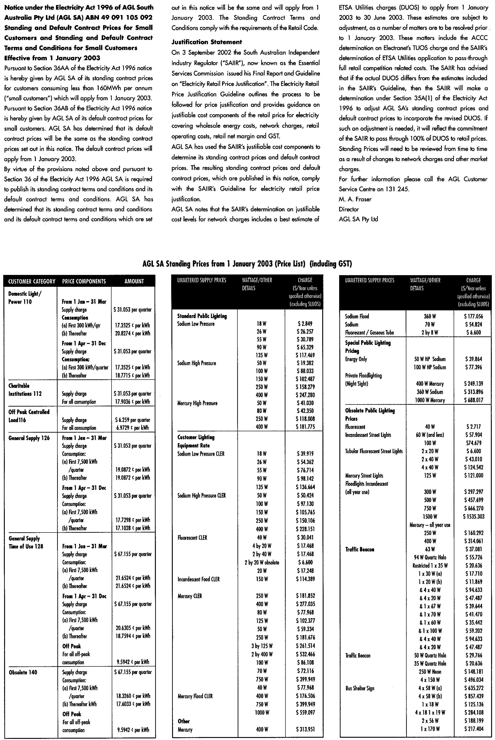
Standing and Default Contract Prices for Small Customers and Standing and Default Contract Terms
and Conditions for Small Customers

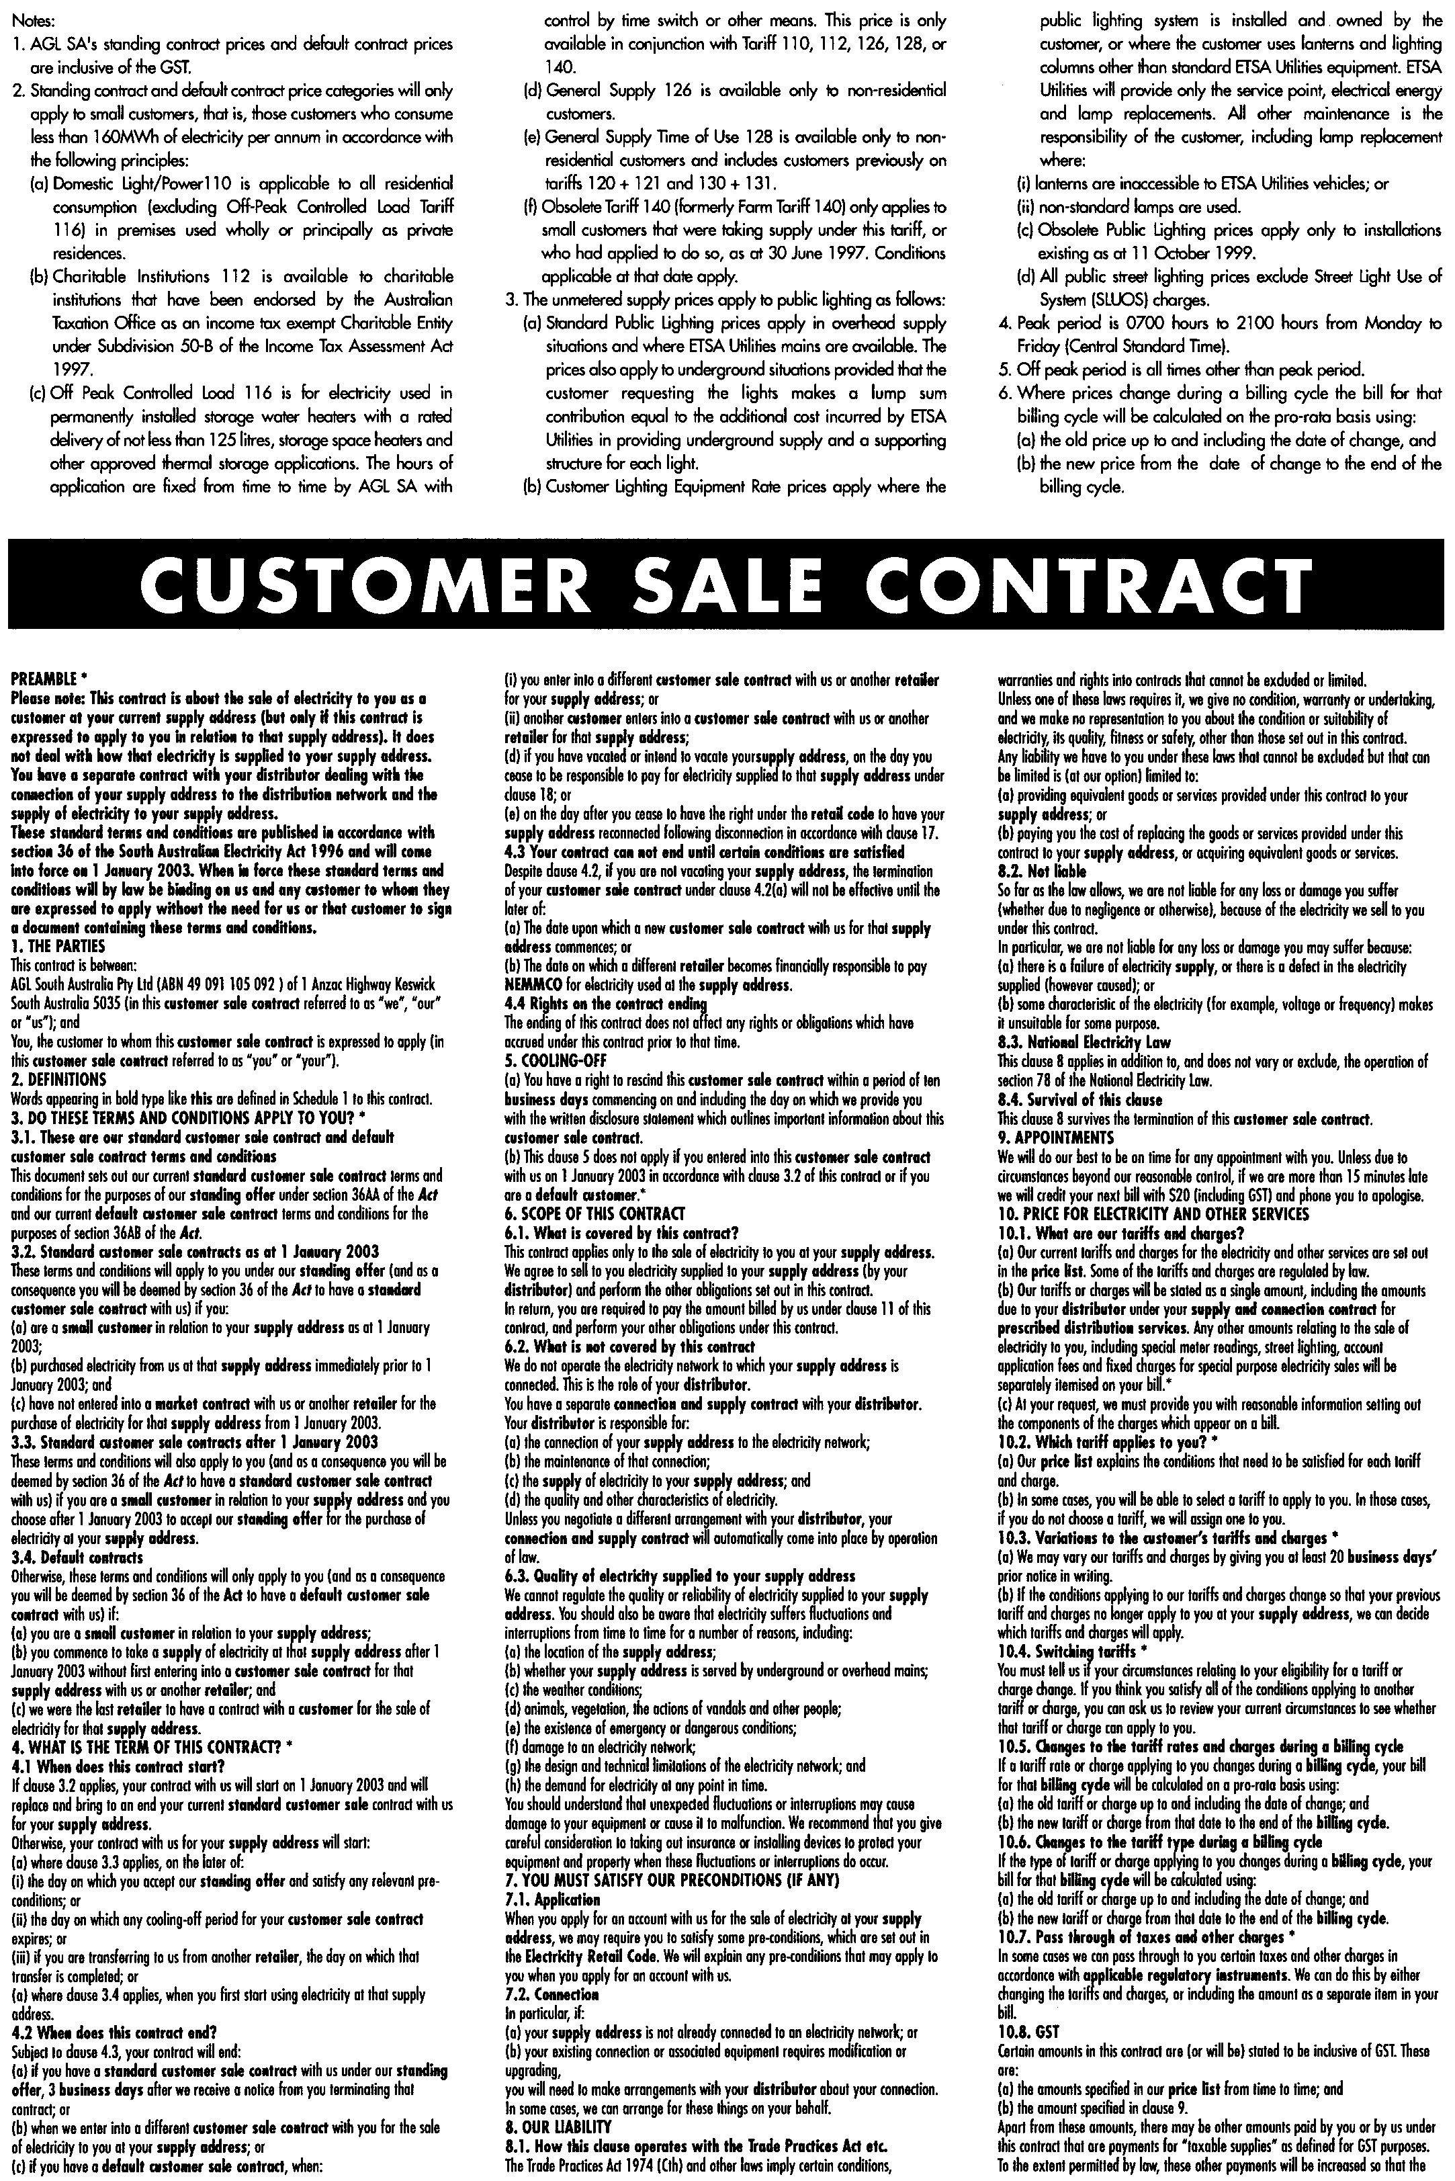

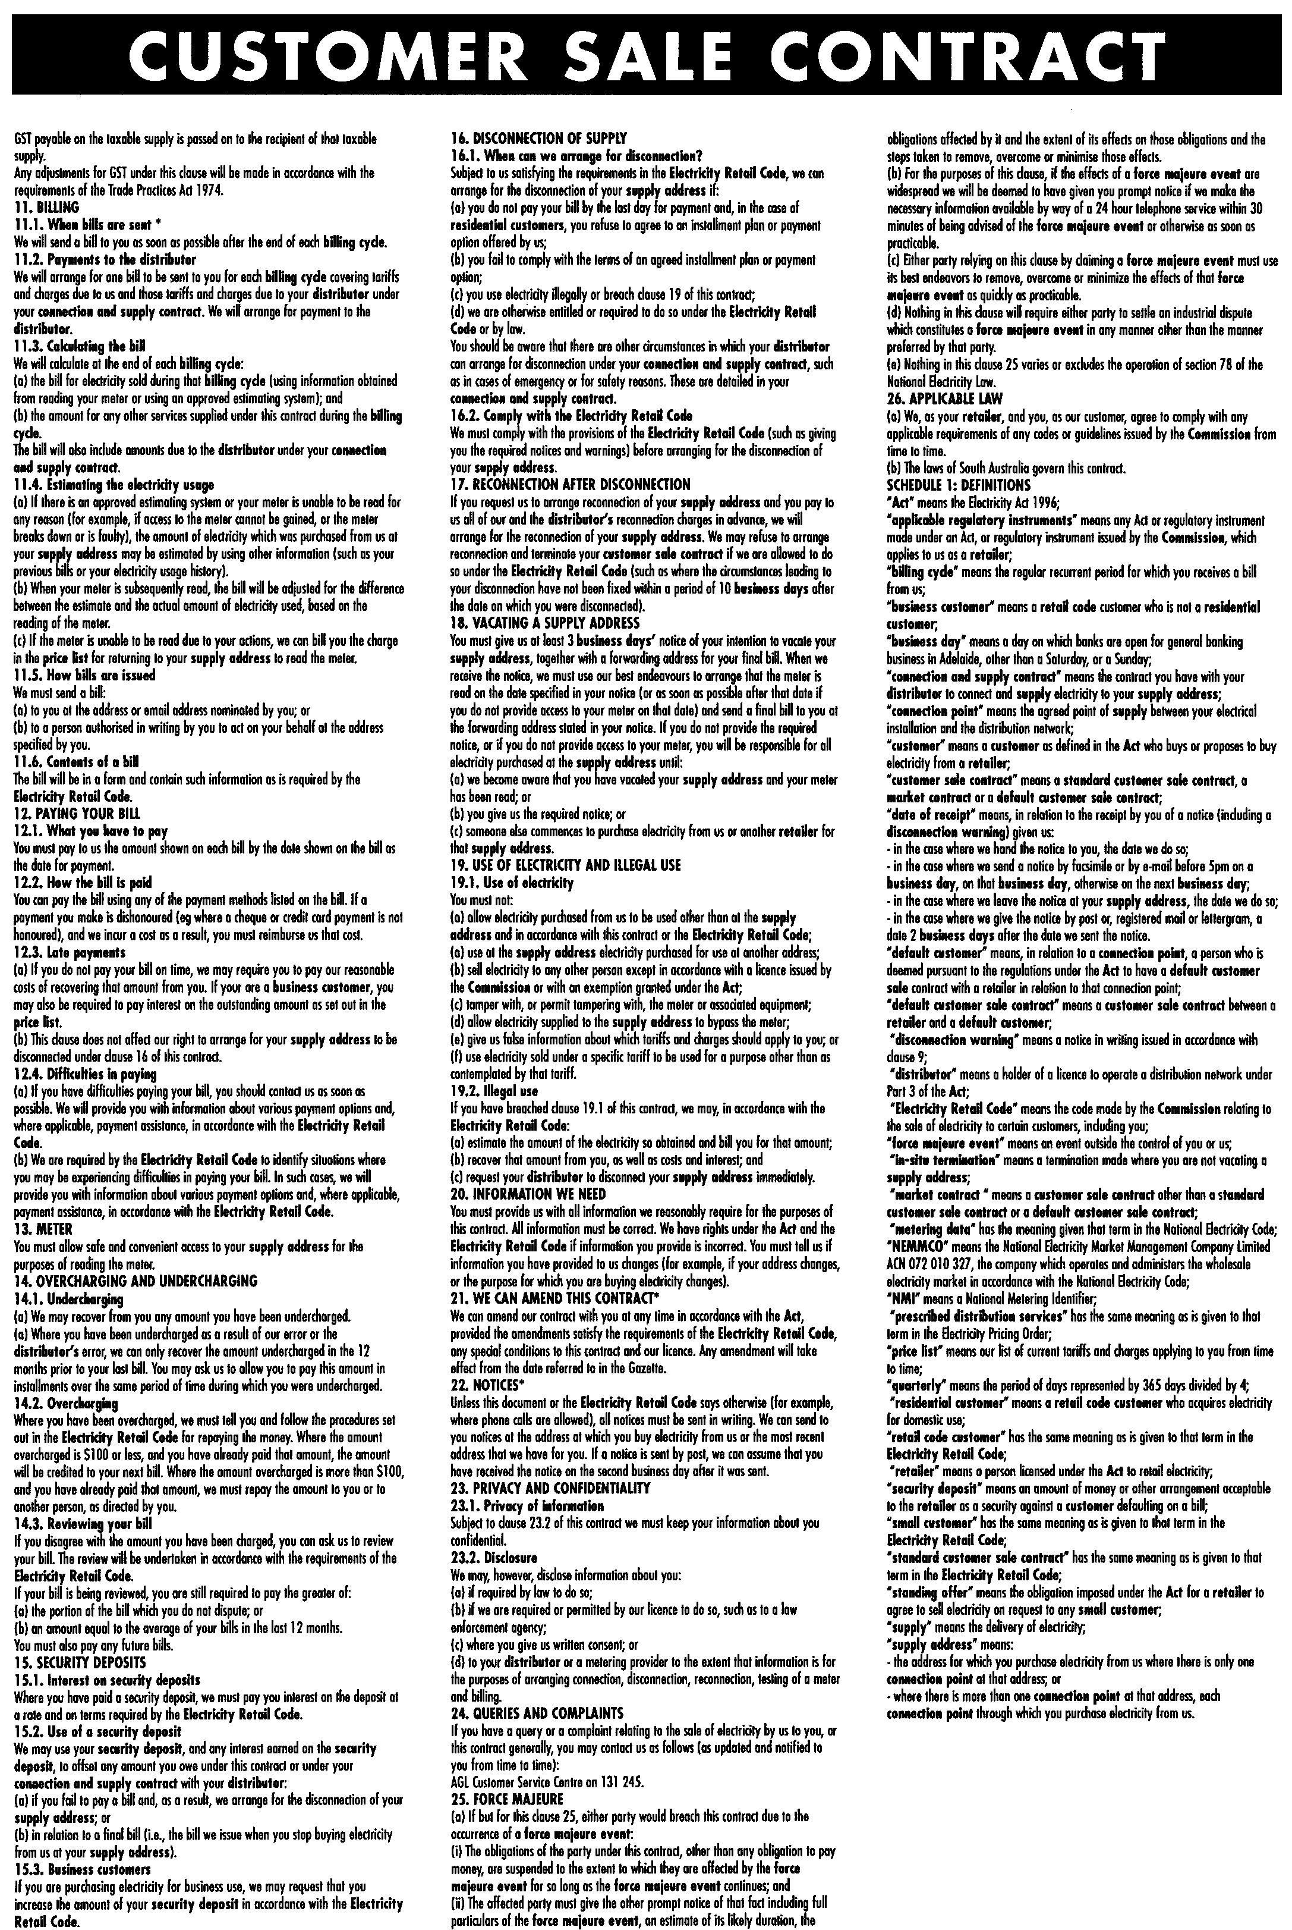

J. D. FERGUSON, Government Printer, South Australia

