No. 36 1703

THE SOUTH AUSTRALIAN

GOVERNMENT GAZETTE

PUBLISHED BY AUTHORITY

ALL PUBLIC ACTS appearing in this GAZETTE are to be considered official, and obeyed as such

ADELAIDE, THURSDAY, 17 APRIL 2003

CONTENTS

Page
Acts Assented To 1704
Aerodrome Fees Act 1998—Notice 1706
Appointments, Resignations, Etc. 1704
Corporations and District Councils—Notices 1785
Crown Lands Act 1929—Notices 1711
Environment Protection Act 1993—Notice 1707
Equal Opportunity Tribunal—Notices 1711
Fisheries Act 1982—Notices 1712
Gaming Machines Act 1992—Notice 1713
Liquor Licensing Act 1997—Notices 1713
Livestock Act 1997—Notice 1717
Mid Year Budget Review—Notice 1757
Mining Act 1971—Notices 1736
National Electricity (South Australia) Act 1996—Notice 1736
National Parks and Wildlife Act 1972—Notice 1736
National Third Party Access Code for Natural Gas Pipeline
Systems—Notice 1737
Petroleum Act 2000—Notices 1745
Private Advertisements 1789

PROCLAMATIONS
Recreational Services (Limitation of Liability)
(Commencement) Proclamation 2003 1762

Page
PROCLAMATIONS—continued
Administrative Arrangements (Administration of
Recreational Services (Limitation of Liability)
Act) Proclamation 2003 1762
Public Trustee Office—Administration of Estates 1788

REGULATIONS
Recreational Services (Limitation of Liability) Act 2002
(No. 37 of 2003) 1763
Parliamentary Superannuation Act 1974 (No. 38 of 2003) 1767
Shop Trading Hours Act 1977 (No. 39 of 2003) 1768
Metropolitan Adelaide Road Widening Plan Act 1972
(No. 40 of 2003) 1775
Superannuation Act 1988 (No. 41 of 2003) 1778
Southern State Superannuation Act 1994
(No. 42 of 2003) 1780
Occupational Therapists Act 1974 (No. 43 of 2003) 1782
Roads (Opening and Closing) Act 1991—Notices 1755
Rules of Court 1749
Vocational Education, Employment and Training
Act 1994—Notice 1760
Water Mains and Sewers—Mains Laid, Replaced, Etc 1755
Wilderness Protection Act 1992—Notice 1756

GOVERNMENT GAZETTE NOTICES
ALL poundkeepers’ and private advertisements forwarded for publication in the South Australian Government Gazette must be PAID FOR PRIOR TO INSERTION; and all notices, from whatever source, should be legibly written on one side of the paper only and sent to Government Publishing SA so as to be received no later
than 4 p.m. on the Tuesday preceding the day of publication. Phone 8207 1045 or Fax 8207 1040. E-mail: governmentgazette@saugov.sa.gov.au. Send as attachments in Word format and please confirm your transmission with a faxed copy of your document, including the date the notice is to be published and to whom the notice will be charged.

Department of the Premier and Cabinet
Adelaide, 17 April 2003
HER Excellency the Governor directs it to be notified for general information that she has in the name and on behalf of Her Majesty The Queen, this day assented to the undermentioned Acts passed by the Legislative Council and House of Assembly in Parliament assembled, viz.:
No. 2 of 2003—Electricity (Pricing Order) Amendment Act 2003. An Act to amend the Electricity Act 1996.
By command,
M. J. Wright, for Premier
DPC 02/0586

Department of the Premier and Cabinet
Adelaide, 17 April 2003
HER Excellency the Governor in Executive Council has been pleased to appoint the undermentioned to the South Australian Psychological Board, pursuant to the provisions of the Psychological Practices Act 1973:
Member: (from 20 April 2003 until 19 October 2004)
Meredith Gwendoline Dickson
Peter Nicholas Gilchrist
Anthony Harold Winefield
Clive Stewart Budden
Marie Jose O’Neill
Janet Isabelle Stephenson
Radomir Stratil
Chair: (from 20 April 2003 until 19 October 2004)
Meredith Gwendoline Dickson
By command,
M. J. Wright, for Premier
MHEA-MGR 0031 CS

Department of the Premier and Cabinet
Adelaide, 17 April 2003
HER Excellency the Governor in Executive Council has been pleased to appoint the undermentioned to the Institute of Medical and Veterinary Science Council, pursuant to the provisions of the
Institute of Medical and Veterinary Science Act 1982:
Member: (from 17 April 2003 until 16 April 2007)
Peter Devitt
By command,
M. J. Wright, for Premier
MHEA-MGR 0025 CS

Department of the Premier and Cabinet
Adelaide, 17 April 2003
HER Excellency the Governor in Executive Council has been pleased to appoint the undermentioned to the South Australian Council on Reproductive Technology, pursuant to the provisions of the Reproductive Technology Act 1988:
Deputy Member: (from 17 April 2003 until 23 December 2003)
Peter Linklater (Deputy to Cox)
By command,
M. J. Wright, for Premier
MHEA-MGR 0009 CS

Department of the Premier and Cabinet
Adelaide, 17 April 2003
HER Excellency the Governor in Executive Council has been pleased to appoint the undermentioned to the Chiropody Board of South Australia, pursuant to the provisions of the Chiropodists Act 1950-1973:
Member: (from 1 July 2003 until 30 June 2006)
George Chris Dracopoulos
Sara Louise Jones
By command,
M. J. Wright, for Premier
MHEA-MGR 0033 CS

Department of the Premier and Cabinet
Adelaide, 17 April 2003
HER Excellency the Governor in Executive Council has been pleased to appoint the undermentioned to the Aquaculture Advisory Committee, pursuant to the provisions of the Aquaculture Act 2001:
Member: (from 23 May 2003 until 22 May 2005)
Richard Stevens
Bruce Zippel
Brian Jeffriess
Michael Whillas
Hagen Stehr
Anthony Cheshire
Ian Nightingale
Peter Dolan
Member: (from 30 September 2003 until 22 May 2005)
Fred Pedler
Member: (from 17 April 2003 until 22 May 2005)
Margi Prideaux
Presiding Member: (from 23 May 2003 until 22 May 2005)
Richard Stevens
By command,
M. J. Wright, for Premier
MAFF 0007/03 CS

Department of the Premier and Cabinet
Adelaide, 17 April 2003
HER Excellency the Governor in Executive Council has been pleased to appoint the undermentioned to the South Eastern Water Conservation and Drainage Board, pursuant to the provisions of the South Eastern Water Conservation and Drainage Act 1992:
Member: (from 17 April 2003 until 12 August 2004)
Richard George Ogilvie
Deputy Presiding Member: (from 17 April 2003 until 12 August 2004)
Richard George Ogilvie
By command,
M. J. Wright, for Premier
MEC 0038/03 CS

Department of the Premier and Cabinet
Adelaide, 17 April 2003
HER Excellency the Governor in Executive Council has been pleased to appoint the undermentioned to the Third Party Premiums Committee, pursuant to the provisions of the Motor Vehicles Act 1959:
Member: (from 17 April 2003)
Joe Di Pinto
By command,
M. J. Wright, for Premier
MAC 0384/03 CS

Department of the Premier and Cabinet
Adelaide, 17 April 2003
HER Excellency the Governor in Executive Council has been pleased to appoint David Cyril Gurry as a Deputy President of the Guardianship Board for a term of five years commencing on 17 April 2003 pursuant to Section 7 of the Guardianship and Administration Act 1993.
By command,
M. J. Wright, for Premier
MSJ 011/03 CS

Department of the Premier and Cabinet
Adelaide, 17 April 2003
HER Excellency the Governor in Executive Council has been pleased to appoint David Cyril Gurry to act in the Office of President of the Guardianship Board while the office remains vacant for the period from 4 August 2003 until 28 August 2003 pursuant to Section 7 of the Guardianship and Administration Act 1993 and Section 36 (d) (ii) of the Acts Interpretation Act 1915.
By command,
M. J. Wright, for Premier
MSJ 011/03 CS

Department of the Premier and Cabinet
Adelaide, 17 April 2003
HER Excellency the Governor in Executive Council has accepted the resignation of Allan Norman Holmes from the office of Commissioner representing South Australia on the Murray-Darling Basin Commission pursuant to Section 11 of the Murray-Darling Basin Act 1993.
By command,
M. J. Wright, for Premier
MRM 0002/03 CS

Department of the Premier and Cabinet
Adelaide, 17 April 2003
HER Excellency the Governor in Executive Council has been pleased to appoint Robert Alan Freeman, Chief Executive of the Department of Water, Land and Biodiversity Conservation as a Commissioner representing South Australia on the Murray-Darling Basin Commission for a period commencing on 17 April 2003 and expiring on 19 June 2004 pursuant to Section 6 (1) of the Murray-Darling Basin Act 1993.
By command,
M. J. Wright, for Premier
MRM 0002/03 CS

AERODROME FEES ACT 1998
Adelaide Airport
Schedule of Charges—Effective 1 March 2003
THE prices shown in this schedule are inclusive of GST.
Service | Charge  per  Passenger  $ |  | ⁽⁸⁾ Charge per 1 000 kg MTOW (pro rata) ⁽¹⁾
Service |  |  | Landing  Charge  $ |  | Insurance  Charge  $ |  | ⁽¹⁾ APS ⁽²⁾  Security  Charge  $
International Passenger air transport aircraft utilising Adelaide Airport Limited operated International Terminal | 11.22 | ⁽³⁾ | Not  applicable |  | Not  applicable |  | Not  applicable
Domestic Passenger air transport aircraft weighing more than 20 000 kg MTOW | 3.85 | ⁽⁴⁾ | Not  applicable |  | Not  applicable |  | Not  applicable
 | OR
 | Not  applicable |  | 11.55 |  | 0.49 |  | 1.20
APS Security for Domestic Passengers where the aircraft has  been charged on a per passenger basis and the aircraft weighs more than 20 000 kg MTOW | 0.94 | ⁽⁵⁾
Security charge for passengers using the International Terminal—includes APS security, passenger screening and baggage screening | 6.17 | ⁽³⁾
Security screening of international transit passengers | 3.65
Common User Domestic Terminal charge | 2.20 | ⁽⁴⁾
Domestic Passenger air transport aircraft weighing less than 20 000 kg MTOW |  |  | 5.28 | ^{(6 & 8)} | 0.14 | ⁽⁶⁾ | Not  applicable
Freight aircraft |  |  | 5.28 | ^{(6 & 8)} | 0.14 | ⁽⁶⁾ | 1.20
Fixed wing aircraft not operating air transport services |  |  | 5.28 | ^{(6 & 8)} | 0.14 | ⁽⁶⁾ | 1.20
Rotary wing aircraft and unpowered aircraft |  |  | 2.64 | ^{(7 & 8)} | 0.07 | ⁽⁷⁾ | Not  applicable

Notes:
⁽¹⁾ MTOW = maximum take-off weight as specified by the manufacturer.
⁽²⁾ APS security charge: applies to all fixed wing aircraft weighing more than 20 000 kg MTOW.
⁽³⁾ Passenger charge International: applies to all departing passengers and excludes transit passengers, infants and positioning crew.
⁽⁴⁾ Passenger charge Domestic: applies to all arriving, departing and transit passengers and excludes infants and positioning crew.
⁽⁵⁾ APS security for Domestic: applies to departing passengers and departing transit passengers and excludes infants and position-ing crew.
⁽⁶⁾ Minimum charge: a minimum charge of $32 applies inclusive of Insurance recovery.
⁽⁷⁾ Minimum charge: a minimum landing charge of $16 applies inclusive of Insurance recovery.
⁽⁸⁾ Parking charges: apply to all aircraft parked longer than two hours in designated general aviation parking areas and will incur a charge of $12 per day or any part of a day. Fixed based operators may apply for a contract rate for parking where the fixed base operator advises Adelaide Airport Limited of the aircraft type and registration of the aircraft that park for more than two hours on each consecutive day per month.
L. Goff, Secretary, Adelaide Airport Limited (ABN 075 176 653)

ENVIRONMENT PROTECTION ACT 1993
Approval of Category B Containers
I, STEPHEN RICHARD SMITH, Senior Adviser, Container Deposit Legislation and Delegate of the Environment Protection Authority (‘the Authority’), pursuant to section 69 of the Environment Protection Act 1993 (SA) (‘the Act’) hereby:
Approval of Category B Containers:
Approve as Category B Containers, subject to the conditions in subclauses (i) and (ii) below, each of the classes of containers identified by reference to the following matters described in the first 4 columns of Schedule 1 of this Notice which are sold in South Australia:
(a) the product which each class of containers shall contain;
(b) the size of the containers;
(c) the type of containers;
(d) the name of the holders of these approvals.
(i) Subsection 69 (3) Arrangements:
The holders of these approvals must ensure that the empty containers which belong to their respective class of containers hereby approved as Category B Containers are collected from collection depots approved under section 69 of the Act by the party named in column 5 of Schedule 1 of this Notice; and
(ii) Approved Refund Markings:
The holders of these approvals must ensure that each container which belongs to their respective class of containers hereby approved as Category B Containers bears the refund marking approved by the Authority in respect of that class of containers.

Product Name | Container  Size (mL) | Container Type | Approval Holder | Collection  Arrangements
1698 Celebration Ale | 500 | Glass | Vinimpex International | Statewide Recycling
33 Export | 250 | Glass | Vinimpex International | Statewide Recycling
Abbot Ale | 500 | Glass | Vinimpex International | Statewide Recycling
Adnams Broadside Ale | 500 | Glass | Vinimpex International | Statewide Recycling
Adnams Suffolk Strong Ale | 440 | Can—Aluminium | Vinimpex International | Statewide Recycling
Adnams Suffolk Strong Ale | 500 | Glass | Vinimpex International | Statewide Recycling
Alhambra Lager | 1 000 | Glass | Vinimpex International | Statewide Recycling
Amstel Bier | 500 | Can—Aluminium | Vinimpex International | Statewide Recycling
Archers Aqua Apple | 275 | Glass | Diageo Australia Pty Ltd | Statewide Recycling
Babycham Original | 200 | Glass | Vinimpex International | Statewide Recycling
Badger Golden Champion Ale | 500 | Glass | Vinimpex International | Statewide Recycling
Badger Golden Glory | 500 | Glass | Vinimpex International | Statewide Recycling
Badger Original | 500 | Glass | Vinimpex International | Statewide Recycling
Banana Bread Beer | 568 | Glass | Vinimpex International | Statewide Recycling
Bass Draught Ale | 500 | Can—Aluminium | Vinimpex International | Statewide Recycling
Batemans Combined Harvest | 500 | Glass | Vinimpex International | Statewide Recycling
Batemans XXX B Ale | 500 | Glass | Vinimpex International | Statewide Recycling
Batemans Yella Belly | 500 | Glass | Vinimpex International | Statewide Recycling
Bavaria Strong & Special | 440 | Can—Aluminium | Vinimpex International | Statewide Recycling
Becks | 330 | Glass | Australian Wine & Liquor Wholesalers Pty Ltd | Flagcan Distributors
Becks Bier | 500 | Can—Aluminium | Vinimpex International | Statewide Recycling
Belhaven Best Ale Caus | 440 | Can—Aluminium | FM Liquor Pty Ltd | Statewide Recycling
Belhaven Fruit Beer | 500 | Glass | FM Liquor Pty Ltd | Statewide Recycling
Bellywasher Lime Flavoured Drink | 355 | Can—Aluminium | Cadbury Schweppes Pty Ltd | Statewide Recycling
Bellywasher Orange Flavoured Drink | 355 | Can—Aluminium | Cadbury Schweppes Pty Ltd | Statewide Recycling
Bellywasher Raspberry Flavoured Drink | 355 | Can—Aluminium | Cadbury Schweppes Pty Ltd | Statewide Recycling
Big Bud | 500 | Glass | Vinimpex International | Statewide Recycling
Bishops Finger | 500 | Glass | Vinimpex International | Statewide Recycling
Black Sheep Ale | 500 | Glass | Vinimpex International | Statewide Recycling
Black Wych Ale | 500 | Glass | Vinimpex International | Statewide Recycling
Boddingtons Bitter | 568 | Can—Aluminium | Vinimpex International | Statewide Recycling
Bombardier Premium Bitter | 568 | Glass | Vinimpex International | Statewide Recycling
Bundaberg Rum & Cola | 375 | Can—Aluminium | Diageo Australia Pty Ltd | Statewide Recycling
Bundaberg Rum O.P. & Cola | 375 | Can—Aluminium | Diageo Australia Pty Ltd | Statewide Recycling
Caledonian Golden Promise Ale | 500 | Glass | Vinimpex International | Statewide Recycling
Capri Cocktail Blue Lagoon | 275 | Glass | Carlton & United Breweries  Ltd | Visy CDL Recycling Services
Capri Cocktail Pina Colada | 275 | Glass | Carlton & United Breweries  Ltd | Visy CDL Recycling Services
Carling Black Ale | 500 | Can—Aluminium | Vinimpex International | Statewide Recycling
Carling Premier | 500 | Can—Aluminium | Vinimpex International | Statewide Recycling
Carlsberg Export Lager | 500 | Can—Aluminium | Vinimpex International | Statewide Recycling
Carlsberg Special Brew | 500 | Can—Aluminium | Vinimpex International | Statewide Recycling
Carlton Sterling | 375 | Can—Aluminium | Carlton & United Breweries  Ltd | Visy CDL Recycling Services
Cascade Autumn Amber | 375 | Glass | Carlton & United Breweries  Ltd | Visy CDL Recycling Services
Cascade First Harvest Ale | 375 | Glass | Carlton & United Breweries  Ltd | Visy CDL Recycling Services
Chaokoh Coconut Juice with Jelly | 350 | Can—Steel | Oriental Merchant Pty Ltd | Statewide Recycling
Chaokoh Coconut Juice with Pulp | 350 | Can—Steel | Oriental Merchant Pty Ltd | Statewide Recycling
Classic French Vanilla Cappuccino | 375 | LPB—Gable Top | National Foods Milk Limited | Statewide Recycling
Classic French Vanilla Cappuccino | 600 | LPB—Gable Top | National Foods Milk Limited | Statewide Recycling
Cobra Lager | 330 | Glass | Vinimpex International | Statewide Recycling
Colt 45 Lager | 500 | Can—Aluminium | Vinimpex International | Statewide Recycling
Cornish Rebellion Ale | 500 | Glass | Vinimpex International | Statewide Recycling
Corona Extra | 330 | Glass | Australian Wine & Liquor Wholesalers Pty Ltd | Flagcan Distributors
Courage Directors | 500 | Can—Aluminium | Vinimpex International | Statewide Recycling
Cumberland Ale | 500 | Glass | Vinimpex International | Statewide Recycling
Derby Nectars ACE Orange Carrot & Lemon | 200 | Glass | Food & Wine Connection  Pty Ltd | Statewide Recycling
Derby Nectars Apricot | 200 | Glass | Food & Wine Connection  Pty Ltd | Statewide Recycling
Derby Nectars Banana Apple & Lemon | 200 | Glass | Food & Wine Connection  Pty Ltd | Statewide Recycling
Derby Nectars Peach | 200 | Glass | Food & Wine Connection  Pty Ltd | Statewide Recycling
Derby Nectars Pear | 200 | Glass | Food & Wine Connection  Pty Ltd | Statewide Recycling
Diamond White Strong Dry | 500 | Can—Aluminium | Vinimpex International | Statewide Recycling
Early Bird Spring Hop Ale | 500 | Glass | Vinimpex International | Statewide Recycling
ECO Organic Springwater | 1 500 | PET | ECO Beverages Australia  Pty Ltd | Visy CDL Recycling Services
ECO Organic Springwater | 600 | PET | ECO Beverages Australia  Pty Ltd | Visy CDL Recycling Services
Eisbrau | 500 | Glass | Vinimpex International | Statewide Recycling
Famous Pals Humphrey Apple Strawberry Juice | 250 | HDPE | L. Z. Enterprises Pty Ltd | Statewide Recycling
Famous Pals Humphrey Lime Punch Juice | 250 | HDPE | L. Z. Enterprises Pty Ltd | Statewide Recycling
Famous Pals Scooby Doo Blueberry Buzz Juice | 250 | HDPE | L. Z. Enterprises Pty Ltd | Statewide Recycling
Famous Pals Scooby Doo Groovy Lime Juice | 250 | HDPE | L. Z. Enterprises Pty Ltd | Statewide Recycling
Famous Pals Scooby Doo Orange Chiller Juice | 250 | HDPE | L. Z. Enterprises Pty Ltd | Statewide Recycling
Famous Pals Scooby Doo Raspberry Rescue Juice | 250 | HDPE | L. Z. Enterprises Pty Ltd | Statewide Recycling
Famous Pals Snoopy Apple Blackcurrant Juice | 250 | HDPE | L. Z. Enterprises Pty Ltd | Statewide Recycling
Famous Pals Snoopy Fast Apple Juice | 250 | HDPE | L. Z. Enterprises Pty Ltd | Statewide Recycling
Famous Pals Snoopy Tropical Wipeout Juice | 250 | HDPE | L. Z. Enterprises Pty Ltd | Statewide Recycling
Faxe Lager | 1 000 | Can—Aluminium | Vinimpex International | Statewide Recycling
Fiddler’s Elbow Ale | 500 | Glass | Vinimpex International | Statewide Recycling
Formidable Ale | 1 000 | Can—Aluminium | Vinimpex International | Statewide Recycling
Frosty Jacks Strong Dry White | 500 | Can—Aluminium | Vinimpex International | Statewide Recycling
Fruit Pops Apple Drink | 250 | PET | P. & N. Beverages Australia  Pty Ltd | Flagcan Distributors
Fruit Pops Cool Blue Drink | 250 | PET | P. & N. Beverages Australia  Pty Ltd | Flagcan Distributors
Fruit Pops Forest Fruits Drink | 250 | PET | P. & N. Beverages Australia  Pty Ltd | Flagcan Distributors
Fruit Pops Orange Drink | 250 | PET | P. & N. Beverages Australia  Pty Ltd | Flagcan Distributors
Fruit Pops Pipelime Drink | 250 | PET | P. & N. Beverages Australia  Pty Ltd | Flagcan Distributors
Fullers 1845 | 500 | Glass | Vinimpex International | Statewide Recycling
Fullers ESB | 500 | Glass | Vinimpex International | Statewide Recycling
Fullers London Pride | 500 | Glass | Vinimpex International | Statewide Recycling
Fullers Organic Honey Dew | 500 | Glass | Vinimpex International | Statewide Recycling
G7 Green Lemon Lime | 250 | Can—Aluminium | Berri Limited | Statewide Recycling
G7 Red Apple Grape & Raspberry | 250 | Can—Aluminium | Berri Limited | Statewide Recycling
G7 Yellow Pineapple Orange & Grape | 250 | Can—Aluminium | Berri Limited | Statewide Recycling
Gaymers Old English Cider | 586 | Can—Aluminium | Vinimpex International | Statewide Recycling
Goldings Summer Hop Ale | 500 | Glass | Vinimpex International | Statewide Recycling
Goliath Ale | 660 | Glass | Vinimpex International | Statewide Recycling
Greene King IPA | 500 | Can—Aluminium | FM Liquor Pty Ltd | Statewide Recycling
Greene King IPA | 660 | Glass | FM Liquor Pty Ltd | Statewide Recycling
Grolsch Lager | 500 | Can—Aluminium | Vinimpex International | Statewide Recycling
Guiness Draught Bitter | 500 | Can—Aluminium | Vinimpex International | Statewide Recycling
Guiness Foreign Stout | 330 | Glass | Vinimpex International | Statewide Recycling
H.e.m.p High Energy More Power | 250 | Can—Aluminium | Direct X | Statewide Recycling
H.e.m.p High Energy More Power | 330 | Glass | Direct X | Statewide Recycling
Harp Irish Lager | 500 | Can—Aluminium | Vinimpex International | Statewide Recycling
Heineken Cold Filter | 500 | Can—Aluminium | Vinimpex International | Statewide Recycling
Hen’s Tooth Bottle Conditioned Ale | 500 | Glass | Vinimpex International | Statewide Recycling
Hobgobbin | 550 | Glass | Vinimpex International | Statewide Recycling
Hoegaarden White Beer | 330 | Glass | Vinimpex International | Statewide Recycling
Holsten Pils | 500 | Can—Aluminium | Vinimpex International | Statewide Recycling
Hopper Berry | 330 | Glass | FM Liquor Pty Ltd | Statewide Recycling
Hopper Citrus | 330 | Glass | FM Liquor Pty Ltd | Statewide Recycling
Hopper Peach | 330 | Glass | FM Liquor Pty Ltd | Statewide Recycling
Ice Dragon Strong White Cider | 500 | Can—Aluminium | Vinimpex International | Statewide Recycling
Jack Daniels & Dry | 375 | Can—Aluminium | Swift & Moore Pty Ltd | Statewide Recycling
Jack Daniels & Lemonade | 375 | Can—Aluminium | Swift & Moore Pty Ltd | Statewide Recycling
Jefi Coconut Milk Drink | 250 | Can—Steel | Oriental Merchant Pty Ltd | Statewide Recycling
Jefi Mix Fruit Drink | 330 | Can—Steel | Oriental Merchant Pty Ltd | Statewide Recycling
John Smith’s Bitter | 500 | Can—Aluminium | Vinimpex International | Statewide Recycling
John Smith’s Extra Smooth Draught Bitter | 500 | Can—Aluminium | Vinimpex International | Statewide Recycling
Johnnie Walker Red Label & Cola | 375 | Can—Aluminium | Diageo Australia Pty Ltd | Statewide Recycling
Kestrel Super Lager | 500 | Can—Aluminium | Vinimpex International | Statewide Recycling
Kingfisher | 330 | Glass | Vinimpex International | Statewide Recycling
Kronebourg 1664 | 500 | Can—Aluminium | Vinimpex International | Statewide Recycling
Labatt Canadian Lager | 500 | Can—Aluminium | Vinimpex International | Statewide Recycling
Labatt Ice | 330 | Glass | Vinimpex International | Statewide Recycling
Leffe Blonde | 330 | Glass | Vinimpex International | Statewide Recycling
Mackeson Stout | 275 | Can—Aluminium | Vinimpex International | Statewide Recycling
Maraca Cranberry Kiss | 330 | PVC | Direct X | Statewide Recycling
Maraca Lemon Kick | 330 | PVC | Direct X | Statewide Recycling
Maraca Raspberry Rumba | 330 | PVC | Direct X | Statewide Recycling
Maraca Tropical Tango | 330 | PVC | Direct X | Statewide Recycling
Marston’s Double Drop | 500 | Glass | Vinimpex International | Statewide Recycling
Marston’s Late Hopped Ale | 500 | Glass | Vinimpex International | Statewide Recycling
Marston’s Owd Rodger | 500 | Glass | Vinimpex International | Statewide Recycling
Marston’s Pedigree Draught Bitter | 500 | Can—Aluminium | Vinimpex International | Statewide Recycling
Marston’s Pedigree Draught Bitter | 500 | Glass | Vinimpex International | Statewide Recycling
Master Brew | 500 | Glass | Vinimpex International | Statewide Recycling
McEwans 80 | 550 | Glass | Vinimpex International | Statewide Recycling
McEwans 90 | 550 | Glass | Vinimpex International | Statewide Recycling
McEwans Export | 500 | Can—Aluminium | Vinimpex International | Statewide Recycling
McEwans Lager | 500 | Can—Aluminium | Vinimpex International | Statewide Recycling
Miller MGD | 355 | Glass | Australian Wine & Liquor Wholesalers Pty Ltd | Flagcan Distributors
Miller Pilsner Lager | 500 | Can—Aluminium | Vinimpex International | Statewide Recycling
Monkey Wrench | 500 | Glass | Vinimpex International | Statewide Recycling
Monteiths Pils | 330 | Glass | FM Liquor Pty Ltd | Statewide Recycling
Monty Pythons Holy Grail | 500 | Glass | Vinimpex International | Statewide Recycling
Morocco | 500 | Glass | Vinimpex International | Statewide Recycling
Morocco Ale | 500 | Glass | FM Liquor Pty Ltd | Statewide Recycling
Murphy’s Stout | 500 | Glass | Vinimpex International | Statewide Recycling
Nastro Azzuro | 330 | Glass | Vinimpex International | Statewide Recycling
Newcastle Brown Ale | 500 | Can—Aluminium | Vinimpex International | Statewide Recycling
Newcastle Brown Ale | 550 | Glass | Vinimpex International | Statewide Recycling
Old Fart | 500 | Glass | Vinimpex International | Statewide Recycling
Old Legover | 500 | Glass | Vinimpex International | Statewide Recycling
Old Speckled Hen | 500 | Can—Aluminium | Vinimpex International | Statewide Recycling
Old Speckled Hen | 500 | Glass | Vinimpex International | Statewide Recycling
Organic Apple Juice | 250 | LPB—Aseptic | Douglas Park Organics | Statewide Recycling
Organic Orange Juice | 250 | LPB—Aseptic | Douglas Park Organics | Statewide Recycling
P & N Juice Apple | 300 | PET | P. & N. Beverages Australia  Pty Ltd | Flagcan Distributors
P. & N. Juice Apple Blackcurrant | 300 | PET | P. & N. Beverages Australia  Pty Ltd | Flagcan Distributors
P. & N. Juice Apple Cranberry | 300 | PET | P. & N. Beverages Australia  Pty Ltd | Flagcan Distributors
P. & N. Juice Brekky Juice | 300 | PET | P. & N. Beverages Australia  Pty Ltd | Flagcan Distributors
P. & N. Juice Orange | 300 | PET | P. & N. Beverages Australia  Pty Ltd | Flagcan Distributors
P. & N. Juice Orange Mango | 300 | PET | P. & N. Beverages Australia  Pty Ltd | Flagcan Distributors
P. & N. Juice Tropical | 300 | PET | P. & N. Beverages Australia  Pty Ltd | Flagcan Distributors
Pendle Witches Brew | 500 | Glass | Vinimpex International | Statewide Recycling
Pilstar Gold Asace Biere Blonde | 250 | Glass | Vinimpex International | Statewide Recycling
Red Stripes | 500 | Can—Aluminium | Vinimpex International | Statewide Recycling
Ride Citrus | 500 | PET | Statray Pty Ltd | Statewide Recycling
Ride Mandarin | 500 | PET | Statray Pty Ltd | Statewide Recycling
Riggwelter Ale | 500 | Glass | FM Liquor Pty Ltd | Statewide Recycling
Riggwelter Strong Ale | 500 | Glass | Vinimpex International | Statewide Recycling
Ripon Jewel Ale | 500 | Glass | FM Liquor Pty Ltd | Statewide Recycling
Rolling Rock | 355 | Glass | Vinimpex International | Statewide Recycling
Ruddles Best Bitter | 500 | Can—Aluminium | Vinimpex International | Statewide Recycling
Ruddles Country | 500 | Can—Aluminium | Vinimpex International | Statewide Recycling
San Miguel | 500 | Can—Aluminium | Vinimpex International | Statewide Recycling
San Miguel Export | 1 000 | Glass | Vinimpex International | Statewide Recycling
San Pellegrino Chinotto | 200 | Glass | Rio Coffee Pty Ltd | Statewide Recycling
San Pellegrino Pompelmo Grapefruit | 200 | Glass | Rio Coffee Pty Ltd | Statewide Recycling
San Pellegrino Sanbitter Gold | 100 | Glass | Rio Coffee Pty Ltd | Statewide Recycling
San Pellegrino Sparkling Mineral Water | 1 000 | Glass | Rio Coffee Pty Ltd | Statewide Recycling
San Pellegrino Sparkling Mineral Water | 250 | Glass | Rio Coffee Pty Ltd | Statewide Recycling
Sapporo Silver Lager | 500 | Can—Aluminium | Vinimpex International | Statewide Recycling
Scrumpy Jacks Cider | 568 | Can—Aluminium | Vinimpex International | Statewide Recycling
Skol Lager | 500 | Can—Aluminium | Vinimpex International | Statewide Recycling
Skol Super Strength | 500 | Can—Aluminium | Vinimpex International | Statewide Recycling
Slinky Blackcurrant | 500 | PET | Statray Pty Ltd | Statewide Recycling
Slinky Mandarin | 500 | PET | Statray Pty Ltd | Statewide Recycling
Smash Repair Lemon Infusion | 500 | PET | Statray Pty Ltd | Statewide Recycling
Smash Repair Zesty Lemon | 500 | PET | Statray Pty Ltd | Statewide Recycling
Smirnoff Ice | 375 | Can—Aluminium | Diageo Australia Pty Ltd | Statewide Recycling
Snacklifter | 500 | Glass | Vinimpex International | Statewide Recycling
Sol Lager | 330 | Glass | Vinimpex International | Statewide Recycling
Spitfire | 500 | Glass | Vinimpex International | Statewide Recycling
Steinhof Pilsner | 500 | Can—Aluminium | Vinimpex International | Statewide Recycling
Stella Artois | 500 | Can—Aluminium | Vinimpex International | Statewide Recycling
Stone’s Bitter | 500 | Can—Aluminium | Vinimpex International | Statewide Recycling
Subway Spring Water | 600 | PET | Berri Limited | Statewide Recycling
Super Bock Beer | 330 | Glass | Vinimpex International | Statewide Recycling
Tanglefoot Strong Ale | 500 | Can—Aluminium | Vinimpex International | Statewide Recycling
Tanglefoot Strong Ale | 500 | Glass | Vinimpex International | Statewide Recycling
Tartan Bitter | 500 | Can—Aluminium | Vinimpex International | Statewide Recycling
Taunton Dry Blackthorne | 568 | Can—Aluminium | Vinimpex International | Statewide Recycling
Taunton Special Vat Cider | 568 | Can—Aluminium | Vinimpex International | Statewide Recycling
Tennents Lager | 500 | Can—Aluminium | Vinimpex International | Statewide Recycling
Tennents Pilsner | 500 | Can—Aluminium | Vinimpex International | Statewide Recycling
Tennents Special Ale | 500 | Can—Aluminium | Vinimpex International | Statewide Recycling
Tennents Super | 500 | Can—Aluminium | Vinimpex International | Statewide Recycling
Tetley’s Draught Bitter | 440 | Can—Aluminium | Vinimpex International | Statewide Recycling
Theakston’s Cool Cask | 500 | Glass | Vinimpex International | Statewide Recycling
Theakston’s Old Perculier Legendary Ale | 500 | Glass | Vinimpex International | Statewide Recycling
Timothy Taylor Landlord | 500 | Glass | Vinimpex International | Statewide Recycling
Timothy Taylor Royal Ale | 500 | Glass | Vinimpex International | Statewide Recycling
Waggle Dance Honey Beer | 550 | Glass | Vinimpex International | Statewide Recycling
Warsteiner Premium Bier | 500 | Can—Aluminium | Vinimpex International | Statewide Recycling
Whistable Bay Organic Ale | 500 | Glass | Vinimpex International | Statewide Recycling
Whitbread Best Bitter | 440 | Can—Aluminium | Vinimpex International | Statewide Recycling
Whitbread Heidenbrau Super | 440 | Can—Aluminium | Vinimpex International | Statewide Recycling
Whitbread Trophy | 440 | Can—Aluminium | Vinimpex International | Statewide Recycling
White Lighting Strong Dry White | 500 | Can—Aluminium | Vinimpex International | Statewide Recycling
Worthington Bitter Draught | 440 | Can—Aluminium | Vinimpex International | Statewide Recycling
Yeo’s Grass Jelly Drink | 330 | Can—Steel | Oriental Merchant Pty Ltd | Statewide Recycling
Yeo’s Ice Lemon Tea | 250 | LPB—Aseptic | Oriental Merchant Pty Ltd | Statewide Recycling
Yeo’s Winter Lemon Drink | 250 | LPB—Aseptic | Oriental Merchant Pty Ltd | Statewide Recycling
Yorkshire Square Ale | 500 | Glass | Vinimpex International | Statewide Recycling
Young’s Ram Rod | 500 | Glass | Vinimpex International | Statewide Recycling
Young’s Triple A | 500 | Glass | Vinimpex International | Statewide Recycling
Zing Apple Blackcurrant Juice | 250 | HDPE | L. Z. Enterprises Pty Ltd | Statewide Recycling
Zing Apple Blueberry Juice | 250 | HDPE | L. Z. Enterprises Pty Ltd | Statewide Recycling
Zing Apple Raspberry Juice | 250 | HDPE | L. Z. Enterprises Pty Ltd | Statewide Recycling
Zing Blue Burst Sports Drink | 600 | HDPE | L. Z. Enterprises Pty Ltd | Statewide Recycling
Zing Bubblegum Juice | 250 | HDPE | L. Z. Enterprises Pty Ltd | Statewide Recycling
Zing Cranberry Chase Sports Drink | 600 | HDPE | L. Z. Enterprises Pty Ltd | Statewide Recycling
Zing Lime Juice | 250 | HDPE | L. Z. Enterprises Pty Ltd | Statewide Recycling
Zing Orange Crush Sports Drink | 600 | HDPE | L. Z. Enterprises Pty Ltd | Statewide Recycling
Zing Orange Juice | 250 | HDPE | L. Z. Enterprises Pty Ltd | Statewide Recycling
Zing Pineapple Pursuit Sports Drink | 600 | HDPE | L. Z. Enterprises Pty Ltd | Statewide Recycling
Zing Tropical Juice | 250 | HDPE | L. Z. Enterprises Pty Ltd | Statewide Recycling

CROWN LANDS ACT 1929: SECTION 5
TAKE NOTICE that pursuant to the Crown Lands Act 1929, I, JOHN HILL, Minister for Environment and Conservation, Minister of the Crown to whom the administration of the Crown Lands Act 1929 is committed DO HEREBY dedicate the Crown Land defined in The Schedule as a Metropolitan Open Space System Recreation Reserve and declare that such land shall be under the care, control and management of the City of Salisbury.
The Schedule
Allotment 105 of DP 55979, Hundred of Yatala, County of Adelaide, exclusive of all necessary roads, being the whole of the land contained in Crown Record Volume 5845 Folio 475, subject nevertheless to:
1. easements to the Minister for Infrastructure (T 2687247 and T 6190811) over those portions of allotment 105 marked A and C on DP 55979.
2. an easement to the City of Salisbury (T 3135187) over that portion of allotment 105 marked B on DP 55979.
Dated 17 April 2003.
J Hill, Minister for Environment and Conservation
PLN 99/0223

CROWN LANDS ACT 1929: SECTION 5
TAKE NOTICE that pursuant to the Crown Lands Act 1929, I, JOHN HILL, Minister for Environment and Conservation, Minister of the Crown to whom the administration of the Crown Lands Act 1929 is committed DO HEREBY resume the land defined in The Schedule.
The Schedule
Reserve for Conservation Purposes, allotment 2 of DP 28145, Hundred of Nangkita, County of Hindmarsh, the notice of which was published in the Government Gazette of 9 April 1998 at page 1674, being the whole of the land contained in Crown Record Volume 5228 Folio 308.
Dated 17 April 2003.
J Hill, Minister for Environment and Conservation
DL 5657/1977

CROWN LANDS ACT 1929: SECTION 5
TAKE NOTICE that pursuant to the Crown Lands Act 1929, I, JOHN HILL, Minister for Environment and Conservation, Minister of the Crown to whom the administration of the Crown Lands Act 1929 is committed DO HEREBY dedicate the Crown Land defined in The Schedule as a Conservation Reserve and declare that such land shall be under the care, control and management of The District Council of Cleve.
The Schedule
Allotment 3 of FP 14818, Hundred of Boothby, County of Jervois, exclusive of all necessary roads, being the whole of the land contained in Crown Record Volume 5890 Folio 661.
Dated 17 April 2003.
J Hill, Minister for Environment and Conservation
DENR 08/0690

CROWN LANDS ACT 1929: SECTION 5
TAKE NOTICE that pursuant to the Crown Lands Act 1929, I, JOHN HILL, Minister for Environment and Conservation, Minister of the Crown to whom the administration of the Crown Lands Act 1929 is committed DO HEREBY:
1. Resume the land defined in The First Schedule.
2. Dedicate the Crown Land defined in The Second Schedule as an Emergency Services Reserve and declare that such land shall be under the care, control and management of the Minister for Emergency Services.
The First Schedule
Reserve for District Council Purposes, section 204, Hundred of Cotton, County of Chandos, the proclamation of which was published in the Government Gazette of 2 December 1965 at page 1953, being the whole of the land contained in Crown Record Volume 5759 Folio 575.
The Second Schedule
Section 204, Hundred of Cotton, County of Chandos, exclusive of all necessary roads, being the whole of the land contained in Crown Record Volume 5759 Folio 575.
Dated 17 April 2003.
J Hill, Minister for Environment and Conservation
DEHAA 11/2642

EQUAL OPPORTUNITY TRIBUNAL
No. 43 of 2003
Notice of Exemption
Before Deputy Presiding Officer Allan
Members Shetliffe and Altman
I HEREBY certify that on 1 April 2003 the Equal Opportunity Tribunal of South Australia, on the application of the Salvation Army Community Services made the following orders for exemption:
An exemption is granted to the applicant pursuant to section 92 of the Equal Opportunity Act 1984 from the provisions of section 52 of the said Act subject to the following conditions:
(1) This exemption shall apply for a period of 3 years commencing on 1 April 2003 and concluding on 31 March 2006.
(2) This exemption shall apply to enable the applicant to employ a person of Indigenous Australian descent to work for Port Augusta Community Services (Salvation Army).
Dated 8 April 2003.
D. Hoban, Deputy Registrar, Equal Opportunity Tribunal

EQUAL OPPORTUNITY TRIBUNAL
No. 44 of 2003
Notice of Exemption
Before Deputy Presiding Officer Allan
Members Shetliffe and Bachmann
I HEREBY certify that on 1 April 2003 the Equal Opportunity Tribunal of South Australia, on the application of the Salvation Army Community Services made the following orders for exemption:
An exemption is granted to the applicant pursuant to section 92 of the Equal Opportunity Act 1984 from the provisions of section 30 of the said Act subject to the following conditions:
(1) This exemption shall apply to enable the applicant, Salvation Army (Bramwell House), to employ a female children’s worker, a part-time female chaplain and female volunteer workers to serve persons who are victims of domestic violence.
(2) This exemption, in regards to the female children’s worker, shall apply for a period of three years commencing on 4 March 2002 and concluding on 3 March 2005.
(3) This exemption, in regards to the part-time chaplain and female volunteer workers, shall apply for a period of three years commencing on 1 April 2003 and concluding on 31 March 2006.
Dated 8 April 2003.
D. Hoban, Deputy Registrar, Equal Opportunity Tribunal

FISHERIES ACT 1982: SECTION 59
TAKE notice that, pursuant to section 59 of the Fisheries Act 1982, the persons listed in Schedule 1 (the ‘exemption holders’) of SA Abalone Developments Pty Ltd, P.O. Box 1579, Port Lincoln, S.A. 5606, are exempt from section 34 of the Fisheries Act 1982 and the Scheme of Management (Abalone Fisheries) Regulations 1991, but only insofar as they may take greenlip abalone (Haliotis laevigata) for the purpose of collecting aquaculture broodstock (the ‘exempted activity’) in the waters specified in Schedule 2 subject to the conditions in Schedule 3.
Schedule 1
Dominic Henderson, Tony Kingdom, Milton Hunt, Darcy Eldridge, Jonas Woolford, Tobin Woolford, Don Morrison and Douglas Graske.
Schedule 2
South Australian coastal waters south and east of a line drawn due south through Point Brown (latitude 32°32.6'S, longitude 133°50.8′E) and west of the meridian of longitude 136°30′E.
Schedule 3
1. The exemption holders may take a maximum of 78 greenlip abalone (Haliotis laevigata) in total.
2. Abalone taken pursuant to this notice must not be sold or transferred to another party.
3. All abalone taken pursuant to this notice must be delivered to and retained on the registered aquaculture site of landbased aquaculture licence number FT00158.
4. The exemption holders may engage in the exempted activity from the date of gazettal of this notice until 30 June 2003, unless varied or revoked earlier.
5. The exemption holders shall notify the PIRSA Fisheries Compliance Unit on 1800 065 522 at least 24 hours prior to conducting the exempted activity with the following information:
• details of the boat that will be used to engage in the exempted activity;
• the name of the person or persons who will be conducting the exempted activity;
• the intended place and time of launching and retrieval of the nominated boat for that day; and
• the intended area of conducting the exempted activity.
6. The exemption holders must, within 50 m of the point of landing of any abalone taken pursuant to this notice, ensure that the PIRSA Fisheries form ‘Abalone Broodstock Collection Statement’ is completed. Immediately upon arrival at the exemption holder’s registered aquaculture site, this form must be faxed to PIRSA Fisheries on (08) 8347 6150.
7. Prior to release into the registered aquaculture site, all abalone taken pursuant to this notice must be tagged so as to be clearly identified as wild broodstock.
8. The exemption holder must record the number of wild broodstock held pursuant to this notice in a register to be maintained at the registered aquaculture site, which must be made available for inspection by a PIRSA Fisheries Compliance Officer upon request.
9. The exemption holder must allow a PIRSA Fisheries Departmental Officer to accompany the exemption holder at any time during the exempted activity.
10. While engaged in the exempted activity the exemption holder must carry or have about or near his person a copy of this notice. Such notice must be produced to a PIRSA Fisheries Compliance Officer upon request.
11. The exemption holder shall not contravene or fail to comply with the Fisheries Act 1982 or any regulations made under that Act, except where specifically exempted by this notice.
Dated 10 April 2003.
W. Zacharin, Director of Fisheries

FISHERIES ACT 1982: SECTION 59
TAKE note that the notice made under section 59 of the Fisheries Act 1982, and published in the South Australian Government Gazette on page number 4094, dated 8 November 2002, being the second notice on that page, referring to SA Abalone Developments Pty Ltd and the collection of greenlip abalone for broodstock, is hereby revoked.
Dated 14 April 2003.
W. Zacharin, Director of Fisheries

FISHERIES ACT 1982: SECTION 59
TAKE note that the notice made under section 59 of the Fisheries Act 1982, and published in the South Australian Government Gazette on page number 4458, dated 5 December 2002, being the second notice on that page, referring to SA Abalone Developments Pty Ltd and the collection of greenlip abalone for broodstock, is hereby revoked.
Dated 14 April 2003.
W. Zacharin, Director of Fisheries

FISHERIES ACT 1982: SECTION 43
TAKE notice that pursuant to section 43 of the Fisheries Act 1982, it is hereby declared that it shall be unlawful for any person to engage in the class of fishing activity specified in Schedule 1, in the area specified in Schedule 2, during the period specified in Schedule 3.
Schedule 1
The act of taking or an act preparatory to or involved in the taking of abalone (Family Haliotidae).
Schedule 2
All the waters of Waterloo Bay (Elliston) contained within the geodesic commencing at the high water mark on the shore of Wellington Point, latitude 33°39.23′S, longitude 134°52.53′E and terminating at the high water mark on the shore at Salmon Point, latitude 33°38.72′S, longitude 134°51.58′E
Schedule 3
From 0001 hours on 1 July 2003 to 2359 hours on 30 June 2004.
Dated 15 April 2003.
W. Zacharin, Director of Fisheries

FISHERIES ACT 1982: SECTION 59
TAKE notice that pursuant to section 59 of the Fisheries Act 1982, Paul Watson (the ‘exemption holder’), 34 Bonanza Road, Port Lincoln, S.A. 5606, is exempt from the provisions of section 34 of the Fisheries Act 1982 and the Scheme of Management (Marine Scalefish Fishery) Regulations 1991 but only insofar as the exemption holder may use up to 8 squid jigging machines to take arrow squid (Nototodarus gouldi) for the purpose of trade or business from the water described in Schedule 1 (the ‘exempted activity’), subject to the conditions set out in Schedule 2, from the date of gazettal of this notice until 31 March 2004, unless varied or revoked earlier.
Schedule 1
The waters south of a line drawn from Cape Donnington to Corny Point and west of a line drawn from Troubridge Point to Marsden Point, at least 3 nautical miles from the shore and at least 1 nautical mile from any isles.
Schedule 2
1. All fish other than arrow squid must be returned to the water immediately.
2. Whilst conducting the exempted activity, the exemption holder may only use a boat that is endorsed on Spencer Gulf Prawn Fishery Licence P29.
3. The exemption holder must not undertake the exempted activity whilst the Spencer Gulf Prawn Fishery is open.
4. The exemption holder must allow a PIRSA Fisheries Departmental Officer to accompany the exemption holder at any time during the exempted activity.
5. The exemption holder must provide a report in writing detailing the daily catch of arrow squid pursuant to this notice to the Director of Fisheries, (Attention: Roger Hill, P.O. Box 282, Port Adelaide, S.A. 5015) within 14 days of the end of each calendar month.
6. The exemption holder shall notify the PIRSA Fisheries Compliance Unit on 1800 065 522 prior to conducting the exempted activity.
7. While engaged in the exempted activity the exemption holder must have in their possession a copy of this notice. Such notice must be produced to a PIRSA Fisheries Compliance Officer if such an officer requests that it be produced.
8. The exemption holder shall not contravene or fail to comply with the Fisheries Act 1982 or any Regulation made under that Act or any condition of the licence, except where specifically exempted by this notice.
Dated 11 April 2003.
W. Zacharin, Director of Fisheries

FISHERIES ACT 1982: SECTION 59
TAKE notice that pursuant to section 59 of the Fisheries Act 1982, Denise Sharp (the ‘permit holder’) or her agents, of Whyalla City Council, P.O. Box 126, Whyalla, S.A. 5600 is exempt from sections 34 and 48G of the Fisheries Act 1982 and the Scheme of Management (Miscellaneous Fishery) Regulations 2000 insofar as she may harvest beach-cast seagrass/seaweed and algae material for amenity purposes (the ‘exempted activity’) in the area specified in Schedule 1, subject to the conditions specified in Schedule 2, from the date of gazettal of this notice until 31 December 2003.
Schedule 1
The area of foreshore that is:
• between the high water mark and the low water mark from coastal beaches of Whyalla extending for 300 m from the marina wall to the playground area south of the main kiosk and Surf Life Saving building; and
• a section of the north beach area at Whyalla for a distance of 200 m from the northern edge of the marina,
excluding all aquatic reserves proclaimed under the Fisheries Act 1982 and any beaches adjacent to lands owned and managed by the Minister for Environment and Heritage.
Schedule 2
1. While engaged in the exempted activity the permit holder must be in possession of a copy of this notice. Such notice must be produced to a PIRSA Fishwatch Compliance Officer if such an officer requests that it be produced.
2. Only unattached beach-cast seagrass/seaweed and algae shall be harvested.
3. The method of removal must not involve the taking of any sand. Sand taken incidental to the harvesting operations is to be returned to the foreshore.
4. Where sand dunes are present no harvesting is to take place within 4 m of the foredune.
5. Seagrass/seaweed and algae removed must not be sold.
Dated 14 April 2003.
W. Zacharin, Director of Fisheries

GAMING MACHINES ACT 1992
Notice of Application
NOTICE is hereby given, pursuant to section 29 of the Gaming Machines Act 1992, that Konami Australia Pty Ltd, 28 Lord Street, Botany, N.S.W. 2019 has applied to the Liquor and Gaming Commissioner for a Game—Incan Pyramid Wildfire.
The application has been set down for hearing on 16 May 2003 at 9 a.m.
Any person may object to the application by lodging a notice of objection in the prescribed form with the Licensing Authority, and serving a copy of the notice on the applicant at the applicant’s address given above, at least seven days before the hearing date.
Plans in respect of the premises the subject of the application are open to public inspection without fee at the Office of the Liquor and Gaming Commissioner, 9th Floor, East Wing, 50 Grenfell Street, Adelaide, S.A. 5000.
Dated 2 April 2003.
Applicant

LIQUOR LICENSING ACT 1997
Notice of Application
NOTICE is hereby given, pursuant to section 52 (2) (b) of the Liquor Licensing Act 1997, that George Robert and Diana Mary Hooper, c/o Westley Digiorgio have applied to the Licensing Authority for a Producer’s Licence in respect of premises situated at Concrete Bridge Road, Naracoorte, S.A. 5271 and to be known as Wongary of Wrattonbully.
The application has been set down for hearing on 23 May 2003 at 9 a.m.
Any person may object to the application by lodging a notice of objection in the prescribed form with the Licensing Authority, and serving a copy of the notice on the applicants at the applicants’ address given above, at least seven days before the hearing date.
Plans in respect of the premises the subject of the application are open to public inspection without fee at the Office of the Liquor and Gaming Commissioner, 9th Floor, East Wing, 50 Grenfell Street, Adelaide, S.A. 5000.
Dated 11 April 2003.
Applicants

LIQUOR LICENSING ACT 1997
Notice of Application
NOTICE is hereby given, pursuant to section 52 (2) (b) of the Liquor Licensing Act 1997, that Mark Guodong Ma has applied to the Licensing Authority for the transfer of a Restaurant Licence in respect of premises situated at 21-23 Hindley Street, Adelaide, S.A. 5000 and known as 21 Hindley Restaurant and to be known as Adelaide Hotpot Restaurant.
The application has been set down for hearing on 26 May 2003 at 9.30 a.m.
Any person may object to the application by lodging a notice of objection in the prescribed form with the Licensing Authority, and serving a copy of the notice on the applicant at the applicant’s address given above, at least seven days before the hearing date.
Plans in respect of the premises the subject of the application are open to public inspection without fee at the Office of the Liquor and Gaming Commissioner, 9th Floor, East Wing, 50 Grenfell Street, Adelaide, S.A. 5000.
Dated 14 April 2003.
Applicant

LIQUOR LICENSING ACT 1997
Notice of Application
NOTICE is hereby given, pursuant to section 52 (2) (b) of the Liquor Licensing Act 1997, that Trevcol Pty Ltd, c/o Moody Rossi & Co., Solicitors has applied to the Licensing Authority for a variation to the Extended Trading Authorisation in respect of premises situated at 40 Ellen Street, Port Pirie, S.A. 5540 and known as International Hotel.
The application has been set down for hearing on 23 May 2003 at 9 a.m.
Conditions
The following licence conditions are sought:
A variation to the Extended Trading Authorisation:
Currently: Thursday to Saturday—midnight to 2 a.m.
Seeking: Friday and Saturday—to 4 a.m. the following day.
Sunday—11 a.m. to 8 p.m. and 8 p.m. to 3 a.m. the following day.
Any person may object to the application by lodging a notice of objection in the prescribed form with the Licensing Authority, and serving a copy of the notice on the applicant at the applicant’s address given above, at least seven days before the hearing date.
Plans in respect of the premises the subject of the application are open to public inspection without fee at the Office of the Liquor and Gaming Commissioner, 9th Floor, East Wing, 50 Grenfell Street, Adelaide, S.A. 5000.
Dated 14 April 2003.
Applicant

LIQUOR LICENSING ACT 1997 AND GAMING MACHINES ACT 1992
Notice of Application
NOTICE is hereby given, pursuant to section 52 of the Liquor Licensing Act 1997 and section 29 of the Gaming Machines Act 1992, that Mark Lawrence and Kathleen Maria Simpson, c/o Piper Alderman, Lawyers have applied to the Licensing Authority for the transfer of a Hotel and Gaming Machine Licence in respect of premises situated at Main Road, Eden Valley, S.A. 5235 and known as Eden Valley Hotel.
The applications have been set down for hearing on 26 May 2003 at 9 a.m.
Any person may object to the application by lodging a notice of objection in the prescribed form with the Licensing Authority, and serving a copy of the notice on the applicants at the applicants’ address given above, at least seven days before the hearing date.
Plans in respect of the premises the subject of the application are open to public inspection without fee at the Office of the Liquor and Gaming Commissioner, 9th Floor, East Wing, 50 Grenfell Street, Adelaide, S.A. 5000.
Dated 14 April 2003.
Applicants

LIQUOR LICENSING ACT 1997
Notice of Application
NOTICE is hereby given, pursuant to section 52 (2) (b) of the Liquor Licensing Act 1997, that Portlin No. 4 Pty Ltd has applied to the Licensing Authority for a variation to the Extended Trading Authorisation and Entertainment Consent in respect of premises situated at 51 South Road, Thebarton, S.A. 5031 and known as West Thebarton Hotel.
The application has been set down for hearing on 16 May 2003 at 9 a.m.
Conditions
The following licence conditions are sought:
1. Variation to the Extended Trading Authorisation for areas 1, 2, 3 and 4 to include:
Monday to Thursday—midnight to 4 a.m. the following day.
Sunday—8 a.m. to 11 a.m. and 8 p.m. to 4 a.m. the following day.
Public Holidays—midnight to 4 a.m. the following day.
Friday and Saturday—midnight to 5 a.m. the following day.
2. A variation to the Entertainment Consent to reflect the sought trading hours in the above mentioned areas.
Any person may object to the application by lodging a notice of objection in the prescribed form with the Licensing Authority, and serving a copy of the notice on the applicant at the applicant’s address given above, at least seven days before the hearing date.
Plans in respect of the premises the subject of the application are open to public inspection without fee at the Office of the Liquor and Gaming Commissioner, 9th Floor, East Wing, 50 Grenfell Street, Adelaide, S.A. 5000.
Dated 11 April 2003.
Applicant

LIQUOR LICENSING ACT 1997
Notice of Application
NOTICE is hereby given, pursuant to section 52 (2) (b) of the Liquor Licensing Act 1997, that Caleygref Pty Ltd has applied to the Licensing Authority for the transfer of a Hotel Licence in respect of premises situated at 219 O’Connell Street, North Adelaide, S.A. 5006 and known as Caledonian Hotel.
The application has been set down for hearing on 21 May 2003 at 9.30 a.m.
Any person may object to the application by lodging a notice of objection in the prescribed form with the Licensing Authority, and serving a copy of the notice on the applicant at the applicant’s address given above, at least seven days before the hearing date.
Plans in respect of the premises the subject of the application are open to public inspection without fee at the Office of the Liquor and Gaming Commissioner, 9th Floor, East Wing, 50 Grenfell Street, Adelaide, S.A. 5000.
Dated 11 April 2003.
Applicant

LIQUOR LICENSING ACT 1997
Notice of Application
NOTICE is hereby given, pursuant to section 52 (2) (b) of the Liquor Licensing Act 1997, that Chianti on the Lake Pty Ltd (ACN 050 021 031) has applied to the Licensing Authority for the transfer of a Producer’s Licence and redefinition of Dining area in respect of premises situated at 290 Port Road, Hindmarsh, S.A. 5007 known as Martin Cellars, and to be known as Henry Martin Wines.
The application has been set down for hearing on 21 May 2003 at 9 a.m.
Any person may object to the application by lodging a notice of objection in the prescribed form with the Licensing Authority, and serving a copy of the notice on the applicant at the applicant’s address given above, at least seven days before the hearing date.
Plans in respect of the premises the subject of the application are open to public inspection without fee at the Office of the Liquor and Gaming Commissioner, 9th Floor, East Wing, 50 Grenfell Street, Adelaide, S.A. 5000.
Dated 10 April 2003.
Applicant

LIQUOR LICENSING ACT 1997
Notice of Application
NOTICE is hereby given, pursuant to section 52 (2) (b) of the Liquor Licensing Act 1997, that Baked On Pty Ltd has applied to the Licensing Authority for a Restaurant Licence in respect of premises situated at Shops 2 and 3, 211 Victoria Square, Adelaide, S.A. 5000 and to be known as Baked On The Square.
The application has been set down for hearing on 16 May 2003 at 9 a.m.
Any person may object to the application by lodging a notice of objection in the prescribed form with the Licensing Authority, and serving a copy of the notice on the applicant at the applicant’s address given above, at least seven days before the hearing date.
Plans in respect of the premises the subject of the application are open to public inspection without fee at the Office of the Liquor and Gaming Commissioner, 9th Floor, East Wing, 50 Grenfell Street, Adelaide, S.A. 5000.
Dated 10 April 2003.
Applicant

LIQUOR LICENSING ACT 1997
Notice of Application
NOTICE is hereby given, pursuant to section 52 (2) (b) of the Liquor Licensing Act 1997, that Christopher Paddon Graham and Elizabeth Ellen Little have applied to the Licensing Authority for the transfer of a Residential Licence in respect of premises situated at Mannum Road, Tungkillo, S.A. 5236 and known as Marengo Hame Bed & Breakfast.
The application has been set down for hearing on 20 May 2003 at 11.30 a.m.
Any person may object to the application by lodging a notice of objection in the prescribed form with the Licensing Authority, and serving a copy of the notice on the applicants at the applicants’ address given above, at least seven days before the hearing date.
Plans in respect of the premises the subject of the application are open to public inspection without fee at the Office of the Liquor and Gaming Commissioner, 9th Floor, East Wing, 50 Grenfell Street, Adelaide, S.A. 5000.
Dated 10 April 2003.
Applicants

LIQUOR LICENSING ACT 1997
Notice of Application
NOTICE is hereby given, pursuant to section 52 (2) (b) of the Liquor Licensing Act 1997, that Darren Shane and Marian Joan Oxlade have applied to the Licensing Authority for the transfer of a Retail Liquor Merchant’s Licence in respect of premises situated at 6 Alamein Avenue, Loxton North, S.A. 5333 and known as Loxton North General Store.
The application has been set down for hearing on 20 May 2003.
Any person may object to the application by lodging a notice of objection in the prescribed form with the Licensing Authority, and serving a copy of the notice on the applicants at the applicants’ address given above, at least seven days before the hearing date.
Plans in respect of the premises the subject of the application are open to public inspection without fee at the Office of the Liquor and Gaming Commissioner, 9th Floor, East Wing, 50 Grenfell Street, Adelaide, S.A. 5000.
Dated 10 April 2003.
Applicants

LIQUOR LICENSING ACT 1997
Notice of Application
NOTICE is hereby given, pursuant to section 52 (2) (b) of the Liquor Licensing Act 1997, that I., R., B. and M. De Luca and C. Middlemiss, c/o Townsends, have applied to the Licensing Authority for the transfer of a Hotel Licence in respect of premises situated at Main North Road, Watervale, S.A. 5452 and known as Watervale Hotel.
The application has been set down for hearing on 13 May 2003 at 11.30 a.m.
Any person may object to the application by lodging a notice of objection in the prescribed form with the Licensing Authority, and serving a copy of the notice on the applicants at the applicants’ address given above, at least seven days before the hearing date.
Plans in respect of the premises the subject of the application are open to public inspection without fee at the Office of the Liquor and Gaming Commissioner, 9th Floor, East Wing, 50 Grenfell Street, Adelaide, S.A. 5000.
Dated 11 April 2003.
Applicants

LIQUOR LICENSING ACT 1997
Notice of Application
NOTICE is hereby given, pursuant to section 52 (2) (b) of the Liquor Licensing Act 1997, that Wanda Tamblyn and Linda Bell have applied to the Licensing Authority for the transfer of a Restaurant Licence in respect of premises situated at 179 Murray Avenue, Renmark, S.A. 5341 known as Rumours Restaurant and to be known as Caffe Sorelle’s.
The application has been set down for hearing on 20 May 2003 at 11 a.m.
Any person may object to the application by lodging a notice of objection in the prescribed form with the Licensing Authority, and serving a copy of the notice on the applicants at the applicants’ address given above, at least seven days before the hearing date.
Plans in respect of the premises the subject of the application are open to public inspection without fee at the Office of the Liquor and Gaming Commissioner, 9th Floor, East Wing, 50 Grenfell Street, Adelaide, S.A. 5000.
Dated 9 April 2003.
Applicants

LIQUOR LICENSING ACT 1997
Notice of Application
NOTICE is hereby given, pursuant to section 52 (2) (b) of the Liquor Licensing Act 1997, that Sze Wan Ki and Jeffrey Jeng Woo Ho have applied to the Licensing Authority for the transfer of a Restaurant Licence in respect of premises situated at 83 Essington Lewis Avenue, Whyalla, S.A. 5600 and known as Oriental Inn Restaurant.
The application has been set down for hearing on 20 May 2003 at 10.30 a.m.
Any person may object to the application by lodging a notice of objection in the prescribed form with the Licensing Authority, and serving a copy of the notice on the applicants at the applicants’ address given above, at least seven days before the hearing date.
Plans in respect of the premises the subject of the application are open to public inspection without fee at the Office of the Liquor and Gaming Commissioner, 9th Floor, East Wing, 50 Grenfell Street, Adelaide, S.A. 5000.
Dated 8 April 2003.
Applicants

LIQUOR LICENSING ACT 1997
Notice of Application
NOTICE is hereby given, pursuant to section 52 (2) (b) of the Liquor Licensing Act 1997, that J. H. Hwang, H. S. Seo and
I. K. Jung have applied to the Licensing Authority for the trans-
fer of a Restaurant Licence in respect of premises situated at
65 Hyde Street, Adelaide, S.A. 5000 and known as Seoul Restaurant (Korean & Japanese).
The application has been set down for hearing on 30 April 2003 at 9 a.m.
Any person may object to the application by lodging a notice of objection in the prescribed form with the Licensing Authority, and serving a copy of the notice on the applicants at the applicants’ address given above, at least seven days before the hearing date.
Plans in respect of the premises the subject of the application are open to public inspection without fee at the Office of the Liquor and Gaming Commissioner, 9th Floor, East Wing, 50 Grenfell Street, Adelaide, S.A. 5000.
Dated 8 April 2003.
Applicants

LIQUOR LICENSING ACT 1997
Notice of Application
NOTICE is hereby given, pursuant to section 52 (2) (b) of the Liquor Licensing Act 1997, that Jason Paul Schwarz, c/o David Watts and Associates, 1 Cator Street, Glenside, S.A. 5065, has applied to the Licensing Authority for a Producer’s Licence in respect of premises situated at Bethany Road, Tanunda and to be known as Schwarz Wine Company.
The application has been set down for hearing on 16 May 2003 at 9 a.m.
Any person may object to the application by lodging a notice of objection in the prescribed form with the Licensing Authority, and serving a copy of the notice on the applicant at the applicant’s address given above, at least seven days before the hearing date.
Plans in respect of the premises the subject of the application are open to public inspection without fee at the Office of the Liquor and Gaming Commissioner, 9th Floor, East Wing, 50 Grenfell Street, Adelaide, S.A. 5000.
Applicant

LIQUOR LICENSING ACT 1997
Notice of Application
NOTICE is hereby given, pursuant to section 52 (2) (b) of the Liquor Licensing Act 1997, that The Wheatsheaf Pub Pty Ltd, as Trustee for the Allendale North Trust has applied to the Licensing Authority for the transfer of a Hotel Licence in respect of premises situated at Allendale North via Kapunda, S.A. 5373 and known as Wheatsheaf Hotel.
The application has been set down for hearing on 20 May 2003 at 10 a.m.
Any person may object to the application by lodging a notice of objection in the prescribed form with the Licensing Authority, and serving a copy of the notice on the applicant at the applicant’s address given above, at least seven days before the hearing date.
Plans in respect of the premises the subject of the application are open to public inspection without fee at the Office of the Liquor and Gaming Commissioner, 9th Floor, East Wing, 50 Grenfell Street, Adelaide, S.A. 5000.
Dated 8 April 2003.
Applicant

LIQUOR LICENSING ACT 1997
Notice of Application
NOTICE is hereby given, pursuant to section 52 (2) (b) of the Liquor Licensing Act 1997, that Domenic Torzi and Tracy Lee Matthews have applied to the Licensing Authority for a Producer’s Licence in respect of premises situated at corner Eden Valley Road and Sugarloaf Hill Road, Mount McKenzie via Angaston, S.A. 5353 and to be known as Torzi Matthews Vintners.
The application has been set down for hearing on 16 May 2003.
Any person may object to the application by lodging a notice of objection in the prescribed form with the Licensing Authority, and serving a copy of the notice on the applicants at the applicants’ address given above, at least seven days before the hearing date.
Plans in respect of the premises the subject of the application are open to public inspection without fee at the Office of the Liquor and Gaming Commissioner, 9th Floor, East Wing, 50 Grenfell Street, Adelaide, S.A. 5000.
Dated 8 April 2003.
Applicants

LIQUOR LICENSING ACT 1997
Notice of Application
NOTICE is hereby given, pursuant to section 52 (2) (b) of the Liquor Licensing Act 1997, that Pavilion Nominees Pty Ltd has applied to the Licensing Authority for an Entertainment Consent in respect of premises situated at corner South Terrace and Peacock Road, Adelaide, S.A. 5000 and known as Pavilion on the Park.
The application has been set down for hearing on 16 May 2003.
Conditions
The following licence conditions are sought:
Entertainment Consent to apply to the whole of the licensed premises during normal trading hours, and to include:
Monday to Thursday—midnight to 2 a.m. the following day.
Friday and Saturday—midnight to 3 a.m. the following day.
Sunday—8 a.m. to 11 a.m. and 8 p.m. to midnight.
Any person may object to the application by lodging a notice of objection in the prescribed form with the Licensing Authority, and serving a copy of the notice on the applicant at the applicant’s address given above, at least seven days before the hearing date.
Plans in respect of the premises the subject of the application are open to public inspection without fee at the Office of the Liquor and Gaming Commissioner, 9th Floor, East Wing, 50 Grenfell Street, Adelaide, S.A. 5000.
Dated 7 April 2003.
Applicant

LIQUOR LICENSING ACT 1997
Notice of Application
NOTICE is hereby given, pursuant to section 52 (2) (b) of the Liquor Licensing Act 1997, that Meridas Corporation Pty Ltd, 29 Hinkley Road, Morphett Vale, S.A. 5162 has applied to the Licensing Authority for the transfer of a Restaurant Licence in respect of premises situated at Shops 4 and 5, 55-57 Beach Road Christies Beach, S.A. 5165 known as Ocean Palace Restaurant and to be known as Fernlee Chinese Restaurant.
The application has been set down for hearing on 20 May 2003 at 9.30 a.m.
Any person may object to the application by lodging a notice of objection in the prescribed form with the Licensing Authority, and serving a copy of the notice on the applicant at the applicant’s address given above, at least seven days before the hearing date.
Plans in respect of the premises the subject of the application are open to public inspection without fee at the Office of the Liquor and Gaming Commissioner, 9th Floor, East Wing, 50 Grenfell Street, Adelaide, S.A. 5000.
Dated 7 April 2003.
Applicant

LIVESTOCK ACT 1997—SECTION 33
Documentation to Accompany Livestock or Livestock Products en Route into the State or a Specified
Part of the State
Notice by the Minister
PURSUANT to section 33 of the Livestock Act 1997, I, Paul Holloway, Minister for Agriculture, Food and Fisheries, require the documentation set out in column 2 below to accompany livestock or livestock products of a class set out in column 1 en route into the State or those areas of the State as described in Schedules 1 and 2 of this Notice.
This notice revokes the notices made by the Minister for Primary Industries on 18 January 2000, 20 March 2000 and 19 May 2001.

Species |  | Documentation
Cattle, bison, buffalo, South American camelids, and deer.  The following are exempt from the requirements for documentation in column 2: beef cattle, bison, buffalo, camelids and deer from Western Australia, the Northern Territory, Queensland and those Rural Lands Protection Districts  of New South Wales declared to  be Protected Areas by Official Notice under the N.S.W. Stock Diseases Act 1923, from time to time. |  | Non exempt animals entering South Australia require:  1. a health certificate known as a Form 1 containing a declaration by the owner the livestock (known as Part 1) completed within the preceding 7 days. The section known as Part 2 (Certificate by Inspector) must be completed if none of the Special Conditions within Part 1 apply; and  2. if entering into the BJD Protected Zone area of South Australia (as described in Schedule 1), a completed Declaration of Johne’s Disease Status for Cattle/Goats form as approved by the Chief Inspector of Stock;  3. if entering into the BJD Control Zone area of South Australia (as described in Schedule 1), from a Residual Zone for bovine Johne’s disease, a completed Declaration of Johne’s Disease Status for Cattle/Goats form as approved by the Chief Inspector of Stock.  For South Australian animals entering the BJD Protected Zone for bovine Johne’s disease area of South Australia (as described in Schedule 1), a completed Declaration of Johne’s Disease Status for Cattle/Goats form as approved by the Chief Inspector of Stock is required.  The description of stock eligibility for completion of the required documentation to enter either the bovine Johne’s disease Protected Zone area or Control Zone area is described in Schedule 3 of this notice.
Swine (Queensland only) |  | For entry into South Australia: a health certificate known as a Form 1 containing a declaration by the owner the livestock (known as Part 1) completed within the preceding 7 days. The section known as Part 2 (Certificate by Inspector) must be completed if none of the Special Conditions within Part 1 apply.
Sheep |  | For entry into South Australia: a health certificate known as a Form 2 containing a declaration by the owner or manager of the livestock (known as Part 1) completed within the preceding 7 days.  If none of the Special Conditions numbered 1, 2, 3, or 4 within Part 1 apply then the sections known as Part 2 (Footrot) and Part 3 (Ovine Johne’s Disease) must be completed.  If Special Condition number 4 within Part 1 applies then only those sections known as Part 2 (Footrot) and Part 3 (Ovine Johne’s Disease) must be completed.  For South Australian animals originating from the SA Control Zone and entering the SA Protected Zone for ovine Johne’s disease areas of South Australia (as described in Schedule 2), a completed National Vendor Declaration—Sheep and Lambs, attached with the “Attachment to the National Vendor Declaration for the movement of sheep from an OJD Control Zone into the SA OJD Protected Zone” form as approved by the Chief Inspector of Stock is required.  The description of stock eligibility for completion of the required documentation to enter the ovine Johne’s disease (OJD) Control Zone area of the State and OJD Protected Zone area of the State (as described in Schedule 2 of this Notice) is described in Schedule 4 of this notice.
Goats  Exemptions:  Goats originating from Western Australia, the Northern Territory, Queensland and those Rural Lands Protection Districts of New South Wales declared to be Protected Areas by Official Notice under the N.S.W. Stock Diseases Act 1923, from time to time, are exempted from the requirement to be accompanied by a completed Declaration of Johne’s Disease Status for Cattle/Goats. |  | For animals entering South Australia:  1. a health certificate known as a Form 2 containing a declaration by the owner or manager of the livestock (known as Part 1) completed within the preceding 7 days.  If none of the Special Conditions numbered 1, 2, 3 or 4 within Part 1 apply then the sections known as Part 2 (Footrot) and Part 3 (Ovine Johne’s Disease) must be completed.  If Special Condition number 4 within Part 1 applies then only those sections known as Part 2 (Footrot) and Part 3 (Ovine Johne’s Disease) must be completed; and  2. if entering into the Protected Zone for bovine Johne’s disease area of South Australia (as described in Schedule 1), a completed Declaration of Johne’s Disease Status for Cattle/Goats form as approved by the Chief Inspector of Stock.  For South Australian animals entering the Protected Zone for bovine Johne’s disease area of South Australia (as described in Schedule 1), a completed Declaration of Johne’s Disease Status for Cattle/Goats form as approved by the Chief Inspector of Stock is required.  The description of stock eligibility for completion of the required documentation to enter the bovine Johne’s disease Protected Zone area is described in Schedule 3 of this notice.  For South Australian animals originating from the SA Control Zone and entering the SA Protected Zone for ovine Johne’s disease areas of South Australia (as described in Schedule 2), a completed National Vendor Declaration—Goats, attached with the “Attachment to the National Vendor Declaration for the movement of goats from an OJD Control Zone into the SA OJD Protected Zone” form as approved by the Chief Inspector of Stock is required.  The description of stock eligibility for completion of the required documentation to enter the ovine Johne’s disease (OJD) Control Zone area of the State and OJD Protected Zone area of the State (as described in Schedule 2 of this Notice), is described in Schedule 4 of this notice.
Apiary products, bee colonies and appliances used in an apiary |  | For entry into South Australia: a health certificate known as a Form 3a issued by an inspector within the preceding 1 month and a declaration by the person proposing to introduce the livestock products into the State completed within the preceding 1 month.
Queen bees and escorts, queen  cells, or package bees |  | For entry into South Australia: a health certificate known as a Form 3b issued by an inspector within the preceding 4 months and a declaration by the person proposing to introduce the livestock products into the State completed within the preceding 4 months.

Definitions
In this Notice:
“BJD Protected Zone” means the Protected Zone referred to in Schedule 1 of this Notice.
“BJD Control Zone” means the Control Zone referred to in Schedule 1 of this Notice.
“Declaration of Johne’s Disease Status for Cattle/Goats” means an Owner declaration form, indicating herd status for Johne’s disease, as approved from time to time by the Chief Inspector of Stock.
“National Vendor Declaration—Sheep and Lambs” means an owner declaration for the sale of sheep and lambs as approved by SAFEMEAT and approved by the Chief Inspector as a vendor declaration pursuant to the Livestock Regulations 1998.
“National Vendor Declaration—Goats” means an owner declaration for the sale of goats as approved by SAFEMEAT and approved by the Chief Inspector as a vendor declaration pursuant to the Livestock Regulations 1998.
“OJD Protected Zone” means the Protected Zone referred to in Schedule 2 of this Notice.
“OJD Control Zone” means the Control Zone referred to in Schedule 2 of this Notice.
Dated 14 April 2003.
Paul Holloway, Minister for Agriculture, Food and Fisheries

Schedule 1
1. The Protected Zone for bovine Johne’s disease area of South Australia comprises that portion of the State of South Australia, bounded generally by the northern Pastoral Lease area, as follows:
Commencing at the north-eastern corner of the State of South Australia; thence southerly along portion of the eastern boundary of the State of South Australia to the south-eastern corner of Block 993, Out of Hundreds (Chowilla)—Chowilla Regional Reserve; thence generally south-westerly and generally north-westerly along the southern boundaries of Chowilla Regional Reserve, and the eastern, southern, western and south-western boundaries of Calperum, Hawks Nest, Taylorville, Glenlock, Westons Flat, Oakview and Bunyung Pastoral Runs to the south-western corner of Bunyung Pastoral Run; generally northerly along the western boundaries of Bunyung, Balah, Old Koomooloo, Sturt Vale, Faraway Hill, Ti-Tree Well, Manunda, Tiverton, Oulnina Park and Winnininnie Pastoral Runs; generally westerly along the southern, south-eastern and south-western and western boundaries of Winnininnie, Melton, Minburra and North Hills Pastoral Runs to the south-western corner of North Hills Pastoral Run; generally northerly along the western, northern, southern and north-western boundaries of North Hills, Minburra, Wilcowie, Three Creeks, Worumba, Shaggy Ridge, Black Hill and Willippa Pastoral Runs to a south-eastern boundary of the southern portion of Prelina Pastoral Run; generally westerly, generally easterly, northerly, generally westerly, generally easterly, generally north-westerly and generally north-easterly along the southern, northern, western, south-western and north-western boundaries of the southern portion of Prelina, Baldoora, Willow Springs and Wirrealpa Pastoral Runs to a south-eastern corner of Oratunga Pastoral Run; generally westerly along the southern, south-eastern and south-western boundaries of Oratunga, Gum Creek, Werta, Mount Falkland and Motpena Pastoral Runs; southerly, westerly and southerly along the eastern and southern boundaries of Motpena, Wintabatinyana and Lake Torrens Pastoral Runs to a north-western corner of Wallerberdina Pastoral Run; generally easterly, generally north-easterly, generally south-westerly and northerly along the northern, north-western, eastern, southern and western boundaries of Wallerberdina Pastoral Run to a southern boundary of Lake Torrens Pastoral Run; westerly and generally south-westerly along the southern and eastern boundaries of Lake Torrens, Yadlamulka, Wilkatana, Mount Arden, Cariewerloo and the southern portion of Illeroo Pastoral Runs; generally south-easterly along the northern and eastern boundaries of Pandurra and Tregalana Pastoral Runs to a north-western corner of Lincoln Park Pastoral Run; easterly, generally northerly, generally south-easterly and generally south-westerly along the northern, western, north-eastern, eastern and south-eastern boundaries of Lincoln Park and Tregalana Pastoral Runs to an eastern boundary of Roopena Pastoral Run; generally south-westerly and northerly along the eastern, southern and western boundaries of Roopena, Myola, Cooyerdoo, Shirrocoe and Gilles Downs Pastoral Runs to the south-western corner of Corunna Pastoral Run; generally north-easterly and generally south-westerly along the north-western, south-eastern and southern boundaries of Corunna and Uno Pastoral Runs to the south-western corner of Uno Pastoral Run; generally north-westerly along the western, south-western, southern, eastern, northern, south-eastern and north-western boundaries of Uno, Yeltana, Bungeroo, Buckleboo, Paney, Scrubby Peak, Lockes Claypan, Lake Everard, Kondoolka and Pinjarra Pastoral Runs to the Dog Fence intersecting the western boundary of Kondoolka Pastoral Run; generally south-westerly and generally north-westerly along the Dog Fence to the south-eastern corner of Nanbona Pastoral Run; westerly and northerly along the southern and western boundaries of Nanbona Pastoral Run to the Dog Fence; north-westerly along the Dog Fence to the north-eastern corner of Watna Pastoral Run; southerly, westerly and northerly along the eastern, southern and western boundaries of Watna and Mitchidy Moola Pastoral Runs to the Dog Fence; westerly along the Dog Fence to an eastern boundary of section 728, Out of Hundreds (Fowler and Nullarbor)—Yalata Aboriginal Land; northerly, westerly and southerly along the eastern, northern and western boundaries of the Yalata Aboriginal Land to the south-eastern corner of Block 1211, Out of Hundreds (Nullarbor and Coompana)—Nullarbor National Park; generally westerly along the southern boundaries of Nullarbor National Park to the western boundary of the State of South Australia; thence northerly and easterly along the western and northern boundaries of the State of South Australia to the point of commencement and crossing all intervening roads and railways.
2. The Control Zone for bovine Johne’s disease area of South Australia includes all the lands comprising the rest of the State not included within the Protected Zone described above.
Schedule 2
1. “OJD Protected Zone of the State” means the whole of the State, including the Hundred of Dudley on Kangaroo Island, but does not include the Hundreds of Haines, MacGillivray, Menzies, Cassini, Seddon, Newland, Duncan, Ritchie, Gosse, McDonald and Borda on Kangaroo Island and the out of hundreds area of Kangaroo Island.
2. “OJD Control Zone of the State” means that area of the State which encompasses the Hundreds of Haines, MacGillivray, Menzies, Cassini, Seddon, Newland, Duncan, Ritchie, Gosse, McDonald and Borda on Kangaroo Island and the out of hundreds area of Kangaroo Island.
Schedule 3
Part 1
Documentation requirements and description of stock eligibility for entry into the Bovine Johne’s Disease (BJD) Protected Zone of South Australia, as described in Schedule 1 of this Notice.
1. In the case of susceptible stock originating from a BJD Protected or Free Zones:
(a) the susceptible stock must originate from a non-restricted Johne’s disease status herd in a Protected or Free Zone; and
(b) use of a completed Declaration of Johne’s Disease Status for Cattle/Goats form or a Form 1 Health Certificate, indicating details of the zone status and herd status, which is given to the person to whom the susceptible stock are delivered is encouraged; or
(c) the susceptible stock are moved in accordance with a written permit issued by an inspector in circumstances that are of a kind approved from time to time by the Chief Inspector of Stock.
2. In the case of susceptible stock originating from a BJD Control Zone:
(a) the susceptible stock are transported:
• in a vehicle directly to an abattoir, where the stock are slaughtered;
• in a vehicle directly to an “approved feedlot”; or
• are transported in a vehicle, directly or via an “approved facility”, into the Protected Zone; and
(b) the susceptible stock must:
• originate from a herd with a monitored negative (MN) status under the National Johne’s Disease Market Assurance Program with a valid expiry date;
• originate from a herd that has tested to the Market Assurance Program standard (TMS) within the previous 12 months;
• originate from a herd that has tested to the Check Test standard (CT) within the previous 12 months;
• originate from a herd that has tested at least one time under the Beef Cattle Trade Assurance standard (BC-TAS Level 1) within the previous 24 months; or
• originate from a herd with a Non-Assessed status and then only young de-sexed cattle (steers and spayed heifers), that will be removed from the Protected Zone before two years of age or the eruption of their first adult teeth; and
(c) the susceptible stock must be accompanied by a completed Declaration of Johne’s Disease Status for Cattle/Goats form or a Form 1 Health Certificate, indicating details of the zone status and herd status of monitored negative (MN) or Tested to MAP standard (TMS) or Check Test standard (CT) or Beef cattle Trade Assurance standard (BC-TAS Level 1) or from Non-Assessed herds (for young desexed cattle), which is given to the person to whom the susceptible stock are delivered; or
(d) the susceptible stock are moved in accordance with a written permit issued by an inspector in circumstances that are of a kind approved from time to time by the Chief Inspector of Stock.
3. In the case of susceptible stock originating from a BJD Residual Zone:
(a) the susceptible stock are transported:
• in a vehicle directly to an abattoir, where the stock are slaughtered;
• in a vehicle directly to an “approved feedlot”; or
• are transported in a vehicle, directly or via an “approved facility”, into the Protected Zone; and
(b) the susceptible stock must:
• originate from a herd with a monitored negative (MN) status under the National Johne’s Disease Market Assurance Program with a valid expiry date; or
• originate from a herd that has tested at least two times under the Beef Cattle Trade Assurance standard (BC-TAS Level 2) within the previous 22-26 months; and
(c) the susceptible stock must be accompanied by a completed Declaration of Johne’s Disease Status for Cattle/Goats form or a Form 1 Health Certificate, indicating details of the zone status and herd status of monitored negative (MN) or Beef cattle Trade Assurance standard (BC-TAS Level 2), which is given to the person to whom the susceptible stock are delivered; or
(d) the susceptible stock are moved in accordance with a written permit issued by an inspector in circumstances that are of a kind approved from time to time by the Chief Inspector of Stock.
Part 2
Documentation requirements and description of stock eligibility for entry into the Bovine Johne’s Disease (BJD) Control Zone of South Australia, described in Schedule 1 of this Notice.
1. In the case of susceptible stock originating from a BJD Control, Protected or Free Zones:
(a) the susceptible stock must originate from a non-restricted Johne’s disease status herd in a Control, Protected or Free Zone;
(b) the susceptible stock must be accompanied by a Form 1 Health Certificate (see exemptions listed in definitions below); and
(c) use of a completed Declaration of Johne’s Disease Status for Cattle/Goats form is encouraged; or
(d) the susceptible stock are moved in accordance with a written permit issued by an inspector in circumstances that are of a kind approved from time to time by the Chief Inspector of Stock.
2. In the case of susceptible stock originating from a BJD Residual Zone:
(a) the susceptible stock are transported:
• in a vehicle directly to an abattoir, where the stock are slaughtered;
• in a vehicle directly to an “approved feedlot”; or
• are transported in a vehicle, directly or via an “approved facility”, into the Control Zone; and
(b) the susceptible stock must:
• originate from a herd with a monitored negative (MN) status under the National Johne’s Disease Market Assurance Program with a valid expiry date;
• originate from a herd that has tested to the Market Assurance Program standard (TMS) within the previous 12 months;
• originate from a herd that has tested to the Check Test standard (CT) within the previous
12 months;
• originate from a herd that has tested at least one time under the Beef Cattle Trade Assurance standard (BC-TAS Level 1) within the previous 24 months; or
• originate from a herd with a Non-Assessed status and then only young de-sexed cattle (steers and spayed heifers), that will be removed from the Control Zone before two years of age or the eruption of their first adult teeth; and
(c) the susceptible stock must be accompanied by a completed Declaration of Johne’s Disease Status for Cattle/Goats form or a Form 1 Health Certificate, indicating details of the zone status and herd status of monitored negative (MN) or Tested to MAP standard (TMS) or Check Test standard (CT) or Beef cattle Trade Assurance standard (BC-TAS Level 1) or from Non-Assessed herds (for young desexed cattle), which is given to the person to whom the susceptible stock are delivered; or
(d) the susceptible stock are moved in accordance with a written permit issued by an inspector in circumstances that are of a kind approved from time to time by the Chief Inspector of Stock.
Definitions:
“approved facility” means a protected sale or other facility that is approved from time to time by the Chief Inspector of Stock.
“approved feedlot” means a feedlot that transports all its stock directly to slaughter, and is authorised in writing by the Chief Inspector of Stock as a feedlot in a Protected or Control Zone, to which otherwise restricted stock may be moved.
“Beef Cattle Trade Assurance Scheme (BC-TAS)” is a method of herd testing as approved from time to time by Animal Health Committee of the Primary Industry Standing Committee.
“BJD” means bovine Johne’s disease.
“Check Test” has the same meaning as in the Rules and is a method of herd testing as approved from time to time by Animal Health Committee of the Primary Industry Standing Committee.
“Control Zone” means the Control Zone referred to in Schedule 1 of this Notice or an area declared, from time to time, as a Control Zone by Animal Health Committee of the Primary Industry Standing Committee.
“directly” means without off-loading susceptible stock from a vehicle on-route.
“Form 1 Health Certificate” is required for all cattle, buffalo, South American camelid, deer or swine entering South Australia, with the sole exemption of beef cattle from the declared BJD Free Zone in WA and the BJD Protected Zone’s in the NT, Qld, NSW and Flinders Island.
“Free Zone” means an area declared, from time to time, as a Free Zone by Animal Health Committee of the Primary Industry Standing Committee.
“herd” means a group of animals maintained as a discrete unit.
“inspector” means a person appointed as an inspector under the law of a State or a Territory of the Commonwealth.
“non-restricted” Johne’s disease status herd in a Protected or Free Zone specifically excludes Suspect, Infected and Restricted status herds.
“monitored negative(MN)” has the same meaning as in the Rules.
“non-assessed (NA)” has the same meaning as in the Rules.
“Declaration of Johne’s Disease Status for Cattle/Goats” means an Owner declaration form, indicating herd status for Johne’s disease, as approved from time to time by the Chief Inspector of Stock.
“Protected Zone” means the Protected Zone referred to in Schedule 1 of this Notice or an area declared, from time to time, as a Protected Zone by Animal Health Committee of the Primary Industry Standing Committee.
“Residual Zone” means the Residual Zone referred to in Schedule 1 of this Notice or an area declared, from time to time, as a Residual Zone by Animal Health Committee of the Primary Industry Standing Committee.
“Rules” means the National Johne’s Disease Program, Standard Definitions and Rules for Cattle, Goats, Alpacas and Deer as approved and published from time to time by the Primary Industry Standing Committee through the Animal Health Committee.
“susceptible stock” means cattle, bison, buffalo, South American camelids, goats and deer.
“tested negative” has the same meaning as in the Rules.
“Tested to Market Assurance Program standards (TMS)” has the same meaning as in the Rules and is a method of herd testing as approved from time to time by Animal Health Committee of the Primary Industry Standing Committee.
Schedule 4
Description of stock eligibility for completion of documentation required to enter the Protected Zone for ovine Johne’s disease area of the State, described in Schedule 2 of this Notice. Stock originating from an ovine Johne’s disease infected, restricted or suspect flock/herd may only enter South Australia with the prior written permission of the Chief Inspector of Stock.
1. In the case of susceptible stock originating from an OJD Control Zone and not from an OJD infected, restricted or suspect flock/herd:
(a) the susceptible stock are transported in a vehicle directly to an abattoir, where the stock are slaughtered;
(b) the susceptible stock are transported in a vehicle directly to an approved feedlot; or
(c) the susceptible stock:
• originate from a monitored negative (MN), or tested negative to SheepMAP standard (TMS) in the previous 12 months, or Market Assured Vaccinating (MAV) status flock/herd;
• have not subsequently lost their status of monitored negative (MN) or tested negative to SheepMAP (TMS), or Market Assured Vaccinating (MAV); and
• are transported in a vehicle, directly or via an approved facility, into the Protected Zone; or
(d) the susceptible stock are transported in a vehicle, directly or via a facility that is used for slaughter only sales, into the same or another Control Zone.
In all instances the susceptible stock introduced from interstate must be accompanied by either a completed SA Form 2 Health Certificate, indicating details of their status as monitored negative (MN) or tested to MAP Standard (TMS) or Market Assured Vaccinating (MAV) flock, which is given to the person to whom the susceptible stock are delivered; In the case of susceptible stock being introduced into the SA OJD Protected Zone from the SA Control Zone (as described in schedule 2), the stock must be accompanied by a completed “National Vendor Declaration (Sheep and Lambs)/National Vendor Declaration (Goats)” with a completed “Attachment to the National Vendor Declaration for the movement of Sheep (or Goats as the case may be) from an OJD Control Zone into the SA OJD Protected Zone” form, as approved by the Chief Inspector, attached.
2. In the case of susceptible stock originating from an OJD Residual Zone:
(a) the susceptible stock must:
• originate from a monitored negative 2 or 3 (MN2 or MN3) or Market Assured Vaccinating (MAV) status flock/herd;
• have not subsequently lost their status of monitored negative 2 or 3 (MN2 or MN3);
• be transported in a vehicle, directly or via an approved facility, into the Protected Zone; and
• be accompanied by either a completed National Ovine Johne’s Disease Vendor Declaration or an SA Form 2 Health Certificate, indicating details of their status as monitored negative 2 or 3 (MN2 or MN3) or Market Assured Vaccinating (MAV) flock), which is given to the person to whom the susceptible stock are delivered; or
(b) the susceptible stock are moved in accordance with a written permit issued by an inspector in circumstances that are of a kind approved from time to time by the Chief Inspector of Stock.
Definitions:
“approved facility” means a protected sale or other facility that is approved from time to time by the Chief Inspector of Stock.
“approved feedlot” means a feedlot that transports all its stock directly to slaughter, and is authorised in writing by the Chief Inspector of Stock as a feedlot to which stock from a Control Zone may be moved;
“OJD” means ovine Johne’s disease.
“Control Zone” means the Control Zone referred to in Schedule 2 of this Notice or an area declared, from time to time, as a Control Zone by Veterinary Committee of the Primary Industries Standing Committee.
“Attachment to the National Vendor Declaration for the movement of sheep from an OJD Control Zone into the SA OJD Protected Zone” form means an Owner declaration form, indicating flock status for Johne’s disease, as approved from time to time by the Chief Inspector of Stock.
“Attachment to the National Vendor Declaration for the movement of goats from an OJD Control Zone into the SA OJD Protected Zone” form means an Owner declaration form, indicating herd status for Johne’s disease, as approved from time to time by the Chief Inspector of Stock.
“directly” means without off-loading susceptible stock from a vehicle on-route.
“flock/herd” means a group of animals maintained as a discrete unit.
“infected” has the same meaning as in the “National Johne’s Disease Program, Standard Definitions and Rules for Sheep (and for goats and deer (other than fallow deer) infected with ovine strains of Mycobacterium paratuberculosis)” as approved and published from time to time by the Primary Industries Standing Committee through the Veterinary Committee.
“inspector” means a person appointed as an inspector under the law of a State or a Territory of the Commonwealth.
“monitored negative(MN)” has the same meaning as in the Rules.
“National Ovine Johne’s Disease Vendor Declaration” means an Owner declaration form, indicating flock/herd status for Johne’s disease, as approved from time to time by the Chief Inspector of Stock.
“Protected Zone” means the Protected Zone referred to in Schedule 2 of this Notice or an area declared, from time to time, as a Protected Zone by Veterinary Committee of the Primary Industries Standing Committee.
“Residual Zone” means a area declared, from time to time, as a Residual Zone by Veterinary Committee of the Primary Industries Standing Committee.
“restricted” has the same meaning as in the “National Johne’s Disease Program, Standard Definitions and Rules for Sheep (and for goats and deer (other than fallow deer) infected with ovine strains of Mycobacterium paratuberculosis)” as approved and published from time to time by the Primary Industries Standing Committee through the Veterinary Committee.
“Rules” means the “National Johne’s Disease Program, Standard Definitions and Rules for Sheep (and for goats and deer (other than fallow deer) infected with ovine strains of Mycobacterium paratuberculosis)” as approved and published from time to time by the Primary Industries Standing Committee through the Veterinary Committee.
“slaughter-only sale” means a sale for the appropriate class of stock that is held in accordance with the written approval of the Chief Inspector of Stock.
“susceptible stock” means sheep, goats and deer other than fallow deer.
“suspect” has the same meaning as in the “National Johne’s Disease Program, Standard Definitions and Rules for Sheep (and for goats and deer (other than fallow deer) infected with ovine strains of Mycobacterium paratuberculosis)” as approved and published from time to time by the Primary Industries Standing Committee through the Veterinary Committee.

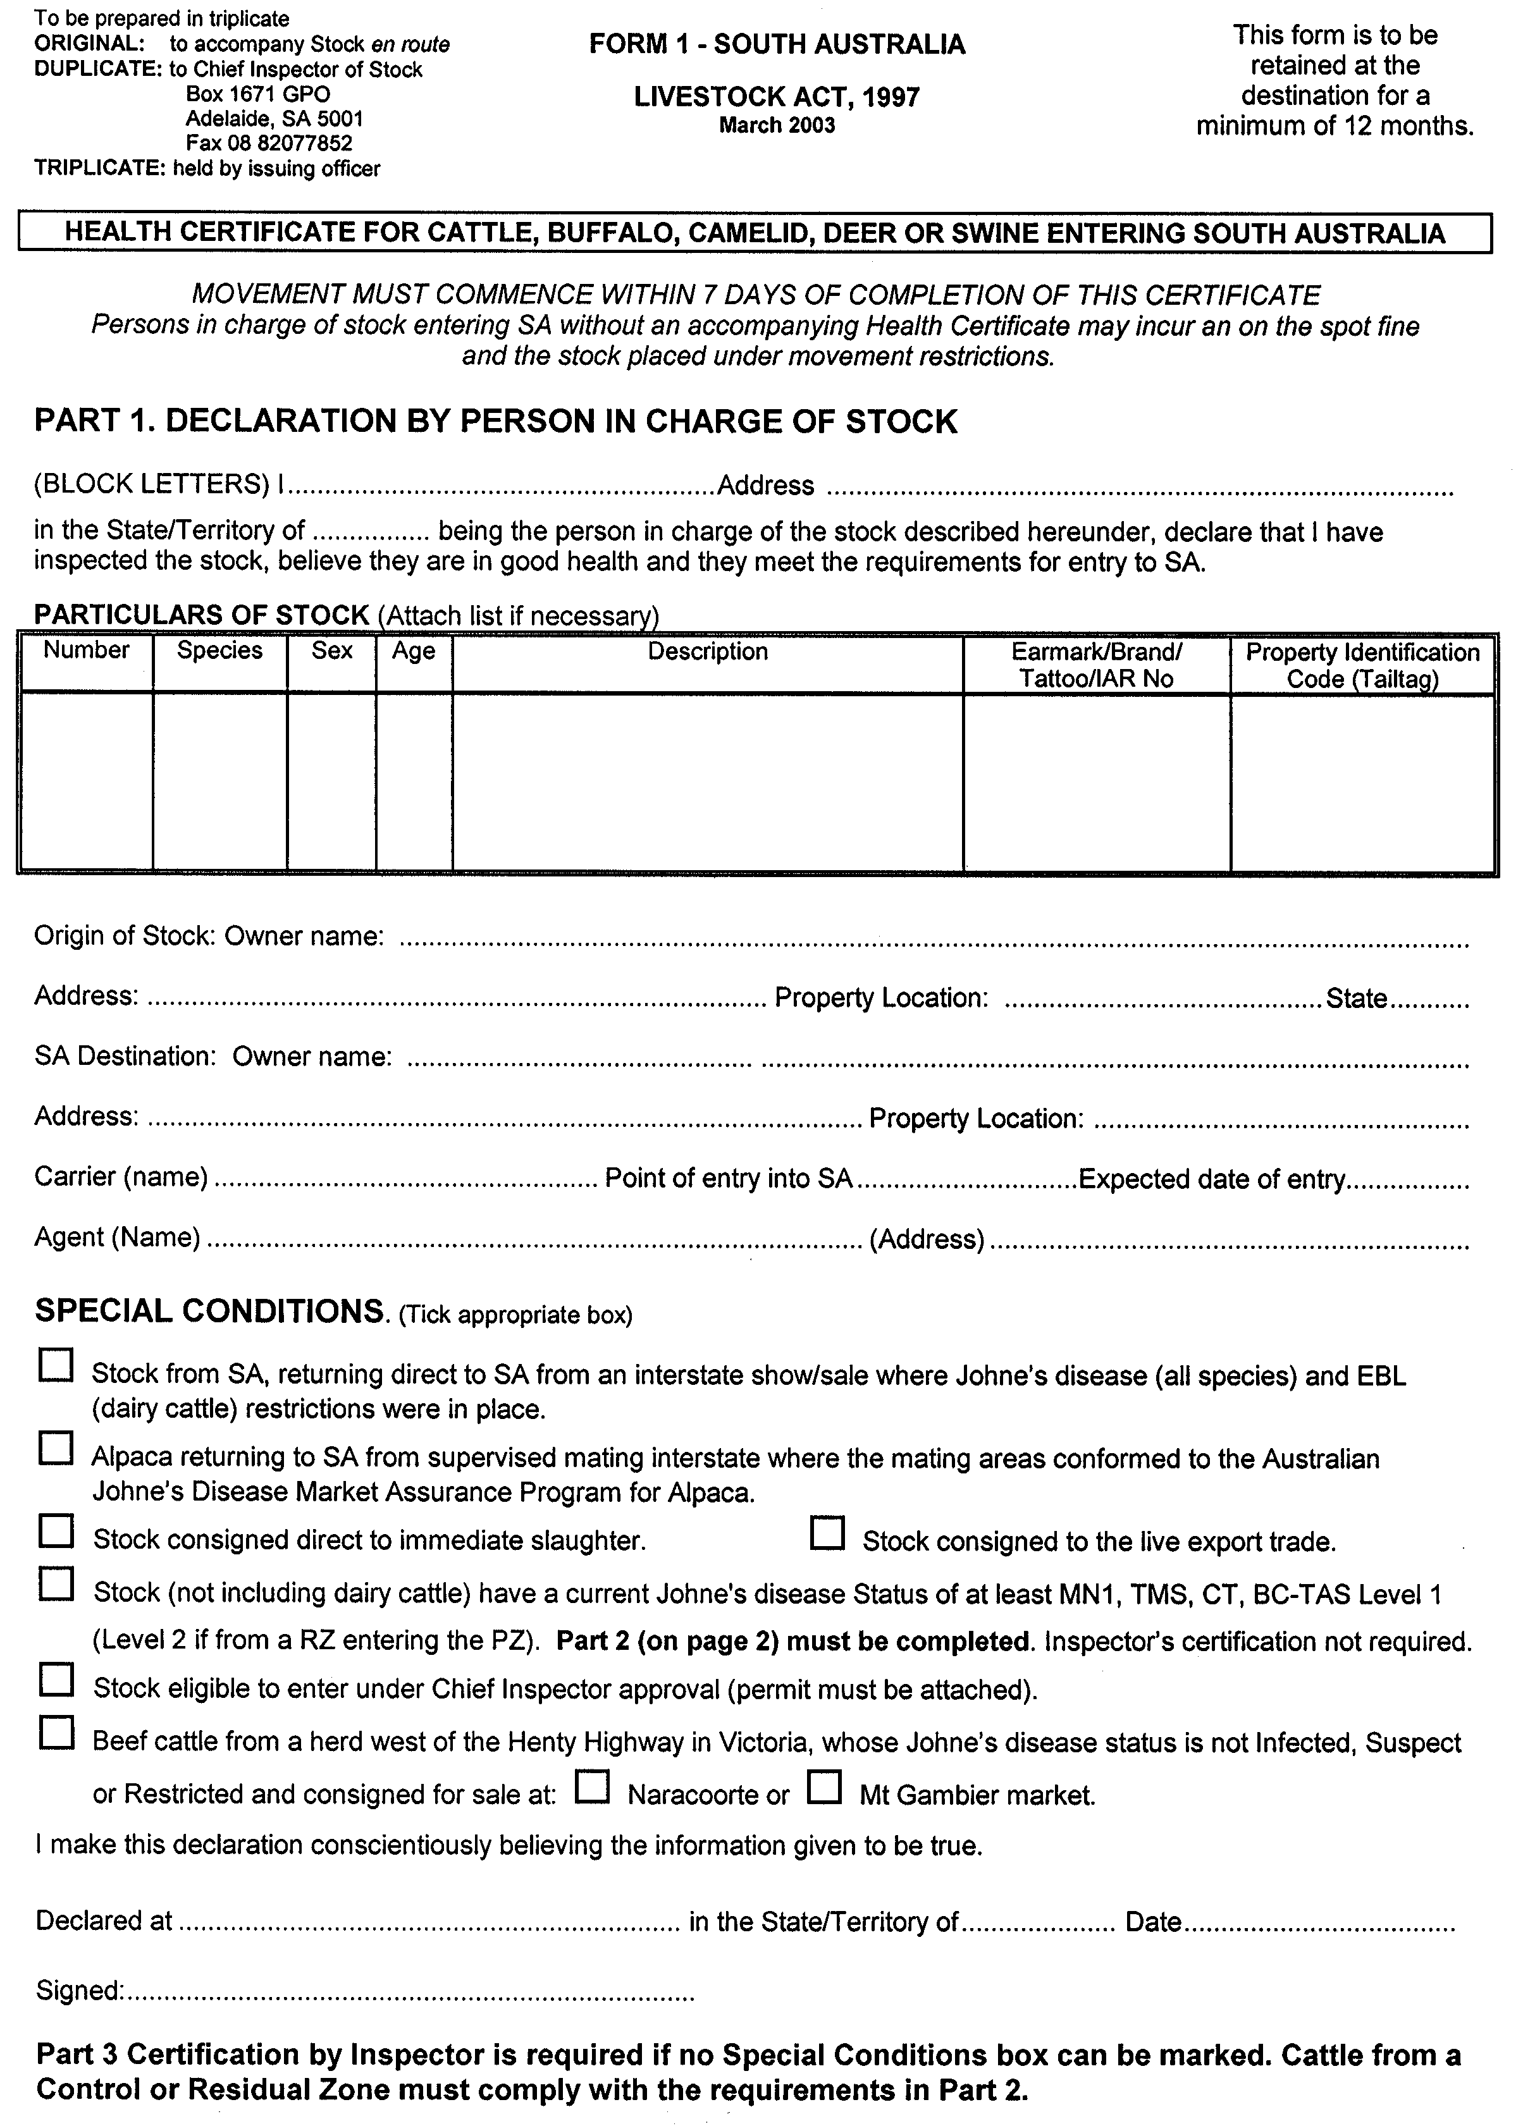
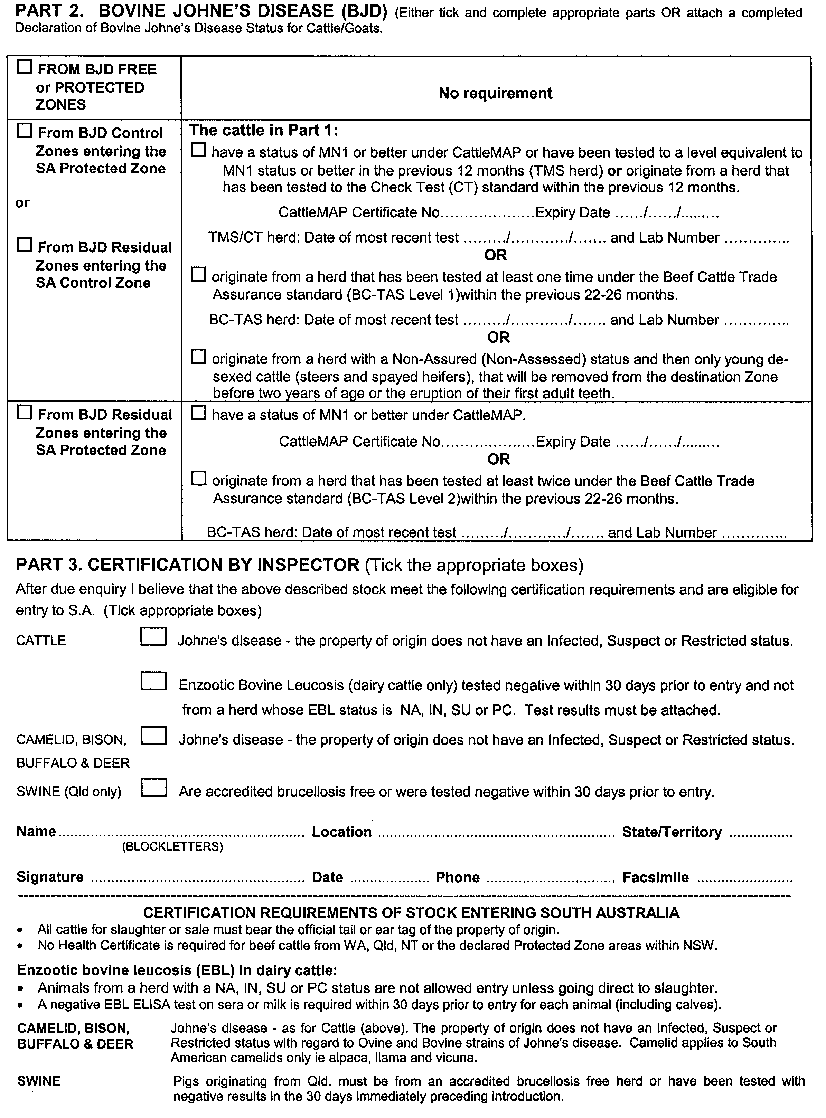
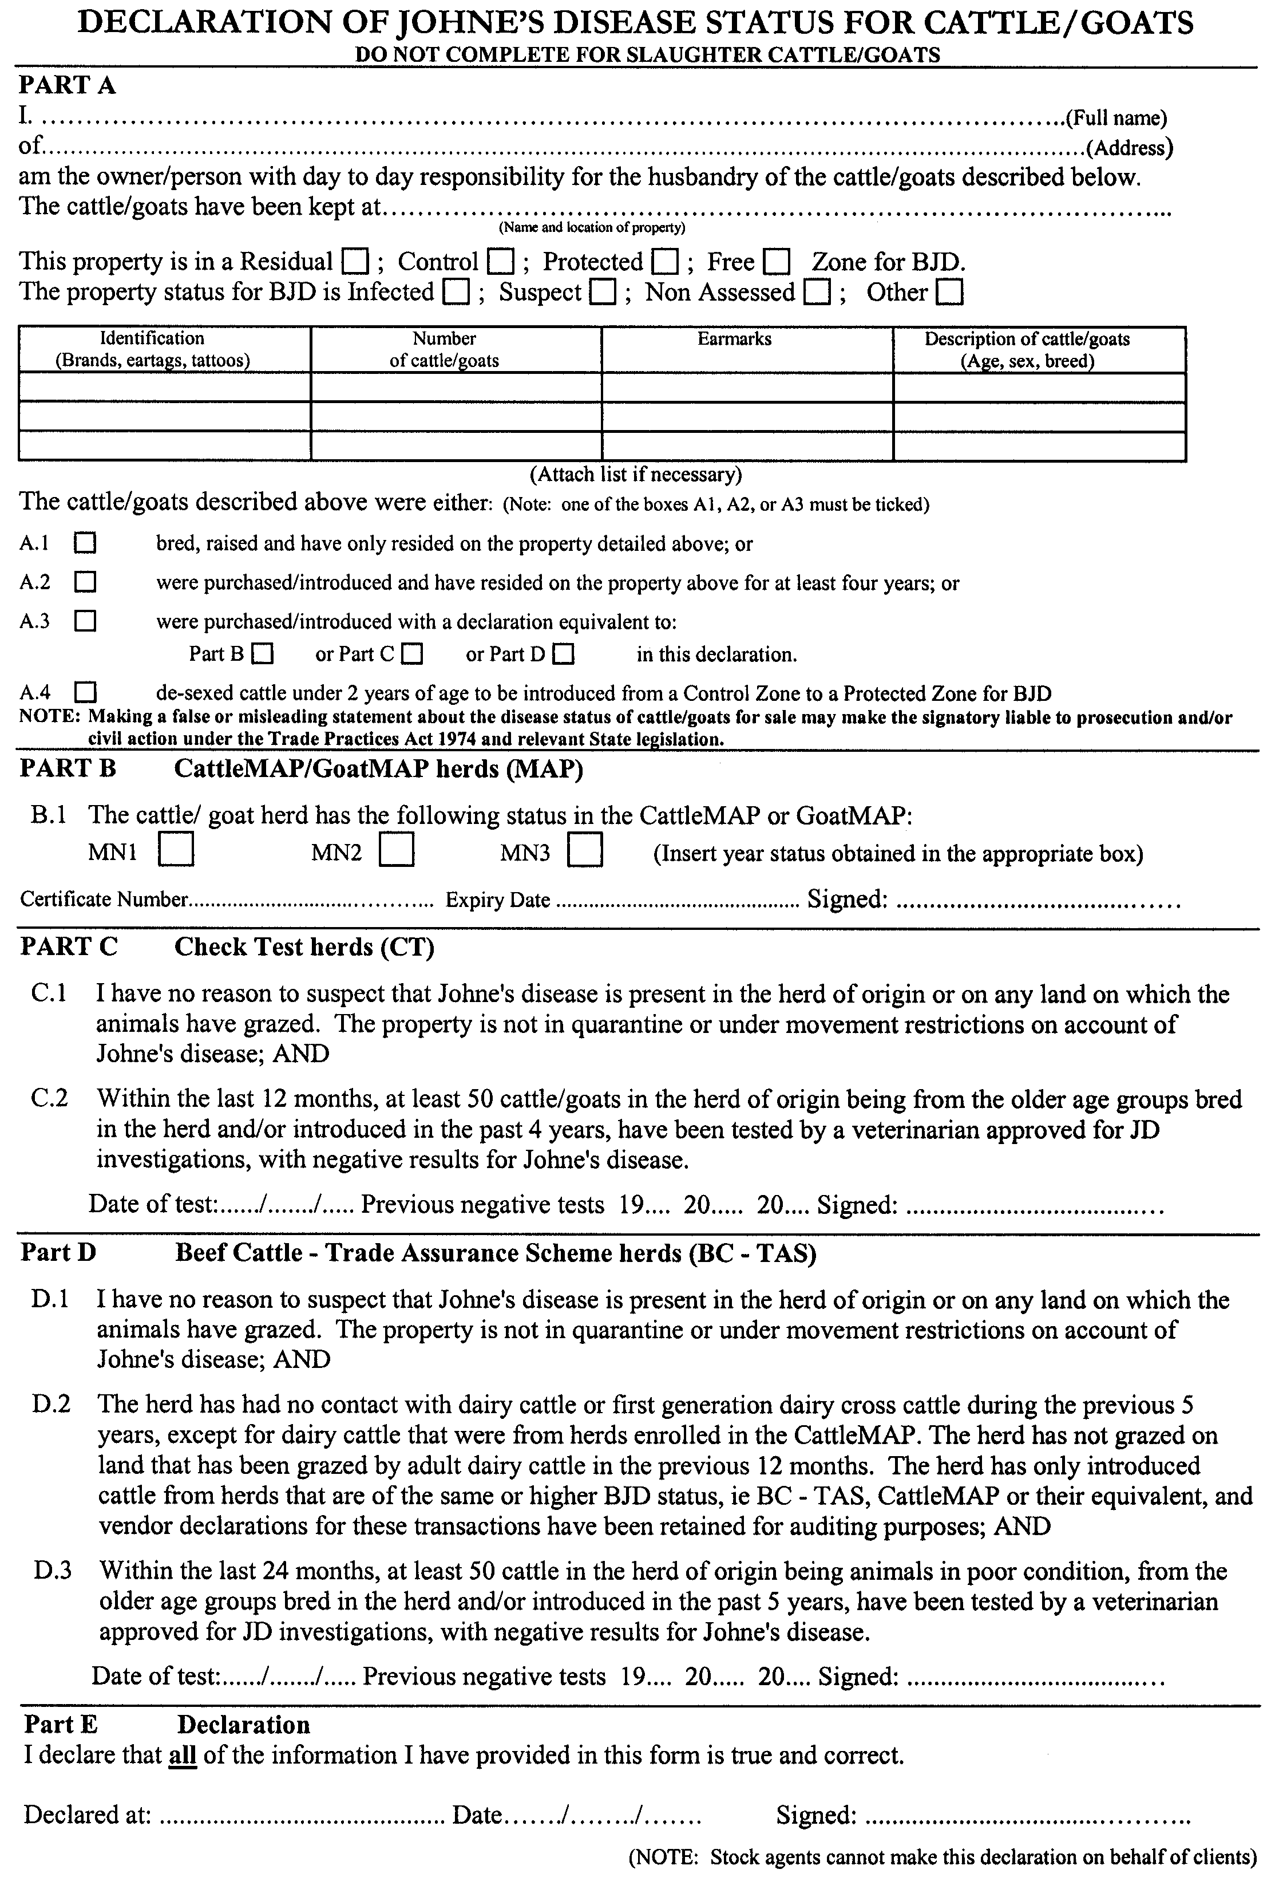
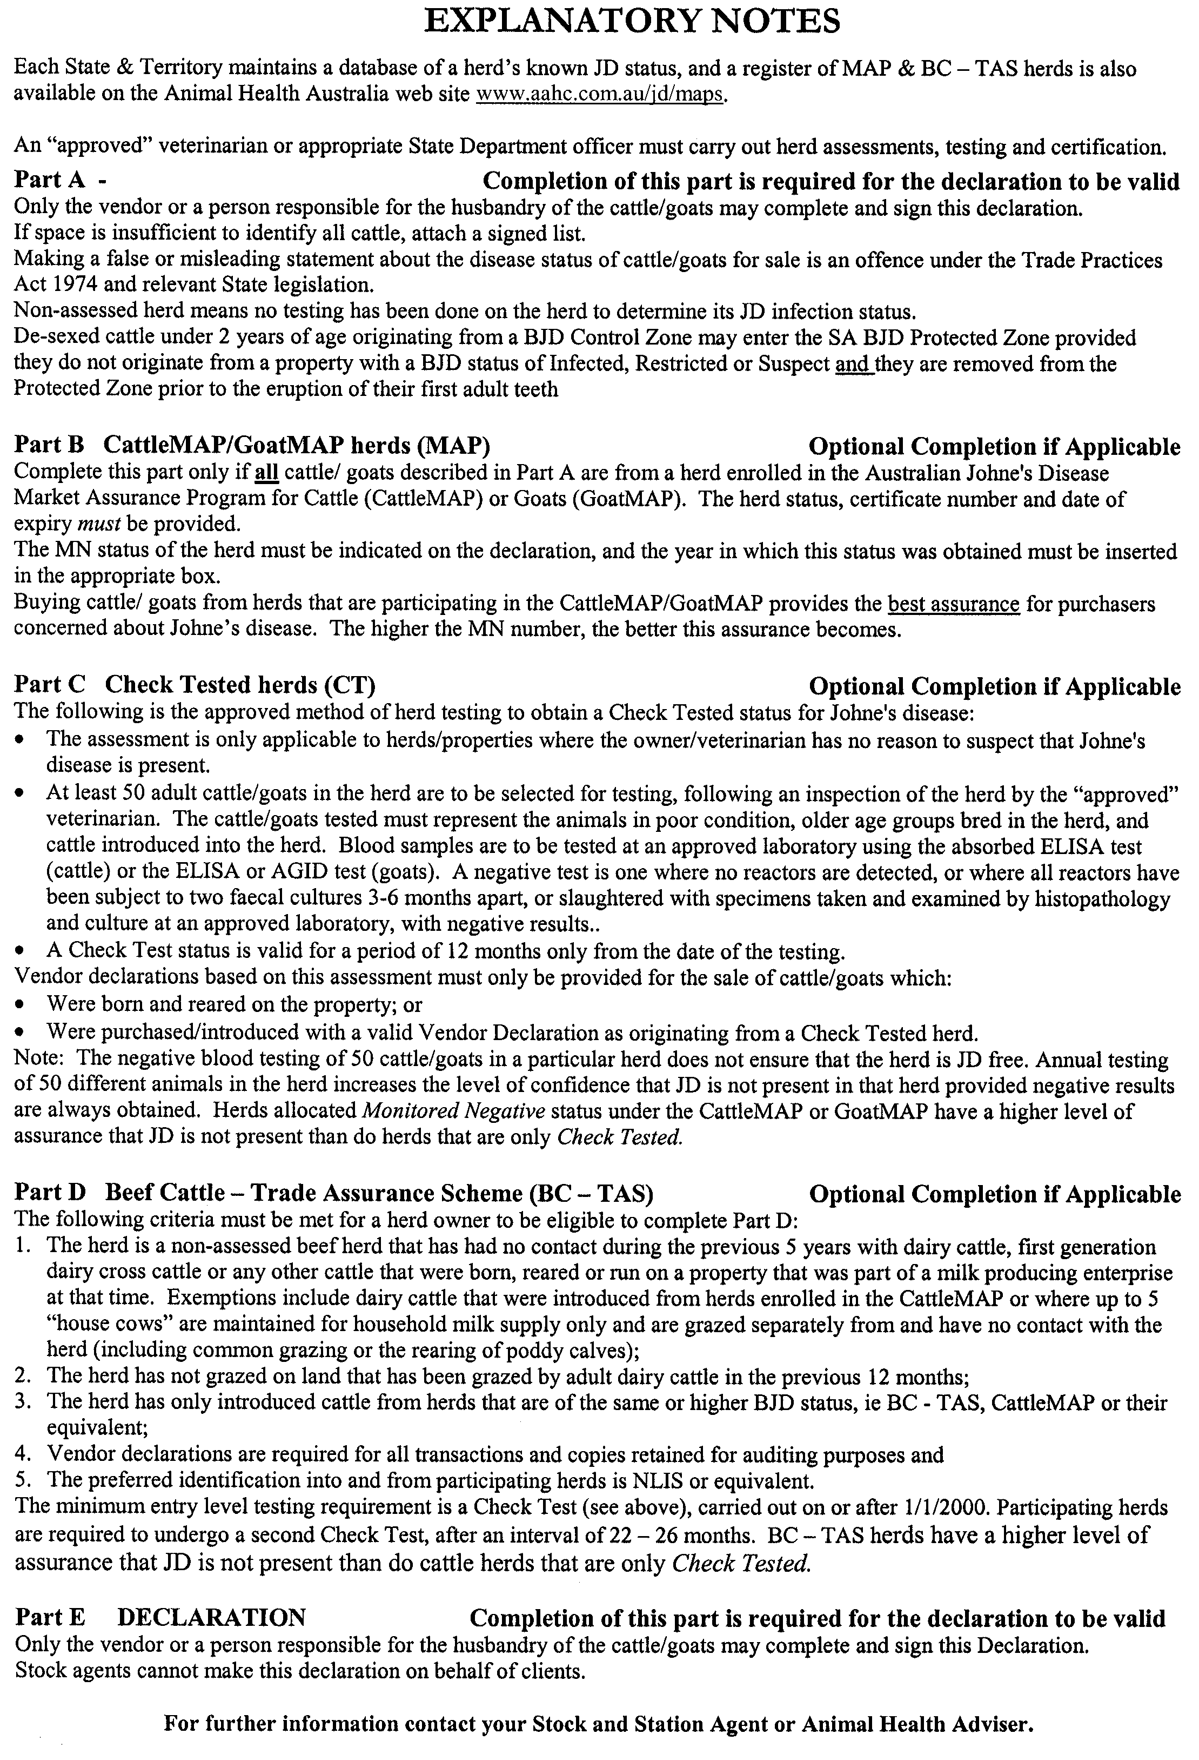
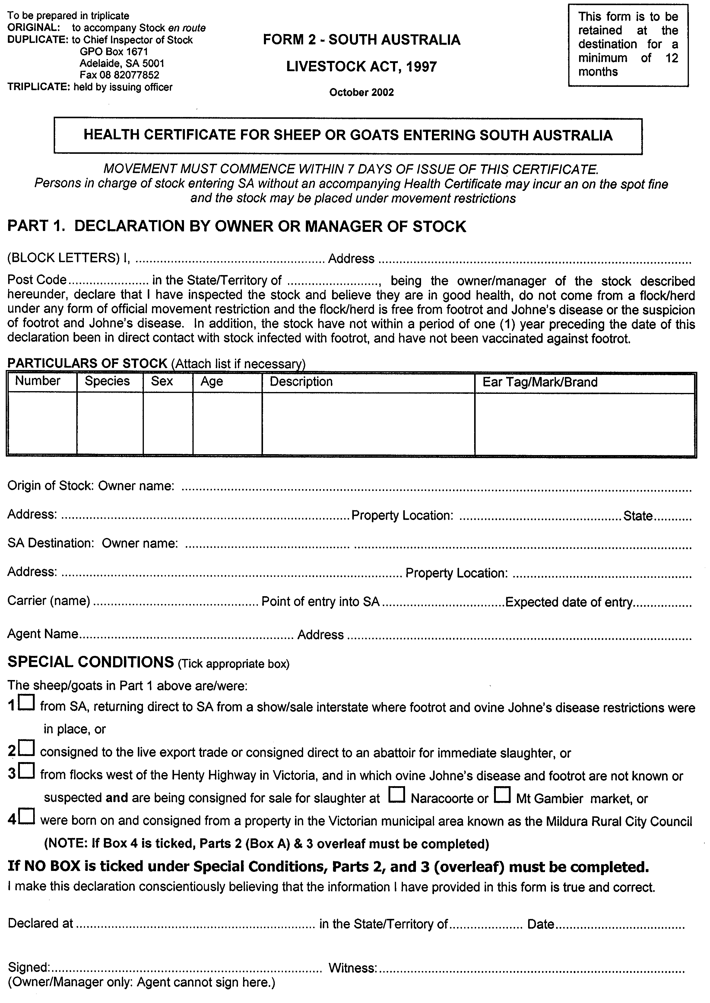

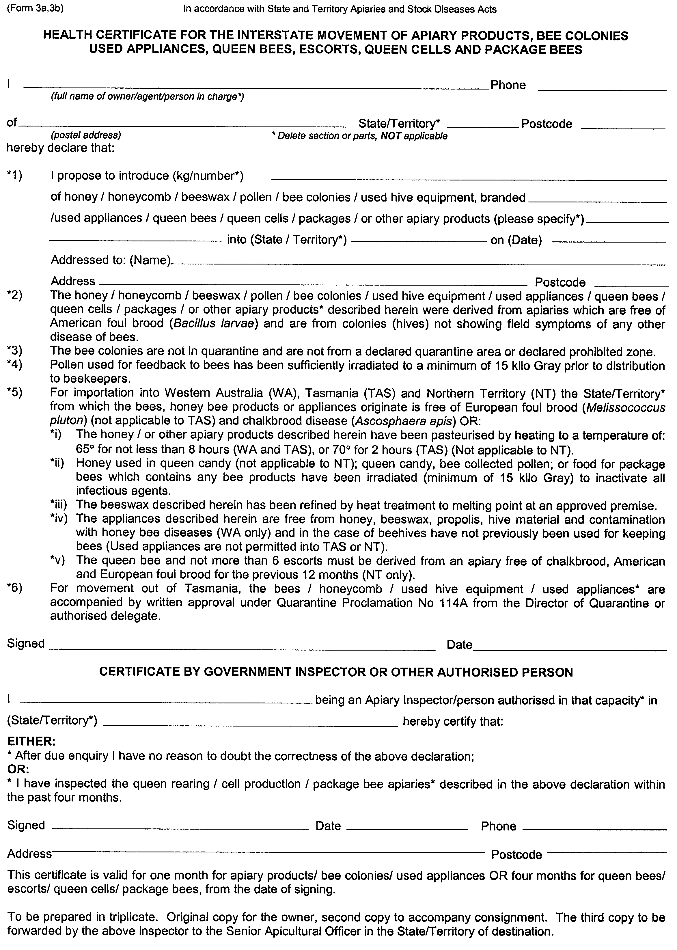
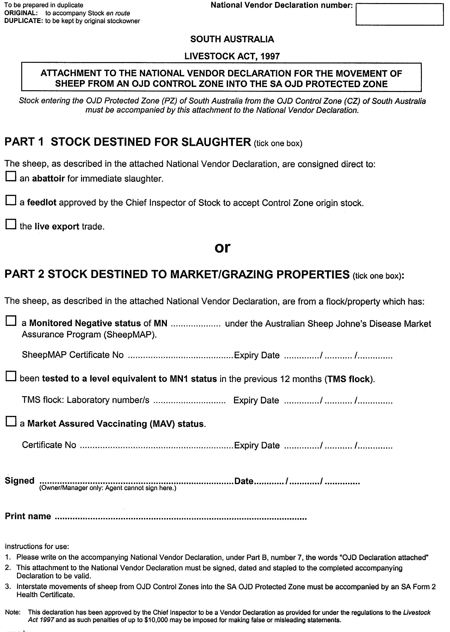

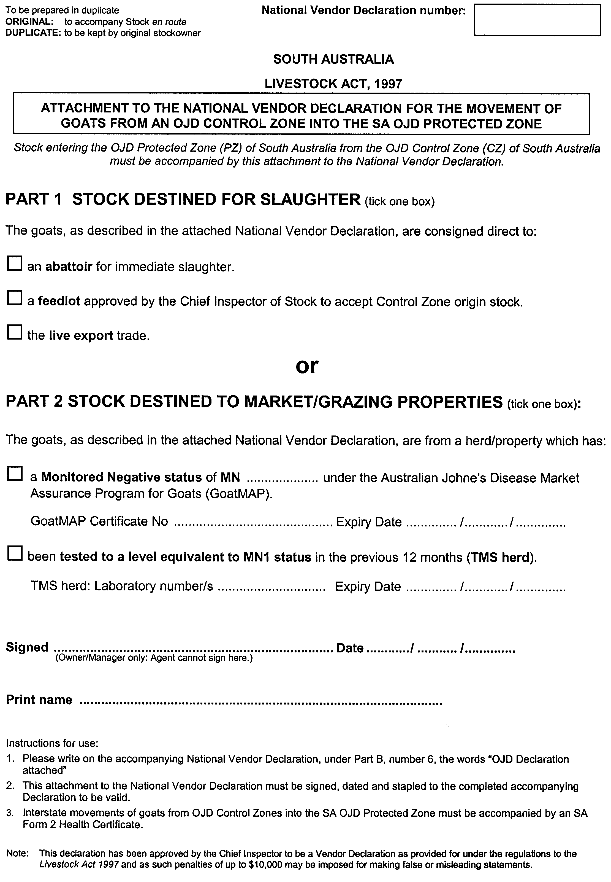

GOVERNMENT GAZETTE ADVERTISEMENT RATES

To apply from 1 July 2002

$  Agents, Ceasing to Act as 34.10  Associations:  Incorporation 17.40  Intention of Incorporation 43.00  Transfer of Properties 43.00  Attorney, Appointment of 34.10  Bailiff’s Sale 43.00  Cemetery Curator Appointed 25.50  Companies:  Alteration to Constitution 34.10  Capital, Increase or Decrease of 43.00  Ceasing to Carry on Business 25.50  Declaration of Dividend 25.50  Incorporation 34.10  Lost Share Certificates:  First Name 25.50  Each Subsequent Name 8.75  Meeting Final 28.75  Meeting Final Regarding Liquidator’s Report on  Conduct of Winding Up (equivalent to ‘Final  Meeting’)  First Name 34.10  Each Subsequent Name 8.75  Notices:  Call 43.00  Change of Name 17.40  Creditors 34.10  Creditors Compromise of Arrangement 34.10  Creditors (extraordinary resolution that ‘the Com-pany be wound up voluntarily and that a liquidator be appointed’) 43.00  Release of Liquidator⎯Application⎯Large Ad. 68.00  ⎯Release Granted 43.00  Receiver and Manager Appointed 39.75  Receiver and Manager Ceasing to Act 34.10  Restored Name 32.25  Petition to Supreme Court for Winding Up 59.50  Summons in Action 51.00  Order of Supreme Court for Winding Up Action 34.10  Register of Interests⎯Section 84 (1) Exempt 77.00  Removal of Office 17.40  Proof of Debts 34.10  Sales of Shares and Forfeiture 34.10  Estates:  Assigned 25.50  Deceased Persons⎯Notice to Creditors, etc. 43.00  Each Subsequent Name 8.75  Deceased Persons⎯Closed Estates 25.50  Each Subsequent Estate 1.10  Probate, Selling of 34.10  Public Trustee, each Estate 8.75 |  | $  Firms:  Ceasing to Carry on Business (each insertion) 22.70  Discontinuance Place of Business 22.70  Land⎯Real Property Act:  Intention to Sell, Notice of 43.00  Lost Certificate of Title Notices 43.00  Cancellation, Notice of (Strata Plan) 43.00  Mortgages:  Caveat Lodgment 17.40  Discharge of 18.30  Foreclosures 17.40  Transfer of 17.40  Sublet 8.75  Leases⎯Application for Transfer (2 insertions) each 8.75  Lost Treasury Receipts (3 insertions) each 25.50  Licensing 51.00  Municipal or District Councils:  Annual Financial Statement⎯Forms 1 and 2 481.00  Electricity Supply⎯Forms 19 and 20 341.00  Default in Payment of Rates:  First Name 68.00  Each Subsequent Name 8.75  Noxious Trade 25.50  Partnership, Dissolution of 25.50  Petitions (small) 17.40  Registered Building Societies (from Registrar-  General) 17.40  Register of Unclaimed Moneys⎯First Name 25.50  Each Subsequent Name 8.75  Registers of Members⎯Three pages and over:  Rate per page (in 8pt) 218.00  Rate per page (in 6pt) 288.00  Sale of Land by Public Auction 43.50  Advertisements 2.40  Advertisements, other than those listed are charged at $2.40 per column line, tabular one-third extra.  Notices by Colleges, Universities, Corporations and District Councils to be charged at $2.40 per line.  Where the notice inserted varies significantly in length from that which is usually published a charge of $2.40 per column line will be applied in lieu of advertisement rates listed.  South Australian Government publications are sold on the condition that they will not be reproduced without prior permission from the Government Printer.
All the above prices include GST

GOVERNMENT GAZETTE NOTICES
ALL private advertisements forwarded for publication in the South Australian Government Gazette must be PAID FOR PRIOR TO INSERTION; and all notices, from whatever source, should be legibly written on one side of the paper only and sent to Government Publishing SA so as to be received no later than 4 p.m. Tuesday preceding the day of publication. Phone 8207 1045 or Fax 8207 1040. E-mail: governmentgazette@saugov.sa.gov.au. Send as attachments in Word format and please confirm your transmission with a faxed copy of your document, including the date the notice is to be published and to whom the notice will be charged.

MISCELLANEOUS LEGISLATION AND GOVERNMENT PUBLICATIONS PRICES AS FROM 1 JULY 2002

Acts, Bills, Rules, Parliamentary Papers and Regulations
Pages | Main | Amends | Pages | Main | Amends

1-16 | 1.95 | 0.85 | 497-512 | 28.10 | 27.00
17-32 | 2.70 | 1.70 | 513-528 | 28.90 | 27.75
33-48 | 3.50 | 2.50 | 529-544 | 29.70 | 28.75
49-64 | 4.45 | 3.35 | 545-560 | 30.50 | 29.75
65-80 | 5.20 | 4.30 | 561-576 | 31.25 | 30.50
81-96 | 6.00 | 5.00 | 577-592 | 32.30 | 31.00
97-112 | 6.90 | 5.85 | 593-608 | 33.10 | 32.00
113-128 | 7.70 | 6.75 | 609-624 | 33.90 | 33.00
129-144 | 8.65 | 7.65 | 625-640 | 34.60 | 33.50
145-160 | 9.50 | 8.50 | 641-656 | 35.40 | 34.50
161-176 | 10.40 | 9.30 | 657-672 | 36.00 | 35.25
177-192 | 11.20 | 10.20 | 673-688 | 37.50 | 36.00
193-208 | 12.00 | 11.10 | 689-704 | 38.30 | 37.00
209-224 | 12.80 | 11.80 | 705-720 | 38.80 | 38.00
225-240 | 13.60 | 12.60 | 721-736 | 40.25 | 38.50
241-257 | 14.50 | 13.30 | 737-752 | 40.75 | 39.75
258-272 | 15.40 | 14.20 | 753-768 | 41.75 | 40.25
273-288 | 16.30 | 15.20 | 769-784 | 42.25 | 41.50
289-304 | 17.00 | 16.00 | 785-800 | 43.00 | 42.25
305-320 | 17.90 | 16.80 | 801-816 | 43.75 | 42.75
321-336 | 18.70 | 17.60 | 817-832 | 44.75 | 43.75
337-352 | 19.60 | 18.60 | 833-848 | 45.75 | 44.50
353-368 | 20.40 | 19.40 | 849-864 | 46.50 | 45.25
369-384 | 21.30 | 20.30 | 865-880 | 47.25 | 46.50
385-400 | 22.00 | 21.10 | 881-896 | 47.75 | 47.00
401-416 | 22.80 | 21.80 | 897-912 | 49.25 | 47.75
417-432 | 23.90 | 22.70 | 913-928 | 49.75 | 49.25
433-448 | 24.60 | 23.60 | 929-944 | 50.50 | 49.75
449-464 | 25.50 | 24.40 | 945-960 | 51.50 | 50.25
465-480 | 26.00 | 25.20 | 961-976 | 52.50 | 51.25
481-496 | 27.10 | 26.00 | 977-992 | 53.50 | 52.00

Legislation—Acts, Regulations, etc: $
Subscriptions:
Acts 174.00
All Bills as Laid 415.00
Rules and Regulations 415.00
Parliamentary Papers 415.00
Bound Acts 192.00
Index 95.50
Government Gazette
Copy 4.55
Subscription 229.00
Hansard
Copy 12.50
Subscription—per session (issued weekly) 360.00
Cloth bound—per volume 154.50
Subscription—per session (issued daily) 360.00
Legislation on Disk
Whole Database 2 659.00
Annual Subscription for fortnightly updates 817.00
Individual Act(s) including updates POA
Compendium
Subscriptions:
New Subs 1 577.00
Updates 556.00
(All the above prices include GST)

All Legislation, Government Gazette, Hansard and Legislation on disk are available from:
Counter Sales Service SA, Government Information Centre
and Mail Orders: Ground Floor, 77 Grenfell Street, Adelaide, S.A. 5000
Phone: 13 23 24 (local call cost), Fax: (08) 8204 1909
TTY (Hearing Impaired): (08) 8204 1923

Online Shop: www.info.sa.gov.au

Subscriptions and Government Publishing SA
Standing Orders: Box 9, Plaza Level, Riverside Centre, North Terrace, Adelaide, S.A. 5000
Phone: (08) 8207 0908, (08) 8207 0910, Fax: (08) 8207 1040

MINING ACT 1971
NOTICE is hereby given in accordance with section 28 (5) of the Mining Act 1971, that the Minister for Mineral Resources Development proposes to grant an Exploration Licence over the undermentioned area:
Applicant: Cheetham Salt Ltd
Location: Point Paterson area—Approximately 15 km south-east of Port Augusta
Term: 1 year
Area in km²: 49
Ref: 131/2002
Plan and co-ordinates can be found on the PIRSA Sarig website: http://www.minerals.pir.sa.gov.au/sarig or by phoning Mineral Tenements on (08) 8463 3103.
H. Tyrteos, Mining Registrar

MINING ACT 1971
NOTICE is hereby given in accordance with section 28 (5) of the Mining Act 1971, that the Minister for Mineral Resources Development proposes to grant an Exploration Licence over the undermentioned area:
Applicant: Adelaide Exploration Ltd
Location: Yantanabie area—Approximately 50 km north-east of Streaky Bay
Term: 1 year
Area in km²: 226
Ref: 165/2002
Plan and co-ordinates can be found on the PIRSA Sarig website: http://www.minerals.pir.sa.gov.au/sarig or by phoning Mineral Tenements on (08) 8463 3103.
H. Tyrteos, Mining Registrar

NATIONAL ELECTRICITY (SOUTH AUSTRALIA)
ACT 1996
Notice Under National Electricity Law—ACT Full Retail Competition Derogations
NOTICE is hereby given pursuant to section 6 (2) of the National Electricity Law, which forms the Schedule to the National Electricity (South Australia) Act 1996, that Chapter 9, Part C (‘Transitional Arrangements for the Australian Capital Territory’) of the National Electricity Code approved under section 6 of the National Electricity Law is amended.
Amendments have been made to clauses 9.19 (e) and 9.23.3 and new clause 9.24A has been inserted. These amendments to the National Electricity Code will commence on 1 July 2003 to coincide with the new effective date for full retail contestability.
A copy of the letter from the ACCC dated 5 March 2003 to the National Electricity Code Administrator Limited (ACN 073 942 775) (‘NECA’) providing authorisation for these amendments is set out below.
Both the amendments and a copy of the ACCC’s letter of 5 March 2003 can be viewed in full in the document entitled ‘ACT full retail competition derogations’ on the Internet website of NECA at www.neca.com.au under ‘The Code’—‘Gazette notices’ section of that website.
The National Electricity Code can be viewed on the NECA Internet website at www.neca.com.au and at the offices of NECA and the National Electricity Market Management Company Limited (ACN 072 010 327). A list of addresses where the Code can be viewed is available on the NECA website.
Dated 17 April 2003.

ACCC Letter of Authorisation
5 March 2003
Stephen Kelly
Managing Director
National Electricity Code Administrator
Level 4, 41 Currie Street
ADELAIDE, S.A. 5000
Dear Stephen
Determination—Application for authorisation of amendments
to the Australian Capital Territory Full Retail
Competition derogations
On 11 December 2002, the Australian Competition and Consumer Commission (Commission) received applications for authorisation (Nos A90858, A90859 and A90860) of amend-ments to the National Electricity Code (code). The applications were submitted by the National Electricity Code Administrator (NECA) on behalf of the Australian Capital Territory (ACT) Treasury.
The proposed amendments are to Chapter 9, Part C of the code and relate to the metering arrangements in Chapter 7 of the code. A further amendment clarifies the way in which responsibility for performing the role of Jurisdictional Regulator in the ACT is assigned.
Please find enclosed a copy of the Commission’s deter-mination, which outlines its analysis and views on the proposed amendments to the derogations contained in Chapter 9. The Commission grants authorisation to the applications.
In accordance with section 101 of the TPA, a person dissatis-fied with the Commission’s determination may apply to the Australian Competition Tribunal for a review of the deter-mination. Each application must be lodged on the appropriate form within 21 days of the date of the determination, with the Registrar of the Tribunal. The Tribunal is located in the Office of the Registrar of the Federal Court in each State.
A copy of this letter together with the determination will be placed on the Public Register kept by the Commission.
If you have any queries or require further information please do not hesitate to contact Maxine Helmling on (02) 6243 1246.
Sebastian Roberts, Acting General Manager, Regulatory Afffairs—Electricity.

NATIONAL PARKS AND WILDLIFE ACT 1972
Cobbler Creek Recreation Park Management Plan
I, JOHN HILL, Minister for Environment and Conservation, hereby give notice under the provisions of section 38 of the National Parks and Wildlife Act 1972, that I have adopted a plan of management for Cobbler Creek Recreation Park.
Copies of the plan may be inspected at or obtained from the offices of the Department for Environment and Heritage at The Environment Shop, Ground Floor, SA Water House, 77 Grenfell Street, Adelaide, S.A. 5000 (G.P.O. Box 1047, Adelaide, S.A. 5001), telephone (08) 8204 1910 or at the Lofty/Barossa District Office, Black Hill Conservation Park, 115 Maryvale Road, Athelstone, S.A. 5076, telephone (08) 8336 0901 or on the internet at:
http://www.environment.sa.gov.au/parks/management_plans.html
Copies of this publication can be purchased at a cost of $10 per copy (plus $2 postage within South Australia) from the addresses above.
J. Hill, Minister for Environment and Conservation

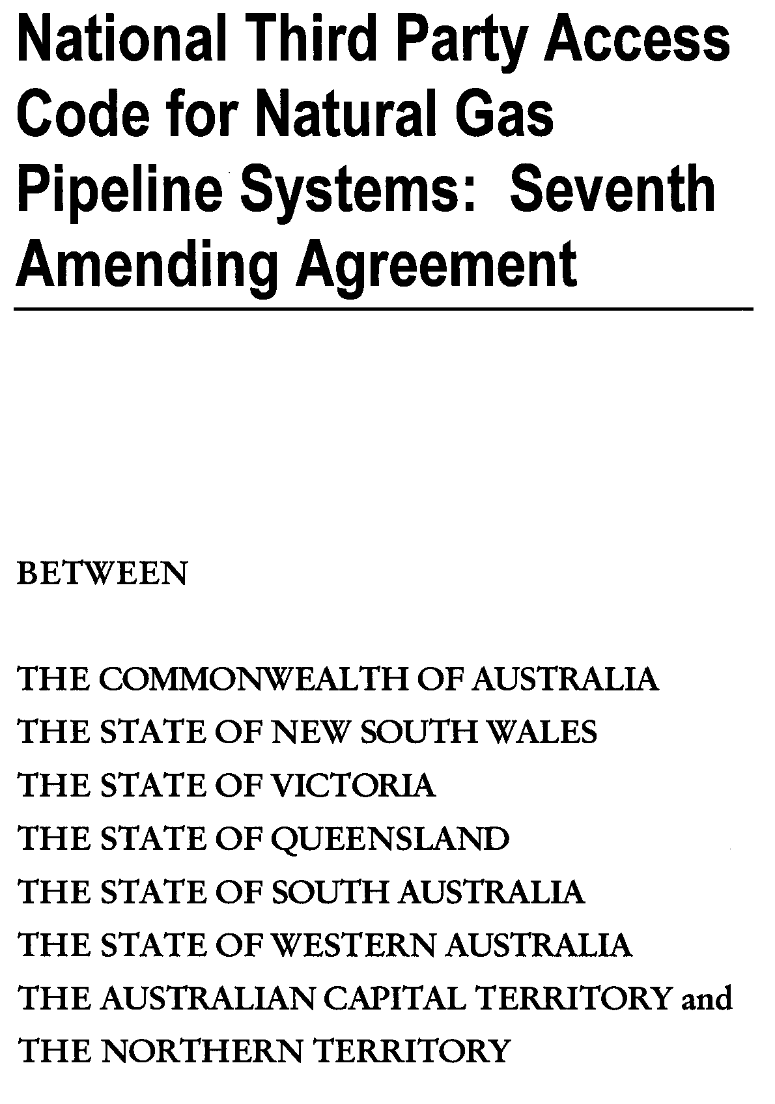
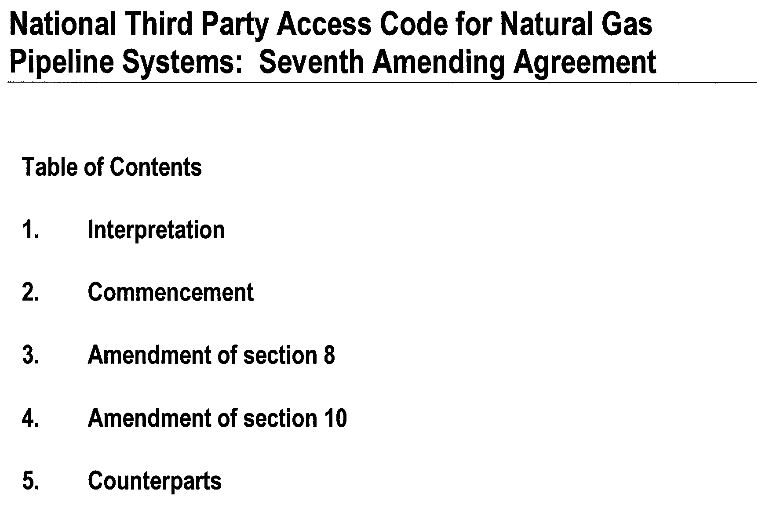
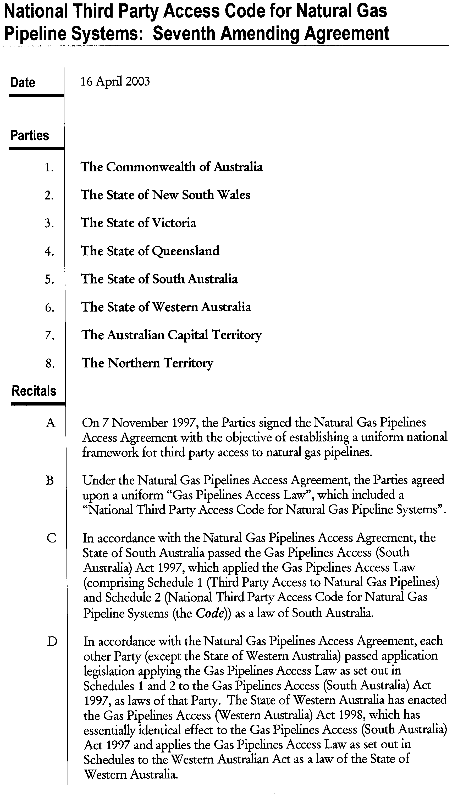
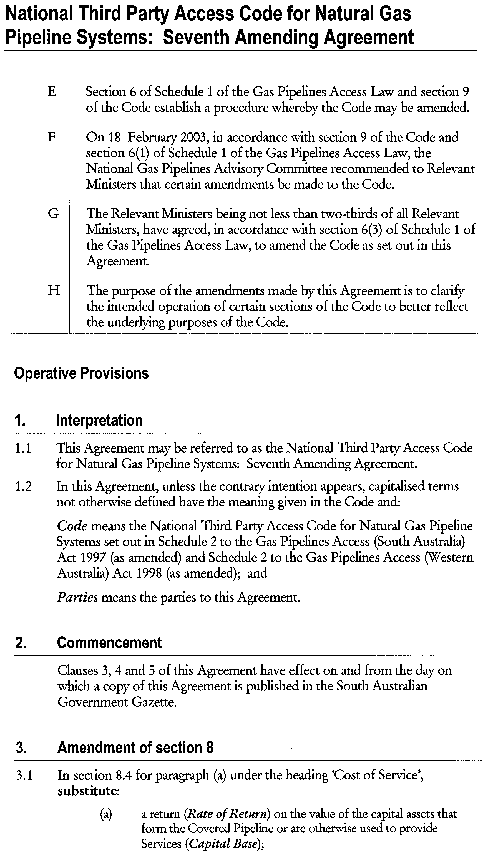
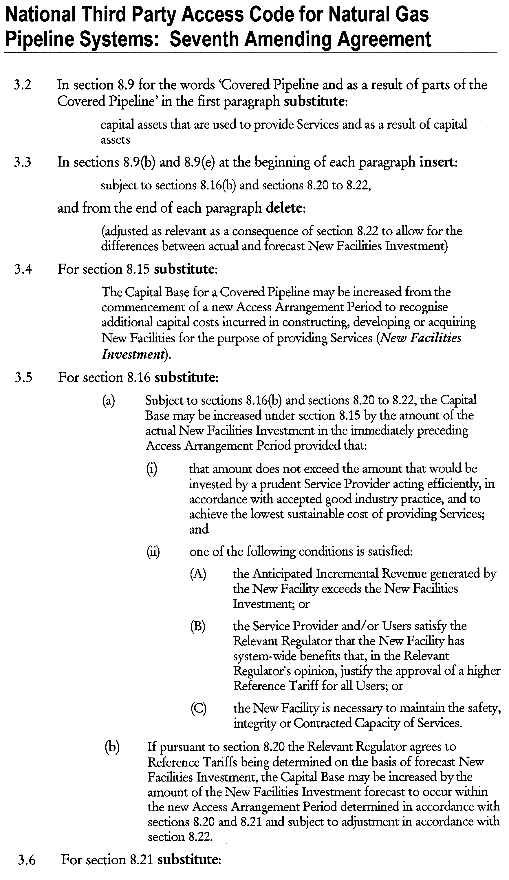
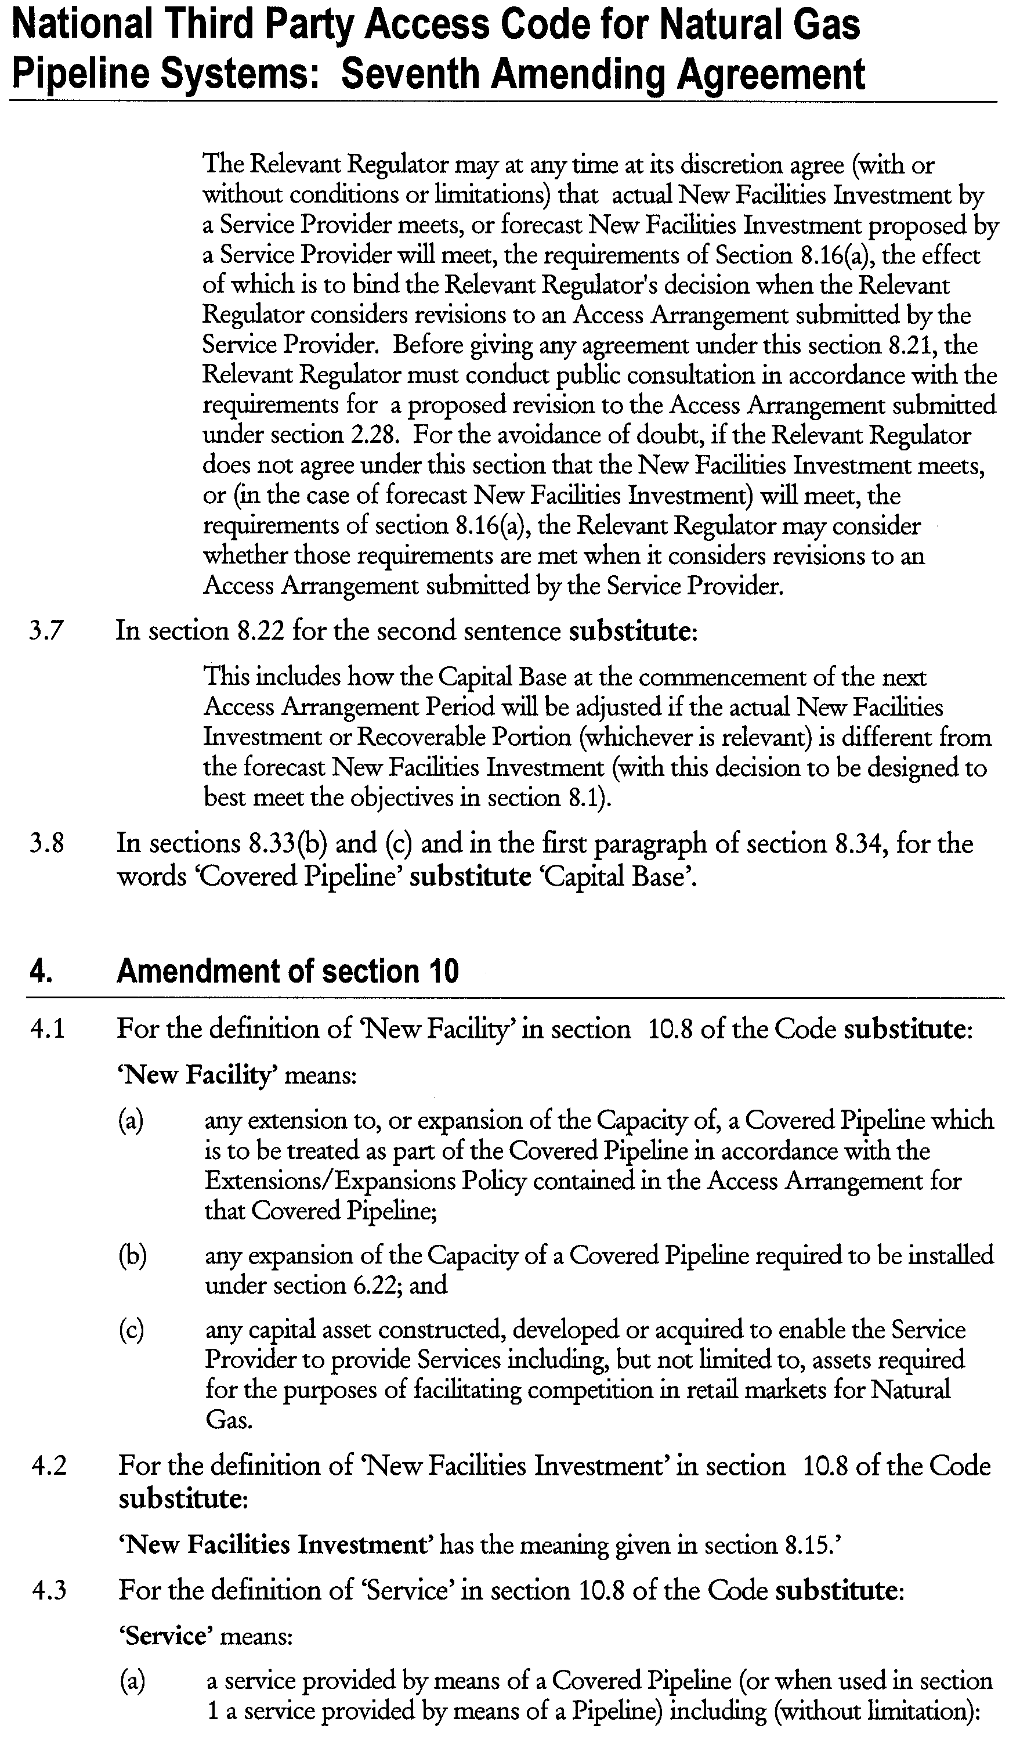
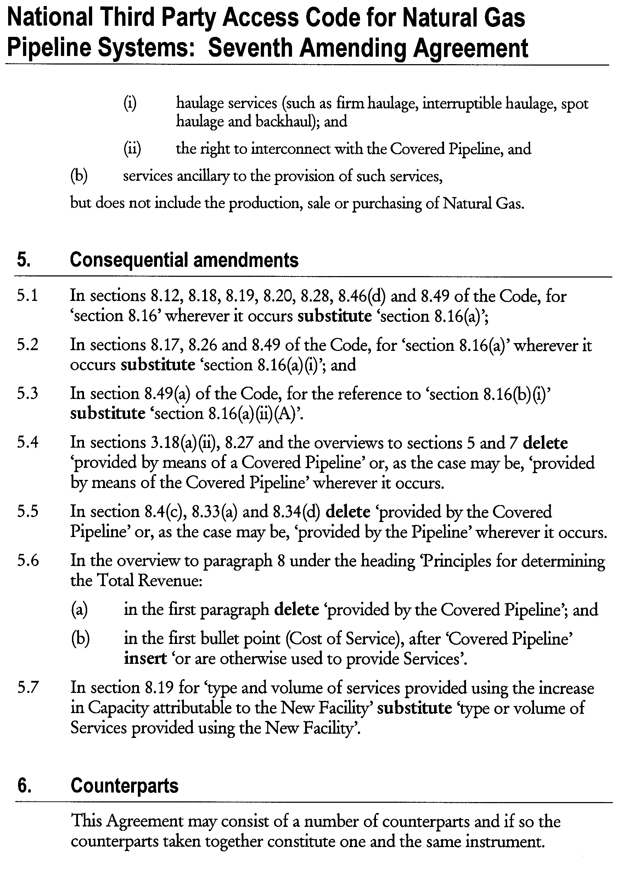


PETROLEUM ACT 2000
Application for Grant of a Production Licence PPL 203
PURSUANT to section 65 (6) of the Petroleum Act 2000 (the Act) and Delegation dated 28 March 2002, Gazetted 11 April 2002, page 1573, notice is hereby given that an application for the grant of a production licence over the area described below has been received from Stuart Petroleum Limited and Mawson Petroleum NL.

Description of Application Area
All that part of the State of South Australia, bounded as follows and shown on the map following:
Commencing at a point being the intersection of latitude 27°13′35″S GDA94 and longitude 140°59′50″E GDA94, thence east to the eastern border of the State of South Australia, thence southerly along the border of the said State to latitude 27°14′10″S GDA94, west to longitude 140°58′40″E GDA94, north to latitude 27°13′40″S GDA94, east to longitude 140°59′50″E GDA94, and north to point of commencement.
Area: 2.03 km² approximately.
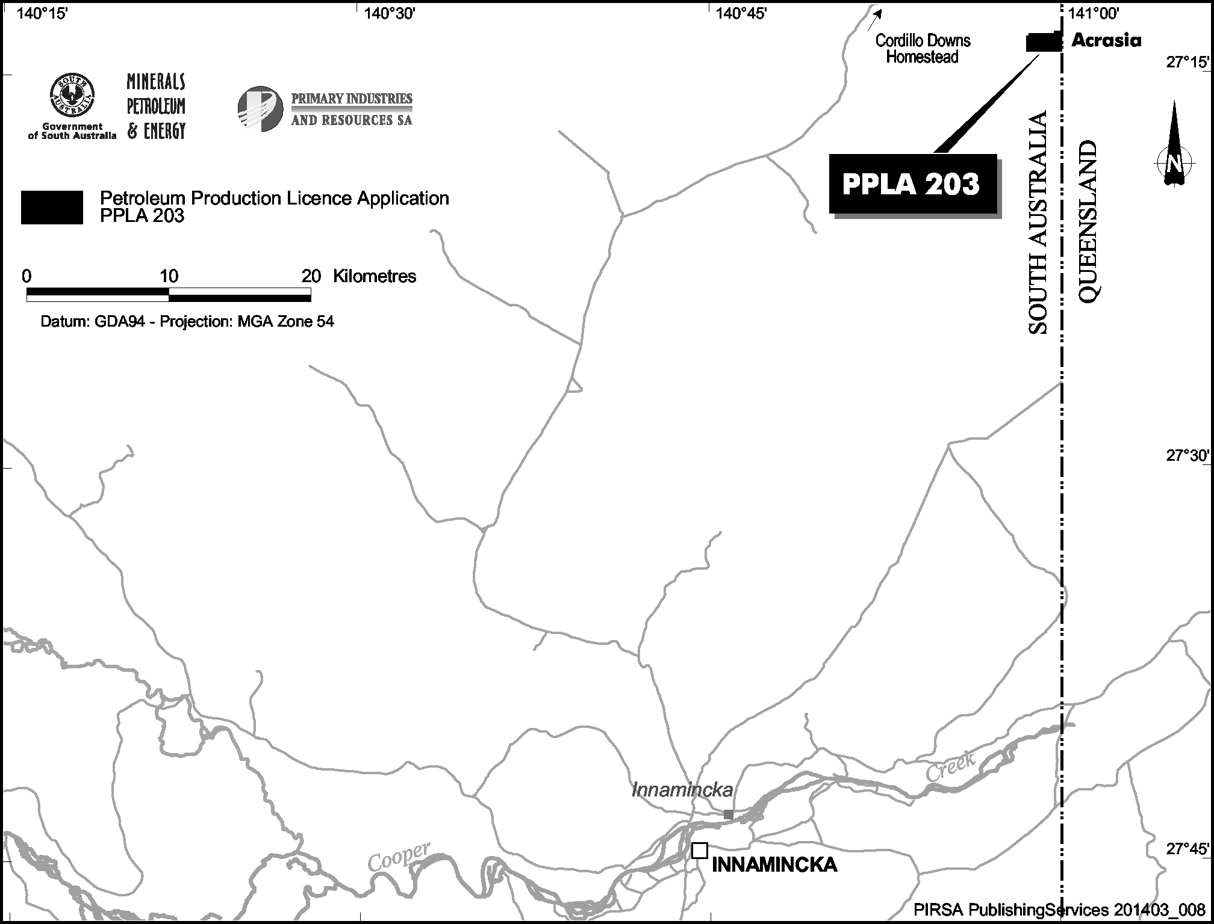
Dated 15 April 2003.
B. A. Goldstein, Director Petroleum,
Minerals, Petroleum and Energy,
Primary Industries and Resources SA
Delegate of the Minister for Mineral Resources Development

PETROLEUM ACT 2000
Grant of Speculative Survey Licence SSL 5
NOTICE is hereby given that Speculative Survey Licence SSL 5 has been granted pursuant to delegated powers dated 28 March 2002, Gazetted 11 April 2002, page 1573.
No. of  Licence | Licensee | Locality | Date of  Expiry | Area in  km² | Reference

5 | Essential Petroleum Resources Limited |  | Otway Basin of South Australia | 10 April 2004 | 37 | 27/2/256

Description of the Area
All that part of the State of South Australia, bounded as follows: Commencing at a point being the intersection of latitude 37°58′00″S GDA94 and longitude 140°55′00″E GDA94, thence east to the eastern border of the State of South Australia, thence southerly along the border of the said State to the northern boundary of Piccaninnie Ponds Conservation Park, thence generally westerly along the boundary of the said Park to longitude 140°55′00″E GDA94 and north to the point of commencement but excluding Lower Glenelg River Conservation Park.
Area: 37 km² approximately.
Dated 11 April 2003.
B. A. Goldstein, Director Petroleum,
Minerals, Petroleum and Energy,
Primary Industries and Resources SA
Delegate of the Minister for Mineral Resources Development

PETROLEUM ACT 2000
Variation of Exploration Licence GEL 97
NOTICE is hereby given that pursuant to delegated powers dated 28 March 2002, Gazetted 11 April 2002, page 1573, the conditions of Exploration Licence GEL 97 have been varied as follows:
Condition 2 has been omitted and the following substituted:
‘During the term of the licence, the Licensee shall carry out or cause to be carried out exploratory operations on the area comprised in the licence in accordance with such work programs as are approved by the Minister from time to time. Year one exploratory operations are guaranteed. These exploratory operations shall include but not necessarily be limited to:
Year of Term of  Licence | Minimum Work Requirements
One | Area Review  Feasibility and commercial negotiations for funding.
Two | Conduct gravity survey and temperature logging of existing wells (if practicable).
Three | Interpret gravity, seismic and temperature data to delineate sub-basin granite distribution.
Four | Review geological, environmental and heritage information to establish potential best location for HDR development.
Five | Investigate feasibility for commercial development of geothermal resource.’
The effect of this variation is to nominally reduce the work program in GEL97 from that originally proposed (but not guaranteed). As no other competitive tenders were received for this area at the time of offer of the licence, no other parties are affected by this variation. The variation recognises the now common ownership with the adjacent GEL98 and that the work originally proposed will be carried out in one or other of the licence areas.
Dated 11 April 2003.
B. A. Goldstein, Director Petroleum,
Minerals, Petroleum and Energy,
Primary Industries and Resources SA
Delegate of the Minister for Mineral Resources Development

PETROLEUM ACT 2000
Grant of Petroleum Exploration Licence PEL 106
NOTICE is hereby given that the undermentioned Petroleum Exploration Licence has been granted under the provisions of the Petroleum Act 2000, pursuant to delegated powers dated 28 March 2002, Gazetted 11 April 2002, page 1573.
No. of  Licence | Licensee | Locality | Date of  Expiry | Area in  km² | Reference

106 | Great Artesian Oil and Gas Limited |  | Cooper Basin of South Australia | 8 April 2008 | 1 007 | 27/2/186

Description of the Area
All that part of the State of South Australia, bounded as follows:
Area 1
Commencing at a point being the intersection of latitude 27°40′00″S AGD66 and longitude 139°40′00″E AGD66, thence east to longitude 139°45′00″E AGD66, south to latitude 27°45′00″S Clarke1858, east to longitude 139°54′00″E AGD66, south to latitude 27°45′10″S AGD66, west to longitude 139°53′50″E AGD66, south to latitude 27°46′20″S AGD66, east to longitude 139°54′50″E AGD66, north to latitude 27°46′10″S AGD66, east to longitude 139°55′30″E AGD66, south to latitude 27°46′30″S AGD66, east to longitude 139°56′30″E AGD66, north to latitude 27°46′00″S AGD66, east to longitude 139°57′10″E AGD66, north to latitude 27°45′50″S AGD66, east to longitude 139°57′40″E AGD66, north to latitude 27°45′30″S AGD66, east to longitude 139°58′00″E AGD66, south to latitude 27°45′40″S AGD66, east to longitude 139°58′20″E AGD66, north to latitude 27°45′30″S AGD66, east to longitude 139°58′30″E AGD66, north to latitude 27°45′20″S AGD66, east to longitude 139°58′40″E AGD66, north to latitude 27°45′00″S Clarke1858, east to longitude 140°01′10″E AGD66, south to latitude 27°45′00″S AGD66, east to longitude 140°01′20″E AGD66, south to latitude 27°45′20″S AGD66, east to longitude 140°01′40″E AGD66, south to latitude 27°45′40″S AGD66, east to longitude 140°01′50″E AGD66, south to latitude 27°45′50″S AGD66, east to longitude 140°02′00″E AGD66, south to latitude 27°46′00″S AGD66, east to longitude 140°02′52″E AGD66, north to latitude 27°45′00″S Clarke1858, east to longitude 140°04′05″E AGD66, south to latitude 27°45′25″S AGD66, east to longitude 140°04′40″E AGD66, south to latitude 27°45′40″S AGD66, west to longitude 140°04′30″E AGD66, south to latitude 27°46′10″S AGD66, west to longitude 140°04′20″E AGD66, south to latitude 27°47′20″S AGD66, west to longitude 140°03′40″E AGD66, south to latitude 27°47′50″S AGD66, west to longitude 140°03′30″E AGD66, south to latitude 27°50′20″S AGD66, west to longitude 140°03′20″E AGD66, south to latitude 27°51′10″S AGD66, east to longitude 140°03′30″E AGD66, south to latitude 27°52′00″S AGD66, east to longitude 140°03′50″E AGD66, south to latitude 27°52′10″S AGD66, east to longitude 140°04′20″E AGD66, south to latitude 27°52′20″S AGD66, east to longitude 140°04′50″E AGD66, south to latitude 27°52′40″S AGD66, west to longitude 140°04′40″E AGD66, south to latitude 27°52′50″S AGD66, west to longitude 140°04′30″E AGD66, south to latitude 27°53′00″S AGD66, west to longitude 140°04′20″E AGD66, south to latitude 27°53′10″S AGD66, west to longitude 140°04′10″E AGD66, south to latitude 27°53′20″S AGD66, west to longitude 140°04′00″E AGD66, south to latitude 27°53′30″S AGD66, west to longitude 140°03′40″E AGD66, south to latitude 27°53′40″S AGD66, west to longitude 140°03′30″E AGD66, south to latitude 27°54′00″S Clarke1858, west to longitude 140°02′00″E Clarke1858, south to latitude 27°55′00″S Clarke1858, west to longitude 140°01′10″E AGD66, north to latitude 27°53′40″S AGD66, east to longitude 140°01′20″E AGD66, north to latitude 27°53′30″S AGD66, east to longitude 140°01′40″E AGD66, north to latitude 27°53′20″S AGD66, east to longitude 140°01′50″E AGD66, north to latitude 27°53′10″S AGD66, east to longitude 140°02′00″E AGD66, north to latitude 27°52′10″S AGD66, west to longitude 140°01′40″E AGD66, north to latitude 27°52′05″S AGD66, west to longitude 140°00′40″E AGD66, north to latitude 27°51′40″S AGD66, west to longitude 140°00′00″E AGD66, north to latitude 27°51′20″S AGD66, west to longitude 139°59′20″E AGD66, north to latitude 27°50′20″S AGD66, west to longitude 139°59′00″E AGD66, north to latitude 27°49′20″S AGD66, west to longitude 139°58′40″E AGD66, north to latitude 27°49′00″S AGD66, west to longitude 139°58′30″E AGD66, north to latitude 27°48′50″S AGD66, east to longitude 139°58′50″E AGD66, south to latitude 27°49′00″S AGD66, east to longitude 140°02′10″E AGD66, north to latitude 27°48′30″S AGD66, east to longitude 140°02′30″E AGD66, north to latitude 27°48′20″S AGD66, east to longitude 140°02′40″E AGD66, north to latitude 27°48′10″S AGD66, east to longitude 140°02′50″E AGD66, north to latitude 27°48′00″S AGD66, east to longitude 140°03′10″E AGD66, north to latitude 27°47′50″S AGD66, east to longitude 140°03′20″E AGD66, north to latitude 27°47′30″S AGD66, west to longitude 140°03′10″E AGD66, north to latitude 27°47′10″S AGD66, west to longitude 140°02′00″E AGD66, south to latitude 27°47′30″S AGD66, west to longitude 139°59′40″E AGD66, north to latitude 27°47′20″S AGD66, west to longitude 139°59′20″E AGD66, north to latitude 27°47′10″S AGD66, west to longitude 139°59′00″E AGD66, north to latitude 27°47′00″S AGD66, west to longitude 139°58′20″E AGD66, north to latitude 27°46′10″S AGD66, west to longitude 139°57′20″E AGD66, south to latitude 27°46′50″S AGD66, west to longitude 139°56′50″E AGD66, south to latitude 27°47′10″S AGD66, west to longitude 139°56′30″E AGD66, south to latitude 27°47′30″S AGD66, west to longitude 139°56′10″E AGD66, south to latitude 27°48′30″S AGD66, east to longitude 139°56′50″E AGD66, south to latitude 27°50′20″S AGD66, west to longitude 139°54′30″E AGD66, north to latitude 27°49′30″S AGD66, west to longitude 139°53′10″E AGD66, south to latitude 27°50′00″S AGD66, west to longitude 139°53′00″E AGD66, south to latitude 27°50′50″S AGD66, west to longitude 139°52′30″E AGD66, south to latitude 27°51′50″S AGD66, west to longitude 139°52′10″E AGD66, south to latitude 27°52′20″S AGD66, west to longitude 139°51′20″E AGD66, south to latitude 27°57′00″S AGD66, east to longitude 139°58′00″E Clarke1858, south to latitude 27°59′00″S Clarke1858, west to longitude 139°57′00″E Clarke1858, south to latitude 28°00′00″S Clarke1858, west to longitude 139°56′00″E Clarke1858, south to latitude 28°02′00″S Clarke1858, west to longitude 139°55′00″E Clarke1858, south to latitude 28°03′50″S AGD66, west to longitude 139°54′30″E AGD66, south to latitude 28°04′00″S AGD66, west to longitude 139°54′20″E AGD66, south to latitude 28°04′20″S AGD66, west to longitude 139°54′10″E AGD66, south to latitude 28°05′00″S AGD66, west to longitude 139°40′00″E AGD66, and north to point of commencement, but excluding the areas bounded as follows:
Commencing at a point being the intersection of latitude 27°46′30″S AGD66 and longitude 139°45′40″E AGD66, thence east to longitude 139°46′20″E AGD66, south to latitude 27°46′40″S AGD66, east to longitude 139°46′30″E AGD66, south to latitude 27°46′50″S AGD66, east to longitude 139°47′10″E AGD66, south to latitude 27°47′00″S AGD66, east to longitude 139°47′20″E AGD66, south to latitude 27°47′40″S AGD66, west to longitude 139°47′10″E AGD66, south to latitude 27°47′50″S AGD66, west to longitude 139°47′00″E AGD66, south to latitude 27°48′00″S AGD66, west to longitude 139°46′40″E AGD66, south to latitude 27°48′10″S AGD66, west to longitude 139°46′30″E AGD66, south to latitude 27°48′30″S AGD66, west to longitude 139°45′40″E AGD66, north to latitude 27°48′10″S AGD66, west to longitude 139°45′30″E AGD66, north to latitude 27°46′50″S AGD66, east to longitude 139°45′40″E AGD66, and north to point of commencement.
and
Commencing at a point being the intersection of latitude 27°46′30″S AGD66 and longitude 139°42′40″E AGD66, thence east to longitude 139°43′15″E AGD66, south to latitude 27°46′35″S AGD66, east to longitude 139°43′20″E AGD66, south to latitude 27°46′40″S AGD66, east to longitude 139°43′30″E AGD66, south to latitude 27°48′05″S AGD66, west to longitude 139°43′25″E AGD66, south to latitude 27°48′10″S AGD66, west to longitude 139°43′10″E AGD66, north to latitude 27°48′00″S AGD66, west to longitude 139°43′00″E AGD66, north to latitude 27°47′40″S AGD66, west to longitude 139°42′50″E AGD66, north to latitude 27°47′20″S AGD66, west to longitude 139°42′10″E AGD66, north to latitude 27°46′50″S AGD66, east to longitude 139°42′20″E AGD66, north to latitude 27°46′40″S AGD66, east to longitude 139°42′40″E AGD66, and north to point of commencement.
and
Commencing at a point being the intersection of latitude 27°47′40″S AGD66 and longitude 139°53′30″E AGD66, thence east to longitude 139°54′00″E AGD66, south to latitude 27°47′45″S AGD66, east to longitude 139°54′05″E AGD66, south to latitude 27°47′50″S AGD66, east to longitude 139°54′10″E AGD66, south to latitude 27°48′00″S AGD66, east to longitude 139°54′15″E AGD66, south to latitude 27°48′05″S AGD66, east to longitude 139°54′20″E AGD66, south to latitude 27°48′50″S AGD66, west to longitude 139°53′50″E AGD66, north to latitude 27°48′40″S AGD66, west to longitude 139°53′30″E AGD66, north to latitude 27°48′30″S AGD66, west to longitude 139°53′20″E AGD66, north to latitude 27°48′25″S AGD66, west to longitude 139°53′10″E AGD66, north to latitude 27°48′00″S AGD66, east to longitude 139°53′20″E AGD66, north to latitude 27°47′50″S AGD66, east to longitude 139°53′30″E AGD66, and north to point of commencement.
and
Commencing at a point being the intersection of latitude 27°55′50″S AGD66 and longitude 139°48′30″E AGD66, thence east to longitude 139°50′10″E AGD66, south to latitude 27°57′40″S AGD66, west to longitude 139°50′00″E AGD66, south to latitude 27°58′00″S AGD66, west to longitude 139°49′00″E AGD66, south to latitude 27°58′15″S AGD66, west to longitude 139°48′00″E AGD66, north to latitude 27°57′55″S AGD66, west to longitude 139°47′50″E AGD66, north to latitude 27°57′35″S AGD66, west to longitude 139°47′45″E AGD66, north to latitude 27°56′40″S AGD66, east to longitude 139°48′20″E AGD66, north to latitude 27°56′20″S AGD66, east to longitude 139°48′30″E AGD66, and north to point of commencement.
and
Commencing at a point being the intersection of latitude 27°59′40″S AGD66 and longitude 139°46′10″E AGD66, thence east to longitude 139°46′40″E AGD66, south to latitude 27°59′50″S AGD66, east to longitude 139°47′30″E AGD66, south to latitude 28°00′00″S AGD66, east to longitude 139°47′40″E AGD66, south to latitude 28°00′20″S AGD66, east to longitude 139°47′50″E AGD66, south to latitude 28°00′30″S AGD66, east to longitude 139°48′10″E AGD66, south to latitude 28°00′40″S AGD66, east to longitude 139°48′20″E AGD66, south to latitude 28°01′10″S AGD66, west to longitude 139°48′10″E AGD66, south to latitude 28°01′20″S AGD66, west to longitude 139°47′20″E AGD66, north to latitude 28°01′10″S AGD66, west to longitude 139°47′00″E AGD66, north to latitude 28°01′00″S AGD66, west to longitude 139°46′40″E AGD66, north to latitude 28°00′50″S AGD66, west to longitude 139°46′30″E AGD66, north to latitude 28°00′40″S AGD66, west to longitude 139°46′20″E AGD66, north to latitude 28°00′20″S AGD66, west to longitude 139°46′10″E AGD66, and north to point of commencement.
and
Commencing at a point being the intersection of latitude 28°00′50″S AGD66 and longitude 139°43′20″E AGD66, thence east to longitude 139°44′40″E AGD66, south to latitude 28°01′30″S AGD66, east to longitude 139°45′00″E AGD66, south to latitude 28°02′10″S AGD66, east to longitude 139°45′20″E AGD66, south to latitude 28°02′30″S AGD66, east to longitude 139°45′40″E AGD66, south to latitude 28°03′00″S AGD66, west to longitude 139°45′20″E AGD66, south to latitude 28°03′10″S AGD66, west to longitude 139°44′50″E AGD66, south to latitude 28°03′30″S AGD66, west to longitude 139°44′30″E AGD66, south to latitude 28°03′40″S AGD66, west to longitude 139°42′40″E AGD66, north to latitude 28°03′20″S AGD66, west to longitude 139°42′30″E AGD66, north to latitude 28°02′40″S AGD66, west to longitude 139°42′20″E AGD66, north to latitude 28°02′00″S AGD66, east to longitude 139°42′40″E AGD66, north to latitude 28°01′10″S AGD66, east to longitude 139°43′00″E AGD66, north to latitude 28°01′00″S AGD66, east to longitude 139°43′20″E AGD66, and north to point of commencement.
Area 2
Commencing at a point being the intersection of latitude 27°45′00″S Clarke1858 and longitude 140°05′50″E AGD66, thence east to longitude 140°07′00″E Clarke1858, south to latitude 27°45′30″S AGD66, west to longitude 140°06′10″E AGD66, south to latitude 27°45′40″S AGD66, west to longitude 140°05′50″E AGD66, and north to point of commencement.
Area 3
Commencing at a point being the intersection of latitude 27°49′00″S Clarke1858 and longitude 140°06′00″E AGD66, thence east to longitude 140°06′40″E AGD66, south to latitude 27°50′40″S AGD66, west to longitude 140°06′10″E AGD66, north to latitude 27°50′30″S AGD66, west to longitude 140°05′50″E AGD66, north to latitude 27°50′20″S AGD66, west to longitude 140°05′40″E AGD66, north to latitude 27°50′00″S AGD66, west to longitude 140°04′40″E AGD66, north to latitude 27°49′20″S AGD66, east to longitude 140°06′00″E AGD66, and north to point of commencement.
Area 4
Commencing at a point being the intersection of latitude 27°54′10″S AGD66 and longitude 140°05′00″E Clarke1858, thence east to longitude 140°06′00″E AGD66, south to latitude 27°55′00″S Clarke1858, west to longitude 140°05′00″E Clarke1858, and north to point of commencement.
Area: 1 007 km² approximately.
Dated 9 April 2003.
B. A. Goldstein, Director Petroleum,
Minerals, Petroleum and Energy,
Primary Industries and Resources SA
Delegate of the Minister for Mineral Resources Development

RULES OF COURT
Amending the Supreme Court Rules 1987
Amendment No. 90 to the Supreme Court Rules
BY virtue and in pursuance of section 72 of the Supreme Court Act 1935, and all other enabling powers, We, the Judges of the Supreme Court of South Australia, make the following Rules to take effect as amendments to the Supreme Court Rules 1987, as amended:
1. These Rules may be cited as the ‘Supreme Court Rules 1987, Amendment No. 90’.
2. The Supreme Court Rules 1987, as amended, by these Rules may be cited as the ‘Supreme Court Rules 1987’.
3. Amend Rule 1A.13 (2) by deleting the word ‘and’ first appearing and insert in lieu ‘shall’.
4. Amend Rule 7.09 by deleting from the heading to that Rule the word ‘Appearance’ and insert in lieu ‘Notice of Address for Service’.
5. Amend Rule 11.04 by deleting ‘Form 5’ and insert in lieu ‘Form 7’.
6. Amend Rule 56B.01 (2) (c) by deleting ‘applies’ and insert in lieu ‘apply’.
7. Amend Rule 67.01 (2) by deleting ‘Form 21’ and insert in lieu ‘Form 18’.
8. Amend Rule 74A.07 (4) by adding at the end thereof ‘It may do so by an authorised electronic communication’.
9. Amend Rule 76.03 (g) (iii) by deleting the word ‘of’ first appearing therein.
10. Amend Rule 86.03 by deleting ‘Form 34’ and insert in lieu ‘Form 33’.
11. Amend Rule 96B by deleting the word ‘Form’ first appearing therein.
12. Amend Rule 101A.06 by deleting ‘(Form 37)’ and insert in lieu ‘(Form 36)’.
13. Amend Rule 102 by:
(a) deleting the words ‘hard copy’ first appearing in Rule 102.02 (1);
(b) deleting the word ‘is’ first appearing in Rule 102.05.
14. Amend Rule 115.03 by deleting ‘Form 22’ and insert in lieu ‘Form 23’.
15. Amend Rule 115A by:
(a) deleting the word ‘lodged’ from Rule 115A.08 (2) and insert in lieu ‘filed’;
(b) deleting the word ‘lodgment’ from Rule 115A.08 (3) and insert in lieu ‘filing’.
16. Delete Form 36 and insert in lieu:
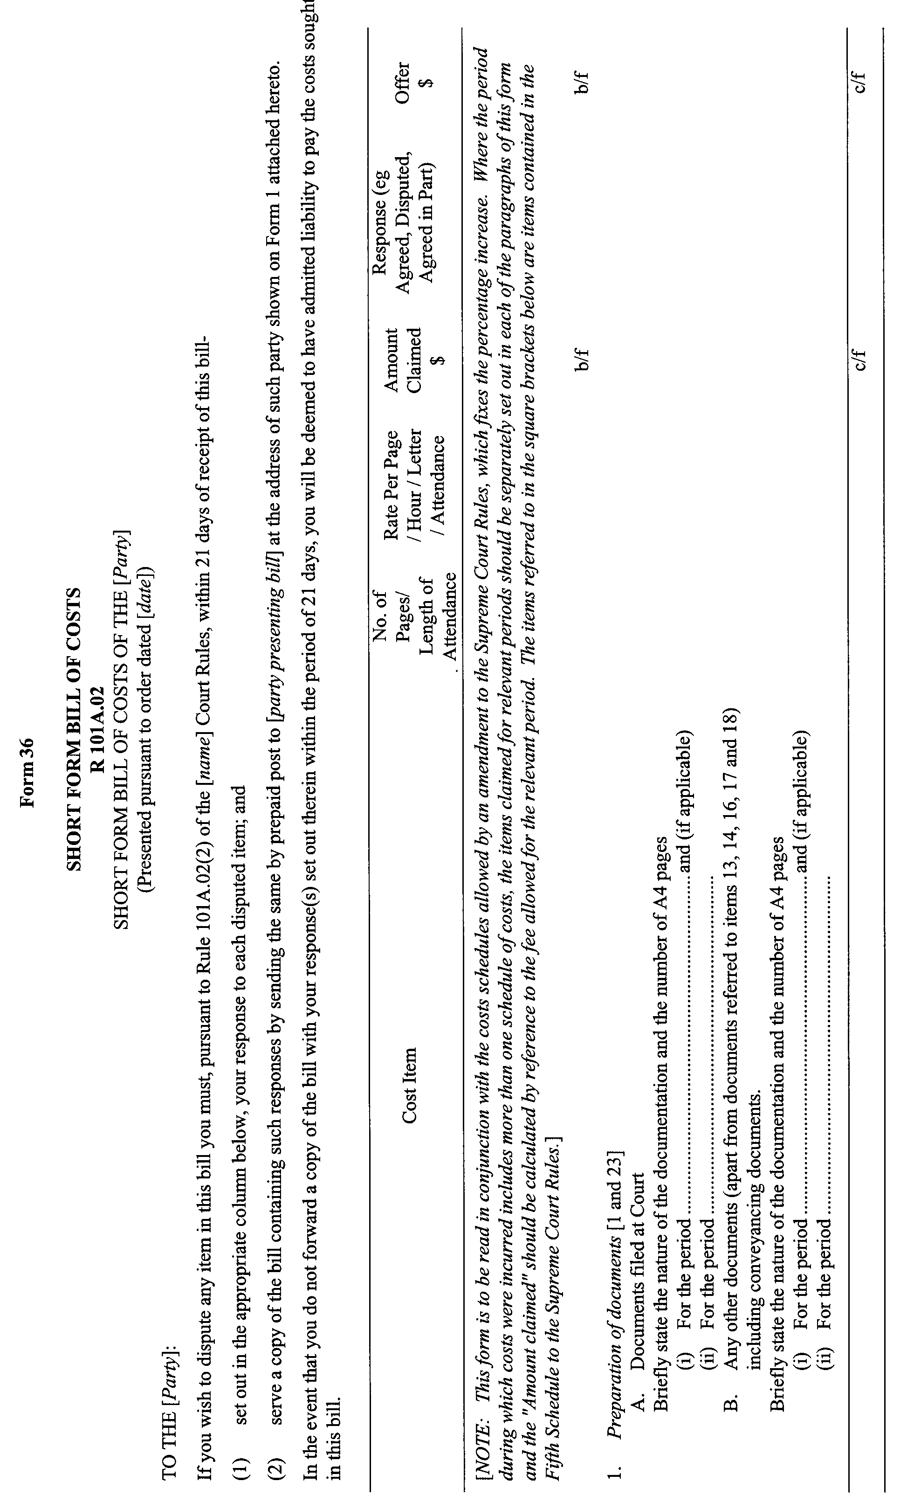
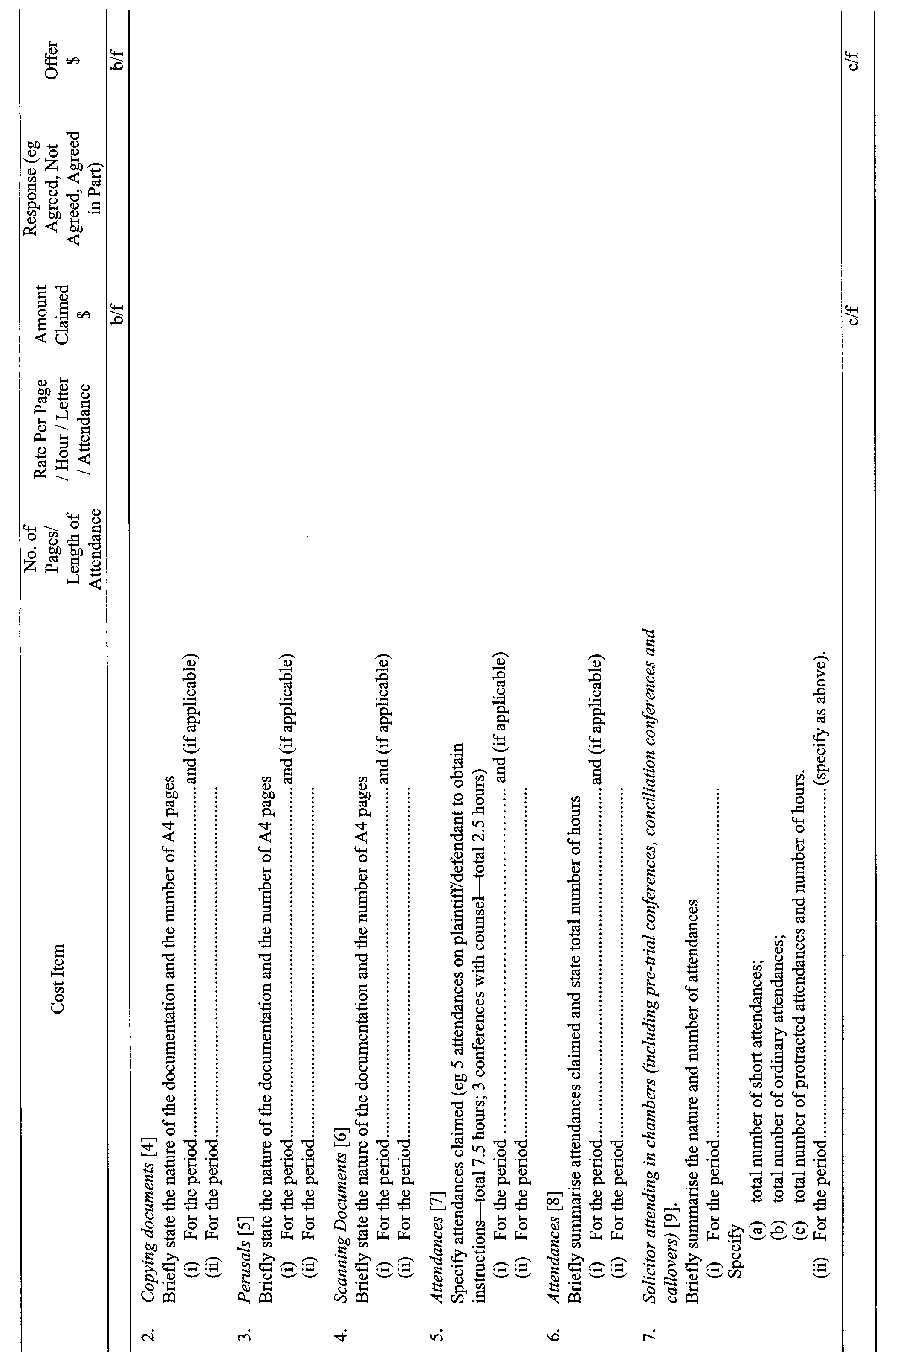
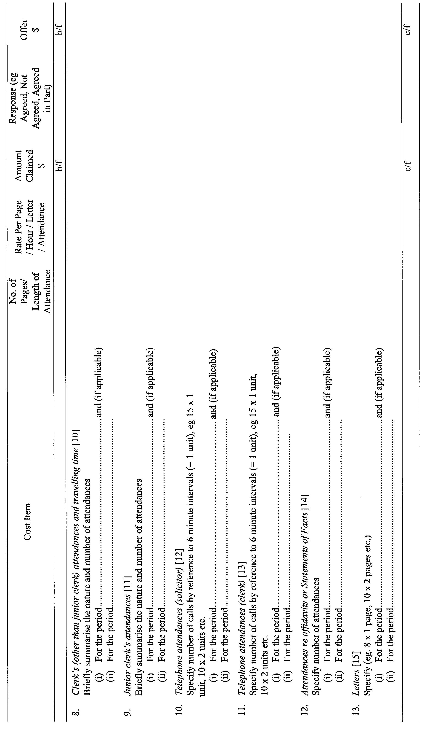
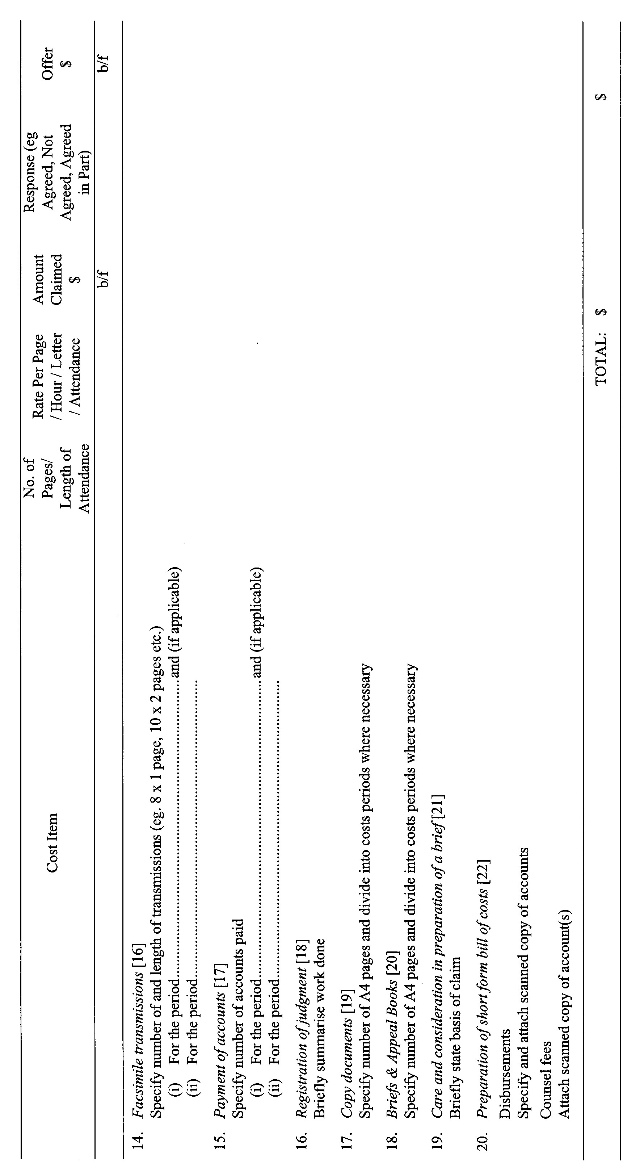
17. Amend Note J to the Ninth Schedule by deleting ‘appearances’ and insert in lieu ‘notices of address for service’.

GIVEN under our hands and the Seal of the Supreme Court of South Australia this 24th day of March 2003.
(l.s.) J. DOYLE, CJ
G. C. PRIOR, J
J. W. PERRY, J
K. P. DUGGAN, J
E. P. MULLIGHAN, J
B. M. DEBELLE, J
M. J. NYLAND, J
B. T. LANDER, J
H. C. WILLIAMS, J
D. J. BLEBY, J
D. F. WICKS, J
BRIAN MARTIN, J
T. A. GRAY, J
A. BESANKO, J

ROADS (OPENING AND CLOSING) ACT 1991:
SECTION 24
NOTICE OF CONFIRMATION OF ROAD
PROCESS ORDER
Section 60, Hundred of Moule
Deposited Plan 56805
BY Road Process Order made on 28 March 2001, the District Council of Ceduna ordered that:
1. Portion of section 60 (Parklands) Hundred of Moule, situated intersecting the said section and adjoining the junction of Peak Terrace and Butler Terrace, Town of Denial Bay, more particularly delineated and numbered ‘1’ in the Preliminary Plan No. 32/0461 be opened as road.
On 9 April 2001, that order was confirmed by the Minister for Administrative and Information Services, conditionally on approval and deposit of the survey plan by the Registrar-General. The condition has now been fulfilled.
Pursuant to section 24 (5) of the Roads (Opening and Closing) Act 1991, NOTICE of the order referred to above and its confirmation is hereby given.
Dated 17 April 2003.
P. M. Kentish, Surveyor-General

ROADS (OPENING AND CLOSING) ACT 1991:
SECTION 24
NOTICE OF CONFIRMATION OF ROAD
PROCESS ORDER
Oakdene Road, Springfield
Deposited Plan 60564
BY Road Process Order made on 7 August 2002, the City of Mitcham ordered that:
1. Portion of the public road (Oakdene Road) situated along and adjoining the south-western boundaries of Allotment 91 in Deposited Plan 3740, more particularly delineated as ‘A’ in the Preliminary Plan No. 02/0010 be closed.
2. The whole of the land subject to closure be transferred to M.M. Chia in accordance with agreement for transfer dated 31 July 2002 entered into between the City of Mitcham and M.M. Chia.
3. The following easement is granted over the whole of the land subject to that closure:
Grant to the South Australian Water Corporation an easement for water supply purposes.
On 7 November 2002, that order was confirmed by the Minister for Administrative Services, conditionally on approval and deposit of the survey plan by the Registrar-General. The condition has now been fulfilled.
Pursuant to section 24 (5) of the Roads (Opening and Closing) Act 1991, NOTICE of the order referred to above and its confirmation is hereby given.
Dated 17 April 2003.
P. M. Kentish, Surveyor-General

ROADS (OPENING AND CLOSING) ACT 1991:
SECTION 24
NOTICE OF CONFIRMATION OF ROAD
PROCESS ORDER
Walkway adjacent Keroma Drive, Aldgate
Deposited Plan 61776
BY Road Process Order made on 19 February 2003, the Adelaide Hills Council ordered that:
1. Portion of the Walkway situated adjoining Allotment 36 in Deposited Plan 9507, more particularly delineated as ‘A’ in the Preliminary Plan No. 02/0019 be closed.
2. The whole of the land subject to closure be transferred to Peter Reginald Hewish in accordance with agreement for transfer dated 19 February 2003, entered into between the Adelaide Hills Council and P. R. Hewish.
On 15 April 2003 that order was confirmed by the Minister for Administrative Services, conditionally on approval and deposit of the survey plan by the Registrar-General. The condition has now been fulfilled.
Pursuant to section 24 (5) of the Roads (Opening and Closing) Act 1991, NOTICE of the order referred to above and its confirmation is hereby given.
Dated 17 April 2003.
P. M. Kentish, Surveyor-General

ROADS (OPENING AND CLOSING) ACT 1991:
SECTION 24
NOTICE OF CONFIRMATION OF ROAD
PROCESS ORDER
Bookmark Avenue, Renmark West
Deposited Plan 57257
BY Road Process Order made on 7 May 2001, the District Council of Renmark Paringa ordered that:
1. Portion of the public road (Bookmark Avenue) situated south of Cucumunga Street and adjoining Allotment 14 in Filed Plan 9832, Allotment 154 in Filed Plan 13164 and Allotments 2 and 1 in Deposited Plan 44512, more particularly delineated as ‘A’, ‘B’, ‘C’ and ‘D’ (respectively) in the Preliminary Plan No. 32/0597 be closed.
2. Portions of the land subject to closure marked ‘A’ and ‘B’ be transferred to Ivan Leopold Matulin and Melva Thomasine Matulin in accordance with agreement for transfer dated 7 May 2001, entered into between the District Council of Renmark Paringa and I. L. and M. T. Matulin.
3. Portion of the land subject to closure marked ‘C’ be transferred to Christine Ann Balfour-Ogilvy in accordance with agreement for transfer dated 7 May 2001, entered into between the District Council of Renmark Paringa and C. A. Balfour-Ogilvy.
4. Portion of the land subject to closure marked ‘D’ be transferred to Melva Thomasine Matulin in accordance with agreement for transfer dated 7 May 2001, entered into between the District Council of Renmark Paringa and M. T. Matulin.
5. The following easements are granted over portion of the land subject to that closure:
Grant to Distribution Lessor Corporation easements for underground and overhead electricity supply purposes.
On 10 April 2003 that order was confirmed by the Minister for Administrative Services, conditionally on approval and deposit of the survey plan by the Registrar-General. The condition has now been fulfilled.
Pursuant to section 24 (5) of the Roads (Opening and Closing) Act 1991, NOTICE of the order referred to above and its confirmation is hereby given.
Dated 17 April 2003.
P. M. Kentish, Surveyor-General

WATER MAINS AND SEWERS

Office of the South Australian Water Corporation
Adelaide, 17 April 2003

WATER MAINS LAID

Notice is hereby given that the following main pipes or parts of main pipes have been laid down by the South Australian Water Corporation in or near the undermentioned water districts and are now available for a constant supply of water to adjacent land.

ADELAIDE WATER DISTRICT

CITY OF ONKAPARINGA
Paringa Parade, Old Noarlunga. p3
Stirling Avenue, Sellicks Beach. p4
Gordon Place, Sellicks Beach. p4

KANMANTOO COUNTRY LANDS WATER DISTRICT

THE DISTRICT COUNCIL OF MOUNT BARKER
Princes Highway, Kanmantoo. p1

WATER MAINS ABANDONED

Notice is hereby given that the undermentioned water mains have been abandoned by the South Australian Water Corporation.

ADELAIDE WATER DISTRICT

CITY OF ONKAPARINGA
Stirling Avenue, Sellicks Beach. p4
Gordon Place, Sellicks Beach. p4

KANMANTOO COUNTRY LANDS WATER DISTRICT

THE DISTRICT COUNCIL OF MOUNT BARKER
Princes Highway, Kanmantoo. p1

WATER MAINS LAID

Notice is hereby given that the undermentioned water mains have been laid down by the South Australian Water Corporation and are not available for a constant supply of water to adjacent land.

OUTSIDE WATER DISTRICTS

ALEXANDRINA COUNCIL
Strathalbyn-Wistow Road, Gemmels. p14-16
Easement in crown land (lot 11 in LTRO DP 51315), Strathalbyn-Wistow Road, Gemmels. p15
Waterworks land (lot 4 in LTRO DP 48238), Strathalbyn-Wistow Road, Gemmels. p16

THE DISTRICT COUNCIL OF MOUNT BARKER
Waterworks land (lot 50 in LTRO DP 47245), hundred of Macclesfield. p6 and 17
Easement in lot 51, Paech Road, hundred of Macclesfield. p6 and 7
Across and in Paech Road, hundred of Macclesfield. p6 and 7
Wellington Road, hundred of Macclesfied. p6 and 7
In and across Strathalbyn-Wistow Road, hundreds of Maccles-field and Strathalbyn. p6-13 and 18
Easements in section 82, hundred of Strathalbyn. p14

SEWERS LAID

Notice is hereby given that the following sewers have been laid down by the South Australian Water Corporation in the under-mentioned drainage area and are now available for house connections.

ALDINGA DRAINAGE AREA

CITY OF ONKAPARINGA
Ozone Avenue, Port Willunga. FB 1111 p35
Anchor Terrace, Port Willunga. FB 1111 p35
Wigham Road, Aldinga Beach. FB 1111 p36
Moore Street, Aldinga Beach. FB 1111 p37
Butterworth Road, Aldinga Beach. FB 1111 p38
Hamilton Road, Aldinga Beach. FB 1111 p39
Esplanade, Aldinga Beach. FB 1111 p39
Harvey Crescent, Aldinga Beach. FB 1111 p44

SEWERS ABANDONED

Notice is hereby given that the undermentioned sewer has been abandoned by the South Australian Water Corporation.

ADELAIDE DRAINAGE AREA

CAMPBELLTOWN CITY COUNCIL
Across Gorge Road, Athelstone. FB 1111 p45

A. Howe, Chief Executive Officer, South Australian Water Corporation.

WILDERNESS PROTECTION ACT 1992
Decision not to proceed with the proposal to proclaim the Point Whidbey Wilderness Protection Area
I, John Hill, Minister for Environment and Conservation, hereby give notice under the provisions of section 22 (6) (g) of the Wilderness Protection Act 1992, that I have decided not to proceed with the proposal to constitute the Point Whidbey Wilderness Protection Area.
The decision has been made following extensive consultation and it is believed that designating and managing the area as a wilderness zone under section 39 of the National Parks and Wildlife Act 1972, through an adopted plan of management will provide appropriate and adequate protection of the wilderness values of the land.
Dated 9 April 2003.
J. Hill, Minister for Environment and Conservation

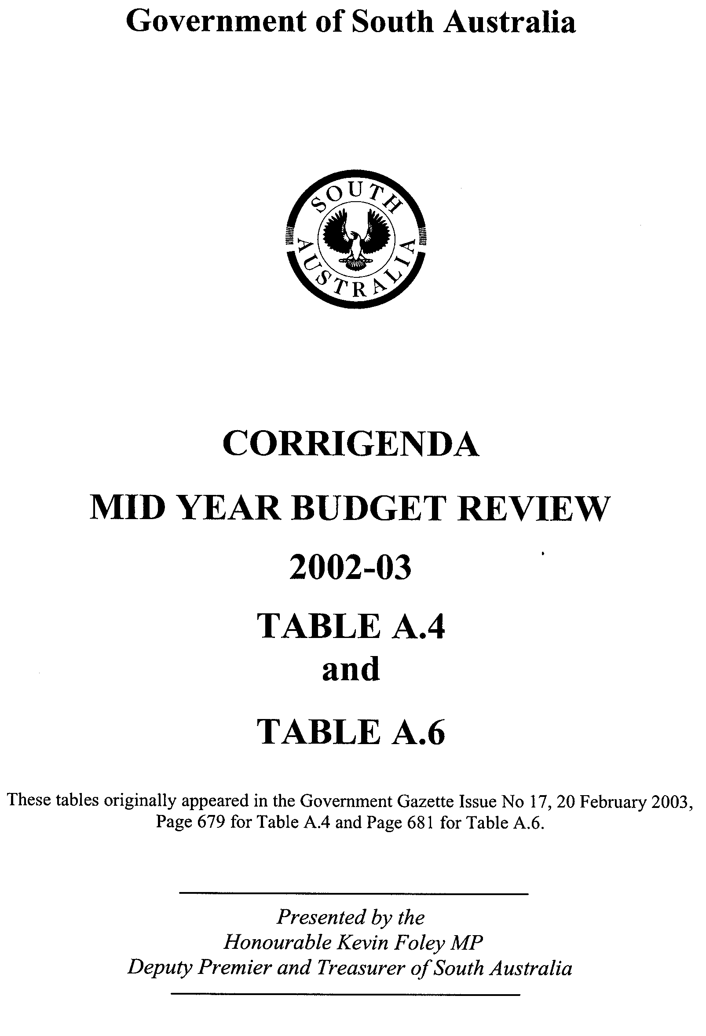
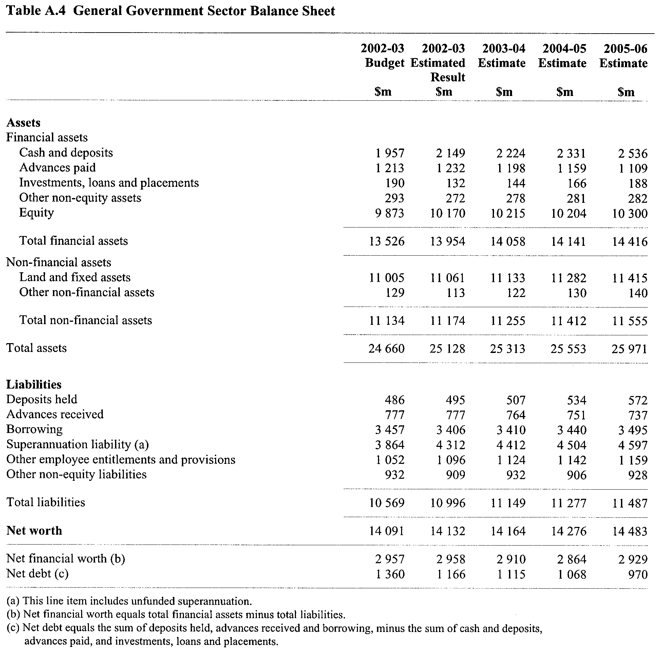

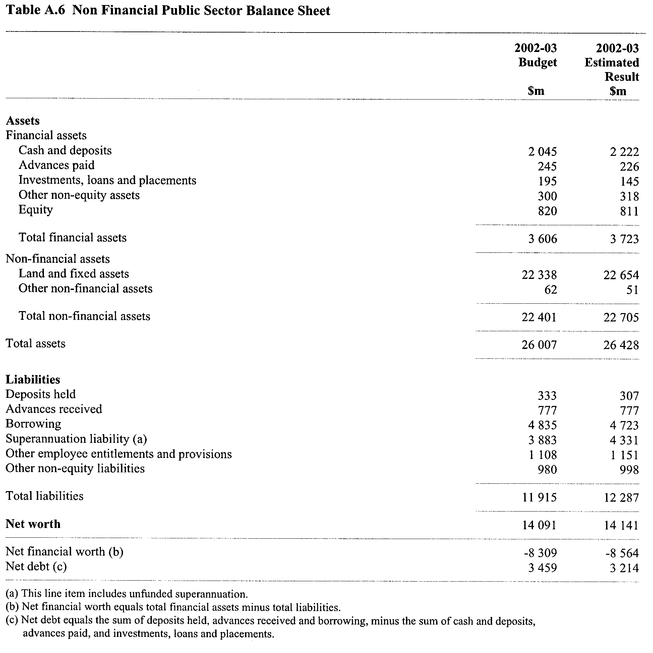

VOCATIONAL EDUCATION, EMPLOYMENT AND TRAINING ACT 1994

PART 4 - CONTRACTS OF TRAINING
Pursuant to the provisions of the Vocational Education, Employment and Training Act (VEET Act),
the Accreditation and Registration Council (ARC) gives notice that it has determined the following:

Occupations that Constitute Trades and Other Declared Vocations

The following schedule is additional to the gazettals of:

1. 24 April 1996 (pg 2045)  2. 31 October 1996 (pg 1544)  3. 5 December 1996 (pg 1818)  4. 6 February 1997 (pg 830)  5. 17 April 1997 (pg 1571)  6. 29 May 1997 (pg 2758)  7. 12 June 1997 (pg 2984)  8. 3 July 1997 (pg 33)  9. 7 August 1997 (pg 311)  10. 18 December 1997 (pg 1677)  11. 22 December 1997 (pg 1776)  12. 23 April 1998 (pg 1959)  13. 18 June 1998 (pg 2594)  14. 6 August 1998 (pg 339)  15. 24 September 1998 (pg 990)  16. 1 October 1998 (pg 1038)  17. 15 October 1998 (pg 1150)  18. 12 November 1998 (pg 1389)  19. 19 November 1998 (pg 1583)  20. 3 December 1998 (pg 1742)  21. 10 December 1998 (pg 1870)  22. 17 December 1998 (pg 1954)  23. 23 December 1998 (pg 2039)  24. 11 March 1999 (pg 1359)  25. 25 March 1999 (pg 1480)  26. 1 April 1999 (Errata) (pg 1605)  27. 22 April 1999 (pg 2219)  28. 29 April 1999 (Errata) (pg 2381)  29. 6 May 1999 (pg 2482)  30. 13 May 1999 (pg 2595)  31. 27 May 1999 (Errata) (pg 2723) | 32. 17 June 1999 (pg 3123)  33. 24 June 1999 (pg 3261)  34. 1 July 1999 (pg 22)  35. 29 July 1999 (pg 602)  36. 30 September 1999 (pg 1364)  37. 14 October 1999 (pg 1973)  38. 11 November 1999 (pg 2327)  39. 6 January 2000 (pg 1169)  40. 30 March 2000 (pg 1921)  41. 6 April 2000 (pg 2047)  42. 13 April 2000 (Errata) (pg 2167)  43. 4 May 2000 (pg 2416)  44. 18 May 2000 (pg 2606) Errata (pg 2609)  45. 15 June 2000 (pg 3282) Errata (pg 3285)  46. 29 June 2000 (pg 3490)  47. 6 July 2000 (pg 22) Errata (pg 24)  48. 20 July 2000 (pg 267)  49. 10 August 2000 (pg 467)  50. 24 August 2000 (pg 643)  51. 14 September 2000 (pg 2002)  52. 12 October 2000 (pg 2475) Errata (pg 2480)  53. 16 November 2000 (pg 3208) Errata (pg 3211)  54. 7 December 2000 (pg 3461) Errata (pg 3467)  55. 15 February 2001 (pg 641) Errata (pg 647)  56. 5 April 2001 (pg 1561)  57. 19 April 2001 (pg 1645)  58. 31 May 2001 (pg 1914)  59. 28 June 2001 (pg 2416)  60. 12 July 2001 (Errata) (pg 2610)  61. 19 July 2001 (Errata) (pg 2713)  62. 26 July 2001 (pg 2785) | 63. 16 August 2001 (pg 3091)  64. 20 September 2001 (pg 4268)  65. 27 September 2001 (pg 4316)  66. 11 October 2001 (Errata) (pg 4466)  67. 15 November 2001 (pg 5041)  68. 29 November 2001 (pg 5227)  69. 13 December 2001 (pg 5385)  70. 20 December 2001 (Errata) (pg 5646)  71. 10 January 2002 (pg 19) Errata (pg 20)  72. 14 February 2002 (pg 861) Errata (pg 869)  73. 14 March 2002 (pg 1329)  74. 11 April 2002 (pg 1579)  75. 18 April 2002 (pg 1613)  76. 24 April 2002 (pg 1665) Errata (pg 1666)  77. 2 May 2002 (Errata) (pg 1809)  78. 9 May 2002 (Errata) (pg 1852)  79. 16 May 2002 (pg 1913)  80. 13 June 2002 (pg 2134)  81. 11 July 2002 (pg 2869)  82. 15 August 2002 (pg 3066)  83. 12 September 2002 (pg3414) Errata (pg 3415)  84. 10 October 2002 (pg 3814)  85. 14 November 2002 (pg 4191)  86. 12 December 2002 (pg 4579)  87. 19 December 2002 (pg 4794)  88. 27 February 2003 Errata (pg 805)  89. 13 March 2003 (pg 943)  90. 20 March 2003 (pg 1092)  91. 3 April 2003 (pg 1302)  92. 17 April 2003

which set out the occupations that constitute trades and other declared vocations and the terms and conditions applicable to
such declared vocations.
Determination of the Accreditation and Registration Council
Minimum Hours for Part-time Contracts of Training

The Accreditation and Registration Council has established policy on minimum hours for part-time contracts of training, including
School Based New Apprenticeships (SBNA’s).

The ARC approved minimum part-time hours for contracts of training as follows:

Contract of Training - Nominal Duration | Minimum Part-time Hours
Up to and including 23 months | 15 hours per week
24 - 48 months | 25 hours per week
School Based New Apprenticeships | 8 hours per week

The minimum part-time hours requirement would also apply to applications to vary the hours of an existing contract from full-time to part-time, or to decrease previously approved part-time hours.

South Australia

Recreational Services (Limitation of Liability) (Commencement) Proclamation 2003

Short title
1. This proclamation may be cited as the Recreational Services (Limitation of Liability) (Commencement) Proclamation 2003.

Commencement of Act
2. The Recreational Services (Limitation of Liability) Act 2002 (No 20 of 2002) will come into operation on 1 July 2003.

Made by the Governor
with the advice and consent of the Executive Council
on 17 April 2003.

T&F03/030CS

South Australia

Administrative Arrangements (Administration of Recreational Services (Limitation of Liability) Act) Proclamation 2003
under section 5 of the Administrative Arrangements Act 1994

Short title
1. This proclamation may be cited as the Administrative Arrangements (Administration of Recreational Services (Limitation of Liability) Act) Proclamation 2003.

Commencement
2. This proclamation comes into operation on the day on which it is made.

Administration of Act committed to Minister for Consumer Affairs
3. The administration of the Recreational Services (Limitation of Liability) Act 2002 is committed to the Minister for Consumer Affairs.

Made by the Governor
with the advice and consent of the Executive Council
on 17 April 2003.

T&F03/030CS
South Australia

Recreational Services (Limitation of Liability) Regulations 2003
under the Recreational Services (Limitation of Liability) Act 2002

Contents

1. Short title
2. Commencement
3. Interpretation
4. Registration of code
5. Information to accompany application to register or vary or cancel undertaking
6. Modification of duty of care by contract—notice to consumers
7. Modification of duty of care by display of notices
8. Fees

Schedule —Notice to Consumer

Short title
1. These regulations may be cited as the Recreational Services (Limitation of Liability) Regulations 2003.

Commencement
2. These regulations will come into operation on 1 July 2003.

Interpretation
3. In these regulations, unless the contrary intention appears—

"Act" means the Recreational Services (Limitation of Liability) Act 2002;

"recreational activity", in relation to the provision of recreational services, means the sporting or other activity or pursuit to which the recreational services relate.

Registration of code
4. (1) For the purposes of section 4(3) of the Act, a code submitted for registration must comply with the following requirements as to form and content:

(a) the code must be in writing in a print size not less than 12 points;

(b) the code must begin with the heading "RECREATIONAL SERVICES (LIMITATION OF LIABILITY) ACT 2002" in capital letters and under that heading contain a further heading giving a title for the code;

(c) the first substantive portion of the code (apart from definitions of terms and other preliminary provisions) must describe as clearly as possible the recreational activity and the recreational services to which the code relates;

(d) the code must then set out the various measures that a provider of the recreational services should take in order to ensure a reasonable level of protection for consumers;
(e) the name, postal address and contact details (such as telephone numbers, fax number and email address) of the applicant for registration of the code must be set out at the end of the code.

(2) If the applicant has, before submitting the code for registration, obtained a report on the code's adequacy, the applicant must submit a copy of the report to the Minister when the code is submitted for registration.

Information to accompany application to register or vary or cancel undertaking
5. (1) For the purposes of section 5(2) of the Act, an application by a provider of recreational services for registration of an undertaking to comply with a registered code must be accompanied by the following information:

(a) the name, postal address and contact details (such as telephone numbers, fax number and email address) of the applicant;

(b) the name or names in which the applicant carries on business in providing the recreational services;

(c) the title of the registered code set out in the code and the identifier given to the code by the Minister on registration of the code;

(d) a description of the recreational services provided by the applicant to which the registered code relates.

(2) For the purposes of section 5(5) of the Act, an application by a registered provider for variation or cancellation of an undertaking must be accompanied by the following information:

(a) the name, postal address and contact details (such as telephone numbers, fax number and email address) of the applicant;

(b) the identifier given to the applicant by the Minister on registration of the undertaking;

(c) if the applicant seeks variation of the details of the registration, the nature of the variation to the details sought by the applicant;

(d) if the applicant seeks cancellation of the provider's registration, a statement to that effect.

Modification of duty of care by contract—notice to consumers
6. A notice to be given to a consumer in accordance with section 6(2) of the Act must be in the form set out in the Schedule.

Modification of duty of care by display of notices
7. A notice to be displayed in accordance with section 6(3) of the Act—

(a) must be displayed—

(i) if the place at which the recreational activity occurs has designated or identifiable public entrances—at those entrances to the place; or

(ii) in any other case—at the walkways or access routes to the place at which the recreational activity occurs that are commonly used by persons who participate in the activity; and

(b) must not be obscured by any structure or thing; and

(c) must comprise the following figures and words in a colour that clearly contrasts with the background colour:

(i) a pictorial symbol of the recreational activity that is at least 15cm x 15cm;

(ii) the words "LIABILITY FOR INJURY LIMITED BY CODE" in capital letters that are at least 5cm high;

(iii) the words "Recreational Services (Limitation of Liability) Act 2002" in letters that are at least 3cm high; and

(d) must have a surface area that is at least 45cm x 45cm.

Fees
8. The following fees must be paid to the Minister:

(a) an applicant for registration of a code under section 4 of the Act must pay—

(i) an application fee of $850; and

(ii) a registration fee of $350;

(b) an applicant for registration of an undertaking under section 5 of the Act must pay a registration fee of $250.
Schedule —Notice to Consumer

Recreational Activity
[insert description of recreational activity]

Provider of recreational activity
[insert name of registered provider]

⋅ You are about to do something which involves some risk to your safety. If you do it, you will give up your normal legal right to get compensation if you are hurt.

⋅ You can only get compensation if we break our safety code.

⋅ You can see this code if you want to. If you are worried, you should ask to see the code before going any further. It will tell you about the safety rules.

This notice is given under section 6(2) of the Recreational Services (Limitation of Liability) Act 2002.

Note—
As required by section 10AA(2) of the Subordinate Legislation Act 1978, the Minister has certified that, in the Minister's opinion, it is necessary or appropriate that these regulations come into operation as set out in these regulations.

Made by the Governor
with the advice and consent of the Executive Council
on 17 April 2003.

No. 37 of 2003
T&F03/030CS
South Australia

Parliamentary Superannuation Regulations 2003
under the Parliamentary Superannuation Act 1974

Contents

1. Short title
2. Commencement
3. Interpretation
4. Prescribed offices and positions (section 19)
5. Expiry

Short title
1. These regulations may be cited as the Parliamentary Superannuation Regulations 2003.

Commencement
2. These regulations come into operation on the day on which they are made.

Interpretation
3. In these regulations—

"Act" means the Parliamentary Superannuation Act 1974.

Prescribed offices and positions (section 19)
4. The following offices and positions are declared to be prescribed offices and positions for the purposes of section 19 of the Act:

(a) membership of the Parliament of the Commonwealth or of the Parliament of any State of the Commonwealth except South Australia;

(b) an office by virtue of which the holder of the office is a Judge as defined by section 4 of the Judges' Pensions Act 1971;

(c) judicial office established by the Commonwealth of Australia Constitution Act or by a law of the Commonwealth.

Expiry
5. These regulations will expire on 1 September 2005.

Note—
As required by section 10AA(2) of the Subordinate Legislation Act 1978, the Minister has certified that, in the Minister's opinion, it is necessary or appropriate that these regulations come into operation as set out in these regulations.

Made by the Governor
with the advice and consent of the Executive Council
on 17 April 2003.

No. 38 of 2003
DPC 009/03 CS
South Australia

Shop Trading Hours Regulations 2003
under the Shop Trading Hours Act 1977

Contents

1. Short title
2. Commencement
3. Interpretation
4. Meaning of "hardware and building materials"
5. Section 13(5f)(b)—Prescribed hardware and building materials and prescribed percentage
6. Closing and fastening of yards
7. Section 17 licences
8. Expiry

Schedule 1—Hardware and building materials

Schedule 2—Hardware and building materials (section 13(5f)(b) of the Act)

Short title
1. These regulations may be cited as the Shop Trading Hours Regulations 2003.

Commencement
2. These regulations come into operation on the day on which they are made.

Interpretation
3. In these regulations, unless the contrary intention appears—

"Act" means the Shop Trading Hours Act 1977.

Meaning of "hardware and building materials"
4. The term "hardware and building materials" when used in the Act means goods of a class set out in Schedule 1 or 2 or goods of a similar class.

Section 13(5f)(b)—Prescribed hardware and building materials and prescribed percentage
5. (1) The hardware and building materials set out in Schedule 2 are prescribed for the purposes of section 13(5f)(b) of the Act.

(2) The percentage of the aggregate price of all hardware and building materials sold at a shop for the purposes of section 13(5f)(b) of the Act is 20 per cent.

Closing and fastening of yards
6. (1) Where a yard comprises the whole or part of a shop, the boundaries of the yard must be closed and fastened against the admission of the public by a fence that meets the following requirements:

(a) the fence must form a barrier that is impossible or difficult for a person to cross and in the case of a fence comprising a chain or rail supported at each end, no part of the chain or rail may be less than 800 millimetres nor more than 1 000 millimetres from the ground;

(b) a gate or door comprising part of the fence must be securely locked;

(c) all parts of the fence that are designed to be removed must be securely locked in place.

(2) In this regulation—

"fence" includes a wall or any other barrier.

Section 17 licences
7. (1) An application for a licence under section 17 of the Act must be in writing and must state—

(a) the address of the shop to which the application relates; and

(b) the name and address of the applicant.

(2) A licence granted under section 17 of the Act is subject to the following limitations, restrictions and conditions:

(a) the shopkeeper must ensure that the business of the shop is predominantly the retail sale of motor spirit and lubricants;

(b) the aggregate price of goods (not being motor spirit, lubricants, spare parts and accessories for motor vehicles or foodstuffs or drinks) sold at the shop during any period of seven consecutive trading days must not exceed 20 per cent of the aggregate price of motor spirit, lubricants and spare parts and accessories for motor vehicles sold at the shop during that period;

(c) the shopkeeper must, at the request of an Inspector, produce the licence to the Inspector for examination.

Expiry
8. These regulations will expire on 1 September 2005.
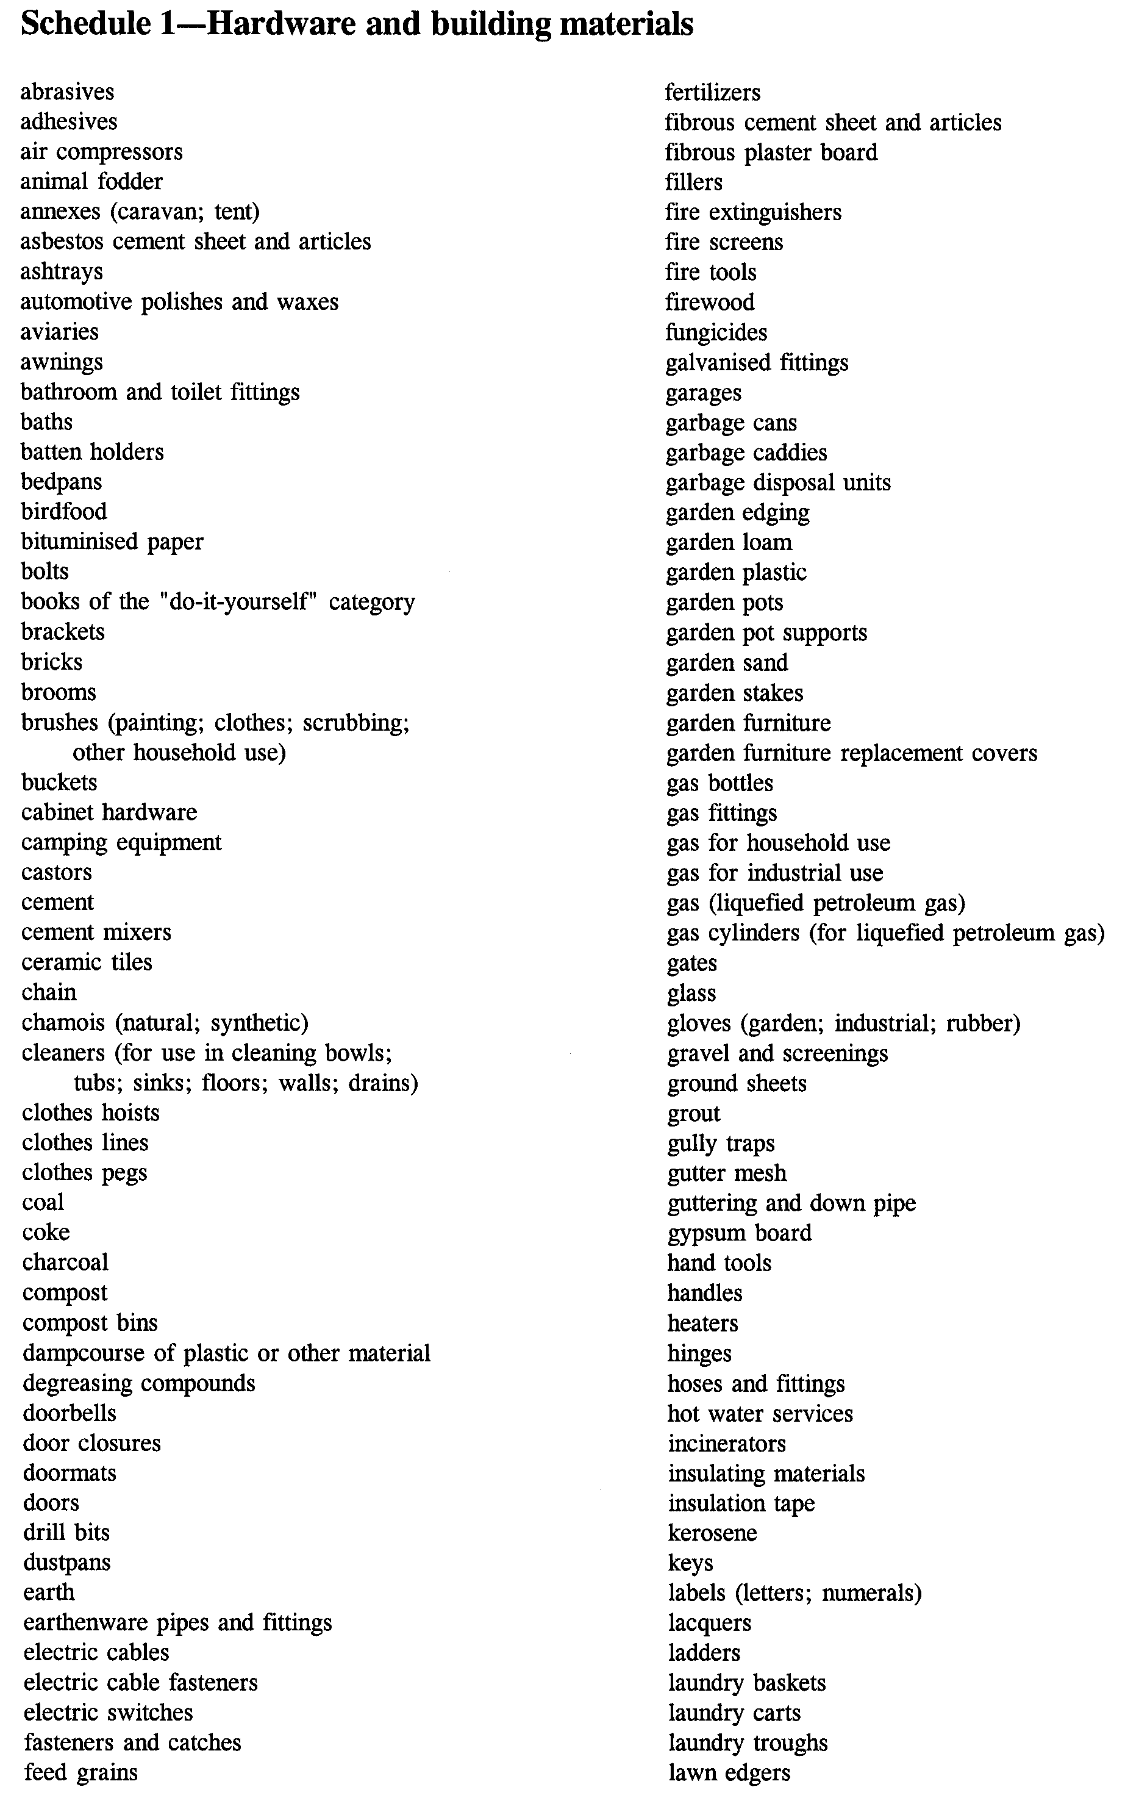
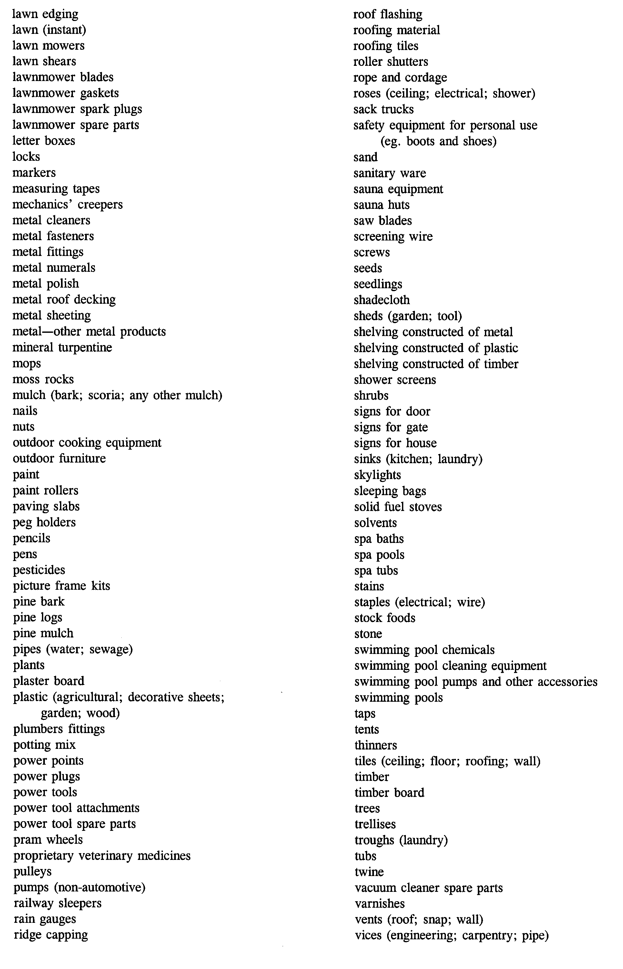

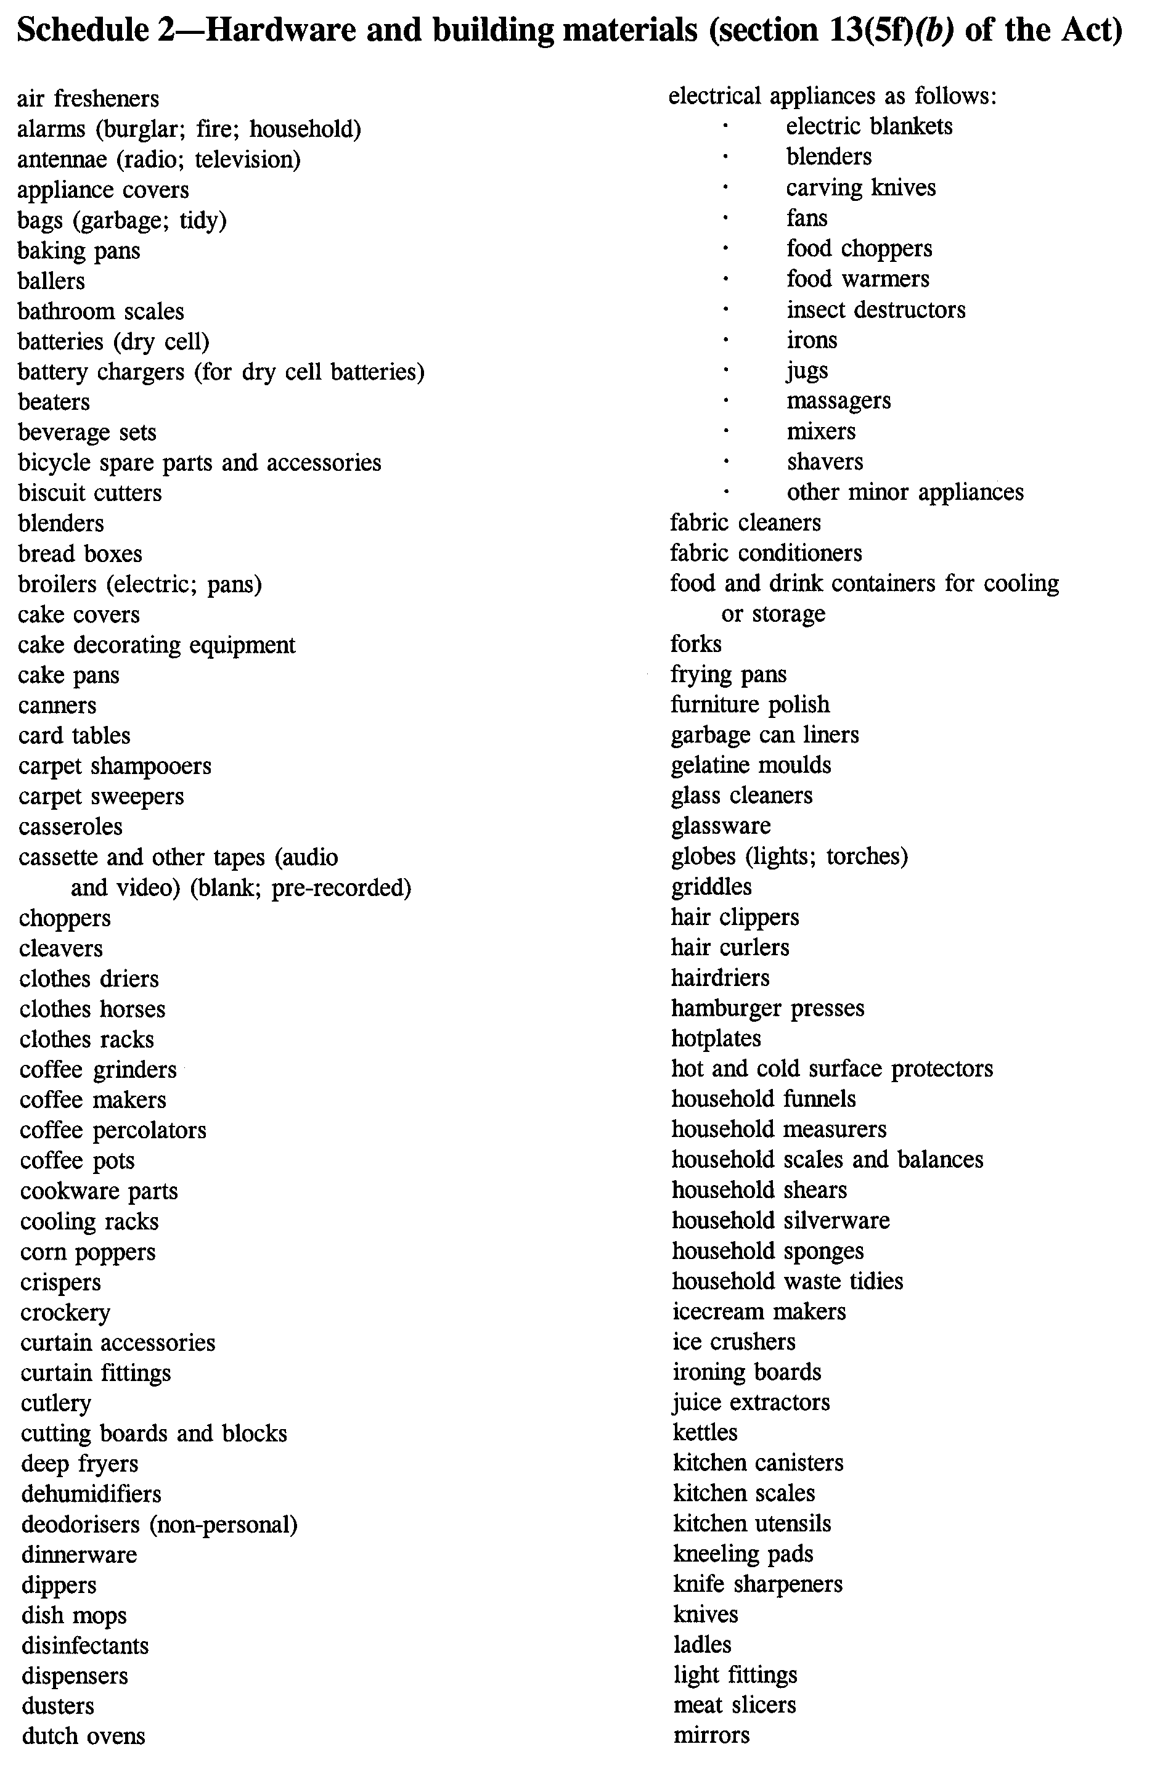
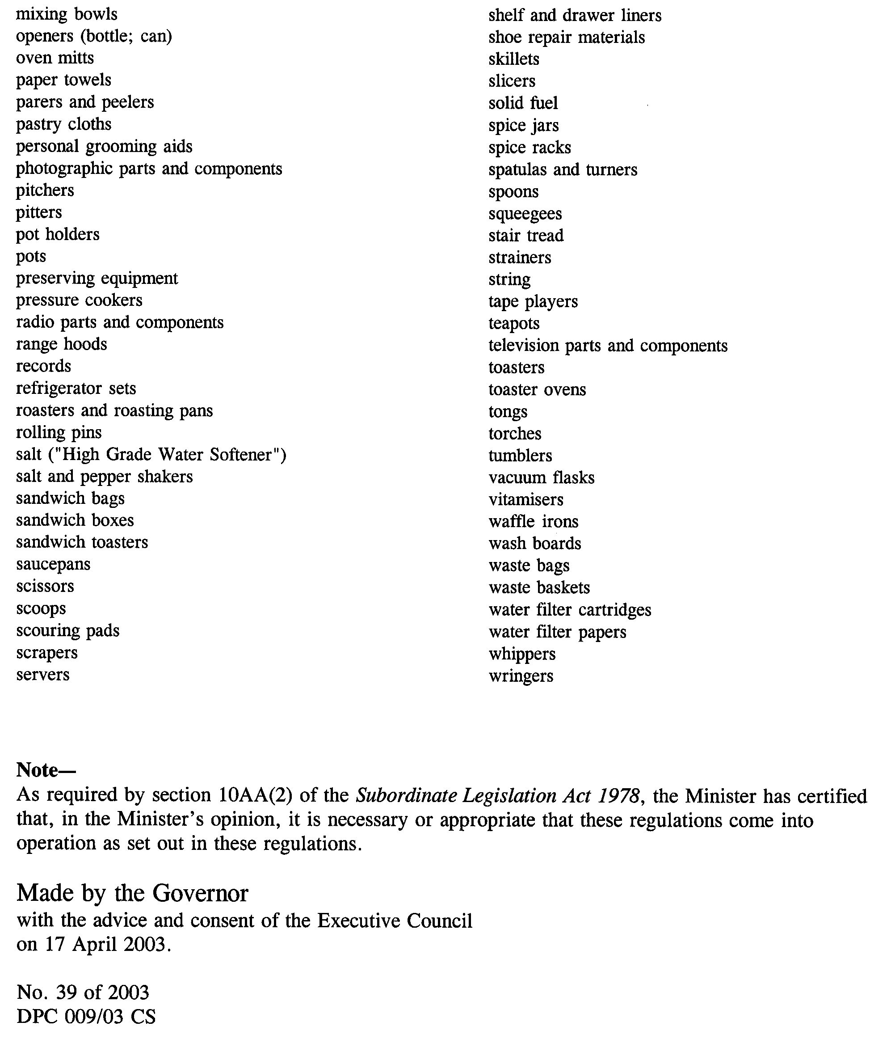
South Australia

Metropolitan Adelaide Road Widening Plan Regulations 2003
under the Metropolitan Adelaide Road Widening Plan Act 1972

Contents

1. Short title
2. Commencement
3. Interpretation
4. Application for consent (section 8)

Schedule—Form

Short title
1. These regulations may be cited as the Metropolitan Adelaide Road Widening Plan Regulations 2003.

Commencement
2. These regulations come into operation on the day on which they are made.

Interpretation
3. In these regulations—

"Act" means the Metropolitan Adelaide Road Widening Plan Act 1972.

Application for consent (section 8)
4. For the purposes of section 8 of the Act, an application for the consent of the Commissioner must be in the form set out in the Schedule.
Schedule—Form

Metropolitan Adelaide Road Widening Plan Act 1972

South Australia

APPLICATION FOR CONSENT OF THE COMMISSIONER OF HIGHWAYS FOR BUILDING WORK

Owner's Name
(Surname) (Other Names)

Name of Applicant (if not owner)

Postal Address

Post Code . . . . . . . . . . .

Relationship to Owner (lessee, prospective purchaser, etc.)

Location of proposed building work (give full details):

L.T.O. Plan No. Allot. No.

Section Hundred

No. . . . . . . . Street Suburb

Certificate of Title Volume Folio

Nature of proposed building work

Proposed location of building work on land:

Distance from existing front road boundary to nearest point of building

Distance from existing side road boundary (if on corner) to nearest point of building

Total estimated cost of proposed building work $

Estimated cost of proposed building work on land to which the Act applies $

Signature
(Applicant)

(Owner or Authorised Agent)
Date
Note:

1. 3 copies of plans and specifications, describing fully the nature and extent of the proposal, must be forwarded with this application.

2. The Act requires that the consent of the Commissioner of Highways must be obtained for any building work on land to which the Act applies.

3. The Act applies to all land shown on the Metropolitan Adelaide Road Widening Plan as possibly required for road widening and all land within 6 metres of the boundary of that land.

Note—
As required by section 10AA(2) of the Subordinate Legislation Act 1978, the Minister has certified that, in the Minister's opinion, it is necessary or appropriate that these regulations come into operation as set out in these regulations.

Made by the Governor
with the advice and consent of the Executive Council
on 17 April 2003.

No. 40 of 2003
DPC 009/03 CS
South Australia

Superannuation Variation Regulations 2003
under the Superannuation Act 1988

Contents

Part 1—Preliminary

1. Short title
2. Commencement
3. Variation provisions

Part 2—Variation of Superannuation Regulations 2001 (Gazette 28.6.2001 p 2455) as varied

4. Variation of regulation 27—Prescription of enterprise agreements

Part 1—Preliminary

Short title
1. These regulations may be cited as the Superannuation Variation Regulations 2003.

Commencement
2. These regulations come into operation on the day on which they are made.

Variation provisions
3. In these regulations, a provision under a heading referring to the variation of specified regulations varies the regulations so specified.

Part 2—Variation of Superannuation Regulations 2001 (Gazette 28.6.2001 p 2455) as varied

Variation of regulation 27—Prescription of enterprise agreements
4. (1) Regulation 27—after paragraph (e) insert:

(ea) House of Assembly Enterprise Agreement 2002;

(2) Regulation 27—after paragraph (g) insert:

(gaa) Legislative Council Enterprise Agreement 2002;

(3) Regulation 27—after paragraph (ga) insert:

(gab) Parliament (Joint Services) Act 1985 Enterprise Agreement 2002;

(4) Regulation 27—after paragraph (j) insert:

(jaa) State Governor's Establishment Enterprise Agreement 2002;

Note—
As required by section 10AA(2) of the Subordinate Legislation Act 1978, the Minister has certified that, in the Minister's opinion, it is necessary or appropriate that these regulations come into operation as set out in these regulations.

Made by the Governor
with the advice and consent of the Executive Council
on 17 April 2003.

No. 41 of 2003
T&F 03/023 CS
South Australia

Southern State Superannuation Variation Regulations 2003
under the Southern State Superannuation Act 1994

Contents

Part 1—Preliminary

1. Short title
2. Commencement
3. Variation provisions

Part 2—Variation of Southern State Superannuation Regulations 1995 (Gazette 29.6.1995 p 3070) as varied

4. Variation of regulation 3A—Prescription of enterprise agreements

Part 1—Preliminary

Short title
1. These regulations may be cited as the Southern State Superannuation Variation Regulations 2003.

Commencement
2. These regulations come into operation on the day on which they are made.

Variation provisions
3. In these regulations, a provision under a heading referring to the variation of specified regulations varies the regulations so specified.

Part 2—Variation of Southern State Superannuation Regulations 1995 (Gazette 29.6.1995 p 3070) as varied

Variation of regulation 3A—Prescription of enterprise agreements
4. (1) Regulation 3A—after paragraph (d) insert:

(da) House of Assembly Enterprise Agreement 2002;

(2) Regulation 3A—after paragraph (f) insert:

(faa) Legislative Council Enterprise Agreement 2002;

(3) Regulation 3A—after paragraph (fa) insert:

(fab) Parliament (Joint Services) Act 1985 Enterprise Agreement 2002;

(4) Regulation 3A—after paragraph (j) insert:

(ja) State Governor's Establishment Enterprise Agreement 2002;

Note—
As required by section 10AA(2) of the Subordinate Legislation Act 1978, the Minister has certified that, in the Minister's opinion, it is necessary or appropriate that these regulations come into operation as set out in these regulations.

Made by the Governor
with the advice and consent of the Executive Council
on 17 April 2003.

No. 42 of 2003
T&F03/023CS
South Australia

Occupational Therapists Variation Regulations 2003
under the Occupational Therapists Act 1974

Contents

Part 1—Preliminary

1. Short title
2. Commencement
3. Variation provisions

Part 2—Variation of Occupational Therapists Regulations 1988 (Gazette 7 April 1988 p 895) as varied

4. Substitution of Schedule 3
Schedule 3—Fees

Part 1—Preliminary

Short title
1. These regulations may be cited as the Occupational Therapists Variation Regulations 2003.

Commencement
2. These regulations come into operation on the day on which they are made.

Variation provisions
3. In these regulations, a provision under a heading referring to the variation of specified regulations varies the regulations so specified.

Part 2—Variation of Occupational Therapists Regulations 1988 (Gazette 7 April 1988 p 895) as varied

Substitution of Schedule 3
4. Schedule 3—delete the Schedule and substitute:

Schedule 3—Fees

1. Application for registration—
(a) if the application is made in respect of the applicant's first year (or part year) of practice immediately following graduation and is made—
(i) between 1 July and 31 December (inclusive) | $100;
(ii) between 1 January and 30 June (inclusive) | $50;

(b) in any other case, if the application is made—
(i) between 1 July and 31 December (inclusive) in any year | $200;
(ii) between 1 January and 30 June (inclusive) in any year | $100.
2. Application for renewal of registration | $150.

Note—
As required by section 10AA(2) of the Subordinate Legislation Act 1978, the Minister has certified that, in the Minister's opinion, it is necessary or appropriate that these regulations come into operation as set out in these regulations.

Made by the Governor
on the recommendation of the Occupational Therapists Registration Board of South Australia and with the advice and consent of the Executive Council
on 17 April 2003.

No. 43 of 2003
CAB/MGR/0032

FAXING COPY?

IF you fax copy to Government Publishing SA for inclusion in the Government Gazette, there is no need to send a Confirmation Copy to us as well.

This creates confusion and may well result in your notice being printed twice.

Please use the following fax number:

Fax transmission: (08) 8207 1040
Phone Inquiries: (08) 8207 1045

Please include a contact person, phone number and order number so that we can phone back with any queries we may have regarding the fax copy.

NOTE: Closing time for lodging new copy (either fax or hard copy) is 4 p.m. on Tuesday preceding the day of publication.

Government Gazette notices can be E-mailed.

The address is:

governmentgazette@saugov.sa.gov.au

Documents should be sent as attachments in Word format.

When sending a document via E-mail, please confirm your transmission with a faxed copy of your document, including the date the notice is to be published.

Fax transmission: (08) 8207 1040
Enquiries: (08) 8207 1045

CITY OF ADELAIDE
Notice of Intention to Declare as Public Roads
NOTICE is hereby given pursuant to section 210 of the Local Government Act 1999, that at a future meeting council intends to declare the following roads to be Public Roads:
(1) Considine Place in Town Acre 612, which is delineated as that part of Considine Place on LTO plan FPX41532 abutting Gilbert Street and measuring 41.96 m on the eastern side, 3.06 m on the northern side, 41.93 m on the western side, and 3.05 m on the southern side.
(2) Evans Place in Town Acre 555, which is delineated as the unnamed road marked ‘B’ on LTO plan FPX22593 and is contained in Partially Cancelled Certificate of Title Volume 215 Folio 243.
(3) Hocking Court in Town Acres 554 and 555, which is delineated as Hocking Court on LTO plan FPX22593 and contained in Partially Cancelled Certificate of Title Volume 215 Folio 243.
(4) Hocking Place in Town Acre 554, which is delineated as Hocking Place on LTO plan FPX22593 and contained in Partially Cancelled Certificate of Title Volume 189 Folio 57.
(5) Myers Street in Town Acres 558 and 559, which is delineated as Myers Street on LTO plan C-1421.
(6) Norman Street in Town Acres 557 and 610, which is delineated as Norman Street on LTO plan C-1421.
(7) Russell Street in Town Acres 556 and 611, which is delineated as Russell Street on FPX22593.
(8) Tapley Street in Town Acre 607, which is delineated as Tapley Street on LTO plan B-3781.
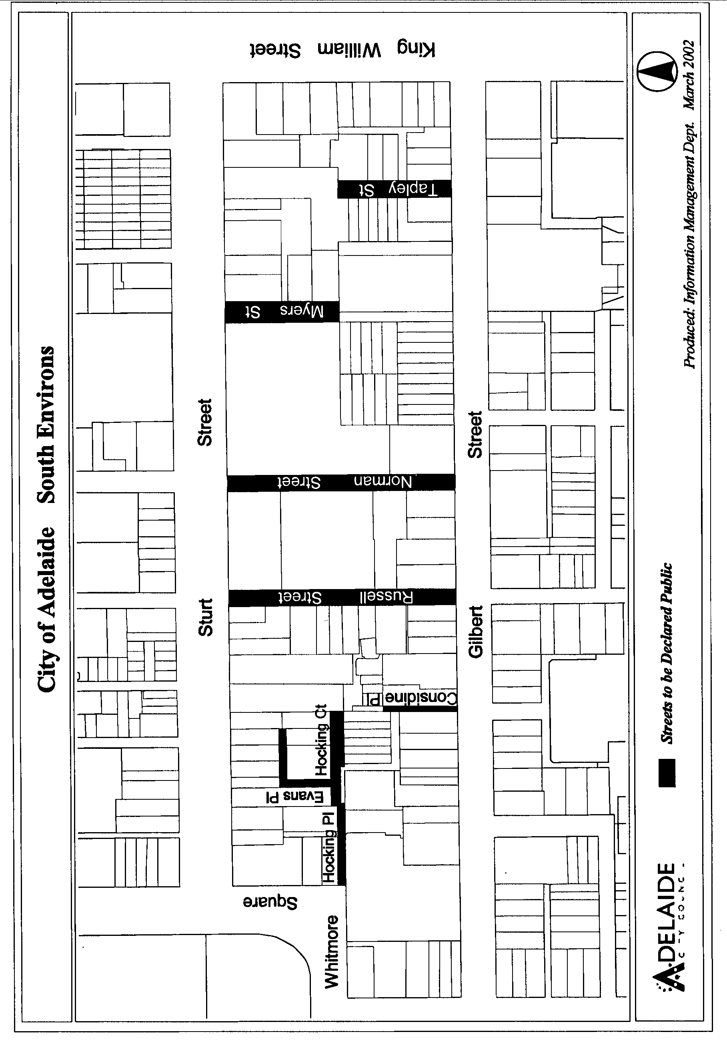
Susan Law, Chief Executive Officer

CITY OF ADELAIDE
Notice of Intention to Declare as Public Roads
NOTICE is hereby given pursuant to section 210 of the Local Government Act 1999, that at a future meeting council intends to declare the following roads to be Public Roads:
(1) Hamilton Place in Town Acres 631 and 692, which is delineated as Allotment 30 on LTO plan DP382 and contained in Certificate of Title Volume 5483 Folio 537.
(2) Park Lane in Town Acre 631, which is delineated as Allotments 29 and 32 on LTO plan DP382 and contained in Certificates of Title Volume 5483 Folio 537 and Volume 5479 Folio 250.
(3) Reeves Street in Town Acre 692, which is delineated as Allotments 31 and 34 on LTO plan DP382 and contained in Certificates of Title Volume 5483 Folio 537 and Volume 5479 Folio 250.
(4) That part of Holland Street in Town Acre 638 delineated as Holland Street on LTO plan DP23156 excluding any part of the said land that is already public.
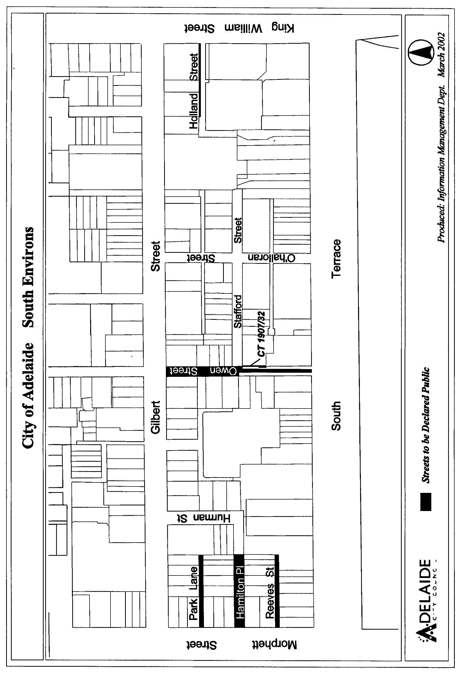
(5) That part of Owen Street in Town Acres 634 and 689 delineated as Owen Street plus the land lettered ‘K’ on LTO plan C-2607.
Susan Law, Chief Executive Officer

CITY OF ADELAIDE
Notice of Declaration as Public Roads
NOTICE is hereby given pursuant to section 210 of the Local Government Act 1999, that at its meeting of 17 March 2003, council declared the following roads to be Public Roads:
(1) Alfred Street in Town Acres 466, 467, and 468, which is delineated as Alfred Street on LTO plan A-9860.
(2) Bartels Street in Town Acres 400 and 461, which is delineated as Bartels Street on LTO plan C-1392.
(3) Claxton Street in Town Acres 397 and 464, which is delineated as Claxton Street on LTO plan A-4488 which is contained in partially cancelled Certificates of Title Volume 197 Folio 154 and Volume 128 Folio 140.
(4) Lowe Street in Town Acres 396 and 465, which is delineated as Lowe Street in LTO plan A-4488 and includes land in partially cancelled Certificate of Title Volume 212 Folio 128.
(5) Mary Street in Town Acres 467 and 468, which is delineated as Mary Street on LTO plan B-1682.
(6) Maud Street in Town Acres 466 and 467, which is delineated as Maud Street on LTO plan B-1682.
(7) The unnamed road west off Lowe Street in Town Acre 396, which is delineated as Rutland Place on LTO plan FP27179 and shall be known as Rutland Place.
(8) Selby Street in Town Acres 399 and 462, which is delineated as Selby Street in LTO plan DP43475 and includes land in Certificate of Title Volume 183 Folio 199.
Susan Law, Chief Executive Officer

CITY OF ADELAIDE
Notice of Declaration as Public Roads
NOTICE is hereby given pursuant to section 210 of the Local Government Act 1999, that at its meeting of 17 March 2003, council declared the following roads to be Public Roads:
(1) Compton Street in Town Acres 404 and 457, which is delineated as Crompton Street (sic) on LTO plan DP48354.
(2) Mill Street in Town Acres 407 and 454, which is delineated as Mill Street on LTO plan C-2989.
(3) That part of Coglin Street in Town Acre 406 contained in that part of Certificate of Title Volume 281 Folio 153 defined as the Private Road on LTO plan DP623 and contained within the land labelled Coglin Street on LTO plan C-2989.
(4) That part of Coglin Street in Town Acre 455 contained in that part of Certificate of Title Volume 5270 Folio 288 defined as Allotment 4 on LTO plan FP35606.
(5) That part of Market Street in Town Acre 405 contained in that part of Certificate of Title Volume 5270 Folio 288 identified as Allotment 5 on LTO plan FP35606.
(6) The unnamed road in Town Acres 405, 406 and 455, which is delineated as that part of Certificate of Title Volume 5270 Folio 288 defined as Allotment 6 on LTO plan FP35606.
(7) That part of Field Street in Town Acre 403 delineated as marked ‘Private Road’ on the plan in Certificate of Title Volume 2826 Folio 99, which is contained in Certificate of Title Volume 130 Folio 60.
(8) Hobsons Place in Town Acres 479 and 534, which is delineated as Hobsons Place on LTO plan DP12276.
(9) That part of Frew Street in Town Acre 530 contained in Certificate of Title Volume 5819 Folio 902.
(10) That part of Norman Street in Town Acres 481 and 532 delineated as all of Norman Street on LTO plan DP31837 excluding Certificates of Title Volume 5061 Folio 650 and Volume 2521 Folio 55 which are already Public.
(11) Russell Street in Town Acres 480 and 533, which is delineated as Russell Street on LTO plan DP12276.
(12) Sabiston Lane in Town Acre 478, which is delineated as the land marked Private Road on LTO plan C-1809 excluding the Private Road in Certificate of Title Volume 5686 Folio 294.
(13) Sultram Place in Town Acre 534, which is delineated as Sultram Place on LTO plan DP43820 and includes Partially Cancelled Certificate of Title Volume 5 Folio 138.
Susan Law, Chief Executive Officer

CITY OF ADELAIDE
Notice of Declaration as Public Roads
NOTICE is hereby given pursuant to section 210 of the Local Government Act 1999, that at its meeting of 31 March 2003, council declared the following roads to be Public Roads:
(1) Sanders Place in Town Acres 600 and 601, which is delineated as Sanders Place on LTO plans DP38986 and DP16165.
(2) Stephen Street in Town Acres 566 and 601, which is delineated as Stephen Street on LTO plan DP16165.
(3) Travers Place in Town Acre 948, which is delineated as certificate of title volume 5813 folio 809.
(4) That part of Fenchurch Street in Town Acres 906 and 919 delineated as Fenchurch Street on LTO plan
B-2071.
(5) Lombard Street in Town Acres 905, 906, 919 and 920, which is delineated as Lombard Street on LTO plan
A-7900.
(6) Tower Street North in Town Acres 905 and 920, which is delineated as Tower Street North on LTO plan
A-4518.
Susan Law, Chief Executive Officer

CITY OF ADELAIDE
Notice of Declaration as Public Roads
NOTICE is hereby given pursuant to section 210 of the Local Government Act 1999, that at its meeting of 31 March 2003, council declared the following roads to be Public Roads:
(1) Bentham Street in Town Acres 200 and 239, which is delineated as Bentham Street on LTO plan C-1488.
(2) Cannon Street in Town Acres 196 and 243, which is delineated as Cannon Street on LTO plan A-3260.
(3) Eliza Street in Town Acres 197 and 242, which is delineated as Eliza Street on LTO plan A-3260.
(4) That part of Post Office Place in Town Acre 238 contained in certificate of title volume 645 folio 122.
(5) Tatham Street in Town Acres 196 and 243, which is delineated as Tatham Street on LTO plan B-1253.
(6) Young Street in Town Acres 197, 198, 241 and 242, which is delineated as Young Street on LTO plan FP25139.
(7) That part of Delhi Street in Town Acres 645 and 646 delineated as Collins Street on LTO plan C-2264 and including certificates of title volume 5478 folio 205 and volume 5822 folio 405.
(8) That part of Dumfries Place in Town Acre 643 delineated as Dumfries Place on LTO plan C-2884.
(9) Osmond Street in Town Acre 641, which is delineated as Allotment 6 and Reserve No. 4 on LTO plan DP697.
(10) The unnamed road in Town Acre 641 delineated as Allotments 5 and 7 on LTO plan DP697 and contained in partially cancelled certificate of title volume 126 folio 7.
(11) The unnamed road to the east off Symonds Place in Town Acre 640, delineated as Private Road on LTO plan C-5104.
(12) The unnamed road to the west off Symonds Place in Town Acres 640 and 683, delineated as Private Road on LTO plan A-4915.
Susan Law, Chief Executive Officer

CITY OF ADELAIDE
Notice of Declaration as Public Roads
NOTICE is hereby given pursuant to section 210 of the Local Government Act 1999, that at its meeting of 17 March 2003, council declared the following roads to be Public Roads:
(1) Elizabeth Street in Town Acres 192 and 247, which is delineated as Certificates of Title Volume 3538 Folio 89,Volume 5802 Folio 819 and Volume 3822 Folio 38, plus Elizabeth Street on LTO plan Tube 183.
(2) Mellor Street in Town Acre 194, which is delineated as Lambert Street on LTO plan A-5676.
(3) Waymouth Court and Mellor Street in Town Acre 245, which is delineated as Certificate of Title Volume 932 Folio 45.
(4) Ranelagh Street and Ranelagh Alley in Town Acre 193, which are delineated as Ranelagh Court, Ranelagh Alley and allotments 49, 50 and 51 on LTO plan FP40003, and are contained in Certificates of Title Volume 456 Folio 47, Volume 5384 Folio 989, and partially cancelled Certificate of Title Volume 1431 Folio 18.
Susan Law, Chief Executive Officer

CITY OF ADELAIDE
Notice of Declaration as Public Roads
NOTICE is hereby given pursuant to section 210 of the Local Government Act 1999, that at its meeting of 17 March 2003, council declared the following roads to be Public Road:
(1) That part of Gladstone Street in Town Acre 435 delineated as Allotment 17 on LTO plan DP939 and contained in Partially Cancelled Certificate of Title Volume 338 Folio 108.
(2) Kate Court in Town Acres 502 and 511, which is delineated as Allotment 43 on LTO plan DP432 and contained in Certificate of Title Volume 5134 Folio 937.
(3) The unnamed road in Town Acres 502 and 503, which is delineated as Allotment 44 on LTO plan DP432 and contained in Certificate of Title Volume 5134 Folio 937.
(4) The unnamed road in Town Acres 510 and 511, which is delineated as Allotment 45 on LTO plan DP432 and contained in Certificate of Title Volume 5134 Folio 937.
(5) Marion Street in Town Acres 503 and 510, which is delineated as Allotment 46 on LTO plan DP432 and contained in Certificate of Title Volume 5134 Folio 937.
(6) That part of Tomsey Lane in Town Acre 509 delineated as Allotment 42 on LTO plan DP262 and contained in Certificate of Title Volume 5134 Folio 935.
(7) Tomsey Street in Town Acres 504, 505, 508 and 509, which is delineated as Allotment 39 on LTO plan DP262 and contained in Certificate of Title Volume 5134 Folio 935.
(8) Tomsey Court and Wilson Street in Town Acres 505 and 508, which are delineated as Allotment 41 on LTO plan DP262 and contained in Certificate of Title Volume 5134 Folio 935, with the east-west orientated street in Town Acre 505 to be known as Wilson Street, and the balance to be known as Tomsey Court.
(9) Wilson Street in Town Acre 506, which is delineated as Wilson Street on LTO plan B-522 and is contained in Partially Cancelled Certificate of Title Volume 116 Folio 248.
(10) Avoca Street and Avoca Place in Town Acre 615, which are delineated as that part of Certificate of Title Volume 194 Folio 174 identified as Avoca Street and Avoca Place on LTO plan FP3394.
(11) Cavan Place in Town Acre 548, which is that part of Certificate of Title Volume 125 Folio 88 delineated as Cavan Street on LTO plan FP7636.
(12) Little Gilbert Street in Town Acres 549 and 618, which is delineated as Little Gilbert Street plus the land marked ‘L’ on LTO plan C-2747.
(13) That part of Little Sturt Street in Town Acres 548 and 619 delineated as Little Sturt Street on LTO plan A-3334.
(14) Logan Street in Town Acres 550 and 617, which is delineated as Logan Street on LTO plan FP942.
(15) Maxwell Street in Town Acres 619, 620 and 621, which is delineated as Maxwell Street on LTO plan A-4679 including Certificate of Title Volume 175 Folio 35.
(16) O’Brien Street in Town Acres 546 and 621, which is delineated as O’Brien Street on LTO plan A-4679.
(17) That part of Certificate of Title Volume 4239 Folio 695 identified as Allotments 3 and 4 on LTO plan FP22784.
Susan Law, Chief Executive Officer

CITY OF PORT ADELAIDE ENFIELD
Conversion of Private Roads to Public Roads
NOTICE is hereby given, pursuant to section 210 (2) (b) of the Local Government Act 1999, that the City of Port Adelaide Enfield intends to declare:
Butler Street, Port Adelaide
The private road known as Butler Street, Port Adelaide contained in General Registry Office Plan 57 of 1857, to be public roads.
Rutland Street, Gillman
The private road known as Rutland Street, Gillman des-cribed as allotment 155 in Deposited Plan 505, to be public roads.
A copy of the plans indicating the location of the private roads are on display in the Civic Centre, 163 St Vincent Street, Port Adelaide and at the Regional Offices situated in the Enfield, Greenacres and Parks Libraries.
Residents may obtain further information and request that a copy of the plans be posted to them by contacting Gary Baron
on telephone (08) 8405 6852, fax (08) 8405 6666 or email gbaron@portenf.sa.gov.au.
H. J. Wierda, City Manager

CITY OF PORT ADELAIDE ENFIELD
Declaration of Public Road
NOTICE is hereby given, pursuant to section 208 (4) of the Local Government Act 1999, that the council at its meeting held on 9 April 2003, resolved that the City of Port Adelaide Enfield hereby declares allotment 50 in Filed Plan 44717, being portion of the land contained within certificate of title volume 5375, folio 339 to be a public road.
H. J. Wierda, City Manager

TOWN OF WALKERVILLE
Change of Meeting Times
NOTICE is hereby given that the meetings of Council Committees scheduled for Monday, 21 April 2003 have been deferred and rescheduled to take place immediately following the council meeting on Monday, 5 May 2003.
R. H. Wallace, Chief Executive Officer

CLARE AND GILBERT VALLEYS COUNCIL
Roads (Opening and Closing) Act 1991
Temporary Road Closure
NOTICE is hereby given, pursuant to section 10 of the Roads (Opening and Closing) Act 1991, that the Clare and Gilbert Valleys Council proposes to make a Road Process Order to close portions of Dominic Street and East Terrace, Clare in the Hundred of Clare comprising a total area of approximately 90 m along Dominic Street and approximately 380 m along East Terrace being a total area of approximately 7 050 m².
The council further proposes to open a new road approximately 15 m wide, located approximately 40 m east of East Terrace and extending from Young Street to Lennon Street, comprising an area of approximately 7 400 m². The portions to be opened as road are marked ‘1’, ‘2’ and ‘3’ respectively in Preliminary Plan 02/0107. The portions of road to be closed are marked ‘A’, ‘B’ and ‘C’ and are to merge with adjacent allotments as set out in Preliminary Plan 02/0107.
A copy of the preliminary plan and a statement of persons affected are available for public inspection at the Council Office, 4 Gleeson Street, Clare, S.A. 5453 and at the Adelaide office of the Surveyor-General, 101 Grenfell Street, Adelaide during normal office hours.
Any person who objects to the proposal may within 28 days of the date of this notice lodge a written notice of objection with the council giving full name and address of the objector, reasons for the objection and state whether the objector wishes to make submissions to a meeting of the council, notice of which will be given.
Any person affected by the proposed road closure may apply for an easement to be granted in the person’s favour over land subject to the proposed closure. A written application must be lodged with the council within 28 days of the date of this notice giving full name and address of the person applying for the grant, full particulars of the nature and location of the easement that is being applied for, the reason for the application for the grant of easement and specifying the land to which the easement is to be annexed.
An objection or application for an easement must be lodged in writing with Clare and Gilbert Valleys Council, 4 Gleeson Street, Clare, S.A. 5453.
A copy of any objection to the road process or of any application for easement must also be lodged with the Surveyor-General, G.P.O. Box 1047, Adelaide, S.A. 5001 within 28 days of the date of this notice.
Where an objection or application for an easement is made, the council will give notification of a meeting at which the matter will be considered, so that the person making the objection or application may attend, if desired, personally or by a representative.
Dated 17 April 2003.
M. A. Goldstone, Chief Executive Officer

DISTRICT COUNCIL OF TATIARA
Proportional Separate Rate
NOTICE is hereby given that pursuant to section 154 of the Local Government Act 1999, on 8 April 2003, Council resolved to charge a proportional separate rate of $5 per metre of rateable property frontage abutting the road where kerbing and sealing works were completed. The following Bordertown township properties will be charged a proportional separate rate of $5 per metre, on the condition that pensioner concessions will be granted in accordance with pensioner concessions for the general rate:
Sixth Street between South Avenue and Venn Avenue.
Milne Street between Fifth Street and Sixth Street.
South side of Venn Avenue between Fifth Street and Sixth Street.
R. J. Harkness, Chief Executive Officer

DISTRICT COUNCIL OF YANKALILLA
Roads (Opening and Closing) Act 1991
NOTICE is hereby given, pursuant to section 10 of the Roads (Opening and Closing) Act 1991, that the District Council of Yankalilla proposes to make a Road Process Order to close and transfer that portion of public road marked ‘A’ on the Preliminary Plan PP03/0028.
Transfer ‘A’ to Koraleigh Pty Ltd, 227 East Terrace, Adelaide, S.A. 5000, and to merge that portion with certificate of title volume 5356, folio 871.
A statement of persons affected by the proposed road process together with a copy of the preliminary plan is available for inspection at the offices of the District Council of Yankalilla, Main Road, Yankalilla, during normal office hours. Copies may also be inspected at the Adelaide office of the Surveyor-General, 101 Grenfell Street, Adelaide, during normal office hours.
Any person is entitled to object to the proposed road process, or any person affected by the proposed closure is entitled to apply for an easement to be granted in that person’s favour over the land subject to the proposed closure. Such objection or application for an easement must set out the full name and address of the person making the objection or application and must be fully supported by reasons.
Any application for an easement must give full particulars of the nature and location of the easement land, where made by a person as the owner of adjoining or nearby land, specify the land to which the easement is to be annexed.
The objection or application for an easement must be made in writing to the District Council of Yankalilla, P.O. Box 9, Yankalilla, S.A. 5204, within 28 days of this notice, and a copy shall be forwarded to the Adelaide office of the Surveyor-General, G.P.O. Box 1354, Adelaide, S.A. 5001. Where a submission is made, the District Council of Yankalilla will give notification of a meeting at which the matter will be considered, so that the person making the submission or a representative may attend, if desired.
Dated 17 April 2003.
R. Sweetman, Chief Executive Officer

DISTRICT COUNCIL OF YANKALILLA
Change of Meeting Times
NOTICE is hereby given that the monthly meeting of the District Council of Yankalilla will be held on Thursday, 1 May 2003 commencing at 10 a.m. in lieu of the scheduled meeting of 8 May 2003.
R. D. Sweetman, Chief Executive Officer

IN the matter of the estates of the undermentioned deceased persons:
Chapman, Gladys Marjorie, late of 25 Lincoln Avenue, Warradale, of no occupation, who died on 13 January 2003.
Cooper, Darryl William, late of 6 Cassab Court, Trott Park, self-employed maintenance worker, who died on 5 January 2003.
Gleeson, Mollie, late of 28 Maxwell Street, Adelaide, of no occupation, who died on 17 January 2003.
Hall, Annie Selena, late of 67 Peters Street, Whyalla Playford, home duties, who died on 4 February 2003.
Hookes, Patricia Margaret, late of 60 Clifford Street, Torrensville, home duties, who died on 28 February 2003.
Lloyd, Shirley, late of 84 Somerset Avenue, Cumberland Park, home duties, who died on 2 March 2003.
Luxton, Lynn Anne, late of 8 Ralph Street, Whyalla Playford, retired teacher, who died on 11 March 2003.
McCarthy, Gwendoline Laurel, late of 6 Ellis Street, Enfield, widow, who died on 21 February 2003.
McKenzie, Isabella, late of 110 Strathfield Terrace, Largs North, of no occupation, who died on 9 March 2003.
Reeves, Doreen Jean Lorna, late of 110 Strathfield Terrace, Largs North, of no occupation, who died on 5 March 2003.
Smith, Douglas Allen, late of 95-97 Kensington Road, Norwood, retired florist, who died on 18 January 2003.
Stalley, Peter Kimpton, late of 12 Olivebank Crescent, Encounter Bay, retired stamp dealer, who died on 18 January 2003.
Tancock, Donald Cleveland, late of Grand Junction Road, Oakden, of no occupation, who died on 30 October 2002.
Thomson, Hugh William, late of 342 Marion Road, North Plympton, of no occupation, who died on 24 January 2003.
Twining, Eugenie Elizabeth, late of 47 Balham Avenue, Kingswood, of no occupation, who died on 18 February 2003.
Vynycy, Douglas Arthur, late of 73 Barry Road, Oaklands Park, retired carpenter, who died on 17 December 2002.
Wooldridge, Gwenda Kathleen, late of 46 Standen Street, Murray Bridge, home duties, who died on 1 March 2003.
Zelipsky, George, late of 11 Argyll Walk, Bellevue Heights, shift supervisor, who died on 3 March 2003.
Notice is hereby given pursuant to the Trustee Act 1936, as amended, the Inheritance (Family Provision) Act 1972, and the Family Relationships Act 1975, that all creditors, beneficiaries, and other persons having claims against the said estates are required to send, in writing, to the Public Trustee, 25 Franklin Street, Adelaide, S.A. 5000, full particulars and proof of such claims, on or before 16 May 2003, otherwise they will be excluded from the distribution of the said estate; and notice is also hereby given that all persons who are indebted to the said estates are required to pay the amount of their debts to the Public Trustee or proceedings will be taken for the recovery thereof; and all persons having any property belonging to the said estates are forthwith to deliver the same to the Public Trustee.
Dated 17 April 2003.
C. J. O’Loughlin, Public Trustee

IN the matter of the estate of the undermentioned deceased person:
Dunstan, Coral Janet, late of 59 Hindmarsh Road, Victor Harbor, who died on 7 February 2003.
Notice is hereby given pursuant to the Trustee Act 1936, as amended, the Inheritance (Family Provision) Act 1972 and the Family Relationships Act 1975, that all creditors, beneficiaries, and other persons having claims against the above estate are directed to send full particulars and evidence of such claims to the undersigned on or before 16 May 2003, otherwise they will be excluded from the distribution of the said estate; and notice is also hereby given that all persons who are indebted to the above estate are required to pay the amount of their debts to the
undersigned or proceedings will be taken for the recovery thereof; and all persons having any property belonging to the said estate are forthwith to deliver the same to the undersigned.
Dated 17 April 2003.
ANZ Executors & Trustee Company Limited (ACN 006 132 332), 530 Collins Street, Melbourne, Vic. 3000.

SOUTH AUSTRALIA—In the Supreme Court. No. 388 of 1998. In the matter of Dysdra Pty Ltd (in liquidation) (ACN 009 643 869) and in the matter of the Corporations Law.
Notice of Release of Liquidator and Dissolution of the Company
Take notice that by order of the Supreme Court of South Australia dated 3 April 2003, I, Bruce James Carter of Ferrier Hodgson, Level 6, 81 Flinders Street, Adelaide, S.A. 5000 the liquidator of the abovenamed company, was granted my release as liquidator and the company was dissolved.
Dated 11 April 2003.
B. J. Carter, Liquidator
Note: Section 481 of the Corporations Law enacts that an order of the Court releasing a liquidator shall discharge him/her in the administration of the affairs of the company, or otherwise in relation to his or her conduct as liquidator, but any such order may be revoked on proof that it was obtained by fraud or by suppression or by concealment of any material fact.

SOUTH AUSTRALIA—In the Supreme Court. No. 1450 of 1998. In the matter of Paulson Motors & Marine Pty Ltd (ACN 007 975 966) and in the matter of the Corporations Act 2001.
Notice by a Liquidator of His Intention to Seek His Release
Take notice that I, Mark Christopher Hall, 26 Flinders Street, Adelaide, S.A. 5000, the liquidator of the abovenamed company, intend to make application to the Supreme Court of South Australia, for my release as the liquidator of the abovenamed company.
And take further notice that if you have any objection to the granting of my release you must file at the Supreme Court and also forward to me within 21 days of publication in the Gazette of the notice of my intention to apply for a release a notice of objection in the form laid down by the Corporations Law (South Australia) Rules 2000. A summary of my receipts and payments as liquidator is enclosed herewith.
Dated 11 April 2003.
M. C. Hall, Liquidator
Note: Section 481 of the Corporations Act 2001 enacts that an order of the Court releasing a liquidator shall discharge him/her in the administration of the affairs of the company, or otherwise in relation to his or her conduct as liquidator, but any such order may be revoked on proof that it was obtained by fraud or by suppression or by concealment of any material fact.

ATTENTION

CUSTOMERS requiring a proof of their notice for inclusion in the Government Gazette, please note that the onus is on you to inform Government Publishing SA of any subsequent corrections by 10 a.m. on Thursday, which is our publication deadline.

For any corrections to your notice please phone 8207 1045 or Fax 8207 1040 before 10 a.m. on Thursday.

If we do not receive any communication by 10 a.m. on Thursday (day of publication) we will presume the notice is correct and will print it as it is.

Remember—the onus is on you to inform us of any corrections necessary to your notice.

NOTE: Closing time for lodging new copy (electronically, fax or hard copy) is 4 p.m. on Tuesday preceding the day of publication. Phone 8207 1045—Fax 8207 1040.
Email: governmentgazette@saugov.sa.gov.au

Printed and published by authority every Thursday by J. D. FERGUSON, Government Printer, South Australia
Price: $4.55, plus postage; to subscribers, $229.00 per annum.
(The above prices are inclusive of GST)

