No. 113 4287

THE SOUTH AUSTRALIAN

GOVERNMENT GAZETTE
www.governmentgazette.sa.gov.au

PUBLISHED BY AUTHORITY

ALL PUBLIC ACTS appearing in this GAZETTE are to be considered official, and obeyed as such

ADELAIDE, THURSDAY, 4 DECEMBER 2003

CONTENTS

Page
Acts Assented To 4288
Appointments, Resignations, Etc. 4288
Corporations and District Councils—Notices 4387
Development Act 1993—Notices 4289
Environment Protection Authority—Notice 4291
Fisheries Act 1982—Notices 4291
Harbors and Navigation Act 1993—Notices 4292
Industrial and Employee Relations Act 1994—Rules 4293
Land and Business (Sale and Conveyancing) Act 1994—
Notices 4309
Liquor Licensing Act 1997—Notices 4310
Passenger Transport Act 1994—Notice 4312
Proclamations 4374
Public Trustee Office—Administration of Estates 4391
Real Property Act 1886—Notice 4313
Remuneration Tribunal—Determination and Report of 4313

Page
REGULATIONS
Motor Vehicles Variation Regulations 2003
(No. 238 of 2003) 4380
Liquor Licensing (Dry Areas—Long Term) Variation
Regulations 2003 (No. 239 of 2003) 4382
Rates and Land Tax Remission (Prescribed Amount)
Variation Regulations 2003 (No. 240 of 2003) 4385
Roads (Opening and Closing) Act 1991—Notices 4315
Road Traffic Act 1961—Notices 4316
Rules of Court 4362
Sale of Property 4391
South Australian Housing Trust Act 1995—Notice 4370
South Australian Motor Sport Regulations 1999—Notices 4365
Survey Act 1992—Notices 4370
Water Resources Act 1997—Notice. 4370
Waterworks Act 1932—Notices 4371

GOVERNMENT GAZETTE NOTICES
ALL poundkeepers’ and private advertisements forwarded for publication in the South Australian Government Gazette must be PAID FOR PRIOR TO INSERTION; and all notices, from whatever source, should be legibly written on one side of the paper only and sent to Government Publishing SA so as to be received no later
than 4 p.m. on the Tuesday preceding the day of publication. Phone 8207 1045 or Fax 8207 1040. E-mail: governmentgazette@saugov.sa.gov.au. Send as attachments in Word format and please confirm your transmission with a faxed copy of your document, including the date the notice is to be published and to whom the notice will be charged. The Government Gazette is available online at: www.governmentgazette.sa.gov.au

Department of the Premier and Cabinet
Adelaide, 4 December 2003
HER Excellency the Governor directs it to be notified for general information that she has in the name and on behalf of Her Majesty The Queen, this day assented to the undermentioned Acts passed by the Legislative Council and House of Assembly in Parliament assembled, viz.:
No. 53 of 2003—Statutes Amendment (Expiation of Offences) Act 2003. An Act to amend the Expiation of Offences Act 1996, the Road Traffic Act 1961 and the Summary Procedure Act 1921.
No. 54 of 2003—Passenger Transport (Dissolution of Passenger Transport Board) Amendment Act 2003. An Act to amend the Passenger Transport Act 1994 and to make related amendments to the Road Traffic Act 1961 and the Super-annuation Act 1988.
No. 55 of 2003—Legal Practitioners (Miscellaneous) Amendment Act 2003. An Act to amend the Legal Practi-tioners Act 1981.
No. 56 of 2003—Summary Offences (Vehicle Immobili-sation Devices) Amendment Act 2003. An Act to amend the Summary Offences Act 1953.
No. 57 of 2003—Statutes Amendment (Bushfire Summit Recommendations) Act 2003. An Act to amend the Country Fires Act 1989 and the South Australian Metropolitan Fire Service Act 1936.
By command,
J. W. Weatherill, for Premier
DPC 02/0586

Department of the Premier and Cabinet
Adelaide, 4 December 2003
HER Excellency the Governor in Executive Council has revoked the appointment of John Hodges Choate as a Member on the South Australian Bushfire Prevention Advisory Committee, pursuant to the Country Fires Act 1989 and the Acts Interpretation Act 1915.
By command,
J. W. Weatherill, for Premier

Department of the Premier and Cabinet
Adelaide, 4 December 2003
HER Excellency the Governor in Executive Council has revoked the appointment of Jasemin Rose as a Deputy Member to John Hodges Choate on the South Australian Bushfire Prevention Advisory Committee, pursuant to the Country Fires Act 1989 and the Acts Interpretation Act 1915.
By command,
J. W. Weatherill, for Premier

Department of the Premier and Cabinet
Adelaide, 4 December 2002
HER Excellency the Governor in Executive Council has been pleased to appoint the undermentioned to the History Trust of South Australia, pursuant to the provisions of the History Trust of South Australia Act 1981:
Member: (from 18 December 2003 until 17 December 2006)
Fiona Catherine Adler
By command,
J. W. Weatherill, for Premier
ASA 00006/02CS

Department of the Premier and Cabinet
Adelaide, 4 December 2003
HER Excellency the Governor in Executive Council has been pleased to appoint the undermentioned to the South Australian Bushfire Prevention Advisory Committee, pursuant to the Country Fires Act 1989:
Member: (from 4 December 2003 until 26 September 2004)
Jane Corin
Deputy Member: (from 4 December 2003 until 26 September 2004)
Jasemin Rose (Deputy to Corin)
By command,
J. W. Weatherill, for Premier
MES 023/03CS

Department of the Premier and Cabinet
Adelaide, 4 December 2003
HER Excellency the Governor in Executive Council has been pleased to appoint the undermentioned to the Superannuation Funds Management Corporation of South Australia Board (Funds SA), pursuant to the provisions of the Superannuation Funds Management Corporation of South Australia Act 1995:
Director: (from 9 December 2003 until 8 December 2006)
Helen Marion Nugent
By command,
J. W. Weatherill, for Premier
DTF 113/03CS

Department of the Premier and Cabinet
Adelaide, 4 December 2003
HER Excellency the Governor in Executive Council has been pleased to appoint the Honourable Kevin Owen Foley, MP, Deputy Premier, Treasurer, Minister Assisting the Premier in Economic Development, Minister for Police and Minister for Federal/State Relations to be also Acting Premier, Acting Minister for Economic Development, Acting Minister for the Arts and Acting Minister for Volunteers for the period 9 December 2003 to 24 December 2003 inclusive, during the absence of the Honourable Michael David Rann, MP.
By command,
J. W. Weatherill, for Premier
DPC 082/94 PT1CS

Department of the Premier and Cabinet
Adelaide, 4 December 2003
HER Excellency the Governor in Executive Council has been pleased to appoint the Honourable Patrick Frederick Conlon, MP, Minister for Infrastructure, Minister for Energy and Minister for Emergency Services to be also Acting Deputy Premier, Acting Treasurer, Acting Minister Assisting the Premier in Economic Development, Acting Minister for Police and Acting Minister for Federal/State Relations for the period 25 December 2003 to 11 January 2004 inclusive, during the absence of the Honourable Kevin Owen Foley, MP.
By command,
J. W. Weatherill, for Premier
DPC 082/94 PT1CS

Department of the Premier and Cabinet
Adelaide, 4 December 2003
HER Excellency the Governor in Executive Council has been pleased to appoint the Honourable John David Hill, MP, Minister for Environment and Conservation, Minister for the River Murray, Minister for the Southern Suburbs and Minister Assisting the Premier in the Arts to be also Acting Deputy Premier, Acting Treasurer, Acting Minister Assisting the Premier in Economic Development, Acting Minister for Police and Acting Minister for Federal/State Relations for the period 12 January 2004 to 29 January 2004 inclusive, during the absence of the Honourable Kevin Owen Foley, MP.
By command,
J. W. Weatherill, for Premier
DPC 082/94 PT1CS

Department of the Premier and Cabinet
Adelaide, 4 December 2003
HER Excellency the Governor in Executive Council has been pleased to appoint the Honourable Jay Wilson Weatherill, MP, Minister for Urban Development and Planning, Minister for Administrative Services and Minister for Gambling to be also Acting Minister for Tourism, Acting Minister for Science and Information Economy and Acting Minister for Employment, Training and Further Education for the period 22 December 2003 to 16 January 2004 inclusive, during the absence of the Honour-able Jane Diane Lomax-Smith, MP.
By command,
J. W. Weatherill, for Premier
DPC 082/94 PT1CS

Department of the Premier and Cabinet
Adelaide, 4 December 2003
HER Excellency the Governor in Executive Council has been pleased to appoint the Honourable Jay Wilson Weatherill, MP, Minister for Urban Development and Planning, Minister for Administrative Services and Minister for Gambling to be also Acting Minister for Industry, Trade and Regional Development, Acting Minister for Small Business, Acting Minister for Local Government and Acting Minister for Forests for the period 22 December 2003 to 11 January 2004 inclusive, during the absence of the Honourable Rory John McEwen, MP.
By command,
J. W. Weatherill, for Premier
DPC 082/94 PT1CS

Department of the Premier and Cabinet
Adelaide, 4 December 2003
HER Excellency the Governor in Executive Council has been pleased to appoint the undermentioned people as Her Majesty’s Counsel in the State of South Australia:
Peter Robert Brebner
Paul Andrew Cuthbertson
Paul Vincent Slattery
Michael David Walter
By command,
J. W. Weatherill, for Premier
ATTG 0423/02CS

Department of the Premier and Cabinet
Adelaide, 4 December 2003
HER Excellency the Governor in Executive Council has been pleased to appoint the undermentioned as Justices of the Peace for South Australia, pursuant to section 4 of the Justices of the Peace Act 1991:
Karen Joy Denton
Jeanette Mary Elliott
Peter Leonard Holt
Christopher Milton Johnstone
Douglas Victor Irving
Seta Singh Kahlon
Jillian Dawn Krebs
Valerie Beth Malcolm
Robert Bruce McLeod
Raymond Marshall Murfitt
Harry Gerrit Nijhuis
Robert Martin Wohlenberg
By command,
J. W. Weatherill, for Premier
ATTG 0082/03CS

DEVELOPMENT ACT 1993, SECTION 28 (1): DECLARA-TION OF INTERIM OPERATION OF CITY OF ONKA-PARINGA LOCAL HERITAGE (WILLUNGA) PLAN AMENDMENT
Notice
PURSUANT to section 28 (1) of the Development Act 1993, I, the Governor, with the advice and consent of the Executive Council, being of the opinion that it is necessary in the interest of the orderly and proper development of the area affected by the ‘City of Onkaparinga—Local Heritage (Willunga) Plan Amend-ment’ that the Plan Amendment should come into operation without delay, declare that the Plan Amendment will come into operation on an interim basis on 4 December 2003.
Given under my hand at Adelaide, 20 November 2003.
Marjorie Jackson-Nelson, Governor
MFUDP CPSA 2003/00020CS

DEVELOPMENT ACT 1993, SECTION 28 (1): DECLARA-TION OF INTERIM OPERATION OF CITY OF ONKA-PARINGA LOCAL HERITAGE (NOARLUNGA) PLAN AMENDMENT
Notice
PURSUANT to section 28 (1) of the Development Act 1993, I, the Governor, with the advice and consent of the Executive Council, being of the opinion that it is necessary in the interest of the orderly and proper development of the area affected by the ‘City of Onkaparinga—Local Heritage (Noarlunga) Plan Amend-ment’ that the Plan Amendment should come into operation without delay, declare that the Plan Amendment will come into operation on an interim basis on 4 December 2003.
Given under my hand at Adelaide, 20 November 2003.
Marjorie Jackson-Nelson, Governor
MFUDP CPSA 2003/00020CS

NOTE TO GOVERNMENT GAZETTE CUSTOMERS

The Government Information Centre at 77 Grenfell Street CLOSED on Friday, 10th October 2003.

All Government Legislation enquiries can now be directed to Service SA, Government Legislation Outlet.

Address Details:

Ground Floor, 101 Grenfell Street, Adelaide, S.A. 5000

Postal Details:

G.P.O. Box 1707, Adelaide, S.A. 5001

Phone: 13 23 24

ENVIRONMENT PROTECTION AUTHORITY
Exemptions
THE Environment Protection Authority has issued to Chicken-town Pty Ltd an exemption from the Environment Protection (Industrial Noise) Policy 1994 which relates to the music event known as the Powderfinger concert to be conducted at Memorial Drive Tennis Complex, Memorial Drive, North Adelaide, on 5 December 2003.
The Environment Protection Authority has issued to Chiodo Tutton Productions Pty Ltd an exemption from the Environment Protection (Industrial Noise) Policy 1994 which relates to the outdoor Moonlight Cinema event to be conducted at Botanic Park from 8 December 2003 until 15 February 2004, inclusive.
G. Sclare, Delegate, Environment Protection Authority

FISHERIES ACT 1982: SECTION 59
TAKE notice that pursuant to section 59 of the Fisheries Act 1982, Garry I. Warrick, RSD 9, via Loxton, S.A. 5333 (the ‘exemption holder’) is exempt from paragraph 34 (1) (a) of the Fisheries Act 1982, but only insofar as he may use the device described in Schedule 1 to take carp, bony bream and other non-native species in the areas specified in Schedule 2 for the purpose of trade or business (the ‘exempted activity’), subject to the conditions set out in Schedule 3, from the date of gazettal of this notice until 30 June 2004, unless varied or revoked earlier.
Schedule 1
‘Carp net’—a gill net with a ply greater than 5, having a maximum length of 50 m and a minimum mesh size of 10 cm and a maximum mesh size not exceeding 18 cm.
Schedule 2
(1) Subject to paragraph (2), the licence holder may conduct fishing activities pursuant to this licence in all backwaters of the River Murray excluding the following areas during the corresponding period set out in the following table:
Area Excluded and
Period of Closure
Lake Littra and outflow channel
Permanent—all year
Clover Lake
Permanent—all year
Coombool Swamp
Permanent—all year
Lake Limbra and outflow channel
Permanent—all year
Lake Woolpolool
Permanent—all year
Ral Ral Creek below Chaffey Pump and entrance waters to Lake Merreti
Permanent—all year
Katarapko Creek and Eckert Creek, including The Splash
Permanent—all year
Bulyong Creek
Permanent—all year
Pilby Creek
Permanent—all year
Hancock Creek
Permanent—all year
Mundic Creek
Permanent—all year
Pike Creek
Permanent—all year
Punkah Creek
Permanent—all year
Slaney Creek
Permanent—all year
Loch Luna
Permanent—all year
Cobdogla Swamp
1 August to 30 April (inclusive)
Loveday Swamp/Mussel lagoons
1 August to 30 April (inclusive)
Lake Merreti
1 August to 31 January (inclusive)
(2) The licence holder may conduct fishing operations within the closure areas and periods listed above if given written approval by the Director of Fisheries to undertake specified carp eradication work in a specified area for a specified period.
Schedule 3
1. The exemption holder must not use more than 30 carp nets at any one time in permitted back waters of the River Murray.
2. The exemption holder must not have more than 30 carp nets in his possession at any time when he is deploying carp nets in the backwaters of the River Fishery.
3. The exemption holder may only engage in the exempted activity when also fishing pursuant to River Fishery Licence No. R27, and may only use a boat to engage in the exempted activity if that boat is registered by endorsement on River Fishery Licence No. R27.
4. The exemption holder must not cause or permit a person to act as his agent when engaging in the exempted activity unless that person may lawfully act as an agent for the exemption holder in relation to River Fishery Licence No. R27.
5. All native fish (excluding bony bream) taken in the course of the exempted activity must be immediately returned to the water.
6. Immediately prior to commencing the exempted activity, the exemption holder must advise the PIRSA Fisheries Compliance Unit on 1800 065 522 with the following details:
• The licence number and person(s) conducting the activity.
• The exact location(s) of the fishing activities.
• The number of carp nets being used.
7. The exemption holder must ensure that the carp nets are checked and all fish removed at least once during each 24 hour period.
8. When the exemption holder moves the carp nets more than 3 km from the reported location of the nets under condition 6, or removes the nets from the River completely, the exemption holder must again report to the PIRSA Fisheries Compliance Unit on 1800 065 522 and provide either details, as required under condition 6 of this exemption, or report that fishing with carp nets has ceased.
9. While engaging in the exempted activity, the exemption holders must be in possession of a copy of this notice. Such notice must be produced to a PIRSA Fisheries Compliance Officer as requested.
10. The exemption holder must not contravene or fail to comply with the Fisheries Act 1982, or any regulations made under that Act, except where specifically exempted by this notice.
Dated 1 December 2003.
W. Zacharin, Director of Fisheries

FISHERIES ACT 1982: SECTION 59
TAKE notice that pursuant to section 59 of the Fisheries Act 1982, Scott Weaver, 29 Fleurieu Drive, Cape Jervis, S.A. 5204 (the ‘principal exemption holder’), and the class of persons specified in Schedule 1 (the ‘other exemption holders’), are exempt from clauses 66, 73, 77A and 77C of Schedule 1 of the Fisheries (General) Regulations 2000, but only insofar as the exemption holders may exceed the prescribed boat limits during a chartered fishing trip on the Fish Stalker II in accordance with the allowable limits specified in Schedule 2 (the ‘exempted activity’), subject to the conditions specified in Schedule 3, from 5 December 2003 until 30 June 2004, unless varied or revoked earlier.
Schedule 1
Any person or persons who charter the boat Fish Stalker II from Scott Weaver or Southern Fishing Charters for the purpose of recreational fishing.
Schedule 2
1. Where the number of ‘other exemption holders’ exceeds six, all of the ‘other exemption holders’ on board the boat are each restricted to taking no more than one half of the daily bag limit (rounded up to nearest whole number if necessary) for those species of scalefish subject to a limit as specified in the Fisheries (General) Regulations 2000) in any one day.
2. Where the number of ‘other exemption holders’ exceeds six, all of the ‘other exemption holders’ on board the boat are each restricted to taking no more than eight cuttlefish or eight calamary or eight cuttlefish and/or calamary in combination in any one day.
3. Where the number of ‘other exemption holders’ exceeds six, all of the ‘other exemption holders’ on board the boat are each restricted to taking either one gummy shark or one school shark in any one day.
4. Where the number of ‘other exemption holders’ exceeds eight, all of the ‘other exemption holders’ on board the boat are each restricted to taking no more than one rock lobster in any one day.
Schedule 3
1. The principal exemption holder, its employees or agents must not take any fish during the chartered fishing trip.
2. The principal exemption holder must not use any boat other than the Fish Stalker II for the purpose of engaging in the exempted activity.
3. The exemption holders must not sell any fish taken pursuant to this notice.
4. The principal exemption holder must not accept any fish taken by the other exemption holders as all or part of the consideration for the charter agreement.
5. The principal exemption holder must contact PIRSA Fish-watch on 1800 065 522 at least 24 hours prior to commencing the exempted activity and advise the time and date of departure of the Fish Stalker II and the estimated time of return to port.
6. While engaged in the exempted activity the principal exemption holder must have in their possession a copy of this notice. Such notice must be produced to a PIRSA Fisheries Officer if requested.
7. The exemption holders must not contravene or fail to comply with the Fisheries Act 1982, or any regulations made under that Act except where specifically exempted by this notice.
Dated 1 December 2003.
W. Zacharin, Director of Fisheries

HARBORS AND NAVIGATION ACT 1993
Determination of the State Crewing Committee
THE following determination made on 30 October 2003, by the State Crewing Committee is published pursuant to part 6, section 45 of the Harbors and Navigation Act 1993.
Michael Wright, Minister for Transport
TSA V26803

HARBORS AND NAVIGATION ACT 1993
Determination of the State Crewing Committee in respect of the
M.V. ‘Sealion 2000’
THE following determination is made by the State Crewing Committee pursuant to part 6, section 45 of the Harbors and Navigation Act 1993, in respect of the Sealion 2000 whilst operating within the following limits:
Operational Limits
Within designated inshore waters between Penneshaw, Cape Jervis and Port Adelaide.
Minimum Complement
From 201-250 passengers—six persons—Master, Mate, Chief Engineer, 1st Engineer and 2GPs (General Purpose Persons).
From 251-354 passengers—seven persons—Master, Mate, Chief Engineer, 1st Engineer and 3GPs (General Purpose Persons).
From 355-378 passengers—eight persons—Master, Mate, Chief Engineer, 1st Engineer and 4GPs (General Purpose Persons).
Minimum Qualifications of Crew
Master—Certificate of Competency as Master Class 4.
Mate—Certificate of Competency as Master Class 5.
Chief Engineer—Certificate of Competency as Marine Engineer Class 3.
1st Engineer—Certificate of Competency as Marine Engine Driver Grade 1.
GP—General Purpose Person—an able-bodied person not less than 16 years of age with not less than 3 months experience and has successfully completed an approved Occupational Health and Safety at Sea course.
Capt. C. Kavina, Presiding Member, State Crewing Committee

HARBORS AND NAVIGATION ACT 1993
Determination of the State Crewing Committee
THE following determination made on 30 October 2003, by the State Crewing Committee is published pursuant to part 6, section 45 of the Harbors and Navigation Act 1993.
Michael Wright, Minister for Transport
TSA V10443

HARBORS AND NAVIGATION ACT 1993
Determination of the State Crewing Committee in respect of the
M.V. ‘Quasar’
THE following determination is made by the State Crewing Committee pursuant to part 6, section 45 of the Harbors and Navigation Act 1993, in respect of the Quasar whilst operating within the following limits:
Operational Limits
1. Smooth Waters as per Schedule 1 of the Harbors and Navigation Regulations 1994.
2. Within restricted offshore operational areas of Gulf of St Vincent, Spencer Gulf and Investigator Strait but not west of an imaginary straight line joining Cape Borda and Cape Catastrophe nor east of an imaginary straight line joining Cape St Albans and Porpoise Head.
Minimum Complement
Limit 1. Less than 12 hours duration
Two Persons–Master and GP (General Purpose Person).
Limit 2. Greater than 12 hours duration
Two Persons—Master and Mate
Minimum Qualifications of Crew
Master—Certificate of Competency as Master Class 5.
Mate—Certificate of Competency as Coxswain and has successfully completed an approved Occupational Health and Safety at Sea and Restricted Radiotelephony courses.
GP—General Purpose Person—an able-bodied person not less than 16 years of age with not less than 3 months experience and has successfully completed an approved Occupational Health and Safety at Sea course.
Note: In Limits 1 and 2 above, either the Master, Mate or GP must possess a Certificate of Competency as Marine Engine Driver Grade III.
Capt. C. Kavina, Presiding Member, State Crewing Committee

INDUSTRIAL AND EMPLOYEE RELATIONS ACT 1994
INDUSTRIAL PROCEEDINGS RULES 1995
I, WILLIAM DAVID JENNINGS, the Senior Judge and President of the Industrial Relations Court and Commission of South Australia, by virtue of the provisions of section 178 of the Industrial and Employee Relations Act 1994, and all other enabling powers, do hereby amend the Industrial Proceedings Rules 1995 as follows, as from the first day of February 2004:
1. That Rule Twenty—Unfair Dismissal Proceedings, be repealed and replaced with the following Rule 20—Unfair Dismissal Proceedings.
2. That forms 3, 4 and 5 be replaced with the following new forms 3, 4 and 5.
Given under my hand and the seals of the Industrial Relations Court and Commission of South Australia.
Dated 28 November 2003.
(l.s.) W. D. Jennings, Senior Judge/President

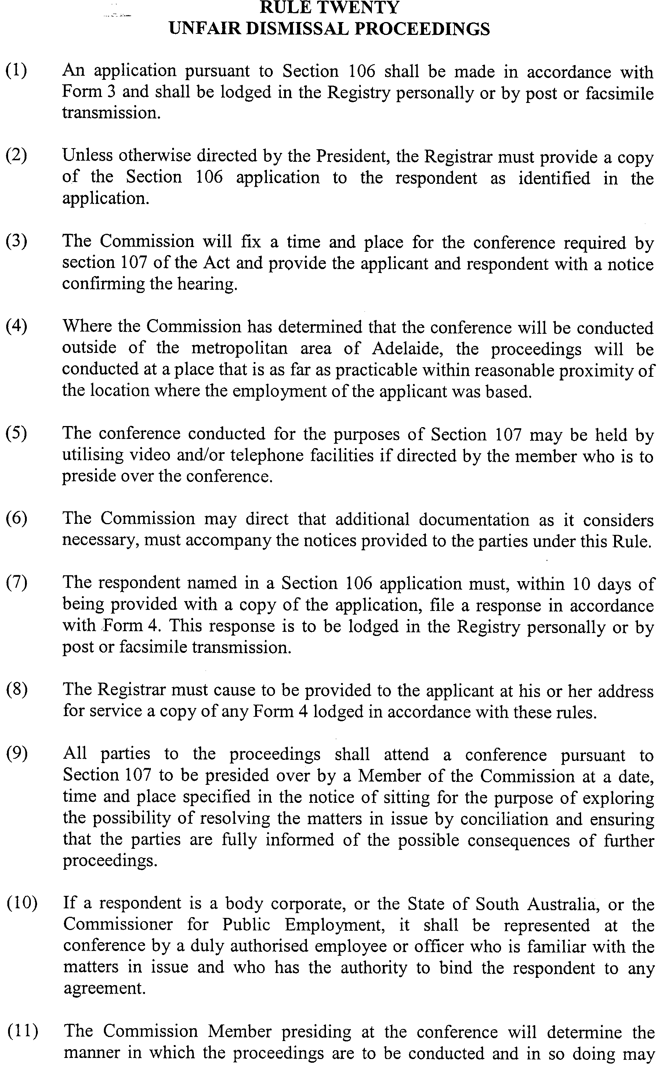
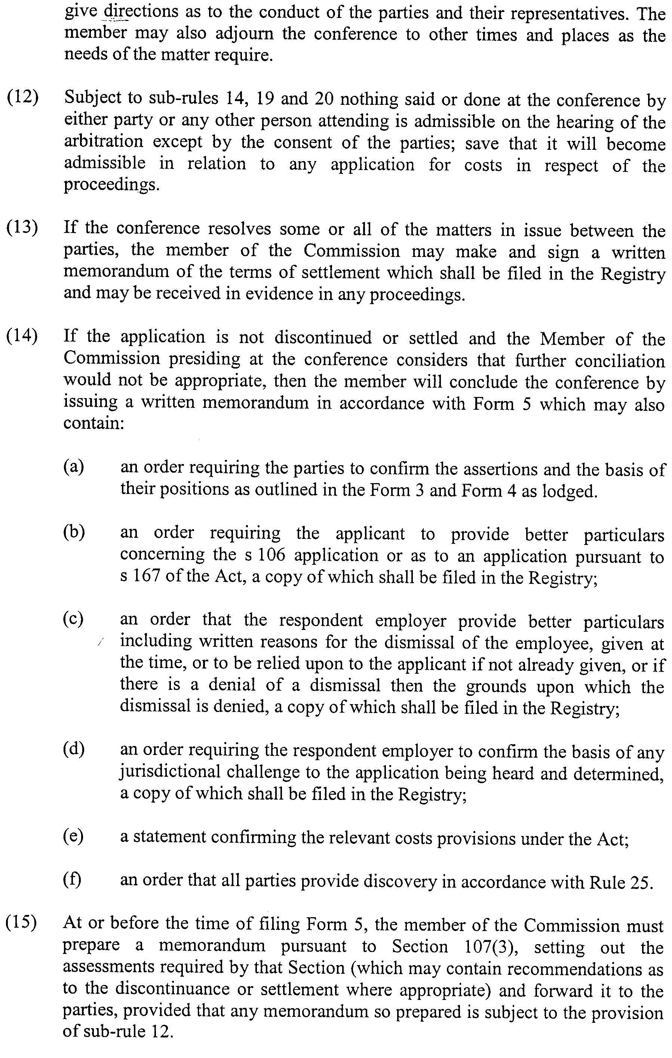
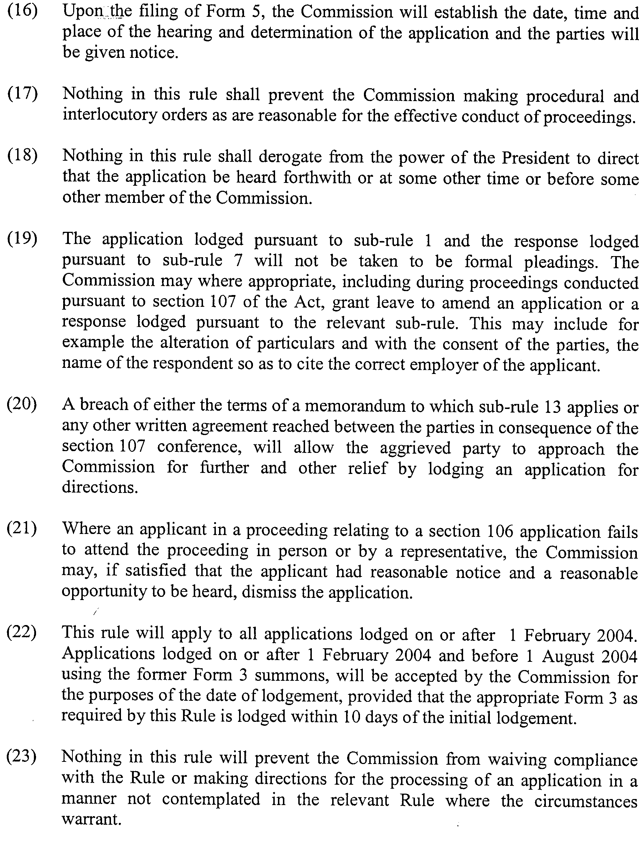
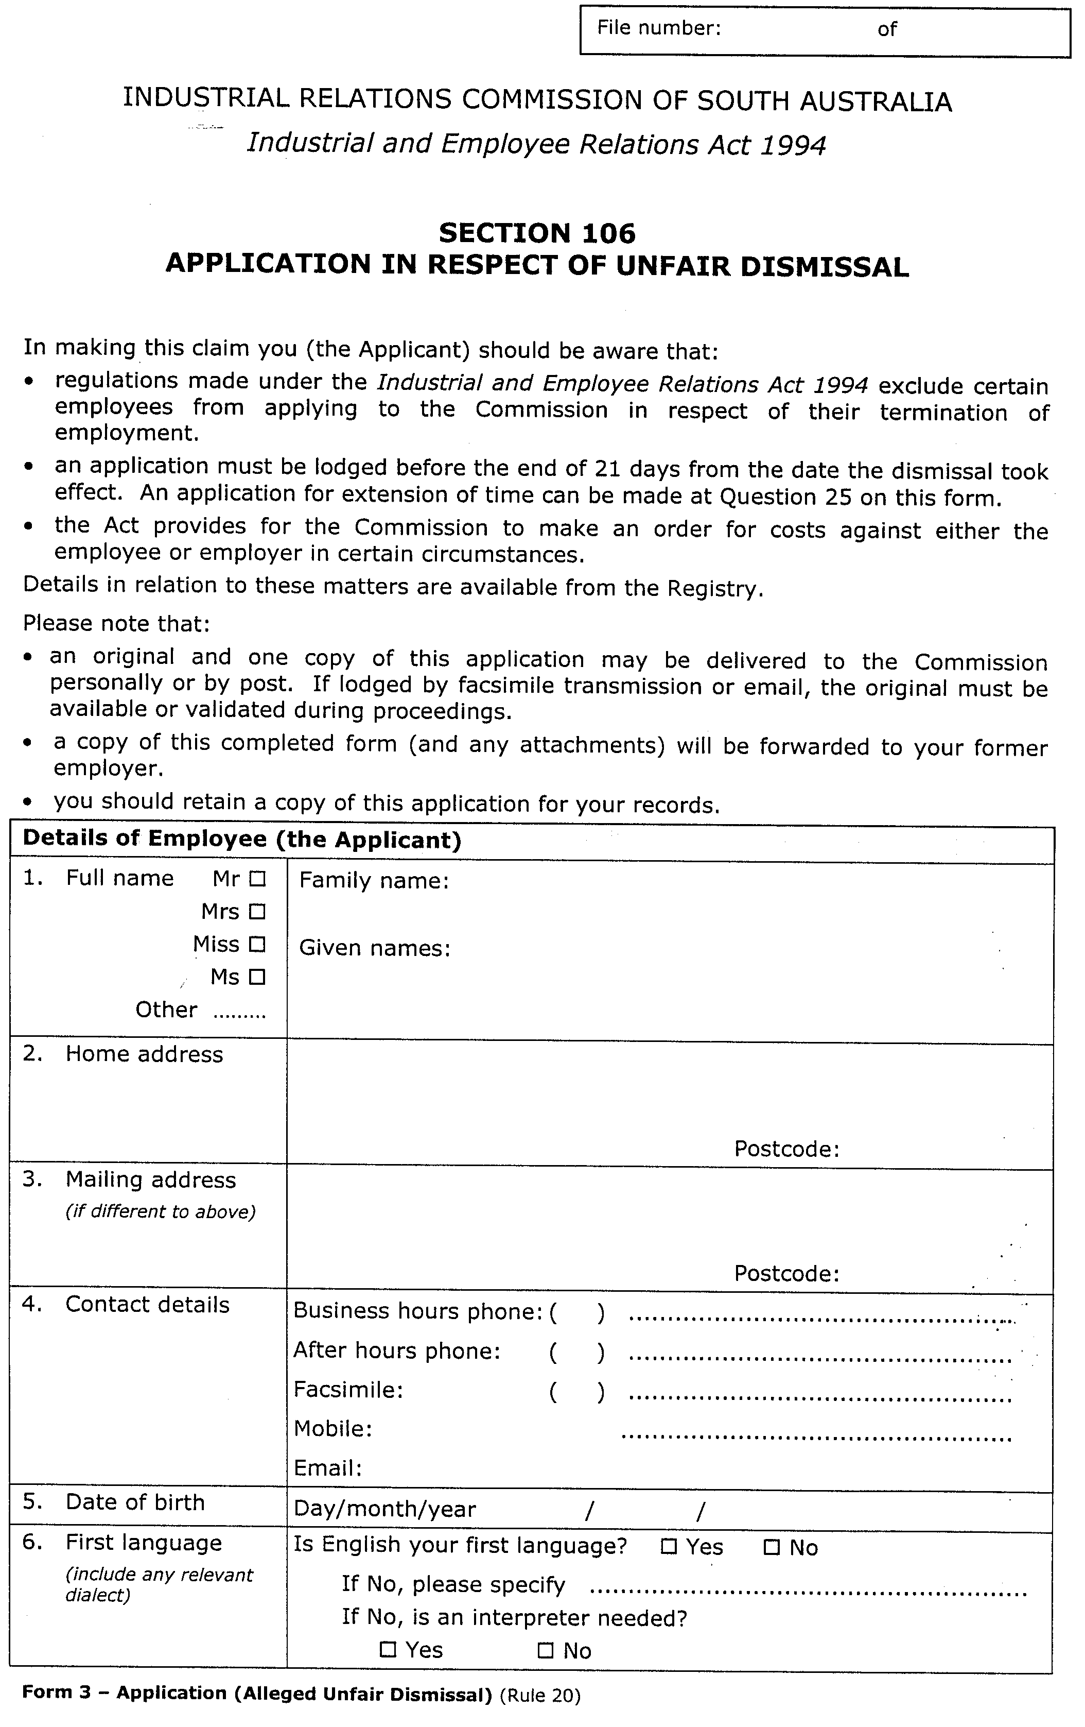
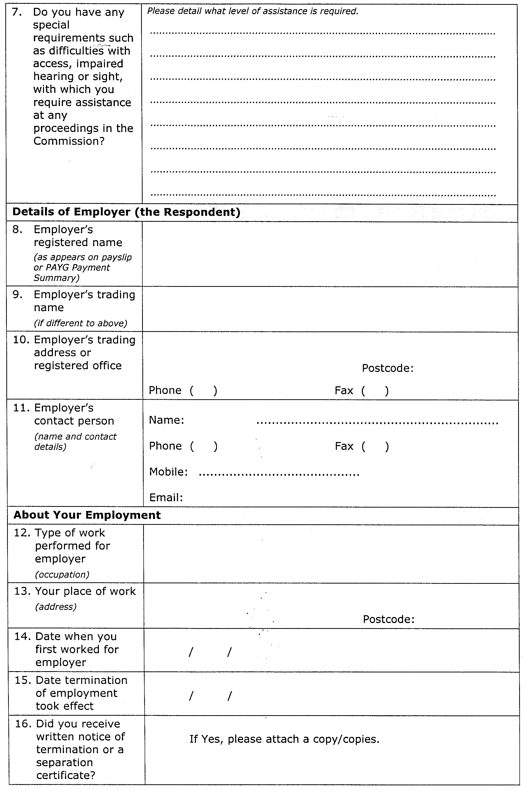

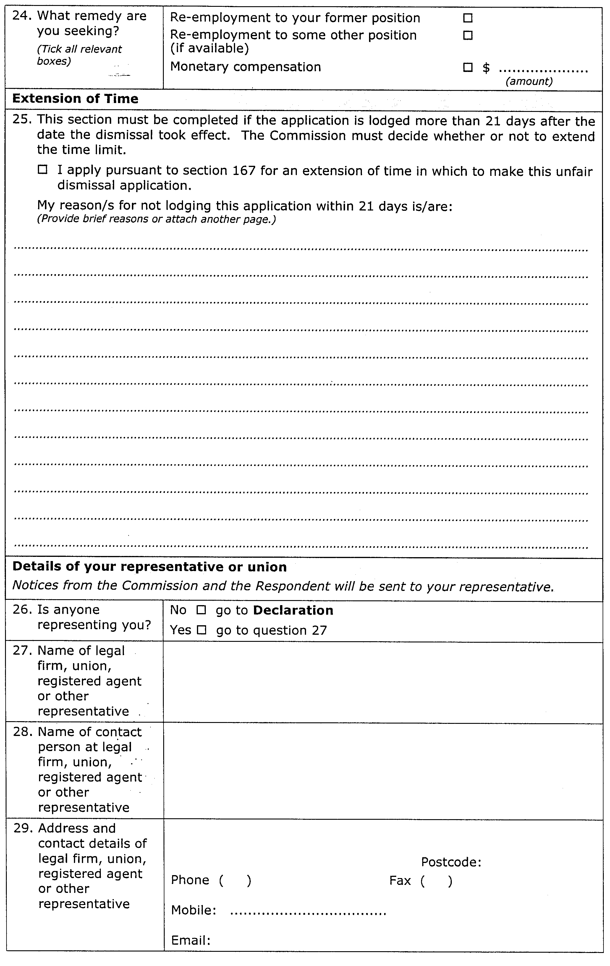
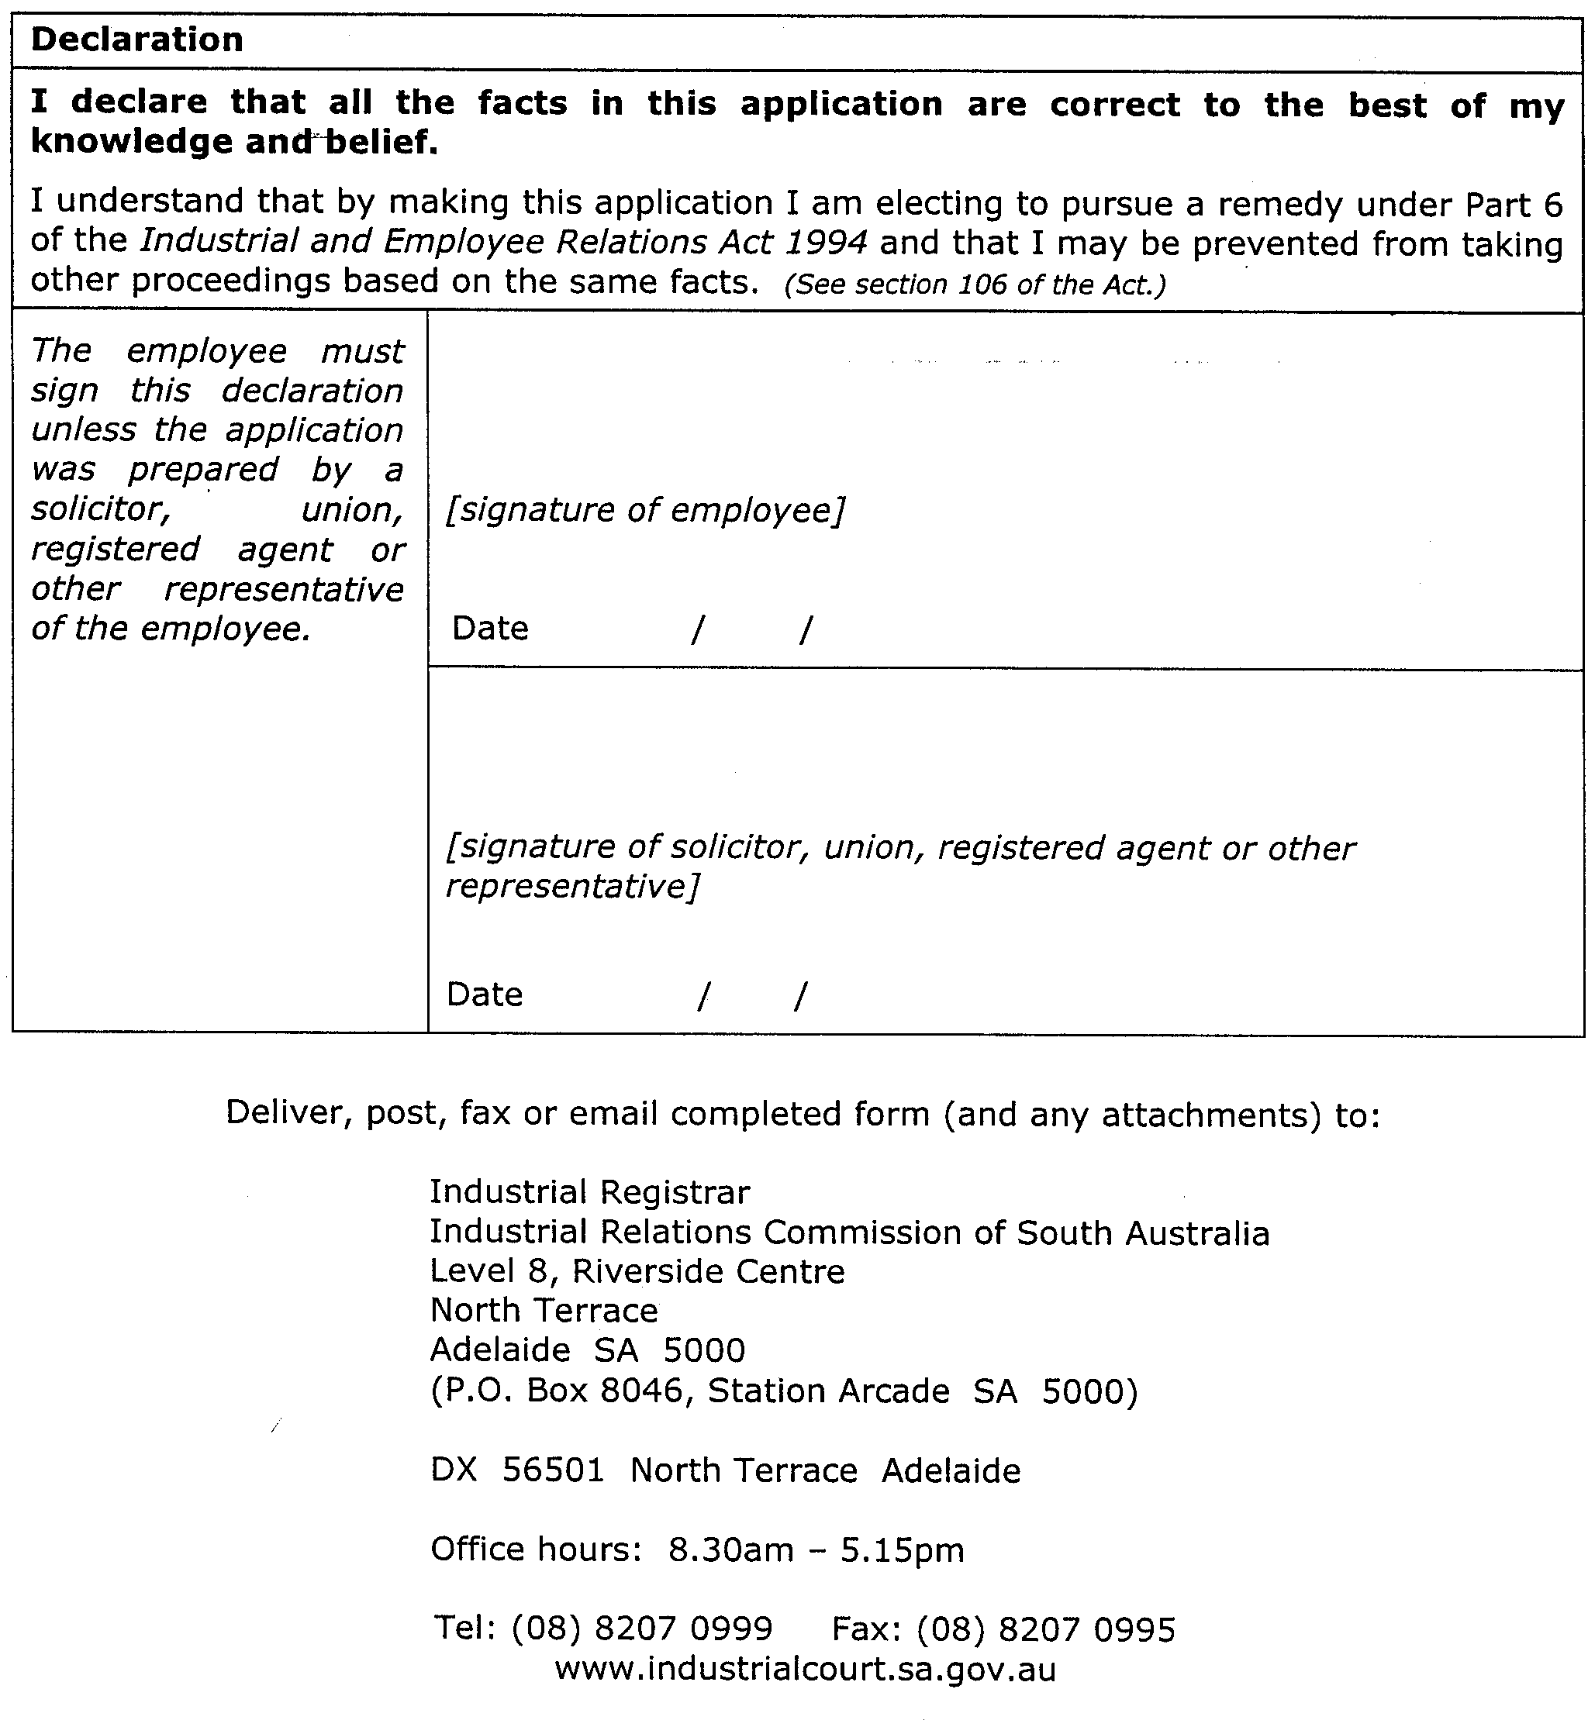
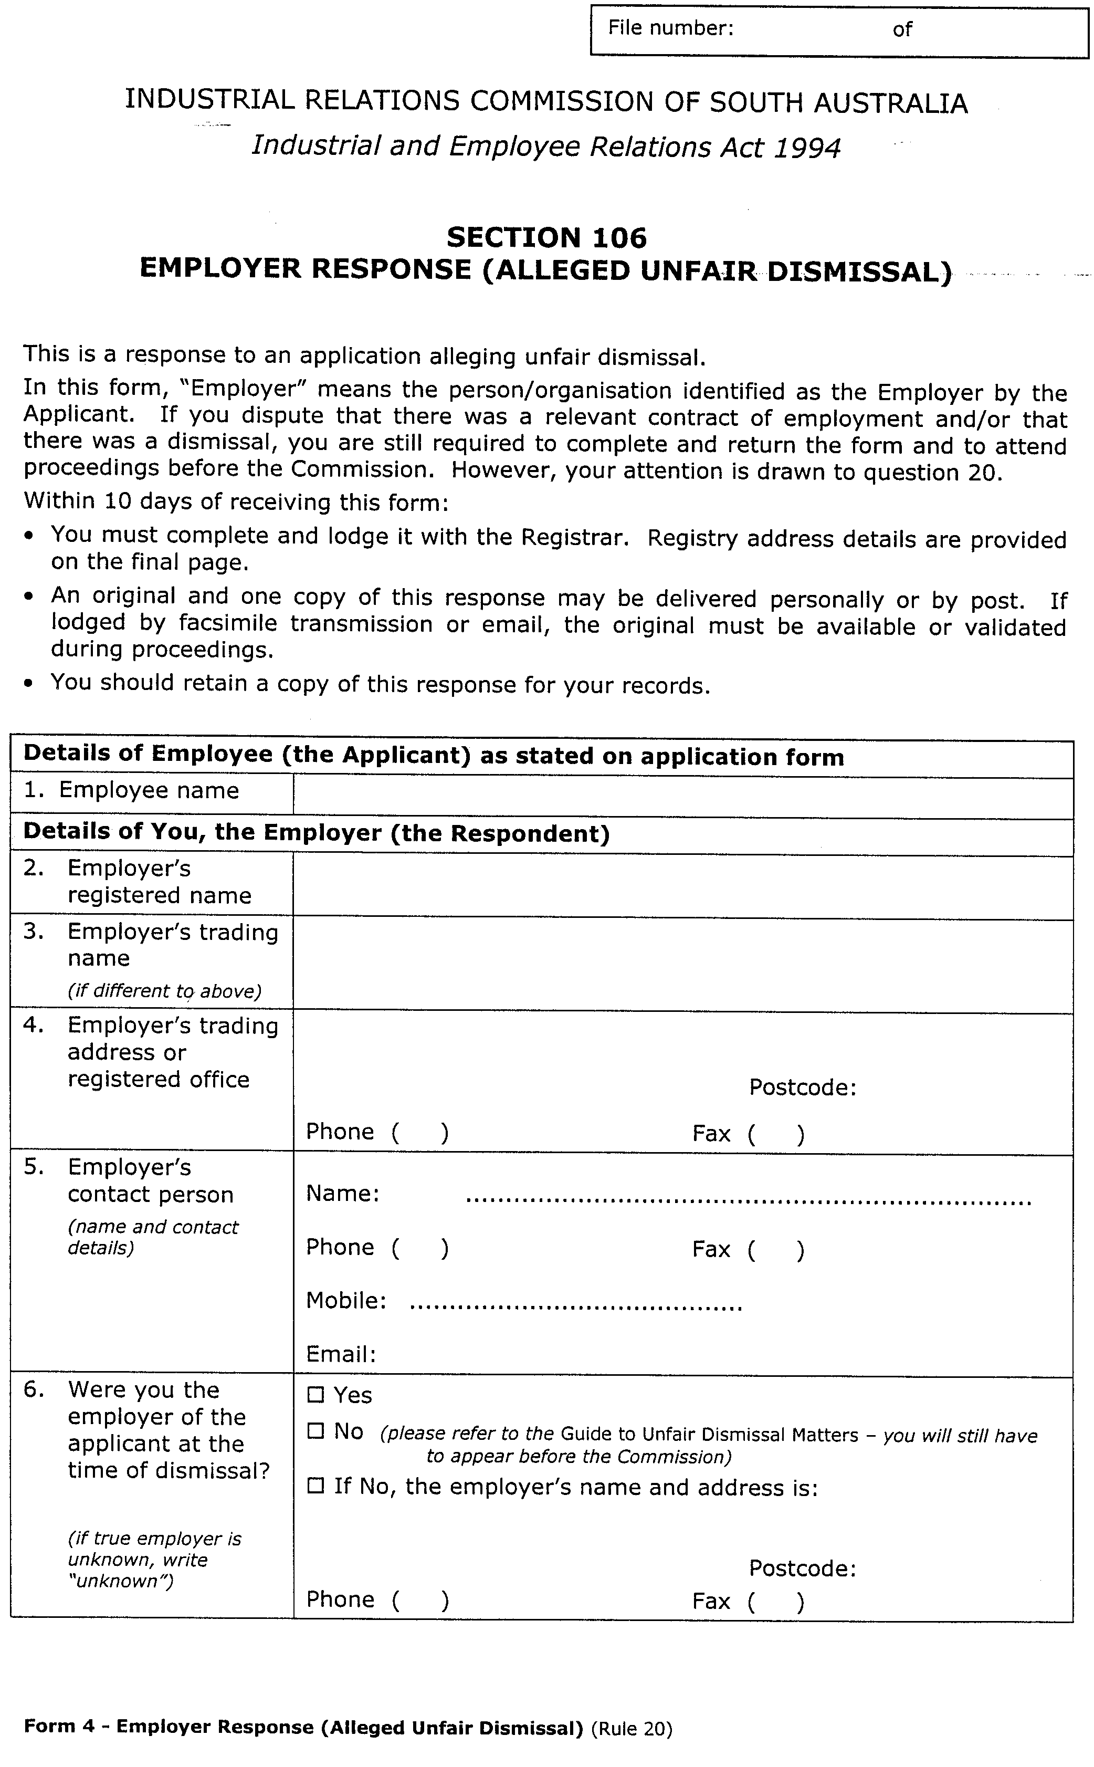
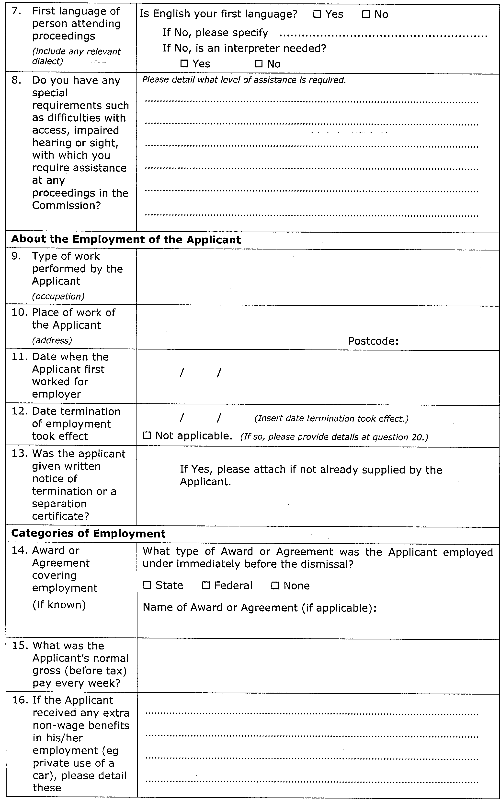
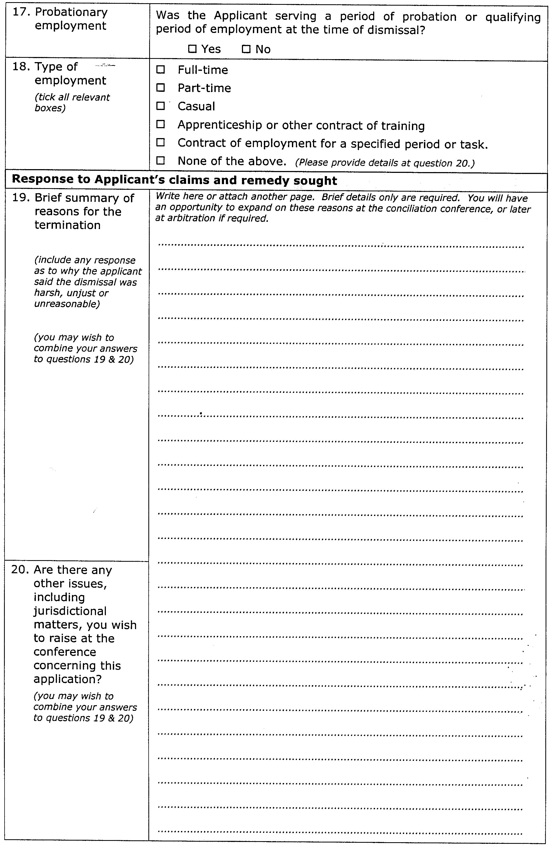
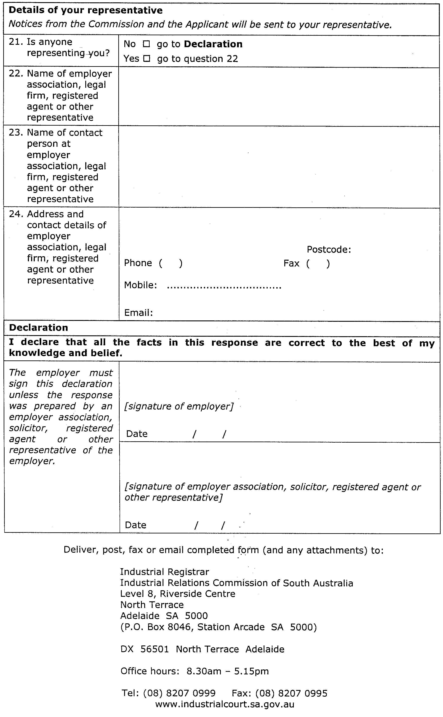
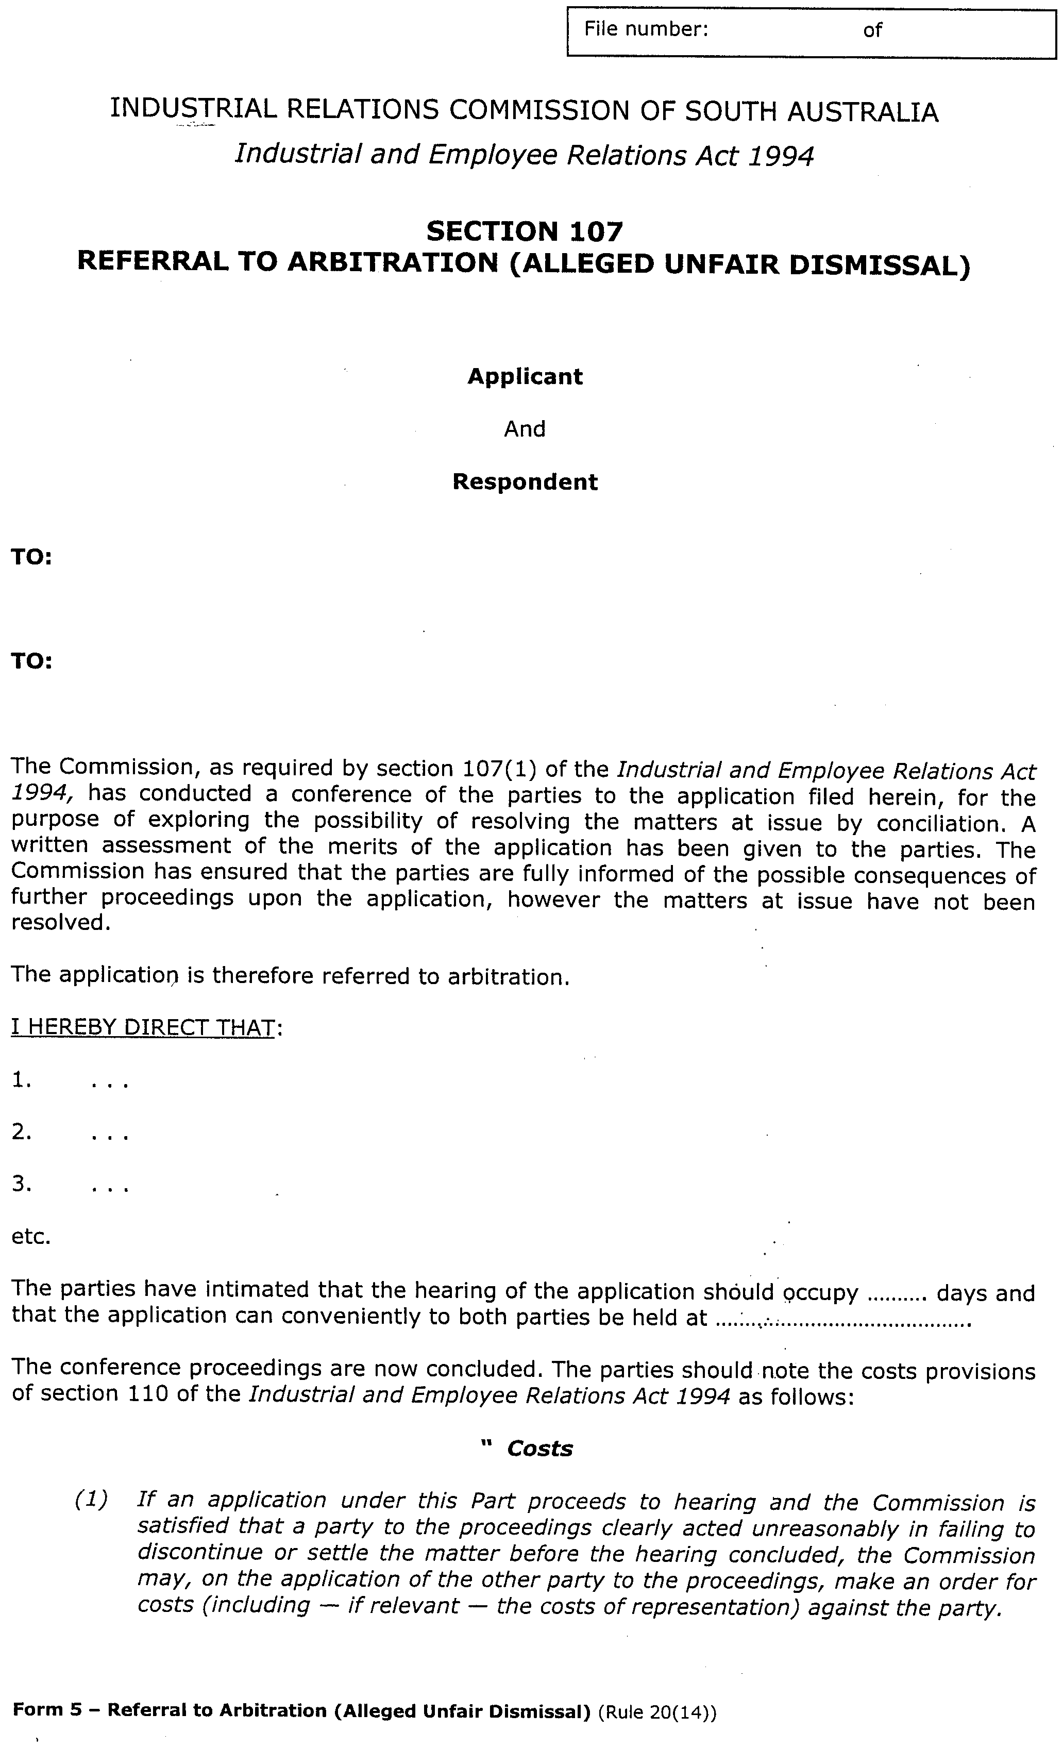
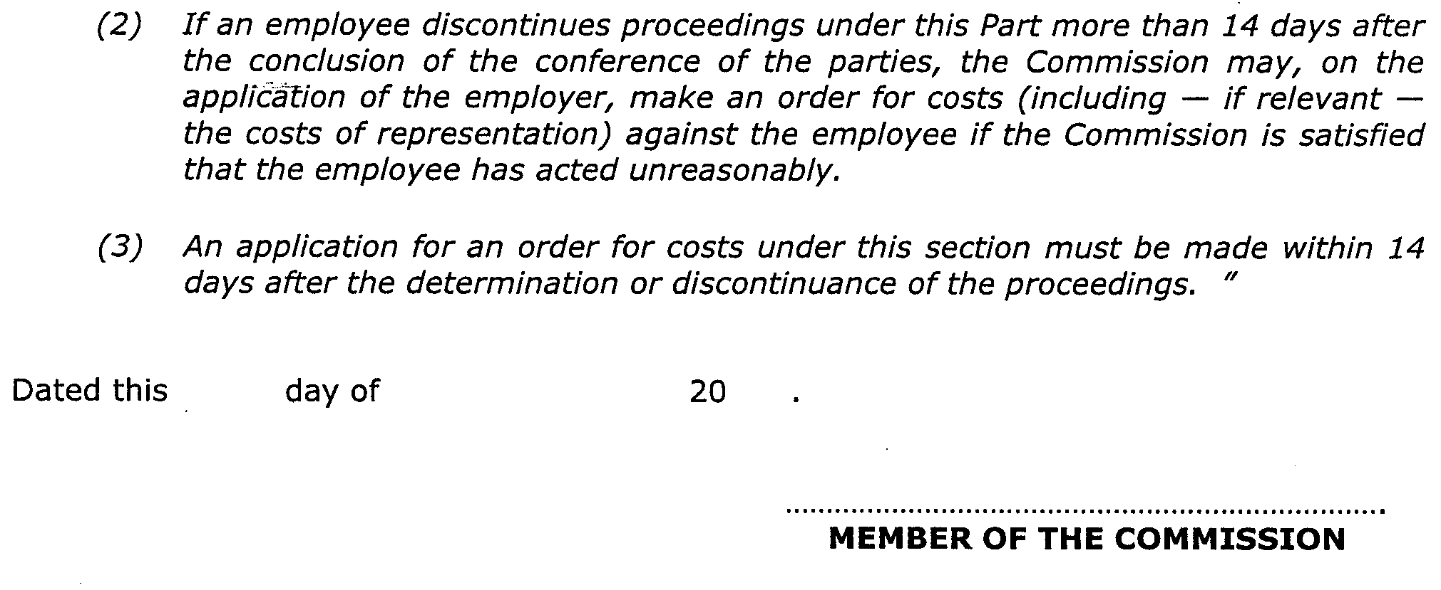

Christmas/New Year Holiday Publishing Information

Last Gazette for 2003 will be Thursday, 18 December 2003

Closing date for notices for publication will be
4 p.m. Tuesday, 16 December 2003

First Gazette for 2004 will be Thursday, 8 January 2004

Closing date for notices for publication will be
4 p.m. Tuesday, 6 January 2004

(There will NOT be a Gazette in the period between these two dates)

It would be appreciated if Government Gazette notices for publication be addressed to:

Government Publishing SA
Box 9
Plaza Level
Riverside Centre
North Terrace, Adelaide, S.A. 5000

AusDoc subscribers:

Government Publishing SA
DX 56508

Facsimile transmission of notices:
(08) 8207 1040
Attention: Government Gazette Section

Inquiries telephone: 8207 1045

Email address for Government Gazette notices:

governmentgazette@saugov.sa.gov.au

When sending a document via Email please confirm your transmission with a faxed copy, including the date the notice is to be published.

LAND AND BUSINESS (SALE AND CONVEYANCING) ACT 1994
Exemption
TAKE notice that, pursuant to section 23 (3) of the Land and Business (Sale and Conveyancing) Act 1994, I, Michael Atkinson, Minister for Consumer Affairs, do hereby exempt the persons named in Schedule 1 from the application of section 23 (2) of the Act in relation to the purchase of the land specified in Schedule 2.
Schedule 1
Marita Waldron and Graham Roper, employees/officers of Blue Gum Estates Pty Ltd.
Schedule 2
The whole of the land described in certificate of title register book volume 5191, folio 606 situated at 10 Old Orchard Close, Athelstone, S.A. 5076.
Dated 4 December 2003.
Signed for and on behalf of the Minister for Consumer Affairs by the Commissioner for Consumer Affairs:
M. Bodycoat, Commissioner

LAND AND BUSINESS (SALE AND CONVEYANCING) ACT 1994
Exemption
TAKE notice that, pursuant to section 32 of the Land and Business (Sale and Conveyancing) Act 1994, I, Michael Atkinson, Minister for Consumer Affairs, do hereby exempt the agent named in Schedule 1 from the application of section 23 (1) of the Act in relation to the purchase of the land specified in Schedule 2.
Schedule 1
P. M. Property Managers Pty Ltd.
Schedule 2
A portion of the land described in certificate of title register book volume 5893, folio 977 situated at Lot 16 Springbank Boulevard, Burton, S.A. 5110.
Dated 4 December 2003.
Signed for and on behalf of the Minister for Consumer Affairs by the Commissioner for Consumer Affairs:
M. Bodycoat, Commissioner

LAND AND BUSINESS (SALE AND CONVEYANCING) ACT 1994
Exemption
TAKE notice that, pursuant to section 23 (3) of the Land and Business (Sale and Conveyancing) Act 1994, I, Michael Atkinson, Minister for Consumer Affairs, do hereby exempt the person named in Schedule 1 from the application of section 23 (2) of the Act in relation to the purchase of the land specified in Schedule 2.
Schedule 1
Nicholas John Redden, an officer/employee of Jack Redden Real Estate Pty Ltd.
Schedule 2
The whole of the land described in certificate of title register book volume 5394, folio 849 situated at 3 Sydney Street, Spalding, S.A. 5454.
Dated 4 December 2003.
Signed for and on behalf of the Minister for Consumer Affairs by the Commissioner for Consumer Affairs:
M. Bodycoat, Commissioner

LAND AND BUSINESS (SALE AND CONVEYANCING) ACT 1994
Exemption
TAKE notice that, pursuant to section 23 (3) of the Land and Business (Sale and Conveyancing) Act 1994, I, Michael Atkinson, Minister for Consumer Affairs, do hereby exempt the person named in Schedule 1 from the application of section 23 (2) of the Act in relation to the purchase of the land specified in Schedule 2.
Schedule 1
Shirley Frances Morgan, an employee of Mazzeo Real Estate Pty Ltd.
Schedule 2
The whole of the land described in certificate of title register book volume 5383, folio 386 situated at 17 Donnington Road, Elizabeth North, S.A. 5113.
Dated 4 December 2003.
Signed for and on behalf of the Minister for Consumer Affairs by the Commissioner for Consumer Affairs:
M. Bodycoat, Commissioner

LAND AND BUSINESS (SALE AND CONVEYANCING) ACT 1994
Exemption
TAKE notice that, pursuant to section 23 (3) of the Land and Business (Sale and Conveyancing) Act 1994, I, Michael Atkinson, Minister for Consumer Affairs, do hereby exempt the persons named in Schedule 1 from the application of section 23 (2) of the Act in relation to the purchase of the land specified in Schedule 2.
Schedule 1
Andrew William Teagle and Jane Marie Teagle, employees of Rosthand Pty Ltd.
Schedule 2
The whole of the land described in certificate of title register book volume 5082, folio 68 situated at 48 High Street, Kapunda, S.A. 5373.
Dated 4 December 2003.
Signed for and on behalf of the Minister for Consumer Affairs by the Commissioner for Consumer Affairs:
M. Bodycoat, Commissioner

LAND AND BUSINESS (SALE AND CONVEYANCING) ACT 1994
Exemption
TAKE notice that, pursuant to section 23 (3) of the Land and Business (Sale and Conveyancing) Act 1994, I, Michael John Atkinson, Minister for Consumer Affairs, do hereby exempt the person named in Schedule 1 from the application of section 23 (2) of the Act in relation to the purchase of the land specified in Schedule 2.
Schedule 1
Alistair Shields, an employee of K. P. Walter Estates Pty Ltd.
Schedule 2
The whole of the land described in certificate of title register book volume 5142, folio 351, situated at 32B Haig Street, Netherby, S.A. 5062.
Dated 4 December 2003.
Signed for and on behalf of the Minister for Consumer Affairs by the Commissioner for Consumer Affairs:
M. Bodycoat, Commissioner

LAND AND BUSINESS (SALE AND CONVEYANCING) ACT 1994
Exemption
TAKE notice that, pursuant to section 23 (3) of the Land and Business (Sale and Conveyancing) Act 1994, I, Michael Atkinson, Minister for Consumer Affairs, do hereby exempt the person named in Schedule 1 from the application of section 23 (2) of the Act in relation to the purchase of the land specified in Schedule 2.
Schedule 1
Robert Benjamin Heaslip, an employee of Elders Ltd.
Schedule 2
The whole of the land described in certificate of title register book volume 5423, folio 279 situated at 259 Port Elliot Road, Hayborough, S.A. 5211.
Dated 4 December 2003.
Signed for and on behalf of the Minister for Consumer Affairs by the Commissioner for Consumer Affairs:
M. Bodycoat, Commissioner

LAND AND BUSINESS (SALE AND CONVEYANCING) ACT 1994
Exemption
TAKE notice that, pursuant to section 23 (3) of the Land and Business (Sale and Conveyancing) Act 1994, I, Michael Atkinson, Minister for Consumer Affairs, do hereby exempt the person named in Schedule 1 from the application of section 23 (2) of the Act in relation to the purchase of the land specified in Schedule 2.
Schedule 1
Richard Douglas Osborne, an employee of Delfin Realty Pty Ltd.
Schedule 2
Portion of the land described in certificate of title register book volume 5898, folio 298 situated at Lots 179 and 180 Macquarie Street, Mawson Lakes, S.A. 5095.
Dated 4 December 2003.
Signed for and on behalf of the Minister for Consumer Affairs by the Commissioner for Consumer Affairs:
M. Bodycoat, Commissioner

LIQUOR LICENSING ACT 1997
Notice of Application
NOTICE is hereby given, pursuant to section 52 (2) (b) of the Liquor Licensing Act 1997, that K & B’s Nominees Pty Ltd, c/o David Watts and Associates has applied to the Licensing Authority for the transfer of an Entertainment Venue Licence in respect of premises situated at 257 Seaview Road, Henley Beach, S.A. 5022 and known as Zootz.
The application has been set down for hearing on 22 December 2003 at 11.30 a.m.
Any person may object to the application by lodging a notice of objection in the prescribed form with the Licensing Authority, and serving a copy of the notice on the applicant at the applicant’s address given above, at least three days before the hearing date.
Plans in respect of the premises the subject of the application are open to public inspection without fee at the Office of the Liquor and Gaming Commissioner, 9th Floor, East Wing, 50 Grenfell Street, Adelaide, S.A. 5000.
Dated 26 November 2003.
Applicant

LIQUOR LICENSING ACT 1997
Notice of Application
NOTICE is hereby given, pursuant to section 52 (2) (b) of the Liquor Licensing Act 1997, that Eden Springs Enterprises Pty Ltd, has applied to the Licensing Authority for a Direct Sales Licence in respect of premises situated at Boehm Springs Road, Springton, S.A. 5235 and known as Eden Springs.
The application has been set down for hearing on 2 January 2004 at 9 a.m.
Any person may object to the application by lodging a notice of objection in the prescribed form with the Licensing Authority, and serving a copy of the notice on the applicant at the applicant’s address given above, at least seven days before the hearing date.
Plans in respect of the premises the subject of the application are open to public inspection without fee at the Office of the Liquor and Gaming Commissioner, 9th Floor, East Wing, 50 Grenfell Street, Adelaide, S.A. 5000.
Dated 25 November 2003.
Applicant

LIQUOR LICENSING ACT 1997
Notice of Application
NOTICE is hereby given, pursuant to section 52 (2) (b) of the Liquor Licensing Act 1997, that Norma Nominees (S.A.) Pty Ltd, has applied to the Licensing Authority for an extension to the Trading Area in respect of premises situated at Greenhill Road, Uraidla, S.A. 5142 and known as Uraidla Hotel.
The application has been set down for hearing on 2 January 2004 at 9 a.m.
Any person may object to the application by lodging a notice of objection in the prescribed form with the Licensing Authority, and serving a copy of the notice on the applicant at the applicant’s address given above, at least seven days before the hearing date.
Plans in respect of the premises the subject of the application are open to public inspection without fee at the Office of the Liquor and Gaming Commissioner, 9th Floor, East Wing, 50 Grenfell Street, Adelaide, S.A. 5000.
Dated 26 November 2003.
Applicant

LIQUOR LICENSING ACT 1997
Notice of Application
NOTICE is hereby given, pursuant to section 52 (2) (b) of the Liquor Licensing Act 1997, that Oodnadatta Pty Ltd has applied to the Licensing Authority for a Residential Licence in respect of premises situated at Ikaturka Terrace, Oodnadatta, S.A. 5734 and known as Pink Roadhouse.
The application has been set down for hearing on 2 January 2004 at 9 a.m.
Conditions
The following licence conditions are sought:
Authority for the licensee to sell liquor on any day except Good Friday and Christmas Day for consumption on the licensed premises by persons seated at a table, or attending a function at which food is provided.
Any person may object to the application by lodging a notice of objection in the prescribed form with the Licensing Authority, and serving a copy of the notice on the applicant at the applicant’s address given above, at least seven days before the hearing date.
Plans in respect of the premises the subject of the application are open to public inspection without fee at the Office of the Liquor and Gaming Commissioner, 9th Floor, East Wing, 50 Grenfell Street, Adelaide, S.A. 5000.
Dated 26 November 2003.
Applicant

LIQUOR LICENSING ACT 1997
Notice of Application
NOTICE is hereby given, pursuant to section 52 (2) (b) of the Liquor Licensing Act 1997, that Stentiford Pty Ltd and Presco Services Pty Ltd have applied to the Licensing Authority for the removal of a Producer’s Licence in respect of premises situated at the corner of Naracoorte/Apsley Road and Bells Road, Naracoorte, S.A. 5271 to be situated at 17 Badenoch Road, Carey Gully, S.A. 5144 and known as Kopparossa Wines.
The application has been set down for hearing on 2 January 2004 at 9 a.m.
Any person may object to the application by lodging a notice of objection in the prescribed form with the Licensing Authority, and serving a copy of the notice on the applicants at the applicants’ address given above, at least four days before the hearing date.
Plans in respect of the premises the subject of the application are open to public inspection without fee at the Office of the Liquor and Gaming Commissioner, 9th Floor, East Wing, 50 Grenfell Street, Adelaide, S.A. 5000.
Dated 27 November 2003.
Applicants

LIQUOR LICENSING ACT 1997
Notice of Application
NOTICE is hereby given, pursuant to section 52 (2) (b) of the Liquor Licensing Act 1997, that Frobisher Pty Ltd, c/o Wall-mans Lawyers, 173 Wakefield Street, Adelaide, S.A. 5000 has applied to the Licensing Authority for a variation to conditions, variation to the current Extended Trading Authorisation, and variation to the current Entertainment Consent in respect of premises situated at 163 Melbourne Street, North Adelaide, S.A. 5006 and known as The Lion Hotel.
The application has been set down for hearing on 9 January 2004 at 9 a.m.
Conditions
The following licence conditions are sought:
1. Variation to Extended Trading Authorisation and the conditions of licence to permit trading:
1.1 in the whole of the premises excluding the adjacent area until 2 a.m. on the mornings following Friday and Saturday nights;
1.2 in the whole of the premises including the adjacent area until midnight on Sunday;
1.3 in the whole of the premises including the adjacent area trading until 2 a.m. on the morning following Christmas Eve.
2. Entertainment consent and conditions of licence to be varied to permit entertainment in the whole of the premises until 11 p.m. on Sunday.
Any person may object to the application by lodging a notice of objection in the prescribed form with the Licensing Authority, and serving a copy of the notice on the applicant at the applicant’s address given above, at least seven days before the hearing date.
Plans in respect of the premises the subject of the application are open to public inspection without fee at the Office of the Liquor and Gaming Commissioner, 9th Floor, East Wing, 50 Grenfell Street, Adelaide, S.A. 5000.
Dated 1 December 2003.
Applicant

LIQUOR LICENSING ACT 1997
Notice of Application
NOTICE is hereby given, pursuant to section 52 (2) (b) of the Liquor Licensing Act 1997, that Helen Rose Campain, c/o Fisher Jeffries has applied to the Licensing Authority for the transfer of a Hotel and Gaming Machine Licence, Extended Trading Authorisation and Entertainment Consent in respect of premises situated at Fourth Street, Alford, S.A. 5554 and known as Alford Hotel.
The application has been set down for hearing on 2 January 2004 at 9 a.m.
Conditions
The following licence conditions are sought:
Extended Trading Authorisation for the following hours:
Thursday, Friday, Saturday and any other day preceding a Public Holiday—midnight to 2 a.m. the following day.
Sunday—8 a.m. to 11 a.m. and 8 p.m. to midnight.
Christmas Day—midnight to 2 a.m. the following day.
That liquor may be sold for consumption off the licensed premises on Sundays between 8 a.m. to 11 a.m. and 8 p.m. and 9 p.m.
Entertainment consent is sought for the whole of the licensed premises and to apply during the abovementioned extended trading hours.
Any person may object to the application by lodging a notice of objection in the prescribed form with the Licensing Authority, and serving a copy of the notice on the applicant at the applicant’s address given above, at least seven days before the hearing date.
Plans in respect of the premises the subject of the application are open to public inspection without fee at the Office of the Liquor and Gaming Commissioner, 9th Floor, East Wing, 50 Grenfell Street, Adelaide, S.A. 5000.
Dated 28 November 2003.
Applicant

LIQUOR LICENSING ACT 1997
Notice of Application
NOTICE is hereby given, pursuant to section 52 (2) (b) of the Liquor Licensing Act 1997, that B. J. Baker Pty Ltd, as Trustee for the B. J. Baker Trust, c/o Westley DiGiorgio Lawyers has applied to the Licensing Authority for the transfer of a Restaurant Licence in respect of premises situated at Naracoorte Caves Conservation Park, Joanna via Naracoorte, S.A. 5271 and known as Bent Wing Cafe.
The application has been set down for hearing on 5 January 2004 at 10.30 a.m.
Any person may object to the application by lodging a notice of objection in the prescribed form with the Licensing Authority, and serving a copy of the notice on the applicant at the applicant’s address given above, at least seven days before the hearing date.
Plans in respect of the premises the subject of the application are open to public inspection without fee at the Office of the Liquor and Gaming Commissioner, 9th Floor, East Wing, 50 Grenfell Street, Adelaide, S.A. 5000.
Dated 28 November 2003.
Applicant

LIQUOR LICENSING ACT 1997
Notice of Application
NOTICE is hereby given, pursuant to section 52 (2) (b) of the Liquor Licensing Act 1997, that Zerella Wines Pty Ltd acting for the Zerella Wines Trust, c/o Edgley Lawyers has applied to the Licensing Authority for a Producer’s Licence in respect of premises situated at Lot 261, Main South Road, Tatachilla, S.A. 5171 and known as Zerella Wines.

The application has been set down for hearing on 2 January 2004 at 9 a.m.
Any person may object to the application by lodging a notice of objection in the prescribed form with the Licensing Authority, and serving a copy of the notice on the applicant at the applicant’s address given above, at least seven days before the hearing date.
Plans in respect of the premises the subject of the application are open to public inspection without fee at the Office of the Liquor and Gaming Commissioner, 9th Floor, East Wing, 50 Grenfell Street, Adelaide, S.A. 5000.
Dated 27 November 2003.
Applicant

LIQUOR LICENSING ACT 1997
Notice of Application
NOTICE is hereby given, pursuant to section 52 (2) (b) of the Liquor Licensing Act 1997, that Hope Valley Bowling Club Inc. has applied to the Licensing Authority for an Extension of the Trading Area and a variation to the current Extended Trading Authorisation in respect of premises situated at 1255 Grand Junction Road, Hope Valley, S.A. 5090 and known as Hope Valley Bowling Club.
The application has been set down for hearing on 2 January 2004 at 9 a.m.
Conditions
The following licence conditions are sought:
• Extension of Trading Area to include the Outdoor Area as per plans lodged for the following hours:
Monday to Saturday—9 a.m. to 10 p.m.
Sunday—9 a.m. to 9 p.m.
• Variation to the current Extended Trading Authorisation to include the abovementioned area.
Any person may object to the application by lodging a notice of objection in the prescribed form with the Licensing Authority, and serving a copy of the notice on the applicant at the applicant’s address given above, at least seven days before the hearing date.
Plans in respect of the premises the subject of the application are open to public inspection without fee at the Office of the Liquor and Gaming Commissioner, 9th Floor, East Wing, 50 Grenfell Street, Adelaide, S.A. 5000.
Dated 26 November 2003.
Applicant

PASSENGER TRANSPORT ACT 1994
Appointments
PURSUANT to section 57 of the Passenger Transport Act 1994, the following persons have been authorised by the Passenger Transport Board to act as Prescribed Officers:
Mark McNicol
Ken Tilbrook
Robert Langford
Dean Dawson
David Greig
Damien Lewis
Jim Hannah
John Thomas
Geoffrey Smith
Dino Brazzalotto
Shaun Watts
Michael Bransden
Garry Davis
H. Webster, Executive Director, Passenger Transport Board

REAL PROPERTY ACT NOTICE
WHEREAS the persons named at the foot hereof have each respectively for himself made application to have the land set forth and described before his name at the foot hereof brought under the operation of the Real Property Act: Notice is hereby given that unless caveat be lodged with the Registrar-General by some person having estate or interest in the said lands on or before the expiration of the period herein below for each case specified, the said several pieces of land will be brought under the operation of the said Act as by law directed. Diagrams delineating these parcels of land may be inspected at the Lands Titles Registration Office, Adelaide, and in the offices of the several corporations or district councils in which the lands are situated.

The Schedule
No. of  Applica-  tion | Description of Property |  | Name |  | Residence | Date up to and  inclusive of which  caveat may be  lodged

30939 | Portions of section 377, Hundred of Yatala, more particularly delineated as Allotment 50 in Filed Plan No. 218638 |  | TransAdelaide |  | Adelaide, S.A. 5000 | 5 February 2004
30940 | Portions of sections 374, 375, 376 and 2066, Hundred of Yatala, more particularly delineated as piece 80 and portion of piece 81 in Filed Plan No. 41179 |  | TransAdelaide |  | Adelaide, S.A. 5000 | 5 February 2004

Dated 4 December 2003, at the Lands Titles Registration Office, Adelaide. J. Zaccaria, Deputy Registrar-General

DETERMINATION OF THE REMUNERATION TRIBUNAL
No. 7 of 2003
Auditor-General, Electoral Commissioner, Deputy Electoral Commissioner, Employee Ombudsman and Ombudsman
1. Scope of Determination
This Determination applies to the separate offices of Auditor-General, Electoral Commissioner, Deputy Electoral Com-missioner, Employee Ombudsman and Ombudsman.
2. Salary
2.1 Auditor-General
The salary of the office of Auditor-General shall be $217 000 per annum from 1 July 2003.
2.2 Electoral Commissioner
The salary of the office of Electoral Commissioner shall be $126 000 per annum from 1 July 2003.
2.3 Deputy Electoral Commissioner
The salary of the office of Deputy Electoral Commis-sioner shall be $92 000 per annum from 1 July 2003, except when acting as Electoral Commissioner for a continuous period of more than one week in which case the Deputy Electoral Commissioner will be paid for the acting period at the rate of the salary for the Electoral Commissioner.
In addition, the Tribunal has determined a separate one-off payment of $10 200 be paid to the Deputy Electoral Commissioner for the work he performed as Research Officer to the Electoral Districts Boundaries Commission during the period February 2001 to March 2003.
2.4 Employee Ombudsman
The salary of the office of Employee Ombudsman shall be $94 000 per annum from 1 July 2003.
2.5 Ombudsman
The salary of the office of Ombudsman shall be $161 000 per annum from 1 July 2003.
3. Telephone Rental and Calls Allowance
When a person to whom this Determination applies is required to have a telephone at home for official purposes, that person shall be paid the whole of the telephone rental for a single point connection without extra services and one third of the cost of metered local calls. Reimbursement should be made for international, STD and mobile official calls on the basis of actual costs incurred.
4. Travelling and Accommodation Allowances
Allowances to be paid will be in accordance with the Tribunal’s most recent Determination on these allowances as amended from time to time.
5. Conveyance Allowances
Allowances to be paid will be in accordance with the Tribunal’s most recent Determination on these allowances as amended from time to time.
6. Date of Operation
The salaries prescribed in Clause 2 are operative from 1 July 2003 and supersede those of all previous Determinations covering persons whose office is listed herein.
Dated 28 November 2003.
H. R. Bachmann, President
D. Flux, Member
J. Meeking, Member

REMUNERATION TRIBUNAL
Report Relating to Determination No. 7 of 2003
1. Introduction
1.1 In accordance with the provisions of the Remuneration Act 1990, the Remuneration Tribunal by letters dated
17 September 2003 invited the Auditor-General, Electoral Commissioner, Deputy Electoral Commissioner, Employee Ombudsman and the Ombudsman to make submissions in relation to the remuneration of those respective office holders. The Tribunal also invited the Premier to make submissions in the public interest.
1.2 On 22 September 2003 the following was published in The Advertiser newspaper:
REMUNERATION TRIBUNAL
Review of Salaries for Statutory Office Holders
Section 8 (2) of the Remuneration Act 1990, requires the Tribunal to sit at least once in each year to review its previous determinations. Accordingly, the Tribunal is conducting a review of the deter-mination incorporating the salaries payable to the following statutory office holders:
• Auditor-General;
• Electoral Commissioner;
• Deputy Electoral Commissioner;
• Employee Ombudsman; and
• Ombudsman
Interested persons, organisations and associations are invited to submit in writing any views they consider should be taken into account in the above review.
The closing date is 3 October 2003 and submissions should be forwarded to:
The Secretary
Remuneration Tribunal
G.P.O. Box 1072
Adelaide, S.A. 5001
or alternatively submissions can be forwarded via the Tribunal’s website: www.remtribunal.sa.gov.au.
Telephone: (08) 8226 4013
Facsimile: (08) 8226 4174
1.3 The Tribunal received written submissions from the Auditor-General and Employee Ombudsman and a joint written submission from the Electoral Commissioner and Deputy Electoral Commissioner. The Ombudsman, Electoral Commissioner and Deputy Electoral Commis-sioner made oral submissions to the Tribunal on 23 October 2003. In the oral submission from the Electoral Commissioner and Deputy Commissioner it was firmly stated that any increases should apply from 1 July 2003. In addition, the Government made written and oral submissions in relation to all of the positions being considered.
1.4 The Tribunal did not receive any written submissions from the public.
2. Auditor-General
2.1 The remuneration of the Auditor-General was last determined in Determination No. 8 of 2002 and the salary is currently $208 300 per annum operative from 1 October 2002.
2.2 The Auditor-General’s submission to the Tribunal requested ‘that the remuneration of the Office of Auditor-General be maintained in accordance with the salary movements that have taken place for Chief Executives in the South Australian public service this year’.
2.3 The Government submitted, ‘a salary increase should be granted to Statutory Officer Holders (being the Auditor-General, Electoral Commissioner, Deputy Electoral Com-missioner, Employee Ombudsman and Ombudsman) that is consistent with the broad background of movements in Public Sector Executive remuneration in 2003 in particular, and in the public sector generally’.
2.4 In previous submissions the government has submitted that ‘given the nature and status of the Statutory Offices, it is in the public interest that the salaries for these officers keep pace with, but do not significantly exceed, increases applicable to other public sector positions of similar status’.
2.5 The Tribunal was advised that an increase of 3.5% on Public Sector Executive’s Total Employment Cost packages was effective from 1 July 2003 and that the salaries for senior public sector employees, covered by the SA Wages Parity Agreement 2001, were increased by 4% from 1 October 2003.
2.6 The government also submitted that the date of operation for any salary increase should remain at 1 October 2003 to preserve the notion of a 12 month period between the operative date for each annual salary review, as is the case for other public sector employment groups. It further submitted that if the operative date was moved back it could have the effect of providing a higher annual per-centage outcome. The submission did not address the fact that the executive remuneration in the public sector, which is the basis for increases in this determination operated from 1 July 2003.
2.7 Having regard to all submissions, the Tribunal determines that the salary for the Office of Auditor-General will be $217 000 per annum. Telephone rental and calls allowance for this Office will remain unaffected by this Determination.
3. Electoral Commissioner
3.1 The remuneration of the Electoral Commissioner was last determined in Determination No. 8 of 2002 and the salary is currently $120 400 per annum operative from 1 October 2002.
3.2 The joint submission from the Electoral Commissioner and Deputy Electoral Commissioner submitted that ‘we should receive the same increases as paid to public service executives in an increase that reflects that those executives are paid from an earlier start date and have added flexibility in terms of total employment contracts’. It was also submitted that ‘yearly salary increases paid to public sector executives are paid on total employment costs including motor vehicle costs and public sector executives are paid increases from 1 July each year’ and ‘therefore, if the Tribunal only passes on a 3.5% increase to the Electoral Commissioner and Deputy Electoral Commis-sioner they would be disadvantaged in real terms com-pared to public sector executives’.
At the hearing, the Electoral Commissioner indicated that historically there had been a relativity between his position and other senior public sector level C executives and requested that the Tribunal take the salaries of the positions of Liquor and Gaming Commissioner, the Equal Opportunity Commissioner and the Public Trustee into consideration. Total employment packages of the holders of those positions range from $158 379 to $175 898.
3.3 The Tribunal was advised of the roles and responsibilities of the Electoral Commissioner, with the support of the Deputy Electoral Commissioner, and in particular, those undertaken in the last year. These included the following:
• ongoing management of one of the most complex electoral programs in Australia;
• the development and/or management of all software required to support all elections conducted by the Office;
• the provision of the Statistical Returns and Election Reports for the February 2002 elections and a complete refreshment of the Office’s website to include all details of those elections;
• certification of 41 Local Government Elector Represen-tation Reviews; conduct of 18 supplementary Local Government elections; and
• proceedings for the Electoral Districts Boundaries Commission (EDBC).
(The Electoral Commissioner is a member of the EDBC and the Deputy Electoral Commissioner performed the role of Research Officer for the EDBC.)
3.4 The Government submissions for the remuneration for the position of Electoral Commissioner mirrored those made in respect to the Auditor-General. However, additional comparative information was also provided in relation to the salary of the Liquor and Gaming Commissioner and the impact of salary increases to an executive on a total remuneration package value contract of employment when compared to an increase to the salary of a Statutory Office holder.
3.5 The Tribunal has considered all submissions and has determined that the salary for the Office of Electoral Commissioner will be $126 000 per annum. Telephone rental and calls allowance for this Office will remain unaffected by this Determination.
4. Deputy Electoral Commissioner
4.1 The remuneration of the Deputy Electoral Commissioner was last determined in Determination No. 8 of 2002 and the salary is currently $87 800 per annum, operative from 1 October 2002.
As previously stated, the submissions presented for the Electoral Commissioner and the Deputy Electoral Commissioner were as a joint submission and therefore their submissions, as detailed at clauses 3.2 and 3.3 are reiterated.
4.2 The Electoral Commissioner also made submissions on behalf of the Deputy Electoral Commissioner in relation to compensation for the work he performed as Research Officer with the Electoral District Boundaries Commission (EDBC).
4.3 The Government submissions for the remuneration for the position of Deputy Electoral Commissioner mirrored those made in respect to the Auditor-General with additional submissions made in relation to the work performed for the EDBC.
4.4 In March 2003, the Tribunal received a request from the Chairman of the EDBC, the Honourable Justice Prior, to make a determination for the Deputy Electoral Commis-sioner for work undertaken as Research Officer to the Commission during the period February 2001 to March 2003. However, having considered the matter at that time, the Tribunal determined (Determination No. 3 of 2003) it more appropriate to address this matter as part of the annual review process.
4.5 The Tribunal has considered all of the submissions received in relation to the Deputy Electoral Commis-sioner’s salary and having regard to these, has determined that the salary for the Office of Deputy Electoral Commissioner will be $92 000 per annum.
4.6 Having regard to the submissions and request from the Chairman, EDBC, Honourable Justice Prior, the tribunal has determined that a separate one-off payment of $10 200 be paid to the Deputy Electoral Commissioner for work performed as Research Officer to the EDBC during the period February 2001 to March 2003. Telephone rental and calls allowance for this Office will remain unaffected by this Determination.
5. Employee Ombudsman
5.1 The remuneration of the Employee Ombudsman was last determined in Determination No. 8 of 2002 and the salary is currently $89 500 per annum, operative from 1 October 2002.
5.2 Whilst no oral submission was received from the Employee Ombudsman, his written submission requested, ‘that the salary of the Employee Ombudsman be adjusted by way of an increase of 4%’. He submitted this per-centage on the basis of a salary increase of 4% from
1 October 2003 within the public sector generally and the recently approved increases to public service executive salaries.
5.3 The Government submission in relation to the position of Employee Ombudsman mirrored that made in respect to the Auditor-General.
5.4 The Tribunal has considered the submissions made and has determined that the salary for this Office will be $94 000 per annum. Telephone rental and calls allowance for this Office will remain unaffected by this Deter-mination.
6. Ombudsman
6.1 The remuneration of the Ombudsman was last determined in Determination No. 8 of 2002 and the salary is currently $154 500 per annum, operative from 1 October 2002.
6.2 The Ombudsman’s oral submission to the Tribunal requested that a salary increase and date of operation for the Office of the Ombudsman be considered that would be no less than that approved for Chief Executives within other agencies of the South Australian Public Sector. He informed the Tribunal of the work that his Office had undertaken in the preceding 12 months and presented a copy of the last annual report. He submitted that the workload had increased by an average of 13% and that the complexities of the Office continued to vary.
6.3 The Government submission in relation to the position of Ombudsman mirrored that made in respect to the Auditor-General.
6.4 Having regard to the submissions made the Tribunal has determined that the salary for this office will be $161 000 per annum. Telephone rental and calls allowance for this Office will remain unaffected by this Determination.
7. Date of Operation
The Tribunal has had regard to the submissions made in regards to the date of operation for salary increases to Statutory Officers and has determined that it is more appropriate to align this date to the date of operation for salary increases paid to senior public sector executives, therefore allowing the increases to keep pace better with other public sector positions of similar status.
It has therefore determined that the salary increases provided for in this Determination will operate from 1 July 2003.
Dated 28 November 2003.
H. R. Bachmann, President

ROADS (OPENING AND CLOSING) ACT 1991:
SECTION 24
NOTICE OF CONFIRMATION OF ROAD
PROCESS ORDER
Helps Road, Burton
Deposited Plan 63042
BY Road Process Order made on 25 February 2003, The Development Assessment Commission ordered that:
1. Portions of the public road (Helps Road) extending southerly from the Waterloo Corner Road to the south-east corner of allotment 2 in Deposited Plan 13902, more particularly delineated and lettered ‘B’ and portions of the land being ‘A’ in Preliminary Plan No. 02/0001 be closed.
2. Issue a Certificate of Title to the City of Salisbury over the whole of the land subject to closure, which land is being retained by Council for Public Purposes.
On 18 September 2003, that order was confirmed by the Minister for Administrative Services conditionally on approval and deposit of the survey plan by the Registrar-General. The condition has now been fulfilled.
Pursuant to section 24 (5) of the Roads (Opening and Closing) Act 1991, NOTICE of the order referred to above and its confirmation is hereby given.
Dated 4 December 2003.
P. M. Kentish, Surveyor-General

ROADS (OPENING AND CLOSING) ACT 1991:
SECTION 24
NOTICE OF CONFIRMATION OF ROAD
PROCESS ORDER
Walkway—Walditch/Wimborne Streets, Elizabeth Downs
Deposited Plan 63396
BY Road Process Order made on 22 September 2003, the City of Playford ordered that:
1. The whole of the walkway between Walditch Street and Wimborne Street adjoining allotments 112 and 102 in Deposited Plan 9517 more particularly lettered ‘A’ and ‘B’ (respectively) in Preliminary Plan No. 03/0076 be closed.
2. The whole of the land subject to closure lettered ‘A’ be transferred to Malcolm Chad Vass in accordance with agreement for transfer dated 22 August 2003, entered into between the City of Playford and M. C. Vass.
3. The whole of the land subject to closure lettered ‘B’ be transferred to Paul Anthony Coombe and Kim Joanne Coombe in accordance with agreement for transfer dated 11 September 2003, entered into between the City of Playford and P. A. and K. J. Coombe.
4. The following easements are granted over the land subject to that closure:
Grant to the Distribution Lessor Corporation an easement for underground electricity supply purposes over the whole of the land.
Grant to the South Australian Water Corporation an ease-ment for sewerage purposes over portion of the land.
On 4 November 2003, that order was confirmed by the Minister for Administrative Services conditionally on approval and deposit of the survey plan by the Registrar-General. The condition has now been fulfilled.
Pursuant to section 24 (5) of the Roads (Opening and Closing) Act 1991, NOTICE of the order referred to above and its confirmation is hereby given.
Dated 4 December 2003.
P. M. Kentish, Surveyor-General

ROAD TRAFFIC ACT 1961
Higher Mass Limits for Vehicles fitted with Road Friendly Suspensions
Information Note
This Notice is a supplement to the Higher Mass Limits Notice of 20 November 2003 and adds additional routes to the network that can be used by Approved Vehicles operating at Higher Mass Limits.
In accordance with the exemption and approval provided by the Notice titled ‘Higher Mass Limits for Vehicles fitted with Road Friendly Suspensions’ published in the South Australian Government Gazette dated 20 November 2003, I hereby permit Approved Vehicles to travel on the routes shown in the attached map subject to the conditions specified in this Supplementary Notice.
1. Definitions
In this Notice:
1.1 ‘approved vehicles’ means vehicle configurations approved for travel to operate at Higher Mass Limits as detailed under clause 2, Table 1 of the Primary Notice.
1.2 ‘supplementary routes’ means routes specified in the map ‘Route Access for General Access Vehicles fitted with Road Friendly Suspension’, as included in this Supplementary Notice.
1.2 ‘Primary Notice’ means the Gazette Notice ‘Higher Mass Limits for Vehicles fitted with Road Friendly Suspensions’ dated 20 November 2003.
1.3 ‘Supplementary Notice’ means this Supplementary Notice; and
1.4 all other terms have the same meaning as in the Primary Notice.
2. Application of Supplementary Notice
This Supplementary Notice applies to Approved Vehicles when travelling on routes shown in the attached map and must be read in conjunction with the Primary Notice.
3. Routes available to approved vehicles
An Approved Vehicle may operate at Higher Mass Limits under the conditions of the Primary Notice on a supplementary route specified in the map ‘Route Access for General Access Vehicles fitted with Road Friendly Suspension’ included in this Supplementary Notice.
4. You must continue to comply with the Primary Notice
A driver of an Approved Vehicle operating at Higher Mass Limits on a route specified in this Supplementary Notice must comply with all conditions and requirements of the Primary Notice.
5. What you must carry
When travelling on a route shown in the attached map the driver must:
5.1 carry a legible copy of this Supplementary Notice;
5.2 carry a legible copy of the Primary Notice and other documentation required to be carried under the Primary Notice; and
5.3 produce both documents for inspection when requested by a duly appointed Transport SA Inspector or a Police Officer.
This Supplementary Notice is valid from 4 December 2003.
Executive Director, Transport SA

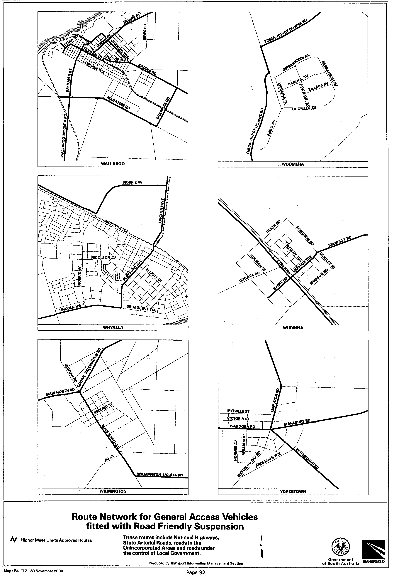

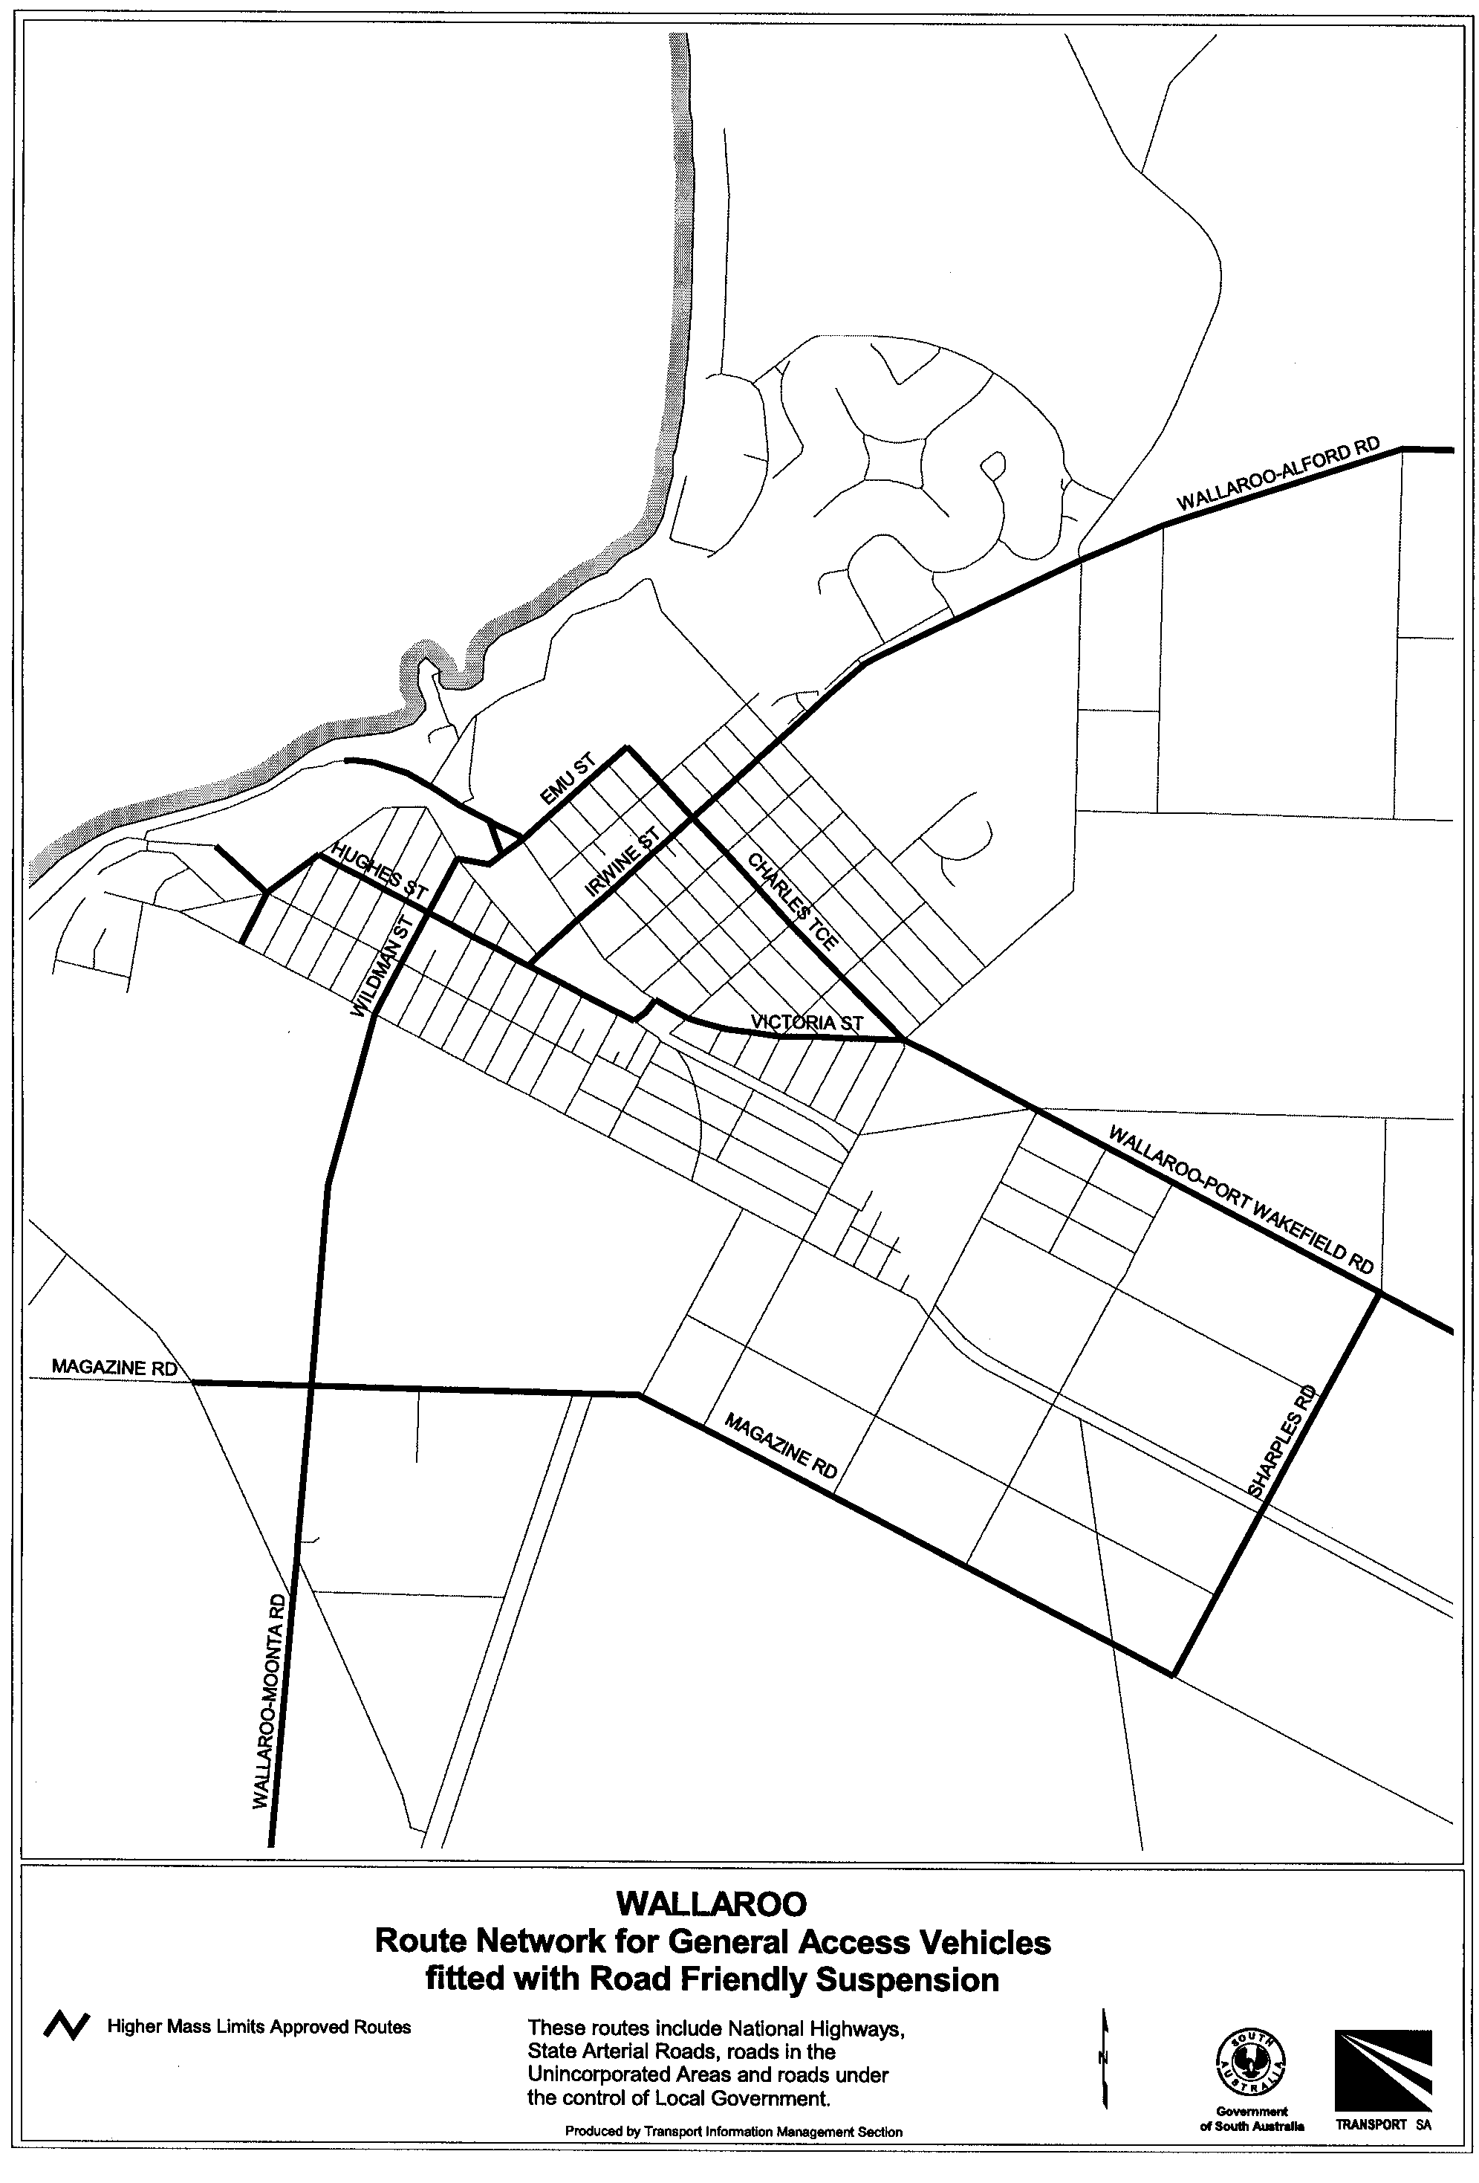

ROAD TRAFFIC ACT 1961

Operation of B-Double Vehicles up to 25 m in Length
Approval and Exemption
UNDER the provisions of Section 161A of the Road Traffic Act 1961 and Regulation 35 of the Road Traffic (Miscellaneous) Regulations 1999, I hereby approve B-Double Vehicles up to an overall length not exceeding 25 m, to operate on routes specified by this Notice and in accordance with the document titled Operation of Medium Combination Vehicles in South Australia, Edition No. 1 (clauses 1-6 and 8-10 only), issued by Transport SA, and

UNDER the provisions of Section 163AA of the Road Traffic Act 1961, I hereby exempt B-Doubles transporting baled wool from Rule 72 Height of the Road Traffic (Vehicle Standards) Rules 1999.

Conditions

Both the exemption and approval are subject to the following conditions:
1. Special Conditions
1.1 This Notice and the document titled ‘Operation of Medium Combination Vehicles in South Australia’, Edition 1 (clauses 1-6 and 8-10 only), issued by Transport SA or a legible copy of each shall be carried by the driver of the vehicle at all times when operating under this approval and exemption and be produced when requested by an Inspector appointed under the Road Traffic Act 1961 and/or Motor Vehicles Act 1959, or a Police Officer.
1.2 This Notice shall stand alone unless it is called up or referred to in any individual permit issued by Transport SA.
1.3 The vehicle is not under ‘Notice of Suspension to Operate as a Medium Combination Vehicle’ issued by the Minister for Transport.
1.4 When the B-Double is travelling along Main South Road between Cape Jervis and Delamere, the drive axle group of a tandem drive prime mover shall have a mass of not less than 14 tonnes when the B-Double is carrying a load of more than 10 tonnes.
1.5 After disembarking from the ferry at Cape Jervis, the B-Double must allow all other passenger vehicles disembarking from the ferry to proceed towards Myponga before the B-Double proceeds.

2. Definitions
For the purpose of this Notice the following definitions shall apply:
2.1 ‘B-Double’ means a combination consisting of a prime mover towing 2 semi-trailers where the first semi-trailer is connected to the prime mover by a fifth wheel coupling and the second semi-trailer is connected to the first semi-trailer by a fifth wheel coupling.
2.2 ‘Maintenance Management Scheme’ means a scheme that is recognised by Transport SA as meeting the requirement of the maintenance management module (including audit requirements) of the National Heavy Vehicle Accreditation Scheme (NHVAS).
2.3 ‘National Heavy Vehicle Accreditation Scheme’ (NHVAS) means the comprehensive accreditation package developed by the National Road Transport Commission and approved by the Australian Transport Council on 14 November 1997.
2.4 ‘valid National Heavy Vehicle Accreditation Scheme (Mass Module) label’ or a ‘valid TruckSafe label’ means a label:
(a) issued to a scheme member (whose accreditation status has not been suspended or cancelled); and
(b) that is legible and displayed on the nominated vehicle (owned or captured by the operator), for which the label was originally issued by the accrediting authority.

3. General Conditions
3.1 The vehicles defined herein are operated in accordance with the conditions specified in the document titled ‘Operation of Medium Combination Vehicles in South Australia’ Edition 1, (clauses 1-6, 8-10 only) issued by Transport SA and as amended by this Notice.
3.2 Where a B-Double is carrying dangerous goods on the Adelaide-Crafers Highway the vehicle combination shall be fitted with an approved anti-lock brake system in accordance with Transport SA’s specifications. Refer to Permit Information Bulletin titled ‘B-Double Anti-lock Brake Systems’.
3.3 The gross mass of the vehicle and/or combination does not exceed the gross vehicle and/or gross combination mass limits specified in the document titled ‘Operation of Medium Combination Vehicles in South Australia’, Edition 1 (clauses 1-6 and 8-10 only), issued by Transport SA.

4. Inspection and Maintenance Accreditation Requirements
4.1 All South Australian registered vehicle units (prime movers and semi-trailers) must be either:
(a) inspected and display a current inspection label as detailed in the document titled ‘Operation of Medium Combination Vehicles in South Australia’ Edition 1, issued by Transport SA; or
(b) accredited under a Maintenance Management Scheme and display a valid National Heavy Vehicle Accreditation Maintenance Module label or valid TruckSafe label.
4.2 Vehicles registered in New South Wales, Victoria, Queensland, Western Australia and Australian Capital Territory must comply with specified inspection and accreditation requirements of their home state or territory.
4.3 Vehicles registered in the Northern Territory must display either current South Australian inspection labels or current Northern Territory inspection and rating labels in accordance with the Mutual Recognition Agreement between South Australia and the Northern Territory, or be accredited under a Maintenance Management Scheme and display either a valid National Heavy Vehicle Accreditation Maintenance Module labels or valid TruckSafe labels.

5. Registration Categories
5.1 Vehicles operating under this Notice shall be registered in accordance with the Charge Codes shown in Table 1.
Table 1
Vehicle Configuration Charge Code

Two Axle Prime Mover hauling two semi-trailers  Three Axle Prime Mover hauling two semi-trailers | MP2  MP3
One Axle trailer  Two Axle trailer  Three Axle trailer | T1  T2  T3
Note: A charge code is displayed on the truck and prime mover registration certificate and registration label.

6. Transport of Baled Wool
6.1 Baled wool may be carried subject to the following conditions:
6.1.1 The baled wool shall not be loaded more than four layers high.
6.1.2 The maximum overall vehicle height including the baled wool shall not exceed 4.6 m.
6.1.3 The overall width of all axles or axle groups of the vehicle carrying the load, excluding the front axle or axle group, when measured between two vertical parallel planes located at the outer extremities of the tyres, shall not be less than 2.1 m.
6.1.4 Hauliers operating under provisions of this Notice should be aware that some bridges, signs, overhead wires, trees and signals may not provide sufficient clearance for the passage of a 4.6 m high vehicle.

Information Note

Persons operating under the provisions of this Notice are advised that some parts of the road system, bridges, signs, roadside furniture and vegetation may not provide sufficient clearance for the passage of a vehicle and load at the dimensions permitted by this notice.

Section 106 of the Road Traffic Act – Damage to roads and works, includes provisions concerning damage to roads, bridges and culverts, interference with roadside furniture and the obligations of persons causing such damage to notify the appropriate authority.

7. Routes
7.1 B-Double Vehicles up to 25 m in length, operating in accordance with this Notice, shall operate only on the approved routes and in accordance with the additional conditions specified in the maps ‘Route Network for B-Double Vehicles up to 25 m in Length’ as included in this Notice.
7.2 B-Doubles are not permitted to assemble or disassemble along the route, or otherwise deviate from the route unless allowed by this Notice or under an individually issued permit.
7.3 B-Doubles may only stop in parking bays showing a ‘Truck Parking Area’ sign for rest purposes or vehicle checks but not for assembly or disassembly purposes. The sign shall comply with Australian Standard AS 1742.6 service symbol sign S13. The signs display a white ‘P’ and symbolic articulated vehicle on a blue background.
7.4 Approval to operate B-Double Vehicles up to 25 metres in length in accordance with the route maps ‘Medium Combination Vehicles Route Network’ included in the document ‘Operation of Medium Combination Vehicles in South Australia’ Edition 1, issued by Transport SA, is revoked.

Commencement of this Notice
This Notice is valid from midnight 11 December 2003.
This exemption may be varied or revoked at any time by notice in writing.

Revocation of previous Notice
The Notice titled ‘Operation of B-Double Vehicles up to 25 m in Length’ that appeared in the South Australian Government Gazette dated 2 May 2002 is revoked at midnight on 11 December 2003.

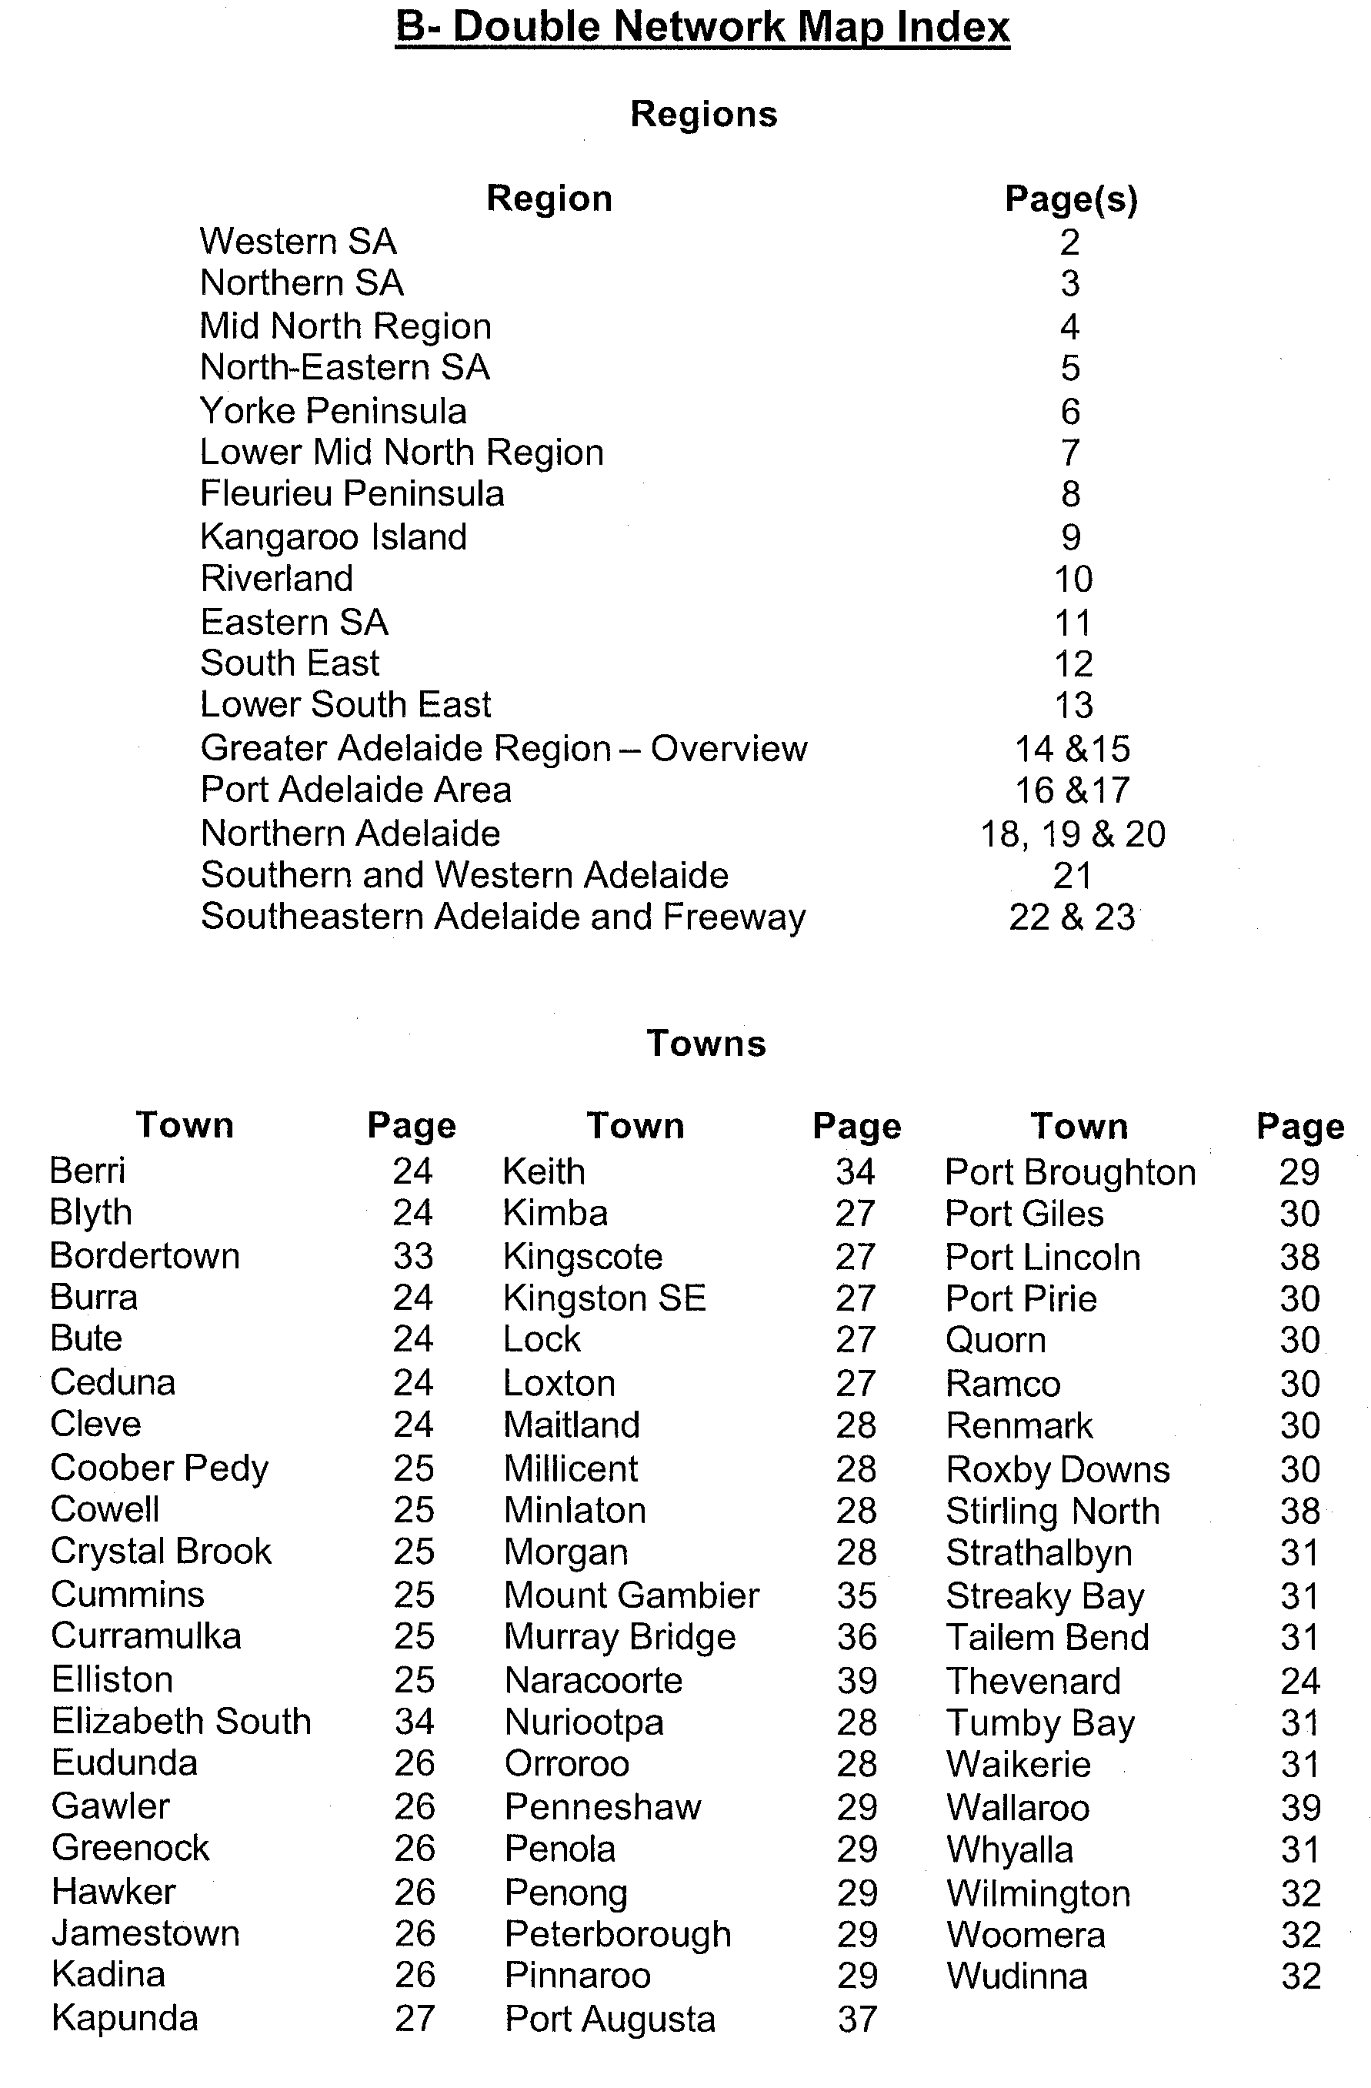
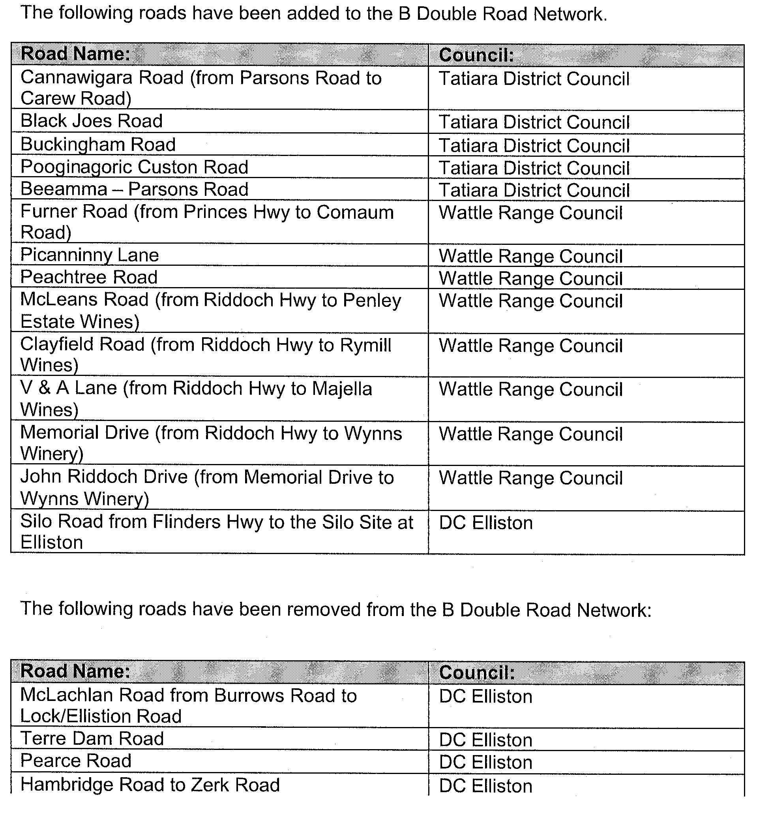
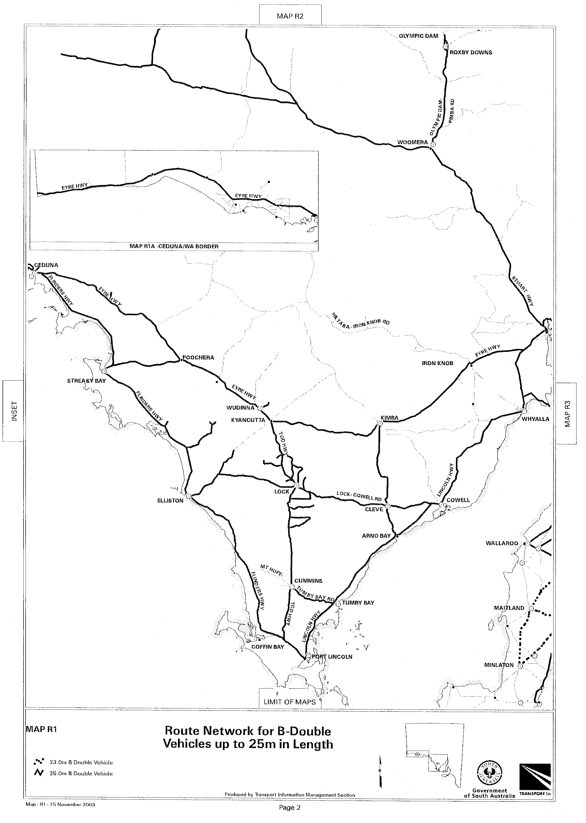
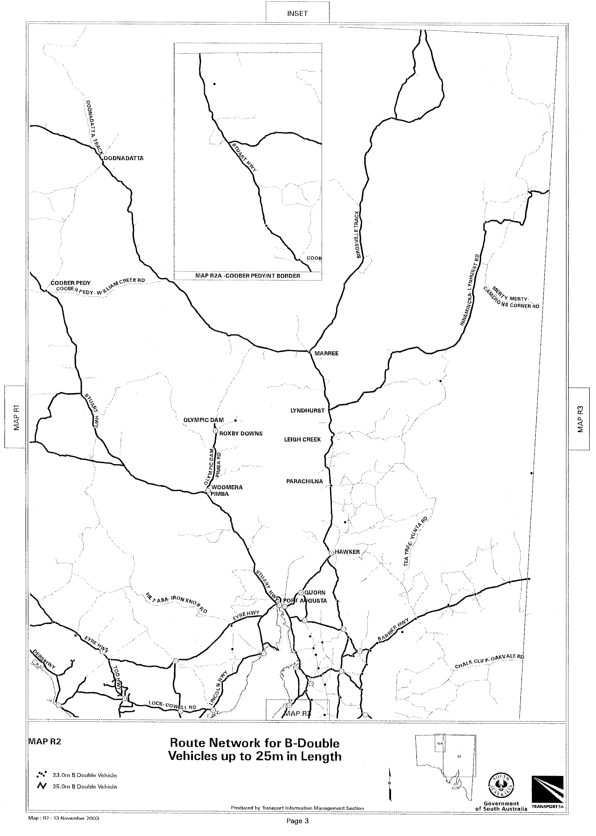
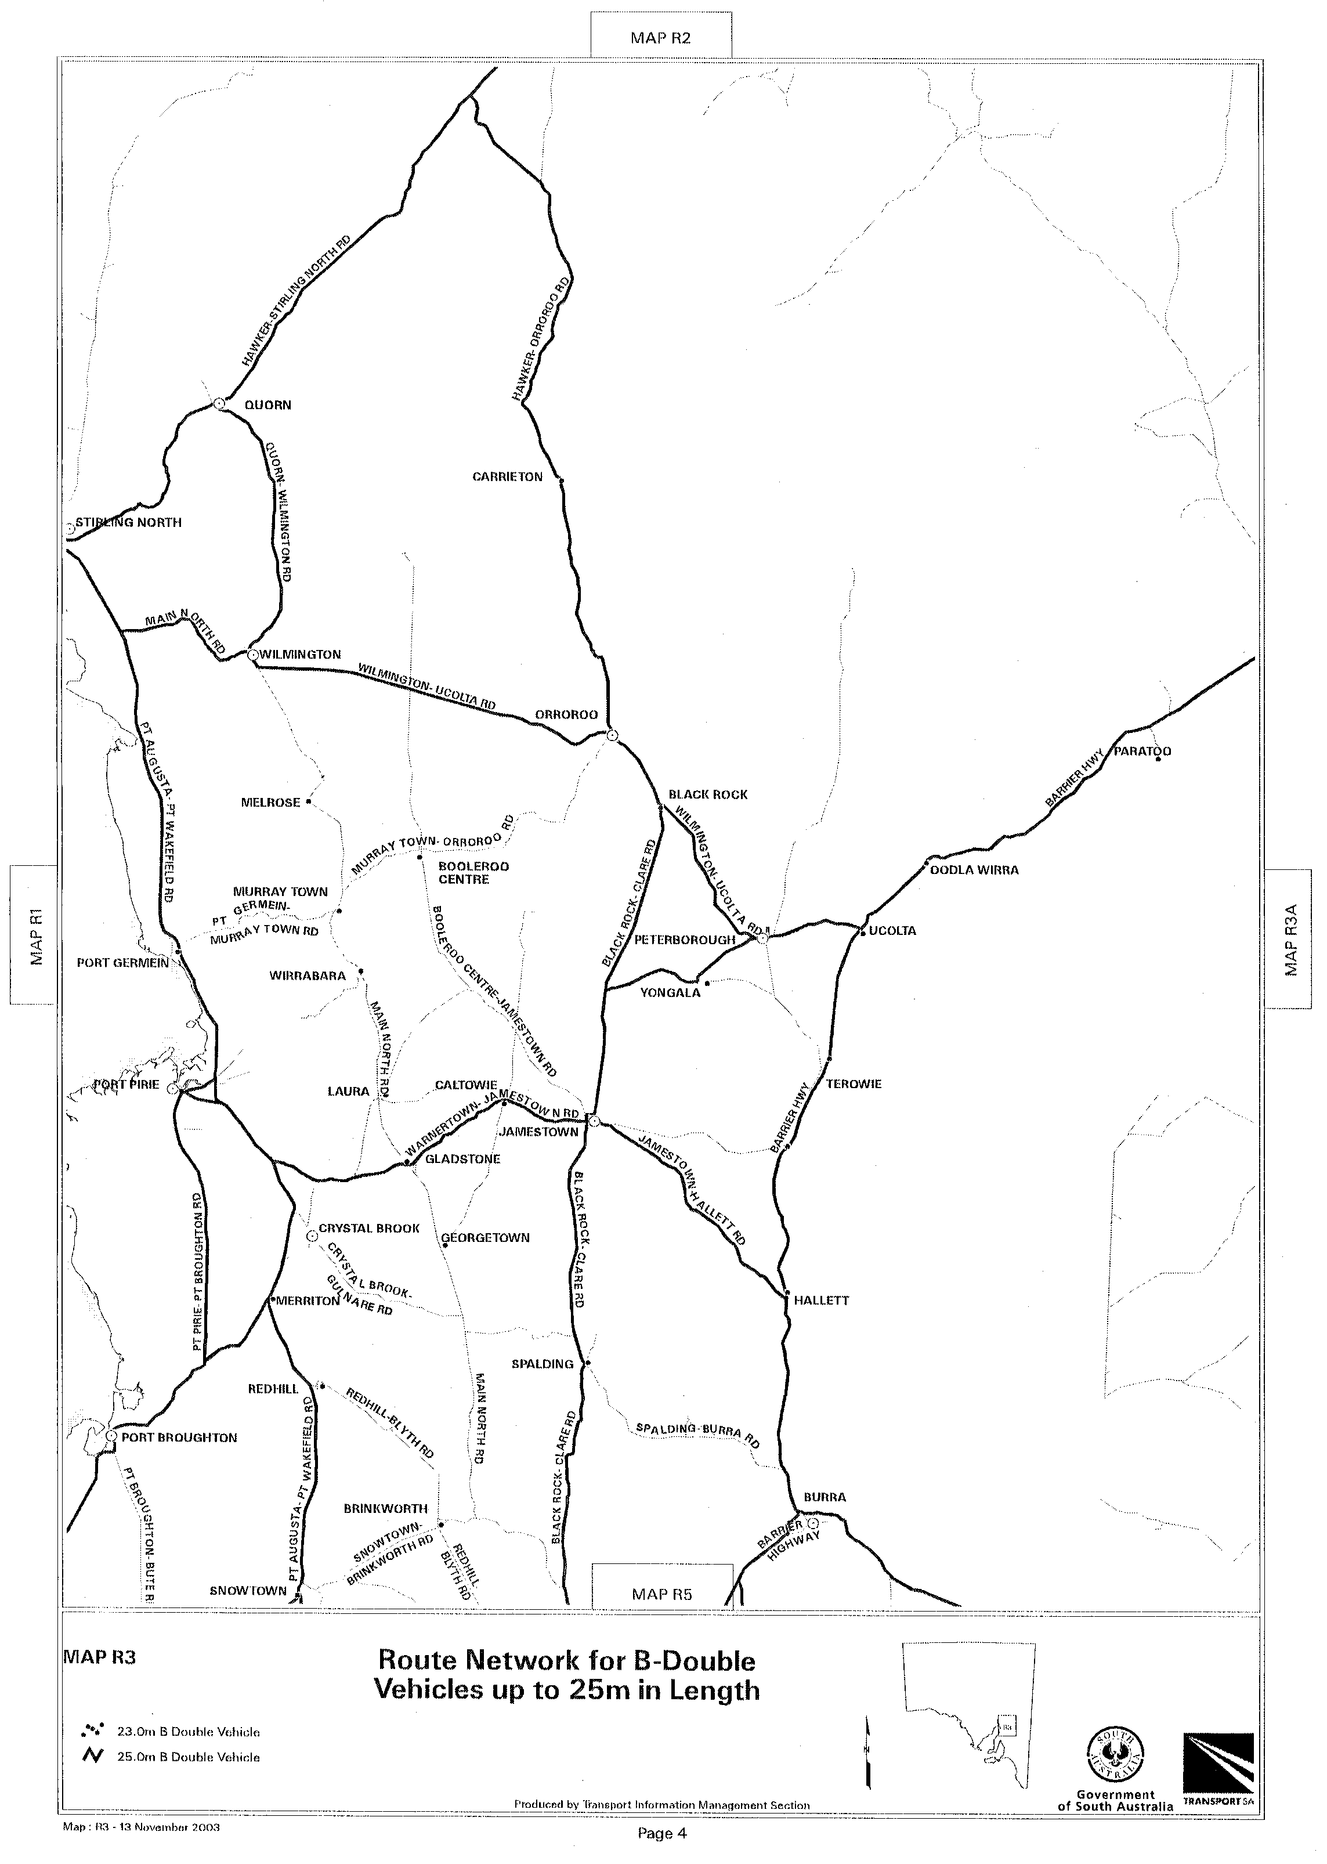
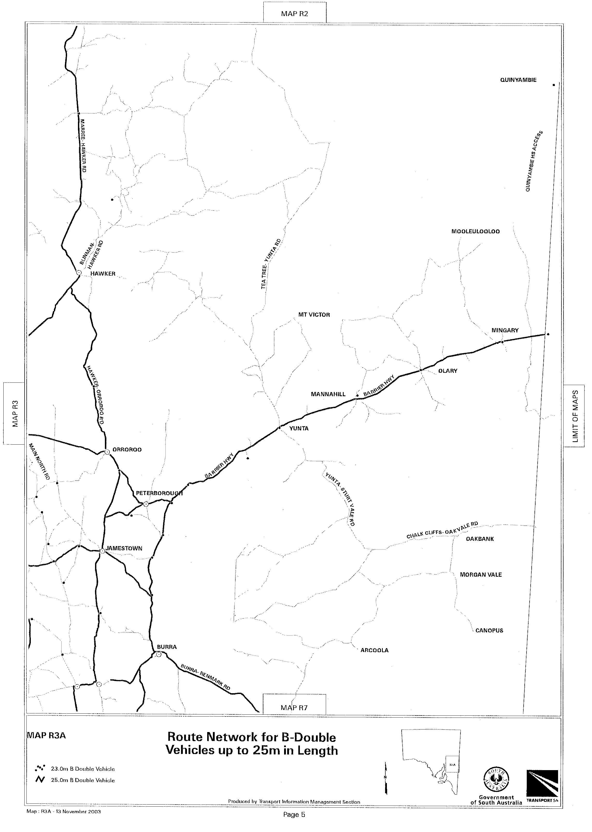
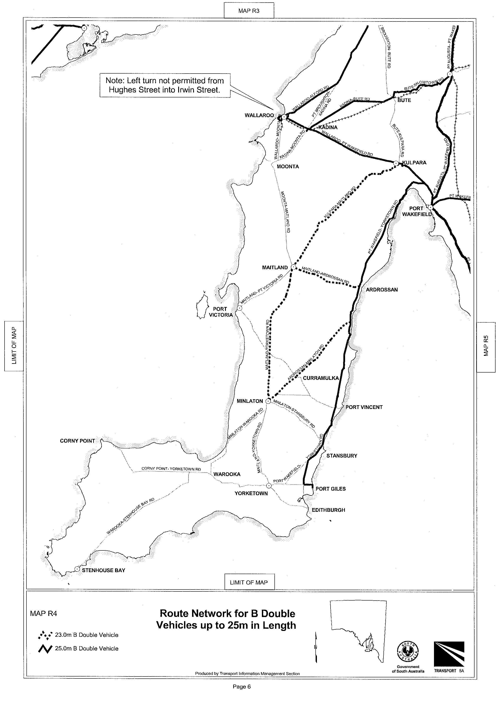
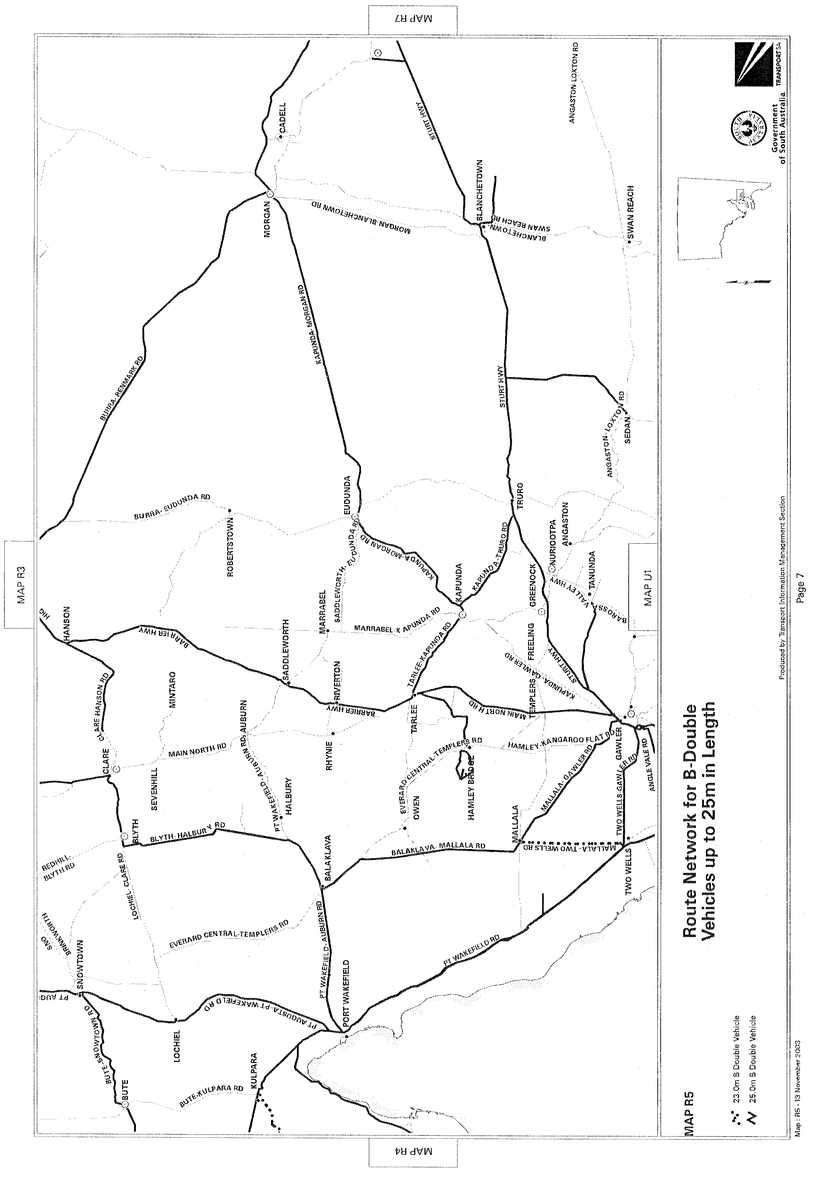
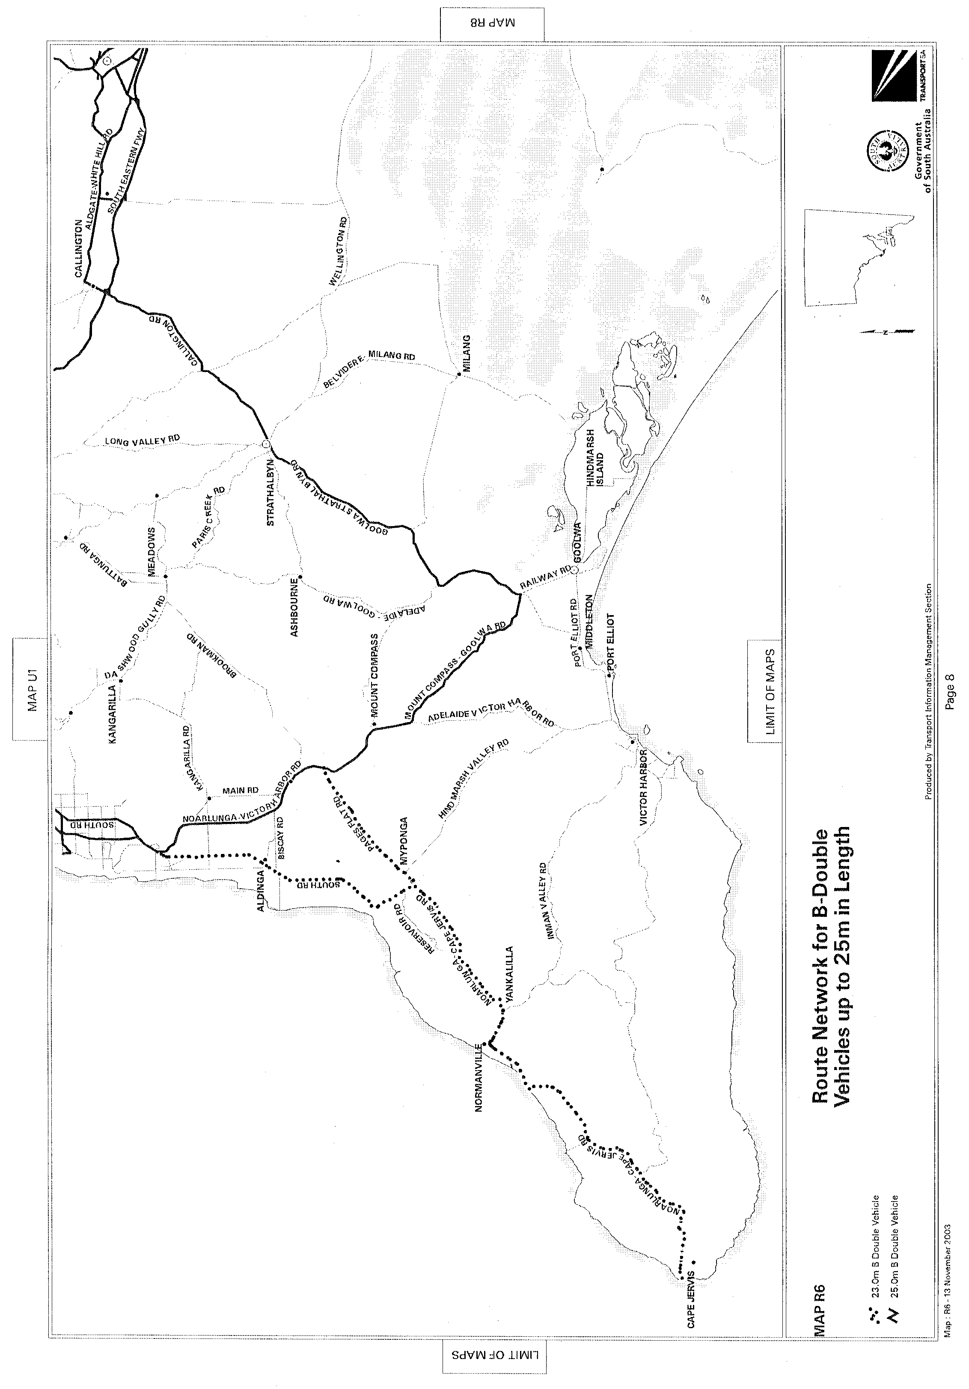
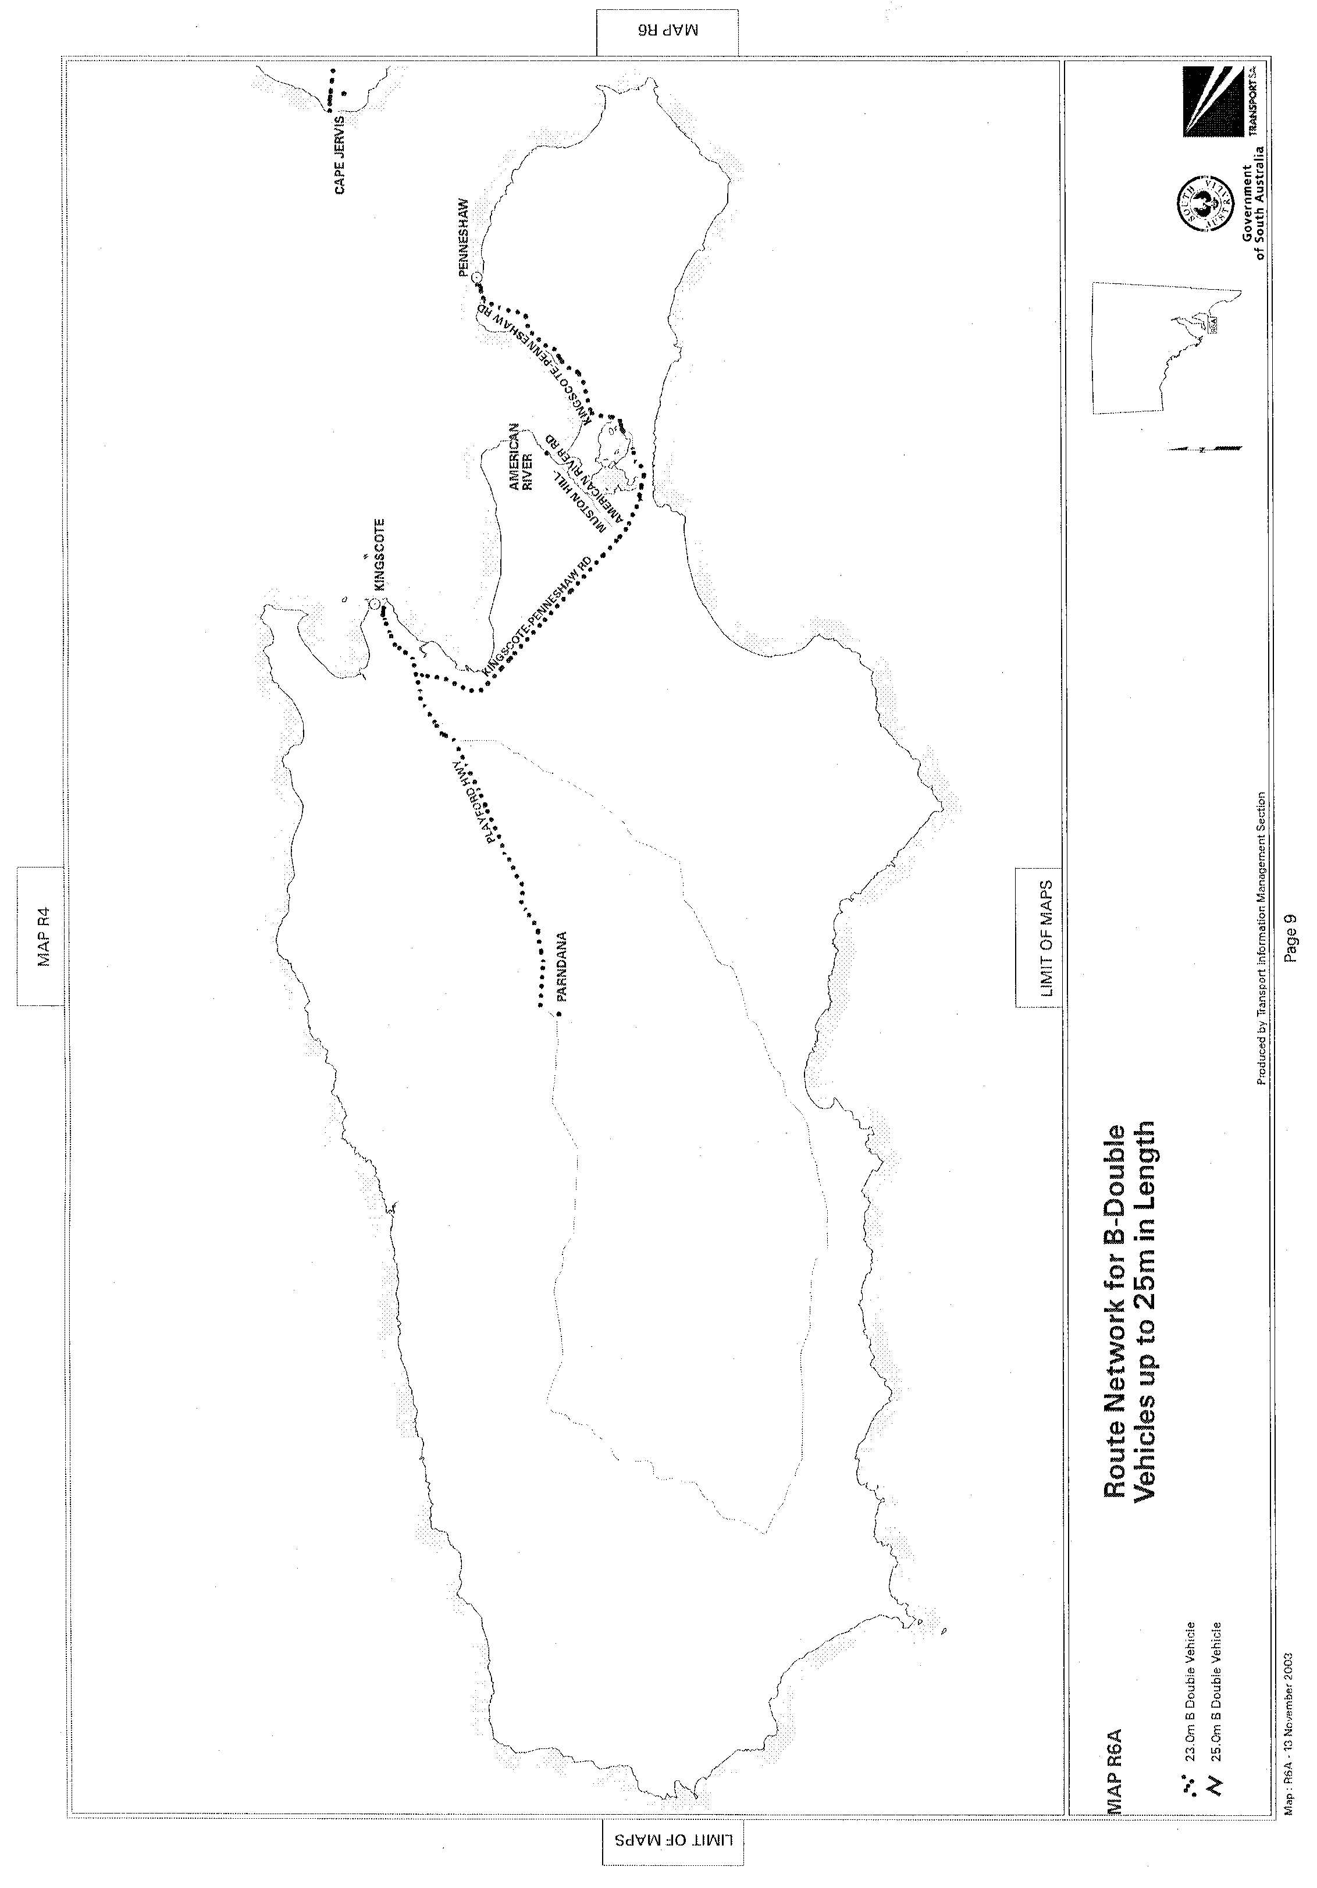
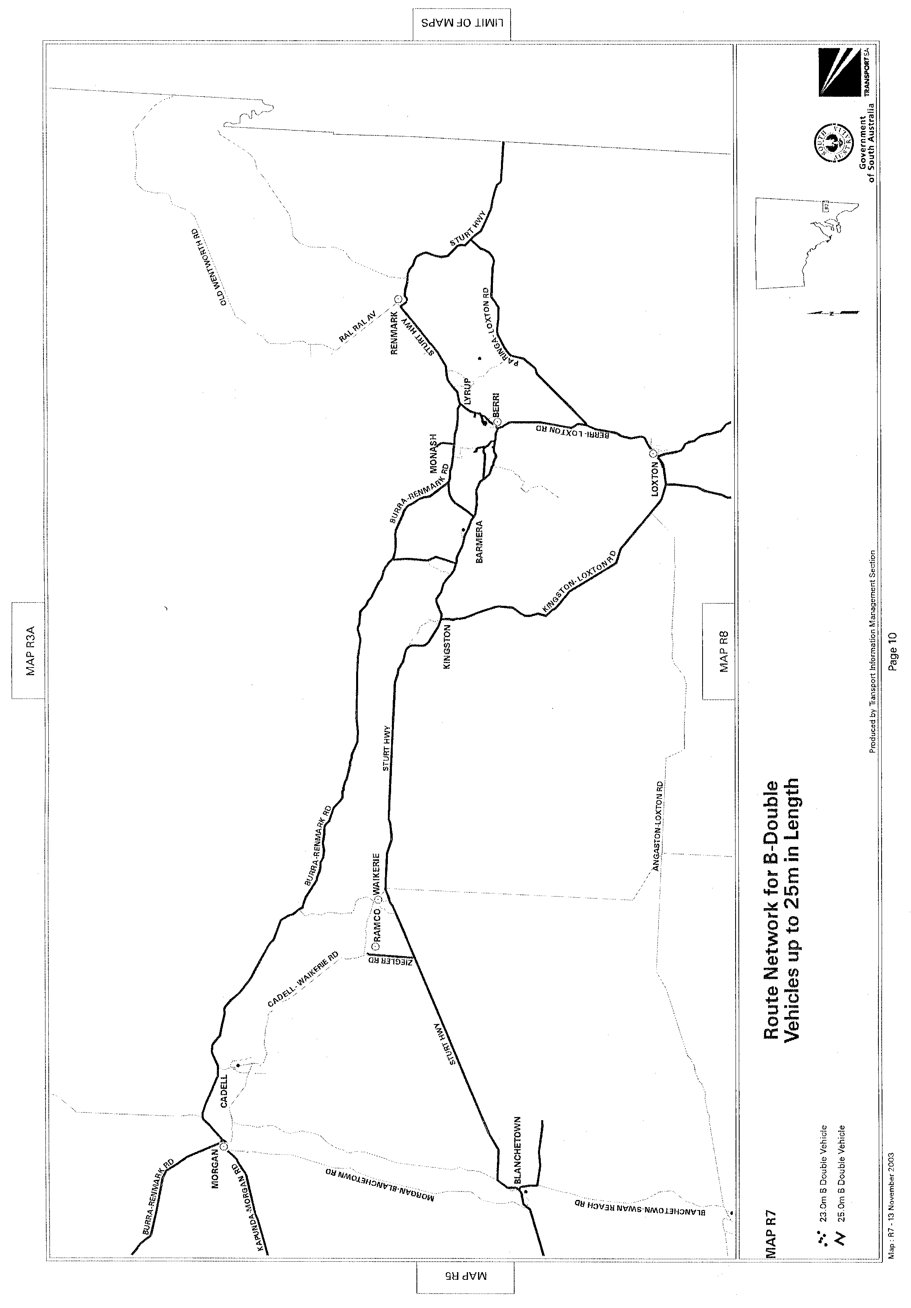
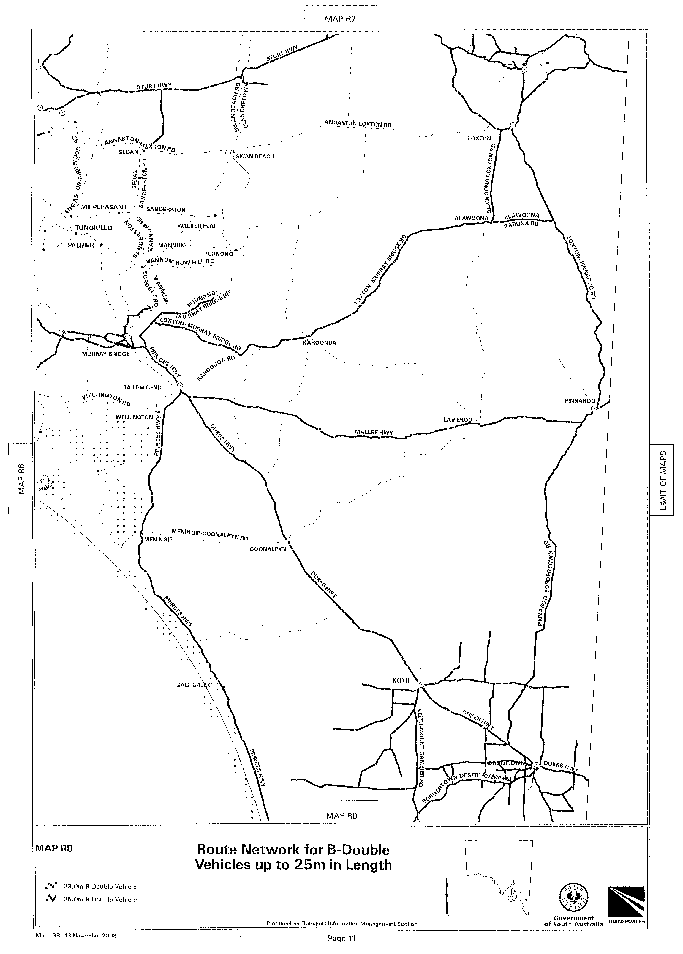
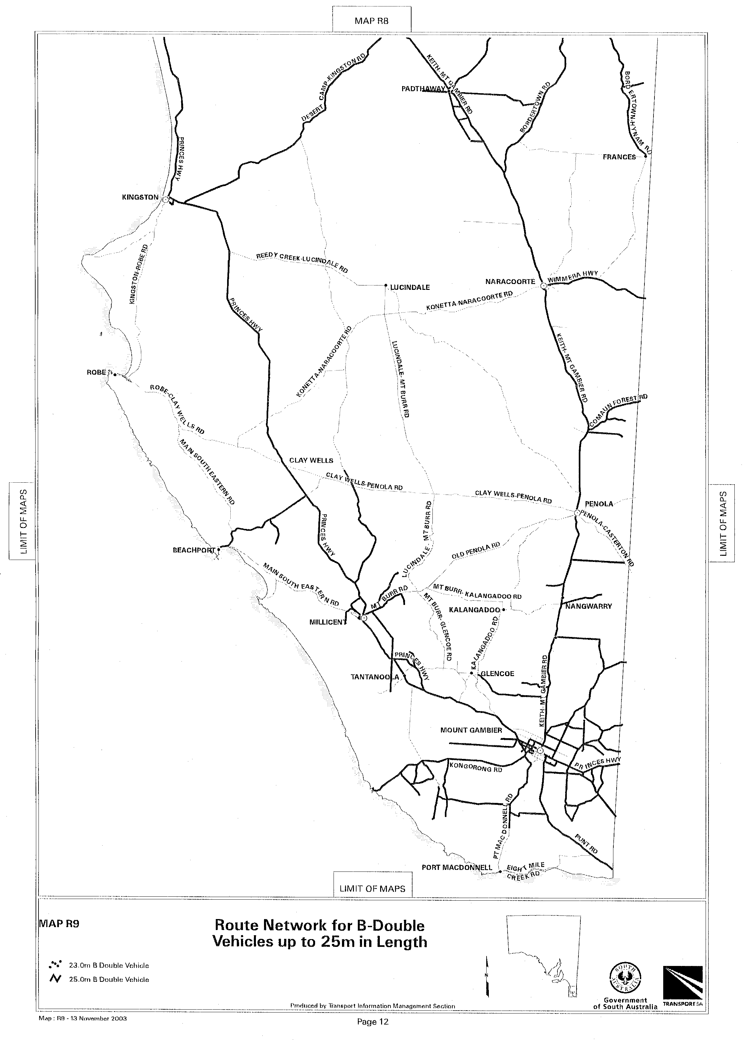
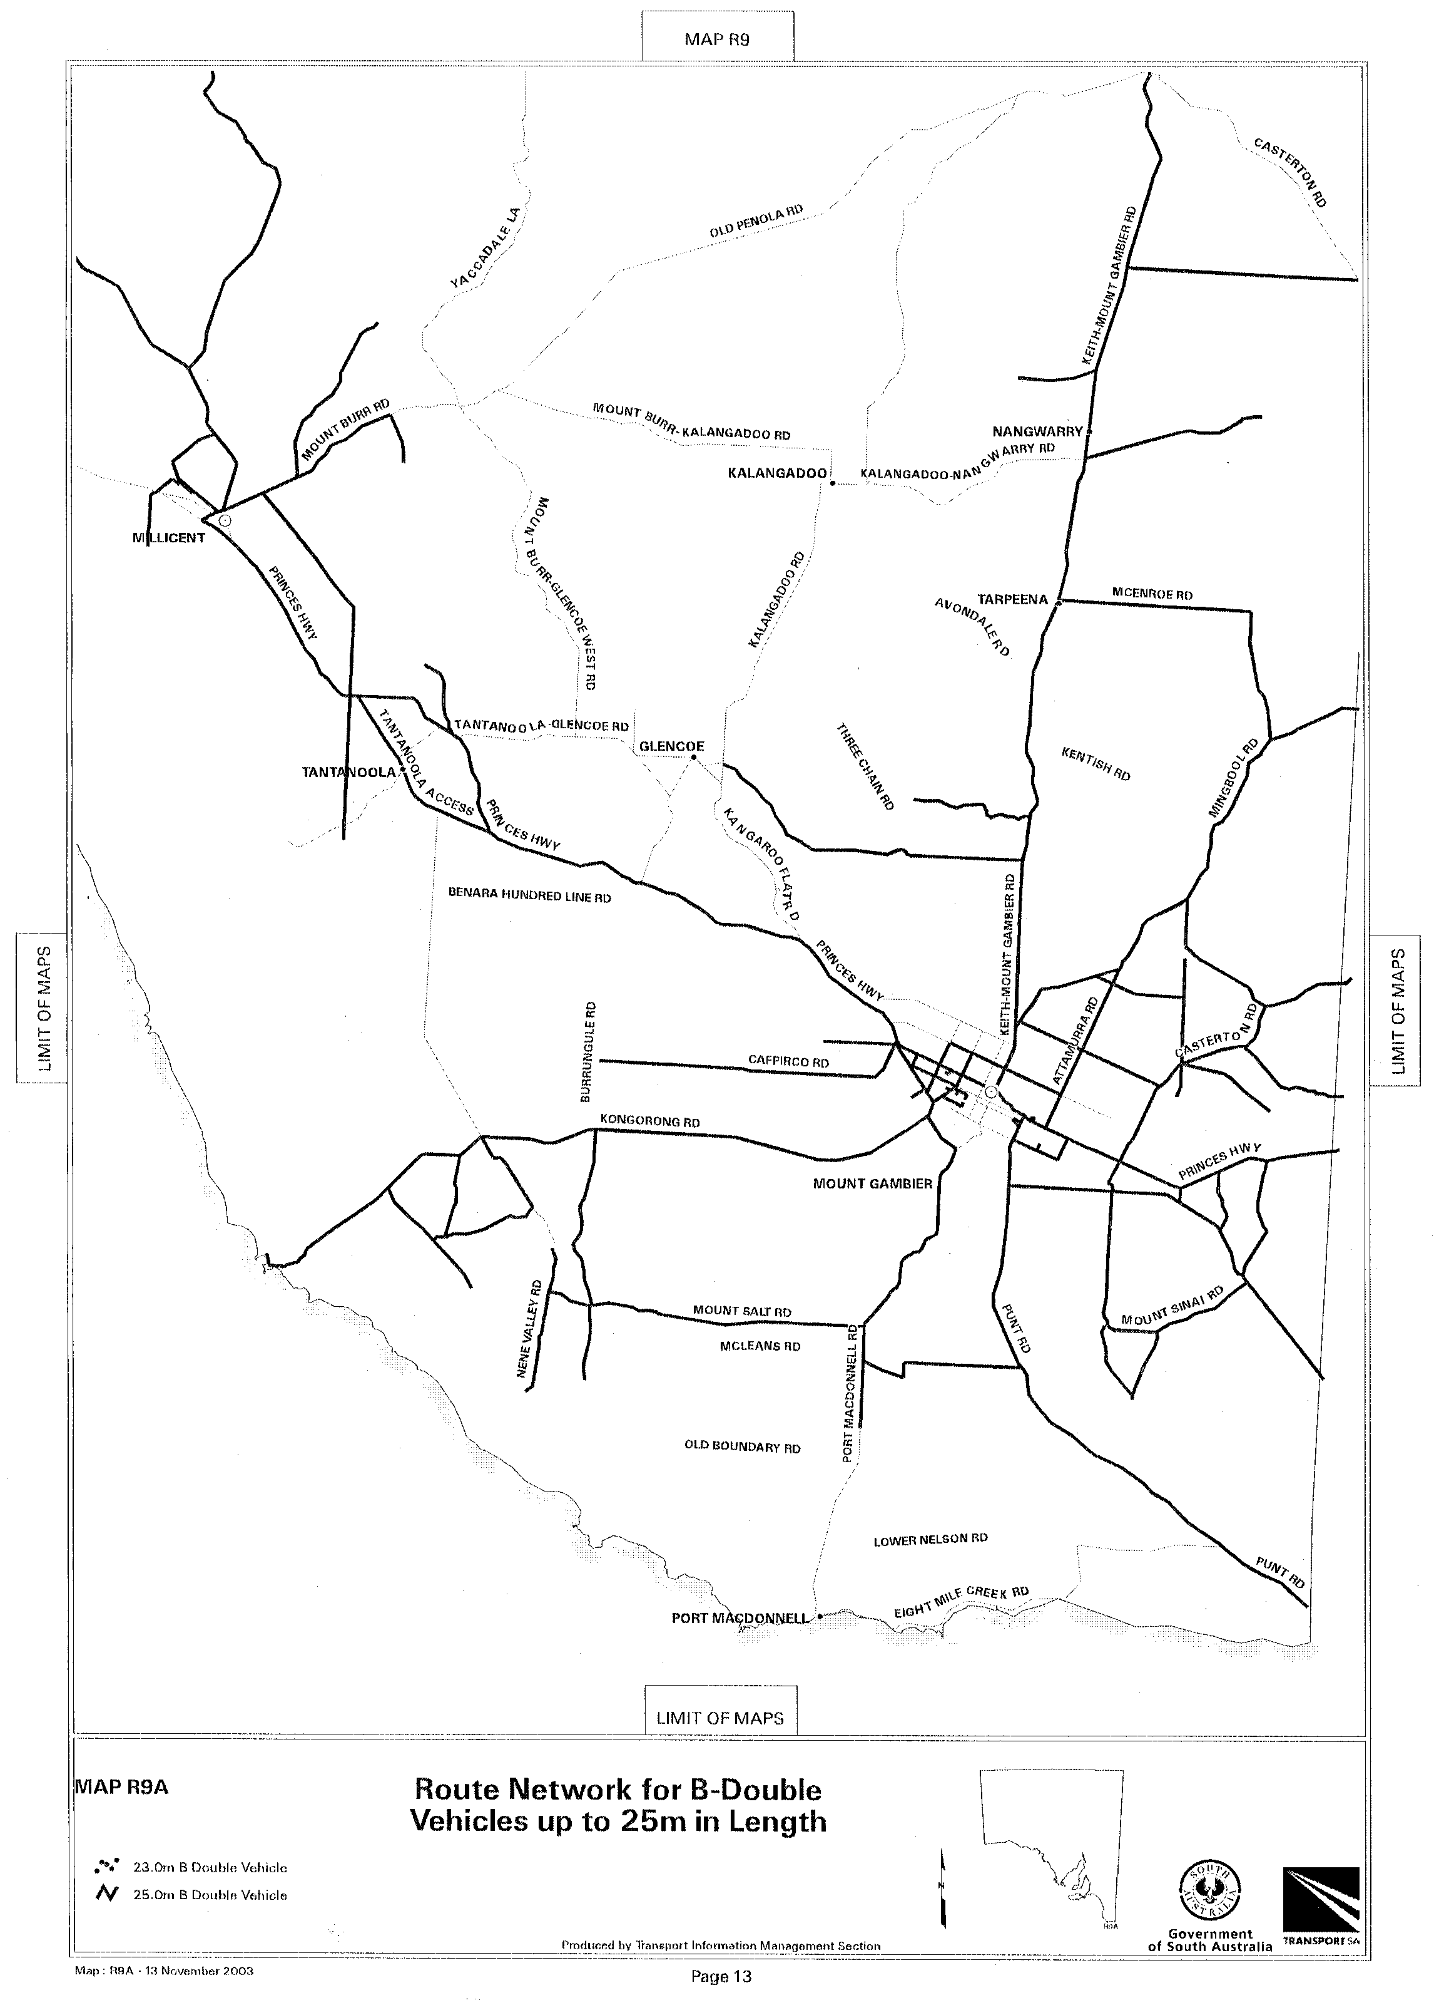
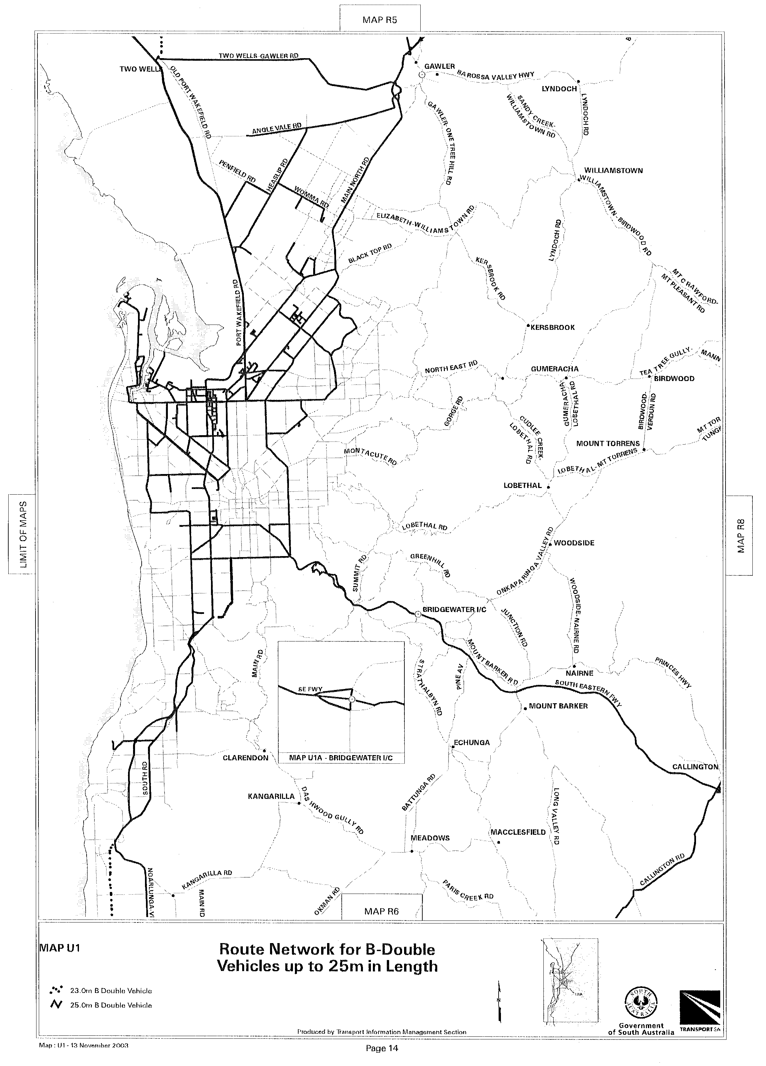
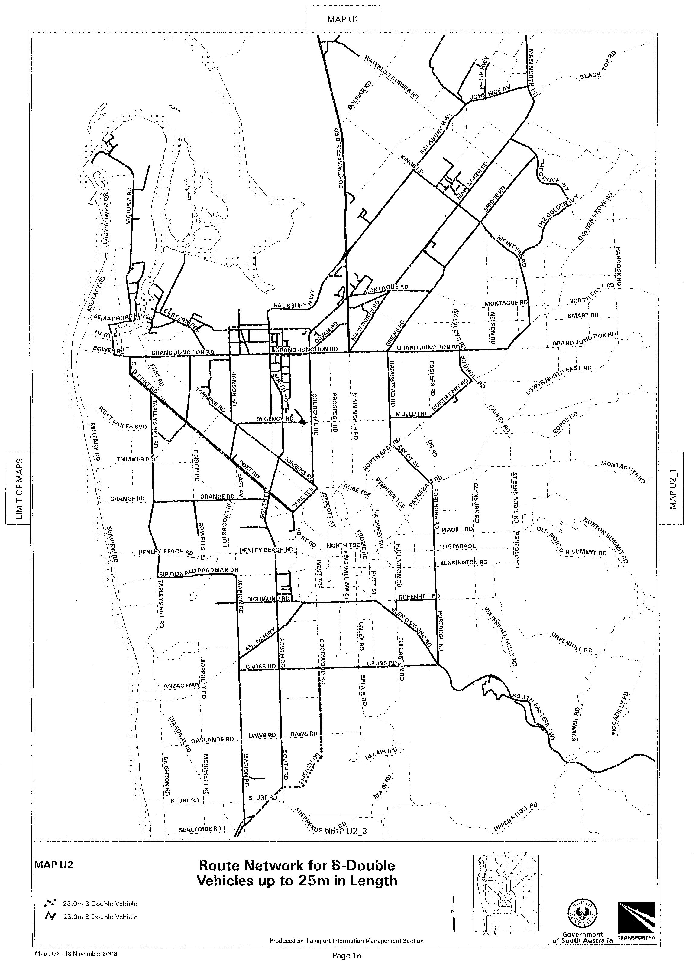
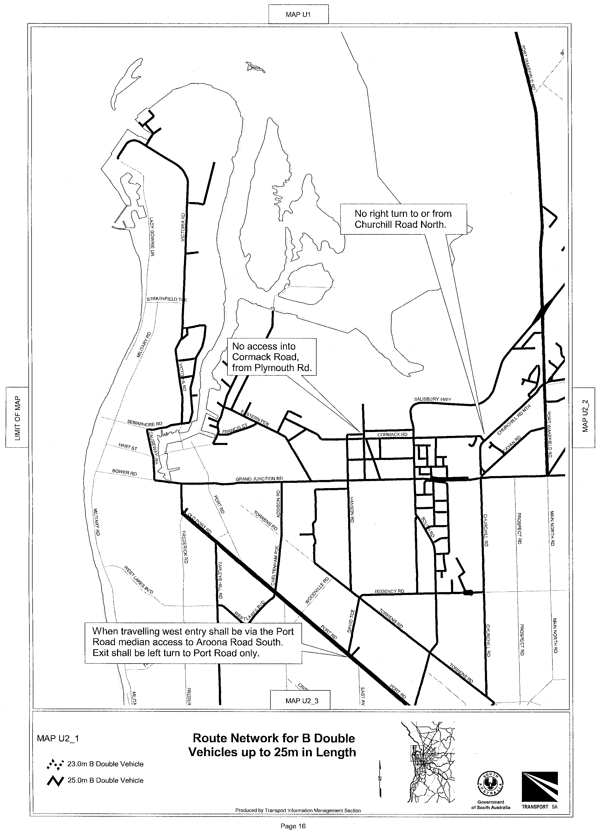
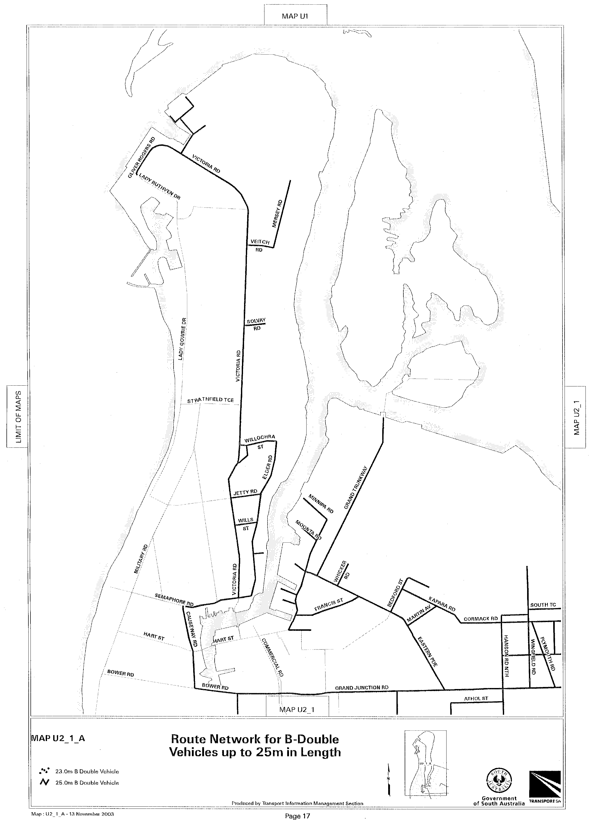
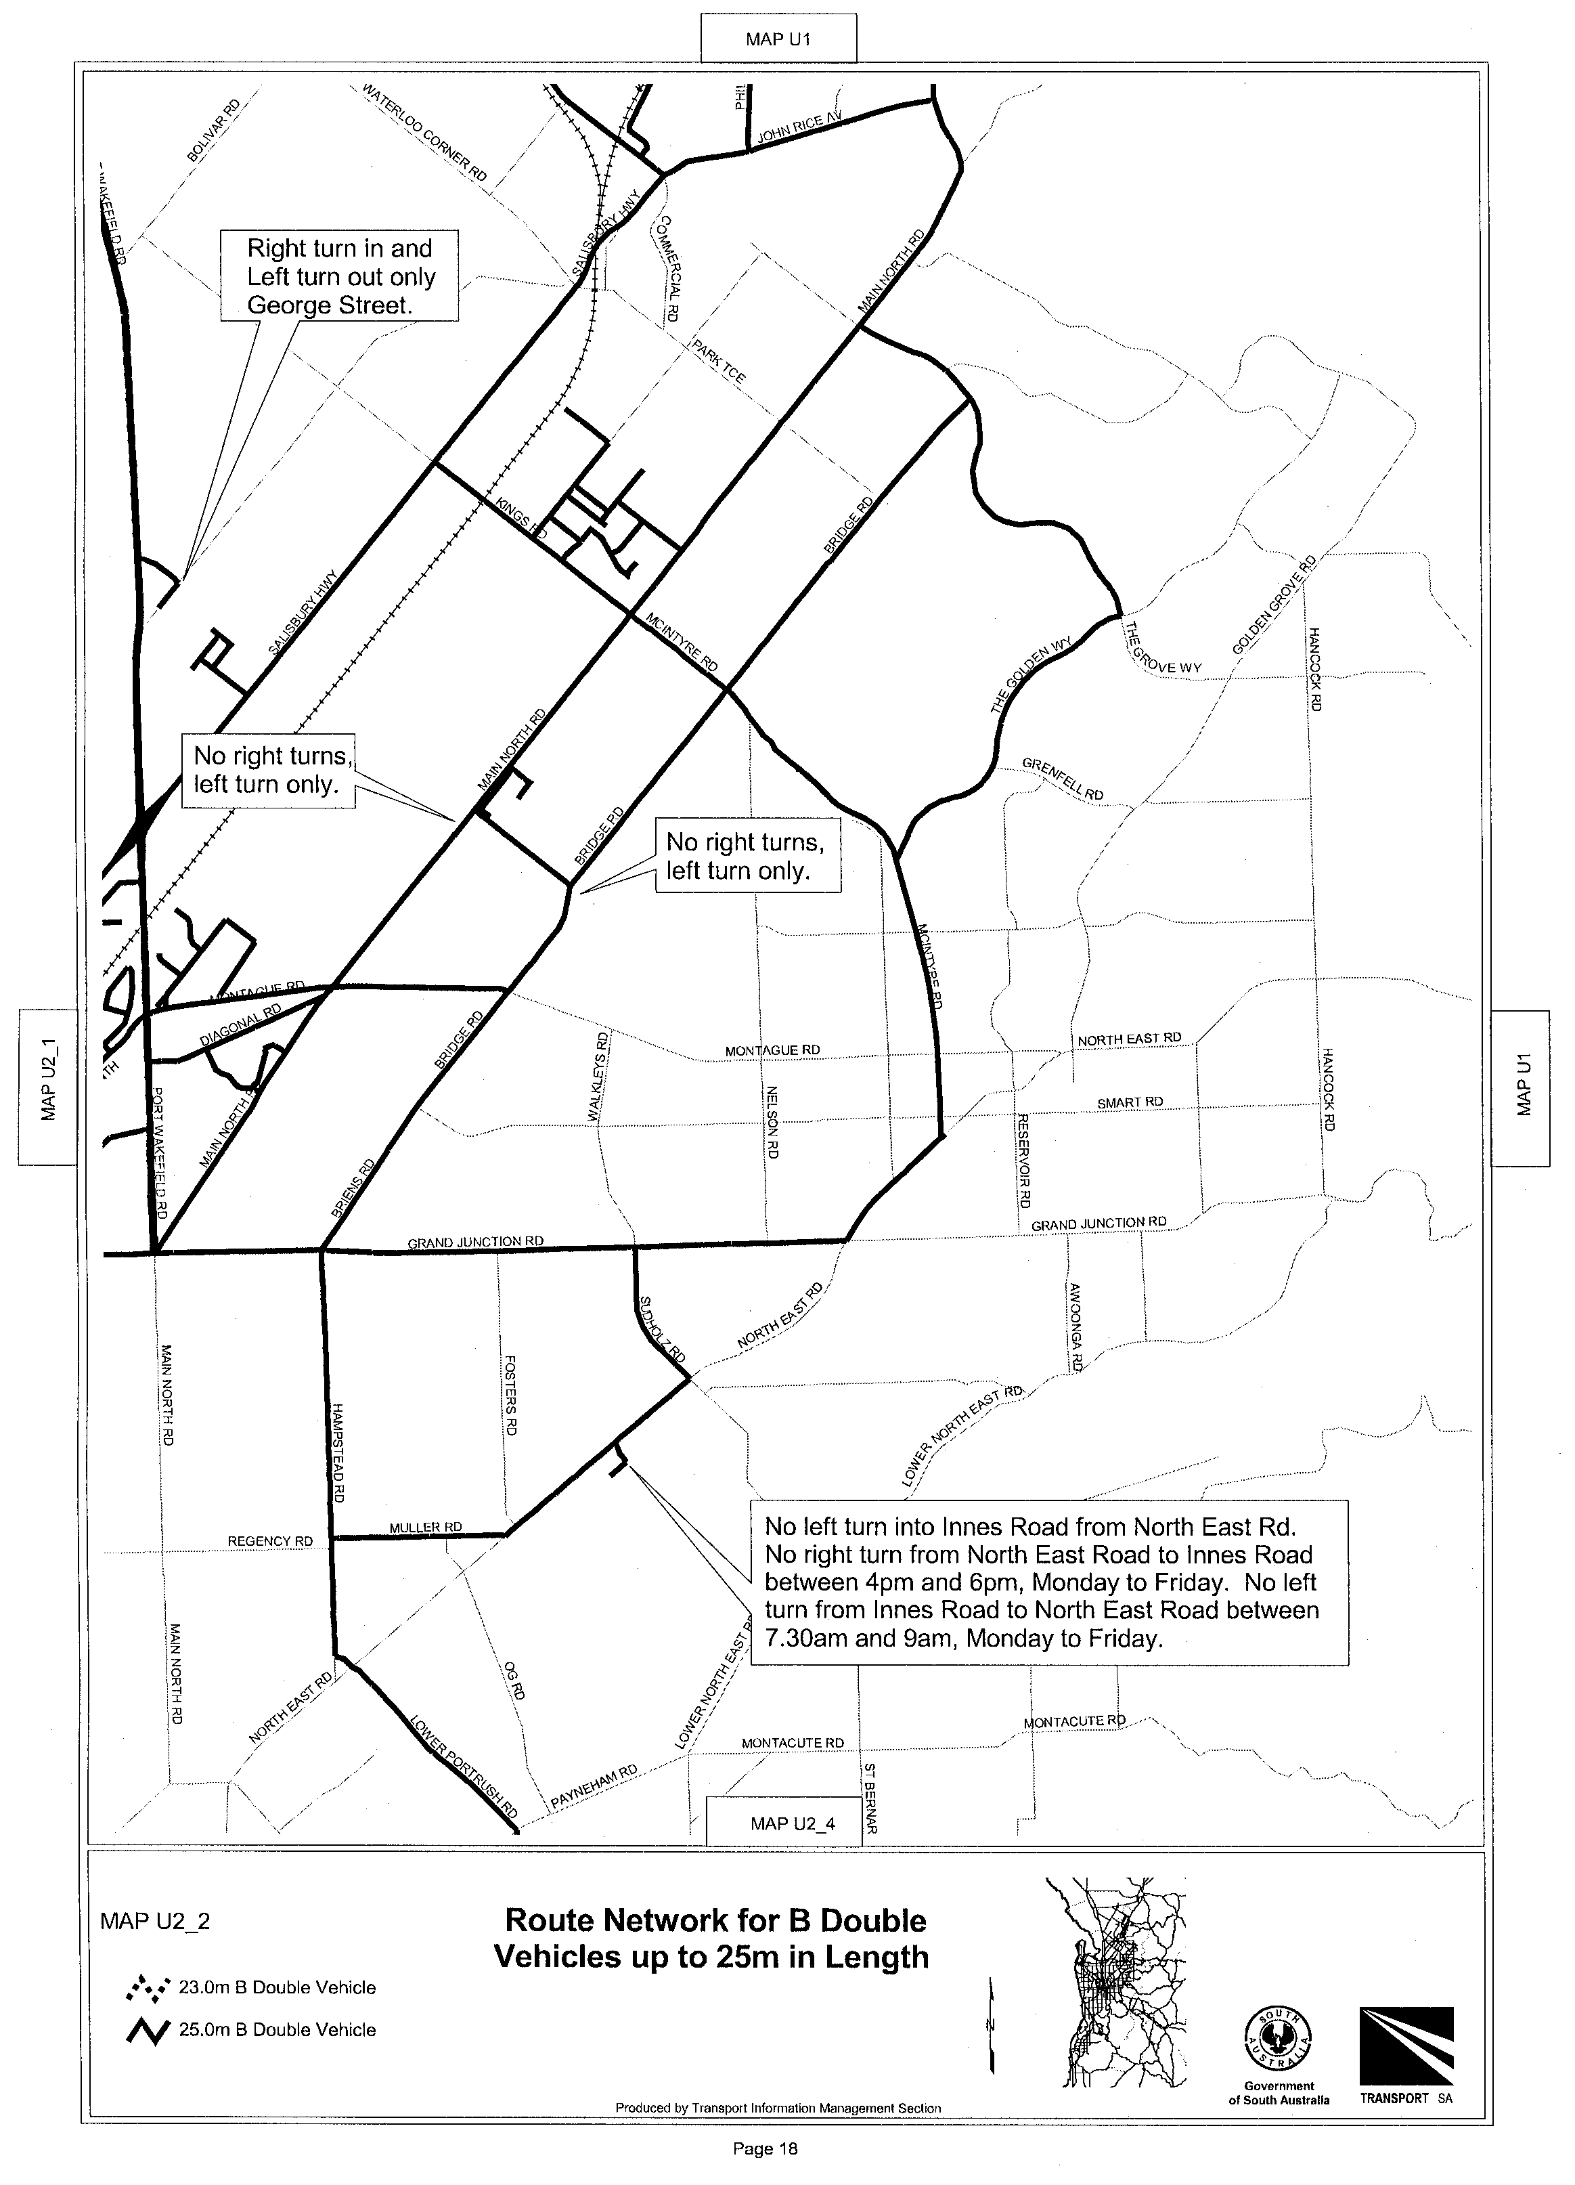
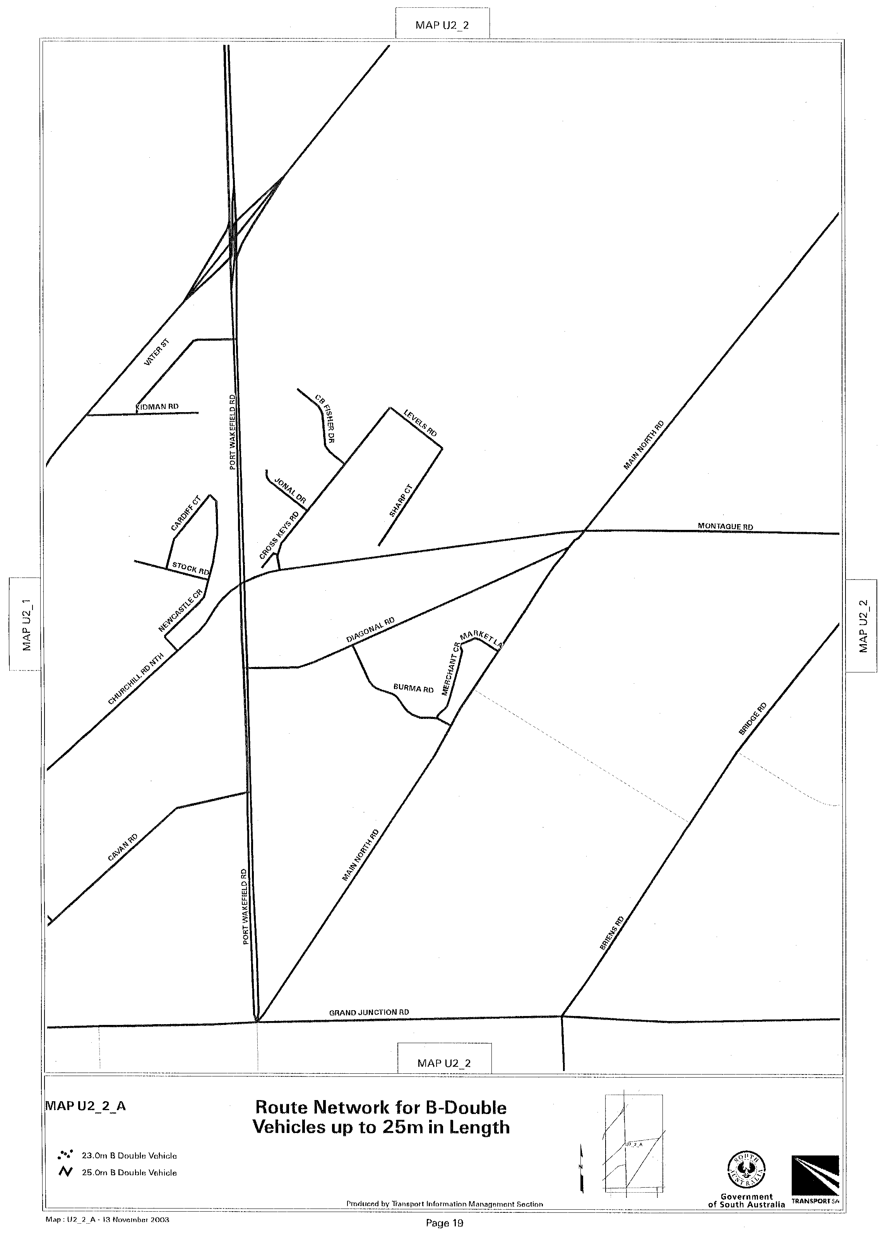
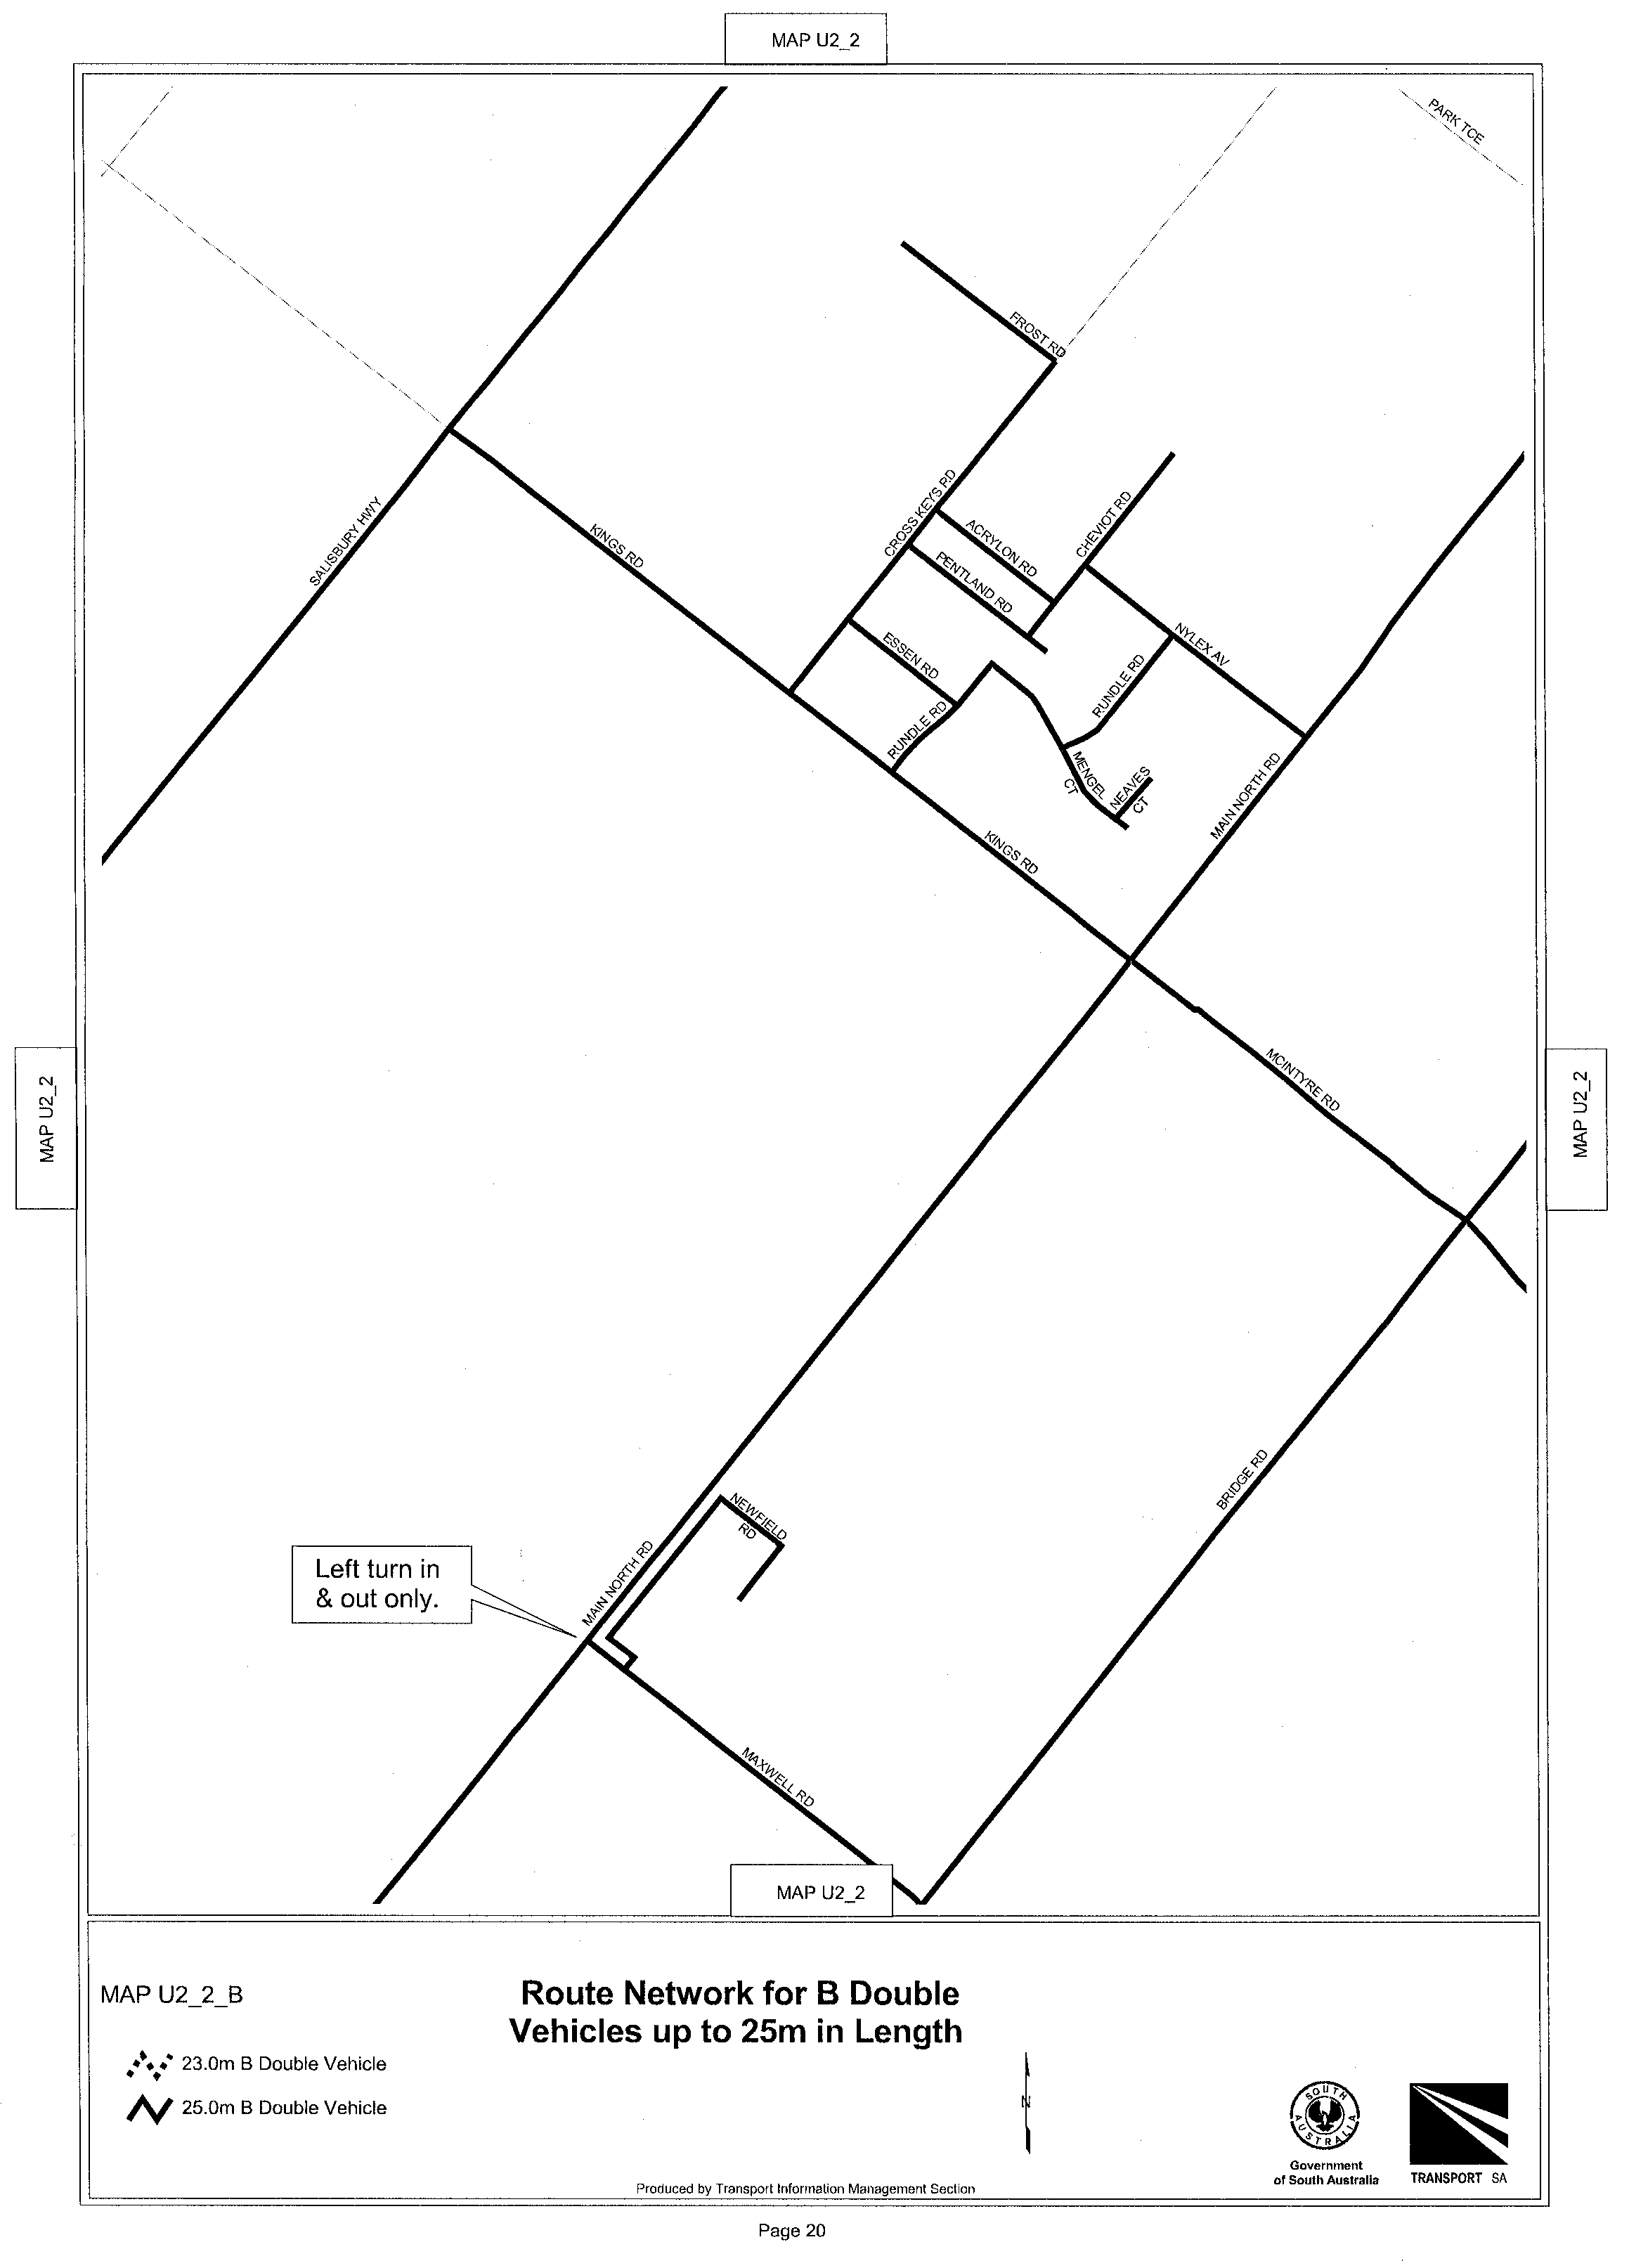
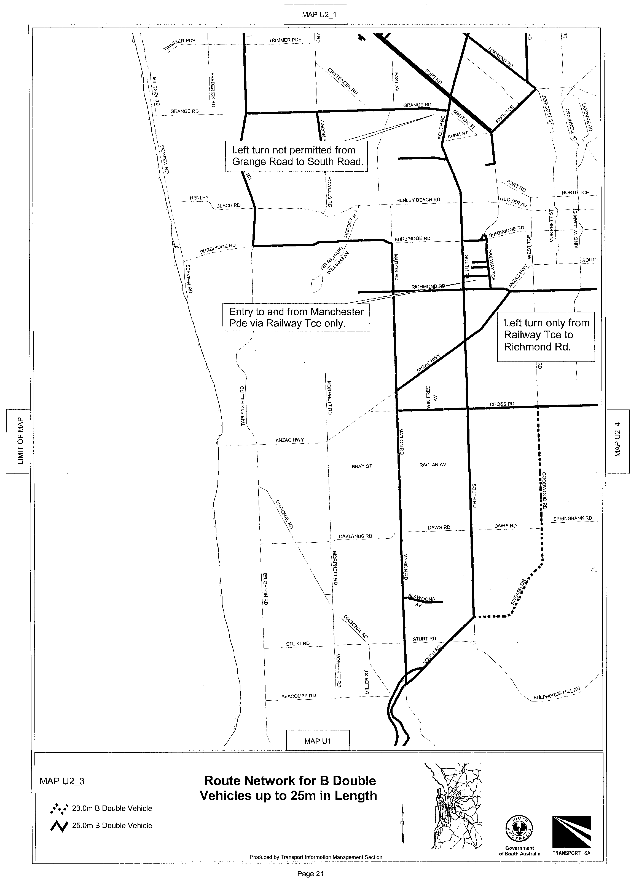
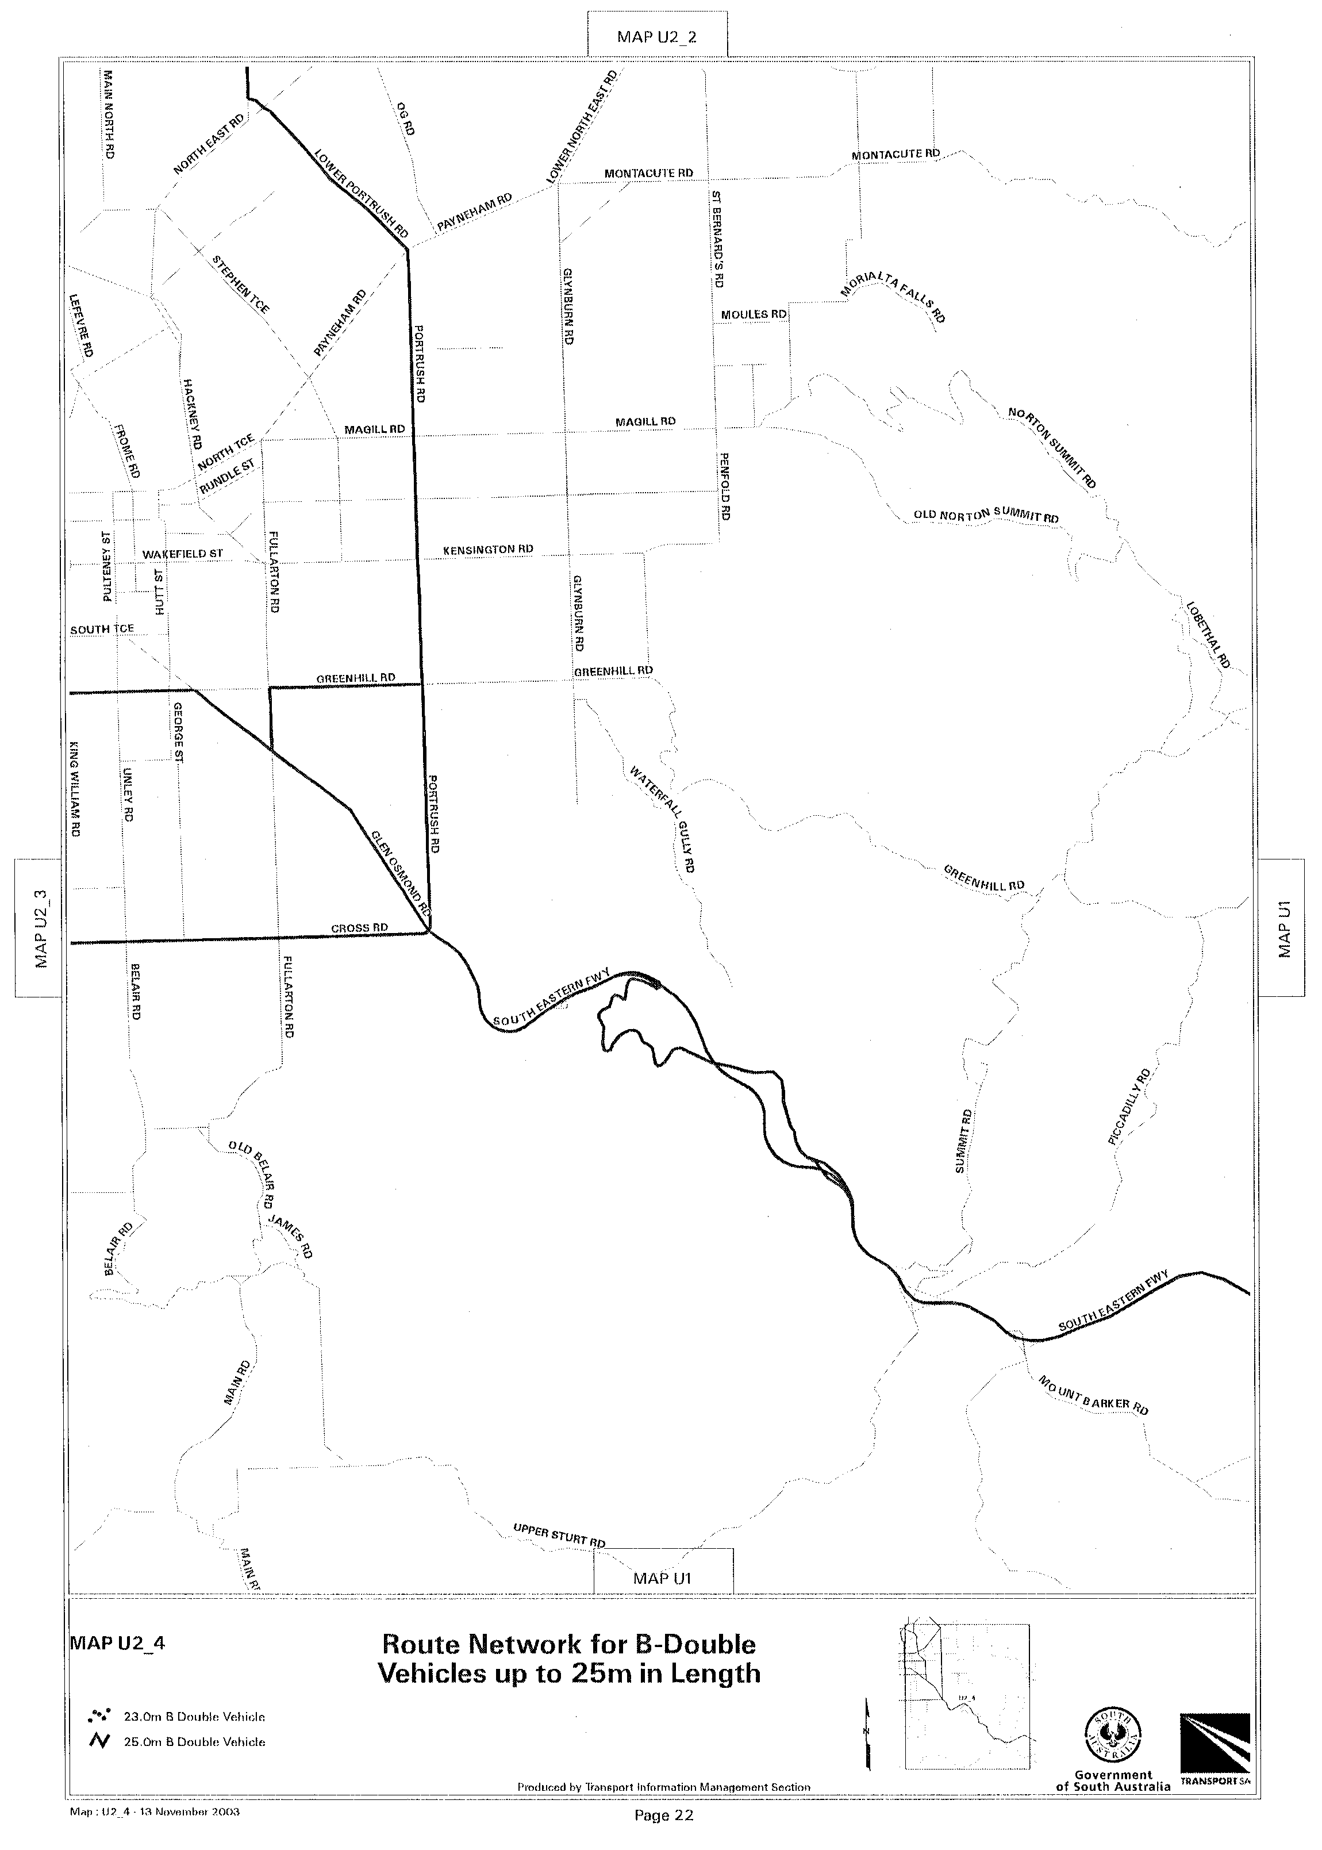
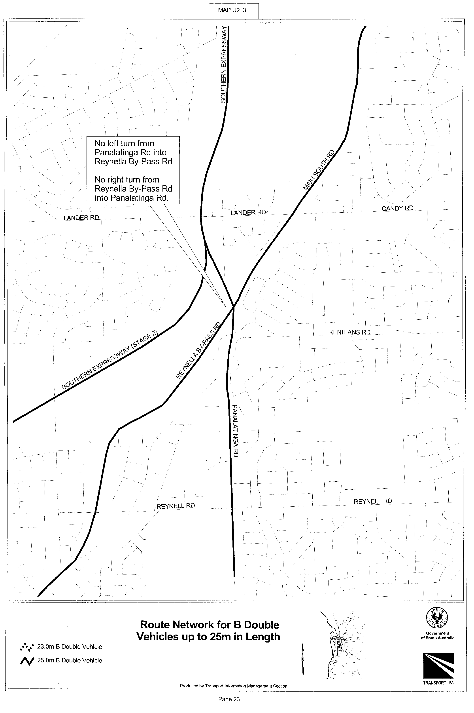
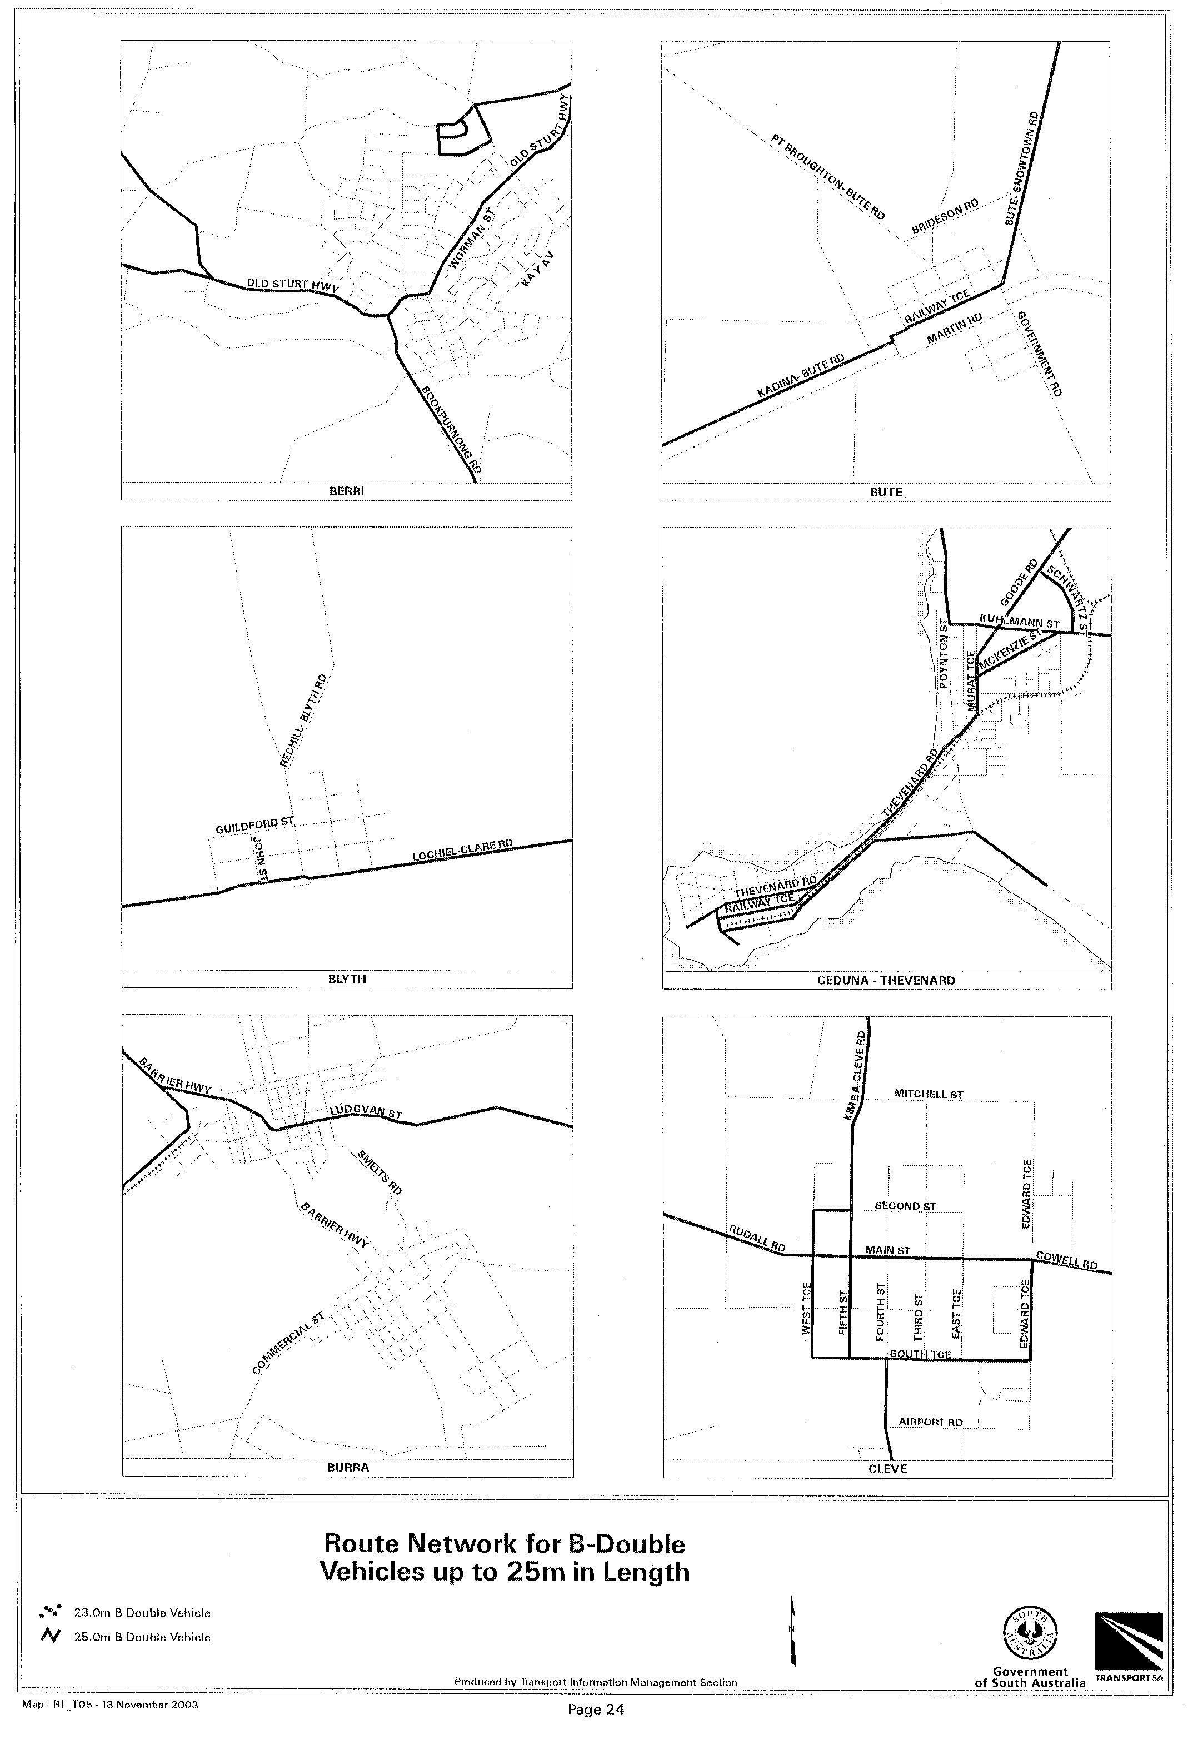
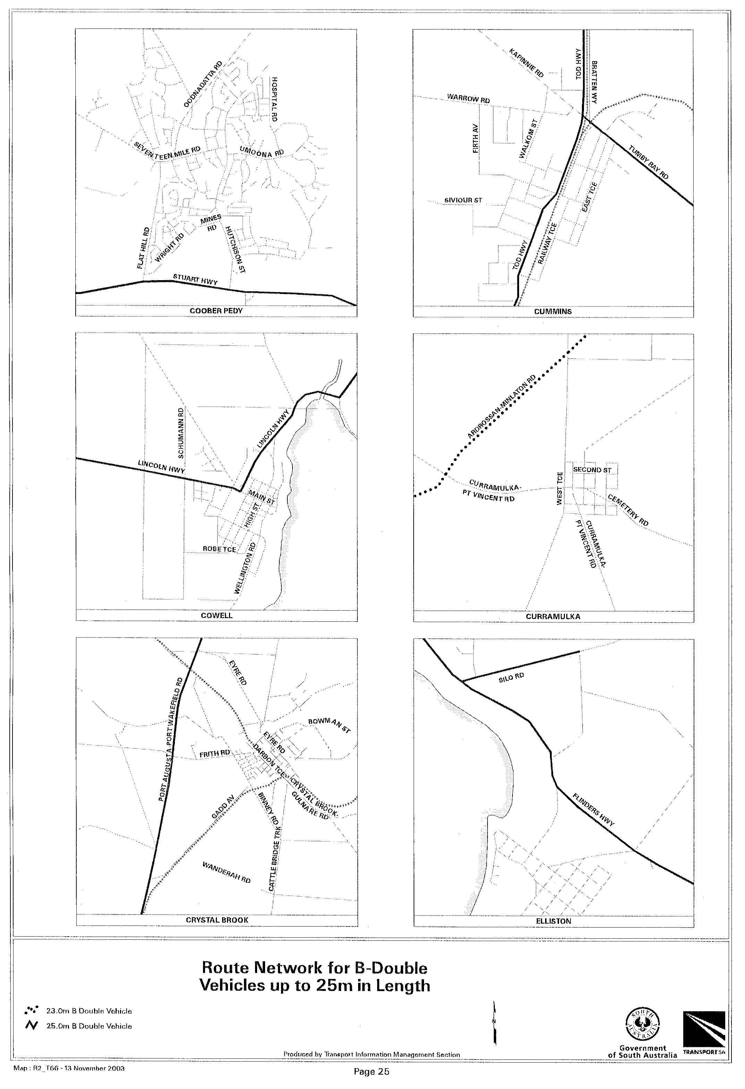
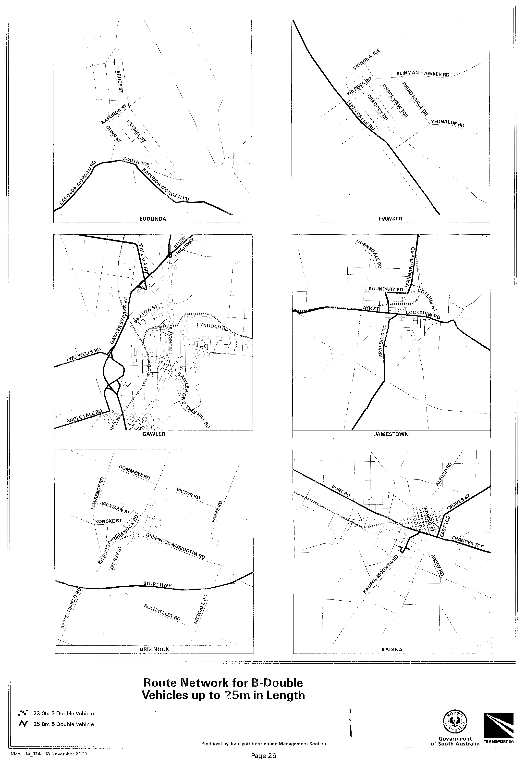
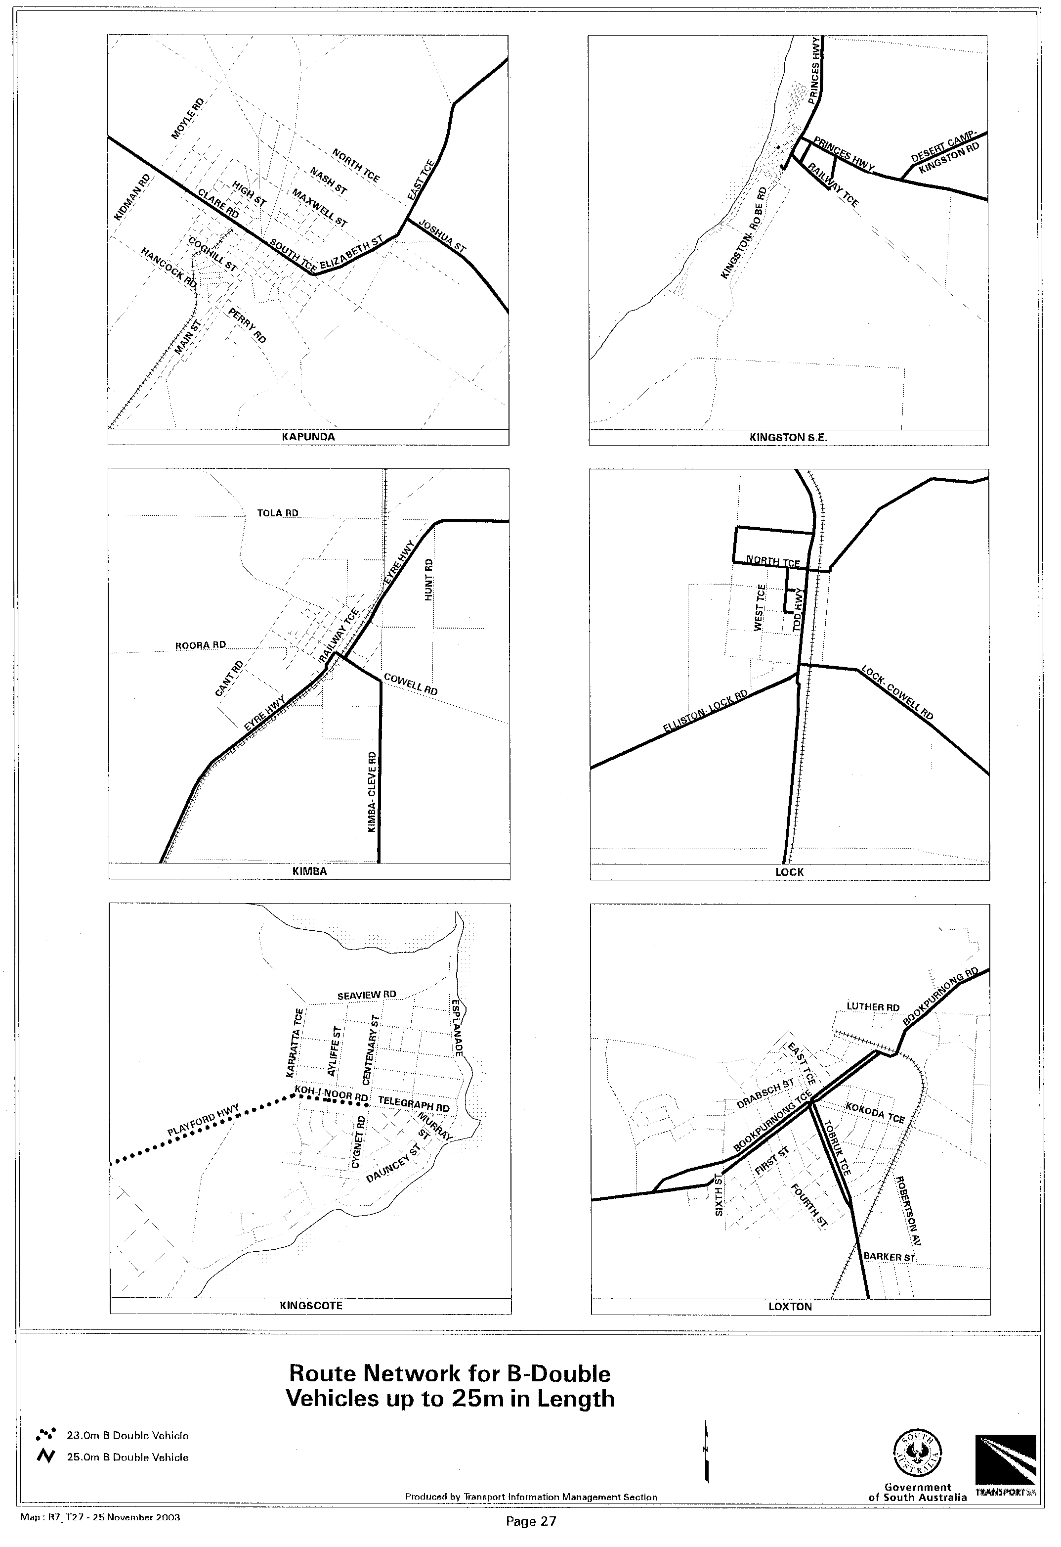
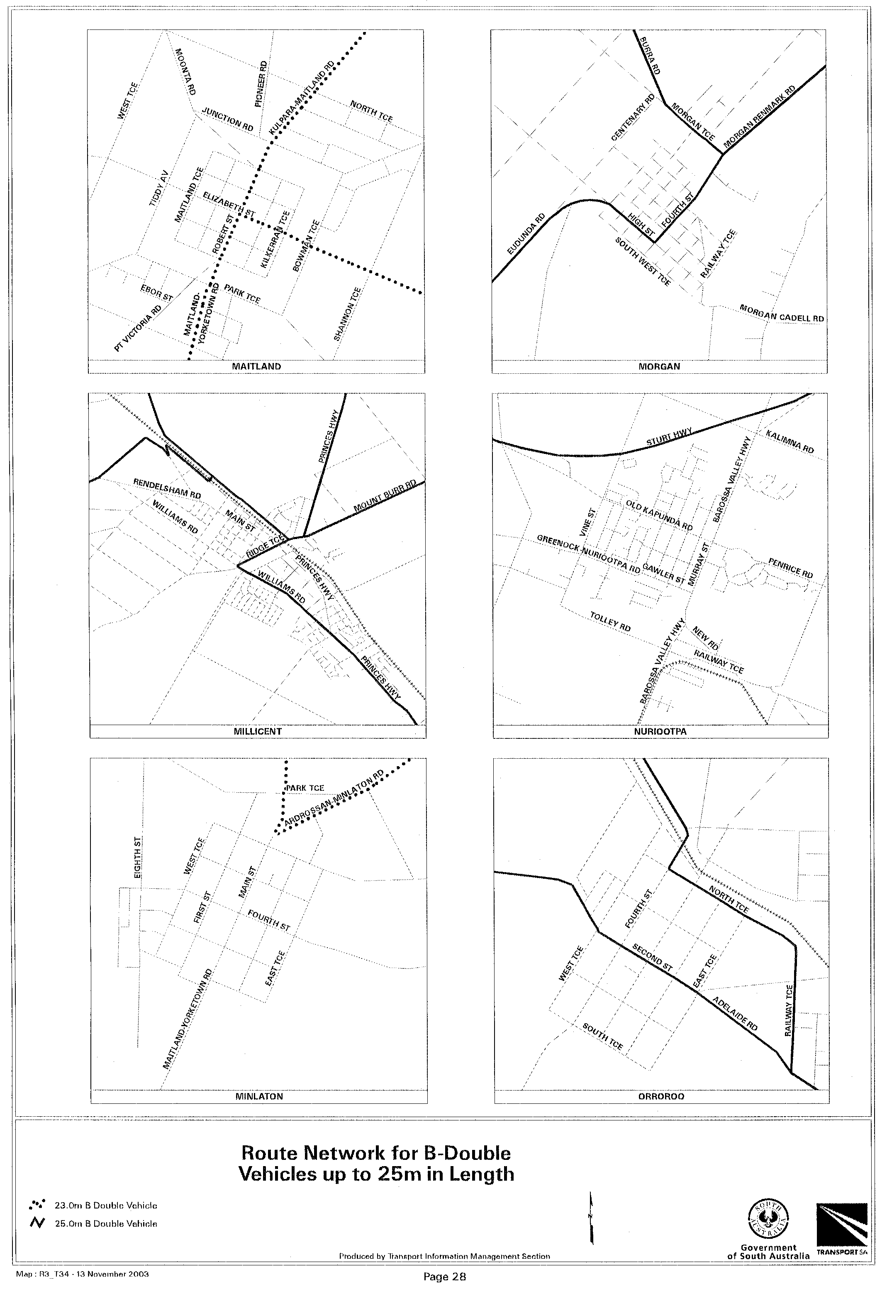
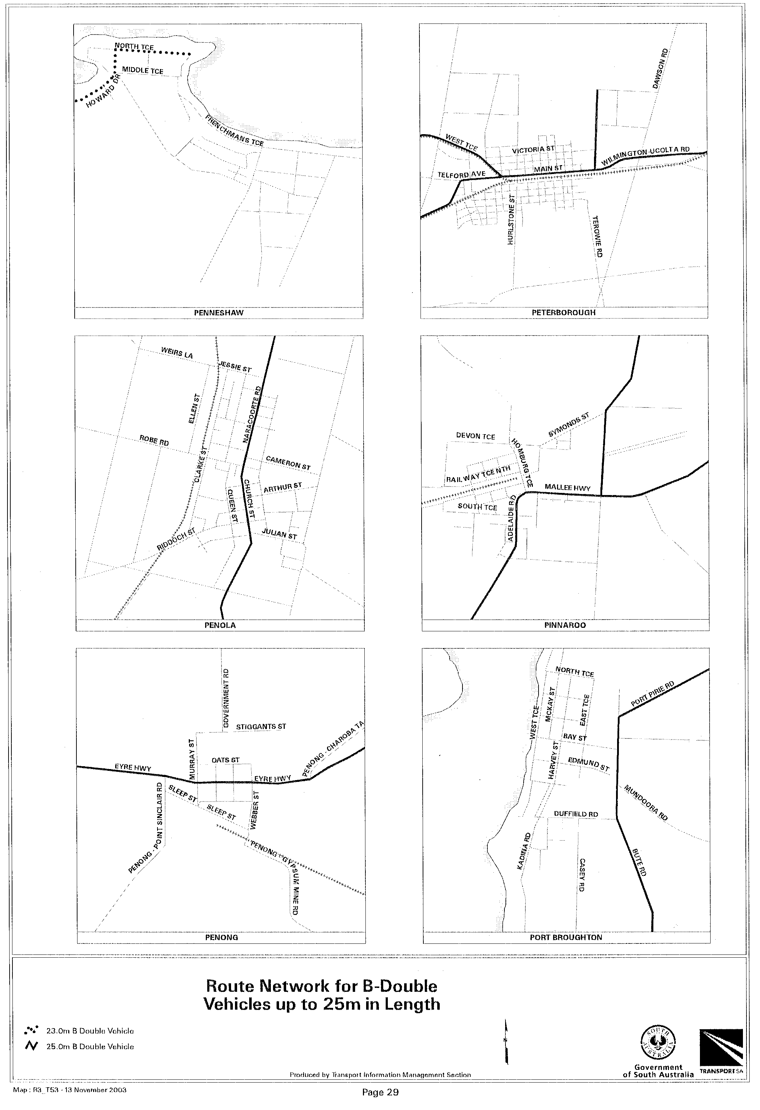
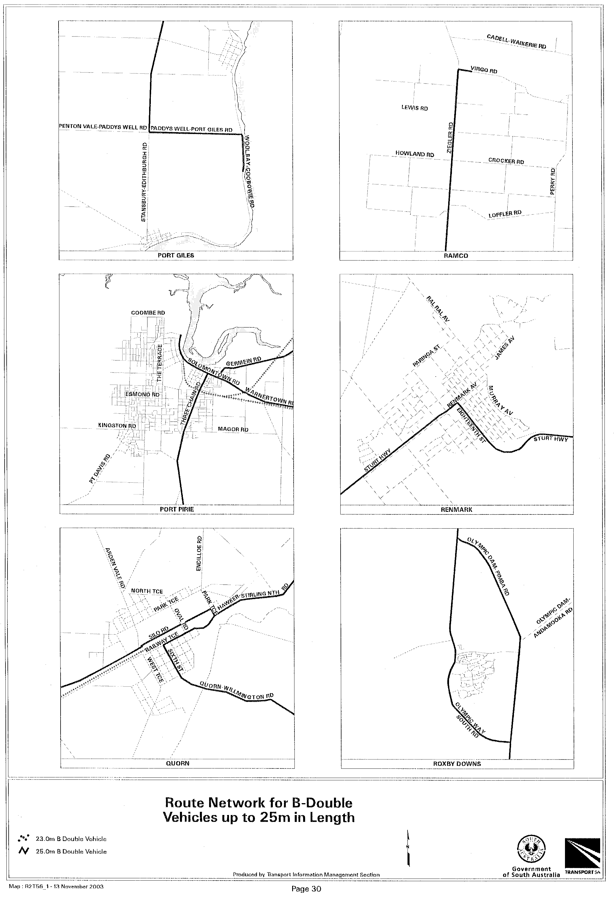
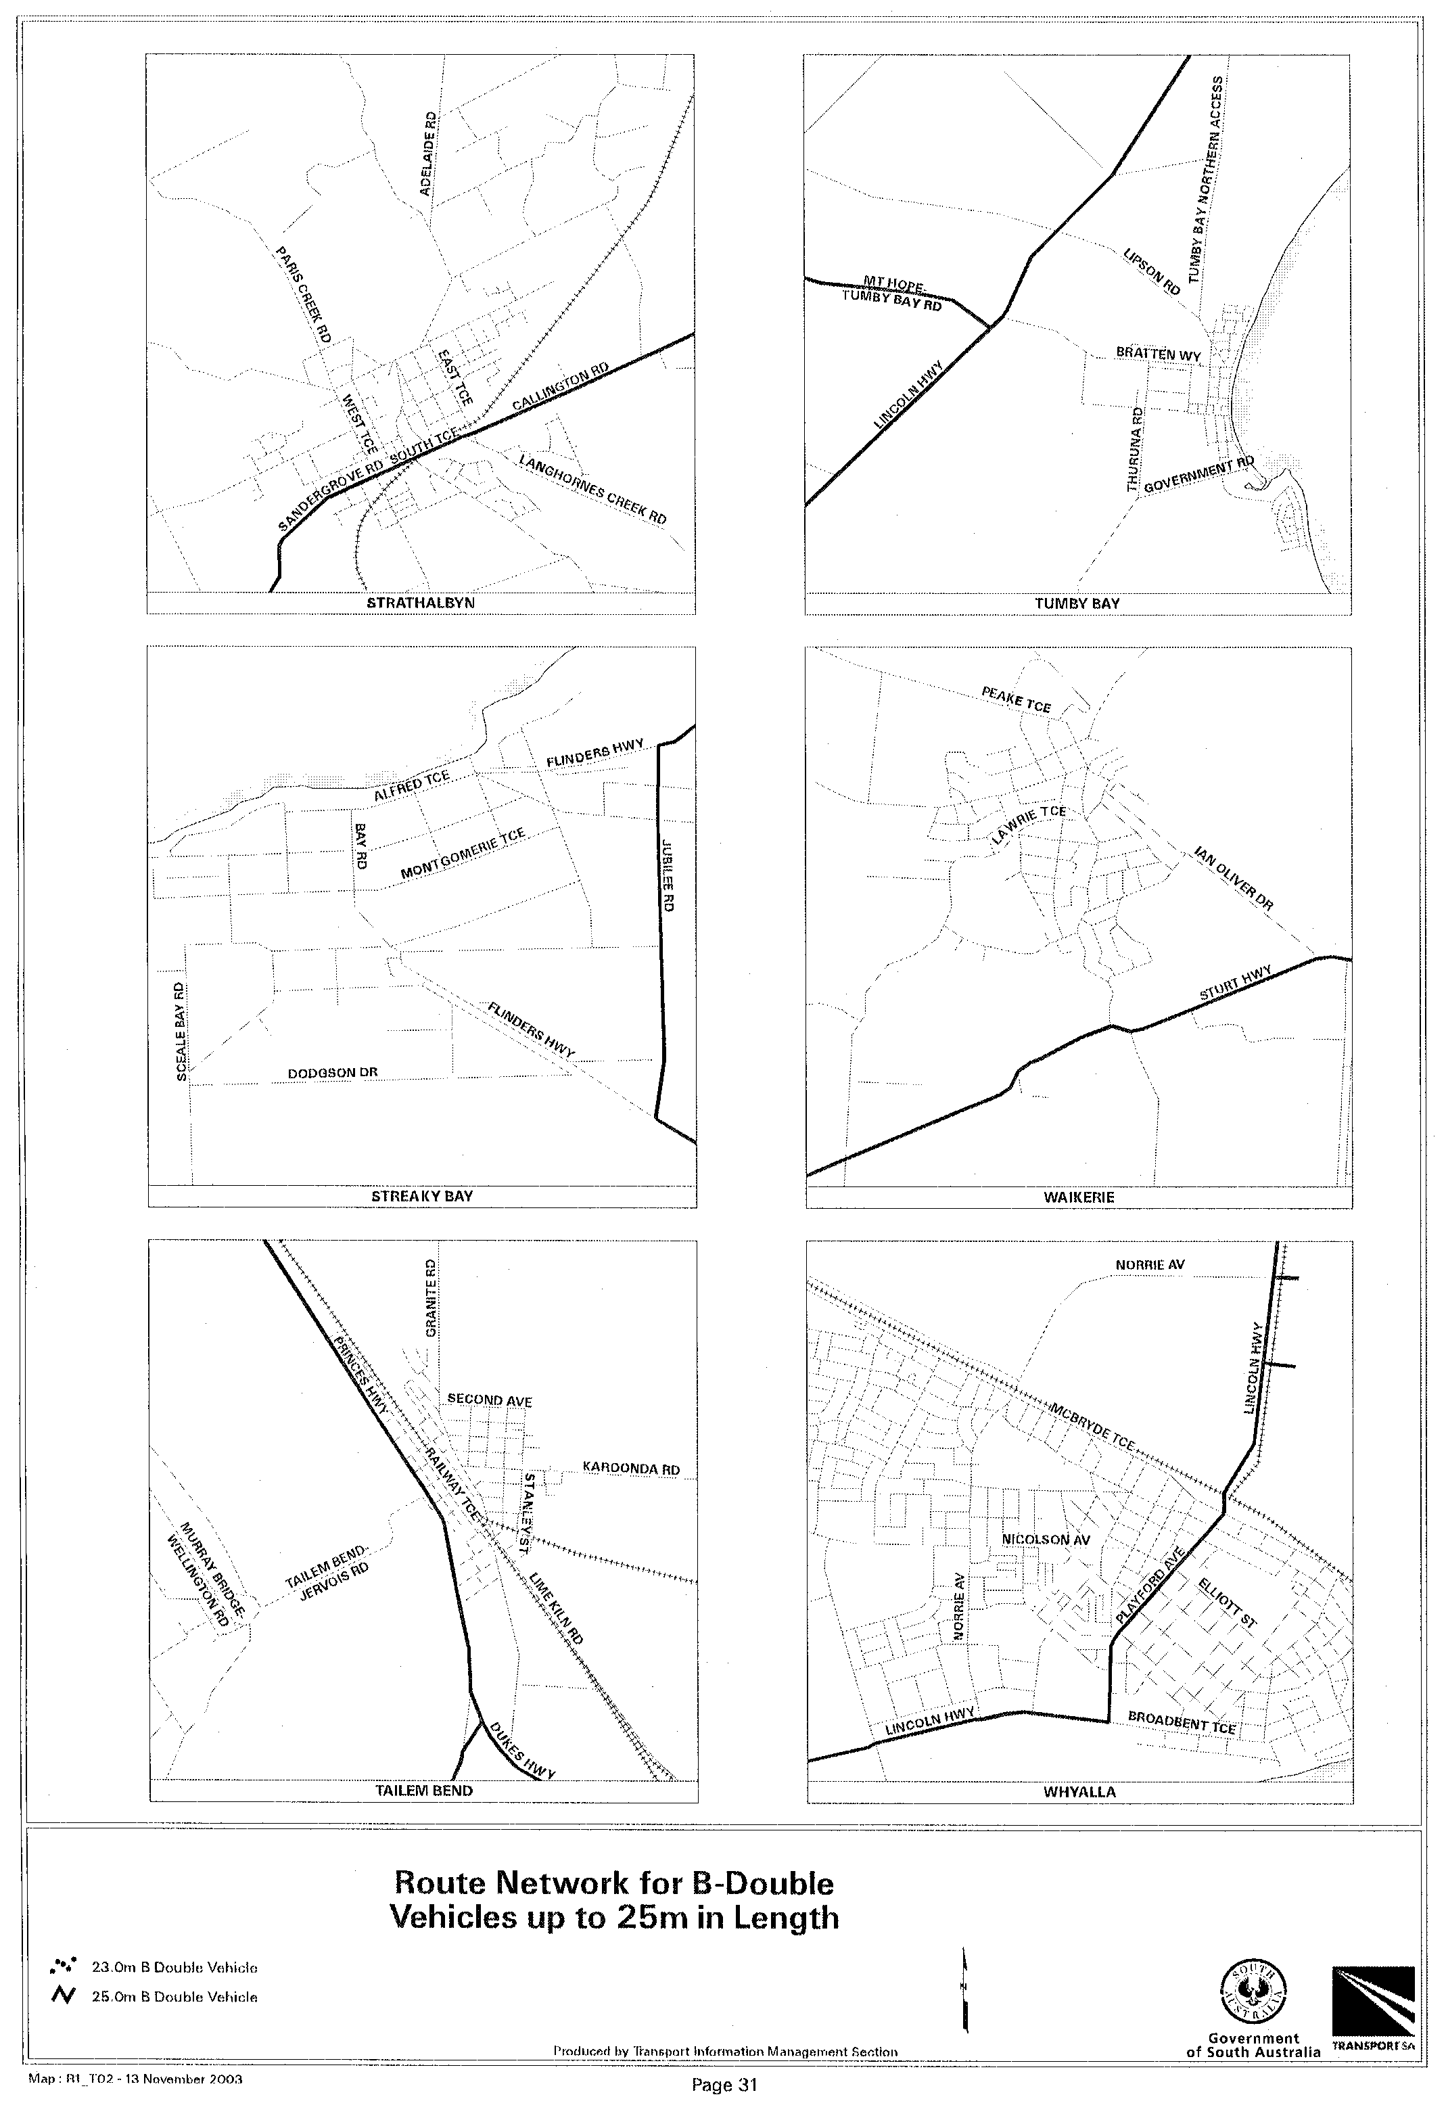
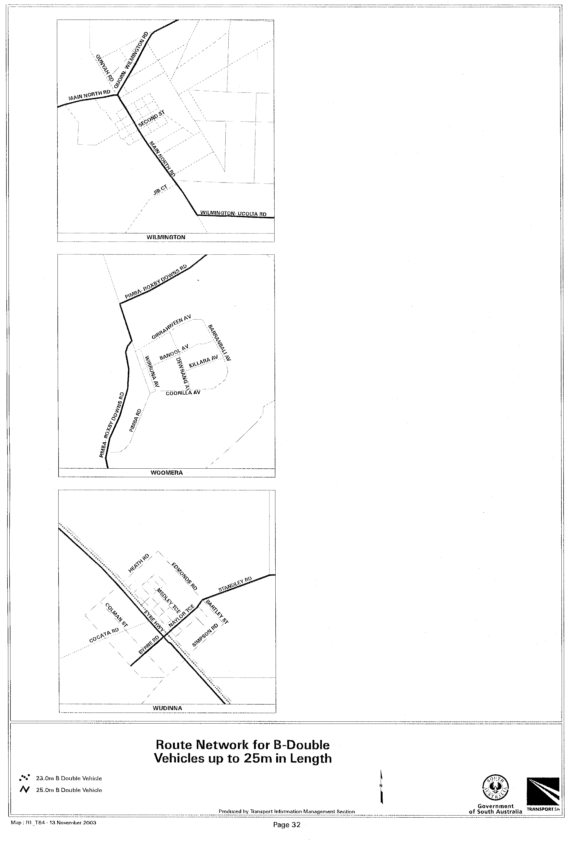
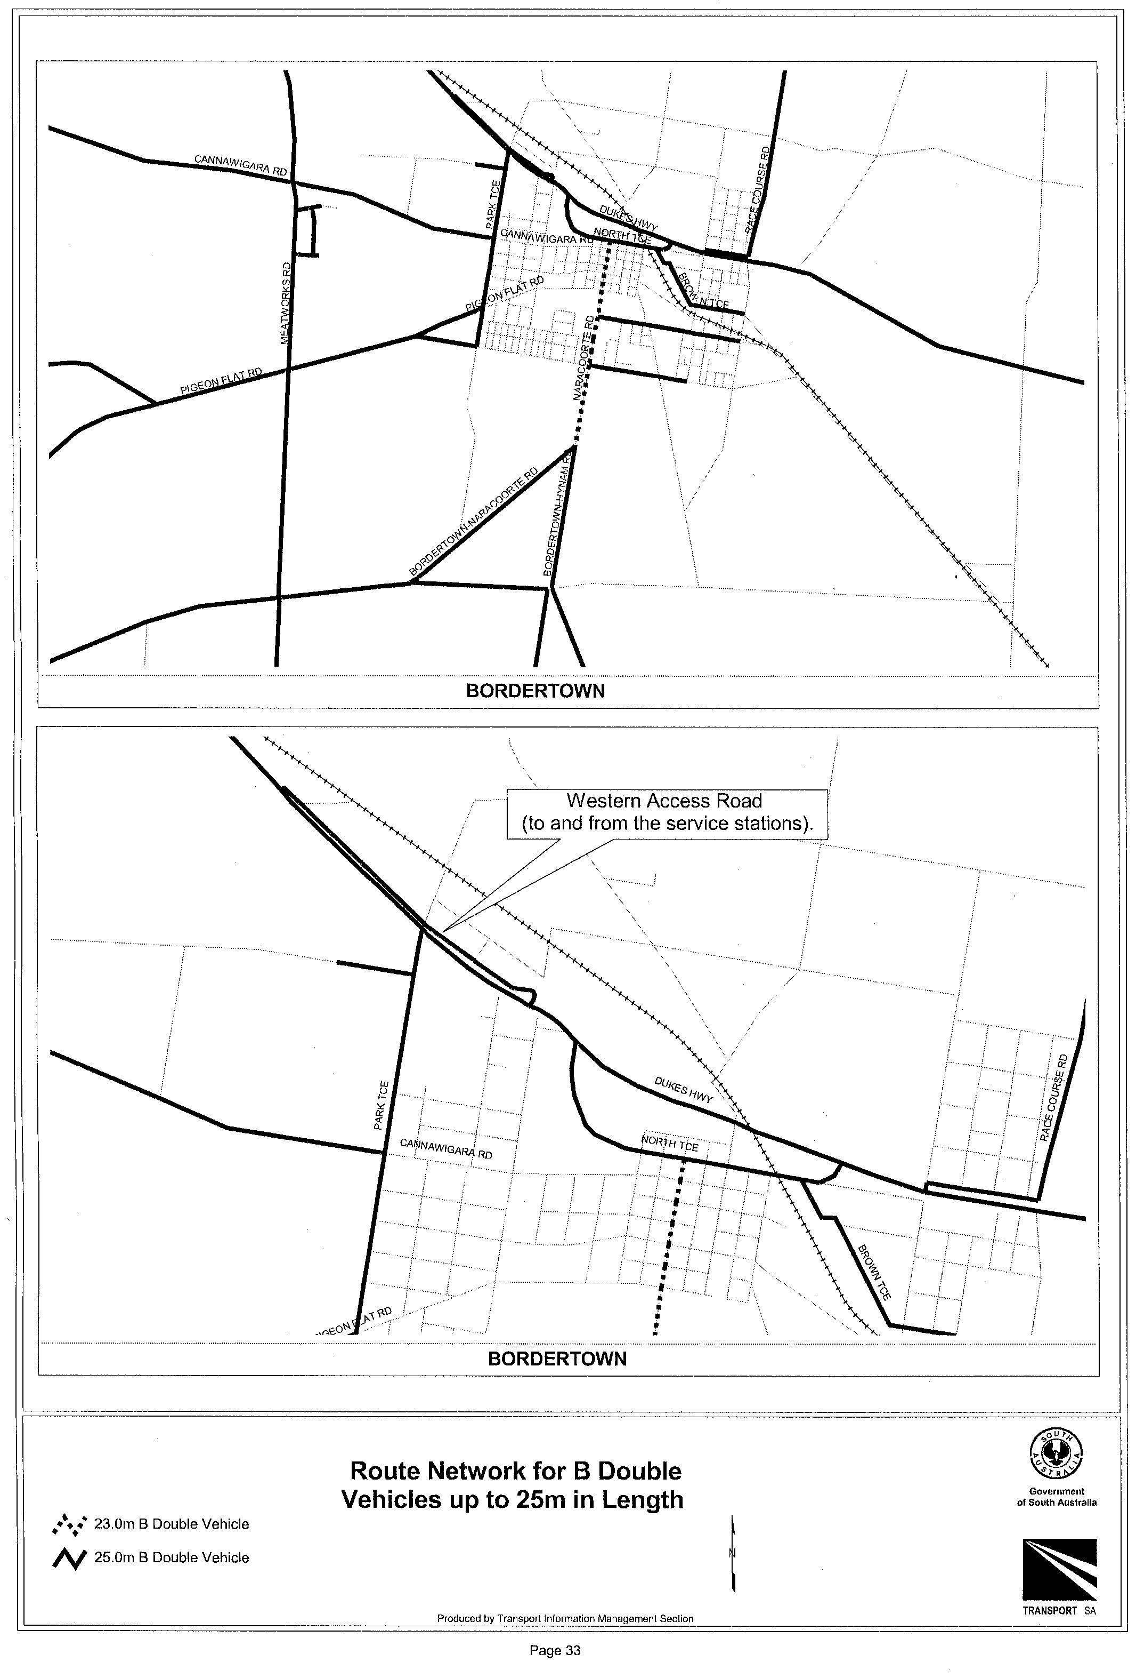
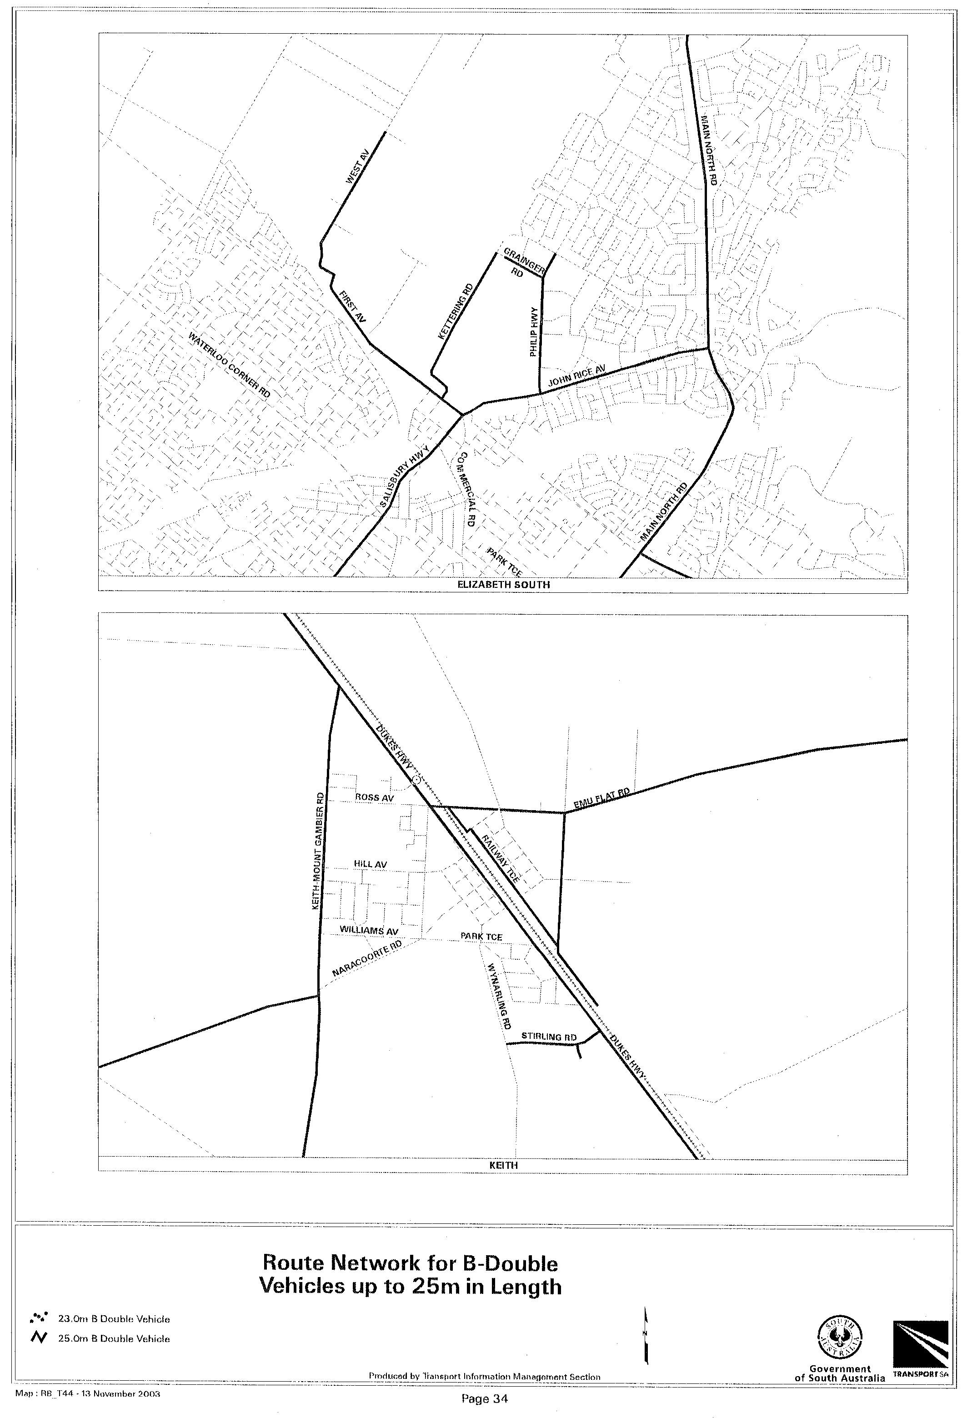
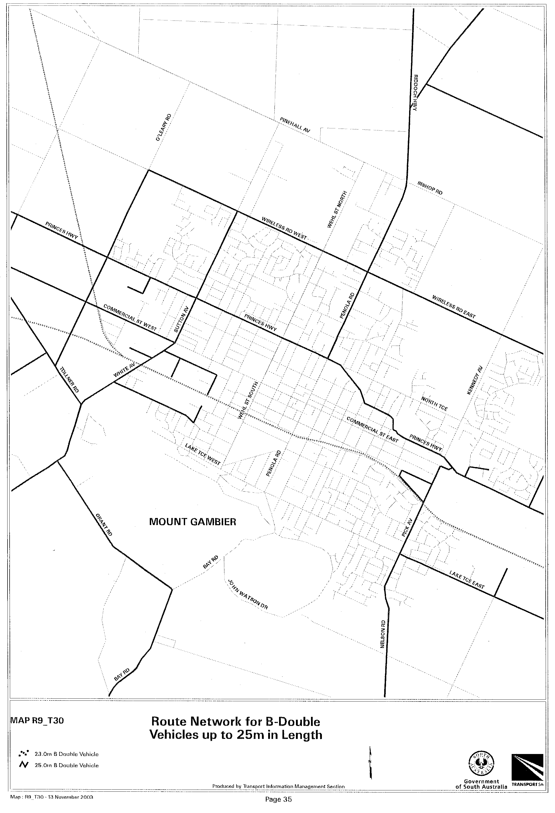
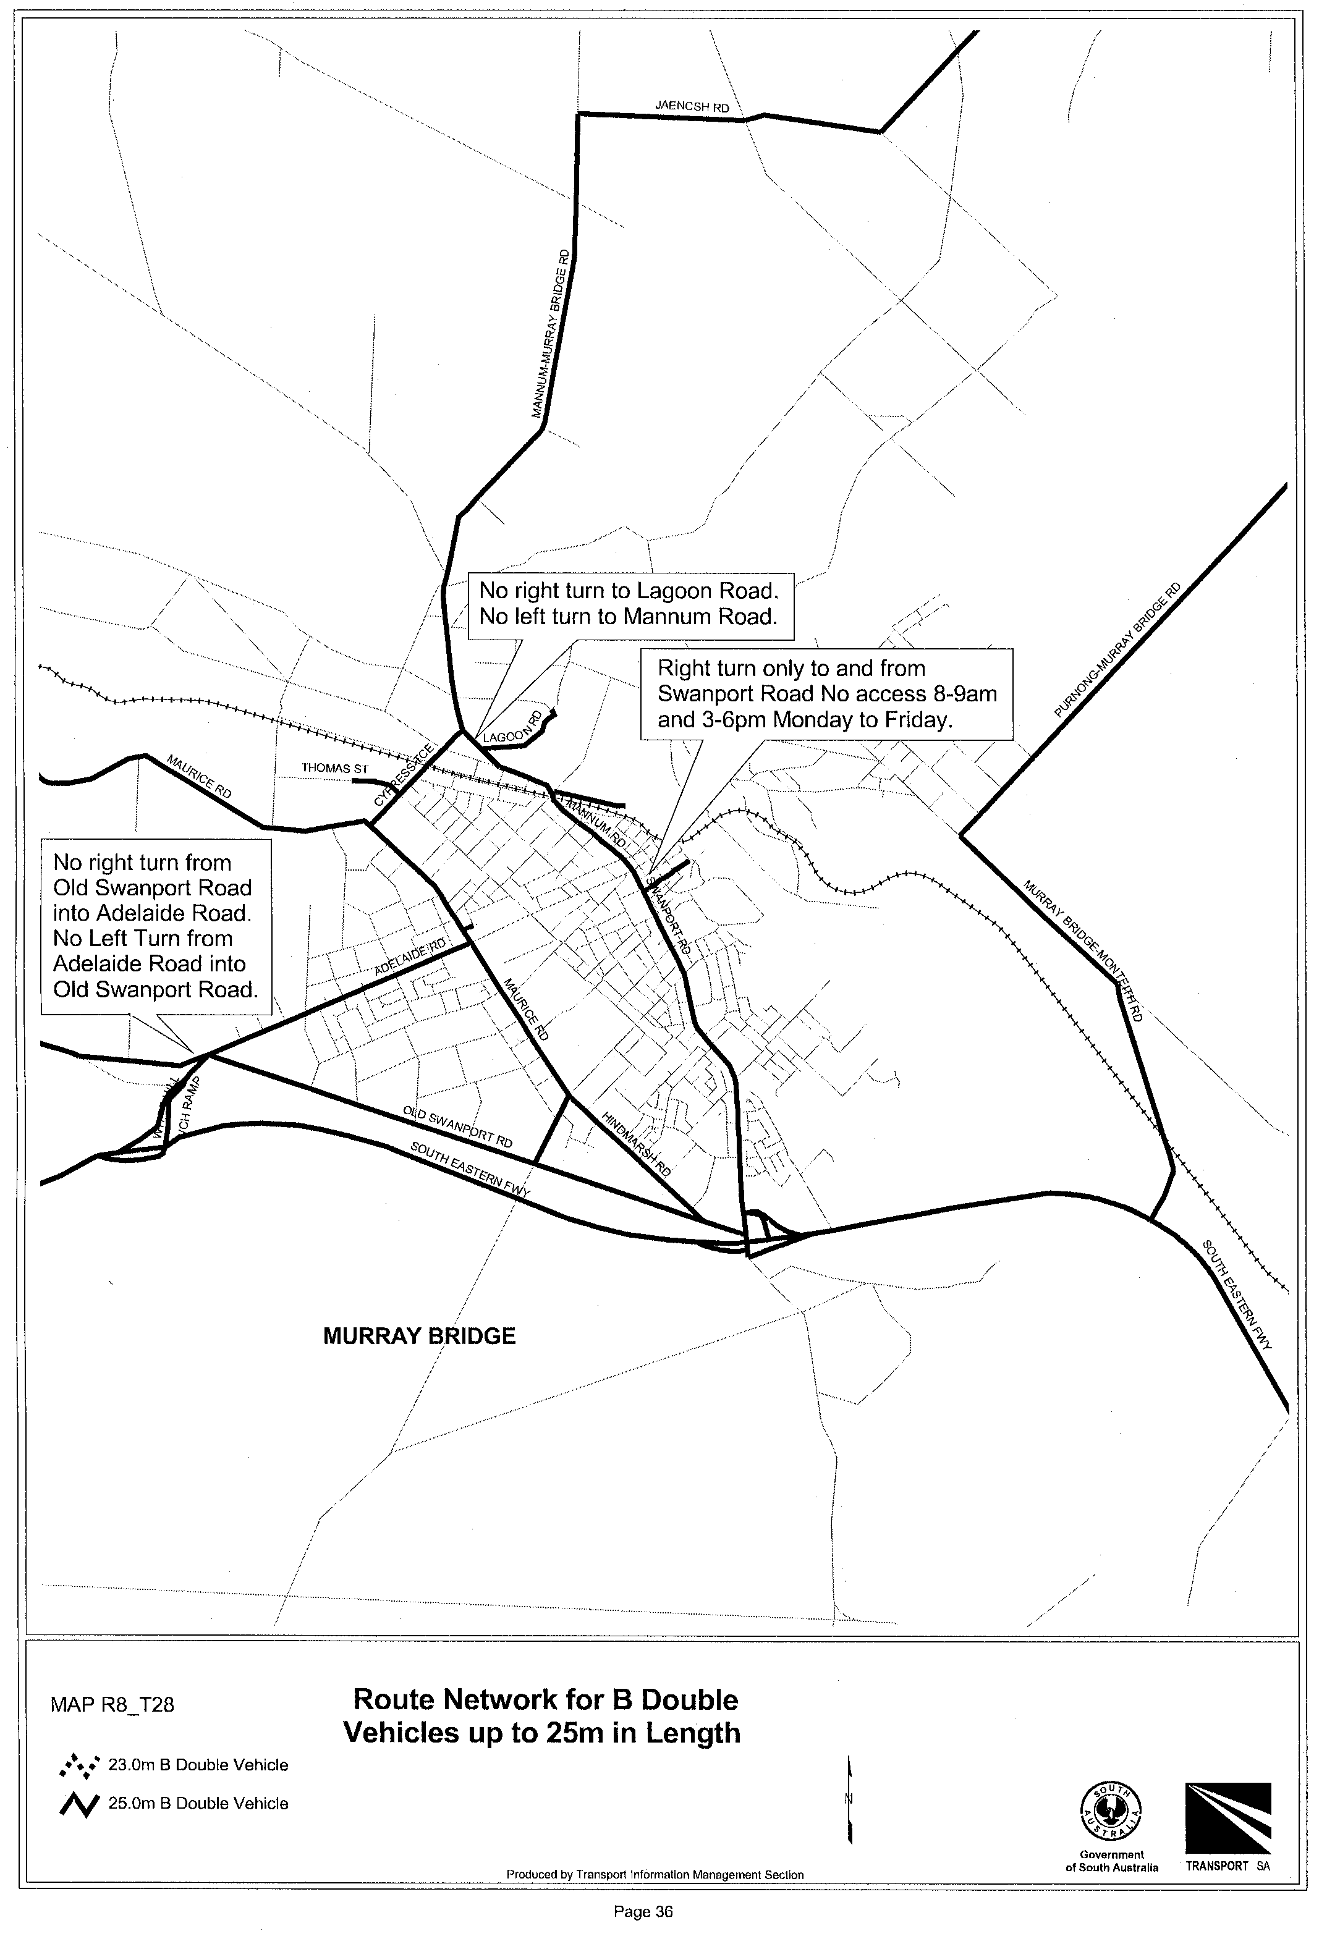
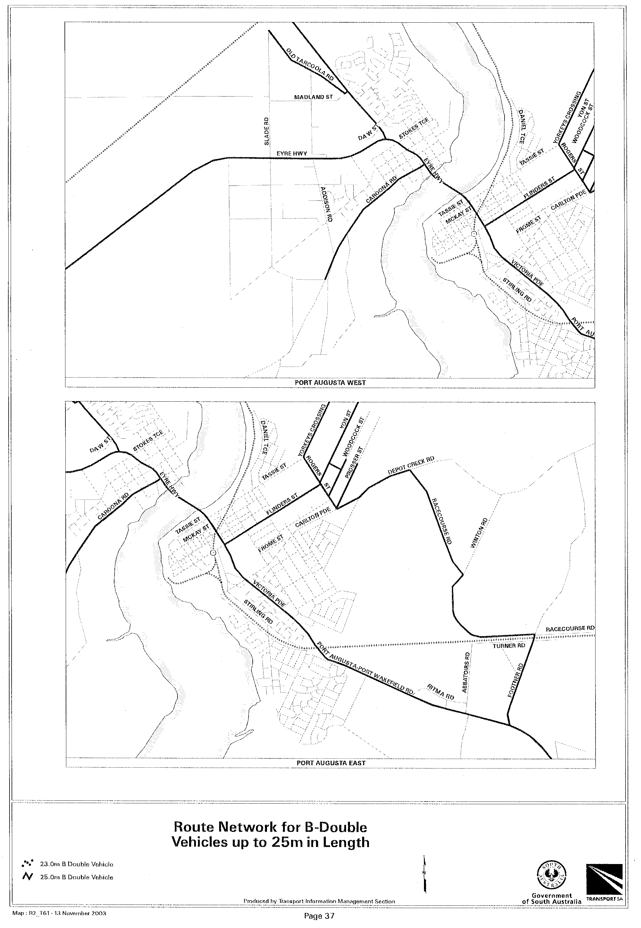
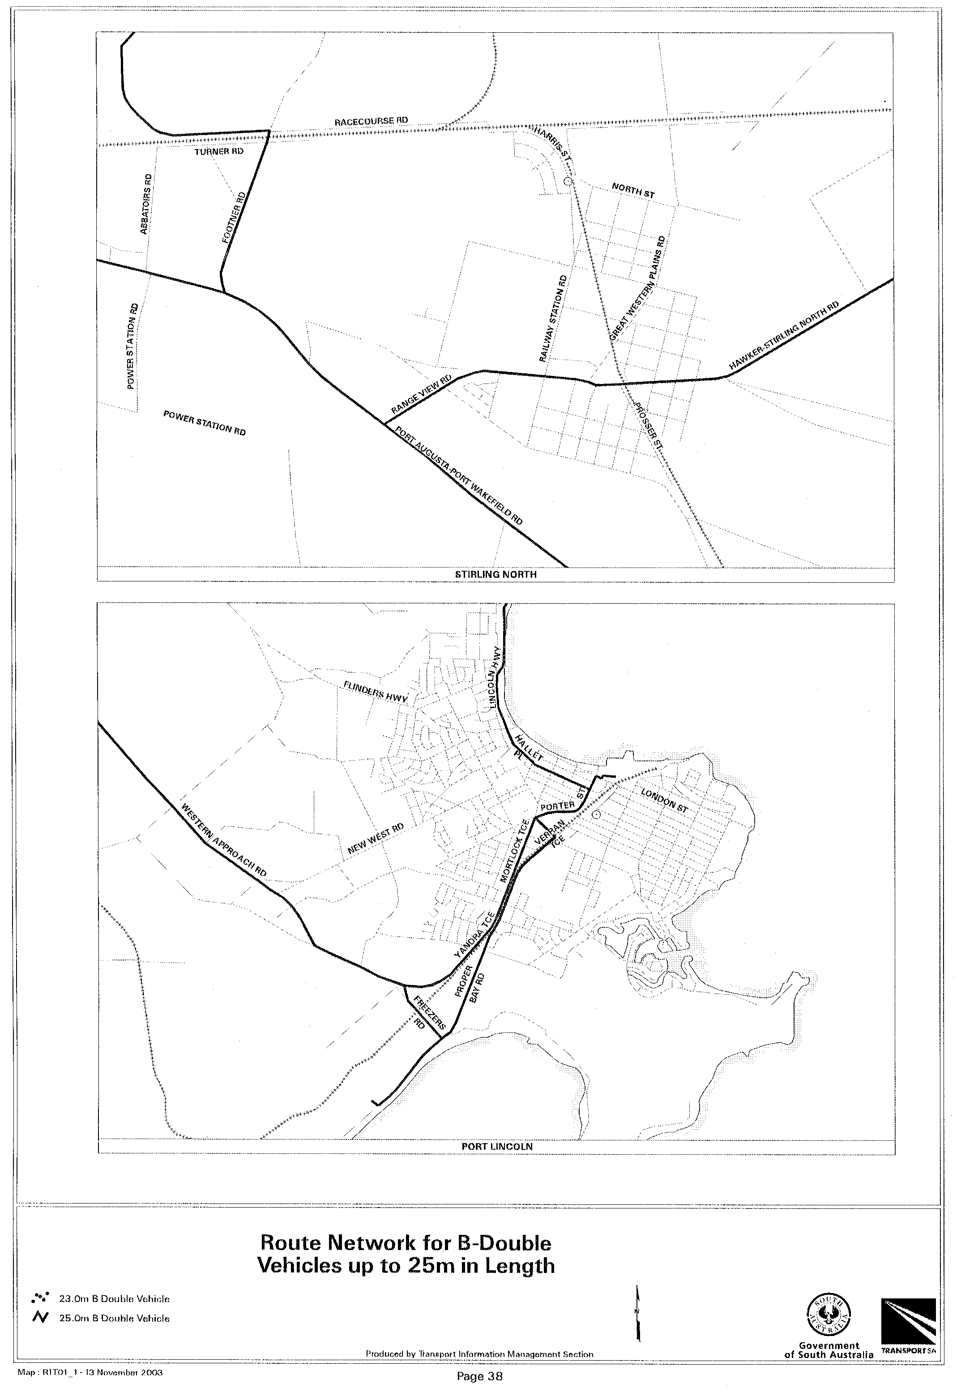

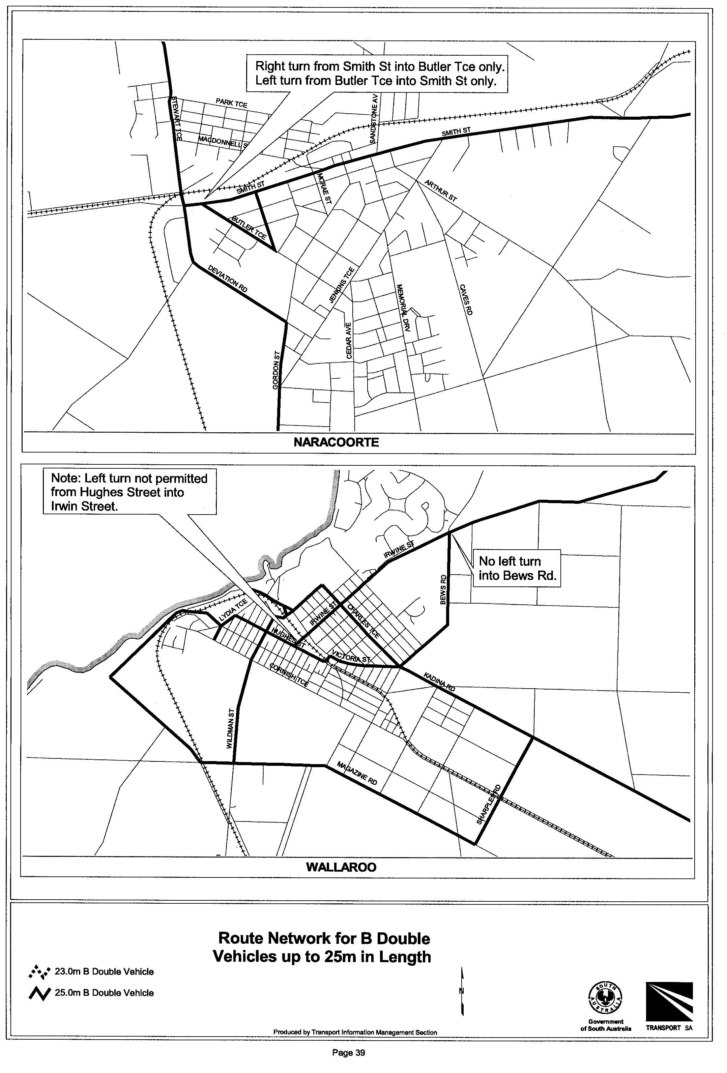
Executive Director, Transport SA

NOTE TO GOVERNMENT GAZETTE CUSTOMERS

The Government Information Centre at 77 Grenfell Street CLOSED on Friday, 10th October 2003.

All Government Legislation enquiries can now be directed to Service SA, Government Legislation Outlet.

Address Details:

Ground Floor, 101 Grenfell Street, Adelaide, S.A. 5000

Postal Details:

G.P.O. Box 1707, Adelaide, S.A. 5001

Phone: 13 23 24

RULES OF COURT
Amending the Probate Rules 1998
Amendment No. 1 to the Probate Rules

BY virtue and in pursuance of Section 122 of the Administration and Probate Act 1919, the Supreme Court Act 1935 and all other enabling powers, We the Judges of the Supreme Court of South Australia, make the following Rules to take effect as amendments to The Probate Rules 1998:
1. These Rules may be cited as ‘The Probate Rules 1998 Amendment No. 1’.
2. The Probate Rules 1998 as amended by these Rules may be cited as ‘The Probate Rules 1988’.
3. Rule 28 is amended by deleting Rule 28.08 and inserting in lieu:
‘28.08 No affidavit shall be insufficient merely because it is sworn before the practitioner acting for the party and on whose behalf it is to be used or before the partner, agent, clerk or employee of that practitioner.’
GIVEN under our hands and the Seal of the Supreme Court of South Australia this 24th day of November 2003.
(l.s.) J. DOYLE, CJ
G. C. PRIOR, J
J. W. PERRY, J
K. P. DUGGAN, J
E. P. MULLIGHAN, J
B. M. DEBELLE, J
M. J. NYLAND, J
D. J. BLEBY, J
BRIAN MARTIN, J
T. A. GRAY, J
A. BESANKO, J
J. R. SULAN, J
A. M. VANSTONE, J

RULES OF COURT
Amending the Supreme Court Rules 1987
Amendment No. 92 to the Supreme Court Rules

BY virtue and in pursuance of Section 72 of the Supreme Court Act 1935, and all other enabling powers, We, the Judges of the Supreme Court of South Australia, make the following Rules to take effect as amendments to the Supreme Court Rules 1987, as amended:
1. These Rules may be cited as the ‘Supreme Court Rules 1987 Amendment No 92’.
2. The Supreme Court Rules 1987 as amended by these Rules may be cited as the ‘Supreme Court Rules 1987’.
3. Rule 10 is amended by:
(a) inserting after Rule 10.03 the following:
‘10.03A (1) This rule applies to all actions commenced on or after the gazettal of Supreme Court Rule 1987 Amendment No. 92 to the exclusion of Rule 10.03.
(2) A summons shall be in force for a period of six months from its date of issue, or if it is to be served out of the state, for such longer period as may be fixed by the Court.
(3) The Court may, from time to time, extend the period for serving a summons for a period of six months.
(4) The Court’s discretion to extend the time for serving a summons may be exercised
(a) even though the time for service by or under this rule has expired; and
(b) even though the time for commencing an action has expired.
(5) Upon an order being made under subrule (2) and before the summons is served the summons shall be endorsed by the plaintiff with a notation to the following effect:
‘Renewed until ………..…………. 20………... by order of the Court made
on …………… day of …………………. 20………….’
(b) by inserting after Rule 10.06 the following:
‘10.06A (1) This Rule applies to all actions commenced on or after the gazettal of Supreme Court Rules 1987 Amendment No 92 to the exclusion of Rule 10.06.
(2) In any action in which within seven months of the date of the summons or of any renewal thereof:
(a) an application shall not have been taken our for an order pursuant to Rule 10.03A extending the time for service of the summons by the renewal thereof;
(b) a notice of address for service shall not have been filed by any defendant; or
(c) the plaintiff being entitled to do so shall not have applied for judgment in default of the filing of a notice of address for service;
the Registrar shall enter the action in a list to be known as the List of Inactive Cases.
(3) Where an application which is referred to in subrule (2) (a) above is refused the Registrar shall enter the action in the List of Inactive Cases.
(4) One month before entering any action in the List of Inactive Cases the Registrar shall give notice to the plaintiff of intention so to do if after seven months from the issue of the summons the action falls within Rule 10.06A (2).
(5) The Registrar shall remove from the list of Inactive Cases any action in respect of which:
(a) a notice of address for service is filed by a defendant;
(b) a judgment in default of filing a notice of address for service is obtained; or
(c) the Court in the exercise of its discretion orders such removal;
within two months of the entry of the action in the List of Inactive Cases.
(6) Upon an action remaining in the List of Inactive Cases for a period of two months after the date upon which it was entered in that List, it shall be at 4 p.m. upon the last day of that period thereupon stand dismissed for want of prosecution, but such dismissal shall not operate as a bar to the commencement by the plaintiff of fresh proceedings in respect of the same cause of action.
(7) Where an action has been dismissed by the operation of clause (6) hereof the Court may reinstate the action in special circumstances.
4. Rule 51.06 is amended by deleting the word ‘pursuant’ and inserting in lieu thereof the word ‘pursuance’.
5. Rule 83.07 (2) is amended by deleting the words ‘provided that’ and following and inserting in lieu ‘or before any clerk or employee of such solicitor’.
GIVEN under our hands and the Seal of the Supreme Court of South Australia this 24th day of November 2003.
(l.s.) J. DOYLE, CJ
G. C. PRIOR, J
J. W. PERRY, J
K. P. DUGGAN, J
E. P. MULLIGHAN, J
B. M. DEBELLE, J
M. J. NYLAND, J
D. J. BLEBY, J
BRIAN MARTIN, J
T. A. GRAY, J
A. BESANKO, J
J. R. SULAN, J
A. M. VANSTONE, J

SOUTH AUSTRALIAN MOTOR SPORT REGULATIONS 1999: REGULATION 12—CONDITIONS IMPOSED ON TICKETS
Notice by the South Australian Motor Sport Board
PURSUANT to Regulation 12 of the South Australian Motor Sport Regulations 1999, the Minister, to whom the administration of that Act has been committed, hereby impose the following conditions in respect of each of the permits, authorisations and tickets to the event known as the ‘Clipsal 500 Adelaide’ in addition to the terms and conditions contained on the back of each ticket:
CONDITIONS OF SALE
In addition to the terms and conditions contained on the back of each ticket, the following conditions and rules shall apply:

Except to the extent permitted by the Trade Practices Act 1974, tickets cannot be exchanged or refunded after purchase. Tickets are non-transferable on the day or during the day of presentation. Upon exit, the Ticketholder’s hand must be stamped to regain entry on the same day. The stamp must be shown along with the valid ticket clipped for that day to regain entry. The South Australian Motor Sport Board (the Board) reserves the right to refuse admittance to or evict from the event any person with reasonable cause.

The Board reserves the right to add, withdraw or substitute any drivers, performers or activities associated with the event, vary programs, seating arrangements and audience capacity and determine and publish additional conditions from time to time.

A person cannot make, reproduce or use any form of still or moving picture or any sound recording (footage) of the motor sport event as defined in the South Australian Motor Sport Act 1984, or any part of it for profit, gain, public advertisement, display or for any other purpose except for the private enjoyment of the person making the footage, without the consent of the Board; and will on demand assign all rights thereto to the Board or its nominees.

Any ticket purchased and the Ticketholder’s entry to and presence at the event is subject to these conditions of sale, conditions of entry displayed at the event entrances and the South Australian Motor Sport Act 1984 as amended and its Regulations. Details are freely available from Clipsal 500 Adelaide, P.O. Box V8, Kent Town, S.A. 5071.

Patrons may not, without prior written consent of the Board bring any of the following items into the Event: any alcoholic beverages; any glass bottles or containers or glass objects (excluding sunglasses, binoculars and prescription glasses); any beverage container with the manufacturer’s seal broken; any drinks coolers or ice boxes (other than one predominantly constructed of polystyrene); any structure or item that may be used to erect a structure, or which is capable of supporting the weight of a person including, without limitation, any chairs, lounges, benches or stools (other than a folding chair or stool); no animals; no weapons of any kind; no fireworks.
CONDITIONS OF ENTRY
THE SA MOTOR SPORT BOARD (Board) WILL NOT BE LIABLE FOR PERSONAL INJURY OR PROPERTY DAMAGE
The Ticketholder attending the motor race and other associated events (Events) hereby acknowledges and agrees as follows:
The Ticketholder has read and understood the Conditions of Sale and Conditions of Entry (Conditions) and agrees to be bound by the Conditions; and intends the Conditions to have full contractual effect. Where relevant, the Ticketholder and any third party who purchases a ticket on behalf of the Ticketholder (‘the third party’) each warrant that the third party had the Ticketholder’s full authority to act as the Ticketholder’s agent for the purposes of buying the ticket and accepting the Conditions.
MOTOR SPORT IS DANGEROUS
In exchange for being able to attend or participate in the event, (and as a condition of the purchase or issue of a ticket): You agree to release Confederation of Australian Motor Sport Ltd (‘CAMS’) and Australian Motor Sport Commission Ltd., promoters, sponsor organisations, land owners and lessees, organisers of the event, their respective servants, officials, representatives and agents (collectively, the ‘Associated Entities’) from all liability for your death, personal injury (including burns), psychological trauma, loss or damage (including property damage) (‘harm’) howsoever arising from your participation in or attendance at the event, except to the extent prohibited by law; you agree that CAMS and Associated Entities do not make any warranty, implied or express, that the event services will be provided with due care and skill or that any materials provided in connection with the services will be fit for the purpose for which they are supplied; and you agree to attend or participate in the event at your own risk.
You acknowledge that the risks associated with attending or participating in the event include the risk that you may suffer harm as a result of: motor vehicles (or parts of them) colliding with other motor vehicles, persons or property; acts of violence and other harmful acts (whether intentional or inadvertent) committed by persons attending or participating in the event; and the failure or unsuitability of facilities (including grand-stands, fences and guard rails) to ensure the safety of persons or property at the event.
You acknowledge that motor sport is dangerous and that accidents causing harm can and do happen and may happen to you.
You accept the conditions of, and acknowledge the risks arising from, attending or participating in the event and being provided with the event services by CAMS and the Associated Entities.
HIGH DANGER AREAS
The Ticketholder on entering into pit lane and/or pit paddock is fully aware and recognises that pit lane and pit paddock are extremely dangerous and there is a real possibility of an accident causing injury, death, property damage or other losses in those areas; is fully aware that it is a condition of entry that they enter the pit lane and pit paddock and other high danger areas of the events ground at their own risk.
CHILDREN ARE TO BE SUPERVISED BY ADULTS
The Ticketholder acknowledges that all children attending the Events must be under the supervision of an adult guardian at all times.
SEVERANCE
If anything in these Conditions of Entry is unenforceable, illegal or void then it is severed and the rest of the Conditions of Entry remain in force.
K. Foley, Deputy Premier

SOUTH AUSTRALIAN MOTOR SPORT ACT 1984: SECTION 26—AVAILABILITY OF PLANS FOR PUBLIC INSPECTION
Notice by the Deputy Premier
PURSUANT to section 26 of the South Australian Motor Sport Act 1984, the Minister to whom the administration of that Act has been committed, hereby designate the offices of Kellogg Brown & Root Pty Ltd located at 186 Greenhill Road, Parkside as the place at which may be inspected by members of the public plans of all works proposed to be carried out by the South Australian Motor Sport Board in relation to the event known as the ‘Clipsal 500 Adelaide’.
K. Foley, Deputy Premier

SOUTH AUSTRALIAN MOTOR SPORT REGULATIONS 1999: REGULATION 11—OPENING AND CLOSING TIME OF THE DECLARED AREA
Notice by the South Australian Motor Sport Board
PURSUANT to Regulation 11 of the South Australian Motor Sport Regulations 1999, I, the Minister to whom the administration of that Act has been committed, hereby fix the following opening and closing times in respect of declared areas for each day of the declared period:
Day Opening Time Closing Time
Thursday, 18 March 2004 8 a.m. 8.30 p.m.
Friday, 19 March 2004 8 a.m. 11 p.m.
Saturday, 20 March 2004 8 a.m. 11 p.m.
Sunday, 21 March 2004 8 a.m. 10 p.m.
K. Foley, Deputy Premier

SOUTH AUSTRALIAN MOTOR SPORT ACT 1984: SECTION 20 (1)—DECLARATION OF AREA AND PERIOD
Notice by the Deputy Premier
PURSUANT to section 20 (1) of the South Australian Motor Sport Act 1984, I, the Minister to whom the administration of that Act has been committed, in respect of the motor sport event promoted by the South Australian Motor Sport Board under the name ‘2004 Clipsal 500 Adelaide’, acting on the recommendation of the Board, declare:
(a) That the area delineated on the plan in the schedule will be a declared area under the Act for the purposes of the event; and
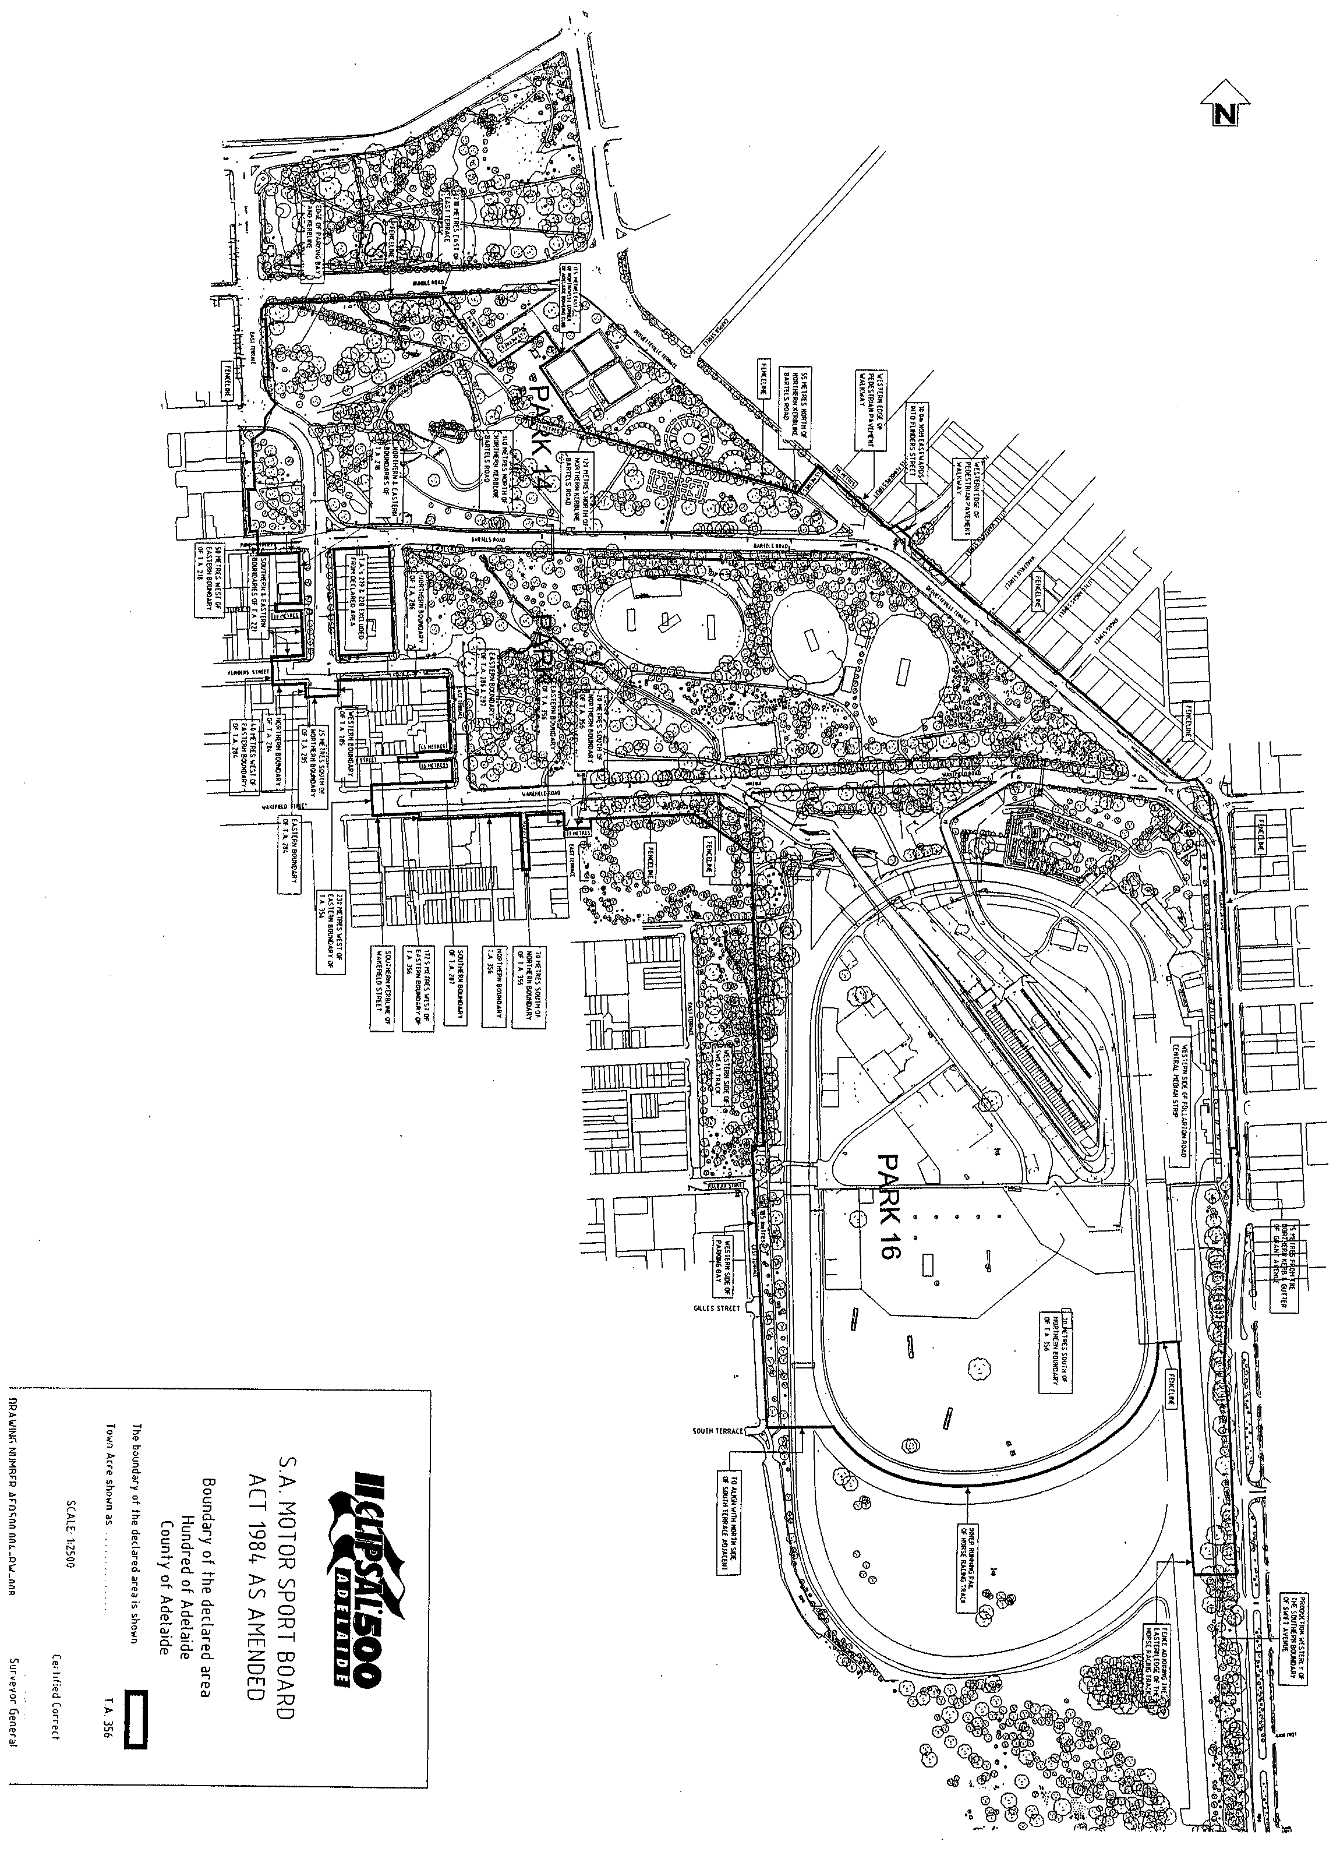
(b) That the period commencing on 17 March 2004 and ending on 21 March 2004 (both days inclusive) will be a declared period under the Act for the purposes of the event.

K. Foley, Deputy Premier

GOVERNMENT GAZETTE ADVERTISEMENT RATES

To apply from 1 July 2002

$  Agents, Ceasing to Act as 34.10  Associations:  Incorporation 17.40  Intention of Incorporation 43.00  Transfer of Properties 43.00  Attorney, Appointment of 34.10  Bailiff’s Sale 43.00  Cemetery Curator Appointed 25.50  Companies:  Alteration to Constitution 34.10  Capital, Increase or Decrease of 43.00  Ceasing to Carry on Business 25.50  Declaration of Dividend 25.50  Incorporation 34.10  Lost Share Certificates:  First Name 25.50  Each Subsequent Name 8.75  Meeting Final 28.75  Meeting Final Regarding Liquidator’s Report on  Conduct of Winding Up (equivalent to ‘Final  Meeting’)  First Name 34.10  Each Subsequent Name 8.75  Notices:  Call 43.00  Change of Name 17.40  Creditors 34.10  Creditors Compromise of Arrangement 34.10  Creditors (extraordinary resolution that ‘the Com-pany be wound up voluntarily and that a liquidator be appointed’) 43.00  Release of Liquidator⎯Application⎯Large Ad. 68.00  ⎯Release Granted 43.00  Receiver and Manager Appointed 39.75  Receiver and Manager Ceasing to Act 34.10  Restored Name 32.25  Petition to Supreme Court for Winding Up 59.50  Summons in Action 51.00  Order of Supreme Court for Winding Up Action 34.10  Register of Interests⎯Section 84 (1) Exempt 77.00  Removal of Office 17.40  Proof of Debts 34.10  Sales of Shares and Forfeiture 34.10  Estates:  Assigned 25.50  Deceased Persons⎯Notice to Creditors, etc. 43.00  Each Subsequent Name 8.75  Deceased Persons⎯Closed Estates 25.50  Each Subsequent Estate 1.10  Probate, Selling of 34.10  Public Trustee, each Estate 8.75 |  | $  Firms:  Ceasing to Carry on Business (each insertion) 22.70  Discontinuance Place of Business 22.70  Land⎯Real Property Act:  Intention to Sell, Notice of 43.00  Lost Certificate of Title Notices 43.00  Cancellation, Notice of (Strata Plan) 43.00  Mortgages:  Caveat Lodgment 17.40  Discharge of 18.30  Foreclosures 17.40  Transfer of 17.40  Sublet 8.75  Leases⎯Application for Transfer (2 insertions) each 8.75  Lost Treasury Receipts (3 insertions) each 25.50  Licensing 51.00  Municipal or District Councils:  Annual Financial Statement⎯Forms 1 and 2 481.00  Electricity Supply⎯Forms 19 and 20 341.00  Default in Payment of Rates:  First Name 68.00  Each Subsequent Name 8.75  Noxious Trade 25.50  Partnership, Dissolution of 25.50  Petitions (small) 17.40  Registered Building Societies (from Registrar-  General) 17.40  Register of Unclaimed Moneys⎯First Name 25.50  Each Subsequent Name 8.75  Registers of Members⎯Three pages and over:  Rate per page (in 8pt) 218.00  Rate per page (in 6pt) 288.00  Sale of Land by Public Auction 43.50  Advertisements 2.40  Advertisements, other than those listed are charged at $2.40 per column line, tabular one-third extra.  Notices by Colleges, Universities, Corporations and District Councils to be charged at $2.40 per line.  Where the notice inserted varies significantly in length from that which is usually published a charge of $2.40 per column line will be applied in lieu of advertisement rates listed.  South Australian Government publications are sold on the condition that they will not be reproduced without prior permission from the Government Printer.
All the above prices include GST

GOVERNMENT GAZETTE NOTICES
ALL private advertisements forwarded for publication in the South Australian Government Gazette must be PAID FOR PRIOR TO INSERTION; and all notices, from whatever source, should be legibly written on one side of the paper only and sent to Government Publishing SA so as to be received no later than 4 p.m. Tuesday preceding the day of publication. Phone 8207 1045 or Fax 8207 1040. E-mail: governmentgazette@saugov.sa.gov.au. Send as attachments in Word format and please confirm your transmission with a faxed copy of your document, including the date the notice is to be published and to whom the notice will be charged.

MISCELLANEOUS LEGISLATION AND GOVERNMENT PUBLICATIONS PRICES AS FROM 1 JULY 2003

Acts, Bills, Rules, Parliamentary Papers and Regulations
Pages | Main | Amends | Pages | Main | Amends

1-16 | 2.05 | 0.90 | 497-512 | 29.20 | 28.00
17-32 | 2.80 | 1.75 | 513-528 | 30.00 | 28.80
33-48 | 3.65 | 2.60 | 529-544 | 30.90 | 29.90
49-64 | 4.60 | 3.50 | 545-560 | 31.70 | 30.90
65-80 | 5.40 | 4.45 | 561-576 | 32.50 | 31.70
81-96 | 6.25 | 5.20 | 577-592 | 33.60 | 32.20
97-112 | 7.15 | 6.05 | 593-608 | 34.40 | 33.25
113-128 | 8.00 | 7.00 | 609-624 | 35.20 | 34.30
129-144 | 9.00 | 7.95 | 625-640 | 35.90 | 34.80
145-160 | 9.85 | 8.80 | 641-656 | 36.80 | 35.85
161-176 | 10.80 | 9.65 | 657-672 | 37.40 | 36.60
177-192 | 11.60 | 10.60 | 673-688 | 39.00 | 37.40
193-208 | 12.50 | 11.50 | 689-704 | 39.80 | 38.40
209-224 | 13.30 | 12.25 | 705-720 | 40.30 | 39.50
225-240 | 14.20 | 13.10 | 721-736 | 41.80 | 40.00
241-257 | 15.10 | 13.80 | 737-752 | 42.30 | 41.30
258-272 | 16.00 | 14.75 | 753-768 | 43.40 | 41.80
273-288 | 16.90 | 15.80 | 769-784 | 43.90 | 43.10
289-304 | 17.60 | 16.60 | 785-800 | 44.70 | 43.90
305-320 | 18.60 | 17.50 | 801-816 | 45.50 | 44.40
321-336 | 19.40 | 18.30 | 817-832 | 46.50 | 45.50
337-352 | 20.40 | 19.30 | 833-848 | 47.50 | 46.25
353-368 | 21.20 | 20.20 | 849-864 | 48.30 | 47.00
369-384 | 22.10 | 21.10 | 865-880 | 49.00 | 48.30
385-400 | 22.90 | 21.90 | 881-896 | 49.60 | 48.80
401-416 | 23.70 | 22.60 | 897-912 | 51.20 | 49.60
417-432 | 24.80 | 23.60 | 913-928 | 51.70 | 51.20
433-448 | 25.60 | 24.50 | 929-944 | 52.50 | 51.70
449-464 | 26.50 | 25.30 | 945-960 | 53.50 | 52.20
465-480 | 27.00 | 26.20 | 961-976 | 54.50 | 53.25
481-496 | 28.20 | 27.00 | 977-992 | 55.60 | 54.00

Legislation—Acts, Regulations, etc: $
Subscriptions:
Acts 180.00
All Bills as Laid 431.00
Rules and Regulations 431.00
Parliamentary Papers 431.00
Bound Acts 199.00
Index 99.00
Government Gazette
Copy 4.70
Subscription 238.00
Hansard
Copy 13.00
Subscription—per session (issued weekly) 374.00
Cloth bound—per volume 161.00
Subscription—per session (issued daily) 374.00
Legislation on Disk
Whole Database 2 763.00
Annual Subscription for fortnightly updates 849.00
Individual Act(s) including updates POA
Compendium
Subscriptions:
New Subs 1 638.00
Updates 578.00
(All the above prices include GST)

All Legislation, Government Gazette, Hansard and Legislation on disk are available from:
Counter Sales Service SA, Government Legislation⁺ Outlet
and Mail Orders: Lands Titles Office, 101 Grenfell Street, Adelaide
Phone: 13 23 24 (local call cost), Fax: (08) 8204 1909
Postal: G.P.O. Box 1707, Adelaide, S.A. 5001

Online Shop: www.shop.service.sa.gov.au

Subscriptions and Government Publishing SA
Standing Orders: Box 9, Plaza Level, Riverside Centre, North Terrace, Adelaide, S.A. 5000
Phone: (08) 8207 0908, (08) 8207 0910, Fax: (08) 8207 1040

SOUTH AUSTRALIAN HOUSING TRUST ACT 1995
Notice of Proposed Transfer
Preamble
1. Section 23 (1) (b) (ii) of the South Australian Housing Trust Act 1995 provides that the Minister may with the concurrence of the Treasurer, by notice in the Gazette, transfer assets, rights and liabilities of the South Australian Housing Trust (SAHT) to a statutory corporation (being a body established under the Housing and Urban Development (Administrative Arrangements) Act 1995.
2. It is proposed to transfer certain assets, rights and liabilities of SAHT to the South Australian Aboriginal Housing Authority (which is a statutory corporation).
3. Section 23 (3) (a) of the South Australian Housing Trust Act 1995 requires that the Minister must not act under section 23 (1) (b) of that Act unless he or she has first given preliminary notice of the proposed transfer.
Notice
PURSUANT to section 23 (3) (a) of the South Australian Housing Trust Act 1995, I, the Minister to whom the administration of that Act is committed, give preliminary notice of an intention to transfer all the assets, rights and liabilities of SAHT referred to in the schedule to the South Australian Aboriginal Housing Authority under section 23 (1) (b) of that Act:
Schedule
1. All vacant land properties administered by the Aboriginal Housing Unit of SAHT.
2. Any debt on whatever account owed to SAHT in relation to a property referred to in clause 1.
3. Any right of SAHT under a warranty, guarantee or other instrument connected with a property referred to in clause 1.
4. Any right of SAHT to bring any action for damage caused to a property referred to in clause 1.
5. Any liability of SAHT for damage, injury or loss in connection with a property referred to in clause 1.
6. Any benefit, obligation, right or liability of SAHT under an agreement or instrument that relates to a property referred to in clause 1.
7. Any record or other instrument kept or held by SAHT that relates to a property referred to in clause 1.
8. A right of SAHT to make any other claim or to bring or take any other action in connection with a property referred to in clause 1.
9. Any right or benefit of SAHT on account of a prepayment made by SAHT in connection with a property referred to in clause 1.
10. Any other right or liability of SAHT in connection with a property referred to in clause 1.
Stephanie Key, Minister for Housing

SURVEY ACT 1992
Confused Boundary Area
PURSUANT to section 50 of the Survey Act 1992, notice is hereby given that a Confused Boundary Area is declared east of the intersection of Flinders Drive and Ransford Street in the area of Cape Jervis, namely allotments 37 to 48 in Deposited Plan 4816 and allotments 177 to 178 in Deposited Plan 7528.
Dated 4 December 2003.
P. M. Kentish, Surveyor-General
REF: LTO 90/2003

SURVEY ACT 1992
Revocation
PURSUANT to section 49 (1) (b) of the Survey Act 1992, I declare that from 4 March 2004:
• designated survey areas numbered 5, 6 and 7 are revoked; and
• the following areas of the State, numbered 5, 6, 7, 145, 146, 147, 148, 149, 150, 151, 152, 153 and 154 outlined in black on Rack Plan 900, to be designated survey areas.
Rack Plan 900 may be inspected at the Information Booth, Land Titles Office, Ground Floor, 101 Grenfell Street, Adelaide.
Dated 4 December 2003.
P. M. Kentish, Surveyor-General

WATER RESOURCES ACT 1997
Notice of Restriction on the taking of water from the River Murray Prescribed Watercourse
PURSUANT to section 16 (9) of the Water Resources Act 1997 (‘the Act’), I, John David Hill, Minister for Environment and Conservation in the State of South Australia, and Minister to whom administration of the Water Resources Act 1997, is committed, hereby revoke the following notices:
• The notice dated 13 June 2003 pursuant to section 16 (1) of the Act published in the Government Gazette on 24 June 2003 at page 2627 (‘the First Notice’).
• The notice dated 25 September 2003, pursuant to section 16 (9) of the Act published in the Government Gazette on 25 September 2003 at page 3641, which varied the first notice.
Pursuant to section 16 (1) of the Water Resources Act 1997 (‘the Act’), I, John David Hill, Minister for Environment and Conservation in the State of South Australia, and Minister to whom administration of the Water Resources Act 1997, is committed, being of the opinion that the rate at which water is being taken from the River Murray Prescribed Watercourse as described in Schedule 1:
• is such that the quantity of water available can no longer meet the demand; and
• there is a risk that the available water will not be sufficient to meet future demand; and
• is affecting the quality of water in the watercourse,
hereby restrict the taking of water from the River Murray Prescribed Watercourse, in the manner, and subject to the conditions, specified in Schedule 2.
Schedule 1
The River Murray Prescribed Watercourse established by proclamation under the Water Resources Act 1976 and continued in existence as if it had been proclaimed under the Water Resources Act 1990 and continued as a regulation under the Water Resources Act 1997, by virtue of clause 2 (1) (a) of Schedule 3 of the Water Resources Act 1997, (‘being the area’) and described in the General Registry Office Plan Number 926/78, sheets 1 to 13.
Schedule 2
1. A person may only take water from the River Murray Prescribed Watercourse in accordance with the terms of a written authorisation granted under this notice by me or my authorised agent.
2. An authorisation terminates according to its terms, or upon expiry or revocation of this notice, whichever is the earliest.
3. An authorisation under this notice may be granted to:
(a) A person holding a water licence endorsed with a water (taking) allocation to take water from the River Murray Prescribed Watercourse entitling that person to take:
• a quantity of water equivalent to 95% of the water (taking) allocation endorsed on the water licence, excluding water allocations for the purposes specified in clause 7 and subject to the provision of clause 4.
(b) A person holding a water licence endorsed with a water (taking) allocation for the taking of water for urban water supply through reticulated water supply infra-structure under the Waterworks Act 1932 (Metropolitan Adelaide) entitling that person to take:
• 122 Gigalitres.
(c) A person holding a water licence endorsed with a water (taking) allocation for the taking of water for urban water supply through reticulated water supply infra-structure under the Waterworks Act 1932 (Country Towns) entitling that person to take:
• 40 Gigalitres.
(d) A person who during the period of this notice, receives approval to convert a water (holding) allocation to a water (taking) allocation under the Water Resources Act 1997, entitling that person to take:
• a quantity of water equivalent to 95% of the water (taking) allocation endorsed on the water licence after conversion, excluding water allocations for purposes specified in clause 7 and subject to the provision of clause 4.
4. Where a water allocation is transferred to the State of South Australia for taking purposes from interstate the total volume transferred may be taken by the transferee.
5. The following condition applies to the taking of water in accordance with this notice:
• The water may only be taken through a meter which accurately measures the quantity of water taken and is at all times in good working condition, unless water is taken to irrigate reclaimed land within the Lower Murray Reclaimed Irrigation Management Zone as defined in the Water Allocation Plan for the River Murray Prescribed Watercourse adopted on 1 July 2002.
6. An authorisation granted under this notice will terminate if the person to whom the authorisation was granted no longer holds a licence endorsed with a water (taking) allocation.
7. This notice of Restriction does not apply:
• to the taking of water pursuant to section 7 (5) of the Act for domestic purposes or for watering stock; or
• to the taking of water for intensive farming as defined under the Act; or
• to the taking of water for animal health and welfare; or
• to the taking of water for fire fighting purposes.
This notice will remain in effect until 30 June 2004, unless earlier varied or revoked.
Dated 26 November 2003.
John Hill, Minister for Environment and Conservation

WATERWORKS ACT 1932
Water Rates in Respect of Non-Commercial Land (except Residential and Vacant Land)
PURSUANT to section 65C (1) (d) of the Waterworks Act 1932, and after consultation with the South Australian Water Corpora-tion, I fix the following water rates in respect of all water supplied to all classes of non-commercial land except residential and vacant land for the financial year commencing on 1 July 2004 and ending on 30 June 2005:
(i) for each kilolitre supplied up to, and including, 125 kilolitres—$0.44 per kilolitre;
(ii) for each kilolitre supplied over 125 kilolitres—$1.03 per kilolitre.
Dated 3 December 2003.
J. Weatherill, Minister for Administrative Services

WATERWORKS ACT 1932
Supply Charge in Respect of Non-Commercial Land (except Residential and Vacant Land)
PURSUANT to section 65C (1) (a) of the Waterworks Act 1932, and after consultation with the South Australian Water Corpora-tion, I fix the supply charge in respect of all classes of non-commercial land except residential and vacant land for the financial year commencing on 1 July 2004 and ending on 30 June 2005 at $155.00 per annum.
Dated 3 December 2003.
J. Weatherill, Minister for Administrative Services

WATERWORKS ACT 1932
Supply Charge in Respect of Non-Commercial (Residential and Vacant) Land
PURSUANT to section 65C (1) (a) of the Waterworks Act 1932, and after consultation with the South Australian Water Corpora-tion, I fix the supply charge in respect of residential and vacant land for the financial year commencing on 1 July 2004 and ending on 30 June 2005 at $141.00 per annum.
Dated 3 December 2003.
J. Weatherill, Minister for Administrative Services

WATERWORKS ACT 1932
Water Rates in Respect of Non-Commercial (Residential and Vacant) Land
PURSUANT to section 65C (1) (d) of the Waterworks Act 1932, and after consultation with the South Australian Water Corpora-tion, I fix the following water rates in respect of water supplied to residential and vacant land for the financial year commencing on 1 July 2004 and ending on 30 June 2005:
(i) for each kilolitre supplied up to, and including, 125 kilolitres—$0.44 per kilolitre;
(ii) for each kilolitre supplied over 125 kilolitres—$1.03 per kilolitre.
Dated 3 December 2003.
J. Weatherill, Minister for Administrative Services

WATERWORKS ACT 1932
Water Rates in Respect of Commercial Land
PURSUANT to section 65C (1) (d) of the Waterworks Act 1932, and after consultation with the South Australian Water Corpora-tion, I fix the water rate in respect of water supplied to commercial land for the financial year commencing on 1 July 2004 and ending on 30 June 2005:
(i) for each kilolitre supplied up to, and including, 125 kilolitres—$0.44 per kilolitre;
(ii) for each kilolitre supplied over 125 kilolitres—$1.03 per kilolitre.
Note: Pursuant to section 65D of the Waterworks Act 1932, part of the water consumption rate is discounted.
Dated 3 December 2003.
J. Weatherill, Minister for Administrative Services

WATERWORKS ACT 1932
Addition of land to Adelaide Water District
PURSUANT to section 6 of the Waterworks Act 1932, the South Australian Water Corporation:
(a) adds to the Adelaide Water District all the land con-tained in allotment 53 in Deposited Plan 4963; and
(b) declares that this notice has effect from the commence-ment of the financial year in which it is published in the Gazette.
Dated 27 November 2003.
Signed for and on behalf of the South Australian Water Corporation by a person duly authorised so to do:
A. Popplewell, General Manager Shared Services
In the presence of:
C. J. McNamara, Billing Manager
SAWATER 03/09381 W1200

WATERWORKS ACT 1932
Addition of land to Robe Water District
PURSUANT to section 6 of the Waterworks Act 1932, the South Australian Water Corporation:
(a) adds to the Robe Water District all the land contained in allotment 91 in Filed Plan 205437; and
(b) declares that this notice has effect from the commence-ment of the financial year in which it is published in the Gazette.
Dated 27 November 2003.
Signed for and on behalf of the South Australian Water Corporation by a person duly authorised so to do:
A. Popplewell, General Manager Shared Services
In the presence of:
C. J. McNamara, Billing Manager
SAWATER 03/09358 W1201

WATERWORKS ACT 1932
Rates for Supply by Agreement
IN relation to agreements for the supply of water entered into pursuant to section 37 (1) of the Waterworks Act 1932, the rates payable in respect of the financial year commencing on 1 July 2004 and ending on 30 June 2005, are as set out in the Schedule.
Schedule
Supply charge payable in respect to each supply in any water district other than those in the Marla water district |  | $141
Water rates payable in respect to each and every supply in any water district other than those in the Marla water district for water supplied during the consumption year ending in the 2004-2005 financial year:  (i) for each kilolitre supplied up to, and including, 125 kilolitres |  | $0.44 per kilolitre
(ii) for each kilolitre supplied over 125 kilolitres |  | $1.03 per kilolitre
Charge payable in respect to each supply in the Marla water district |  | $282
Water rates payable in respect to each and every supply in the Marla water district for water supplied during the consumption year ending in the 2004-2005 financial year:  (i) for each kilolitre supplied up to, and including, 125 kilolitres |  | $0.88 per kilolitre
(ii) for each kilolitre supplied over 125 kilolitres |  | $2.06 per kilolitre

Dated 3 December 2003.
Signed for and on behalf of the South Australian Water Corporation by a person duly authorised so to do:
Anne Howe, Chief Executive
In the presence of: Ian Miller, Corporation Secretary

South Australia
Cooper Basin (Ratification) Amendment Act (Commencement) Proclamation 2003
1—Short title
This proclamation may be cited as the Cooper Basin (Ratification) Amendment Act (Commencement) Proclamation 2003.
2—Commencement of Act
The Cooper Basin (Ratification) Amendment Act 2003 (No 43 of 2003) (except section 7(1) and (5)) will come into operation on 15 December 20031.
Note—
1 Section 2(2) of the Act provides that section 7(1) and (5) will be taken to have come into operation on 1 July 2000.
Made by the Governor
with the advice and consent of the Executive Council
on 4 December 2003.
MMRD03/0027CS

South Australia
University of Adelaide (Miscellaneous) Amendment Act (Commencement) Proclamation 2003
1—Short title
This proclamation may be cited as the University of Adelaide (Miscellaneous) Amendment Act (Commencement) Proclamation 2003.
2—Commencement of Act and suspension of certain provisions
(1) The University of Adelaide (Miscellaneous) Amendment Act 2003 (No 47 of 2003) (the Amendment Act) will come into operation on 4 December 2003.
(2) The operation of—
(a) sections 4(6), 14(1)(ab), 14(3), 14(5), 14(6), 14(7), 14(10), 14(11), 15 and 18 of the Amendment Act; and
(b) paragraph (ab) of section 12(1) of the University of Adelaide Act 1971 (inserted into the University of Adelaide Act 1971 by section 14(1) of the Amendment Act),
are suspended until a day to be fixed by subsequent proclamation or proclamations.
Made by the Governor
with the advice and consent of the Executive Council
on 4 December 2003.
METAFE42/03CS

South Australia
Highways (Road Closure—Mount Barker Road, Eagle on the Hill) Proclamation 2003
under section 27AA of the Highways Act 1926
1—Short title
This proclamation may be cited as the Highways (Road Closure—Mount Barker Road, Eagle on the Hill) Proclamation 2003.
2—Commencement
This proclamation comes into operation on the day on which it is made.
3—Road closure
The portion of Mount Barker Road delineated as allotment 10 in Plan No FP 42248 lodged in the Lands Titles Registration Office is closed subject to—
(a) an easement for the transmission of electricity by underground cable to Distribution Lessor Corporation, subject to lease 8890000, over that portion of allotment 10 marked A on the plan; and
(b) an easement for the transmission of electricity by overhead cable to Distribution Lessor Corporation, subject to lease 8890000, over that portion of allotment 10 marked B on the plan; and
(c) an easement for the transmission of electricity by overhead cable to Distribution Lessor Corporation, subject to lease 8890000, over that portion of allotment 10 marked C on the plan.
Made by the Governor
on the recommendation of the Commissioner of Highways and with the advice and consent of the Executive Council
on 4 December 2003.
CTSA99/09379

South Australia
Public Sector Management (Department for Business, Manufacturing and Trade) Proclamation 2003
under section 7 of the Public Sector Management Act 1995
1—Short title
This proclamation may be cited as the Public Sector Management (Department for Business, Manufacturing and Trade) Proclamation 2003.
2—Commencement
This proclamation will come into operation on 1 January 2004.
3—Transfer of employees
The employees of the Department for Business, Manufacturing and Trade referred to in column 1 of Schedule 1 are transferred to the administrative unit referred to in column 2 of Schedule 1 opposite that reference.
Schedule 1
Column 1 |  | Column 2
Employees in the Business and Skilled Migration Unit |  | Department of the Premier and Cabinet
Employees engaged in the Reinvest function of the administrative unit relating to primary production |  | Department of Primary Industries and Resources
Employees in the Food Team in the Centre for Innovation, Business and Manufacturing |  | Department of Primary Industries and Resources
Employees engaged in work supporting the Wine Industry Council |  | Department of Primary Industries and Resources
Employees in the State Infrastructure Division, other than employees engaged in work related to telecommunications or energy issues |  | Department for Administrative and Information Services
Made by the Governor
with the advice and consent of the Executive Council
on 4 December 2003.
MITRD135/001/028CS

South Australia
Public Sector Management (Merger of OED and DBMT) Proclamation 2003
under section 7 of the Public Sector Management Act 1995
1—Short title
This proclamation may be cited as the Public Sector Management (Merger of OED and DBMT) Proclamation 2003.
2—Commencement
This proclamation comes into operation on the day on which it is made.
3—Transfer of employees of OED
All employees in the Office of Economic Development (other than the Acting Chief Executive) are transferred to the Department for Business, Manufacturing and Trade.
4—Abolition of OED
The Office of Economic Development is abolished.
5—Incorporation of public sector employees into DBMT
(1) All public sector employees employed by the Economic Development Board (including the Deputy Chief Executive of the Economic Development Board) are incorporated into the Department for Business, Manufacturing and Trade.
(2) It is declared—
(a) that each public sector employee incorporated into the Department for Business, Manufacturing and Trade by subclause (1) who was, immediately before incorporation, employed under a contract on a temporary or casual basis, or for a fixed term, will be taken to be appointed to that administrative unit subject to a contract under section 34 or 40 of the Public Sector Management Act 1995 (as the case may require) on the same conditions and, if applicable, for the balance of the term of the contract in existence immediately before incorporation; and
(b) for the purposes of determining entitlements with respect to recreation leave, sick leave and long service leave, that service of each employee incorporated into the Department for Business, Manufacturing and Trade by subclause (1) with the Economic Development Board will be taken to have been service under the Public Sector Management Act 1995 and that each such employee will be taken to have continuity of employment without termination of the employee's service.
6—Transitional provision—financial accounting and reporting purposes
It is declared that, for financial accounting and reporting purposes, the transfer or incorporation of employees under this proclamation, and any associated transfer of functions and duties, may be taken to have occurred on 1 December 2003.
Made by the Governor
with the advice and consent of the Executive Council
on 4 December 2003.
MITRD135/001/0028CS

South Australia
Motor Vehicles Variation Regulations 2003
under the Motor Vehicles Act 1959

Contents
Part 1—Preliminary
1 Short title
2 Commencement
3 Variation provisions
Part 2—Variation of Motor Vehicles Regulations 1996
4 Variation of regulation 4—Interpretation
5 Insertion of regulation 13A
6 Variation of regulation 20—Vehicles for which a registration label is not required to be issued

Part 1—Preliminary
1—Short title
These regulations may be cited as the Motor Vehicles Variation Regulations 2003.
2—Commencement
These regulations come into operation on the day on which they are made.
3—Variation provisions
In these regulations, a provision under a heading referring to the variation of specified regulations varies the regulations so specified.
Part 2—Variation of Motor Vehicles Regulations 1996
4—Variation of regulation 4—Interpretation
Regulation 4—after subregulation (1) insert:
(2) A reference in these regulations to a government-registered motor vehicle is a reference to a motor vehicle—
(a) that is registered under the scheme established for the registration of motor vehicles used for or in connection with Government or Government sponsored services and known as the Continuous Government Registration Scheme; and
(b) in respect of which the Registrar has issued number plates of the class established by the Registrar under section 47A of the Act as Class 8—Government Vehicle Number Plates.
5—Insertion of regulation 13A
After regulation 13 insert:
13A—Exemption from section 47D(1)(c) of Act in relation to police motor bikes
A member of the police force who, in the course of official duties, drives on a road, or causes to stand on a road, a government-registered motor bike at the front of which is attached a label or sticker that bears the number allotted to the motor bike under the Act is exempt from section 47D(1)(c) of the Act if —
(a) the label or sticker is made of silver reflective decal material; and
(b) the label or sticker is 220 mm wide and 93 mm high; and
(c) every letter and figure on the label or sticker is printed in blue on a white background and in upper case; and
(d) the label or sticker bears the slogan "SA Government".
6—Variation of regulation 20—Vehicles for which a registration label is not required to be issued
(1) Regulation 20(1)—delete "a motor vehicle that is registered under the Continuous Government Registration Scheme and in respect of which Class 8—Government Vehicle Number Plates are issued" and substitute:
a government-registered motor vehicle
(2) Regulation 20(2)—delete subregulation (2)
Note—
As required by section 10AA(2) of the Subordinate Legislation Act 1978, the Minister has certified that, in the Minister's opinion, it is necessary or appropriate that these regulations come into operation as set out in these regulations.
Made by the Governor
with the advice and consent of the Executive Council
on 4 December 2003.
No. 238 of 2003.
TSA 2003/07881/CTSA01

South Australia
Liquor Licensing (Dry Areas—Long Term) Variation Regulations 2003
under the Liquor Licensing Act 1997

Contents
Part 1—Preliminary
1 Short title
2 Commencement
3 Variation provisions
Part 2—Variation of Liquor Licensing (Dry Areas—Long Term) Regulations 1997
4 Variation of Schedule 1—Long term dry areas

Part 1—Preliminary
1—Short title
These regulations may be cited as the Liquor Licensing (Dry Areas—Long Term) Variation Regulations 2003.
2—Commencement
These regulations come into operation on the day on which they are made.
3—Variation provisions
In these regulations, a provision under a heading referring to the variation of specified regulations varies the regulations so specified.
Part 2—Variation of Liquor Licensing (Dry Areas—Long Term) Regulations 1997
4—Variation of Schedule 1—Long term dry areas
Schedule 1—after item headed "Meningie—Area 1" insert:

Millicent—Area 1
(there is no plan for this area)
Area | Period | Extent of prohibition
The area in Millicent bounded as follows:  commencing at the point at which the prolongation in a straight line of the north-eastern boundary of Railway Terrace intersects the south-eastern boundary of Short Street, then south-westerly along that boundary of Short Street to the point at which it intersects the prolongation in a straight line of the south-western boundary of Davenport Street, then north-westerly along that prolongation and boundary of Davenport Street to the south-eastern boundary of Kentish Place, then generally south-westerly, north-westerly and north-easterly along the south-eastern, south-western and north-western boundaries of Kentish Place (so as to include the whole of Kentish Place within the area) back to the south-western boundary of Davenport Street, then north-westerly along that boundary of Davenport Street and the prolongation in a straight line of that boundary to the south-eastern bank of the drain that runs parallel to, and lies between, North Terrace and Ridge Terrace, then north-easterly along that bank of the drain to the point at which it intersects the prolongation in a straight line of the south-western boundary of the ETSA Utilities depot that lies between the drain and North Terrace (CT5685/491), then south-easterly along that prolongation and boundary of the depot to the north-western boundary of North Terrace, then north-easterly along that boundary of North Terrace to its intersection with the prolongation in a straight line of the north-eastern boundary of Railway Terrace, then south-easterly along that prolongation and boundary of Railway Terrace (and the prolongation in a straight line of that boundary) to the point of commencement. | Continuous until 4 December 2004. | The consumption and possession of liquor are prohibited.
Note—
As required by section 10AA(2) of the Subordinate Legislation Act 1978, the Minister has certified that, in the Minister's opinion, it is necessary or appropriate that these regulations come into operation as set out in these regulations.
Made by the Governor
with the advice and consent of the Executive Council
on 4 December 2003.
No. 239 of 2003.
OLGC21/2003

South Australia
Rates and Land Tax Remission (Prescribed Amount) Variation Regulations 2003
under the Rates and Land Tax Remission Act 1986

Contents
Part 1—Preliminary
1 Short title
2 Commencement
3 Variation provisions
Part 2—Variation of Rates and Land Tax Remission Regulations 1990
4 Variation of regulation 3—Interpretation

Part 1—Preliminary
1—Short title
These regulations may be cited as the Rates and Land Tax Remission (Prescribed Amount) Variation Regulations 2003.
2—Commencement
These regulations will come into operation on 1 July 2004.
3—Variation provisions
In these regulations, a provision under a heading referring to the variation of specified regulations varies the regulations so specified.
Part 2—Variation of Rates and Land Tax Remission Regulations 1990
4—Variation of regulation 3—Interpretation
Regulation 3, definition of prescribed amount, (a)—delete "$80" and substitute:
$85
Made by the Governor
with the advice and consent of the Executive Council
on 4 December 2003.
No. 240 of 2003.

FAXING COPY?
IF you fax copy to Government Publishing SA for inclusion in the Government Gazette, there is no need to send a Confirmation Copy to us as well.
This creates confusion and may well result in your notice being printed twice.
Please use the following fax number:
Fax transmission: (08) 8207 1040
Phone Inquiries: (08) 8207 1045
Please include a contact person, phone number and order number so that we can phone back with any queries we may have regarding the fax copy.
NOTE: Closing time for lodging new copy (fax, hard copy or email) is 4 p.m. on Tuesday preceding the day of publication.

Government Gazette notices can be E-mailed.
The address is:
governmentgazette@saugov.sa.gov.au
Documents should be sent as attachments in Word format.
When sending a document via E-mail, please confirm your transmission with a faxed copy of your document, including the date the notice is to be published.
Fax transmission: (08) 8207 1040
Enquiries: (08) 8207 1045
NOTE: Closing time for lodging new copy (fax, hard copy or email) is 4 p.m. on Tuesday preceding the day of publication.

CITY OF CAMPBELLTOWN
Result of Supplementary Election for Area Councillor
Conducted on Monday, 17 November 2003
Formal Ballot Papers: 6 895 Quota: 3 448
Informal Ballot Papers: 42
Candidates | First  Preference  Votes | Result After  Distribution  of Preferences
Vagnarelli, Athos | 1 194
Glaetzer, Roger | 1 188
Liapis, Steve Soteres | 1 821
Serpo, Elvin | 189
Fitzharris, Anne | 2 068 | Elected
Ciaravolo, Rosa | 435
Steve Tully, Returning Officer

THE RURAL CITY OF MURRAY BRIDGE
Naming of Reserve
NOTICE is hereby given, pursuant to section 219 of the Local Government Act 1999, that The Rural City of Murray Bridge at its meeting held on 27 October 2003, resolved that the reserve situated at the corner of Green Street and South Boraka Road, Mypolonga, be formally named Irene Hughes Park.
C. Collins, Acting Chief Executive Officer

THE RURAL CITY OF MURRAY BRIDGE
Development Act 1993
Murray Bridge Residential (Narooma) Plan Amendment Report (PAR)—Rescheduled Public Hearing Date
NOTICE is hereby given that the Rural City of Murray Bridge has rescheduled the Public Hearing for the Murray Bridge Residential (Narooma) Plan Amendment Report.
The public hearing will now be held on 16 December 2003 from 6 p.m. at the Council Committee Room, 2 Seventh Street, Murray Bridge, to enable people to speak to council’s committee in relation to the PAR and submissions.
Dated 2 December 2003.
R. Foster, Chief Executive Officer

CITY OF ONKAPARINGA
Development Act 1993
Draft Plan Amendment Report—Onkaparinga (City) Development Plan Local Heritage (Noarlunga) Plan Amendment Report
NOTICE is hereby given that the City of Onkaparinga has prepared a Plan Amendment Report (PAR) to amend the Onkaparinga (City) Development Plan.
The PAR proposes to amend the Onkaparinga (City) Develop-ment Plan by incorporating additional local heritage places. All additional local heritage places are located in Blewitt Springs, Christies Beach, Hackham, Hackham West, Lonsdale, Moana, McLaren Vale, Morphett Vale, Noarlunga Centre, Noarlunga Downs, Old Noarlunga, Onkaparinga Hills, Port Noarlunga, Port Noarlunga South, Reynella and Woodcroft. Land affected by the Plan Amendment Report is owned by various private persons, and by the City of Onkaparinga.
The draft PAR will be available for public inspection and purchase during office hours at the offices of the City of Onka-paringa from 4 December 2003 to 4 March 2004. The Council offices are located at:
• Noarlunga—Ramsay Place, Noarlunga Centre;
• Willunga—St Peters Terrace, Willunga;
• Aberfoyle Park—The Hub, Aberfoyle Park.
Copies of the Plan Amendment Report can be viewed or down-loaded at Council’s website: www.onkaparingacity.com or purchased from council for a photocopying fee of $5.
An information night concerning the Plan Amendment Report will be held at the Moana Surf Life Saving Club on 5 February 2004 at 6.30 p.m. People wishing more information about the Plan Amendment Report may attend this evening or enquire at the Noarlunga office any time during the consultation period.
Council invites written submissions regarding the draft PAR until 4 March 2004.
Written submissions should also clearly indicate whether or not their author (or agent) intends to speak at a public hearing to be held on 19 April 2004 at 7 p.m. at the Noarlunga office of the Council, Ramsay Place, Noarlunga Centre. All submissions should be addressed to the City Manager, City of Onkaparinga, P.O. Box 1, Noarlunga Centre, S.A. 5168.
Copies of all submissions received will be available for inspection by interested persons at the Council offices from 5 March 2004 until the date of the public hearing on 19 April 2004.
Please note that the public hearing may not be held if no submissions indicate an interest in speaking at the public hearing.
Dated 4 December 2003.
J. Tate, Chief Executive Officer

CITY OF ONKAPARINGA
Development Act 1993
Draft Plan Amendment Report—Onkaparinga (City) Development Plan Local Heritage (Willunga) Plan Amendment Report
NOTICE is hereby given that the City of Onkaparinga has prepared a Plan Amendment Report (PAR) to amend the Onkaparinga (City) Development Plan.
The PAR proposes to amend the Onkaparinga (City) Develop-ment Plan by incorporating additional local heritage places. All additional local heritage places are located in Aldinga, Aldinga Beach, Maslin Beach, McLaren Vale, Port Willunga, Sellicks Beach and Willunga. Land affected by the Plan Amendment Report is owned by various private persons, agencies, and by the City of Onkaparinga.
The draft PAR will be available for public inspection and purchase during office hours at the offices of the City of Onka-paringa from 4 December 2003 to 4 March 2004. The Council offices are located at:
• Noarlunga—Ramsay Place, Noarlunga Centre;
• Willunga—St Peters Terrace, Willunga;
• Aberfoyle Park—The Hub, Aberfoyle Park.
Copies of the Plan Amendment Report can be viewed or down-loaded at Council’s website: www.onkaparingacity.com or purchased from council for a photocopying fee of $5.
An information night concerning the Plan Amendment Report will be held at the Moana Surf Life Saving Club on 5 February 2004 at 6.30 p.m. People wishing more information about the Plan Amendment Report may attend this evening or enquire at the Noarlunga office any time during the consultation period.
Council invites written submissions regarding the draft PAR until 4 March 2004.
Written submissions should also clearly indicate whether or not their author (or agent) intends to speak at a public hearing to be held on 5 April 2004 at 7 p.m. at the Noarlunga office of the Council, Ramsay Place, Noarlunga Centre. All submissions should be addressed to the City Manager, City of Onkaparinga, P.O. Box 1, Noarlunga Centre, S.A. 5168.
Copies of all submissions received will be available for inspection by interested persons at the Council offices from 5 March 2004 until the date of the public hearing on 5 April 2004.
Please note that the public hearing may not be held if no submission indicates an interest in speaking at the public hearing.
Dated 4 December 2003.
J. Tate, Chief Executive Officer

CITY OF PORT ADELAIDE ENFIELD
Exclusion of Land from Classification of Community Land
NOTICE is hereby given that pursuant to Section 193 of the Local Government Act 1999 the City of Port Adelaide Enfield at its meeting held on 14 October 2003, resolved to re-classify the land described hereunder as Community Land:
Allotments 202 in Filed Plan 29487 (CT 5138/283), allotment 24 in Filed Plan 3161 (CT 5138/279) and allotment 25 in Filed Plan 3161 (CT 5138/345) Causeway Road, Ethelton.
The land was compulsorily acquired by council as part of the Hart Street Stormwater Pumping Station upgrade.
H. J. Wierda, City Manager

CITY OF PORT LINCOLN
Appointment
NOTICE is hereby given that Geoff Dodd has been appointed Acting Chief Executive Officer for the City of Port Lincoln for the period from 15 December 2003 until 24 December 2003, during which time Ian Burfitt will be taking annual leave.
I. Burfitt, Chief Executive Officer

CITY OF VICTOR HARBOR
Naming of Roads
NOTICE is hereby given that the City of Victor Harbor, pursuant to section 219 of the Local Government Act 1999, has named the following roads within its district:
1. In the subdivision contained in Deposited Plan 58879, the road which runs in a south-easterly direction off Glenvale Road, is to be known as Stockridge Road.
2. The roads contained in Development Plan 453/D011/00 have been named as follows:
(a) Road B—Riverway Court.
(b) Road C—Palm Court.
3. The road marked New Road in Development Plan 453/D500/03, which runs in a north-westerly direction off Waterport Road, be known as Pitt Lane.
4. The road contained in Development Plan 453/D500/02 which runs in a northerly direction off Waterport Road is to be known as Lincoln Drive.
5. The roads contained in Development Plan 453/D029/02 have been named as follows:
(a) The road referred to as Skipper Boulevard in the plan is to be known as Prime Boulevard.
(b) The road referred to as Keats Crescent in the plan is to be known as Wishart Crescent.
(c) The road referred to as Elizabeth Street in the plan is to be known as Tripp Street.
6. The roads contained in Development Plan 453/D003/94 have been named as follows:
(a) Road A—Matthew Flinders Drive (this is an exten-sion of the existing Matthew Flinders Drive).
(b) Road B—Allen Street.
(c) Road C—Belmont Avenue.
7. That the small portion of road which connects Govern-ment Road to Henderson Road, be named Henderson Crossing Road.
Change of Road Name
Notice is hereby given that the City of Victor Harbor, pursuant to section 219 of the Local Government Act 1999, has resolved that the road contained in Development Plan 453/D500/02, referred to on that plan as Public Road and currently named Lincoln Road, which runs in a northerly direction off Water-port Road, is to be renamed Pervan Road.
G. Maxwell, City Manager

CITY OF VICTOR HARBOR
Change of Meeting Date
NOTICE is hereby given that the City of Victor Harbor resolved at the meeting held on Monday, 24 November 2003, that one Development Assessment Panel and Ordinary Council Meeting be held in December 2003, that being on Monday, 15 December, in lieu of the normal fortnightly cycle:
3 p.m.—Development Assessment Panel
7 p.m.—Ordinary Council Meeting
G. K. Maxwell, City Manager

DISTRICT COUNCIL OF KAROONDA EAST MURRAY
Temporary Road Closure
NOTICE is hereby given that at its meeting held on 11 November 2003, council resolved to exercise the powers pursuant to section 33 of the Road Traffic Act 1961 and Clause F of the Instrument of General Approval of the Minister dated 12 March 2001, accordingly, council pursuant to section 33 (1) (a) of the Road Traffic Act 1961, declares that the event to be conducted, being a Christmas Street Party and a New Year’s Eve Street Party, are events to which section 33 of the Road Traffic Act 1961 applies and as such, makes an order that Railway Terrace, Karoonda, between Bodey Street and East Terrace, will be closed to traffic from 5 p.m. to 10.30 p.m. on Wednesday,
24 December 2003 and 5 p.m. on Wednesday, 31 December 2003 to 3 a.m. on Thursday, 1 January 2004.
Pursuant to section 33 (1) (b) of the Road Traffic Act 1961, make an order directing that persons taking part in the event be exempted, in relation to roads, from the duty to observe the Australian Road Rules specified and attached to the exemption:
Rule 230—Crossing a Road—General
P. Smithson, Chief Executive Officer

NARACOORTE LUCINDALE COUNCIL
Change of Council/Committee Meeting Date
NOTICE is hereby given that at the council meeting held on 25 November 2003, it was resolved that the meeting date for Council/Committee meetings for December 2003, be held on 16 December 2003.
D. Hovenden, Chief Executive Officer

PORT PIRIE REGIONAL COUNCIL
By-law Made Under the Local Government Act 1999
By-law No. 1—Permits and Penalties
TO repeal by-laws, provide for a permit system and continuing penalties in Council by-laws and, to clarify the construction of such by-laws.
All previous by-laws made or adopted by the council, prior to the date this by-law is made, are hereby repealed with the exception of By-law No. 8 dealing with Taxis.
1. Permits
1.1 In any by-law of the Council unless the contrary intention is clearly indicated the word ‘permission’ means the permission of the Council given in writing.
1.2 The Council may attach such conditions to a grant of permission as it thinks fit, and may vary or revoke such conditions or impose new conditions by notice in writing to the permit holder.
1.3 Any permit holder shall comply with every such condition.
1.4 The Council may revoke such grant of permission at any time by notice in writing to the permit holder.
2. Penalties
2.1 Any person who commits a breach of any by-law of the Council shall be guilty of an offence and shall be liable to a maximum penalty being the maximum penalty referred to in the Local Government Act 1999 that may be fixed by by-law for any breach of a by-law.
2.2 Any person who commits a breach of any by-law of the Council of a continuing nature shall be guilty of an offence and, in addition to any other penalty that may be imposed, shall be liable to further penalty for every day on which the offence is continued, such penalty being the maximum amount referred to in the Local Government Act 1934, as amended, and/or the Local Government Act 1999, which may be prescribed by by-law for offences of a continuing nature.
3. Construction
Every by-law of the Council shall be subject to any Act of Parliament and Regulations made thereunder.
The foregoing by-law was duly made and passed at a meeting of the Council of the Port Pirie Regional Council held on 26 November 2003, by an absolute majority of the members for the time being constituting the Council, there being at least two-thirds of the members present.
J. Vucic, Chief Executive Officer

PORT PIRIE REGIONAL COUNCIL
By-law Made Under the Local Government Act 1999
By-law No. 2—Moveable Signs
TO protect visual amenity and public safety on roads and footpaths by setting standards for moveable signs and regulating their placement in a manner which recognises the advertising needs of businesses to maximise economic viability.
1. Definitions
In this by-law:
1.1 ‘footpath area’ means that part of a street or road between the property boundary of the street or road and the edge of the carriageway on the same side as that boundary;
1.2 ‘moveable sign’ has the same meaning as in the Local Government Act 1999;
1.3 ‘authorised person’ means a person appointed as an authorised person pursuant to Section 260 of the Local Government Act 1999;
1.4 ‘business premises’ means the premises from which a business, trade or calling is conducted;
1.5 ‘road’ means public streets and roads;
1.6 ‘the Council’ means the Port Pirie Regional Council.
2. Construction and design
A moveable sign displayed on a public street or road shall:
2.1 be of a kind known as an ‘A’ Frame or Sandwich Board sign, an ‘inverted “T”’ sign, or a flat sign;
2.2 be well constructed and maintained in good condition so as not to present a hazard to any member of the public using the footpath upon which the moveable sign has been placed;
2.3 be of strong construction so as to be stable when in position and to be able to keep its position in adverse weather conditions;
2.4 not contain sharp or jagged edges or corners;
2.5 not be unsightly or offensive in appearance or content;
2.6 not contain flashing parts;
2.7 be constructed of timber, metal, plastic or plastic coated cardboard, or a mixture of such materials;
2.8 not exceed 900 mm in perpendicular height, or have a base with any side exceeding 600 mm in length;
2.9 not have a display area exceeding 1 m² in total or, if the sign is two-sided, 1 m² on each side;
2.10 be stable when in position;
2.11 in the case of an ‘A’ Frame or Sandwich Board sign:
2.11.1 be hinged or joined at the top;
2.11.2 be of such construction that its sides shall be securely fixed or locked in position when erected;
2.12 in the case of an ‘inverted “T”’ sign, contain no struts or supports that run between the display area and the base of the sign.
3. Placement
A moveable sign shall only be positioned on a public street or road on the footpath area subject to the following conditions. The moveable sign:
3.1 must be adjacent to the premises of the business to which it relates;
3.2 where there is no kerb to define the footpath, must allow a set back of 400 mm from the edge of the carriageway;
3.3 in the case of a flat sign, must be in line with and against the property boundary of the street or road;
3.4 must be placed no less than 2 m away from any structure, fixed object, tree, bush or plant (including another moveable sign);
3.5 must not, without council’s permission, be fixed, tied or chained to or, leaned against any other structure, fixed object, tree, bush or plant (including another moveable sign);
3.6 must not be placed on a sealed part of any footpath area, unless the sealed part is wide enough to contain the sign and still leave a clear thoroughfare at least 1.2 m wide;
3.7 must not be placed within 1 m of the corner of a street or road;
3.8 must not be placed on a landscaped area;
3.9 must not be placed on a designated parking area or within 1 m of an entrance to or exit from premises;
3.10 must not be placed within 6 m of an intersection;
3.11 must not unreasonably restrict the use of the footpath or road or endanger the safety of members of the public.
4. Restrictions
A moveable sign displayed on a public street or road shall:
4.1 display material which advertises a business being con-ducted on commercial premises adjacent to the sign, or the products available from that business;
4.2 be limited to one per business premises;
4.3 only be displayed when the business is open to the public;
4.4 be securely fixed in position such that it cannot be blown over or swept away;
4.5 not be in such a position or in such circumstances that the safety of any user of the street or road is at risk;
4.6 not be displayed during the hours of darkness unless it is clearly visible;
4.7 not to be displayed on a medium strip, traffic island or on a carriage way of a street or road.
5. Exemptions
5.1 Paragraph 3.1 and paragraph 4.1 do not apply to a moveable sign which is used:
5.1.1 to advertise a garage sale taking place from residential premises;
5.1.2 as a directional sign to an event run by an incorporated association or a charitable body;
5.1.3 with permission.
5.2 Paragraphs 4.1 and 4.2 do not apply to a flat sign, the message of which only contains newspaper headlines and the name of a newspaper.
5.3 This by-law does not apply to:
5.3.1 a moveable sign that is placed on a public street or road pursuant to an authorisation under another Act; or
5.3.2 a moveable sign that is designed to direct people to the open inspection of any land or building that is available for purchase or lease; or
5.3.3 a moveable sign that is related to a State or Commonwealth election and is displayed during the period commencing on the issue of the writ or writs for the election and ending at the close of polls on polling days.
6. Removal of unauthorised moveable signs
6.1 If a moveable sign has been placed on any public street, road or footpath in contravention of this by-law or of Section 226 of the Local Government Act 1999, an authorised person may direct the owner of the sign to remove the moveable sign from the street, road or footpath.
6.2 If the authorised person cannot find the owner, or the owner fails to comply immediately with the order, the authorised person may remove the sign.
6.3 If a moveable sign that is removed is not claimed within 30 days of such removal the authorised person may sell, destroy or otherwise dispose of the moveable sign as the authorised person thinks fit.
6.4 Any person who displays an unauthorised moveable sign or who is the owner of an unauthorised moveable sign which has been removed must pay the Council any reasonable costs incurred in removing, storing or attempting to dispose of the moveable sign before being entitled to recover the moveable sign.
7. Removal of authorised moveable sign
7.1 A moveable sign must be removed or relocated by the person who placed the moveable sign on a street, road or footpath or the owner of the moveable sign, at the request of an authorised officer if, in the opinion of the authorised person, and notwithstanding compliance with this by-law, there is any hazard or obstruction or there is likely to be a hazard or obstruction arising out of the location of the moveable sign.
7.2 A moveable sign must be removed or relocated by the person who placed the moveable sign on a street, road or public place or the owner of the sign, at the request of an authorised person if so required by the authorised person for the purpose of special events, parades, road or footpath works or any other circumstances which, in the opinion of the authorised person, requires relocation of the moveable sign.
The foregoing by-law was duly made and passed at a meeting of the Council of the Port Pirie Regional Council held on 26 November 2003, by an absolute majority of the members for the time being constituting the Council, there being at least two-thirds of the members present.
J. Vucic, Chief Executive Officer

PORT PIRIE REGIONAL COUNCIL
By-law Made Under the Local Government Act 1999
By-law No. 4—Roads
FOR the management, control and regulation of activities on roads.
1. Definitions
In this by-law:
1.1 ‘road’ has the same meaning as in the Local Govern-ment Act 1999;
1.2 ‘authorised person’ means a person appointed as an authorised person pursuant to Section 260 of the Local Government Act 1999;
1.3 ‘electoral matter’ has the same meaning as in the Electoral Act 1995, provided that such electoral matter is not capable of causing physical damage or injury to any person within its immediate vicinity;
1.4 ‘the Council’ means the Port Pirie Regional Council.
2. Activities requiring permission
No person shall without permission on any road:
2.1 Working on vehicles
perform the work of repairing, washing, painting, panel beating or other work of any nature on or to any vehicle, except for running repairs in the case of breakdown;
2.2 Horses, cattle etc.
2.2.1 ride, lead or drive any horse, cattle, sheep and other like animal, except where the Council has set aside a track or other area for use by or in connection with the animal of that kind;
2.2.2 stand, draw up or allow to remain stationary any horse, cattle, sheep and other like animal whether attached to a vehicle or not;
2.3 Preaching
preach or harangue;
2.4 Donations
ask for or receive or indicate that he or she desires a donation of money or any other thing;
2.5 Amplification
use an amplifier or other device whether mechanical or electrical for the purpose of amplifying sound or broad-casting announcements or advertisements;
2.6 Canvassing
convey any advertising, religious or other message to any bystander, passer-by or other person provided that this restriction shall not apply to any handbill or leaflet given out or distributed by or with the authority of a candidate during the course of a Federal, State or Local Government election or to a handbill or leaflet given out or distributed during the course and for the purpose of a Referendum;
2.7 Advertising
display any sign for the purpose of commercial adver-tising, other than a moveable sign which is displayed on a public road in accordance with Council’s moveable signs by-law.
2.8 Camping
camp or remain overnight;
2.9 Exhibition or display
conduct any public exhibition or display.
3. Posting of bills etc.
3.1 No person shall, without the Council’s permission, post any bills, advertisements or other papers or items on a building or structure on a road except for any electoral matter posted on a building or structure with the authority of a candidate during the course of a Federal, State or Local Government election or Referendum.
4. Removal of animals and persons
4.1 If any animal is found on a road in breach of a by-law:
4.1.1 any person in charge of the animal shall remove it on the request of an authorised person; and
4.1.2 an authorised person may remove the animal if a person fails to comply with the request, or if no person is in charge of the animal.
4.2 An authorised person may direct any person found committing a breach of these by-laws to cease the action or to take specified action to remedy the breach.
5. Exemptions
5.1 The restrictions in this by-law do not apply to any Police officer, Council officer or employee acting in the course and within the scope of that person’s normal duties, or to a contractor while performing work for the Council and while acting under the supervision of a Council officer, or to the driver of an emergency vehicle (within the meaning of the Australian Road Rules 1999 and the Road Traffic (Road Rules—Ancillary and Miscellaneous Provisions) Regulations 1999) while driving that vehicle in relation to an emergency.
6. Application
6.1 Paragraph 2.2 of this by-law shall apply only in such portion or portions of the area as the Council may by resolution direct in accordance with Section 246 (3) (e) of the Local Government Act 1999.
The foregoing by-law was duly made and passed at a meeting of the Council of the Port Pirie Regional Council held on 26 November 2003, by an absolute majority of the members for the time being constituting the Council, there being at least two-thirds of the members present.
J. Vucic, Chief Executive Officer

IN the matter of the estates of the undermentioned deceased persons:
Burgess, Moira Jean, late of 7 Stonyfell Drive, Murray Bridge, widow, who died on 19 September 2003.
Fearnside, Mary Constance, late of 68 Maud Street, Unley, home duties, who died on 26 September 2003.
Gibbs, Ronald William, late of 84 Lansdowne Terrace, Walkerville, retired aircraft engineer, who died on 31 October 2003.
Grenci, Francesco, late of 6 Mumford Avenue, St Agnes, of no occupation, who died on 29 August 2003.
Grindlay, Leonard George, late of 108 South Road, West Hindmarsh, retired brick maker, who died on 10 August 1999.
McArthur, Norma Ivy Doris, late of 37 Kitchener Street, Kilburn, home duties, who died on 3 September 2003.
McCrea, Rosslyn George, late of 160 O.G. Road, Felixstow, retired police officer, who died on 26 July 2003.
Moore, Moyna Jean, late of Ruwoldt Road, Yahl, of no occupation, who died on 25 August 2003.
Ross, Shane Francis, late of 122 Goodman Road, Elizabeth South, truck driver, who died on 22 November 2001.
Settle, Kenneth, late of 20 Galloway Road, Christies Beach, retired timber worker, who died on 7 October 2003.
Tartoosie, Melba Patratic, late of 7 Grant Avenue, Rose Park, home duties, who died on 5 September 2003.
Thomas, Elaine, late of 13 Wooltana Avenue, Myrtle Bank, of no occupation, who died on 16 October 2003.
Notice is hereby given pursuant to the Trustee Act 1936, as amended, the Inheritance (Family Provision) Act 1972, and the Family Relationships Act 1975, that all creditors, beneficiaries, and other persons having claims against the said estates are required to send, in writing, to the Public Trustee, 25 Franklin Street, Adelaide 5000, full particulars and proof of such claims, on or before 9 January 2004, otherwise they will be excluded from the distribution of the said estate; and notice is also hereby given that all persons who are indebted to the said estates are required to pay the amount of their debts to the Public Trustee or proceedings will be taken for the recovery thereof; and all persons having any property belonging to the said estates are forthwith to deliver the same to the Public Trustee.
Dated 4 December 2003.
C. J. O’Loughlin, Public Trustee

SALE OF PROPERTY
Auction Date: Monday, 22 December 2003 at 11 a.m.
Location: Unit 11/12 Ashbrook Avenue, Payneham.
NOTICE is hereby given that on the above date at the time and place stated, by virtue of the Warrant of Sale issued out of the Magistrates Court of South Australia, Action No. AMCCI 16271 of 2002, directed to the Sheriff of South Australia in an action wherein Strata Corporation No. 14246 Incorporated is the Plaintiff and Kristen Louise James is the Defendant, I, Tim Goodes, Sheriff, of the State of South Australia, will by my auctioneers, Griffin Real Estate, make sale of the estate, right, title or interest whatsoever it may be of the Defendant Kristen Louise James as the registered proprietor of an estate in fee simple in the following:
That piece of land situated in the area named Payneham, being Unit 11/12 Ashbrook Avenue, being the property comprised in certificate of title register book volume 5034, folio 638 and volume 5557, folio 139.
Further particulars from the auctioneers.
Griffin Real Estate,
179 King William Road,
Hyde Park, S.A. 5061
Telephone: (08) 8357 3177

Christmas/New Year Holiday Publishing Information

Last Gazette for 2003 will be Thursday, 18 December 2003

Closing date for notices for publication will be
4 p.m. Tuesday, 16 December 2003

First Gazette for 2004 will be Thursday, 8 January 2004

Closing date for notices for publication will be
4 p.m. Tuesday, 6 January 2004

(There will NOT be a Gazette in the period between these two dates)

It would be appreciated if Government Gazette notices for publication be addressed to:

Government Publishing SA
Box 9
Plaza Level
Riverside Centre
North Terrace, Adelaide, S.A. 5000

AusDoc subscribers:

Government Publishing SA
DX 56508

Facsimile transmission of notices:
(08) 8207 1040
Attention: Government Gazette Section

Inquiries telephone: 8207 1045

Email address for Government Gazette notices:

governmentgazette@saugov.sa.gov.au

When sending a document via Email please confirm your transmission with a faxed copy, including the date the notice is to be published.

ATTENTION

CUSTOMERS requiring a proof of their notice for inclusion in the Government Gazette, please note that the onus is on you to inform Government Publishing SA of any subsequent corrections by 10 a.m. on Thursday, which is our publication deadline.

For any corrections to your notice please phone 8207 1045 or Fax 8207 1040 before 10 a.m. on Thursday.

If we do not receive any communication by 10 a.m. on Thursday (day of publication) we will presume the notice is correct and will print it as it is.

Remember—the onus is on you to inform us of any corrections necessary to your notice.

NOTE: Closing time for lodging new copy (electronically, fax or hard copy) is 4 p.m. on Tuesday preceding the day of publication. Phone 8207 1045—Fax 8207 1040.
Email: governmentgazette@saugov.sa.gov.au

Printed and published by authority every Thursday by J. D. FERGUSON, Government Printer, South Australia
Price: $4.70, plus postage; to subscribers, $238.00 per annum.
(The above prices are inclusive of GST)

