No. 4 159

THE SOUTH AUSTRALIAN

GOVERNMENT GAZETTE

PUBLISHED BY AUTHORITY

ALL PUBLIC ACTS appearing in this GAZETTE are to be considered official, and obeyed as such

ADELAIDE, THURSDAY, 16 JANUARY 2003

CONTENTS

Page
Administrative Arrangements Act 1994—Notice 160
Appointments—Notices 160
Building Work Contractors Act 1995—Notices 160
Corporations and District Councils—Notices 199
Crown Lands Act 1929—Notices 161
Land Acquisition Act 1969—Notice 163
Liquor Licensing Act 1997—Notices 163
National Electricity (South Australia) Act 1996—Notice 165
National Parks and Wildlife Act 1972—Notice 166
Port Augusta Circuit Court—Notice 162
Private Advertisement 201
Proclamations 180
Public Trustee Office—Administration of Estates 201
REGULATIONS
Liquor Licensing (Dry Areas—Long Term) Variation
Regulations 2003—
(No. 1 of 2003) 183
(No. 2 of 2003) 185
Petroleum Products Variation Regulations 2003
(No. 3 of 2003) 189
Mines and Works Inspection Variation Regulations 2003
(No. 4 of 2003) 191
Primary Industry Funding Schemes (Marine Scalefish
Industry Fund) Regulations 2003 (No. 5 of 2003) 193
Victims of Crime Variation Regulations 2003
(No. 6 of 2003) 196
Roads (Opening and Closing) Act 1991—Notices 166
Second-hand Vehicle Dealers Act 1995—Notices 167
Survey Act 1992—Notices 170
Transport, Department of—Notices to Mariners 179
Upper South East Dryland Salinity and Flood Management
Act 2002—Notice 179

GOVERNMENT GAZETTE NOTICES
ALL poundkeepers’ and private advertisements forwarded for publication in the South Australian Government Gazette must be PAID FOR PRIOR TO INSERTION; and all notices, from whatever source, should be legibly written on one side of the paper only and sent to Government Publishing SA so as to be received no later
than 4 p.m. on the Tuesday preceding the day of publication. Phone 8207 1045 or Fax 8207 1040. E-mail: governmentgazette@saugov.sa.gov.au. Send as attachments in Word format and please confirm your transmission with a faxed copy of your document, including the date the notice is to be published and to whom the notice will be charged.

Department of the Premier and Cabinet
Adelaide, 16 January 2003
HER Excellency the Governor in Executive Council has been pleased to appoint the undermentioned to the Nurses Board of South Australia, pursuant to the provisions of the Nurses Act 1999:
Deputy Presiding Member: (from 16 January 2003 until 6 October 2005)
Roslyn Donnellan-Fernandez
By command,
J. D. Lomax-Smith, for Premier
MHEA-MGR 0026CS

Department of the Premier and Cabinet
Adelaide, 16 January 2003
HER Excellency the Governor in Executive Council has been pleased to appoint the undermentioned to the South Australian Multicultural and Ethnic Affairs Commission, pursuant to the provisions of the South Australian Multicultural and Ethnic Affairs Commission Act 1980:
Member: (from 16 January 2003 until 31 December 2003)
Malgorzata Mascibroda
Member: (from 16 January 2003 until 31 December 2005)
Petar Zdravkovski
Archie Kwesi Andrews
By command,
J. D. Lomax-Smith, for Premier
ATTG 0433/02CS

Department of the Premier and Cabinet
Adelaide, 16 January 2003
HER Excellency the Governor in Executive Council has been pleased to appoint the undermentioned to the Resi Corporation Board, pursuant to the provisions of the Electricity Corporations Act 1994:
Director: (from 16 January 2003 until 31 December 2003)
Andrew George Anastasiades
By command,
J. D. Lomax-Smith, for Premier
TFD 111/02CS

ADMINISTRATIVE ARRANGEMENTS ACT 1994
Delegation
NOTICE is hereby given that I, Patrick Conlon, Minister for Government Enterprises, being the Minister responsible for the Industrial and Commercial Premises Corporation, hereby delegate pursuant to section 9 (1) of the Administrative Arrangements Act 1994 all my powers and functions under:
(a) the Public Corporations Act 1993 insofar as those powers and functions relate to the Industrial and Commercial Premises Corporation; and
(b) the Public Corporations (Industrial and Commercial Premises Corporation) Regulations 1997,
to the Minister Assisting in Government Enterprises.
Whereas:
A. The Industrial and Commercial Premises Corporation has been continued in existence as a subsidiary of the Minister for Government Enterprises by the Public Corporations (Industrial and Commercial Premises Corporation) Regulations 1997.
B. The Minister Assisting in Government Enterprises is to exercise ministerial responsibility and powers in respect of the Industrial and Commercial Premises Corporation.
Dated 6 January 2003.
P. Conlon, Minister for Government Enterprises

BUILDING WORK CONTRACTORS ACT 1995
Exemption
TAKE notice that, pursuant to section 45 of the Building Work Contractors Act 1995, I, Michael John Atkinson, Minister for Consumer Affairs, do hereby exempt the licensee named in Schedule 1 from the application of Division 3 of Part 5 of the Act in relation to domestic building work described in Schedule 2 and subject to the conditions specified in Schedule 3.
Schedule 1
Eastern Building Group Pty Ltd, BLD 154563.
Schedule 2
Work performed by the licensee to construct eight speculative homes on the property described as 284 Grange Road, Flinders Park.
Schedule 3
The licensee must, prior to the commencement of the works, effect an amendment to the contract between the licensee and the property owners, Land Corp Pty Ltd and Crowncorp Pty Ltd, for the following:
1. That the property owners are required to inform prospective purchasers that a policy of building indemnity insurance has not been issued in respect of the properties.
2. That the licensee and the property owners Land Corp Pty Ltd and Crowncorp Pty Ltd will not transfer their interest in the land prior to the date of completion of the building work without the authorisation of the Commissioner for Consumer Affairs.
3. That the licensee and the property owners Land Corp Pty Ltd and Crowncorp Pty Ltd are required to have independent building inspections and provide the certificates of same to all purchasers of the properties prior to the sale of the properties.
Dated 21 December 2002.
M. J. Atkinson, Minister for Consumer Affairs
Ref: 610/02-00436

BUILDING WORK CONTRACTORS ACT 1995
Exemption
TAKE notice that, pursuant to section 45 of the Building Work Contractors Act 1995, I, Michael John Atkinson, Minister for Consumer Affairs, do hereby exempt the licensee named in Schedule 1 from the application of Division 3 of Part 5 of the Act in relation to domestic building work described in Schedule 2 and subject to the conditions specified in Schedule 3.
Schedule 1
Eastern Building Group Pty Ltd, BLD 154563.
Schedule 2
Work performed by the licensee to construct three speculative homes on the property described as 32 Wembley Avenue, Hectorville.
Schedule 3
The licensee must, prior to the commencement of the works, effect an amendment to the contract between the licensee and the property owners, Land Corp Pty Ltd and Crowncorp Pty Ltd, for the following:
1. That the property owners are required to inform prospective purchasers that a policy of building indemnity insurance has not been issued in respect of the properties.
2. That the licensee and the property owners Land Corp Pty Ltd and Crowncorp Pty Ltd will not transfer their interest in the land prior to the date of completion of the building work without the authorisation of the Commissioner for Consumer Affairs.
3. That the licensee and the property owners Land Corp Pty Ltd and Crowncorp Pty Ltd are required to have independent building inspections and provide the certificates of same to all purchasers of the properties prior to the sale of the properties.
Dated 21 December 2002.
M. J. Atkinson, Minister for Consumer Affairs
Ref: 610/02-00436

BUILDING WORK CONTRACTORS ACT 1995
Exemption
TAKE notice that, pursuant to section 45 of the Building Work Contractors Act 1995, I, Michael John Atkinson, Minister for Consumer Affairs, do hereby exempt the licensee named in Schedule 1 from the application of Division 3 of Part 5 of the Act in relation to domestic building work described in Schedule 2 and subject to the conditions specified in Schedule 3.
Schedule 1
Eastern Building Group Pty Ltd, BLD 154563.
Schedule 2
Work performed by the licensee to construct two speculative homes on the property described as 206 Childers Street, North Adelaide.
Schedule 3
The licensee must, prior to the commencement of the works, effect an amendment to the contract between the licensee and the property owners, Land Corp Pty Ltd and Crowncorp Pty Ltd, for the following:
1. That the property owners are required to inform prospective purchasers that a policy of building indemnity insurance has not been issued in respect of the properties.
2. That the licensee and the property owners Land Corp Pty Ltd and Crowncorp Pty Ltd will not transfer their interest in the land prior to the date of completion of the building work without the authorisation of the Commissioner for Consumer Affairs.
3. That the licensee and the property owners Land Corp Pty Ltd and Crowncorp Pty Ltd are required to have independent building inspections and provide the certificates of same to all purchasers of the properties prior to the sale of the properties.
Dated 21 December 2002.
M. J. Atkinson, Minister for Consumer Affairs
Ref: 610/02-00436

BUILDING WORK CONTRACTORS ACT 1995
Exemption
TAKE notice that, pursuant to section 45 of the Building Work Contractors Act 1995, I, Michael John Atkinson, Minister for Consumer Affairs, do hereby exempt the licensee named in Schedule 1 from the application of Division 3 of Part 5 of the Act in relation to domestic building work described in Schedule 2 and subject to the conditions specified in Schedule 3.
Schedule 1
Eastern Building Group Pty Ltd, BLD 154563.
Schedule 2
Work performed by the licensee to construct one speculative home on the property described as 16 Gordon Terrace, Rosslyn Park.
Schedule 3
The licensee must, prior to the commencement of the works, effect an amendment to the contract between the licensee and the property owners, Land Corp Pty Ltd and Crowncorp Pty Ltd, for the following:
1. That the property owners are required to inform prospective purchasers that a policy of building indemnity insurance has not been issued in respect of the property.
2. That the licensee and the property owners Land Corp Pty Ltd and Crowncorp Pty Ltd will not transfer their interest in the land prior to the date of completion of the building work without the authorisation of the Commissioner for Consumer Affairs.
3. That the licensee and the property owners Land Corp Pty Ltd and Crowncorp Pty Ltd are required to have independent building inspections and provide the certificates of same to the purchasers of the property prior to the sale of the property.
Dated 21 December 2002.
M. J. Atkinson, Minister for Consumer Affairs
Ref: 610/02-00436

CROWN LANDS ACT 1929: SECTION 5
TAKE NOTICE that pursuant to the Crown Lands Act 1929, I JOHN HILL, Minister for Environment and Conservation, Minister of the Crown to whom the administration of the Crown Lands Act 1929, is committed DO HEREBY dedicate the Crown Land defined in The Schedule as a Public Road.
The Schedule
Allotment 5 of DP 55044, Hundred of Muloowurtie, County of Fergusson, being within the district of Yorke Peninsula.
Dated 16 January 2003.
J. Hill, Minister for Environment and Conservation
DENR 10/0054

CROWN LANDS ACT 1929: SECTION 5
TAKE NOTICE that pursuant to the Crown Lands Act 1929, I JOHN HILL, Minister for Environment and Conservation, Minister of the Crown to whom the administration of the Crown Lands Act 1929 is committed DO HEREBY:
1. Resume the land defined in The First Schedule.
2. Dedicate the Crown Land defined in The Second Schedule as a Reserve for Recreation and School purposes and declare that such land shall be under the care, control and management of the Northern Areas Council.
The First Schedule
Parking and Recreation Reserve, allotment 274, Town of Gladstone, Hundred of Booyoolie, County of Victoria, the notice of which was published in the Government Gazette of 7 May 1987 at page 1222, being the whole of the land comprised in Crown Record Volume 5758 Folio 672.
The Second Schedule
Allotment 274, Town of Gladstone, Hundred of Booyoolie, County of Victoria, exclusive of all necessary roads, being the whole of the land comprised in Crown Record Volume 5758 Folio 672.
Dated 16 January 2003.
J. Hill, Minister for Environment and Conservation
DENR 2731/1995

CROWN LANDS ACT 1929: SECTION 5
TAKE NOTICE that pursuant to the Crown Lands Act 1929, I JOHN HILL, Minister for Environment and Conservation, Minister of the Crown to whom the administration of the Crown Lands Act 1929, is committed DO HEREBY:
1. Dedicate the Crown Land defined in The First Schedule as Reserve for the purposes of the Yatala Labour Prison and declare that such land shall be under the care, control and management of the Minister for Correctional Services.
2. Dedicate the Crown Land defined in The Second Schedule as a Recreation Reserve and declare that such land shall be under the care, control and management of the City of Salisbury.
The First Schedule
Allotment 15 of DP 61086, Hundred of Yatala, County of Adelaide, exclusive of all necessary roads, subject nevertheless to:
1. an easement to the Minister for Infrastructure (LG 4382/275) over that portion of allotment 15 marked ‘B’ on DP 61086.
2. an easement to Distribution Lessor Corporation (subject to lease 8890000) (RLG 8587869) for the transmission of electricity by below ground cable over that portion of allotment 15 marked ‘C’ on DP 61086.
3. an easement to Distribution Lessor Corporation (subject to lease 8890000) (RLG 8587869) for the transmission of electricity by overhead cable over that portion of allotment 15 marked ‘D’ on DP 61086.
4. an easement to the South Australian Water Corporation (RLG 8643244) over that portion of allotment 15 marked ‘E’ on DP 61086.
5. a free and unrestricted right of way over that portion of allotment 15 marked ‘A’ on DP 61086 and appurtenant to allotment 14 (DP 61086).
The Second Schedule
Allotment 14 of DP 61086, Hundred of Yatala, County of Adelaide, exclusive of all necessary roads, together with a free and unrestricted right of way shown marked ‘A’ on DP 61086.
Dated 16 January 2003.
J. Hill, Minister for Environment and Conservation
DEHAA 17/1066

DISTRICT COURT OF SOUTH AUSTRALIA
PORT AUGUSTA CIRCUIT COURT
Sheriff’s Office, Adelaide, 9 January 2003
IN pursuance of a precept from the District Court of South Australia to me directed, I do hereby give notice that the said court will sit as a Court of Oyer and Terminer and General Gaol Delivery at the Courthouse at Port Augusta on the day and time undermentioned and all parties bound to prosecute and give evidence and all jurors summoned and all others having business at the said Court are required to attend the sittings thereof and the order of such business will be unless a Judge otherwise orders as follows:
Tuesday, 28 January 2003 at 10 a.m. on the first day of the sittings the only business taken will be the arraignment of prisoners in gaol and the passing of sentences on prisoners in gaol committed for sentence; the surrender of prisoners on bail committed for sentence; the surrender of persons in response to ex officio informations or of persons on bail and committed for trial who have signified their intentions to plead guilty and the passing of sentences.
Juries will be summoned for Thursday, 30 January 2003 and persons will be tried on this and subsequent days of the sittings.
Prisoners in HM Gaol and on bail for sentence and for trial at the sittings of the Port Augusta Courthouse, commencing on Tuesday, 28 January 2003.
Devine, Shane Anthony |  | Application for order for taking of buccal swab | In gaol
Kilmartin, Bernadette Margaret |  | Application for enforcement of a breached bond; possessing heroin for sale | On bail
Pretty, Brian Kevin |  | Application for order for taking of buccal swab | In gaol
Kake, Linda Elizabeth |  | Larceny | On bail
Kake, Linda Elizabeth |  | Non-aggravated serious criminal trespass (place of residence); false pretences (10); unlawful possession; estreatment of bail (2) | On bail
Kake, Linda Elizabeth |  | Non-aggravated serious criminal trespass (place of residence) (3); larceny (2); damaging property (4); drive unregistered motor vehicle on a road; drive uninsured motor vehicle on a road | On bail
Kilmartin, Bernadette Margaret |  | Application for a breached bond; larceny (4) | On bail
Alavija, Luka |  | Unlawful sexual intercourse with a person under 12 | On bail
Amos, Dennis |  | Serious criminal trespass in a non-residential building; larceny; criminal trespass in a place of residence | In gaol
Amos, Dennis Wayne |  | Aggravated serious criminal trespass—residence; larceny (2); serious criminal trespass in a non-residential building | In gaol
Aplin, Timothy Robert |  | Causing death by dangerous driving; causing bodily harm by dangerous driving | On bail
Barlow, Brett Albert George |  | Taking part in the sale of methylamphetamine; selling methylamphetamine | In gaol
Bowdler, Paul Anthony |  | Endangering life | On bail
Coaby, Matthew Morris |  | Threatening to cause harm (2); assault a police officer (2); resist or obstruct a police officer (2); escape from custody; possess an object with intent to cause harm | On bail
Cook, Simon Peter |  | Threatening to cause harm (2); assault a police officer (2); resist or obstruct a police officer (2); possess an object with intent to cause harm; assist escape | On bail
Davies, Brenton Lee |  | Aggravated serious criminal trespass (non-residential); larceny | On bail
Flanagan, Brendan John |  | Non-aggravated serious criminal trespass (place of residence); indecent assault; assault occasioning actual bodily harm | On bail
Fowler, Christopher Lee Wade |  | Aggravated serious criminal trespass (non-residential); larceny | On bail
Fowler, David John |  | Selling methylamphetamine (3); possessing methylamphetamine for sale | On bail
Germain, David Raymond |  | Threatening life (2); unlawful wounding | In gaol
Hay, James Waimaranra |  | Aggravated serious criminal trespass—residence occupied; robbery with violence | In gaol
Hickman, Anthony John |  | Assault occasioning actual bodily harm | On bail
Kake, Linda Elizabeth |  | Sacrilege (2); non-aggravated serious criminal trespass (non-residential) (3) | On bail
Kelly, Denise Eileen |  | Aggravated serious criminal trespass—residence occupied; larceny | In gaol
Kelly, Stephen Brian |  | Serious criminal trespass in a non-residential building; larceny; receiving | On bail
Knibbs, Dwayne Robert |  | Aggravated serious criminal trespass (non-residential); larceny | On bail
Knibbs, Jason Lloyd |  | Aggravated serious criminal trespass (non-residential); larceny | On bail
Lamb, Christopher David |  | Possessing amphetamine for sale; possessing cannabis for sale or supply | On bail
Lazic, Melanie Dawn |  | Application for enforcement of a breached bond; non-aggravated serious criminal trespass (place of residence); larceny; false pretences (3) | On bail
McInnes, Desmond Robert |  | Rape; assault occasioning actual bodily harm; threatening life | On bail
M |  | Assault with intent to commit offence; rape | In gaol
O’Connor, Nathan John |  | Aggravated serious criminal trespass (non-residential); larceny | On bail
Olsen, Troy Nicholas |  | Causing death by dangerous driving; causing bodily harm by dangerous driving | On bail
Parker, Robert Kevin |  | Threatening life; unlawfully detain person; rape | On bail
Potter, Darren James |  | Possessing cannabis for supply | On bail
Reid, Donielle Raydon |  | Threatening to cause harm (2); assaulting a police officer (2); resist or obstruct a police officer (2); assist escape; possess an object with intent to cause harm | In gaol
Richardson, Nicholas Lee |  | Endangering life; damaging property; drive in reckless or dangerous manner; fail to comply with request to stop vehicle; false report to police | On bail
Richter, Dusty Lee |  | Aggravated serious criminal trespass in a place of residence; assault with intent to rob whilst armed | On bail
Rogers, Matthew James Henry |  | Robbery with violence | On bail
Saint, Trevor John |  | Possessing a controlled substance for sale | On bail
Spisso, Antonio |  | Threatening life; assault occasioning actual bodily harm | On bail
Sterlson, Steven John |  | Aggravated serious criminal trespass—residence not occupied; common assault on person other than family member; damaging property | On bail
Taylor, Dannie James |  | Arson | On bail
Taylor, Leslie George |  | Aggravated serious criminal trespass—residence occupied; assault occasioning actual bodily harm | On bail
Taylor, Philip John |  | Fraudulent conversion (23) | On bail
Varcoe, Gordon Cedric |  | Trespass in place of residence knowing another present; aggravated serious criminal trespass (non-residential) | In gaol
W |  | Aggravated serious criminal trespass (place of residence); assault with intent to rape | On bail
Yendall, Lindsay Neil |  | Aggravated serious criminal trespass—residence occupied; indecent assault | On bail
Prisoners on bail must surrender at 10 a.m. of the day appointed for their respective trials. If they do not appear when called upon their recognizances and those of their bail will be estreated and a bench warrant will be issued forthwith.
By order of the Court,
W. T. Goodes, Sheriff

LAND ACQUISITION ACT 1969
(Section 16)
Notice of Acquisition
SOUTH AUSTRALIAN WATER CORPORATION (the ‘Authority’), 15th Level, SA Water House, 77 Grenfell Street, Adelaide, S.A. 5000, acquires the following interests in the following land:
Definition of Land Acquired
An easement for sewerage purposes over that piece of land being portion of Allotment 118 in Filed Plan No. 37009 in the area named Hindmarsh Valley, in the Hundreds of Encounter Bay and Goolwa, being portion of the land comprised and described in Certificate of Title Volume 5807, Folio 474, more particularly delineated and lettered ‘E’ on Filed Plan No. 44226.
This notice is given under section 16 of the Land Acquisition Act 1969.
Compensation
A person who has or had an interest in the land that is divested or diminished by the acquisition or the enjoyment of which is adversely affected by the acquisition who does not receive an offer of compensation from the Authority may apply to the Authority for compensation.
Inquiries
Inquiries should be directed to:
The Property Manager
SA Water Corporation
15th Level, SA Water House
77 Grenfell Street
Adelaide, S.A. 5000
Phone (08) 8204 1674
Dated 14 January 2003.
By Order of the Authority:
E. Lewandowski, Manager, Property

LIQUOR LICENSING ACT 1997
Notice of Application
NOTICE is hereby given, pursuant to section 52 (2) (b) of the Liquor Licensing Act 1997, that Russell Ingram and Alison L. Schell have applied to the Licensing Authority for the transfer of a Hotel Licence in respect of premises situated at Main Road, Ashbourne, S.A. 5157 and known as The Greenman Inn.
The application has been set down for hearing on 14 February 2003 at 9 a.m.
Conditions
The following conditions are sought:
Authorisation for a Redefinition of the licensed area to include the lawn area as per plans lodged with the licensing authority.
A variation to the Entertainment Consent, Trading Authori-sation and Extended Trading Authorisation to include both the current and proposed areas of licensed premises.
A variation to the Trading Authorisation:
Monday to Thursday—5 a.m. to midnight.
Friday and Saturday—5 a.m. to midnight.
A variation to the Extended Trading Authorisation:
Friday and Saturday—midnight to 1 a.m. the following day.
To vary Condition 2 to allow, under section 32 (3) (a) of the Act, the licensee to be exempt from the obligation to keep the licensed premises open for the sale of liquor on Mondays and Tuesdays.
Any person may object to the application by lodging a notice of objection in the prescribed form with the Licensing Authority, and serving a copy of the notice on the applicants at the applicants’ address given above, at least seven days before the hearing date.
Plans in respect of the premises the subject of the application are open to public inspection without fee at the Office of the Liquor and Gaming Commissioner, 9th Floor, East Wing, 50 Grenfell Street, Adelaide, S.A. 5000.
Dated 9 January 2003.
Applicants

LIQUOR LICENSING ACT 1997
Notice of Application
NOTICE is hereby given, pursuant to section 52 (2) (b) of the Liquor Licensing Act 1997, that Angus Wines Pty Ltd have applied to the Licensing Authority for the redefinition of the licensed area and designation of a tasting area in respect of a Producer’s Licence located at Captain Sturt Road, Hindmarsh Island, S.A. 5214 and known as Angus Wines.
The application has been set down for hearing on 14 February 2003.
Any person may object to the application by lodging a notice of objection in the prescribed form with the Licensing Authority, and serving a copy of the notice on the applicant at the applicant’s address given above, at least seven days before the hearing date.
Plans in respect of the premises the subject of the application are open to public inspection without fee at the Office of the Liquor and Gaming Commissioner, 9th Floor, East Wing, 50 Grenfell Street, Adelaide, S.A. 5000.
Dated 7 January 2003.
Applicant

LIQUOR LICENSING ACT 1997
Notice of Application
NOTICE is hereby given, pursuant to section 52 (2) (b) of the Liquor Licensing Act 1997, that Kirrily Rae Ellison has applied to the Licensing Authority for a Restaurant Licence with Extended Trading Authorisation and Entertainment Consent in respect of the premises situated at the Basement, 15 Hindley Street, Adelaide, S.A. 5000 and to be known as the Well Restaurant.
The application has been set down for hearing on 14 February at 9 a.m.
Conditions
The following licence conditions are sought:
• Extended trading authorisation:
Friday and Saturday—midnight to 2 a.m. the following day.
Sunday—8 a.m. to 11 a.m. and 8 p.m. to midnight.
• Approval pursuant to section 34 (1) (c) to serve liquor without a meal to persons seated at a table
• Entertainment consent
Any person may object to the application by lodging a notice of objection in the prescribed form with the Licensing Authority, and serving a copy of the notice on the applicant at the applicant’s address given above, at least seven days before the hearing date.
Plans in respect of the premises the subject of the application are open to public inspection without fee at the Office of the Liquor and Gaming Commissioner, 9th Floor, East Wing, 50 Grenfell Street, Adelaide, S.A. 5000.
Dated 14 January 2003.
Applicant

LIQUOR LICENSING ACT 1997
Notice of Application
NOTICE is hereby given, pursuant to section 52 (2) (b) of the Liquor Licensing Act 1997, that J. F. & Y. J. Freschi Pty Ltd for the Freschi Family Trust, c/o Clelands, 208 Carrington Street, Adelaide, S.A. 5000 has applied to the Licensing Authority for a Producer’s Licence in respect of the premises situated at Parcels 15 and 16, Ballandown Road, Lakes Plains, via Langhorne Creek, S.A. 5255 and to be known as Ballandown Wines.
The application has been set down for hearing on 14 February 2003 at 9 a.m.
Any person may object to the application by lodging a notice of objection in the prescribed form with the Licensing Authority, and serving a copy of the notice on the applicant at the applicant’s address given above, at least seven days before the hearing date.
Plans in respect of the premises the subject of the application are open to public inspection without fee at the Office of the Liquor and Gaming Commissioner, 9th Floor, East Wing, 50 Grenfell Street, Adelaide, S.A. 5000.
Dated 7 January 2003.
Applicant

LIQUOR LICENSING ACT 1997
Notice of Application
NOTICE is hereby given, pursuant to section 52 (2) (b) of the Liquor Licensing Act 1997, that Greenfield Investments Pty Ltd, 184 Grange Road, Flinders Park, S.A. 5025 has applied to the Licensing Authority for the transfer of an Entertainment Venue Licence in respect of premises situated at 41 Gouger Street, Adelaide, S.A. 5000 and known as Riffs Music Lounge.
The application has been set down for hearing on 17 February 2003 at 11 a.m.
Any person may object to the application by lodging a notice of objection in the prescribed form with the Licensing Authority, and serving a copy of the notice on the applicant at the applicant’s address given above, at least seven days before the hearing date.
Plans in respect of the premises the subject of the application are open to public inspection without fee at the Office of the Liquor and Gaming Commissioner, 9th Floor, East Wing, 50 Grenfell Street, Adelaide, S.A. 5000.
Dated 8 January 2003.
Applicant

LIQUOR LICENSING ACT 1997
Notice of Application
NOTICE is hereby given, pursuant to section 52 (2) (b) of the Liquor Licensing Act 1997, that Jim Barry Wines Pty Ltd has applied to the Licensing Authority for the transfer of a Wholesale Liquor Merchant’s Licence in respect of premises situated at 29 Blyth Road, Clare, S.A. 5453 and known as Jim Barry Wines.
The application has been set down for hearing on 17 February 2003 at 10 a.m.
Any person may object to the application by lodging a notice of objection in the prescribed form with the Licensing Authority, and serving a copy of the notice on the applicant at the applicant’s address given above, at least seven days before the hearing date.
Plans in respect of the premises the subject of the application are open to public inspection without fee at the Office of the Liquor and Gaming Commissioner, 9th Floor, East Wing, 50 Grenfell Street, Adelaide, S.A. 5000.
Dated 3 January 2003.
Applicant

LIQUOR LICENSING ACT 1997
Notice of Application
NOTICE is hereby given, pursuant to section 52 (2) (b) of the Liquor Licensing Act 1997, that Mintaro Manoora Sporting Club Inc. has applied to the Licensing Authority for a Limited Club Licence with an Extended Trading Authorisation in respect of premises situated at Mortlock Park, Mintaro-Burra Road, Mintaro, S.A. 5415 and also a Limited Club Licence with an Extended Trading Authorisation in respect of premises situated at Manoora Centenary Park, Weymouth Street, Manoora, S.A. 5414 and both to be known as Mintaro Manoora Sporting Club.
The application has been set down for hearing on 21 February 2003.
Conditions
The following licence conditions are sought:
Extended Trading Authorisation: Saturday, Midnight to 2 a.m. the following day.
Any person may object to the application by lodging a notice of objection in the prescribed form with the Licensing Authority, and serving a copy of the notice on the applicant at the applicant’s address given above, at least seven days before the hearing date.
Plans in respect of the premises the subject of the application are open to public inspection without fee at the Office of the Liquor and Gaming Commissioner, 9th Floor, East Wing, 50 Grenfell Street, Adelaide, S.A. 5000.
Dated 14 January 2003.
Applicant

LIQUOR LICENSING ACT 1997
Notice of Application
NOTICE is hereby given, pursuant to section 52 (2) (b) of the Liquor Licensing Act 1997, that David Ian Kassebaum has applied to the Licensing Authority for a Producer’s Licence in respect of premises to be situated at Section 202, Bishop Lane, Winkie, S.A. 5343 and to be known as Winkie Ridge Wines.
The application has been set down for hearing on 21 February 2003 at 9 a.m.
Any person may object to the application by lodging a notice of objection in the prescribed form with the Licensing Authority, and serving a copy of the notice on the applicant at the applicant’s address given above, at least seven days before the hearing date.
Plans in respect of the premises the subject of the application are open to public inspection without fee at the Office of the Liquor and Gaming Commissioner, 9th Floor, East Wing, 50 Grenfell Street, Adelaide, S.A. 5000.
Dated 13 January 2003.
Applicant

NATIONAL ELECTRICITY (SOUTH AUSTRALIA)
ACT 1996
Notice under Section 6 (2) of the National Electricity Law and National Electricity Code
Bidding and rebidding rules Code changes
NOTICE is hereby given pursuant to section 6 (2) of the National Electricity Law, which forms the schedule to the National Electricity (South Australia) Act 1996, and Clause 8.3.9 (d) of the National Electricity Code approved under section 6 of the National Electricity Law, that amendments are made to clauses 3.8.22, 3.11.3, 4.2.6 and 8.8.1, new Clause 3.8.22A is inserted and amended definitions are inserted in Chapter 10 of the National Electricity Code. These amendments to the National Electricity Code commence on 1 February 2003.
As required by clause 8.3.9 (d) of the National Electricity Code, a copy of the ACCC’s letter granting final authorisation dated 4 December 2002 is set out below.
The amendments referred to above and a copy of the ACCC’s letter dated 4 December 2002 can be viewed on the Internet website of National Electricity Code Administrator Limited (ACN 073 942 775) (‘NECA’) at www.neca.com.au under ‘The Code—Gazette notices’ section of that website.
The National Electricity Code can be viewed on the NECA Internet website at www.neca.com.au and at the offices of NECA and National Electricity Market Management Company Limited (ACN 072 010 327). A list of addresses where the Code can be viewed is available on the NECA website.
Dated 16 January 2003.

ACCC Letter of Authorisation
4 December 2002
Stephen Kelly
Managing Director
National Electricity Code Administrator
Level 4, 41 Currie Street
ADELAIDE, S.A. 5000
Dear Stephen
Final Determination—Changes to bidding and rebidding rules (Nos A90797, A90798, A90799)
On 13 September 2001, the Australian Competition and Consumer Commission (Commission) received applications for authorisation (Nos A90797, A90798 and A90799) of amend-ments to the National Electricity Code (Code). These applications were submitted by the National Electricity Code Administrator (NECA), under Part VII of the Trade Practices Act 1974 (TPA). The proposed changes to rebidding rules are intended to address anti-competitive behaviour by improving the reliability of pre-dispatch forecast prices, and the utilisation of ancillary services.
On 4 December 2002, the Commission released its final determination relating to the changes. The Commission agreed to authorise parts of the code changes proposed by NECA but was not convinced that the entire package would result in a net public benefit. The Commission has granted authorisation, conditional upon a number of amendments to the proposed Code changes being made. The conditions of authorisation are outlined in chapter 10 of the determination.
A person dissatisfied with the final determination may appeal to the Australian Competition Tribunal for its review.
Draft Determinations
• Technical Standards Code Changes (Nos A90834, A90835, A90836)
• Changes to Queensland derogation-intra-regional loss factors (Nos A90847, A90848, A90849)
The Commission received applications for authorisation of changes to and derogations from the National Electricity Code for the above matters on 3 June 2002, and 14 October 2002, respectively.
The Technical Standards code changes were submitted by NECA, under Part VII of the Trade Practices Act 1974 (TPA). The code changes relate to the implementation of the conclusions and recommendations of the Reliability Panel’s review of technical standards in the National Electricity Market.
The changes to the Queensland derogation-intra-regional loss factors were lodged by NECA on behalf of the Queensland government. The proposed changes seek to extend the derogation relating to the calculation of forward looking loss factors in Queensland.
The Commission has granted interim authorisation to changes relating to Queensland intra-regional loss factors, and at the same time has released its draft determination on the matter.
The draft determinations for this and the Technical Standards code changes outline the Commission’s proposal to grant authorisation and any conditions of authorisation.
Copies of the draft determinations are available on the Commission’s website at www.accc.gov.au.
The Commission now invites NECA and other interested parties to notify it within 14 days of 4 December 2002 as to whether they wish the Commission to hold a pre-determination conference in relation to either of these draft determinations. If NECA or an interested party notifies the Commission by 18 December 2002 that they wish the Commission to hold a conference, the Commission will hold a conference in Canberra at a time and place to be notified.
The applicant, interested parties who receive a copy of a draft determination and any other interested parties whose presence the Commission considers appropriate are entitled to participate in any such conference. Following the conference the Commission will take into account issues raised at the conference and any related submissions and will issue a final determination in relation to the matter for which the conference was called.
If no pre-determination conference is called for any of the above matters, then the draft determination for that matter will become the final determination. A person dissatisfied with the final determination can appeal the decision to the Australian Competition Tribunal.
If you have any queries or require any further information please contact Mrs Maxine Helmling on (02) 6243 1246.
Yours sincerely,
Sebastian Roberts, Acting General Manager, Regulatory Affairs—Electricity

NATIONAL PARKS AND WILDLIFE ACT 1972, SECTION 42 (1): NICOLAS BAUDIN ISLAND CONSERVATION PARK PROHIBITED AREA
Notice by the Minister
PURSUANT to section 42 (1) of the National Parks and Wildlife Act 1972, I, John Hill, Minister for Environment and Conserva-tion, being satisfied that it is expedient for the purpose of conserving native animals, declare the following portion of the Nicolas Baudin Island Conservation Park to be a prohibited area:
Allotments 2 and 3 of DP 61029, Out of Hundreds (Elliston).
This declaration is made in order to restrict disturbance to the breeding cycle of the Australian Sea Lion and New Zealand Fur Seal.
A person must not enter the prohibited area unless authorised to do so by a permit issued by the Minister.
Dated 16 January 2003.
John Hill, Minister for Environment and Conservation

ROADS (OPENING AND CLOSING) ACT 1991:
SECTION 24
NOTICE OF CONFIRMATION OF ROAD
PROCESS ORDER
Public Road, Port Pirie South
Deposited Plan 60422
BY Road Process Order made on 1 October 2002, the Port Pirie Regional Council ordered that:
1. Portion of the public road north of Cottell Street adjoining the western and northern boundaries of allotment 59 in Deposited Plan 1976 more particularly lettered ‘A’ in Preliminary Plan No. 02/0044 be closed.
2. The whole of the land subject to closure be transferred to Andrew Rory Good and Bernadette Mary Good in accordance with agreement for transfer dated 5 July 2002, entered into between the Port Pirie Regional Council and A. R. Good and B. M. Good.
On 9 January 2003, that order was confirmed by the Minister for Administrative Services conditionally on approval and deposit of the survey plan by the Registrar-General. The condition has now been fulfilled.
Pursuant to section 24 (5) of the Roads (Opening and Closing) Act 1991, NOTICE of the order referred to above and its confirmation is hereby given.
Dated 16 January 2003.
P. M. Kentish, Surveyor-General

ROADS (OPENING AND CLOSING) ACT 1991:
SECTION 24
NOTICE OF CONFIRMATION OF ROAD
PROCESS ORDER
McGinty Road, Bowmans
Deposited Plan 60833
BY Road Process Order made on 24 July 2002, the Wakefield Regional Council ordered that:
1. Portion of the public road (McGinty Road) adjoining the western boundary of section 162 in the Hundred of Inkerman more particularly lettered ‘A’ in Preliminary Plan No. 02/0022 be closed.
2. The whole of the land subject to closure be transferred to Balco Holdings Pty Ltd in accordance with agreement for transfer dated 10 July 2002, entered into between the Wake-field Regional Council and Balco Holdings Pty Ltd.
3. The following easements are granted over the whole of the land subject to that closure:
Grant a free and unrestricted right of way appurtenant to Certificate of Title Volume 5855, Folio 379.
Grant to the Distribution Lessor Corporation an easement for overhead electricity supply purposes.
On 7 November 2002, that order was confirmed by the Minister for Administrative Services conditionally on approval and deposit of the survey plan by the Registrar-General. The condition has now been fulfilled.
Pursuant to section 24 (5) of the Roads (Opening and Closing) Act 1991, NOTICE of the order referred to above and its confirmation is hereby given.
Dated 16 January 2003.
P. M. Kentish, Surveyor-General

ROADS (OPENING AND CLOSING) ACT 1991:
SECTION 24
NOTICE OF CONFIRMATION OF ROAD
PROCESS ORDER
Public Road, Swan Reach
Deposited Plan 60907
BY Road Process Order made on 18 October 2002, the Mid Murray Council ordered that:
1. Portion of the unnamed public road adjoining allotment 17 in Deposited Plan 50912 more particularly lettered ‘A’ in Preliminary Plan No. 01/0706 be closed.
2. The whole of the land subject to closure be transferred to Garry William Morrison, Merilyn Anne Morrison, Maureen Koch, Grant Andrew Evers and Dianne Helen Evers in accordance with agreement for transfer dated 4 July 2002, entered into between the Mid Murray Council and G. W. Morrison, M. A. Morrison, M. Koch, G. A. Evers and D. H. Evers.
On 2 December 2002 that order was confirmed by the Minister for Administrative Services conditionally on approval and deposit of the survey plan by the Registrar-General. The condition has now been fulfilled.
Pursuant to section 24 (5) of the Roads (Opening and Closing) Act 1991, NOTICE of the order referred to above and its confirmation is hereby given.
Dated 16 January 2003.
P. M. Kentish, Surveyor-General

SECOND-HAND VEHICLE DEALERS ACT 1995
Appointments
I, MICHAEL ATKINSON, Minister for Consumer Affairs in the State of South Australia, pursuant to the provisions of Schedule 2 (Appointment and Selection of Assessors for District Court) of the Second-hand Vehicle Dealers Act 1995, hereby appoint the persons named in Schedule A of this Instrument of Appointment, to be Consumer Assessors subject to the terms and conditions stated in Schedule B.
Schedule A
Persons appointed as consumer assessors for the purposes of the Second-hand Vehicle Dealers Act 1995:
Alby Martin
Scott Robertson
Schedule B
Term and Conditions for Assessors
Pursuant to clause 2 of Schedule 2 of the Second-hand Vehicle Dealers Act 1995, the persons named in Schedule A are appointed pursuant to the following term and conditions:
Term
Assessors are appointed for a term ending on 13 May 2005.
Conditions
(1) Assessors are subject to the conditions set out in clauses 2 to 6 inclusive, of Schedule 2 (Appointment and Selection of Assessors for District Court) of the Second-hand Vehicle Dealers Act 1995; and
(2) Assessors will be remunerated in accordance with the guidelines approved by the Commissioner for Public Employment in Circular 60, Section 8—‘Remuneration by Sessional Fee’.
Dated 26 November 2002.
Michael Atkinson, Minister for Consumer Affairs

SECOND-HAND VEHICLE DEALERS ACT 1995
Appointments
I, MICHAEL ATKINSON, Minister for Consumer Affairs in the State of South Australia, pursuant to the provisions of Schedule 1 (Appointment and Selection of Assessors for Magistrates Court) of the Second-hand Vehicle Dealers Act 1995, hereby appoint the persons named in Schedule A of this Instrument of Appointment, to be Consumer Assessors subject to the terms and conditions stated in Schedule B.
Schedule A
Persons appointed as consumer assessors for the purposes of the Second-hand Vehicle Dealers Act 1995:
Alby Martin
Scott Robertson
Schedule B
Term and Conditions for Assessors
Pursuant to clause 2 of Schedule 1 of the Second-hand Vehicle Dealers Act 1995, the persons named in Schedule A are appointed pursuant to the following term and conditions:
Term
Assessors are appointed for a term ending on 13 May 2005.
Conditions
(1) Assessors are subject to the conditions set out in clauses 2 to 6 inclusive, of Schedule 1 (Appointment and Selection of Assessors for Magistrates Court) of the Second-hand Vehicle Dealers Act 1995; and
(2) Assessors will be remunerated in accordance with the guidelines approved by the Commissioner for Public Employment in Circular 60, Section 8—‘Remuneration by Sessional Fee’.
Dated 26 November 2002.
Michael Atkinson, Minister for Consumer Affairs

GOVERNMENT GAZETTE ADVERTISEMENT RATES

To apply from 1 July 2002

$  Agents, Ceasing to Act as 34.10  Associations:  Incorporation 17.40  Intention of Incorporation 43.00  Transfer of Properties 43.00  Attorney, Appointment of 34.10  Bailiff’s Sale 43.00  Cemetery Curator Appointed 25.50  Companies:  Alteration to Constitution 34.10  Capital, Increase or Decrease of 43.00  Ceasing to Carry on Business 25.50  Declaration of Dividend 25.50  Incorporation 34.10  Lost Share Certificates:  First Name 25.50  Each Subsequent Name 8.75  Meeting Final 28.75  Meeting Final Regarding Liquidator’s Report on  Conduct of Winding Up (equivalent to ‘Final  Meeting’)  First Name 34.10  Each Subsequent Name 8.75  Notices:  Call 43.00  Change of Name 17.40  Creditors 34.10  Creditors Compromise of Arrangement 34.10  Creditors (extraordinary resolution that ‘the Com-pany be wound up voluntarily and that a liquidator be appointed’) 43.00  Release of Liquidator⎯Application⎯Large Ad. 68.00  ⎯Release Granted 43.00  Receiver and Manager Appointed 39.75  Receiver and Manager Ceasing to Act 34.10  Restored Name 32.25  Petition to Supreme Court for Winding Up 59.50  Summons in Action 51.00  Order of Supreme Court for Winding Up Action 34.10  Register of Interests⎯Section 84 (1) Exempt 77.00  Removal of Office 17.40  Proof of Debts 34.10  Sales of Shares and Forfeiture 34.10  Estates:  Assigned 25.50  Deceased Persons⎯Notice to Creditors, etc. 43.00  Each Subsequent Name 8.75  Deceased Persons⎯Closed Estates 25.50  Each Subsequent Estate 1.10  Probate, Selling of 34.10  Public Trustee, each Estate 8.75 |  | $  Firms:  Ceasing to Carry on Business (each insertion) 22.70  Discontinuance Place of Business 22.70  Land⎯Real Property Act:  Intention to Sell, Notice of 43.00  Lost Certificate of Title Notices 43.00  Cancellation, Notice of (Strata Plan) 43.00  Mortgages:  Caveat Lodgment 17.40  Discharge of 18.30  Foreclosures 17.40  Transfer of 17.40  Sublet 8.75  Leases⎯Application for Transfer (2 insertions) each 8.75  Lost Treasury Receipts (3 insertions) each 25.50  Licensing 51.00  Municipal or District Councils:  Annual Financial Statement⎯Forms 1 and 2 481.00  Electricity Supply⎯Forms 19 and 20 341.00  Default in Payment of Rates:  First Name 68.00  Each Subsequent Name 8.75  Noxious Trade 25.50  Partnership, Dissolution of 25.50  Petitions (small) 17.40  Registered Building Societies (from Registrar-  General) 17.40  Register of Unclaimed Moneys⎯First Name 25.50  Each Subsequent Name 8.75  Registers of Members⎯Three pages and over:  Rate per page (in 8pt) 218.00  Rate per page (in 6pt) 288.00  Sale of Land by Public Auction 43.50  Advertisements 2.40  Advertisements, other than those listed are charged at $2.40 per column line, tabular one-third extra.  Notices by Colleges, Universities, Corporations and District Councils to be charged at $2.40 per line.  Where the notice inserted varies significantly in length from that which is usually published a charge of $2.40 per column line will be applied in lieu of advertisement rates listed.  South Australian Government publications are sold on the condition that they will not be reproduced without prior permission from the Government Printer.
All the above prices include GST

GOVERNMENT GAZETTE NOTICES
ALL private advertisements forwarded for publication in the South Australian Government Gazette must be PAID FOR PRIOR TO INSERTION; and all notices, from whatever source, should be legibly written on one side of the paper only and sent to Government Publishing SA so as to be received no later than 4 p.m. Tuesday preceding the day of publication. Phone 8207 1045 or Fax 8207 1040. E-mail: governmentgazette@saugov.sa.gov.au. Send as attachments in Word format and please confirm your transmission with a faxed copy of your document, including the date the notice is to be published and to whom the notice will be charged.

MISCELLANEOUS LEGISLATION AND GOVERNMENT PUBLICATIONS PRICES AS FROM 1 JULY 2002

Acts, Bills, Rules, Parliamentary Papers and Regulations
Pages | Main | Amends | Pages | Main | Amends

1-16 | 1.95 | 0.85 | 497-512 | 28.10 | 27.00
17-32 | 2.70 | 1.70 | 513-528 | 28.90 | 27.75
33-48 | 3.50 | 2.50 | 529-544 | 29.70 | 28.75
49-64 | 4.45 | 3.35 | 545-560 | 30.50 | 29.75
65-80 | 5.20 | 4.30 | 561-576 | 31.25 | 30.50
81-96 | 6.00 | 5.00 | 577-592 | 32.30 | 31.00
97-112 | 6.90 | 5.85 | 593-608 | 33.10 | 32.00
113-128 | 7.70 | 6.75 | 609-624 | 33.90 | 33.00
129-144 | 8.65 | 7.65 | 625-640 | 34.60 | 33.50
145-160 | 9.50 | 8.50 | 641-656 | 35.40 | 34.50
161-176 | 10.40 | 9.30 | 657-672 | 36.00 | 35.25
177-192 | 11.20 | 10.20 | 673-688 | 37.50 | 36.00
193-208 | 12.00 | 11.10 | 689-704 | 38.30 | 37.00
209-224 | 12.80 | 11.80 | 705-720 | 38.80 | 38.00
225-240 | 13.60 | 12.60 | 721-736 | 40.25 | 38.50
241-257 | 14.50 | 13.30 | 737-752 | 40.75 | 39.75
258-272 | 15.40 | 14.20 | 753-768 | 41.75 | 40.25
273-288 | 16.30 | 15.20 | 769-784 | 42.25 | 41.50
289-304 | 17.00 | 16.00 | 785-800 | 43.00 | 42.25
305-320 | 17.90 | 16.80 | 801-816 | 43.75 | 42.75
321-336 | 18.70 | 17.60 | 817-832 | 44.75 | 43.75
337-352 | 19.60 | 18.60 | 833-848 | 45.75 | 44.50
353-368 | 20.40 | 19.40 | 849-864 | 46.50 | 45.25
369-384 | 21.30 | 20.30 | 865-880 | 47.25 | 46.50
385-400 | 22.00 | 21.10 | 881-896 | 47.75 | 47.00
401-416 | 22.80 | 21.80 | 897-912 | 49.25 | 47.75
417-432 | 23.90 | 22.70 | 913-928 | 49.75 | 49.25
433-448 | 24.60 | 23.60 | 929-944 | 50.50 | 49.75
449-464 | 25.50 | 24.40 | 945-960 | 51.50 | 50.25
465-480 | 26.00 | 25.20 | 961-976 | 52.50 | 51.25
481-496 | 27.10 | 26.00 | 977-992 | 53.50 | 52.00

Legislation—Acts, Regulations, etc: $
Subscriptions:
Acts 174.00
All Bills as Laid 415.00
Rules and Regulations 415.00
Parliamentary Papers 415.00
Bound Acts 192.00
Index 95.50
Government Gazette
Copy 4.55
Subscription 229.00
Hansard
Copy 12.50
Subscription—per session (issued weekly) 360.00
Cloth bound—per volume 154.50
Subscription—per session (issued daily) 360.00
Legislation on Disk
Whole Database 2 659.00
Annual Subscription for fortnightly updates 817.00
Individual Act(s) including updates POA
Compendium
Subscriptions:
New Subs 1 577.00
Updates 556.00
(All the above prices include GST)

All Legislation, Government Gazette, Hansard and Legislation on disk are available from:
Counter Sales Service SA, Government Information Centre
and Mail Orders: Ground Floor, 77 Grenfell Street, Adelaide, S.A. 5000
Phone: 13 23 24 (local call cost), Fax: (08) 8204 1909
TTY (Hearing Impaired): (08) 8204 1923

Online Shop: www.info.sa.gov.au

Subscriptions and Government Publishing SA
Standing Orders: Box 9, Plaza Level, Riverside Centre, North Terrace, Adelaide, S.A. 5000
Phone: (08) 8207 0908, (08) 8207 0910, Fax: (08) 8207 1040

SURVEY ACT 1992
Designated Survey Areas
PURSUANT to section 49 (1) (b) of the Survey Act 1992, I declare that from 16 April 2003 the following areas of the State numbered 136-144 inclusive outlined in black on the following plans, to be designated survey areas.

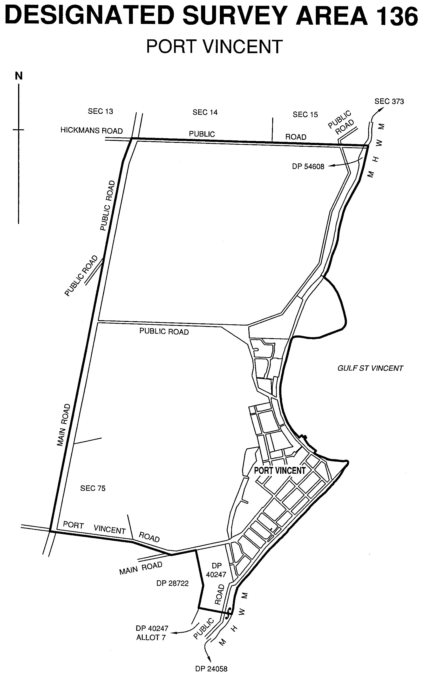

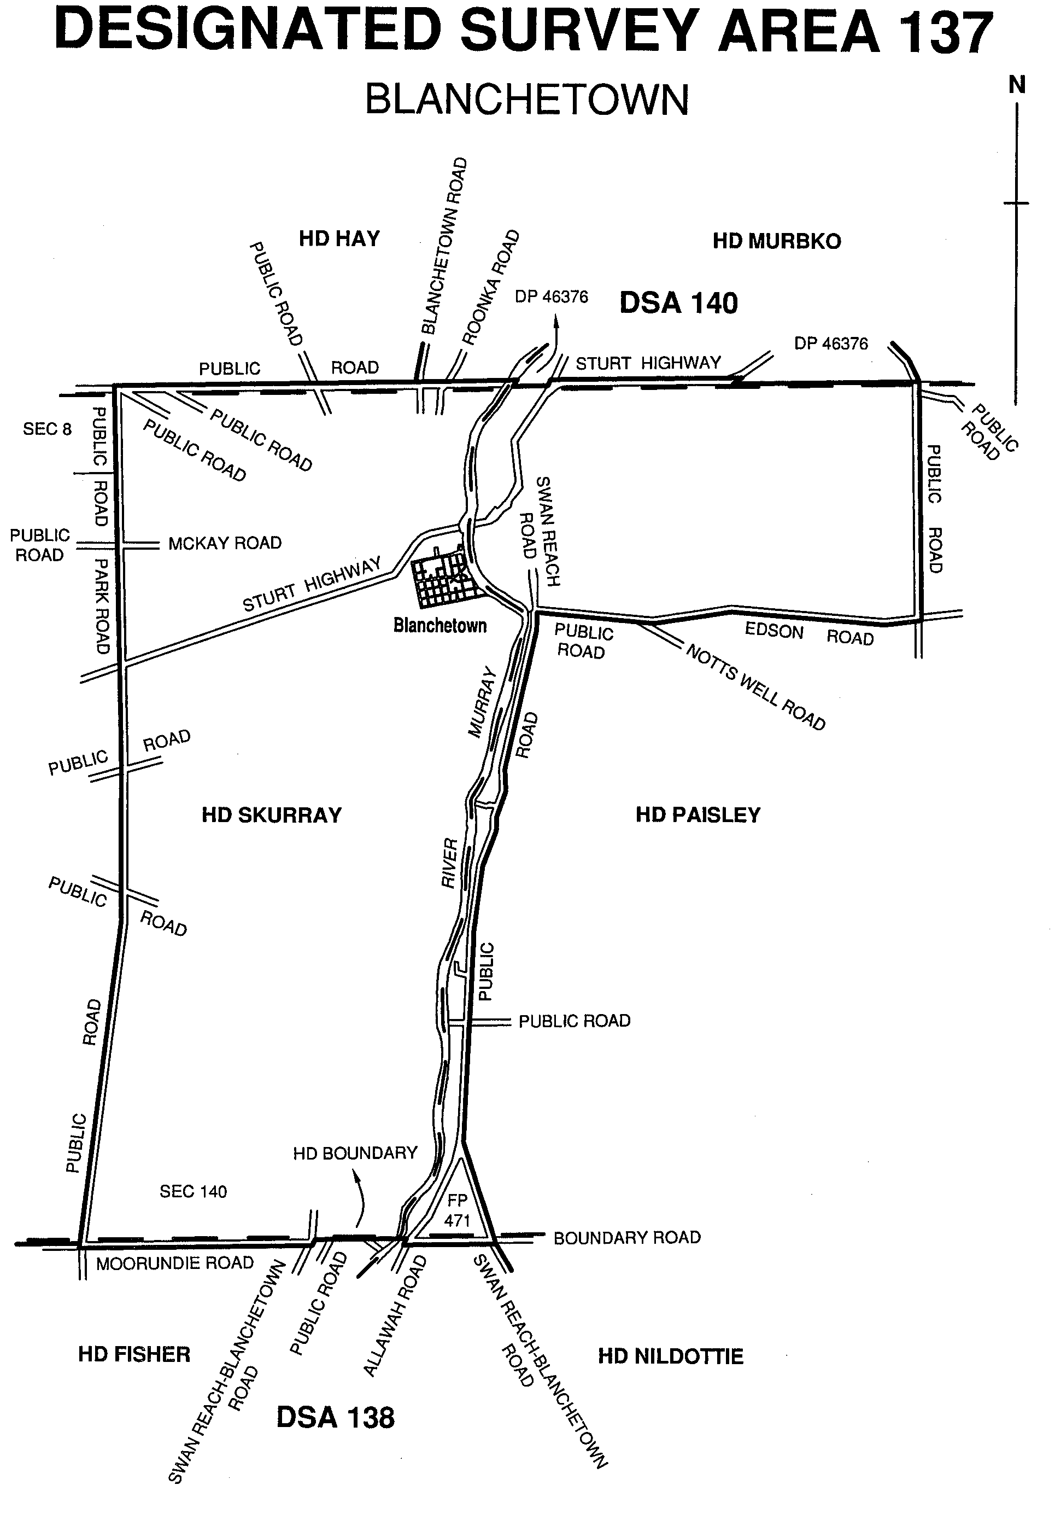
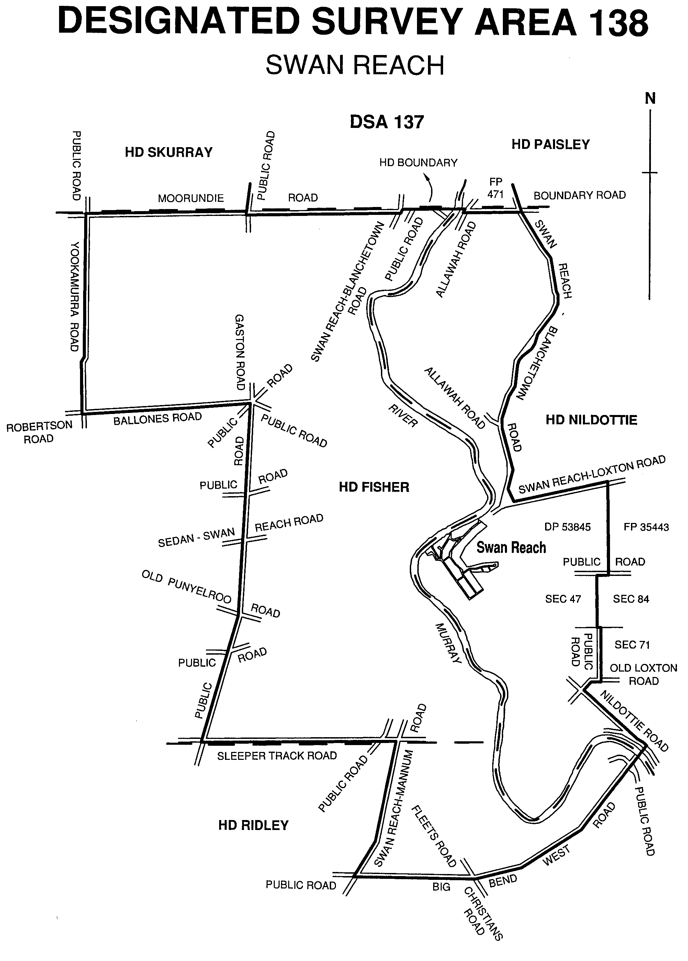
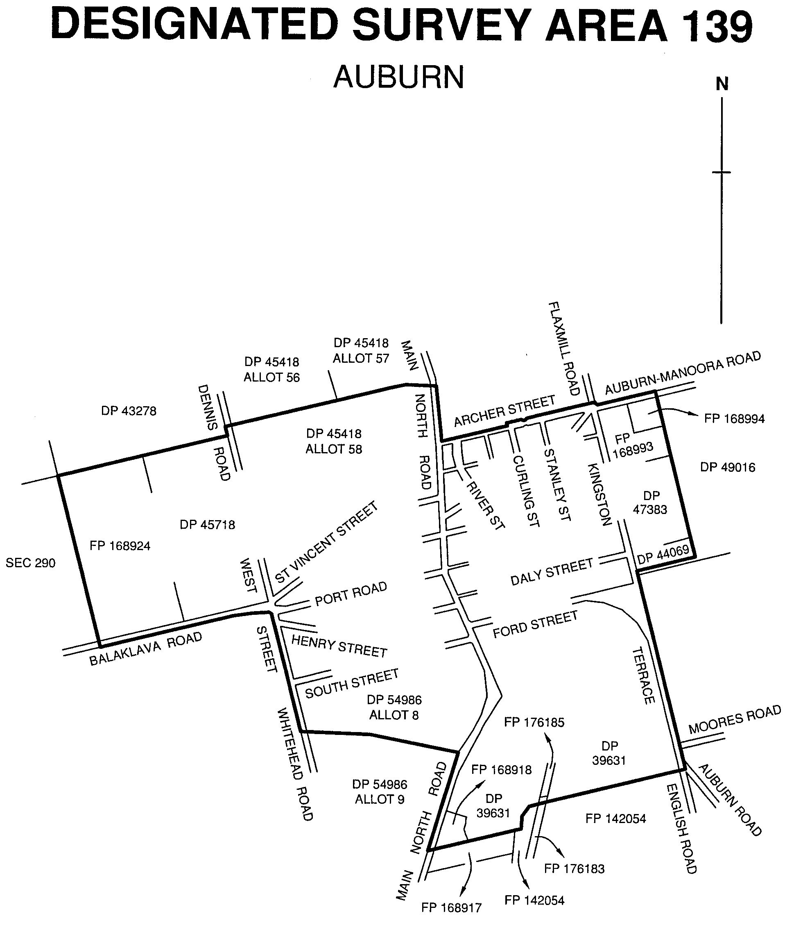
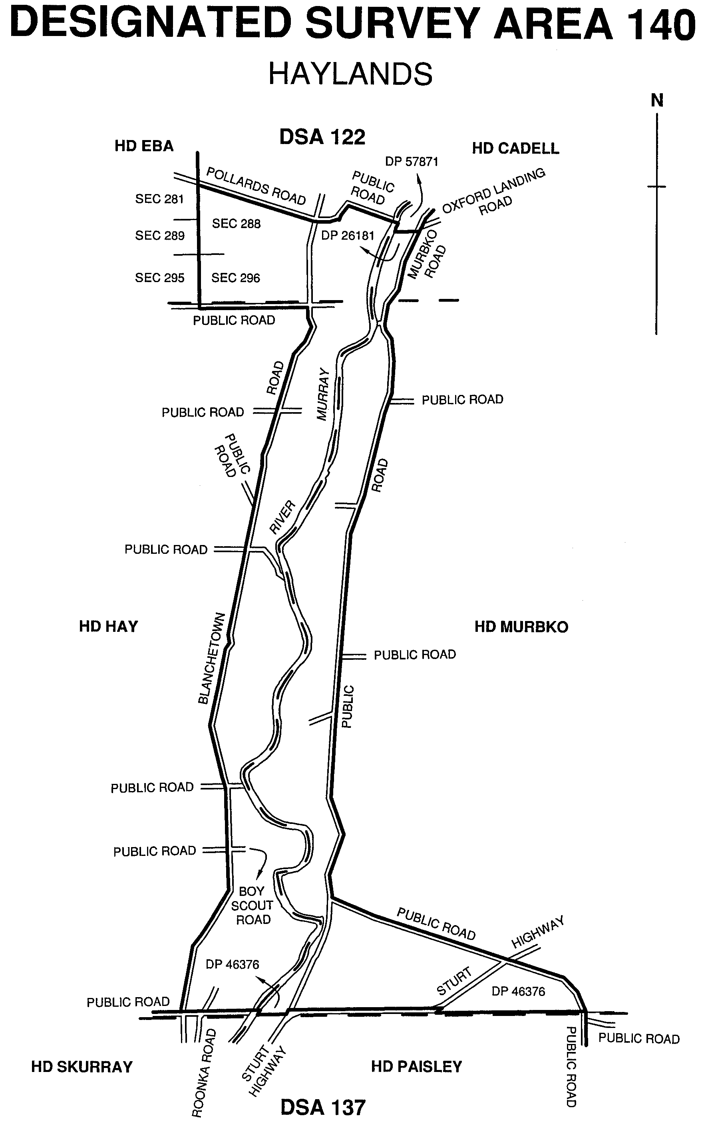
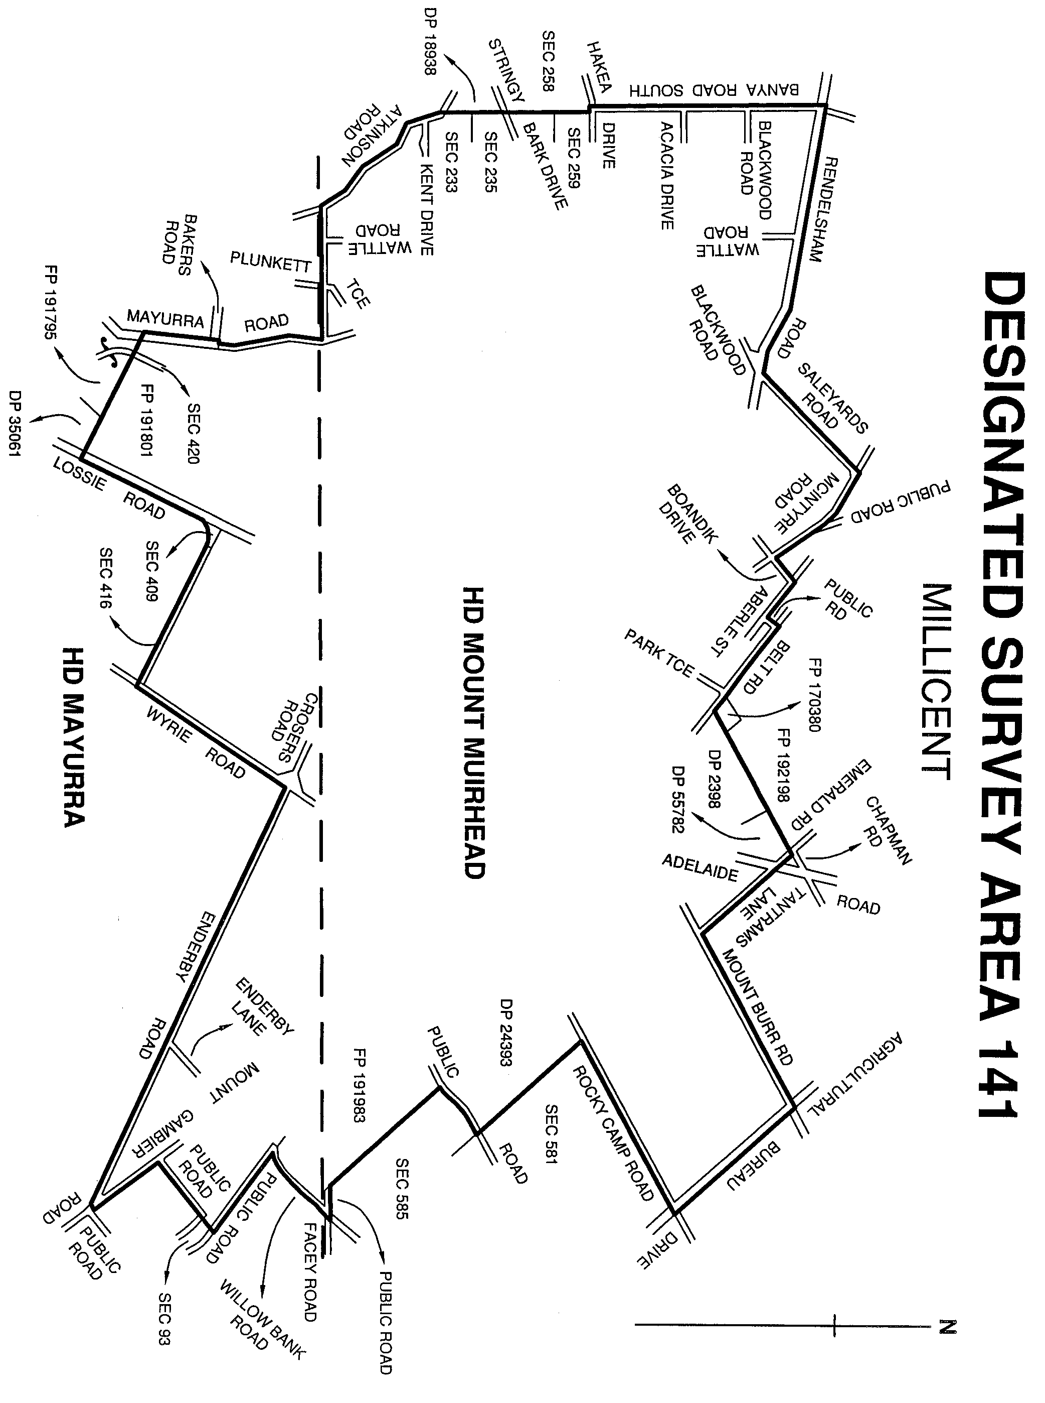
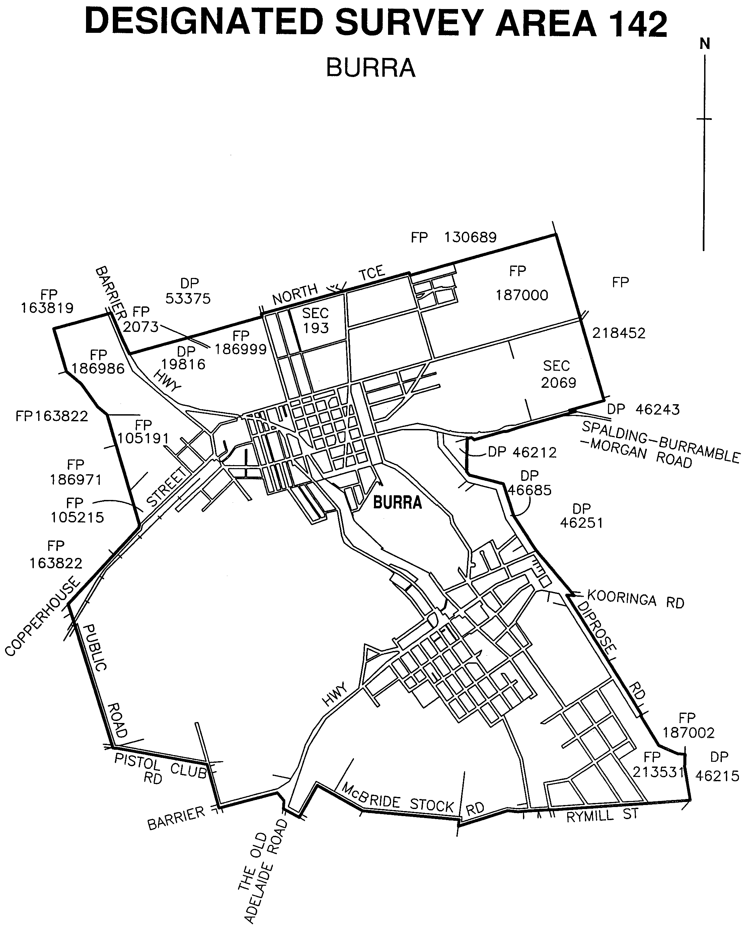
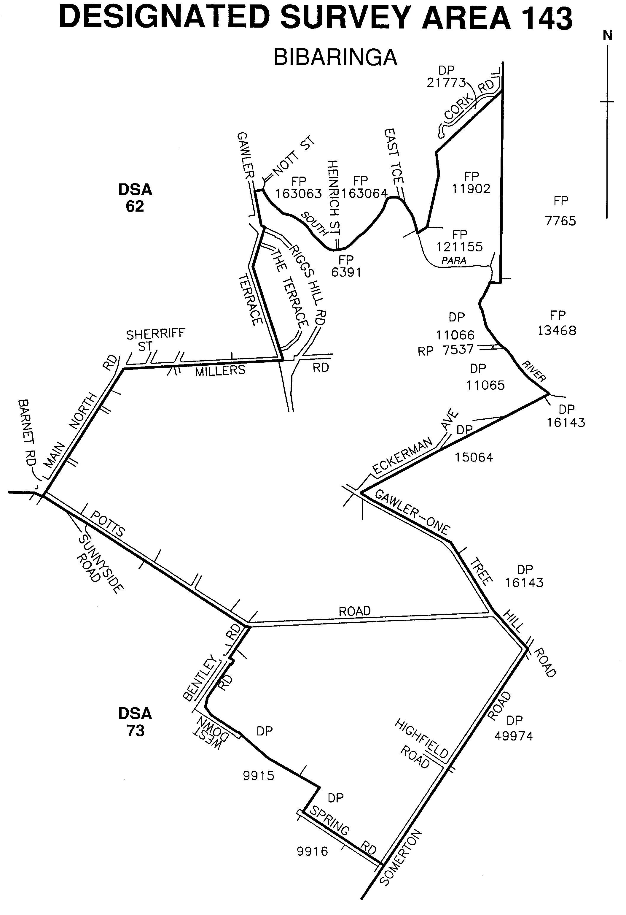

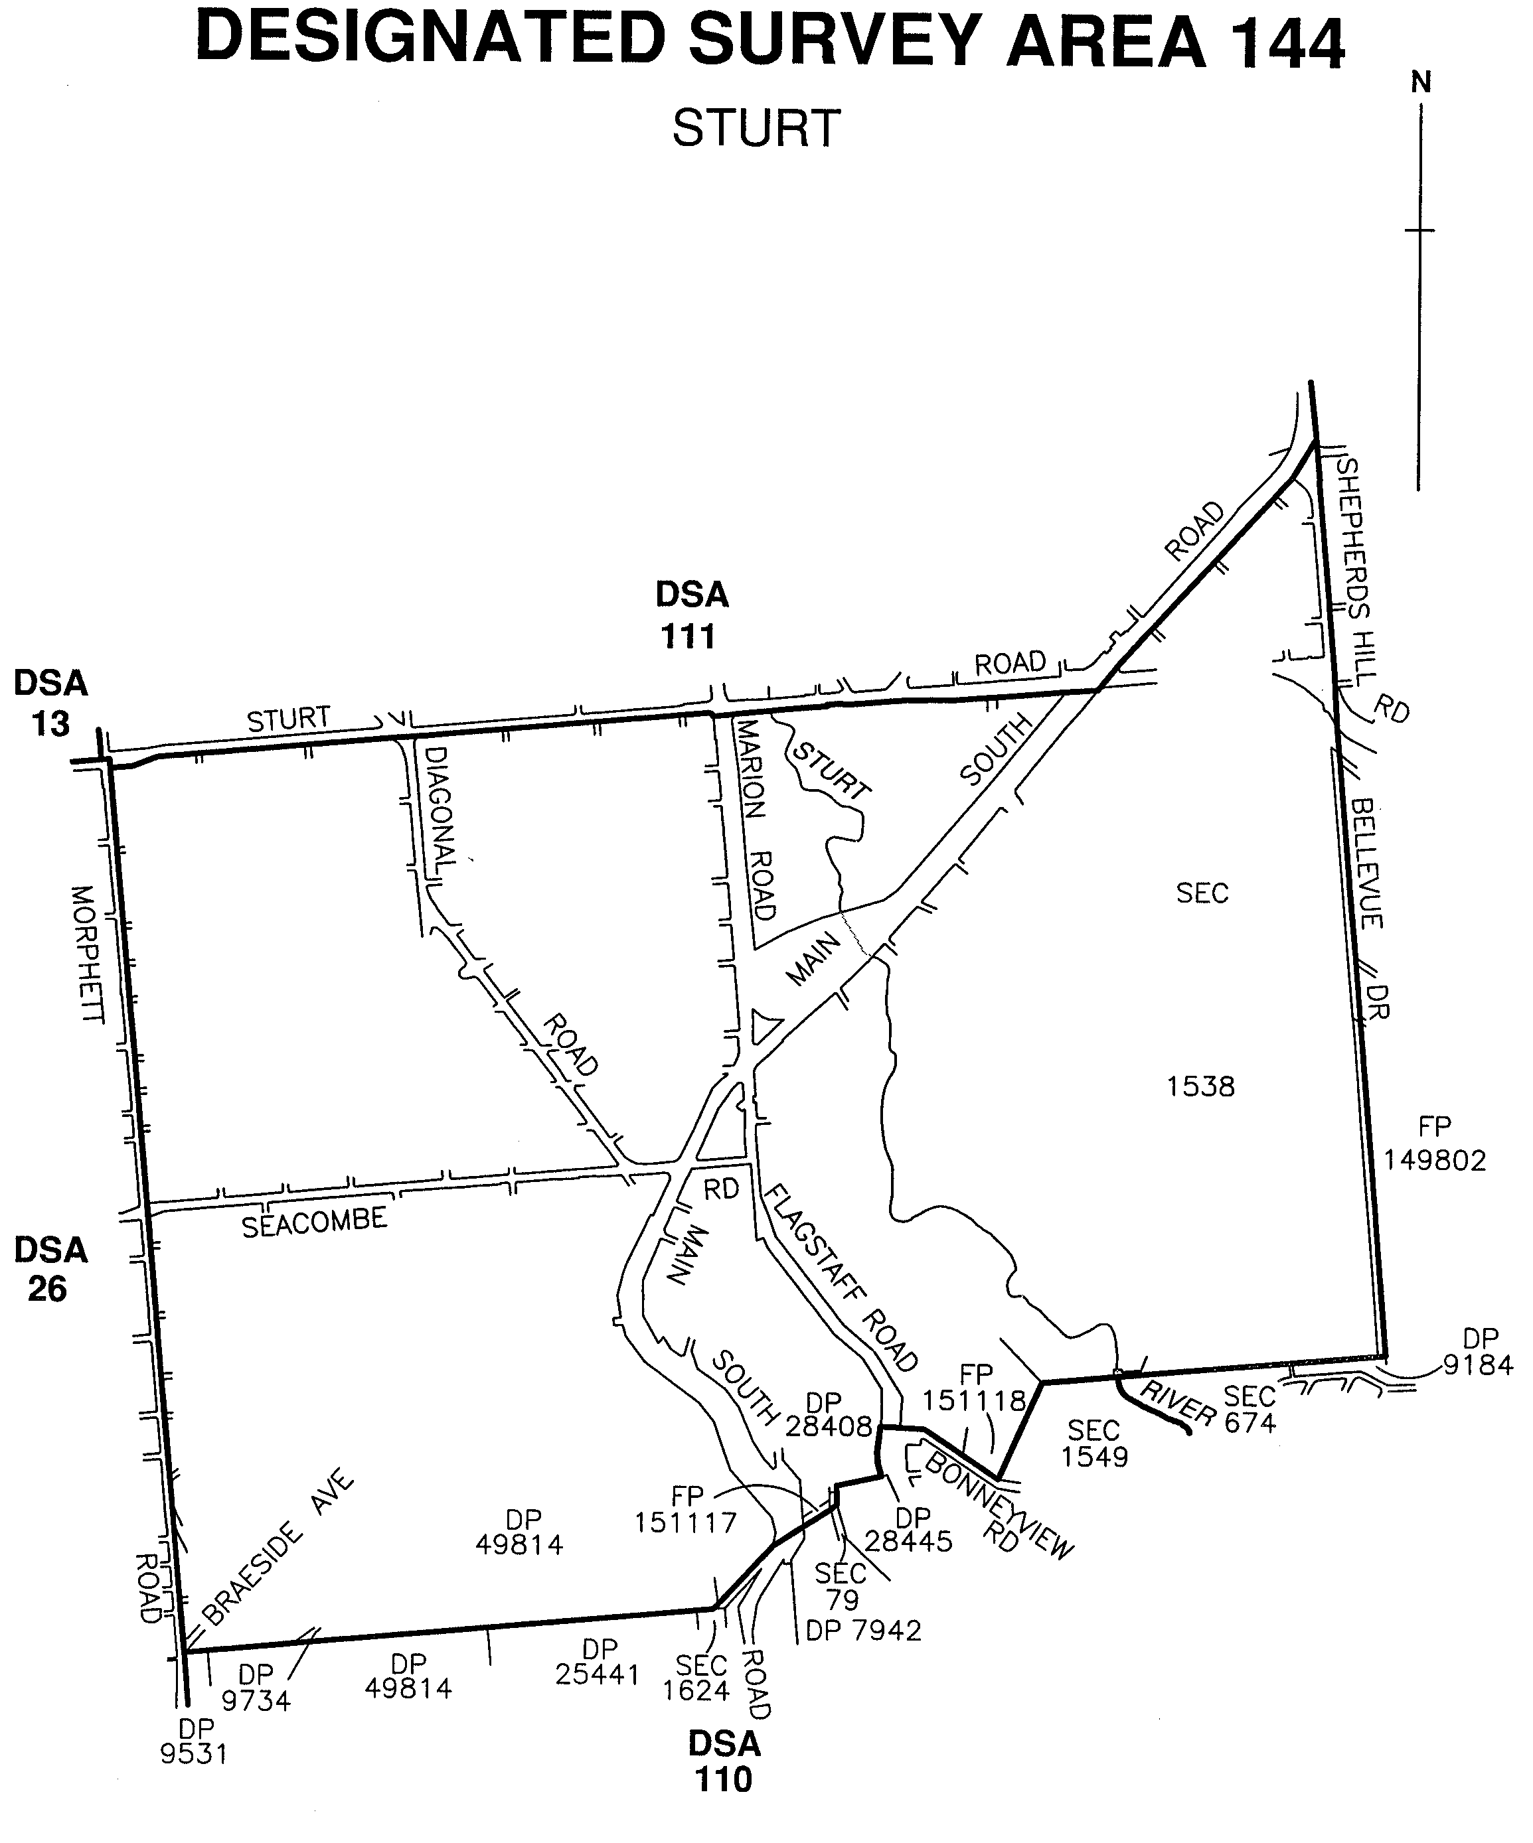

Dated 16 January 2003.
P. M. Kentish, Surveyor-General

NOTICE TO MARINERS
No. 3 of 2003
South Australia—Spencer Gulf—Arno Bay—Navigation
Marker Missing
THE South Cardinal Marker north-east of Arno Bay Jetty in approximate WGS 84 position latitude 33°54.84′S and longitude 136°35.28′E has been reported missing.
Mariners are advised to exercise caution when navigating in the vicinity.
The mark will be re-established as soon as practicable.
Navy charts affected: Aus 777 and 344
Adelaide, 7 January 2003.
M. Wright, Minister for Transport
TSA 2003/00309

NOTICE TO MARINERS
No. 4 of 2003
South Australia—Spencer Gulf—Tumby Bay—Marker Buoy Adrift
A PORT hand unlit marker buoy marking the shoal in Tumby Bay in approximate WGS 84 position latitude 34°23′00.83″S and longitude 136°06′46.97″E has been reported adrift.
The buoy will be re-established as soon as practicable and mariners are advised to exercise caution when navigating in the vicinity.
Navy chart affected: Aus 777
Adelaide, 10 January 2003.
M. Wright, Minister for Transport
TSA 2003/00309

UPPER SOUTH EAST DRYLAND SALINITY AND FLOOD MANAGEMENT ACT 2002
Appointments
TAKE notice that pursuant to section 9 of the Upper South East Dryland Salinity and Flood Management Act 2002, I have appointed the following persons to be authorised officers for the purposes of that Act:
Roger Barrington Wickes
Andrew William Johnson
Roger Mark Ebsary
Michael Julian Pierce
Robert Charles Kemp
Trevor John Ferguson
Brenton Paul Grear
Shane Robert Childs
Dated 19 December 2002.
J. Hill, Minister for Environment and Conservation

South Australia

Controlled Substances (Cannabis) Amendment (Commencement) Proclamation 2003

Short title
1. This proclamation may be cited as the Controlled Substances (Cannabis) Amendment (Commencement) Proclamation 2003.

Commencement of Act
2. The Controlled Substances (Cannabis) Amendment Act 2002 (No 47 of 2002) will come into operation on 1 February 2003.

AGO0439/02CS

Made by the Governor
with the advice and consent of the Executive Council
on 16 January 2003

South Australia

Criminal Law Consolidation (Offences of Dishonesty) Amendment (Commencement) Proclamation 2003

Short title
1. This proclamation may be cited as the Criminal Law Consolidation (Offences of Dishonesty) Amendment (Commencement) Proclamation 2003.

Commencement of Act and suspension of certain provisions
2. (1) The Criminal Law Consolidation (Offences of Dishonesty) Amendment Act 2002 (No 26 of 2002) will come into operation on 16 January 2003.

(2) The operation of sections 4 to 8 (inclusive), 12 to 16 (inclusive) and 19(2) of the Act are suspended until a day or days to be fixed by subsequent proclamation or proclamations.

AGO0446/02CS

Made by the Governor
with the advice and consent of the Executive Council
on 16 January 2003

South Australia

National Parks and Wildlife (Constitution of Nicolas Baudin Island Conservation Park) Proclamation 2003
under section 30(1) of the National Parks and Wildlife Act 1972

Short title
1. This proclamation may be cited as the National Parks and Wildlife (Constitution of Nicolas Baudin Island Conservation Park) Proclamation 2003.

Commencement
2. This proclamation comes into operation on the day on which it is made.

Constitution of Nicolas Baudin Island Conservation Park
3. The following Crown land is constituted as a conservation park and assigned the name Nicolas Baudin Island Conservation Park:

Allotments 1, 2 and 3 of DP 61029, Out of Hundreds (Elliston).

EC03/009CS

Made by the Governor
being of the opinion that the Crown land described in clause 3 should be protected and preserved for the purposes of conserving any wildlife and the natural features of the land and with the advice and consent of the Executive Council
on 16 January 2003

South Australia

National Parks and Wildlife (Constitution of Poonthie Ruwi—Riverdale Conservation Park) Proclamation 2003
under section 30(1) of the National Parks and Wildlife Act 1972

Short title
1. This proclamation may be cited as the National Parks and Wildlife (Constitution of Poonthie Ruwi—Riverdale Conservation Park) Proclamation 2003.

Commencement
2. This proclamation comes into operation on the day on which it is made.

Constitution of Poonthie Ruwi—Riverdale Conservation Park
3. The following Crown land is constituted as a conservation park and assigned the name Poonthie Ruwi—Riverdale Conservation Park:

Allotments 2, 3, 4, 5 and 6 of DP 36415, Hundred of Seymour, County of Russell.

EC03/0002CS

Made by the Governor
being of the opinion that the Crown land described in clause 3 should be protected and preserved for the purpose of conserving any wildlife and the natural features of the land and with the advice and consent of the Executive Council
on 16 January 2003

South Australia

Liquor Licensing (Dry Areas—Long Term) Variation Regulations 2003
under the Liquor Licensing Act 1997

Contents

Part 1—Preliminary

1. Short title
2. Commencement
3. Variation provisions

Part 2—Variation of Liquor Licensing (Dry Areas—Long Term) Regulations 1997 (Gazette 6.11.1997 p 1217) as varied

4. Variation of Schedule 1—Long Term Dry Areas

Part 1—Preliminary

Short title
1. These regulations may be cited as the Liquor Licensing (Dry Areas—Long Term) Variation Regulations 2003.

Commencement
2. These regulations come into operation on the day on which they are made.

Note—
As required by section 10AA(2) of the Subordinate Legislation Act 1978, the Minister has certified that, in the Minister's opinion, it is necessary or appropriate that these regulations come into operation as set out in this regulation.

Variation provisions
3. In these regulations, a provision under a heading referring to the variation of specified regulations varies the regulations so specified.

Part 2—Variation of Liquor Licensing (Dry Areas—Long Term) Regulations 1997 (Gazette 6.11.1997 p 1217) as varied

Variation of Schedule 1—Long Term Dry Areas
4. Schedule 1, item headed "Coober Pedy—Area 1", column headed "Period"—delete "6 December 2002" and substitute:

30 April 2003

LLCS 3/96

No. 1 of 2003

Made by the Governor
with the advice and consent of the Executive Council
on 16 January 2003.

South Australia

Liquor Licensing (Dry Areas—Long Term) Variation Regulations 2003
under the Liquor Licensing Act 1997

Contents

Part 1—Preliminary

1. Short title
2. Commencement
3. Variation provisions

Part 2—Variation of Liquor Licensing (Dry Areas—Long Term) Regulations 1997 (Gazette 6.11.1997 p 1217) as varied

4. Variation of Schedule 1—Long Term Dry Areas
5. Variation of Schedule 2—Plans of Long Term Dry Areas

Schedule—Plan of long term dry area

Part 1—Preliminary

Short title
1. These regulations may be cited as the Liquor Licensing (Dry Areas—Long Term) Variation Regulations 2003.

Commencement
2. These regulations come into operation on the day on which they are made.

Note—
As required by section 10AA(2) of the Subordinate Legislation Act 1978, the Minister has certified that, in the Minister's opinion, it is necessary or appropriate that these regulations come into operation as set out in this regulation.

Variation provisions
3. In these regulations, a provision under a heading referring to the variation of specified regulations varies the regulations so specified.

Part 2—Variation of Liquor Licensing (Dry Areas—Long Term) Regulations 1997 (Gazette 6.11.1997 p 1217) as varied

Variation of Schedule 1—Long Term Dry Areas
4. (1) Schedule 1, item headed "Barmera—Area 1", column headed "Period"—delete "31 August 2002" and substitute:

24 October 2004

(2) Schedule 1, item headed "Barmera—Area 2", column headed "Period"—delete "31 August 2002" and substitute:

24 October 2004

(3) Schedule 1, item headed "Berri—Area 1", column headed "Period"—delete "31 August 2002" and substitute:

24 October 2004

(4) Schedule 1, item headed "Berri—Area 2", column headed "Period"—delete "31 August 2002" and substitute:

24 October 2004

(5) Schedule 1, item headed "Paringa—Area 1", column headed "Period"—delete "31 August 2002" and substitute:

24 October 2004

(6) Schedule 1, item headed "Paringa—Area 1", column headed "Extent of prohibition"—delete "The consumption of liquor is prohibited" and substitute:

The consumption and possession of liquor are prohibited

(7) Schedule 1, item headed "Renmark—Area 1", column headed "Area"—delete "(including the north-westerly prolongation in a straight line of that boundary to the northern boundary of James Avenue), but excluding the area marked "B" on Renmark—Plan No. 1 in Schedule 2" and substitute:

(including the north-westerly prolongation in a straight line of that boundary to the north-western boundary of James Avenue)

(8) Schedule 1, item headed "Renmark—Area 1", column headed "Period"—delete "31 August 2002" and substitute:

24 October 2004

(9) Schedule 1, item headed "Renmark—Area 1", column headed "Extent of prohibition"—delete the column and substitute:
Extent of prohibition
The consumption of liquor is prohibited.

The possession of liquor is prohibited except by a person who owns, leases, works on or is staying on a vessel moored to any part of the area and—

(a) who enters the area solely for the purpose of boarding the vessel; or
(b) who enters the area from the vessel solely for the purpose of leaving the area.

(This exception is in addition to the general exceptions in regulation 5(3)).

(10) Schedule 1, item headed "Renmark—Area 2"—delete the item

Variation of Schedule 2—Plans of Long Term Dry Areas
5. Schedule 2, plan headed "Renmark—Plan No. 1"—delete the plan and substitute the plan in the Schedule of these regulations

Schedule—Plan of long term dry area
Renmark—Plan No. 1

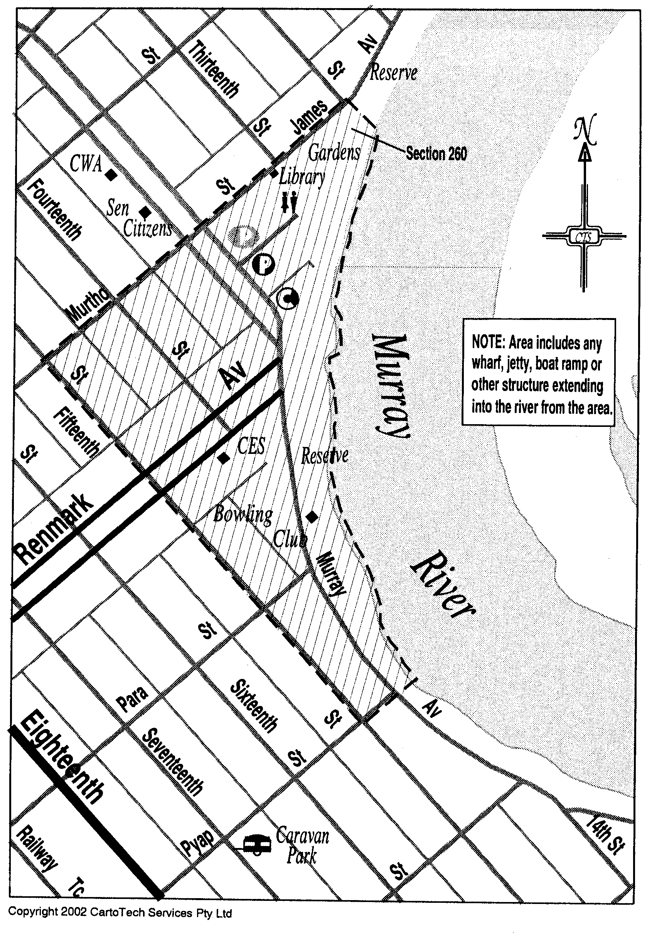

OLGC 4/2002

No. 2 of 2003

Made by the Governor
with the advice and consent of the Executive Council
on 16 January 2003.

South Australia

Petroleum Products Variation Regulations 2003
under the Petroleum Products Regulation Act 1995

Contents

Part 1—Preliminary

1. Short title
2. Commencement
3. Variation provisions

Part 2—Variation of Petroleum Products Regulations 1995 (Gazette 1.6.1995 p 2574) as varied

4. Insertion of regulation 9AB
9AB. Permitted disclosure of information (s. 56)

Part 1—Preliminary

Short title
1. These regulations may be cited as the Petroleum Products Variation Regulations 2003.

Commencement
2. These regulations come into operation on the day on which they are made.

Note—
As required by section 10AA(2) of the Subordinate Legislation Act 1978, the Minister has certified that, in the Minister's opinion, it is necessary or appropriate that these regulations come into operation as set out in this regulation.

Variation provisions
3. In these regulations, a provision under a heading referring to the variation of specified regulations varies the regulations so specified.

Part 2—Variation of Petroleum Products Regulations 1995 (Gazette 1.6.1995 p 2574) as varied

Insertion of regulation 9AB
4. After regulation 9A insert:

Permitted disclosure of information (s. 56)
9AB. The following offices are prescribed for the purposes of section 56(2)(e) of the Act:

(a) Attorney-General;

(b) Solicitor-General;

(c) Director of Public Prosecutions;

(d) offices in the Attorney-General's Department;

(e) Auditor-General;

(f) Ombudsman;

(g) Commissioner for Consumer Affairs;

(h) Registrar of Motor Vehicles;

(i) Chief Executive Officer of WorkCover Corporation of South Australia;

(j) offices in the police force of or above the rank of inspector;

(k) offices of another State, or of a Territory, or of the Commonwealth, the holders of which are employed in the administration of laws relating to taxation or customs;

(l) Chairperson of the Australian Securities Commission;

(m) Australian Statistician;

(n) Commissioner of the Australian Federal Police;

(o) Chief Executive Officer of the Australian Crime Commission.

T&F 01/067 CS

No. 3 of 2003

Made by the Governor
with the advice and consent of the Executive Council
on 16 January 2003.

South Australia

Mines and Works Inspection Variation Regulations 2003
under the Mines and Works Inspection Act 1920

Contents

Part 1—Preliminary

1. Short title
2. Commencement
3. Variation provisions

Part 2—Variation of Mines and Works Inspection Regulations 1998 (Gazette 21.8.1998 p 579) as varied

4. Variation of regulation 8—Approval to undertake certain activities

Part 1—Preliminary

Short title
1. These regulations may be cited as the Mines and Works Inspection Variation Regulations 2003.

Commencement
2. These regulations come into operation on the day on which they are made.

Note—
As required by section 10AA(2) of the Subordinate Legislation Act 1978, the Minister has certified that, in the Minister's opinion, it is necessary or appropriate that these regulations come into operation as set out in this regulation.

Variation provisions
3. In these regulations, a provision under a heading referring to the variation of specified regulations varies the regulations so specified.

Part 2—Variation of Mines and Works Inspection Regulations 1998 (Gazette 21.8.1998 p 579) as varied

Variation of regulation 8—Approval to undertake certain activities
4. (1) Regulation 8(1)—after "the Chief Inspector" insert:

or an authorised person

(2) Regulation 8(2)—after "the Chief Inspector" wherever occurring insert:

or an authorised person

(3) Regulation 8—after subregulation (3) insert:

(4) In this regulation—

"authorised person" means a person authorised in writing by the Chief Inspector to give an approval under this regulation.

MMRD 02/0061CS

No. 4 of 2003

Made by the Governor
with the advice and consent of the Executive Council
on 16 January 2003.

South Australia

Primary Industry Funding Schemes (Marine Scalefish Industry Fund) Regulations 2003
under the Primary Industry Funding Schemes Act 1998

Contents

1. Short title
2. Commencement
3. Interpretation
4. Establishment of Fund
5. Contributions to Fund
6. Application of Fund
7. False or misleading statements

Short title
1. These regulations may be cited as the Primary Industry Funding Schemes (Marine Scalefish Industry Fund) Regulations 2003.

Commencement
2. These regulations will come into operation on 16 January 2003.

Note—
As required by section 10AA(2) of the Subordinate Legislation Act 1978, the Minister has certified that, in the Minister's opinion, it is necessary or appropriate that these regulations come into operation as set out in this regulation.

Interpretation
3. (1) In these regulations, unless the contrary intention appears—

"Act" means the Primary Industry Funding Schemes Act 1998;

"Fund"—see regulation ;

"licence period" means the period of 12 months commencing on 1 July in any year;

"marine scalefish fishery" has the same meaning as in the Scheme of Management (Marine Scalefish Fisheries) Regulations 1991 (see Gazette 27.6.1991 p 2187), as varied;

"marine scalefish fishery licence" means a licence under section 34 of the Fisheries Act 1982 in respect of a marine scalefish fishery;

"prescribed period" means—

(a) the period commencing on 16 January 2003 and ending on 30 June 2003; or

(b) a licence period.

(2) A person is in default in relation to contributions to the Fund if, within the immediately preceding two prescribed periods—

(a) a contribution payable to the Fund by the person has not been paid; or

(b) the person has been refunded contributions from the Fund.

Establishment of Fund
4. (1) The Marine Scalefish Industry Fund (the Fund) is established.

(2) The Fund will be administered by the Minister.

(3) The Fund consists of—

(a) contributions paid or collected in accordance with these regulations; and

(b) income of the Fund from investment; and

(c) any other money received by the Minister for payment into the Fund.

Contributions to Fund
5. (1) A contribution of $400 is payable to the Minister for payment into the Fund by the holder of a marine scalefish fishery licence in respect of—

(a) the period commencing on 16 January 2003 and ending on 30 June 2003; and

(b) each licence period commencing after 16 January 2003 for which the holder makes application for renewal of the licence.

(2) The contribution in respect of the period referred to in subregulation (1)(a) is payable on 28 February 2003.

(3) The contribution in respect of a licence period is payable on 31 July following the commencement of that licence period.

(4) Refund of a contribution paid in respect of a prescribed period may be claimed by notice in writing to the Minister within 12 months following that prescribed period.

(5) If a person satisfies the Minister that the person is entitled to a refund, the Minister must refund to the person the amount of the contribution paid by the person in respect of the prescribed period to which the claim for refund relates.

Application of Fund
6. (1) The Fund may be applied by the Minister for any of the following purposes:

(a) payments to a body that, in the opinion of the Minister, represents holders of marine scalefish fishery licences for one or more of the following purposes:

(i) profiling and promotion of the marine scalefish industry;

(ii) development of the marine scalefish industry, including strategic planning;

(iii) environmental management of the marine scalefish industry;

(iv) other purposes of the body;

(b) payments for other purposes for the benefit of the marine scalefish industry;

(c) payment of the expenses of administering the Fund;

(d) repayment of contributions to the Fund under regulation .

(2) A person who is in default in relation to contributions to the Fund is not entitled to receive direct benefits or services funded by payments from the Fund.

False or misleading statements
7. A person must not make a statement that is false or misleading in a material particular (whether by reason of the inclusion or omission of any particular) in any information provided, or record kept, for the purposes of these regulations.

Maximum penalty: $5 000.

MAFF02/0066CS

No. 5 of 2003

Made by the Governor
with the advice and consent of the Executive Council
on 16 January 2003.

South Australia

Victims of Crime Variation Regulations 2003
under the Victims of Crime Act 2001

Contents

Part 1—Preliminary

1. Short title
2. Commencement
3. Variation provisions

Part 2—Variation of Victims of Crime Regulations 2002 (Gazette 19.12.2002 p 4801)

4. Substitution of regulation 8
8. Imposition of levy (s. 32 of Act)

Part 1—Preliminary

Short title
1. These regulations may be cited as the Victims of Crime Variation Regulations 2003.

Commencement
2. These regulations come into operation on the day on which they are made.

Note—
As required by section 10AA(2) of the Subordinate Legislation Act 1978, the Minister has certified that, in the Minister's opinion, it is necessary or appropriate that these regulations come into operation as set out in this regulation.

Variation provisions
3. In these regulations, a provision under a heading referring to the variation of specified regulations varies the regulations so specified.

Part 2—Variation of Victims of Crime Regulations 2002 (Gazette 19.12.2002 p 4801)

Substitution of regulation 8
4. Regulation 8—delete the regulation and substitute:

Imposition of levy (s. 32 of Act)
8. (1) For the purposes of section 32(2) of the Act, a levy is not imposed on a person who expiates an offence under an expiation notice if—

(a) the notice is issued by a council (within the meaning of the Local Government Act 1999) or other authority with powers and functions of local government; or

(b) the notice is issued by a university or other tertiary educational institution established by an Act; or

(c) the notice is issued by an incorporated hospital or incorporated health centre (within the meaning of the South Australian Health Commission Act 1976); or

(d) the notice is issued by the Institute of Medical and Veterinary Science; or

(e) the notice is issued by the Board of the Botanic Gardens and State Herbarium; or

(f) the offence is under the Technical and Further Education (Vehicles) Regulations 1998.

(2) For the purposes of section 32(4) of the Act, the amount of the levy is fixed by Schedule 3.

AGO 0380/02 CS

No. 6 of 2003

Made by the Governor
with the advice and consent of the Executive Council
on 16 January 2003.

FAXING COPY?

IF you fax copy to Government Publishing SA for inclusion in the Government Gazette, there is no need to send a Confirmation Copy to us as well.

This creates confusion and may well result in your notice being printed twice.

Please use the following fax number:

Fax transmission: (08) 8207 1040
Phone Inquiries: (08) 8207 1045

Please include a contact person, phone number and order number so that we can phone back with any queries we may have regarding the fax copy.

NOTE: Closing time for lodging new copy (either fax or hard copy) is 4 p.m. on Tuesday preceding the day of publication.

Government Gazette notices can be E-mailed.

The address is:

governmentgazette@saugov.sa.gov.au

Documents should be sent as attachments in Word format.

When sending a document via E-mail, please confirm your transmission with a faxed copy of your document, including the date the notice is to be published.

Fax transmission: (08) 8207 1040
Enquiries: (08) 8207 1045

CITY OF PORT AUGUSTA
Exclusion of Land from Classification as Community Land
NOTICE is hereby given that at its meeting held on 2 December 2002, the Corporation of the City of Port Augusta decided that pursuant to section 193 of the Local Government Act 1999, the vacant parcels of land under contract to purchase (i.e. 3 Alamein Road, Port Augusta), more particularly described in register book volume 2505, folio 57 and volume 5697, folio 625, be excluded from the classification of community land.
J. G. Stephens, City Manager

CITY OF TEA TREE GULLY
Roads (Opening and Closing) Act 1991
NOTICE is hereby given pursuant to section 10 of the Roads (Opening and Closing) Act 1991, the City of Tea Tree Gully proposes to make a Road Process Order to close the following road in the Hundred of Yatala, being all that portion of Elcombe Crescent, Modbury situate dividing allotments 6 to 11 in Deposited Plan 7338 from allotments 1, 2 and 5 in Deposited Plan 7338, allotment 53 in Deposited Plan 42413 and allotments 2 to 4 in Filed Plan 6 and marked ‘A’ on Preliminary Plan No. 03/0005.
It is proposed that the road to be closed marked ‘A’ be transferred to Aretzis Investments Pty Ltd and Harralex Nominees Pty Ltd and merged with said allotments 1, 2 and 7 to 11 in Deposited Plan 7338 and allotments 2 to 4 in Filed Plan 6.
A preliminary plan of the proposal and statement are available for public inspection at the Tea Tree Gully Council Office, 571 Montague Road, Modbury between the hours of 8.45 a.m. and 5 p.m., Monday to Friday or at the Adelaide office of the Surveyor-General, during normal office hours.
Any person may object to the proposal (and any adjoining landowner or other person substantially affected by the proposed road closure may apply for an easement relative to the closure). Such objection (or application for an easement) must be made in writing to the City of Tea Tree Gully within 28 days of the date of this notice.
If a submission is made the City of Tea Tree Gully is required to give notice of a time and place at which a meeting will be held to consider the matter, so that the person making the submission (or a representative) may attend to support the submission, if desired.
Any submission must set out the full name and address of the person making the submission and must be fully supported by reasons (and any application for the grant of an easement must give full particulars of the nature and location of the easement and where made by a person as the owner of adjoining or nearby land, specify the land to which the easement is to be annexed). A copy of the submission must be forwarded to the Surveyor-General at Adelaide.
Dated 16 January 2003.
G. Perkin, Chief Executive Officer

CITY OF VICTOR HARBOR
Revocation of Land from Classification as Community Land
NOTICE is hereby given pursuant to section 194 (2) of the Local Government Act 1999, that public comment is being invited on a council proposal to revoke the following properties from Classification as Community Land, pursuant to section 194 (1):
Portion of section 650
Recreation Reserve—Gazette 2.8.1951
Crown Record Volume 5756, Folio 523
Inman Valley Road, Victor Harbor
It is proposed to:
• resume and re-dedicate the portion of the reserve con-taining the Lower Inman Fire Station, as Emergency Service Reserve under care, control and management of the Minister for Emergency Services;
• licence portion of the reserve to the SA Country Fire Service for car parking.
Portion of section 653
Stone Reserve—Gazette 11.9.1930
Crown Record Volume 5756, Folio 525
Greenhills Road, Victor Harbor
It is proposed to:
• resume and re-dedicate the portion of the reserve con-taining the Hindmarsh Valley Fire Station as Emergency Service Reserve under care, control and management of the Minister for Emergency Services;
• licence portion of the reserve to the SA Country Fire Service for access and car parking.
Written comments on the revocation of either of these two parcels of land from community classification should be forwarded to:
City Manager
City of Victor Harbor
P.O. Box 11
Victor Harbor, S.A. 5211
Closing date for submissions is Friday, 14 February 2003.
J. Bohnsack, Acting City Manager

CLARE AND GILBERT VALLEYS COUNCIL
Change of Meeting Date
NOTICE is hereby given that the Clare and Gilbert Valleys Council resolved at its meeting held on 16 December 2002 to change the date of the scheduled January Ordinary Council meeting and Development Assessment Panel meeting from Monday, 20 January 2003 to Wednesday, 29 January 2003 and that the meetings be held in the Council Chambers, Clare Town Hall, 229 Main North Road, Clare, with the Development Assessment Panel meeting commencing at 6 p.m. and the Ordinary Council meeting commencing at 7 p.m.
M. A. Goldstone, Chief Executive Officer

DISTRICT COUNCIL OF LOWER EYRE PENINSULA
Aerodrome Fees
NOTICE is hereby given that, pursuant to the Aerodrome Fees Act 1998, the District Council of Lower Eyre Peninsula hereby advises that Arrival and Departure Fees at the Port Lincoln Airport are fixed as follows, and are effective from 1 January 2003:
Landing Fees
All aircraft except Regular Passenger Transport:
$8.03 per 1 000 kg
$8.03 minimum fee
Passenger Fees
Arrival Fees: $7.04 per person
Departure Fees: $7.04 per person
Note: All fees are GST Inclusive.
P. Aird, District Clerk

DISTRICT COUNCIL OF MOUNT REMARKABLE
Exclusion of Land from Classification as Community Land
NOTICE is hereby given that at a meeting of the District Council of Mount Remarkable held on 10 December 2002, the council resolved that pursuant to section 193 of the Local Government Act 1999, to exclude the following land from classification as Community Land:
Asset No. | Certificate of Title | Legal Description of Land | Description/Improvements
2 | 5688/342 | Lot 261 in Filed Plan 185153, Appila | Appila CFS Station
2 | 5685/723 | Lot 262 in Filed Plan 185154, Appila | Appila CFS Station
4 | 5837/256 | Lot 7, Appila Township | Vacant land
11 | 5702/610 | Lot 21 in Deposited Plan 1744, Booleroo Centre | Vacant land for drainage purposes
17 | 5703/178 | Lot 115 in Deposited Plan 50833, Melrose | Backpackers and Heritage Centre
20 | 5695/116 | Lot 880 in Filed Plan 184962, New Melrose | Vacant land
21 | 5428/168 | Lot 110 in Deposited Plan 26609, New Melrose | Council Depot
22 | 5481/658 | Lot 94 in Filed Plan 208275, New Melrose | Council Depot
26 | 5527/974 | Lot 167, Port Germein | Vacant land
26 | 5703/945 | Lot 168, Port Germein | Vacant land
27 | 5527/976 | Lot 172, Port Germein | CFS Shed and Drainage Easement
32B | 5703/945 | Lots 215, 216 and 224, Port Germein | Caravan Park
32C | 5527/977 | Lot 223, Port Germein | Caravan Park
32D | 5748/613 | Lot 220, Port Germein | Caravan Park
32E | 5709/529 | Lot 222, Port Germein | Caravan Park
39 | 5412/992  5412/666 | Lots 26, 27 and 28, Port Germein | Private Road
40 | 5843/192 | Lot 222, Wilmington | Wilmington Kindergarten
41 | 5809/549 | Lots 142 and 143, Wilmington | Public Toilets, Depot and CFS Shed
48 | 5186/331 | Lot 26, Wirrabara | Vacant land
56 | 5434/307  5434/308  5434/309  5434/310  5434/311  5434/312  5434/313  5434/314  5434/301  5434/315  5434/316  5434/318  5434/319  5434/320 | Lots 162 to 175, Wirrabara | Vacant Residential Allotments
57 | 5497/921 | Section 265, Hundred of Appila | Wirrabara Rubbish Dump
74 | 5373/123  5373/124  5373/125 | Lots 222, 223 and 227 all of Deposited Plan  27503, Hundred of Booleroo | Vacant land
76 | 5812/260 | Lot 768 in Filed Plan 184850, Hundred of  Booleroo | Booleroo Rubbish Dump
85 | 5831/144 | Lot 400 in Deposited Plan 24446, Hundred of Darling | Former Wirrabara Forest CWA and Tennis Clubhouse site
101 | 2025/107 | Lot 649 in Filed Plan 184731, Hundred of  Willochra | Vacant land
102 | 5487/517 | Sections 231 and 232, Hundred of Willochra | STEDS Ponds and surrounding land
113 | 5696/523 (limited) | Lot 874 in Filed Plan 184956, Hundred of Wongyarra | Slee’s Quarry Reserve
114 | 5737/162 | Lot 871 in Filed Plan 184953, Hundred of Wongyarra | Lello’s Quarry Reserve
116 | 5709/465 | Lot 870 in Filed Plan 184952, Hundred of Wongyarra | Lello’s Quarry Reserve
121 | 5636/704 | Closed Road ‘L’ RP4635, Hundred of  Wongyarra | Closed road
131 | 5577/864 | Lot 115, Port Germein | Vacant land
132 | 5370/814 | Lot 116, Port Germein | Vacant land
133 | 5666/891 | Lot 204 in Filed Plan 185096, Wirrabara | Vacant land
134 | 5314/956 | Lot 91 in Filed Plan 170277, Wilmington | Vacant land
136 | — | Closed Road ‘A’ Road Plan 4916  Closed Road ‘A’ Road Plan 4918, Booleroo  Centre | CFS and SES Stations and Public Conveniences
138 | — | Lot 259 of section 187, Hundred of Willowie | TV Installation
140 | 5849/144 | Lot 566 in Deposited Plan 55578, Hundred of  Wongyarra | Melrose STEDS Ponds
P. J. Moore, Chief Executive Officer

WATTLE RANGE COUNCIL
Development Act 1993
Wattle Range (District) Consolidation and Format Plan Amendment Report—Draft for Public and Agency Consultation
NOTICE is hereby given that the District Council of Wattle Range has prepared a draft Format Plan Amendment Report to amend the Wattle Range (District) Development Plan.
This Plan Amendment Report will amend the Wattle Range (District) Development Plan by ensuring a consistent approach to development in the region through the consolidation of the Millicent, Penola and Beachport Development Plans. The draft Plan Amendment Report seeks to consolidate the three Develop-ment Plans into one Development Plan for the council area. This will result in a more user friendly document.
In addition, Region-wide policies for the South East have been incorporated into Council-wide provisions, where applicable and areas within the Beachport Development Plan have now been changed to zones. The Plan Amendment Report also incorporates public notification categories within each zone in accordance with the Development Regulations 1993. It does not result in the notification requirements on applicants being any more onerous than required under the Development Act 1993 and Regulations.
The draft Plan Amendment Report will be available for public inspection during normal office hours at all Council Offices, George Street, Millicent; Arthur Street, Penola and Millicent Road, Beachport. A copy of the Plan Amendment Report can be obtained from the council at $30 each.
Written submissions regarding the draft amendment will be accepted by the Wattle Range Council, until 5 p.m. on Thursday, 20 March 2003. The written submission should clearly indicate whether you wish to speak at the public hearing regarding your submission. All submissions should be addressed to the Chief Executive Officer, Wattle Range District Council, P.O. Box 27, Millicent, S.A. 5280.
Copies of all submissions received will be available for inspection by interested persons at the above Council offices from the close of submissions until the date of the public hearing.
A public hearing will be held at 5 p.m. on Tuesday, 15 April 2003, at the Council Civic Centre, George Street, Millicent. The public hearing may not be held if no submission indicates an interest in speaking at the public hearing.
Dated 16 January 2003.
F. Brennan, Chief Executive Officer

IN the matter of the estates of the undermentioned deceased persons:
Boakes, Elva Isabella, late of 3 Peppermint Grove, Noarlunga Downs, home duties, who died on 3 December 2002.
Bowering, Muriel Lois, late of 3 Wheelton Street, Kingscote, Kangaroo Island, home duties, who died on 12 October 2002.
Crouch, Lisa, late of 91 Hectorville Road, Hectorville, home duties, who died on 21 September 2002.
Cys, Violet May, late of 18 Reynell Street, West Croydon, home duties, who died on 12 November 2002.
Engel, Bernice Rose, late of 21 Foster Street, Parkside, widow, who died on 14 October 2002.
Hann, Clifford Maxwell, late of 157 Beulah Road, Norwood, retired welder, who died on 29 November 2002.
Hocking, Ettie Lorna, late of 59 George Street, Paradise, widow, who died on 7 November 2002.
Junge, Phyllis Ethel, late of 157 Beulah Road, Norwood, of no occupation, who died on 10 November 2002.
Latty, Claude Conran, late of 39 Finniss Street, Marion, retired public servant, who died on 28 September 2002.
Lowman, Gordon Henry, late of 63 Park Road, Kensington Park, retired postal worker, who died on 11 November 2002.
Lutz, Muriel Joyce, late of Ethelbert Square, Brompton, widow, who died on 18 November 2002.
MacLeod, Gladys, late of 17 Kingston Avenue, Seacombe Gardens, retired nurse, who died on 2 November 2002.
Natt, Kenneth Paul, late of 143 Philip Highway, Elizabeth South, of no occupation, who died on 2 November 2002.
Palmer, Edith Ann, late of 34 Molesworth Street, North Adelaide, of no occupation, who died on 29 September 2002.
Paunovic, Warwara, late of 55 Regency Road, Croydon Park, home duties, who died on 8 November 2002.
Powell, Robert Allan, late of Angle Vale Road, Hillier, retired boilermaker welder, who died on 22 September 2002.
Reed, Alison Elsie, late of 160 Walkerville Terrace, Walkerville, widow, who died on 29 October 2002.
Skewes, Alice Jean, late of 336 Kensington Road, Leabrook, home duties, who died on 1 November 2002.
Sauberer, Franklin Kurt, late of Bains Road, Woodcroft, metal worker, who died on 24 July 2002.
Snowden, Janette Daphne, late of 4 Kowhai Drive, Nerang, Queensland, home duties, who died on 21 June 2001.
Stocker, Hartley Nathaniel, late of 4 Wadham Street, Brompton, of no occupation, who died on 31 October 2002.
Winzen, Marjorie Eleanor, late of Hawdon Street, Barmera, of no occupation, who died on 22 October 2002.
Wood, Ethel Lucy, late of 25 Birdwood Street, Netherby, home duties, who died on 11 November 2002.
Notice is hereby given pursuant to the Trustee Act 1936, as amended, the Inheritance (Family Provision) Act 1972, and the Family Relationships Act 1975, that all creditors, beneficiaries, and other persons having claims against the said estates are required to send, in writing, to the Public Trustee, 25 Franklin Street, Adelaide, S.A. 5000, full particulars and proof of such claims, on or before 14 February 2003, otherwise they will be excluded from the distribution of the said estate; and notice is also hereby given that all persons who are indebted to the said estates are required to pay the amount of their debts to the Public Trustee or proceedings will be taken for the recovery thereof; and all persons having any property belonging to the said estates are forthwith to deliver the same to the Public Trustee.
Dated 16 January 2003.
C. J. O’Loughlin, Public Trustee

SOUTH AUSTRALIA—In the Supreme Court. No. 2377 of 1996. In the matter of Johnston & Pahl Pty Limited (ACN 007 706 738) and in the matter of the Corporations Act 2001.
Notice by a Liquidator of His Intention to Seek His Release
Take notice that I, Peter Ivan Macks, 26 Flinders Street, Adelaide, S.A. 5000, the liquidator of the abovenamed company, intend to make application to the Supreme Court of South Australia for my release as the liquidator of the abovenamed company. And take further notice that if you have any objection to the granting of my release you must file at the Supreme Court and also forward to me within 21 days of the publication in the Gazette of the notice of my intention to apply for a release a notice of objection in the form laid down by the Corporations Law 2000.
Dated 13 January 2003.
P. I. Macks, Liquidator

ATTENTION

CUSTOMERS requiring a proof of their notice for inclusion in the Government Gazette, please note that the onus is on you to inform Government Publishing SA of any subsequent corrections by 10 a.m. on Thursday, which is our publication deadline.

For any corrections to your notice please phone 8207 1045 or Fax 8207 1040 before 10 a.m. on Thursday.

If we do not receive any communication by 10 a.m. on Thursday (day of publication) we will presume the notice is correct and will print it as it is.

Remember—the onus is on you to inform us of any corrections necessary to your notice.

NOTE: Closing time for lodging new copy (electronically, fax or hard copy) is 4 p.m. on Tuesday preceding the day of publication. Phone 8207 1045—Fax 8207 1040.
Email: governmentgazette@saugov.sa.gov.au

Printed and published by authority every Thursday by J. D. FERGUSON, Government Printer, South Australia
Price: $4.55, plus postage; to subscribers, $229.00 per annum.
(The above prices are inclusive of GST)

