SUPPLEMENTARY GAZETTE



THE SOUTH AUSTRALIAN

GOVERNMENT GAZETTE

PUBLISHED BY AUTHORITY

ALL PUBLIC ACTS appearing in this GAZETTE are to be considered official, and obeyed as such

ADELAIDE, FRIDAY, 31 JANUARY 2003

ROAD TRAFFIC ACT 1961
Supplementary Notice
Higher Mass Limits for Vehicles fitted with Road Friendly Suspensions

Information Note
- This Notice is a supplement to the Higher Mass Limits (HML) Notice of 14 November 2002 and removes the section of Park Terrace, Salisbury, between Commercial Road and Salisbury Highway from the route network that can be used by approved vehicles operating at Higher Mass Limits.
- This Notice contains replacement pages 18, 19 and 21 for the HML Network Map attached to the Primary Notice of 14 November 2002.

IN accordance with my exemption under the Primary Notice (as defined in clause 1.4), I hereby:
(i) remove the section of Park Terrace, Salisbury, between Commercial Road and Salisbury Highway from the approved route network for vehicles operating at Higher Mass Limits; and
(ii) provide replacement pages 18, 19 and 21 for the HML Network Map attached to the Primary Notice, which removes the section of Park Terrace from the approved route network.

1. Definitions
In this Notice:
1.1 ‘approved vehicles’ means vehicle configurations approved for travel under clause 2, Table 1 of the Primary Notice;
1.2 ‘approved route network’ means the approved routes specified in the HML Network Map titled ‘Route Network for General Access Vehicles fitted with Road Friendly Suspensions’ attached to the Primary Notice;
1.3 ‘Primary Notice’ means the Gazette Notice ‘Higher Mass Limits for Vehicles Fitted with Road Friendly Suspensions’ published in the South Australian Government Gazette dated 14 November 2002;
1.4 ‘Supplementary Notice’ means this Supplementary Notice; and
1.5 all other terms have the same meaning as in the Primary Notice.

2. Application of Supplementary Notice
This Supplementary Notice applies to approved vehicles operating under the Primary Notice dated 14 November 2002.

3. Routes removed from Primary Notice
Travel is not permitted on the section of Park Terrace, Salisbury, between Commercial Road and Salisbury Highway.

4. You must continue to comply with the Primary Notice
A driver must continue to comply with all conditions and requirements of the Primary Notice.

This Supplementary Notice is valid from 1 February 2003.

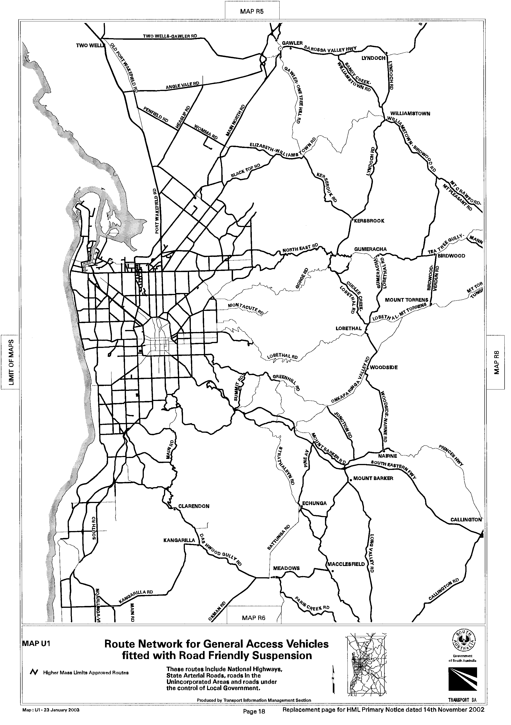
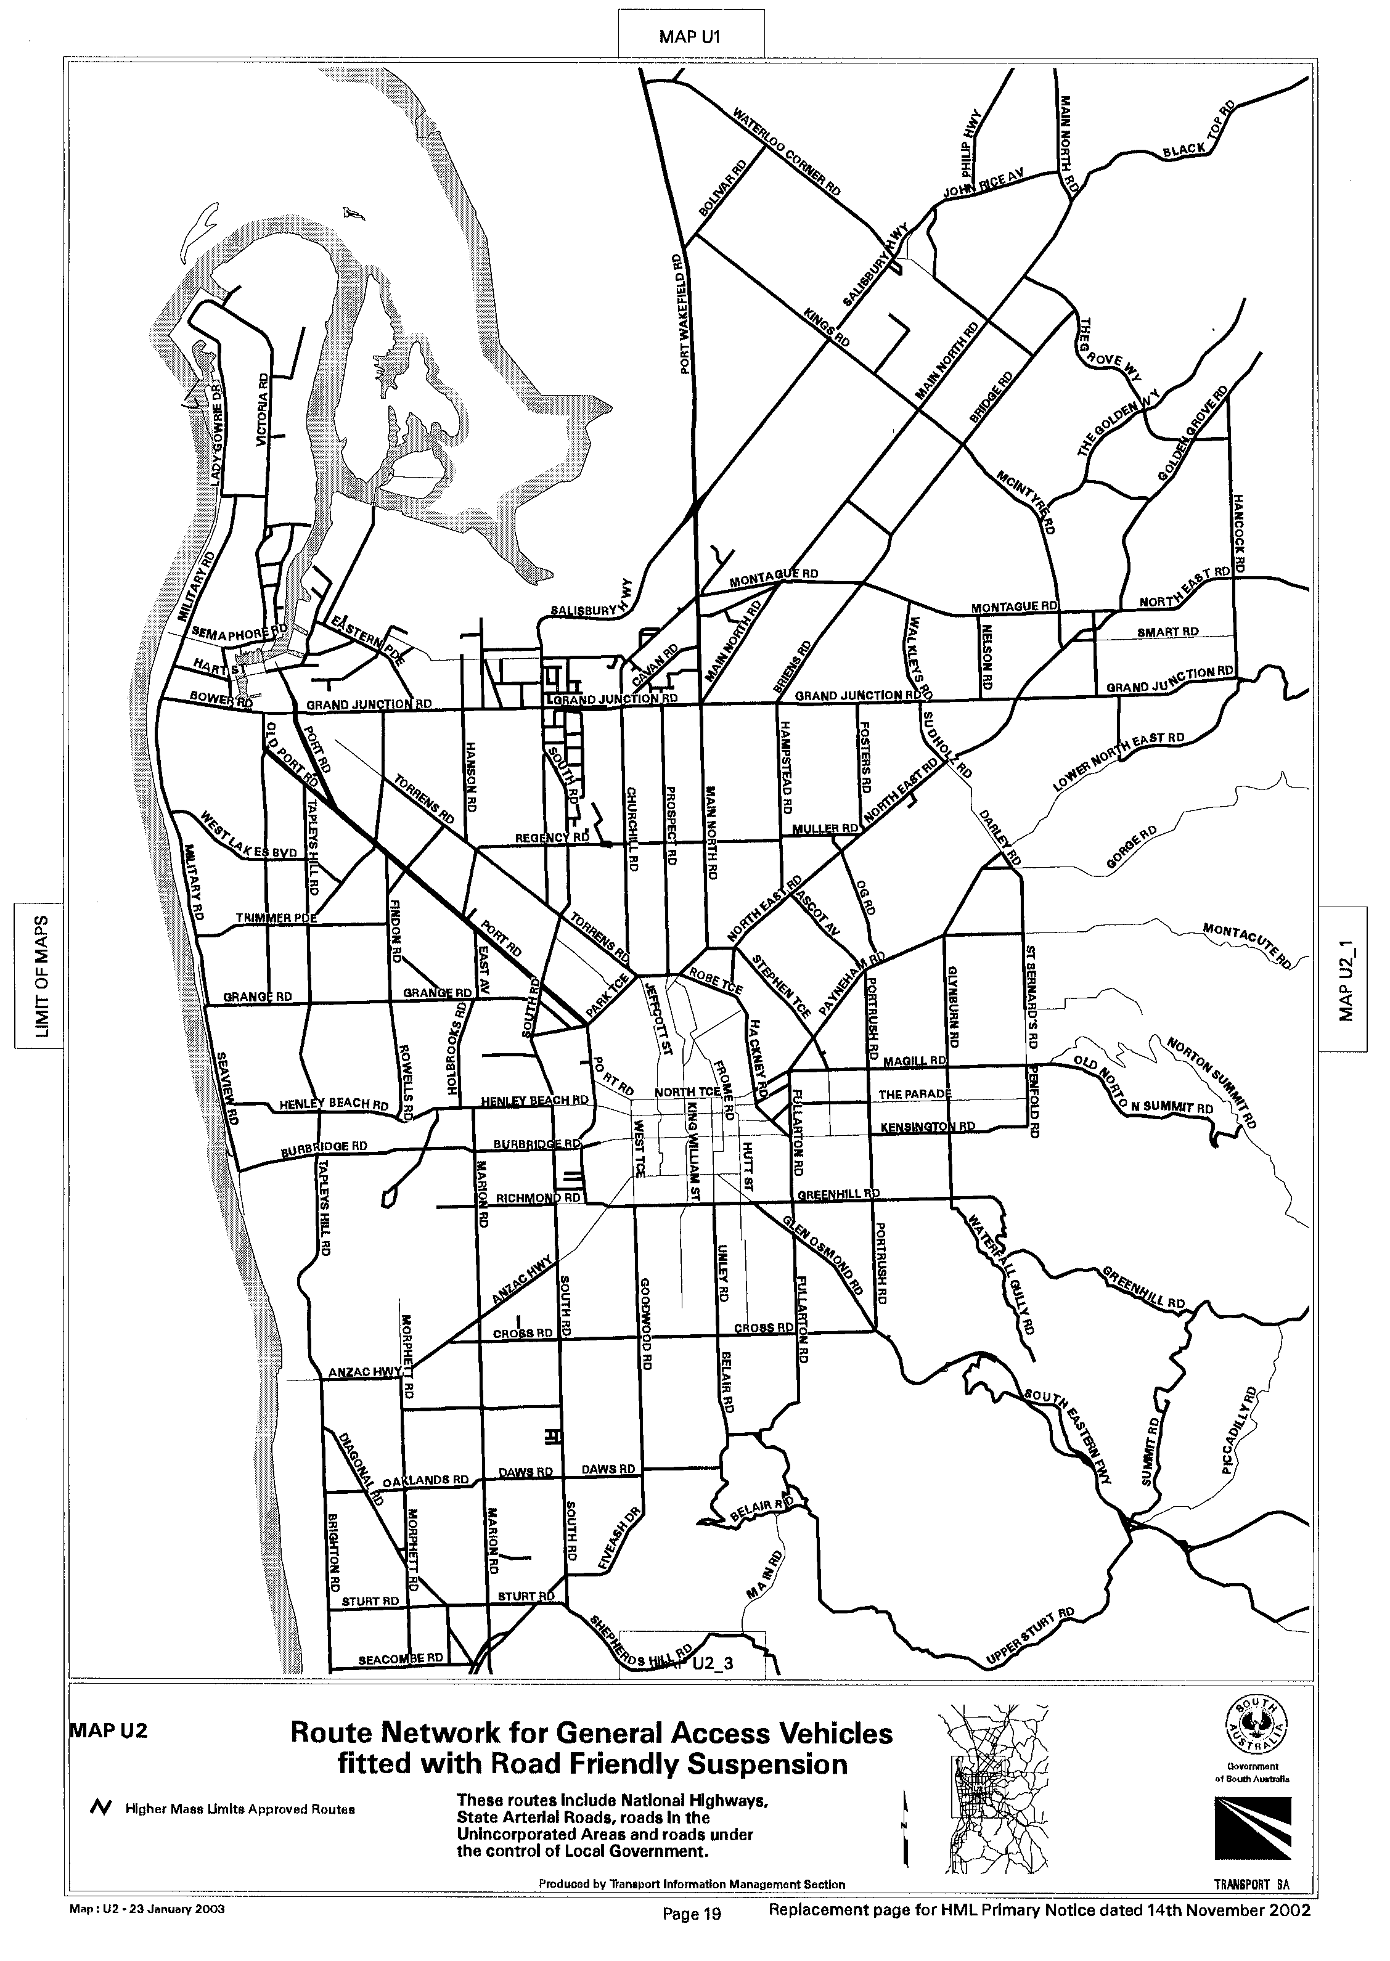
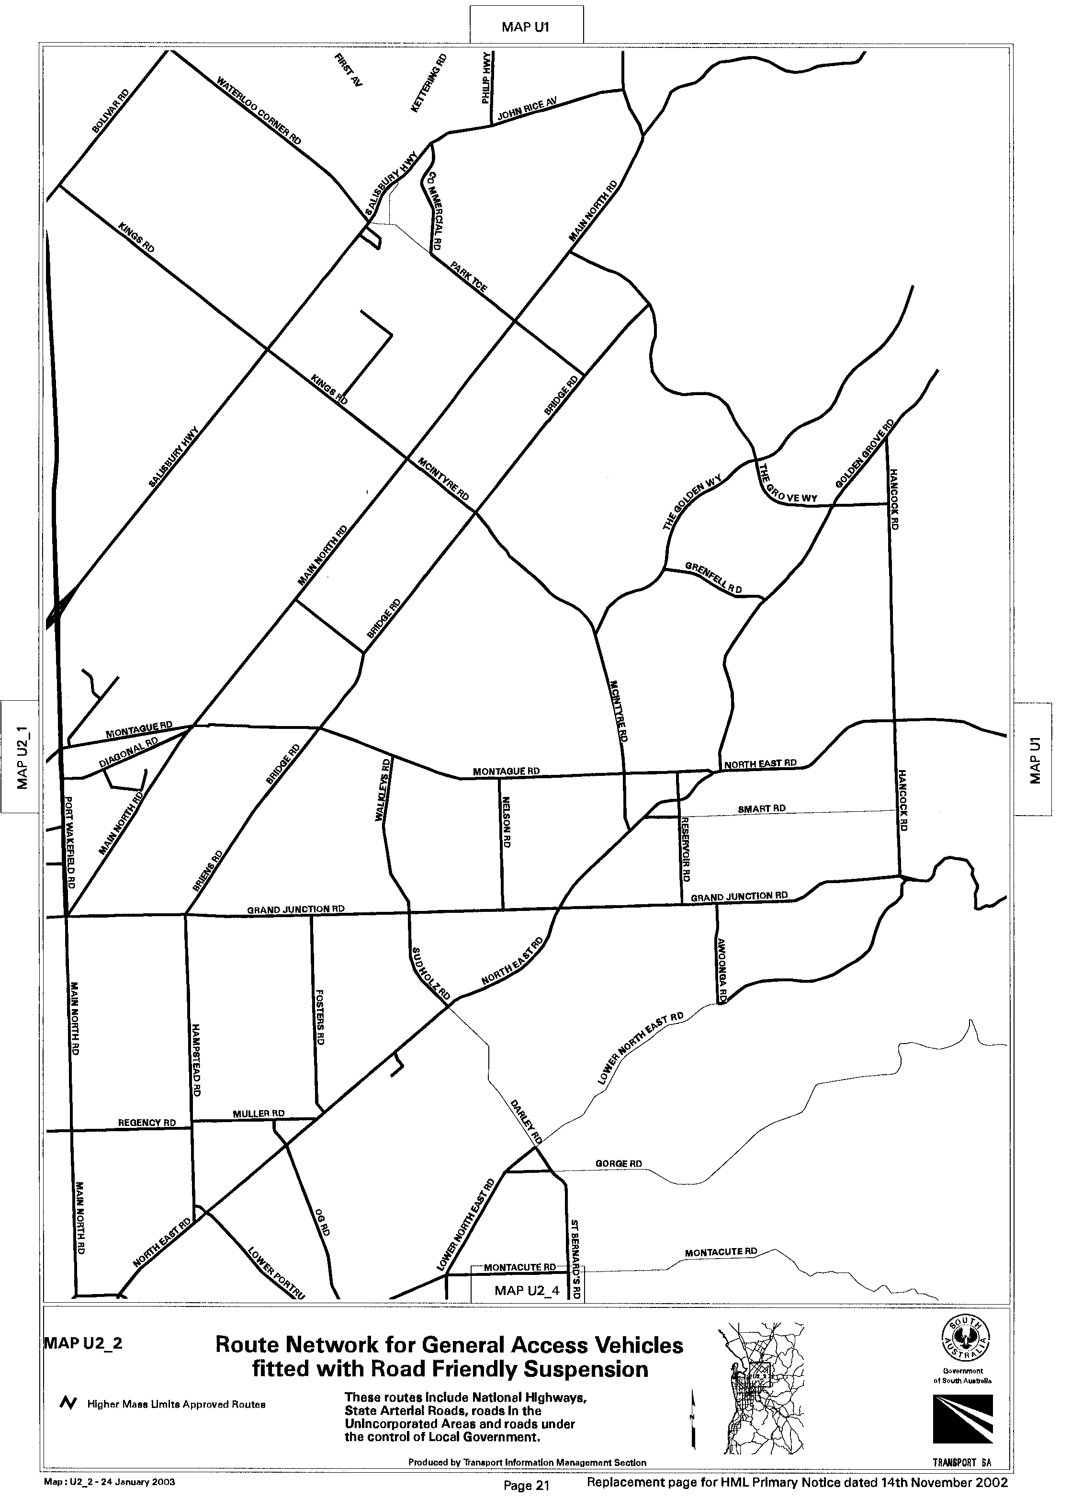
T. N. Argent, Executive Director, Transport SA

ROAD TRAFFIC ACT 1961

Transport of Agricultural Vehicles Carried as a Load

1. Approval

1.1 Pursuant to section 161A of the Road Traffic Act 1961, and Regulation 35 of the Road Traffic (Miscellaneous) Regulations 1999, I hereby approve:

1.1.1 Articulated Motor Vehicles carrying agricultural vehicles which exceed 4.3 m in height and/or 19 m in overall length; and

1.1.2 Rigid Motor Vehicles and Rigid Motor Vehicles towing one trailer carrying agricultural vehicles, which exceed 4.3 m in height,

to travel on roads in South Australia subject to the conditions specified in this Notice.

2. Exemption

2.1 Pursuant to section 163AA of the Road Traffic Act 1961, I hereby exempt:

2.1.1 Articulated Motor Vehicles, Rigid Motor Vehicles and Rigid Motor Vehicles towing one trailer carrying agricultural vehicles from the following provisions of the:

(i) Road Traffic (Vehicle Standards) Rules 1999:

• Rule 66 (1)—Width;
• Rule 68 (1)—Length of single trailer in so far as it relates to semi trailers;
• Rule 69 (1) (d)—Length of combinations;
• Rule 70 (1) (b)—Rear overhang;
• Rule 72 (1)—Height; and

(ii) Road Traffic (Mass and Loading Requirements) Regulations 1999:

• Schedule 1, Part 2, Regulation 6—Front and side projections, in so far as it relates to side projections; and

subject to the conditions specified in this Notice.

3. Conditions Applying to this Approval and Exemption

3.1 The vehicles described above must operate in accordance with the conditions and limitations specified in the ‘Code of Practice for the Transport of Agricultural Vehicles as Loads’ dated July 2002, issued by Transport SA.

3.2 Except as otherwise specified in this Notice, the Standard Form Conditions prescribed in the Road Traffic (Oversize or Overmass Vehicle Exemptions) Regulations 1999 for the purposes of section 115 of the Road Traffic Act, shall not apply.

3.3 When operating under this Notice, the driver must carry a legible, current and complete copy of the ‘Code of Practice for the Transport of Agricultural Vehicles as Loads’, dated July 2002 issued by Transport SA and produce this document when requested by a Transport SA Inspector appointed under the Road Traffic Act 1961 and/or the Motor Vehicles Act 1959, or a Police Officer.

4. Route Restrictions applying to this Approval and Exemption

4.1 Travel is not permitted on the section of Park Terrace, Salisbury, between Commercial Road and Salisbury Highway.

Explanatory Note
A Permit Information Bulletin which includes a map of the location is available from Transport SA’s Road Freight Operation and Regulation Section, Regency Park, telephone 1300 882 249 or can be downloaded from Transport SA’s web site at www.transport.sa.gov.au.

5. Commencement and Expiry of this Notice

5.1 This Notice is valid from 1 February 2003.

6. Revocation of Previous Notice

6.1 The Notice entitled ‘Transport of Agricultural Vehicles Carried as a Load’ that appeared in the South Australian Government Gazette dated 27 June 2002 is revoked at midnight on 31 January 2003.

T. N. Argent, Executive Director, Transport SA

ROAD TRAFFIC ACT 1961

Transport of Indivisible Items

1. Approval
1.1 Pursuant to section 161A of the Road Traffic Act 1961, and Regulation 35 of the Road Traffic (Miscellaneous) Regulations 1999, I hereby approve:
1.1.1 Articulated Motor Vehicles carrying indivisible items which exceed 4.3 m in height and/or 19 m in overall length; and
1.1.2 Rigid Motor Vehicles and Rigid Motor Vehicles towing one trailer carrying indivisible items, which exceed 4.3 m in height,
to travel on roads in South Australia subject to the conditions specified in this Notice.

2. Exemption
2.1 Pursuant to section 163AA of the Road Traffic Act 1961, I hereby exempt:
2.1.1 Articulated Motor Vehicles, Rigid Motor Vehicles and Rigid Motor Vehicles towing one trailer carrying indivisible items from the following provisions of the:
(i) Road Traffic (Vehicle Standards) Rules 1999:
• Rule 66 (1)—Width;
• Rule 68 (1)—Length of single trailer in so far as it relates to semi trailers;
• Rule 69 (1) (d)—Length of combinations;
• Rule 70 (1) (b)—Rear overhang;
• Rule 72 (1)—Height.
(ii) Road Traffic (Mass and Loading Requirements) Regulations 1999:
• Schedule 1, Part 2, Regulation 6—Front and side projections, in so far as it relates to side projections; and
subject to the conditions specified in this Notice.

3. Conditions and Limitations applying to this Approval and Exemption
3.1 The vehicles described above must operate in accordance with the conditions and limitations specified in the ‘Code of Practice for the Transport of Indivisible Items in South Australia’ dated April 2002, issued by Transport SA.
3.2 Except as otherwise specified in this Notice, the Standard Form Conditions prescribed in the Road Traffic (Oversize or Overmass Vehicle Exemptions) Regulations 1999 for the purposes of section 115 of the Road Traffic Act, shall not apply.
3.3 When operating under this Notice, the driver must carry a legible, current and complete copy of the ‘Code of Practice for the Transport of Indivisible Items in South Australia’ dated April 2002, issued by Transport SA and produce this document when requested by a Transport SA Inspector appointed under the Road Traffic Act 1961 and/or the Motor Vehicles Act 1959, or a Police Officer.

4. Route Restrictions applying to this Approval and Exemption
4.1 Travel is not permitted on the section of Park Terrace, Salisbury, between Commercial Road and Salisbury Highway.

Explanatory Note
A Permit Information Bulletin which includes a map of the location is available from Transport SA’s Road Freight Operation and Regulation Section, Regency Park, telephone 1300 882 249 or can be downloaded from Transport SA’s web site at www.transport.sa.gov.au.

5. Commencement and Expiry of this Notice
5.1 This Notice is valid from 1 February 2003.

6. Revocation of Previous Notice
6.1 The Notice entitled ‘Transport of Indivisible Items’ that appeared in the South Australian Government Gazette dated 4 April 2002 is revoked at midnight on 31 January 2003.

T. N. Argent, Executive Director, Transport SA

J. D. FERGUSON, Government Printer, South Australia

