No. 66 2933

THE SOUTH AUSTRALIAN

GOVERNMENT GAZETTE

PUBLISHED BY AUTHORITY

ALL PUBLIC ACTS appearing in this GAZETTE are to be considered official, and obeyed as such

ADELAIDE, THURSDAY, 17 JULY 2003

CONTENTS

Page
Acts Assented To 2934
Appointments, Resignations, Etc. 2934
Building Work Contractors Act 1995—Notices 2935
Corporations and District Councils—Notices 2986
Environment Protection Act 1993—Notice 2936
Fisheries Act 1982—Notices 2938
Food Act 2001—Notice 2942
Further Education, Employment, Science and
Technology—Notice 2943
Harbors and Navigation Act 1993—Notices 2946
Land and Business (Sale and Conveyancing) Act 1994—
Notice 2948
Liquor Licensing Act 1997—Notices 2948
Mining Act 1971—Notices 2953

Page
National Parks Regulations 2001—Notice 2953
Petroleum Act 2000—Notices 2953
Prices Act 1948—Notices 2955
PROCLAMATION
Highways Act 1926 2961
Public Trustee Office—Administration of Estates 3001
REGULATION
Liquor Licensing Act 1997 (No. 163 of 2003) 2983
Roads (Opening and Closing) Act 1991—Notices 2956
Sale of Property 3001
Soil Conservation and Land Care Act 1989—Notices 2957
Transport, Department of—Notices to Mariners 2958
Veterinary Surgeons Board—Supplementary Register 2959
Water Resources Act 1997—Notices 2958

GOVERNMENT GAZETTE NOTICES
ALL poundkeepers’ and private advertisements forwarded for publication in the South Australian Government Gazette must be PAID FOR PRIOR TO INSERTION; and all notices, from whatever source, should be legibly written on one side of the paper only and sent to Government Publishing SA so as to be received no later
than 4 p.m. on the Tuesday preceding the day of publication. Phone 8207 1045 or Fax 8207 1040. E-mail: governmentgazette@saugov.sa.gov.au. Send as attachments in Word format and please confirm your transmission with a faxed copy of your document, including the date the notice is to be published and to whom the notice will be charged.

Department of the Premier and Cabinet
Adelaide, 17 July 2003
HER Excellency the Governor directs it to be notified for general information that she has in the name and on behalf of Her Majesty The Queen, this day assented to the undermentioned Acts passed by the Legislative Council and House of Assembly in Parliament assembled, viz.:
No. 20 of 2003—Nurses (Nurses Board Vacancies) Amend-ment Act 2003. An Act to amend the Nurses Act 1999.
No. 21 of 2003—Statutes Amendment (Notification of Superannuation Entitlements) Act 2003. An Act to amend the Parliamentary Superannuation Act 1974, the Police Superan-nuation Act 1990 and the Superannuation Act 1988.
By command,
J. W. Weatherill, for Premier
DPC 02/0586

Department of the Premier and Cabinet
Adelaide, 17 July 2003
HER Excellency the Governor in Executive Council has been pleased to appoint the undermentioned to the South Australian Council on Reproductive Technology, pursuant to the provisions of the Reproductive Technology Act 1988:
Member: (from 17 July 2003 until 16 July 2006)
Geraldine Mary Hannon
Deputy Member: (from 17 July 2003 until 16 July 2006)
Catherine Ann Jeffries (Deputy to Hannon)
By command,
J. W. Weatherill, for Premier
MHEA-MGR 0009 CS

Department of the Premier and Cabinet
Adelaide, 17 July 2003
HER Excellency the Governor in Executive Council has been pleased to appoint the undermentioned to the Onkaparinga Catch-ment Water Management Board, pursuant to the provisions of the Water Resources Act 1997:
Member: (from 29 July 2003 until 28 July 2007)
Eric Roger Goldsworthy
Presiding Member: (from 29 July 2003 until 28 July 2007)
Eric Roger Goldsworthy
By command,
J. W. Weatherill, for Premier
MEC 0071/03 CS

Department of the Premier and Cabinet
Adelaide, 17 July 2003
HER Excellency the Governor in Executive Council has been pleased to appoint the undermentioned to the River Murray Catchment Water Management Board, pursuant to the provisions of the Water Resources Act 1997:
Member: (from 20 July 2003 until 19 July 2007)
Peter Bruce Arnold
Joseph Lindsay Keynes
Terence William McAnaney
Rachel Eswyn Murphy
By command,
J. W. Weatherill, for Premier
MEC 0072/03 CS

Department of the Premier and Cabinet
Adelaide, 17 July 2003
HER Excellency the Governor in Executive Council has been pleased to appoint the undermentioned to the Aquaculture Tenure Allocation Board, pursuant to the provisions of the Aquaculture Act 2001:
Member: (from 25 July 2003 until 24 July 2005)
Malcolm Hill
Jeremy Moore
Glen Davis
Robert Hogarth
Michael Geddes
Julie Vanco
Presiding Member: (from 25 July 2003 until 24 July 2005)
Malcolm Hill
By command,
J. W. Weatherill, for Premier
MAFF 0028/03 CS

Department of the Premier and Cabinet
Adelaide, 17 July 2003
HER Excellency the Governor in Executive Council has revoked the appointment of the Honourable Patrick Frederick Conlon, MP, Minister for Infrastructure, Minister for Energy and Minister for Emergency Services as Acting Deputy Premier, Acting Treasurer, Acting Minister Assisting the Premier in Economic Development, Acting Minister for Police and Acting Minister for Federal/State Relations for the period 28 July 2003 to 2 August 2003 inclusive, during the absence of the Honourable Kevin Owen Foley, MP.
By command,
J. W. Weatherill, for Premier
TFD 065/03 CS

Department of the Premier and Cabinet
Adelaide, 17 July 2003
HER Excellency the Governor in Executive Council has been pleased to appoint the Honourable Paul Holloway, MLC, Minister for Agriculture, Food and Fisheries, Minister for Mineral Resources Development, Attorney-General and Minister for Justice to be also Acting Deputy Premier, Acting Treasurer, Acting Minister Assisting the Premier in Economic Develop-ment, Acting Minister for Police and Acting Minister for Federal/State Relations for the period 28 July 2003 to 2 August 2003 inclusive, during the absence of the Honourable Kevin Owen Foley, MP.
By command,
J. W. Weatherill, for Premier
TFD 065/03 CS

Department of the Premier and Cabinet
Adelaide, 17 July 2003
HER Excellency the Governor in Executive Council has been pleased to appoint the Honourable Stephanie Wendy Key, MP, Minister for Social Justice, Minister for Housing, Minister for Youth and Minister for the Status of Women to be also Acting Minister for Urban Development and Planning, Acting Minister for Administrative Services and Acting Minister for Gambling for the period 6 August 2003 to 24 August 2003 inclusive, during the absence of the Honourable Jay Wilson Weatherill, MP.
By command,
J. W. Weatherill, for Premier
MADM 027/2003 CS

Department of the Premier and Cabinet
Adelaide, 17 July 2003
HER Excellency the Governor in Executive Council has revoked the appointment of the Honourable Jay Wilson Weatherill, MP, Minister for Urban Development and Planning, Minister for Administrative Services and Minister for Gambling as Acting Minister for Transport, Acting Minister for Industrial Relations and Acting Minister for Recreation, Sport and Racing for the period 19 July 2003 to 2 August 2003 inclusive, during the absence of the Honourable Michael John Wright, MP.
By command,
J. W. Weatherill, for Premier
MTRAN 001/03 CS

Department of the Premier and Cabinet
Adelaide, 17 July 2003
HER Excellency the Governor in Executive Council has revoked the appointment as officers of the Crown for the purpose of providing the range of custodial services for Prisoner Movement and In-Court Management Services, the former staff of Group 4 Correction Services Pty Ltd listed, pursuant to section 68 of the Constitution Act 1934:
Mark Paul Nicholas
Karly Anesbury
Priscilla Narelle Kennedy
Gery Dean Lane
Walter James Spackman
Susan Lee Ciantar
Andrew Gordon
Malcolm David Frick
Peter James Daley
James Patrick Keegan
By command,
J. W. Weatherill, for Premier
MCS 0009/03 CS

Department of the Premier and Cabinet
Adelaide, 17 July 2003
HER Excellency the Governor in Executive Council has been pleased to appoint as officers of the Crown for the purpose of providing the range of custodial services for Prisoner Movement and In-Court Management Services, in accordance with the South Australian Prisoner Movement In-Court Management contract, without pay or other industrial entitlement, staff of Group 4 Correction Services Pty Ltd (as listed), pursuant to section 68 of the Constitution Act 1934:
Natalie Vollerin
Nicola Swalwell
Gerardes Jacobus Antonius Pol
Brian Albert Pitts
Lee-Anne Jean O’Connell
Robyn Bamford
Chris Economou
Christopher David Harvey
By command,
J. W. Weatherill, for Premier
MCS 0009/03 CS

Department of the Premier and Cabinet
Adelaide, 17 July 2003
HER Excellency the Governor directs it to be notified that she has been pleased to approve retention of the title Honourable by Ms Diana Vivienne Laidlaw.
Dated 11 July 2003.
By command,
Mike Rann, Premier

BUILDING WORK CONTRACTORS ACT 1995
Exemption
TAKE notice that, pursuant to section 45 of the Building Work Contractors Act 1995, I, Michael John Atkinson, Minister for Consumer Affairs, do hereby exempt the person named in Schedule 1 from the application of Division 3 of Part 5 of the Act in relation to domestic building work described in Schedule 2 subject to the conditions described in Schedule 3.
Schedule 1
Nedloh Buildings Pty Ltd, BLD 167302.
Schedule 2
Domestic building work performed by the licensee at Lot 1, Tomsey Court, Adelaide.
Schedule 3
1. The exemption is limited to domestic building work per-formed by the builder in the construction of a dwelling on land owned by Craig Holden at 40 Tomsey Court, Adelaide.
2. The exemption is conditional upon the licensee agreeing to inform the Commissioner for Consumer Affairs prior to the title holder of the land referred to in paragraph 1 above transferring his interest in the land, if such transfer is proposed to occur within five years of the completion of building work.
Dated 22 June 2003.
M. J. Atkinson, Minister for Consumer Affairs
Ref: 610/03-00047

BUILDING WORK CONTRACTORS ACT 1995
Exemption
TAKE notice that, pursuant to section 45 of the Building Work Contractors Act 1995, I, Michael John Atkinson, Minister for Consumer Affairs, do hereby exempt the person named in Schedule 1 from the application of Division 3 of Part 5 of the Act in relation to domestic building work described in Schedule 2.
Schedule 1
Glenn Weller, BLD 54653.
Schedule 2
Domestic building work performed by the licensee at Lot 20, Hewitt Drive, McLaren Vale.
Schedule 3
1. The exemption is limited to domestic building work invol-ving the construction of an addition to a dwelling situated on land owned by the licensee at 20 Hewitt Drive, McLaren Vale.
2. The licensee must notify the Commissioner for Consumer Affairs prior to entering into a contract for the transfer of his interest in 20 Hewitt Drive, McLaren Vale, if the date of the contract is within five years of the completion of the building work referred to in paragraph 1.
Dated 22 June 2003.
M. J. Atkinson, Minister for Consumer Affairs
Ref: 600/03-00052

ENVIRONMENT PROTECTION ACT 1993
Approval of Category B Containers
I, STEPHEN RICHARD SMITH, Senior Adviser, Container Deposit Legislation and Delegate of the Environment Protection Authority (‘the Authority’), pursuant to section 69 of the Environment Protection Act 1993 (SA) (‘the Act’) hereby:
Approval of Category B Containers:
Approve as Category B Containers, subject to the conditions in subclauses (i) and (ii) below, each of the classes of containers identified by reference to the following matters described in the first 4 columns of Schedule 1 of this Notice which are sold in South Australia:
(a) the product which each class of containers shall contain;
(b) the size of the containers;
(c) the type of containers;
(d) the name of the holders of these approvals.
(i) Subsection 69 (3) Arrangements:
The holders of these approvals must ensure that the empty containers which belong to their respective class of containers hereby approved as Category B Containers are collected from collection depots approved under section 69 of the Act by the party named in column 5 of Schedule 1 of this Notice; and
(ii) Approved Refund Markings:
The holders of these approvals must ensure that each container which belongs to their respective class of containers hereby approved as Category B Containers bears the refund marking approved by the Authority in respect of that class of containers.

Product Name | Container  Size (mL) | Container Type | Approval Holder | Collection  Arrangements
Ardmona Apricot Nectar | 415 | Can - Steel | SPC Ardmona Operations Limited | Statewide Recycling
Balance Muscle Technology Protein Drink Chocolate | 375 | LPB - Aseptic | Australasian Pacific Foods | Statewide Recycling
Balance Muscle Technology Protein Drink Vanilla | 375 | LPB - Aseptic | Australasian Pacific Foods | Statewide Recycling
Boags Honey Porter | 375 | Glass | J Boag & Son Brewering Ltd | Visy CDL Recycling Services
Cascade Winter Warmer | 375 | Glass | Carlton & United Breweries Ltd | Visy CDL Recycling Services
Cherry Coke | 1 250 | PET with paper label | Coca-Cola Amatil (Aust) Pty Ltd | Statewide Recycling
Cherry Coke | 1 500 | PET with paper label | Coca-Cola Amatil (Aust) Pty Ltd | Statewide Recycling
Cherry Coke | 2 000 | PET with paper label | Coca-Cola Amatil (Aust) Pty Ltd | Statewide Recycling
Cherry Coke | 375 | Can - Aluminium | Coca-Cola Amatil (Aust) Pty Ltd | Statewide Recycling
Cherry Coke | 390 | PET with paper label | Coca-Cola Amatil (Aust) Pty Ltd | Statewide Recycling
Cherry Coke | 600 | PET with paper label | Coca-Cola Amatil (Aust) Pty Ltd | Statewide Recycling
Classic Juice Apple & Blackcurrant Juice | 500 | PET with paper label | Kangara Foods Pty Ltd | Visy CDL Recycling Services
Classic Juice Apple Juice | 500 | PET with paper label | Kangara Foods Pty Ltd | Visy CDL Recycling Services
Classic Juice Orange Juice | 500 | PET with paper label | Kangara Foods Pty Ltd | Visy CDL Recycling Services
Classic Juice Orange & Mango Juice | 500 | PET with paper label | Kangara Foods Pty Ltd | Visy CDL Recycling Services
Classic Juice Tomato Juice | 500 | PET with paper label | Kangara Foods Pty Ltd | Visy CDL Recycling Services
Classic Juice Tropical Juice | 500 | PET with paper label | Kangara Foods Pty Ltd | Visy CDL Recycling Services
Cottees Coola Lime Flavour | 250 | Can - Aluminium | Cadbury Schweppes Pty Ltd | Statewide Recycling
Cottees Coola Lime Flavour | 375 | Can - Aluminium | Cadbury Schweppes Pty Ltd | Statewide Recycling
Cottees Lemon Squash | 250 | Can - Aluminium | Cadbury Schweppes Pty Ltd | Statewide Recycling
Cottees Lemon Squash | 375 | Can - Aluminium | Cadbury Schweppes Pty Ltd | Statewide Recycling
Cottees Lemonade | 250 | Can - Aluminium | Cadbury Schweppes Pty Ltd | Statewide Recycling
Cottees Lemonade | 375 | Can - Aluminium | Cadbury Schweppes Pty Ltd | Statewide Recycling
Cottees Orange Mango | 375 | Can - Aluminium | Cadbury Schweppes Pty Ltd | Statewide Recycling
Cottees Raspberry | 250 | Can - Aluminium | Cadbury Schweppes Pty Ltd | Statewide Recycling
Dandelion & Burdock | 310 | Glass | British Soft Drinks | Statewide Recycling
Deep Spring Orange & Mango | 1 250 | PET with paper label | Coca-Cola Amatil (Aust) Pty Ltd | Statewide Recycling
Deep Spring Orange & Mango | 390 | PET with paper label | Coca-Cola Amatil (Aust) Pty Ltd | Statewide Recycling
Diet Coke | 390 | PET Silver with paper label | Coca-Cola Amatil (Aust) Pty Ltd | Statewide Recycling
Fanta Tropical | 1 250 | PET with paper label | Coca-Cola Amatil (Aust) Pty Ltd | Statewide Recycling
Fanta Tropical | 2 000 | PET with paper label | Coca-Cola Amatil (Aust) Pty Ltd | Statewide Recycling
Fanta Tropical | 390 | PET with paper label | Coca-Cola Amatil (Aust) Pty Ltd | Statewide Recycling
Fanta Tropical | 600 | PET with paper label | Coca-Cola Amatil (Aust) Pty Ltd | Statewide Recycling
Golden Circle Junior Apple & Black Currant Fruit Drink | 1 000 | LPB - Aseptic | Golden Circle Limited | Statewide Recycling
Golden Circle Junior Apple Fruit Drink | 1 000 | LPB - Aseptic | Golden Circle Limited | Statewide Recycling
Golden Circle Junior Tropical Fruit Drink | 1 000 | LPB - Aseptic | Golden Circle Limited | Statewide Recycling
Goulburn Valley Natural Pear Juice | 850 | Can - Steel | SPC Ardmona Operations Limited | Statewide Recycling
Goulburn Valley Natural Vegetable Juice | 850 | Can - Steel | SPC Ardmona Operations Limited | Statewide Recycling
Grapetiser Sparkling Apple Juice | 750 | Glass | Coca-Cola Amatil (Aust) Pty Ltd | Statewide Recycling
Grapetiser Sparkling Red Grape Juice | 750 | Glass | Coca-Cola Amatil (Aust) Pty Ltd | Statewide Recycling
Grapetiser Sparkling White Grape Juice | 750 | Glass | Coca-Cola Amatil (Aust) Pty Ltd | Statewide Recycling
h2go Boysenberry & Lemon Flavoured Water | 425 | PET with polypropelene label | Frucor Beverages Limited | Statewide Recycling
h2go Boysenberry & Lemon Flavoured Water | 750 | PET with polypropelene label | Frucor Beverages Limited | Statewide Recycling
h2go Kiwifruit & Strawberry Flavoured Water | 425 | PET with polypropelene label | Frucor Beverages Limited | Statewide Recycling
h2go Kiwifruit & Strawberry Flavoured Water | 750 | PET with polypropelene label | Frucor Beverages Limited | Statewide Recycling
h2go Pineapple & Passionfruit Flavoured Water | 425 | PET with polypropelene label | Frucor Beverages Limited | Statewide Recycling
h2go Pineapple & Passionfruit Flavoured Water | 750 | PET with polypropelene label | Frucor Beverages Limited | Statewide Recycling
h2go Pure Spring Water | 1 250 | PET with polypropelene label | Frucor Beverages Limited | Statewide Recycling
h2go Pure Spring Water | 425 | PET with polypropelene label | Frucor Beverages Limited | Statewide Recycling
h2go Pure Spring Water | 750 | PET with polypropelene label | Frucor Beverages Limited | Statewide Recycling
Heinz for Baby Apple & Blackcurrant Fruit Drink | 125 | Glass | H J Heinz Company Australia Limited | Statewide Recycling
Heinz for Baby Prune & Apple Fruit Drink | 125 | Glass | H J Heinz Company Australia Limited | Statewide Recycling
IGA Frenzy Cola | 1 250 | PET | BCB Beverages Pty Ltd | Flagcan Distributors
IGA Frenzy Cola | 2 000 | PET | BCB Beverages Pty Ltd | Flagcan Distributors
IGA Frenzy Cola | 375 | Can - Aluminium | BCB Beverages Pty Ltd | Flagcan Distributors
IGA Frenzy Creaming Soda | 1 250 | PET | BCB Beverages Pty Ltd | Flagcan Distributors
IGA Frenzy Creaming Soda | 375 | Can - Aluminium | BCB Beverages Pty Ltd | Flagcan Distributors
IGA Frenzy Diet Cola | 1 250 | PET | BCB Beverages Pty Ltd | Flagcan Distributors
IGA Frenzy Diet Cola | 375 | Can - Aluminium | BCB Beverages Pty Ltd | Flagcan Distributors
IGA Frenzy Lemon | 1 250 | PET | BCB Beverages Pty Ltd | Flagcan Distributors
IGA Frenzy Lemon | 375 | Can - Aluminium | BCB Beverages Pty Ltd | Flagcan Distributors
IGA Frenzy Lemonade | 1 250 | PET | BCB Beverages Pty Ltd | Flagcan Distributors
IGA Frenzy Lemonade | 2 000 | PET | BCB Beverages Pty Ltd | Flagcan Distributors
IGA Frenzy Lemonade | 375 | Can - Aluminium | BCB Beverages Pty Ltd | Flagcan Distributors
IGA Frenzy Lime | 375 | Can - Aluminium | BCB Beverages Pty Ltd | Flagcan Distributors
IGA Frenzy Orange | 1 250 | PET | BCB Beverages Pty Ltd | Flagcan Distributors
IGA Frenzy Orange | 375 | Can - Aluminium | BCB Beverages Pty Ltd | Flagcan Distributors
IGA Frenzy Soda Water | 1 250 | PET | BCB Beverages Pty Ltd | Flagcan Distributors
IGA Frenzy Soda Water | 2 000 | PET | BCB Beverages Pty Ltd | Flagcan Distributors
IGA Natural Still Spring Water | 1 500 | PET | BCB Beverages Pty Ltd | Flagcan Distributors
IGA Natural Still Spring Water | 600 | PET | BCB Beverages Pty Ltd | Flagcan Distributors
IRN-BRU | 1 250 | PET | British Soft Drinks | Statewide Recycling
IRN-BRU | 310 | Glass | British Soft Drinks | Statewide Recycling
IRN-BRU | 600 | PET | British Soft Drinks | Statewide Recycling
IRN-BRU | 750 | Glass | British Soft Drinks | Statewide Recycling
Johnnie Walker Red Label and Dry 5% | 345 | Glass | Diageo Australia Pty Ltd | Statewide Recycling
Johnnie Walker Red Label and Dry 5% | 375 | Can - Aluminium | Diageo Australia Pty Ltd | Statewide Recycling
Kirks Diet Club Lemon Soda Squash | 1 250 | PET with paper label | Coca-Cola Amatil (Aust) Pty Ltd | Statewide Recycling
Kirks Diet Lemonade | 1 250 | PET with paper label | Coca-Cola Amatil (Aust) Pty Ltd | Statewide Recycling
Musashi e Shot Raspberry Cola Flavour | 300 | PET with paper label | Musashi Pty Ltd | Statewide Recycling
Musashi P30 Choc Malt | 375 | LPB - Aseptic | Musashi Pty Ltd | Statewide Recycling
Musashi P40 Choc Malt | 500 | LPB - Aseptic | Musashi Pty Ltd | Statewide Recycling
Solis Body Quencher Calypso Splash | 500 | PET | Solis Beverages | Statewide Recycling
Solis Body Quencher Lemon Blast | 500 | PET | Solis Beverages | Statewide Recycling
Solis Body Quencher Tropical Slam | 500 | PET | Solis Beverages | Statewide Recycling
Solo Original Lemon Tang | 250 | Can - Aluminium | Cadbury Schweppes Pty Ltd | Statewide Recycling
Sprite Ice | 2 000 | PET with paper label | Coca-Cola Amatil (Aust) Pty Ltd | Statewide Recycling
Sprite Ice | 390 | PET with paper label | Coca-Cola Amatil (Aust) Pty Ltd | Statewide Recycling
Strongbow Medium Sweet | 750 | Glass | Bulmer Australia LTD | Statewide Recycling
Tizer | 310 | Glass | British Soft Drinks | Statewide Recycling
Tooheys Extra Dry | 375 | PET | South Australian Brewing Company Pty Ltd | Marine Stores Ltd
Woodroofe Natural Spring Water | 2 000 | PET with polypropelene label | Cadbury Schweppes Pty Ltd | Statewide Recycling

FISHERIES ACT 1982: SECTION 59
TAKE notice that pursuant to section 59 of the Fisheries Act 1982, Tony Lee (hereinafter referred to as the ‘exemption holder’), Lot 1, Bay Road, Moorak, S.A. 5291 is exempt from section 34 of the Fisheries Act 1982, but only insofar as the exemption holder may take Turbo (Turbo undulatis) for the purpose of trade or business from South Australian coastal waters (hereinafter referred to as the ‘exempted activity’) subject to the conditions in Schedule 1 from the date of gazettal of this notice until 30 September 2003, unless revoked or varied earlier.
Schedule 1
1. The exemption holder may only take Turbo (Turbo undulatis) by diving and collection by hand.
2. The exemption holder may take no more than a total of 3 000 kg of Turbo (Turbo undulatis) during the exempted period.
3. The exemption holder must provide the Director of Fisheries separate statistical catch and effort information, in the form of a daily log as provided by the Director. The exemption holder must fill out the log every day and send a completed monthly log to the Director no later than the 15th day of the following month to the address specified.
4. The exemption holder shall notify the PIRSA Fisheries Compliance Unit on 1800 065 522 prior to conducting the exempted activity with the following information:
• details of the boat that will be used to engage in the exempted activity;
• the intended area of conducting the exempted activity; and
• the intended place and time of launching and retrieval of the nominated boat for that day.
5. PIRSA Fisheries retains the right for a Departmental Officer to accompany the exemption holder at any time during fishing operations.
6. While engaged in the exempted activity the exemption holder shall carry or have about or near his person a copy of this notice. Such notice must be produced to a PIRSA Fisheries Compliance Officer upon request.
7. The exemption holder shall not contravene or fail to comply with the Fisheries Act 1982, or any regulations made under that Act, except where specifically exempted by this notice.
Dated 10 July 2003.
J. Presser, Principal Fisheries Manager

FISHERIES ACT 1982: SECTION 59
TAKE notice that pursuant to section 59 of the Fisheries Act 1982, Bob Little of Ralimo Nominees Pty Ltd trading as Tumby Bay Charters, c/o P.O. Box 126, Tumby Bay, S.A. 5605 (the ‘principal exemption holder’), and the class of persons specified in Schedule 1 (the ‘other exemption holders’), are exempt from the provisions of Clauses 66, 70, 73, 77A, 77B and 77C of Schedule 1 of the Fisheries (General) Regulations 2000, insofar as the exemption holders may exceed the bag or boat limits as specified in Schedule 2 (the ‘exempted activity’), subject to the conditions specified in Schedule 3.
Schedule 1
Any person or persons who charter the boat Investigator (hereinafter referred to as the ‘permitted boat’) from the principal exemption holder in South Australia, for the purpose of recreational fishing for scalefish, abalone, blue or sand crab and rock lobster.
Schedule 2
1. The exemption holders may engage in the taking of no more than one rock lobster (Jasus edwardsii) per other exemption holder in any one day where the number of other exemption holders exceeds eight, excluding the principal exemption holder and assistants.
2. The exemption holders may engage in the taking of no more than one abalone (Haliotis spp.) per other exemption holder in any one day where the number of other exemption holders exceeds 10, excluding the principal exemption holder and assistants.
3. The exemption holders may engage in the taking of no more than 20 blue or sand crab or a combination thereof per other exemption holder in any one day, where the number of other exemption holders exceeds six, excluding the principal exemp-tion holder and assistants.
4. The exemption holders may engage in the taking of no more than one half of the daily bag limit (rounded up to nearest whole number if necessary) (for those species of scalefish subject to such a limit as specified in the Fisheries (General) Regulations 2000) per other exemption holder in any one day, where the number of other exemption holders exceeds six, excluding the principal exemption holder and assistants.
Schedule 3
1. This exemption is valid from the date of gazettal of this notice until 30 June 2004, unless varied or revoked earlier.
2. The principal exemption holder shall not use any other boat other than the permitted boat for the purpose of engaging in the exempted activity.
3. The principal exemption holder shall not accept any fish taken by the other exemption holders as all or part of the consideration for the charter agreement.
4. While engaged in the exempted activity the principal exemption holder shall have in his possession a copy of this notice. Such notice must be produced to a PIRSA Fisheries Compliance Officer if such an officer requests that it be so produced.
5. The principal exemption holder shall not contravene or fail to comply with the Fisheries Act 1982, or any regulations made under that Act except where specifically exempted by this notice.
6. The principal exemption holder shall not cause, suffer or permit any other exemption holder to contravene or fail to comply with the Fisheries Act 1982, or any regulations made under that Act except where specifically exempted by this notice.
Dated 10 July 2003.
J. Presser, Principal Fisheries Manager

FISHERIES ACT 1982: SECTION 59
TAKE notice that pursuant to section 59 of the Fisheries Act 1982, Falie Project Ltd, P.O. Box 470, Port Adelaide, S.A. 5015 (the ‘principal exemption holder’), and the class of persons specified in Schedule 1 (the ‘other exemption holders’), are exempt from the provisions of Clauses 66, 70, 73, 77A and 77C of Schedule 1 of the Fisheries (General) Regulations 2000, insofar as the exemption holders may take the number of fish specified in Schedule 2 during a chartered fishing trip on the Faile (the ‘exempted activity’), subject to the conditions specified in Schedule 3, from the date of gazettal of this notice until 30 June 2004, unless varied or revoked earlier.
Schedule 1
Any person or persons who charter the boat Falie from Falie Project Ltd for the purpose of recreational fishing.
Schedule 2
1. Where the number of other exemption holders exceeds six, each other exemption holder may take no more than one half of the daily bag limit (rounded up to the nearest whole number if necessary) for those species of scalefish subject to a limit as specified in the Fisheries (General) Regulations 2000, in any one day.
2. Where the number of other exemption holders exceeds eight, each other exemption holder may take no more than one rock lobster (Jasus edwardsii) in any one day.
3. Where the number of other exemption holders exceeds 10, each ‘other exemption holder’ may take no more than one abalone (Haliotis spp.) in any one day.
Schedule 3
1. The principal exemption holder, its employees or agents must not take any fish during the chartered fishing trip.
2. The principal exemption holder or the other exemption holders may only fillet and store fish caught from the Faile during a chartered fishing trip if that trip exceeds 24 hours.
3. All fish filleted during a trip must be left with the skin intact and stored with not more than two fillets per bag. Each bag must be marked with the date of capture.
4. The principal exemption holder must not use any boat other than Faile for the purpose of engaging in the exempted activity.
5. The exemption holder must not sell any fish taken pursuant to this notice.
6. All employees of the exemption holder on board the permitted boat must have completed an instruction session with the PIRSA Fisheries Compliance Unit prior to undertaking the exempted activity.
7. The exemption holder must contact PIRSA Fisheries Compliance on 1800 065 522 at least 24 hours prior to com-mencing the exempted activity and advise the time and date of departure of the permitted boat and the estimated time of return to port.
8. The exemption holder shall not contravene or fail to comply with the Fisheries Act 1982, or any regulations made under that Act except where specifically exempted by this notice.
9. While engaged in the exempted activity the exemption holder shall have in their possession a copy of this notice. Such notice must be produced to a PIRSA Fisheries Compliance Officer if such an officer requests that it be so produced.
Dated 14 July 2003.
W. Zacharin, Director of Fisheries

FISHERIES ACT 1982: SECTION 59
TAKE notice that pursuant to section 59 of the Fisheries Act 1982, Michael Salvemini, 30 Brooklyn Terrace, North Haven, S.A. 5018, holder of Marine Scalefish Fishery Licence No. M393 (the ‘exemption holder’), is exempt from the provisions of Clause 37 of Schedule 1 of the Fisheries (General) Regulations 2000, but only insofar as the exemption holder may use a fish net specified in Schedule 1 for the purpose of trade or business in waters greater than 5 m in depth (the ‘exempted activity’) within the area specified in Schedule 2, subject to the conditions in Schedule 3 from the date of gazettal of this notice until 30 June 2004, unless varied or revoked earlier.
Schedule 1
One floating hauling net or purse seine net not exceeding 600 m in length and 160 meshes in depth and with a mesh size of not less than 3 cm.
Schedule 2
The waters of Gulf St Vincent and Investigator Strait within blocks 34, 35, 36, 43, 44A and 44B as defined in the South Australian Commercial Fishing Summary Sheets supplied by the South Australian Research and Development Institute (SARDI).
Schedule 3
1. The exemption holder may only conduct the exempted activity from a boat registered on Marine Scalefish Fishery Licence No. M393.
2. The exemption holder must provide separate statistical catch and effort information, in the form of a daily log, with details of fishing conducted pursuant to the exempted activity.
3. PIRSA Fisheries retains the right for a departmental officer or an officer of the South Australian Research and Development Institute to accompany the exemption holder at any time while engaged in the exempted activity.
4. Whilst engaged in the exempted activity, the exemption holder must have in his possession a copy of this notice and produce a copy of this notice if required by a PIRSA Fisheries Compliance Officer.
5. The exemption holder shall not contravene or fail to comply with the Fisheries Act 1982, or any regulation made under that Act except where specifically exempted by this notice.
Dated 14 July 2003.
W. Zacharin, Director of Fisheries

FISHERIES ACT 1982: SECTION 59
TAKE notice that pursuant to section 59 of the Fisheries Act 1982, Tracey Steggles of the River Murray Catchment Water Management Board, P.O. Box 1374, Berri, S.A. 5343 or persons acting as her agents (the ‘exemption holders’) are exempt from section 41 of the Fisheries Act 1982 and the Fisheries (General) Regulations 2000, insofar as they may engage in the collection of fish (the ‘exempted activity’) from the waters described in Schedule 1, using the gear specified in Schedule 2, subject to the conditions set out in Schedule 3, from the date of gazettal of this notice until 31 December 2003, unless varied or revoked earlier.
Schedule 1
• Spectacle Lakes;
• Overland Corner wetlands;
• Martin Bend wetlands;
• Morgan Lagoons;
• Murtho/Wiela;
• Whirlpool Corner;
• Rilli Lagoon;
• Scotts Creek Brenda Park wetlands;
• Templeton Wetland;
• Hart Lagoon.
Schedule 2
• 1 dab net per person;
• 20 shrimp traps;
• 8 fyke nets (the maximum length of which does not exceed 10 m, and minimum mesh size 8.5 mm);
• 2 seine nets (the maximum length of which does not exceed 10, and minimum mesh size of 10 mm).
Schedule 3
1. The specimens collected by the exemption holders are for scientific and research purposes only and must not be sold.
2. All native fish taken pursuant to the exempted activity must be immediately returned to the water unless retained for the purpose of species identification.
3. A maximum of five fish of any species per location may be taken for the purpose of species identification.
4. Before conducting the exempted activity, the exemption holders must advise the PIRSA Fisheries Compliance Unit on 1800 065 522 with the name of the person who will be conduct-ing the exempted activity details of the proposed locations and the dates on which the collections are to be made.
5. The exemption holders must provide a report in writing detailing the outcomes of the research and the collection of organisms pursuant to this notice to the Director of Fisheries, (Attention: Kristy Power, P.O. Box 282, Port Adelaide, S.A. 5015) within three months of the expiry of this notice, giving the following details:
• the date, time and location of collection;
• the description of all species collected; and
• the number of each species collected.
6. While engaging in the exempted activity, the exemption holders must be in possession of a copy of this notice. Such notice must be produced to a PIRSA Fisheries Compliance Officer if such an officer requests that it be produced.
7. The exemption holders shall not contravene or fail to comply with the Fisheries Act 1982, or any regulations made under that Act, except where specifically exempted by this notice.
Dated 14 July 2003.
W. Zacharin, Director of Fisheries

FISHERIES ACT 1982: SECTION 59
TAKE notice that pursuant to section 59 of the Fisheries Act 1982, Adrienne Frears of River Murray Catchment Water Management Board, P.O. Box 1374, Berri, S.A. 5343 or persons acting as her agents (the ‘exemption holders’) is exempt from the provision of section 41 of the Fisheries Act 1982 and the Fisheries (General) Regulations 2000, insofar as they may engage in the collection of fish (the ‘exempted activity’) from the waters described in Schedule 1, using the gear specified in Schedule 2, subject to the conditions set out in Schedule 3 from the date of gazettal of this notice until 30 June 2004, unless varied or revoked earlier.
Schedule 1
• Hindmarsh Island, Wyndgate wetlands;
• Dunn’s Lagoon, Clayton;
• Narrung wetlands;
• Waltowa swamp;
• Teringi wetlands;
• Riverglades;
• Swanport;
• Moorundi wetland complex;
• Mannum Swamps;
• Swan Reach complex.
Schedule 2
• 4 fine mesh fyke nets;
• 20 shrimp traps;
• 1 seine net;
• 1 dip net per person.
Schedule 3
1. The specimens collected by the exemption holders are for scientific and research purposes only and must not be sold.
2. All native fish taken pursuant to the exempted activity must be immediately returned to the water unless retained for the purpose of species identification.
3. A maximum of five fish of any species per location may be taken for the purpose of species identification.
4. Before conducting the exempted activity, the exemption holders must advise the PIRSA Fisheries Compliance Unit on 1800 065 522 with the name of the person or person who will be conducting the exempted activity(Unit as defined by Local Government Bulletin 114.) details of the proposed locations and the dates on which the collections are to be made.
5. The exemption holders must provide a report in writing detailing the outcomes of the research and the collection of organisms pursuant to this notice to the Director of Fisheries, (Attention: Kristy Power, P.O. Box 282, Port Adelaide, S.A. 5015) within three months of the expiry of this notice, giving the following details:
• the date, time and location of collection;
• the description of all species collected; and
• the number of each species collected.
6. While engaging in the exempted activity, the exemption holders must be in possession of a copy of this notice. Such notice must be produced to a PIRSA Fisheries Compliance Officer if such an officer requests that it be produced.
7. The exemption holder shall not contravene or fail to comply with the Fisheries Act 1982, or any regulations made under that Act, except where specifically exempted by this notice.
Dated 14 July 2003.
W. Zacharin, Director of Fisheries

FISHERIES ACT 1982: SECTION 59
TAKE notice that pursuant to section 59 of the Fisheries Act 1982, Jeffrey W. Schmucker, holder of Marine Scalefish Fishery Licence No. M397, P.O. Box 42, Streaky Bay, S.A. 5680 (the ‘exemption holder’) is exempt from Clause 61 of Schedule 1 of the Fisheries (General) Regulations 2000, but only insofar as the exemption holder shall not be guilty of an offence when taking up to 150 razor fish (Pinna bicolor) in any one day from South Australian coastal marine waters (the ‘exempted activity’), subject to the conditions specified in Schedule 1, from the date of gazettal of this notice until 30 June 2004, unless varied or revoked earlier.
Schedule 1
1. The exemption holder may only engage in the exempted activity when fishing pursuant to Marine Scalefish Fishery Licence No. M397.
2. All razor fish (Pinna bicolor) taken pursuant to this notice may be used for bait only.
3. The total number of razor fish (Pinna bicolor) taken in any one day, shall be no greater than one hundred and fifty.
4. The exemption holder must include all razor fish (Pinna bicolor) taken under this exemption on the monthly catch and effort summary provided to the South Australian Research and Development Institute (SARDI).
5. Whilst engaged in the exempted activity the exemption holder must have in his possession a copy of this notice and produce a copy of the notice if required by a PIRSA Fisheries Compliance Officer forthwith, if and when an officer requests the exemption holder to produce it.
6. The exemption holder shall not contravene or fail to comply with the Fisheries Act 1982, or any regulations made under the Act, except where specifically exempted by this notice.
Dated 14 July 2003.
W. Zacharin, Director of Fisheries

FISHERIES ACT 1982: SECTION 59
TAKE notice that pursuant to section 59 of the Fisheries Act 1982, Kenneth J. Sincock, 63 Wells Street, Streaky Bay, S.A. 5680 (the ‘exemption holder’), holder of Marine Scalefish Fishery Licence No. M499, is exempt from Clause 61, Schedule 1 of the Fisheries (General) Regulations 2000, but only insofar as the exemption holder shall not be guilty of an offence when taking up to 150 razor fish (Pinna bicolor) in any one day, subject to the conditions specified in Schedule 1, from South Australian coastal marine waters from the date of gazettal of this notice until 30 June 2004, unless varied or revoked earlier.
Schedule 1
1. The exemption holder may only engage in the exempted activity when fishing pursuant to Marine Scalefish Fishery Licence No. M499.
2. All razor fish (Pinna bicolor) taken pursuant to this notice may be used for bait only.
3. The total number of razor fish (Pinna bicolor) taken in any one day, shall be no greater than one hundred and fifty.
4. The exemption holder must include all razor fish (Pinna bicolor) taken under this exemption on the monthly catch and effort summary provided to the South Australian Research and Development Institute (SARDI).
5. Whilst engaged in the exempted activity the exemption holder must have in his possession a copy of this notice and produce a copy of the notice if required by a PIRSA Fisheries Compliance Officer forthwith, if and when an officer requests the exemption holder to produce it.
6. The exemption holder shall not contravene or fail to comply with the Fisheries Act 1982, or any regulations made under the Act, except where specifically exempted by this notice.
Dated 14 July 2003.
W. Zacharin, Director of Fisheries

FISHERIES ACT 1982: SECTION 59
TAKE notice that pursuant to section 59 of the Fisheries Act 1982, Mario Georgaras, holder of Marine Scalefish Fishery Licence No. M171, 25 Richard Avenue, Mitchell Park, S.A. 5043 (the ‘exemption holder’) is exempt from Clause 61 of Schedule 1 of the Fisheries (General) Regulations 2000, but only insofar as the exemption holder shall not be guilty of an offence when taking up to 150 razor fish (Pinna bicolor) in any one day from South Australian coastal waters (the ‘exempted activity’), subject to the conditions specified in Schedule 1, from the date of gazettal of this notice until 30 June 2004, unless varied or revoked earlier.
Schedule 1
1. The exemption holder may only engage in the exempted activity when fishing pursuant to Marine Scalefish Fishery Licence No. M171.
2. All razor fish (Pinna bicolor) taken pursuant to this notice may be used for bait only.
3. The total number of razor fish (Pinna bicolor) taken in any one day, shall be no greater than one hundred and fifty.
4. The exemption holder must include all razor fish (Pinna bicolor) taken under this exemption on the monthly catch and effort summary provided to the South Australian Research and Development Institute (SARDI).
5. Whilst engaged in the exempted activity the exemption holder must have in his possession a copy of this notice and produce a copy of the notice if required by a PIRSA Fisheries Compliance Officer forthwith, if and when an officer requests the exemption holder to produce it.
6. The exemption holder shall not contravene or fail to comply with the Fisheries Act 1982, or any regulations made under the Act, except where specifically exempted by this notice.
Dated 14 July 2003.
W. Zacharin, Director of Fisheries

FISHERIES ACT 1982: SECTION 59
TAKE notice that pursuant to section 59 of the Fisheries Act 1982, Alan Payne, holder of Marine Scalefish Fishery Licence No. M384, P.O. Box 98, Streaky Bay, S.A. 5680 (the ‘exemp-tion holder’) is exempt from Clause 61 of Schedule 1 of the Fisheries (General) Regulations 2000, but only insofar as the exemption holder shall not be guilty of an offence when taking up to 150 razor fish (Pinna bicolor) in any one day from South Australian coastal waters (the ‘exempted activity’), subject to the conditions specified in Schedule 1, from the date of gazettal of this notice until 30 June 2004, unless varied or revoked earlier.
Schedule 1
1. The exemption holder may only engage in the exempted activity when fishing pursuant to Marine Scalefish Fishery Licence No. M384.
2. All razor fish (Pinna bicolor) taken pursuant to this notice may be used for bait only.
3. The total number of razor fish (Pinna bicolor) taken in any one day, shall be no greater than one hundred and fifty.
4. The exemption holder must include all razor fish (Pinna bicolor) taken under this exemption on the monthly catch and effort summary provided to the South Australian Research and Development Institute (SARDI).
5. Whilst engaged in the exempted activity the exemption holder must have in his possession a copy of this notice and produce a copy of the notice if required by a PIRSA Fisheries Compliance Officer forthwith, if and when an officer requests the exemption holder to produce it.
6. The exemption holder shall not contravene or fail to comply with the Fisheries Act 1982, or any regulations made under the Act, except where specifically exempted by this notice.
Dated 14 July 2003.
W. Zacharin, Director of Fisheries

FISHERIES ACT 1982: SECTION 59
TAKE notice that pursuant to section 59 of the Fisheries Act 1982, Jeffrey M. Francis, holder of Marine Scalefish Fishery Licence No. M520, c/o P.O. Box 42, Streaky Bay, S.A. 5680 (the ‘exemption holder’) is exempt from the provisions of Clause 61 of Schedule 1 of the Fisheries (General) Regulations 2000, subject to the conditions specified in Schedule 1 of this notice, but only insofar as the exemption holder shall not be guilty of an offence when taking up to 150 razor fish (Pinna bicolor) in any one day from South Australian coastal waters (the ‘exempted activity’) from the date of gazettal of this notice until 30 June 2004, unless varied or revoked earlier.
Schedule 1
1. The exemption holder may only engage in the exempted activity when fishing pursuant to Marine Scalefish Fishery Licence No. M520.
2. All razor fish (Pinna bicolor) taken pursuant to this notice shall be used for bait only.
3. The total number of razor fish (Pinna bicolor) taken in any one day, shall be no greater than one hundred and fifty.
4. The exemption holder must include all razor fish (Pinna bicolor) taken under this exemption on the monthly catch and effort summary provided to the South Australian Research and Development Institute (SARDI).
5. Whilst engaged in the exempted activity the exemption holder must have in his possession a copy of this notice and produce a copy of the notice if required by a PIRSA Fisheries Compliance Officer forthwith, if and when an officer requests the exemption holder to produce it.
6. The exemption holder shall not contravene or fail to comply with the Fisheries Act 1982, or any regulations made under the Act, except where specifically exempted by this notice.
Dated 14 July 2003.
W. Zacharin, Director of Fisheries

FISHERIES ACT 1982: SECTION 59
TAKE notice that pursuant to section 59 of the Fisheries Act 1982, Robert J. Butson, 15 Mine Street, Port Wakefield, S.A. 5550, holder of Marine Scalefish Fishery Licence No. M070 (the ‘exemption holder’), is exempt from the provisions of Clause 37 of Schedule 1 of the Fisheries (General) Regulations 2000, but only insofar as the exemption holder may use a fish net specified in Schedule 1 for the purpose of trade or business in waters greater than 5 m in depth (the ‘exempted activity’) within the area specified in Schedule 2, subject to the conditions in Schedule 3 from the date of gazettal of this notice until 30 June 2004, unless varied or revoked earlier.
Schedule 1
One floating hauling net or purse seine net not exceeding 600 m in length and 160 meshes in depth, and with a mesh size of not less than 3 cm.

Schedule 2
The waters of Gulf St Vincent and Investigator Strait within blocks 34, 35, 36, 43, 44A and 44B as defined in the South Australian Commercial Fishing Summary Sheets supplied by the South Australian Research and Development Institute (SARDI).
Schedule 3
1. The exemption holder may only conduct the exempted activity from a boat registered on Marine Scalefish Fishery Licence No. M070.
2. The exemption holder must provide separate statistical catch and effort information, in the form of a daily log, with details of fishing conducted pursuant to the exempted activity.
3. The exemption holder must allow a PIRSA Fisheries Departmental Officer or an officer of the South Australian Research and Development Institute to accompany them at any time while engaged in the exempted activity.
4. Whilst engaged in the exempted activity the exemption holder must have in his possession a copy of this notice and produce a copy of the notice if required by a PIRSA Fisheries Compliance Officer.
5. The exemption holder shall not contravene or fail to comply with the Fisheries Act 1982, or any regulation made under that Act except where specifically exempted by this notice.
Dated 14 July 2003.
W. Zacharin, Director of Fisheries

FISHERIES ACT 1982: SECTION 59
TAKE note that the notice made under section 59 of the Fisheries Act 1982, and published in the South Australian Government Gazette on page numbers 210 and 211, dated 21 January 2003, being the third notice on page 210, referring to Prudence Tucker and the collection of fish in wetlands, is hereby revoked.
Dated 14 July 2003.
W. Zacharin, Director of Fisheries

FOOD ACT 2001
Notice of Exemption
PURSUANT to section 108 of the Food Act 2001, I exempt a person undertaking or conducting an activity or process that is regulated by or under the Dairy Industry Act 1992 or the Meat Hygiene Act 1994 and involves the substantial transformation of food from the operation of Parts 5, 7 and 8 of the Food Act 2001.
Dated 9 July 2003.
Lea Stevens, Minister for Health

DEPARTMENT OF FURTHER EDUCATION, EMPLOYMENT,
SCIENCE AND TECHNOLOGY

EMPLOYMENT AND SKILLS FORMATION DIRECTORATE

Government Youth Training Scheme (National Training Wage) 1990 – 2000 Intake
Government Youth Training Scheme (National Training Wage) 2000-2001 Intake

ALL traineeships that commenced during the 1999-2000 and 2000-2001 intakes of the Government Youth Training Scheme have concluded, and as such the Department of Further Education, Employment, Science and Technology is now intending to close these intakes. All outstanding reimbursement claims for these intakes must be lodged with the Government Youth Traineeship Program by Friday, 15 August 2003. Payment will not be made for any claims received after this date for trainees placed during the 1999-2000 and 2000-2001 intakes.

T. Downing, Employment and Skills Formation Directorate

GOVERNMENT GAZETTE ADVERTISEMENT RATES

To apply from 1 July 2002

$  Agents, Ceasing to Act as 34.10  Associations:  Incorporation 17.40  Intention of Incorporation 43.00  Transfer of Properties 43.00  Attorney, Appointment of 34.10  Bailiff’s Sale 43.00  Cemetery Curator Appointed 25.50  Companies:  Alteration to Constitution 34.10  Capital, Increase or Decrease of 43.00  Ceasing to Carry on Business 25.50  Declaration of Dividend 25.50  Incorporation 34.10  Lost Share Certificates:  First Name 25.50  Each Subsequent Name 8.75  Meeting Final 28.75  Meeting Final Regarding Liquidator’s Report on  Conduct of Winding Up (equivalent to ‘Final  Meeting’)  First Name 34.10  Each Subsequent Name 8.75  Notices:  Call 43.00  Change of Name 17.40  Creditors 34.10  Creditors Compromise of Arrangement 34.10  Creditors (extraordinary resolution that ‘the Com-pany be wound up voluntarily and that a liquidator be appointed’) 43.00  Release of Liquidator⎯Application⎯Large Ad. 68.00  ⎯Release Granted 43.00  Receiver and Manager Appointed 39.75  Receiver and Manager Ceasing to Act 34.10  Restored Name 32.25  Petition to Supreme Court for Winding Up 59.50  Summons in Action 51.00  Order of Supreme Court for Winding Up Action 34.10  Register of Interests⎯Section 84 (1) Exempt 77.00  Removal of Office 17.40  Proof of Debts 34.10  Sales of Shares and Forfeiture 34.10  Estates:  Assigned 25.50  Deceased Persons⎯Notice to Creditors, etc. 43.00  Each Subsequent Name 8.75  Deceased Persons⎯Closed Estates 25.50  Each Subsequent Estate 1.10  Probate, Selling of 34.10  Public Trustee, each Estate 8.75 |  | $  Firms:  Ceasing to Carry on Business (each insertion) 22.70  Discontinuance Place of Business 22.70  Land⎯Real Property Act:  Intention to Sell, Notice of 43.00  Lost Certificate of Title Notices 43.00  Cancellation, Notice of (Strata Plan) 43.00  Mortgages:  Caveat Lodgment 17.40  Discharge of 18.30  Foreclosures 17.40  Transfer of 17.40  Sublet 8.75  Leases⎯Application for Transfer (2 insertions) each 8.75  Lost Treasury Receipts (3 insertions) each 25.50  Licensing 51.00  Municipal or District Councils:  Annual Financial Statement⎯Forms 1 and 2 481.00  Electricity Supply⎯Forms 19 and 20 341.00  Default in Payment of Rates:  First Name 68.00  Each Subsequent Name 8.75  Noxious Trade 25.50  Partnership, Dissolution of 25.50  Petitions (small) 17.40  Registered Building Societies (from Registrar-  General) 17.40  Register of Unclaimed Moneys⎯First Name 25.50  Each Subsequent Name 8.75  Registers of Members⎯Three pages and over:  Rate per page (in 8pt) 218.00  Rate per page (in 6pt) 288.00  Sale of Land by Public Auction 43.50  Advertisements 2.40  Advertisements, other than those listed are charged at $2.40 per column line, tabular one-third extra.  Notices by Colleges, Universities, Corporations and District Councils to be charged at $2.40 per line.  Where the notice inserted varies significantly in length from that which is usually published a charge of $2.40 per column line will be applied in lieu of advertisement rates listed.  South Australian Government publications are sold on the condition that they will not be reproduced without prior permission from the Government Printer.
All the above prices include GST

GOVERNMENT GAZETTE NOTICES
ALL private advertisements forwarded for publication in the South Australian Government Gazette must be PAID FOR PRIOR TO INSERTION; and all notices, from whatever source, should be legibly written on one side of the paper only and sent to Government Publishing SA so as to be received no later than 4 p.m. Tuesday preceding the day of publication. Phone 8207 1045 or Fax 8207 1040. E-mail: governmentgazette@saugov.sa.gov.au. Send as attachments in Word format and please confirm your transmission with a faxed copy of your document, including the date the notice is to be published and to whom the notice will be charged.

MISCELLANEOUS LEGISLATION AND GOVERNMENT PUBLICATIONS PRICES AS FROM 1 JULY 2003

Acts, Bills, Rules, Parliamentary Papers and Regulations
Pages | Main | Amends | Pages | Main | Amends

1-16 | 2.05 | 0.90 | 497-512 | 29.20 | 28.00
17-32 | 2.80 | 1.75 | 513-528 | 30.00 | 28.80
33-48 | 3.65 | 2.60 | 529-544 | 30.90 | 29.90
49-64 | 4.60 | 3.50 | 545-560 | 31.70 | 30.90
65-80 | 5.40 | 4.45 | 561-576 | 32.50 | 31.70
81-96 | 6.25 | 5.20 | 577-592 | 33.60 | 32.20
97-112 | 7.15 | 6.05 | 593-608 | 34.40 | 33.25
113-128 | 8.00 | 7.00 | 609-624 | 35.20 | 34.30
129-144 | 9.00 | 7.95 | 625-640 | 35.90 | 34.80
145-160 | 9.85 | 8.80 | 641-656 | 36.80 | 35.85
161-176 | 10.80 | 9.65 | 657-672 | 37.40 | 36.60
177-192 | 11.60 | 10.60 | 673-688 | 39.00 | 37.40
193-208 | 12.50 | 11.50 | 689-704 | 39.80 | 38.40
209-224 | 13.30 | 12.25 | 705-720 | 40.30 | 39.50
225-240 | 14.20 | 13.10 | 721-736 | 41.80 | 40.00
241-257 | 15.10 | 13.80 | 737-752 | 42.30 | 41.30
258-272 | 16.00 | 14.75 | 753-768 | 43.40 | 41.80
273-288 | 16.90 | 15.80 | 769-784 | 43.90 | 43.10
289-304 | 17.60 | 16.60 | 785-800 | 44.70 | 43.90
305-320 | 18.60 | 17.50 | 801-816 | 45.50 | 44.40
321-336 | 19.40 | 18.30 | 817-832 | 46.50 | 45.50
337-352 | 20.40 | 19.30 | 833-848 | 47.50 | 46.25
353-368 | 21.20 | 20.20 | 849-864 | 48.30 | 47.00
369-384 | 22.10 | 21.10 | 865-880 | 49.00 | 48.30
385-400 | 22.90 | 21.90 | 881-896 | 49.60 | 48.80
401-416 | 23.70 | 22.60 | 897-912 | 51.20 | 49.60
417-432 | 24.80 | 23.60 | 913-928 | 51.70 | 51.20
433-448 | 25.60 | 24.50 | 929-944 | 52.50 | 51.70
449-464 | 26.50 | 25.30 | 945-960 | 53.50 | 52.20
465-480 | 27.00 | 26.20 | 961-976 | 54.50 | 53.25
481-496 | 28.20 | 27.00 | 977-992 | 55.60 | 54.00

Legislation—Acts, Regulations, etc: $
Subscriptions:
Acts 180.00
All Bills as Laid 431.00
Rules and Regulations 431.00
Parliamentary Papers 431.00
Bound Acts 199.00
Index 99.00
Government Gazette
Copy 4.70
Subscription 238.00
Hansard
Copy 13.00
Subscription—per session (issued weekly) 374.00
Cloth bound—per volume 161.00
Subscription—per session (issued daily) 374.00
Legislation on Disk
Whole Database 2 763.00
Annual Subscription for fortnightly updates 849.00
Individual Act(s) including updates POA
Compendium
Subscriptions:
New Subs 1 638.00
Updates 578.00
(All the above prices include GST)

All Legislation, Government Gazette, Hansard and Legislation on disk are available from:
Counter Sales Service SA, Government Information Centre
and Mail Orders: Ground Floor, 77 Grenfell Street, Adelaide, S.A. 5000
Phone: 13 23 24 (local call cost), Fax: (08) 8204 1909
TTY (Hearing Impaired): (08) 8204 1923

Online Shop: www.info.sa.gov.au

Subscriptions and Government Publishing SA
Standing Orders: Box 9, Plaza Level, Riverside Centre, North Terrace, Adelaide, S.A. 5000
Phone: (08) 8207 0908, (08) 8207 0910, Fax: (08) 8207 1040

HARBORS AND NAVIGATION ACT 1993
Determination of the State Crewing Committee
THE following determination made on 29 May 2003, by the State Crewing Committee is published pursuant to part 6, section 45 of the Harbors and Navigation Act 1993.
Michael Wright, Minister for Transport
TSA V27673

HARBORS AND NAVIGATION ACT 1993
Determination of the State Crewing Committee in respect of the M.V. ‘A M Kinnear’
THE following determination is made by the State Crewing Committee pursuant to part 6, section 45 of the Harbors and Navigation Act 1993, in respect of the A M Kinnear whilst operating within the waters of the River Murray of South Australia not below Wellington.
Minimum Complement
Two persons—Master and GP (General Purpose Person).
Minimum Qualifications of Crew
Master—Certificate of Competency as Master Class 5 RMIW.
GP—General purpose person, an able-bodied person not less than 16 years of age with not less than 3 months experience and has successfully completed an approved Occupational Health and Safety at Sea course.
Capt C. Kavina, Presiding Member, State Crewing Committee

HARBORS AND NAVIGATION ACT 1993
Determination of the State Crewing Committee
THE following determination made on 1 November 2001, by the State Crewing Committee is published pursuant to part 6, section 45 of the Harbors and Navigation Act 1993.
Michael Wright, Minister for Transport
TSA V28254

HARBORS AND NAVIGATION ACT 1993
Determination of the State Crewing Committee in respect of the M.V. ‘Apollo’
THE following determination is made by the State Crewing Committee pursuant to part 6, section 45 of the Harbors and Navigation Act 1993, in respect of the Apollo whilst operating within the following limits:
Operational Limits
1. Within Partially Smooth Water Limits of South Australia as per Schedule 1 of the Harbors and Navigation Act 1993.
2. Within 15 nautical miles of the coast of South Australia.
Minimum Complement
1. One person—Master.
2. Two persons—Master and GP (General Purpose Person).
Minimum Qualifications of Crew
Master—Certificate of Competency as Coxswain and has successfully completed approved Occupational Health and Safety at Sea and Restricted Radiotelephony courses.
GP—General purpose person, an able-bodied person not less than 16 years of age with not less than 3 months experience and has successfully completed an approved Occupational Health and Safety at Sea course.
Note: Either the Master or GP must possess a Certificate of Competency as Marine Engine Driver Grade III.
Capt C. Kavina, Presiding Member, State Crewing Committee

HARBORS AND NAVIGATION ACT 1993
Determination of the State Crewing Committee
THE following determination made on 29 May 2003, by the State Crewing Committee is published pursuant to part 6, section 45 of the Harbors and Navigation Act 1993.
Michael Wright, Minister for Transport
TSA V27539

HARBORS AND NAVIGATION ACT 1993
Determination of the State Crewing Committee in respect of the M.V. ‘Happy Valley’
THE following determination is made by the State Crewing Committee pursuant to part 6, section 45 of the Harbors and Navigation Act 1993, in respect of the Happy Valley whilst operating within Smooth Water Limits of South Australia as per Schedule 1 of the Harbors and Navigation Act 1993.
Minimum Complement
One person—Master
Minimum Qualifications of Crew
Master—Certificate of Competency as Coxswain RMIW and has successfully completed approved Occupational Health and Safety at Sea and Restricted Radiotelephony courses.
Capt C. Kavina, Presiding Member, State Crewing Committee

HARBORS AND NAVIGATION ACT 1993
Determination of the State Crewing Committee
THE following determination made on 29 May 2003, by the State Crewing Committee is published pursuant to part 6, section 45 of the Harbors and Navigation Act 1993.
Michael Wright, Minister for Transport
TSA V25499

HARBORS AND NAVIGATION ACT 1993
Determination of the State Crewing Committee in respect of the M.V. ‘Irabinna’
THE following determination is made by the State Crewing Committee pursuant to part 6, section 45 of the Harbors and Navigation Act 1993, in respect of the Irabinna whilst operating within the waters of the River Murray of South Australia not below Wellington.
Minimum Complement
Two persons—Master and GP (General Purpose Person).
Minimum Qualifications of Crew
Master—Certificate of Competency as Master Class 5 RMIW.
GP—General purpose person, an able bodied-person not less than 16 years of age with not less than 3 months experience and has successfully completed an approved Occupational Health and Safety at Sea course.
Note: Either the Master or GP must possess a Certificate of Competency as Marine Engine Driver Grade III.
Capt C. Kavina, Presiding Member, State Crewing Committee

HARBORS AND NAVIGATION ACT 1993
Determination of the State Crewing Committee
THE following determination made on 29 May 2003, by the State Crewing Committee is published pursuant to part 6, section 45 of the Harbors and Navigation Act 1993.
Michael Wright, Minister for Transport
TSA V27674

HARBORS AND NAVIGATION ACT 1993
Determination of the State Crewing Committee in respect of the M.V. ‘J A Ligertwood’
THE following determination is made by the State Crewing Committee pursuant to part 6, section 45 of the Harbors and Navigation Act 1993, in respect of the J A Ligertwood whilst operating within the waters of the River Murray of South Australia not below Wellington.
Minimum Complement
Two persons—Master and GP (General Purpose Person).
Minimum Qualifications of Crew
Master—Certificate of Competency as Master Class 5 RMIW.
GP—General purpose person, an able-bodied person not less than 16 years of age with not less than 3 months experience and has successfully completed an approved Occupational Health and Safety at Sea course.
Capt C. Kavina, Presiding Member, State Crewing Committee

HARBORS AND NAVIGATION ACT 1993
Determination of the State Crewing Committee
THE following determination made on 29 May 2003, by the State Crewing Committee is published pursuant to part 6, section 45 of the Harbors and Navigation Act 1993.
Michael Wright, Minister for Transport
TSA V28023

HARBORS AND NAVIGATION ACT 1993
Determination of the State Crewing Committee in respect of the M.V. ‘Millbrook’
THE following determination is made by the State Crewing Committee pursuant to part 6, section 45 of the Harbors and Navigation Act 1993, in respect of the Millbrook whilst operating within Smooth Water Limits of South Australia as per Schedule 1 of the Harbors and Navigation Act 1993.
Minimum Complement
One person—Master
Minimum Qualifications of Crew
Master—Certificate of Competency as Coxswain RMIW and has successfully completed approved Occupational Health and Safety at Sea and Restricted Radiotelephony courses.
Capt C. Kavina, Presiding Member, State Crewing Committee

HARBORS AND NAVIGATION ACT 1993
Determination of the State Crewing Committee
THE following determination made on 29 May 2003, by the State Crewing Committee is published pursuant to part 6, section 45 of the Harbors and Navigation Act 1993.
Michael Wright, Minister for Transport
TSA V20474

HARBORS AND NAVIGATION ACT 1993
Determination of the State Crewing Committee in respect of the M.V. ‘Maratala’
THE following determination is made by the State Crewing Committee pursuant to part 6, section 45 of the Harbors and Navigation Act 1993, in respect of the Maratala whilst operating within the water of the River Murray of South Australia not below Wellington.
Minimum Complement
Four persons—Master, Mate, Engineer and GP (General Purpose Person).
Minimum Qualifications of Crew
Master—Certificate of Competency as Master Class 4 RMIW.
Mate—Certificate of Competency as Master Class 5 RMIW.
Engineer—Certificate of Competency as Marine Engine Driver Grade III.
GP—General purpose person, an able-bodied person not less than 16 years of age with not less than 3 months experience and has successfully completed an approved Occupational Health and Safety at Sea course.
Capt C. Kavina, Presiding Member, State Crewing Committee

HARBORS AND NAVIGATION ACT 1993
Determination of the State Crewing Committee
THE following determination made on 29 May 2003, by the State Crewing Committee is published pursuant to part 6, section 45 of the Harbors and Navigation Act 1993.
Michael Wright, Minister for Transport
TSA V27718

HARBORS AND NAVIGATION ACT 1993
Determination of the State Crewing Committee in respect of the M.V. ‘Myponga’
THE following determination is made by the State Crewing Committee pursuant to part 6, section 45 of the Harbors and Navigation Act 1993, in respect of the Myponga whilst operating within Smooth Water Limits of South Australia as per Schedule 1 of the Harbors and Navigation Act 1993.
Minimum Complement
One person—Master
Minimum Qualifications of Crew
Master—Certificate of Competency as Coxswain RMIW and has successfully completed approved Occupational Health and Safety at Sea and Restricted Radiotelephony courses.
Capt C. Kavina, Presiding Member, State Crewing Committee

HARBORS AND NAVIGATION ACT 1993
Determination of the State Crewing Committee
THE following determination made on 29 May 2003, by the State Crewing Committee is published pursuant to part 6, section 45 of the Harbors and Navigation Act 1993.
Michael Wright, Minister for Transport
TSA V28496

HARBORS AND NAVIGATION ACT 1993
Determination of the State Crewing Committee in respect of the M.V. ‘Port Lincoln Marine Science’
THE following determination is made by the State Crewing Committee pursuant to part 6, section 45 of the Harbors and Navigation Act 1993, in respect of the Port Lincoln Marine Science whilst operating within 15 nautical miles of the coast of South Australia.
Minimum Complement
Research Non-Diving Operations
One Person—Master
Research Diving Operations
Two persons—Master and GP (General Purpose Person).
Minimum Qualifications of Crew
Master—Certificate of Competency as Coxswain and has successfully completed approved Occupational Health and Safety and Restricted Radiotelephony courses.
GP—General purpose person, an able-bodied person not less than 16 years of age with not less than 3 months experience and has successfully completed an approved Occupational Health and Safety at Sea course.
Capt C. Kavina, Presiding Member, State Crewing Committee

HARBORS AND NAVIGATION ACT 1993
Determination of the State Crewing Committee
THE following determination made on 29 May 2003, by the State Crewing Committee is published pursuant to part 6, section 45 of the Harbors and Navigation Act 1993.
Michael Wright, Minister for Transport
TSA V28022

HARBORS AND NAVIGATION ACT 1993
Determination of the State Crewing Committee in respect of the M.V. ‘Sth Para’
THE following determination is made by the State Crewing Committee pursuant to part 6, section 45 of the Harbors and Navigation Act 1993, in respect of the Sth Para whilst operating within Smooth Water Limits of South Australia as per Schedule 1 of the Harbors and Navigation Act 1993.
Minimum Complement
One person—Master
Minimum Qualifications of Crew
Master—Certificate of Competency as Coxswain RMIW and has successfully completed approved Occupational Health and Safety at Sea and Restricted Radiotelephony courses.
Capt C. Kavina, Presiding Member, State Crewing Committee

LAND AND BUSINESS (SALE AND CONVEYANCING) ACT 1994
Exemption
TAKE notice that, pursuant to section 23 (3) of the Land and Business (Sale and Conveyancing) Act 1994, I, John David Hill, Minister for Consumer Affairs, do hereby exempt the person named in Schedule 1 from the application of section 23 (2) of the Act in relation to the purchase of the land specified in Schedule 2.
Schedule 1
Gary McGill, an officer/employee of P. M. Property Managers Pty Ltd.
Schedule 2
The whole of the land described in certificate of title register book volume 5525, folio 172, situated at Lot 36, Dartmouth Street, Davoren Park, S.A. 5113.
Dated 17 July 2003.
Signed for and on behalf of the Minister for Consumer Affairs by the Commissioner for Consumer Affairs:
M. Bodycoat, Commissioner

LIQUOR LICENSING ACT 1997
Notice of Application
NOTICE is hereby given, pursuant to section 52 (2) (b) of the Liquor Licensing Act 1997, that Lobster City Cafe Pty Ltd has applied to the Licensing Authority for the transfer of a Restaurant Licence in respect of premises situated at 108 Gouger Street, Adelaide, S.A. 5000 known as Rock Lobster and to be known as Lobster City Cafe.
The application has been set down for hearing on 13 August 2003.
Any person may object to the application by lodging a notice of objection in the prescribed form with the Licensing Authority, and serving a copy of the notice on the applicant at the applicant’s address given above, at least seven days before the hearing date.
Plans in respect of the premises the subject of the application are open to public inspection without fee at the Office of the Liquor and Gaming Commissioner, 9th Floor, East Wing, 50 Grenfell Street, Adelaide, S.A. 5000.
Dated 11 July 2003.
Applicant

LIQUOR LICENSING ACT 1997
Notice of Application
NOTICE is hereby given, pursuant to section 52 (2) (b) of the Liquor Licensing Act 1997, that Christine Margaret and Terence John Wilkinson have applied to the Licensing Authority for a Restaurant Licence with an Extended Trading Authorisation and Entertainment Consent in respect of the premises situated at Montifiore Street, Callington, S.A. 5254 and to be known as Lavand’e of Callington.
The application has been set down for hearing on 15 August 2003 at 9 a.m.
Conditions
The following licence conditions are sought:
Extended trading authorisation is sought for the areas as depicted in the plan:
• Sunday, 8 p.m. to midnight for consumption on the licensed premises by persons seated at a table or attending a function at which food is provided.
Entertainment consent is sought for the areas as depicted in the plan.
Any person may object to the application by lodging a notice of objection in the prescribed form with the Licensing Authority, and serving a copy of the notice on the applicants at the applicants’ address given above, at least seven days before the hearing date.
Plans in respect of the premises the subject of the application are open to public inspection without fee at the Office of the Liquor and Gaming Commissioner, 9th Floor, East Wing, 50 Grenfell Street, Adelaide, S.A. 5000.
Dated 4 July 2003.
Applicants

LIQUOR LICENSING ACT 1997
Notice of Application
NOTICE is hereby given, pursuant to section 52 (2) (b) of the Liquor Licensing Act 1997, that Flip Dog Pty Ltd has applied to the Licensing Authority for a variation to the conditions of the licence in respect of the premises situated at 182 Hindley Street West, Adelaide, S.A. 5000 and known as Supermild.
The application has been set down for hearing on 15 August 2003 at 9 a.m.
Conditions
The following licence conditions are sought:
A variation to the extended trading authorisation from Monday, 11 a.m. to 1 a.m. the following day; Thursday, 11 a.m. to 3 a.m. the following day; Sunday, 11 a.m. to midnight to the following:
Monday, 11 a.m. to 3 a.m. the following day; Thursday, 11 a.m. to 5 a.m. the following day and Sunday, 11 a.m. to 3 a.m. the following day.
The current entertainment consent is to apply to the hours sought.
Any person may object to the application by lodging a notice of objection in the prescribed form with the Licensing Authority, and serving a copy of the notice on the applicant at the applicant’s address given above, at least seven days before the hearing date.
Plans in respect of the premises the subject of the application are open to public inspection without fee at the Office of the Liquor and Gaming Commissioner, 9th Floor, East Wing, 50 Grenfell Street, Adelaide, S.A. 5000.
Dated 10 July 2003.
Applicant

LIQUOR LICENSING ACT 1997
Notice of Application
NOTICE is hereby given, pursuant to section 52 (2) (b) of the Liquor Licensing Act 1997, that TBS Australia Management Pty Ltd has applied to the Licensing Authority for a Direct Sales Licence in respect of the premises situated at 11 Coachhouse Drive, Gulfview Heights, S.A. 5096 and to be known as Inscriptions Australia.
The application has been set down for hearing on 15 August 2003 at 9 a.m.
Any person may object to the application by lodging a notice of objection in the prescribed form with the Licensing Authority, and serving a copy of the notice on the applicant at the applicant’s address given above, at least seven days before the hearing date.
Plans in respect of the premises the subject of the application are open to public inspection without fee at the Office of the Liquor and Gaming Commissioner, 9th Floor, East Wing, 50 Grenfell Street, Adelaide, S.A. 5000.
Dated 7 July 2003.
Applicant

LIQUOR LICENSING ACT 1997
Notice of Application
NOTICE is hereby given, pursuant to section 52 (2) (b) of the Liquor Licensing Act 1997, that Combined Ex-Services Mess Association SA Inc. has applied to the Licensing Authority for a Limited Club Licence in respect of the premises situated at King William Road, Adelaide, S.A. 5000 and to be known as Anzac House.
The application has been set down for hearing on 15 August 2003 at 9 a.m.
Any person may object to the application by lodging a notice of objection in the prescribed form with the Licensing Authority, and serving a copy of the notice on the applicant at the applicant’s address given above, at least seven days before the hearing date.
Plans in respect of the premises the subject of the application are open to public inspection without fee at the Office of the Liquor and Gaming Commissioner, 9th Floor, East Wing, 50 Grenfell Street, Adelaide, S.A. 5000.
Dated 7 July 2003.
Applicant

LIQUOR LICENSING ACT 1997
Notice of Application
NOTICE is hereby given, pursuant to section 52 (2) (b) of the Liquor Licensing Act 1997, that David Peter Kassebaum and Dianne Joy Kassebaum (trading as Kassebaum Wines), Nitschke Road, Marananga via Nuriootpa, S.A. 5355 have applied to the Licensing Authority for a Producer’s Licence in respect of premises situated at part section 114, Hundred of Nuriootpa on Nitschke Road, Marananga via Nuriootpa, S.A. 5355 being all the land comprised in certificate of title register book volume 5887, folio 199 and to be known as Kassebaum Wines.
The application has been set down for hearing on 15 August 2003.
Any person may object to the application by lodging a notice of objection in the prescribed form with the Licensing Authority, and serving a copy of the notice on the applicants at the applicants’ address given above, at least seven days before the hearing date.
Plans in respect of the premises the subject of the application are open to public inspection without fee at the Office of the Liquor and Gaming Commissioner, 9th Floor, East Wing, 50 Grenfell Street, Adelaide, S.A. 5000.
Dated 5 June 2003.
Applicants

LIQUOR LICENSING ACT 1997
Notice of Application
NOTICE is hereby given, pursuant to section 52 (2) (b) of the Liquor Licensing Act 1997, that Woolies Liquor Stores Pty Ltd, c/o Greg Griffin has applied to the Licensing Authority for the removal of a Retail Liquor Merchant’s Licence from premises situated at Shop 2, 60-64 Gorge Road to be situated at Shop 19, 60-64 Gorge Road, Newton, S.A. 5074 known as BWS Newton.
The application has been set down for hearing on 15 August 2003 at 9 a.m.
Any person may object to the application by lodging a notice of objection in the prescribed form with the Licensing Authority, and serving a copy of the notice on the applicant at the applicant’s address given above, at least seven days before the hearing date.
Plans in respect of the premises the subject of the application are open to public inspection without fee at the Office of the Liquor and Gaming Commissioner, 9th Floor, East Wing, 50 Grenfell Street, Adelaide, S.A. 5000.
Dated 9 July 2003.
Applicant

LIQUOR LICENSING ACT 1997
Notice of Application
NOTICE is hereby given, pursuant to section 52 (2) (b) of the Liquor Licensing Act 1997, that Mattlind Nominees Pty Ltd has applied to the Licensing Authority for a Producer’s Licence in respect of premises situated at Lot 102, Bagshaw Road, Kersbrook, S.A. 5231 and to be known as Kersbrook Hill Wines.
The application has been set down for hearing on 15 August 2003.
Any person may object to the application by lodging a notice of objection in the prescribed form with the Licensing Authority, and serving a copy of the notice on the applicant at the applicant’s address given above, at least seven days before the hearing date.
Plans in respect of the premises the subject of the application are open to public inspection without fee at the Office of the Liquor and Gaming Commissioner, 9th Floor, East Wing, 50 Grenfell Street, Adelaide, S.A. 5000.
Dated 10 July 2003.
Applicant

LIQUOR LICENSING ACT 1997
Notice of Application
NOTICE is hereby given, pursuant to section 52 (2) (b) of the Liquor Licensing Act 1997, that Byron James Leaney has applied to the Licensing Authority for a Producer’s Licence in respect of premises situated at 20 Shelley Avenue, Port Willunga, S.A. 5173 and to be known as Five Hats Wine Company.
The application has been set down for hearing on 15 August 2003 at 9 a.m.
Any person may object to the application by lodging a notice of objection in the prescribed form with the Licensing Authority, and serving a copy of the notice on the applicant at the applicant’s address given above, at least seven days before the hearing date.
Plans in respect of the premises the subject of the application are open to public inspection without fee at the Office of the Liquor and Gaming Commissioner, 9th Floor, East Wing, 50 Grenfell Street, Adelaide, S.A. 5000.
Dated 10 July 2003.
Applicant

LIQUOR LICENSING ACT 1997
Notice of Application
NOTICE is hereby given, pursuant to section 52 (2) (b) of the Liquor Licensing Act 1997, that Our World Winemaking Australia Pty Ltd (ACN 074 081 155) has applied to the Licensing Authority for a Producer’s Licence in respect of premises situated at 492 Kangarilla Road, McLaren Flat, S.A. 5171.
The application has been set down for hearing on 15 August 2003.
Any person may object to the application by lodging a notice of objection in the prescribed form with the Licensing Authority, and serving a copy of the notice on the applicant at the applicant’s address given above, at least seven days before the hearing date.
Plans in respect of the premises the subject of the application are open to public inspection without fee at the Office of the Liquor and Gaming Commissioner, 9th Floor, East Wing, 50 Grenfell Street, Adelaide, S.A. 5000.
Dated 10 July 2003.
Applicant

LIQUOR LICENSING ACT 1997
Notice of Application
NOTICE is hereby given, pursuant to section 52 (2) (b) of the Liquor Licensing Act 1997, that Queen Adelaide Club has applied to the Licensing Authority for the Variation of Conditions to the Licence in respect of premises situated at 6 Stephens Place, Adelaide, S.A. 5000 and known as Queen Adelaide Club.
The application has been set down for hearing on 15 August 2003 at 9 a.m.
Conditions
The following licence conditions are sought:
To sell liquor on the licensed premises to members for consumption on or off the premises on any day other than Good Friday and Christmas Day, between the hours of 5 a.m. and midnight.
Any person may object to the application by lodging a notice of objection in the prescribed form with the Licensing Authority, and serving a copy of the notice on the applicant at the applicant’s address given above, at least seven days before the hearing date.
Plans in respect of the premises the subject of the application are open to public inspection without fee at the Office of the Liquor and Gaming Commissioner, 9th Floor, East Wing, 50 Grenfell Street, Adelaide, S.A. 5000.
Dated 10 July 2003.
Applicant

LIQUOR LICENSING ACT 1997
Notice of Application
NOTICE is hereby given, pursuant to section 52 (2) (b) of the Liquor Licensing Act 1997, that The Pylion Society of Southy Australia Navarinon Inc has applied to the Licensing Authority for a Limited Club Licence with Extended Trading Authorisation and Entertainment Consent in respect of premises situated at 83 South Road, Thebarton, S.A. 5031 and known as Navarino.
The application has been set down for hearing on 15 August 2003 at 9 a.m.
Conditions
The following licence conditions are sought:
Extended Trading Authorisation is sought to apply to the areas as depicted in the plan:
Friday, midnight to 2 a.m. the following day; Saturday, midnight to 2 a.m. the following day; Sunday, 8 p.m. to midnight.
Entertainment Consent is sought for the hours sought in the areas depicted in the plan.
Any person may object to the application by lodging a notice of objection in the prescribed form with the Licensing Authority, and serving a copy of the notice on the applicant at the applicant’s address given above, at least seven days before the hearing date.
Plans in respect of the premises the subject of the application are open to public inspection without fee at the Office of the Liquor and Gaming Commissioner, 9th Floor, East Wing, 50 Grenfell Street, Adelaide, S.A. 5000.
Dated 10 July 2003.
Applicant

LIQUOR LICENSING ACT 1997
Notice of Application
NOTICE is hereby given, pursuant to section 52 (2) (b) of the Liquor Licensing Act 1997, that Europa Group Pty Ltd, c/o Moody Rossi & Co. has applied to the Licensing Authority for a Restaurant Licence and Extended Trading Authorisation in respect of the premises to be situated at 12-14 Jetty Road, Glenelg, S.A. 5045 and to be known as Europa at the Bay.
The application has been set down for hearing on 15 August 2003 at 9 a.m.
Conditions
The following licence conditions are sought:
Extended trading authorisation is sought in the areas as depicted in the plan lodged with the Liquor and Gambling Commission:
Monday to Saturday, midnight to 2 a.m. the following day; Sunday, 8 p.m. to 1 a.m. the following day for con-sumption on the licensed premises by persons:
• seated at a table; or
• attending a function at which food is provided.
Any person may object to the application by lodging a notice of objection in the prescribed form with the Licensing Authority, and serving a copy of the notice on the applicant at the applicant’s address given above, at least seven days before the hearing date.
Plans in respect of the premises the subject of the application are open to public inspection without fee at the Office of the Liquor and Gaming Commissioner, 9th Floor, East Wing, 50 Grenfell Street, Adelaide, S.A. 5000.
Dated 11 July 2003.
Applicant

LIQUOR LICENSING ACT 1997
Notice of Application
NOTICE is hereby given, pursuant to section 52 (2) (b) of the Liquor Licensing Act 1997, that Aleksandar Lalic, Bronislava Lesue and Simone Hunt have applied to the Licensing Authority for the transfer of a Restaurant Licence, Variation of Conditions of Licence and Variation to Entertainment Consent in respect of the premises situated at Lot 8 Hutchison Street, Coober Pedy, S.A. 5723 known as Hong Kong Lees Chinese Restaurant and to be known as Temptation Restaurant.
The application has been set down for hearing on 15 August 2003 at 9 a.m.
Conditions
The following licence conditions are sought:
From the trading hours of the premises shall be Monday to Sunday 4 p.m. to 3 a.m., except Christmas Day, New Year’s Day and Good Friday. On Sunday trading shall be 4 p.m. to midnight with or without meals and between midnight to 2 a.m. with meals only.
To the trading hours of the premises shall be Monday to Sunday 8.30 a.m. to 3 a.m. the following day. Entertainment consent trading hours shall be Monday to Sunday 5 p.m. to 3 a.m. the following day.
Any person may object to the application by lodging a notice of objection in the prescribed form with the Licensing Authority, and serving a copy of the notice on the applicants at the applicants’ address given above, at least seven days before the hearing date.
Plans in respect of the premises the subject of the application are open to public inspection without fee at the Office of the Liquor and Gaming Commissioner, 9th Floor, East Wing, 50 Grenfell Street, Adelaide, S.A. 5000.
Dated 14 July 2003.
Applicants

LIQUOR LICENSING ACT 1997
Notice of Application
NOTICE is hereby given, pursuant to section 52 (2) (b) of the Liquor Licensing Act 1997, that Jon Foster and Josephine Lamattina have applied to the Licensing Authority for a Producer’s Licence in respect of premises situated at Lots 86 and 87 Farley Road, Kingston-on-Murray, S.A. 5331 and to be known as Chellodene.
The application has been set down for hearing on 15 August 2003 at 9 a.m.
Any person may object to the application by lodging a notice of objection in the prescribed form with the Licensing Authority, and serving a copy of the notice on the applicants at the applicants’ address given above, at least seven days before the hearing date.
Plans in respect of the premises the subject of the application are open to public inspection without fee at the Office of the Liquor and Gaming Commissioner, 9th Floor, East Wing, 50 Grenfell Street, Adelaide, S.A. 5000.
Dated 10 July 2003.
Applicants

LIQUOR LICENSING ACT 1997
Notice of Application
NOTICE is hereby given, pursuant to section 52 (2) (b) of the Liquor Licensing Act 1997, that Frances Ann Scutchings has applied to the Licensing Authority for a Producer’s Licence in respect of premises situated at Step Road, Langhorne Creek, S.A. 5255 and to be known as Calliope Vintry.
The application has been set down for hearing on 15 August 2003 at 9 a.m.
Any person may object to the application by lodging a notice of objection in the prescribed form with the Licensing Authority, and serving a copy of the notice on the applicant at the applicant’s address given above, at least seven days before the hearing date.
Plans in respect of the premises the subject of the application are open to public inspection without fee at the Office of the Liquor and Gaming Commissioner, 9th Floor, East Wing, 50 Grenfell Street, Adelaide, S.A. 5000.
Dated 10 July 2003.
Applicant

LIQUOR LICENSING ACT 1997
Notice of Application
NOTICE is hereby given, pursuant to section 52 (2) (b) of the Liquor Licensing Act 1997, that Vivienne Frances Shaw, c/o David Watts and Associates, Liquor Licensing Consultants has applied to the Licensing Authority for the transfer of a Restaurant Licence in respect of premises situated at Erindale Shopping Centre, Kensington Road, Erindale, S.A. 5066 known as Erindale Fine Foods and to be known as Oriel Cafe.
The application has been set down for hearing on 18 August 2003 at 9.30 a.m.
Any person may object to the application by lodging a notice of objection in the prescribed form with the Licensing Authority, and serving a copy of the notice on the applicant at the applicant’s address given above, at least seven days before the hearing date.
Plans in respect of the premises the subject of the application are open to public inspection without fee at the Office of the Liquor and Gaming Commissioner, 9th Floor, East Wing, 50 Grenfell Street, Adelaide, S.A. 5000.
Dated 27 June 2003.
Applicant

LIQUOR LICENSING ACT 1997
Notice of Application
NOTICE is hereby given, pursuant to section 52 (2) (b) of the Liquor Licensing Act 1997, that Currency Creek Estate Wines Pty Ltd has applied to the Licensing Authority for the transfer of a Special Circumstances Licence in respect of premises situated at Winery Road, Currency Creek, S.A. 5214 and known as Currency Creek Winery Complex.
The application has been set down for hearing on 18 August 2003 at 11 a.m.
Any person may object to the application by lodging a notice of objection in the prescribed form with the Licensing Authority, and serving a copy of the notice on the applicant at the applicant’s address given above, at least seven days before the hearing date.
Plans in respect of the premises the subject of the application are open to public inspection without fee at the Office of the Liquor and Gaming Commissioner, 9th Floor, East Wing, 50 Grenfell Street, Adelaide, S.A. 5000.
Dated 7 July 2003.
Applicant

LIQUOR LICENSING ACT 1997
Notice of Application
NOTICE is hereby given, pursuant to section 52 (2) (b) of the Liquor Licensing Act 1997, that Sekim Pty Ltd has applied to the Licensing Authority for the transfer of a Restaurant Licence in respect of premises situated at corner Main South and Pimpala Roads, Reynella, S.A. 5161 and known as Fasta Pasta Reynella.
The application has been set down for hearing on 19 August 2003 at 9.30 a.m.
Any person may object to the application by lodging a notice of objection in the prescribed form with the Licensing Authority, and serving a copy of the notice on the applicant at the applicant’s address given above, at least seven days before the hearing date.
Plans in respect of the premises the subject of the application are open to public inspection without fee at the Office of the Liquor and Gaming Commissioner, 9th Floor, East Wing, 50 Grenfell Street, Adelaide, S.A. 5000.
Dated 7 July 2003.
Applicant

LIQUOR LICENSING ACT 1997
Notice of Application
NOTICE is hereby given, pursuant to section 52 (2) (b) of the Liquor Licensing Act 1997, that John Ashlee McMurtrie and Gabrielle Elizabeth McMurtrie, c/o Jeff Stevens & Associates have applied to the Licensing Authority for the transfer of a Residential Licence in respect of premises situated at Lot 10, Batson Parade, Hindmarsh Island, S.A. 5214 and known as Narnu Park Homestead.
The application has been set down for hearing on 19 August 2003 at 10 a.m.
Any person may object to the application by lodging a notice of objection in the prescribed form with the Licensing Authority, and serving a copy of the notice on the applicants at the applicants’ address given above, at least seven days before the hearing date.
Plans in respect of the premises the subject of the application are open to public inspection without fee at the Office of the Liquor and Gaming Commissioner, 9th Floor, East Wing, 50 Grenfell Street, Adelaide, S.A. 5000.
Dated 7 July 2003.
Applicants

LIQUOR LICENSING ACT 1997
Notice of Application
NOTICE is hereby given, pursuant to section 52 (2) (b) of the Liquor Licensing Act 1997, that Nicolangelo and Maria Circosta, c/o Edgley Lawyers have applied to the Licensing Authority for the transfer of a Hotel and Gaming Machine Licence in respect of premises situated at Murray Street, Gawler, S.A. 5118 and known as Exchange Hotel.
The application has been set down for hearing on 19 August 2003 at 10.30 a.m.
Any person may object to the application by lodging a notice of objection in the prescribed form with the Licensing Authority, and serving a copy of the notice on the applicants at the applicants’ address given above, at least seven days before the hearing date.
Plans in respect of the premises the subject of the application are open to public inspection without fee at the Office of the Liquor and Gaming Commissioner, 9th Floor, East Wing, 50 Grenfell Street, Adelaide, S.A. 5000.
Dated 7 July 2003.
Applicants

LIQUOR LICENSING ACT 1997
Notice of Application
NOTICE is hereby given, pursuant to section 52 (2) (b) of the Liquor Licensing Act 1997, that Aeolic Pty Ltd, as trustee for the Siam Star Unit Trust, has applied to the Licensing Authority for the transfer of a Restaurant Licence in respect of premises situated at 67 Gouger Street, Adelaide, S.A. 5000 and known as Star of Siam.
The application has been set down for hearing on 20 August 2003 at 9 a.m.
Any person may object to the application by lodging a notice of objection in the prescribed form with the Licensing Authority, and serving a copy of the notice on the applicant at the applicant’s address given above, at least seven days before the hearing date.
Plans in respect of the premises the subject of the application are open to public inspection without fee at the Office of the Liquor and Gaming Commissioner, 9th Floor, East Wing, 50 Grenfell Street, Adelaide, S.A. 5000.
Dated 7 July 2003.
Applicant

LIQUOR LICENSING ACT 1997
Notice of Application
NOTICE is hereby given, pursuant to section 52 (2) (b) of the Liquor Licensing Act 1997, that Aeolic Pty Ltd, as trustee for the Saim Star Unit Trust, has applied to the Licensing Authority for the transfer of a Restaurant Licence in respect of premises situated at 108 Tynte Street, North Adelaide, S.A. 5006 and known as Amarin Thai Restaurant.
The application has been set down for hearing on 20 August 2003 at 9 a.m.
Any person may object to the application by lodging a notice of objection in the prescribed form with the Licensing Authority, and serving a copy of the notice on the applicant at the applicant’s address given above, at least seven days before the hearing date.
Plans in respect of the premises the subject of the application are open to public inspection without fee at the Office of the Liquor and Gaming Commissioner, 9th Floor, East Wing, 50 Grenfell Street, Adelaide, S.A. 5000.
Dated 7 July 2003.
Applicant

LIQUOR LICENSING ACT 1997
Notice of Application
NOTICE is hereby given, pursuant to section 52 (2) (b) of the Liquor Licensing Act 1997, that The Pub Rex Company Pty Ltd, c/o David Watts and Associates has applied to the Licensing Authority for the transfer of a Hotel and Gaming Machine Licence in respect of premises situated at 76-78 Causeway Road, Glanville, S.A. 5015 known as the New Cumberland Hotel and to be known as Cumberland Hotel.
The application has been set down for hearing on 18 August 2003 at 10.30 a.m.
Any person may object to the application by lodging a notice of objection in the prescribed form with the Licensing Authority, and serving a copy of the notice on the applicant at the applicant’s address given above, at least seven days before the hearing date.
Plans in respect of the premises the subject of the application are open to public inspection without fee at the Office of the Liquor and Gaming Commissioner, 9th Floor, East Wing, 50 Grenfell Street, Adelaide, S.A. 5000.
Dated 4 July 2003.
Applicant

LIQUOR LICENSING ACT 1997 AND GAMING MACHINES ACT 1992
Notice of Application
NOTICE is hereby given, pursuant to section 52 of the Liquor Licensing Act 1997 and section 29 of the Gaming Machines Act 1992, that Great View Pty Ltd (ACN 104 987 055), c/o Piper Alderman, 167 Flinders Street, Adelaide, S.A. 5000 has applied to the Liquor and Gaming Commissioner for the transfer of a Hotel Licence and a Gaming Machine Licence in respect of premises situated at Mount Barker Road, Eagle on the Hill, S.A. 5150 and known as Eagle on the Hill Hotel.
The applications have been set down for hearing on 19 August 2003.
Any person may object to the application by lodging a notice of objection in the prescribed form with the Licensing Authority, and serving a copy of the notice on the applicant at the applicant’s address given above, at least seven days before the hearing date.
Plans in respect of the premises the subject of the application are open to public inspection without fee at the Office of the Liquor and Gaming Commissioner, 9th Floor, East Wing, 50 Grenfell Street, Adelaide, S.A. 5000.
Dated 10 July 2003.
Applicant

LIQUOR LICENSING ACT 1997 AND GAMING MACHINES ACT 1992
Notice of Application
NOTICE is hereby given, pursuant to section 52 of the Liquor Licensing Act 1997 and section 29 of the Gaming Machines Act 1992, that the Angaston Pub Pty Ltd (ACN 105 149 604), c/o Kelly & Co., Level 17, Santos House, 91 King William Street, Adelaide, S.A. 5000 has applied to the Liquor and Gaming Commissioner for the transfer of the transfer of a Special Circumstances Licence and a Gaming Machine Licence in respect of premises situated at 59 Murray Street, Angaston, S.A. 5353 and known as Angaston Hotel.
The applications have been set down for hearing on 18 August 2003.
Any person may object to the application by lodging a notice of objection in the prescribed form with the Licensing Authority, and serving a copy of the notice on the applicant at the applicant’s address given above, at least seven days before the hearing date.
Plans in respect of the premises the subject of the application are open to public inspection without fee at the Office of the Liquor and Gaming Commissioner, 9th Floor, East Wing, 50 Grenfell Street, Adelaide, S.A. 5000.
Dated 8 July 2003.
Applicant

LIQUOR LICENSING ACT 1997 AND GAMING MACHINES ACT 1992
Notice of Application
NOTICE is hereby given, pursuant to section 52 of the Liquor Licensing Act 1997 and section 29 of the Gaming Machines Act 1992, that Schumacher Investments Pty Ltd, Torque General Engineering Pty Ltd and Neville Victor Gent have applied to the Liquor and Gaming Commissioner for the transfer of a Hotel Licence and a Gaming Machine Licence in respect of premises situated at Gilbert Street, Lyndoch, S.A. 5351 and known as Lyndoch Hotel.
The applications have been set down for hearing on 18 August 2003.
Any person may object to the application by lodging a notice of objection in the prescribed form with the Licensing Authority, and serving a copy of the notice on the applicants at the applicants’ address given above, at least seven days before the hearing date.
Plans in respect of the premises the subject of the application are open to public inspection without fee at the Office of the Liquor and Gaming Commissioner, 9th Floor, East Wing, 50 Grenfell Street, Adelaide, S.A. 5000.
Dated 9 July 2003.
Applicants

MINING ACT 1971
NOTICE is hereby given in accordance with section 28 (5) of the Mining Act 1971, that the Minister for Mineral Resources Development proposes to grant Exploration Licences over the undermentioned areas:
Applicant: Flinders Diamonds Ltd
Location: Willochra area—Approximately 60 km east of Port Augusta
Term: 1 year
Area in km²: 2 345
Ref: 107/03
Applicant: Flinders Diamonds Ltd
Location: Willochra area—Approximately 40 km north-east of Port Augusta
Term: 1 year
Area in km²: 1 466
Ref: 108/03
Applicant: Tasman Resources NL
Location: Porter Hill area—Approximately 50 km north of Andamooka
Term: 1 year
Area in km²: 940
Ref: 109/03
Applicant: Kelaray Pty Ltd
Location: Lake Torrens area—Approximately 180 km north of Port Augusta
Term: 1 year
Area in km²: 295
Ref: 94/2003
Plans and co-ordinates can be found on the PIRSA Sarig website: http://www.minerals.pir.sa.gov.au/sarig or by phoning Mineral Tenements on (08) 8463 3103.
H. Tyrteos, Mining Registrar, Department of Primary Industries and Resources

MINING ACT 1971
Department of Primary Industries and Resources
NOTICE is hereby given that the mining lease mentioned and described below is declared cancelled.

No. of Lease | Lessee  Reference | Locality | Reason for  Cancellation
ML 5619 | Rajko Letinic T1424 | In block 1145,  (Out of Hundreds) Olary, Wadnaminga Goldfield | Non-payment of rental
P. Holloway, Minister for Agriculture, Food and Fisheries, Minister for Mineral Resources Development.

NATIONAL PARKS REGULATIONS 2001
Cox Scrub Conservation Park (Cole Crossing)
PURSUANT to Regulation 11 of the National Parks Regulations 2001, I, Edward Gregory Leaman, the Director of National Parks and Wildlife, grant permission to the public to use Cole Crossing Track and Ashbourne Road car park, (Section 1984, Hundred of Kondoparinga) at Cox Scrub Conservation Park.
Pursuant to Regulation 10 of the National Parks Regulations 2001, I set aside Section 102, Hundred of Kondoparinga as a camping area.
Dated 4 July 2003.
E. G. Leaman, Director, National Parks and Wildlife

PETROLEUM ACT 2000
Application for Grant of Variation to Pipeline Licence
PURSUANT to section 65 (6) of the Petroleum Act 2000 (the Act) I, Barry Alan Goldstein, Director Petroleum, Minerals and Energy Division, Department of Primary Industries and Resources SA, Delegate of the Minister for Mineral Resources Development, pursuant to Delegation dated 28 March 2002, Gazetted 11 April 2002, do hereby publish notice of the receipt of an application for a variation to Pipeline Licence 13.
General Description of Application
South East Australia Gas Pty Ltd has submitted an application for a variation to Pipeline Licence 13. The proposed variation will require a minor realignment of the pipeline whereby points 1204 to 1216 as listed on page 23 of Schedule 2 of the licence are replaced with 6 new co-ordinate points which lie outside the current 100 m wide licence corridor from 333532E 6141050N to 333132E 6141788N.
Dated 11 July 2003.
B. A. Goldstein, Delegate of the Minister for Mineral Resources Development

PETROLEUM ACT 2000
Application for Grant of an Associated Facilities Licence AFL 3
PURSUANT to section 65 (6) of the Petroleum Act 2000 (the Act) and Delegation dated 28 March 2002, Gazetted 11 April 2002, page 1573, notice is hereby given that an application for the grant of an Associated Facilities Licence over the area described below has been received from Stuart Petroleum Limited.
Description of Application Area
A 50 m buffer around line segments defined by the following pairs of co-ordinates (decimal degrees GDA 94), adjacent to Petroleum Exploration Licence PEL 102:

From |  | To
-27.324944 | 140.751219 | -27.312470 | 140.763093
-27.446768 | 140.751260 | -27.436716 | 140.759469
-27.445865 | 140.751232 | -27.450566 | 140.760046
-27.204778 | 140.667891 | -27.195437 | 140.693129
-27.178307 | 140.667899 | -27.174303 | 140.677803
-27.165107 | 140.667847 | -27.161957 | 140.675901
-27.210511 | 140.667944 | -27.205656 | 140.680944
-27.201256 | 140.667770 | -27.200998 | 140.705968
-27.165125 | 140.642219 | -27.160730 | 140.653628
-27.165137 | 140.619235 | -27.161686 | 140.628351
-27.165178 | 140.601389 | -27.161760 | 140.599544
-27.335118 | 140.496225 | -27.331758 | 140.503509
-27.507549 | 140.577513 | -27.500005 | 140.584568
-27.300362 | 140.581777 | -27.295711 | 140.593416

Dated 15 July 2003.
B. A. Goldstein, Director Petroleum
Minerals and Energy Division
Primary Industries and Resources SA
Delegate of the Minister for Mineral Resources Development

PETROLEUM ACT 2000
Application for Grant of an Associated Facilities Licence AFL 4
PURSUANT to section 65 (6) of the Petroleum Act 2000 (the Act) and Delegation dated 28 March 2002, Gazetted 11 April 2002, page 1573, notice is hereby given that an application for the grant of an Associated Facilities Licence over the area described below has been received from Stuart Petroleum Limited.
Description of Application Area
A 50 m buffer around line segments defined by the following pairs of co-ordinates (decimal degrees GDA 94), adjacent to Petroleum Exploration Licence PEL 113:

From |  | To
-28.526623 | 140.251251 | -28.524954 | 140.256312
-28.532093 | 140.251274 | -28.529348 | 140.259153
-28.539341 | 140.251253 | -28.535119 | 140.263232
-28.542699 | 140.251260 | -28.538505 | 140.263372
-28.550597 | 140.251276 | -28.545399 | 140.266421
-28.554632 | 140.251278 | -28.553405 | 140.254701
-28.555931 | 140.251238 | -28.560421 | 140.253629
-28.519105 | 140.200626 | -28.523576 | 140.202626

Dated 15 July 2003.
B. A. Goldstein, Director Petroleum
Minerals and Energy Division
Primary Industries and Resources SA
Delegate of the Minister for Mineral Resources Development

PRICES ACT 1948, SECTION 24: DECLARATION OF MAXIMUM PRICES FOR RECOVERY, TOWING, STORAGE AND QUOTATION FOR REPAIR OF MOTOR VEHICLES DAMAGED IN ACCIDENTS WITHIN THE DECLARED AREA
Order by Delegate of the Minister for Consumer Affairs
PURSUANT to section 24 of the Prices Act 1948, I, Margaret Thetis Phelps, being a person to whom the Minister for Consumer Affairs has delegated his powers under that section, make the following order.
Citation
1. This order may be cited as Prices Order No. 1127 (S.A.).
Commencement
2. This order will come into operation on the 18th day of July 2003.
Order No. 1126 (S.A.) Superseded
3. This order supersedes Prices Order No. 1126 (S.A.) (see Gazette 18 October 2001 p. 4558).
Interpretation
4. (1) In this order:
‘GST’ means the tax payable under the GST law;
‘GST law’ means:
(a) A New Tax System (Goods and Services Tax) Act 1999 (Commonwealth); and
(b) the related legislation of the Commonwealth dealing with the imposition of a tax on the supply of goods, services and other things;
‘motor car’ means a motor vehicle (as defined in section 5 of the Motor Vehicles Act 1959):
(a) designed for the principal purpose of carrying passengers; and
(b) designed to carry not more than 8 adult persons (including the driver),
and includes a motor vehicle of the type commonly known as a utility, station sedan or panel van;
‘normal hours’ means the hours between 7.30 a.m. and 5 p.m. on any day other than a Saturday, Sunday or public holiday;
‘prescribed motor vehicle’ means a motor car, motor bike, caravan or trailer;
‘running kilometres’, in relation to the distance travelled for the purposes of supplying a service to which this order applies, means the number of kilometres travelled from the registered premises of the person supplying the service to the scene of the accident, from the scene of the accident to the place of repair or storage of the prescribed motor vehicle to which the services relate and from the place of repair or storage of the vehicle to those registered premises.
(2) In this order the expressions ‘accident’, ‘caravan’, ‘declared area’, ‘motor bike’, ‘quotation for repair’, ‘registered premises’, ‘tow’ ‘towtruck’ and ‘trailer’ have the same meaning as in the Motor Vehicles Act 1959.
Services to Which Order Applies
5. This order applies to the following services:
(a) the recovery and towing at or from the scene of an accident occurring within the declared area of a pres-cribed motor vehicle damaged in the accident;
(b) the storage of a prescribed motor vehicle damaged in an accident occurring within the declared area;
(c) the quotation for repair of a prescribed motor vehicle damaged in an accident occurring within the declared area.
Declaration of Maximum Prices
6. (1) Subject to this clause, I declare that the maximum price (inclusive of GST component) at which a service specified in the first column of the table in the Schedule may be supplied is:
(a) in the case of a service provided during normal hours—the amount specified opposite in the second column of the table;
(b) in the case of a service provided outside normal hours—the amount specified opposite in the third column of the table.
(2) If the work involved in supplying a service to which this order applies is carried out partly during normal hours and partly outside normal hours, the maximum price that may be charged for providing the service must be calculated according to the maximum price specified in the Schedule for providing the service during the time of day at which the work is actually carried out.
$A = \frac{B}{\text{20}} X C$ (3) The maximum price that may be charged for supplying a service for which the Schedule specifies a maximum price per hour is to be calculated in accordance with the following formula:
where—
A is the maximum amount that may be charged for the service;
B is the maximum price per hour for the service specified in the Schedule;
C is the number of complete 6 minute periods spent in providing the service.
(4) If the use of more than one towtruck is necessary to supply a service to which this order applies, the maximum price specified in the Schedule may be charged in respect of each towtruck used in supplying the service.
Order Not to Apply to Supply of Services by Certain Persons
7. This order does not apply in relation to a person who supplies a service referred to in clause 4 while there is in force an order under section 24 of the Prices Act 1948, fixing a maximum price for the supply of that service by that particular person.
Schedule

Service | Maximum  price (normal hours) | Maximum  price (outside normal hours)
1. Recovery of a prescribed motor vehicle at the scene of the accident and towing the vehicle:
• from the scene of the accident to a place of repair or storage; or
• from a place of storage to a place of repair:
— for a distance not exceeding 20 running kilometres | $213.14 | $250.87
— for each running kilometre in excess of 20 running kilometres | $2.01 | $2.79
Note: The above charge includes:
(a) 30 minutes of waiting time or working time at the scene of the accident; and
(b) the use of a power winch, trailer and any other specialised equipment necessary to recover and tow the vehicle.
Waiting time or working time at the scene of the accident in excess of 30 minutes | $70.91 per  hour or part  of an hour | $80.20 per hour or part  of an hour
Waiting time or working time at the scene of the accident where more than one person is engaged to recover the vehicle—for each additional person so engaged | $24.57 per  hour or part  of an hour | $41.89 per  hour or part  of an hour
Service | Maximum  price (normal hours) | Maximum  price (outside normal hours)
2. Storage of a prescribed motor vehicle:  • in open locked storage | $6.38 per day | $6.38 per day
• in covered locked storage | $13.78 per day | $13.78 per day
3. Quotation for repair of a prescribed motor vehicle where the estimated cost of repairs:  • does not exceed $1 000 | $2.74 per  each $100 of  the estimated cost or part  of $100 | $2.74 per  each $100 of  the estimated cost or part  of $100
• exceeds $1 000 but does not exceed $2 000 | $27.51 plus $2.08 per each $100 of the estimated cost  or part of  $100 | $27.51 plus $2.08 per each $100 of the estimated cost  or part of  $100
• exceeds $2 000 | $48.46 plus $6.95 per each $1 000 of the estimated cost  or part of $1 000 up to  an additional maximum charge of  $77 | $48.46 plus $6.95 per each $1 000 of the estimated cost  or part of $1 000 up to  an additional maximum charge of  $77
Dated the 11th day of July 2003.
M. Phelps, Delegate of the Minister for Consumer Affairs

PRICES ACT 1948, SECTION 12 (2): RECORDS REQUIRED TO BE KEPT IN RELATION TO RECOVERY, TOWING, STORAGE AND QUOTATION FOR REPAIR OF MOTOR VEHICLES DAMAGED IN ACCIDENTS WITHIN THE DECLARED AREA
Notice by Delegate of the Commissioner for Prices
PURSUANT to section 12 (2) of the Prices Act 1948, I, Margaret Thetis Phelps, being a person to whom the Commissioner for Prices has delegated his powers under that section, require persons who in the course of a business supply a declared service to which Prices Order No. 1127 (S.A.) applies to keep, in respect of each service so supplied, a record setting out:
(a) the time and date when the service was ordered; and
(b) the name of the person who ordered the service or other information sufficient to identify that person; and
(c) the number of running kilometres travelled for the purposes of supplying the service; and
(d) the time and date of arrival at the place of storage or repair of the vehicle to which the service relates and of return to the registered premises of the person supplying the service; and
(e) if the work involved in supplying the service was carried out partly during normal hours and partly outside normal hours—details of the work carried out during normal hours and outside normal hours; and
(f) if more that one towtruck was used in supplying the service or more than one person was engaged in supplying the service—the number of towtrucks used or persons engaged; and
(g) how the total charge for supplying the service was calculated.
Words and expressions used in this notice have the same meaning as in Prices Order No. 1127 (S.A.).
This notice will take effect on the day on which Prices Order No. 1127 (S.A.) comes into operation.
Dated the 11th day of July 2003.
M. Phelps, Delegate of the Commissioner for Prices

ROADS (OPENING AND CLOSING) ACT 1991:
SECTION 24
NOTICE OF CONFIRMATION OF ROAD
PROCESS ORDER
Edwards Terrace, Town of Cleve
Deposited Plan 58819
BY Road Process Order made on 14 December 2001, The District Council of Cleve ordered that:
1. Portion of the public road (Edwards Terrace) between Main Street and Whyte Street adjoining allotment 269 in Town of Cleve more particularly lettered ‘A’ in Preliminary Plan No. 32/0683 be closed.
2. The whole of the land subject to closure be transferred to the Eastern Eyre Health and Aged Care Inc. in accordance with agreement for transfer dated 7 November 2001 entered into between The District Council of Cleve and Eastern Eyre Health and Aged Care Inc.
On 12 June 2002 that order was confirmed by the Minister for Administrative Services conditionally on approval and deposit of the survey plan by the Registrar-General. The condition has now been fulfilled.
Pursuant to section 24 (5) of the Roads (Opening and Closing) Act 1991, NOTICE of the order referred to above and its confirmation is hereby given.
Dated 17 July 2003.
P. M. Kentish, Surveyor-General

ROADS (OPENING AND CLOSING) ACT 1991:
SECTION 24
NOTICE OF CONFIRMATION OF ROAD
PROCESS ORDER
Bishopstone Road, Davoren Park
Deposited Plan 61289
BY Road Process Order made on 17 December 2002, the City of Playford ordered that:
1. Portion of the public road (Bishopstone Road) adjoining the western boundary of allotment 11 in Filed Plan 14460, more particularly delineated and lettered ‘A’ in Preliminary Plan No. 02/0090 be closed.
2. Issue a Certificate of Title to the City of Playford for the whole of the land subject to closure which land is being retained by council to merge with the adjoining council owned land.
3. The following easements are granted over the land subject to that closure:
Grant to the South Australian Water Corporation ease-ments for water supply and sewerage purposes over the whole of the land.
Grant to Distribution Lessor Corporation an easement for overhead electricity supply purposes over the whole of the land.
Grant to Envestra (SA) Limited an easement for gas supply purposes over portion of the land.
On 26 February 2003 that order was confirmed by the Minister for Administrative Services conditionally on approval and deposit of the survey plan by the Registrar-General. The condition has now been fulfilled.
Pursuant to section 24 (5) of the Roads (Opening and Closing) Act 1991, NOTICE of the order referred to above and its confirmation is hereby given.
Dated 17 July 2003.
P. M. Kentish, Surveyor-General

ROADS (OPENING AND CLOSING) ACT 1991:
SECTION 24
NOTICE OF CONFIRMATION OF ROAD
PROCESS ORDER
Walkway—Midway Road/Burdon Street, Elizabeth Park
Deposited Plan 62102
BY Road Process Order made on 9 April 2003, the City of Playford ordered that:
1. The whole of the walkway between Midway Road and Burdon Street adjoining allotments 583 and 597 in Deposited Plan 6711 more particularly lettered ‘A’ and ‘B’ (respectively) in Preliminary Plan No. 02/0115 be closed.
2. The whole of the land subject to closure lettered ‘A’ be transferred to Andrew Robertson McCulloch in accordance with agreement for transfer dated 1 April 2003 entered into between the City of Playford and A. R. McCulloch.
3. The whole of the land subject to closure lettered ‘B’ be transferred to the South Australian Housing Trust in accordance with agreement for transfer dated 8 April 2003 entered into between the City of Playford and South Australian Housing Trust.
4. The following easement is granted over portion of the land subject to that closure:
Grant to the South Australian Water Corporation an ease-ment for sewerage purposes.
On 2 June 2003 that order was confirmed by the Minister for Administrative Services conditionally on approval and deposit of the survey plan by the Registrar-General. The condition has now been fulfilled.
Pursuant to section 24 (5) of the Roads (Opening and Closing) Act 1991, NOTICE of the order referred to above and its confirmation is hereby given.
Dated 17 July 2003.
P. M. Kentish, Surveyor-General

ROADS (OPENING AND CLOSING) ACT 1991:
SECTION 24
NOTICE OF CONFIRMATION OF ROAD
PROCESS ORDER
Woods Hill Road, Norton Summit
Deposited Plan 62355
BY Road Process Order made on 10 March 2003, The Adelaide Hills Council ordered that:
1. Portion of the public road (Woods Hill Road) dividing section 710 in the Hundred of Adelaide, from allotment 68 in Filed Plan 130022 and allotment 1 in Deposited Plan 56848 being portion of the land more particularly lettered ‘A’ in Preliminary Plan No. 02/0077 be closed.
2. The whole of the land subject to closure be transferred to Thomas Michael Monaghan and Debra Kaye Monaghan in accordance with agreement for transfer dated 10 March 2003 entered into between The Adelaide Hills Council and T. M. and D. K. Monaghan.
On 27 June 2003 that order was confirmed by the Minister for Administrative Services conditionally on approval and deposit of the survey plan by the Registrar-General. The condition has now been fulfilled.
Pursuant to section 24 (5) of the Roads (Opening and Closing) Act 1991, NOTICE of the order referred to above and its confirmation is hereby given.
Dated 17 July 2003.
P. M. Kentish, Surveyor-General

ROADS (OPENING AND CLOSING) ACT 1991:
SECTION 24
NOTICE OF CONFIRMATION OF ROAD
PROCESS ORDER
King Street, Port Lincoln
Deposited Plan 62460
BY Road Process Order made on 6 May 2003, the City of Port Lincoln ordered that:
1. Portion of the public road (King Street) situated adjoining the southern boundaries of Allotment 243 in Filed Plan 179465 and Allotment 60 in Deposited Plan 53037, more particularly delineated as ‘A’ in Preliminary Plan No. 02/0005 be closed.
2. The whole of the land subject to closure be transferred to Ausbulk Limited in accordance with agreement for transfer dated 2 April 2003 entered into between the City of Port Lincoln and Ausbulk Limited.
3. The following easement is granted over the whole of the land subject to closure:
Grant to Distribution Lessor Corporation an easement for electricity supply purposes.
On 11 July 2003 that order was confirmed by the Minister for Administrative Services, conditionally on approval and deposit of the survey plan by the Registrar-General. The condition has now been fulfilled.
Pursuant to section 24 (5) of the Roads (Opening and Closing) Act 1991, notice of the order referred to above and its confirmation is hereby given.
Dated 17 July 2003.
P. M. Kentish, Surveyor-General

SOIL CONSERVATION AND LAND CARE ACT 1989
Appointments
I, JOHN DAVID HILL, Minister for Environment and Conser-vation in the State of South Australia to whom the administration of the Soil Conservation and Land Care Act 1989, has been committed, do hereby appoint the following people as members of the Northern Hills Soil Conservation Board, pursuant to section 24 of the Act until 30 December 2003:
Wesley Allen Seeliger
Sydney Ronald Kyloh
Timothy Richard Barritt
Helen Bourne
Richard Philip Underdown
with Timothy Potter as the Local Government Representative.
Dated 8 July 2003.
J. D. Hill, Minister for Environment and Conservation

SOIL CONSERVATION AND LAND CARE ACT 1989
Appointments
I, JOHN DAVID HILL, Minister for Environment and Conser-vation in the State of South Australia to whom the administration of the Soil Conservation and Land Care Act 1989, has been committed, do hereby appoint the following people as members of the Eastern Districts Soil Conservation Board, pursuant to section 24 of the Act until 30 December 2003:
Jonathon David Lindner
Paul Arnott Williams
Dudley Cockington
Victor George William Breeding
Ann Breeding
with Christopher Malcolm Reed as the Local Government Representative.
Dated 8 July 2003.
J. D. Hill, Minister for Environment and Conservation

NOTICE TO MARINERS
No. 32 of 2003
South Australia—Gulf St Vincent—Port Adelaide River—
Draft Restrictions
Former Notice No. 59 of 2001
A COMPLETE hydrographic survey of all berths and the channel of the Port Adelaide River has recently been carried out. This survey has shown that portions of a number of berths and sections of the channel are not at their declared depths, namely:
Inner Harbor Berths 12, 16, 17, 25, 29, H, K and N; Osborne Berths 1 and 2; Penrice Berth; Outer Harbor Berths 1 to 4; Channel Sheets 2 to 9, 15 and 17 to 20.
Flinders Ports are about to commence an extensive main-tenance dredging program to correct this situation.
Mariners intending to transit these sections of the Port Adelaide River, including the berths, should contact Flinders Ports Pty Ltd on (08) 8447 0623 to confirm the maximum allowable draft until further notice.
Mariners are reminded that the width restrictions referred to in the previous notice remain in force.
Navy chart affected: Aus 137.
Local chart: Port Adelaide and Approaches.
Publications affected: Australian Pilot, Volume 1 (7th Edition, 1992) page 128.
Dated at Adelaide, 7 July 2003.
M. Wright, Minister for Transport
FP 2001/1439
TSA 2003/00738

NOTICE TO MARINERS
No. 33 of 2003
South Australia—Coffin Bay—Channel Marker Light Extinguished Temporarily Replaced
MARINERS are advised that the No. 10 Channel Marker light (Vol. K 1863.8) Fl WR ev 1.5 secs in position latitude 34°56.587′S, longitude 135°24.082′E has been extinguished and is being temporarily replaced by an unsectored flashing red light, FIR ev 1.5 secs.
Vol. K 1863.8
Navy charts affected: Aus 121.
Publications affected: Australian Pilot, Volume 1 (7th Edition, 1992) page 81.
Adelaide, 10 July 2003.
M. Wright, Minister for Transport
FP 2001/1439
TSA 2003/00710

WATER RESOURCES ACT 1997
Notice of Restriction of Water Use in the Marne Catchment Area
PURSUANT to section 16 (1) of the Water Resources Act 1997 (‘the Act’), I, John David Hill, Minister for Environment and Conservation, being of the opinion that:
1. the rate at which water is being taken from the watercourses and wells accessing the upper unconfined aquifer in the Murray Group Formation and the lower confined aquifer in the Renmark Beds (‘the wells’) in the area described in Schedule 1 (‘the designated area’) is likely to affect the quality of the water in those watercourses and wells;
2. the rate at which water is being taken from watercourses and the wells in the designated area is such that there is a risk that the available water in the designated area will not be sufficient to meet future demand; and
3. the rate at which surface water is taken from the designated area is such that the surface water available in the designated area can no longer meet the demand,
hereby restrict the taking of surface water, water from water-courses and water from the wells, in the designated area subject to the exceptions specified in Schedule 2.
Schedule 1
The Marne River catchment as indicated in the GRO Plan No. 172/99.
Schedule 2
1. Subject to clause 3 of this Schedule a person authorised in writing by the Minister responsible for administering the Act (‘the Minister’) or delegate pursuant to any of the following notices under section 16 of the Act:
(a) a notice published in the Government Gazette on 29 April 1999 at page 2380 (‘the 1999 Notice’);
(b) a notice published in the Government Gazette on 3 May 2001 at page 1719 (‘the 2001 Notice’);
(c) the 2001 Notice as varied by notice of variation published in the Government Gazette on 16 May 2002 at page 1897 varying the 2001 Notice,
may take water for the same purpose and subject to the same conditions as specified in the authorisation, except where a person has been issued with more than one authorisation, that person may only take water for the purpose and subject to the same conditions as specified in the latest authorisation issued to that person.
2. An authorisation may be granted by the Minister or delegate pursuant to this Notice in accordance with policy criteria dated 16 June 1999 and 23 September 1999 signed by the Minister (‘the Guidelines’).
3. Any authorisation referred to in clauses 1 or 2 of Schedule 2 may be varied by the Minister or delegate by the issue of a further written authorisation granted in accordance with the Guidelines.
4. It is a condition of the right to take water under this Notice that:
(a) The water is only taken through a meter which accurately measures the quantity of water taken and is at all times in good working condition; and
(b) The person or persons with the right to take water under this Notice will permit any person appointed as an authorised officer under section 87 of the Act to read the meter and inspect the meter, for the purpose of assessing whether the meter is in good condition and is accurately measuring the rate the water is taken, at any reasonable time.
5. This restriction does not apply to the taking of water pursuant to section 7 (5) of the Act for domestic purposes or watering stock (other than stock subject to intensive farming) or to taking water for fire fighting, road making, or reticulating supplies of potable water for townships in the area.
This notice will remain in effect for 2 years unless earlier varied or revoked.
Dated 11 July 2003.
J. D. Hill, Minister for Environment and Conservation

WATER RESOURCES ACT 1997
Revocation of Notice of Restriction
PURSUANT to section 16 (1) of the Water Resources Act 1997 (‘the Act’), I, John David Hill, Minister for Environment and Conservation, revoke the Notice of Restriction of Water Use in the Marne Catchment Area dated 17 April 2003 and published in the Government Gazette (page 1812) of 24 April 2003.
Dated 11 July 2003.
J. D. Hill, Minister for Environment and Conservation

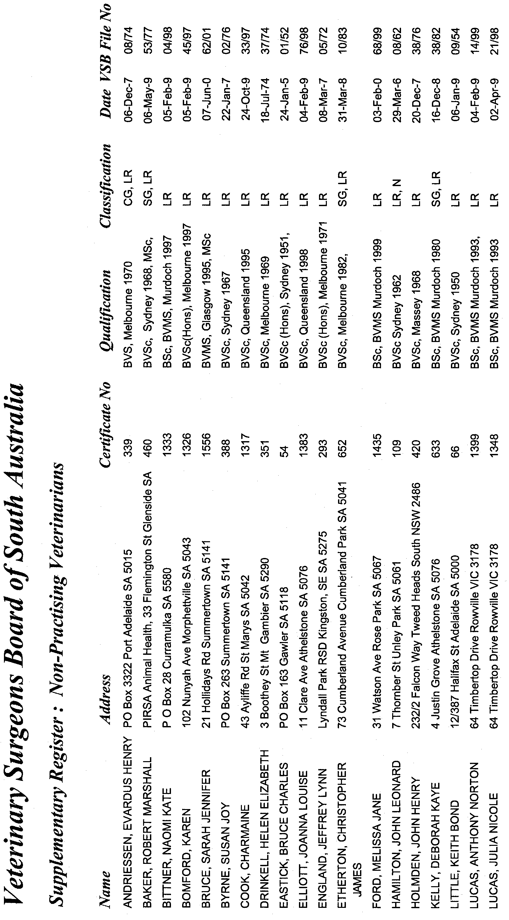
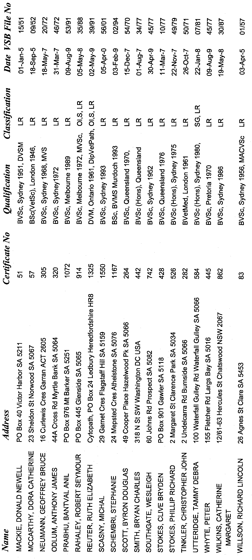

South Australia

Highways (Control of Access—Sturt Highway) Proclamation 2003
under section 30A(1) of the Highways Act 1926

Preamble
1. On 13 September 1973 a portion of road in the Hundred of Nuriootpa was declared by proclamation to be a controlled-access road (Gazette 13.9.1973 p 1988). On 30 June 1977, part of that controlled-access road was declared by proclamation to cease to be a controlled-access road (Gazette 30.6.1977 p 1836).

2. It is now intended that the remaining part of that controlled-access road cease to be a controlled-access road.

3. On 8 July 1976 a portion of road in the Hundreds of Mudla Wirra and Nuriootpa was declared by proclamation to be a controlled-access road (Gazette 8.7.1976 p 79). On 26 February 1987 part of that controlled-access road was revoked by proclamation (Gazette 26.2.1987 p 434).

4. It is now intended that the remaining part of that controlled-access road cease to be a controlled-access road.

5. On 26 February 1987 a portion of road in the Hundreds of Mudla Wirra and Nuriootpa was declared by proclamation to be a controlled-access road (Gazette 26.2.1987 p 434).

6. It is now intended that part of that controlled-access road cease to be part of that controlled-access road.

7. It is also intended that portions of Road No 7200 Sturt Highway in the Hundred of Nuriootpa be declared to be a controlled-access road. For that purpose portions of road that cease to be part of a controlled-access road referred to in clause 1, 3 or 5 will form part of the new controlled-access road.

Short title
1. This proclamation may be cited as the Highways (Control of Access—Sturt Highway) Proclamation 2003.

Commencement
2. This proclamation comes into operation on the day on which it is made.

Land ceasing to be controlled-access road
3. (1) The remaining part of the controlled-access road referred to in clause 1 of the preamble ceases to be a controlled-access road.

(2) The remaining part of the controlled-access road referred to in clause 3 of the preamble ceases to be a controlled-access road.

(3) The part of the controlled-access road referred to in clause 5 of the preamble that lies between the south-westerly production of the northern boundary of Schmidt Road, Gawler Belt, and the north-eastern end of the controlled-access road ceases to be part of the controlled-access road.

Controlled-access road
4. The land shaded in grey on the plan in the Schedule of this proclamation is a controlled-access road.

Routes and means of access
5. The routes and means of access by which persons and vehicles may enter or leave the controlled-access road declared in clause 4 are as shown on the plan referred to in that clause.

Schedule —Plan

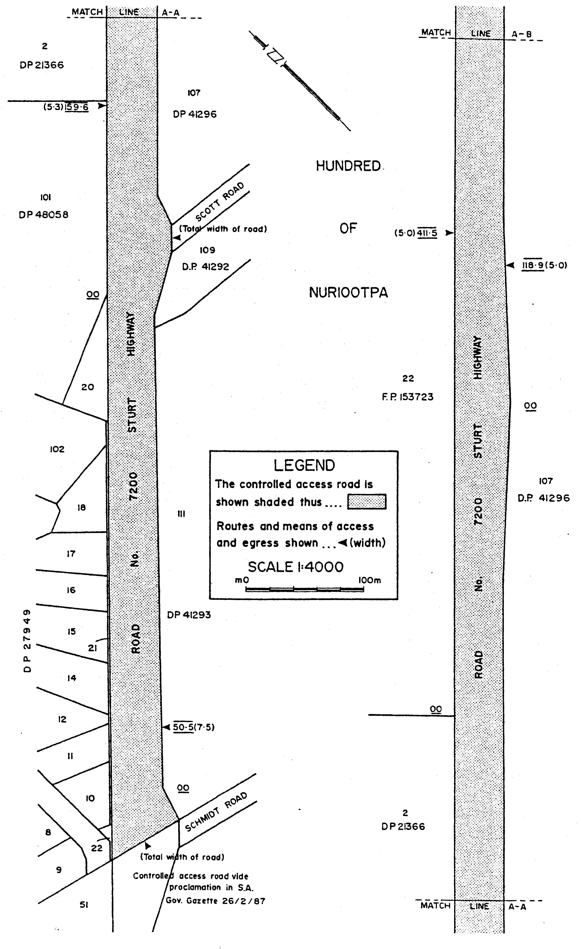

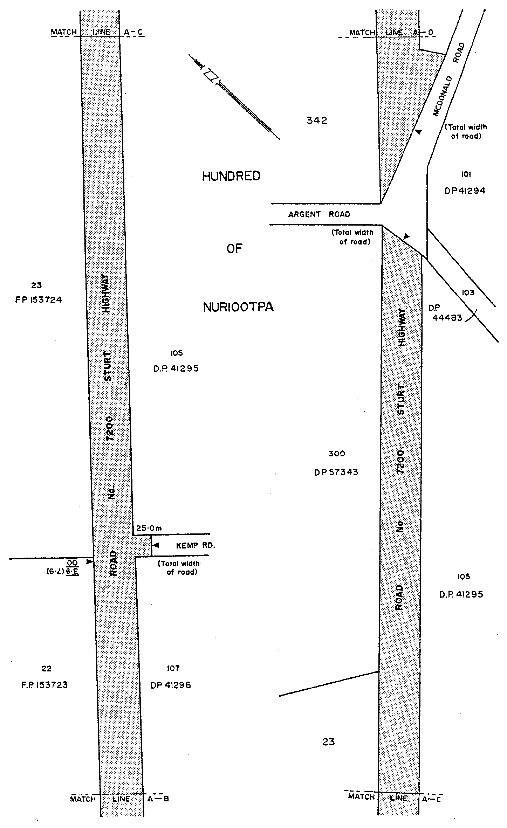

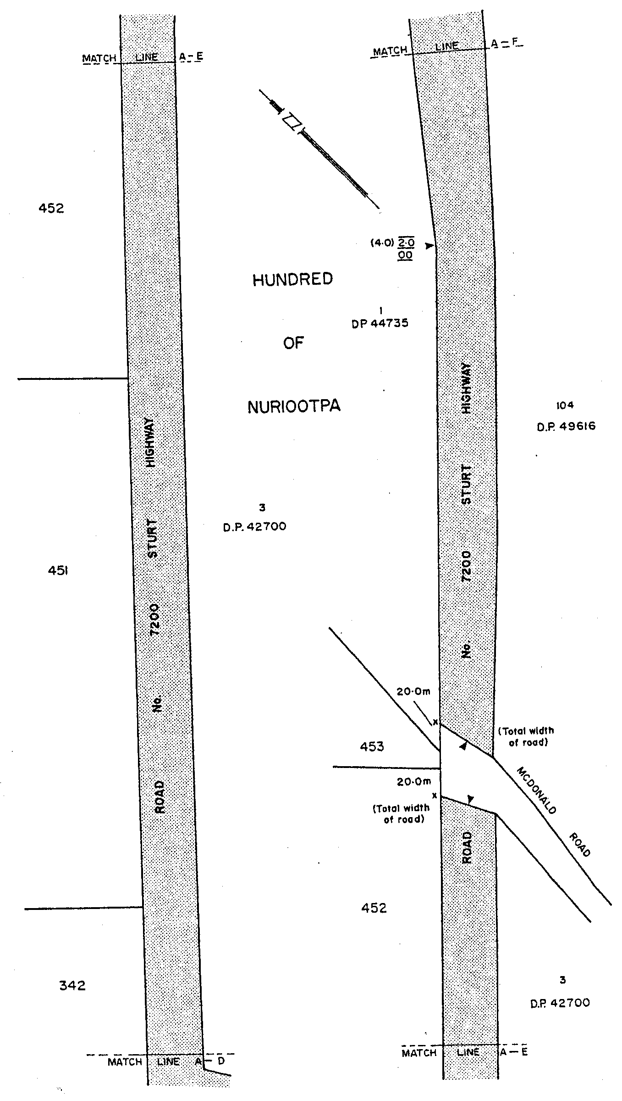

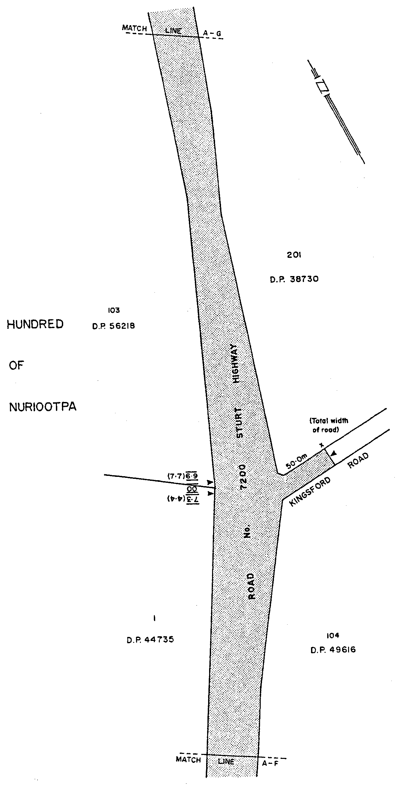

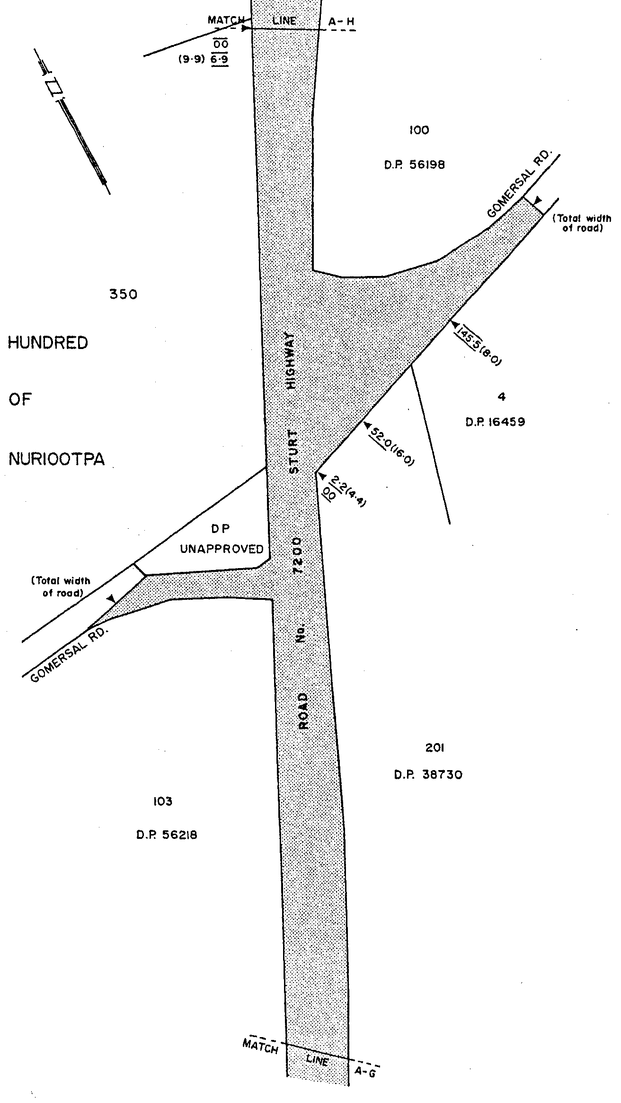

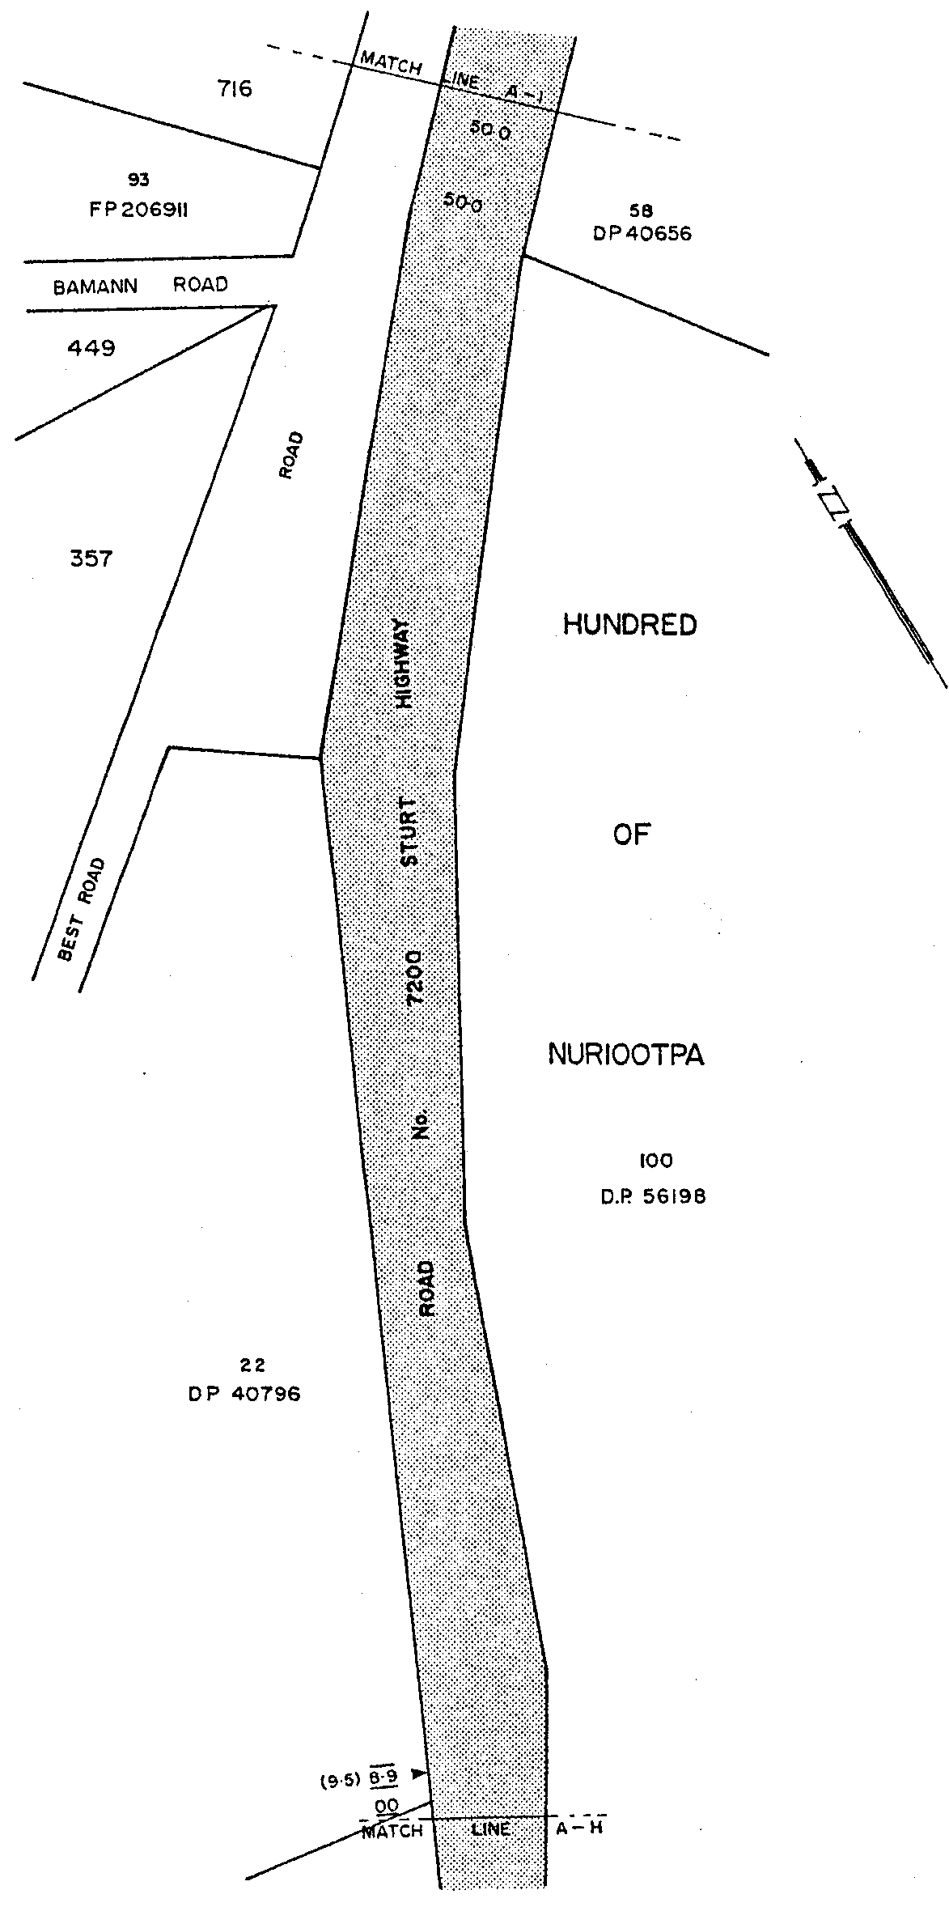

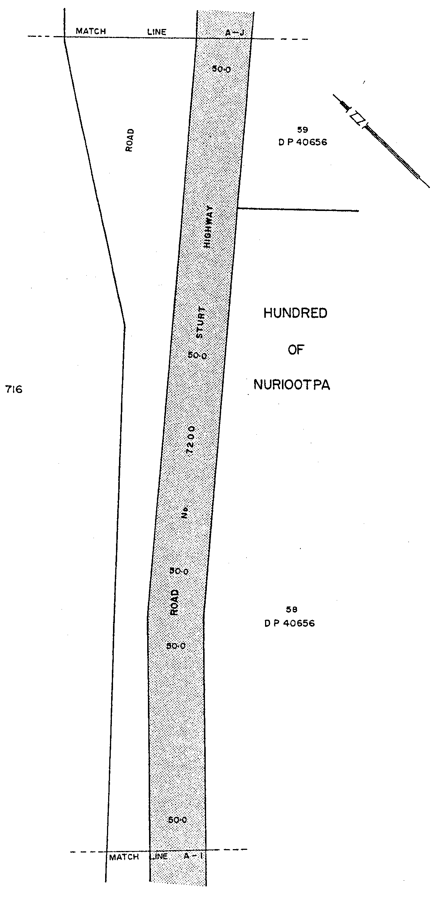

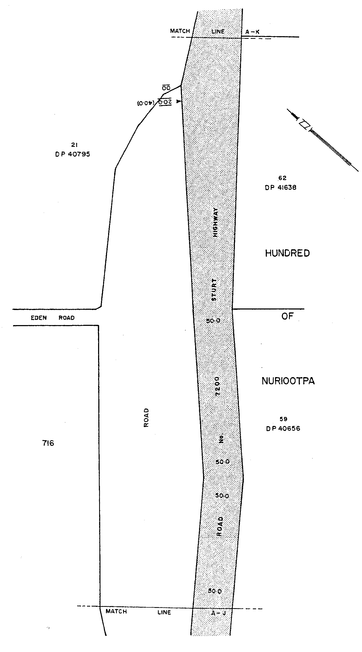

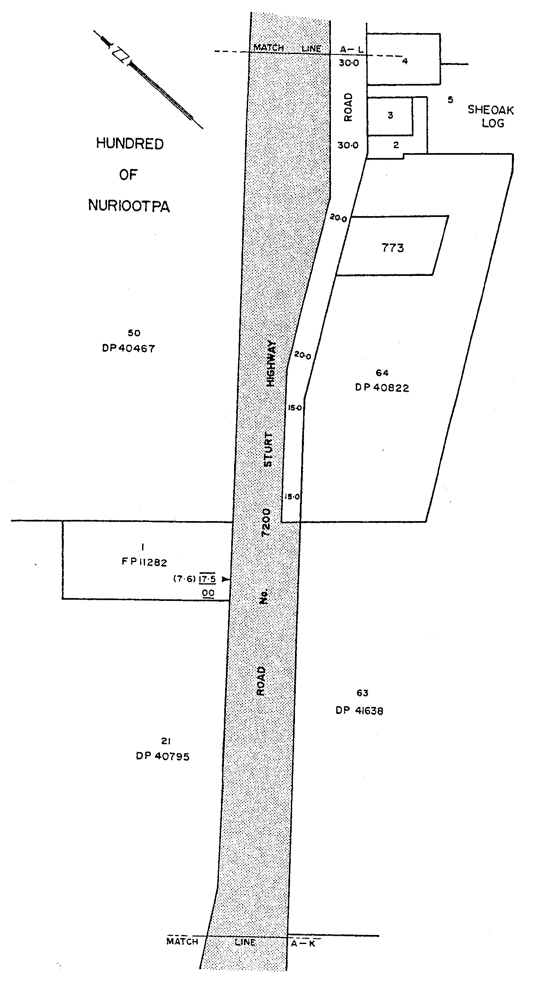

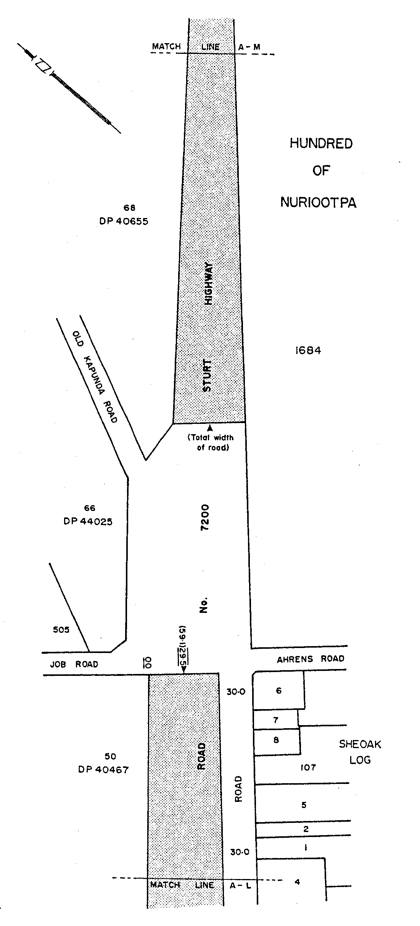

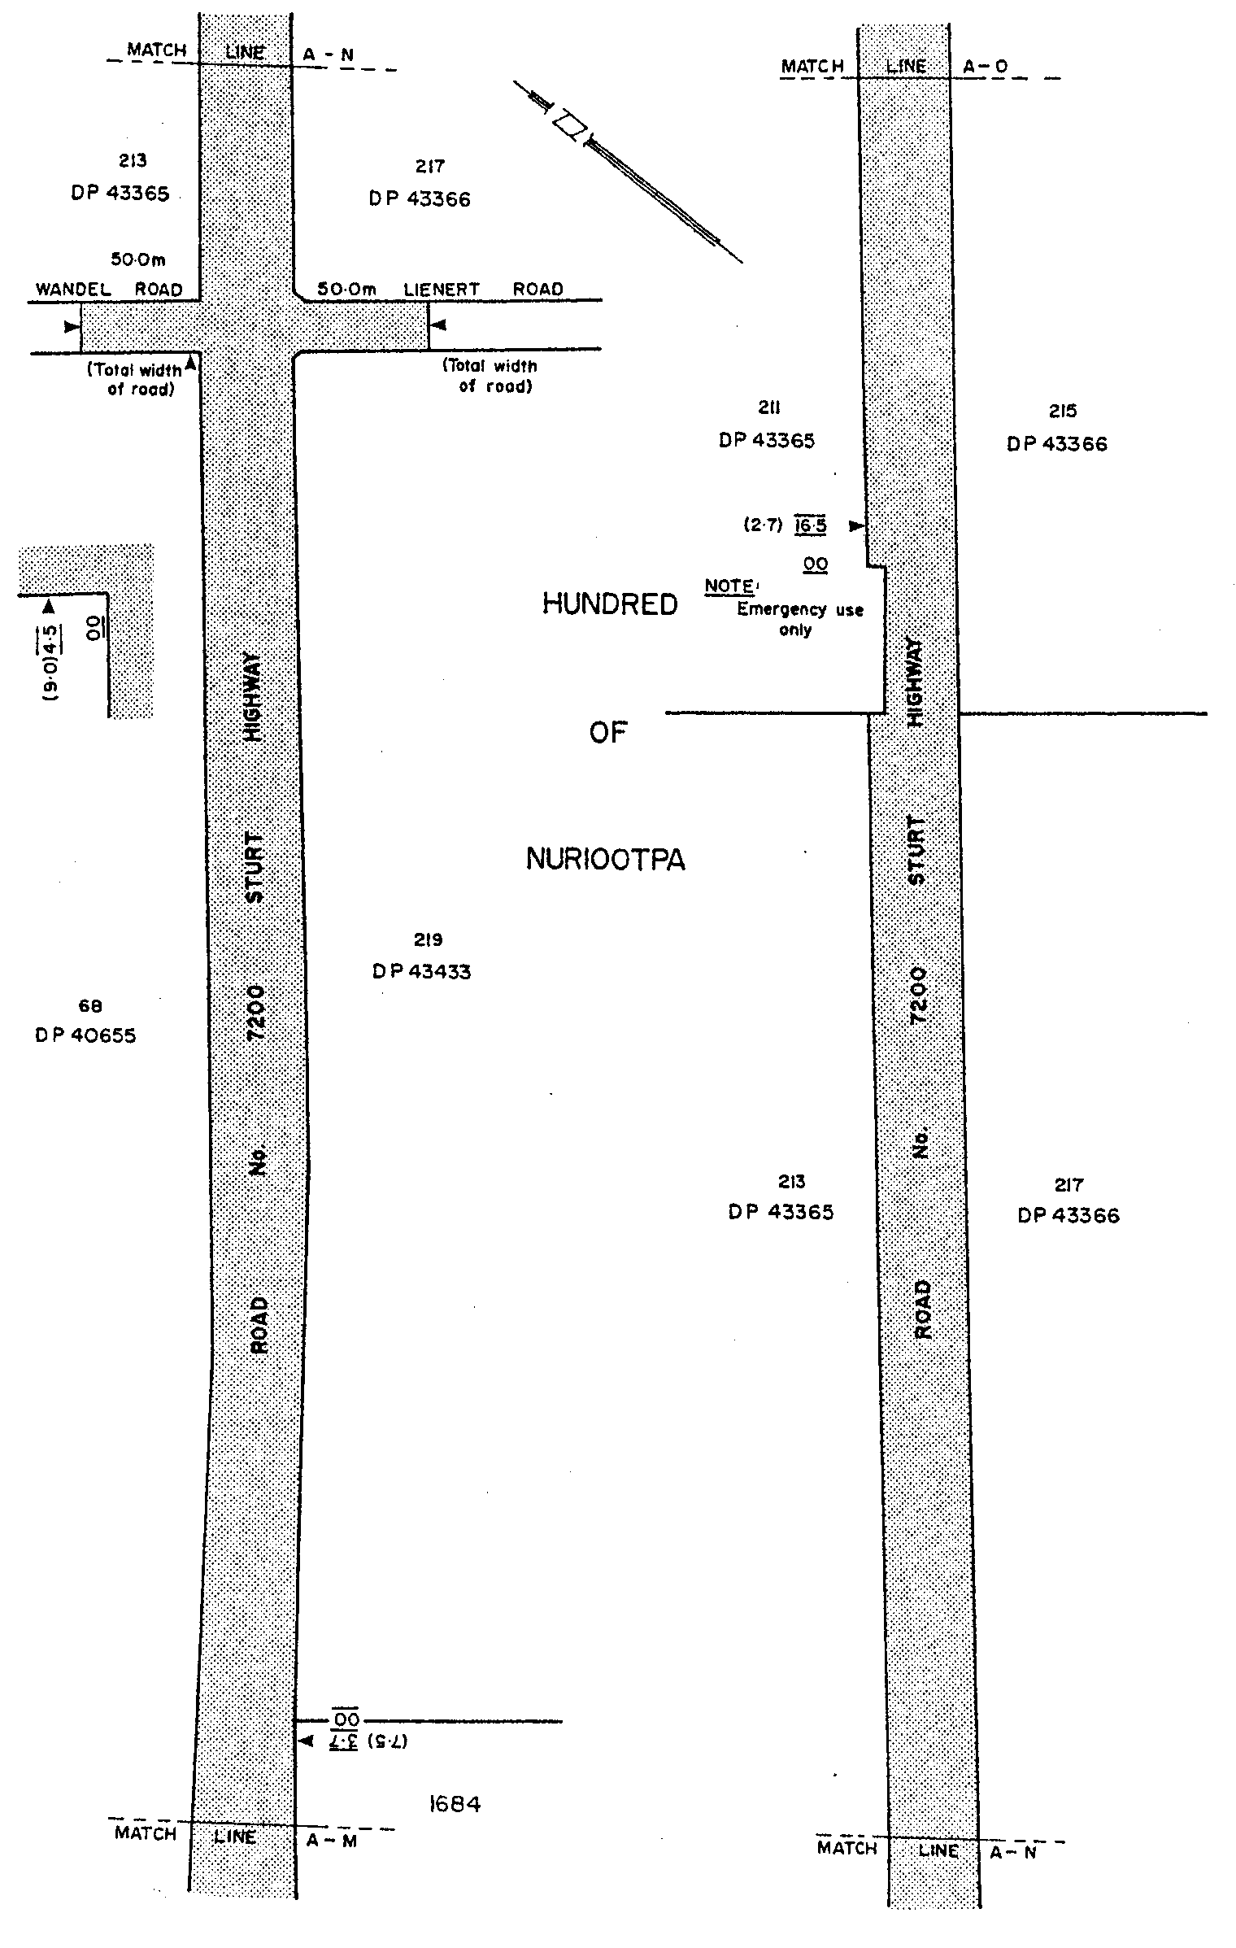

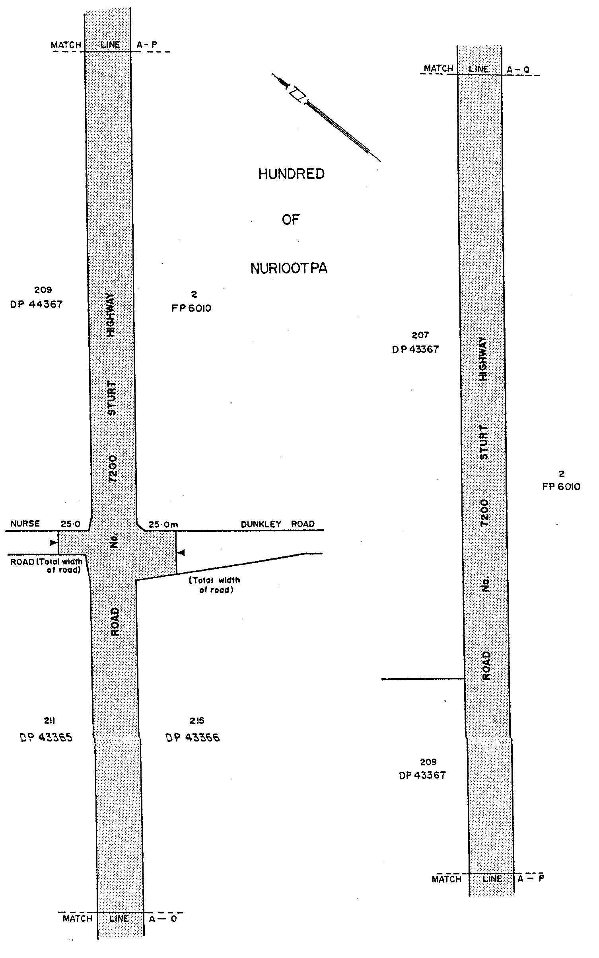

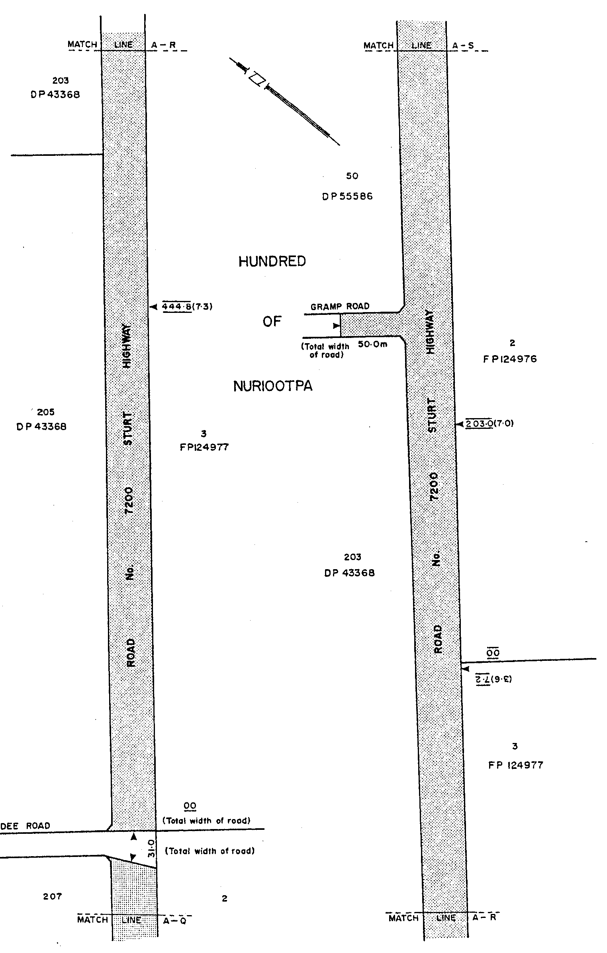

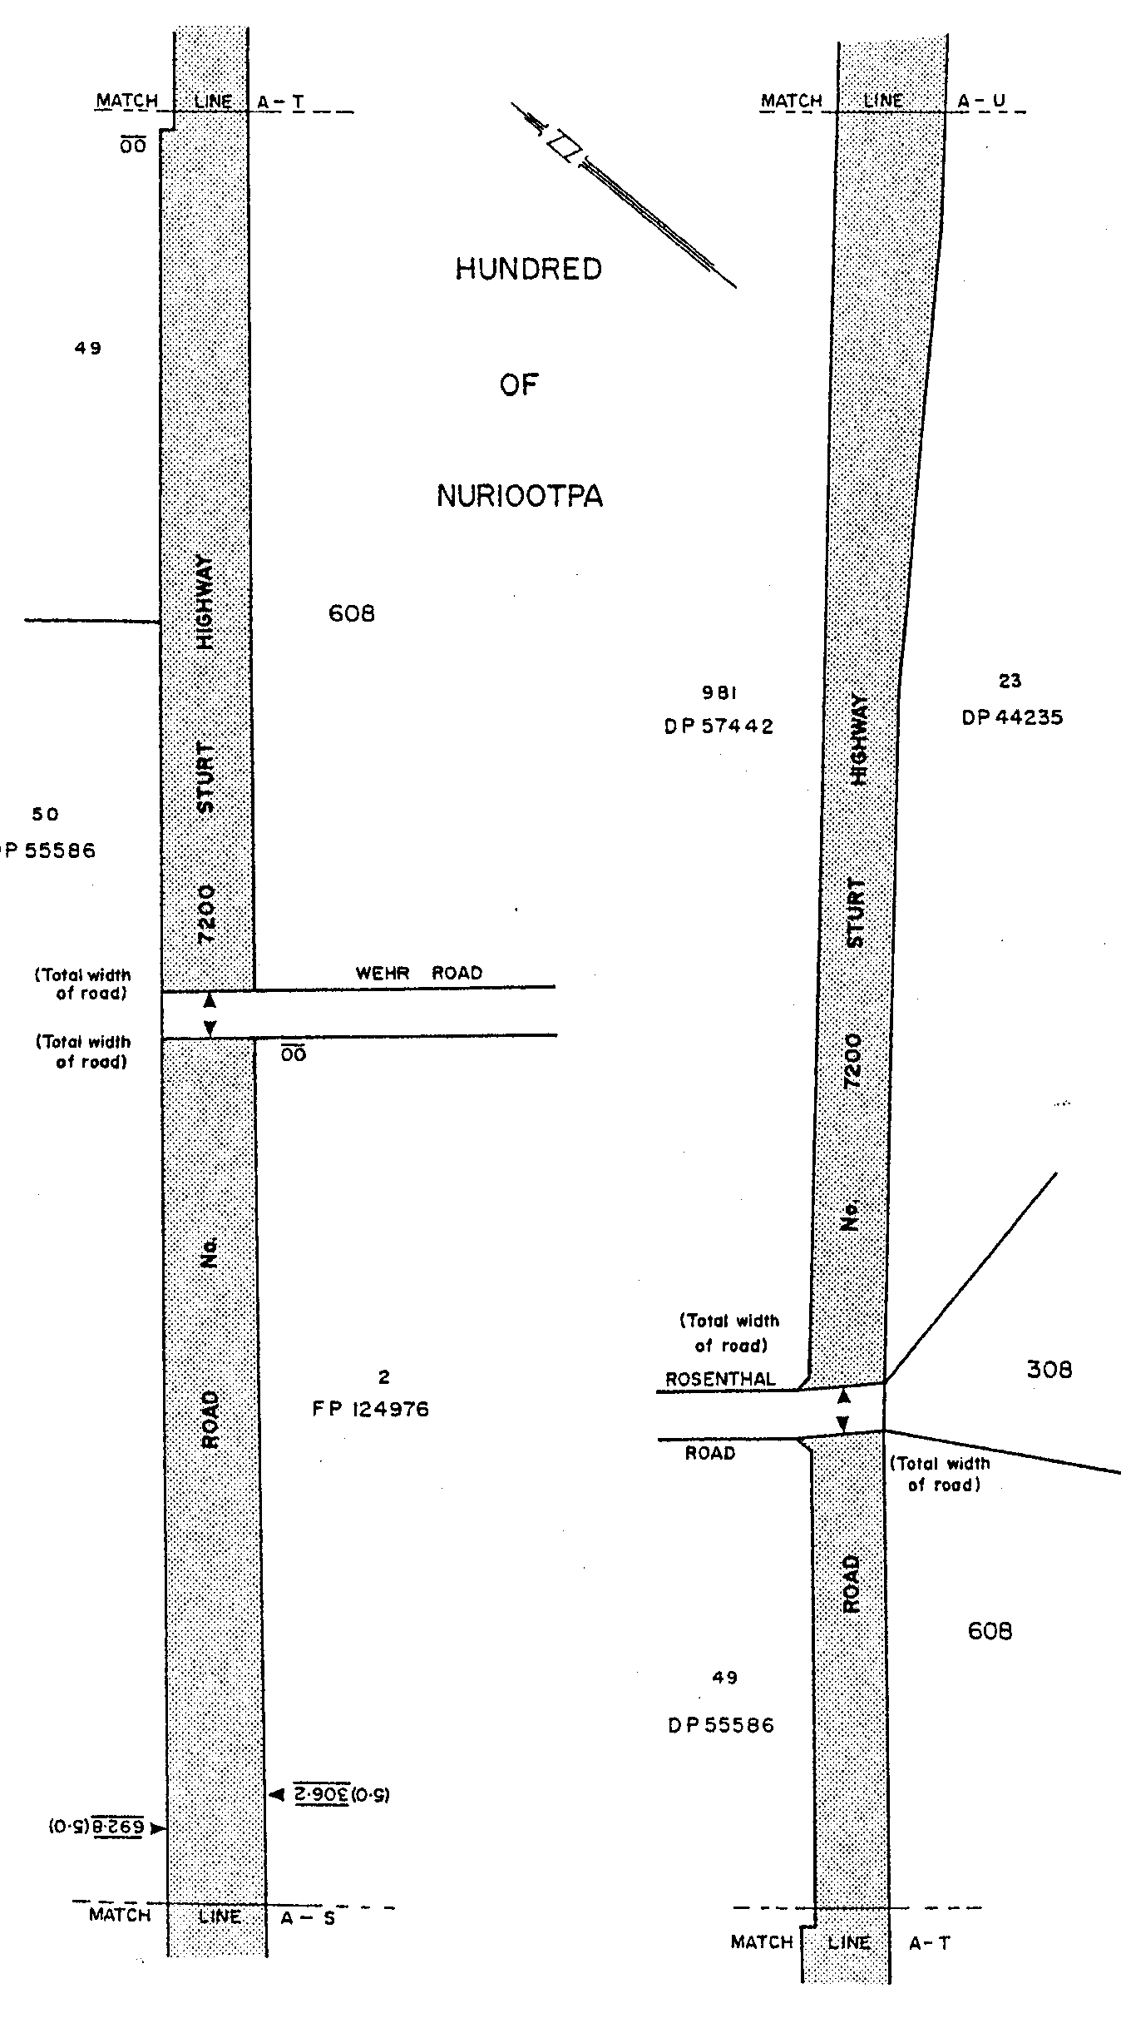

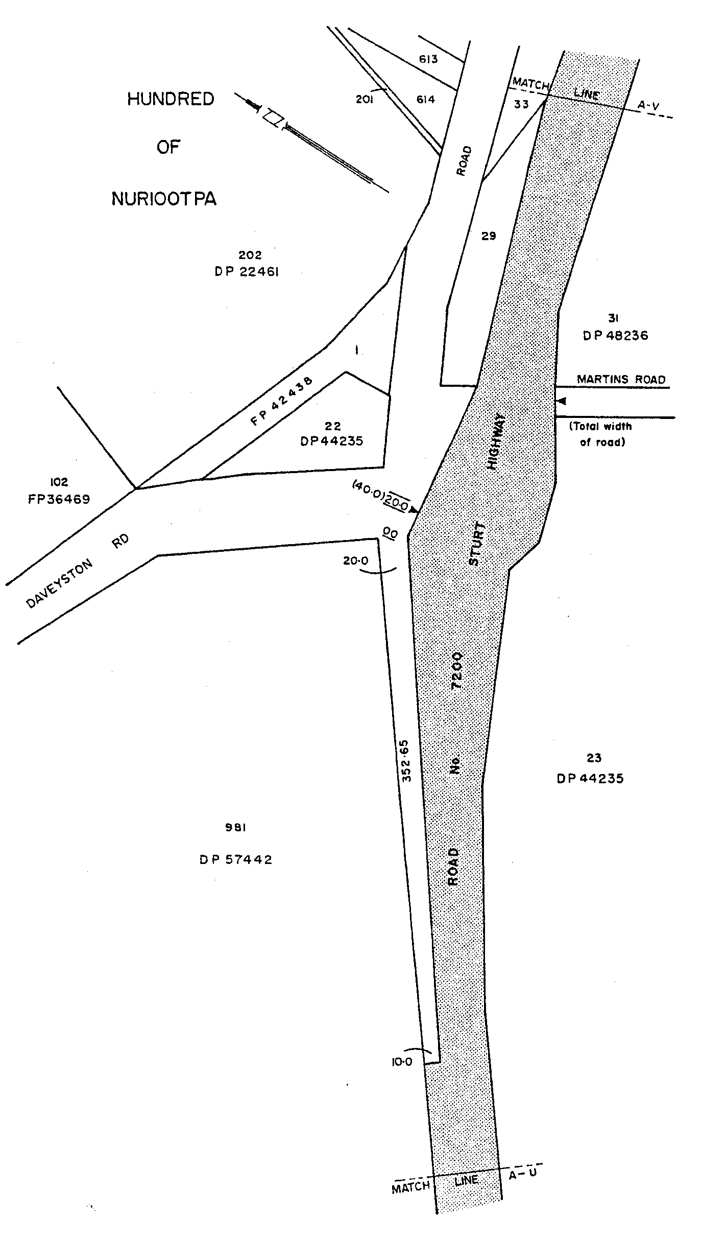

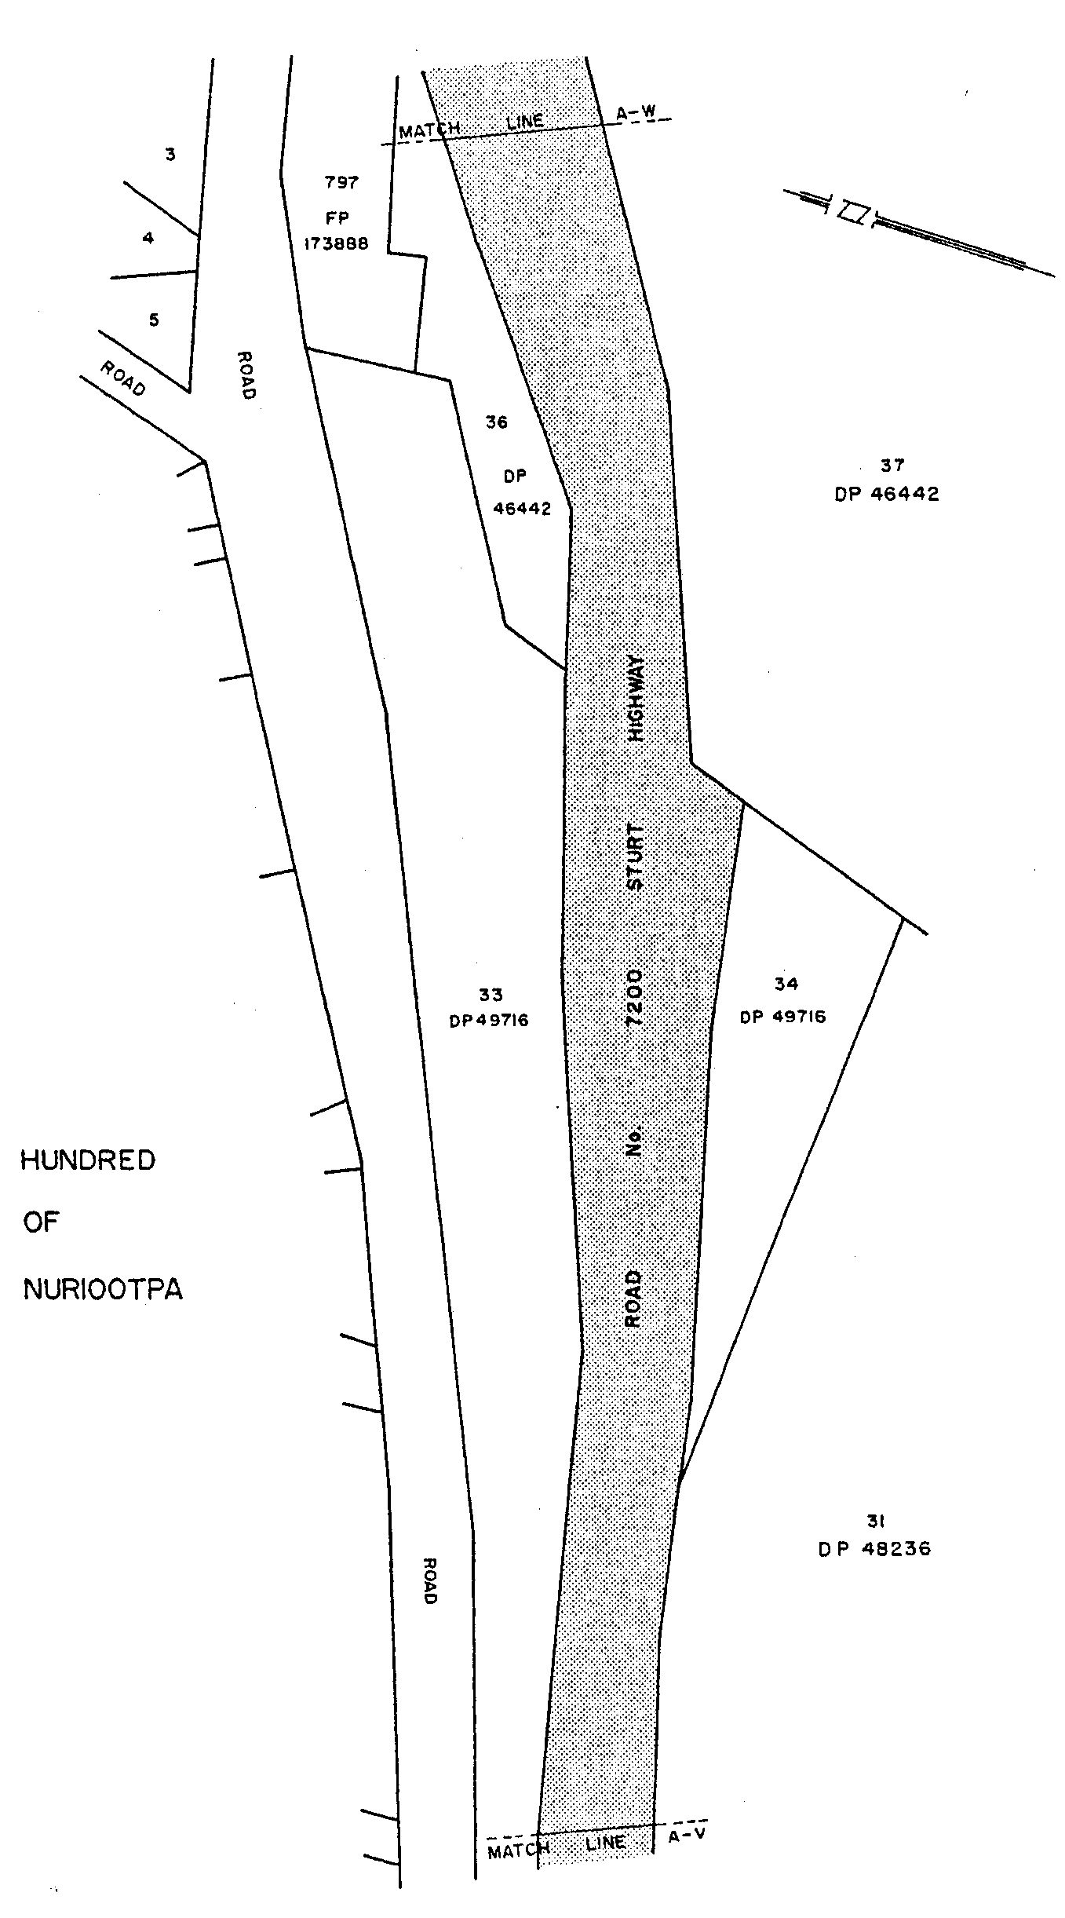

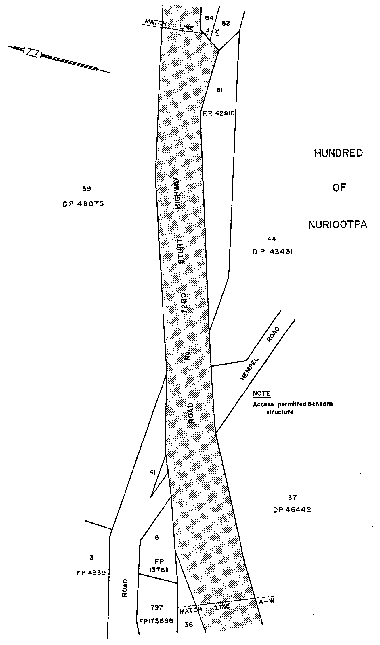

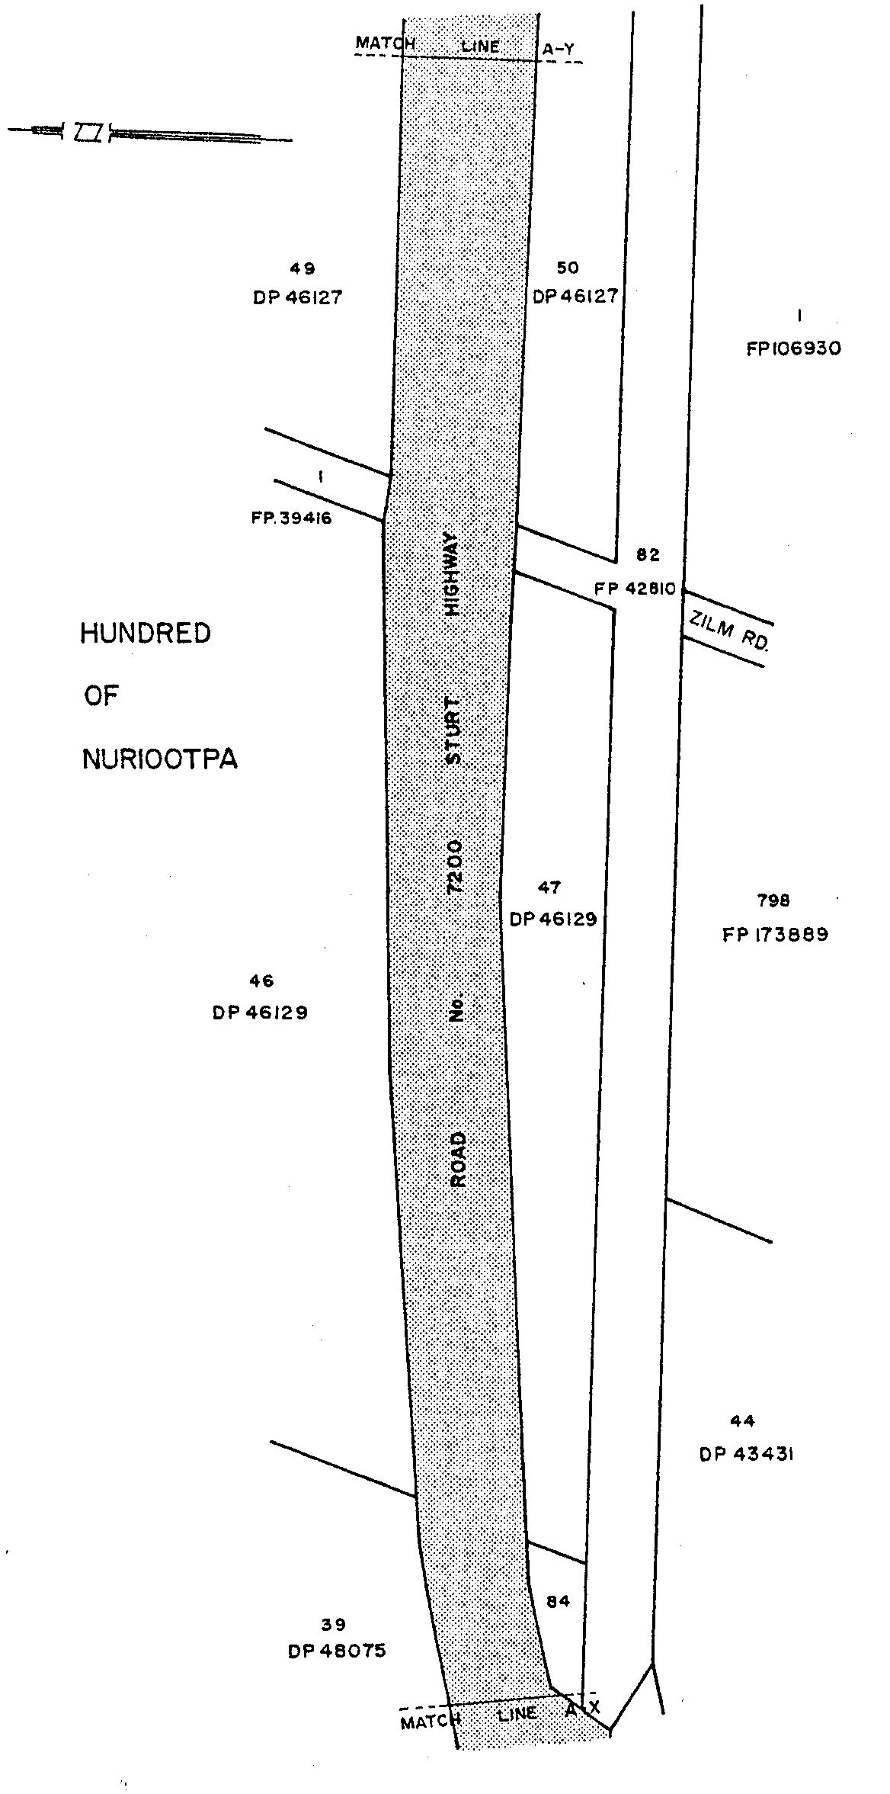

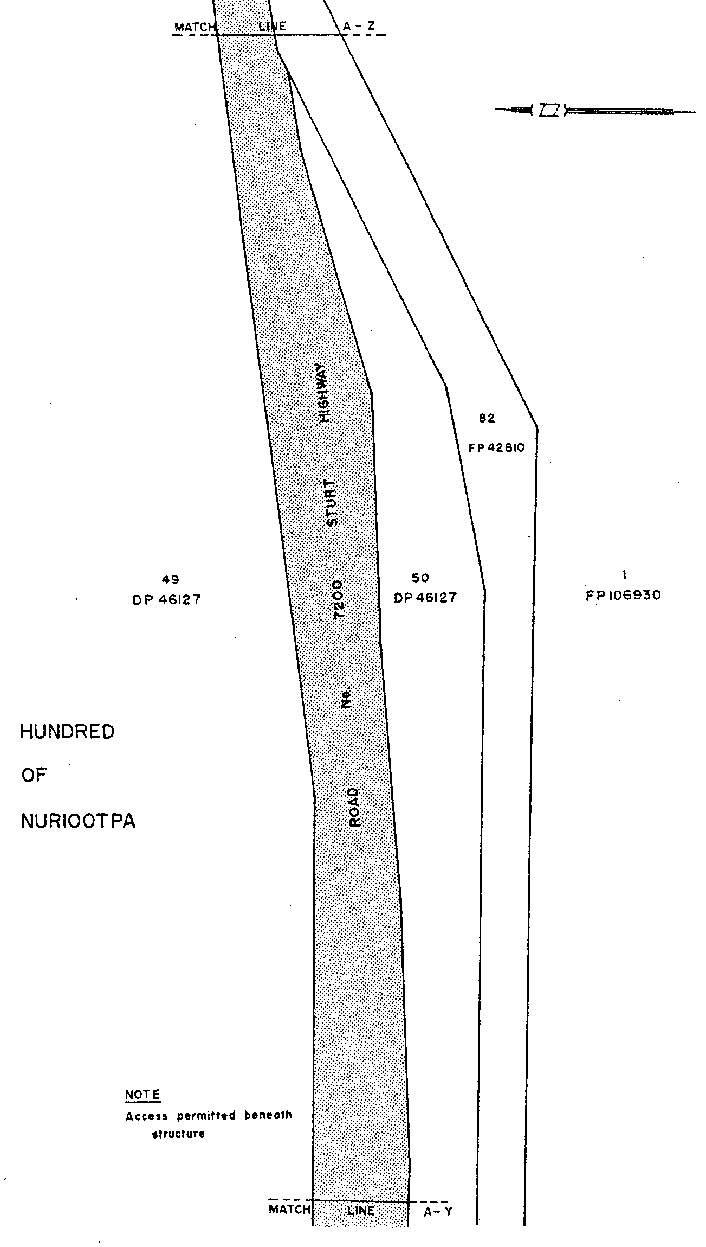

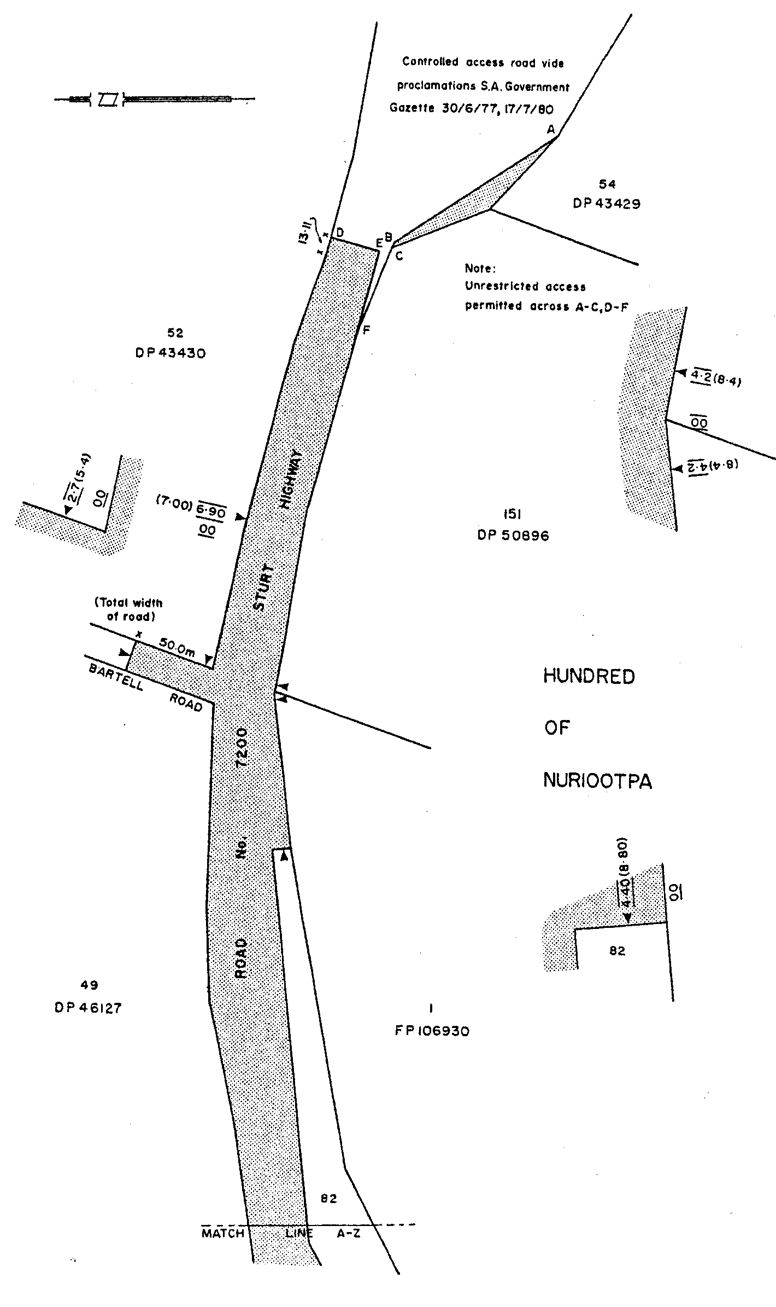

on the recommendation of the Commissioner of Highways and with the advice and consent of the Executive Council
on 17 July 2003.

CTSA2003/00914
South Australia

Liquor Licensing (Dry Areas—Long Term) Variation Regulations 2003
under the Liquor Licensing Act 1997

Contents

Part 1—Preliminary

1. Short title
2. Commencement
3. Variation provisions

Part 2—Variation of Liquor Licensing (Dry Areas—Long Term) Regulations 1997 (Gazette 6.11.1997 p 1217) as varied

4. Variation of Schedule 1—Long term dry areas

Part 1—Preliminary

Short title
1. These regulations may be cited as the Liquor Licensing (Dry Areas—Long Term) Variation Regulations 2003.

Commencement
2. These regulations come into operation on the day on which they are made.

Variation provisions
3. In these regulations, a provision under a heading referring to the variation of specified regulations varies the regulations so specified.

Part 2—Variation of Liquor Licensing (Dry Areas—Long Term) Regulations 1997 (Gazette 6.11.1997 p 1217) as varied

Variation of Schedule 1—Long term dry areas
4. (1) Schedule 1, item headed "Port Pirie—Area 1", column headed "Period"—delete "3 June 2003 (but excluding the period between 10 p.m. on 31 December 2002 and 1 a.m. on 1 January 2003)" and substitute:

3 June 2004

(2) Schedule 1, item headed "Port Pirie—Area 1", column headed "Extent of prohibition"—delete "The consumption of liquor is prohibited" and substitute:

The consumption and possession of liquor are prohibited

(3) Schedule 1, item headed "Port Pirie—Area 2", column headed "Period"—delete "2003" and substitute:

2004

(4) Schedule 1, item headed "Port Pirie—Area 2", column headed "Extent of prohibition"—delete "The consumption of liquor is prohibited" and substitute:

The consumption and possession of liquor are prohibited

(5) Schedule 1, item headed "Port Pirie—Area 3", column headed "Period"—delete "2003" and substitute:

2004

(6) Schedule 1, item headed "Port Pirie—Area 3", column headed "Extent of prohibition"—delete "The consumption of liquor is prohibited" and substitute:

The consumption and possession of liquor are prohibited

Note—
As required by section 10AA(2) of the Subordinate Legislation Act 1978, the Minister has certified that, in the Minister's opinion, it is necessary or appropriate that these regulations come into operation as set out in these regulations.

Made by the Governor
with the advice and consent of the Executive Council
on 17 July 2003.

No. 163 of 2003
OLGC8/2003

FAXING COPY?

IF you fax copy to Government Publishing SA for inclusion in the Government Gazette, there is no need to send a Confirmation Copy to us as well.

This creates confusion and may well result in your notice being printed twice.

Please use the following fax number:

Fax transmission: (08) 8207 1040
Phone Inquiries: (08) 8207 1045

Please include a contact person, phone number and order number so that we can phone back with any queries we may have regarding the fax copy.

NOTE: Closing time for lodging new copy (either fax or hard copy) is 4 p.m. on Tuesday preceding the day of publication.

Government Gazette notices can be E-mailed.

The address is:

governmentgazette@saugov.sa.gov.au

Documents should be sent as attachments in Word format.

When sending a document via E-mail, please confirm your transmission with a faxed copy of your document, including the date the notice is to be published.

Fax transmission: (08) 8207 1040
Enquiries: (08) 8207 1045

CITY OF ADELAIDE
Notice of Intention to Declare as Public Road
NOTICE is hereby given, pursuant to section 210 of the Local Government Act 1999, that at a future meeting, council intends to declare the following roads to be Public Roads:
1. Vincent Place in Town Acre 656, which is delineated as Vincent Place on LTO Plan B-3276.
2. Vincent Street in Town Acres 656, 657, 666 and 667, which is delineated as Vincent Street on LTO Plan B-3540 and includes Partially Cancelled Certificate of Title volume 199, folio 179.
3. Power Street in Town Acres 579 and 588, which is delineated as Power Street on LTO Plan C-2359 and is contained in Partially Cancelled Certificate of Title volume 157, folio 158.
4. St John Street in Town Acres 581 and 586, which is delineated as St John Street on LTO Plan FP 14691.
Susan Law, Chief Executive Officer

CITY OF ADELAIDE
Declaration as Public Road
NOTICE is hereby given, pursuant to sections 210 and 219 of the Local Government Act 1999, that at its meeting held on 28 April 2003, the Council of the Corporation of the City of Adelaide declares public the following portions of land contained in Certificates of Title Volume 5790, Folio 530 and Volume 5802, Folio 649 and declares that the name Hyde Street be applied to the said pieces of road. The affected land is part of Hyde Street in Town Acres 147 and 164 and is delineated, Allotment 92 in LTO FP 207094 and Allotment 93 in FP 207095.
Susan Law, Chief Executive Officer

CITY OF BURNSIDE
Roads (Opening and Closing) Act 1991
Road Closure—Kensington Road, Leabrook
NOTICE is hereby given, pursuant to section 10 of the Roads (Opening and Closing) Act 1991, that the City of Burnside proposes to make a Road Process Order to close and merge with the adjoining Allotment 6 in Filed Plan 101715 and Allotment 10 in Deposited Plan 1356, being a strip 2.5 m wide of the public road (Kensington Road) west of Bretwalder Avenue, shown more particularly delineated and lettered ‘A’ and ‘B’ on Preliminary Plan No. 03/0033.
Closed road ‘A’ and ‘B’ is to be transferred to Peter Richard Dean and Veronica Dean.
A copy of the plan and a statement of persons affected are available for public inspection at the offices of the Council, 401 Greenhill Road, Tusmore and at the Adelaide office of the Surveyor-General, 101 Grenfell Street, Adelaide during normal office hours.
Any application for easement or objection must set out the full name, address and details of the submission and must be fully supported by reasons.
The application for easement or objection must be made in writing to the Council, P.O. Box 9, Glenside, S.A. 5065 within 28 days of this notice and a copy must be forwarded to the Surveyor-General, G.P.O. Box 1354, Adelaide, S.A. 5001. Where a submission is made, the council will give notification of a meeting at which the matter will be considered.
Dated 16 July 2003.
J. Hanlon, Chief Executive Officer

CITY OF NORWOOD, PAYNEHAM & ST PETERS
Adoption of Valuation
NOTICE is hereby given that the council of the Corporation of the City of Norwood, Payneham & St Peters at a meeting held on Monday, 7 July 2003 by virtue of the powers contained in section 167 (2) (a) of the Local Government Act 1999, resolved to adopt for rating purposes, the Valuer-General’s valuation of capital values applicable to the land within the area of the council for the 2003-2004 financial year being $5 131 691 400 and that 1 July 2003 is specified as the date on which such valuation shall become and be the valuation of the council. The valuation is deposited in the Municipal Offices, 175 The Parade, Norwood and may be inspected by any persons interested therein between the hours of 9 a.m. and 5 p.m., Monday to Friday.
Declaration of Rates
Notice is hereby given that in exercise of the powers contained in section 153 (1) (b) of the Local Government Act 1999 and pursuant to section 156 (1) (d) the council of the Corporation of the City of Norwood, Payneham & St Peters, after considering and adopting the financial estimates for the financial year ending 30 June 2004 and adopting valuations that are to apply to land within the Municipality of Norwood, Payneham & St Peters, resolve to declare differential general rates as follows:
(a) In respect of rateable property which is used for Commercial—Shop, Commercial—Office, Commercial—Other, Industrial—Light, Industrial—Other, Vacant Land and Other land uses and classified as such in the assessment records of the council at the date of this declaration, a Differential General Rate of 0.364080 cents in the dollar for the assessed capital value of such property.
(b) In respect of rateable property which is used for Residential land use and classified as such in the assess-ment records if the council at the date of this declaration, a Differential General Rate of 0.303385 cents in the dollars for the assessed capital value of such property.
Minimum Rate
Notice is hereby given that pursuant to the provisions of section 158 (1) (a) of the Local Government Act 1999 the council of the Corporation of the City of Norwood, Payneham & St Peters, hereby fixes the amount of $465 as a minimum amount by way of rates in respect to rateable land throughout the whole of the Municipality.
Declaration of Separate Rate
Notice is hereby given that pursuant to the provisions of section 154 (1) of the Local Government Act 1999 and section 138 of the Water Resources Act 1997, in order to reimburse to the council the amount contributed to the River Torrens Water Catchment Management Board, the council of the Corporation of the City of Norwood, Payneham & St Peters, declares a separate rate of 0.008150 cents in the dollar on the adopted capital value of rateable land within the Municipality for the financial year ending 30 June 2004.
Payment of Rates
Notice is hereby given that pursuant to section 181 of the Local Government Act 1999, the council of the Corporation of the City of Norwood, Payneham & St Peters, hereby declares that all rates, including charges which have been imposed, for the financial year ending 30 June 2004, shall be payable in four equal instalments, with instalments falling due on 1 September 2003, 1 December 2003, 1 March 2004 and 1 June 2004, provided that in cases where the account requiring payment of rates is not sent out at least 30 days prior to the due date for payment, the authority to fix the date by which rates must be paid in respect to those assessments, be determined by the Chief Executive Officer.
P. Perilli, Acting Chief Executive Officer

CITY OF ONKAPARINGA
Adoption of Valuation
NOTICE is hereby given that the Council at its meeting held on
1 July 2003 resolved in accordance with section 167 (2) (a) of the Local Government Act 1999, to adopt the Valuer-General’s valuation of capital value being $11 341 878 100 for the year ending 30 June 2004, and hereby specifies that 1 July 2003 shall be the day as and from which such valuation shall become the valuation of the council.
Declaration of General Rates
Notice is hereby given that at its meeting held on 1 July 2003, the Council determined that in exercise of the powers contained in section 153 (1) (b) of the Act. It is appropriate pursuant to section 156 (1) (a) of the Act to declare differential general rates in the area of the Council according to land use in accordance with Regulation 10 of the Local Government (General) Regulations, as follows:
0.3966 cents in the dollar on rateable land of Category 7 (Primary Production) use; and
0.4957 cents in the dollar on rateable land of all other categories of use.
Pursuant to section 158 (1) (a) of the Act, a minimum amount payable by way of rates of $521.70 in respect of all rateable land in the Council’s area.
Pursuant to section 158 (1) (b) of the Act, to alter the amount that would otherwise be payable by way of general rates in respect of all land of Category 1 (Residential) use which has a value of $189 000 or more by reducing the general rates of such land by 20% for each dollar levied against the valuation in excess of this amount.
Declaration of Separate Rates—Catchment Water Levies
Notice is hereby given that at its meeting held on 1 July 2003, the Council in exercise of the powers contained in section 138 of the Water Resources Act 1997 and section 154 (1) of the Local Government Act 1999, in order to reimburse to the Council the amount contributed to Catchment Water Management Boards, the Council declares a separate rate upon the Capital Value of rateable land as follows:
0.00686 cents in the dollar on all rateable land in the Council’s area in the Catchment Area of the Patawalonga Catchment Water Management Board; and
0.01785 cents in the dollar on all rateable land in the Council’s area in the Catchment Area of the Onkaparinga Catchment Water Management Board.
Service Charges
Notice is hereby given that the Council at its meeting held on
1 July 2003 resolved that for the year ending 30 June 2004, pursuant to section 155 of the Act, the Council imposes the method of recovery of septic tank effluent costs is by annual service charge of:
• $320 per unit on each occupied allotment; and
• $320 per unit on each vacant allotment; and
• the rate for multiple tenancies on occupied allotments used for commercial purposes be $192 per tenancy where two tenancies exist, $128 per tenancy where three tenancies exist, or $96 per tenancy where four or more tenancies exist.
In the case of a single residential household a ‘Unit’ will equal one. In the case of higher use properties (such as schools, hospitals and other multiple tenancy properties etc.) an equivalent unit charge is calculated.
Notice is hereby given that the Council at its meeting held on
1 July 2003 resolved that for the year ending 30 June 2004 pursuant to section 188 (1) of the Act, the Council imposes a Service Fee for connection to the STEDS system of $2 000 per connection, be applied to connections arising from applications lodged for approval after the adoption of the increased fee.
Declaration of Separate Rate—Beach Road
Notice is hereby given that at its meeting held on 1 July 2003, the Council determines that pursuant to section 154 of the Local Government Act 1999, for the financial year ending 30 June 2004, in order to raise the amount of $176 000 to carry out the project of promoting and enhancing business viability, profitability, trade and commerce and the installation and upgrade of infrastructure in that part of the Council’s area comprising rateable land abutting Beach Road, Christies Beach, the Council declares a separate rate (to be known as the Beach Road Separate Rate) of 0.5011 cents in the dollar of the capital value of all rateable land within that part of the area.
In exercise of the powers contained in section 166 (1) (b) of the Local Government Act 1999, principal ratepayers of rateable land in that part of the area liable to pay individually or in aggregate a Beach Road Separate Rate of $5 000 or more in respect of one or more assessments shall be entitled, upon written application to the Council, to a rebate of 70 cents in respect of each dollar payable in excess of $5 000.
In exercise of the powers contained in section 44 of the Local Government Act 1999, the Council delegates to the City Manager the power to receive a written application for a rebate of the Beach Road Separate Rate from a principal ratepayer and to authorise a rebate in respect of the Beach Road Separate Rate in accordance with part (ii) of this resolution.
Payment of Rates
Notice is hereby given that at its meeting held on 1 July 2003, the Council determines that pursuant to the provisions of section 181 of the Local Government Act 1999, the Council resolves that the abovementioned rates including charges which have been imposed for the financial year ending 30 June 2004 will fall due in four equal or approximately equal instalments on the following days:
1 September 2003
1 December 2003
1 March 2004
1 June 2004
J. Tate, City Manager

CITY OF PLAYFORD
Adoption of Valuation and Declaration of Rates
for the Financial Year ending 30 June 2004
NOTICE is hereby given that the City of Playford, at its meeting on Tuesday, 1 July 2003, resolved as follows:
Adoption of Valuations
The most recent valuation of the Valuer-General available to the council, of the capital value of land within the council’s area, be adopted for rating purposes for the year ending 30 June 2004, totalling $3 701 828 500.
Declaration of General Rates
In exercise of the powers contained in Chapter 10 of the Local Government Act 1999, the following general rates were declared by the council of the City of Playford to apply to all rateable land within the council area:
1. A fixed charge of $374.
2. Differential general rates in the dollar based on Capital Values as follows:
2.1 all land within the council area except for land falling within 2.2 to 2.5 inclusive:
(a) 0.29042 cents in the dollar on rateable land of Category 1 (Residential), Category 8 (Vacant Land) and Category 9 (Other) use;
(b) 0.27316 cents in the dollar on rateable land of Category 7 (Primary Production) use;
2.2 all land within the council area which immediately prior to 3 May 1997 constituted the area of the former City of Elizabeth:
(i) in that part comprising the Regional Centre Zone in the council’s then or current Development Plan, 1.47275 cents in the dollar on rateable land of Category 1 (Residential), Category 2 (Com-mercial—Shop), Category 3 (Commercial—Office), Category 4 (Commercial—Other), Category 5 (Industry—Light), Category 6 (Industry—Other), Category 7 (Primary Produc-tion), Category 8 (Vacant Land) and Category 9 (Other) use;
(ii) in all other parts of the area, 1.49952 cents in the dollar on rateable land of Category 2 (Com-mercial—Shop), Category 3 (Commercial—Office), Category 4 (Commercial—Other), Category 5 (Industry—Light) and Category 6 (Industry—Other) use;
2.3 all land within the council area which immediately prior to 3 May 1997 constituted the area of the former council of the City of Munno Para (except for land within 2.4 and 2.5 below), 1.14773 cents in the dollar on rateable land of Category 2 (Commercial—Shop), Category 3 (Commercial—Office), Category 4 (Commercial—Other), Category 5 (Industry—Light) and Category 6 (Industry—Other) use;
2.4 all land within the area of the council which immediately prior to 3 May 1997 constituted the area of the former council of the City of Munno Para (other than referred to in 2.3 above and 2.5 below) which is not located within the townships of Hillbank, Blakeview, Craigmore, Andrews Farm, Smithfield, Munno Para, Elizabeth Downs, Smith-field Plains or Davoren Park, 1.06846 cents in the dollar on rateable land of Category 2 (Commercial—Shop), Category 3 (Commercial—Office), Category 4 (Commercial—Other), Category 5 (Industry—Light) and Category 6 (Industry—Other) use;
2.5 all land within the council area which immediately prior to 3 May 1997, constituted the area of the former council of the City of Munno Para and which is located within the townships of Angle Vale, One Tree Hill and Virginia, a rate of 0.27076 cents in the dollar.
Declaration of Separate Rate—Water Catchment Levy
In exercise of the powers contained in section 138 of the Water Resources Act 1997 and section 154 of the Local Government Act 1999, in order to reimburse the council for the amount contributed to the Northern Adelaide and Barossa Water Catchment Board, a separate rate of 0.011730 cents in the dollar is declared on all rateable land in the council’s area in the Northern Adelaide and Barossa Water Catchment based on capital values.
Payment
All rates will fall due in four instalments payable on 3 September 2003, 3 December 2003, 3 March 2004 and 3 June 2004.
T. R. S. Jackson, Chief Executive Officer

CITY OF SALISBURY
Cross Keys Road, Salisbury South
NOTICE is hereby given, pursuant to section 194 of the Local Government Act 1999, that at a meeting held on 30 June 2003, the Council of the City of Salisbury resolved that Allotment 9 within Filed Plan 113393 in the area named Salisbury South, comprised within certificate of title register book volume 5360, folio 948, to be purchased by Council for use as a Depot, be excluded from classification as Community Land.
Dated 17 July 2003.
Stephen Hains, City Manager

CITY OF SALISBURY
Salisbury (City) Development Plan—Parafield
Gardens Industrial/Residential Plan Amendment Report by the Council
Draft for Public Consultation
THE City of Salisbury has prepared a draft Plan Amendment Report to amend the Salisbury (City) Development Plan as it affects the area of Parafield Gardens that is generally bounded by Port Wakefield Road, Shepherdson Road, Martins Road and Ryans Road.
The Plan Amendment Report will amend the Salisbury (City) Development Plan by introducing policies to change the land use zone and controls for a significant area of land that is currently zoned for Industry to Residential. The study area is currently zoned mainly as Industry with smaller portions zoned Special Residential and Residential. The location of the North East Ring Route has been determined to intersect with Port Wakefield Road some distance to the south of the study area at Globe Derby. Access to Port Wakefield Road for industrial and commercial activities is expected to be more difficult from the study area. To address the access, amount of suitable industrial land available within the Council area, and the land use conflicts, it is proposed that the area be rezoned in the following manner:
• Retain the existing developed areas along Port Wakefield Road for commercial and industrial uses;
• Identify alternative access opportunities for these activities;
• Allocate adequate buffers to ensure that the commercial/industrial operations can continue in a viable fashion and that impacts on residential areas are minimised;
• Delete the ‘Special Residential’ zone;
• Reduce the ‘Industry’ zone and extend the ‘Residential’ zone to the west and the north in the study area.
The draft Plan Amendment Report and statement will be available for public inspection and purchase during normal office hours at the City of Salisbury Office, 12 James Street, Salisbury, and will be available on the council’s web-site at www.salisbury.sa.gov.au from Tuesday, 22 July 2003 to Monday, 22 September 2003. A copy of the Plan Amendment Report can be purchased from council, at a cost of $10 per copy.
Written submissions regarding the draft amendment will be accepted by the City of Salisbury until 22 September 2003. The written submission should also clearly indicate whether you wish to speak at the public hearing about your submission. All submissions should be addressed to the City Manager, City of Salisbury, P.O. Box 8, Salisbury S.A. 5108.
Copies of all submissions received will be available for inspection by interested persons at 12 James Street, Salisbury, from Tuesday, 22 July 2003 until the date of the public hearing. A Public Hearing will be held at 6.30 p.m. on Monday, 29 September 2003 at Morella Community House, 90 Kings Road, Parafield Gardens.
The Public Hearing may not be held if no submission indicates an interest in speaking at the Public Hearing.
Council staff will be available to discuss the draft Plan Amendment Report and answer questions on Tuesday, 19 August 2003 between the hours of 5 p.m. and 7 p.m. at the Parafield Gardens Community Club, 61-69 Shepherdson Road, Parafield Gardens.
Dated 17 July 2003.
S. Hains, City Manager

CITY OF SALISBURY
Proposed Declaration of Public Road
NOTICE is hereby given by the City of Salisbury pursuant to section 210 (2) (b) of the Local Government Act 1999, that at its meeting to be held on Monday, 22 September 2003, the City of Salisbury intends to declare Allotment 82 in Filed Plan 113986 being the land currently identified as James Lane, Salisbury, to be public road.
S. Hains, City Manager

CITY OF VICTOR HARBOR
Adoption of Valuation
NOTICE is hereby given that the council of the City of Victor Harbor, at a meeting held on 7 July 2003, adopted for rating purposes for the year ending 30 June 2004, the Valuer-General’s valuation of capital value in relation to land within the area of the council and declared that the total valuation that is to apply within the area is $1 594 835 000 of which $1 547 436 400 is the valuation of rateable land.
Declaration of Rates
Notice is hereby given that the council of the City of Victor Harbor, at a meeting held on 7 July 2003, considered and adopted a budget and declared the following differential general rates on rateable land within the area for the year ending 30 June 2004, based on the capital value of property situated in the following zones within the City of Victor Harbor, as described in the Victor Harbor Development Plan, as follows:
• A differential general rate of 0.346 cents in the dollar on the capital value of all rateable property situated in Zone 1, which comprises General Farming, Future Residential, Rural Coastal and Water Protection Zones.
• A differential general rate of 0.389 cents in the dollar on the capital value of all rateable property situated in Zone 2, which comprises Rural Living 1, Rural Living 2, Rural Living 3 and Rural Living 4 Zones.
• A differential general rate of 0.432 cents in the dollar on the capital value of all rateable property situated in Zone 3, which comprises District Centre, Local Centre (Victoria Street), Residential (Victoria Street), Residential Foreshore, Foreshore, Granite Island, Residential, Residential (Golf Course), Residential (Lakeside), Neigh-bourhood Centre, Local Centre (Yilki), Local Centre (Hayborough), Light Industry, Industry, Home Industry, Tourist Accommodation (Inman River), Tourist Accom-modation (Whalers Inn) and Recreation Zones.
Fixed Charge
A fixed charge of $130 has been imposed on each piece of rateable land within the area of the City of Victor Harbor.
Payment of Rates
Rates for the year ending 30 June 2004 are payable by quarterly instalments on the 8th day of the months of September 2003, December 2003, March 2004 and June 2004, unless otherwise agreed with the principal ratepayer. The City Manager is delegated the powers to enter into agreements with principal ratepayers for the payment of rates in such instalments falling due on such days as the City Manager thinks fit.
G. K. Maxwell, City Manager

ALEXANDRINA COUNCIL
Declaration of Rates for Year Ending 30 June 2004
NOTICE is hereby given that council declares the following rates on the capital value differentiated by reference to locality and land use at its meeting on 3 July 2003 as follows:
1. Urban
1.1 For rateable land in the following zones delineated in the Alexandrina Council Development Plan as:
• Residential
• Residential (Goolwa)
• Residential (Strathalbyn)
• Residential (Milang)
• Residential (Golf Course)
• Residential (Mount Compass)
• Industry
• Industrial
• Light Industry
• Light Industrial
• Home Industry
• Tourist Accommodation
• Tourist Commercial
• Local Centre
• District Centre
• Country Township (Langhorne Creek)
• Waterfront (Sections 183, 213 to 325, 331 and 447 Hundred of Alexandrina)
• Local Centre
• Country Township (Clayton)
• Town Centre (Mount Compass)
• Historic Conservation—Centre
• Historic Conservation—Residential
• Historic Conservation—Tourism Accommodation
• Historic Conservation—Coastal
• Historic Waterfront Centre
• Centre Conservation
• Commercial
• Centre (Goolwa)
• Recreation (Goolwa)
• Urban Waterfront
A differential rate of 0.4344 cents in the dollar of capital value of rateable land with land use categories 1, 2, 3, 4, 5, 6, 8 and 9 as described in the Local Government (Land Use) Regulations.
1.2 For rateable land in the following zones delineated in the Alexandrina Council Development Plan as:
• Residential Marina (Hindmarsh Island)
• Residential (Hindmarsh Island)
• Residential West (Hindmarsh Island)
• Portions of Rural Waterfront (Hindmarsh Island) and Conservation (Hindmarsh Island) Zones within sections 2, 6, and 10 Hundred of Nangkita.
A differential rate of 0.4127 cents in the dollar of capital value of rateable land with land use categories 1, 2, 3, 4, 5, 6, 8 and 9 as described in the Local Government (Land Use) Regulations.
2. Urban Fringe
For rateable land in the following zones delineated in the Alexandrina Council Development Plan as:
• Rural Living (Strathalbyn District) Policy areas 7, 8 and 9
• Future Urban
• Rural Living (Port Elliot Goolwa District)
• Rural Fringe
• Country Living
• Rural (Deferred Urban)
• Rural Waterfront (Hindmarsh Island)
• Holiday House (Hindmarsh Island)
• Conservation (Hindmarsh Island)
• General Farming (Hindmarsh Island)
• Country Living (Hindmarsh Island)
A differential rate of 0.3910 cents in the dollar of capital value of rateable land with and use categories numbered 1, 2, 3, 4, 5, 6, 8 and 9 and described in the Local Government (Land Use) Regulations.
3. Rural
3.1 For all rateable land in the Willunga (OM) district as delineated in Map ALEX/68 of the Alexandrina Council Development Plan.
A differential rate of 0.3648 cents in the dollar of capital value of rateable land.
3.2 For all other land in the Alexandrina Council District, which is not, described in categories 1 (Urban) and 2 (Urban Fringe) or 3 (Rural ex-Willunga) a differential rate of 0.3475 cents in the dollar of capital value.
Minimum Rate
A minimum amount by way of general rates of $483 is fixed in respect of rateable land in accordance with section 158 of the Local Government Act 1999.
Rebate (rate capping)
That in exercise of the powers contained in section 166 (1) (l) of the Local Government Act 1999 and to provide relief against what would otherwise amount to a substantial change in rates payable by a rate payer due to rapid changes in valuation, a rebate of general rates for the 2003-2004 financial year will be granted to the principal ratepayer of an assessment as follows:
• Residential properties on which the principal ratepayer receives a State Pensioner rebate (as approved by S.A.Water) or a Self Funded Retirees rebate (as approved by Revenue S.A.)—A rebate of the amount by which the general rate amount payable exceeds the 2002-2003 general rate payable x 115%*.
• Residential properties which are the owner’s principal place of residence (other than pensioners and self funded retirees). A rebate of the amount by which the general rate amount payable exceeds the 2002-2003 general rate payable x 120%*.
• Commercial and Industrial Properties: A rebate of the amount by which the general rate amount payable exceeds the 2002-2003 general rate payable x 120%*.
• Primary production properties: A rebate of that amount by which the general rate amount payable exceeds the 2002-2003 general rate payable x 120%*.
*The rebate will not apply where:
• The property has been acquired by the ratepayer or has become their principal place of residence after 1 July 2002.
• The increase in general rate payable is due in whole or in part to an increase in valuation of the property attributable to improvements (including maturing vines) made to it valued in excess of $10 000.
• The increase in general rate payable is due in whole or in part to an increase in valuation of the property attributable to a change in the zoning of the land under the Development Act 1993.
Rebates will be calculated automatically by council from the best information available to council and shown on the 2003-2004 rates notice. Ratepayers who believe they have not been granted a rebate to which they are entitled should contact our rates officers on 8555 7000 within 30 days of the date of notice to verify their eligibility, and if eligible lodge a written application for the rebate.
Service Charge
The council provides a septic tank effluent disposal system to properties in portions of the townships of Strathalbyn, Goolwa, Port Elliot, Port Elliot (Waterport), and Milang.
The council will recover these costs through the imposition of service charges and for these purposes hereby imposes service charges of $176, $251, $243, $275 and $289 respectively for each occupied unit and $132, $188, $182, $206 and $217 respectively for each unoccupied unit.
Where the service is provided to non-rateable land, a service charge is levied against the land.
Water Schemes
Council has adopted the following charges for the year ending 30 June 2004:
1. Clayton Water Scheme
(a) An access charge of $135 for properties connected to the scheme with an additional charge of 42 cents per kL for consumption up to a maximum of 125 kL per year, and an excess rate of $1.00 per kL for usage above 125 kL.
(b) An access charge of $135 for properties to which the water service is available, but not connected.
2. Langhorne Creek Water Scheme
(a) An access charge of $135 for properties connected to the scheme with an additional charge of 42 cents per kL for consumption up to a maximum of 125 kL per year, and an excess rate of $1.00 per kL for usage above 125 kL.
3. Finniss Water Scheme
An access charge of $152 for properties connected to the scheme with an additional charge of $1.50 per kL for consumption
J. L. Coombe, Chief Executive

THE BAROSSA COUNCIL
Closure of Streets or Roads
NOTICE is hereby given that pursuant to section 359 of the Local Government Act 1934, as amended, all vehicles are to be excluded from the unnamed road reserve that bounds the eastern boundary of Lots 6 and 7, DP 18106, CT 5248/561, Section 582, CT 5248/560, and the western boundary of Lot 100, Section 589, DP 45283, CT 5386/117, Lot 11, FP 9191, CT 5484/357, Lot 12, FP 9191, CT 5484/355 running north-east from the junction of Altona Road and the Sand Track, Altona to the Water Reserve situated at Section 359, Hundred of Barossa as approved by resolution of council at its meeting held on 1 July 2003.
J. Jones, Chief Executive Officer

DISTRICT COUNCIL OF BARUNGA WEST
Adoption of Valuation and Declaration of Rates
NOTICE is hereby given that at a meeting of council held on
8 July 2003, it was resolved for the 2003-2004 financial year:
1. Adoption of Valuation for Rating
That the council of the District Council of Barunga West adopts the most recent capital valuation of the Valuer-General
for rating purposes, totalling $432 021 160, comprising $418 875 300 for rateable land and $13 145 860 for non-rateable land.
2. Adoption of Rates
2.1. That an amount of $175 be a fixed charge on each separate piece of rateable land in the area of the council for the purposes of rates pursuant to section 152 of the Local Government Act 1999.
2.2 That the differential general rates on capital value of rateable land within the area of the council be declared as follows:
2.2.1 0.352 cents in the dollar for all rateable land within the area of the council which has a land designated as Residential;
2.2.2 0.66 cents in the dollar for all rateable land within the area of the council which has a land use designated as Commercial—Shop—Office or Other, Industrial—Light or Other;
2.2.3 0.295 cents in the dollar for all rateable land within the area of the council which has a land use designated as Primary Production;
2.2.4 0.325 cents in the dollar for all rateable land within the area of the council which has a land use designated as Vacant.
3. Service Charge
Pursuant to section 155 of the Local Government Act 1999, council declares a service charge on buildings and vacant properties being serviced by the Bute Common Effluent Scheme:
Building—$95
Vacant—$55
Pursuant to section 155 of the Local Government Act 1999, council declares a service charge on buildings and vacant properties being serviced by the Port Broughton Common Effluent Scheme:
Building—$290
Vacant—$205
4. Separate Rates
Pursuant to section 154 of the Local Government Act 1999, council hereby declares that a separate rate of $12 per assessment be levied on properties within the Port Broughton and Fisherman’s Bay townships for the purpose of mosquito control.
N. Hand, District Manager

DISTRICT COUNCIL OF LOXTON WAIKERIE
Adoption of Valuation, Budget and Declaration of
Rates for 2003-2004
NOTICE is hereby given that at its meeting held on 8 July 2003, the District Council of Loxton Waikerie for the financial year ending 30 June 2004 and in exercise of the powers contained in Chapter 10 of the Local Government Act 1999, passed the following resolutions:
1. Adoption of Valuation
1.1 The rates assessed on rateable land in the area of the council will be based on the capital value of land for all rateable land.
1.2 Pursuant to section 167 (2) (a) of the Local Government Act 1999, hereinafter referred to as ‘the Act’ the most recent valuations of the Valuer-General available to the council of the capital value of land within the council’s area, be adopted for rating purposes for the 2003-2004 financial year totalling $998 986 460.
2. Declaration of the General Rates
The said general rates declared are as follows:
That pursuant to section 152 of the Act, the council declares a general rate of 0.602 cents in the dollar on the capital value of all rateable land within the council’s area.
3. Minimum Rate
3.1 Subject to 3.2 and pursuant to section 158 of the Act, the council declares a minimum amount payable by way of rates of $320 upon all rateable properties within its area for the financial year ending 30 June 2004.
3.2 That in respect of rateable land within the area of the former council of Brown’s Well with a capital value of not more than $16 612 the principal ratepayer shall pay no more than $100 on each separate piece of rateable land for the year ending 30 June 2004.
4. Service Charges
Pursuant to section 155 of the Act, the council declares the following service charges payable where a common effluent connection point is provided:
• to such properties serviced by the Waikerie common effluent disposal scheme—an annual service charge of $280 per unit on each occupied allotment and an annual service charge of $260 on each vacant allotment and whether such allotments are rateable land or not.
• to such properties serviced by the Loxton common effluent disposal scheme—an annual service charge of $170 per unit on each occupied allotment and an annual service charge of $150 on each vacant allotment and whether such allotments are rateable land or not.
• to such properties serviced by the Moorook common effluent disposal scheme—an annual service charge of $250 per unit on each occupied allotment and an annual service charge of $230 on each vacant allotment and whether such allotments are rateable land or not.
T. L. Burgemeister, District Manager

DISTRICT COUNCIL OF MOUNT BARKER
Adoption of Valuation and Declaration of Rates
NOTICE is hereby given that at its meeting held on 7 July 2003, the council in exercise of the powers contained in Chapter 10 of the Local Government Act 1999:
Adoption of Statement of Estimated Annual Expenditure and Income for the Year ending 30 June 2004
That the Statement of Estimated Annual Expenditure and Income, including estimates of Cash Flow, Operating Statement, Statement of Changes in Equity, Statement for Determination of Rates, Statement of Operating Expenditure and Income and Statement of Financial Position for the 2003-2004 financial year as distributed in attachments 1, 2, 3 and 4 providing for:
• an expenditure of a total sum of $20 550 286;
• estimated income other than rates of $10 170 985; and
• the amount required to be raised by rates of $10 362 742,
be adopted.
Adoption of Valuation
That the most recent valuation of the Valuer-General available to the council of the capital value of land within the council’s area totalling $2 256 908 520 be adopted for the 2003-2004 financial year.
Declaration of Differential General Rates
That Differential General Rates be declared according to the following land use categories in the council area (Local Government Act 1999, section 156 (1)) as follows:
1.0 For land within the Local Government Code 1—Residential, 0.486 cents in the dollar on the capital value of rateable land;
2.0 For land within the Local Government Code 1—Rural Residential (Rural Residential as defined in the council’s rating policy 2003-2004), 0.440 cents in the dollar on the capital value of rateable land;
3.0 For land within the Local Government Code 2—Commercial—Shop, 0.486 cents in the dollar on the capital value of rateable land;
4.0 For land within the Local Government Code 3—Commercial—Office, 0.486 cents in the dollar on the capital value of rateable land;
5.0 For land within the Local Government Code 4—Commercial—Other, 0.486 cents in the dollar on the capital value of rateable land;
6.0 For land within the Local Government Code 5—Industry—Light, 0.486 cents in the dollar on the capital value of rateable land;
7.0 For land within the Local Government Code 6—Industry—Other, 0.486 cents in the dollar on the capital value of rateable land;
8.0 For land within the Local Government Code 7—Primary Production, 0.403 cents in the dollar on the capital value of rateable land;
9.0 For land within the Local Government Code 8—Vacant Land, 0.486 cents in the dollar on the capital value of rateable land;
10.0 For land within the Local Government Code 9—Other, 0.486 cents in the dollar on the capital value of rateable land.
Pursuant to section 158 (1) (a) of the Local Government Act 1999, that a minimum amount payable by way of rates of $435 be fixed in respect of rateable land in the council’s area.
Pursuant to section 166 (1) (b) of the Local Government Act 1999, a rebate of rates be granted to legitimate primary producers with a notional value, Australian Business Number and who sign a statutory declaration, prepared by council staff. The rebate will be calculated at the equivalent of 30 per cent of the residential rate, provided the amount payable is at least the declared minimum rate.
Pursuant to section 181 (2) (a) all rates will be payable in four instalments. The instalments will be payable in the months of September, December, March and June of the financial year for which the rates are declared.
Declaration of Service Charges—STEDS Service Charge
Pursuant to section 155 of the Local Government Act 1999, the council declared for the financial year ending 30 June 2004 the following service charges payable by ratepayers benefitted by the common effluent drainage scheme authorised by the Minister in those portions of the area as follows:
(i) a charge of $255 per unit in Mount Barker;
(ii) a charge of $255 per unit in Littlehampton;
(iii) a charge of $255 per unit in Brukunga;
(iv) a charge of $255 per unit in Meadows;
(v) a charge of $255 per unit in Echunga;
(vi) a charge of $255 per unit in Nairne;
(vii) a charge of $255 per unit in Macclesfield;
(viii) a connection fee of $2 500 per unit in all areas.
Refuse Charge
That a refuse charge for the kerbside waste collection service and disposal for the 2003-2004 year be fixed at $95 for a 240 L divided bin to all ratepayers who have access to the service, to be charged pro rata, irrespective of whether or not the service is utilised. The exception is vacant land.
Meadows Water Service Charge
That the Meadows water service charge for the 2003-2004 financial year be fixed at $195 with the exception of the Meadows School which shall be charged at the rate of $684.55 plus CPI per annum.
Separate Rate—Hahndorf
That pursuant to section 154 of the Local Government Act 1999, for the fiscal year ending 30 June 2004, and in order to undertake the project of promoting and enhancing business viability, profitability, trade and commerce in that part of the council’s area.
Comprising land within the Historical Township of Hahndorf (HT1) as described in the Development Plan applicable to the District Council of Mount Barker, the following differential separate rates are declared on all rateable land, based upon capital value of the land subject to the rate, as follows:
1.0 Land uses—Category 2 (Commercial—Shop); Category 3 (Commercial—Office); Category 4 (Commercial—Other); Category 5 (Industry—Light); Category 6 (Industry—Other), 0.1895 cents in the dollar.
Separate Rate—Mount Barker
That pursuant to section 154 of the Local Government Act 1999, for the fiscal year ending 30 June 2004, for enhancing the commercial and business viability of the Regional Town Centre as determined by the Mount Barker Town Centre Development Association, when formed.
Comprising land within the Mount Barker Regional Town Centre Zone as described in the Development Plan applicable to the District Council of Mount Barker, the following differential separate rates are declared on all rateable land, based upon capital value of the land subject to the rates, as follows:
1.0 Land uses—Category 2 (Commercial—Shop); Category 3 (Commercial—Office); Category 4 (Commercial—Other); Category 5 (Industry—Light); Category 6 (Industry—Other), Category 8 (Vacant Land), 0.1057 cents in the dollar.
Separate Rate—Water Catchment Levy
That in exercise of the powers contained in section 138 of the Water Resources Act 1997 and section 155 of the Local Government Act 1999, in order to reimburse to the council the amount of $71 595 contributed to the Onkaparinga Catchment Water Management Board.
A separate rate of 0.0172 cents in the dollar based upon the capital value of rateable land, is declared on all rateable land in the council’s area, within the Onkaparinga Catchment Area for the year ending 30 June 2004.
A. Stuart, Chief Executive Officer

DISTRICT COUNCIL OF MOUNT BARKER
By-law Made Under the Local Government Act 1999
By-law No. 1—Permits and Penalties
TO provide for a permit system and continuing penalties in Council by-laws, to clarify the construction of such by-laws, and to repeal by-laws.
A. All previous by-laws made or adopted by the Council, prior to the date this by-law is made, are hereby repealed effective from the day on which this by-law comes into operation.
1. Permits
1.1 In any by-law of the Council, unless the contrary intention is clearly indicated, the word ‘permission’ means the permission of the Council given in writing.
1.2 The Council may attach such conditions to a grant of permission as it thinks fit, and may vary or revoke such conditions or impose new conditions by notice in writing to the permit holder.
1.3 Any permit holder shall comply with every such condition.
1.4 The Council may revoke such grant of permission at any time by notice in writing to the permit holder.
2. Offences and Penalties
2.1 Any person who commits a breach of any by-law of the Council shall be guilty of an offence and shall be liable to a maximum penalty being the maximum penalty referred to in the Local Government Act 1999 that may be fixed by by-law for any breach of a by-law.
2.2 Any person who commits a breach of any by-law of the Council of a continuing nature shall be guilty of an offence and, in addition to any other penalty that may be imposed, shall be liable to a further penalty for every day on which the offence is continued, such penalty being the maximum amount referred to in the Local Government Act 1934 and/or Local Government Act 1999 which may be prescribed by by-law for offences of a continuing nature.
3. Construction
Every by-law of the Council shall be subject to any Act of Parliament and Regulations made thereunder.
The foregoing by-law was duly made and passed at a meeting of the District Council of Mount Barker held on 7 July 2026 by an absolute majority of the members for the time being constitut-ing the Council, there being at least two-thirds of the members present.
A. Stuart, Chief Executive Officer

DISTRICT COUNCIL OF MOUNT BARKER
By-law Made Under the Local Government Act 1999
By-law No. 2—Moveable Signs
TO set standards for moveable signs on streets and roads and to provide conditions for and the placement of such signs.
1. Definitions
In this by-law:
1.1 ‘footpath area’ means that part of a street or road between the property boundary of the street or road and the edge of the carriageway on the same side as that boundary; and
1.2 ‘moveable sign’ means a moveable advertisement or sign;
1.3 ‘road’ means a public or private street, road or thoroughfare to which public access is available on a continuous or substantially continuous basis to vehicles or pedestrians or both and includes:
1.3.1 a bridge, viaduct or subway; or
1.3.2 an alley, laneway or walkway.
2. Construction
A moveable sign displayed on a public street or road shall:
2.1 be of a kind known as an ‘A’ Frame or Sandwich Board sign, an ‘inverted “T”’ sign, or a flat sign;
2.2 be well constructed and maintained in good condition so as not to present a hazard to any member of the public;
2.3 be of strong construction so as to be stable when in position and to be able to keep its position in adverse weather conditions with no sharp or jagged edges or corners;
2.4 not be unsightly or offensive in appearance or content;
2.5 not contain flashing parts and be non-reflective;
2.6 be constructed of timber, metal, plastic or plastic coated cardboard, or a mixture of such materials;
2.7 not be more than 1.2 m high, 800 mm wide and 800 mm deep;
2.8 not have a display area exceeding 1 m² in total or, if the sign is two-sided, 1 m² on each side;
2.9 be stable when in position;
2.10 in the case of an ‘A’ Frame or Sandwich Board sign:
2.10.1 be hinged or joined at the top;
2.10.2 be of such construction that sides shall be securely fixed or locked in position when erected;
2.11 in the case of an ‘inverted “T”’ sign, contain no struts or supports that run between the display area and the base of the sign.
3. Position
A moveable sign shall only be positioned on a public street or road on the footpath area at least 600 mm from the kerb subject to the following conditions:
3.1 where there is no kerb to define the footpath, a set back of 2 m from the edge of the carriageway is required;
3.2 in the case of a flat sign, the message of which only contains newspaper headlines and the name of a newspaper, the sign must be resting against the business to which it relates;
3.3 there must be no less than 1.2 m wide between the sign and any structure, fixed object, tree, bush or plant (including another moveable sign);
3.4 the sign must not be placed on a sealed part of any footpath area, unless the sealed part is wide enough to contain the sign and still leave a clear thoroughfare at least 1.2 m wide;
3.5 the sign must not be within 10 m of the corner of a street or road;
3.6 the sign must be adjacent to the premises of the business to which it relates;
3.7 the sign must not obstruct the view of motorists exiting or using a driveway or road.
4. Restrictions
A moveable sign shall:
4.1 display material which advertises a business being conducted on commercial premises adjacent to the sign, or the products available from that business;
4.2 be limited to one per business;
4.3 only be displayed when the business is open;
4.4 be securely fixed in position such that it cannot be blown over or swept away;
4.5 not be in such a position or in such circumstances that the safety of any user of the street or road is at risk;
4.6 not be displayed during the hours of darkness unless it is clearly visible;
4.7 not to be displayed on a median strip, traffic island or on a carriageway of a street or road;
4.8 not be displayed in any portion or portions of an area as the Council may by resolution direct in accordance with section 246 (3) (e) of the Local Government Act 1999.
5. Exceptions
5.1 Paragraph 3.6 and paragraph 4.1 do not apply to a moveable sign which is used:
5.1.1 to advertise a garage sale taking place from residential premises;
5.1.2 as a directional sign to an event run by an incorporated association or a charitable body.
5.2 Paragraphs 4.1, 4.2 and 4.3 do not apply to a flat sign, the message of which only contains newspaper head-lines and the name of a newspaper.
6. Application
This by-law does not apply if:
6.1 the moveable sign is placed pursuant to an authorisation under another Act; or
6.2 the moveable sign is designed to direct people to the open inspection of any land or building that is available for purchase or lease; or
6.3 the moveable sign is related to a Local Government, State or Commonwealth election and is displayed during the period commencing on the issue of the writ or writs for the election and ending at the close of polls on polling days.
7. Construction
This by-law is subject to any Act of Parliament and Regulations made thereunder.
The foregoing by-law was duly made and passed at a meeting of the District Council of Mount Barker held on 7 July 2003 by an absolute majority of the members for the time being constituting the Council, there being at least two-thirds of the members present.
A. Stuart, Chief Executive Officer

DISTRICT COUNCIL OF MOUNT BARKER
By-law Made Under the Local Government Act 1999
By-law No. 3—Roads
FOR the management of roads vested in or under the control of the Council.
1. Definitions
In this by-law:
1.1 ‘authorised person’ means a person appointed an authorised person pursuant to section 260 of the Local Government Act 1999;
1.2 ‘electoral matter’ has the same meaning as in the Electoral Act 1995 provided that such electoral matter is not capable of causing physical damage or injury to any person within its immediate vicinity;
1.3 ‘Emergency Vehicle’ has the same meaning as in the Australian Road Rules 1999 and the Road Traffic (Road Rules—Ancillary and Miscellaneous Provisions) Regu-lations 1999;
1.4 ‘road’ means a public or private street, road or thoroughfare to which public access is available on a continuous or substantially continuous basis to vehicles or pedestrians or both and includes:
1.4.1 a bridge, viaduct or subway; or
1.4.2 an alley, laneway or walkway.
2. Activities Requiring Permission
No person shall without permission on any road:
2.1 Repairs to Vehicles
perform the work of repairing, washing, painting, panel-beating or other work of any nature on or to any vehicle, provided that this paragraph shall not extend to running repairs in the case of breakdown;
2.2 Donations
ask for or receive or indicate that he or she desires a donation of money or any other thing;
2.3 Preaching
preach or harangue;
2.4 Amplification
use an amplifier or other device whether mechanical or electrical for the purpose of amplifying sound or broad-casting announcements or advertisements;
2.5 Horses, Cattle, Camel or Sheep
ride, lead or drive any horse, cattle, camel or sheep, on any street or road in those areas that the Council has designated by resolution;
2.6 Camping
camp or remain overnight.
3. Posting of Bills
No person shall, without the Council’s permission, post any bills, advertisements or other papers or items on a building or structure on a road except for any electoral matter posted on a building or structure with the authority of a candidate during the course of a Federal, State or Local Government election or Referendum.
4. Public Exhibitions and Displays
No person shall, without the Council’s permission, allow any public exhibition or display to occur on a road.
5. Removal of Animals and Persons
5.1 If any animal is found on part of a road in breach of a by-law any person in charge of the animal shall immediately remove it from that part on the request of any authorised person; and
5.2 An authorised person may direct any person who is considered to be committing or has committed a breach of this by-law to leave that part of the road. Failure to comply with that direction forthwith is a breach of this by-law.
6. Exemptions
The restrictions in this by-law do not apply to any Police Officer, Council Officer or employee acting in the course and within the scope of that person’s normal duties, or to a contractor while performing work for the Council and while acting under the supervision of a Council Officer, or an emergency worker when driving an Emergency Vehicle in an emergency situation.
7. Construction
This by-law is subject to any Act of Parliament and Regulations made thereunder.
8. Applications of Paragraphs
Paragraph 2.5 of this by-law shall apply only in such portion or portions of the area as the Council may by resolution direct in accordance with section 246 (3) (e) of the Local Government Act 1999.
The foregoing by-law was duly made and passed at a meeting of the District Council of Mount Barker held on 7 July 2003 by an absolute majority of the members for the time being constituting the Council, there being at least two-thirds of the members present.
A. Stuart, Chief Executive Officer

DISTRICT COUNCIL OF MOUNT BARKER
By-law Made Under the Local Government Act 1999
By-law No. 4—Local Government Land
FOR the management of all land vested in or under the control of the Council.
1. Definitions
In this by-law:
1.1 ‘authorised person’ means a person appointed an authorised person pursuant to section 260 of the Local Government Act 1999;
1.2 ‘electoral matter’ has the same meaning as in the Electoral Act 1995 provided that such electoral matter is not capable of causing physical damage or injury to any person within its immediate vicinity;
1.3 ‘Emergency Vehicle’ has the same meaning as in the Australian Road Rules 1999 and the Road Traffic (Road Rules) Ancillary and Miscellaneous Provisions Regula-tions 1999;
1.4 ‘liquor’ has the same meaning as defined in the Liquor Licensing Act 1997;
1.5 ‘local government land’ means all land vested in or under the control of the Council (except streets and roads);
1.6 ‘open container’ means a container which:
1.6.1 after the contents thereof have been sealed at the time of manufacture and:
(a) being a bottle, has had its cap, cork or top removed (whether or not it has since been replaced);
(b) being a can, it has been opened or punc-tured;
(c) being a cask, has had its tap placed in a position to allow it to be used;
(d) being any form of container, it has been opened, broken, punctured or manipulated in such a way as to allow access to the contents thereof; or
1.6.2 is a flask, glass or mug or other container used for drinking purposes;
1.7 ‘vehicle’ has the same meaning as in the Australian Road Rules 1999.
2. Activities Requiring Permission
No person shall without permission, which shall be given in writing by the Council, on any local government land:
2.1 Vehicles Generally
2.1.1 being the driver of a vehicle, fail to obey the indications given by any sign erected by or with the authority of the Council, for regulating traffic or indicating the direction or route to be followed by traffic on that land;
2.1.2 drive or propel a vehicle on any part thereof where the Council has excluded vehicles generally (or of that class) pursuant to Section 359 of the Local Government Act 1934;
2.2 Trading
2.2.1 carry on the business of selling or offering or exposing for sale any goods, merchandise, commodity, article or thing; or
2.2.2 set up a van or other vehicle or stall or other structure, tray, carpet or device for the purpose of buying or selling any goods, merchandise, commodity, article or thing;
2.3 Overhanging Articles
suspend or hang any article or thing from any building, verandah, pergola, post or other structure where it might present a nuisance or danger to any person using local government land;
2.4 Entertainers
sing, busk or play any recording or upon any musical instrument so as to appear to be for the purpose of entertaining other persons;
2.5 Donations
ask for or receive or indicate that he or she desires a donation of money or any other thing;
2.6 Preaching
preach or harangue;
2.7 Distribute
give out or distribute to any bystander or passer-by any handbill, book, notice, or other printed matter, provided that this restriction shall not apply to any handbill or leaflet given out or distributed by or with the authority of a candidate during the course of a Federal, State or Local Government Election or to a handbill or leaflet given out or distributed during the course and for the purpose of a Referendum;
2.8 Handbills on Cars
place or put on any vehicle any handbill, advertisement, notice or printed matter except for any electoral matter posted on a vehicle with the authority of a candidate during the course of a Federal, State or Local Govern-ment election or Referendum;
2.9 Amplification
use an amplifier or other device whether mechanical or electrical for the purpose of amplifying sound or broad-casting announcements;
2.10 Removing Soil etc.
carry away or remove any soil, clay, gravel, sand, timber, stones, pebbles or any part of the land;
2.11 Depositing Soil
deposit any soil, clay, gravel, sand, timber, stones, pebbles or any other matter on the land;
2.12 Digging Soil
dig the soil to collect worms, grubs or insects;
2.13 Rubbish
throw, cast, place, deposit or leave any rubbish or refuse of any kind whatsoever, except in any refuse containers provided for that purpose;
2.14 Picking Fruit etc.
pick fruit, nuts, seeds or berries from any trees or bushes thereon;
2.15 Games
2.15.1 participate in any game, recreation or amuse-ment which involves the use of a ball, missile or other object which by the use thereof may cause or be likely to cause injury or discom-fort to any person being on or in the vicinity of that land or detract from or be likely to detract from another person’s lawful use and enjoyment of that land;
2.15.2 play any organised competition sport, as dis-tinct from organised social play, in accordance with paragraph 7 of this by-law;
2.16 Athletic and Ball Sports
2.16.1 to which this subparagraph applies, in accordance with paragraph 7 of this by-law, promote, organise or take part in any organised athletic sport;
2.16.2 to which this subparagraph applies, in accor-dance with paragraph 7 of this by-law, play or practice the game of golf;
2.17 Smoking
smoke tobacco or any other substance in any building or part thereof;
2.18 Closed Lands
enter or remain on any part of local government land:
2.18.1 at any time during which the Council has declared that the part shall be closed to the public, and which is indicated by a sign adjacent to the entrance to that part;
2.18.2 where the land is enclosed with fences and/or walls and gates have been closed and locked; or
2.18.3 where admission charges are payable, for that person to enter that part without paying those charges;
2.19 Tents
erect any tent or other structure of calico, canvas, plastic or similar material;
2.20 Camping
camp or remain overnight;
2.21 Fauna
2.21.1 take, interfere with or disturb any animal or bird or the eggs or young of any animal or bird;
2.21.2 disturb, interfere with or damage any burrow, nest or habitat of any animal or bird; or
2.21.3 use, possess or have control of any device for the purpose of killing or capturing any animal or bird;
2.22 Flora
2.22.1 take, uproot or damage any plant;
2.22.2 remove, take or disturb any soil, stone, wood, timber or bark;
2.22.3 collect or take any dead wood or timber for the purpose of using the same to make or maintain a fire; or
2.22.4 ride or drive any vehicle or animal or run, stand or walk on any flowerbed or garden plot;
2.23 Animals
2.23.1 allow any stock to stray into or depasture therein;
2.23.2 allow any animal to damage any flower bed, garden plot, tree, lawn or other item or place;
2.24 Fires
light any fire except:
2.24.1 in a place provided by the Council for that purpose; or
2.24.2 in a portable barbeque, as long as the barbeque is used in an area that is clear of flammable material;
2.25 Fireworks
use, discharge or explode any fireworks;
2.26 Swimming
swim or bathe in any pond or lake;
2.27 Bridge jumping
jump or dive from any bridge;
2.28 Toilets
in any public convenience:
2.28.1 urinate other than in a urinal or pan or defecate other than in a pan set apart for that purpose;
2.28.2 smoke tobacco or any other substance;
2.28.3 deposit anything in a pan, urinal or drain that is likely to cause a blockage;
2.28.4 use it for a purpose for which it was not designed or constructed;
2.28.5 enter any toilet that is set aside for use of the opposite sex except:
(a) where a child under the age of seven years is accompanied by an adult person; and/or
(b) to provide assistance to a disabled person;
2.29 Cemeteries
comprising a cemetery:
2.29.1 bury or inter any human or animal remains;
2.29.2 erect any memorial;
2.30 No liquor
2.30.1 to which this subparagraph applies in accordance with paragraph 7 of this by-law consume, carry or be in possession or charge of any liquor (provided the land constitutes a park or reserve) save and except on premises in respect of which a licence is in force pursuant to the Liquor Licensing Act 1997;
2.30.2 to which this subparagraph applies in accordance with paragraph 7 of this by-law excepting sealed containers, consume, carry, be in possession or charge of any liquor in an open container (provided the land constitutes a park or reserve) save and except on premises in respect of which a licence is in force pursuant to the Liquor Licensing Act 1997;
2.31 Horses, Cattle or Sheep
2.31.1 send, drive, lead, ride or take any horse, cattle or sheep or permit any horse, cattle or sheep to be sent, driven, led, ridden or taken;
2.31.2 allow any horse, cattle or sheep to be let loose or left unattended.
3. Posting of Bills
No person shall without the Council’s permission post any bills, advertisements or other papers or items on a building or structure on local government land or other public place except for any electoral matter posted on a building or structure with the authority of a candidate during the course of a Federal, State or Local Government election or Referendum.
4. Prohibited Activities
No person shall on any local government land:
4.1 Use of Equipment
use any form of equipment or property belonging to the Council other than in the manner and for the purpose for which it was designed or set aside;
4.2 Repairs to Vehicles
perform the work of repairing, washing, painting, panel-beating or other work of any nature on or to any vehicle, provided that this paragraph shall not extend to running repairs in the case of breakdown;
4.3 Annoyances
annoy or unreasonably interfere with any other person’s use of the land by making a noise or creating a disturbance that has not been authorised by the Council;
4.4 Directions
fail to comply with any reasonable direction or request from an authorised person of the Council relating to:
4.4.1 that person’s use of the land;
4.4.2 that person’s conduct and behaviour on the land;
4.4.3 that person’s safety on the land; or
4.4.4 the safety and enjoyment of the land by other persons;
4.5 Missiles
throw, roll or discharge any stone, substance or missile to the danger of any person or animal;
4.6 Glass
wilfully break any glass, china or other brittle material;
4.7 Defacing Property
deface, paint, write, cut names or make marks on or fix bills or advertisements to any tree, rock, gate, fence, building, sign or other property of the Council therein except for any electoral matter posted on a building or structure with the authority of a candidate during the course of a Federal, State or Local Government election or Referendum.
5. Removal of Animals and Persons
5.1 If any animal is found on any part of local government land in breach of a by-law:
5.1.1 any person in charge of the animal shall remove it immediately from the local government land on the request of an authorised person; and
5.1.2 any authorised person may remove it from the local government land if the person fails to comply with the request, or if no person is in charge of the animal.
5.2 An authorised person may direct any person who is considered to be committing or has committed a breach of this by-law to leave that part of the local government land. Failure to comply with that direction forthwith is a breach of this by-law.
6. Exemptions
The restrictions in this by-law do not apply to any Police Officer, Council Officer or employee acting in the course and within the scope of that person’s normal duties, or to a contractor while performing work for the Council and while acting under the supervision of a Council Officer, or an emergency worker when driving an Emergency Vehicle in an emergency situation.
7. Application of Paragraphs
Any of subparagraphs 2.15.2, 2.16 and 2.30 of this by-law shall apply only in such portion or portions of the area and at such times as the Council may by resolution direct in accordance with section 246 (3) (e) of the Local Government Act 1999.
8. Construction
This by-law is subject to any Act of Parliament and Regulations made thereunder.
The foregoing by-law was duly made and passed at a meeting of the District Council of Mount Barker held on 7 July 2003, by an absolute majority of the members for the time being constituting the Council, there being at least two-thirds of the members present.
A. Stuart, Chief Executive Officer

DISTRICT COUNCIL OF MOUNT BARKER
By-law Made Under the Dog and Cat Management Act 1995 and the Local Government Act 1999
By-law No. 5—Dogs
FOR the management and control of dogs within the Council’s area.
1. Definitions
In this by-law unless the context otherwise requires:
1.1 ‘Act’ means the Dog and Cat Management Act 1995;
1.2 ‘approved kennel establishment’ means a building, structure or area approved by the relevant authority, pursuant to the Development Act 1993 for the keeping of cats and/or dogs on a temporary or permanent basis;
1.3 ‘council land’ means all parklands, reserves, ornamental grounds, streets, roads, jetties, bridges, foreshore, public places and other land vested in or under the control of the Council;
1.4 ‘dog’ means an animal of the species canis familiaris but does not include a dingo or cross of a dingo;
1.5 ‘premises’ means any domestic and non-domestic premises, except a kennel establishment in respect of which a development authorisation is in force under the Development Act 1993;
1.6 ‘working dogs’ means a dog used principally for the droving or tending of stock;
1.7 ‘effective control’ means that a dog is only under the effective control of a person while:
1.7.1 the person is exercising effective control of the dog:
1.7.1.1 by means of a chain, cord or leash that does not exceed 2 m in length restrain-ing the dog; or
1.7.1.2 by command, the dog being in close proximity to the person and the person being able to see the dog at all times; or
1.7.2 the person has effectively secured the dog:
1.7.2.1 by placing it in a cage, vehicle or other object or structure; or
1.7.2.2 by tethering it to a fixed object by means of a chain, cord or leash that does not exceed 2 m in length.
2. Dog Free Areas
No person shall on any Council land to which this paragraph applies, in accordance with paragraph 6 of this by-law cause, suffer or permit any dog under that person’s control, charge or authority to be, or remain in that place.
3. Dogs on Leash Areas
No person shall on any Council land to which this paragraph applies, in accordance with paragraph 6 of this by-law, cause, suffer or permit any dog under that person’s control, charge or authority to be or remain in that public place unless such dog is restrained by a strong leash not exceeding 2 m in length and either tethered securely to a fixed object or held by a person capable of controlling the dog and preventing it from being a nuisance or a danger to other persons or animals.
4. Dog Exercise Areas
4.1 Any person may enter upon any part of Council land to which this paragraph applies in accordance with paragraph 6 of this by-law, for the purpose of exercising a dog under his or her control.
4.2 Where a person enters upon such part of Council land for that purpose, he or she shall ensure that the dog or dogs under his or her control remain under effective control (within the meaning of the Dog and Cat Management Act 1995) while on the land.
4.3 Signs shall be erected to denote the land to which this paragraph applies, and information shall be provided to the public in a manner determined by the Council’s Chief Executive Officer to inform the public about such land.
5. Limit on Dog Numbers
5.1 The limit on the number of dogs on any premises shall be two, except where three dogs may be kept in areas in accordance with paragraph 6 of this by-law.
5.2 Up to two working dogs may also be kept on premises in areas in accordance with paragraph 6 of this by-law.
5.3 No person shall, without obtaining the written permission of the Council, keep any dog on any premises where the number of dogs on those premises exceeds the limit unless the premises are an approved kennel establishment.
5.4 Any person who, according to the Council’s dog registration records, keeps more than two dogs on any premises, as at the date this by-law comes into operation, will be entitled to continue keeping that number of dogs provided that there is no contravention of the Act or any other legislation.
6. Application of Paragraphs
Any of paragraphs 2, 3 and subparagraph 4.1 and paragraph 5 of this by-law shall apply only in such portion or portions of Council land as the Council may by resolution direct in accordance with section 246 (3) (e) of the Local Government Act, 1999. In subparagraphs 5.1 and 5.2 (areas as designed by this clause) refers to Council areas zoned as follows:
• Historic Township (Rural Setting Heritage Area) Zone [HT(4)];
• Rural Watershed Protection Zone;
• Rural (Mount Barker) Zone;
• Rural (Kanmantoo and Kondoparinga) Zones.
7. Construction
This by-law is subject to any Act of Parliament and Regulations made thereunder.
The foregoing by-law was duly made and passed at a meeting of the District Council of Mount Barker held on 7 July 2003 by an absolute majority of the members for the time being constituting the Council, there being at least two-thirds of the members present.
A. Stuart, Chief Executive Officer

DISTRICT COUNCIL OF MOUNT BARKER
Roads (Opening and Closing) Act 1991
Road Closure—Public Roads, Harrogate
NOTICE is hereby given, pursuant to section 10 of the Roads (Opening and Closing) Act 1991, that the District Council of Mount Barker proposes to make a Road Process Order to close and transfer to Robert Simon Cedric Johnson and Angela Marie Brennan the whole of the unnamed public roads between allotment 13 in Filed Plan 160290, sections 1855 to 1858, Hundred of Kanmantoo inclusive and allotment 7 in Filed Plan 3288, shown more particularly delineated and lettered ‘C’, ‘D’, ‘E’ and ‘F’ in Preliminary Plan No. 03/0018.
A copy of the plan and a statement of persons affected are available for public inspection at the offices of the Council, Mann Street, Mount Barker and the Adelaide office of the Surveyor-General, 101 Grenfell Street, Adelaide during normal office hours.
Any person is entitled to object to the proposed road process, or any person affected by the proposed closure is entitled to apply for an easement to be granted in that person’s favour over the land subject to the proposed closure. Such objection or application for an easement must set out the full name and address of the person making the objection or application and must be fully supported by reasons. Any application for an easement must give full particulars of the nature and location of the easement and where made by a person as the owner of adjoining or nearby land, specify the land to which the easement is to be annexed.
The objection or application for an easement must be made in writing to the Council, P.O. Box 54, Mount Barker, S.A. 5251 WITHIN 28 DAYS OF THIS NOTICE and a copy shall be forwarded to the Surveyor-General, G.P.O. Box 1354, Adelaide, S.A. 5001. Where a submission is made, the council will give notification of a meeting at which the matter will be considered, so that the person making the submission or a representative may attend, if so desired.
Dated 17 July 2003.
A. Stuart, Chief Executive Officer

NORTHERN AREAS COUNCIL
Adoption of Valuation
NOTICE is hereby given that the Northern Areas Council at its meeting held on 8 July 2003, resolved, in accordance with section 167 of the Local Government Act 1999, to adopt capital values made by the Valuer-General for the financial year ending 30 June 2004, being $618 445 680 comprising $607 937 821 for rateable land and $10 507 859 for non-rateable land and hereby specifies 8 July 2003, as the day from which such valuation shall become the assessment of council.
Declaration of Rates
Notice is hereby given that the Northern Areas Council at its meeting held on 8 July 2003, in accordance with Chapter 10 of the Local Government Act 1999, declared for the financial year ending 30 June 2004, the following rates:
(1) A differential general rate of 0.4850 cents in the dollar on rateable land within the township of Jamestown and the following adjacent land comprising sections 417, 418, 426 to 431, 464 to 468, 473 to 475, 497 to 501, 503 to 506, 517 to 521, 621, 657 and part sections 491 to 496, Hundred of Belalie and excluding assessment 8702198003; and within the townships of Gladstone and Laura, excluding urban farmland properties comprising assessments 7620488002, 7620554006, 7622237004, 7622236001, 762227100*, 7622272002, 7622268003, 7622267000, 762250220*, 7622270007, 7622504002, 762250300*, 7622502007, 762249000*; and within the townships of Georgetown, Gulnare, Yacka, Spalding and Caltowie.
(2) A differential general rate of 0.2620 cents in the dollar on the remainder of rateable land within the council area.
(3) A fixed charge of $120 be imposed on separate rateable land in accordance with section 152 (1) (c) of the Local Government Act 1999.
Service Charges
Notice is hereby given that the Northern Areas Council at its meeting held on 8 July 2003, in accordance with section 155 of the Local Government Act 1999, for the financial year ending 30 June 2004, declared:
(1) Pursuant to section 155 of the Local Government Act 1999, a service charge of $146 per unit (‘unit’ being as set out in the document entitled ‘Determination of Service Charges—Septic Tank Disposal Schemes’ issued by the S.T.E.D.S. Advisory Committee and dated 1 September 1992), be imposed on each assess-ment of occupied land, and a service charge of $142 be imposed on each assessment of vacant land, in the township of Laura to which land the council makes available a septic tank effluent disposal service.
(2) Pursuant to section 155 of the Local Government Act 1999, a service charge of $50 per unit (‘unit’ being as set out in the document entitled ‘Determination of Service Charges—Septic Tank Disposal Schemes’ issued by the S.T.E.D.S. Advisory Committee and dated 1 September 1992) be imposed on each assess-ment of occupied land, and a service charge of $32 be imposed on each assessment of vacant land in the township of Jamestown to which land the council makes available a septic tank effluent disposal service.
(3) Pursuant to section 155 of the Local Government Act 1999, as amended, a service charge of $147 per unit (‘unit’ being as set out in the document entitled ‘Deter-mination of Service Charges—Septic Tank Disposal Schemes’ issued by the S.T.E.D.S. Advisory Com-mittee and dated 1 September 1992) be imposed on each assessment of occupied land, and a service charge of $32 be imposed on each assessment of vacant land in the Moyletown area to which land the council makes available a septic tank effluent disposal service.
Payment of Rates
1. In accordance with section 181 of the Local Government Act 1999, rates declared for the year ending 30 June 2004 will be payable in four equal or approximately equal instalments, with the instalments falling due on the following dates:
First instalment—Friday, 5 September 2003
Second instalment—Friday, 5 December 2003
Third instalment—Friday, 5 March 2004
Fourth instalment—Friday, 4 June 2004
2. In accordance with section 181 (11) of the Local Govern-ment Act 1999, a discount of 3% will be granted for rates paid in full on or before 5 September 2003.
P. A. McInerney, Chief Executive Officer

RENMARK PARINGA COUNCIL
Adoption of Valuation and Declaration of Rates
NOTICE is hereby given that at its meeting held on Tuesday, 8 July 2003 the Renmark Paringa Council for the financial year ending 30 June 2004 and in exercise of powers contained in Chapter 10 of the Local Government Act 1999, passed the following resolutions:
1. Adoption of Valuation
1.1 The rates assessed on rateable land in the area of the council will be based on the site value of land for all rateable land.
1.2 Pursuant to section 167 (2) (a) of the Act the most recent valuations of the Valuer-General available to council of the site value of land within the council’s area, totalling $232 312 820 for rating purposes.
2. Declaration of General Rates
Pursuant to section 156 (1) (b) the following differential general rates are hereby declared on rateable land within the council area, which vary according to the locality of the land as defined by the zones established pursuant to the Develop-ment Act 1993, Development Plan and Renmark Paringa (DC) Development Plan:

Zone | Zone Description | Cents in $
1 | Residential | 1.763
2 | District Business | 1.763
3 | General Industry | 1.763
4 | Horticulture (Deferred Urban) | 1.052
5 | Horticulture | 1.052
6 | Dryland Calperum | 1.052
7 | Flood | 1.052
8 | Tourist Accommodation | 1.763
9 | Community | 1.763
10 | Country Living | 1.052
11 | Town Centre | 1.763
12 | Local Centre | 1.763
13 | Residential Waterfront | 1.763
14 | Residential River Murray | 1.763
17 | Flood Adjoining | 1.052
18 | Waterfront | 1.763
30 | Business | 1.763
31 | Commercial | 1.763
32 | Country Living | 1.052
33 | Dryland | 1.052
34 | Flood Plain | 1.052
35 | Fringe | 1.052
36 | Industrial | 1.763
37 | Lyrup Residential | 1.763
38 | Paringa Residential | 1.763

3. Minimum Rate
Pursuant to section 158 of the Local Government Act 1999 the council fixes a minimum amount payable by way of rates of $300 upon all rateable land within its area in respect of the financial year ending 30 June 2004.
4. Service Charges
Pursuant to section 155 of the Act, the council declares the following service charges payable in respect to rateable and non-rateable land where a septic tank effluent disposal connec-tion point is provided:
• Within the Township of Renmark—an annual service charge of $126 per unit in respect of each piece of rateable land (whether vacant or occupied) serviced by the Renmark Scheme.
• Those properties within the Township of Paringa—an annual service charge of $105 per unit in respect of each piece of rateable land (whether vacant or occupied) serviced by the Paringa Scheme.
5. Rebate Arrangements
The council has resolved pursuant to section 166 (1) (l) of the Local Government Act 1999 for the purpose of providing relief against what would otherwise amount to a substantial change in rates payable due to anomalies in valuations, to provide a rebate of 50% to the principal ratepayer of land without the need for the principal ratepayer to make written application in the following circumstances:
1. the rateable land is zoned Dryland Farming; and
2. the predominant and actual land use is farming as defined in the Development Act Regulations 1993 as amended; and
3. the rebate shall not apply to any properties paying less than the minimum rate of $300.
6. Payment by Instalments
Pursuant to section 181 of the Local Government Act 1999 general rates, minimum rates and service charges shall be payable in four equal or approximately equal instalments on the following dates:
8 September 2003
8 December 2003
8 March 2004
7 June 2004
7. Delegations
The council delegates to the Chief Executive Officer pursuant to section 44 of the Local Government Act 1999 the power pursuant to section 181 (5) and (7) to enter into arrange-ments on behalf of council with ratepayers regarding the pay-ment of rates at times other than those specified in paragraph 6 of this declaration.
8. Rating Policy
Pursuant to section 171 (1) of the Local Government Act 1999, council adopts the rating policy for the 2003-2004 financial year.
B. C. Hurst, Chief Executive Officer

DISTRICT COUNCIL OF TATIARA
Adoption of Valuation and Declaration of Rates
NOTICE is hereby given that the District Council of Tatiara at its meeting held on 8 July 2003, resolved that for the financial year ending 30 June 2004 and in exercise of powers contained in Chapter 10 of the Local Government Act 1999, passed the following resolutions:
Adoption of Valuations
That it be recommended that in accordance with the provisions of section 167 (2) (a) of the Local Government Act 1999 that council adopt for rating purposes for the year ending 30 June 2004, the Valuer-General’s valuations of the Capital Values applicable to land within the area of the council, totalling $11 045 236 380 and that the date of adoption of the valuations be 8 July 2003.
Adoption of Budget
That council adopts the budget for the financial year ending 30 June 2004, comprising the following documents, pursuant to section 123 (2) (b) of the Local Government Act 1999:
• Budgeted Operating Statement
• Budgeted statement of financial position
• Budgeted statement of changes in equity
• Budgeted statement of cash flows
• Rates Determination.
Declaration of Rates
That pursuant to section 156 (1) (b) of the Local Government Act 1999 the council declares the following differential general rates for the 2003-2004 financial year, on rateable land within the area, by reference to the locality of the land:
0.6495 cents in the dollar within the townships of Border-town, Keith, Mundulla, Padthaway, and Wolseley;
0.4650 cents in the dollar in the area outside the townships of Bordertown, Keith, Mundulla, Padthaway and Wolseley.
Declaration of Minimum Rate
That pursuant to section 158 (1) (a) of the Local Government Act 1999, the council fixes in respect of the year ending 30 June 2004 a minimum amount payable by way of general rate on rateable land within the townships of Bordertown, Keith, Mundulla, Padthaway, and Wolseley in the sum of $190.
Declaration of Separate Rate
That pursuant to section 154 of the Local Government Act 1999, council declares a Separate Rate of $20.33 for the 2003-2004 financial year on rateable properties in the East Ward and a Separate Rate of $26.23 for the 2003-2004 financial year on rate-able properties in the West Ward. Pensioner concessions will be granted in accordance with pensioner concessions for the general rate. The East Ward Separate Rate and the West Ward Separate Rate are for the purpose of funding the redevelopment of the Bordertown Memorial Hospital Inc. and the Keith & District Hospital Inc. for aged care facilities.
Septic Tank Effluent Drainage Scheme Service Charge
That pursuant to section 155 (8) of the Local Government Act 1999 in respect of the year ending 30 June 2004 the council imposes:
An annual service charge, based on property units, on rate-able and non-rateable land within its area, which is serviced by Septic Tank Effluent Disposal Schemes.
In the area covered by the Bordertown Septic Tank Effluent Drainage Scheme an annual service charge of $90 on each vacant allotment and an annual service charge of $120 on all other assessed properties.
In the area covered by the Keith Septic Tank Effluent Drainage Scheme an annual service charge of $90 on each vacant allotment and an annual service charge of $120 on all other assessed properties.
In the area covered by the Mundulla Septic Tank Effluent Drainage Scheme an annual service charge of $73 on each vacant allotment and an annual service charge of $100 on all other assessed properties.
In the area covered by the Wolseley Septic Tank Effluent Drainage Scheme an annual service charge of $150 on each vacant allotment and an annual service charge of $190 on all other assessed properties.
Declaration of Separate Rate
That in exercise of the powers contained in section 138 of the Water Resources Act 1997 and section 154 (1) of the Local Government Act 1999 in order to reimburse to the council the amount contributed to the South East Catchment Water Manage-ment Board, the council declares a separate rate of $16.55 on all rateable land in the council’s area in the catchment area of the Board, based on a fixed levy of the same amount on all rateable land.
Payment of Rates
That pursuant to section 181 of the Local Government Act 1999 the council declares that the rates and charges payable in respect of the 2003-2004 financial year, are payable in four instalments due on:
1 September 2003
1 December 2003
1 March 2004
1 June 2004.
R. J. Harkness, Chief Executive Officer

WATTLE RANGE COUNCIL
Adoption of Valuation and Declaration of Rates
NOTICE is hereby given that at its meeting held on 30 June 2003, the council in exercise of the powers contained in Part 1 of Chapter 10 of the Local Government Act 1999:
1. Adopted the valuations that are to apply in its area
for rating purposes for the 2003-2004 financial year, being
the capital valuations of the Valuer-General, totalling $1 762 575 180 comprising $1 727 760 360 in respect of rateable land and $34 814 820 in respect of non-rateable land before alteration.
2. Declared differential general rates on rateable land within its area for the year ending 30 June 2004 as follows:
(a) 0.5680 cents in the dollar on the capital value of rateable land within the following township areas:
(i) in respect of land within the Millicent township area;
(ii) in respect of land within the Southend, Tantanoola and Rendelsham township areas;
(iii) in respect of land within the townships of Penola, Coonawarra, Kalangadoo and Nangwarry the boundaries of which are defined in that part of the Development Plan under the Development Act 1993, applicable to the former District Council of Penola;
(iv) in respect of land within the Beachport township; and
(v) in respect of land within the Mount Burr town-ship.
(b) 0.5070 cents in the dollar on the capital value of rateable land within the following areas:
(i) Rural Living—Beachport: In respect of land in the former District Council of Beachport area within the Beachport Rural Living Policy Area as described in that part of the Development Plan under the Development Act 1993, applicable to the former District Council of Beachport.
(c) General Industrial: for properties within the General Industrial Zone as described in that part of the Development Plan under the Development Act 1993, applicable to the former District Council of Millicent area:
(i) 0.5680 cents in the dollar for properties located within the Millicent township area;
(ii) 0.4180 cents in the dollar for properties located outside the Millicent township area and having a land code use of 7 (Primary Production);
(iii) 0.5680 cents in the dollar for all other properties within the zone.
(d) Country Living—Millicent: 0.5680 cents in the dollar on the capital value of rateable land for properties within the Country Living Zone as described in that part of the Development Plan under the Development Act 1993, applicable to the former District Council of Millicent area.
(e) Rural Living (Millicent): for properties within the Rural Living (Millicent) Zone as described in that part of the Development Plan under the Development Act 1993 applicable to the former District Council of Millicent area:
(i) 0.5680 cents in the dollar for properties located within the Millicent township area;
(ii) 0.4180 cents in the dollar for properties located outside the Millicent township area and having a land code use of 7 (Primary Production);
(iii) 0.5070 cents in the dollar for all other properties within the zone.
(f) 0.4180 cents in the dollar in respect of all other property not hereinbefore referred to in the council area.
3. Declared a minimum amount payable by way of general rates on rateable land in its area of $367.
4. Declared a service charge (Garbage Collection Service) of $68 in the following areas:
(a) Townships—for all occupied properties within the townships of Millicent, Rendelsham, Tantanoola, Beachport, Kalangadoo, Penola, Coonawarra, Mount Burr, Nangwarry, Hatherleigh and Southend.
(b) For all occupied properties within the General Industrial Zone, Country Living Zone, Rural Living (Millicent) Zone, Rural Living (Glencoe) Zone and Country Township (Hatherleigh) Zone as described in that part of the Development Plan under the Development Act 1993, applicable to the former District Council of Millicent area.
(c) For all occupied properties within the Rural Living, and Beachport Industrial Zone as described in that part of the Development Plan under the Development Act 1993, applicable to the former District Council of Beachport area.
5. Declared the following separate rates:
(a) Mount Burr Recreation Area Facilities—a separate rate of $10 on all properties within the Mount Burr Township for the purpose of funding the provision of recreational facilities in Mount Burr.
(b) Penola Medical Support Fund—a separate rate of $10 on all properties within the former District Council of Penola areas for the purpose of planning, carrying out, making available, supporting, maintaining and improving the provision of medical services, includ-ing the attraction of and maintaining of doctors, to serve the area.
(c) Sheoak Lodge Nursing Home—a separate rate of $16 on all properties within the former District Council of Beachport and District Council of Millicent areas for the purpose of supporting, maintaining and improving the provision of nursing home accommodation at the Sheoak Lodge Nursing Home, Millicent.
(d) South East Water Catchment Management Board Levy—a separate rate of $12.35, pursuant to section 138 of the Water Resources Act 1997, all rateable land within the council area excluding those properties paying a water based levy.
6. Declared service charges on all properties serviced by septic tank effluent disposal schemes within its area as follows:
Southend Township $
(a) Occupied Unit 270
(b) Occupied Unit—Yates Court only 190
(c) Vacant Unit 215
(d) Vacant Unit—Yates Court only 140
(e) Occupied Unit which requires pump 200
Penola Township $
(a) Occupied Unit 107
(b) Occupied Unit in respect of land serviced by Extension 1 of the Penola Common Effluent Drainage System 85
(c) Vacant Unit 80
Kalangadoo Township
(a) Occupied Unit 100
(b) Vacant Unit (Unit as defined by Local
Government Bulletin 114.) 50
7. Declared that all rates are payable in four equal or approximately equal instalments with the first instalment pay-able on or before 1 September 2003, second instalment on or before 1 December 2003, third instalment on or before 1 March 2004 and the fourth instalment on or before 1 June 2004.
F. N. Brennan, Chief Executive Officer

IN the matter of the estates of the undermentioned deceased persons:
Allan, Carole Ann, late of 348 Portrush Road, Tusmore, book seller, who died on 5 June 2003.
Bennett, Ethel Mary, late of 48 Gill Street, Rosewater, home duties, who died on 24 February 2003.
Cobb, Sheila, late of Leighton Avenue, Klemzig, of no occupation, who died on 18 May 2003.
Dodd, Phyllis Kathleen, late of 30 Collingwood Avenue, Hazelwood Park, widow, who died on 31 May 2003.
Jones, Bonda Mary, late of 6 Kent Street, South Plympton, widow, who died on 23 May 2003.
Kennedy, Susanne Kay, late of 20 Sizer Street, Lower Mitcham, pharmacist, who died on 25 February 2003.
Knappstein, Phyllis Margaret, late of 511 Henley Beach Road, Fulham, widow, who died on 9 May 2003.
Kviklys, Rona Evelyn, late of 160 Walkerville Terrace, Walkerville, of no occupation, who died on 30 April 2003.
Leighton, Florence Winifred, late of 39 Finniss Street, Marion, of no occupation, who died on 2 June 2003.
Lewis, Joyce Monta, late of 148 Beulah Road, Norwood, widow, who died on 30 May 2003.
Newton, May, late of 280 Seaview Road, Henley Beach, of no occupation, who died on 27 May 2003.
Parker, Ellen, late of 10 Malvern Lane, Salisbury East, home duties, who died on 9 April 2003.
Phelan, Kathleen Mary, late of 41 Parks Street, Solomontown, retired school teacher, who died on 4 June 2003.
Schebella, Stanley, late of 207-255 Hampstead Road, Northfield, retired clerk, who died on 14 April 2003.
Souter, Alexander George Mitchell, late of 6 Booth Avenue, Linden Park, retired storeman, who died on 6 April 2003.
Spencer, Arthur Edward, late of 10 Danby Street, Torrensville, retired labourer, who died on 14 May 2003.
Szczepanski, Elisabeth, late of 46 Gladstone Road, Mansfield Park, retired machinist, who died on 31 May 2003.
Notice is hereby given pursuant to the Trustee Act 1936, as amended, the Inheritance (Family Provision) Act 1972, and the Family Relationships Act 1975, that all creditors, beneficiaries, and other persons having claims against the said estates are required to send, in writing, to the Public Trustee, 25 Franklin Street, Adelaide 5000, full particulars and proof of such claims, on or before 15 August 2003, otherwise they will be excluded from the distribution of the said estate; and notice is also hereby given that all persons who are indebted to the said estates are required to pay the amount of their debts to the Public Trustee or proceedings will be taken for the recovery thereof; and all persons having any property belonging to the said estates are forthwith to deliver the same to the Public Trustee.
Dated 17 July 2003.
C. J. O’Loughlin, Public Trustee

SALE OF PROPERTY
Auction Date: Friday, 8 August 2003 at 11 a.m.
Location: 6 Lymn Avenue, Athelstone.
NOTICE is hereby given that on the above date at the time and place stated, by virtue of Warrant of Sale issued out of the Magistrates Court of South Australia, Action No. ELCCI 2192 of 2002, directed to the Sheriff of South Australia in an action wherein South Australian Water Corporation is the Plaintiff and Janis Dreimanis is the Defendant, I, Tim Goodes, Sheriff, of the State of South Australia, will by my auctioneers, Griffin Real Estate, make sale of the estate, right, title or interest whatsoever it may be of the Defendant, Janis Dreimanis as the registered proprietor of an estate in fee simple in the following:
That piece of land situated in the area named Athelstone, being 6 Lymn Avenue, being the property comprised in Certificate of Title Register Book Volume 5608 Folio 434.
Further particulars from the auctioneers:
Griffin Real Estate
179 King William Road
Hyde Park, S.A. 5061
Telephone (08) 8357 3177

ATTENTION

CUSTOMERS requiring a proof of their notice for inclusion in the Government Gazette, please note that the onus is on you to inform Government Publishing SA of any subsequent corrections by 10 a.m. on Thursday, which is our publication deadline.

For any corrections to your notice please phone 8207 1045 or Fax 8207 1040 before 10 a.m. on Thursday.

If we do not receive any communication by 10 a.m. on Thursday (day of publication) we will presume the notice is correct and will print it as it is.

Remember—the onus is on you to inform us of any corrections necessary to your notice.

NOTE: Closing time for lodging new copy (electronically, fax or hard copy) is 4 p.m. on Tuesday preceding the day of publication. Phone 8207 1045—Fax 8207 1040.
Email: governmentgazette@saugov.sa.gov.au

Printed and published by authority every Thursday by J. D. FERGUSON, Government Printer, South Australia
Price: $4.70, plus postage; to subscribers, $238.00 per annum.
(The above prices are inclusive of GST)

