No. 68 3005

THE SOUTH AUSTRALIAN

GOVERNMENT GAZETTE

PUBLISHED BY AUTHORITY

ALL PUBLIC ACTS appearing in this GAZETTE are to be considered official, and obeyed as such

ADELAIDE, THURSDAY, 24 JULY 2003

CONTENTS

Page
Acts Assented To 3006
Appointments, Resignations, Etc. 3006
Aquaculture Act 2001—Notice 3007
Co-operatives Act 1997—Rules 3009
Corporations and District Councils—Notices 3128
Crown Lands Act 1929—Notices 3008
Development Act 1993—Notices 3078
Environment Protection Act 1993—Notice 3082
Equal Opportunity Act 1984—Notice 3080
Fisheries Act 1982—Notices 3080
Harbors and Navigation Act 1993—Notices 3083
Highways Act 1926—Notices 3084
Housing Improvement Act 1940—Notices 3085
Land and Business (Sale and Conveyancing) Act 1994—
Notices 3087
Legislative Council—Resolutions 3007
Liquor Licensing Act 1997—Notices 3087
Mining Act 1971—Notice 3090
Mount Gambier Circuit Court—Notice 3090
Petroleum (Submerged Lands) Act 1967—Notice 3091
Prices Act 1948—Notices 3091
Private Advertisements 3138
PROCLAMATIONS
Criminal Law Consolidation (Self Defence)
Amendment (Commencement) Proclamation 2003 3103
Criminal Law (Sentencing) (Sentencing Guidelines)
Amendment (Commencement) Proclamation 2003 3103
Page
PROCLAMATIONS (continued)
Criminal Law (Sentencing) (Serious Repeat Offences)
Amendment (Commencement) Proclamation 2003 3104
Mining (Revocation of Private Mine) Proclamation 2003 3105
Mining (Variation of Private Mine) Proclamation 2003 3106
Planning (Revocation of Open Space Preservation)
Proclamation 2003 3107
Public Sector Management (Public Sector Workforce
Relations Division) Proclamation 2003 3108
Public Sector Management Act 1995—Notice 3093
Public Trustee Office—Administration of Estates 3137

REGULATIONS
Liquor Licensing (Dry Areas—Long Term) Variation
Regulations 2003 (No. 164 of 2003) 3109
Liquor Licensing (Dry Areas—Long Term) Variation
Regulations 2003 (No. 165 of 2003) 3112
Passenger Transport (General) Variation Regulations
2003 (No. 166 of 2003) 3114
Victims of Crime Regulations 2003 (No. 167 of 2003) 3116
Roads (Opening and Closing) Act 1991—Notices 3093
Superannuation Act 1988—Notice 3094
Superannuation Funds Management Corporation of
South Australia Act 1995—Notice 3094
Unclaimed Moneys Act 1891—Notices 3139
Water Mains and Sewers—Mains Laid, Replaced, Etc 3095
Waterworks Act 1932—Notices 3098

GOVERNMENT GAZETTE NOTICES
ALL poundkeepers’ and private advertisements forwarded for publication in the South Australian Government Gazette must be PAID FOR PRIOR TO INSERTION; and all notices, from whatever source, should be legibly written on one side of the paper only and sent to Government Publishing SA so as to be received no later
than 4 p.m. on the Tuesday preceding the day of publication. Phone 8207 1045 or Fax 8207 1040. E-mail: governmentgazette@saugov.sa.gov.au. Send as attachments in Word format and please confirm your transmission with a faxed copy of your document, including the date the notice is to be published and to whom the notice will be charged.

Department of the Premier and Cabinet
Adelaide, 24 July 2003
HIS Excellency the Governor’s Deputy directs it to be notified for general information that he has in the name and on behalf of Her Majesty The Queen, this day assented to the undermentioned Acts passed by the Legislative Council and House of Assembly in Parliament assembled, viz.:
No. 23 of 2003—Criminal Law (Sentencing) (Serious Repeat Offenders) Amendment Act 2003. An Act to amend the Criminal Law (Sentencing) Act 1988.
No. 24 of 2003—Aboriginal Lands Parliamentary Standing Committee Act 2003. An Act to provide for the establishment of the Aboriginal Lands Parliamentary Standing Committee; to define the functions, powers and duties of that Committee; to amend the Aboriginal Lands Trust Act 1966 and the Parliamentary Remuneration Act 1990; and for other purposes.
No. 25 of 2003—Summary Procedure (Classification of Offences) Amendment Act 2003. An Act to amend the Summary Procedure Act 1921.
No. 26 of 2003—Chicken Meat Industry Act 2003. An Act to provide for stabilisation of the chicken meat industry, to repeal the Poultry Meat Industry Act 1969; and for other purposes.
No. 27 of 2003—Appropriation Act 2003. An Act for the appropriation of money from the Consolidated Account for the year ending 30 June 2004 and for other purposes.
No. 28 of 2003—Criminal Law Consolidation (Self Defence) Amendment Act 2003. An Act to amend the Criminal Law Consolidation Act 1935.
No. 29 of 2003—Criminal Law (Sentencing) (Sentencing Guidelines) Amendment Act 2003. An Act to amend the Criminal Law (Sentencing) Act 1988.
No. 30 of 2003—National Wine Centre (Restructuring and Leasing Arrangements) (University of Adelaide) Amendment Act 2003. An Act to amend the National Wine Centre (Restructuring and Leasing Arrangements) Act 2002.
No. 31 of 2003—Stamp Duties (Rental and Mortgage Duty) Amendment Act 2003. An Act to amend the Stamp Duties Act 1923.
No. 32 of 2003—Waterworks (Save the River Murray Levy) Amendment Act 2003. An Act to amend the Waterworks Act 1932.
By command,
J. W. Weatherill, for Premier
DPC 02/0586

Department of the Premier and Cabinet
Adelaide, 24 July 2003
HIS Excellency the Governor’s Deputy in Executive Council has been pleased to appoint the undermentioned to the Passenger Transport Board, pursuant to the provisions of the Passenger Transport Act 1994:
Member: (from 24 July 2003 until 30 September 2003)
Dagmar Egen
Rodney John Payze
Chair: (from 24 July 2003 until 30 September 2003)
Dagmar Egen
By command,
J. W. Weatherill, for Premier
PTB 004/2003 CS

Department of the Premier and Cabinet
Adelaide, 24 July 2003
HIS Excellency the Governor’s Deputy in Executive Council has been pleased to appoint the undermentioned to the South Australian Motor Sport Board pursuant to the provisions of the South Australian Motor Sport Act 1984:
Member: (from 24 July 2003 until 9 September 2005)
Richard Edward Dudley Hayward
Creston Magasdi
By command,
J. W. Weatherill, for Premier
TFD 076/03 CS

Department of the Premier and Cabinet
Adelaide, 24 July 2003
HIS Excellency the Governor’s Deputy has been pleased to appoint Paul Joseph Case to the position of Chief Executive, Department for Administrative and Information Services, for a term of five years commencing on 11 August 2003 pursuant to Part 4 of the Public Sector Management Act 1995.
By command,
J. W. Weatherill, for Premier
DPC 025/03 CS

Department of the Premier and Cabinet
Adelaide, 24 July 2003
HIS Excellency the Governor’s Deputy has been pleased to appoint the Honourable Paul Holloway, MLC, Minister for Agriculture, Food and Fisheries, Minister for Mineral Resources Development, Attorney-General and Minister for Justice to be also Acting Minister for Education and Children’s Services for the period 30 July 2003 to 14 August 2003 inclusive during the absence of the Honourable Patricia Lynne White, MP.
By command,
J. W. Weatherill, for Premier
MECS 13/03 CS

Department of the Premier and Cabinet
Adelaide, 24 July 2003
HIS Excellency the Governor’s Deputy has been pleased to appoint the Honourable Terance Gerald Roberts, MLC, Minister for Aboriginal Affairs and Reconciliation, Minister for Correctional Services and Minister Assisting the Minister for Environment and Conservation to be also Acting Minister for Consumer Affairs and Acting Minister for Multicultural Affairs for the period 25 July 2003 to 10 August 2003 inclusive during the absence of the Honourable John David Hill, MP.
By command,
J. W. Weatherill, for Premier
MEC 0049/03 CS

Department of the Premier and Cabinet
Adelaide, 24 July 2003
HIS Excellency the Governor’s Deputy has been pleased to appoint the Honourable Jay Wilson Weatherill, MP, Minister for Urban Development and Planning, Minister for Administrative Services and Minister for Gambling to be also Acting Minister for Industry, Trade and Regional Development, Acting Minister for Small Business, Acting Minister for Local Government and Acting Minister for Forests for the period 25 August 2003 to
7 September 2003 inclusive during the absence of the Honourable Rory John McEwen, MP.
By command,
J. W. Weatherill, for Premier
DBMT 210/003/683 CS

Department of the Premier and Cabinet
Adelaide, 24 July 2003
HIS Excellency the Governor’s Deputy has been pleased to appoint the Honourable Jay Wilson Weatherill, MP, Minister for Urban Development and Planning, Minister for Administrative Services and Minister for Gambling to be also Acting Minister for Infrastructure, Acting Minister for Energy and Acting Minister for Emergency Services for the period 29 July 2003 to
3 August 2003 inclusive during the absence of the Honourable Patrick Frederick Conlon, MP.
By command,
J. W. Weatherill, for Premier
MINF 005/03 CS

Department of the Premier and Cabinet
Adelaide, 24 July 2003
HIS Excellency the Governor’s Deputy has been pleased to appoint the Honourable Kevin Owen Foley, MP, Deputy Premier, Treasurer, Minister Assisting the Premier in Economic Development, Minister for Police and Minister for Federal/State Relations to be also Acting Minister for Infrastructure, Acting Minister for Energy and Acting Minister for Emergency Services for the period 4 August 2003 to 12 August 2003 inclusive during the absence of the Honourable Patrick Frederick Conlon, MP.
By command,
J. W. Weatherill, for Premier
MINF 005/03 CS

Department of the Premier and Cabinet
Adelaide, 24 July 2003
HIS Excellency the Governor’s Deputy has been pleased to appoint the persons listed as Justices of the Peace for South Australia, pursuant to section 4 of the Justices of the Peace Act 1991:
Margaret Brand
Debra Sharon Clarke
Raylene Ellen Dawson
Carmen Anne Garcia
Todd Gerard Geisler
Jason Mark Hondow
Thomas Hopkins
James Ian MacDonald
Anne Denise Pelzer
Leanne Marie Turnbull
By command,
J. W. Weatherill, for Premier
ATTG 0039/03 CS

Department of the Premier and Cabinet
Adelaide, 24 July 2003
HIS Excellency the Governor’s Deputy has accepted the resignation of His Honour Justice Bruce Thomas Lander from the Office of Justice of the Supreme Court of South Australia with effect from 13 July 2003.
By command,
J. W. Weatherill, for Premier
ATTG 0059/03 CS

Legislative Council Office, 16 July 2003
FORWARDED to the Honourable the Premier the following Resolution, passed by the Legislative Council on 16 July 2003:
That the Regulations under the Criminal Law (Forensic Procedures) Act 1998, concerning Qualified Persons Fees, made on 8 May 2003 and laid on the table of this council on 13 May 2003, be disallowed.
J. M. Davis, Clerk

Legislative Council Office, 16 July 2003
FORWARDED to the Honourable the Premier the following Resolution, passed by the Legislative Council on 16 July 2003:
That the Regulations under the Criminal Injuries Compen-sation Act 1978, concerning Scale of Costs, made on 19 December 2002 and laid on the table of this council on
18 February 2003, be disallowed.
J. M. Davis, Clerk

Legislative Council Office, 16 July 2003
FORWARDED to the Honourable the Premier the following Resolution, passed by the Legislative Council on 16 July 2003:
That the Regulations under the Listening and Surveillance Devices Act 1972, concerning Records and Warrants, made
on 12 December 2002 and laid on the table of this council on 18 February 2003, be disallowed.
J. M. Davis, Clerk

Legislative Council Office, 16 July 2003
FORWARDED to the Honourable the Premier the following Resolution, passed by the Legislative Council on 16 July 2003:
That the Regulations under the Victims of Crime Act 2001, concerning Application Costs and Levy, made on 19 Decem-ber 2002 and laid on the table of this council on 18 February 2003, be disallowed.
J. M. Davis, Clerk

Legislative Council Office, 16 July 2003
FORWARDED to the Honourable the Premier the following Resolution, passed by the Legislative Council on 16 July 2003:
That the Regulations under the Freedom of Information Act 1991, concerning Essential Services Commission, made on
31 October 2002 and laid on the table of this council on
12 November 2002, be disallowed.
J. M. Davis, Clerk

AQUACULTURE ACT 2001
Standard Licence Conditions (General) Draft Aquaculture Policy
PURSUANT to section 12 of the Aquaculture Act 2001 notice is hereby given that the Minister for Agriculture, Food and Fisheries has released the following draft aquaculture policy for public consultation, which has been developed in accordance with the provisions of Part 4 of the Aquaculture Act 2001.
It is proposed to establish a framework of Standard Conditions to promote the efficient and effective regulation and ecologically sustainable development of South Australia’s aquaculture industry.
The Draft Standard Licence Conditions (General) Policy identifies Standard Licence Conditions applicable to all forms of aquaculture in South Australia. These Standard Licence Conditions form an integral component of the adaptive management regime necessary to ensure that ecologically sustainable development of South Australia’s aquaculture industry.
The Draft Policy will be available as at Friday, 25 July 2003, from PIRSA Aquaculture, 14th Floor, 25 Grenfell Street, (G.P.O. Box 1625), Adelaide, S.A. 5001, on the internet at www.pir.sa.gov.au/aquaculture, by telephoning (08) 8226 0314 or by faxing (08) 8226 0330.
Written submissions in relation to the draft policy are invited from the public and should be made to PIRSA Aquaculture, G.P.O. Box 1625, Adelaide, S.A. 5001. Submissions must be received by 5 p.m. on Friday, 26 September 2003.
Dated 10 June 2003.
P. Holloway, Minister for Agriculture, Food and Fisheries

CROWN LANDS ACT 1929: SECTION 5
TAKE NOTICE that pursuant to the Crown Lands Act 1929, I, JOHN HILL, Minister for Environment and Conservation, Minister of the Crown to whom the administration of the Crown Lands Act 1929 is committed DO HEREBY:
1. Resume the land defined in The First Schedule.
2. Dedicate the Crown Land defined in The Second Schedule as Park Lands and declare that such land shall be under the care, control and management of The District Council of Streaky Bay.
3. Dedicate the Crown Land defined in The Third Schedule as a Fire Station Reserve and declare that such land shall be under the care, control and management of the Minister for Emergency Services.
The First Schedule
Portion of Park Lands, section 95, adjacent to the Town of Wirrulla, Hundred of Walpuppie, declared to be Park Lands, together with other land pursuant to the Waste Lands Act 1857 and subsequently placed under the care, control and management of The District Council of Streaky Bay pursuant to Act 2156/1934, being portion of the land contained in Crown Record Volume 5762 Folio 313.
The Second Schedule
Allotment 157 of DP 62518, adjacent to the Town of Wirrulla, Hundred of Walpuppie, County of Dufferin, exclusive of all necessary roads.
The Third Schedule
Allotment 156 of DP 62518, Hundred of Walpuppie, County of Dufferin, exclusive of all necessary roads.
Dated 24 July 2003.
J. Hill, Minister for Environment and Conservation
DENR 08/0676

CROWN LANDS ACT 1929: SECTION 5
TAKE NOTICE that pursuant to the Crown Lands Act 1929, I, JOHN HILL, Minister for Environment and Conservation, Minister of the Crown to whom the administration of the Crown Lands Act 1929 is committed DO HEREBY dedicate the Crown Land defined in The Schedule as Public Roads.
The Schedule
Allotments 11 and 12 of DP 51077, Hundred of Mount Muirhead, County of Grey, being within the Wattle Range district.
Dated 24 July 2003.
J. Hill, Minister for Environment and Conservation
DEH 09/2420

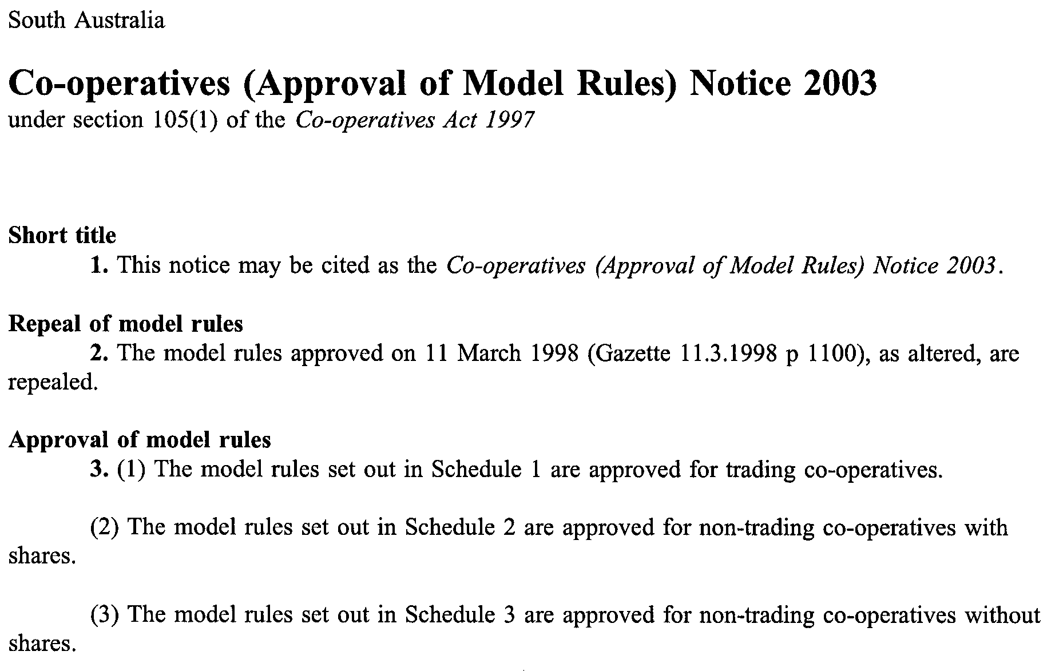
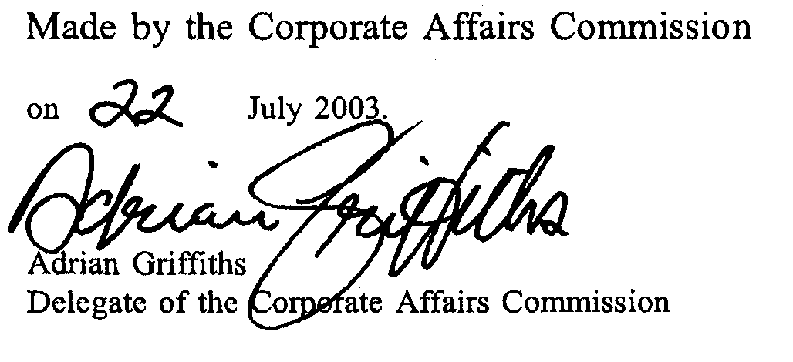

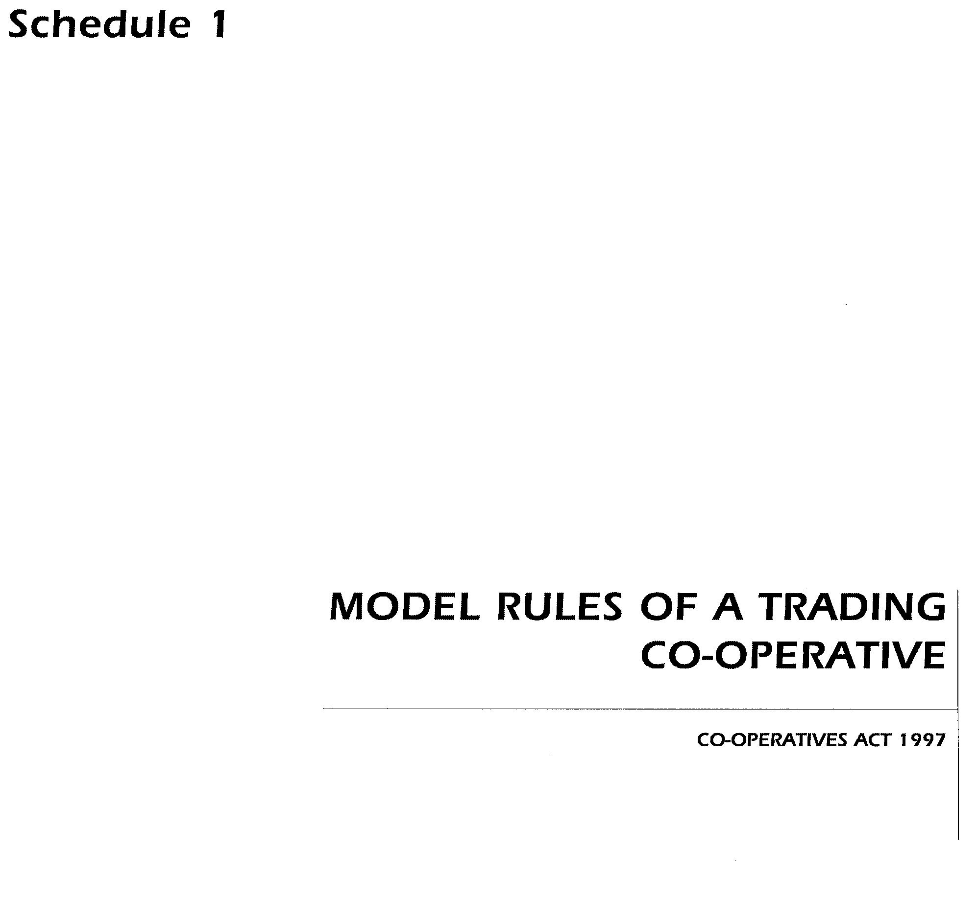
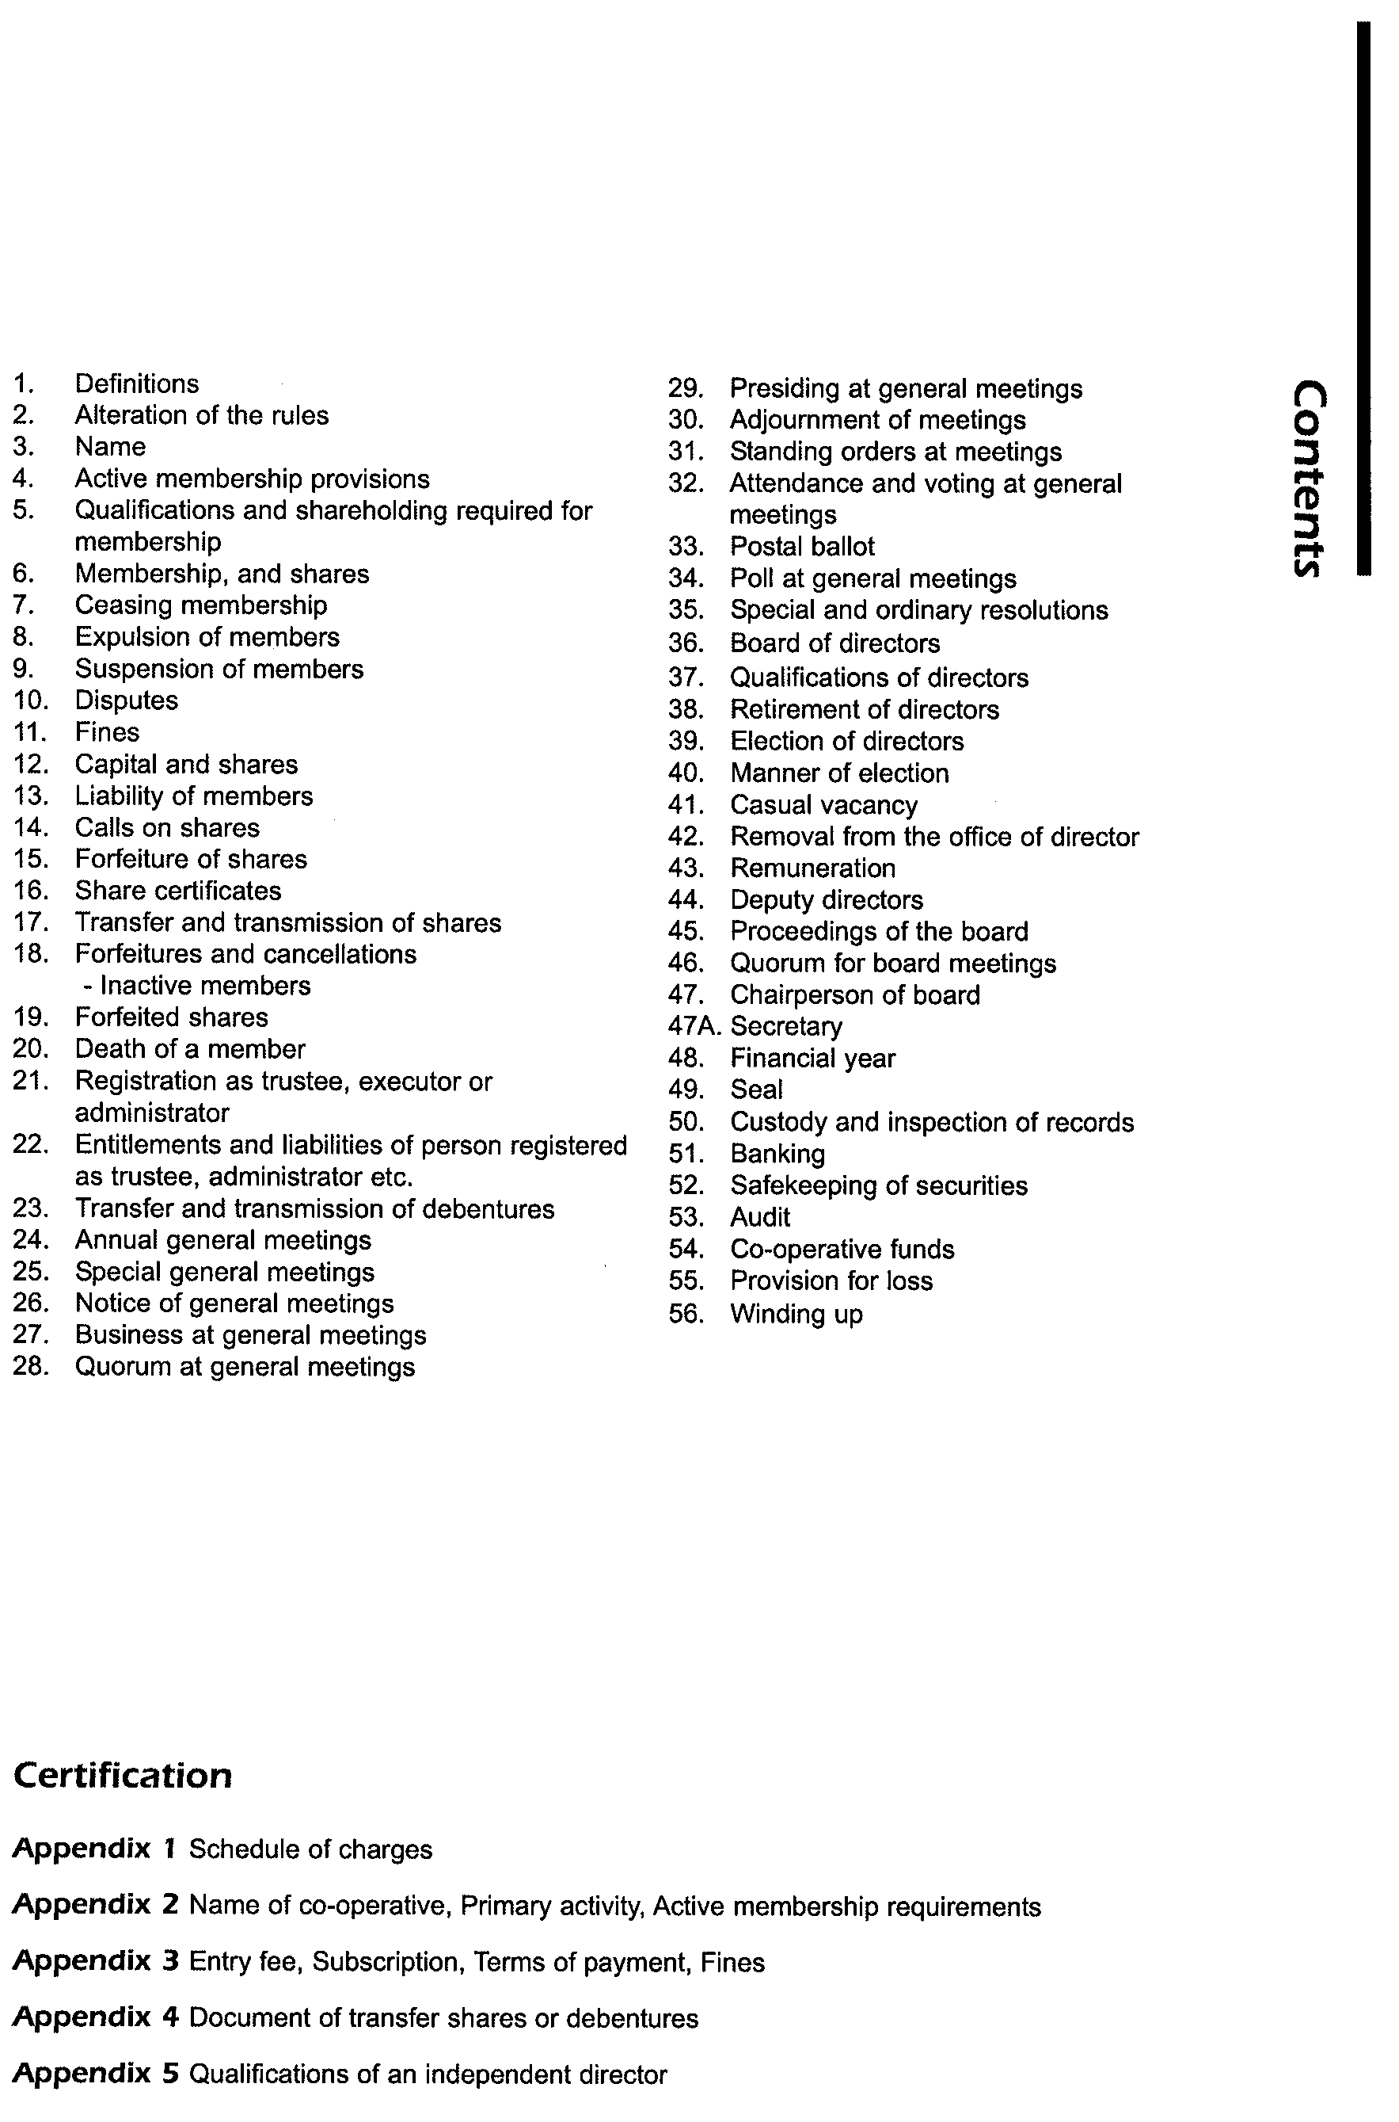
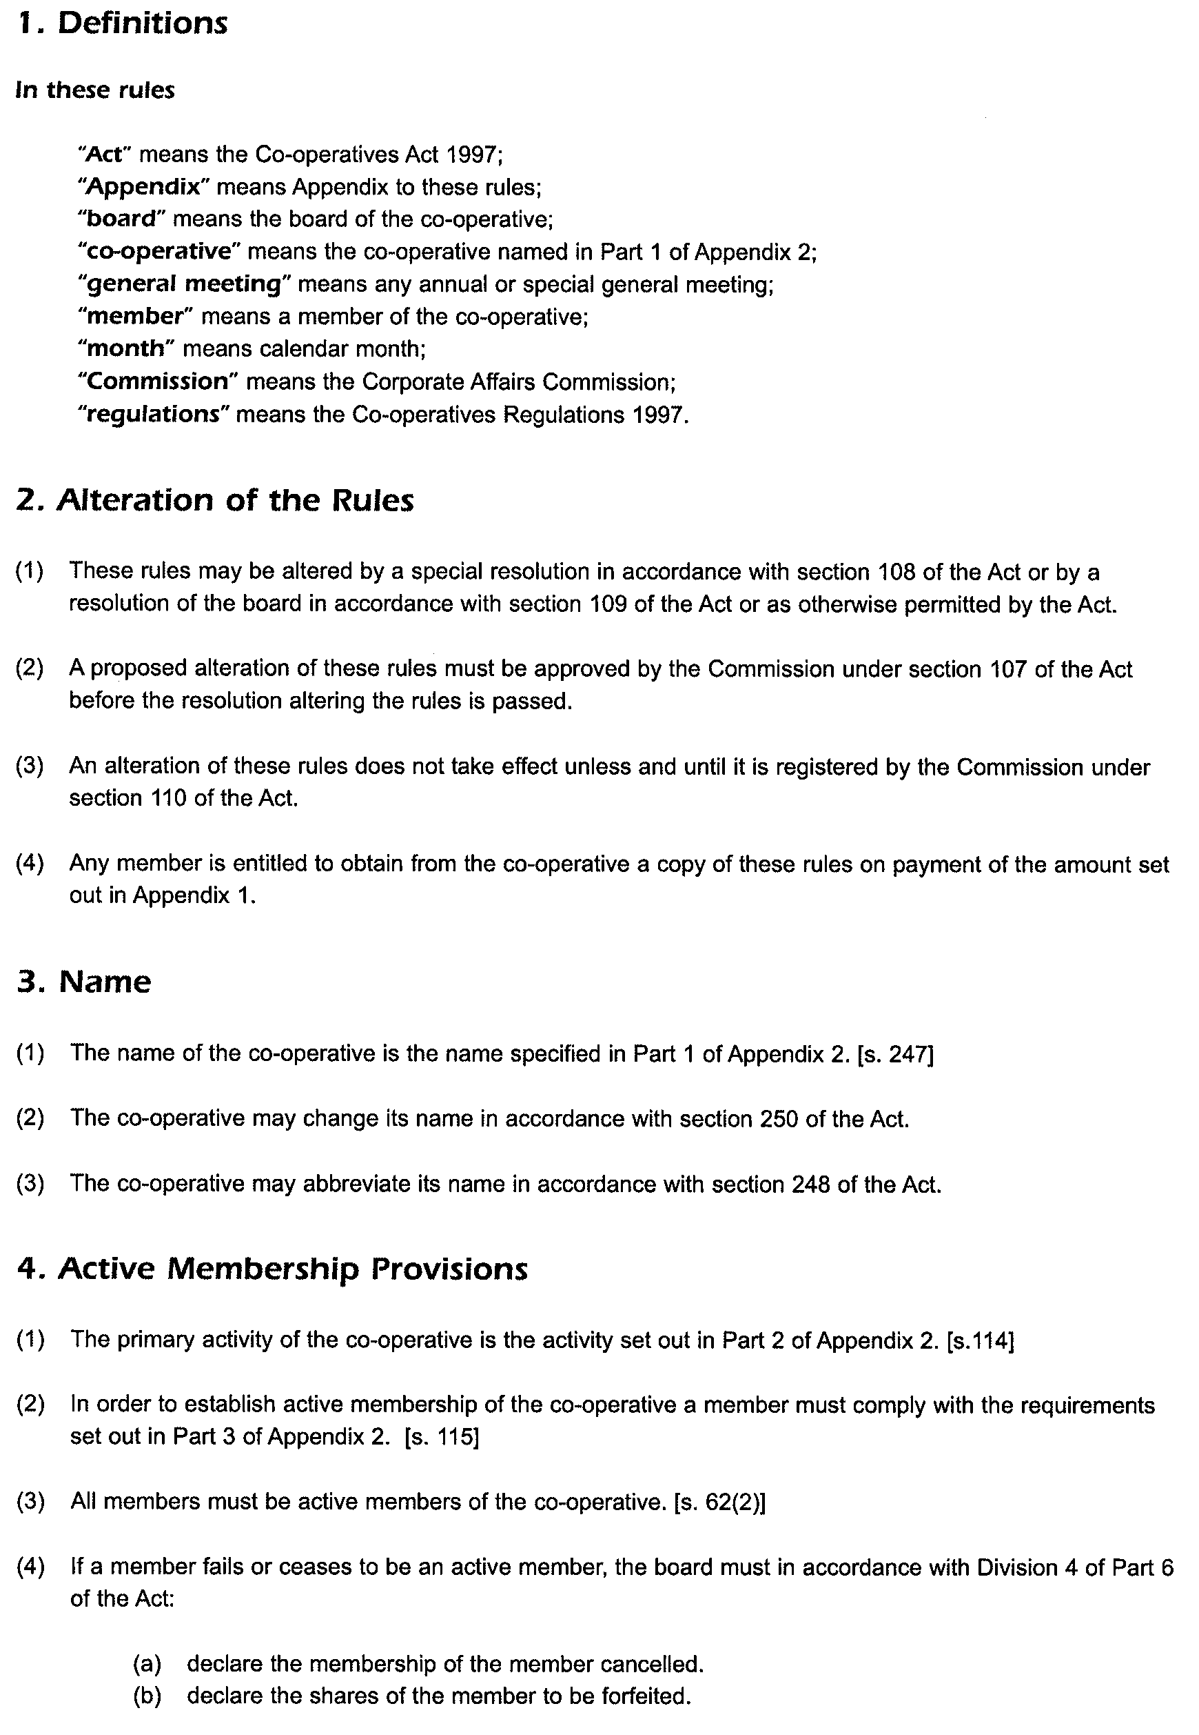
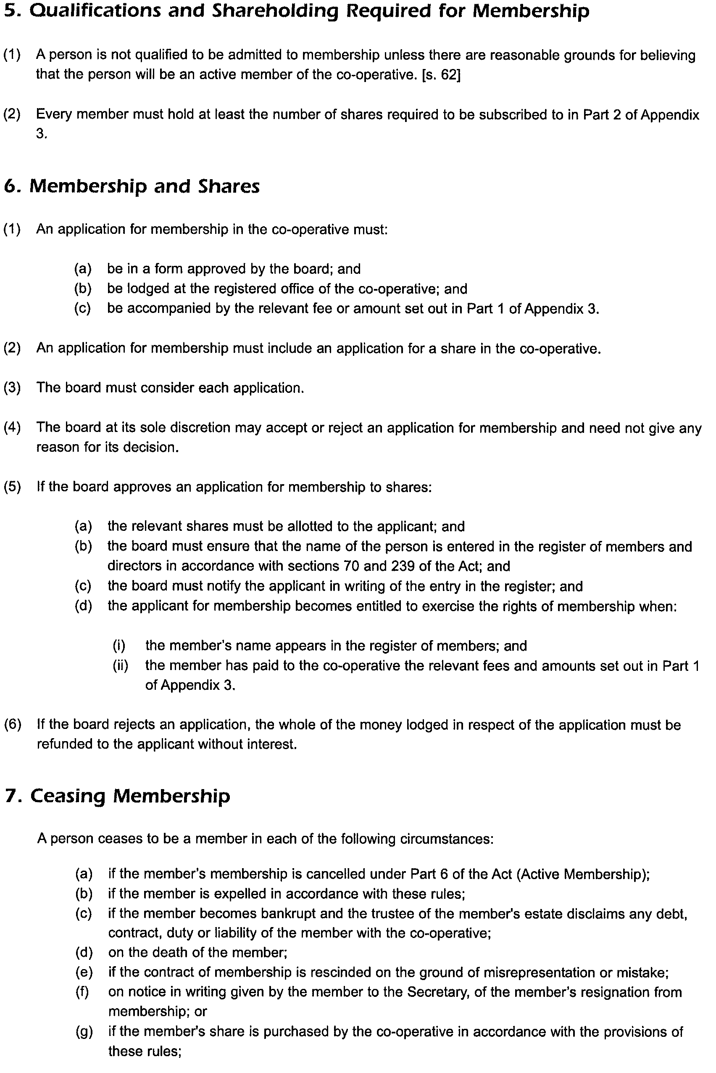
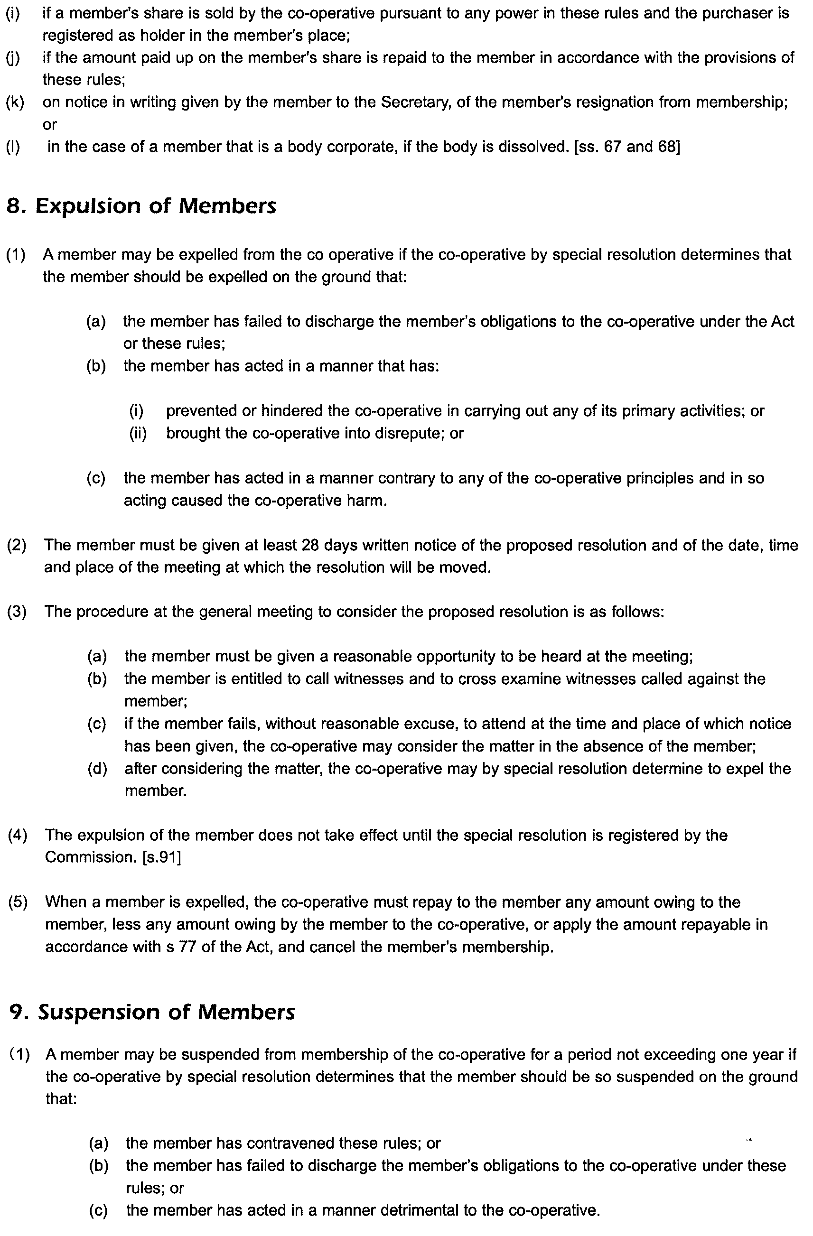
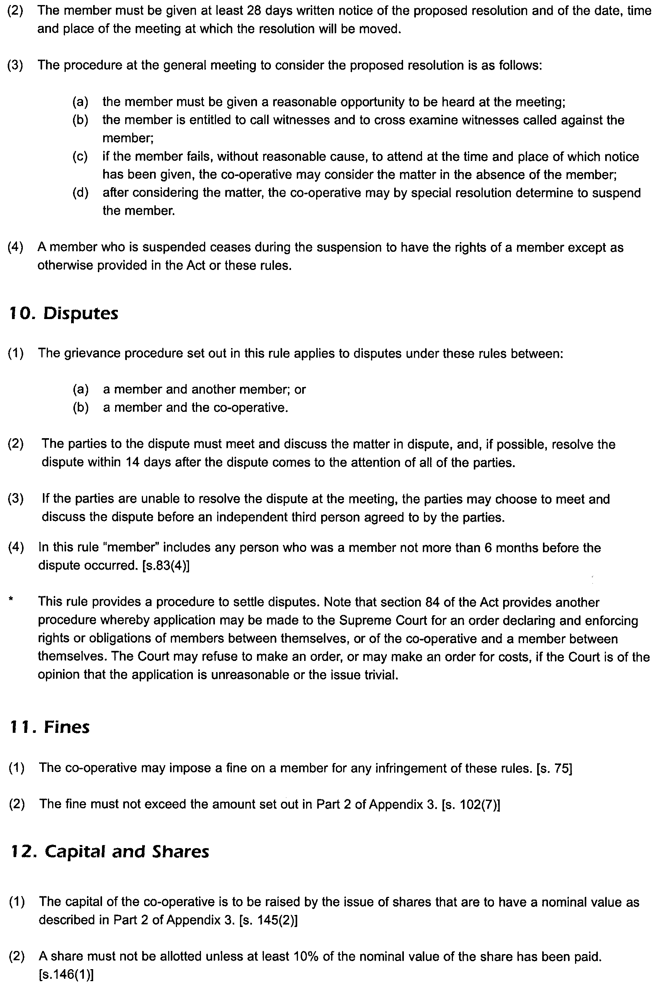
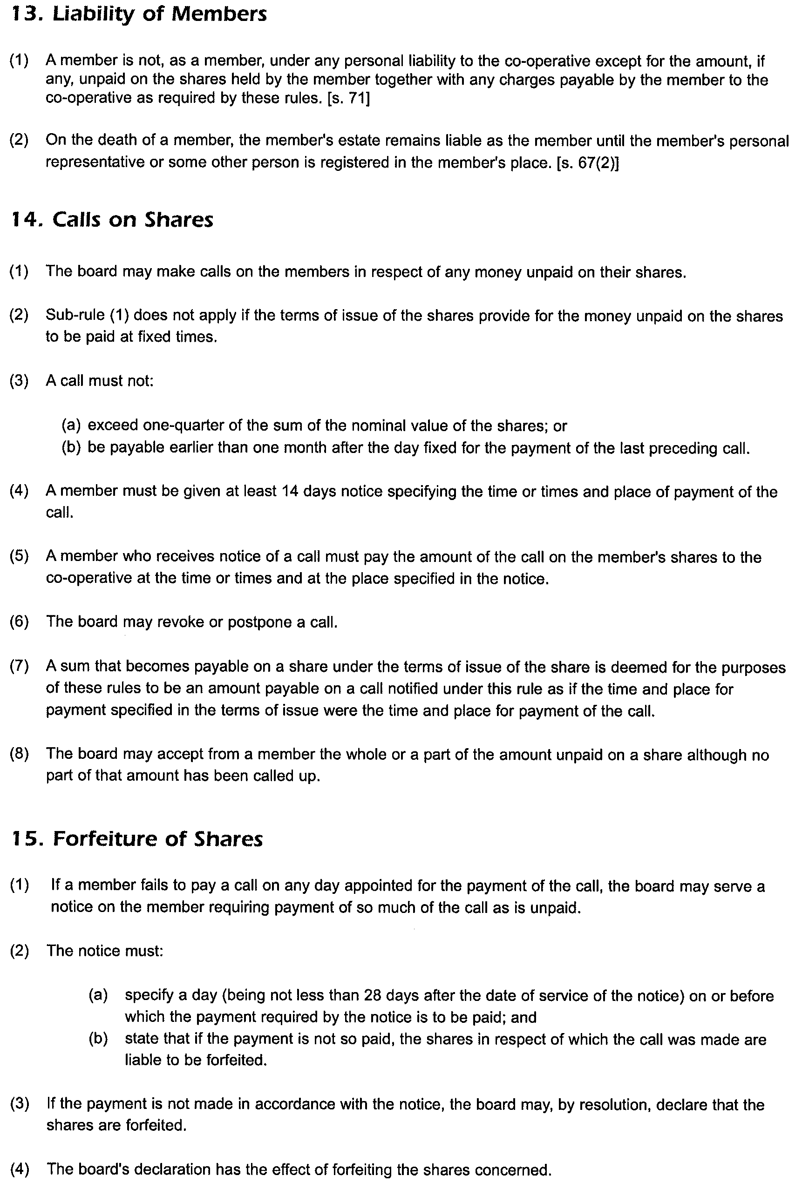
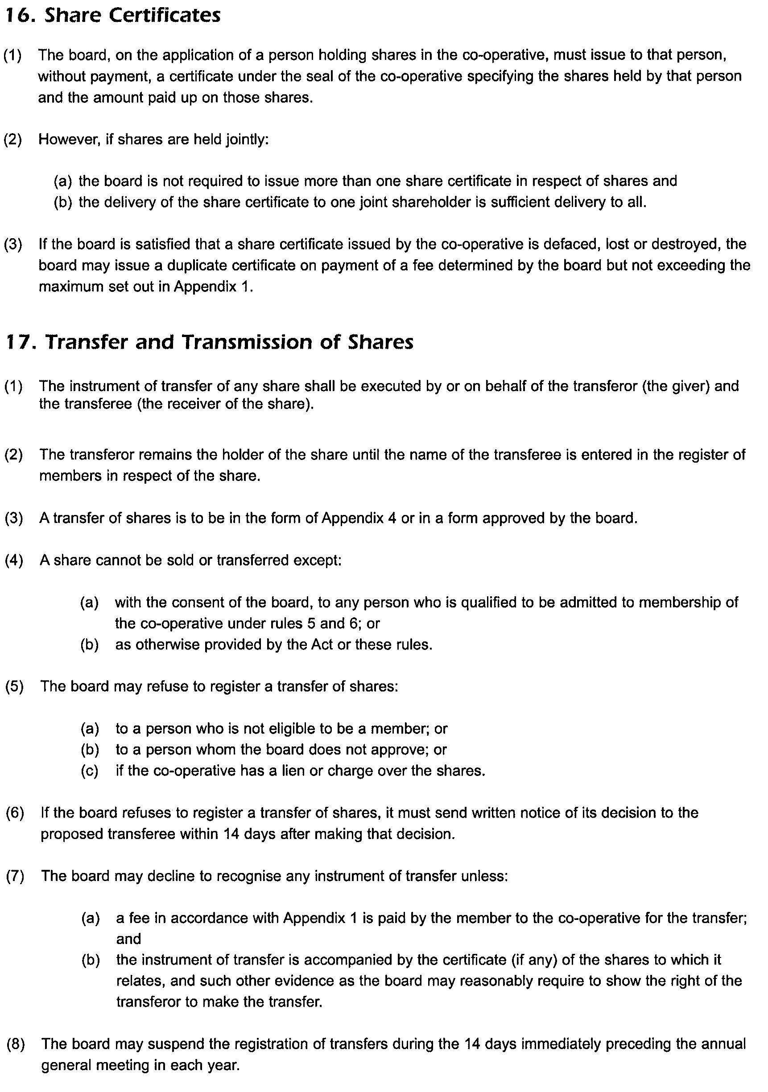
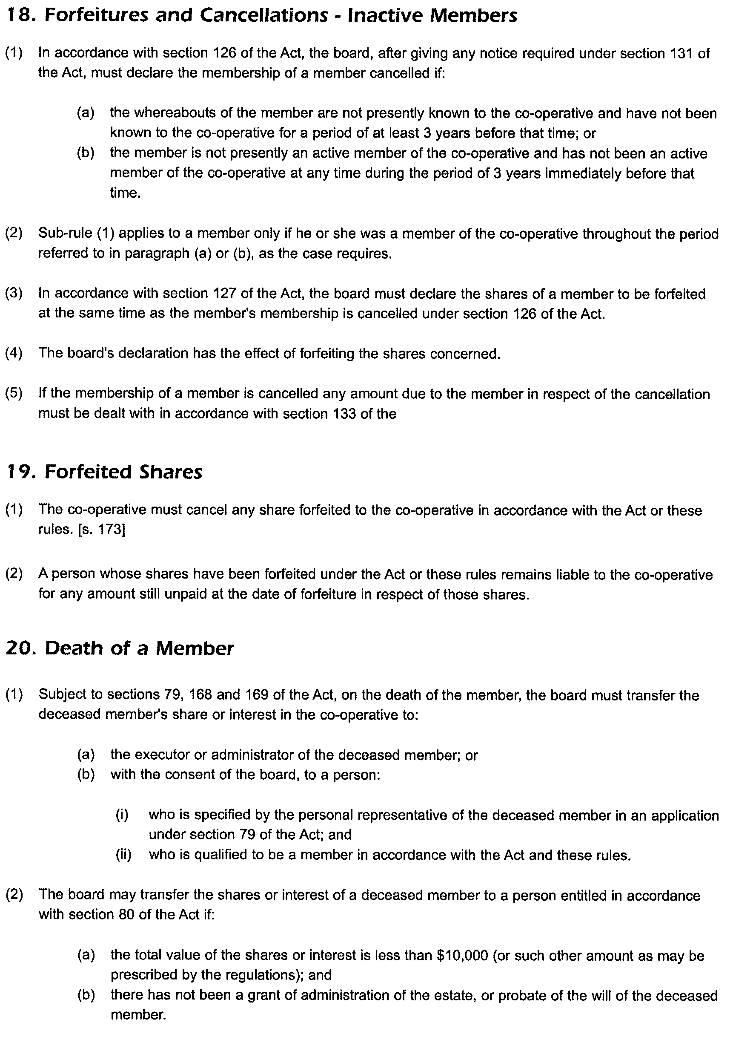
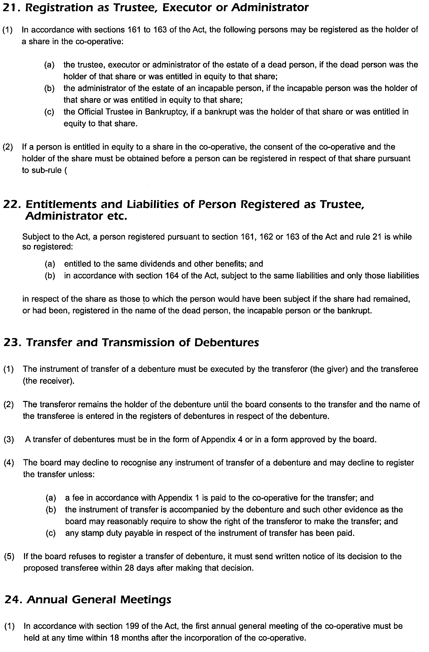
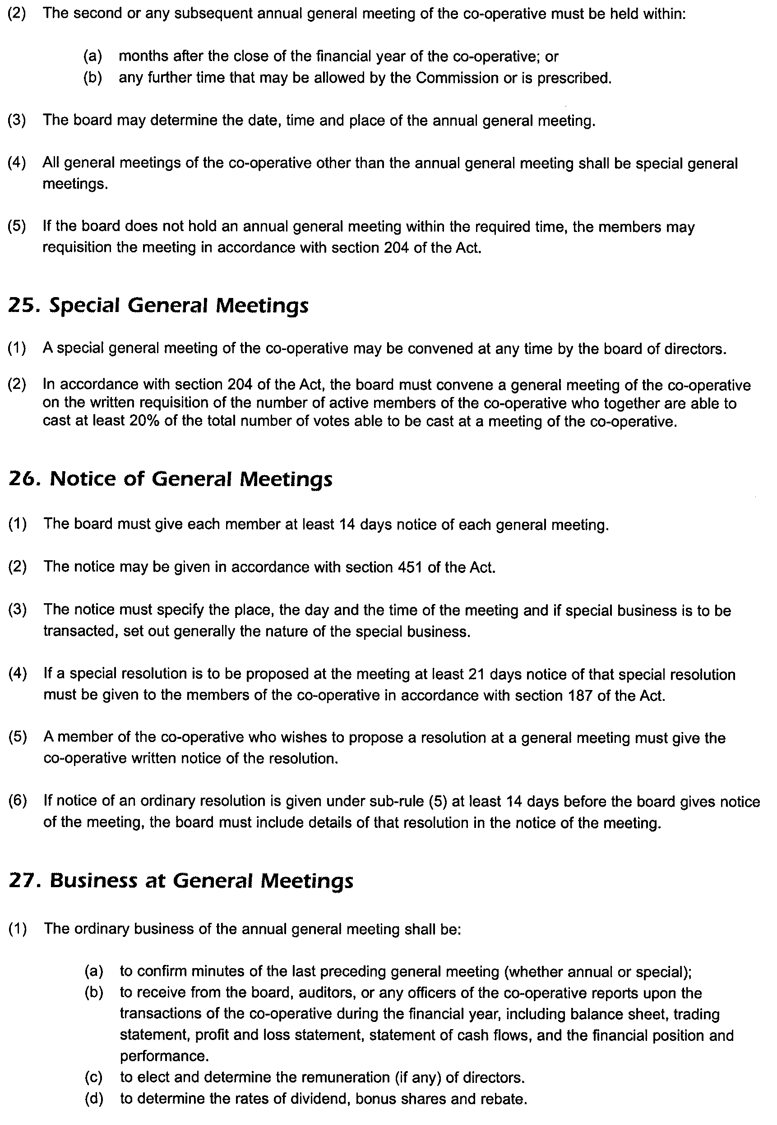
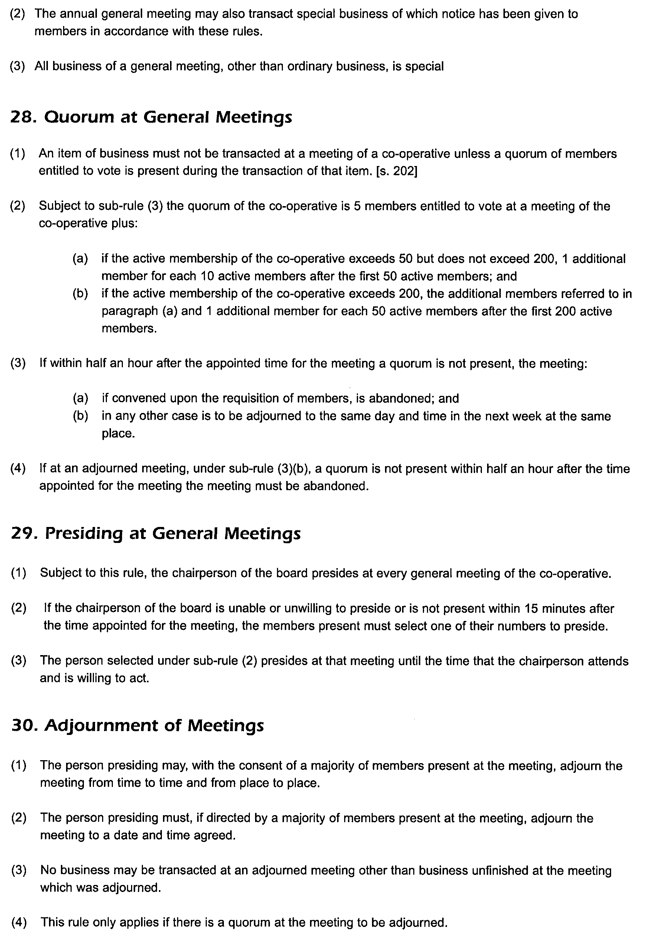
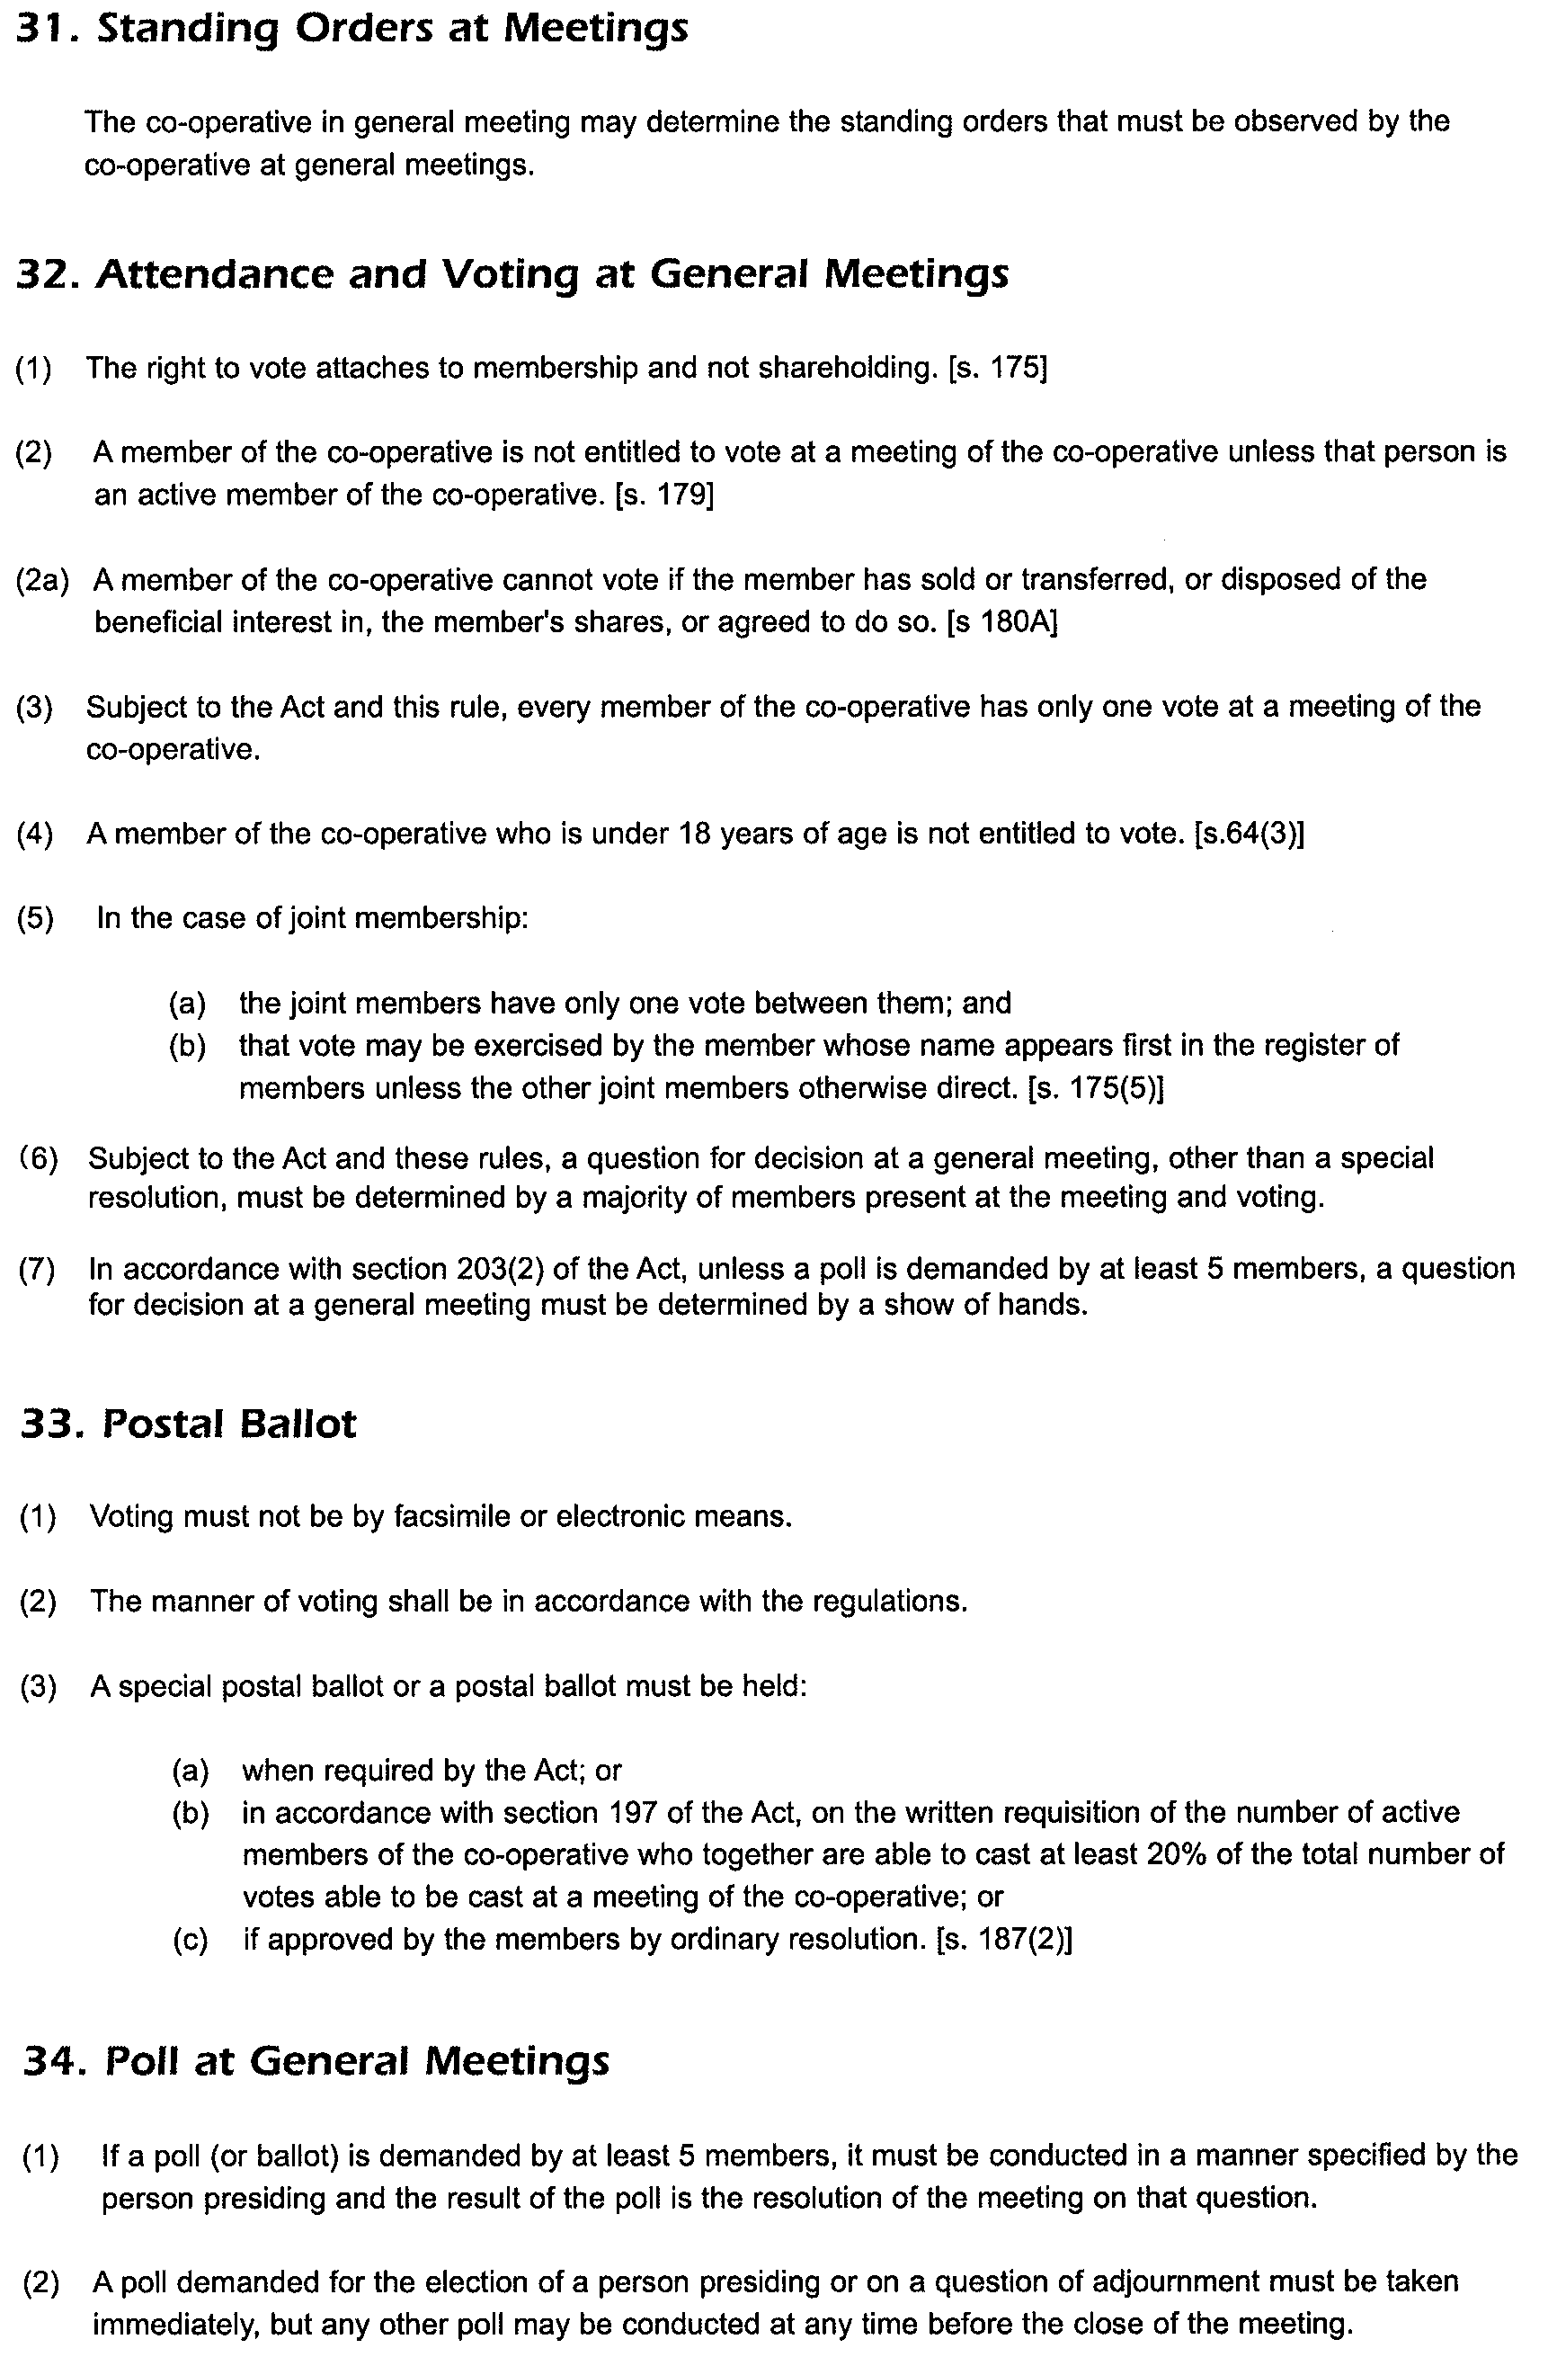
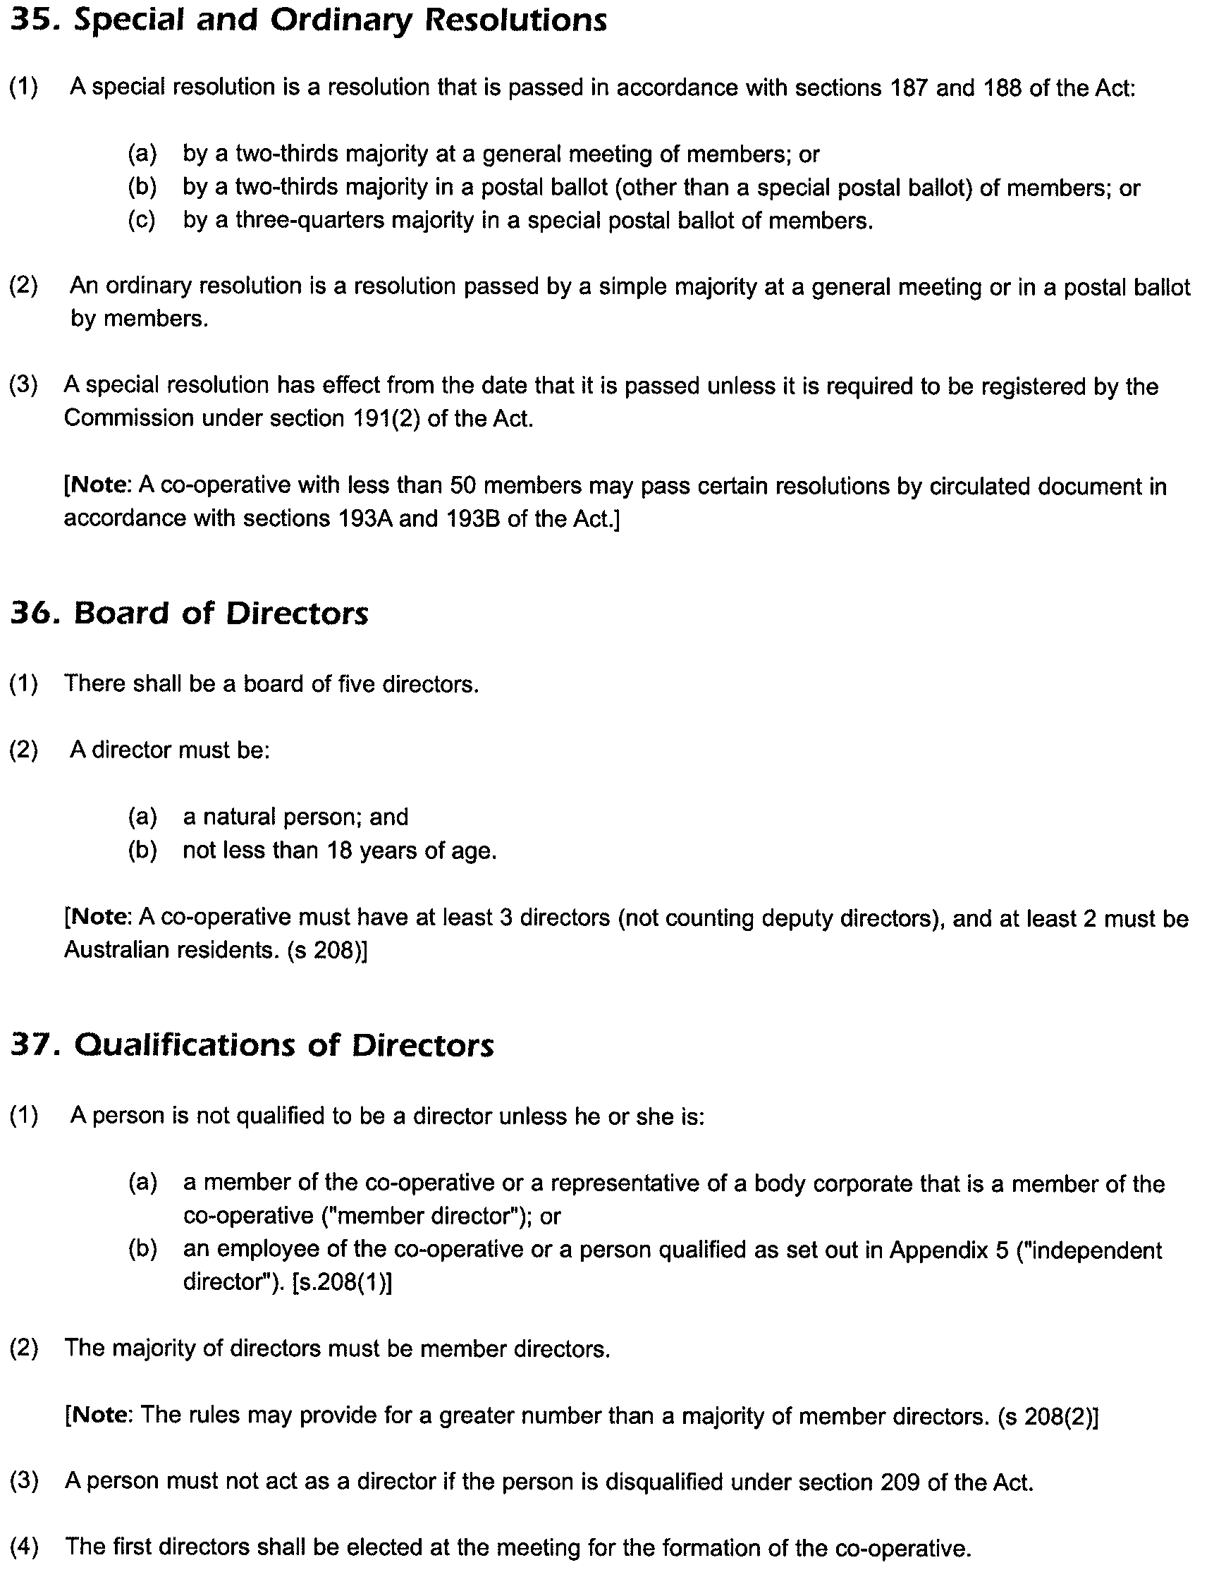
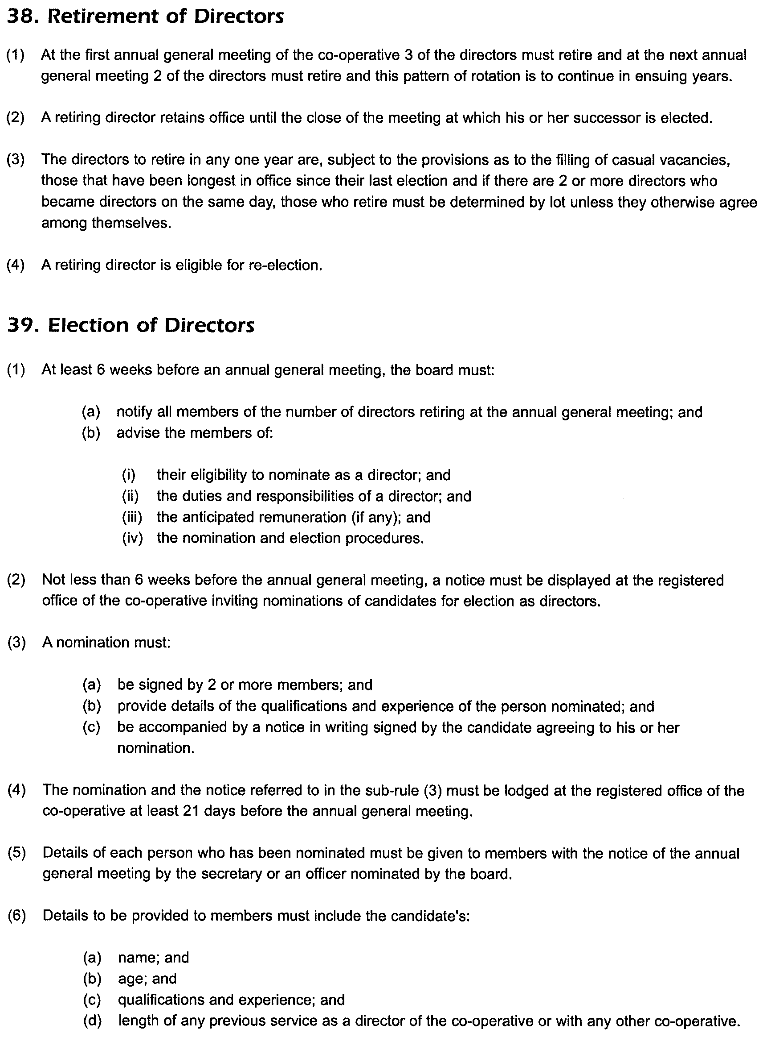
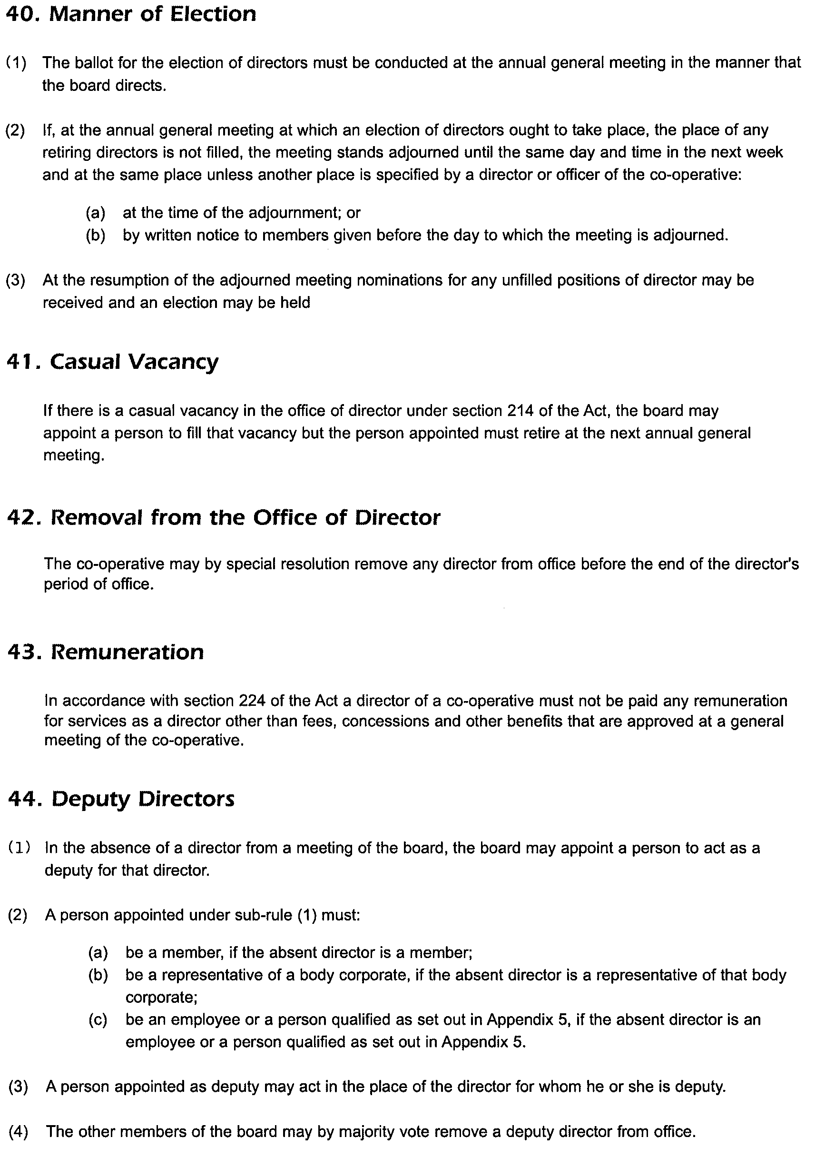
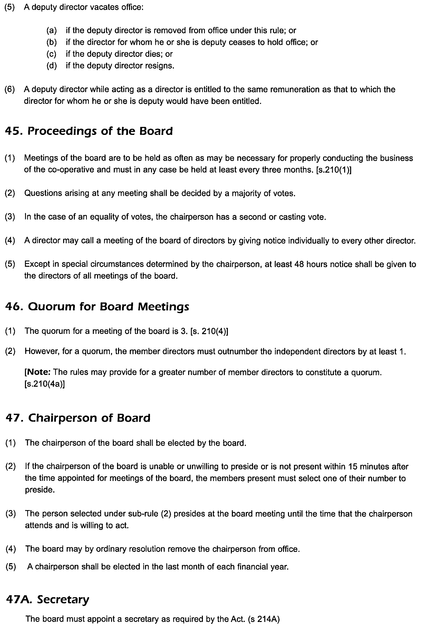
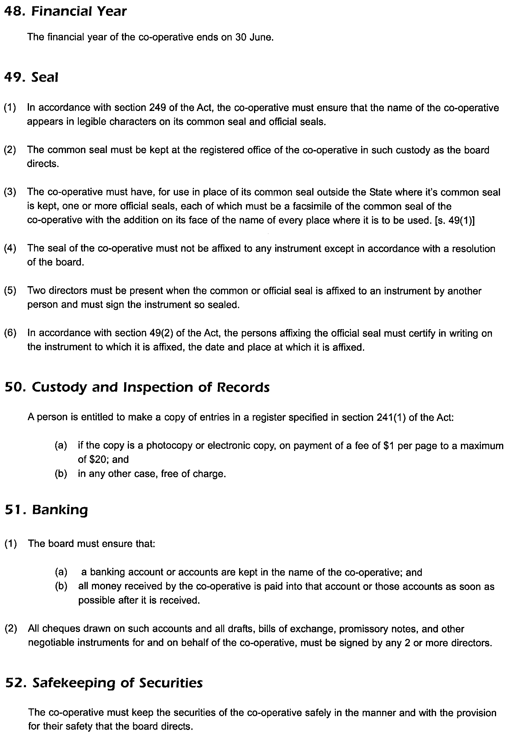
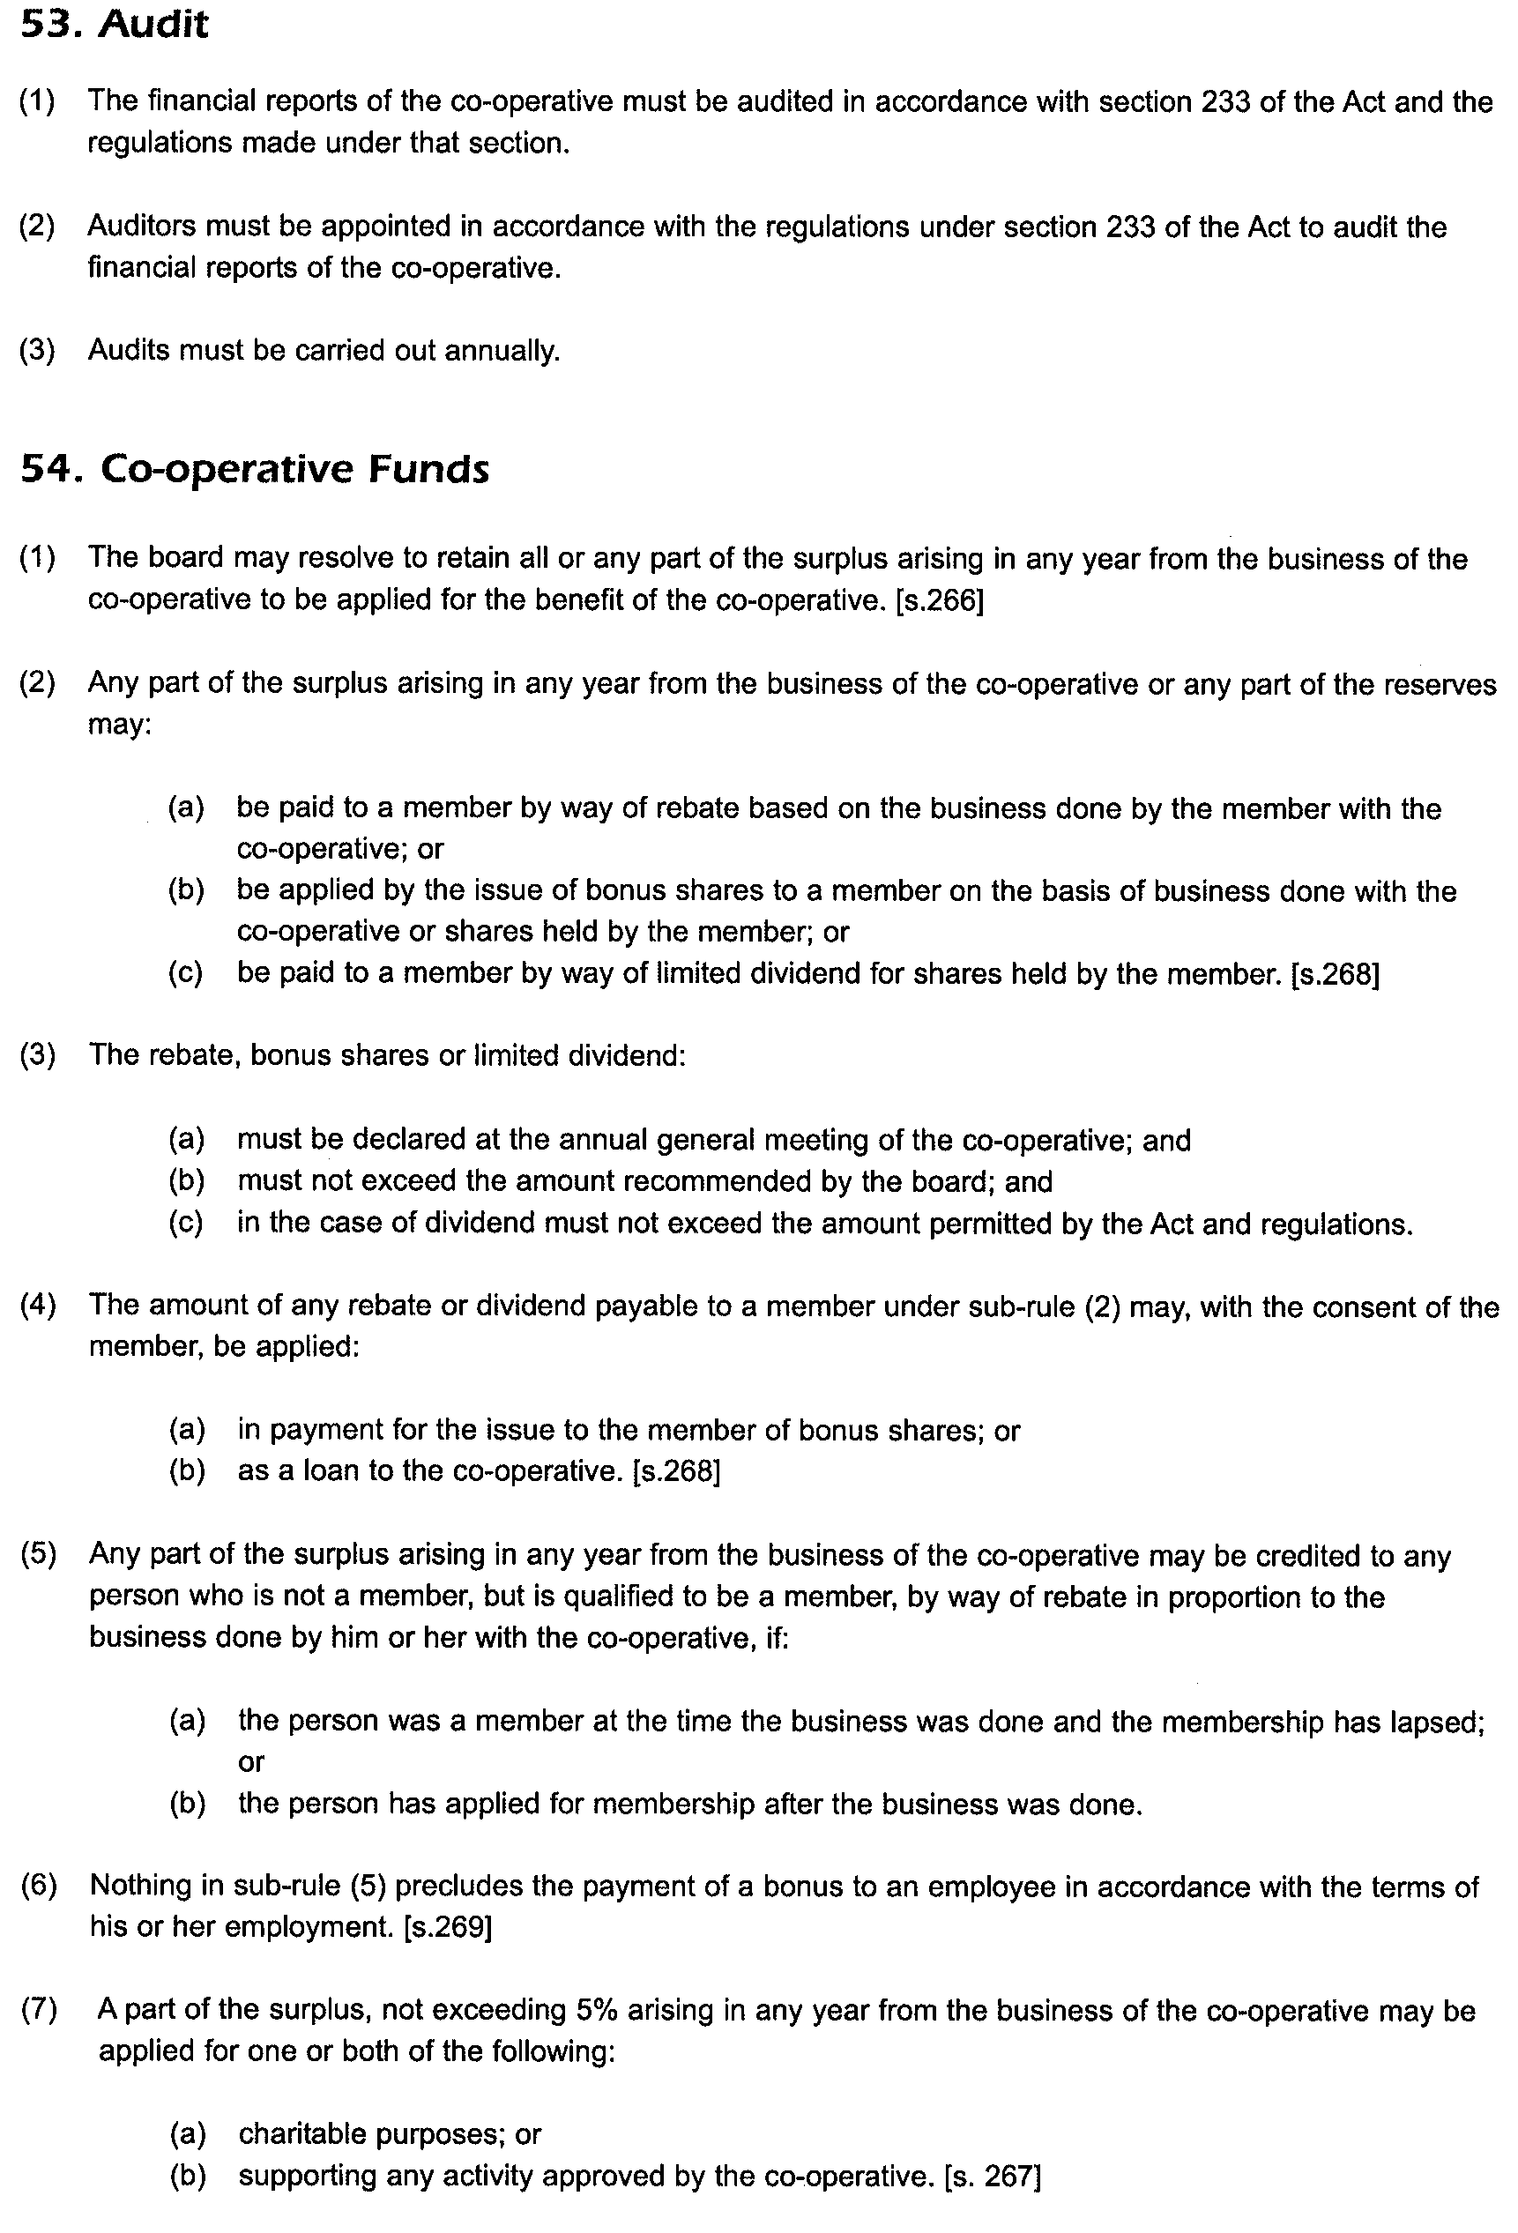
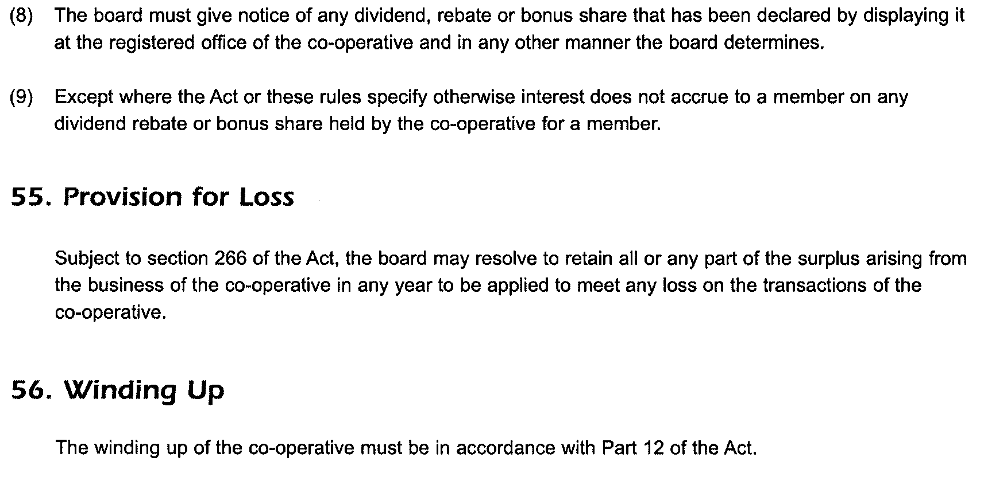
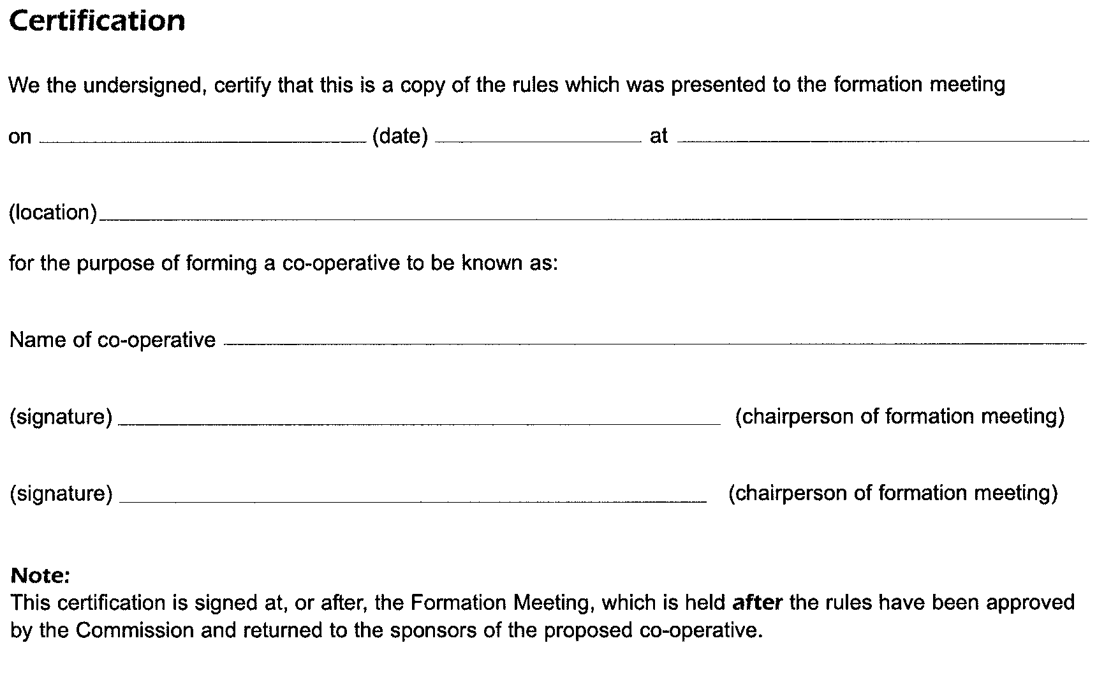
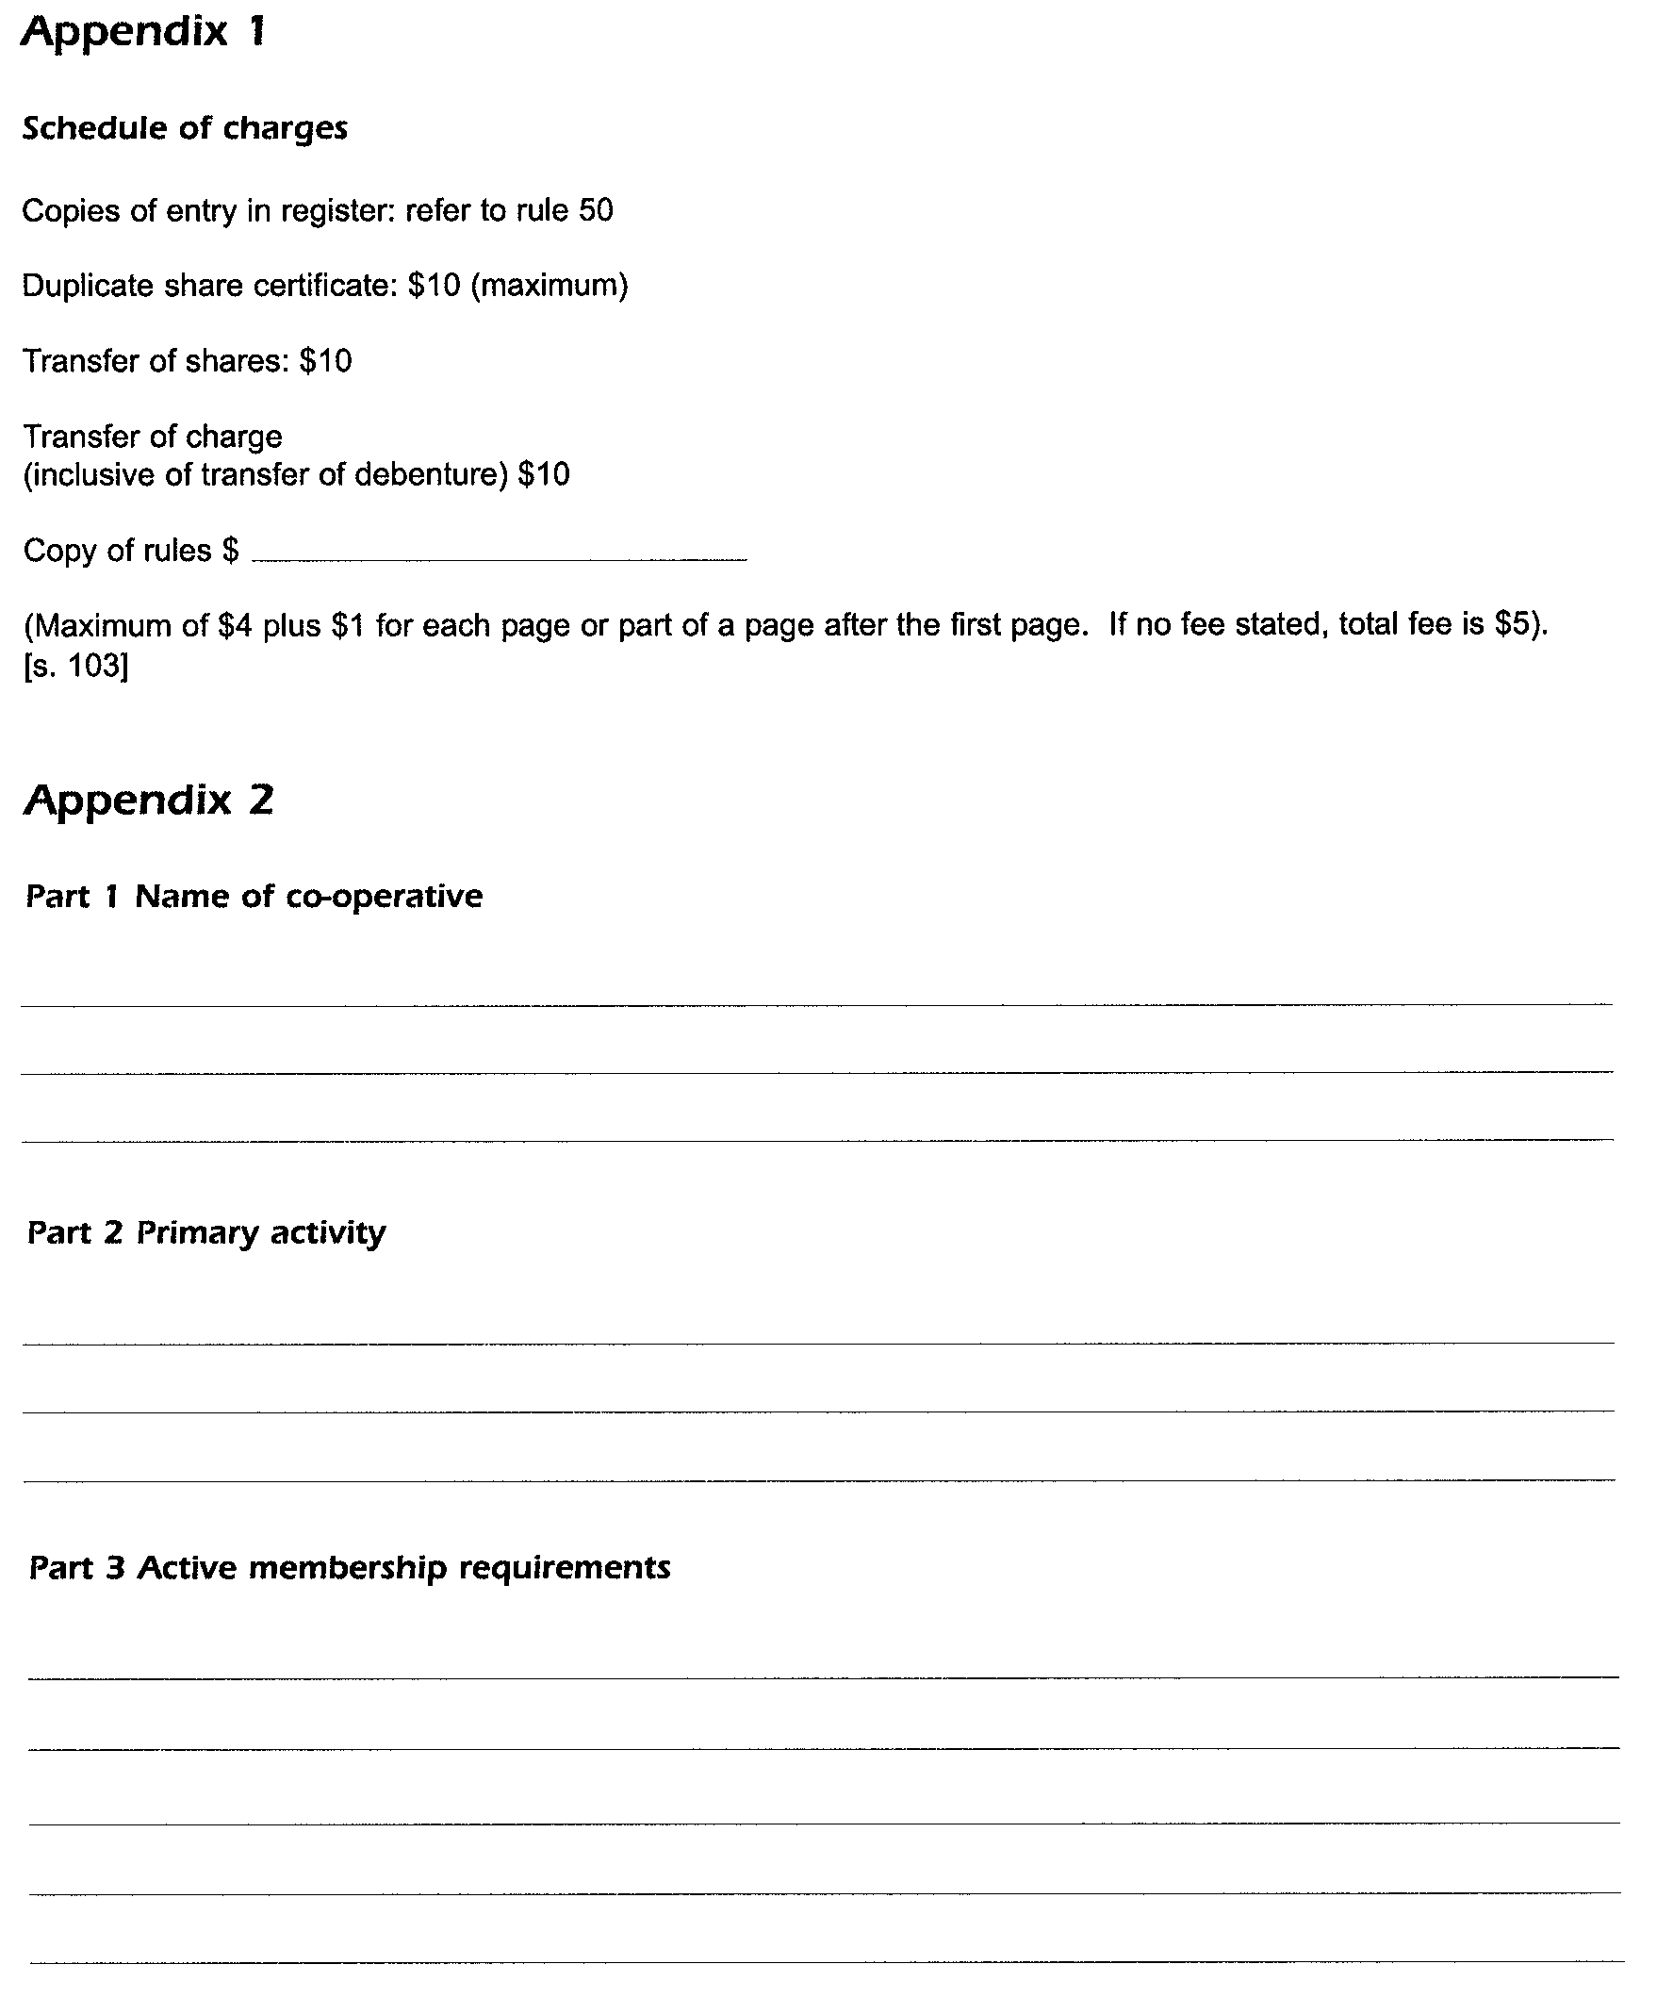
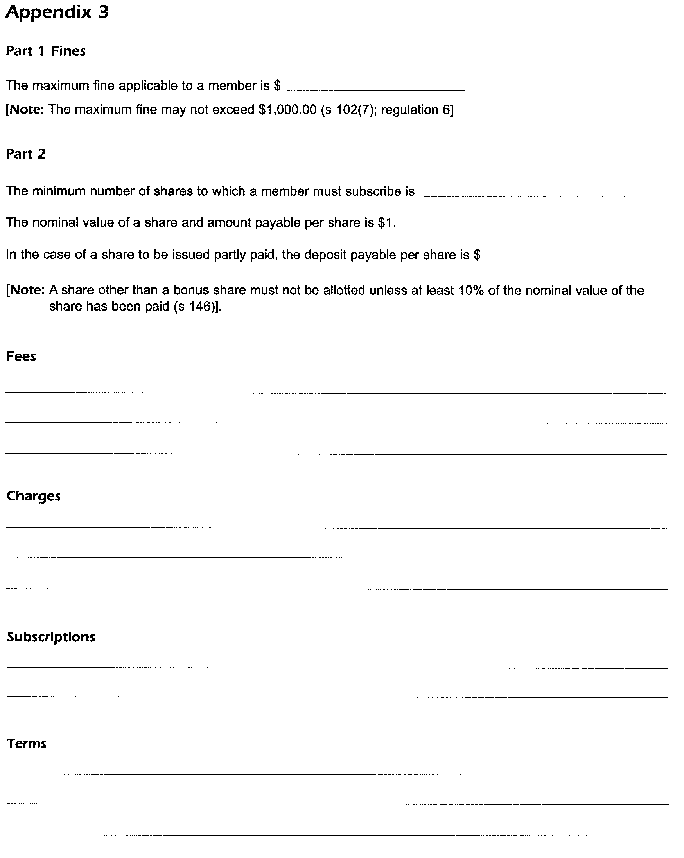

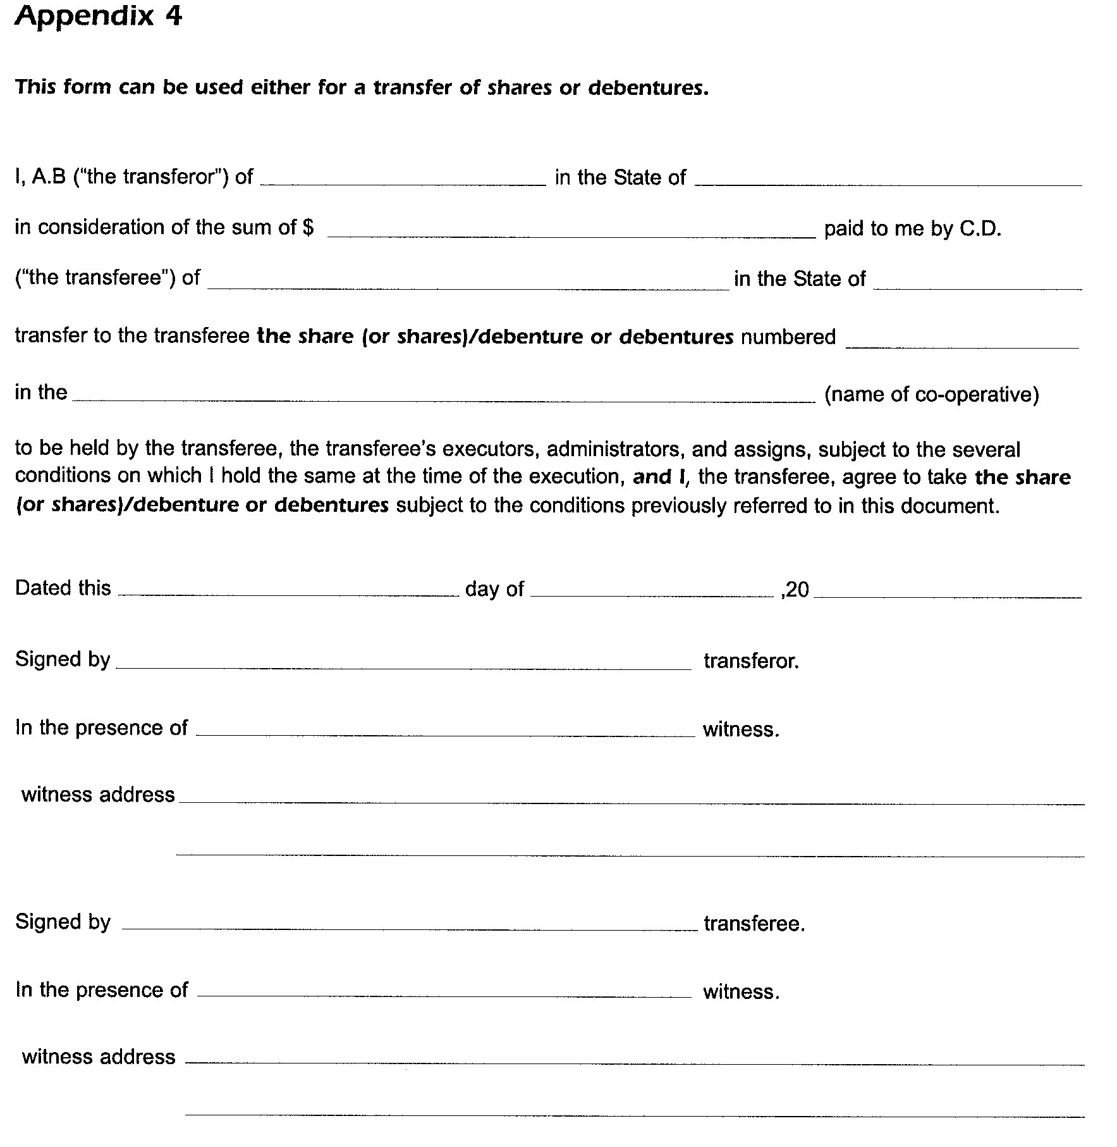



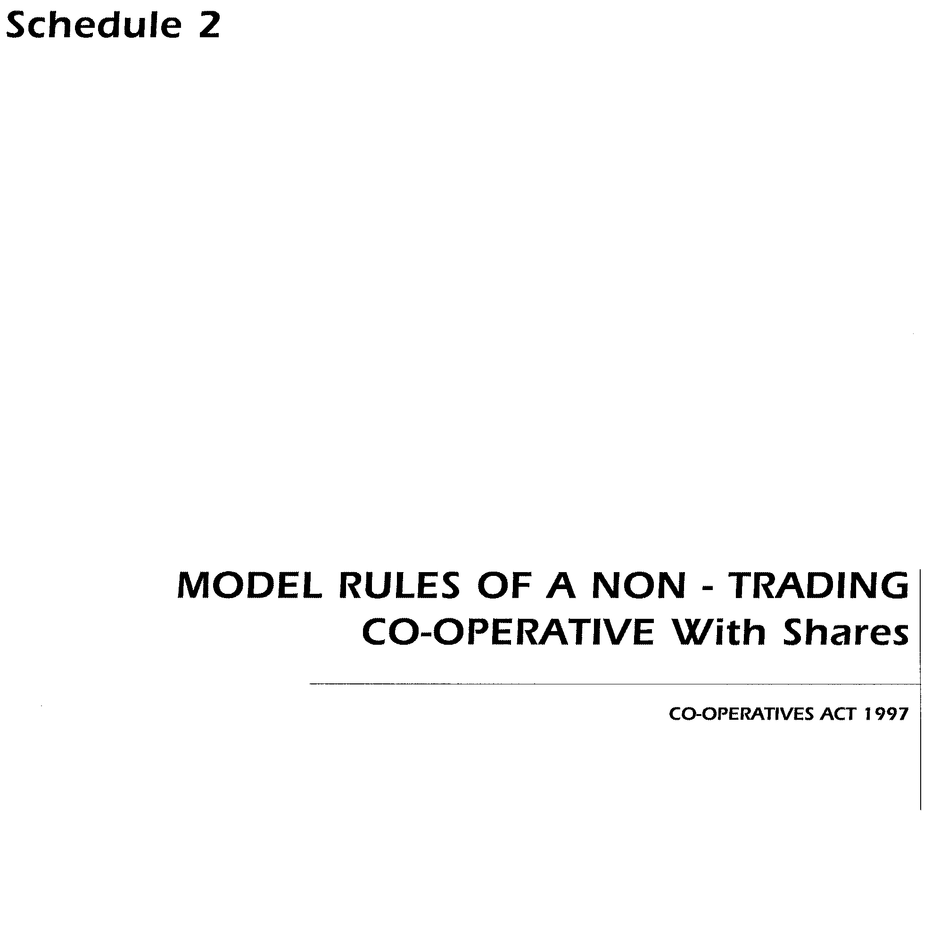
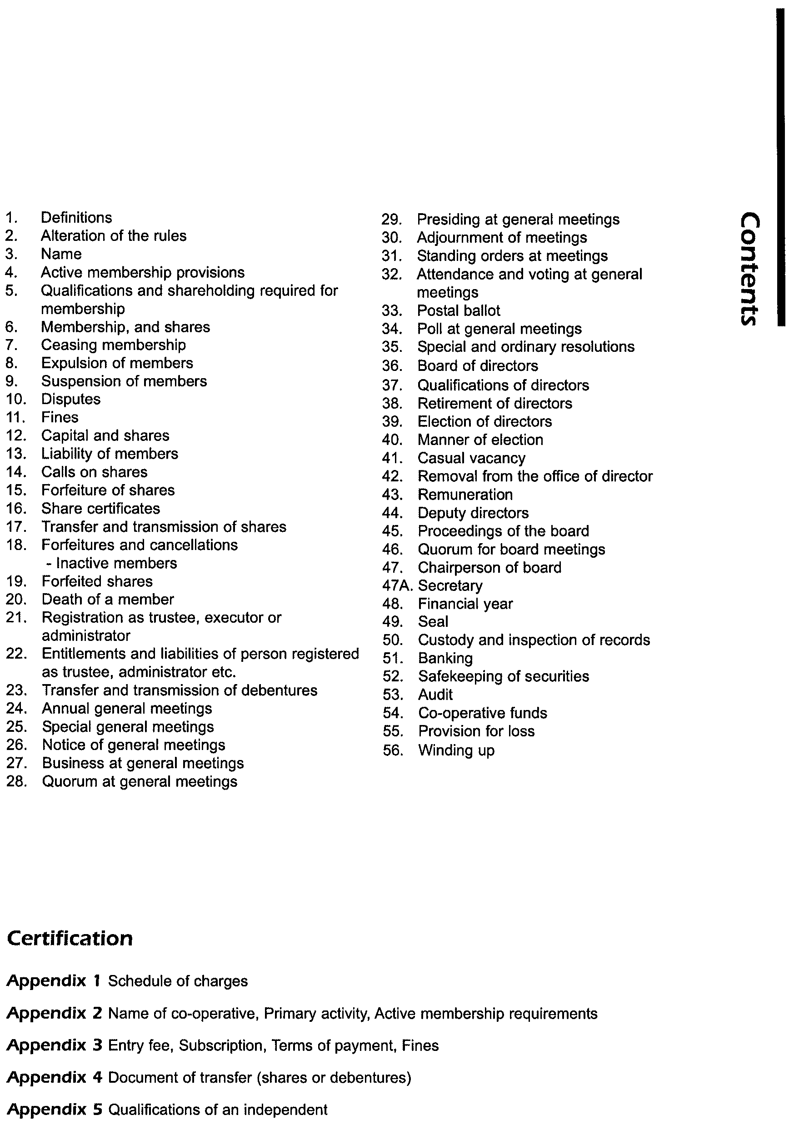
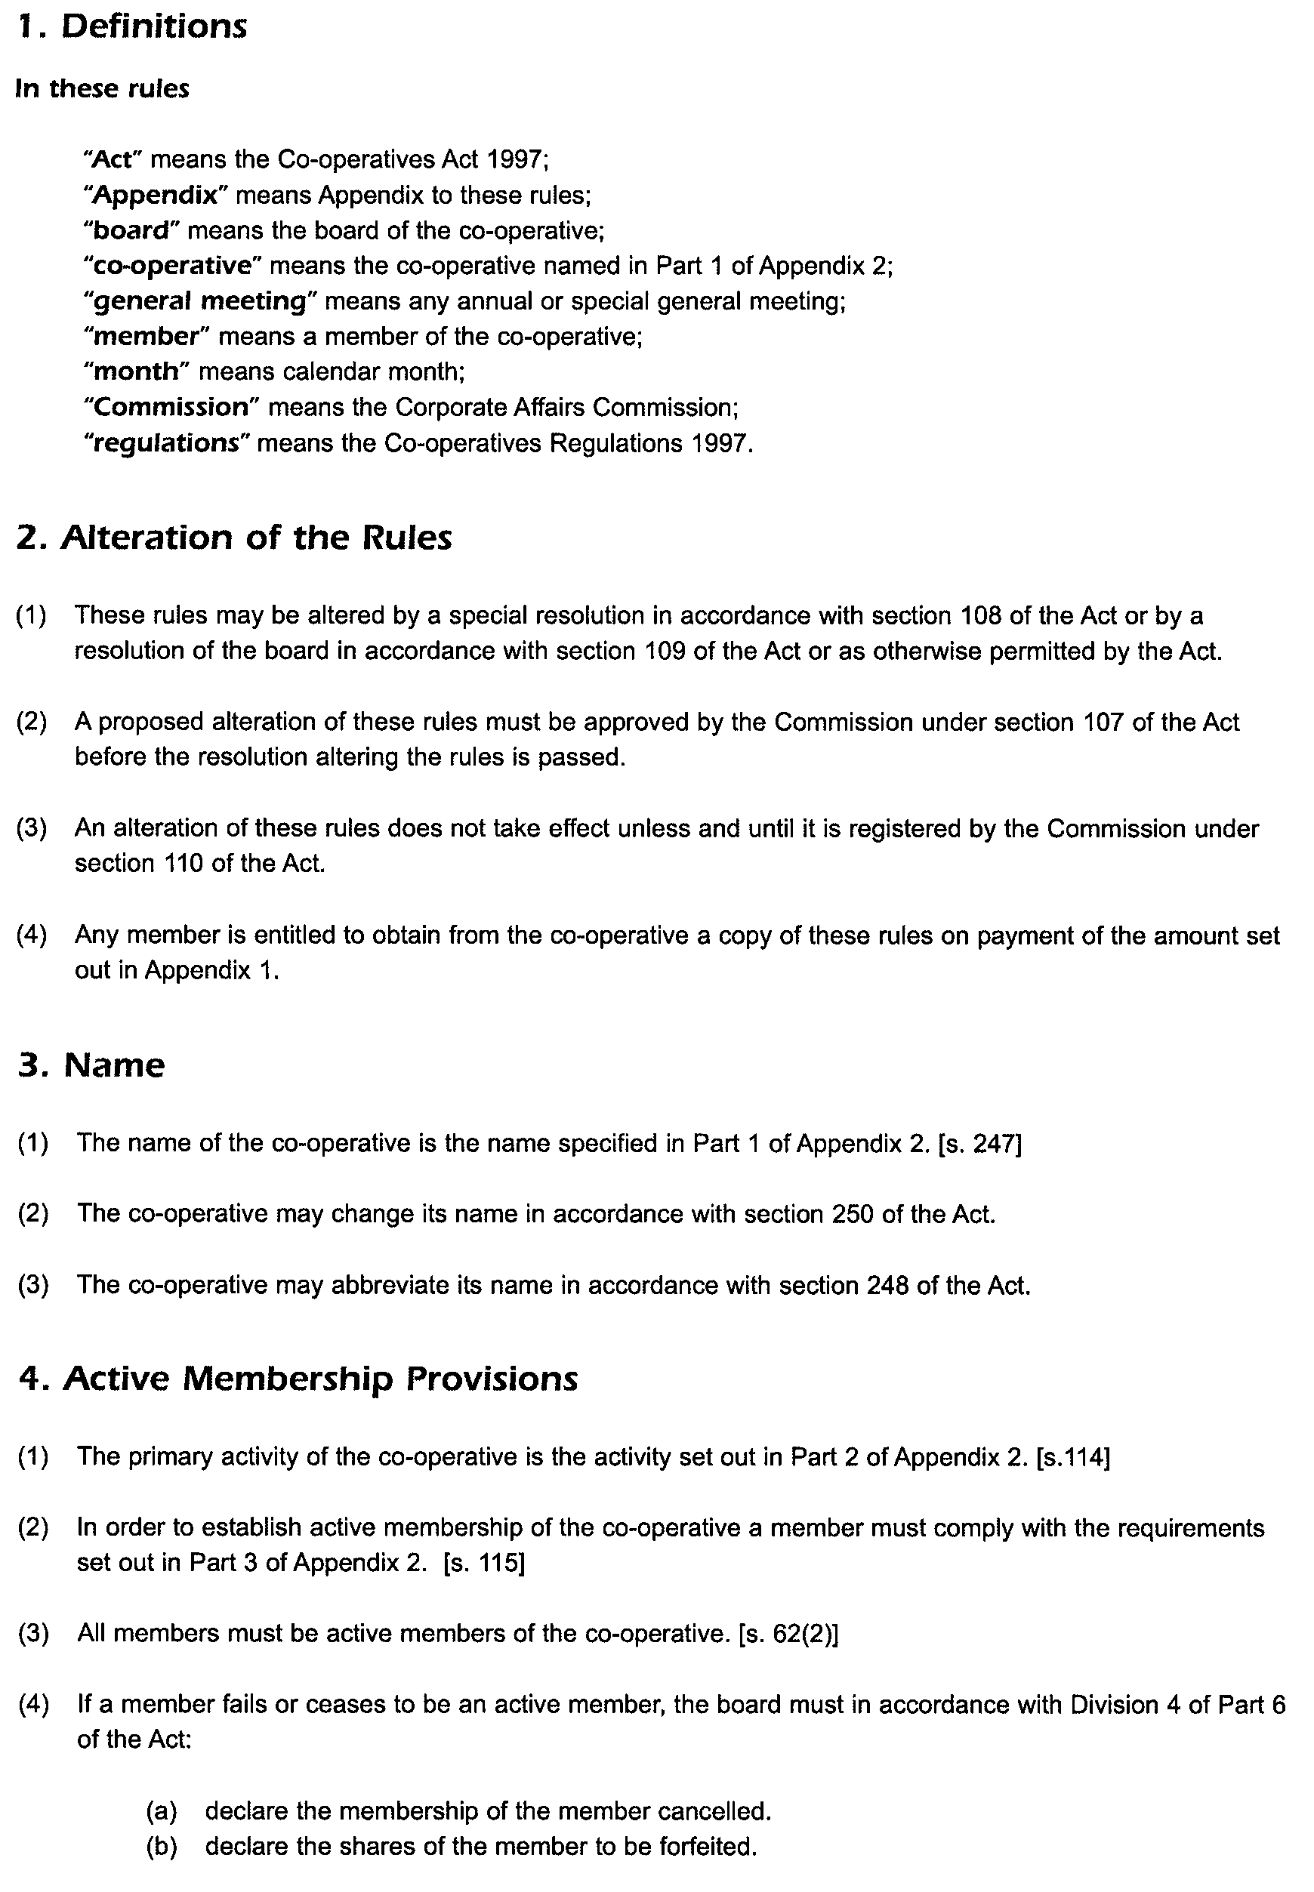
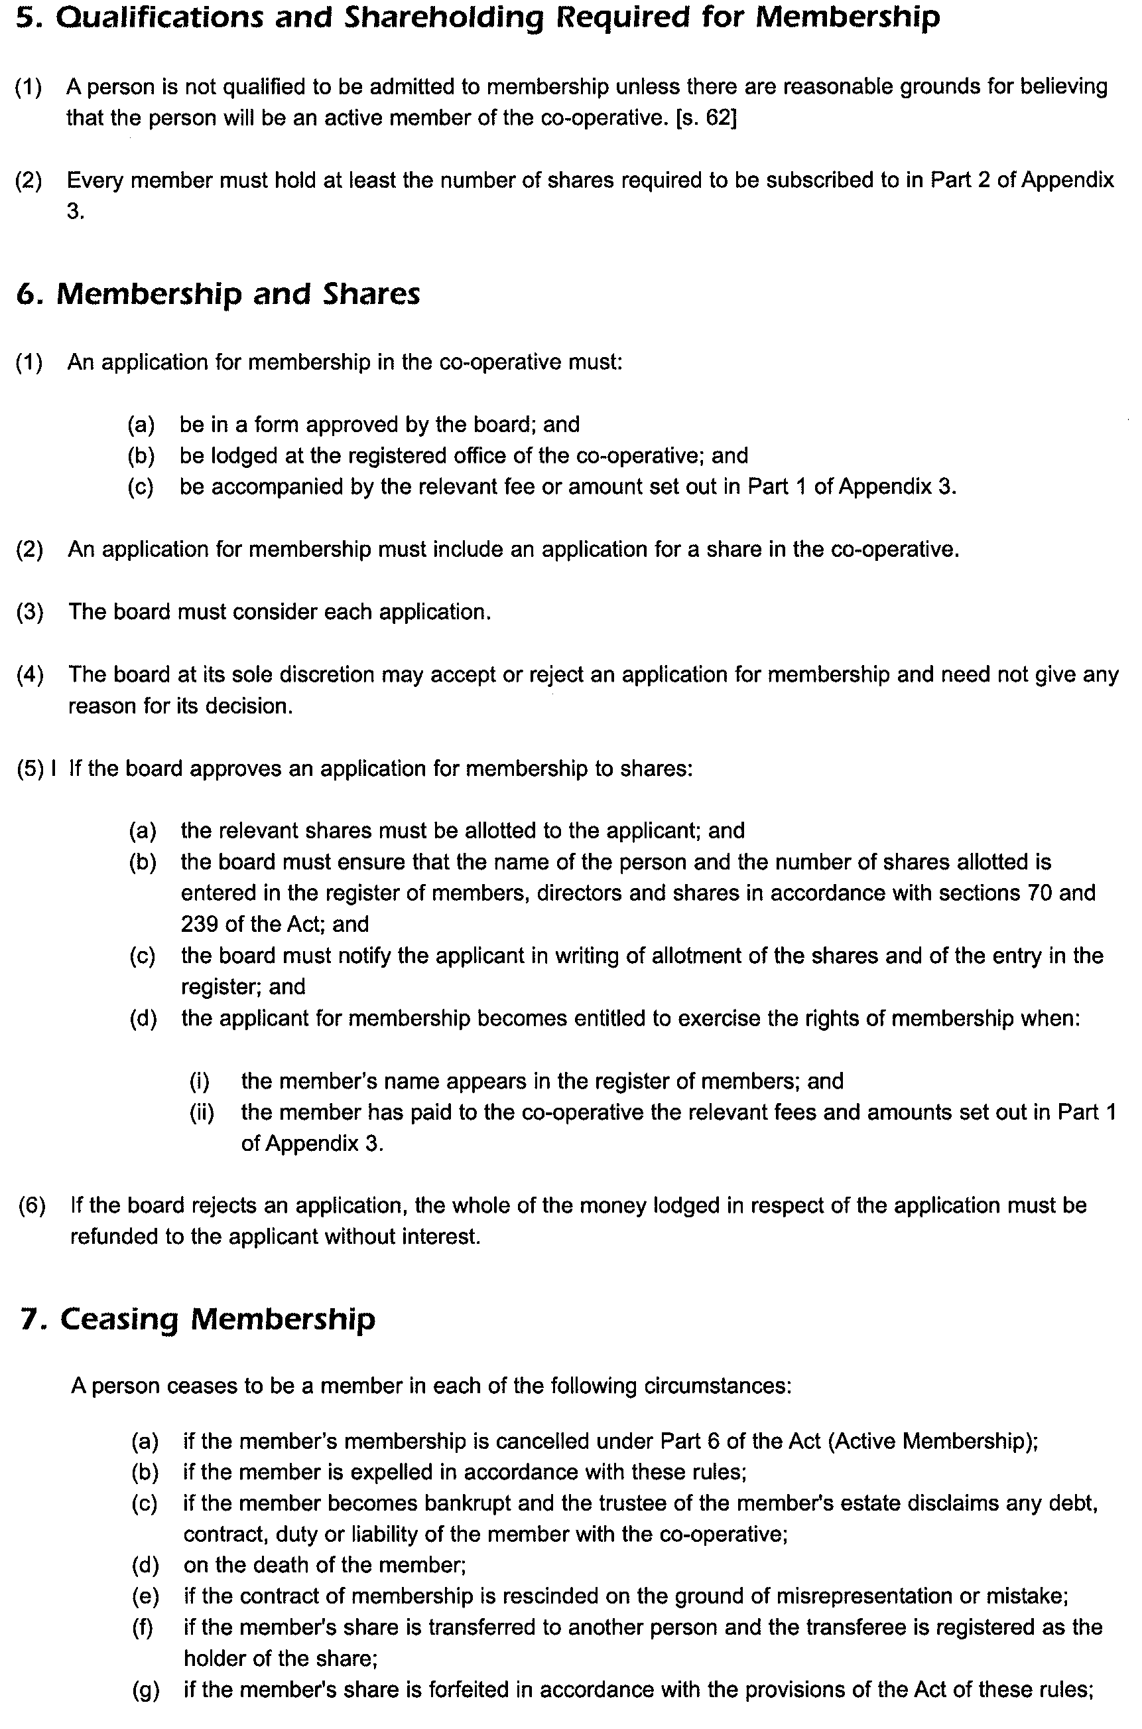
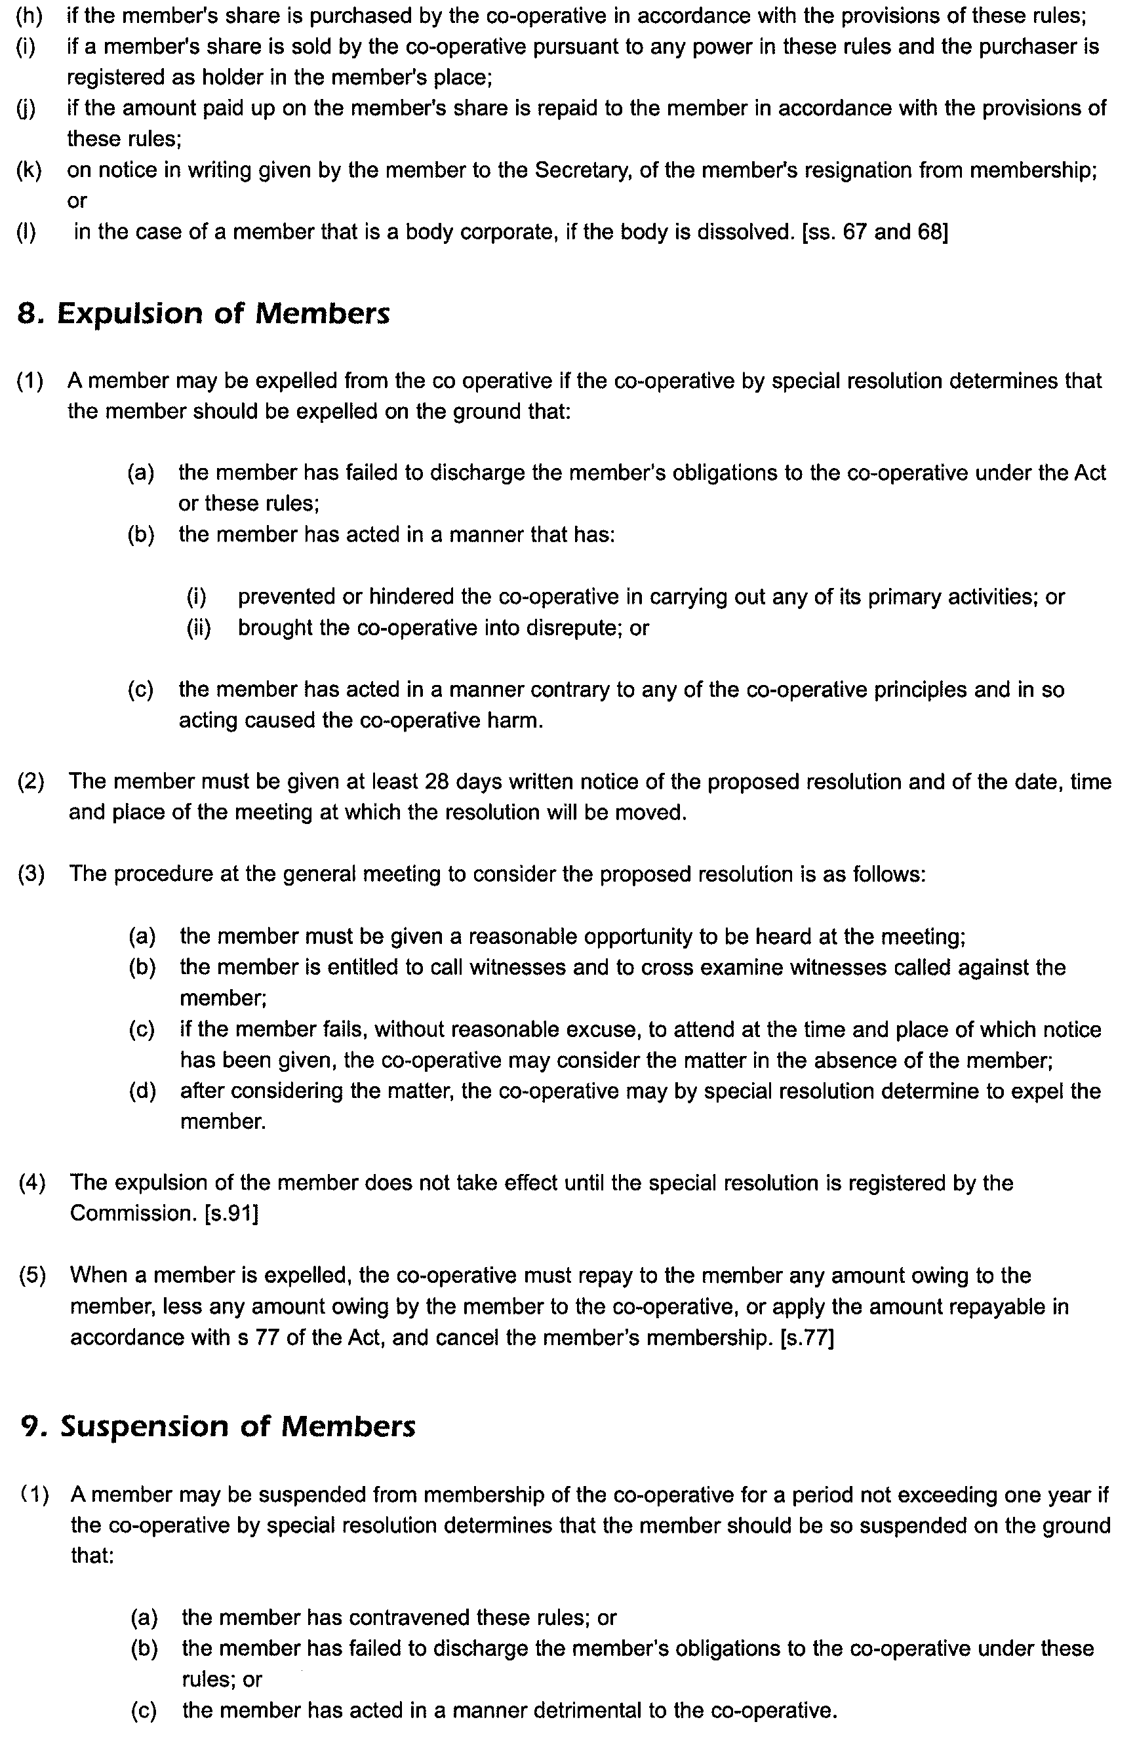
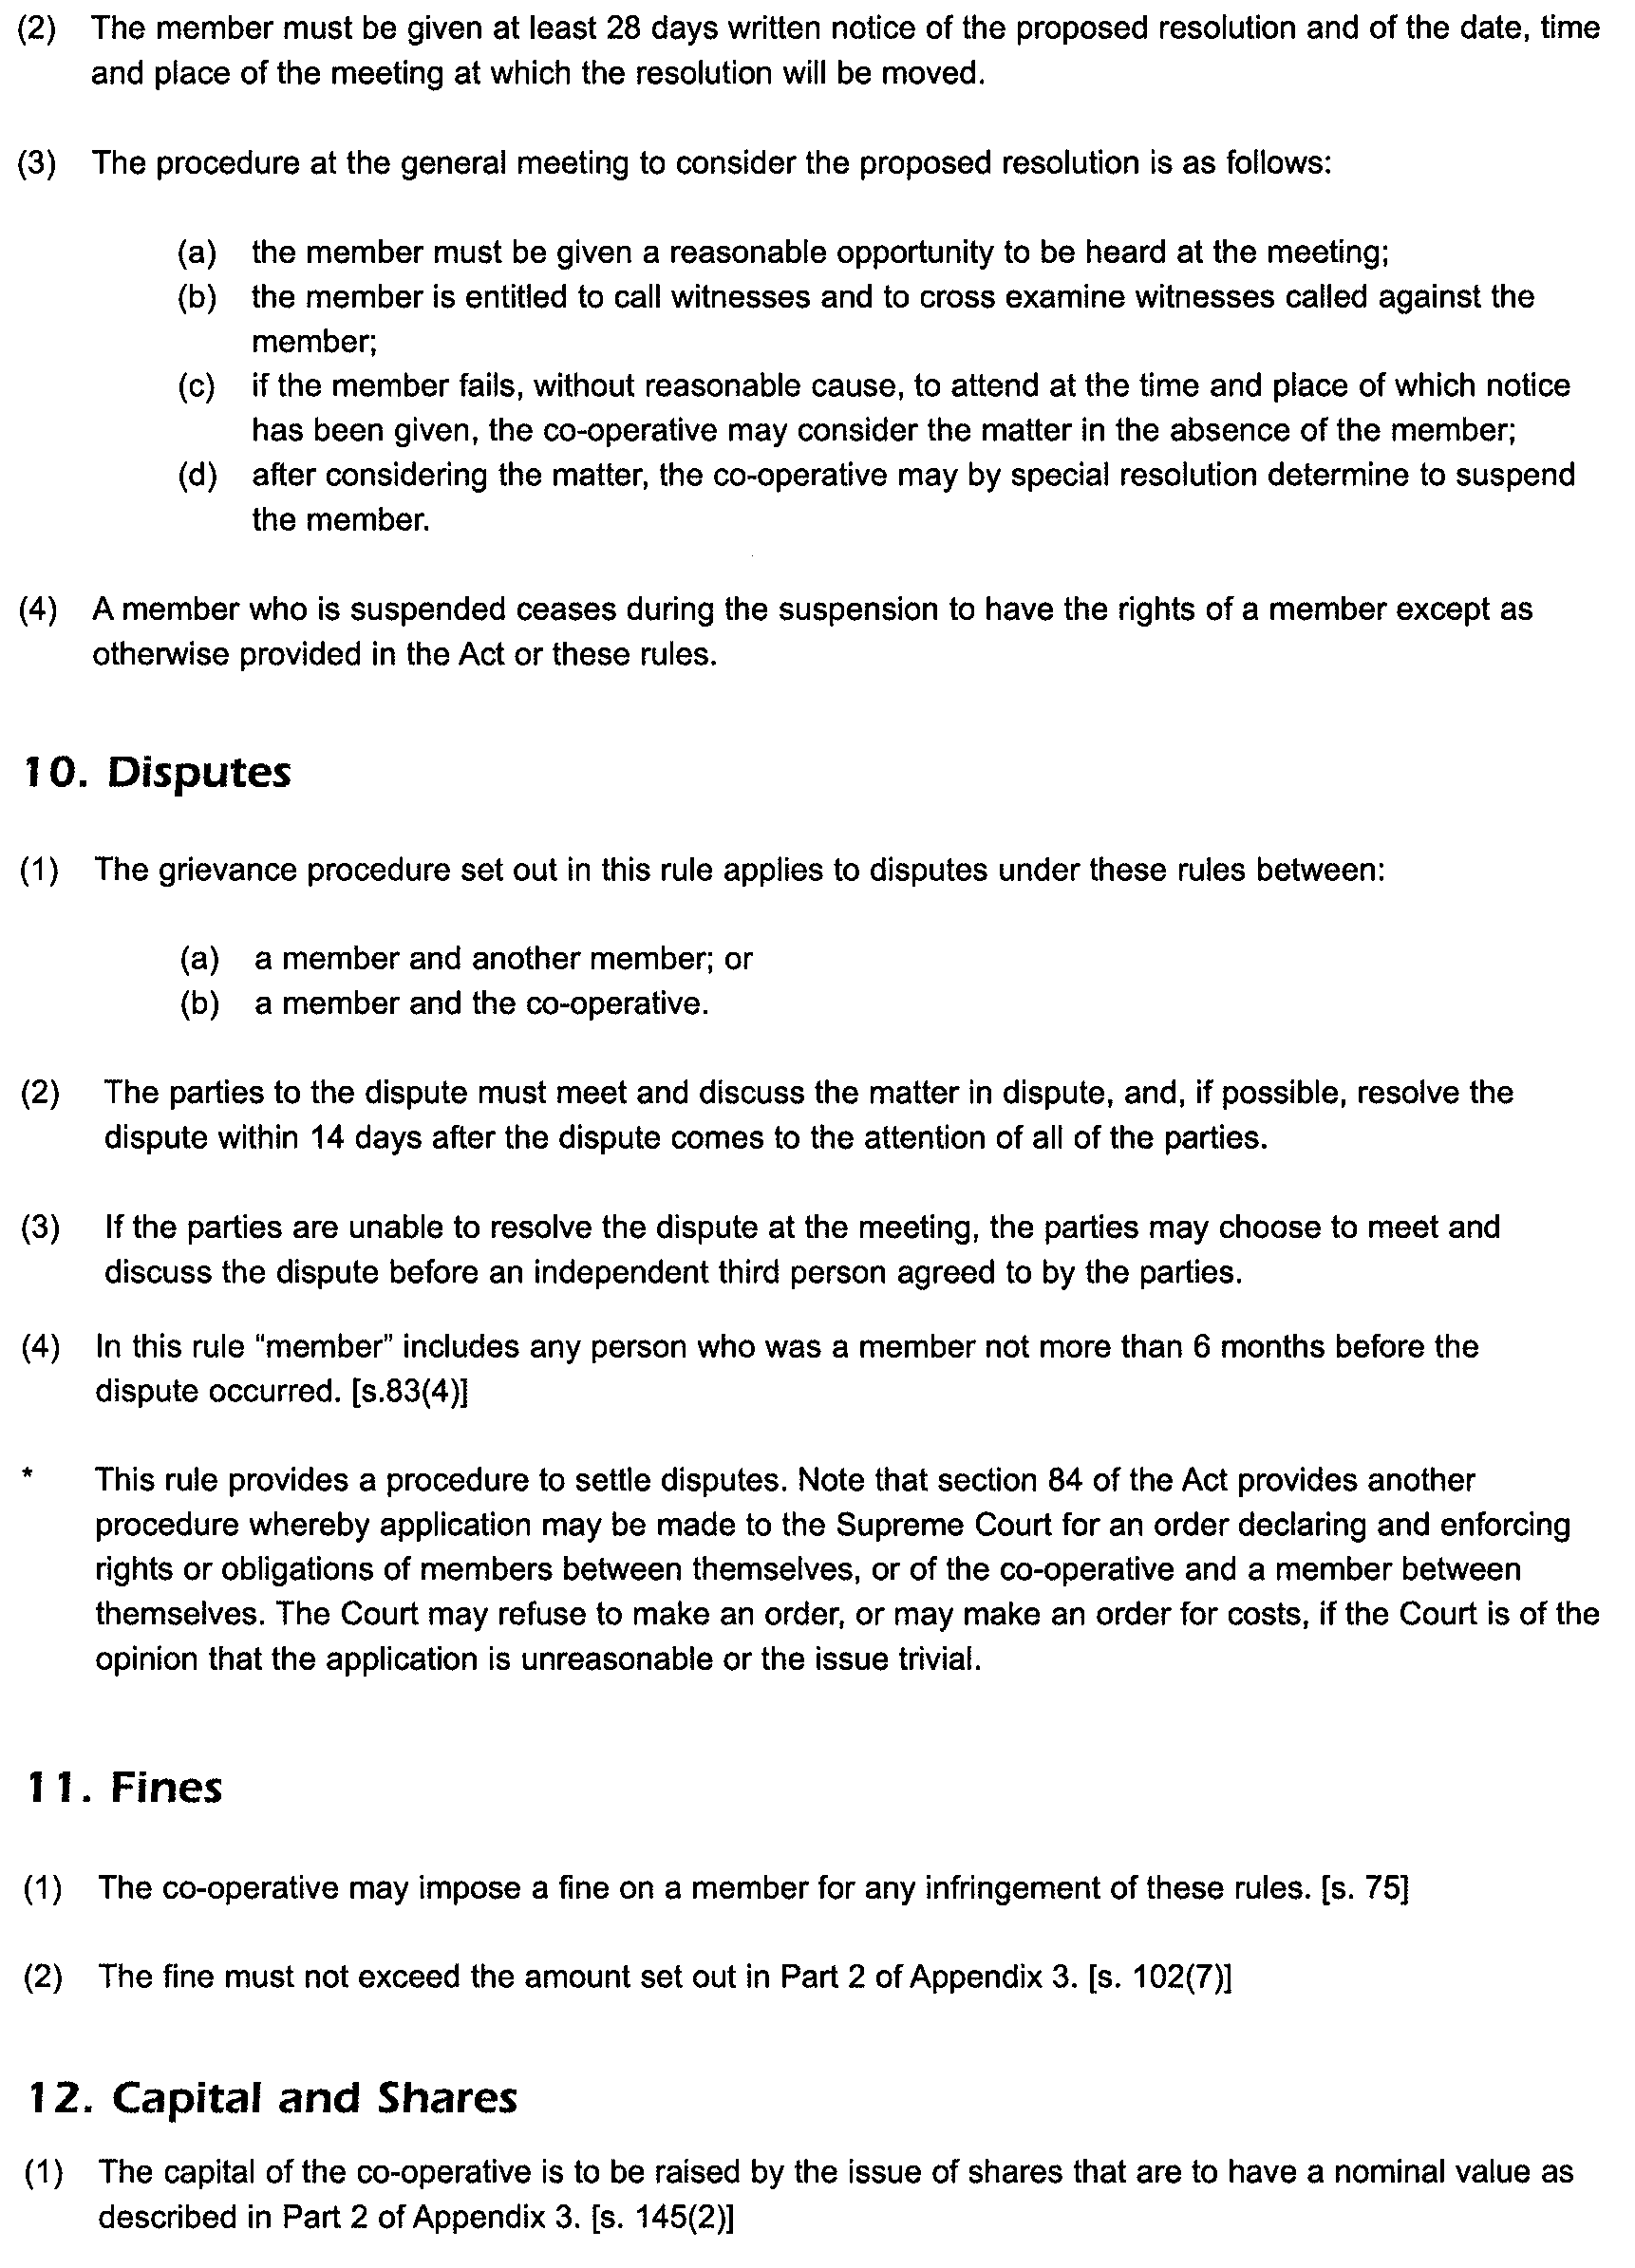
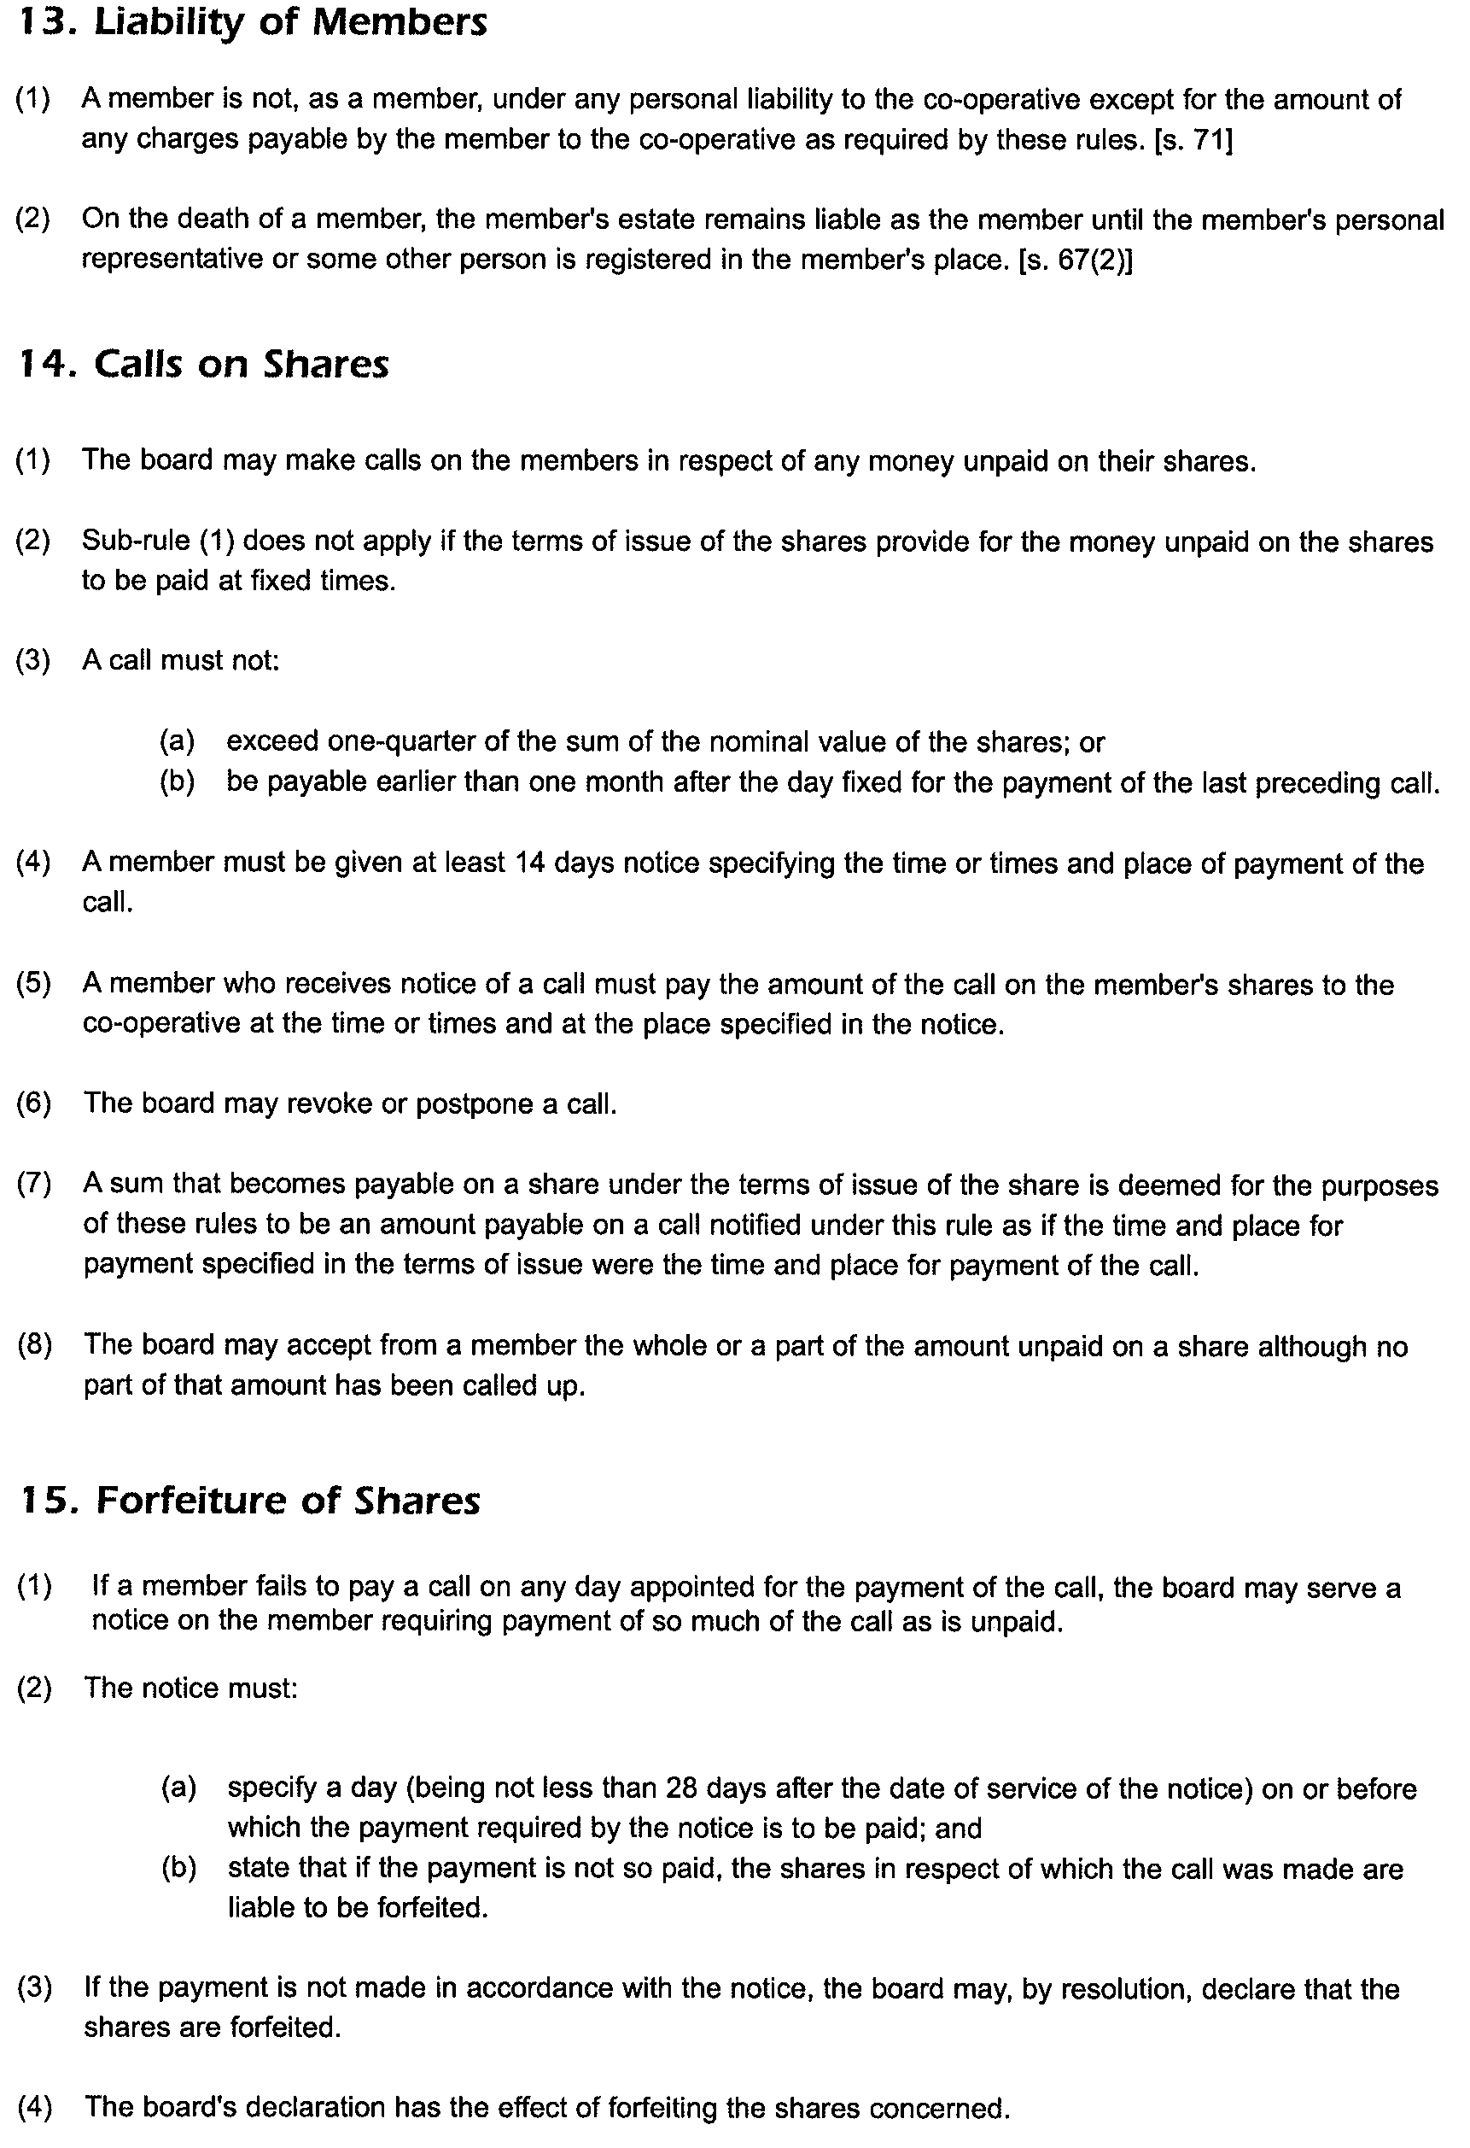
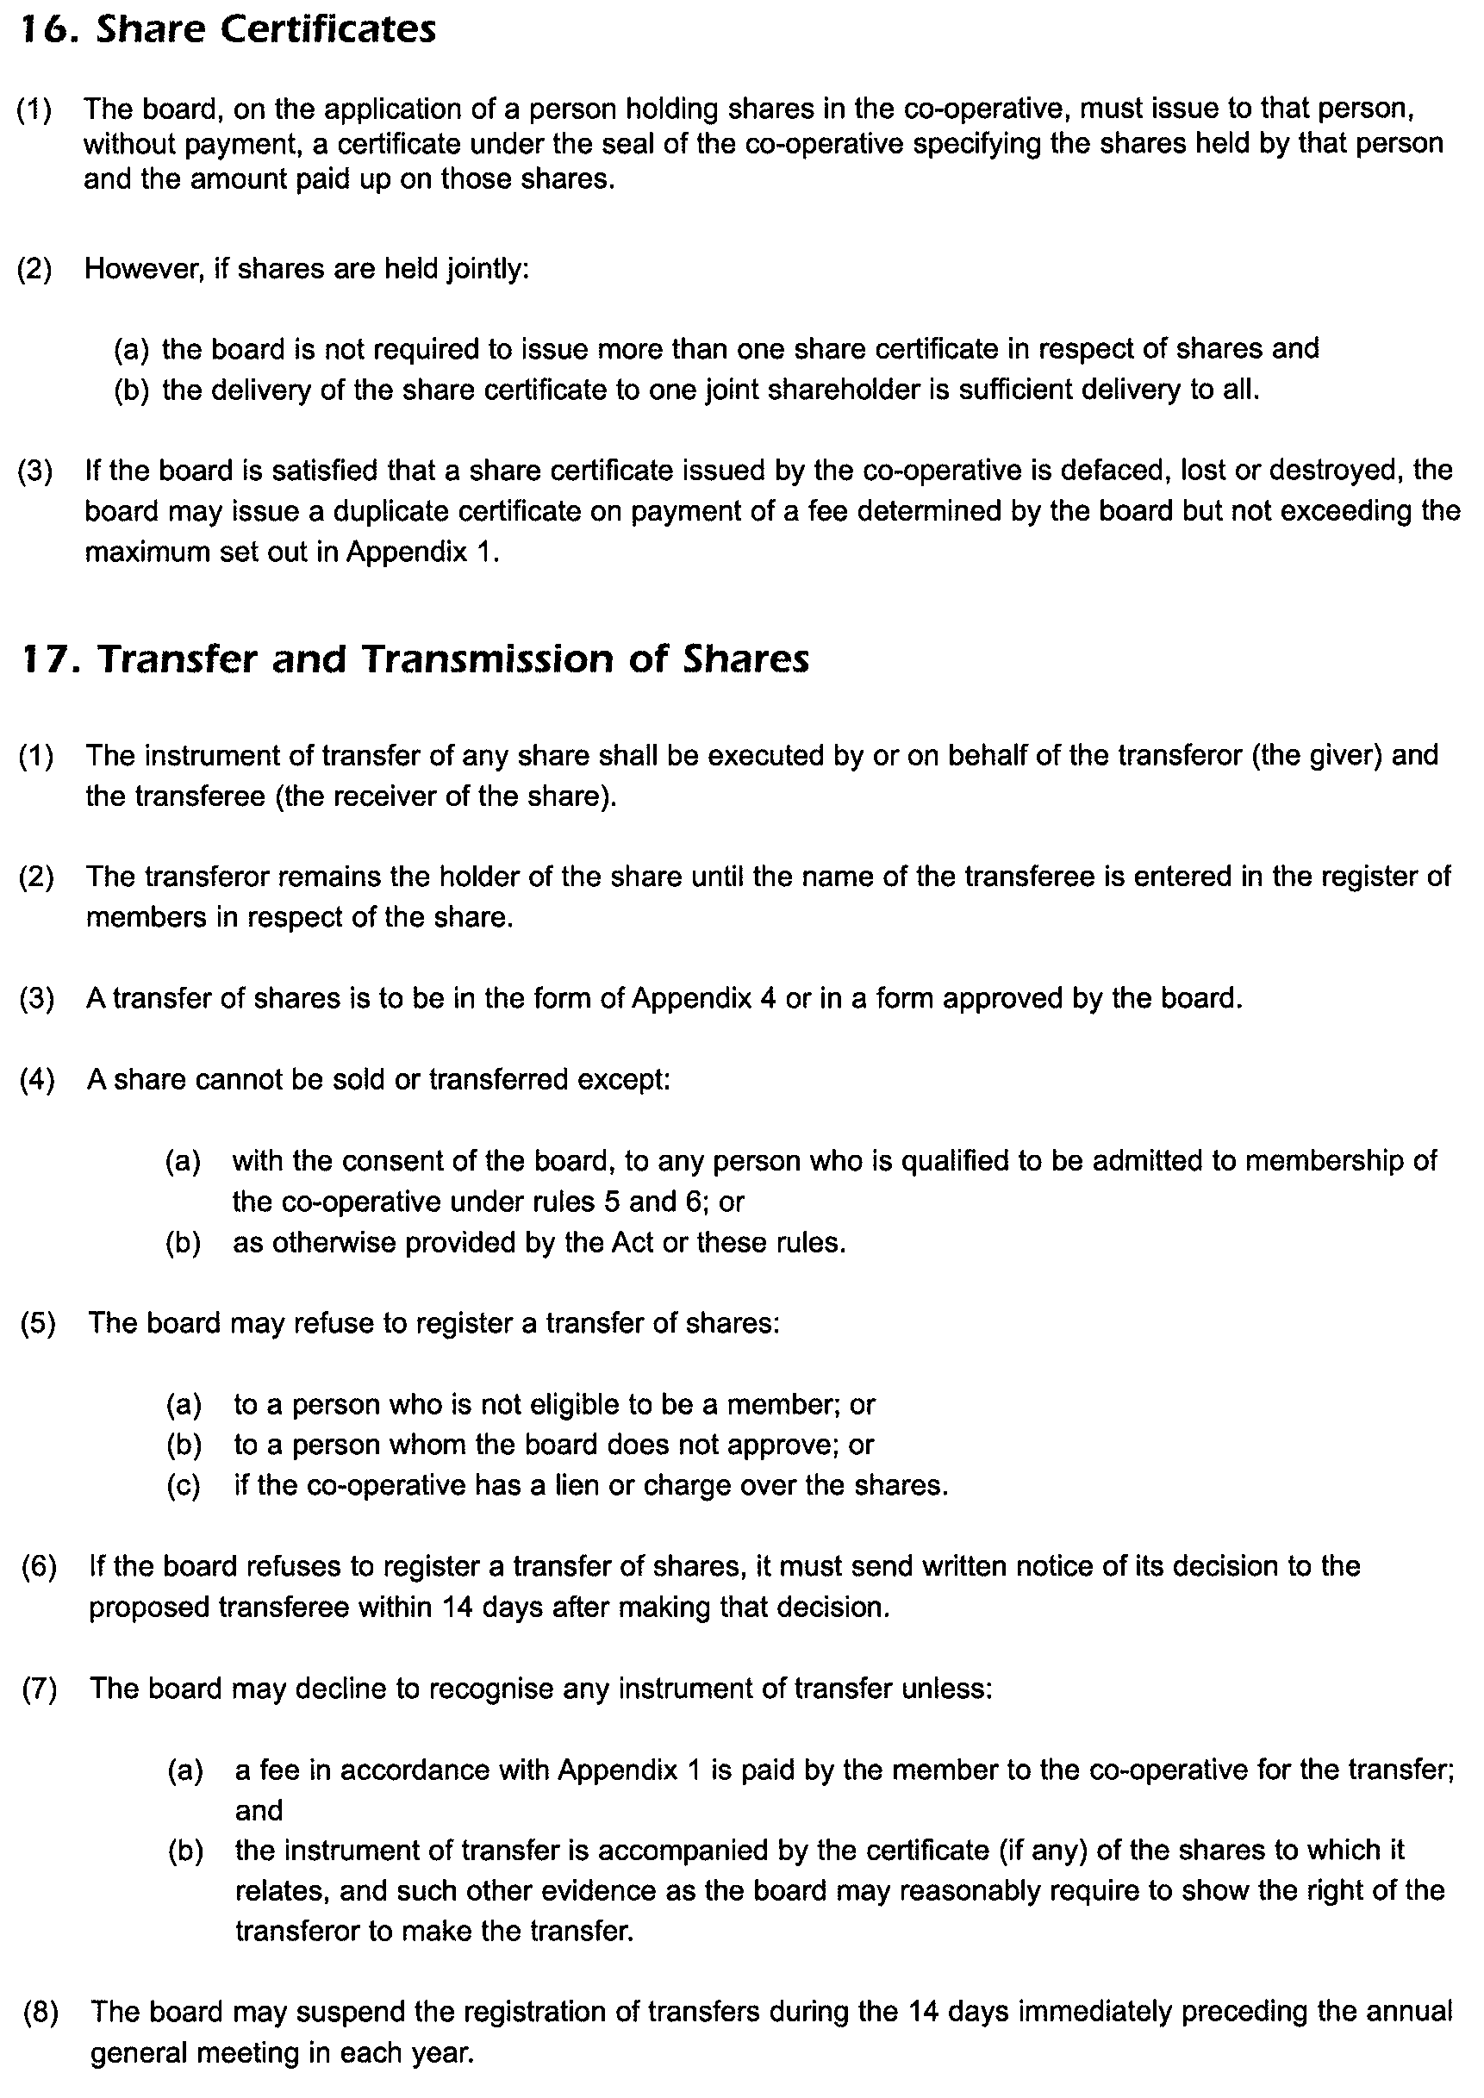
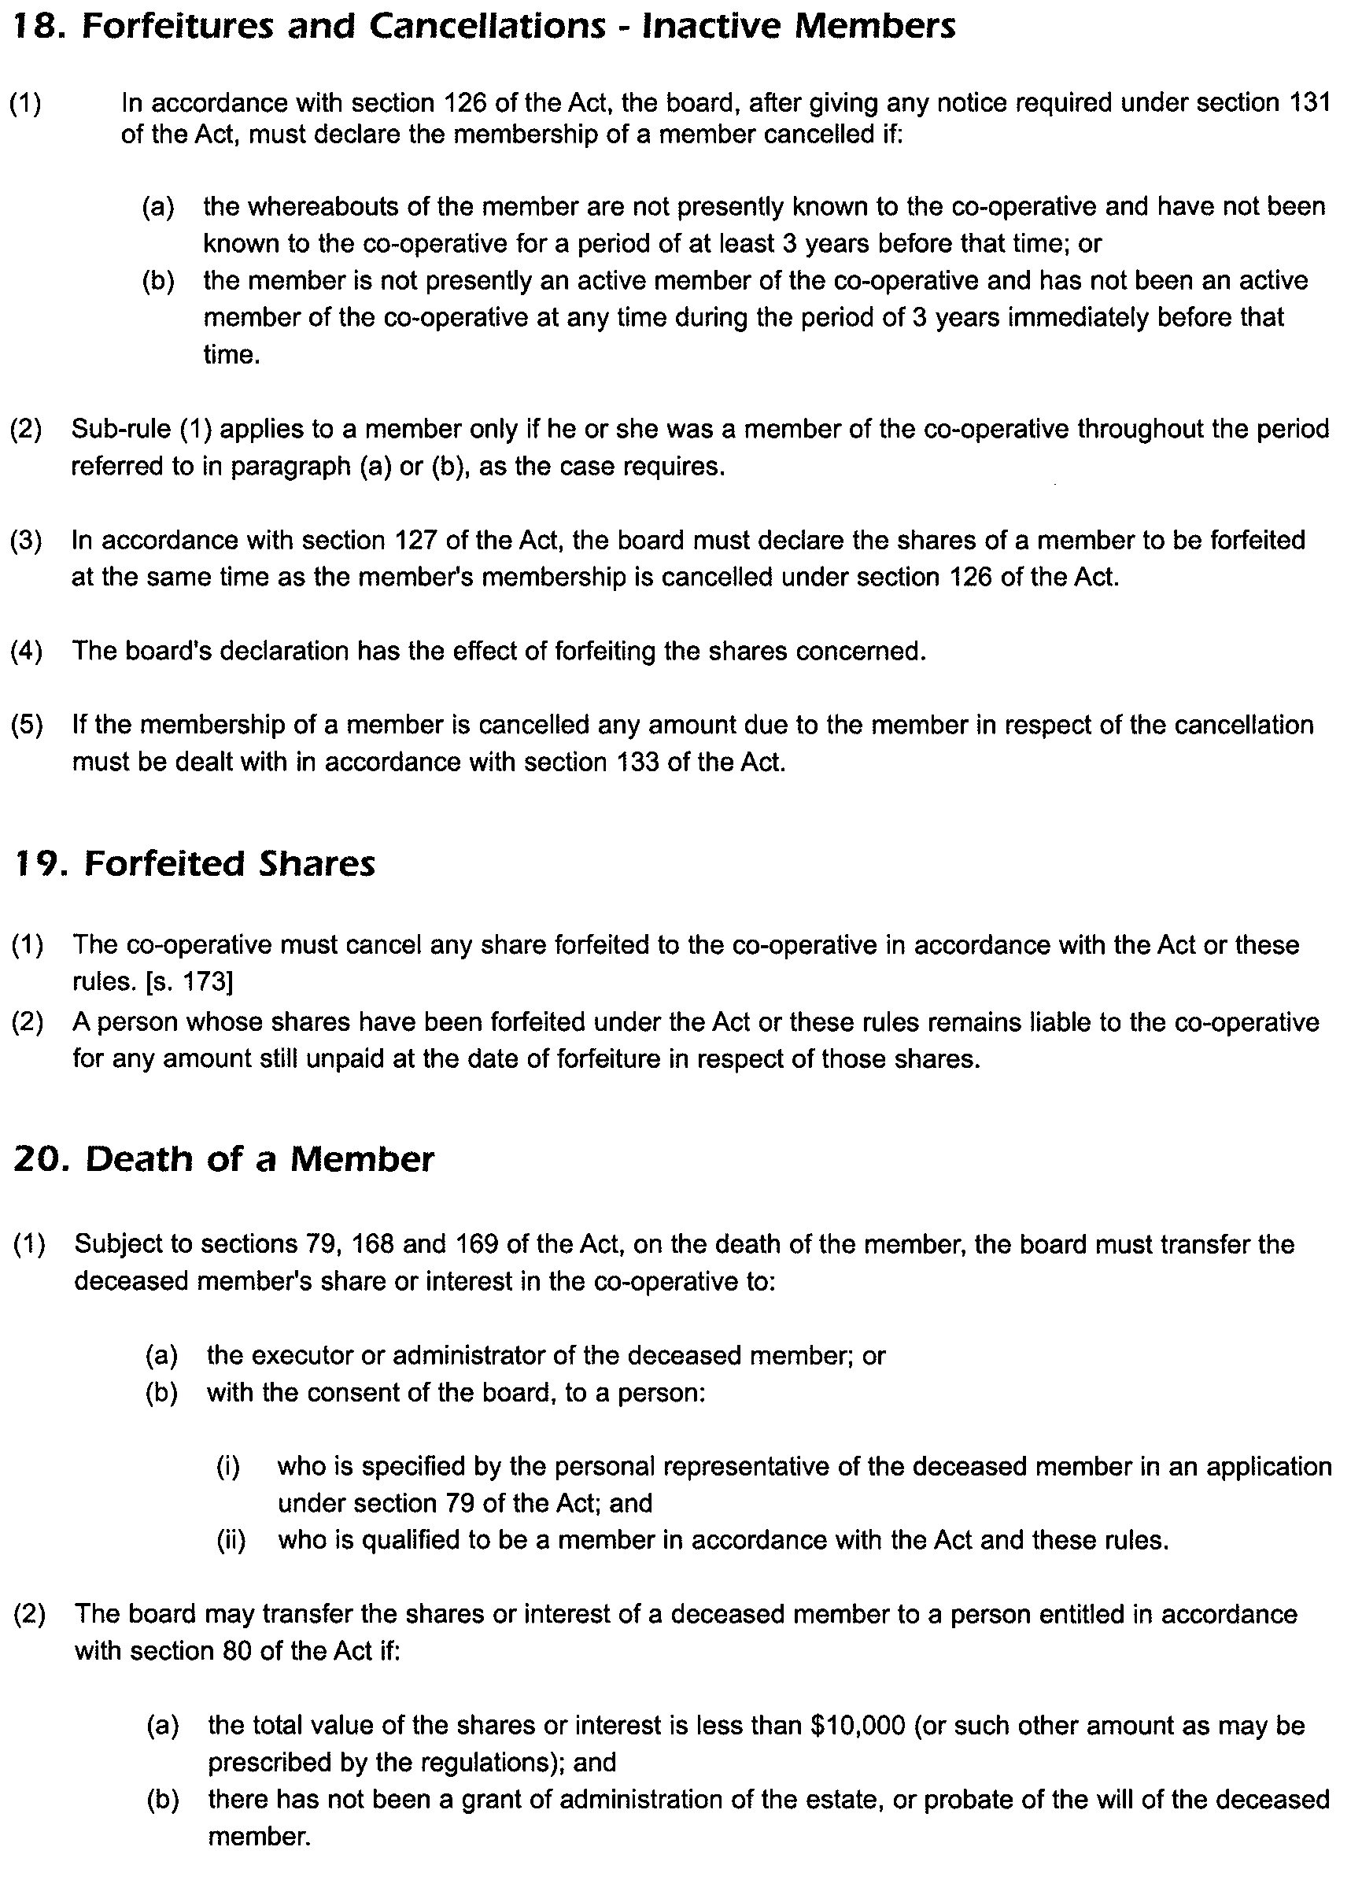
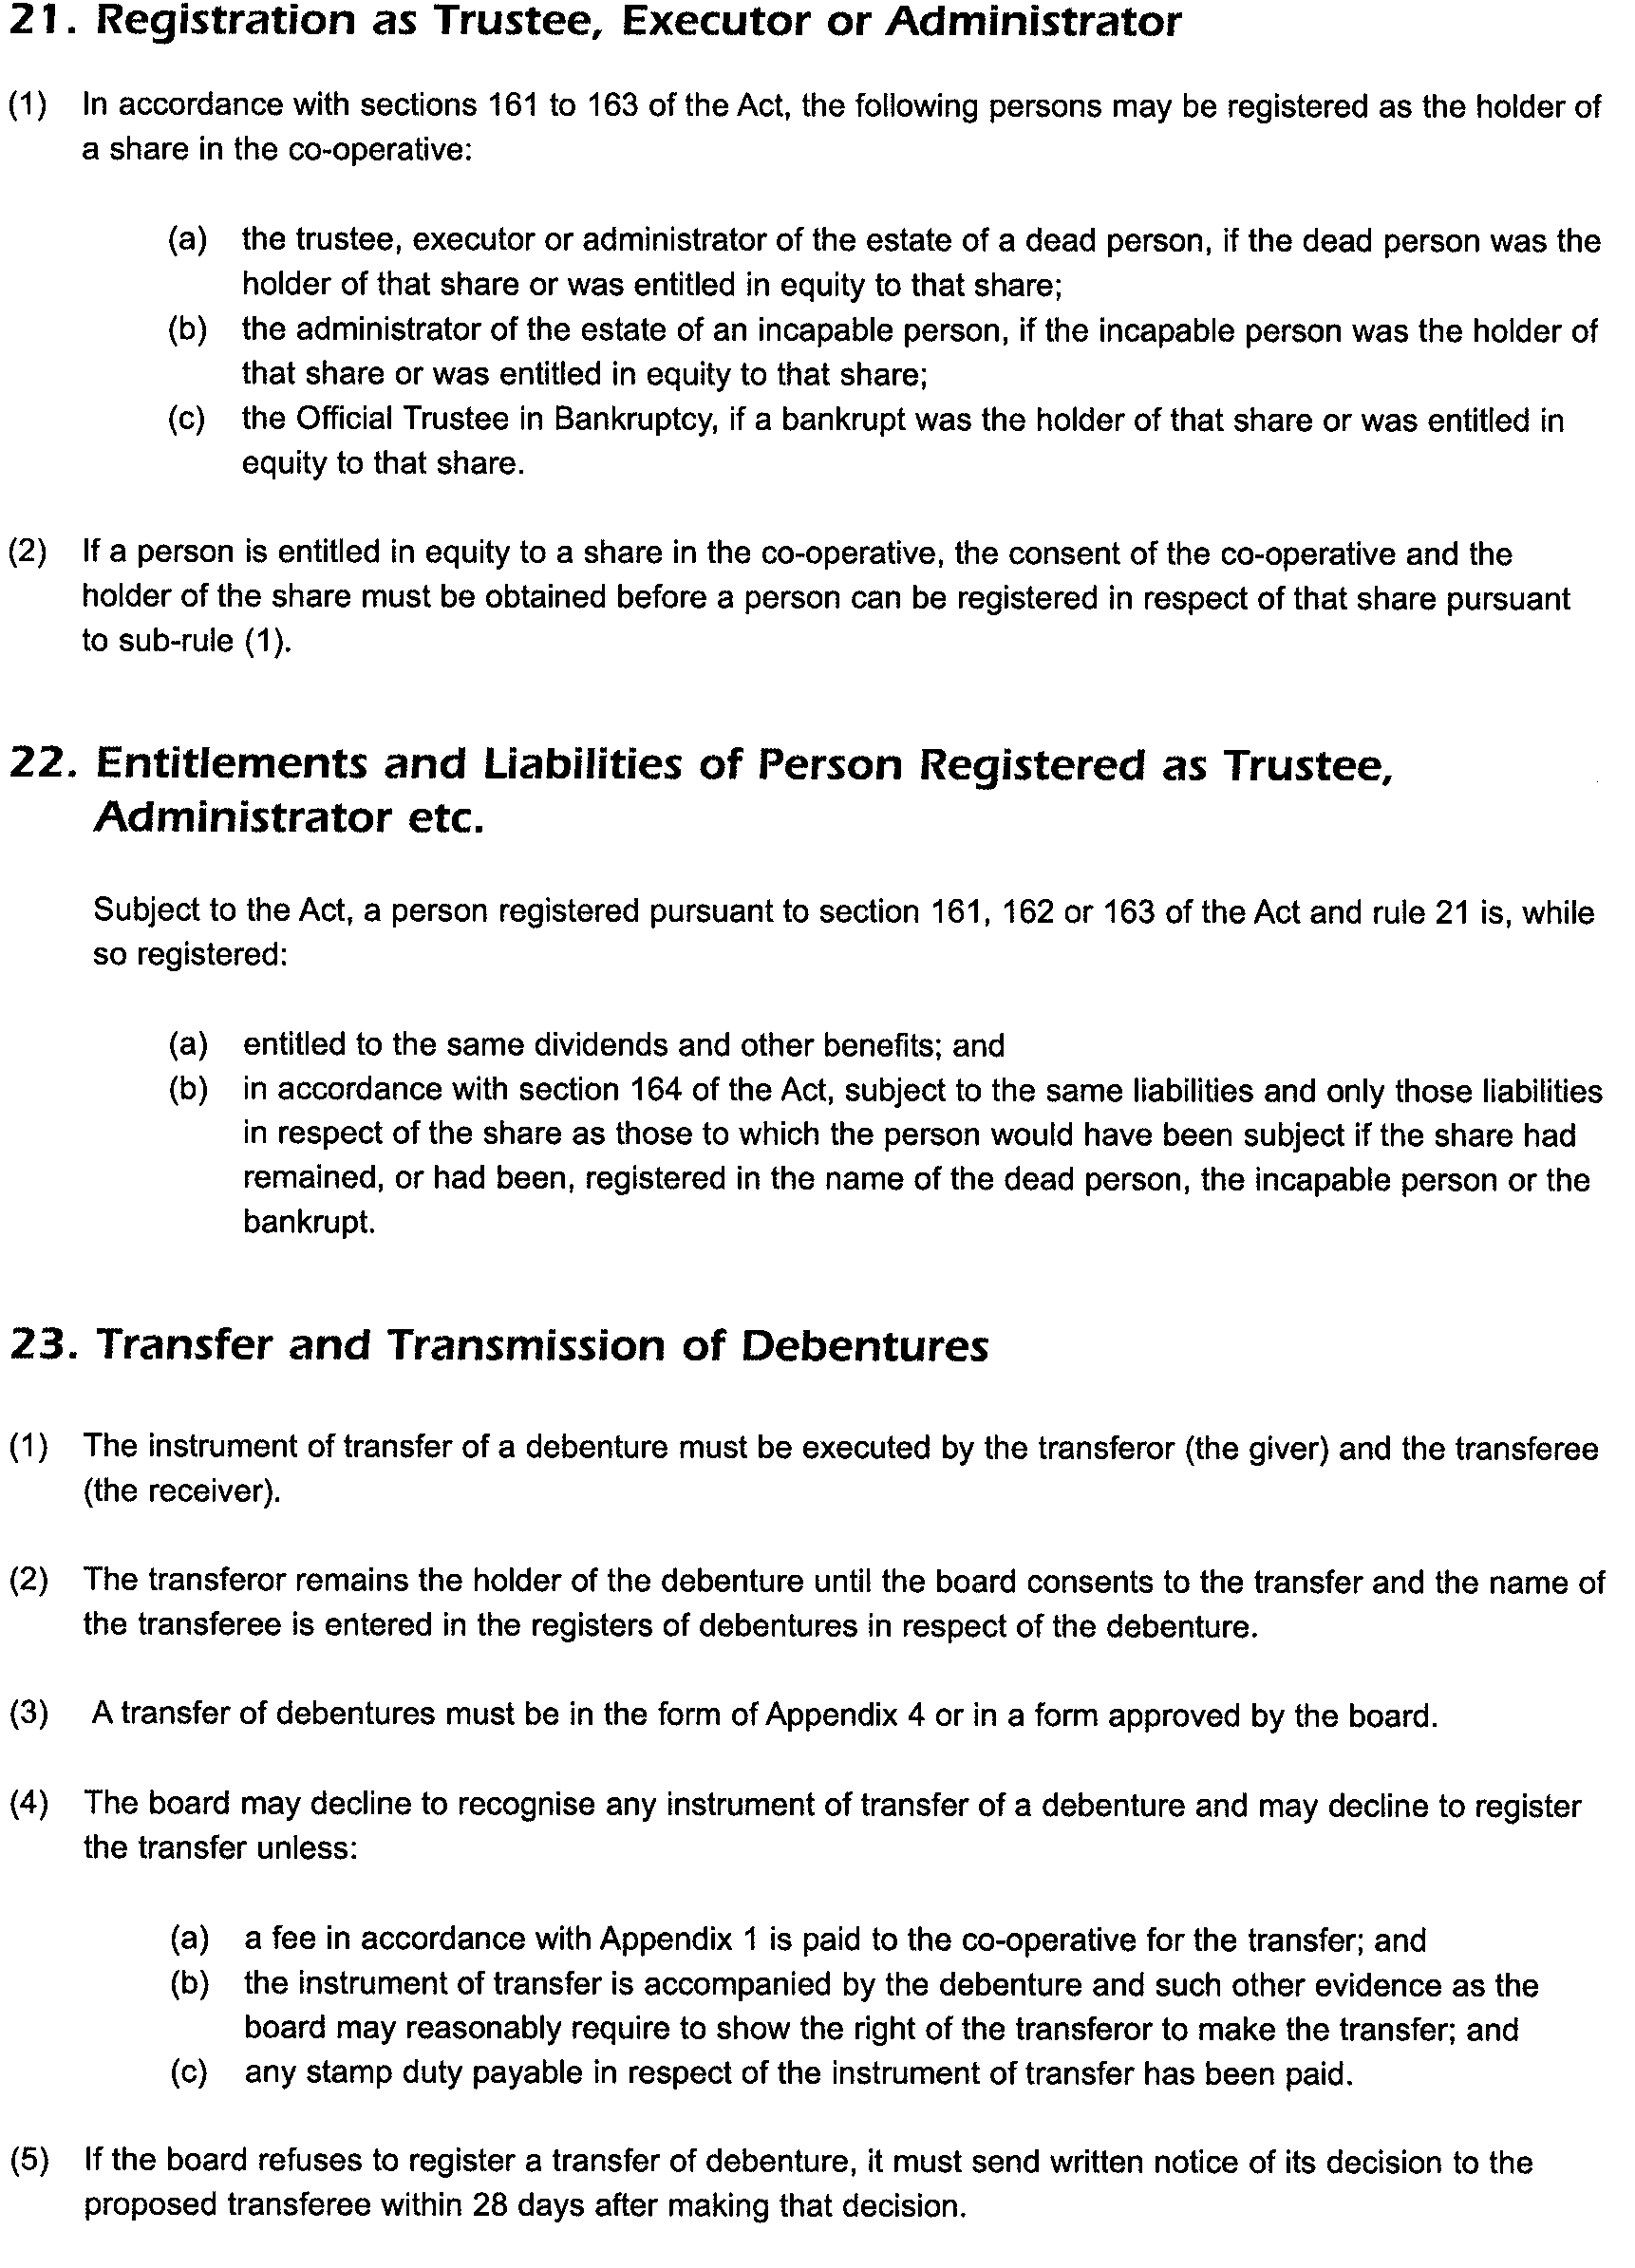
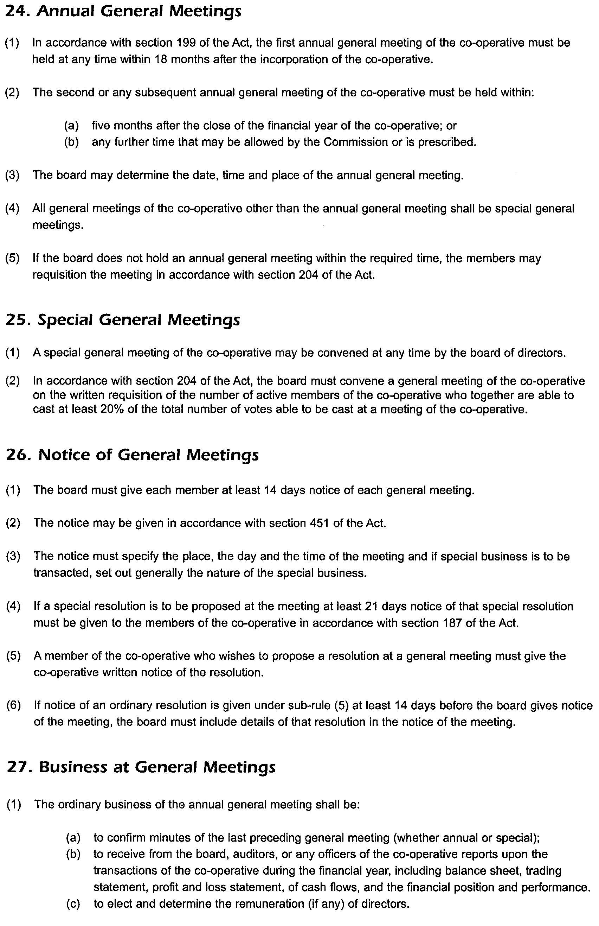
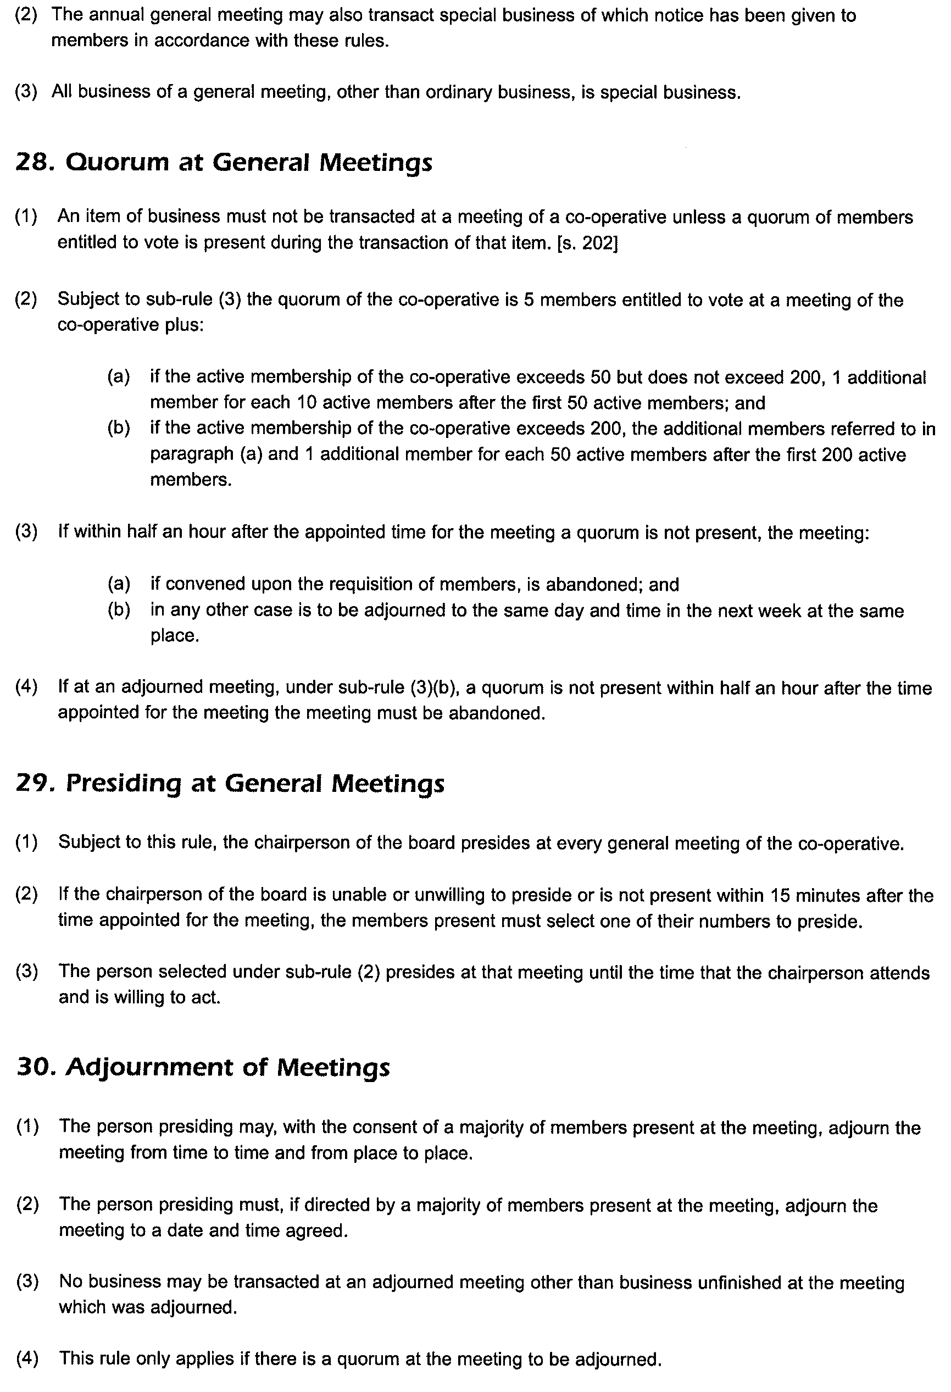
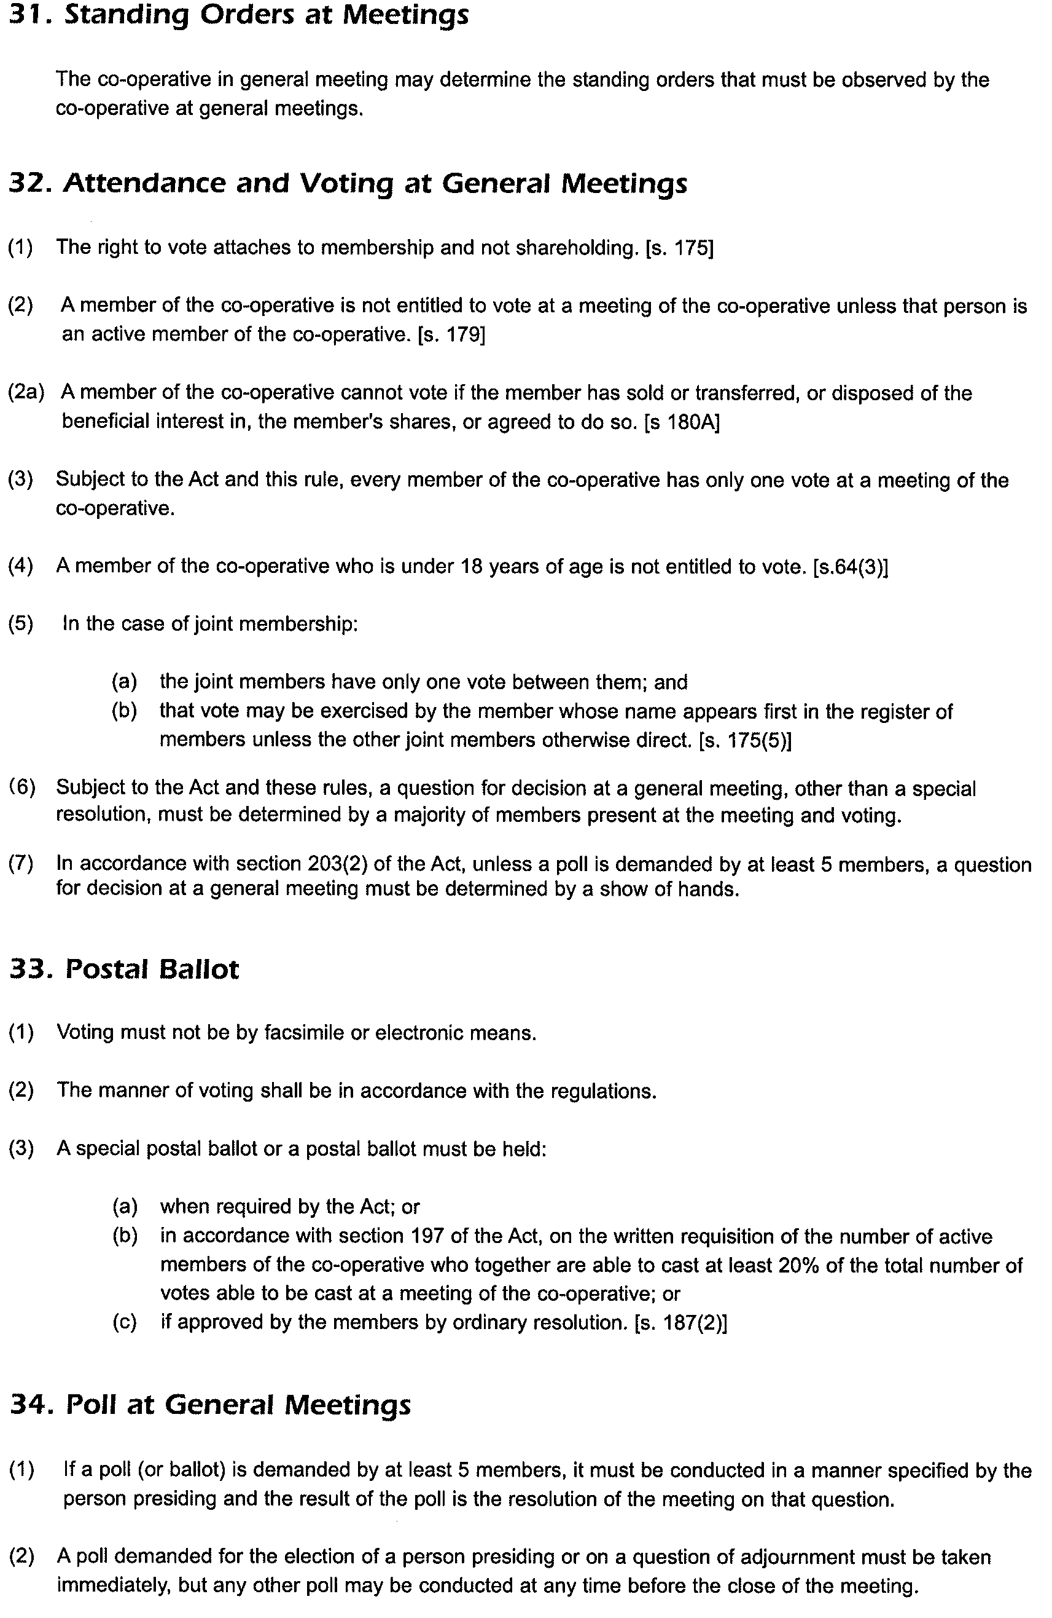
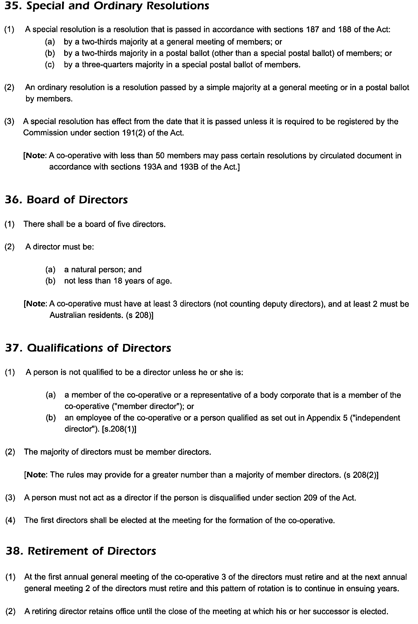
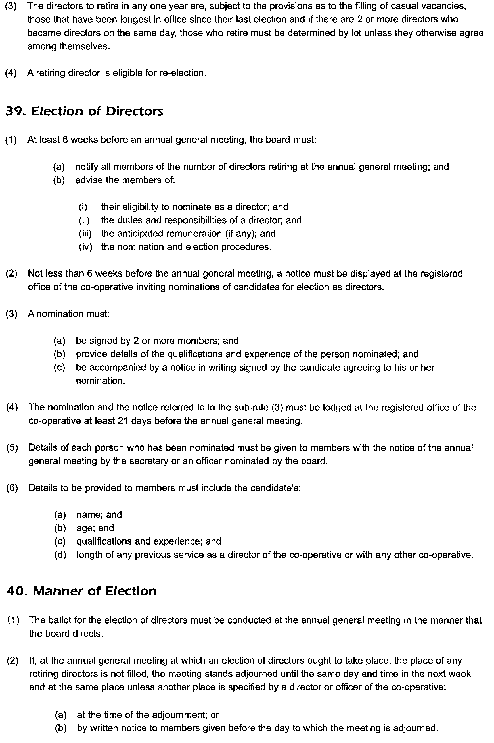
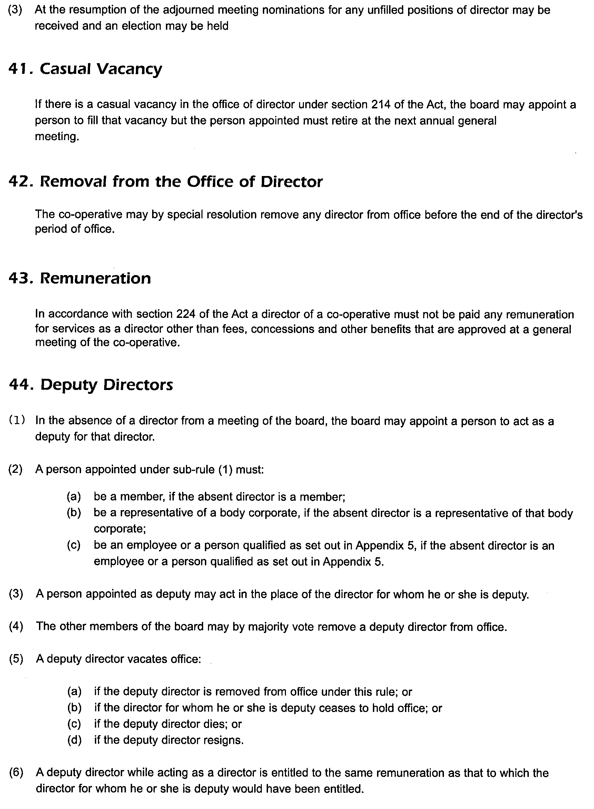
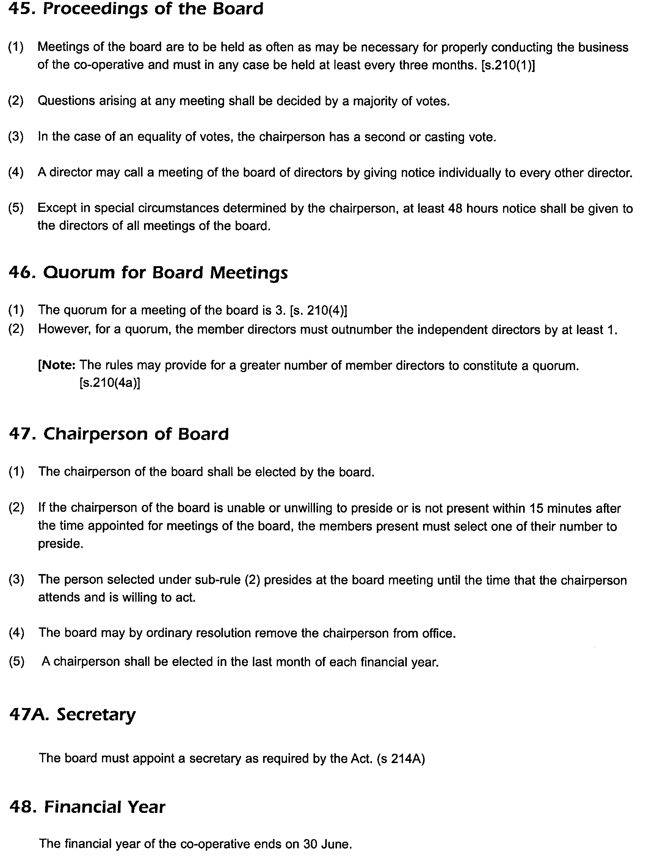
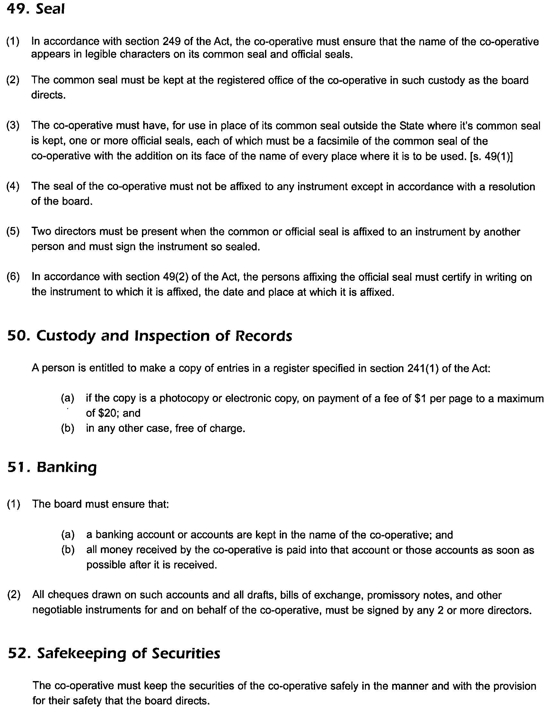
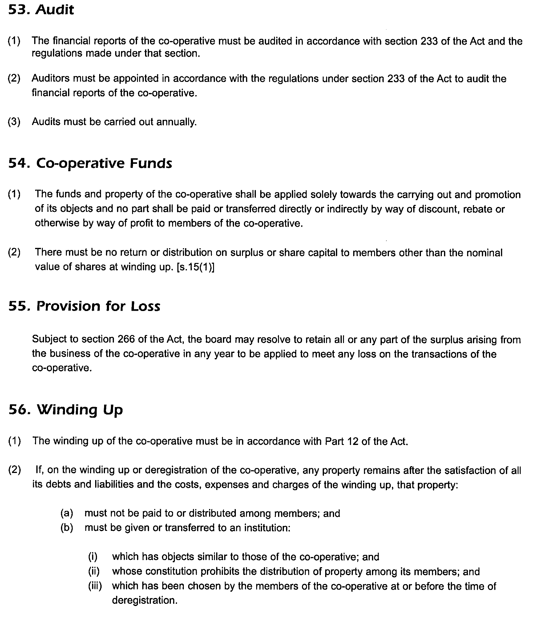
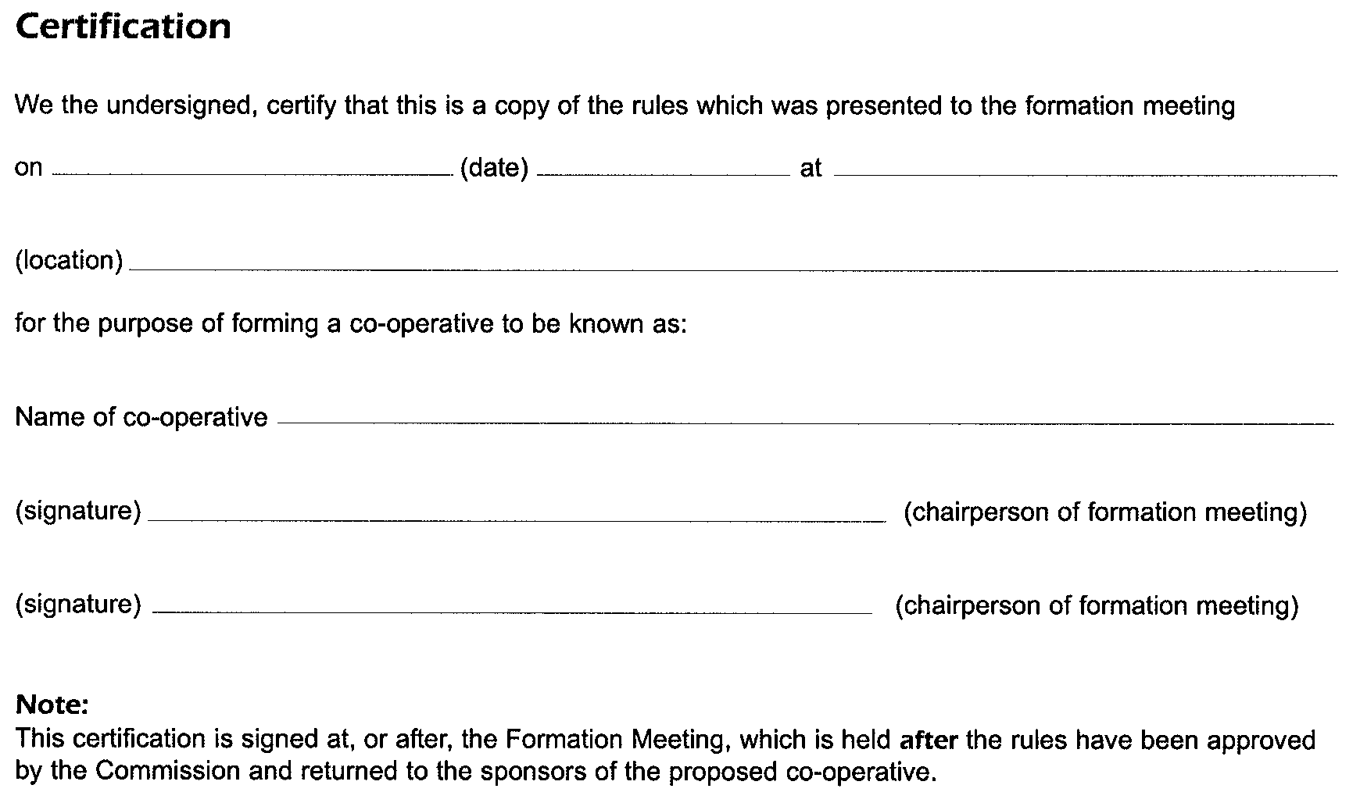
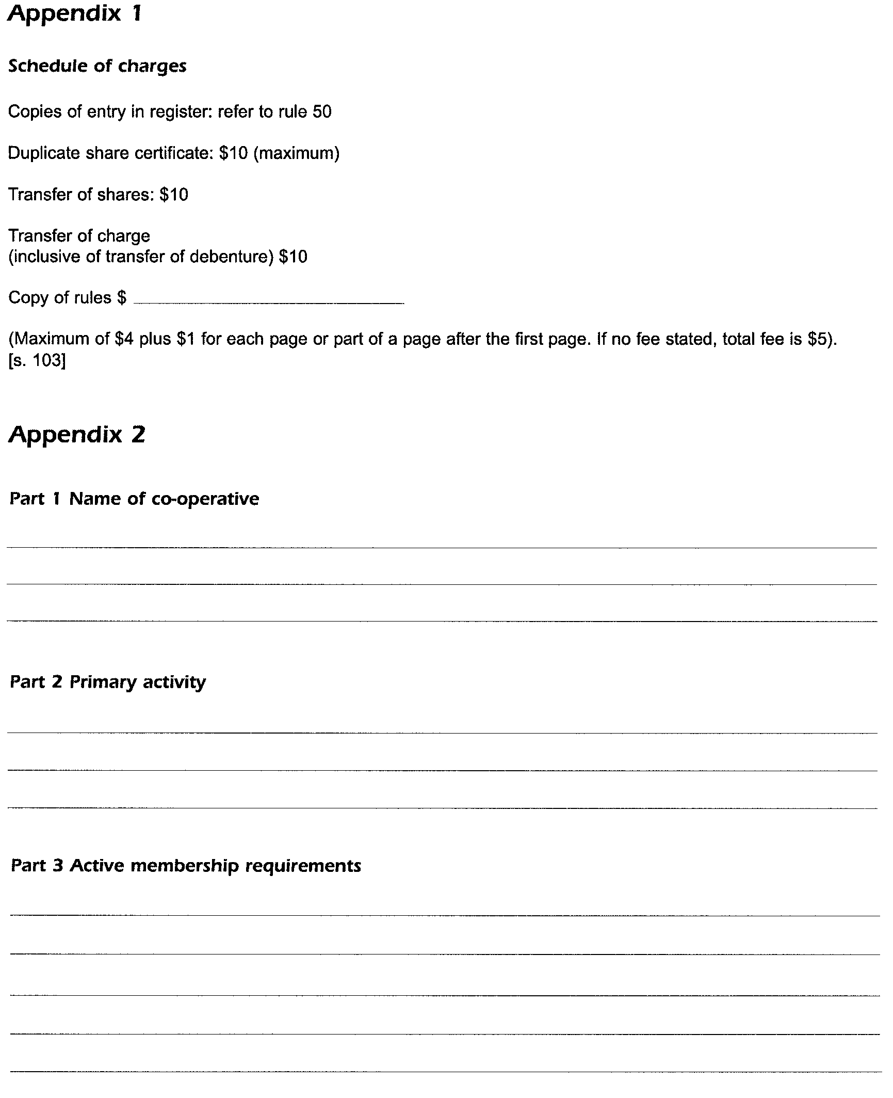
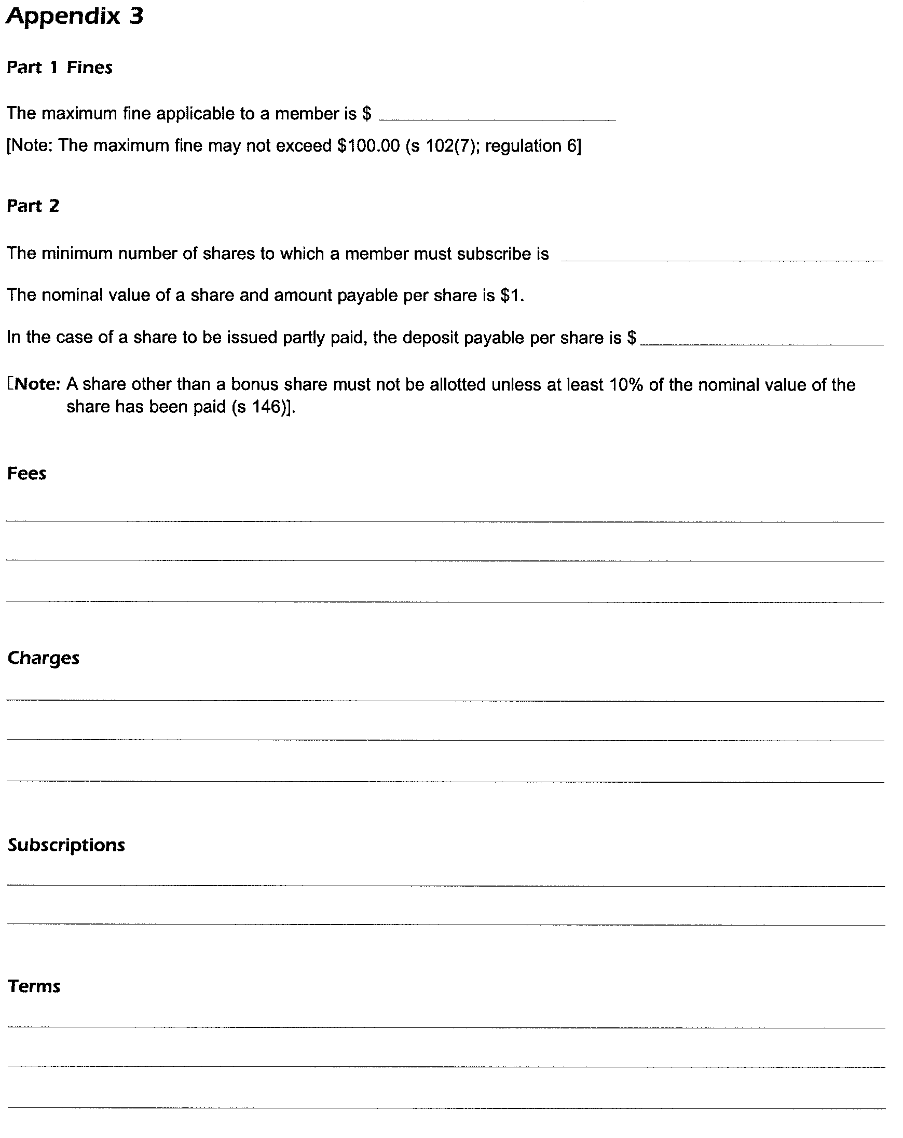

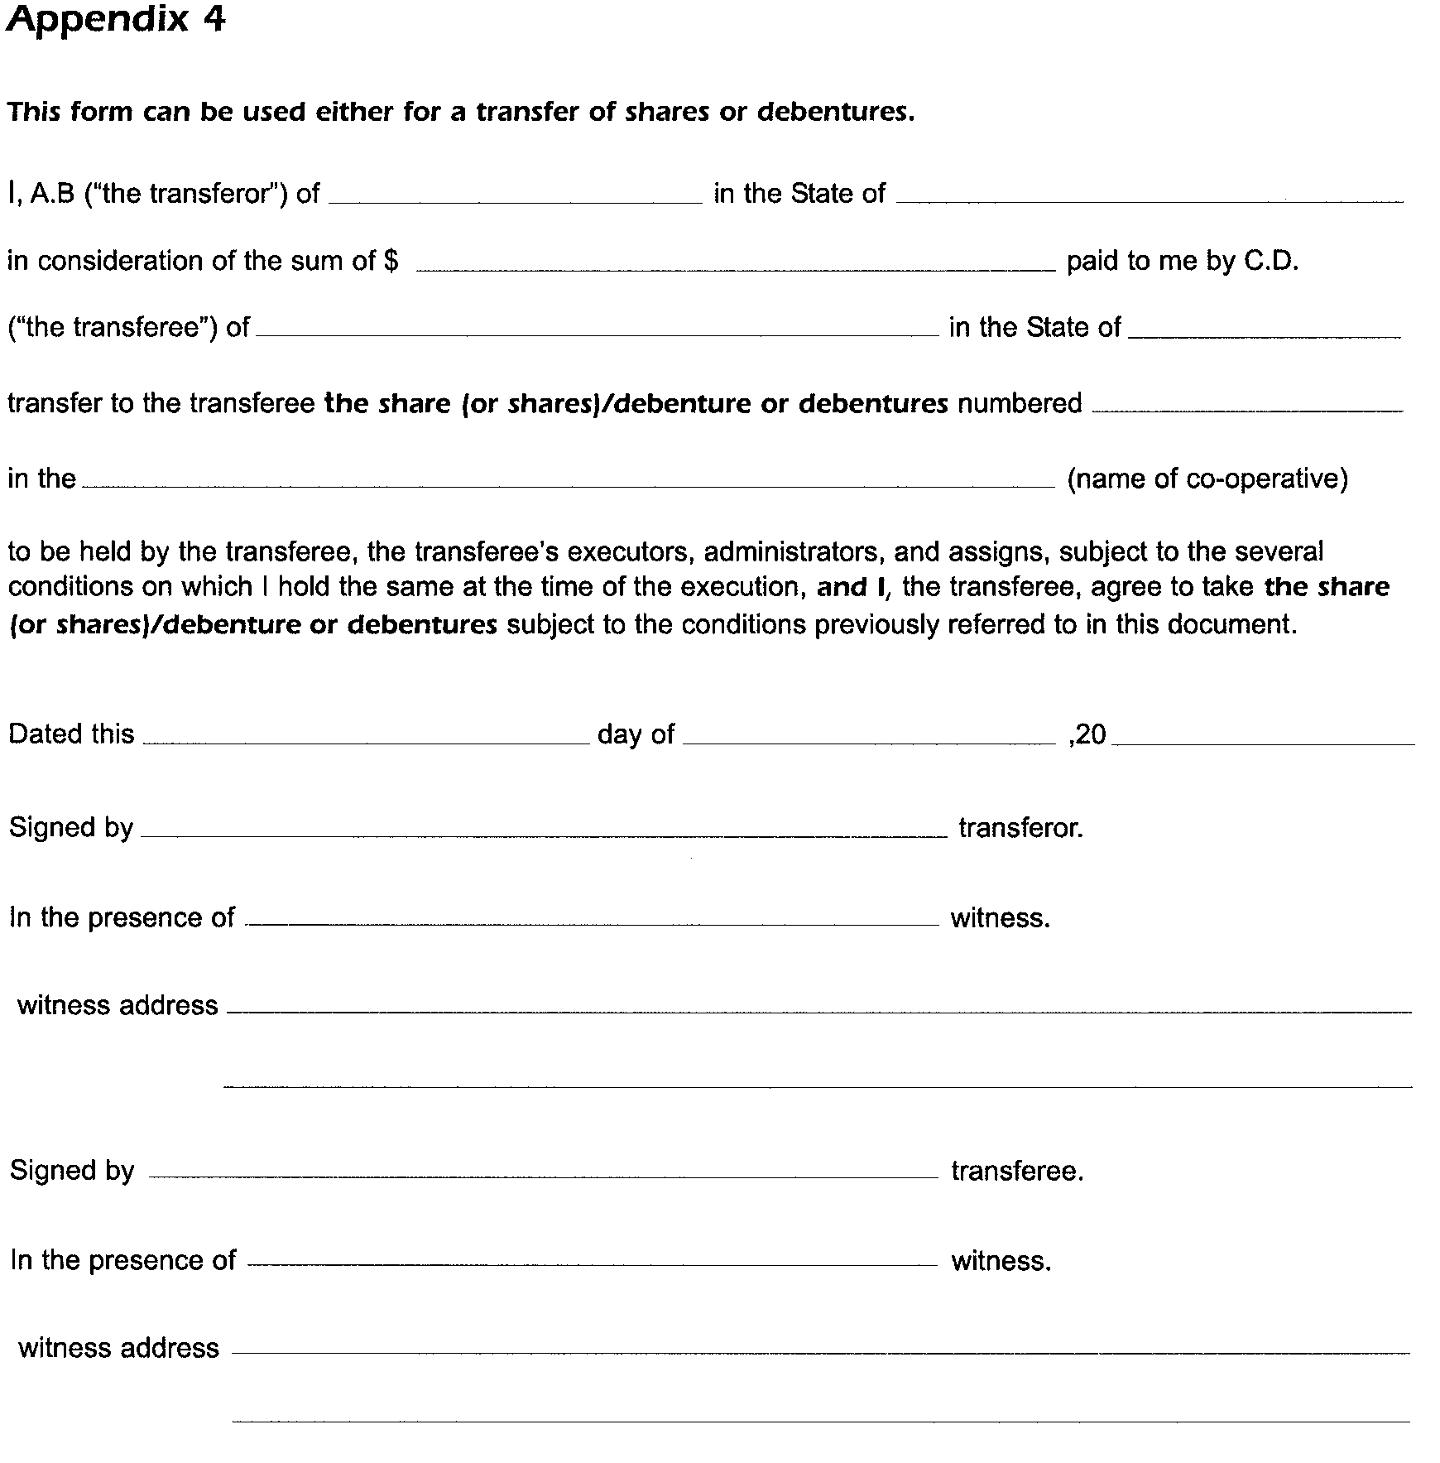


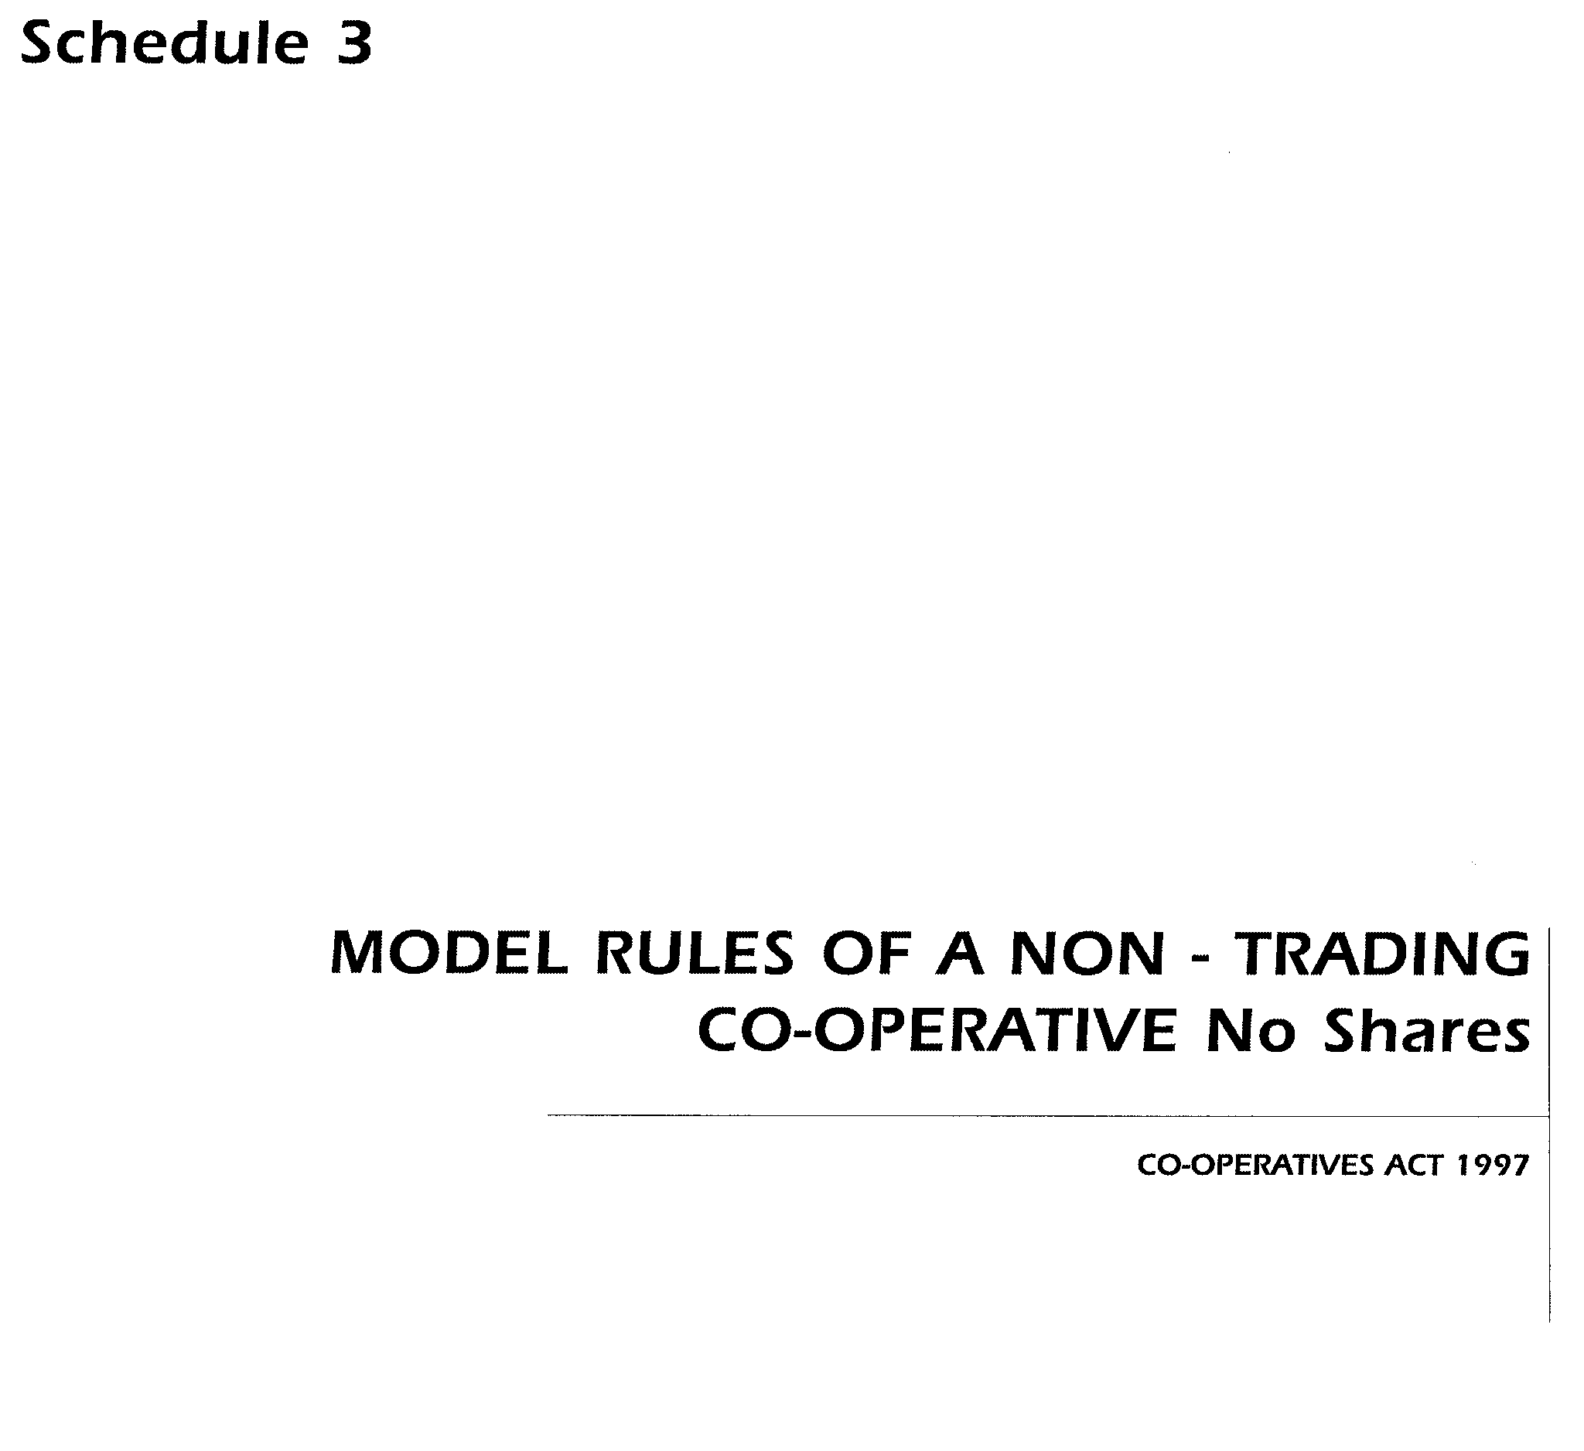
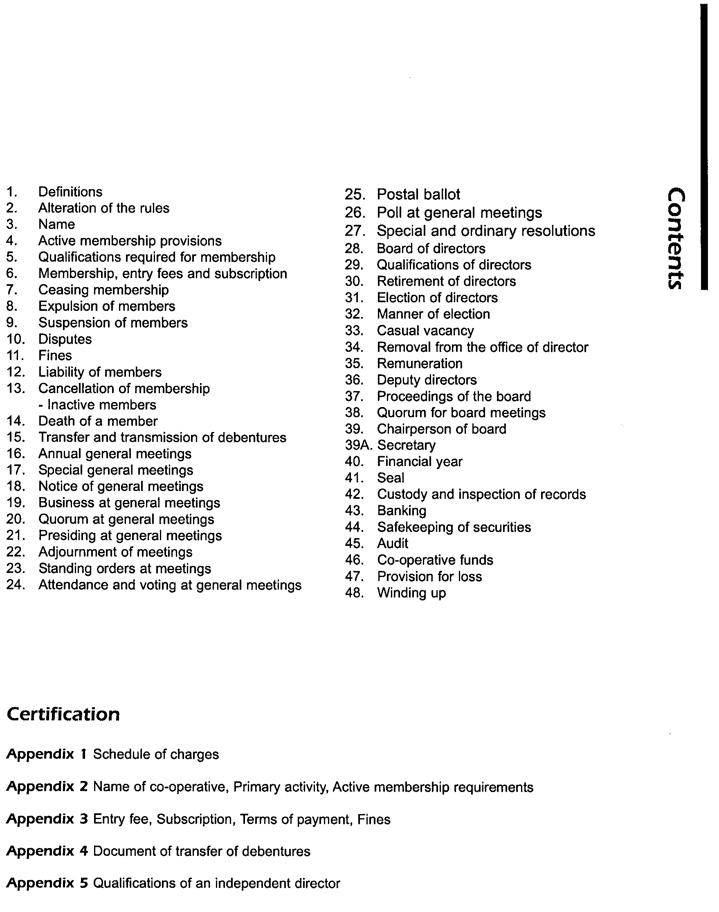
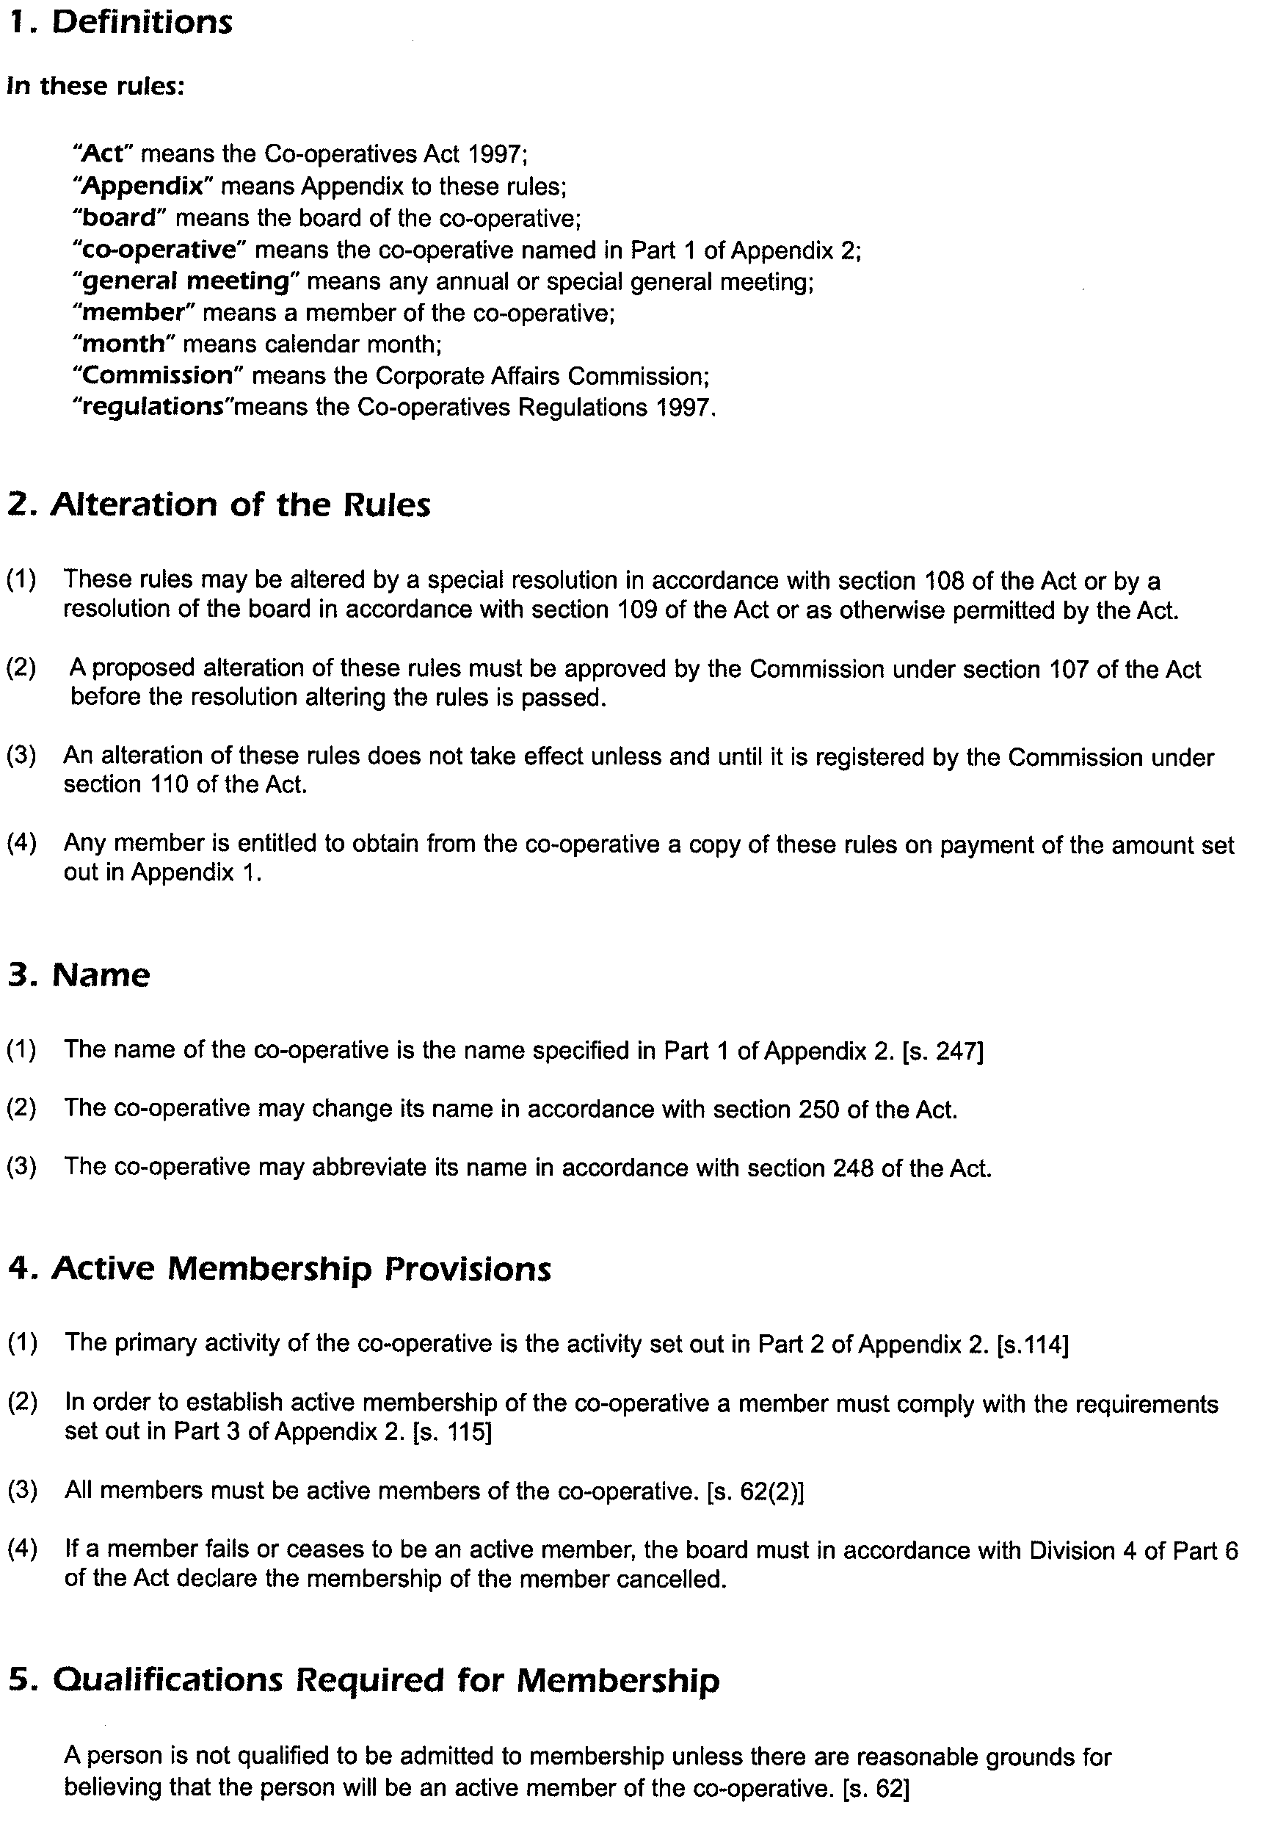
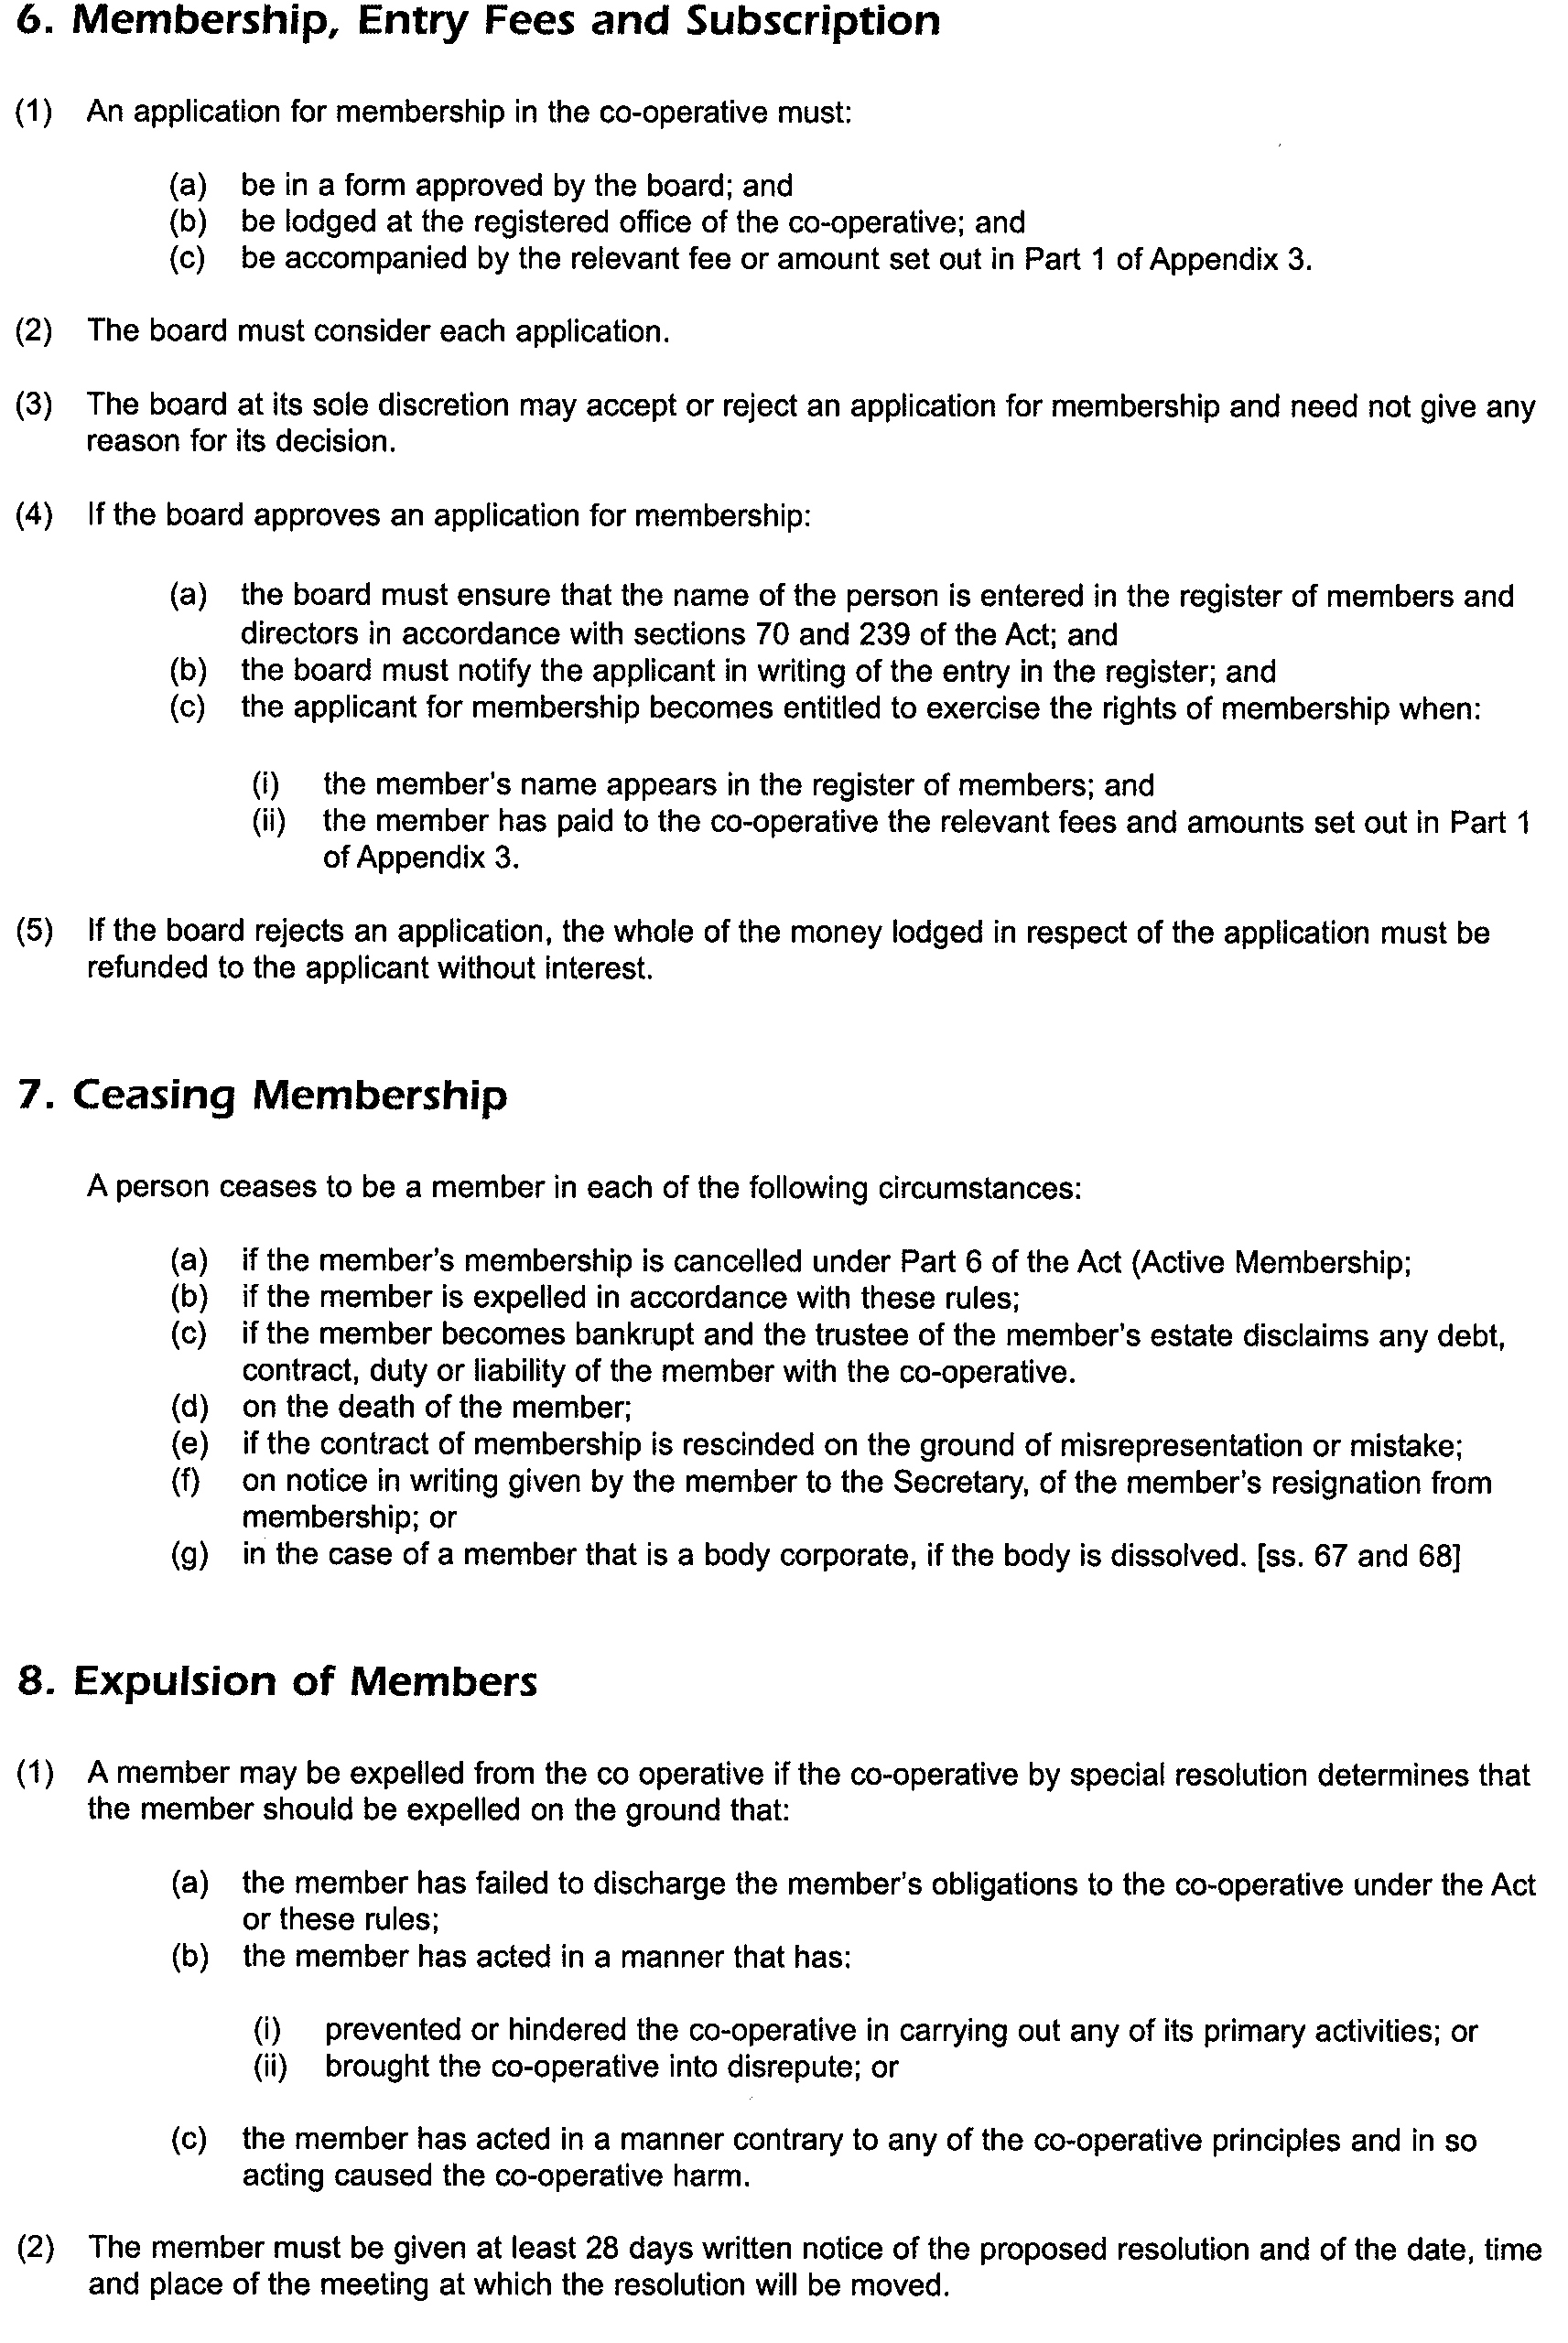
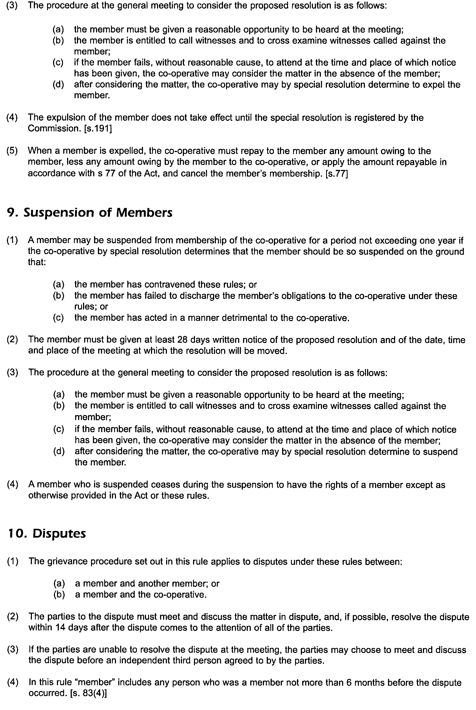
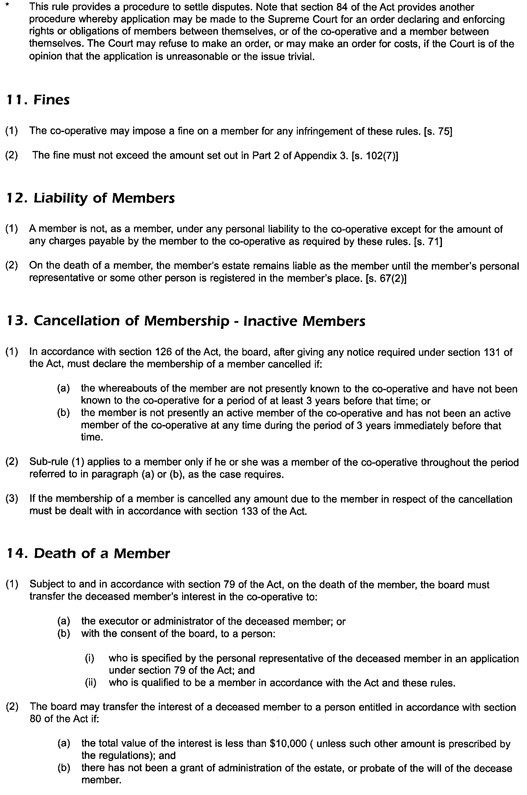
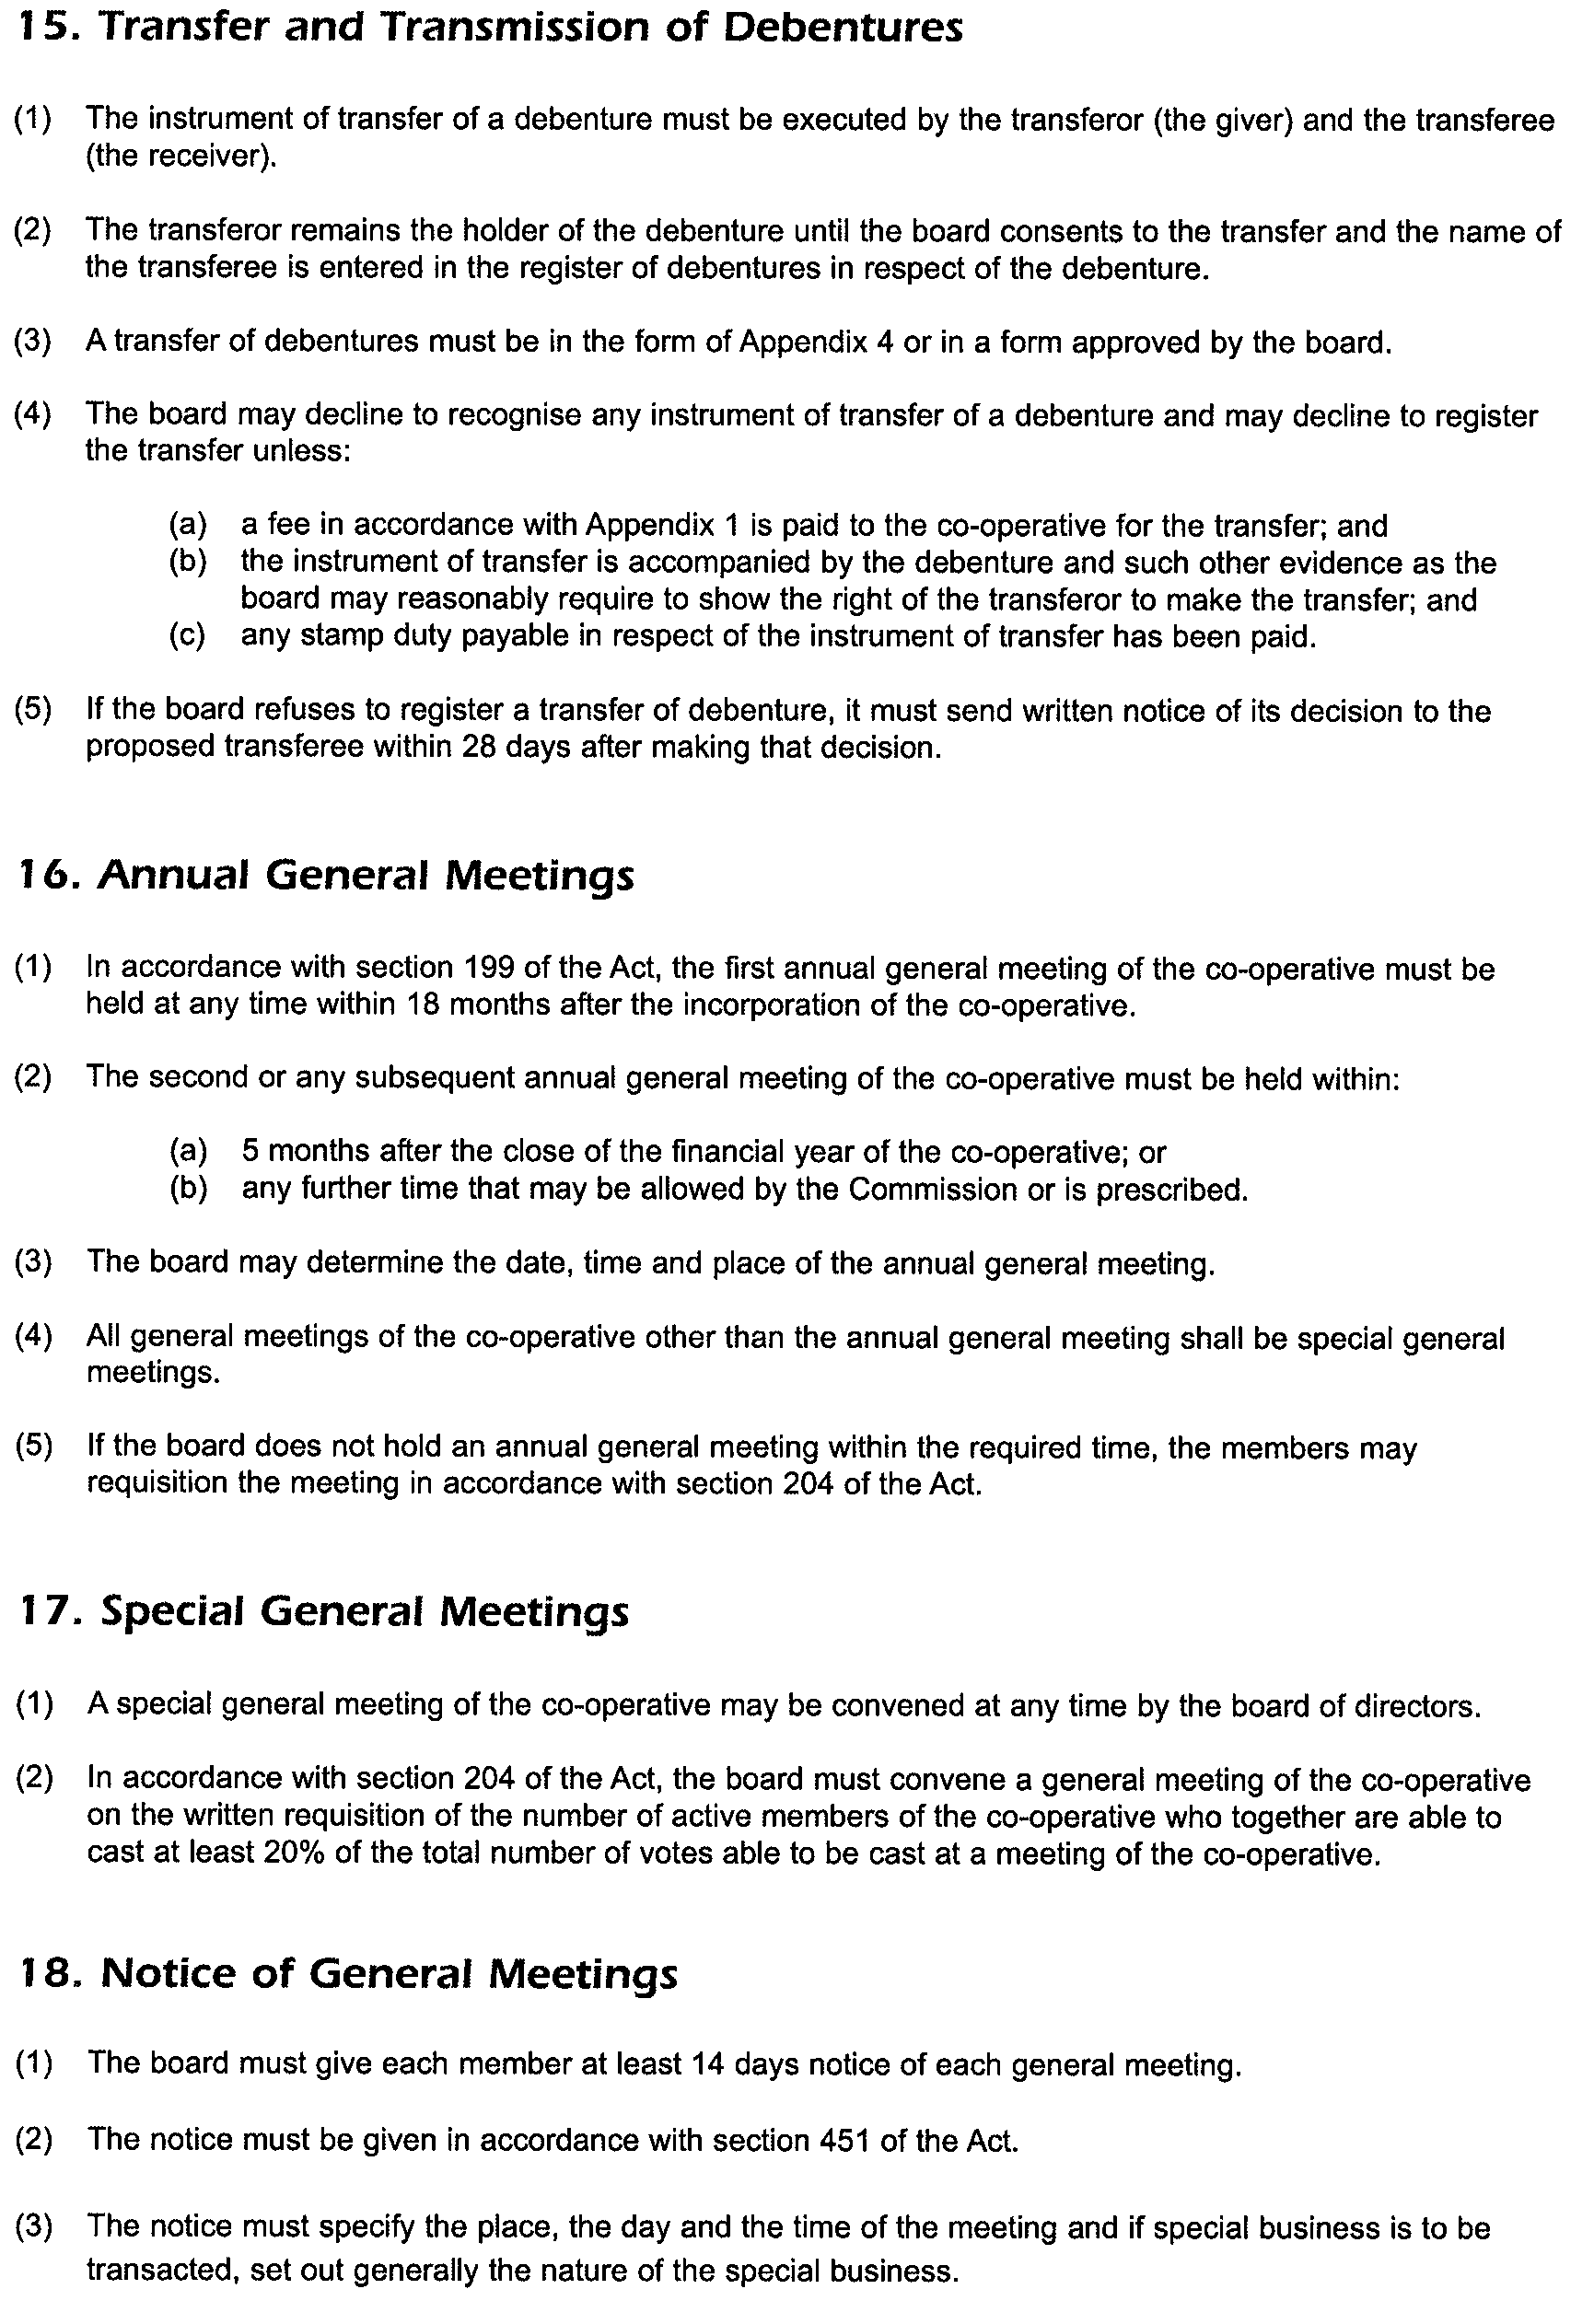
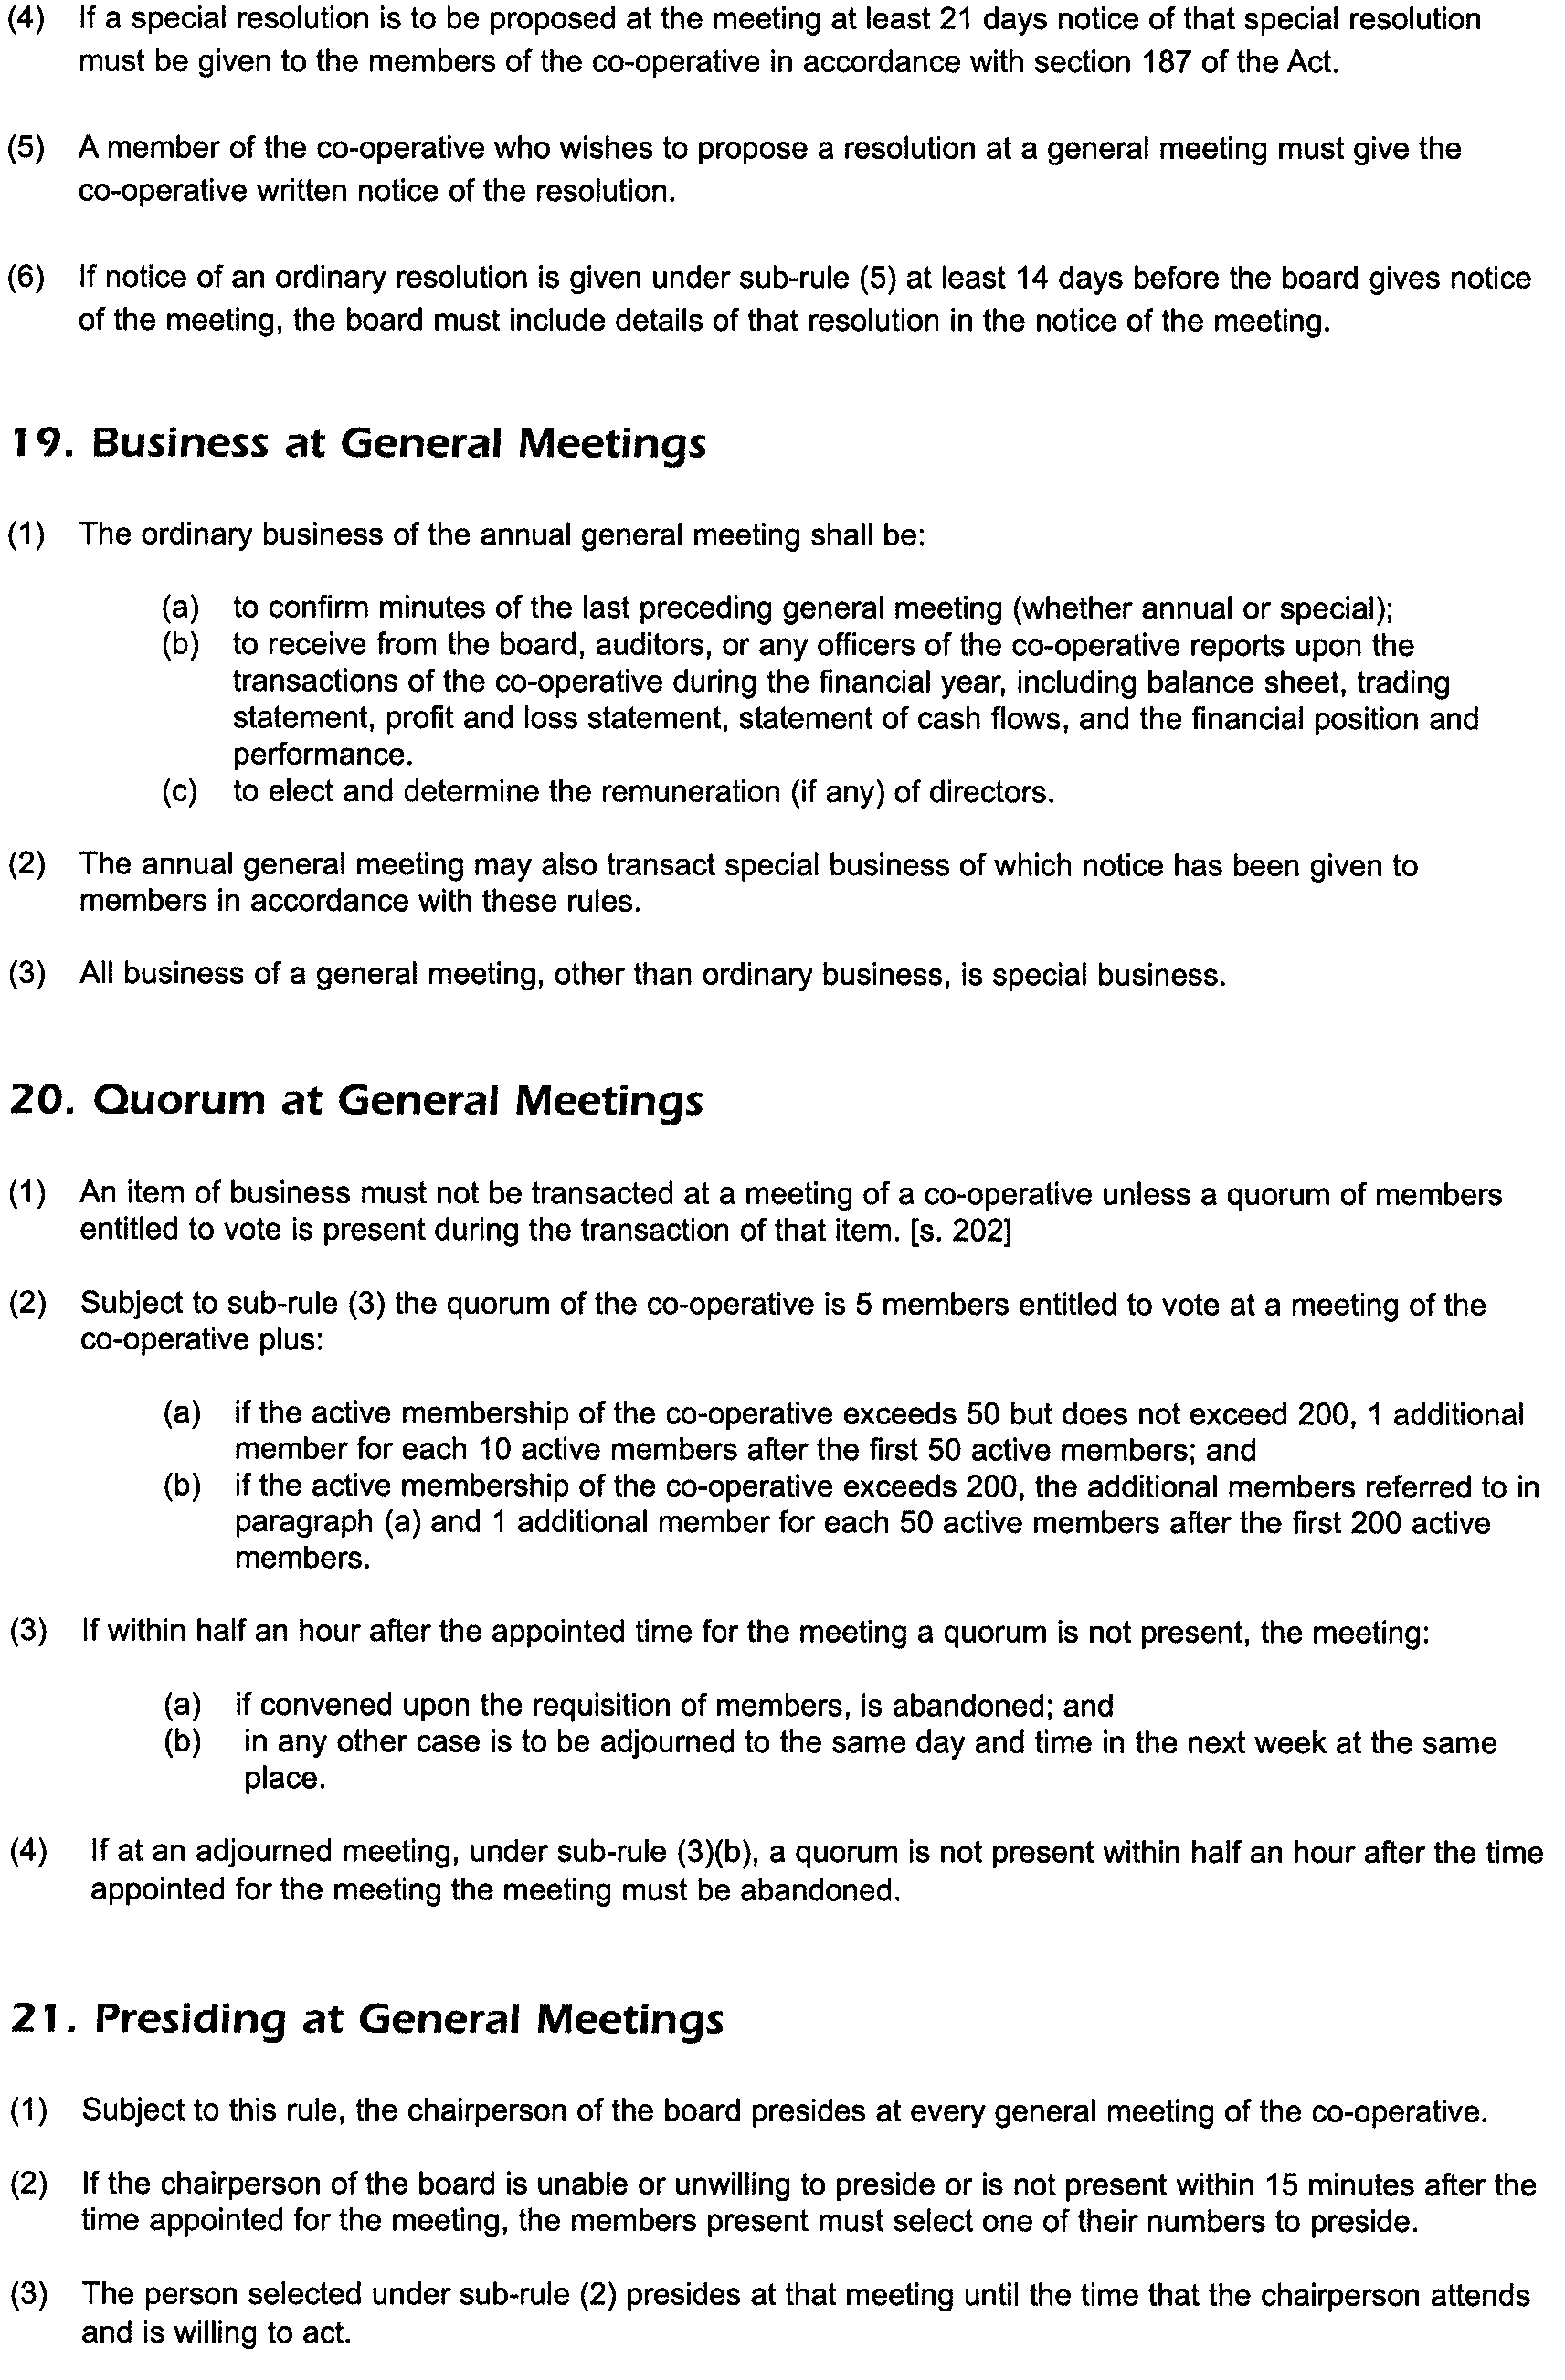
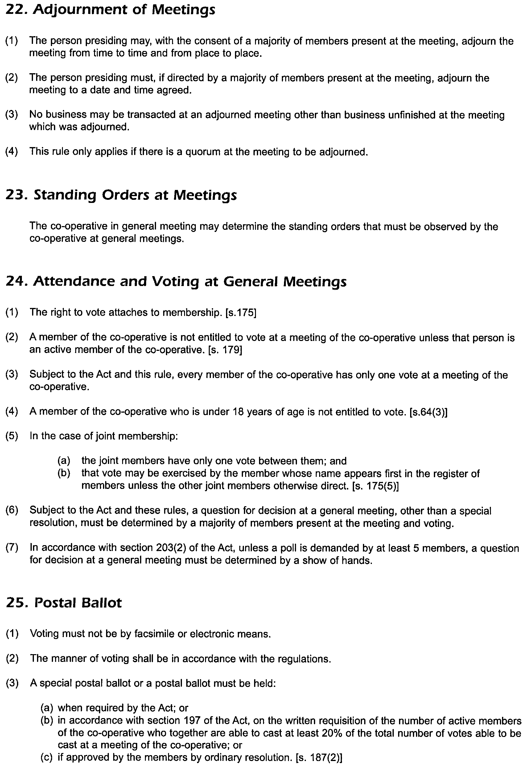
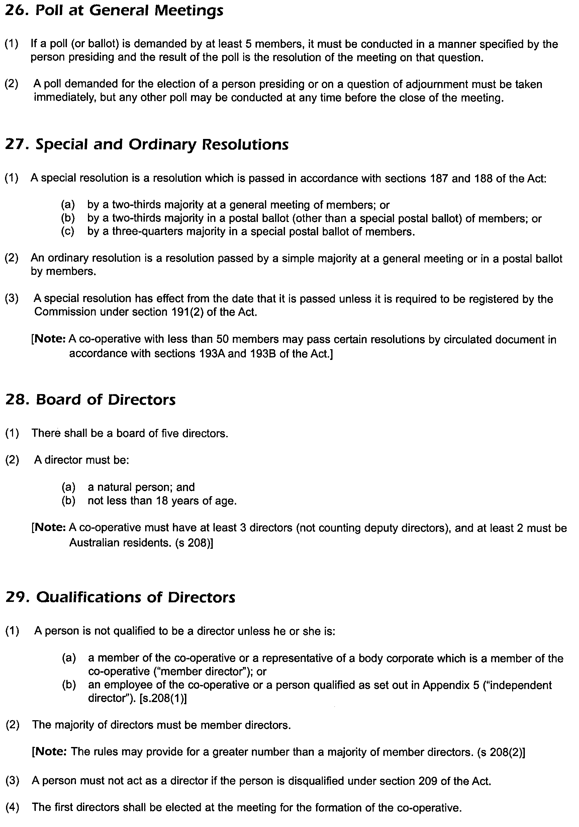
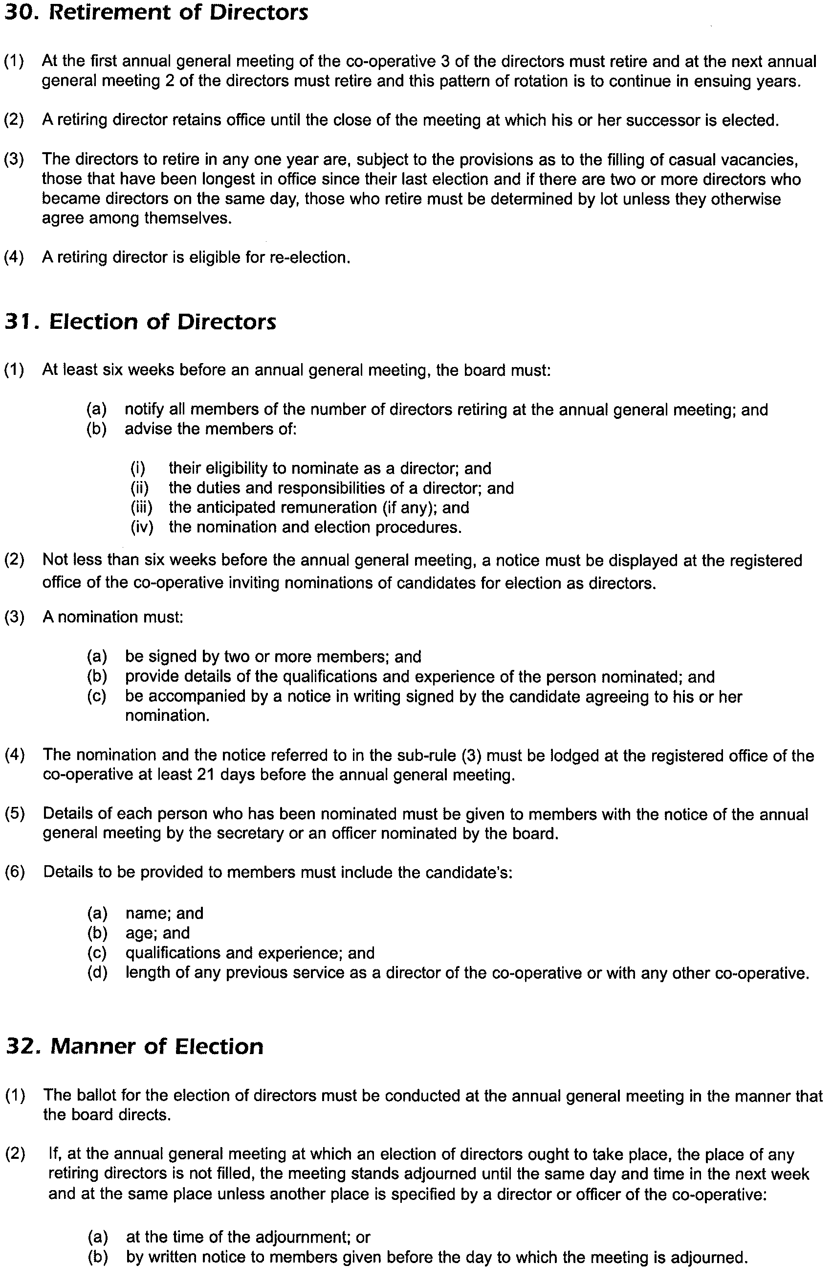
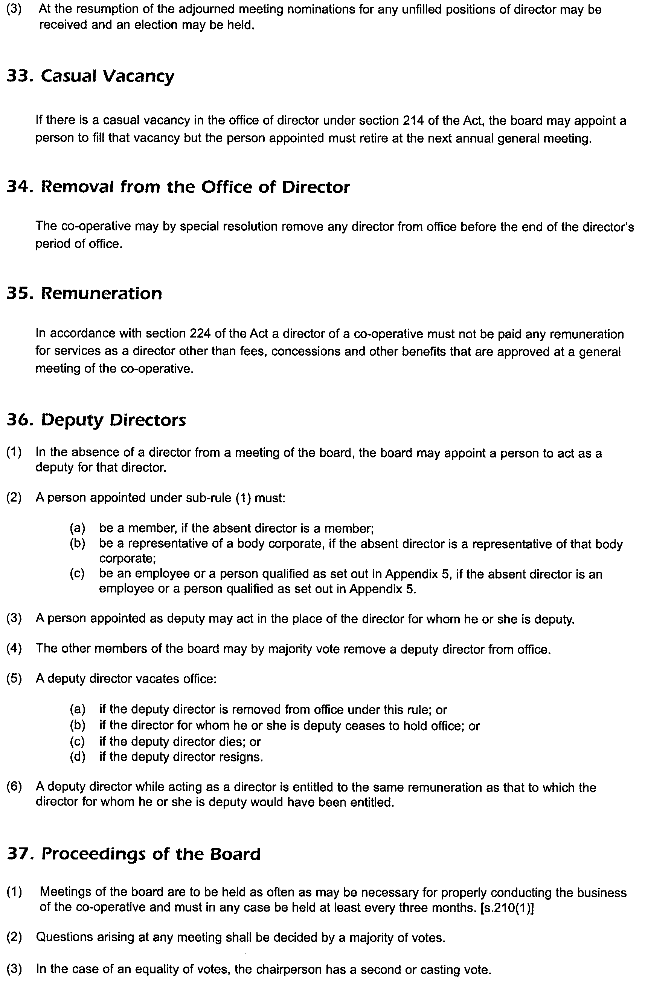
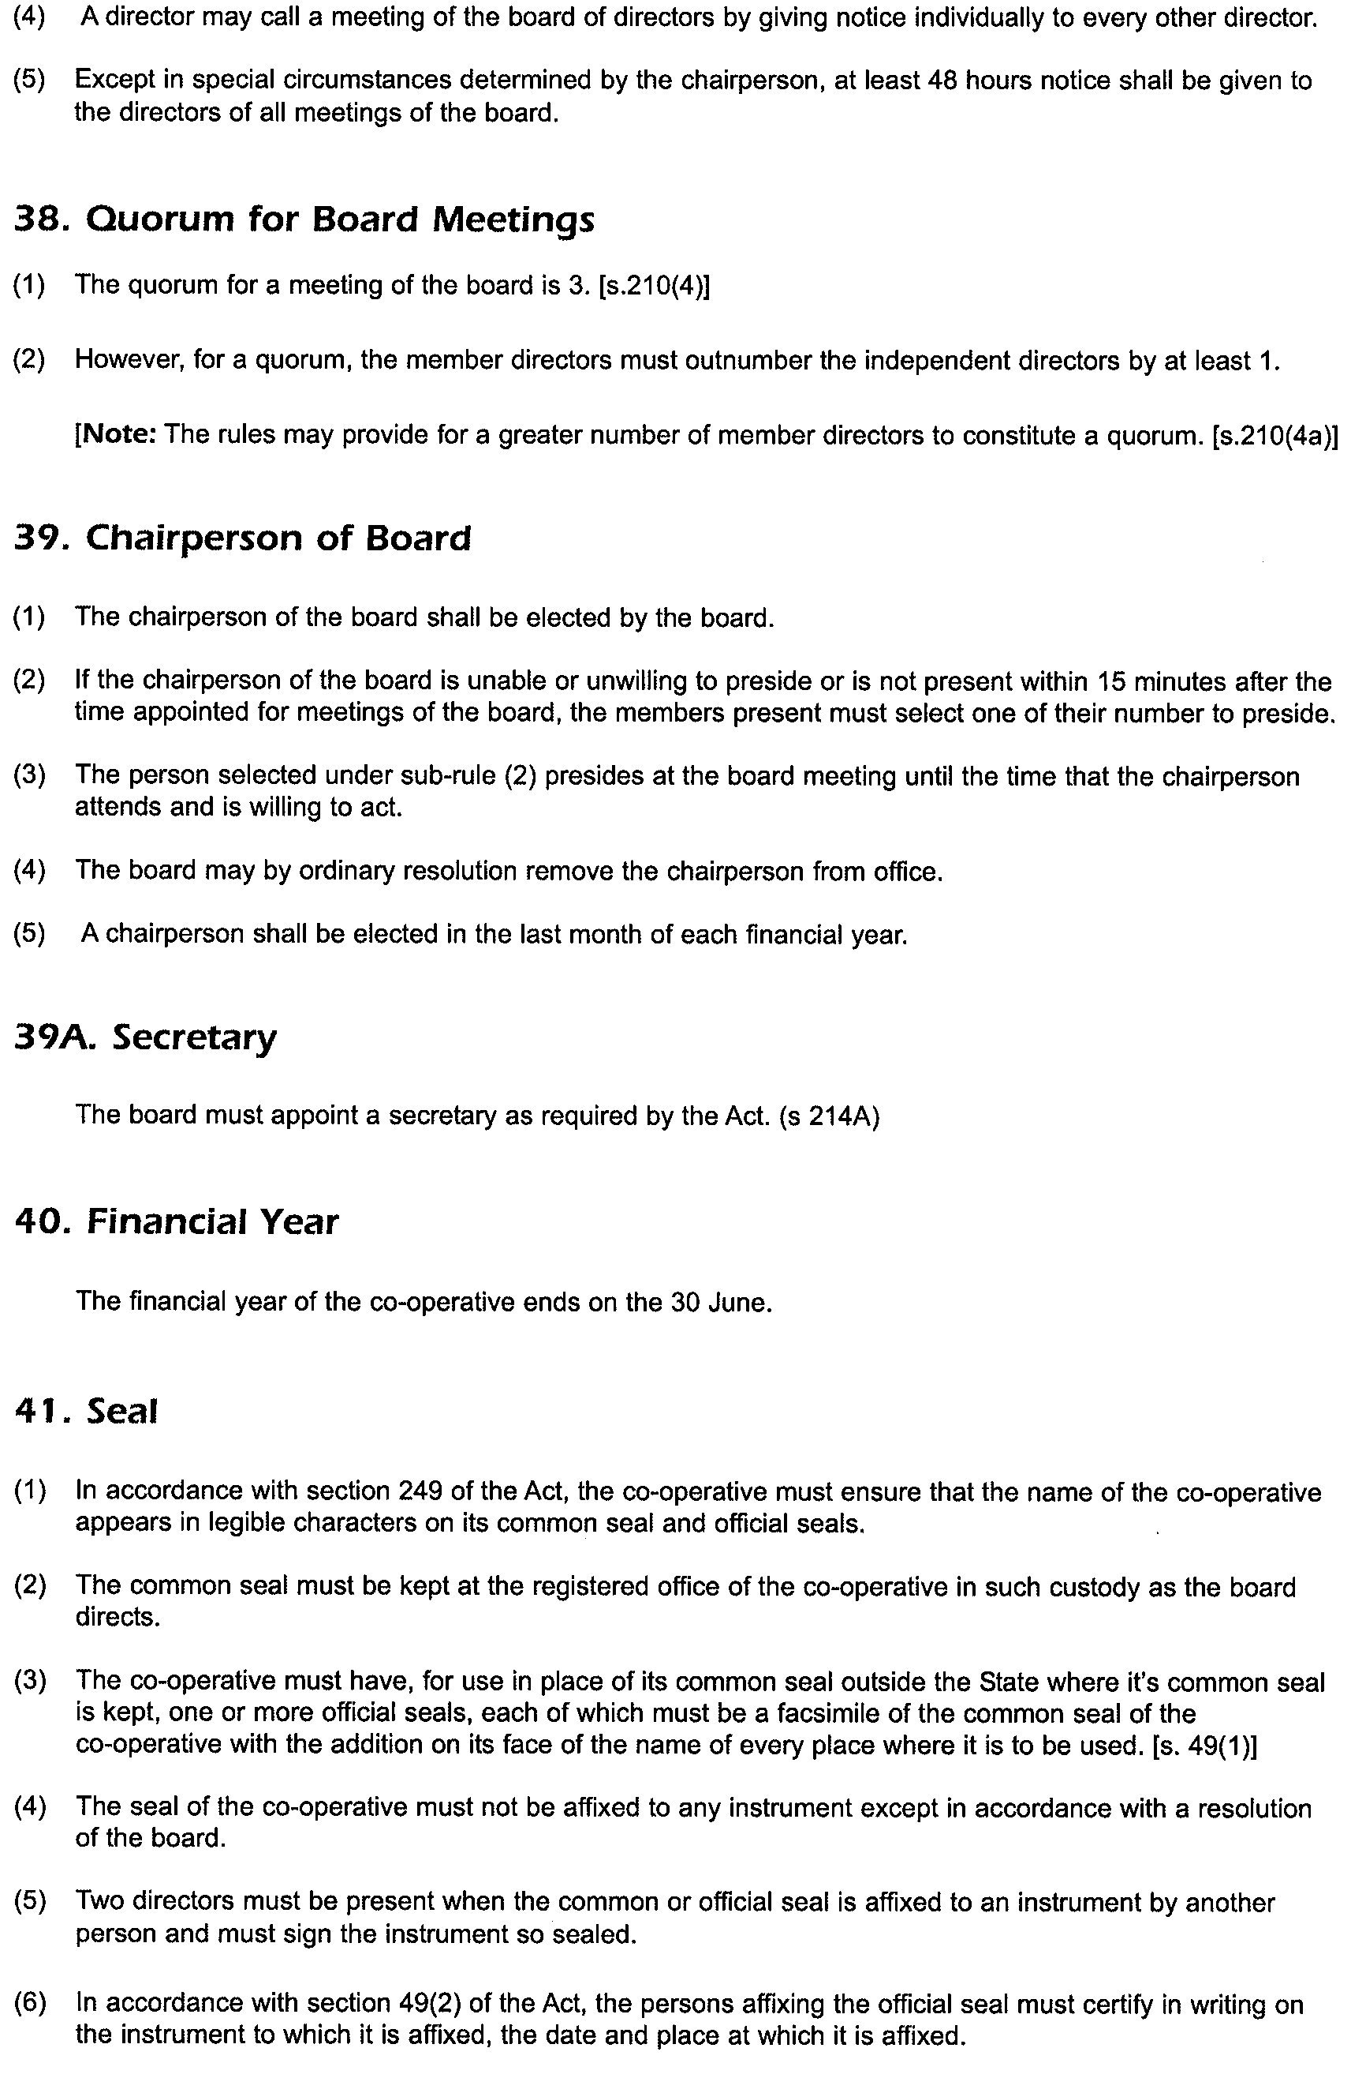
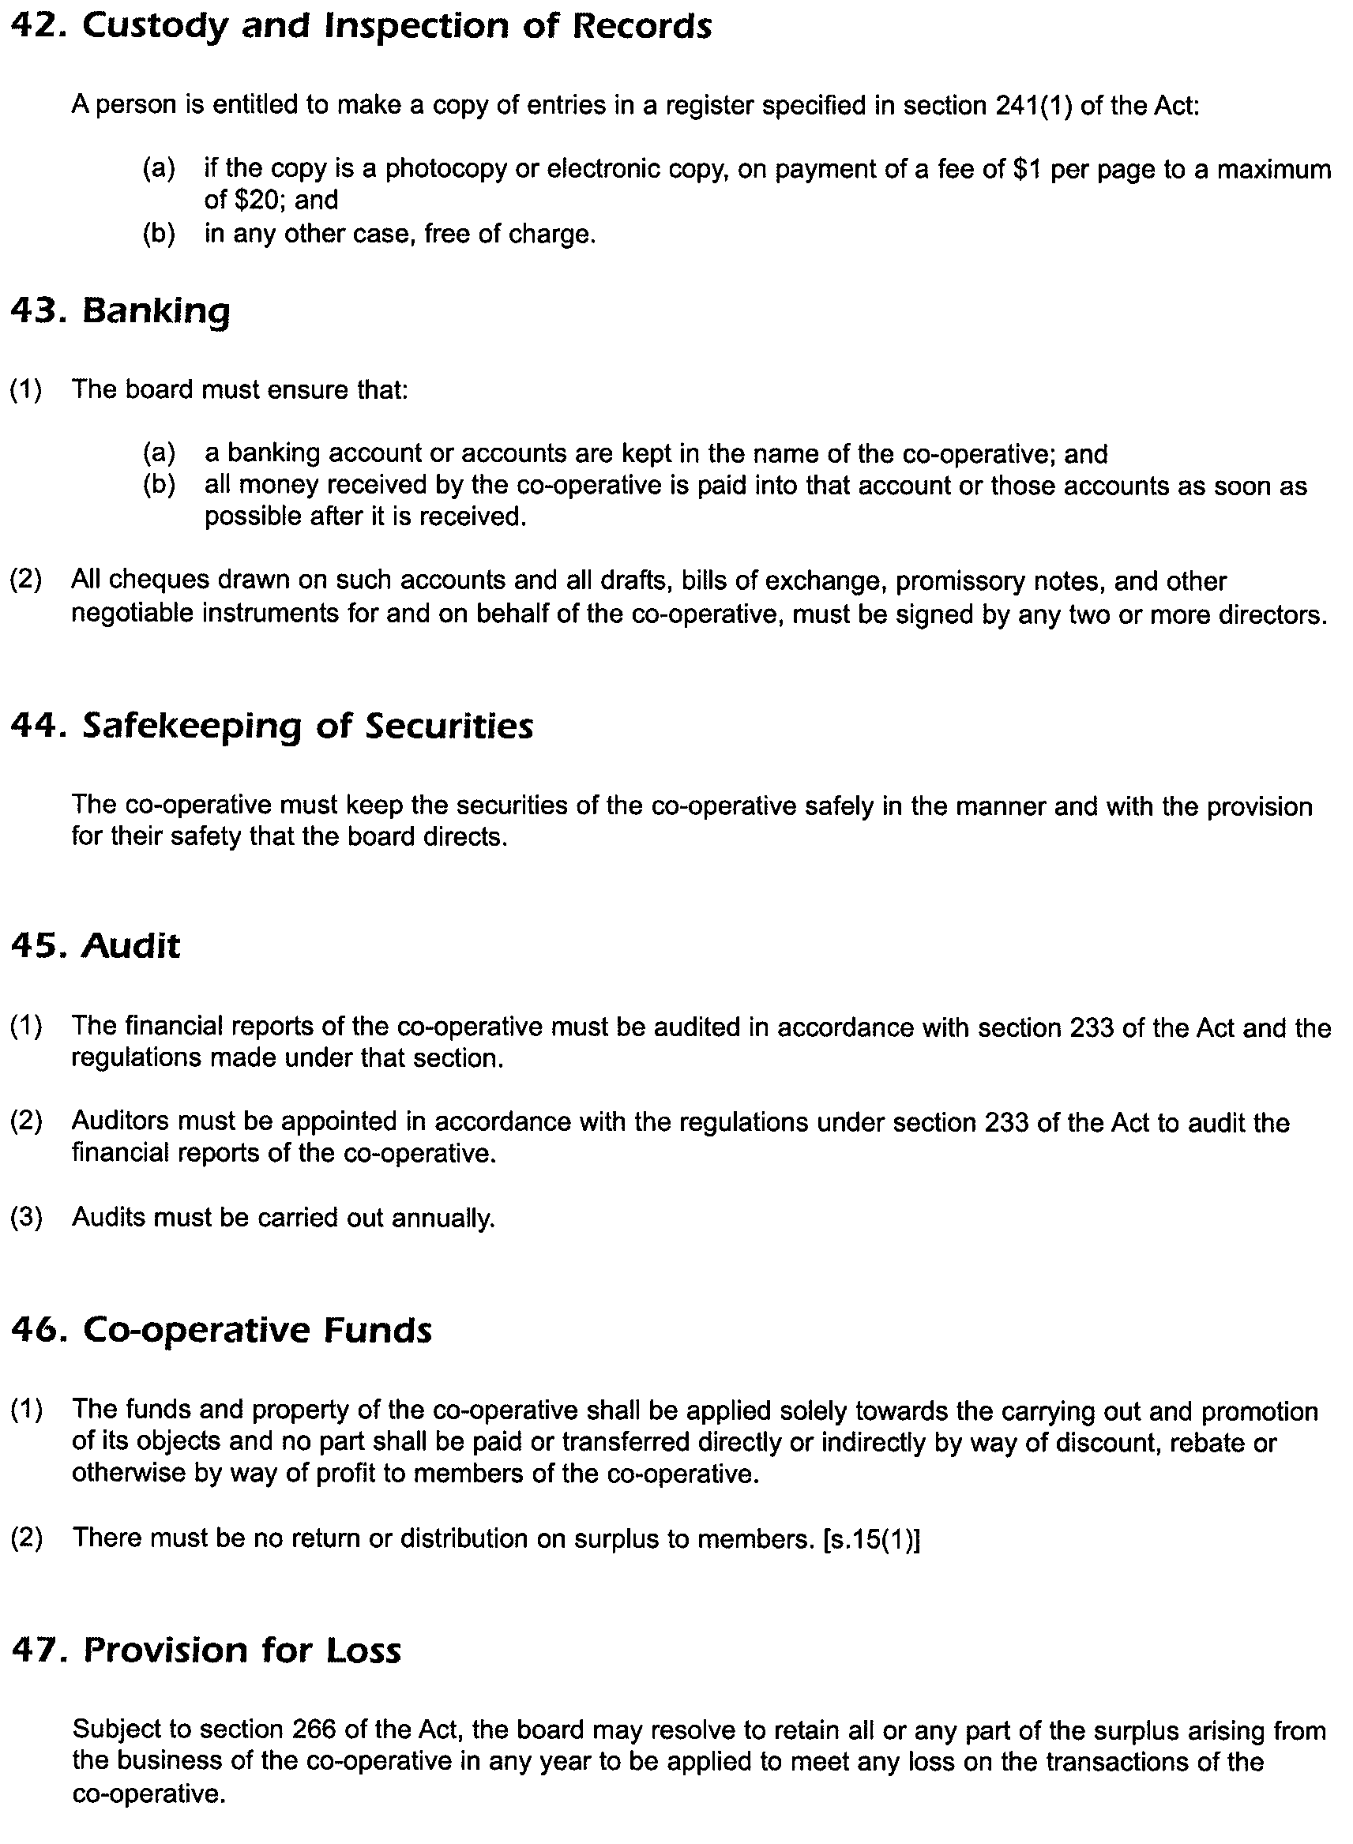
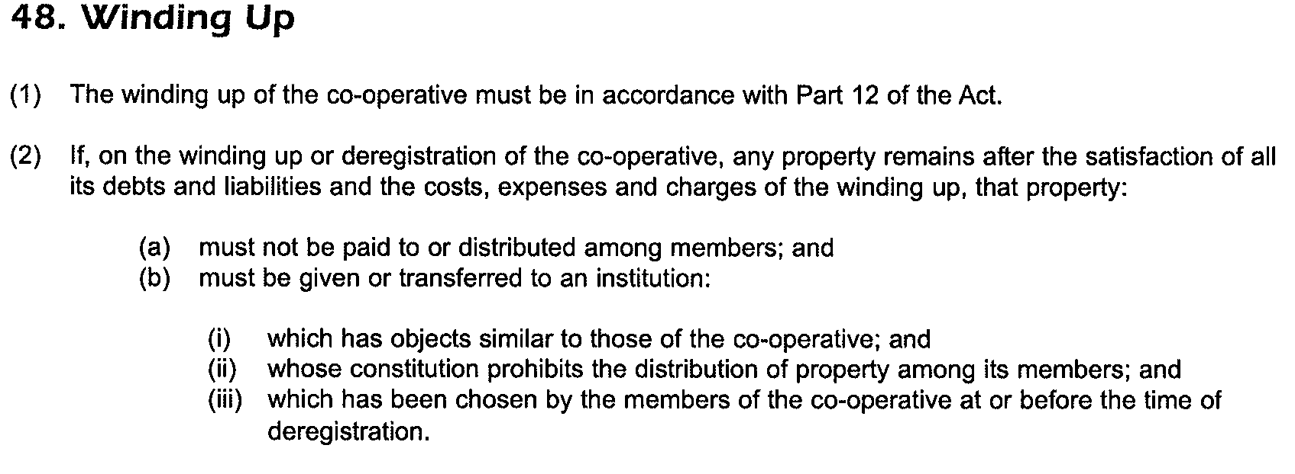
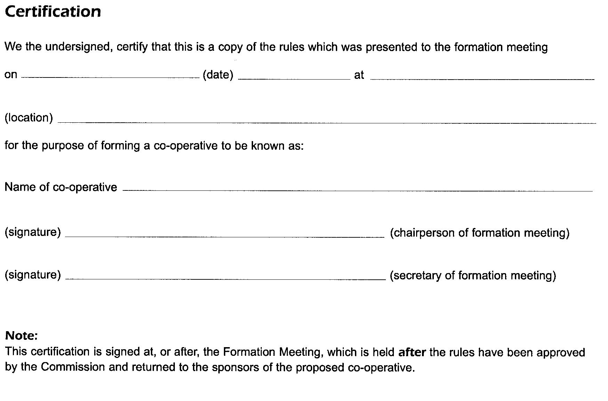
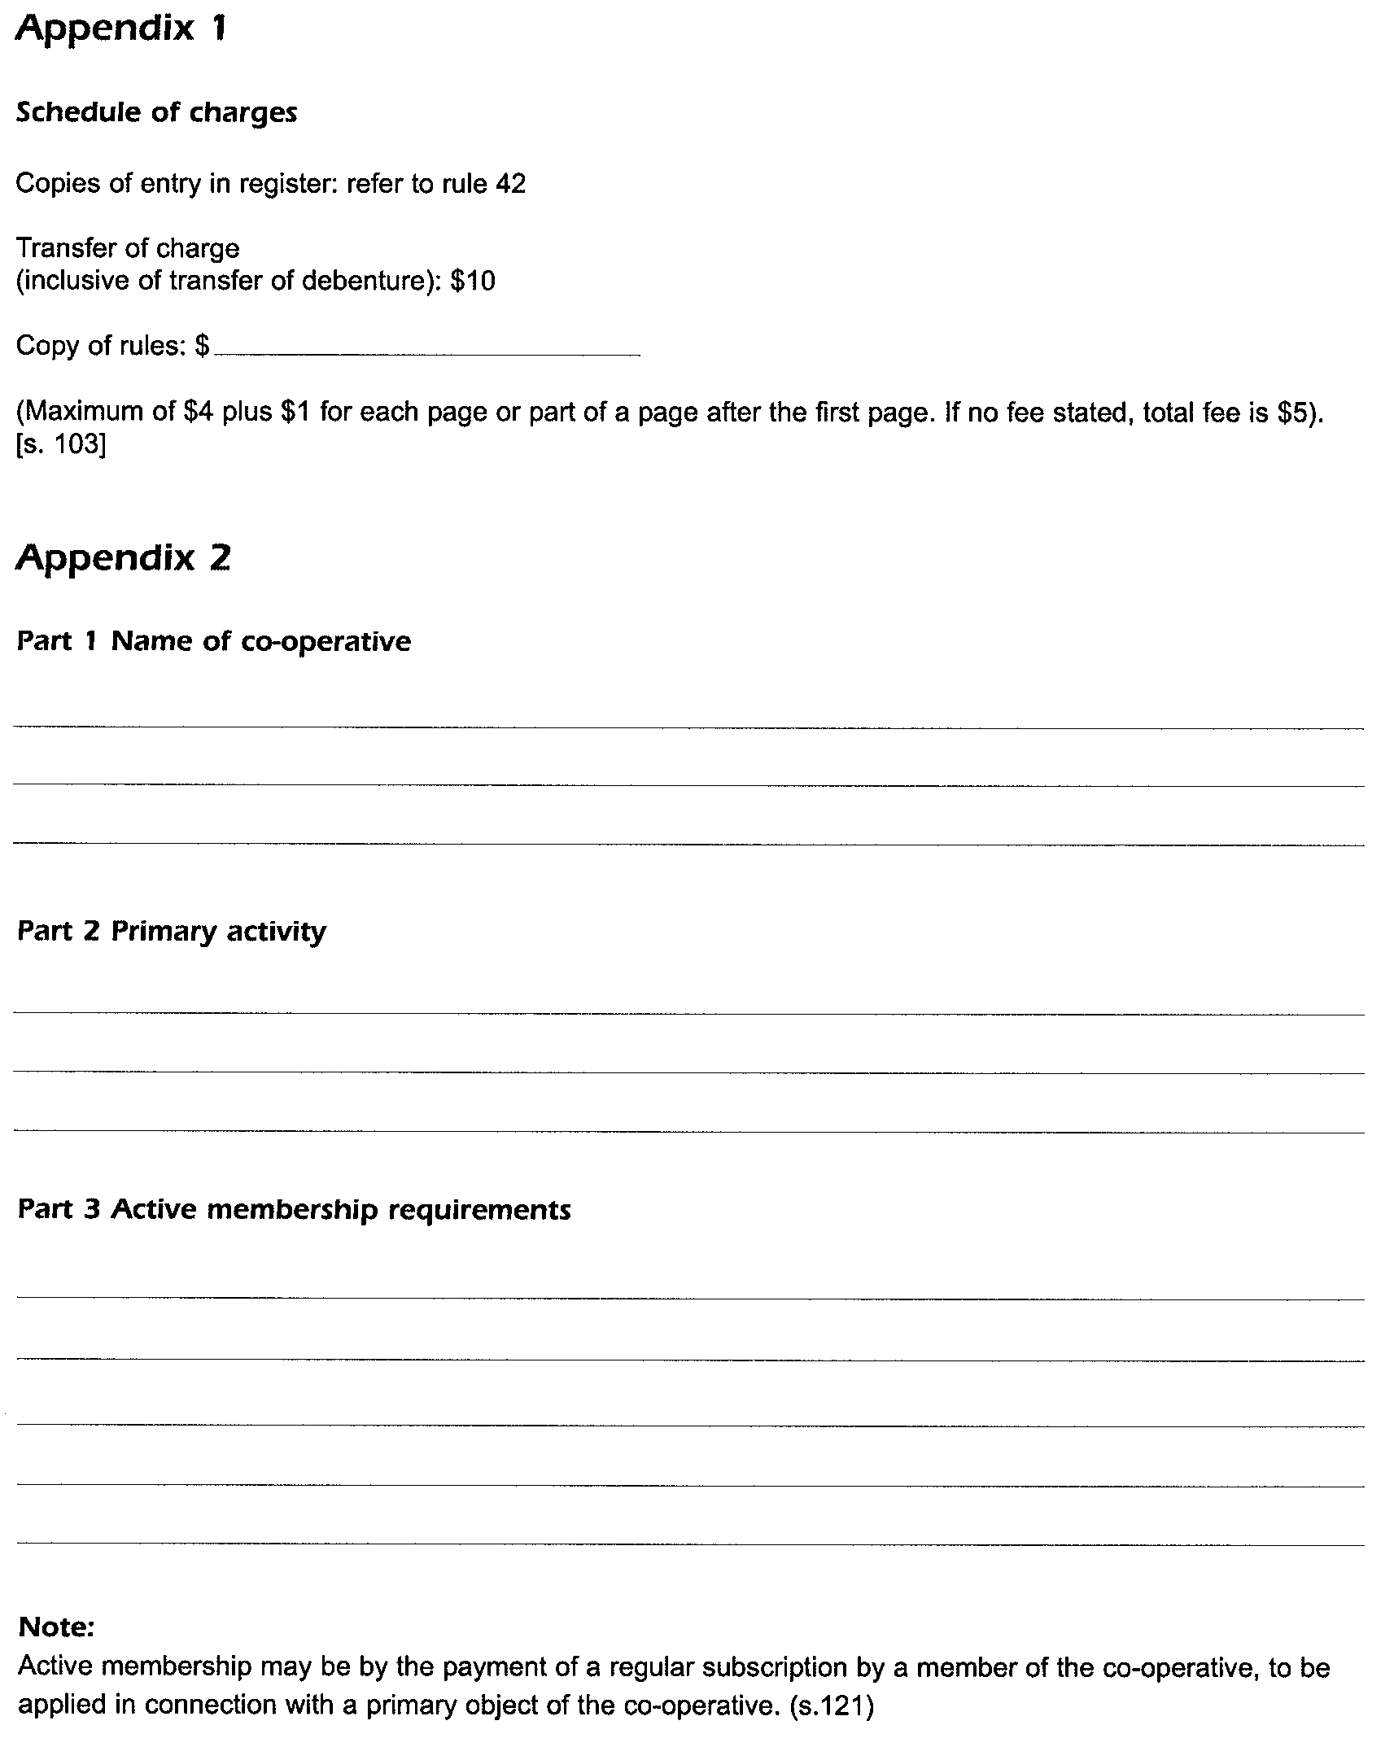
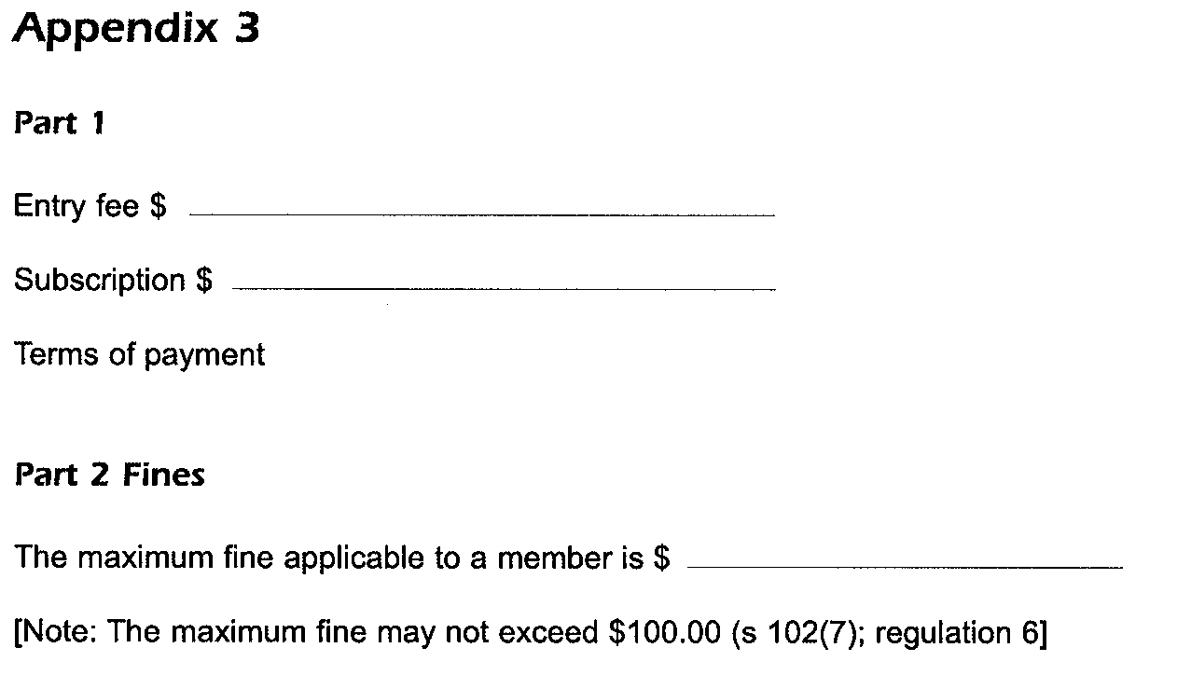

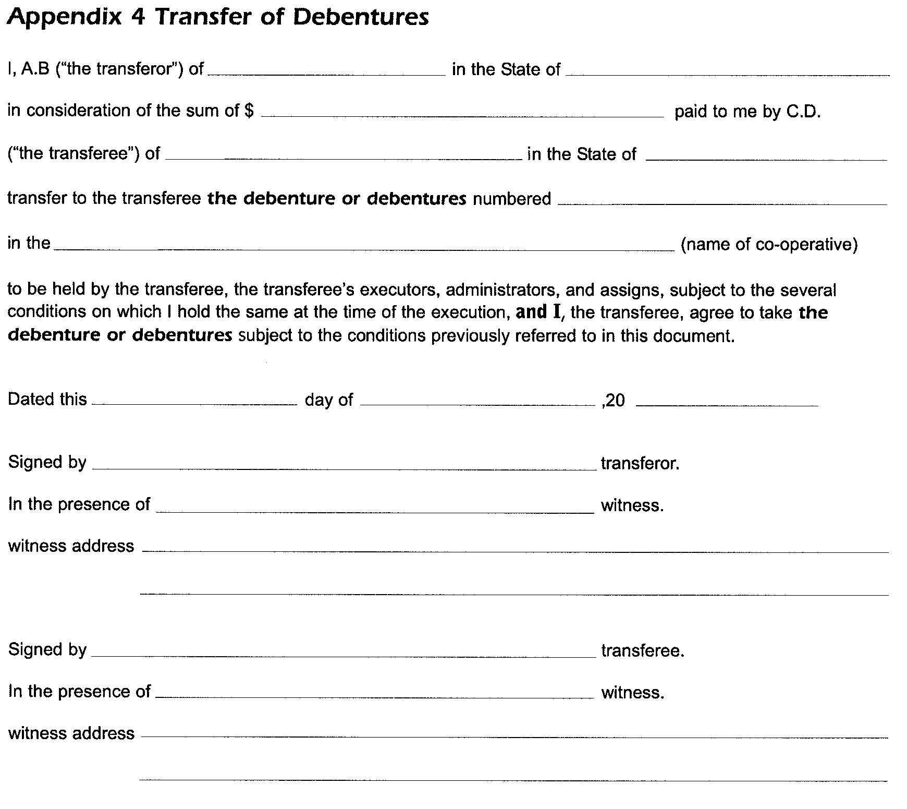



GOVERNMENT GAZETTE ADVERTISEMENT RATES

To apply from 1 July 2002

$  Agents, Ceasing to Act as 34.10  Associations:  Incorporation 17.40  Intention of Incorporation 43.00  Transfer of Properties 43.00  Attorney, Appointment of 34.10  Bailiff’s Sale 43.00  Cemetery Curator Appointed 25.50  Companies:  Alteration to Constitution 34.10  Capital, Increase or Decrease of 43.00  Ceasing to Carry on Business 25.50  Declaration of Dividend 25.50  Incorporation 34.10  Lost Share Certificates:  First Name 25.50  Each Subsequent Name 8.75  Meeting Final 28.75  Meeting Final Regarding Liquidator’s Report on  Conduct of Winding Up (equivalent to ‘Final  Meeting’)  First Name 34.10  Each Subsequent Name 8.75  Notices:  Call 43.00  Change of Name 17.40  Creditors 34.10  Creditors Compromise of Arrangement 34.10  Creditors (extraordinary resolution that ‘the Com-pany be wound up voluntarily and that a liquidator be appointed’) 43.00  Release of Liquidator⎯Application⎯Large Ad. 68.00  ⎯Release Granted 43.00  Receiver and Manager Appointed 39.75  Receiver and Manager Ceasing to Act 34.10  Restored Name 32.25  Petition to Supreme Court for Winding Up 59.50  Summons in Action 51.00  Order of Supreme Court for Winding Up Action 34.10  Register of Interests⎯Section 84 (1) Exempt 77.00  Removal of Office 17.40  Proof of Debts 34.10  Sales of Shares and Forfeiture 34.10  Estates:  Assigned 25.50  Deceased Persons⎯Notice to Creditors, etc. 43.00  Each Subsequent Name 8.75  Deceased Persons⎯Closed Estates 25.50  Each Subsequent Estate 1.10  Probate, Selling of 34.10  Public Trustee, each Estate 8.75 |  | $  Firms:  Ceasing to Carry on Business (each insertion) 22.70  Discontinuance Place of Business 22.70  Land⎯Real Property Act:  Intention to Sell, Notice of 43.00  Lost Certificate of Title Notices 43.00  Cancellation, Notice of (Strata Plan) 43.00  Mortgages:  Caveat Lodgment 17.40  Discharge of 18.30  Foreclosures 17.40  Transfer of 17.40  Sublet 8.75  Leases⎯Application for Transfer (2 insertions) each 8.75  Lost Treasury Receipts (3 insertions) each 25.50  Licensing 51.00  Municipal or District Councils:  Annual Financial Statement⎯Forms 1 and 2 481.00  Electricity Supply⎯Forms 19 and 20 341.00  Default in Payment of Rates:  First Name 68.00  Each Subsequent Name 8.75  Noxious Trade 25.50  Partnership, Dissolution of 25.50  Petitions (small) 17.40  Registered Building Societies (from Registrar-  General) 17.40  Register of Unclaimed Moneys⎯First Name 25.50  Each Subsequent Name 8.75  Registers of Members⎯Three pages and over:  Rate per page (in 8pt) 218.00  Rate per page (in 6pt) 288.00  Sale of Land by Public Auction 43.50  Advertisements 2.40  Advertisements, other than those listed are charged at $2.40 per column line, tabular one-third extra.  Notices by Colleges, Universities, Corporations and District Councils to be charged at $2.40 per line.  Where the notice inserted varies significantly in length from that which is usually published a charge of $2.40 per column line will be applied in lieu of advertisement rates listed.  South Australian Government publications are sold on the condition that they will not be reproduced without prior permission from the Government Printer.
All the above prices include GST

GOVERNMENT GAZETTE NOTICES
ALL private advertisements forwarded for publication in the South Australian Government Gazette must be PAID FOR PRIOR TO INSERTION; and all notices, from whatever source, should be legibly written on one side of the paper only and sent to Government Publishing SA so as to be received no later than 4 p.m. Tuesday preceding the day of publication. Phone 8207 1045 or Fax 8207 1040. E-mail: governmentgazette@saugov.sa.gov.au. Send as attachments in Word format and please confirm your transmission with a faxed copy of your document, including the date the notice is to be published and to whom the notice will be charged.

MISCELLANEOUS LEGISLATION AND GOVERNMENT PUBLICATIONS PRICES AS FROM 1 JULY 2003

Acts, Bills, Rules, Parliamentary Papers and Regulations
Pages | Main | Amends | Pages | Main | Amends

1-16 | 2.05 | 0.90 | 497-512 | 29.20 | 28.00
17-32 | 2.80 | 1.75 | 513-528 | 30.00 | 28.80
33-48 | 3.65 | 2.60 | 529-544 | 30.90 | 29.90
49-64 | 4.60 | 3.50 | 545-560 | 31.70 | 30.90
65-80 | 5.40 | 4.45 | 561-576 | 32.50 | 31.70
81-96 | 6.25 | 5.20 | 577-592 | 33.60 | 32.20
97-112 | 7.15 | 6.05 | 593-608 | 34.40 | 33.25
113-128 | 8.00 | 7.00 | 609-624 | 35.20 | 34.30
129-144 | 9.00 | 7.95 | 625-640 | 35.90 | 34.80
145-160 | 9.85 | 8.80 | 641-656 | 36.80 | 35.85
161-176 | 10.80 | 9.65 | 657-672 | 37.40 | 36.60
177-192 | 11.60 | 10.60 | 673-688 | 39.00 | 37.40
193-208 | 12.50 | 11.50 | 689-704 | 39.80 | 38.40
209-224 | 13.30 | 12.25 | 705-720 | 40.30 | 39.50
225-240 | 14.20 | 13.10 | 721-736 | 41.80 | 40.00
241-257 | 15.10 | 13.80 | 737-752 | 42.30 | 41.30
258-272 | 16.00 | 14.75 | 753-768 | 43.40 | 41.80
273-288 | 16.90 | 15.80 | 769-784 | 43.90 | 43.10
289-304 | 17.60 | 16.60 | 785-800 | 44.70 | 43.90
305-320 | 18.60 | 17.50 | 801-816 | 45.50 | 44.40
321-336 | 19.40 | 18.30 | 817-832 | 46.50 | 45.50
337-352 | 20.40 | 19.30 | 833-848 | 47.50 | 46.25
353-368 | 21.20 | 20.20 | 849-864 | 48.30 | 47.00
369-384 | 22.10 | 21.10 | 865-880 | 49.00 | 48.30
385-400 | 22.90 | 21.90 | 881-896 | 49.60 | 48.80
401-416 | 23.70 | 22.60 | 897-912 | 51.20 | 49.60
417-432 | 24.80 | 23.60 | 913-928 | 51.70 | 51.20
433-448 | 25.60 | 24.50 | 929-944 | 52.50 | 51.70
449-464 | 26.50 | 25.30 | 945-960 | 53.50 | 52.20
465-480 | 27.00 | 26.20 | 961-976 | 54.50 | 53.25
481-496 | 28.20 | 27.00 | 977-992 | 55.60 | 54.00

Legislation—Acts, Regulations, etc: $
Subscriptions:
Acts 180.00
All Bills as Laid 431.00
Rules and Regulations 431.00
Parliamentary Papers 431.00
Bound Acts 199.00
Index 99.00
Government Gazette
Copy 4.70
Subscription 238.00
Hansard
Copy 13.00
Subscription—per session (issued weekly) 374.00
Cloth bound—per volume 161.00
Subscription—per session (issued daily) 374.00
Legislation on Disk
Whole Database 2 763.00
Annual Subscription for fortnightly updates 849.00
Individual Act(s) including updates POA
Compendium
Subscriptions:
New Subs 1 638.00
Updates 578.00
(All the above prices include GST)

All Legislation, Government Gazette, Hansard and Legislation on disk are available from:
Counter Sales Service SA, Government Information Centre
and Mail Orders: Ground Floor, 77 Grenfell Street, Adelaide, S.A. 5000
Phone: 13 23 24 (local call cost), Fax: (08) 8204 1909
TTY (Hearing Impaired): (08) 8204 1923

Online Shop: www.info.sa.gov.au

Subscriptions and Government Publishing SA
Standing Orders: Box 9, Plaza Level, Riverside Centre, North Terrace, Adelaide, S.A. 5000
Phone: (08) 8207 0908, (08) 8207 0910, Fax: (08) 8207 1040

DEVELOPMENT ACT 1993, SECTION 26 (8): WIND FARMS PLAN AMENDMENT
Preamble
1. The Development Plan Amendment entitled ‘Wind Farms Plan Amendment’ (the Plan Amendment) has been finalised in accordance with the provisions of the Development Act 1993.
2. The Minister for Urban Development and Planning has decided to approve the Plan Amendment.
Notice
PURSUANT to section 26 of the Development Act 1993, I—
(a) approve the Plan Amendment; and
(b) fix the day on which this notice is published in the Gazette as the day on which the Plan Amendment will come into operation.
Dated 24 July 2003.
J. Weatherill, Minister for Urban Development and Planning
PLN 02/0276

DEVELOPMENT ACT 1993, SECTION 25 (17): KINGSTON DISTRICT COUNCIL—GENERAL REVIEW PLAN AMENDMENT
Preamble
1. The Development Plan Amendment entitled ‘Kingston District Council—General Review Plan Amendment’ (the Plan Amendment) has been finalised in accordance with the provisions of the Development Act 1993.
2. The Minister for Urban Development and Planning has decided to approve the Plan Amendment.
Notice
PURSUANT to section 25 of the Development Act 1993, I—
(a) approve the Plan Amendment; and
(b) fix the day on which this notice is published in the Gazette as the day on which the Plan Amendment will come into operation.
Dated 24 July 2003.
J. Weatherill, Minister for Urban Development and Planning
PLN 00/0451

DEVELOPMENT ACT 1993, SECTION 29 (2) (b) (ii): AMENDMENT TO THE LAND NOT WITHIN A COUNCIL AREA (COASTAL WATERS) DEVELOP-MENT PLAN
Preamble
It is necessary to amend the Land Not Within A Council Area (Coastal Waters) Development Plan dated 12 September 2002.
Notice
PURSUANT to section 29 (2) (b) (ii) of the Development Act 1993, I, Jay Weatherill, being the Minister administering the Act, amend The Land Not Within A Council Area (Coastal Waters) Development Plan dated 12 September 2002, as follows:
Part A:
Delete the contents of the Preface page and insert the contents of Attachment A.
Part B:
Under the heading ‘Coastal Waters’, in the Introduction for the Land Not Within A Council Area (Coastal Waters) Development Plan after the words ‘and includes’ insert the following words:
‘both the Spencer Gulf and Gulf St Vincent,’

Attachment A
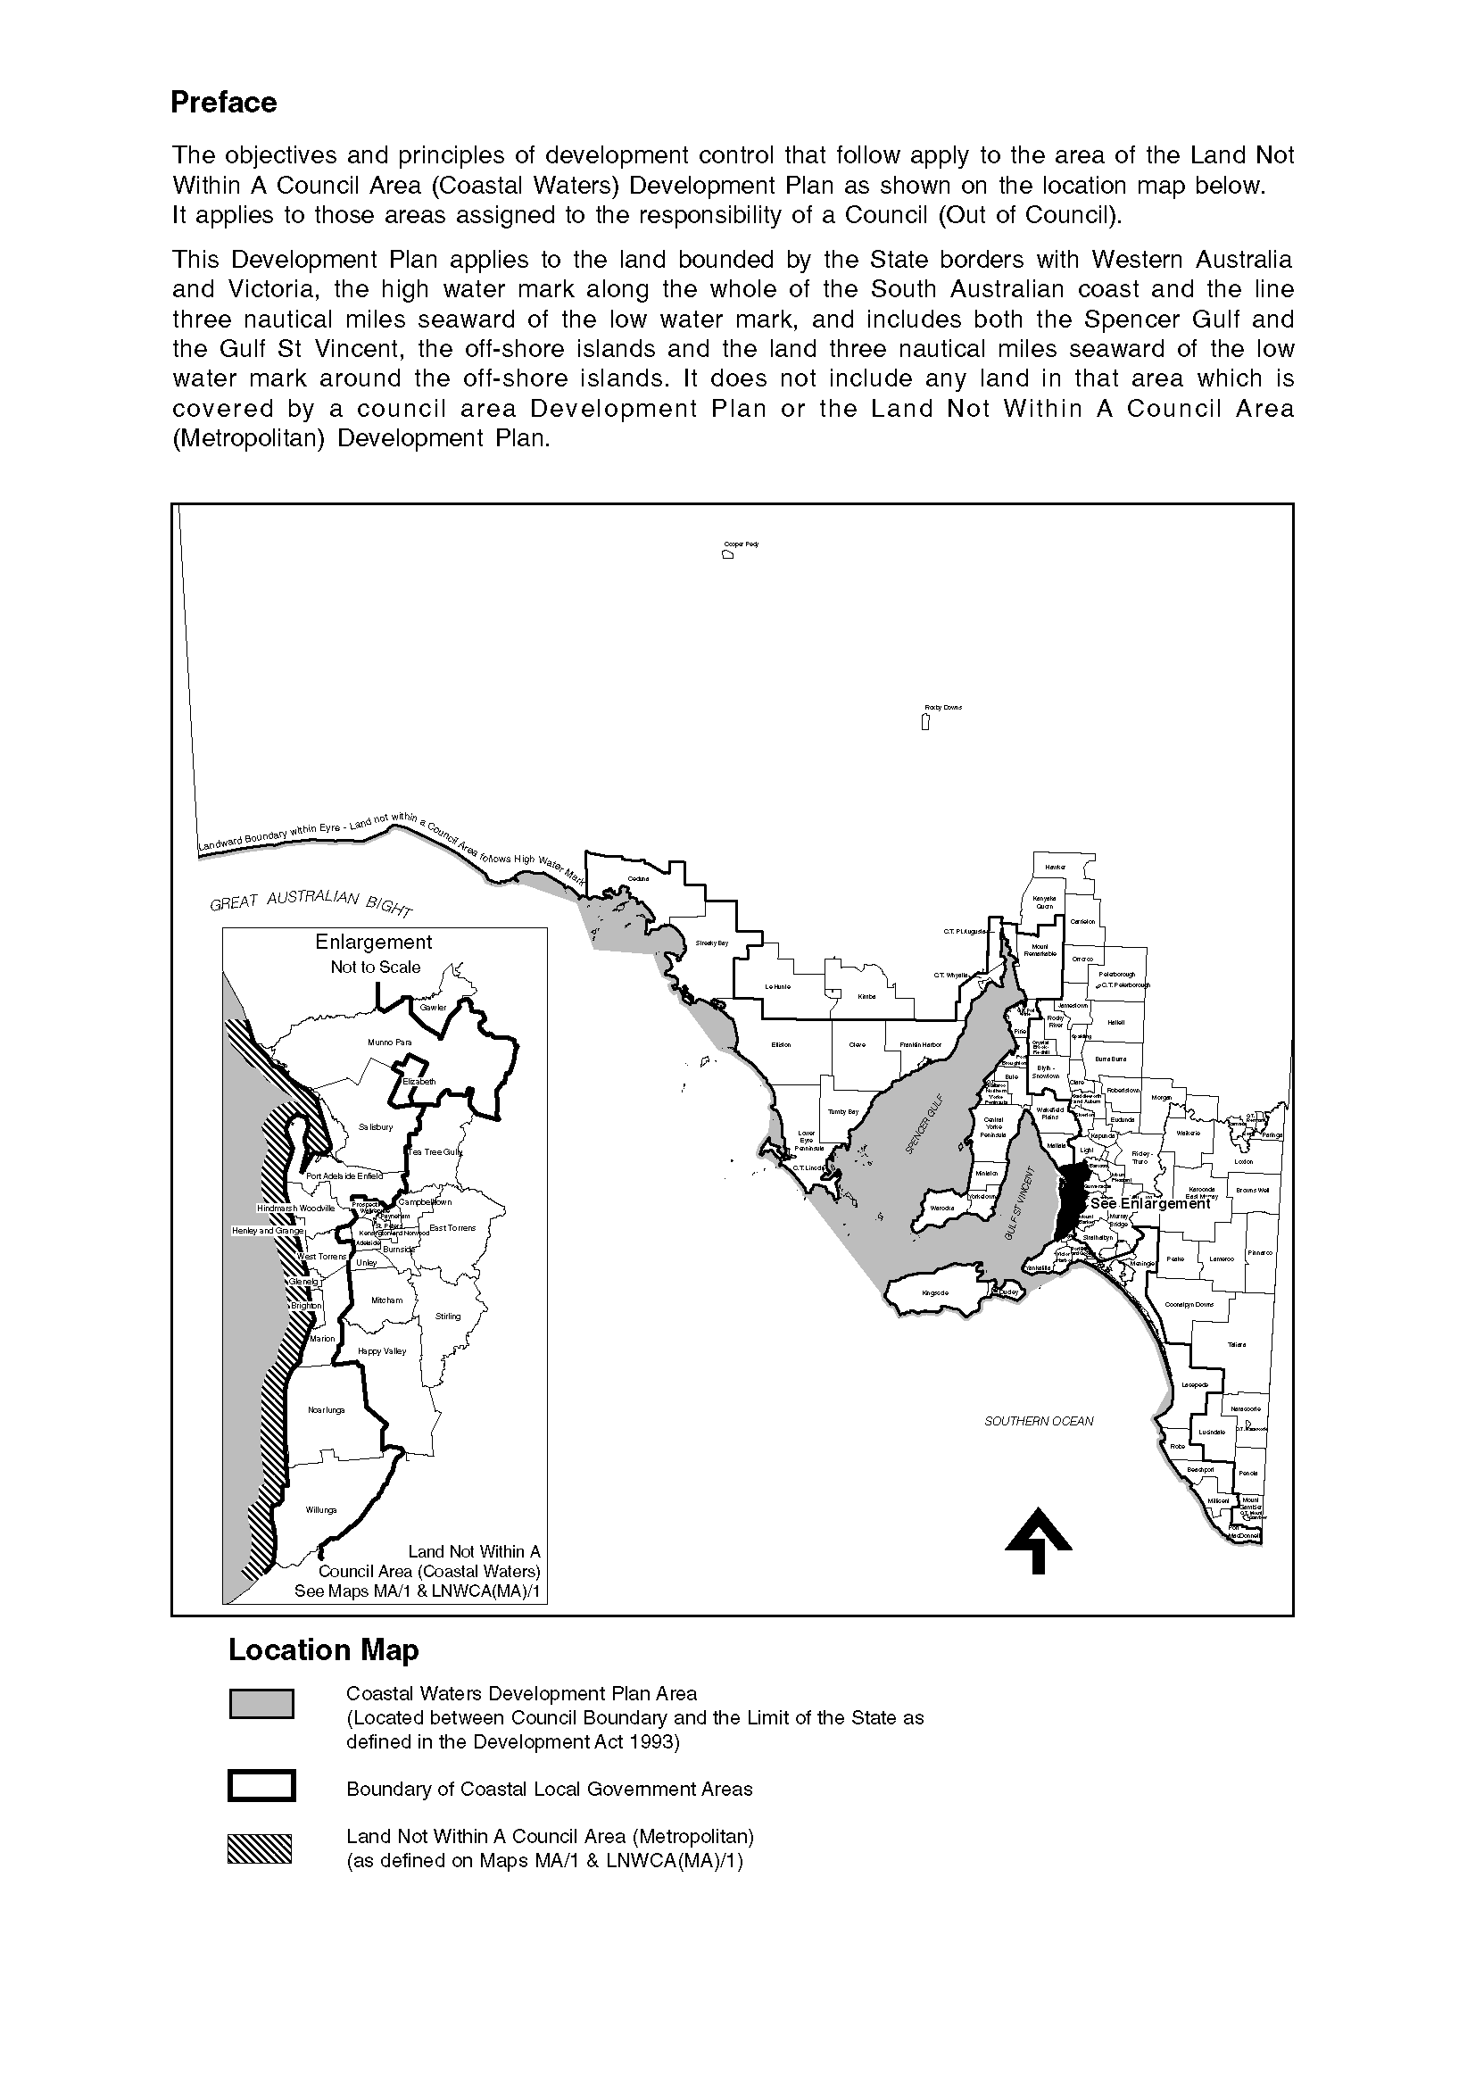
Dated 24 July 2003.
J. Weatherill, Minister for Urban Development and Planning
PLN 01/0597

DEVELOPMENT ACT 1993, SECTION 26 (8): LAND NOT WITHIN A COUNCIL AREA (COASTAL WATERS) DEVELOPMENT PLAN—LOWER EYRE PENINSULA AQUACULTURE PLAN AMENDMENT
Preamble
1. The Development Plan Amendment entitled ‘Land Not Within A Council Area (Coastal Waters)—Lower Eyre Peninsula Aquaculture Plan Amendment’ (the Plan Amendment) has been finalised in accordance with the provisions of the Development Act 1993.
2. The Minister for Urban Development and Planning has decided to approve the Plan Amendment.
Notice
PURSUANT to section 26 of the Development Act 1993, I—
(a) approve the Plan Amendment; and
(b) fix the day on which this notice is published in the Gazette as the day on which the Plan Amendment will come into operation.
Dated 24 July 2003.
J. Weatherill, Minister for Urban Development and Planning
PLN 98/0004

EQUAL OPPORTUNITY TRIBUNAL
No. 286 of 2003
Notice of Exemption
Before Deputy Presiding Officer Robertson
Members Williams and Shetliffe
I HEREBY certify that on 17 July 2003, the Equal Opportunity Tribunal of South Australia, on the application of the City of Playford made the following orders for exemption:
1. That the City of Playford be granted an exemption from the provisions of s.52 of the Equal Opportunity Act 1984 for the purpose of appointing an Aboriginal or Torres Strait Islander person to the position of Aboriginal Torres Strait Islander Community Worker.
2. This exemption shall be for a period of three years from 17 July 2003.
Dated 18 July 2003.
D. Hoban, Deputy Registrar, Equal Opportunity Tribunal

FISHERIES ACT 1982: SECTION 59
TAKE notice that pursuant to section 59 of the Fisheries Act 1982, Victor Bell (the ‘exemption holder’), P.O. Box 131, Kingscote, S.A. 5223, holder of Marine Scalefish Fishery Licence No. M104, is exempt from the provisions of section 41 of the Fisheries Act 1982, Regulation 7 and Schedule 6 of the Fisheries (General) Regulations 2000, but only insofar as the exemption holder shall not be guilty of an offence when taking undersized fish of the species cockles (Katelysia spp.) (the ‘exempted activity’), within those waters specified in Schedule 1, subject to the conditions specified in Schedule 2, from the date of gazettal of this notice until 30 June 2004, unless varied or revoked earlier.
Schedule 1
The waters in the vicinity of Kingscote bounded as follows:
Commencing at a point at high water mark at Cape Rouge, latitude 35°35′52″S, and longitude 137°37′32″E, then along the geodesic (190°T), to a point at high water mark on the south coast on the Bay of Shoals, latitude 35°38′18″S, and longitude 137°37′05″E, then following the line of high water mark in a generally easterly and southerly direction to a point at high water mark at the landward end of the Kingscote jetty, latitude 35°39′15″S and longitude 137°38′32″E, then along the
geodesic (133°T) for a distance of 2.3 nautical miles to position latitude 35°40′32″S, longitude 137°41′00″E, then along the geodesic (033°T) for a distance of 2.1 nautical miles to a position latitude 35°38′50″S, longitude 137°42′15″E, then
along the geodesic (325°T) to a point at high water mark on Marsden Point, latitude 35°33′55″S and longitude 137°38′07″E, then following the line of high water mark in a generally southerly direction back to the point of commence-ment.
Schedule 2
1. Any fish taken by the exemption holder pursuant to this notice must be not less than 27 mm in length measured at the greatest dimension.
2. Any fish taken by the exemption holder pursuant to this notice must be used for bait only and must not be sold.
3. The exemption holder must include all cockles taken pursuant to this exemption on the monthly catch and effort summary provided to the South Australian Research and Development Institute (SARDI).
4. While engaged in the exempted activity, the exemption holder shall carry or have about or near his person, a copy of this notice which must be produced to a PIRSA Fisheries Compliance Officer upon request.
5. The exemption holder shall not contravene or fail to comply with the Fisheries Act 1982, or any regulation made under that Act, except where specifically exempted by this notice.
Dated 17 July 2003.
W. Zacharin, Director of Fisheries

FISHERIES ACT 1982: SECTION 59
TAKE notice that pursuant to section 59 of the Fisheries Act 1982, Peter Maxwell Doley, 12 Wheelton Street, Kingscote, S.A. 5223 (the ‘exemption holder’), holder of Marine Scalefish Fishery Licence No. M117, is exempt from the provisions
of section 41 of the Fisheries Act 1982, Regulation 7 and Schedule 6 of the Fisheries (General) Regulations 2000, but only insofar as the exemption holder shall not be guilty of an offence when taking undersized fish of the species cockles (Katelysia spp.) (the ‘exempted activity’), within those waters specified in Schedule 1, subject to the conditions specified in Schedule 2, from the date of gazettal of this notice until 30 June 2004, unless varied or revoked earlier.
Schedule 1
The waters in the vicinity of Kingscote bounded as follows:
Commencing at a point at high water mark at Cape Rouge, latitude 35°35′52″S, and longitude 137°37′32″E, then along the geodesic (190°T), to a point at high water mark on the south coast on the Bay of Shoals, latitude 35°38′18″S, and longitude 137°37′05″E, then following the line of high water mark in a generally easterly and southerly direction to a point at high water mark at the landward end of the Kingscote jetty, latitude 35°39′15″S and longitude 137°38′32″E, then along the geodesic (133°T) for a distance of 2.3 nautical miles to position latitude 35°40′32″S, longitude 137°41′00″E, then along the geodesic (033°T) for a distance of 2.1 nautical miles to a position latitude 35°38′50″S, longitude 137°42′15″E, then along the geodesic (325°T) to a point at high water mark on Marsden Point, latitude 35°33′55″S and longitude 137°38′07″E, then following the line of high water mark in a generally southerly direction back to the point of commencement.
Schedule 2
1. Any fish taken by the exemption holder pursuant to this notice must be not less than 27 mm in length measured at the greatest dimension.
2. Any fish taken by the exemption holder pursuant to this notice must be used for bait only and must not be sold.
3. The exemption holder must include all cockles taken pursuant to this exemption on the monthly catch and effort summary provided to the South Australian Research and Development Institute (SARDI).
4. While engaged in the exempted activity, the exemption holder shall carry or have about or near his person, a copy of this notice which must be produced to a PIRSA Fisheries Compliance Officer upon request.
5. The exemption holder shall not contravene or fail to comply with the Fisheries Act 1982, or any regulation made under that Act, except where specifically exempted by this notice.
Dated 17 July 2003.
W. Zacharin, Director of Fisheries

FISHERIES ACT 1982: SECTION 59
TAKE notice that, pursuant to Section 59 of the Fisheries Act 1982, KI Seafood Marketing Pty Ltd, 90 Morphett Road, Glengowrie, S.A. 5044 (hereinafter referred to as the ‘exemption holder’) or their agents are exempt from section 41 of the Fisheries Act 1982, Schedule 6 of the Fisheries (General) Regulations 2000 and the provisions of the Scheme of Management (Abalone Fisheries) Regulations 1991 but only insofar as they may take greenlip abalone (Haliotis laevigata) and blacklip abalone (Haliotis rubra) for the purpose of aquaculture broodstock (the ‘exempted activity’) in the waters specified in Schedule 1, subject to the conditions in Schedule 2, from 1 July 2003 until 30 June 2004, unless this notice is varied or revoked earlier.
Schedule 1
South Australian coastal waters between the meridians of longitude 136°30′E and 139°E not including the waters of the Coorong or any other waters inside the Murray Mouth.
Schedule 2
1. The exemption holder may take a maximum of 100 greenlip abalone (Haliotis laevigata).
2. The exemption holder may take a maximum of 100 blacklip abalone (Haliotis rubra).
3. All abalone taken pursuant to this notice may not be sold or transferred to another party.
4. All abalone taken pursuant to this notice must be delivered to and retained on the registered aquaculture site of landbased Aquaculture Licence No. FT00634.
5. The only persons who may act as agents of the exemption holder are William J. Marmion and Neil Henry.
6. The exemption holder shall notify the PIRSA Fishwatch on 1800 065 522 at least 24 hours prior to conducting the exempted activity with the following information:
• details of the boat that will be used to engage in the exempted activity;
• the name of the person who will be conducting the exempted activity;
• the intended place and time of launching and retrieval of the nominated boat for that day; and
• the intended area of conducting the exempted activity.
7. The exemption holder must, within 50 m of the point of landing of any abalone taken pursuant to this notice, complete the PIRSA Fisheries form ‘Abalone Broodstock Collection Statement’. Immediately upon arrival at the exemption holder’s registered aquaculture site, this form must be faxed to PIRSA Fisheries on (08) 8347 6150. Prior to release into the registered aquaculture site, all abalone taken pursuant to this notice must be tagged so as to be clearly identified as wild broodstock.
8. The exemption holder shall record the number of wild broodstock held pursuant to this notice in a register to be maintained at the registered aquaculture site, which must be made available for inspection by a PIRSA Fisheries Compliance Officer upon request.
9. PIRSA Fisheries retains the right for departmental officers to accompany the exemption holder at any time during the exempted activity.
10. While engaged in the exempted activity the exemption holder shall carry or have about or near his person a copy of this notice. Such notice must be produced to a PIRSA Fisheries Compliance Officer upon request.
11. The exemption holder shall not contravene or fail to comply with the Fisheries Act 1982 or any regulations made under that Act, except where specifically exempted by this notice.
Dated 17 July 2003.
W. Zacharin, Director of Fisheries

FISHERIES ACT 1982: SECTION 59
TAKE notice that pursuant to section 59 of the Fisheries Act 1982, Ian Fuller and Abracadabra Fishing Charters, P.O. Box 199, Glenelg, S.A. 5045 (the ‘principal exemption holder’), and the class of persons specified in Schedule 1 (the ‘other exemption holders’), are exempt from clauses 66, 70, 73, 77A and 77C of Schedule 1 of the Fisheries (General) Regulations 2000, but only insofar as the exemption holders may take the number of fish specified in Schedule 2 during a chartered fishing trip on the Abracadabra 3 (the ‘exempted activity’), subject to the cond-itions specified in Schedule 3, from the date of gazettal of this notice until 31 July 2004, unless varied or revoked earlier.
Schedule 1
Any person or persons who charter the boat Abracadabra 3 from Ian Fuller and/or Abracadabra Fishing Charters for the purpose of recreational fishing.
Schedule 2
1. Where the number of other exemption holders exceeds six, each other exemption holder may take no more than one half of the daily bag limit (rounded up to the nearest whole number if necessary) for those species of scalefish subject to a limit as specified in the Fisheries (General) Regulations 2000 in any one day.
2. Where the number of other exemption holders exceeds six, each other exemption holder may take no more than a combined total of twenty blue crabs and sand crabs each in any one day.
3. Where the number of other exemption holders exceeds eight, each other exemption holder may take no more than one rock lobster (Jasus edwardsii) in any one day.
4. Where the number of other exemption holders exceeds ten, each other exemption holder may take no more than one abalone (Haliotis spp.) in any one day.
Schedule 3
1. The principal exemption holder, its employees or agents must not take any fish during the chartered fishing trip.
2. The principal exemption holder must not use any boat other than the Abracadabra 3 for the purpose of engaging in the exempted activity.
3. The exemption holder must not sell any fish taken pursuant to this notice.
4. The principal exemption holder must not accept any fish taken by the other exemption holders as all or part of the consideration for the charter agreement.
5. The exemption holder must contact PIRSA Fisheries Compliance on 1800 065 522 at least 24 hours prior to commencing the exempted activity and advise the time and date of departure of the permitted boat and the estimated time of return to port.
6. The exemption holder shall not contravene or fail to comply with the Fisheries Act 1982, or any regulations made under that Act except where specifically exempted by this notice.
7. While engaged in the exempted activity the exemption holder shall have in their possession a copy of this notice. Such notice must be produced to a PIRSA Fisheries Compliance Officer if such an officer requests that it be so produced.
Dated 20 July 2003.
W. Zacharin, Director of Fisheries

[Republished]
ENVIRONMENT PROTECTION ACT 1993
Variation to Existing Approvals of Collection Depots
I, STEPHEN RICHARD SMITH Senior Adviser, Container Deposit Legislation and Delegate of the Environment Protection Authority (‘the Authority’), pursuant to section 69 of the Environment Protection Act 1993 (SA) (‘the Act’) hereby:
Variation to Existing Approvals of Collection Depots:
Vary the approvals of collection depots that were granted under the Act prior to the date of this Notice and impose the conditions of these approvals to be as follows:
Approval of Collection Depots:
The collection depots identified by reference to the following matters are approved:
(a) the name of the collection depot described in Column 1 of Schedule 1 of this Notice;
(b) the name of the proprietor of the depot identified in Column 3 of Schedule 1 of this Notice;
(c) the location of the depot described in Columns 4-6 of Schedule 2 of this Notice; and
(d) the collection area in relation to which the collection depot is approved referred to in Column 7 of Schedule 2 of this Notice.
These collection depots listed at Schedule 1 of this Notice are approved in relation to all classes of containers which were approved under the Act, at or subsequent to the date of this Notice, as Category B Containers.
Conditions of approval:
Impose the following conditions on these approvals:
(a) The person in charge of a collection depot shall ensure the depot premises complies with Council planning regulations and shall be kept in an orderly condition.
(b) The person in charge of a collection depot who wishes to transfer the operation of a depot to another person or intends to change the location of a depot shall notify the Authority in writing within one month of the change occurring.
(c) The person in charge of a collection depot who wishes to cease operation of that depot shall give notice in writing to the Authority.
(d) The person in charge of a collection depot shall take such measures as are necessary in the operation and maintenance of the depot to prevent or control:
(i) a nuisance or offensive condition;
(ii) a risk to health or safety;
(iii) damage to the environment.
(e) The person in charge of a collection depot is reminded of the general environmental duty, as required by Section 25 of the Environment Protection Act, to take all reasonable and practical measures to ensure that the activities on the whole site, do not pollute the environment in a way which causes or may cause environmental harm.
Schedule 1
Variations to Approved Collection Depots

COLUMN 1 | COLUMN 2 | COLUMN 3 | COLUMN 4 | COLUMN 5 | COLUMN 6 | COLUMN 7
Depot Name | Company/Trading Name | Proprietors | Depot Location  Street | Depot Location  Suburb | Certificate of Title No. Volume/Folio Number | Collection  Area
Kingston Recycling Depot | AC & A Barnett | Andrew Charles Barnett and Annemarie Barnett | 10 Railway Terrace | Kingston | — | Southern
Renmark Recycling Services | Renmark  Recycling Services | Greg and Kylie  Braver | Allotments 5 and 6, Murray  Avenue | Renmark | Allotments 5 and 6, Section 58,  Block A | Southern
Port Kenny Recycling | LJ Famigliette and  J Andrae | LJ Famigliette and  J Andrae | Section 72, Hundred of Wright | Port Kenny | 4222/98 | Southern

HARBORS AND NAVIGATION ACT 1993
Determination of the State Crewing Committee
THE following determination made on 16 July 2003, by the State Crewing Committee is published pursuant to part 6, section 45 of the Harbors and Navigation Act 1993.
Michael Wright, Minister for Transport
TSA V27203

HARBORS AND NAVIGATION ACT 1993
Determination of the State Crewing Committee in respect of the M.V. ‘Blue Fin Fishing Charters’
THE following determination is made by the State Crewing Committee pursuant to part 6, section 45 of the Harbors and Navigation Act 1993, in respect of the Blue Fin Fishing Charters whilst operating within the following limits:
Operational Limits
Limit 1. Within 15 nautical miles of the coast of South Australia.
Limit 2. Within 30 nautical miles of the coast of South Australia.
Minimum Complement
Limit 1. One person—Master.
Limit 2. Two persons—Master and GP (General Purpose Person).
Minimum Qualifications of Crew
Limit 1. Master—Certificate of Competency as Coxswain and has successfully completed approved Occupational Health and Safety at Sea and Restricted Radio-telephony courses.
Limit 2. Master—Certificate of Competency as Master
Class 5.
GP—General purpose person, an able-bodied person not less than 16 years of age with not less than 3 months experience and has successfully completed an approved Occupational Health and Safety at Sea course.
Note: In Limit 2 above, either the Master or GP must possess a Certificate of Competency as Marine Engine Driver Grade III.
Capt C. Kavina, Presiding Member, State Crewing Committee

HARBORS AND NAVIGATION ACT 1993
Determination of the State Crewing Committee
THE following determination made on 16 July 2003, by the State Crewing Committee is published pursuant to part 6, section 45 of the Harbors and Navigation Act 1993.
Michael Wright, Minister for Transport
TSA V20168

HARBORS AND NAVIGATION ACT 1993
Determination of the State Crewing Committee in respect of the M.V. ‘River Truck’
THE following determination is made by the State Crewing Committee pursuant to part 6, section 45 of the Harbors and Navigation Act 1993, in respect of the River Truck whilst operating within the River Murray of South Australia not below Wellington.
Minimum Complement
One person—Master
Minimum Qualifications of Crew
Master—Certificate of Competency as Coxswain RMIW and has successfully completed Occupational Health and Safety at Sea and Restricted Radiotelephony courses.
Capt C. Kavina, Presiding Member, State Crewing Committee

HARBORS AND NAVIGATION ACT 1993
Determination of the State Crewing Committee
THE following determination made on 16 July 2003, by the State Crewing Committee is published pursuant to part 6, section 45 of the Harbors and Navigation Act 1993.
Michael Wright, Minister for Transport
TSA V10305

HARBORS AND NAVIGATION ACT 1993
Determination of the State Crewing Committee in respect of the M.T. ‘Ungarra’
THE following determination is made by the State Crewing Committee pursuant to part 6, section 45 of the Harbors and Navigation Act 1993, in respect of the Ungarra whilst operating within the following limits:
Operational Limits
Limit 1. Within 15 nautical miles of the coast of South Australia.
Limit 2. Within 30 nautical miles of the coast of South Australia.
Minimum Complement
Limit 1. Three persons—Master and 2 GPs (General Purpose Persons).
Limit 2. Three persons—Master, Engineer and GP (General Purpose Person).
Minimum Qualifications of Crew
Master—Certificate of Competency as Master Class 5.
Engineer—Certificate of Competency as Marine Engine Driver Grade II.
GP—General purpose person, an able-bodied person not less than 16 years of age with not less than 3 months experience and has successfully completed an approved Occupational Health and Safety at Sea course.
Note: In Limit 1 above, either the Master or a GP must possess a Certificate of Competency as Marine Engine Driver Grade III.
Capt C. Kavina, Presiding Member, State Crewing Committee

HARBORS AND NAVIGATION ACT 1993
Determination of the State Crewing Committee
THE following determination made on 16 July 2003, by the State Crewing Committee is published pursuant to part 6, section 45 of the Harbors and Navigation Act 1993.
Michael Wright, Minister for Transport
TSA V11379

HARBORS AND NAVIGATION ACT 1993
Determination of the State Crewing Committee in respect of the M.T. ‘Wanilla’
THE following determination is made by the State Crewing Committee pursuant to part 6, section 45 of the Harbors and Navigation Act 1993, in respect of the Wanilla whilst operating within 15 nautical miles of the coast of South Australia within the waters of Spencer Gulf and St Vincent Gulf, east of a line drawn from Cape Catastrophe to Cape Borda and west of a line drawn from Cape Willoughby to the Murray Mouth within a 20 nautical mile radius of an Operational VHF radio coast station or Limited VHF radio coast station.
Minimum Complement
Three persons—Master and two GPs (General Purpose Persons).
Minimum Qualifications of Crew
Master—Certificate of Competency as Master Class 5.

GP—General purpose person, an able-bodied person not less than 16 years of age with not less than 3 months experience and has successfully completed an approved Occupational Health and Safety at Sea course.
Note: Either the Master or GP must possess a Certificate of Competency as Marine Engine Driver Grade III.
Capt C. Kavina, Presiding Member, State Crewing Committee

HIGHWAYS ACT 1926
Section 26 (4)
I, JONATHAN NEVILLE STEELE, Commissioner of High-ways Delegate, with the approval of the Minister for Transport and pursuant to my delegated powers under section 12A of the Highways Act 1926, do hereby give notice that I have varied the section 26 (3) notice published in the 11 September 2001, Supplementary Gazette No. 115, page 4036, regarding that portion of Road Number 03000 known as Hawker-Orroroo Road contained within the boundaries of the District Council of Orroroo Carrieton until further notice to reflect the realigned route of Road Number 03000.
Dated 24 July 2003.
J. N. Steele, Commissioner of Highways Delegate

HIGHWAYS ACT 1926
Section 26 (4)
I, JONATHAN NEVILLE STEELE, Commissioner of High-ways Delegate, with the approval of the Minister for Transport and pursuant to my delegated powers under section 12A of the Highways Act 1926, do hereby give notice that I have varied the section 26 (3) notice published in the 11 September 2001, Supplementary Gazette No. 115, page 4036, regarding that portion of Road Number 03000 known as Hawker-Orroroo Road contained within the boundaries of the Flinders Ranges Council until further notice to reflect the realigned route of Road Number 03000.
Dated 24 July 2003.
J. N. Steele, Commissioner of Highways Delegate

HOUSING IMPROVEMENT ACT 1940
WHEREAS by notice published in the Government Gazette on the dates mentioned in the following table the South Australian Housing Trust did declare the houses described in the said table to be substandard for the purposes of Part 7 of the Housing Improvement Act 1940, the South Australian Housing Trust in the exercise of the powers conferred by the said Part, does hereby fix as the maximum rental per week which shall be payable subject to section 55 of the Residential Tenancies Act 1995, in respect of each house described in the following table the amount shown in the said table opposite the description of such house and this notice shall come into force on the date of this publication in the Gazette.
Address of House | Allotment, Section, etc. | Certificate of Title  Volume Folio | Date and page of Government Gazette in which notice declaring house to be substandard published | Maximum rental per week payable in respect of each house  $

Section 126, Thelma Road, Barmera |  | Cobdogla Irrigation Area (Nookamka Division), Section 126, County of Hamley | Cro  670 | wn Lease  112 |  | 26.1.89, page 227 | 130.00
1 Hocking Street, Brompton |  | Allotments 199, 200 and 201 in Deposited Plan 459, Hundred of Yatala | 5106 | 284 |  | 24.6.93, page 2152 | 150.00
9 Lelante Street, Burra |  | Allotment 374 in Filed Plan 186886, Hundred of Kooringa | 5819 | 217 |  | 1.5.03, page 1835 | 90.00
4 Coronation Avenue, Campbelltown |  | Allotment 3 in Deposited Plan 5221, Hundred of Adelaide | 5382 | 849 |  | 29.5.03, page 2068 | 90.00
282 Railway Terrace, Coonamia, via Port Pirie |  | Allotment 1 in Filed Plan 15103, Hundred of Pirie | 5476 | 949 |  | 24.9.92, page 1183 | 5.00
51 Para Road, Evanston |  | Allotment 2 in Filed Plan 1503, Hundred of Munno Para | 5129 | 811 |  | 24.9.92, page 1183 | 145.00
2 Short Street, Gawler East |  | Allotment 6 in Filed Plan 143360, Hundred of Nuriootpa | 5264 | 340 |  | 1.5.03, page 1835 | 110.00
1 (Section 22), Dawkins Road, Gawler River |  | Section 22, Hundred of Mudla Wirra | 5755 | 136 |  | 29.5.03, page 2068 | 85.00
112A Port Road, Kadina |  | Allotment 272 in Filed Plan 198453, Hundred of Wallaroo | 5796 | 370 |  | 28.7.88, page 533 | 110.00
9 Russell Street, Kadina |  | Allotment 15 in Filed Plan 102780, Hundred of Wallaroo | 5124 | 364 |  | 1.5.03, page 1835 | 112.00
1 Bishops Place, Kensington |  | Allotment 38 in Filed Plan 139118, Hundred of Adelaide | 5783 | 174 |  | 26.6.80, page 1891 | 145.00
63 Phillis Street, Maylands |  | Allotment 34 in Filed Plan 134985, Hundred of Adelaide | 5820 | 795 |  | 2.11.67, page 1971 | 175.00
Section 2860, Mitchell Street (corner Lloyd Street), Moonta Mines |  | Section 2860, Hundred of Wallaroo | 5141 | 609 |  | 16.5.91, page 1606 | 95.00
9 Newland Street, Mount Barker |  | Allotment 152 in Filed Plan 9188, Hundred of Macclesfield | 5832 | 447 |  | 7.9.72, page 1429 | 120.00
42 Main Road, Normanville |  | Allotment 464 in Filed Plan 165183, Hundred of Yankalilla | 5503 | 210 |  | 25.3.93, page 1081 | 5.00
53 Hodgeman Road, Pennington |  | Allotment 26 in Deposited Plan 1756, Hundred of Yatala | 5876 | 260 |  | 30.11.95, page 1513 | 120.00
27 Alpha Terrace, Port Pirie |  | Allotment 853 in Filed Plan 209229, Hundred of Pirie | 5809 | 684 |  | 5.1.78, page 21 | 100.00
11 Branford Street, Port Pirie |  | Allotment 430 in Filed Plan 188562, Hundred of Pirie | 5826 | 103 |  | 26.6.80, page 1891 | 50.00
116 Wandearah Road, Port Pirie South |  | Allotment 112 in Deposited Plan 4261, Hundred of Pirie | 5706 | 838 |  | 1.5.03, page 1835 | 70.00
30 Maude Street, Port Pirie West |  | Allotment 95 in Filed Plan 209606, Hundred of Pirie | 5574 | 134 |  | 25.11.93, page 2605 | 5.00
77 Senate Road, Port Pirie West |  | Allotment 6 in Deposited Plan 1651, Hundred of Pirie | 5661 | 529 |  | 13.3.80, page 508 | 110.00
Sections 86 and 147, Mount Alma Road, Victor Harbor |  | Allotment 90 in Deposited Plan 40603, Hundred of Encounter Bay | 5333 | 551 |  | 27.5.93, page 1784 | 5.00
4 Charles Terrace, Wallaroo |  | Allotment 273 in Filed Plan 190025, Hundred of Wallaroo | 5874 | 770 |  | 29.10.98, page 1289 | 100.00

Dated at Adelaide, 24 July 2003. M. Downie, General Manager, Housing Trust

HOUSING IMPROVEMENT ACT 1940
WHEREAS by notice published in the Government Gazette on the dates mentioned in the following table the South Australian Housing Trust did declare the houses described in the said table to be substandard for the purposes of Part 7 of the Housing Improvement Act 1940, and whereas the South Australian Housing Trust is satisfied that each of the houses described hereunder has ceased to be substandard, notice is hereby given that, in exercise of the powers conferred by the said Part, the South Australian Housing Trust does hereby revoke the said declaration in respect of each house.
Address of House | Allotment, Section, etc. | Certificate of Title  Volume Folio | Date and page of Government Gazette in which notice declaring house to be substandard published

3 Rushworth Avenue, Brooklyn Park |  | Allotment 4 in Deposited Plan 4100, Hundred of Adelaide | 5433 | 548 |  | 25.1.96, page 828
U2/13 Exmouth Road, Exeter |  | Unit 2, Strata Plan 7059, Hundred of Port Adelaide | 5008 | 559 |  | 30.10.97, page 1113
91 Sussex Street, North Adelaide |  | Allotment 1 in Deposited Plan 24672, Hundred of Yatala | 5434 | 993 |  | 5.3.42, page 385
Lot 2, Sambell Road, Peterborough (AKA Lot 813, Sambell Road) |  | Allotment 813 in Filed Plan 185705, Hundred of Yongala | 5847 | 650 |  | 26.4.01, page 1664
Flat 1/5 Gertrude Street, Port Pirie |  | Allotment 8 in Filed Plan 161403, Hundred of Pirie | 5295 | 966 |  | 19.8.76, page 605
Flat 2/5 Gertrude Street, Port Pirie |  | Allotment 8 in Filed Plan 161403, Hundred of Pirie | 5295 | 966 |  | 19.8.76, page 605
Flat 3/5 Gertrude Street, Port Pirie |  | Allotment 8 in Filed Plan 161403, Hundred of Pirie | 5295 | 966 |  | 19.8.76, page 605
11 Third Street, Port Pirie |  | Allotment 107 in Filed Plan 184189, Hundred of Pirie | 5791 | 985 |  | 5.1.78, page 21
42 Pirie Street, Port Pirie |  | Allotment 102 in Deposited Plan 775, Hundred of Pirie | 5817 | 194 |  | 11.1.79, page 55
14 Square Street, Port Pirie |  | Allotment 23 in Deposited Plan 454, Hundred of Pirie | 5252 | 669 |  | 24.2.77, page 570
12 Frances Street, Port Pirie West |  | Allotment 269 in Filed Plan 189211, Hundred of Pirie | 5787 | 448 |  | 23.6.77, page 1807
40 McNicol Terrace, Rosewater |  | Allotment 4 in Deposited Plan 497, Hundred of Port Adelaide | 5342 | 361 |  | 29.10.98, page 1289
283 Glynburn Road, St Morris |  | Allotment 22 in Deposited Plan 1984, Hundred of Adelaide | 5514 | 359 |  | 23.12.92, page 2295
2 Wheatland Street, Seacliff |  | Allotment 42 in Filed Plan 218461, Hundred of Noarlunga | 5850 | 525 |  | 12.5.88, page 1192
4 Wheatland Street, Seacliff (AKA 2 Wheatland Street) |  | Allotment 42 in Filed Plan 218461, Hundred of Noarlunga | 5850 | 525 |  | 12.5.88, page 1192
6 Wheatland Street, Seacliff (AKA 2 Wheatland Street) |  | Allotment 42 in Filed Plan 218461, Hundred of Noarlunga | 5850 | 525 |  | 12.5.88, page 1192
Unit 8, Wheatland Street, Seacliff (AKA 2 Wheatland Street) |  | Allotment 42 in Filed Plan 218461, Hundred of Noarlunga | 5850 | 525 |  | 12.5.88, page 1192
35 Harris Street, Stirling North |  | Allotment 20 in Filed Plan 17364, Hundred of Davenport | 5311 | 975 |  | 30.3.00, page 1908
Semi-detached concrete brick house, part of shed at Section 683, Denbow Road, Waikerie |  | Section 683, Ramco Division of Waikerie Irrigation Area, Hundred of Waikerie | Cro  1304 | wn Lease  33 |  | 13.7.89, page 87

Dated at Adelaide, 24 July 2003. M. Downie, General Manager, Housing Trust

HOUSING IMPROVEMENT ACT 1940
NOTICE is hereby given that the South Australian Housing Trust in the exercise of the powers conferred by the Housing Improvement Act 1940, does hereby declare the houses described in the table hereunder to be substandard for the purposes of Part 7 of the Housing Improvement Act 1940.
No. of House and Street | Locality | Allotment, Section, etc. | Certificate of Title  Volume Folio

5 Floriedale Road |  | Greenacres | Allotment 16 in Filed Plan 127250, Hundred of Yatala | 5816 | 782
5 Russell Street |  | Magill | Allotment 42 in Deposited Plan 3471, Hundred of Adelaide | 5220 | 973
73 Nashwauk Crescent (also known as 324 Esplanade) |  | Moana | Allotment 1 in Deposited Plan 3752, Hundred of Willunga | 5348 | 386
57 Bridges Street |  | Peterborough | Allotment 123 in Deposited Plan 1050, Hundred of Yongala | 5255 | 604
434-442 Yatala Vale Road |  | Yatala Vale | Allotment 4 in Filed Plan 3449, Hundred of Yatala | 5160 | 849

Dated at Adelaide, 24 July 2003. M. Downie, General Manager, Housing Trust

LAND AND BUSINESS (SALE AND CONVEYANCING) ACT 1994
Exemption
TAKE notice that, pursuant to section 23 (3) of the Land and Business (Sale and Conveyancing) Act 1994, I, John David Hill, Minister for Consumer Affairs, do hereby exempt the person named in Schedule 1 from the application of section 23 (2) of the Act in relation to the purchase of the land specified in Schedule 2.
Schedule 1
Gareth James Eriksson, an officer/employee of Toop Real Estate Group Pty Ltd.
Schedule 2
The whole of the land described in certificate of title register book volume 5076, folio 246, situated at 45 Elizabeth Street, Evandale, S.A. 5069.
Dated 24 July 2003.
Signed for and on behalf of the Minister for Consumer Affairs by the Commissioner for Consumer Affairs:
M. Bodycoat, Commissioner

LAND AND BUSINESS (SALE AND CONVEYANCING) ACT 1994
Exemption
TAKE notice that, pursuant to section 23 (3) of the Land and Business (Sale and Conveyancing) Act 1994, I, John David Hill, Minister for Consumer Affairs, do hereby exempt the person named in Schedule 1 from the application of section 23 (2) of the Act in relation to the purchase of the land specified in Schedule 2.
Schedule 1
Barry John Ritter, an officer/employee of D. M. Fimmell & Co. Pty Ltd.
Schedule 2
The whole of the land described in certificate of title register book volume 5300, folio 724, situated at 15 McArthur Street, Mount Gambier, S.A. 5290.
Dated 24 July 2003.
Signed for and on behalf of the Minister for Consumer Affairs by the Commissioner for Consumer Affairs:
M. Bodycoat, Commissioner

LIQUOR LICENSING ACT 1997
Notice of Application
NOTICE is hereby given, pursuant to section 52 (2) (b) of the Liquor Licensing Act 1997, that Scott & Ung Pty Ltd, c/o Camatta Lempens Pty Ltd, 1st Floor, 345 King William Street, Adelaide, S.A. 5000 has applied to the Licensing Authority for a variation to the conditions of the Entertainment Venue Licence in respect of premises situated at 171 Hindley Street, Adelaide, S.A. 5000 and known as Max’s Karaoke Club.
The application has been set down for hearing on 22 August 2003 at 9 a.m.
Conditions
The following licence conditions are sought:
That the current condition 1 of the licence be amended to enable the premises to sell liquor between the hours of 8 p.m. and 5 a.m. the following day on any day of the week to a diner for consumption on the licensed premises in a designated dining area with or ancillary to a meal provided by the licensee.
That the existing condition 2 of the licence authorising the licensee to sell liquor on the licensed premises for consumption on the licensed premises when live entertainment is being provided on the licensed premises, so long as food is available for purchase by members of the public on the licensed premises between the following hours:
Monday, 9 p.m. to 2 a.m. the following day; Tuesday, 9 p.m. to 2 a.m. the following day; Wednesday, 9 p.m. to 2 a.m. the following day; Thursday, 9 p.m. to 5 a.m. the following day; Friday, 9 p.m. to 5 a.m. the following day; Saturday, 9 p.m. to 5 a.m. the following day; Sunday, 9 p.m. to 2 a.m. the following day; Sunday (preceding a public holiday on the Monday), 9 p.m. to 5 a.m. the following day,
be deleted in its entirety so that the premises will be able to trade from 9 p.m. until 5 a.m. the following day on any day in accordance with section 35 (1) (b) of the Liquor Licensing Act.
All other conditions of the licence will remain.
Any person may object to the application by lodging a notice of objection in the prescribed form with the Licensing Authority, and serving a copy of the notice on the applicant at the applicant’s address given above, at least seven days before the hearing date.
Plans in respect of the premises the subject of the application are open to public inspection without fee at the Office of the Liquor and Gaming Commissioner, 9th Floor, East Wing, 50 Grenfell Street, Adelaide, S.A. 5000.
Dated 18 July 2003.
Applicant

LIQUOR LICENSING ACT 1997
Notice of Application
NOTICE is hereby given, pursuant to section 52 (2) (b) of the Liquor Licensing Act 1997, that Mawson Suites Pty Ltd as trustee for the Gunn Mawson Accommodation Trust, c/o Fisher Jeffries, SGIC Building, Level 15, 211 Victoria Square, Adelaide, S.A. 5000 has applied to the Licensing Authority for a Residential Licence in respect of premises situated at 10 Main Street, Mawson Lakes, S.A. 5096 and to be known as Mawson Lakes Hotel.
The application has been set down for hearing on 22 August 2003 at 9 a.m.
Any person may object to the application by lodging a notice of objection in the prescribed form with the Licensing Authority, and serving a copy of the notice on the applicant at the applicant’s address given above, at least seven days before the hearing date.
Plans in respect of the premises the subject of the application are open to public inspection without fee at the Office of the Liquor and Gaming Commissioner, 9th Floor, East Wing, 50 Grenfell Street, Adelaide, S.A. 5000.
Dated 21 July 2003.
Applicant

LIQUOR LICENSING ACT 1997
Notice of Application
NOTICE is hereby given, pursuant to section 52 (2) (b) of the Liquor Licensing Act 1997, that Toad Park Pty Ltd, c/o Fisher Jeffries, SGIC Building, Level 15, 211 Victoria Square, Adelaide, S.A. 5000 has applied to the Licensing Authority for a variation to the Extended Trading Authorisation and a Hotel Licence in respect of premises situated at 10 Main Street, Mawson Lakes, S.A. 5095 and known as Mawson Lakes Hotel.
The application has been set down for hearing on 22 August 2003 at 9 a.m.
Conditions
The following licence conditions are sought:
1. The extended trading authorisation be varied to permit liquor to be sold for consumption in areas 1, 2, 4, 5 and 6 of the licensed premises on:
Sunday to Wednesday, midnight to 2 a.m. the following day;
Thursday to Saturday, midnight to 3 a.m. the following day.
2. The deletion of licence condition 1 (d) requiring all amplification to be via the licensee’s in-house sound system.
Any person may object to the application by lodging a notice of objection in the prescribed form with the Licensing Authority, and serving a copy of the notice on the applicant at the applicant’s address given above, at least seven days before the hearing date.
Plans in respect of the premises the subject of the application are open to public inspection without fee at the Office of the Liquor and Gaming Commissioner, 9th Floor, East Wing, 50 Grenfell Street, Adelaide, S.A. 5000.
Dated 17 July 2003.
Applicant

LIQUOR LICENSING ACT 1997
Notice of Application
NOTICE is hereby given, pursuant to section 52 (2) (b) of the Liquor Licensing Act 1997, that Rejuvenation Clinics Aust. Pty Ltd, c/o Piper Alderman, 167 Flinders Street, Adelaide, S.A. 5000 has applied to the Licensing Authority for a Restaurant Licence in respect of premises situated at 36B Semaphore Road, Semaphore, S.A. 5019 and to be known as Froot Cafe.
The application has been set down for hearing on 22 August 2003 at 9 a.m.
Conditions
The following licence conditions are sought:
Authorisation to sell liquor on any day except Good Friday and Christmas Day for consumption on the licensed premises by a person seated at a table or attending a function at which food is provided.
Any person may object to the application by lodging a notice of objection in the prescribed form with the Licensing Authority, and serving a copy of the notice on the applicant at the applicant’s address given above, at least seven days before the hearing date.
Plans in respect of the premises the subject of the application are open to public inspection without fee at the Office of the Liquor and Gaming Commissioner, 9th Floor, East Wing, 50 Grenfell Street, Adelaide, S.A. 5000.
Dated 18 July 2003.
Applicant

LIQUOR LICENSING ACT 1997
Notice of Application
NOTICE is hereby given, pursuant to section 52 (2) (b) of the Liquor Licensing Act 1997, that Santucci Organic Enterprises Pty Ltd has applied to the Licensing Authority for a Retail Liquor Merchant’s Licence in respect of premises situated at Shop 7, 259-269 Unley Road, Malvern, S.A. 5016 and to be known as Organic Solutions.
The application has been set down for hearing on 22 August 2003 at 9 a.m.
Any person may object to the application by lodging a notice of objection in the prescribed form with the Licensing Authority, and serving a copy of the notice on the applicant at the applicant’s address given above, at least seven days before the hearing date.
Plans in respect of the premises the subject of the application are open to public inspection without fee at the Office of the Liquor and Gaming Commissioner, 9th Floor, East Wing, 50 Grenfell Street, Adelaide, S.A. 5000.
Dated 18 July 2003.
Applicant

LIQUOR LICENSING ACT 1997
Notice of Application
NOTICE is hereby given, pursuant to section 52 (2) (b) of the Liquor Licensing Act 1997, that Con Papoulis, as trustee for
C. & M. Papoulis Family Trust has applied to the Licensing Authority for a Restaurant Licence with Extended Trading Authorisation in respect of premises situated at the rear of Adelaide Town Hall, Pilgrim Lane, Adelaide, S.A. 5000 and to be known as Town Hall Garden Cafe.
The application has been set down for hearing on 22 August 2003 at 9 a.m.
Conditions
The following licence conditions are sought:
• Extended trading authorisation:
Sunday, 8 a.m. to 11 a.m. and 8 p.m. to 9 p.m.;
Public Holidays, 7 a.m. to 9 p.m.
• Approval pursuant to section 34 (1) (c).
Any person may object to the application by lodging a notice of objection in the prescribed form with the Licensing Authority, and serving a copy of the notice on the applicant at the applicant’s address given above, at least seven days before the hearing date.
Plans in respect of the premises the subject of the application are open to public inspection without fee at the Office of the Liquor and Gaming Commissioner, 9th Floor, East Wing, 50 Grenfell Street, Adelaide, S.A. 5000.
Dated 17 July 2003.
Applicant

LIQUOR LICENSING ACT 1997
Notice of Application
NOTICE is hereby given, pursuant to section 52 (2) (b) of the Liquor Licensing Act 1997, that Vino Globus Pty Ltd, c/o Hunt & Hunt Lawyers has applied to the Licensing Authority for the removal of a wholesale Liquor Merchant’s Licence in respect of premises situated at 25 Peel Street, Adelaide, S.A. 5000 and to be situated at 56C Wheatland Street, Seacliff, S.A. 5049 and to be known as Vino Globus.
The application has been set down for hearing on 22 August 2003 at 9 a.m.
Any person may object to the application by lodging a notice of objection in the prescribed form with the Licensing Authority, and serving a copy of the notice on the applicant at the applicant’s address given above, at least seven days before the hearing date.
Plans in respect of the premises the subject of the application are open to public inspection without fee at the Office of the Liquor and Gaming Commissioner, 9th Floor, East Wing, 50 Grenfell Street, Adelaide, S.A. 5000.
Dated 16 July 2003.
Applicant

LIQUOR LICENSING ACT 1997
Notice of Application
NOTICE is hereby given, pursuant to section 52 (2) (b) of the Liquor Licensing Act 1997, that Paul Jerome, Margaret Germaine Helene and Thomas Sheridan White have applied to the Licensing Authority for a Wholesale Liquor Merchant’s Licence in respect of premises situated at Main Victor Harbor Road, Mount Jagged, S.A. 5210 and to be known as Mount Jagged Wines.
The application has been set down for hearing on 22 August 2003 at 9 a.m.
Any person may object to the application by lodging a notice of objection in the prescribed form with the Licensing Authority, and serving a copy of the notice on the applicants at the applicants’ address given above, at least seven days before the hearing date.
Plans in respect of the premises the subject of the application are open to public inspection without fee at the Office of the Liquor and Gaming Commissioner, 9th Floor, East Wing, 50 Grenfell Street, Adelaide, S.A. 5000.
Dated 16 July 2003.
Applicants

LIQUOR LICENSING ACT 1997
Notice of Application
NOTICE is hereby given, pursuant to section 52 (2) (b) of the Liquor Licensing Act 1997, that Intervintner Pty Ltd, c/o Cowell Clarke Solicitors has applied to the Licensing Authority for a Wholesale Liquor Merchant’s Licence in respect of premises situated at 49 Greenhill Road, Wayville, S.A. 5034 and to be known as Intervintner.
The application has been set down for hearing on 22 August 2003 at 9 a.m.
Any person may object to the application by lodging a notice of objection in the prescribed form with the Licensing Authority, and serving a copy of the notice on the applicant at the applicant’s address given above, at least seven days before the hearing date.
Plans in respect of the premises the subject of the application are open to public inspection without fee at the Office of the Liquor and Gaming Commissioner, 9th Floor, East Wing, 50 Grenfell Street, Adelaide, S.A. 5000.
Dated 16 July 2003.
Applicant

LIQUOR LICENSING ACT 1997
Notice of Application
NOTICE is hereby given, pursuant to section 52 (2) (b) of the Liquor Licensing Act 1997, that Bhimsen Dangal has applied to the Licensing Authority for a Restaurant Licence in respect of premises situated at 66 Melbourne Street, North Adelaide, S.A. 5006 and to be known as The Himalayan Kitchen.
The application has been set down for hearing on 22 August 2003 at 9 a.m.
Conditions
The following licence conditions are sought:
Extended Trading Authorisation is sought in the areas as depicted in the plan lodged with the Liquor and Gaming Commission:
Sunday, 8 p.m. to midnight.
For consumption on the licensed premises by persons seated at a table or attending a function at which food is provided.
Any person may object to the application by lodging a notice of objection in the prescribed form with the Licensing Authority, and serving a copy of the notice on the applicant at the applicant’s address given above, at least seven days before the hearing date.
Plans in respect of the premises the subject of the application are open to public inspection without fee at the Office of the Liquor and Gaming Commissioner, 9th Floor, East Wing, 50 Grenfell Street, Adelaide, S.A. 5000.
Dated 15 July 2003.
Applicant

LIQUOR LICENSING ACT 1997
Notice of Application
NOTICE is hereby given, pursuant to section 52 (2) (b) of the Liquor Licensing Act 1997, that South Australian Bridge Association Inc. has applied to the Licensing Authority for a Limited Club Licence in respect of premises situated at 243 Young Street, Unley, S.A. 5061 and to be known as South Australian Bridge Association.
The application has been set down for hearing on 22 August 2003 at 9 a.m.
Conditions
The following licence conditions are sought:
Extended Trading Authorisation is sought in the areas as depicted in the plan lodged with the Liquor and Gaming Commission.
Sunday, 8 a.m. to 11 a.m. and 8 p.m. to 10 p.m.
Any person may object to the application by lodging a notice of objection in the prescribed form with the Licensing Authority, and serving a copy of the notice on the applicant at the applicant’s address given above, at least seven days before the hearing date.
Plans in respect of the premises the subject of the application are open to public inspection without fee at the Office of the Liquor and Gaming Commissioner, 9th Floor, East Wing, 50 Grenfell Street, Adelaide, S.A. 5000.
Dated 14 July 2003.
Applicant

LIQUOR LICENSING ACT 1997
Notice of Application
NOTICE is hereby given, pursuant to section 52 (2) (b) of the Liquor Licensing Act 1997, that Stephen Scotford and Mark Holman have applied to the Licensing Authority for a Special Circumstances Licence in respect of premises situated at 27 Norseman Street, Port Noarlunga, S.A. 5167 and to be known as Southern Spirit Limousine.
The application has been set down for hearing on 22 August 2003 at 9 a.m.
Conditions
The following licence conditions are sought:
The licence authorises the sale, supply and consumption of all types of liquor to and by passengers on any day and at any time in the vehicle and areas adjacent thereto provided such sales and consumption is always under the supervision and control of the driver of the subject vehicle.
Any person may object to the application by lodging a notice of objection in the prescribed form with the Licensing Authority, and serving a copy of the notice on the applicants at the applicants’ address given above, at least seven days before the hearing date.
Plans in respect of the premises the subject of the application are open to public inspection without fee at the Office of the Liquor and Gaming Commissioner, 9th Floor, East Wing, 50 Grenfell Street, Adelaide, S.A. 5000.
Dated 15 July 2003.
Applicants

LIQUOR LICENSING ACT 1997
Notice of Application
NOTICE is hereby given, pursuant to section 52 (2) (b) of the Liquor Licensing Act 1997, that Savmar Pty Ltd has applied to the Licensing Authority for the transfer of a Restaurant Licence in respect of premises situated at 6-9 East Terrace, Adelaide, S.A. 5000 and known as East Terrace Continental.
The application has been set down for hearing on 25 August 2003 at 10 a.m.
Any person may object to the application by lodging a notice of objection in the prescribed form with the Licensing Authority, and serving a copy of the notice on the applicant at the applicant’s address given above, at least seven days before the hearing date.
Plans in respect of the premises the subject of the application are open to public inspection without fee at the Office of the Liquor and Gaming Commissioner, 9th Floor, East Wing, 50 Grenfell Street, Adelaide, S.A. 5000.
Dated 15 July 2003.
Applicant

LIQUOR LICENSING ACT 1997
Notice of Application
NOTICE is hereby given, pursuant to section 52 (2) (b) of the Liquor Licensing Act 1997, that Sefule Pty Ltd, c/o Kelly & Co. has applied to the Licensing Authority for the transfer of a Special Circumstances and Gaming Machine Licence in respect of premises situated at Cape Jervis Road, Second Valley, S.A. 5204 and known as Wirrina Cove Paradise Resort.
The application has been set down for hearing on 25 August 2003 at 9.30 a.m.
Any person may object to the application by lodging a notice of objection in the prescribed form with the Licensing Authority, and serving a copy of the notice on the applicant at the applicant’s address given above, at least seven days before the hearing date.
Plans in respect of the premises the subject of the application are open to public inspection without fee at the Office of the Liquor and Gaming Commissioner, 9th Floor, East Wing, 50 Grenfell Street, Adelaide, S.A. 5000.
Dated 17 July 2003.
Applicant

LIQUOR LICENSING ACT 1997
Notice of Application
NOTICE is hereby given, pursuant to section 52 (2) (b) of the Liquor Licensing Act 1997, that Ellismar Pty Ltd, c/o Piper Alderman, 167 Flinders Street, Adelaide, S.A. 5000 has applied to the Licensing Authority for the transfer of a Hotel and Gaming Machine Licence in respect of premises situated at 55 George Street, Millicent, S.A. 5280 and known as Grand Hotel.
The application has been set down for hearing on 26 August 2003 at 9.30 a.m.
Any person may object to the application by lodging a notice of objection in the prescribed form with the Licensing Authority, and serving a copy of the notice on the applicant at the applicant’s address given above, at least seven days before the hearing date.
Plans in respect of the premises the subject of the application are open to public inspection without fee at the Office of the Liquor and Gaming Commissioner, 9th Floor, East Wing, 50 Grenfell Street, Adelaide, S.A. 5000.
Dated 17 July 2003.
Applicant

LIQUOR LICENSING ACT 1997
Notice of Application
NOTICE is hereby given, pursuant to section 52 (2) (b) of the Liquor Licensing Act 1997, that H. & V. Parpoulas Nominees Pty Ltd has applied to the Licensing Authority for the transfer of a Residential Licence in respect of premises situated at 212 Adelaide Road, Murray Bridge, S.A. 5253, known as Motel Murray Bridge and to be known as Murray Bridge Motor Lodge.
The application has been set down for hearing on 26 August 2003 at 10 a.m.
Any person may object to the application by lodging a notice of objection in the prescribed form with the Licensing Authority, and serving a copy of the notice on the applicant at the applicant’s address given above, at least seven days before the hearing date.
Plans in respect of the premises the subject of the application are open to public inspection without fee at the Office of the Liquor and Gaming Commissioner, 9th Floor, East Wing, 50 Grenfell Street, Adelaide, S.A. 5000.
Dated 15 July 2003.
Applicant

LIQUOR LICENSING ACT 1997
Notice of Application
NOTICE is hereby given, pursuant to section 52 (2) (b) of the Liquor Licensing Act 1997, that Greeta Garland has applied to the Licensing Authority for the transfer of a Restaurant Licence in respect of premises situated at Shop 2, 117 Portrush Road, Evandale, S.A. 5069 and known as Indian Mahal Restaurant & Take-Away.
The application has been set down for hearing on 27 August 2003 at 10 a.m.
Any person may object to the application by lodging a notice of objection in the prescribed form with the Licensing Authority, and serving a copy of the notice on the applicant at the applicant’s address given above, at least seven days before the hearing date.
Plans in respect of the premises the subject of the application are open to public inspection without fee at the Office of the Liquor and Gaming Commissioner, 9th Floor, East Wing, 50 Grenfell Street, Adelaide, S.A. 5000.
Dated 16 July 2003.
Applicant

MINING ACT 1971
NOTICE is hereby given in accordance with section 28 (5) of the Mining Act 1971, that the Minister for Mineral Resources Development proposes to grant an Exploration Licence over the undermentioned area:
Applicant: Western Metals Copper Limited
Location: Currency Creek area—Approximately 45 km south-east of Adelaide
Term: 1 year
Area in km²: 174
Ref: 127/2002
Plans and co-ordinates can be found on the PIRSA Sarig website: http://www.minerals.pir.sa.gov.au/sarig or by phoning Mineral Tenements on (08) 8463 3103.
H. Tyrteos, Mining Registrar

MOUNT GAMBIER CIRCUIT COURT
DISTRICT COURT OF SOUTH AUSTRALIA
Sheriff’s Office, Adelaide, 16 July 2003
IN pursuance of a precept from the District Court to me directed, I do hereby give notice that the said Court will sit as a Court of Oyer and Terminer and General Gaol Delivery at the Courthouse at Mount Gambier on the day and time undermentioned and all parties bound to prosecute and give evidence and all jurors summoned and all others having business at the said court are required to attend the sittings thereof and the order of business will be, unless a Judge otherwise orders, as follows:
Monday, 4 August 2003 at 10 a.m. the first day of the sittings the only business taken will be the arraignment of prisoners in gaol and the passing of sentences on prisoners in gaol committed for sentence; the surrender of prisoners on bail committed for sentence; the surrender of persons in response to ex officio
informations or of persons on bail and committed for trial who have signified their intention to plead guilty and the passing of sentences for all matters listed for disposition by the District Court.
Juries will be summoned for Tuesday, 5 August 2003 and persons will be tried on this and subsequent days of the sittings.
Prisoners in H.M. Gaol and on Bail for Sentence and for Trial at the Sittings of the Mount Gambier Courthouse, commencing Monday, 4 August 2003.
Gordini, Shane Renato |  | Common assault on person other than family member | On bail
Alves, Shane Colin |  | Robbery with violence | On bail
Bahnisch, Mark Robert |  | Possessing (nominate controlled substance); taking part in the production of a controlled substance | On bail
Brockie, Waylon Christopher |  | Damaging property (2); aggravated serious criminal trespass—residence not occupied; common assault on family member; common assault on person other than family member | On bail
Chamings, Anthony Leslie |  | Producing a controlled substance; carry offensive weapon; fail to wear seatbelt properly adjusted and fastened | On bail
Danielsen, Gustav Stephen |  | Aggravated serious criminal trespass in a place of residence; assaulting a family member; common assault | On bail
Gordini, Shane Renato |  | Aggravated serious criminal trespass | On bail
Hazel, Gregory Ian |  | Rape | On bail
Hoobin, Garry |  | Fabricate, alter or conceal evidence | On bail
Jackway, Gavin Luke |  | Aggravated serious criminal trespass in a place of residence; larceny | In gaol
Keenan, Rickie-Lee Gail |  | Aggravated serious criminal trespass in a place of residence; larceny | On bail
Jama, Ibrahim Ali |  | Wounding with intent to do grievous bodily harm | On bail
L |  | Unlawful sexual intercourse with a person under 12; indecent assault (2); gross indecency | In gaol
Sinel, Matthew Wayne |  | Aggravated serious criminal trespass in a place of residence; assault occasioning actual bodily harm; common assault; damaging property | On bail
Woodward, Travis John |  | Aggravated serious criminal trespass—residence occupied | On bail
Starega, Brendan Douglas |  | Aggravated serious criminal trespass—residence occupied | On bail
Carlson, Darren John |  | Aggravated serious criminal trespass—residence occupied | On bail
Prisoners on bail must surrender at 10 a.m. of the day appointed for their respective trials. If they do not appear when called upon their recognizances and those of their bail will be estreated and a bench warrant will be issued forthwith.
By order of the Court,
W. T. M. Goodes, Sheriff

COMMONWEALTH OF AUSTRALIA
Petroleum (Submerged Lands) Act 1967
Declaration of Location
I, BARRY ALAN GOLDSTEIN, the Delegate of the Designated Authority in respect of the adjacent area in respect of South Australia, pursuant to section 8H of the Petroleum (Submerged Lands) Act 1967 (‘the Act’) pursuant to a nomination made by the registered holders of permit EPP 24 in accordance with section 36 of the Act and by virtue of section 37 (1) of the Act, hereby declare the block nominated below to be a location.
Description of Blocks
The references hereunder are to the names of the map sheet of the 1:1 000 000 series and to the numbers of graticular sections shown thereon.
Map Sheet SJ 54 (Hamilton)
Block 1169
Made under the Petroleum (Submerged Lands) Act 1967 of the Commonwealth of Australia.
Dated 22 July 2003.
B. A. Goldstein, Delegate of the Designated Authority for the South Australia Adjacent Area. Pursuant to delegated powers dated 14 July 2002, Gazetted 22 August 2002, page 3127.

PRICES ACT 1948, SECTION 12 (2): RECORDS REQUIRED TO BE KEPT IN RELATION TO RECOVERY, TOWING, STORAGE AND QUOTATION FOR REPAIR OF MOTOR VEHICLES DAMAGED IN ACCIDENTS WITHIN THE DECLARED AREA
Notice by Delegate of the Commissioner for Prices
PURSUANT to section 12 (2) of the Prices Act 1948, I, Margaret Thetis Phelps, being a person to whom the Commissioner for Prices has delegated his powers under that section, require persons who in the course of a business supply a declared service to which Prices Order No. 1128 (S.A.) applies to keep, in respect of each service so supplied, a record setting out:
(a) the time and date when the service was ordered; and
(b) the name of the person who ordered the service or other information sufficient to identify that person; and
(c) the number of running kilometres travelled for the purposes of supplying the service; and
(d) the time and date of arrival at the place of storage or repair of the vehicle to which the service relates and of return to the registered premises of the person supplying the service; and
(e) if the work involved in supplying the service was carried out partly during normal hours and partly outside normal hours—details of the work carried out during normal hours and outside normal hours; and
(f) if more that one tow truck was used in supplying the service or more than one person was engaged in supplying the service—the number of tow trucks used or persons engaged; and
(g) how the total charge for supplying the service was calculated.
Words and expressions used in this notice have the same meaning as in Prices Order No. 1128 (S.A.).
This notice will take effect on the day on which Prices Order No. 1128 (S.A.) comes into operation.
Dated 22 July 2003.
M. Phelps, Delegate of the Commissioner for Prices

PRICES ACT 1948, SECTION 24: DECLARATION OF MAXIMUM PRICES FOR RECOVERY, TOWING, STORAGE AND QUOTATION FOR REPAIR OF MOTOR VEHICLES DAMAGED IN ACCIDENTS WITHIN THE DECLARED AREA
Order by Delegate of the Minister for Consumer Affairs
PURSUANT to section 24 of the Prices Act 1948, I, Margaret Thetis Phelps, being a person to whom the Minister for Consumer Affairs has delegated his powers under that section, make the following order.
Citation
1. This order may be cited as Prices Order No. 1128 (S.A.).
Commencement
2. This order will come into operation on 24 July 2003.
Order No. 1127 (S.A.) Superseded
3. This order supersedes Prices Order No. 1127 (S.A.) (see Gazette 17 July 2003 p. 2995).
Interpretation
4. (1) In this order:
‘GST’ means the tax payable under the GST law;
‘GST law’ means:
(a) A New Tax System (Goods and Services Tax) Act 1999 (Commonwealth); and
(b) the related legislation of the Commonwealth dealing with the imposition of a tax on the supply of goods, services and other things;
‘motor car’ means a motor vehicle (as defined in section 5 of the Motor Vehicles Act 1959):
(a) designed for the principal purpose of carrying passengers; and
(b) designed to carry not more than 8 adult persons (including the driver),
and includes a motor vehicle of the type commonly known as a utility, station sedan or panel van;
‘normal hours’ means the hours between 7.30 a.m. and 5 p.m. on any day other than a Saturday, Sunday or public holiday;
‘prescribed motor vehicle’ means a motor car, motor bike, caravan or trailer;
‘running kilometres’, in relation to the distance travelled for the purposes of supplying a service to which this order applies, means the number of kilometres travelled from the registered premises of the person supplying the service to the scene of the accident, from the scene of the accident to the place of repair or storage of the prescribed motor vehicle to which the services relate and from the place of repair or storage of the vehicle to those registered premises.
(2) In this order the expressions ‘accident’, ‘caravan’, ‘declared area’, ‘motor bike’, ‘quotation for repair’, ‘registered premises’, ‘tow’ ‘towtruck’ and ‘trailer’ have the same meaning as in the Motor Vehicles Act 1959.
Services to Which Order Applies
5. This order applies to the following services:
(a) the recovery and towing at or from the scene of an accident occurring within the declared area of a pres-cribed motor vehicle damaged in the accident;
(b) the storage of a prescribed motor vehicle damaged in an accident occurring within the declared area;
(c) the quotation for repair of a prescribed motor vehicle damaged in an accident occurring within the declared area.
Declaration of Maximum Prices
6. (1) Subject to this clause, I declare that the maximum price (inclusive of GST component) at which a service specified in the first column of the table in the Schedule may be supplied is:
(a) in the case of a service provided during normal hours—the amount specified opposite in the second column of the table;
(b) in the case of a service provided outside normal hours—the amount specified opposite in the third column of the table.
(2) If the work involved in supplying a service to which this order applies is carried out partly during normal hours and partly outside normal hours, the maximum price that may be charged for providing the service must be calculated according to the maximum price specified in the Schedule for providing the service during the time of day at which the work is actually carried out.
$A = \frac{B}{\text{20}} X C$ (3) The maximum price that may be charged for supplying a service for which the Schedule specifies a maximum price per hour is to be calculated in accordance with the following formula:
where—
A is the maximum amount that may be charged for the service;
B is the maximum price per hour for the service specified in the Schedule;
C is the number of complete 6 minute periods spent in providing the service.
(4) If the use of more than one towtruck is necessary to supply a service to which this order applies, the maximum price specified in the Schedule may be charged in respect of each towtruck used in supplying the service.
Order Not to Apply to Supply of Services by Certain Persons
7. This order does not apply in relation to a person who supplies a service referred to in clause 4 while there is in force an order under section 24 of the Prices Act 1948, fixing a maximum price for the supply of that service by that particular person.
Schedule

Service | Maximum  price (normal hours) | Maximum  price (outside normal hours)
1. Recovery of a prescribed motor vehicle at the scene of the accident and towing the vehicle:
• from the scene of the accident to a place of repair or storage; or
• from a place of storage to a place of repair:
— for a distance not exceeding 20 running kilometres | $213.14 | $250.87
— for each running kilometre in excess of 20 running kilometres | $2.01 | $2.79
Note: The above charge includes:
(a) 30 minutes of waiting time or working time at the scene of the accident; and
(b) the use of a power winch, trailer and any other specialised equipment necessary to recover and tow the vehicle.
Waiting time or working time at the scene of the accident in excess of 30 minutes | $70.91 per  hour or part  of an hour | $88.22 per hour or part  of an hour
Waiting time or working time at the scene of the accident where more than one person is engaged to recover the vehicle—for each additional person so engaged | $24.57 per  hour or part  of an hour | $41.89 per  hour or part  of an hour
Service | Maximum  price (normal hours) | Maximum  price (outside normal hours)
2. Storage of a prescribed motor vehicle:  • in open locked storage | $6.38 per day | $6.38 per day
• in covered locked storage | $13.78 per day | $13.78 per day
3. Quotation for repair of a prescribed motor vehicle where the estimated cost of repairs:  • does not exceed $1 000 | $2.74 per  each $100 of  the estimated cost or part  of $100 | $2.74 per  each $100 of  the estimated cost or part  of $100
• exceeds $1 000 but does not exceed $2 000 | $27.51 plus $2.08 per each $100 of the estimated cost  or part of  $100 | $27.51 plus $2.08 per each $100 of the estimated cost  or part of  $100
• exceeds $2 000 | $48.46 plus $6.95 per each $1 000 of the estimated cost  or part of $1 000 up to  an additional maximum charge of  $77 | $48.46 plus $6.95 per each $1 000 of the estimated cost  or part of $1 000 up to  an additional maximum charge of  $77
Dated 22 July 2003.
M. Phelps, Delegate of the Minister for Consumer Affairs

PUBLIC SECTOR MANAGEMENT ACT 1995
Equal Employment Opportunity Program
WHEREAS the Premier, being the Minister responsible for the Public Sector Management Act 1995, may publish in the Gazette an equal employment opportunity program designed to ensure that persons of a defined class have equal opportunities in relation to employment in the public sector with persons not of that class and whereas the Premier may make special provision for persons of a defined class employed in the public sector with a view to enabling them to compete for other positions or pursue careers in the public sector as effectively as persons not of that class, I, Mike Rann, Premier, do hereby publish the equal opportunity program set out in this Schedule.
The Schedule
Indigenous Scholarships for the South Australian Public Sector
Object
The aim of this program is to increase employment of Indigenous South Australians through the provision of Indigenous Scholarships for Indigenous students who are studying full-time in a recognised tertiary institution.
Special Provisions
Pursuant to section 67 (2) (a) of the Public Sector Management Act 1995, I make special provisions to achieve the object as follows:
(a) the Commissioner for Public Employment may seek applications for Indigenous Scholarships in the South Australian public sector from Aboriginal and Torres Strait Islander people who are studying full-time in a recognised tertiary institution, to register to apply for an Indigenous Scholarship.
Students who are selected by a public sector agency will sign a scholarship agreement with that agency and will:
• undertake full-time study towards an undergraduate degree, an accepted diploma, or associate diploma, from an approved tertiary institution;
• receive a study allowance during the academic year and full salary from the public sector agency during work placements;
• undertake a work placement in the public sector agency, usually during the long vacation period, attend any induction and mentoring sessions; and
• obtain employment in the public sector agency on successful completion of their studies and workplace assessment.
Dated 21 July 2003.
Mike Rann, Premier

ROADS (OPENING AND CLOSING) ACT 1991:
SECTION 24
NOTICE OF CONFIRMATION OF ROAD
PROCESS ORDER
Public Road—George Main and Oval Roads, Victor Harbor
Deposited Plan 62198
BY Road Process Order made on 14 April 2003, the City of Victor Harbor ordered that:
1. Portion of the unnamed public road between George Main and Oval Roads adjoining allotment 384 in Filed Plan 165633, allotment 95 in Filed Plan 166405, allotment 385 in Filed Plan 165634 and allotment 383 in Filed Plan 165634 more particularly delineated and lettered ‘A’, ‘B’, ‘C’ and ‘D’ (respectively) in Preliminary Plan No. 02/0128 be closed.
2. Transfer the whole of the land subject to closure to Stratco (S.A.) Pty Ltd in accordance with agreements for transfer dated 10 February 2003 entered into between the City of Victor Harbor and Stratco (S.A.) Pty Ltd.
On 22 July 2003 that order was confirmed by the Minister for Administrative Services conditionally on approval and deposit of the survey plan by the Registrar-General. The condition has now been fulfilled.
Pursuant to section 24 (5) of the Roads (Opening and Closing) Act 1991, NOTICE of the order referred to above and its confirmation is hereby given.
Dated 24 July 2003.
P. M. Kentish, Surveyor-General

ROADS (OPENING AND CLOSING) ACT 1991:
SECTION 24
NOTICE OF CONFIRMATION OF ROAD
PROCESS ORDER
Reynolds Street, Ferryden Park
Deposited Plan 62321
BY Road Process Order made on 28 May 2003, the Development Assessment Commission ordered that:
1. Portion of the public road (Reynolds Street) adjoining allotments 203 and 204 in Deposited Plan 4234 and allotment 904 in Deposited Plan 60486, more particularly delineated and lettered ‘A’ in the Preliminary Plan No. 02/0136 be closed.
2. Transfer the whole of the land subject to closure to the South Australian Housing Trust in accordance with agreement for transfer dated 26 May 2003 entered into between the City of Port Adelaide Enfield and the South Australian Housing Trust.
On 11 July 2003 that order was confirmed by the Minister for Administrative Services conditionally on approval and deposit of the survey plan by the Registrar-General. The condition has now been fulfilled.
Pursuant to section 24 (5) of the Roads (Opening and Closing) Act 1991, NOTICE of the order referred to above and its confirmation is hereby given.
Dated 24 July 2003.
P. M. Kentish, Surveyor-General

ROADS (OPENING AND CLOSING) ACT 1991:
SECTION 24
NOTICE OF CONFIRMATION OF ROAD
PROCESS ORDER
Romney Avenue, Ferryden Park
Deposited Plan 62405
BY Road Process Order made on 3 July 2003, the City of Port Adelaide Enfield ordered that:
1. Portion (southern end) of Romney Avenue adjoining allotments 156 and 191 in Deposited Plan 4234 and Regency Road, more particularly delineated as ‘A’ in Preliminary Plan No. 02/0137 be closed.
2. Issue a Certificate of Title to the City of Port Adelaide Enfield for the whole of the closed road, which is being retained by the Council for public purposes.
. 3. The following easements are granted over the whole of the land subject to that closure:
Grant to the South Australian Water Corporation ease-ments for water and sewerage purposes.
Grant to Distribution Lessor Corporation an easement for overhead electricity supply purposes.
On 22 July 2003 that order was confirmed by the Minister for Administrative Services, conditionally on approval and deposit of the survey plan by the Registrar-General. The condition has now been fulfilled.
Pursuant to section 24 (5) of the Roads (Opening and Closing) Act 1991, NOTICE of the order referred to above and its confirmation is hereby given.
Dated 24 July 2003.
P. M. Kentish, Surveyor-General

SUPERANNUATION FUNDS MANAGEMENT CORPORATION OF SOUTH AUSTRALIA ACT 1995
Election of Board Member
Election of One Board Member by Contributors within the meaning of:
• The Police Superannuation Act 1990.
• The Superannuation Act 1988.
• Members of the Scheme established under the Southern State Superannuation Act 1994.
PURSUANT to Regulation 5 under the Act, I am required to conduct the election of ONE member to the Board of Directors of the Superannuation Funds Management Corporation of South Australia.
Nominations are invited and may be made from Tuesday, 22 July 2003, but must reach me by no later than 12 noon on Friday, 8 August 2003.
Persons eligible to nominate must:
• have obtained a degree, diploma or other qualification with an emphasis on law, accountancy, economics, com-merce, mathematics, statistics, investment or financial management from an institution or tertiary education; or
• have had at least five years experience in:
– the investment and management of superannuation funds or other substantial sums of money; or
– business management; or
– financial management in the banking sector; or
– asset management; or
– auditing; or
– any other area that is relevant to the performance by the Authority of its functions,
or at least five years experience in two or more of those areas.
Nominations must be made on the approved form and signed by at least 10 persons eligible to vote in the election. Persons eligible to vote must be contributors within the meaning of the Police Superannuation Act 1990, the Superannuation Act 1988, or a member of the Southern State Superannuation (Triple S) Scheme as at Monday, 21 July 2003.
Candidates may, in support of their nomination, provide promotional material of not more than 200 words and one photograph which will be forwarded to electors with their ballot papers. For inclusion this material must reach me by no later than the close of nominations.
Should a postal ballot be necessary, it will open on Friday, 29 August 2003 and will close at 10 a.m. on Monday, 22 September 2003.
Nomination forms may be obtained from the State Electoral Office, 134 Fullarton Road, Rose Park, S.A. 5067  8401 4300. Any queries in relation to the role of a Board Member should be directed to Rick Harper, Chief Executive Officer, Superannuation Funds Management Corporation of South Australia, G.P.O. Box 2639, Adelaide, S.A. 5001  8204 2355.
Please forward nominations to:
State Electoral Office
G.P.O. Box 646
Adelaide, S.A. 5001
(134 Fullarton Road, Rose Park, S.A. 5067).
Dated 22 July 2003.
Steve Tully, Returning Officer

SUPERANNUATION ACT 1988
South Australian Superannuation Board
Election of Two Board Members
PURSUANT to Regulation 6 under the Superannuation Act 1988, I am required to conduct the election of TWO members to the South Australian Superannuation Board.
Nominations are invited and may be made from Tuesday, 22 July 2003, but must reach me by no later than 12 noon on Friday, 8 August 2003.
Nominations must be made on the approved form and signed by at least 10 persons eligible to vote in the election. Persons eligible to vote must be contributors within the meaning of the Superannuation Act 1988, or a member of the Southern State Superannuation (Triple S) Scheme as at Monday, 21 July 2003.
Candidates may, in support of their nomination, prepare promotional material of not more than 200 words and one photograph which will be forwarded to voters with their ballot papers. For inclusion this material must reach me by no later than the close of nominations.
Should a postal ballot be necessary, it will open on Friday, 29 August 2003 and will close at 10 a.m. on Monday, 22 September 2003.
Nomination forms may be obtained from the State Electoral Office, 134 Fullarton Road, Rose Park, S.A. 5067  8401 4300. Any queries in relation to the role of a Board Member should be directed to Kym Carter, Secretary Super SA, G.P.O. Box 48, Adelaide, S.A. 5001  8226 9710.
Please forward nominations to:
State Electoral Office
G.P.O. Box 646
Adelaide, S.A. 5001
(134 Fullarton Road, Rose Park, S.A. 5067).
Dated 22 July 2003.
Steve Tully, Returning Officer

WATER MAINS AND SEWERS

Office of the South Australian Water Corporation
Adelaide, 24 July 2003

WATER MAINS LAID

Notice is hereby given that the following main pipes or parts of main pipes have been laid down by the South Australian Water Corporation in or near the undermentioned water districts and are now available for a constant supply of water to adjacent land.

ADELAIDE WATER DISTRICT

ADELAIDE HILLS COUNCIL
Mill Road, Lobethal. p23
Old Carey Gully Road, Stirling. p68
Golflinks Road, Stirling. p68

CITY OF BURNSIDE
Brunswick Lane, Dulwich. p25

TOWN OF GAWLER
Commercial Lane, Gawler. p26

CITY OF ONKAPARINGA
Liston Street, O’Halloran Hill. p21

CITY OF PORT ADELAIDE ENFIELD
Mornington Terrace, Northgate. p16
Easements in lot 151 in LTRO DP 60084, Mornington Terrace, Northgate. p16 and 18
Bremerton Way, Northgate. p16
Davenport Place, Northgate. p16
Vickers Vimy Parade, Northgate. p16 and 17
Stratford Way, Northgate. p17
Balmain Drive, Northgate. p17
Butler Grove, Northgate. p17 and 18
Brookfield Circuit, Northgate. p18
Wakefield Place, Northgate. p18

CITY OF WEST TORRENS
Weaver Avenue, Richmond. p20
Victoria Avenue, Camden Park. p22

TOWNSHIP OF AUBURN WATER DISTRICT

CLARE AND GILBERT VALLEYS COUNCIL
Church Street, Auburn. p19

BAROSSA COUNTRY LANDS WATER DISTRICT

LIGHT REGIONAL COUNCIL
Two Wells Road, Gawler River. p76

BIRDWOOD WATER DISTRICT

ADELAIDE HILLS COUNCIL
Shannon Street, Birdwood. p79
Pool Street, Birdwood. p82

BUNDALEER COUNTRY LANDS WATER DISTRICT

WAKEFIELD REGIONAL COUNCIL
Port Wakefield-Auburn Road, Port Wakefield and Bowmans. p47 and 48

MOUNT GAMBIER WATER DISTRICT

CITY OF MOUNT GAMBIER
In and across Jubilee Highway East, Mount Gambier. p59
Kennedy Avenue, Mount Gambier. p59

MYPONGA WATER DISTRICT

DISTRICT COUNCIL OF YANKALILLA
Across Ronald Street, Normanville. p83
Across Croser Street, Normanville. p83
Easement in allotment piece 17 in LTRO DP 22128, Jetty Road, Normanville. p83

NURIOOTPA WATER DISTRICT

LIGHT REGIONAL COUNCIL
Neil Avenue, Nuriootpa. p78

PORT ELLIOT WATER DISTRICT

CITY OF VICTOR HARBOR
Colman Avenue, McCracken. p24

ROWLAND FLAT WATER DISTRICT

BAROSSA COUNCIL
Rowland Flat Road, Rowland Flat. This main is available on application only. p56

SEPPELTSFIELD WATER DISTRICT

LIGHT REGIONAL COUNCIL
Martins Road, Seppeltsfield. p80

SPRINGTON WATER DISTRICT

BAROSSA COUNCIL
Williamstown Road, Springton. This main is available on the south side by application only. p81

TRURO WATER DISTRICT

MID MURRAY COUNCIL
George Street, Truro. This main is available on application only. p77

TWO WELLS WATER DISTRICT

DISTRICT COUNCIL OF MALLALA
Old Port Wakefield Road, Two Wells. This main is available on the north side by application only to lot 22 in LTRO DP 38050, and allotment piece 26 in LTRO DP 56870. p75

WARREN COUNTRY LANDS WATER DISTRICT

BAROSSA COUNCIL
Across and in Lindner Road, Lyndoch. These mains are available on application only. p50-52

LIGHT REGIONAL COUNCIL
In and across Rowland Flat Road, Rowland Flat. This main is available on application only. p56

WAKEFIELD REGIONAL COUNCIL
Alma South Road, Alma. p57 and 58
Branson Road, Alma. p58

OUTSIDE WATER DISTRICTS

MID MURRAY COUNCIL
In and across Sedan-Angaston Road, Keyneton. This main is available on application only. p70 and 74
Easements in lot 33 and allotment piece 34 in LTRO FP 161157, allotment piece 91 in LTRO FP 212262, and allotment pieces 1 and 2 in LTRO FP 149495, Sedan-Angaston Road, Keyneton. This main is available on application only. p70-74
Easements in section 322, Corks Hill Road, Keyneton. This main is available on application only. p74
Across and in Prongorong Road, Keyneton. This main is available on application only. p74

WATER MAINS ABANDONED

Notice is hereby given that the undermentioned water mains have been abandoned by the South Australian Water Corporation.

ADELAIDE WATER DISTRICT

ADELAIDE HILLS COUNCIL
In and across Old Carey Gully Road, Stirling. p68
Golflinks Road, Stirling. p68

BAROSSA COUNTRY LANDS WATER DISTRICT

LIGHT REGIONAL COUNCIL
Two Wells Road, Gawler River. p76

BUNDALEER COUNTRY LANDS WATER DISTRICT

WAKEFIELD REGIONAL COUNCIL
Port Wakefield-Auburn Road, Port Wakefield and Bowmans. p47 and 48

MOUNT GAMBIER WATER DISTRICT

CITY OF MOUNT GAMBIER
Kalimna Crescent, Mount Gambier. p36
De Garis Street, Mount Gambier. p37
MacKenzie Place, Mount Gambier. p38
Lake Terrace West, Mount Gambier. p39
Lake Terrace East, Mount Gambier. p39
Bay Road, Mount Gambier. p39

NURIOOTPA WATER DISTRICT

LIGHT REGIONAL COUNCIL
Neil Avenue, Nuriootpa. p78

SEPPELTSFIELD WATER DISTRICT

LIGHT REGIONAL COUNCIL
Martins Road, Seppeltsfield. p80

TWO WELLS WATER DISTRICT

DISTRICT COUNCIL OF MALLALA
Old Port Wakefield Road, Two Wells. p75

WARREN COUNTRY LANDS WATER DISTRICT

WAKEFIELD REGIONAL COUNCIL
Alma South Road, Alma. p57 and 58
Branson Road, Alma. p58

WATER MAINS LAID

Notice is hereby given that the undermentioned water mains have been laid down by the South Australian Water Corporation and are not available for a constant supply of water to adjacent land.

ADELAIDE WATER DISTRICT

ADELAIDE HILLS COUNCIL
Pain Road, Hahndorf. p3-5
Waterworks land (lot 60 in LTRO FP 132751), Pitt Road, Paracombe. p66 and 67
Across and in Pitt Road, Paracombe. p66 and 67

THE DISTRICT COUNCIL OF MOUNT BARKER
Across and in Pain Road, hundred of Onkaparinga. p1-3

OUTSIDE ADELAIDE WATER DISTRICT

ADELAIDE HILLS COUNCIL
Easement in lot 1 in LTRO FP 17160, Jones Road, Balhannah. p5 and 6
Easements in lots 23 and 22 in LTRO DP 30099, Ravenswood Lane, Balhannah. p6-8
Across Ravenswood Lane, Balhannah. p8
Easements in lot 202 in LTRO DP 56159 and lot 51 in LTRO DP 30429, Junction Road, Balhannah. p8-11
Across Junction Road, Balhannah. p11
Easement in lot 87 in LTRO FP 156822, Junction Road, Balhannah. p11
Easements in lot 2 in LTRO FP 293, Daniels Road, Balhannah. p11 and 12
Across Daniels Road, Balhannah. p12
Easements in lot 18 in LTRO DP 45947, Daniels Road, Balhannah. p12-14
Waterworks land (lot 41 in LTRO FP 157476), Altmanns Road, Balhannah. p14 and 15

BAROSSA COUNTRY LANDS WATER DISTRICT

LIGHT REGIONAL COUNCIL
In and across Coleman Road, Pinkerton Plains. p60-65

SEWERS LAID

Notice is hereby given that the following sewers have been laid down by the South Australian Water Corporation in the undermentioned drainage areas and are now available for house connections.

ADELAIDE DRAINAGE AREA

CITY OF CHARLES STURT
Fife Street, Woodville South. FB 1115 p13
Across and in Seaview Road, Grange. FB 1115 p14
Caskey Street, Woodville North. FB 1115 p10

TOWN OF GAWLER
Cockshell Drive, Gawler East. FB 1115 p19

CITY OF HOLDFAST BAY
Cecelia Street, North Brighton. FB 1115 p17

CITY OF ONKAPARINGA
Easement in lot 100 in LTRO DP 61331, Taminga Way, Flagstaff Hill. FB 1115 p22

CITY OF PORT ADELAIDE ENFIELD
Fosters Road, Northgate. FB 1115 p26

CITY OF WEST TORRENS
Weaver Avenue, Richmond. FB 1115 p8
Victoria Avenue, Camden Park. FB 1115 p15

ALDINGA DRAINAGE AREA

CITY OF ONKAPARINGA
Port Road, Port Willunga. FB 1115 p9
Caffrey Crescent, Port Willunga. FB 1115 p18
Eden Terrace, Port Willunga. FB 1115 p18
Shelly Avenue, Port Willunga. FB 1115 p20
Hamilton Road, Aldinga Beach. FB 1115 p21
De Caux Avenue, Port Willunga. FB 1115 p23
Loader Crescent, Port Willunga. FB 1115 p23
Leaker Avenue, Aldinga Beach. FB 1115 p24
Zephyr Terrace, Port Willunga. FB 1115 p25

LOBETHAL COUNTRY DRAINAGE AREA

ADELAIDE HILLS COUNCIL
Easements in lot 2 in LTRO DP 62146, Mill Road, Lobethal. FB 1115 p11

MURRAY BRIDGE COUNTRY DRAINAGE AREA

THE RURAL CITY OF MURRAY BRIDGE
Tumbella Drive, Murray Bridge. FB 1115 p27

STIRLING COUNTRY DRAINAGE AREA

ADELAIDE HILLS COUNCIL
Easements in lot 1001 in LTRO DP 21333, Ashenden Road, lot 80 in LTRO FP 158726, lot 5 in LTRO FP 159214, and lot 22 in LTRO FP 100565, Wycombe Road, and lot 87 in LTRO FP 158733, Pindari Place, Aldgate. FB 1115 p12

SEWERS ABANDONED

Notice is hereby given that the undermentioned sewers have been abandoned by the South Australian Water Corporation.

PORT LINCOLN COUNTRY DRAINAGE AREA

CITY OF PORT LINCOLN
Across and in Stamford Terrace, Port Lincoln—300 mm MSCL and 300 mm PVC pumping main. FB 1112 p49
Easement in lot 951 in LTRO DP 61659 and lot 21 in LTRO DP 55373, Laguna Drive, Port Lincoln—300 mm PVC pumping main. FB 1112 p49
Laguna Drive, Port Lincoln—300 mm PVC pumping main. FB 1112 p49
Waterworks land (lot 1002 in LTRO DP 50702), Laguna Drive, Port Lincoln—300 mm PVC pumping main. FB 1112 p49
Calais Avenue, Port Lincoln—300 mm PVC pumping main. FB 1112 p49
St Andrews Terrace, Port Lincoln—300 mm PVC pumping main. FB 1112 p50
Island Drive, Port Lincoln—300 mm PVC pumping main. FB 1112 p50
Easement in reserve (section 826), Island Drive, Port Lincoln—300 mm PVC and 250 mm MSCL pumping main. FB 1112 p50
Easement in section 939, Jubilee Drive, Port Lincoln—250 mm MSCL pumping main. FB 1112 p53
Jubilee Drive, Port Lincoln—250 mm MSCL and 300 mm PVC pumping main. FB 1112 p53
Easements in section 897, Bridge Crescent, Port Lincoln—300 mm PVC pumping main. FB 1112 p54
St Andrews Drive, Port Lincoln—300 mm PVC pumping main. FB 1112 p54

STIRLING COUNTRY DRAINAGE AREA

ADELAIDE HILLS COUNCIL
Sewerage land (lot 1 in LTRO FP 6667), Snows Road, Aldgate—150 mm PVC pumping main. FB 1113 p40
Snows Road, Aldgate—150 mm PVC pumping main. FB 1113 p40

SEWERS LAID

Notice is hereby given that the undermentioned sewers have been laid down by the South Australian Water Corporation and are not available for house connections.

PORT LINCOLN COUNTRY DRAINAGE AREA

CITY OF PORT LINCOLN
Across and in Stamford Terrace, Port Lincoln—300 mm PVC pumping main. FB 1112 p49 and 51
Easement in lot 951 in LTRO DP 61659 and lot 21 in LTRO DP 55373, Laguna Drive, Port Lincoln—300 mm PVC pumping main. FB 1112 p49 and 51
Laguna Drive, Port Lincoln—300 mm PVC pumping main. FB 1112 p49, 51and 52
Waterworks land (lot 1002 in LTRO DP 50702), Laguna Drive, Port Lincoln—300 mm PVC pumping main. FB 1112 p49 and 52
Calais Avenue, Port Lincoln—300 mm PVC pumping main. FB 1112 p49-52
St Andrews Terrace, Port Lincoln—300 mm PVC pumping main. FB 1112 p50 and 52
Island Drive, Port Lincoln—300 mm PVC pumping main. FB 1112 p50 and 52
Easement in reserve (section 826), Island Drive, Port Lincoln—300 mm PVC pumping main. FB 1112 p50 and 52
Easement in section 939, Jubilee Drive, Port Lincoln—300 mm PVC pumping main. FB 1112 p53
Jubilee Drive, Port Lincoln—300 mm PVC pumping main. FB 1112 p53
Bridge Crescent, Port Lincoln—300 mm PVC pumping main. FB 1112 p54
St Andrews Drive, Port Lincoln—300 mm PVC pumping main. FB 1112 p54

STIRLING COUNTRY DRAINAGE AREA

ADELAIDE HILLS COUNCIL
Sewerage land (lot 1 in LTRO FP 6667), Snows Road, Aldgate—150 mm PVC pumping main. FB 1113 p40
Snows Road, Aldgate—150 mm PVC pumping main. FB 1113 p40

ADDENDUM

Addendum to notice in “Government Gazette” of 19 August 1982.

“SEWERS LAID”

“ADELAIDE DRAINAGE AREA”

“City of Noarlunga”
“Cambridge Street, Port Noarlunga South—240.0 m of 150 mm VC sewer from 150 mm sewer Berwick Street running southerly to lot 78. This sewer is available for house connections on the western side only.”
To this notice add “This sewer is now available to lot 15 in LTRO DP 61726.” FB 1115 p16

A. Howe, Chief Executive Officer, South Australian Water Corporation

WATERWORKS ACT 1932
Constitution of Township of Sevenhill Water District
PURSUANT to section 6 of the Waterworks Act 1932, the South Australian Water Corporation:
(a) declares the land shown on the plan in the schedule to be the Township of Sevenhill Water District; and
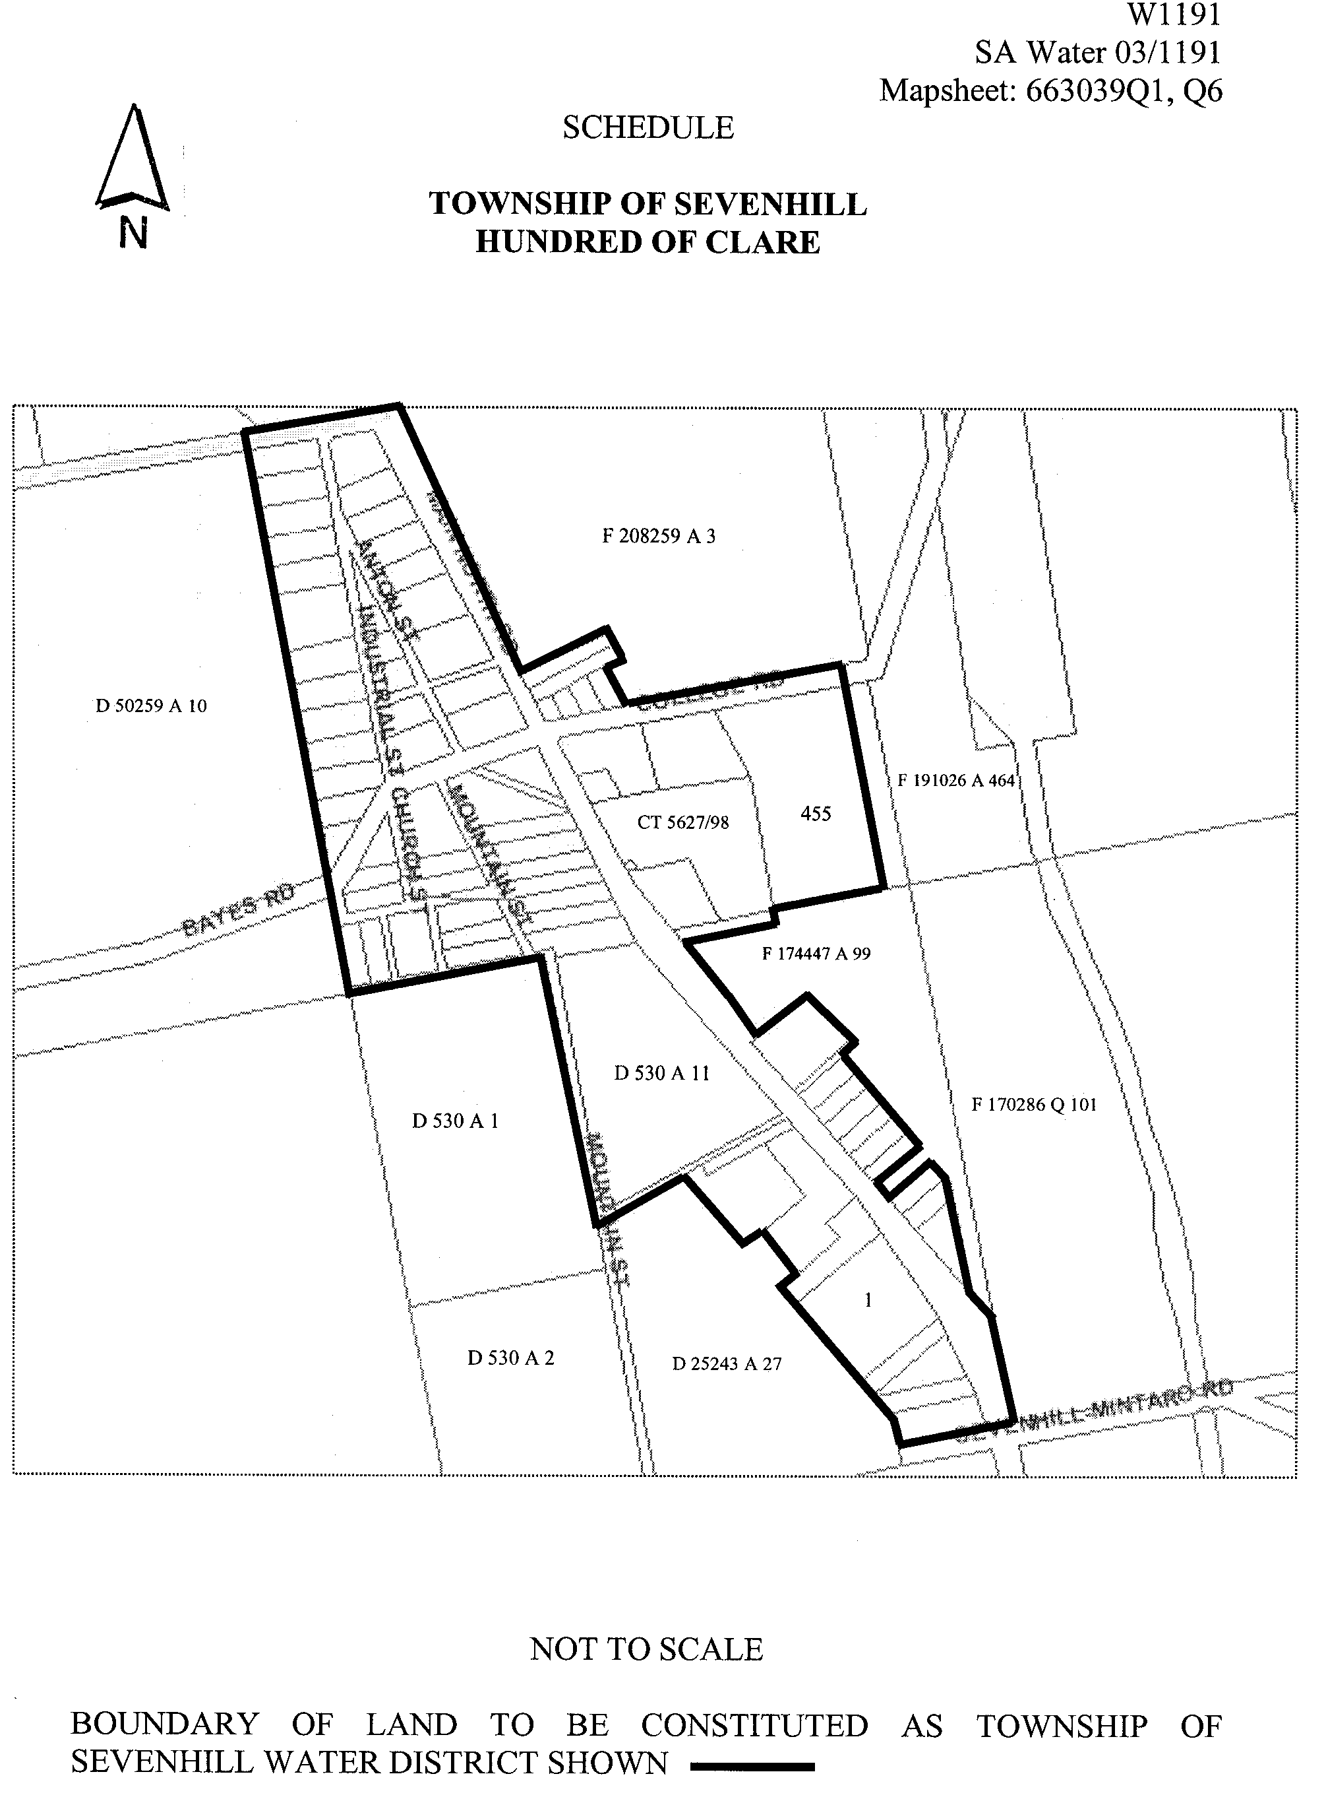
(b) declares that this notice will have effect from 1 July 2003.

Dated 15 July 2003.
Signed for and on behalf of the South Australian Water Corporation by a person duly authorised so to do:
A. Popplewell, General Manager Shared Services
In the presence of: C. J. McNamara, Billing Manager
SAWATER 03/01191 W1191

WATERWORKS ACT 1932
Constitution of Township of Penwortham Water District
PURSUANT to section 6 of the Waterworks Act 1932, the South Australian Water Corporation:
(a) declares the land shown on the plan in the schedule to be the Township of Penwortham Water District; and
(b) declares that this notice will have effect from 1 July 2003.
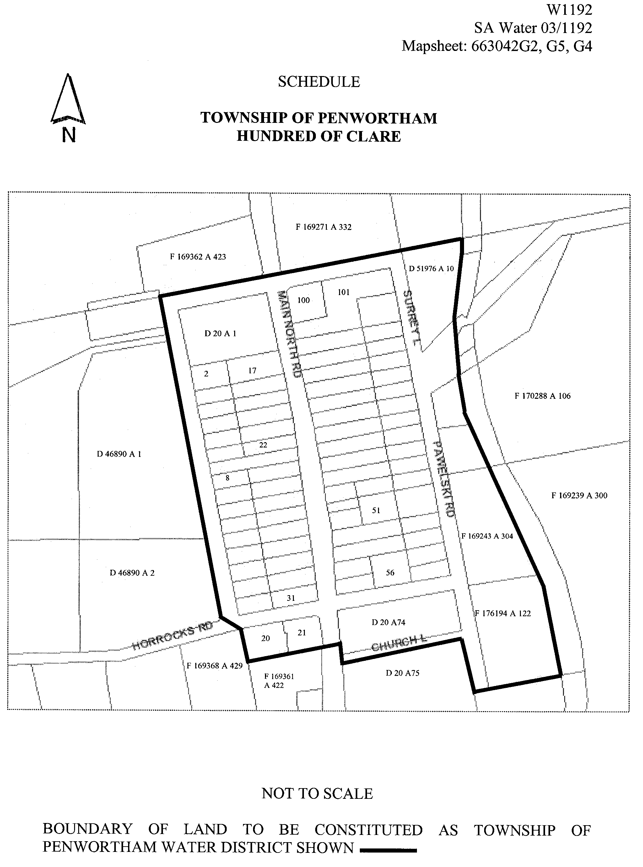
Dated 15 July 2003.
Signed for and on behalf of the South Australian Water Corporation by a person duly authorised so to do:
A. Popplewell, General Manager Shared Services
In the presence of: C. J. McNamara, Billing Manager
SAWATER 03/01192 W1192

WATERWORKS ACT 1932
Constitution of Township of Watervale Water District
PURSUANT to section 6 of the Waterworks Act 1932, the South Australian Water Corporation:
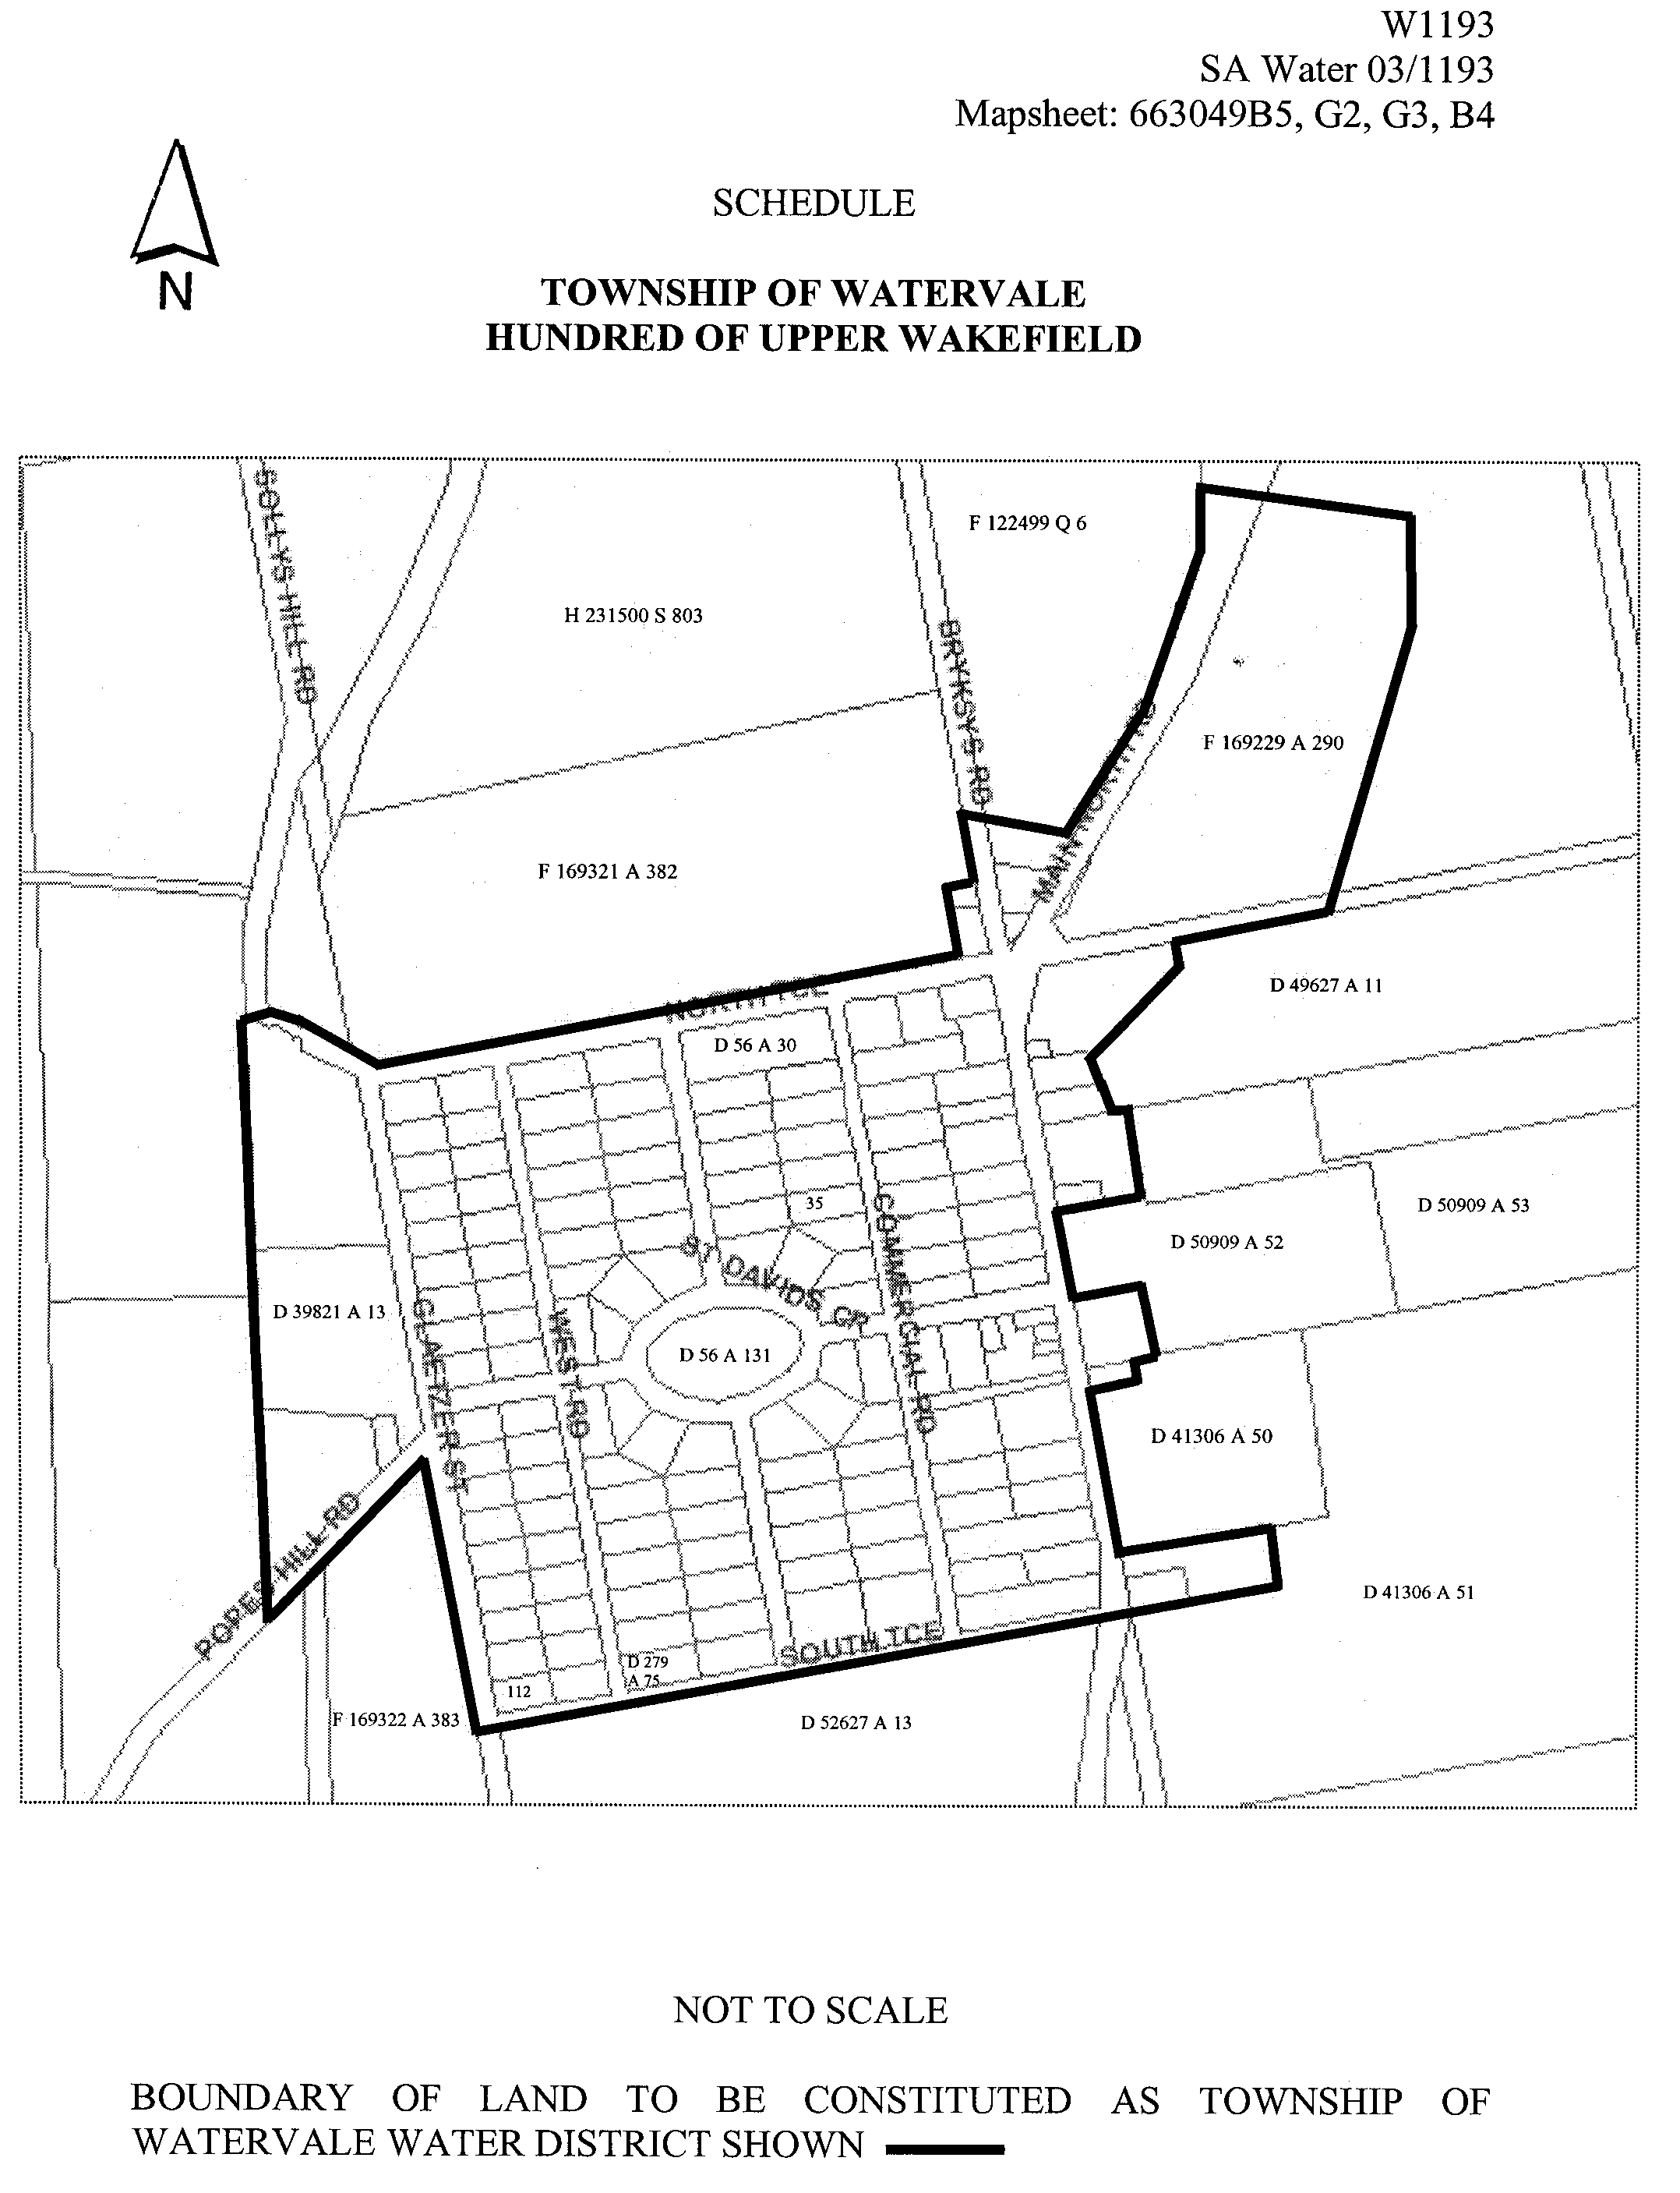
(a) declares the land shown on the plan in the schedule to be the Township of Watervale Water District; and
(b) declares that this notice will have effect from 1 July 2003.

Dated 15 July 2003.
Signed for and on behalf of the South Australian Water Corporation by a person duly authorised so to do:
A. Popplewell, General Manager Shared Services
In the presence of: C. J. McNamara, Billing Manager
SAWATER 03/01193 W1193

WATERWORKS ACT 1932
Constitution of Township of Leasingham Water District
PURSUANT to section 6 of the Waterworks Act 1932, the South Australian Water Corporation:
(a) declares the land shown on the plan in the schedule to be the Township of Leasingham Water District; and
(b) declares that this notice will have effect from 1 July 2003.
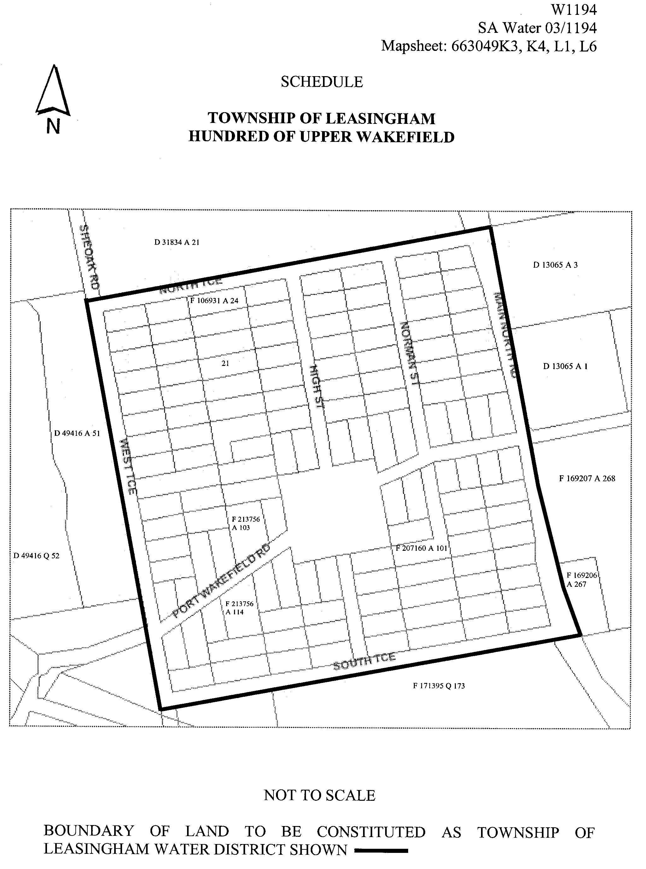
Dated 15 July 2003.
Signed for and on behalf of the South Australian Water Corporation by a person duly authorised so to do:
A. Popplewell, General Manager Shared Services
In the presence of: C. J. McNamara, Billing Manager
SAWATER 03/01194 W1194

WATERWORKS ACT 1932
Constitution of Township of Mintaro Water District
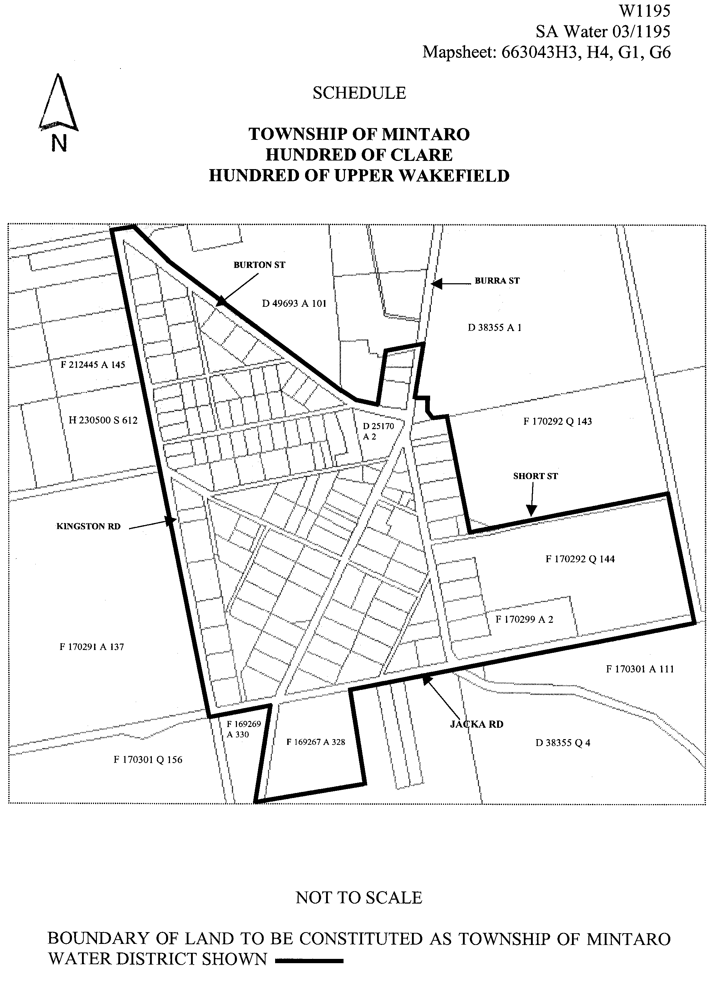
PURSUANT to section 6 of the Waterworks Act 1932, the South Australian Water Corporation:
(a) declares the land shown on the plan in the schedule to be the Township of Mintaro Water District; and
(b) declares that this notice will have effect from 1 July 2003.

Dated 15 July 2003.
Signed for and on behalf of the South Australian Water Corporation by a person duly authorised so to do:
A. Popplewell, General Manager Shared Services
In the presence of: C. J. McNamara, Billing Manager
SAWATER 03/01195 W1195

South Australia
Criminal Law Consolidation (Self Defence) Amendment (Commencement) Proclamation 2003
1—Short title
This proclamation may be cited as the Criminal Law Consolidation (Self Defence) Amendment (Commencement) Proclamation 2003.
2—Commencement
The Criminal Law Consolidation (Self Defence) Amendment Act 2003 (Act
No. 28 of 2003) will come into operation on 27 July 2003.
Made by the Governor’s Deputy
with the advice and consent of the Executive Council
on 24 July 2003.
AGO 0127/02 CS

South Australia
Criminal Law (Sentencing) (Sentencing Guidelines) Amendment (Commencement) Proclamation 2003
1—Short title
This proclamation may be cited as the Criminal Law (Sentencing) (Sentencing Guidelines) Amendment (Commencement) Proclamation 2003.
2—Commencement of Act
The Criminal Law (Sentencing) (Sentencing Guidelines) Amendment Act 2003 (Act
No. 29 of 2003) will come into operation on 27 July 2003.
Made by the Governor’s Deputy
with the advice and consent of the Executive Council
on 24 July 2003.
AGO 0127/02 CS

South Australia
Criminal Law (Sentencing) (Serious Repeat Offenders) Amendment (Commencement) Proclamation 2003
1—Short title
This proclamation may be cited as the Criminal Law (Sentencing) (Serious Repeat Offenders) Amendment (Commencement) Proclamation 2003.
2—Commencement of Act
The Criminal Law (Sentencing) (Serious Repeat Offenders) Amendment Act 2003 (Act
No. 23 of 2003) will come into operation on 27 July 2003.
Made by the Governor’s Deputy
with the advice and consent of the Executive Council
on 24 July 2003.
AGO 0127/02 CS

South Australia
Mining (Revocation of Private Mine) Proclamation 2003
under section 73N of the Mining Act 1971

Preamble
1 The following area was declared to be a private mine by proclamation on 12 October 1972 (Gazette 12.10.1972 p1871):
Section 322, hundred of Waterhouse, county of Robe and being the whole of the
land comprised and described in Land Grant Register Book Volume 478
Folio 143.
2 The Warden’s Court has declared (on 4 June 2003 in Action No 41 of 2003) that proper grounds exist for revoking the declaration referred to in clause 1.

1—Short title
This proclamation may be cited as the Mining (Revocation of Private Mine)
Proclamation 2003.
2—Commencement
This proclamation comes into operation on the day on which it is made.
3—Revocation of private mine
The declaration referred to in clause 1 of the preamble is revoked.
Made by the Governor’s Deputy
on the basis of the declaration of the Warden’s Court referred to in clause 2 of the preamble
and with the advice and consent of the Executive Council
on 24 July 2003.
AGO 0047/02 CS

South Australia
Mining (Variation of Private Mine) Proclamation 2003
under section 73N of the Mining Act 1971

Preamble
1 The following areas were declared to be a private mine by proclamation on 27
September 1973 (Gazette 27.9.1973 p2127):
(a) that portion of section 94, hundred of Goolwa, county of Hindmarsh,
described in Certificate of Title Register Book Volume 1317 Folio 50;
(b) that portion of section 89, hundred of Goolwa, county of Hindmarsh,
described in Certificate of Title Register Book Volume 3541 Folio 114.
2 The Warden's Court has declared (on 7 May 2003 in Action No 495 of 2002) that
proper grounds exist for varying the declaration referred to in clause 1 by excising the following area from the area of the private mine:
Allotment 91 in filed plan 166150, hundred of Goolwa, being the whole of the
land comprised in Certificate of Title Register Book Volume 5571 Folio 680.

1—Short title
This proclamation may be cited as the Mining (Variation of Private Mine)
Proclamation 2003.
2—Commencement
This proclamation comes into operation on the day on which it is made.
3—Variation of private mine
The declaration referred to in clause 1 of the preamble is varied by excising from the
area of the private mine the land described in clause 2 of the preamble.
Made by the Governor’s Deputy
on the basis of the declaration of the Warden's Court referred to in clause 2 of the preamble
and with the advice and consent of the Executive Council
on 24 July 2003.
AGO 0397/02 CS

South Australia
Planning (Revocation of Open Space Preservation) Proclamation 2003
under section 62 of the Planning Act 1982
1—Short title
This proclamation may be cited as the Planning (Revocation of Open Space Preservation) Proclamation 2003.
2—Commencement
This proclamation comes into operation on the day on which it is made.
3—Revocation of prohibition
(1) The prohibition imposed in relation to the prescribed land by a proclamation that has force and effect under section 62 of the Planning Act 1982 (as continued under section 21 of the Statutes Repeal and Amendment (Development) Act 1993) is revoked.
(2) In subclause (1)—
prescribed land means Allotment 100 in Deposited Plan D37397, being land in Certificate of Title Register Book Volume 5227 Folio 464.
Made by the Governor’s Deputy
with the advice and consent of the Executive Council
on 24 July 2003.
CPSA2003/00010

South Australia
Public Sector Management (Public Sector Workforce Relations Division) Proclamation 2003
under section 7 of the Public Sector Management Act 1995
1—Short title
This proclamation may be cited as the Public Sector Management (Public Sector Workforce Relations Division) Proclamation 2003.
2—Commencement
This proclamation will come into operation on 11 August 2003.
3—Transfer of employees
The employees of the Department of Premier and Cabinet who, immediately before the commencement of this proclamation, are working in the Public Sector Workforce Relations Division, Office for the Commissioner for Public Employment, are transferred to the Department for Administrative and Information Services.
Made by the Governor’s Deputy
with the advice and consent of the Executive Council
on 24 July 2003.
DPC 024/03 CS

South Australia

Liquor Licensing (Dry Areas—Long Term) Variation Regulations 2003
under the Liquor Licensing Act 1997

Contents

Part 1—Preliminary

1. Short title
2. Commencement
3. Variation provisions

Part 2—Variation of Liquor Licensing (Dry Areas—Long Term) Regulations 1997 (Gazette 6.11.1997 p 1217) as varied

4. Variation of Schedule 1—Long term dry areas
5. Variation of Schedule 2—Plans of long term dry areas

Schedule—Plan of long term dry area

Part 1—Preliminary

Short title
1. These regulations may be cited as the Liquor Licensing (Dry Areas—Long Term) Variation Regulations 2003.

Commencement
2. These regulations come into operation on the day on which they are made.

Variation provisions
3. In these regulations, a provision under a heading referring to the variation of specified regulations varies the regulations so specified.

Part 2—Variation of Liquor Licensing (Dry Areas—Long Term) Regulations 1997 (Gazette 6.11.1997 p 1217) as varied

Variation of Schedule 1—Long term dry areas
4. Schedule 1—after item headed "Glenelg—Area 1" insert:

Golden Grove—Area 1
(see Schedule 2: Golden Grove—Plan No 1)

Area | Period | Extent of prohibition
The area at Golden Grove and Wynn Vale bounded as follows: commencing at the point at which the north-western boundary of The Golden Way meets the south-western boundary of Asgard Drive, then generally north-westerly along that boundary of Asgard Drive to the south-eastern boundary of Atlantis Drive, then generally south-westerly along that boundary of Atlantis Drive to the north-eastern boundary of The Grove Way, then in a straight line by the shortest route to the point at which the southern boundary of Aeolian Drive meets the south-western boundary of The Grove Way, then north-westerly along that boundary of The Grove Way to the point at which it meets the northern boundary of Lot 57 of Deposited Plan No 54563, then generally south-westerly along that boundary of Lot 57 and the prolongation in a straight line of that boundary to the southern boundary of Aeolian Drive, then generally westerly along that boundary of Aeolian Drive to the south-eastern boundary of Elysium Drive, then generally south-westerly and south-easterly along that boundary of Elysium Drive to the north-western boundary of The Golden Way, then north-easterly along that boundary of The Golden Way to the point at which it intersects the prolongation in a straight line of the north-eastern boundary of Surrey Farm Drive, then generally south-easterly, easterly and north-easterly along that prolongation and boundary of Surrey Farm Drive to the south-western boundary of The Grove Way, then generally north-westerly and northerly along that boundary of The Grove Way to the point at which it intersects the north-western boundary of The Golden Way, then generally north-easterly along that boundary of The Golden Way to the point of commencement. | Continuous until 10 July 2004. | The consumption and possession of liquor are prohibited.

Variation of Schedule 2—Plans of long term dry areas
5. Schedule 2—after the plan headed "Glenelg—Plan No 1" insert the plan in the Schedule of these regulations.

Schedule—Plan of long term dry area

Golden Grove—Plan No 1
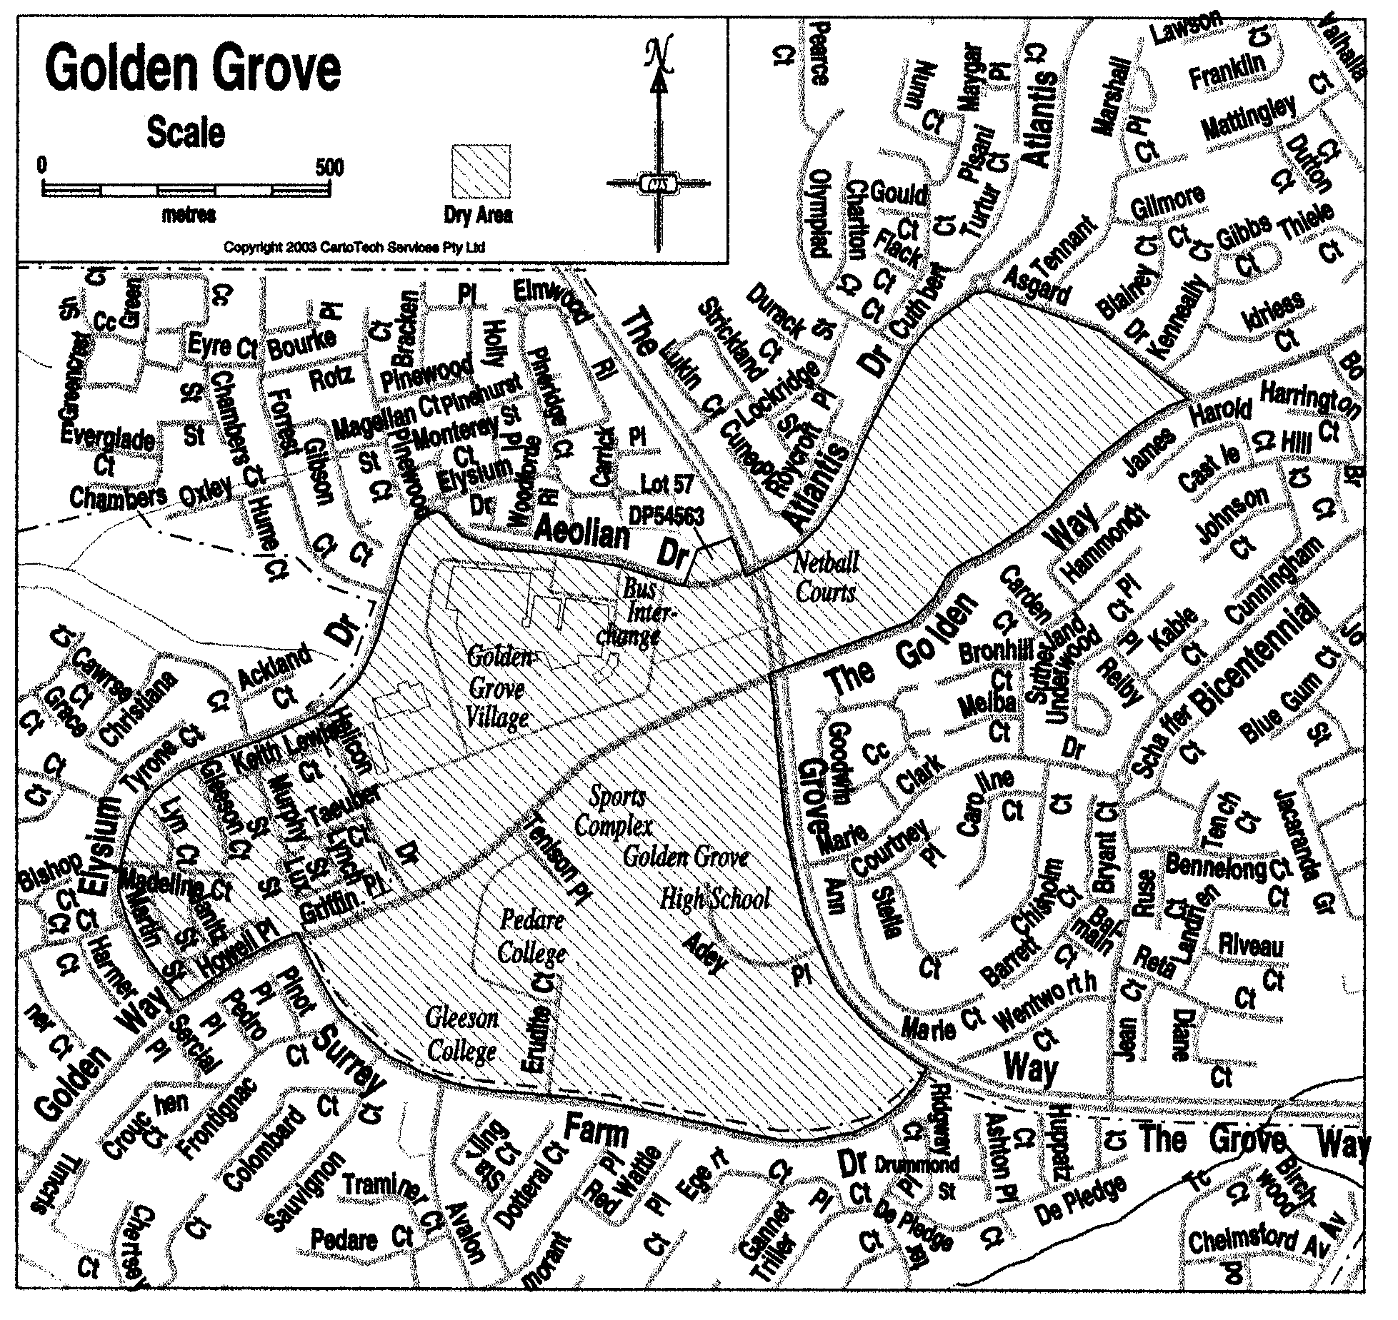

Note—
As required by section 10AA(2) of the Subordinate Legislation Act 1978, the Minister has certified that, in the Minister's opinion, it is necessary or appropriate that these regulations come into operation as set out in these regulations.

Made by the Governor's Deputy
with the advice and consent of the Executive Council
on 24 July 2003.

No. 164 of 2003.
OLGC10/2003

South Australia

Liquor Licensing (Dry Areas—Long Term) Variation Regulations 2003
under the Liquor Licensing Act 1997

Contents

Part 1—Preliminary

1. Short title
2. Commencement
3. Variation provisions

Part 2—Variation of Liquor Licensing (Dry Areas—Long Term) Regulations 1997 (Gazette 6.11.1997 p 1217) as varied

4. Variation of Schedule 1—Long term dry areas

Part 1—Preliminary

Short title
1. These regulations may be cited as the Liquor Licensing (Dry Areas—Long Term) Variation Regulations 2003.

Commencement
2. These regulations come into operation on the day on which they are made.

Variation provisions
3. In these regulations, a provision under a heading referring to the variation of specified regulations varies the regulations so specified.

Part 2—Variation of Liquor Licensing (Dry Areas—Long Term) Regulations 1997 (Gazette 6.11.1997 p 1217) as varied

Variation of Schedule 1—Long term dry areas
4. Schedule 1, item headed "Meningie—Area 1", column headed "Period"—delete "3 June 2003" and substitute:

10 July 2006

Note—
As required by section 10AA(2) of the Subordinate Legislation Act 1978, the Minister has certified that, in the Minister's opinion, it is necessary or appropriate that these regulations come into operation as set out in these regulations.

Made by the Governor's Deputy
with the advice and consent of the Executive Council
on 24 July 2003.

No. 165 of 2003.
OLGC12/2003

South Australia

Passenger Transport (General) Variation Regulations 2003
under the Passenger Transport Act 1994

Contents

Part 1—Preliminary

1. Short title
2. Commencement
3. Variation provisions

Part 2—Variation of Passenger Transport (General) Regulations 1994 (Gazette 28.7.1994 p 254) as varied

4. Variation of Schedule 2—Maximum fares chargeable by taxis

Part 1—Preliminary

Short title
1. These regulations may be cited as the Passenger Transport (General) Variation Regulations 2003.

Commencement
2. These regulations come into operation on 27 July 2003.

Variation provisions
3. In these regulations, a provision under a heading referring to the variation of specified regulations varies the regulations so specified.

Part 2—Variation of Passenger Transport (General) Regulations 1994 (Gazette 28.7.1994 p 254) as varied

Variation of Schedule 2—Maximum fares chargeable by taxis
4. (1) Schedule 2, clause 1(1)(b)(i)—delete "85.10" and substitute:

82.22

(2) Schedule 2, clause 1(1)(b)(ii)—delete "79.47" and substitute:

76.78

(3) Schedule 2, clause 1(1)(c)(i)—delete "15.38" and substitute:

12.63

(4) Schedule 2, clause 1(1)(c)(ii)—delete "15.02" and substitute:

12.63

(5) Schedule 2, clause 2(1)—delete "$0.78" and substitute:

$0.82

(6) Schedule 2, clause 2(1)—delete "15.38" and substitute:

12.63

(7) Schedule 2, clause 2(3)—delete "15.38" and substitute:

12.63

Note—
As required by section 10AA(2) of the Subordinate Legislation Act 1978, the Minister has certified that, in the Minister's opinion, it is necessary or appropriate that these regulations come into operation as set out in these regulations.

Made by the Governor's Deputy
with the advice and consent of the Executive Council
on 24 July 2003.

No. 166 of 2003.
CPTB 2003/0003

South Australia

Victims of Crime Regulations 2003
under the Victims of Crime Act 2001

Contents

1. Short title
2. Commencement
3. Revocation, etc
4. Interpretation
5. Requirements for applications for statutory compensation (section 18 of Act)
6. Prescribed scale of costs (section 25 of Act)
7. Prescribed proportion to be paid into Fund (section 30 of Act)
8. Imposition of levy (section 32 of Act)
9. Review of operation of these regulations

Schedule 1—Requirements for applications for statutory compensation

Schedule 2—Prescribed scale of costs

Schedule 3—Victims of crime levy

Short title
1. These regulations may be cited as the Victims of Crime Regulations 2003.

Commencement
2. These regulations come into operation on the day on which they are made.

Revocation, etc
3. (1) The Criminal Injuries Compensation (Fund) Regulations 1997 (Gazette 21.8.1997 p 431) are revoked.

(2) The Criminal Injuries Compensation Regulations 2002 (Gazette 29.8.2002 p 3313) as varied continue in force for the purpose of applications for compensation to be determined under the repealed Criminal Injuries Compensation Act 1978 (see Schedule 1 of the Act) but for no other purpose.

Interpretation
4. In these regulations—

"Act" means the Victims of Crime Act 2001;

"limited claim"—a claim for statutory compensation is a limited claim if it is limited to a claim for compensation for one or both of the following:

(a) for grief suffered in consequence of the commission of a homicide (see section 17(2) of the Act);

(b) for funeral expenses (see section 17(4) of the Act),

and "limited application" has a corresponding meaning;

"period for negotiation"—in relation to a claim for statutory compensation, the period for negotiation is 3 months from the making of the application or a longer period agreed between the Crown Solicitor and the claimant (see section 18(5) of the Act);

"related claim"—a claim for statutory compensation is a related claim if—

(a) in proceedings under the Act, the same legal practitioner represents more than one victim of an offence claiming compensation in respect of injury arising from the offence; or

(b) in proceedings under the Act, the same legal practitioner represents more than one victim of a series of offences claiming compensation in respect of injury arising from the series of offences;

"series of offences" means offences committed consecutively by one offender, or offences committed simultaneously or consecutively by offenders acting in concert (see section 23 of the Act).

Requirements for applications for statutory compensation (section 18 of Act)
5. (1) For the purposes of section 18(4)(a)(i) of the Act, the information required to be included in an application for statutory compensation is set out in Part A of Schedule 1.

(2) For the purposes of section 18(4)(a)(iii) of the Act, a list of the documents required to accompany an application for statutory compensation is set out in Part B of Schedule 1.

Note—
See also section 18(4)(a)(ii) of the Act which requires an application for statutory compensation to be accompanied by any medical reports relevant to the injury in the possession of, or accessible to, the claimant.

(3) If a claimant seeks to be exempted under section 18(4)(c)(ii) of the Act from serving a copy of an application for statutory compensation on the offender, the claimant must include in the application (in addition to the other required information) full details of the attempts made by the claimant to locate the offender.

Prescribed scale of costs (section 25 of Act)
6. (1) For the purposes of section 25(1) of the Act, the prescribed scale of costs is set out in Schedule 2.

(2) No fee is payable in proceedings under the Act except as set out in Schedule 2.

(3) However, subregulation (2) does not prevent the Crown from recovering its costs in respect of proceedings under the Act.

Prescribed proportion to be paid into Fund (section 30 of Act)
7. For the purposes of section 30(3) of the Act, the prescribed proportion of the aggregate amount paid into General Revenue by way of fines that is to be paid into the Victims of Crime Fund is 20 per cent.

Imposition of levy (section 32 of Act)
8. (1) For the purposes of section 32(2) of the Act, a levy is not imposed on a person who expiates an offence under an expiation notice if—

(a) the notice is issued by a council (within the meaning of the Local Government Act 1999) or other authority with powers and functions of local government; or

(b) the notice is issued by a university or other tertiary educational institution established by an Act; or

(c) the notice is issued by an incorporated hospital or incorporated health centre (within the meaning of the South Australian Health Commission Act 1976); or

(d) the notice is issued by the Institute of Medical and Veterinary Science; or

(e) the notice is issued by the Board of the Botanic Gardens and State Herbarium; or

(f) the offence is under the Technical and Further Education (Vehicles) Regulations 1998.

(2) For the purposes of section 32(4) of the Act, the amount of the levy is fixed by Schedule 3.

Review of operation of these regulations
9. (1) The Minister must, at the end of 2 years from the commencement of these regulations, review their operation.

(2) A report on the review must be prepared and laid before the Legislative Review Committee of the Parliament.

Schedule 1—Requirements for applications for statutory compensation

Part A—Information to be included in application

Claimant information
1. A claimant must include in an application for statutory compensation the following information:

(a) the name, address and date of birth of the claimant;

(b) the name and date of birth of the victim of the offence (if not the claimant);

(c) the date, time and place of the offence;

(d) the nature of the offence and the details surrounding the occurrence of the offence;

(e) when and where the offence was reported to the police or, if not reported, the reason for not reporting the offence;

(f) details of the nature and extent of the injury;

(g) if the victim of the offence is dead—

(i) the relationship of the claimant to the victim; and

(ii) the date of death; and

(iii) the date of the funeral.

Note—
Failure to report an offence to the police within a reasonable time after its commission may result in a claimant being refused statutory compensation unless the claimant can establish good reason for the failure—see section 20(7) of the Act.

Offender information
2. A claimant must include in an application for statutory compensation the following information about the offender:

(a) the name and address of the offender (if known);

(b) if the offender was charged with any offence—

(i) details of the charges laid; and

(ii) details of the court in which the charges were laid; and

(iii) the date of the trial (if any);

(c) the outcome of the prosecution of any offence, including, if the offender was convicted of an offence—

(i) details of the conviction recorded; and

(ii) details of the court in which the conviction was recorded; and

(iii) the date of the conviction;

(d) whether the claimant gave evidence for the prosecution at the trial of the offender and, if not, the reasons why the claimant did not give evidence;

(e) if the claimant seeks an exemption from the requirement to serve the application on the offender on the ground that the whereabouts of the offender are unknown (see section 18(4)(c) if the Act)—details of attempts by the claimant to locate the offender.

Note—
Failure of or refusal by the victim to give evidence in the prosecution of an offender may result in a claimant being refused statutory compensation unless the claimant can establish good reason for the failure or refusal—see section 20(7) of the Act.

Information about action taken to ascertain defendant's assets
3. A claimant must include in an application (other than a limited application) for statutory compensation details, and results, of any searches carried out by the claimant in order to ascertain the assets (if any) of the defendant.

Information about statutory compensation being claimed
4. (1) A claimant must include in an application for statutory compensation that is limited to compensation for funeral expenses an itemised list of funeral expenses (see section 17(4) of the Act).

(2) A claimant must include in an application for statutory compensation the following information about the compensation being claimed:

(a) particulars of special damages, including—

(i) an itemised list of expenses in relation to any treatment and the name of the person or institution to whom the expense was paid or is payable;

(ii) as to each item, details of any refund or entitlement to refund of treatment costs from Medicare, an insurer or any other source;

(iii) an itemised list of funeral expenses;

(b) particulars of loss of earnings as follows:

(i) if past loss of earnings is being claimed, details of the period off work or any period of reduced work and the amount that would have been earned had the claimant worked during that period (showing how this is calculated);

(ii) if an ongoing loss of earnings or a loss of earning capacity is being claimed, details of—

(A) the occupation or business of the claimant at the time of the injury and during the 12 months prior to the injury;

(B) the gross income received from the occupation or business during the 12 month period ending on 30 June last prior to the injury;

(C) any disability (including mental disability) from which the claimant is suffering or has suffered in consequence of the injury and which is preventing or has prevented (wholly or in part) the claimant from performing his or her occupation or business;

(D) the periods since the injury during which the claimant has been unable (wholly or in part) to perform his or her usual occupation or business, together with the periods during which the incapacity has been total and the periods during which it has been partial;

(E) where there has been partial incapacity, the nature and extent of the partial incapacity;

(F) the periods since the injury during which the claimant has been employed or otherwise engaged in an occupation or business and, in respect of each such occupation or business—

⋅ the nature of the occupation or business;

⋅ the address at which it was conducted or performed;

⋅ the name of the employer;

⋅ the gross income received by the claimant.

Formulated claim
5. (1) A claimant must include in an application (other than a limited application) for statutory compensation a formulated claim showing the amount of compensation for which the claimant proposes the claim be settled.

(2) The formulated claim must set out separately—

(a) the number of points claimed for non-financial loss (see section 20(3)(a)(ii) of the Act); and

(b) the amount claimed for—

(i) any closed period of past loss of earnings; and

(ii) any loss of earning capacity; and

(iii) special damages.

(3) The formulated claim must include a statement of all amounts received, or likely to be received, by or on behalf of the claimant from the offender, an insurer or any other source, and details of any steps taken to obtain payment or compensation from the offender or any other person, body corporate or government department or agency in respect of the injury.

Part B—Documents required to accompany application

Police records, statements etc
6. An application for statutory compensation must be accompanied by a copy of any record, statement or evidence relating to the offence provided to the claimant by the police.

General medical practitioner's report
7. If there is no other medical or psychological report relevant to an injury caused by an offence, the claimant's application (other than a limited application) for statutory compensation must be accompanied by a report from the claimant's usual or treating general medical practitioner summarising—

(a) the history taken from the claimant; and

(b) the nature and extent of the injury; and

(c) the history of the treatment of the injury; and

(d) whether there is a need for any future treatment and, if so, the nature of the future treatment; and

(e) the prognosis; and

(f) the nature and extent of any permanent disability as a result of the injury.

Note—
See also clause 4(2) of Schedule 2.
Photographs
8. (1) If an application for statutory compensation includes a claim for a permanent disability in the nature of scarring, deformity or disfigurement resulting from an injury caused by an offence, the application must be accompanied by—

(a) any relevant photographs, which must be dated, of the claimant taken before the claimant was injured; and

(b) photographs of the injury taken at or about the time of the making of the application.

(2) A photograph taken for the purposes of subclause (1)(b) must, on the reverse of the photograph, be signed and dated by a legal practitioner or justice certifying that—

(a) he or she has seen, and is satisfied as to the identity of, the claimant; and

(b) the photograph is a true photograph of the claimant.

Statement of loss of earnings etc
9. (1) If an application for statutory compensation includes a claim for past loss of earnings—

(a) by the claimant as an employee—the application must be accompanied by a letter from the employer or employer's insurer confirming the period during which the claimant lost earnings and the amount lost during the period;

(b) by the claimant as a self-employed person—the application must be accompanied by written evidence supporting the claim.

(2) If an application for statutory compensation includes a claim for loss of earnings as a result of the claimant being unable, as a consequence of the injury, to enter into, or carry out, a contract with a particular person, the application must be accompanied by—

(a) a letter from the person confirming the availability of work for the claimant during the relevant period and the value of that work; or

(b) some other written evidence supporting the claim.

(3) If an application for statutory compensation includes a claim for loss of earning capacity by the claimant, the application must be accompanied by a copy of the claimant's income tax return—

(a) for each of the 5 financial years immediately preceding the commission of the offence; and

(b) for the financial year during which the offence was committed; and

(c) for each of the financial years occurring since the financial year referred to in paragraph (b).

Note—
A claimant may obtain copies of tax returns by making an application under the Freedom of Information Act to the Australian Taxation Office.

Documents relating to amounts received by claimant from other sources
10. An application for statutory compensation must be accompanied by—

(a) copies of any documents relating to any amounts received, or likely to be received, by or on behalf of the claimant from the offender, an insurer or any other source, and details of any steps taken to obtain payment or compensation from the offender or any other person, body corporate or government department or agency in respect of the injury; and

(b) details of any potential claim (apart from this claim) that the claimant may have against the offender or any other person for compensation or damages arising out of the injury, including details of the steps taken to pursue such a claim.

Schedule 2—Prescribed scale of costs

1. | Solicitor's fee for claim for statutory compensation
 | (1) For a limited claim where the identity of the offender is known, compensation is agreed and an application is made to the court to obtain a consent order | $500
Note—
No fee is payable for a limited claim where the identity of the offender is unknown and compensation is agreed during the period for negotiation.
 | (2) For any other claim—
 | (a) in the case of a claim that is not a related claim | $1 000
 | (b) in the case of related claims—
 | (i) for one of the related claims | $1 000
 | (ii) for each of the other related claims | $800
2. | Counsel's fee
 | (1) Preliminary fee  For all work preparatory to an application to the court for statutory compensation (including, advice on evidence and any other legal advice on the application, conferences and proofing witnesses) and for the first 5 hours of the hearing of the application | Not more than $750
 | (2) Additional fee  For each hour or part of an hour after the first 5 hours of the hearing of the application | 1/5 of the preliminary fee actually charged
 | (3) Compromise of minor's claim  Subject to subclause (4), for an opinion as to the compromise of a minor's claim for statutory compensation | $500
 | (4) Compromise of minor's related claim  For an opinion as to the compromise of a minor's related claim for statutory compensation | $350 for each opinion
3. | On appeal | $500
4. | Disbursements
 | (1) If—
 | (a) an application for statutory compensation is made to the court, a legal practitioner may recover all disbursements reasonably incurred under the Act as certified by the court;
 | (b) an application for statutory compensation is settled during the period for negotiation, a legal practitioner may recover all disbursements reasonably incurred as certified by the Crown Solicitor.
 | (2) However—
 | (a) a legal practitioner may not recover the cost of obtaining a copy of a hospital record before the end of the period for negotiation unless the Crown Solicitor has agreed that it is necessary to obtain a copy of the record; and
 | (b) a legal practitioner may not recover the cost of obtaining a medical or psychological report (other than a report from the claimant's usual or treating general medical practitioner) before the end of the period for negotiation unless the Crown Solicitor has agreed that it is necessary to obtain the report; and
 | (c) a legal practitioner may not recover the cost of obtaining a report from more than one expert in the same specialty unless the Crown Solicitor has agreed that it is necessary to obtain the additional report.
 | (3) For the purposes of subclause (2)(c), psychiatrists and psychologists will be taken to be experts in the same specialty.
Schedule 3—Victims of crime levy

Victims of crime levy
(1) Subject to this clause, the amount of the levy is—

(a) in relation to a summary offence—

(i) if the offence is expiated—$10;

(ii) in any other case—$35;

(b) in relation to an indictable offence—$60.

(2) If a summary or an indictable offence appears in the following list, the levy in relation to that offence is twice the levy that would otherwise be payable under subclause (1):

(a) an offence under the Aircraft Offences Act 1971;

(b) an offence against section 11, 12, 12A, 13, 19, 19AA, 20, 21, 23, 25, 27, 29, 30, 33A, 39, 40, 41, 42, 43, 44, 47A, 48, 49, 56, 58, 58A, 59, 64, 74, 80, 81, 82, 85(1), 155, 158, 167, 168, 169, 170, 170A, 206, 207, 208, 209 or 270A of the Criminal Law Consolidation Act 1935;

(c) an offence under the Kidnapping Act 1960;

(d) an offence against section 6 of the Summary Offences Act 1953.

(3) If, but for this subclause, the amount of the levy payable by a youth—

(a) under subclause (1) would exceed $20, the amount of the levy will be $20;

(b) under subclause (2) would exceed $40, the amount of the levy will be $40.

Note—
As required by section 10AA(2) of the Subordinate Legislation Act 1978, the Minister has certified that, in the Minister's opinion, it is necessary or appropriate that these regulations come into operation as set out in these regulations.

Made by the Governor's Deputy
with the advice and consent of the Executive Council
on 24 July 2003.

No. 167 of 2003
AGO 0380/02 CS

FAXING COPY?

IF you fax copy to Government Publishing SA for inclusion in the Government Gazette, there is no need to send a Confirmation Copy to us as well.

This creates confusion and may well result in your notice being printed twice.

Please use the following fax number:

Fax transmission: (08) 8207 1040
Phone Inquiries: (08) 8207 1045

Please include a contact person, phone number and order number so that we can phone back with any queries we may have regarding the fax copy.

NOTE: Closing time for lodging new copy (either fax or hard copy) is 4 p.m. on Tuesday preceding the day of publication.

Government Gazette notices can be E-mailed.

The address is:

governmentgazette@saugov.sa.gov.au

Documents should be sent as attachments in Word format.

When sending a document via E-mail, please confirm your transmission with a faxed copy of your document, including the date the notice is to be published.

Fax transmission: (08) 8207 1040
Enquiries: (08) 8207 1045

CITY OF ADELAIDE
One-Way Traffic Conditions
NOTICE is hereby given that the Council of the Corporation of the City of Adelaide, at its meeting held on 23 June 2003, adopted the following resolution:
That pursuant to section 359 (1) of the Local Government Act 1934, as amended, and section 32 of the Road Traffic Act, 1961, all vehicles other than those vehicles indicated in Column 3 shall be excluded from the section of road named in Column 1 and described in Column 2:
Column 1  Street |  | Column 2  Location |  | Column 3  Class of Vehicles Exempt
O’Brien Street |  | From the southern building alignment of Sturt Street to the northern building alignment of Gilbert Street. |  | Any vehicle travelling in a southerly direction from Sturt Street to Gilbert Street.  Any vehicles owned or operated by or on behalf of the Adelaide City Council for the purposes of street cleaning and maintenance.
Little Sturt Street |  | From the southern building alignment of Sturt Street to the northern building alignment of Gilbert Street. |  | Any vehicle travelling in a northerly direction from Gilbert Street to Sturt Street.  Any vehicles owned or operated by or on behalf of the Adelaide City Council for the purposes of street cleaning and maintenance.

Further information can be obtained from John Hanchett, Asset Management, Telephone 8203 7433 or e-mail:
j.hanchett@adelaidecitycouncil.com
Susan Law, Chief Executive Officer

CITY OF ADELAIDE
Road Closures
NOTICE is hereby given that council at its meeting held on Monday, 14 July 2003, adopted the following resolution:
That pursuant to section 359 (1) of the Local Government Act 1934, as amended, and section 32 of the Road Traffic Act 1961, all vehicles other than those vehicles indicated in Column 3 below shall be excluded from the road so named in Column 1:
Column 1  Street |  | Column 2  Location |  | Column 3  Class of Vehicles Exempt
Colby Place |  | From a point 43 m north of the northern building alignment of Halifax Street to a point 65 m north of the northern building alignment of Halifax Street. |  | Those vehicles owned, operated or authorised by Craig Holden Constructions. Any vehicle owned or operated by Adelaide City Council for the purposes of street cleaning and maintenance.
Adjacent residents and businesses be advised accordingly.
Susan Law, Chief Executive Officer

CITY OF ADELAIDE
Declaration as Public Road—Notice of Intention
NOTICE is hereby given pursuant to section 210 of the Local Government Act 1999, that at a future meeting Council intends to declare the following road to be a Public Road:
Portions on Vaughan Place in Town Acres 28, 29 and 34 being:
(1) that part contained in certificates of title volume 268, folios 205, 206 and 207 and volume 269, folio 47 and designated AZ on Lands Titles Office plan Deposited Plan 61170;
(2) that part delineated as allotment 501 on Lands Titles Office plan Deposited Plan 61170 and contained in certificate of title volume 5889, folio 848; and
(3) that part delineated as piece 112 on certificate of title volume 5884, folio 361 and designated CZ on Lands Titles Office plan Deposited Plan 61170.
Susan Law, Chief Executive Officer

CITY OF ADELAIDE
Adoption of Valuation and Declaration of Rates
NOTICE is hereby given that the Council of the Corporation of the City of Adelaide at its meeting held on 9 July 2003:
Adoption of Valuation
Resolved that pursuant to section 167 (2) (b) of the Local Government Act 1999 the Valuations for 2003-2004, prepared on the basis of Annual Value, comprised within the Assess-ment Record, amounting to $469 397 830, made by valuers employed by Council, be adopted as applying to the land within the area of the Corporation of the City of Adelaide for rating purposes. The Assessment Record includes assessments of value for rateable and exempt land. The total assessed annual value of rateable land, which the Council adopts for rating purposes, is $383 131 980. The total assessed annual value of land exempt from council rates is $86 265 850.
Declaration of Rates
Declared a Differential General Rate of 12.3 cents in the dollar for all land uses (other than residential) within the City of Adelaide for the financial year ending 30 June 2004.
Declared a Differential General Rate of 10.5 cents in the dollar for all land with a residential land use within the City of Adelaide for the financial year ending 30 June 2004.
Declared a separate rate of 0.1411 cents in the dollar on rateable land within the Council area falling within the catchment area of the Torrens Catchment Water Management Board, in accordance with the requirements of section 138 of the Water Resources Act 1997.
Declared a separate rate of 0.1368 cents in the dollar on rateable land within the Council area falling within the catchment area of the Patawalonga Catchment Water Manage-ment Board, in accordance with the requirements of section 138 of the Water Resources Act 1997.
Declared a differential separate rate (to be known as the Rundle Mall Environs Separate Rate) of 2.64 cents in the dollar for the period 1 July 2003 to 30 June 2004 on all rateable land except land which has a residential land use within the Rundle Mall Environs for the purposes of marketing the Rundle Mall Environs, pursuant to section 154 (1) of the Local Government Act 1999.
Determined that all Council Rates be payable in four instalments due on or before the first working days of September 2003, December 2003, March 2004 and June 2004 respectively.
Susan Law, Chief Executive Officer

CITY OF MOUNT GAMBIER
Local Government Act 1999—By-law No. A4 (6)
Exemption for Election—Moveable Signs
TO exempt moveable signs from compliance with council by-laws where such signs are related to a State or Commonwealth election and are displayed during the course of the election.
A4 (6) A person may place and maintain a moveable sign on a road without compliance with by-laws of the council if the sign is related to a State or Common-wealth election and is displayed during the period commencing on the issue of the writ or writs for the election and ending at the close of polls on polling day.
The foregoing by-law was duly made and passed at a meeting of the council of the City of Mount Gambier held on 15 July 2003, by an absolute majority of the members for the time being constituting the council, there being at least two-thirds of the members present.
G. Muller, Chief Executive Officer

CITY OF MOUNT GAMBIER
Adoption of Valuation and Declaration of Rates
NOTICE is hereby given that at a meeting of the council of the City of Mount Gambier held on Tuesday, 15 July 2003, the council resolved:
Adoption of Valuation
To adopt for rating purposes for the 2003-2004 financial year, the Valuer-General’s valuations of the site values applicable to land within the area of the council, totalling $427 374 163 and that the date of adoption of the valuations is 15 July 2003.
Declaration of Differential General Rates
To declare differential general rates for the 2003-2004 financial year as follows:
1. In respect of such rateable property which is located within the City Centre Zone (CCe) and within the Authorised Mount Gambier (City) Development Plan Maps MtG(C)/8 and MtG(C)/9 a differential general rate of 2.92 cents in the dollar on the assessed site valuation of such rateable property.
2. In respect of such rateable property which is located within all other zones and policy areas and which are zoned as Residential, Local Shopping, Commercial, Commerce/ Industry, Light Industry, General Industry, Recreation, Public Purposes (Rail Transport), Industry (Enterprise), Lakes, Residential (Industry Transition), Rural (Deferred Industry), Public Purposes (Show Grounds), Country Living, and the following policy areas being Residential Policy Areas (vis. 1. Northern Residential Policy Area and 2. Eastern Residential Policy Area), Residential Local Heritage Policy Areas, City Centre Local Heritage Policy Areas and Commercial Local Heritage Policy Areas, and contained within the Authorised Mount Gambier (City) Development Plan, Maps MtG(C)/3 to 18 inclusive, and all being within the area of the City of Mount Gambier, a differential general rate of 1.767 cents in the dollar on the assessed site valuation of such rateable property.
Declaration of a Minimum Amount
To fix in respect of the 2003-2004 financial year a minimum amount of rates payable on rateable land within the area of the City of Mount Gambier in the sum of $485.
Declaration of Separate Rate
In order to reimburse to the council the amount contributed to the South East Catchment Water Management Board, to declare a separate rate of $12.70 per site on all rateable land in the council’s area in the catchment area of the said Board based on a fixed levy of the same amount on all rateable land for the 2003-2004 financial year.
Payment of Council Rates
Pursuant to the powers contained in section 181 (2) (a) and (14) of the Local Government Act 1999, the council declares that rates and charges payable in respect of the 2003-2004 financial year, be by quarterly instalments due and payable on or before:
12 September 2003;
12 December 2003;
12 March 2004;
11 June 2004.
G. Muller, Chief Executive Officer

CITY OF PORT ADELAIDE ENFIELD
Adoption of Valuation and Declaration of Rates
NOTICE is hereby given that at its meeting held on 9 July 2003, the council:
1. Adopted the valuations that are to apply in its area for rating purposes for the 2003-2004 financial year, totalling $9 369 042 700.
2. Declared differential general rates on rateable land within its area as follows:
• Residential—A differential general rate of 0.004 cents in the dollar on the value of the land subject to the rate.
• Commercial—Shop—A differential general rate of 0.0083 cents in the dollar on the value of the land subject to the rate.
• Commercial—Office—A differential general rate of 0.0083 cents in the dollar on the value of the land subject to the rate.
• Commercial—Other—A differential general rate of 0.0083 cents in the dollar on the value of the land subject to the rate.
• Industry—Light—A differential general rate of 0.0083 cents in the dollar on the value of the land subject to the rate.
• Industry—Other—A differential general rate of 0.0083 cents in the dollar on the value of the land subject to the rate.
• Primary Production—A differential general rate of 0.0083 cents in the dollar on the value of the land subject to the rate.
• Vacant Land—A differential general rate of 0.0083 cents in the dollar on the value of the land subject to the rate.
• Other—A differential general rate of 0.0083 cents in the dollar on the value of the land subject to the rate.
3. Fixed a minimum amount payable by way of rates, pursuant to section 158 of the Local Government Act 1999, in respect of the 2003-2004 financial year, in respect of rateable land within all parts of its area of $492, excluding the following:
• The area defined as Industry (Port) Zone by the Port Adelaide Enfield (City) Development Plan dated 12 June 2003.
• The Business Policy Area of the Marina (North Haven) Zone in the City of Port Adelaide Enfield Development Plan Map PAdE/43, dated 12 June 2003.
• The Boat Haven Policy Area of the Marina (North Haven) Zone in the City of Port Adelaide Enfield Development Plan Map PAdE/43, dated 12 June 2003.
4. Declared a separate rate in respect to the 2003-2004 financial year of 0.0000912 cents in the dollar on the value of rateable land in the catchment area of the Torrens Catchment Water Management Board.
5. Declared a separate rate in respect to the 2003-2004 financial year of 0.0002212 cents in the dollar on the value of rateable land in the catchment area of the Northern Adelaide and Barossa Water Management Board.
6. Declared a separate rate in respect to the 2003-2004 financial year of 0.00188 cents in the dollar on the value of rateable land for each allotment contained within Deposited Plan No. 42580 comprising the New Haven Village at Osborne.
7. Declared that all rates declared or payable in respect of or during the 2003-2004 financial year will fall due (unless otherwise agreed with the principal ratepayer) in four equal or approximately equal instalments payable on 10 September 2003, 10 December 2003, 10 March 2004 and 10 June 2004,
with reference to categories of uses being the categories of uses as differentiating factors referred to in the Local Government (General) Regulations 1999.
H. J. Wierda, City Manager

CITY OF PROSPECT
Adoption of Valuations and Declaration of Rates 2003-2004
NOTICE is hereby given that the Council of the City of Prospect at its meeting held on 8 July 2003 and for the financial year ending 30 June 2004:
• Resolved that the most recent valuations of capital
value made by the Valuer-General, amounting to $2 382 550 600, be adopted for rating purposes;
• declared differential general rates upon the basis of land use as follows:
(a) 0.3716 cents in the dollar on the capital value of rateable land of residential use and vacant land; and
(b) 0.5398 cents in the dollar on the capital value of rateable land of Commercial—Shop, Commercial—Office, Commercial—Other, Industry—Light, Industry—Other, Primary Production and other land uses;
• set a minimum amount payable by way of differential general rates of $567; and
• declared a separate rate of 0.009934 cents in the dollar on rateable land within the Council area which falls within the catchment area of the Torrens Catchment Water Management Board.
R. Pincombe, City Manager

CITY OF SALISBURY
Notice of Exclusion of Land from Classification as
Community Land
NOTICE is hereby given that pursuant to section 193 (4) of the Local Government Act 1999, the City of Salisbury resolved at its meeting held on 24 February 2003, that portions of Helps Road to be closed, as identified in the final plan as pieces 1000 and 1001 and Allotment 1002, in the area of Burton be excluded from classification as community land, subject to confirmation of the Road Process Order by the Minister, pursuant to section 24 (4) of the Roads (Opening and Closing) Act 1991, pursuant to section 193 (6) the council hereby gives notice of its resolution.
The City of Salisbury resolved at its meeting held on 26 August 2002, that the area marked A, between Diagonal Road and Main North Road, Pooraka, shown on the Preliminary Road Closure Plan No. 02/0032, be excluded from classification as community land, subject to confirmation of the Road Process Order by the Minister, pursuant to section 24 (4) of the Roads (Opening and Closing) Act 1991, pursuant to section 193 (6) the council hereby gives notice of its resolution.
S. Hains, City Manager

CITY OF WHYALLA
Declaration of Rates
NOTICE is hereby given that the Corporation of the City of Whyalla at its meeting held on 3 July 2003, by virtue of the powers vested in it under the Local Government Act 1999, has adopted valuations of the land in its area to the amount of $172 746 600 for rating purposes, and having considered and adopted its budget for the financial year ending 30 June 2004, resolved:
That in relation to the 2003-2004 rating year for the period ending on 30 June 2004, the Corporation of the City of Whyalla hereby declares, pursuant to the provisions of the Local Govern-ment Act 1999, sections 152 (1) (c) and 153, differential general rates based on the site value of all rateable property within its area and further declared a fixed charge, as follows:
1. The Differential General Rate shall vary according to the locality of the land in various zones defined in the City’s Development Plan, established, pursuant to the Development Act 1993, and the use of the land, pursuant to section 156 of the Local Government Act 1999 and Regulation 10 (2) of the Local Government (General) Regulations 1999, and the rate applies as follows:
(a) locality and use as differentiating factors:
(i) in respect of all rateable land situated in Local Shopping, District Shopping, Commercial, General Commercial, District Centre and Business Zones, and so recorded in the assess-ment records of the council, a differential general rate of 9.809 cents in the dollar on the assessed site value of the land, but excluding any land categorised as Residential in the said Regulations and for which the general differen-tial rate is declared in paragraph (b) hereunder;
(ii) in respect of all rateable land situated in Light Industry and General Industry Zones, and so recorded in the assessment records of the council, a differential general rate of 7.433 cents in the dollar on the assessed site value of the land, but excluding any land categorised as Residential in the said Regulations and for which the general differential rate is declared in para-graph (b) hereunder;
(iii) in respect of all rateable property situated in Residential and Community Use Zones and so recorded in the assessment records of the council, a differential general rate of 2.486 cents in the dollar on the assessed site value of the land, but excluding any land categorised as Commercial—Shop, Commercial—Office, Com-mercial—Other, Industry—Light and Industry—Other in the said Regulations, and for which the general differential rate is declared in paragraph (b) hereunder;
(iv) in respect of all rateable property situated in Urban Farmland and Urban Farm (Airport) Zones and so recorded in the assessment records of the council, a differential general rate of 1.472 cents in the dollar on the assessed site value of the land, but excluding any land categorised as Commercial—Shop, Com-mercial—Office, Commercial—Other, Industry—Light and Industry—Other in the said Regulations and for which the general differential rate is declared in paragraph (b) hereunder;
(v) in respect of all rateable property situated in Special Industry (Hydrocarbons) Zones and so recorded in the assessment records of the council, a differential general rate of 47.740 cents in the dollar on the assessed site value of the land, but excluding any land categorised as Residential in the said Regulations and for which the general differential rate is declared in para-graph (b) hereunder;
(vi) in respect of all rateable properties situated in Coastal and Tourist Accommodation (Point Lowly) Zones and so recorded in the assessment records of the council, a differential general rate of 0.270 cents in the dollar on the assessed
site value of the land, but excluding any
land categorised as Commercial—Shop, Com-mercial—Office, Commercial—Other, Industry— Light and Industry—Other in the said Regula-tions and for which the general differential rate is declared in paragraph (b) hereunder;
(b) land use as a differentiating factor in accordance with, as follows:
(i) Residential—a differential general rate of 2.486 cents in the dollar on the assessed site value of each such property;
(ii) Commercial—Shop—a differential general rate of 9.809 cents in the dollar on the assessed site value of each such property;
(iii) Commercial—Office—a differential general rate of 9.809 cents in the dollar on the assessed site value of each such property;
(iv) Commercial—Other—a differential general rate of 9.809 cents in the dollar on the assessed site value of each such property;
(v) Industry—Light—a differential general rate of 7.433 cents in the dollar on the assessed site value of each such property;
(vi) Industry—Other—a differential general rate of 7.433 cents in the dollar on the assessed site value of each such property;
(vii) Primary Production—a differential general rate of 0.103 cents in the dollar on the assessed site value of each such property;
(viii) Vacant Land—a differential general rate of 2.486 cents in the dollar on the assessed site value of each such property;
(ix) Other (any other land use not referred to in a previous category)—a differential general rate of 9.809 cents in the dollar on the assessed site value of each such property.
2. The fixed charge shall be the sum of $186.50.
3. Declaration of a Service Rate:
The Corporation of the City of Whyalla further declares a Service Rate of $90 on rateable land within its area for the provision of the service of collection, treatment or disposal of waste where such a service is provided, pursuant to section 155 of the Local Government Act 1999.
Amount to be Raised
An amount of $8 070 857 be declared as the amount which the council intends to raise by general rates, the fixed charge and the service rate, which amount is calculated as follows:
$
• General rates 5 263 536
• Fixed charge 1 901 741
• Service rate 905 580
4. Declaration of a Separate Rate:
The Corporation of the City of Whyalla further declares, pursuant to section 154 of the Local Government Act 1999, a separate rate of 2.518 cents in the dollar based on the value of the land subject to the rate, situated in the area delineated in the plan attached as Annexure F to the report under reference.
The purpose of the Separate Rate is to provide funds to be applied towards development of the City Plaza and surrounding district, secure funding for the City Plaza Co-ordinator, promotional activities throughout the year and beautifying the City Plaza area for the benefit of Whyalla.
5. Rates shall be Payable:
All rates shall be payable in four instalments in the 2003-2004 financial year within 30 days of the date of the Rate Notice or on 12 September 2003 for the first instalment, 5 December 2003 for the second instalment, 5 March 2004 for the third instalment and 4 June 2004 for the fourth instal-ment, whichever is the earlier date, pursuant to section 181 of the Local Government Act 1999.
The council may agree with the principal ratepayer that rates will be payable in such instalments falling due on such days as the council sees fit and in that event, the ratepayers rates will be payable accordingly, pursuant to subsection 181 (5) of that Act.
Annexure F
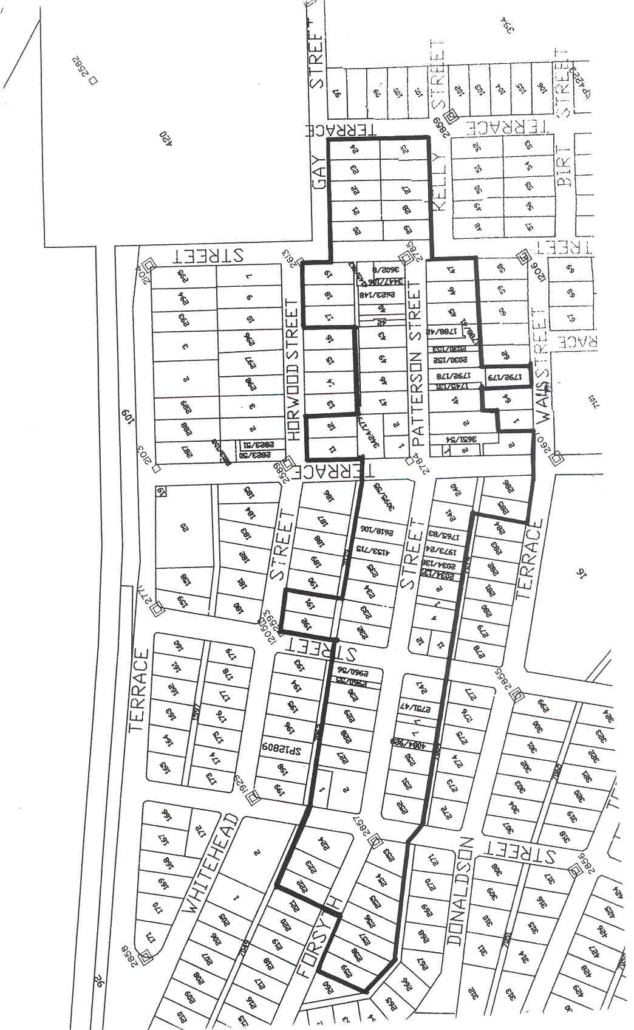
J. Wright, Chief Executive Officer

ADELAIDE HILLS COUNCIL
Adoption of Budget and Declaration of Rates
NOTICE is hereby given that at a meeting held on 15 July 2003 the Council in exercise of the powers contained in Chapter 10 of the Local Government Act 1999, passed the following resolutions:
Determination of Valuation—2003-2004
1. The most recent valuations of the Valuer-General available to the Council of the capital value of land within the Council’s area, be adopted for rating purposes, totalling $4 290 268 360.
Declaration of Rates
2. The following rates were declared by the Council to apply to all rateable land within the Council area:
(a) on rateable land of Category 7 use (Primary Production), a rate of 0.2926 cents in the dollar of the capital value of such land;
(b) on rateable land of all other Category uses, a rate of 0.3251 cents in the dollar of the capital value of such land.
The Council declared a fixed charge of $175 be imposed in respect of all rateable land in the Council’s area.
Imposition of Water Resources Levy
3. In order to reimburse to the Council the amount contributed to Catchment Water Management Boards, the Council declared a separate rate upon the capital value of rateable land as follows:
3.1 0.0164 cents in the dollar on all rateable land in the Council’s area which is in the catchment area of the Onkaparinga Catchment Water Management Board;
3.2 0.0067 cents in the dollar on all rateable land in the Council’s area which is in the catchment area of the Patawalonga Catchment Water Management Board;
3.3 0.0087 cents in the dollar on all rateable land in the Council’s area which is in the catchment area of the River Torrens Catchment Water Management Board;
3.4 0.0104 cents in the dollar on all rateable land in the Council’s area which is in the catchment area of the Northern Adelaide and Barossa Catchment Water Management Board.
Service Charges
4. The Council imposed the following annual services charges:
4.1 in the areas covered by the Woodside Septic Tank Effluent Drainage Scheme $317 on each occupied allotment and $210 on each vacant allotment;
4.2 in the areas covered by the Woodside Extension Septic Tank Effluent Drainage Scheme $317 on each occupied allotment and $210 on each vacant allotment;
4.3 in the areas covered by the Birdwood and Mt Torrens township Septic Tank Effluent Drainage Scheme $270 on each occupied allotment and $187 on each vacant allotment;
4.4 in the areas covered by the Kersbrook township Septic Tank Effluent Drainage Scheme $398 on each occupied allotment and $315 on each vacant allotment;
4.5 in the areas covered by the Charleston township Septic Tank Effluent Drainage Scheme $377 on each occupied allotment and $267 on each vacant allotment;
4.6 in the areas covered by the Verdun township Septic Tank Effluent Drainage Scheme $445 on each occupied allotment and $335 on each vacant allotment;
4.7 in the areas covered by the Mt Lofty Ward Septic Tank Effluent Drainage Scheme $384 on each occupied allotment and $258 on each vacant allotment.
P. Peppin, Chief Executive Officer

THE COORONG DISTRICT COUNCIL
Results of Supplementary Elections Conducted on 14 July 2003
COUNCILLOR Lakes Ward (1 vacancy):
Formal Ballot Papers: 592
Informal Ballot Papers: 2
Quota: 297
Candidates | First  Preference  Votes | Result after Distribution  of Preferences
Hills, Sarah | 47
Strother, Roger | 253 | Elected
Simmons, Paul | 190
Hiscock, Gary John | 102
Steve Tully, Returning Officer

COUNCILLOR Parks Ward (1 vacancy):
Formal Ballot Papers: 498
Informal Ballot Paper: 1
Quota: 250
Candidates | First  Preference  Votes | Result after Distribution  of Preferences
Woidt, Dianne | 419 | Elected
Dillon, Edward | 79
Steve Tully, Returning Officer

THE COORONG DISTRICT COUNCIL
Adoption of Valuation and declaration of Rates
NOTICE is hereby given that The Coorong District Council at its meeting held on 8 July 2003, resolved as follows:
Adoption of Valuation
That the most recent valuations of the Valuer-General available to the council, of the capital value of land within the council’s area, be adopted, totalling $567 246 300.
Declaration of General Rates
To declare the following general rates:
1. A fixed charge of $190.
2. Differential general rates of:
(1) 0.5675 cents in the dollar of the capital value of the land within the townships of Coonalpyn, Meningie, Tailem Bend and Tintinara and that area zoned as East Wellington Township;
(2) 0.5240 cents in the dollar of the capital value of all other rateable land.
Declaration of Separate Rate—Water Catchment Levy
In order to reimburse the council for the amount contributed to the South East Catchment Water Management Board, a separate rate of $11.86 on all rateable land in the council’s area in the catchment area of the Board.
Service Charges
1. To impose the following service charges for the recovery of Septic Tank Effluent Drainage and Disposal costs:
(a) $80 per unit for occupied land in the Meningie, Tailem Bend, Tintinara and East Wellington Schemes;
(b) $25 per unit for vacant land in the Meningie, Tailem Bend, Tintinara and East Wellington Schemes.
2. To declare the following service charges for the supply of water:
(a) in the area of the Narrung Water Scheme:
$165 Vacant Land
$430 Occupied Land
(b) in the area of the East Wellington Water Scheme a service charge comprised of $165 plus 90 c per kL for water usage in excess of 125 kL per annum;
(b) in the area of the Peake Water Scheme a service charge comprised of $120 plus 90 c per kL for water usage in excess of 125 kL per annum.
W. R. Paterson, Chief Executive Officer

REGIONAL COUNCIL OF GOYDER
Adoption of Valuation and Declaration of Rates
NOTICE is hereby given that at a meeting of the council held on Tuesday, 15 July 2003, the council resolved as follows:
Adoption of Valuation
1. Pursuant to section 167 (2) (a) of the Local Government Act 1999, council adopted for the financial year ending 30 June 2004, capital valuation made by the Valuer-General being $495 523 040 in relation to the area of the council for the purpose of rating and hereby specifies 15 July 2003 as the day as and from which such valuation shall become and be the valuation of the council.
Annual Service Charge—Septic Tank Effluent Drainage Schemes
2. Pursuant to section 155 of the Local Government Act 1999, council adopted the following annual service charges for the year ending 30 June 2004:
(a) for all properties included in the area serviced by that part of the Burra Septic Tank Effluent Drainage Scheme, which was installed prior to 1995, an annual service charge of $211.90 per property unit for occupied property and an annual service charge of $153.50 per unit for vacant allotments;
(b) for all properties included in the area serviced by that part of the Burra Septic Tank Effluent Disposal Scheme which was installed during and after 1995, an annual service charge of $221.60 per property unit for occupied property and an annual service charge of $157.70 per property unit for vacant allotments;
(c) for all properties included in the area serviced by the Eudunda Septic Tank Effluent Drainage Scheme, an annual service charge of $99.60 per property for occupied property and an annual service charge of $74.70 per property unit for vacant allotments.
A ‘property unit’ is determined in accordance with the document entitled ‘Guidelines for establishing property units related to service charges for Septic Tank Effluent Disposal Schemes’ as published by the Local Government Association of South Australia, February 1996, adopted by council in July 1997.
Annual Service Rate—Waste Collection
3. Pursuant to section 155 of the Local Government Act 1999, council adopted the following annual service rate for the year ending 30 June 2004, for Waste Collection Services:
(a) for all residences and businesses in the townships of Terowie, Whyte Yarcowie, Hallett, Mount Bryan, Burra, Robertstown, Point Pass, Eudunda, Farrell Flat and Booborowie, an annual service rate of $70 per property unit for occupied property, and an annual service rate of $0.00 per unit for unoccupied properties;
(b) for all properties outside of the above townships that have made application and have access to the waste collection service, an annual service rate of $70 per property unit.
Fixed Charge
4. Pursuant to section 151 of the Local Government Act 1999, and subject to the provision of section 152 (2), council declares a fixed charge of $150 for the 2003-2004 financial year.
Differential General Rates
5. Pursuant to section 156 of the Local Government Act 1999, the following differential general rates for the year ending 30 June 2004, were declared with reference to the locality of the land:
(a) 0.3867 cents in the dollar for land located within the Hallett Ward area;
(b) 0.7278 cents in the dollar for land located within the Burra Township area;
(c) 0.3867 cents in the dollar for land located outside the Burra Township area but within the Burra Ward area;
(d) 0.4744 cents in the dollar for land located within the Eudunda Township area;
(e) 0.3867 cents in the dollar for land located outside the Eudunda Township area but within the Eudunda Ward area; and
(f) 0.3867 cents in the dollar for land located within the Robertstown Ward area.
Payment of Rates
6. Pursuant to section 181 (1) of the Local Government Act 1999, rates are payable by four instalments due on 5 Sep-tember 2003, 5 December 2003, 5 March 2004 and 4 June 2004.
Early Payment Discount
7. That pursuant to section 181 (1) of the Local Government Act 1999, all rates (general, separate and service) for 2003-2004 paid in full on or before the due date of the first instalment date will attract a 4% discount.
S. Kerrigan, Chief Executive Officer

DISTRICT COUNCIL OF GRANT
Adoption of Valuation and Declaration of Rates
NOTICE is hereby given that at its meeting held on 21 July 2003, council in exercise of the powers contained in Part 1 of Chapter 10 of the Local Government Act 1999:
1. Adopted the valuation that is to apply in its area for rating purposes for the 2003-2004 financial year, being the capital valuation of the Valuer-General, totalling $1 086 060 600.
2. Declared a general rate on all rateable land within its area of 0.353 cents in the dollar on the capital value of rateable land, for the year ending 30 June 2004.
3. Declared a minimum amount payable by way of general rates on rateable land in its area of $346, for the year ending 30 June 2004.
4. Declared an annual service charge of $81 for the year ending 30 June 2004, for the collection and disposal of domestic waste (Mobile Garbage Bins) on each rateable occupied property as follows:
(a) in the townships of Port MacDonnell, Racecourse Bay, Donovans, Caveton, Carpenter Rocks, Blackfellows Caves, Nene Valley, Kongorong, Allendale East and the Pelican Point/Carpenter Rocks Shacks area;
(b) in the following streets and roads at Moorak; Kilsby Road, Orchard Road, Florence Street, Berkefeld Road, Johnston Road, Northumberland Avenue and Bay Road (from the boundary of the City of Mount Gambier to Tarrant Road);
(c) in the following street and roads at Yahl; Brim Brim Road, Church Street, Yahl Road (from Square Mile Road to Yahl Hall Road), Yahl Hall Road (from Brim Brim Road to Yahl Road), Lange Road (from Yahl Road to the eastern boundary of property A5325,
Lot 1, FP9406).
(d) in the following street and roads at Tarpeena; bounded by McEncroe Road (from Riddoch Highway to Bailey Road), Bailey Road (from McEncroe Road to Clezy Road), Clezy Road (from Bailey Road to Quarry Road), Quarry Road (from Clezy Road to Medhurst Road), Medhurst Road (from Quarry Road to Riddoch Highway), Riddoch Highway (from Medhurst Road to Albinia Terrace West), Albinia Terrace West (from Riddoch Highway to Marion Terrace), Marion Terrace (from Albinia Terrace West to Boully Road), and Boully Road (from Marion Terrace to Riddoch Highway).
5. Declared a separate rate (Water Catchment Levy) of $12.80, in respect of the financial year ending 30 June 2004, on all rateable land in council’s area in the catchment area of the Board, based on a fixed levy of the same amount payable on all rateable land, excluding those properties paying a water based levy.
6. Declared, for the financial year ending 30 June 2004:
(a) a service charge of $117 per annum on all vacant allotments and $305 per annum on all occupied allotments in that part of the township of Port MacDonnell served by the Septic Tank Effluent Drainage Scheme;
(b) a service charge of $110 per annum on all vacant allotments and $170 per annum on all occupied allotments in that part of the township of Tarpeena served by the Common Effluent Drainage Scheme;
(c) a service charge of $1 366 per annum on all occupied allotments in that part of the Pelican Point area from sections 690 to 700, sections 702 to 726 Hundred of Kongorong, Lot 8 (DP5111) Newton Road, and Lot 651 Newton Road, served by the Septic Tank Effluent Drainage Scheme.
7. Declared that all rates in respect of the financial year ending on 30 June 2004, are payable in four equal or approximately equal instalments with the first instalment payable on or before 12 September 2003, the second instalment payable on or before 12 December 2003, the third instalment payable on or before 12 March 2004, and the fourth instalment payable on or before 11 June 2004.
R. J. Peate, Chief Executive Officer

KANGAROO ISLAND COUNCIL
Adoption of Valuation and Declaration of Rates
NOTICE is hereby given that at its meeting held on 9 July 2003, the Kangaroo Island Council, for the financial year ending 30 June 2004:
Adoption of Valuation
1. Adopted the Valuer-General’s valuation of capital values totalling $533 983 480.
Fixed Charge
2. Imposed a fixed charge of $220 in respect of each separate piece of rateable land in its area.
Differential General Rates
3. Declared differential general rates in accordance with the use of the land as follows:
(1) Residential—0.003353 cents in the dollar;
(2) Commercial—Shop, Commercial—Office, Com-mercial—Other, Industry—Light, Industry—Other, Primary Production and Other Rateable Land—0.005669 cents in the dollar; and
(3) Vacant Land—0.009653 cents in the dollar (after further consideration, council resolved not to alter the rates in the dollar for vacant land).
Service Charges
4. Imposed annual service charges on all occupied and vacant properties to which a septic tank effluent drainage service is available as follows:
(1) within the Townships of Kingscote and Brownlow:
Scheme 1 (as defined): $
Vacant Land 240
Occupied Land 240
Scheme 2 (as defined):
Vacant Land 240
Occupied Land 240
(2) within the Township of Parndana:
Scheme 1 (as defined): $
Vacant Land 240
Occupied Land 240
Scheme 2 (as defined):
Vacant Land 240
Occupied Land 240
Scheme 3 (as defined):
Vacant Land 240
Occupied Land 240
Scheme 4 (as defined):
Vacant Land 240
Occupied Land 240
Payment of Rates
5. Determined that rates will be paid in four equal quarterly instalments due on 26 September 2003, 26 December 2003,
26 March 2004 and 25 June 2004 respectively.
R. Rattray, Chief Executive Officer

LIGHT REGIONAL COUNCIL
Result of Supplementary Election for a Councillor to Represent the Western Barossa Ward Conducted on 14 July 2003
Formal Ballot Papers: 828
Informal Ballot Paper: 1
Quota: 415
Candidates | First  Preference  Votes | Result after Distribution  of Preferences
Schluter, Michael | 630 | Elected
Riedel, William | 198
Steve Tully, Returning Officer

DISTRICT COUNCIL OF LOWER EYRE PENINSULA
Adoption of Valuation
NOTICE is hereby given, pursuant to section 167 of the Local Government Act 1999, that the District Council of Lower Eyre Peninsula, at a meeting held on Wednesday, 9 July 2003, adopted the valuation that is to apply to land within its area for rating purposes made by the Valuer-General based on the capital values totalling $645 348 660 for the year ending 30 June 2004.
Declaration of Rates
Notice is hereby given that the District Council of Lower Eyre Peninsula, at a meeting held on Wednesday, 9 July 2003, made the following declarations for the year ending 30 June 2004:
Differential General Rates
• 0.3111 cents in the dollar for land within the gazetted townships of Cummins, Coffin Bay, North Shields, Louth Bay and Boston;
• 0.2753 cents in the dollar for land within the gazetted townships of Stamford, Edillilie, Yeelanna, Coulta, Mount Hope, Wanilla and Lake Wangary;
• 0.2753 cents in the dollar for all other land outside of any gazetted township in the district.
Fixed Charge
• $225 for each assessment.
Separate Rate
Pursuant to section 138 of the Water Resources Act 1997 and section 154 of the Local Government Act 1999, in order to reimburse the council the amount con-tributed to the Eyre Peninsula Catchment Water Management Board, a separate rate of $30.68 be declared on all rateable land in the council area for the year ending 30 June 2004.
Service Charge
Pursuant to section 155 of the Local Government Act 1999, for all properties serviced by common effluent drainage schemes within the council district, the following service charges be declared for the year ending 30 June 2004:
$
Occupied Allotment Charge—
Cummins Township 150
Vacant Allotment Charge—
Cummins Township 108
Occupied Allotment Charge—
North Shields Township 226
Vacant Allotment Charge—
North Shields Township 205
Occupied Allotment Charge—
Coffin Bay Township 300
Pump Reduction Charge—
Coffin Bay Township 205
Vacant Allotment Charge—
Coffin Bay Township 200
Small Tank Occupied Charge—
Coffin Bay Township 325
Occupied Allotment Charge—
Tulka Settlement 140
Vacant Allotment Charge—
Tulka Settlement 40
P. Aird, District Clerk

MID MURRAY COUNCIL
Adoption of Valuation
NOTICE is hereby given that pursuant to the provisions of section 167 (2) (a) of the Local Government Act 1999, the Mid Murray Council at a meeting held on 7 July 2003, adopted the valuation of capital value made by the Valuer-General for rating purposes for the year ending 30 June 2004, being the most recent valuation available. The total capital value for the council area amounts to $990 237 520.
Attribution of Land Uses
1. The numbers indicated against the various categories of land use prescribed by Regulation 10 of the Local Government (General) Regulations 1999, are used to designate land uses in the Assessment Record.
2. The use indicated by those numbers in respect of each separate assessment of land described in the assessment record (as laid before the council) is attributed to each such assessment respectively.
3. Reference in the council resolutions to land being of a certain category use means the use indicated by that category number in the Regulations.
Declaration of Rates
Notice is hereby given that the council at a meeting held on 7 July 2003, resolved that pursuant to sections 153 (1) (b) and 156 (1) (c) of the Local Government Act 1999, that the following differential general rates be declared for the financial year ending 30 June 2004, on the capital values of all rateable property within the area, the said differential general rates to vary by reference to the locality in which the rateable property is situated and to land use, as specified under Regulation 10 of the Local Government (General) Regulations 1999, made pursuant to section 156 of the Local Government Act 1999.
The said differential general rates declared are as follows:
(1) For rateable land within the Township of Mannum a differential rate of 0.60 cents in the dollar of the capital value of rateable land.
(2) For rateable land within the Townships of Barton, Blanchetown, Cadell, Cambrai, Dutton, Greenways, Keyneton, Morgan, Palmer, Nildottie, Purnong, Sedan, Swan Reach, Truro and Tungkillo a differential rate of 0.59 cents in the dollar of the capital value of rateable land with land use categories 1, 2, 3, 4, 5, 6, 8 and 9.
(3) For rateable land within the Townships of Barton, Greenways, Swan Reach and Truro a differential rate of 0.46 cents in the dollar of the capital value of rateable land with land use category 7.
(4) For rateable land outside the Townships of Barton, Blanchetown, Cadell, Cambrai, Dutton, Greenways, Keyneton, Mannum, Morgan, Palmer, Nildottie, Purnong, Sedan, Swan Reach, Truro and Tungkillo a differential rate of 0.46 cents in the dollar of the capital value of rateable land with land use of categories 1, 2, 3, 4, 5 and 6.
(5) For rateable land outside the Townships of Barton, Blanchetown, Cadell, Cambrai, Dutton, Greenways, Keyneton, Mannum, Morgan, Palmer, Nildottie, Purnong, Sedan, Swan Reach, Truro and Tungkillo a differential rate of 0.46 cents in the dollar of the capital value of rateable land with land use categories 7, 8
and 9.
Pursuant to section 158 (1) (a) of the Local Government Act 1999, the council declared a minimum amount of $325 payable by way of rates on rateable land within the area of the Mid Murray Council for the year ending 30 June 2004.
Declaration of Service Charges
Pursuant to section 155 of the Local Government Act 1999, the council declared, for the year ending 30 June 2004, that the following service charges are payable on each property con-nected to the septic tank effluent drainage schemes in the following areas:
$
per unit
Big Bend area—Occupied Land 300
Greenways Landing area—Occupied Land 300
Kroehn’s Landing area—Occupied Land 300
Seven Mile Shacks—Occupied Land 300
Scrubby Flat area—Occupied Land 350
Swan Reach area—Occupied Land 300
Walker Flat area—Occupied Land 350
Truro—Occupied Land 300
North Punyelroo area—Occupied Land 155
Caloote Landing area—Occupied Land 155
Bolto Reserve area—Occupied Land 350
Old Teal Flat area—Occupied Land 350
The Rocks area—Occupied Land 350
(‘unit’ being as set out in the document entitled Determination Service Charges—Septic Tank Effluent Disposal Schemes issued by the STEDS Advisory Committee and dated 1 September 1992).
Pursuant to section 155 of the Local Government Act 1999, the council declared for the year ending 30 June 2004, that the following service charges are payable on each property which has been provided with a connection point for the waste disposal treatment system in the following areas and which have not paid to the council their share of the capital cost to install the waste disposal treatment system:
$
Blanchetown area 646
Brenda Park area 557
Marks Landing area 724
Scotts Creek area 756
Teal Flat area 764
Payment of Rates
Notice is hereby given that pursuant to sections 44 and 181 of the Local Government Act 1999, in respect of the financial year ending 30 June 2004:
(1) All rates are payable in four equal (or approximately equal) quarterly instalments falling due on the following dates:
1st quarterly instalment due on 15 September 2003
2nd quarterly instalment due on 15 December 2003
3rd quarterly instalment due on 15 March 2004
4th quarterly instalment due on 15 June 2004
(2) In cases where the quarterly account requiring payment of rates is not sent at least 30 days prior to the due date for payment, or an amended account is required to be sent, authority to fix the date by which rates must be paid in respect of those assessments affected has been delegated to the Chief Executive Officer.
G. R. Brus, Chief Executive Officer

DISTRICT COUNCIL OF PETERBOROUGH
Appointment
NOTICE is hereby given that at the Council meeting held on Monday, 7 July 2003, pursuant to section 26 (1) (b) of the Dog and Cat Management Act 1995, council appointed Terry Donald Barnes as Registrar of Dogs effective from 1 July 2003, vice Cheryl Kaye Willmott resigned.
T. D. Barnes, Chief Executive Officer

DISTRICT COUNCIL OF ROBE
Adoption of Valuation and Declaration of Rates
NOTICE is hereby given that at a meeting held on 17 July 2003, the council in exercise of the powers contained in Chapter 10 of the Local Government Act 1999, resolved as follows:
Adoption of Valuation
That the District Council of Robe in accordance with section 167 of the Local Government Act 1999, adopts for the year ending 30 June 2004, the Government valuation of capital value in relation to the area of council, totalling $373 420 380 and hereby specifies 17 July 2003 as the day as and from which such valuation shall become and be the valuation of the council.
Declaration of Rates
That the District Council of Robe, pursuant to section 152 of the Local Government Act 1999, declared a general rate of 0.4334 cents in the dollar on the assessed capital value of all rateable property in the District Council of Robe for the financial year ending 30 June 2004.
Pursuant to section 158 of the said Act, council declared that the minimum amount which shall be payable by way of rates on any one assessment in the Township of Robe shall be $400 for the financial year ending 30 June 2004.
STEDS Service Charge
That pursuant to section 155 of the Local Government Act 1999, council declared that the service charge for the year ending 30 June 2004, for all properties serviced by the Robe Septic Tank Effluent Drainage Scheme be:
$
Occupied with desludging 195.70
Occupied without desludging 182.20
Unoccupied 153.30
Subdivision with desludging 87.10
Subdivision without desludging 70.50
Unit is as defined by Local Government Bulletin No. 144.
Water Catchment Levy
That in exercise of the powers contained in section 138 of the Water Resources Act 1997 and section 154 of the Local Government Act 1999, in order to reimburse to the council the amount contributed to the South East Water Catchment Board, a separate rate of $13.70 be declared on all rateable land in the council’s area in the catchment area of the Board based on a fixed levy of the same amount on all rateable land.
R. J. Kay, Chief Executive Officer

SOUTHERN MALLEE DISTRICT COUNCIL
Result of Supplementary Election for a Councillor to Represent the Kelly/Scales Ward Conducted on 14 July 2003
Formal Ballot Papers: 342
Informal Ballot Papers: 2
Quota: 172
Candidates | First  Preference  Votes | Result after Distribution  of Preferences
Gum, George | 331 | Elected
Ames, Allan | 11
Steve Tully, Returning Officer

WAKEFIELD REGIONAL COUNCIL
Roads (Opening and Closing) 1991
Re-alignment of War Memorial Drive, Balaklava
NOTICE is hereby given that pursuant to section 10 of the Roads (Opening and Closing) Act 1991, that council proposes to make a Road Process Order to open as road portion of allotment 200 in Deposited Plan 31957 (Recreation Reserve) shown numbered ‘2’ on Preliminary Plan No. 03/0056, and to close two portions of War Memorial Drive (no longer required as road) shown lettered ‘A’ and ‘B’ on Preliminary Plan No. 03/0056 to be added to the said allotment 200 which land is dedicated under the Crown Lands Act 1929 for recreation reserve.
A copy of the plan and statement of persons affected are available for public inspection at Council’s office, 10 Edith Terrace, Balaklava and the office of the Surveyor-General, 101 Grenfell Street, Adelaide, during normal office hours.
Any application for easement or objection must be made in writing within 28 days from 24 July 2003, to the council, P.O. Box 167, Balaklava, S.A. 5461 and the Surveyor-General, G.P.O. Box 1354, Adelaide, S.A. 5001, setting out full details. Where a submission is made, council will give notification of a meeting to deal with the matter.
P. J. Barry, Chief Executive Officer

WAKEFIELD REGIONAL COUNCIL
Adoption of Valuation and Declaration of Rates
NOTICE is hereby given that at a meeting held on 9 July 2003, the Wakefield Regional Council in exercise of its powers con-tained in Chapter 10 of the Local Government Act 1999, made the following resolutions:
Adoption of Valuation
That council, in accordance with the provisions of section 167 of the Local Government Act 1999, adopts for the year ending 30 June 2004, the most recent valuation made by the Valuer-General of capital value in relation to the area of the council, that being the valuation listing of 27 June 2003, showing a total assessment for the district of $794 779 160.
Declaration of Differential General Rates
That pursuant to the provisions of sections 151 (1) (a), 156 (1) (b), (7) (b) and (c) of the Local Government Act 1999, council declares differential general rates on property within its area for the financial year ending 30 June 2004, by reference to rateable property situated within or outside a township as follows:
(a) all land situated within the boundaries of the follow-ing townships:
• the townships of Balaklava, Blyth, Hamley Bridge, Owen and Port Wakefield—0.739 cents in the dollar;
• the townships of Brinkworth, Lochiel and Snow-town—1.140 cents in the dollar;
(b) all land situated outside of the aforementioned town-ship boundaries:
• 0.292 cents in the dollar,
and, further that pursuant to the provisions of section 166 (1) (e) of the Local Government Act 1999, rebates shall be granted to provide relief against what would otherwise amount to a substantial change in rates payable by individual rate-payers due to a change in the basis of valuation used for the purposes of rating, rapid changes in valuation or anomalies in valuations, to the extent that the general rate payable on each assessment shall not incur an increase of greater than 12% on the previous year’s (2002-2003) general rate amount so payable, except where an increase is the result of new building work or development activity.
Declaration of Minimum Amount
That pursuant to the provisions of section 158 of the Local Government Act 1999, council fixes a minimum rate of $380 for the district in respect of the year ending 30 June 2004.
Declaration of Service Charge
That pursuant to the provisions of section 155 of the Local Government Act 1999, council declares service charges for the year ending 30 June 2004, for the purposes of recovering from the ratepayers in those particular townships who will be benefited by the authorised schemes for the disposal of sewerage effluent and capital cost of the work and the cost of the maintenance and operation thereof, as follows:
Town | Occupied  (unit charge)  $ | Unoccupied  (unit charge)  $
Balaklava | 95 | 68
Blyth | 160 | 130
Hamley Bridge | 123 | 106
Port Wakefield | 84 | —
Snowtown | 84 | 64
Payment of Rates
That in accordance with the provisions of section 181 (1) (a) and (14) of the Local Government Act 1999, council deter-mines that all rates imposed in respect of the year ending 30 June 2004, will fall due in four instalments and further that council determines pursuant to section 181 (2) that the instalments will fall due on Friday, 5 September 2003, Friday, 5 December 2003, Friday, 5 March 2004 and Friday, 4 June 2004.
P. Barry, Chief Executive Officer

IN the matter of the estates of the undermentioned deceased persons:
Boehm, Mavis Louisa, late of 51 Eighth Avenue, St Peters, of no occupation, who died on 19 June 2003.
Bosman, Antonius Marinus Josephus, late of 29 First Street, Gawler South, retired electrician, who died on 17 May 2003.
Brown, Reginald Walton, late of 4-30 Homestead Avenue, Walkley Heights, retired production manager, who died on 10 June 2003.
Craig, Sidney Benjamin, late of 1A Mount Barker Road, Hahndorf, retired engineer, who died on 9 June 2003.
Czarnyi, Michael, late of 61-63 Oxford Terrace, Port Lincoln, retired railway worker, who died on 1 April 2003.
Daw, Lewis William, late of 25 Jeffries Street, Whyalla Playford, retired geological assistant, who died on 1 January 2002.
Foster, Gertrude Edna, late of 12 Pearson Street, Clarence Gardens, widow, who died on 2 June 2003.
Glastonbury, Frederick William James, late of 29 Austral Terrace, Morphettville, retired garage attendant, who died on 11 May 2003.
Gray, Doris Maud, late of 66 Nelson Road, Valley View, of no occupation, who died on 17 February 2003.
Gummow, Viola Priscilla, late of 20 Third Avenue, St Peters, widow, who died on 16 June 2003.
Hill, Edward William, late of 71 Stokes Terrace, Port Augusta West, retired leading checker, who died on 19 May 2003.
Johns, Barrie Murison, late of 13 Second Street, Snowtown, retired joiner, who died on 10 April 2003.
Jones, Mavis Jean, late of 74 Princes Highway, Tailem Bend, of no occupation, who died on 19 February 2003.
MacGeoch, Frederick Charles, late of 68 Maria Street, Thebarton, pipe fitter, who died on 8 September 1959.
McDonald, John McGregor, late of 39 Campus Drive, Aberfoyle Park, retired machine operator, who died on 7 May 2003.
Miller, Mary Patricia, late of 1 Windsor Street, Parkside, retired teacher, who died on 22 June 2003.
O’Shaughnessy, Maureen Amy Ellen Mary, late of 342 Marion Road, North Plympton, retired public servant, who died on 4 June 2003.
Popov, Tsolo, late of 2 Jelly Street, Woodville, retired opal miner, who died on 16 March 2003.
Sawtell, Mildred Doris, late of 278 Old South Road, Old Reynella, of no occupation, who died on 6 June 2003.
Seaman, David Ernest, late of 73 Portrush Road, Payneham, retired furniture buyer, who died on 6 June 2003.
Walsh, Mathew Edward, late of 10 Rellum Street, Glengowrie, retired driver, who died on 19 June 2003.
Wilson, Shirley Althea, late of 39 Finniss Street, Marion, retired public servant, who died on 16 June 2003.
Notice is hereby given pursuant to the Trustee Act 1936, as amended, the Inheritance (Family Provision) Act 1972, and the Family Relationships Act 1975, that all creditors, beneficiaries, and other persons having claims against the said estates are required to send, in writing, to the Public Trustee, 25 Franklin Street, Adelaide 5000, full particulars and proof of such claims, on or before 22 August 2003, otherwise they will be excluded from the distribution of the said estate; and notice is also hereby given that all persons who are indebted to the said estates are required to pay the amount of their debts to the Public Trustee or proceedings will be taken for the recovery thereof; and all persons having any property belonging to the said estates are forthwith to deliver the same to the Public Trustee.
Dated 24 July 2003.
C. J. O’Loughlin, Public Trustee

IN the matter of the estate of the undermentioned deceased person:
Francis, Ethel, late of Christies Beach Residential Care, 50 Gulfview Road, Christies Beach, widow, who died on
6 July 2003.
Notice is hereby given pursuant to the Trustee Act 1936, as amended, the Inheritance (Family Provision) Act 1972-1975 and the Family Relationships Act 1975, that all creditors, beneficiaries, and other persons having claims against the abovenamed estate are directed to send full particulars of such claims to the undersigned on or before 22 August 2003, otherwise they will be excluded from the distribution of the said estate; and notice is also hereby given that all persons who are indebted to the above estate are required to pay the amount of their debt to the undersigned or proceedings will be taken for the recovery thereof; and all persons having any property belonging to the said estate are forthwith to deliver the same to the undersigned.
Dated 24 July 2003.
ANZ Executors & Trustee Company Limited, (ACN 006 132 332), 530 Collins Street, Mel-bourne, Vic. 3000.

SOUTH AUSTRALIA—In the Supreme Court. No. 1019 of 2000. In the matter of Mitchell Project Consultancy Pty Ltd (in liquidation) (ACN 067 954 107) and in the matter of the Corporations Act 2001.
Notice by a Liquidator of His Intention to Seek His Release and Dissolution of the Company
Take notice that I, Bruce James Carter of Ferrier Hodgson, the liquidator of the abovenamed company, intend to make application to the Supreme Court of South Australia for my release as the liquidator and dissolution of the abovenamed company. And take further notice that if you have any objection to the granting of my release you must file at the Supreme Court and also forward to me within 21 days of the publication in the Gazette of the notice of my intention to apply for a release a notice of objection in the form laid down by the Corporations (South Australia) Rules 1993.
Dated 18 July 2003.
B. J. Carter, Liquidator
Note: Section 481 of the Corporations Act 2001, enacts that an order of the Court releasing the liquidator shall discharge him/ her from all liability in respect of any act done or default made by him or her in the administration of the affairs of the company, or otherwise in relation to his or her conduct as liquidator, but any such order may be revoked on proof that it was obtained by fraud or by suppression or by concealment of any material fact.

UNCLAIMED MONEYS ACT 1891
Register of Unclaimed Moneys held by S.E.A.S. Sapfor Forests Pty Ltd over $10
1995 Distribution

Name | Address |  | Amount  $
Ashton, Louie | — | 421.93
Bissell, Jack | 13 Waddell Street, Bacchus Marsh, Vic. 3340 | 684.56
Bourne, Eric William and Thomas Harry | 19 Church Croft, Fownhope, Hereford HR1 4PL U.K. | 16.31
Brown, David John (deceased) | 36 Gleneagles Avenue, Mornington, Vic. 3931 | 15.81
Brown, Jennifer Mary | 18 Edward Road, High Wycombe, W.A. 6057 | 14.46
Buchanan, Elva Gwendoline | 31 Myall Avenue, Murray Bridge, S.A. 5253 | 28.87
Cahill, Margaret Mary | — | 684.56
Cannon, Malcolm Richard | c/o Barracks Section, Woomera, S.A. 5720 | 15.81
Clay, Ralph Bernard | Lot 30, Birds Road, Ferny Creek, Vic. 3786 | 1 128.88
Collins, Brian Edwin | 13 Tallarook Road, Hawthorndene, S.A. 5051 | 14.46
Dowley, Doreen Joyce (deceased) | 25 East Terrace, Loxton, S.A. 5333 | 15.81
Dyer, Stanley Alec | P.O. Box 322, Monash, S.A. 5342 | 421.93
Eldridge, Aileen Lesley Perry | 1 Aitken Street, Berri, S.A. 5343 | 1 998.33
Elvey, Gladys Faith | 4 Joan Street, Bendigo, Vic. 3550 | 14.46
Evans, Rosemary Bernadette | Box 123, Balaklava, S.A. 5461 | 421.93
Fairley, Graeme Russell | RMB 8306, Wangaratta South, Vic. 3678 | 15.81
Farquhar, Rodney Douglas | 39 Crittenden Road, Smithfield Plains, S.A. 5114 | 15.81
Fischer, Reginald Edgar (deceased) | 25 Murray Street, Gawler, S.A. 5118 | 3 207.68
Florence, Bevin Thomas | RMB 1720, Midland Highway, Shepparton, Vic. 3630 | 421.93
Freund, Malcolm, Donald and Graham | Seventh Street, Morgan, S.A. 5320 | 14.46
Geue, Viola Edna | 26 East Terrace, Strathalbyn, S.A. 5255 | 14.46
Gill, Peter William | 23 Deputer Street, Rochedale, Qld 4123 | 564.44
Gowling, Barry Douglas | Sandalwood, S.A. 5309 | 30.27
Grant, Vivienne Ludwiga | 50 Venus Street, South Caulfield, Vic. 3162 | 15.81
Grossberg, Leo and Charlotte (deceased) | 7 Madden Street, North Balwyn, Vic. 3104 | 31.17
Hackett, Veronica | P.O. Box 41, Paynesville, Vic. 3880 | 421.93
Hammond, Aileen Mary Joyce | P.O. Box 8, Terang, Vic. 3264 | 843.41
Hardie, Norman Clyde and Nellie Florence | 5 Flinders Street, Point Vernon, Qld 4655 | 421.93
Haugh, John Gerald Everard | — | 564.44
Hayes, Ernest Francis | 25 Edis Street, Kyabram, Vic. 3620 | 843.41
Heino, Eugen Jack and Rifka | 1119 Ocean Parkway Apt #5-0, Brooklyn N.Y. 11230 U.S.A. | 32.62
Heinrich, Ian Clement (deceased) | 5th Floor 22 Grenfell Street, Adelaide, S.A. 5000 | 57.29
Hill, Peter Spencer | P.O. Box 5495, Toowoomba, Qld 4350 | 14.46
Howes, Jacqualynn Leslie | — | 843.41
Huffer, Vera Myrtle (deceased) | 3 Villamanta Street, Geelong West, Vic. 3218 | 684.56
Hurley, Colleen Patricia | 70 Beamish Avenue, Mount Pleasant, W.A. 6153 | 15.81
Jarrett, Albert Douglas | P.O. Box 64, Bordertown, S.A. 5268 | 15.81
Jennings, Heather Gaye | 24 Loch Street, West End, Qld 4101 | 1 603.84
John, Keith Ronald | Light Pass, S.A. 5355 | 14.46
Johnson, Margaret Elizabeth | — | 1 128.88
Klenke, Eric John | 9 Albert Place, Mount Barker, S.A. 5251 | 421.93
Koch, Susannah Mary | 115 Frederick Street, Welland, S.A. 5009 | 14.46
Kotz, Helen Grace (deceased) | — | 564.44
Larwood, Ethel Maude | 8/3 Alpha Street, Kensington Park, S.A. 5068 | 564.44
Love, Allan Oswald | P.O. Box 759, Broadbeach, Qld 4218 | 421.93
Lumley, Ian William | 47 Whatley Street, Carrum, Vic. 3197 | 684.56
Mackie, Jock David | — | 15.81
Martiensen, Allan James | — | 15.81
Martiensen, Barbara Joy | — | 15.81
McLean, Malcolm John | Epson Road, Chiltern, Vic. 3683 | 564.44
Naylor, John William | 155 Second Avenue, Royston Park, S.A. 5070 | 684.56
Noye, Ronald Barry | Jervois, S.A. 5259 | 14.46
O’Brien, Thomas (deceased) | 186 Boran Road, Glenhuntly, Vic. 3163 | 16.31
Parker, Anne May and Wilson, Robert | 5 Caroline Street, Kilsyth, Vic. 3137 | 421.93
Peirce, Eleanor Joyce | 13 Brookside Avenue, Tranmere, S.A. 5073 | 684.56
Pembroke School Inc. | 342 The Parade, Kensington, S.A. 5068 | 15.81
Pike, Brian | 41 Judd Road, Elizabeth, S.A. 5112 | 1 998.33
Prentice, Denis Gavan | 77 Argent Street, Broken Hill, N.S.W. 2880 | 421.93
Rees, Christine Anne | 48 Cromwell Street, North Caulfield, Vic. 3161 | 15.81
Ricketts, John Colin and Thelma Rena | M/S 299 Baillies Road, Bundaberg, Qld 4670 | 421.93
Ritschel, Rudolf | — | 4 905.35
Ruediger, John Edward | 37 Lawrie Street, Salisbury, S.A. 5108 | 14.46
Ruediger, Lillian Maud | P.O. Box 533, Renmark, S.A. 5341 | 15.81
Spencer, James Noel | 18 Harold Street, Benalla, Vic. 3672 | 15.81
Svarc, Henrik and Feiga | 1064 55th Street, Brooklyn N.Y. 11219 U.S.A. | 16.31
Tainsh, Emily Ethel Blanche | — | 564.44
Tanner, Reginald John | Jervois, S.A. 5259 | 15.81
Thind, Mona Ranjit and Shalu Ranjit | 16 Cumbrae Place, Burnside Gardens, N.S.W. 2151 | 1 998.33
Thomas, Andrew Phillip and Joanne Michelle | 20 Scott Grove, Glen Iris, Vic. 3146 | 15.81
Todd, Quentin Stuart | 10 Ruby Street, Brahma Lodge, S.A. 5109 | 16.31
Tucker, Philip and Batty, Rosalind | 135 Addiscott Road, Bellbrae, Vic. 3228 | 564.44
Vanstone, Douglas Colin | — | 1 998.33
Walker, Dorothy Boyd | — | 422.43
Watson, John, Daryl and Bruce | P.O. Box 83, Bordertown, S.A. 5268 | 31.17
Westphalen, John Arthur (deceased) | 4 Ridgehaven Drive, Bellevue Heights, S.A. 5050 | 14.46
Williams, Dorothy Clara | 21 Webb Street, Kaniva, Vic. 3419 | 32.62
Williams, Price Owen (deceased) | 135 Glen Osmond Road, Eastwood, S.A. 5063 | 14.46
 | Total | $36 371.82

UNCLAIMED MONEYS ACT 1891
Register of Unclaimed Moneys held by S.E.A.S. Sapfor Forests Pty Ltd over $10
1996 Distribution

Name | Address |  | Amount  $
Ahern, Adam | 402/279 The Esplanade, Cairns, Qld 4870 | 63.26
Aickin, Roger Keith | P.O. Box 1312, Frankston, Vic. 3199 | 117.66
A. N. Carter Trust and <Treloar Family A/C> | — | 502.95
Annett, Sharon Jane | — | 836.15
Ashton, Louie | — | 249.31
Babington, Edward John | c/o Post Office, Bowen, Qld 4805 | 224.54
Bain, Annette and Kirk, Helen and Lamshed, Pauline and Ebsary, Marcia | P.O. Box 2, Port Broughton, S.A. 5522 | 28.37
Barritt, Jeanette Anne | 190 Childers Street, North Adelaide, S.A. 5006 | 470.04
Beare, Vernon Charles | P.O. Box 352, Bordertown, S.A. 5268 | 28.37
Beech, Kathryn | 2/57 Asling Street, Brighton, Vic. 3186 | 176.47
Bell, Howard Sydney | P.O. Box 47, Hamley Bridge, S.A. 5401 | 112.03
Bell, Mark Harold | 11 Stanley Street, Morphett Vale, S.A. 5162 | 28.37
Bennett, Hugh Jonathan and Frances Margaret | c/o Post Office, Wistow, S.A. 5251 | 60.30
Biggins, Lincoln | Yeppoon, Qld 4703 | 224.54
Bissell, Jack | 13 Waddell Street, Bacchus Marsh, Vic. 3340 | 481.48
Bowering, Estate of Donald Maxwell | 233 Cambridge Road, Kilsyth, Vic. 3137 | 120.60
Briglia, John Richard | — | 2 508.45
Brough, Jeffrey John | 15 Ward Street, North Geelong, Vic. 3215 | 249.31
Buckenara, Estate of the late Mirren Kelburn | G.P.O. Box 3008FF, Melbourne, Vic. 3001 | 1 672.30
Buckley, John | P.O. Box 124, Euroa, Vic. 3666 | 241.20
Burdett, Louis Charles | 1/9 Toward Street, Murrumbeena, Vic. 3163 | 480.90
Burge, Kelvin Andrew | Horseshoe Bend Road, Grovedale, Vic. 3216 | 259.31
Burge, Virginia Kathryn | Horseshoe Bend Road, Grovedale, Vic. 3216 | 259.31
Burns, Terry James | 7 Glass Court, Alice Springs, N.T. 0870 | 836.15
Burrows, Raymond John | — | 1 676.20
Burton, Marshall Roland | 25 Roberts Crescent, Holden Hill, S.A. 5088 | 836.15
Butler, Mark Frederick | 38 Ivy Street, Prahran, Vic. 3181 | 60.30
Cahill, Margaret Mary | — | 481.48
Cameron, Douglas Gordon | 4/82 Marine Parade, Coolangatta, Qld 4225 | 60.30
Campbell, Jeannie Elizabeth | 34 Acland Street, St Kilda, Vic. 3182 | 63.26
Carpenter, Leon Horrace | — | 100.95
Clark, Susan Elizabeth | — | 60.30
Clarke, Peter Thornton | — | 836.15
Clay, Ralph Bernard | Lot 30, Birds Road, Ferny Creek, Vic. 3786 | 436.11
Cliff, Brenton Barton | 10 Hilltop Boulevard, Hillbank, S.A. 5112 | 224.54
Cole, Clyde Thomas and Marian Constance | P.O. Box 1302, Port Lincoln, S.A. 5606 | 201.45
Connock, Janice Beryl | 8 Fanning Street, Charlton, Vic. 3525 | 152.11
Cooper, Grace E. | RMB 3750, Rochester, Vic. 3561 | 262.71
Cooper, Grace Elizabeth | RMS 422, Rochester, Vic. 3561 | 262.71
Coughlin, Julie Patricia | 32 Gowrie Avenue, Glengowrie, S.A. 5044 | 63.26
Cranna, Geoffrey Bruce | 10 Eagle Street, Brisbane, Qld 4000 | 63.26
Crosby, Belinda Marion | P.O. Box 3, Merimbula, N.S.W. 2548 | 60.30
Cumming, Andrew Gervaise | — | 480.90
Davies, Timothy Colin | — | 224.54
Deans, Robert McNeish and Vernon, Derris Ann | 42 McLaughlan Road, Windsor Gardens, S.A. 5087 | 117.66
Demmler, Lillian Elizabeth | 3 Sunnyside Road, Floreat Park, W.A. 6014 | 235.27
Douventzidis, Bill | 39 Beatty Street, Linden Park, S.A. 5065 | 259.31
Downing, Alison Grant | 15 Rainsford Street, Werribee, Vic. 3030 | 218.03
Dyer, Stanley Alec | P.O. Box 32, Monash, S.A. 5342 | 249.31
Edwards, Patricia Joan | PMB 31, Burra, S.A. 5417 | 304.22
Eldridge, Perry | 1 Aitken Street, Berri, S.A. 5343 | 480.90
Ellard, Eileen Joy and Tivy, Patricia May | 12/74 Military Road, Tennyson, S.A. 5022 | 100.95
Elliot, Alan John | P.O. Box 10, Castlemaine, Vic. 3450 | 100.95
Ewing, David William | 18 Convent Lane, Yamba, N.S.W. 2464 | 201.45
Fieldman, Joseph | P.O. Box 188, Dandenong, Vic. 3175 | 518.12
Fitzgerald, Susan Patricia | 20 Gordon Street, Port Pirie, S.A. 5540 | 60.30
Florence, Bevin Thomas | RMB 1720, Midland Highway, Shepparton, Vic. 3630 | 249.31
Francis, Trevor John | P.O. Box 94, Bungalow, Qld 4870 | 117.66
Gerschwitz, Jennifer Margaret | 14 Surrey Parade, Morphett Vale, S.A. 5162 | 60.30
Geue, Viola Edna | 26 East Terrace, Strathalbyn, S.A. 5255 | 117.66
Gibson, Barrie Edwin and Karen Vivienne | 28 Splatt Street, Swan Hill, Vic. 3585 | 56.24
Gill, Peter William | 23 Deputer Street, Rochedale, Qld 4123 | 218.03
Goodhart, Alexander Robert | 22 Victory Street, Virginia, Qld 4014 | 100.95
Goodwin, Ella Evelyn | Lot 28, Central Road, Drysdale, Vic. 3222 | 604.54
Goodwin, Kenneth Lindsay | RMB 522, Minyip, Vic. 3392 | 2 241.95
Graetz, Wendy Angela | Box 46, Sedan, S.A. 5355 | 481.48
Greenslade, Cheryl Elise | Womma Road, Penfield Gardens, S.A. 5121 | 28.37
Hackett, Veronica | P.O. Box 41, Paynesville, Vic. 3880 | 249.31
Hammond, Aileen Mary Joyce | P.O. Box 8, Terang, Vic. 3264 | 3 843.17
Handasyde, Craig Gilbert | Collier Road, Kilsyth, Vic. 3137 | 117.66
Handasyde, Stephen Leslie | Collier Road, Kilsyth, Vic. 3137 | 117.66
Hardie, Norman Clyde and Nellie Florence | 5 Flinders Street, Point Vernon, Qld 4655 | 249.31
Harris, Garth Ernest | P.O. Box 250, Coolum Beach, Qld 4573 | 117.66
Harris, Reginald Winston | 85 Howard Road, Dingley, Vic. 3172 | 117.66
Harrison, Tiffany Anne | 3 Francis Street, Echuca, Vic. 3564 | 259.31
Harrison, Virginia Jane | 3 Francis Street, Echuca, Vic. 3564 | 259.31
Harvey, Brian Campbell | P.O. Box 168, Kununurra, W.A. 6743 | 56.24
Haugh, John Gerald Everard | — | 218.03
Hayes, Ernest Francis | 25 Edis Street, Kyabram, Vic. 3620 | 498.57
Heard, Rodney Thomas | 41 Hunter Street, Carnegie, Vic. 3163 | 480.90
Hedwards, Valerie Joy | Gray Street West, Swan Hill, Vic. 3585 | 63.26
Heinrich, Yvonne Ruth | P.O. Box 180, Clare, S.A. 5453 | 28.37
Hill, Nicholas Crawford | 16 Statenborough Street, Leabrook, S.A. 5068 | 259.31
Hill, Peter Spencer | P.O. Box 5495, Toowoomba, Qld 4350 | 120.60
Hill, Ronald James | Delamere, S.A. 5204 | 259.31
Hill, Sandra Anne | — | 259.31
Hille, Jennifer Henrietta Mary | P.O. Box 141, Woodside, S.A. 5244 | 56.24
Hills, Joseph Harold | 321 Whitehorse Road, Balwyn, Vic. 3103 | 836.15
Hoepner, Roy Stanley | P.O. Box 21, Brinkworth, S.A. 5464 | 249.31
Hoff, Pamela and Burke, Ian and Phillip | 577 Balcombe Road, Black Rock, Vic. 3193 | 120.60
Honey, Stephen, Jason and Cameron | 9 Cobain Square, Wantirna, Vic. 3152 | 56.24
Howes, Jacqualynn Leslie | — | 498.57
Huffer, Estate of the late Vera Myrtle | 3 Villamanta Street, Geelong West, Vic. 3218 | 481.48
Huggins, Joan Doreen | Jervois, S.A. 5259 | 836.15
Humphries, Karen June | PMB 10, Cleve, S.A. 5640 | 28.37
Hunter, Jean Stuart | 33 Missouri Avenue, Wagga Wagga, N.S.W. 2650 | 249.31
Jacobs, Jean | Private Mail Bag 1, Kadina, S.A. 5555 | 117.66
Jennings, Heather Gaye | 24 Loch Street, West End, Qld 4101 | 151.16
Johnson, Brian Richard and Gillian | 1 Chanel Court, Craigmore, S.A. 5114 | 259.31
Johnson, Margaret Elizabeth | — | 436.11
Kennedy, Sandra Rosemary | 166 Lake Terrace East, Mount Gambier, S.A. 5290 | 100.95
Kirk, Margaret Ruth | 2 Carmen Street, St Ives, N.S.W. 2075 | 836.15
Ludwig, Lothar Max | Klingmuller | 1 676.20
Kluge, Norman Walter | 1 Hewish Crescent, Elizabeth Park, S.A. 5113 | 120.60
Knapton, William Gustaf Leslie | — | 60.30
Knight, Robert Cedric Parnwell | PMB 27, Dunmurra via Katherine, NT 0851 | 63.26
Knight, William Frederick | 122 Galway Avenue, Broadview, S.A. 5083 | 259.31
Kobal, George | 361 Anzac Highway, Camden Park, S.A. 5038 | 480.90
Kostyshyn, Bohoan Jurij | 28 Hayward Avenue, Torrensville, S.A. 5031 | 28.37
Kotz, Estate of the late Helen Grace | — | 218.03
Krahnert, Morris Victor | 150 Chapman Street, Swan Hill, Vic. 3585 | 63.76
Kramm, Hermann Bernhard | P.O. Box 8, Hahndorf, S.A. 5245 | 117.66
Laidlaw, Robert Farrell | — | 1 672.30
Lambert, Ian Anthony | 5 Park Road, Kensington Park, S.A. 5068 | 224.54
Larwood, Ethel Maud | 8/3 Aplha Street, Kensington Park, S.A. 5068 | 218.03
Love, Allan Oswald | P.O. Box 759, Broadbeach, Qld 4218 | 249.31
Lucieer, Benjamin | P.O. Box 632, Traralgon, Vic. 3844 | 224.54
Luck, Jonathan | P.O. Box 6920, Cairns, Qld 4870 | 28.37
Lumley, Ian William | 47 Whatley Street, Carrum, Vic. 3197 | 481.48
Macilwain, Jane Mathie | 29 Antilo Road, Ingle Farm, S.A. 5098 | 63.26
Madsen, Julie-Anne | P.O. Box 100, Glenelg, S.A. 5045 | 480.90
Madsen, Estate of the late Stewart Richard | Unit 2/154 Marion Road, West Richmond, S.A. 5033 | 112.03
Markey, Gregory Barton | — | 598.56
Martin, Francis John | P.O. Box 3687, Alice Springs, NT 0871 | 117.66
Mattner, William Ronald | 16 Schubert Drive, Hahndorf, S.A. 5245 | 218.03
McCauley, Peter Charles | P.O. Box 583, Wagga Wagga, N.S.W. 2650 | 836.15
McFarlane, Robert Graham | P.O. Box 128, O’Halloran Hill, S.A. 5158 | 259.31
McGargill, Gordon Winstanley | 550 Portrush Road, Glen Osmond, S.A. 5064 | 315.40
McGilvray, Kenneth Malcolm | P.O. Box 564, Sunshine, Vic. 3020 | 518.12
McWilliam, Wilma Margaret | 63 Liddiard Street, Hawthorn, Vic. 3122 | 480.90
Melmeth, Wayne Herbert | c/o Post Office, Iron Baron, S.A. 5600 | 117.66
Middleton, Walter Charles | 22 Belmont Road, Croydon, Vic. 3136 | 60.30
Milde, Dorothy Jean | 19 Ackland Avenue, Clarence Gardens, S.A. 5039 | 836.15
Mitchell, Peter Robert and Young, Margaret Joan | Glencoe West, S.A. 5291 | 480.90
Zealand, Wendy June | P.O. Box 82, Kingscote, S.A. 5223 | 259.31
Mudie, Geoffrey George | 4 Dorothy Street, Doveton, Vic. 3177 | 259.31
Murray, Jacquelyn Elizabeth (deceased) | P.O. Box 493, Millicent, S.A. 5280 | 218.03
Murray, Paul John | 16A Haines Street, Hawthorn, Vic. 3122 | 259.31
Nall, Joanne Beth Derham | 22 Capitol Avenue, McKinnon, Vic. 3204 | 63.26
Naylor, John William | 155 Second Avenue, Royston Park, S.A. 5072 | 481.48
Niland, Lois Hilda | 13 Bombay Street, Oaklands Park, S.A. 5046 | 480.90
Noack, Carey Royston | 1B Jane Street, Willaston, S.A. 5118 | 28.37
Nolan, Margaret Ellen | 39 Fantone Road, Craigie, W.A. 6025 | 117.66
Novak, Michael Otto | — | 480.90
Nuske, David John | 3 Rodney Street, Woodville, S.A. 5011 | 259.31
Osborn, William Thomas | 12 Apex Crescent, Bulleen, Vic. 3105 | 60.30
Osborne, Paul, Brendan and Ashley | Harvey Road, Dover, Tas. 7117 | 262.71
Parker, Anne May and Wilson, Robert | 5 Caroline Street, Kilsyth, Vic. 3137 | 249.31
Paton, Andrew | 49 Amber Grove, Mount Waverley, Vic. 3149 | 259.31
Paton, Elizabeth | 49 Amber Grove, Mount Waverley, Vic. 3149 | 259.31
Peck, Keith William and Glenice June | P.O. Box 207, Balranald, N.S.W. 2715 | 218.03
Peirce, Eleanor Joyce | 13 Brookside Avenue, Tranmere, S.A. 5073 | 481.48
Perry, Ralph Ashford and Susan Mary | 16 Chartwell Drive, Benowa, Qld 4217 | 259.31
Phelps, Rhonda Blanche | 9 Peters Avenue, Fulham Gardens, S.A. 5024 | 1 676.20
Phillips, Estate of the late Florence Ada | 38 Orchard Circuit, Shepparton, Vic. 3630 | 1 676.20
Pianto, Christopher Alan | Shop 8, Heyers Road, Grovedale, Vic. 3216 | 259.31
Pitt, Eryl Hugh | 3 Ord Street, West Perth, W.A. 6005 | 1 923.65
Pohlers, Arthur Johannes | 1/71 Hare Street, Echuca, Vic. 3564 | 1 672.30
Polmear, Eileen and Bell, Russell and Rumpff, Margaret | 10 Lawford Street, Box Hill North, Vic. 3129 | 117.66
Prendergast, William | P.O. Box 1218, Parramatta, N.S.W. 2124 | 100.95
Prentice, Denis Gavan | 77 Argent Street, Broken Hill, N.S.W. 2880 | 249.31
Ranford, Estate of the late Mavis Emmerline Maude | 11 Oldsmobile Terrace, Dudley Park, S.A. 5008 | 224.54
Ratcliffe, Geoffrey Arthur | P.O. Box 18, Undera, Vic. 3629 | 836.15
Rees, Colin Geoffrey | 465 Lorimer Street, Port Melbourne, Vic. 3207 | 100.95
Rehn, Shaun Jason | PMB 14, Arno Bay, S.A. 5603 | 100.95
Renkauskas, Henry | 2 Forfar Street, Hamlyn Heights, Vic. 3215 | 259.31
Rice, Elaine Fay | 40 Lyndoch Road, Gawler, S.A. 5118 | 259.31
Rich, Margaret | 6 Grange Court, Northlakes, N.T. 0812 | 28.37
Richards, Gary Edmund | 96 Chapman Street, Swan Hill, Vic. 3585 | 28.37
Ricketts, John Colin and Thelma Rena | M/S 299 Baillies Road, Bundaberg, Qld 4670 | 249.31
Ritschel, Rudolf | — | 956.41
Roach, Steven Gregory and Craig Walter | P.O. Box 123, Alford, S.A. 5555 | 28.37
Robinson, David James | P.O. Box 81, Sunshine, Vic. 3020 | 836.15
Robinson, Kenton James and Peter Douglas | 8 Ophray Court, Mildura, Vic. 3500 | 100.95
Rodda, Gaynor Meryl | 103 Sydenham Road, Norwood, S.A. 5067 | 28.37
Rogers, Graham Roy | 1 Cowell Road, Cleve, S.A. 5640 | 100.95
Rouxel, Cheryl Lee | P.O. Box 293, Kingscote, S.A. 5223 | 259.31
Schmidt, Naomi Grace | 2/10 Donald Avenue, Paradise Point, Qld 4216 | 60.30
Schultz, Raymond Leslie | 260 Drummond Street, Carlton, Vic. 3053 | 480.90
Scroop, Anthony John | 10 Mavis Street, Footscray, Vic. 3011 | 60.30
Segrave, Phyllis Patricia | — | 259.31
Segrave, Estate of the late William Foy | — | 259.31
Seidl, Rainer and Anke | 75 Booth Avenue, Morphett Vale, S.A. 5162 | 28.37
Shepherd, Karin Marie Helen | — | 836.15
Single, Estate of the late Kenneth | — | 118.61
Smiles, Judith Anne | 12 Blyth Street, Vermont, Vic. 3131 | 218.03
Staniford, Richard Peter | Carey Gully, S.A. 5144 | 28.37
Stewart, Ann Easton | 1/16 Queen Street, Colac, Vic. 3250 | 60.30
Stillard, John Alexander | RMB 4018, Cobram, Vic. 3644 | 60.30
Swan, Graeme Leslie | 104 High Street, Belmont, Vic. 3216 | 259.31
Tainsh, Emily Ethel Blanche | — | 218.03
Taranto, Samuel Michael | — | 836.15
Thind, Mona Ranjit and Shalue Ranjit | 16 Cumbrae Place, Burnside Gardens, N.S.W. 2151 | 63.26
Thomas, Bryan Jackson and Lisbeth Margaret | 131 King Arthur Terrace, Tennyson, Qld 4105 | 259.31
Tonkin, Edward Wayne | Box 1194, Shepparton, Vic. 3630 | 224.54
Tonuma, Viljo Enn and Kalju Enn | 2/35 Davis Avenue, South Yarra, Vic. 3141 | 480.90
Tralaggan, Peter | c/o Post Office, Hamilton, S.A. 5373 | 60.30
Tucker, Philip and Batty, Rosalind | 135 Addiscott Road, Bellbrae, Vic. 3228 | 218.03
Tweg, Bertha Bella | 1/200 Kambrook Road, Caulfield, Vic. 3162 | 117.66
Unger, Gertrude Frida | 62 Eleanor Terrace, Murray Bridge, S.A. 5253 | 152.11
Unger, Walter Gerhard | 62 Eleanor Terrace, Murray Bridge, S.A. 5253 | 152.11
Walker, Dorothy Boyd | — | 250.26
Wall, Edward Burton | 35 Historic Drive, Highbury, S.A. 5089 | 268.82
Wallace, Stephen Joseph | 188 Fitzmaurice Street, Wagga Wagga, N.S.W. 2650 | 224.54
Ward, John Edmund | RSD Bulga Road, Swan Hill, Vic. 3585 | 117.66
Warman, Therese and James, Christopher and Danielle | 22 Ocean Boulevard, Seacliff South, S.A. 5049 | 28.37
Webster, Estate of the late Ethel | P.O. Box 70, Warrnambool, Vic. 3280 | 56.24
Wetsteijn, Thea Gertrude | 17 Fratley Avenue, Farm Cove, Auckland, N.Z. | 259.31
Whittaker, Keith | Carpentaria Street, Talbot, Vic. 3371 | 117.66
Whyte, George Macleod | 33 Kaye Street, Charlton, Vic. 3525 | 480.90
Williames, Alan Robert | 200 Hien Road, Buccan, Qld 4207 | 63.26
Williams, Margaret Lynette | P.O. Box 242, Oakey, Qld 4401 | 100.95
Williamson, David, Richard and Margaret | — | 836.15
Wilson, Anthony | Flat 5E, Casa Grandi, Bligh Place, Randwick, N.S.W. 2031 | 117.66
Woolrich, Iris Caroline Ernestine | McCarthy Road, Olinda, Vic. 3788 | 836.15
Wynne, Sylvia Irene | 2A Heathmont Road, Ringwood, Vic. 3134 | 117.66
Zarucki, Oleg | — | 964.75
 | Total | $75 915.56

ATTENTION

CUSTOMERS requiring a proof of their notice for inclusion in the Government Gazette, please note that the onus is on you to inform Government Publishing SA of any subsequent corrections by 10 a.m. on Thursday, which is our publication deadline.

For any corrections to your notice please phone 8207 1045 or Fax 8207 1040 before 10 a.m. on Thursday.

If we do not receive any communication by 10 a.m. on Thursday (day of publication) we will presume the notice is correct and will print it as it is.

Remember—the onus is on you to inform us of any corrections necessary to your notice.

NOTE: Closing time for lodging new copy (electronically, fax or hard copy) is 4 p.m. on Tuesday preceding the day of publication. Phone 8207 1045—Fax 8207 1040.
Email: governmentgazette@saugov.sa.gov.au

Printed and published by authority every Thursday by J. D. FERGUSON, Government Printer, South Australia
Price: $4.70, plus postage; to subscribers, $238.00 per annum.
(The above prices are inclusive of GST)

