No. 53 2443

THE SOUTH AUSTRALIAN

GOVERNMENT GAZETTE

PUBLISHED BY AUTHORITY

ALL PUBLIC ACTS appearing in this GAZETTE are to be considered official, and obeyed as such

ADELAIDE, THURSDAY, 12 JUNE 2003

CONTENTS

Page
Acts Assented To 2444
Aerodrome Fees Act 1998—Notice 2446
Appointments, Resignations, Etc. 2444
Associations Incorporation Act 1985—Notice 2447
Boundary Adjustment Facilitation Panel—Notices 2447
Building Work Contractors Act 1995—Notice 2447
Corporations and District Councils—Notices 2552
Crown Lands Act 1929—Notice 2447
Development Act 1993—Notices 2447
Development Regulations 1993—Notice 2448
Enrolled Nurse Competency Standards—Notice 2449
Essential Services Act 2002—Notice 2473
Fisheries Act 1982—Notices 2479
Harbors and Navigation Act 1993—Notices 2478
Housing Improvement Act 1940—Erratum 2478
Land Acquisition Act 1969—Notice 2480
Land and Business (Sale and Conveyancing) Act 1994—
Notices 2480
Liquor Licensing Act 1997—Notices 2481
Mining Act 1971—Notices 2484
Motor Vehicles Act 1959—Notice 2448
Prevention of Cruelty to Animals Act 1985—Notices 2484
PROCLAMATIONS
Administrative Arrangements (Administration of
Dental Practice Act) Proclamation 2003 2495
Page
PROCLAMATIONS—continued
Constitution (Legislative Council Casual Vacancy)
Proclamation 2003 2496
Dental Practice (Commencement) Proclamation 2003 2495
Mining (Miscellaneous) Amendment (Commencement)
Proclamation 2003 2497
Private Advertisements 2555
Public Trustee Office—Administration of Estates 2554

REGULATIONS
Fisheries (General) Variation Regulations 2003
(No. 146 of 2003) 2498
Statute Law Revision Regulations 2003
(No. 147 of 2003) 2500
Dental Practice (General) Regulations 2003
(No. 148 of 2003) 2539
Roads (Opening and Closing) Act 1991—Notice 2487
Rules of Court—Notices 2485
Transport, Department of—Notices to Mariners 2487
Unclaimed Moneys Act 1891—Notice 2556
Vocational Education, Employment and Training Act
1994—Notice 2488
Water Resources Act 1997—Notices 2445
Water Mains and Sewers—Mains Laid, Replaced, Etc 2557

GOVERNMENT GAZETTE NOTICES
ALL poundkeepers’ and private advertisements forwarded for publication in the South Australian Government Gazette must be PAID FOR PRIOR TO INSERTION; and all notices, from whatever source, should be legibly written on one side of the paper only and sent to Government Publishing SA so as to be received no later
than 4 p.m. on the Tuesday preceding the day of publication. Phone 8207 1045 or Fax 8207 1040. E-mail: governmentgazette@saugov.sa.gov.au. Send as attachments in Word format and please confirm your transmission with a faxed copy of your document, including the date the notice is to be published and to whom the notice will be charged.

Department of the Premier and Cabinet
Adelaide, 12 June 2003
HER Excellency the Governor directs it to be notified for general information that she has in the name and on behalf of Her Majesty The Queen, this day assented to the undermentioned Acts passed by the Legislative Council and House of Assembly in Parliament assembled, viz.:
No. 8 of 2003—Statutes Amendment (Road Safety Reforms) Act 2003. An Act to amend the Harbors and Navigation Act 1993, the Motor Vehicles Act 1959 and the Road Traffic Act 1961.
No. 9 of 2003—Statutes Amendment (Gas and Electricity) Act 2003. An Act to amend the Gas Act 1997, the Gas Pipelines Access (South Australia) Act 1997, the Electricity Act 1996 and the Local Government Act 1999.
No. 10 of 2003—Training and Skills Development Act 2003. An Act to make provision relating to higher education, vocational education and training and adult community education; to establish the Training and Skills Commission; to repeal the Vocational Education, Employment and Training Act 1994; and for other purposes.
No. 11 of 2003—Supply Bill 2003. An Act for the appropriation of money from the Consolidated Account for the financial year ending 30 June 2004.
No. 12 of 2003—Mining (Miscellaneous) Amendment Act 2003. An Act to amend the Mining Act 1971 and the Opal Mining Act 1995.
No. 13 of 2003—Statutes Amendment (Equal Super-annuation Entitlements for Same Sex Couples) Act 2003. An Act to amend the Parliamentary Superannuation Act 1974, the Police Superannuation Act 1990, the Southern State Superannuation Act 1994 and the Superannuation Act 1988.
By command,
Trish White, for Premier
DPC 02/0586

Department of the Premier and Cabinet
Adelaide, 12 June 2003
HER Excellency the Governor in Executive Council has been pleased to appoint the undermentioned to the Art Gallery Board, pursuant to the provisions of the Art Gallery Act 1939:
Member: (from 21 July 2003 until 20 July 2006)
Anne Fulwood
By command,
Trish White, for Premier
ASA 00007/2002CS

Department of the Premier and Cabinet
Adelaide, 12 June 2003
HER Excellency the Governor has been pleased to appoint the Honourable Kevin Owen Foley, MP, Deputy Premier, Treasurer, Minister Assisting the Premier in Economic Develop-ment, Minister for Police and Minister for Federal/State Relations to be also Acting Premier, Acting Minister for Economic Development and Acting Minister for Volunteers for the period 18 June 2003 to 6 July 2003 inclusive, during the absence of the Honourable Michael David Rann, MP.
By command,
Trish White, for Premier
DPC 030/96PT3CS

Department of the Premier and Cabinet
Adelaide, 12 June 2003
HER Excellency the Governor has been pleased to appoint the Honourable John David Hill, MP, Minister for Environment and Conservation, Minister for the River Murray, Minister for the Southern Suburbs and Minister Assisting the Premier in the Arts to be also Acting Minister for the Arts for the period 18 June 2003 to 6 July 2003 inclusive, during the absence of the Honourable Michael David Rann, MP.
By command,
Trish White, for Premier
DPC 030/96PT3CS

Department of the Premier and Cabinet
Adelaide, 12 June 2003
HER Excellency the Governor has been pleased to appoint the Honourable Kevin Owen Foley, MP, Deputy Premier, Treasurer, Minister Assisting the Premier in Economic Development, Minister for Police and Minister for Federal/State Relations, to be also Acting Minister for Infrastructure, Acting Minister for Energy and Acting Minister for Emergency Services for the period 14 June 2003 to 23 June 2003 inclusive during the absence of the Honourable Patrick Frederick Conlon, MP.
By command,
Trish White, for Premier
MENE 007/03CS

Department of the Premier and Cabinet
Adelaide, 12 June 2003
HER Excellency the Governor in Executive Council has been pleased to appoint the persons listed as Justice of the Peace for South Australia, pursuant to Section 4 of the Justices of the Peace Act 1991:
Anthony Michael Cocca
Frank Jaraslaw Fursenko
Esther Grigoriou
Sue-Anne Kenny
Neville Edward Kitchin
Janette Maree Martin
Nancy Palombi
David Peter Scotland
Gigliola Julie Taylor
Karen Michelle Walding
Chris Whiteside
By command,
Trish White, for Premier
ATTG 0039/03CS

Department of the Premier and Cabinet
Adelaide, 12 June 2003
HER Excellency the Governor has been pleased to appoint Joslene Mazel and Geraldine Marie Sladden as Clerks of Executive Council.
By command,
Trish White, for Premier
DPC 41/94CS

WATER RESOURCES ACT 1997
Notice on Basis of Levy for 2003-2004 in the Onkaparinga Catchment Water Management Board’s Catchment Area
1. I, JOHN DAVID HILL, Minister for Environment and Conservation, have determined pursuant to section 138 (3) of the Water Resources Act 1997 that the basis for the levy in the catchment area of the Onkaparinga Catchment Water Management Board for the 2003-2004 financial year will be the capital value of rateable land.
2. Her Excellency the Governor, gave her approval of the method referred to in paragraph 1 on 12 June 2003.
Dated 12 June 2003.
J. D. Hill, Minister for Environment and Conservation

WATER RESOURCES ACT 1997
Notice of Contributions in 2003-2004 by Constituent Councils of the Onkaparinga Catchment Water Management Board’s Catchment Area
1. I, JOHN DAVID HILL, Minister for Environment and Conservation, have determined pursuant to section 135 of the Water Resources Act 1997 that:
(a) the total amount to be contributed by constituent councils of the catchment area of the Onkaparinga Catchment Water Management Board in respect of the 2003-2004 financial year is to be the sum of two million two hundred and sixty-seven thousand and four hundred and thirty-six dollars; and
(b) constituent councils of the Board’s area will share the liability for the payment of that amount as follows:
Constituent Councils Amount
$
Adelaide Hills 418 262
Marion 267 007
Mount Barker 74 447
Onkaparinga 1 506 341
Yankalilla 1 379
Total 2 267 436
2. Her Excellency the Governor gave her approval of the amounts referred to in paragraph 1 on 12 June 2003.
Dated 12 June 2003.
J. D. Hill, Minister for Environment and Conservation

WATER RESOURCES ACT 1997
Notice on Basis of Levy for 2003-2004 in the Eyre Peninsula Catchment Water Management Board’s Catchment Area
1. I, JOHN DAVID HILL, Minister for Environment and Conservation, have determined pursuant to section 138 (3) of the Water Resources Act 1997 that the basis for the levy in the catchment area of the Eyre Peninsula Catchment Water Management Board for the 2003-2004 financial year will be the capital value of rateable land.
2. Her Excellency the Governor, gave her approval of the method referred to in paragraph 1 on 12 June 2003.
Dated 12 June 2003.
J. D. Hill, Minister for Environment and Conservation

WATER RESOURCES ACT 1997
Notice of Contributions in 2003-2004 by Constituent Councils
of the Eyre Peninsula Catchment Water Management Board’s Catchment Area
1. I, JOHN DAVID HILL, Minister for Environment and Conservation, have determined pursuant to section 135 of the Water Resources Act 1997 that:
(a) the total amount to be contributed by constituent councils of the catchment area of the Eyre Peninsula Catchment Water Management Board in respect of the 2003-2004 financial year is to be the sum of five hundred and sixty-eight thousand and three dollars; and
(b) constituent councils of the Board’s area will share the liability for the payment of that amount as follows:
Constituent Councils Amount
$
Ceduna 53 073
Cleve 31 706
Elliston 25 695
Franklin Harbour 25 726
Kimba 21 023
Le Hunte 22 207
Lower Eyre Peninsula 80 605
Port Lincoln 221 944
Streaky Bay 37 593
Tumby Bay 48 431
Total 568 003
2. Her Excellency the Governor gave her approval of the amounts referred to in paragraph 1 on 12 June 2003.
Dated 12 June 2003.
J. D. Hill, Minister for Environment and Conservation

WATER RESOURCES ACT 1997
Notice on Basis of Levy for 2003-2004 in the South East Catchment Water Management Board’s Catchment Area
1. I, JOHN DAVID HILL, Minister for Environment and Conservation, have determined pursuant to section 138 (3) of the Water Resources Act 1997 that the basis for the levy in the catchment area of the South East Catchment Water Management Board for the 2003-2004 financial year will be the capital value of rateable land.
2. Her Excellency the Governor, gave her approval of the method referred to in paragraph 1 on 12 June 2003.
Dated 12 June 2003.
J. D. Hill, Minister for Environment and Conservation

WATER RESOURCES ACT 1997
Notice of Contributions in 2003-2004 by Constituent Councils
of the South East Catchment Water Management Board’s
Catchment Area
1. I, JOHN DAVID HILL, Minister for Environment and Conservation, have determined pursuant to section 135 of the Water Resources Act 1997 that:
(a) the total amount to be contributed by constituent councils of the catchment area of the South East Catchment Water Management Board in respect of the 2003-2004 financial year is to be the sum of four hundred and sixty-one thousand and two hundred and thirty-nine dollars; and
(b) constituent councils of the Board’s area will share the liability for the payment of that amount as follows:
Constituent Councils Amount
$
City of Mount Gambier 145 307
Coorong 9 751
Grant 56 116
Kingston 27 541
Naracoorte Lucindale 59 094
Robe 22 825
Southern Mallee 192
Tatiara 55 439
Wattle Range 84 973
Total 461 239
2. Her Excellency the Governor gave her approval of the amounts referred to in paragraph 1 on 12 June 2003.
Dated 12 June 2003.
J. D. Hill, Minister for Environment and Conservation

AERODROME FEES ACT 1998
Adelaide Airport
Schedule of Charges—Effective 1 July 2003
THE prices shown in this schedule are inclusive of GST.
Service | Charge  per  Passenger  $ | Charge per 1 000 kg MTOW (pro-rata) ⁽¹⁾
Service | Charge  per  Passenger  $ | Landing Charge  $ | Terminal Charge  $ | APS Security  Charge ⁽²⁾  $

International passenger air transport aircraft utilising AAL operated International Terminal | 11.60 | ⁽³⁾ | Not appli | cable | Not appli | cable | Not applicable
Domestic Passenger air transport aircraft weighing more than 20 000 kg MTOW | 3.98 | ⁽⁵⁾ | Not appli | cable | Not appli | cable | Not applicable
OR | Not appli | cable | 11.94 |  | 0.51 |  | 1.20
Diversions from other airports for passenger air transport aircraft weighing more than 20 000 kg MTOW
International passenger air transport aircraft | Not appli | cable | 4.95 |  | Not appli | cable | Not applicable
Domestic passenger air transport aircraft | Not appli | cable | 5.97 |  | Not appli | cable | Not applicable
APS Security for Domestic Passengers where the aircraft has been charged on a per passenger basis and the aircraft weighs more than 20 000 kg MTOW | 0.94 | ⁽⁶⁾
Security charge for passengers using the International Terminal—includes APS security, passengers screening and baggage screening | 6.17 | ⁽⁴⁾
Security screening of international transit passengers | 3.65
Common User Domestic Terminal charge | 2.27 | ⁽⁵⁾
Domestic Passenger air transport aircraft weighing less than 20 000 kg MTOW |  |  | 5.46 | ^{(7 & 9)} | 0.15 | ⁽⁷⁾ | Not applicable
Freight aircraft |  |  | 5.46 | ^{(7 & 9)} | 0.15 | ⁽⁷⁾ | 1.20
Fixed wing aircraft not operating air transport services |  |  | 5.46 | ^{(7 & 9)} | 0.15 | ⁽⁷⁾ | 1.20
Rotary wing aircraft and unpowered aircraft |  |  | 2.73 | ^{(8 & 9)} | 0.07 | ⁽⁸⁾ | Not applicable

Notes:
⁽¹⁾ (MTOW = maximum take-off weight as specified by the manufacturer).
⁽²⁾ APS Security charge: applies to all fixed wing aircraft weighing more than 20 000 kg MTOW.
⁽³⁾ Passenger charge International applies to all arriving and departing passengers and excludes transit passengers, infants and positioning crew.
⁽⁴⁾ Security charge for International applies to departing passengers only and excludes transit passengers, infants and positioning crew.
⁽⁵⁾ Passenger charge Domestic applies to all arriving, departing and transit passengers and excludes infants and positioning crew.
⁽⁶⁾ APS Security for Domestic applies to departing passengers and departing transit passengers and excludes infants and positioning crew.
⁽⁷⁾ Minimum charge: a minimum charge of $33.09 applies inclusive of insurance recovery.
⁽⁸⁾ Minimum charge: a minimum landing charge of $16.54 applies inclusive of insurance recovery.
⁽⁹⁾ Parking charges: applies to all aircraft parked longer than two hours in designated general aviation parking areas and will incur a charge of $12.41 per day or any part of a day. Fixed based operators may apply for a contract rate for parking where the fixed base operator advises Adelaide Airport Limited of the aircraft type and registration of the aircraft that parks for more than two hours on each consecutive day per month.
⁽¹⁰⁾ Infants are defined as less than 2 years old, not occupying a seat.

ASSOCIATIONS INCORPORATION ACT 1985
Deregistration of Associations
NOTICE is hereby given that the Corporate Affairs Commission approves the applications for deregistration received from the Associations named below pursuant to section 43A of the Associations Incorporation Act 1985. Deregistration takes effect on the date of publication of this notice:
Charra Recreation Centre Incorporated
River Port of Goolwa Christmas Festival Associations Incorporated
McLaren Region Tourism Association Incorporated
Nairne Retirement Village Incorporated
Largs Bay Lodge No. 130 Incorporated
The Memorial Hospital Foundation Incorporated
The Bowhill STED Scheme Incorporated
Gil Penna Junior Cricket Development Trust Fund Incorporated.
Given at Adelaide, 10 June 2003.
R. Lawley, a Delegate of the Corporate Affairs Commission

BOUNDARY ADJUSTMENT FACILITATION PANEL—JOINT STRUCTURAL REFORM PROPOSAL—CITY OF PORT ADELAIDE ENFIELD AND CITY OF TEA TREE GULLY
PURSUANT to section 27 (3) of the Local Government Act 1999, notice is hereby given that the Boundary Adjustment Facilitation Panel has received a joint structural reform proposal from the City of Port Adelaide Enfield and the City of Tea Tree Gully for a minor boundary alteration between the two Councils, at Riverside Grove, Dernancourt.
A copy of the structural reform proposal is available for inspection at the Office of Local Government, Level 7, Roma Mitchell Building, 136 North Terrace, Adelaide, the City of Port Adelaide Enfield, 163 St Vincent Street, Port Adelaide or the City of Tea Tree Gully, 571 Montague Road, Modbury.
Any person or organisation wishing to make a written submission to the Boundary Adjustment Facilitation Panel about this proposal is invited to do so by 5 p.m. on Friday, 11 July 2003.
Submissions should be addressed to the Executive Officer, Boundary Adjustment Facilitation Panel, P.O. Box 8021, Hindley Street, Adelaide, S.A. 5000. Inquiries can be made to Colin Hore on 8204 8700.
R. Clancy, Chair, Boundary Adjustment Facilitation Panel

BOUNDARY ADJUSTMENT FACILITATION PANEL—JOINT STRUCTURAL REFORM PROPOSAL—THE CITY OF PROSPECT AND CITY OF CHARLES STURT
PURSUANT to section 27 (3) of the Local Government Act 1999, notice is hereby given that the Boundary Adjustment Facilitation Panel has received a joint structural reform proposal from The City of Prospect and the City of Charles Sturt for a minor boundary alteration between the two Councils, at Torrens Road, Ovingham.
A copy of the structural reform proposal is available for inspection at the Office of Local Government, Level 7, Roma Mitchell Building, 136 North Terrace, Adelaide, The City of Prospect, 128 Prospect Road Prospect or the City of Charles Sturt, 72 Woodville Road, Woodville.
Any person or organisation wishing to make a written submission to the Boundary Adjustment Facilitation Panel about this proposal is invited to do so by 5 p.m. on Friday, 11 July 2003.
Submissions should be addressed to the Executive Officer, Boundary Adjustment Facilitation Panel, P.O. Box 8021, Hindley Street, Adelaide, S.A. 5000. Inquiries can be made to Colin Hore on 8204 8700.
R. Clancy, Chair, Boundary Adjustment Facilitation Panel

BUILDING WORK CONTRACTORS ACT 1995
Exemptions
I, MICHAEL JOHN ATKINSON, Minister for Consumer Affairs for the State of South Australia, grant Tony John Berry (‘the applicant’), P.O. Box 1831, Port Augusta, S.A. 5700, an exemption from section 9 (1) (c) of the Building Work Contractors Act 1995, for a building work contractor’s licence subject to the following conditions that are to remain in force until 15 November 2012:
1. That the value of any one contract entered into by the applicant with the public must not exceed $60 000.
2. That the applicant must disclose his bankruptcy to any person or body with whom he contracts.
This exemption is granted pursuant to section 45 of the Act.
Dated 30 April 2003.
M. Atkinson, Minister for Consumer Affairs

CROWN LANDS ACT 1929: SECTION 5
TAKE notice that pursuant to the Crown Lands Act 1929, I JOHN HILL, Minister for Environment and Conservation, Minister of the Crown to whom the administration of the Crown Lands Act 1929, is committed DO HEREBY:
1. Resume the lands defined in The First Schedule.
2. Dedicate the Crown Land defined in The Second Schedule as Recreation Reserves (two) and declare that such land shall be under the care, control and management of The Corporation of the City of Whyalla.
The First Schedule
1. Reserve for Recreation Purposes, sections 32 and 33, Hundred of Randell, County of York, the proclamation of which was published in the Government Gazette of 17 April 1969 at pages 1089 and 1090, The Fourth Schedule, being the whole of the land contained in Crown Records Volume 5752 Folios 624 and 625 respectively.
2. Reserve for Recreation and Plantation Purposes, allotment 339 of DP 33299, Hundred of Randell, County of York, the notice of which was published in the Government Gazette of 17 December 1992 at pages 2236 and 2237, The Second Schedule, being the whole of the land contained in Crown Record Volume 5752 Folio 735.
The Second Schedule
1. Allotment 100 of DP 61444, Hundred of Randell, County of York, exclusive of all necessary roads, subject nevertheless to existing easements to the Minister for Infrastructure more particularly described in Government Gazette of 17 December 1992 at pages 2236 and 2237, The Second Schedule.
2. Allotment 103 of DP 61444, Hundred of Randell, County of York, exclusive of all necessary roads.
Dated 12 June 2003.
J. Hill, Minister for Environment and Conservation
DEHAA 13/0726

DEVELOPMENT ACT 1993, SECTION 25 (17): CITY OF ADELAIDE—SIGNIFICANT TREES PLAN AMENDMENT
Preamble
1. The Development Plan Amendment entitled ‘City of Adelaide—Significant Trees Plan Amendment’ (the Plan Amendment) has been finalised in accordance with the provisions of the Development Act 1993.
2. The Minister for Urban Development and Planning has decided to approve the Plan Amendment.
Notice
PURSUANT to section 25 of the Development Act 1993, I—
(a) approve the Plan Amendment; and
(b) fix the day on which this notice is published in the Gazette as the day on which the Plan Amendment will come into operation.
Dated 12 June 2003.
J. Weatherill, Minister for Urban Development and Planning
PLN/01/0319

DEVELOPMENT ACT 1993, SECTION 25 (17): CITY OF UNLEY—SIGNIFICANT TREES MANAGEMENT PLAN AMENDMENT
Preamble
1. The Development Plan Amendment entitled ‘City of Unley—Significant Trees Management Plan Amendment’ (the Plan Amendment) has been finalised in accordance with the provisions of the Development Act 1993.
2. The Minister for Urban Development and Planning has decided to approve the Plan Amendment.
Notice
PURSUANT to section 25 of the Development Act 1993, I—
(a) approve the Plan Amendment; and
(b) fix the day on which this notice is published in the Gazette as the day on which the Plan Amendment will come into operation.
Dated 12 June 2003.
J. Weatherill, Minister for Urban Development and Planning
PLN/00/0428

DEVELOPMENT ACT 1993, SECTION 29 (2) (b) (i): AMENDMENT TO THE WEST TORRENS (CITY) DEVELOPMENT PLAN
Preamble
It is necessary to amend the West Torrens (City) Development Plan dated 12 June 2003.
Notice
PURSUANT to section 29 (2) (b) (i) of the Development Act 1993, I, Jay Weatherill, being the Minister administering the Act, amend:
The West Torrens (City) Development Plan dated 12 June 2003, as follows:
Delete Principle of Development Control numbered 128 in the Council Wide Section.
Dated 12 June 2003.
J. Weatherill, Minister for Urban Development and Planning
PLN/99/0355

DEVELOPMENT ACT 1993, SECTION 28 (1): DECLAR-ATION OF INTERIM OPERATION OF CITY OF WEST TORRENS FLOOD PRONE AREAS PLAN AMEND-MENT
Notice
PURSUANT to section 28 (1) of the Development Act 1993, I, the Governor, with the advice and consent of the Executive Council, being of the opinion that it is necessary in the interest of the orderly and proper development of the area affected by the ‘City of West Torrens—Flood Prone Areas Plan Amendment’ that the Plan Amendment should come into operation without delay, declare that the Plan Amendment will come into operation on an interim basis on 12 June 2003.
Given under my hand at Adelaide, 5 June 2003.
Marjorie Jackson-Nelson, Governor
MFUDP CAB CPSA 2003/00008 CS

DEVELOPMENT ACT 1993, SECTION 28 (1): DECLAR-ATION OF INTERIM OPERATION OF CITY OF PLAYFORD—BUCKLAND PARK AND ENVIRONS PLAN AMENDMENT
Notice
PURSUANT to section 28 (1) of the Development Act 1993, I, the Governor, with the advice and consent of the Executive Council, being of the opinion that it is necessary in the interest of the orderly and proper development of the area affected by the ‘City of Playford—Buckland Park and Environs Plan Amendment’ that the Plan Amendment should come into operation without delay, declare that the Plan Amendment will come into operation on an interim basis on 12 June 2003.
Given under my hand at Adelaide, 5 June 2003.
Marjorie Jackson-Nelson, Governor
MFUDP CAB CPSA 2003/00007 CS

DEVELOPMENT REGULATIONS 1993
Schedule of Construction Indices
Preamble
Schedule 6 of the Development Regulations 1993 refers to a construction index determined by the Minister from time to time and set out in the Schedule of Construction Indices. The construction index will be used in the determination of fees payable by applicants seeking assessment against the Building Rules under the Development Act 1993.
Notice
PURSUANT to Schedule 6 of the Development Regulations 1993, I have determined the construction indices in the Schedule for the purposes of Schedule 6 of the Development Regulations 1993.
This notice will come into effect on 1 July 2003.
Schedule
Schedule of 2003 Construction Indices
Building Classes Construction Indices
Class 1,2,4 828
Class 3,5,6 1 103
Class 7,8 731
Class 9a and 9c 1 250
Class 9b 1 138
Class 10 247
Dated 4 June 2003.
J. Weatherill, Minister for Urban Development and Planning

MOTOR VEHICLES ACT 1959
Recognised Historic Motor Vehicle Club
NOTICE is hereby given that the undermentioned club is recognised as an historic motor vehicle club in accordance with Schedule 1, Clause 3 (3) (a) of the Motor Vehicles Regulations, for the purposes of section 25 of the Motor Vehicles Act 1959.
Mannum Classic Vehicle Club.
Dated 28 May 2003.
R. J. Frisby, Registrar of Motor Vehicles

ENROLLED NURSE COMPETENCY STANDARDS

(without Interpretive Cues)
Description of the Enrolled Nurse on Entry to Practice
The enrolled nurse is an associate to the registered nurse who demonstrates competence in the provision of patient-centred care as specified by the registering authority’s licence to practise, educational preparation and context of care.
Core as opposed to minimum enrolled nursing practice requires the enrolled nurse to work under the direction and supervision of the registered nurse as stipulated by the relevant nurse registering authority. At all times, the enrolled nurse retains responsibility for his/her actions and remains accountable in providing delegated nursing care.
Core enrolled nurse responsibilities in the provision of patient-centred nursing care include recognition of normal and abnormal in assessment, intervention and evaluation of individual health and functional status. The enrolled nurse monitors the impact of nursing care and maintains ongoing communication with the registered nurse regarding the health and functional status of individuals. Core enrolled nurse responsibilities also include providing support and comfort, assisting with activities of daily living to achieve an optimal level of independence, and providing for emotional needs of individuals. Where state law and organisational policy allows, enrolled nurses may administer prescribed medicines or maintain intravenous fluids, in accordance with their educational preparation.
Enrolled nurses are required to be information technology literate with specific skills in the application of health care technology. Enrolled nurses demonstrate critical and reflective thinking skills in contributing to decision making which includes reporting changes in health and functional status and individual responses to health care interventions. Enrolled nurses work as a part of the health care team to advocate for and facilitate the involvement of individuals, their families and significant others in planning and evaluating care and progress toward health outcomes.
These responsibilities are illustrative of the types of core activities that an enrolled nurse would be expected to undertake on entry to practice.
All enrolled nurses have a responsibility for ongoing self-development to maintain their knowledge base to carry out their role.
Professional and Ethical Practice
Competency Unit 1
Functions in accordance with legislation, policies and procedures affecting enrolled nursing practice
Competency Element 1.1
Demonstrates knowledge of legislation and common law pertinent to enrolled nursing practice.
Competency Element 1.2
Demonstrates knowledge of organisational policies and procedures pertinent to enrolled nursing practice.
Competency Element 1.3
Fulfils the duty of care in the course of enrolled nursing practice.
Competency Element 1.4
Acts to ensure safe outcomes for individuals and groups by recognising and reporting the potential for harm.
Competency Element 1.5
Reports practices that may breach legislation, policies and procedures relating to nursing practice to the appropriate person.
Competency Unit 2
Conducts nursing practice in a way that can be ethically justified
Competency Element 2.1
Acts in accordance with the nursing profession’s codes.
Competency Element 2.2
Demonstrates an understanding of the implications of these codes for enrolled nursing practice.
Competency Unit 3
Conducts nursing practice in a way that respects the rights of individuals and groups
Competency Element 3.1
Practises in accordance with organisational policies relevant to individual/group rights in the health care context.
Competency Element 3.2
Demonstrates an understanding of the rights of individuals/groups in the health care setting.
Competency Element 3.3
Liaises with others to ensure that the rights of individuals/groups are maintained.
Competency Element 3.4
Demonstrates respect for the values, customs, spiritual beliefs and practices of individuals and groups.
Competency Element 3.5
Liaises with others to ensure that the spiritual, emotional and cultural needs of individuals/groups are met.
Competency Element 3.6
Contributes to the provision of relevant health care information to individuals and groups.
Competency Unit 4
Accepts accountability and responsibility for own actions within enrolled nursing practice
Competency Element 4.1
Recognises own level of competence.

Competency Element 4.2
Recognises the differences in accountability and responsibility between registered nurses, enrolled nurses and unregulated care workers.
Competency Element 4.3
Differentiates the responsibility and accountability of the registered nurse and enrolled nurse in the delegation of nursing care.
Critical Thinking and Analysis
Competency Unit 5
Demonstrates critical thinking in the conduct of enrolled nursing practice
Competency Element 5.1
Uses nursing standards to assess own performance.
Competency Element 5.2
Recognises the need for and participates in continuing self/professional development.
Competency Element 5.3
Recognises the need for care of self.
Management of Care
Competency Unit 6
Contributes to the formulation of care plans in collaboration with the registered nurse, individuals and groups
Competency Element 6.1
Accurately collects and reports data regarding the health and functional status of individuals and groups.
Competency Element 6.2
Participates with the registered nurse and individuals and groups in identifying expected health care outcomes.
Competency Element 6.3
Participates with the registered nurse in evaluation of progress of individuals and groups toward expected outcomes and reformulation of care plans.
Competency Unit 7
Manages nursing care of individuals and groups within the scope of enrolled nursing practice
Competency Element 7.1
Implements planned nursing care to achieve identified outcomes.
Competency Element 7.2
Recognises and reports changes in the health and functional status of individuals/groups to the registered nurse.
Competency Element 7.3
Ensures communication, reporting and documentation are timely and accurate.
Competency Element 7.4
Organises workload to facilitate planned nursing care for individuals and groups.
Enabling
Competency Unit 8
Contributes to the promotion of safety, security and personal integrity of individuals and groups within the scope of enrolled nursing practice
Competency Element 8.1
Acts appropriately to enhance the safety of individuals and groups at all times.
Competency Element 8.2
Establishes maintains and concludes effective interpersonal communication.
Competency Element 8.3
Applies appropriate strategies to promote the self-esteem of individuals and groups.
Competency Element 8.4
Acts appropriately to maintain the dignity and integrity of individuals and groups.
Competency Unit 9
Provides support and care to individuals and groups within the scope of enrolled nursing practice
Competency Element 9.1
Provides for the comfort needs of individuals and groups experiencing illness or dependence.
Competency Element 9.2
Collaborates with the registered nurse and members of the health care team in the provision of nursing care to individuals and groups experiencing illness or dependence.
Competency Element 9.3
Contributes to the health education of individuals or groups to maintain and promote health.
Competency Element 9.4
Communicates with individuals and groups to enable therapeutic outcomes.
Competency Unit 10
Collaborates with members of the health care team to achieve effective health care outcomes
Competency Element 10.1
Demonstrates an understanding of the role of the enrolled nurse as a member of the health care team.
Competency Element 10.2
Demonstrates an understanding of the role of members of the health care team in achieving health care outcomes.
Competency Element 10.3
Establishes and maintains collaborative relationships with members of the health care team.
Competency Element 10.4
Contributes to decision-making by members of the health care team.
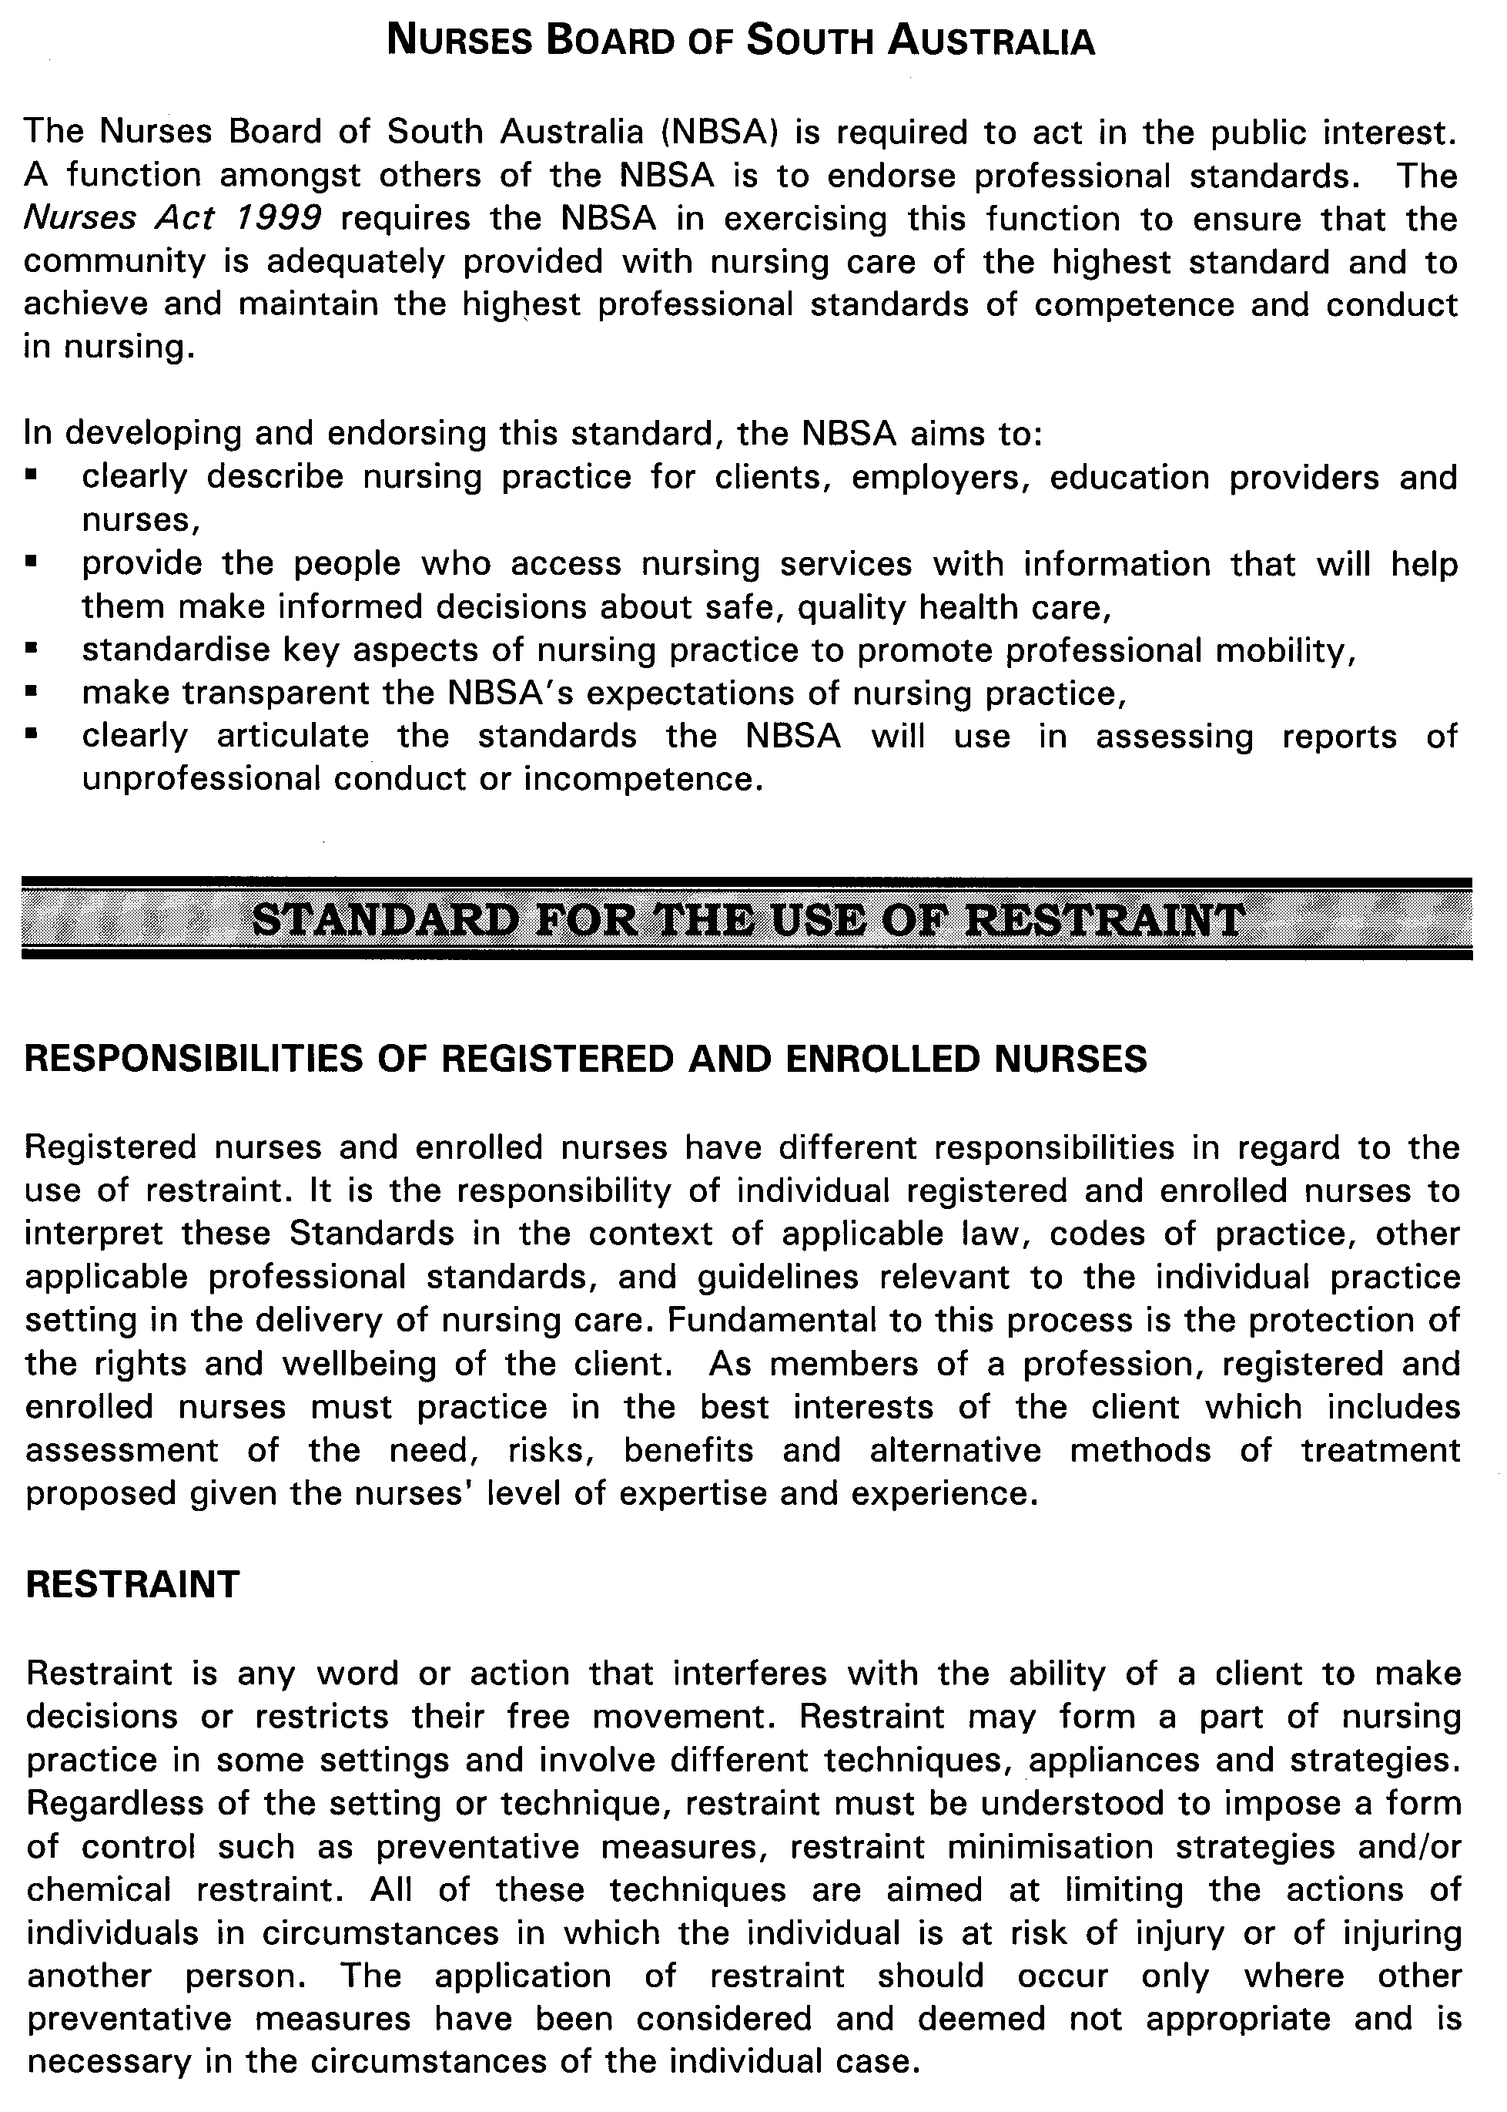
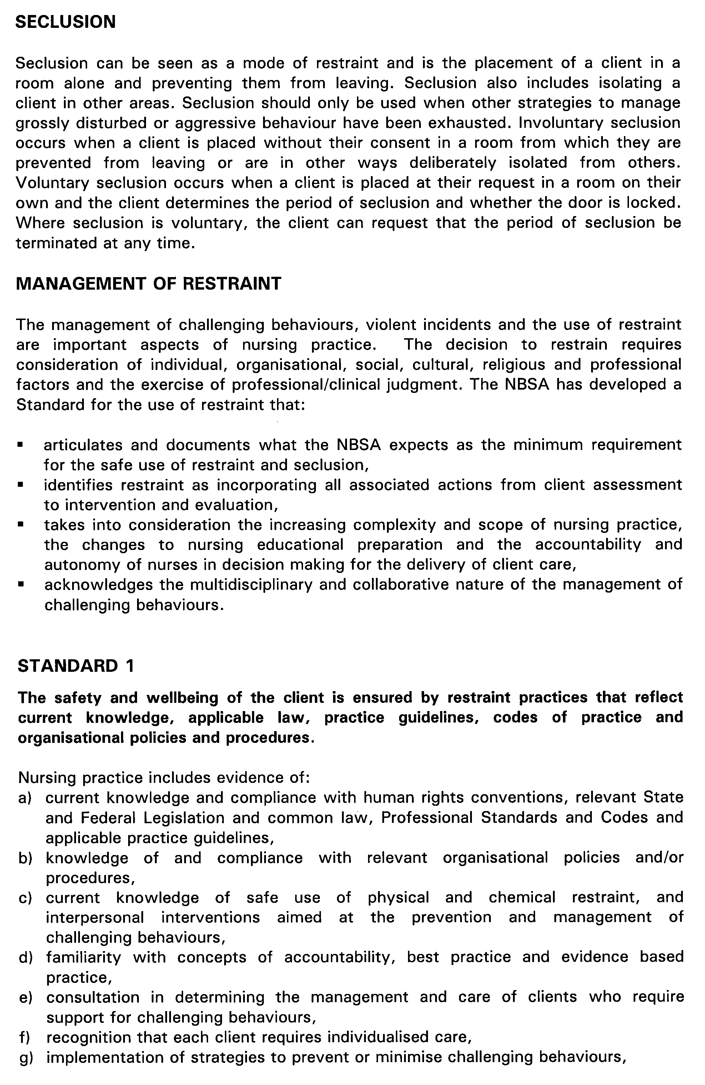
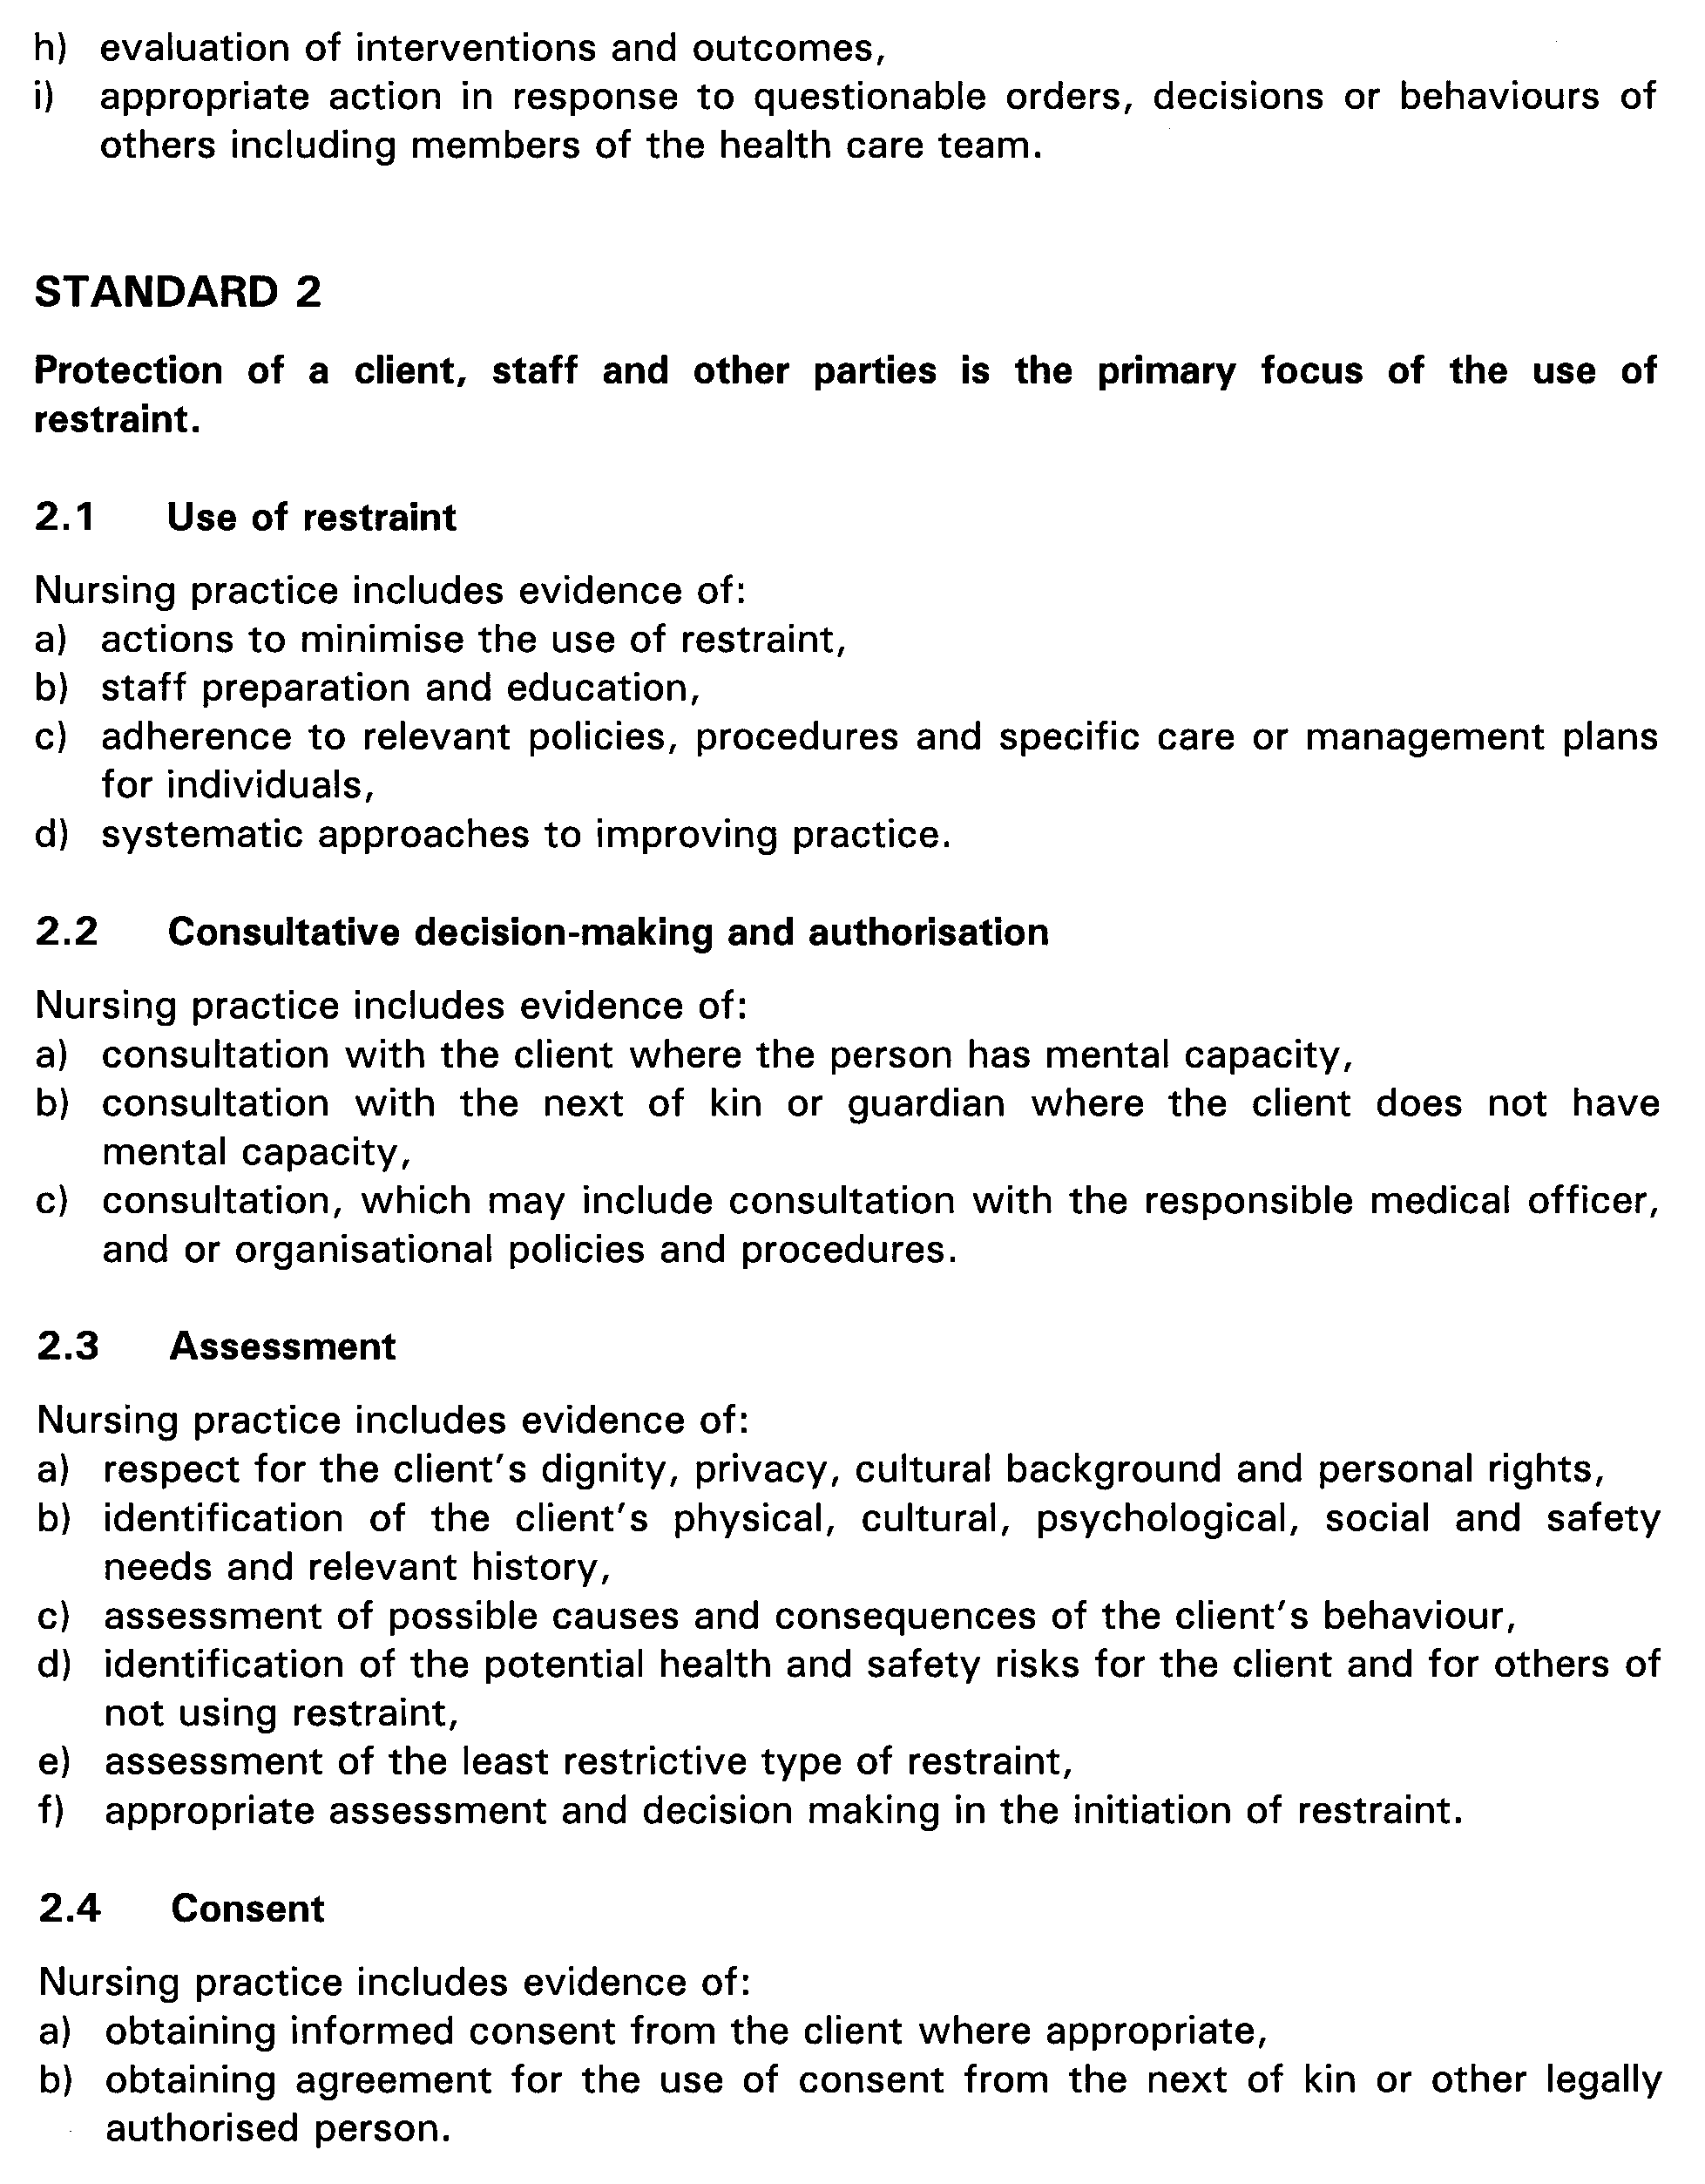
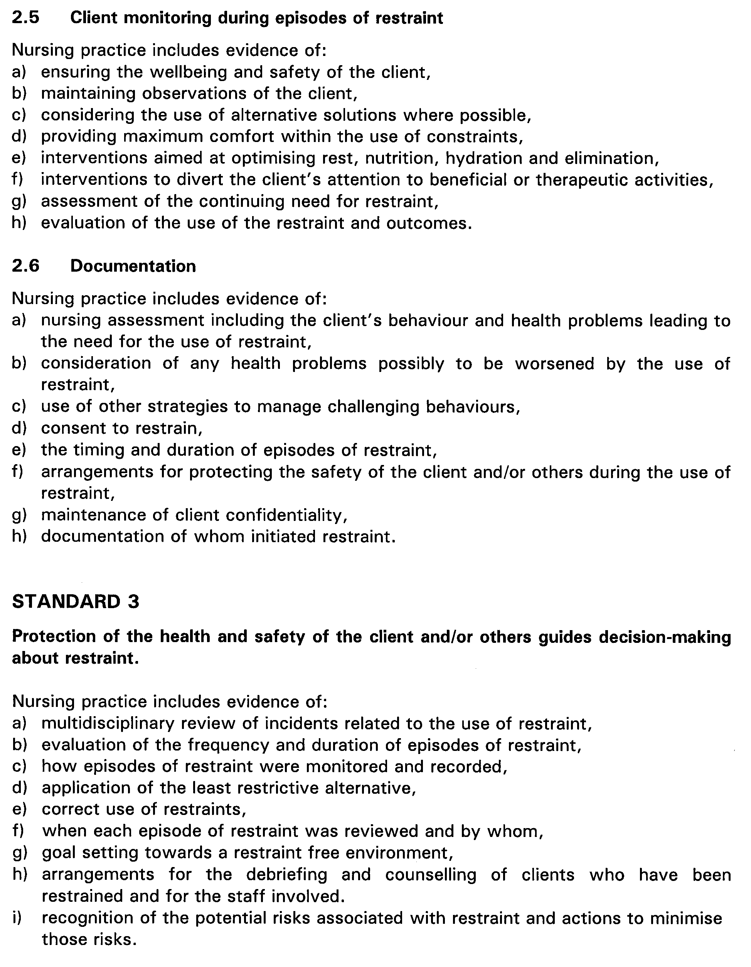

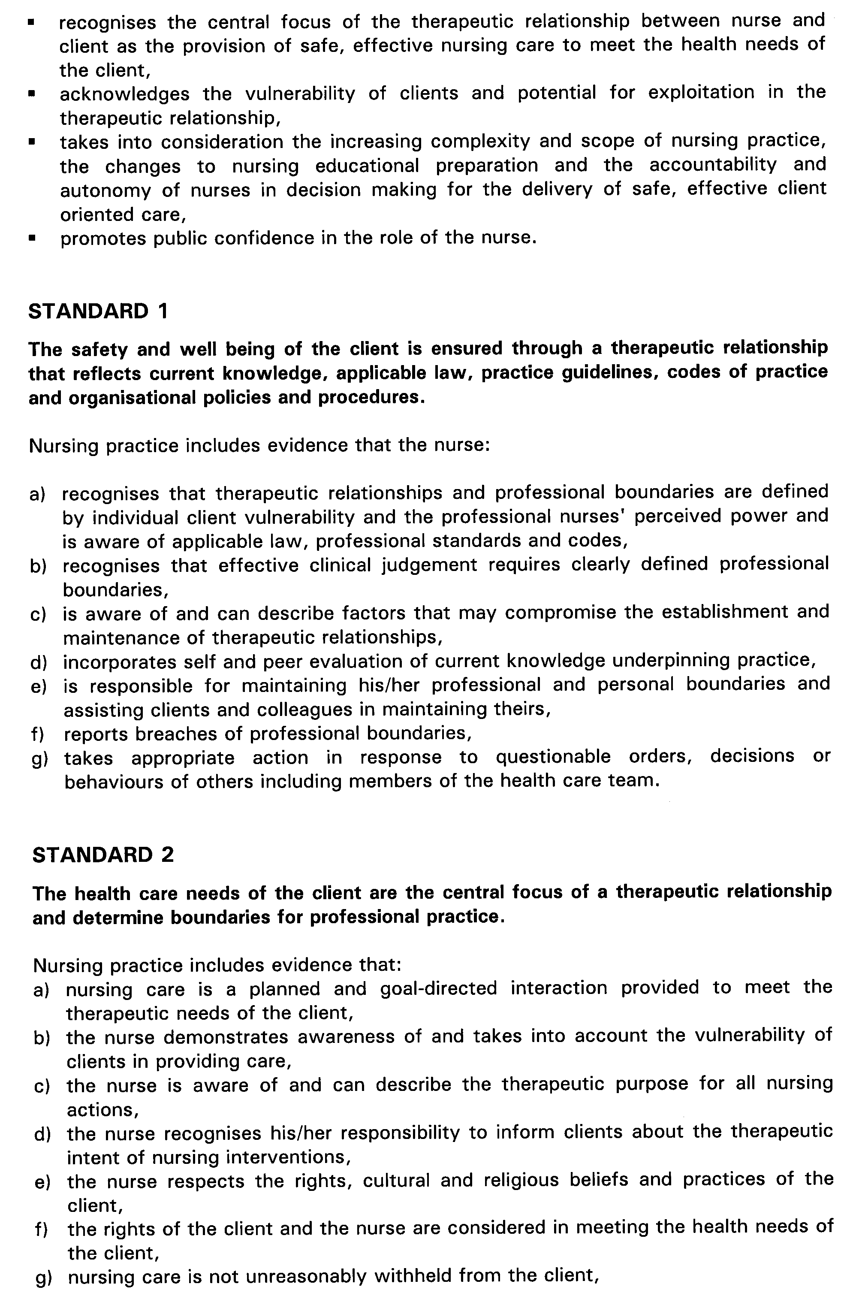

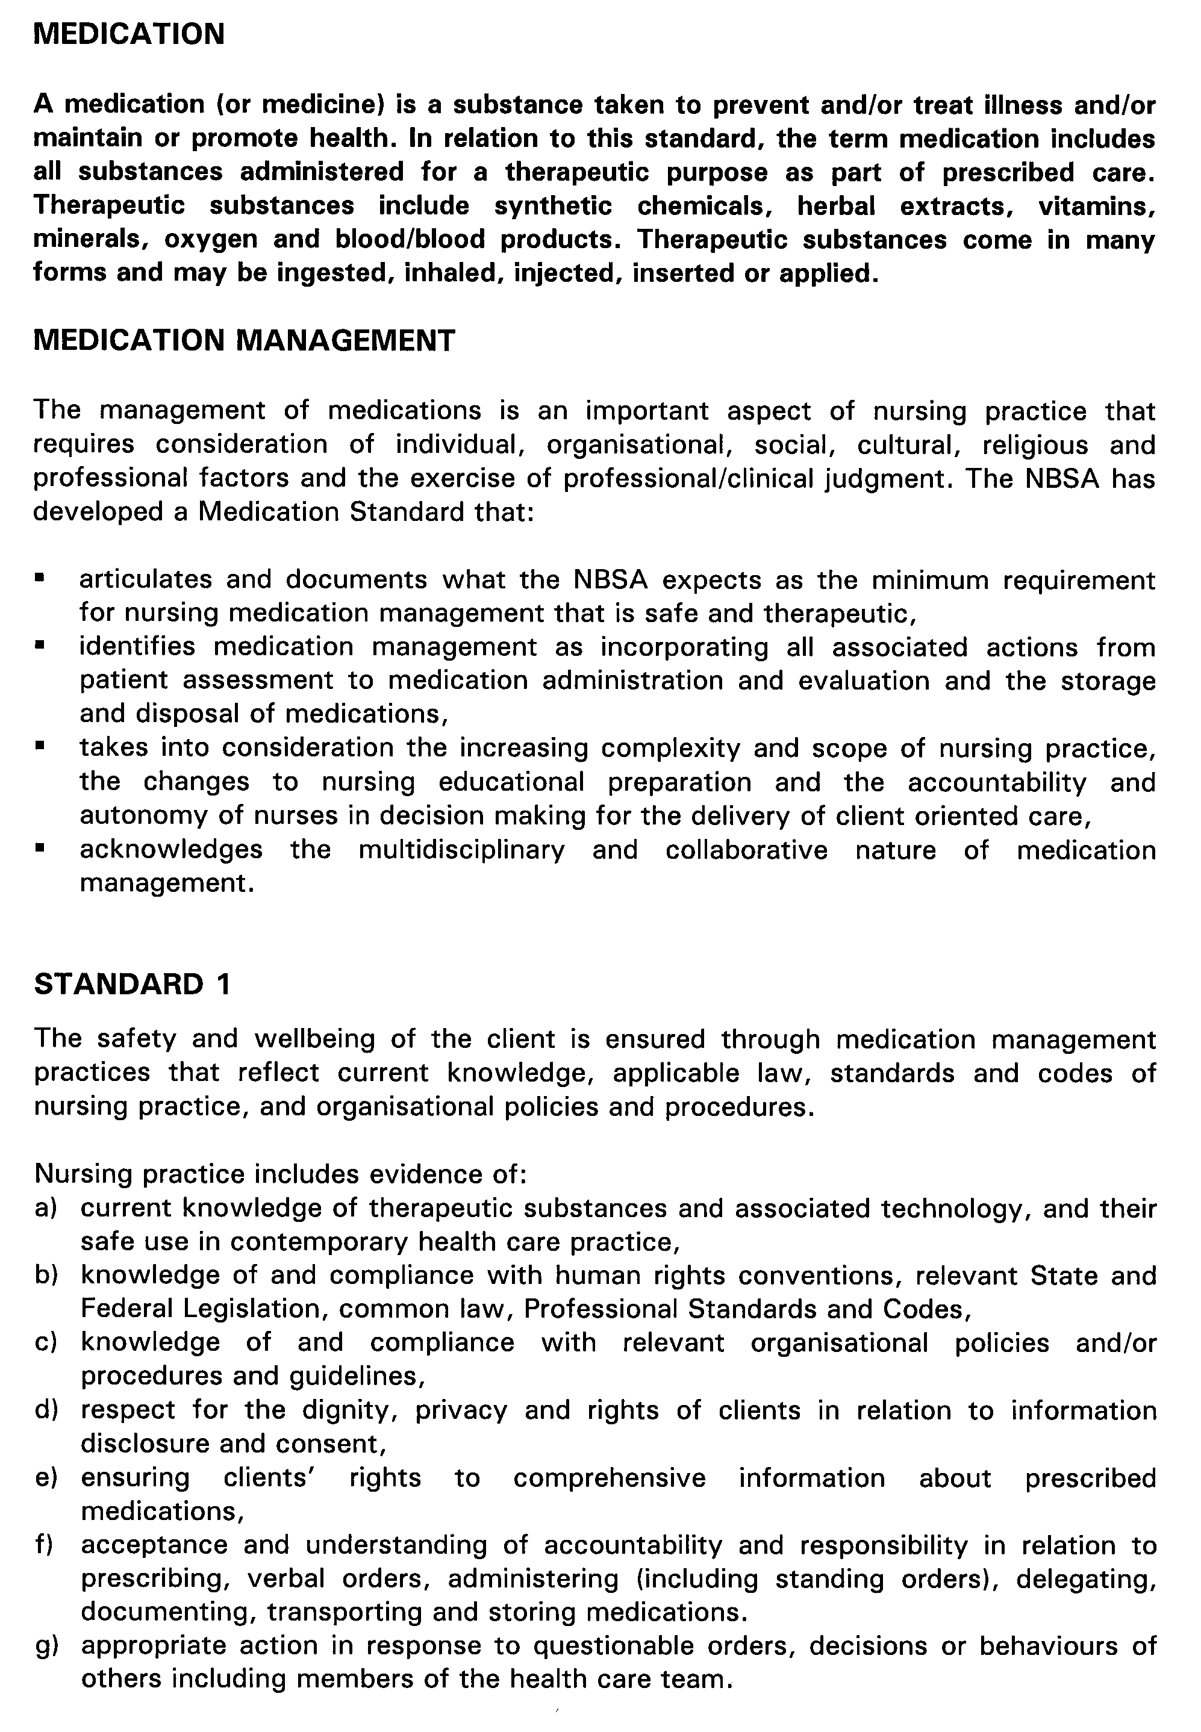
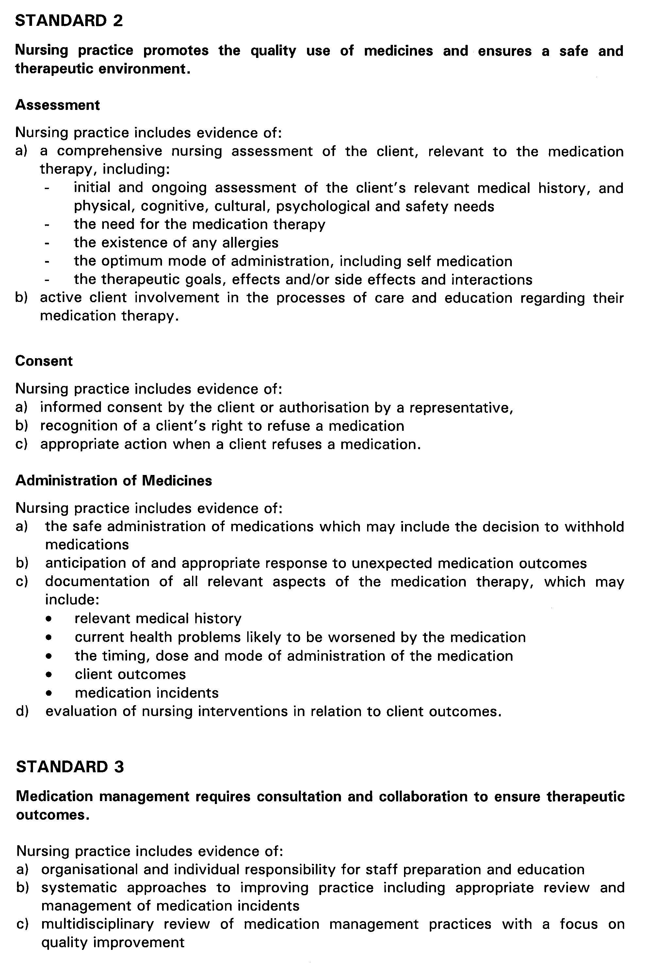

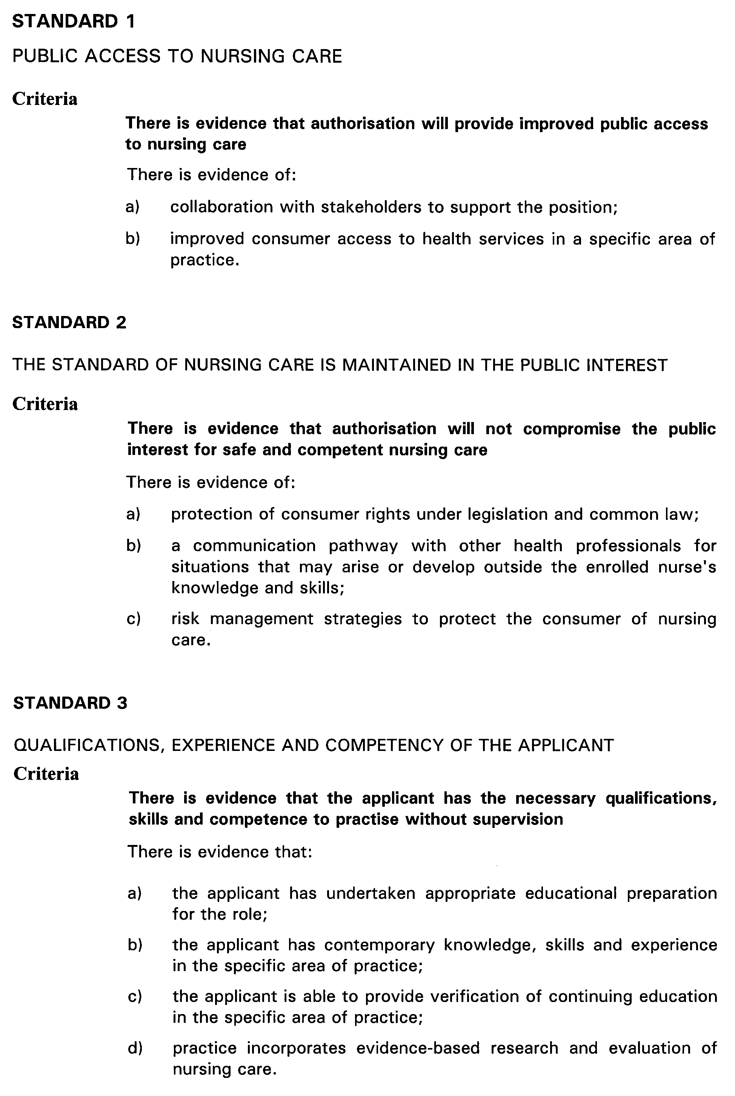




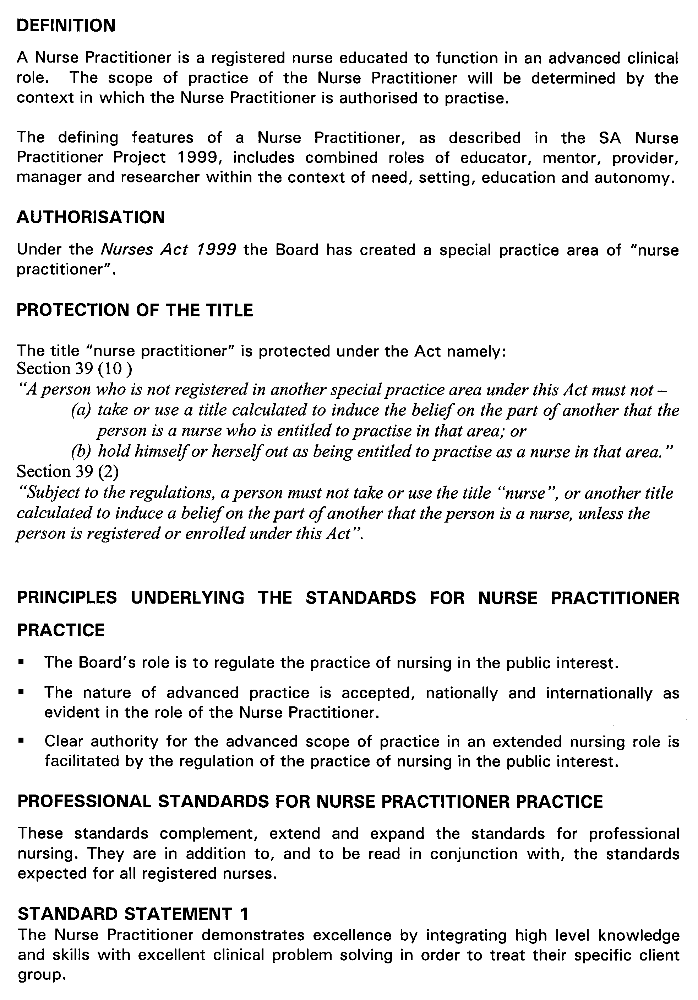





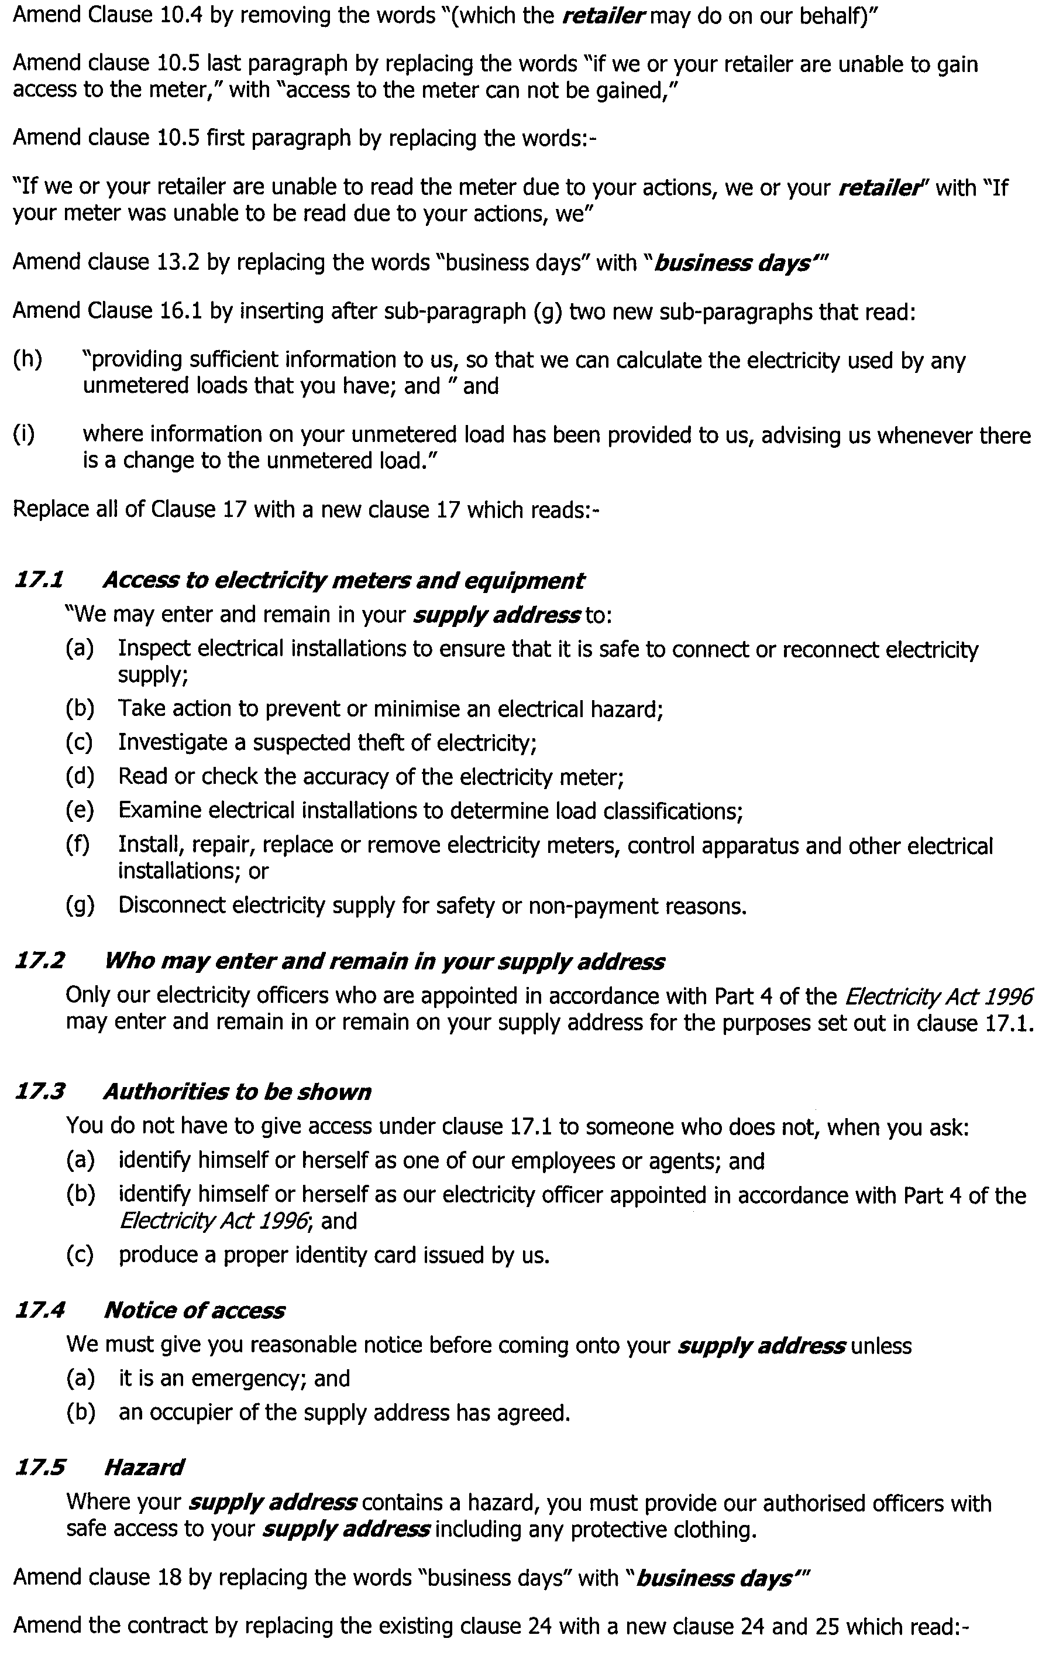
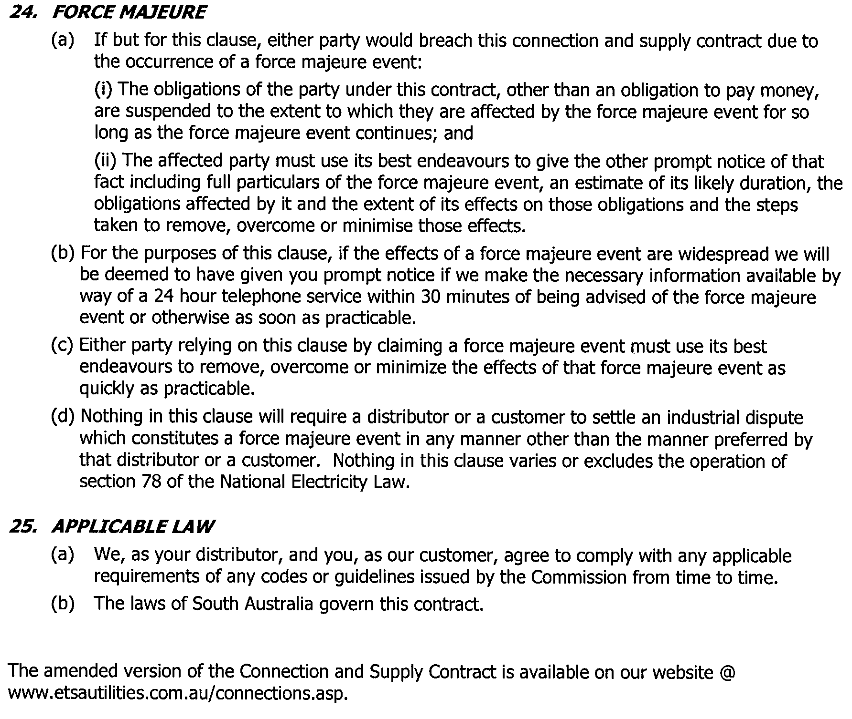

GOVERNMENT GAZETTE ADVERTISEMENT RATES

To apply from 1 July 2002

$  Agents, Ceasing to Act as 34.10  Associations:  Incorporation 17.40  Intention of Incorporation 43.00  Transfer of Properties 43.00  Attorney, Appointment of 34.10  Bailiff’s Sale 43.00  Cemetery Curator Appointed 25.50  Companies:  Alteration to Constitution 34.10  Capital, Increase or Decrease of 43.00  Ceasing to Carry on Business 25.50  Declaration of Dividend 25.50  Incorporation 34.10  Lost Share Certificates:  First Name 25.50  Each Subsequent Name 8.75  Meeting Final 28.75  Meeting Final Regarding Liquidator’s Report on  Conduct of Winding Up (equivalent to ‘Final  Meeting’)  First Name 34.10  Each Subsequent Name 8.75  Notices:  Call 43.00  Change of Name 17.40  Creditors 34.10  Creditors Compromise of Arrangement 34.10  Creditors (extraordinary resolution that ‘the Com-pany be wound up voluntarily and that a liquidator be appointed’) 43.00  Release of Liquidator⎯Application⎯Large Ad. 68.00  ⎯Release Granted 43.00  Receiver and Manager Appointed 39.75  Receiver and Manager Ceasing to Act 34.10  Restored Name 32.25  Petition to Supreme Court for Winding Up 59.50  Summons in Action 51.00  Order of Supreme Court for Winding Up Action 34.10  Register of Interests⎯Section 84 (1) Exempt 77.00  Removal of Office 17.40  Proof of Debts 34.10  Sales of Shares and Forfeiture 34.10  Estates:  Assigned 25.50  Deceased Persons⎯Notice to Creditors, etc. 43.00  Each Subsequent Name 8.75  Deceased Persons⎯Closed Estates 25.50  Each Subsequent Estate 1.10  Probate, Selling of 34.10  Public Trustee, each Estate 8.75 |  | $  Firms:  Ceasing to Carry on Business (each insertion) 22.70  Discontinuance Place of Business 22.70  Land⎯Real Property Act:  Intention to Sell, Notice of 43.00  Lost Certificate of Title Notices 43.00  Cancellation, Notice of (Strata Plan) 43.00  Mortgages:  Caveat Lodgment 17.40  Discharge of 18.30  Foreclosures 17.40  Transfer of 17.40  Sublet 8.75  Leases⎯Application for Transfer (2 insertions) each 8.75  Lost Treasury Receipts (3 insertions) each 25.50  Licensing 51.00  Municipal or District Councils:  Annual Financial Statement⎯Forms 1 and 2 481.00  Electricity Supply⎯Forms 19 and 20 341.00  Default in Payment of Rates:  First Name 68.00  Each Subsequent Name 8.75  Noxious Trade 25.50  Partnership, Dissolution of 25.50  Petitions (small) 17.40  Registered Building Societies (from Registrar-  General) 17.40  Register of Unclaimed Moneys⎯First Name 25.50  Each Subsequent Name 8.75  Registers of Members⎯Three pages and over:  Rate per page (in 8pt) 218.00  Rate per page (in 6pt) 288.00  Sale of Land by Public Auction 43.50  Advertisements 2.40  Advertisements, other than those listed are charged at $2.40 per column line, tabular one-third extra.  Notices by Colleges, Universities, Corporations and District Councils to be charged at $2.40 per line.  Where the notice inserted varies significantly in length from that which is usually published a charge of $2.40 per column line will be applied in lieu of advertisement rates listed.  South Australian Government publications are sold on the condition that they will not be reproduced without prior permission from the Government Printer.
All the above prices include GST

GOVERNMENT GAZETTE NOTICES
ALL private advertisements forwarded for publication in the South Australian Government Gazette must be PAID FOR PRIOR TO INSERTION; and all notices, from whatever source, should be legibly written on one side of the paper only and sent to Government Publishing SA so as to be received no later than 4 p.m. Tuesday preceding the day of publication. Phone 8207 1045 or Fax 8207 1040. E-mail: governmentgazette@saugov.sa.gov.au. Send as attachments in Word format and please confirm your transmission with a faxed copy of your document, including the date the notice is to be published and to whom the notice will be charged.

MISCELLANEOUS LEGISLATION AND GOVERNMENT PUBLICATIONS PRICES AS FROM 1 JULY 2003

Acts, Bills, Rules, Parliamentary Papers and Regulations
Pages | Main | Amends | Pages | Main | Amends

1-16 | 2.05 | 0.90 | 497-512 | 29.20 | 28.00
17-32 | 2.80 | 1.75 | 513-528 | 30.00 | 28.80
33-48 | 3.65 | 2.60 | 529-544 | 30.90 | 29.90
49-64 | 4.60 | 3.50 | 545-560 | 31.70 | 30.90
65-80 | 5.40 | 4.45 | 561-576 | 32.50 | 31.70
81-96 | 6.25 | 5.20 | 577-592 | 33.60 | 32.20
97-112 | 7.15 | 6.05 | 593-608 | 34.40 | 33.25
113-128 | 8.00 | 7.00 | 609-624 | 35.20 | 34.30
129-144 | 9.00 | 7.95 | 625-640 | 35.90 | 34.80
145-160 | 9.85 | 8.80 | 641-656 | 36.80 | 35.85
161-176 | 10.80 | 9.65 | 657-672 | 37.40 | 36.60
177-192 | 11.60 | 10.60 | 673-688 | 39.00 | 37.40
193-208 | 12.50 | 11.50 | 689-704 | 39.80 | 38.40
209-224 | 13.30 | 12.25 | 705-720 | 40.30 | 39.50
225-240 | 14.20 | 13.10 | 721-736 | 41.80 | 40.00
241-257 | 15.10 | 13.80 | 737-752 | 42.30 | 41.30
258-272 | 16.00 | 14.75 | 753-768 | 43.40 | 41.80
273-288 | 16.90 | 15.80 | 769-784 | 43.90 | 43.10
289-304 | 17.60 | 16.60 | 785-800 | 44.70 | 43.90
305-320 | 18.60 | 17.50 | 801-816 | 45.50 | 44.40
321-336 | 19.40 | 18.30 | 817-832 | 46.50 | 45.50
337-352 | 20.40 | 19.30 | 833-848 | 47.50 | 46.25
353-368 | 21.20 | 20.20 | 849-864 | 48.30 | 47.00
369-384 | 22.10 | 21.10 | 865-880 | 49.00 | 48.30
385-400 | 22.90 | 21.90 | 881-896 | 49.60 | 48.80
401-416 | 23.70 | 22.60 | 897-912 | 51.20 | 49.60
417-432 | 24.80 | 23.60 | 913-928 | 51.70 | 51.20
433-448 | 25.60 | 24.50 | 929-944 | 52.50 | 51.70
449-464 | 26.50 | 25.30 | 945-960 | 53.50 | 52.20
465-480 | 27.00 | 26.20 | 961-976 | 54.50 | 53.25
481-496 | 28.20 | 27.00 | 977-992 | 55.60 | 54.00

Legislation—Acts, Regulations, etc: $
Subscriptions:
Acts 180.00
All Bills as Laid 431.00
Rules and Regulations 431.00
Parliamentary Papers 431.00
Bound Acts 199.00
Index 99.00
Government Gazette
Copy 4.70
Subscription 238.00
Hansard
Copy 13.00
Subscription—per session (issued weekly) 374.00
Cloth bound—per volume 161.00
Subscription—per session (issued daily) 374.00
Legislation on Disk
Whole Database 2 763.00
Annual Subscription for fortnightly updates 849.00
Individual Act(s) including updates POA
Compendium
Subscriptions:
New Subs 1 638.00
Updates 578.00
(All the above prices include GST)

All Legislation, Government Gazette, Hansard and Legislation on disk are available from:
Counter Sales Service SA, Government Information Centre
and Mail Orders: Ground Floor, 77 Grenfell Street, Adelaide, S.A. 5000
Phone: 13 23 24 (local call cost), Fax: (08) 8204 1909
TTY (Hearing Impaired): (08) 8204 1923

Online Shop: www.info.sa.gov.au

Subscriptions and Government Publishing SA
Standing Orders: Box 9, Plaza Level, Riverside Centre, North Terrace, Adelaide, S.A. 5000
Phone: (08) 8207 0908, (08) 8207 0910, Fax: (08) 8207 1040

Erratum
IN Government Gazette of 29 May 2003 in the second notice on page 2068 the 5th address should be replaced with this new address.
HOUSING IMPROVEMENT ACT 1940
WHEREAS by notice published in the Government Gazette on the dates mentioned in the following table the South Australian Housing Trust did declare the houses described in the said table to be substandard for the purposes of Part 7 of the Housing Improvement Act 1940, the South Australian Housing Trust in the exercise of the powers conferred by the said Part, does hereby fix as the maximum rental per week which shall be payable subject to section 55 of the Residential Tenancies Act 1995, in respect of each house described in the following table the amount shown in the said table opposite the description of such house and this notice shall come into force on the date of this publication in the Gazette.
Address of House | Allotment, Section, etc. | Certificate of Title  Volume Folio | Date and page of Government Gazette in which notice declaring house to be substandard published | Maximum rental per week payable in respect of each house  $

31 Cockburn Road, Jamestown |  | Allotment 1 in filed plan 9959, Hundred of Belalie | 5489 | 223 |  | 9.3.78, page 850 | 150.00

Dated at Adelaide, 29 May 2003. M. Downie, General Manager, Housing Trust

HARBORS AND NAVIGATION ACT 1993
SCHEDULE OF SHIPPING CHARGES PURSUANT TO SECTION 31*
TAKE notice that the Schedule of Shipping Charges published in the South Australian Government Gazette, page 3439, 19 September 2002, is hereby revoked and replaced with the following:
Effective from 1 July 2003
Navigation Services Charge **
The Navigation Services Charge is to recover the costs of providing navigational aids to commercial shipping using the State’s Indentured ports. This will be a charge to vessels on the basis of the number of times the vessel enters State waters from outside those waters and proceeds to an indentured or private port in the State.
Note: Other charging arrangements have been made and apply to the ports of Ardrossan; Klein Point; Port Adelaide; Port Giles; Port Lincoln; Port Pirie; Thevenard and Wallaroo
The base charge (GST inclusive) to be applied is $988 + $0.10897 per gross ton per trading voyage within South Australian waters.
The base charge will be reduced by 25% for each subsequent call of the commercial vessel after the first call and within six months of the first call, (i.e. 100% of base charge for first call; 75% for second call within 6 months of the first call; 50% for the third call; 25% for the fourth call). No Navigation Services Charge will be payable for the fifth call and any subsequent call, provided they occur within six months of the first call.
Alternatively, an option of a one-off, up-front payment of 2.3 times the base charge for unlimited calls by the one commercial vessel in a six month period is available. Application must be made prior to the entry of the vessel into South Australian waters.
Harbor Services Charge (applied at Port Bonython only) **
The Harbor Services Charge is to recover the costs of servicing vessels in port and at berths.
The base charge (GST inclusive) to be applied is $2 662 + $0.004946 per Gross Registered Ton of the vessel per hour at berth.
Cargo Services Charge **
The Cargo Services Charge is to recover the costs of providing the basic port facilities.
The following charges (GST inclusive) on imported and exported Bulk Cargo apply:
Whyalla Lime sand at $0.03966 per tonne
Note: The charges above are to apply to commercial vessels or cargoes unless alternative charges have been agreed by negotiation with the Minister for Transport and Urban Planning.
Dated 12 June 2003.
M. J. Wright, Minister for Transport

HARBORS AND NAVIGATION ACT 1993
Fishing Industry Facilities Schedule of Fees and Charges Pursuant to Section 31—Effective from 1 July 2003
FEES for storage, slipping, straddle carrier use and vessel movements in Boat Yards at Port MacDonnell, Beachport, Kingscote and Bosanquet Bay are charged to recover some of the costs associated with the operation and administration of these facilities. Where applicable, fee rate divisions that were previously measured in Imperial measures have been converted to their Metric equivalents.
All of the fees and charges listed below are inclusive of GST:
Port MacDonnell Boat Yard
Storage fees are to be charged at Port MacDonnell Boat Yard at a flat rate for all vessels of $20 per vessel per week (or part thereof).
Beachport Boat Yard
Storage fees at Beachport Boat Yard are to be charged at $9.75 for vessels up to 7.62 m (25 feet), $13.95 for vessels over 7.62 m and up to 9.14 m (30 feet) and $17.48 for vessels over 9.14 m, all on a per vessel per week (or part thereof) basis.
On Trailer Slipping Fees are charged for up to two hours on an increasing scale dependent on vessel length as follows. All fees listed are per hour (or part thereof): up to 7.62 m (25 feet) at $47.15; over 7.62 m and up to 9.14 m (30 feet) at $56.82; over 9.14 m and up to 10.67 m (35 feet) at $75.56; over 10.67 m and up to 12.19 m (40 feet) at $94.41; over 12.19 m and up to 13.72 m (45 feet) at $113.78; over 13.72 m and up to 15.24 m (50 feet) at $142.01; over 15.24 m and up to 16.76 m (55 feet) at $170.73; over 16.76 m and up to 18.29 m (60 feet) at $199.21; over 18.29 m and up to 19.81 m (65 feet) at $236.80.
Additional to the above and only when applicable, an After Hours Slipping Charge of $35.20, Overtime Charge of $46.52 and/or After Hours Callout Charge of $188.58 may apply.
A Straddle Usage Charge of $15.21 applies each time the Straddle Carrier is used. In addition to the base charge, charges per movement are made on increasing scales dependent on vessel length and the type of movement as follows:
For Sea to Land movements: up to 7.62 m at $94.29; over 7.62 m and up to 9.14 m (30 feet) at $113.65; over 9.14 m and up to 10.67 m (35 feet) at $151.11; over 10.67 m and up to 12.19 m (40 feet) at $188.83; over 12.19 m and up to 13.72 m (45 feet) at $227.55; over 13.72 m and up to 15.24 m (50 feet) at $284.00; over 15.24 m and up to 16.76 m (55 feet) at $341.46; over 16.76 m and up to 18.29 m (60 feet) at $398.40; over 18.29 m and up to 19.81 m (65 feet) at $473.59.
For Sea to Land movements via the wash down area: up to 7.62 m at $141.44; over 7.62 m and up to 9.14 m (30 feet) at $170.48; over 9.14 m and up to 10.67 m (35 feet) at $226.67; over 10.67 m and up to 12.19 m (40 feet) at $283.24; over 12.19 m and up to 13.72 m (45 feet) at $341.33; over 13.72 m and up to 15.24 m (50 feet) at $426.00; over 15.24 m and up to 16.76 m (55 feet) at $512.18; over 16.76 m and up to 18.29 m (60 feet) at $597.60; over 18.29 m and up to 19.81 m (65 feet) at $710.37.
For Land to Sea movements: up to 7.62 m at $47.15; over 7.62 m and up to 9.14 m (30 feet) at $56.82; over 9.14 m and up to 10.67 m (35 feet) at $75.56 over 10.67 m and up to 12.19 m (40 feet) at $94.41; over 12.19 m and up to 13.72 m (45 feet) at $113.78; over 13.72 m and up to 15.24 m (50 feet) at $142.01; over 15.24 m and up to 16.76 m (55 feet) at $170.73; over 16.76 m and up to 18.29 m (60 feet) at $199.21; over 18.29 m and up to 19.81 m (65 feet) at $236.80.
For Land to Sea only movements: up to 7.62 m at $94.29; over 7.62 m and up to 9.14 m (30 feet) at $113.65; over 9.14 m and up to 10.67 m (35 feet) at $151.11; over 10.67 m and up to 12.19 m (40 feet) at $188.83; over 12.19 m and up to 13.72 m (45 feet) at $227.55; over 13.72 m and up to 15.24 m (50 feet) at $284.00; over 15.24 m and up to 16.76 m (55 feet) at $341.46; over 16.76 m and up to 18.29 m (60 feet) at $398.40; over 18.29 m and up to 19.81 m (65 feet) at $473.59.
For Shifts in Yard: up to 7.62 m at $47.15; over 7.62 m and up to 9.14 m (30 feet) at $56.82; over 9.14 m and up to 10.67 m (35 feet) at $75.56; over 10.67 m and up to 12.19 m (40 feet) at $94.41; over 12.19 m and up to 13.72 m (45 feet) at $113.78; over 13.72 m and up to 15.24 m (50 feet) at $142.01; over 15.24 m and up to 16.76 m (55 feet) at $170.73; over 16.76 m and up to 18.29 m (60 feet) at $199.21 over 18.29 m and up to 19.81 m (65 feet) at $236.80.
Slipway Fees—Kingscote and Thevenard (Bosanquet Bay)
Slipway Fees are charged by vessel length and period of time on the Slipway on sliding scales as follows. All rates shown are per day rates and periods are inclusive of the days mentioned:
Up to 6.25 m: $
1st day 30.74
2nd to 3rd day 10.51
Subsequent days 7.03
Over 6.25 m and up to 7.75 m:
1st day 42.86
2nd to 4th day 14.97
Subsequent days 9.60
Over 7.75 m and up to 9.25 m:
1st day 51.66
2nd to 5th day 17.89
Subsequent days 12.46
Over 9.25 m and up to 10.75 m:
1st day 68.69
2nd to 8th day 23.26
Subsequent days 15.54
Over 10.75 m and up to 12.25 m:
1st day 85.83
2nd to 8th day 29.32
Subsequent days 19.83
Over 12.25 m and up to 13.75 m:
1st day 103.43
2nd to 8th day 34.40
Subsequent days 23.26
Over 13.75 m and up to 15.25 m:
1st day 129.10
2nd to 8th day 42.97
Subsequent days 30.63
Over 15.25 m and up to 17.00 m:
1st day 155.21
2nd to 8th day 51.77
Subsequent days 34.40
Over 17.00 m and up to 18.50 m:
1st day 181.10
2nd to 8th day 60.23
Subsequent days 40.46
Over 18.50 m and up to 20.00 m:
1st day 215.27
2nd to 8th day 77.49
Subsequent days 51.77
Dated 12 June 2003.
M. Wright, Minister for Transport

FISHERIES ACT 1982: SECTION 59
TAKE notice that pursuant to section 59 of the Fisheries Act 1982, the exemption granted under section 59 of the Fisheries Act 1982 to Nicolai Konow, Centre for Coral Reef Biodiversity, School of Marine Biology, James Cook University, Townsville, Qld 4811 (the ‘exemption holder’) dated 9 July 2002, is hereby varied to:
• allow the exempted activity to be undertaken in all coastal waters of South Australia excluding aquatic reserves; and
• to limit the number of specimens that may be taken during each collection trip to 6 specimens of each species.
W. Zacharin, Director of Fisheries

FISHERIES ACT 1982: SECTION 59
TAKE notice that pursuant to section 59 of the Fisheries Act 1982, Rockne Little (hereinafter referred to as the ‘exemption holder’), Rainbow South Pacific Export Ltd, P.O. Box 1235, Coulta, S.A. 5607 is exempt from section 34 of the Fisheries Act 1982 but only insofar as he may take sea urchins (Family Echinometridae) (hereinafter referred to as the 'exempted activity') subject to the conditions in Schedule 1 for the purposes of trade or business, from the date of gazettal of this notice until 30 September 2003, unless varied or revoked earlier.
Schedule 1
1. Fish may be taken from coastal waters of the State excluding the waters of Coffin Bay south of latitude 34°30.30′S.
2. The exemption holder may authorise a person to act on his behalf in conducting the exempted activity for a maximum of 21 days in any one financial year (the nominated person). The exemption holder must make this nomination prior to the nominated person commencing or conducting acts preparatory to commencing the exempted activity by telephoning the PIRSA Fisheries Compliance Unit on 1800 065 522 and provide the following information:
• the full name of the nominated person; and
• the residential address of the nominated person.
3. The exemption holder (or the nominated person) and two other people (assistants) may engage in the exempted activity at any one time. The people assisting the exemption holder must, at all times whilst conducting the exempted activity, remain within 50 m of the exemption holder. Sea urchins may only be taken by hand.
4. The exemption holder must provide the Director of Fisheries statistical catch and effort information (including zero returns if no fishing operations have been conducted), in the form of a daily log as provided, within 15 days of the completion of each calendar month.
5. The exemption holder shall notify the PIRSA Fisheries Compliance Unit on 1800 065 522 at least one hour prior to conducting the exempted activity with the following information:
• details of the boat that will be used to engage in the exempted activity;
• the intended area of conducting the exempted activity;
• the intended place and time of launching and retrieval of the nominated boat for that day; and
• the name of the assistants (if any) who will be assisting the exemption holder or the nominated person.
7. PIRSA Fisheries retains the right for a Departmental Officer to accompany the exemption holder or nominated person at any time whilst conducting the exempted activity.
8. The exemption holder or his assistants must not conduct any other fishing activity whilst undertaking the exempted activity.
9. While engaged in the exempted activity the exemption holder (or the nominated person) shall carry or have about or near his person a copy of this notice. Such notice must be produced to a PIRSA Fisheries Compliance Officer upon request.
10. The exemption holder shall not contravene or fail to comply with the Fisheries Act 1982 or any regulations made under that Act, except where specifically exempted by this notice.
Dated 12 June 2003.
W. Zacharin, Director of Fisheries

LAND ACQUISITION ACT 1969
Notice of Acquisition
THE Commissioner of Highways (the Authority), 33 Warwick Street, Walkerville, S.A. 5081, acquires the following interests in the following land:
Comprising the fee simple of that piece of land situated at Wingfield, S.A. 5013 being portion of the land contained in Certificate of Title register book volume 5854, folio 298 and being the whole of the land numbered allotment 29 on plan FP9381.
This notice is given under section 16 of the Land Acquisition Act 1969.
Compensation
A person who has or had an interest in the land that is divested or diminished by the acquisition or the enjoyment of which is adversely affected by the acquisition who does not receive an offer of compensation from the Authority may apply to the Authority for compensation.
Inquiries
Inquiries should be directed to:
John Gluis
P.O. Box 1
Walkerville, S.A. 5081
Telephone: (08) 8343 2423
Dated 6 June 2003.
The Common Seal of the Commissioner of Highways was hereto affixed by direction of the Commissioner of Highways in the presence of:
D. Woods, Manager, Land Acquisition and Disposal, Transport SA

LAND AND BUSINESS (SALE AND CONVEYANCING) ACT 1994
Exemption
TAKE notice that, pursuant to section 23 (3) of the Land and Business (Sale and Conveyancing) Act 1994, I, Michael John Atkinson, Minister for Consumer Affairs, do hereby exempt the person named in Schedule 1 from the application of section 23 (2) of the Act in relation to the purchase of the land specified in Schedule 2.
Schedule 1
Phillip Hamilton Bradley, an officer/employee of Neil Ottoson Real Estate Pty Ltd.
Schedule 2
The whole of the land described in certificate of title register book volume 5335, folio 623, situated at 2 Second Avenue, Naracoorte, S.A. 5271.
Dated 12 June 2003.
Signed for and on behalf of the Minister for Consumer Affairs by the Commissioner for Consumer Affairs:
M. Bodycoat, Commissioner

LAND AND BUSINESS (SALE AND CONVEYANCING) ACT 1994
Exemption
TAKE notice that, pursuant to section 23 (3) of the Land and Business (Sale and Conveyancing) Act 1994, I, Michael John Atkinson, Minister for Consumer Affairs, do hereby exempt the person named in Schedule 1 from the application of section 23 (2) of the Act in relation to the purchase of the land specified in Schedule 2.
Schedule 1
Brett Wayne Lehmann, an officer/employee of Carson Inglis Coastal Investments Pty Ltd.
Schedule 2
The whole of the land described in certificate of title register book volume 5396, folios 290, 294 and 299, situated at allotments 92, 101 and 108, Second Street, Kingston SE, S.A. 5275.
Dated 12 June 2003.
Signed for and on behalf of the Minister for Consumer Affairs by the Commissioner for Consumer Affairs:
M. Bodycoat, Commissioner

LAND AND BUSINESS (SALE AND CONVEYANCING) ACT 1994
Exemption
TAKE notice that, pursuant to section 23 (3) of the Land and Business (Sale and Conveyancing) Act 1994, I, Michael John Atkinson, Minister for Consumer Affairs, do hereby exempt the person named in Schedule 1 from the application of section 23 (2) of the Act in relation to the purchase of the land specified in Schedule 2.
Schedule 1
Simone Maree Mercer, an officer/employee of Warmingtons Pty Ltd.
Schedule 2
The whole of the land described in certificate of title register book volume 5315, folio 325, situated at 32 Port Road, Kadina, S.A. 5554.
Dated 12 June 2003.
Signed for and on behalf of the Minister for Consumer Affairs by the Commissioner for Consumer Affairs:
M. Bodycoat, Commissioner

LIQUOR LICENSING ACT 1997
Notice of Application
NOTICE is hereby given, pursuant to section 52 (2) (b) of the Liquor Licensing Act 1997, that Citrus Blu Pty Ltd has applied to the Licensing Authority for a Restaurance Licence with section 34 (1) (c) and Extended Trading Authorisation in respect of premises situated at 18 Union Street, Adelaide, S.A. 5000 and known as Citrus Blu.
The application has been set down for hearing on 11 July 2003 at 9 a.m.
Conditions
The following licence conditions are sought:
Extended Trading Authorisation is sought for the areas as depicted in the plan.
Sunday and Public Holidays, 8 a.m. to 11 a.m. and 8 p.m. to 11 p.m.
For consumption on the licensed premises by persons seated at a table or attending a function at which food is provided.
Any person may object to the application by lodging a notice of objection in the prescribed form with the Licensing Authority, and serving a copy of the notice on the applicant at the applicant’s address given above, at least seven days before the hearing date.
Plans in respect of the premises the subject of the application are open to public inspection without fee at the Office of the Liquor and Gaming Commissioner, 9th Floor, East Wing, 50 Grenfell Street, Adelaide, S.A. 5000.
Dated 3 June 2003.
Applicant

LIQUOR LICENSING ACT 1997
Notice of Application
NOTICE is hereby given, pursuant to section 52 (2) (b) of the Liquor Licensing Act 1997, that Dang Vu, Dinh Phuc Vu and Phin Thi Chau have applied to the Licensing Authority for the transfer of a Restaurant Licence in respect of premises situated at 89 Gouger Street, Adelaide, S.A. 5000 and known as Lime and Lemon Thai Cafe.
The application has been set down for hearing on 14 July 2003 at 9.30 a.m.
Any person may object to the application by lodging a notice of objection in the prescribed form with the Licensing Authority, and serving a copy of the notice on the applicants at the applicants’ address given above, at least seven days before the hearing date.
Plans in respect of the premises the subject of the application are open to public inspection without fee at the Office of the Liquor and Gaming Commissioner, 9th Floor, East Wing, 50 Grenfell Street, Adelaide, S.A. 5000.
Dated 4 June 2003.
Applicants

LIQUOR LICENSING ACT 1997
Notice of Application
NOTICE is hereby given, pursuant to section 52 (2) (b) of the Liquor Licensing Act 1997, that Lindsay Howard Gilchrist and Pamela Joyce Rowland, have applied to the Licensing Authority for the transfer of a Retail Liquor Merchant’s Licence in respect of premises situated at Cape Jaffa Caravan Park, via Kingston, S.A. 5275 and known as Cape Jaffa Bottle Shop.
The application has been set down for hearing on 14 July 2003 at 10 a.m.
Any person may object to the application by lodging a notice of objection in the prescribed form with the Licensing Authority, and serving a copy of the notice on the applicants at the applicants’ address given above, at least seven days before the hearing date.
Plans in respect of the premises the subject of the application are open to public inspection without fee at the Office of the Liquor and Gaming Commissioner, 9th Floor, East Wing, 50 Grenfell Street, Adelaide, S.A. 5000.
Dated 4 June 2003.
Applicants

LIQUOR LICENSING ACT 1997
Notice of Application
NOTICE is hereby given, pursuant to section 52 (2) (b) of the Liquor Licensing Act 1997, that Michelle May Rushworth has applied to the Licensing Authority for the transfer of a Hotel Licence in respect of premises situated at 21 Lewis Terrace, Iron Knob, S.A. 5601 and known as Iron Knob Hotel
The application has been set down for hearing on 14 July 2003 at 10.30 a.m.
Any person may object to the application by lodging a notice of objection in the prescribed form with the Licensing Authority, and serving a copy of the notice on the applicant at the applicant’s address given above, at least seven days before the hearing date.
Plans in respect of the premises the subject of the application are open to public inspection without fee at the Office of the Liquor and Gaming Commissioner, 9th Floor, East Wing, 50 Grenfell Street, Adelaide, S.A. 5000.
Dated 5 June 2003.
Applicant

LIQUOR LICENSING ACT 1997
Notice of Application
NOTICE is hereby given, pursuant to section 52 (2) (b) of the Liquor Licensing Act 1997, that Michael Groff and Tamara Boakes have applied to the Licensing Authority for the transfer of a Special Circumstances Licence in respect of premises situated at 181 Hindley Street, Adelaide, S.A. 5000 and known as Laughing Gas and to be known as Jive.
The application has been set down for hearing on 14 July 2003 at 11 a.m.
Conditions
The following licence conditions are sought:
Amendment to condition 1 which reads:
• The premises shall operate primarily and predominantly as a live theatre with any other activity on the premises being ancillary to such operation.
To read:
• The premises shall operate with art exhibitions, book launches, comedy, dance, DJ’s film, live theatre, live music of every genre (both acoustic and amplified), and spoken word.
Any person may object to the application by lodging a notice of objection in the prescribed form with the Licensing Authority, and serving a copy of the notice on the applicants at the applicants’ address given above, at least seven days before the hearing date.
Plans in respect of the premises the subject of the application are open to public inspection without fee at the Office of the Liquor and Gaming Commissioner, 9th Floor, East Wing, 50 Grenfell Street, Adelaide, S.A. 5000.
Dated 6 June 2003.
Applicants

LIQUOR LICENSING ACT 1997
Notice of Application
NOTICE is hereby given, pursuant to section 52 (2) (b) of the Liquor Licensing Act 1997, that Elizabeth Motor Inn Motel Pty Ltd, c/o Edgley Lawyers, has applied to the Licensing Authority for the transfer of a Residential Licence in respect of premises situated at corner Ifould and Main North Roads, Elizabeth Park, S.A. 5113 and known as Elizabeth Motor Inn.
The application has been set down for hearing on 15 July 2003 at 9 a.m.
Any person may object to the application by lodging a notice of objection in the prescribed form with the Licensing Authority, and serving a copy of the notice on the applicant at the applicant’s address given above, at least seven days before the hearing date.
Plans in respect of the premises the subject of the application are open to public inspection without fee at the Office of the Liquor and Gaming Commissioner, 9th Floor, East Wing, 50 Grenfell Street, Adelaide, S.A. 5000.
Dated 4 June 2003.
Applicant

LIQUOR LICENSING ACT 1997
Notice of Application
NOTICE is hereby given, pursuant to section 52 (2) (b) of the Liquor Licensing Act 1997, that Andrew Marshall, c/o Mead Robson Steale has applied to the Licensing Authority for the transfer of a Restaurant Licence in respect of premises situated at 82 North Terrace, Littlehampton, S.A. 5250 and known as Littlehampton Chinese Restaurant.
The application has been set down for hearing on 15 July 2003 at 10 a.m.
Any person may object to the application by lodging a notice of objection in the prescribed form with the Licensing Authority, and serving a copy of the notice on the applicant at the applicant’s address given above, at least seven days before the hearing date.
Plans in respect of the premises the subject of the application are open to public inspection without fee at the Office of the Liquor and Gaming Commissioner, 9th Floor, East Wing, 50 Grenfell Street, Adelaide, S.A. 5000.
Dated 6 June 2003.
Applicant

LIQUOR LICENSING ACT 1997
Notice of Application
NOTICE is hereby given, pursuant to section 52 (2) (b) of the Liquor Licensing Act 1997, that The Southern Hotel, c/o Jarrod Ryan, of Kelly & Co. has applied to the Licensing Authority for a variation to Conditions of Licence in respect of premises situated at 23 Murray Street, Gawler, S.A. 5118 and known as The Southern.
The application has been set down for hearing on 15 July 2003 at 10.30 a.m.
Conditions
The following licence conditions are sought:
• Variation to Extended Trading Authorisation for all areas of the Hotel to include:
Thursday to Saturday—midnight to 4 a.m. the following day.
Sunday preceding a Public Holiday—8 a.m. to 11 a.m. and 8 p.m. to 4 a.m. the following day.
• Variation to Entertainment Consent to reflect the amended trading hours.
Any person may object to the application by lodging a notice of objection in the prescribed form with the Licensing Authority, and serving a copy of the notice on the applicant at the applicant’s address given above, at least seven days before the hearing date.
Plans in respect of the premises the subject of the application are open to public inspection without fee at the Office of the Liquor and Gaming Commissioner, 9th Floor, East Wing, 50 Grenfell Street, Adelaide, S.A. 5000.
Dated 6 June 2003.
Applicant

LIQUOR LICENSING ACT 1997
Notice of Application
NOTICE is hereby given, pursuant to section 52 (2) (b) of the Liquor Licensing Act 1997, that Drumcalpin Wines Pty Ltd, c/o Wallmans Lawyers, has applied to the Licensing Authority for a Direct Sales Licence in respect of the premises situated at Level 2, 134A The Parade, Norwood, S.A. 5067.
The application has been set down for hearing on 11 July 2003 at 9 a.m.
Any person may object to the application by lodging a notice of objection in the prescribed form with the Licensing Authority, and serving a copy of the notice on the applicant at the applicant’s address given above, at least seven days before the hearing date.
Plans in respect of the premises the subject of the application are open to public inspection without fee at the Office of the Liquor and Gaming Commissioner, 9th Floor, East Wing, 50 Grenfell Street, Adelaide, S.A. 5000.
Dated 10 June 2003.
Applicant

LIQUOR LICENSING ACT 1997
Notice of Application
NOTICE is hereby given, pursuant to section 52 (2) (b) of the Liquor Licensing Act 1997, that Ian Burrows has applied to the Licensing Authority for a Wholesale Liquor Merchant’s Licence in respect of premises situated at 2 Durham Street, Glenelg, S.A. 5045 and known as Ian Burrows Wine Agency.
The application has been set down for hearing on 11 July 2003 at 9 a.m.
Any person may object to the application by lodging a notice of objection in the prescribed form with the Licensing Authority, and serving a copy of the notice on the applicant at the applicant’s address given above, at least seven days before the hearing date.
Plans in respect of the premises the subject of the application are open to public inspection without fee at the Office of the Liquor and Gaming Commissioner, 9th Floor, East Wing, 50 Grenfell Street, Adelaide, S.A. 5000.
Dated 2 June 2003.
Applicant

LIQUOR LICENSING ACT 1997
Notice of Application
NOTICE is hereby given, pursuant to section 52 (2) (b) of the Liquor Licensing Act 1997, that Adelaide City Entertainment Pty Ltd has applied to the Licensing Authority for a redefinition and variation to an Extended Trading Authorisation in respect of premises situated at 1 North Terrace, Adelaide, S.A. 5000 and known as Newmarket Hotel.
The application has been set down for hearing on 11 July 2003 at 9 a.m.
Conditions
The following licence conditions are sought:
A redefinition is sought to include a walkway area, as depicted on the plan lodged, on both Wednesdays and Saturdays from 10 p.m. to 6 a.m. the following day.
Any person may object to the application by lodging a notice of objection in the prescribed form with the Licensing Authority, and serving a copy of the notice on the applicant at the applicant’s address given above, at least seven days before the hearing date.
Plans in respect of the premises the subject of the application are open to public inspection without fee at the Office of the Liquor and Gaming Commissioner, 9th Floor, East Wing, 50 Grenfell Street, Adelaide, S.A. 5000.
Dated 2 June 2003.
Applicant

LIQUOR LICENSING ACT 1997
Notice of Application
NOTICE is hereby given, pursuant to section 52 (2) (b) of the Liquor Licensing Act 1997, that Max Hunter has applied to the Licensing Authority for Alterations of Licensed Premises, variation to Extended Trading Authorisation and Entertainment Consent in respect of premises situated at 29 Harvey Street, Port Broughton, S.A. 5522 and known as RSL Port Broughton Sub Branch.
The application has been set down for hearing on 11 July 2003 at 9 a.m.
Conditions
The following licence conditions are sought:
• Alterations of the licensed premises to include the additional areas as shown on plan lodged with the application.
• That the current Extended Trading Authorisation and current Entertainment Consent apply to the above-mentioned additional areas.
Any person may object to the application by lodging a notice of objection in the prescribed form with the Licensing Authority, and serving a copy of the notice on the applicant at the applicant’s address given above, at least seven days before the hearing date.
Plans in respect of the premises the subject of the application are open to public inspection without fee at the Office of the Liquor and Gaming Commissioner, 9th Floor, East Wing, 50 Grenfell Street, Adelaide, S.A. 5000.
Dated 3 June 2003.
Applicant

LIQUOR LICENSING ACT 1997
Notice of Application
NOTICE is hereby given, pursuant to section 52 (2) (b) of the Liquor Licensing Act 1997, that Wilman Nominees Pty Ltd has applied to the Licensing Authority for a variation to an Extended Trading Authorisation in respect of premises situated at 246 North East Road, Klemzig, S.A. 5087 and known as O.G. Hotel.
The application has been set down for hearing on 11 July 2003 at 9 a.m.
Conditions
The following licence conditions are sought:
• Monday to Wednesday—midnight to 3 a.m. the following day.
• Sunday—9 a.m. to 11 a.m. and 8 p.m. to 3 a.m. the following day.
• Public Holidays—midnight to 3 a.m. the following day.
Any person may object to the application by lodging a notice of objection in the prescribed form with the Licensing Authority, and serving a copy of the notice on the applicant at the applicant’s address given above, at least seven days before the hearing date.
Plans in respect of the premises the subject of the application are open to public inspection without fee at the Office of the Liquor and Gaming Commissioner, 9th Floor, East Wing, 50 Grenfell Street, Adelaide, S.A. 5000.
Dated 4 June 2003.
Applicant

LIQUOR LICENSING ACT 1997
Notice of Application
NOTICE is hereby given, pursuant to section 52 (2) (b) of the Liquor Licensing Act 1997, that Futcom Pty Ltd, c/o David Watts, has applied to the Licensing Authority for a Producer’s Licence in respect of premises situated at 23 Greengate Crescent, Beaumont, S.A. 5066 and known as Greengate Wines.
The application has been set down for hearing on 11 July 2003 at 9 a.m.
Any person may object to the application by lodging a notice of objection in the prescribed form with the Licensing Authority, and serving a copy of the notice on the applicant at the applicant’s address given above, at least seven days before the hearing date.
Plans in respect of the premises the subject of the application are open to public inspection without fee at the Office of the Liquor and Gaming Commissioner, 9th Floor, East Wing, 50 Grenfell Street, Adelaide, S.A. 5000.
Dated 4 June 2003.
Applicant

LIQUOR LICENSING ACT 1997
Notice of Application
NOTICE is hereby given, pursuant to section 52 (2) (b) of the Liquor Licensing Act 1997, that Akuna Station Pty Ltd, c/o Paula Stirling, Finlaysons Lawyers, has applied to the Licensing Authority for a Producer’s Licence in respect of premises situated at Section 279, Hundred of Moorook and known as Akuna Station Pty Ltd.
The application has been set down for hearing on 11 July 2003 at 9 a.m.
Any person may object to the application by lodging a notice of objection in the prescribed form with the Licensing Authority, and serving a copy of the notice on the applicant at the applicant’s address given above, at least seven days before the hearing date.
Plans in respect of the premises the subject of the application are open to public inspection without fee at the Office of the Liquor and Gaming Commissioner, 9th Floor, East Wing, 50 Grenfell Street, Adelaide, S.A. 5000.
Dated 4 June 2003.
Applicant

LIQUOR LICENSING ACT 1997
Notice of Application
NOTICE is hereby given, pursuant to section 52 (2) (b) of the Liquor Licensing Act 1997, that Miranda Wines Pty Ltd has applied to the Licensing Authority for an Entertainment Consent Licence in respect of premises situated at Sturt Highway, Rowland Flat, S.A. 5350 and known as Miranda Wines.
The application has been set down for hearing on 11 July 2003 at 9 a.m.
Conditions
The following licence conditions are sought:
• Monday to Thursday—noon to midnight.
• Friday and Saturday—noon to 1 a.m. the following day.
• Sunday—5 p.m. to 2 a.m. the following day.
• Public Holidays—noon to midnight.
Any person may object to the application by lodging a notice of objection in the prescribed form with the Licensing Authority, and serving a copy of the notice on the applicant at the applicant’s address given above, at least seven days before the hearing date.
Plans in respect of the premises the subject of the application are open to public inspection without fee at the Office of the Liquor and Gaming Commissioner, 9th Floor, East Wing, 50 Grenfell Street, Adelaide, S.A. 5000.
Dated 4 June 2003.
Applicant

LIQUOR LICENSING ACT 1997
Notice of Application
NOTICE is hereby given, pursuant to section 52 (2) (b) of the Liquor Licensing Act 1997, that Michael and Paul Coligan, c/o Michael Jeffries, have applied to the Licensing Authority for a variation to the Conditions of the Entertainment Consent in respect of premises situated at Callington, S.A. 5254 and known as Callington Hotel.
The application has been set down for hearing on 11 July 2003 at 9 a.m.
Condition
The following licence condition is sought:
The application seeks approval for entertainment in the form of acoustic music, Jazz, Blues and Rock bands to be conducted in the Beer Garden on a Sunday between noon and 6 p.m.
Any person may object to the application by lodging a notice of objection in the prescribed form with the Licensing Authority, and serving a copy of the notice on the applicants at the applicants’ address given above, at least seven days before the hearing date.
Plans in respect of the premises the subject of the application are open to public inspection without fee at the Office of the Liquor and Gaming Commissioner, 9th Floor, East Wing, 50 Grenfell Street, Adelaide, S.A. 5000.
Dated 5 June 2003.
Applicants

MINING ACT 1971
NOTICE is hereby given in accordance with section 28 (5) of the Mining Act 1971, that the Minister for Mineral Resources Development proposes to grant an Exploration Licence over the undermentioned area.
Applicant: Tasman Resources NL
Location: White Cliff area—approximately 70 km north-north-west of Andamooka.
Term: One Year
Area in km²: 1 563
Ref: 178/2002
Plan and co-ordinates can be found on the PIRSA Sarig website: http://www.minerals.pir.sa.gov.au/sarig or by phoning Mineral Tenements on 08 8463 3103.
H. Tyrteos, Mining Registrar, Department of Primary Industries and Resources

MINING ACT 1971
NOTICE is hereby given in accordance with section 35A (1) of the Mining Act 1971, that an application for a mining lease over the undermentioned mineral claim has been received. Details of the proposal may be inspected at the Department of Primary Industries and Resources, Mineral Resources Group, Level 5, 101 Grenfell Street, Adelaide, S.A. 5000:
Applicant: M. & L. J. Wishard Contractors Pty Ltd
Claim Numbers: 3301 and 3302
Location: In section 430, Hundred of Paringa
Purpose: Excavate gypsum for agricultural purposes from a shallow open cut mine
Reference: T2322
A copy of the proposal has been provided to the District Council of Renmark Paringa.
Written submissions in relation to the granting of the mining lease are invited to be received at the Department of Primary Industries and Resources, Mineral Resources Group, Level 5, 101 Grenfell Street, Adelaide, S.A. 5000 or G.P.O. Box 1671, Adelaide, S.A. 5001 no later than 26 June 2003.
H. Tyrteos, Mining Registrar

PREVENTION OF CRUELTY TO ANIMALS ACT 1985
Appointment
PURSUANT to section 28 of the Prevention of Cruelty to Animals Act 1985, I, John Hill, Minister for Environment and Conservation, appoints the following person nominated by the Royal Society for the Prevention of Cruelty to Animals South Australia Incorporated to be an Inspector for the purposes of the Act.
Joy Elizabeth Parry
Dated 31 May 2003.
J. Hill, Minister for Environment and Conservation

PREVENTION OF CRUELTY TO ANIMALS ACT 1985
Revocation of Appointment
PURSUANT to section 28 of the Prevention of Cruelty to Animals Act 1985, I, John Hill, Minister for Environment and Conservation, revoke the appointment of the following person as Inspector under the Act.
Peter John Masters
Dated 5 June 2003.
J. Hill, Minister for Environment and Conservation

RULES OF COURT
Amending the Supreme Court Rules 1987
Amendment No. 91 to the Supreme Court Rules
BY virtue and in pursuance of Section 72 of the Supreme Court Act 1935, and all other enabling powers, We, the Judges of the Supreme Court of South Australia, make the following Rules to take effect as amendments to the Supreme Court Rules 1987, as amended:
1. These Rules may be cited as the ‘Supreme Court Rules 1987 Amendment No. 91’.
2. The Supreme Court Rules 1987, as amended by these Rules may be cited as the ‘Supreme Court Rules 1987.
3. The operation of the following Rules:
Rules 1A, 7.10, 40.01 (6), 41.01 (5), 53.01 (3), 53.02 (4) and 81.11A.
is suspended.
4. The operation of the following portions of Rules:
(a) Rule 3.07 (2) from ‘However where a form’ to the end thereof.
(b) Rule 5 the definition of ‘affidavit’, ‘file’ and ‘specified document’.
(c) Rule 46A.02 (e) from ‘In the case of a pleading filed electronically’ to the end thereof.
(d) Rule 83.08 (3) from ‘This subrule shall only’ to the end thereof.
(3) Rule 102.09 from ‘In the event that such a document’ to the end thereof.
is suspended.
5. Delete Rule 102.03 and insert in lieu:
‘102.03 Any notice, request or consent required or allowed by these Rules may be transmitted as an authorized electronic communication where it is practicable to do so. In any case in which it is necessary to transmit such a document in hard copy format it shall be printed, typed or handwritten, unless the Court otherwise orders.’
GIVEN under our hands and the Seal of the Supreme Court of South Australia this 26th day of May 2003.
(l.s.) J. DOYLE, CJ
G. C. PRIOR, J
K. P. DUGGAN, J
B. M. DEBELLE, J
M. J. NYLAND, J
B. T. LANDER, J
D. J. BLEBY, J
BRIAN MARTIN, J
T. A. GRAY, J
A. BESANKO, J
J. R. SULAN, J

RULES OF COURT
Amending the Supreme Court Criminal Rules 1992
Amendment No. 15 to the Supreme Court
Criminal Rules
BY virtue and in pursuance of Section 72 of the Supreme Court Act 1935, and all other enabling powers, We, the Judges of the Supreme Court of South Australia, make the following Rules to take effect as amendments to the Supreme Court Criminal Rules 1992, as amended:
1. These Rules may be cited as the ‘Supreme Court Criminal Rules 1992 Amendment No. 15’.
2. The Supreme Court Criminal Rules 1992, as amended by these Rules may be cited as the ‘Supreme Court Criminal Rules 1992’.
3. Delete Rule 6.04 and insert in lieu thereof:
‘6.04 (1) The certificate required by Section 8 (2) of the Criminal Law (Legal Representation) Act 2001 is to be in Form 3.
(2) The assurance to be given by an unrepresented defendant pursuant to section 8 (3) of the Criminal Law (Legal Representation) Act 2001 is to be in Form 6.’
4. Delete Form 3 in the Schedule and insert in lieu thereof:
‘FORM 3
Certificate Under Section 8 of the Criminal Law (Legal Representation) Act 2001
R v ……………………………………
1. I, ….…………………………….……….. of ………………….……………………..
act for the abovenamed defendant.
2. I certify that the defendant is an assisted person,
or
I undertake that the defendant will be provided with legal representation for the duration of the trial,
or
I certify that the defendant is not an assisted person and I am not prepared to give an undertaking that the defendant will be provided with legal representation for the duration of the trial.
[Delete whichever is inapplicable]
Dated this ……………………………day of ……..….……………………………………..…….
………………………………….
[Signed]’
GIVEN under our hands and the Seal of the Supreme Court of South Australia this 26th day of May 2003.
(l.s.) J. DOYLE, CJ
G. C. PRIOR, J
K. P. DUGGAN, J
B. M. DEBELLE, J
M. J. NYLAND, J
B. T. LANDER, J
D. J. BLEBY, J
BRIAN MARTIN, J
T. A. GRAY, J
A. BESANKO, J
J. R. SULAN, J

ROADS (OPENING AND CLOSING) ACT 1991:
SECTION 24
NOTICE OF CONFIRMATION OF ROAD
PROCESS ORDER
Sturt Highway, Barmera
Deposited Plan 57706
BY Road Process Order made on 27 June 2001, The Berri Barmera Council ordered that:
1. Portion of the public road (Sturt Highway) situated adjoining the southern boundary of Section 637, Cobdogla Irrigation Area, more particularly delineated as ‘A’ in the Preliminary Plan No. 32/0593 be closed.
2. The whole of the land subject to closure be transferred to Anthony John Taylor, Eleanor Mary Taylor, Rodney Leonard Ford and Gayle Maree Ford in accordance with agreement for transfer dated 27 June 2001 entered into between The Berri Barmera Council and the abovenamed transferees.
On 2 August 2001 that order was confirmed by the Minister for Administrative and Information Services, conditionally on approval and deposit of the survey plan by the Registrar-General. The condition has now been fulfilled.
Pursuant to section 24 (5) of the Roads (Opening and Closing) Act 1991, notice of the order referred to above and its confirmation is hereby given.
Dated 12 June 2003.
P. M. Kentish, Surveyor-General

NOTICE TO MARINERS
No. 25 of 2003
South Australia—Defence Activity in Defence Practice Area R245 (Spencer Gulf)
AREA 245 in the Spencer Gulf is declared a Defence Practice Area under the Defence Force Regulation 49 (1).
Defence trials involving ships, a submarine and explosives will be carried out in this area from 0600 on 11 June to 2100 to 26 June 2003. Unauthorised persons or property within this area during this period risk serious injury or damage.
The designated area is bounded by a circle of radius one nautical mile centered on a position at latitude 34°55.9′S and longitude 136°14.0′E. This is approximately 5 nautical miles north-east of Horny Point, Thistle Island.
Trespassers found within the Area 245 during this period are likely to be prosecuted as this would be a breach of the defined DPA and therefore an offence against the Commonwealth Law including the Defence Force Regulations 1952.
Call Sign ‘Navy Range Control’ on a Trial Support Vessel may be contacted on VHF MarineBand 69 whilst trials are underway.
For further enquiries contact N. Walton on 8341 3262 or Mobile 0402 226 0103.
Navy charts affected: Aus 134, 343, 345 and 776.
Publication affected: Australia Pilot, Volume 1 (Seventh Edition 1992), pages 86 and 87.
Dated at Adelaide, 3 June 2003.
M. Wright, Minister for Transport, Industrial Relations, Recreation, Sport and Racing
TSA 2003/00738

NOTICE TO MARINERS
No. 26 of 2003
South Australia—Spencer Gulf—Port Bonython—Temporary Buoys on Exclusion Zones
NOTICE is hereby given that the extremities of the 400 m exclusion zone off Port Bonython jetty has been marked with unlit pink fluorescent buoys temporarily till the end of July. The western end at WGS 84 position 32°59.763′S 137°46.071′E and the eastern end at 32°59.829′S 137°45.860′E. Trespassers entering the exclusion zone are likely to be prosecuted.
Navy chart affected: Aus 136.
Dated at Adelaide, 4 June 2003.
M. Wright, Minister for Transport, Industrial Relations, Recreation, Sport and Racing
TSA 2003/00738

NOTICE TO MARINERS
No. 27 of 2003
South Australia—River Murray—Abnormal Falls in Water Levels
NOTICE is hereby given that the water levels in the River Murray downstream of the border are expected to fall to abnormal levels as the flow in the River Murray drops below the normal minimum flow. This is due to the continuing drought conditions in the Murray-Darling Basin.
Mariners are advised to exercise caution when navigating in these waters until conditions improve. For further information please contact (08) 8595 2222.
Dated at Adelaide, 5 June 2003.
M. Wright, Minister for Transport, Industrial Relations, Recreation, Sport and Racing
TSA 2003/00738

NOTICE TO MARINERS
No. 28 of 2003
South Australia—Yatala Channel—Bird Rock Marker Reported Missing
Former Notice No. 24 of 2003
MARINERS are advised that the existing marker on Bird Rock referred to in the previous notice has been reported missing due to storm damage. This day marker including its light will be replaced within two weeks. During this period, mariners are advised to proceed with caution in the vicinity.
Navy chart affected: Aus 120.
Publications affected: Australia Pilot, Vol. 1 (Seventh Edition, 1992) page 74.
Dated at Adelaide, 5 June 2003.
M. Wright, Minister for Transport, Industrial Relations, Recreation, Sport and Racing
TSA 2003/00738
FP 2001/1439

VOCATIONAL EDUCATION, EMPLOYMENT AND TRAINING ACT 1994

PART 4 - CONTRACTS OF TRAINING
Pursuant to the provisions of the Vocational Education, Employment and Training Act (VEET Act),
the Accreditation and Registration Council (ARC) gives notice that it has determined the following:

Occupations that Constitute Trades and Other Declared Vocations
The following schedule is additional to the gazettals of:
1. 24 April 1996 (pg 2045) | 32. 17 June 1999 (pg 3123) | 63. 16 August 2001 (pg 3091)
2. 31 October 1996 (pg 1544) | 33. 24 June 1999 (pg 3261) | 64. 20 September 2001 (pg 4268)
3. 5 December 1996 (pg 1818) | 34. 1 July 1999 (pg 22) | 65. 27 September 2001 (pg 4316)
4. 6 February 1997 (pg 830) | 35. 29 July 1999 (pg 602) | 66. 11 October 2001 (Errata) (pg 4466)
5. 17 April 1997 (pg 1571) | 36. 30 September 1999 (pg 1364) | 67. 15 November 2001 (pg 5041)
6. 29 May 1997 (pg 2758) | 37. 14 October 1999 (pg 1973) | 68. 29 November 2001 (pg 5227)
7. 12 June 1997 (pg 2984) | 38. 11 November 1999 (pg 2327) | 69. 13 December 2001 (pg 5385)
8. 3 July 1997 (pg 33) | 39. 6 January 2000 (pg 1169) | 70. 20 December 2001 (Errata) (pg 5646)
9. 7 August 1997 (pg 311) | 40. 30 March 2000 (pg 1921) | 71. 10 January 2002 (pg 19) Errata (pg 20)
10. 18 December 1997 (pg 1677) | 41. 6 April 2000 (pg 2047) | 72. 14 February 2002 (pg 861) Errata (pg 869)
11. 22 December 1997 (pg 1776) | 42. 13 April 2000 (Errata) (pg 2167) | 73. 14 March 2002 (pg 1329)
12. 23 April 1998 (pg 1959) | 43. 4 May 2000 (pg 2416) | 74. 11 April 2002 (pg 1579)
13. 18 June 1998 (pg 2594) | 44. 18 May 2000 (pg 2606) Errata (pg 2609) | 75. 18 April 2002 (pg 1613)
14. 6 August 1998 (pg 339) | 45. 15 June 2000 (pg 3282) Errata (pg 3285) | 76. 24 April 2002 (pg 1665) Errata (pg 1666)
15. 24 September 1998 (pg 990) | 46. 29 June 2000 (pg 3490) | 77. 2 May 2002 (Errata) (pg 1809)
16. 1 October 1998 (pg 1038) | 47. 6 July 2000 (pg 22) Errata (pg 24) | 78. 9 May 2002 (Errata) (pg 1852)
17. 15 October 1998 (pg 1150) | 48. 20 July 2000 (pg 267) | 79. 16 May 2002 (pg 1913)
18. 12 November 1998 (pg 1389) | 49. 10 August 2000 (pg 467) | 80. 13 June 2002 (pg 2134)
19. 19 November 1998 (pg 1583) | 50. 24 August 2000 (pg 643) | 81. 11 July 2002 (pg 2869)
20. 3 December 1998 (pg 1742) | 51. 14 September 2000 (pg 2002) | 82. 15 August 2002 (pg 3066)
21. 10 December 1998 (pg 1870) | 52. 12 October 2000 (pg 2475) Errata (pg 2480) | 83. 12 September 2002 (pg3414) Errata (pg3415)
22. 17 December 1998 (pg 1954) | 53. 16 November 2000 (pg 3208) Errata (pg 3211) | 84. 10 October 2002 (pg 3814)
23. 23 December 1998 (pg 2039) | 54. 7 December 2000 (pg 3461) Errata (pg 3467) | 85. 14 November 2002 (pg 4191)
24. 11 March 1999 (pg 1359) | 55. 15 February 2001 (pg 641) Errata (pg 647) | 86. 12 December 2002 (pg 4579)
25. 25 March 1999 (pg 1480) | 56. 5 April 2001 (pg 1561) | 87. 19 December 2002 (pg 4794)
26. 1 April 1999 (Errata) (pg 1605) | 57. 19 April 2001 (pg 1645) | 88. 27 February 2003 Errata (pg 805)
27. 22 April 1999 (pg 2219) | 58. 31 May 2001 (pg 1914) | 89. 13 March 2003 (pg 943)
28. 29 April 1999 (Errata) (pg 2381) | 59. 28 June 2001 (pg 2416) | 90. 20 March 2003 (pg 1092)
29. 6 May 1999 (pg 2482) | 60. 12 July 2001 (Errata) (pg 2610) | 91. 3 April 2003 (pg 1302)
30. 13 May 1999 (pg 2595) | 61. 19 July 2001 (Errata) (pg 2713) | 92. 17 April 2003 (pg 1760)
31. 27 May 1999 (Errata) (pg 2723) | 62. 26 July 2001 (pg 2785) | 93. 15 May 2003 (pg 1972)
 |  | 94. 12 June 2003

which set out the occupations that constitute trades and other declared vocations and the terms and conditions applicable to such declared vocations.

SCHEDULE - DECLARED VOCATIONS, REQUIRED COURSES OF INSTRUCTION AND ASSOCIATED CONDITIONS

Changes to the Declared Vocations appear in bold.
Occupation/Occupation Levels  Declared Vocation  * Trade  # Other than trade | Course code  National / State  and expiry date | Approved Course of Instruction and Stream | Nominal Term of  Contract of  Training | Nominal hours of  attendance at  approved course | Probationary Period
# School Assistant  ARC June 2003 | 21173VIC  30 June 2006 | Certificate III in Education - Streams:  - Office Administration Support  - Information Technology Support  - Language and Literacy Assistant  - Working with Students with Disability  - Library Assistant | 12 months  12 months  12 months  12 months  12 months | 340 hours  335 hours  340 hours  355 hours  350 hours | 1 month  1 month  1 month  1 month  1 month
# Dental Assistant  ARC November 2002 | HLT40602 | Health Training Package  Certificate III in Dental Assisting (Oral Health Education) Note: Certificate III HLT31802 is a prerequisite | 24 months | 780 hours | 2 months
 | HLT40702 | Certificate IV in Dental Assisting (Dental Radiography) Note: Certificate III HLT31802 is a prerequisite | 24 months | 760 hours | 2 months
 | HLT40802 | Certificate IV in Dental Assisting (Assistance during General Anaesthesia and Conscious Sedation) Note: Certificate III HLT31802 is a prerequisite | 24 months | 770 hours | 2 months
# Dental Technologist  ARC November 2002 | HLT50502 | Health Training Package  Diploma of Dental Technology | 36 months | 1778 hours | 3 months
# Health Care Assistant  ARC November 2002 | HLT40902 | Health Training Package  Certificate IV in Complimentary and Alternative Health Care Assistance | 24 months | 720 hours | 2 months
# Health Support Worker  ARC November 2002 | HLT20302 | Health Training Package  Certificate II in Health Support Services (Laundry Support Services) | 12 months | 300 hours | 1 month
 | HLT30402 | Certificate III in Health Support Services (Laundry Support Services) Note: Certificate II HLT20302 is a prerequisite | 12 months | 560 hours | 1 month
 | HLT20402 | Certificate II in Health Support Services (General Maintenance) | 12 months | 225 hours | 1 month
 | HLT30602 | Certificate III in Health Support Services (General Maintenance) | 12 months | 360 hours | 1 month
 | HLT20802 | Certificate II in Health Support Services (Cleaning Support Services) | 12 months | 259 hours | 1 month
 | HLT30902 | Certificate III in Health Support Services (Cleaning Support Services) Note: Certificate II HLT20802 is a prerequisite | 12 months | 365 hours | 1 month
 | HLT20402 | Certificate II in Health Support Worker (Grounds Maintenance) | 12 months | 298 hours | 1 month
 | HLT30502 | Certificate III in Health Support Worker (Grounds Maintenance) Note: Certificate II HLT20402 is a prerequisite | 12 months | 660 hours | 1 month
 | HTL30102 | Certificate III in Pathology Specimen Collection | 12 months | 375 hours | 1 month
 | HTL31202 | Certificate III in Health Service Assistance (Pathology Assistance) | 12 months | 395 hours | 1 month
 | HLT20102 | Certificate II in Health Support Services (Stores) | 12 months | 300 hours | 1 month
 | HLT20202 | Certificate II in Health Support Services (General Transport Support) | 12 months | 280 hours | 1 month
 | HLT20602 | Certificate II in Health Support Services (Food Support Services) | 12 months | 280 hours | 1 month
 | HLT31002 | Certificate III in Health Support Services  Note: Any Certificate II in Health Support Services Qualifications are a prerequisite | 12 months | 400 hours | 1 months
 | HLT31102 | Certificate III in Health Service Assistance (Sterilisation Services) | 12 months | 395 hours | 1 month
 | HLT31302 | Certificate III in Health Service Assistance (Operating Theatre Support) | 12 months | 350 hours | 1 month
 | HLT31502 | Certificate III in Health Service Assistance (Nutrition and Dietetic Support) | 12 months | 375 hours | 1 month
 | HLT31602 | Certificate III in Health Service Assistance (Client/Patient Services) | 12 months | 400 hours | 1 month
 | HLT31702 | Certificate III in Health Service Assistance (Allied Health Assistance) Note: Certificate II HLT31602 is a pre-requisite | 12 months | 375 hours | 1 month
 | HLT40402 | Certificate IV in Health Support Services (Supervision) Note: Any Certificate III in Health Support Services Qualifications or equivalent is a prerequisite | 24 months | 780 hours | 1 month
# Health Services Assistant | HLT20702 | Certificate II in Health Support Services (Client/Patient Support Services) | 12 months | 270 hours | 1 month
ARC November 2002 | HLT30802 | Certificate III in Health Support Services (Client/Patient Support Services) | 12 months | 390 hours | 1 month
 | HLT31402 | Certificate III in Health Service Assistance (Hospital and Community Pharmacy Service) | 12 months | 395 hours | 1 month
 | HLT40502 | Certificate IV in Health Service Assistance (Hospital and Community Health Pharmacy Technician) Note: Certificate III HLT31402 is a prerequisite | 24 months | 770 hours | 1 month
# Customer Servicing (Financial Institutions) |  | Financial Services Training Package
ARC December 1999 | FNB20199 | Certificate II in Financial Services | 12 months | 230 hours | 1 month
ARC October 2000 | FNB30199 | Certificate III in Financial Services | 24 months | 680 hours | 2 months
ARC February 2003 | FNB30201 | Certificate III In Financial Services  (General Insurance) | 24 months | 525 hours | 2 months
ARC June 2003 | FNB30302 | Certificate III in Financial Services (Accounts Clerical) | 24 months | 595 hours | 2 months
ARC June 2000 | FNB40199 | Certificate IV in Financial Services | 24 months | 1080 hours | 3 months
ARC June 2000 | FNB40299 | Certificate IV in Financial Services (Personal Trust Administration) | 24 months | 965 hours | 2 months
ARC June 2000 | FNB40399 | Certificate IV in Financial Services (Credit Management & Mercantile Agents) | 24 months | 895 hours | 2 months
ARC March 2002 | FNB40401 | Certificate IV in Financial Services (General Insurance) | 24 months | 575 hours | 2 months
ARC March 2002 | FNB40501 | Certificate IV in Financial Services (Assessment Services) | 24 months | 535 hours | 2 months
ARC June 2003 | FNB40602 | Certificate IV in Financial Services (Accounting) | 24 months | 780 hours | 2 months
ARC June 2003 | FNB40702 | Certificate IV in Financial Services (Financial Planning Support) | 24 months | 1240 hours | 2 months
ARC June 2000 | FNB50199 | Diploma of Financial Services | 36 months | 1245 hours | 3 months
ARC June 2003 | FNB50202 | Diploma of Accounting  Replacing the following course of instruction:  (Students may be enrolled in new courses from date of gazettal - no new students to be enrolled in old courses from 1 January 2004 | 36 months | 1200 hours | 3 months
ARC June 2000 | FNB50299 | Diploma of Accounting | 36 months | 1200 hours | 3 months
ARC June 2000 | FNB50399 | Diploma of Financial Services (Insurance Broking) | 36 months | 820 hours | 3 months
ARC June 2000 | FNB50499 | Diploma of Financial Services (Distribution) | 36 months | 1005 hours | 3 months
ARC June 2000 | FNB50599 | Diploma of Financial Services (Loss Adjusting) | 36 months | 865 hours | 3 months
ARC March 2002 | FNB50701 | Diploma of Financial Services (General Insurance) | 36 months | 780 hours | 3 months
ARC June 2000 | FNB60199 | Advanced Diploma of Financial Services | 48 months | 1305 hours | 3 months
ARC June 2003 | FNB60202 | Advanced Diploma of Accounting  Replacing the following course of instruction:  (Students may be enrolled in new courses from date of gazettal - no new students to be enrolled in old courses from 1 January 2004 | 48 months | 1500 hours | 3 months
ARC June 2000 | FNB60299 | Advanced Diploma of Accounting | 48 months | 1500 hours | 3 months

SCHEDULE - DECLARED VOCATIONS, REQUIRED COURSES OF INSTRUCTION AND ASSOCIATED CONDITIONS

Errata

Occupation/Occupation Levels  Declared Vocation  * Trade  # Other than trade | Course code  National / State  and expiry date | Approved Course of Instruction and Stream | Nominal Term of  Contract of  Training | Nominal hours of  attendance at  approved course | Probationary Period
# Recreational Vehicle Manufacturing Service and Sales |  | Caravan Industry Training Package
ARC November 2002 | THC20199 | Certificate II in Recreational Vehicle Manufacturing | 320 hours | 12 months | 1 month
ARC November 2002 | THC30199 | Certificate III in Recreational Vehicle Manufacturing | 830 hours | 24 months | 2 months
ARC November 2002 | THC40199 | Certificate IV in Recreational Vehicle Manufacturing | 1384 hours | 36 months | 3 months
ARC November 2002 | THC20299 | Certificate II in Recreational Vehicle Servicing | 310 hours | 12 months | 1 month
ARC November 2002 | THC30299 | Certificate III in Recreational Vehicle Servicing | 535 hours | 24 months | 2 months
ARC November 2002 | THC40299 | Certificate IV in Recreational Vehicle Servicing | 1085 hours | 36 months | 3 months
ARC November 2002 | THC20399 | Certificate II in Recreational Vehicle & Accessories Retailing | 227 hours | 12 months | 1 month
ARC November 2002 | THC30399 | Certificate III in Recreational Vehicle & Accessories Retailing | 602 hours | 24 months | 2 months
ARC November 2002 | THC40399 | Certificate IV in Recreational Vehicle & Accessories Retailing | 876 hours | 36 months | 3 months

South Australia

Dental Practice (Commencement) Proclamation 2003

Short title
1. This proclamation may be cited as the Dental Practice (Commencement) Proclamation 2003.

Commencement of suspended provisions
2. The remaining provisions of the Dental Practice Act 2001 will come into operation on 19 June 2003.

Made by the Governor
with the advice and consent of the Executive Council
on 12 June 2003.

DHSCS03/19

South Australia

Administrative Arrangements (Administration of Dental Practice Act) Proclamation 2003
under section 5 of the Administrative Arrangements Act 1994

Short title
1. This proclamation may be cited as the Administrative Arrangements (Administration of Dental Practice Act) Proclamation 2003.

Commencement
2. This proclamation comes into operation on the day on which it is made.

Administration of Act committed to Minister for Health
3. The administration of the Dental Practice Act 2001 is committed to the Minister for Health.

Made by the Governor
with the advice and consent of the Executive Council
on 12 June 2003.

DHSCS03/19

South Australia

Constitution (Legislative Council Casual Vacancy) Proclamation 2003
under section 13 of the Constitution Act 1934

Preamble

1. A seat of a member of the Legislative Council has become vacant by resignation of the Honourable Diana Vivienne Laidlaw, M.L.C.

2. A person must be chosen to occupy the vacant seat by an assembly of the members of both Houses of Parliament.

3. It is necessary to make provision in relation to the constitution and proceedings of that assembly.

Short title
1. This proclamation may be cited as the Constitution (Legislative Council Casual Vacancy) Proclamation 2003.

Commencement
2. This proclamation comes into operation on the day on which it is made.

Provisions relating to the assembly of members
3. The following provisions apply in relation to the constitution and proceedings of an assembly of the members of both Houses of Parliament to choose a person to occupy the vacant seat in the Legislative Council caused by the resignation of the Honourable Diana Vivienne Laidlaw, M.L.C.:

(a) the assembly will meet at 12.30 p.m. on Thursday, 26 June 2003, at the Legislative Council Chamber;

(b) the Honourable Ronald Roy Roberts, M.L.C., is appointed to preside over the assembly;

(c) Janice Maxine Davis is appointed to be clerk of the assembly;

(d) the following rules are to be observed at the assembly and applied as the method by which the decision of the assembly will be evidenced:

(i) the presiding officer will take the chair;

(ii) the clerk of the assembly will read this proclamation;

(iii) the presiding officer will invite nominations for the vacant seat from the members of the assembly;

(iv) nominations will first be made without debate;

(v) a nomination will not be accepted by the presiding officer unless—

(A) the nomination is seconded; and

(B) the person nominated is a person who can lawfully be chosen by the assembly to occupy the vacancy;

(vi) when it appears that no further nominations are to be made, the members making the nominations, the members seconding the nominations and any other members of the assembly may speak if they desire;

(vii) when members have concluded their remarks, a ballot will be taken if necessary;

(viii) the presiding officer will announce to the assembly the name of the person chosen to occupy the vacant seat;

(ix) the President of the Legislative Council must be informed in writing of the decision of the assembly and notice of the decision must be published in the Gazette.

Made by the Governor
with the advice and consent of the Executive Council
on 12 June 2003.

DPC 003/03CS

South Australia

Mining (Miscellaneous) Amendment (Commencement) Proclamation 2003

Short title
1. This proclamation may be cited as the Mining (Miscellaneous) Amendment (Commencement) Proclamation 2003.

Commencement of Act
2. The Mining (Miscellaneous) Amendment Act 2003 (No 12 of 2003) will come into operation on 12 June 2003.

Made by the Governor
with the advice and consent of the Executive Council
on 12 June 2003.

MMRD 02/0051 CS

South Australia

Fisheries (General) Variation Regulations 2003
under the Fisheries Act 1982

Contents

Part 1—Preliminary

1. Short title
2. Commencement
3. Variation provisions

Part 2—Variation of Fisheries (General) Regulations 2000 (Gazette 31.8.2000 p 1235) as varied

4. Variation of regulation 4—Interpretation
5. Variation of Schedule 1—Fishing activities of a prescribed class for the purposes of s. 41 of the Act
6. Variation of Schedule 9—Expiation of offences (reg. 32)

Part 1—Preliminary

Short title
1. These regulations may be cited as the Fisheries (General) Variation Regulations 2003.

Commencement
2. These regulations will come into operation on 1 July 2003.

Variation provisions
3. In these regulations, a provision under a heading referring to the variation of specified regulations varies the regulations so specified.

Part 2—Variation of Fisheries (General) Regulations 2000 (Gazette 31.8.2000 p 1235) as varied

Variation of regulation 4—Interpretation
4. Regulation 4(1), definition of "crab net"—delete the definition and substitute:

"crab net" means a device used to take crabs (Family Portunidae) consisting of a drop net or a net in the form of a bag or cone attached to a hoop at its opening;

Variation of Schedule 1—Fishing activities of a prescribed class for the purposes of s. 41 of the Act
5. (1) Schedule 1—after clause 118 insert:

119. The taking of blue crabs (Portunus pelagicus) by a licensed person in the waters of the State by using a crab net consisting of a net—

(a) attached at its opening to a hoop the diameter of which exceeds 150 centimetres; or

(b) any part of which extends from the hoop at its opening for more than 30 per cent of the diameter of the hoop; or

(c) having a mesh size at its base of less than 3 centimetres.

120. The taking of crabs of any species (Family Portunidae) by an unlicensed person in the waters of the State by using a crab net or hand net consisting of a net—

(a) attached at its opening to a hoop the diameter of which exceeds 107 centimetres; or

(b) any part of which extends from the hoop at its opening for more than 92 centimetres.

(2) Schedule 1, clause 121—delete the clause

Variation of Schedule 9—Expiation of offences (reg. 32)
6. (1) Schedule 9—after the item relating to clause 118 of Schedule 1 insert:

119 Taking blue crabs using crab net of unlawful specifications (commercial) $100
120 Taking crabs using crab net or hand net of unlawful specifications $50
(recreational)

(2) Schedule 9, item relating to clause 121 of Schedule 1—delete the item

Note—
As required by section 10AA(2) of the Subordinate Legislation Act 1978, the Minister has certified that, in the Minister's opinion, it is necessary or appropriate that these regulations come into operation as set out in these regulations.

Made by the Governor
with the advice and consent of the Executive Council
on 12 June 2003.

No. 146 of 2003
MAFF03/0010CS

South Australia

Statute Law Revision Regulations 2003
under the Agricultural Chemicals Act 1955, the ASER (Restructure) Act 1997, the Building Work Contractors Act 1995, the Chiropodists Act 1950, the Chiropractors Act 1991, the Controlled Substances Act 1984, the Co-operatives Act 1997, the Country Fires Act 1989, the Development Act 1993, the Electricity Act 1996, the Emergency Services Funding Act 1998, the Employment Agents Registration Act 1993, the Explosives Act 1936, the Fees Regulation Act 1927, the Gaming Machines Act 1992, the Harbors and Navigation Act 1993, the Local Government Act 1999, the Lottery and Gaming Act 1936, the Members of Parliament (Register of Interests) Act 1983, the Mental Health Act 1993, the Mines and Works Inspection Act 1920, the Motor Vehicles Act 1959, the National Crime Authority (State Provisions) Act 1984, the National Parks and Wildlife Act 1972, the Natural Gas Authority Act 1967, the Nurses Act 1999, the Occupational Health, Safety and Welfare Act 1986, the Opal Mining Act 1995, the Optometrists Act 1920, the Passenger Transport Act 1994, the Prisoners (Interstate Transfer) Act 1982, the Psychological Practices Act 1973, the Public and Environmental Health Act 1987, the Public Corporations Act 1993, the Public Trustee Act 1995, the Rates and Land Tax Remission Act 1986, the Real Property Act 1886, the Retail and Commercial Leases Act 1995, the Road Traffic Act 1961, the Second-hand Vehicle Dealers Act 1995, the Sewerage Act 1929, the South Australian Co-operative and Community Housing Act 1991, the South Australian Health Commission Act 1976, the Superannuation Act 1988, the Supported Residential Facilities Act 1992, the Trade Measurement Act 1993, the Trustee Companies Act 1988, the Unclaimed Goods Act 1987, the Valuation of Land Act 1971, the Victims of Crime Act 2001, the Water Resources Act 1997, the WorkCover Corporation Act 1994 and the Workers Rehabilitation and Compensation Act 1986.

Contents

1. Short title
2. Commencement
3. Variation of regulations specified in Schedule 1

Schedule 1—Statute law revision variations

Schedule 2—Schedule to be substituted in Development Regulations

Short title
1. These regulations may be cited as the Statute Law Revision Regulations 2003.

Commencement
2. (1) Subject to subregulation (2), these regulations come into operation on the day on which they are made.

(2) The variation of the Proof of Age Card Fees Regulations 1996 will come into operation in accordance with section 5 of the Fees Regulation Act 1927.

Variation of regulations specified in Schedule 1
3. If a regulation sought to be varied by Schedule 1 is, before the commencement of these regulations, varied in a manner that renders a variation contained in the Schedule ineffective, that variation will be taken to have been struck out from the Schedule.
Schedule 1—Statute law revision variations

Provision varied | How varied
Adelaide Festival Centre Trust (Application of Public Corporations Act 1993) Regulations 1998 (Gazette 13.11.1998 p 1412)
Regulation 1 | Delete the regulation and substitute:  Short title  1. These regulations may be cited as the Public Corporations (Adelaide Festival Centre Trust) Regulations 1998.
Agricultural Chemicals Regulations 1996 (Gazette 29.8.1996 p 996) as varied
Schedule 1A | Redesignate the clauses in Part 2 as clauses 5, 6 and 7
ASER (Restructure) Regulations 1998 (Gazette 25.6.1998 p 2737)
Schedule 2 | Designate the table at the end of the Schedule as clause 4 (and the heading to the table as the heading to the clause)
Building Work Contractors Regulations 1996 (Gazette 23.5.1996 p 2547) as varied
Schedule 2 | Designate the contents of Part A as clause 1, the contents of Part B as clause 2 and the contents of Part C as clause 3 (but retain the Part headings)
Schedule 2, Part C | Delete "as set out below" and substitute"  as follows:  Designate the item headed "Any Building Work" as  paragraph (a)  Designate the item headed "Light Commercial/Industrial and Residential Building Work" as paragraph (b), the first, second and third dot points as subparagraphs (i), (ii) and (iii) respectively and the subsubparagraphs (a) and (b) as subsubparagraphs (A) and (B) respectively  Designate the item headed "Residential Building Work" as paragraph (c) and the first, second and third dot points as subparagraphs (i), (ii) and (iii) respectively  Designate the item headed "Other Specified Building Work" as paragraph (d), the first and second dot points as subparagraphs (i) and (ii) respectively and subsubparagraphs (a) and (b) as subsubparagraphs (A) and (B) respectively
Chiropodists Regulations 1989 (Gazette 16.2.1989 p 475) as varied
Heading to Part 1 | Relocate the heading so that it precedes regulation 1
Heading to Schedule 1 | Delete the heading "FIRST SCHEDULE Chiropodists Act, 1950 APPLICATION FOR REGISTRATION: REGULATION 17" and substitute:  Schedule 1—Application for registration  (Regulation 17)
Chiropractors Regulations 1992 (Gazette 14.5.1992 p 1397) as varied
Regulation 12(a)(i) | Delete "Schedule 2" and substitute:  Form 1 of Schedule 2
Regulation 12(a)(ii) | Delete "Schedule 3" and substitute:  Form 2 of Schedule 2
Regulation 13(a) | Delete "in Schedule 4" and substitute:  Form 3 of Schedule 2
Heading to Schedule 2 | Delete the heading "SCHEDULE 2 CHIROPRACTORS ACT 1991 (Reg. 12), APPLICATION FOR REGISTRATION IN SOUTH AUSTRALIA (Natural Person)" and substitute:  Schedule 2—Forms  Form 1: Application by natural person for registration in South Australia
Heading to Schedule 3 | Delete the heading "SCHEDULE 3 CHIROPRACTORS ACT 1991 (Reg. 12) APPLICATION FOR REGISTRATION IN SOUTH AUSTRALIA (Company)" and substitute:  Form 2: Application by company for registration in South Australia
Heading to Schedule 4 | Delete the heading "SCHEDULE 4 CHIROPRACTORS ACT 1991 (reg. 13) APPLICATION FOR RENEWAL OF REGISTRATION" and substitute:  Form 3: Application for renewal of registration
Controlled Substances (Poisons) Regulations 1996 (Gazette 4.1.1996 p 36) as varied
Regulation 6(1) | Delete "primary substances:" and "related substances:"
Regulation 6(1)(a) | Before "substances" insert "primary"
Regulation 6(1)(b) | Before "substances" insert "primary"
Regulation 6(1)(c) | Before "substances" insert "primary"
Regulation 6(1)(d) | Before "substances" insert "related"
Schedule A | Redesignate paragraphs 1, 2 and 3 as paragraphs (a), (b) and (c) respectively  Redesignate subparagraphs (a), (b), (c), (d), (e), (f), (g), (ga), (h), (ha), (i), (j), (k), (l), (m), (ma), (n), (o), (p) and (q) as subparagraphs (i), (ii), (iii), (iv), (v), (vi), (vii), (viii), (ix), (x), (xi), (xii), (xiii), (xiv), (xv), (xvi), (xvii), (xviii), (xix) and (xx) respectively
Heading to Schedule L | Delete the heading "SCHEDULE L Controlled Substances Act 1984 END USER STATEMENT (Regulations 33 and 34)" and substitute:  Schedule L—End user statement  (Regulations 33 and 34)
Controlled Substances (Volatile Solvents) Regulations 1996 (Gazette 4.1.1996 p 32)
Heading to Schedule | Delete the heading and substitute:  Schedule—Volatile solvents
Co-operatives Regulations 1997 (Gazette 20.11.1997 p 1365) as varied
Schedule 2 | Designate the forms as clause 11 (Forms)
Country Fires Regulations 1989 (Gazette 31.8.1989 p 713) as varied
Heading to Schedule 1 | Delete the heading "FIRST SCHEDULE Country Fires Act, 1989 Certificate of Registration—C.F.S. Brigade" and substitute:  Schedule 1—Certificate of registration of a CFS brigade
Heading to Schedule 2 | Delete the heading "SECOND SCHEDULE Country Fires Act, 1989 Standard Constitution—C.F.S. Brigade" and substitute:  Schedule 2—Standard constitution of a CFS brigade
Heading to Schedule 3 | Delete the heading "THIRD SCHEDULE Country Fires Act, 1989 Officers of a C.F.S. Brigade" and substitute:  Schedule 3—Officers of a CFS brigade
Heading to Schedule 4 | Delete the heading "FOURTH SCHEDULE Country Fires Act, 1989" and substitute:  Schedule 4—Functions of other brigade officers
Heading to Schedule 5 | Delete the heading "FIFTH SCHEDULE Country Fires Act, 1989 Certificate of Registration—C.F.S. Group" and substitute:  Schedule 5—Certificate of registration of a CFS group
Heading to Schedule 6 | Delete the heading "SIXTH SCHEDULE Country Fires Act, 1989 Standard Constitution—C.F.S. Group" and substitute:  Schedule 6—Standard constitution of a CFS group
Heading to Schedule 7 | Delete the heading "SEVENTH SCHEDULE Country Fires Act, 1989 Officers of a C.F.S. Group" and substitute:  Schedule 7—Officers of a CFS group
Heading to Schedule 8 | Delete the heading "EIGHTH SCHEDULE Country Fires Act, 1989" and substitute:  Schedule 8—Functions of other group officers
Heading to Schedule 9 | Delete the heading "NINTH SCHEDULE Country Fires Act, 1989" and substitute:  Schedule 9—Permit authorising person to light or maintain fire during fire danger season
Heading to Schedule 10 | Delete the heading "TENTH SCHEDULE Country Fires Act, 1989" and substitute:  Schedule 10—Permit authorising person to light or maintain fire in open air contrary to terms of total fire ban
Heading to Schedule 11 | Delete the heading "ELEVENTH SCHEDULE Country Fires Act, 1989 [Regulation 33(3)]" and substitute:  Schedule 11—Regulation 33 declaration
Heading to Schedule 12 | Delete the heading "TWELFTH SCHEDULE Country Fires Act, 1989 Section 40—Notice to the owner of land" and substitute:  Schedule 12—Section 40 notice
Heading to Schedule 13 | Delete the heading "THIRTEENTH SCHEDULE Country Fires Act, 1989 Section 40—Variation or revocation of a notice" and substitute:  Schedule 13—Variation or revocation of section 40 notice
Heading to Schedule 14 | Delete the heading "FOURTEENTH SCHEDULE Country Fires Act, 1989 Certificate of Identity under the Country Fires Act, 1989" and substitute:  Schedule 14—Certificate of identity under the Act
Heading to Schedule 15 | Delete the heading "FIFTEENTH SCHEDULE Country Fires Act, 1989 Certificate of Identity—Fire Prevention Officer" and substitute:  Schedule 15—Certificate of identity for fire prevention officer
Heading to Schedule 16 | Delete the heading "SIXTEENTH SCHEDULE Country Fires Act, 1989 The Official Emblems of the Country Fire Service" and substitute:  Schedule 16—Official emblems of CFS
Development Regulations 1993 (Gazette 27.10.1993 p 1954) as varied
Schedule 2 | Designate the contents before clause 1 as clause A1
Schedule 2, clause 1 | Designate the contents above the Schedule heading as subclause (1) and the contents below that heading as subclause (2)  Delete "specified in the Schedule to this clause" and substitute:  to which this clause applies  Delete "SCHEDULE" and substitute:  (2) This clause applies to—  Redesignate paragraphs (1) and (2) as paragraphs (a) and (b)  Redesignate subparagraphs (a), (b), (ba), (c), (d), (e), (f), (g) and (h) of paragraph (2) as subparagraphs (i), (ii), (iii), (iv), (v), (vi), (vii), (viii) and (ix) respectively
Schedule 3 | Designate the contents before clause 1 as clause A1 (Application of Schedule 3)
Schedule 3A | Designate the contents before clause 1 as clause A1 (Application of Schedule 3A)
Schedule 4 | Designate the contents below the Part 1 heading and above the clause 1 heading as clause A1 (Application of Part 1)  Designate the contents below the Part 2 heading and above the clause 1 heading as clause 5 (Application of Part 2)  Redesignate clauses 1, 2, 3, 4, 5, 6, 7, 8, 9, 10, 11 and 12 of Part 2 as clauses 6, 7, 8, 9, 10, 11, 12, 13, 14, 15, 16 and 17 respectively  Delete "clause 4 of Part 1" (see clause 12 of Part 2) and substitute:  clause 4
Schedule 8 | Delete the Schedule and substitute the Schedule set out in Schedule 2 of these regulations
Schedule 9 | Redesignate clauses 1, 2, 3, 4, 5, 6, 7 and 8 of Part 2 as clauses 16, 17, 18, 19, 20, 21, 22 and 23 respectively  Redesignate clause 1 of Part 3 as clause 24  Delete "clause 7 of Part 2" (see clause 13) and substitute:  clause 22  Delete "clause 1(2) of Part 1" (see clause 15) and substitute:  clause 1(2)  Delete "clause 6 of Part 1" (see clause 1(b) of Part 2) and substitute:  clause 6
Schedule 10, clause 3 | Delete "set out in the Schedule to this subclause" and substitute:  to which this clause applies  Delete "SCHEDULE" and substitute:  (2) This clause applies to—  Redesignate paragraphs A, B, C and D as paragraphs (a), (b), (c) and (d) respectively  Redesignate subparagraphs (a), (b) and (c) of paragraph B as subparagraphs (i), (ii) and (iii) respectively
Schedule 10, clause 9(1) | Delete "set out in the Schedule to this subclause" and substitute:  to which this subclause applies  Delete "SCHEDULE" and substitute:  (1a) Subclause (1) applies to—  Redesignate paragraphs A, B, C, D and E as paragraphs (a), (b), (c), (d) and (e) respectively
Schedule 10, clause 9(2) | Delete "set out in the Schedule to this subclause" and substitute:  to which this subclause applies  Delete "SCHEDULE" and substitute:  (3) Subclause (2) applies to—  Redesignate paragraphs A, B, C, D and E as paragraphs (a), (b), (c), (d) and (e) respectively  Delete "ambit of item B" and substitute:  ambit of subclause (3)(b)
Electricity (General) Regulations 1997 (Gazette 26.6.1997 p 3144) as varied
Schedule 2 | Before table 1 insert:  13—Tables
Schedule 3, clause 7 | Before table 1 insert:  (6) Table
Electricity (Principles of Vegetation Clearance) Regulations 1996 (Gazette 19.12.1996 p 2045) as varied
Schedule 1 | Delete "LEGEND:" and substitute:  Part AA—Legend
Schedule 2 | Before table 1 insert:  4—Tables

Emergency Services Funding (Remissions—Land) Regulations 2000 (Gazette 29.6.2000 p 3500) as varied
Heading to Schedule | Delete the heading and substitute:  Schedule—Land use for which levy remitted
Employment Agents Registration Regulations 1995 (Gazette 14.12.1995 p 1678)
Heading to Schedule 1 | Delete "Employment Agents Registration Act 1993"
Heading to Schedule 2 | Delete "Employment Agents Registration Act 1993"
Heading to Schedule 3 | Delete "Employment Agents Registration Act 1993"
Explosives Regulations 1996 (Gazette 15.8.1996 p 578) as varied
Regulation 1.06(1) | Delete "the Schedule to this regulation" and substitute:  Schedule AA
Regulation 1.06(2), (3), (4), (5) and (6) | Delete "the Schedule" wherever occurring and substitute in each case:  Schedule AA
Schedule to regulation 1.06 | Redesignate the Schedule as Schedule AA and relocate the Schedule so that it is before Schedule A  Delete "SCHEDULE TO REGULATION 1.06" and substitute:  Schedule AA—Duties and responsibilities  (Regulation 1.06)
Regulation 4.13 | Delete the regulation and substitute:  Requirements for mixing appliances  4.13 A mixing appliance must not be used for the mixing of an Ammonium Nitrate mixture unless it is maintained in a clean condition and—  (a) if the mixing appliance is hand operated only—the appliance does not include in its construction any copper, copper alloy, zinc, or galvanised iron that is likely to come into contact with Ammonium Nitrate in its mixed or unmixed form;  (b) if the mixing appliance is mechanically operated—the appliance has been approved in writing by the Chief Inspector.
Regulation 7.13 | Designate the contents before subregulation (1) as subregulation (A1)  Delete "following provisions" and substitute:  provisions set out in this regulation  Redesignate subregulation (1)(a) as subregulation (1)  After that subregulation insert:  (Licensee, person in charge of vehicle)  Redesignate subregulation (1)(b) as subregulation (1a) and delete "this paragraph" and substitute:  subregulation (1)  Redesignate subregulation (9)(a) as subregulation (9)  Redesignate subregulation (9)(b) as subregulation (9a)  Redesignate subregulation (9)(c) as subregulation (9b) and delete "this subregulation" and substitute:  subregulation (9) or (9a)  Redesignate subregulation (9)(d) as subregulation (9c) and delete "this subregulation is" and substitute:  subregulation (9), (9a) and (9b) are  Redesignate subregulation (10)(a) as subregulation (10)  Redesignate subregulation (10)(b) as subregulation (10a)  Redesignate subregulation (16)(a) as subregulation (16)  Redesignate subregulation (16)(b) as subregulation (16a)  Redesignate subregulation (16)(c) as subregulation (16b)  Redesignate subregulation (20)(a) as subregulation (20)  Redesignate subregulation (20)(b) as subregulation (20a)
Heading to Part 16 | Delete the heading
Heading to Schedule A | Delete the heading "SCHEDULE A (Regulation 13.02(b)) South Australia Explosives Act 1936 NOTICE OF INTENTION TO IMPORT EXPLOSIVES" and substitute:  Schedule A—Notice of intention to import explosives  (Regulation 13.02(b))
Heading to Schedule B | Delete the heading "SCHEDULE B (Regulation 13.05) South Australia Explosives Act 1936 FORM OF APPLICATION FOR LICENCE TO IMPORT EXPLOSIVES" and substitute:  Schedule B—Application for licence to import explosives  (Regulation 13.05)
Heading to Schedule C | Delete the heading "SCHEDULE C (Regulation 13.08) South Australia Explosives Act 1936 LICENCE TO IMPORT EXPLOSIVES" and substitute:  Schedule C—Licence to import explosives  (Regulation 13.08)
Heading to Schedule D | Delete the heading "SCHEDULE D (Regulation 14.03) South Australia Explosives Act 1936 APPLICATION FOR PERMIT TO PURCHASE EXPLOSIVES" and substitute:  Schedule D—Application for permit to purchase explosives  (Regulation 14.03)
Heading to Schedule E | Delete the heading "SCHEDULE E (Regulation 14.07) South Australia Explosives Act 1936 PERMIT TO PURCHASE EXPLOSIVES" and substitute:  Schedule E—Permit to purchase explosives  (Regulation 14.07)
Heading to Schedule H | Delete the heading "SCHEDULE H (Regulation 3.01) Explosives Act 1936 FORM OF APPLICATION FOR A LICENCE FOR A FACTORY FOR THE MANUFACTURE OF EXPLOSIVES" and substitute:  Schedule H—Application for licence for factory to manufacture explosives  (Regulation 3.01)
Heading to Schedule I | Delete the heading "SCHEDULE I (Regulation 3.06(b)) South Australia Explosives Act 1936 LICENCE FOR A FACTORY FOR THE MANUFACTURE OF EXPLOSIVES" and substitute:  Schedule I—Factory licence to manufacture explosives  (Regulation 3.06(b))
Heading to Schedule J | Delete the heading "SCHEDULE J (Regulation 4.03(1)) Explosives Act 1936 FORM OF APPLICATION FOR LICENCE TO MIX AND USE AMMONIUM NITRATE MIXTURE" and substitute:  Schedule J—Application for licence to mix and use ammonium nitrate mixture  (Regulation 4.03(1))
Heading to Schedule K | Delete the heading "SCHEDULE K (Regulation 4.05(a)) South Australia Explosives Act 1936 LICENCE TO MIX AND USE AMMONIUM NITRATE MIXTURE" and substitute:  Schedule K—Licence to mix and use ammonium nitrate mixture  (Regulation 4.05(a))
Heading to Schedule L | Delete the heading "SCHEDULE L (Regulations 7.02(2), 10.09(e), 11.07)" and substitute:  Schedule L—Table showing quantity of explosive equivalent to 1 000 detonators  (Regulations 7.02(2), 10.09(e) and 11.07)
Heading to Schedule M | Delete the heading "SCHEDULE M (Regulation 7.03(b)) South Australia Explosives Act 1936 FORM OF APPLICATION FOR LICENCE TO CARRY EXPLOSIVES" and substitute:  Schedule M—Application for licence to carry explosives  (Regulation 7.03(b))
Heading to Schedule N | Delete the heading "SCHEDULE N (Regulation 7.04(3)) South Australia Explosives Act 1936 LICENCE TO CARRY EXPLOSIVES" and substitute:  Schedule N—Licence to carry explosives  (Regulation 7.04(3))
Heading to Schedule O | Delete the heading "SCHEDULE O South Australia DEPARTMENT OF TRANSPORT PERMISSION FOR SHIP TO ENTER PROHIBITED AREA PURSUANT TO SECTION 31 OF EXPLOSIVES ACT 1936" and substitute:  Schedule O—Permission for ship to enter prohibited area  (Section 31 of Act)
Heading to Schedule P | Delete the heading "SCHEDULE P (Regulation 10.03) Explosives Act 1936 FORM OF APPLICATION FOR LICENCE FOR PREMISES FOR THE STORAGE OF EXPLOSIVES" and substitute:  Schedule P—Application for licence for keeping explosives on premises  (Regulation 10.03)  Delete "SCHEDULE P—continued (Regulation 10.03) Explosives Act 1936 FORM OF APPLICATION FOR LICENCE FOR PREMISES FOR THE STORAGE OF EXPLOSIVES"
Heading to Schedule Q | Delete the heading "SCHEDULE Q (Regulation 10.05) South Australia Explosives Act 1936 LICENCE FOR PREMISES" and substitute:  Schedule Q—Licence for keeping explosives on premises  (Regulation 10.05)
Heading to Schedule R | Delete the heading "SCHEDULE R (Regulation 11.02) Explosives Act 1936 FORM OF APPLICATION FOR LICENCE FOR A MAGAZINE FOR THE STORAGE OF kg OF EXPLOSIVES" and substitute:  Schedule R—Application for licence for keeping explosives in magazine  (Regulation 11.02)
Heading to Schedule R1 | Delete the heading "SCHEDULE R1 (Regulation 11.02) Explosives Act 1936" and substitute:  Schedule R1—Details of magazine  (Regulation 11.02)
Heading to Schedule S | Delete the heading "SCHEDULE S (Regulation 11.04(2)) South Australia Explosives Act 1936 LICENCE FOR MAGAZINE" and substitute:  Schedule S—Licence for keeping explosives in magazine  (Regulation 11.04(2))
Heading to Schedule T | Delete the heading "SCHEDULE T (Regulations 11.01, 11.05, 11.06(a)) South Australia Explosives Act 1936" and substitute:  Schedule T—Tables of safety distance for magazines  (Regulations 11.01, 11.05, 11.06(a))
Heading to Schedule U | Delete the heading "SCHEDULE U (Regulations 7.13(3), 7.13(4)(b), 7.13(5), 7.13(6)(b)) South Australia Explosives Act 1936 BOX FOR THE CARRIAGE OF EXPLOSIVES" and substitute:  Schedule U—Box for carriage of explosives  (Regulations 7.13(3), 7.13(4)(b), 7.13(5), 7.13(6)(b))
Gaming Machines Regulations 1993 (Gazette 11.3.1993 p 861) as varied
Heading to Schedule 1 | Delete the heading "SCHEDULE 1 GAMING MACHINES ACT 1992 APPLICATION FOR A GAMING MACHINE LICENCE" and substitute:  Schedule 1—Application for gaming machine licence
Heading to Schedule 2 | Delete the heading "SCHEDULE 2 GAMING MACHINES ACT 1992 APPLICATION FOR A GAMING MACHINE DEALER'S LICENCE" and substitute:  Schedule 2—Application for gaming machine dealer's licence
Heading to Schedule 3 | Delete the heading "SCHEDULE 3 GAMING MACHINES ACT APPLICATION FOR GAMING MACHINE MONITOR LICENCE" and substitute:  Schedule 3—Application for gaming machine monitor licence
Heading to Schedule 4 | Delete the heading "SCHEDULE 4 GAMING MACHINES ACT APPLICATION FOR TRANSFER OF A GAMING MACHINE LICENCE" and substitute:  Schedule 4—Application for transfer of gaming machine licence
Heading to Schedule 5 | Delete the heading "SCHEDULE 5" substitute:  Schedule 5—Prescribed forms for notice of application
Heading to Schedule 6 | Delete the heading "SCHEDULE 6 GAMING MACHINES ACT (Section 30) NOTICE OF OBJECTION TO APPLICATION" and substitute:  Schedule 6—Notice of objection to application  (Section 30 of Act)
Heading to Schedule 7 | Delete the heading "SCHEDULE 7 GAMING MACHINES ACT 1992 (Section 57) NOTICE OF WARNING TO MINORS" and substitute:  Schedule 7—Notice of warning to minors  (Section 57 of Act)
Harbors and Navigation (Breath Analysis and Blood Test) Regulations 1997 (Gazette 4.12.1997 p 1533) as varied
Schedule 1AA | Delete "HARBORS AND NAVIGATION ACT 1993 ORAL ADVICE ON REFUSAL OR FAILURE TO COMPLY WITH ALCOTEST OR BREATH ANALYSIS DIRECTION: SECTION 71(4)(b)"
Health Commission (Prescribed Health Service) Regulations 2002 (Gazette 29.8.2002 p 3260)
Regulation 1 | Delete the regulation and substitute:  Short title  1. These regulations may be cited as the South Australian Health Commission (Prescribed Health Service) Regulations 2002.

Housing Co-operatives (Investment Shares) Regulations 1994 (Gazette 11.8.1994 p 451) as varied
Delete all references to the Housing Co-operatives Act 1991 and substitute in each case:
South Australian Co-operative and Community Housing Act 1991
Regulation 1 | Delete the regulation and substitute:  Short title  1. These regulations may be cited as the South Australian Co-operative and Community Housing (Housing Co-operatives—Investment Shares) Regulations 1994.
Schedule 1, clause 1 | Redesignate subclauses (a) and (b) as subclauses (1) and (2) respectively
Schedule 1, clause 4 | Designate the first dot point as paragraph (a) and the second dot point as paragraph (b)
Schedule 1, clause 6 | Redesignate subclauses (a) and (b) as subclauses (1) and (2) respectively  Redesignate paragraphs (i), (ii) and (iii) as paragraphs (a), (b) and (c) respectively
Schedule 1, clause 9 | Redesignate subclauses (a) and (b) as subclauses (1) and (2) respectively
Schedule 1, clause 11 | Redesignate subclauses (a), (b) and (c) as subclauses (1), (2) and (3) respectively
Local Government (Financial Management) Regulations 1999 (Gazette 25.11.1999 p 2885)
Regulation 16(2) | After "Schedule 2" insert:  of the Act
Heading to Schedule | Delete the heading "Schedule FINANCIAL STATEMENTS" and substitute:  Schedule—Financial statements  (Regulation 5)
Lottery and Gaming Regulations 1993 (Gazette 27.10.1993 p 1901) as varied
Heading to Schedule 1 | Delete the heading "SCHEDULE 1" and substitute:  Schedule 1—Application for major lottery licence  (Regulation 13)
Heading to Schedule 2 | Delete the heading "SCHEDULE 2" and substitute:  Schedule 2—Application for bingo licence  (Regulation 13)
Heading to Schedule 3 | Delete the heading "SCHEDULE 3" and substitute:  Schedule 3—Application for instance lottery licence  (Regulation 13)
Heading to Schedule 4 | Delete the heading "SCHEDULE 4" and substitute:  Schedule 4—Application for trade promotion lottery licence  (Regulation 17B)
Heading to Schedule 5 | Delete the heading "SCHEDULE 5" and substitute:  Schedule 5—Financial statement—major lottery licence  (Regulation 20)
Heading to Schedule 6 | Delete the heading "SCHEDULE 6" and substitute:  Schedule 6—Quarterly financial statement—bingo licence  (Regulation 21)
Heading to Schedule 7 | Delete the heading "SCHEDULE 7" and substitute:  Schedule 7—Annual financial statement—instant lottery licence  (Regulation 22)
Heading to Schedule 8 | Delete the heading "SCHEDULE 8" and substitute:  Schedule 8—Application for instant lottery ticket supplier's licence  (Regulation 27)
Heading to Schedule 9 | Delete the heading "SCHEDULE 9" and substitute:  Schedule 9—Quarterly financial statement—instant lottery ticket supplier's licence  (Regulation 29)
Members of Parliament (Register of Interests) Regulations 1993 (Gazette 1.7.1993 p 409) as varied
Heading to Schedule 1 | Delete the heading "SCHEDULE 1" and substitute:  Schedule 1—Prescribed form—Primary return
Heading to Schedule 2 | Delete the heading "SCHEDULE 2" and substitute:  Schedule 2—Prescribed form—Ordinary return
Mental Health Regulations 1995 (Gazette 2.3.1995 p 763) as varied
Heading to Schedule | Delete the heading and substitute:  Schedule—Forms

Mines and Works Inspection Regulations 1998 (Gazette 21.8.1998 p 579) as varied
Heading to Schedule 1 | Delete the heading and substitute:  Schedule 1—Board of Examiners, certificates and permits
Motor Vehicles Regulations 1996 (Gazette 30.5.1996 p 2751) as varied
Regulation 21(2) | Delete subregulation (2) and substitute:
 | (2) For the purposes of section 48(4) of the Act, a motor vehicle registered under the Act may be driven on roads without the registration label being affixed to the vehicle—
 | (a) if—
 | (i) the vehicle is, for the purpose of having the label destroyed, being driven to the place where the label is to be destroyed; and
 | (ii) the driver carries with him or her a receipt, issued by the Registrar or an officer appointed by the Registrar, for a completed application for cancellation of the registration of the vehicle; or
(b) if—

(i) the label has been destroyed; and
 | (ii) the vehicle is being driven by the nearest practicable route from the place where the label was destroyed to some other place where the vehicle is to be kept or stored or to a port or depot from which the vehicle is to be shipped or railed; and
 | (iii) the driver carries with him or her a receipt, issued by the Registrar or an officer appointed by the Registrar, for a completed application for cancellation of the registration of the vehicle; or
(c) if—

(i) payment of the fees payable for registration of the vehicle was made by mail, telephone or the internet; and
 | (ii) the registration label has not been received by the registered owner or the registered operator of the vehicle or his or her agent; and
 | (iii) not more than 30 days have elapsed from the date the payment was made.
National Crime Authority (State Provisions) Regulations 1985 (Gazette 6.6.1985 p 2085) as varied
Italicised headings before regulations 3, 4 and 6 | Delete the headings
Heading to Schedule | Delete the heading and substitute:  Schedule—Forms
National Parks (Parking) Regulations 1997 (Gazette 28.8.1997 p 554)
Regulation 1 | Delete the regulation and substitute:  Short title  1. These regulations may be cited as the National Parks and Wildlife (Parking) Regulations 1997.
Heading to Schedule | Delete the heading and substitute:  Schedule—Map showing reserves to which regulations apply
National Parks Regulations 2001 (Gazette 23.8.2001 p 3354) as varied
Regulation 1 | Delete the regulation and substitute:  Short title  1. These regulations may be cited as the National Parks and Wildlife (National Parks) Regulations 2001.
Nurses (Electoral) Regulations 1999 (Gazette 3.6.1999 p 3018)
Heading to Schedule | Delete the heading and substitute:  Schedule—Method of counting votes
Occupational Health, Safety and Welfare Regulations 1995 (Gazette 23.2.1995 p 423) as varied
Italicised heading before regulation 1.3.1 | Delete the heading and substitute:  Subdivision 1—Responsibilities of employers
Italicised heading before regulation 1.3.8 | Delete the heading and substitute:  Subdivision 2—Responsibilities of employees
Italicised heading before regulation 3.2.1 | Delete the heading and substitute:  Subdivision 1—Duties of designers
Italicised heading before regulation 3.2.4 | Delete the heading and substitute:  Subdivision 2—Duties of manufacturers
Italicised heading before regulation 3.2.8 | Delete the heading and substitute:  Subdivision 3—Duties of importers
Italicised heading before regulation 3.2.11 | Delete the heading and substitute:  Subdivision 4—Duties of suppliers
Italicised heading before regulation 3.2.13 | Delete the heading and substitute:  Subdivision 5—Duties of erectors or installers
Italicised heading before regulation 3.2.15 | Delete the heading and substitute:  Subdivision 6—Duties of employers
Italicised heading before regulation 3.2.24 | Delete the heading and substitute:  Subdivision 7—Employer's specific duties for control of risk
Italicised heading before regulation 3.2.36 | Delete the heading and substitute:  Subdivision 8—Duties of owners
Regulation 3.2.36 | Delete "these regulations under the heading "Duties of Owners"" and substitute:  this Subdivision
Italicised heading before regulation 3.2.45 | Delete the heading and substitute:  Subdivision 9—Duties of self-employed persons
Italicised heading before regulation 3A.2.1 | Delete the heading and substitute:  Subdivision 1—Duties of designers
Italicised heading before regulation 3A.2.4 | Delete the heading and substitute:  Subdivision 2—Duties of manufacturers
Italicised heading before regulation 3A.2.8 | Delete the heading and substitute:  Subdivision 3—Duties of importers
Italicised heading before regulation 3A.2.9 | Delete the heading and substitute:  Subdivision 4—Duties of suppliers
Italicised heading before regulation 4.1.1 | Delete the heading and substitute:  Subdivision 1—Preliminary
Italicised heading before regulation 4.1.4 | Delete the heading and substitute:  Subdivision 2—Supplier's duties
Italicised heading before regulation 4.1.9 | Delete the heading and substitute:  Subdivision 3—Employer's duties
Italicised headings in Part 5 Division 5.12 | Delete the headings
Italicised headings in Part 5 Division 5.13 | Delete the headings
Italicised headings in Part 6 Division 6.1 | Delete the headings
Heading to Schedule 7 | Delete the heading "SCHEDULE 7 Application for a Licence to Carry Out Asbestos Removal Work (OR) (Application for a Limited Licence to Carry Out Asbestos Removal Work)" and substitute:  Schedule 7—Form for application for licence or limited licence to carry out asbestos removal work
Opal Mining Regulations 1997 (Gazette 3.4.1997 p 1410) as varied
Heading to Schedule 3 | Delete the heading "SCHEDULE 3 Opal Mining Act 1995 NOTICE INITIATING NEGOTIATIONS WITH NATIVE TITLE PARTIES UNDER SECTION 55 OF THE OPAL MINING ACT 1995" and substitute:  Schedule 3—Form of notice initiating negotiations with native title parties  (Section 55 of Act)
Optometrists Regulations 1996 (Gazette 29.8.1996 p 864) as varied
Heading to Schedule 1 | Delete the heading "SCHEDULE 1 OPTOMETRISTS ACT 1920 APPLICATION FOR REGISTRATION UNDER SECTION 20" and substitute:  Schedule 1—Application for registration under section 20 of Act
Heading to Schedule 2 | Delete the heading "SCHEDULE 2 OPTOMETRISTS ACT 1920 APPLICATION FOR REGISTRATION UNDER SECTION 21" and substitute:  Schedule 2—Application for registration under section 21 of Act
Heading to Schedule 3 | Delete the heading "SCHEDULE 3 OPTOMETRISTS ACT 1920 APPLICATION FOR RENEWAL OF PRACTISING CERTIFICATE" and substitute:  Schedule 3—Application for renewal of practising certificate
Heading to Schedule 4 | Delete the heading and substitute:  Schedule 4—Information to be included in registers
Passenger Transport (General) Regulations 1994 (Gazette 28.7.1994 p 254) as varied
Schedule 2, clause 6 | Delete the clause
Heading to Schedule 3 | Delete the heading "SCHEDULE 3" and substitute:  Schedule 3—Form for certificate of inspection under section 54 of the Act
Pipelines Authority Regulations 1995 (Gazette 1.6.1995 p 2570)
Regulation 1 | Delete the regulation and substitute:  Short title  1. These regulations may be cited as the Natural Gas Authority Regulations 1995.
Regulation 3 | Delete "Pipelines Authority Act 1967" and substitute:  Natural Gas Authority Act 1967
Heading to Schedule | Delete the heading "SCHEDULE" and substitute:  Schedule—Prescribed form of pipeline lease
Schedule | Delete "Pipelines Authority Act 1967" wherever occurring and substitute in each case:  Natural Gas Authority Act 1967
Prisoners (Interstate Transfer) Regulations 1984 (Gazette 28.6.1984 p 1985)
Regulation 4(2) | Delete "Schedule 1" and substitute:  the Schedule
Heading after regulation 33 | Delete the heading "FORMS" and substitute:  Schedule—Forms
Proof of Age Card Fees Regulations 1996 (Gazette 30.5.1996 p 2750) as varied
Regulation 1 | Delete the regulation and substitute:  Short title  1. These regulations may be cited as the Fees Regulation (Proof of Age Card) Regulations 1996.
Psychological Practices Regulations 1996 (Gazette 29.8.1996 p 875) as varied
Heading to Schedule 1 | Delete the heading "SCHEDULE 1" and substitute:  Schedule 1—Forms
Public and Environmental Health Regulations 1991 (Gazette 6.6.1991 p 1824) as varied
Italicised heading before regulation 4 | Delete the heading
Regulation 6(1)(c)(i)(B)(I) | Delete subsubsubparagraph (I)
Regulation 6(1)(c)(i)(B)(II) | Delete "(II) on or after 1 July 1993—"
Public Trustee Regulations 1995 (Gazette 3.8.1995 p 368) as varied
Schedule 1A | Redesignate clauses A and B as clauses 1 and 2 respectively
Schedule 2 | Redesignate divisions A, B and C as Divisions 1, 2 and 3 respectively (retaining the descriptive headings for each of the Divisions)  Designate the contents of Part 2 as clause 12 (Maximum fees)  Delete "this Part" and substitute:  the table
Rates and Land Tax Remission Regulations 1990 (Gazette 5.4.1990 p 964) as varied
Regulation 4(1)(b)(ii) | Delete "Part B" and substitute:  clause 2
Regulation 4(2) | Delete "Part C" and substitute:  clause 3
Regulation 4(2)(b) | Delete "Part B" and substitute:  clause 2
Heading to Schedule | Delete the heading and substitute:  Schedule—Criteria for entitlement to remission
Schedule | Designate the contents of Part A as clause 1 (Ordinary conditions) and delete the Part A heading  Designate the contents of Part B as clause 2 (Special conditions) and delete the Part B heading  Designate the contents of Part C as clause 3 (Relevant date) and delete the Part C heading  Designate the contents of Part D as clause 4 (Additional requirement for water and sewer rates) and delete the Part D heading
Delete "Part A" and substitute:
clause 1

Delete "Part B" and substitute:
clause 2

Delete "Parts A and B" and substitute:
clauses 1 and 2

Delete "Part C" wherever occurring and substitute in each case:
clause 3
Real Property (Amalgamation Units) Regulations 1992 (Gazette 21.5.1992 p 1475) as varied
Regulation 4(3) | Designate the paragraph commencing "allotments comprising roads" as paragraph (a) and the paragraph commencing "allotments comprising reserves" as paragraph (b)
Part 4 | Redesignate Part 4 as Schedule 3—Fees and relocate it so that it appears after Schedule 2  Delete the clause number (previously clause 7)
Heading to Schedule 1 | Delete the heading and substitute:  Schedule 1—Description of land for purposes of regulation 4
Heading to Schedule 2 | Delete the heading and substitute:  Schedule 2—Description of land for purposes of regulation 5
Real Property (Land Division) Regulations 1995 (Gazette 31.8.1995 p 616) as varied
Heading to Schedule 2 | Delete the heading and substitute:  Schedule 2—Requirements for plans
Retail and Commercial Leases Regulations 1995 (Gazette 29.6.1995 p 3101) as varied
Heading to Schedule 3 | Delete the heading "SCHEDULE 3" and substitute:  Schedule 3—Exclusion of warranty of fitness for purpose
Heading to Schedule 4 | Delete the heading "SCHEDULE 4 Regulation 9 Model form" and substitute:  Schedule 4—Model form for notice of request  (Regulation 9)
Heading to Schedule 5 | Delete the heading "SCHEDULE 5" and substitute:  Schedule 5—Notice by lessor of storage of goods
Road Traffic (Miscellaneous) Regulations 1999 (Gazette 25.11.1999 p 2690) as varied
Regulation 20(1) | Delete "described in the Schedule of this regulation" and substitute:  to which this regulation applies
Regulation 20, Schedule | Redesignate the Schedule as subregulation (5)  Delete "SCHEDULE" and substitute:  (5) This regulation applies to—  Redesignate items 1, 2 and 3 as paragraphs (a), (b) and (c) respectively
Regulation 23(1) | Delete "referred to in the Schedule of this regulation" and substitute:  to which this regulation applies
Regulation 23, Schedule | Redesignate subclause (1) of the Schedule as subregulation (3)  Delete "SCHEDULE (1) The" and substitute:  (3) This regulation applies to the  Redesignate subclause (2) of the Schedule as subregulation (4)  Delete "In subclause (1)—" and substitute:  In this regulation—
Schedule 1 | Delete "ROAD TRAFFIC ACT 1961" first occurring  After "SECTION 47g(2a)(a)" in the heading to Part A insert:  OF ROAD TRAFFIC ACT 1961
Second-hand Vehicle Dealers Regulations 1995 (Gazette 2.11.1995 p 1258) as varied
Regulation 20(2) | Delete "Part 2" and substitute:  paragraph (c)
Schedule 3 | Delete "PART 1"  Delete "PART 2"  Redesignate paragraphs 1, 2 and 3 as paragraphs (a), (b) and (c) respectively
Heading to Schedule 4 | Delete "DEFECTS IN VEHICLES"
Sewerage Regulations 1996 (Gazette 22.8.1996 p 733) as varied
Heading to Schedule 1 | Delete the heading and substitute:  Schedule 1—Trees and shrubs to which regulation 24(2) applies
Heading to Schedule 2 | Delete the heading and substitute:  Schedule 2—Trees and shrubs to which regulation 24(3) applies
South Australian Co-operative and Community Housing (General) Regulations 1992 (Gazette 9.1.1992 p 33) as varied
Schedule 1, form 1 | Relocate the heading "FORM 1" so that it appears at the beginning of the form
Heading to Schedule 2 | Delete "SCHEDULE 2 Regulation 5 Fees" and substitute:  Schedule 2—Fees  (Regulation 5)
Heading to Schedule 3 | Delete the heading "SCHEDULE 3" and substitute:  Schedule 3—Requirements for income and expenditure statements and balance sheets
Schedule 3 | Redesignate Parts 1 and 2 as clauses 1 and 2 respectively  Redesignate clauses 1, 2, 3 and 4 of Part 1 as subclauses (1), (2), (3) and (4) of clause 1 respectively  Redesignate clauses 1, 2, 3, 4, 5 and 6 of Part 2 as subclauses (1), (2), (3), (4), (5) and (6) of clause 2 respectively
Heading to Schedule 4 | Delete the heading "SCHEDULE 4 MODEL RULES" and substitute:  Schedule 4—Model rules  Part 1—Interpretation
Schedule 4 | Designate the contents before "SECTION A: NAME, ESTABLISHMENT AND POWERS" as rule 1 (Interpretation)
 | Designate the first sentence as subrule (1) and the second sentence as subrule (2)
 | Redesignate rules 1, 2, 3, 4 and 5 of Section A as rules 2, 3, 4, 5 and 6 respectively
 | Redesignate rules 1, 2 and 3 of Section B as rules 7, 8 and 9 respectively
 | Redesignate rules 1, 2, 3 and 4 of Section C as rules 10, 11, 12 and 13 respectively
 | Redesignate rules 1, 2, 3, 4, 5, 6 and 7 of Section D as rules 14, 15, 16, 17, 18, 19 and 20 respectively
 | Redesignate rules 1, 2 and 3 of Section E as rules 21, 22 and 23 respectively
 | Redesignate rules 1, 2, 3 and 4 of Section F as rules 24, 25, 26 and 27 respectively
 | Redesignate rules 1, 2, 3 and 4 of Section G as rules 28, 29, 30 and 31 respectively
 | Redesignate subrules (a), (b), (c), (d), (e), (f), (g), (h) and (i) wherever occurring as subrules (1), (2), (3), (4), (5), (6), (7), (8) and (9) respectively
 | Redesignate paragraphs (i), (ii), (iii), (iv), (v) and (vi) wherever occurring as paragraphs (a), (b), (c), (d), (e) and (f) respectively
Delete "sub-clause" (from Section B, rule 3(b)) and substitute:
subrule
Delete "rules D1(a)ii, 1(d), 7(a) and (b) and E1 (a, b, c, d)" (from Section D, rule 1(a)(i)) and substitute:
rules 14(1)(b) and (4), 20(1) and (2), 21(1), (2), (3) and (4)
Delete "rule C2(a) above" (see Section D, rule 1(a)(ii)) and substitute:
rule 11(1)
Delete "subrule (b) above" (see Section D, rule 2(c)) and substitute:
subrule (2)
Delete "subclause (a)" (see Section D, rule 5(b)) and substitute:
subrule (1)
Delete "subclause (c)" (see Section D, rule 5(d)) and substitute:
subrule (3)
 | Delete "OPTIONAL CLAUSE (if membership fees are payable):" (see Section E, rule 1, after subrule (d))
 | Insert "[Insert this subrule if membership fees are payable.]" before "Each financial member" (see Section E, rule 1(e))
Delete "sub-rule (b)" (see Section E, rule 3(a)" and substitute:
subrule (2)
Delete "clause" wherever occurring (see Section F, rule 1(c) and Section G, rule 4(b)) and substitute in each case:
rule
Delete "SECTION A: NAME, ESTABLISHMENT AND POWERS" and substitute:
Part 2—Name, establishment and powers
Delete "SECTION B: THE RULES AND BY-LAWS" and substitute:
Part 3—Rules and By-laws
Delete "SECTION C: MEMBERSHIP AND MEMBERSHIP RIGHTS" and substitute:
Part 4—Membership and membership rights
Delete "SECTION D: MANAGEMENT OF THE CO-OPERATIVE" and substitute:
Part 5—Management of co-operative
Delete "SECTION E: MEETINGS OF THE CO-OPERATIVE" and substitute:
Part 6—Meetings of co-operative
Delete "SECTION F: FINANCE, PROPERTY AND AUDIT" and substitute:
Part 7—Finance, property and audit
Delete "SECTION G: MISCELLANEOUS" and substitute:
Part 8—Miscellaneous
South Australian Health Commission (Cancer) Regulations 1991 (Gazette 6.6.1991 p 1832) as varied
Heading to Schedule | Delete the heading and substitute:  Schedule—Form for reporting of cancer
South Australian Health Commission (Private Hospitals) Regulations 2000 (Gazette 31.8.2000 p 1023) as varied
Heading to Schedule 1 | Delete the heading and substitute:  Schedule 1—Particulars for application for licence
Heading to Schedule 2 | Delete the heading and substitute:  Schedule 2—Prescribed particulars for annual return
Heading to Schedule 3 | Delete the heading and substitute:  Schedule 3—Prescribed information for application to transfer licence
South Australian Health Commission (Recognised Hospital and Incorporated Health Centre—Compensable and Non-Medicare Patients Fees) Regulations 1995 (Gazette 13.4.95 p 1442) as varied
Schedule 1 | After clause 7 insert:  8—Table  Designate the contents at the end of the table commencing "In this table" as clause 9 (Interpretation of table)  Delete "this table" and substitute:  the table
Superannuation (Bordertown Memorial Hospital Employees) Regulations 1993 (Gazette 1.7.1993 p 382) as varied
Heading to Schedule | Delete the heading and substitute:  Schedule—Contributors
Superannuation (Child, Adolescent and Family Health Service Employees) Regulations 1993 (Gazette 9.9.1993 p 1075) as varied
Heading to Schedule | Delete the heading and substitute:  Schedule—Contributors
Superannuation (Kingston Soldiers' Memorial Hospital Employees) Regulations 1993 (Gazette 1.7.1993 p 397) as varied
Heading to Schedule | Delete the heading and substitute:  Schedule—Contributors
Superannuation (Lyell McEwin Employees) Regulations 1999 (Gazette 17.12.1998 p 1961)
Heading to Schedule | Delete the heading and substitute:  Schedule—Contributors
Supported Residential Facilities Regulations 1994 (Gazette 8.12. 1994 p 1969) as varied
Heading to Schedule 1 | Delete "Supported Residential Facilities Act 1992"
Heading to Schedule 2 | Delete the heading "SCHEDULE 2 Supported Residential Facilities Act 1992 (Regulation 9)" and substitute:  Schedule 2—Form of notice to be displayed  (Regulation 9)
Trade Measurement (Measuring Instruments) Regulations 1993 (Gazette 30.9.1993 p 1411) as varied
Before regulation 1 | Insert:  Part 1—Preliminary
Trade Measurement (Miscellaneous) Regulations 1993 (Gazette 30.9.1993 p 1387) as varied
Regulation 4(3) | Delete "to this regulation"
Table | Relocate the table so that it follows the wording of regulation 4(3)
Trade Measurement (Pre-Packed Articles) Regulations 1993 (Gazette 30.9.1993 p 1422) as varied
Regulation 13 | Delete "to this regulation"  Relocate the table so that it follows the wording of subregulation (2)  Designate the contents under the table as subregulation (2a) and delete "this Table" and substitute:  subregulation (2)
Regulation 27 | Delete "to this regulation" (see subregulation (2))  Relocate the table so that it follows the wording of subregulation (2)
Regulation 33 | Delete "to this regulation" wherever occurring
Regulation 34(2) | Delete "to this regulation"
Schedule 1 | Redesignate items 1, 2, 3, 4, 5, 6, 7, 8, 9, 10, 11 and 12 wherever occurring as subclauses (1), (2), (3), (4), (5), (6), (7), (8), (9), (10), (11) and (12) respectively  Designate each of the items relating to a particular kind of goods as clauses as follows:  Clause 1—Textile goods  Clause 2—Food goods  Clause 3—Medicinal and toilet goods  Clause 4—Hardware goods  Clause 5—General goods
Trustee Companies Regulations 1989 (Gazette 20.4.1989 p 1112)
Heading to Schedule | Delete the heading "SCHEDULE Trustee Companies Regulations, 1989 STATEMENT BY A TRUSTEE COMPANY PURSUANT TO SECTION 17(1) OF THE TRUSTEE COMPANIES ACT, 1988" and substitute:  Schedule—Trustee company statement  (Section 17(1) of Act)
Unclaimed Goods Regulations 1998 (Gazette 17.12.1998 p 1974)
Heading to Schedule 1 | Delete the heading "SCHEDULE 1 Notice of Request for Collection of Goods: Unclaimed Goods Act 1987, Section 5" and substitute:  Schedule 1—Notice of request for collection of goods  (Section 5 of Act)
Heading to Schedule 2 | Delete the heading "SCHEDULE 2 Notice of Proposed Sale of Goods: Unclaimed Goods Act 1987, Section 6" and substitute:  Schedule 2—Notice of proposed sale of goods  (Section 6 of Act)
Valuation of Land Regulations 1991 (Gazette 27.6.1991 p 2206) as varied
Heading to Schedule 1 | Delete the heading and substitute:  Schedule 1—Forms
Victims of Crime Regulations 2002 (Gazette 19.12.2002 p 4801) as varied
Schedule 1 | Renumber clauses 1, 2, 3, 4 and 5 of Part B as clauses 6, 7,  8, 9 and 10 respectively
Water Resources (Extension of Adopted Management Policies) Regulations 1998 (Gazette 30.6.1998 p 2771 as varied
Heading to Schedule | Delete the heading and substitute:  Schedule—Prescribed wells areas
WorkCover Corporation (Claims Management—Contractual Arrangements) Regulations 1997 (Gazette 11.9.1997 p 708)
Heading to Schedule | Delete the heading and substitute:  Schedule—Form of contract
Workers Rehabilitation and Compensation (Claims and Registration) Regulations 1999 (Gazette 25.11.1999 p 2764) as varied
Heading to Schedule 1 | Delete the heading and substitute:  Schedule 1—Certificate of recognised  medical expert
Heading to Schedule 2 | Delete the heading and substitute:  Schedule 2—Employer report form
Heading to Schedule 3 | Delete the heading and substitute:  Schedule 3—Application forms
Schedule 3, Part 1 | Delete "PART 1" and substitute:  Part 1—Forms  Forms  1. The following are the forms referred to in  regulation 11:
Schedule 3, Part 2 | Redesignate clauses 1, 2, 3, 4 and 5 as clauses 2, 3, 4, 5  and 6 respectively and designate the italicised headings that appear above each clause as clause headings
Schedule 3, Part 3 | Redesignate clauses 1, 2 and 3 as clauses 7 (Corporate structure), 8 (Administration) and 9 (Registered associations) respectively
Workers Rehabilitation and Compensation (Dispute Resolution) Regulations 1996 (Gazette 30.5.1996 p 2704) as varied
Heading to Schedule 1 | Delete the heading and substitute:  Schedule 1—Notice of dispute
Heading to Schedule 2 | Delete the heading and substitute:  Schedule 2—Application for expedited decision
Workers Rehabilitation and Compensation (Scales of Charges—Medical Practitioners) Regulations 1999 (Gazette 14.1.1999 p 58) as varied
Notes appearing before Schedule A | Delete note 1  Redesignate note 2 as an unnumbered note and relocate it so that it appears after the heading to Schedule A
Schedule 2—Schedule to be substituted in Development Regulations

Schedule 8—Referrals and concurrences

1—Interpretation
(1) In this Schedule—

"coastal land" means—

(a) land situated in a zone or area defined in the relevant Development Plan where the name of the zone or area includes the word "Coast" or "Coastal", or which indicates or suggests in some other way that the zone or area is situated on the coast;

(b) where paragraph (a) does not apply—

(i) land that is situated in an area that, in the opinion of the relevant authority, comprises a township or an urban area and that is within 100 metres of the coast measured mean high water mark on the sea shore at spring tide; or

(ii) land that is situated in an area that, in the opinion of the relevant authority, comprises rural land and that is within 500 metres landward of the coast from mean high water mark on the sea shore at spring tide,

if there is no zone or area of a kind referred to in paragraph (a) between the land and the coast;

(c) an area three nautical miles seaward of mean high water mark on the sea shore at spring tide;

"prescribed area" means any part of the coast within the meaning of the Coast Protection Act 1972, or any other waters of the sea within the State.

(2) In relation to each item in the table in clause 2—

(a) a form of development referred to in column 1 is prescribed as a class of development for the purposes of section 37 of the Act; and

(b) the body referred to in column 2 is prescribed as the body to which the relevant application is referred for the purposes of section 37 of the Act; and

(c) the period referred to in column 3 is prescribed for the purposes of section 37(1)(b) of the Act; and

(d) the following term or terms, when specified in column 4, have (subject to any qualification referred to in the relevant item) the meanings assigned to them as follows:

(i) Regard—this means that the relevant authority cannot consent to or approve the development without having regard to the response of the prescribed body;

(ii) Concurrence—this means that the relevant authority cannot consent to or approve the development without the concurrence of the prescribed body (which concurrence may be given by the prescribed body on such conditions as it thinks fit);
(iii) Direction—this means that the prescribed body may direct the relevant authority—

(A) to refuse the relevant application; or

(B) if the relevant authority decides to consent to or approve the development—(subject to any other Act) to impose such conditions as the prescribed body thinks fit,

(and that the relevant authority must comply with any such direction).

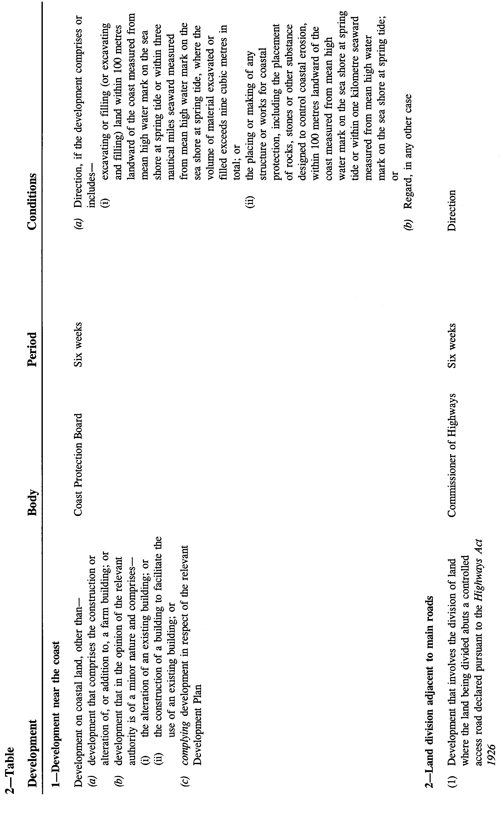
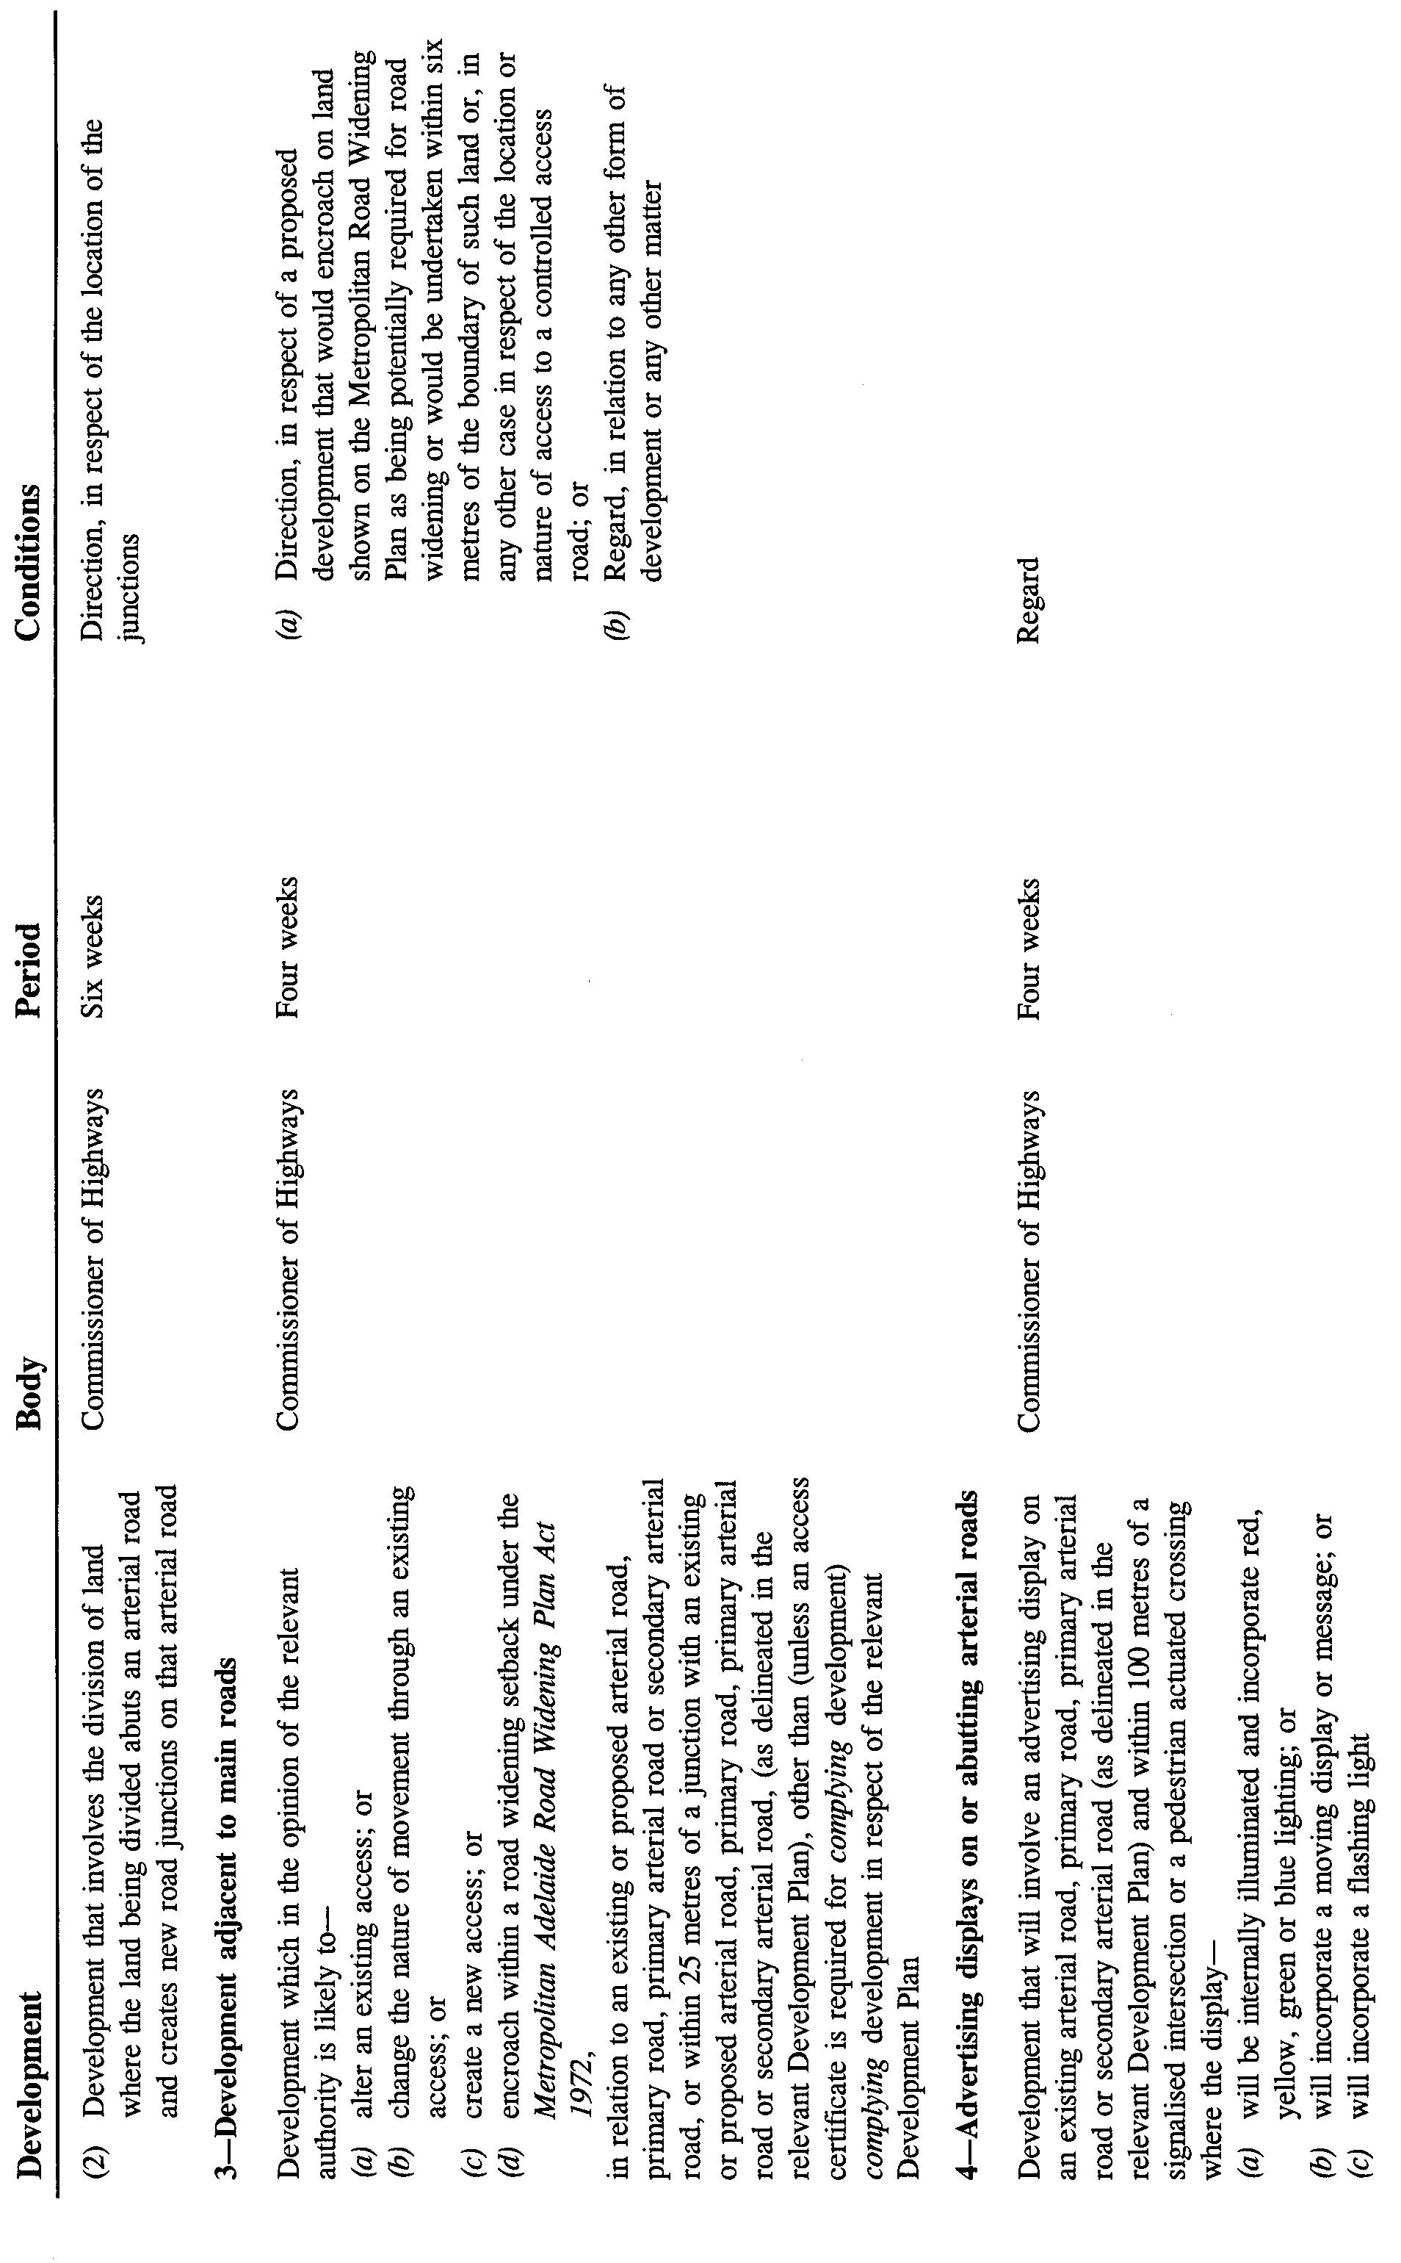
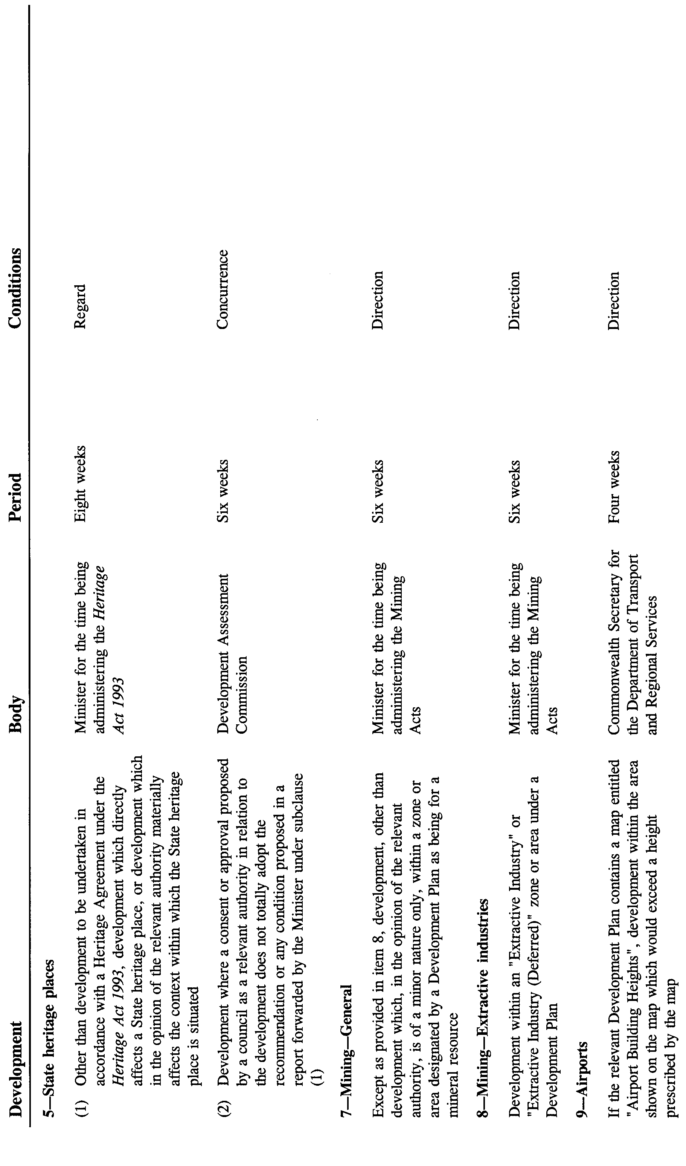
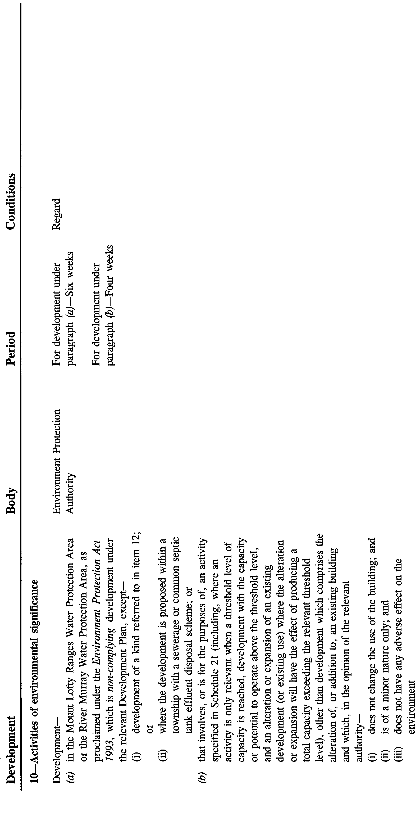
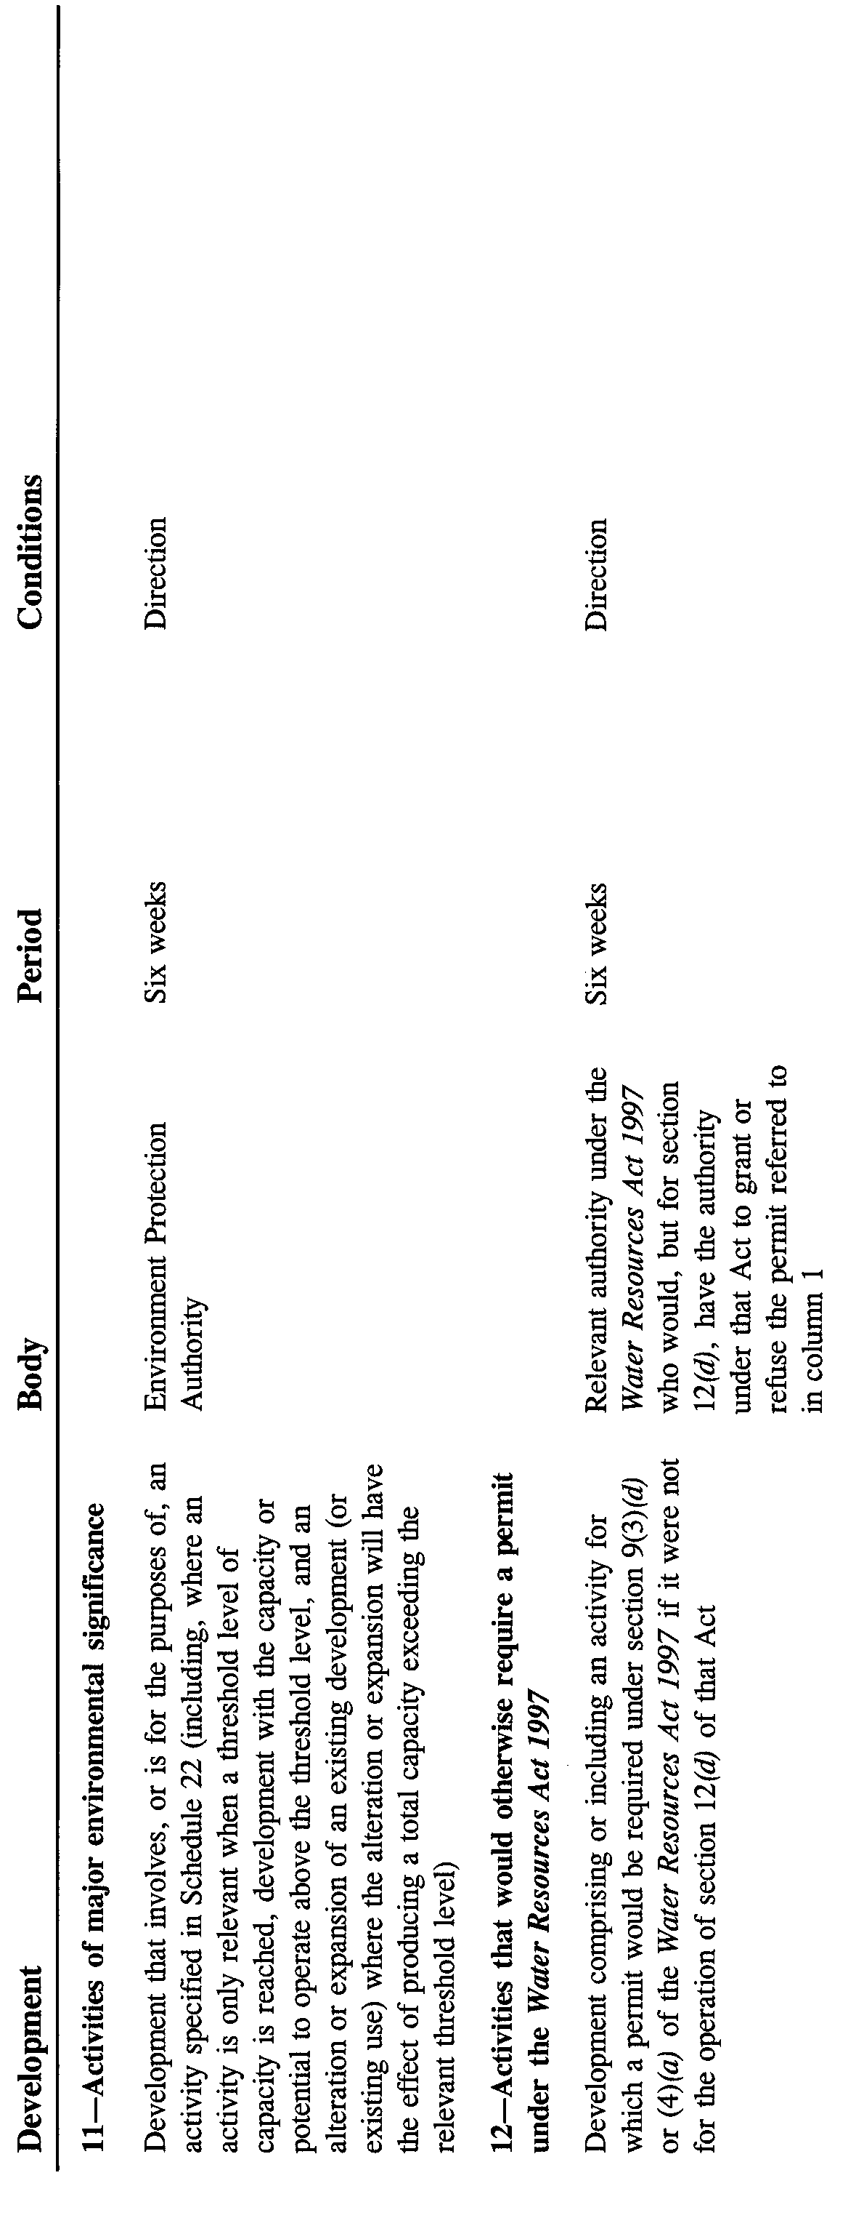
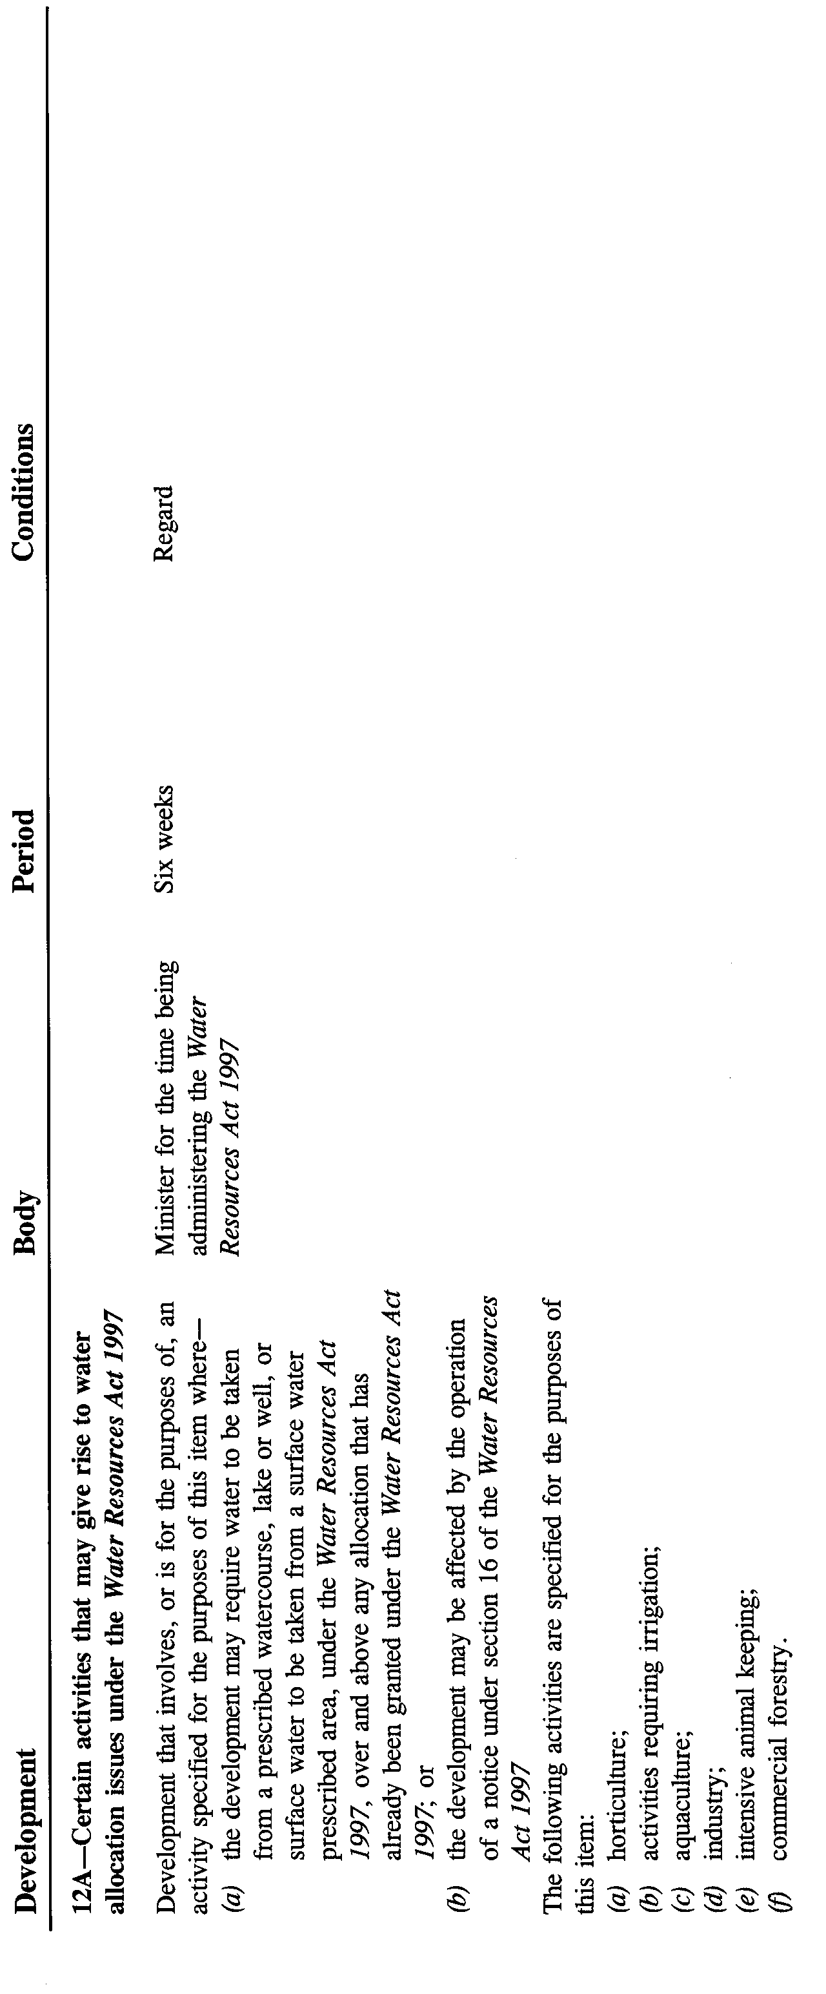
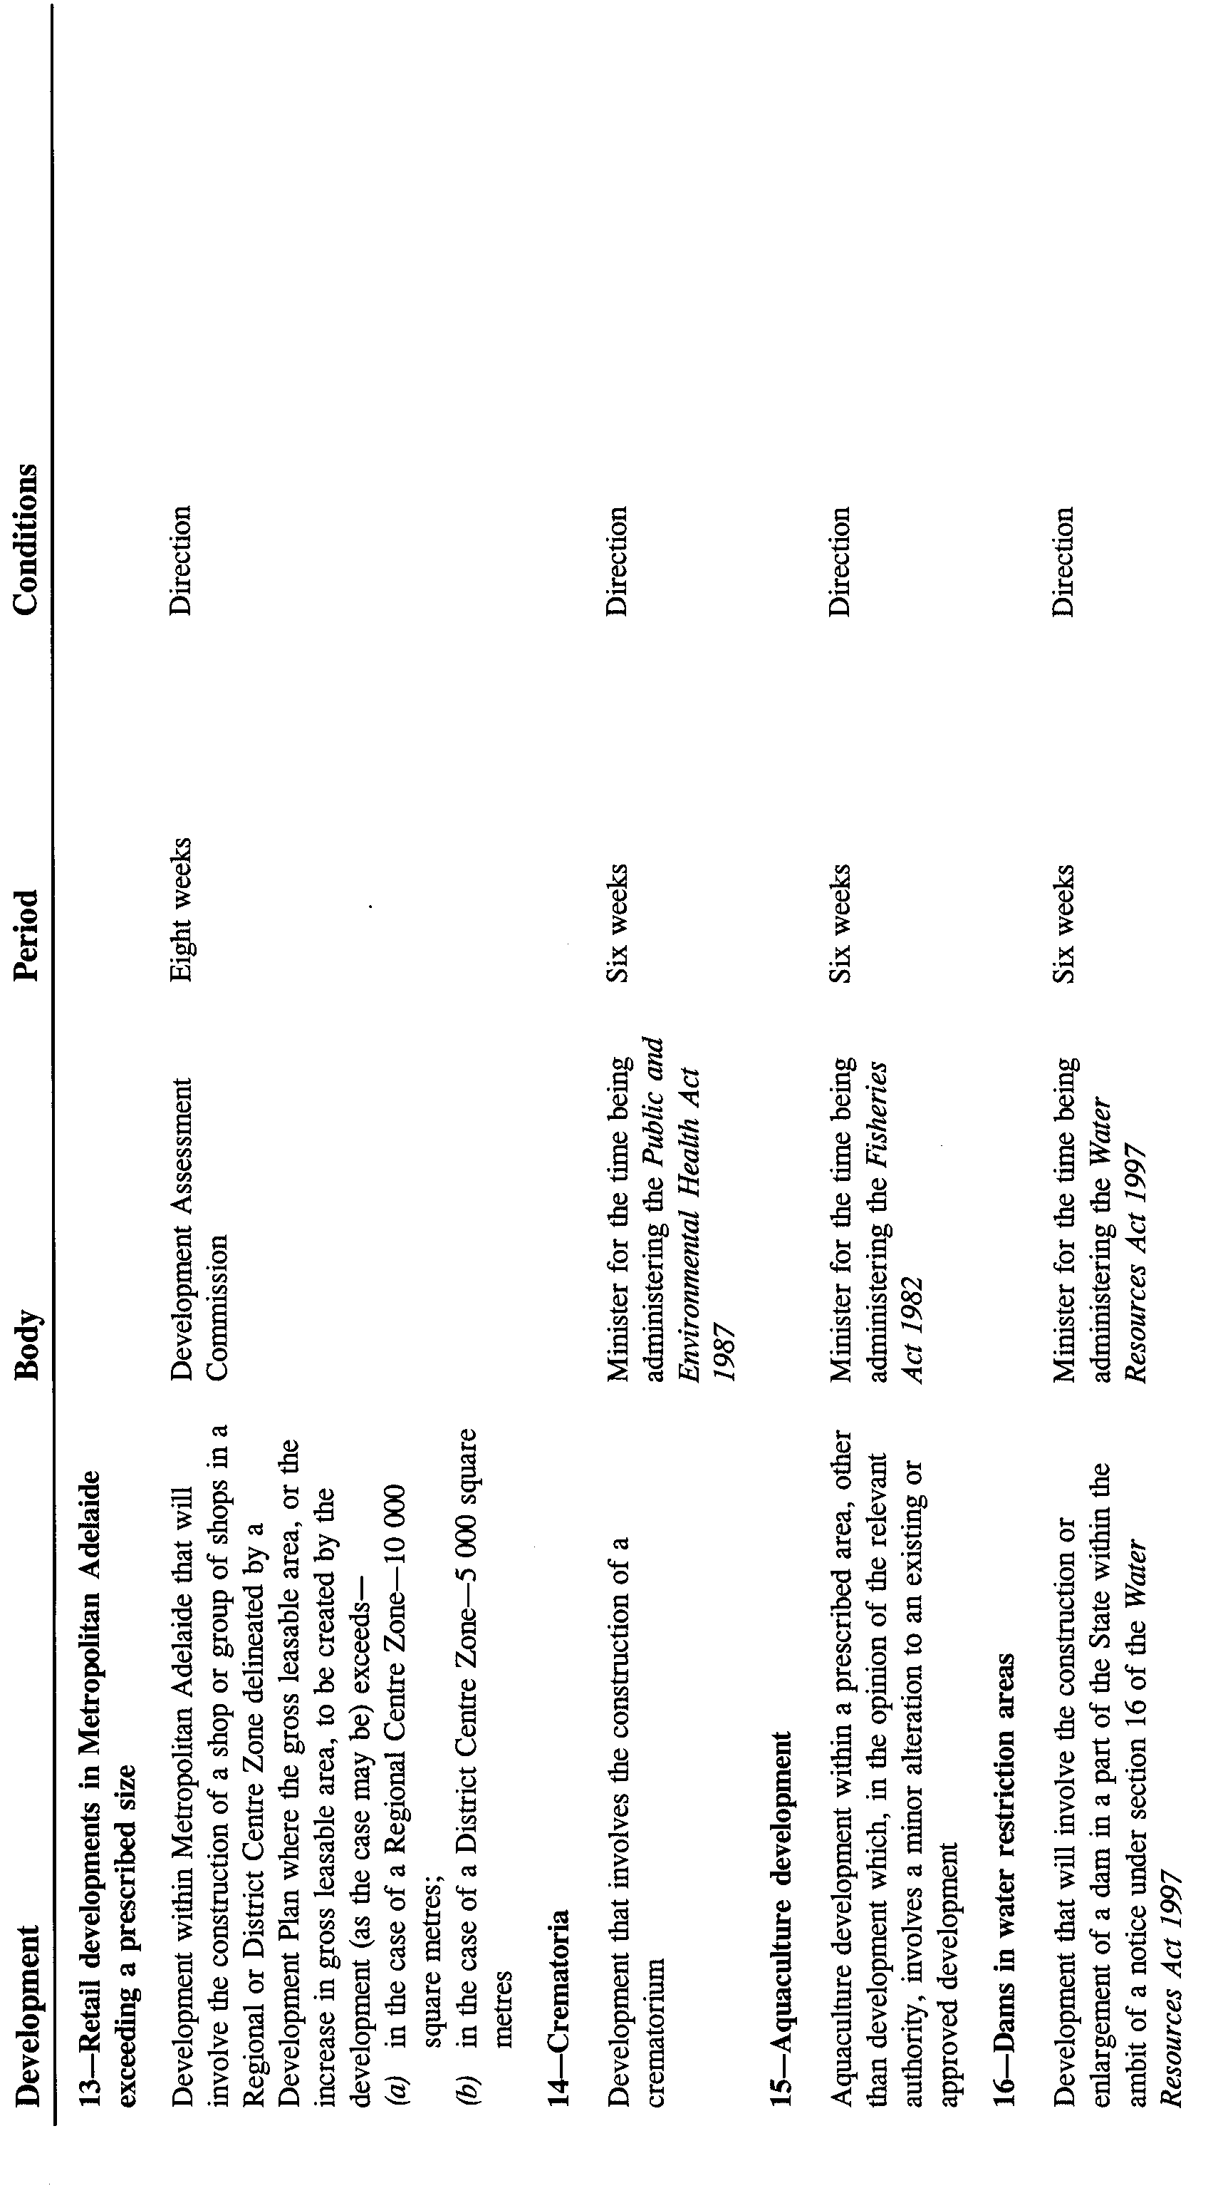
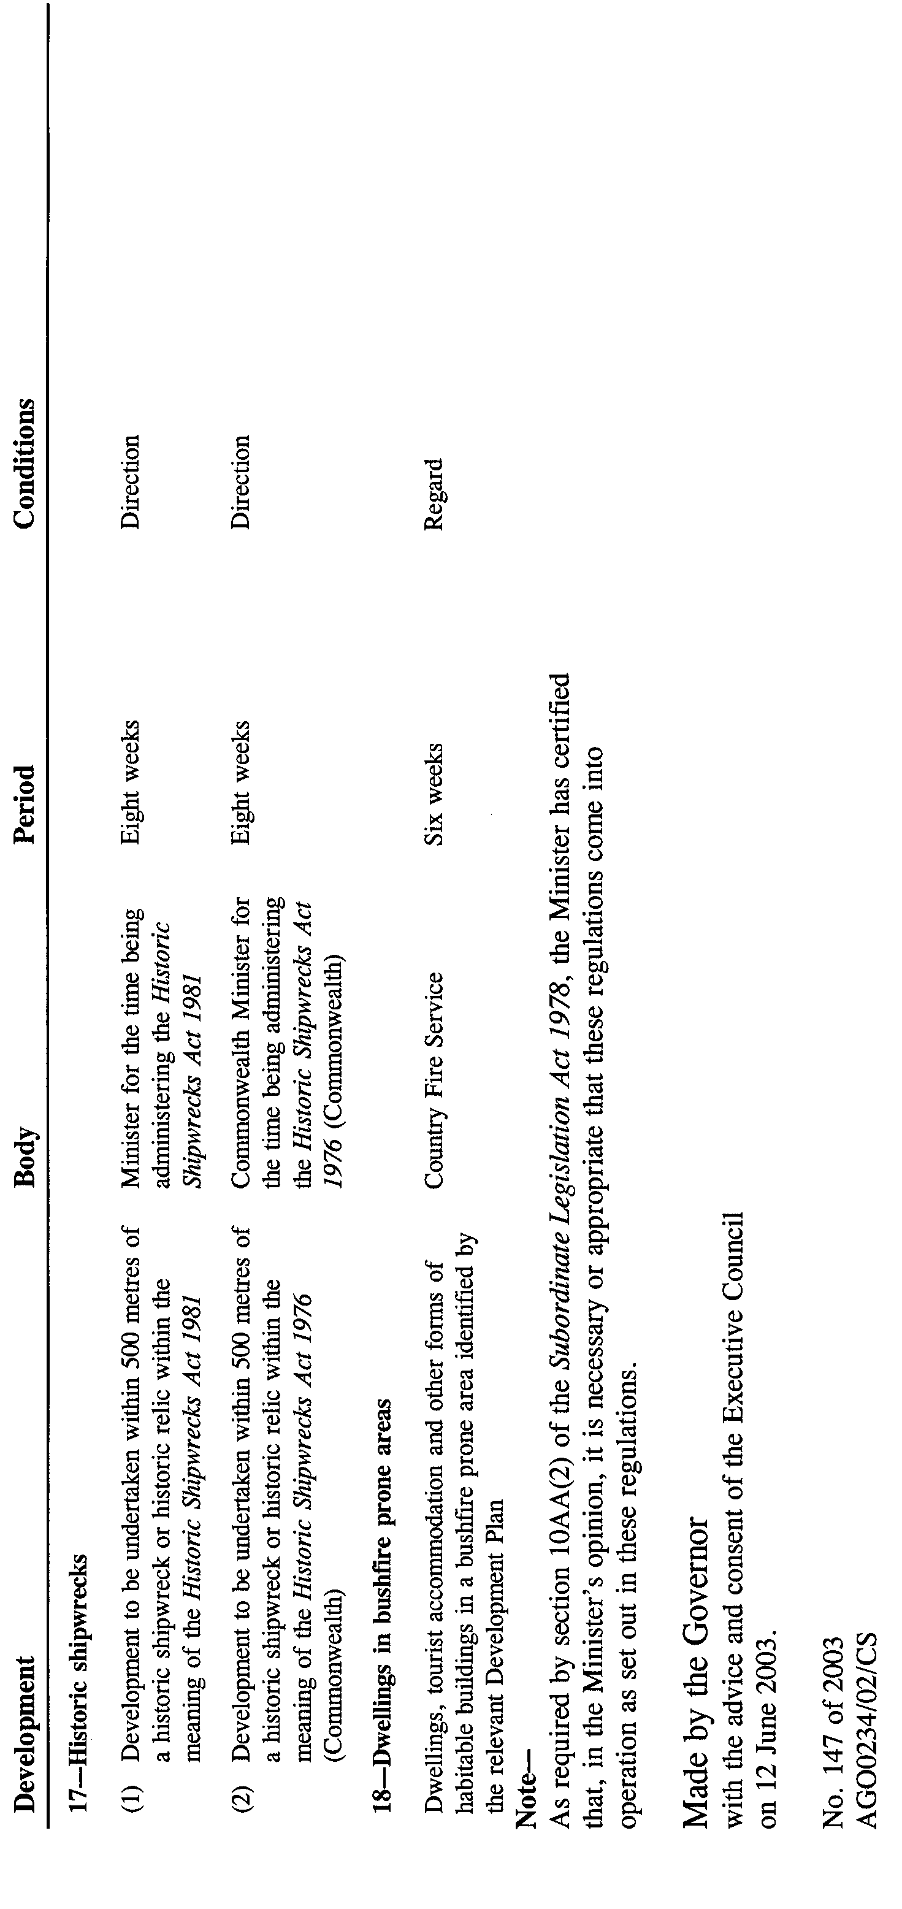
South Australia

Dental Practice (General) Regulations 2003
under the Dental Practice Act 2001

Contents

Part 1—Preliminary

1. Short title
2. Commencement
3. Interpretation
4. Prescribed communicable infections (section 3(1) of Act)

Part 2—Registration

Division 1—Authority conferred by registration

5. Meaning of supervision
6. Prescribed branches of dentistry (section 31(b) of Act)
7. Authority conferred by registration as dental hygienist (section 31(e) of Act)
8. Authority conferred by registration as dental therapist (section 31(f) of Act)
9. Authority conferred by registration as dental student (section 31(h) of Act)
10. Review of requirement for supervision

Division 2—Special obligations of company practitioners

11. Returns by companies (section 39 of Act)

Division 3—Restrictions relating to the provision of dental treatment

12. Use of certain titles or descriptions prohibited (section 44 of Act)
13. Exemptions from restriction on provision of dental treatment by unqualified persons (section 45 of Act)

Part 3—Miscellaneous

14. Obligation to report medical unfitness of dental practitioner or dental student (section 54 of Act)
15. Dental practitioner etc must declare interest in prescribed business (section 75 of Act)
16. Information relating to claim against registered person to be provided (section 79 of Act)
17. Fees and charges

Schedule 1—Form of annual return by company

Schedule 2—Prohibited words

Part 1—Preliminary

Short title
1. These regulations may be cited as the Dental Practice (General) Regulations 2003.

Commencement
2. These regulations will come into operation on the day on which the Dental Practice Act 2001 comes into operation.

Interpretation
3. In these regulations, unless the contrary intention appears—

"Act" means the Dental Practice Act 2001;

"child" means a person under the age of 18 years;

"employ" includes engage under a contract for services;

"prescribed body" means—

(a) Nganampa Health Council Incorporated; or

(b) Nunkuwarrin Yunti of South Australia Incorporated;

"public sector" has the same meaning as in the Public Sector Management Act 1995.

Prescribed communicable infections (section 3(1) of Act)
4. For the purposes of the definition of "prescribed communicable infection" in section 3(1) of the Act, the following infections are prescribed:

(a) Hepatitis B;

(b) Hepatitis C.

Part 2—Registration

Division 1—Authority conferred by registration

Meaning of supervision
5. (1) For the purposes of this Division, dental treatment is provided to a patient by a person under the supervision of a dental practitioner if and only if—

(a) the practitioner has responsibility for the care of the patient; and

(b) the treatment is of a kind authorised by the practitioner's registration; and

(c) the practitioner has personally attended the patient; and

(d) the practitioner has prepared or approved a written individual treatment plan for the patient within the previous 6 months; and

(e) the treatment is provided in accordance with the plan; and

(f) subject to subregulation (2), a dental practitioner whose registration authorises the provision of the treatment of the kind concerned is present on the premises where the treatment is being provided and is available—

(i) to advise or assist the person in the provision of the treatment; or

(ii) to intervene in the provision of the treatment,

as may be necessary in the circumstances of the case.

(2) If a dental hygienist provides dental treatment of a kind authorised by his or her registration—

(a) in the course of an epidemiological research project being undertaken by the hygienist; or

(b) on the premises of the Julia Farr Centre or at a supported residential facility as defined in the Supported Residential Facilities Act 1992,

subregulation (1)(f) does not apply, but instead a registered dentist or registered specialist must be contactable by telephone, facsimile, electronic mail or other electronic means to provide advice or instruction to the hygienist, if necessary, while the hygienist is providing the treatment.

Prescribed branches of dentistry (section 31(b) of Act)
6. For the purposes of section 31(b) of the Act, the following branches of dentistry are prescribed:

(a) dento maxillofacial radiology;

(b) endodontics;

(c) oral and maxillofacial surgery;

(d) oral medicine;

(e) oral pathology;

(f) orthodontics;

(g) paediatric dentistry;

(h) periodontics;

(i) prosthodontics;

(j) public health dentistry.

Authority conferred by registration as dental hygienist (section 31(e) of Act)
7. (1) For the purposes of section 31(e) of the Act, registration on the register of dental hygienists authorises—

(a) a dental hygienist employed in the public sector or by a prescribed body to provide dental treatment of a kind prescribed by subregulation (2) in accordance with the conditions of the hygienist's employment;

(b) a dental hygienist employed in the private sector (other than by a prescribed body) to provide dental treatment of a kind prescribed by subregulation (2) under the supervision of a registered dentist or registered specialist.

(2) For the purposes of subregulation (1), the following kinds of dental treatment are prescribed:

(a) oral examination and the assessment and recording of oral conditions;

(b) the taking of impressions of teeth (other than for the purposes of prosthodontic or prosthetic dental treatment);

(c) the application of preventive and therapeutic solutions to teeth;

(d) preventive dental procedures, including the application of fissure sealants;

(e) the non-surgical management of gingival and periodontal conditions, including root debridement;

(f) orthodontic procedures that do not initiate tooth movement (including, but not limited to, orthodontic band sizing or selection, the bonding of fixed orthodontic retainers, the disengagement of arch-wires and the removal of orthodontic attachments and adhesives);

(g) the placement and removal of metallic and non-metallic separators;

(h) splinting to stabilise mobile teeth;

(i) the polishing and recontouring of restorations;

(j) the application of professionally available bleaching agents;

(k) the removal of sutures;

(l) the application and removal of periodontal packs;

(m) diagnostic dental radiography, but only if—

(i) the dental hygienist is licensed under section 31 of the Radiation Protection and Control Act 1982 to operate ionizing radiation apparatus used for such radiography; and

(ii) the exposure of a patient to ionizing radiation for the purpose of such radiography has been authorised under Division 1 of Part 3 of the Radiation Protection and Control (Ionising Radiation) Regulations 2000;

(n) dental treatment consisting of—

(i) the administration of local anaesthetic solutions for the purposes of dental procedures; and

(ii) the placement of temporary restorations not involving removal of a tooth structure,

but only if the dental hygienist has been authorised in writing by the Board to provide dental treatment of that kind.

Authority conferred by registration as dental therapist (section 31(f) of Act)
8. (1) For the purposes of section 31(f) of the Act, registration on the register of dental therapists authorises—

(a) a dental therapist employed in the public sector or by a prescribed body to provide to a child dental treatment of a kind prescribed by subregulation (2) in accordance with the conditions of the therapist's employment;

(b) a dental therapist employed in the private sector (other than by a prescribed body) to provide to a child dental treatment of a kind prescribed by subregulation (2) under the supervision of a registered dentist or registered specialist.

(2) For the purposes of subregulation (1), the following kinds of dental treatment are prescribed:

(a) oral examination;

(b) the diagnosis of oral conditions and planning of dental treatment;

(c) the taking of impressions of teeth (other than for the purposes of prosthodontic or prosthetic dental treatment);

(d) the application of preventive and therapeutic solutions to teeth;

(e) preventive dental procedures, including the application of fissure sealants;

(f) the administration of local anaesthetic solutions for the purposes of dental procedures;

(g) dental prophylaxis, including the removal of dental calculus;

(h) splinting to stabilise mobile teeth;

(i) restoration of coronal tooth structure, including pulp capping and pulpotomy;

(j) extraction of deciduous teeth;
(k) the referral to—

(i) in the case of a dental therapist who provides dental treatment under the supervision of a registered dentist or registered specialist—that dentist or specialist; or

(ii) in any other case—a registered dentist or registered specialist,

of a patient whose present situation requires dental treatment of a kind not authorised by the dental therapist's registration;

(l) diagnostic dental radiography, but only if—

(i) the dental therapist is licensed under section 31 of the Radiation Protection and Control Act 1982 to operate ionizing radiation apparatus used for such radiography; and

(ii) the exposure of a patient to ionizing radiation for the purpose of such radiography has been authorised under Division 1 of Part 3 of the Radiation Protection and Control (Ionising Radiation) Regulations 2000.

Authority conferred by registration as dental student (section 31(h) of Act)
9. For the purposes of section 31(h) of the Act, registration on the register of dental students authorises the student to provide, under the supervision of a dental practitioner giving instruction in a course of study that provides qualifications for registration as a dental practitioner under the Act in which the student is enrolled, dental treatment of a kind authorised by the practitioner's registration.

Review of requirement for supervision
10. (1) Within 12 months after the day on which these regulations come into operation, the Minister must, in consultation with the Board and representatives of the various dental professions—

(a) cause a review of the operation of regulation for the purpose of determining whether the level and form of supervision required is appropriate in the various circumstances to which that regulation applies—

(i) having regard to the future needs of the community for the services provided by the various dental professions; and

(ii) with a view to maximising the public benefit from the effective utilisation of the practice of dentistry by the various dental professions; and

(b) cause a report on the outcome of the review to be prepared and submitted to him or her.

(2) The Minister must, within 6 sitting days after receiving the report, cause a copy of the report to be laid before both Houses of Parliament.

Division 2—Special obligations of company practitioners

Returns by companies (section 39 of Act)
11. For the purposes of section 39 of the Act—

(a) the form of return set out in Schedule 1 is prescribed; and

(b) the completed form must be signed on behalf of the company by a director and the secretary of the company.

Division 3—Restrictions relating to the provision of dental treatment

Use of certain titles or descriptions prohibited (section 44 of Act)
12. For the purposes of section 44(1) and (3) of the Act, the words specified in column 1 of the table in Schedule 2 are prescribed in relation to a person who is not registered on the register specified opposite in column 2.

Exemptions from restriction on provision of dental treatment by unqualified persons (section 45 of Act)
13. Pursuant to section 45(2)(b) of the Act, dental treatment may be provided by an unqualified person through the instrumentality of a qualified person if—

(a) the unqualified person is an agency or instrumentality of the Crown and the treatment is provided by a qualified person employed by that agency or instrumentality; or

(b) the unqualified person is an educational institution and the treatment is provided by a dental student enrolled at that institution in a course of study that provides qualifications for registration as a dental practitioner under the Act;

(c) the unqualified person is a prescribed body and the treatment is provided by a registered dental hygienist or registered dental therapist employed by that body.

Part 3—Miscellaneous

Obligation to report medical unfitness of dental practitioner or dental student (section 54 of Act)
14. For the purposes of section 54(2) of the Act, the information required to be included in a report submitted to the Board by a medical practitioner who has treated, or is treating, a patient who is a dental practitioner or dental student is—

(a) the diagnosis of the patient's medical condition; and

(b) the prognosis and likely duration of the patient's medical condition; and

(c) a description of any treatment being received by the patient for the medical condition.

Dental practitioner etc must declare interest in prescribed business (section 75 of Act)
15. (1) For the purposes of section 75(1) of the Act, the information that must be given to the Board by a person who has an interest in a prescribed business is—

(a) the full name and residential address of the person who has the interest; and

(b) if the person who has the interest is a prescribed relative of a dental practitioner—the relationship of the person to the dental practitioner; and

(c) the name, address and nature of the prescribed business in which the person has the interest; and

(d) the nature of the interest and of any benefit derived from the interest; and

(e) if the interest consists of a shareholding in a prescribed business—the number, nominal value and class of shares held and particulars of any voting rights exercisable by the holder at a meeting of shareholders.

(2) For the purposes of section 75(2) of the Act, details of the change in the information referred to in subregulation (1) must be given to the Board by the person.

Information relating to claim against registered person to be provided (section 79 of Act)
16. For the purposes of section 79 of the Act, the information relating to a claim referred to in that section to be provided to the Board is—

(a) the nature of the treatment or procedure that is alleged to have been carried out negligently; and

(b) full details of the alleged negligence; and

(c) the address of the premises at which the negligence is alleged to have occurred; and

(d) the time at which and the date on which the negligence is alleged to have occurred; and

(e) full details of the injury suffered or allegedly suffered by the claimant as a result of the alleged negligence.

Fees and charges
17. (1) The Board may fix—

(a) registration fees; and

(b) reinstatement fees; and

(c) annual practice fees; and

(d) fees or charges for the inspection of a register; and

(e) fees or charges for a copy of any part of a register; and

(f) fees or charges for services provided by the Board in the exercise of its functions under the Act.

(2) Fees or charges fixed by the Board may be differential, varying according to factors determined by the Board.

(3) The Board may recover a fee or charge fixed under this regulation by action in a court of competent jurisdiction as a debt due to the Board from the person liable for payment of the fee or charge.

(4) A person is exempt from the obligation to pay a registration fee or annual practice fee fixed by the Board under this regulation if the person—

(a) is registered as a dental practitioner in another State or a Territory of the Commonwealth and the appropriate fees have been paid in respect of the person's registration in that State or Territory; and

(b) is employed by any of the following to provide dental treatment:

(i) the Australian Government; or

(ii) the Royal Flying Doctor Service (S.A. Branch) Inc.; or

(iii) a person or body approved by the Board.

Schedule 1—Form of annual return by company

1. Return relating to the period of 12 months ending on 30 June .... (the return period)

2. Name of the company

3. Register under the Dental Practice Act 2001 on which the company is registered

4. Address of the registered office of the company

5. Address and telephone number of the principal place at which the company provides dental treatment

6. Address and telephone number of every other place at which the company provides dental treatment

7. Business name of each practice conducted under a business name by the company

8. In relation to each person who, on 30 June in the return period, was a director or a member of the company or had a right to participate in the distribution of the profits of the company, the following information:

(a) the person's full name and residential address;

(b) the number of shares in the company held by the person;

(c) the number of votes the person was entitled to cast at a meeting of members of the company;

(d) in the case of a member of the company—the qualification by virtue of which the person was entitled to be a member of the company.

9. In relation to each person who, on 30 June in the return period, was a director or a member of the company or had a right to participate in the distribution of the profits of the company, the following information:

(a) the person's full name and residential address;

(b) the number of shares in the company held by the person;

(c) the number of votes the person was entitled to cast at a meeting of members of the company;

(d) in the case of a member of the company—the qualification by virtue of which the person was entitled to be a member of the company.

10. In relation to each person who was a director of the company during the return period, the following information:

(a) the person's full name and residential address;

(b) whether the director was a registered person or a prescribed relative of another director of the company;

(c) if the director was a registered person for part of the return period—the date on which the director became or ceased to be a registered person;

(d) if the director was a prescribed relative of another director of the company—details of the relationship and, if the relationship commenced or ceased during the return period, the date of commencement or cessation of the relationship.

11. In relation to each person who was a member of the company during the return period, the following information:

(a) the person's full name and residential address;

(b) whether the member was a registered person;

(c) if the member was a registered person for part of the return period—the date on which the member became or ceased to be a registered person;

(d) if the member was a prescribed relative of a director or employee of the company—details of the relationship between the member and director or employee;

(e) if the member was a prescribed relative of a director or employee of the company for part of the return period—the date on which the member became or ceased to be such a prescribed relative.

12. In relation to each person who was a beneficial owner of shares in the company during the return period, the following information:

(a) the person's full name and residential address;

(b) a description of the shares including the number of shares, their nominal value and the voting rights attached to the shares;

(c) the full name and residential address of the person in whose name the shares were registered;

(d) details of the beneficial ownership of the shares, including any documentary evidence of beneficial ownership;

(e) if the beneficial owner of the shares became or ceased to be the beneficial owner of the shares during the return period—

(i) the date on which the beneficial owner of shares became or ceased to be a beneficial owner; and

(ii) details of the circumstances in which the beneficial owner became or ceased to be a beneficial owner;

(f) whether the beneficial owner of the shares was a prescribed relative of a director or employee of the company;

(g) if the beneficial owner of the shares was a prescribed relative of a director or employee of the company during part of the return period—the date on which the beneficial owner became or ceased to be a prescribed relative;

(h) if the beneficial owner of the shares was a prescribed relative of a director or employee of the company during the return period—details of the relationship;

(i) whether the beneficial owner of the shares was a registered person;

(j) if the beneficial owner of the shares became or ceased to be a registered person during the return period—the date on which the beneficial owner of the shares became or ceased to be a registered person.

Schedule 2—Prohibited words

Prescribed words | Appropriate register
Advanced dental prosthetist | Register of advanced dental prosthetists
Dental hygienist | Register of dental hygienists
Dental practitioner | Register of dentists, register of specialists, register of dental prosthetists, register of advanced dental prosthetists, register of dental hygienists, register of dental therapists or register of dental technicians
Dental prosthetist | Register of dental prosthetists
Dental specialist | Register of specialists
Dental student | Register of dental students
Dental surgeon | Register of dentists
Dental technician | Register of dental technicians
Dental therapist | Register of dental therapists
Dentist | Register of dentists
Dento maxillofacial radiologist | Register of specialists in dento maxillofacial radiology
Endodontist | Register of specialists in endodontics
Oral and maxillofacial surgery | Register of specialists in oral and maxillofacial surgery
Oral medicine | Register of specialists in oral medicine
Oral pathologist | Register of specialists in oral pathology
Orthodontist | Register of specialists in orthodontics
Paediatric dentist | Register of specialists in paediatric dentistry
Paedodontist | Register of specialists in paediatric dentistry
Periodontist | Register of specialists in periodontics
Prosthodontist | Register of specialists in prosthodontics
Public health dentist | Register of specialists in public health dentistry
Student dental practitioner | Register of dental students

Note—
As required by section 10AA(2) of the Subordinate Legislation Act 1978, the Minister has certified that, in the Minister's opinion, it is necessary or appropriate that these regulations come into operation as set out in these regulations.

Made by the Governor
with the advice and consent of the Executive Council
on 12 June 2003.

No. 148 of 2003
DHSC 03/14

FAXING COPY?

IF you fax copy to Government Publishing SA for inclusion in the Government Gazette, there is no need to send a Confirmation Copy to us as well.

This creates confusion and may well result in your notice being printed twice.

Please use the following fax number:

Fax transmission: (08) 8207 1040
Phone Inquiries: (08) 8207 1045

Please include a contact person, phone number and order number so that we can phone back with any queries we may have regarding the fax copy.

NOTE: Closing time for lodging new copy (either fax or hard copy) is 4 p.m. on Tuesday preceding the day of publication.

Government Gazette notices can be E-mailed.

The address is:

governmentgazette@saugov.sa.gov.au

Documents should be sent as attachments in Word format.

When sending a document via E-mail, please confirm your transmission with a faxed copy of your document, including the date the notice is to be published.

Fax transmission: (08) 8207 1040
Enquiries: (08) 8207 1045

CITY OF HOLDFAST BAY
Declaration of Public Road
NOTICE is hereby given that the City of Holdfast Bay proposes pursuant to section 210 of the Local Government Act 1999, to declare allotments 15 and 17 in Deposited Plan 588 being portions of laneway off High Street, Glenelg, contained in certificate of title volume 1266, folio 30 as public roads. Submissions can be made by any person claiming an interest in the land and any submissions must set out the full name and address of the person making the submission and must be fully supported by reasons.
S. Gawler, Chief Executive Officer

CITY OF PLAYFORD
Development Act 1993
Playford (City) Development Plan—Buckland Park and Environs Plan Amendment Report—Draft for Public Consultation and Interim Development Control
THE City of Playford has prepared a draft Plan Amendment Report to amend the Playford (City) Development Plan. The Plan Amendment Report affects approximately 60 km² of land. The affected land is bound by the Gawler River to the north, the coast to the west, Port Wakefield Road to the east and the City of Playford Council boundary and the rear boundary of allotments fronting Anjanto Road to the south.
The Plan Amendment Report will amend the Playford (City) Development Plan by introducing policies that support intensive horticulture activities, restrict new rural living developments, guide wind-farm developments, guide horse-keeping activities and protect natural watercourses, and promote appropriate developments at the salt-fields/horticulture interface.
The draft Plan Amendment Report will be available for public inspection and purchase during normal office hours at the City of Playford Council Offices, Gapper Building, Warooka Drive, Smithfield and 3 Windsor Square, Elizabeth or is available on council’s web-site at www.playford.sa.gov.au from 12 June 2003 to 8 August 2003. A copy of the Plan Amendment Report can be purchased from the council at $7 each.
Council has scheduled an informal community information evening at the Virginia Horticulture Centre at 7 p.m. on Thursday, 26 June 2003. Interested persons are requested to R.S.V.P. to Stephen Yarwood on 8254 0222 by Wednesday, 18 June 2003.
Written submissions regarding the draft amendment will be accepted by the City of Playford until 8 August 2003. The written submission should also clearly indicate whether you will wish to speak at the public hearing on your submission. All submissions should be addressed to the Chief Executive Officer of the City of Playford.
Copies of all submissions received will be available for inspection by interested persons at the abovementioned council office from 8 August 2003 until the date of public hearing. A public hearing will be held at 7 p.m. on 20 August 2003, at the City of Playford Council Chambers located at 3 Windsor Square, Elizabeth. The public hearing may not be held if no submission indicates an interest in speaking at the public hearing.
Dated 12 June 2003.
T. Jackson, Chief Executive Officer

CITY OF SALISBURY
Roads (Opening and Closing) Act 1991
Pentridge Road, Salisbury North
NOTICE is hereby given pursuant to section 10 of the Roads (Opening and Closing) Act 1991, that council proposes to make a road process order to close and retain a portion of Pentridge Road between Motcombe Road and Stratford Road adjoining allotment 562 in Deposited Plan No. 4599, more particularly delineated ‘A’ on Preliminary Plan No. 03/0002.
A copy of the plan and statement of persons affected are available for public inspection at the Council Office, 12 James Street, Salisbury and the office of the Surveyor-General, 101 Grenfell Street, Adelaide, during normal office hours.
Any application for easement or objections must set out the full name, address and details of the submission and must be fully supported by reasons.
The application for easement or objections must be made in writing within 28 days of this notice to the Council, P.O. Box 8, Salisbury, S.A. 5108 and the Surveyor-General, G.P.O. Box 1354, Adelaide, S.A. 5001, setting out full details.
Where a submission is made, council will give notification of a meeting at which the matter will be considered.
Inquiries relating to this matter may be directed to Elisa Perry (phone 8406 8451) or Julie Bond (phone 8406 8306).
Dated 11 June 2003.
S. Hains, City Manager

CITY OF WEST TORRENS
Development Act 1993
West Torrens (City) Development Plan—Flood Prone Areas PAR—Draft for Public and Agency Consultation and Interim Development Control
THE City of West Torrens has prepared a draft Flood Prone Areas Plan Amendment Report (PAR) to amend the West Torrens (City) Development Plan as it affects flood prone land affected by the Brown Hill and Keswick Creeks. This PAR will have immediate effect as it is under Interim Development Control for a period of 12 months.
The PAR will amend the West Torrens (City) Development Plan by amending:
• Council-wide Principles of Development Control
• complying development lists, and
• introducing Figures which identify land within the 1 in 100 year Average Recurrence Interval flood plain associated with the Brown Hill and Keswick Creeks.
The draft PAR will be available for public inspection during normal office hours at the City of West Torrens Offices, 165 Sir Donald Bradman Drive, Hilton from 12 June 2003 to 7 August 2003. The draft PAR will also be available for inspection at the City of West Torrens Library, Brooker Terrace, Hilton, the Thebarton Library, 166 South Road, Torrensville and the City of West Torrens website at www.wtcc.sa.gov.au. A copy of the PAR can be purchased from the Civic Centre at a cost of $10 each.
Written submissions regarding the draft PAR will be accepted by the City of West Torrens, until 5 p.m. on Thursday, 7 August 2003. The written submission should clearly indicate whether you wish to speak at the public hearing regarding your submission. All submissions should be addressed to the Chief Executive Officer of the City of West Torrens, 165 Sir Donald Bradman Drive, Hilton, S.A. 5033.
Copies of all submissions received will be available for inspection by interested persons at the above council offices from the close of public inspection until the date of the public hearing.
A public hearing will be held at 7.30 p.m. on Tuesday, 26 August 2003 at the City of West Torrens Civic Centre, 165 Sir Donald Bradman Drive, Hilton. The public hearing may not be held if no submission indicates an interest in speaking at the public hearing.
For further information, please contact Councils Principal Planner Policy and Projects, Paul Weymouth on 8416 6247 or via email: pweymout@wtcc.sa.gov.au.
Dated 12 June 2003.
T. Starr, Chief Executive Officer

CITY OF WHYALLA
Adoption of Valuations
NOTICE is hereby given that the Corporation of the City of Whyalla at its meeting held on 26 May 2003, in accordance with section 167 of the Local Government Act 1999, adopted the Valuer-General’s valuation of site value in the amount of $172 746 600 and hereby specifies that 1 July 2003, shall be the day as and from which such assessment shall become the assessment of the council for the year ending 30 June 2004.
The said valuations are included in the Assessment Book, which is held in the office of the council at Darling Terrace and may be inspected by any interested persons between the hours of 9 a.m. and 5 p.m., Monday to Friday.
J. Wright, Chief Executive Officer

THE COORONG DISTRICT COUNCIL
Roads (Opening and Closing) Act 1991
Road Closure—Public Road, Waltowa
NOTICE is hereby given, pursuant to section 10 of the Roads (Opening and Closing) Act 1991, that The Coorong District Council proposes to make a Road Process Order to close and transfer to J. S. Jose Holdings Pty Ltd the whole of the unnamed public road adjoining the southern boundaries of section 237 in Hundred of Bonney and allotment 7 in Filed Plan 15838, shown more particularly delineated and lettered ‘A’ and ‘B’ (respectively) on the Preliminary Plan No. 02/0135.
A copy of the plan and a statement of persons affected are available for public inspection at the offices of the Council. 49 Princes Highway, Meningie and the Adelaide office of the Surveyor-General, 101 Grenfell Street, Adelaide during normal office hours.
Any person is entitled to object to the proposed road process, or any person affected by the proposed closure is entitled to apply for an easement to be granted in that person’s favour over the land subject to the proposed closure. Such objection or application for an easement must set out the full name and address of the person making the objection or application and must be fully supported by reasons. Any application for an easement must give full particulars of the nature and location of the easement and where made by a person as the owner of adjoining or nearby land, specify the land to which the easement is to be annexed.
The objection or application for an easement must be made in writing to the Council, P.O. Box 28, Meningie, S.A. 5264 within 28 days of this notice and a copy shall be forwarded to the Surveyor-General, G.P.O. Box 1354, Adelaide, S.A. 5001. Where a submission is made, the council will give notification of a meeting at which the matter will be considered, so that the person making the submission or a representative may attend, if so desired.
Dated 12 June 2003.
W. R. Paterson, Chief Executive Officer

THE COORONG DISTRICT COUNCIL
Roads (Opening and Closing) Act 1991
Road Opening and Closing—Public Road, Deepwater
NOTICE is hereby given, pursuant to section 10 of the Roads (Opening and Closing) Act 1991, that The Coorong District Council proposes to make a Road Process Order to close and transfer to the adjoining owner portion of the public road adjoining the eastern boundary of Log Crossing North Road, more particularly delineated and lettered ‘A’, in section 13, Hundred of Messent and open as public road portion numbered ‘1’ in Preliminary Plan No. 02/0139.
A copy of the plan and a statement of persons affected are available for public inspection at the offices of the Council, 49 Princes Highway, Meningie, S.A. 5260 and the Adelaide office of the Surveyor-General, 25 Pirie Street, Adelaide, S.A. 5000 during normal office hours.
Any person is entitled to object to the proposed road process, or any person affected by the proposed closure is entitled to apply for an easement to be granted in that person’s favour over the land subject to the proposed closure. Such objection or application for an easement must set out the full name and address of the person making the objection or application and must be fully supported by reasons. Any application for an easement must give full particulars of the nature and location of the easement and where made by a person as the owner of adjoining or nearby land, specify the land to which the easement is to be annexed.
The objection or application for an easement must be made in writing to the Council, P.O. Box 28, Meningie, S.A. 5264 within 28 days of this notice and a copy shall be forwarded to the Surveyor-General, G.P.O. Box 1354, Adelaide, S.A. 5001. Where a submission is made, the council will give notification of a meeting at which the matter will be considered, so that the person making the submission or a representative may attend, if so desired.
Dated 12 June 2003.
W. R. Paterson, Chief Executive Officer

THE COORONG DISTRICT COUNCIL
Roads (Opening and Closing) Act 1991
Road Closure—Public Road, Moorlands
NOTICE is hereby given, pursuant to section 10 of the Roads (Opening and Closing) Act 1991, that The Coorong District Council proposes to make a Road Process Order to close and transfer to Kingsley John Maczkowiack the whole of the unnamed public road between section 4 in Hundred of Sherlock and allotment 115 in Filed Plan 207933, shown more particularly delineated and lettered ‘A’ on the Preliminary Plan No. 02/0141.
A copy of the plan and a statement of persons affected are available for public inspection at the offices of the Council, 49 Princes Highway, Meningie and the Adelaide office of the Surveyor-General, 101 Grenfell Street, Adelaide during normal office hours.
Any person is entitled to object to the proposed road process, or any person affected by the proposed closure is entitled to apply for an easement to be granted in that person’s favour over the land subject to the proposed closure. Such objection or application for an easement must set out the full name and address of the person making the objection or application and must be fully supported by reasons. Any application for an easement must give full particulars of the nature and location of the easement and where made by a person as the owner of adjoining or nearby land, specify the land to which the easement is to be annexed.
The objection or application for an easement must be made in writing to the Council, P.O. Box 28, Meningie, S.A. 5264 within 28 days of this notice and a copy shall be forwarded to the Surveyor-General, G.P.O. Box 1354, Adelaide, S.A. 5001. Where a submission is made, the council will give notification of a meeting at which the matter will be considered, so that the person making the submission or a representative may attend, if so desired.
Dated 12 June 2003.
W. R. Paterson, Chief Executive Officer

MID MURRAY COUNCIL
Declaration of Public Road
NOTICE is hereby given pursuant to section 210 of the Local Government Act 1999, that at a future meeting, the council intends to declare Allotment 28 in Deposited Plan 1919, being a portion of the land comprised in Certificate of Title register book volume 5650 folio 966, known commonly as a portion of Anzac Avenue, Swan Reach, to be public road.
G. Brus, Chief Executive Officer

Erratum
DISTRICT COUNCIL OF YANKALILLA
Results of Periodical Elections
COUNCILLOR Flinders Ward (2 vacancies):
Formal Ballot Papers: 491
Informal Ballot Papers: 7
Quota: 164
Candidates | First  Preference  Votes | Result after Distribution  of Preferences
Brand, Nigel | 113 | Elected (2)
Evans, Doug | 242 | Elected (1)
Croser, John | 64
Roach, Ron | 72
COUNCILLOR Bungala Ward (3 vacancies):
Formal Ballot Papers: 716
Informal Ballot Papers: 11
Quota: 180
Candidates | First  Preference  Votes | Result after Distribution  of Preferences
Spilsbury, Bruce | 433 | Elected (1)
Byers, Vanessa | 117 | Elected (2)
Van Emden, Frits | 29
Sanderson, John | 82 | Elected (3)
Perry, Ron | 55

COUNCILLOR Hewett Ward (2 vacancies):
Formal Ballot Papers: 549
Informal Ballot Papers: 7
Quota: 184
Candidates | First  Preference  Votes | Result after Distribution  of Preferences
Whitford, Peter | 252 | Elected (1)
Hughes, John | 150 | Elected (2)
Barker, Roger | 84
Webb, Barry | 63
COUNCILLOR Carrickalinga Ward (2 vacancies):
Formal Ballot Papers: 413
Informal Ballot Papers: 7
Quota: 138
Candidates | First  Preference  Votes | Result after Distribution  of Preferences
Schlein, Malcolm | 161 | Elected (1)
Steinwedel, Trevor | 122
Davis, Ruth | 130 | Elected (2)
Steve Tully, Returning Officer

IN the matter of the estates of the undermentioned deceased persons:
Aitchison, Margaret Mary, late of 6 Booth Avenue, Linden Park, married woman, who died on 27 February 2003.
Anderson, Edna Joyce, late of 3 Price Street, Mount Gambier, home duties, who died on 29 March 2003.
Gilham, Eric John, late of 5 Shepherdson Road, Mount Gambier, retired quality control inspector, who died on 4 April 2003.
Gluis, Ivy Annie, late of 342 Marion Road, North Plympton, of no occupation, who died on 9 April 2003.
Johnson, Harold James, late of 262 Cross Road, Kings Park, retired carer, who died on 20 April 2003.
Kessell, Desmond Ross, late of 4 Aberfeldy Avenue, Edwardstown, retired line supervisor, who died on 8 February 2003.
Liddicoat, Josephine Mary, late of 278 Old South Road, Old Reynella, home duties, who died on 10 April 2003.
Lynch, Thomas William, late of 17 Norman Street, Findon, retired amusement operator, who died on 8 May 2003.
Patston, Geoffrey Charles, late of 10 Gordon Street, Glenelg, retired clerk, who died on 18 November 2001.
Patterson, Phyllis Mary, late of 16 Cleland Avenue, Dulwich, widow, who died on 19 March 2003.
Rathbone, Iris Patricia, late of 53-59 Austral Terrace, Morphettville, widow, who died on 23 March 2003.
Taylor, Violet Hayes, late of 110 Strathfield Terrace, Largs North, of no occupation, who died on 16 March 2003.
Thomas, Tony, late of 19 Broughton Avenue, Kurralta Park, retired garage attendant, who died on 15 January 2003.
Woodifield, Raymond James, late of 22 Norman Street, Port Pirie, retired truck driver, who died on 21 February 2003.
Notice is hereby given pursuant to the Trustee Act 1936, as amended, the Inheritance (Family Provision) Act 1972, and the Family Relationships Act 1975, that all creditors, beneficiaries, and other persons having claims against the said estates are required to send, in writing, to the Public Trustee, 25 Franklin Street, Adelaide 5000, full particulars and proof of such claims, on or before 11 July 2003, otherwise they will be excluded from the distribution of the said estate; and notice is also hereby given that all persons who are indebted to the said estates are required to pay the amount of their debts to the Public Trustee or proceedings will be taken for the recovery thereof; and all persons having any property belonging to the said estates are forthwith to deliver the same to the Public Trustee.
Dated 12 June 2003.
C. J. O’Loughlin, Public Trustee

IN the matter of the estate of the undermentioned deceased person:
MacLean, Joan, late of Valley View Nursing Home, 66 Nelson Road, Valley View, widow, who died on 25 May 2003.
Notice is hereby given pursuant to the Trustee Act 1936, as amended, the Inheritance (Family Provision) Act 1972 and the Family Relationships Act 1975, that all creditors, beneficiaries, and other persons having claims against the above estate are directed to send full particulars and evidence of such claims to the undersigned on or before 11 July 2003, otherwise they will be excluded from the distribution of the estate; and notice is also hereby given that all persons who are indebted to the above estate are required to pay the amount of their debt to the undersigned or proceedings will be taken for the recovery thereof; and all persons having any property belonging to the said estate are forthwith to deliver the same to the undersigned.
Dated 12 June 2003.
ANZ Executors & Trustee Company Limited (ACN 006 132 332), 530 Collins Street, Melbourne, Victoria 3000

SOUTH AUSTRALIA—In the Supreme Court. No. 2717 of 1990. In the matter of Jeffcott Holdings Limited (in liquidation) (ACN 008 110 343) formerly trading as Magnacrete Ltd and in the matter of the Corporations Law.
Notice by a Liquidator of His Intention to Seek His Release and Dissolution of the Company
Take notice that I, John Sheahan, Level 8, 26 Flinders Street, Adelaide, S.A. 5000, the liquidator of the abovenamed company, intend to make application to the Supreme Court of South Australia for my release as the liquidator and dissolution of the abovenamed company.
And take further notice that if you have any objection to the granting of my release and dissolution of the company, you must file at the Supreme Court and also forward to me, within 21 days of the publication in the Gazette of the notice of my intention to apply for a release and dissolution of the company a notice of objection in the form laid down by the Corporations (South Australia) Rules 1993.
Dated 5 June 2003.
J. Sheahan, Official Liquidator
Note: Section 481 of the Corporations Law enacts that an order of the Court releasing a liquidator shall discharge him/her in the administration of the affairs of the company, or otherwise in relation to his or her conduct as liquidator, but any such order may be revoked on proof that it was obtained by fraud or by suppression or by concealment of any material fact.

UNCLAIMED MONEYS ACT 1891
Register of Unclaimed Moneys held by Hardy Wine Company Limited (ABN 86 008 273 907) over $10 as at May 2003

Name of Owner  on Books |  | Address | Total  Amount  $ |  | Description of  Unclaimed Money |  |  | Date of  Last Claim
Andrew, Kent A. |  | P.O. Box 419, Waikerie, S.A. 5330 | 45.00 |  |  | Unclaimed dividends | Oct. 1996
Fairman, Douglass |  | Pinestows, Sandy Way, Cobham, Surrey KT 122EY, England, U.K. | 210.02 |  |  | Unclaimed dividends | May 1996
Hardy, Stephen Robert |  | 13/41 Kangaroo Street, Manly, N.S.W. 2095 | 45.00 |  |  | Unclaimed dividends | May 1996
Hardy, Stephen Robert |  | 13/41 Kangaroo Street, Manly, N.S.W. 2095 | 45.00 |  |  | Unclaimed dividends | Oct. 1996
Hayden, Mark S. |  | 13 Arizona Terrace, Glenalta, S.A. 5052 | 180.00 |  |  | Unclaimed dividends | Oct. 1996
Heres Nominees Pty Ltd |  | Level 5, 67 Castlereagh Street, Sydney, N.S.W. 2000 | 63.00 |  |  | Unclaimed dividends | Oct. 1996
Industrial Refrigeration |  | P.O. Box 74, Port Adelaide, S.A. 5015 | 76.50 |  |  | Unclaimed dividends | Oct. 1996
Karnenjarin, Dr Michael James and Carolyn Anne |  | 1294 North East Road, Tea Tree Gully, S.A. 5126 | 131.22 |  |  | Unclaimed dividends | Oct. 1996
Linkenholl |  | P.O. Box 907, Bareena, Vic. 3220 | 450.00 |  |  | Unclaimed dividends | Oct. 1996
P. W. Peterson and Associates |  | ‘Brenda Station’, Goodoonga, N.S.W. 2831 | 104.99 |  |  | Unclaimed dividends | Oct. 1996
Rodger, Clive |  | 91 Hawkesbury Crescent, Farrer, A.C.T. 2607 | 135.00 |  |  | Unclaimed dividends | Oct. 1996
Tootel, Daniel John |  | P.O. Box 202, Albert Park, Vic. 3206 | 90.00 |  |  | Unclaimed dividends | Oct. 1996
White, Lyndell |  | ‘Tuliallan’, Clyde Road, Berwick, Vic. 3806 | 225.00 |  |  | Unclaimed dividends | Oct. 1996
 |  |  | 1 575.73

WATER MAINS AND SEWERS

Office of the South Australian Water Corporation
Adelaide, 12 June 2003

WATER MAINS LAID

Notice is hereby given that the following main pipes or parts of main pipes have been laid down by the South Australian Water Corporation in or near the undermentioned water districts and are now available for a constant supply of water to adjacent land.

ADELAIDE WATER DISTRICT

CAMPBELLTOWN CITY COUNCIL
Easements in lot 2 in LTRO DP 39990, Alan Avenue, Campbelltown. p28

CITY OF MARION
Milham Street, Oaklands Park. p30
Easements in lot 220 in LTRO DP 56981, Milham Street, Oaklands Park. p30
Easements in lot 1 in LTRO DP 59367, Milham Street, Oaklands Park. p30

THE DISTRICT COUNCIL OF MOUNT BARKER
Rachel Circuit, Nairne. p24
Joanne Street, Nairne. p24
Easements in allotment piece 1013 in LTRO DP 61577, Rachel Circuit, Nairne. p25
Easement in lot 106, O’Donnell Drive, Littlehampton. p29
Monks Avenue, Littlehampton. p29
Easements in lot 10 in LTRO DP 11382, Monks Avenue, Litlehampton. p29

CITY OF ONKAPARINGA
Market Crescent, Old Noarlunga. p16
Hall Crescent, Old Noarlunga. p16
Erebus Circuit, Morphett Vale. p18
Easements in lot 100 in LTRO DP 61815, Erebus Circuit, Morphett Vale. p18
Easement in reserve (lot 98), Erebus Circuit, Morphett Vale. p18

CITY OF SALISBURY
Mawson Lakes Boulevard, Mawson Lakes. p19
Shearwater Drive, Mawson Lakes. p19 and 22
Plover Street, Mawson Lakes. p19 and 20
Pomarine Street, Mawson Lakes. p19 and 20
Kingfisher Avenue, Mawson Lakes. p20 and 22
Swan Circuit, Mawson Lakes. p20 and 21
Petrel Crescent, Mawson Lakes. p22
Prion Circuit, Mawson Lakes. p22 and 23
Egret Street, Mawson Lakes. p23

TANUNDA WATER DISTRICT

BAROSSA COUNCIL
Easements in lot 800 in LTRO DP 61243, Aughey Street, Tanunda. p26
Lehmann Road, Tanunda. p26 and 27
Arrawarra Place, Tanunda. p26 and 27
Paradale Drive, Tanunda. p27
John Schulz Court, Tanunda. p27
Settlers Grove, Tanunda. p27
Easements in reserve (lot 803), and lot 19, Carl Street, Tanunda. p27
WATER MAINS ABANDONED

Notice is hereby given that the undermentioned water mains have been abandoned by the South Australian Water Corporation.

ADELAIDE WATER DISTRICT

CITY OF MARION
Easement in lot 1 in LTRO DP 58100, Crusade Court, Hallett Cove. p17
Milham Street, Oaklands Park. p30

WATER MAINS LAID

Notice is hereby given that the undermentioned water mains have been laid down by the South Australian Water Corporation and are not available for a constant supply of water to adjacent land.

STREAKY BAY COUNTRY LANDS WATER DISTRICT

DISTRICT COUNCIL OF STREAKY BAY
Waterworks reserve (section 310, hundred of Ripon), Streaky Bay. p1 and 2
Easement in sections 45 and 64, hundred of Ripon, Streaky Bay. p1-4
Mudge Terrace, Streaky Bay. p1 and 9
In and across Jessie Flat Road, Streaky Bay. p1 and 10-12
Government road west and north of section 255, and north of section 254, hundred of Ripon, Streaky Bay. p1 and 13-15
Easements in section 328, hundred of Ripon, Streaky Bay. p1 and 15

STREAKY BAY TOWNSHIP WATER DISTRICT

DISTRICT COUNCIL OF STREAKY BAY
Across and in Wallschutzky Road, Streaky Bay. p1 and 4
Across Flinders Highway, Streaky Bay. p1 and 4
Bellenger Way, Streaky Bay. p1 and 5
Jubilee Road, Streaky Bay. p1 and 6-8
Mudge Terrace, Streaky Bay. p1 and 9

SEWERS LAID

Notice is hereby given that the following sewers have been laid down by the South Australian Water Corporation in the undermentioned drainage areas and are now available for house connections.

ADELAIDE DRAINAGE AREA

CAMPBELLTOWN CITY COUNCIL
Easements in lot 2 in LTRO DP 39990, Alan Avenue, Campbelltown. FB 1113 p28

CITY OF CHARLES STURT
Spring Street, Beverley. FB 1111 p59

TOWN OF GAWLER
Coleman Parade, Evanston Park. FB 1113 p32-34
Selway Place, Evanston Park. FB 1113 p32-34
Easements in lots 74-70, Selway Place, Evanston Park. FB 1113 p32-34

CITY OF MARION
Navigator Avenue, Sheidow Park. FB 1113 p20, 21 and 24
Holdfast Drive, Sheidow Park. FB 1113 p20-23
Steamranger Drive, Sheidow Park. FB 1113 p20, 22 and 24
Captain Place, Sheidow Park. FB 1113 p20-23
Blanche Court, Sheidow Park. FB 1113 p20, 21 and 24
Austin Court, Sheidow Park. FB 1113 p20, 21 and 24

CITY OF ONKAPARINGA
Easement in reserve (lot 520), Nicolle Drive, Morphett Vale. FB 1113 p29-31
Easements in lot 100 in LTRO DP 61815, Erebus Circuit, Morphett Vale. FB 1113 p29-31
Easement in reserve (lot 97), and lots 12-9, Erebus Circuit, Morphett Vale. FB 1113 p29 and 30
Erebus Circuit, Morphett Vale. FB 1113 p29-31

ALDINGA DRAINAGE AREA

CITY OF ONKAPARINGA
Dolphin Boulevard, Aldinga Beach. FB 1113 p17 and 18
Spinnaker Court, Aldinga Beach. FB 1113 p17 and 18
Easement in lot 383, Ketch Court, Aldinga Beach. FB 1113 p17 and 19
Ketch Court, Aldinga Beach. FB 1113 p17-19
Easement in lot 398, Ketch Court, Aldinga Beach. FB 1113 p17 and 19

SEWERS ABANDONED

Notice is hereby given that the undermentioned sewer has been abandoned by the South Australian Water Corporation.

ADELAIDE DRAINAGE AREA

CITY OF ONKAPARINGA
Easement in Reserve (lot 236), Flavian Crescent, Morphett Vale. FB 1113 p29

DELETION

Deletion to notice in “Government Gazette” of 19 December 1974.

“SEWERS LAID”

“ADELAIDE DRAINAGE AREA”

CITY OF CHARLES STURT

“Chatswood Crescent, Kidman Park – 222.6 m of 150 mm V.C. sewer from 300 mm sewer Valetta Road running northerly, north-westerly and westerly to lot 22. This sewer is available for house connections on the western and south-western sides only for the first 92.6 m.”

Delete “This sewer is available for house connections on the western and south-western sides only for the first 92.6 m.” FB 1115 p7

A. Howe, Chief Executive Officer, South Australian Water Corporation

ATTENTION

CUSTOMERS requiring a proof of their notice for inclusion in the Government Gazette, please note that the onus is on you to inform Government Publishing SA of any subsequent corrections by 10 a.m. on Thursday, which is our publication deadline.

For any corrections to your notice please phone 8207 1045 or Fax 8207 1040 before 10 a.m. on Thursday.

If we do not receive any communication by 10 a.m. on Thursday (day of publication) we will presume the notice is correct and will print it as it is.

Remember—the onus is on you to inform us of any corrections necessary to your notice.

NOTE: Closing time for lodging new copy (electronically, fax or hard copy) is 4 p.m. on Tuesday preceding the day of publication. Phone 8207 1045—Fax 8207 1040.
Email: governmentgazette@saugov.sa.gov.au

Printed and published by authority every Thursday by J. D. FERGUSON, Government Printer, South Australia
Price: $4.55, plus postage; to subscribers, $229.00 per annum.
(The above prices are inclusive of GST)

