No. 56 2565



THE SOUTH AUSTRALIAN

GOVERNMENT GAZETTE

PUBLISHED BY AUTHORITY

ALL PUBLIC ACTS appearing in this GAZETTE are to be considered official, and obeyed as such

ADELAIDE, THURSDAY, 19 JUNE 2003

CONTENTS

Page
Acts Assented To 2566
Appointments, Resignations, Etc. 2566
Corporations and District Councils—Notices 2621
Crown Lands Act 1929—Notices 2567
Development Act 1993—Notices 2570
Electricity Act 1996—Notice 2582
Environment Protection Act 1993—Notice 2583
Fisheries Act 1982—Notices 2568, 2586
Fruit and Plant Protection Act 1992—Notice 2587
Groundwater (Border Agreement) Act 1985—Notice 2587
House of Assembly—Resolution Passed 2567
Land and Business (Sale and Conveyancing) Act 1994—
Notice 2587
Liquor Licensing Act 1997—Notices 2587
Mining Act 1971—Notices 2590
Prevention of Cruelty to Animals Act 1985—Notice 2590
Private Advertisements 2622

PROCLAMATIONS
Co-operatives (Miscellaneous) Amendment
(Commencement) Proclamations 2003 2598
Dental Practice (Exemption) Proclamation 2003 2599
Local Government (Boundary Adjustment—Adelaide
Hills and The Barossa Councils) Proclamation 2003 2601
Mining (Reservation from Act) (Coastal Land)
Variation Proclamation 2003 2603
Page
PROCLAMATIONS—continued
Motor Accident Commission (Transfer of Residual
Assets and Liabilities) Proclamation 2003 2605
Shop Trading Hours (Miscellaneous) Amendment (Commencement) Proclamation 2003 2598
Shop Trading Hours (Miscellaneous) Amendment
(Transitional Provision) Proclamation 2003 2609
Public Trustee Office—Administration of Estates 2622
Radiation Protection and Control Act 1982—Notices 2590

REGULATIONS
Co-operatives Variation Regulations 2003
(No. 149 of 2003) 2610
Training and Skills Development Regulations 2003
(No. 150 of 2003) 2613
Medical Practitioners Variation Regulations 2003
(No. 151 of 2003) 2616
Recognised Hospital (Medicare Patients) Fees
Variation Regulations 2003 (No. 152 of 2003) 2618
Roads (Opening and Closing) Act 1991—Notices 2591
Sale of Property 2622
Sewerage Act 1929—Notice 2592
Soil Conservation and Land Care Act 1989—Notice 2592
Transport SA, Registration and Licensing—Notice 2593
Water Resources Act 1997—Notices 2595
Waterworks Act 1932—Notices 2596

GOVERNMENT GAZETTE NOTICES
ALL poundkeepers’ and private advertisements forwarded for publication in the South Australian Government Gazette must be PAID FOR PRIOR TO INSERTION; and all notices, from whatever source, should be legibly written on one side of the paper only and sent to Government Publishing SA so as to be received no later
than 4 p.m. on the Tuesday preceding the day of publication. Phone 8207 1045 or Fax 8207 1040. E-mail: governmentgazette@saugov.sa.gov.au. Send as attachments in Word format and please confirm your transmission with a faxed copy of your document, including the date the notice is to be published and to whom the notice will be charged.

Department of the Premier and Cabinet
Adelaide, 19 June 2003
HER Excellency the Governor directs it to be notified for general information that she has in the name and on behalf of Her Majesty The Queen, this day assented to the undermentioned Acts passed by the Legislative Council and House of Assembly in Parliament assembled, viz.:
No. 15 of 2003—Statutes Amendment (Water Conservation Practices) Act 2003. An Act to amend the Water Resources Act 1997 and the Waterworks Act 1932.
No. 16 of 2003—Legal Practitioners (Insurance) Amendment Act 2003. An Act to amend the Legal Practitioners Act 1981.
No. 17 of 2003—Prohibition of Human Cloning Act 2003. An Act to prohibit human cloning and other unacceptable practices associated with reproductive technology and for other purposes.
No. 18 of 2003—Research Involving Human Embryos Act 2003. An Act to regulate certain activities involving the use of human embryos and other related activities; to amend the Reproductive Technology Act 1988; and for other purposes.
No. 19 of 2003—Shop Trading Hours (Miscellaneous) Amendment Act 2003. An Act to amend the Shop Trading Hours Act 1977 and to make related amendments to the Retail and Commercial Leases Act 1995.
By command,
S. W. Key, for Premier
DPC 02/0586

Department of the Premier and Cabinet
Adelaide, 19 June 2003
HER Excellency the Governor in Executive Council has been pleased to appoint the undermentioned to the Dental Board of South Australia, pursuant to the provisions of the Dental Practice Act 2001:
Member: (from 19 June 2003 until 18 June 2005)
Anne Bampton
Robyn Brown
Vivian Brian Burgess
David Burrow
Susan Joan Gaffney
Peter Ronald Noblet
Marie Louise Reichstein
Donald Charles Wilson
Member: (from 19 June 2003 until 18 June 2006)
Neil John Sullivan
Neville Spencer
Susan Mary Aldenhoven
Jenny Miller
Jan Connolly
By command,
S. W. Key, for Premier
MHEA-MGR 0012CS

Department of the Premier and Cabinet
Adelaide, 19 June 2003
HER Excellency the Governor in Executive Council has been pleased to appoint the undermentioned to the Dental Professional Conduct Tribunal, pursuant to the provisions of the Dental Practice Act 2001:
Member: (from 19 June 2003 until 18 June 2005)
Mira Canala
Philip John Carr
Anthony William Lake
Barry James Newman
Smylie Ian McInnes
Virginia Ann Street
Member: (from 19 June 2003 until 18 June 2006)
Susan Elizabeth O’Connor
Anita King
William Howard Squire
Gregory Natt
Katrina Louise Plastow
Presiding Member: (from 19 June 2003 until 18 June 2006)
Susan Elizabeth O’Connor
By command,
S. W. Key, for Premier
MHEA-MGR 0035CS

Department of the Premier and Cabinet
Adelaide, 19 June 2003
HER Excellency the Governor in Executive Council has been pleased to appoint the undermentioned to the Motor Accident Commission, pursuant to the provisions of the Motor Accident Commission Act 1992:
Director: (from 1 July 2003 until 30 June 2004)
David Henry Archbold
Christopher Lee Harris
Director: (from 1 July 2003 until 30 June 2005)
Denise Watkins
Director: (from 1 July 2003 until 30 June 2006)
John Thomas Hill
By command,
S. W. Key, for Premier
TFD 055/03CS

Department of the Premier and Cabinet
Adelaide, 19 June 2003
HER Excellency the Governor in Executive Council has been pleased to appoint the Honourable the Chief Justice John Jeremy Doyle, as Governor’s Deputy of South Australia for the period from 6.30 p.m. on Thursday, 10 July 2003 until 5 p.m. on Sunday, 13 July 2003 and for the period from 1 p.m. on Tuesday, 22 July 2003 until 9 a.m. on Sunday, 27 July 2003.
By command,
S. W. Key, for Premier

Department of the Premier and Cabinet
Adelaide, 19 June 2003
HER Excellency the Governor in Executive Council has been pleased to appoint Bruno Krumins, Member of the Order of Australia, as Governor’s Deputy of South Australia for the period from 9 a.m. on Sunday, 27 July 2003 until 5 p.m. on Thursday, 7 August 2003.
By command,
S. W. Key, for Premier

Department of the Premier and Cabinet
Adelaide, 19 June 2003
HER Excellency the Governor in Executive Council has been pleased to appoint the Honourable Jay Wilson Weatherill, MP, Minister for Urban Development and Planning, Minister for Administrative Services and Minister for Gambling to be also Acting Minister for Tourism, Acting Minister for Science and Information Economy and Acting Minister for Employment, Training and Further Education for the period 19 June 2003 to 2 July 2003 inclusive during the absence of the Honourable Jane Diane Lomax-Smith, MP.
By command,
S. W. Key, for Premier
MSIE 12/03CS

Department of the Premier and Cabinet
Adelaide, 19 June 2003
HER Excellency the Governor in Executive Council has been pleased to appoint Judge Dean Ernest Clayton as a Deputy Presiding Officer of the Equal Opportunity Tribunal from 19 June 2003 until 18 June 2006, pursuant to Section 18 of the Equal Opportunity Act 1984.
By command,
S. W. Key, for Premier
ATTG 0083/03CS

Department of the Premier and Cabinet
Adelaide, 19 June 2003
HER Excellency the Governor in Executive Council has been pleased to designate Judge Dean Ernest Clayton as a Judge of the Environment, Resources and Development Court from 19 June 2003, pursuant to Section 8 (6) of the Environment, Resources and Development Court Act 1993.
By command,
S. W. Key, for Premier
ATTG 0083/03CS

Department of the Premier and Cabinet
Adelaide, 19 June 2003
HER Excellency the Governor in Executive Council has been pleased to appoint the persons listed as Justices of the Peace for South Australia, pursuant to Section 4 of the Justices of the Peace Act 1991:
Stephen Baines
Suzanne Maree Elflett
Ingrid Flower
Robert Bruce Hardwick
Mary Rose Kelly
Graham John Mason
Dianne Elizabeth Need
Raylene Patricia Ogilvy
Wayne Clive Rivett
Tarik Skaka
Fay Elinor Suter
By command,
S. W. Key, for Premier
ATTG 0082/03CS

Department of the Premier and Cabinet
Adelaide, 19 June 2003
HER Excellency the Governor in Executive Council has been pleased to allow and countersign the proposed amendments to By-law 5 of The Flinders University of South Australia, sealed on 21 March 2003, pursuant to Section 20 (6) of The Flinders University of South Australia Act 1966.
By command,
S. W. Key, for Premier
METFE 02/03CS

Department of the Premier and Cabinet
Adelaide, 19 June 2003
HER Excellency the Governor in Executive Council has been pleased to allow and countersign the proposed amendments to Statutes 7.1 and 7.3 of the Statutes of The Flinders University of South Australia, sealed on 21 March 2003, pursuant to Section 20 (3) of The Flinders University of South Australia Act 1966.
By command,
S. W. Key, for Premier
METFE 02/03CS

House of Assembly Office, 28 May 2003
FORWARDED to the Honourable the Premier the following Resolution, passed by the House of Assembly on 28 May 2003:
That the Clare and Gilbert Valleys Council By-law No. 3 entitled Council Land, made on 17 March 2003, and laid on the table of this House on 27 March 2003, be disallowed.
D. A. Bridges, Clerk

CROWN LANDS ACT 1929: SECTION 5
TAKE notice that pursuant to the Crown Lands Act 1929, I, JOHN HILL, Minister for Environment and Conservation, Minister of the Crown to whom the administration of the Crown Lands Act 1929, is committed DO HEREBY resume the land defined in The Schedule.
The Schedule
Depot Reserve, allotment 201 of DP 50784, Hundred of Kooringa, County of Burra, the notice of which was published in the Government Gazette of 22 October 1998 at page 1171, being the whole of the land contained in Crown Record Volume 5612 Folio 726.
Dated 19 June 2003.
J. Hill, Minister for Environment and Conservation
DEHAA 10/1096

CROWN LANDS ACT 1929: SECTION 5
TAKE notice that pursuant to the Crown Lands Act 1929, I, JOHN HILL, Minister for Environment and Conservation, Minister of the Crown to whom the administration of the Crown Lands Act 1929, is committed DO HEREBY:
1. Resume the land defined in The First Schedule.
2. Dedicate the Crown Land defined in The Second Schedule as a Community Purposes Reserve and declare that such land shall be under the care, control and management of the Alexandrina Council.
The First Schedule
Recreation Reserve, allotment 227, Town of Goolwa, Hundred of Goolwa, County of Hindmarsh, the notice of which, together with other land was published in the Government Gazette of 9 October 1986 at page 1354, The Second Schedule, being the whole of the land contained in Crown Record Volume 5754 Folio 614.
The Second Schedule
Allotment 227, Town of Goolwa, Hundred of Goolwa, County of Hindmarsh, exclusive of all necessary roads, being the whole of the land contained in Crown Record Volume 5754 Folio 614.
Dated 19 June 2003.
J. Hill, Minister for Environment and Conservation
DEHAA 12/0738

CROWN LANDS ACT 1929: SECTION 5
TAKE notice that pursuant to the Crown Lands Act 1929, I, JOHN HILL, Minister for Environment and Conservation, Minister of the Crown to whom the administration of the Crown Lands Act 1929, is committed DO HEREBY:
1. Vary the notice as described in The First Schedule by declaring that Conservation and Camping Reserve as defined in The First Schedule shall cease to be under the care, control and management of the Narungga Nations Aboriginal Corporation and by further declaring that the said Conservation and Camping Reserve shall be under the care, control and management of the Narungga Nation Aboriginal Land Corporation.
2. Vary the notice as described in The Second Schedule by declaring that Conservation and Camping Reserve as defined in The Second Schedule shall cease to be under the care, control and management of the Narungga Nations Aboriginal Corporation and by further declaring that the said Conservation and Camping Reserve shall be under the care, control and management of the Narungga Nation Aboriginal Land Corporation.
The First Schedule
Conservation and Camping Reserve, section 621, Hundred of Melville, County of Fergusson, the notice of which was published in the Government Gazette of 31 January 2002 at page 420, The First Schedule, being the whole of the land contained in Crown Record Volume 5744 Folio 654.
The Second Schedule
Conservation and Camping Reserve, sections 622, 626 and 627, Hundred of Melville, County of Fergusson, the notice of which was published in the Government Gazette of 31 January 2002 at page 420, The Second Schedule, being the whole of the land contained in Crown Records Volume 5744 Folios 655, 656 and 657.
Dated 19 June 2003.
J. Hill, Minister for Environment and Conservation
DEHAA 10/1024

DEPARTMENT OF PRIMARY INDUSTRIES AND RESOURCES SA—FISHERIES DIVISION
NOTICE is hereby given pursuant to section 28 (10) of the Fisheries Act 1982, that the following items have been seized by officers of the Department of Primary Industries and Resources SA, Fisheries Division at Guichen Bay on 28 April 2003:
1 rock lobster pot with red plastic neck, orange rope
1 red buoy (faded)
1 small white buoy, pot rusted.
The above items were suspected to have been used or intended to be used, in contravention of the Fisheries Act 1982, and were taken into possession at Guichen Bay.
After the expiration of one month from the date of this notice the items listed above shall, on the order of the Minister for Primary Industries, be forfeited to the Crown and shall be either disposed of by sale or destruction.
The above items may be viewed at the Kingston office of the Department of Primary Industries and Resources SA, Fisheries Division.
Dated 5 May 2003.
M. Lewis, General Manager, Fisheries Services

DEPARTMENT OF PRIMARY INDUSTRIES AND RESOURCES SA—FISHERIES DIVISION
NOTICE is hereby given pursuant to section 28 (10) of the Fisheries Act 1982, that the following items have been seized by officers of the Department of Primary Industries and Resources SA, Fisheries Division at Guichen Bay on 23 March 2003:
1 rock lobster pot, red plastic neck, yellow/blue woven rope
1 white buoy
1 chipped orange buoy
1 blue berley basket.
The above items were suspected to have been used or intended to be used, in contravention of the Fisheries Act 1982, and were taken into possession at Guichen Bay (Robe).
After the expiration of one month from the date of this notice the items listed above shall, on the order of the Minister for Primary Industries, be forfeited to the Crown and shall be either disposed of by sale or destruction.
The above items may be viewed at the Kingston office of the Department of Primary Industries and Resources SA, Fisheries Division.
Dated 15 May 2003.
M. Lewis, General Manager, Fisheries Services

DEPARTMENT OF PRIMARY INDUSTRIES AND RESOURCES SA—FISHERIES DIVISION
NOTICE is hereby given pursuant to section 28 (10) of the Fisheries Act 1982, that the following items have been seized by officers of the Department of Primary Industries and Resources SA, Fisheries Division at Hallett Cove Beach on 16 May 2003:
One 37 m small mesh net, 1 black plastic fish bin.
The above items were suspected to have been used or intended to be used, in contravention of the Fisheries Act 1982, and were taken into possession at Hallett Cove Beach.
After the expiration of one month from the date of this notice the items listed above shall, on the order of the Minister for Primary Industries, be forfeited to the Crown and shall be either disposed of by sale or destruction.
The above items may be viewed at the Port Adelaide office of the Department of Primary Industries and Resources SA, Fisheries Division.
Dated 20 May 2003.
M. Lewis, General Manager, Fisheries Services

DEPARTMENT OF PRIMARY INDUSTRIES AND RESOURCES SA—FISHERIES DIVISION
NOTICE is hereby given pursuant to section 28 (10) of the Fisheries Act 1982, that the following items have been seized by officers of the Department of Primary Industries and Resources SA, Fisheries Division at Chowilla Creek on 17 May 2003:
2 fish traps constructed from 50 mm mesh, 1 000 mm diameter by 1 000 mm long; 3 metal rings, 1 entrance funnel, with a length of white rope attached to each end.
1 fish trap constructed from 50 mm mesh, 1 000 mm diameter by 1 000 mm long, 2 metal rings, 1 entrance funnel, with a length of white rope attached to each end.
The above items were suspected to have been used or intended to be used, in contravention of the Fisheries Act 1982, and were taken into possession at Chowilla Creek.
After the expiration of one month from the date of this notice the items listed above shall, on the order of the Minister for Primary Industries, be forfeited to the Crown and shall be either disposed of by sale or destruction.
The above items may be viewed at the Loxton office of the Department of Primary Industries and Resources SA, Fisheries Division.
Dated 4 June 2003.
M. Lewis, General Manager, Fisheries Services

DEPARTMENT OF PRIMARY INDUSTRIES AND RESOURCES SA—FISHERIES DIVISION
NOTICE is hereby given pursuant to section 28 (10) of the Fisheries Act 1982, that the following items have been seized by officers of the Department of Primary Industries and Resources SA, Fisheries Division in the Coorong in the vicinity of Nine Mile Point on 11 April 2003:
1 mesh net comprising of 4 panels of 11.5 cm mono-filament mesh net each 25 meshes deep slung 28 fathoms of silver rope, buoy line plastic coated wire rings used as weights. On one end there was one red and one white buoy and the other end one used to be red, one black and one white buoy on a PVC pole. There were no commercial fishery numbers displayed on any of the buoys or on the intermediate buoys and there was no tag attached to the net. The net was anchored by one mud anchor at either end.
The above items were suspected to have been used or intended to be used, in contravention of the Fisheries Act 1982, and were taken into possession in the Coorong in the vicinity of Nine Mile Point.
After the expiration of one month from the date of this notice the items listed above shall, on the order of the Minister for Primary Industries, be forfeited to the Crown and shall be either disposed of by sale or destruction.
The above items may be viewed at the Birkenhead office of the Department of Primary Industries and Resources SA, Fisheries Division.
Dated 5 June 2003.
M. Lewis, General Manager, Fisheries Services

DEPARTMENT OF PRIMARY INDUSTRIES AND RESOURCES SA—FISHERIES DIVISION
NOTICE is hereby given pursuant to section 28 (10) of the Fisheries Act 1982, that the following items have been seized by officers of the Department of Primary Industries and Resources SA, Fisheries Division at Point Brown on 6 January 2003:
4 untagged bee-hive rock lobster pots.
The above items were suspected to have been used or intended to be used, in contravention of the Fisheries Act 1982, and were taken into possession at Point Brown.
After the expiration of one month from the date of this notice the items listed above shall, on the order of the Minister for Primary Industries, be forfeited to the Crown and shall be either disposed of by sale or destruction.
The above items may be viewed at the Streaky Bay office of the Department of Primary Industries and Resources SA, Fisheries Division.
Dated 5 June 2003.
M. Lewis, General Manager, Fisheries Services

DEPARTMENT OF PRIMARY INDUSTRIES AND RESOURCES SA—FISHERIES DIVISION
NOTICE is hereby given pursuant to section 28 (10) of the Fisheries Act 1982, that the following items have been seized by officers of the Department of Primary Industries and Resources SA, Fisheries Division at Guichen Bay (Robe) on 8 April 2003:
1 marker approximately 3.5 m cane pole (broken/snapped)
1 white buoy and 1 red buoy, silver plastic flag, 1 m of chain, yellow/blue rope
1 concrete brick.
The above items were suspected to have been used or intended to be used, in contravention of the Fisheries Act 1982, and were taken into possession at Guichen Bay (Robe).
After the expiration of one month from the date of this notice the items listed above shall, on the order of the Minister for Primary Industries, be forfeited to the Crown and shall be either disposed of by sale or destruction.
The above items may be viewed at the Kingston office of the Department of Primary Industries and Resources SA, Fisheries Division.
Dated 5 June 2003.
M. Lewis, General Manager, Fisheries Services

DEPARTMENT OF PRIMARY INDUSTRIES AND RESOURCES SA—FISHERIES DIVISION
NOTICE is hereby given pursuant to section 28 (10) of the Fisheries Act 1982, that the following items have been seized by officers of the Department of Primary Industries and Resources SA, Fisheries Division at the mangrove area near Whyalla Salt Works on 9 January 2003:
1 partially made net with green headline and 100 mm black mesh. The net is 4 m in length with 16 brown floats on headline.
54 orange floats (small) with 1 large orange float.
1 green stubby holder (writing WA Advance Hire) with 1 Biker magazine.
1 roll of black polyester chord.
1 pair of gloves (dirty).
1 ammunition box with seat attached to lid, with 12 galvanised coach head bolts with nuts.
1 rope of 12 mm nylon with 3 black oyster baskets 60 cm in length, with total length of rope 7 m (poor condition).
1 rope of 12 mm nylon (white) which is 10 m in length with 2 green oyster baskets attached, (poor condition).
The above items were suspected to have been used or intended to be used, in contravention of the Fisheries Act 1982, and were taken into possession at the mangrove area near Whyalla Salt Works.
After the expiration of one month from the date of this notice the items listed above shall, on the order of the Minister for Primary Industries, be forfeited to the Crown and shall be either disposed of by sale or destruction.
The above items may be viewed at the Whyalla office of the Department of Primary Industries and Resources SA, Fisheries Division.
Dated 5 June 2003.
M. Lewis, General Manager, Fisheries Services

DEPARTMENT OF PRIMARY INDUSTRIES AND RESOURCES SA—FISHERIES DIVISION
NOTICE is hereby given pursuant to section 28 (10) of the Fisheries Act 1982, that the following items have been seized by officers of the Department of Primary Industries and Resources SA, Fisheries Division at Guichen Bay on 23 March 2003:
1 rock lobster pot with red plastic neck, orange and yellow rope, 2 black bait baskets, 1 red buoy, 1 white buoy with L4X written on it, 1 small white buoy with S094 written on it.
The above items were suspected to have been used or intended to be used, in contravention of the Fisheries Act 1982, and were taken into possession at Guichen Bay.
After the expiration of one month from the date of this notice the items listed above shall, on the order of the Minister for Primary Industries, be forfeited to the Crown and shall be either disposed of by sale or destruction.
The above items may be viewed at the Kingston office of the Department of Primary Industries and Resources SA, Fisheries Division.
Dated 5 June 2003.
M. Lewis, General Manager, Fisheries Services

DEPARTMENT OF PRIMARY INDUSTRIES AND RESOURCES SA—FISHERIES DIVISION
NOTICE is hereby given pursuant to section 28 (10) of the Fisheries Act 1982, that the following items have been seized by officers of the Department of Primary Industries and Resources SA, Fisheries Division at Guichen Bay on 23 March 2003:
1 rock lobster pot with red plastic neck, yellow/blue woven rope, 1 white buoy, 1 orange buoy, 1 blue berley basket.
The above items were suspected to have been used or intended to be used, in contravention of the Fisheries Act 1982, and were taken into possession at Guichen Bay.
After the expiration of one month from the date of this notice the items listed above shall, on the order of the Minister for Primary Industries, be forfeited to the Crown and shall be either disposed of by sale or destruction.
The above items may be viewed at the Kingston office of the Department of Primary Industries and Resources SA, Fisheries Division.
Dated 5 June 2003.
M. Lewis, General Manager, Fisheries Services

DEPARTMENT OF PRIMARY INDUSTRIES AND RESOURCES SA—FISHERIES DIVISION
NOTICE is hereby given pursuant to section 28 (10) of the Fisheries Act 1982, that the following items have been seized by officers of the Department of Primary Industries and Resources SA, Fisheries Division at Guichen Bay on 8 April 2003:
1 rock lobster pot (rusted), red plastic neck, orange rope, 1 red buoy, 1 small white buoy.
The above items were suspected to have been used or intended to be used, in contravention of the Fisheries Act 1982, and were taken into possession at Guichen Bay.
After the expiration of one month from the date of this notice the items listed above shall, on the order of the Minister for Primary Industries, be forfeited to the Crown and shall be either disposed of by sale or destruction.
The above items may be viewed at the Kingston office of the Department of Primary Industries and Resources SA, Fisheries Division.
Dated 5 June 2003.
M. Lewis, General Manager, Fisheries Services

DEPARTMENT OF PRIMARY INDUSTRIES AND RESOURCES SA—FISHERIES DIVISION
NOTICE is hereby given pursuant to section 28 (10) of the Fisheries Act 1982, that the following items have been seized by officers of the Department of Primary Industries and Resources SA, Fisheries Division at Off-shore (Robe) on 20 April 2003:
1 rock lobster pot with red plastic neck, yellow rope and orange rope, 1 small white buoy, 1 faded pink buoy, red label around base.
The above items were suspected to have been used or intended to be used, in contravention of the Fisheries Act 1982, and were taken into possession at Off-shore (Robe).
After the expiration of one month from the date of this notice the items listed above shall, on the order of the Minister for Primary Industries, be forfeited to the Crown and shall be either disposed of by sale or destruction.
The above items may be viewed at the Kingston office of the Department of Primary Industries and Resources SA, Fisheries Division.
Dated 5 June 2003.
M. Lewis, General Manager, Fisheries Services

DEPARTMENT OF PRIMARY INDUSTRIES AND RESOURCES SA—FISHERIES DIVISION
NOTICE is hereby given pursuant to section 28 (10) of the Fisheries Act 1982, that the following items have been seized by officers of the Department of Primary Industries and Resources SA, Fisheries Division at Rivoli Bay on 6 January 2003:
1 rock lobster pot with cane neck, 2 black bait baskets with toggles, orange rope, white buoy, pink plastic buoy with L1 BOLMAN on it and 113549, 01/02, green tag No. 004828.
1 rock lobster pot with black neck, orange mesh, 2 black bait baskets with one toggle, white rope, 2 white buoys S05 written on both and 35239 on one, plastic red buoy with Jacko written on it.
The above items were suspected to have been used or intended to be used, in contravention of the Fisheries Act 1982, and were taken into possession at Rivoli Bay.
After the expiration of one month from the date of this notice the items listed above shall, on the order of the Minister for Primary Industries, be forfeited to the Crown and shall be either disposed of by sale or destruction.
The above items may be viewed at the Kingston office of the Department of Primary Industries and Resources SA, Fisheries Division.
Dated 5 June 2003.
M. Lewis, General Manager, Fisheries Services

DEPARTMENT OF PRIMARY INDUSTRIES AND RESOURCES SA—FISHERIES DIVISION
NOTICE is hereby given pursuant to section 28 (10) of the Fisheries Act 1982, that the following items have been seized by officers of the Department of Primary Industries and Resources SA, Fisheries Division at the Old Salt Works Bridge, Port Augusta on 28 May 2003:
1 set net, made from fluorescent green monofilament fishing line, mesh size is 15 cm, float line is made from brown rope 5.8 m in length with 5 brown corks, lead line is made from brown rope of 5.6 m in length with 8 leads attached, from cork line to lead line is a distance of 2.45 m, net has 3 big holes in it, very poor condition.
The above items were suspected to have been used or intended to be used, in contravention of the Fisheries Act 1982, and were taken into possession at the Old Salt Works Bridge, Port Augusta.
After the expiration of one month from the date of this notice the items listed above shall, on the order of the Minister for Primary Industries, be forfeited to the Crown and shall be either disposed of by sale or destruction.
The above items may be viewed at the Whyalla office of the Department of Primary Industries and Resources SA, Fisheries Division.
Dated 11 June 2003.
M. Lewis, General Manager, Fisheries Services

DEVELOPMENT ACT 1993: SECTION 46 (4)
Preamble
1. Subsection (4) of section 46 of the Development Act 1993, provides that the Minister may, by notice in the Gazette, revoke a declaration previously made under subsection (1) of that section.
2. The Minister has decided to revoke various declarations that have effect under section 46 of the Development Act 1993.
3. The declarations to be revoked include declarations that were made by the Governor under section 50 of the Planning Act 1982 or section 48 of the Development Act 1993 (before it was amended by the Development (Major Development Assessment) Amendment Act 1996) on the basis that those declarations now have effect as if they were declarations of the Minister under section 46 of the Development Act 1993, pursuant to section 19 of the Statutes Repeal and Amendment (Development) Act 1993 and section 14 of the Development (Major Development Assessment) Amendment Act 1996.
Notice
PURSUANT to subsection (4) of section 46 of the Development Act 1993, I revoke the following declarations under that section, or that have effect under that section:
(a) the following declarations made by the Governor under section 50 of the Planning Act 1982:
(i) the declaration published in the Gazette on 24 September 1987 at p. 941;
(ii) the declaration published in the Gazette on 1 November 1990 at p. 1441;
(iii) the declaration published in the Gazette on 5 September 1991 at p. 748;
(iv) the declaration published in the Gazette on 7 May 1992 at p. 1364;
(v) the declaration published in the Gazette on 11 February 1993 at p. 554;
(b) the declaration made by the Governor under section 48 of the Development Act 1993 (as in force immediately before the commencement of the Development (Major Development Assessment) Amendment Act 1996) by notice published in the Gazette on 20 April 1995;
(c) the following declarations of the Minister under section 46 of the Development Act 1993:
(i) the declaration published in the Gazette on 22 May 1997 at pp. 2639 and 2640;
(ii) the declaration published in the Gazette on 11 September 1997 at pp. 671 to 675;
(iii) the declaration published in the Gazette on 29 January 1998 at pp. 319 and 320.
Dated 19 June 2003.
J. Weatherill, Minister for Urban Development and Planning

DEVELOPMENT ACT 1993
Alteration to the Building Code of Australia
Preamble
1. The Building Code of Australia as in force from time to time is adopted by the Development Regulations 1993 as part of the Building Rules under the Development Act 1993.
2. The Building Code of Australia has been altered.
3. The Development Act 1993 requires that notice of the alteration must be published before the alteration can take effect.
Notice
PURSUANT to sections 4 (7) and 108 (7) of the Development Act 1993, notice is given of an alteration to the 1996 Edition of the Building Code of Australia, that alteration being Amendment No. 13, published by the Australian Building Codes Board, as modified by the variations and additions for South Australia contained in the appendix to that Code.
The alterations made by Amendment No. 13 to the Building Code of Australia will take effect for the purposes of the Development Act 1993 on 1 July 2003.
Dated 19 June 2003.
N. Savery, as Minister’s Delegate, Executive Director, Planning SA

DEVELOPMENT ACT 1993
Alteration to the South Australian Housing Code
Preamble
The Development Act 1993 requires that where a Code is adopted by the Regulations, notice of the alteration must be published before the alteration can take effect.
Notice
PURSUANT to sections 4 (7) and 108 (7) of the Development Act 1993, notice is given of an alteration to the 1998 edition of the South Australian Housing Code, which is called up in the South Australian Appendix to Volume Two of the Building Code of Australia 1996 edition, that alteration being Amendment No. 10 as published by Planning SA.
The alterations made by Amendment No. 10 to the South Australian Housing Code will take effect for the purposes of the Development Act 1993 on 1 July 2003.
Dated 19 June 2003.
N. Savery, as Minister’s Delegate, Executive Director Planning SA

DEVELOPMENT ACT 1993, SECTION 29 (2) (a): AMEND-MENT TO THE VICTOR HARBOR (DC) DEVELOP-MENT PLAN
Preamble
It is necessary to amend the Victor Harbor (DC) Development Plan dated 3 October 2002.
Notice
PURSUANT to section 29 (2) (a) of the Development Act 1993, I, Jay Weatherill, being the Minister administering the Act, amend:
The Victor Harbor (DC) Development Plan dated 3 October 2002, as follows:
(a) Delete Map ViH/1 (Overlay 3);
(b) Under Council Wide Bushfire Prone Area Introduction delete the wording ‘Map ViH/1 (Overlay 3)’ and insert the wording ‘Figures ViHBPA/1 to 6’; and
(c) Insert the figures contained in Attachment A.

ATTACHMENT A
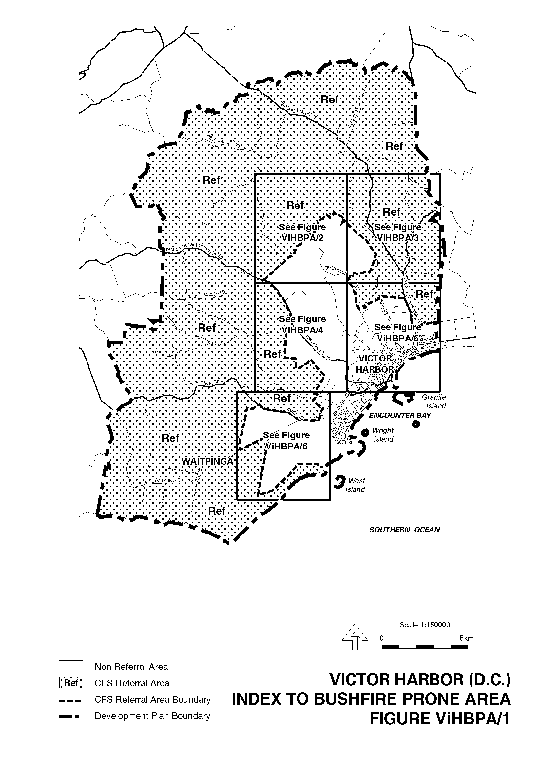
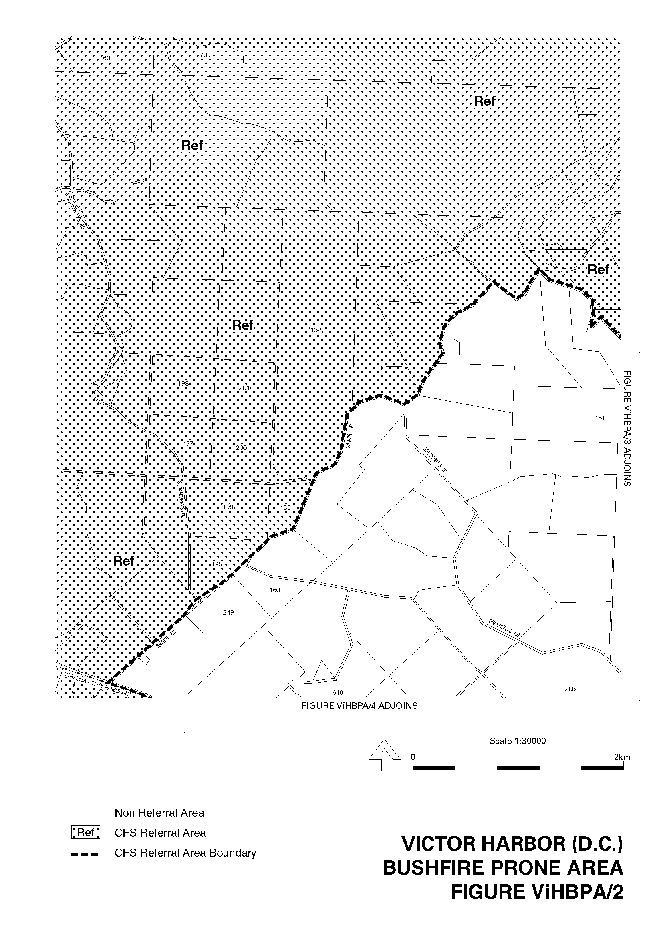
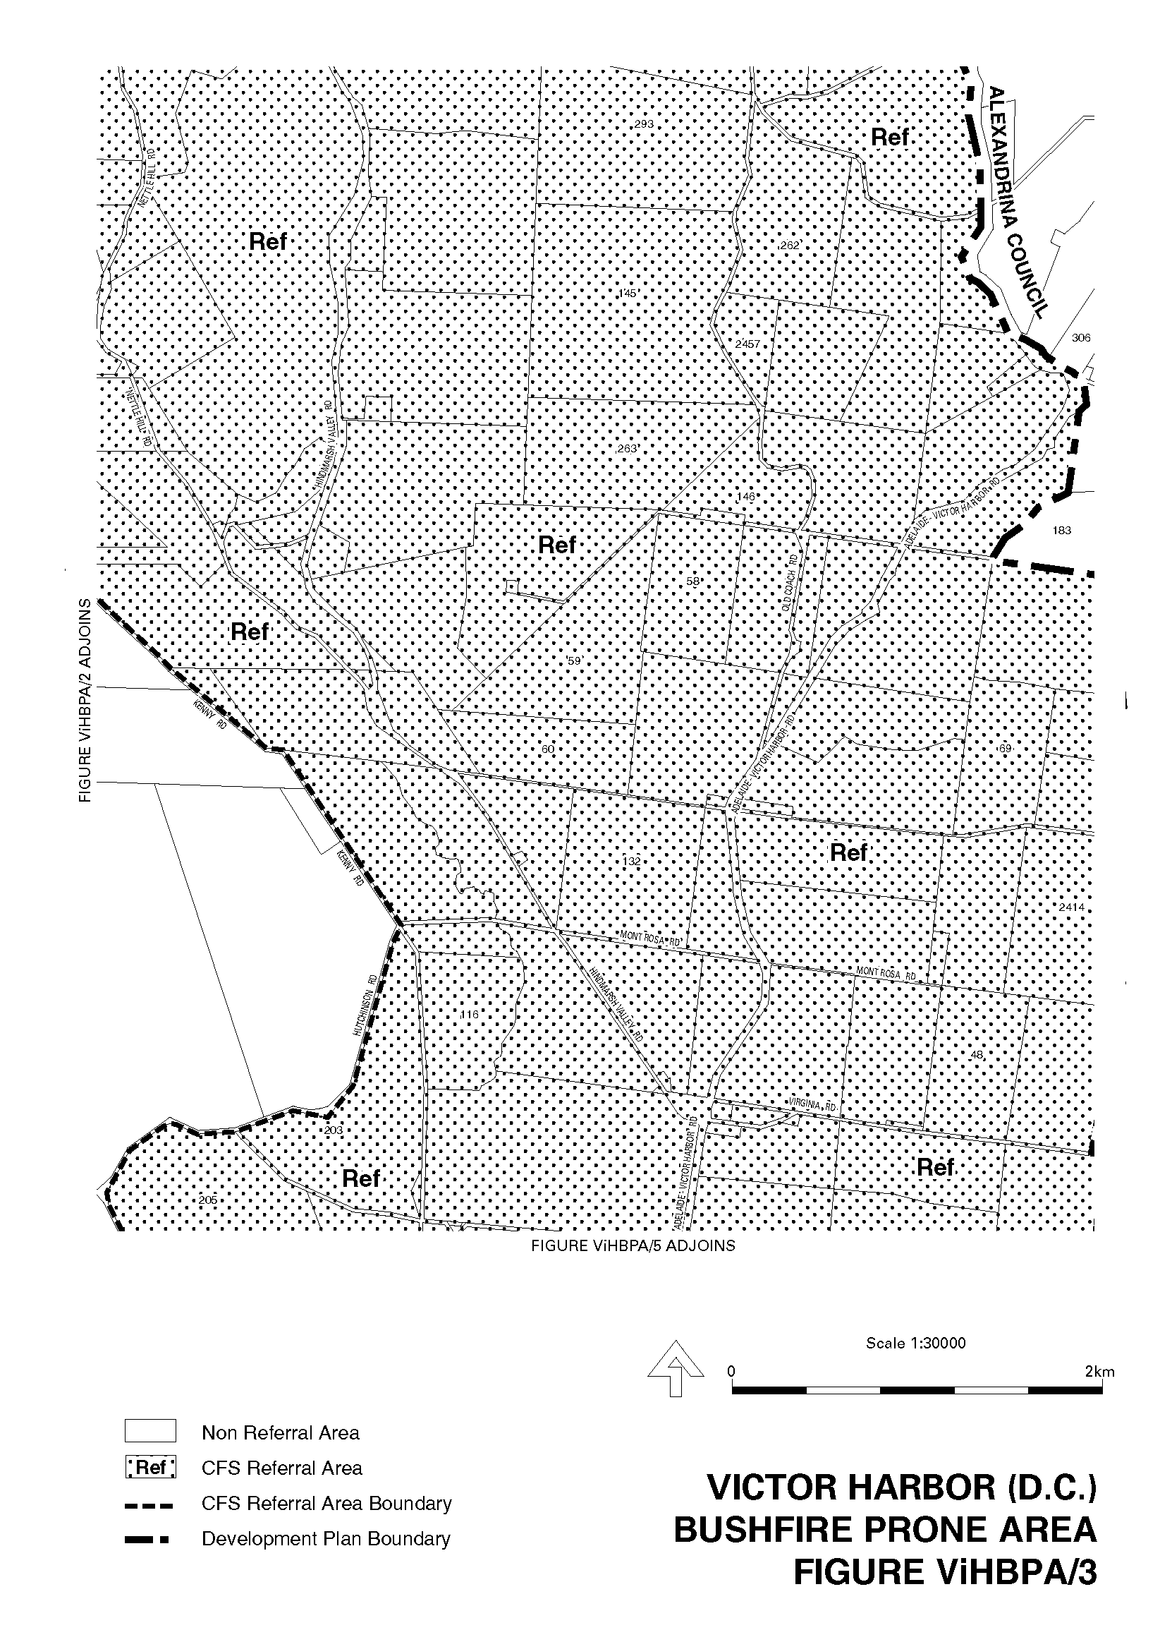
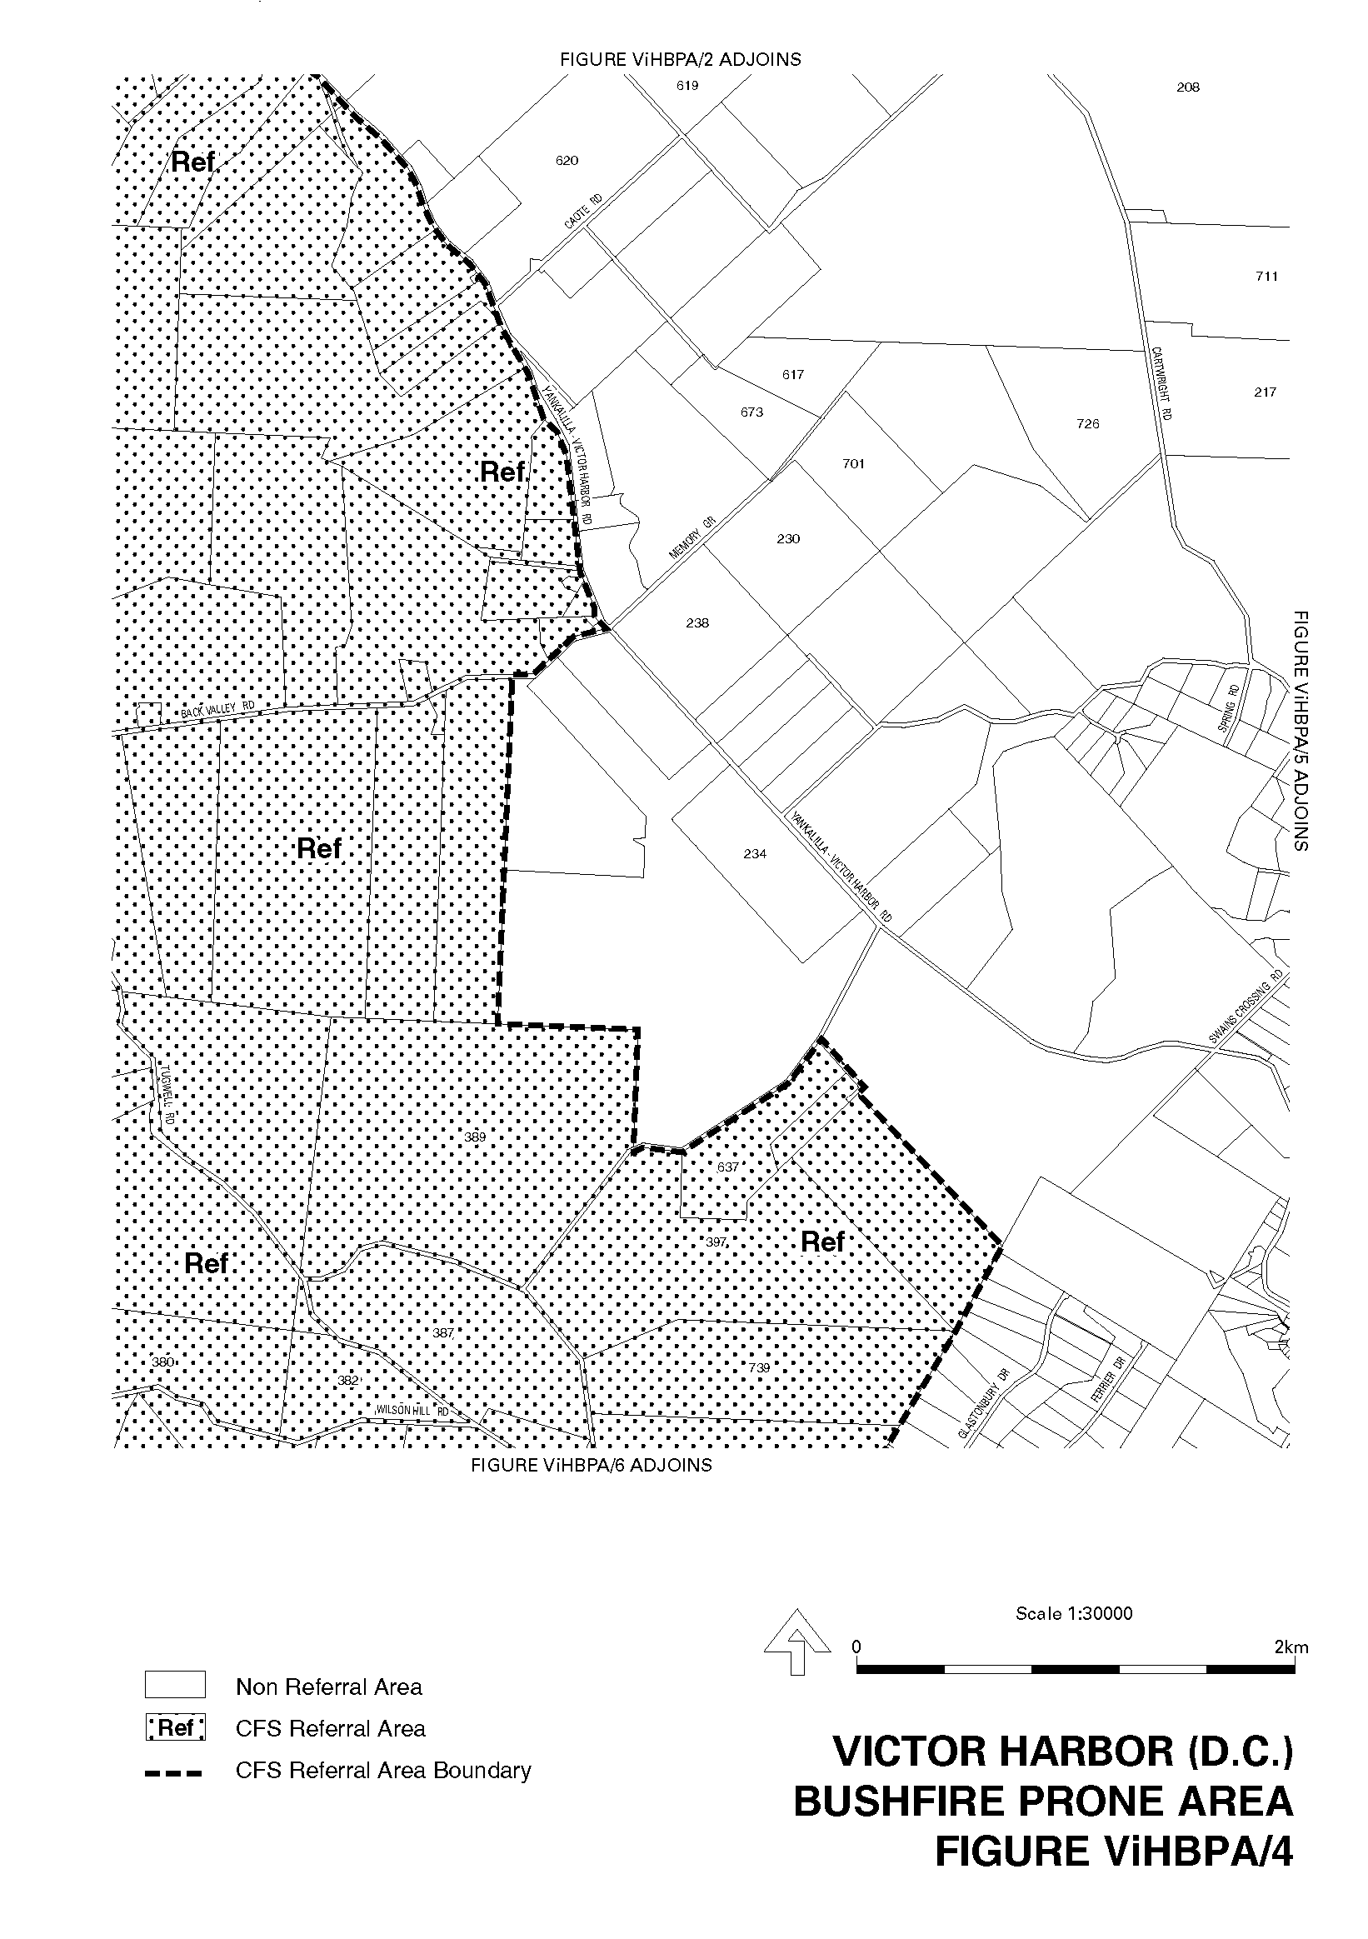
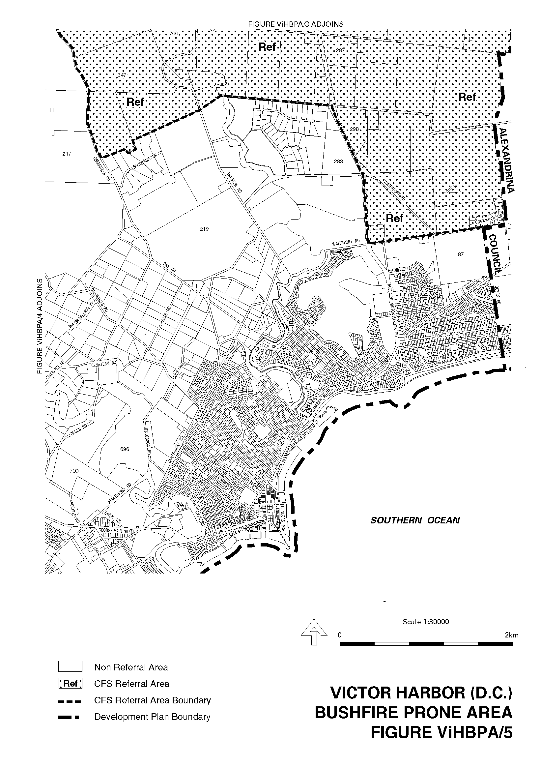
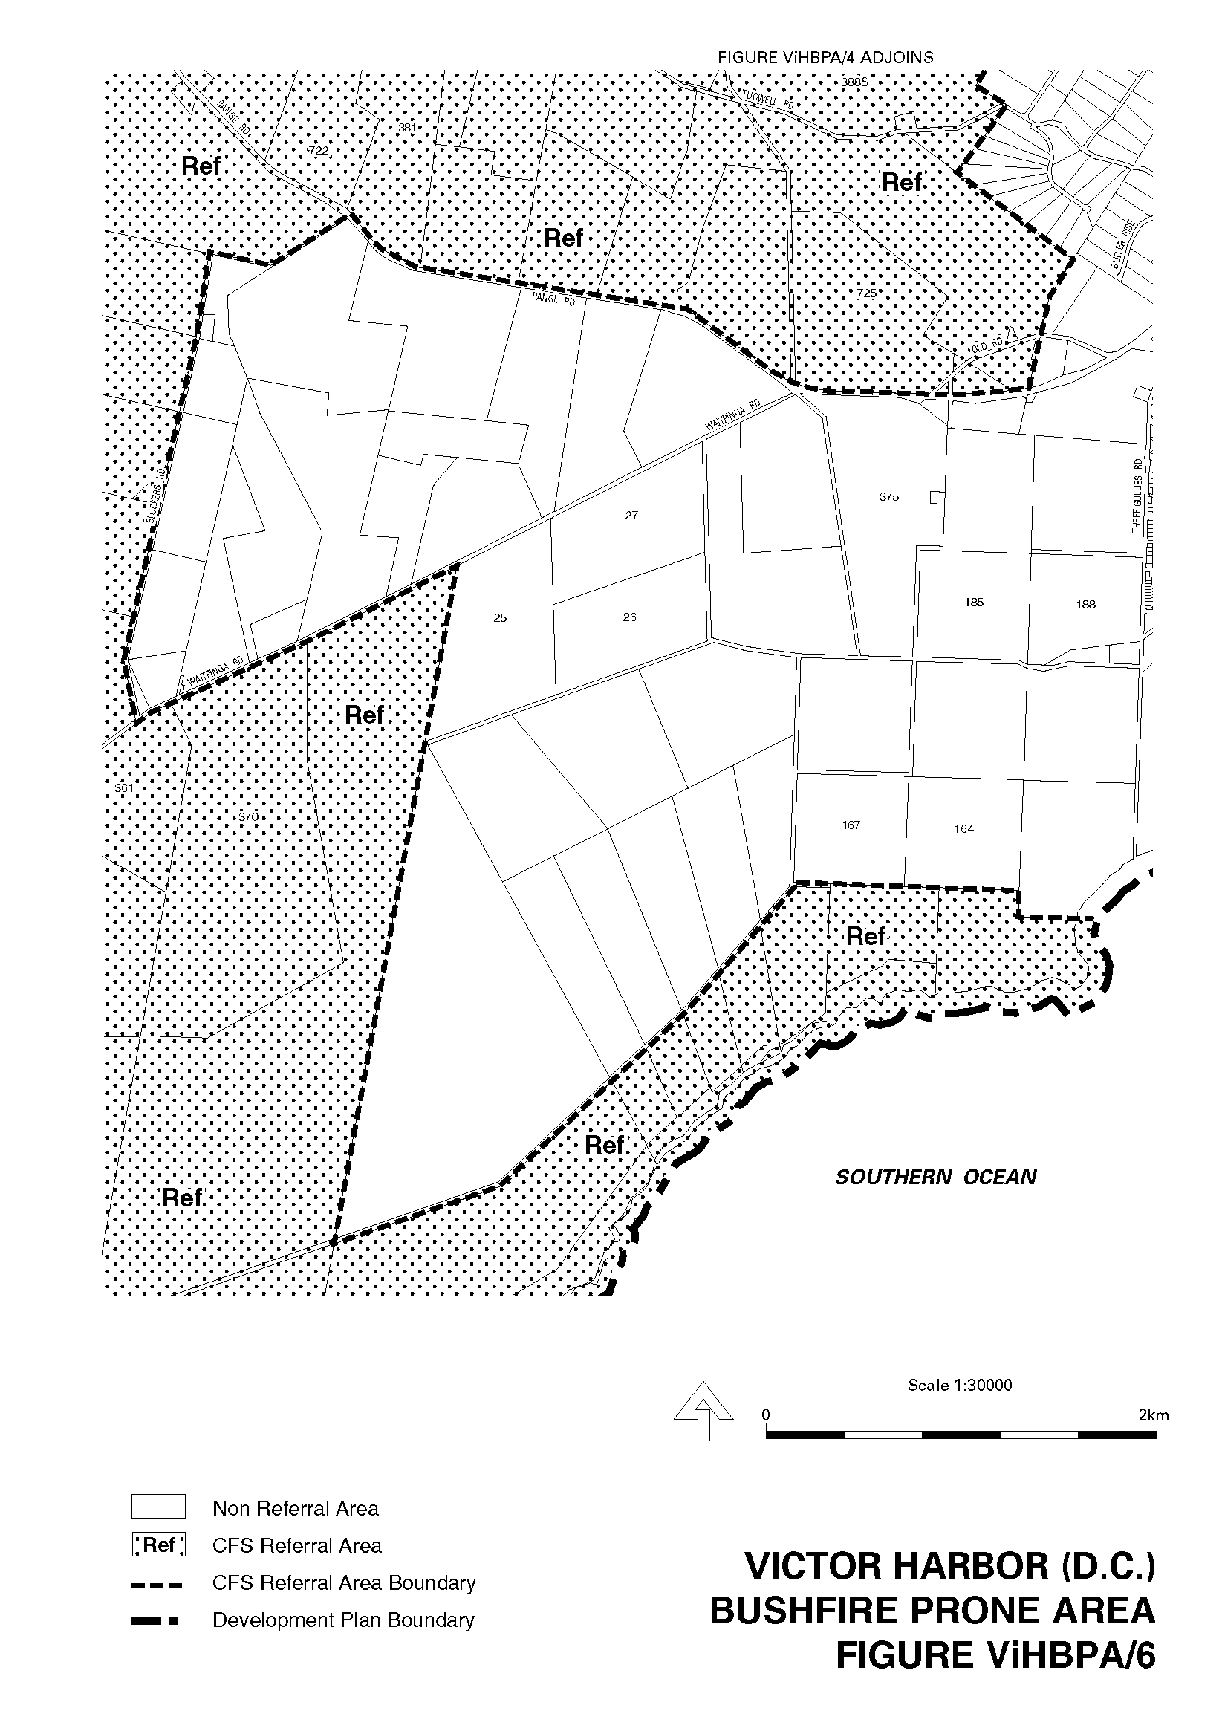
Dated 19 June 2003.
J. Weatherill, Minister for Urban Development and Planning
PLN 99/0348

SERVICE SA GOVERNMENT INFORMATION CENTRE
Located on the Ground Floor, SA Water House, 77 Grenfell Street, Adelaide, will be closed on Friday, 27 June 2003 for annual stock-take.

ONLY Government Gazette sales for 26 June 2003 will be available from SA Water, SA Water House, 77 Grenfell Street, Adelaide from 9 a.m. to 5 p.m. on Friday, 27 June 2003. No other publications can be sold.

Manager, Service SA, Government Information Centre

GOVERNMENT GAZETTE ADVERTISEMENT RATES

To apply from 1 July 2002

$  Agents, Ceasing to Act as 34.10  Associations:  Incorporation 17.40  Intention of Incorporation 43.00  Transfer of Properties 43.00  Attorney, Appointment of 34.10  Bailiff’s Sale 43.00  Cemetery Curator Appointed 25.50  Companies:  Alteration to Constitution 34.10  Capital, Increase or Decrease of 43.00  Ceasing to Carry on Business 25.50  Declaration of Dividend 25.50  Incorporation 34.10  Lost Share Certificates:  First Name 25.50  Each Subsequent Name 8.75  Meeting Final 28.75  Meeting Final Regarding Liquidator’s Report on  Conduct of Winding Up (equivalent to ‘Final  Meeting’)  First Name 34.10  Each Subsequent Name 8.75  Notices:  Call 43.00  Change of Name 17.40  Creditors 34.10  Creditors Compromise of Arrangement 34.10  Creditors (extraordinary resolution that ‘the Com-pany be wound up voluntarily and that a liquidator be appointed’) 43.00  Release of Liquidator⎯Application⎯Large Ad. 68.00  ⎯Release Granted 43.00  Receiver and Manager Appointed 39.75  Receiver and Manager Ceasing to Act 34.10  Restored Name 32.25  Petition to Supreme Court for Winding Up 59.50  Summons in Action 51.00  Order of Supreme Court for Winding Up Action 34.10  Register of Interests⎯Section 84 (1) Exempt 77.00  Removal of Office 17.40  Proof of Debts 34.10  Sales of Shares and Forfeiture 34.10  Estates:  Assigned 25.50  Deceased Persons⎯Notice to Creditors, etc. 43.00  Each Subsequent Name 8.75  Deceased Persons⎯Closed Estates 25.50  Each Subsequent Estate 1.10  Probate, Selling of 34.10  Public Trustee, each Estate 8.75 |  | $  Firms:  Ceasing to Carry on Business (each insertion) 22.70  Discontinuance Place of Business 22.70  Land⎯Real Property Act:  Intention to Sell, Notice of 43.00  Lost Certificate of Title Notices 43.00  Cancellation, Notice of (Strata Plan) 43.00  Mortgages:  Caveat Lodgment 17.40  Discharge of 18.30  Foreclosures 17.40  Transfer of 17.40  Sublet 8.75  Leases⎯Application for Transfer (2 insertions) each 8.75  Lost Treasury Receipts (3 insertions) each 25.50  Licensing 51.00  Municipal or District Councils:  Annual Financial Statement⎯Forms 1 and 2 481.00  Electricity Supply⎯Forms 19 and 20 341.00  Default in Payment of Rates:  First Name 68.00  Each Subsequent Name 8.75  Noxious Trade 25.50  Partnership, Dissolution of 25.50  Petitions (small) 17.40  Registered Building Societies (from Registrar-  General) 17.40  Register of Unclaimed Moneys⎯First Name 25.50  Each Subsequent Name 8.75  Registers of Members⎯Three pages and over:  Rate per page (in 8pt) 218.00  Rate per page (in 6pt) 288.00  Sale of Land by Public Auction 43.50  Advertisements 2.40  Advertisements, other than those listed are charged at $2.40 per column line, tabular one-third extra.  Notices by Colleges, Universities, Corporations and District Councils to be charged at $2.40 per line.  Where the notice inserted varies significantly in length from that which is usually published a charge of $2.40 per column line will be applied in lieu of advertisement rates listed.  South Australian Government publications are sold on the condition that they will not be reproduced without prior permission from the Government Printer.
All the above prices include GST

GOVERNMENT GAZETTE NOTICES
ALL private advertisements forwarded for publication in the South Australian Government Gazette must be PAID FOR PRIOR TO INSERTION; and all notices, from whatever source, should be legibly written on one side of the paper only and sent to Government Publishing SA so as to be received no later than 4 p.m. Tuesday preceding the day of publication. Phone 8207 1045 or Fax 8207 1040. E-mail: governmentgazette@saugov.sa.gov.au. Send as attachments in Word format and please confirm your transmission with a faxed copy of your document, including the date the notice is to be published and to whom the notice will be charged.

MISCELLANEOUS LEGISLATION AND GOVERNMENT PUBLICATIONS PRICES AS FROM 1 JULY 2003

Acts, Bills, Rules, Parliamentary Papers and Regulations
Pages | Main | Amends | Pages | Main | Amends

1-16 | 2.05 | 0.90 | 497-512 | 29.20 | 28.00
17-32 | 2.80 | 1.75 | 513-528 | 30.00 | 28.80
33-48 | 3.65 | 2.60 | 529-544 | 30.90 | 29.90
49-64 | 4.60 | 3.50 | 545-560 | 31.70 | 30.90
65-80 | 5.40 | 4.45 | 561-576 | 32.50 | 31.70
81-96 | 6.25 | 5.20 | 577-592 | 33.60 | 32.20
97-112 | 7.15 | 6.05 | 593-608 | 34.40 | 33.25
113-128 | 8.00 | 7.00 | 609-624 | 35.20 | 34.30
129-144 | 9.00 | 7.95 | 625-640 | 35.90 | 34.80
145-160 | 9.85 | 8.80 | 641-656 | 36.80 | 35.85
161-176 | 10.80 | 9.65 | 657-672 | 37.40 | 36.60
177-192 | 11.60 | 10.60 | 673-688 | 39.00 | 37.40
193-208 | 12.50 | 11.50 | 689-704 | 39.80 | 38.40
209-224 | 13.30 | 12.25 | 705-720 | 40.30 | 39.50
225-240 | 14.20 | 13.10 | 721-736 | 41.80 | 40.00
241-257 | 15.10 | 13.80 | 737-752 | 42.30 | 41.30
258-272 | 16.00 | 14.75 | 753-768 | 43.40 | 41.80
273-288 | 16.90 | 15.80 | 769-784 | 43.90 | 43.10
289-304 | 17.60 | 16.60 | 785-800 | 44.70 | 43.90
305-320 | 18.60 | 17.50 | 801-816 | 45.50 | 44.40
321-336 | 19.40 | 18.30 | 817-832 | 46.50 | 45.50
337-352 | 20.40 | 19.30 | 833-848 | 47.50 | 46.25
353-368 | 21.20 | 20.20 | 849-864 | 48.30 | 47.00
369-384 | 22.10 | 21.10 | 865-880 | 49.00 | 48.30
385-400 | 22.90 | 21.90 | 881-896 | 49.60 | 48.80
401-416 | 23.70 | 22.60 | 897-912 | 51.20 | 49.60
417-432 | 24.80 | 23.60 | 913-928 | 51.70 | 51.20
433-448 | 25.60 | 24.50 | 929-944 | 52.50 | 51.70
449-464 | 26.50 | 25.30 | 945-960 | 53.50 | 52.20
465-480 | 27.00 | 26.20 | 961-976 | 54.50 | 53.25
481-496 | 28.20 | 27.00 | 977-992 | 55.60 | 54.00

Legislation—Acts, Regulations, etc: $
Subscriptions:
Acts 180.00
All Bills as Laid 431.00
Rules and Regulations 431.00
Parliamentary Papers 431.00
Bound Acts 199.00
Index 99.00
Government Gazette
Copy 4.70
Subscription 238.00
Hansard
Copy 13.00
Subscription—per session (issued weekly) 374.00
Cloth bound—per volume 161.00
Subscription—per session (issued daily) 374.00
Legislation on Disk
Whole Database 2 763.00
Annual Subscription for fortnightly updates 849.00
Individual Act(s) including updates POA
Compendium
Subscriptions:
New Subs 1 638.00
Updates 578.00
(All the above prices include GST)

All Legislation, Government Gazette, Hansard and Legislation on disk are available from:
Counter Sales Service SA, Government Information Centre
and Mail Orders: Ground Floor, 77 Grenfell Street, Adelaide, S.A. 5000
Phone: 13 23 24 (local call cost), Fax: (08) 8204 1909
TTY (Hearing Impaired): (08) 8204 1923

Online Shop: www.info.sa.gov.au

Subscriptions and Government Publishing SA
Standing Orders: Box 9, Plaza Level, Riverside Centre, North Terrace, Adelaide, S.A. 5000
Phone: (08) 8207 0908, (08) 8207 0910, Fax: (08) 8207 1040

ELECTRICITY ACT 1996
Default Contract Prices
NOTICE is hereby given that in accordance with section 36AB of the Electricity Act 1996 (SA) TXU Electricity Limited (ABN 91 064 651 118) (‘TXU’) hereby publishes its default contract prices. TXU’s default contract prices will come into effect 28 days from the date of this notice.
The prices detailed in this notice apply for default customers only of TXU and are to be read with TXU’s Default Contract Terms and Conditions published in the Government Gazette on 27 February 2003.
TXU has based its default contract price on the pricing of one of its South Australian market contracts (specifically, the ‘TXU Residential and Business Options’ market contract). TXU relied upon and adopted the justifiable cost components provided by the Essential Services Commission of South Australia (in Part 3 of its Electricity Industry Guideline No. 10—Electricity Retail Price Justification) in determining the default contract price.
The default contract price is constructed:
(1) without differentiated summer pricing; and
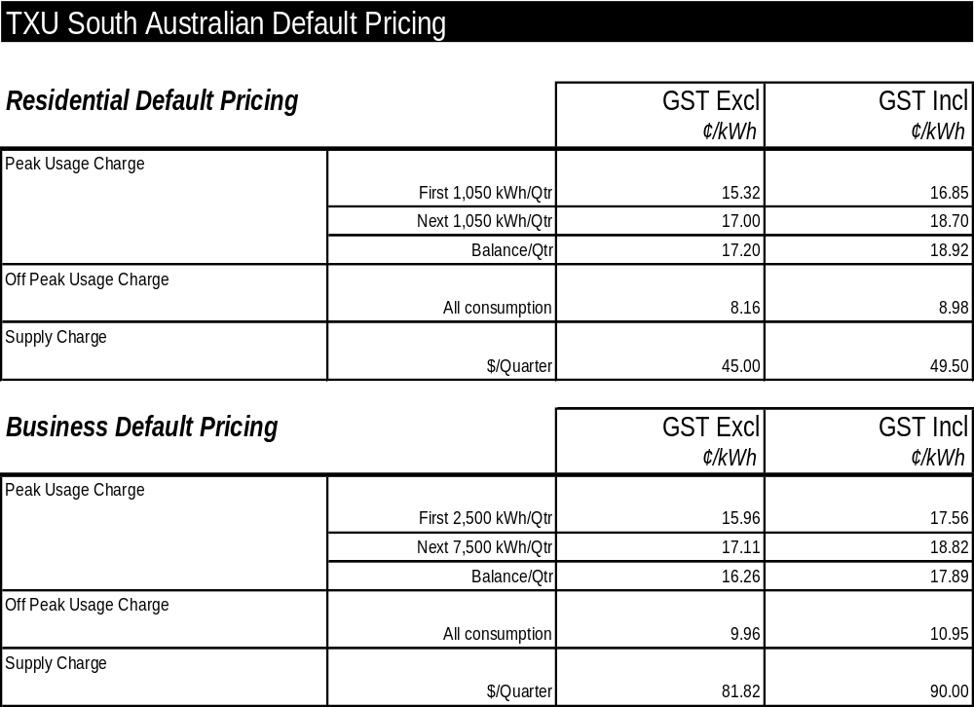
(2) with no additional fixed supply charge for off peak usage.
TXU reserves the right to change its default contract price from time to time acting in accordance with all applicable regulations.

Residential Default Pricing applies to residential customers in premises used wholly or principally as private residences.
Business Default Pricing applies to business customers in premises that are not used wholly or principally as private residences.
Off Peak Usage charges will apply where electricity is supplied at off peak rates (if applicable) where the meter has the ability to register off peak usage.
S. Philley, Chief Executive Officer

ENVIRONMENT PROTECTION ACT 1993
Approval of Category B Containers
I, STEPHEN RICHARD SMITH, Senior Adviser, Container Deposit Legislation and Delegate of the Environment Protection Authority (‘the Authority’), pursuant to section 69 of the Environment Protection Act 1993 (SA) (‘the Act’) hereby:
Approval of Category B Containers:
Approve as Category B Containers, subject to the conditions in subclauses (i) and (ii) below, each of the classes of containers identified by reference to the following matters described in the first 4 columns of Schedule 1 of this Notice which are sold in South Australia:
(a) the product which each class of containers shall contain;
(b) the size of the containers;
(c) the type of containers;
(d) the name of the holders of these approvals.
(i) Subsection 69 (3) Arrangements:
The holders of these approvals must ensure that the empty containers which belong to their respective class of containers hereby approved as Category B Containers are collected from collection depots approved under section 69 of the Act by the party named in column 5 of Schedule 1 of this Notice; and
(ii) Approved Refund Markings:
The holders of these approvals must ensure that each container which belongs to their respective class of containers hereby approved as Category B Containers bears the refund marking approved by the Authority in respect of that class of containers.

Product Name | Container  Size (mL) | Container Type | Approval Holder | Collection  Arrangements
Archers spri Peach | 275 | Glass | Diageo Australia Pty Ltd | Statewide Recycling
Archers spri Watermelon | 275 | Glass | Diageo Australia Pty Ltd | Statewide Recycling
Archers spri Wildberry | 275 | Glass | Diageo Australia Pty Ltd | Statewide Recycling
Baileys Minis | 70 | PET | Diageo Australia Pty Ltd | Statewide Recycling
Budweiser | 355 | Glass | Coopers Brewery Ltd | Marine Stores Ltd
C S Cowboy | 270 | Glass | Independent Distillers Australia | Statewide Recycling
Chin Chin Apple Soda | 350 | Can - Steel | New World Trading Company  Pty Ltd | Statewide Recycling
Chin Chin Basil Seed Drink | 350 | Can - Steel | New World Trading Company  Pty Ltd | Statewide Recycling
Chin Chin Black Drink | 350 | Can - Steel | New World Trading Company  Pty Ltd | Statewide Recycling
Chin Chin Genesis Coffee | 250 | Can - Steel | New World Trading Company  Pty Ltd | Statewide Recycling
Chin Chin Grass Jelly Banana | 320 | Can - Steel | New World Trading Company  Pty Ltd | Statewide Recycling
Chin Chin Guava Drink | 350 | Can - Steel | New World Trading Company  Pty Ltd | Statewide Recycling
Chin Chin Lemon Tea | 350 | Can - Steel | New World Trading Company  Pty Ltd | Statewide Recycling
Chin Chin Mango Juice | 350 | Can - Steel | New World Trading Company  Pty Ltd | Statewide Recycling
Chin Chin Mixed Fruit Drink | 350 | Can - Steel | New World Trading Company  Pty Ltd | Statewide Recycling
Chin Chin Pearl Milk Tea | 320 | Can - Steel | New World Trading Company  Pty Ltd | Statewide Recycling
Chin Chin Plum Fruit Juice | 340 | Can - Steel | New World Trading Company  Pty Ltd | Statewide Recycling
Chin Chin Sarsaparilla Soda | 350 | Can - Steel | New World Trading Company  Pty Ltd | Statewide Recycling
Chin Chin Wax Gourd Juice | 350 | Can - Steel | New World Trading Company  Pty Ltd | Statewide Recycling
Classic Hits Creaming Soda Ceda | 1 250 | PET | P. & N. Beverages Australia  Pty Ltd | Flagcan Distributors
Classic Hits Pineapple Crush | 1 250 | PET | P. & N. Beverages Australia  Pty Ltd | Flagcan Distributors
Classic Hits Sparkling Soda Water | 1 250 | PET | P. & N. Beverages Australia  Pty Ltd | Flagcan Distributors
De De Basil Seed Drink | 290 | Glass | New World Trading Company  Pty Ltd | Statewide Recycling
De De Pennywort Drink | 290 | Glass | New World Trading Company  Pty Ltd | Statewide Recycling
Diet Coke with Vanilla | 375 | Can - Aluminium | Coca-Cola Amatil (Aust) Pty  Ltd | Statewide Recycling
Fruitopia Apple & Blackcurrant Juice | 250 | Glass | Coca-Cola Amatil (Aust) Pty  Ltd | Statewide Recycling
Fruitopia Apple & Blackcurrant Juice | 305 | PET - Paper Label | Coca-Cola Amatil (Aust) Pty  Ltd | Statewide Recycling
Fruitopia Apple & Blackcurrant Juice | 350 | PET - Paper Label | Coca-Cola Amatil (Aust) Pty  Ltd | Statewide Recycling
Fruitopia Apple Juice | 250 | Glass | Coca-Cola Amatil (Aust) Pty  Ltd | Statewide Recycling
Fruitopia Apple Juice | 350 | PET - Paper Label | Coca-Cola Amatil (Aust) Pty  Ltd | Statewide Recycling
Fruitopia Orange | 250 | Glass | Coca-Cola Amatil (Aust) Pty  Ltd | Statewide Recycling
Fruitopia Orange Juice | 305 | PET - Paper Label | Coca-Cola Amatil (Aust) Pty  Ltd | Statewide Recycling
Fruitopia Orange Juice | 350 | PET - Paper Label | Coca-Cola Amatil (Aust) Pty  Ltd | Statewide Recycling
Fruitopia Orange & Mango | 250 | Glass | Coca-Cola Amatil (Aust) Pty  Ltd | Statewide Recycling
Fruitopia Orange & Mango | 350 | PET - Paper Label | Coca-Cola Amatil (Aust) Pty  Ltd | Statewide Recycling
Fruitopia Pineapple Juice | 250 | Glass | Coca-Cola Amatil (Aust) Pty  Ltd | Statewide Recycling
Fruitopia Pineapple Juice | 350 | PET - Paper Label | Coca-Cola Amatil (Aust) Pty  Ltd | Statewide Recycling
Fruitopia Tomato Juice | 250 | Glass | Coca-Cola Amatil (Aust) Pty  Ltd | Statewide Recycling
G Force Tangy Apple | 400 | PET | Frucor Beverages Limited | Statewide Recycling
G Force Tangy Apple | 800 | PET | Frucor Beverages Limited | Statewide Recycling
Heineken Lager Beer | 3 000 | Glass | Heineken Australia Pty Ltd | Visy CDL Recycling Services
Iceberg Water | 500 | PET | New World Trading Company  Pty Ltd | Statewide Recycling
Inner Circle Pot Still Rum & Cola 6% | 375 | Can - Aluminium | Miranda Wines Pty Ltd | Visy CDL Recycling Services
Inner Circle Pot Still Rum & Cola 9% | 375 | Can - Aluminium | Miranda Wines Pty Ltd | Visy CDL Recycling Services
Jameson Chill | 275 | Glass | Orlando Wyndham Group Pty  Ltd | Marine Stores Ltd
Johnnie Walker Red Label & Cola | 345 | Glass | Diageo Australia Pty Ltd | Statewide Recycling
Kirks Orange | 375 | Can - Aluminium | Coca-Cola Amatil (Aust) Pty  Ltd | Statewide Recycling
Midori Splice | 275 | Glass | Suntory (Aust) Pty Ltd | Statewide Recycling
Nestle Nescafe Espresso | 600 | HDPE - PVC Labels | Nestle Australia Ltd | Statewide Recycling
Nestle Nescafe Latte | 600 | HDPE - PVC Labels | Nestle Australia Ltd | Statewide Recycling
Nippy’s Little Suckers Apple Blueberry Flavoured Fruit Drink | 250 | HDPE | Knispel Fruit Juices Pty Ltd | Statewide Recycling
Nippy’s Little Suckers Apple Lime Flavoured Fruit Drink | 250 | HDPE | Knispel Fruit Juices Pty Ltd | Statewide Recycling
Nippy’s Little Suckers Apple Raspberry Flavoured Fruit Drink | 250 | HDPE | Knispel Fruit Juices Pty Ltd | Statewide Recycling
Nippy’s Little Suckers Orange Flavoured Fruit Drink | 250 | HDPE | Knispel Fruit Juices Pty Ltd | Statewide Recycling
Nippy’s Little Suckers Tropical Flavoured Fruit Drink | 250 | HDPE | Knispel Fruit Juices Pty Ltd | Statewide Recycling
Ocean Spray Blueberry Classic | 1 500 | Glass | Ocean Spray International Inc. | Statewide Recycling
Ocean Spray Cranberry Blackcurrant | 1 500 | Glass | Ocean Spray International Inc. | Statewide Recycling
Ocean Spray Cranberry Classic | 1 000 | Glass | Ocean Spray International Inc. | Statewide Recycling
Ocean Spray Cranberry Classic | 1 500 | Glass | Ocean Spray International Inc. | Statewide Recycling
Ocean Spray Cranberry Classic | 295 | Glass | Ocean Spray International Inc. | Statewide Recycling
Ocean Spray Cranberry Light | 1 000 | Glass | Ocean Spray International Inc. | Statewide Recycling
Ocean Spray Cranberry Light | 1 500 | PET | Ocean Spray International Inc. | Statewide Recycling
Ocean Spray Pink Grapefruit &  Passionfruit | 1 500 | Glass | Ocean Spray International Inc. | Statewide Recycling
Ocean Spray Raspberry Cranberry | 1 500 | Glass | Ocean Spray International Inc. | Statewide Recycling
Ocean Spray Ruby Red Grapefruit | 1 500 | Glass | Ocean Spray International Inc. | Statewide Recycling
Ocean Spray Ruby Red Grapefruit | 1 500 | PET | Ocean Spray International Inc. | Statewide Recycling
Pelisterka Natural Sparkling Mineral  Water | 1 500 | PET - Paper Label | Marco Polo Foods Pty Ltd | Statewide Recycling
Radenska Iced Tea | 1 500 | PET - Paper Label | Marco Polo Foods Pty Ltd | Statewide Recycling
Radenska Iced Tea Lemon | 1 500 | PET - Paper Label | Marco Polo Foods Pty Ltd | Statewide Recycling
Radenska Iced Tea Peach | 1 500 | PET - Paper Label | Marco Polo Foods Pty Ltd | Statewide Recycling
Radenska Natural Sparkling Mineral  Water | 1 500 | PET - Paper Label | Marco Polo Foods Pty Ltd | Statewide Recycling
Rosa Green Tea | 500 | PET - Paper Label | Bronhill Health Distributors | Statewide Recycling
San Benedetto Aranciata | 175 | Glass | Global Food Distributors Pty  Ltd | Statewide Recycling
San Benedetto Aranciata | 250 | Glass | Global Food Distributors Pty  Ltd | Statewide Recycling
San Benedetto Chinotto | 175 | Glass | Global Food Distributors Pty  Ltd | Statewide Recycling
San Benedetto Chinotto | 250 | Glass | Global Food Distributors Pty  Ltd | Statewide Recycling
San Benedetto Gassosa | 175 | Glass | Global Food Distributors Pty  Ltd | Statewide Recycling
San Benedetto Gassosa | 250 | Glass | Global Food Distributors Pty  Ltd | Statewide Recycling
San Benedetto Limone | 175 | Glass | Global Food Distributors Pty  Ltd | Statewide Recycling
San Benedetto Limone | 250 | Glass | Global Food Distributors Pty  Ltd | Statewide Recycling
San Benedetto Mineral Water | 1 000 | Glass | Global Food Distributors Pty  Ltd | Statewide Recycling
San Benedetto Mineral Water | 1 500 | PET - Paper Label | Global Food Distributors Pty  Ltd | Statewide Recycling
San Benedetto Mineral Water | 250 | Glass | Global Food Distributors Pty  Ltd | Statewide Recycling
San Benedetto Mineral Water | 500 | Glass | Global Food Distributors Pty  Ltd | Statewide Recycling
San Benedetto Mineral Water | 500 | PET - Paper Label | Global Food Distributors Pty  Ltd | Statewide Recycling
San Benedetto Mineral Water | 750 | Glass | Global Food Distributors Pty  Ltd | Statewide Recycling
San Benedetto Pompelmo | 175 | Glass | Global Food Distributors Pty  Ltd | Statewide Recycling
San Benedetto Pompelmo | 250 | Glass | Global Food Distributors Pty  Ltd | Statewide Recycling
San Benedetto Sanguinella | 175 | Glass | Global Food Distributors Pty  Ltd | Statewide Recycling
San Benedetto Sanguinella | 250 | Glass | Global Food Distributors Pty  Ltd | Statewide Recycling
San Benedetto Sparkling Mineral Water | 1 000 | PET - Paper Label | Global Food Distributors Pty  Ltd | Statewide Recycling
San Benedetto Sparkling Mineral Water | 1 500 | PET - Paper Label | Global Food Distributors Pty  Ltd | Statewide Recycling
San Benedetto Sparkling Mineral Water | 250 | PET - Paper Label | Global Food Distributors Pty  Ltd | Statewide Recycling
San Benedetto Sparkling Mineral Water | 500 | PET - Paper Label | Global Food Distributors Pty  Ltd | Statewide Recycling
San Benedetto Sparkling Mineral Water | 750 | PET - Paper Label | Global Food Distributors Pty  Ltd | Statewide Recycling
Ski D’Lite Yogurt to Go Bananarama | 200 | HDPE - PVC sleeve | Dairy Vale Foods Limited | Statewide Recycling
Ski D’Lite Yogurt to Go Peach n Mango | 200 | HDPE - PVC sleeve | Dairy Vale Foods Limited | Statewide Recycling
Ski D’Lite Yogurt to Go Tropical Escape | 200 | HDPE - PVC sleeve | Dairy Vale Foods Limited | Statewide Recycling
Ski D’Lite Yogurt to Go Vanilla Creme | 200 | HDPE - PVC sleeve | Dairy Vale Foods Limited | Statewide Recycling
Ski D’Lite Yogurt to Go Wild Strawberry | 200 | HDPE - PVC sleeve | Dairy Vale Foods Limited | Statewide Recycling
Ski Divine Yogurt to Go Berry Heaven | 200 | HDPE - PVC sleeve | Dairy Vale Foods Limited | Statewide Recycling
Ski Divine Yogurt to Go Mango | 200 | HDPE - PVC sleeve | Dairy Vale Foods Limited | Statewide Recycling
Ski Divine Yogurt to Go Wild Strawberry | 200 | HDPE - PVC sleeve | Dairy Vale Foods Limited | Statewide Recycling
Slam Energy Water | 500 | PET - Paper Label | Statray Pty Ltd | Statewide Recycling
Slider Fruit Tingle | 330 | Glass | Fryer Holdings Pty Ltd | Flagcan Distributors
Slider Red Rave | 330 | Glass | Fryer Holdings Pty Ltd | Flagcan Distributors
Smirnoff Ice | 335 | Glass | Diageo Australia Pty Ltd | Statewide Recycling
Southern Comfort & Cranberry Lemonade | 330 | Glass | Swift & Moore Pty Ltd | Statewide Recycling
Southern Comfort & Lemonade | 330 | Glass | Swift & Moore Pty Ltd | Statewide Recycling
Stappj | 180 | Glass | Basile Imports | Statewide Recycling
Sugar Free V | 250 | Can - Aluminium | Frucor Beverages Limited | Statewide Recycling
Sugar Free V | 350 | Glass | Frucor Beverages Limited | Statewide Recycling
The Incredible Gulp Caramelicious | 200 | HDPE - PVC sleeve | Dairy Vale Foods Limited | Statewide Recycling
The Incredible Gulp Mudslide | 200 | HDPE - PVC sleeve | Dairy Vale Foods Limited | Statewide Recycling
The Incredible Gulp Rippling Raspberry | 200 | HDPE - PVC sleeve | Dairy Vale Foods Limited | Statewide Recycling
The Incredible Gulp Slippery Strawberry | 200 | HDPE - PVC sleeve | Dairy Vale Foods Limited | Statewide Recycling
The Incredible Gulp Velvety Vanilla | 200 | HDPE - PVC sleeve | Dairy Vale Foods Limited | Statewide Recycling
Ultraslim Chocolate | 250 | LPB - Aseptic | AB Food & Beverages Australia Pty Ltd | Statewide Recycling
Ultraslim Vanilla | 250 | LPB - Aseptic | AB Food & Beverages Australia Pty Ltd | Statewide Recycling
V | 250 | Can - Aluminium | Frucor Beverages Limited | Statewide Recycling
Vitasoy Flavoured Soy Milk | 250 | LPB - Aseptic | Bronhill Health Distributors | Statewide Recycling
Wonderfarm Basil Seed Drink | 325 | Can - Steel | New World Trading Company  Pty Ltd | Statewide Recycling
Wonderfarm Birds Nest | 250 | Can - Steel | New World Trading Company  Pty Ltd | Statewide Recycling
Wonderfarm Ginseng Drink | 250 | Can - Steel | New World Trading Company  Pty Ltd | Statewide Recycling
Wonderfarm Mango Juice | 250 | Can - Steel | New World Trading Company  Pty Ltd | Statewide Recycling
Wonderfarm Natrual Coconut Juice | 250 | Can - Steel | New World Trading Company  Pty Ltd | Statewide Recycling
Wonderfarm Pennywort Drink | 325 | Can - Steel | New World Trading Company  Pty Ltd | Statewide Recycling
Wonderfarm Sour Sop Juice | 250 | Can - Steel | New World Trading Company  Pty Ltd | Statewide Recycling
Wonderfarm VN Coffee | 250 | Can - Steel | New World Trading Company  Pty Ltd | Statewide Recycling
Wonderfarm Young Coconut Juice | 325 | Can - Steel | New World Trading Company  Pty Ltd | Statewide Recycling
Zolo Palm Sugar Juice | 300 | Can - Steel | New World Trading Company  Pty Ltd | Statewide Recycling
Zolo Palm Sugar Juice | 300 | Glass | New World Trading Company  Pty Ltd | Statewide Recycling

FISHERIES ACT 1982: SECTION 59
TAKE notice that pursuant to section 59 of the Fisheries Act 1982, the Director of Fisheries is exempt from subsection 36 (2) of the Fisheries Act 1982 and subregulation 13 (2) of the Scheme of Management (Miscellaneous Fishery) Regulations 2000, insofar as the Director may, upon application, grant registration of a person as the master of a registered boat in relation to a licence of a class listed in Schedule 1 to a person that is not the holder of the licence, from the date of gazettal of this notice until 30 June 2004.
Schedule 1
Miscellaneous Fishery licences endorsed to allow the taking of scallops (Family Pectinidae) and/or sea urchins (Heliocidaris erythogramma).
Miscellaneous Fishery licences endorsed to allow the taking of native oysters (Ostrea anasi).
Dated 10 June 2003.
P. Holloway, Minister for Agriculture, Food and Fisheries

FISHERIES ACT 1982: SECTION 59
TAKE notice that pursuant to section 59 of the Fisheries Act 1982, the Director of Fisheries is exempt from subsection 36 (2) of the Fisheries Act 1982 and regulation 12 of the Scheme of Management (Marine Scalefish Fishery) Regulations 1991, insofar as the Director may, upon application, grant registration of a person as the master of a registered boat in relation to a licence of a class listed in Schedule 1 to a person that is not the holder of the licence, from the date of gazettal of this notice until 30 June 2004.
Schedule 1
Marine Scalefish Fishery licences endorsed to allow the use of a pilchard net.
Marine Scalefish Fishery licences endorsed to allow the use of an ocean jacket trap.
Dated 10 June 2003.
P. Holloway, Minister for Agriculture, Food and Fisheries

FISHERIES ACT 1982: SECTION 59
TAKE notice that pursuant to section 59 of the Fisheries Act 1982, the holder of a prawn fishery licence issued pursuant to the Scheme of Management (Prawn Fisheries) Regulations 1991 (the ‘exemption holder’) or their agent are exempt from notices made under section 43 of the Fisheries Act 1982, prohibiting the taking of western king prawns (Penaeus latisulcatus) in the waters specified in Schedule 1, in that the exemption holder shall not be guilty of an offence when using prawn trawl nets in accordance with the conditions of their fishery licence for the purpose of gear trials (the ‘exempted activity’) subject to the conditions contained in Schedule 2.
Schedule 1
The waters of Spencer Gulf and Gulf St Vincent contained within the following co-ordinates:
Port Lincoln
Those waters of Spencer Gulf bounded by a line commencing at position latitude 34°42.00′S, longitude 135°52.70′E, then to position latitude 34°41.70′S, longitude 135°53.40′E, then to position latitude 34°43.40′S, longitude 135°54.50′E, then to position latitude 34°43.70′S, longitude 135°53.80′E, then to the point of commencement.
Wallaroo
Those waters of Spencer Gulf bounded by a line commencing at position latitude 33°53.20′S, longitude 137°22.00′E, then to position latitude 33°53.50′S, longitude 137°32.50′E, then to position latitude 35°55.00′S, longitude 137°31.50′E, then to position latitude 33°54.70′S, longitude 137°31.00′E, then to the point of commencement.
Port Pirie
Those waters of Spencer Gulf bounded by a line commencing at position latitude 33°07.90′S, longitude 137°46.50′E, then to position latitude 33°08.10′S, longitude 137°46.70′E, then to position latitude 33°10.10′S, longitude 137°45.80′E, then to position latitude 33°09.90′S, longitude 137°45.60′E, then to the point of commencement.
Port Adelaide
Those waters of Gulf St Vincent commencing at position latitude 34°45.00′S, longitude 138°17.00′E, then to position latitude 34°47.00′S, longitude 138°17.00′E, then to position latitude 34°47.00′S, longitude 138°15.00′E, then to position latitude 34°45.00′S, longitude 138°15.00′E, then to the point of commencement.
Schedule 2
1. The exemption is valid from the date of gazettal of this notice until 30 June 2004, unless varied or revoked.
2. The exemption holder may only conduct the exempted activity between 0900 hours and 1700 hours.
3. The exemption holder may only engage in the exempted activity in those waters of Spencer Gulf or Gulf St Vincent greater than 10 m in depth.
4. Any fish taken during the exempted activity are to be returned to the water immediately.
5. The exemption holder must contact the PIRSA Fisheries Compliance Unit on 1800 065 522 not less than one hour prior to departure from port and provide them with the following information:
• a description of the boat to be used along with any registration number marked on that boat;
• the estimated time of departure from port;
• the area in which the gear trials are to be conducted;
• the estimated time of return to port; and
• the nominated agent to conduct the exempted activity.
6. The exemption holder must contact the PIRSA Fisheries Compliance Unit on 1800 065 522 not less than one hour prior to the boat returning to port and provide them with the following information:
• a description of the boat along with any registration number marked on that boat; and
• the estimated time of return to port.
7. The exemption holder shall not contravene or fail to comply with the Fisheries Act 1982, or any other regulations made under that Act except whereby specifically exempted by this notice.
Dated 12 June 2003.
W. Zacharin, Director of Fisheries

FRUIT AND PLANT PROTECTION ACT 1992
Notice Concerning the Control of Branched Broomrape
PURSUANT to the Fruit and Plant Protection Act 1992, I, John Hill, Minister for Environment and Conservation vary the notice under the Act published at page 4260 of the Government Gazette of 20 September 2001 (as varied) as follows:
Paragraph 3 is amended by the addition of the following areas to that portion of the State defined in (1) to be a quarantine area with respect to the disease Branched Broomrape:
The whole of the land comprised and described in CT 5657 Folio 51 and CT 5772 Folio 775 and CT 5529 Folio 700 and CT 5871 Folio 365, Hundred of Forster, County of Albert, South Australia.
Dated 4 June 2003.
J. D. Hill, Minister for Environment and Conservation

GROUNDWATER (BORDER AGREEMENT) ACT 1985
Notice of Alteration of Permissible Rate of Potentiometric
Surface Lowering
I, JOHN HILL, Minister for Environment and Conservation, hereby give the following notice:
1. This notice is made under the powers conferred by Clause 28 (4) of the Border Groundwaters Agreement and all other available powers.
2. This notice takes effect on and from the date it is published in the Government Gazette of both the Government and the State of South Australia and the Government of the State of Victoria.
3. On and from the date on which the notice takes effect:
(a) the permissible rate of potentiometric surface lowering for Zones 1A, 2A, 3A, 4A and 5A in South Australia will be 0.25 m; and
(b) the permissible rate of potentiometric surface lowering for Zones 1B, 2B, 3B, 4B and 5B in Victoria will be 0.25 m.
Dated 30 December 2002.
J. Hill, Minister for Environment and Conservation

LAND AND BUSINESS (SALE AND CONVEYANCING) ACT 1994
Exemption
TAKE notice that, pursuant to section 23 (3) of the Land and Business (Sale and Conveyancing) Act 1994, I, Michael John Atkinson, Minister for Consumer Affairs, do hereby exempt the person named in Schedule 1 from the application of section 23 (2) of the Act in relation to the purchase of the land specified in Schedule 2.
Schedule 1
Anna-Marie Baric, an officer/employee of River Forde Pty Ltd.
Schedule 2
The whole of the land described in Crown Lease Perpetual No. 899, book volume 680, folio 120, situated at 551 Hoskin Road, Berri, S.A. 5343.
Dated 19 June 2003.
Signed for and on behalf of the Minister for Consumer Affairs by the Commissioner for Consumer Affairs:
M. Bodycoat, Commissioner

LIQUOR LICENSING ACT 1997
Notice of Application
NOTICE is hereby given, pursuant to section 52 (2) (b) of the Liquor Licensing Act 1997, that Brian William Humble has applied to the Licensing Authority for the transfer of a Restaurant Licence in respect of premises situated at Tenancy 2, Bi-Lo Shopping Centre, McLaren Street, Mount Barker, S.A. 5251 and known as McLarens in the Mall Snack Bar & Coffee.
The application has been set down for hearing on 14 July 2003 at 9 a.m.
Any person may object to the application by lodging a notice of objection in the prescribed form with the Licensing Authority, and serving a copy of the notice on the applicant at the applicant’s address given above, at least seven days before the hearing date.
Plans in respect of the premises the subject of the application are open to public inspection without fee at the Office of the Liquor and Gaming Commissioner, 9th Floor, East Wing, 50 Grenfell Street, Adelaide, S.A. 5000.
Dated 10 June 2003.
Applicant

LIQUOR LICENSING ACT 1997
Notice of Application
NOTICE is hereby given, pursuant to section 52 (2) (b) of the Liquor Licensing Act 1997, that Griffin Pastoral Co. Pty Ltd has applied to the Licensing Authority for a Producer’s Licence in respect of premises situated at Tenison Vineyard, Cowans Road, Robe, S.A. 5276 and to be known as Karatta Wine Company.
The application has been set down for hearing on 18 July 2003 at 9 a.m.
Any person may object to the application by lodging a notice of objection in the prescribed form with the Licensing Authority, and serving a copy of the notice on the applicant at the applicant’s address given above, at least seven days before the hearing date.
Plans in respect of the premises the subject of the application are open to public inspection without fee at the Office of the Liquor and Gaming Commissioner, 9th Floor, East Wing, 50 Grenfell Street, Adelaide, S.A. 5000.
Dated 10 June 2003.
Applicant

LIQUOR LICENSING ACT 1997
Notice of Application
NOTICE is hereby given, pursuant to section 52 (2) (b) of the Liquor Licensing Act 1997, that Christine Margaret and Terence John Wilkinson have applied to the Licensing Authority for a Restaurant Licence with an Extended Trading Authorisation and Entertainment Consent in respect of premises situated at Montifiore Street, Callington, S.A. 5254 and to be known as Lavand’e of Callington.
The application has been set down for hearing on 18 July 2003 at 9 a.m.
Conditions
The following licence conditions are sought:
Extended trading authorisation is sought for the areas as depicted in the plan:
• Sunday, 8 p.m. to midnight.
For consumption on the licensed premises by persons seated at a table; or attending a function at which food is provided.
Entertainment consent is sought for the areas as depicted in the plan.
Any person may object to the application by lodging a notice of objection in the prescribed form with the Licensing Authority, and serving a copy of the notice on the applicants at the applicants’ address given above, at least seven days before the hearing date.
Plans in respect of the premises the subject of the application are open to public inspection without fee at the Office of the Liquor and Gaming Commissioner, 9th Floor, East Wing, 50 Grenfell Street, Adelaide, S.A. 5000.
Dated 11 June 2003.
Applicants

LIQUOR LICENSING ACT 1997
Notice of Application
NOTICE is hereby given, pursuant to section 52 (2) (b) of the Liquor Licensing Act 1997, that Crestview Pty Ltd has applied to the Licensing Authority for the removal of a Retail Liquor Merchant’s Licence and Producer’s Licence in respect of premises situated at 49 Fraser Avenue, Happy Valley, S.A. 5159 and to be situated at 24-26 Kangarilla Road, McLaren Vale, S.A. 5171 and known as Beresford Wines.
The application has been set down for hearing on 18 July 2003 at 9 a.m.
Any person may object to the application by lodging a notice of objection in the prescribed form with the Licensing Authority, and serving a copy of the notice on the applicant at the applicant’s address given above, at least seven days before the hearing date.
Plans in respect of the premises the subject of the application are open to public inspection without fee at the Office of the Liquor and Gaming Commissioner, 9th Floor, East Wing, 50 Grenfell Street, Adelaide, S.A. 5000.
Dated 10 June 2003.
Applicant

LIQUOR LICENSING ACT 1997
Notice of Application
NOTICE is hereby given, pursuant to section 52 (2) (b) of the Liquor Licensing Act 1997, that Tartan Pty Ltd (ACN 007 695 034) has applied to the Licensing Authority for a variation to an Extended Trading Authorisation Licence which is in force in respect of premises situated at 647 North East Road, Gilles Plains and known as Highlander Hotel.
The application has been set down for hearing on Friday, 18 July 2003 at 9 a.m.
Conditions
The following additional licence conditions are sought:
1. That the licensee be permitted to sell liquor for consumption on the licensed premises each Monday, Tuesday and Wednesday from midnight to 2 a.m. the following morning, and each Thursday, Friday and Saturday from 2 a.m. of the following morning to 3 a.m.
2. That the Extended Trading Authorisation shall apply to the areas referred to on the plan held in the Liquor and Gaming Commission as Area 1 (Lounge), Area 3 (Dining Room), Area 7 (Mezzanine Dining) and Area 2 (Gaming Room) during the days and times sought in this application and all other days and times previously authorised for extended trading.
Entertainment will not be conducted during the additional trading times sought in this application.
Any person may object to the application by lodging a notice of objection in the prescribed form with the Licensing Authority, and serving a copy of the notice on the applicant at the applicant’s address given above, at least seven days before the hearing date.
Plans in respect of the premises the subject of the application are open to public inspection without fee at the Office of the Liquor and Gaming Commissioner, 9th Floor, East Wing, 50 Grenfell Street, Adelaide, S.A. 5000.
Dated 10 June 2003.
Applicant

LIQUOR LICENSING ACT 1997
Notice of Application
NOTICE is hereby given, pursuant to section 52 (2) (b) of the Liquor Licensing Act 1997, that Dino Paul and Veronica Ann Sigismondi have applied to the Licensing Authority for a Producer’s Licence in respect of premises situated at section 498 and 499, Main Road, Lyrup, S.A. 5343 and to be known as Sigismondi Estate Wines.
The application has been set down for hearing on 18 July 2003 at 9 a.m.
Any person may object to the application by lodging a notice of objection in the prescribed form with the Licensing Authority, and serving a copy of the notice on the applicants at the applicants’ address given above, at least seven days before the hearing date.
Plans in respect of the premises the subject of the application are open to public inspection without fee at the Office of the Liquor and Gaming Commissioner, 9th Floor, East Wing, 50 Grenfell Street, Adelaide, S.A. 5000.
Dated 12 June 2003.
Applicants

LIQUOR LICENSING ACT 1997
Notice of Application
NOTICE is hereby given, pursuant to section 52 (2) (b) of the Liquor Licensing Act 1997, that Daryl Robert and Pamela Rae Foulis, c/o Westley Digiorgio have applied to the Licensing Authority for a Restaurant Licence in respect of premises situated at 146 Chark Road, Mundulla, S.A. 5270 and to be known as Mundulla Bed & Breakfast.
The application has been set down for hearing on 18 July 2003 at 9 a.m.
Any person may object to the application by lodging a notice of objection in the prescribed form with the Licensing Authority, and serving a copy of the notice on the applicants at the applicants’ address given above, at least seven days before the hearing date.
Plans in respect of the premises the subject of the application are open to public inspection without fee at the Office of the Liquor and Gaming Commissioner, 9th Floor, East Wing, 50 Grenfell Street, Adelaide, S.A. 5000.
Dated 12 June 2003.
Applicants

LIQUOR LICENSING ACT 1997
Notice of Application
NOTICE is hereby given, pursuant to section 52 (2) (b) of the Liquor Licensing Act 1997, that Woolies Liquor Stores Pty Ltd, 599 Main North Road, Gepps Cross, S.A. 5094, c/o Greg Griffin has applied to the Licensing Authority for the removal of a Retail Liquor Merchant’s Licence in respect of premises situated at Lot 1, corner Smith Street and Butler Terrace, Naracoorte, S.A. 5271 and to be situated at Kincraig Shopping Centre, Robertson Street, Naracoorte, S.A. 5271.
The application has been set down for hearing on 18 July 2003 at 9 a.m.
Any person may object to the application by lodging a notice of objection in the prescribed form with the Licensing Authority, and serving a copy of the notice on the applicant at the applicant’s address given above, at least seven days before the hearing date.
Plans in respect of the premises the subject of the application are open to public inspection without fee at the Office of the Liquor and Gaming Commissioner, 9th Floor, East Wing, 50 Grenfell Street, Adelaide, S.A. 5000.
Dated 13 June 2003.
Applicant

LIQUOR LICENSING ACT 1997
Notice of Application
NOTICE is hereby given, pursuant to section 52 (2) (b) of the Liquor Licensing Act 1997, that Joseph Masika has applied to the Licensing Authority for a Direct Sales Licence in respect of premises situated at 14 William Street, South Plympton, S.A. 5038 and to be known as African Cuisine & Arts Centre.
The application has been set down for hearing on 18 July 2003 at 9 a.m.
Any person may object to the application by lodging a notice of objection in the prescribed form with the Licensing Authority, and serving a copy of the notice on the applicant at the applicant’s address given above, at least seven days before the hearing date.
Plans in respect of the premises the subject of the application are open to public inspection without fee at the Office of the Liquor and Gaming Commissioner, 9th Floor, East Wing, 50 Grenfell Street, Adelaide, S.A. 5000.
Dated 13 June 2003.
Applicant

LIQUOR LICENSING ACT 1997
Notice of Application
NOTICE is hereby given, pursuant to section 52 (2) (b) of the Liquor Licensing Act 1997, that Carole and Michael Forshaw have applied to the Licensing Authority for the transfer of a Restaurant Licence in respect of premises situated at 54 King William Street, Adelaide, S.A. 5000 and known as Berties Southern Cross.
The application has been set down for hearing on 21 July 2003 at 9 a.m.
Any person may object to the application by lodging a notice of objection in the prescribed form with the Licensing Authority, and serving a copy of the notice on the applicants at the applicants’ address given above, at least seven days before the hearing date.
Plans in respect of the premises the subject of the application are open to public inspection without fee at the Office of the Liquor and Gaming Commissioner, 9th Floor, East Wing, 50 Grenfell Street, Adelaide, S.A. 5000.
Dated 10 June 2003.
Applicants

LIQUOR LICENSING ACT 1997
Notice of Application
NOTICE is hereby given, pursuant to section 52 (2) (b) of the Liquor Licensing Act 1997, that Dinh Phuc Vu and Thi Hanh Pham have applied to the Licensing Authority for the transfer of a Restaurant Licence in respect of premises situated at 289 Rundle Street, Adelaide, S.A. 5000 and known as Lemongrass Bistro.
The application has been set down for hearing on 22 July 2003 at 9.30 a.m.
Any person may object to the application by lodging a notice of objection in the prescribed form with the Licensing Authority, and serving a copy of the notice on the applicants at the applicants’ address given above, at least seven days before the hearing date.
Plans in respect of the premises the subject of the application are open to public inspection without fee at the Office of the Liquor and Gaming Commissioner, 9th Floor, East Wing, 50 Grenfell Street, Adelaide, S.A. 5000.
Dated 12 June 2003.
Applicants

LIQUOR LICENSING ACT 1997
Notice of Application
NOTICE is hereby given, pursuant to section 52 (2) (b) of the Liquor Licensing Act 1997, that M. E. & L. E. Wildash Pty Ltd, c/o Jeff Stevens & Associates has applied to the Licensing Authority for the transfer of a Hotel and Gaming Machine Licence in respect of premises situated at Stuart Street, Melrose, S.A. 5483 and known as Mount Remarkable Hotel.
The application has been set down for hearing on 21 July 2003 at 10 a.m.
Any person may object to the application by lodging a notice of objection in the prescribed form with the Licensing Authority, and serving a copy of the notice on the applicant at the applicant’s address given above, at least seven days before the hearing date.
Plans in respect of the premises the subject of the application are open to public inspection without fee at the Office of the Liquor and Gaming Commissioner, 9th Floor, East Wing, 50 Grenfell Street, Adelaide, S.A. 5000.
Dated 12 June 2003.
Applicant

LIQUOR LICENSING ACT 1997
Notice of Application
NOTICE is hereby given, pursuant to section 52 (2) (b) of the Liquor Licensing Act 1997, that John Barry Etherington and Shirley Dianne Etherington have applied to the Licensing Authority for the transfer of a Hotel and Gaming Machine Licence in respect of premises situated at Railway Terrace, Morgan, S.A. 5320 and known as Terminus Hotel.
The application has been set down for hearing on 23 July 2003 at 10 a.m.
Any person may object to the application by lodging a notice of objection in the prescribed form with the Licensing Authority, and serving a copy of the notice on the applicants at the applicants’ address given above, at least seven days before the hearing date.
Plans in respect of the premises the subject of the application are open to public inspection without fee at the Office of the Liquor and Gaming Commissioner, 9th Floor, East Wing, 50 Grenfell Street, Adelaide, S.A. 5000.
Dated 12 June 2003.
Applicants

LIQUOR LICENSING ACT 1997 AND GAMING MACHINES ACT 1992
Notice of Application
NOTICE is hereby given, pursuant to section 52 of the Liquor Licensing Act 1997 and section 29 of the Gaming Machines Act 1992, that Kermode Street Company Pty Ltd, c/o Donaldson Walsh has applied to the Liquor and Gaming Commissioner for the transfer of a Hotel Licence and a Gaming Machine Licence in respect of premises situated at 117 Kermode Street, North Adelaide, S.A. 5006 and known as Queens Head Hotel.
The applications have been set down for hearing on 21 July 2003 at 10.30 a.m.
Any person may object to the application by lodging a notice of objection in the prescribed form with the Licensing Authority, and serving a copy of the notice on the applicant at the applicant’s address given above, at least seven days before the hearing date.
Plans in respect of the premises the subject of the application are open to public inspection without fee at the Office of the Liquor and Gaming Commissioner, 9th Floor, East Wing, 50 Grenfell Street, Adelaide, S.A. 5000.
Dated 13 June 2003.
Applicant

LIQUOR LICENSING ACT 1997 AND GAMING MACHINES ACT 1992
Notice of Application
NOTICE is hereby given, pursuant to section 52 of the Liquor Licensing Act 1997 and section 29 of the Gaming Machines Act 1992, that The Tap Inn Pty Ltd (ACN 007 809 976) has applied to the Liquor and Gaming Commissioner for the transfer of a Hotel and Gaming Machine Licence and variation to an Extended Trading Authorisation in respect of premises situated at 76 Rundle Street, Kent Town, S.A. 5067 and known as The Kent Town Hotel.
The applications have been set down for hearing on 18 July 2003.
Condition
The following licence condition is sought:
The variation sought is to add to Sunday nights 8 p.m. to midnight.
Any person may object to the application by lodging a notice of objection in the prescribed form with the Licensing Authority, and serving a copy of the notice on the applicant at the applicant’s address given above, at least seven days before the hearing date.
Plans in respect of the premises the subject of the application are open to public inspection without fee at the Office of the Liquor and Gaming Commissioner, 9th Floor, East Wing, 50 Grenfell Street, Adelaide, S.A. 5000.
Dated 13 June 2003.
Applicant

MINING ACT 1971
NOTICE is hereby given in accordance with section 28 (5) of the Mining Act 1971, that the Minister for Mineral Resources Development proposes to grant Exploration Licences over the undermentioned areas:
Applicant: Avoca Resources Limited
Location: Plank Point area—Approximately 50 km north-east of Cowell
Term: 1 year
Area in km²: 464
Ref.: 152/2002
Applicant: Avoca Resources Limited
Location: Lake Macfarlane area—Approximately 100 km north-west of Port Augusta
Term: 1 year
Area in km²: 1 196
Ref.: 057/2003
Applicant: Redport Limited (45%), Kelaray Pty Ltd (55%)
Location: Aurora Tank area—Approximately 100 km south-west of Coober Pedy
Term: 1 year
Area in km²: 80
Ref.: 037/2003
Plans and co-ordinates can be found on the PIRSA Sarig website: http://www.minerals.pir.sa.gov.au/sarig or by phoning Mineral Tenements on (08) 8463 3103.
H. Tyrteos, Mining Registrar

MINING ACT 1971
NOTICE is hereby given in accordance with section 35A (1) of the Mining Act 1971, applications for two mining leases over the undermentioned mineral claim has been received. Details of the proposal may be inspected at the Department of Primary Industries and Resources, Mineral Resources Group, Level 5, 101 Grenfell Street, Adelaide, S.A. 5000:
Applicant: Ronald Kevin Johnson
Claim No.: MC 3354
Location: In lot 395, FP193387, Hundred of Blanche, approximately 10 km west of Mount Gambier
Purpose: To excavate limestone from an open cut mine for road rubble and agricultural purposes
Ref.: T2365
A copy of the proposal has been provided to the Grant District Council.
Written submissions in relation to the granting of the mining lease are invited to be received at the Department of Primary Industries and Resources, Mineral Resources Group, Level 5, 101 Grenfell Street, Adelaide, S.A. 5000 or G.P.O. Box 1671, Adelaide, S.A. 5001 no later than 21 July 2003.
H. Tyrteos, Mining Registrar

PREVENTION OF CRUELTY TO ANIMALS ACT 1985
Appointments
PURSUANT to section 28 of the Prevention of Cruelty to Animals Act 1985, I, John Hill, Minister for Environment and Conservation, appoint the following persons nominated by the Royal Society for the Prevention of Cruelty to Animals South Australia Incorporated to be Inspectors for the purposes of the Act:
Robert Marshall Baker
Diana Christine Miller
Trent Dion Scholz
Sandra Brumfield
Dated 16 June 2003.
J. Hill, Minister for Environment and Conservation

RADIATION PROTECTION AND CONTROL ACT 1982
Notice by Delegate of the Minister for Environment and Conservation
PURSUANT to section 44 of the Radiation Protection and Control Act 1982, I, Jill Fitch, Acting Director of the Radiation Protection Division of the Environment Protection Authority, being a person to whom the powers of the Minister under that section have been delegated under the Act, exempt Dr Michael Innes Kitchener, MBBS, FRACP from the requirement of Regulation 40 of the Ionizing Radiation Regulations 2000, to the extent that he may authorise the treatment with radionuclides of patients suffering from the disorders listed in Column 1 of the Schedule subject to the following conditions:
(1) the authorisation and treatment shall be given in accordance with the requirements of Regulations 42 and 43;
(2) the type and maximum activity of the radionuclides to be used in the treatment shall conform with those listed in Column 2 of the Schedule;
(3) authorisation for treatment of malignant disorders shall only be given following consultation with a radiation oncologist;
(4) the treatments shall only be carried out at premises registered under section 29 of the Radiation Protection and Control Act 1982;
(5) the treatment of malignant disorders using I-131 shall only be carried out at the following hospitals: Royal Adelaide Hospital, North Western Adelaide Health Service (TQEH and Lyell McEwin), Women’s and Children’s Hospital, Flinders Medical Centre and St Andrew’s Hospital; and
(6) the treatment of neuro-endocrine and other tumours that are octreotide-avid using Y-90, and the treatment of hepatocellular carcinoma using I-131 shall only be carried out at the North Western Adelaide Health Service (TQEH).
The Schedule
Column 1 |  | Column 2
Neuro-endocrine and other tumours that are octreotide-avid |  | In-111 | 7 GBq
Hepatocellular carcinoma |  | I-131 | 2.2 GBq
Non-Hodgkins Lymphoma |  | I-131 | 6 GBq
Advanced malignant phaeochromocytoma, neuroblastoma or other endocrine tumours with active uptake |  | I-131 | 5 GBq
Thyroid malignancy |  | I-131 | 5 GBq
Thyrotoxicosis |  | I-131 | 600 MBq
Painful bone metastases |  | Sr-89 | 150 MBq
Painful bone metastases |  | Sm-153 | 5 GBq
Polycythaemia rubra vera |  | P-32 | 200 MBq
Thrombocytosis |  | P-32 | 200 MBq
Rheumatoid arthritis and related diseases |  | Y-90 | 500 MBq
Haemophiliac arthropathy |  | Y-90 | 500 MBq
Neuro-endocrine and other tumours that are octreotide-avid |  | Y-90 | 14 GBq
Primary and secondary hepatic malignancies |  | Y-90 | 10 GBq
The exemption from the requirement of Regulation 40 of the Ionizing Radiation Regulations 2000, granted to Dr Michael Innes Kitchener on 28 March 2002, is hereby revoked.
Dated 19 June 2003.
J. Fitch, Delegate of the Minister for Environment and Conservaton.

RADIATION PROTECTION AND CONTROL ACT 1982
Notice by Delegate of the Minister for Environment and Conservation
PURSUANT to section 44 of the Radiation Protection and Control Act 1982, I, Jill Fitch, Acting Director of the Radiation Protection Division of the Environment Protection Authority, being a person to whom the powers of the Minister under that section have been delegated under the Act, exempt Dr Timothy Mark Cain, MBBS, FRANZCR from the requirement of Regulation 40 of the Ionizing Radiation Regulations 2000, to the extent that he may authorise the treatment with radionuclides of patients suffering from the disorders listed in Column 1 of the Schedule subject to the following conditions:
(1) the authorisation and treatment shall be given in accordance with the requirements of Regulations 42 and 43;
(2) the type and maximum activity of the radionuclides to be used in the treatment shall conform with those listed in Column 2 of the Schedule;
(3) authorisation for treatment of malignant disorders shall only be given following consultation with a radiation oncologist;
(4) the treatments shall only be carried out at premises registered under section 29 of the Radiation Protection and Control Act 1982; and
(5) the treatment of malignant disorders using I-131 shall only be carried out at the Women’s and Children’s Hospital.
The Schedule
Column 1 |  | Column 2
Advanced malignant phaeochromocytoma, neuroblastoma or other endocrine tumours with active uptake |  | I-131 | 7.4 GBq
Thyroid malignancy |  | I-131 | 7.4 GBq
Thyrotoxicosis |  | I-131 | 600 MBq
Non-toxic multinodular goitre |  | I-131 | 600 MBq
Primary and secondary hepatic malignancies |  | Y-90 | 10 GBq
Rheumatoid arthritis and related diseases |  | Y-90 | 500 MBq
Haemophiliac arthropathy |  | Y-90 | 500 MBq
Pigmented villonodular synovitis |  | Y-90 | 500 MBq
Painful bone metastases |  | Sm-153 | 10 GBq
Malignant neuro-endocrine tumours |  | In-111 | 7 GBq
The exemption from the requirement of Regulation 40 of the Ionizing Radiation Regulations 2000, granted to Dr Timothy Mark Cain on 11 April 2002, is hereby revoked.
Dated 19 June 2003.
J. Fitch, Delegate of the Minister for Environment and Conservaton.

ROADS (OPENING AND CLOSING) ACT 1991:
SECTION 24
NOTICE OF CONFIRMATION OF ROAD
PROCESS ORDER
Howard Street, Burra
Deposited Plan 61256
BY Road Process Order made on 19 November 2002, the Regional Council of Goyder ordered that:
1. Portion of the public road (Howard Street) dividing allotment 99 in Filed Plan 206305, allotment 289 in Filed Plan 186801 and 128 in Filed Plan 206543 from 294 in Filed Plan 186806 more particularly lettered ‘A’ in Preliminary Plan No. 02/0079 be closed.
2. The whole of the land subject to closure be transferred to PR & RK Opperman Pty Ltd in accordance with agreement for transfer dated 28 October 2002 entered into between the Regional Council of Goyder and PR & RK Opperman Pty Ltd.
On 23 April 2003 that order was confirmed by the Minister for Administrative Services conditionally on approval and deposit of the survey plan by the Registrar-General. The condition has now been fulfilled.
Pursuant to section 24 (5) of the Roads (Opening and Closing) Act 1991, NOTICE of the order referred to above and its confirmation is hereby given.
Dated 19 June 2003.
P. M. Kentish, Surveyor-General

ROADS (OPENING AND CLOSING) ACT 1991:
SECTION 24
NOTICE OF CONFIRMATION OF ROAD
PROCESS ORDER
Public Road east of Main Road, Town of Finniss
Deposited Plan 62010
BY Road Process Order made on 16 December 2002, the Alexandrina Council ordered that:
1. The whole of the unnamed public road dividing section 105 in Hundred of Kondoparinga from allotments 93, 73 and 74 in the Town of Finniss more particularly lettered ‘A’ in Preliminary Plan No. 02/0070 be closed.
2. The whole of the land subject to closure be transferred to John Alexander Springhall and Wendy Kathryn Haren in accordance with agreement for transfer dated 20 November 2002 entered into between the Alexandrina Council and J. A. Springhall and W. K. Haren.
On 2 June 2003 that order was confirmed by the Minister for Administrative Services conditionally on approval and deposit of the survey plan by the Registrar-General. The condition has now been fulfilled.
Pursuant to section 24 (5) of the Roads (Opening and Closing) Act 1991, NOTICE of the order referred to above and its confirmation is hereby given.
Dated 19 June 2003.
P. M. Kentish, Surveyor-General

ROADS (OPENING AND CLOSING) ACT 1991:
SECTION 24
NOTICE OF CONFIRMATION OF ROAD
PROCESS ORDER
Walkway—Stratton/Woodlands Roads, Elizabeth Downs
Deposited Plan 62101
BY Road Process Order made on 3 April 2003, the City of Playford ordered that:
1. The whole of the public road (walkway) between Stratton Road and Woodlands Road adjoining allotments 155 and 173 in Deposited Plan 9691 more particularly lettered ‘A’ and ‘B’ (respectively) in Preliminary Plan No. 02/0106 be closed.
2. The whole of the land subject to closure lettered ‘A’ be transferred to Gerard Michael Ian Trower and Gloria Jean Trower in accordance with agreement for transfer dated 2 April 2003 entered into between the City of Playford and to G. M. I. Trower and G. J. Trower.
3. The whole of the land subject to closure lettered ‘B’ be transferred to Helen Beatrice Williams and John Henry Williams in accordance with agreement for transfer dated 2 April 2003 entered into between the City of Playford and H. B. Williams and J. H. Williams.
4. The following easements are granted over the land subject to that closure:
Grant to the Distribution Lessor Corporation an easement for electricity supply purposes over the whole of the land.
Grant to the South Australian Water Corporation an easement for sewerage purposes over portion of the land.
On 2 June 2003 that order was confirmed by the Minister for Administrative Services conditionally on approval and deposit of the survey plan by the Registrar-General. The condition has now been fulfilled.
Pursuant to section 24 (5) of the Roads (Opening and Closing) Act 1991, NOTICE of the order referred to above and its confirmation is hereby given.
Dated 19 June 2003.
P. M. Kentish, Surveyor-General

SEWERAGE ACT 1929
Addition of Land to Adelaide Drainage Area
PURSUANT to section 18 of the Sewerage Act 1929, the South Australian Water Corporation:
(a) adds to the Adelaide Drainage Area all the land contained in:
(i) allotment 100 in Deposited Plan 59900;
(ii) allotment 101 in Deposited Plan 59901; and
(iii) allotments 75 to 90 inclusive, 95, 201 and 202 in Deposited Plan 61406; and
(b) declares that this notice will have effect from 1 July 2003.
Dated 10 June 2003.
Signed for and on behalf of the South Australian Water Corporation by a person duly authorised so to do:
A. Popplewell, General Manager Shared Services
In the presence of:
C. J. McNamara, Billing Manager
SAWATER 03/00854 D1171

SOIL CONSERVATION AND LAND CARE ACT 1989
Appointments
I, JOHN DAVID HILL, Minister for Environment and Conservation in the State of South Australia to whom the administration of the Soil Conservation and Land Care Act 1989, has been committed, do hereby appoint the following people as members of the Northern Flinders Ranges Soil Conservation Board, pursuant to section 24 of the Act until 30 June 2003:
Nicki dePreu
Leonard Nutt
Dated 16 June 2003.
J. Hill, Minister for Environment and Conservation

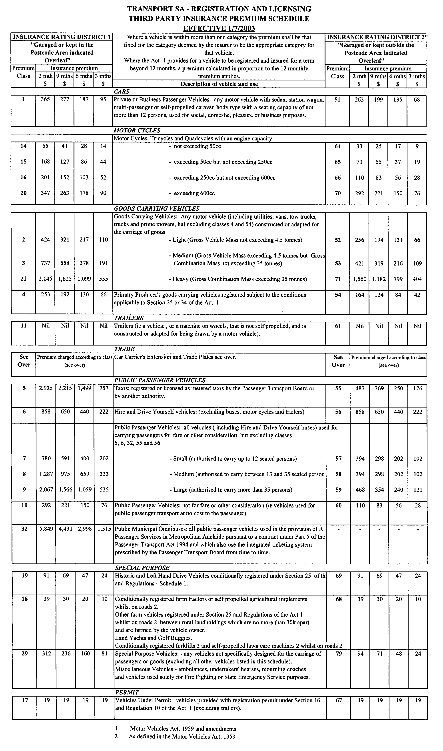
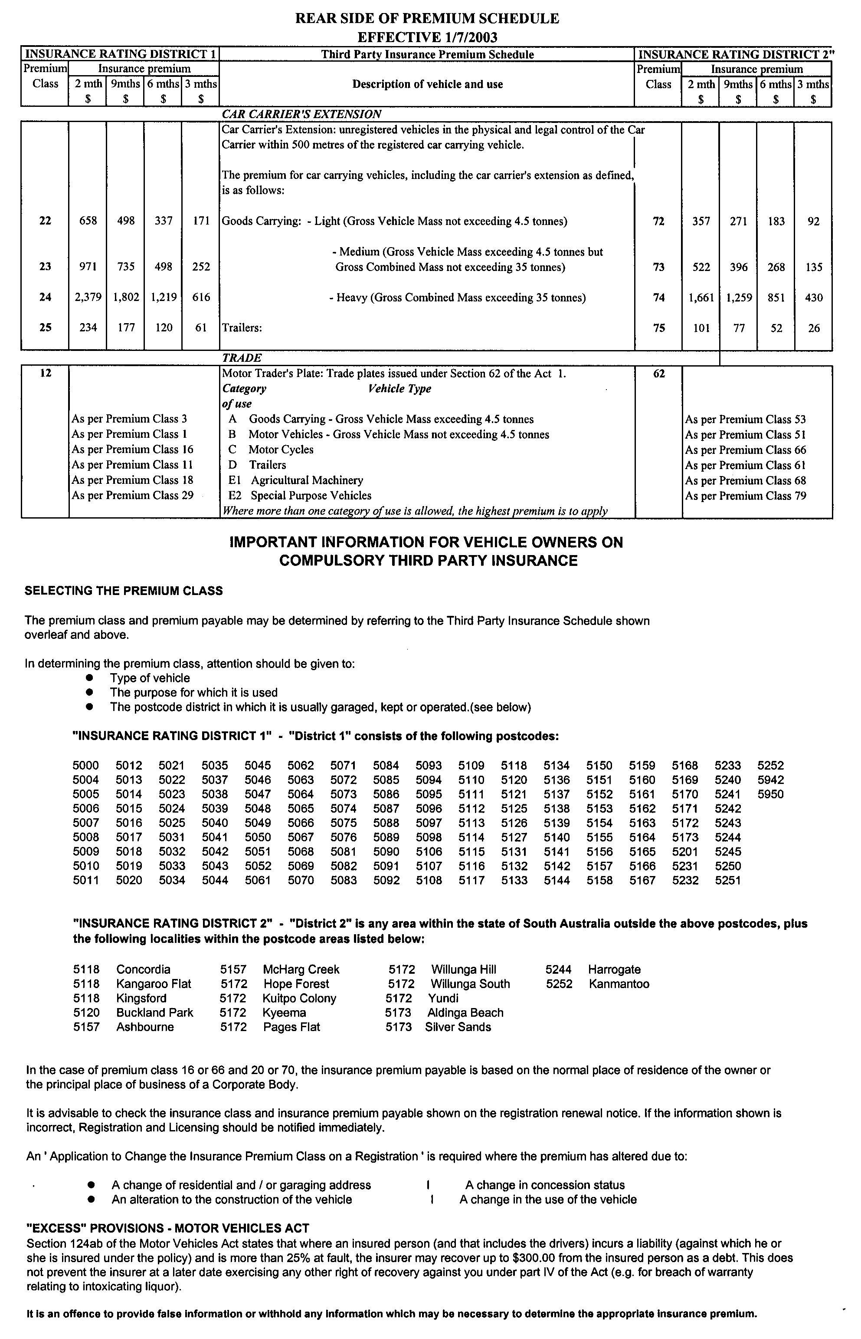
WATER RESOURCES ACT 1997
Notice of Establishment of Levy for the Mallee Prescribed
Wells Area
I, JOHN DAVID HILL, Minister for Environment and Conservation, hereby declare the following levies, payable by persons authorised by a water licence, to take water from prescribed wells within the Mallee Prescribed Wells Area. The levy does not apply where the water is taken for domestic purposes or for the watering of stock not subject to intensive farming.
Pursuant to section 122 (6) and (8) of the Water Resources Act 1997, a levy of 1.0 cent per kilolitre of water allocation specified on the licence where the water is taken for the purpose of providing a reticulated water supply pursuant to the Waterworks Act 1932 is declared.
Pursuant to section 122 (6) and (8) of the Water Resources Act 1997, a levy is payable by persons who are authorised by a water licence to take for irrigation purposes from a prescribed well or wells within the area, at the following rates:
• where the water allocation on the licence is specified as an annual volume in kilolitres, 0.3 cents per kilolitre of the allocation;
• where the water allocation on the licence is specified in Irrigation Equivalents, in the Northern Zone of the Mallee Prescribed Wells Area, $31.50 per hectare Irrigation Equivalent of the allocation or part thereof;
• where the water allocation on the licence is specified in Irrigation Equivalents, in the Southern Zone of the Mallee Prescribed Wells Area, $26 per hectare Irrigation Equivalent of the water allocation or part thereof.
This notice has effect in relation to the financial year commencing on 1 July 2003.
Dated 17 June 2003.
J. D. Hill, Minister for Environment and Conservation

WATER RESOURCES ACT 1997
Notice of Establishment of Levy for the McLaren Vale Prescribed Wells Area
I, JOHN DAVID HILL, Minister for Environment and Conservation, hereby declare a levy, payable by persons authorised by a water licence, to take water from prescribed wells within the McLaren Vale Prescribed Wells Area. The levy does not apply where the water is taken for domestic purposes or for the watering of stock not subject to intensive farming.
Pursuant to section 122 (7) of the Water Resources Act 1997, a levy of 1.0 cent per kilolitre of water taken is declared.
This notice has effect in relation to the financial year commencing on 1 July 2003.
Dated 17 June 2003.
J. D. Hill, Minister for Environment and Conservation

WATER RESOURCES ACT 1997
Notice of Establishment of Levy for the Noora Prescribed
Wells Area
I, JOHN DAVID HILL, Minister for Environment and Conservation, hereby declare a levy, payable by persons authorised by a water licence, to take water from prescribed wells within the Noora Prescribed Wells Area. The levy does not apply where the water is taken for domestic purposes or for the watering of stock not subject to intensive farming.
Pursuant to section 122 (6) of the Water Resources Act 1997, a levy of 0.35 cents per kilolitre of water allocation specified on the water licence is declared.
This notice has effect in relation to the financial year commencing on 1 July 2003.
Dated 17 June 2003.
J. D. Hill, Minister for Environment and Conservation

WATER RESOURCES ACT 1997
Notice of Establishment of Levy for the Angas Bremer Prescribed Wells Area
I, JOHN DAVID HILL, Minister for Environment and Conservation, hereby declare a levy, payable by persons authorised by a water licence, to take water from prescribed wells within the Angas Bremer Prescribed Wells Area. The levy does not apply where the water is taken for domestic purposes or for the watering of stock not subject to intensive farming.
Pursuant to section 122 (6) of the Water Resources Act 1997, a levy of 0.35 cents per kilolitre of water allocation specified on the water licence is declared.
This notice has effect in relation to the financial year commencing on 1 July 2003.
Dated 17 June 2003.
J. D. Hill, Minister for Environment and Conservation

WATER RESOURCES ACT 1997
Notice of Establishment of Levy for the Barossa Prescribed Water Resources Area
I, JOHN DAVID HILL, Minister for Environment and Conservation, hereby declare a levy, payable by persons authorised by a water licence, to take water from the prescribed wells, watercourses and surface water within the Barossa Prescribed Water Resources Area (the Area). The levy does not apply where the water is taken for domestic purposes or for the watering of stock not subject to intensive farming.
Pursuant to section 122 (6) of the Water Resources Act 1997, the following levy is declared:
• where the water allocation on the licence is specified as an annual volume in kilolitres, 1.0 cent per kilolitre of allocation; and
• where the water allocation on the licence is specified as an area of crop, at the following rates:
Crop Type | Levy Rate per  Hectare of  allocation  $
Lucerne/Full Pasture/Fodder | 50
Vegetables | 50
Recreation/lawn | 50
Cut Flowers | 50
Starter pasture | 10
Fruit trees | 10
Stone fruit | 10
Pome fruit | 10
Vines | 10
Eucalypts | 10
Native Trees/Native Flowers | 10
Nursery | 10
Pistachio | 10
Walnuts | 10
Environmental Garden | 10
This notice has effect in relation to the financial year com-mencing on 1 July 2003.
Dated 17 June 2003.
J. D. Hill, Minister for Environment and Conservation

WATER RESOURCES ACT 1997
Notice of Establishment of Levy for the Musgrave and Southern Basins Prescribed Wells Areas
I, JOHN DAVID HILL, Minister for Environment and Conservation, hereby declare a levy, payable by persons authorised by a water licence, to take water from a prescribed well or wells within the Musgrave and/or Southern Basins Prescribed Wells Areas. The levy does not apply where the water is taken for domestic purposes or for the watering of stock not subject to intensive farming.
Pursuant to section 122 (6) of the Water Resources Act 1997, a levy of 2.0 cents per kilolitre for water allocation specified on the water licence is declared.
This notice has effect in relation to the financial year commencing on 1 July 2003.
Dated 17 June 2003.
J. D. Hill, Minister for Environment and Conservation

WATER RESOURCES ACT 1997
Notice of Establishment of Levy for the River Murray
Prescribed Watercourse
I, JOHN DAVID HILL, Minister for Environment and Conservation, hereby declare a levy, payable by persons authorised by a water licence, to take water from the River Murray Prescribed Watercourse. The levy does not apply where the water is taken for domestic purposes or for the watering of stock not subject to intensive farming, or is taken pursuant to a licence, which states that the water is to be taken for environmental purposes.
Pursuant to section 122 (6) and (8) (b) of the Water Resources Act 1997, a levy of 1.0 cent per kilolitre of water allocation specified on the licence where water is taken for the purpose of providing a reticulated water supply pursuant to the Waterworks Act 1932 is declared.
Pursuant to section 122 (6) and (8) (b) of the Water Resources Act 1997, a levy of 0.35 cents per kilolitre for water allocation specified on the licence where the water is not used for the purpose of providing a reticulated water supply pursuant to the Waterworks Act 1932, is declared.
Pursuant to section 122 (6) and (8) (b) of the Water Resources Act 1997 and section 68 of the Ground Water (Qualco-Sunlands) Control Act 2000, a levy of 0.33 cents per kilolitre for water allocation specified on the licence where water is taken and used to irrigate properties within the Qualco-Sunlands Groundwater Control Scheme area.
This notice has effect in relation to the financial year commencing on 1 July 2003.
Dated 17 June 2003.
J. D. Hill, Minister for Environment and Conservation

WATER RESOURCES ACT 1997
Notice of Establishment of Levy for the Northern Adelaide Plains Prescribed Wells Area
I, JOHN DAVID HILL, Minister for Environment and Conservation, hereby declare the following levies, payable by persons authorised by a water licence, to take water from prescribed wells within the Northern Adelaide Plains Prescribed Wells Area. The levy does not apply where the water is taken for domestic purposes or for the watering of stock not subject to intensive farming.
Pursuant to section 122 (6) of the Water Resources Act 1997, a levy of 0.5 cents per kilolitre of water allocation specified on the water licence is declared for the right to take water.
Pursuant to section 122 (7) of the Water Resources Act 1997, a levy of 0.5 cents per kilolitre of water taken is declared.
This notice has effect in relation to the financial year commencing on 1 July 2003.
Dated 17 June 2003.
J. D. Hill, Minister for Environment and Conservation

WATERWORKS ACT 1932
Removal of Land from Yorke Peninsula Country Lands Water District and Addition to Port Vincent Water District
Addition of Land to Port Vincent Water District
PURSUANT to section 6 of the Waterworks Act 1932, the South Australian Water Corporation:
(a) removes from the Yorke Peninsula Country Lands Water District and adds to the Port Vincent Water District all the land contained in allotment 104 in Deposited Plan 54608;
(b) adds to the Port Vincent Water District all the land contained in allotment 101 in Deposited Plan 54608; and
(c) declares that this notice will have effect from 1 July 2003.
Dated 10 June 2003.
Signed for and on behalf of the South Australian Water Corporation by a person duly authorised so to do:
A. Popplewell, General Manager Shared Services
In the presence of:
C. J. McNamara, Billing Manager
SAWATER 03/00858 W1174

WATERWORKS ACT 1932
Removal of Land from Barossa Country Lands Water District
and Addition to Adelaide Water District
PURSUANT to section 6 of the Waterworks Act 1932, the South Australian Water Corporation:
(a) removes from the Barossa Country Lands Water District and adds to the Adelaide Water District all the land contained in:
(i) allotment 100 in Deposited Plan 59900;
(ii) allotment 101 in Deposited Plan 59901; and
(iii) allotments 75 to 90 inclusive, 95, 201 and 202 in Deposited Plan 61406; and
(b) declares that this notice will have effect from 1 July 2003.
Dated 10 June 2003.
Signed for and on behalf of the South Australian Water Corporation by a person duly authorised so to do:
A. Popplewell, General Manager Shared Services
In the presence of:
C. J. McNamara, Billing Manager
SAWATER 03/00853 W1175

WATERWORKS ACT 1932
Removal of Land from Barossa Country Lands Water District
and Addition to Lyndoch Water District
PURSUANT to section 6 of the Waterworks Act 1932, the South Australian Water Corporation:
(a) removes from the Barossa Country Lands Water District and adds to the Lyndoch Water District all the land contained in allotment 3 in Deposited Plan 51493; and
(b) declares that this notice will have effect from 1 July 2003.
Dated 10 June 2003.
Signed for and on behalf of the South Australian Water Corporation by a person duly authorised so to do:
A. Popplewell, General Manager Shared Services
In the presence of:
C. J. McNamara, Billing Manager
SAWATER 03/00859 W1176

South Australia

Co-operatives (Miscellaneous) Amendment (Commencement) Proclamation 2003

Short title
1. This proclamation may be cited as the Co-operatives (Miscellaneous) Amendment (Commencement) Proclamation 2003.

Commencement of Act
2. The Co-operatives (Miscellaneous) Amendment Act 2002 (No 25 of 2002) will come into operation on 1 July 2003.

Made by the Governor
with the advice and consent of the Executive Council
on 19 June 2003.

OCBA015/03

South Australia

Shop Trading Hours (Miscellaneous) Amendment (Commencement) Proclamation 2003

Short title
1. This proclamation may be cited as the Shop Trading Hours (Miscellaneous) Amendment (Commencement) Proclamation 2003.

Commencement of Act
2. The Shop Trading Hours (Miscellaneous) Amendment Act 2003 (No 19 of 2003) will come into operation on 7 July 2003.

Made by the Governor
with the advice and consent of the Executive Council
on 19 June 2003.

MIR-WPS0018/02

South Australia

Dental Practice (Exemption) Proclamation 2003
under section 45 of the Dental Practice Act 2001

Short title
1. This proclamation may be cited as the Dental Practice (Exemption) Proclamation 2003.

Commencement
2. This proclamation comes into operation on the day on which it is made.

Exemption from section 45(1) of Act
3. The persons and bodies specified in the Schedule ("exempt dental services providers") are exempt from section 45(1) of the Act subject to—

(a) a condition that an exempt dental services provider must not provide dental treatment for fee or reward except through the instrumentality of a qualified person; and

(b) a condition that, if there is a change in any of the following particulars, the exempt dental services provider must, within 30 days of the change, give the Minister and the Board notice in writing setting out details of the change:

(i) the exempt dental services provider's full name and business or registered address;

(ii) the registered business names, if any, under which dental treatment is provided by the exempt dental services provider;

(iii) the address of the premises at which dental treatment is provided by the exempt dental services provider;

(iv) the nature of the dental treatment provided by the exempt dental services provider;

(v) the full names and business addresses of the qualified persons through the instrumentality of whom dental treatment is provided by the exempt dental services provider;

(vi) in the case of an exempt dental services provider that is a trust or corporate entity—the full names and addresses of all persons who occupy a position of authority in the trust or corporate entity; and

(c) a condition that, if any of the following events occur, the exempt dental services provider must, within 30 days of the occurrence of the event, give the Minister and the Board notice in writing setting out details of the event:

(i) the exempt dental services provider or, in the case of an exempt dental services provider that is a trust or corporate entity, a person who holds a position of authority in the trust or corporate entity—

(A) is convicted of an offence of dishonesty; or

(B) is suspended or disqualified from practising or carrying on an occupation, trade or business under a law of this State, the Commonwealth, another State or a Territory of the Commonwealth; or
(C) has his or her registration, licence or other authority to provide dental treatment in a place outside this State cancelled or revoked by a person or body responsible under the law of that place for the registration or licensing of persons who provide dental treatment; or

(D) becomes an undischarged bankrupt or becomes subject to a composition or deed or scheme of arrangement with or for the benefit of creditors;

(ii) a body corporate of which—

(A) the exempt dental services provider is a director; or

(B) in the case of an exempt dental services provider that is a trust or corporate entity—a person who holds a position of authority in the trust or corporate entity is a director,

is wound up for the benefit of creditors.

Expiry
4. This proclamation expires on the third anniversary of its commencement.

Schedule—Exempt dental services providers

BHAS Dental Clinic Incorporated
Duggan Dental Castings Pty Ltd trading as Total Denture and Dental Care
GW Evans Dental Laboratory Pty Ltd trading as Performance Mouthguards and Holdfast Dental Clinic
Health-Partners Incorporated
Inkata Pty Ltd trading as Brighton Denture and Dental Clinic
Allan Joslin trading as Marion Denture and Dental Clinic
Derek Robert Juers trading as Natural Denture Clinic (Port Noarlunga)
Timothy Martin trading as Elizabeth South Dental Clinic and Grange Jetty Street Denture and Dental Clinic
Robert Gerrit Storm and Leonard Stuart Storm trading as Storm's Dental Laboratory

Made by the Governor
with the advice and consent of the Executive Council
on 19 June 2003.

DHSCS03/19

South Australia

Local Government (Boundary Adjustment—Adelaide Hills and The Barossa Councils) Proclamation 2003
under sections 9(d) and 11 of the Local Government Act 1999

Short title
1. This proclamation may be cited as the Local Government (Boundary Adjustment—Adelaide Hills and The Barossa Councils) Proclamation 2003.

Commencement
2. This proclamation comes into operation on the day on which it is made.

Boundary adjustment
3. The boundaries of the areas of the Adelaide Hills Council and The Barossa Council are altered so that a part of the common boundary between those areas now follows the centre of the Adelaide—Mannum Road in the manner indicated in the map in the Schedule.

Schedule

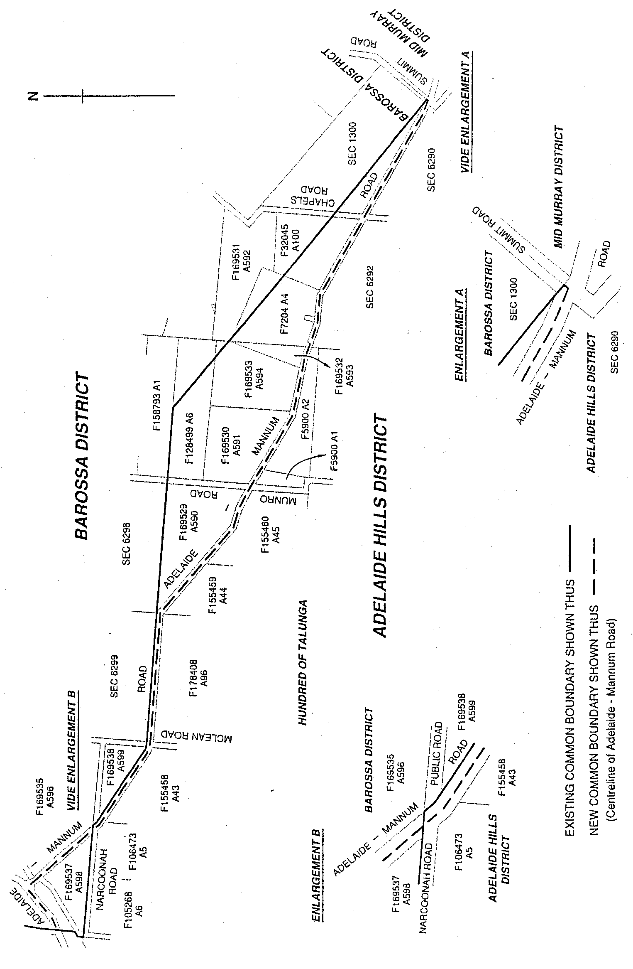

Made by the Governor
on the recommendation of the Boundary Adjustment Facilitation Panel and with the advice and consent of the Executive Council
on 19 June 2003.

COLG2003/0006

South Australia

Mining (Reservation from Act) (Coastal land) Variation Proclamation 2003
under section 8(2) of the Mining Act 1971

Preamble

1. By proclamation made pursuant to the Mining Act 1971 on 19 April 1973 (Gazette 19.4.1973 p 1777, fourth appearing), as varied, certain land along the coast of the State of South Australia is reserved from the operation of certain provisions of that Act.

2. It is now intended that part of that land be excluded from that reservation.

Part 1—Preliminary

Short title
1. This proclamation may be cited as the Mining (Reservation from Act) (Coastal land) Variation Proclamation 2003.

Commencement
2. This proclamation comes into operation on the day on which it is made.

Variation provisions
3. In this proclamation, a provision under a heading referring to the variation of a specified proclamation varies the proclamation so specified.

Part 2—Variation of proclamation under Mining Act 1971 reserving lands from operation of certain provisions of Act (Gazette 19.4.1973 p 1777, fourth appearing) as varied

Variation of Schedule
4. Schedule—after paragraph C insert:

D. The following land is excluded from the reserved land referred to in paragraphs A and B: that piece of land in the Hundreds of Cunningham, Muloowurtie, Curramulka and Ramsay bounded as follows: commencing at a point being the intersection of latitude 34°23˜S and a line parallel to and 800 metres inland from highwater mark, Gulf St Vincent (western side), thence east to a line being low water mark, Gulf St Vincent (western side), thence generally southwesterly along the said line to latitude 34°50˜S, west to a line parallel to and 800 metres inland from highwater mark, Gulf St Vincent (western side), thence generally northeasterly along the said parallel line to the point of commencement, all the within latitudes and longitudes being geodetic and expressed in terms of the Australian Geodetic Datum as defined on p 4984 of Commonwealth Gazette number 84 dated October 6, 1966 (AGD66).

Made by the Governor
with the advice and consent of the Executive Council
on 19 June 2003.

MMRD03/0030CS

South Australia

Motor Accident Commission (Transfer of Residual Assets and Liabilities) Proclamation 2003
under section 30 of the SGIC (Sale) Act 1995

Short title
1. This proclamation may be cited as the Motor Accident Commission (Transfer of Residual Assets and Liabilities) Proclamation 2003.

Commencement
2. This proclamation comes into operation on 30 June 2003.

Definitions and interpretation
3. (1) In this proclamation, unless the contrary intention appears—

"Act" means the SGIC (Sale) Act 1995;

"Homestart" means the former body corporate Homestart Finance Limited ACN 008 272 437 dissolved by clause 3 of Schedule 2 of the Housing and Urban Development (Administrative Arrangements) Act 1995 and includes the Minister for Housing and any other successor in title to Homestart Finance Limited and the Minister for Housing;

"MAC" means the body corporate originally established as the State Government Insurance Commission and continued in existence as the Motor Accident Commission by the Motor Accident Commission Act 1992;

"SAAMC" means the body corporate continued in existence as the South Australian Asset Management Corporation by the State Bank of South Australia Act 1983;

"SAICORP" means the body corporate known as South Australian Government Captive Insurance Corporation established as a subsidiary of the Treasurer by the Public Corporations (Treasurer) Regulations 1994 made under the Public Corporations Act 1993;

"Transfer Date" means the date on which this proclamation comes into operation;

"Transfer Order" means the order made by the Treasurer under section 8 of the Act on 4 July 1995;

"Transferee" means each of SAAMC and SAICORP.

(2) Words and phrases defined in the Act but not defined in this proclamation have the same meaning in this proclamation.

(3) In this proclamation, unless the contrary intention appears—

(a) a reference to a contract, covenant, arrangement or agreement is a reference to a contract, covenant, arrangement or agreement notwithstanding that by its terms it is expressed to be or is by its nature personal or for any other reason not capable of assignment;

(b) a reference to an asset or property is a reference to an asset or property subject to all equities having priority over the rights of MAC as at the Transfer Date;
(c) a reference to a right, title and interest in any property of MAC is a reference to all the estate, right, title, interest, claim and defined which MAC has in, to or in the property the subject of this proclamation or expressed or intended to be and which MAC has power to transfer or convey;

(d) references to this proclamation or any other order, deed, agreement or instrument will be taken to include references to this proclamation, or such other order, deed, agreement or instrument as amended, novated, supplemented, varied or replaced from time to time;

(e) references to a person in this proclamation will be taken to include, where the person is a natural person, the personal representatives and permitted assigns of that person and, where a body corporate, its successors in title and permitted assigns.

Breaches of contract
4. (1) The Transferee will be liable for all breaches of any contract, agreement, arrangement or undertaking committed prior to the Transfer Date by MAC in respect of any asset transferred to the Transferee by this proclamation.

(2) The Transferee will be entitled to the benefit of all breaches of any contract, agreement, arrangement or undertaking transferred by this proclamation to the Transferee to which MAC is a party committed prior to the Transfer Date by any person that MAC would, apart from this proclamation, be entitled to.

Transfer
5. Pursuant to section 30 of the Act, I hereby transfer—

(a) the assets and liabilities described in Schedule 1 to SAAMC; and

(b) the assets and liabilities described in Schedule 2 to SAICORP.

Persons bound
6. This proclamation is binding—

(a) in respect of the assets and liabilities described in Schedule 1 of this proclamation, on—

(i) MAC;

(ii) SAAMC;

(iii) any person named as insured in the policies described in Schedule 1;

(iv) any person having rights under, or in relation to, the policies described in Schedule 1; and

(b) in respect of the assets and liabilities described in Schedule 2 of this proclamation, on—

(i) MAC;

(ii) SAICORP;

(iii) any person named as insured in the policies described in Schedule 2; and

(iv) any person having rights under, or in relation to, the policies described in Schedule 2.
Schedule 1

Item 1 All mortgage insurance policies issued in the name of State Government Insurance Commission as insurer and various financial institutions as insured, other than policies:

(a) transferred by the Transfer Order; or

(b) issued to Homestart as insured; or

(c) in relation to which Homestart is the beneficiary or has a beneficial interest.

Item 2 All workers compensation policies issued in the name of State Government Insurance Commission as insurer and various employers as insured, other than policies transferred by the Transfer Order.

Item 3 All liabilities arising under the policies described in Item 1 and Item 2.

Item 4 The amount held in reserve by MAC on the Transfer Date in relation to liabilities arising under the policies described in Item 1 and Item 2.
Schedule 2

Item 1 All policies described in the Act as Part A policies issued in the name of State Government Insurance Commission as insurer and various persons as insured, other than policies transferred by the Transfer Order.

Item 2 All liabilities arising under any of the policies described in Item 1.

Made by the Governor
with the advice and consent of the Executive Council
on 19 June 2003.

T&F03/063CS
South Australia

Shop Trading Hours (Miscellaneous) Amendment (Transitional Provision) Proclamation 2003
under clause 3 of the Schedule of the Shop Trading Hours (Miscellaneous) Amendment Act 2003

Short title
1. This proclamation may be cited as the Shop Trading Hours (Miscellaneous) Amendment (Transitional Provision) Proclamation 2003.

Commencement
2. This proclamation will come into operation on 7 July 2003.

Transitional provision—fixing of day
3. For the purposes of clause 3 of the Schedule of the Shop Trading Hours (Miscellaneous) Amendment Act 2003, 7 July 2003 is fixed.

Made by the Governor
with the advice and consent of the Executive Council
on 19 June 2003.

MIR-WPS0018/02
South Australia

Co-operatives Variation Regulations 2003
under the Co-operatives Act 1997

Contents

Part 1—Preliminary

1. Short title
2. Commencement
3. Variation provisions

Part 2—Variation of the Co-operatives Regulations 1997 (Gazette 20.11.1997 p 1365) as varied

4. Insertion of regulation 5A
5A. Implied application of Part 9.4B of Corporations Act
5. Variation of regulation 12—Application of Corporations Act concerning officers of co-operatives and related duties
6. Substitution of regulation 13
13. Requirements for financial records, statements and reports
7. Revocation of regulation 27
8. Variation of Schedule 5

Part 1—Preliminary

Short title
1. These regulations may be cited as the Co-operatives Variation Regulations 2003.

Commencement
2. These regulations will come into operation on 1 July 2003.

Variation provisions
3. In these regulations, a provision under a heading referring to the variation of specified regulations varies the regulations so specified.

Part 2—Variation of the Co-operatives Regulations 1997 (Gazette 20.11.1997 p 1365) as varied

Insertion of regulation 5A
4. After regulation 5 insert:

Implied application of Part 9.4B of Corporations Act
5A. A reference in Part 9.4B of the Corporations Act to a corporation is, insofar as that Part applies for the purposes of the Co-operatives Act 1997, taken to be a reference to a co-operative.

Variation of regulation 12—Application of Corporations Act concerning officers of co-operatives and related duties
5. (1) Regulation 12—after "were omitted" insert:

and "before the commencement of section 52 of the Co-operatives (Miscellaneous) Amendment Act 2002" were substituted

(2) Regulation 12—after its present contents as varied by this regulation (now to be designated as subregulation (1)) insert:

(2) Pursuant to paragraph (c) of section 333 of the Act, section 588G of the Corporations Act is modified in its application under that section as if paragraph (d) of subsection (1) were omitted and the following paragraph substituted:

(d) that time is at or after the commencement of section 52 of the Co-operatives (Miscellaneous) Amendment Act 2002.

Substitution of regulation 13
6. Regulation 13—delete the regulation and substitute:

Requirements for financial records, statements and reports
13. (1) A co-operative is declared to be an applied Corporations legislation matter for the purposes of Part 3 of the Corporations (Ancillary Provisions) Act 2001 in relation to the provisions of section 198F, Part 2F.3, sections 249K, 249V and 250T and Parts 2M.2, 2M.3, 2M.4 and 2M.7 of the Corporations Act, subject to the following modifications:

(a) the modifications specified in the Co-operatives Act 1997 and Schedule 2A of these regulations;

(b) sections 247A and 300(14) and (15) of the Corporations Act are modified in their application under this regulation as if any reference to section 237 of that Act were a reference to section 95 of the Co-operatives Act 1997.

(2) For the purposes of section 233(1) of the Act, a co-operative must—

(a) keep financial records and prepare financial statements and reports as required by the provisions of the Corporations Act applied by this regulation (as modified); and

(b) ensure that those financial statements and financial reports are audited in accordance with the provisions of the Corporations Act applied by this regulation (as modified).

Revocation of regulation 27
7. Regulation 27—delete the regulation

Variation of Schedule 5
8. Schedule 5—after item 12 insert:

12A. Application to Commission for exemption (section 144B) $238

Note—
As required by section 10AA(2) of the Subordinate Legislation Act 1978, the Minister has certified that, in the Minister's opinion, it is necessary or appropriate that these regulations come into operation as set out in these regulations.

Made by the Governor
with the advice and consent of the Executive Council
on 19 June 2003.

No. 149 of 2003

South Australia

Training and Skills Development Regulations 2003
under the Training and Skills Development Act 2003

Contents

1. Short title
2. Commencement
3. Interpretation
4. Fees

Schedule—Revocation of Vocational Education, Employment and Training Regulations 1996 (Gazette 2.5.1996 p 2414)

Short title
1. These regulations may be cited as the Training and Skills Development Regulations 2003.

Commencement
2. These regulations will come into operation on the day on which the Training and Skills Development Act 2003 comes into operation.

Interpretation
3. In these regulations—

"Act" means the Training and Skills Development Act 2003.

Fees
4. (1) The Minister may fix fees payable to the Minister for the performance of the Minister's functions under section 5(1) of the Act.

(2) The Minister may fix fees payable to the Minister for the performance of the Commission's functions under the Act, including the following:

(a) functions assigned to the Commission under Part 3 of the Act relating to training organisations and courses, including—

(i) the registration of a person as a training organisation; and

(ii) the renewal of the registration of a training organisation; and

(iii) the variation of the registration of a training organisation; and

(iv) the accreditation of a course; and

(v) the renewal of the accreditation of a course;

(b) functions assigned to the Commission under Part 4 of the Act relating to the regulation of contracts of training;

(c) functions assigned to the Commission under Part 5 of the Act relating to the recognition of the competency of persons and the granting of qualifications or statements certifying the competency.

(3) The Minister may—

(a) waive or reduce (in a particular case or classes of cases) fees that would otherwise be payable under this regulation; and

(b) refund (in whole or in part) a fee paid under this regulation.

(4) The Minister may recover a fee payable under this regulation as a debt.
Schedule—Revocation of Vocational Education, Employment and Training Regulations 1996 (Gazette 2.5.1996 p 2414)

The Vocational Education, Employment and Training Regulations 1996 (see Gazette 2.5.1996 p 2414) are revoked.

Note—
As required by section 10AA(2) of the Subordinate Legislation Act 1978, the Minister has certified that, in the Minister's opinion, it is necessary or appropriate that these regulations come into operation as set out in these regulations.

Made by the Governor
with the advice and consent of the Executive Council
on 19 June 2003.

No. 150 of 2003
METAFE23/02CS

South Australia

Medical Practitioners Variation Regulations 2003
under the Medical Practitioners Act 1983

Contents

Part 1—Preliminary

1. Short title
2. Commencement
3. Variation provisions

Part 2—Variation of Medical Practitioners Regulations 1999 (Gazette 26.8.1999 p 986) as varied

4. Variation of Schedule 5—Fees

Part 1—Preliminary

Short title
1. These regulations may be cited as the Medical Practitioners Variation Regulations 2003.

Commencement
2. These regulations will come into operation on 1 October 2003.

Variation provisions
3. In these regulations, a provision under a heading referring to the variation of specified regulations varies the regulations so specified.

Part 2—Variation of Medical Practitioners Regulations 1999 (Gazette 26.8.1999 p 986) as varied

Variation of Schedule 5—Fees
4. (1) Schedule 5, clause 8—delete "$280" and substitute:

$300

(2) Schedule 5, clause 8—delete "$210" and substitute:

$250

(3) Schedule 5, clause 8—delete "$170" and substitute:

$200

(4) Schedule 5, clause 8—delete "$120" and substitute:

$150

Note—
As required by section 10AA(2) of the Subordinate Legislation Act 1978, the Minister has certified that, in the Minister's opinion, it is necessary or appropriate that these regulations come into operation as set out in these regulations.

Made by the Governor
with the advice and consent of the Executive Council
on 19 June 2003.

No. 151 of 2003
CAB/MGR/0006

South Australia

Recognised Hospital (Medicare Patients) Fees Variation Regulations 2003
under the South Australian Health Commission Act 1976

Contents

Part 1—Preliminary

1. Short title
2. Commencement
3. Variation provisions

Part 2—Variation of Recognised Hospital (Medicare Patients) Fees Regulations 2002 (Gazette 29.8.2002 p 3256)

4. Substitution of regulation 1
1. Short title
5. Variation of Schedule—Fees for services provided to Medicare patients at recognised hospitals

Part 1—Preliminary

Short title
1. These regulations may be cited as the Recognised Hospital (Medicare Patients) Fees Variation Regulations 2003.

Commencement
2. These regulations will come into operation on 1 July 2003.

Variation provisions
3. In these regulations, a provision under a heading referring to the variation of specified regulations varies the regulations so specified.

Part 2—Variation of Recognised Hospital (Medicare Patients) Fees Regulations 2002 (Gazette 29.8.2002 p 3256)

Substitution of regulation 1
4. Regulation 1—delete the regulation and substitute:

Short title
1. These regulations may be cited as the South Australian Health Commission (Recognised Hospital—Medicare Patients Fees) Regulations 2002.

Variation of Schedule—Fees for services provided to Medicare patients at recognised hospitals
5. (1) Schedule, clause 2—delete "$242.00" and substitute:

$250.00

(2) Schedule, clause 4(a)—delete "$175.00" and substitute:

$181.00

(3) Schedule, clause 4(b)—delete "$200.00" and substitute:

$207.00

(4) Schedule, clause 4(c)—delete "$219.00" and substitute:

$226.00

(5) Schedule, clause 4(d)—delete "$242.00" and substitute:

$250.00

(6) Schedule, clause 7—delete "$82.50" and substitute:

$85.50

Note—
As required by section 10AA(2) of the Subordinate Legislation Act 1978, the Minister has certified that, in the Minister's opinion, it is necessary or appropriate that these regulations come into operation as set out in these regulations.

Made by the Governor
on the recommendation of the Minister for Health and with the advice and consent of the Executive Council
on 19 June 2003.

No. 152 of 2003
DHSCS 03/25

FAXING COPY?

IF you fax copy to Government Publishing SA for inclusion in the Government Gazette, there is no need to send a Confirmation Copy to us as well.

This creates confusion and may well result in your notice being printed twice.

Please use the following fax number:

Fax transmission: (08) 8207 1040
Phone Inquiries: (08) 8207 1045

Please include a contact person, phone number and order number so that we can phone back with any queries we may have regarding the fax copy.

NOTE: Closing time for lodging new copy (either fax or hard copy) is 4 p.m. on Tuesday preceding the day of publication.

Government Gazette notices can be E-mailed.

The address is:

governmentgazette@saugov.sa.gov.au

Documents should be sent as attachments in Word format.

When sending a document via E-mail, please confirm your transmission with a faxed copy of your document, including the date the notice is to be published.

Fax transmission: (08) 8207 1040
Enquiries: (08) 8207 1045

CITY OF ADELAIDE
Road Closures
NOTICE is hereby given that council at its meeting held on Tuesday, 10 June 2003, adopted the following resolutions:
‘That:
(1) Pursuant to section 359 (1) of the Local Government Act 1934, as amended, and section 32 of the Road Traffic Act 1961, all vehicles other than those vehicles indicated in Column 3 below shall be excluded from the road so named in Column 1:
Column 1 Bath Lane (east-west section).
Column 2 From the western building alignment of Pulteney Street to a point 17 m west of the western building alignment of Pulteney Street.
Column 3 Those vehicles owned or operated or authorised by Build Tec Services. Any vehicle owned or operated by Adelaide City Council for the purposes of street cleaning and maintenance.
(2) Adjacent residents and businesses be advised accordingly.’
‘That:
(1) Pursuant to section 359 (1) of the Local Government Act 1934, as amended, and section 32 of the Road Traffic Act 1961, all vehicles other than those vehicles indicated in Column 3 below shall be excluded from the road so named in Column 1:
Column 1 Austin Street (north-south section).
Column 2 From a point 10 m south of the southern building alignment of North Terrace to a point 90.8 m west of the western building alignment of Pulteney Street.
Column 3 Those vehicles owned or operated or authorised by Built Environs or John Hindmarsh. Any vehicle owned or operated by Adelaide City Council for the purposes of street cleaning and maintenance.
(2) Adjacent residents and businesses be advised accordingly.’
Dated 19 June 2003.
Susan Law, Chief Executive Officer

CITY OF WEST TORRENS
Roads (Opening and Closing) Act 1991
Road Closures
NOTICE is hereby given pursuant to section 10 of the Roads (Opening and Closing) Act 1991, that the City of West Torrens proposes to make a Road Process Order to close those portions of St Anton Street marked ‘A’ and ‘B’ on Preliminary Plan No. 03/0052. The closed road marked ‘A’ is to be merged with Allotment 134 in Filed Plan 19271, Hundred of Adelaide. The closed road marked ‘B’ is to be merged with Allotment 135 in Filed Plan 19271, Hundred of Adelaide.
The preliminary plan and associated statements prepared pursuant to section 9 of the Roads (Opening and Closing) Act 1991 are available for examination to the public at the office of the City of West Torrens, 165 Sir Donald Bradman Drive, Hilton and at the Adelaide office of the Surveyor-General, 101 Grenfell Street, Adelaide, during normal office hours.
Any person who wishes to object to this proposal may lodge a written objection to the City of West Torrens, 165 Sir Donald Bradman Drive, Hilton, S.A. 5033 and a copy forwarded to the Surveyor-General, 101 Grenfell Street, Adelaide, S.A. 5000 within 28 days of the date of this notice. Any objectors must include their full name and address, stating their reasons for objecting and stating whether or not they wish to make submissions to the City of West Torrens at a meeting convened to consider such objections.
Any land owner adjoining or other person substantially affected by the closure may apply for an easement over all or part of the proposed road closure. Such application shall be in writing to the City of West Torrens, 165 Sir Donald Bradman Drive, Hilton, S.A. 5033 and a copy must be forwarded to the office of the Surveyor-General, 101 Grenfell Street, Adelaide, S.A. 5000 within 28 days of the date of this notice. The applicants must include their full name and address giving particulars of the nature and location of the easement being applied for, specifying the land to which the easement is to be annexed and stating the reasons for the application for easement.
T. Starr, Chief Executive Officer

THE BAROSSA COUNCIL
Roads (Opening and Closing) Act 1991
Road Closing, Hoffman Road, Tanunda
NOTICE is hereby given pursuant to section 10 of the said Act, that council proposes to make a Road Process Order to close and transfer to Peter Lehmann Wines Ltd (subject to a drainage easement), the public road (Hoffman Road) north of Para Road and adjacent allotment 845 in Filed Plan 105653 shown lettered ‘A’ on Preliminary Plan No. 03/0046.
A copy of the plan and statement of persons affected are available for public inspection at the Council’s Office, 1 Washington Street, Angaston and the office of the Surveyor-General, 101 Grenfell Street, Adelaide during normal office hours.
Any application for easement or objection must be made in writing within 28 days from 19 June 2003, to the council at P.O. Box 295, Angaston, S.A. 5353 and the Surveyor-General, G.P.O. Box 1354, Adelaide, S.A. 5001, setting out full details.
Where a submission is made, council will give notification of a meeting to deal with the matter.
J. G. Jones, Chief Executive Officer

DISTRICT COUNCIL OF KAROONDA EAST MURRAY
Adoption of Valuation and Declaration of Rates
NOTICE is hereby given that at its meeting held on Tuesday, 10 June 2003, the council in accordance with section 167 (2) (a) of the Local Government Act 1999, made a valuation of all properties within the district for the year ending 30 June 2003, by adopting the most recent capital valuation as supplied by the Valuer-General, and that such valuation to become and be the valuation of the council for the 2003-2004 financial year:
$
Rateable 84 205 924
Non-Rateable 4 717 496
Total $88 923 420
Service Charge—Common Effluent Drainage Scheme
Pursuant to section 155 of the Local Government Act 1999, the council declared the following service charges to be payable by owners or occupiers as set out thereunder, in respect to the financial year ending 30 June 2004:
Occupied Properties $60
Vacant Properties $35
Declaration of Rates
Pursuant to section 153 of the Local Government Act 1999, the council did on 10 June 2003, declare a general rate of 0.801 cents in the dollar on the capital value of all rateable land within the area for the 2003-2004 financial year.
Minimum Amount Payable by Way of Rates
Pursuant to section 158 (1) of the Local Government Act 1999, the council resolved that the minimum amount payable by way of rates in respect of rateable land within the area for the 2003-2004 financial year shall be $80.
Payment of Rates
Pursuant to section 181 (1) (c) of the Local Government Act 1999, the council resolved that the rates for the year ending 30 June 2004, will fall due in four instalments on 12 September 2003, 12 December 2003, 12 March 2004 and 13 June 2004.
To encourage prompt payment of rates council offers a discount of 5 per cent on all rates paid in full by 12 September 2003.
P. Smithson, Chief Executive Officer

DISTRICT COUNCIL OF KAROONDA EAST MURRAY
Results of Supplementary Election Karoonda Ward—
Nominations Received
NOTICE is hereby given that at the close of nominations at 12 noon on Thursday, 12 June 2003, the following person was nominated and elected as a candidate unopposed:
Ward Councillor for Karoonda Ward (1 vacancy):
Wooldridge, William John (elected unopposed)
Campaign Donations Return
Candidates must forward a campaign donations return to the Council Chief Executive Officer within six weeks after the conclusion of the election.
Steve Tully, Returning Officer

IN the matter of the estates of the undermentioned deceased persons:
Bain, William, late of 324 Military Road, Semaphore Park, retired panel beater, who died on 27 April 2003.
Barnett, Inez Joan, late of 61-63 Oxford Terrace, Port Lincoln, widow, who died on 25 March 2003.
Bradley, Louie Daphne, late of 40 Winchester Street, Malvern, of no occupation, who died on 9 May 2003.
Castle, Nina, late of 4 Roxburgh Court, Epping, Victoria, home duties, who died on 18 January 2003.
Fitzgerald, Margaret Philomena, late of 109 Regency Road, Croydon Park, home duties, who died on 24 April 2003.
Gow, Sidney Ruth, late of 97 Mentone Road, Hayborough, married woman, who died on 7 May 2003.
Haines, Gladys Emily Nellie, late of 54 Buxton Street, North Adelaide, widow, who died on 24 March 2003.
Helling, Percival John, late of Sturdee Street, Linden Park, of no occupation, who died on 4 September 2002.
Khan, Raymond Barry, late of 10 Palmer Street, Collingwood, Victoria, rigger, who died on 10 August 1983.
Lines, Avis May, late of 7 Victoria Street, Goodwood, widow, who died on 18 March 2003.
Lyon, Flora McDonald, late of Yakkalla Street, Bateau Bay, New South Wales, of no occupation, who died on 25 February 2003.
McBride, Lizzetta May, late of West Terrace, Quorn, of no occupation, who died on 22 April 2003.
Panuccio, Giorgio Domenico, late of 187 Tapleys Hill Road, Seaton, retired market gardener, who died on 15 December 2001.
Pilkington, Vincent James, late of 7 Partridge Street, Goolwa, retired naval officer, who died on 20 March 2003.
Weller, Douglas Barrey, late of 20 Norseman Avenue, Westbourne Park, retired salesman, who died on 19 April 2003.
Wenzel, Barry John, late of 38 David Street, Happy Valley, retired graphic reproducer, who died on 14 August 2002.
Notice is hereby given pursuant to the Trustee Act 1936, as amended, the Inheritance (Family Provision) Act 1972, and the Family Relationships Act 1975, that all creditors, beneficiaries, and other persons having claims against the said estates are required to send, in writing, to the Public Trustee, 25 Franklin Street, Adelaide 5000, full particulars and proof of such claims, on or before 18 July 2003, otherwise they will be excluded from the distribution of the said estate; and notice is also hereby given
that all persons who are indebted to the said estates are required to pay the amount of their debts to the Public Trustee or proceedings will be taken for the recovery thereof; and all persons having any property belonging to the said estates are forthwith to deliver the same to the Public Trustee.
Dated 19 June 2003.
C. J. O’Loughlin, Public Trustee

IN the matter of the estates of the undermentioned deceased persons:
Richardson, George William, late of 6 Muscatel Avenue, Wattle Park, retired bank manager, who died on 22 April 2003.
Gow, Gregory Neil, late of O’Connell Avenue and Randell Road, Hindmarsh Island, company director, who died on 15 May 2003.
Notice is hereby given pursuant to the Trustee Act 1936, as amended, the Inheritance (Family Provision) Act 1972 and the Family Relationships Act 1975, that all creditors, beneficiaries, and other persons having claims against any of the above estates are directed to send full particulars and evidence of such claims to the undersigned on or before 18 July 2003, otherwise they will be excluded from the distribution of the estate; and notice is also hereby given that all persons who are indebted to any of the above estates are required to pay the amount of their debt to the undersigned or proceedings will be taken for the recovery thereof; and all persons having any property belonging to any of the said estates are forthwith to deliver the same to the undersigned.
Dated 19 June 2003.
ANZ Executors & Trustee Company Limited (ACN 006 132 332), 530 Collins Street, Melbourne, Vic. 3000

ESTATE OF KARLIS GARSEVICS (DECEASED)
NOTICE is hereby given that a Master of the Supreme Court of South Australia has, pursuant to the Trustee Act 1936, as amended, directed that all creditors, beneficiaries and other persons having claims against the estate of Karlis Garsevics, late of Kings Park Nursing Home, 285 Goodwood Road, Kings Park, S.A. 5034, deceased, who died at Kings Park aforesaid on 20 May 2001 and letters of administration of whose estate were granted on 18 February 2002 to Biruta Irbe, 22 Second Avenue, Seaton, S.A. 5023, the lawful attorney of Ruta Priede, Flat 10, 19 Birzu Street, Bauska in Latvia for the use and benefit of the said Ruta Priede and until she shall duly apply for and obtain letters of administration of the estate of the said deceased are directed to send full particulars in writing of their claims to the undersigned on or before 20 August 2003, otherwise they will be excluded from the distribution of the said estate.
Dated 19 June 2003.
Inga R. Berzins & Associates, Solicitors, 356 Unley Road, Unley Park, S.A. 5061

SALE OF PROPERTY
Auction Date: Wednesday, 9 July 2003 at 10 a.m.
Location: Government Auctions SA
47 Transport Avenue, Netley
NOTICE is hereby given that on the above date at the time and place stated, by virtue of Orders for Sale issued by the Fines Payment Unit of South Australia, Penalty No. AMC-99-1635/2 and others, are directed to the Sheriff of South Australia in an Action wherein Richard Gwynne Phillips is the Defendant, I, Tim Goodes, Sheriff of the State of South Australia, will by my auctioneers, Government Auctions SA make sale of the following:
Mitsubishi Colt XL
Registration No. UAT 121

SALE OF PROPERTY
Auction Date: Wednesday, 9 July 2003 at 10 a.m.
Location: Government Auctions SA
47 Transport Avenue, Netley
NOTICE is hereby given that on the above date at the time and place stated, by virtue of Orders for Sale issued by the Fines Payment Unit of South Australia, Penalty No. EXREG-98-8188/1 and others, are directed to the Sheriff of South Australia in an Action wherein Samuel Stanischewski is the Defendant, I, Tim Goodes, Sheriff of the State of South Australia, will by my auctioneers, Government Auctions SA make sale of the following:
Toyota Celica
Registration No. VNN 367

SALE OF PROPERTY
Auction Date: Friday, 11 July 2003 at 11 a.m.
Location: 3 Flight Street, Morphett Vale.
NOTICE is hereby given that on the above date at the time and place stated, by virtue of Warrant of Sale issued out of the Magistrates Court of South Australia, Action No. AMCCI 165 of 2003, directed to the Sheriff of South Australia in an action wherein Australian Central Credit Union Ltd is the Plaintiff and Timothy J. Brown and Leah Ann Priest are the Defendants, I, Tim Goodes, Sheriff of the State of South Australia, will by my auctioneers, Griffin Real Estate, make sale of the estate, right, title or interest whatsoever it may be of the Defendants Timothy J. Brown and Leah Ann Priest as the registered proprietors of an estate in fee simple in the following:
That piece of land situated in the area named Morphett Vale, being 3 Flight Street, being the property comprised in certificate of title register book volume 5222, folio 205.
Further particulars from the auctioneers.
Griffin Real Estate, 179 King William Street, Hyde Park, S.A. 5061. Telephone 8357 3177.

SALE OF PROPERTY
Auction Date: Thursday, 10 July 2003 at 1 p.m.
Location: 73 Conroy Street, Port Augusta.
NOTICE is hereby given that on the above date at the time and place stated, by virtue of Warrant of Sale issued out of the Magistrates Court of South Australia, Action No. PAUCI 95 of 2002, directed to the Sheriff of South Australia in an action wherein Joseph Guidolin and P. A. Guidolin trading as J. & P. A. Guidolin Carpentry is the Plaintiff and Stelios Kafetzis is the Defendant, I, Tim Goodes, Sheriff of the State of South Australia, will by my auctioneers, Century 21, make sale of the estate, right, title or interest whatsoever it may be of the Defendant Stelios Kafetzis as the registered proprietor of an estate in fee simple in the following:
That piece of land situated in the area named Port Augusta, being 73 Conroy Street, being the property comprised in certificate of title register book volume 5815, folio 803.
Further particulars from the auctioneers.
Century 21, 10 Mackay Street, Port Augusta, S.A. 5700. Telephone (08) 8642 3322

ATTENTION

CUSTOMERS requiring a proof of their notice for inclusion in the Government Gazette, please note that the onus is on you to inform Government Publishing SA of any subsequent corrections by 10 a.m. on Thursday, which is our publication deadline.

For any corrections to your notice please phone 8207 1045 or Fax 8207 1040 before 10 a.m. on Thursday.

If we do not receive any communication by 10 a.m. on Thursday (day of publication) we will presume the notice is correct and will print it as it is.

Remember—the onus is on you to inform us of any corrections necessary to your notice.

NOTE: Closing time for lodging new copy (electronically, fax or hard copy) is 4 p.m. on Tuesday preceding the day of publication. Phone 8207 1045—Fax 8207 1040.
Email: governmentgazette@saugov.sa.gov.au

Printed and published by authority every Thursday by J. D. FERGUSON, Government Printer, South Australia
Price: $4.55, plus postage; to subscribers, $229.00 per annum.
(The above prices are inclusive of GST)

