No. 24 1047

THE SOUTH AUSTRALIAN

GOVERNMENT GAZETTE

PUBLISHED BY AUTHORITY

ALL PUBLIC ACTS appearing in this GAZETTE are to be considered official, and obeyed as such

ADELAIDE, THURSDAY, 20 MARCH 2003

CONTENTS

Page
Appointments, Resignations, Etc. 1048
Building Work Contractors Act 1995—Notice 1048
Corporations and District Councils—Notices 1114
Crown Lands Act 1929—Notices 1049
Development Act 1993—Notices 1050
Environment Protection Act 1993—Notice 1058
Equal Opportunity Tribunal—Notice 1054
Fisheries Act 1982—Notices 1054
Geographical Names Act 1991—Notice 1055
Harbors and Navigation Act 1993—Notices 1059
Land Acquisition Act 1969—Notices 1060
Land and Business (Sale and Conveyancing) Act 1994—
Notices 1060
Liquor Licensing Act 1997—Notices 1061
Mining Act 1971—Notice 1063
Mount Gambier Circuit Court—Notice 1049
Optometrists Act 1920—Register 1063

Page
Private Advertisements 1121
Public Trustee Office—Administration of Estates 1120

REGULATIONS
Local Government Act 1999—
(No. 23 of 2003) 1095
City of Adelaide Act 1998 (No. 24 of 2003) 1097
Local Government Act 1934 (No. 25 of 2003) 1099
Workers Rehabilitation and Compensation
Act 1986 (No. 26 of 2003) 1100
Water Resources Act 1997 (No. 27 of 2003) 1111
Roads (Opening and Closing) Act 1991—Notices 1066
Rules of Court 1069
Veterinary Surgeons Act 1985—Registers 1070
Vocational Education, Employment and Training
Act 1994—Notice 1092
Water Mains and Sewers—Mains Laid, Replaced, Etc 1067

GOVERNMENT GAZETTE NOTICES
ALL poundkeepers’ and private advertisements forwarded for publication in the South Australian Government Gazette must be PAID FOR PRIOR TO INSERTION; and all notices, from whatever source, should be legibly written on one side of the paper only and sent to Government Publishing SA so as to be received no later
than 4 p.m. on the Tuesday preceding the day of publication. Phone 8207 1045 or Fax 8207 1040. E-mail: governmentgazette@saugov.sa.gov.au. Send as attachments in Word format and please confirm your transmission with a faxed copy of your document, including the date the notice is to be published and to whom the notice will be charged.

Department of the Premier and Cabinet
Adelaide, 20 March 2003
HER Excellency the Governor in Executive Council has been pleased to appoint the undermentioned to the Physiotherapists Board of South Australia, pursuant to the provisions of the Physiotherapists Act 1991:
Member: (from 20 March 2003 until 19 March 2006)
Alison Adair
Andrew John Potter
Barbara Garrett
Ruth Grant
Grant William Barron
Alison Bell
Anna Gisela Maria Van Kessel
By command,
J. W. Weatherill, for Premier
MHEA-MGR 0030 CS

Department of the Premier and Cabinet
Adelaide, 20 March 2003
HER Excellency the Governor in Executive Council has been pleased to appoint the undermentioned to the Dog Fence Board, pursuant to the provisions of the Dog Fence Act 1946:
Member: (from 20 March 2003 until 19 March 2007)
Donald Andrew Nicolson
Mark David Ramsey
James Ranembe Morgan
Jock Hugh MacLachlan
Phillip Alfred Trowbridge
By command,
J. W. Weatherill, for Premier
MEC 0028/03 CS

Department of the Premier and Cabinet
Adelaide, 20 March 2003
HER Excellency the Governor in Executive Council has been pleased to appoint the undermentioned to the Residential Tenancies Tribunal, pursuant to the provisions of the Residential Tenancies Act 1995:
Deputy Registrar: (from 20 March 2003)
Matthew Karl Roesler
By command,
J. W. Weatherill, for Premier
OCBA 602/03 00008 CS

Department of the Premier and Cabinet
Adelaide, 20 March 2003
HER Excellency the Governor in Executive Council has been pleased to appoint Bruno Krumins, Member of the Order of Australia, as Governor’s Deputy of South Australia for a period from 9.05 a.m. on Monday, 24 March 2003 until 11 a.m. on Thursday, 27 March 2003.
By command,
J. W. Weatherill, for Premier

Department of the Premier and Cabinet
Adelaide, 20 March 2003
HER Excellency the Governor in Executive Council has removed from office the Justices of the Peace listed, pursuant to Section 6 of the Justices of the Peace Act 1991:
Anthony Henry Bacon
Silvano Silvio Ballestrin
Valma Joy Banks
Gavin Charles Branford
Jonquille Mary Crafter
Ruth Lena Lord
Ermioni Mourtzios
Helen Mary Murdoch
Charles William Natt
Barry Ronald Rimmer
By command,
J. W. Weatherill, for Premier
ATTG 0046/03 CS

Department of the Premier and Cabinet
Adelaide, 20 March 2003
HER Excellency the Governor in Executive Council has amended the instrument of appointment of Simon Ckuj and Gina Webling as Members of the South Australian Multicultural and Ethnic Affairs Commission signed on 20 December 2001 and the Minutes of the Executive Council meeting held on 20 December 2001 by changing the date of expiration of appointment from 31 December 2005 to 31 December 2004.
By command,
J. W. Weatherill, for Premier
DPC 042/95 CS

Department of the Premier and Cabinet
Adelaide, 20 March 2003
HER Excellency the Governor in Executive Council has been pleased to appoint Leonie Farrell to the office of Magistrate and to the office of Industrial Magistrate both on an auxiliary basis from 20 March 2003 to 20 September 2003, it being a condition of appointment that the powers and jurisdictions of office should only be exercised during the time or times the actual duties are being undertaken, but at no other time throughout the period of appointment, pursuant to the provisions of the Judicial Administration (Auxiliary Appointments and Powers) Act 1988.
By command,
J. W. Weatherill, for Premier
ATTG 0048/03 CS

BUILDING WORK CONTRACTORS ACT 1995
Exemption
TAKE notice that, pursuant to section 45 of the Building Work Contractors Act 1995, I, Michael John Atkinson, Minister for Consumer Affairs, do hereby exempt the licensee named in Schedule 1 from the application of Division 3 of Part 5 of the above Act in relation to domestic building work described in Schedule 2 and subject to the conditions specified in Schedule 3.
Schedule 1
Fairmont Homes Proprietary Limited, BLD 4575.
Schedule 2
Domestic building work performed by the licensee for Happy Valley Lifestyle Village Pty Ltd on the property described as Happy Valley Lifestyle Village at Lots 9, 103 and 109 (referred to as Lot 502), Chandlers Hill Road, Happy Valley.
Schedule 3
1. The licensee must, prior to commencement of the building works, effect an amendment to the contracts between the building company and the property owner(s) such that the latter are required to inform prospective residents of the properties that a policy of building indemnity insurance has not been issued in respect of the properties.
2. The licensee must, prior to commencement of the building works, effect an amendment to the contracts between the building company and the property owner(s) such that the owners will not transfer their interest in the land prior to the date of completion of the building work, or within five years of its completion, without the authorisation of the Commissioner for Consumer Affairs.
3. The licensee must, prior to commencement of the building works provide a copy of amended contracts between the building company and the property owner(s) such that a certified copy of this Certificate of Exemption is to be provided to each resident of the properties for the five year warranty period to which it applies.
4. The licensee must, prior to commencement of the building works, provide a copy of amended contracts between the building company and the property owner(s) such that they abide by these exemption conditions for each project to the Commissioner for Consumer Affairs.
Dated 7 March 2003.
M. J. Atkinson, Minister for Consumer Affairs
Ref: 610/03-00011

MOUNT GAMBIER CIRCUIT COURT
DISTRICT COURT OF SOUTH AUSTRALIA
Sheriff’s Office, Adelaide, 14 March 2003
IN pursuance of a precept from the District Court to me directed, I do hereby give notice that the said Court will sit as a Court of Oyer and Terminer and General Gaol Delivery at the Courthouse at Mount Gambier on the day and time undermentioned and all parties bound to prosecute and give evidence and all jurors summoned and all others having business at the said Court are required to attend the sittings thereof and the order of such business will be, unless a Judge otherwise orders, as follows:
Monday, 7 April 2003 at 10 a.m. on the first day of the sittings the only business taken will be the arraignment of prisoners in gaol and the passing of sentences on prisoners in gaol committed for sentence; the surrender of prisoners on bail committed for sentence; the surrender of persons in response to ex officio informations or of persons on bail and committed for trial who have signified their intentions to plead guilty and the passing of sentences for all matters listed for disposition by the District Court.
Juries will be summoned for Tuesday, 8 April 2003 and persons will be tried on this and subsequent days of the sittings.
Prisoners in H.M. Gaol and on Bail for Sentence and for Trial at the Sittings of the Mount Gambier Courthouse, commencing on Monday, 7 April 2003.
Grandinetti, Christopher John |  | Threatening life (7); common assault on other person other than family member; carry offensive weapon | In gaol
Morgan, Phillip |  | Unlawful sexual intercourse (2) | On bail
Perry, Scott Charles |  | Aggravated serious criminal trespass in a place of residence; common assault (2) | On bail
Rozynski, Kathalene |  | Aggravated serious criminal trespass in a place of residence; common assault (2) | On bail
Whitehead, Amanda Dee |  | Aggravated serious criminal trespass—residence occupied; larceny | On bail
Wood, Anthony David |  | Unlawful sexual intercourse with a person under 12; inciting a child to commit an indecent act | On bail
Alves, Shane Colin |  | Application for enforcement of a breached bond | On bail
Barlow, Mark Frank |  | Producing a controlled substance | On bail
Brennan, Lucas Benjamin |  | Aggravated serious criminal trespass (non-residential); larceny | On bail
Hellyer, Hayden Leigh |  | Aggravated serious criminal trespass (non-residential); larceny | On bail
Cebulski, Rudolph |  | Arson | On bail
Cocks, Warren Jeffrey |  | Causing bodily harm by dangerous driving | On bail
Fletcher, Stephen John |  | Aggravated serious criminal trespass—residence occupied | On bail
Caplikis, Matthew John |  | Application for order for taking of buccal swab | In gaol
Neill, Joshua James |  | Application to vary a condition of a bond | On bail
Allen, Damien John |  | Aggravated serious criminal trespass—residence occupied; common assault on person other than family member (2) | On bail
Opperman, Mary-Louise |  | Aggravated serious criminal trespass—residence occupied; common assault on person other than family member (2) | On bail
Alleyn, Damian John |  | Aggravated serious criminal trespass—residence occupied; damaging property; common assault on person other than family member (2); disorderly behaviour; refuse name and address; resist police | On bail
Alves, Shane Colin |  | Aggravated serious criminal trespass—(non-residential); larceny | On bail
Prisoners on bail must surrender at 10 a.m. of the day appointed for their respective trials. If they do not appear when called upon their recognizances and those of their bail will be estreated and a bench warrant issued forthwith.
By order of the Court,
W. T. M. Goodes, Sheriff

CROWN LANDS ACT 1929: SECTION 5
TAKE NOTICE that pursuant to the Crown Lands Act 1929, I JOHN HILL, Minister for Environment and Conservation, Minister of the Crown to whom the administration of the Crown Lands Act 1929 is committed DO HEREBY dedicate the Crown Land defined in The Schedule as a Recreation and Tourist Reserve and declare that such land shall be under the care, control and management of the Alexandrina Council.
The Schedule
Pieces 15, 16, 19 and 20 of DP 59505, Hundred of Goolwa, County of Hindmarsh, exclusive of all necessary roads, being the whole of the land contained in Crown Records Volume 5876 Folios 321 and 323.
Dated 20 March 2003.
J. Hill, Minister for Environment and Conservation
DENR 3543/1995

CROWN LANDS ACT 1929: SECTION 5
TAKE NOTICE that pursuant to the Crown Lands Act 1929, I JOHN HILL, Minister for Environment and Conservation, Minister of the Crown to whom the administration of the Crown Lands Act 1929 is committed DO HEREBY dedicate the Crown Land defined in The Schedule as a Reserve for Office Administration Purposes and declare that such land shall be under the care, control and management of the Minister for Administrative Services.
The Schedule
Allotment 614 of DP 58665, Hundred of Lincoln, County of Flinders, exclusive of all necessary roads, being the whole of the land contained in Crown Record Volume 5888 Folio 581.
Dated 20 March 2003.
J. Hill, Minister for Environment and Conservation
DENR 08/0555

CROWN LANDS ACT 1929: SECTION 5
TAKE notice that pursuant to the Crown Lands Act 1929, I JOHN HILL, Minister for Environment and Conservation, Minister of the Crown to whom the administration of the Crown Lands Act, 1929 is committed DO HEREBY:
1. Resume the land defined in The First Schedule.
2. Dedicate the Crown Land defined in The Second Schedule as an Emergency Services Reserve and declare that such land shall be under the care, control and management of the Minister for Emergency Services.
The First Schedule
Portion of Reserve for Show and Recreation purposes (portion of former section 129), now numbered as allotment 200 of DP 61477, Hundred of Hooper, the proclamation of which was published in the Government Gazette of 19 July 1928 at pages 89 and 90, The Second Schedule, being portion of the land contained in Crown Record Volume 5755 Folio 88.
The Second Schedule
Allotment 200 of DP 61477, Hundred of Hooper, County of Buccleuch, exclusive of all necessary roads, being portion of the land contained in Crown Record Volume 5755 Folio 88.
Dated 20 March 2003.
J. Hill, Minister for Environment and Conservation
DEHAA 11/2879

DEVELOPMENT ACT 1993, SECTION 48: DECISION BY THE DEVELOPMENT ASSESSMENT COMMISSION AS DELEGATE OF THE GOVERNOR
Preamble
1. The decision of the Governor under section 48 of the Development Act 1993, to approve the development of Holdfast Shores Stage 2A development located adjacent to Chappell Drive, Glenelg was published in the Gazette on 8 June 2000.
2. An amended proposal to develop the Holdfast Shores Stage 2A development was subsequently considered and approved by the Development Assessment Commission and published in the Gazette on 7 December 2000.
3. A further amended proposal to develop the Holdfast Shores Stage 2A development was subsequently considered and approved by the Development Assessment Commission and published in the Gazette on 1 March 2001.
4. Another further amended proposal to develop the Holdfast Shores Stage 2A development was subsequently considered and approved by the Development Assessment Commission and published in the Gazette on 17 May 2001.
5. Another further amended proposal to develop the Holdfast Shores Stage 2A development was subsequently considered and approved by the Development Assessment Commission and published in the Gazette on 28 February 2002.
6. Another further amended proposal to develop the Holdfast Shores Stage 2A development was subsequently considered and approved by the Development Assessment Commission and published in the Gazette on 3 October 2002.
7. A subsequent amended proposal to develop the Holdfast Shores Stage 2A development has now been under consideration under Division 2 of Part 4 of the Development Act 1993.
8. The proposed amendments include:
• Two internally illuminated vertical signs, 1.2 m wide x 9 m high, constructed of dark grey powder coated aluminium, attached to the northern and southern ends of the building, extending from the floor level of the fourth floor to the floor level of the seventh floor.
• An internally illuminated horizontal sign, 8 m wide x 2.5 m high, centrally located on the roof on the western (beach) side of the building, constructed of sand coloured powder coated aluminium.
• An internally illuminated sign, horizontal 8 m wide x 2.5 m high, centrally located on the roof on the eastern (Colley Reserve) side of the building.
9. The amendments to the development are contained in:
(a) The letter from Woodhead International on behalf of the Holdfast Shores Consortium to the Minister for Urban Development and Planning dated 24 January 2003.
(b) Drawing number 00098601AR SK135 by Woodhead International dated 24 January 2001, showing the Pier Hotel Western Signage.
(c) Drawing number 00098601AR SK136 by Woodhead International dated 24 January 2001, showing the Pier Hotel Eastern Signage.
(d) Drawing number 00098601AR SK137 by Woodhead International dated 24 January 2001, showing the Pier Hotel Northern Signage.
(e) Drawing number 00098601AR SK138 by Woodhead International dated 24 January 2001, showing the Pier Hotel Southern Signage.
(f) Drawing number 00098601AR SK139 by Woodhead International dated 24 January 2001, showing the Pier Hotel Signage Details.
(g) Plan number 00098601 SK140 by Urban Construct Baulderstone Hornibrook Joint Venture dated March 2002, showing the north elevation.
(h) Plan number 00098601AR SK141 by Urban Construct Baulderstone Hornibrook Joint Venture dated March 2002, showing the south elevation.
(i) Plan number 00098601AR SK142 by Urban Construct Baulderstone Hornibrook Joint Venture dated March 2002, showing the east elevation.
(j) Plan number 00098601AR SK143 by Urban Construct Baulderstone Hornibrook Joint Venture dated December 2001, showing the west elevation.
(k) Plan number 00098601AR SK144 by Urban Construct Baulderstone Hornibrook Joint Venture dated March 2002, showing sections F-F & G-G.
10. The Development Assessment Commission has, in con-sidering the application, had regard to all relevant matters under section 48 (5) of the Development Act 1993.
11. The Development Assessment Commission is satisfied that the amendments do not require the preparation of a further or amended Development Report.
Decision
PURSUANT to section 48 of the Development Act 1993, the Development Assessment Commission, as delegate of the Governor, grants development approval to the amended Holdfast Shores Stage 2A proposal located adjacent to Chappell Drive, Glenelg for a hotel, car parking, landscaping and associated works, subject to conditions.
Conditions of approval
1. The Holdfast Shores Stage 2A development must be under-taken in accordance with:
(a) the following plans contained in the Development Report dated December 1999, as they relate to the proposals for Stage 2A, except to the extent that they are varied by the plans described in paragraphs (c), (d), (e), (f), (g), (h) and (i):
• Site plan, Plan 5;
• Pedestrian movement, Plan 7;
• Vehicular movement, Plan 8;
• Urban spaces, Plan 9;
• Hotel environs study, Plan 18;
• Public art Masterplan, Plan 21; and
• Hotel: landscaping plan, Plan 36; and
(b) the following plans contained in the report from Wood-head International and Masterplan to Planning SA (a branch of the Department of Transport, Urban Planning and the Arts) dated 25 February 2000, except to the extent that they are varied by the plans described in paragraphs (c) and (d):
• Revised hotel plaza plan, Supplementary Plan SP 6, dated February 2000;
• Revised hotel plaza section, Supplementary Plan SP 7, dated February 2000;
• Revised hotel plaza details, Supplementary Plan SP 8, dated February 2000;
• Bridge-plan, elevation and details, Supplementary Plan SP 23, dated February 2000;
• West plaza level detail, Supplementary Plan SP 30, dated February 2000;
• East plaza level detail, Supplementary Plan SP 31, dated February 2000;
• Open space/vegetation, supplementary plan SP 32, dated December 1999; and
• Amended dining room window, Supplementary Plan SP 33, dated December 1999; and
(c) the following plans except that they are varied by the plans described in paragraph (d):
• Hotel undercroft plan, Supplementary Plan SP 34 Rev. A, dated 27 March 2000;
• Hotel plaza plan, Supplementary Plan SP35 Rev. A, dated 27 March 2000;
• Temporary car park option 1, Supplementary Plan SP36, undated;
• Temporary toilets, Supplementary Plan SP 39, dated 27 March 2000;
• Hotel western edge, plan detail, Supplementary Plan SP 40 A, dated April 2000; and
• Hotel western edge, section details, Supplementary Plan SP41 A, dated April 2000; and
(d) the following plans except that they are varied by the plans described in paragraph (e):
• Perspective, Supplementary Plan SP 42 dated 15 November 2000;
• Site Coverage Comparison: Original Masterplan and Amended Plan, Supplementary Plan SP 50 dated 15 November 2000;
• Site Coverage Comparison: Approved Plan and Amended Plan, Supplementary Plan SP 51 dated 15 November 2000;
• Traffic Circulation Diagram, Supplementary Plan SP 52 dated 15 November 2000; and
• Eastern Plaza: Urban Design Amendments, Supple-mentary Plan SP 53 dated 15 November 2000; and
(e) the following plans except that they are varied by the plans described in paragraph (f):
• Car Park Floor Plan Supplementary Plan SP 55 dated 2 February 2001;
• Ground Floor Plan Supplementary Plan SP 56 dated 2 February 2001;
• First, Second, Third, Fourth Floor Plans Supple-mentary Plan SP 57 dated 2 February 2001;
• Fifth, Sixth, Seventh Roof Plans Supplementary Plan SP 58 dated 2 February 2001;
• Elevations Supplementary Plan SP 59 dated 2 February 2001;
• Elevations Supplementary Plan SP 60 dated 2 February 2001;
• Sections Supplementary Plan SP 61 dated 2 February 2001; and
• Supplementary Plan SP 62 dated 16 February 2001; and
(f) the following plan except that it is varied by the plans described in paragraph (g):
• Ground Floor Fit-out Plan Supplementary Plan SP 64 amendment A dated 20 November 2001; and
(g) the following plan except that it is varied by the plans described in paragraph (h):
• Map Reference 6628-50-j & h dated 10 May 2001 by Alexander Symonds;
(h) the following plans except that it is varied by the plans described in paragraph (i):
• Plan number 00098601 AR SK 104 by Urban Construct Baulderstone Hornibrook Joint Venture dated 1 July 2002 marked up to highlight changes to the design of the plaza and pedestrian and bicycle path.
• Plan of division and redesignation of parcels of allotment 700, certificate of title volume 5875, folio 521 and allotment 701, certificate of title volume 5875, folio 520 in DP 57305 of section 1623, Hundred of Noarlunga and of portion of seabed, foreshore and closed road by Alexander & Symonds Pty Ltd completed 4 May 2001, held in Development Assessment Commission docket number 110/D500/02.
• Plan of division and associated scheme description of proposed Lot 801, section 1623, Hundred of Noar-lunga for primary strata community allotments by Alexander & Symonds Pty Ltd received by Planning SA on 26 July 2002, held in Development Assess-ment Commission docket number 110/C020/02.
• Plan of division and associated scheme description of proposed primary strata community Lot 2, section 1623, Hundred of Noarlunga for secondary strata community allotments by Alexander & Symonds Pty Ltd received by Planning SA on 26 July 2002, held in Development Assessment Commission docket number 110/C021/02.
(i) the following plans:
• Drawing number 00098601AR SK135 by Woodhead International dated 24 January 2001, showing the Pier Hotel Western Signage.
• Drawing number 00098601AR SK136 by Woodhead International dated 24 January 2001, showing the Pier Hotel Eastern Signage.
• Drawing number 00098601AR SK137 by Woodhead International dated 24 January 2001, showing the Pier Hotel Northern Signage.
• Drawing number 00098601AR SK138 by Woodhead International dated 24 January 2001, showing the Pier Hotel Southern Signage.
• Drawing number 00098601AR SK139 by Woodhead International dated 24 January 2001, showing the Pier Hotel Signage Details.
• Plan number 00098601 SK140 by Urban Construct Baulderstone Hornibrook Joint Venture dated March 2002, showing the north elevation.
• Plan number 00098601AR SK141 by Urban Construct Baulderstone Hornibrook Joint Venture dated March 2002, showing the south elevation.
• Plan number 00098601AR SK142 by Urban Construct Baulderstone Hornibrook Joint Venture dated March 2002, showing the east elevation.
• Plan number 00098601AR SK143 by Urban Construct Baulderstone Hornibrook Joint Venture dated December 2001, showing the west elevation.
• Plan number 00098601AR SK144 by Urban Construct Baulderstone Hornibrook Joint Venture dated March 2002, showing sections F-F & G-G.
(j) the following documents except to the extent that they are varied by the plans described in paragraphs (a) to (i) inclusive:
• facsimiles dated 3 March 2000, 20 March 2000 and 22 March 2000, from Woodhead International to Planning SA (a branch of the Department of Transport, Urban Planning and the Arts);
• the reports dated 25 February 2000, 28 February 2000, 29 February 2000, 14 March 2000 and 4 April 2000, from Woodhead International and Masterplan to Planning SA (a branch of the Department of Transport, Urban Planning and the Arts);
• the two reports dated 18 April 2000, from Woodhead International to Planning SA (a branch of the Department of Transport, Urban Planning and the Arts);
• the letters from Murray Young and Associates, traffic consultants, to Woodhead International dated 3 April 2000, 14 April 2000, 28 April 2000 and 9 November 2000;
• the letter from Woodhead International to the Development Assessment Commission dated 10 November 2000; and
• the report entitled 'Holdfast Shores Stage 2. Hotel and Associated Facilities Amendment Report' prepared by Master Plan SA Pty Ltd dated November 2000.
• the letter from Woodhead International to the Development Assessment Commission dated 31 January 2001;
• the report entitled 'Holdfast Shores Stage 2-Hotel and Associated Facilities Amendment Report 2' prepared by Master Plan SA Pty Ltd dated February 2001;
• the 'Car Parking Review of Amendment 2' from Murray F. Young and Associates dated February 2001 and 12 February 2001;
• the letter from Woodhead International to the Development Assessment Commission dated 26 November 2001;
• the report entitled 'Holdfast Shores Stage 2-Pier Hotel Ground Floor Variations' prepared by Master Plan SA Pty Ltd dated November 2001; and
• the letters from Murray Young and Associates, traffic consultants, to Woodhead International dated 21 November 2001 and 13 December 2001;
• the letter from Woodhead International on behalf of the Holdfast Shores Consortium to the Minister for Urban Development and Planning dated 3 July 2002;
• Scheme description for primary community plan for The Pier Holdfast Shores, Holdfast Promenade, Glenelg received by Planning SA on 26 July 2002, held in Development Assessment Commission docket number 110/C020/02.
• Scheme description for secondary community plan for The Pier Holdfast Shores, Holdfast Promenade, Glenelg received by Planning SA on 26 July 2002, held in Development Assessment Commission docket number 110/C021/02.
• The letter from Woodhead International on behalf of the Holdfast Shores Consortium to the Minister for Urban Development and Planning dated 24 January 2003.
2. No works may be commenced unless and until:
(a) a private certifier or the City of Holdfast Bay has certified to the Development Assessment Commission that all work that constitutes building work under the Development Act 1993, complies with the Building Rules;
(b) an Environmental Management Plan (EMP) has been prepared in consultation with the Environment Protection Authority and the City of Holdfast Bay to address the management issues during construction. Matters to be addressed in the EMP must include:
• traffic management during construction, including transport beyond the development site;
• control and management of construction noise;
• dust and mud control;
• working hours;
• stormwater management during construction;
• site security and fencing;
• disposal of building waste and refuse;
• protection and cleaning of roads and pathways;
• site clean up; and
(c) adherence to all relevant Environment Protection Authority codes of practice for construction sites.
3. Subject to conditions 3A and 3B, the hotel must not be used or occupied for the purposes outlined in the application until:
(a) all car parks proposed for Stage 2A have been established in accordance with the plans listed in Condition 1 (e);
(b) plans for street furniture and directional signs for Stage 2A (including siting, elevations and materials) have been prepared by the proponent to the satisfaction of the Development Assessment Commission in consultation with the City of Holdfast Bay;
(c) plans for public art for Stage 2A in accordance with plan 21 entitled 'Public Art Masterplan' and dated December 1999 (including siting, elevations and materials) have been prepared by the proponent to the satisfaction of the Development Assessment Commis-sion in consultation with the City of Holdfast Bay;
(d) lighting of all external areas has been provided to the satisfaction of the Development Assessment Commis-sion to ensure the safety of users of the pedestrian paths and plazas; and
(e) (i) plans for the drainage of stormwater from the Stage 2A site (including siting, elevations and materials) have been prepared by the proponent to the satisfaction of the Development Assessment Com-mission in consultation with the City of Holdfast Bay;
(ii) stormwater infrastructure has been installed in accordance with the plans prepared pursuant to condition 3 (e) (i) to the satisfaction of the Development Assessment Commission in consul-tation with the City of Holdfast Bay; and
(iii) stormwater infrastructure is operational.
3A. Notwithstanding condition 3 the hotel may be used and occupied for the purposes outlined in the application before the construction of the part of the basement car park marked out and indicated by the notation "Defer Basement Construction" on the plan referred to in paragraph 8 (b) of the Preamble subject to:
(a) a temporary car park having first been established in accordance with the plan referred to in paragraph 8 (c) of the Preamble; and
(b) that temporary car park being available for use for the purposes of the approved development until that part of the basement car park has been constructed and is available for use.
3B. If the construction of Holdfast Shores Stage 2B shall not have been commenced by substantial works on the site on or before 30 June 2006 (or such later date as the Development Assessment Commission may fix at any time) the construction of the part of the basement car park referred to in condition 3A must be undertaken forthwith and commenced by substantial works on the site within three calendar months of that date (or of any later date fixed by the Development Commission) (or within such extended period as the Development Assessment Commission may allow).
4. Street furniture and directional signs for the Stage 2A development must be established in accordance with the plans prepared pursuant to condition 3 (b) within six months of the first occupation of the hotel to the satisfaction of the Development Assessment Commission.
5. Public art for the Stage 2A development must be established in accordance with the plans prepared pursuant to condition 3 (c) within six months of the first occupation of the hotel to the satisfaction of the Development Assessment Commission.
6. The car parking areas must be designed in accordance with Australian Standards 2890.1-1993 and line markings must be maintained in good and substantial condition at all times.
7. The pedestrian paths and plazas proposed in the application, including the area situated between the existing Glenelg Surf Life Saving Club and the hotel building, must be open for pedestrian use from the commencement of use and occupation of the hotel and must then be kept open for pedestrian use at all times.
8. An iron-barred gate of at least 1.5 m in height must be constructed at the entrance to the stairwell on the south-eastern corner of the hotel building.
9. Access for service deliveries and waste disposal vehicles at the hotel plaza level must only be allowed between 7 a.m. and 10 a.m. daily.
10. The proposed toilets to replace the existing toilets adjoining the kiosk on the north-eastern side of the site must be established to the satisfaction of the Development Assessment Commission in consultation with the City of Holdfast Bay prior to the demolition of these existing toilets.
11. Driveways, parking and manoeuvring areas and footpaths must be kept illuminated during the hours of darkness when the bar and lounge facilities are open to the public, and such lights must be directed and screened so that drivers are not distracted by lights.
12. Landscaping proposed in the application must be estab-lished before the first occupation of the hotel and plants must be maintained in good health and condition at all times. A plant must be replaced if or when it dies or becomes seriously diseased within the first growing season after the plant dies or becomes seriously diseased.
13. Vegetation proposed to be established along the western edge of the undercroft parking of the hotel must:
• provide sufficient foliage and density of planting to screen the undercroft to ensure that the presence of cars is not obtrusive when viewed from the promenade; and
• not unreasonably inhibit ventilation from the undercroft parking areas (which may require pruning or thinning of the vegetation from time to time).
14. Management of stormwater from the Stage 2A site must comply with the Environment Protection Authority's 'Stormwater Pollution Prevention Code of Practice for Local, State and Federal Government' during construction of the Stage 2A development.
15. The quality of any stormwater entering the Holdfast Shores marina from the Stage 2A development must comply with the guidelines applicable to secondary recreational use and the protection of aquatic ecosystems within the ANZECC Australian Water Quality Guidelines for Fresh and Marine Waters (November 1992), or any standard that may be subsequently substituted therefore.
16. Stormwater from the Stage 2A site must not be disposed of by way of a pipe or similar structure that conveys the stormwater to the beach.
17. Site works, construction work and truck movements to and from the site must only be carried out between 7 a.m. and 6 p.m., Monday to Saturday inclusive.
18. Payment of $1 620.00 shall be made into the Planning and Development Fund (1 allotment @ $1 620.00 per allotment). Cheques shall be made payable and marked 'Not Negotiable' to the Development Assessment Commission and payment made on Level 5, Roma Mitchell House, 136 North Terrace, Adelaide, (opposite the Railway Station) or sent to G.P.O. Box 1815, Adelaide.
Notes to the Applicant:
1. The plans and documents referred to in Condition 1 of the approval together describe the development hereby approved.
2. No additional advertising signs, other than those referred to in parts 8 and 9 of the Preamble above, are hereby approved. The display of any additional advertising sign will require separate approval.

3. Noise emissions from the Stage 2A development will be subject to the Environment Protection (Industrial Noise) Policy 1994 and the Environment Protection Act 1993.
4. The proponent should consult with Adelaide Airport Ltd on crane operations prior to construction.
Dated 20 March 2003.
P. Cockrum, Secretary, Development Assessment Commission.

DEVELOPMENT ACT 1993, SECTION 25 (17): CORPOR-ATION OF THE TOWN OF GAWLER—GAWLER RIVERS FLOOD PLAIN PLAN AMENDMENT
Preamble
1. The Development Plan amendment entitled ‘Corporation of the Town of Gawler—Gawler Rivers Flood Plain Plan Amendment’ (the Plan Amendment) has been finalised in accordance with the provisions of the Development Act 1993.
2. The Minister for Urban Development and Planning has decided to approve the Plan Amendment.
Notice
PURSUANT to section 25 of the Development Act 1993, I—
(a) approve the Plan Amendment; and
(b) fix the day on which this notice is published in the Gazette as the day on which the Plan Amendment will come into operation.
Dated 20 March 2003.
J. Weatherill, Minister for Urban Development and Planning
PLN 00/0070

DEVELOPMENT ACT 1993, SECTION 26 (8): GAWLER (CT), PLAYFORD (CITY), ONKAPARINGA (CITY) DEVELOPMENT PLANS—METROPOLITAN URBAN BOUNDARY PLAN AMENDMENT
Preamble
1. The Development Plan amendment entitled ‘Gawler (CT), Playford (City), Onkaparinga (City) Development Plans—Metropolitan Urban Boundary Plan Amendment’ (the Plan Amendment) has been finalised in accordance with the provisions of the Development Act 1993.
2. The Minister for Urban Development and Planning has decided to approve the Plan Amendment.
Notice
PURSUANT to section 26 of the Development Act 1993, I—
(a) approve the Plan Amendment; and
(b) fix the day on which this notice is published in the Gazette as the day on which the Plan Amendment will come into operation.
Dated 20 March 2003.
J. Weatherill, Minister for Urban Development and Planning
PLN 02/0092

DEVELOPMENT ACT 1993, SECTION 29 (2) (b) AMEND-MENT TO THE ADELAIDE HILLS COUNCIL DEVELOPMENT PLAN
Preamble
It is necessary to amend the Adelaide Hills Council Development Plan, dated 5 December 2002.
Notice
PURSUANT to section 29 (2) (b) of the Development Act 1993, I, Jay Weatherill, being the Minister administering the Act, amend:
The Adelaide Hills Council Development Plan, dated 5 December 2002, is to be amended as follows:
In ‘Table AdHi2—Local Heritage Places’, reference to the property ‘9 Wembley Avenue, Bridgewater’ be removed.
Dated 20 March 2003.
J. Weatherill, Minister for Urban Development and Planning
PLN 00/0250

EQUAL OPPORTUNITY TRIBUNAL
No. 6 of 2003
Notice of Exemption
Before Deputy Presiding Officer Bright
Members Bachmann and Shetliffe
I HEREBY certify that on 6 March 2003, the Equal Opportunity Tribunal of South Australia, on the application of the United Trades & Labor Council of South Australia made the following orders for exemption:
An exemption is granted to the applicant pursuant to section 92 of the Equal Opportunity Act 1984 from the provisions of section 35a (1) (b) of the said Act subject to the following conditions:
(1) This present exemption, on the previous terms, will be extended for a period of three years commencing on Thursday, 6 March 2003.
Dated 10 March 2003.
J. Nemcic, Deputy Registrar, Equal Opportunity Tribunal

DEPARTMENT OF PRIMARY INDUSTRIES AND RESOURCES SA—FISHERIES DIVISION
NOTICE is hereby given pursuant to section 28 (10) of the Fisheries Act 1982, that the following items have been seized by officers of the Department of Primary Industries and Resources SA, Fisheries Division:
1 rock lobster pot, red plastic neck; 1 red buoy; 1 orange buoy, orange/black pattern rope, pink rope, pot physically damaged
1 rock lobster pot, very new condition, red plastic neck; 1 red buoy; 1 smaller white buoy, clean white rope; 1 red plastic bait basket
The above items were suspected to have been used or intended to be used, in contravention of the Fisheries Act 1982, and were taken into possession at Rivoli Bay, Beachport on 6 January 2003.
After the expiration of one month from the date of this notice the items listed above shall, on the order of the Minister for Primary Industries, be forfeited to the Crown and shall be either disposed of by sale or destruction.
The above items may be viewed at the Kingston office of the Department of Primary Industries and Resources SA, Fisheries Division.
Dated 12 March 2003.
M. Lewis, General Manager Fisheries Services

DEPARTMENT OF PRIMARY INDUSTRIES AND RESOURCES SA—FISHERIES DIVISION
NOTICE is hereby given pursuant to section 28 (10) of the Fisheries Act 1982, that the following items have been seized by officers of the Department of Primary Industries and Resources SA, Fisheries Division:
1 drop net
2 black hoops, orange mesh, white rope
2 small floats, 1 black plastic bait basket
The above items were suspected to have been used or intended to be used, in contravention of the Fisheries Act 1982, and were taken into possession at Rivoli Bay, Beachport on 6 January 2003.
After the expiration of one month from the date of this notice the items listed above shall, on the order of the Minister for Primary Industries, be forfeited to the Crown and shall be either disposed of by sale or destruction.
The above items may be viewed at the Kingston office of the Department of Primary Industries and Resources SA, Fisheries Division.
Dated 12 March 2003.
M. Lewis, General Manager Fisheries Services

DEPARTMENT OF PRIMARY INDUSTRIES AND RESOURCES SA—FISHERIES DIVISION
NOTICE is hereby given pursuant to section 28 (10) of the Fisheries Act 1982, that the following items have been seized by officers of the Department of Primary Industries and Resources SA, Fisheries Division:
1 rock lobster pot, red plastic neck; 1 red buoy, orange and white rope (dirty and faded); 1 black plastic bait basket, cable tied to pot
The above items were suspected to have been used or intended to be used, in contravention of the Fisheries Act 1982, and were taken into possession at Rivoli Bay, Beachport on 6 January 2003.
After the expiration of one month from the date of this notice the items listed above shall, on the order of the Minister for Primary Industries, be forfeited to the Crown and shall be either disposed of by sale or destruction.
The above items may be viewed at the Kingston office of the Department of Primary Industries and Resources SA, Fisheries Division.
Dated 12 March 2003.
M. Lewis, General Manager Fisheries Services

DEPARTMENT OF PRIMARY INDUSTRIES AND RESOURCES SA—FISHERIES DIVISION
NOTICE is hereby given pursuant to section 28 (10) of the Fisheries Act 1982, that the following items have been seized by officers of the Department of Primary Industries and Resources SA, Fisheries Division:
1 drum net constructed from white cotton 60 mm mesh with 3 wooden supports and 2 metal rings, 1 000 mm in diameter, 2 400 mm in length, 1 entrance funnel with an entrance ring of 600 mm in diameter, a length of black rope attached with a Besser block weight and metal peg
1 wire fish trap, constructed from wire 70 mm mesh, 700 mm diameter x 1 100 mm long, 1 entrance funnel, with a length of black twine attached
1 wire fish trap, constructed from wire 70 mm mesh, 800 mm diameter x 1 100 mm long, 2 metal rings, 1 entrance funnel, with a length of black twine attached
2 wire fish traps, constructed from square wire 70 mm mesh, 750 mm diameter x 1 200 mm long, 1 entrance funnel, with a length of black rope attached to an orange bridle rope
The above items were suspected to have been used or intended to be used, in contravention of the Fisheries Act 1982, and were taken into possession at Chowilla Creek on 5 September 2002.
After the expiration of one month from the date of this notice the items listed above shall, on the order of the Minister for Primary Industries, be forfeited to the Crown and shall be either disposed of by sale or destruction.
The above items may be viewed at the Loxton office of the Department of Primary Industries and Resources SA, Fisheries Division.
Dated 12 March 2003.
M. Lewis, General Manager Fisheries Services

DEPARTMENT OF PRIMARY INDUSTRIES AND RESOURCES SA—FISHERIES DIVISION
NOTICE is hereby given pursuant to section 28 (10) of the Fisheries Act 1982, that the following items have been seized by officers of the Department of Primary Industries and Resources SA, Fisheries Division:
1 rock lobster pot, cane neck, blue rope, red 4 L float, black bait basket
1 rock lobster pot, red plastic neck, red rope, 1 blue and 1 red 4 L float
1 rock lobster pot, black tube neck, orange rope, 1 red 4 L float
1 rock lobster pot, red neck, orange rope, 1 red 4 L and 1 green 1 L float
1 rock lobster pot, red neck, orange rope, 1 red 4 L and 1 green 1 L float
1 rock lobster pot, red neck and cane, orange rope, 1 red 4 L and 1 green 1 L float
1 rock lobster pot, red neck, yellow rope, 1 red 4 L and 1 white 1 L float
1 rock lobster pot, cane neck, white and yellow rope, 1 red 4 L and 1 white 5 L float and 2 black bait baskets
1 rock lobster pot, red plastic neck, yellow and red rope, white strap, 1 red 4 L and 1 white 500 ml float, 1 black bait basket
The above items were suspected to have been used or intended to be used, in contravention of the Fisheries Act 1982, and were taken into possession at Port MacDonnell East on 3 January 2003.
After the expiration of one month from the date of this notice the items listed above shall, on the order of the Minister for Primary Industries, be forfeited to the Crown and shall be either disposed of by sale or destruction.
The above items may be viewed at the Mount Gambier office of the Department of Primary Industries and Resources SA, Fisheries Division.
Dated 12 March 2003.
M. Lewis, General Manager Fisheries Services

DEPARTMENT OF PRIMARY INDUSTRIES AND RESOURCES SA—FISHERIES DIVISION
NOTICE is hereby given pursuant to section 28 (10) of the Fisheries Act 1982, that the following items have been seized by officers of the Department of Primary Industries and Resources SA, Fisheries Division:
1 rock lobster pot with red neck; 2 black bait baskets, yellow and blue rope (thin); small red buoy in poor and damaged condition
The above items were suspected to have been used or intended to be used, in contravention of the Fisheries Act 1982, and were taken into possession at Robe, off West Beach Parking Bay on 17 February 2003.
After the expiration of one month from the date of this notice the items listed above shall, on the order of the Minister for Primary Industries, be forfeited to the Crown and shall be either disposed of by sale or destruction.
The above items may be viewed at the Kingston office of the Department of Primary Industries and Resources SA, Fisheries Division.
Dated 12 March 2003.
M. Lewis, General Manager Fisheries Services

DEPARTMENT OF PRIMARY INDUSTRIES AND RESOURCES SA—FISHERIES DIVISION
NOTICE is hereby given pursuant to section 28 (10) of the Fisheries Act 1982, that the following items have been seized by officers of the Department of Primary Industries and Resources SA, Fisheries Division:
2 rock lobster pots with red plastic necks; small white buoys with approx 1 ft blue rope; white thin rope, red buoys, both in good condition
1 rock lobster pot with red plastic neck; small white buoy with approx. 1 ft blue rope; thin white rope, red buoy and black bait basket
The above items were suspected to have been used or intended to be used, in contravention of the Fisheries Act 1982, and were taken into possession offshore at Beachport (Penguin Island) on 14 February 2003.
After the expiration of one month from the date of this notice the items listed above shall, on the order of the Minister for Primary Industries, be forfeited to the Crown and shall be either disposed of by sale or destruction.
The above items may be viewed at the Kingston office of the Department of Primary Industries and Resources SA, Fisheries Division.
Dated 12 March 2003.
M. Lewis, General Manager Fisheries Services

GEOGRAPHICAL NAMES ACT 1991
For Public Consultation
Notice of Intention to Assign a Name to a Place
NOTICE is hereby given pursuant to the provisions of the above Act, that the Minister for Administrative Services seeks public comment on a proposal to assign the dual name VICTORIA SQUARE/TARNDANYANGGA to that feature within the City of Adelaide currently identified as VICTORIA SQUARE.
Submissions in writing regarding this proposal may be lodged with the Secretary, Geographical Names Advisory Committee, Third Floor, 50 Grenfell Street, Adelaide, S.A. 5000, (G.P.O. Box 1354, Adelaide, S.A. 5001) within one month of the publication of this notice.
Dated 26 February 2003.
P. M. Kentish, Surveyor-General, Department for Administrative and Information Services
04/0273

GOVERNMENT GAZETTE ADVERTISEMENT RATES

To apply from 1 July 2002

$  Agents, Ceasing to Act as 34.10  Associations:  Incorporation 17.40  Intention of Incorporation 43.00  Transfer of Properties 43.00  Attorney, Appointment of 34.10  Bailiff’s Sale 43.00  Cemetery Curator Appointed 25.50  Companies:  Alteration to Constitution 34.10  Capital, Increase or Decrease of 43.00  Ceasing to Carry on Business 25.50  Declaration of Dividend 25.50  Incorporation 34.10  Lost Share Certificates:  First Name 25.50  Each Subsequent Name 8.75  Meeting Final 28.75  Meeting Final Regarding Liquidator’s Report on  Conduct of Winding Up (equivalent to ‘Final  Meeting’)  First Name 34.10  Each Subsequent Name 8.75  Notices:  Call 43.00  Change of Name 17.40  Creditors 34.10  Creditors Compromise of Arrangement 34.10  Creditors (extraordinary resolution that ‘the Com-pany be wound up voluntarily and that a liquidator be appointed’) 43.00  Release of Liquidator⎯Application⎯Large Ad. 68.00  ⎯Release Granted 43.00  Receiver and Manager Appointed 39.75  Receiver and Manager Ceasing to Act 34.10  Restored Name 32.25  Petition to Supreme Court for Winding Up 59.50  Summons in Action 51.00  Order of Supreme Court for Winding Up Action 34.10  Register of Interests⎯Section 84 (1) Exempt 77.00  Removal of Office 17.40  Proof of Debts 34.10  Sales of Shares and Forfeiture 34.10  Estates:  Assigned 25.50  Deceased Persons⎯Notice to Creditors, etc. 43.00  Each Subsequent Name 8.75  Deceased Persons⎯Closed Estates 25.50  Each Subsequent Estate 1.10  Probate, Selling of 34.10  Public Trustee, each Estate 8.75 |  | $  Firms:  Ceasing to Carry on Business (each insertion) 22.70  Discontinuance Place of Business 22.70  Land⎯Real Property Act:  Intention to Sell, Notice of 43.00  Lost Certificate of Title Notices 43.00  Cancellation, Notice of (Strata Plan) 43.00  Mortgages:  Caveat Lodgment 17.40  Discharge of 18.30  Foreclosures 17.40  Transfer of 17.40  Sublet 8.75  Leases⎯Application for Transfer (2 insertions) each 8.75  Lost Treasury Receipts (3 insertions) each 25.50  Licensing 51.00  Municipal or District Councils:  Annual Financial Statement⎯Forms 1 and 2 481.00  Electricity Supply⎯Forms 19 and 20 341.00  Default in Payment of Rates:  First Name 68.00  Each Subsequent Name 8.75  Noxious Trade 25.50  Partnership, Dissolution of 25.50  Petitions (small) 17.40  Registered Building Societies (from Registrar-  General) 17.40  Register of Unclaimed Moneys⎯First Name 25.50  Each Subsequent Name 8.75  Registers of Members⎯Three pages and over:  Rate per page (in 8pt) 218.00  Rate per page (in 6pt) 288.00  Sale of Land by Public Auction 43.50  Advertisements 2.40  Advertisements, other than those listed are charged at $2.40 per column line, tabular one-third extra.  Notices by Colleges, Universities, Corporations and District Councils to be charged at $2.40 per line.  Where the notice inserted varies significantly in length from that which is usually published a charge of $2.40 per column line will be applied in lieu of advertisement rates listed.  South Australian Government publications are sold on the condition that they will not be reproduced without prior permission from the Government Printer.
All the above prices include GST

GOVERNMENT GAZETTE NOTICES
ALL private advertisements forwarded for publication in the South Australian Government Gazette must be PAID FOR PRIOR TO INSERTION; and all notices, from whatever source, should be legibly written on one side of the paper only and sent to Government Publishing SA so as to be received no later than 4 p.m. Tuesday preceding the day of publication. Phone 8207 1045 or Fax 8207 1040. E-mail: governmentgazette@saugov.sa.gov.au. Send as attachments in Word format and please confirm your transmission with a faxed copy of your document, including the date the notice is to be published and to whom the notice will be charged.

MISCELLANEOUS LEGISLATION AND GOVERNMENT PUBLICATIONS PRICES AS FROM 1 JULY 2002

Acts, Bills, Rules, Parliamentary Papers and Regulations
Pages | Main | Amends | Pages | Main | Amends

1-16 | 1.95 | 0.85 | 497-512 | 28.10 | 27.00
17-32 | 2.70 | 1.70 | 513-528 | 28.90 | 27.75
33-48 | 3.50 | 2.50 | 529-544 | 29.70 | 28.75
49-64 | 4.45 | 3.35 | 545-560 | 30.50 | 29.75
65-80 | 5.20 | 4.30 | 561-576 | 31.25 | 30.50
81-96 | 6.00 | 5.00 | 577-592 | 32.30 | 31.00
97-112 | 6.90 | 5.85 | 593-608 | 33.10 | 32.00
113-128 | 7.70 | 6.75 | 609-624 | 33.90 | 33.00
129-144 | 8.65 | 7.65 | 625-640 | 34.60 | 33.50
145-160 | 9.50 | 8.50 | 641-656 | 35.40 | 34.50
161-176 | 10.40 | 9.30 | 657-672 | 36.00 | 35.25
177-192 | 11.20 | 10.20 | 673-688 | 37.50 | 36.00
193-208 | 12.00 | 11.10 | 689-704 | 38.30 | 37.00
209-224 | 12.80 | 11.80 | 705-720 | 38.80 | 38.00
225-240 | 13.60 | 12.60 | 721-736 | 40.25 | 38.50
241-257 | 14.50 | 13.30 | 737-752 | 40.75 | 39.75
258-272 | 15.40 | 14.20 | 753-768 | 41.75 | 40.25
273-288 | 16.30 | 15.20 | 769-784 | 42.25 | 41.50
289-304 | 17.00 | 16.00 | 785-800 | 43.00 | 42.25
305-320 | 17.90 | 16.80 | 801-816 | 43.75 | 42.75
321-336 | 18.70 | 17.60 | 817-832 | 44.75 | 43.75
337-352 | 19.60 | 18.60 | 833-848 | 45.75 | 44.50
353-368 | 20.40 | 19.40 | 849-864 | 46.50 | 45.25
369-384 | 21.30 | 20.30 | 865-880 | 47.25 | 46.50
385-400 | 22.00 | 21.10 | 881-896 | 47.75 | 47.00
401-416 | 22.80 | 21.80 | 897-912 | 49.25 | 47.75
417-432 | 23.90 | 22.70 | 913-928 | 49.75 | 49.25
433-448 | 24.60 | 23.60 | 929-944 | 50.50 | 49.75
449-464 | 25.50 | 24.40 | 945-960 | 51.50 | 50.25
465-480 | 26.00 | 25.20 | 961-976 | 52.50 | 51.25
481-496 | 27.10 | 26.00 | 977-992 | 53.50 | 52.00

Legislation—Acts, Regulations, etc: $
Subscriptions:
Acts 174.00
All Bills as Laid 415.00
Rules and Regulations 415.00
Parliamentary Papers 415.00
Bound Acts 192.00
Index 95.50
Government Gazette
Copy 4.55
Subscription 229.00
Hansard
Copy 12.50
Subscription—per session (issued weekly) 360.00
Cloth bound—per volume 154.50
Subscription—per session (issued daily) 360.00
Legislation on Disk
Whole Database 2 659.00
Annual Subscription for fortnightly updates 817.00
Individual Act(s) including updates POA
Compendium
Subscriptions:
New Subs 1 577.00
Updates 556.00
(All the above prices include GST)

All Legislation, Government Gazette, Hansard and Legislation on disk are available from:
Counter Sales Service SA, Government Information Centre
and Mail Orders: Ground Floor, 77 Grenfell Street, Adelaide, S.A. 5000
Phone: 13 23 24 (local call cost), Fax: (08) 8204 1909
TTY (Hearing Impaired): (08) 8204 1923

Online Shop: www.info.sa.gov.au

Subscriptions and Government Publishing SA
Standing Orders: Box 9, Plaza Level, Riverside Centre, North Terrace, Adelaide, S.A. 5000
Phone: (08) 8207 0908, (08) 8207 0910, Fax: (08) 8207 1040

Environment Protection Act 1993
Approval of Category B Containers
I, STEPHEN RICHARD SMITH, Senior Adviser, Container Deposit Legislation and Delegate of the Environment Protection Authority (‘the Authority’), pursuant to section 69 of the Environment Protection Act 1993 (SA) (‘the Act’) hereby:
Approval of Category B Containers:
Approve as Category B Containers, subject to the conditions in sub-clauses (i) and (ii) below, each of the classes of containers identified by reference to the following matters described in the first 4 columns of Schedule 1 of this Notice which are sold in South Australia:
(a) the product which each class of containers shall contain;
(b) the size of the containers;
(c) the type of containers;
(d) the name of the holders of these approvals
(i) Subsection 69(3) Arrangements:
The holders of these approvals must ensure that the empty containers which belong to their respective class of containers hereby approved as Category B Containers are collected from collection depots approved under section 69 of the Act by the party named in column 5 of Schedule 1 of this Notice; and
(ii) Approved Refund Markings:
The holders of these approvals must ensure that each container which belongs to their respective class of containers hereby approved as Category B Containers bears the refund marking approved by the Authority in respect of that class of containers.
Schedule 1
Approvals up to and including 31 January 2003

Column 1 | Column 2 | Column 3 | Column 4 | Column 5 | Column 6
Product Name | Container  Size  (ml) | Container Type | Approval  Holder | Collection  Arrangements | Approval Class  (Category A or B)
Aroona Pure Spring Water | 350 | PET | Aroona Valley Springs Pty Ltd | Statewide Recycling | Category B Container
Aroona Pure Spring Water | 600 | PET | Aroona Valley Springs Pty Ltd | Statewide Recycling | Category B Container
Aroona Pure Spring Water | 1000 | PET | Aroona Valley Springs Pty Ltd | Statewide Recycling | Category B Container
Aroona Pure Spring Water | 1500 | PET | Aroona Valley Springs Pty Ltd | Statewide Recycling | Category B Container
Aroona Pure Spring Water | 3000 | PET | Aroona Valley Springs Pty Ltd | Statewide Recycling | Category B Container
Schneider Weiesse Original Hefeweizen | 500 | Glass | Empire Liquor | Statewide Recycling | Category B Container
Schneider Weiesse Kristal Weizen | 500 | Glass | Empire Liquor | Statewide Recycling | Category B Container
Schneider Aventinus | 500 | Glass | Empire Liquor | Statewide Recycling | Category B Container
Paulaner Original Munich Lager | 330 | Glass | Empire Liquor | Statewide Recycling | Category B Container
Southern Wrangler Bourbon & Cola | 440 | Can-Aluminium | Indio Beverages Australia Pty Ltd | Marine Stores Ltd | Category B Container
Kentucky Rebel Bourbon & Cola | 250 | Glass | South Australian Brewing Company Pty Ltd | Marine Stores Ltd | Category B Container
Perrier Mineral Water | 330 | Glass | F Mayer Melbourne Pty Ltd | Statewide Recycling | Category B Container
Perrier Mineral Water | 750 | Glass | F Mayer Melbourne Pty Ltd | Statewide Recycling | Category B Container
Carlton Cold Shot | 375 | Glass | Carlton & United Breweries Ltd | Visy CDL Recycling Services | Category B Container
Peroni Gran Riserva | 330 | Glass | Festival City Wines & Spirits Pty Limited | Statewide Recycling | Category B Container
Coopers New Draught | 375 | Glass | Coopers Brewery Ltd | Marine Stores Ltd | Category B Container
Coopers New Draught | 375 | Can-Aluminium | Coopers Brewery Ltd | Marine Stores Ltd | Category B Container
Coopers New Light | 375 | Glass | Coopers Brewery Ltd | Marine Stores Ltd | Category B Container
Coopers New Light | 375 | Can-Aluminium | Coopers Brewery Ltd | Marine Stores Ltd | Category B Container
Caporal Beer | 330 | Glass | Beer Importers & Distributors Pty Ltd | Statewide Recycling | Category B Container
Bornem Dubbel | 330 | Glass | Beer Importers & Distributors Pty Ltd | Statewide Recycling | Category B Container
Bornem Trippel | 330 | Glass | Beer Importers & Distributors Pty Ltd | Statewide Recycling | Category B Container
Boucanier | 330 | Glass | Beer Importers & Distributors Pty Ltd | Statewide Recycling | Category B Container
Molony’s Soft Drink | 330 | Glass | Geoff Morris Wholesalers Pty Ltd | Statewide Recycling | Category B Container
Grolsch Premium Lager | 1500 | Glass | Tucker Seabrook (Aust) Pty Ltd | Statewide Recycling | Category B Container

HARBORS AND NAVIGATION ACT 1993
Determination of the State Crewing Committee
THE following determination made on 13 February 2003, by the State Crewing Committee is published pursuant to part 6, section 45 of the Harbors and Navigation Act 1993.

Michael Wright, Minister for Transport
TSA V28307

HARBORS AND NAVIGATION ACT 1993
Determination of the State Crewing Committee in respect of the
M.V. ‘Gerald John’
THE following determination is made by the State Crewing Committee pursuant to part 6, section 45 of the Harbors and Navigation Act 1993 in respect of the Gerald John whilst operating within the following limits:
Operational Limits
1. Within 15 nautical miles of the coast of South Australia.
2. Within 30 nautical miles of the coast of South Australia.
3. Within 100 nautical miles of the coast of South Australia.
Minimum Complement
Limit 1. Passenger and Fishing Charters
One person—Master
Dive Charters
Two persons—Master and GP (General Purpose Person)
Limit 2. Passenger and Fishing Charters
Two persons—Master and GP (General Purpose Person)
Dive Charters
Two persons—Master and GP (General Purpose Person)
Limit 3. Passenger and Fishing Charters
Two persons—Master and Mate
Dive Charters
Three persons—Master, Mate and GP (General Purpose Person)
Minimum Qualifications of Crew
Limit 1. Master—Certificate of Competency as Coxswain and has successfully completed approved Occupational Health and Safety at Sea and Restricted Radiotelephony courses.
Limits 2. and 3. Master—Certificate of Competency as Master Class 5.
Limit 3. Mate—Certificate of Competency as Coxswain and has successfully completed approved Occupational Health and Safety at Sea and Restricted Radiotelephony courses.
GP—General purpose person, an able-bodied person not less than 16 years of age with not less than 3 months experience and has successfully completed an approved Occupational Health and Safety at Sea course.
Note: Either the Master, Mate or GP in each limit must possess a Certificate of Competency as Marine Engine Driver Grade III.
Capt. C. Kavina, Presiding Member, State Crewing Committee

HARBORS AND NAVIGATION ACT 1993
Determination of the State Crewing Committee
THE following determination made on 22 October 2002, by the State Crewing Committee is published pursuant to part 6, section 45 of the Harbors and Navigation Act 1993.
Michael Wright, Minister for Transport
TSA V11032

HARBORS AND NAVIGATION ACT 1993
Determination of the State Crewing Committee in respect of the
M.V. ‘Hot Spot Too’
THE following determination is made by the State Crewing Committee pursuant to part 6, section 45 of the Harbors and Navigation Act 1993 in respect of the Hot Spot Too whilst operating within the following limits:
Operational Limits
1. Within 15 nautical miles of the coast of South Australia.
2. Within 30 nautical miles of the coast of South Australia.
Minimum Complement
1. One person—Master
2. Two persons—Master and GP (General Purpose Person)
Minimum Qualifications of Crew
Limit 1. Master—Certificate of Competency as Coxswain and has successfully completed approved Occupational Health and Safety at Sea and Restricted Radiotelephony courses.
Limit 2. Master—Certificate of Competency as Master Class 5.
GP—General purpose person, an able-bodied person not less than 16 years of age with not less than 3 months experience and has successfully completed an approved Occupational Health and Safety at Sea course.
Note: In limit 2 above, either the Master or GP must possess a Certificate of Competency as Marine Engine Driver Grade III.
Capt. C. Kavina, Presiding Member, State Crewing Committee

HARBORS AND NAVIGATION ACT 1993
Determination of the State Crewing Committee
THE following determination made on 10 December 2001, by the State Crewing Committee is published pursuant to part 6, section 45 of the Harbors and Navigation Act 1993.
Michael Wright, Minister for Transport
TSA V28271

HARBORS AND NAVIGATION ACT 1993
Determination of the State Crewing Committee in respect of the
M.V. ‘Murray Venturer’
THE following determination is made by the State Crewing Committee pursuant to part 6, section 45 of the Harbors and Navigation Act 1993 in respect of the Murray Venturer whilst operating within the River Murray of South Australia but not below Wellington.
Minimum complement
Two persons—Master and GP (General Purpose Person).
Minimum Qualifications of Crew
Master—Certificate of Competency as Master 5.
GP—General purpose person, an able-bodied person not less than 16 years of age with not less than 3 months experience and has successfully completed an approved Elements of Shipboard Safety Course.
Note: Either the Master or GP must possess a Certificate of Competency as Marine Engine Driver Grade III.
Capt. C. Kavina, Presiding Member, State Crewing Committee

HARBORS AND NAVIGATION ACT 1993
Determination of the State Crewing Committee
THE following determination made on 25 October 2000 by the State Crewing Committee is published pursuant to part 6, section 45 of the Harbors and Navigation Act 1993.
Michael Wright, Minister for Transport
V27633

HARBORS AND NAVIGATION ACT 1993
Determination of the State Crewing Committee in respect of the
M.V. ‘Punt’
THE following determination is made by the State Crewing Committee pursuant to part 6, section 45 of the Harbors and Navigation Act 1993 in respect of the Punt whilst operating within Partially Smooth Waters limits of South Australia.
Minimum complement
One person—Master
Minimum Qualifications of Crew
Master—Certificate of Competency as Coxswain and has successfully completed Occupational Health and Safety at Sea and Restricted Radiotelephony courses.
Capt. C. Kavina, Presiding Member, State Crewing Committee

HARBORS AND NAVIGATION ACT 1993
Determination of the State Crewing Committee
THE following determination made on 31 May 2002, by the State Crewing Committee is published pursuant to part 6, section 45 of the Harbors and Navigation Act 1993.
Michael Wright, Minister for Transport
TSA V28454

HARBORS AND NAVIGATION ACT 1993
Determination of the State Crewing Committee in respect of the
M.V. ‘Wildfish II’
THE following determination is made by the State Crewing Committee pursuant to part 6, section 45 of the Harbors and Navigation Act 1993 in respect of the Wildfish II whilst operating within 15 nautical miles of the coast of South Australia.
Minimum complement
Passenger and Fishing Charter Operations
One person—Master
Dive Charter Operations
Two persons—Master and GP (General Purpose Person)
Minimum Qualifications of Crew
Master—Certificate of Competency as Coxswain and has successfully completed approved Occupational Health and Safety at Sea and Restricted Radiotelephony courses.
GP—General purpose person, an able-bodied person not less than 16 years of age with not less than 3 months experience and has successfully completed an approved Occupational Health and Safety at Sea course.
Capt. C. Kavina, Presiding Member, State Crewing Committee

LAND ACQUISITION ACT 1969
Notice of Acquisition
SOUTH AUSTRALIAN WATER CORPORATION (the Authority), Level 15, SA Water House, 77 Grenfell Street, Adelaide, S.A. 5000 acquires the following interests in the following land:
An easement for sewerage purposes over that piece of land being portion of Allotment 501 in Deposited Plan 44418 in the area named Balhannah being portion of the land comprised and described in Certificate of Title Volume 5328 Folio 76 more particularly delineated and marked ‘E’ on FPX43970.
This notice is given under section 16 of the Land Acquisition Act 1969.
Compensation
A person who has or had an interest in the land that is divested or diminished by the acquisition or the enjoyment of which is adversely affected by the acquisition who does not receive an offer of compensation from the Authority may apply to the authority for compensation.
Inquiries
Inquiries should be directed to:
The Property Manager
S.A. Water Corporation
15th Level, SA Water House
77 Grenfell Street
Adelaide, S.A. 5000
Telephone 8204 1674.
Dated 20 March 2003.
By Order of the Authority,
E. Lewandowski, Manager, Property

LAND ACQUISITION ACT 1969
Notice of Acquisition
CITY OF PORT ADELAIDE ENFIELD, (‘the Authority’) 163 St Vincent Street, Port Adelaide, S.A. 5015 acquires the following interests in the following land:
An estate in fee simple in the whole of the land comprised in Certificate of Title Register Book Volume 5138, folios 279, 283 and 345.
This notice is given under section 16 of the Land Acquisition Act 1969.
Compensation
A person who has or had an interest in the land that is divested or diminished by the acquisition or the enjoyment of which is adversely affected by the acquisition who does not receive an offer of compensation from the Authority may apply to the authority for compensation.
Inquiries
Inquiries should be directed to:
Amanda Nicholls
Solicitor for the Authority
Norman Waterhouse
Phone: 8210 1200
Dated 20 March 2003.
A. Nicholls, Solicitor for the Authority

LAND AND BUSINESS (SALE AND CONVEYANCING) ACT 1994
Exemption
TAKE notice that, pursuant to section 32 (1) of the Land and Business (Sale and Conveyancing) Act 1994, I, Michael John Atkinson, Minister for Consumer Affairs, do hereby exempt the person named in Schedule 1 from the application of section 23 (1) of the Act in relation to the purchase of the land specified in Schedule 2.
Schedule 1
Patricia Cameron, Registered Agent.
Schedule 2
The whole of the land described in certificate of title register book volume 5854, folio 196, situated at Lot 1, Penny Lane, Coffin Bay, S.A. 5607.
Dated 20 March 2003.
Signed for and on behalf of the Minister for Consumer Affairs by the Commissioner for Consumer Affairs:
M. Bodycoat, Commissioner

LAND AND BUSINESS (SALE AND CONVEYANCING) ACT 1994
Exemption
TAKE notice that, pursuant to section 23 (3) of the Land and Business (Sale and Conveyancing) Act 1994, I, Michael John Atkinson, Minister for Consumer Affairs, do hereby exempt the person named in Schedule 1 from the application of section 23 (2) of the Act in relation to the purchase of the land specified in Schedule 2.
Schedule 1
John Anthony Cavanagh, an officer/employee of John Cavanagh Real Estate Pty Ltd.
Schedule 2
The whole of the land described in certificate of title register book volume 5175, folio 763, situated at 15 Fourth Street, Millicent, S.A. 5280.
Dated 20 March 2003.
Signed for and on behalf of the Minister for Consumer Affairs by the Commissioner for Consumer Affairs:
M. Bodycoat, Commissioner

LIQUOR LICENSING ACT 1997 AND GAMING MACHINES ACT 1992
Notice of Applications
NOTICE is hereby given, pursuant to section 52 of the Liquor Licensing Act 1997 and section 29 of the Gaming Machines Act 1992, that Mustang Bar Pty Ltd (ACN 096 271 804), c/o Wallmans Lawyers, 173 Wakefield Street, Adelaide, S.A. 5000 has applied to the Liquor and Gaming Commissioner for the transfer of a Special Circumstances Licence and Gaming Machine Licence in respect of premises situated at 125 Hindley Street, Adelaide, S.A. 5000 and known as Royal Admiral Hotel.
The applications have been set down for hearing on 23 April 2003.
Any person may object to the applications by lodging a notice of objection in the prescribed form with the Licensing Authority, and serving a copy of the notice on the applicant at the applicant’s address given above, at least seven days before the hearing date.
Plans in respect of the premises the subject of the applications are open to public inspection without fee at the Office of the Liquor and Gaming Commissioner, 9th Floor, East Wing, 50 Grenfell Street, Adelaide, S.A. 5000.
Dated 13 March 2003.
Applicant

LIQUOR LICENSING ACT 1997
Notice of Application
NOTICE is hereby given, pursuant to section 52 (2) (b) of the Liquor Licensing Act 1997, that Goldana Pty Ltd as trustee for the LFM Family Trust, c/o 35 Gardenia Crescent, Morphett Vale, S.A. 5162 has applied to the Licensing Authority for the transfer of a Restaurant Licence in respect of premises situated at 196 Hindley Street, Adelaide, S.A. 5000 and known as Original Barbeque Inn.
The application has been set down for hearing on 11 April 2003 at 9.30 a.m.
Any person may object to the application by lodging a notice of objection in the prescribed form with the Licensing Authority, and serving a copy of the notice on the applicant at the applicant’s address given above, at least seven days before the hearing date.
Plans in respect of the premises the subject of the application are open to public inspection without fee at the Office of the Liquor and Gaming Commissioner, 9th Floor, East Wing, 50 Grenfell Street, Adelaide, S.A. 5000.
Dated 17 March 2003.
Applicant

LIQUOR LICENSING ACT 1997
Notice of Application
NOTICE is hereby given, pursuant to section 52 (2) (b) of the Liquor Licensing Act 1997, that Blacklock Nominees Pty Ltd has applied to the Licensing Authority for the Approval of Alterations in respect of the premises situated at Main Street, Normanville, S.A. 5204 and known as Normanville Hotel.
The application has been set down for hearing on 17 April 2003 at 9 a.m.
Condition
The following licence condition is sought:
The currently approved Entertainment Consents and Extended Trading Authorisations are to apply
Any person may object to the application by lodging a notice of objection in the prescribed form with the Licensing Authority, and serving a copy of the notice on the applicant at the applicant’s address given above, at least seven days before the hearing date.
Plans in respect of the premises the subject of the application are open to public inspection without fee at the Office of the Liquor and Gaming Commissioner, 9th Floor, East Wing, 50 Grenfell Street, Adelaide, S.A. 5000.
Dated 17 March 2002.
Applicant

LIQUOR LICENSING ACT 1997
Notice of Application
NOTICE is hereby given, pursuant to section 52 (2) (b) of the Liquor Licensing Act 1997, that Murdock Wines Pty Ltd, Section 517, Riddoch Highway, Coonawarra, S.A. 5263 has applied to the Licensing Authority for a Producer’s Licence in respect of the premises situated at Section 517, Riddoch Highway, Coonawarra, S.A. 5263 and known as Murdock Wines.
The application has been set down for hearing on 17 April 2003 at 9 a.m.
Any person may object to the application by lodging a notice of objection in the prescribed form with the Licensing Authority, and serving a copy of the notice on the applicant at the applicant’s address given above, at least seven days before the hearing date.
Plans in respect of the premises the subject of the application are open to public inspection without fee at the Office of the Liquor and Gaming Commissioner, 9th Floor, East Wing, 50 Grenfell Street, Adelaide, S.A. 5000.
Dated 17 March 2003.
Applicant

LIQUOR LICENSING ACT 1997
Notice of Application
NOTICE is hereby given, pursuant to section 52 (2) (b) of the Liquor Licensing Act 1997, that Mirooloo Estates Pty Ltd as trustee for the Radford Family Trust, c/o Heuzenroeder & Heuzenroeder has applied to the Licensing Authority for a Producer’s Licence in respect of the premises situated at Lower Pumpas Road, Eden Valley, S.A. 5235 and to be known as Mirooloo Estates.
The application has been set down for hearing on 17 April 2003 at 9 a.m.
Any person may object to the application by lodging a notice of objection in the prescribed form with the Licensing Authority, and serving a copy of the notice on the applicant at the applicant’s address given above, at least seven days before the hearing date.
Plans in respect of the premises the subject of the application are open to public inspection without fee at the Office of the Liquor and Gaming Commissioner, 9th Floor, East Wing, 50 Grenfell Street, Adelaide, S.A. 5000.
Dated 17 March 2003.
Applicant

LIQUOR LICENSING ACT 1997
Notice of Application
NOTICE is hereby given, pursuant to section 52 (2) (b) of the Liquor Licensing Act 1997, that Portofino’s Food Pty Ltd has applied to the Licensing Authority for a Restaurant Licence in respect of premises situated at 904 South Road, Edwardstown, S.A. 5039 and to be known as Portofino’s.
The application has been set down for hearing on 17 April 2003.
Any person may object to the application by lodging a notice of objection in the prescribed form with the Licensing Authority, and serving a copy of the notice on the applicant at the applicant’s address given above, at least seven days before the hearing date.
Plans in respect of the premises the subject of the application are open to public inspection without fee at the Office of the Liquor and Gaming Commissioner, 9th Floor, East Wing, 50 Grenfell Street, Adelaide, S.A. 5000.
Dated 12 March 2003.
Applicant

LIQUOR LICENSING ACT 1997
Notice of Application
NOTICE is hereby given, pursuant to section 52 (2) (b) of the Liquor Licensing Act 1997, that Russell Davis and Julia Davis have applied to the Licensing Authority for the transfer of a Restaurant Licence in respect of premises situated at 15 Heritage Street, Keith, S.A. 5267 and known as Penny Farthing Coffee & Crafts.
The application has been set down for hearing on 22 April 2003 at 9 a.m.
Any person may object to the application by lodging a notice of objection in the prescribed form with the Licensing Authority, and serving a copy of the notice on the applicants at the applicants’ address given above, at least seven days before the hearing date.
Plans in respect of the premises the subject of the application are open to public inspection without fee at the Office of the Liquor and Gaming Commissioner, 9th Floor, East Wing, 50 Grenfell Street, Adelaide, S.A. 5000.
Dated 17 March 2003.
Applicants

LIQUOR LICENSING ACT 1997
Notice of Application
NOTICE is hereby given, pursuant to section 52 (2) (b) of the Liquor Licensing Act 1997, that Carol Ann Van Boekel, c/o Fisher Jeffries, SGIC Building, Level 15, 211 Victoria Square, Adelaide, S.A. 5000 has applied to the Licensing Authority for the transfer of a Hotel Licence in respect of premises situated at 6 Charles Street, Caltowie, S.A. 5490 and known as Caltowie Hotel.
The application has been set down for hearing on 22 April 2003 at 11.30 a.m.
Any person may object to the application by lodging a notice of objection in the prescribed form with the Licensing Authority, and serving a copy of the notice on the applicant at the applicant’s address given above, at least seven days before the hearing date.
Plans in respect of the premises the subject of the application are open to public inspection without fee at the Office of the Liquor and Gaming Commissioner, 9th Floor, East Wing, 50 Grenfell Street, Adelaide, S.A. 5000.
Dated 17 March 2003.
Applicant

LIQUOR LICENSING ACT 1997
Notice of Application
NOTICE is hereby given, pursuant to section 52 (2) (b) of the Liquor Licensing Act 1997, that Cleco Nominees No. 324 Pty Ltd, c/o Philip Foreman, 26 Mann Street, Mount Barker, S.A. 5251 has applied to the Licensing Authority for the transfer of a Hotel and Gaming Machine Licence in respect of premises situated at Main Street, Langhorne Creek, S.A. 5255 and known as Bridge Hotel.
The application has been set down for hearing on 22 April 2003 at 11 a.m.
Any person may object to the application by lodging a notice of objection in the prescribed form with the Licensing Authority, and serving a copy of the notice on the applicant at the applicant’s address given above, at least seven days before the hearing date.
Plans in respect of the premises the subject of the application are open to public inspection without fee at the Office of the Liquor and Gaming Commissioner, 9th Floor, East Wing, 50 Grenfell Street, Adelaide, S.A. 5000.
Dated 17 March 2003.
Applicant

LIQUOR LICENSING ACT 1997
Notice of Application
NOTICE is hereby given, pursuant to section 52 (2) (b) of the Liquor Licensing Act 1997, that Wardland Holdings Pty Ltd as trustee for the Simounds Family Trust, 20 Kerley Street, Port Broughton, S.A. 5522 has applied to the Licensing Authority for the transfer of a Hotel Licence in respect of premises situated at Wendourie Road, Clare, S.A. 5433 and known as Paddy Gleeson’s Bar and Bistro and to be known as Salt n Vines Bar and Bistro.
The application has been set down for hearing on 22 April 2003 at 10.30 a.m.
Any person may object to the application by lodging a notice of objection in the prescribed form with the Licensing Authority, and serving a copy of the notice on the applicant at the applicant’s address given above, at least seven days before the hearing date.
Plans in respect of the premises the subject of the application are open to public inspection without fee at the Office of the Liquor and Gaming Commissioner, 9th Floor, East Wing, 50 Grenfell Street, Adelaide, S.A. 5000.
Dated 17 March 2003.
Applicant

LIQUOR LICENSING ACT 1997
Notice of Application
NOTICE is hereby given, pursuant to section 52 (2) (b) of the Liquor Licensing Act 1997, that Dennis John Liddy and Jennifer Fay Liddy (as trustees for the Dennis Liddy Family Trust) have applied to the Licensing Authority for the transfer of a Hotel and Gaming Machine Licence in respect of the premises situated at 26 Alexander Street, Wallaroo, S.A. 5556 and known as Wallaroo Hotel.
The application has been set down for hearing on 22 April 2003 at 9.30 a.m.
Any person may object to the application by lodging a notice of objection in the prescribed form with the Licensing Authority, and serving a copy of the notice on the applicants at the applicants’ address given above, at least seven days before the hearing date.
Plans in respect of the premises the subject of the application are open to public inspection without fee at the Office of the Liquor and Gaming Commissioner, 9th Floor, East Wing, 50 Grenfell Street, Adelaide, S.A. 5000.
Dated 17 March 2003.
Applicants

LIQUOR LICENSING ACT 1997
Notice of Application
NOTICE is hereby given, pursuant to section 52 (2) (b) of the Liquor Licensing Act 1997, that Amanda Jane Ahlburg, c/o Philip Foreman, 26 Mann Street, Mount Barker, S.A. 5251 has applied to the Licensing Authority for the transfer of a Special Circumstances Licence in respect of premises situated at 2 Junction Street, Nairne, S.A. 5252 and known as Albert Mill Restaurant.
The application has been set down for hearing on 22 April 2003 at 10 a.m.
Any person may object to the application by lodging a notice of objection in the prescribed form with the Licensing Authority, and serving a copy of the notice on the applicant at the applicant’s address given above, at least seven days before the hearing date.
Plans in respect of the premises the subject of the application are open to public inspection without fee at the Office of the Liquor and Gaming Commissioner, 9th Floor, East Wing, 50 Grenfell Street, Adelaide, S.A. 5000.
Dated 17 March 2003.
Applicant

LIQUOR LICENSING ACT 1997
Notice of Application
NOTICE is hereby given, pursuant to section 52 (2) (b) of the Liquor Licensing Act 1997, that Qotbuddin Habibi, Lal Muhammad Ashoor and Nasim Ahmadi have applied to the Licensing Authority for the transfer of a Restaurant Licence in respect of premises situated at Shop 11/511 North East Road, Gilles Plains, S.A. 5086 and known as Maya’s Indian Take-Away Restaurant and to be known as Flavours of India.
The application has been set down for hearing on 23 April 2003 at 10.30 a.m.
Any person may object to the application by lodging a notice of objection in the prescribed form with the Licensing Authority, and serving a copy of the notice on the applicants at the applicants’ address given above, at least seven days before the hearing date.
Plans in respect of the premises the subject of the application are open to public inspection without fee at the Office of the Liquor and Gaming Commissioner, 9th Floor, East Wing, 50 Grenfell Street, Adelaide, S.A. 5000.
Dated 17 March 2003.
Applicants

MINING ACT 1971
Nomination of Magistrates to Exercise Jurisdiction
and Powers of Mining Warden
NOTICE is hereby given that pursuant to section 6 of the Mining Act 1971, I, Michael Atkinson, Attorney-General, nominate these Stipendiary Magistrates to exercise the jurisdiction and powers of a Mining Warden in accordance with section 6 of the Mining Act 1971, to take effect from the date of gazettal:
Joseph Marcus Baldino
Elizabeth Bolton
Rosanne Helen McInnes
Stefan Peter Metanomski
Derek Yorke Nevill Sprod.
Dated 12 March 2003.
Michael Atkinson, Attorney-General

OPTOMETRISTS ACT 1920
Registered Optometrists
as at 28 February 2003
AITCHISON STUART WILLIAM
AMES ROBERT LIONEL
ANDREW LAUREN MARIE
BAILEY NEVILLE
BANNISTER LAURENCE WALKER
BARNETT DUNCAN LINSDAY
BARRY JOHN PETER
BARTON DANIEL
BEAL MARTIN RUPERT STEPHEN
BELL PAUL CLAYTON
BENNETT REGINALD FREDERICK
BERRY CAROLINE ISABEL
BERRY MARK BOYD
BLUNTISH IAN STANFORD
BOLTON ANTONY LAURENCE
BOOTH JASON MATTHEW
BOSLAND JOHN DEREK
BOSLAND KATHRYN JANE
BOTTRILL ANTOINETTE DIANE LOUISE
BOTTRILL DAVID JAMES
BRESLER ARN SHANE
BROOK IAN OLLIVER
BROWN PAUL ANTHONY
BUCHANAN DAVID SCOTT
BUI HOLME
BULL BENJAMIN ANTHONY
BULLEN MICHAEL ROBERT
BURNSIDE MICHAEL EDWARD
BUTLER GRAEME ANDREW
CAHILL LUKE FRANCIS
CANT DONALD PERCIVAL
CAPPER ELIZABETH JANE
CARLISLE KAREN JANE
CARPENTER PAUL ANTHONY
CHENERY KENNETH DESMOND
CHEUNG CHING PUI
CHIN WILLIAM
CHRISTIANSEN ANDREW RICHARD
CHUNGUE DINA
CLEM PHILIP MARTIN
CONDON WILFRED PETER
COOREY DAVID MICHAEL
CUNNINGHAM MICHAEL GERARD
De BOCK JELLE
DELANEY PETER JOHN
DERRICK WAYNE STEPHEN
DICKENSON JENNIFER
DICKENSON WILLIAM ARTHUR
DINI KATHERINE ANNE
DINI PAUL JAMES
DIXON PETER JAMES
DONOVAN REBECCA
DUNSFORD NIGEL EMERY
EMSLEY JOHN GORDON
ENG HUE
EVANS COLIN GLYN
FIELDHOUSE RONALD HORACE
FOTKOU PAUL
GATERELL LORI LEANNE
GILLIES DIANA BERYL
GONSALVES JOSE ANTHONY
GRACE ASHLEY ANTHONY
GRACE RUTH MARGARET
GREGORY KENNETH BADEN
GRIFFITHS ANDREW CHARLES
GROTH MELANIE KATE
GRZESNIAK KATARINA
GUNAWAN BEE BUAN
GUNAWAN HANDANI
GUPPY KRISTIN LEIGH
HANCOCK MITCHELL JOHN
HARTIN SAMUEL JARROD
HEANEY LESLEY ANNE
HO SINGH
HOCKING IAN LESLIE
HOLDEN STUART LINDSAY JAMES
HOLDING LEIGH JAMES
HOLLAND JASON JOHN
HOOK MARK JOHN
HORNE CHAU HAN
HOWE WILLIAM
HUANG YU-CHIA (NINA)
HUME JOHN BRYCE
HUNT PHILIP ANDREW
IVKOVIC DARKO ANTHONY
JENKINS GRAEME SKENE
JESSOP DONALD SCOTT
JOHNSTON ERICA JANE
JOHNSTON KIRSTY LEE
KAVANAGH ROSEMARIE
KAWECKI CHRISTOPHER
KEARY PETER MICHAEL
KEEN HELEN ELIZABETH
KEIPERT LEWIS DOUGLAS
KENEFICK JAMES DAVID
KINCHINGTON DAVID PATRICK
KIRKMAN MARGARET ANNE
KONG AIMEE CHUI-YEE
KRUSZEWSKI HENRY JOHN
LAI EE-LYNN
LAKE DONALD DEREK
LAM LEE CHOON
LANHAM JENNIFER ANNE
LARSEN KURT CHRISTOPHER
LAVERTY EMMA MARY
LEE LINDA
LEHMANN ANDREW MARK
LEHMANN JULIANNE MARGARET
LEWRY ALLAN JOHN
LOVELL JULIAN CAMPBELL
LYGO DAVID JAMES
MACBETH MICHAEL ROBERT
MACPHERSON ANN FAITH
MALINGRE RENE MARCEL PIERRE
MANN STANLEY BRADSHAW
MANN VERONICA LOUISE
MARTIN FREDERICK WAYNE
MARTIN JANN ELIZABETH
McCREERY GRANT BRUCE
McGLINCHEY STEPHEN
McGOWAN STEPHEN LAURENCE
McGREGOR ROBERT BRUCE
McLARTY ANTHONY MATTHEW
McMAHON ERIN BLEAKLEY
McTAGGART CHRISTOPHER MARK
MERRINGTON PETER JOHN
MILDENHALL PAULA JANE
MILFORD PHILIP KENDALL
MILHINCH PETER HADFIELD
MISTRY DIPIKA
MORRIS PHILIP ANDREW
MORTIER SHANE ANTONIO
MULLER KELLY JANE
MULLER SHARON MAREE
MURPHY SIOBHAN GRAINNE
MURRAY ANDREA DORNE
MURRAY NEIL BRUCE
MUSSON CHRISTINE ANNE
NG TOH SANG
NGUYEN HON HANH
NGUYEN TIEN VINH
NGUYEN TRAN HOANG NAM
NGUYEN-DUC ANNIE TU-AN
OAKEY GEOFFREY GORDON
O’BRIEN DAVID ANTHONY
O’BRIEN KELLY MARIE
O’CALLAGHAN GAVIN JOSEPH
O’CONNOR DAVID CHRISTOPHER
O’CONNOR MARK JOHN
O’NEILL ANDREW PAUL
O’NEILL MARGARET THERESE
OSWALD PETER JAMES
OVERDUIN KRISTIN KAYNE
PAPPAGEORGIOU LOUCIA HELEN
PARSONS MARK PHILIP WILLIAM
PESUDOVS KONRAD
PHILLIPS ANTHONY JOHN
POCKNEE ELISE
POVOLNY MONIKA
PRENTICE JACKELYN OLIVIA
PRESTON SUZANNE MARIE
PRITCHARD ROBERT
PURDUE ANTHEA KYLIE
RIVETT ASHLEY GORDON
ROGER THOMAS JOHN
ROONEY KEVIN FRANCIS
ROYLE LISA MARIE
SANUN BHUPINDER SINGH
SARA DONALD EDWARD
SCHONEVELD PAUL GREGORY
SCHULTZ GLEN PHILLIP
SCOTT-HOY STEPHEN
SEILER ROBERT ARTHUR
SELBY NIGEL
SHIN MAY
SIBBIN DEREK RICHARD
SIMPSON MICHAEL CRAWFORD
SINGH SAILENDRA RAM
SLATER BRIAN GERARD
SMITH LEANNE
SOTIROPOULOS ORIANA
STANBURY DION NEVILLE
STANLEY MURRAY DAVID
STOKES CLIVE ROBERT
SUTTON KAY LOUISE
TAN KOK CHONG
TANG JASON WAI MUN
TARGETT ALLAN PETER
TAYLER BRIAN OSWALD
THAKER ADAM RAMESH
THOMAS ANDREW ROY SCOTT
THOMSON CHRISTOPHER WYVILLE
THORNTON PENELOPE RAE
TING CHECK NGUONG
TRIMPER MERVYN STANLEY
TRINH ANH
TRUONG JOHN LONG VI
UPTON GEORGE MOSTYN
VANSTONE JOHN ALLEN
VERNEY STEPHEN JOHN
WALLIS ANNETTE
WALLIS ERIC ROBERT
WALLIS REX BURTON
WATKINS RODNEY DENNIS
WATLING MARK EDWARD AUSTIN
WELCH DAVID JOHN
WELLS JANE MARGARET
WHEELER IAN ROBERT
WILDEN STEFANIE BARBARA
WILKINSON HARTLEY LANCE
WILLMORE MELVIN ROBERT
WILSON MANDY
WOJT JACINTA
WOJT MARK
WYATT SIMONE LYNETTE
WYNN IAN LESLIE
YEE BASIL
YEOW DARRAN LIZONG
Optometrists Wishing to be Removed
from the Register
BIGAULT OLIVIA JANE
CHEUNG MELISSA CHU PENG
CHOU REINTA (FEI-FEI)
COOKE LOIS ANNE
COTTIER ROBYN AMANDA
D’AGOSTINI WAYNE ANDREW
DING MATTHEW
EATON ALLYSON
FREWIN JOLYON WESTCOTT
HUTCHINS ELKIRRA EDNA
KELLER INGRID SUZETTE
KHOR LEE PENG
KIERATH JANE MARIE
KOZULIN MICHAEL
LAYBUTT CHRISTOPHER
LIEU TUEMAN
LIM MONPREE JU-TECK
LU LE KIM
LY HUE KIM
MOHSENI ABDUL-AZIM
NG CHOW ENG
NGUYEN HOANG-TU
NGUYEN HONG TUYET
NICHOLLS HEIDI LEE
NOLAN GEORGIA MAREE
PARAMANATHAN KALA
PERIVOLIOTIS OLGA DEMETROULA
PHUAH LI NA SELINA
PRITCHARD CAROLYN DEBORAH
RILEY MARTIN ANTHONY
ROWE STEPHEN CHARLES HARTLEY
SEETO ASHLEY
SOLLEVELD TERESA ANN
STEPHENS JENNY
TRAN LEIGH NGHIDUC
WHITEHEAD GAYNOR
WU JUNE
YAM JAMES
Registered Optical Dispensers
as at 28 February 2003
ACHESON JANETTE ELLEN
ADAMS
(nee FICKLING) CHRISTINE
ADAMS RONALD MAURICE
ALLEN DAVID JEFFREY
ANDERSON KEVIN FFRANCIS
ARNST FREDERIC DONALD
ASHFORD IAN PATRICK
BAILEY BARBARA FRANCES
BALAZA STEPHEN
BATES PHOEBE RAE
BELL ANNE
BINNEY KIRSTY MARIE
BLAIN MICHELLE
BOYS PHILIP JOHN
BREUKER LINDA JOAN
BRIGGS BRIAN CHARLES
BROWN KYLIE LYN
BROWNE ROBERT GEOFFREY
BULLEN GILLIAN PATRICIA
BUSHELL KEITH NEVILLE
BUTCHER ROBERT RICHARD
BUTCHER SCOTT KENDALL
BUTCHER WENDY LILIAN
CAMPBELL MARK ALISTAIR
CATTERALL JULIE ELIZABETH
CHAMPION KEITH THOMAS
CHEESMAN GRAHAM ATHELSTAN
CLARKE SANDRA JAYNE
COLE MARY EDITH
CONDELLO-
QUILLIAM SARINELLA
CONROY VINCENT ROBIN
COOPE PAUL
COTTLE DENNIS LINDSAY
CROSBY EVELYN JOAN
CROSSLEY CHARLES ERIC
CUMMINGS GRAHAM MALCOLM
DARTNALL SHIRLEY
DATSON DAVID LESLIE
DAVIES HEATHER MARGARET
DEACON RICHARD JOHN
DEL BONO JOSEPH FELICE
DICKINS KARREN JANE
DIGLIO VINCE JOHN
DINOS ELIZABETH
DIXON
(nee LACZINA) MICHELLE KIM
DORMAN JOHN FRANCIS
DORMAN MARK JOHN
DORZ STEVEN PETER
DOUGLAS ELAINE MARY
DREW VIRGINIA ANNE
DUNGEY LEIGH ANTHONY
ECKERMANN GREGORY JOHN
ECKERT PETER JOHN
ECKSTEIN SILVIA
ESHMAN BARRIE FREDERICK
ESHMAN JULIE LOUISE
EWER TREVOR MAX
FISK DENIS ANDREW
FLETCHER JULIE MARGARET
FOREMAN SANDRA
FREEMAN ROYCE ANNETTE
FROMM DAVID JOHN
FURY DIANNE LESLEY
GALLAGHER PETER EMMETT
GARDNER PATRICIA STEPHANIE
GAUCI VINCENT
GEORGONICAS STEPHEN
GEPP STEPHEN WAYNE
GODDEN DEBORAH ANNE
GOLDSWORTHY KAREN ANNE
GOODWIN MERILYN JEAN
GUEST JILLIAN ADA
GUY ANDREW JAMES
HALLINAN HELENA
HANISCH DAVID PAUL
HARRIOTT TONI ANNE
HARRIS TRAFFORD JOHN
HARTSHORNE DAVID RALPH
HAWKE CAMERON STUART
HENLEY BEVERLEY ANNE
HILDER EUNICE MARIE
HOGAN MARTIN XAVIER
HOLMES MARTIN SCOTT
HONEY KERRY BENTLEY
HOSKING JILLIAN PATRICIA
HULL TRACEY MAREE
HUTTON MARGARET RUTH
HUTTON STEVEN ANDREW
INGLIS TREVOR
ISAACS WARREN
JACOBS DAVID GEORGE
JARRETT SALLY ANN
JOHNSTON DENISE JUNE
JONES ANDREW LUCAS
KEHOE JANE
KELLY GAIL
KEMP JOSEPHINE LEE
KEOGH KYM HAROLD
KILLIS MARIA
KINGSMILL CAROLYN JANE
KUBLER SASCHA HARALD
LANGFORD DONNA-MAREE
LAUSBERG WERNER HUBERT
LEWRY TONIA ANN
LIDDIARD SALLY ELIZABETH
LO OI KING ALICE
LONGBOTTOM WENDY JEAN
LOWERY JNR DEWEY LEE
MACKENZIE BRIAN BERRY
MACOLINO MARIA
MANGELSDORF REBECCA ELIZABETH
MARTIN MURRAY CHARLES
MARTIN PENELOPE JANE
MASON NICOLA JANE
MATE MICHAEL JOHN
MATULICK KATHRYN LEANNE
McFALL JACQUELINE CLAIRE
McGIBBON VANESSA LEE
McINERNEY MICHAEL BRIAN
McINERNEY PAUL KEVIN
McNAMARA BERNADETTE LOUISE
MEDCALF JENNIFER MERLE
MILLER CHRISTOPHER JOHN
MONKSFIELD MICHELLE LEE
MORAN TIMOTHY JAMES
MUNYARD WENDY MARIE
ODGERS MARY ROSE
OMAR ASMARA MARGARET
ORTMANN LOUISE JOANNE
OUZMAN MICHELE
PAECH JANINE MARY
PARRY JULIE FAY
PEARSON CRAIG ANDREW
PETHICK PRUDENCE ROSALIND
PHILLIPS BRETT DON
PRITCHARD TASLIM
PRZIBILLA HEATHER JEAN
PRZIBILLA TIMOTHY CLARENCE
PULLEN JOHN RUSSELL
PURLING JOANNE
RAKE MEREDITH PHYLLIS MAY
REID SHARON KAYE
RICHTER SHELLEY ANN
ROBJOHNS PETER JOHN
ROBJOHNS
(nee FUNNELL) TANJA ANN
ROGERS JOHN ALLAN
SCHROEDER SHARON ANN
SEKULA ZITA
SENECA CAROLINA
SIMON MARK ALLEN
SIMS KERRIE ANNE
SMITH BRIAN NORMAN
SMITH COBI CHRISTINE
SMITH RODNEY DONALD
SMITHSON LOUISE MAY
SPENCER NARAH LEE
SPENCER TODD STUART
STANES CYNTHIA LOIS
STANSBOROUGH AMANDA GAYE
STANSBOROUGH JASON GLENN
STANYER ELINOR MAY
STEVENS ROSEMARY ANN
TAINTEY ROBERT JAMES
TEN VOORDE LUCIA JOHANNA
THOMPSON SHILO ARLENE
TILKE GLENN LAWRENCE
TILKE LEANNE DOROTHY
TIMMINS PERRY JOHN
TIMMINS SUSAN ANN
TRUEACK NATASHA LOUISE
TSOUTSOURAS SUSAN JANE
VAN BALEN AUGUSTINUS ADRIANUS
VAN SPRANG JAN CORNELIS
VANDERZALM JACQUELINE FRANCES
VEARS TERESA VICKI
VIANT BRENDAN THOMAS
VIRGO LEIGHTON DAVID
WALTER CHERYL KAYE
WAUGH DEBRA VALERIE
WEBBER MARIE ANNE
WESTALL MARGARET CHRISTINA
WHIBLEY JOHN MARK
WHITE JEFFREY DEAN
WHITTAKER KAREN MICHELLE
WHITTALL MICHAEL JOHN
WILLIAMSON CLARE LOUISE
WILLINGTON GRANT SCOTT
Optical Dispensers Removed
from the Register
COKER SUZANNE GILLIAN
COOPER JULIE MICHELE
CROOK LANCE OWEN
DOMINGO LEAH SUSANNE
GEORGOPOULOS NICHOLAS
JOSHI SANGEETA SUBHASH
MACBETH TANIA DENISE
O’NEILL ROBERT ANTHONY
SMITH SHEILA
WOOLNOUGH MICHELLE KYLIE

ROADS (OPENING AND CLOSING) ACT 1991:
SECTION 37
Issue of Certificate of Title
NOTICE is hereby given pursuant to section 37 (1) of the Roads (Opening and Closing) Act 1991 that:
WHEREAS it is considered that JULIUS LOUIS WILHELM WEGENER of near Palmer was entitled to a Certificate of Title over the closed road ‘Y’ in exchange for portion of section 6599, Hundred of Talunga, opened as road and marked ‘15’ in Road Plan No. 710, deposited in the Office of the Surveyor-General at Adelaide vide notice of confirmation of road order published in the Government Gazette of 6 December 1906 at page 1130:
AND whereas no Certificate of Title was issued in respect of the said closed road and the said JULIUS LOUIS WILHELM WEGENER is believed to be dead or unknown:
AND whereas application is made by JOHN ARNOLD MUSTER and BETTY LORRAINE MUSTER both of P.O. Box 53, BIRDWOOD, S.A. 5234 for the issue of a Certificate of Title over the said closed road by virtue of possession:
AND whereas I am satisfied that the applicants are in possession of the said closed road and that there is apparently no other known person entitled to possession thereof:
TAKE NOTICE that unless objection by any person claiming any interest in the said land is made in writing to me within one month from the date of this notice, I propose to issue a Certificate of Title for the said land to the said applicant.
Objections should be addressed to the Surveyor-General, Department for Administrative and Information Services, G.P.O. Box 1354, Adelaide, S.A. 5001.
Dated 20 March 2003.
K. Sarneckis, Acting Surveyor-General
03/0015

ROADS (OPENING AND CLOSING) ACT 1991:
SECTION 24
NOTICE OF CONFIRMATION OF ROAD
PROCESS ORDER
Walkway—Malbanda and Kalina Avenues, Para Vista
Deposited Plan 59885
BY Road Process Order made on 21 May 2002, the City of Salisbury ordered that:
1. The whole of the public road (walkway) between Malbanda and Kalina Avenues adjoining allotment 238 in Deposited Plan 7874 and allotment 94 in Deposited Plan 7683 more particularly lettered ‘Z’ and ‘Y’ (respectively) in Preliminary Plan No. 01/0705 be closed.
2. The whole of the land subject to closure lettered ‘Z’ be transferred to Darryl Stewart Woolford and Helen Marie Woolford in accordance with agreement for transfer dated 21 May 2002 entered into between the City of Salisbury and D. S. and H. M. Woolford.
3. The whole of the land subject to closure lettered ‘Y’ be transferred to Clive Raymond Arthur and Marian Joy Wood in accordance with agreement for transfer dated 21 May 2002 entered into between the City of Salisbury and C. R. Arthur and M. J. Wood.
On 6 March 2003 that order was confirmed by the Minister for Administrative Services conditionally on approval and deposit of the survey plan by the Registrar-General. The condition has now been fulfilled.
Pursuant to section 24 (5) of the Roads (Opening and Closing) Act 1991, NOTICE of the order referred to above and its confirmation is hereby given.
Dated 20 March 2003.
K. Sarneckis, Acting Surveyor-General

WATER MAINS AND SEWERS

Office of the South Australian Water Corporation
Adelaide, 20 March 2003

WATER MAINS LAID

Notice is hereby given that the following main pipes or parts of main pipes have been laid down by the South Australian Water Corporation in or near the undermentioned water districts and are now available for a constant supply of water to adjacent land.

ADELAIDE WATER DISTRICT

CITY OF MITCHAM
Coppins Road, Urrbrae. p33
Easements in lot 12 in LTRO DP 55804, Cross Road, Urrbrae. p33

CITY OF NORWOOD PAYNEHAM AND ST PETERS
Payneham Road, St Peters, Joslin and Evandale. p23 and 24
Abbotsbury Place, Evandale. p25

CITY OF ONKAPARINGA
Dolphin Boulevard, Aldinga Beach. p29
Spinnaker Court, Aldinga Beach. p29
Ketch Court, Aldinga Beach. p29
Taminga Way, Flagstaff Hill. p34
Pinnacle Crescent, Flagstaff Hill. p38
Niklaus Court, Flagstaff Hill. p38
Gulfview Drive, Chandlers Hill. p40
Coast View Court, Chandlers Hill. p40 and 41
Mount Malvern Road, Chandlers Hill. p40
Scenic Court, Chandlers Hill. p40
Georgia Glen, Chandlers Hill. p41

CITY OF PLAYFORD
Toorak Drive, Blakeview. p30
Woodleigh Court, Blakeview. p31
Hazelwood Place, Blakeview. p31

CITY OF PORT ADELAIDE ENFIELD
Norfolk Street, Gillman. p26
Public road (lot 27 in LTRO DP 54797), Gepps Cross. p35-37

CITY OF SALISBURY
The Walk, Mawson Lakes. p32

GOOLWA WATER DISTRICT

ALEXANDRINA COUNCIL
Ventura Place, Hindmarsh Island. p16, 19 and 20
Tolarno Drive, Hindmarsh Island. p17
Easements in lot 2036 in LTRO DP 60446, Randell Road, Hindmarsh Island. p18 and 20
Vesta Drive, Hindmarsh Island. p18 and 21
Shannon Place, Hindmarsh Island. p20

PORT ELLIOT WATER DISTRICT

CITY OF VICTOR HARBOR
Coromandel Drive, McCracken. p39

TWO WELLS WATER DISTRICT

DISTRICT COUNCIL OF MALLALA
Clydesdale Drive, Two Wells. p28

WATER MAINS ABANDONED

Notice is hereby given that the undermentioned water mains have been abandoned by the South Australian Water Corporation.

ADELAIDE WATER DISTRICT

CITY OF NORWOOD PAYNEHAM AND ST PETERS
Payneham Road, St Peters, Joslin and Evandale. p23 and 24
Abbotsbury Place, Evandale. p25

CITY OF PLAYFORD
Easements in lot 781, Toorak Drive and lot 862, Applecross Drive, Blakeview. p30

CITY OF PORT ADELAIDE ENFIELD
Norfolk Street, Gillman. p26

OUTSIDE WATER DISTRICTS

CITY OF VICTOR HARBOR
Nettle Hill Road, Hindmarsh Valley. p3, 4, 6, 7 and 9
Easement in lot 1 in LTRO DP 27536, Nettle Hill Road, Hindmarsh Valley. p4 and 8
Reservoir Road, Hindmarsh Valley. p4 and 8
Waterworks land (lot 73), Reservoir Road, Hindmarsh Valley. p8

WATER MAINS LAID

Notice is hereby given that the undermentioned water mains have been laid down by the South Australian Water Corporation and are not available for a constant supply of water to adjacent land.

BERRI WATERWORKS

OUTSIDE BERRI WATER DISTRICT

THE BERRI BARMERA COUNCIL
Easements in lot 27 in LTRO DP 59040, Bosman Drive, Berri. p22

OUTSIDE WATER DISTRICTS

CITY OF VICTOR HARBOR
Waterworks land (lots 123, 124 and 114), Nettle Hill Road, and lot 73, Reservoir Road, Hindmarsh Valley. p1, 2, 4-8 and 12-15
Across and in Nettle Hill Road, Hindmarsh Valley. p2-7, 9 and 10
Easement in lot 1 in LTRO DP 27536, Nettle Hill Road, Hindmarsh Valley. p4
Across and in Reservoir Road, Hindmarsh Valley. p4, 5 and 8

SEWERS LAID

Notice is hereby given that the following sewers have been laid down by the South Australian Water Corporation in the undermentioned drainage areas and are now available for house connections.

ADELAIDE DRAINAGE AREA

CITY OF MITCHAM
Warriparinga Avenue, Craigburn Farm. FB 1112 p27 and 28
Easements in lots 503 and 517, Warriparinga Avenue, and lot 504 and lots 507-511, The Farm Lane, Craigburn Farm. FB 1112 p27 and 28
Across and in Cross Road, Urrbrae. FB 1112 p20 and 21
Easements in lot 12 in LTRO DP 55804, Cross Road, Urrbrae. FB 1112 p20 and 21

CITY OF ONKAPARINGA
Easements in lot 110, lots 107-100, and lots 122-118 Taminga Way, Flagstaff Hill. FB 1112 p22 and 23
Waterworks land (lot 1191 in LTRO DP 10275), Flagstaff Hill. FB 1112 p22 and 23
Waterworks land (allotment piece 603 in LTRO DP 56823), Manning Road, Flagstaff Hill. FB 1112 p22 and 23
Easements in reserve (lot 100), Shah Court, Flagstaff Hill. p29-31
Pinnacle Crescent, Flagstaff Hill. p29-32
Easements in lots 43-45, Pinnacle Crescent, and lots 47-50, Daveys Road, Flagstaff Hill. FB 1112 p29, 30 and 32
Niklaus Court, Flagstaff Hill. p29-32
Across Shah Court, Flagstaff Hill. p29, 30 and 32
Easements in lots 24 and 25, Niklaus Court, Flagstaff Hill. p29, 30 and 32

CITY OF PLAYFORD
Applecross Drive, Blakeview. FB 1112 p17 and 18
Toorak Drive, Blakeview. FB 1112 p17 and 18
Easement in lot 767, Applecross Drive, and lot 2000 in LTRO FP 32266, Craigmore Road, Blakeview. FB 1112 p17 and 18

CITY OF PORT ADELAIDE ENFIELD
Easement in allotment piece 19 in LTRO DP 54797, and drainage reserve (lot 24 in LTRO DP 54797), Gepps Cross. FB 1112 p24 and 25
Public road (lot 27 in LTRO DP 54797), Gepps Cross. FB 1112 p24-26
Easement in lot 12 in LTRO DP 54797, Gepps Cross. FB 1112 p24 and 26

CITY OF SALISBURY
The Walk, Mawson Lakes. FB 1112 p19

VICTOR HARBOR COUNTRY DRAINAGE AREA

CITY OF VICTOR HARBOR
Easements in lots 86-95 and lot 103, Coromandel Drive, and reserve (lot 207), Adelaide Road, McCracken. FB 1112 p33 and 34
Coromandel Drive, McCracken. FB 1112 p33 and 34
A. Howe, Chief Executive Officer, South Australian Water Corporation

RULES OF COURT
Amending the District Court Rules 1992
Amendment No. 40 of the District Court Rules

BY virtue and in pursuance of section 51 of the District Court Act 1991, and all other powers us thereunto enabling, We, Terence Anthony Worthington, Chief Judge and Robert Martin Lunn and Peter Anthony John Herriman, Judges of the District Court of South Australia, do hereby make the following Rules of Court:
1. These Rules may be cited as the ‘District Court Rules 1992 Amendment No. 40’.
2. The District Court Rules 1992, as amended, by these Rules, may be cited as the ‘District Court Rules 1992’.
3. That Rule II-27A be amended by:
(1) Deleting ‘Rule 65 is not to apply to the District Court and’ and ‘in lieu of it’; and
(2) Substituting ‘65A’ for ‘65’ wherever it appears in Rule II-27A.
Dated 10 March 2003.
(l.s.) T. A. WORTHINGTON, CJ
R. M. LUNN, J
P. A. J. HERRIMAN, J

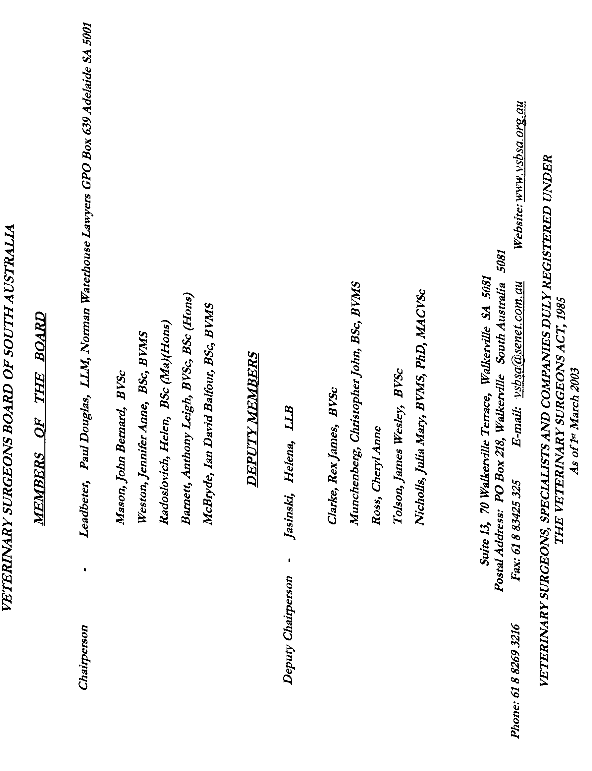
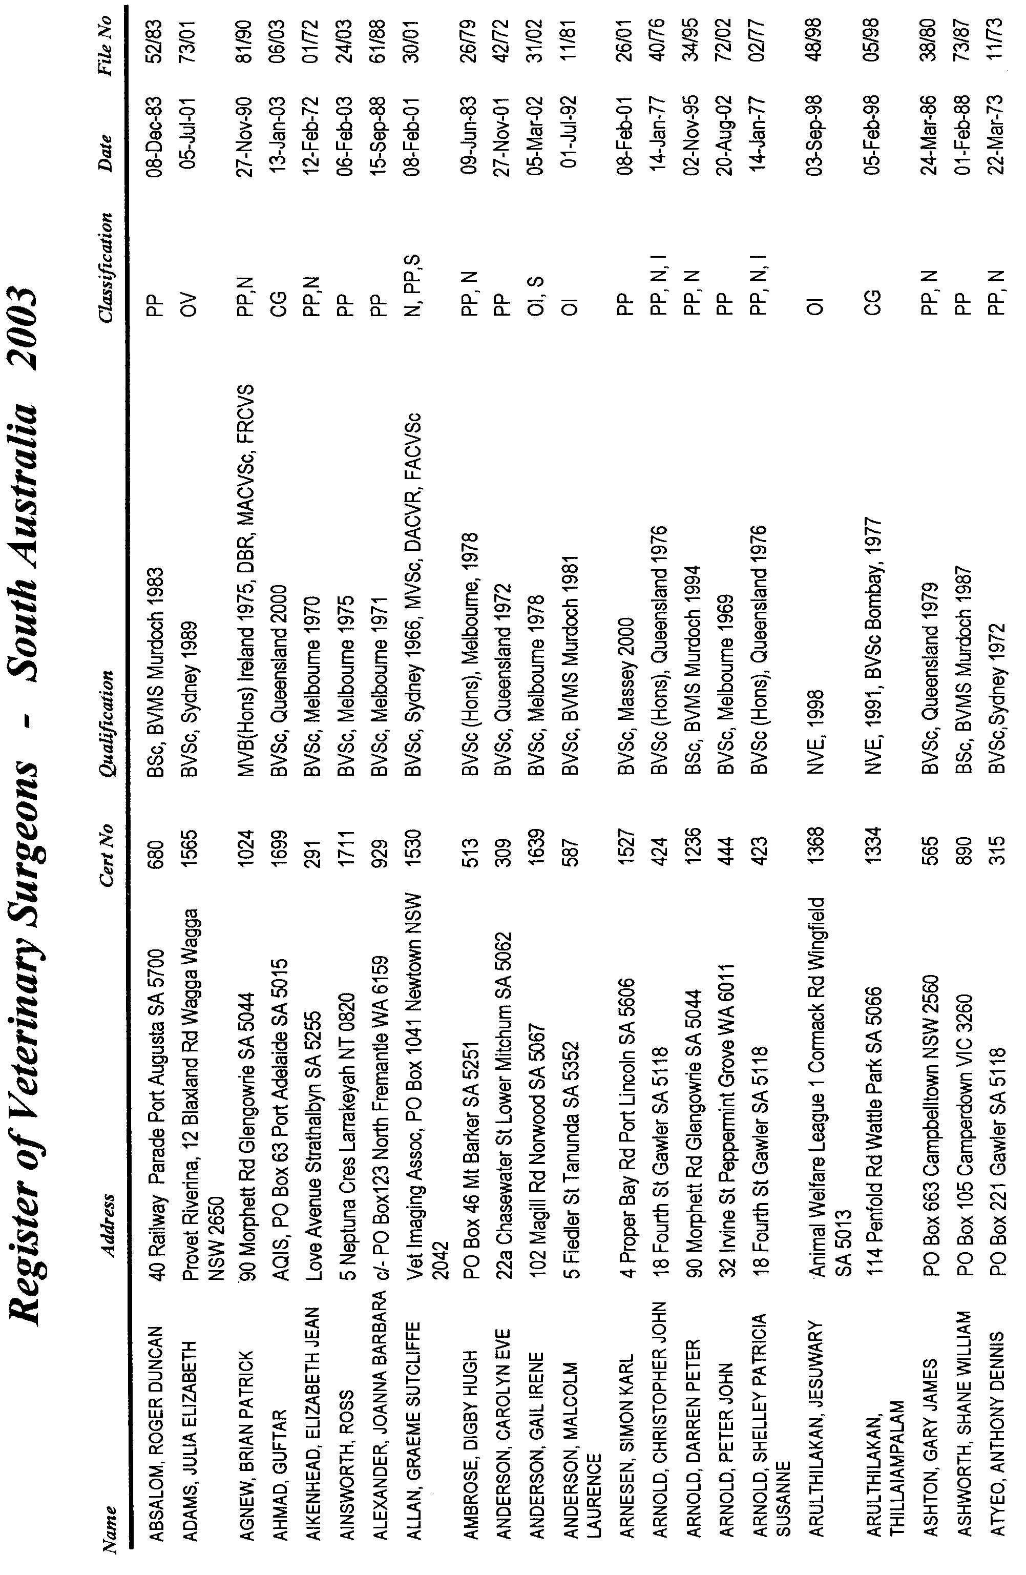
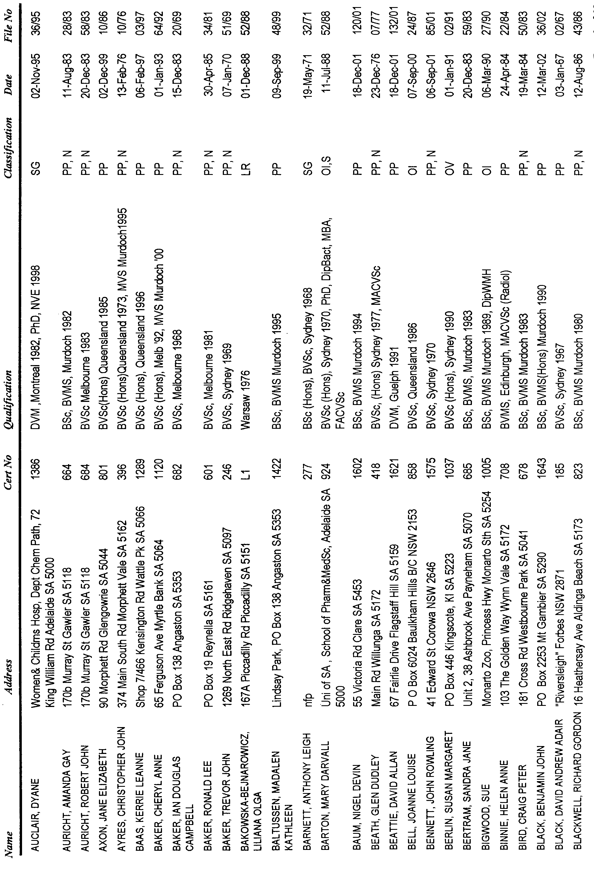
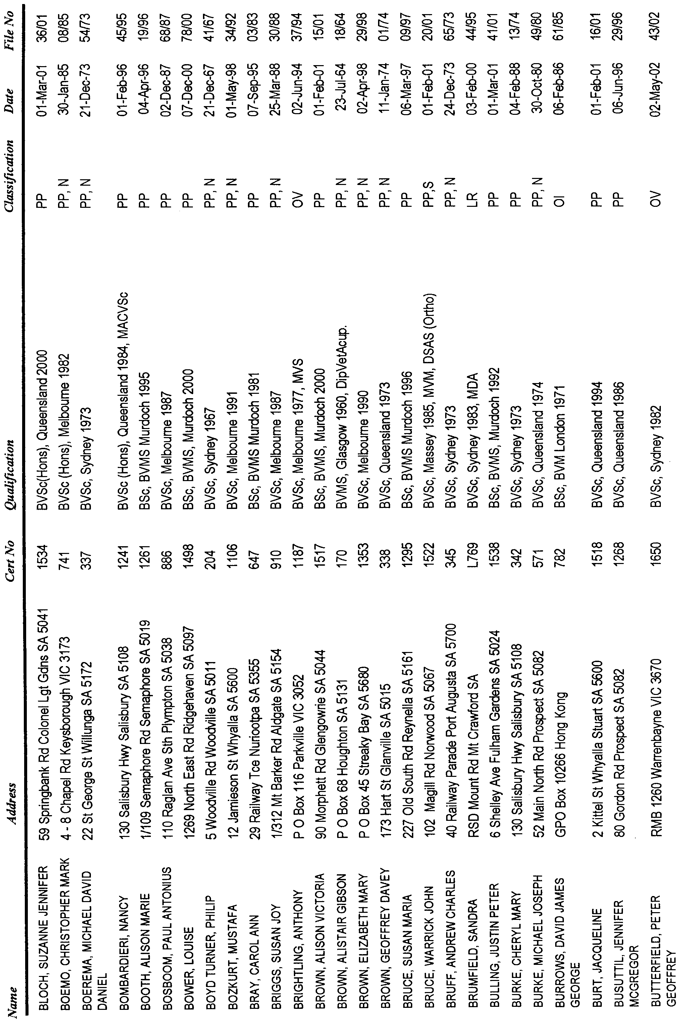
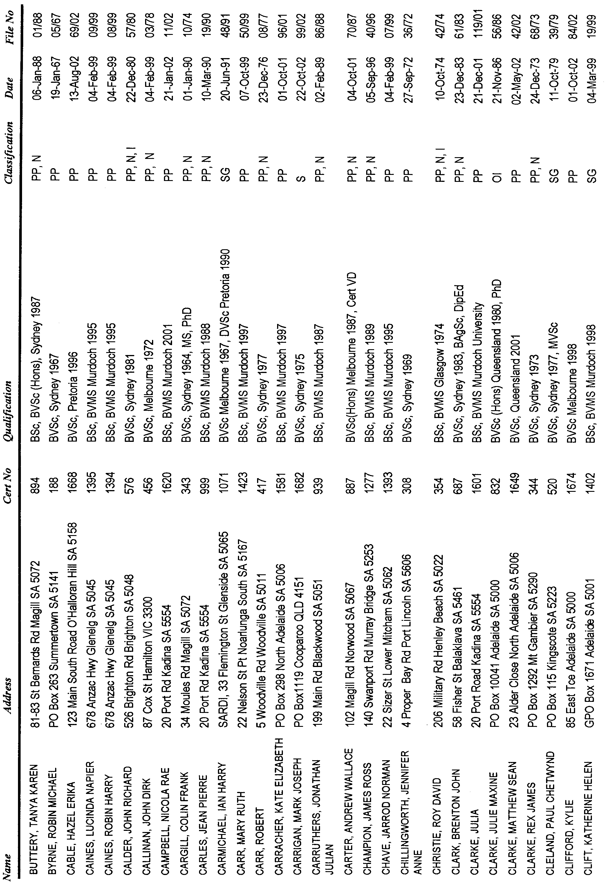
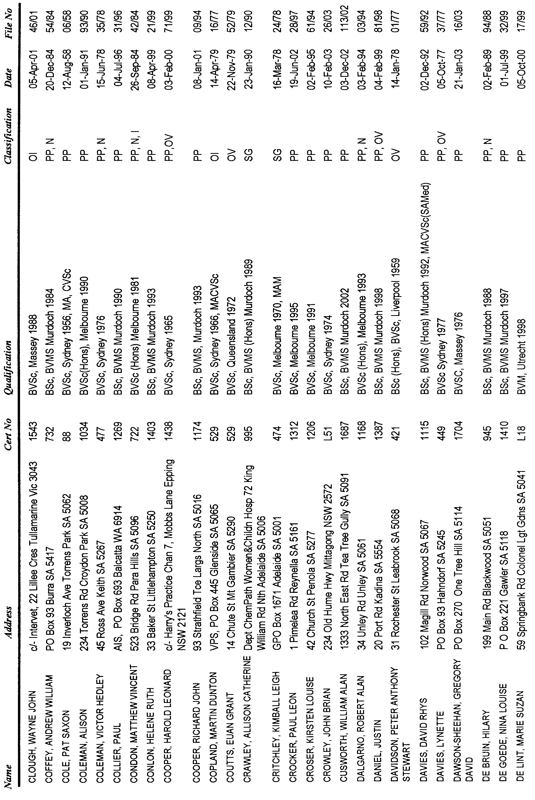
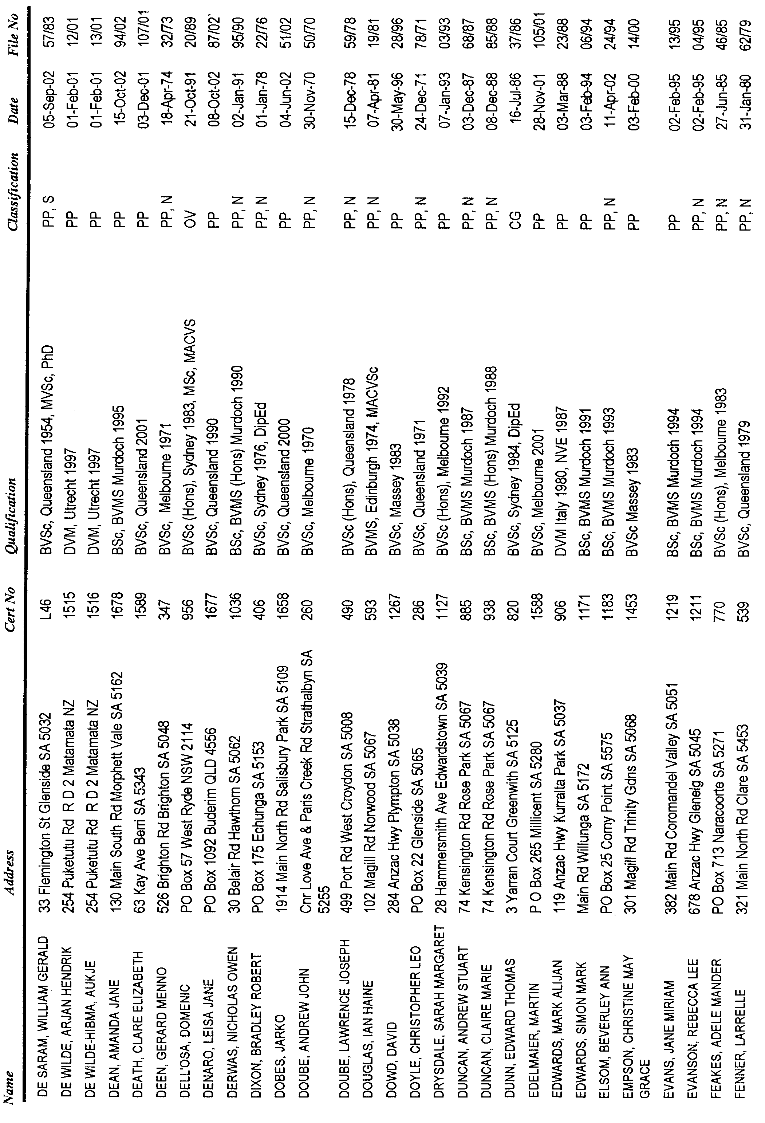
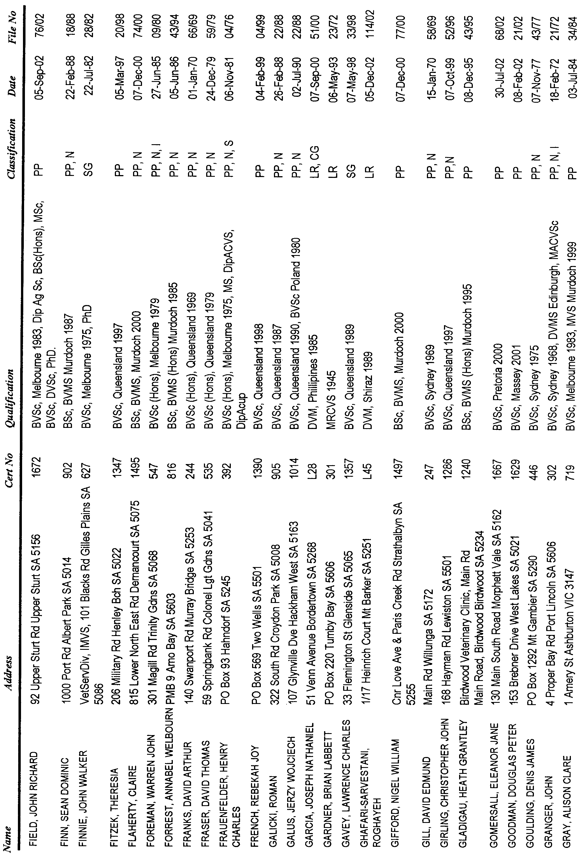
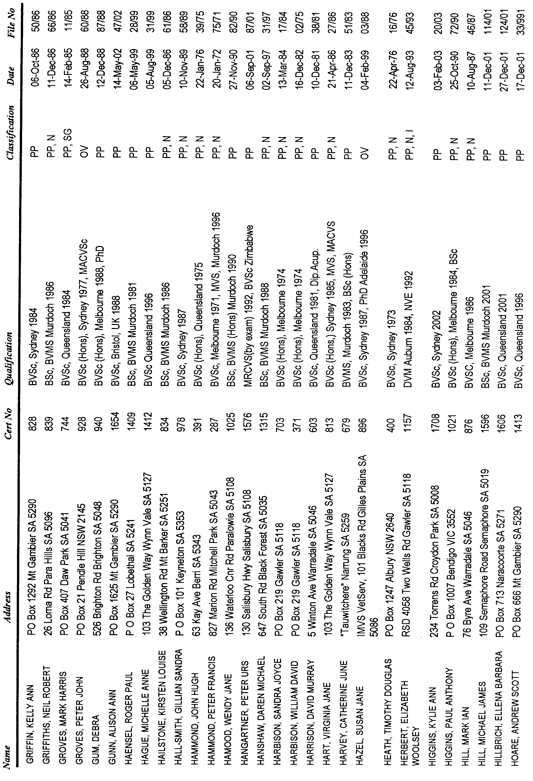
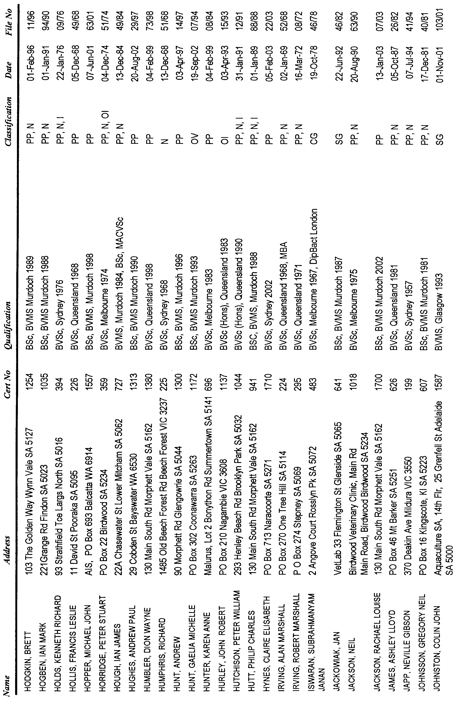
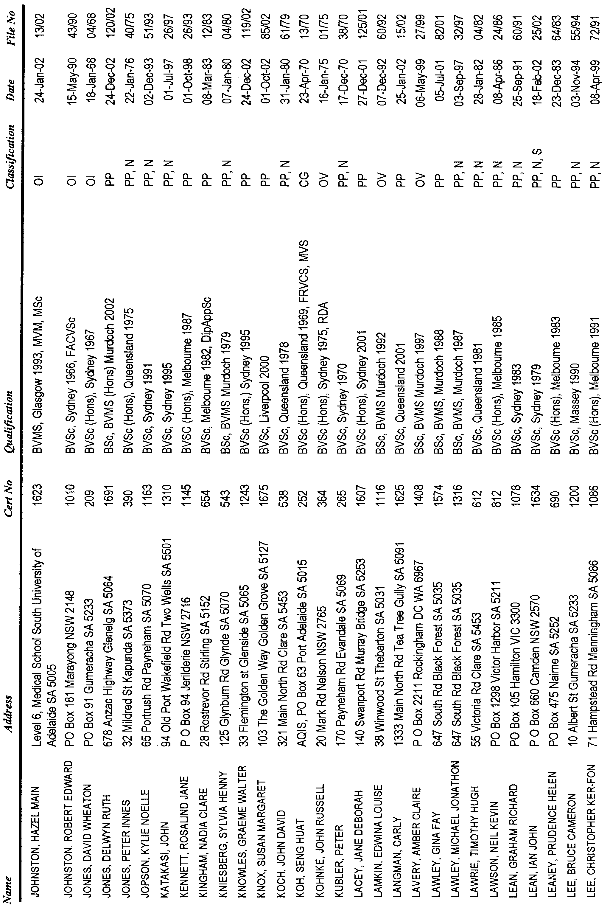
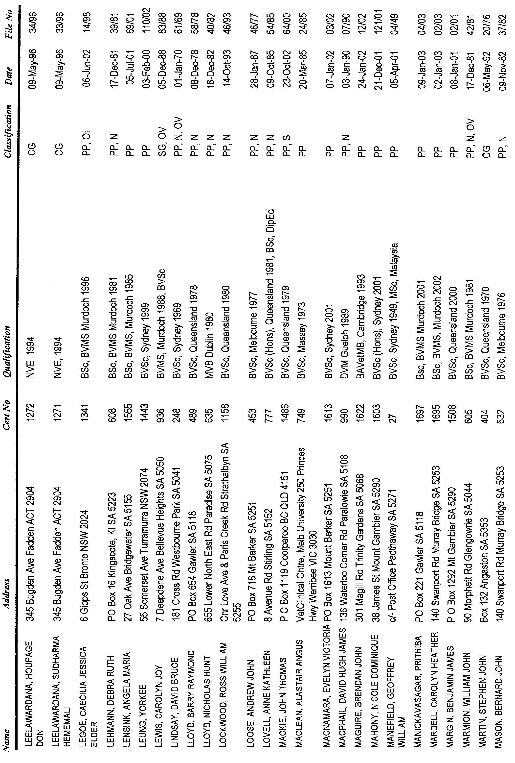
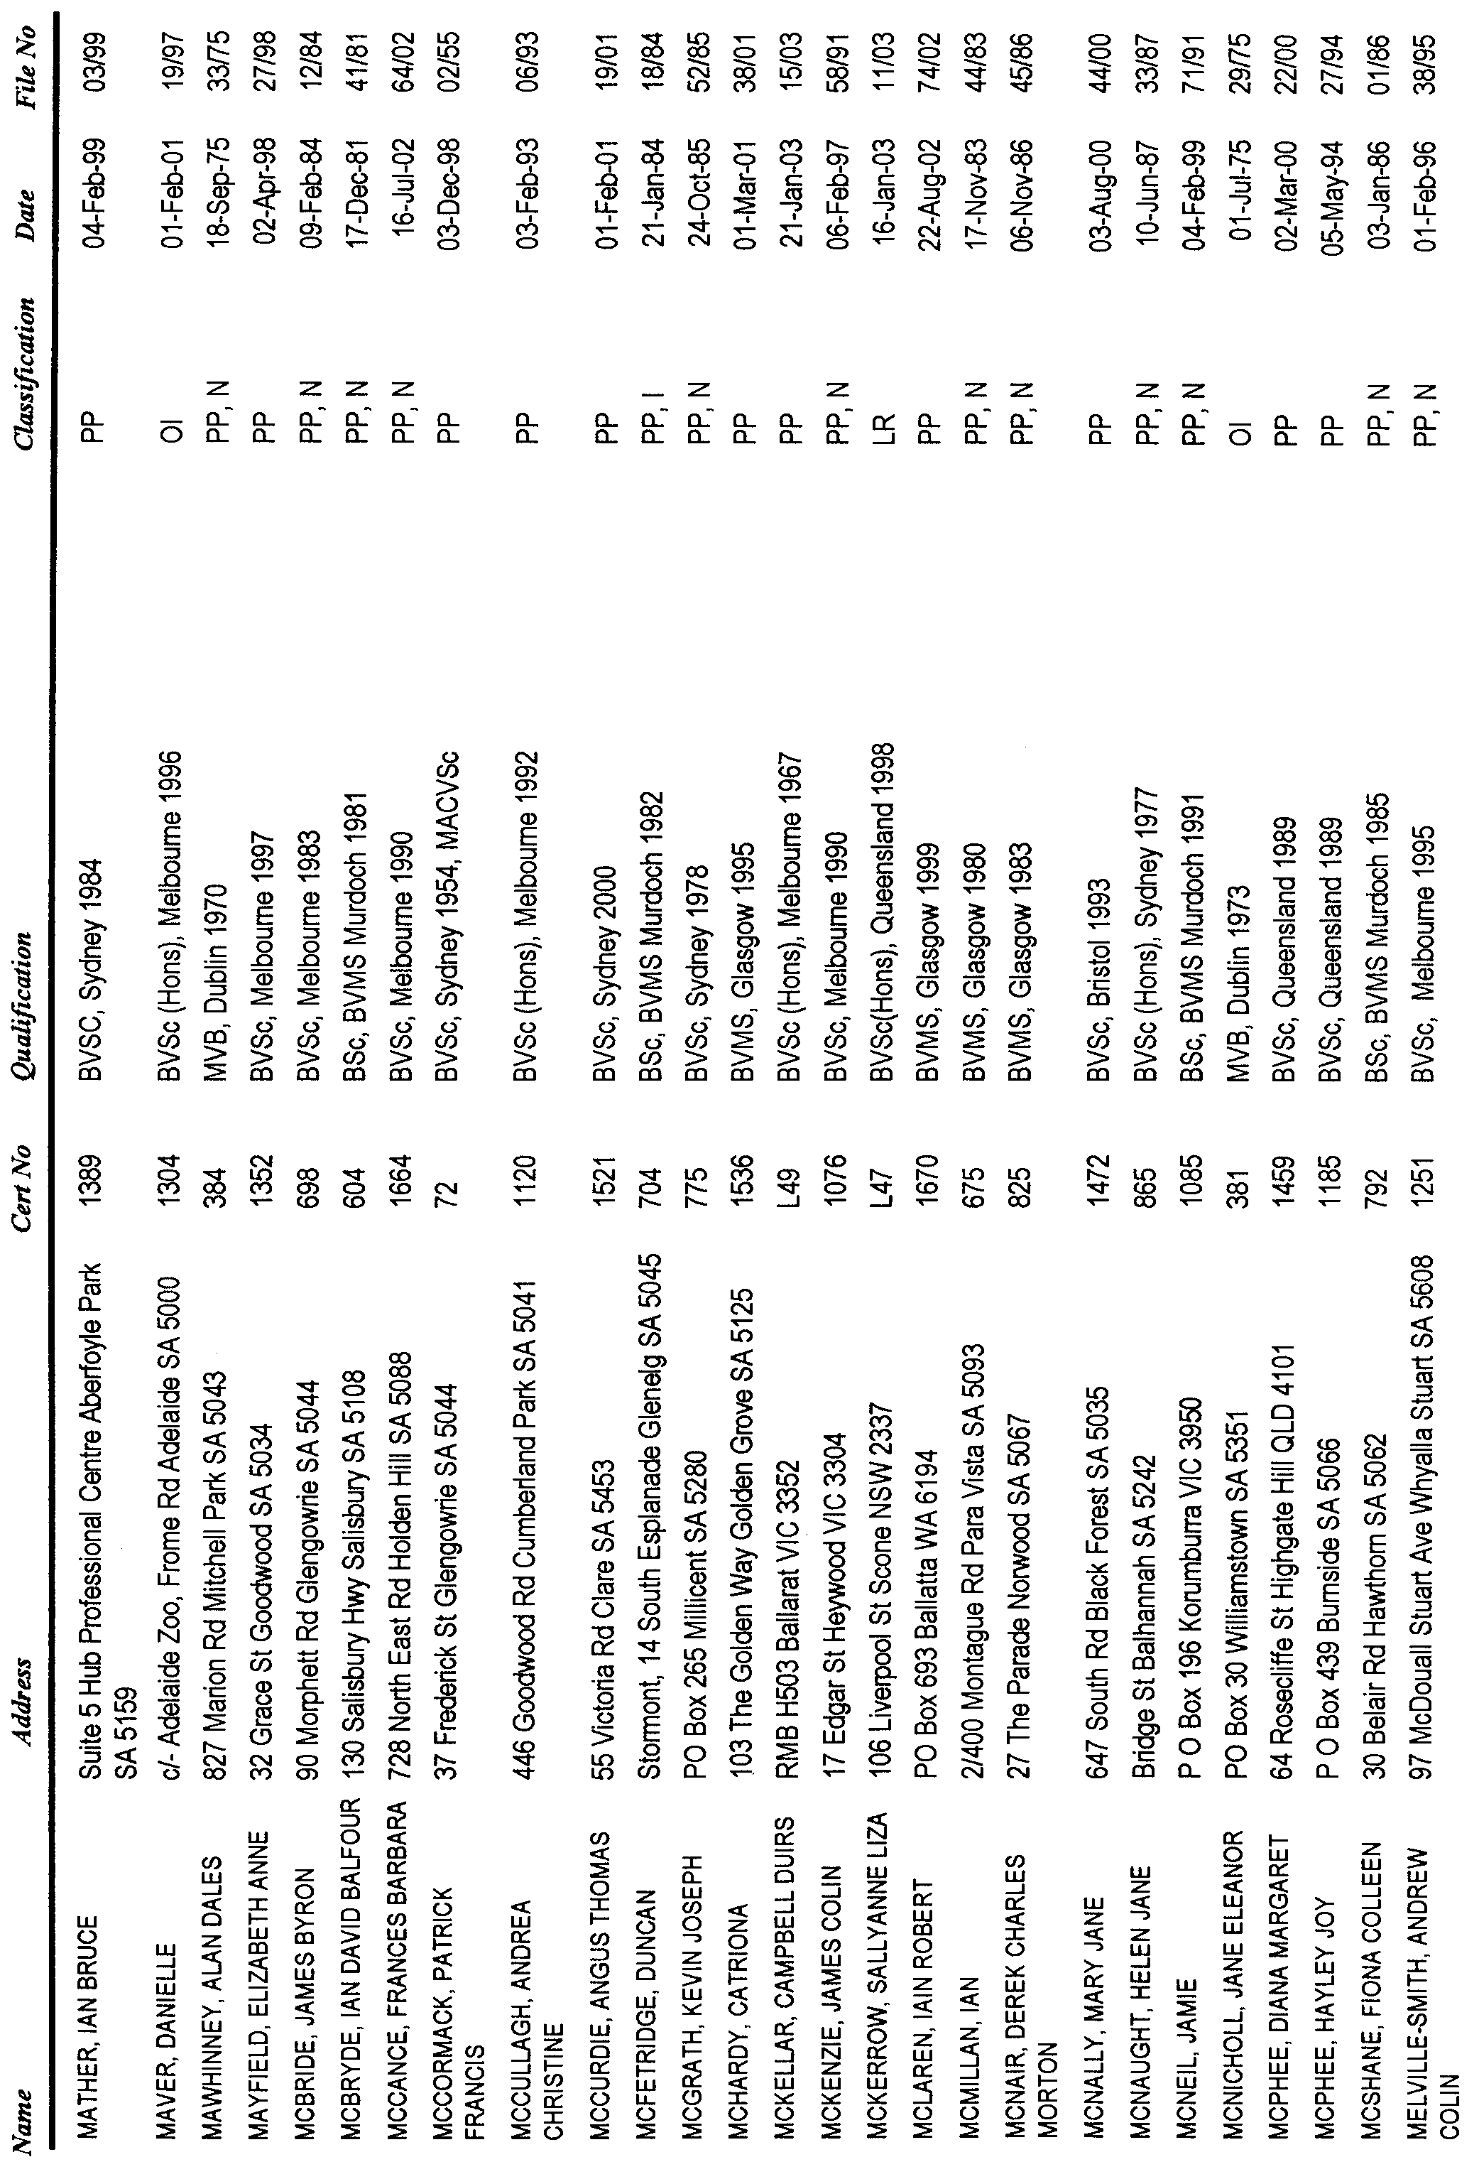
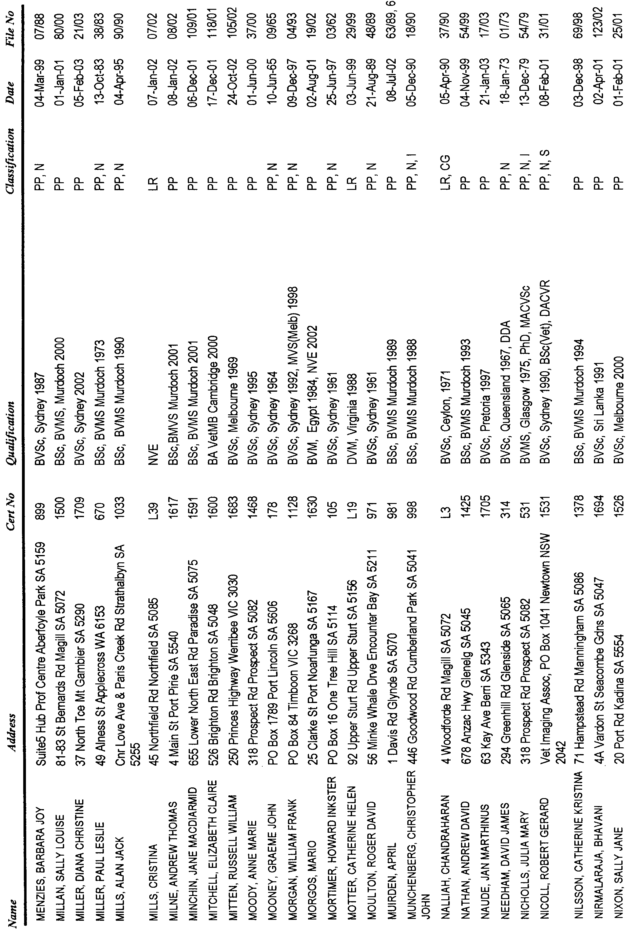
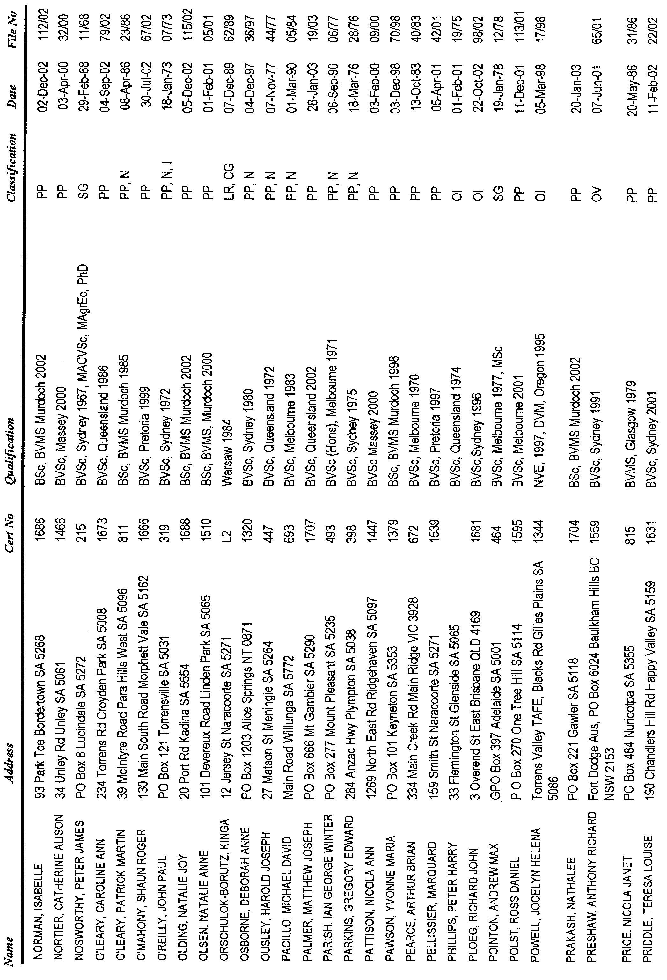
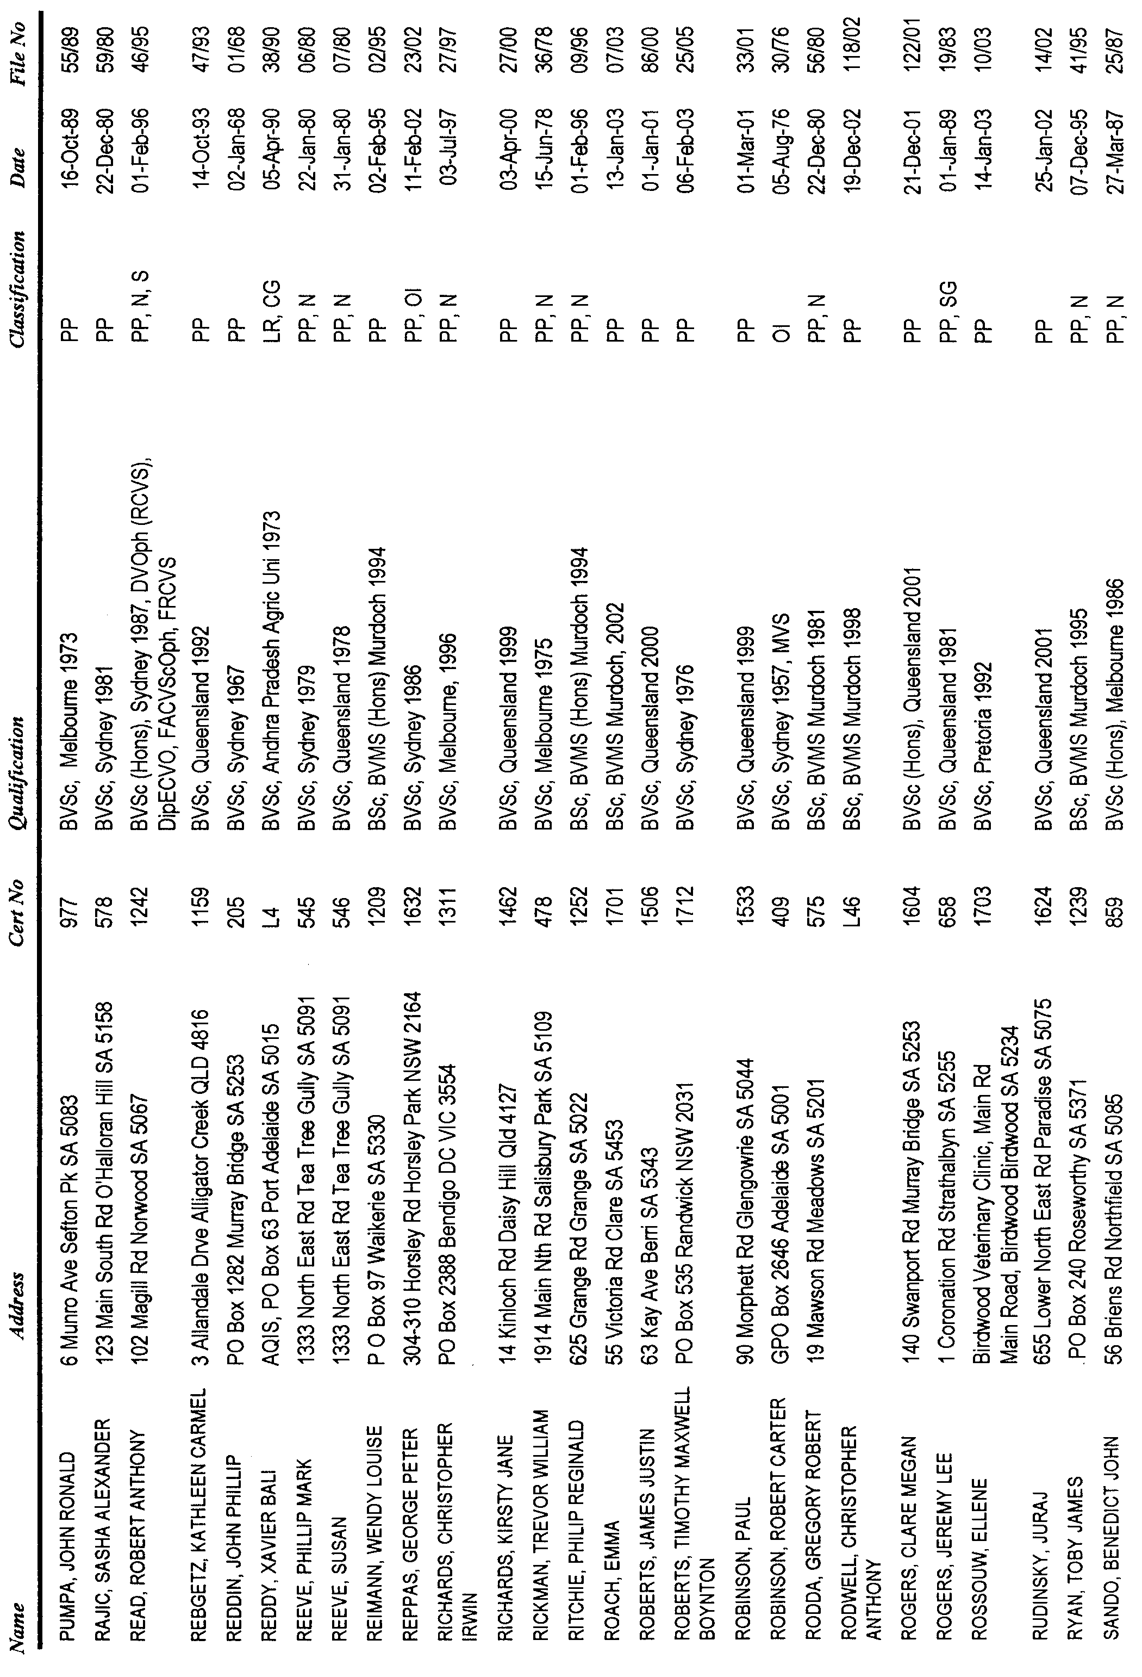
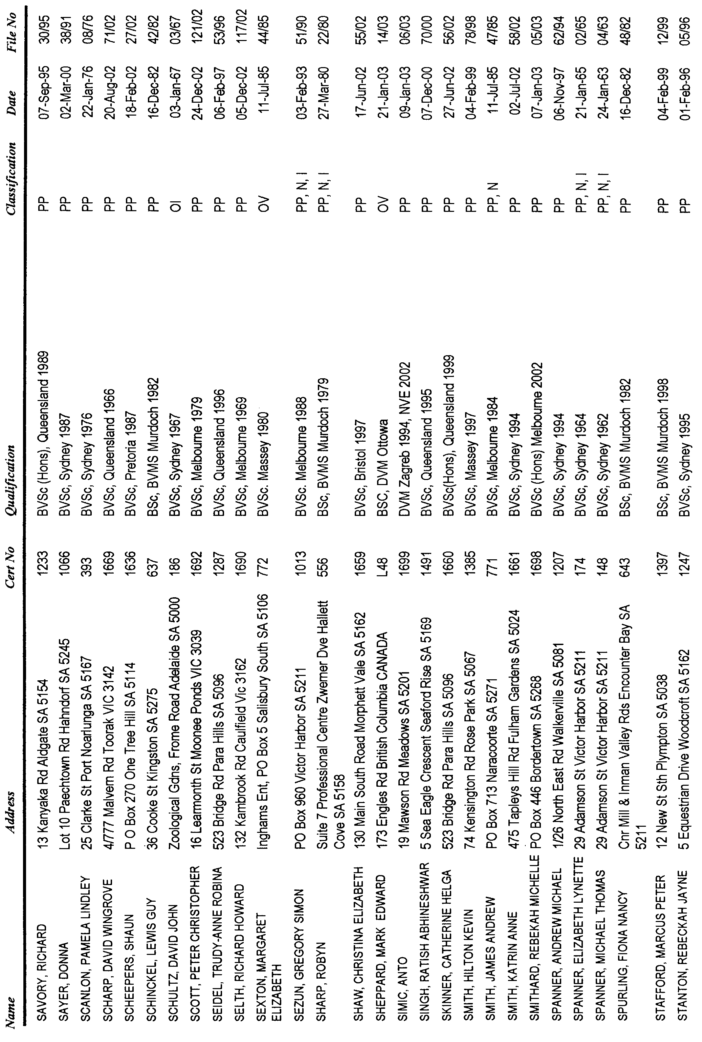
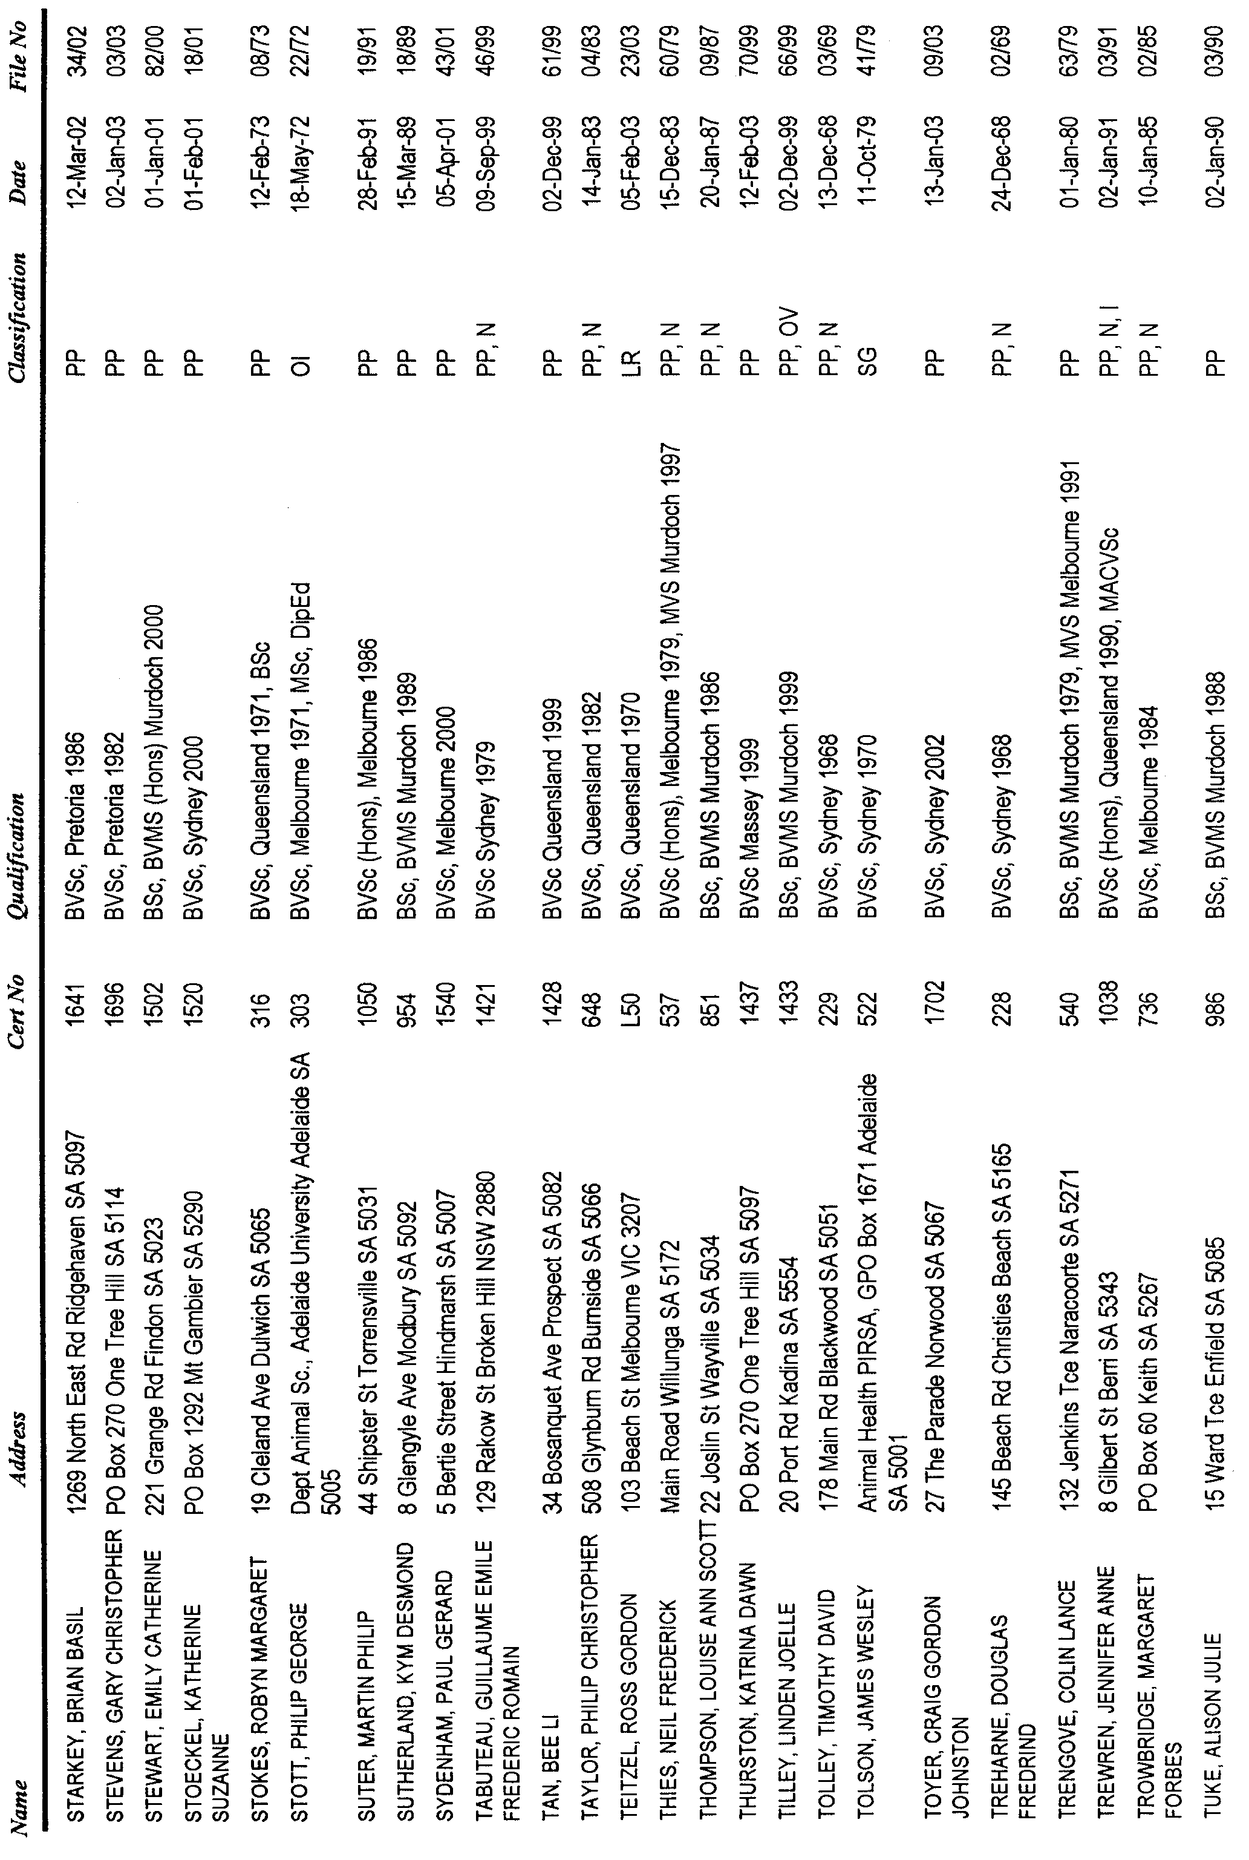
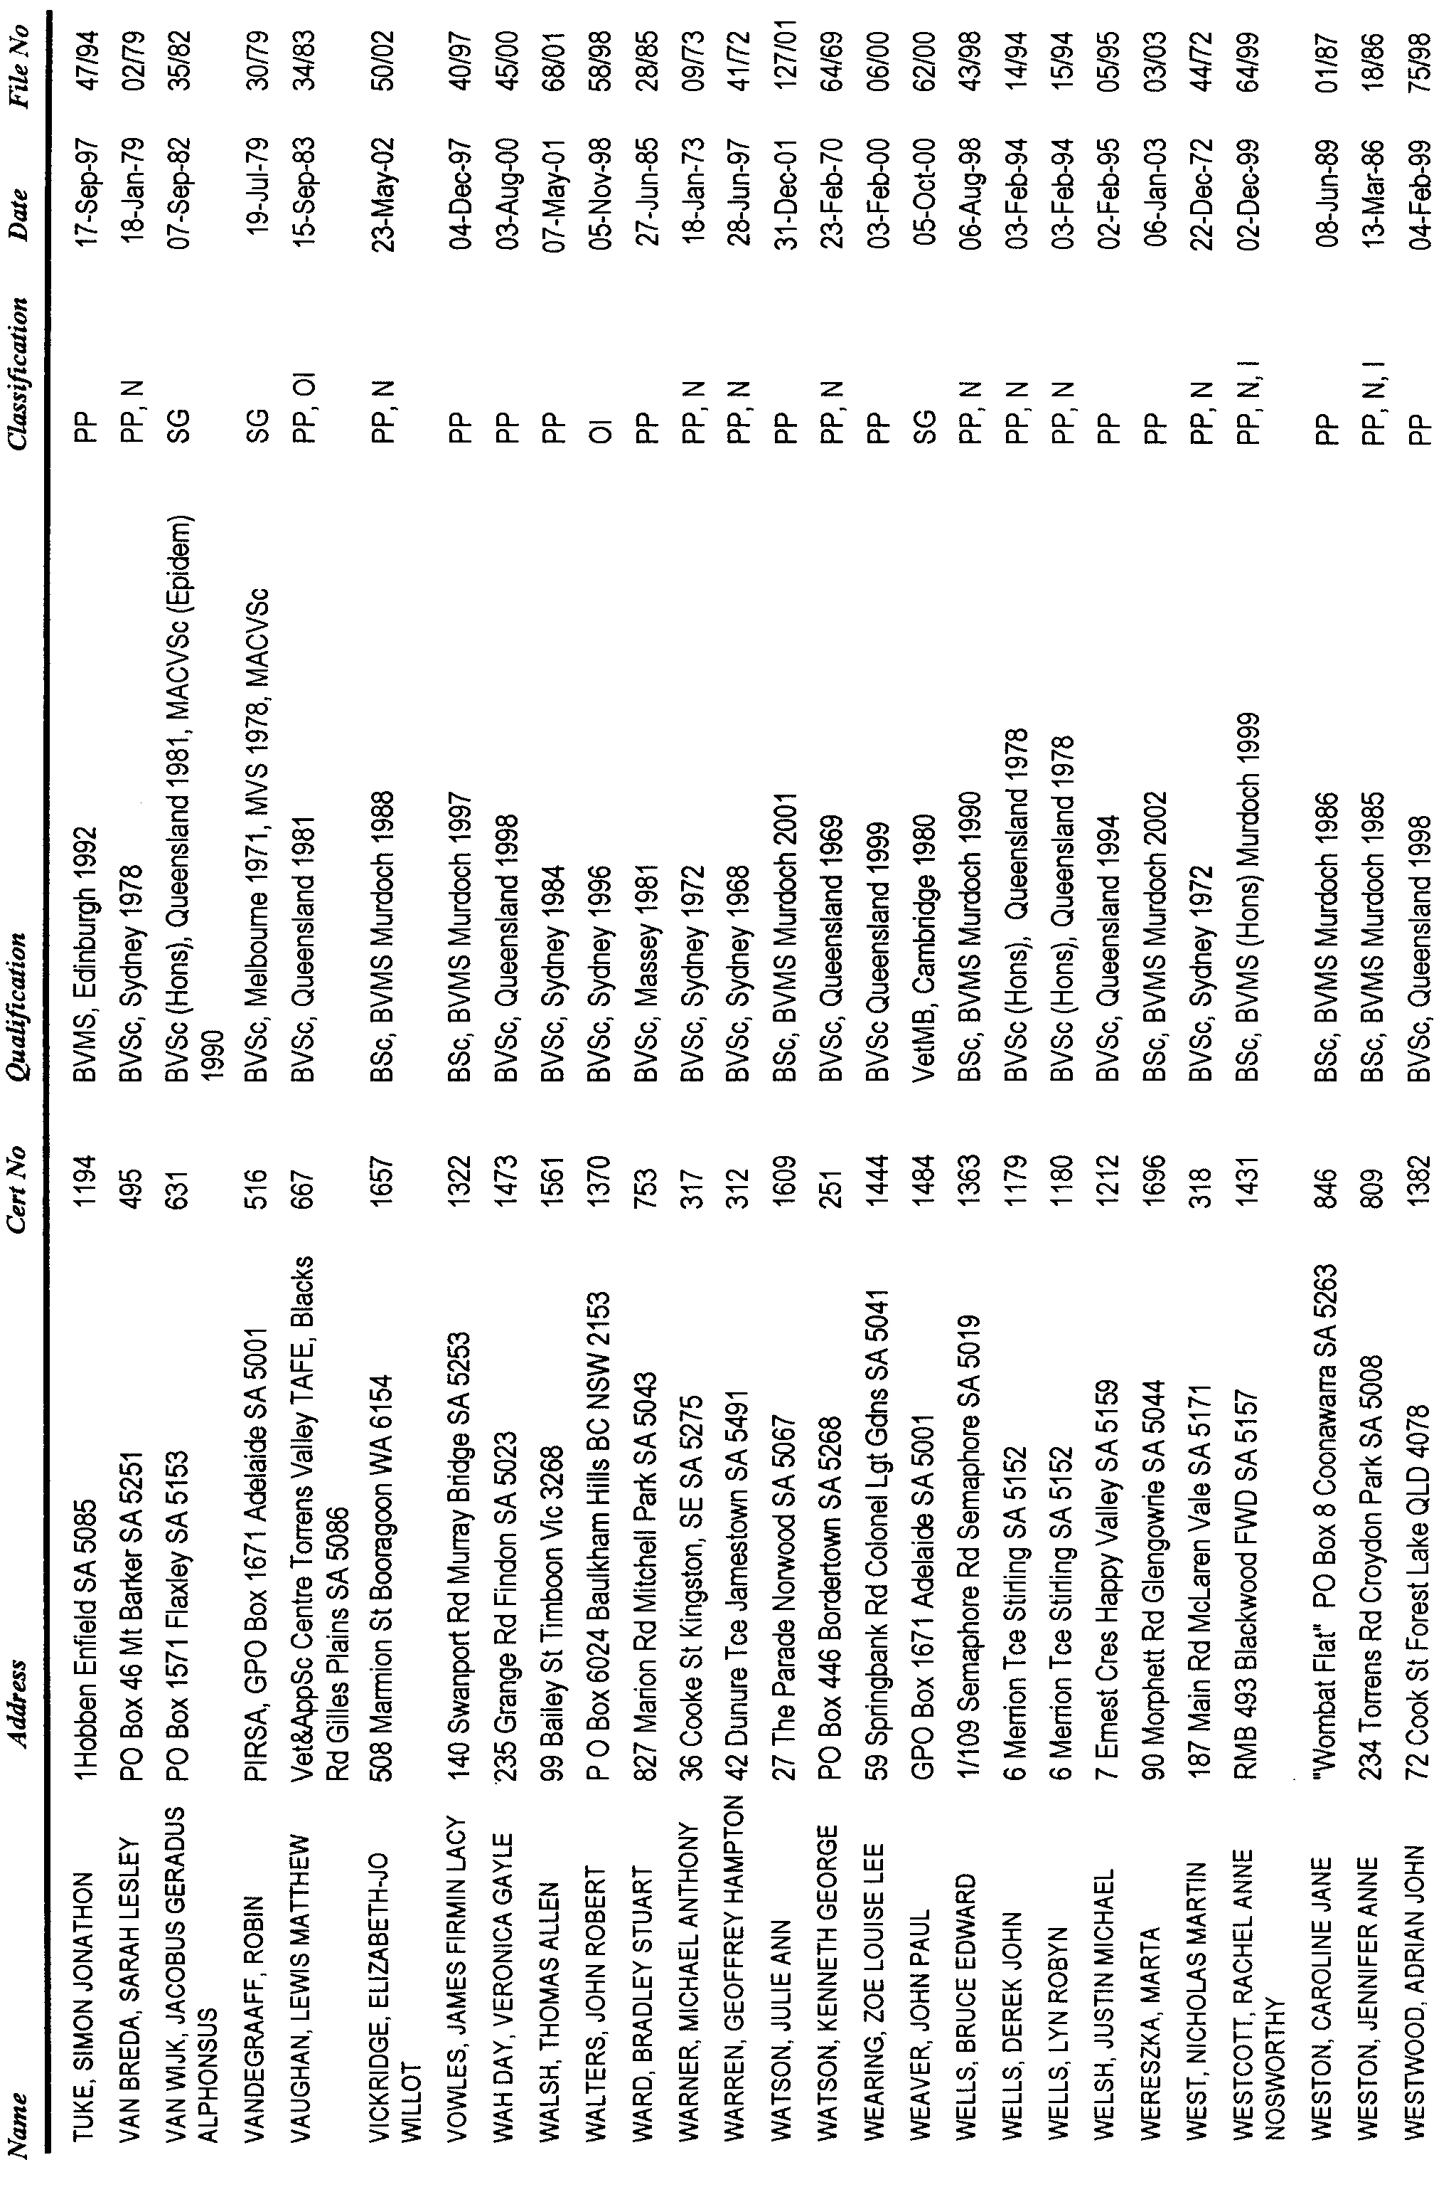
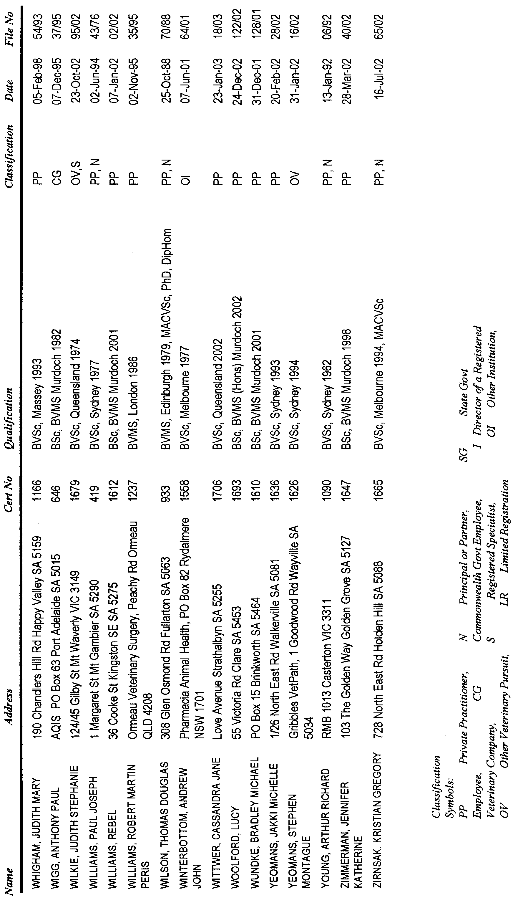
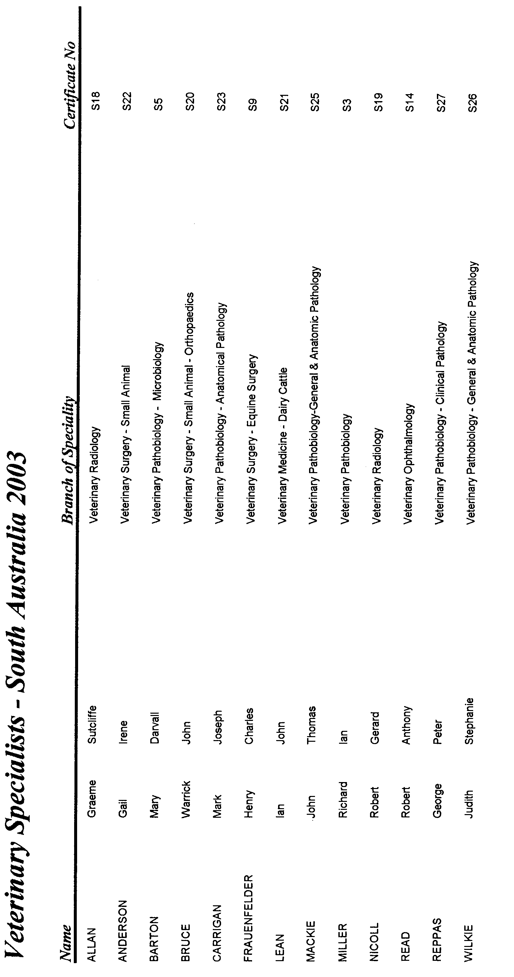
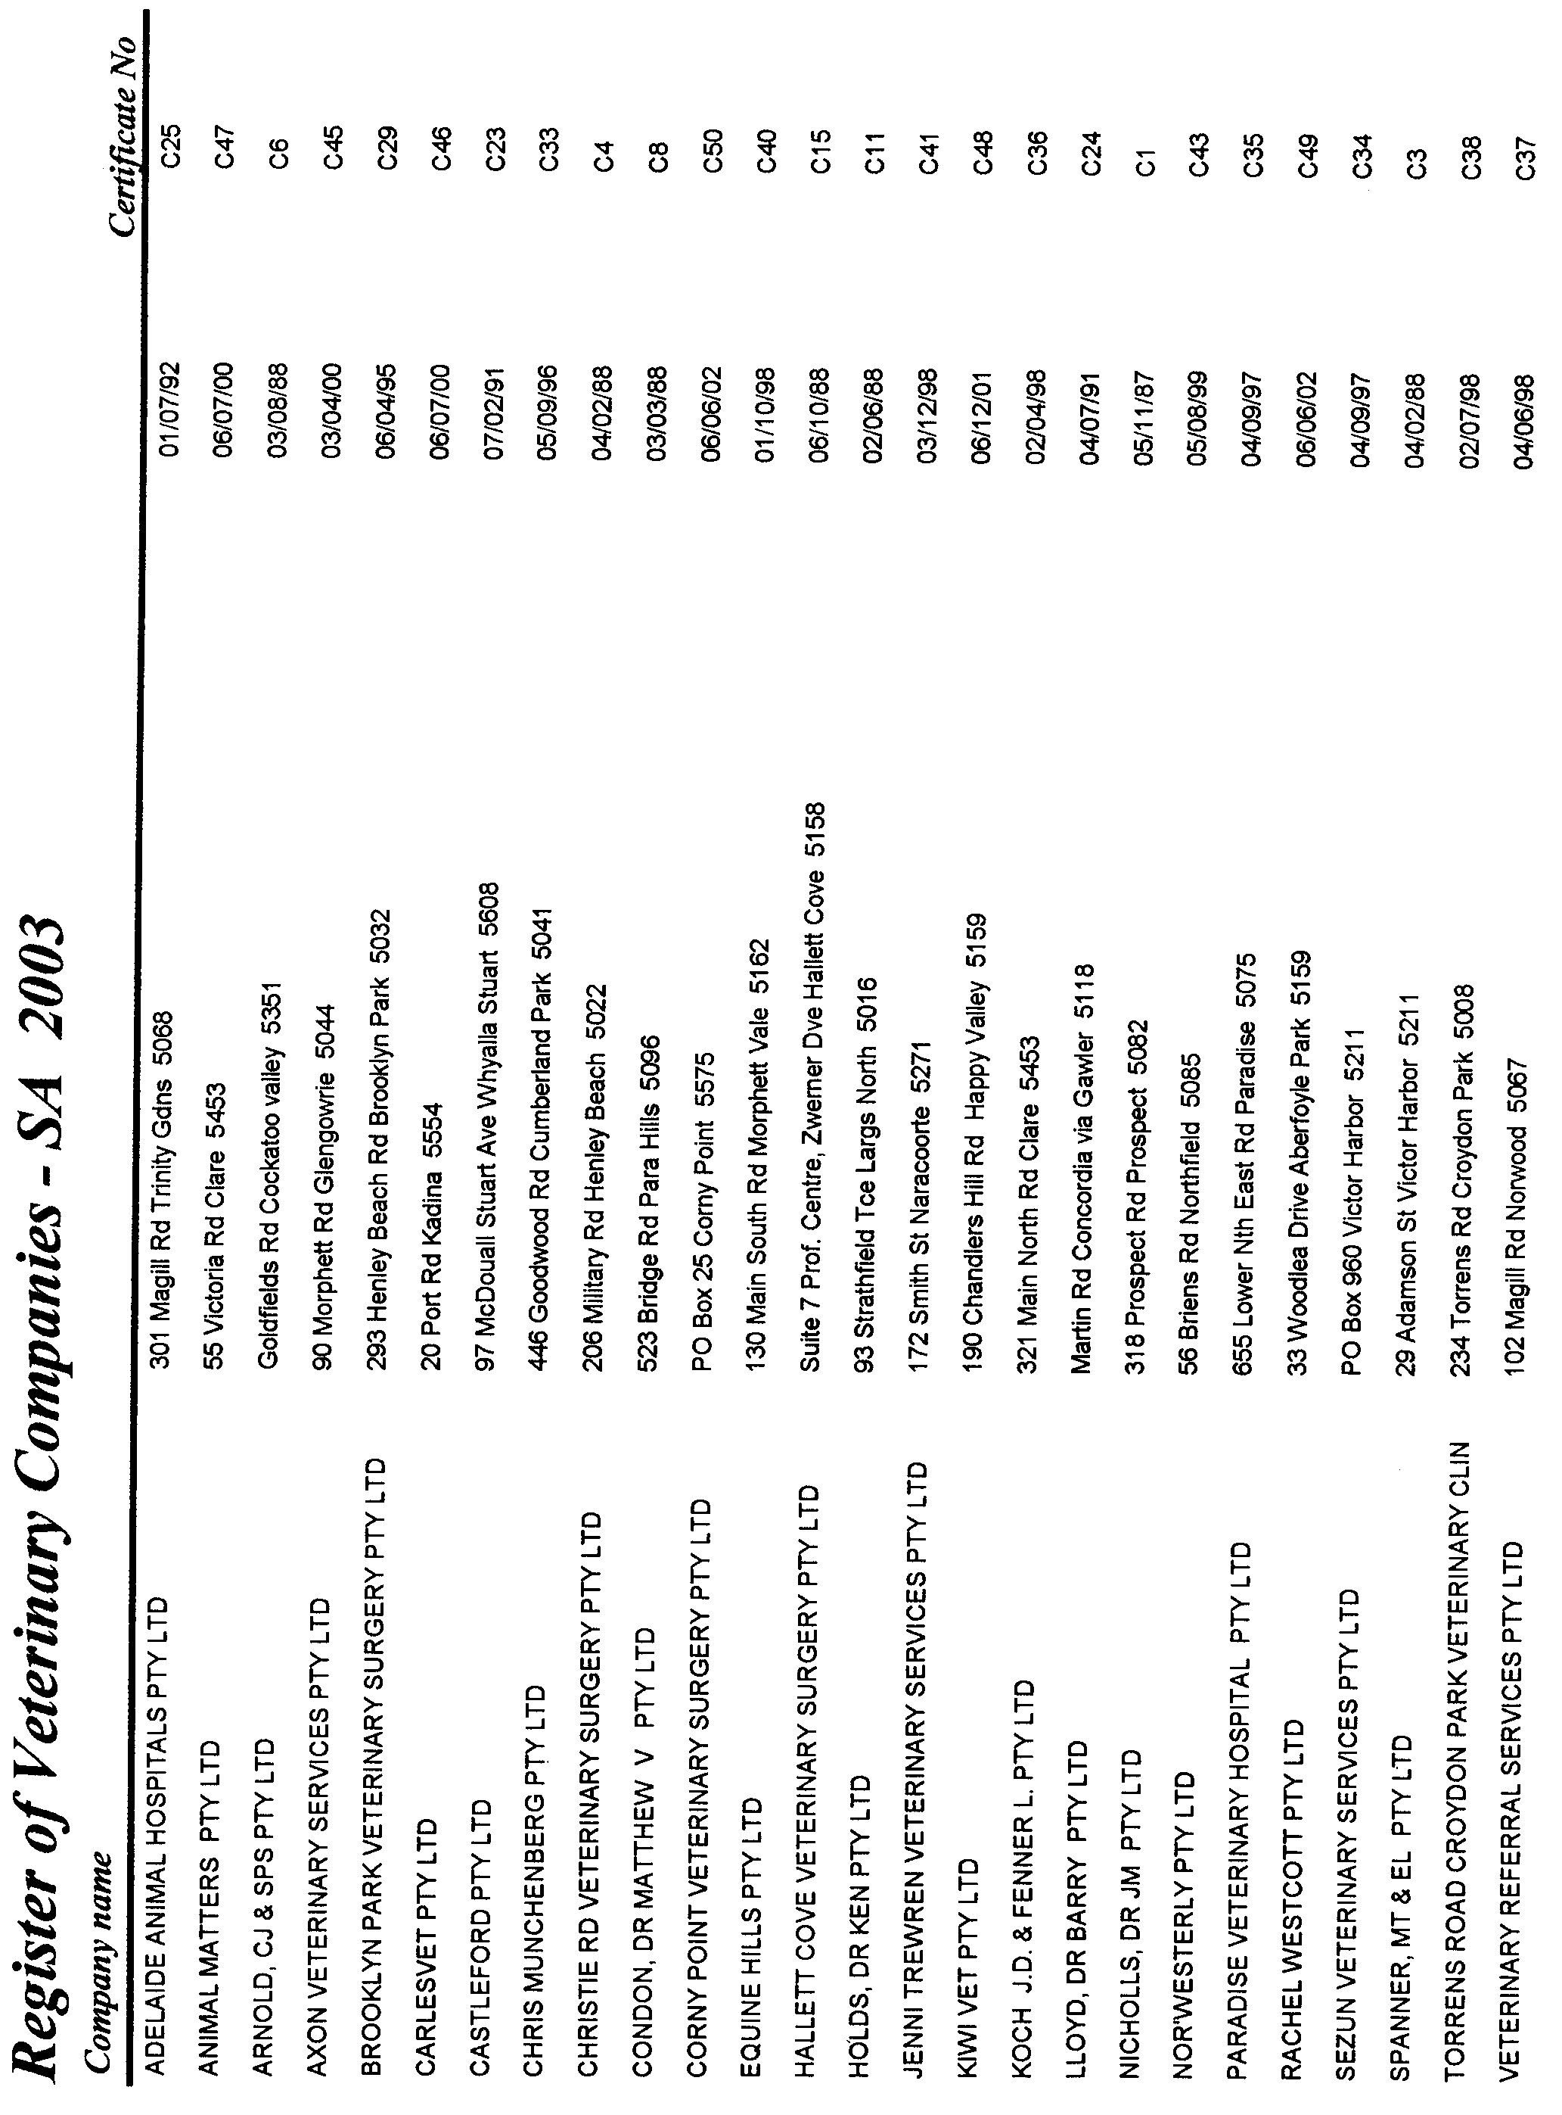

VOCATIONAL EDUCATION, EMPLOYMENT AND TRAINING ACT 1994

PART 4 - CONTRACTS OF TRAINING
Pursuant to the provisions of the Vocational Education, Employment and Training Act (VEET Act),
the Accreditation and Registration Council (ARC) gives notice that it has determined the following:

Occupations that Constitute Trades and Other Declared Vocations
The following schedule is additional to the gazettals of:

1. 24 April 1996 (pg 2045) | 31. 27 May 1999 (Errata) (pg 2723) | 61. 19 July 2001 (Errata) (pg 2713)
2. 31 October 1996 (pg 1544) | 32. 17 June 1999 (pg 3123) | 62. 26 July 2001 (pg 2785)
3. 5 December 1996 (pg 1818) | 33. 24 June 1999 (pg 3261) | 63. 16 August 2001 (pg 3091)
4. 6 February 1997 (pg 830) | 34. 1 July 1999 (pg 22) | 64. 20 September 2001 (pg 4268)
5. 17 April 1997 (pg 1571) | 35. 29 July 1999 (pg 602) | 65. 27 September 2001 (pg 4316)
6. 29 May 1997 (pg 2758) | 36. 30 September 1999 (pg 1364) | 66. 11 October 2001 (Errata) (pg 4466)
7. 12 June 1997 (pg 2984) | 37. 14 October 1999 (pg 1973) | 67. 15 November 2001 (pg 5041)
8. 3 July 1997 (pg 33) | 38. 11 November 1999 (pg 2327) | 68. 29 November 2001 (pg 5227)
9. 7 August 1997 (pg 311) | 39. 6 January 2000 (pg 1169) | 69. 13 December 2001 (pg 5385)
10. 18 December 1997 (pg 1677) | 40. 30 March 2000 (pg 1921) | 70. 20 December 2001 (Errata) (pg 5646)
11. 22 December 1997 (pg 1776) | 41. 6 April 2000 (pg 2047) | 71. 10 January 2002 (pg 19) Errata (pg 20)
12. 23 April 1998 (pg 1959) | 42. 13 April 2000 (Errata) (pg 2167) | 72. 14 February 2002 (pg 861) Errata (pg 869)
13. 18 June 1998 (pg 2594) | 43. 4 May 2000 (pg 2416) | 73. 14 March 2002 (pg 1329)
14. 6 August 1998 (pg 339) | 44. 18 May 2000 (pg 2606) Errata (pg 2609) | 74. 11 April 2002 (pg 1579)
15. 24 September 1998 (pg 990) | 45. 15 June 2000 (pg 3282) Errata (pg 3285) | 75. 18 April 2002 (pg 1613)
16. 1 October 1998 (pg 1038) | 46. 29 June 2000 (pg 3490) | 76. 24 April 2002 (pg 1665) Errata (pg 1666)
17. 15 October 1998 (pg 1150) | 47. 6 July 2000 (pg 22) Errata (pg 24) | 77. 2 May 2002 (Errata) (pg 1809)
18. 12 November 1998 (pg 1389) | 48. 20 July 2000 (pg 267) | 78. 9 May 2002 (Errata) (pg 1852)
19. 19 November 1998 (pg 1583) | 49. 10 August 2000 (pg 467) | 79. 16 May 2002 (pg 1913)
20. 3 December 1998 (pg 1742) | 50. 24 August 2000 (pg 643) | 80. 13 June 2002 (pg 2134)
21. 10 December 1998 (pg 1870) | 51. 14 September 2000 (pg 2002) | 81. 11 July 2002 (pg 2869)
22. 17 December 1998 (pg 1954) | 52. 12 October 2000 (pg 2475) Errata (pg 2480) | 82. 15 August 2002 (pg 3066)
23. 23 December 1998 (pg 2039) | 53. 16 November 2000 (pg 3208) Errata (pg 3211) | 83. 12 September 2002 (pg3414) Errata (pg3415)
24. 11 March 1999 (pg 1359) | 54. 7 December 2000 (pg 3461) Errata (pg 3467) | 84. 10 October 2002 (pg 3814)
25. 25 March 1999 (pg 1480) | 55. 15 February 2001 (pg 641) Errata (pg 647) | 85. 14 November 2002 (pg 4191)
26. 1 April 1999 (Errata) (pg 1605) | 56. 5 April 2001 (pg 1561) | 86. 12 December 2002 (pg 4579)
27. 22 April 1999 (pg 2219) | 57. 19 April 2001 (pg 1645) | 87. 19 December 2002 (pg 4794)
28. 29 April 1999 (Errata) (pg 2381) | 58. 31 May 2001 (pg 1914) | 88. 27 February 2003 Errata (pg 805)
29. 6 May 1999 (pg 2482) | 59. 28 June 2001 (pg 2416) | 89. 13 March 2003
30. 13 May 1999 (pg 2595) | 60. 12 July 2001 (Errata) (pg 2610) | 90. 20 March 2003

which set out the occupations that constitute trades and other declared vocations and the terms and conditions applicable to
such declared vocations.

SCHEDULE - DECLARED VOCATIONS, REQUIRED COURSES OF INSTRUCTION AND ASSOCIATED CONDITIONS

Changes to the Declared Vocations appear in bold

Occupation/Occupation Levels  Declared Vocation  * Trade  # Other than trade | Course code  National / State  and expiry date | Approved Course of Instruction and Stream | Nominal Term of  Contract of  Training | Nominal hours of  attendance at  approved course | Probationary Period

# Environment Worker
ARC February 2003 | RTD20102 | Certificate II in Conservation and Land Management | 12 months | 560 hours | 1 month
 | RTD30102 | Certificate III in Conservation and Land Management | 36 months | 950 hours | 3 months
 | RTD40102 | Certificate IV in Conservation and Land Management | 48 months | 1360 hours | 3 months
 | RTD50102 | Diploma of Conservation and Land Management | 48 months | 1770 hours | 3 months
 | RTD60102 | Advanced Diploma of Conservation and Land Management | 48 months | 1780 hours | 3 months
# Health Ancillary Worker (Dental Assistant)
ARC November 2002 | HLT31802 | Certificate III in Dental Assisting  Replacing the following course/s of instruction: | 12 months | 410 hours | 1 month
Declared ICTC February 1996 | 12805SA  SALPR  31 Dec 03 | Certificate III in Health Ancillary Worker Dental Assistant | 12 months | 410 hours | 1 month
# Dental Prosthetics  ARC April 2001 | 5809  V12407AFC  31 Dec 02 | Certificate IV in Dental Technology | 48 months | 988 hours | 3 months
ARC November 2002 | HLT60402 | Advanced Diploma of Dental Prosthetics | 48 months | 1310 hours | 3 months
# Massage Therapist  ARC November 2002 | HLT40302 | Certificate IV in Massage | 24 months | 745 hours | 2 months
 |  | Sport Industry Training Package
ARC November 2001 | SRS30601 | Certificate III in Sport (Massage Therapy) | 24 months | 726 hours | 2 months
 | SRS50401 | Diploma of Sport (Massage Therapy) | 36 months | 980 hours | 3 months

South Australia

Local Government (Members Allowances and Benefits) Variation Regulations 2003
under the Local Government Act 1999

Contents

Part 1—Preliminary

1. Short title
2. Commencement
3. Variation provisions

Part 2—Variation of Local Government (Members Allowances and Benefits) Regulations 1999 (Gazette 25.11.99 p 2900)

4. Variation of regulation 4—Allowances—s. 76

Part 1—Preliminary

Short title
1. These regulations may be cited as the Local Government (Members Allowances and Benefits) Variation Regulations 2003.

Commencement
2. These regulations come into operation on 12 May 2003.

Variation provisions
3. In these regulations, a provision under a heading referring to the variation of specified regulations varies the regulations so specified.

Part 2—Variation of Local Government (Members Allowances and Benefits) Regulations 1999 (Gazette 25.11.99 p 2900)

Variation of regulation 4—Allowances—s. 76
4. (1) Regulation 4(1)(a)(i)—delete "$1 500" and substitute:

$1 670

(2) Regulation 4(1)(a)(ii)—delete "$6 000" and substitute:

$6 680

Note—
As required by section 10AA(2) of the Subordinate Legislation Act 1978, the Minister has certified that, in the Minister's opinion, it is necessary or appropriate that these regulations come into operation as set out in these regulations.

Made by the Governor
with the advice and consent of the Executive Council
on 20 March 2003.

No. 23 of 2003
COLG2002/0014

South Australia

City of Adelaide (Members Allowances and Benefits) Variation Regulations 2003
under the City of Adelaide Act 1998

Contents

Part 1—Preliminary

1. Short title
2. Commencement
3. Variation provisions

Part 2—Variation of City of Adelaide (Members Allowances and Benefits) Regulations 1998 (Gazette 3.12.1998 p 1800) as varied

4. Variation of regulation 4—Allowances

Part 1—Preliminary

Short title
1. These regulations may be cited as the City of Adelaide (Members Allowances and Benefits) Variation Regulations 2003.

Commencement
2. These regulations come into operation on 12 May 2003.

Variation provisions
3. In these regulations, a provision under a heading referring to the variation of specified regulations varies the regulations so specified.

Part 2—Variation of City of Adelaide (Members Allowances and Benefits) Regulations 1998 (Gazette 3.12.1998 p 1800) as varied

Variation of regulation 4—Allowances
4. (1) Regulation 4(1)(a)(i)—delete "$9 000" and substitute:

$10 270

(2) Regulation 4(1)(a)(ii)—delete "$12 000" and substitute:

$13 700

Note—
As required by section 10AA(2) of the Subordinate Legislation Act 1978, the Minister has certified that, in the Minister's opinion, it is necessary or appropriate that these regulations come into operation as set out in these regulations.

Made by the Governor
with the advice and consent of the Executive Council
on 20 March 2003.

No. 24 of 2003.
COLG2002/0014

South Australia

Local Government Revocation Regulations 2003
under the Local Government Act 1934

Contents

Part 1—Preliminary

1. Short title
2. Commencement
3. Variation provisions

Part 2—Revocation of Local Government (Members Allowances and Expenses) Regulations 1995 (Gazette 27.4.1995 p 1656) as varied

4. Revocation of regulations

Part 1—Preliminary

Short title
1. These regulations may be cited as the Local Government Revocation Regulations 2003.

Commencement
2. These regulations come into operation on the day on which they are made.

Variation provisions
3. In these regulations, a provision under a heading referring to the variation of specified regulations varies the regulations so specified.

Part 2—Revocation of Local Government (Members Allowances and Expenses) Regulations 1995 (Gazette 27.4.1995 p 1656) as varied

Revocation of regulations
4. The Local Government (Members Allowances and Expenses) Regulations 1995 (Gazette 27.4.1995 p 1656), as varied, are revoked.

Note—
As required by section 10AA(2) of the Subordinate Legislation Act 1978, the Minister has certified that, in the Minister's opinion, it is necessary or appropriate that these regulations come into operation as set out in these regulations.

Made by the Governor
with the advice and consent of the Executive Council
on 20 March 2003.

No. 25 of 2003
COLG2002/0014

South Australia

Workers Rehabilitation and Compensation (Scales of Charges—Medical Practitioners) Variation Regulations 2003
under the Workers Rehabilitation and Compensation Act 1986

Contents

Part 1—Preliminary

1. Short title
2. Commencement
3. Variation provisions

Part 2—Variation of Workers Rehabilitation and Compensation (Scales of Charges—Medical Practitioners) Regulations 1999 (Gazette 14.1.1999 p 58) as varied

4. Substitution of heading to Schedule A
Schedule A—Clinical medical services
5. Revocation of Schedule B
Schedule B—Workers compensation services

Part 1—Preliminary

Short title
1. These regulations may be cited as the Workers Rehabilitation and Compensation (Scales of Charges—Medical Practitioners) Variation Regulations 2003.

Commencement
2. These regulations will come into operation on 14 April 2003.

Variation provisions
3. In these regulations, a provision under a heading referring to the variation of specified regulations varies the regulations so specified.

Part 2—Variation of Workers Rehabilitation and Compensation (Scales of Charges—Medical Practitioners) Regulations 1999 (Gazette 14.1.1999 p 58) as varied

Substitution of heading to Schedule A
4. Heading to Schedule A—delete the heading and substitute:

Schedule A—Clinical medical services

Revocation of Schedule B
5. Schedule B—delete the Schedule and substitute:

Schedule B—Workers compensation services

Medical report—treating doctor
Item No. | Group | Description | Maximum Fee
WMG16 | General Practitioners | Treating doctor medical report—provided within 10 business days of receipt of the initial request. | $150.40
WMG17 | General Practitioners | Treating doctor medical report—provided between 10 and 30 business days after receipt of the initial request. | $117.00
WMG18 | General Practitioners | Treating doctor medical report—provided 30 or more business days after receipt of the initial request. | $89.10
WMS16 | Specialists in a surgical discipline | Treating doctor medical report—provided within 10 business days of receipt of the initial request. | $239.60
WMS17 | Specialists in a surgical discipline | Treating doctor medical report—provided between 10 and 30 business days after receipt of the initial request. | $206.20
WMS18 | Specialists in a surgical discipline | Treating doctor medical report—provided 30 or more business days after receipt of the initial request. | $167.20
WMP16 | Consultant Physicians | Treating doctor medical report—provided within 10 business days of receipt of the initial request. | $239.60
WMP17 | Consultant Physicians | Treating doctor medical report—provided between 10 and 30 business days after receipt of the initial request. | $206.20
WMP18 | Consultant Physicians | Treating doctor medical report—provided 30 or more business days after receipt of the initial request. | $167.20

Note 1: A medical report must be requested in writing and may be requested by—
▪ a claims agent, self-managed or exempt employer; or
▪ a worker’s representative or advocate.
(Refer to the report preparation guidelines on page 1 of the explanatory booklet "Schedule B—Workers Compensation".)

Note 2: The date of request is taken to be 2 business days after the date the letter of request is posted, or 1 business day after the request is faxed. A business day is any day, excluding Saturday, Sunday and public holidays.

Note 3: Most reports are expected to be completed on the basis of the medical practitioner’s clinical notes, therefore a consultation is not necessarily a pre-requisite for the preparation of a report. However, if required in the judgement of the medical practitioner, the consultation is billed in the usual manner.

Note 4: Reading time for treating doctor medical reports is not normally chargeable. However, an appropriate fee for reading time for treating doctor medical reports will be authorised by the claims agent, self-managed or exempt employer if the costs are reasonable; for example, if the medical practitioner believes he or she has been asked to read an unusually large amount of material supplied by the requestor.

Note 5: A report clarification fee may be charged for clarification of a report if it is considered reasonable and not sought as a result of failure by the provider to address the original request. The claims agent, self-managed or exempt employer will authorise the cost if it is considered reasonable.

Note 6: Payment for reports will not be made in advance.
Short report—treating doctor
Item No. | Group | Description | Maximum Fee
WMG37 | General Practitioners | Short report—provided within 72 hours of receipt of the initial request. | $70.00
WMG38 | General Practitioners | Short report—provided more than 72 hours after receipt of the initial request. | $20.00
WMS37 | Specialists in a surgical discipline | Short report—provided within 72 hours of receipt of the initial request. | $70.00
WMS38 | Specialists in a surgical discipline | Short report—provided more than 72 hours after receipt of the initial request. | $20.00
WMP37 | Consultant Physicians | Short report—provided within 72 hours of receipt of the initial request. | $70.00
WMP38 | Consultant Physicians | Short report—provided more than 72 hours after receipt of the initial request. | $20.00

Note 1: The requestor must specify in the request that he or she is seeking a short report.

Note 2: A medical report must be requested in writing and may be requested by—
▪ a claims agent, self-managed or exempt employer; or
▪ a worker’s representative or advocate.

Note 3: The date of request is taken to be 2 business days after the date the letter of request is posted, or 1 business day after the request is faxed. A business day is any day, excluding Saturday, Sunday and public holidays.

Note 4: Reports should be concise and focused. The anticipated length of a short report is approximately half an A4 page.
(Refer to the report preparation guidelines on page 1 of the explanatory booklet "Schedule B—Workers Compensation".)

Note 5: A short report should be based on the medical practitioner’s notes and should not require a consultation with the patient. There may be occasions where a consultation is deemed appropriate; for example, if the practitioner has not seen the patient for some time or detailed information is required about the range of duties being considered, a consultation fee may be billed in the usual manner.

Note 6: Short reports may be faxed to the requestor with the relevant account.

Note 7: A report clarification fee may be charged for clarification of a report if it is considered reasonable and not sought as a result of failure by the provider to address the original request. The claims agent, self-managed or exempt employer will authorise the cost if it is considered reasonable.

Note 8: Payment for reports will not be made in advance.

Telephone calls (excluding calls made to or received from workers)
Item No. | Group | Description | Maximum Fee
WMG19 | General Practitioners | Telephone calls—of up to and including 10 minutes duration. | $22.50
WMG20 | General Practitioners | Telephone calls—of more than 10 minutes duration. | $51.00
WMS19 | Specialists in a surgical discipline | Telephone calls—of up to and including 10 minutes duration. | $30.00
WMS20 | Specialists in a surgical discipline | Telephone calls—of more than 10 minutes duration. | $67.50
WMP19 | Consultant Physicians | Telephone calls—of up to and including 10 minutes duration. | $30.00
WMP20 | Consultant Physicians | Telephone calls—of more than 10 minutes duration. | $67.50

Note 1: Telephone calls are chargeable if of a case specific nature, made to or received from—
▪ a claims agent, self-managed or exempt employer; or
▪ an employer; or
▪ a worker’s representative or advocate; or
▪ a WorkCover Corporation medical consultant; or
▪ a provider of return to work services registered by WorkCover Corporation.

Note 2: Telephone contact between treating / referring medical providers which forms part of the clinical management of the case is not chargeable.

Note 3: A fee is payable if the telephone contact occurs during a consultation with the worker provided that the consultation duration excludes the duration of the telephone call. For example, if the consultation and telephone call duration is 40 minutes and the call duration alone is 10 minutes, the consultation should be billed as a 30 minute consultation.

Note 4: Invoices for telephone calls in accordance with this item must record the name of the other party.

Worksite assessment
Item No. | Group | Description | Maximum Fee
WMG08 | General Practitioners | Worksite assessment—for the purpose of assessing and reporting the duties that are or can be made available, and the capacity of the worker to undertake these duties. | $142.60 per hour
WMS08 | Specialists in a surgical discipline | Worksite assessment—for the purpose of assessing and reporting the duties that are or can be made available, and the capacity of the worker to undertake these duties. | $183.90 per hour
WMP08 | Consultant Physicians | Worksite assessment—for the purpose of assessing and reporting the duties that are or can be made available, and the capacity of the worker to undertake these duties. | $183.90 per hour

Note 1: A worksite assessment may be requested by—
▪ a claims agent, self-managed or exempt employer; or
▪ a worker, worker’s representative or advocate.

Note 2: The claims agent, self-managed or exempt employer will authorise the fee if it is considered reasonable.

Note 3: At worksite visits it is expected that the employer, worker or worker’s representative, claims agent or self-managed or exempt employer representative should be present.

Note 4: The claims agent, self-managed or exempt employer should contact the employer to ensure appropriate access to the worksite and to arrange for an employer representative to be available to help maximise the value of time spent in the workplace.

Note 5: The worksite assessment must include an assessment of the physical environment, mental work demands, human behaviour, working conditions, educational requirements and other conditions.
Note 6: The report of a worksite assessment is to be completed and distributed to relevant parties in attendance during the worksite assessment. A copy must also be provided to the case manager, treating doctor and worker (if not present) within 1 week of the assessment. No additional fee is payable for completion of the form.

Proformas can be obtained from WorkCover Corporation on (08) 8233 2452.

Case conference
Item No. | Group | Description | Maximum Fee
WMG09 | General Practitioners | Case conference—to determine details of limitations to work, recommendations facilitating a return to work and options for management of the worker’s recovery, including medical treatment strategies. | $142.60 per hour
WMS09 | Specialists in a surgical discipline | Case conference—to determine details of limitations to work, recommendations facilitating a return to work and options for management of the worker’s recovery, including medical treatment strategies. | $183.90 per hour
WMP09 | Consultant Physicians | Case conference—to determine details of limitations to work, recommendations facilitating a return to work and options for management of the worker’s recovery, including medical treatment strategies. | $183.90 per hour

Note 1: This service must be authorised by the claims agent, self-managed or exempt employer.

Note 2: A case conference may be requested by—
▪ a treating medical expert; or
▪ an employer; or
▪ a worker or worker’s advocate; or
▪ a claims agent, self-managed or exempt employer; or
▪ a provider of return to work services registered by WorkCover Corporation.

Note 3: The claims agent, self-managed or exempt employer must be represented at the case conference. The worker, or worker’s advocate or representative must always be invited to attend the case conference.

Note 4: It is the responsibility of the claims agent, self-managed or exempt employer to make a written and signed record of the case conference that is to be distributed to all attendees. Differences of opinion should be noted in the record. No fee is payable for records made by any medical practitioner during the case conference.

Travel—worksite assessments, case conferences and dispute resolution
Item No. | Group | Description | Maximum Fee
WMG10 | General Practitioners | Travel time—worksite assessment, case conference or dispute resolution. | $142.60 per hour
WMS10 | Specialists in a surgical discipline | Travel time—worksite assessment, case conference or dispute resolution. | $183.90 per hour
WMP10 | Consultant Physicians | Travel time—worksite assessment, case conference or dispute resolution. | $183.90 per hour

Note 1: Travel must be authorised by the claims agent, self-managed or exempt employer.

Note 2: All accounts must include the total time spent travelling plus the distance travelled.

Note 3: The case manager may choose to contain costs by requesting the service from an appropriate practitioner based in the worker's locality.

Note 4: Where more than 1 worksite assessment, case conference or dispute resolution is conducted, the travel fee is to be apportioned accordingly.

Third party consultation
Item No. | Group | Description | Maximum Fee
WMG14 | General Practitioners | Third party consultation—at the doctor’s rooms where the worker is usually not present. | $142.60 per hour
WMS14 | Specialists in a surgical discipline | Third party consultation—at the doctor’s rooms where the worker is usually not present. | $183.90 per hour
WMP14 | Consultant Physicians | Third party consultation—at the doctor’s rooms where the worker is usually not present. | $183.90 per hour

Note 1: This service must be authorised by the claims agent, self-managed or exempt employer.

Note 2: This service should involve 1 of the following:
▪ an employer; or
▪ a claims agent, self-managed or exempt employer; or
▪ a worker’s representative or advocate; or
▪ a provider of return to work services registered by WorkCover Corporation.

Note 3: This service may include a video viewing of a worker’s normal duties, alternative duties or other activities.

Note 4: It is the responsibility of the claims agent, self-managed or exempt employer to ensure a written and signed record is made of the third party consultation that is to be distributed to all attendees. No fee is payable for records made by a medical practitioner during the third party consultation.

Note 5: If, as a result of the third party consultation, the medical practitioner has amended details regarding the injured worker’s limitations to work, capacity, recommendations for facilitating a return to work and/or options for management of the worker, the medical practitioner must consider the worker’s input into this decision.

Attendance for the purpose of dispute resolution
Item No. | Group | Description | Maximum Fee
WMG15 | General Practitioners | Attendance for the purpose of dispute resolution. | $142.60 per hour
WMS15 | Specialists in a surgical discipline | Attendance for the purpose of dispute resolution. | $183.90 per hour
WMP15 | Consultant Physicians | Attendance for the purpose of dispute resolution. | $183.90 per hour

Note 1: Attendance for the purpose of dispute resolution must be at the request of—
▪ a claims agent, self-managed or exempt employer; or
▪ a worker or worker’s representative; or
▪ an employer or employer’s representative.

Note 2: A witness at a dispute resolution proceeding is entitled to reimbursement of any expense that the dispute resolution authority certifies has been, or is likely to be, reasonably incurred by the witness as a consequence of appearing before the authority.
Cancellation of an attendance for the purpose of a dispute resolution
Item No. | Group | Description | Maximum Fee
WMG36 | General Practitioners | Cancellation for the purpose of dispute resolution. | $142.60 per hour
WMS36 | Specialists in a surgical discipline | Cancellation for the purpose of dispute resolution. | $183.90 per hour
WMP36 | Consultant Physicians | Cancellation for the purpose of dispute resolution. | $183.90 per hour

Note 1: Payment for cancellation of an attendance for the purpose of dispute resolution will only be made when the attendance was at the request of—
▪ a claims agent, self-managed or exempt employer; or
▪ a worker or worker’s representative; or
▪ an employer or employer’s representative.

Note 2: A cancellation fee is payable only if the cancellation occurs less than 24 hours before the time of the proposed attendance.

Independent medical examiners—medical report
Item No. | Group | Description | Maximum Fee
WMS29 | Specialists in a surgical discipline | Independent medical examiner report—provided within 10 business days of receipt of the initial request. | $222.90
WMS30 | Specialists in a surgical discipline | Independent medical examiner report—provided between 10 and 30 business days after receipt of the initial request. | $200.50
WMS31 | Specialists in a surgical discipline | Independent medical examiner report—provided 30 or more business days after receipt of the initial request. | $167.20
WMP29 | Consultant Physicians | Independent medical examiner report—provided within 10 business days of receipt of the initial request. | $222.90
WMP30 | Consultant Physicians | Independent medical examiner report—provided between 10 and 30 business days after receipt of the initial request. | $200.50
WMP31 | Consultant Physicians | Independent medical examiner report—provided 30 or more business days after receipt of the initial request. | $167.20

Note 1: A medical report must be requested in writing and may be requested by—
▪ a claims agent, self-managed or exempt employer; or
▪ a worker, worker’s representative or advocate.
(Refer to the report preparation guidelines on page 1 of the explanatory booklet "Schedule B—Workers Compensation".)

Note 2: The date of request is taken to be 2 business days after the date the letter of request is posted, or 1 business day after the request is faxed. A business day is any day, excluding Saturday, Sunday and public holidays.

Note 3: There is an expectation that a consultation will be required for the preparation of a report and should be billed in the usual manner.

Note 4: Independent Medical Examiners on WorkCover Corporation’s Register of Independent Medical Examiner Providers have a separate service and fee schedule. Please contact WorkCover Corporation on (08) 8233 2452 for details.
Note 5: A report clarification fee may be charged for clarification of a report if it is considered reasonable and not sought as a result of failure by the provider to address the original request. The claims agent, self-managed or exempt employer will authorise the cost if it is considered reasonable.

Note 6: Payment for reports will not be made in advance.

Independent medical examiners—reading time
Item No. | Group | Description | Maximum Fee
WMS32 | Specialists in a surgical discipline | Reading time—payable to an independent medical examiner for reading prior reports or other information forwarded by the requestor. | $27.90
WMP32 | Consultant Physicians | Reading time—payable to an independent medical examiner for reading prior reports or other information forwarded by the requestor. | $27.90

Independent medical examiners—short report
Item No. | Group | Description | Maximum Fee
WMSA1 | Specialists in a surgical discipline | Independent medical examiner short report—provided within 72 hours of receipt of the initial request. | $70.00
WMSA2 | Specialists in a surgical discipline | Independent medical examiner short report—provided more than 72 hours after receipt of the initial request. | $20.00
WMPA1 | Consultant Physicians | Independent medical examiner short report—provided within 72 hours of receipt of the initial request. | $70.00
WMPA2 | Consultant Physicians | Independent medical examiner short report—provided more than 72 hours after receipt of the initial request. | $20.00

Note 1: The requestor must specify in the request that he or she is seeking a short report.

Note 2: A medical report must be requested in writing and may be requested by—
▪ a claims agent, self-managed or exempt employer; or
▪ a worker, a worker’s representative or advocate.

Note 3: The date of request is taken to be 2 business days after the date the letter of request is posted, or 1 business day after the request is faxed. A business day is any day, excluding Saturday, Sunday and public holidays.

Note 4: Reports should be concise and focused. The anticipated length of a short report is approximately half an A4 page. (Refer to the report preparation guidelines on page 1 of the explanatory booklet "Schedule B—Workers Compensation".)

Note 5: The intention of this fee is to provide a facility for follow up questions or issues relating to prior independent medical examinations and additional consultations may not be required. The decision to undertake a further consultation is at the discretion of the medical practitioner.

Note 6: Short reports may be faxed to the requestor with the relevant account.

Note 7: A report clarification fee may be charged for clarification of a report if it is considered reasonable and not sought as a result of failure by the provider to address the original request. The claims agent, self-managed or exempt employer will authorise the cost if it is considered reasonable.

Note 8: Payment for reports will not be made in advance.

Independent medical examiners—travel
Item No. | Group | Description | Maximum Fee
MS940 | Specialists in a surgical discipline | Travel time—worksite assessment, case conference or dispute resolution. | $183.90 per hour
MP940 | Consultant Physicians | Travel time—worksite assessment, case conference or dispute resolution. | $183.90 per hour

Note 1: Travel will be approved for independent medical examiner services requested by—

▪ a claims agent, self-managed or exempt employer; or
▪ the worker or worker's representative.

Travel must be authorised by the claims agent, self-managed or exempt employer. The cost will be authorised if it is considered reasonable.

Note 2: All accounts must include the total time spent travelling as well as the distance travelled.

Note 3: When the service is requested by the case manager, he or she may choose to contain costs by requesting the service from an appropriately based practitioner in the worker’s locality.

Note 4: Where more than 1 examination and report is conducted, the travel fee is to be apportioned accordingly.

Independent medical examiners—cancellation of an appointment
Item No. | Group | Description | Maximum Fee
WMS34 | Specialists in a surgical discipline | Cancellation of an appointment—less than 24 hours before the time of the scheduled appointment. | $47.90
WMP34 | Consultant Physicians | Cancellation of an appointment—less than 24 hours before the time of the scheduled appointment. | $84.70

Note 1: Fees apply only to the cancellation of medical appointments arranged by—
▪ a claims agent, self-managed or exempt employer; or
▪ a worker, a worker’s representative or advocate.

Specified duties form (SDF)
Item No. | Group | Description | Maximum Fee
WMG23 | General Practitioners | Completion of a specified duties form (SDF). | $16.70
WMS23 | Specialists in a surgical discipline | Completion of a specified duties form (SDF). | $16.70
WMP23 | Consultant Physicians | Completion of a specified duties form (SDF). | $16.70

Note 1: This form is to be completed at the request of the worker, worker’s advocate or representative, claims agent, self-managed or exempt employer.

Note 2: A fee is not payable if the form is completed during a consultation with the worker.

Note 3: SDFs may be obtained by contacting WorkCover Corporation on 13 18 55.

Emergency retrieval teams—travel time
Item No. | Group | Description | Maximum Fee
WMS51 | Specialists | Travel time—by a retrieval team doctor in association with a professional attendance relating to Medicare Benefits Schedule item numbers 00160, 00161, 00162, 00163 and 00164, other than ‘out of hours’ travel (refer to item number WMS52). | $183.90 per hour
WMS52 | Specialists | Travel time—by a retrieval team doctor between 11pm and 7am any day of the week or on a public holiday in association with a professional attendance relating to Medicare Benefits Schedule item numbers 00160, 00161, 00162, 00163 and 00164. | $267.40 per hour

Note: Where more than 1 worker is treated at the site of the emergency, the travel fee is to be apportioned accordingly.

Extra-Corporeal Shock Wave Therapy
Item No. | Group | Description | Maximum Fee
WMI11 | Specialists | For the initial treatment of Extra-Corporeal Shock Wave Therapy provided by a specialist radiology practice. | $110.00
WMI12 | Specialists | For subsequent treatments of Extra-Corporeal Shock Wave Therapy provided by a specialist radiology practice. | $90.00
WMI13 | Specialists | For double treatments (bilateral or multiple) of Extra-Corporeal Shock Wave Therapy provided by a specialist radiology practice. | $150.00

Note 1: The I in prefix WMI item numbers represents the letter "I", not the numeral "1".

Note 2: This treatment has been approved by WorkCover Corporation for use in the following conditions:
▪ heel pain/plantar fasciitis; or
▪ calcific tendonitis of shoulder; or
▪ lateral epicondylitis (tennis elbow); or
▪ medial epicondylitis; or
▪ non-united fractures.

Note 3: Extra-corporeal Shock Wave Therapy for any other conditions must be authorised by the claims agent, self-managed or exempt employer prior to treatment.

Services delivered by ear, nose and throat surgeons
Item No. | Group | Description | Maximum Fee
WME24 | Otorhinolaryngologists | Cortical Evoked Response Audiometry—verification. | $256.30
WME2A | Otorhinolaryngologists | Cortical Evoked Response Audiometry—quantification. | $256.30
WME25 | Otorhinolaryngologists | Sensonics Smell Identification Test. | $111.40

Services delivered by medical practitioners
Item No. | Group | Description | Maximum Fee
WMG26 | Medical Practitioners | Fluids, intravenous drip infusion of—percutaneous. | $44.00
WMG27 | Medical Practitioners | Fluids, intravenous drip infusion of—open exposure. | $73.00

Note: Item WMG26 is only payable where the service is not in association with a surgical procedure.

Services delivered by medical practitioners in the practice of hypnotherapy
Item No. | Group | Description | Maximum Fee
WMG31 | Medical Practitioners | At consulting rooms—not more than 15 minutes. | $37.70
WMG28 | Medical Practitioners | At consulting rooms—16-30 minutes. | $65.70
WMG29 | Medical Practitioners | At consulting rooms—31-45 minutes. | $98.60
WMG30 | Medical Practitioners | At consulting rooms—more than 46 minutes. | $134.30

Note—
As required by section 10AA(2) of the Subordinate Legislation Act 1978, the Minister has certified that, in the Minister's opinion, it is necessary or appropriate that these regulations come into operation as set out in these regulations.

Made by the Governor
with the advice and consent of the Executive Council
on 20 March 2003.

No. 26 of 2003.
02/WCK003CS

South Australia

Water Resources (Marne River and Saunders Creek—Prescribed Water Resources) Regulations 2003
under the Water Resources Act 1997

Contents

1. Short title
2. Commencement
3. Interpretation
4. Declaration of surface water prescribed area
5. Establishment and prescribed periods—surface water prescribed area
6. Declaration of prescribed watercourses
7. Establishment and prescribed periods—watercourses
8. Declaration of wells
9. Establishment and prescribed periods—wells

Short title
1. These regulations may be cited as the Water Resources (Marne River and Saunders Creek—Prescribed Water Resources) Regulations 2003.

Commencement
2. These regulations come into operation on the day on which they are made.

Note—
As required by section 10AA(2) of the Subordinate Legislation Act 1978, the Minister has certified that, in the Minister's opinion, it is necessary or appropriate that these regulations come into operation as set out in this regulation.

Interpretation
3. In these regulations, unless the contrary intention appears—

"Marne River and Saunders Creek Area" means the area comprising the Marne River Proposed Prescribed Water Resources Area and the Saunders Creek Proposed Prescribed Water Resources Area as delineated and shown on GRO plan No. 429/2002.

Declaration of surface water prescribed area
4. The Marne River and Saunders Creek Area is declared to be a surface water prescribed area.

Establishment and prescribed periods—surface water prescribed area
5. (1) The establishment period in relation to the surface water prescribed area declared by regulation 4 commenced on 6 May 1996 and ended at the commencement of the prescribed period (24 January 2002).

(2) The prescribed period in relation to the surface water prescribed area declared by regulation 4 commenced on 24 January 2002 and ends 3 years from the day on which these regulations come into operation.
Declaration of prescribed watercourses
6. All watercourses in the Marne River and Saunders Creek Area are declared to be prescribed watercourses.

Establishment and prescribed periods—watercourses
7. (1) The establishment period in relation to the prescribed watercourses declared by regulation 6 commenced on 6 May 1996 and ended at the commencement of the prescribed period (24 January 2002).

(2) The prescribed period in relation to the prescribed watercourses declared by regulation 6 commenced on 24 January 2002 and ends 3 years from the day on which these regulations come into operation.

Declaration of wells
8. Existing wells in the Marne River and Saunders Creek Area and wells drilled in that Area in the future are declared to be prescribed wells.

Establishment and prescribed periods—wells
9. (1) The establishment period in relation to the prescribed wells declared by regulation 8 commenced on 6 May 1996 and ended at the commencement of the prescribed period (24 January 2002).

(2) The prescribed period in relation to the prescribed wells declared by regulation 8 commenced on 24 January 2002 and ends 3 years from the day on which these regulations come into operation.

EC 02/0079 CS

No. 27 of 2003.

Made by the Governor
on the recommendation of the Minister for Environment and Conservation and with the advice and consent of the Executive Council
on 20 March 2003.

FAXING COPY?

IF you fax copy to Government Publishing SA for inclusion in the Government Gazette, there is no need to send a Confirmation Copy to us as well.

This creates confusion and may well result in your notice being printed twice.

Please use the following fax number:

Fax transmission: (08) 8207 1040
Phone Inquiries: (08) 8207 1045

Please include a contact person, phone number and order number so that we can phone back with any queries we may have regarding the fax copy.

NOTE: Closing time for lodging new copy (either fax or hard copy) is 4 p.m. on Tuesday preceding the day of publication.

Government Gazette notices can be E-mailed.

The address is:

governmentgazette@saugov.sa.gov.au

Documents should be sent as attachments in Word format.

When sending a document via E-mail, please confirm your transmission with a faxed copy of your document, including the date the notice is to be published.

Fax transmission: (08) 8207 1040
Enquiries: (08) 8207 1045

DISTRICT COUNCIL OF TATIARA
Proportional Separate Rate
NOTICE is hereby given that pursuant to section 154 of the Local Government Act 1999, on 11 March 2003, council resolved to charge a proportional separate rate of $5 per metre of rateable property frontage abutting the road where kerbing and sealing works were completed.
The following Bordertown township properties will be charged a proportional separate rate of $5 per metre, on the condition that pensioner concessions will be granted in accordance with pensioner concessions for the general rate:
• High Street between Albert Parade and Victoria Parade
R. J. Harkness, Chief Executive Officer

WAKEFIELD REGIONAL COUNCIL
By-law Made Under the Local Government Act 1999
By-law No. 1—Permits And Penalties
TO provide for a permit system and continuing penalties in Council by-laws, to clarify the construction of such by-laws, and to repeal by-laws.
A. All previous by-laws made or adopted by the Council, prior to the date this by-law is made, are hereby repealed effective from the day on which this by-law comes into operation.
1. Permits
1.1 In any by-law of the Council, unless the contrary intention is clearly indicated, the word ‘permission’ means the permission of the Council given in writing.
1.2 The Council may attach such conditions to a grant of permission as it thinks fit, and may vary or revoke such conditions or impose new conditions by notice in writing to the permit holder.
1.3 Any permit holder shall comply with every such condition.
1.4 The Council may revoke such grant of permission at any time by notice in writing to the permit holder.
1.5 In any by-law of the Council the word ‘Council’ means the Wakefield Regional Council.
2. Offences and Penalties
2.1 Any person who commits a breach of any by-law of the Council shall be guilty of an offence and shall be liable to a maximum penalty being the maximum penalty referred to in the Local Government Act 1999 that may be fixed by by-law for any breach of a by-law.
2.2 Any person who commits a breach of any by-law of the Council of a continuing nature shall be guilty of an offence and, in addition to any other penalty that may be imposed, shall be liable to a further penalty for every day on which the offence is continued, such penalty being the maximum amount referred to in the Local Government Act 1934 and/or Local Government Act 1999 which may be prescribed by by-law for offences of a continuing nature.
3. Construction
Every by-law of the Council shall be subject to any Act of Parliament and Regulations made thereunder.
The foregoing by-law was duly made and passed at a meeting of the Wakefield Regional Council held on 12 March 2003 by an absolute majority of the members for the time being constituting the Council, there being at least two-thirds of the members present.
P. J. Barry, Chief Executive Officer

WAKEFIELD REGIONAL COUNCIL
By-law Made Under the Local Government Act 1999
By-law No. 2—Moveable Signs
TO set standards for moveable signs on streets and roads and to provide conditions for and the placement of such signs.
1. Definitions
In this by-law:
1.1 ‘footpath area’ means that part of a street or road between the property boundary of the street or road and the edge of the carriageway on the same side as that boundary; and
1.2 ‘moveable sign’ has the same meaning as in the Local Government Act 1999.
2. Construction
A moveable sign displayed on a public street or road shall:
2.1 be of a kind known as an ‘A’ Frame or Sandwich Board sign, an ‘inverted “T”’ sign, or a flat sign;
2.2 be well constructed and maintained in good condition so as not to present a hazard to any member of the public;
2.3 be of strong construction so as to be stable when in position and to be able to keep its position in adverse weather conditions with no sharp or jagged edges or corners;
2.4 not be unsightly or offensive in appearance or content;
2.5 not contain flashing parts or any moveable attachment;
2.6 be constructed of timber, metal, plastic or plastic coated cardboard, or a mixture of such materials;
2.7 not exceed 900 mm in perpendicular height, or have a base with any side exceeding 600 mm in length;
2.8 not have a display area exceeding 1 m² in total or, if the sign is two-sided, 1 m² on each side;
2.9 be stable when in position;
2.10 in the case of an ‘A’ Frame or Sandwich Board sign:
2.10.1 be hinged or joined at the top;
2.10.2 be of such construction that it’s sides shall be securely fixed or locked in position when erected;
2.11 in the case of an ‘inverted “T”’ sign, contain no struts or supports that run between the display area and the base of the sign.
3. Position
A moveable sign shall only be positioned on a public street or road on the footpath area subject to the following conditions. Where there is no kerb to define the footpath, a set back of 400 mm from the edge of the shoulder of the carriageway is required:
3.1 in the case of a flat sign, must be in line with and against the property boundary of the street or road;
3.2 must not be placed on a sealed part of any footpath area, unless the sealed part is wide enough to contain the sign and still leave a clear thoroughfare at least 1.2 m wide;
3.3 not within 1 m from the corner property line;
3.4 in accordance with paragraph 5, must be adjacent to the premises of the business to which it relates.
4. Restrictions
A moveable sign shall:
4.1 in accordance with paragraph 5, display material which advertises a business being conducted on commercial premises adjacent to the sign, or the products available from that business;
4.2 be limited to one per business premises;
4.3 only be displayed when the business is open;
4.4 be securely fixed in position such that it cannot be blown over or swept away;
4.5 not be in such a position or in such circumstances that the safety of any user of the street or road is at risk;
4.6 not be displayed during the hours of darkness unless it is clearly visible;
4.7 not to be displayed on a carriage way of a street or road which includes medians, traffic islands, roundabouts, kerb protruberances, and unsealed shoulders.
5. Exceptions
5.1 Sub-paragraphs 3.4 and 4.1 do not apply to a moveable sign which is used:
5.1.1 to advertise a garage sale taking place from residential premises;
5.1.2 as a directional sign to an event run by an incorporated association or a charitable body;
5.1.3 with permission.
5.2 Paragraphs 4.1 and 4.2 do not apply to a flat sign, the message of which only contains newspaper headlines and the name of a newspaper.
6. Application
This by-law does not apply if:
6.1 the moveable sign is placed there pursuant to an authorisation under another Act; or
6.2 the moveable sign is designed to direct people to the open inspection of any land or building that is available for purchase or lease; or
6.3 the moveable sign is related to a State or Common-wealth election and is displayed during the period commencing on the issue of the writ or writs for the election and ending at the close of polls on polling days.
7. Construction
This by-law is subject to any Act of Parliament and Regu-lations made thereunder.
The foregoing by-law was duly made and passed at a meeting of the Wakefield Regional Council held on 12 March 2003 by an absolute majority of the members for the time being constituting the Council, there being at least two-thirds of the members present.
P. J. Barry, Chief Executive Officer

WAKEFIELD REGIONAL COUNCIL
By-law Made Under the Local Government Act 1999
By-law No. 3—Local Government Land
FOR the management and regulation of the use of and access to all land vested in or under the control of the Council including the prohibition and regulation of particular activities on local government land.
1. Definitions
In this by-law:
1.1 ‘authorised person’ means a person appointed an authorised person pursuant to Section 260 of the Local Government Act 1999;
1.2 ‘electoral matter’ has the same meaning as in the Electoral Act 1985 provided that such electoral matter is not capable of causing physical damage or injury to any person within its immediate vicinity;
1.3 ‘Emergency Vehicle’ has the same meaning as in the Australian Road Rules 1999 and the Road Traffic (Road Rules) Ancillary and Miscellaneous Provisions Regu-lations 1999;
1.4 ‘liquor’ has the same meaning as defined in the Liquor Licensing Act 1997;
1.5 ‘local government land’ means all land vested in or under the control of the Council (except streets and roads);
1.6 ‘open container’ means a container which:
1.6.1 after the contents thereof have been sealed at the time of manufacture and:
(a) being a bottle, has had its cap, cork or top removed (whether or not it has since been replaced);
(b) being a can, it has been opened or punctured;
(c) being a cask, has had its tap placed in a position to allow it to be used;
(d) being any form of container, it has been opened, broken, punctured or manipulated in such a way as to allow access to the contents thereof; or
1.6.2 is a flask, glass or mug or other container used for drinking purposes;
1.7 ‘vehicle’ has the same meaning as in the Australian Road Rules 1999.
2. Activities Requiring Permission
No person shall without permission on any local government land:
2.1 Vehicles Generally
2.1.1 being the driver of a vehicle, fail to obey the indications given by any sign erected by or with the authority of the Council, for regulating traffic or indicating the direction or route to be followed by traffic on that land;
2.1.2 drive or propel a vehicle on any part thereof where the Council has excluded vehicles generally (or of that class) pursuant to Section 359 of the Local Government Act 1934;
2.2 Vehicles on Parks, etc.
2.2.1 drive, park or propel a motor vehicle unless on an area or road constructed or set aside by the Council for the parking or travelling of motor vehicles;
2.2.2 except on a properly constructed area for the purpose, promote, organise or take part in any race, test or trial of any kind in which motor vehicles, motor cycles, motor scooters or bicycles take part;
2.3 Working on Vehicles
perform the work of repairing, washing, painting, panel beating or other work of any nature on or to any vehicle, except for running repairs in the case of breakdown;
2.4 Trading
2.4.1 carry on the business of selling or offering or exposing for sale any goods, merchandise, commodity, article or thing; or
2.4.2 set up a van or other vehicle or stall or other structure, tray, carpet or device for the purpose of buying or selling any goods, merchandise, commodity, article or thing;
2.5 Overhanging Articles
suspend or hang any article or thing from any building, verandah, pergola, post or other structure where it might present a nuisance or danger to any person using local government land;
2.6 Entertainers
sing, busk or play any recording or upon any musical instrument so as to appear to be for the purpose of entertaining other persons whether or not receiving money;
2.7 Donations
ask for or receive or indicate that he or she desires a donation of money or any other thing;
2.8 Preaching
preach or harangue;
2.9 Distribute
give out or distribute to any bystander or passer-by any handbill, book, notice, or other printed matter, provided that this restriction shall not apply to any handbill or leaflet given out or distributed by or with the authority of a candidate during the course of a Federal, State or Local Government Election or to a handbill or leaflet given out or distributed during the course and for the purpose of a Referendum;
2.10 Handbills on Cars
place or put on any vehicle any handbill, advertisement, notice or printed matter except for any electoral matter posted on a vehicle with the authority of a candidate during the course of a Federal, State or Local Government election or Referendum;
2.11 Amplification
use an amplifier or other device whether mechanical or electrical for the purpose of amplifying sound or broad-casting announcements;
2.12 Removing Soil etc.
carry away or remove any soil, clay, gravel, sand, timber, stones, pebbles or any part of the land;
2.13 Depositing Soil
deposit any soil, clay, gravel, sand, timber, stones, pebbles or any other matter on the land;
2.14 Picking Fruit etc.
pick fruit, nuts or berries from any trees or bushes thereon;
2.15 Games
2.15.1 participate in any game, recreation or amuse-ment which involves the use of a ball, missile or other object which by the use thereof may cause or be likely to cause injury or discomfort to any person being on or in the vicinity of that land or detract from or be likely to detract from another person’s lawful use and enjoyment of that land;
2.15.2 play any organised competition sport, as distinct from organised social play, in accord-ance with paragraph 9 of this by-law;
2.16 Athletic and Ball Sports
2.16.1 to which this subparagraph applies, in accord-ance with paragraph 9 of this by-law, promote, organise or take part in any organised athletic sport;
2.16.2 to which this subparagraph applies, in accord-ance with paragraph 9 of this by-law, play or practice the game of golf;
2.17 Smoking
smoke tobacco or any other substance in any building or part thereof;
2.18 Closed Lands
enter or remain on any part of local government land:
2.18.1 at any time during which the Council has declared that the part shall be closed to the public, and which is indicated by a sign adjacent to the entrance to that part;
2.18.2 where the land is enclosed with fences and/or walls, and gates have been closed and locked; or
2.18.3 where admission charges are payable, for that person to enter that part without paying those charges;
2.19 Tents
(except with the Council or other Government authority) erect any tent or other structure of calico, canvass, plastic or similar material as a place of habitation;
2.20 Camping
camp or remain overnight;
2.21 Fauna
2.21.1 take, interfere with or disturb any animal or bird or the eggs or young of any animal or bird;
2.21.2 disturb, interfere with or damage any burrow, nest or habitat of any animal or bird; or
2.21.3 use, possess or have control of any device for the purpose of killing or capturing any animal or bird;
2.22 Flora
2.22.1 take, uproot or damage any plant;
2.22.2 remove, take or disturb any soil, stone, wood, timber or bark;
2.22.3 collect or take any dead wood or timber for the purpose of using the same to make or maintain a fire; or
2.22.4 ride or drive any vehicle or animal or run, stand or walk on any flowerbed or garden plot;
2.23 Animals
2.23.1 allow any stock to stray into or depasture therein;
2.23.2 allow any animal to damage any flower bed, garden plot, tree, lawn or other item or place;
2.24 Fires
light any fire except:
2.24.1 in a place provided by the Council for that purpose; or
2.24.2 in a portable barbeque, as long as the barbeque is used in an area that is clear of flammable material;
2.25 Fireworks
use, discharge or explode any fireworks;
2.26 Swimming
swim or bathe in any pond, or lake to which this sub-paragraph 2.26 applies;
2.27 Bridge Jumping
jump or dive from any bridge;
2.28 Boat Ramps
launch or retrieve a boat to or from any pond or lake to which this subparagraph 2.28 applies;
2.29 Use of Boats and Boat Ramps
2.29.1 use or launch a boat or other object in any body of water except:
(a) a body of water that the Council has set aside for that purpose; or
(b) in an area where a nearby sign states that such activity is allowed and in accordance with any conditions stated in the sign;
2.29.2 launch or retrieve a boat other than from a boat ramp constructed for that purpose;
2.29.3 allow any vehicle to remain stationary on any boat ramp longer than is necessary to launch or retrieve a boat;
2.29.4 drive or propel any vehicle on such a ramp or thoroughfare at a speed greater than 25 km/h;
2.29.5 hire out a boat on or from any part of a body of water;
2.30 Toilets
in any public convenience on local government land:
2.30.1 urinate other than in a urinal or pan or defecate other than in a pan set apart for that purpose;
2.30.2 smoke tobacco or any other substance;
2.30.3 deposit anything in a pan, urinal or drain that is likely to cause a blockage;
2.30.4 use it for a purpose for which it was not designed or constructed;
2.30.5 enter any toilet that is set aside for use of the opposite sex except where:
(a) a child under the age of five years accompanied by an adult person; and/or
(b) to provide assistance to a disabled person;
2.31 Cemeteries
comprising a cemetery:
2.31.1 bury or inter any human or animal remains;
2.31.2 erect any memorial;
2.32 No Liquor
2.32.1 consume, carry or be in possession or charge of any liquor (provided the land constitutes a park or reserve);
2.32.2 excepting sealed containers, consume, carry, be in possession or charge of any liquor in an open container (provided the land constitutes a park or reserve);
2.33 Rubbish and Rubbish Dumps
2.33.1 interfere with, remove or take away any rubbish that has been discarded at any rubbish dump on any local government land;
2.33.2 remove, disperse or interfere with any rubbish, (including bottles, newspapers, cans, containers or packaging) that has been dis-carded in a Council rubbish bin on local government land.
2.34 Mooring
2.34.1 moor any boat, house boat, raft or other water craft on or to local government land or in any area that the Council has not set aside for the mooring of any boat, raft or other water craft;
2.34.2 obstruct any boat, raft or other water craft or any mooring place, or any access to any boat, raft, object (either floating or sunk) whether that access is by water or by land;
3. Posting of Bills
No person shall without the Council’s permission post any bills, advertisements or other papers or items on a building or structure on local government land or other public place except for any electoral matter posted on a building or structure with the authority of a candidate during the course of a Federal, State or Local Government election or Referendum.
4. Prohibited Activities
No person shall on any local government land:
4.1 Use of Equipment
use any form of equipment or property belonging to the Council other than in the manner and for the purpose for which it was designed or set aside;
4.2 Working on Vehicles
perform the work of repairing, washing, painting, panel beating or other work of any nature on or to any vehicle, provided that this paragraph shall not extend to running repairs in the case of breakdown;
4.3 Annoyances
annoy or unreasonably interfere with any other person’s use of the land by making a noise or creating a disturbance that has not been authorised by the Council;
4.4 Directions
fail to comply with any reasonable direction or request from an authorised person of the Council relating to:
4.4.1 that person’s use of the land;
4.4.2 that person’s conduct and behaviour on the land;
4.4.3 that person’s safety on the land; or
4.4.4 the safety and enjoyment of the land by other persons.
4.5 Missiles
throw, roll or discharge any stone, substance or missile to the danger of any person or animal;
4.6 Glass
wilfully break any glass, china or other brittle material;
4.7 Defacing Property
deface, paint, write, cut names or make marks on or fix bills or advertisements to any tree, rock, gate, fence, building, sign or other property of the Council therein except for any electoral matter posted on a building or structure with the authority of a candidate during the course of a Federal, State or Local Government election or Referendum;
4.8 Horses, Cattle, Camels or Sheep
4.8.1 send, drive, lead, ride or take any horse, cattle, camel or sheep or permit any horse, cattle, camel or sheep to be sent, driven, led, ridden or taken on any land which the Council has, by resolution, declared to be prohibited for such purpose;
4.8.2 allow any horse, cattle, camel or sheep to be let loose or left unattended on any land which the Council has, by resolution, declared to be prohibited for such purpose.
5. Removal of Animals and Directions to Persons
5.1 if any animal is found on any part of local government land in breach of a by-law:
5.1.1 any person in charge of the animal shall forthwith remove it from that part on the request of an authorised person; and
5.1.2 any authorised person may remove it therefrom if the person fails to comply with the request, or if no person is in charge of the animal;
5.2 an authorised person may direct any person who is considered to be committing or has committed a breach of this by-law to leave that part of the local government land. Failure to comply with that direction forthwith is a breach of this by-law.
6. Removal of Encroachment or Interference
Any person who encroaches onto or interferes with local government land contrary to this by-law must at the request in writing of an authorised person, cease the encroachment or interference and remove the source of the encroachment or interference, and reinstate the land to the same standard as the state of the land prior to the encroachment or interference.
7. Council May Do Work
If a person fails to remove an encroachment or interference on local government land in accordance with a request of an authorised officer pursuant to Clause 6 of this by-law, then the Council may:
7.1 undertake the work itself; and
7.2 recover the cost of doing so from that person.
8. Exemptions
The restrictions in this by-law do not apply to any Police Officer, Council Officer or employee acting in the course and within the scope of that person’s normal duties, or to a contractor while performing work for the Council and while acting under the supervision of a Council Officer, or an emergency worker when driving an Emergency Vehicle in an emergency situation.
9. Application of Paragraphs
Any of subparagraphs 2.15.2, 2.16, 2.26 and 2.28 of this by-law shall apply only in such portion or portions of the area as the Council may by resolution direct in accordance with Section 246 (3) (e) of the Local Government Act 1999.
10. Construction
This by-law is subject to any Act of Parliament and Regulations made thereunder.
The foregoing by-law was duly made and passed at a meeting of the Wakefield Regional Council held on 12 March 2003 by an absolute majority of the members for the time being constituting the Council, there being at least two-thirds of the members present.
P. J. Barry, Chief Executive Officer

WAKEFIELD REGIONAL COUNCIL
By-law Made Under the Local Government Act 1999
By-law No. 4—Roads
FOR the management, control and regulation of activities on roads vested in or under the control of the council.
1. Definitions
In this by-law:
1.1 ‘authorised person’ means a person appointed an authorised person pursuant to Section 260 of the Local Government Act 1999;
1.2 ‘emergency vehicle’ has the same meaning as in the Australian Road Rules 1999 and the Road Traffic (Road Rules—Ancillary and Miscellaneous Provisions) Regu-lations 1999;
1.3 ‘electoral matter’ has the same meaning as in the Electoral Act 1985 provided that such electoral matter is not capable of causing physical damage or injury to any person within its immediate vicinity;
1.4 ‘road’ has the same meaning as in the Local Government Act 1999.
2. Activities Requiring Permission
No person shall without permission on any road:
2.1 Working on Vehicles
perform the work of repairing, washing, painting, panel-beating or other work of any nature on or to any vehicle, provided that this paragraph shall not extend to running repairs in the case of breakdown;
2.2 Donations
ask for or receive or indicate that he or she desires a donation of money or any other thing;
2.3 Preaching
preach or harangue;
2.4 Amplification
use an amplifier or other device whether mechanical or electrical for the purpose of amplifying sound or broadcasting announcements or advertisements;
2.5 Horses, Cattle, Camel or Sheep
ride, lead or drive any horse, cattle, camel or sheep, on any street or road in those areas that the Council has designated by resolution;
2.6 Camping
camp or remain overnight.
2.7 Advertising
display any sign for the purpose of commercial advertising, other than a moveable sign which is displayed on a public road in accordance with the Council’s moveable signs by-law;
2.8 Exhibition or display
Conduct any public exhibition or display;
3. Posting of Bills
No person shall, without the Council’s permission, post any bills, advertisements or other papers or items on a building or structure on a road except for any electoral matter posted on a building or structure with the authority of a candidate during the course of a Federal, State or Local Government election or Referendum.
4. Removal of Animals and Persons
4.1 If any animal is found on part of a road in breach of a by-law any person in charge of the animal shall forthwith remove it from that part on the request of any authorised person; and
4.2 An authorised person may direct any person who is considered to be committing or has committed a breach of this by-law to leave that part of the road. Failure to comply with that direction forthwith is a breach of this by-law.
5. Exemptions
The restrictions in this by-law do not apply to any Police Officer, Council Officer or employee acting in the course and within the scope of that person’s normal duties, or to a contractor while performing work for the Council and while acting under the supervision of a Council Officer, or an emergency worker, when driving an Emergency Vehicle in an emergency situation.
6. Construction
This by-law is subject to any Act of Parliament and Regulations made thereunder.
7. Application of Paragraphs
Paragraph 2.5 of this by-law shall apply only in such portion or portions of the area as the Council may by resolution direct in accordance with Section 246 (3) (e) of the Local Government Act 1999.
The foregoing by-law was duly made and passed at a meeting of the Wakefield Regional Council held on 12 March 2003 by an absolute majority of the members for the time being constituting the Council, there being at least two-thirds of the members present.
P. J. Barry, Chief Executive Officer

WAKEFIELD REGIONAL COUNCIL
By-law Made Under the Dog and Cat Management Act 1995 and the Local Government Act 1999
By-law No. 5—Dogs
FOR the management and control of dogs within the Council’s area:
1. Definitions
In this by-law unless the context otherwise requires:
1.1 ‘Act’ means the Dog and Cat Management Act 1995;
1.2 ‘approved kennel establishment’ means a building, structure or area approved by the relevant authority, pursuant to the Development Act 1993, for the keeping of cats and/or dogs on a temporary or permanent basis;
1.3 ‘council land’ means all parklands, reserves, ornamental grounds, streets, roads, jetties, bridges, foreshore, public places and other land vested in or under the control of the Council;
1.4 ‘dog’ means an animal of the species canis familiaris but does not include a dingo or cross of a dingo;
1.5 ‘premises’ means any domestic and non-domestic premises, except a kennel establishment in respect of which a development authorisation is in force under the Development Act 1993;
1.6 ‘small dwelling’ means a flat, a service flat, home unit, or a suite of rooms which is wholly occupied, or designed or intended or adapted to be occupied, as a separate dwelling, but does not include a detached, semi-detached or row dwelling house.
2. Dog free areas
No person shall on any Council land to which this paragraph applies, in accordance with paragraph 5 of this by-law cause, suffer or permit any dog under that person’s control, charge or authority to be, or remain in that place.
3. Dogs on leash areas
No person shall on any Council land to which this paragraph applies, in accordance with paragraph 5 of this by-law, cause, suffer or permit any dog under that person’s control, charge or authority to be or remain in that public place unless such dog is restrained by a strong leash not exceeding 2 metres in length and either tethered securely to a fixed object or held by a person capable of controlling the dog and preventing it from being a nuisance or a danger to other persons.
4. Dog exercise areas
4.1 Any person may enter upon any part of Council land to which this paragraph applies in accordance with para-graph 5 of this by-law, for the purpose of exercising a dog under his or her control;
4.2 Where a person enters upon such part of Council land for that purpose, he or she shall ensure that the dog or dogs under his or her control remain under effective control (within the meaning of the Dog and Cat Management Act 1995) while on the land;
4.3 Signs shall be erected to denote the land to which this paragraph applies, and information shall be provided to the public in a manner determined by the Council’s Chief Executive Officer to inform the public about such land.
5. Limit on dog numbers
5.1 The limit on the number of dogs within a township shall be:
5.1.1 in a small dwelling, one dog;
5.1.2 in premises other than a small dwelling, two dogs; and
5.1.3 outside of a township it shall be three dogs, other than working dogs.
5.2 No person shall, without obtaining written permission of the Council, keep any dog on any premises where the number of dogs exceeds the limit:
5.2.1 unless the premises is an approved kennel establishment; or
5.2.2 the council has exempted any premises from compliance with Clause 5 of this by-law by the granting of an exemption.
6. Application of Paragraphs
Any of paragraphs 2, 3 and subparagraph 4.1 of this by-law shall apply only in such portion or portions of Council land as the Council may by resolution direct in accordance with Section 246 (3) (e) of the Local Government Act 1999.
7. Construction
This by-law is subject to any Act of Parliament and Regulations made thereunder.
The foregoing by-law was duly made and passed at a meeting of the Wakefield Regional Council held on 12 March 2003 by an absolute majority of the members for the time being constituting the Council, there being at least two-thirds of the members present.
P. J. Barry, Chief Executive Officer

WAKEFIELD REGIONAL COUNCIL
By-law Made Under the Local Government Act 1999
By-law No. 6—Bird Scaring Devices
THE purpose of this by-law is to regulate the use of bird scaring devices to enable land owners reasonable means by which to protect crops, but at the same time to prevent nuisances and to encourage land owners and occupiers to use a wide range of bird control techniques.
1. Definitions
In this by-law:
1.1 ‘Device’ means any noise-generating device designed and used for the purpose of scaring birds and other animals from land.
1.2 ‘Activation’ is:
1.2.1 For a gas gun, one discharge;
1.2.2 Noise emission from any electronic device/ ‘tweeter’ that reproduces or simulates bird communication calls; and
1.3 ‘Discharge’ in the context of a gas gun is one or more firings or detonations in quick succession.
1.4 ‘Flammable undergrowth’ means grass, weeds and other flammable or potentially flammable growth.
1.5 ‘Horticulture’ means the use of land for market gardening, viticulture, floriculture, orchards, wholesale plant nurseries or commercial turf growing.
1.6 ‘Management Plan’ means a plan of actions and strategies to deter birds from causing damage to produce on the lands.
2. Prohibited Activities
No person being the owner or occupier of land, shall for the purpose of scaring birds from the land, use or employ any mechanical or other device:
2.1 In such a manner as to be, in the opinion of the Council, an unreasonable nuisance or danger to any other person;
2.2 On Christmas Day or Good Friday; and
2.3 Where the device is gas powered:
2.3.1 unless the flammable undergrowth within a
4 metre radius of the device is destroyed by cutting, slashing or utilising other means; and
2.3.2 unless all other flammable material within a
4 metre radius of the device is removed.
3. Activities requiring permission
No person shall without permission:
3.1 Activate a device unless it is operated as part of a Management Plan;
3.2 Activate a device unless it has marked on the body of the device the owner’s full name and 24 hour telephone contact number(s) and provide such details to Council when seeking permission;
3.3 Activate a device other than during the hours of 6 a.m. to 8.30 p.m.;
3.4 Activate more than one device per 10 hectares of land;
3.5 Activate a device other than within the confines of an area of the land used for the purposes of horticulture;
3.6 Direct a device towards a dwelling other than that person’s dwelling;
3.7 Activate multiple devices on the same property with synchronising the sounds;
3.8 Activate a device within 200 metres of a public roadway without first placing notification on the boundary of the property and the public roadway of the existence of the device;
3.9 Activate a device within 300 metres of a residence (other than that person’s residence);
3.10 Activate a device within 600 metres of a Residential or Rural Living zone boundary, a childcare centre, school or hospital building;
3.11 Discharge a gas gun at frequencies greater than 5 per hour;
3.12 Activate an electronic device for no greater than a 30 second duration;
3.13 In the case of small parcels of adjacent land that are separately owned or occupied on which devices are used:
3.13.1 activate more than one device per 10 hectares of aggregated land; or
3.13.2 activate more than one device per 10 hectares of aggregated land so that the aggregated number of emissions is not more than five (5) per hour; and
3.14 activate a device in a building or structure.
4. Intention to use a device
Any person intending to operate a bird scaring device(s) must notify the Council of their intention to do so outlining:
4.1 Their name and address;
4.2 The number of devices intended to be used;
4.3 The type of each device; and
4.4 The minimum distance from occupied neighbouring premises.
5. Notice
5.1 Where there is a breach of any provision of this by-law the Council may serve notice in writing on the owner or occupier of any land requiring that person to reduce the number of activations or disarm and remove the device.
5.2 The person on whom the notice is served shall comply with the notice.
5.3 If the notice is not complied with, the Council may carry out the requirements of the notice and may recover the cost of so doing from the person to whom the notice was directed.
6. Construction
This by-law is subject to any Act of Parliament and Regulations made thereunder.
The foregoing by-law was duly made and passed at a meeting of the Wakefield Regional Council held on 12 March 2003 by an absolute majority of the members for the time being constituting the Council, there being at least two-thirds of the members present.
P. J. Barry, Chief Executive Officer

IN the matter of the estates of the undermentioned deceased persons:
Andrew, Freda Gladys Rose, late of 37 Dyson Road, Port Noarlunga, of no occupation, who died on 4 February 2003.
Burner, Maureen Heather, late of Grand Junction Road, Oakden, of no occupation, who died on 19 January 2003.
Davies, Macswell Charles, late of 56 Lincoln Street, Largs Bay, retired merchant seaman, who died on 1 January 2001.
De Temmerman, Freda Mary, late of 26 River Road, Port Noarlunga, widow, who died on 12 January 2003.
Dunn, Mary, late of 156 Main North Road, Prospect, retired district nurse, who died on 4 February 2003.
Grahame, Barrie Gerard, late of 35 Hulbert Street, Hove, retired insurance broker, who died on 1 February 2003.
Hobby, Ronald James, late of 5 Smithers Court, Kersbrook, retired forest maintenance worker, who died on 15 September 2002.
Holland, Eileen Agnes, late of 24 Daniel Terrace, Port Augusta, home duties, who died on 7 January 2003.
Hollens, Christopher Patrick, late of 226 Fullarton Road, Glenside, of no occupation, who died on 26 November 2002.
Kneller, Lois Evelyn, late of 39 Finniss Street, Marion, of no occupation, who died on 5 February 2003.
Lewis, Margaret Grace, late of 38 Agnes Street, Mount Gambier, home duties, who died on 31 December 2002.
Parsons, Greta Evelyn, late of 39 Finniss Street, Marion, home duties, who died on 23 December 2002.
Renney, Joyce Irene, late of 1 Willow Crescent, Elizabeth Vale, home duties, who died on 9 February 2003.
Rogers, Donald Edward, late of 6 Thistle Avenue, Flinders Park, retired linesman, who died on 5 January 2003.
Schocroft, Florence May, late of 13 Fitzroy Terrace, Fitzroy, widow, who died on 8 February 2003.
Shaw, Pamela Mary, late of 2 Nelson Street, Payneham, home duties, who died on 7 February 2003.
Tugwell, William Joshua Hiram, late of 7 Paul Street, Hectorville, retired railway clerk, who died on 6 February 2003.
Voit, Louise Valda, late of 101 Lake Terrace East, Mount Gambier, home duties, who died on 25 November 2002.
Wieckowski, Elsie, late of 51 Eve Road, Bellevue Heights, of no occupation, who died on 19 January 2003.
Zbierski, Veronica Mary, late of Newton Street, Whyalla, home duties, who died on 29 January 2002.
Notice is hereby given pursuant to the Trustee Act 1936, as amended, the Inheritance (Family Provision) Act 1972, and the Family Relationships Act 1975, that all creditors, beneficiaries, and other persons having claims against the said estates are required to send, in writing, to the Public Trustee, 25 Franklin Street, Adelaide, S.A. 5000, full particulars and proof of such claims, on or before 18 April 2003, otherwise they will be excluded from the distribution of the said estate; and notice is also hereby given that all persons who are indebted to the said estates are required to pay the amount of their debts to the Public Trustee or proceedings will be taken for the recovery thereof; and all persons having any property belonging to the said estates are forthwith to deliver the same to the Public Trustee.
Dated 20 March 2003.
C. J. O’Loughlin, Public Trustee

IN the matter of the estate of the undermentioned deceased person:
Gosling, Vilma Lorraine, late of 21 Mansfield Street, Good-wood, who died on 12 November 2002.
Notice is hereby given pursuant to the Trustee Act 1936, as amended, the Inheritance (Family Provision) Act 1972, and the Family Relationships Act 1975, that all creditors, beneficiaries, and other persons having claims against the abovenamed estate are directed to send full particulars of such claims to the undersigned on or before 18 April 2003 otherwise they will be excluded from the distribution of the estate.
Dated 20 March 2003.
Perpetual Trustees SA Limited (ACN 008 273 916), c/o Ground Floor, 39 Hunter Street, Sydney, N.S.W. 2000

SOUTH AUSTRALIA—In the Supreme Court No. 521 of 1997. In the matter of Bayford Enterprises Pty Ltd (in liquidation) (ACN 075 401 017) and in the matter of the Corporations Act.
Notice of Release of Liquidator
Take notice that by order of the Supreme Court of South Australia, dated 6 March 2003, I, Russell Heywood-Smith, 248 Flinders Street, Adelaide, S.A. 5000, the liquidator of the abovenamed company, was granted my release as liquidator.
Dated 13 March 2003.
Russell Heywood-Smith, Liquidator

ATTENTION

CUSTOMERS requiring a proof of their notice for inclusion in the Government Gazette, please note that the onus is on you to inform Government Publishing SA of any subsequent corrections by 10 a.m. on Thursday, which is our publication deadline.

For any corrections to your notice please phone 8207 1045 or Fax 8207 1040 before 10 a.m. on Thursday.

If we do not receive any communication by 10 a.m. on Thursday (day of publication) we will presume the notice is correct and will print it as it is.

Remember—the onus is on you to inform us of any corrections necessary to your notice.

NOTE: Closing time for lodging new copy (electronically, fax or hard copy) is 4 p.m. on Tuesday preceding the day of publication. Phone 8207 1045—Fax 8207 1040.
Email: governmentgazette@saugov.sa.gov.au

Printed and published by authority every Thursday by J. D. FERGUSON, Government Printer, South Australia
Price: $4.55, plus postage; to subscribers, $229.00 per annum.
(The above prices are inclusive of GST)

