No. 49 2041

THE SOUTH AUSTRALIAN

GOVERNMENT GAZETTE

PUBLISHED BY AUTHORITY

ALL PUBLIC ACTS appearing in this GAZETTE are to be considered official, and obeyed as such

ADELAIDE, THURSDAY, 29 MAY 2003

CONTENTS

Page
Acts Assented To 2042
Appointment, Resignation, Etc. 2042
Corporations and District Councils—Notices 2084
Crown Lands Act 1929—Notices 2043
Development Act 1993—Notices 2044
Environment Protection Act 1993—Notice 2055
Fisheries Act 1982—Notice 2057
Gas Act 1997—Notice 2060
Geographical Names Act 1991—Notice 2066
Harbors and Navigation Act 1993—Notices 2066
Housing Improvement Act 1940—Notices 2068
Land and Business (Sale and Conveyancing)
Act 1994—Notices 2070
Page
Liquor Licensing Act 1997—Notices 2070
Mining Act 1971—Notices 2072
National Parks and Wildlife Act 1972—Notice 2074
Petroleum Act 2000—Notices 2074
Port Augusta Circuit Court—Sittings 2078
Private Advertisements 2100
Public Finance and Audit Act 1987—Notice 2042
Public Trustee Office—Administration of Estates 2099
Rail Safety Act 1996—Notice 2079
Roads (Opening and Closing) Act 1991—Notices 2079
Water Mains and Sewers—Mains Laid, Replaced, Etc. 2080
Water Resources Act 1997—Notices 2042, 2082

GOVERNMENT GAZETTE NOTICES
ALL poundkeepers’ and private advertisements forwarded for publication in the South Australian Government Gazette must be PAID FOR PRIOR TO INSERTION; and all notices, from whatever source, should be legibly written on one side of the paper only and sent to Government Publishing SA so as to be received no later
than 4 p.m. on the Tuesday preceding the day of publication. Phone 8207 1045 or Fax 8207 1040. E-mail: governmentgazette@saugov.sa.gov.au. Send as attachments in Word format and please confirm your transmission with a faxed copy of your document, including the date the notice is to be published and to whom the notice will be charged.

Department of the Premier and Cabinet
Adelaide, 29 May 2003
HER Excellency the Governor directs it to be notified for general information that she has in the name and on behalf of Her Majesty The Queen, this day assented to the undermentioned Act passed by the Legislative Council and House of Assembly in Parliament assembled, viz.:
No. 4 of 2003—Statutes Amendment and Repeal (National Competition Policy) Bill 2003. An Act to amend the Conveyancers Act 1994, the Land and Business (Sale and Conveyancing) Act 1994 and the Local Government Act 1934; and to repeal the Advances to Settlers Act 1930, the Emergency Powers Act 1941, the Loans for Fencing and Water Piping Act 1938, the Loans to Producers Act 1927 and the Student Hostels (Advances) Act 1961.
No. 5 of 2003—Gaming Machines (Extension of Freeze on Gaming Machines) Amendment Act 2003. An Act to amend the Gaming Machines Act 1992
By command,
J. Weatherill, for Premier
DPC 02/0586

Department of the Premier and Cabinet
Adelaide, 29 May 2003
HER Excellency the Governor in Executive Council has been pleased to appoint the persons listed as inspectors of motor vehicles pursuant to section 7 of the Motor Vehicles Act 1959:
Alan Whitaker
Rickman Dean Smith
Timothy Scott Brown
Domenic Taranta
Alistair King
Cameron Bruce Lord
Craig Jeffrey Clarke
Robert Geoffrey House
Craig Leslie Walkom
Paul Thomas Atkins
Brendan Anthony Watson
Paul Clifford
Dean Andrew Holloway
David John Lock
By command,
J. Weatherill, for Premier
DTRN 03921/97CS

PUBLIC FINANCE AND AUDIT ACT 1987
Regulation 5a—Governor’s Appropriation
Fund—Form 1
Approval to Appropriate Funds from the Consolidated Account
PURSUANT to section 12 of the Act, I appropriate from the Consolidated Account to the public purposes of the State an amount of $181 506 000 for the financial year ending 30 June 2004.
Given under my hand 29 May 2003.
Marjorie Jackson-Nelson, Governor

WATER RESOURCES ACT 1997
Notice on Basis of Levy for 2003-2004 in the Northern
Adelaide and Barossa Catchment Water Management Board’s Catchment Area
1. I, JOHN DAVID HILL, Minister for Environment and Conservation, have determined pursuant to section 138 (3) of the Water Resources Act 1997 that the basis for the levy in the catchment area of the Northern Adelaide and Barossa Catchment Water Management Board for the 2003-2004 financial year will be the capital value of rateable land.
2. Her Excellency, the Governor, gave her approval of the method referred to in paragraph 1 on 29 May 2003.
Dated 29 May 2003.
J. D. Hill, Minister for Environment and Conservation

WATER RESOURCES ACT 1997
Notice of Contributions in 2003-2004 by Constituent Councils of the Northern Adelaide and Barossa Catchment Water Management Board’s Catchment Area
1. I, JOHN DAVID HILL, Minister for Environment and Conservation, have determined pursuant to section 135 of the Water Resources Act 1997 that:
(a) the total amount to be contributed by constituent councils of the catchment area of the Northern Adelaide and Barossa Catchment Water Management Board in respect of the 2003-2004 financial year is to be the sum of two million three hundred and forty-eight thousand and six hundred dollars; and
(b) constituent councils of the Board’s area will share the liability for the payment of that amount as follows:
Constituent Councils Amount
$
Adelaide Hills 23 100
Barossa 221 700
Gawler 130 800
Light Regional 76 400
Mallala 33 100
Playford 423 400
Port Adelaide/Enfield 32 100
Salisbury 670 700
Tea Tree Gully 737 300
Total 2 348 600
2. Her Excellency the Governor gave her approval of the amounts referred to in paragraph 1 on 29 May 2003.
Dated 29 May 2003.
J. D. Hill, Minister for Environment and Conservation

WATER RESOURCES ACT 1997
Notice on Basis of Levy for 2003-2004 in the Patawalonga Catchment Water Management Board’s Catchment Area
1. I, JOHN DAVID HILL, Minister for Environment and Conservation, have determined pursuant to section 138 (3) of the Water Resources Act 1997 that the basis for the levy in the catchment area of the Patawalonga Catchment Water Management Board for the 2003-2004 financial year will be the capital value of rateable land.
2. Her Excellency, the Governor, gave her approval of the method referred to in paragraph 1 on 29 May 2003.
Dated 29 May 2003.
J. D. Hill, Minister for Environment and Conservation

WATER RESOURCES ACT 1997
Notice of Contributions in 2003-2004 by Constituent Councils
of the Patawalonga Catchment Water Management Board’s Catchment Area
1. I, JOHN DAVID HILL, Minister for Environment and Conservation, have determined pursuant to section 135 of the Water Resources Act 1997 that:
(a) the total amount to be contributed by constituent councils of the catchment area of the Patawalonga Catchment Water Management Board in respect of the 2003-2004 financial year is to be the sum of two million four hundred and forty-four thousand and two hundred dollars; and
(b) constituent councils of the Board’s area will share the liability for the payment of that amount as follows:
Constituent Councils Amount
$
Adelaide 96 300
Adelaide Hills 19 800
Burnside 168 500
Charles Sturt 17 600
Holdfast Bay 401 900
Marion 438 900
Mitcham 443 600
Onkaparinga 66 000
Unley 414 400
West Torrens 377 200
Total 2 444 200
2. Her Excellency the Governor gave her approval of the amounts referred to in paragraph 1 on 29 May 2003.
Dated 29 May 2003.
J. D. Hill, Minister for Environment and Conservation

WATER RESOURCES ACT 1997
Notice on Basis of Levy for 2003-2004 in the Torrens Catchment Water Management Board’s Catchment Area
1. I, JOHN DAVID HILL, Minister for Environment and Conservation, have determined pursuant to section 138 (3) of the Water Resources Act 1997 that the basis for the levy in the catchment area of the Torrens Catchment Water Management Board for the 2003-2004 financial year will be the capital value of rateable land.
2. Her Excellency, the Governor, gave her approval of the method referred to in paragraph 1 on 29 May 2003.
Dated 29 May 2003.
J. D. Hill, Minister for Environment and Conservation

WATER RESOURCES ACT 1997
Notice of Contributions in 2003-2004 by Constituent Councils
of the Torrens Catchment Water Management Board’s
Catchment Area
1. I, JOHN DAVID HILL, Minister for Environment and Conservation, have determined pursuant to section 135 of the Water Resources Act 1997 that:
(a) the total amount to be contributed by constituent councils of the catchment area of the Torrens Catchment Water Management Board in respect of the 2003-2004 financial year is to be the sum of four million one hundred and fifty-four thousand and two hundred dollars; and
(b) constituent councils of the Board’s area will share the liability for the payment of that amount as follows:
Constituent Councils Amount
$
Adelaide 441 300
Adelaide Hills 79 700
Barossa 6 500
Burnside 447 700
Campbelltown 341 300
Charles Sturt 1 040 200
Norwood Payneham and St Peters 405 300
Port Adelaide/Enfield 836 700
Prospect 230 700
Tea Tree Gully 85 600
Walkerville 121 200
West Torrens 118 000
Total 4 154 200
2. Her Excellency the Governor gave her approval of the amounts referred to in paragraph 1 on 29 May 2003.
Dated 29 May 2003.
J. D. Hill, Minister for Environment and Conservation

CROWN LANDS ACT 1929: SECTION 5
TAKE NOTICE that pursuant to the Crown Lands Act 1929, I, JOHN HILL, Minister for Environment and Conservation, Minister of the Crown to whom the administration of the Crown Lands Act 1929 is committed DO HEREBY dedicate the Crown Land defined in The Schedule as a Public Road.
The Schedule
Allotment 11 of DP 61869, Hundred of Seymour, County of Russell, being within The Coorong district.
Dated 29 May 2003.
J. Hill, Minister for Environment and Conservation
DEH 12/0931

CROWN LANDS ACT 1929: SECTION 5
TAKE NOTICE that pursuant to the Crown Lands Act 1929, I, JOHN HILL, Minister for Environment and Conservation, Minister of the Crown to whom the administration of the Crown Lands Act, 1929 is committed DO HEREBY:
1. Resume the land defined in The First Schedule.
2. Dedicate the Crown Land defined in The Second Schedule as an Emergency Services Reserve and declare that such land shall be under the care, control and management of the Minister for Emergency Services.
The First Schedule
Reserve for Fire Station and Ambulance Purposes, allotment 129, Town of Coonalpyn, Hundred of Coneybeer, the proclamation of which was published in the Government Gazette of 18 January 1962 at page 86, being the whole of the land contained in Crown Record Volume 5754 Folio 468.
The Second Schedule
Allotment 129, Town of Coonalpyn, Hundred of Coneybeer, County of Buccleuch, exclusive of all necessary roads, being the whole of the land contained in Crown Record Volume 5754 Folio 468.
Dated 29 May 2003.
J. Hill, Minister for Environment and Conservation
DEHAA 12/0797

CROWN LANDS ACT 1929: SECTION 5
TAKE NOTICE that pursuant to the Crown Lands Act 1929, I, JOHN HILL, Minister for Environment and Conservation, Minister of the Crown to whom the administration of the Crown Lands Act 1929 is committed DO HEREBY:
1. Resume the land defined in The First Schedule.
2. Dedicate the Crown Land defined in The Second Schedule as an Emergency Services Reserve and declare that such land shall be under the care, control and management of the Minister for Emergency Services.
The First Schedule
Reserve for Country Fire Service Purposes, section 70, Hundred of Colebatch, County of Cardwell, the notice of which was published in the Government Gazette of 26 March 1987 at page 790, being the whole of the land contained in Crown Record Volume 5754 Folio 453.
The Second Schedule
Section 70, Hundred of Colebatch, County of Cardwell, exclusive of all necessary roads, being the whole of the land contained in Crown Record Volume 5754 Folio 453.
Dated 29 May 2003.
J. Hill, Minister for Environment and Conservation
DEHAA 12/0799

DEVELOPMENT ACT 1993
Average Variation in the Market Value of Land
1. The contributions in respect of open space under section 50 (5) of the Development Act 1993 are:
Land within Metropolitan Adelaide $1 830
Land outside Metropolitan Adelaide $830
for each allotment that does not exceed one hectare in area.
2. The Valuer-General has advised that the average variation in the market value of land in the year ended 30 June 2002 were:
Land within Metropolitan Adelaide—an increase of 21.06 per cent; and
Land outside Metropolitan Adelaide—an increase of 20.36 per cent.
3. On and after 1 June 2003, the contributions in respect of open space under section 50 (5) of the Development Act 1993, shall be as follows:
Land within Metropolitan area $2 215
Land outside Metropolitan area $998
Dated 14 May 2003.
Jay Weatherill, Minister for Urban Development and Planning

DEVELOPMENT ACT 1993, SECTION 29 (2) (a) AMENDMENT TO THE ALEXANDRINA
COUNCIL DEVELOPMENT PLAN
Preamble
It is necessary to amend the Alexandrina Council Development Plan dated 7 February 2002.
Notice
PURSUANT to Section 29(2)(a) of the Development Act 1993, I, Jay Weatherill MP, being the Minister administering the Act, amend:
The Alexandrina Council Development Plan dated 7 February 2002, as follows:
(a) Delete Maps Alex/1 (Overlay 3), Alex/1 (Overlay 3) Enlargement A, Alex/1 (Overlay 3) Enlargement B, Alex/1 (Overlay 3) Enlargement C, and Alex/1 (Overlay 3) Enlargement D;
(b) Under Council Wide Bushfire Prone Area Objectives – Introduction: delete the wording “Map Alex/1 (Overlay 3)” and insert the wording ‘Figures AlexBPA/1 to 9’;
(c) Under Council Wide Bushfire Prone Area Principles of Development Control – Introduction: delete the wording “Map Alex/1 (Overlay 3)” and insert the wording ‘Figures AlexBPA/1 to 9’; and
(d) Insert the figures contained in Attachment A.

ATTACHMENT A
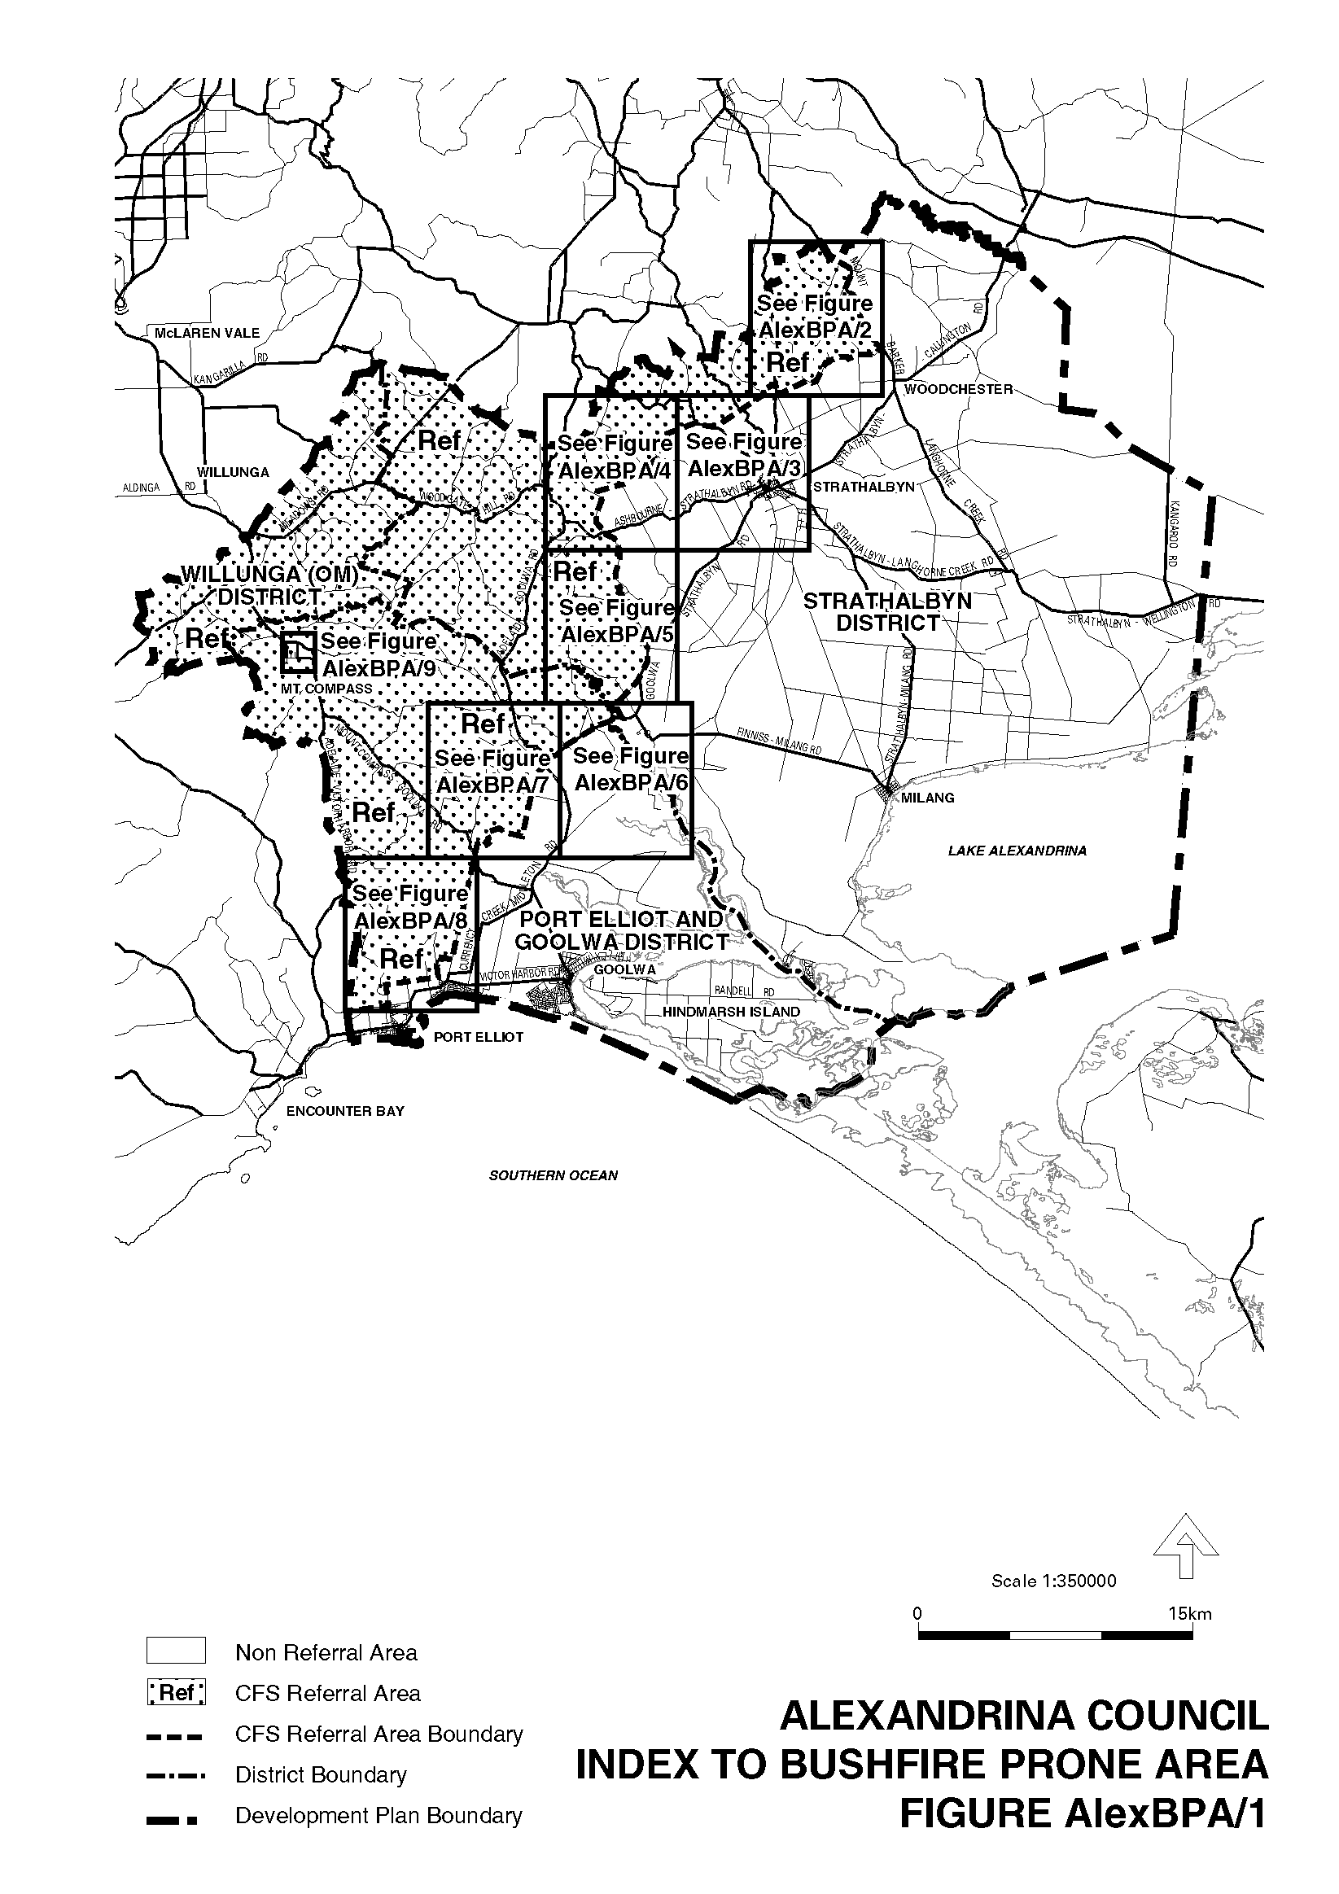

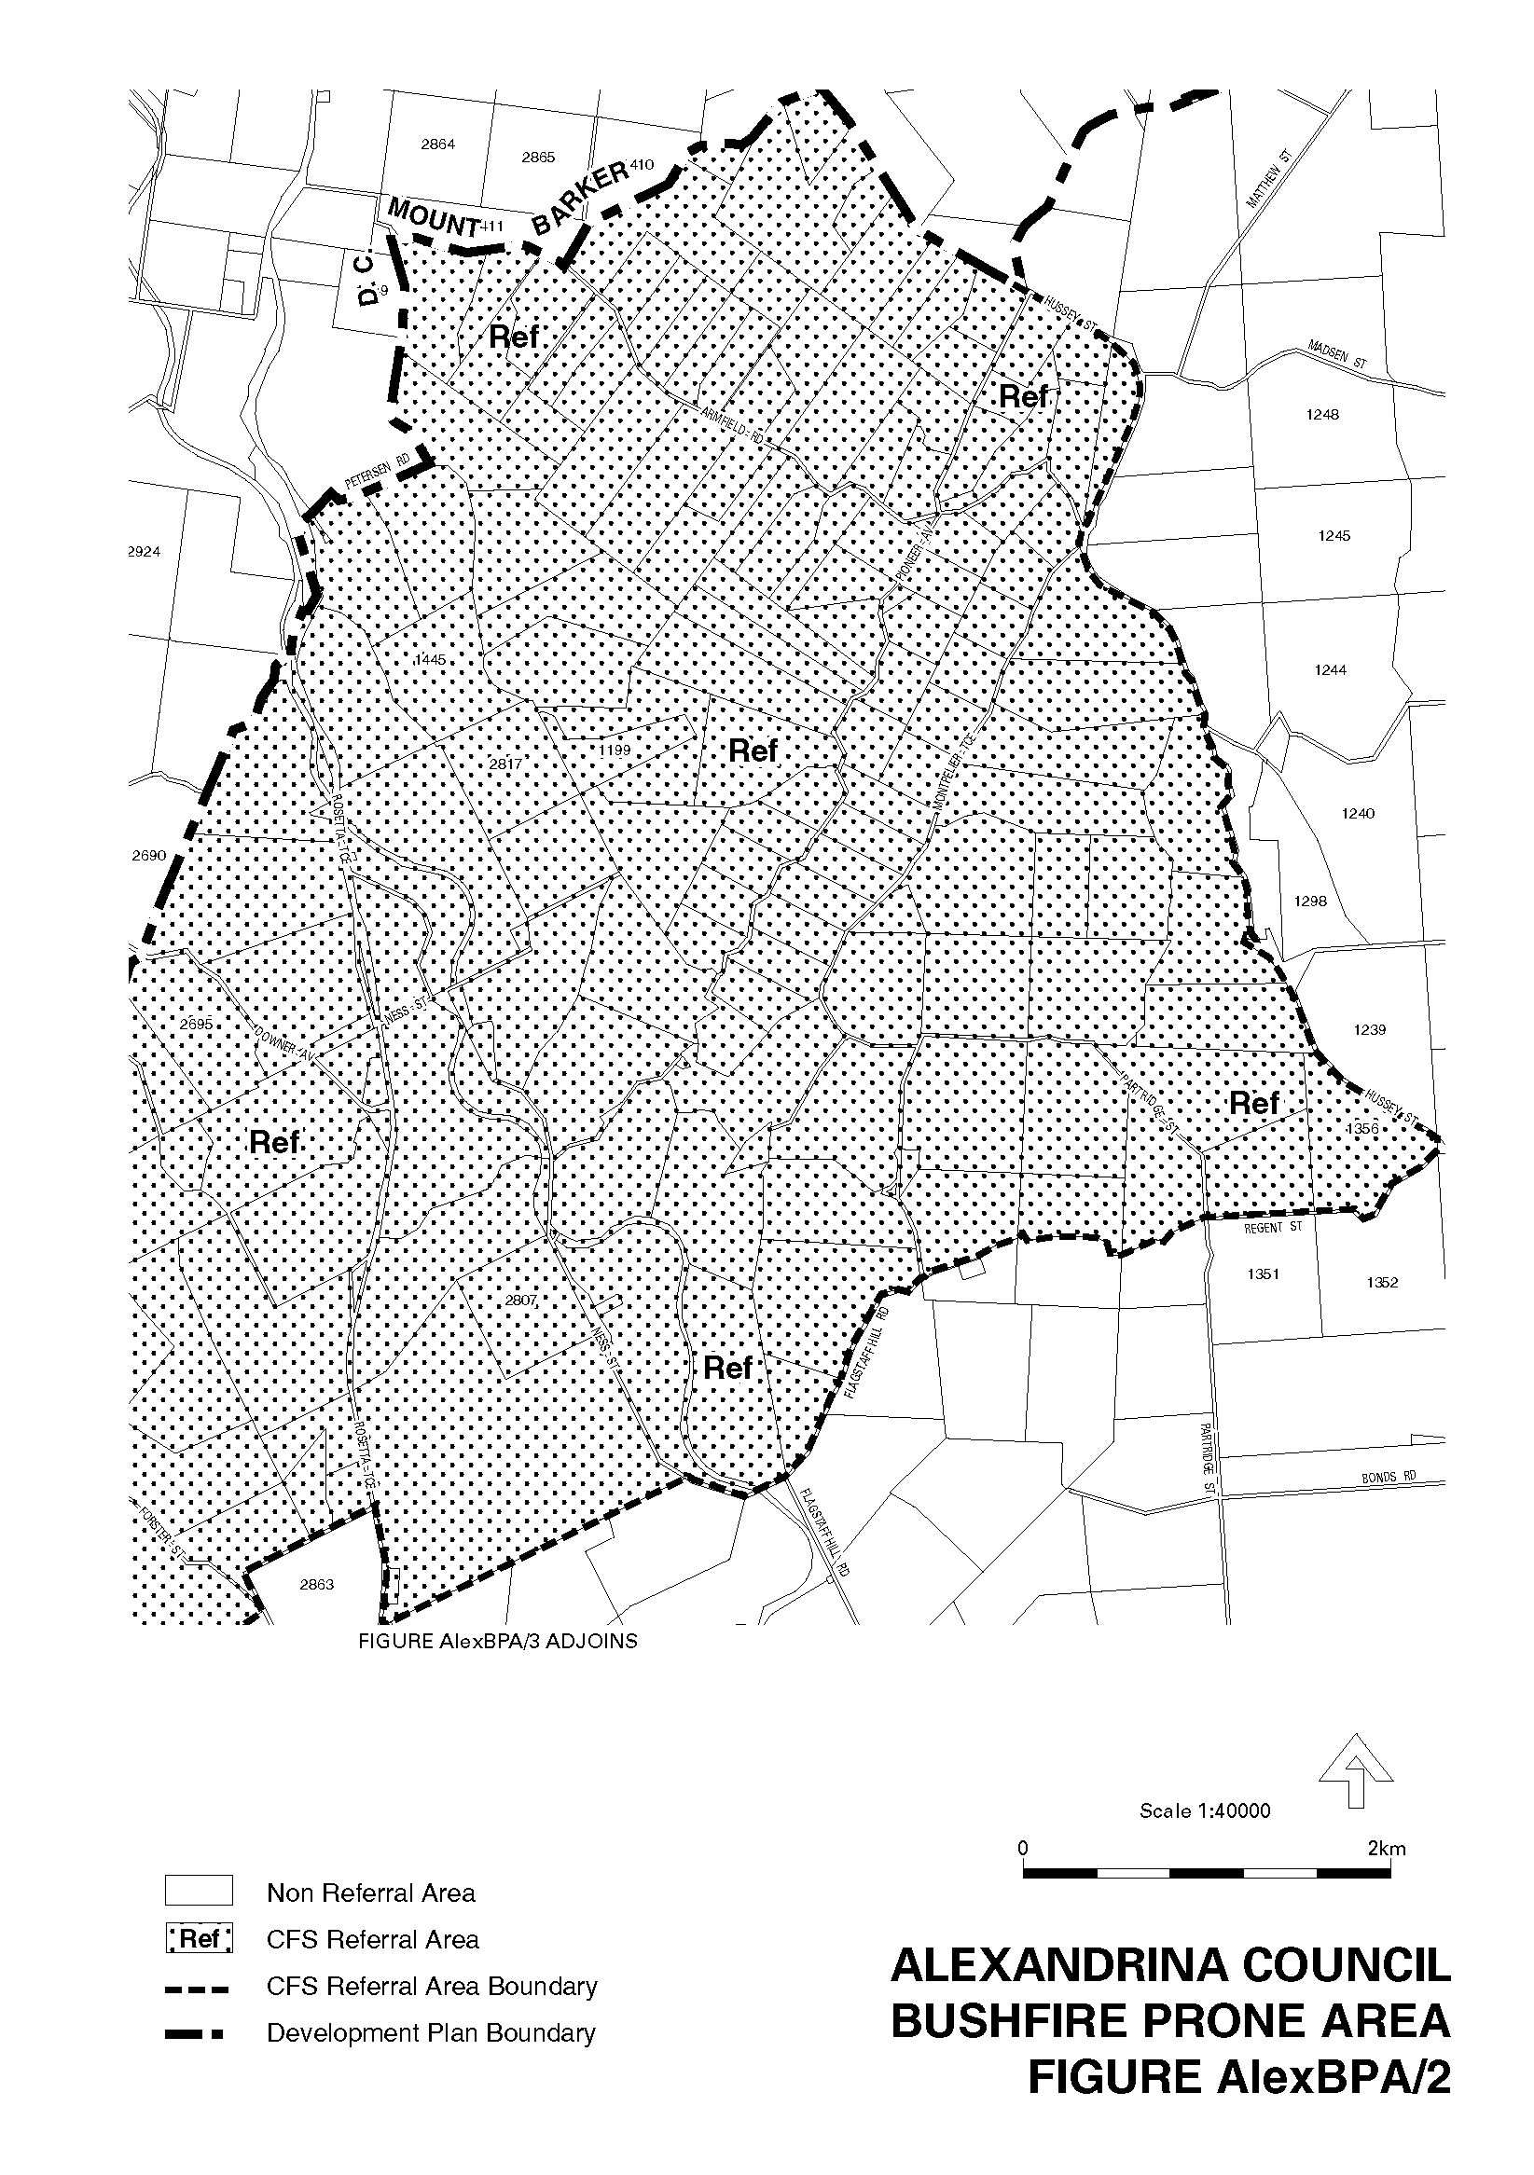
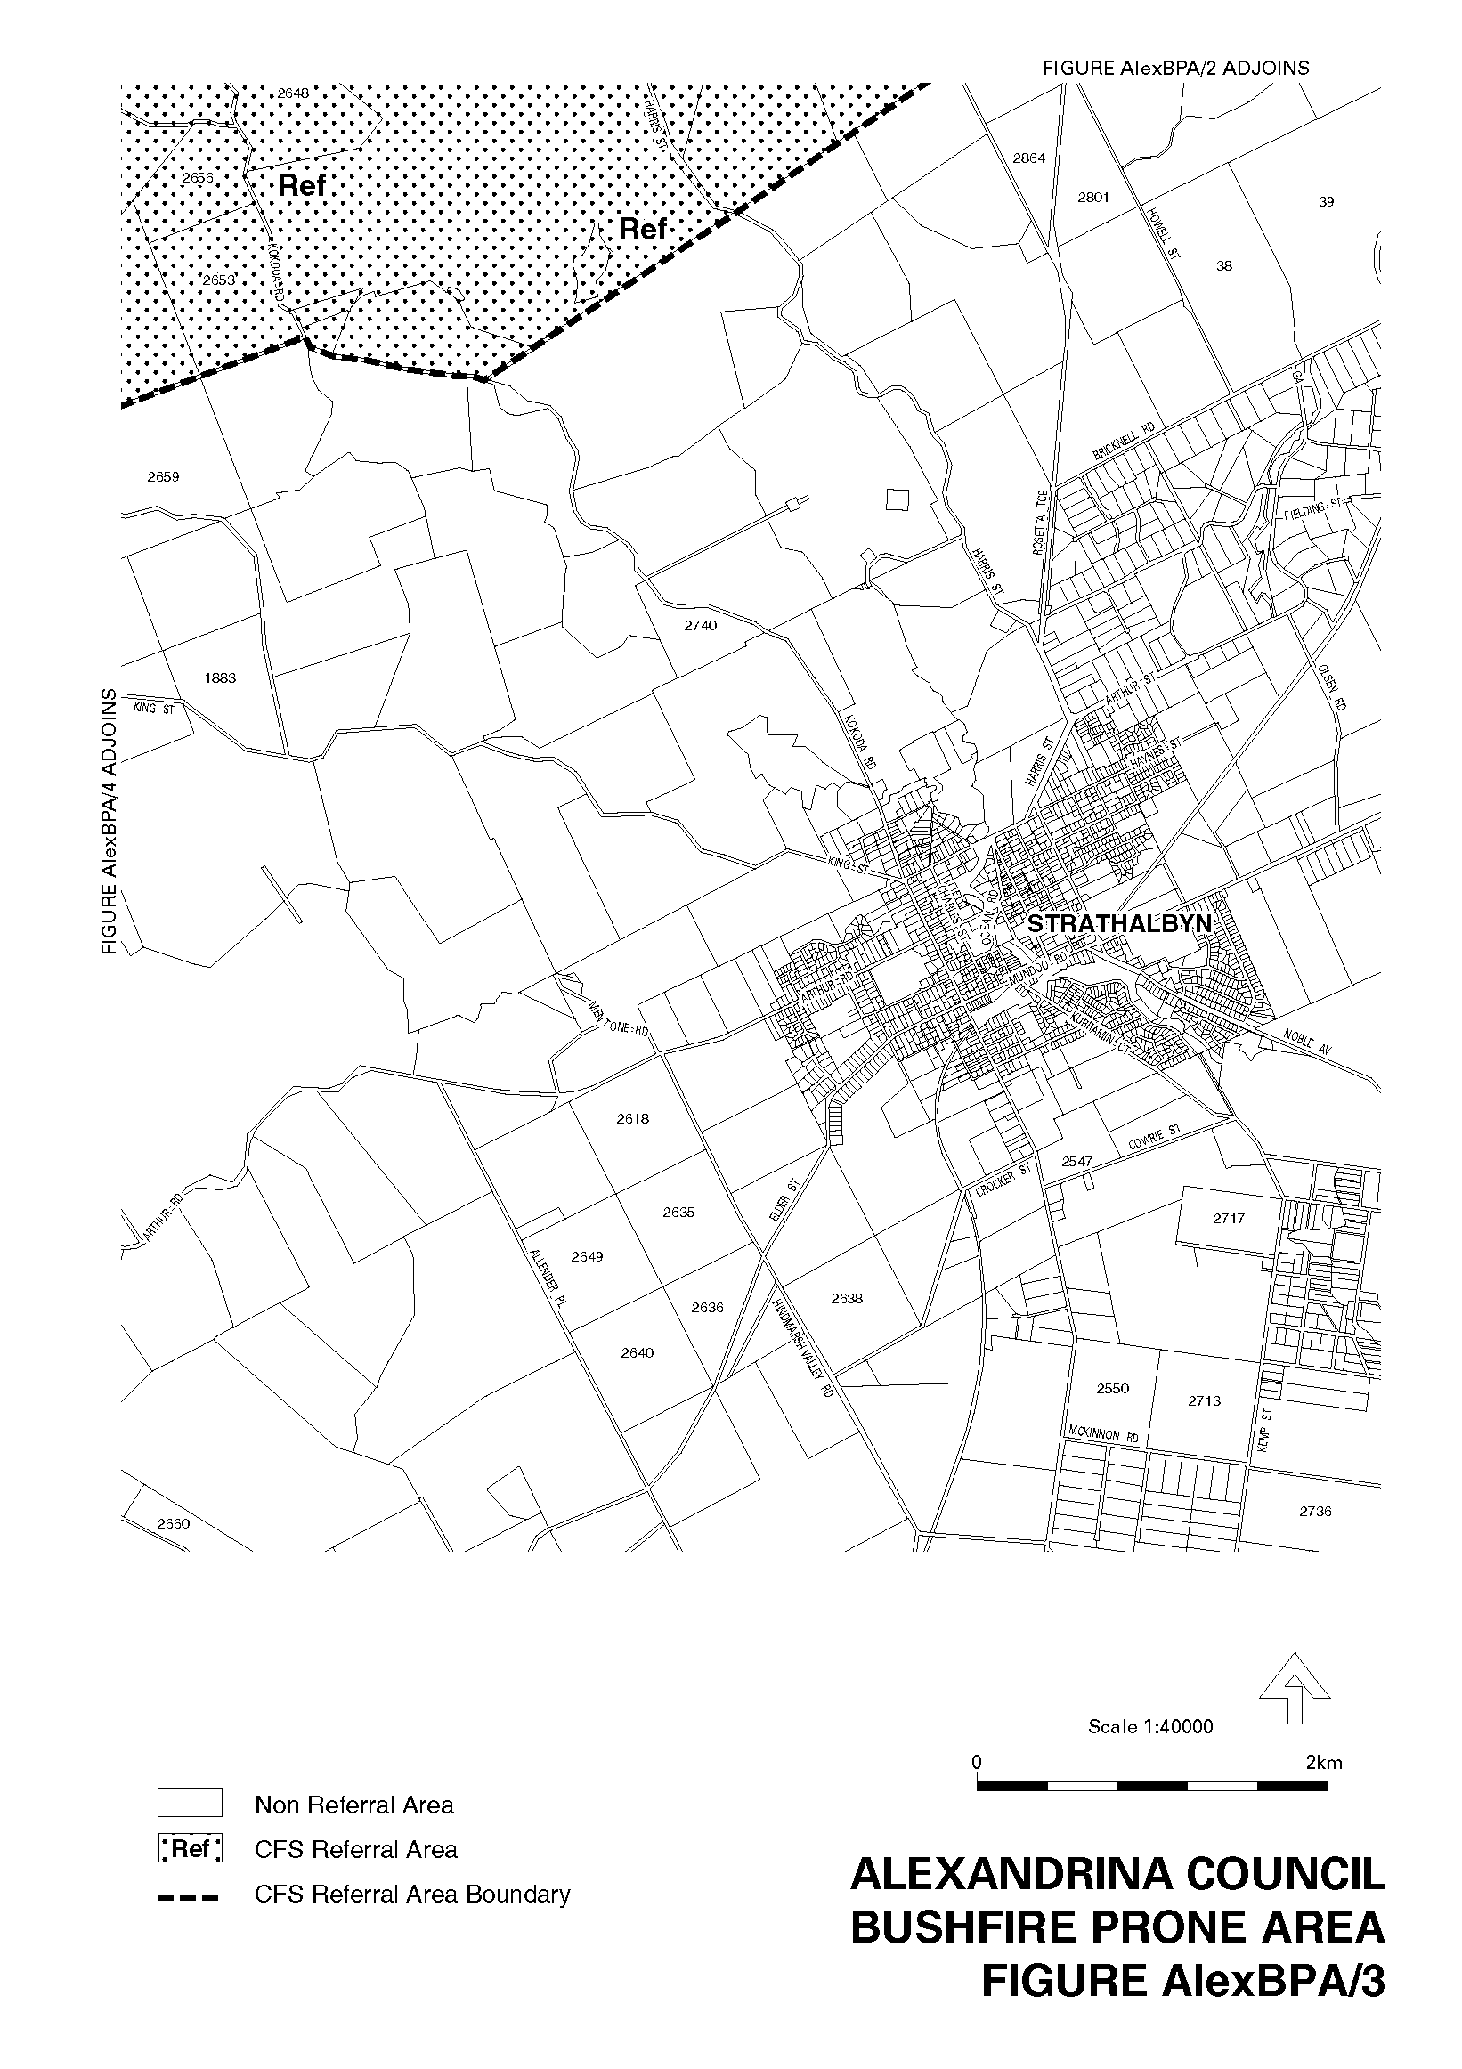
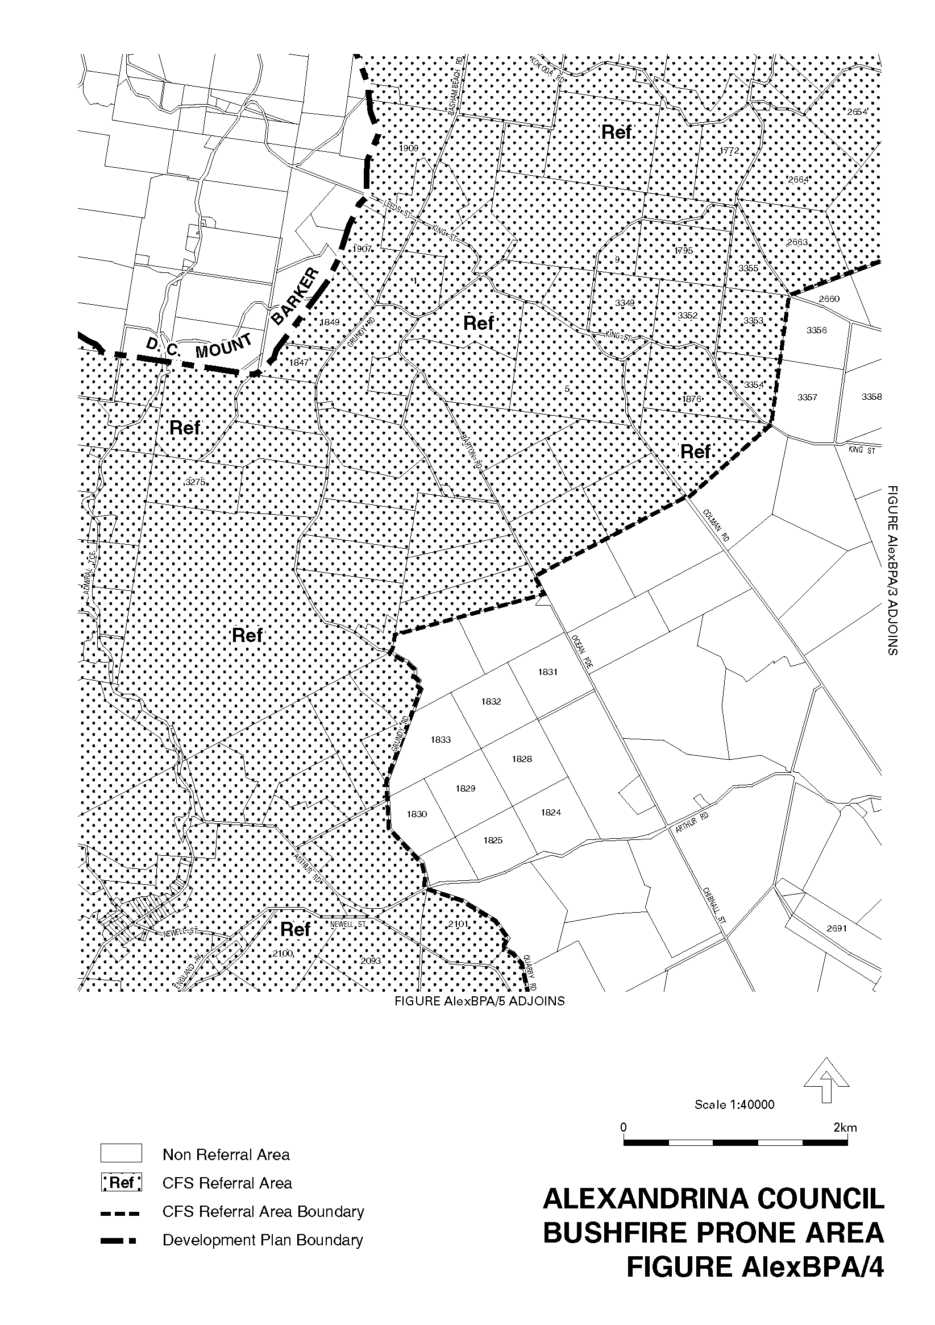
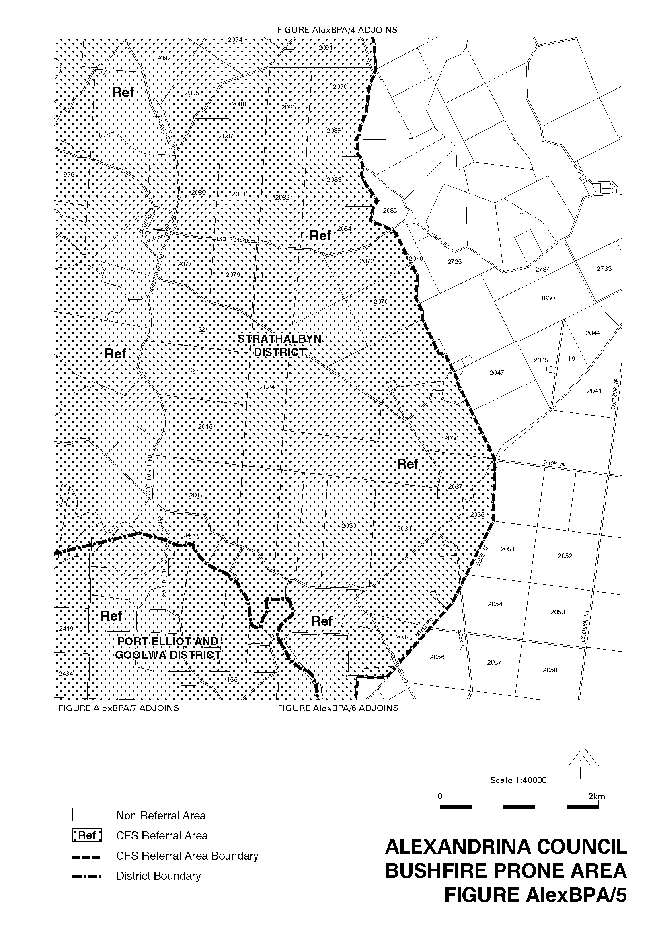
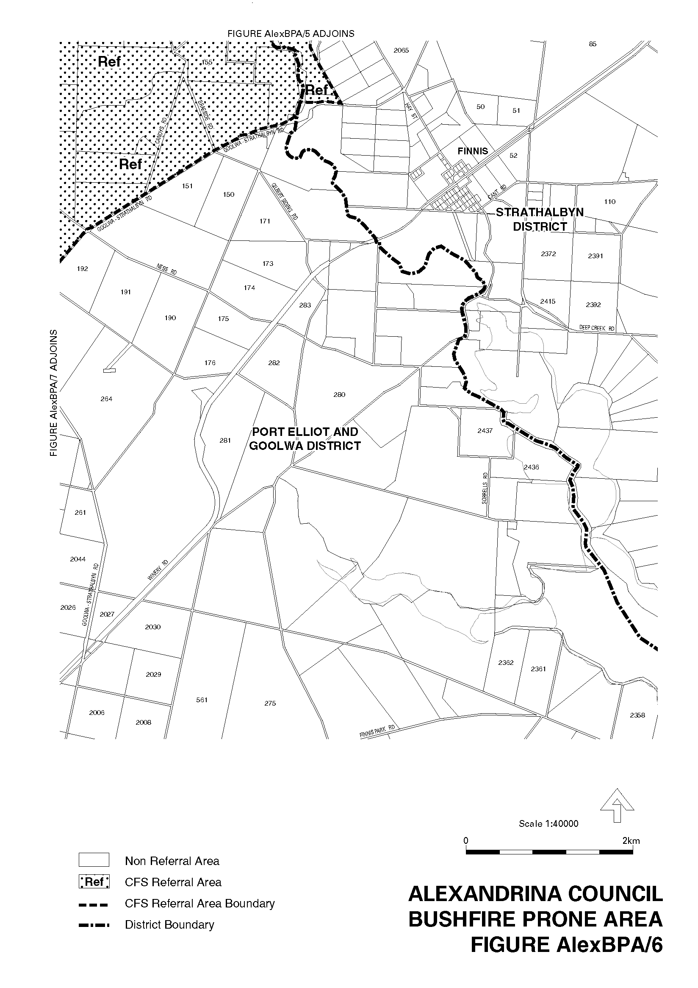
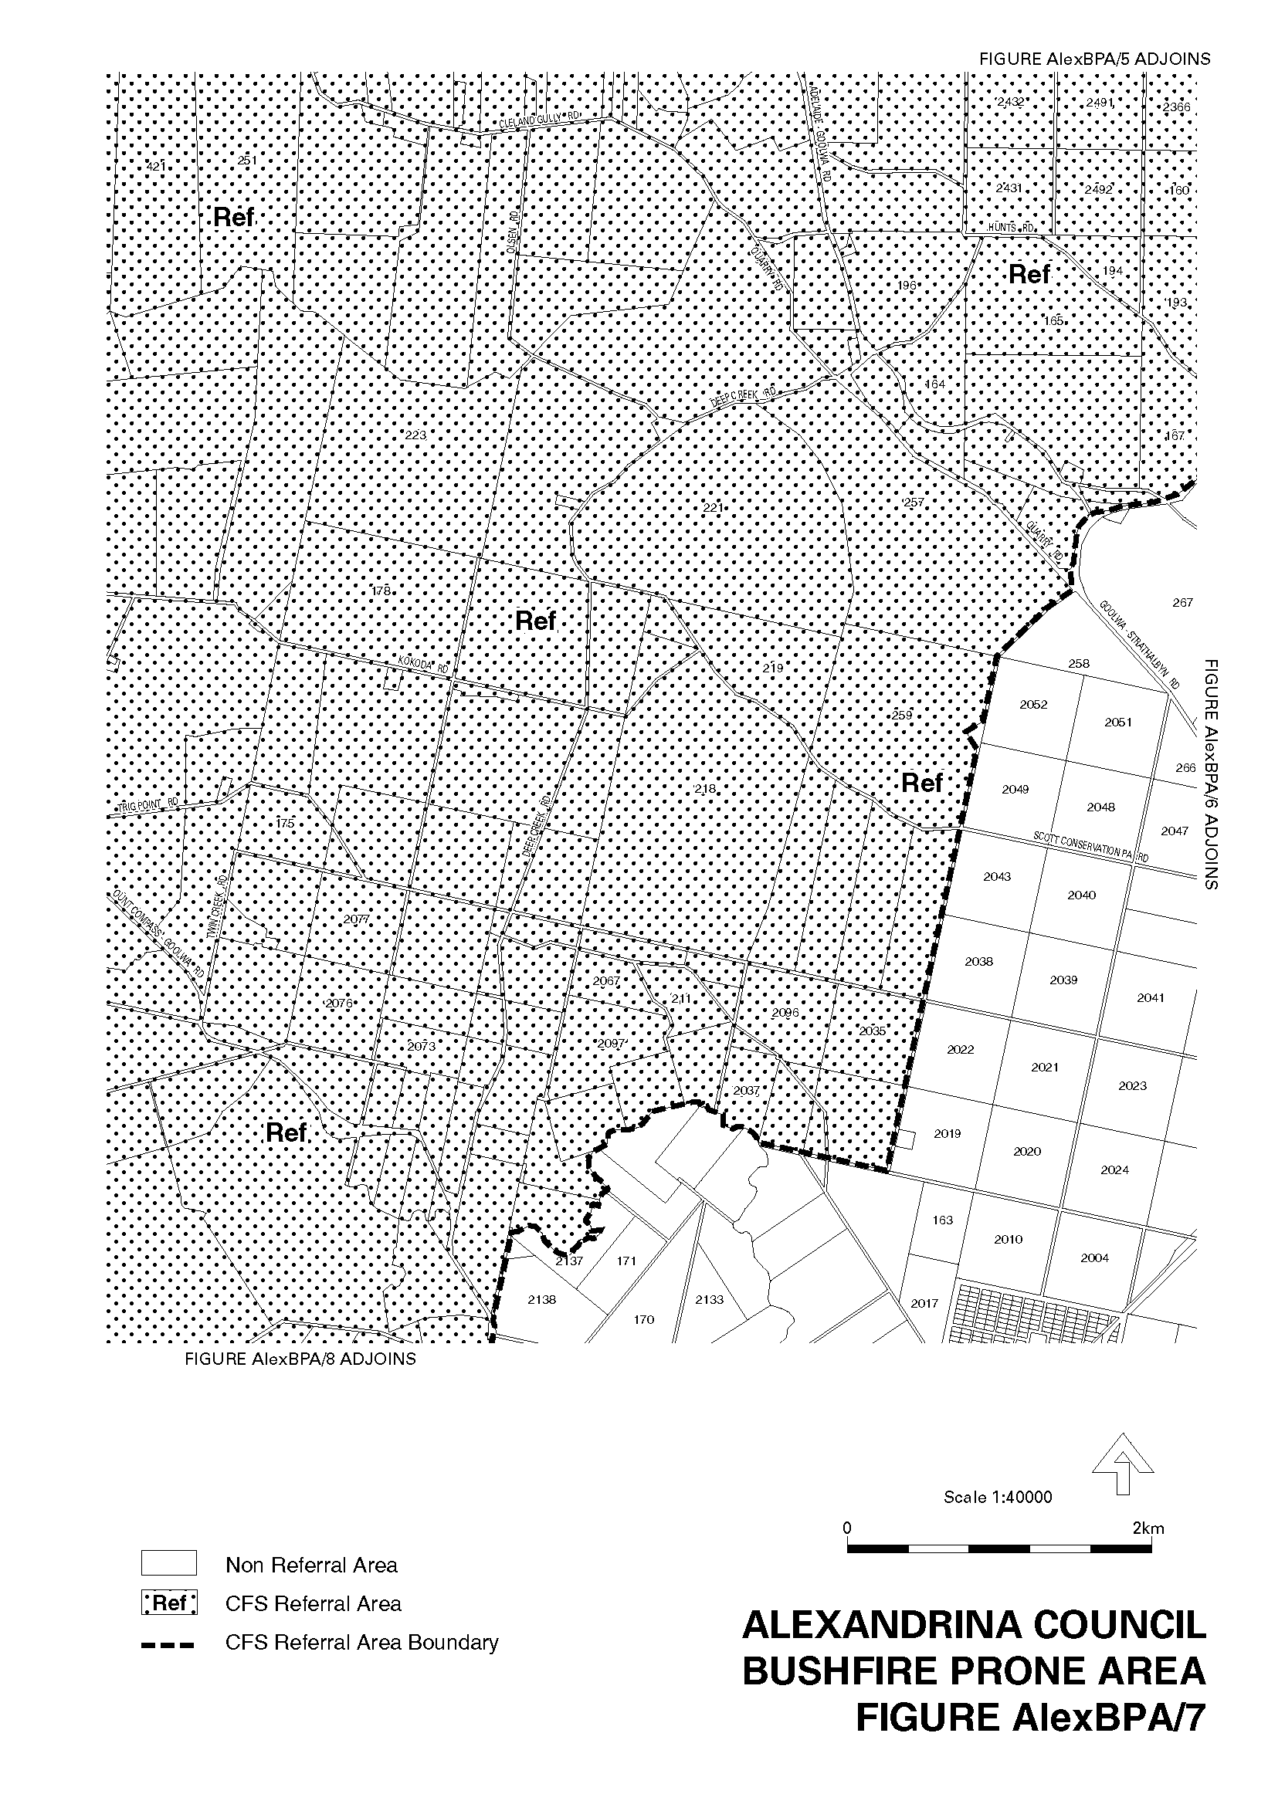
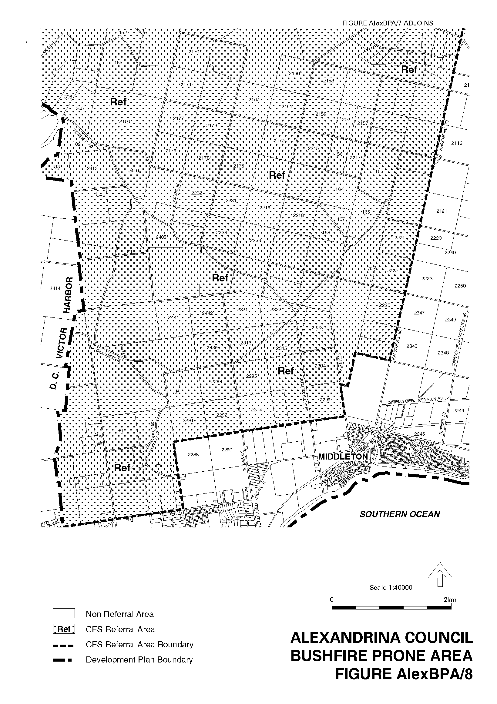
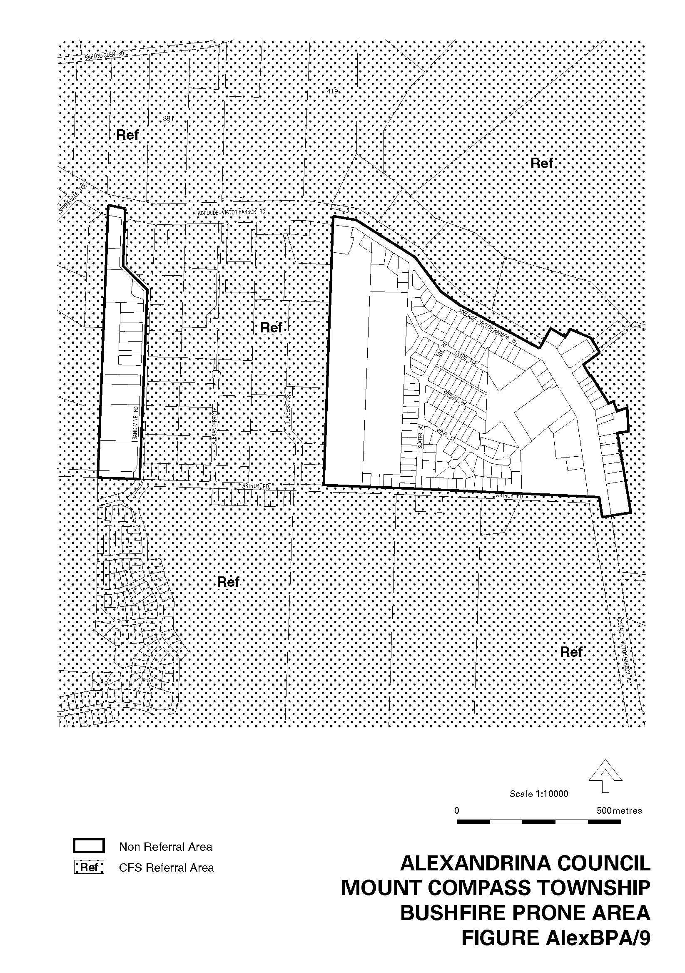
Dated 29 May 2003.
Jay Weatherill, Minister for Urban Development and Planning
PLN/01/0087

ENVIRONMENT PROTECTION ACT 1993
Approval of Category B Containers
I, STEPHEN RICHARD SMITH, Senior Adviser, Container Deposit Legislation and Delegate of the Environment Protection Authority (‘the Authority’), pursuant to section 69 of the Environment Protection Act 1993 (SA) (‘the Act’) hereby:
Approval of Category B Containers:
Approve as Category B Containers, subject to the conditions in subclauses (i) and (ii) below, each of the classes of containers identified by reference to the following matters described in the first 4 columns of Schedule 1 of this Notice which are sold in South Australia:
(a) the product which each class of containers shall contain;
(b) the size of the containers;
(c) the type of containers;
(d) the name of the holders of these approvals.
(i) Subsection 69 (3) Arrangements:
The holders of these approvals must ensure that the empty containers which belong to their respective class of containers hereby approved as Category B Containers are collected from collection depots approved under section 69 of the Act by the party named in column 5 of Schedule 1 of this Notice; and
(ii) Approved Refund Markings:
The holders of these approvals must ensure that each container which belongs to their respective class of containers hereby approved as Category B Containers bears the refund marking approved by the Authority in respect of that class of containers.

Product Name | Container  Size (mL) | Container Type | Approval Holder | Collection  Arrangements
Amstel Lager | 330 | Glass | Woolworths Limited | Visy CDL Recycling Services
Amsterdam Mariner Premium Lager | 330 | Glass | Woolworths Limited | Visy CDL Recycling Services
Berri Apricot Nectar | 170 | Can - Steel | Berri Limited | Statewide Recycling
Berri Tomato Juice | 170 | Can - Steel | Berri Limited | Statewide Recycling
Classic Nectars Apricot | 175 | Glass | Bickfords Australia Pty Ltd | Statewide Recycling
Classic Nectars Mango | 175 | Glass | Bickfords Australia Pty Ltd | Statewide Recycling
Classic Nectars Peach | 175 | Glass | Bickfords Australia Pty Ltd | Statewide Recycling
Classic Nectars Pear | 175 | Glass | Bickfords Australia Pty Ltd | Statewide Recycling
Diet Coke with Vanilla | 1 250 | PET | Coca-Cola Amatil (Aust) Pty Ltd | Statewide Recycling
Diet Coke with Vanilla | 1 500 | PET | Coca-Cola Amatil (Aust) Pty Ltd | Statewide Recycling
Diet Coke with Vanilla | 2 000 | PET | Coca-Cola Amatil (Aust) Pty Ltd | Statewide Recycling
Diet Coke with Vanilla | 375 | Can - Aluminium | Coca-Cola Amatil (Aust) Pty Ltd | Statewide Recycling
Diet Coke with Vanilla | 390 | PET | Coca-Cola Amatil (Aust) Pty Ltd | Statewide Recycling
Diet Coke with Vanilla | 600 | PET | Coca-Cola Amatil (Aust) Pty Ltd | Statewide Recycling
FX Vodka Lemon Lime | 275 | Glass | Independent Distillers Australia | Statewide Recycling
FX Vodka Passionfruit | 275 | Glass | Independent Distillers Australia | Statewide Recycling
FX Vodka Raspberry | 275 | Glass | Independent Distillers Australia | Statewide Recycling
H2GO Mineral Water | 425 | PET | Frucor Beverages Limited | Statewide Recycling
James Boag’s Premium | 375 | Glass | Carlton & United Breweries Ltd | Visy CDL Recycling Services
James Boag’s Premium Light | 375 | Glass | Carlton & United Breweries Ltd | Visy CDL Recycling Services
LIV Mango & Banana Smoothie | 200 | PET | Synergy Trading Pty Ltd | Visy CDL Recycling Services
LIV Mango & Passionfruit Smoothie | 200 | PET | Synergy Trading Pty Ltd | Visy CDL Recycling Services
Lowenbrau Original | 330 | Glass | Woolworths Limited | Visy CDL Recycling Services
Molony’s Cave Cola | 330 | Glass | Geoff Morris Wholesalers Pty Ltd | Statewide Recycling
Molony’s Forest Lime | 330 | Glass | Geoff Morris Wholesalers Pty Ltd | Statewide Recycling
Molony’s Rocky Red | 330 | Glass | Geoff Morris Wholesalers Pty Ltd | Statewide Recycling
Monteiths Black Beer | 330 | Glass | Woolworths Limited | Visy CDL Recycling Services
Monteiths Golden Lager Beer | 330 | Glass | Woolworths Limited | Visy CDL Recycling Services
Monteiths Original Ale Beer | 330 | Glass | Woolworths Limited | Visy CDL Recycling Services
Nekta Liquid Kiwi Fruit | 2 000 | PET | Merenda Wholesalers Adelaide | Statewide Recycling
Nekta Liquid Kiwi Fruit | 375 | PET | Merenda Wholesalers Adelaide | Statewide Recycling
Nippys Apple Juice | 500 | LPB - Aseptic | Knispel Fruit Juices Pty Ltd | Statewide Recycling
Nippys Pineapple Crush Pineapple Juice | 300 | PET | Knispel Fruit Juices Pty Ltd | Statewide Recycling
Nippys Pineapple Crush Pineapple Juice | 500 | PET | Knispel Fruit Juices Pty Ltd | Statewide Recycling
Nippys Tropical Juice | 300 | PET | Knispel Fruit Juices Pty Ltd | Statewide Recycling
Nippys Tropical Juice | 500 | PET | Knispel Fruit Juices Pty Ltd | Statewide Recycling
PowerAde Light Artic Ice | 600 | PET | Coca-Cola Amatil (Aust) Pty Ltd | Statewide Recycling
PowerAde Light Citrus Breeze | 600 | PET | Coca-Cola Amatil (Aust) Pty Ltd | Statewide Recycling
Sprite Ice | 1 250 | PET | Coca-Cola Amatil (Aust) Pty Ltd | Statewide Recycling
Sprite Ice | 2000 | PET | Coca-Cola Amatil (Aust) Pty Ltd | Statewide Recycling
Sprite Ice | 390 | PET | Coca-Cola Amatil (Aust) Pty Ltd | Statewide Recycling
Sprite Ice | 600 | PET | Coca-Cola Amatil (Aust) Pty Ltd | Statewide Recycling
Sydney Cider | 330 | Glass | Feyn Drink Pty Ltd | Statewide Recycling
Tooheys Extra Dry | 375 | Can—Aluminium | South Australian Brewing Company Pty Ltd | Marine Stores Ltd
Torquay Pineapple & Lime | 375 | Can—Aluminium | BCB Beverages Pty Ltd | Flagcan Distributors
Traffic Stoppers Cola Soft Drink | 2 000 | PET | Pure & Natural Beverages Pty Ltd | Flagcan Distributors
Traffic Stoppers Creaming Soda Soft Drink | 2 000 | PET | Pure & Natural Beverages Pty Ltd | Flagcan Distributors
Traffic Stoppers Lemon Soft Drink | 2 000 | PET | Pure & Natural Beverages Pty Ltd | Flagcan Distributors
Traffic Stoppers Orange Soft Drink | 2 000 | PET | Pure & Natural Beverages Pty Ltd | Flagcan Distributors
Yakult | 65 | Polystyrene | Yakult Australia Pty Ltd | Statewide Recycling

FISHERIES ACT 1982: SECTION 59
TAKE notice that pursuant to section 59 of the Fisheries Act 1982, those holders of a licence issued pursuant to the Scheme of Management (Rock Lobster Fisheries) Regulations 1991 (the ‘exemption holders’) are exempted from the provisions of clause 123 of Schedule 1 of the Fisheries (General) Regulations 2000 in that an exemption holder shall not be guilty of an offence when using a boat that is registered and endorsed on a fishery licence pursuant to Division 1, Part 4 of the Fisheries Act 1982 for the activities described in Schedule 1 (the ‘exempted activity’) subject to the conditions specified in Schedule 2, from 1 July 2003 until 30 June 2004, unless this notice is varied or revoked earlier.
Schedule 1
1. The taking of fish other than rock lobster (Jasus edwardsii) for purposes other than trade or business.
2. The carrying, setting or retrieving of recreational rock lobster pots.
Schedule 2
1. An exemption holder must notify the PIRSA Fisheries Compliance Unit via Link Communications on 1800 065 522 prior to engaging in the exempted activity with the following information:
• the commercial boat registration number and the fishery licence number to which the call applies;
• the name of the person making the call (must be a licence holder or a registered master) and the rock lobster fishery licence number;
• the number of recreational pots to be used from the boat;
• the registration numbers of the recreational pots that will be placed on the boat;
• the time and date the exempted activity will commence; and
• the time and date the exempted activity will cease.
2. An exemption holder shall not contravene or fail to comply with the Fisheries Act 1982, or any other regulations made under that Act except where specifically exempted by this notice.
Dated 20 May 2003.
W. Zacharin, Director of Fisheries

GOVERNMENT GAZETTE ADVERTISEMENT RATES

To apply from 1 July 2002

$  Agents, Ceasing to Act as 34.10  Associations:  Incorporation 17.40  Intention of Incorporation 43.00  Transfer of Properties 43.00  Attorney, Appointment of 34.10  Bailiff’s Sale 43.00  Cemetery Curator Appointed 25.50  Companies:  Alteration to Constitution 34.10  Capital, Increase or Decrease of 43.00  Ceasing to Carry on Business 25.50  Declaration of Dividend 25.50  Incorporation 34.10  Lost Share Certificates:  First Name 25.50  Each Subsequent Name 8.75  Meeting Final 28.75  Meeting Final Regarding Liquidator’s Report on  Conduct of Winding Up (equivalent to ‘Final  Meeting’)  First Name 34.10  Each Subsequent Name 8.75  Notices:  Call 43.00  Change of Name 17.40  Creditors 34.10  Creditors Compromise of Arrangement 34.10  Creditors (extraordinary resolution that ‘the Com-pany be wound up voluntarily and that a liquidator be appointed’) 43.00  Release of Liquidator⎯Application⎯Large Ad. 68.00  ⎯Release Granted 43.00  Receiver and Manager Appointed 39.75  Receiver and Manager Ceasing to Act 34.10  Restored Name 32.25  Petition to Supreme Court for Winding Up 59.50  Summons in Action 51.00  Order of Supreme Court for Winding Up Action 34.10  Register of Interests⎯Section 84 (1) Exempt 77.00  Removal of Office 17.40  Proof of Debts 34.10  Sales of Shares and Forfeiture 34.10  Estates:  Assigned 25.50  Deceased Persons⎯Notice to Creditors, etc. 43.00  Each Subsequent Name 8.75  Deceased Persons⎯Closed Estates 25.50  Each Subsequent Estate 1.10  Probate, Selling of 34.10  Public Trustee, each Estate 8.75 |  | $  Firms:  Ceasing to Carry on Business (each insertion) 22.70  Discontinuance Place of Business 22.70  Land⎯Real Property Act:  Intention to Sell, Notice of 43.00  Lost Certificate of Title Notices 43.00  Cancellation, Notice of (Strata Plan) 43.00  Mortgages:  Caveat Lodgment 17.40  Discharge of 18.30  Foreclosures 17.40  Transfer of 17.40  Sublet 8.75  Leases⎯Application for Transfer (2 insertions) each 8.75  Lost Treasury Receipts (3 insertions) each 25.50  Licensing 51.00  Municipal or District Councils:  Annual Financial Statement⎯Forms 1 and 2 481.00  Electricity Supply⎯Forms 19 and 20 341.00  Default in Payment of Rates:  First Name 68.00  Each Subsequent Name 8.75  Noxious Trade 25.50  Partnership, Dissolution of 25.50  Petitions (small) 17.40  Registered Building Societies (from Registrar-  General) 17.40  Register of Unclaimed Moneys⎯First Name 25.50  Each Subsequent Name 8.75  Registers of Members⎯Three pages and over:  Rate per page (in 8pt) 218.00  Rate per page (in 6pt) 288.00  Sale of Land by Public Auction 43.50  Advertisements 2.40  Advertisements, other than those listed are charged at $2.40 per column line, tabular one-third extra.  Notices by Colleges, Universities, Corporations and District Councils to be charged at $2.40 per line.  Where the notice inserted varies significantly in length from that which is usually published a charge of $2.40 per column line will be applied in lieu of advertisement rates listed.  South Australian Government publications are sold on the condition that they will not be reproduced without prior permission from the Government Printer.
All the above prices include GST

GOVERNMENT GAZETTE NOTICES
ALL private advertisements forwarded for publication in the South Australian Government Gazette must be PAID FOR PRIOR TO INSERTION; and all notices, from whatever source, should be legibly written on one side of the paper only and sent to Government Publishing SA so as to be received no later than 4 p.m. Tuesday preceding the day of publication. Phone 8207 1045 or Fax 8207 1040. E-mail: governmentgazette@saugov.sa.gov.au. Send as attachments in Word format and please confirm your transmission with a faxed copy of your document, including the date the notice is to be published and to whom the notice will be charged.

MISCELLANEOUS LEGISLATION AND GOVERNMENT PUBLICATIONS PRICES AS FROM 1 JULY 2002

Acts, Bills, Rules, Parliamentary Papers and Regulations
Pages | Main | Amends | Pages | Main | Amends

1-16 | 1.95 | 0.85 | 497-512 | 28.10 | 27.00
17-32 | 2.70 | 1.70 | 513-528 | 28.90 | 27.75
33-48 | 3.50 | 2.50 | 529-544 | 29.70 | 28.75
49-64 | 4.45 | 3.35 | 545-560 | 30.50 | 29.75
65-80 | 5.20 | 4.30 | 561-576 | 31.25 | 30.50
81-96 | 6.00 | 5.00 | 577-592 | 32.30 | 31.00
97-112 | 6.90 | 5.85 | 593-608 | 33.10 | 32.00
113-128 | 7.70 | 6.75 | 609-624 | 33.90 | 33.00
129-144 | 8.65 | 7.65 | 625-640 | 34.60 | 33.50
145-160 | 9.50 | 8.50 | 641-656 | 35.40 | 34.50
161-176 | 10.40 | 9.30 | 657-672 | 36.00 | 35.25
177-192 | 11.20 | 10.20 | 673-688 | 37.50 | 36.00
193-208 | 12.00 | 11.10 | 689-704 | 38.30 | 37.00
209-224 | 12.80 | 11.80 | 705-720 | 38.80 | 38.00
225-240 | 13.60 | 12.60 | 721-736 | 40.25 | 38.50
241-257 | 14.50 | 13.30 | 737-752 | 40.75 | 39.75
258-272 | 15.40 | 14.20 | 753-768 | 41.75 | 40.25
273-288 | 16.30 | 15.20 | 769-784 | 42.25 | 41.50
289-304 | 17.00 | 16.00 | 785-800 | 43.00 | 42.25
305-320 | 17.90 | 16.80 | 801-816 | 43.75 | 42.75
321-336 | 18.70 | 17.60 | 817-832 | 44.75 | 43.75
337-352 | 19.60 | 18.60 | 833-848 | 45.75 | 44.50
353-368 | 20.40 | 19.40 | 849-864 | 46.50 | 45.25
369-384 | 21.30 | 20.30 | 865-880 | 47.25 | 46.50
385-400 | 22.00 | 21.10 | 881-896 | 47.75 | 47.00
401-416 | 22.80 | 21.80 | 897-912 | 49.25 | 47.75
417-432 | 23.90 | 22.70 | 913-928 | 49.75 | 49.25
433-448 | 24.60 | 23.60 | 929-944 | 50.50 | 49.75
449-464 | 25.50 | 24.40 | 945-960 | 51.50 | 50.25
465-480 | 26.00 | 25.20 | 961-976 | 52.50 | 51.25
481-496 | 27.10 | 26.00 | 977-992 | 53.50 | 52.00

Legislation—Acts, Regulations, etc: $
Subscriptions:
Acts 174.00
All Bills as Laid 415.00
Rules and Regulations 415.00
Parliamentary Papers 415.00
Bound Acts 192.00
Index 95.50
Government Gazette
Copy 4.55
Subscription 229.00
Hansard
Copy 12.50
Subscription—per session (issued weekly) 360.00
Cloth bound—per volume 154.50
Subscription—per session (issued daily) 360.00
Legislation on Disk
Whole Database 2 659.00
Annual Subscription for fortnightly updates 817.00
Individual Act(s) including updates POA
Compendium
Subscriptions:
New Subs 1 577.00
Updates 556.00
(All the above prices include GST)

All Legislation, Government Gazette, Hansard and Legislation on disk are available from:
Counter Sales Service SA, Government Information Centre
and Mail Orders: Ground Floor, 77 Grenfell Street, Adelaide, S.A. 5000
Phone: 13 23 24 (local call cost), Fax: (08) 8204 1909
TTY (Hearing Impaired): (08) 8204 1923

Online Shop: www.info.sa.gov.au

Subscriptions and Government Publishing SA
Standing Orders: Box 9, Plaza Level, Riverside Centre, North Terrace, Adelaide, S.A. 5000
Phone: (08) 8207 0908, (08) 8207 0910, Fax: (08) 8207 1040

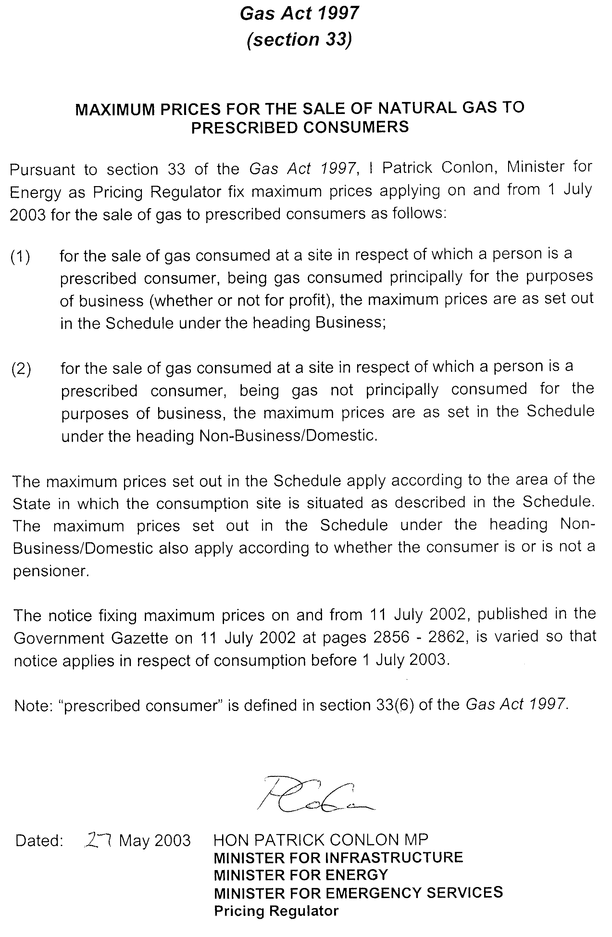
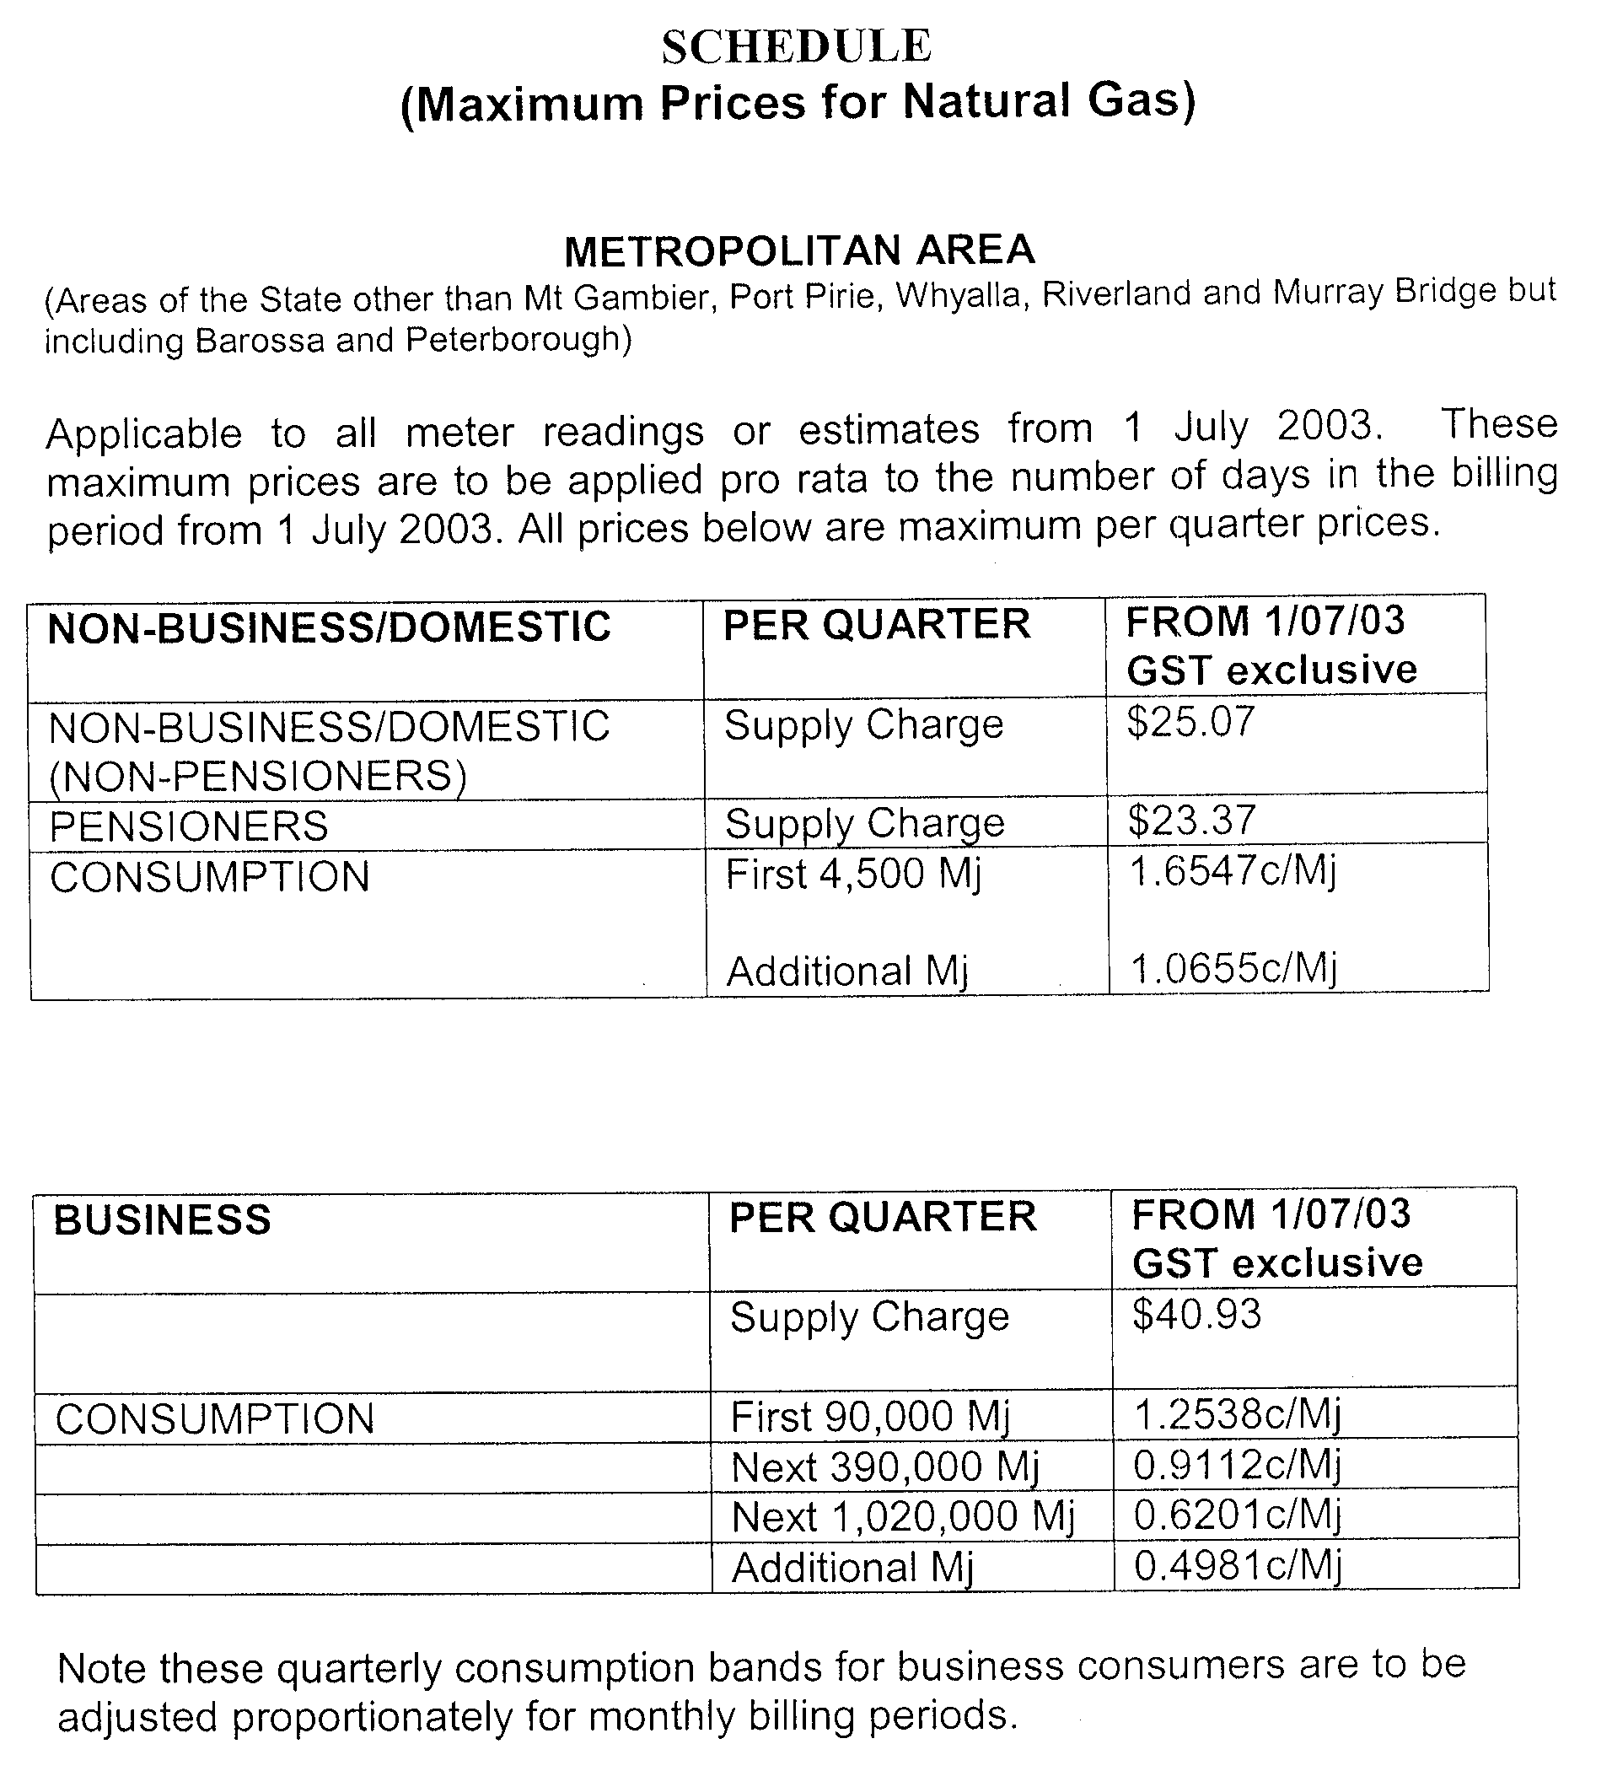
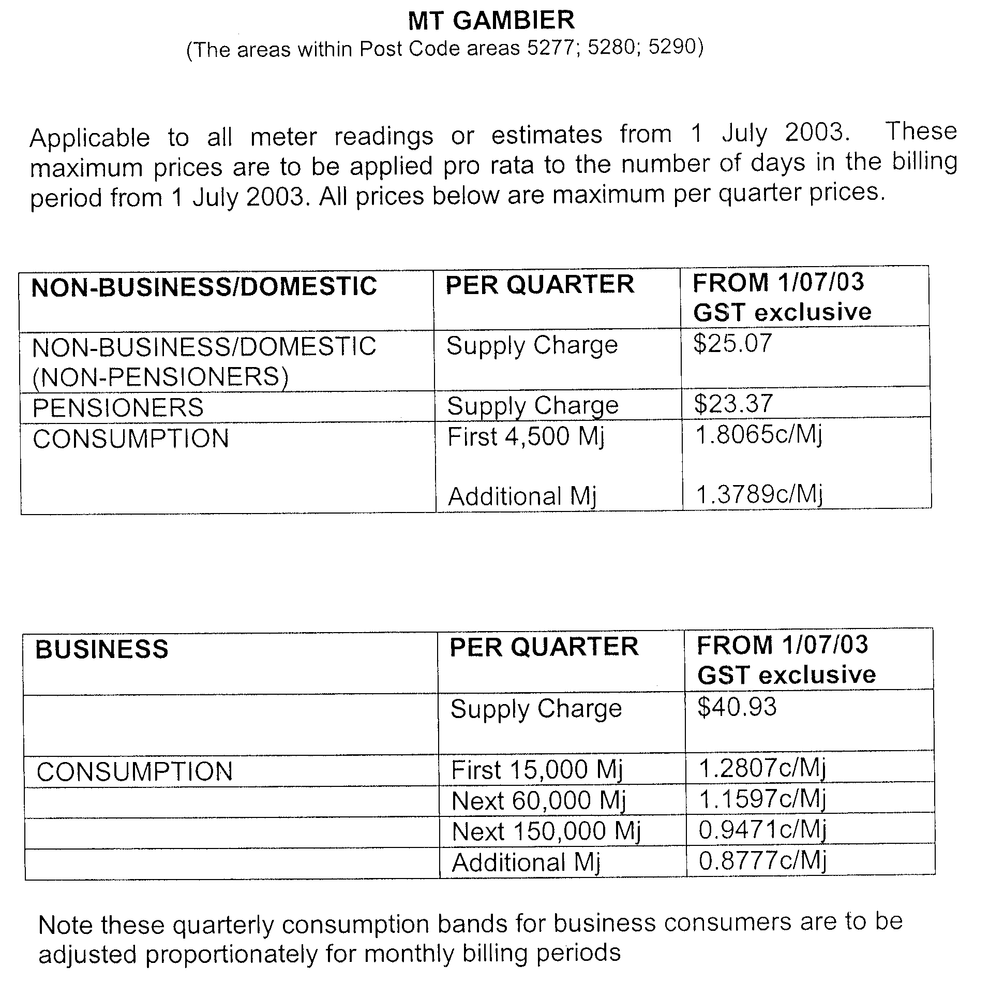
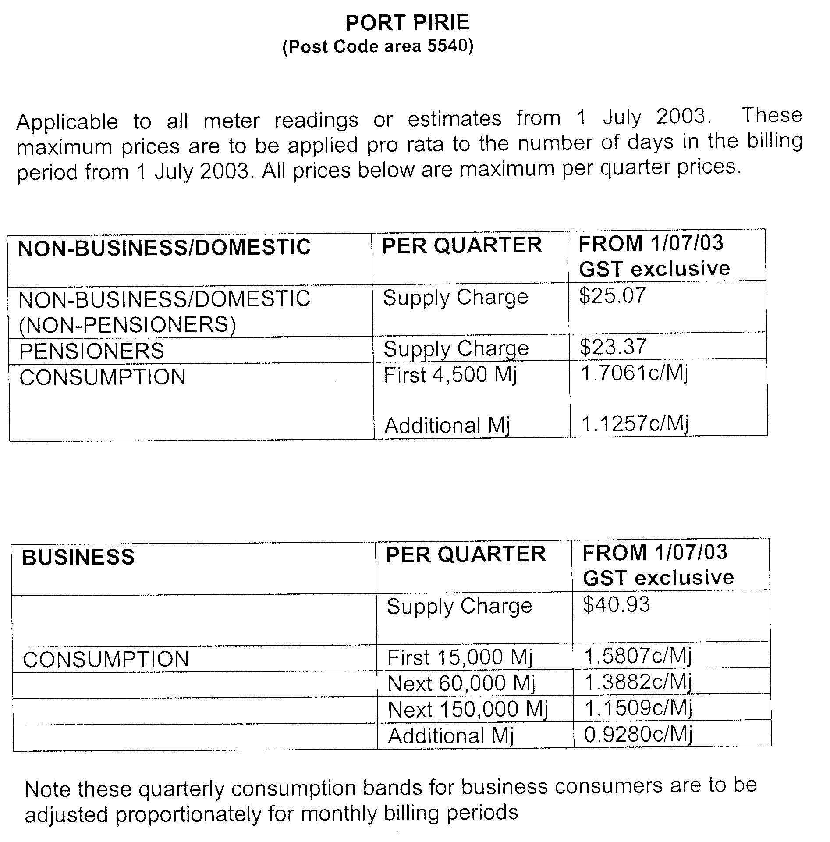
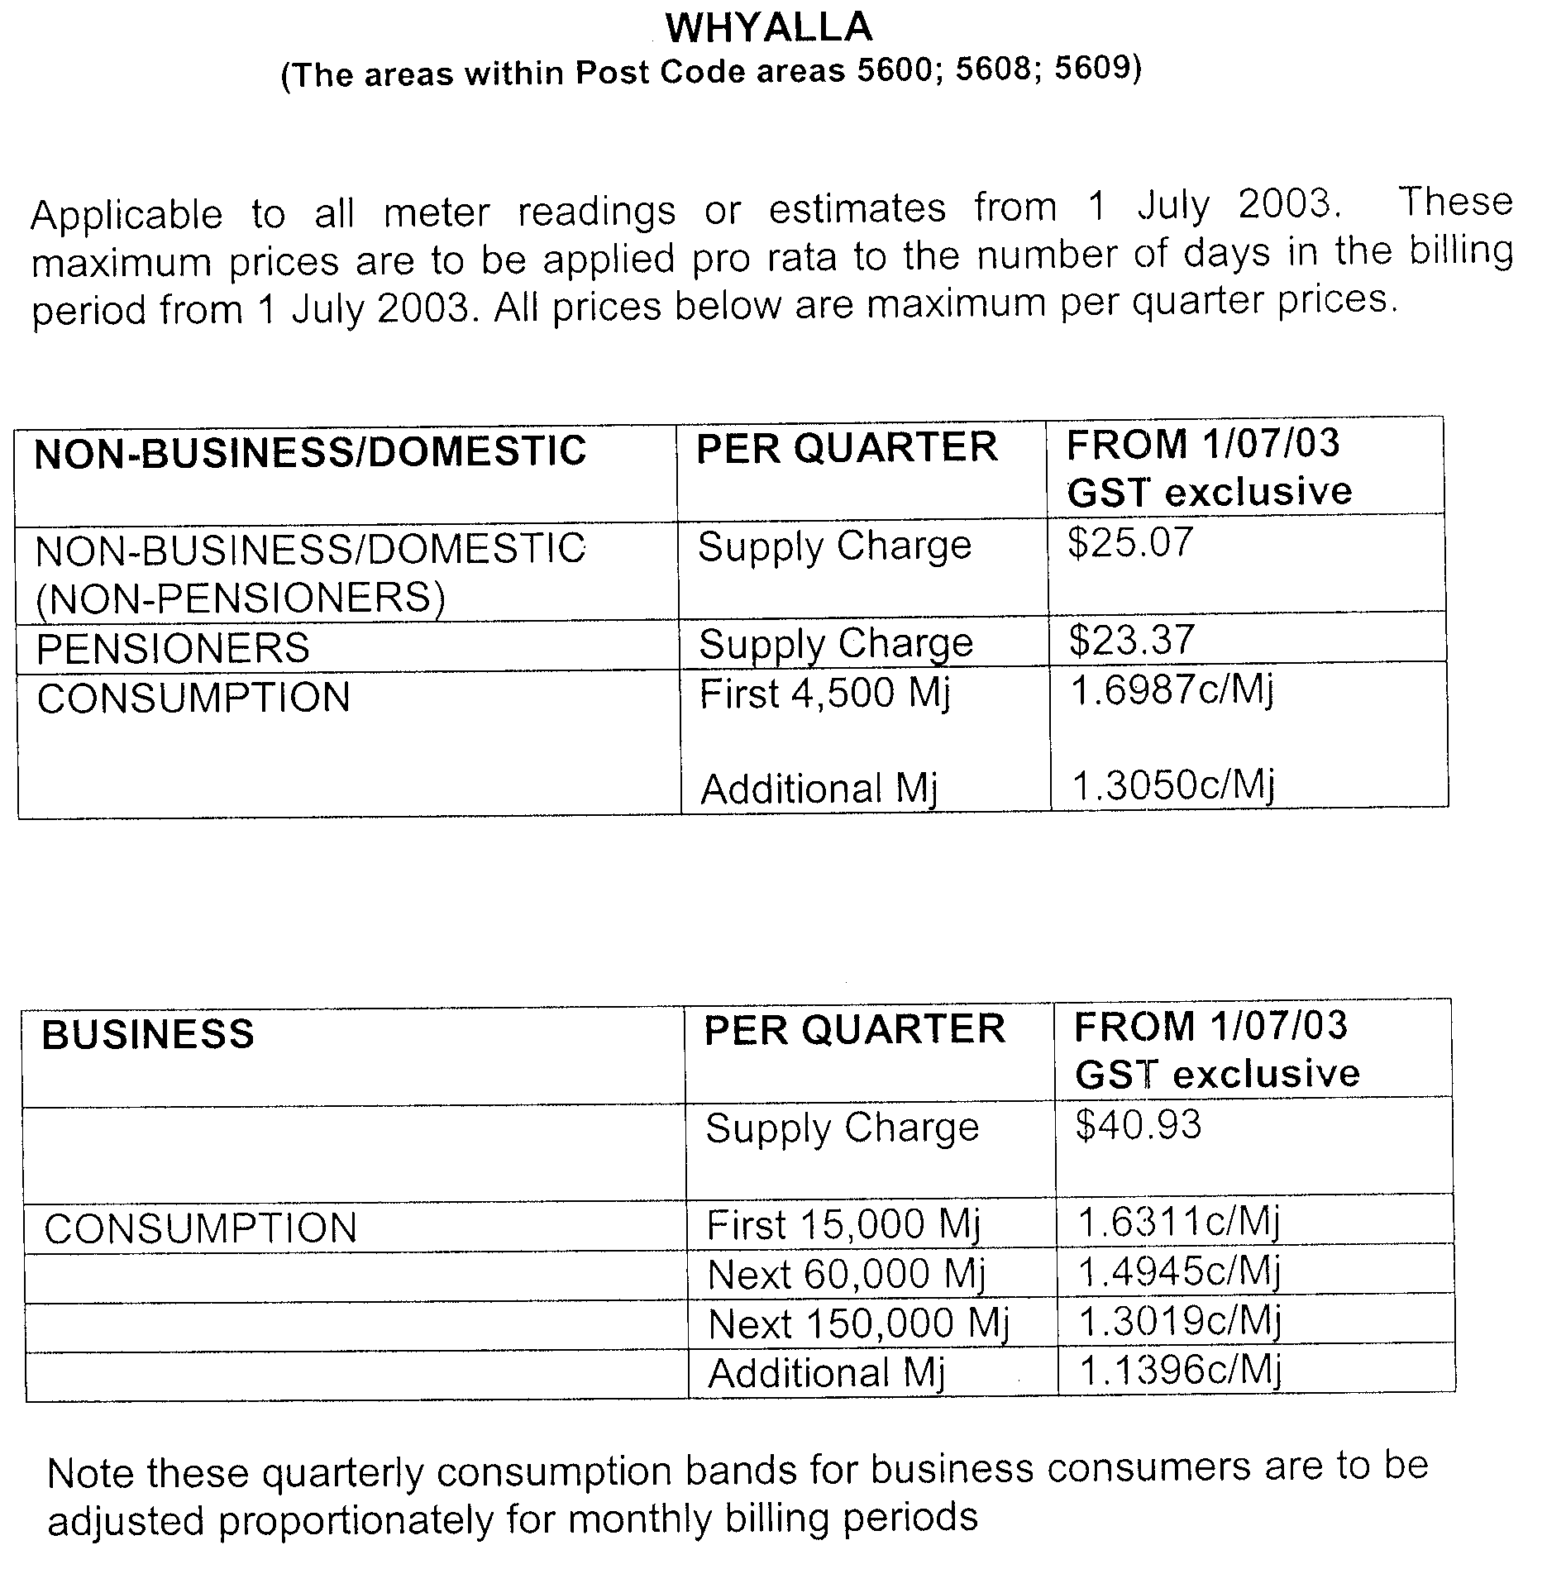
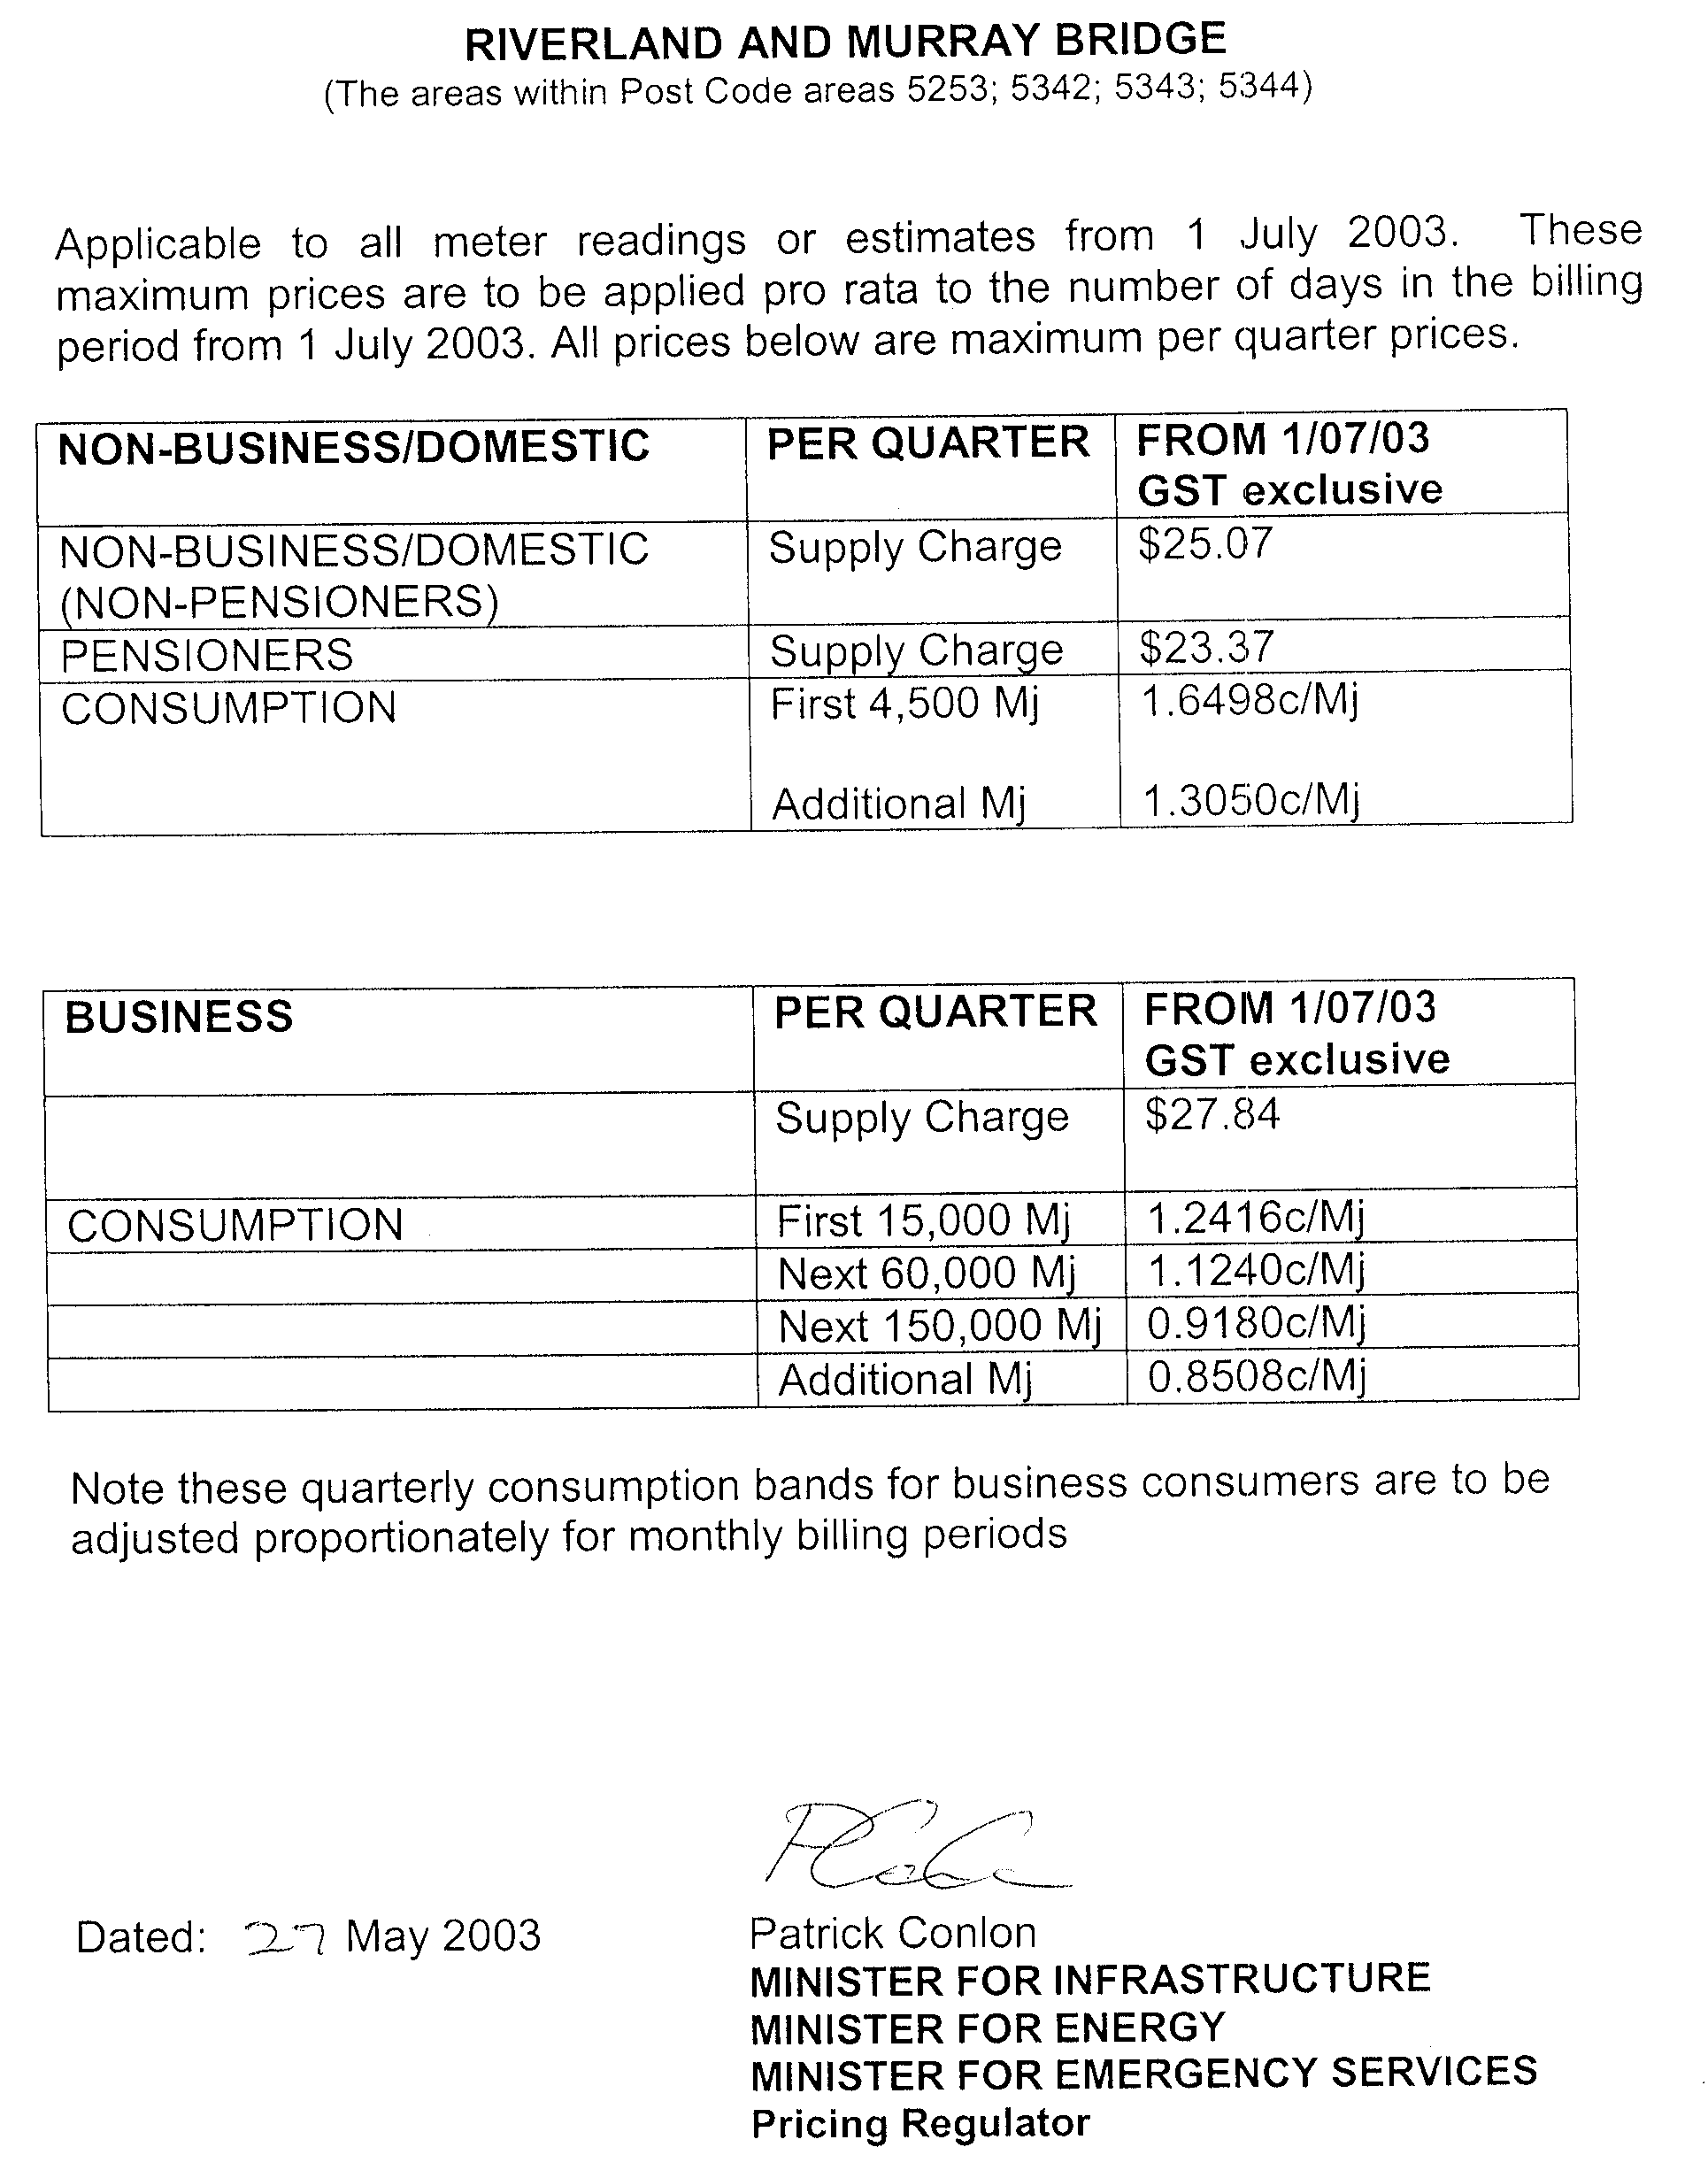
GEOGRAPHICAL NAMES ACT 1991
Notice to Assign a Name to a Place
NOTICE is hereby given pursuant to the provisions of the above Act that I, Jay Weatherill, Minister for Administrative Services, Minister of the Crown to whom the administration of the Geographical Names Act 1991 is committed DO HEREBY assign the name NICOLAS BAUDIN ISLAND to that feature currently unidentified and located on the 1:50 000 Searcy Mapsheet, at GDA94 grid reference 418728 East, 6346571 North and shown on the plan below.
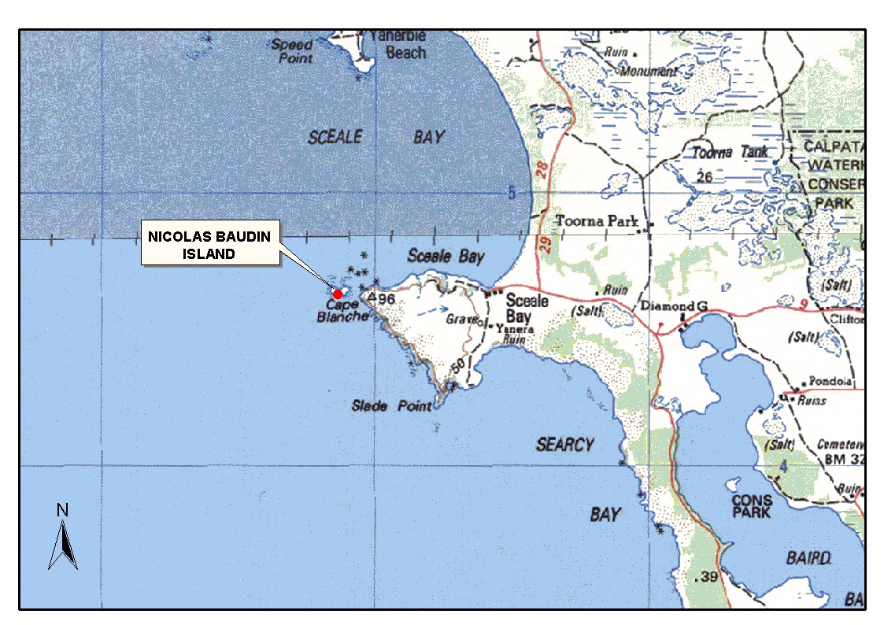The Plan
Dated 14 May 2003.
Jay Weatherill, Minister for Urban Development and Planning, Minister for Gambling, Minister for Administrative Services, Minister Assisting in Government Enterprises
DAIS22-413/02/0068

HARBORS AND NAVIGATION ACT 1993
Determination of the State Crewing Committee
THE following additional determination made on 22 October 2002, by the State Crewing Committee is published pursuant to part 6, section 45 of the Harbors and Navigation Act 1993.
M. Wright, Minister for Transport
TSA V28347

HARBORS AND NAVIGATION ACT 1993
Determination of the State Crewing Committee in respect of the
M.V. ‘Absolutely Farrbulous’
THE following additional determination is made by the State Crewing Committee pursuant to part 6, section 45 of the Harbors and Navigation Act 1993 in respect of the Absolutely Farrbulous whilst operating within the following limits:
Operational Limits
Within 15 nautical miles of the coast of South Australia.
Within 30 nautical miles of the coast of South Australia.
Minimum Complement
Limit 1. Less than 12 hours duration
One person—Master
Greater than 12 hours duration
Two persons—Master and Mate
Limit 2. Less than 12 hours duration
Two persons—Master and GP (General Purpose Person)
Greater than 12 hours duration
Two persons—Master and Mate
Minimum Qualifications of Crew
Limit 1. Master—Certificate of Competency as Coxswain and has successfully completed approved Occupational Health and Safety at Sea and Restricted Radiotelephony courses.
Limit 2. Master—Certificate of Competency as Master Class 5.
Mate—Certificate of Competency as Coxswain and has successfully completed approved Occupational Health and Safety at Sea and Restricted Radiotelephony courses.
GP—General purpose person, an able bodied person not less than 16 years of age with not less than 3 months experience and has successfully completed an approved Occupational Health and Safety at Sea course.
Note: In Limit 2 above, either the Masters, Mate or GP must possess a Certificate of Competency as Marine Engine Driver Grade III.
Capt. C. Kavina, Presiding Member, State Crewing Committee

HARBORS AND NAVIGATION ACT 1993
Determination of the State Crewing Committee
THE following determination made on 20 December 2002, by the State Crewing Committee is published pursuant to part 6, section 45 of the Harbors and Navigation Act 1993.
M. Wright, Minister for Transport
TSA V28052

HARBORS AND NAVIGATION ACT 1993
Determination of the State Crewing Committee in respect of the
M.V. ‘Regardless’
THE following determination is made by the State Crewing Committee pursuant to part 6, section 45 of the Harbors and Navigation Act 1993 in respect of the Regardless whilst operating within 15 nautical miles of the coast of South Australia.
Minimum Complement
Passenger and Fishing Charter operations
One person—Master
Dive Charter operations
Two persons—Master and GP (General Purpose Person)
Minimum Qualifications of Crew.
Master—Certificate of Competency as Master Class 5.
GP—General purpose person, an able bodied person not less than 16 years of age with not less than 3 months experience and has successfully completed an approved Occupational Health and Safety at Sea course.
Note: Either the Master or GP must possess a Certificate of Competency as Marine Engine Driver Grade III.
Capt. C. Kavina, Presiding Member, State Crewing Committee

HARBORS AND NAVIGATION ACT 1993
Determination of the State Crewing Committee
THE following determination made on 24 April 2003, by the State Crewing Committee is published pursuant to part 6, section 45 of the Harbors and Navigation Act 1993.
M. Wright, Minister for Transport
TSA V28414

HARBORS AND NAVIGATION ACT 1993
Determination of the State Crewing Committee in respect of the
M.V. ‘No Fear’
THE following determination is made by the State Crewing Committee pursuant to part 6, section 45 of the Harbors and Navigation Act 1993 in respect of the No Fear whilst operating within 200 nautical miles of the coast of South Australia.
Minimum Complement
Operations less than 12 hours duration
Two persons—Master and GP (General Purpose Person)
Operations greater than 12 hours duration
Two persons—Master and Mate
Minimum Qualifications of Crew
Master—Certificate of Competency as Master Class 5.
Mate—Certificate of Competency as Coxswain and has successfully completed approved Occupational Health and Safety at Sea and Restricted Radiotelephony courses.
GP—General purpose person, an able bodied person not less than 16 years of age with not less than 3 months experience and has successfully completed an approved Occupational Health and Safety at Sea course.
Note: Either the Master, Mate or GP must possess a Certificate of Competency as Marine Engine Driver Grade I.
Capt. C. Kavina, Presiding Member, State Crewing Committee

HARBORS AND NAVIGATION ACT 1993
Determination of the State Crewing Committee
THE following determination made on 24 April 2003, by the State Crewing Committee is published pursuant to part 6, section 45 of the Harbors and Navigation Act 1993.
M. Wright, Minister for Transport
TSA V28244

HARBORS AND NAVIGATION ACT 1993
Determination of the State Crewing Committee in respect of the
M.V. ‘Su-Baroo’
THE following determination is made by the State Crewing Committee pursuant to part 6, section 45 of the Harbors and Navigation Act 1993 in respect of the Su-Baroo whilst operating within 30 nautical miles of the coast of South Australia.
Minimum Complement
Fishing or Passenger Charter Operations
Less than 12 hours duration
Two persons—Master and GP (General Purpose Person)
Greater than 12 hours duration
Two persons—Master and Mate
Dive Charter Operations
Less than 12 hours duration
Two persons—Master and GP (General Purpose Person)
Greater than 12 hours duration
Two persons—Master and Mate
Minimum Qualifications of Crew
Master—Certificate of Competency as Master Class 5.
Mate—Certificate of Competency as Coxswain and has successfully completed approved Occupational Health and Safety at Sea and Restricted Radio Telephony courses.
GP—General purpose person, an able bodied person not less than 16 years of age with not less than 3 months experience and has successfully completed an approved Occupational Health and Safety at Sea course.
Note: Either the Master, Mate or GP must possess a Certificate of Competency as Marine Engine Driver Grade II.
Capt. C. Kavina, Presiding Member, State Crewing Committee

HOUSING IMPROVEMENT ACT 1940
NOTICE is hereby given that the South Australian Housing Trust in the exercise of the powers conferred by the Housing Improvement Act 1940, does hereby declare the houses described in the table hereunder to be substandard for the purposes of Part 7 of the Housing Improvement Act 1940.
No. of House and Street | Locality | Allotment, Section, etc. | Certificate of Title  Volume Folio

26 West Lakes Boulevard |  | Albert Park | Allotment 55 in filed plan 118137, Hundred of Yatala | 5360 | 641
4 Coronation Avenue |  | Campbelltown | Allotment 3 in deposited plan 5221, Hundred of Adelaide | 5382 | 849
1 Dawkins Road, (section 22) |  | Gawler River | Section 22, Hundred of Mudla Wirra | Crow  5755 | n Record  136
Flat 1, 168D Jetty Road |  | Glenelg | Allotment 78 in filed plan 6534, Hundred of Noarlunga | 5078 | 141
12 Viaduct Road |  | Eden Hills | Allotment 21 in deposited plan 1296, Hundred of Adelaide | 5876 | 203
47 Swaine Avenue |  | Rose Park | Allotment 38 in filed plan 140699, Hundred of Adelaide | 5377 | 52
7 Burwood Avenue |  | Woodville North | Allotment 174 in deposited plan 789, Hundred of Yatala | 5550 | 188

Dated at Adelaide, 29 May 2003. M. Downie, General Manager, Housing Trust

HOUSING IMPROVEMENT ACT 1940
WHEREAS by notice published in the Government Gazette on the dates mentioned in the following table the South Australian Housing Trust did declare the houses described in the said table to be substandard for the purposes of Part 7 of the Housing Improvement Act 1940, the South Australian Housing Trust in the exercise of the powers conferred by the said Part, does hereby fix as the maximum rental per week which shall be payable subject to section 55 of the Residential Tenancies Act 1995, in respect of each house described in the following table the amount shown in the said table opposite the description of such house and this notice shall come into force on the date of this publication in the Gazette.
Address of House | Allotment, Section, etc. | Certificate of Title  Volume Folio | Date and page of Government Gazette in which notice declaring house to be substandard published | Maximum rental per week payable in respect of each house  $

9 Thomas Street, Aldinga Beach |  | Allotment 65 in deposited plan 3244, Hundred of Willunga | 5624 | 469 |  | 27.3.03, page 1186 | 100.00
22 Sissman Street, Davoren Park |  | Allotment 5 in deposited plan 40848, Hundred of Munno Para | 5227 | 178 |  | 25.7.02, page 2936 | 90.00
49 Devon Street South, Goodwood |  | Allotment 211 in deposited plan 684, Hundred of Adelaide | 5466 | 551 |  | 14.8.66, page 547 | 80.00
35 Bacon Street, Hindmarsh |  | Allotment 87 in filed plan 120106, Hundred of Yatala | 5725 | 218 |  | 26.6.75, page 2465 | 150.00
31 Cockburn Road, Jamestown |  | Allotment 1 in filed plan 9959, Hundred of Belalie | 5489 | 223 |  | 9.3.78, page 850 | 155.00

Dated at Adelaide, 29 May 2003. M. Downie, General Manager, Housing Trust

HOUSING IMPROVEMENT ACT 1940
WHEREAS by notice published in the Government Gazette on the dates mentioned in the following table the South Australian Housing Trust did declare the houses described in the said table to be substandard for the purposes of Part 7 of the Housing Improvement Act 1940, and whereas the South Australian Housing Trust is satisfied that each of the houses described hereunder has ceased to be substandard, notice is hereby given that, in exercise of the powers conferred by the said Part, the South Australian Housing Trust does hereby revoke the said declaration in respect of each house.
Address of House | Allotment, Section, etc. | Certificate of Title  Volume Folio | Date and page of Government Gazette in which notice declaring house to be substandard published

16 Tomsey Street, Adelaide |  | Allotment 1 in deposited plan 61334, Hundred of Adelaide | 5893 | 581 |  | 13.10.66, page 1602
16 Beaconsfield Terrace, Ascot Park |  | Allotment 184 in deposited plan 1256, Hundred of Adelaide | 5576 | 206 |  | 9.1.97, page 92
Shack at rear of 2 Alma Street, Athol Park |  | Allotment 144 in deposited plan 4418, Hundred of Yatala | 5225 | 181 |  | 17.7.69, page 200
106 Drayton Street, Bowden |  | Allotment 13 in filed plan 122060, Hundred of Yatala | 5484 | 232 |  | 22.9.66, page 707
60 Marcian Avenue, Elizabeth Downs |  | Allotment 1147 in deposited plan 7707, Hundred of Munno Para | 5590 | 627 |  | 29.11.01, page 5222
101 Conyngham Street, Frewville |  | Allotment 16 in deposited plan 2184, Hundred of Adelaide | 5501 | 907 |  | 7.5.98, page 2133
23 North Street, Frewville |  | Allotment 60 in filed plan 15858, Hundred of Adelaide | 5841 | 543 |  | 6.2.03, page 468
19 Patricia Avenue, Hillcrest |  | Allotment 573 in deposited plan 5518, Hundred of Yatala | 5588 | 60 |  | 27.1.94, page 154
52 Dunure Terrace, Jamestown |  | Allotment 13 in deposited plan 442, Hundred of Belalie | 5339 | 494 |  | 6.9.84, page 826
4 Park Road, Kensington Park |  | Allotment 3 in Primary Community Plan 20978, Hundred of Yatala | 5871 | 270 |  | 29.2.96, page 1333
Detached iron clad hut at Section 731 Mackey Road, Loxton |  | Section 731, Hundred of Bookpurnong | 5867 | 895 |  | 28.10.93, page 2118
9 Fourth Street, Nuriootpa |  | Allotment 885 in filed plan 210861, Hundred of Nuriootpa | 5553 | 163 |  | 6.10.83, page 1073
75 Webb Street, Port Adelaide |  | Allotment 515 in deposited plan 3, Hundreds of Port Adelaide and Yatala | 5164 | 638 |  | 28.9.95, page 831
Section 291, Hundred of Barossa, Williamstown |  | Allotments 2, 3 and 4 in filed Plan 156236, Hundred of Barossa | 5287 | 6 |  | 14.9.78, page 956

Dated at Adelaide, 29 May 2003. M. Downie, General Manager, Housing Trust

LAND AND BUSINESS (SALE AND CONVEYANCING) ACT 1994
Exemption
TAKE notice that, pursuant to section 23 (3) of the Land and Business (Sale and Conveyancing) Act 1994, I, Michael John Atkinson, Minister for Consumer Affairs, do hereby exempt the person named in Schedule 1 from the application of section 23 (2) of the Act in relation to the purchase of the land specified in Schedule 2.
Schedule 1
Giuseppina Auricchio, an officer/employee of Mariarosa Pty Ltd.
Schedule 2
The whole of the land described in certificate of title register book volume 5845, folio 407, situated at 25 Raymond Avenue, Seaton, S.A. 5023.
Dated 29 May 2003.
Signed for and on behalf of the Minister for Consumer Affairs by the Commissioner for Consumer Affairs:
M. Bodycoat, Commissioner

LAND AND BUSINESS (SALE AND CONVEYANCING) ACT 1994
Exemption
TAKE notice that, pursuant to section 23 (3) of the Land and Business (Sale and Conveyancing) Act 1994, I, Michael John Atkinson, Minister for Consumer Affairs, do hereby exempt the person named in Schedule 1 from the application of section 23 (2) of the Act in relation to the purchase of the land specified in Schedule 2.
Schedule 1
Gary John Musolino, officer/employee of Athelstone Real Estate Pty Ltd.
Schedule 2
The whole of the land described in certificate of title register book volume 5442, folio 102, situated at 35 Vine Street, Magill, S.A. 5072.
Dated 29 May 2003.
Signed for and on behalf of the Minister for Consumer Affairs by the Commissioner for Consumer Affairs:
M. Bodycoat, Commissioner

LAND AND BUSINESS (SALE AND CONVEYANCING) ACT 1994
Exemption
TAKE notice that, pursuant to section 23 (3) of the Land and Business (Sale and Conveyancing) Act 1994, I, Michael John Atkinson, Minister for Consumer Affairs, do hereby exempt the person named in Schedule 1 from the application of section 23 (2) of the Act in relation to the purchase of the land specified in Schedule 2.
Schedule 1
Jennifer Sally King, an officer/employee of WE XL Pty Ltd.
Schedule 2
The whole of the land described in certificate of title register book volume 5646, folio 526, situated at 28 Capeview Crescent, Hackham, S.A. 5163.
Dated 29 May 2003.
Signed for and on behalf of the Minister for Consumer Affairs by the Commissioner for Consumer Affairs:
M. Bodycoat, Commissioner

LIQUOR LICENSING ACT 1997
Notice of Application
NOTICE is hereby given, pursuant to section 52 (2) (b) of the Liquor Licensing Act 1997, that Janetto Grigoriadis has applied to the Licensing Authority for the transfer of a Restaurant Licence with a 34 (1) (c) authorisation, Extended Trading Authorisation and a Redefinition in respect of the premises situated at 178 Hutt Street, Adelaide, S.A. 5000 and known as Queen of Tarts.
The application has been set down for hearing on 27 June 2003 at 9 a.m.
Conditions
The following licence conditions are sought:
• Approval pursuant to section 34 (1) (c);
• Redefinition of the licensed premises to include an outdoor dining area and balcony area as depicted in the plan lodged with this office;
• Extended trading authorisation to apply to all areas including those sought in this application on Sunday, 8 a.m. to 11 a.m. and 8 p.m. to midnight.
Any person may object to the application by lodging a notice of objection in the prescribed form with the Licensing Authority, and serving a copy of the notice on the applicant at the applicant’s address given above, at least seven days before the hearing date.
Plans in respect of the premises the subject of the application are open to public inspection without fee at the Office of the Liquor and Gaming Commissioner, 9th Floor, East Wing, 50 Grenfell Street, Adelaide, S.A. 5000.
Dated 21 May 2003.
Applicant

LIQUOR LICENSING ACT 1997
Notice of Application
NOTICE is hereby given, pursuant to section 52 (2) (b) of the Liquor Licensing Act 1997, that Broomore Pty Ltd, c/o Edgley Lawyers, has applied to the Licensing Authority for a Special Circumstances Licence in respect of the premises situated at Lot 2, Deposited Plan 55528, Hundred of Dudley, Kangaroo Island, Penneshaw, S.A. 5222 and to be known as Sunset Winery & Wine Interpretive Centre.
The application has been set down for hearing on 27 June 2003 at 9 a.m.
Conditions
The following licence conditions are sought:
The licence shall authorise the sale and/or supply of wine produced by the applicant either personally or under contract and other Kangaroo Island wine:
1. On the licensed premises at any time for consumption off the licensed premises;
2. By way of sample for consumption in the areas depicted on the plan as area 1 (decking), area 2 (cellar door) and area 3 (observation walkway);
3. To produce and sell or supply wine produced by the applicant;
4. To promote and sell or supply other wines produced on Kangaroo Island,
to provide information and marketing on the Kangaroo Island wine industry, essentially a wine industry interpretative function; and to use and promote complimentary local products, namely Kangaroo Island Olive, and both the Island Pure (sheep’s milk) and Kangaroo Island farmhouse cheeses.
Any person may object to the application by lodging a notice of objection in the prescribed form with the Licensing Authority, and serving a copy of the notice on the applicant at the applicant’s address given above, at least seven days before the hearing date.
Plans in respect of the premises the subject of the application are open to public inspection without fee at the Office of the Liquor and Gaming Commissioner, 9th Floor, East Wing, 50 Grenfell Street, Adelaide, S.A. 5000.
Dated 21 May 2003.
Applicant

LIQUOR LICENSING ACT 1997
Notice of Application
NOTICE is hereby given, pursuant to section 52 (2) (b) of the Liquor Licensing Act 1997, that R. Aoukar & Sons Pty Ltd, as trustee for the Cafe Palazzo Unit Trust, c/o Cowell Clarke solicitors, has applied to the Licensing Authority for a Restaurant Licence with Extended Trading Authorisation in respect of the premises situated at 168 O’Connell Street, North Adelaide, S.A. 5006 and to be known as Cafe Palazzo.
The application has been set down for hearing on 27 June 2003 at 9 a.m.
Conditions
The following licence conditions are sought:
Extended trading authorisation is sought in the areas as depicted in the plan: Monday to Saturday, midnight to 3 a.m. the following day; Sunday, 8 a.m. to 11 a.m. and 8 p.m. to 3 a.m. the following day; Public Holidays, 8 a.m. to 3 a.m. the following day and midnight to 2 a.m. on Christmas Day.
Any person may object to the application by lodging a notice of objection in the prescribed form with the Licensing Authority, and serving a copy of the notice on the applicant at the applicant’s address given above, at least seven days before the hearing date.
Plans in respect of the premises the subject of the application are open to public inspection without fee at the Office of the Liquor and Gaming Commissioner, 9th Floor, East Wing, 50 Grenfell Street, Adelaide, S.A. 5000.
Dated 23 May 2003.
Applicant

LIQUOR LICENSING ACT 1997
Notice of Application
NOTICE is hereby given, pursuant to section 52 (2) (b) of the Liquor Licensing Act 1997, that Australian Domaine Wines Pty Ltd has applied to the Licensing Authority for the Removal of a Wholesale Liquor Merchant’s Licence in respect of the premises situated at 95 Walkerville Terrace, Walkerville, S.A. 5082 to be situated at 81 Orsmond Street, Hindmarsh, S.A. 5007 and known as Australian Domaine Wines Pty Ltd. Also, Wine SA Pty Ltd has applied to the Licensing Authority for the Removal of a Wholesale Liquor Merchant’s Licence in respect of the premises situated at 95A Walkerville Terrace, Walkerville, S.A. 5081 to be situated at 81 Orsmond Street, Hindmarsh, S.A. 5007 and known as Barletta Bros Wine Co.
The application has been set down for hearing on 20 June 2003 at 9 a.m.
Any person may object to the application by lodging a notice of objection in the prescribed form with the Licensing Authority, and serving a copy of the notice on the applicant at the applicant’s address given above, at least seven days before the hearing date.
Plans in respect of the premises the subject of the application are open to public inspection without fee at the Office of the Liquor and Gaming Commissioner, 9th Floor, East Wing, 50 Grenfell Street, Adelaide, S.A. 5000.
Dated 22 May 2003.
Applicant

LIQUOR LICENSING ACT 1997
Notice of Application
NOTICE is hereby given, pursuant to section 52 (2) (b) of the Liquor Licensing Act 1997, that Torrens Valley Football Club Inc. has applied to the Licensing Authority for a Limited Club Licence with Extended Trading Authorisation and Entertainment Consent in respect of the premises situated at Melrose Street, Mount Pleasant, S.A. 5235 and known as Talunga Park Pavillion.
The application has been set down for hearing on 27 June 2003 at 9 a.m.
Conditions
The following licence conditions are sought:
Extended trading authorisation is to apply to the areas as depicted in the plan lodged with this office: Saturday, midnight to 2 a.m. the following day.
Entertainment consent is sought for the area as depicted in the plan lodged with this office.
Any person may object to the application by lodging a notice of objection in the prescribed form with the Licensing Authority, and serving a copy of the notice on the applicant at the applicant’s address given above, at least seven days before the hearing date.
Plans in respect of the premises the subject of the application are open to public inspection without fee at the Office of the Liquor and Gaming Commissioner, 9th Floor, East Wing, 50 Grenfell Street, Adelaide, S.A. 5000.
Dated 20 May 2003.
Applicant

LIQUOR LICENSING ACT 1997
Notice of Application
NOTICE is hereby given, pursuant to section 52 (2) (b) of the Liquor Licensing Act 1997, that Genesis Transport Services Pty Ltd has applied to the Licensing Authority for a Special Circumstances Licence in respect of the premises situated at Quarry Lincoln Road, Victor Harbor, S.A. 5211 and to be known as Genesis Transport Services.
The application has been set down for hearing on 27 June 2003 at 9 a.m.
Conditions
The following licence conditions are sought:
• To sell liquor in accordance with section 40 of the Liquor Licensing Act 1997 and any other conditions of this licence.
• For consumption on or adjacent to the licensed vehicles (provided that the passengers are always under the supervision and control of the driver of the subject vehicles) on any day at anytime (except Good Friday).
• The Extended Trading Authorisation does not allow trading between the hours of midnight and 5 a.m. on Good Friday, the day after Good Friday or the day after Christmas Day.
Any person may object to the application by lodging a notice of objection in the prescribed form with the Licensing Authority, and serving a copy of the notice on the applicant at the applicant’s address given above, at least seven days before the hearing date.
Plans in respect of the premises the subject of the application are open to public inspection without fee at the Office of the Liquor and Gaming Commissioner, 9th Floor, East Wing, 50 Grenfell Street, Adelaide, S.A. 5000.
Dated 20 May 2003.
Applicant

LIQUOR LICENSING ACT 1997
Notice of Application
NOTICE is hereby given, pursuant to section 52 (2) (b) of the Liquor Licensing Act 1997, that Rodney William and Patricia Anne Simpson have applied to the Licensing Authority for the transfer of a Hotel Licence in respect of the premises situated at Main Street, Pekina, S.A. 5431 and known as Pekina Hotel.
The application has been set down for hearing on 30 June 2003 at 9.30 a.m.
Any person may object to the application by lodging a notice of objection in the prescribed form with the Licensing Authority, and serving a copy of the notice on the applicants at the applicants’ address given above, at least seven days before the hearing date.
Plans in respect of the premises the subject of the application are open to public inspection without fee at the Office of the Liquor and Gaming Commissioner, 9th Floor, East Wing, 50 Grenfell Street, Adelaide, S.A. 5000.
Dated 22 May 2003.
Applicants

LIQUOR LICENSING ACT 1997
Notice of Application
NOTICE is hereby given, pursuant to section 52 (2) (b) of the Liquor Licensing Act 1997, that Flashpoint Pty Ltd (as trustee for the P. & D. Darwin Family Trust) has applied to the Licensing Authority for the transfer of a Special Circumstances Licence in respect of the premises situated at corner North Terrace and Morphett Street, Adelaide, S.A. 5000 and known as Music House.
The application has been set down for hearing on 1 July 2003 at 9.30 a.m.
Any person may object to the application by lodging a notice of objection in the prescribed form with the Licensing Authority, and serving a copy of the notice on the applicant at the applicant’s address given above, at least seven days before the hearing date.
Plans in respect of the premises the subject of the application are open to public inspection without fee at the Office of the Liquor and Gaming Commissioner, 9th Floor, East Wing, 50 Grenfell Street, Adelaide, S.A. 5000.
Dated 23 May 2003.
Applicant

LIQUOR LICENSING ACT 1997
Notice of Application
NOTICE is hereby given, pursuant to section 52 (2) (b) of the Liquor Licensing Act 1997, that Lia Daniela Nicoli has applied to the Licensing Authority for the transfer of a Restaurant Licence in respect of the premises situated at 143 Goodwood Road, Goodwood, S.A. 5034 and known as Cafe Deco.
The application has been set down for hearing on 1 July 2003 at 10.30 a.m.
Any person may object to the application by lodging a notice of objection in the prescribed form with the Licensing Authority, and serving a copy of the notice on the applicant at the applicant’s address given above, at least seven days before the hearing date.
Plans in respect of the premises the subject of the application are open to public inspection without fee at the Office of the Liquor and Gaming Commissioner, 9th Floor, East Wing, 50 Grenfell Street, Adelaide, S.A. 5000.
Dated 22 May 2003.
Applicant

LIQUOR LICENSING ACT 1997
Notice of Application
NOTICE is hereby given, pursuant to section 52 (2) (b) of the Liquor Licensing Act 1997, that Cker Pty Ltd, Building 86 Fricker Circuit, Adelaide Airport, S.A. 5950 has applied to the Licensing Authority for the transfer of a Restaurant Licence in respect of the premises situated at 199-201 Waymouth Street, Adelaide, S.A. 5000 known as Osteria Sanso and to be known as Naschen Bistro.
The application has been set down for hearing on 1 July 2003 at 10 a.m.
Any person may object to the application by lodging a notice of objection in the prescribed form with the Licensing Authority, and serving a copy of the notice on the applicant at the applicant’s address given above, at least seven days before the hearing date.
Plans in respect of the premises the subject of the application are open to public inspection without fee at the Office of the Liquor and Gaming Commissioner, 9th Floor, East Wing, 50 Grenfell Street, Adelaide, S.A. 5000.
Dated 20 May 2003.
Applicant

LIQUOR LICENSING ACT 1997 AND GAMING MACHINES ACT 1992
Notice of Application
NOTICE is hereby given, pursuant to section 52 of the Liquor Licensing Act 1997 and section 29 of the Gaming Machines Act 1992, that Billiards & Snooker Association of South Australia Inc., c/o Wallmans Lawyers has applied to the Liquor and Gaming Commissioner for the removal of a Club Licence and the grant of a Gaming Machine Licence in respect of premises situated at 176 Pulteney Street, Adelaide, S.A. 5000, to be situated at 12-28 Rose Street, Adelaide, S.A. 5000 and known as Billiards and Snooker Association of SA.
The applications have been set down for hearing on 27 June 2003 at 9 a.m.
Any person may object to the application by lodging a notice of objection in the prescribed form with the Licensing Authority, and serving a copy of the notice on the applicant at the applicant’s address given above, at least seven days before the hearing date.
Plans in respect of the premises the subject of the application are open to public inspection without fee at the Office of the Liquor and Gaming Commissioner, 9th Floor, East Wing, 50 Grenfell Street, Adelaide, S.A. 5000.
Dated 22 May 2003.
Applicant

MINING ACT, 1971
NOTICE is hereby given in accordance with section 35A (1) of the Mining Act 1971, that an application for a mining lease over the undermentioned mineral claim has been received. Details of the proposal may be inspected at the Department of Primary Industries and Resources, Mineral Resources Group, Level 5, 101 Grenfell Street, Adelaide, S.A. 5000:
Applicant: Longs Sands & Metal Pty Ltd
Claim Number: 3353
Location: In allotments 105 and 106, Hundred of Mobilong
Purpose: to excavate sand from a shallow open cut mine
Reference: T2366
A copy of the proposal has been provided to The Rural City of Murray Bridge.
Written submissions in relation to the granting of the mining lease are invited to be received at the Department of Primary Industries and Resources, Mineral Resources Group, Level 5, 101 Grenfell Street, Adelaide, S.A. 5000 or G.P.O. Box 1671, Adelaide, S.A. 5001 no later than 16 June 2003.
H. Tyrteos, Mining Registrar

MINING ACT 1971
NOTICE is hereby given in accordance with section 35A (1) of the Mining Act 1971, that an application for a mining lease over the undermentioned mineral claim has been received. Details of the proposal may be inspected at the Department of Primary Industries and Resources, Mineral Resources Group, Level 5, 101 Grenfell Street, Adelaide, S.A. 5000:
Applicant: Nyrang Enterprises Pty Ltd
Claim Number: 3317
Location: In Lot 8, FP102165 Hundred of Moorooroo—
Approximately 5 km east of Nuriootpa
Purpose: Recovery of sand from an open cut pit.
Reference: T2346
A copy of the proposal has been provided to the District Council of Barossa.
Written submissions in relation to the granting of the mining lease are invited to be received at the Department of Primary Industries and Resources, Mineral Resources Group, Level 5, 101 Grenfell Street, Adelaide, S.A. 5000 or G.P.O. Box 1671 Adelaide, S.A. 5001 no later than 13 June 2003.
H. Tyrteos, Mining Registrar

MINING ACT 1971
NOTICE is hereby given in accordance with section 35A (1) of the Mining Act 1971, that an application for a mining lease over the undermentioned mineral claim has been received. Details of the proposal may be inspected at the Department of Primary Industries and Resources, Mineral Resources Group, Level 5, 101 Grenfell Street, Adelaide, S.A. 5000:
Applicant: District Council of Mallala
Claim Number: 3371
Location: In sections 321 and 322, Hundred of Dublin
Purpose: excavate limestone rubble from a shallow open cut mine
Reference: T2380
A copy of the proposal has been provided to the District Council of Mallala.
Written submissions in relation to the granting of the mining lease are invited to be received at the Department of Primary Industries and Resources, Mineral Resources Group, Level 5, 101 Grenfell Street, Adelaide, S.A. 5000 or G.P.O. Box 1671, Adelaide, S.A. 5001 no later than 23 June 2003.
H. Tyrteos, Mining Registrar

MINING ACT 1971
NOTICE is hereby given in accordance with section 28 (5) of the Mining Act 1971, that the Minister for Mineral Resources Development proposes to grant an Exploration Licence over the undermentioned area.
Applicant: Dominion Gold Operations Pty Ltd (37%), MIM Limited (63%)
Location: Kingoonya Area
Term: One Year
Area in km²: 1 074
Ref: 133/2002
Plan and co-ordinates can be found on the PIRSA Sarig website: http://www.minerals.pir.sa.gov.au/sarig or by phoning Mineral Tenements on (08) 8463 3103.
H. Tyrteos, Mining Registrar, Department of Primary Industries and Resources

MINING ACT 1971
NOTICE is hereby given in accordance with section 28 (5) of the Mining Act 1971, that the Minister for Mineral Resources Development proposes to grant an Exploration Licence over the undermentioned area.
Applicant: Dominion Gold Operations Pty Ltd (37%), MIM Limited (63%)
Location: Goose Area—Approximately 40 km north of Kin-goonya
Term: One Year
Area in km²: 601
Ref: 134/2002
Plan and co-ordinates can be found on the PIRSA Sarig website: http://www.minerals.pir.sa.gov.au/sarig or by phoning Mineral Tenements on (08) 8463 3103.
H. Tyrteos, Mining Registrar, Department of Primary Industries and Resources

MINING ACT 1971
NOTICE is hereby given in accordance with section 28 (5) of the Mining Act 1971, that the Minister for Mineral Resources Development proposes to grant an Exploration Licence over the undermentioned area.
Applicant: Southwestern Mining Company Pty Ltd
Location: Moorlands Area—Approximately 105 km west of Pinnaroo
Term: One Year
Area in km²: 655
Ref: 022/2003
Plan and co-ordinates can be found on the PIRSA Sarig website: http://www.minerals.pir.sa.gov.au/sarig or by phoning Mineral Tenements on (08) 8463 3103.
H. Tyrteos, Mining Registrar, Department of Primary Industries and Resources

MINING ACT 1971
NOTICE is hereby given in accordance with section 28 (5) of the Mining Act 1971, that the Minister for Mineral Resources Development proposes to grant an Exploration Licence over the undermentioned area.
Applicant: Minex (Aust) Pty Ltd
Location: Nagel Hill Area—Approximately 75 km east of Adelaide
Term: One Year
Area in km²: 378
Ref: 007/2003
Plan and co-ordinates can be found on the PIRSA Sarig website: http://www.minerals.pir.sa.gov.au/sarig or by phoning Mineral Tenements on (08) 8463 3103.
H. Tyrteos, Mining Registrar, Department of Primary Industries and Resources

MINING ACT 1971
NOTICE is hereby given in accordance with section 28 (5) of the Mining Act 1971, that the Minister for Mineral Resources Development proposes to grant an Exploration Licence over the undermentioned area.
Applicant: Minex (Aust) Pty Ltd
Location: Cooper Hill Area—Approximately 90 km west-north-west of Ceduna
Term: One Year
Area in km²: 637
Ref: 019/2003
Plan and co-ordinates can be found on the PIRSA Sarig website: http://www.minerals.pir.sa.gov.au/sarig or by phoning Mineral Tenements on (08) 8463 3103.
H. Tyrteos, Mining Registrar, Department of Primary Industries and Resources

NATIONAL PARKS AND WILDLIFE ACT 1972
Lake Newland Conservation Park Management Plan
I, JOHN HILL, Minister for Environment and Conservation, hereby give notice under the provisions of section 38 of the National Parks and Wildlife Act 1972, that I have adopted a plan of management for Lake Newland Conservation Park.
Copies of the plan may be inspected at or obtained from the offices of the Department for Environment and Heritage at The Environment Shop, Ground Floor, SA Water House, 77 Grenfell Street, Adelaide, S.A. 5000 (G.P.O. Box 1047, Adelaide, S.A. 5001), telephone (08) 8204 1910 or at the Port Lincoln Regional Office, 75 Liverpool Street, Port Lincoln, S.A. 5606 (P.O. Box 22, Port Lincoln, S.A. 5606), telephone (08) 8688 3111 or on the departmental website:
http://www.environment.sa.gov.au/parks/management_plans.html
Copies of this publication can be purchased at a cost of $8.00 per copy (plus $2 postage within South Australia) from the addresses above.
J. Hill, Minister for Environment and Conservation

PETROLEUM ACT 2000
Section 25(5)(b)
Variation of Exploration Licence PEL 136
NOTICE is hereby given that under the provisions of the Petroleum Act 2000, pursuant to delegated powers dated 28 March 2002, Gazetted 11 April 2002, page 1573, the conditions of the abovementioned Exploration Licence have been varied as follows:
Condition 2 has been omitted and the following substituted:
‘2. During the term of the licence, the Licensee shall carry out or cause to be carried out exploratory operations on the area comprised in the licence in accordance with such work programs as are approved by the Minister from time to time. Year one exploratory operations are guaranteed. These exploratory operations shall include but not necessarily be limited to:
Year of Term of Licence | Minimum Work Requirements
One | Geological and geophysical studies
Two | Geological and geophysical studies; High resol-ution gravity survey
Three | 80 km 2D or 50 km² 3D Seismic
Four | Drill one well
Five | 50 km² 3D Seismic  Drill one well’
The variation provides for acquisition of a high resolution gravity survey in Year 2 in lieu of the originally programmed 2D seismic survey, to firm up leads that emerged from the Year 1 studies. The Year 3 program now includes acquisition of 2D or 3D Seismic in lieu of 3D Seismic.
Dated 16 May 2003.
C. D. Cockshell, Acting Director Petroleum, Minerals, Petroleum and Energy, PIRSA, Delegate of the Minister for Mineral Resources Development

PETROLEUM ACT 2000
Grant of Petroleum Exploration Licence PEL 114
NOTICE is hereby given that the undermentioned Petroleum Exploration Licence has been granted under the provisions of the Petroleum Act 2000, pursuant to delegated powers dated 28 March 2002, Gazetted 11 April 2002, page 1573.
No. of  Licence | Licensee | Locality | Date of  Expiry | Area in  km² | Reference

114 | Santos Limited |  | Cooper Basin of South Australia | 21 May 2008 | 958 | 27/2/200

Description of the Area
All that part of the State of South Australia, bounded as follows:
PEL 114
Area 1—Commencing at a point being the intersection of latitude 28°16′30″S AGD66 and longitude 140°32′10″E AGD66, thence east to longitude 140°32′30″E AGD66, south to latitude 28°16′40″S AGD66, east to longitude 140°35′00″E AGD66, south to latitude 28°40′00″S AGD66, west to longitude 140°18′20″E AGD66, north to latitude 28°39′10″S AGD66, west to longitude 140°16′40″E AGD66, north to latitude 28°39′00″S AGD66, west to longitude 140°15′40″E AGD66, south to latitude 28°40′00″S AGD66, west to longitude 140°15′00″E AGD66, north to latitude 28°26′00″S AGD66, east to longitude 140°15′10″E AGD66, south to latitude 28°26′10″S AGD66, east to longitude 140°15′40″E AGD66, south to latitude 28°26′20″S AGD66, east to longitude 140°16′10″E AGD66, south to latitude 28°26′30″S AGD66, east to longitude 140°16′40″E AGD66, south to latitude 28°26′40″S AGD66, east to longitude 140°17′10″E AGD66, south to latitude 28°26′50″S AGD66, east to longitude 140°18′30″E AGD66, north to latitude 28°26′20″S AGD66, east to longitude 140°18′50″E AGD66, north to latitude 28°25′50″S AGD66, east to longitude 140°19′10″E AGD66, north to latitude 28°25′20″S AGD66, east to longitude 140°19′30″E AGD66, north to latitude 28°25′00″S AGD66, east to longitude 140°19′40″E AGD66, north to latitude 28°24′50″S AGD66, east to longitude 140°20′00″E AGD66, north to latitude 28°24′30″S AGD66, east to longitude 140°20′30″E AGD66, north to latitude 28°24′10″S AGD66, east to longitude 140°21′00″E AGD66, north to latitude 28°23′50″S AGD66, east to longitude 140°21′30″E AGD66, north to latitude 28°23′30″S AGD66, east to longitude 140°22′00″E AGD66, north to latitude 28°23′10″S AGD66, east to longitude 140°22′30″E AGD66, north to latitude 28°22′50″S AGD66, east to longitude 140°23′10″E AGD66, north to latitude 28°22′30″S AGD66, east to longitude 140°23′50″E AGD66, north to latitude 28°22′10″S AGD66, east to longitude 140°24′10″E AGD66, north to latitude 28°21′50″S AGD66, east to longitude 140°24′30″E AGD66, north to latitude 28°21′30″S AGD66, east to longitude 140°25′00″E AGD66, north to latitude 28°21′10″S AGD66, east to longitude 140°25′30″E AGD66, north to latitude 28°20′50″S AGD66, east to longitude 140°26′00″E AGD66, north to latitude 28°20′30″S AGD66, east to longitude 140°26′20″E AGD66, north to latitude 28°20′10″S AGD66, east to longitude 140°26′40″E AGD66, north to latitude 28°19′50″S AGD66, east to longitude 140°26′50″E AGD66, north to latitude 28°19′30″S AGD66, east to longitude 140°27′10″E AGD66, north to latitude 28°19′10″S AGD66, east to longitude 140°27′30″E AGD66, north to latitude 28°18′50″S AGD66, east to longitude 140°27′50″E AGD66, north to latitude 28°18′30″S AGD66, east to longitude 140°28′20″E AGD66, north to latitude 28°18′20″S AGD66, east to longitude 140°28′50″E AGD66, north to latitude 28°18′10″S AGD66, east to longitude 140°29′10″E AGD66, north to latitude 28°18′00″S AGD66, east to longitude 140°29′40″E AGD66, north to latitude 28°17′50″S AGD66, east to longitude 140°30′00″E AGD66, north to latitude 28°17′40″S AGD66, east to longitude 140°30′10″E AGD66, north to latitude 28°17′30″S AGD66, east to longitude 140°30′30″E AGD66, north to latitude 28°17′20″S AGD66, east to longitude 140°30′50″E AGD66, north to latitude 28°17′10″S AGD66, east to longitude 140°31′00″E AGD66, north to latitude 28°17′00″S AGD66, east to longitude 140°31′20″E AGD66, north to latitude 28°16′50″S AGD66, east to longitude 140°31′50″E AGD66, north to latitude 28°16′40″S AGD66, east to longitude 140°32′10″E AGD66, and north to point of commencement but excluding the areas bounded as follows:
Commencing at a point being the intersection of latitude 28°19′10″S AGD66 and longitude 140°28′20″E AGD66, thence east to longitude 140°29′50″E AGD66, south to latitude 28°19′30″S AGD66, east to longitude 140°30′00″E AGD66, south to latitude 28°20′25″S AGD66, west to longitude 140°29′45″E AGD66, south to latitude 28°20′35″S AGD66, west to longitude 140°29′05″E AGD66, south to latitude 28°20′40″S AGD66, west to longitude 140°28′50″E AGD66, south to latitude 28°20′50″S AGD66, west to longitude 140°28′30″E AGD66, south to latitude 28°21′40″S AGD66, west to longitude 140°26′40″E AGD66, north to latitude 28°20′10″S AGD66, east to longitude 140°27′50″E AGD66, north to latitude 28°20′05″S AGD66, east to longitude 140°28′00″E AGD66, north to latitude 28°19′55″S AGD66, east to longitude 140°28′10″E AGD66, north to latitude 28°19′30″S AGD66, east to longitude 140°28′20″E AGD66, and north to point of commencement, and
Commencing at a point being the intersection of latitude 28°17′30″S AGD66 and longitude 140°32′05″E AGD66, thence east to longitude 140°32′40″E AGD66, south to latitude 28°17′50″S AGD66, east to longitude 140°32′50″E AGD66, south to latitude 28°17′55″S AGD66, east to longitude 140°33′00″E AGD66, south to latitude 28°18′00″S AGD66, east to longitude 140°33′02″E AGD66, south to latitude 28°18′10″S AGD66, west to longitude 140°33′00″E AGD66, south to latitude 28°18′15″S AGD66, west to longitude 140°32′30″E AGD66, north to latitude 28°18′10″S AGD66, west to longitude 140°32′25″E AGD66, north to latitude 28°18′05″S AGD66, west to longitude 140°32′15″E AGD66, north to latitude 28°18′00″S AGD66, west to longitude 140°32′00″E AGD66, north to latitude 28°17′55″S AGD66, west to longitude 140°31′50″E AGD66, north to latitude 28°17′45″S AGD66, east to longitude 140°31′55″E AGD66, north to latitude 28°17′40″S AGD66, east to longitude 140°32′05″E AGD66, and north to point of commencement, and
Commencing at a point being the intersection of latitude 28°21′55″S AGD66 and longitude 140°31′40″E AGD66, thence east to longitude 140°32′05″E AGD66, south to latitude 28°22′15″S AGD66, west to longitude 140°32′00″E AGD66, south to latitude 28°22′20″S AGD66, west to longitude 140°31′45″E AGD66, south to latitude 28°22′25″S AGD66, west to longitude 140°31′40″E AGD66, south to latitude 28°22′35″S AGD66, west to longitude 140°31′30″E AGD66, south to latitude 28°23′00″S AGD66, west to longitude 140°31′25″E AGD66, south to latitude 28°23′10″S AGD66, west to longitude 140°31′15″E AGD66, south to latitude 28°23′25″S AGD66, west to longitude 140°30′50″E AGD66, north to latitude 28°23′05″S AGD66, east to longitude 140°30′55″E AGD66, north to latitude 28°22′45″S AGD66, east to longitude 140°31′00″E AGD66, north to latitude 28°22′40″S AGD66, east to longitude 140°31′05″E AGD66, north to latitude 28°22′35″S AGD66, east to longitude 140°31′10″E AGD66, north to latitude 28°22′25″S AGD66, east to longitude 140°31′25″E AGD66, north to latitude 28°22′15″S AGD66, east to longitude 140°31′30″E AGD66, north to latitude 28°22′10″S AGD66, east to longitude 140°31′35″E AGD66, north to latitude 28°22′00″S AGD66, east to longitude 140°31′40″E AGD66, and north to point of commencement, and
Commencing at a point being the intersection of latitude 28°22′05″S AGD66 and longitude 140°25′00″E AGD66, thence east to longitude 140°26′30″E AGD66, south to latitude 28°22′10″S AGD66, east to longitude 140°26′40″E AGD66, south to latitude 28°22′30″S AGD66, east to longitude 140°27′00″E AGD66, south to latitude 28°22′45″S AGD66, east to longitude 140°27′10″E AGD66, south to latitude 28°23′15″S AGD66, west to longitude 140°27′00″E AGD66, south to latitude 28°23′45″S AGD66, west to longitude 140°26′50″E AGD66, south to latitude 28°23′55″S AGD66, west to longitude 140°26′40″E AGD66, south to latitude 28°24′00″S AGD66, west to longitude 140°25′10″E AGD66, north to latitude 28°23′50″S AGD66, west to longitude 140°25′00″E AGD66, and north to point of commencement, and
Commencing at a point being the intersection of latitude 28°26′50″S AGD66 and longitude 140°28′50″E AGD66, thence east to longitude 140°29′40″E AGD66, south to latitude 28°27′00″S AGD66, east to longitude 140°30′00″E AGD66, south to latitude 28°27′10″S AGD66, east to longitude 140°31′05″E AGD66, south to latitude 28°28′00″S Clarke1858, west to longitude 140°31′00″E Clarke1858, south to latitude 28°28′40″S AGD66, west to longitude 140°29′55″E AGD66, south to latitude 28°29′00″S Clarke1858, east to longitude 140°30′00″E Clarke1858, south to latitude 28°29′15″S AGD66, west to longitude 140°29′10″E AGD66, south to latitude 28°29′30″S AGD66, west to longitude 140°28′15″E AGD66, north to latitude 28°28′55″S AGD66, west to longitude 140°27′40″E AGD66, south to latitude 28°29′10″S AGD66, west to longitude 140°27′10″E AGD66, north to latitude 28°29′05″S AGD66, west to longitude 140°26′35″E AGD66, north to latitude 28°28′00″S AGD66, east to longitude 140°26′50″E AGD66, north to latitude 28°27′30″S AGD66, east to longitude 140°27′20″E AGD66, north to latitude 28°27′00″S AGD66, east to longitude 140°28′20″E AGD66, south to latitude 28°27′20″S AGD66, east to longitude 140°28′40″E AGD66, south to latitude 28°27′25″S AGD66, east to longitude 140°28′50″E AGD66, and north to point of commencement, and
Commencing at a point being the intersection of latitude 28°26′55″S AGD66 and longitude 140°21′10″E AGD66, thence east to longitude 140°22′00″E AGD66, south to latitude 28°27′05″S AGD66, east to longitude 140°22′15″E AGD66, south to latitude 28°27′30″S AGD66, west to longitude 140°22′00″E AGD66, south to latitude 28°27′35″S AGD66, west to longitude 140°21′55″E AGD66, south to latitude 28°27′40″S AGD66, west to longitude 140°21′45″E AGD66, south to latitude 28°27′50″S AGD66, west to longitude 140°21′20″E AGD66, south to latitude 28°29′20″S AGD66, east to longitude 140°24′30″E AGD66, south to latitude 28°29′40″S AGD66, east to longitude 140°25′30″E AGD66, south to latitude 28°30′30″S AGD66, east to longitude 140°26′00″E AGD66, south to latitude 28°31′10″S AGD66, west to longitude 140°25′50″E AGD66, south to latitude 28°31′20″S AGD66, west to longitude 140°25′30″E AGD66, south to latitude 28°32′00″S Clarke1858, west to longitude 140°25′00″E Clarke1858, south to latitude 28°32′30″S AGD66, west to longitude 140°24′00″E AGD66, south to latitude 28°32′50″S AGD66, west to longitude 140°22′30″E AGD66, south to latitude 28°33′00″S AGD66, west to longitude 140°21′50″E AGD66, south to latitude 28°33′20″S AGD66, east to longitude 140°22′30″E AGD66, south to latitude 28°33′40″S AGD66, west to longitude 140°22′20″E AGD66, south to latitude 28°33′50″S AGD66, west to longitude 140°22′10″E AGD66, south to latitude 28°34′05″S AGD66, west to longitude 140°21′30″E AGD66, south to latitude 28°34′10″S AGD66, west to longitude 140°21′20″E AGD66, south to latitude 28°34′20″S AGD66, west to longitude 140°20′30″E AGD66, north to latitude 28°34′00″S AGD66, west to longitude 140°18′50″E AGD66, north to latitude 28°33′40″S AGD66, west to longitude 140°17′30″E AGD66, north to latitude 28°33′30″S AGD66, west to longitude 140°16′10″E AGD66, north to latitude 28°33′00″S AGD66, west to longitude 140°15′40″E AGD66, north to latitude 28°32′20″S AGD66, east to longitude 140°15′50″E AGD66, north to latitude 28°31′20″S AGD66, west to longitude 140°15′30″E AGD66, north to latitude 28°30′00″S AGD66, east to longitude 140°15′50″E AGD66, north to latitude 28°29′40″S AGD66, east to longitude 140°16′20″E AGD66, north to latitude 28°29′20″S AGD66, east to longitude 140°17′00″E AGD66, north to latitude 28°29′00″S AGD66, east to longitude 140°17′20″E AGD66, north to latitude 28°28′40″S AGD66, east to longitude 140°19′00″E AGD66, north to latitude 28°28′00″S AGD66, east to longitude 140°20′00″E AGD66, north to latitude 28°27′40″S AGD66, east to longitude 140°21′00″E AGD66, south to latitude 28°27′50″S AGD66, east to longitude 140°21′15″E AGD66, north to latitude 28°27′30″S AGD66, west to longitude 140°21′10″E AGD66, and north to point of commencement.
Area 2—Commencing at a point being the intersection of latitude 28°10′00″S AGD66 and longitude 140°28′00″E Clarke1858, thence east to longitude 140°29′00″E AGD66, south to latitude 28°12′30″S AGD66, east to longitude 140°31′00″E AGD66, south to latitude 28°14′00″S AGD66, east to longitude 140°35′00″E AGD66, south to latitude 28°14′40″S AGD66, west to longitude 140°34′10″E AGD66, south to latitude 28°15′00″S AGD66, west to longitude 140°33′30″E AGD66, south to latitude 28°15′20″S AGD66, west to longitude 140°33′20″E AGD66, south to latitude 28°15′40″S AGD66, west to longitude 140°32′50″E AGD66, north to latitude 28°15′20″S AGD66, west to longitude 140°32′30″E AGD66, north to latitude 28°15′00″S AGD66, west to longitude 140°32′10″E AGD66, north to latitude 28°14′40″S AGD66, west to longitude 140°32′00″E AGD66, north to latitude 28°14′20″S AGD66, west to longitude 140°28′00″E Clarke1858, and north to point of commencement.
Area 3—Commencing at a point being the intersection of latitude 28°33′30″S AGD66 and longitude 140°20′50″E AGD66, thence east to longitude 140°21′30″E AGD66, south to latitude 28°33′40″S AGD66, west to longitude 140°20′50″E AGD66, and north to point of commencement.
Area: 958 km² approximately.
Dated 22 May 2003.
C. D. Cockshell, Acting Director Petroleum
Minerals, Petroleum and Energy
Primary Industries and Resources SA
Delegate of the Minister for Mineral Resources Development

PETROLEUM ACT 2000
Notification of Successful Applicants for Petroleum Exploration Licences over Areas OT2002-A and OT2002-B
PURSUANT to section 22 (6) (a) of the Petroleum Act 2000 (the Act) and Delegation dated 28 March 2002, Gazetted 11 April 2002, page 1573, notice is hereby given that the following applicants were successful in applications for petroleum exploration licences over designated areas as follows:
OT 2002-A Rawson Resources Limited
OT 2002-B Rawson Resources Limited
Further, it is notified that the successful applicants, being the sole applicants for the designated areas, met all selection criteria published in Gazette dated 3 October 2002, page 3592 for the grant of a petroleum exploration licence.
The applicant’s work program for each area is as follows:
OT 2002-A
Year of Term of Permit | Work Program | Estimated Expenditure  $
*One | Sub-surface mapping using open file geological and geophysical data  Regional (Phase 1) soil-gas field survey over prospective leads and/or prospects | 220 000
*Two | Seismic attribute studies and fault geo-seal investigations for areas identified by Phase 1 soil-gas survey  Detail (Phase 2) soil-gas field survey over prospective leads and/or prospects as highlighted by Phase 1 soil-gas survey | 220 000
Three | 100 km 2D Seismic; 300 km Seismic Reprocessing  Fault seal, migration and reservoir investigations | 520 000
Four | One Well; Review Studies | 1 530 000
Five | Renewal Studies | 60 000
*Guaranteed

OT 2002-B
Year of Term of Permit | Work Program | Estimated Expenditure  $
*One | Sub-surface mapping using open file geological and geophysical data  Regional (Phase 1) soil-gas field survey over prospective leads and/or prospects | 220 000
*Two | Seismic attribute studies and fault geo-seal investigations for areas identified by Phase 1 soil-gas survey  Detail (Phase 2) soil-gas field survey over prospective leads and/or prospects as highlighted by Phase 1 soil-gas survey | 220 000
Three | 100 km 2D Seismic; 300 km Seismic Reprocessing  Fault seal, migration and reservoir investigations | 520 000
Four | One Well; Review Studies | 1 530 000
Five | Renewal Studies | 60 000
*Guaranteed

Dated 27 May 2003.
Barry A. Goldstein, Director Petroleum
Minerals, Petroleum and Energy,
Delegate of the Minister for Mineral Resources Development

THE DISTRICT COURT OF SOUTH AUSTRALIA
PORT AUGUSTA CIRCUIT COURT
Sheriff’s Office, Adelaide, 20 May 2003
IN pursuance of a precept from the District Court of South Australia to me directed, I do hereby give notice that the said court will sit as a Court of Oyer and Terminer and General Gaol Delivery at the Courthouse at Port Augusta on the day and time undermentioned and all parties bound to prosecute and give evidence and all jurors summoned and all others having business at the said Court are required to attend the sittings thereof and the order of such business will be unless a Judge otherwise orders as follows:
Monday, 2 June 2003 at 10 a.m. on the first day of the sittings the only business taken will be the arraignment of prisoners in gaol and the passing of sentences on prisoners in gaol committed for sentence; the surrender of prisoners on bail committed for sentence; the surrender of persons in response to ex officio informations or of persons on bail and committed for trial who have signified their intentions to plead guilty and the passing of sentences.
Juries will be summoned for Wednesday, 4 June 2003 and persons will be tried on this and subsequent days of the sittings.
Prisoners in H M Gaol and on bail for sentence and for trial at the sittings of the Port Augusta Courthouse, commencing on Monday, 2 June 2003.
Alavaija, Luka |  | Rape | On bail
Anderson, Nigel |  | Trespass in place of residence knowing another present; Commit common assault on member of own family | On bail
Bilney, Jeremy Craig |  | Aggravated serious criminal trespass in non-residential building; Larceny | In gaol
Calnan, Paul Edward |  | Threatening life | On bail
Carr, William Brown |  | Unlawful sexual intercourse; Indecent assault | On bail
Castley, Kym Alexander |  | Indecent assault (2); Assault with intent to rape | On bail
Clark, Darren Luke |  | Aggravated serious criminal trespass in a place of residence; Larceny | In gaol
Fels, Chad |  | Aggravated serious criminal trespass—residence occupied; Larceny | On bail
Fels, Chad |  | Escape from custody | On bail
Gilbert, Christopher |  | Aggravated serious criminal trespass—residence not occupied; Common assault on person other than family member | On bail
Fatt, Brenton |  | Aggravated serious criminal trespass—residence not occupied | On bail
Lennon, Matthew Scott |  | Aggravated serious criminal trespass—residence not occupied | On bail
Graham, Leeanne Karen |  | Aggravated serious criminal trespass in a place of residence; Larceny | On bail
Gray, David Raymond |  | Unlawful sexual intercourse with a person under 12 (6); Threatening life | On bail
Hera-Singh, Troy Frank |  | Aggravated serious criminal trespass—residence not occupied; Larceny | In gaol
Hickman, Anthony John |  | Assault occasioning actual bodily harm | On bail
Jako, Emily Ovlary |  | Breach of bond; Larceny in a dwellinghouse | On bail
Jako, Emily Ovlary |  | Attempted break and enter building and commit offence; False name and address; Provide false information on a bail application | On bail
Johnson, Joanne Kerry Anne |  | Be in building at night intending to commit an offence | On bail
Jose, Matthew Adam Brian |  | Aggravated serious criminal trespass (non-residential); Larceny | On bail
Koerber, Andrew John |  | Unlawful sexual intercourse with a person under 12; Indecent assault | On bail
Kourakis, Michael Evangelos |  | Produced cannabis | On bail
Lamb, Christopher David |  | Possessing amphetamine for sale; Possessing cannabis for sale or supply | On bail
Langsdorf, Phillip David |  | Aggravated serious criminal trespass—residence occupied; Larceny | On bail
Langsdorf, Phillip David |  | Assault occasioning actual bodily harm | On bail
Langsdorf, Phillip David |  | Aggravated serious criminal trespass—residence occupied; Aid and abet illegal use of a motor vehicle | On bail
Lawson, Adrian Dulla |  | Aggravated serious criminal trespass—residence occupied; Rape; Indecent assault | In gaol
Lebois, Kym Shannon |  | Producing cannabis | On bail
Lennon, Anthony |  | Wounding with intent to do grievous bodily harm | In gaol
May, Damian Stuart |  | Indecent assault (2); Rape attempted | On bail
Merkel, Scott Andrew |  | Non-aggravated serious criminal trespass (place of residence); Assault occasioning actual bodily harm; Threatening life (2); Aggravated serious criminal trespass—residence not occupied; Common assault | On bail
Miller, Marina Dawn |  | Aggravated serious criminal trespass—residence occupied; Threatening life; Common assault on person other than family member | On bail
Mitakiki, Hector Steven |  | Assault with intent to commit offence rape; Indecent assault; Assault occasioning actual bodily harm | On bail
Monaghan, Darren James |  | Producing cannabis | On bail
Newchurch, Caban James |  | Application for enforcement of a breached bond; Burglary | On bail
Newchurch, Caban James |  | Application for enforcement of a breached bond; Damaging property (4) | On bail
Newchurch, Caban James |  | Damaging property
Nicholls, Mark Colin |  | Common assault on person other than family member; Threatening life (2) | On bail
Dempsey, Justin Kym |  | Common assault on person other than family member; Threatening life (2) | On bail
Stawlarski, Jason Cain |  | Common assault on person other than family member; Threatening life | On bail
Phillips, Matthew |  | Aggravated serious criminal trespass (non-residential); Larceny | On bail
Price, Adam James |  | Possess a firearm without a licence; Aggravated serious trespass; Larceny | On bail
Rudland, Raelene Ivy |  | Aggravated serious criminal trespass in a place of residence (2); Larceny (2); Receiving | On bail
Sterlson, Steven John |  | Possessing Methylamphetamine for sale (3) | On bail
Stewart, Bruce Francis |  | Aggravated serious criminal trespass in a place of residence; Common assault | On bail
Taylor, Dannie James |  | Falsification of accounts (11); Arson (2) | On bail
Taylor, Ronald Keith |  | Unlawful sexual intercourse; Indecent assault (2) | On bail
Tyrrell, Roger Charles |  | Producing a controlled substance | On bail
Warren, Jerimiah Angas |  | Aggravated serious criminal trespass in a place of Residence; Larceny; Sacrilege | On bail
Wilton, Sabian Rowan Veran |  | Rape | On bail
Prisoners on bail must surrender at 10 a.m. of the day appointed for the respective trials. If they do not appear when called upon their recognizances and those of their bail will be estreated and a bench warrant issued forthwith.
By Order of the Court
W. T. Goodes, Sheriff

RAIL SAFETY ACT 1996
Fees Payable by Accredited Railway Owners and Operators and Owners of Registered Private Railway Sidings
I, MICHAEL JOHN WRIGHT, the Minister for Transport, pursuant to sections 21 and 22 of the said Act, do hereby fix the following fees.
Dated 27 May 2003.
M. J. Wright, Minister for Transport

Effective 1 July 2003
Schedule of Fees
Fees Payable by Accredited Railway Owners and Operators and Owners of Registered Private Railway Sidings
Application Fees
No fee payable.
Annual Fee—Commercial Railway Owners and Operators
An accredited person shall pay annual accreditation fees according to their accreditation category or categories.
A person accredited as both an owner and an operator shall pay an annual fee equal to the total of both the owner and operator annual fee. A person accredited as both a Category 4 owner and a Category 4 operator shall pay a maximum combined annual fee of $6 063.
For temporary accreditation the amount payable shall be based on the estimated annual fee proportionally adjusted on a pro rata basis to reflect the actual number of weeks, or part thereof, that the accreditation will remain in force. A minimum fee of $121 applies for temporary accreditation.
Commercial Railway Owner and Operator Annual Fee:
Accreditation  Category | Owner  Annual Fee  $ | Operator  Annual Fee  $
1 | 33 703 | 33 703
2 | 22 468 | 22 468
3 | 11 235 | 11 235
4  (minimum fee) | 6 063 | 6 063

Annual Fee—Not-for-Profit Heritage/Tourist Owners and Operators
No fee payable.
Annual Fee—Owner of a Registered Private Siding
No fee payable.
Fee for Late Payment of Annual Fees
Where payment of fees is made after the due date, then payment must be accompanied by a late payment fee of 5 per cent of the amount outstanding on the due date.
Commercial Railway Owner and Operator Accreditation Category
Historical information, where available, will be used for the purpose of determining the Accreditation Category. Where historical information is not available, a projected assessment will be used.
Owner Criteria
Track Owned  (Main Line Kilometres) | Accreditation  Category
Greater than 1 000 | 1
Greater than 500 up to 1 000 | 2
Greater than 50 up to 500 | 3
From 0 to 50 and/or passenger or freight terminal/marshalling yard owner, or rail infrastructure maintainer only | 4

Operator Criteria
Train Kilometres Operated  (Main Line) | Accreditation  Category
(including train kilometres operated as a hook-and-pull provider)
Greater than 3 million per annum | 1
Greater than 1 million up to 3 million per annum | 2
Greater than 50 000 up to 1 million per annum | 3
Up to 50 000 per annum, or rolling stock maintainer and/or provider only, or train operator which only contracts other accredited operators to hook-and-pull its trains | 4

ROADS (OPENING AND CLOSING) ACT 1991:
SECTION 24
NOTICE OF CONFIRMATION OF ROAD PROCESS ORDER
Public Road adjacent Lock 5, Paringa
Deposited Plan 54003
BY Road Process Order made on 2 February 2002, the District Council of Renmark Paringa ordered that:
1. Portion of allotment 253 in Filed Plan 177459, portion of allotment 256 in Filed Plan 177462, portion of sections 138 and 1 (Recreation Reserves) in the Hundred of Paringa and portion of allotment 255 in Filed Plan 177460, more particularly delineated and numbered ‘1’, ‘2’, ‘3’, ‘4’ and portion of ‘5’ (respectively) in Preliminary Plan No. 32/0484 be opened as road, forming a re-alignment of the adjoining road.
2. Portion of the unnamed public road adjoining the western boundary of allotment 253 in Filed Plan 177459 more particularly lettered ‘A’ in Preliminary Plan No. 32/0484 be closed.
3. The whole of the land subject to closure lettered ‘A’ be transferred to Patricia Boon in accordance with agreement for exchange dated 20 July 1999 entered into between the District Council of Renmark Paringa and P. Boon.
On 16 February 2000 that order was confirmed by the Minister for Administrative Services conditionally on approval and deposit of the survey plan by the Registrar-General. The condition has now been fulfilled.
Pursuant to section 24 (5) of the Roads (Opening and Closing) Act 1991, NOTICE of the order referred to above and its confirmation is hereby given.
Dated 29 May 2003.
P. M. Kentish, Surveyor-General

ROADS (OPENING AND CLOSING) ACT 1991:
SECTION 24
NOTICE OF CONFIRMATION OF ROAD PROCESS ORDER
Barclay Road, Sunlands
Deposited Plan 61394
BY Road Process Order made on 16 August 2002, the District Council of Loxton Waikerie ordered that:
1. Portion of the Public Road (Barclay Road) situated adjoining Allotment 136 in Deposited Plan 7206, more particularly delineated as ‘A’ in Preliminary Plan No. 02/0026 be closed.
2. The whole of the land subject to closure be transferred to Stanley James Gare in accordance with agreement for transfer dated 16 August 2002 entered into between the District Council of Loxton Waikerie and S. J. Gare.
On 23 May 2003 that order was confirmed by the Minister for Administrative Services, conditionally on approval and deposit of the survey plan by the Registrar-General. The condition has now been fulfilled.
Pursuant to section 24 (5) of the Roads (Opening and Closing) Act 1991, NOTICE of the order referred to above and its confirmation is hereby given.
Dated 29 May 2003.
P. M. Kentish, Surveyor-General

ROADS (OPENING AND CLOSING) ACT 1991:
SECTION 24
NOTICE OF CONFIRMATION OF ROAD PROCESS ORDER
Frances Terrace, Kadina
Deposited Plan 61460
BY Road Process Order made on 1 November 2002, the District Council of The Copper Coast ordered that:
1. Portion of the public road (Frances Terrace) situated adjoining the southern boundaries of Allotments 214 and 213, Town of Kadina, more particularly delineated as ‘A’ and ‘B’ (respectively) in Preliminary Plan No. 32/0574 be closed.
2. The whole of the land subject to closure be transferred to Gunning Investments Pty Ltd in accordance with agreement for transfer dated 1 November 2002 entered into between the District Council of The Copper Coast and Gunning Investments Pty Ltd.
3. The following easement is granted over portion of the land subject to closure:
Grant to the South Australian Water Corporation an easement for water supply purposes.
On 23 May 2003 that order was confirmed by the Minister for Administrative Services, conditionally on approval and deposit of the survey plan by the Registrar-General. The condition has now been fulfilled.
Pursuant to section 24 (5) of the Roads (Opening and Closing) Act 1991, NOTICE of the order referred to above and its confirmation is hereby given.
Dated 29 May 2003.
P. M. Kentish, Surveyor-General

ROADS (OPENING AND CLOSING) ACT 1991
Road Closure—Bundarra Avenue and Talinga Avenue, Kilburn
NOTICE is hereby given, pursuant to section 10 of the Roads (Opening and Closing) Act 1991, that the Development Assessment Commission proposes to make a Road Process Order to close portion of the public roads (Bundarra Avenue, Talinga Avenue and Hillsdale Street) extending southerly off Leader Avenue to the north-west corner of allotment 7 in Deposited Plan 28492, more particularly delineated and lettered ‘A’ in Preliminary Plan No. 02/0133.
Closed road lettered ‘A’ is to be retained by the City of Port Adelaide Enfield and added to the adjoining reserve.
A copy of the plan and a statement of persons affected are available for public inspection at the offices of the City of Port Adelaide Enfield situated in the Civic Centre, 163 St Vincent Street, Port Adelaide and in the Libraries at Enfield, Greenacres and Parks and the office of the Surveyor-General, 101 Grenfell Street, Adelaide, during normal office hours.
Any application for easement or objection must set out the full name, address and details of the submission and must be fully supported by reasons.
The application for easement or objection must be made in writing to the Development Assessment Commission, 136 North Terrace, Adelaide, S.A. 5000 within 28 days of this notice and a copy must be forwarded to the Surveyor-General, P.O. Box 1354, Adelaide, S.A. 5000. Where a submission is made, the Development Assessment Commission will give notification of a meeting at which the matter will be considered.
Commission Contact: Doug Johnston Phone 8303 0734.
Dated 29 May 2003.
P. M. Kentish, Surveyor-General

WATER MAINS AND SEWERS

Office of the South Australian Water Corporation
Adelaide, 29 May 2003

WATER MAINS LAID

Notice is hereby given that the following main pipes or parts of main pipes have been laid down by the South Australian Water Corporation in or near the undermentioned water districts and are now available for a constant supply of water to adjacent land.

ADELAIDE WATER DISTRICT

CITY OF CHARLES STURT
Kauper Street, Royal Park. p16

CITY OF PORT ADELAIDE ENFIELD
Sutherland Road, Ferryden Park. p31-34
Balranald Street, Ferryden Park. p32
Douglas Street, Ferryden Park. p35
Hallett Court, Ferryden Park. p35
Glasgow Street, Ferryden Park. p36
Loddon Street, Ferryden Park. p36

BEETALOO COUNTRY LANDS WATER DISTRICT

PORT PIRIE REGIONAL COUNCIL
Magor Road, Coonamia. p2

EDITHBURGH WATER DISTRICT

DISTRICT COUNCIL OF YORKE PENINSULA
Mary Street, Edithburgh. p30

LAURA WATER DISTRICT

NORTHERN AREAS COUNCIL
Garden Street, Laura. This main is available on the west side by application only. p10

MOONTA WATER DISTRICT

DISTRICT COUNCIL OF THE COPPER COAST
North Terrace, Moonta Bay. p1
Moonta Road, Moonta Bay. p12

MORGAN WATER DISTRICT

MID MURRAY COUNCIL
Across and in Railway Terrace, Morgan. p7
Government road in lot 8 in LTRO DP 28502 (continuation of Railway Terrace), Morgan. p7

NURIOOTPA WATER DISTRICT

BAROSSA COUNCIL
Greenock Road, Nuriootpa. This main is available on the north side by application only. p24 and 25

LIGHT REGIONAL COUNCIL
Greenock Road, Nuriootpa. This main is available on the north side by application only for the first 373.20 metres. p25

PENNESHAW WATER DISTRICT

KANGAROO ISLAND COUNCIL
Trethewey Terrace, Penneshaw. p15

PORT AUGUSTA WATER DISTRICT

CITY OF PORT AUGUSTA
North Terrace, Stirling North. This main is available on the north side by application only. p28

QUORN WATER DISTRICT

THE FLINDERS RANGES COUNCIL
Norman Street, Quorn. p3
Richmond Street, Quorn. p4
Park Terrace, Quorn. p4
Hayward Street, Quorn. p4
Fredrick Street, Quorn. p4
Saint Barbe Street, Quorn. p4
Fifth Street, Quorn. p5
First Street, Quorn. p5
Silo Road, Quorn. p6

WALLAROO WATER DISTRICT

DISTRICT COUNCIL OF THE COPPER COAST
Daly Street, Wallaroo. p11

WHYALLA WATER DISTRICT

THE CORPORATION OF THE CITY OF WHYALLA
Heath Street, Whyalla Norrie. p26

WOOL BAY WATER DISTRICT

DISTRICT COUNCIL OF YORKE PENINSULA
Sixth Street, Wool Bay. p13

WATER MAINS ABANDONED

Notice is hereby given that the undermentioned water mains have been abandoned by the South Australian Water Corporation.

ADELAIDE WATER DISTRICT

CITY OF PORT ADELAIDE ENFIELD
Sutherland Road, Ferryden Park. p31-34
Balranald Street, Ferryden Park. p32
Douglas Street, Ferryden Park. p35
Hallett Court, Ferryden Park. p35
Glasgow Street, Ferryden Park. p36
Loddon Street, Ferryden Park. p36

MORGAN WATER DISTRICT

MID MURRAY COUNCIL

Railway Terrace, Morgan. p7

Government road in lot 8 in LTRO DP 28502 (continuation of Railway Terrace), Morgan. p7

QUORN WATER DISTRICT

THE FLINDERS RANGES COUNCIL
Richmond Street, Quorn. p4
Park Terrace, Quorn. p4
Hayward Street, Quorn. p4
Fredrick Street, Quorn. p4
Saint Barbe Street, Quorn. p4
Fifth Street, Quorn. p5
First Street, Quorn. p5
Silo Road, Quorn. p6

WALLAROO WATER DISTRICT

DISTRICT COUNCIL OF THE COPPER COAST
Easement in lot A in LTRO RP 8405, Cornish Terrace, Wallaroo. p11

WHYALLA WATER DISTRICT

THE CORPORATION OF THE CITY OF WHYALLA
Heath Street, Whyalla Norrie. p26

WATER MAINS LAID

Notice is hereby given that the undermentioned water mains have been laid down by the South Australian Water Corporation and are not available for a constant supply of water to adjacent land.

MOOROOK COUNTRY LANDS WATER DISTRICT

WAIKERIE WATERWORKS

DISTRICT COUNCIL OF LOXTON WAIKERIE
Civic Avenue, Waikerie. p21
McCutcheon Street, Waikerie. p21
Ian Oliver Drive, Waikerie. p21 and 22
Penaluna Crescent, Waikerie. p22

ADDENDUM

Addendum to notice in “Government Gazette” of 13 April 2000.

“WATER MAINS LAID”

“PORT LINCOLN WATER DISTRICT”

“CITY OF PORT LINCOLN”
“Nootina Road, Port Lincoln. p26”

To this notice add “This main is available on the west side by application only for the last 10.4 metres.” p14

SEWERS LAID

Notice is hereby given that the following sewers have been laid down by the South Australian Water Corporation in the undermentioned drainage areas and are now available for house connections.

ADELAIDE DRAINAGE AREA

CITY OF PORT ADELAIDE ENFIELD
Third Avenue, Woodville Gardens. FB 1111 p58

ALDINGA DRAINAGE AREA

CITY OF ONKAPARINGA
Aldam Avenue, Aldinga Beach. FB 1111 p52
Illman Crescent, Aldinga Beach. FB 1111 p53
Jobson Street, Aldinga Beach. FB 1111 p53
Ratcliffe Road, Aldinga Beach. FB 1111 p54
McBurney Crescent, Aldinga Beach. FB 1111 p55
Stock Street, Aldinga Beach. FB 1111 p56
Shelly Avenue, Port Willunga. FB 1111 p57

CORRECTION

Correction to notice in “Government Gazette” of 15 May 2003.

“SEWERS LAID”

“ADELAIDE DRAINAGE AREA”

“CITY OF ONKAPARINGA”
“Easements in lot 50, Chamberlain Drive and lots 62-58, Swinton Close, Christie Downs. FB 1112 p59 and 60”

for “lots 62-58” read “lots 62-59”

A. Howe, Chief Executive Officer, South Australian Water Corporation

WATER RESOURCES ACT 1997
Notice of Authorisation to take water
for the purpose of pulp and paper mill operations
PURSUANT to section 11 of the Water Resources Act 1997, I, JOHN DAVID HILL, Minister for Environment and Conservation, hereby authorise water to be taken from the unconfined aquifer in the Mayurra and Hindmarsh management areas within the Lacepede Kongorong Prescribed Wells Area, for the purpose of pulp and paper mill operations under the Pulp and Paper (Hundreds of Mayurra and Hindmarsh) Act 1964 subject to the conditions specified in Schedule A.
Schedule A
(1) No more than 18 300 ML of water must be taken in any financial year.
(2) Subject to clause (5) of this Schedule the water must only be taken from the wells with the following Unit Numbers:
6922/221, 6922/799, 6922/2091, 6922/2093, 6922/2094, 6922/2095, 6922/2099, 6922/2103, 6922/2105, 6922/2111, 6922/2112, 6922/2117, 6922/2118, 6922/2128, 6922/2512, 6922/3403.
(3) The water must only be taken through a meter installed at the point of extraction.
(4) On 1 July in each year the person taking water pursuant to this authorisation must provide the Minister for Environment and Conservation with a report specifying the amount of water taken through each of the wells referred to in clause (2) of this Schedule.
Dated 23 May 2003.
J. D. Hill, Minister for Environment and Conservation

FAXING COPY?

IF you fax copy to Government Publishing SA for inclusion in the Government Gazette, there is no need to send a Confirmation Copy to us as well.

This creates confusion and may well result in your notice being printed twice.

Please use the following fax number:

Fax transmission: (08) 8207 1040
Phone Inquiries: (08) 8207 1045

Please include a contact person, phone number and order number so that we can phone back with any queries we may have regarding the fax copy.

NOTE: Closing time for lodging new copy (either fax or hard copy) is 4 p.m. on Tuesday preceding the day of publication.

Government Gazette notices can be E-mailed.

The address is:

governmentgazette@saugov.sa.gov.au

Documents should be sent as attachments in Word format.

When sending a document via E-mail, please confirm your transmission with a faxed copy of your document, including the date the notice is to be published.

Fax transmission: (08) 8207 1040
Enquiries: (08) 8207 1045

CITY OF ADELAIDE
Declaration as Public Road
NOTICE is hereby given pursuant to section 210 of the Local Government Act 1999, that at its meeting on 31 March 2003, council declared the following road to be Public Road:
The un-named road in Town Acre 506, which is delineated as Private Road on LTO plan B-522 and is contained in Partially Cancelled Certificate of Title Volume 116, Folio 248.
Susan Law, Chief Executive Officer

CITY OF ADELAIDE
Results of Periodical Elections
LORD MAYOR (1 vacancy):
Formal Ballot Papers: 7 456
Informal Ballot Papers: 12
Quota: 3 729
Candidates | First  Preference  Votes | Result after Distribution  of Preferences
Mackie, Greg | 2 017
Huang, Alfred | 1 987
Harbison, Michael | 3 452 | Elected
COUNCILLOR (8 vacancies):
Formal Ballot Papers: 6 939
Informal Ballot Papers: 245
Quota: 772
Candidates | First  Preference  Votes | Result after Distribution  of Preferences
Moran, Anne | 1 716 | Elected (1)
Ventura, Bruno G. | 214
Monks, Bill | 197
Hayward, Richard | 621 | Elected (2)
Taylor, A. C. (Bert) | 417 | Elected (6)
Darley, Peter Martin | 530 | Elected (3)
Angove, Robert (Bob) | 401 | Elected (4)
Williams, Howard | 35
Sumner-Dodd, Polly | 233
Clearihan, Sue | 253 | Elected (7)
Crossing, David | 9
Ford, Frank | 285
Longmuir, James | 51
Henderson, Kelly | 24
Hoyle, Chérie | 115
Brine, Judith | 462 | Elected (5)
Constantine, Kali | 69
Simpson, James | 96
Rowse, Roger John | 287
Magasdi, Cris | 266 | Elected (8)
McAlary, Bernadette | 23
Shelton, Roscoe | 99
Thompson, Morrie | 81
Hiles, Darian | 59
Schulz, Michael | 79
Rossis, Arnie | 154
Chehade, Amin | 70
Wallace, Barry | 93
Steve Tully, Returning Officer

CITY OF BURNSIDE
Results of Periodical Elections
MAYOR (1 vacancy):
Formal Ballot Papers: 10 026
Informal Ballot Papers: 64
Quota: 5 014
Candidates | First  Preference  Votes | Result after Distribution  of Preferences
O’Grady, Adam | 1 176
Hawke, Jean | 756
Greiner, Wendy | 8 094 | Elected
COUNCILLOR Beaumont Ward (2 vacancies):
Formal Ballot Papers: 1 767
Informal Ballot Papers: 22
Quota: 590
Candidates | First  Preference  Votes | Result after Distribution  of Preferences
Rippon, Ted | 207
Currie, Janet C. | 146
Ward, Allan Albert | 403 | Elected (2)
Raedel, Deborah | 256
Hillier, Andrew | 556 | Elected (1)
Devlin, Bill | 134
Calandro, Karyn | 65
COUNCILLOR Burnside Ward (2 vacancies):
Bills, Graham | Elected unopposed
Gilbert, Rob | Elected unopposed
COUNCILLOR Eastwood and Glenunga Ward (2 vacancies):
Formal Ballot Papers: 1 874
Informal Ballot Papers: 36
Quota: 625
Candidates | First  Preference  Votes | Result after Distribution  of Preferences
Waxman, Patsy | 142
Wilkins, Di | 492 | Elected (1)
Comerford, Patrick | 246
Palk, Leni | 458
Jacobsen, Jim | 536 | Elected (2)
COUNCILLOR Kensington Gardens and Magill Ward (2 vacancies):
Formal Ballot Papers: 1 569
Informal Ballot Papers: 27
Quota: 524
Candidates | First  Preference  Votes | Result after Distribution  of Preferences
Houston, Sandra | 215
Caruso, Mario | 284
Obst, Corey | 655 | Elected (1)
Collins, Chris | 384 | Elected (2)
Franchi, Adrian | 31

COUNCILLOR Kensington Park Ward (2 vacancies):
Formal Ballot Papers: 1 664
Informal Ballot Papers: 50
Quota: 555
Candidates | First  Preference  Votes | Result after Distribution  of Preferences
Harris, Peter Gordon | 705 | Elected (1)
Dodd, Brenton | 208
Davey, Jane V. | 314 | Elected (2)
Thomson, Russell | 128
Carbone, Julian | 309
COUNCILLOR Rose Park and Toorak Gardens Ward (2 vacancies):
Formal Ballot Papers: 1 537
Informal Ballot Papers: 37
Quota: 513
Candidates | First  Preference  Votes | Result after Distribution  of Preferences
Sellars, Tim | 301
Young, Zane | 128
Wickham, Jean | 382 | Elected (2)
Morley, Chris | 521 | Elected (1)
Shepherd, George | 205
Steve Tully, Returning Officer

CITY OF CHARLES STURT
Results of Periodical Elections
MAYOR (1 vacancy):
Formal Ballot Papers: 23 352
Informal Ballot Papers: 126
Quota: 11 677
Candidates | First  Preference  Votes | Result after Distribution  of Preferences
Anderson, Harold | 14 891 | Elected
Meschino, Carlo | 3 136
Ienco, Joe | 5 325
COUNCILLOR Semaphore Park Ward (2 vacancies):
Formal Ballot Papers: 2 520
Informal Ballot Papers: 83
Quota: 841
Candidates | First  Preference  Votes | Result after Distribution  of Preferences
Scheffler, Tom | 900 | Elected (2)
Ferrao, Gerard | 954 | Elected (1)
Campaign, Peter | 431
Buesnel, Graham | 235
COUNCILLOR Royal Park Ward (2 vacancies):
Formal Ballot Papers: 2 287
Informal Ballot Papers: 135
Quota: 763
Candidates | First  Preference  Votes | Result after Distribution  of Preferences
Wasylenko, Tolley | 1 144 | Elected (1)
Deakin, Sandra | 409
Ghent, Stuart Wilson | 550 | Elected (2)
Robins, Barry C. | 184
COUNCILLOR Grange Ward (2 vacancies):
Howland, John | Elected Unopposed
Miller, Allison | Elected Unopposed
COUNCILLOR Henley Ward (2 vacancies):
Formal Ballot Papers: 2 824
Informal Ballot Papers: 69
Quota: 942
Candidates | First  Preference  Votes | Result after Distribution  of Preferences
Dodds, Tim | 987 | Elected (1)
Carey, Alan | 321
Fitzpatrick, Jim | 786 | Elected (2)
Phillips, Bernie | 730
COUNCILLOR Cheltenham Ward (2 vacancies):
Formal Ballot Papers: 1 921
Informal Ballot Papers: 46
Quota: 641
Candidates | First  Preference  Votes | Result after Distribution  of Preferences
Spanton, Margaret | 699 | Elected (2)
Grant, Robert Hugh | 734 | Elected (1)
Taylor, Chris | 488
COUNCILLOR Findon Ward (2 vacancies):
Formal Ballot Papers: 2 355
Informal Ballot Papers: 191
Quota: 786
Candidates | First  Preference  Votes | Result after Distribution  of Preferences
Duncan, Julie | 1 202 | Elected (1)
Beinke, Dennis | 197
Harvie, Donald | 81
Olsen, R. T. (Dick) | 875 | Elected (2)
COUNCILLOR Kidman Ward (2 vacancies):
Formal Ballot Papers: 2 461
Informal Ballot Papers: 95
Quota: 821
Candidates | First  Preference  Votes | Result after Distribution  of Preferences
Chadwick, Lance | 365
Carbone, Joe | 353
Pinto, John | 375 | Elected (2)
Curtis, Marni | 1 368 | Elected (1)
COUNCILLOR Woodville Ward (2 vacancies):
Formal Ballot Papers: 1 925
Informal Ballot Papers: 132
Quota: 642
Candidates | First  Preference  Votes | Result after Distribution  of Preferences
Taylor, Jenny | 774 | Elected (2)
Freak, Brian Noel | 822 | Elected (1)
Robb, Grant Cameron | 329

COUNCILLOR Beverley Ward (2 vacancies):
Formal Ballot Papers: 2 072
Informal Ballot Papers: 117
Quota: 691
Candidates | First  Preference  Votes | Result after Distribution  of Preferences
Hall, Phillip | 544
Agius, Edgar | 953 | Elected (1)
Wilson, Garry | 575 | Elected (2)
COUNCILLOR Hindmarsh Ward (2 vacancies):
Formal Ballot Papers: 1 945
Informal Ballot Papers: 60
Quota: 649
Candidates | First  Preference  Votes | Result after Distribution  of Preferences
Marks, Phil | 287
Tsavaridis, John | 660 | Elected (1)
Coffen, Douglas Wayne | 59
Rainsford, Des | 238
Sladic, Dijana | 242
Luscri, Carmela | 459 | Elected (2)
Steve Tully, Returning Officer

CITY OF HOLDFAST BAY
Results of Periodical Elections
MAYOR (1 vacancy):
Formal Ballot Papers: 11 078
Informal Ballot Papers: 17
Quota: 5 540
Candidates | First  Preference  Votes | Result after Distribution  of Preferences
Rollond, Ken | 7 423 | Elected
Nadilo, Brian | 3 655
COUNCILLOR Glenelg Ward (3 vacancies):
Formal Ballot Papers: 2 339
Informal Ballot Papers: 53
Quota: 585
Candidates | First  Preference  Votes | Result after Distribution  of Preferences
Tilley, Suzy | 703 | Elected (1)
Dixon, Peter William | 513 | Elected (2)
Wilson, John Allan | 48
Bonfiglio, Francesca | 138
Brincat, Ray | 354
Macaskill, Pat | 404 | Elected (3)
Dolling, Leon | 179

COUNCILLOR Somerton Ward (3 vacancies):
Formal Ballot Papers: 2 851
Informal Ballot Papers: 74
Quota: 713
Candidates | First  Preference  Votes | Result after Distribution  of Preferences
Bouchée, Mikki | 565 | Elected (3)
Aston, Don | 300
Crutchett, Philip | 801 | Elected (2)
McCreery, Graeme | 330
Lush, Cheryl | 855 | Elected (1)
COUNCILLOR Brighton Ward (3 vacancies):
Knight, Dennis  Norton, Alan  Swiderczuk, Dariusz J. |  | Elected unopposed  Elected unopposed  Elected unopposed

COUNCILLOR Seacliff Ward (3 vacancies):
Formal Ballot Papers: 2 682
Informal Ballot Papers: 38
Quota: 671
Candidates | First  Preference  Votes | Result after Distribution  of Preferences
Edwards, Rod | 1 161 | Elected (1)
Rampling, Paul | 277
Deakin, Jon | 546 | Elected (2)
Hersey, Dean | 295
Holt, Peter | 403 | Elected (3)
Steve Tully, Returning Officer

CITY OF MITCHAM
Results of Periodical Elections
MAYOR (1 vacancy):
Brooks, Ivan Elected unopposed

COUNCILLOR Boorman Ward (2 vacancies):
Formal Ballot Papers: 2 465
Informal Ballot Papers: 26
Quota: 822
Candidates | First  Preference  Votes | Result after Distribution  of Preferences
Hart, Cathryn Ann | 816 | Elected (1)
Fisher, Leigh | 373
Allen, George | 146
Rowe, David | 538
Picton, Michael | 592 | Elected (2)

COUNCILLOR Gault Ward (2 vacancies):
Formal Ballot Papers: 2 080
Informal Ballot Papers: 21
Quota: 694
Candidates | First  Preference  Votes | Result after Distribution  of Preferences
Fisher, Stephen | 798 | Elected (1)
Adcock, Chris | 444
Sinclair, Ann | 216
Hudson, Grant | 622 | Elected (2)
COUNCILLOR Overton Ward (2 vacancies):
Sanderson, John Liddell  Hain, John. |  | Elected unopposed  Elected unopposed
COUNCILLOR Babbage Ward (2 vacancies):
Gellie, Christopher  Warren, Richard. |  | Elected unopposed  Elected unopposed
COUNCILLOR Craigburn Ward (2 vacancies):
Grimm, Elaine  Chennell, Heather. |  | Elected unopposed  Elected unopposed
COUNCILLOR The Park Ward (2 vacancies):
Formal Ballot Papers: 2 325
Informal Ballot Papers: 29
Quota: 776
Candidates | First  Preference  Votes | Result after Distribution  of Preferences
Ward, Mark | 253
Marshall, Bob | 839 | Elected (1)
Chappell, Brenton | 126
Grigg, Josie | 507
Campbell, Colin | 600 | Elected (2)
Steve Tully, Returning Officer

THE RURAL CITY OF MURRAY BRIDGE
Results of Periodical Elections
MAYOR (1 vacancy):
Arbon, Allan Elected unopposed

COUNCILLOR Mobilong Ward (3 vacancies):
Formal Ballot Papers: 1 703
Informal Ballot Papers: 15
Quota: 426
Candidates | First  Preference  Votes | Result after Distribution  of Preferences
Schubert, Clem | 478 | Elected (3)
Weinmann, Theo | 485 | Elected (2)
Leyland, Kath | 234
Coventry, Ken | 506 | Elected (1)

COUNCILLOR Brinkley Ward (3 vacancies):
Formal Ballot Papers: 1 696
Informal Ballot Papers: 20
Quota: 425
Candidates | First  Preference  Votes | Result after Distribution  of Preferences
England, Bob | 429 | Elected (1)
Fabbian, Lui | 304
Laubsch, Barry Douglas | 410 | Elected (2)
Steinborner, Keith | 56
Cheeseman, Wayne | 87
Pearson, Bruce | 410 | Elected (3)
COUNCILLOR Monarto Ward (3 vacancies):
Formal Ballot Papers: 1 502
Informal Ballot Papers: 17
Quota: 376
Candidates | First  Preference  Votes | Result after Distribution  of Preferences
Sanders, F. | 250 | Elected (3)
Simmons, Keith | 243
Brisbane, Cleve | 121
Weinert, Milton | 609 | Elected (1)
Nutt, Phil | 279 | Elected (2)
Steve Tully, Returning Officer

CITY OF ONKAPARINGA
Results of Periodical Elections
MAYOR (1 vacancy):
Formal Ballot Papers: 25 135
Informal Ballot Papers: 88
Quota: 12 568
Candidates | First  Preference  Votes | Result after Distribution  of Preferences
Gilbert, Ray | 12 800 | Elected
Rosenberg, Lorraine Florence | 12 335
COUNCILLOR Wine Coast Ward (4 vacancies):
Formal Ballot Papers: 5 856
Informal Ballot Papers: 177
Quota: 1 172
Candidates | First  Preference  Votes | Result after Distribution  of Preferences
Peat, Richard | 2 195 | Elected (1)
Ackers, John | 384
Osland, Vicki | 615 | Elected (4)
Moss, Fred | 262
Taylor, Jane | 827 | Elected (2)
Summers, Carol | 553
Bennett, Aine | 335
Flaherty, Tim | 685 | Elected (3)

COUNCILLOR Mid South Coast Ward (4 vacancies):
Formal Ballot Papers: 5 382
Informal Ballot Papers: 179
Quota: 1 077
Candidates | First  Preference  Votes | Result after Distribution  of Preferences
Pratt, Graham | 1 079 | Elected (2)
Jamieson, William (Bill) | 1 427 | Elected (1)
Ferguson, Arthur (Artie) | 933 | Elected (4)
Allen, Brian | 635
Pridham, Paul | 298
Rowland, Bill | 1 010 | Elected (3)
COUNCILLOR Knox Ward (4 vacancies):
Formal Ballot Papers: 4 580
Informal Ballot Papers: 118
Quota: 917
Candidates | First  Preference  Votes | Result after Distribution  of Preferences
Van Brussel, Leon. | 286
Oakes, Alan | 1 115 | Elected (1)
Brown, Rod | 798 | Elected (4)
Amezdroz, Alan | 372
Greaves, Heidi | 972 | Elected (3)
Erwin, Doreen | 1 037 | Elected (2)
COUNCILLOR Pimpala Ward (4 vacancies):
Formal Ballot Papers: 4 139
Informal Ballot Papers: 120
Quota: 828
Candidates | First  Preference  Votes | Result after Distribution  of Preferences
Zorzi, Ferruccio. | 388
Dormand, Charles | 541 | Elected (4)
Coomans, Bill | 508
Nash, Sharon | 791 | Elected (3)
Whellum, Ray | 189
Brown, Sandra | 915 | Elected (1)
Schulze, Peter | 807 | Elected (2)
COUNCILLOR Thalassa Ward (4 vacancies):
Formal Ballot Papers: 4 558
Informal Ballot Papers: 107
Quota: 912
Candidates | First  Preference  Votes | Result after Distribution  of Preferences
Macey, Rod. | 733 | Elected (3)
Cook, Susanne (nee Chandler) | 524 | Elected (4)
Fletcher, Trevor | 1 580 | Elected (1)
Clark, Dave | 574
Parslow, Darryl | 1 147 | Elected (2)
Steve Tully, Returning Officer

CITY OF PORT ADELAIDE ENFIELD
Roads (Opening and Closing) Act 1991
Road Closure
NOTICE is hereby given pursuant to section 10 of the Roads (Opening and Closing) Act 1991, that the City of Port Adelaide Enfield proposes to make a Road Process Order to close and transfer the public road, between Fosters Road and Condamine Street adjacent to Allotment 10 in FP 127344 and Allotment 11 in FP 127345 and transfer to S. J. and D. S. Thompson the portion marked ‘A’ and transfer to A. Kumar the portion marked ‘B’ as delineated on Preliminary Plan No. 03/0036.
A copy of the plan and a statement of persons affected are available for public inspection at the Civic Centre, 163 St Vincent Street, Port Adelaide, S.A. 5015, the Council Offices situated in the Enfield, Greenacres and Parks Libraries and the Adelaide Office of the Surveyor-General during normal office hours.
Any application for easement or objection must be made in writing to the Council, P.O. Box 110, Port Adelaide, S.A. 5015 within 28 days of this notice and a copy must be forwarded to the Surveyor-General, G.P.O Box 1354, Adelaide, S.A. 5001. Where a submission is made, the council will give notification of a meeting at which the matter will be considered.
Dated 28 May 2003.
H. J. Wierda, City Manager

CITY OF PROSPECT
Results of Periodical Elections
MAYOR (1 vacancy):
Formal Ballot Papers: 4 741
Informal Ballot Papers: 136
Quota: 2 371
Candidates | First  Preference  Votes | Result after Distribution  of Preferences
Barnett, Kristina | 2 639 | Elected
Dixon, Ashley | 2 102
COUNCILLOR Nailsworth Ward (2 vacancies):
Formal Ballot Papers: 991
Informal Ballot Papers: 27
Quota: 331
Candidates | First  Preference  Votes | Result after Distribution  of Preferences
Wellby, Trudy | 208
Byford, Kate | 236 | Elected (2)
Stock, Frank | 217
Harris, Allen | 330 | Elected (1)
COUNCILLOR Kingston Ward (2 vacancies):
Formal Ballot Papers: 989
Informal Ballot Papers: 29
Quota: 330
Candidates | First  Preference  Votes | Result after Distribution  of Preferences
Betterman, Cynthia | 454 | Elected (1)
Randle, Peter John | 172
Van Velsen, Margaret Ruth | 129
Blaikie, David | 234 | Elected (2)

COUNCILLOR Fitzroy Ward (2 vacancies):
Formal Ballot Papers: 947
Informal Ballot Papers: 24
Quota: 316
Candidates | First  Preference  Votes | Result after Distribution  of Preferences
Mitchell, Matthew | 399 | Elected (1)
Neck, Deborah | 202
McMahon, Bob | 123
Karahalios, Sheron | 223 | Elected (2)
COUNCILLOR St Johns Wood Ward (2 vacancies):
Formal Ballot Papers: 937
Informal Ballot Papers: 26
Quota: 313
Candidates | First  Preference  Votes | Result after Distribution  of Preferences
O’Loughlin, David | 679 | Elected (1)
Mussared, Rebecca | 46
Bray, Rhonda | 79
Newall, Timothy | 133 | Elected (2)
COUNCILLOR Highbury Ward (2 vacancies):
Formal Ballot Papers: 848
Informal Ballot Papers: 24
Quota: 283
Candidates | First  Preference  Votes | Result after Distribution  of Preferences
Bambrick, Karin Louise | 143
Mussared, Fran | 177
Wellby, Brian | 336 | Elected (1)
Amamoo, Damian | 192 | Elected (2)
Steve Tully, Returning Officer

CITY OF TEA TREE GULLY
Roads (Opening and Closing) Act 1991
Road Closure—Portion of Beltana Avenue, Modbury North
NOTICE is hereby given, pursuant to section 10 of the Roads (Opening and Closing) Act 1991, that the City of Tea Tree Gully proposes to make a Road Process Order to close and retain portion of the public road (Beltana Avenue) between Montague Road and the southern boundary of Allotment 68 on Deposited Plan 7478, more particularly delineated and marked ‘A’ on Preliminary Plan No. 03/0039.
A copy of the plan and statement of persons affected are available for public inspection at the offices of the Council, 571 Montague Road, Modbury and at the Adelaide Office of the Surveyor-General, 101 Grenfell Street, Adelaide, during normal office hours.
Any application for easement or objection must set out the full name, address and details of the submission and must be fully supported by reasons.
The application for easement or objection must be made in writing within 28 days of this notice to the Council, P.O. Box 571, Modbury, S.A. 5092, and a copy must be forwarded to the Surveyor-General, G.P.O. Box 1354, Adelaide, S.A. 5001. Where a submission is made, council will give notification of a meeting at which the matter will be considered.
G. Perkin, Chief Executive Officer

CITY OF TEA TREE GULLY
Results of Periodical Elections
MAYOR (1 vacancy):
Formal Ballot Papers: 19 323
Informal Ballot Papers: 54
Quota: 9 662
Candidates | First  Preference  Votes | Result after Distribution  of Preferences
Lewinsohn, Harry | 413
Panagaris, Peter | 4 649
Nassig, Marino | 1 392
Purdom, Lesley | 7 369 | Elected
Keane, Bernie | 5 500
COUNCILLOR Pedare Ward (2 vacancies):
Formal Ballot Papers: 2 994
Informal Ballot Papers: 115
Quota: 999
Candidates | First  Preference  Votes | Result after Distribution  of Preferences
Posta, Christine | 259
Doyle, Maria | 202
Winter, Barry | 676 | Elected (1)
Shearing, Colin | 358
Barbaro, Paul | 476
Langer, Josef | 192
Frances, Andy | 447 | Elected (2)
Lorenzo, Mike | 384
COUNCILLOR Drumminor Ward (2 vacancies):
Formal Ballot Papers: 2 851
Informal Ballot Papers: 82
Quota: 951
Candidates | First  Preference  Votes | Result after Distribution  of Preferences
Dodd, Anthony | 463
Smith, Miriam | 686 | Elected (2)
Sztorc, Violetta | 332
Gallasch, Gordon | 1 167 | Elected (1)
Knöote-Parke, Ashley | 203
COUNCILLOR Hillcott Ward (2 vacancies):
Formal Ballot Papers: 2 907
Informal Ballot Papers: 67
Quota: 970
Candidates | First  Preference  Votes | Result after Distribution  of Preferences
Gibbons, Steve. | 199
Osterstock, Mark | 1 698 | Elected (1)
Batten, Stan | 233
Hudson, Vicki | 777 | Elected (2)

COUNCILLOR Balmoral Ward (2 vacancies):
Formal Ballot Papers: 3 211
Informal Ballot Papers: 152
Quota: 1 071
Candidates | First  Preference  Votes | Result after Distribution  of Preferences
Knight, Kevin J.. | 1 602 | Elected (1)
Jensen, Svend | 281
Denholm, Graeme | 1 020 | Elected (2)
Kiploks, Jimmy | 308
COUNCILLOR Steventon Ward (2 vacancies):
Formal Ballot Papers: 3 246
Informal Ballot Papers: 149
Quota: 1 083
Candidates | First  Preference  Votes | Result after Distribution  of Preferences
Sztorc, Derek. | 479
Moorcraft, Jamie | 410
Lees, Brian | 1 492 | Elected (1)
Ivan, Anne | 865 | Elected (2)
COUNCILLOR Water Gully Ward (2 vacancies):
Formal Ballot Papers: 3 444
Informal Ballot Papers: 189
Quota: 1 149
Candidates | First  Preference  Votes | Result after Distribution  of Preferences
Leue, Peter Kym. | 1 650 | Elected (1)
Romano, Maddalena | 839 | Elected (2)
Tropeano, Grace | 229
Ricci, Joy | 726
Steve Tully, Returning Officer

CITY OF VICTOR HARBOR
Results of Periodical Elections
MAYOR (1 vacancy):
Formal Ballot Papers: 5 417
Informal Ballot Papers: 20
Quota: 2 709
Candidates | First  Preference  Votes | Result after Distribution  of Preferences
Schubert, Scott | 1 948 | Elected
Bond, Barbara | 1 754
Crompton, John | 1 715

COUNCILLOR (10 vacancies):
Formal Ballot Papers: 5 137
Informal Ballot Papers: 237
Quota: 468
Candidates | First  Preference  Votes | Result after Distribution  of Preferences
Michelmore, Deane H. | 1 379 | Elected (1)
Cooper, Liz. | 371 | Elected (4)
Chigwidden, Pat | 545 | Elected (2)
Webb, Robert | 323 | Elected (5)
Trezise, Kerry | 286 | Elected (6)
Parker, Rae | 194
Loeser, Keith | 254 | Elected (10)
Jones, Roy | 143
Ewens, Kay | 269 | Elected (7)
Gelling, Tony | 139
Sinclair-Warren, Dianne | 468 | Elected (3)
Sinclair, Grahame | 201 | Elected (9)
Porter, D. Graeme | 39
Allison, Mary | 273 | Elected (8)
Crago, Peter | 76
Richards, Mark | 177
Steve Tully, Returning Officer

CITY OF WEST TORRENS
Results of Periodical Elections
MAYOR (1 vacancy):
Trainer, John P. | Elected unopposed
COUNCILLOR Keswick Ward (2 vacancies):
Pilkington, John | Elected unopposed
Blackwell, Barry | Elected unopposed
COUNCILLOR Hilton Ward (2 vacancies):
Formal Ballot Papers: 1 668
Informal Ballot Papers: 39
Quota: 557
Candidates | First  Preference  Votes | Result after Distribution  of Preferences
Christopoulos, Adriana | 703 | Elected (1)
Vlahos, George | 572 | Elected (2)
Subacius, Michael | 134
Della, Paul | 259
COUNCILLOR Plympton Ward (2 vacancies):
Formal Ballot Papers: 2 103
Informal Ballot Papers: 35
Quota: 702
Candidates | First  Preference  Votes | Result after Distribution  of Preferences
Mangos, Arthur Con | 799 | Elected (1)
Cenzato, Mary | 98
De Palma, Toni | 171
Owen, Trevor Neil | 782 | Elected (2)
Woltynski, Edmund | 253

COUNCILLOR Lockleys Ward (2 vacancies):
O’Rielley, Annette | Elected unopposed
McKay, Kym | Elected unopposed
COUNCILLOR Airport Ward (2 vacancies):
Haese, Rosalie | Elected unopposed
Palmer, Garth R. | Elected unopposed
COUNCILLOR Morphett Ward (2 vacancies):
Demetriou, George | Elected unopposed
Costanzo, Emilio | Elected unopposed
COUNCILLOR Thebarton Ward (2 vacancies):
Formal Ballot Papers: 1 746
Informal Ballot Papers: 26
Quota: 583
Candidates | First  Preference  Votes | Result after Distribution  of Preferences
Maroulis, John | 251
Marks, Sue | 209
Lindner, John | 313 | Elected (2)
Polito, A. | 635 | Elected (1)
Kaeding, Kevin | 251
Guinane, Michael | 87
Steve Tully, Returning Officer

CITY OF WHYALLA
Results of Periodical Elections
MAYOR (1 vacancy):
Formal Ballot Papers: 5 851
Informal Ballot Papers: 19
Quota: 2 926
Candidates | First  Preference  Votes | Result after Distribution  of Preferences
Pollock, Jim | 2 768 | Elected
Crowe, George R. | 1 023
Smith, John | 2 060
COUNCILLOR (10 vacancies):
Formal Ballot Papers: 5 616
Informal Ballot Papers: 241
Quota: 511
Candidates | First  Preference  Votes | Result after Distribution  of Preferences
Salter, Mike | 468 | Elected (4)
McGinniss, Ruby | 431 | Elected (5)
Coombe, Natasha | 574 | Elected (2)
McNamara, Elly | 166
Antonio, Tom | 418 | Elected (6)
Hodge, Merton | 515 | Elected (3)
Scheide, Gunter | 342 | Elected (7)
Horn, Ricky | 202
Lawrence, Jeanie | 55
Waters, Jo-anne | 76
Pickert, Geoff | 323 | Elected (9)
Warner, John | 127
Hagenbruch, Debbie | 160
Velthuizen, Jack | 234 | Elected (10)
Broadway, Bob | 157
Lawrence, Graham | 73
Stovell, Susan | 196 | Elected (8)
Hughes, Eddie | 1 099 | Elected (1)
Steve Tully, Returning Officer

CORPORATION OF THE TOWN OF WALKERVILLE
Results of Periodical Elections
MAYOR (1 vacancy):
Rich, John Elected unopposed

COUNCILLOR Medindie/Gilbert Ward (3 vacancies):
Hedges, Alan Frederick Elected unopposed
Adams, Rex Elected unopposed
Westenberg, Luke Anthony John Elected unopposed

COUNCILLOR Walkerville Ward (3 vacancies):
Formal Ballot Papers: 748
Informal Ballot Papers: 9
Quota: 188
Candidates | First  Preference  Votes | Result after Distribution  of Preferences
Linn, Jeanette, B. | 274 | Elected (1)
Eady, Patricia. | 225 | Elected (2)
Pederick, Anthony Maxwell | 154 | Elected (3)
Wallace, David | 95
COUNCILLOR Vale Park Ward (3 vacancies):
Formal Ballot Papers: 739
Informal Ballot Papers: 11
Quota: 185
Candidates | First  Preference  Votes | Result after Distribution  of Preferences
McCallum, Jan | 110
Reade, Anthony | 117 | Elected (2)
Whiting, David | 385 | Elected (1)
Rossis, Helen | 127 | Elected (3)
Steve Tully, Returning Officer

ALEXANDRINA COUNCIL
Results of Periodical Elections
MAYOR (1 vacancy):
Formal Ballot Papers: 6 846
Informal Ballot Papers: 17
Quota: 3 424
Candidates | First  Preference  Votes | Result after Distribution  of Preferences
Siemers, John L. K. | 2 464
McHugh, Kym | 4 382 | Elected
COUNCILLOR Nangkita-Kuitpo Ward (1 vacancy):
Connor, Glenda |  | Elected unopposed
COUNCILLOR Strathalbyn Ward (2 vacancies):
Woolford, Anne  Jarrett, Geoff. |  | Elected unopposed  Elected unopposed

COUNCILLOR Angas-Bremer Ward (2 vacancies):
Formal Ballot Papers: 1 151
Informal Ballot Papers: 27
Quota: 384
Candidates | First  Preference  Votes | Result after Distribution  of Preferences
Potter, Rod | 463 | Elected (1)
Featherston, Barry J. | 382 | Elected (2)
Bower, Tony | 80
Smith, Shirley L. | 226
COUNCILLOR Port Elliot-Middleton Ward (2 vacancies):
Formal Ballot Papers: 1 266
Informal Ballot Papers: 62
Quota: 423
Candidates | First  Preference  Votes | Result after Distribution  of Preferences
Oliver, Alan | 542 | Elected (1)
Martin, Geoff N. | 257
Beckett, Mary. | 467 | Elected (2)
COUNCILLOR Goolwa-Hindmarsh Island Ward (4 vacancies):
Formal Ballot Papers: 2 690
Informal Ballot Papers: 51
Quota: 539
Candidates | First  Preference  Votes | Result after Distribution  of Preferences
Ginno, Brian | 296
Medlyn, Rick | 373 | Elected (3)
Griffin, Barry. | 331
Tuckwell, Frank | 482 | Elected (2)
Davis, Jim. | 529 | Elected (1)
Fleming, David | 100
Presgrave, Anthony | 195
Reedman, Peter | 384 | Elected (4)
Steve Tully, Returning Officer

THE BAROSSA COUNCIL
Results of Periodical Elections
MAYOR (1 vacancy):
Hurn, Brian Elected unopposed

COUNCILLOR (13 vacancies):
Formal Ballot Papers: 5 094
Informal Ballot Papers: 264
Quota: 364
Candidates | First  Preference  Votes | Result after Distribution  of Preferences
Wiese, Joerg | 332 | Elected (9)
de Vries, Dave | 410 | Elected (4)
Biscoe, Patsy | 405 | Elected (5)
Furnell, Jim | 196 | Elected (10)
Linke, Chris | 280 | Elected (8)
Eidam, Ingrid | 175 | Elected (12)
Seager, Michael | 524 | Elected (3)
Hurn, Tony | 378 | Elected (6)
Lykke, David | 587 | Elected (2)
Angas, John | 761 | Elected (1)
Marschall, Sue | 300 | Elected (7)
Schulz, Peter | 95
Wright, Garth W. | 241 | Elected (13)
Marks, Theo | 132
Stewart, Barrie | 278 | Elected (11)
Steve Tully, Returning Officer

THE BERRI BARMERA COUNCIL
Results of Periodical Elections
Erratum
IN Government Gazette of 22 May 2003, page 2035, fourth notice appearing, the office of Mayor ballot results were printed incorrectly. The correct results are printed herewith:
Evans, Margaret | 2 121 | Elected
Millington, Pat | 1 590
[*]

DISTRICT COUNCIL OF CEDUNA
Results of Periodical Elections
OFFICE of Mayor (one vacancy):
Formal Ballot Papers: 1 504
Informal Ballot Papers: Nil
Quota: 753
Candidates | First  Preference  Votes | Result after Distribution  of Preferences
Ross, Michael | 152
McCarthy, Ken | 965 | Elected
Duffy, Peter James | 387
Office of Councillor (eight vacancies):
Formal Ballot Papers: 1 498
Informal Ballot Papers: 31
Quota: 164
Candidates | First  Preference  Votes | Result after Distribution  of Preferences
Spry, Sharyn Elizabeth | 92 | Elected (7)
Brown, Lynton | 138 | Elected (3)
Stawiarski, Jason | 47
Limbert, Greg | 25
Maynard, Ken | 85
Spriggs, Bob | 24
Michell, Rosslyn | 62
Ronan, Carolyn | 88 | Elected (6)
Burge, Edwin L. | 145 | Elected (2)
Kerridge, Elaine | 78
Comas, Mark | 122 | Elected (4)
Suter, Allan | 175 | Elected (1)
Bawden, Janet | 13
Trenowden, Trevor G. | 120 | Elected (5)
Harre, Ken | 60
Cawood, Ian | 129 | Elected (8)
Workman, Brian | 64
Steve Tully, Returning Officer

CLARE & GILBERT VALLEYS COUNCIL
Results of Periodical Elections
MAYOR (1 vacancy):
Formal Ballot Papers: 3 159
Informal Ballot Papers: 3
Quota: 1 580
Candidates | First  Preference  Votes | Result after Distribution  of Preferences
Dixon, Terry R. | 1 541
Jacka, Patricia | 1 618 | Elected
COUNCILLOR (9 vacancies):
Wurst, Sue | Elected unopposed
Benger, Don | Elected unopposed
Ackland, Trevor | Elected unopposed
Pynor, Martin | Elected unopposed
Chapman, Tom | Elected unopposed
Young, John | Elected unopposed
Hannaford, Don | Elected unopposed
Koch, John | Elected unopposed
Dunn, Rosemary | Elected unopposed
Steve Tully, Returning Officer

DISTRICT COUNCIL OF CLEVE
Results of Periodical Elections
COUNCILLOR (8 vacancies):
Formal Ballot Papers: 1 001
Informal Ballot Papers: 12
Quota: 112
Candidates | First  Preference  Votes | Result after Distribution  of Preferences
Ward, Eddy | 274 | Elected (1)
Hauschild, Don | 36 | Elected (6)
Millard, Bevan | 84 | Elected (4)
Humphries, Glenys | 57 | Elected (7)
Edwards, Allan J. | 133 | Elected (3)
Schuster, Errol | 24
Siviour, Dean | 60
Jackson, Judith | 232 | Elected (2)
Cook, Greg | 36 | Elected (5)
Herde, Rod | 65 | Elected (8)
Steve Tully, Returning Officer

DISTRICT COUNCIL OF COOBER PEDY
Results of Periodical Elections
MAYOR (1 vacancy):
Formal Ballot Papers: 810
Informal Ballot Papers: 5
Quota: 406
Candidates | First  Preference  Votes | Result after Distribution  of Preferences
Bains, Steve | 494 | Elected
Malliotis, Eric | 316
COUNCILLOR (8 vacancies):
Formal Ballot Papers: 750
Informal Ballot Papers: 60
Quota: 84
Candidates | First  Preference  Votes | Result after Distribution  of Preferences
Doulgeris, Tina | 144 | Elected (2)
Maylin, Mike. | 107 | Elected (4)
Quartermain, Ian | 62 | Elected (5)
Blobel, Harry | 42 | Elected (6)
Athanasiadis, Paul | 133 | Elected (3)
Wardle, Roanna | 24 | Elected (8)
Walker, Robin Dean | 34
Temple, Rose | 46 | Elected (7)
Rapaic, Boro | 158 | Elected (1)
Steve Tully, Returning Officer

COORONG DISTRICT COUNCIL
Results of Periodical Elections
COUNCILLOR Parks Ward (3 vacancies):
Fairbairn, James Cook | Elected unopposed
Mattner, Peter Kevin | Elected unopposed
(A supplementary election is being conducted to fill the remaining vacancy.)

COUNCILLOR Mallee Ward (5 vacancies):
Formal Ballot Papers: 998
Informal Ballot Papers: 17
Quota: 167
Candidates | First  Preference  Votes | Result after Distribution  of Preferences
Marshall, Ted | 34
Freak, Ted | 185 | Elected (2)
Moore, Heather | 169 | Elected (3)
Dickson, Geraldine Margaret | 132 | Elected (5)
Woidt, Dianne | 77
Mersh, Bill | 31
Whibley, Evonne | 29
Jaensch, Neville Ross | 148 | Elected (4)
Pentland, David | 193 | Elected (1)
COUNCILLOR Lakes Ward (4 vacancies):
Appelkamp, Garry | Elected unopposed
Scobie, Keith | Elected unopposed
Tanner, Bob | Elected unopposed
(A supplementary election is being conducted to fill the remaining vacancy.)
Steve Tully, Returning Officer

DISTRICT COUNCIL OF THE COPPER COAST
Results of Periodical Elections
MAYOR (1 vacancy):
Thomas, Paul D. K. Elected unopposed

COUNCILLOR Kadina Ward (3 vacancies):
Formal Ballot Papers: 1 378
Informal Ballot Papers: 14
Quota: 345
Candidates | First  Preference  Votes | Result after Distribution  of Preferences
Rodda, Dean Wayne | 683 | Elected (1)
Papps, David | 97
Talbot, Roslyn | 292 | Elected (3)
March, Paul | 306 | Elected (2)
COUNCILLOR Paskeville Ward (1 vacancy):
Bussenschutt, Brian Elected unopposed

COUNCILLOR Moonta Ward (3 vacancies):
Formal Ballot Papers: 1 454
Informal Ballot papers: 9
Quota: 364

Candidates | First  Preference  Votes | Result after Distribution  of Preferences
Crayford, Chris | 189
Tonkin, Tommy | 433 | Elected (2)
Schmidt, Bruce | 656 | Elected (1)
Davis, Richard | 176 | Elected (3)
COUNCILLOR Wallaroo Ward (3 vacancies):
Formal Ballot Papers: 1 457
Informal Ballot Papers: 13
Quota: 365
Candidates | First  Preference  Votes | Result after Distribution  of Preferences
Hammond, Jeff | 366 | Elected (2)
Male, Geoff | 291 | Elected (3)
Brand, Albert L. | 186
Niotis, Judith | 386 | Elected (1)
Davies, Rod | 228
Steve Tully, Returning Officer

DISTRICT COUNCIL OF FRANKLIN HARBOUR
Results of Periodical Elections
COUNCILLOR (6 vacancies):
Formal Ballot Papers: 729
Informal Ballot Papers: 5
Quota: 105
Candidates | First  Preference  Votes | Result after Distribution  of Preferences
Kaden, Tony | 121 | Elected (2)
Thompson, Bryan W. | 94 | Elected (3)
Jackson, Gavin | 52 | Elected (6)
McFarlane, Rob | 29
Udy, Robert | 60 | Elected (5)
Smith, Kevin | 22
Franklin, Sharran | 20
Norris, Bob | 234 | Elected (1)
Elleway, Eddie | 53 | Elected (4)
Wildman, Alfred Frank | 44
Steve Tully, Returning Officer

REGIONAL COUNCIL OF GOYDER
Results of Periodical Elections
COUNCILLOR Hallett Ward (2 vacancies):
Formal Ballot Papers: 335
Informal Ballot Papers: 2
Quota: 112
Candidates | First  Preference  Votes | Result after Distribution  of Preferences
Wiltshire, Doug | 91
Mattey, S. Peter | 111 | Elected (2)
Sullivan, Laurie | 133 | Elected (1)
COUNCILLOR Burra Ward (5 vacancies):
Formal Ballot Papers: 901
Informal Ballot Papers: 18
Quota: 151
Candidates | First  Preference  Votes | Result after Distribution  of Preferences
Reilly, Peter | 207 | Elected (1)
Bradley, Bob | 145 | Elected (2)
Stockman, Tim | 73 | Elected (5)
Underwood, Trevor | 41
Woodgate, Colleen Y. | 109 | Elected (4)
Quinn, Jim | 62
Gill, Adrian (Gilly) | 132 | Elected (3)
Wallis, Kevin (Wally) | 43
Wright, Maureen | 89
COUNCILLOR Eudunda Ward (4 vacancies):
Reese, Jim Elected unopposed
Simper, Stan Elected unopposed
Schiller, Paul A. Elected unopposed
Pfitzner, Don Elected unopposed
COUNCILLOR Robertstown Ward (2 vacancies):
Mosey, Warren Elected unopposed
Keller, Denis Elected unopposed

Steve Tully, Returning Officer

KANGAROO ISLAND COUNCIL
Results of Periodical Elections
MAYOR (1 vacancy):
Pengilly, Michael Redding Elected unopposed
COUNCILLOR (9 vacancies):
Formal Ballot Papers: 2 074
Informal Ballot Papers: 59
Quota: 208
Candidates | First  Preference  Votes | Result after Distribution  of Preferences
Davis, Rebecca Joy | 354 | Elected (1)
Hobbs, Mike | 183 | Elected (6)
Page, Phil | 51
Brauer, Peter | 328 | Elected (2)
Turner, Milton | 190 | Elected (7)
Richards, Bill | 71 | Elected (8)
Wickham, Craig | 271 | Elected (3)
Bates, Jayne | 263 | Elected (4)
McDonald, Scott | 103 | Elected (9)
Boxall, Malcolm Robert | 260 | Elected (5)
Steve Tully, Returning Officer

KINGSTON DISTRICT COUNCIL
Results of Periodical Elections
COUNCILLOR Watervalley Ward (2 vacancies):
Formal Ballot Papers: 261
Informal Ballot Papers: 3
Quota: 88
Candidates | First  Preference  Votes | Result after Distribution  of Preferences
England, Chris | 91 | Elected (1)
McBride, Keith | 88 | Elected (2)
Downs, Owen | 82
COUNCILLOR Kingston Ward (4 vacancies):
Formal Ballot Papers: 559
Informal Ballot Papers: 9
Quota: 112
Candidates | First  Preference  Votes | Result after Distribution  of Preferences
Gribble, Graham E. | 208 | Elected (1)
Olley, Alan | 130 | Elected (3)
Towle, Tom | 8
Casey, Leonie | 27 | Elected (4)
Peters, Gary | 186 | Elected (2)
COUNCILLOR Blackford Ward (2 vacancies):
Legoe, John | Elected unopposed
Lyon, Reginald | Elected unopposed
COUNCILLOR Woolmit Ward (3 vacancies):
Flint, Evan | Elected unopposed
Higgins, John | Elected unopposed
Usher, Graham | Elected unopposed
Steve Tully, Returning Officer

DISTRICT COUNCIL OF LOWER EYRE PENINSULA
Results of Periodical Elections
COUNCILLOR (7 vacancies):
Formal Ballot Papers: 1 698
Informal Ballot Papers: 33
Quota: 213
Candidates | First  Preference  Votes | Result after Distribution  of Preferences
Pedler, Paul | 328 | Elected (2)
Johnson, Frank | 54
Bobrige, Gaile | 100 | Elected (6)
Treloar, Brian | 465 | Elected (1)
Thyer, Peter | 49
Hill, Max | 90 | Elected (7)
Holman, Wendy | 236 | Elected (3)
Murray, Leon | 179 | Elected (5)
Low, Julie | 197 | Elected (4)
Steve Tully, Returning Officer

DISTRICT COUNCIL OF LOXTON WAIKERIE
Results of Periodical Elections
MAYOR (1 vacancy):
Formal Ballot Papers: 4 693
Informal Ballot Papers: 10
Quota: 2 347
Candidates | First  Preference  Votes | Result after Distribution  of Preferences
Cass, Jan | 2 143
Maywald, Dean | 2 550 | Elected
COUNCILLOR (12 vacancies):
Formal Ballot Papers: 4 361
Informal Ballot Papers: 294
Quota: 336
Candidates | First  Preference  Votes | Result after Distribution  of Preferences
Gillett, Dennis | 210 | Elected (12)
Duvnjak Holdernesse, Sara | 112
Rogers, Barry | 108 | Elected (10)
Simes, Frances | 472 | Elected (3)
Quinton, Elizabeth | 133
Ward, Mark L. | 205 | Elected (9)
Kimber, Ben | 180 | Elected (11)
Clark, George | 307 | Elected (4)
Hartwig, Merv | 169 | Elected (5)
Copeland, Ross | 837 | Elected (1)
Woosnam, Michael | 106
Petch, John | 205 | Elected (8)
Haslam, Bert | 310 | Elected (6)
Vikor, Joe | 90
Hawkins, Peter | 106
Flavel, Jody | 243 | Elected (7)
Edwards, Peter Ray | 28
Stasinowsky, Leon | 540 | Elected (2)
Steve Tully, Returning Officer

DISTRICT COUNCIL OF MALLALA
Results of Periodical Elections
COUNCILLOR Dublin Ward (2 vacancies):
Keen, Terry-Anne Elected unopposed
Jones, Steve Elected unopposed
COUNCILLOR Mallala Ward (2 vacancies):
Formal Ballot Papers: 458
Informal Ballot Papers: 4
Quota: 153
Candidates | First  Preference  Votes | Result after Distribution  of Preferences
Strudwicke, Marcus | 186 | Elected (1)
Parsons, David | 31
Charleson, Keith | 136 | Elected (2)
Langridge, Tiffany | 105
COUNCILLOR Two Wells Ward (3 vacancies):
Gameau, Margaret Elected unopposed
Kennedy, Steve Elected unopposed
Daniele, Joe Elected unopposed
COUNCILLOR Lewiston Ward (4 vacancies):
Formal Ballot Papers: 522
Informal Ballot Papers: 11
Quota: 105
Candidates | First  Preference  Votes | Result after Distribution  of Preferences
Goulter, Gerry | 86 | Elected (3)
Fabrici, Rudi | 159 | Elected (1)
Godfrey, Dean | 32
Picard, Michael Anthony | 86 | Elected (4)
Stojanovski, Rose | 67
Summerton, B. J. (Tom) | 92 | Elected (2)
Steve Tully, Returning Officer

MID MURRAY COUNCIL
Results of Periodical Elections
MAYOR (1 vacancy):
Mann, Ian Elected unopposed
COUNCILLOR Randell Ward (3 vacancies):
Formal Ballot Papers: 1 175
Informal Ballot Papers: 5
Quota: 294
Candidates | First  Preference  Votes | Result after Distribution  of Preferences
Mead, Rosalie | 222
Taylor, Brian | 250 | Elected (3)
Bottroff, Michele | 122
Smith, Peter R. | 326 | Elected (1)
Rowe, Christine | 255 | Elected (2)
COUNCILLOR River South Ward (2 vacancies):
Formal Ballot Papers: 677
Informal Ballot Papers: 11
Quota: 226
Candidates | First  Preference  Votes | Result after Distribution  of Preferences
Kluge, Mike | 214 | Elected (2)
Burgess, Dave | 246 | Elected (1)
Bond, Ian M. | 217
COUNCILLOR Sturt Ward (2 vacancies):
Formal Ballot Papers: 634
Informal Ballot Papers: 15
Quota: 212
Candidates | First  Preference  Votes | Result after Distribution  of Preferences
Rosenzweig, W. Kevin | 158
Lillecrapp, Roger M. | 285 | Elected (1)
Rothe, Allan John | 191 | Elected (2)

COUNCILLOR River North Ward (3 vacancies):
Formal Ballot Papers: 1 232
Informal Ballot Papers: 10
Quota: 309
Candidates | First  Preference  Votes | Result after Distribution  of Preferences
Lindner, John T. | 350 | Elected (1)
Sayers, Ken | 109
Knipe, Heather | 307 | Elected (2)
Katsoura, Tracey | 205
Nickolls, Allen | 261 | Elected (3)
COUNCILLOR Reedy Creek Ward (1 vacancy):
Townsend, David Elected unopposed

Steve Tully, Returning Officer

NARACOORTE LUCINDALE COUNCIL
Results of Periodical Elections
MAYOR (1 vacancy):
Formal Ballot Papers: 3 493
Informal Ballot Papers: 11
Quota: 1 747
Candidates | First  Preference  Votes | Result after Distribution  of Preferences
Bourne, Richard Newman | 2 134 | Elected
Vincent, Noel | 1 359
COUNCILLOR (10 vacancies):
Formal Ballot Papers: 3 397
Informal Ballot Papers: 113
Quota: 309
Candidates | First  Preference  Votes | Result after Distribution  of Preferences
Wisbey, Jenny | 395 | Elected (4)
Cummings, Pat | 40
James, D. W. (Jim) | 225 | Elected (7)
Cobbledick, Bill | 782 | Elected (1)
Rayner, Trevor Gordon | 359 | Elected (6)
Travers, Liz | 184 | Elected (8)
Schultz, Helen | 48 | Elected (9)
Davies, Joe | 78 | Elected (10)
McGorm, Jack | 56
Hood, David | 368 | Elected (5)
Jared, Ashley | 454 | Elected (2)
Vickery, Erika | 408 | Elected (3)
Steve Tully, Returning Officer

DISTRICT COUNCIL OF ORROROO/CARRIETON
Results of Periodical Elections
COUNCILLOR (9 vacancies):
Rowe, Gay Elected unopposed
Schmidt, Lorna Elected unopposed
Byerlee, Malcolm Elected unopposed
Shackleford, Murray Elected unopposed
Luckraft, Warren Elected unopposed
Mannion, John Elected unopposed
Case, Faye Elected unopposed
Parkyn, Col Elected unopposed
Bowman, Kathie Elected unopposed

Steve Tully, Returning Officer

DISTRICT COUNCIL OF PETERBOROUGH
Results of Periodical Elections
MAYOR (1 vacancy):
Whittle, Ruth Elected unopposed
COUNCILLOR (8 vacancies):
Formal Ballot Papers: 818
Informal Ballot Papers: 16
Quota: 91
Candidates | First  Preference  Votes | Result after Distribution  of Preferences
Sandland, John | 379 | Elected (1)
Hardbottle, Frank | 31 | Elected (6)
Chapman, Norm | 60 | Elected (3)
Clapp, Leon | 54 | Elected (4)
Berryman, Tony | 41 | Elected (8)
Pelton, John | 61 | Elected (5)
Woodman, Chris | 116 | Elected (2)
Soltysiak, Bev | 27
Mills, Shane | 49 | Elected (7)
Steve Tully, Returning Officer

RENMARK PARINGA COUNCIL
Results of Periodical Elections
MAYOR (1 vacancy):
Formal Ballot Papers: 3 332
Informal Ballot Papers: 23
Quota 1 667
Candidates | First  Preference  Votes | Result after Distribution  of Preferences
Thomas, Rod | 1 981 | Elected
McAuliffe, Trish | 1 351
COUNCILLOR (8 vacancies):
Formal Ballot Papers: 3 219
Informal Ballot Papers: 130
Quota: 358
Candidates | First  Preference  Votes | Result after Distribution  of Preferences
Chown, Mark | 283 | Elected (5)
Chaplin, Brenton | 161
Coden, Vic | 155
Schmidt, Max | 236 | Elected (8)
Twyford, Robert S. | 250 | Elected (7)
Papageorgiou, Jack | 317 | Elected (2)
Andrews, Ian | 118
Daniel, Graeme | 353 | Elected (1)
Lazarevic, Steph | 77
Howie, Margaret | 116
ter Bogt, Harry | 147
Campbell, Paul | 91
Nattrass, Neville G.. | 298 | Elected (3)
Eckermann, Alan | 289 | Elected (4)
Petersen, Terry | 269 | Elected (6)
Minnas, Alex | 59
Steve Tully, Returning Officer

SOUTHERN MALLEE DISTRICT COUNCIL
Results of Periodical Elections
COUNCILLOR Price Cotton Ward (2 vacancies):
Pfeiffer, Neville Elected unopposed
Sexton, Robert Elected unopposed
COUNCILLOR Bews Ward (3 vacancies):
Ramke, John Elected unopposed
Maynard, Leslie John Elected unopposed
Kelly, Glen Elected unopposed
COUNCILLOR Gray Ward (1 vacancy):
Hancock, Gordon Elected unopposed
COUNCILLOR Kelly/Scales Ward (3 vacancies):
Boseley, Glenys Elected unopposed
Angel, Ann Elected unopposed
(A supplementary election is being conducted to fill the remaining vacancy.)

Steve Tully, Returning Officer

DISTRICT COUNCIL OF STREAKY BAY
Results of Periodical Elections
COUNCILLOR Flinders Ward (4 vacancies):
Formal Ballot Papers: 474
Informal Ballot Papers: 7
Quota: 95
Candidates | First  Preference  Votes | Result after Distribution  of Preferences
Wharff, John | 140 | Elected (1)
Baker, Lisa | 43
Kemp, Trevor Dudley | 68 | Elected (4)
Pagh, Francis | 98 | Elected (3)
Schreiber, Greg | 125 | Elected (2)
COUNCILLOR Eyre Ward (4 vacancies):
Formal Ballot Papers: 463
Informal Ballot Papers: 1
Quota: 93
Candidates | First  Preference  Votes | Result after Distribution  of Preferences
Cotton, Karen | 97 | Elected (3)
Fuller, Ross | 103 | Elected (2)
Gunn, Ian | 151 | Elected (1)
Gosling, Phillip | 21
Hull, Geoff | 56 | Elected (4)
Gilmore, Trevor R. | 35
Steve Tully, Returning Officer

DISTRICT COUNCIL OF TATIARA
Results of Periodical Elections
COUNCILLOR East Ward (7 vacancies):
Formal Ballot Papers: 1 934
Informal Ballot Papers: 10
Quota: 242
Candidates | First  Preference  Votes | Result after Distribution  of Preferences
Ridgway, Ian | 185 | Elected (5)
Penniment, Diana | 307 | Elected (2)
McLellan, Jan | 125 | Elected (6)
Ross, John | 412 | Elected (1)
Davis, Edward Henry | 113 | Elected (7)
Langley, Edward | 270 | Elected (3)
Gersch, Ron | 103
McInerney, Kenneth John | 223 | Elected (4)
Murphy, Mark | 96
Belluzzo, Issy | 100
COUNCILLOR West Ward (3 vacancies):
Malthouse, Margaret Elected unopposed
Stanbury, Richard (Chard) Elected unopposed
Vickery, Richard Elected unopposed

Steve Tully, Returning Officer

WATTLE RANGE COUNCIL
Results of Periodical Elections
MAYOR (1 vacancy):
Formal Ballot Papers: 4 863
Informal Ballot Papers: 12
Quota: 2 432
Candidates | First  Preference  Votes | Result after Distribution  of Preferences
William John Schuller | 1 024
Donald MacFarlane Ferguson | 3 839 | Elected
Total | 4 863
COUNCILLOR Kintore Ward (2 vacancies):
Formal Ballot Papers: 1 077
Informal Ballot Papers: 10
Quota: 360
Candidates | First  Preference  Votes | Result after Distribution  of Preferences
Rosemary June Kain | 292 | Elected
Barbara Mary Cameron | 235
John Douglas Clarke | 291 | Elected
Ralph Adamo | 259
Total | 1 077

COUNCILLOR Riddoch Ward (2 vacancies):
Formal Ballot Papers: 935
Informal Ballot Papers: 13
Quota: 312
Candidates | First  Preference  Votes | Result after Distribution  of Preferences
Vivian Fay Reschke | 374 | Elected
Simon Andrew Cox | 345 | Elected
William John Murray | 216
Total | 935
COUNCILLOR Corcoran Ward (5 vacancies):
Formal Ballot Papers: 2 240
Informal Ballot Papers: 19
Quota: 374
Candidates | First  Preference  Votes | Result after Distribution  of Preferences
John Trafford | 541 | Elected
Maurice William David Gritton | 127
John Crichton Sinclair | 142
Mark Edward Braes | 503 | Elected
Gwenda Fay Lawlor | 346 | Elected
Cornelis (Jim) Van Schaik | 240 | Elected
Peter Alan Dunnicliff | 151
Dav Ivan Robinski | 32
Zigurds Peter Osis | 158 | Elected
Total | 2 240

COUNCILLOR SorbyAdams Ward (2 vacancies):
Formal Ballot Papers: 721
Informal Ballot Papers: 19
Quota: 214
Candidates | First  Preference  Votes | Result after Distribution  of Preferences
Robert John Stewart | 135
Bernard David Larter | 210 | Elected
Maureen Fay Childs | 376 | Elected
Total | 721
Steve Tully, Returning Officer

DISTRICT COUNCIL OF YORKE PENINSULA
Roads (Opening and Closing) Act 1991
Marine Parade—Port Vincent
NOTICE is hereby given, pursuant to section 10 of the Roads (Opening and Closing) Act 1991, that the District Council of Yorke Peninsula proposes to make a Road Process Order to close a portion of the public road (Marine Parade) adjacent to Allotment 5 in filed plan 146373 and allotment 6 in filed plan 146374, more particularly delineated and marked ‘A’ and ‘B’ in Preliminary Plan 03/0042. The portion marked ‘A’ is to be transferred and merged with adjoining allotment 5 in filed plan 146373 and portion marked ‘B’ is to be transferred and merged with adjoining allotment 6 in filed plan 146374.
A copy of the Preliminary Plan and statement of persons affected is available for public inspection at the Council Office, 18 Main Street, Minlaton and at the Adelaide office of the Surveyor-General, during normal office hours.
Any person affected may object to the proposed road process, or apply for an easement to be granted in the person’s favour over land subject to the proposed road closure. Such objection, or application for an easement, must set out the full name and address of person, and reason for making the objection or application. Any application for an easement must give full particulars of the nature and location of the easement and, where made by a person as the owner of adjoining or nearby land, specify the land to which the easement is to be annexed.
An objection, or application for an easement, must be lodged in writing to the District Council of Yorke Peninsula, P.O. Box 88 Minlaton, S.A. 5575, and a copy lodged with the Surveyor-General, Department of Administrative and Information Ser-vices, G.P.O. Box 1354, Adelaide, S.A. 5001, within 28 days of this notice.
Where an objection or application for an easement is made, the council will give notification of a meeting at which the matter will be considered, so that the person making the objection or application may attend, if desired, personally or by a represent-ative.
S. Griffiths, Chief Executive Officer

DISTRICT COUNCIL OF YORKE PENINSULA
Roads (Opening and Closing) Act 1991
Public Road—Yorketown
NOTICE is hereby given, pursuant to section 10 of the Roads (Opening and Closing) Act 1991, that the District Council of Yorke Peninsula proposes to make a Road Process Order to close Allotment 12 in filed plan 7171 being public road (adjacent Warooka-Yorketown Road and Yorke Terrace), more particularly delineated and marked ‘A’, ‘B’ and ‘C’ in Preliminary Plan 03/0040. The portions marked ‘A’, ‘B’ and ‘C’ are to be sold by public tender.
A copy of the Preliminary Plan and statement of persons affected is available for public inspection at the Council Office, 15 Edithburgh Road, Yorketown and at the Adelaide office of the Surveyor-General, during normal office hours.
Any person affected may object to the proposed road process, or apply for an easement to be granted in the person’s favour over land subject to the proposed road closure. Such objection, or application for an easement, must set out the full name and address of person, and reason for making the objection or application. Any application for an easement must give full particulars of the nature and location of the easement and, where made by a person as the owner of adjoining or nearby land, specify the land to which the easement is to be annexed.
An objection, or application for an easement, must be lodged in writing to the District Council of Yorke Peninsula, P.O. Box 88 Minlaton, S.A. 5575, and a copy lodged with the Surveyor-General, Department of Administrative and Information Ser-vices, G.P.O. Box 1354, Adelaide, S.A. 5001, within 28 days of this notice.
Where an objection or application for an easement is made, the council will give notification of a meeting at which the matter will be considered, so that the person making the objection or application may attend, if desired, personally or by a represent-ative.
S. Griffiths, Chief Executive Officer

IN the matter of the estates of the undermentioned deceased persons:
Baker, Ian George, late of 48 Folland Avenue, Northfield, retired welder, who died on 25 February 2003.
Bauer, Roy Stanley, late of 30 Sussex Terrace, Westbourne Park, retired public servant, who died on 5 April 2003.
Jarrett, Clyde Maxwell, late of 39 Cresdee Road, Campbelltown, retired gardener, who died on 29 March 2003.
Johnson, Margaret Eleanor, late of Chain of Ponds, Lyndoch Road, Kersbrook, home duties, who died on 11 March 2003.
Klotz, Leonard Frederick, late of 30 Sussex Terrace, Westbourne Park, retired mail supervisor, who died on 12 April 2003.
McInnes, Maureen Joyce, late of 3 Golfers Avenue, Seaton, home duties, who died on 9 March 2003.
Paterson, Lilian Rose Birnie, late of 58 Ryan Avenue, Woodville West, widow, who died on 17 April 2003.
Staszak, Henryk, late of 12 Torrington Avenue, Devon Park, of no occupation, who died on 26 February 2003.
Wozniakowski, Andrzej, late of 147 Wattle Street, Malvern, retired machinist, who died on 28 March 2003.
Notice is hereby given pursuant to the Trustee Act 1936, as amended, the Inheritance (Family Provision) Act 1972, and the Family Relationships Act 1975, that all creditors, beneficiaries, and other persons having claims against the said estates are required to send, in writing, to the Public Trustee, 25 Franklin Street, Adelaide, S.A. 5000, full particulars and proof of such claims, on or before 27 June 2003, otherwise they will be excluded from the distribution of the said estate; and notice is also hereby given that all persons who are indebted to the said estates are required to pay the amount of their debts to the Public Trustee or proceedings will be taken for the recovery thereof; and all persons having any property belonging to the said estates are forthwith to deliver the same to the Public Trustee.
Dated 29 May 2003.
C. J. O’Loughlin, Public Trustee

IN the matter of the estates of the undermentioned deceased persons:
Johns, Eleanor Christabel, late of Kirkholme Hostel, 7 Victoria Street, Goodwood, spinster, who died on 6 April 2003.
Alexander, Mona Annie Beatrice, late of Unit 243, Masonic Homes, Petersen Street, Somerton Park, widow, who died on 8 April 2003.
Notice is hereby given pursuant to the Trustee Act 1936, as amended, the Inheritance (Family Provision) Act 1972 and the Family Relationships Act 1975, that all creditors, beneficiaries, and other persons having claims against any of the above estates are directed to send full particulars and evidence of such claims to the undersigned on or before 27 June 2003, otherwise they will be excluded from the distribution of the estate; and notice is also hereby given that all persons who are indebted to any of the above estates are required to pay the amount of their debt to the undersigned or proceedings will be taken for the recovery thereof; and all persons having any property belonging to any of the said estates are forthwith to deliver the same to the undersigned.
Dated 29 May 2003.
ANZ Executors & Trustee Company Limited (ACN 006 132 332), 530 Collins Street, Melbourne, Victoria 3000

SOUTH AUSTRALIA—In the Supreme Court No. 1618 of 1997. In the matter of Darren Ousey Engineering Pty Ltd (In Liquidation) (ACN 070 260 785) and in the matter of the Corporations Law.
Notice of Release of Liquidator and Dissolution of the Company
Take notice that by Order of the Supreme Court of South Australia, dated 7 April 2003, I, Hillary Elizabeth Orr, Level 3, 104 Frome Street, Adelaide, S.A. 5000 the liquidator of the abovenamed company, was granted my release as liquidator and the company was dissolved as at the date of this order.
Dated 27 May 2003.
H. E. Orr, Liquidator

SOUTH AUSTRALIA—In the Supreme Court No. 878 of 2001. In the matter of Port Wakefield Road Bottle and Can Pty Ltd (ACN 073 936 731) and in the matter of the Corporations Law.
Notice by a Liquidator of His Intention to Seek His Release
Take notice that I, Mark Christopher Hall, 26 Flinders Street, Adelaide, S.A. 5000, the liquidator of the abovenamed company, intend to make application to the Supreme Court of South Australia for my release as the liquidator of the abovenamed company.
And take further notice that if you have any objection to the granting of my release you must file at the Supreme Court and also forward to me, within 21 days of the publication in the Gazette of the notice of my intention to apply for a release a notice of objection in the form laid down by the Corporations (South Australia) Rules 2000.
Dated 26 May 2003.
M. C. Hall, Liquidator

ATTENTION

CUSTOMERS requiring a proof of their notice for inclusion in the Government Gazette, please note that the onus is on you to inform Government Publishing SA of any subsequent corrections by 10 a.m. on Thursday, which is our publication deadline.

For any corrections to your notice please phone 8207 1045 or Fax 8207 1040 before 10 a.m. on Thursday.

If we do not receive any communication by 10 a.m. on Thursday (day of publication) we will presume the notice is correct and will print it as it is.

Remember—the onus is on you to inform us of any corrections necessary to your notice.

NOTE: Closing time for lodging new copy (electronically, fax or hard copy) is 4 p.m. on Tuesday preceding the day of publication. Phone 8207 1045—Fax 8207 1040.
Email: governmentgazette@saugov.sa.gov.au

Printed and published by authority every Thursday by J. D. FERGUSON, Government Printer, South Australia
Price: $4.55, plus postage; to subscribers, $229.00 per annum.
(The above prices are inclusive of GST)

