No. 106 3989

THE SOUTH AUSTRALIAN

GOVERNMENT GAZETTE
www.governmentgazette.sa.gov.au

PUBLISHED BY AUTHORITY

ALL PUBLIC ACTS appearing in this GAZETTE are to be considered official, and obeyed as such

ADELAIDE, THURSDAY, 6 NOVEMBER 2003

CONTENTS

Page
Appointments, Resignations, Etc. 3990
Associations Incorporation Act 1985—Notice 3990
Corporations and District Councils—Notices 4017
Development Act 1993—Notice 3990
Fisheries Act 1982—Notices 3990
Geographical Names Act 1991—Notice 3991
Land and Business (Sale and Conveyancing) Act 1994—
Notice 3991
Liquor Licensing Act 1997—Notices 3991
Mining Act 1971—Notice 3996
Motor Vehicles Act 1959—Notice 3997
Petroleum Act 2000—Notices 3999
Page
Private Advertisement 4018
Public Trustee Office—Administration of Estates 4018

REGULATIONS
Liquor Licensing Act 1997 (No. 224 of 2003) 4012
Public Corporations Act 1993 (No. 225 of 2003) 4014
Roads (Opening and Closing) Act 1991—Notices 4001
Road Traffic Act 1961—Notice 4003
Sale of Property 4019
Soil Conservation and Land Care Act 1989—Notice 4007
Water Resources Act 1997—Notices 4007
Waterworks Act 1932—Notice 4007

GOVERNMENT GAZETTE NOTICES
ALL poundkeepers’ and private advertisements forwarded for publication in the South Australian Government Gazette must be PAID FOR PRIOR TO INSERTION; and all notices, from whatever source, should be legibly written on one side of the paper only and sent to Government Publishing SA so as to be received no later
than 4 p.m. on the Tuesday preceding the day of publication. Phone 8207 1045 or Fax 8207 1040. E-mail: governmentgazette@saugov.sa.gov.au. Send as attachments in Word format and please confirm your transmission with a faxed copy of your document, including the date the notice is to be published and to whom the notice will be charged. The Government Gazette is available online at: www.governmentgazette.sa.gov.au

Department of the Premier and Cabinet
Adelaide, 6 November 2003
HER Excellency the Governor in Executive Council has been pleased to appoint the undermentioned to the Animal Welfare Advisory Committee, pursuant to the provisions of the Prevention of Cruelty to Animals Act 1985:
Member: (From 6 November 2003 until 7 May 2006)
Helen Ward
Warren John Starick
Mark David Peters
By command,
S. W. Key, for Acting Premier
MEC 007/03CS

Department of the Premier and Cabinet
Adelaide, 6 November 2003
HER Excellency the Governor in Executive Council has been pleased to appoint David Cyril Gurry to the office of Magistrate on an auxiliary basis for a period commencing on 1 January 2004 and expiring on 30 June 2004, it being a condition of appointment that the powers and jurisdictions of office should only be exercised during the time or times the actual duties are being undertaken, but at no other time throughout the period of appointment, pursuant to the provisions of the Judicial Administration (Auxiliary Appointments and Powers) Act 1988.
By command,
S. W. Key, for Acting Premier
ATTG 0048/03CS

Department of the Premier and Cabinet
Adelaide, 6 November 2003
HER Excellency the Governor in Executive Council has been pleased to appoint the persons listed as Justices of the Peace for South Australia, pursuant to section 4 of the Justices of the Peace Act 1991:
Antonio Vincenzo Finamore
Mark Harrison
David Allan Hawke
Paul Stuart Johnston
David Robert Lodge
Peter Alan Matthews
David Hugh Monck
Sheryl Anne Myers
Paul John Skidmore
Elizabeth May Storoschuk
By command,
S. W. Key, for Acting Premier
ATTG 0082/03CS

ASSOCIATIONS INCORPORATION ACT 1985
Deregistration of Associations
NOTICE is hereby given that the Corporate Affairs Commission approves the applications for deregistration received from the associations named below pursuant to section 43A of the Associations Incorporation Act 1985. Deregistration takes effect on the date of publication of this notice:
Quorn and District War Memorial Swimming Pool Association Incorporated;
South Australian Dune Buggy Club Incorporated;
The Australian Disability Foundation Incorporated;
The Box Factory Community Centre Incorporated;
Women in Insurance (SA) Incorporated.
Given at Adelaide, 6 November 2003.
B. Colquist, a Delegate of the Corporate Affairs Commission

DEVELOPMENT ACT 1993, SECTION 25 (17): CITY OF ONKAPARINGA—SEAFORD INDUSTRIAL LAND PLAN AMENDMENT
Preamble
1. The Development Plan amendment entitled ‘City of Onkaparinga—Seaford Industrial Land Plan Amendment’ (the Plan Amendment) has been finalised in accordance with the provisions of the Development Act 1993.
2. The Minister for Urban Development and Planning has decided to approve the Plan Amendment.
Notice
PURSUANT to section 25 of the Development Act 1993, I—
(a) approve the Plan Amendment; and
(b) fix the day on which this notice is published in the Gazette as the day on which the Plan Amendment will come into operation.
Dated 6 November 2003.
J. Weatherill, Minister for Urban Development and Planning
PLN 01/0086

FISHERIES ACT 1982: SECTION 59
TAKE notice that, pursuant to section 59 of the Fisheries Act 1982, all persons undertaking fishing activity are exempt from clause 66, Schedule 1 and clause 10, Schedule 6 of the Fisheries (General) Regulations 2000 but only insofar as a person may engage in the activity described in Schedule 1, subject to the conditions in Schedule 2, for the period commencing on 10 November 2003 and ending on 31 December 2004.
Schedule 1
The taking of yellowtail kingfish in the waters of Spencer Gulf that have a minimum length of 45 cm and a maximum length of 60 cm.
Schedule 2
1. The maximum number of yellowtail kingfish that may be taken pursuant to this notice by a person on any one day is 10, unless that person is fishing pursuant to a commercial fishery licence granted under section 34 of the Fisheries Act 1982.
2. The maximum number of yellowtail kingfish that may be taken pursuant to this notice from a boat on any one day is 30, unless the boat is registered and endorsed on a commercial fishery licence granted under section 34 of the Fisheries Act 1982.
3. The exemption holders must not contravene or fail to comply with the Fisheries Act 1982, or any regulations made under that Act, except where specifically exempted by this notice.
Dated 4 November 2003.
W. Zacharin, Director of Fisheries

FISHERIES ACT 1982: SECTION 59
TAKE notice that pursuant to section 59 of the Fisheries Act 1982, Michael Lake of Sinclair Knight Merz Pty Ltd, 590 Orrong Road, Armadale, Vic. 3134, (the ‘exemption holder’), or persons acting as his agent, are exempt from the provisions of section 41 of the Fisheries Act 1982, but only insofar as they may engage in the collection of fish (the ‘exempted activity’) from the waters described in Schedule 1, using the gear specified in Schedule 2, subject to the conditions set out in Schedule 3, from 5 November 2003 until 30 April 2004, unless varied or revoked earlier.
Schedule 1
Murbko Flat  Murbko South  Cadell  Hart Lagoon  Templeton  Goat Island/  Paringa | Kroehns Landing  Cobdogla Basin  Teringie  Waltowa  Milang Shores/  Clayton  Riverglades | Whirlpool Corner  Mundic Creek  Rilli Lagoon  Gurra Lakes  Thiele’s Flat  Loveday complex  Martins Bend
Paddock  Woolenook  Ajax/Achilles  Karelia  Clarks Sandbar  Loveday Swamps  Swanport | Devon Downs South  Forsters Lagoon  Marks Landing  Sinclair Flat  Murbpook Lagoon  Nigra Creek  Ramco Lagoon  North Purnong | Loch Luna  Narrung  Hindmarsh—Mundoo Island  Tolderol  Piawalla
Schedule 2
15 fyke nets—minimum mesh of 5 mm, maximum leader of 6 m and maximum opening of 60 cm;
1 seine net—minimum mesh of 6 mm, maximum length of 10 m;
50 bait traps;
1 electro fishing backpack.
Schedule 3
1. The specimens collected by the exemption holder are for scientific and research purposes only and must not be sold.
2. All native fish taken in the course of the exempted activity must be immediately returned to the water unless retained for the purpose of species identification.
3. A maximum of 5 fish of any species per location may be taken for the purpose of species identification.
4. Before conducting the exempted activity, the exemption holder must advise the PIRSA Fisheries Compliance Unit on 1800 065 522 with the name of the person or persons who will be conducting the exempted activity, details of the proposed locations and the dates on which the collections are to be made.
5. The exemption holder must provide a report in writing detailing the outcomes of the research and the collection of organisms pursuant to this notice to the Director of Fisheries, (Attention: Kristy Power, P.O. Box 282, Port Adelaide, S.A. 5015) by 31 July 2004, giving the following details:
• the date and time of collection;
• the description of all species collected; and
• the number of each species collected.
6. While engaging in the exempted activity, the exemption holder must be in possession of a copy of this notice. Such notice must be produced to a PIRSA Fisheries Compliance Officer if requested.
7. The exemption holder must not contravene or fail to comply with the Fisheries Act 1982, or any regulations made under that Act, except where specifically exempted by this notice.
Dated 4 November 2003.
W. Zacharin, Director of Fisheries

GEOGRAPHICAL NAMES ACT 1991
Notice of Declaration of Names of Places
Corrigendum
IN the Government Gazette of 8 August 1991, page 533, first notice appearing, second column Mapsheet 1:50 000 6635-1 ‘Wirrealpa’ declared the valley name as EREGUNDA VALLEY, this should have been spelt as ERENGUNDA VALLEY.
Dated 31 October 2003.
M. Vassallo for P. M. Kentish, Surveyor-General, Department for Administrative and Information Services
DAIS 04/0455

LAND AND BUSINESS (SALE AND CONVEYANCING) ACT 1994
Exemption
TAKE notice that, pursuant to section 23 (3) of the Land and Business (Sale and Conveyancing) Act 1994, I, Michael John Atkinson, Minister for Consumer Affairs, do hereby exempt the person named in Schedule 1 from the application of section 23 (2) of the Act in relation to the purchase of the land specified in Schedule 2.
Schedule 1
Andrew Robert Hill, an employee of Shorland Estates Pty Ltd.
Schedule 2
The whole of the land described in certificate of title register book volume 5810, folio 163, situated at Lot 174, Mountain Glen Estate, Mount Barker, S.A. 5251.
Dated 6 November 2003.
Signed for and on behalf of the Minister for Consumer Affairs by the Commissioner for Consumer Affairs:
M. Bodycoat, Commissioner

LIQUOR LICENSING ACT 1997
Notice of Application
NOTICE is hereby given, pursuant to section 52 (2) (b) of the Liquor Licensing Act 1997, that Barbara Schrepel, c/o Wallace Lawyers has applied to the Licensing Authority for the transfer of a Retail Liquor Merchant’s Licence in respect of premises situated at Pearson Street, Greenways, S.A. 5272 and known as Greenways General Store.
The application has been set down for hearing on 28 November 2003 at 9.30 a.m.
Any person may object to the application by lodging a notice of objection in the prescribed form with the Licensing Authority, and serving a copy of the notice on the applicant at the applicant’s address given above, at least seven days before the hearing date.
Plans in respect of the premises the subject of the application are open to public inspection without fee at the Office of the Liquor and Gaming Commissioner, 9th Floor, East Wing, 50 Grenfell Street, Adelaide, S.A. 5000.
Dated 27 October 2003.
Applicant

LIQUOR LICENSING ACT 1997
Notice of Application
NOTICE is hereby given, pursuant to section 52 (2) (b) of the Liquor Licensing Act 1997, that David Alistair Cheesley and Julia Ann Culley, c/o R. J. F. Harley have applied to the Licensing Authority for a Special Circumstances Licence in respect of premises situated at 8 Hill Street, Willunga, S.A. 5172 and to be known as Willunga Black Duck Cellars.
The application has been set down for hearing on 5 December 2003 at 9 a.m.
Conditions
The following licence conditions are sought:
1. Hours of operation:
Thursday to Saturday: 9 a.m. to midnight
Sunday: 10 a.m. to 9 p.m.
2. Conditions of licence:
(1) authorises the consumption of liquor on the licensed premises at any time with or ancillary to a meal provided by the licensee;
(2) authorises the licensee to sell liquor at any time for consumption on the licensed premises with or ancillary to a meal provided by the licensee;
(3) authorises the licensee to sell liquor on any day except Good Friday and Christmas Day for consump-tion on the licensed premises by persons:
(a) seated at a table; or
(b) attending a function at which food is provided;
(4) authorises the licensee:
(a) to sell liquor or supply by way of sample for consumption on the premises in the area adjacent to that area marked ‘Bar’ on the approved plan; and
(b) to sell for consumption off the premises any liquor which is produced by the licensee or any person who is a ‘close associate’ of such person/s as defined in section 7 of the Act.
3. The premises are approved for the purpose of providing entertainment.
Any person may object to the application by lodging a notice of objection in the prescribed form with the Licensing Authority, and serving a copy of the notice on the applicants at the applicants’ address given above, at least seven days before the hearing date.
Plans in respect of the premises the subject of the application are open to public inspection without fee at the Office of the Liquor and Gaming Commissioner, 9th Floor, East Wing, 50 Grenfell Street, Adelaide, S.A. 5000.
Dated 30 October 2003.
Applicants

LIQUOR LICENSING ACT 1997
Notice of Application
NOTICE is hereby given, pursuant to section 52 (2) (b) of the Liquor Licensing Act 1997, that SA-Export-Wines Pty Ltd, c/o David Watts and Associates, Liquor Licensing Consultants has applied to the Licensing Authority for a Direct Sales Licence in respect of premises situated at 3 Dorset Court, Flagstaff Hill, S.A. 5159 and to be known as SA-Export-Wines.
The application has been set down for hearing on 5 December 2003 at 9 a.m.
Any person may object to the application by lodging a notice of objection in the prescribed form with the Licensing Authority, and serving a copy of the notice on the applicant at the applicant’s address given above, at least seven days before the hearing date.
Plans in respect of the premises the subject of the application are open to public inspection without fee at the Office of the Liquor and Gaming Commissioner, 9th Floor, East Wing, 50 Grenfell Street, Adelaide, S.A. 5000.
Dated 24 October 2003.
Applicant

LIQUOR LICENSING ACT 1997
Notice of Application
NOTICE is hereby given, pursuant to section 52 (2) (b) of the Liquor Licensing Act 1997, that Wayne Phillip Calvert has applied to the Licensing Authority for a Restaurant Licence in respect of premises situated at 12 Oban Street, Ferryden Park, S.A. 5010 and known as The Blue Orbe Industrie Cafe.
The application has been set down for hearing on 5 December 2003 at 9 a.m.
Any person may object to the application by lodging a notice of objection in the prescribed form with the Licensing Authority, and serving a copy of the notice on the applicant at the applicant’s address given above, at least seven days before the hearing date.
Plans in respect of the premises the subject of the application are open to public inspection without fee at the Office of the Liquor and Gaming Commissioner, 9th Floor, East Wing, 50 Grenfell Street, Adelaide, S.A. 5000.
Dated 27 October 2003.
Applicant

LIQUOR LICENSING ACT 1997
Notice of Application
NOTICE is hereby given, pursuant to section 52 (2) (b) of the Liquor Licensing Act 1997, that Heineken Australia Pty Ltd has applied to the Licensing Authority for a Wholesale Liquor Merchant’s Licence in respect of premises situated at 8 Neville Avenue, Clarence Gardens, S.A. 5039 and to be known as Heineken Australia.
The application has been set down for hearing on 5 December 2003 at 9 a.m.
Any person may object to the application by lodging a notice of objection in the prescribed form with the Licensing Authority, and serving a copy of the notice on the applicant at the applicant’s address given above, at least seven days before the hearing date.
Plans in respect of the premises the subject of the application are open to public inspection without fee at the Office of the Liquor and Gaming Commissioner, 9th Floor, East Wing, 50 Grenfell Street, Adelaide, S.A. 5000.
Dated 28 October 2003.
Applicant

LIQUOR LICENSING ACT 1997
Notice of Application
NOTICE is hereby given, pursuant to section 52 (2) (b) of the Liquor Licensing Act 1997, that David Sands has applied to the Licensing Authority for a Limited Club Licence with Extended Trading Authorisation in respect of premises situated at Essington-Lewis Drive, Rapid Bay, S.A. 5204 and to be known as Rapid Bay & District Cricket Club.
The application has been set down for hearing on 6 November 2003 at 9 a.m.
Conditions
The following licence conditions are sought:
Extended trading authorisation: Wednesday, midnight to 2 a.m. the following day; Saturday, midnight to 2 a.m. the following day; Sunday, 8 a.m. to 11 a.m. and 8 p.m. to 10 p.m.
Any person may object to the application by lodging a notice of objection in the prescribed form with the Licensing Authority, and serving a copy of the notice on the applicant at the applicant’s address given above, at least seven days before the hearing date.
Plans in respect of the premises the subject of the application are open to public inspection without fee at the Office of the Liquor and Gaming Commissioner, 9th Floor, East Wing, 50 Grenfell Street, Adelaide, S.A. 5000.
Dated 28 October 2003.
Applicant

LIQUOR LICENSING ACT 1997
Notice of Application
NOTICE is hereby given, pursuant to section 52 (2) (b) of the Liquor Licensing Act 1997, that The Unley Community Sports Club Inc. has applied to the Licensing Authority for a variation to Extended Trading Authorisation in respect of premises situated at 39 Oxford Terrace, Unley, S.A. 5061 and known as Unley Community Sports Club.
The application has been set down for hearing on 5 December 2003 at 9 a.m.
Condition
The following licence condition is sought:
Variation to Extended Trading Authorisation: Sunday, 8 p.m. to 10 p.m.
Any person may object to the application by lodging a notice of objection in the prescribed form with the Licensing Authority, and serving a copy of the notice on the applicant at the applicant’s address given above, at least seven days before the hearing date.
Plans in respect of the premises the subject of the application are open to public inspection without fee at the Office of the Liquor and Gaming Commissioner, 9th Floor, East Wing, 50 Grenfell Street, Adelaide, S.A. 5000.
Dated 29 October 2003.
Applicant

LIQUOR LICENSING ACT 1997
Notice of Application
NOTICE is hereby given, pursuant to section 52 (2) (b) of the Liquor Licensing Act 1997, that Lindsey Cove Pty Ltd and Sandmar Nominees Pty Ltd, c/o Kelly & Co. have applied to the Licensing Authority for the alterations and redefinition of the Hotel Licence in respect of the premises situated at 39 Carlisle Street, Ethelton, S.A. 5015 and known as Ethelton Hotel.
The application has been set down for hearing on 5 December 2003 at 9 a.m.
Condition
The following licence conditions is sought:
Alterations and redefinition as per plans lodged with the Liquor and Gaming Commissioner.
Any person may object to the application by lodging a notice of objection in the prescribed form with the Licensing Authority, and serving a copy of the notice on the applicants at the applicants’ address given above, at least seven days before the hearing date.
Plans in respect of the premises the subject of the application are open to public inspection without fee at the Office of the Liquor and Gaming Commissioner, 9th Floor, East Wing, 50 Grenfell Street, Adelaide, S.A. 5000.
Dated 30 October 2003.
Applicants

LIQUOR LICENSING ACT 1997
Notice of Application
NOTICE is hereby given, pursuant to section 52 (2) (b) of the Liquor Licensing Act 1997, that Para Praia Pty Ltd has applied to the Licensing Authority for a Restaurant Licence with Extended Trading Authorisation in respect of premises situated at 85 Jetty Road, Brighton, S.A. 5048 and to be known as Brighton Jetty Cafe.
The application has been set down for hearing on 5 December 2003 at 9 a.m.
Conditions
The following licence conditions are sought:
• Extended Trading Authorisation: Sunday, 8 p.m. to midnight;
• Under section 34 (1) (c) for consumption on the licensed premises by persons: seated at a table or attending a function at which food is provided.
Any person may object to the application by lodging a notice of objection in the prescribed form with the Licensing Authority, and serving a copy of the notice on the applicant at the applicant’s address given above, at least seven days before the hearing date.
Plans in respect of the premises the subject of the application are open to public inspection without fee at the Office of the Liquor and Gaming Commissioner, 9th Floor, East Wing, 50 Grenfell Street, Adelaide, S.A. 5000.
Dated 30 October 2003.
Applicant

LIQUOR LICENSING ACT 1997
Notice of Application
NOTICE is hereby given, pursuant to section 52 (2) (b) of the Liquor Licensing Act 1997, that Multiverse Group Pty Ltd has applied to the Licensing Authority for a Restaurant Licence in respect of premises situated at 35 Semaphore Road, Semaphore, S.A. 5019 and to be known as Sonic Temple.
The application has been set down for hearing on 5 December 2003 at 9 a.m.
Any person may object to the application by lodging a notice of objection in the prescribed form with the Licensing Authority, and serving a copy of the notice on the applicant at the applicant’s address given above, at least seven days before the hearing date.
Plans in respect of the premises the subject of the application are open to public inspection without fee at the Office of the Liquor and Gaming Commissioner, 9th Floor, East Wing, 50 Grenfell Street, Adelaide, S.A. 5000.
Dated 30 October 2003.
Applicant

LIQUOR LICENSING ACT 1997
Notice of Application
NOTICE is hereby given, pursuant to section 52 (2) (b) of the Liquor Licensing Act 1997, that Lee Windram has applied to the Licensing Authority for a Restaurant Licence with Extended Trading Authorisation in respect of the premises situated at Shop 10, 89 Main Street, Normanville, S.A. 5204 and to be known as Cafe Linga.
The application has been set down for hearing on 5 December 2003 at 9 a.m.
Conditions
The following licence conditions are sought:
• Extended Trading Authorisation: Sunday, 8 a.m. to 11 a.m. and 8 p.m. to midnight;
• Under section 34 (1) (c) for consumption on the licensed premises by persons: seated at a table or attending a function at which food is provided.
Any person may object to the application by lodging a notice of objection in the prescribed form with the Licensing Authority, and serving a copy of the notice on the applicant at the applicant’s address given above, at least seven days before the hearing date.
Plans in respect of the premises the subject of the application are open to public inspection without fee at the Office of the Liquor and Gaming Commissioner, 9th Floor, East Wing, 50 Grenfell Street, Adelaide, S.A. 5000.
Dated 30 October 2003.
Applicant

LIQUOR LICENSING ACT 1997
Notice of Application
NOTICE is hereby given, pursuant to section 52 (2) (b) of the Liquor Licensing Act 1997, that MMM Corp Pty Ltd, as trustee for the Mpire Family Trust, has applied to the Licensing Authority for the transfer of a Restaurant Licence, variation to the entertainment consent and variation to conditions in respect of premises situated at 1st Floor, 42-44 Jetty Road, Glenelg, S.A. 5045 known as Bali Hai Grill and to be known as Goodlife Modern Organic Pizza.
The application has been set down for hearing on 5 December 2003 at 9 a.m.
Conditions
The following licence conditions are sought:
A variation to the current entertainment consent to be included in area 2.
To remove the following conditions:
1. There shall be no dance floor installed in or on the premises.
2. There shall not be any live entertainment after midnight on any day.
3. Entertainment shall be limited to Balinese style solo artist, three-piece jazz group or similar.
4. No loud speaker shall be placed closer than 4 m from any entrance or exit from the premises.
5. There shall be no entertainment on or in any balcony or outdoor area.
6. All amplification shall be via the licensees ‘in-house’ sound system.
7. There shall be no loud speaker placed on or in the fascia of the premises, balcony or in any adjacent outdoor area or footpath.
Any person may object to the application by lodging a notice of objection in the prescribed form with the Licensing Authority, and serving a copy of the notice on the applicant at the applicant’s address given above, at least seven days before the hearing date.
Plans in respect of the premises the subject of the application are open to public inspection without fee at the Office of the Liquor and Gaming Commissioner, 9th Floor, East Wing, 50 Grenfell Street, Adelaide, S.A. 5000.
Dated 31 October 2003.
Applicant

LIQUOR LICENSING ACT 1997
Notice of Application
NOTICE is hereby given, pursuant to section 52 (2) (b) of the Liquor Licensing Act 1997, that Craig Jessup and Phillip Chehade have applied to the Licensing Authority for a Wholesale Liquor Merchant’s Licence in respect of premises situated at 118 Tynte Street, North Adelaide, S.A. 5006 and to be known as Palais Imports.
The application has been set down for hearing on 5 December 2003 at 9 a.m.
Any person may object to the application by lodging a notice of objection in the prescribed form with the Licensing Authority, and serving a copy of the notice on the applicants at the applicants’ address given above, at least seven days before the hearing date.
Plans in respect of the premises the subject of the application are open to public inspection without fee at the Office of the Liquor and Gaming Commissioner, 9th Floor, East Wing, 50 Grenfell Street, Adelaide, S.A. 5000.
Dated 31 October 2003.
Applicants

LIQUOR LICENSING ACT 1997
Notice of Application
NOTICE is hereby given, pursuant to section 52 (2) (b) of the Liquor Licensing Act 1997, that Dasdel Nominees Pty Ltd, as Trustee for Dasdel Investment Trust, c/o Geoff Forbes has applied to the Licensing Authority for the transfer of a Hotel and Gaming Machine Licence with redefinition of licensed area, variation of Entertainment Consent and variation of Extended Trading Authorisation in respect of premises situated at Melrose Street, Mount Pleasant, S.A. 5235 and known as Totness Inn.
The application has been set down for hearing on 5 December 2003 at 9 a.m.
Conditions
The following licence conditions are sought:
The applicant seeks to redefine the licensed area in accordance with the plans lodged with this office and to vary the existing Entertainment Consent and Extended Trading Authorisation to include the redefined area.
Any person may object to the application by lodging a notice of objection in the prescribed form with the Licensing Authority, and serving a copy of the notice on the applicant at the applicant’s address given above, at least seven days before the hearing date.
Plans in respect of the premises the subject of the application are open to public inspection without fee at the Office of the Liquor and Gaming Commissioner, 9th Floor, East Wing, 50 Grenfell Street, Adelaide, S.A. 5000.
Dated 31 October 2003.
Applicant

LIQUOR LICENSING ACT 1997
Notice of Application
NOTICE is hereby given, pursuant to section 52 (2) (b) of the Liquor Licensing Act 1997, that Stonyfell Creek Cellars Pty Ltd has applied to the Licensing Authority for the removal of a Producer’s Licence and Wholesale Liquor Merchant’s Licence in respect of premises situated at Stonyfell Road, Stonyfell, S.A. 5066, to be situated at Level 1, 120 Hutt Street, Adelaide, S.A. 5000 and known as Stonyfell Creek Cellars.
The application has been set down for hearing on 5 December 2003 at 9 a.m.
Any person may object to the application by lodging a notice of objection in the prescribed form with the Licensing Authority, and serving a copy of the notice on the applicant at the applicant’s address given above, at least seven days before the hearing date.
Plans in respect of the premises the subject of the application are open to public inspection without fee at the Office of the Liquor and Gaming Commissioner, 9th Floor, East Wing, 50 Grenfell Street, Adelaide, S.A. 5000.
Dated 3 November 2003.
Applicant

LIQUOR LICENSING ACT 1997
Notice of Application
NOTICE is hereby given, pursuant to section 52 (2) (b) of the Liquor Licensing Act 1997, that Thuy Thanh Tang has applied to the Licensing Authority for a Restaurant Licence in respect of premises situated at Shop 14, 93 Main South Road, O’Halloran Hill, S.A. 5158 and known as Hilltop Fast Food.
The application has been set down for hearing on 5 December 2003 at 9 a.m.
Any person may object to the application by lodging a notice of objection in the prescribed form with the Licensing Authority, and serving a copy of the notice on the applicant at the applicant’s address given above, at least seven days before the hearing date.
Plans in respect of the premises the subject of the application are open to public inspection without fee at the Office of the Liquor and Gaming Commissioner, 9th Floor, East Wing, 50 Grenfell Street, Adelaide, S.A. 5000.
Dated 29 October 2003.
Applicant

LIQUOR LICENSING ACT 1997
Notice of Application
NOTICE is hereby given, pursuant to section 52 (2) (b) of the Liquor Licensing Act 1997, that Tillingham Pty Ltd has applied to the Licensing Authority for the transfer and removal of a Special Circumstances Licence in respect of premises situated at 161 Pirie Street, Adelaide, S.A. 5000, to be situated at 192 Pirie Street, Adelaide, S.A. 5000, known as Shotz Night Club/Pool Room and to be known as Shotz Bar.
The application has been set down for hearing on 5 December 2003 at 9 a.m.
Any person may object to the application by lodging a notice of objection in the prescribed form with the Licensing Authority, and serving a copy of the notice on the applicant at the applicant’s address given above, at least seven days before the hearing date.
Plans in respect of the premises the subject of the application are open to public inspection without fee at the Office of the Liquor and Gaming Commissioner, 9th Floor, East Wing, 50 Grenfell Street, Adelaide, S.A. 5000.
Dated 4 November 2003.
Applicant

LIQUOR LICENSING ACT 1997
Notice of Application
NOTICE is hereby given, pursuant to section 52 (2) (b) of the Liquor Licensing Act 1997, that David Alistair Cheesley, c/o
R. J. F. Harley, Hunt and Hunt, Level 12, 26 Flinders Street, Adelaide, S.A. 5000 has applied to the Licensing Authority for a Producer’s Licence in respect of premises situated at 8 Hill Street, Willunga, S.A. 5172 and to be known as Willunga Creek Wines.
The application has been set down for hearing on 5 December 2003 at 9 a.m.
Any person may object to the application by lodging a notice of objection in the prescribed form with the Licensing Authority, and serving a copy of the notice on the applicant at the applicant’s address given above, at least seven days before the hearing date.
Plans in respect of the premises the subject of the application are open to public inspection without fee at the Office of the Liquor and Gaming Commissioner, 9th Floor, East Wing, 50 Grenfell Street, Adelaide, S.A. 5000.
Dated 30 October 2003.
Applicant

LIQUOR LICENSING ACT 1997
Notice of Application
NOTICE is hereby given, pursuant to section 52 (2) (b) of the Liquor Licensing Act 1997, that Morcoburt Pty Ltd, c/o Wallmans Lawyers, 173 Wakefield Street, Adelaide, S.A. 5000 has applied to the Licensing Authority for the transfer of a Special Circumstances Licence and variation to Conditions of Licence in respect of premises situated at 286-288 Rundle Street, Adelaide, S.A. 5000 and known as Jazz Bistro.
The application has been set down for hearing on 5 December 2003 at 9 a.m.
Conditions
The following licence condition is sought:
• Variation to trading hours for the adjacent pavement area 3 to include Sunday from 10 a.m. to midnight.
Any person may object to the application by lodging a notice of objection in the prescribed form with the Licensing Authority, and serving a copy of the notice on the applicant at the applicant’s address given above, at least seven days before the hearing date.
Plans in respect of the premises the subject of the application are open to public inspection without fee at the Office of the Liquor and Gaming Commissioner, 9th Floor, East Wing, 50 Grenfell Street, Adelaide, S.A. 5000.
Dated 31 October 2003.
Applicant

LIQUOR LICENSING ACT 1997
Notice of Application
NOTICE is hereby given, pursuant to section 52 (2) (b) of the Liquor Licensing Act 1997, that Habermann’s Hohe Pty Ltd has applied to the Licensing Authority for the transfer of a Producer’s Licence in respect of premises situated at Light Pass Road, Tanunda, S.A. 5352 and known as Habermann’s Hohe.
The application has been set down for hearing on 8 December 2003 at 9.30 a.m.
Any person may object to the application by lodging a notice of objection in the prescribed form with the Licensing Authority, and serving a copy of the notice on the applicant at the applicant’s address given above, at least seven days before the hearing date.
Plans in respect of the premises the subject of the application are open to public inspection without fee at the Office of the Liquor and Gaming Commissioner, 9th Floor, East Wing, 50 Grenfell Street, Adelaide, S.A. 5000.
Dated 30 October 2003.
Applicant

LIQUOR LICENSING ACT 1997
Notice of Application
NOTICE is hereby given, pursuant to section 52 (2) (b) of the Liquor Licensing Act 1997, that Casa Restaurants Pty Ltd has applied to the Licensing Authority for the transfer of a Restaurant Licence in respect of premises situated at 1512 South Road, Darlington, S.A. 5047 and known as La Casa Cafe and to be known as La Casa.
The application has been set down for hearing on 8 December 2003 at 10 a.m.
Any person may object to the application by lodging a notice of objection in the prescribed form with the Licensing Authority, and serving a copy of the notice on the applicant at the applicant’s address given above, at least seven days before the hearing date.
Plans in respect of the premises the subject of the application are open to public inspection without fee at the Office of the Liquor and Gaming Commissioner, 9th Floor, East Wing, 50 Grenfell Street, Adelaide, S.A. 5000.
Dated 28 October 2003.
Applicant

LIQUOR LICENSING ACT 1997
Notice of Application
NOTICE is hereby given, pursuant to section 52 (2) (b) of the Liquor Licensing Act 1997, that Sonara Krix, c/o Fred Moller & Associates has applied to the Licensing Authority for the transfer of a Restaurant Licence in respect of premises situated at 2/120 Mount Barker Road, Stirling, S.A. 5152 and known as Gusto’s of Stirling.
The application has been set down for hearing on 8 December 2003 at 10.30 a.m.
Any person may object to the application by lodging a notice of objection in the prescribed form with the Licensing Authority, and serving a copy of the notice on the applicant at the applicant’s address given above, at least seven days before the hearing date.
Plans in respect of the premises the subject of the application are open to public inspection without fee at the Office of the Liquor and Gaming Commissioner, 9th Floor, East Wing, 50 Grenfell Street, Adelaide, S.A. 5000.
Dated 29 October 2003.
Applicant

LIQUOR LICENSING ACT 1997
Notice of Application
NOTICE is hereby given, pursuant to section 52 (2) (b) of the Liquor Licensing Act 1997, that Rocket Bar Pty Ltd as trustee for the Rocket Bar Unit Trust has applied to the Licensing Authority for the transfer of a Entertainment Venue Licence in respect of premises situated at 142 Hindley Street, Adelaide, S.A. 5000 to be known as Rocket Bar and currently known as Minke Bar.
The application has been set down for hearing on 8 December 2003 at 11 a.m.
Any person may object to the application by lodging a notice of objection in the prescribed form with the Licensing Authority, and serving a copy of the notice on the applicant at the applicant’s address given above, at least seven days before the hearing date.
Plans in respect of the premises the subject of the application are open to public inspection without fee at the Office of the Liquor and Gaming Commissioner, 9th Floor, East Wing, 50 Grenfell Street, Adelaide, S.A. 5000.
Dated 31 October 2003.
Applicant

LIQUOR LICENSING ACT 1997
Notice of Application
NOTICE is hereby given, pursuant to section 52 (2) (b) of the Liquor Licensing Act 1997, that Gawler Facility Management Services Pty Ltd, c/o Edgley Lawyers has applied to the Licensing Authority for the transfer of a Residential Licence in respect of premises situated at 406-408 Burbridge Road, Brooklyn Park, S.A. 5032 and known as Airport Motel.
The application has been set down for hearing on 9 December 2003 at 9 a.m.
Any person may object to the application by lodging a notice of objection in the prescribed form with the Licensing Authority, and serving a copy of the notice on the applicant at the applicant’s address given above, at least seven days before the hearing date.
Plans in respect of the premises the subject of the application are open to public inspection without fee at the Office of the Liquor and Gaming Commissioner, 9th Floor, East Wing, 50 Grenfell Street, Adelaide, S.A. 5000.
Dated 28 October 2003.
Applicant

LIQUOR LICENSING ACT 1997
Notice of Application
NOTICE is hereby given, pursuant to section 52 (2) (b) of the Liquor Licensing Act 1997, that John Sparapani has applied to the Licensing Authority for the transfer of a Restaurant Licence in respect of premises situated at Shops 3 and 4, 57 Unley Road, Parkside, S.A. 5063 and known as Chatz Cafe.
The application has been set down for hearing on 9 December 2003 at 10.30 a.m.
Any person may object to the application by lodging a notice of objection in the prescribed form with the Licensing Authority, and serving a copy of the notice on the applicant at the applicant’s address given above, at least seven days before the hearing date.
Plans in respect of the premises the subject of the application are open to public inspection without fee at the Office of the Liquor and Gaming Commissioner, 9th Floor, East Wing, 50 Grenfell Street, Adelaide, S.A. 5000.
Dated 30 October 2003.
Applicant

LIQUOR LICENSING ACT 1997
Notice of Application
NOTICE is hereby given, pursuant to section 52 (2) (b) of the Liquor Licensing Act 1997, that Whoiswhatsis Pty Ltd, c/o Fisher Jeffries has applied to the Licensing Authority for the transfer of a Residential Licence in respect of premises situated at Main North Road, Auburn, S.A. 5451 and known as Auburn Motel.
The application has been set down for hearing on 9 December 2003 at 10 a.m.
Any person may object to the application by lodging a notice of objection in the prescribed form with the Licensing Authority, and serving a copy of the notice on the applicant at the applicant’s address given above, at least seven days before the hearing date.
Plans in respect of the premises the subject of the application are open to public inspection without fee at the Office of the Liquor and Gaming Commissioner, 9th Floor, East Wing, 50 Grenfell Street, Adelaide, S.A. 5000.
Dated 31 October 2003.
Applicant

MINING ACT 1971
NOTICE is hereby given in accordance with section 35A (1) of the Mining Act 1971, that an application for a mining lease has been received. Details of the proposal may be inspected at the Department of Primary Industries and Resources, Mineral Resources Group, Mineral Resources Group, Level 5, 101 Grenfell Street, Adelaide, S.A. 5000:
Applicant: Gambier Earthmovers Pty Ltd
Claim No.: 3356
Location: Allotment 10 of Deposited Plan 47027, Hundred of Young, approximately 20 km north-west of Mount Gambier.
Purpose: Excavate sand to be used for construction and garden filling from an open cut mine.
Ref.: T2368
A copy of the proposal has been provided to the Wattle Range District Council.
Written submissions in relation to the granting of the mining lease are invited to be received at the Department of Primary Industries and Resources, Mineral Resources Group, Level 5, 101 Grenfell Street, Adelaide, S.A. 5000 or G.P.O. Box 1671, Adelaide, S.A. 5001 no later than 21 November 2003.
H. Tyrteos, Mining Registrar

South Australia
Mutual Recognition of Certain Overseas Drivers’ Licences
under section 79A(b) of the Motor Vehicles Act 1959

1—Short title
This notice may be cited as the Mutual Recognition of Certain Overseas Drivers’ Licences.
2—Commencement
This notice will come into operation on 10 November 2003.
3—Exemption for certain overseas licence holders from the requirement to undertake and pass a practical driving test for the issue of a South Australian driver’s licence
For the purposes of section 79A(b) of the Act, an applicant for a South Australian driver’s licence is exempt from the requirement to undertake and pass a practical driving test (basic car and motor cycle classes only), where the applicant holds, or has held within the preceding five years, an overseas driver’s licence issued in any of the countries (other than New Zealand) that are listed below:
Austria Greece Norway
Belgium Italy Portugal
Canada Ireland Spain
Denmark Japan Sweden
Finland Luxembourg Switzerland
France Netherlands United Kingdom
Germany New Zealand United States
and;
For an applicant who holds, or has held within the preceding five years, a New Zealand driver’s licence, to be exempt from the requirement to undertake and pass a practical driving test for all licence classes.
Made by the Registrar of Motor Vehicles
on 29 October 2003.

NOTE TO GOVERNMENT GAZETTE CUSTOMERS

The Government Information Centre at 77 Grenfell Street CLOSED on Friday, 10th October 2003.

All Government Legislation enquiries can now be directed to Service SA, Government Legislation Outlet.

Address Details:

Ground Floor, 101 Grenfell Street, Adelaide, S.A. 5000

Postal Details:

G.P.O. Box 1707, Adelaide, S.A. 5001

Phone: 13 23 24

PETROLEUM ACT 2000
Application for Grant of an Associated Facilities Licence AFL 5
PURSUANT to section 65 (6) of the Petroleum Act 2000 (the Act) and Delegation dated 28 March 2002, Gazetted 11 April 2002, page 1573, notice is hereby given that an application for the grant of an Associated Facilities Licence over the area described below has been received from Victoria Petroleum NL.
Description of Application Area
A 50 m buffer around line segments adjacent to petroleum exploration licence PEL 104 as shown on the map following:
Map of the Application Area
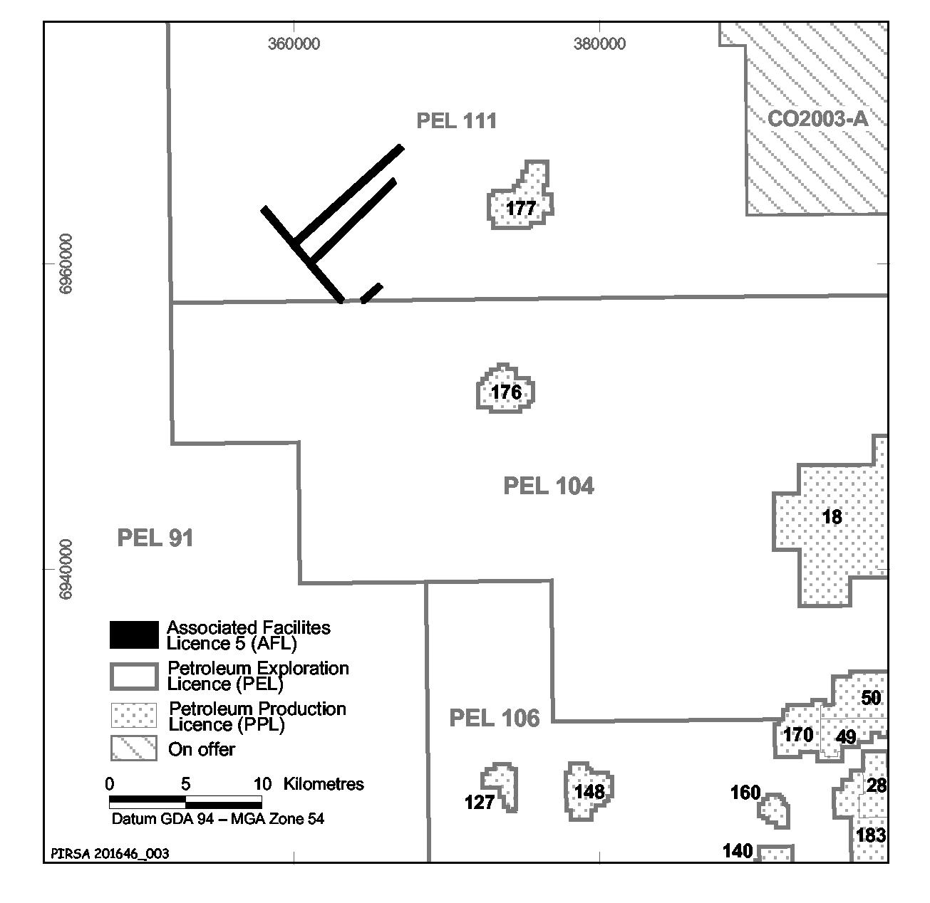
Area: 2.5 km² approximately.
Dated 4 November 2003.
B. A. Goldstein, Director Petroleum,
Minerals and Energy Division,
Primary Industries and Resources SA
Delegate of the Minister for Mineral Resources Development

PETROLEUM ACT 2000
Application for Grant of an Associated Facilities Licence AFL 6
PURSUANT to section 65 (6) of the Petroleum Act 2000 (the Act) and Delegation dated 28 March 2002, Gazetted 11 April 2002, page 1573, notice is hereby given that an application for the grant of an Associated Facilities Licence over the area described below has been received from Victoria Petroleum NL.
Description of Application Area
A 50 m buffer around line segments adjacent to petroleum exploration licence PEL 104 as shown on the map following:
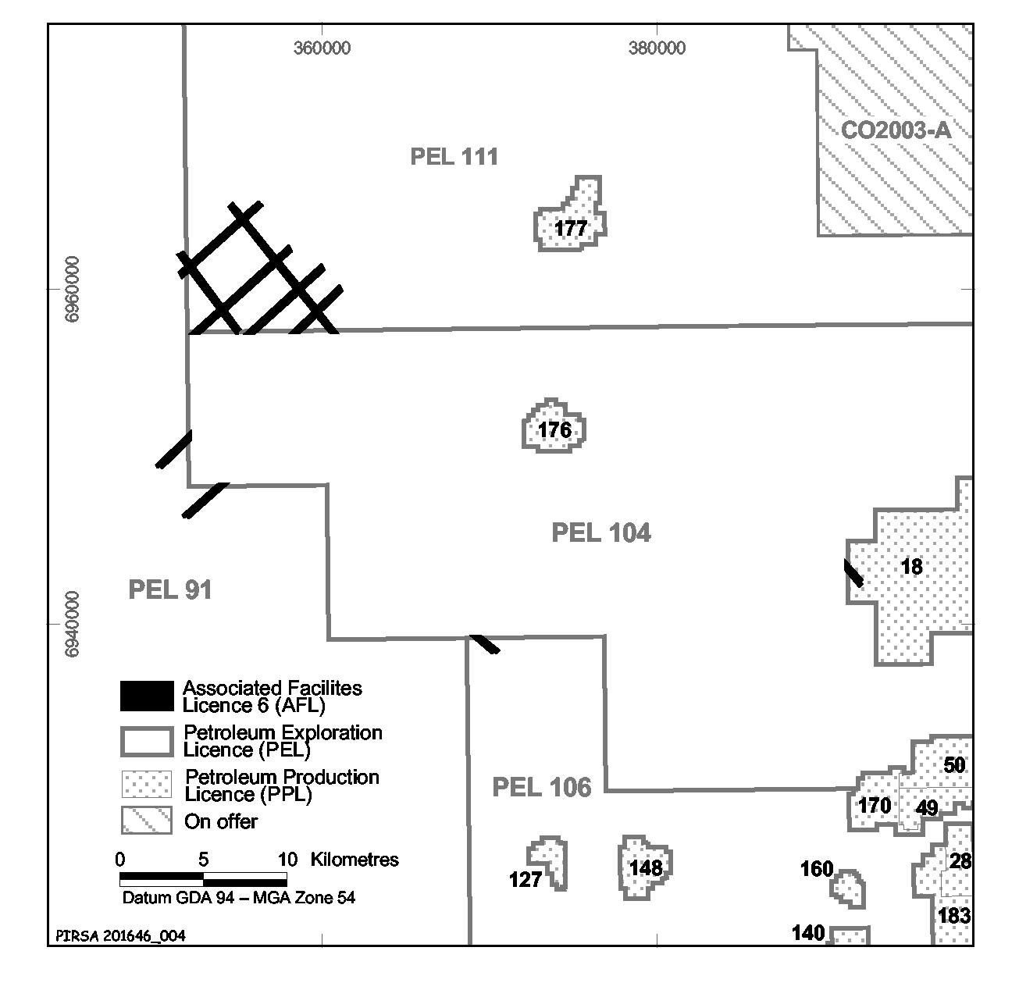
Map of the Application Area

Area: 4.7 km² approximately.
Dated 4 November 2003.
B. A. Goldstein, Director Petroleum,
Minerals and Energy Division,
Primary Industries and Resources SA
Delegate of the Minister for Mineral Resources Development

PETROLEUM ACT 2000
Suspension of Geothermal Exploration Licence GEL 99
NOTICE is hereby given that the abovementioned Geothermal Exploration Licence has been suspended under the provisions of the Petroleum Act 2000, from and including 17 October 2003 to 16 April 2004, pursuant to delegated powers dated 28 March 2002, Gazetted 11 April 2002, page 1573.
The expiry date of GEL 99 is now determined to be 21 August 2007.
Dated 31 October 2003.
B. A. Goldstein, Director Petroleum Minerals and Energy Division Primary Industries and Resources SA Delegate of the Minister for Mineral Resources Development

ROADS (OPENING AND CLOSING) ACT 1991:
SECTION 24
NOTICE OF CONFIRMATION OF ROAD
PROCESS ORDER
Greenhills Road and Hawke Road, Lower Inman Valley
Deposited Plan 63045
BY Road Process Order made on 22 August 2003 the City of Victor Harbor ordered that:
1. Portion of section 470 adjoining the south-western boundary of the said section, more particularly delineated and numbered ‘1’ in Preliminary Plan No. 02/0092 be opened as road.
2. Portion of Hawke Road (Public Road) adjoining the south-eastern boundary of section 470, more particularly delineated and lettered ‘C’ on Preliminary Plan No. 02/0092 be closed.
3. Vest in the Crown the whole of the land subject to closure.
On 31 October 2003, that order was confirmed by the Minister for Administrative Services, conditionally on approval and deposit of the survey plan by the Registrar-General. The con-dition has now been fulfilled.
Pursuant to section 24 (5) of the Roads (Opening and Closing) Act 1991, NOTICE of the order referred to above and its confirmation is hereby given.
Dated 6 November 2003.
P. M. Kentish, Surveyor-General

ROADS (OPENING AND CLOSING) ACT 1991:
SECTION 24
NOTICE OF CONFIRMATION OF ROAD
PROCESS ORDER
Public Road, Tumby Bay
Deposited Plan 62998
BY Road Process Order made on 25 August 2003, The District Council of Tumby Bay ordered that:
1. The whole of the unnamed public road between Schramms Road and White River Road adjoining sections 239, 240, 241, 242, 243, 180 and 245 in the Hundred of Hutchison, more particularly delineated and lettered ‘A’, ‘B’, ‘C’, ‘D’, ‘E’, ‘F’ and ‘G’ on Preliminary Plan No. 03/0051 be closed.
2. The whole of the land subject to closure lettered ‘A’ to be transferred to the Norbidnee Pty Ltd in accordance with agreement for transfer dated 29 June 2003, entered into between The District Council of Tumby Bay and Norbidnee Pty Ltd.
3. The whole of the land subject to closure lettered ‘B’, ‘C’ and ‘D’ to be transferred to Alan Wayne Roediger and Marlene Roediger in accordance with agreement for transfer dated 10 July 2003, entered into between The District Council of Tumby Bay and Alan Wayne Roediger and Marlene Roediger.
4. The whole of the land subject to closure lettered ‘E’, ‘F’ and ‘G’ to be transferred to Peter Mervyn Swaffer and Michelle Lexie Frick Swaffer in accordance with agreement for transfer dated 27 June 2003, entered into between The District Council of Tumby Bay and Peter Mervyn Swaffer and Michelle Lexie Frick Swaffer.
5. The following easement be granted over portion of the land subject to that closure:
Grant to the South Australian Water Corporation an ease-ment for water supply purposes.
On 17 September 2003, that order was confirmed by the Minister for Administrative Services, conditionally on approval and deposit of the survey plan by the Registrar-General. The condition has now been fulfilled.
Pursuant to section 24 (5) of the Roads (Opening and Closing) Act 1991, NOTICE of the order referred to above and its confirmation is hereby given.
Dated 6 November 2003.
P. M. Kentish, Surveyor-General

ROADS (OPENING AND CLOSING) ACT 1991:
SECTION 24
NOTICE OF CONFIRMATION OF ROAD
PROCESS ORDER
Giles Street, Kilkenny
Deposited Plan 63188
BY Road Process Order made on 29 August 2003, the City of Charles Sturt ordered that:
1. The whole of the public road (Giles Street) south of Regency Road adjoining allotment 50 in Deposited Plan 45534 more particularly lettered ‘A’ on Preliminary Plan No. 02/0134 be closed.
2. The whole of the land subject to closure be transferred to the Spring Grove Estate Pty Ltd in accordance with agreement for transfer dated 29 August 2003, entered into between the City of Charles Sturt and Spring Grove Estate Pty Ltd.
3. The following easements are granted over portions of the land subject to that closure:
Grant to the South Australian Water Corporation ease-ments for water and sewerage purposes.
Grant to the City of Charles Sturt an easement for drainage purposes.
On 8 October 2003, that order was confirmed by the Minister for Administrative Services conditionally on approval and deposit of the survey plan by the Registrar-General. The condition has now been fulfilled.
Pursuant to section 24 (5) of the Roads (Opening and Closing) Act 1991, NOTICE of the order referred to above and its confirmation is hereby given.
Dated 6 November 2003.
P. M. Kentish, Surveyor-General

ROADS (OPENING AND CLOSING) ACT 1991:
SECTION 24
NOTICE OF CONFIRMATION OF ROAD
PROCESS ORDER
Pentridge Road, Salisbury North
Deposited Plan 63186
BY Road Process Order made on 4 September 2003, the City of Salisbury ordered that:
1. Portion of the public road (Pentridge Road) adjoining Motcombe Road and allotment 562 (reserve) in Deposited Plan 4599, more particularly delineated and lettered ‘A’ on Preliminary Plan No. 03/0002 be closed.
2. Issue a Certificate of Title to the City of Salisbury for the whole of the land subject to closure, which land is being retained by Council for merging with the adjoining council reserve.
3. The following easements are granted over portion of the land subject to that closure:
Grant to the Distribution Lessor Corporation an easement for overhead electricity supply purposes.
Grant to the South Australian Water Corporation an ease-ment for water supply purposes.
On 8 October 2003, that order was confirmed by the Minister for Administrative Services conditionally on approval and deposit of the survey plan by the Registrar-General. The condition has now been fulfilled.
Pursuant to section 24 (5) of the Roads (Opening and Closing) Act 1991, NOTICE of the order referred to above and its confirmation is hereby given.
Dated 6 November 2003.
P. M. Kentish, Surveyor-General

ROADS (OPENING AND CLOSING) ACT 1991:
SECTION 24
NOTICE OF CONFIRMATION OF ROAD
PROCESS ORDER
Public Thoroughfare, Moana
Deposited Plan 63328
BY Road Process Order made on 17 September 2003, the City of Onkaparinga ordered that:
1. Portion of the road (Thoroughfare) adjoining Regent Street and the north-western boundary of allotment 482 in Deposited Plan 6210 more particularly lettered ‘A’ on Preliminary Plan No. 03/0038 be closed.
2. The whole of the land subject to closure be transferred to Kenneth Stanley Milde and Dorothy Milde in accordance with agreement for transfer dated 17 September 2003, entered into between the City of Onkaparinga and to K. S. Milde and D. Milde.
On 31 October 2003, that order was confirmed by the Minister for Administrative Services conditionally on approval and deposit of the survey plan by the Registrar-General. The condition has now been fulfilled.
Pursuant to section 24 (5) of the Roads (Opening and Closing) Act 1991, NOTICE of the order referred to above and its confirmation is hereby given.
Dated 6 November 2003.
P. M. Kentish, Surveyor-General

ROADS (OPENING AND CLOSING) ACT 1991:
SECTION 24
NOTICE OF CONFIRMATION OF ROAD
PROCESS ORDER
D’Aranda Terrace, Milang
Deposited Plan 60618
BY Road Process Order made on 13 September 2002, the Alexandrina Council ordered that:
1. Portion of the unnamed public road adjoining sections 186 and 187 in the Hundred of Alexandrina and portion of D’Aranda Terrace adjoining allotment 1 in Filed Plan 40909, more particularly lettered ‘A’ and ‘B’ (respectively) on Preliminary Plan No. 32/0592 be closed.
2. Vest the whole of the land subject to closure in the Crown.
On 31 October 2003, that order was confirmed by the Minister for Administrative Services conditionally on approval and deposit of the survey plan by the Registrar-General. The condition has now been fulfilled.
Pursuant to section 24 (5) of the Roads (Opening and Closing) Act 1991, NOTICE of the order referred to above and its confirmation is hereby given.
Dated 6 November 2003.
P. M. Kentish, Surveyor-General

ROAD TRAFFIC ACT 1961

Exemption for Left Hand Drive Agricultural Machines

1. Exemption

1.1 Pursuant to section 163AA of the Road Traffic Act 1961, I hereby exempt Left Hand Drive Agricultural Machines from the following provisions of the:

1.1.1 Road Traffic (Vehicle Standards) Rules 1999:

• Rule 27 (1)—Steering: A motor vehicle must have a right-hand drive.

subject to the conditions specified in this Notice.

2. Definition

• ‘Agricultural machine’ means a machine with its own motive power, built to perform agricultural tasks.
• ‘Left hand drive vehicle’ means a motor vehicle that has its steering wheel on the left of the longitudinal axis of the vehicle.

3. Conditions Applying to this Exemption

3.1 The driver’s view, from the seating position of the vehicle, of the road and traffic to the front and sides of the vehicle must cover at least 80 degrees to the left and 80 degrees to the right with no more than one 10 degree blind spot in the forward vision area and, no blind spot is permitted within 10 degrees of the longitudinal centre line that intersects the driver’s seating position, nor between 60 and 80 degrees of the longitudinal centre line that intersects the driver’s seating position. Reference Fig 1 below.

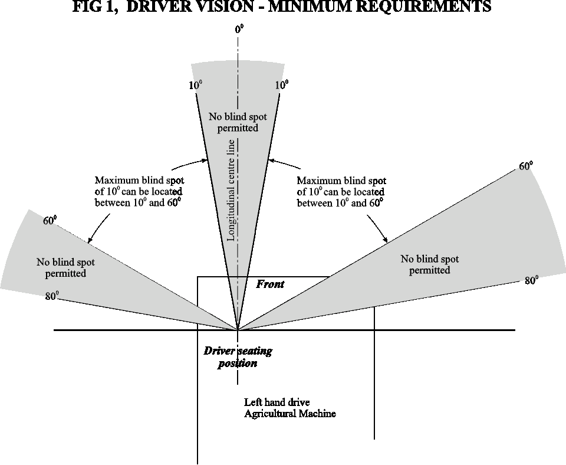

3.2 The agricultural machine shall not travel within the Adelaide Area (Metropolitan).

3.3 For the purposes of this notice, the ‘Adelaide Area (Metropolitan)’ is defined as the area described in ‘Map 1, Adelaide Area (Metropolitan)’ of this notice.

3.4 If the agricultural machine has a retractable boom, the boom must be retracted and stored below the operator’s cabin level while travelling on the road or road related area.

3.5 Left hand and right hand exterior mirrors must be fitted which, by themselves or in conjunction with an interior mirror, provide the driver with a clear unobstructed view to the rear.

3.6 The agricultural machine shall display a warning light or lights (revolving yellow flashing light/s) so that the light emanating from at least one of them is clearly visible at a distance of 500 metres in any direction and which meets the following specification:

3.6.1 Emit a rotating, flashing, yellow coloured light; and
3.6.2 Flash at a rate between 120 and 200 times per minute; and
3.6.3 Have a power of at least 55 watts; and
3.6.4 Not be a strobe light.

3.7 The headlights must be fitted with a dipping device to deflect the light projected from the headlight downwards, or downwards and to the left.

3.8 This notice or a legible copy of this notice shall be carried by the driver of the vehicle at all times when operating under this exemption and be produced when requested by an inspector appointed under the Road Traffic Act 1961 and/or the Motor Vehicles Act 1959, or a Police Officer.

3.9 Oversize or Overmass agricultural machine must also operate in accordance with the ‘Code of Practice for Oversize or Overmass Agricultural Vehicles’ dated May 2002, issued by Transport SA.

3.10 The agricultural machine must meet all other requirements set out in the Road Traffic Act 1961 and Regulations.

3.11 The agricultural machine is conditionally registered pursuant to the requirements of Section 25 of the Motor Vehicles Act 1959.

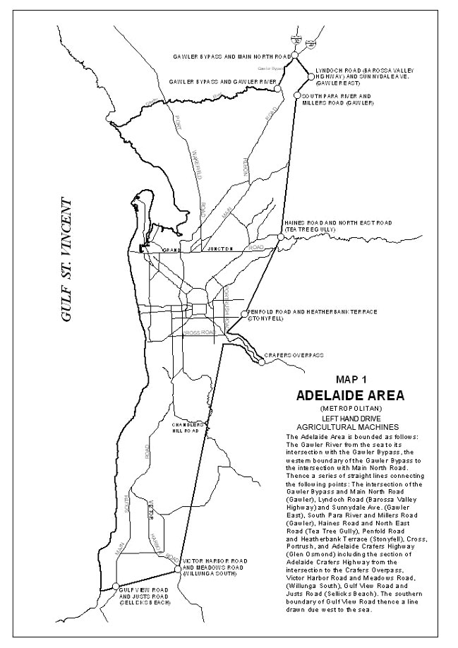

Executive Director, Transport SA

Christmas/New Year Holiday Publishing Information

Last Gazette for 2003 will be Thursday, 18 December 2003

Closing date for notices for publication will be
4 p.m. Tuesday, 16 December 2003

First Gazette for 2004 will be Thursday, 8 January 2004

Closing date for notices for publication will be
4 p.m. Tuesday, 6 January 2004

(There will NOT be a Gazette in the period between these two dates)

It would be appreciated if Government Gazette notices for publication be addressed to:

Government Publishing SA
Box 9
Plaza Level
Riverside Centre
North Terrace, Adelaide, S.A. 5000

AusDoc subscribers:

Government Publishing SA
DX 56508

Facsimile transmission of notices:
(08) 8207 1040
Attention: Government Gazette Section

Inquiries telephone: 8207 1045

Email address for Government Gazette notices:

governmentgazette@saugov.sa.gov.au

When sending a document via Email please confirm your transmission with a faxed copy, including the date the notice is to be published.

SOIL CONSERVATION AND LAND CARE ACT 1989
Appointments
I, JOHN DAVID HILL, Minister for Environment and Conservation in the State of South Australia to whom the administration of the Soil Conservation and Land Care Act 1989 has been committed, do hereby appoint the following person as a member of the Lower South East Soil Conservation Board pursuant to section 24 of the Act until 31 August 2004:
Ronald Weston Ellis as the Local Government representative
Dated 30 October 2003.
John Hill, Minister for Environment and Conservation

WATERWORKS ACT 1932
Instrument of Authority to Issue Expiation Notices
PURSUANT to a delegation by the former Minister for Infrastructure (now the Minister for Administrative Services) dated 4 May 1997, the South Australian Water Corporation authorises the officers named in the Schedule to give expiation notices arising under the Waterworks Act 1932.
This instrument revokes all previous authorities in regard to the giving of expiation notices under the Waterworks Act 1932.
Schedule
Bailey, Arthur George
Baker, David Michael
Ball, Geoffrey Alan
Bartsch, Errol Neill
Beard, Robert Malcolm Roland
Bell, Bryce Rodney
Boothey, Rodney Deane
Brown, Alan Seaford
Butcher, Brian Charles
Caddle, Stephen
Carmen, David Ian
Clark, Jeffery Don
Cock, Graham John
Cooke, Richard John
Curtis, Gary Frank
Dennehy, Dianne
Donovan, Gary Patrick
Dowling, Robin David
Edwards, Darryl Gene
Eerden, Lambertus Hendricus
Fitzpatrick, Lee Kent
Fountain, Tony Walter
Fowler, Brian
Fung, Francis Kwok-Lun
Gill, Roger Colin
Hadfield, John Joseph
Harris, Steven
Hawken, Graham Robert
Heaven, Robert John
Hodgson, Lennard Frank
Hoepner, Barry Robert
Hoffrichter, Kym
Hogben, Graham Ronald
Hogben, Noel John
Hollick, John Frederick
Jenner, Brenton Jared
Johnson, Brian James
Jones, Darryl Lee
Kohn, Raymond Bruce
McLean, Neil John
McMahon, Richard John
McPharlin, Andrew Ferguson
Meyers, Kenneth Norman
Morgan, Robert Ivan
Murray, Brian John
Nikolajevic, Jon
Perotti, Fulvio
Perriam, Christopher Ian
Perry, Graham Charles
Perry, Roger Neil
Phillips, Peter Warren
Rann, Anthony John
Reed, Arthur John Wayne
Roberts, Wayne Eric
Rouse, Lynda Rae
Rowe, Trevor Wayne
Ruccioch, Paul Michael
Samuel, Peter Ronald
Sargent, Ford Stanley
Skipworth, Neville Brian
Sterzl, Paul Gregory
Stewart, Alan David
Sullivan, Kevin Rostyn
Thornton, Marcus John
Van Rooyen, Jakobus
Veldhoen, Ben Peter
Walker, John Frederick
Williams, Barry John
Williams, Mark Richard
Wolter, Trevor John
Dated 3 November 2003.
Signed for and on behalf of the South Australian Water Corporation by a person duly authorised so to do:
A. D. Howe
In the presence of:
I. R. Miller
SAW 97/02783

WATER RESOURCES ACT 1997
Revocation of Notice of Restriction
PURSUANT to section 16 (9) of the Water Resources Act 1997 (‘the Act’), I, John David Hill, Minister for Environment and Conservation, revoke the Notice of Restriction of Water Use in the Padthaway Prescribed Wells Area dated 12 December 2001 and published in the Government Gazette (page 5377) of 13 December 2001.
Dated 8 October 2003.
John Hill, Minister for Environment and Conservation

WATER RESOURCES ACT 1997
Notice of Intention to vary the Proclamation establishing the Northern Adelaide and Barossa Catchment Water Management Board Area, pursuant to section 54 of the Water Resources Act 1997
I, JOHN DAVID HILL, the Minister for Environment and Conservation in the State of South Australia, do hereby give notice, pursuant to section 54 of the Water Resources Act 1997, that I propose to recommend to the Governor that she vary the proclamation made on 24 December 1997 establishing the Northern Adelaide and Barossa Catchment Water Management Board by deleting clause (c) which identifies the catchment area of the Board as being that part of the State delineated in GRO Plan No. 514 of 1997, and replacing it with the following clause (c):
‘(c) identify that part of the State delineated in GRO Plan No. 428/2003 as the catchment area in relation to which the Board is established.’
The proposed area delineated in GRO Plan No. 428/2003 is illustrated in the map below:
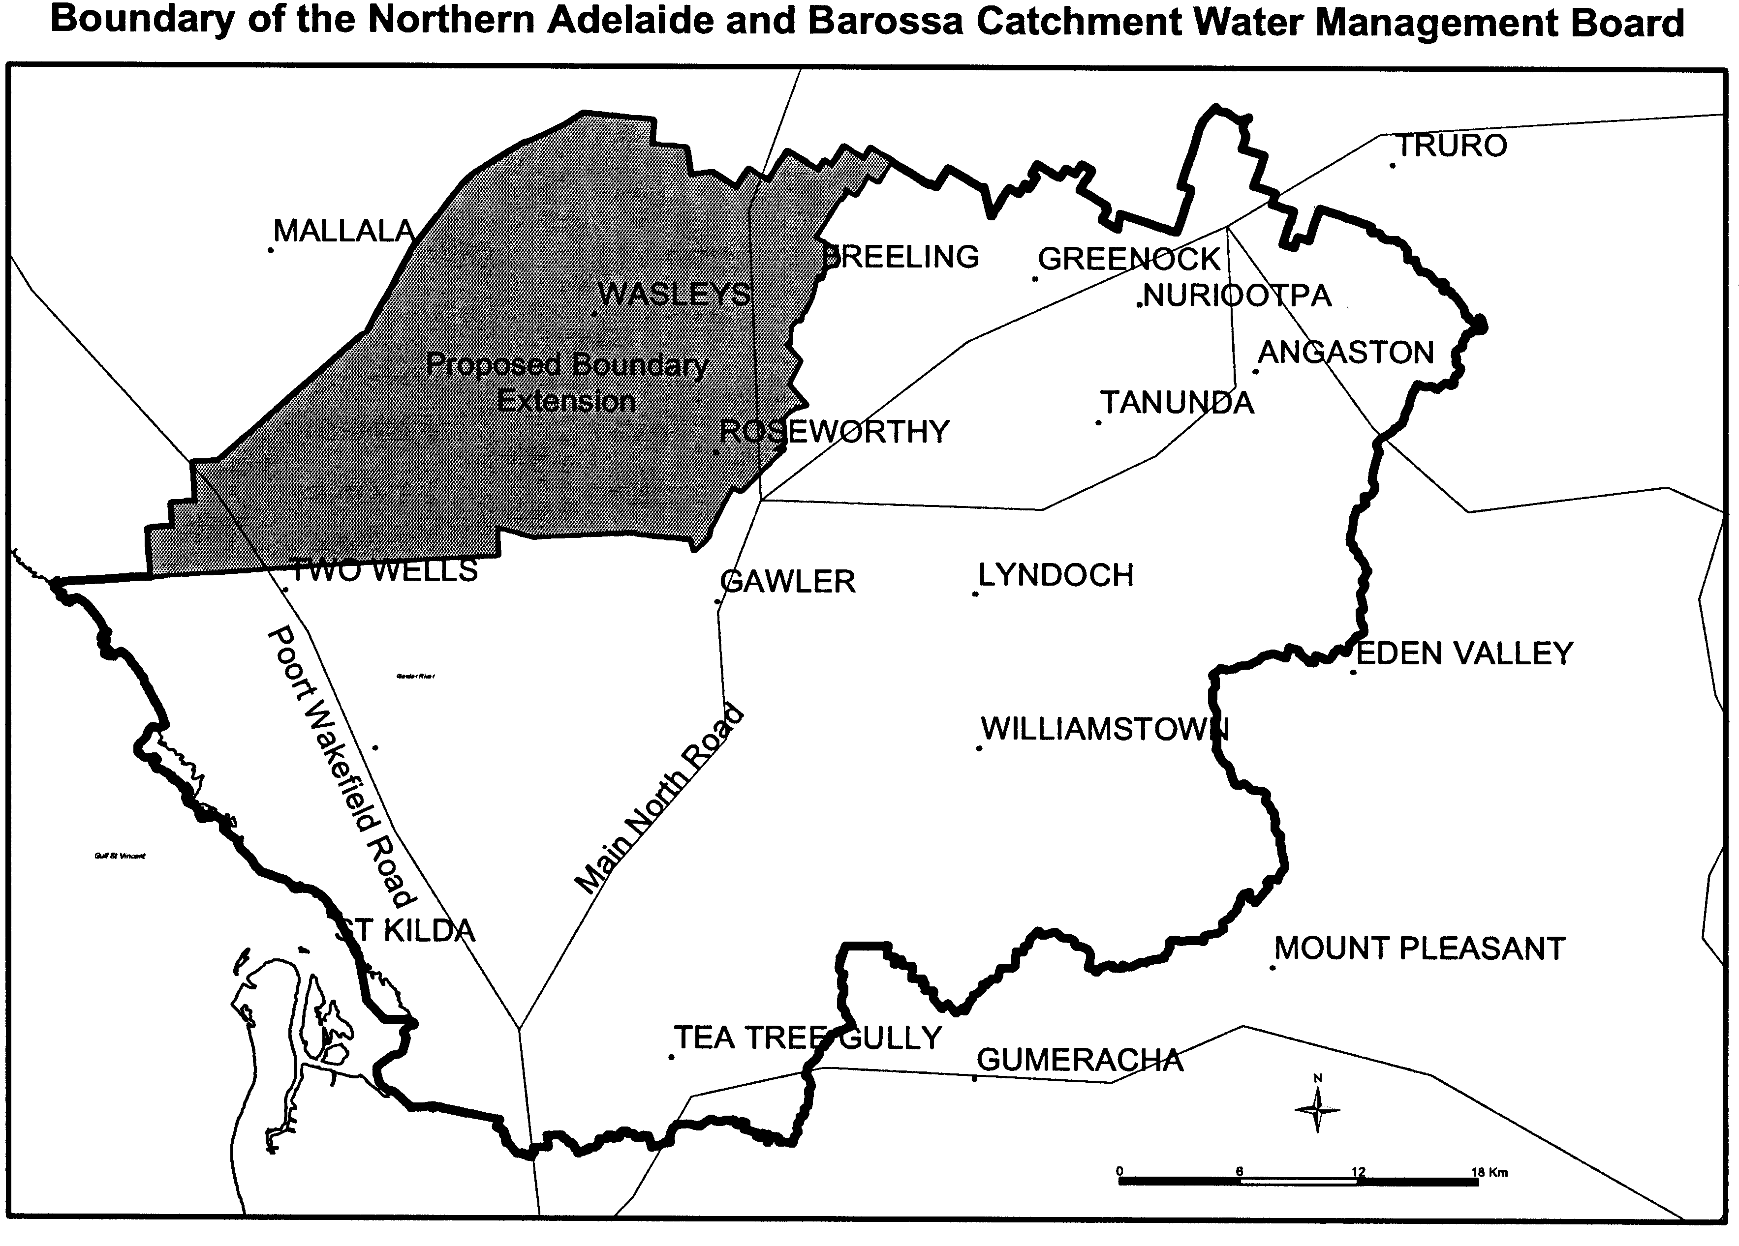
The proposed variation will have the effect of incorporating the Kangaroo Flat area into the Northern Adelaide and Barossa Catchment Water Management Board Area. The reason for varying the catchment area is that the Kangaroo Flat area is under increasing pressure from irrigation development, which will not be sustainable without the introduction of controls over water resource use. The inclusion of the Kangaroo Flat area within the boundary of the Board’s area will enable the Board to ensure that the underground water resources of the region are managed in accordance with the principles of ecologically sustainable development.
I invite interested persons to make a written submission on this proposal. The closing date for submissions will be 30 January 2004.
All submissions and enquiries on this proposal should be directed to:
The Minister for Environment and Conservation
c/o Phil Murray
Senior Catchment Management Officer
NRM Planning Support
Department of Water, Land and Biodiversity Conservation
G.P.O. Box 2834
Adelaide, S.A. 5001
Telephone (08) 8463 6858.
Dated 1 November 2003.
J. Hill, Minister for Environment and Conservation

WATER RESOURCES ACT 1997
Notice of intention to vary the regulation declaring the Northern Adelaide Plains Prescribed Wells Area, Pursuant to section 8 of the Water Resources Act 1997
I, JOHN DAVID HILL, the Minister for Environment and Conservation in the State of South Australia, hereby give notice that I propose to recommend to the Governor that she vary the proclamation, made under section 41 of the Water Resources Act 1976 on 13 May 1976, which was in force immediately before the commencement of the Water Resources Act 1997, by deleting clause 1 and replacing it with the following clause 1:
‘1. Declare that the area of the State delineated in GRO Plan No. 429/2003 shall be a Prescribed Wells Area for the purpose of the said Act, such area to be known as the Northern Adelaide Plains Prescribed Wells Area.’
I propose that in all other respects the proclamation remain the same.
The proposed area delineated in GRO Plan No. 429/2003 is illustrated in the map below:
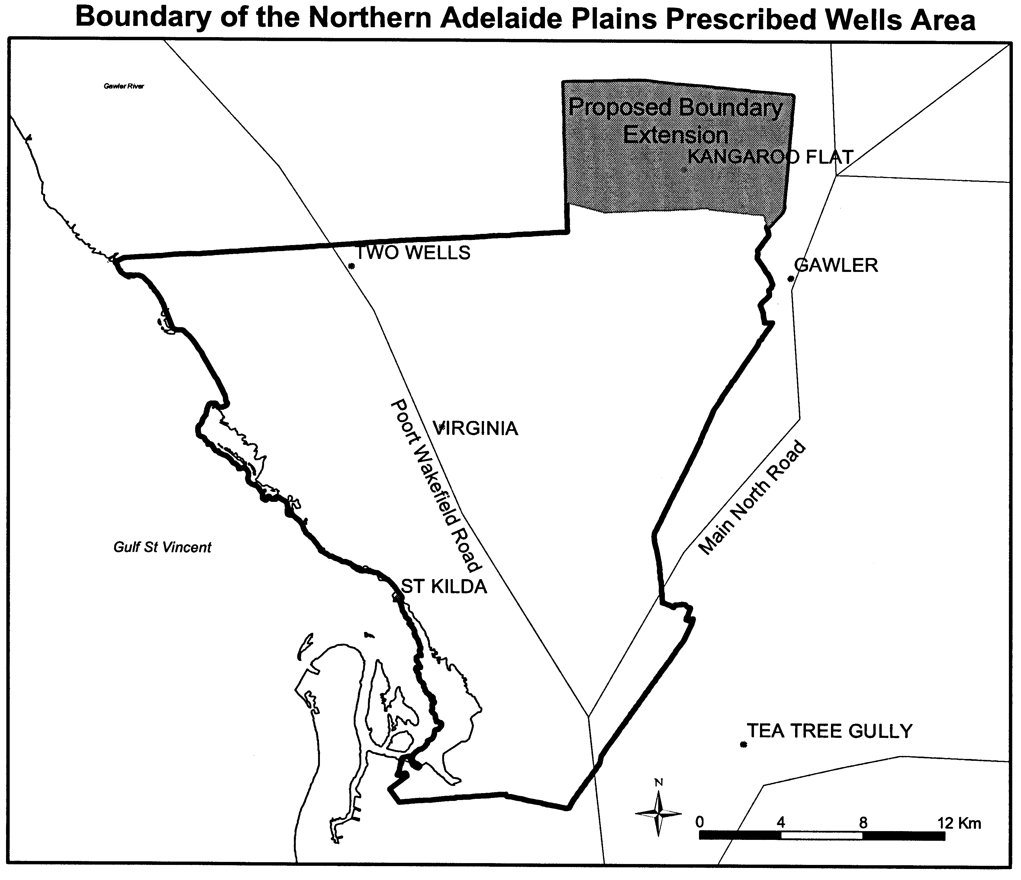
The variation of the proclamation will incorporate Kangaroo Flat Restricted Area, an area bounded by the bold line in GRO Plan No. 45/2000, within the Northern Adelaide Plains Prescribed Wells Area. The reason for incorporating this area is that Kangaroo Flat is under increasing pressure from irrigation development, which will not be sustainable without the introduction of controls over water resource use. The inclusion of the Kangaroo Flat Restricted Area within the Northern Adelaide Plains Prescribed Wells Area will ensure that all irrigators extracting from the aquifer system are subject to the same conditions of use as will be set out in a water allocation plan and enable the underground water resources of the region to be managed and used in accordance with the Object of the Water Resources Act 1997.
I invite all interested persons to make written submissions to me in relation to this proposal. The closing date for submissions will be 27 February 2004.
All submissions and enquiries should be addressed to:
The Minister for Environment and Conservation
c/o Phil Murray
Senior Catchment Management Officer
NRM Planning Support
Department of Water, Land and Biodiversity Conservation
G.P.O. Box 2834
Adelaide, S.A. 5001
Telephone: (08) 8463 6858.
Dated 1 November 2003.
J. Hill, Minister for Environment and Conservation

GOVERNMENT GAZETTE ADVERTISEMENT RATES

To apply from 1 July 2002

$  Agents, Ceasing to Act as 34.10  Associations:  Incorporation 17.40  Intention of Incorporation 43.00  Transfer of Properties 43.00  Attorney, Appointment of 34.10  Bailiff’s Sale 43.00  Cemetery Curator Appointed 25.50  Companies:  Alteration to Constitution 34.10  Capital, Increase or Decrease of 43.00  Ceasing to Carry on Business 25.50  Declaration of Dividend 25.50  Incorporation 34.10  Lost Share Certificates:  First Name 25.50  Each Subsequent Name 8.75  Meeting Final 28.75  Meeting Final Regarding Liquidator’s Report on  Conduct of Winding Up (equivalent to ‘Final  Meeting’)  First Name 34.10  Each Subsequent Name 8.75  Notices:  Call 43.00  Change of Name 17.40  Creditors 34.10  Creditors Compromise of Arrangement 34.10  Creditors (extraordinary resolution that ‘the Com-pany be wound up voluntarily and that a liquidator be appointed’) 43.00  Release of Liquidator⎯Application⎯Large Ad. 68.00  ⎯Release Granted 43.00  Receiver and Manager Appointed 39.75  Receiver and Manager Ceasing to Act 34.10  Restored Name 32.25  Petition to Supreme Court for Winding Up 59.50  Summons in Action 51.00  Order of Supreme Court for Winding Up Action 34.10  Register of Interests⎯Section 84 (1) Exempt 77.00  Removal of Office 17.40  Proof of Debts 34.10  Sales of Shares and Forfeiture 34.10  Estates:  Assigned 25.50  Deceased Persons⎯Notice to Creditors, etc. 43.00  Each Subsequent Name 8.75  Deceased Persons⎯Closed Estates 25.50  Each Subsequent Estate 1.10  Probate, Selling of 34.10  Public Trustee, each Estate 8.75 |  | $  Firms:  Ceasing to Carry on Business (each insertion) 22.70  Discontinuance Place of Business 22.70  Land⎯Real Property Act:  Intention to Sell, Notice of 43.00  Lost Certificate of Title Notices 43.00  Cancellation, Notice of (Strata Plan) 43.00  Mortgages:  Caveat Lodgment 17.40  Discharge of 18.30  Foreclosures 17.40  Transfer of 17.40  Sublet 8.75  Leases⎯Application for Transfer (2 insertions) each 8.75  Lost Treasury Receipts (3 insertions) each 25.50  Licensing 51.00  Municipal or District Councils:  Annual Financial Statement⎯Forms 1 and 2 481.00  Electricity Supply⎯Forms 19 and 20 341.00  Default in Payment of Rates:  First Name 68.00  Each Subsequent Name 8.75  Noxious Trade 25.50  Partnership, Dissolution of 25.50  Petitions (small) 17.40  Registered Building Societies (from Registrar-  General) 17.40  Register of Unclaimed Moneys⎯First Name 25.50  Each Subsequent Name 8.75  Registers of Members⎯Three pages and over:  Rate per page (in 8pt) 218.00  Rate per page (in 6pt) 288.00  Sale of Land by Public Auction 43.50  Advertisements 2.40  Advertisements, other than those listed are charged at $2.40 per column line, tabular one-third extra.  Notices by Colleges, Universities, Corporations and District Councils to be charged at $2.40 per line.  Where the notice inserted varies significantly in length from that which is usually published a charge of $2.40 per column line will be applied in lieu of advertisement rates listed.  South Australian Government publications are sold on the condition that they will not be reproduced without prior permission from the Government Printer.
All the above prices include GST

GOVERNMENT GAZETTE NOTICES
ALL private advertisements forwarded for publication in the South Australian Government Gazette must be PAID FOR PRIOR TO INSERTION; and all notices, from whatever source, should be legibly written on one side of the paper only and sent to Government Publishing SA so as to be received no later than 4 p.m. Tuesday preceding the day of publication. Phone 8207 1045 or Fax 8207 1040. E-mail: governmentgazette@saugov.sa.gov.au. Send as attachments in Word format and please confirm your transmission with a faxed copy of your document, including the date the notice is to be published and to whom the notice will be charged.

MISCELLANEOUS LEGISLATION AND GOVERNMENT PUBLICATIONS PRICES AS FROM 1 JULY 2003

Acts, Bills, Rules, Parliamentary Papers and Regulations
Pages | Main | Amends | Pages | Main | Amends

1-16 | 2.05 | 0.90 | 497-512 | 29.20 | 28.00
17-32 | 2.80 | 1.75 | 513-528 | 30.00 | 28.80
33-48 | 3.65 | 2.60 | 529-544 | 30.90 | 29.90
49-64 | 4.60 | 3.50 | 545-560 | 31.70 | 30.90
65-80 | 5.40 | 4.45 | 561-576 | 32.50 | 31.70
81-96 | 6.25 | 5.20 | 577-592 | 33.60 | 32.20
97-112 | 7.15 | 6.05 | 593-608 | 34.40 | 33.25
113-128 | 8.00 | 7.00 | 609-624 | 35.20 | 34.30
129-144 | 9.00 | 7.95 | 625-640 | 35.90 | 34.80
145-160 | 9.85 | 8.80 | 641-656 | 36.80 | 35.85
161-176 | 10.80 | 9.65 | 657-672 | 37.40 | 36.60
177-192 | 11.60 | 10.60 | 673-688 | 39.00 | 37.40
193-208 | 12.50 | 11.50 | 689-704 | 39.80 | 38.40
209-224 | 13.30 | 12.25 | 705-720 | 40.30 | 39.50
225-240 | 14.20 | 13.10 | 721-736 | 41.80 | 40.00
241-257 | 15.10 | 13.80 | 737-752 | 42.30 | 41.30
258-272 | 16.00 | 14.75 | 753-768 | 43.40 | 41.80
273-288 | 16.90 | 15.80 | 769-784 | 43.90 | 43.10
289-304 | 17.60 | 16.60 | 785-800 | 44.70 | 43.90
305-320 | 18.60 | 17.50 | 801-816 | 45.50 | 44.40
321-336 | 19.40 | 18.30 | 817-832 | 46.50 | 45.50
337-352 | 20.40 | 19.30 | 833-848 | 47.50 | 46.25
353-368 | 21.20 | 20.20 | 849-864 | 48.30 | 47.00
369-384 | 22.10 | 21.10 | 865-880 | 49.00 | 48.30
385-400 | 22.90 | 21.90 | 881-896 | 49.60 | 48.80
401-416 | 23.70 | 22.60 | 897-912 | 51.20 | 49.60
417-432 | 24.80 | 23.60 | 913-928 | 51.70 | 51.20
433-448 | 25.60 | 24.50 | 929-944 | 52.50 | 51.70
449-464 | 26.50 | 25.30 | 945-960 | 53.50 | 52.20
465-480 | 27.00 | 26.20 | 961-976 | 54.50 | 53.25
481-496 | 28.20 | 27.00 | 977-992 | 55.60 | 54.00

Legislation—Acts, Regulations, etc: $
Subscriptions:
Acts 180.00
All Bills as Laid 431.00
Rules and Regulations 431.00
Parliamentary Papers 431.00
Bound Acts 199.00
Index 99.00
Government Gazette
Copy 4.70
Subscription 238.00
Hansard
Copy 13.00
Subscription—per session (issued weekly) 374.00
Cloth bound—per volume 161.00
Subscription—per session (issued daily) 374.00
Legislation on Disk
Whole Database 2 763.00
Annual Subscription for fortnightly updates 849.00
Individual Act(s) including updates POA
Compendium
Subscriptions:
New Subs 1 638.00
Updates 578.00
(All the above prices include GST)

All Legislation, Government Gazette, Hansard and Legislation on disk are available from:
Counter Sales Service SA, Government Legislation⁺ Outlet
and Mail Orders: Lands Titles Office, 101 Grenfell Street, Adelaide
Phone: 13 23 24 (local call cost), Fax: (08) 8204 1909
Postal: G.P.O. Box 1707, Adelaide, S.A. 5001

Online Shop: www.shop.service.sa.gov.au

Subscriptions and Government Publishing SA
Standing Orders: Box 9, Plaza Level, Riverside Centre, North Terrace, Adelaide, S.A. 5000
Phone: (08) 8207 0908, (08) 8207 0910, Fax: (08) 8207 1040

South Australia
Liquor Licensing (Dry Areas—Short Term) Variation Regulations 2003
under the Liquor Licensing Act 1997

Contents
Part 1—Preliminary
1 Short title
2 Commencement
3 Variation provisions
Part 2—Variation of Liquor Licensing (Dry Areas—Short Term) Regulations 1997
4 Variation of Schedule 1—Short term dry areas

Part 1—Preliminary
1—Short title
These regulations may be cited as the Liquor Licensing (Dry Areas—Short Term) Variation Regulations 2003.
2—Commencement
These regulations come into operation on the day on which they are made.
3—Variation provisions
In these regulations, a provision under a heading referring to the variation of specified regulations varies the regulations so specified.
Part 2—Variation of Liquor Licensing (Dry Areas—Short Term) Regulations 1997
4—Variation of Schedule 1—Short term dry areas
(1) Schedule 1, item headed "Victor Harbor—Area 1", column headed "Period"—delete the column and substitute:
Period
(a) Continuously from 12.01 a.m. on 21 November 2003 to 12.01 a.m. on 30 November 2003; and
(b) From 3 p.m. on 31 December 2003 to 8 a.m. on 1 January 2004.
(2) Schedule 1, item headed "Victor Harbor—Area 2", column headed "Period"—delete the column and substitute:
Period
(a) Continuously from 12.01 a.m. on 21 November 2003 to 12.01 a.m. on 30 November 2003; and
(b) From 3 p.m. on 31 December 2003 to 8 a.m. on 1 January 2004.
Note—
As required by section 10AA(2) of the Subordinate Legislation Act 1978, the Minister has certified that, in the Minister's opinion, it is necessary or appropriate that these regulations come into operation as set out in these regulations.
Made by the Governor
with the advice and consent of the Executive Council
on 6 November 2003.
No. 224 of 2003
OLGC16/2003

South Australia
Public Corporations (South Australian Athletics Stadium) (Dissolution and Revocation) Regulations 2003
under the Public Corporations Act 1993

Contents
Part 1—Preliminary
1 Short title
2 Commencement
3 Interpretation
Part 2—Dissolution of South Australian Athletics Stadium
4 Dissolution and transfer of assets and liabilities of South Australian Athletics Stadium
Part 3—Revocation of Public Corporations (South Australian Athletics Stadium) Regulations 1997
5 Revocation of regulations

Part 1—Preliminary
1—Short title
These regulations may be cited as the Public Corporations (South Australian Athletics Stadium) (Dissolution and Revocation) Regulations 2003.
2—Commencement
These regulations come into operation on the day on which they are made.
3—Interpretation
In these regulations—
Act means the Public Corporations Act 1993.
Part 2—Dissolution of South Australian Athletics Stadium
4—Dissolution and transfer of assets and liabilities of South Australian Athletics Stadium
Pursuant to section 25 of the Act—
(a) South Australian Athletics Stadium established as a subsidiary of the Minister for Recreation and Sport by regulation under Part 5 of the Act is dissolved; and
(b) the assets and liabilities of South Australian Athletics Stadium immediately before its dissolution are transferred to and vested in or attached to the Minister for Recreation, Sport and Racing.
Part 3—Revocation of Public Corporations (South Australian Athletics Stadium) Regulations 1997
5—Revocation of regulations
The Public Corporations (South Australian Athletics Stadium) Regulations 1997 are revoked.
Note—
As required by section 10AA(2) of the Subordinate Legislation Act 1978, the Minister has certified that, in the Minister's opinion, it is necessary or appropriate that these regulations come into operation as set out in these regulations.
Made by the Governor
with the advice and consent of the Executive Council
on 6 November 2003.
No. 225 of 2003
MRS03/004

FAXING COPY?

IF you fax copy to Government Publishing SA for inclusion in the Government Gazette, there is no need to send a Confirmation Copy to us as well.

This creates confusion and may well result in your notice being printed twice.

Please use the following fax number:

Fax transmission: (08) 8207 1040
Phone Inquiries: (08) 8207 1045

Please include a contact person, phone number and order number so that we can phone back with any queries we may have regarding the fax copy.

NOTE: Closing time for lodging new copy (either fax or hard copy) is 4 p.m. on Tuesday preceding the day of publication.

Government Gazette notices can be E-mailed.

The address is:

governmentgazette@saugov.sa.gov.au

Documents should be sent as attachments in Word format.

When sending a document via E-mail, please confirm your transmission with a faxed copy of your document, including the date the notice is to be published.

Fax transmission: (08) 8207 1040
Enquiries: (08) 8207 1045

CITY OF CAMPBELLTOWN
Roads (Opening and Closing) Act 1991
Road Closure—Gorge Road, Athelstone
NOTICE is hereby given, pursuant to section 10 of the Roads (Opening and Closing) Act 1991, that the Corporation of the City of Campbelltown proposes to make a Road Process Order to close and transfer portion of the public road (Gorge Road) adjoining allotments 154 and 155 in Deposited Plan 6777 and allotment 63 in Filed Plan 133353 shown and more particularly delineated and lettered ‘A’, ‘B’ and ‘C’ in Preliminary Plan No. 03/0096.
Closed road ‘A’ is to be transferred to Rudolf Johan Brinck-man and Maureen Margaret Brinckman and merged with adjoining allotment 155 in Deposited Plan 6777.
Closed road ‘B’ is to be transferred to Jammal Consultancy for the Arabian Gulf Pty Ltd and merged with adjoining allotment 154 in Deposited Plan 6777.
Closed road ‘C’ is to be retained by the Corporation of the City of Campbelltown as Reserve.
A copy of the plan and a statement of persons affected are available for public inspection at the branch office of the Council, 172 Montacute Road, Rostrevor, S.A. 5073 and at the Adelaide office of the Surveyor-General during normal working hours.
Any application for easement or objection must set out the full name, address and details of the submission and must be fully supported by reasons.
The application for easement or objection must be made in writing to the council, P.O. Box 1, Campbelltown, S.A. 5074 within 28 days of this notice and a copy must be forwarded to the Surveyor-General, G.P.O. Box 1354, Adelaide, S.A. 5001. Where a submission is made, the council will give notification of a meeting at which the matter will be considered.
Dated 22 October 2003.
P. Vlatko, Chief Executive Officer

CITY OF MITCHAM
Roads (Opening and Closing) Act 1991
Road Closures—Saddle Hill Reserve, Pasadena
NOTICE is hereby given in accordance with section 10 of the Roads (Opening and Closing) Act 1991, that the City of Mitcham proposes to make a Road Process Order to close the following roads in the Hundred of Adelaide:
being all those portions of public road within Saddle Hill Reserve, Pasadena, generally situate intersecting and adjoining allotments 810, 812 and 823 in Deposited Plan 3738, allotment 89 in Deposited Plan 11175, allotment 82 in Deposited Plan 11173, allotment 85 in Deposited Plan 11174, allotment 88 in Deposited Plan 11176, allotments 125 and 126 in Deposited Plan 11358, allotment 127 in Deposited Plan 11357, allotment 53 in Filed Plan 21887 and allotment 70 in Filed Plan 218383 and marked ‘A’ on Preliminary Plan 03/0095.
It is proposed that the portion of road to be closed marked ‘A’ be retained by the City of Mitcham and merged with the said Saddle Hill Reserve.
A preliminary plan of the proposal, and a statement, are available for public inspection at the Mitcham Council Office, 131 Belair Road, Torrens Park, between the hours of 9 a.m. and 5 p.m., Monday to Friday, or at the Adelaide office of the Surveyor-General during normal office hours.
Any person may object to the proposal (and any adjoining landowner or other person substantially affected by the proposed road closure may apply for an easement relative to the closure). Such objection (or application for an easement) must be made in
writing to the City of Mitcham WITHIN 28 DAYS OF THE DATE OF THIS NOTICE. If a submission is made, the City of Mitcham is required to give notice of the time and place at which a meeting will be held to consider the matter, so that the person making the submission (or a representative) may attend to support the submission, if so desired. Any submission must set out the full name and address of the person making the submission, and must be fully supported by reasons (and any application for the grant of an easement must give full particulars of the nature and location of the easement and, where made by a person as the owner of adjoining or nearby land, specify the land to which the easement is to be annexed). A copy of the submission must be forwarded to the Surveyor-General at Adelaide.
Dated 6 November 2003.
R. Malcolm, Chief Executive Officer

CITY OF ONKAPARINGA
Roads (Opening and Closing) Act 1991
Road Closure—Portion of Esplanade, Port Noarlunga
NOTICE is hereby given pursuant to section 10 of the said Act, that council proposes to make a Road Process Order to close and sell to S. P. and S. A. Fuller, the portion of unmade road adjoining the front of allotment 91 in Deposited Plan 48646 shown as ‘A’ on Preliminary Plan 02/0072.
A copy of the plan and statement of persons affected are available for public inspection at the Council Office, Ramsay Place, Noarlunga Centre and the office of the Surveyor-General, 101 Grenfell Street, Adelaide, during normal office hours.
Any application for easement or objections must be made in writing setting out full details, within 28 days from 6 November 2003, to the Council, P.O. Box 1, Noarlunga Centre, S.A. 5168 and the Surveyor-General, G.P.O. Box 1354, Adelaide, S.A. 5001.
Where a submission is made, council will give notification of a meeting to deal with the matter.
Dated 6 November 2003.
J. Tate, City Manager

CITY OF PLAYFORD
Roads (Opening and Closing) Act 1991
Walkway Closure—Magor Street to Sullivan Road,
Elizabeth Park
NOTICE is hereby given pursuant to section 10 of the said Act, that council proposes to make a Road Process Order to close and sell to D. K. Vickery and the SA Housing Trust, the adjoining walkway (allotment 633 in Deposited Plan 6709) shown as ‘A’ and ‘B’ (respectively) on Preliminary Plan 03/0090.
A copy of the plan and statement of persons affected are available for public inspection at the Council Office, Warooka Drive, Smithfield and the office of the Surveyor-General, 101 Grenfell Street, Adelaide, during normal office hours.
Any application for easement or objections must be made in writing setting out full details, within 28 days from 6 November 2003, to the Council, Warooka Drive, Smithfield, S.A. 5114 and the Surveyor-General, G.P.O. Box 1354, Adelaide, S.A. 5001.
Where a submission is made, council will give notification of a meeting to deal with the matter.
Dated 6 November 2003.
T. Jackson, Chief Executive Officer

CITY OF UNLEY
Roads (Opening and Closing) Act 1991
Road Closure—Darby Street, Fullarton
NOTICE is hereby given pursuant to section 10 of the said Act, that council proposes to make a Road Process Order to close and sell to Fullarton Lutheran Homes Inc., the whole of Darby Street shown as ‘A’ to ‘F’ (inclusive) on Preliminary Plan 03/0089.
A copy of the plan and statement of persons affected are available for public inspection at the Council Office, 181 Unley Road, Unley and the office of the Surveyor-General, 101 Grenfell Street, Adelaide, during normal office hours.
Any application for easement or objections must be made in writing setting out full details, within 28 days from 6 November 2003, to the Council, P.O. Box 1, Unley, S.A. 5061 and the Surveyor-General, G.P.O. Box 1354, Adelaide, S.A. 5001.
Where a submission is made, council will give notification of a meeting to deal with the matter.
Dated 6 November 2003.
R. Green, Chief Executive Officer

TOWN OF GAWLER
Classification as Community Land
NOTICE is hereby given pursuant to section 193 (6) (b) of the Local Government Act 1999, that at the council meeting held on 28 October 2003, council resolved to classify the land contained in certificates of title 5494/323 and 5494/324, commonly known as Elliott Goodger Memorial Park, as community land.
This land was previously excluded from the classification of community land at the council meeting held on 26 November 2002.
J. McEachen, Town Manager

DISTRICT COUNCIL OF ELLISTON
Appointment
NOTICE is hereby given that at the ordinary meeting of council held on Friday, 17 October 2003, Trevor J. Lovell was appointed as Acting Chief Executive Officer effective from Thursday, 6 November 2003 until further notice vide David E. Hitchcock resigned.
D. Hitchcock, Chief Executive Officer

IN the matter of the estates of the undermentioned deceased persons:
Emms, Elsie May, late of 50 Gulfview Road, Christies Beach, widow, who died on 28 September 2003.
Connor, Ella Myrtle, late of 56 High Street, Grange, of no occupation, who died on 22 August 2003.
Conway, Sandra Marguerite, late of 65 Tusmore Avenue, Tusmore, retired public servant, who died on 30 August 2003.
Davis, Joyce Eileen, late of 8 Waterman Terrace, Mitchell Park, retired newsagent, who died on 11 September 2003.
Gray, Lilley Catherine, late of Lock, widow, who died on 3 July 2002.
Haese, Gweneth Ann, late of 23 Hurlstone Street, Peterborough, widow, who died on 5 September 2003.
Howell, Richard Cecil James, late of 36 Tregenza Avenue, Elizabeth South, retired cleaner, who died on 12 September 2003.
Hughes, Kenneth Lyal, late of 39 Beach Road, Brighton, retired storeman, who died on 1 September 2003.
Jenkins, Adeline, late of 86 Oaklands Road, Glengowrie, retired secretary, who died 10 September 2003.
Koehne, Kurt Casper Irwin, late of 4 Tennyson Avenue, Tranmere, retired commercial artist, who died on 28 July 2003.
Kohler, Nancy Margaret, late of 15 Rosemary Street, Woodville West, retired tailoress, who died on 26 September 2003.
Ludwig, Hans Gunter, late of 276 Portrush Road, Beulah Park, of no occupation, who died on 29 May 2003.
Lynch, Peter Joseph, late of 18 Seventh Street, Port Germein, retired park ranger, who died on 14 July 2003.
Male, Alfred Edwin, late of 10 Harrison Road, Renown Park, retired bricklayer, who died on 3 September 2003.
McClure, Nicholas Charles, late of 17 Yalpara Street, Eden Hills, university lecturer, who died on 20 September 2002.
Munton, Theresa, late of 19 Barr-Smith Avenue, Myrtle Bank, widow, who died on 30 August 2003.
Pilkington, Roy, late of 2 Jelley Street, Woodville, retired boilermaker, who died on 10 September 2003.
Potter, Eileen, late of 6 Ellis Street, Enfield, of no occupation, who died on 12 September 2003.
Richmond, Muriel Maud, late of 7 Railway Terrace, Old Reynella, retired photographer, who died on 17 February 2003.
Robson, Eric Allister, late of 99 George Street, Moonta, retired bricklayer, who died on 27 August 2003.
Schrapel, Margaret Joan, late of 15 Reginald Street, Port Pirie South, home duties, who died on 10 September 2003.
Shillingford, Lorima Aileen, late of 14-22 King William Road, Wayville, of no occupation, who died on 14 August 2003.
Speck, Lewis, late of 15 Rosemary Street, Woodville West, retired chef, who died on 25 September 2003.
Whiley, Mary Teresa, late of 160 Walkerville Terrace, Walkerville, retired bookkeeper, who died on 27 August 2003.
Notice is hereby given pursuant to the Trustee Act 1936, as amended, the Inheritance (Family Provision) Act 1972, and the Family Relationships Act 1975, that all creditors, beneficiaries, and other persons having claims against the said estates are required to send, in writing, to the Public Trustee, 25 Franklin Street, Adelaide 5000, full particulars and proof of such claims, on or before 5 December 2003, otherwise they will be excluded from the distribution of the said estate; and notice is also hereby given that all persons who are indebted to the said estates are required to pay the amount of their debts to the Public Trustee or proceedings will be taken for the recovery thereof; and all persons having any property belonging to the said estates are forthwith to deliver the same to the Public Trustee.
Dated 6 November 2003.
C. J. O’Loughlin, Public Trustee

SOUTH AUSTRALIA—In the Supreme Court No. 1321 of 1991. In the matter of World Express (SA) Pty (ACN 008 074 413) and in the matter of the Corporations Law.
Notice of Release of Liquidator and Dissolution of the Company
Take notice that by Order of the Supreme Court of South Australia dated 28 October 2003, I, John Sheahan, Level 8, 26 Flinders Street, Adelaide, the liquidator of the abovenamed company, was granted my release as liquidator and the company was dissolved as at the date of this Order.
Dated 31 October 2003.
J. Sheahan, Liquidator

SALE OF PROPERTY
Auction Date: Thursday, 27 November 2003 at 11 a.m.
Location: Lots 45 and 46, Wheatley Street, Kapunda.
NOTICE is hereby given that on the above date, at the time and place stated, by virtue of the Warrant of Sale issued out of the Magistrates Court of South Australia, Action No. AMCCI 4267 of 2002, directed to the Sheriff of South Australia in an action wherein South Australian Water Corporation is the Plaintiff and Stefan Krawczuk is the Defendant, I, Tim Goodes, Sheriff, of the State of South Australia, will by my auctioneers, Griffin Real Estate, make sale of the estate, right, title or interest whatsoever it may be of the Defendant, Stefan Krawczuk as the registered proprietor of an estate in fee simple in the following:
That piece of land situated in the area named Kapunda, being Lots 45 and 46, Wheatley Street, being the property comprised in Certificate of Title Register Book Volume 5529 Folio 638 and Volume 5366 Folio 365.
Further particulars from the auctioneers:
Griffin Real Estate
179 King William Road
Hyde Park, S.A. 5061
Telephone (08) 8357 3177

SALE OF PROPERTY
Auction Date: Friday, 28 November 2003 at 12 p.m.
Location: Berth E17 at Holdfast Quay Marina, North Glenelg.
NOTICE is hereby given that on the above date at the time and place stated, by virtue of the Warrant of Sale issued out of the Magistrates Court of South Australia, Action No. AMCCI 10505 of 2003 and others, directed to the Sheriff of South Australia in an action wherein Paul James Vogt is the Plaintiff and Louise Jane Sampson is the Defendant, I, Tim Goodes, Sheriff of the State of South Australia, will by my auctioneers, Kearns, make sale of the following:
6.7 m white fibreglass cabin cruiser, a Pride of Sunseeker Boat with a Volvo Penta 228 hp sterndrive engine.
Registration No. GQ196S
Further particulars from the auctioneers:
Kearns Auctioneers 21
G.P.O. Box 1415
Adelaide, S.A. 5001
Telephone (08) 8342 4445

ATTENTION

CUSTOMERS requiring a proof of their notice for inclusion in the Government Gazette, please note that the onus is on you to inform Government Publishing SA of any subsequent corrections by 10 a.m. on Thursday, which is our publication deadline.

For any corrections to your notice please phone 8207 1045 or Fax 8207 1040 before 10 a.m. on Thursday.

If we do not receive any communication by 10 a.m. on Thursday (day of publication) we will presume the notice is correct and will print it as it is.

Remember—the onus is on you to inform us of any corrections necessary to your notice.

NOTE: Closing time for lodging new copy (electronically, fax or hard copy) is 4 p.m. on Tuesday preceding the day of publication. Phone 8207 1045—Fax 8207 1040.
Email: governmentgazette@saugov.sa.gov.au

Printed and published by authority every Thursday by J. D. FERGUSON, Government Printer, South Australia
Price: $4.70, plus postage; to subscribers, $238.00 per annum.
(The above prices are inclusive of GST)

