No. 83 3423

THE SOUTH AUSTRALIAN

GOVERNMENT GAZETTE

PUBLISHED BY AUTHORITY

ALL PUBLIC ACTS appearing in this GAZETTE are to be considered official, and obeyed as such

ADELAIDE, THURSDAY, 4 SEPTEMBER 2003

CONTENTS

Page
Appointments, Resignations, Etc. 3424
Corporations and District Councils—Notices 3455
Crown Lands Act 1929—Notices 3425
Development Act 1993—Notices 3425
Essential Services Commission Act 2002—Notice 3425
Geographical Names Act 1991—Notice 3426
Land Acquisition Act 1969—Notice 3426
Land and Business (Sale and Conveyancing) Act 1994—
Notice 3426
Liquor Licensing Act 1997—Notices 3426
Local Government Act 1999—Notices 3432
Petroleum Act 2000—Notice 3437
Port Augusta Circuit Court—Notice 3437
Proclamations 3446
Public Corporations Act 1993—Notice 3438
Public Trustee Office—Administration of Estates 3456
REGULATION
Development (Development Assessment Processes)
Variation Regulations 2003 (No. 190 of 2003) 3448
Renmark Irrigation Trust, The—Notice 3438
Roads (Opening and Closing) Act 1991—Notices 3438
Road Traffic Act 1961—Notices 3438
Survey Act 1992—Notice 3442
Water Mains and Sewers—Mains Laid, Replaced, Etc 3442
Waterworks Act 1932—Notices 3444

GOVERNMENT GAZETTE NOTICES
ALL poundkeepers’ and private advertisements forwarded for publication in the South Australian Government Gazette must be PAID FOR PRIOR TO INSERTION; and all notices, from whatever source, should be legibly written on one side of the paper only and sent to Government Publishing SA so as to be received no later
than 4 p.m. on the Tuesday preceding the day of publication. Phone 8207 1045 or Fax 8207 1040. E-mail: governmentgazette@saugov.sa.gov.au. Send as attachments in Word format and please confirm your transmission with a faxed copy of your document, including the date the notice is to be published and to whom the notice will be charged.

Department of the Premier and Cabinet
Adelaide, 4 September 2003
HER Excellency the Governor in Executive Council has been pleased to appoint the undermentioned to the South Australian Bushfire Prevention Advisory Committee, pursuant to the provisions of the Country Fires Act 1989:
Deputy Member: (from 4 September 2003 until 26 September 2004)
Ian Bailey (Deputy to Brooks)
Simon Cox (Deputy to Roocke)
By command,
J. W. Weatherill, for Premier
MES 016/03CS

Department of the Premier and Cabinet
Adelaide, 4 September 2003
HER Excellency the Governor in Executive Council has been pleased to appoint the undermentioned to the South Australian Tourism Commission Board, pursuant to the provisions of the South Australian Tourism Commission Act 1993:
Director: (from 20 September 2003 until 30 September 2004)
Philip James Hoffman
Francene Connor
Jane James
David James Minear
Douglas Gautier
Director: (from 20 September 2003 until 30 September 2005)
Craig Wickham
Mark Butler
Chair: (from 20 September 2003 until 30 September 2004)
Philip James Hoffman
Deputy Chair: (from 20 September 2003 until 30 September 2005)
Anne Kathryn Skipper
By command,
J. W. Weatherill, for Premier
MTOU 14/03CS

Department of the Premier and Cabinet
Adelaide, 4 September 2003
HER Excellency the Governor in Executive Council has been pleased to appoint the undermentioned to the Carrick Hill Trust, pursuant to the provisions of the Carrick Hill Trust Act 1985:
Member: (from 4 September 2003 until 30 April 2005)
Deborah Raftopoulos
By command,
J. W. Weatherill, for Premier
MART 00005/2002CS

Department of the Premier and Cabinet
Adelaide, 4 September 2003
HER Excellency the Governor in Executive Council has been pleased to appoint the undermentioned to the State Disaster Committee, pursuant to the provisions of the State Disaster Act 1980:
Member: (from 4 September 2003 until 30 June 2004)
Shiralee Ann Reardon
Deputy Member: (from 4 September 2003 until 30 June 2004)
John Trainer
By command,
J. W. Weatherill, for Premier
ATTG 0296/02TC1CS

Department of the Premier and Cabinet
Adelaide, 4 September 2003
HER Excellency the Governor in Executive Council has been pleased to appoint the Honourable Michael John Wright, MP, Minister for Transport, Minister for Industrial Relations and Minister for Recreation, Sport and Racing to be also Acting Minister for Tourism, Acting Minister for Science and Information Economy and Acting Minister for Employment, Training and Further Education for the period 5 September 2003 to 9 September 2003 inclusive, during the absence of the Honourable Jane Diane Lomax-Smith, MP.
By command,
J. W. Weatherill, for Premier
METFE 34/03CS

Department of the Premier and Cabinet
Adelaide, 4 September 2003
HER Excellency the Governor in Executive Council has revoked the appointment of David Steele as an Industrial Relations Commissioner and an Enterprise Agreement Commissioner of the Industrial Relations Commission of South Australia, pursuant to the provisions of the Industrial and Employee Relations Act 1994 and the Acts Interpretation Act 1915.
By command,
J. W. Weatherill, for Premier
MIR WPS026/03CS

Department of the Premier and Cabinet
Adelaide, 4 September 2003
HER Excellency the Governor in Executive Council has been pleased to appoint David Steel as an Industrial Relations Commissioner and an Enterprise Agreement Commissioner of the Industrial Relations Commission of South Australia from 8 September 2003 to 7 September 2009, pursuant to the provisions of the Industrial and Employee Relations Act 1994.
By command,
J. W. Weatherill, for Premier
MIR WPS026/03CS

Department of the Premier and Cabinet
Adelaide, 4 September 2003
HER Excellency the Governor in Executive Council has removed from office the Justices of the Peace listed, pursuant to section 6 of the Justices of the Peace Act 1991:
John William Cross
John Ross-Davis
Karen Jane Duncan
Helen Joan Eggert
Clarence Lindsay Fitzgerald
Donald Robert Griffiths
Kylie Jane Heneker
Ronald John Hoey
Keith Edward Jenkin
Marie Ellen Keley
Glen Duncan Gerard Kelly
Albert Bernard Knoblauch
Robin Milne Mackay
Brian Ray March
Allan John Matschoss
Ermioni Mourtzios
Clive William Paine
Donald Panizzon
Norman Frederick Putland
Florence Margaret Reed
Mark Douglas Schrapel
Wayne Austin Sharp
Jennifer Dawn Urlwin
By command,
J. W. Weatherill, for Premier
ATTG 0046/03CS

Department of the Premier and Cabinet
Adelaide, 4 September 2003
HER Excellency the Governor in Executive Council has revoked the appointment of Geraldine Marie Sladden as a Clerk of Executive Council, pursuant to the Letters Patent, section 68 of the Constitution Act 1934 and the Acts Interpretation Act 1915.
By command,
J. W. Weatherill, for Premier
DPC 041/94CS

Department of the Premier and Cabinet
Adelaide, 4 September 2003
HER Excellency the Governor in Executive Council has been pleased to appoint Susanne Margaret Richards as a Clerk of Executive Council, pursuant to the Letters Patent and section 68 of the Constitution Act 1934.
By command,
J. W. Weatherill, for Premier
DPC 041/94CS

CROWN LANDS ACT 1929: SECTION 5
TAKE notice that pursuant to the Crown Lands Act 1929, I JOHN HILL, Minister for Environment and Conservation, Minister of the Crown to whom the administration of the Crown Lands Act 1929 is committed DO HEREBY dedicate the Crown Land defined in The Schedule as a Public Road.
The Schedule
Allotment 515 of DP 61753, Hundred of Yatala, County of Adelaide, being within the municipality of Tea Tree Gully.
Dated 4 September 2003.
J. Hill, Minister for Environment and Conservation
DEHAA 17/1240

CROWN LANDS ACT 1929: SECTION 5
TAKE notice that pursuant to the Crown Lands Act 1929, I JOHN HILL, Minister for Environment and Conservation, Minister of the Crown to whom the administration of the Crown Lands Act 1929 is committed DO HEREBY:
1. Resume the land defined in The First Schedule.
2. Dedicate the Crown Land defined in The Second Schedule as a Recreation Reserve and declare that such land shall be under the care, control and management of The Barossa Council.
The First Schedule
Recreation Reserve, allotment 100 in Deposited Plan No. 27779, Hundred of Moorooroo, County of Light, the notice of which was published in the Government Gazette of 15 February 1990 at page 454, being the whole of the land contained in Crown Record Volume 5752 Folio 204.
The Second Schedule
Allotment 99 of DP 62253, Hundred of Moorooroo, County of Light, exclusive of all necessary roads.
Dated 4 September 2003.
J. Hill, Minister for Environment and Conservation
DEH 10/1091

DEVELOPMENT ACT 1993: SECTION 46 (4)
Preamble
1. Subsection (4) of section 46 of the Development Act 1993 provides that the Minister may, by notice in the Gazette, revoke a declaration previously made under subsection (1) of that section.
2. The Minister has decided to revoke a declaration that has effect under section 46 of the Development Act 1993.
Notice
PURSUANT to subsection (4) of section 46 of the Development Act 1993, I revoke the declaration of the Minister under section 46 of the Development Act 1993, published in the Gazette on 28 September 2000 at pp 2223 and 2224.
Dated 25 August 2003.
J. Weatherill, Minister for Urban Development and Planning

DEVELOPMENT ACT 1993, SECTION 25(17): CITY OF CHARLES STURT—HINDMARSH AND WOODVILLE (CITY) AND HENLEY AND GRANGE (CITY) DE-VELOPMENT PLANS—GENERAL PLAN AMEND-MENT
Preamble
1. The Development Plan amendment entitled ‘City of Charles Sturt—Hindmarsh and Woodville (City) and Henley and Grange (City) Development Plans—General Plan Amendment’ (the Plan Amendment) has been finalised in accordance with the provisions of the Development Act 1993.
2. The Minister for Urban Development and Planning has decided to approve the Plan Amendment.
Notice
PURSUANT to section 25 of the Development Act 1993, I:
(a) approve the Plan Amendment; and
(b) fix the day on which this notice is published in the Gazette as the day on which the Plan Amendment will come into operation.
Dated 4 September 2003.
J. Weatherill, Minister for Urban Development and Planning
PLN 97/0480

ESSENTIAL SERVICES COMMISSION ACT 2002
Variation to Electricity Metering Code
NOTICE is hereby given that, pursuant to section 28 of the Essential Services Commission Act 2002, the Essential Services Commission has varied clause 1.2.4 of the Electricity Retail Code, to apply to the electricity supply industry, a regulated industry under the Electricity Act 1996, to have effect on and from 4 September 2003.
A copy of the Electricity Retail Code (as varied—version ERC/2) may be inspected or obtained from the Essential Services Commission, 8th Floor, 50 Pirie Street, Adelaide and is also available at www.escosa.sagov.au.
Queries in relation to the Electricity Retail Code may be directed to the Essential Services Commission, 8th Floor, 50 Pirie Street, Adelaide. Telephone (08) 8463 4444 or Freecall 1800 633 592.
Execution:
The seal of the Essential Services Commission was affixed with due Authority by the Chairperson of the Essential Services Commission.
Dated 3 September 2003.
(l.s.) L. W. Owens, Chairperson, Essential Services Commission

[Republished]
GEOGRAPHICAL NAMES ACT 1991
For Public Consultation
Notice of Intention to Assign a Name to a Place
NOTICE is hereby given pursuant to the provisions of the above Act, that the Minister for Administrative Services seeks public comment on a proposal to assign the name FIDES BLUFF to that feature located on the 1:50 000 Snug Cove Mapsheet (6226-1), as shown on the plan below.
The Plan
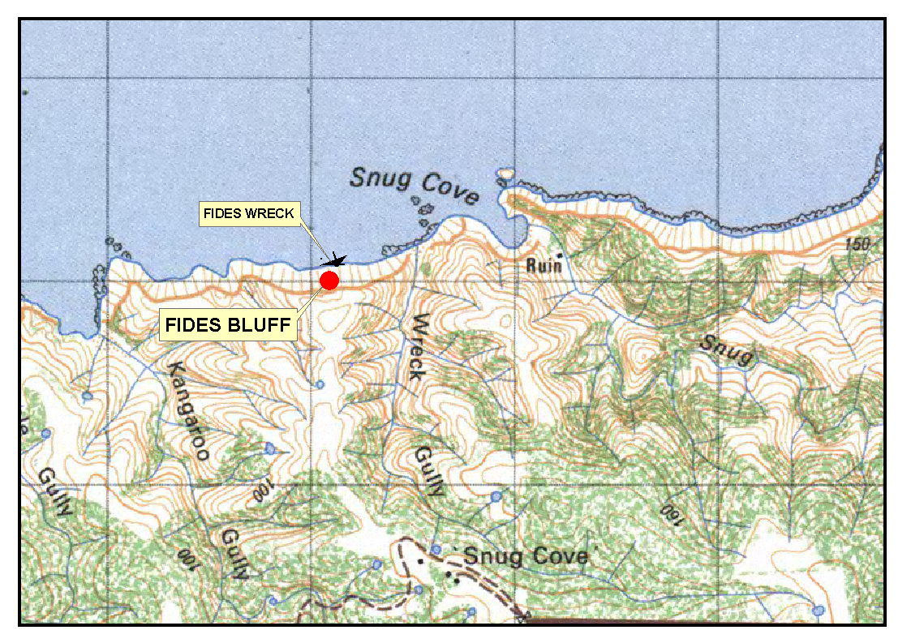 Submissions in writing regarding this proposal may be lodged with the Secretary, Geographical Names Advisory Committee, G.P.O. Box 1354, Adelaide, S.A. 5001, within one month of the publication of this notice.
Dated 21 August 2003.
P. M. Kentish, Surveyor-General, Department for Administrative and Information Services
DAIS 22-413/03/0021

LAND ACQUISITION ACT 1969
(Section 16)
Notice of Acquisition
S.A. WATER CORPORATION (the ‘Authority’), Level 15, S.A. Water House, 77 Grenfell Street, Adelaide, S.A. 5000, acquires the following interests in the following land:
An easement for sewerage purposes over portion of allotment 3 in Deposited Plan No. 2806, in the area named Stirling, Hundred of Noarlunga and being portion of the land comprised and described in certificate of title volume 5218, folio 803, more particularly delineated and lettered ‘E’ on approved Filed Plan No. FPX44281.
This notice is given under section 16 of the Land Acquisition Act 1969.
Offer of Compensation
A person who has or had an interest in the land that is divested or diminished by the acquisition or the enjoyment of which is adversely affected by the acquisition who does not receive an offer of compensation from the Authority may apply to the Authority for compensation.
Inquiries
Inquiries should be directed to:
The Property Manager:
S.A. Water Corporation
Level 15, S.A. Water House
77 Grenfell Street
Adelaide, S.A. 5000
Phone (08) 8204 1674
Dated 4 September 2003.
By Order of the Authority,
E. Lewandowski, Property Manager

LAND AND BUSINESS (SALE AND CONVEYANCING) ACT 1994
Exemption
TAKE notice that, pursuant to section 23 (3) of the Land and Business (Sale and Conveyancing) Act 1994, I, John David Hill, Minister for Consumer Affairs, do hereby exempt the persons named in Schedule 1 from the application of section 23 (2) of the Act in relation to the purchase of the business specified in Schedule 2.
Schedule 1
John Richard Langford and Aleksandar Bojanic, employees of Langfords Hotel Brokers Pty Ltd.
Schedule 2
The business known as Eagle on the Hill Hotel, situated at Mount Barker Road, Eagle on the Hill, S.A. 5150.
Dated 4 September 2003.
Signed for and on behalf of the Minister for Consumer Affairs by the Commissioner for Consumer Affairs:
M. Bodycoat, Commissioner

LIQUOR LICENSING ACT 1997
Notice of Application
NOTICE is hereby given, pursuant to section 52 (2) (b) of the Liquor Licensing Act 1997, that Valley of Armagh Pty Ltd, as trustee for the Glendalough Unit Trust, c/o Richards, Commercial Lawyers, has applied to the Licensing Authority for a Producer’s Licence in respect of premises situated at Allotment 101, St Georges Terrace, Clare, S.A. 5453 and to be known as Valley of Armagh.
The application has been set down for hearing on 3 October 2003 at 9 a.m.
Any person may object to the application by lodging a notice of objection in the prescribed form with the Licensing Authority, and serving a copy of the notice on the applicant at the applicant’s address given above, at least seven days before the hearing date.
Plans in respect of the premises the subject of the application are open to public inspection without fee at the Office of the Liquor and Gaming Commissioner, 9th Floor, East Wing, 50 Grenfell Street, Adelaide, S.A. 5000.
Dated 26 August 2003.
Applicant

LIQUOR LICENSING ACT 1997
Notice of Application
NOTICE is hereby given, pursuant to section 52 (2) (b) of the Liquor Licensing Act 1997, that Peter and Mary Darr, as trustees for the Darr Family Trust, c/o Leon McEvoy have applied to the Licensing Authority for a Retail Liquor Merchant’s Licence in respect of premises situated at 3 Main Street, Robe, S.A. 5276 and known as Limestone Coast Cellars.
The application has been set down for hearing on 3 October 2003 at 9 a.m.
Any person may object to the application by lodging a notice of objection in the prescribed form with the Licensing Authority, and serving a copy of the notice on the applicants at the applicants’ address given above, at least seven days before the hearing date.
Plans in respect of the premises the subject of the application are open to public inspection without fee at the Office of the Liquor and Gaming Commissioner, 9th Floor, East Wing, 50 Grenfell Street, Adelaide, S.A. 5000.
Dated 27 August 2003.
Applicants

LIQUOR LICENSING ACT 1997
Notice of Application
NOTICE is hereby given, pursuant to section 52 (2) (b) of the Liquor Licensing Act 1997, that Marcella and David Day have applied to the Licensing Authority for the transfer and removal of a Special Circumstances Licence in respect of premises situated at The Croft, Little Road, Aldinga, S.A. 5173 and to be situated at 60 Port Road, Willunga, and known as Little Legend Limos.
The application has been set down for hearing on 3 October 2003 at 9 a.m.
Any person may object to the application by lodging a notice of objection in the prescribed form with the Licensing Authority, and serving a copy of the notice on the applicants at the applicants’ address given above, at least seven days before the hearing date.
Plans in respect of the premises the subject of the application are open to public inspection without fee at the Office of the Liquor and Gaming Commissioner, 9th Floor, East Wing, 50 Grenfell Street, Adelaide, S.A. 5000.
Dated 28 August 2003.
Applicants

LIQUOR LICENSING ACT 1997
Notice of Application
NOTICE is hereby given, pursuant to section 52 (2) (b) of the Liquor Licensing Act 1997, that Ronald C. and Suzanne V. Coller, c/o Sam Ielasi have applied to the Licensing Authority for the transfer of Restaurant Licence in respect of premises situated at 1 Gawler Street, Port Noarlunga, S.A. 5167 and known as Agatha’s Food Store.
The application has been set down for hearing on 3 October 2003 at 9 a.m.
Any person may object to the application by lodging a notice of objection in the prescribed form with the Licensing Authority, and serving a copy of the notice on the applicants at the applicants’ address given above, at least seven days before the hearing date.
Plans in respect of the premises the subject of the application are open to public inspection without fee at the Office of the Liquor and Gaming Commissioner, 9th Floor, East Wing, 50 Grenfell Street, Adelaide, S.A. 5000.
Dated 28 August 2003.
Applicants

LIQUOR LICENSING ACT 1997
Notice of Application
NOTICE is hereby given, pursuant to section 52 (2) (b) of the Liquor Licensing Act 1997, that Ranjit Singh Rawat has applied to the Licensing Authority for the transfer of a Restaurant Licence in respect of premises situated at Shop 2, 542 Greenhill Road, Hazelwood Park, S.A. 5066 and known as Indian Tandoori Challa and to be known as Chapati House 1.
The application has been set down for hearing on 7 October 2003 at 10 a.m.
Any person may object to the application by lodging a notice of objection in the prescribed form with the Licensing Authority, and serving a copy of the notice on the applicant at the applicant’s address given above, at least seven days before the hearing date.
Plans in respect of the premises the subject of the application are open to public inspection without fee at the Office of the Liquor and Gaming Commissioner, 9th Floor, East Wing, 50 Grenfell Street, Adelaide, S.A. 5000.
Dated 25 August 2003.
Applicant

LIQUOR LICENSING ACT 1997
Notice of Application
NOTICE is hereby given, pursuant to section 52 (2) (b) of the Liquor Licensing Act 1997, that Que Siang Lai and Lixia Ma have applied to the Licensing Authority for the transfer of a Restaurant Licence in respect of premises situated at Shop 6, Richardson Place, Roxby Downs, S.A. 5725 and known as Roxby Chinese Restaurant.
The application has been set down for hearing on 7 October 2003 at 10.30 a.m.
Any person may object to the application by lodging a notice of objection in the prescribed form with the Licensing Authority, and serving a copy of the notice on the applicants at the applicants’ address given above, at least seven days before the hearing date.
Plans in respect of the premises the subject of the application are open to public inspection without fee at the Office of the Liquor and Gaming Commissioner, 9th Floor, East Wing, 50 Grenfell Street, Adelaide, S.A. 5000.
Dated 25 August 2003.
Applicants

LIQUOR LICENSING ACT 1997
Notice of Application
NOTICE is hereby given, pursuant to section 52 (2) (b) of the Liquor Licensing Act 1997, that WTB Soccer Club Inc., c/o Cowell Clarke Commercial Lawyers, has applied to the Licensing Authority for the transfer of a Special Circumstances Licence in respect of premises situated at cnr Saratoga Drive and Morphett Road, Novar Gardens, S.A. 5040 and known as West Torrens Birkalla Soccer Club.
The application has been set down for hearing on 7 October 2003 at 10 a.m.
Any person may object to the application by lodging a notice of objection in the prescribed form with the Licensing Authority, and serving a copy of the notice on the applicant at the applicant’s address given above, at least seven days before the hearing date.
Plans in respect of the premises the subject of the application are open to public inspection without fee at the Office of the Liquor and Gaming Commissioner, 9th Floor, East Wing, 50 Grenfell Street, Adelaide, S.A. 5000.
Dated 25 August 2003.
Applicant

LIQUOR LICENSING ACT 1997
Notice of Application
NOTICE is hereby given, pursuant to section 52 (2) (b) of the Liquor Licensing Act 1997, that Grand Central Management (Australia) Pty Ltd, c/o Minter Ellison Lawyers has applied to the Licensing Authority for the transfer of a Residential Licence in respect of premises situated at 12 Currie Street, Adelaide, S.A. 5000 and known as Duxton Hotel Adelaide.
The application has been set down for hearing on 7 October 2003 at 11 a.m.
Any person may object to the application by lodging a notice of objection in the prescribed form with the Licensing Authority, and serving a copy of the notice on the applicant at the applicant’s address given above, at least seven days before the hearing date.
Plans in respect of the premises the subject of the application are open to public inspection without fee at the Office of the Liquor and Gaming Commissioner, 9th Floor, East Wing, 50 Grenfell Street, Adelaide, S.A. 5000.
Dated 26 August 2003.
Applicant

LIQUOR LICENSING ACT 1997
Notice of Application
NOTICE is hereby given, pursuant to section 52 (2) (b) of the Liquor Licensing Act 1997, that Heidenreich Vineyards Pty Ltd, c/o Heuzenroeder & Heuzenroeder has applied to the Licensing Authority for the transfer of a Producer’s Licence in respect of premises situated at Lot 194, Section 57, Light Pass Road, Tanunda, S.A. 5352 and known as Heidenreich Estate.
The application has been set down for hearing on 8 October 2003 at 10 a.m.
Any person may object to the application by lodging a notice of objection in the prescribed form with the Licensing Authority, and serving a copy of the notice on the applicant at the applicant’s address given above, at least seven days before the hearing date.
Plans in respect of the premises the subject of the application are open to public inspection without fee at the Office of the Liquor and Gaming Commissioner, 9th Floor, East Wing, 50 Grenfell Street, Adelaide, S.A. 5000.
Dated 25 August 2003.
Applicant

LIQUOR LICENSING ACT 1997
Notice of Application
NOTICE is hereby given, pursuant to section 52 (2) (b) of the Liquor Licensing Act 1997, that Richard and Jane Louise Rowe have applied to the Licensing Authority for the transfer of a Restaurant Licence in respect of premises situated at Main Road, Springton, S.A. 5235 and known as Cafe C.
The application has been set down for hearing on 8 October 2003 at 11 a.m.
Any person may object to the application by lodging a notice of objection in the prescribed form with the Licensing Authority, and serving a copy of the notice on the applicants at the applicants’ address given above, at least seven days before the hearing date.
Plans in respect of the premises the subject of the application are open to public inspection without fee at the Office of the Liquor and Gaming Commissioner, 9th Floor, East Wing, 50 Grenfell Street, Adelaide, S.A. 5000.
Dated 26 August 2003.
Applicants

LIQUOR LICENSING ACT 1997
Notice of Application
NOTICE is hereby given, pursuant to section 52 (2) (b) of the Liquor Licensing Act 1997, that Cucinare Con Passione Pty Ltd, as trustee for the Cucinare Con Passione Trust, has applied to the Licensing Authority for the transfer of a Restaurant Licence and Entertainment Venue Licence in respect of premises situated at 7 Percy Street, Mount Gambier, S.A. 5290 and known as Coco’s Pizza Pasta & Grill.
The application has been set down for hearing on 9 October 2003 at 10 a.m.
Any person may object to the application by lodging a notice of objection in the prescribed form with the Licensing Authority, and serving a copy of the notice on the applicant at the applicant’s address given above, at least seven days before the hearing date.
Plans in respect of the premises the subject of the application are open to public inspection without fee at the Office of the Liquor and Gaming Commissioner, 9th Floor, East Wing, 50 Grenfell Street, Adelaide, S.A. 5000.
Dated 29 August 2003.
Applicant

LIQUOR LICENSING ACT 1997
Notice of Application
NOTICE is hereby given, pursuant to section 52 (2) (b) of the Liquor Licensing Act 1997, that A. & B. Rawlins Pty Ltd (ACN 105 266 331) has applied to the Licensing Authority for the transfer of the Special Circumstances Licence and a variation to the Extended Trading Authorisation in respect of premises situated at Pier No. 3, R3 Marina Pier Building, Holdfast Shores, Glenelg, S.A. 5045 and known as Rhett’s Bar-Bistro.
The application has been set down for hearing on 3 October 2003.
Conditions
The following licence conditions are sought:
To vary the current Extended Trading Authorisation to include the following hours, Sunday 8 a.m. to 11 a.m.
Any person may object to the application by lodging a notice of objection in the prescribed form with the Licensing Authority, and serving a copy of the notice on the applicant at the applicant’s address given above, at least seven days before the hearing date.
Plans in respect of the premises the subject of the application are open to public inspection without fee at the Office of the Liquor and Gaming Commissioner, 9th Floor, East Wing, 50 Grenfell Street, Adelaide, S.A. 5000.
Dated 11 August 2003.
Applicant

LIQUOR LICENSING ACT 1997
Notice of Application
NOTICE is hereby given, pursuant to section 52 (2) (b) of the Liquor Licensing Act 1997, that ALH Group Pty Ltd, c/o Kelly & Co., Level 17, 91 King William Street, Adelaide, S.A. 5000 has applied to the Licensing Authority for the variation to the Extended Trading Authorisation in respect of premises situated at 54-60 O’Connell Street, North Adelaide, S.A. 5006 and known as Archer Hotel.
The application has been set down for hearing on 3 October 2003 at 9 a.m.
Conditions
The following licence conditions are sought:
To extend the Existing Trading Authorisation on Friday and Saturday nights from 1 a.m. the next day to 2 a.m. the next day and also the Existing Extended Trading Authorisation on Sundays preceding a Public Holiday from midnight to 2 a.m. the next day.
The licensee is willing to accept a grant of this application on a trial period basis until the expiry of the existing trial period for the hotel’s existing trading hours and conditions, namely on 27 January 2004.
No other changes of trading hours or licence conditions is being sought.
Any person may object to the application by lodging a notice of objection in the prescribed form with the Licensing Authority, and serving a copy of the notice on the applicant at the applicant’s address given above, at least seven days before the hearing date.
Plans in respect of the premises the subject of the application are open to public inspection without fee at the Office of the Liquor and Gaming Commissioner, 9th Floor, East Wing, 50 Grenfell Street, Adelaide, S.A. 5000.
Dated 25 August 2003.
Applicant

LIQUOR LICENSING ACT 1997
Notice of Application
NOTICE is hereby given, pursuant to section 52 (2) (b) of the Liquor Licensing Act 1997, that Old Noarlunga Hotel Pty Ltd c/o Michael Jeffries has applied to the Licensing Authority for an Extended Trading Authorisation in respect of premises situated at 38 Patapinda Road, Old Noarlunga, S.A. 5168 and known as Old Noarlunga Hotel.
The application has been set down for hearing on 3 October 2003 at 9 a.m.
Conditions
The following licence conditions are sought in the application:
1. That the licensee be permitted to sell liquor for consumption on the licensed premises each Sunday from 8 a.m. to 11 a.m. and 8 p.m. to midnight.
2. That the licensee be permitted to sell liquor for consumption off the licensed premises each Sunday from 8 a.m. to 11 a.m. and 8 p.m. to 9 p.m.
3. That the Extended Trading Authorisation shall apply to the areas referred to on the plan kept at the Liquor and Gaming Commission as Area 1 (Dining Room), Area 2 (Gaming Room) and Area 3 (Front Bar).
Any person may object to the application by lodging a notice of objection in the prescribed form with the Licensing Authority, and serving a copy of the notice on the applicant at the applicant’s address given above, at least seven days before the hearing date.
Plans in respect of the premises the subject of the application are open to public inspection without fee at the Office of the Liquor and Gaming Commissioner, 9th Floor, East Wing, 50 Grenfell Street, Adelaide, S.A. 5000.
Dated 26 August 2003.
Applicant

LIQUOR LICENSING ACT 1997
Notice of Application
NOTICE is hereby given, pursuant to section 52 (2) (b) of the Liquor Licensing Act 1997, that David Edward Healey has applied to the Licensing Authority for a Hotel Licence with an Extended Trading Authorisation and Entertainment Consent in respect of premises to be situated at 1 Liddiard Road, Corny Point, S.A. 5575.
The application has been set down for hearing on 3 October 2003 at 9 a.m.
Conditions
The following licence conditions are sought:
Extended Trading Authorisation is to apply to the areas as depicted in the plan on Sunday from 8 a.m. to 11 a.m. and 8 p.m. to midnight.
Entertainment Consent is sought for the areas as depicted on the plan as bar area, lounge area and beer garden on Monday to Sunday (including public holidays) from 8 a.m. to midnight.
Any person may object to the application by lodging a notice of objection in the prescribed form with the Licensing Authority, and serving a copy of the notice on the applicant at the applicant’s address given above, at least seven days before the hearing date.
Plans in respect of the premises the subject of the application are open to public inspection without fee at the Office of the Liquor and Gaming Commissioner, 9th Floor, East Wing, 50 Grenfell Street, Adelaide, S.A. 5000.
Dated 28 August 2003.
Applicant

LIQUOR LICENSING ACT 1997
Notice of Application
NOTICE is hereby given, pursuant to section 52 (2) (b) of the Liquor Licensing Act 1997, that Tony and Amporn Tesoro have applied to the Licensing Authority for the transfer of a Restaurant Licence with Extended Trading Authorisation in respect of premises situated at 37 Hindmarsh Square, Adelaide, S.A. 5000 known as Take It Easy Thai Café and to be known as Thai In A Wok.
The application has been set down for hearing on 3 October 2003 at 9 a.m.
Conditions
The following licence conditions are sought:
Extended Trading Authorisation to Apply to Area 1: Sunday, 10 a.m. to 11 a.m. and 8 p.m. to midnight.
Any person may object to the application by lodging a notice of objection in the prescribed form with the Licensing Authority, and serving a copy of the notice on the applicants at the applicants’ address given above, at least seven days before the hearing date.
Plans in respect of the premises the subject of the application are open to public inspection without fee at the Office of the Liquor and Gaming Commissioner, 9th Floor, East Wing, 50 Grenfell Street, Adelaide, S.A. 5000.
Dated 28 August 2003.
Applicants

LIQUOR LICENSING ACT 1997
Notice of Application
NOTICE is hereby given, pursuant to section 52 (2) (b) of the Liquor Licensing Act 1997, that Scott Salisbury No. 2 Pty Ltd as trustee for the Salisbury Trust No. 2 and ITOF Developments Pty Ltd have applied to the Licensing Authority for the transfer and alterations of a Hotel Licence in respect of premises situated at 261 Pirie Street, Adelaide, S.A. 5000 and known as Tivoli Hotel.
The application has been set down for hearing on 8 October 2003 at 9.30 a.m.
Condition
The following licence condition is sought:
Alterations to the premises as per the plans lodged.
Any person may object to the application by lodging a notice of objection in the prescribed form with the Licensing Authority, and serving a copy of the notice on the applicants at the applicants’ address given above, at least seven days before the hearing date.
Plans in respect of the premises the subject of the application are open to public inspection without fee at the Office of the Liquor and Gaming Commissioner, 9th Floor, East Wing, 50 Grenfell Street, Adelaide, S.A. 5000.
Dated 25 August 2003.
Applicants

GOVERNMENT GAZETTE ADVERTISEMENT RATES

To apply from 1 July 2002

$  Agents, Ceasing to Act as 34.10  Associations:  Incorporation 17.40  Intention of Incorporation 43.00  Transfer of Properties 43.00  Attorney, Appointment of 34.10  Bailiff’s Sale 43.00  Cemetery Curator Appointed 25.50  Companies:  Alteration to Constitution 34.10  Capital, Increase or Decrease of 43.00  Ceasing to Carry on Business 25.50  Declaration of Dividend 25.50  Incorporation 34.10  Lost Share Certificates:  First Name 25.50  Each Subsequent Name 8.75  Meeting Final 28.75  Meeting Final Regarding Liquidator’s Report on  Conduct of Winding Up (equivalent to ‘Final  Meeting’)  First Name 34.10  Each Subsequent Name 8.75  Notices:  Call 43.00  Change of Name 17.40  Creditors 34.10  Creditors Compromise of Arrangement 34.10  Creditors (extraordinary resolution that ‘the Com-pany be wound up voluntarily and that a liquidator be appointed’) 43.00  Release of Liquidator⎯Application⎯Large Ad. 68.00  ⎯Release Granted 43.00  Receiver and Manager Appointed 39.75  Receiver and Manager Ceasing to Act 34.10  Restored Name 32.25  Petition to Supreme Court for Winding Up 59.50  Summons in Action 51.00  Order of Supreme Court for Winding Up Action 34.10  Register of Interests⎯Section 84 (1) Exempt 77.00  Removal of Office 17.40  Proof of Debts 34.10  Sales of Shares and Forfeiture 34.10  Estates:  Assigned 25.50  Deceased Persons⎯Notice to Creditors, etc. 43.00  Each Subsequent Name 8.75  Deceased Persons⎯Closed Estates 25.50  Each Subsequent Estate 1.10  Probate, Selling of 34.10  Public Trustee, each Estate 8.75 |  | $  Firms:  Ceasing to Carry on Business (each insertion) 22.70  Discontinuance Place of Business 22.70  Land⎯Real Property Act:  Intention to Sell, Notice of 43.00  Lost Certificate of Title Notices 43.00  Cancellation, Notice of (Strata Plan) 43.00  Mortgages:  Caveat Lodgment 17.40  Discharge of 18.30  Foreclosures 17.40  Transfer of 17.40  Sublet 8.75  Leases⎯Application for Transfer (2 insertions) each 8.75  Lost Treasury Receipts (3 insertions) each 25.50  Licensing 51.00  Municipal or District Councils:  Annual Financial Statement⎯Forms 1 and 2 481.00  Electricity Supply⎯Forms 19 and 20 341.00  Default in Payment of Rates:  First Name 68.00  Each Subsequent Name 8.75  Noxious Trade 25.50  Partnership, Dissolution of 25.50  Petitions (small) 17.40  Registered Building Societies (from Registrar-  General) 17.40  Register of Unclaimed Moneys⎯First Name 25.50  Each Subsequent Name 8.75  Registers of Members⎯Three pages and over:  Rate per page (in 8pt) 218.00  Rate per page (in 6pt) 288.00  Sale of Land by Public Auction 43.50  Advertisements 2.40  Advertisements, other than those listed are charged at $2.40 per column line, tabular one-third extra.  Notices by Colleges, Universities, Corporations and District Councils to be charged at $2.40 per line.  Where the notice inserted varies significantly in length from that which is usually published a charge of $2.40 per column line will be applied in lieu of advertisement rates listed.  South Australian Government publications are sold on the condition that they will not be reproduced without prior permission from the Government Printer.
All the above prices include GST

GOVERNMENT GAZETTE NOTICES
ALL private advertisements forwarded for publication in the South Australian Government Gazette must be PAID FOR PRIOR TO INSERTION; and all notices, from whatever source, should be legibly written on one side of the paper only and sent to Government Publishing SA so as to be received no later than 4 p.m. Tuesday preceding the day of publication. Phone 8207 1045 or Fax 8207 1040. E-mail: governmentgazette@saugov.sa.gov.au. Send as attachments in Word format and please confirm your transmission with a faxed copy of your document, including the date the notice is to be published and to whom the notice will be charged.

MISCELLANEOUS LEGISLATION AND GOVERNMENT PUBLICATIONS PRICES AS FROM 1 JULY 2003

Acts, Bills, Rules, Parliamentary Papers and Regulations
Pages | Main | Amends | Pages | Main | Amends

1-16 | 2.05 | 0.90 | 497-512 | 29.20 | 28.00
17-32 | 2.80 | 1.75 | 513-528 | 30.00 | 28.80
33-48 | 3.65 | 2.60 | 529-544 | 30.90 | 29.90
49-64 | 4.60 | 3.50 | 545-560 | 31.70 | 30.90
65-80 | 5.40 | 4.45 | 561-576 | 32.50 | 31.70
81-96 | 6.25 | 5.20 | 577-592 | 33.60 | 32.20
97-112 | 7.15 | 6.05 | 593-608 | 34.40 | 33.25
113-128 | 8.00 | 7.00 | 609-624 | 35.20 | 34.30
129-144 | 9.00 | 7.95 | 625-640 | 35.90 | 34.80
145-160 | 9.85 | 8.80 | 641-656 | 36.80 | 35.85
161-176 | 10.80 | 9.65 | 657-672 | 37.40 | 36.60
177-192 | 11.60 | 10.60 | 673-688 | 39.00 | 37.40
193-208 | 12.50 | 11.50 | 689-704 | 39.80 | 38.40
209-224 | 13.30 | 12.25 | 705-720 | 40.30 | 39.50
225-240 | 14.20 | 13.10 | 721-736 | 41.80 | 40.00
241-257 | 15.10 | 13.80 | 737-752 | 42.30 | 41.30
258-272 | 16.00 | 14.75 | 753-768 | 43.40 | 41.80
273-288 | 16.90 | 15.80 | 769-784 | 43.90 | 43.10
289-304 | 17.60 | 16.60 | 785-800 | 44.70 | 43.90
305-320 | 18.60 | 17.50 | 801-816 | 45.50 | 44.40
321-336 | 19.40 | 18.30 | 817-832 | 46.50 | 45.50
337-352 | 20.40 | 19.30 | 833-848 | 47.50 | 46.25
353-368 | 21.20 | 20.20 | 849-864 | 48.30 | 47.00
369-384 | 22.10 | 21.10 | 865-880 | 49.00 | 48.30
385-400 | 22.90 | 21.90 | 881-896 | 49.60 | 48.80
401-416 | 23.70 | 22.60 | 897-912 | 51.20 | 49.60
417-432 | 24.80 | 23.60 | 913-928 | 51.70 | 51.20
433-448 | 25.60 | 24.50 | 929-944 | 52.50 | 51.70
449-464 | 26.50 | 25.30 | 945-960 | 53.50 | 52.20
465-480 | 27.00 | 26.20 | 961-976 | 54.50 | 53.25
481-496 | 28.20 | 27.00 | 977-992 | 55.60 | 54.00

Legislation—Acts, Regulations, etc: $
Subscriptions:
Acts 180.00
All Bills as Laid 431.00
Rules and Regulations 431.00
Parliamentary Papers 431.00
Bound Acts 199.00
Index 99.00
Government Gazette
Copy 4.70
Subscription 238.00
Hansard
Copy 13.00
Subscription—per session (issued weekly) 374.00
Cloth bound—per volume 161.00
Subscription—per session (issued daily) 374.00
Legislation on Disk
Whole Database 2 763.00
Annual Subscription for fortnightly updates 849.00
Individual Act(s) including updates POA
Compendium
Subscriptions:
New Subs 1 638.00
Updates 578.00
(All the above prices include GST)

All Legislation, Government Gazette, Hansard and Legislation on disk are available from:
Counter Sales Service SA, Government Information Centre
and Mail Orders: Ground Floor, 77 Grenfell Street, Adelaide, S.A. 5000
Phone: 13 23 24 (local call cost), Fax: (08) 8204 1909
TTY (Hearing Impaired): (08) 8204 1923

Online Shop: www.info.sa.gov.au

Subscriptions and Government Publishing SA
Standing Orders: Box 9, Plaza Level, Riverside Centre, North Terrace, Adelaide, S.A. 5000
Phone: (08) 8207 0908, (08) 8207 0910, Fax: (08) 8207 1040

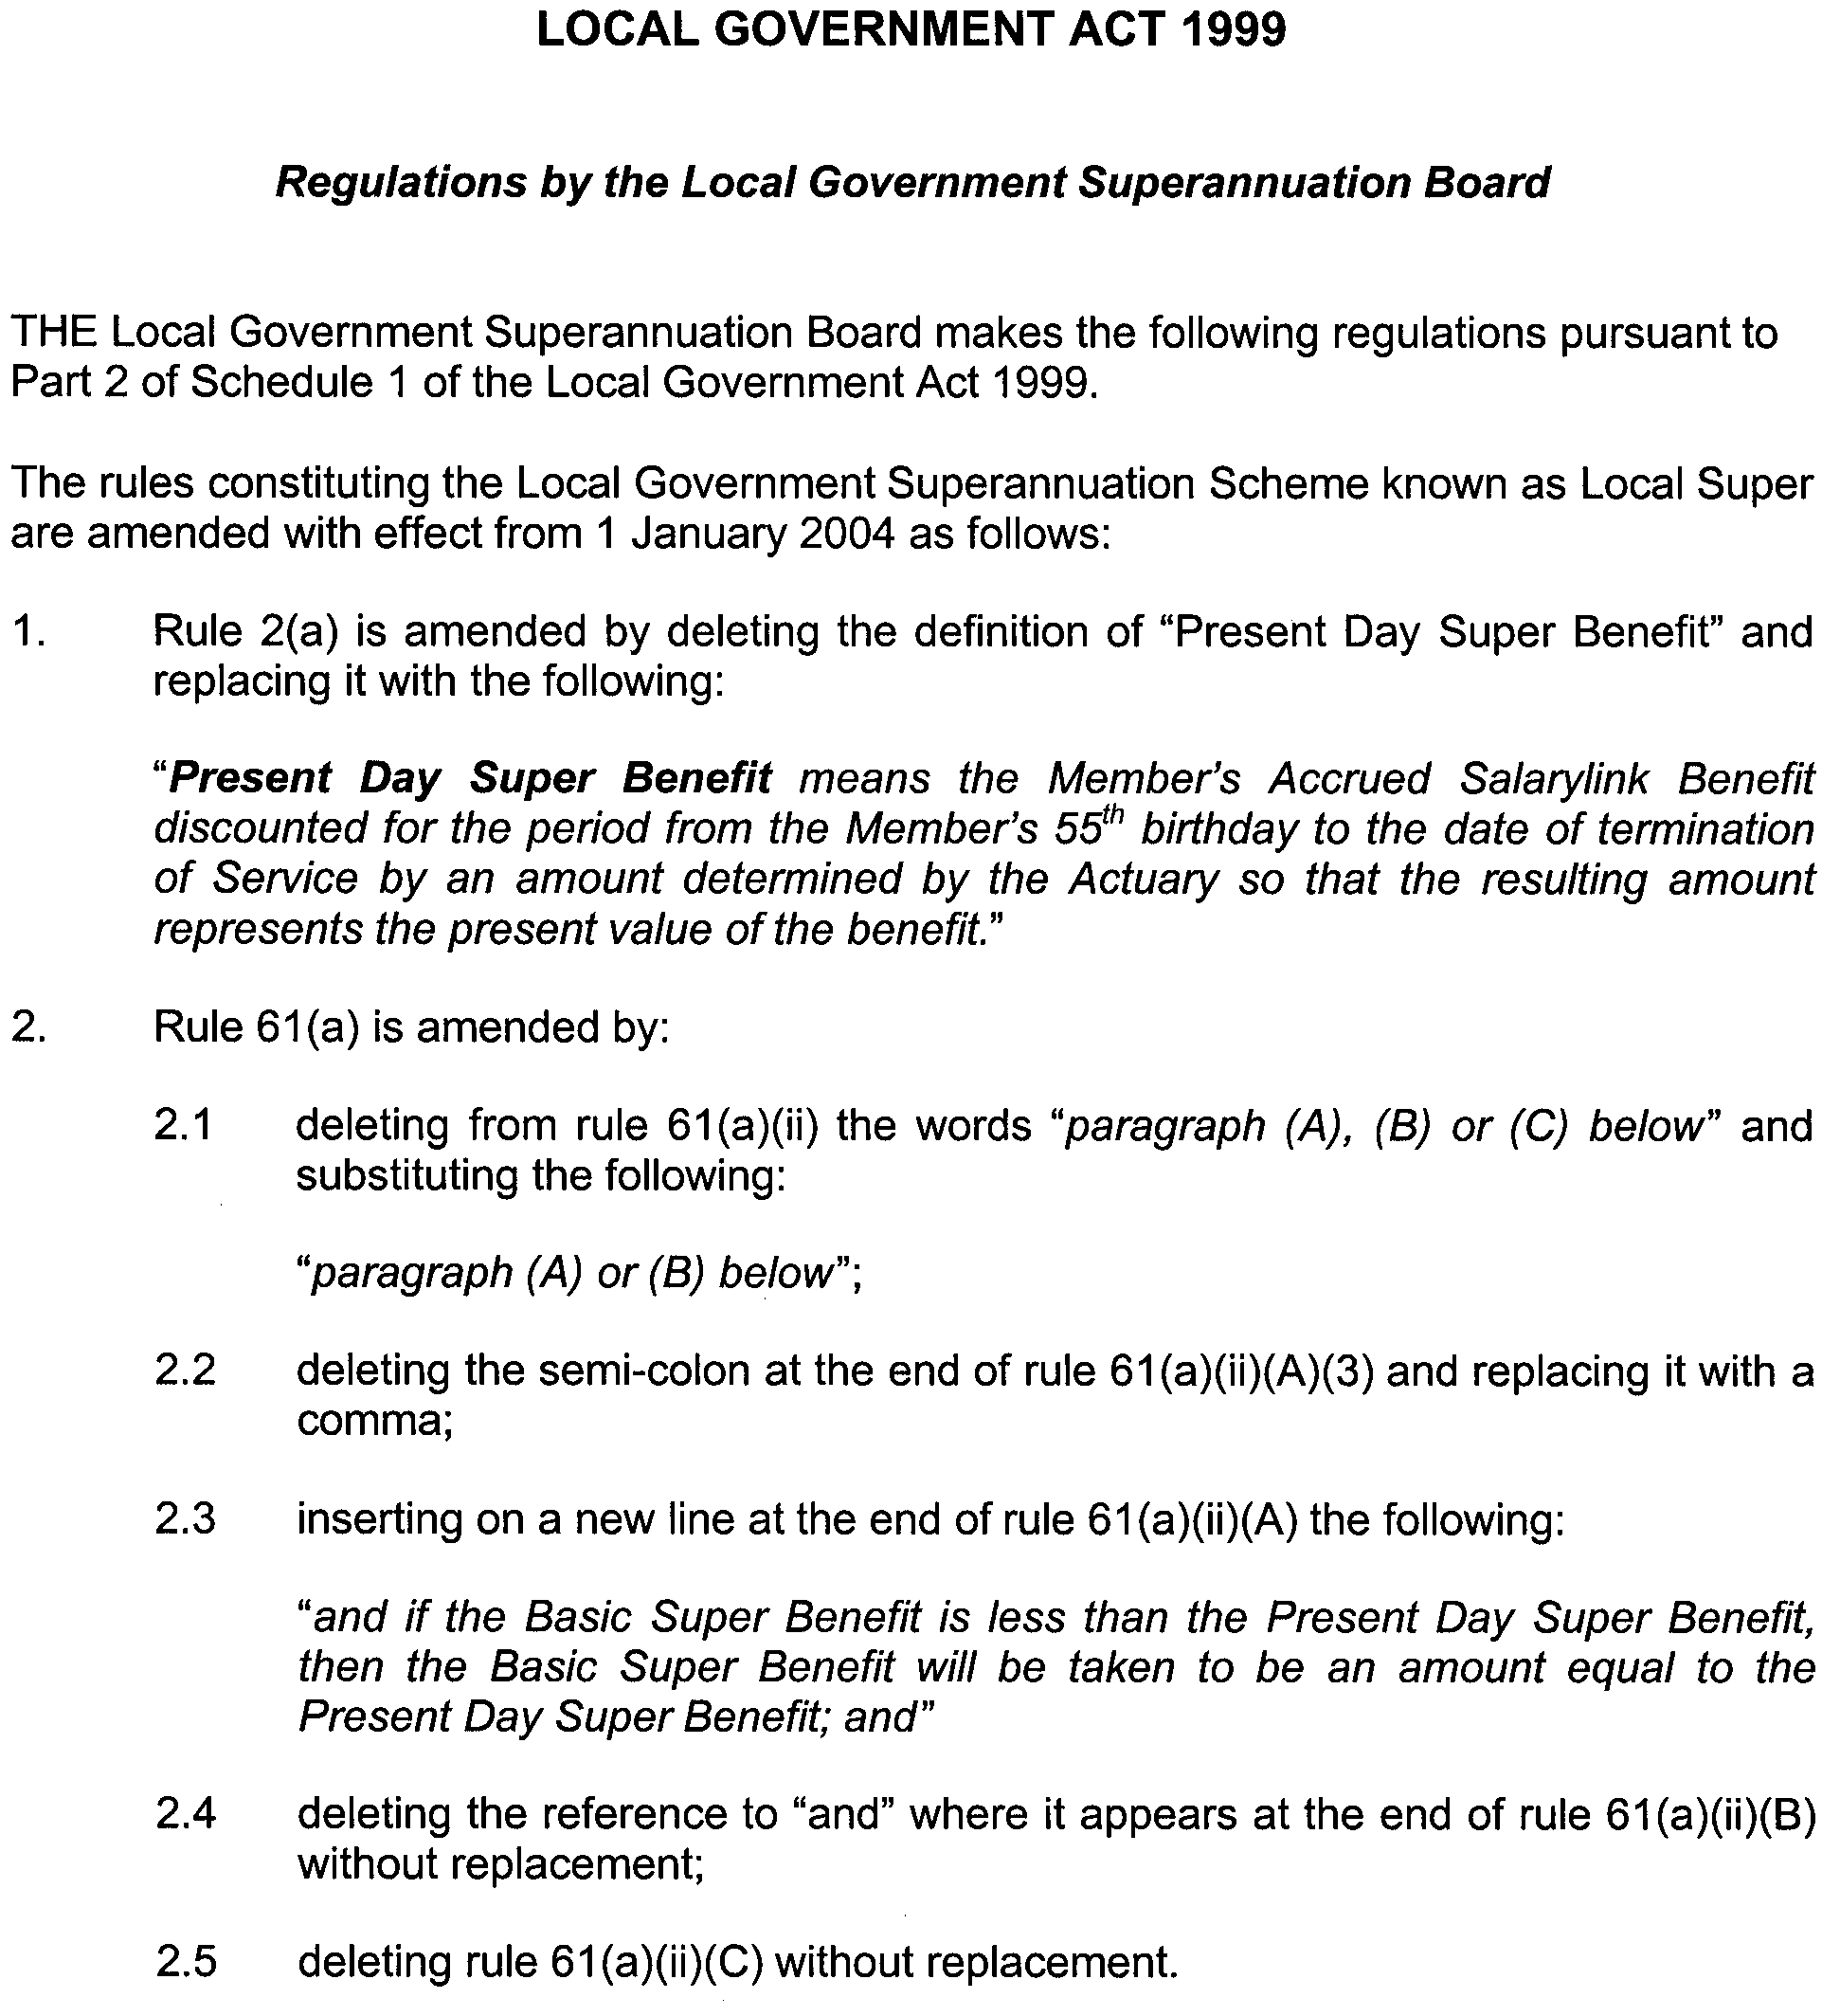

Dated 26 August 2003.

Caroline Parkin, Acting Executive Officer

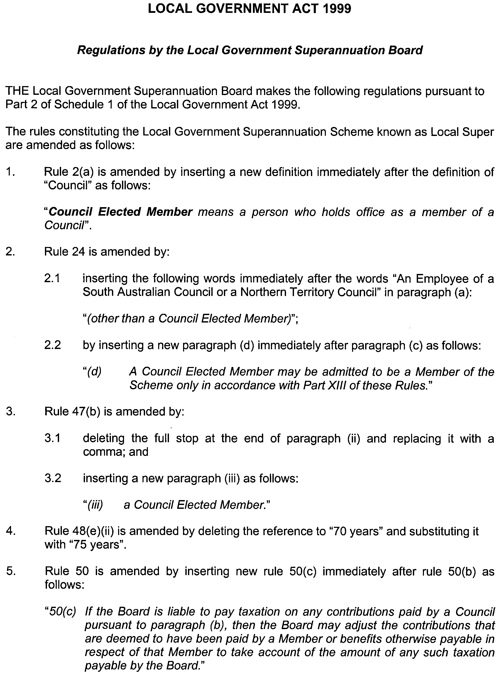
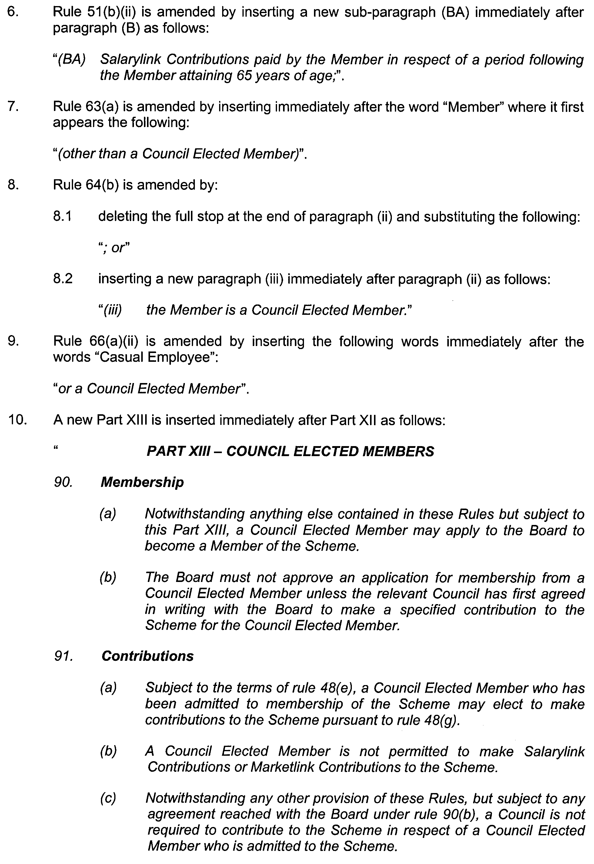
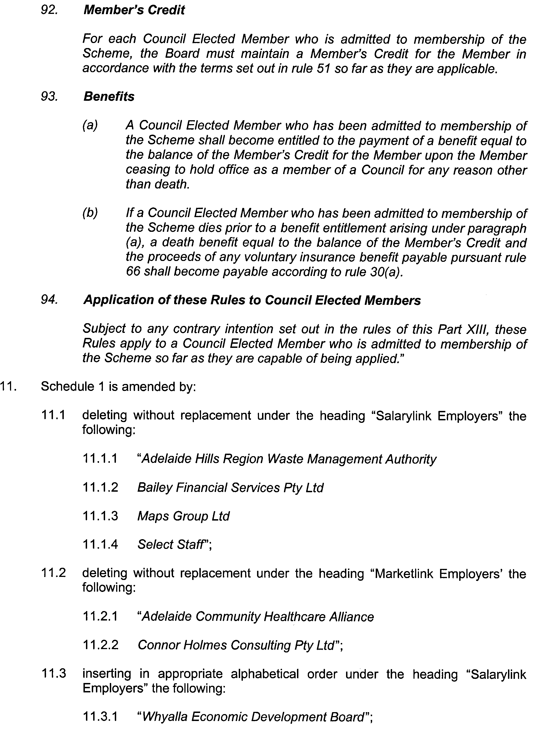

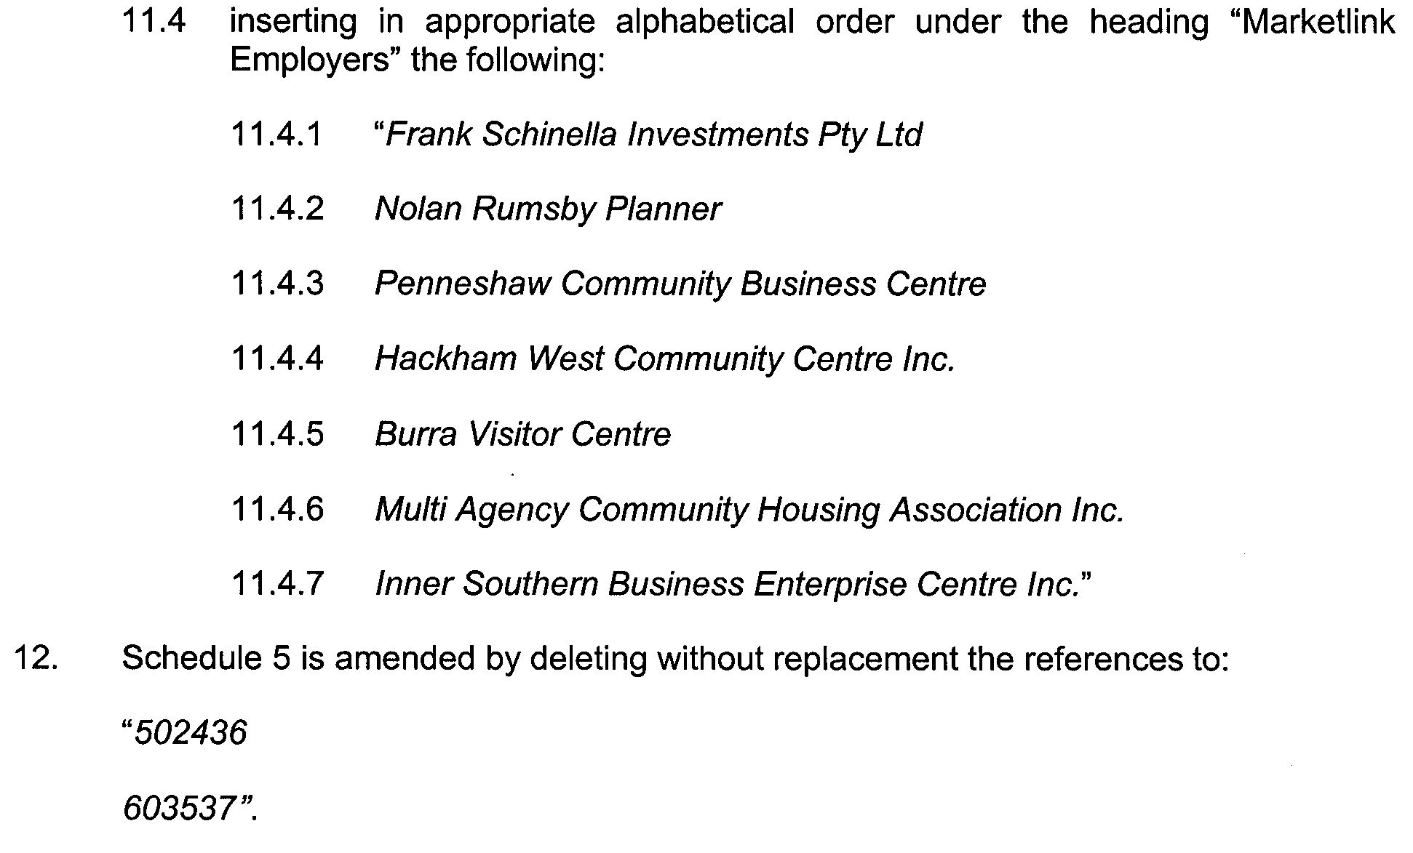

Dated 26 August 2003.

Caroline Parkin, Acting Executive Officer

PETROLEUM ACT 2000
Variation of Pipeline Licence PL 13
NOTICE is hereby given that under the provisions of the Petroleum Act 2000, pursuant to delegated powers dated 28 March 2002, Gazetted 11 April 2002, page 1573, the conditions of the abovementioned Pipeline Licence held by South East Australia Gas Pty Ltd have been varied as follows:
The pipeline licence is varied by amending the licence granted 12 February 2002 and varied by instruments dated 30 September 2002, 6 February 2003 and 12 March 2003, as follows:
(i) by deleting the coordinates associated with Point ID 1204 to 1216 inclusive (13 sets) on Page 23 to Schedule 2 of the licence and replacing with new coordinates (6 sets) as follows:

No. | EASTING |  |  | NORTHING
1204 | 333532.3 |  | mE | 6141050.1 | mN
1205 | 333610.7 |  | mE | 6141621.0 | mN
1206 | 333600.5 |  | mE | 6141635.8 | mN
1207 | 333590.7 |  | mE | 6141637.7 | mN
1208 | 333409.2 |  | mE | 6141671.5 | mN
1209 | 333131.7 |  | mE | 6141788.4 | mN

Dated 1 September 2003.
Barry A. Goldstein, Director Petroleum
Minerals and Energy Division
Primary Industries and Resources SA
Delegate of the Minister for Mineral
Resources Development

THE DISTRICT COURT OF SOUTH AUSTRALIA
PORT AUGUSTA CIRCUIT COURT
Sheriff’s Office, Adelaide, 19 August 2003
IN pursuance of a precept from the District Court of South Australia to me directed, I do hereby give notice that the said court will sit as a Court of Oyer and Terminer and General Gaol Delivery at the Courthouse at Port Augusta on the day and time undermentioned and all parties bound to prosecute and give evidence and all jurors summoned and all others having business at the said Court are required to attend the sittings thereof and the order of such business will be unless a Judge otherwise orders as follows:
Monday, 1 September 2003 at 10 a.m. on the first day of the sittings the only business taken will be the arraignment of prisoners in gaol and the passing of sentences on prisoners in gaol committed for sentence; the surrender of prisoners on bail committed for sentence; the surrender of persons in response to ex officio informations or of persons on bail and committed for trial who have signified their intentions to plead guilty and the passing of sentences.
Juries will be summoned for Wednesday, 3 September 2003 and persons will be tried on this and subsequent days of the sittings.
Prisoners in H M Gaol and on bail for sentence and for trial
at the sittings of the Port Augusta Courthouse, commencing Monday, 1 September 2003.
Taylor, Matthew James |  | Breach of bond; aggravated serious criminal trespass (non-residential) | On bail
Bates, Stephen John |  | Causing bodily harm by dangerous driving | On bail
Benn, Derek John |  | Attempted rape | On bail
Bilney, Christopher Daniel |  | Aggravated serious criminal trespass in a place of residence; larceny | —
Boonekamp, Nicolas James |  | Rape | On bail
B |  | Unlawful sexual intercourse with a person under 12 | On bail
Burgess, Robert John |  | Aggravated serious trespass in a place of residence; larceny | On bail
Butterfield, Craig Stewart |  | Armed robbery | In gaol
Castley, Kym Alexander |  | Indecent assault (2); assault with intent to rape | On bail
Cheriton, Sean Richard |  | Aggravated serious criminal trespass in a place of residence | On bail
Cooper, Thias John |  | Aggravated serious criminal trespass—residence not occupied; larceny | On bail
Davis, Tony |  | Wounding with intent to do grievous bodily harm | In goal
Dinovitser, Alexander |  | Accessory after the fact | On bail
Edmondson, Peter Martyn |  | Larceny from the person; assault with intent to resist or prevent lawful apprehension | In gaol
Edwards, Adrian |  | Rape | On bail
Franke, Shane Trevor |  | Indecent assault; unlawful sexual intercourse (2); gross indecency | On bail
Grantham, Ricky George |  | Property damage; aggravated serious criminal trespass in a place of residence; common assault | On bail
Hombsch, Tony John |  | Rape; unlawful sexual intercourse with a person under 12; indecent assault | On bail
Houston, Harry Henry |  | Non-aggravated serious criminal trespass (place of residence); commit common assault on member of own family; threatening life | On bail
Johns, Stuart Anthony |  | Assault occasioning actual bodily harm (2); causing grievous bodily harm with intent to do such harm | On bail
Joslyn, Jason Craig |  | Aggravated serious criminal trespass—residence occupied; robbery with violence; selling cannabis | On bail
Argent, Roydon Percy |  | Aggravated serious criminal trespass—residence occupied; robbery with violence; selling cannabis | On bail
Kelly, Denise Eileen |  | Assault with intent to rob | On bail
K |  | Unlawful sexual intercourse with a person under 12; indecent assault | On bail
Larsen, Justin Michael |  | Non-aggravated serious criminal trespass (place of residence); common assault on person other than family member; larceny | In gaol
Lisk, Darren James |  | Unlawful sexual intercourse | On bail
McKay, Scott Michael |  | Produce cannabis | On bail
Naylon, Felicity Hanna Marie |  | Wounding with intent to do grievous bodily harm; threatening to cause harm | In gaol
Newbon, William Murray |  | Producing cannabis | On bail
Plummer, Donna May |  | Aggravated serious criminal trespass—in a place of residence; common assault | On bail
Reid, Maxwell John |  | Defraud Commonwealth or public authority (2); obtaining a gain | On bail
Reid, Edna |  | Defraud Commonwealth or public authority (2) | On bail
Dasborough, Graham Ernest |  | Obtaining a gain | On bail
Rogers, Zachary Taylor |  | Common assault (3); threatening life | On bail
Smith, Keith Frederick |  | Unlawful sexual intercourse with a person under 12; indecent assault | On bail
Solly, Michael Dean |  | Aggravated serious criminal trespass—residence not occupied; larceny | On bail
Trueman, Jonathon Eumalic |  | Rape (4); commit common assault on member of own family; indecent assault | On bail
Verio, Natasha Trieste |  | Accessory after the fact | On bail
Birch, Penny Louise |  | Accessory after the fact | On bail
Kellie, Merryn Johanna |  | Accessory after the fact | On bail
Warhurst, Norman |  | Rape (3); indecent assault (2) | On bail
Whelan, Adam Nicholas |  | Indecent assault; unlawful sexual intercourse with a person under 12 | On bail
Wilson, Cindy Zora Louise |  | Threatening life | On bail
Wilton, Sabian Rowan Veran |  | Rape | On bail
Prisoners on bail must surrender at 10 a.m. of the day appointed for the respective trials. If they do not appear when called upon their recognizances and those of their bail will be estreated and a bench warrant issued forthwith.
By Order of the Court,
W. T. Goodes, Sheriff

PUBLIC CORPORATIONS ACT 1993
Ministerial Direction
PURSUANT to section 6 (1) (b) of the Public Corporations Act 1993, I, Minister for Transport, direct that TransAdelaide provide me with a report on options for relocating the current fuel storage facility by the Torrens Lake by 12 September 2003.
Dated 27 August 2003.
M. J. Wright, Minister for Transport

THE RENMARK IRRIGATION TRUST
Notice of Water Supply Rate No. 7
AT a meeting of the Renmark Irrigation Trust, duly held on 27 June 2003, a Water Supply Rate incorporating an Access Charge of $119.70 per hectare on all rateable land within the district and a Delivery Fee of 3.03 cents per kL was declared for the half year ending 31 December 2003. All persons liable are required to pay the amount of the rate, according to the assessment, to the Secretary at the Trust Office.
Dated 28 August 2003.
W. D. Morris, Chief Executive Officer/Secretary

ROADS (OPENING AND CLOSING) ACT 1991:
SECTION 24
NOTICE OF CONFIRMATION OF ROAD
PROCESS ORDER
Duckshooters Road and Pudneys Road, Hundred of Kongorong
Deposited Plan 58833
BY Road Process Order made on 24 January 2002, the District Council of Grant ordered that:
1. Portions of section 418 and portion of section 547 in Hundred of Kongorong more particularly delineated and numbered ‘1’, ‘2’, ‘3’ and ‘4’ (respectively) in Preliminary Plan No. 32/0564 be opened as road, forming a widening of the adjoining Duckshooters Road.
2. Portion of section 331 in Hundred of Kongorong inter-secting the said section, more particularly delineated and numbered ‘5’ in Preliminary Plan No. 32/0564 be opened as road.
3. Portion of section 419 in Hundred of Kongorong more particularly delineated and numbered ‘6’ in Preliminary Plan No. 32/0564 be opened as road, forming a widening of the adjoining Concannon Road.
4. Portion of section 718 in Hundred of MacDonnell more particularly delineated and numbered ‘7’ in Preliminary Plan No. 32/0564 be opened as road, forming a widening of the adjoining Old Boundary Road.
5. Portion of the public road (Pudneys Road) dividing sections 331 and 419 in Hundred of Kongorong more particularly lettered ‘A’ and ‘B’ in Preliminary Plan No. 32/0564 be closed.
6. Transfer the whole of the land subject to closure lettered ‘A’ to John Robert Jenkin in accordance with agreement for exchange dated 17 May 2000 entered into between the District Council of Grant and J. R. Jenkin.
7. Transfer the whole of the land subject to closure lettered ‘B’ to Paul Terence Vandepeer and Erica Henrietta Vandepeer in accordance with agreement for exchange dated 17 May 2000 entered into between the District Council of Grant and Tyngara Pty Ltd.
On 12 June 2002 that order was confirmed by the Minister for Administrative Services conditionally on approval and deposit of the survey plan by the Registrar-General. The condition has now been fulfilled.
Pursuant to section 24 (5) of the Roads (Opening and Closing) Act 1991, NOTICE of the order referred to above and its confirmation is hereby given.
Dated 4 September 2003.
P. M. Kentish, Surveyor-General

ROADS (OPENING AND CLOSING) ACT 1991:
SECTION 24
NOTICE OF CONFIRMATION OF ROAD
PROCESS ORDER
Elcombe Crescent, Modbury
Deposited Plan 62375
BY Road Process Order made on 10 May 2003, the City of Tea Tree Gully ordered that:
1. Portion of the public road (Elcombe Crescent) adjoining North East Road and allotments 6 to 11 (inclusive) in Deposited Plan 7338 more particularly lettered ‘A’ in Preliminary Plan No. 03/0005 be closed.
2. The whole of the land subject to closure be transferred to Aretzis Investments Pty Ltd and Harralex Nominees Pty Ltd in accordance with agreement for transfer dated 4 April 2003 entered into between the City of Tea Tree Gully and Aretzis Investments Pty Ltd and Harralex Nominees Pty Ltd.
On 29 August 2003 that order was confirmed by the Minister for Administrative Services conditionally on approval and deposit of the survey plan by the Registrar-General. The condition has now been fulfilled.
Pursuant to section 24 (5) of the Roads (Opening and Closing) Act 1991, NOTICE of the order referred to above and its confirmation is hereby given.
Dated 4 September 2003.
P. M. Kentish, Surveyor-General

ROAD TRAFFIC ACT 1961
Exemption for Single Axle Pig Trailers to Exceed the Maximum Mass Limit of 8.5 tonnes
PURSUANT to section 163AA of the Road Traffic Act 1961, I hereby exempt pig trailers fitted with a single axle from the maximum mass limit requirement of 8.5 tonnes specified in Schedule 1, Table 1 ‘Mass limits for single axles and axle groups’, of the Road Traffic (Mass and Loading Requirements) Regulations 1999:
Subject to the following conditions:
1. The single axle is fitted with dual tyres.
2. That the wheels and tyres fitted to the axle of the vehicle must be of sufficient size and capacity to carry the part of the vehicle’s gross mass transmitted to the ground through the axle.

3. The pig trailer was manufactured prior to 1 December 1999.
4. The mass carried on the pig trailer does not exceed the least of:
4.1 The manufacturer’s specified Aggregate Trailer Mass; or
4.2 The manufacturer’s specified Gross Trailer Mass; or
4.3 The Gross Trailer Mass specified by the Registering Authority; or
4.4 9.0 tonnes.
This exemption expires at midnight on 30 September 2004.
The notice titled ‘Exemption for single axle pig trailers to exceed the maximum mass limit of 8.5 tonnes’ appearing in the South Australian Government Gazette, dated 19 September 2002, is hereby revoked.
Executive Director, Transport SA

ROAD TRAFFIC ACT 1961
Exemption for Tandem Axle Pig Trailers to Exceed the Maximum Mass Limit of 15 tonnes
PURSUANT to section 163AA of the Road Traffic Act 1961, I hereby exempt pig trailers fitted with a tandem axle group from the maximum mass limit requirement of 15 tonnes specified in Schedule 1, Table 1 ‘Mass limits for single axles and axle groups’, of the Road Traffic (Mass and Loading Requirements) Regulations 1999:
Subject to the following conditions:
1. The pig trailer is fitted with a load sharing tandem axle group.
2. Both axles are fitted with dual tyres.
3. The wheels and tyres fitted to an axle of the vehicle must be of sufficient size and capacity to carry the part of the vehicle’s gross mass transmitted to the ground through the axle.
4. The pig trailer was manufactured prior to 1 December 1999.
5. The mass carried on the pig trailer does not exceed the least of:
5.1 The manufacturer’s specified Aggregate Trailer Mass; or
5.2 The manufacturer’s specified Gross Trailer Mass; or
5.3 The Gross Trailer Mass specified by the Registering Authority; or
5.4 16.5 tonnes.
This exemption expires at midnight on 30 September 2004.
The notice titled ‘Exemption for tandem axle pig trailers to exceed the maximum mass limit of 15 tonnes’ appearing in the South Australian Government Gazette, dated 19 September 2002, is hereby revoked.
Executive Director, Transport SA

ROAD TRAFFIC ACT 1961
Semi-trailers Constructed to 4.6 Metres High
PURSUANT to the provisions of Section 163AA of the Road Traffic Act 1961, I hereby exempt the semi-trailer portion of Articulated Motor Vehicles from Rule 72 (Height) of the Road Traffic (Vehicle Standards) Rules 1999; and
PURSUANT to the provisions of Section 161A of the Road Traffic Act 1961, and Regulation 35 of the Road Traffic (Miscellaneous) Regulations 1999, I hereby approve Articulated Motor Vehicles where the semi-trailer portion is constructed to an overall height of 4.6 metres to operate in South Australia:
Subject to the following conditions:
1. Special Conditions
1.1 This Notice or a legible copy shall be carried by the driver of the vehicle at all times when operating under this exemption and be produced when requested by an Inspector appointed under the Road Traffic Act 1961 and/or the Motor Vehicles Act 1959, or a Police Officer.
1.2 Except as otherwise specified in this exemption Notice, the standard form conditions prescribed in the Road Traffic (Oversize or Overmass Vehicle Exemptions) Regulations 1999 for the purposes of section 115 of the Act, shall not apply.
1.3 This Notice shall stand alone. It cannot be used in conjunction with any other exemption or approval notice or permit.
1.4 This Notice is only valid for vehicle combinations operating as an articulated vehicle, that is a prime mover and semi-trailer only.
1.4.1 For the purpose of this Notice, articulated vehicle has the same meaning as described in the Road Traffic Act 1961 which is a combination consisting of a prime mover towing one semi-trailer.
2. Height
2.1 The constructed height of the semi-trailer must not exceed 4.6 metres.
2.2 Any load carried must be contained within the constructed frame or body of the semi-trailer.
2.3 This Notice only applies to semi-trailers constructed as pantechnicon vans or curtain sided vans where the frame and roof is constructed to a maximum overall height of 4.6 metres.
3. Vehicle Configuration and Mass Limits
3.1 The semi-trailer must have at least 50% of its deck length at not more than 1.2 metres above the ground.
3.2 The gross mass of the articulated motor vehicle combination must not be more than 90% of the gross mass limit that applies to that combination, based on the axle mass limits specified in the Road Traffic (Mass and Loading Requirements) Regulations 1999 Schedule 1 Part 1—Mass Limits.

Example
A 6 axle articulated vehicle normally permitted to operate at 42.5t must not exceed 38.25t.

3.3 A semi-trailer manufactured on or after 1 July 1991 must be certified by the Australian Motor Vehicle Certification Board as an over-dimension vehicle.
4. Suspension Systems
4.1 The semi-trailer axle group shall be fitted with air bag suspension and effective dampers.
5. General Conditions
5.1 This Notice applies only to the vehicles specified, and does not relieve the owner and/or driver of the duty to observe all other provisions of the Road Traffic Act and Local Government by-laws.
5.2 A high load clearance from Optus must be obtained for travel within the Optus Clearance Zone specified in the map ‘Optus Clearance Zone’ attached to this notice. Details of route, time of travel, load and height must be provided to obtain a clearance. The clearance or clearance number shall be carried by the driver of the vehicle at all times when operating under this exemption and be produced when requested by an Inspector appointed under the Road Traffic Act 1961 and/or the Motor Vehicles Act 1959, or a Police Officer.
5.3 Before starting the journey the driver must contact ETSA Utilities about height clearances under power lines along the route.
5.4 Before starting the journey the driver must contact Telstra about height clearances under telecommunications lines along the route.
5.5 The conditions set out in this notice may be overridden by a limitation fixed at any time on a bridge, culvert, causeway, road or road ferry.
Information Note
Persons operating under the provisions of this Notice are advised that some parts of the road system, bridges, signs, roadside furniture and vegetation may not provide sufficient clearance for the passage of a vehicle and load at the dimensions permitted by this notice.
Section 106 of the Road Traffic Act—Damage to roads and works, includes provisions concerning damage to roads, bridges and culverts, interference with roadside furniture and the obligations of persons causing such damage to notify the appropriate authority.

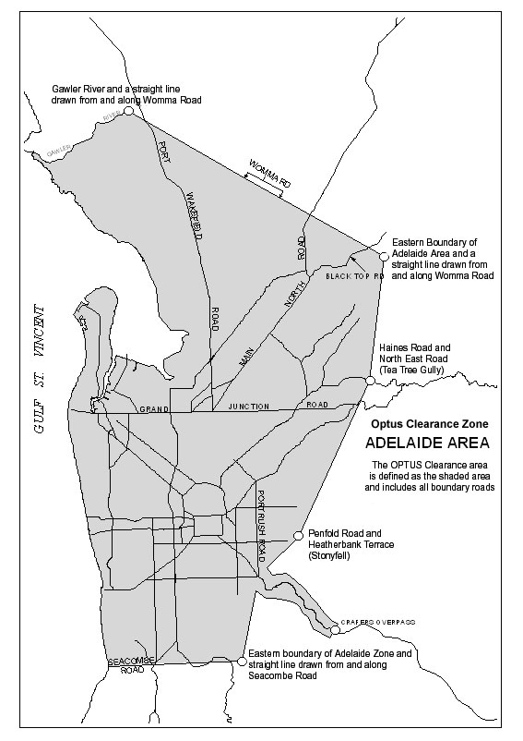
Executive Director, Transport SA

SURVEY ACT 1992
Confused Boundary Areas
PURSUANT to section 50 of the Survey Act 1992, notice is hereby given that two Confused Boundary Areas are declared in the area of Coobowie namely the area bounded by Giles Street East, Weaver Street, Anstey Terrace and Gilbert Street and the area bounded by Salt Creek Road, Bowden Street, Beach Road and Weaver Street.
Dated 4 September 2003.
P. M. Kentish, Surveyor-General
REF: LTO 69/2003
LTO 70/2003

WATER MAINS AND SEWERS

Office of the South Australian Water Corporation
Adelaide 4 September 2003

WATER MAINS LAID

Notice is hereby given that the following main pipes or parts of main pipes have been laid down by the South Australian Water Corporation in or near the undermentioned water districts and are now available for a constant supply of water to adjacent land.

ADELAIDE WATER DISTRICT

BAROSSA COUNCIL
Meadow Road, Kalbeeba. This main is available on application only. p20

CITY OF CHARLES STURT
Torrens Road, Ovingham. p42
Devonport Terrace, Ovingham. p42

CITY OF MARION
Elizabeth Crescent, Hallett Cove. p13 and 14
Phillip Court, Hallett Cove. p13
Skipper Close, Hallett Cove. p13 and 14
Bradbury Court, Hallett Cove. p14

THE DISTRICT COUNCIL OF MOUNT BARKER
Gollan Circuit, Mount Barker. p5
Bald Hills Road, Mount Barker. p6
Easement in reserve (lot 319 in LTRO DP 61252), Green Avenue, Mount Barker. p6
Mitton Court, Mount Barker. p6
Green Avenue, Mount Barker. p6-8
Finlayson Street, Mount Barker. p6 and 8
Randell Street, Mount Barker. p6
Parkview Drive, Mount Barker. p6 and 8
Tate Avenue, Mount Barker. p7
Link Street, Mount Barker. p7 and 9
Penny Street, Mount Barker. p9
Easements in lot 333 in LTRO DP 62496, Link Street, Mount Barker. p9
Post Close, Mount Barker. p9
Atlantic Road, Mount Barker. p17
Easement in lot 2000 in LTRO DP 62022, Claret Ash Drive, Mount Barker. p17

CITY OF ONKAPARINGA
Humphrys Road, Aldinga Beach. p21
In and across Button Road, Sellicks Hill. p28 and 29

CITY OF PLAYFORD
Leicester Grove, Andrews Farm. p1
The Grove, Andrews Farm. p1
Easements in lot 2057 in LTRO DP 62027, The Grove, Andrews Farm. p1
Dawn Close, Andrews Farm. p1
Moir Street, Smithfield. p22

THE CITY OF PROSPECT
Devonport Terrace, Ovingham. p42
Toronto Street, Ovingham. p42
Torrens Road, Ovingham. p43
Churchill Road, Ovingham. p43

CITY OF SALISBURY
Sandpiper Chase, Mawson Lakes. p2

BAROSSA COUNTRY LANDS WATER DISTRICT

DISTRICT COUNCIL OF MALLALA
Port Wakefield Road, Windsor. p24 and 27
Gilberts Road, Windsor. p24
Walker Road, Windsor. p24
Bakers Road, Windsor. p24

BUNDALEER COUNTRY LANDS WATER DISTRICT

WAKEFIELD REGIONAL COUNCIL
O’Hara’s Road, Mount Templeton. p40

BURRA WATER DISTRICT

REGIONAL COUNCIL OF GOYDER
Mitchell Flat, Burra. p33

COFFIN BAY WATER DISTRICT

DISTRICT COUNCIL OF LOWER EYRE PENINSULA
Victoria Avenue, Coffin Bay. p10
Benson Avenue, Coffin Bay. p10
Sarah Court, Coffin Bay. p10-12
Easements in lot 400 in LTRO DP 60745, Victoria Avenue, Coffin Bay. p12

GOOLWA WATER DISTRICT

ALEXANDRINA COUNCIL
Wakool Court, Goolwa. p3
River Court, Goolwa North. p4

TOWNSHIP OF JAMESTOWN WATER DISTRICT

NORTHERN AREAS COUNCIL
Moyle Street, Jamestown. p31

JAMESTOWN COUNTRY LANDS WATER DISTRICT

NORTHERN AREA COUNCIL
Easement in section 68, hundred of Belalie, Jamestown. p41
In and across Spalding Road, Bundaleer North and Jamestown. p41

KADINA WATER DISTRICT

DISTRICT COUNCIL OF THE COPPER COAST
Thyer Street, Newtown. p23

NURIOOTPA WATER DISTRICT

BAROSSA COUNCIL
Easements in lot 158 in LTRO DP 56881, Pinot Crescent, Nuriootpa. p16

PORT AUGUSTA WATER DISTRICT

CITY OF PORT AUGUSTA
Easement in lot 501 in LTRO DP 57962, Marryatt Street, Port Augusta. p34
Yuda Street, Port Augusta. p47

PORT VICTOR WATER DISTRICT

CITY OF VICTOR HARBOR
In and across Wright Terrace, Victor Harbor. p15

SPRINGTON WATER DISTRICT

BAROSSA COUNCIL
William Street, Springton. This main is available on the east side by application only. p26

VIRGINIA WATER DISTRICT

CITY OF PLAYFORD
Taylors Road, Virginia. p19

WALLAROO WATER DISTRICT

DISTRICT COUNCIL OF THE COPPER COAST
East Terrace, Wallaroo. p32

WARREN COUNTRY LANDS WATER DISTRICT

BAROSSA COUNCIL
Across and in Milway Avenue, Nuriootpa. This main is available on application only. p25
Across Sturt Highway, Nuriootpa. This main is available on application only. p25

CLARE AND GILBERT VALLEYS COUNCIL
In and across Hills Road, Tarlee. p36-39

YORKETOWN WATER DISTRICT

DISTRICT COUNCIL OF YORKE PENINSULA
Memorial Drive, Yorketown. p30

WATER MAINS ABANDONED

Notice is hereby given that the undermentioned water mains have been abandoned by the South Australian Water Corporation.

ADELAIDE WATER DISTRICT

CITY OF CHARLES STURT
Torrens Road, Ovingham. p42
Devonport Terrace, Ovingham. p42

CITY OF ONKAPARINGA
In and across Button Road, Sellicks Hill. p28 and 29
Waterworks land (lot 300 in LTRO FP 164123), Main South Road, Sellicks Hill. p28 and 29

THE CITY OF PROSPECT
Devonport Terrace, Ovingham. p42
Toronto Street, Ovingham. p42
Torrens Road, Ovingham. p43
Churchill Road, Ovingham. p43

BAROSSA COUNTRY LANDS WATER DISTRICT

DISTRICT COUNCIL OF MALLALA
Port Wakefield Road, Windsor. p24 and 27
Gilberts Road, Windsor. p24
Walker Road, Windsor. p24
Bakers Road, Windsor. p24

BUNDALEER COUNTRY LANDS WATER DISTRICT

WAKEFIELD REGIONAL COUNCIL
O’Hara’s Road, Mount Templeton. p40
Watchman Exchange Road, Mount Templeton. p40

JAMESTOWN COUNTRY LANDS WATER DISTRICT

NORTHERN AREAS COUNCIL
Easement in section 68, hundred of Belalie, Jamestown. p41
In and across Spalding Road, Bundaleer North and Jamestown. p41

PORT AUGUSTA WATER DISTRICT

CITY OF PORT AUGUSTA
Tassie Street, Port Augusta. p46
Yuda Street, Port Augusta. p46

PORT PIRIE WATER DISTRICT

PORT PIRIE REGIONAL COUNCIL
Boundary Road, Solomontown and Coonamia. p35

PORT VICTOR WATER DISTRICT

CITY OF VICTOR HARBOR
Wright Terrace, Victor Harbor. p15

WARREN COUNTRY LANDS WATER DISTRICT

CLARE AND GILBERT VALLEYS COUNCIL
Hills Road, Tarlee. p36-39

SEWERS LAID

Notice is hereby given that the following sewers have been laid down by the South Australian Water Corporation in the undermentioned drainage areas and are now available for house connections.

ADELAIDE DRAINAGE AREA

CITY OF PLAYFORD
Easement in lot 2057 in LTRO DP 62027, The Grove, Andrews Farm. FB 1117 p41 and 42
Leicester Grove, Andrews Farm. FB 1117 p41 and 42
The Grove, Andrews Farm. FB 1117 p41 and 42
Dawn Close, Andrews Farm. FB 1117 p41 and 42
Moir Street, Smithfield. FB 1115 p31

THE CITY OF PROSPECT
Edgeworth Street, Prospect. FB 1115 p35

CITY OF SALISBURY
Easement in lot 13 in LTRO DP 55266, Mawson Lakes Boulevard, Mawson Lakes. FB 1115 p34

ALDINGA DRAINAGE AREA

CITY OF ONKAPARINGA
Esplanade, Port Willunga. FB 1115 p32
Seaview Street, Aldinga Beach. FB 1115 p33

SEWERS ABANDONED

Notice is hereby given that the undermentioned sewers have been abandoned by the South Australian Water Corporation.

ADELAIDE DRAINAGE AREA

THE CITY OF PROSPECT
Edgeworth Street, Prospect. FB 1115 p35

CITY OF SALISBURY
Easements in lot 13 in LTRO DP 55266, Mawson Lakes Boulevard, Mawson Lakes. FB 1115 p34

PORT AUGUSTA COUNTRY DRAINAGE AREA

CITY OF PORT AUGUSTA
Easement in lot 2 in LTRO DP 21216, Tassie Street, Port Augusta. FB 1111 p46

A. Howe, Chief Executive Officer, South Australian Water Corporation

WATERWORKS ACT 1932
Removal of Land from Barossa Country Lands Water District and Addition to Lyndoch Water District
PURSUANT to section 6 of the Waterworks Act 1932, the South Australian Water Corporation:
(a) removes from the Barossa Country Lands Water District and adds to the Lyndoch Water District all the land contained in allotment 1 in Deposited Plan 33655 (except the portion of that land already in the Lyndoch Water District); and
(b) declares that this notice has effect from the commence-ment of the financial year in which it is published in the Gazette.
Dated 20 August 2003.
Signed for and on behalf of the South Australian Water Corporation by a person duly authorised so to do:
A. Popplewell, General Manager Shared Services
In the presence of:
C. J. McNamara, Billing Manager
SA WATER 03/01197 W1177

WATERWORKS ACT 1932
Addition of Land to Birdwood Water District
PURSUANT to section 6 of the Waterworks Act 1932, the South Australian Water Corporation:
(a) adds to the Birdwood Water District all the land contained in allotment 92 in Filed Plan 155107; and
(b) declares that this notice has effect from the commence-ment of the financial year in which it is published in the Gazette.
Dated 20 August 2003.
Signed for and on behalf of the South Australian Water Corporation by a person duly authorised so to do:
A. Popplewell, General Manager Shared Services
In the presence of:
C. J. McNamara, Billing Manager
SA WATER 03/05385 W1179

WATERWORKS ACT 1932
Removal of Land from Burdett Country Lands Water District and Addition to Murray Bridge Water District
PURSUANT to section 6 of the Waterworks Act 1932, the South Australian Water Corporation:
(a) removes from the Burdett Country Lands Water District and adds to the Murray Bridge Water District all the land contained in allotment 26 in Deposited Plan 59161; and
(b) declares that this notice has effect from the commence-ment of the financial year in which it is published in the Gazette.
Dated 20 August 2003.
Signed for and on behalf of the South Australian Water Corporation by a person duly authorised so to do:
A. Popplewell, General Manager Shared Services
In the presence of:
C. J. McNamara, Billing Manager
SA WATER 03/05062 W1181

WATERWORKS ACT 1932
Removal of Land from Tod River Country Lands Water District and Addition to Coffin Bay Water District
PURSUANT to section 6 of the Waterworks Act 1932, the South Australian Water Corporation:
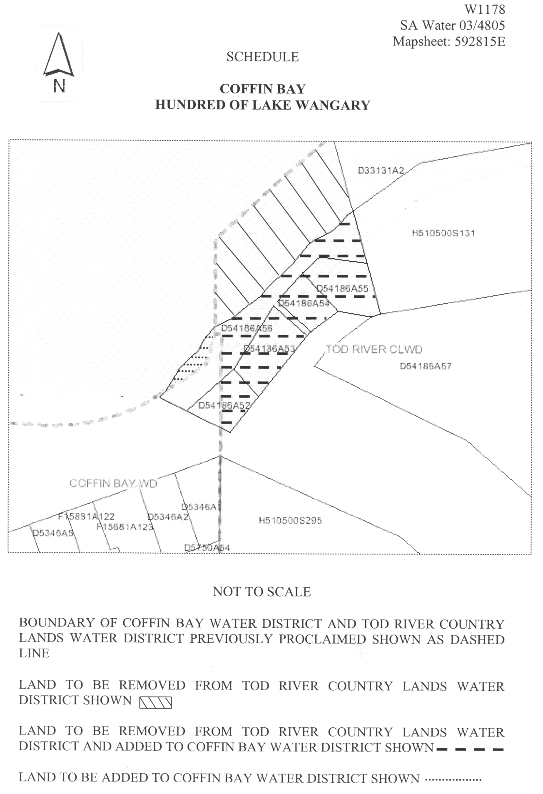
(a) removes from the Tod River Country Lands Water District the land shown (hachured) on the plan in the schedule; and
(b) removes from the Tod River Country Lands Water District and adds to the Coffin Bay Water District the land shown (broken lines) on the plan in the schedule; and
(c) adds to the Coffin Bay Water District the land shown (dotted lines) on the plan in the schedule; and
(b) declares that this notice has effect from the commencement of the financial year in which it is published in the Gazette.

Dated 20 August 2003.
Signed for and on behalf of the South Australian Water Corporation by a person duly authorised so to do:
A. Popplewell, General Manager Shared Services
In the presence of:
C. J. McNamara, Billing Manager
SA WATER 03/04805 W1178

South Australia
Administrative Arrangements (Conferral of Ministerial Functions and Powers) (STEDS Program) Proclamation 2003
under the Administrative Arrangements Act 1994
1—Short title
This proclamation may be cited as the Administrative Arrangements (Conferral of Ministerial Functions and Powers) (STEDS Program) Proclamation 2003.
2—Commencement
This proclamation comes into operation on the day on which it is made.
3—Conferral of ministerial functions and powers
The ministerial functions and powers associated with the administration of the Septic Tank Effluent Disposal Scheme program are conferred on the Minister for Local Government.
Made by the Governor
with the advice and consent of the Executive Council
on 4 September 2003.
COLG2003/0008

South Australia
Mining (Reservation from Act) (Coastal land) Variation Proclamation 2003
under section 8(2) of the Mining Act 1971

Preamble
1 By proclamation made pursuant to the Mining Act 1971 on 19 April 1973 (Gazette 19.4.1973 p1777, fourth appearing), as varied, certain land along the coast of the State of South Australia is reserved from the operation of certain provisions of that Act.
2 By proclamation made pursuant to the Mining Act 1971 on 1 August 2002 (Gazette 1.8.2002 p2968) Section 2283 in the Hundred of Goolwa was excluded from that reservation.
3 It is now intended that Section 2283 in the Hundred of Goolwa no longer be excluded from that reservation.

Part 1—Preliminary
1—Short title
This proclamation may be cited as the Mining (Reservation from Act) (Coastal land) Variation Proclamation 2003.
2—Commencement
This proclamation comes into operation on the day on which it is made.
3—Variation provisions
In this proclamation, a provision under a heading referring to the variation of a specified proclamation varies the proclamation so specified.
Part 2—Variation of proclamation under Mining Act 1971 reserving lands from operation of certain provisions of Act (Gazette 19.4.1973 p1777, fourth appearing) as varied
4—Variation of Schedule
Schedule, paragraph A(iv)—delete subparagraph (iv)
Made by the Governor
with the advice and consent of the Executive Council
on 4 September 2003.
MMRD 02/0040CS
South Australia
Development (Development Assessment Processes) Variation Regulations 2003
under the Development Act 1993

Contents
Part 1—Preliminary
1 Short title
2 Commencement
3 Variation provisions
Part 2—Variation of Development Regulations 1993
4 Insertion of regulation 18A
5 Variation of regulation 24—Referrals
6 Variation of regulation 28—Special provision relating to fire authorities
7 Insertion of 78AA
8 Variation of regulation 86—Qualifications in planning
9 Variation of regulation 88—Certificate of independent technical expert in certain cases
10 Variation of Schedule 3
11 Variation of Schedule 4
12 Variation of Schedule 7
13 Variation of Schedule 8
14 Variation of Schedule 9
15 Variation of Schedule 10
16 Variation of Schedule 18

Part 1—Preliminary
1—Short title
These regulations may be cited as the Development (Development Assessment Processes) Variation Regulations 2003.
2—Commencement
These regulations come into operation on the day on which they are made.
3—Variation provisions
In these regulations, a provision under a heading referring to the variation of specified regulations varies the regulations so specified.
Part 2—Variation of Development Regulations 1993
4—Insertion of regulation 18A
After regulation 18 insert:
18A—Notification of application to build along a common boundary
(1) If—
(a) an application proposes development in the form of building work along a boundary, other than building work constituted by the construction of a fence; and
(b) the development is a Category 1 development,
then—
(c) the relevant authority must—
(i) give the owner of land on the other side of the boundary notice of the application; and
(ii) give consideration to any representations in writing made by that owner within 10 business days after the notification is given; and
(d) if a representation is received under paragraph (c), the relevant authority may, in its absolute discretion, allow the owner to appear personally or by representative before it to be heard in support of the representation.
(2) For the purposes of subregulation (1), building work is along a boundary if there is no set-back from that boundary.
5—Variation of regulation 24—Referrals
Regulation 24(2)—delete "qualification" and substitute:
qualifications that a referral under that subregulation will only relate to whether a provisional development plan consent should be granted and
6—Variation of regulation 28—Special provision relating to fire authorities
Regulation 28(1)(d)—delete paragraph (d)
7—Insertion of 78AA
After regulation 78 insert:
78AA—On-site retention of stormwater
(1) This regulation applies to—
(a) Class 1 and 2 buildings under the Building Code; and
(b) Class 10a structures associated with Class 1 and 2 buildings under the Building Code.
(2) If a relevant authority, on granting a development authorisation in relation to a building to which this regulation applies, directs that one or more on-site stormwater retention devices be incorporated as part of a stormwater drainage system, then any relevant requirements of Minister's Specification SA 78AA must be complied with (unless the relevant authority accepts an alternative solution).
8—Variation of regulation 86—Qualifications in planning
Regulation 86(5)(a)—delete "the Royal Australian Planning Institute Incorporated" and substitute:
the Urban and Regional Planning Chapter of the Planning Institute of Australia Incorporated
9—Variation of regulation 88—Certificate of independent technical expert in certain cases
Regulation 88(1)(c)—delete "SA"
10—Variation of Schedule 3
(1) Schedule 3, clause 4(1)(a)—delete "or in a Residential Zone in the area of the City of Charles Sturt in the former area of the City of Henley and Grange or in a Residential 1 Zone, Residential 2A Zone, Residential 3B Zone or Residential 3C Zone in the area of the City of Charles Sturt in the former area of the City of Hindmarsh and Woodville" and substitute:
in the Golden Grove Residential Zone or in the Golden Grove Residential D Zone, or in Policy Area 4 or Policy Area 5 in the Residential Zone in the City of Charles Sturt
(2) Schedule 3, clause 4(1)(e)(i)—delete subsubparagraphs (C) and (D) and substitute:
(C) the Golden Grove Residential Zone or in the Golden Grove Residential D Zone; or
(D) Policy Area 4 or Policy Area 5 in the Residential Zone in the City of Charles Sturt; or
(3) Schedule 3, clause 4(1)(e)—after subparagraph (i) insert:
(ia) a fence in the Residential Historic (Conservation) Zone in the City of Charles Sturt that is situated on the boundary of the relevant allotment with a road (other than a laneway); or
(4) Schedule 3—after clause 13 insert:
14—Gas Infrastructure
(1) Subject to subclause (2), the construction, alteration, extension, repair or maintenance (including any incidental excavation or filling) of gas infrastructure.
(2) subclause (1) does not apply where the gas infrastructure is within—
(a) a local heritage place; or
(b) coastal land.
(3) In this clause—
coastal land has the same meaning as in Schedule 8;
gas infrastructure has the same meaning as in the Gas Act 1997, but does not include a transmission pipeline within the meaning of the Petroleum Act 2000.
11—Variation of Schedule 4
(1) Schedule 4, clause 1(1)—after "local heritage place," insert:
a Residential Historic (Conservation) Zone,
(2) Schedule 4, clause 1(1)(d)(i)(C) and (D)—delete subsubparagraphs (C) and (D) and substitute:
(C) the Golden Grove Residential Zone or in the Golden Grove Residential D Zone; or
(D) Policy Area 4 or Policy Area 5 in the Residential Zone in the City of Charles Sturt; or
12—Variation of Schedule 7
Schedule 7, clause 2(a)(iii)—delete "$57.50" and substitute:
$57
13—Variation of Schedule 8
(1) Schedule 8, clause 1(1)—after the definition of prescribed area insert:
wind farm means an undertaking where one or more wind turbine generators (whether or not located on the same site) are used to generate electricity that is then supplied to another person for use at another place.
(2) Schedule 8, after item 9—insert the following items under the relevant headings (which headings appear in italics in the following table for reference purposes only):
Development | Body | Period | Conditions
9A—Windfarms
Development that involves the establishment of a windfarm | Environment Protection Authority | Six weeks | Regard
(3) Schedule 8, item 12—delete "section 12(d)" wherever occurring and substitute in each case:
12(1)(d)
(4) Schedule 8, item 12A—delete "Minister for the time being administering the Water Resources Act 1997" and substitute:
The Chief Executive of the Department of the Minister responsible for the administration of the Water Resources Act 1997
(5) Schedule 8, item 16—delete "Minister for the time being administering the Water Resources Act 1997 and substitute:
The Chief Executive of the Department of the Minister responsible for the administration of the Water Resources Act 1997
(6) Schedule 8, item 18—delete "a bushfire prone area" and substitute:
a CFS Referral Area in a Bushfire Prone Area
(7) Schedule 8, item 18—delete "Regard" and substitute:
Direction
14—Variation of Schedule 9
(1) Schedule 9, clause 5—delete "the applicant proposes to use the land" and substitute:
the land is to be used
(2) Schedule 9, clause 16(ab)—delete "detached"
(3) Schedule 9, clause 17—delete "changed the nature" and substitute:
change the nature
15—Variation of Schedule 10
Schedule 10, clause 16—delete clause 16
16—Variation of Schedule 18
(1) Schedule 18, clause 1—delete "Angaston (DC)"
(2) Schedule 18, clause 1—delete "Barossa (DC)" and substitute:
The Barossa Council
(3) Schedule 18, clause 1—delete "Happy Valley (City)"
(4) Schedule 18, clause 1—delete "Mount Pleasant (DC)"
(5) Schedule 18, clause 1—delete "Noarlunga (City)" and substitute:
Onkaparinga (City)
(6) Schedule 18, clause 1—delete "Tanunda (DC)"
(7) Schedule 18, clause 1—delete "Willunga (DC) (Metro)"
(8) Schedule 18, clause 2(a), (b) and (c)—delete paragraphs (a), (b) and (c) and substitute:
(a) The Barossa Council Bushfire Prone Area Map denoted as—
(i) Index to Bushfire Prone Area—FIGURE BaroBPA/1;
(ii) Stockwell Township—FIGURE BaroBPA/2;
(iii) Nuriootpa Township—FIGURE BaroBPA/3;
(iv) Moculta Township—FIGURE BaroBPA/4;
(v) Angaston Township—FIGURE BaroBPA/5;
(vi) Tanunda Township—FIGURE BaroBPA/7;
(vii) Lyndoch Township—FIGURE BaroBPA/11, BaroBPA/15;
(viii) Williamstown Township—FIGURE BaroBPA/12, BaroBPA/16;
(b) Mitcham (City) Bushfire Prone Area Map denoted as—
(i) Index to Bushfire Prone Area—FIGURE MitBPA/1;
(ii) FIGURE MitBPA/7;
(iii) FIGURE MitBPA/8;
(iv) FIGURE MitBPA/9;
(v) FIGURE MitBPA/10;
(vi) FIGURE MitBPA/11;
(vii) FIGURE MitBPA/12.
Note—
As required by section 10AA(2) of the Subordinate Legislation Act 1978, the Minister has certified that, in the Minister's opinion, it is necessary or appropriate that these regulations come into operation as set out in these regulations.
Made by the Governor
with the advice and consent of the Executive Council
on 4 September 2003.
No. 190 of 2003
CPSA2003/00001CS

FAXING COPY?

IF you fax copy to Government Publishing SA for inclusion in the Government Gazette, there is no need to send a Confirmation Copy to us as well.

This creates confusion and may well result in your notice being printed twice.

Please use the following fax number:

Fax transmission: (08) 8207 1040
Phone Inquiries: (08) 8207 1045

Please include a contact person, phone number and order number so that we can phone back with any queries we may have regarding the fax copy.

NOTE: Closing time for lodging new copy (either fax or hard copy) is 4 p.m. on Tuesday preceding the day of publication.

Government Gazette notices can be E-mailed.

The address is:

governmentgazette@saugov.sa.gov.au

Documents should be sent as attachments in Word format.

When sending a document via E-mail, please confirm your transmission with a faxed copy of your document, including the date the notice is to be published.

Fax transmission: (08) 8207 1040
Enquiries: (08) 8207 1045

CITY OF CAMPBELLTOWN
Adoption of Valuation and Declaration of Rates
NOTICE is hereby given that the Corporation of the City of Campbelltown, at a meeting held on 1 July 2003, passed the following resolutions:
Adoption of Valuation
That the Corporation of the City of Campbelltown in respect of the financial year commencing on 1 July 2003 and con-cluding on 30 June 2004, pursuant to section 167 (2) of the Local Government Act 1999, adopt the capital valuations made by the Valuer-General for rating purposes, totalling $4 411 151 600.
Declaration of General Rate for the Year 2003-2004
That pursuant to section 153 (1) of the Local Government Act 1999, the council hereby declares a general rate of 0.371733 cents for each one dollar of the assessed capital value of rateable property within the Municipality for the financial year commencing on 1 July 2003 and ending on 30 June 2004 and the council in respect of the said financial year hereby fixes pursuant to section 158 (1) (a) of the said Act a minimum amount of $500 which shall be payable by way of rates on rateable land within the Municipality.
Catchment Environment Levy
That pursuant to section 154 (4) of the Local Government Act 1999 and the Water Resources Act 1997, council declares a separate rate of 0.008247 cents in the dollar of the capital value of rateable land within the Torrens Catchment Area within the boundaries of the City of Campbelltown, for the financial year commencing on 1 July 2003 and ending on 30 June 2004.
P. Vlatko, Chief Executive Officer

CITY OF PLAYFORD
Naming of Road
NOTICE is hereby given that the City of Playford at a meeting held on 26 August 2003, resolved pursuant to section 219 of the Local Government Act 1999, that the Government road as partly shown in Deposited Plan 19006 and from Humbug Scrub Road, Yattalunga to the South Para River be named Glenburnie Road.
T. J. Jackson, Chief Executive Officer

CITY OF PROSPECT
Roads (Opening and Closing) Act 1991
Road Closure, Portion of Brooke Street, Broadview
NOTICE is hereby given, pursuant to section 10 of the said Act, that council proposes to make a Road Process Order to close and sell to Cairnline Pty Ltd the eastern end of Brooke Street (adjacent allotment 3 in Filed Plan 100724), shown as ‘A’ on Preliminary Plan No. 03/0062.
A copy of the plan and statement of persons affected are available for public inspection at the Council’s Office, 128 Prospect Road, Prospect and the office of the Surveyor-General, 101 Grenfell Street, Adelaide during normal office hours.
Any application for easement or objection must be made in writing within 28 days from 4 September 2003 to the Council, P.O. Box 171, Prospect, S.A. 5082 and the Surveyor-General, G.P.O. Box 1354, Adelaide, S.A. 5001, setting out full details.
Where a submission is made, council will give notification of a meeting to deal with the matter.
M. Llewellyn-Smith, Chief Executive Officer

ADELAIDE HILLS COUNCIL
Roads (Opening and Closing) Act 1991
Road Closure, Portion of Crescent Drive, Norton Summit
NOTICE is hereby given, pursuant to section 10 of the said Act, that council proposes to make a Road Process Order to close and sell to G. and S. Y. Fragnito a triangular-shaped strip of Crescent Drive (adjacent allotment 34 in Filed Plan 130088), shown as ‘A’ on Preliminary Plan No. 03/0079.
A copy of the plan and statement of persons affected are available for public inspection at the Council’s Office, 28 Main Street, Woodside and the office of the Surveyor-General, 101 Grenfell Street, Adelaide during normal office hours.
Any application for easement or objection must be made in writing within 28 days from 4 September 2003 to the Council, P.O. Box 44, Woodside, S.A. 5244 and the Surveyor-General, G.P.O. Box 1354, Adelaide, S.A. 5001, setting out full details.
Where a submission is made, council will give notification of a meeting to deal with the matter.
P. Peppin, Chief Executive Officer

ADELAIDE HILLS COUNCIL
Roads (Opening and Closing) Act 1991
Road Process Order—Mount Barker Road, Stirling
NOTICE is hereby given, pursuant to section 10 of the Roads (Opening and Closing) Act 1991, that the Adelaide Hills Council proposes to make a Road Process Order to close and sell to Peter Robinson Motors portion of the public road (Mount Barker Road) adjoining the northern boundary of allotment 7 in Deposited Plan 50425, shown lettered ‘A’ on Preliminary Plan 03/0043.
A statement of persons affected by the road process together with a copy of the Preliminary Plan are available for public inspection at the Council Offices, Mount Barker Road, Stirling and Main Street, Woodside between the hours of 9 a.m. and 5 p.m. weekdays only. Copies may also be inspected at the Adelaide Office of the Surveyor-General during normal working hours.
Any person who may wish to object to the proposed road process must lodge with the said council a Notice of Objection within 28 days of the date of this notice.
All objections shall be in writing giving the objector’s full name and address, reasons for the objection and whether the objector wishes to appear in person or be represented at the subsequent meeting when the objection will be determined by council.
An application for an easement shall be in writing giving the full name and address of the person applying for the grant, full details of the nature and location of the requested easement whether it will be in favour of the owner of adjoining or nearby land and, if so specify the land to which the easement will be annexed and reasons for the grant of easement.
A copy of any submission must be forwarded to the Surveyor-General at Adelaide.
Dated 27 August 2003.
P. Peppin, Chief Executive Officer

DISTRICT COUNCIL OF COOBER PEDY
Adoption of Valuation
NOTICE is hereby given that, pursuant to section 167 of the Local Government Act 1999, the District Council of Coober Pedy at a meeting held on 21 August 2003 adopted for the year ending 30 June 2004 the Valuer-General’s valuation of capital values relating to property within the council district totalling $86 787 800.
Declaration of Rates
Notice is hereby given that, pursuant to section 156 of the Local Government Act 1999, the District Council of Coober Pedy at a meeting held on 21 August 2003 declared the differential rates on property within its area for the year ending 30 June 2004 and that the rates will vary according to the use of the land.
Pursuant to section 156 of the Local Government Act 1999, the land uses which have been used are as defined in section 10 (2) of the Local Government (General) Regulations 1999, and are as follows:
Land Use 1: Residential 0.2737 cents in the dollar.
Land Use 2: Commercial—Shop 0.9422 cents in the dollar.
Land Use 3: Commercial—Office 0.9422 cents in the dollar.
Land Use 4: Commercial—Other 0.9422 cents in the dollar.
Land Use 5: Industry Light 0.9422 cents in the dollar.
Land Use 6: Industry—Other 0.9422 cents in the dollar.
Land Use 7: Primary Production 0.9422 cents in the dollar.
Land Use 8: Vacant Land 0.1377 cents in the dollar.
Land Use 9: Other Land Non Rateable.
and that council, pursuant to section 152 of the Local Government Act 1999, at its meeting of 21 August 2003 declares that a fixed charge of $270 will apply to all rateable properties.
Sewerage Rate
Notice is hereby given that the District Council of Coober Pedy at a meeting held on 21 August 2003, in exercise of the powers contained in section 154 of the Local Government Act 1999, declared a separate rate in that part of the District Council of Coober Pedy within the Defined Area for the year ending 30 June 2004 for the purposes of the Coober Pedy Sewerage Scheme, of 0.4161 cents in the dollar of the capital value of the rateable land, with the exception of those properties that cannot be connected.
Water Supply Charge
Notice is hereby given that pursuant to section 155 of the Local Government Act 1999, the District Council of Coober Pedy at a meeting held on 21 August 2003 declared that the tariffs in relation to water service charges for the year ending 30 June 2004 are as follows:
Access Charges
• Vacant Land $100
• Residential $125
• Business with usage last year less than 300kL $250
• Commercial with usage last year over 300kL $500
Usage Charges
• Up to 50kL $3.10 per kL
• 50kL to 300kL $3.85 per kL
• 300kL and over $4.70 per kL
T. McLeod, Chief Executive Officer

DISTRICT COUNCIL OF ELLISTON
Roads (Opening and Closing) Act 1991
Esplanade, Elliston
NOTICE is hereby given pursuant to section 10 of the Roads (Opening and Closing) Act 1991, that council proposes to make a Road Process Order to close an irregular-strip (east side) of Esplanade adjoining allotments 1 and 2 in Deposited Plan 28015 and allotment 167 in Town of Elliston more particularly delineated and lettered ‘A’, ‘B’ and ‘C’ respectively on Preliminary Plan 03/0049.
Closed road ‘A’ is to be transferred to J. M. and M. N. Newton, closed road ‘B’ is to be transferred to T. L. Hamden and closed road ‘C’ is to be transferred to Bascoz Pty Ltd.
A copy of the plan and statement of persons affected are available for public inspection at Council’s Offices, Beach Terrace, Elliston and the Surveyor-General’s Office, 101 Grenfell Street, Adelaide, during normal office hours.
Any application for easement or objection must set out the full name, address and details of the submission and must be fully supported by reasons.
Any application for easement or objection must be made in writing within 28 days from 4 September 2003 to the Council, P.O. Box 43, Elliston, S.A. 5670 and the Surveyor-General, G.P.O. Box 1354, Adelaide, S.A. 5001, setting out full details.
Where a submission is made, council will give notification of a meeting to deal with the matter.
Dated 4 September 2003.
D. Hitchcock, Chief Executive Officer

KINGSTON DISTRICT COUNCIL
Appointment
NOTICE is hereby given that, pursuant to section 102 of the Local Government Act 1999, Daryl Cearns be appointed Acting Chief Executive Officer for the period from Monday,
8 September 2003 to Friday, 12 September 2003, being a one week period, vide Chief Executive Officer on annual leave.
S. J. Rufus, Chief Executive Officer

DISTRICT COUNCIL OF STREAKY BAY
Change of Meeting Venue
NOTICE is hereby given that the ordinary council meeting scheduled for Wednesday, 15 October 2003 will now be held in the Wirrulla Golf & Bowls Club at 9.30 a.m., in lieu of the Council Chambers.
J. Rumbelow, Chief Executive Officer

IN the matter of the estates of the undermentioned deceased persons:
Cridland, Kenneth Douglas, late of 10 Morton Road, Christie Downs, retired salesman, who died on 5 July 2003.
Driver, Nadine Monique, late of 10 Myall Avenue, Blackwood, administrative officer, who died on 27 March 2003.
Du Wight, Dora Edith, late of 111A Morphett Road, Morphettville, widow, who died on 11 July 2003.
Goodwin, Shirley Margaret, late of 37 Cross Road, Kingswood, of no occupation, who died on 26 June 2003.
Grindlay, Eunice Ivy Irene, late of 110 Strathfield Terrace, Largs North, of no occupation, who died on 4 July 2002.
Grindlay, Kenneth William, late of 9 Alfred Avenue, Beverley, furnaceman, who died on 24 June 1973.
Grindlay, Marjorie May, late of 9 Alfred Avenue, Beverley home duties, who died on 3 February 1981.

Hall, Olive Edith Nellie, late of 15 Young Street, Glenelg East, home duties, who died on 21 July 2003.
Koch, Daphne Correl, late of 5 Lokan Street, Redwood Park, retired real estate representative, who died on 31 December 2001.
McNamara, Mary Ruby Elinor, late of 32 Cross Road, Myrtle Bank, of no occupation, who died on 17 July 2003.
Modistach, Vera May, late of 1 Austral Terrace, Morphettville, home duties, who died on 1 August 2003.
Nalty Zita Elizabeth, late of 63-71 Labrina Avenue, Prospect, retired public servant, who died on 15 May 2003.
Olsson, Edward Lorimer, late of 32 Cross Road Myrtle Bank, retired business proprietor, who died on 6 July 2003.
Pearce, Lorna, late of 3 Redin Street, Richmond, home duties, who died on 24 June 2003.
Pridham, Mervyn James, late of 40 Yongala Street, Taperoo, painter and docker, who died on 26 July 1975.
Robinson, Dulcie, late of 13 Fitzroy Terrace, Fitzroy, of no occupation, who died on 6 June 2003.
Scott, Nellie Alice Jean, late of 324 Military Road, Semaphore Park, of no occupation, who died on 8 June 2003.
Stevens, Beatrice Ellen, late of 122 Esplanade, Semaphore, widow, who died on 19 July 2003.
Notice is hereby given pursuant to the Trustee Act 1936, as amended, the Inheritance (Family Provision) Act 1972, and the Family Relationships Act 1975, that all creditors, beneficiaries, and other persons having claims against the said estates are required to send, in writing, to the Public Trustee, 25 Franklin Street, Adelaide 5000, full particulars and proof of such claims, on or before 3 October 2003, otherwise they will be excluded from the distribution of the said estate; and notice is also hereby given that all persons who are indebted to the said estates are required to pay the amount of their debts to the Public Trustee or proceedings will be taken for the recovery thereof; and all persons having any property belonging to the said estates are forthwith to deliver the same to the Public Trustee.
Dated 4 September 2003.
C. J. O’Loughlin, Public Trustee

ATTENTION

CUSTOMERS requiring a proof of their notice for inclusion in the Government Gazette, please note that the onus is on you to inform Government Publishing SA of any subsequent corrections by 10 a.m. on Thursday, which is our publication deadline.

For any corrections to your notice please phone 8207 1045 or Fax 8207 1040 before 10 a.m. on Thursday.

If we do not receive any communication by 10 a.m. on Thursday (day of publication) we will presume the notice is correct and will print it as it is.

Remember—the onus is on you to inform us of any corrections necessary to your notice.

NOTE: Closing time for lodging new copy (electronically, fax or hard copy) is 4 p.m. on Tuesday preceding the day of publication. Phone 8207 1045—Fax 8207 1040.
Email: governmentgazette@saugov.sa.gov.au

Printed and published by authority every Thursday by J. D. FERGUSON, Government Printer, South Australia
Price: $4.70, plus postage; to subscribers, $238.00 per annum.
(The above prices are inclusive of GST)

