No. 87 3493

THE SOUTH AUSTRALIAN

GOVERNMENT GAZETTE

PUBLISHED BY AUTHORITY

ALL PUBLIC ACTS appearing in this GAZETTE are to be considered official, and obeyed as such

ADELAIDE, THURSDAY, 11 SEPTEMBER 2003

CONTENTS

Page
Appointments, Resignations, Etc. 3494
Associations Incorporation Act 1985—Notice 3494
Corporations and District Councils—Notices 3579
Dangerous Substances Act 1979—Notice 3495
Development Act 1993—Notice 3495
Environment Protection Act 1993—Notices 3498
Firearms Act 1977—Notice 3501
Geographical Names Act 1991—Notice 3501
Industrial and Employee Relations Act 1994—Notice 3501
Land Acquisition Act 1969—Notices 3501
Land and Business (Sale and Conveyancing) Act 1994—
Notices 3502
Liquor Licensing Act 1997—Notices 3502
Mining Act 1971—Notice 3508
Occupational Health, Safety and Welfare Act 1986—
Notice 3508
Petroleum Products Regulation Act 1995—Notice 3508
Public Trustee Office—Administration of Estates 3579
Real Property Act 1886—Notice 3509
REGULATION
Development (Revocation of Regulation 18A)
Variation Regulations 2003 (No. 191 of 2003) 3576
Road Traffic Act 1961—Notice 3509
Rules of Court 3510
Sewerage Act 1929—Notice 3574
Treasurer’s Quarterly Statements 3515
State Emergency Service Act 1987—Notice 3574
Waterworks Act 1932—Notices 3574

GOVERNMENT GAZETTE NOTICES
ALL poundkeepers’ and private advertisements forwarded for publication in the South Australian Government Gazette must be PAID FOR PRIOR TO INSERTION; and all notices, from whatever source, should be legibly written on one side of the paper only and sent to Government Publishing SA so as to be received no later
than 4 p.m. on the Tuesday preceding the day of publication. Phone 8207 1045 or Fax 8207 1040. E-mail: governmentgazette@saugov.sa.gov.au. Send as attachments in Word format and please confirm your transmission with a faxed copy of your document, including the date the notice is to be published and to whom the notice will be charged.

Department of the Premier and Cabinet
Adelaide, 11 September 2003
HER Excellency the Governor in Executive Council has been pleased to appoint the undermentioned to the South Australian Tourism Commission Board, pursuant to the provisions of the South Australian Tourism Commission Act 1993:
Director: (from 20 September 2003 until 30 September 2005):
Peter Gerard Collins
By command,
J. W. Weatherill, for Premier
MTOU 14/03 CS

Department of the Premier and Cabinet
Adelaide, 11 September 2003
HER Excellency the Governor in Executive Council has been pleased to appoint Bruno Krumins, Member of the Order of Australia, as Governor’s Deputy of South Australia for the period from 1 p.m. on Thursday, 11 September 2003 until 9 a.m. on Wednesday, 8 October 2003.
By command,
J. W. Weatherill, for Premier

Department of the Premier and Cabinet
Adelaide, 11 September 2003
HER Excellency the Governor in Executive Council has been pleased to appoint the Honourable Jay Wilson Weatherill, MP, Minister for Urban Development and Planning, Minister for Administrative Services and Minister for Gambling to be also Acting Minister for Industry, Trade and Regional Development, Acting Minister for Small Business, Acting Minister for Local Government and Acting Minister for Forests for the period 6 October 2003 to 11 October 2003 inclusive during the absence of the Honourable Rory John McEwen, MP.
By command,
J. W. Weatherill, for Premier
DBMT 385/001/056 CS

Department of the Premier and Cabinet
Adelaide, 11 September 2003
HER Excellency the Governor in Executive Council has been pleased to appoint Leonie Farrell to the office of Industrial Magistrate on an auxiliary basis for a period of six months commencing on 21 September 2003, it being a condition of appointment that the powers and jurisdictions of office should only be exercised during the time or times the actual duties are being undertaken, but at no other time throughout the period of appointment, pursuant to the provisions of the Judicial Administration (Auxiliary Appointments and Powers) Act 1988.
By command,
J. W. Weatherill, for Premier
ATTG 0048/03 TC1 CS

Department of the Premier and Cabinet
Adelaide, 11 September 2003
HER Excellency the Governor in Executive Council has revoked the appointment as officers of the Crown for the purpose of providing the range of custodial services for Prisoner Movement and In-Court Management services, the former staff of Group 4 Correction Services Pty Ltd listed below, pursuant to Section 68 of the Constitution Act 1934:
William Paul McClean
Ashley Hemsworth
Ravi Bhatia
Gavin McClintock
Tracey Gardsenni
Stewart Tawera
Ronald Dale Wylie
Neil Stewart Orchard
Stephen Edwards
William Thompson
By command,
J. W. Weatherill, for Premier
DCS 0012/03 CS

Department of the Premier and Cabinet
Adelaide, 11 September 2003
HER Excellency the Governor in Executive Council has been pleased to appoint as officers of the Crown for the purpose of providing the range of custodial services for the management of Mount Gambier Prison, in accordance with the South Australian Prisoner Movement In-Court Management contract, without pay or other industrial entitlement the staff of Group 4 Correction Services Pty Ltd, as listed, pursuant to Section 68 of the Constitution Act 1934:
John Charles Wing
Lincoln James Hannett
Russell Derek Petty
By command,
J. W. Weatherill, for Premier
DCS 0012/03 CS

ASSOCIATIONS INCORPORATION ACT 1985
Deregistration of Associations
NOTICE is hereby given that the Corporate Affairs Commission approves the applications for deregistration received from the associations named below pursuant to section 43A of the Associations Incorporation Act 1985. Deregistration takes effect on the date of publication of this notice:
Bowden Brompton Community Legal Services Incorporated
Elizabeth Community Church Incorporated
The Kingswood Ladies’ Probus Club Incorporated
Lincoln and Districts Greyhound Raceway Incorporated
O.P.N.D. Incorporated
Worm Industry Association Incorporated
Given at Adelaide, 11 September 2003.
B. Colquist, a Delegate of the Corporate Affairs Commission

DANGEROUS SUBSTANCES ACT 1979
Appointments
I, MICHAEL JOHN WRIGHT, Minister for Industrial Relations in and for the State of South Australia, hereby appoint the undermentioned persons as Authorised Officers for the purposes of the Dangerous Substances Act 1979, pursuant to section 7 (1) of the Dangerous Substances Act 1979:
David Bruce Beer
Cynthia Monica Bornman
Melanie-Jayne Carruthers
Amanda Louise Crane
Luis Cuevas
Adrian Leslie Gray
Matteo Icolaro
Leanne Marie McLennan
Peter John Masters
Dated 4 September 2003.
M. J. Wright, Minister for Industrial Relations

DEVELOPMENT ACT 1993, SECTION 25 (17): DISTRICT COUNCIL OF TUMBY BAY—BULK HANDLING FACILITIES PLAN AMENDMENT
Preamble
1. The Development Plan amendment entitled ‘District Council of Tumby Bay—Bulk Handling Facilities Plan Amendment’ (the Plan Amendment) has been finalised in accordance with the provisions of the Development Act 1993.
2. The Minister for Urban Development and Planning has decided to approve the Plan Amendment.
Notice
PURSUANT to section 25 of the Development Act 1993, I—
(a) approve the Plan Amendment; and
(b) fix the day on which this notice is published in the Gazette as the day on which the Plan Amendment will come into operation.
Dated 11 September 2003.
J. Weatherill, Minister for Urban Development and Planning
PLN 02/0248

GOVERNMENT GAZETTE ADVERTISEMENT RATES

To apply from 1 July 2002

$  Agents, Ceasing to Act as 34.10  Associations:  Incorporation 17.40  Intention of Incorporation 43.00  Transfer of Properties 43.00  Attorney, Appointment of 34.10  Bailiff’s Sale 43.00  Cemetery Curator Appointed 25.50  Companies:  Alteration to Constitution 34.10  Capital, Increase or Decrease of 43.00  Ceasing to Carry on Business 25.50  Declaration of Dividend 25.50  Incorporation 34.10  Lost Share Certificates:  First Name 25.50  Each Subsequent Name 8.75  Meeting Final 28.75  Meeting Final Regarding Liquidator’s Report on  Conduct of Winding Up (equivalent to ‘Final  Meeting’)  First Name 34.10  Each Subsequent Name 8.75  Notices:  Call 43.00  Change of Name 17.40  Creditors 34.10  Creditors Compromise of Arrangement 34.10  Creditors (extraordinary resolution that ‘the Com-pany be wound up voluntarily and that a liquidator be appointed’) 43.00  Release of Liquidator⎯Application⎯Large Ad. 68.00  ⎯Release Granted 43.00  Receiver and Manager Appointed 39.75  Receiver and Manager Ceasing to Act 34.10  Restored Name 32.25  Petition to Supreme Court for Winding Up 59.50  Summons in Action 51.00  Order of Supreme Court for Winding Up Action 34.10  Register of Interests⎯Section 84 (1) Exempt 77.00  Removal of Office 17.40  Proof of Debts 34.10  Sales of Shares and Forfeiture 34.10  Estates:  Assigned 25.50  Deceased Persons⎯Notice to Creditors, etc. 43.00  Each Subsequent Name 8.75  Deceased Persons⎯Closed Estates 25.50  Each Subsequent Estate 1.10  Probate, Selling of 34.10  Public Trustee, each Estate 8.75 |  | $  Firms:  Ceasing to Carry on Business (each insertion) 22.70  Discontinuance Place of Business 22.70  Land⎯Real Property Act:  Intention to Sell, Notice of 43.00  Lost Certificate of Title Notices 43.00  Cancellation, Notice of (Strata Plan) 43.00  Mortgages:  Caveat Lodgment 17.40  Discharge of 18.30  Foreclosures 17.40  Transfer of 17.40  Sublet 8.75  Leases⎯Application for Transfer (2 insertions) each 8.75  Lost Treasury Receipts (3 insertions) each 25.50  Licensing 51.00  Municipal or District Councils:  Annual Financial Statement⎯Forms 1 and 2 481.00  Electricity Supply⎯Forms 19 and 20 341.00  Default in Payment of Rates:  First Name 68.00  Each Subsequent Name 8.75  Noxious Trade 25.50  Partnership, Dissolution of 25.50  Petitions (small) 17.40  Registered Building Societies (from Registrar-  General) 17.40  Register of Unclaimed Moneys⎯First Name 25.50  Each Subsequent Name 8.75  Registers of Members⎯Three pages and over:  Rate per page (in 8pt) 218.00  Rate per page (in 6pt) 288.00  Sale of Land by Public Auction 43.50  Advertisements 2.40  Advertisements, other than those listed are charged at $2.40 per column line, tabular one-third extra.  Notices by Colleges, Universities, Corporations and District Councils to be charged at $2.40 per line.  Where the notice inserted varies significantly in length from that which is usually published a charge of $2.40 per column line will be applied in lieu of advertisement rates listed.  South Australian Government publications are sold on the condition that they will not be reproduced without prior permission from the Government Printer.
All the above prices include GST

GOVERNMENT GAZETTE NOTICES
ALL private advertisements forwarded for publication in the South Australian Government Gazette must be PAID FOR PRIOR TO INSERTION; and all notices, from whatever source, should be legibly written on one side of the paper only and sent to Government Publishing SA so as to be received no later than 4 p.m. Tuesday preceding the day of publication. Phone 8207 1045 or Fax 8207 1040. E-mail: governmentgazette@saugov.sa.gov.au. Send as attachments in Word format and please confirm your transmission with a faxed copy of your document, including the date the notice is to be published and to whom the notice will be charged.

MISCELLANEOUS LEGISLATION AND GOVERNMENT PUBLICATIONS PRICES AS FROM 1 JULY 2003

Acts, Bills, Rules, Parliamentary Papers and Regulations
Pages | Main | Amends | Pages | Main | Amends

1-16 | 2.05 | 0.90 | 497-512 | 29.20 | 28.00
17-32 | 2.80 | 1.75 | 513-528 | 30.00 | 28.80
33-48 | 3.65 | 2.60 | 529-544 | 30.90 | 29.90
49-64 | 4.60 | 3.50 | 545-560 | 31.70 | 30.90
65-80 | 5.40 | 4.45 | 561-576 | 32.50 | 31.70
81-96 | 6.25 | 5.20 | 577-592 | 33.60 | 32.20
97-112 | 7.15 | 6.05 | 593-608 | 34.40 | 33.25
113-128 | 8.00 | 7.00 | 609-624 | 35.20 | 34.30
129-144 | 9.00 | 7.95 | 625-640 | 35.90 | 34.80
145-160 | 9.85 | 8.80 | 641-656 | 36.80 | 35.85
161-176 | 10.80 | 9.65 | 657-672 | 37.40 | 36.60
177-192 | 11.60 | 10.60 | 673-688 | 39.00 | 37.40
193-208 | 12.50 | 11.50 | 689-704 | 39.80 | 38.40
209-224 | 13.30 | 12.25 | 705-720 | 40.30 | 39.50
225-240 | 14.20 | 13.10 | 721-736 | 41.80 | 40.00
241-257 | 15.10 | 13.80 | 737-752 | 42.30 | 41.30
258-272 | 16.00 | 14.75 | 753-768 | 43.40 | 41.80
273-288 | 16.90 | 15.80 | 769-784 | 43.90 | 43.10
289-304 | 17.60 | 16.60 | 785-800 | 44.70 | 43.90
305-320 | 18.60 | 17.50 | 801-816 | 45.50 | 44.40
321-336 | 19.40 | 18.30 | 817-832 | 46.50 | 45.50
337-352 | 20.40 | 19.30 | 833-848 | 47.50 | 46.25
353-368 | 21.20 | 20.20 | 849-864 | 48.30 | 47.00
369-384 | 22.10 | 21.10 | 865-880 | 49.00 | 48.30
385-400 | 22.90 | 21.90 | 881-896 | 49.60 | 48.80
401-416 | 23.70 | 22.60 | 897-912 | 51.20 | 49.60
417-432 | 24.80 | 23.60 | 913-928 | 51.70 | 51.20
433-448 | 25.60 | 24.50 | 929-944 | 52.50 | 51.70
449-464 | 26.50 | 25.30 | 945-960 | 53.50 | 52.20
465-480 | 27.00 | 26.20 | 961-976 | 54.50 | 53.25
481-496 | 28.20 | 27.00 | 977-992 | 55.60 | 54.00

Legislation—Acts, Regulations, etc: $
Subscriptions:
Acts 180.00
All Bills as Laid 431.00
Rules and Regulations 431.00
Parliamentary Papers 431.00
Bound Acts 199.00
Index 99.00
Government Gazette
Copy 4.70
Subscription 238.00
Hansard
Copy 13.00
Subscription—per session (issued weekly) 374.00
Cloth bound—per volume 161.00
Subscription—per session (issued daily) 374.00
Legislation on Disk
Whole Database 2 763.00
Annual Subscription for fortnightly updates 849.00
Individual Act(s) including updates POA
Compendium
Subscriptions:
New Subs 1 638.00
Updates 578.00
(All the above prices include GST)

All Legislation, Government Gazette, Hansard and Legislation on disk are available from:
Counter Sales Service SA, Government Information Centre
and Mail Orders: Ground Floor, 77 Grenfell Street, Adelaide, S.A. 5000
Phone: 13 23 24 (local call cost), Fax: (08) 8204 1909
TTY (Hearing Impaired): (08) 8204 1923

Online Shop: www.info.sa.gov.au

Subscriptions and Government Publishing SA
Standing Orders: Box 9, Plaza Level, Riverside Centre, North Terrace, Adelaide, S.A. 5000
Phone: (08) 8207 0908, (08) 8207 0910, Fax: (08) 8207 1040

ENVIRONMENT PROTECTION ACT 1993
Approval of Category B Containers
I, STEPHEN RICHARD SMITH, Senior Adviser, Container Deposit Legislation and Delegate of the Environment Protection Authority (‘the Authority’), pursuant to section 69 of the Environment Protection Act 1993 (SA) (‘the Act’) hereby:
Approval of Category B Containers
Approve as Category B Containers, subject to the conditions in subclauses (i) and (ii) below, each of the classes of containers identified by reference to the following matters described in the first 4 columns of Schedule 1 of this Notice which are sold in South Australia:
(a) the product which each class of containers shall contain;
(b) the size of the containers;
(c) the type of containers;
(d) the name of the holders of these approvals.
(i) Subsection 69 (3) Arrangements
The holders of these approvals must ensure that the empty containers which belong to their respective class of containers hereby approved as Category B Containers are collected from collection depots approved under section 69 of the Act by the party named in Column 5 of Schedule 1 of this Notice; and
(ii) Approved Refund Markings
The holders of these approvals must ensure that each container which belongs to their respective class of containers hereby approved as Category B Containers bears the refund marking approved by the Authority in respect of that class of containers.

Column 1 | Column 2 | Column 3 | Column 4 | Column 5
Product Name | Container  Size (mL) | Container Type | Approval Holder | Collection  Arrangements
Alcoholic Moo Joose Banana Smash | 250 | Glass | Wicked Holdings Pty Ltd | Statewide Recycling
Alcoholic Moo Joose Choc Fusion | 250 | Glass | Wicked Holdings Pty Ltd | Statewide Recycling
Alcoholic Moo Joose Strawberry Rush | 250 | Glass | Wicked Holdings Pty Ltd | Statewide Recycling
Alcoholic Moo Joose Wicked Irish | 250 | Glass | Wicked Holdings Pty Ltd | Statewide Recycling
Australia’s Fruits Apple Cranberry Fruit Drink | 1 200 | PET | P & N Beverages Australia  Pty Ltd | Flagcan Distributors
Australia’s Fruits Apple Fruit Drink | 1 200 | PET | P & N Beverages Australia  Pty Ltd | Flagcan Distributors
Australia’s Fruits Orange Fruit Drink | 1 200 | PET | P & N Beverages Australia  Pty Ltd | Flagcan Distributors
Australia’s Fruits Orange Passionfruit Fruit Drink | 1 200 | PET | P & N Beverages Australia  Pty Ltd | Flagcan Distributors
Berri Apricot Fruit Drink | 2 400 | PET | Berri Limited | Statewide Recycling
Berri Harmonics Cranberry Drink | 1 500 | LPB—Aseptic | Berri Limited | Statewide Recycling
Berri Multi-V With Added Calcium Vitamin A, C & Folate Orange Juice | 250 | LPB—Aseptic | Berri Limited | Statewide Recycling
Berri Multi-V With Added Fibre Vitamin C, E & Folate Apple Juice | 250 | LPB—Aseptic | Berri Limited | Statewide Recycling
Berri Multi-V With Added Folate Vitamin A & C Breakfast Juice | 250 | LPB—Aseptic | Berri Limited | Statewide Recycling
Berri Multi-V With Antioxidants Vitamin A, C & E Apple & Mango Juice | 250 | LPB—Aseptic | Berri Limited | Statewide Recycling
Cadbury Caramello Koala Choc Caramel Flavoured Drink | 300 | HDPE with PVC Label | Cadbury Schweppes Pty Ltd | Statewide Recycling
Cadbury Chocolate Flavoured Drink | 600 | HDPE with PVC Label | Cadbury Schweppes Pty Ltd | Statewide Recycling
Cadbury Crunchie Honeycomb Flavoured Drink | 600 | HDPE with PVC Label | Cadbury Schweppes Pty Ltd | Statewide Recycling
Cadbury Freddo Choc Strawberry Flavoured Drink | 300 | HDPE with PVC Label | Cadbury Schweppes Pty Ltd | Statewide Recycling
Cadbury Freddo Chocolate Flavoured Drink | 300 | HDPE with PVC Label | Cadbury Schweppes Pty Ltd | Statewide Recycling
Cadbury Yowie Choc Banana Flavoured Drink | 300 | HDPE with PVC Label | Cadbury Schweppes Pty Ltd | Statewide Recycling
Classic Juice Premium Apple & Blackcurrant Juice | 300 | PET with Paper Label | Kangara Foods Pty Ltd | Visy CDL Recycling Services
Classic Juice Premium Apple Juice | 300 | PET with Paper Label | Kangara Foods Pty Ltd | Visy CDL Recycling Services
Classic Juice Premium Orange Juice | 300 | PET with Paper Label | Kangara Foods Pty Ltd | Visy CDL Recycling Services
Classic Juice Premium Orange & Mango Juice | 300 | PET with Paper Label | Kangara Foods Pty Ltd | Visy CDL Recycling Services
Classic Juice Premium Tomato Juice | 300 | PET with Paper Label | Kangara Foods Pty Ltd | Visy CDL Recycling Services
Classic Juice Premium Tropical Juice | 300 | PET with Paper Label | Kangara Foods Pty Ltd | Visy CDL Recycling Services
Coca-Cola | 250 | Glass | Coca-Cola Amatil (Aust) Pty  Ltd | Statewide Recycling
Diet Coke | 250 | Glass | Coca-Cola Amatil (Aust) Pty  Ltd | Statewide Recycling
Esprit Ice Tea Lemon Flavour | 300 | Glass | Bickfords Australia Pty Ltd | Statewide Recycling
Esprit Ice Tea Peach Flavour | 300 | Glass | Bickfords Australia Pty Ltd | Statewide Recycling
Esprit Ice Tea Strawberry Flavour | 300 | Glass | Bickfords Australia Pty Ltd | Statewide Recycling
Fiji Natural Spring Water | 1 000 | PET | McWilliams Wines Pty Limited | Visy CDL Recycling Services
Fiji Natural Spring Water | 500 | PET | McWilliams Wines Pty Limited | Visy CDL Recycling Services
Guinness Draught | 440 | Can—Aluminium | Diageo Australia Pty Ltd | Statewide Recycling
Jim Beam Black Kentucky Straight Bourbon Whiskey & Cola | 330 | Glass | Maxxium Australia Pty Ltd | Statewide Recycling
Jim Beam Kentucky Straight Bourbon Whiskey & Cola (White Label) | 330 | Glass | Maxxium Australia Pty Ltd | Statewide Recycling
Jim Beam Kentucky Straight Bourbon Whiskey & Dry (Green Label) | 330 | Glass | Maxxium Australia Pty Ltd | Statewide Recycling
Jim Beam Kentucky Straight Bourbon Whiskey & Dry (Green Label) | 375 | Can—Aluminium | Maxxium Australia Pty Ltd | Statewide Recycling
Kazoo Natural Soft Drinks Mountain Lime | 1 250 | PET with Polyethylene Label | Coca-Cola Amatil (Aust) Pty  Ltd | Statewide Recycling
Kazoo Natural Soft Drinks Orangutan | 1 250 | PET with Polyethylene Label | Coca-Cola Amatil (Aust) Pty  Ltd | Statewide Recycling
Kazoo Natural Soft Drinks Raspbeary | 1 250 | PET with Polyethylene Label | Coca-Cola Amatil (Aust) Pty  Ltd | Statewide Recycling
Kazoo Natural Soft Drinks Rhinapple | 1 250 | PET with Polyethylene Label | Coca-Cola Amatil (Aust) Pty  Ltd | Statewide Recycling
Kilkenny Draught Irish Beer | 440 | Can—Aluminium | Diageo Australia Pty Ltd | Statewide Recycling
Mildura Sunrise Apple Cherry & Berry | 2 000 | LPB—Gable Top | Berri Limited | Statewide Recycling
Mildura Sunrise 5 Fruits Fruit Drink | 2 000 | LPB—Gable Top | Berri Limited | Statewide Recycling
Mildura Sunrise Apple Blackcurrant Fruit Drink | 2 000 | LPB—Gable Top | Berri Limited | Statewide Recycling
Mildura Sunrise Apple Cranberry Fruit Drink | 2 000 | LPB—Gable Top | Berri Limited | Statewide Recycling
Mildura Sunrise Apple Guava Fruit Drink | 2 000 | LPB—Gable Top | Berri Limited | Statewide Recycling
Mildura Sunrise Fruit Punch Fruit Drink | 2 000 | LPB—Gable Top | Berri Limited | Statewide Recycling
Mildura Sunrise Orange Fruit Drink | 2 000 | LPB—Gable Top | Berri Limited | Statewide Recycling
Mildura Sunrise Orange Mango Fruit Drink | 2 000 | LPB—Gable Top | Berri Limited | Statewide Recycling
Mildura Sunrise Orange Passionfruit Fruit Drink | 2 000 | LPB—Gable Top | Berri Limited | Statewide Recycling
Mildura Sunrise Pineapple Coconut Fruit Drink | 2 000 | LPB—Gable Top | Berri Limited | Statewide Recycling
Mildura Sunrise Tropical Fruit Drink | 2 000 | LPB—Gable Top | Berri Limited | Statewide Recycling
Norfolk Punch | 750 | Glass | Earth Images Pty Ltd t/a  Norfolk Punch (Australia) | Marine Stores Ltd
Peats Ridge Natural Still Spring Water | 1 500 | PET with Paper Label | Coca-Cola Amatil (Aust) Pty  Ltd | Statewide Recycling
Peats Ridge Natural Still Spring Water | 350 | PET with Paper Label | Coca-Cola Amatil (Aust) Pty  Ltd | Statewide Recycling
Peats Ridge Natural Still Spring Water | 600 | PET with Paper Label | Coca-Cola Amatil (Aust) Pty  Ltd | Statewide Recycling
Powerade Green Slam | 600 | PET with Polyethylene Label | Coca-Cola Amatil (Aust) Pty  Ltd | Statewide Recycling
Powerade Orange | 600 | PET with Polyethylene Label | Coca-Cola Amatil (Aust) Pty  Ltd | Statewide Recycling
Prima Apple Berry Fruit Drink | 250 | LPB—Aseptic | Berri Limited | Statewide Recycling
Squeeze Fruits of Forest Fruit Drink | 2 000 | HDPE with Paper Label | Berri Limited | Statewide Recycling
Squeeze Orange Fruit Drink | 2 000 | HDPE with Paper Label | Berri Limited | Statewide Recycling
Squeeze Orange Mango Fruit Drink | 2 000 | HDPE with Paper Label | Berri Limited | Statewide Recycling
Squeeze Orange Passio Fruit Drink | 2 000 | HDPE with Paper Label | Berri Limited | Statewide Recycling
UDL Gin & Bitter Lemon | 375 | Can—Aluminium | Diageo Australia Pty Ltd | Statewide Recycling
UDL Gin & Tonic | 375 | Can—Aluminium | Diageo Australia Pty Ltd | Statewide Recycling
UDL Ouzo & Cola | 375 | Can—Aluminium | Diageo Australia Pty Ltd | Statewide Recycling
UDL Sambuca & Cola | 375 | Can—Aluminium | Diageo Australia Pty Ltd | Statewide Recycling
UDL Scotch & Cola | 375 | Can—Aluminium | Diageo Australia Pty Ltd | Statewide Recycling
UDL Vodka Lemon Lime & Soda | 375 | Can—Aluminium | Diageo Australia Pty Ltd | Statewide Recycling
UDL Vodka Lime & Soda | 375 | Can—Aluminium | Diageo Australia Pty Ltd | Statewide Recycling
UDL Vodka Orange | 375 | Can—Aluminium | Diageo Australia Pty Ltd | Statewide Recycling
UDL Vodka Passionfruit | 375 | Can—Aluminium | Diageo Australia Pty Ltd | Statewide Recycling
UDL Vodka Raspberry | 375 | Can—Aluminium | Diageo Australia Pty Ltd | Statewide Recycling
V8 Hot n Spicy Vegetable Juice | 250 | LPB—Aseptic | Campbell’s Soups Australia | Visy CDL Recycling Services
V8 V-Plenish Apple & Berry Juice | 250 | LPB—Aseptic | Campbell’s Soups Australia | Visy CDL Recycling Services
V8 V-Plenish Citrus Juice | 250 | LPB—Aseptic | Campbell’s Soups Australia | Visy CDL Recycling Services
V8 V-Plenish Melon Burst Juice | 250 | LPB—Aseptic | Campbell’s Soups Australia | Visy CDL Recycling Services
V8 V-Plenish Tropical Juice | 250 | LPB—Aseptic | Campbell’s Soups Australia | Visy CDL Recycling Services
V8 Vegetable Juice | 250 | LPB—Aseptic | Campbell’s Soups Australia | Visy CDL Recycling Services
Woody Blue Bourbon & Cola | 275 | Glass | Independent Distillers Australia | Statewide Recycling

ENVIRONMENT PROTECTION ACT 1993
Variation to Existing Approvals of Collection Depots
I, STEPHEN RICHARD SMITH Senior Adviser, Container Deposit Legislation and Delegate of the Environment Protection Authority (‘the Authority’), pursuant to section 69 of the
Environment Protection Act 1993 (SA) (‘the Act’) hereby:
Variation to Existing Approvals of Collection Depots:
Vary the approvals of collection depots that were granted under the Act prior to the date of this Notice and impose the conditions of these approvals to be as follows:
Approval of Collection Depots:
The collection depots identified by reference to the following matters are approved:
(a) the name of the collection depot described in Column 1 of Schedule 1 of this Notice;
(b) the name of the proprietor of the depot identified in Column 3 of Schedule 1 of this Notice;
(c) the location of the depot described in Columns 4-5 of Schedule 2 of this Notice; and
(d) the collection area in relation to which the collection depot is approved referred to in Column 6 of Schedule 2 of this Notice.
These collection depots listed at Schedule 1 of this Notice are approved in relation to all classes of containers which were approved under the Act, at or subsequent to the date of this Notice, as Category B Containers.
Conditions of approval:
Impose the following conditions on these approvals:
(a) The person in charge of a collection depot shall ensure the depot premises complies with Council planning regulations and shall be kept in an orderly condition.
(b) The person in charge of a collection depot who wishes to transfer the operation of a depot to another person or intends to change the location of a depot shall notify the Authority in writing within one month of the change occurring.
(c) The person in charge of a collection depot who wishes to cease operation of that depot shall give notice in writing to the Authority.
(d) The person in charge of a collection depot shall take such measures as are necessary in the operation and maintenance of the depot to prevent or control:
(i) a nuisance or offensive condition;
(ii) a risk to health or safety;
(iii) damage to the environment.
(e) The person in charge of a collection depot is reminded of the general environmental duty, as required by Section 25 of the Environment Protection Act, to take all reasonable and practical measures to ensure that the activities on the whole site, do not pollute the environment in a way which causes or may cause environmental harm.
Schedule 1
Variations to Approved Collection Depots

COLUMN 1 | COLUMN 2 | COLUMN 3 | COLUMN 4 | COLUMN 5 | COLUMN 6
Depot Name | Company/Trading Name | Proprietors | Depot Location  Street | Depot Location  Suburb | Collection Area
Mount Barker Bottle & Can Pty Ltd | Mount Barker Bottle & Can Pty Ltd | Leslie, Kathleen and Paul Chandler | 50 Secker Road | Mount Barker | Southern

FIREARMS ACT 1977
Recognised Firearms Club
I DECLARE the SSAA (SA) Incorporated Kangaroo Island Branch, to be a recognised firearms club pursuant to section 26A of the Firearms Act 1977.
Dated 7 September 2003.
K. Foley, Minister for Police

GEOGRAPHICAL NAMES ACT 1991
Notice to Assign a Name to a Place
NOTICE is hereby given pursuant to the provisions of the above Act that I, PETER MACLAREN KENTISH, Surveyor-General and Delegate appointed by Jay Weatherill, Minister for Administrative Services, Minister of the Crown to whom the administration of the Geographical Names Act 1991 is committed DO HEREBY assign the name WATTIPARRINGGA CREEK to that creek located on the 1:50 000 Noarlunga Mapsheet
(6627-4), as shown on the plan below.
The Plan

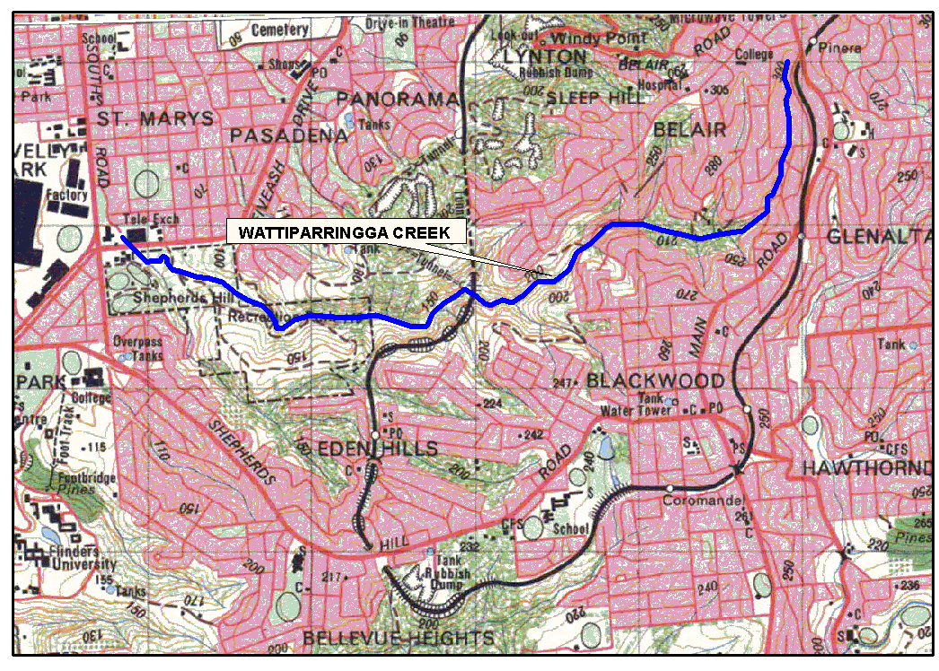
Dated 4 September 2003.
P. M. Kentish, Surveyor-General
04/0194

INDUSTRIAL AND EMPLOYEE RELATIONS ACT 1994
Appointments
I, MICHAEL JOHN WRIGHT, Minister for Industrial Relations in and for the State of South Australia, hereby appoint the undermentioned persons to be Inspectors for the purposes of the Industrial and Employee Relations Act 1994, pursuant to section 64 (1) (b) of the Industrial and Employee Relations Act 1994:
Bryan Wayne Atterton
David Bruce Beer
Cynthia Monica Bornman
Melanie-Jayne Carruthers
Adrian Leslie Gray
Matteo Icolaro
Leanne Marie McLennan
Peter John Masters
Colin Ross Richards
Simon Luigi John Ridge
Michael Arnold Wilson
Dated 4 September 2003.
M. J. Wright, Minister for Industrial Relations

LAND ACQUISITION ACT 1969
(Section 16)
Notice of Acquisition
S.A. WATER CORPORATION (the ‘Authority’), Level 15, S.A. Water House, 77 Grenfell Street, Adelaide, S.A. 5000, acquires the following interests in the following land:
An easement for sewerage purposes over portion of allotment 114 in Deposited Plan No. 37121, in the area named Stirling, Hundred of Noarlunga and being portion of the land comprised and described in certificate of title volume 5149, folio 198, more particularly delineated and lettered ‘E’ on approved Filed Plan No. FPX44281.
This notice is given under section 16 of the Land Acquisition Act 1969.
Offer of Compensation
A person who has or had an interest in the land that is divested or diminished by the acquisition or the enjoyment of which is adversely affected by the acquisition who does not receive an offer of compensation from the Authority may apply to the Authority for compensation.
Inquiries
Inquiries should be directed to:
The Property Manager:
S.A. Water Corporation
Level 15, S.A. Water House
77 Grenfell Street
Adelaide, S.A. 5000
Phone (08) 8204 1674
Dated 11 September 2003.
By Order of the Authority,
E. Lewandowski, Property Manager

LAND ACQUISITION ACT 1969
(Section 16)
Notice of Acquisition
S.A. WATER CORPORATION (the ‘Authority’), Level 15, S.A. Water House, 77 Grenfell Street, Adelaide, S.A. 5000, acquires the following interests in the following land:
An easement for sewerage purposes over portion of allotment 113 in Deposited Plan No. 37121, in the area named Stirling, Hundred of Noarlunga and being portion of the land comprised and described in certificate of title volume 5149, folio 197, more particularly delineated and lettered ‘E’ on approved Filed Plan No. FPX44281.
This notice is given under section 16 of the Land Acquisition Act 1969.
Offer of Compensation
A person who has or had an interest in the land that is divested or diminished by the acquisition or the enjoyment of which is adversely affected by the acquisition who does not receive an offer of compensation from the Authority may apply to the Authority for compensation.
Inquiries
Inquiries should be directed to:
The Property Manager:
S.A. Water Corporation
Level 15, S.A. Water House
77 Grenfell Street
Adelaide, S.A. 5000
Phone (08) 8204 1674
Dated 11 September 2003.
By Order of the Authority,
E. Lewandowski, Property Manager

LAND ACQUISITION ACT 1969
(Section 16)
Notice of Acquisition
S.A. WATER CORPORATION (the ‘Authority’), Level 15, S.A. Water House, 77 Grenfell Street, Adelaide, S.A. 5000, acquires the following interests in the following land:
An easement for sewerage purposes over that piece of land being portion of allotment 133 in Filed Plan No. 15717, in the area named St Georges being portion of the land comprised and described in certificate of title volume 5641, folio 667, more particularly delineated and marked ‘D’ on approved Filed Plan No. FPX44451.
This notice is given under section 16 of the Land Acquisition Act 1969.
Offer of Compensation
A person who has or had an interest in the land that is divested or diminished by the acquisition or the enjoyment of which is adversely affected by the acquisition who does not receive an offer of compensation from the Authority may apply to the Authority for compensation.
Inquiries
Inquiries should be directed to:
The Property Manager:
S.A. Water Corporation
Level 15, S.A. Water House
77 Grenfell Street
Adelaide, S.A. 5000
Phone (08) 8204 1674
Dated 11 September 2003.
By Order of the Authority,
E. Lewandowski, Property Manager

LAND AND BUSINESS (SALE AND CONVEYANCING) ACT 1994
Exemption
TAKE notice that, pursuant to section 23 (3) of the Land and Business (Sale and Conveyancing) Act 1994, I, Michael Atkinson, Minister for Consumer Affairs, do hereby exempt the person named in Schedule 1 from the application of section 23 (2) of the Act in relation to the purchase of the land specified in Schedule 2.
Schedule 1
Michele Ann Alexandrou, an employee of Apartment Sales S.A. Pty Ltd.
Schedule 2
The part of the land described in certificate of title register books volume 5706, folio 811; volume 5706, folio 812; volume 5818, folio 200 and volume 5818, folio 255, being Apartment 502 ‘Alpha Apartments’, situated at Vaughan Place, Adelaide, S.A. 5000.
Dated 11 September 2003.
Signed for and on behalf of the Minister for Consumer Affairs by the Commissioner for Consumer Affairs:
M. Bodycoat, Commissioner

LAND AND BUSINESS (SALE AND CONVEYANCING) ACT 1994
Exemption
TAKE notice that, pursuant to section 23 (3) of the Land and Business (Sale and Conveyancing) Act 1994, I, Michael Atkinson, Minister for Consumer Affairs, do hereby exempt the person named in Schedule 1 from the application of section 23 (2) of the Act in relation to the purchase of the land specified in Schedule 2.
Schedule 1
Alan Donald Miller, an employee of Delfin Realty Pty Ltd.
Schedule 2
The portion of the land described in certificate of title register book volume 5301, folio 884, situated at Lot 410, Otway Crescent, Mawson Lakes, S.A. 5095.
Dated 11 September 2003.
Signed for and on behalf of the Minister for Consumer Affairs by the Commissioner for Consumer Affairs:
M. Bodycoat, Commissioner

LAND AND BUSINESS (SALE AND CONVEYANCING) ACT 1994
Exemption
TAKE notice that, pursuant to section 23 (3) of the Land and Business (Sale and Conveyancing) Act 1994, I, Michael Atkinson, Minister for Consumer Affairs, do hereby exempt the person named in Schedule 1 from the application of section 23 (2) of the Act in relation to the purchase of the land specified in Schedule 2.
Schedule 1
Georgina Kate McInness, employee of Elders Ltd.
Schedule 2
The portion of the land contained within the Crown Lease Perpetual No. 442 Register Book Volume 1123, Folio 50 being Section No. 499 in the Ramco Division Waikerie Irrigation Area Hundred of Waikerie County of Hamley, described as Allotment 500 in DA 551/D007/03.
Dated 11 September 2003.
Signed for and on behalf of the Minister for Consumer Affairs by the Commissioner for Consumer Affairs:
M. Bodycoat, Commissioner

LIQUOR LICENSING ACT 1997
Notice of Application
NOTICE is hereby given, pursuant to section 52 (2) (b) of the Liquor Licensing Act 1997, that the Chancellor (Adelaide) Pty Ltd, c/o Minter Ellison Lawyers has applied to the Licensing Authority for the transfer of a Residential Licence in respect of premises situated at 12 Currie Street, Adelaide, S.A. 5000 and known as Duxton Hotel Adelaide.
The application has been set down for hearing on 7 October 2003 at 11 a.m.
Any person may object to the application by lodging a notice of objection in the prescribed form with the Licensing Authority, and serving a copy of the notice on the applicant at the applicant’s address given above, on or before 6 October 2003.
Plans in respect of the premises the subject of the application are open to public inspection without fee at the Office of the Liquor and Gaming Commissioner, 9th Floor, East Wing, 50 Grenfell Street, Adelaide, S.A. 5000.
Dated 5 September 2003.
Applicant

LIQUOR LICENSING ACT 1997
Notice of Application
NOTICE is hereby given, pursuant to section 52 (2) (b) of the Liquor Licensing Act 1997, that Bowland Salisbury Pty Ltd has applied to the Licensing Authority for the transfer and variation to conditions of a Special Circumstances Licence in respect of premises situated at 2 Clayson Road, Salisbury East, S.A. 5109, known as Salisbury Ten Pin Bowl and to be known as Bowland Salisbury.
The application has been set down for hearing on 10 October 2003 at 9 a.m.
Conditions
The following licence conditions are sought:
To vary the hours for consumption on the premises from:
Sunday to Friday inclusive: 11.30 a.m. to 12.30 a.m. the following day;
Saturday: 9 a.m. to 1.30 a.m. the following day;
Good Friday: Nil;
The day after Good Friday: 9 a.m. to noon;
To:
Monday to Thursday: 9 a.m. to midnight;
Friday and Saturdays: 9 a.m. to 2 a.m. the following day;
Sundays: 9 a.m. to midnight.
Extended Trading Authorisation is not authorised on Good Friday, the day after Good Friday or the day after Christmas Day.
To delete the following conditions:
• That there be no drinking at the liquor servery or bar and a sign erected indicating this.
• The licensee may make application for up to four limited licences per annum, to extend the trading hours with DJ style entertainment, for pre-booked Lock In functions to be held on a Saturday night only.
• Patrons of the centre shall vacate the centre car park within 30 minutes of the close of business.
• The centre car park shall be secured by a padlocked chain at the close of business each day, following the departure of patrons and centre staff.
• A licensed security person shall regularly patrol the centre car park during the hours of darkness, while the centre is in operation and continuously patrol the centre car park until 30 minutes after the close of business.
• The premises shall be closed to the public outside of the trading hours permitted under the licence.
• The licensee shall give, by way of a letter-drop not less than 7 days notice of any prebooked Lock-In function to be held on the premises, including the hours of the function, to the occupiers of the listed premises.
To vary the following conditions:
• An Entertainment Consent restricted to non-intrusive background music, utilising the in-house sound system, is granted.
To:
• Entertainment to be restricted to the in-house music system and to solo artists at private functions of more than 40 people. There are to be no bands or similar and the premises are not to operate as a nightclub, disco, etc.
Any person may object to the application by lodging a notice of objection in the prescribed form with the Licensing Authority, and serving a copy of the notice on the applicant at the applicant’s address given above, at least seven days before the hearing date.
Plans in respect of the premises the subject of the application are open to public inspection without fee at the Office of the Liquor and Gaming Commissioner, 9th Floor, East Wing, 50 Grenfell Street, Adelaide, S.A. 5000.
Dated 3 September 2003.
Applicant

LIQUOR LICENSING ACT 1997
Notice of Application
NOTICE is hereby given, pursuant to section 52 (2) (b) of the Liquor Licensing Act 1997, that Parker Hotel Pty Ltd has applied to the Licensing Authority for the Extended Trading Authorisation and a variation to Entertainment Consent in respect of premises situated at Fooks Terrace, St Kilda, S.A. 5110 and known as St Kilda Hotel.
The application has been set down for hearing on 10 October 2003 at 9 a.m.
Conditions
The following licence conditions are sought:
• Extended Trading Authorisation is sought to apply to areas 1 to 3 as depicted in the plan lodged:
Monday to Wednesday: Midnight to 1 a.m. the follow-ing day;
Thursday to Saturday: Midnight to 2 a.m. the following day;
Sunday: 8 p.m. to midnight;
Public Holidays: Midnight to 2 a.m. the following day.
• The current Entertainment Consent which applies to areas 1 and 2 is sought to also include area 3 as per plan lodged and is sought to apply to the extended trading hours.
Any person may object to the application by lodging a notice of objection in the prescribed form with the Licensing Authority, and serving a copy of the notice on the applicant at the applicant’s address given above, at least seven days before the hearing date.
Plans in respect of the premises the subject of the application are open to public inspection without fee at the Office of the Liquor and Gaming Commissioner, 9th Floor, East Wing, 50 Grenfell Street, Adelaide, S.A. 5000.
Dated 1 September 2003.
Applicant

LIQUOR LICENSING ACT 1997
Notice of Application
NOTICE is hereby given, pursuant to section 52 (2) (b) of the Liquor Licensing Act 1997, that Wet Spot Dive Club Inc has applied to the Licensing Authority for a Limited Club Licence with Extended Trading Authorisation in respect of premises situated at Unit 4, 355 Brighton Road, Hove, S.A. 5046 and to be known as Wet Spot Dive Club Inc.
The application has been set down for hearing on 10 October 2003 at 9 a.m.

Conditions
The following licence condition is sought:
Extended Trading Authorisation:
Friday, midnight to 1 a.m. the following day;
Saturday, midnight to 1 a.m. the following day; and
Sunday, 8 p.m. to midnight
Any person may object to the application by lodging a notice of objection in the prescribed form with the Licensing Authority, and serving a copy of the notice on the applicant at the applicant’s address given above, at least seven days before the hearing date.
Plans in respect of the premises the subject of the application are open to public inspection without fee at the Office of the Liquor and Gaming Commissioner, 9th Floor, East Wing, 50 Grenfell Street, Adelaide, S.A. 5000.
Dated 1 September 2003.
Applicant

LIQUOR LICENSING ACT 1997
Notice of Application
NOTICE is hereby given, pursuant to section 52 (2) (b) of the Liquor Licensing Act 1997, that Epaminondas Koutouzis, c/o Stuart Andrew, 11 Ahern Street, Berri, S.A. 5343 has applied to the Licensing Authority for a Producer’s Licence in respect of premises situated at section 1537, Chilton Road, Berri, S.A. 5343 and to be known as Myth Wines.
The application has been set down for hearing on 10 October 2003 at 9 a.m.
Any person may object to the application by lodging a notice of objection in the prescribed form with the Licensing Authority, and serving a copy of the notice on the applicant at the applicant’s address given above, at least seven days before the hearing date.
Plans in respect of the premises the subject of the application are open to public inspection without fee at the Office of the Liquor and Gaming Commissioner, 9th Floor, East Wing, 50 Grenfell Street, Adelaide, S.A. 5000.
Dated 1 September 2003.
Applicant

LIQUOR LICENSING ACT 1997
Notice of Application
NOTICE is hereby given, pursuant to section 52 (2) (b) of the Liquor Licensing Act 1997, that Darryl Ian Lang has applied to the Licensing Authority for a Producer’s Licence in respect of premises situated at section 401, Derrick Road, Loxton North, S.A. 5333 and known as Second Dune.
The application has been set down for hearing on 10 October 2003 at 9 a.m.
Any person may object to the application by lodging a notice of objection in the prescribed form with the Licensing Authority, and serving a copy of the notice on the applicant at the applicant’s address given above, at least seven days before the hearing date.
Plans in respect of the premises the subject of the application are open to public inspection without fee at the Office of the Liquor and Gaming Commissioner, 9th Floor, East Wing, 50 Grenfell Street, Adelaide, S.A. 5000.
Dated 3 September 2003.
Applicant

LIQUOR LICENSING ACT 1997
Notice of Application
NOTICE is hereby given, pursuant to section 52 (2) (b) of the Liquor Licensing Act 1997, that S.A. Liquor Distributors Limited, c/o Johnson Winter & Slattery has applied to the Licensing Authority for the removal of a Wholesale Liquor Merchant’s Licence from premises situated at 60 Patricia Avenue, Camden Park, S.A. 5038, to be situated at 98 Jervois Street, Torrensville, S.A. 5031 and known as S.A. Liquor Distributors.
The application has been set down for hearing on 10 October 2003 at 9 a.m.
Any person may object to the application by lodging a notice of objection in the prescribed form with the Licensing Authority, and serving a copy of the notice on the applicant at the applicant’s address given above, at least seven days before the hearing date.
Plans in respect of the premises the subject of the application are open to public inspection without fee at the Office of the Liquor and Gaming Commissioner, 9th Floor, East Wing, 50 Grenfell Street, Adelaide, S.A. 5000.
Dated 4 September 2003.
Applicant

LIQUOR LICENSING ACT 1997
Notice of Application
NOTICE is hereby given, pursuant to section 52 (2) (b) of the Liquor Licensing Act 1997, that Hewitson Pty Ltd has applied to the Licensing Authority for the removal of a Producer’s Licence in respect of premises situated at 16 McGowan Avenue, Unley, S.A. 5061, to be situated at 66 London Road, Mile End, S.A. 5031 and known as Hewitson.
The application has been set down for hearing on 10 October 2003 at 9 a.m.
Any person may object to the application by lodging a notice of objection in the prescribed form with the Licensing Authority, and serving a copy of the notice on the applicant at the applicant’s address given above, at least seven days before the hearing date.
Plans in respect of the premises the subject of the application are open to public inspection without fee at the Office of the Liquor and Gaming Commissioner, 9th Floor, East Wing, 50 Grenfell Street, Adelaide, S.A. 5000.
Dated 4 September 2003.
Applicant

LIQUOR LICENSING ACT 1997
Notice of Application
NOTICE is hereby given, pursuant to section 52 (2) (b) of the Liquor Licensing Act 1997, that James Edward and Annabelle Mary Tilbrook, c/o Wallmans Lawyers, 173 Wakefield Street, Adelaide, S.A. 5000 have applied to the Licensing Authority for a Producer’s Licence in respect of premises situated at Building 17, Adelaide Hills Business & Tourism Centre, 1 Adelaide to Lobethal Road, Lobethal, S.A. 5241 and to be known as Tilbrook Estate.
The application has been set down for hearing on 10 October 2003 at 9 a.m.
Any person may object to the application by lodging a notice of objection in the prescribed form with the Licensing Authority, and serving a copy of the notice on the applicants at the applicants’ address given above, at least seven days before the hearing date.
Plans in respect of the premises the subject of the application are open to public inspection without fee at the Office of the Liquor and Gaming Commissioner, 9th Floor, East Wing, 50 Grenfell Street, Adelaide, S.A. 5000.
Dated 4 September 2003.
Applicants

LIQUOR LICENSING ACT 1997
Notice of Application
NOTICE is hereby given, pursuant to section 52 (2) (b) of the Liquor Licensing Act 1997, that Middleton Winery Pty Ltd has applied to the Licensing Authority for a Wholesale Liquor Merchant’s Licence in respect of premises situated at Flagstaff Hill Road, Middleton, S.A. 5213 and known as Middleton Winery Pty Ltd.
The application has been set down for hearing on 10 October 2003 at 9 a.m.
Any person may object to the application by lodging a notice of objection in the prescribed form with the Licensing Authority, and serving a copy of the notice on the applicant at the applicant’s address given above, at least seven days before the hearing date.
Plans in respect of the premises the subject of the application are open to public inspection without fee at the Office of the Liquor and Gaming Commissioner, 9th Floor, East Wing, 50 Grenfell Street, Adelaide, S.A. 5000.
Dated 4 September 2003.
Applicant

LIQUOR LICENSING ACT 1997
Notice of Application
NOTICE is hereby given, pursuant to section 52 (2) (b) of the Liquor Licensing Act 1997, that Dodunski Nominees Pty Ltd, c/o Wallmans Lawyers, has applied to the Licensing Authority for the transfer of a Residential Licence and Entertainment Consent in respect of premises situated at 728 Tapleys Hill Road, West Beach, S.A. 5024 and known as Adelaide Aviators Lodge.
The application has been set down for hearing on 10 October 2003 at 9 a.m.
Conditions
The following licence conditions are sought:
Entertainment Consent is sought to apply to Areas 1 and 2 as depicted in the plan.
The Redefinition of the Premises to designate Area 3 as dining, section 33 (1) (b) for consumption on the licensed premises by persons:
seated at a table; or
attending a function at which food is provided.
Any person may object to the application by lodging a notice of objection in the prescribed form with the Licensing Authority, and serving a copy of the notice on the applicant at the applicant’s address given above, at least seven days before the hearing date.
Plans in respect of the premises the subject of the application are open to public inspection without fee at the Office of the Liquor and Gaming Commissioner, 9th Floor, East Wing, 50 Grenfell Street, Adelaide, S.A. 5000.
Dated 8 September 2003.
Applicant

LIQUOR LICENSING ACT 1997
Notice of Application
NOTICE is hereby given, pursuant to section 52 (2) (b) of the Liquor Licensing Act 1997, that Pea. Pea. Pea. Pty Ltd as trustee for the Pea. Pea. Pea. Family Trust c/o Fisher Jeffries, Level 15, 211 Victoria Square, Adelaide, S.A. 5000 has applied to the Licensing Authority for the transfer of a Hotel and Gaming Machine Licence and variation to Entertainment Consent Conditions in respect of the premises situated at 22 Commercial Road, Burra, S.A. 5417 and known as Commercial Hotel.
The application has been set down for hearing on 10 October 2003 at 9 a.m.
Conditions
The following licence condition is sought:
The applicant seeks a variation to the Entertainment Consent at the premises to permit (in addition to existing rights) the provision of small groups and individual performers playing jazz music.
Any person may object to the application by lodging a notice of objection in the prescribed form with the Licensing Authority, and serving a copy of the notice on the applicant at the applicant’s address given above, at least seven days before the hearing date.
Plans in respect of the premises the subject of the application are open to public inspection without fee at the Office of the Liquor and Gaming Commissioner, 9th Floor, East Wing, 50 Grenfell Street, Adelaide, S.A. 5000.
Dated 8 September 2003.
Applicant

LIQUOR LICENSING ACT 1997
Notice of Application
NOTICE is hereby given, pursuant to section 52 (2) (b) of the Liquor Licensing Act 1997, that Blackfriars Priory School has applied to the Licensing Authority for a Producer’s Licence in respect of premises situated at 17 Prospect Road, Prospect, S.A. 5082 and to be known as Blackfriars Priory School.
The application has been set down for hearing on 10 October 2003 at 9 a.m.
Any person may object to the application by lodging a notice of objection in the prescribed form with the Licensing Authority, and serving a copy of the notice on the applicant at the applicant’s address given above, at least seven days before the hearing date.
Plans in respect of the premises the subject of the application are open to public inspection without fee at the Office of the Liquor and Gaming Commissioner, 9th Floor, East Wing, 50 Grenfell Street, Adelaide, S.A. 5000.
Dated 5 September 2003.
Applicant

LIQUOR LICENSING ACT 1997
Notice of Application
NOTICE is hereby given, pursuant to section 52 (2) (b) of the Liquor Licensing Act 1997, that Woodville-West Torrens Foot-ball Club Inc., c/o Andersons Solicitors has applied to the Licensing Authority for a Club Licence with Extended Trading Authorisation and Entertainment Consent in respect of premises situated at Woodville Oval, Oval Road, Woodville, S.A. 5011 and known as Woodville-West Torrens Football Club.
The application has been set down for hearing on 10 October 2003 at 9 a.m.
Conditions
The following licence conditions are sought:
Extended Trading Authorisation is sought in the areas as depicted in the plan:
Thursday to Saturday: Midnight to 1 a.m. the following day;
Sunday: 8 p.m. to midnight;
Christmas Day and Good Friday: Nil;
New Year’s Day: Midnight to 2 a.m. the following day.
Entertainment Consent is sought to apply to the premises when open for the areas as depicted in the plan.
Other conditions sought:
• When South Australian National Football League matches or any other sporting event authorised by the Woodville-West Torrens Football Club are played at the oval the licensed premises will be the area outlined in red on the plan for the period one hour before and one hour after the match, or other sporting event.
• When the area under the club’s control is used for a function other than a sporting event the licensed premises will be defined to include the oval as cross-hatched in red on the plan.
Any person may object to the application by lodging a notice of objection in the prescribed form with the Licensing Authority, and serving a copy of the notice on the applicant at the applicant’s address given above, at least seven days before the hearing date.
Plans in respect of the premises the subject of the application are open to public inspection without fee at the Office of the Liquor and Gaming Commissioner, 9th Floor, East Wing, 50 Grenfell Street, Adelaide, S.A. 5000.
Dated 5 September 2003.
Applicant

LIQUOR LICENSING ACT 1997
Notice of Application
NOTICE is hereby given, pursuant to section 52 (2) (b) of the Liquor Licensing Act 1997, that Teleta Pty Ltd as trustee for the Seta Family Trust and Kamseene Pty Ltd as trustee for the J. F. & H. Donnellan Superannuation Fund, c/o Fisher Jeffries have applied to the Licensing Authority for the transfer of a Hotel Licence in respect of premises situated at 112 Commercial Street, Mount Gambier, S.A. 5290 and known as Federal Hotel Motel.
The application has been set down for hearing on 10 October 2003 at 10 a.m.
Any person may object to the application by lodging a notice of objection in the prescribed form with the Licensing Authority, and serving a copy of the notice on the applicants at the applicants’ address given above, at least seven days before the hearing date.
Plans in respect of the premises the subject of the application are open to public inspection without fee at the Office of the Liquor and Gaming Commissioner, 9th Floor, East Wing, 50 Grenfell Street, Adelaide, S.A. 5000.
Dated 8 September 2003.
Applicants

LIQUOR LICENSING ACT 1997
Notice of Application
NOTICE is hereby given, pursuant to section 52 (2) (b) of the Liquor Licensing Act 1997, that Bakvro Pty Ltd has applied to the Licensing Authority for the transfer of a Restaurant Licence in respect of premises situated at 1st Level, Myer Centre, Rundle Mall, Adelaide, S.A. 5000 and known as Billy Baxter’s Coffee House.
The application has been set down for hearing on 20 October 2003 at 10.30 a.m.
Any person may object to the application by lodging a notice of objection in the prescribed form with the Licensing Authority, and serving a copy of the notice on the applicant at the applicant’s address given above, at least seven days before the hearing date.
Plans in respect of the premises the subject of the application are open to public inspection without fee at the Office of the Liquor and Gaming Commissioner, 9th Floor, East Wing, 50 Grenfell Street, Adelaide, S.A. 5000.
Dated 8 September 2003.
Applicant

LIQUOR LICENSING ACT 1997
Notice of Application
NOTICE is hereby given, pursuant to section 52 (2) (b) of the Liquor Licensing Act 1997, that G. M. Lopresti Pty Ltd has applied to the Licensing Authority for the transfer of a Restaurant Licence in respect of premises situated at Shop 13, Ingle Farm Shopping Centre, Montague Road, Ingle Farm, S.A. 5098 and known as Caffe Dolci.
The application has been set down for hearing on 13 October 2003 at 10 a.m.
Any person may object to the application by lodging a notice of objection in the prescribed form with the Licensing Authority, and serving a copy of the notice on the applicant at the applicant’s address given above, at least seven days before the hearing date.
Plans in respect of the premises the subject of the application are open to public inspection without fee at the Office of the Liquor and Gaming Commissioner, 9th Floor, East Wing, 50 Grenfell Street, Adelaide, S.A. 5000.
Dated 29 August 2003.
Applicant

LIQUOR LICENSING ACT 1997
Notice of Application
NOTICE is hereby given, pursuant to section 52 (2) (b) of the Liquor Licensing Act 1997, that Mauviel Holdings Pty Ltd has applied to the Licensing Authority for the transfer of a Special Circumstances Licence in respect of premises situated at Tenancy 13A and Part 12, 177-193 The Parade, Norwood, S.A. 5067 and known as The George Wine Bar.
The application has been set down for hearing on 13 October 2003 at 9 a.m.
Any person may object to the application by lodging a notice of objection in the prescribed form with the Licensing Authority, and serving a copy of the notice on the applicant at the applicant’s address given above, at least seven days before the hearing date.
Plans in respect of the premises the subject of the application are open to public inspection without fee at the Office of the Liquor and Gaming Commissioner, 9th Floor, East Wing, 50 Grenfell Street, Adelaide, S.A. 5000.
Dated 29 August 2003.
Applicant

LIQUOR LICENSING ACT 1997
Notice of Application
NOTICE is hereby given, pursuant to section 52 (2) (b) of the Liquor Licensing Act 1997, that DPN Investments Pty Ltd, Adbet Pty Ltd and David and Jennifer Key, c/o Edgley Lawyers have applied to the Licensing Authority for the transfer of a Restaurant Licence in respect of premises situated at R5 Marina Pier, Holdfast Shores, S.A. 5045 and to be known as Zucca Greek Mezze.
The application has been set down for hearing on 13 October 2003 at 10.30 a.m.
Any person may object to the application by lodging a notice of objection in the prescribed form with the Licensing Authority, and serving a copy of the notice on the applicants at the applicants’ address given above, at least seven days before the hearing date.
Plans in respect of the premises the subject of the application are open to public inspection without fee at the Office of the Liquor and Gaming Commissioner, 9th Floor, East Wing, 50 Grenfell Street, Adelaide, S.A. 5000.
Dated 8 September 2003.
Applicants

LIQUOR LICENSING ACT 1997
Notice of Application
NOTICE is hereby given, pursuant to section 52 (2) (b) of the Liquor Licensing Act 1997, that Bowland Salisbury Pty Ltd has applied to the Licensing Authority for the transfer of a Special Circumstances Licence in respect of premises situated at 2 Clayson Road, Salisbury East, S.A. 5109, known as Salisbury Ten Pin Bowl and to be known as Bowland Salisbury.
The application has been set down for hearing on 14 October 2003 at 9 a.m.
Any person may object to the application by lodging a notice of objection in the prescribed form with the Licensing Authority, and serving a copy of the notice on the applicant at the applicant’s address given above, at least seven days before the hearing date.
Plans in respect of the premises the subject of the application are open to public inspection without fee at the Office of the Liquor and Gaming Commissioner, 9th Floor, East Wing, 50 Grenfell Street, Adelaide, S.A. 5000.
Dated 2 September 2003.
Applicant

LIQUOR LICENSING ACT 1997
Notice of Application
NOTICE is hereby given, pursuant to section 52 (2) (b) of the Liquor Licensing Act 1997, that Chapati Investments Pty Ltd, c/o Geoff Forbes has applied to the Licensing Authority for the transfer of a Hotel Licence in respect of premises situated at 18 Main Road, Solomontown, S.A. 5540 and known as Hotel Newcastle.
The application has been set down for hearing on 15 October 2003 at 9.30 a.m.
Any person may object to the application by lodging a notice of objection in the prescribed form with the Licensing Authority, and serving a copy of the notice on the applicant at the applicant’s address given above, at least seven days before the hearing date.
Plans in respect of the premises the subject of the application are open to public inspection without fee at the Office of the Liquor and Gaming Commissioner, 9th Floor, East Wing, 50 Grenfell Street, Adelaide, S.A. 5000.
Dated 5 September 2003.
Applicant

LIQUOR LICENSING ACT 1997
Notice of Application
NOTICE is hereby given, pursuant to section 52 (2) (b) of the Liquor Licensing Act 1997, that Bestside Pty Ltd c/o Piper Alderman, 167 Flinders Street, Adelaide, S.A. 5000 has applied to the Licensing Authority for the transfer of a Residential Licence in respect of premises situated at Market Street, Burra, S.A. 5417 and known as Burra Motor Inn.
The application has been set down for hearing on 15 October 2003 at 10.30 a.m.
Any person may object to the application by lodging a notice of objection in the prescribed form with the Licensing Authority, and serving a copy of the notice on the applicant at the applicant’s address given above, at least seven days before the hearing date.
Plans in respect of the premises the subject of the application are open to public inspection without fee at the Office of the Liquor and Gaming Commissioner, 9th Floor, East Wing, 50 Grenfell Street, Adelaide, S.A. 5000.
Dated 5 September 2003.
Applicant

LIQUOR LICENSING ACT 1997
Notice of Application
NOTICE is hereby given, pursuant to section 52 (2) (b) of the Liquor Licensing Act 1997, that Gregg Peter George, Christopher John George, Barbara Lillian George and Angela Louise Hodge have applied to the Licensing Authority for the transfer of a Retail Liquor Merchant’s Licence in respect of premises situated at Main Road, Pine Point, S.A. 5571 and known as Pine Point General Store.
The application has been set down for hearing on 15 October 2003 at 9 a.m.
Any person may object to the application by lodging a notice of objection in the prescribed form with the Licensing Authority, and serving a copy of the notice on the applicants at the applicants’ address given above, at least seven days before the hearing date.
Plans in respect of the premises the subject of the application are open to public inspection without fee at the Office of the Liquor and Gaming Commissioner, 9th Floor, East Wing, 50 Grenfell Street, Adelaide, S.A. 5000.
Dated 5 September 2003.
Applicants

MINING ACT 1971
NOTICE is hereby given in accordance with section 28 (5) of the Mining Act 1971, that the Minister for Mineral Resources Development proposes to grant an Exploration Licence over the undermentioned area:
Applicant: Flinders Diamonds Limited
Location: Mount Torrens area⎯Approximately 40 km east of Adelaide.
Term: 1 year
Area in km²: 192
Ref.: 090/2003
Plans and co-ordinates can be found on the PIRSA Sarig website:
http://www.minerals.pir.sa.gov.au/sarig or by phoning Mineral Tenements on (08) 8463 3103.
Dated 11 September 2003.
H. Tyrteos, Mining Registrar

OCCUPATIONAL HEALTH, SAFETY AND WELFARE
ACT 1986
Appointments
I, MICHAEL JOHN WRIGHT, Minister for Industrial Relations in and for the State of South Australia, hereby authorise under the Occupational Health, Safety and Welfare Act 1986, the undermentioned public service employees to exercise the powers of an Inspector, pursuant to the Occupational Health, Safety and Welfare Act 1986:
David John Adams
David Bruce Beer
Melanie-Jayne Carruthers
Luis Cuevas
John Stuart McKenzie
Leanne Marie McLennan
Peter John Masters
Dated 4 September 2003.
M. J. Wright, Minister for Industrial Relations

PETROLEUM PRODUCTS REGULATION ACT 1995
Appointments
I, MICHAEL JOHN WRIGHT, Minister for Industrial Relations in and for the State of South Australia, hereby appoint the following persons as Authorised Officers for the purposes of the Petroleum Products Regulation Act 1995, in accordance with my delegated authority under section 49 of the Petroleum Products Regulation Act 1995:
David Bruce Beer
Cynthia Monica Bornman
Melanie-Jayne Carruthers
Luis Cuevas
Adrian Leslie Gray
Matteo Icolaro
Leanne Marie McLennan
Peter John Masters
Dated 4 September 2003.
M. J. Wright, Minister for Industrial Relations

REAL PROPERTY ACT NOTICE
WHEREAS the persons named at the foot hereof have each respectively for himself made application to have the land set forth and described before his name at the foot hereof brought under the operation of the Real Property Act: Notice is hereby given that unless caveat be lodged with the Registrar-General by some person having estate or interest in the said lands on or before the expiration of the period herein below for each case specified, the said several pieces of land will be brought under the operation of the said Act as by law directed. Diagrams delineating these parcels of land may be inspected at the Lands Titles Registration Office, Adelaide, and in the offices of the several corporations or district councils in which the lands are situated.

The Schedule
No. of  Applica-  tion | Description of Property |  | Name |  | Residence | Date up to and  inclusive of which  caveat may be  lodged

31034 | Portion of allotments 46, 47 and 51 and the whole of Allotment 50 in GRO Plan 459 of 1854 being portion of section 355, Hundred of Yatala. The land is more particularly defined as Allotment 91 in Filed Plan No. 207183 |  | Origin Energy Asset Management Ltd |  | 1 King William Street, Adelaide, S.A. 5000 | 12 November 2003

Dated 11 September 2003, at the Lands Titles Registration Office, Adelaide. J. Zaccaria, Deputy Registrar-General

ROAD TRAFFIC ACT 1961
Exemption from the Fitting of Brakes to Boat Trailers
UNDER section 163AA of the Road Traffic Act 1961, I hereby grant exemption for boat trailers built prior to July 1990 which have an unladen mass not exceeding 750 kilograms and a laden mass not exceeding 2 tonnes:
1. Exemption
From the following provisions of the Road Traffic (Vehicle Standards) Rules 1999:
• Rule 132 (1)—Trailer braking requirements;
• Rule 133—Operation of brakes on trailers;
• Rule 20, but only insofar as it requires compliance with third edition Australian Design Rule (‘ADR’) 38—all other requirements under Rule 20 must be complied with.
2. Definition
For the purpose of this Notice a boat trailer is defined as a trailer built for the sole purpose of carrying a boat and its design prevents it being used for general duties. A boat trailer is towed at normal road speeds in general traffic conditions.
3. Conditions Applying to this Exemption
Subject to the following conditions:
3.1 That the unladen mass of the towing vehicle is at least 1.2 times greater than the total laden mass of the boat trailer, boat and other equipment carried thereon.
3.2 The laden mass of the towed boat trailer must not exceed the maximum legal unbraked towing capacity specified by the manufacturer of the towing vehicle:
3.2.1 For the purpose of this Notice ‘Laden Mass’ means the mass of the boat trailer, boat and any other equipment carried thereon that is borne on the surfaces on which the trailer is standing or stationary when disconnected from the towing vehicle.
3.3 The speed of the vehicle combination does not exceed 90 km/h.
3.4 That the trailer complies with all other requirements of the Road Traffic Act 1961.
4. Commencement and Expiry of this Notice
This Notice is valid from the date of publication and will expire at midnight on 30 September 2006.
Information Note
This exemption will not be extended beyond 30 September 2006 at which time all boat trailers must comply with the Road Traffic (Vehicle Standards) Rules 1999.

This exemption may be varied or revoked at any time by notice in writing.
The Notice titled ‘Exemption for the Fitting of Brakes to Boat Trailers Built Prior to July 1990 which have a Laden mass not Exceeding 2 tonnes’ appearing in the South Australian Government Gazette, dated 16 November 2000, is hereby revoked.
Dated 27 August 2003.
Executive Director, Transport SA
Authorised Delegate for the Minister for Transport

RULES OF COURT
Magistrates Court of South Australia
Amendment No. 20 to the Magistrates Court Rules
PURSUANT to section 49 of the Magistrates Court Act 1991, and all other enabling powers, we, the undersigned, do hereby make the following amendments to the Magistrates Court Rules 1992, as amended:
1. These Rules may be cited as the Magistrates Court Rules 1992, Amendment 20.
2. The Magistrates Court Rules 1992, as amended, by these Rules, may be cited as the ‘Magistrates Court Rules 1992’.
3. Rule 12 is deleted and replaced with the following:
12.00 COMPLAINT
12.01 A complaint reduced to writing shall comply with Form No. 1.
12.02 Subject to Rule 12.04, the complainant (or other duly authorised person) may make a complaint by stating the matter of complaint to a witness who must be a Registrar, Deputy Registrar or Justice of the Peace.
12.03 The complaint when reduced to writing must be:
(i) signed by the complainant (or other duly authorised person), and, subject to Rule 12.04;
(ii) signed and dated by the witness.
12.04 A ‘public authority’ or ‘public officer’ (as defined in section 57a of the Act) or a legal practitioner may make a complaint in writing on signing and dating it without appearing before a witness.
12.05 Where a complaint is made by a police officer in the execution of his duty the complaint and proceedings thereon may be entitled ‘Police v ...... ’.
12.06 Where a complaint is made by a ‘public authority’ (as defined in section 57a of the Act) the complaint and proceedings thereon may be entitled ‘ (Name of public authority) v.........’.
12.07 A complaint must be filed in the Court within seven days of being made unless not practicable.
12.08 A copy of the complaint shall be given to the defendant on or before the time of the first Court appearance.
12.09 A complaint for contempt of Court may be made by a judicial officer as provided for in Rule 12.04.
12.10 A complaint shall comply with Rule 15.03.
4. Rule 19.10 is amended by deleting ‘Rule 15.02’ and replacing it with ‘Rule 15.03’.
5. Rule 24.01 is amended by deleting the words ‘section 181, section 195 (2) and 3, section 196 (4), section 198 (2)’.
6. Rule 47 is amended by deleting Rule 47.08 and adding the following:
47.08 An application for review of an enforcement order pursuant to section 14 of the Expiation of Offences Act shall comply with Form 51.
47.09 Upon receipt of an application the Registrar shall:
(a) notify the issuing authority of the application;
(b) set the matter down to be heard by a Magistrate in the absence of all parties not less than 14 days from the date of notification to the issuing authority (the first hearing date).
47.10 If the issuing authority does not notify the Registrar of an objection to the application a Magistrate shall consider the application on the first hearing date. Neither the applicant nor the issuing authority need be present at the time it is considered.
47.11 If the issuing authority notifies the Registrar of an objection as provided in Rule 47.10 or a Magistrate, having considered the application does not intend to grant the application on the basis of the evidence provided with the application, consideration of the application shall be adjourned to later time and date (second hearing date).
47.12 The applicant and the issuing authority shall be notified of the second hearing date.
47.13 At the second hearing the Court may hear and determine the application on the basis of the matters set out in the application and any further evidence or submissions made by or on behalf of the applicant and the issuing authority.
47.14 It shall be sufficient notification for the purpose of this rule if the party is notified in writing, by telephone or by e-mail at the address supplied by the party.
7. The following is added to Rule 49:
49.03 A warrant issues pursuant to either section 15 (5) or section 31 (5) of the Criminal Law (Forensic Procedures) Act shall comply with form 74.
8. The following form 74 shall be added.

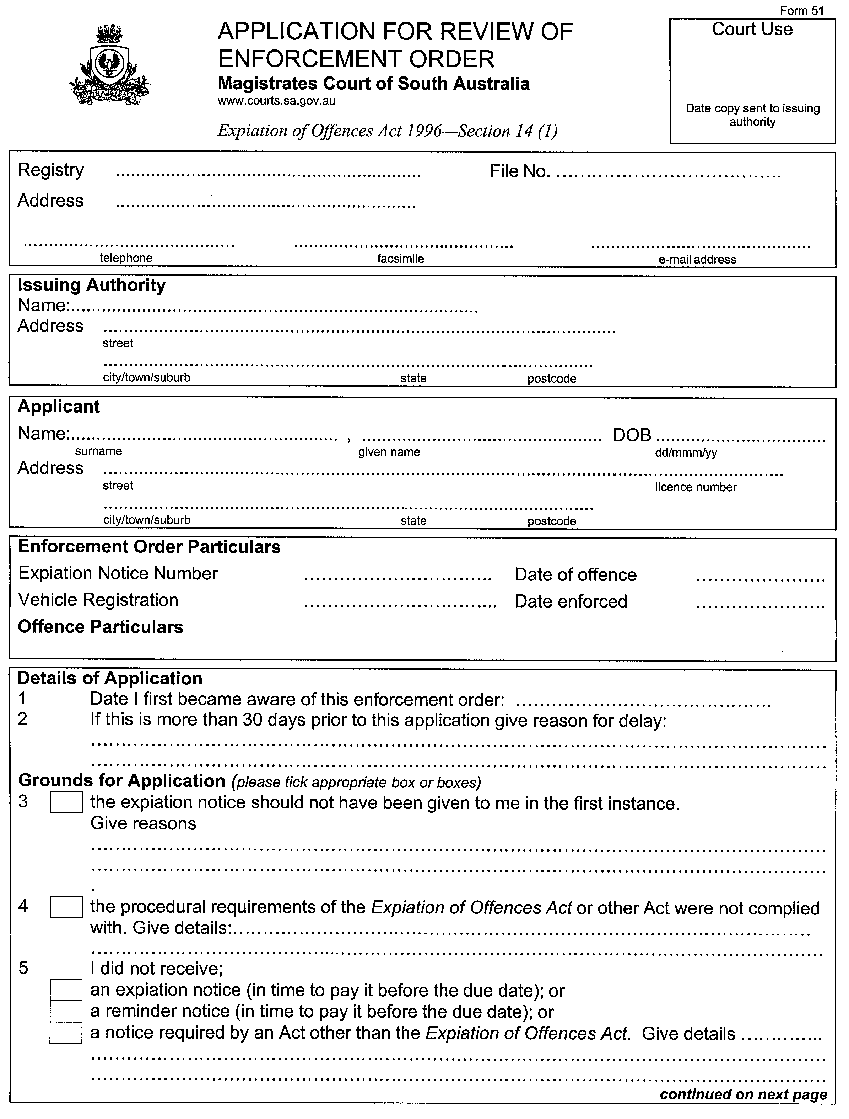
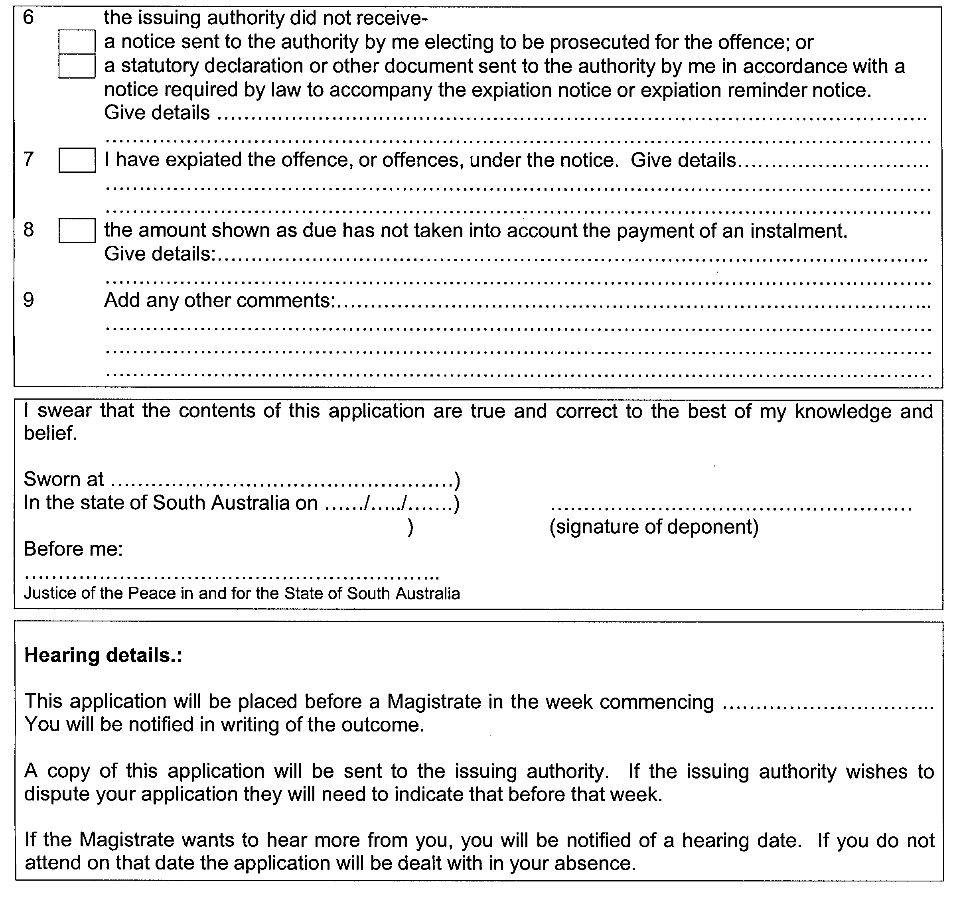

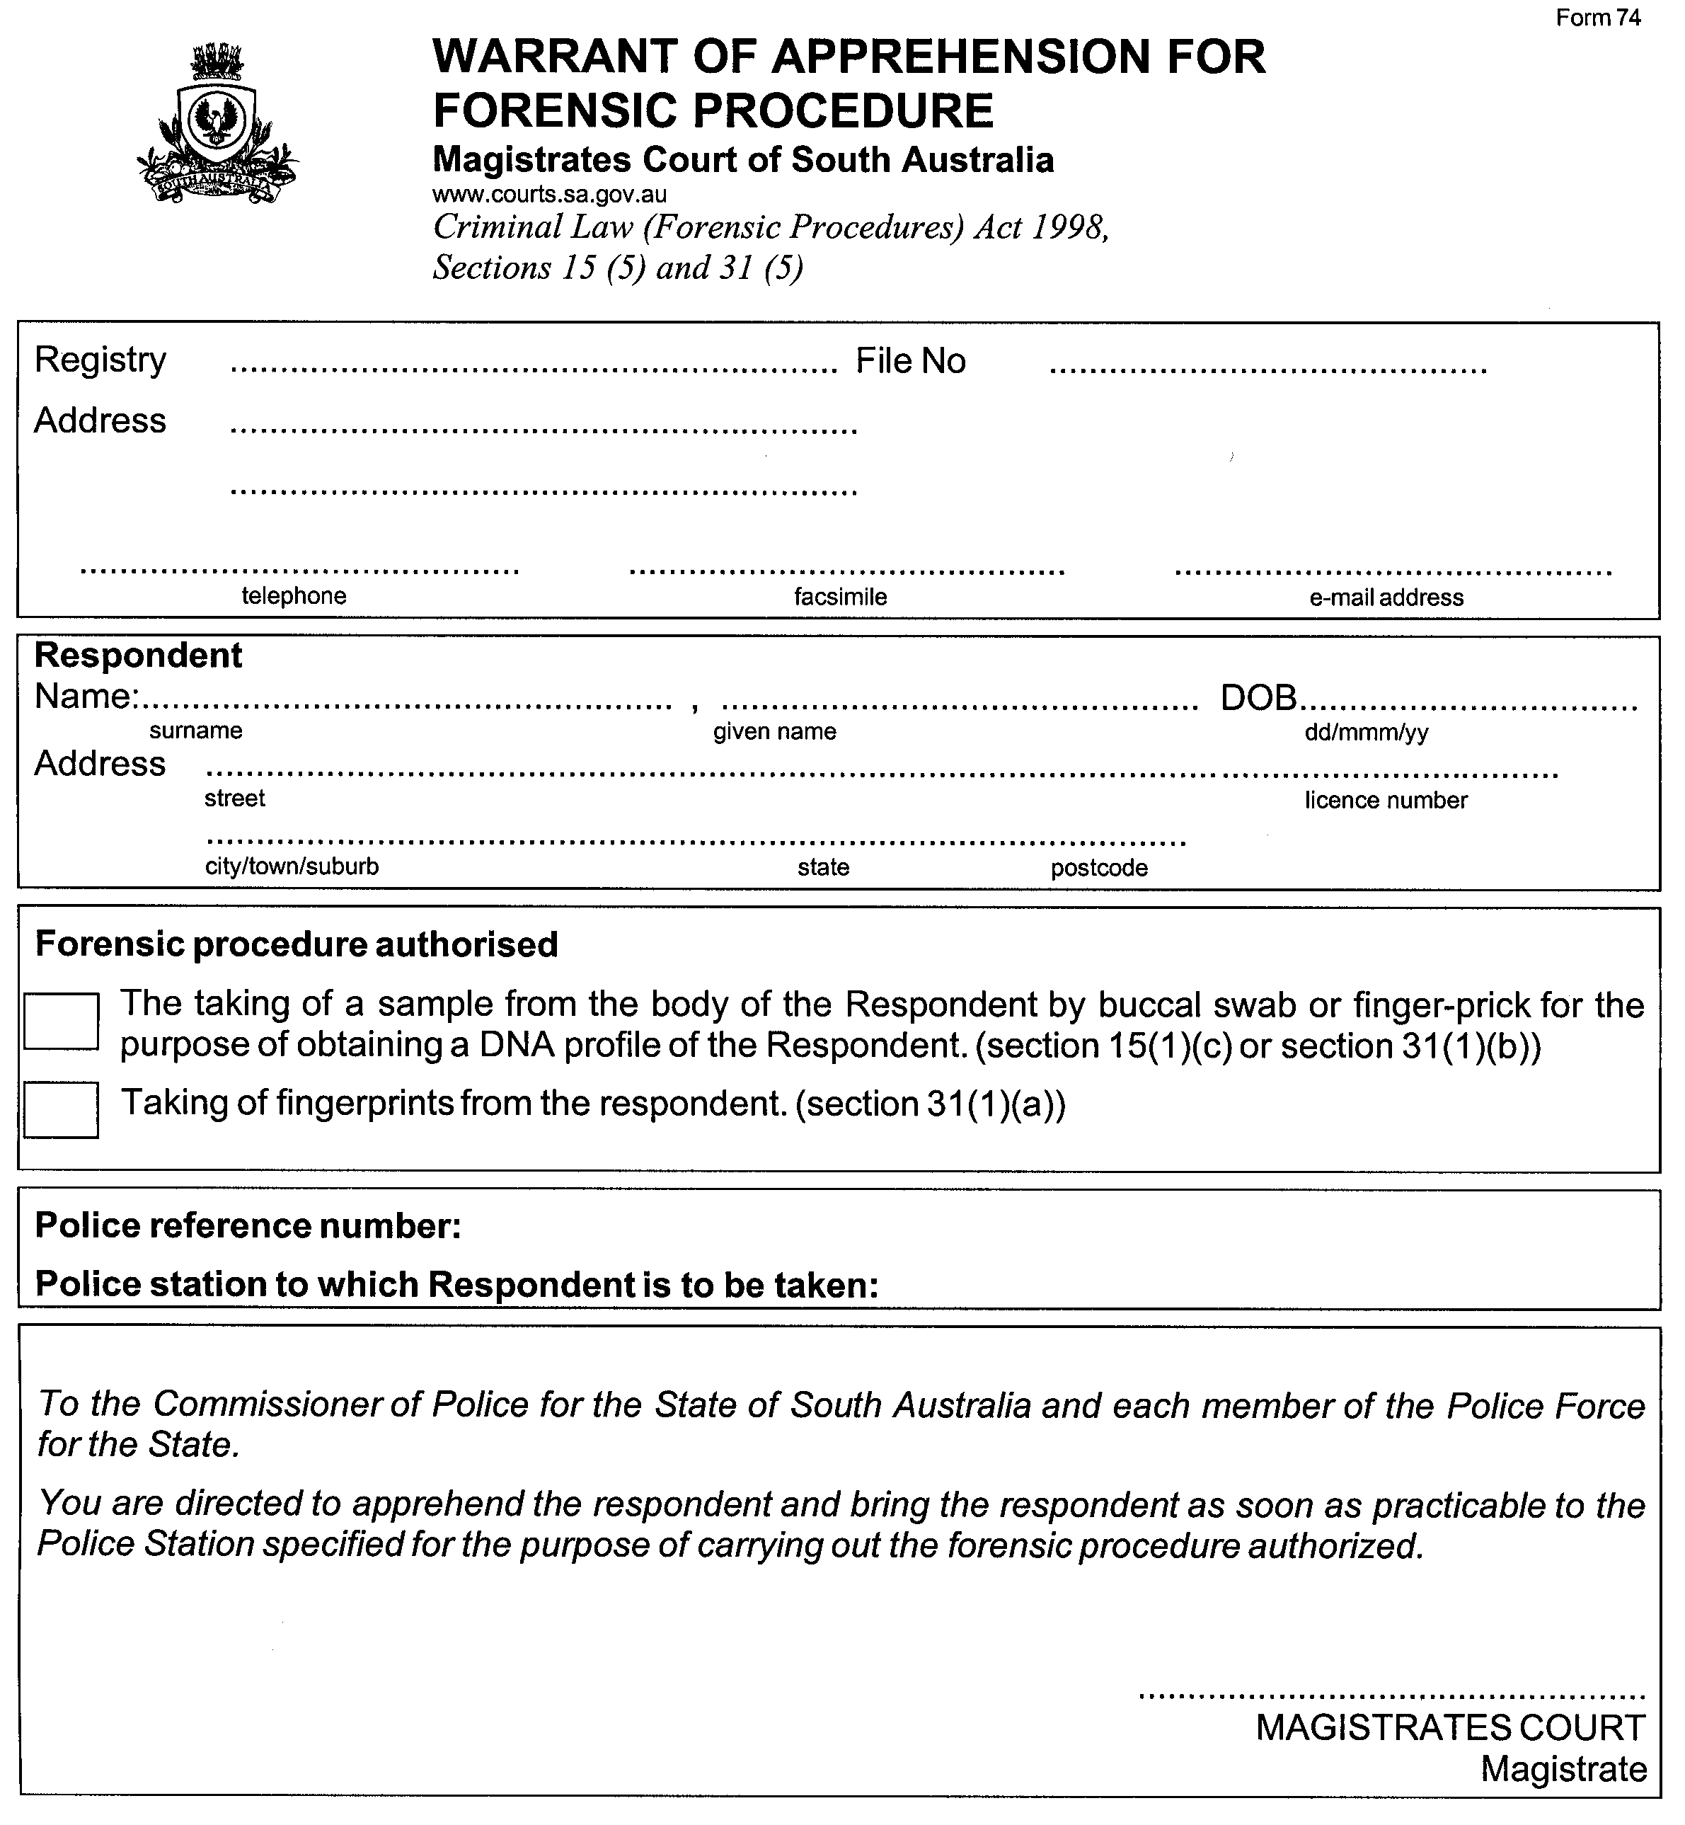
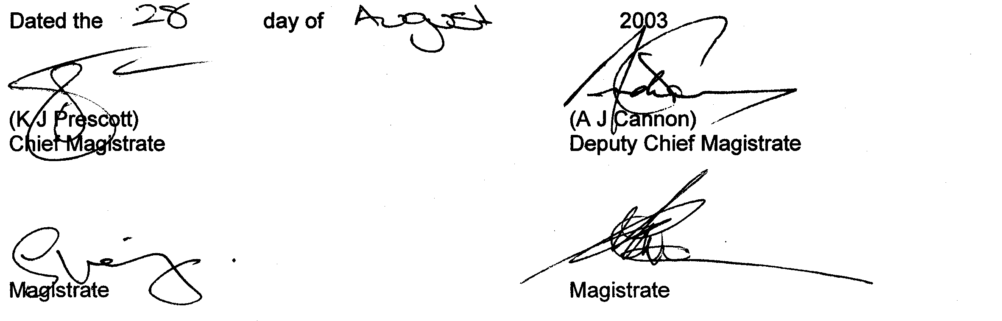

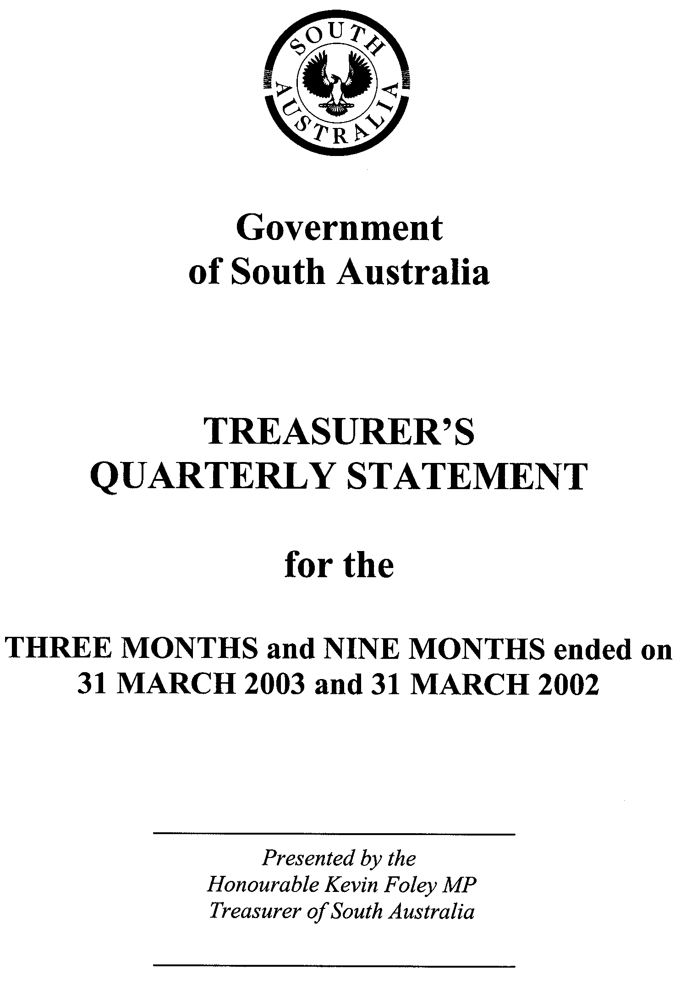
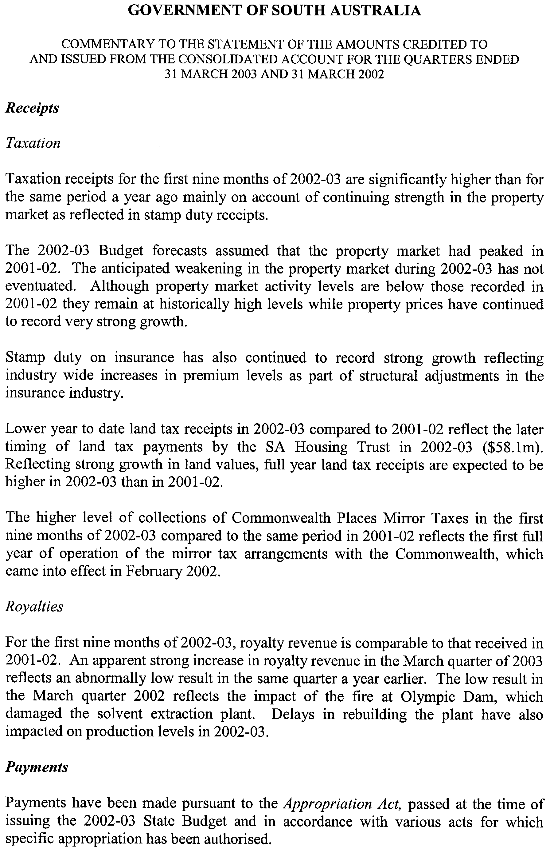
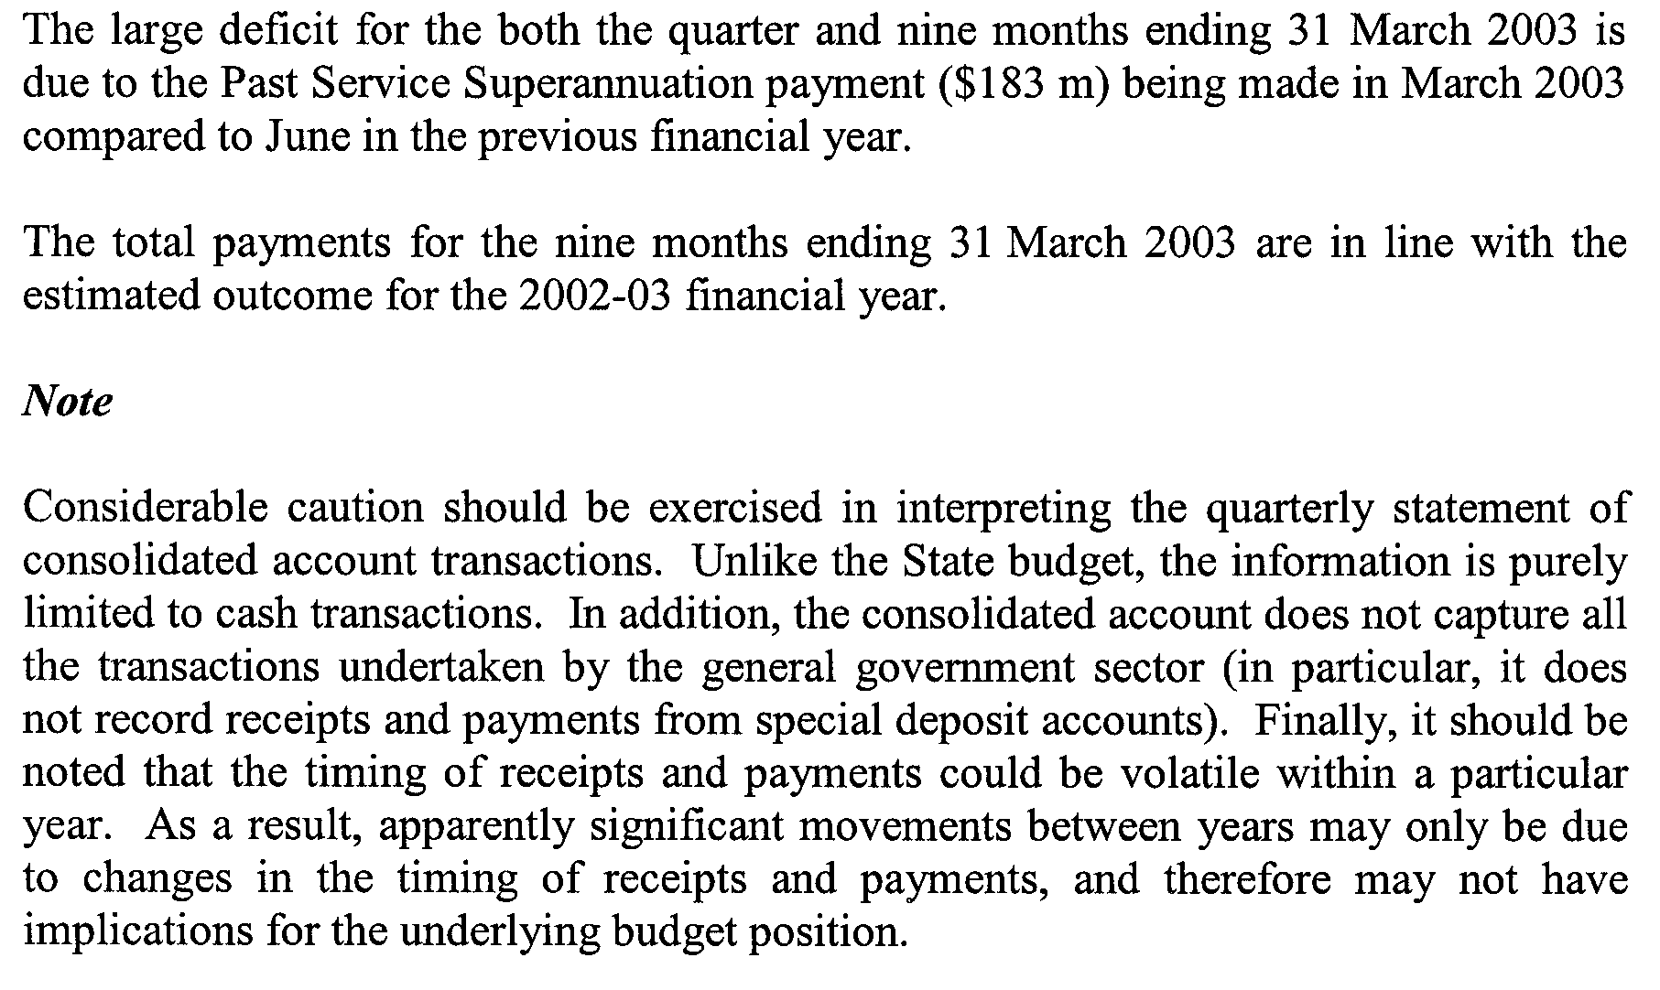
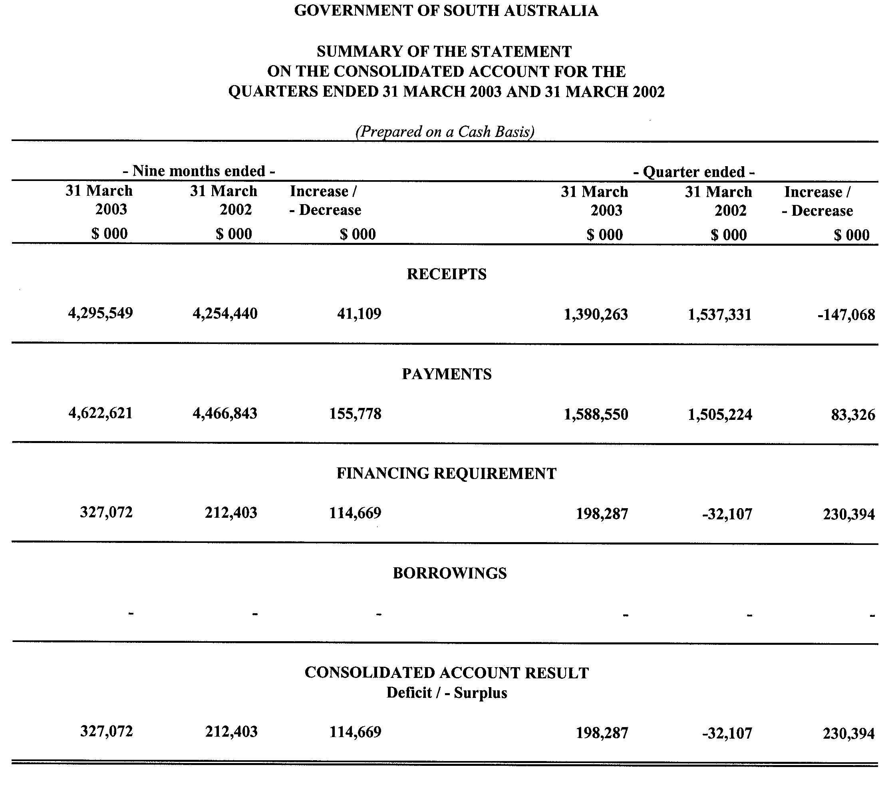
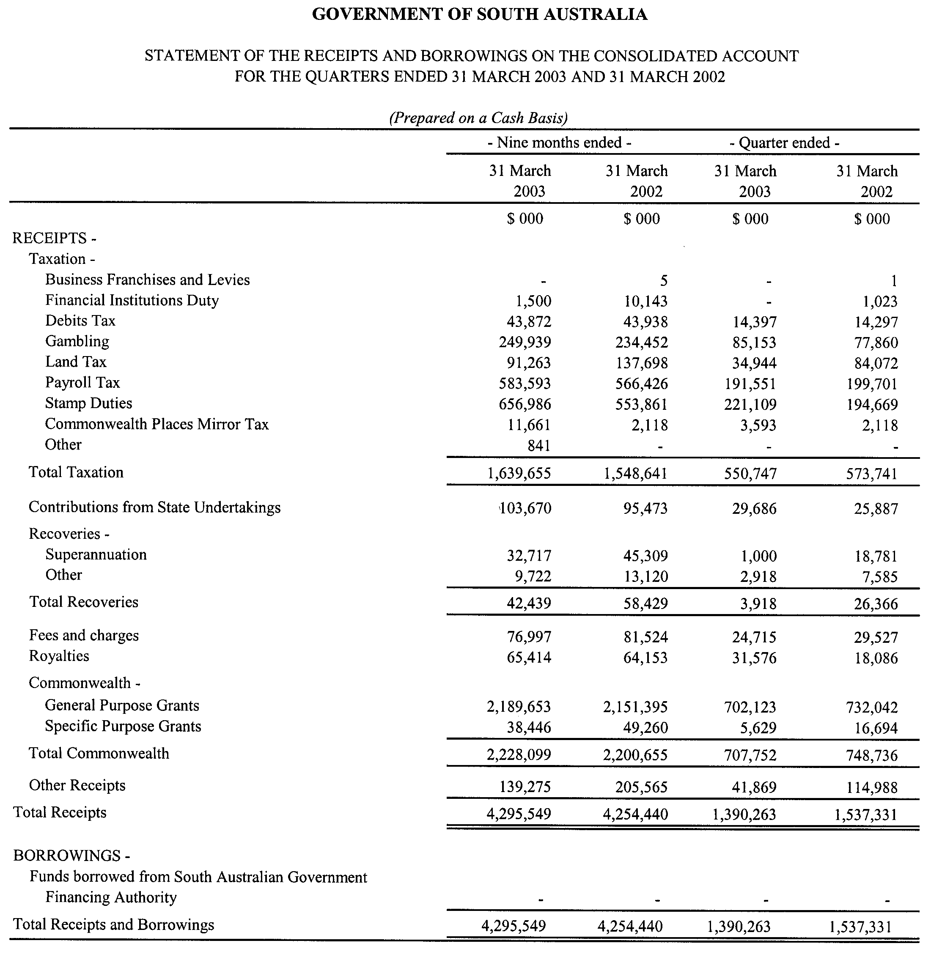
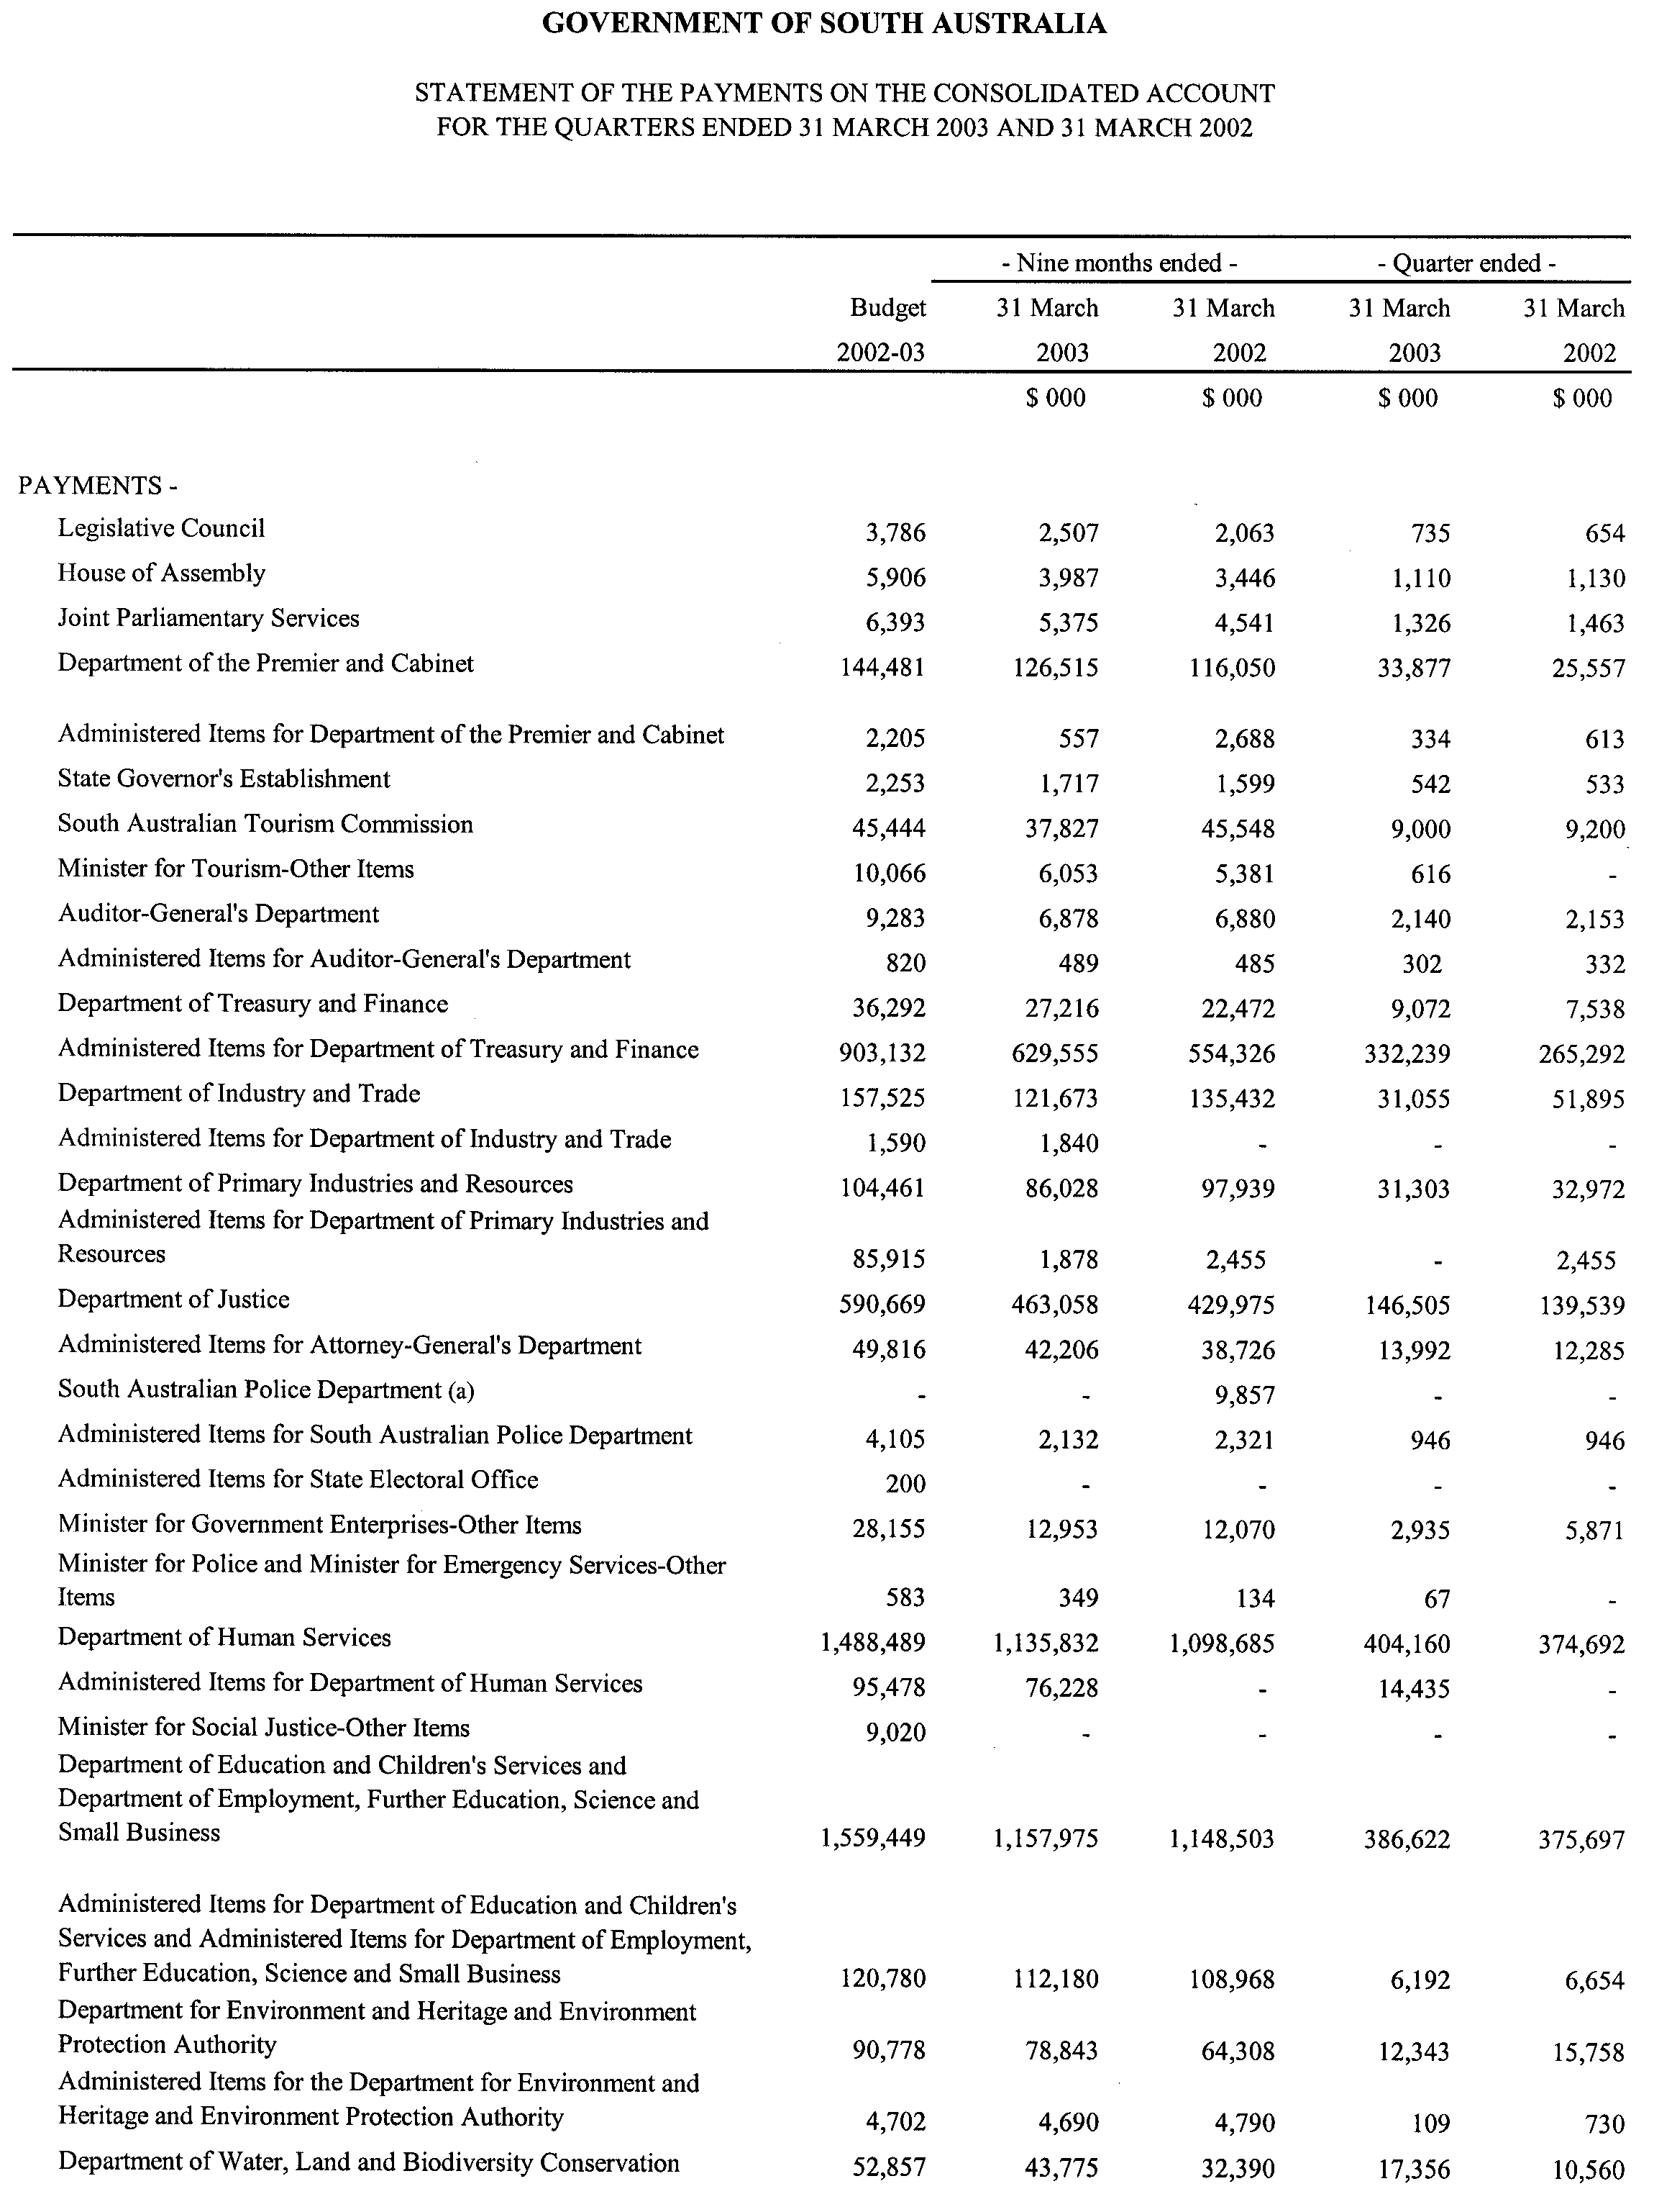
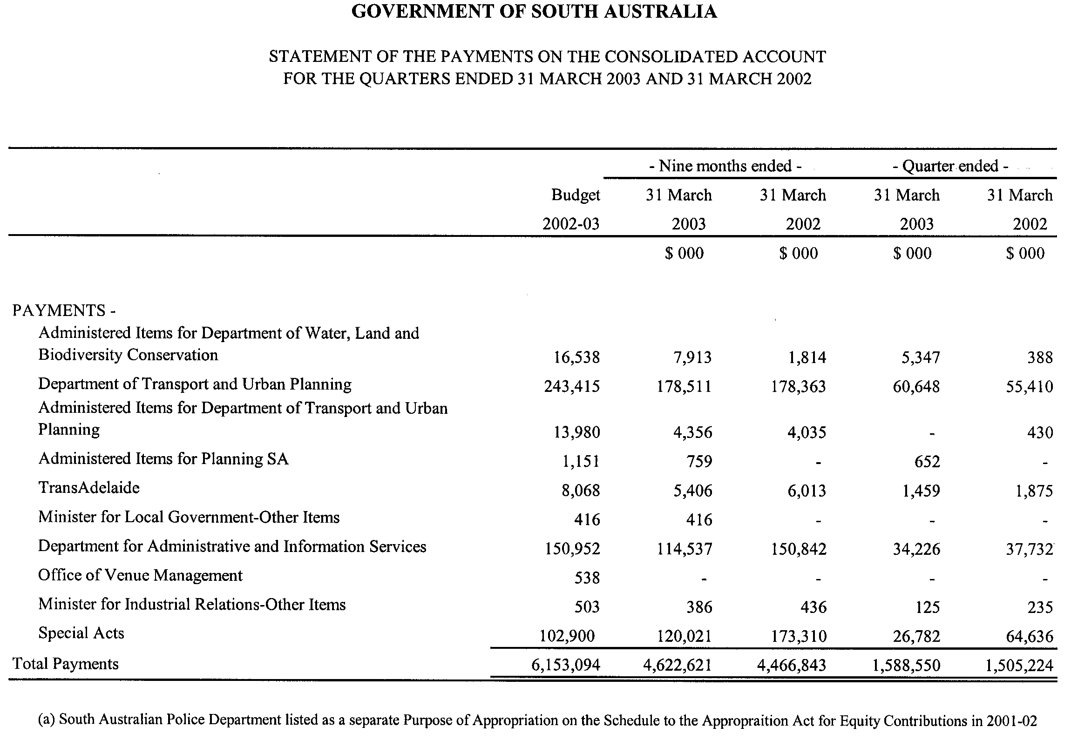
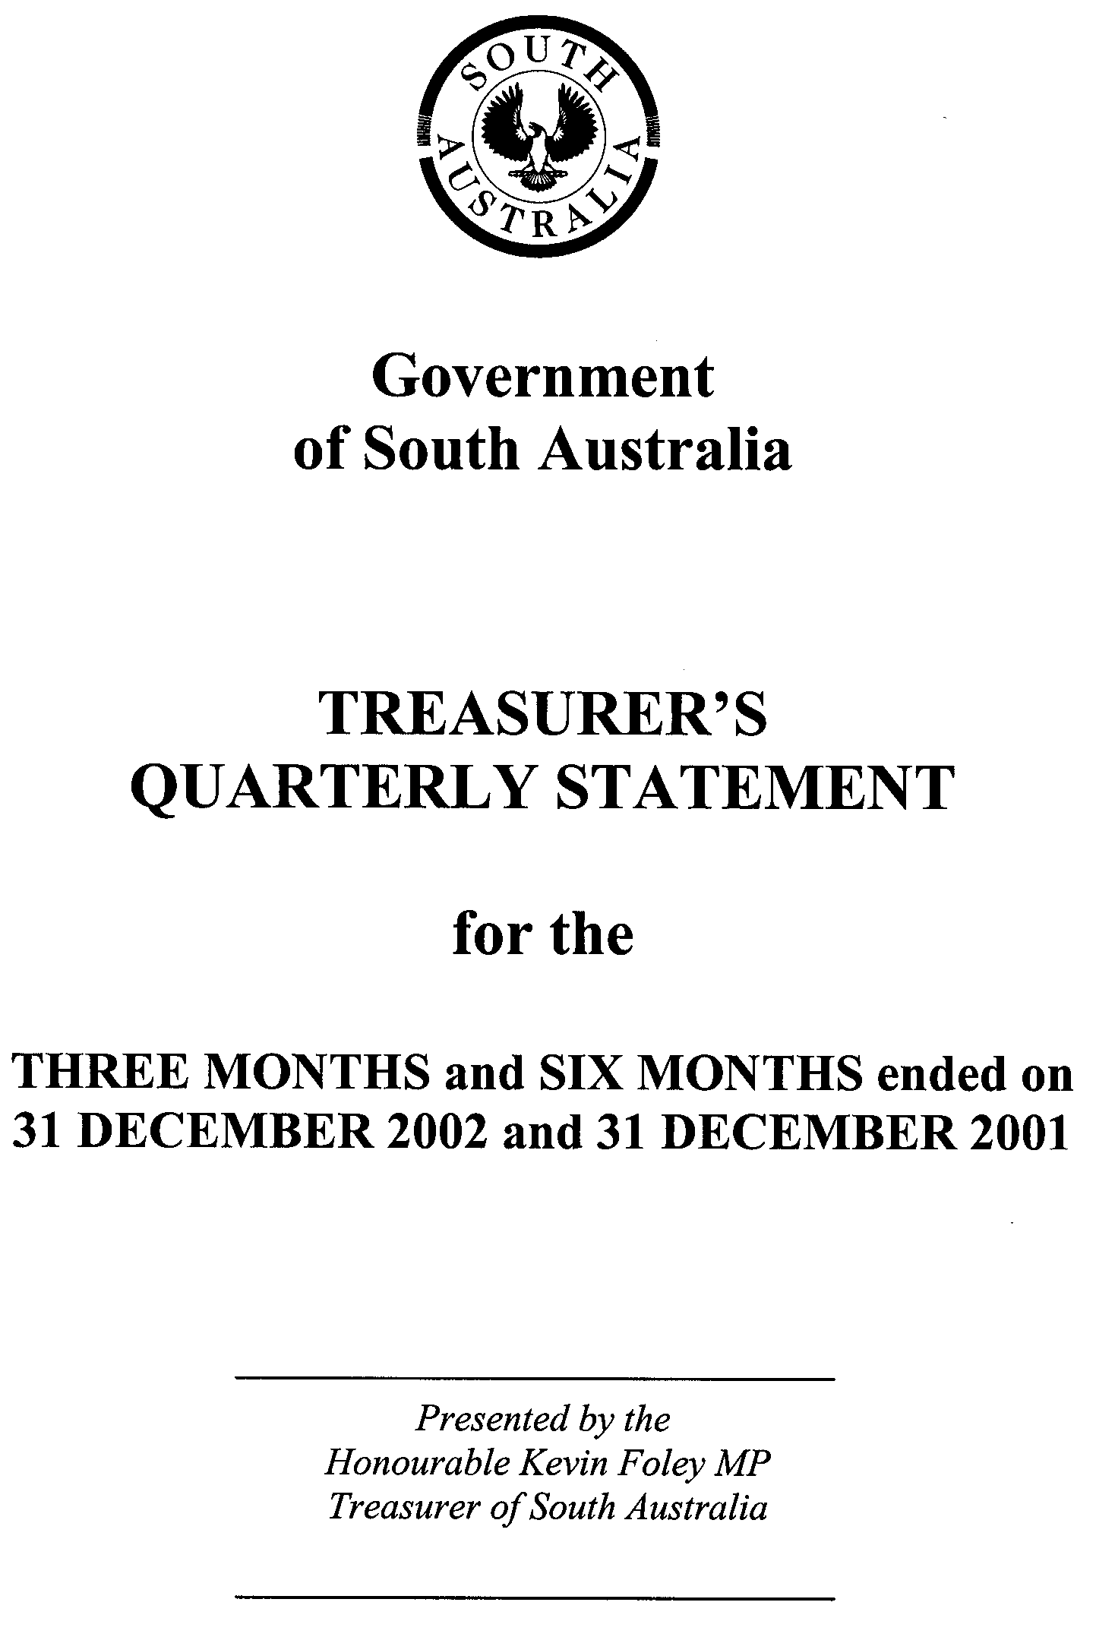
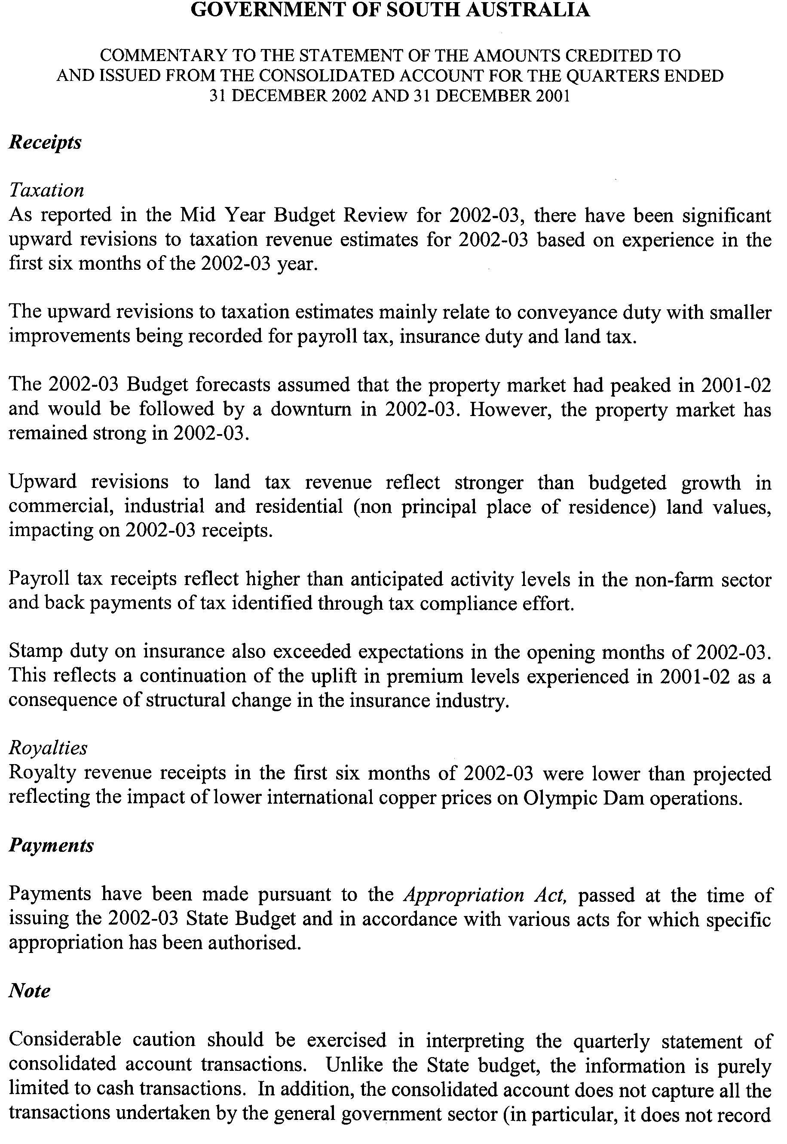
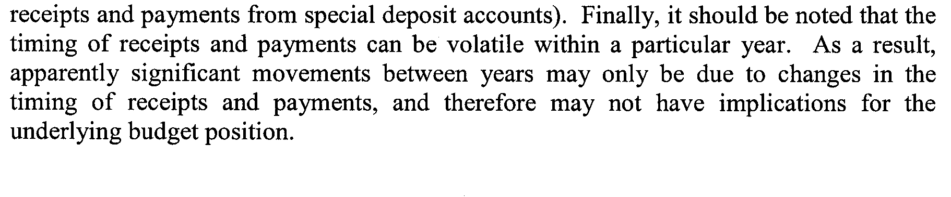
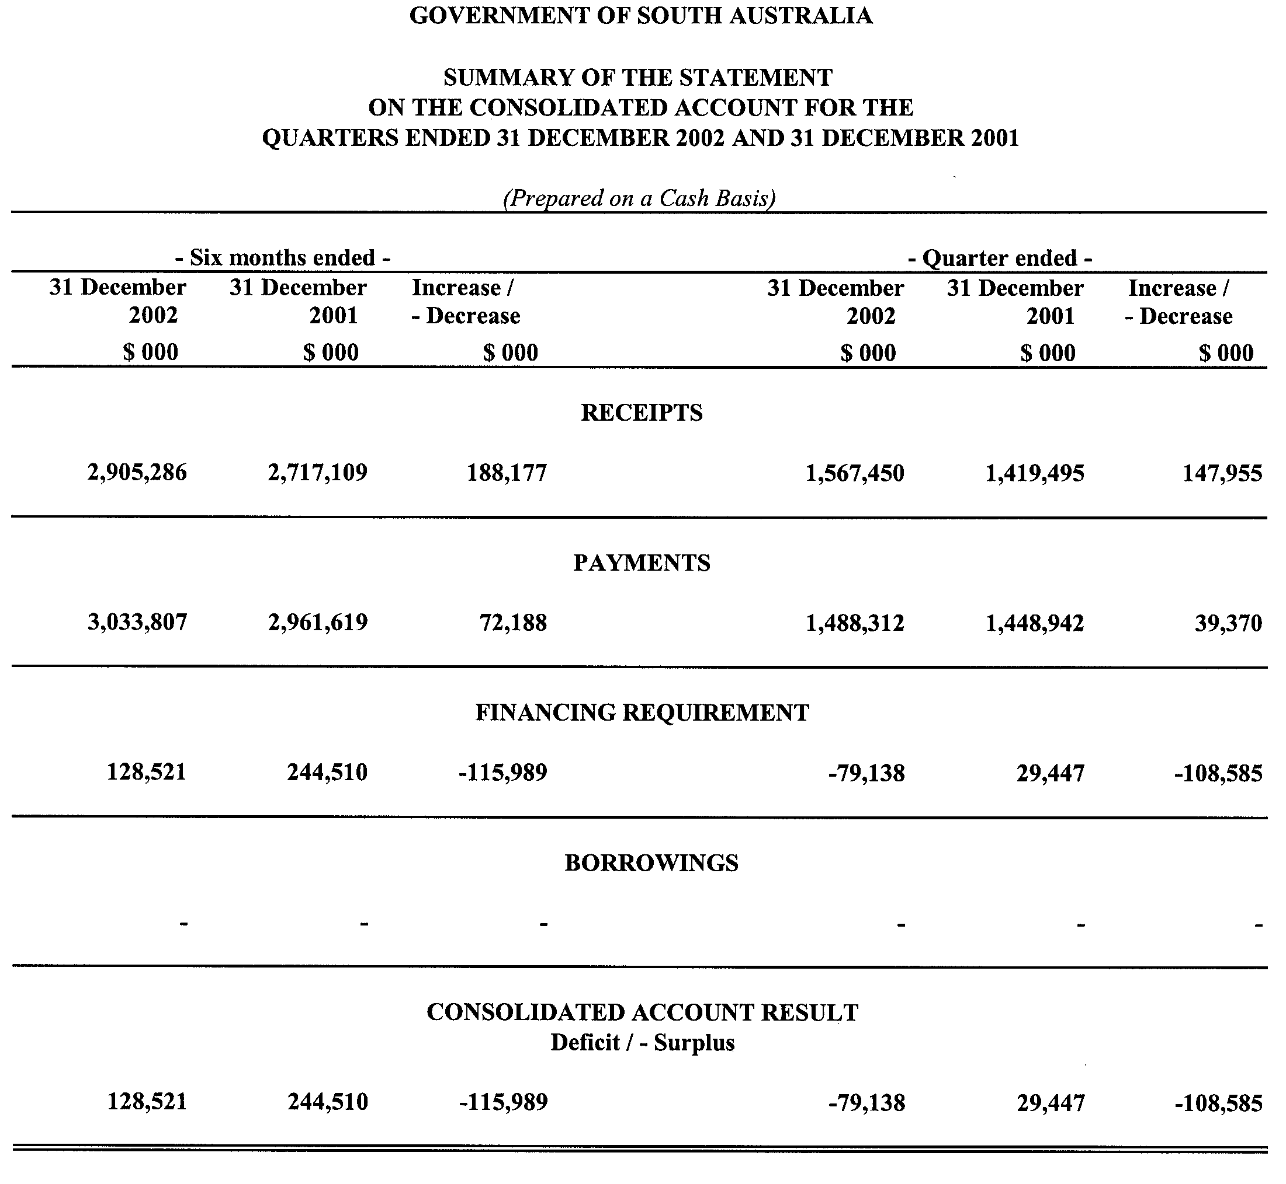
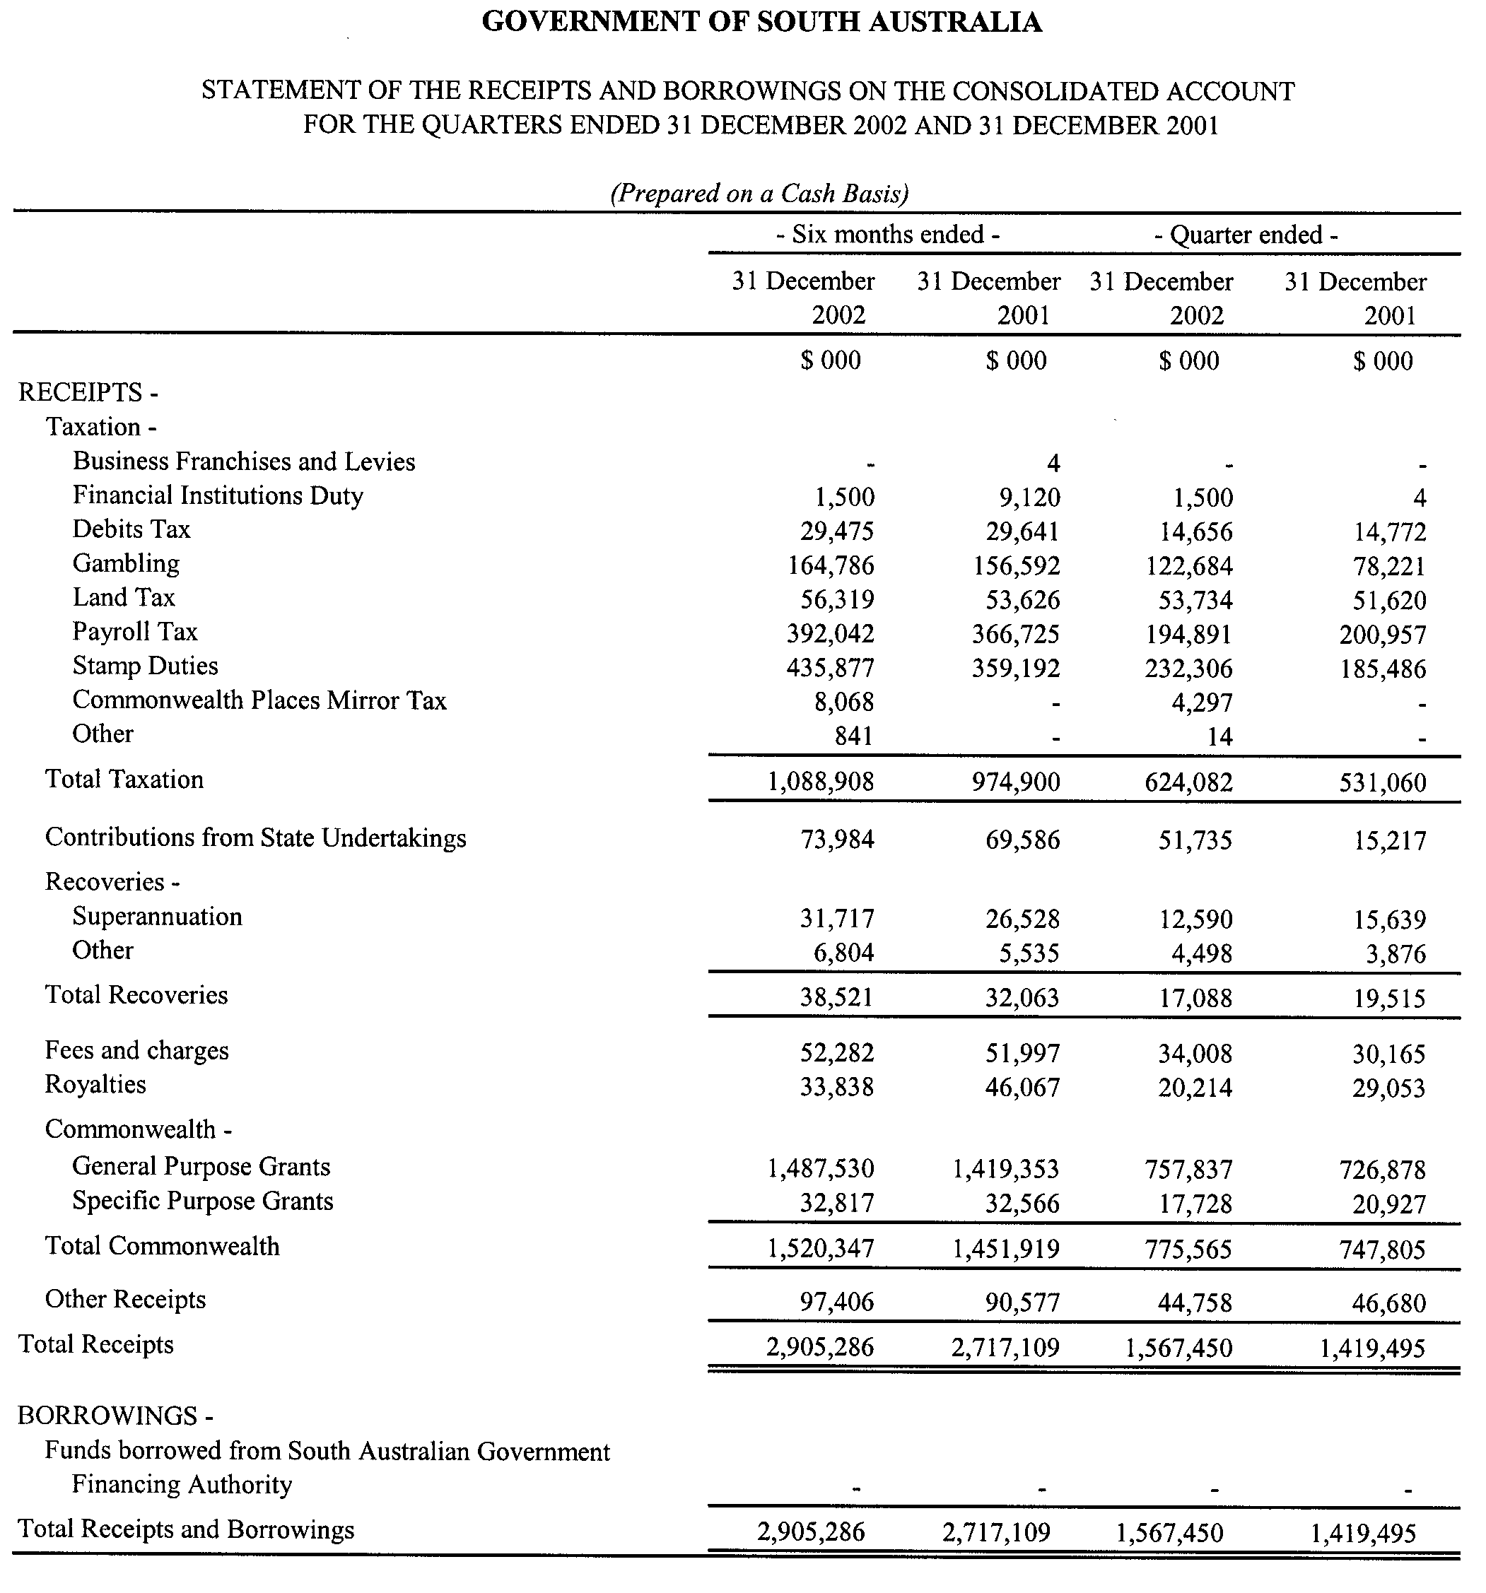
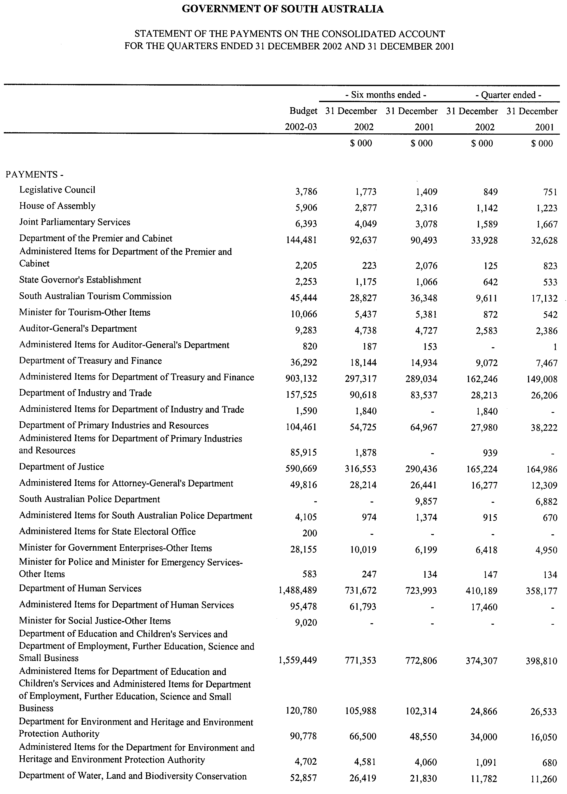
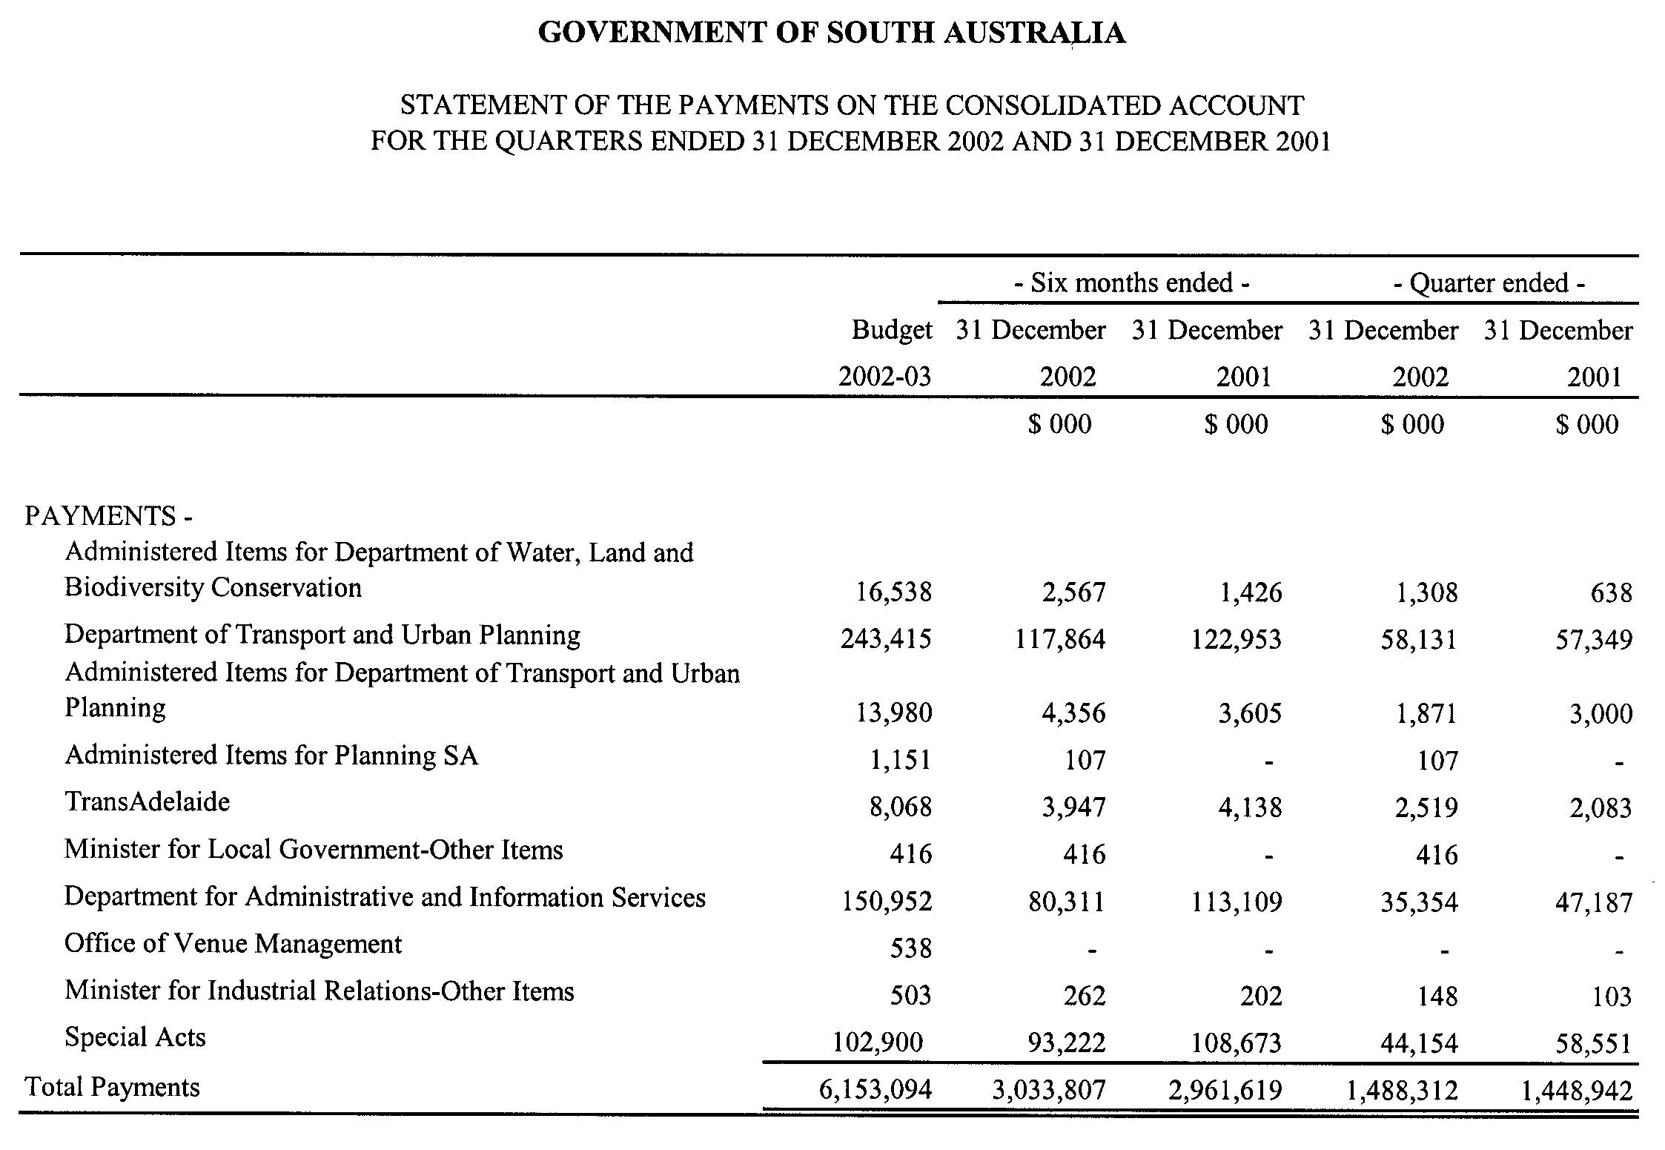
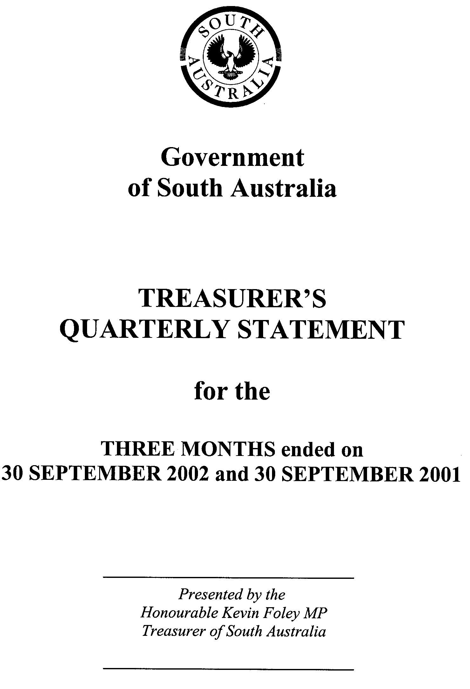
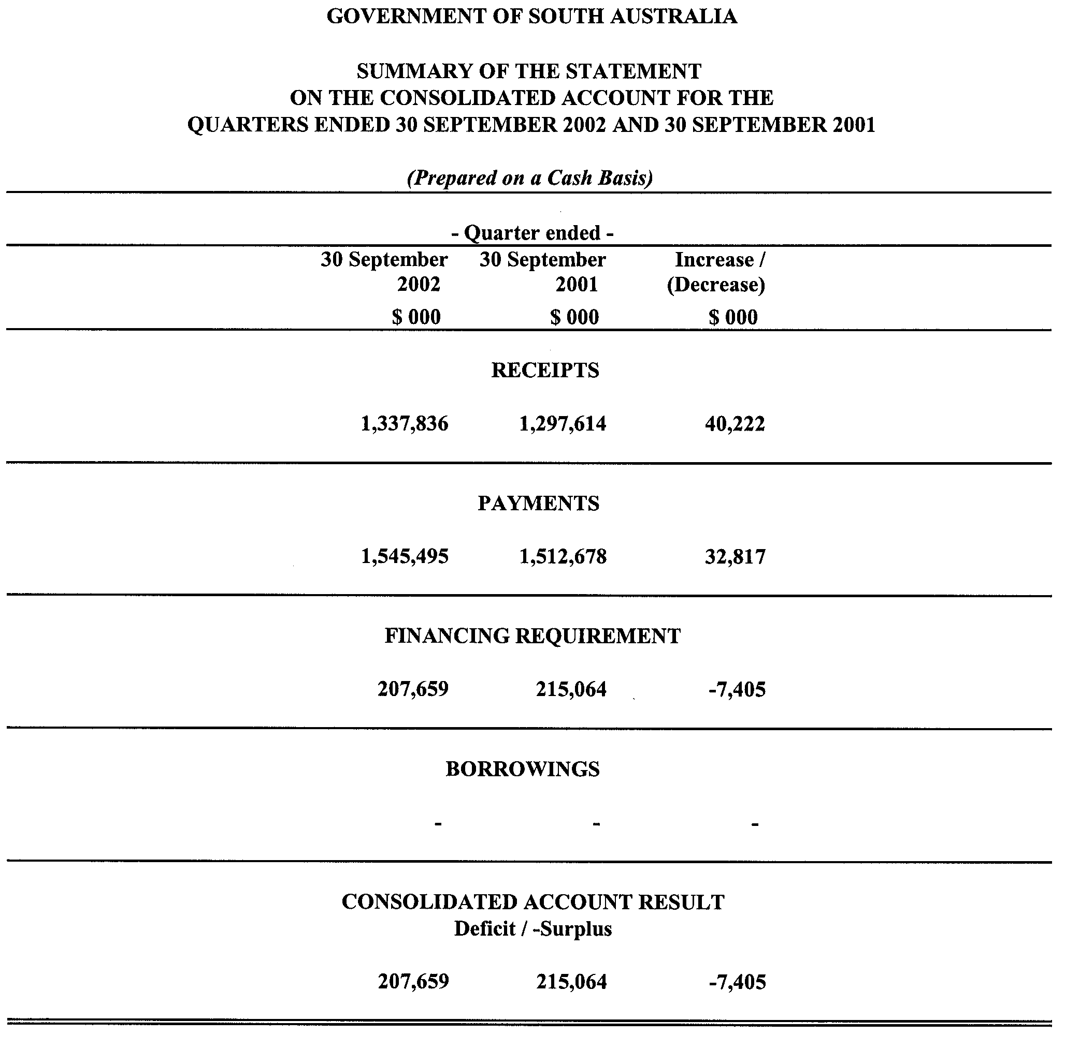
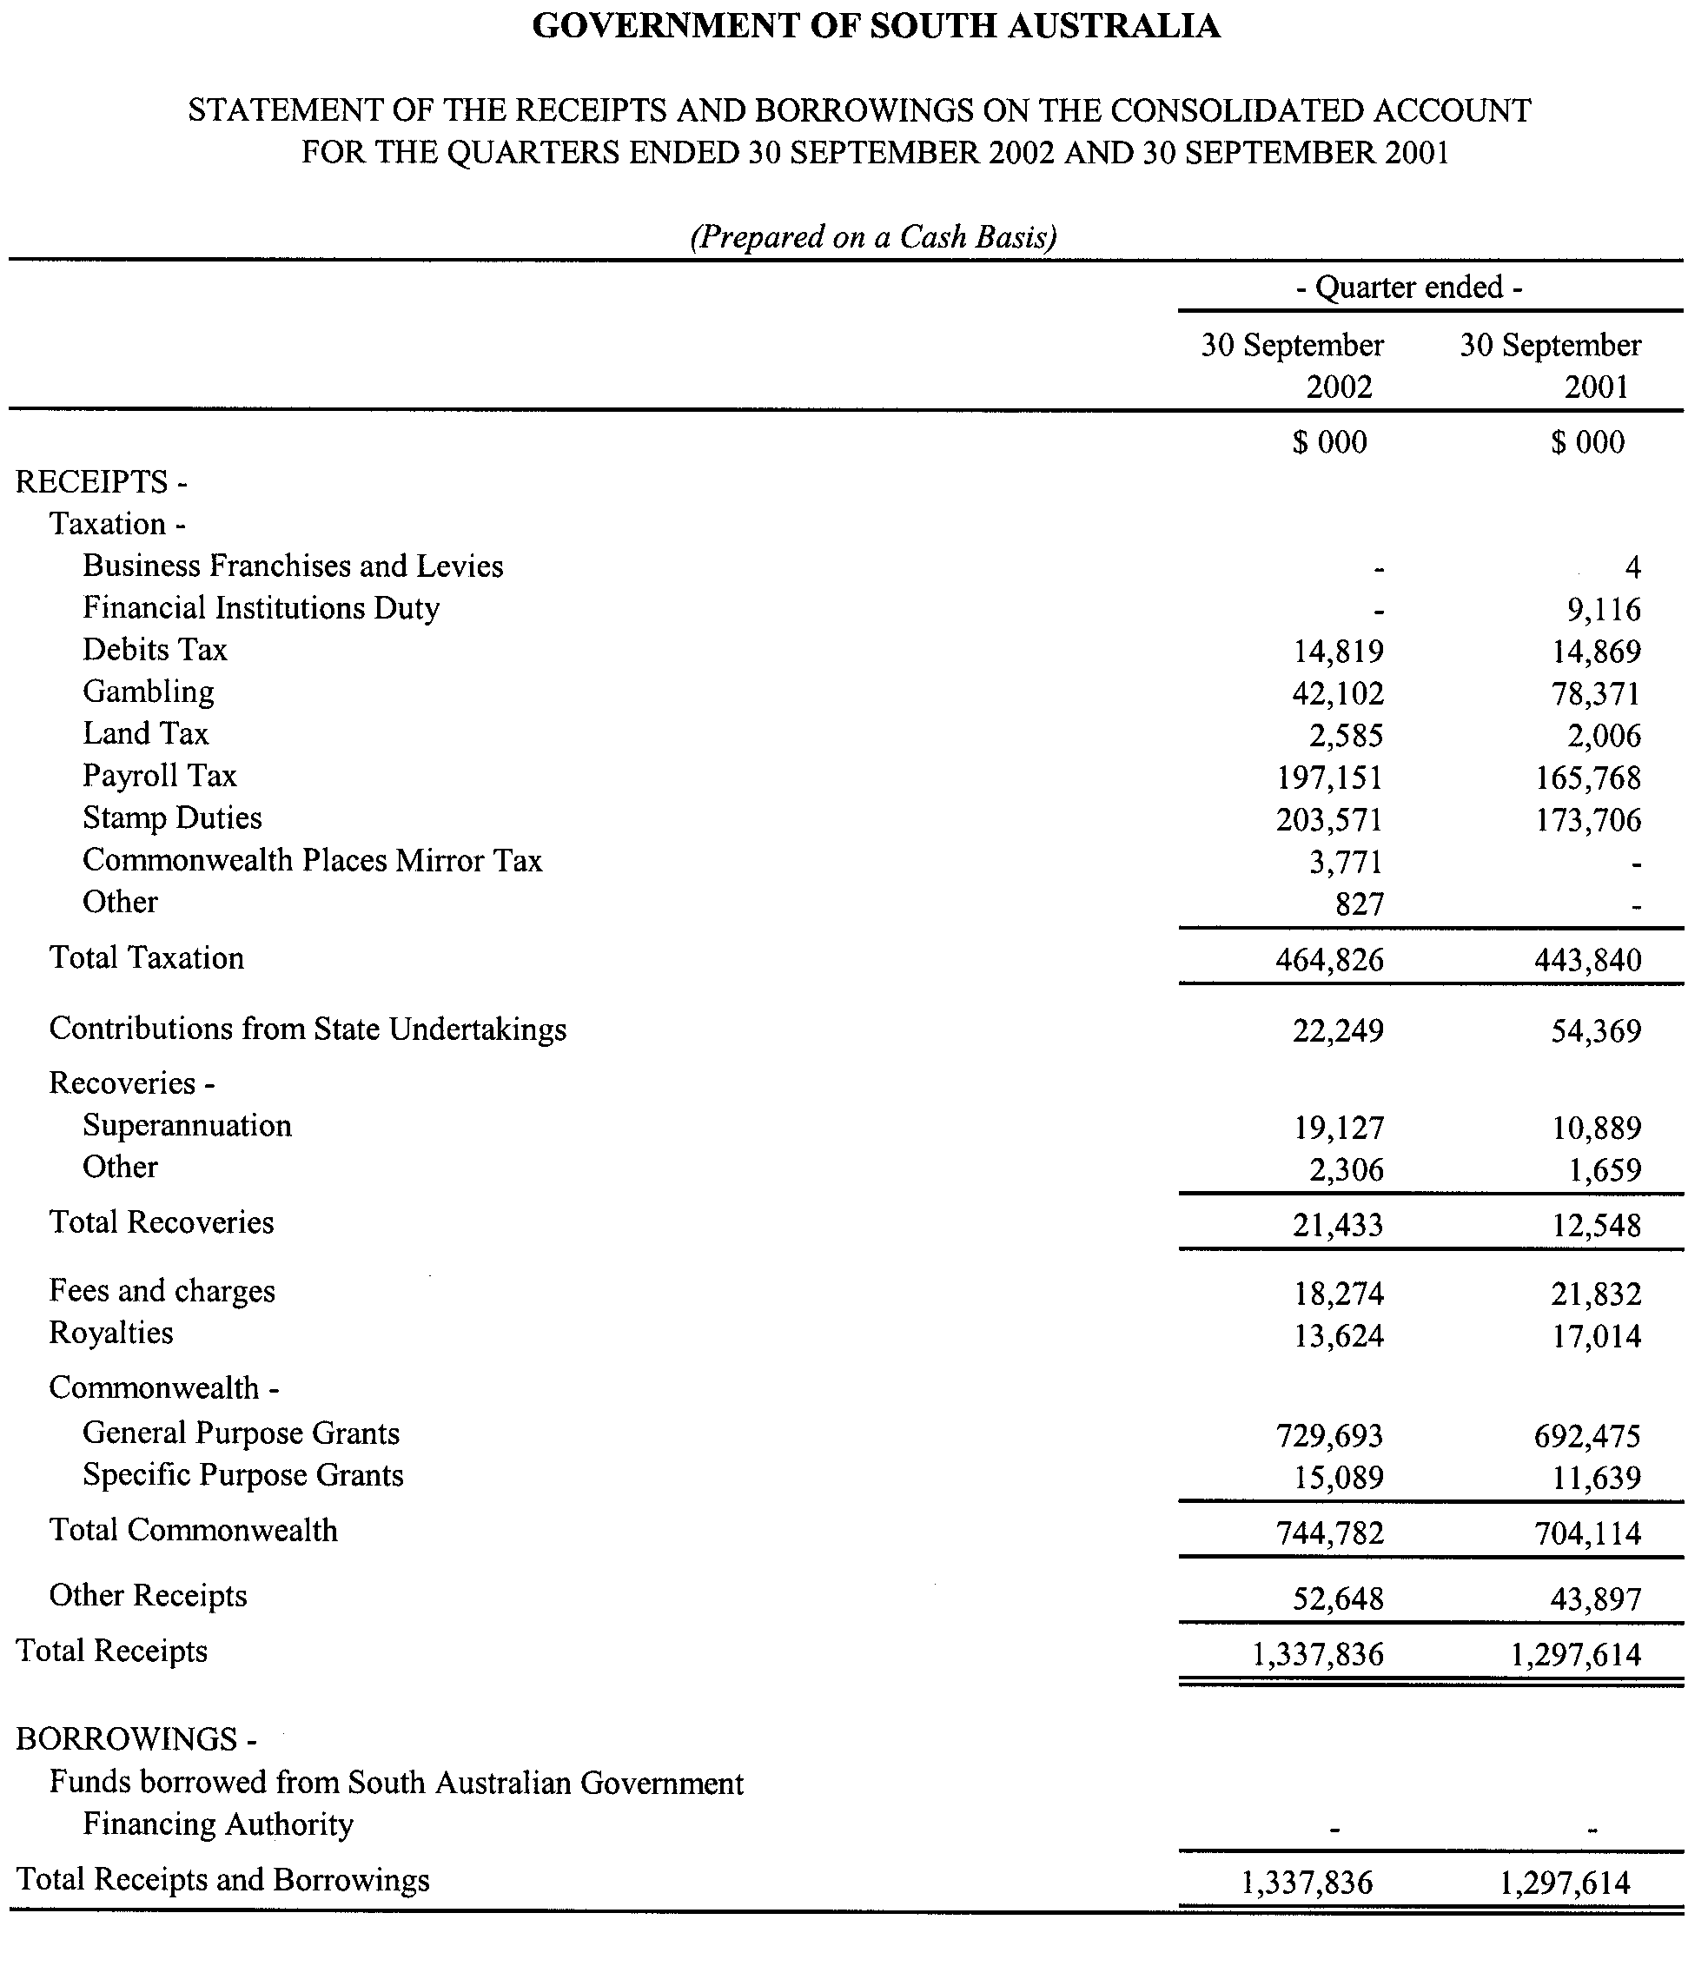
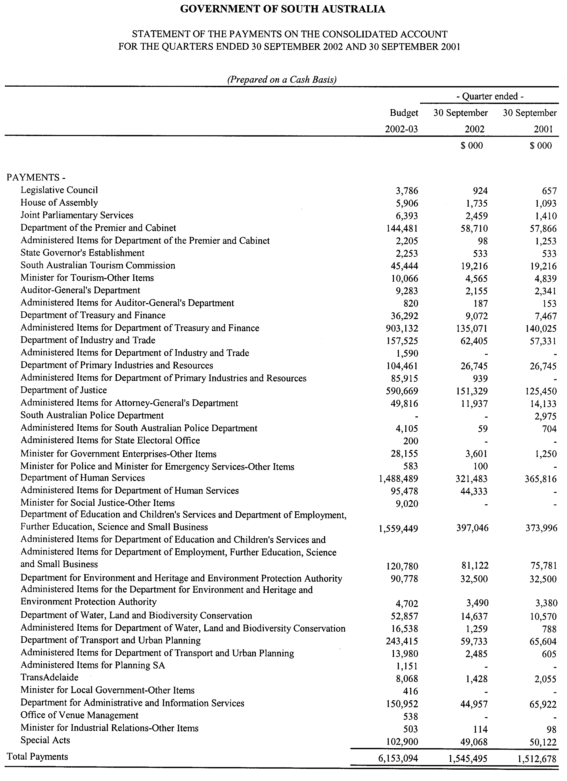
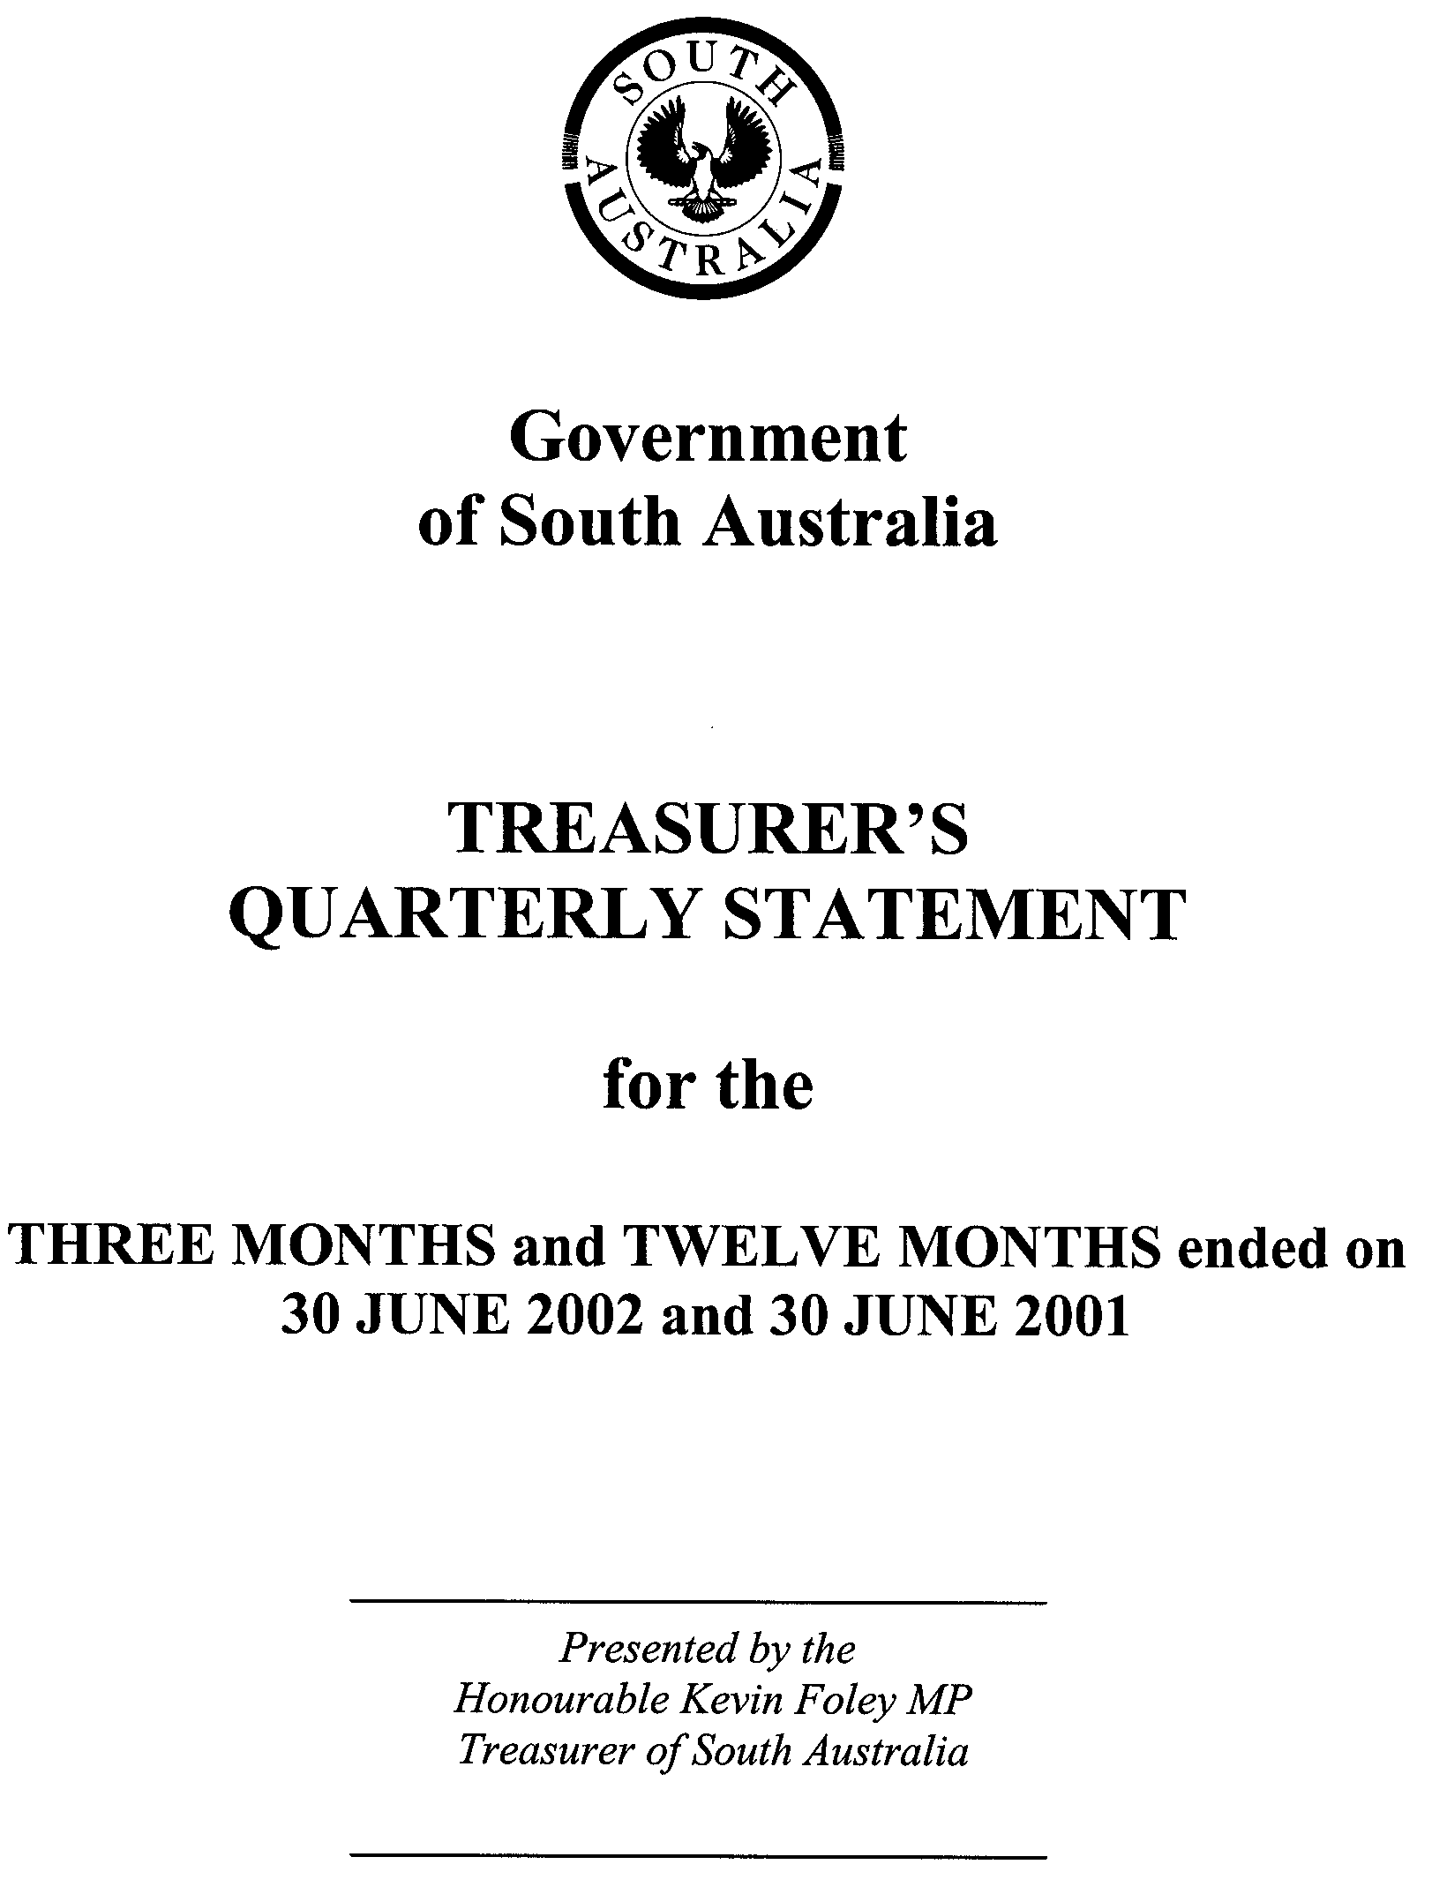
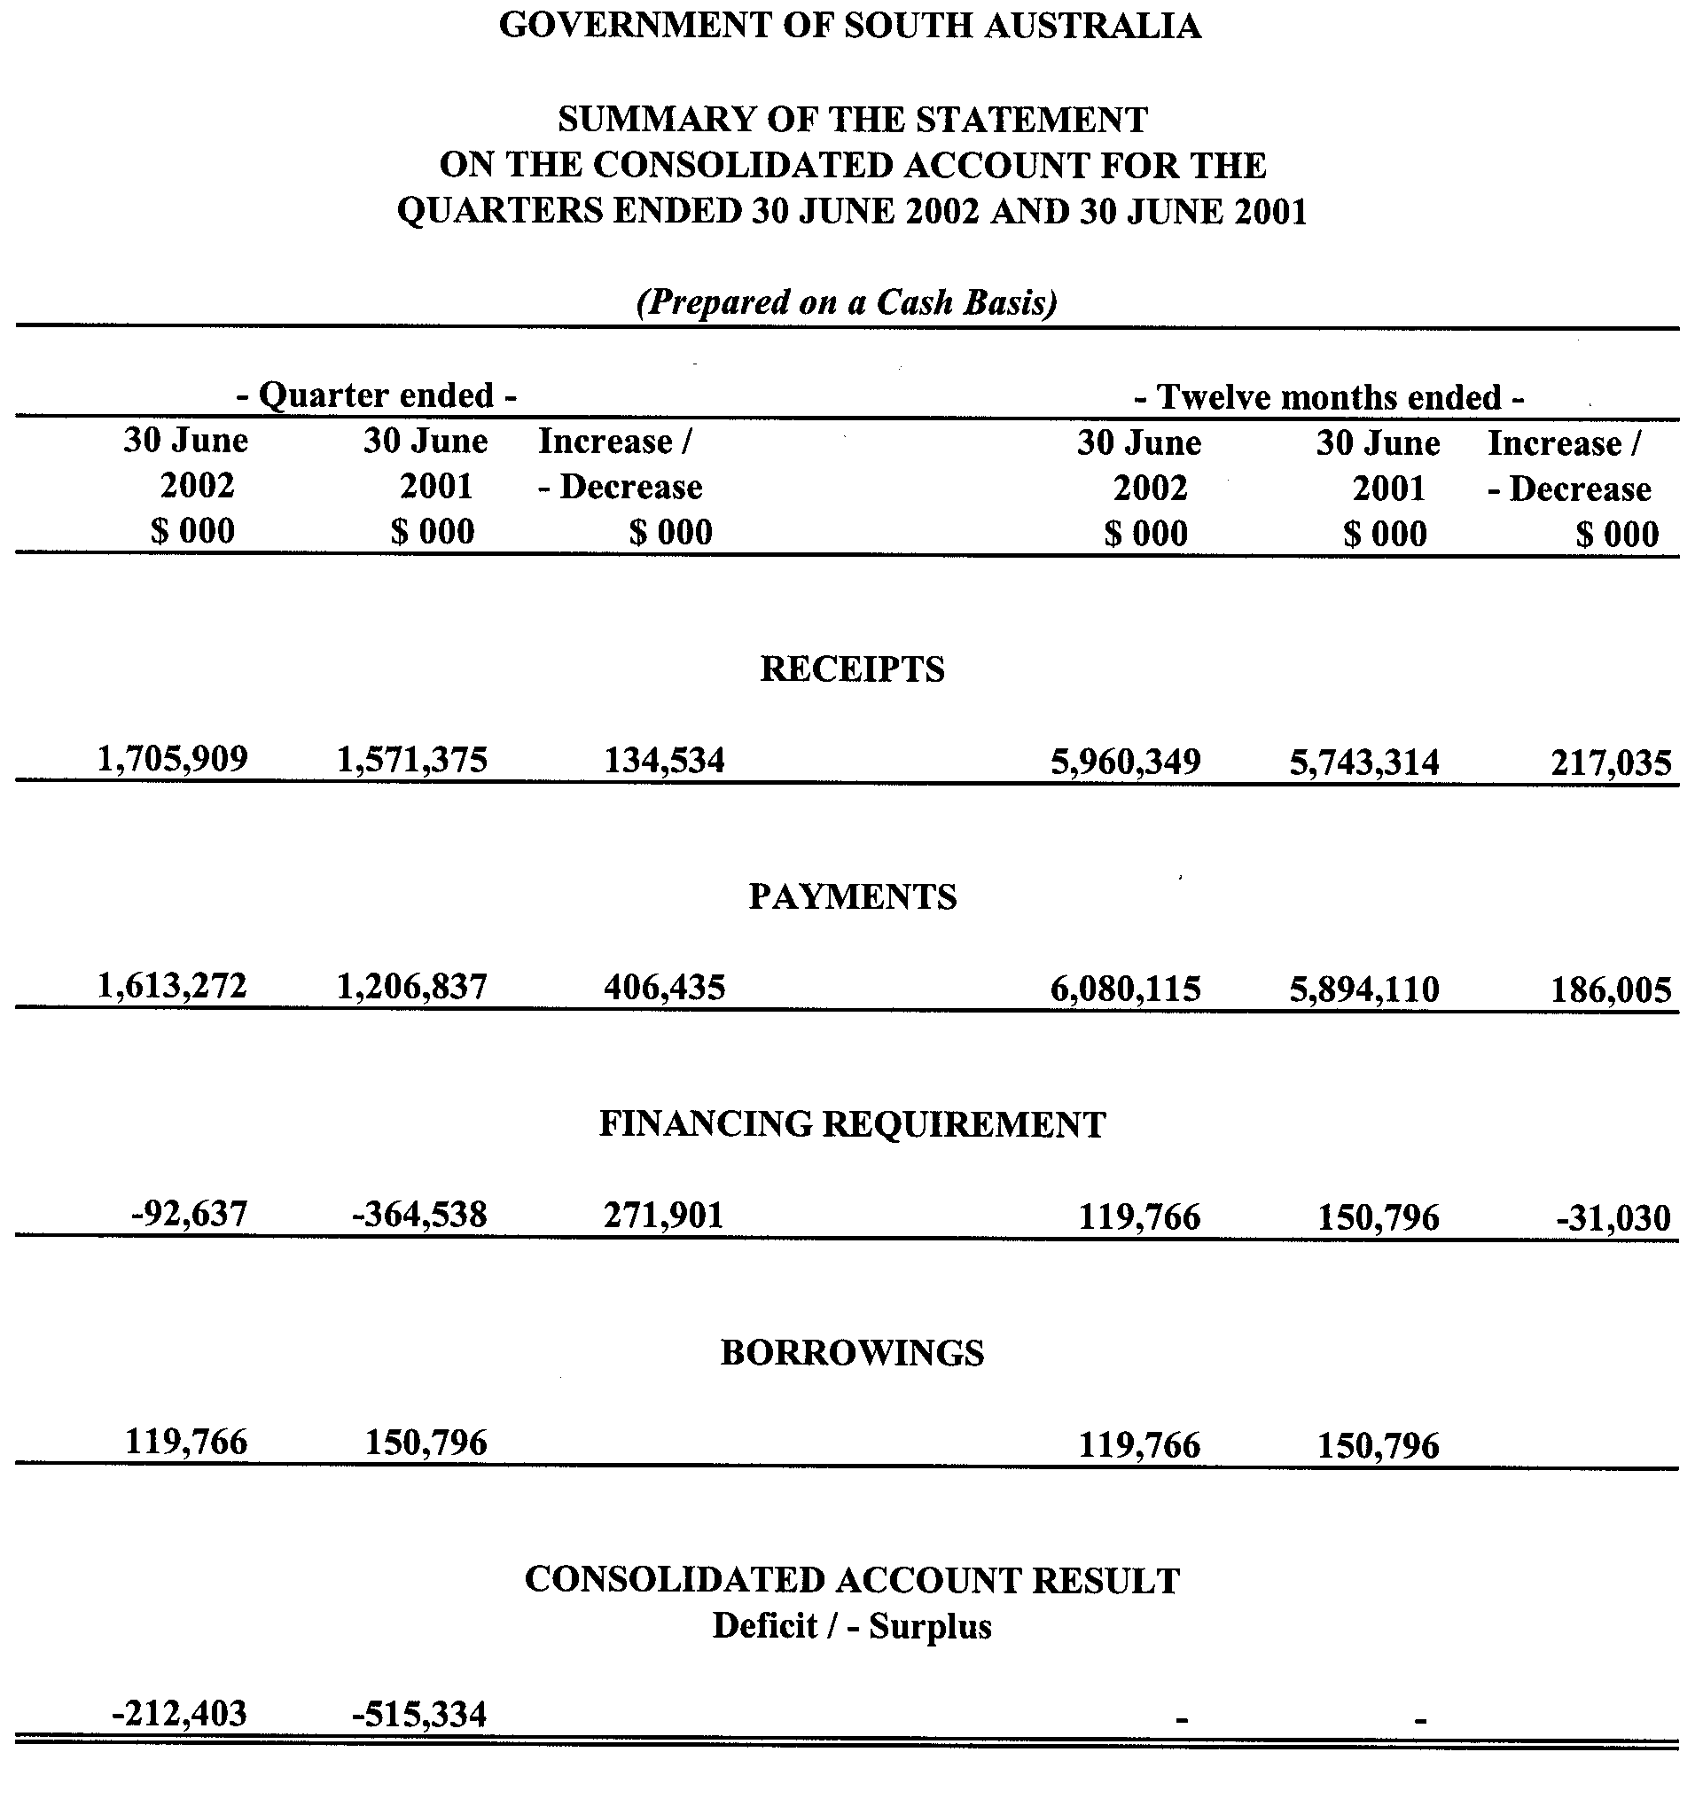
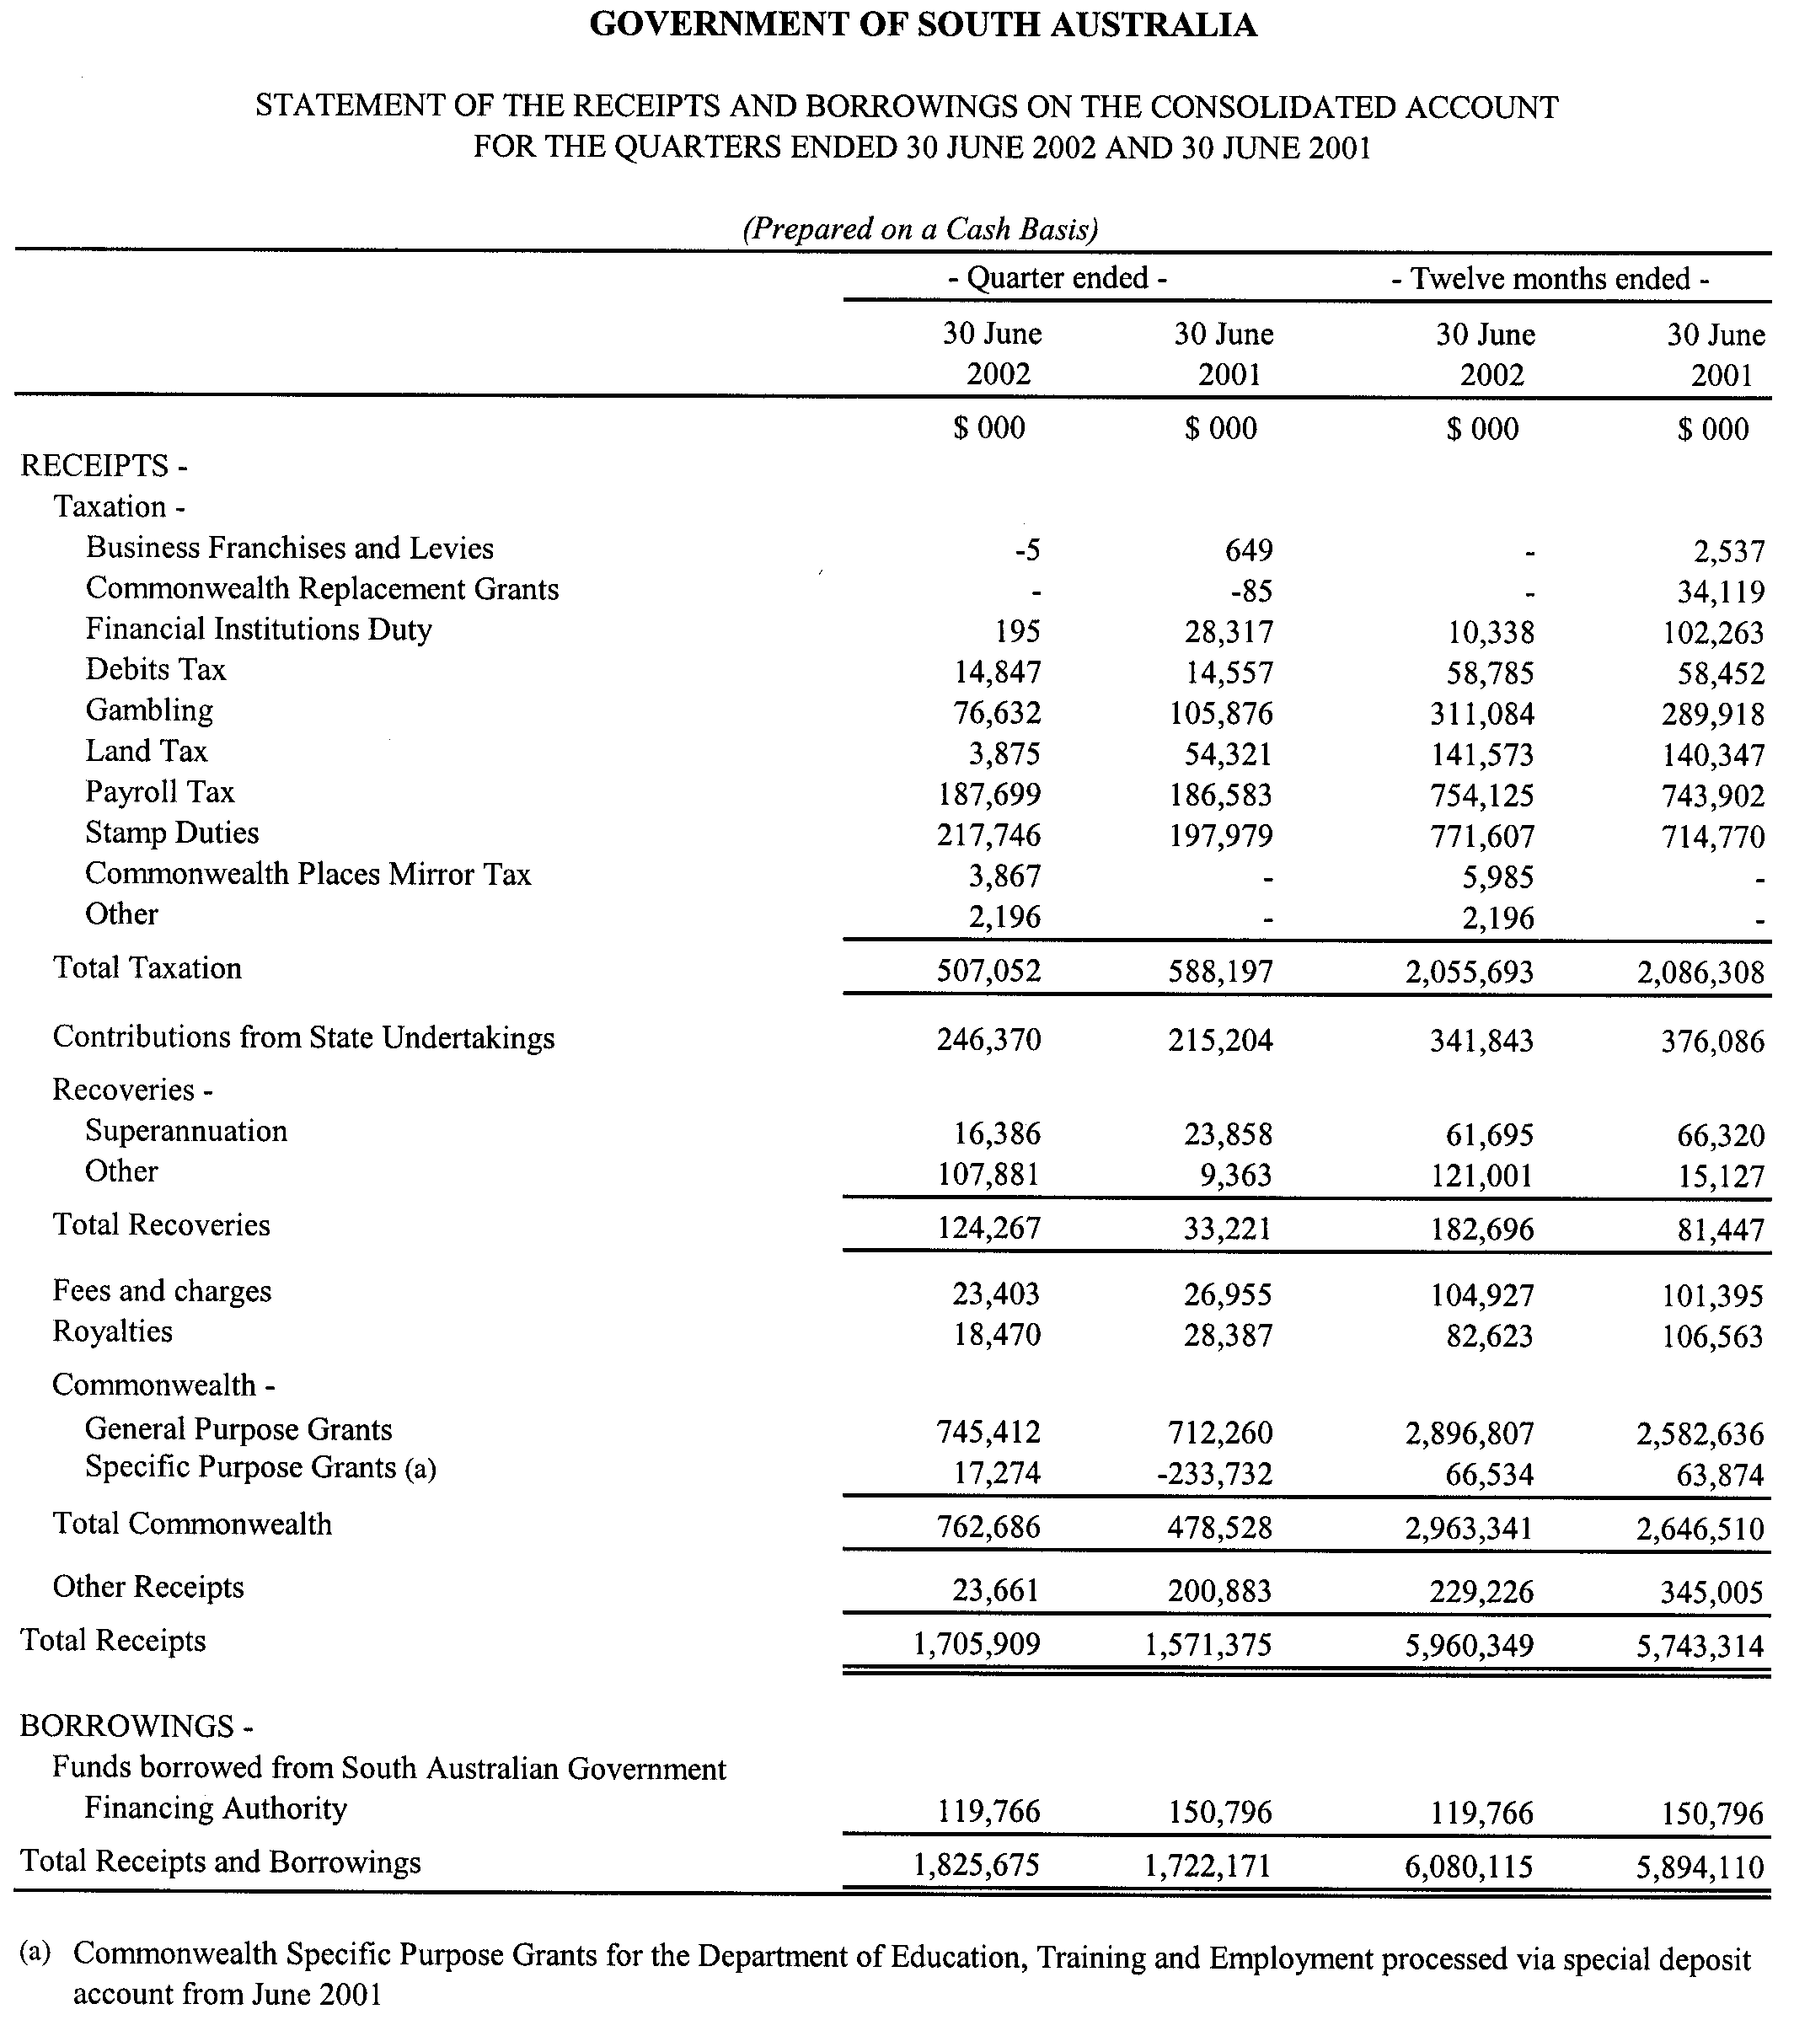
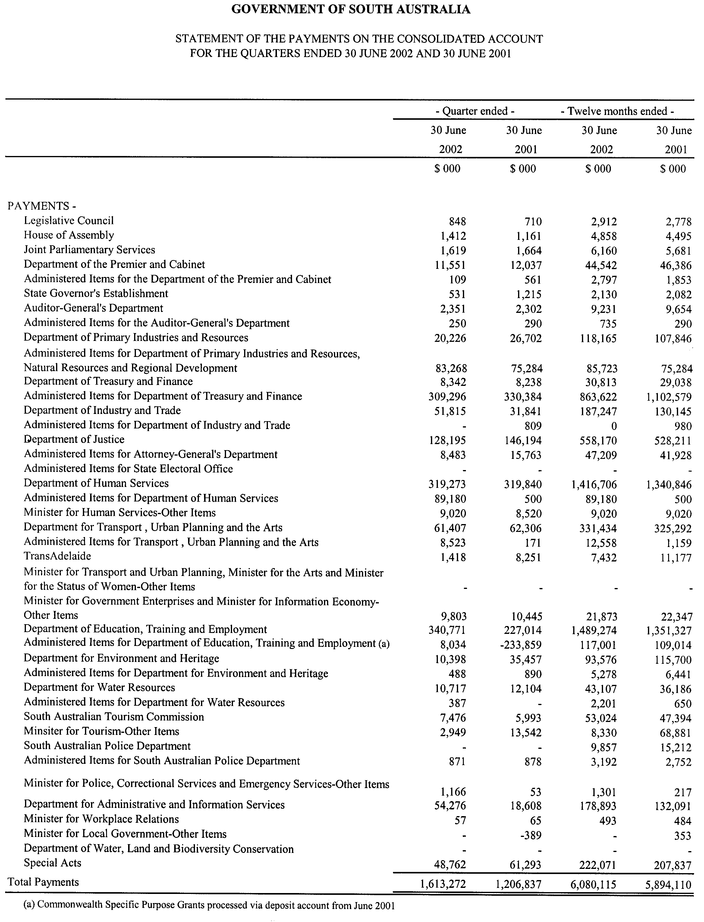
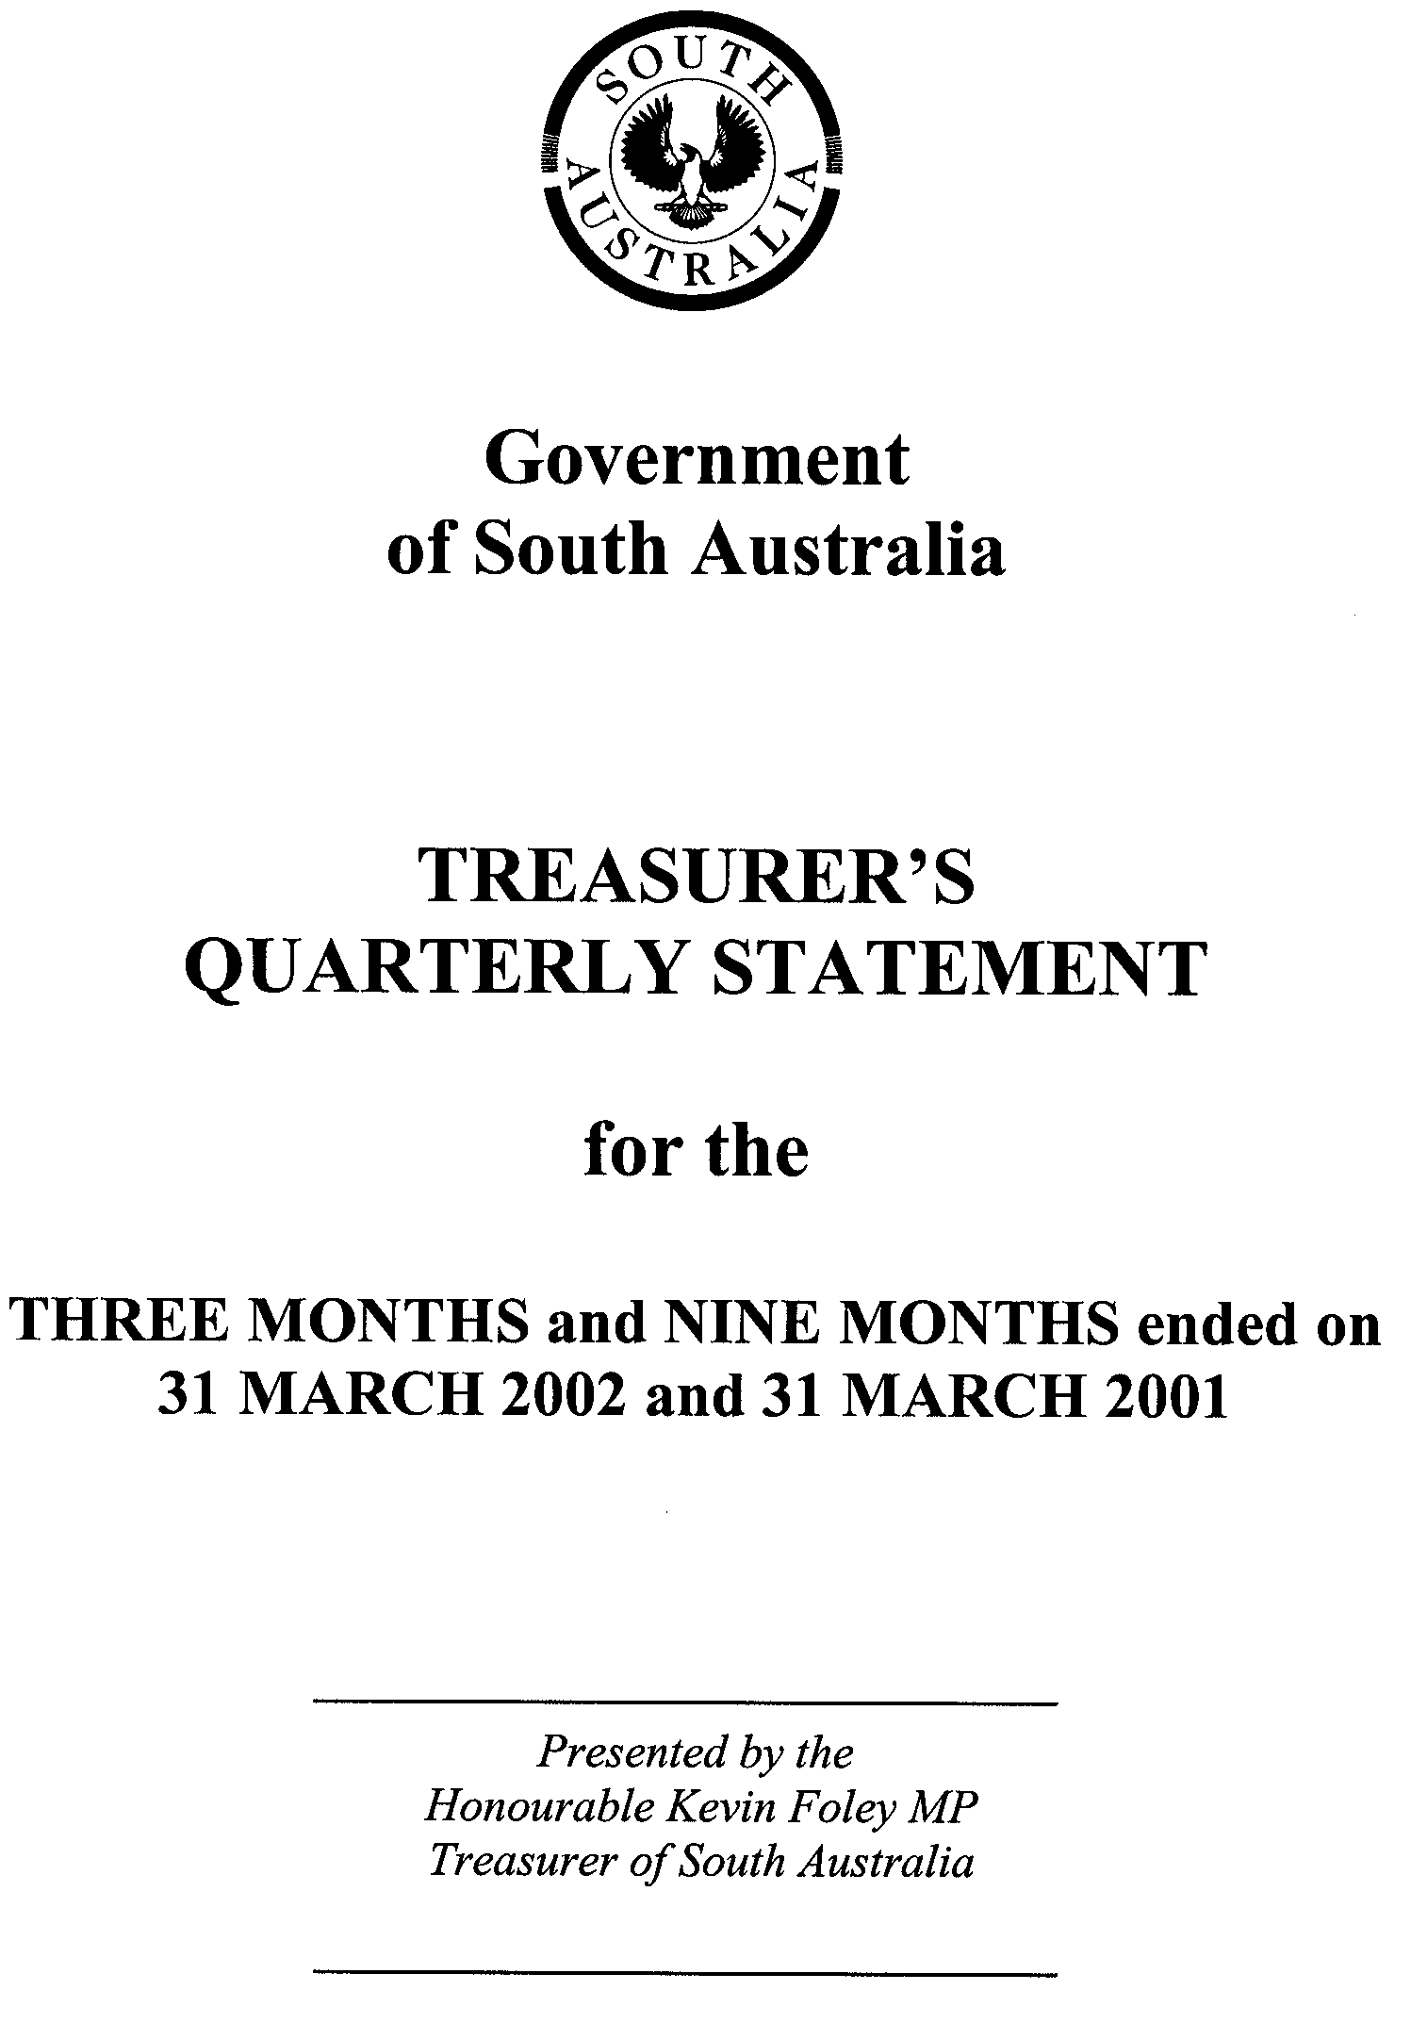
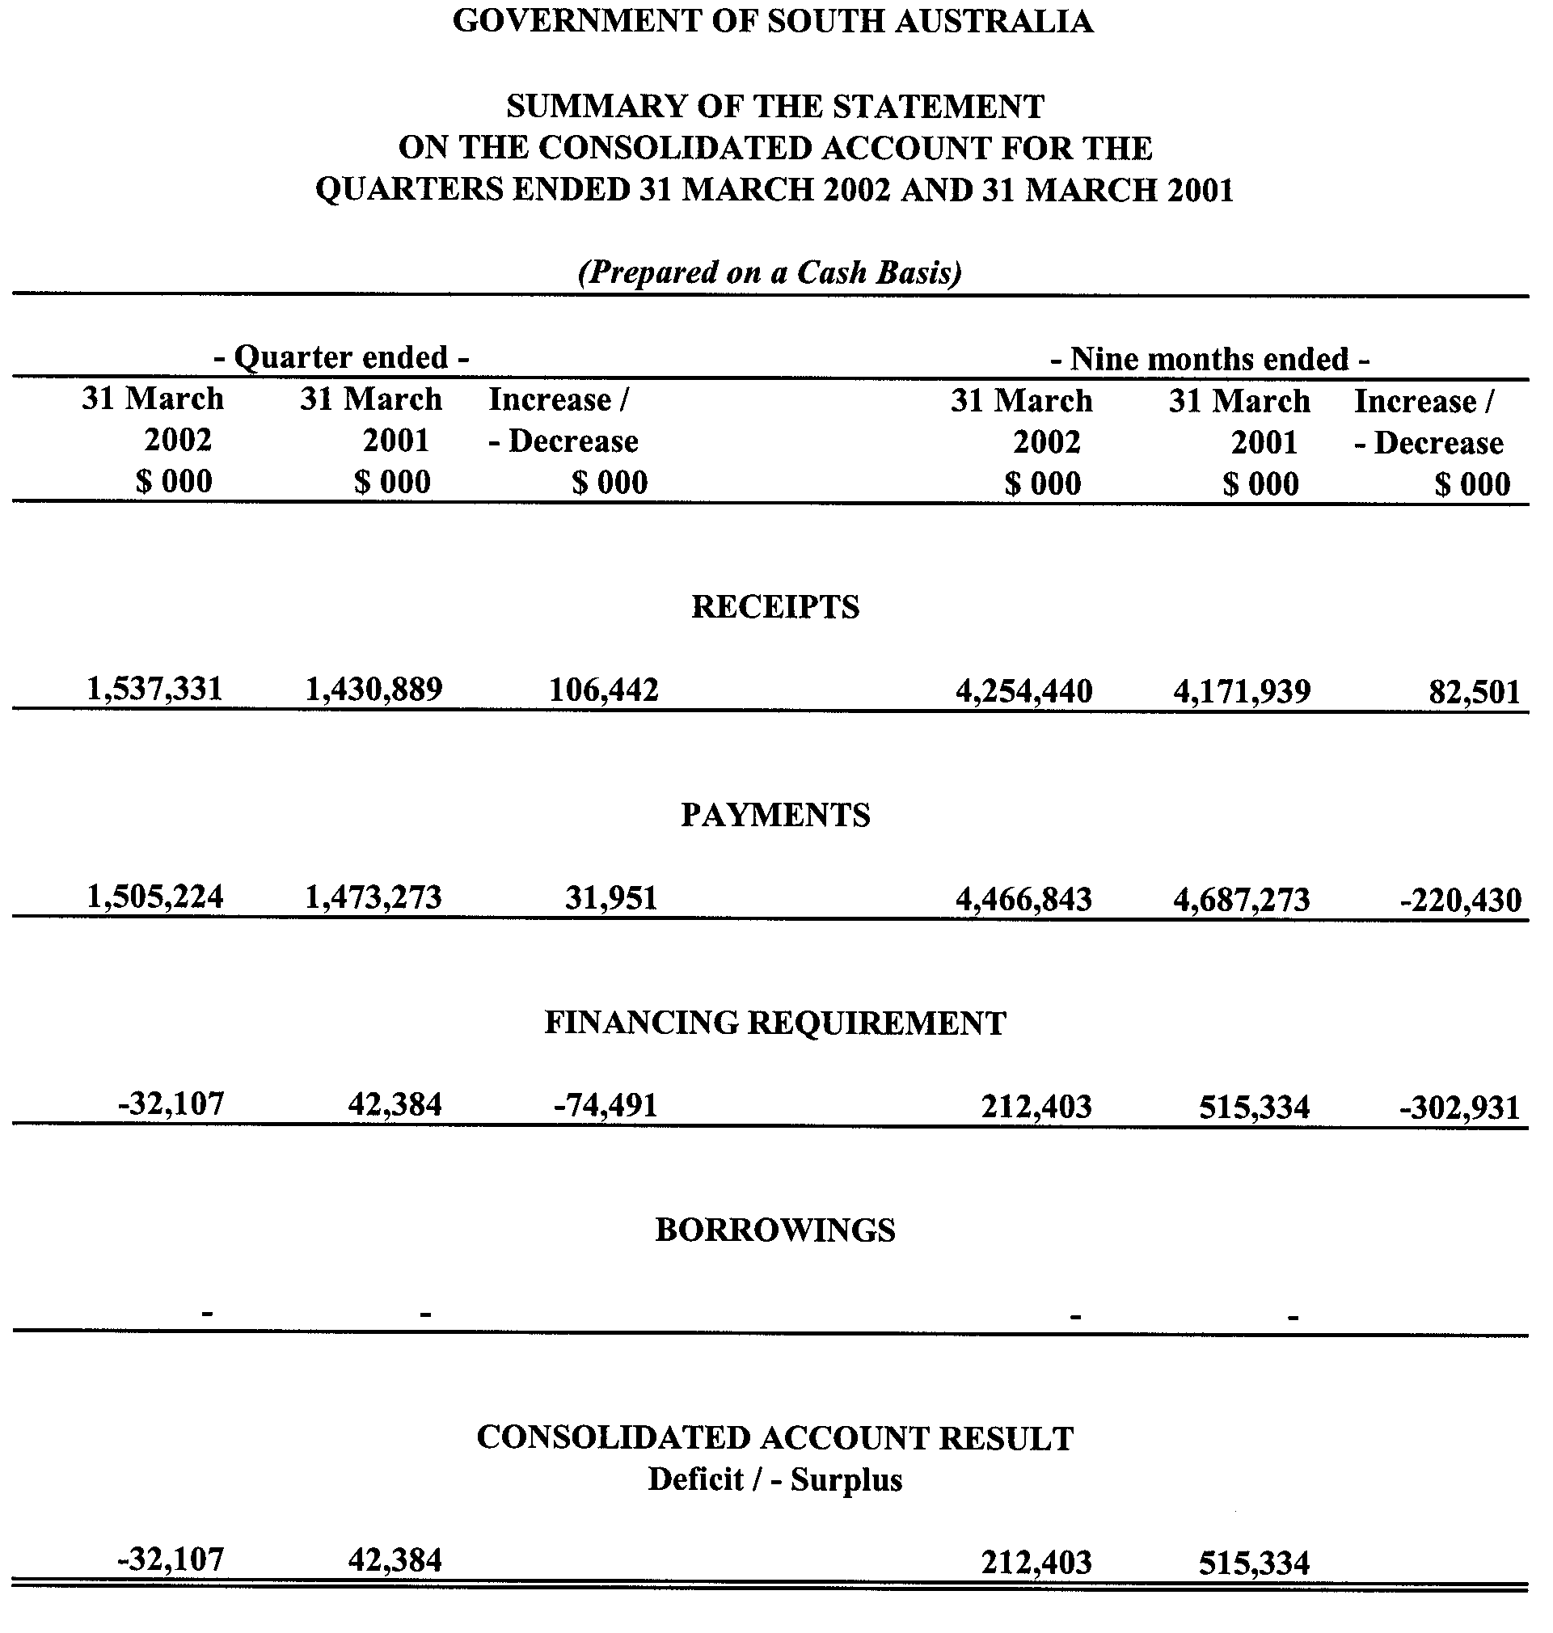
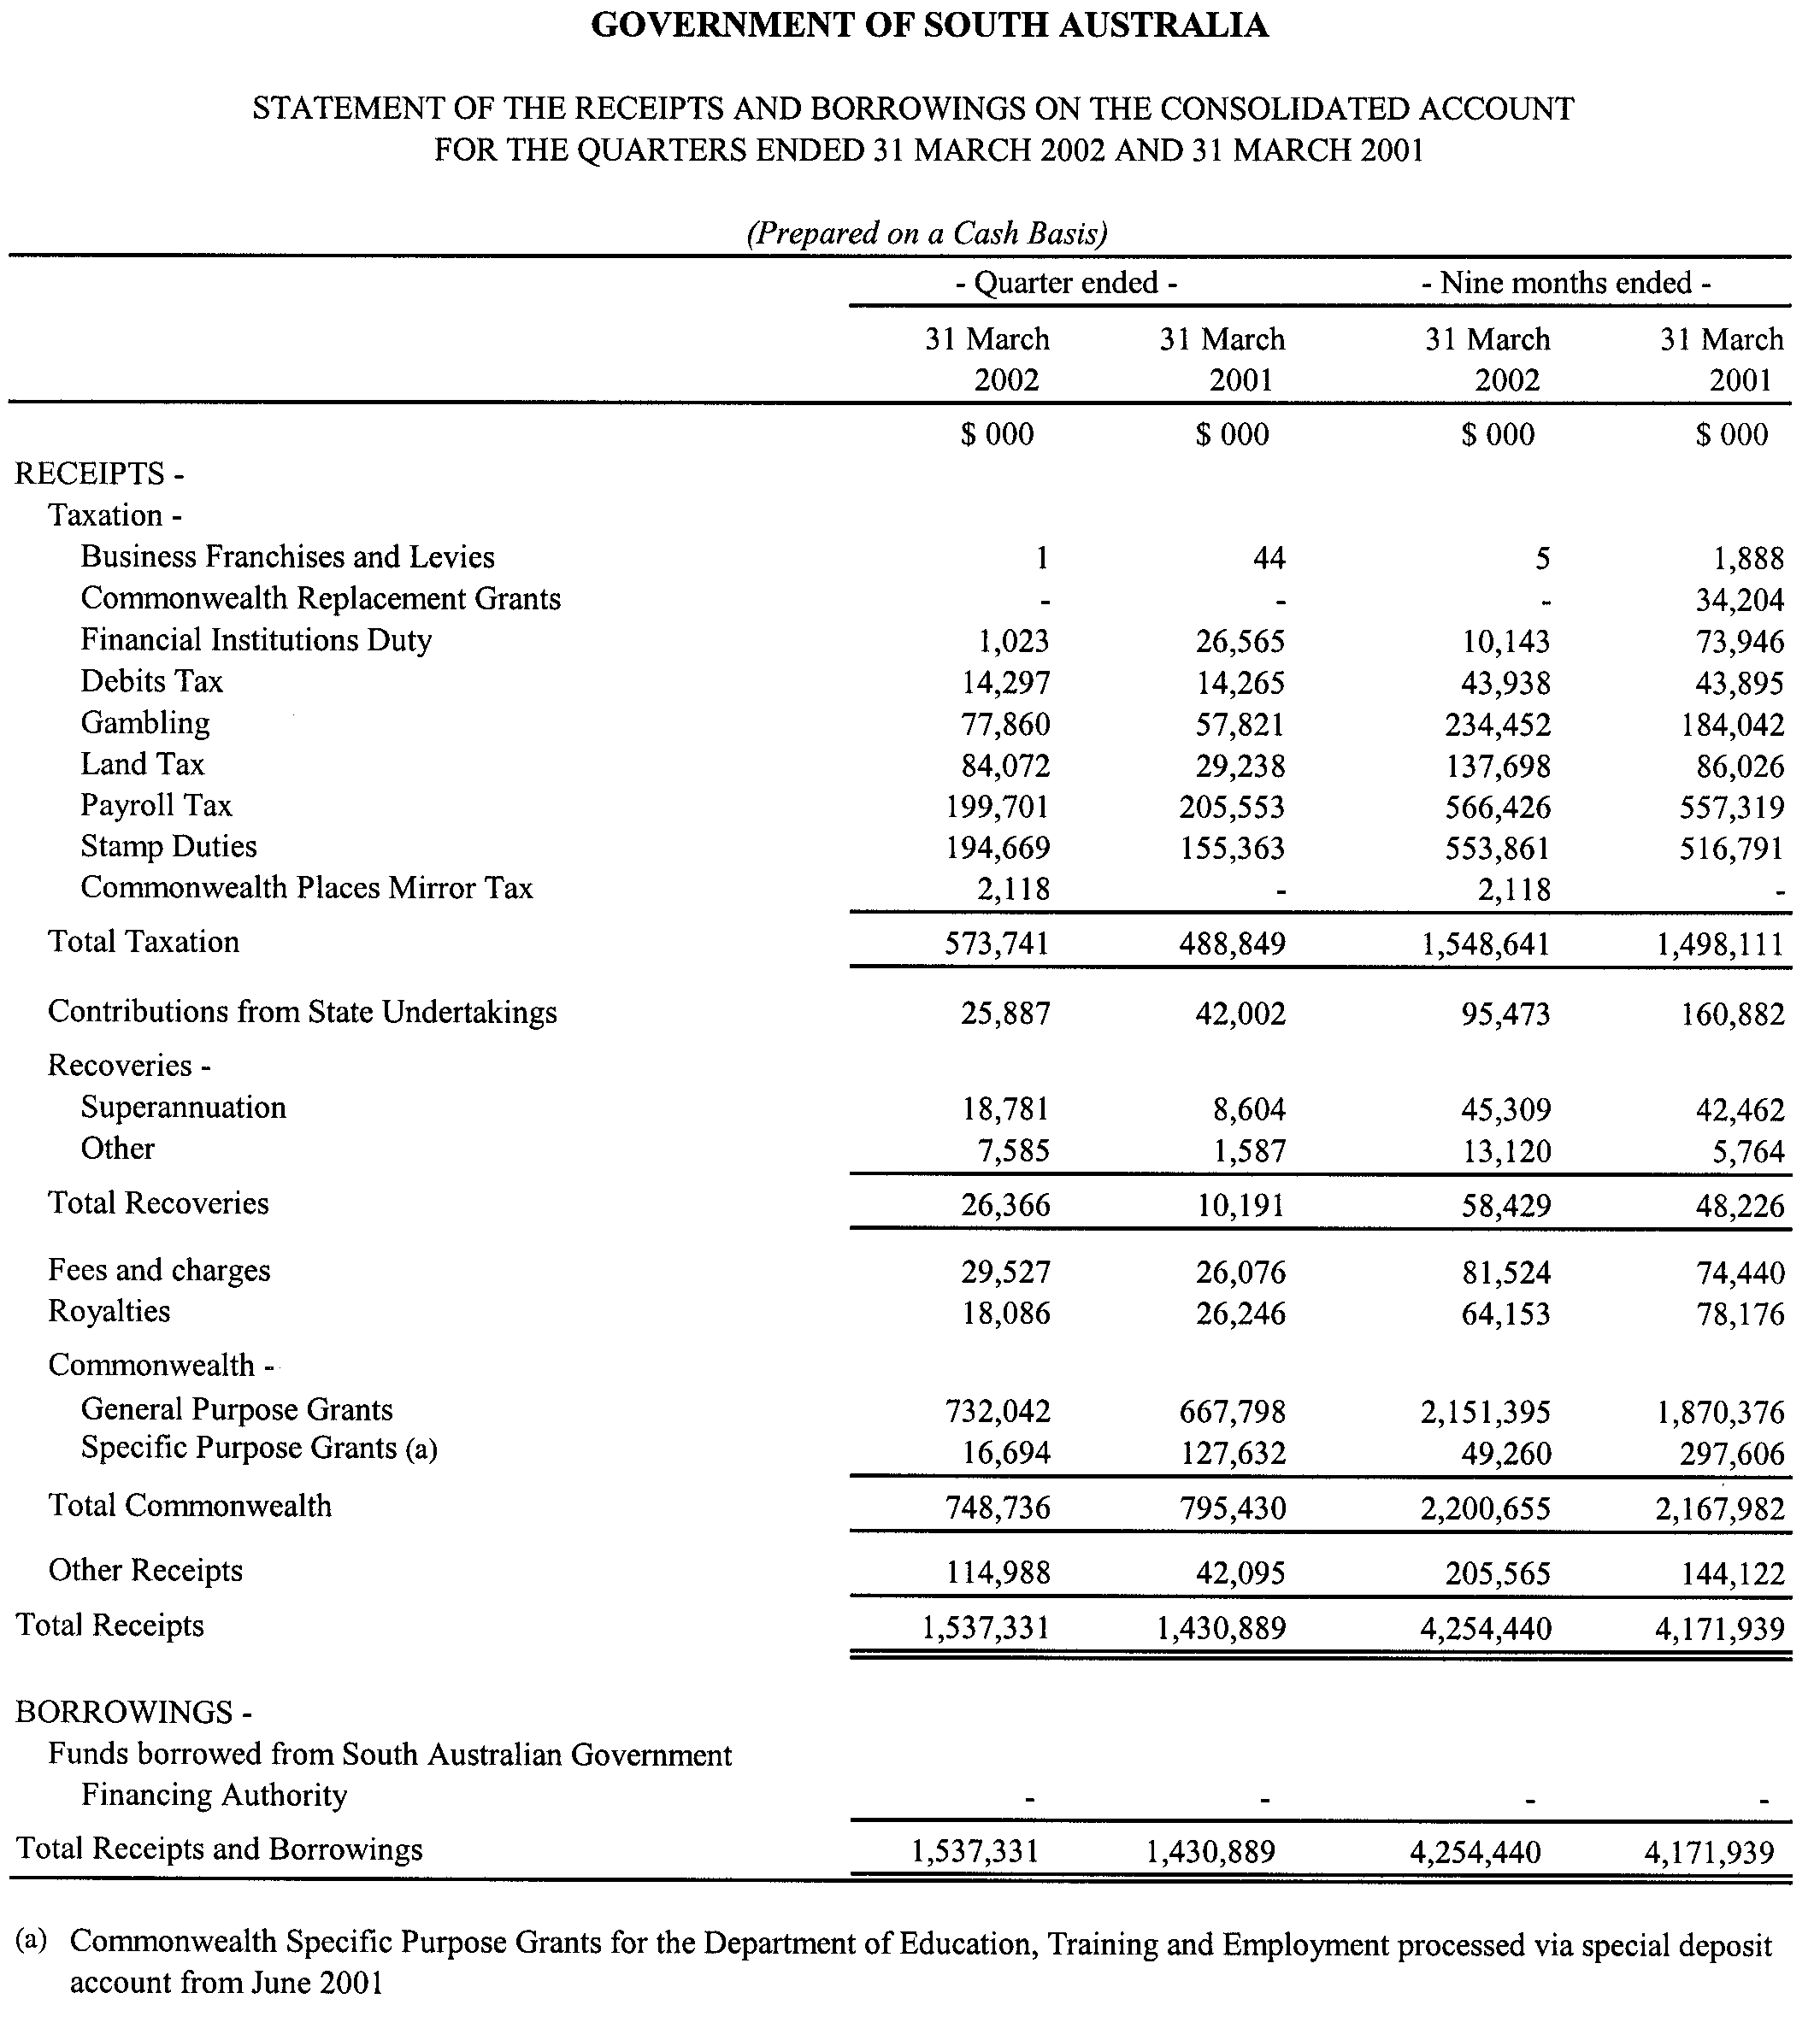
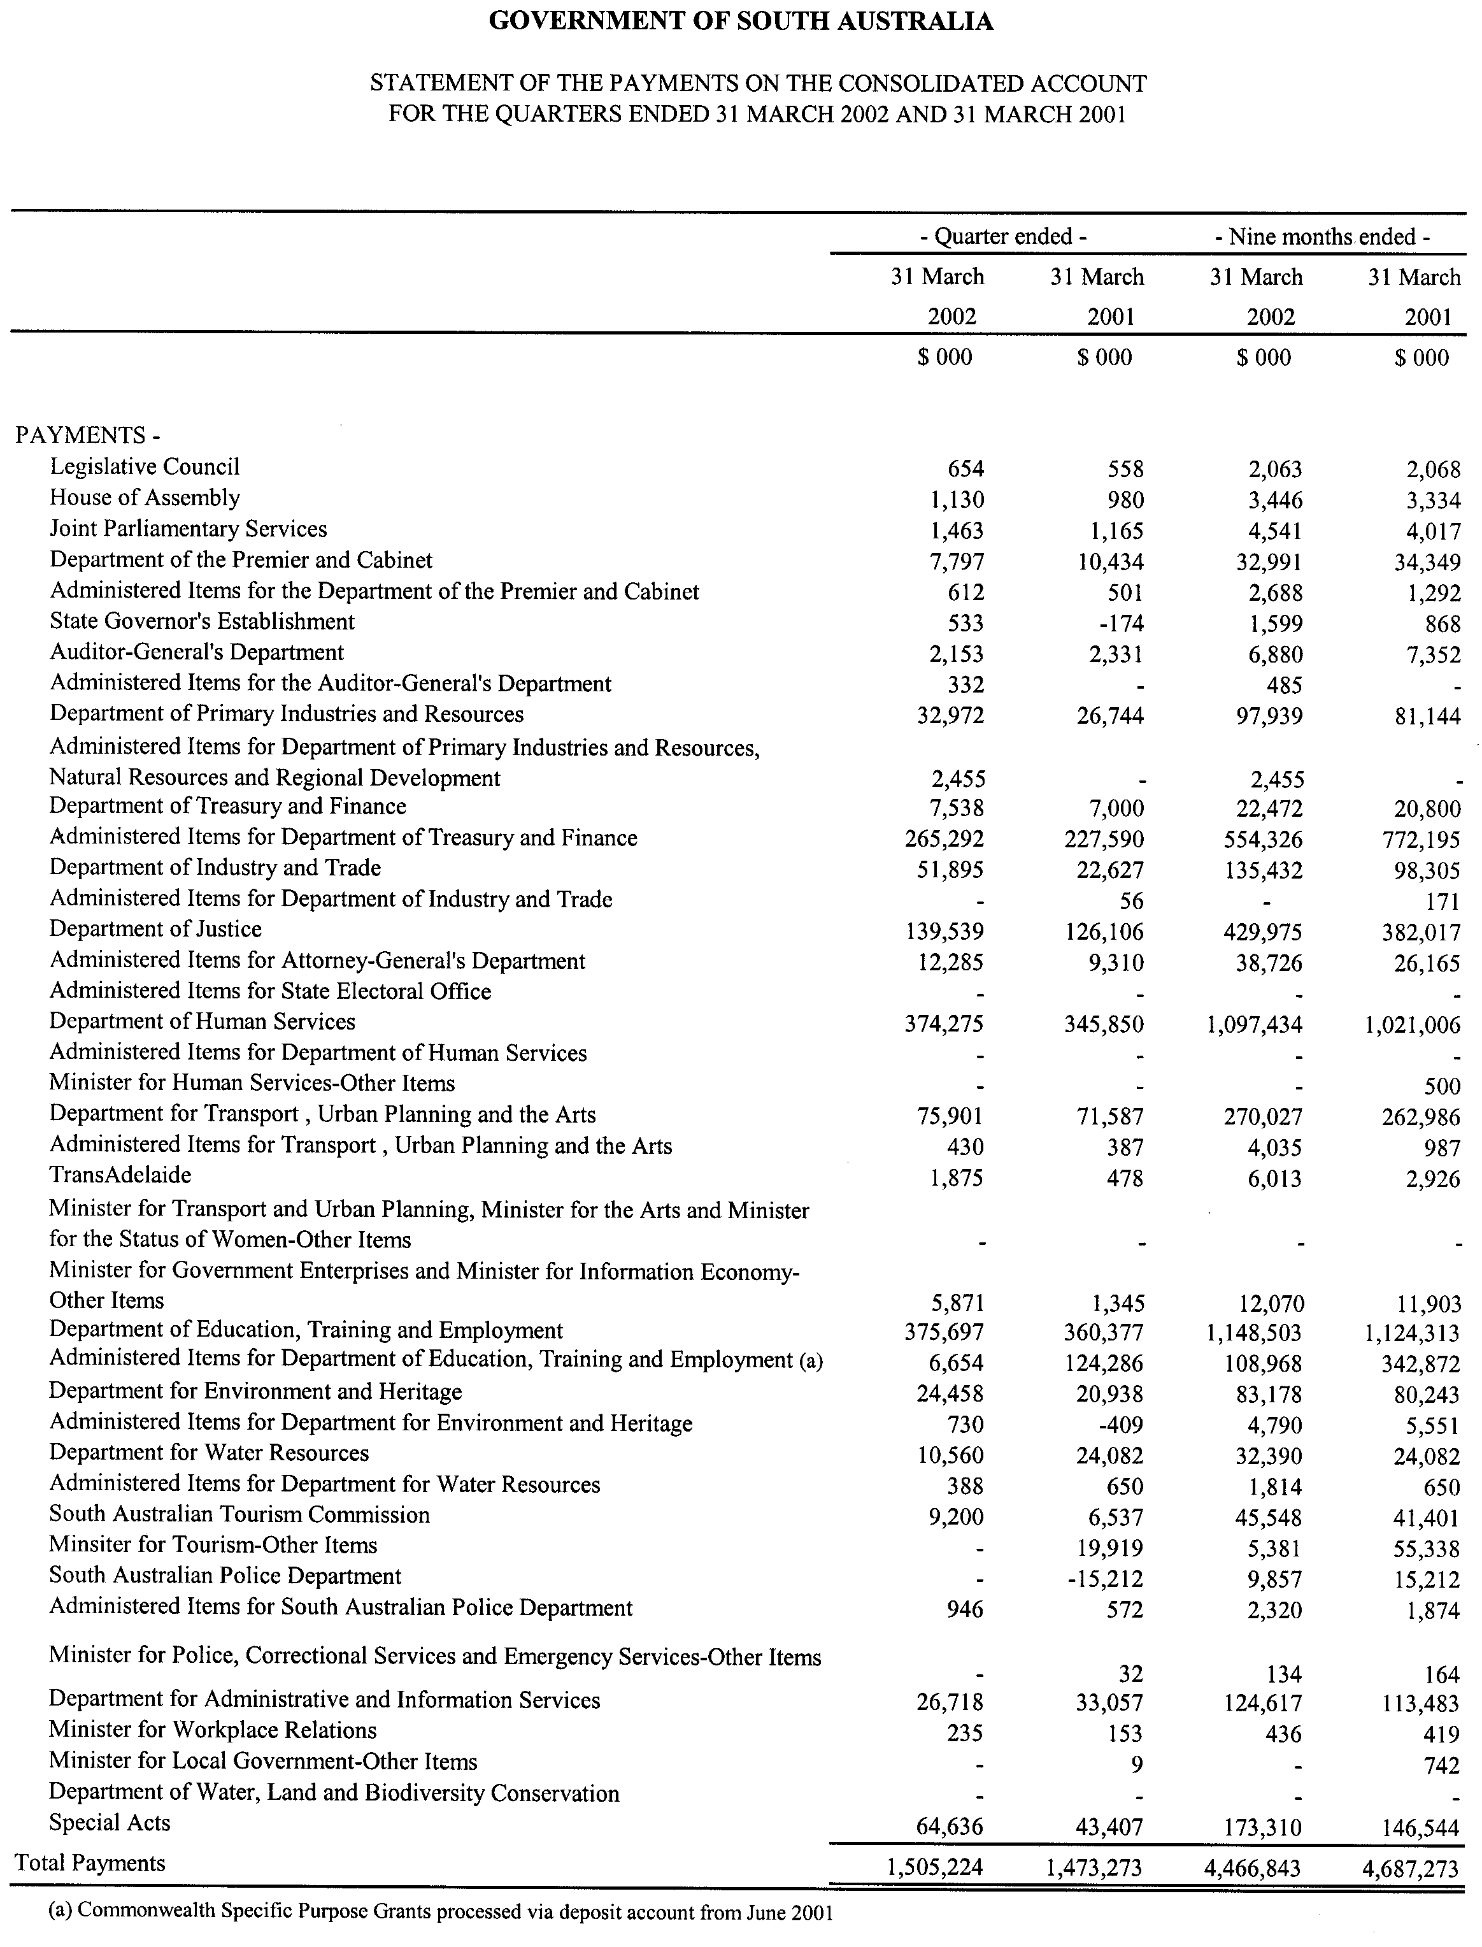
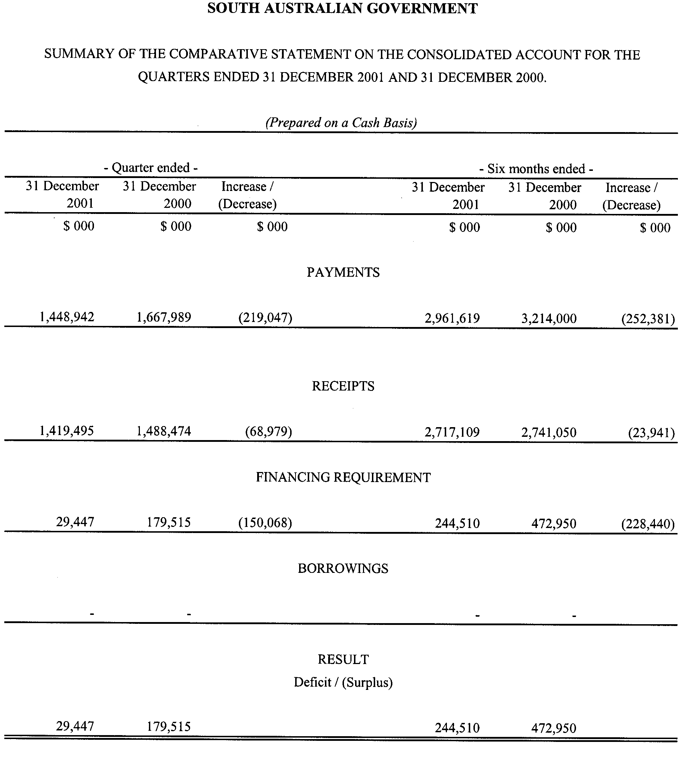
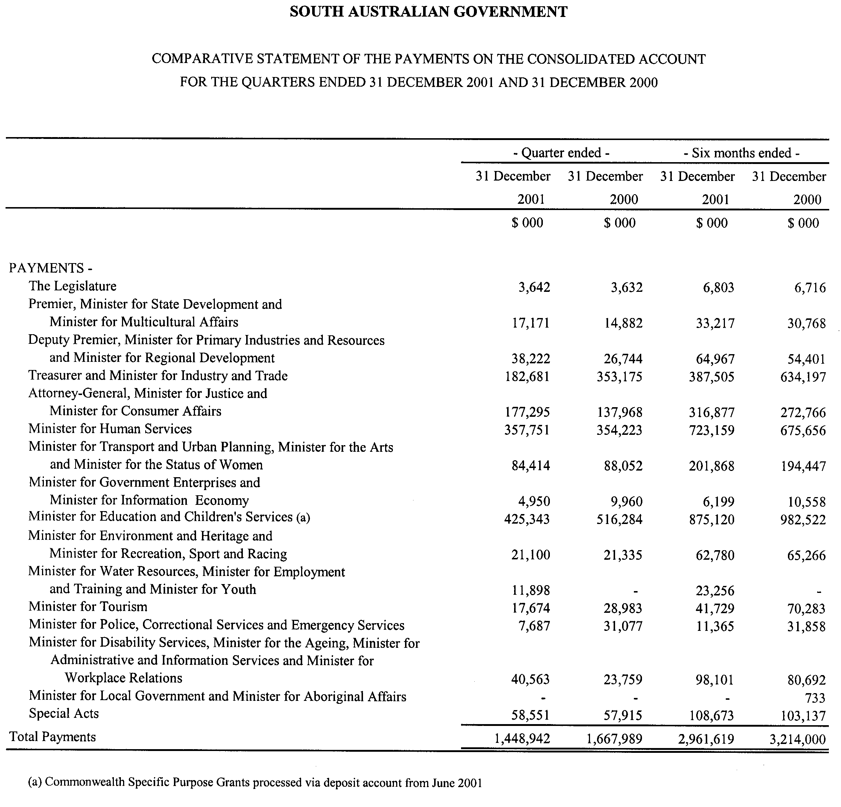
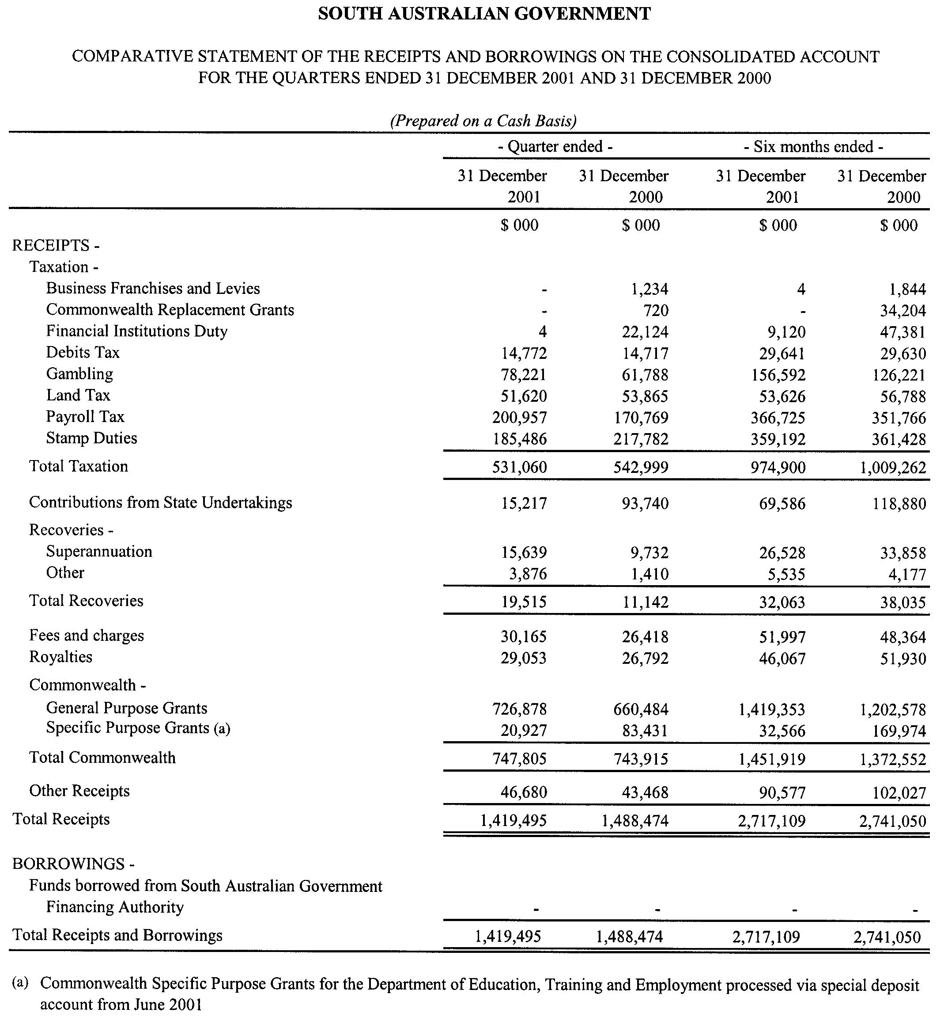
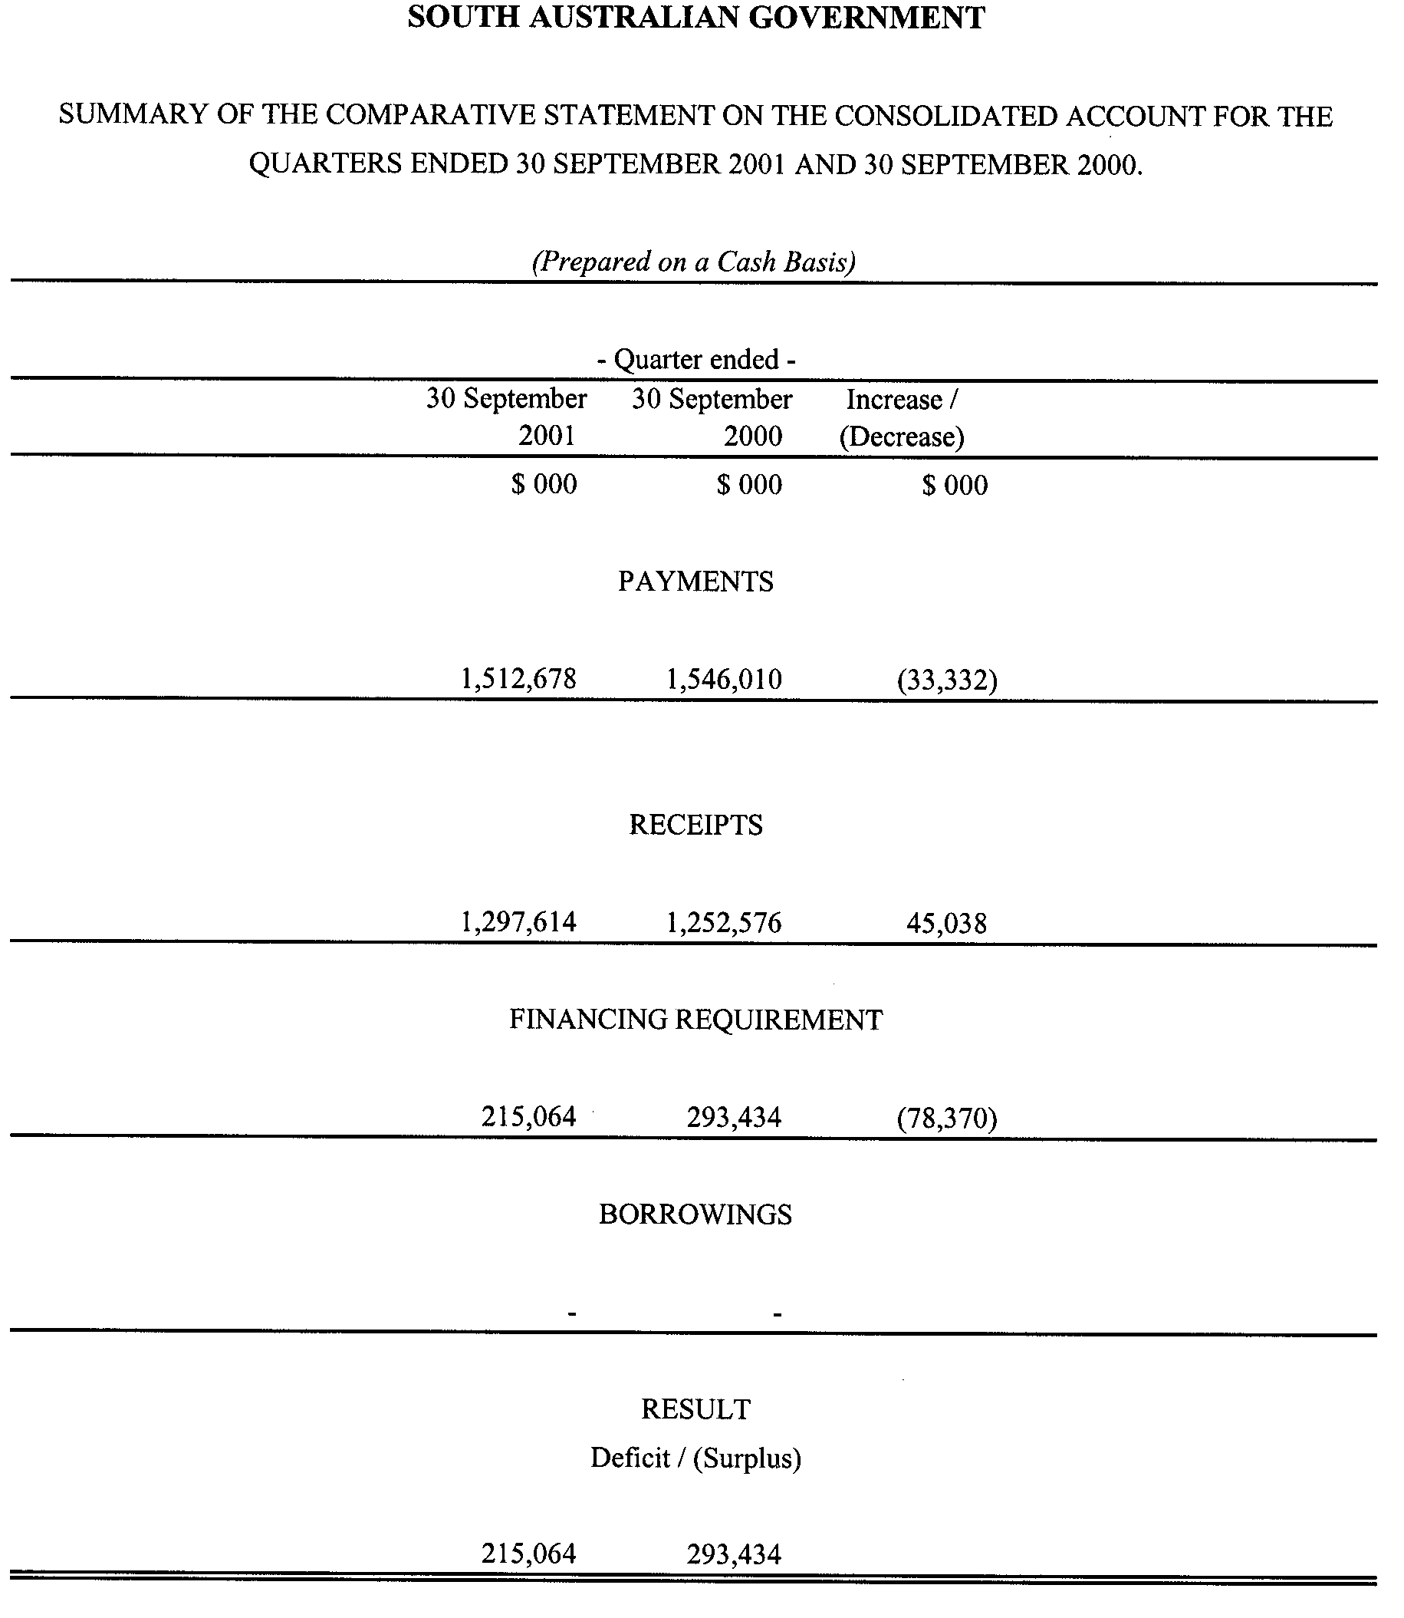
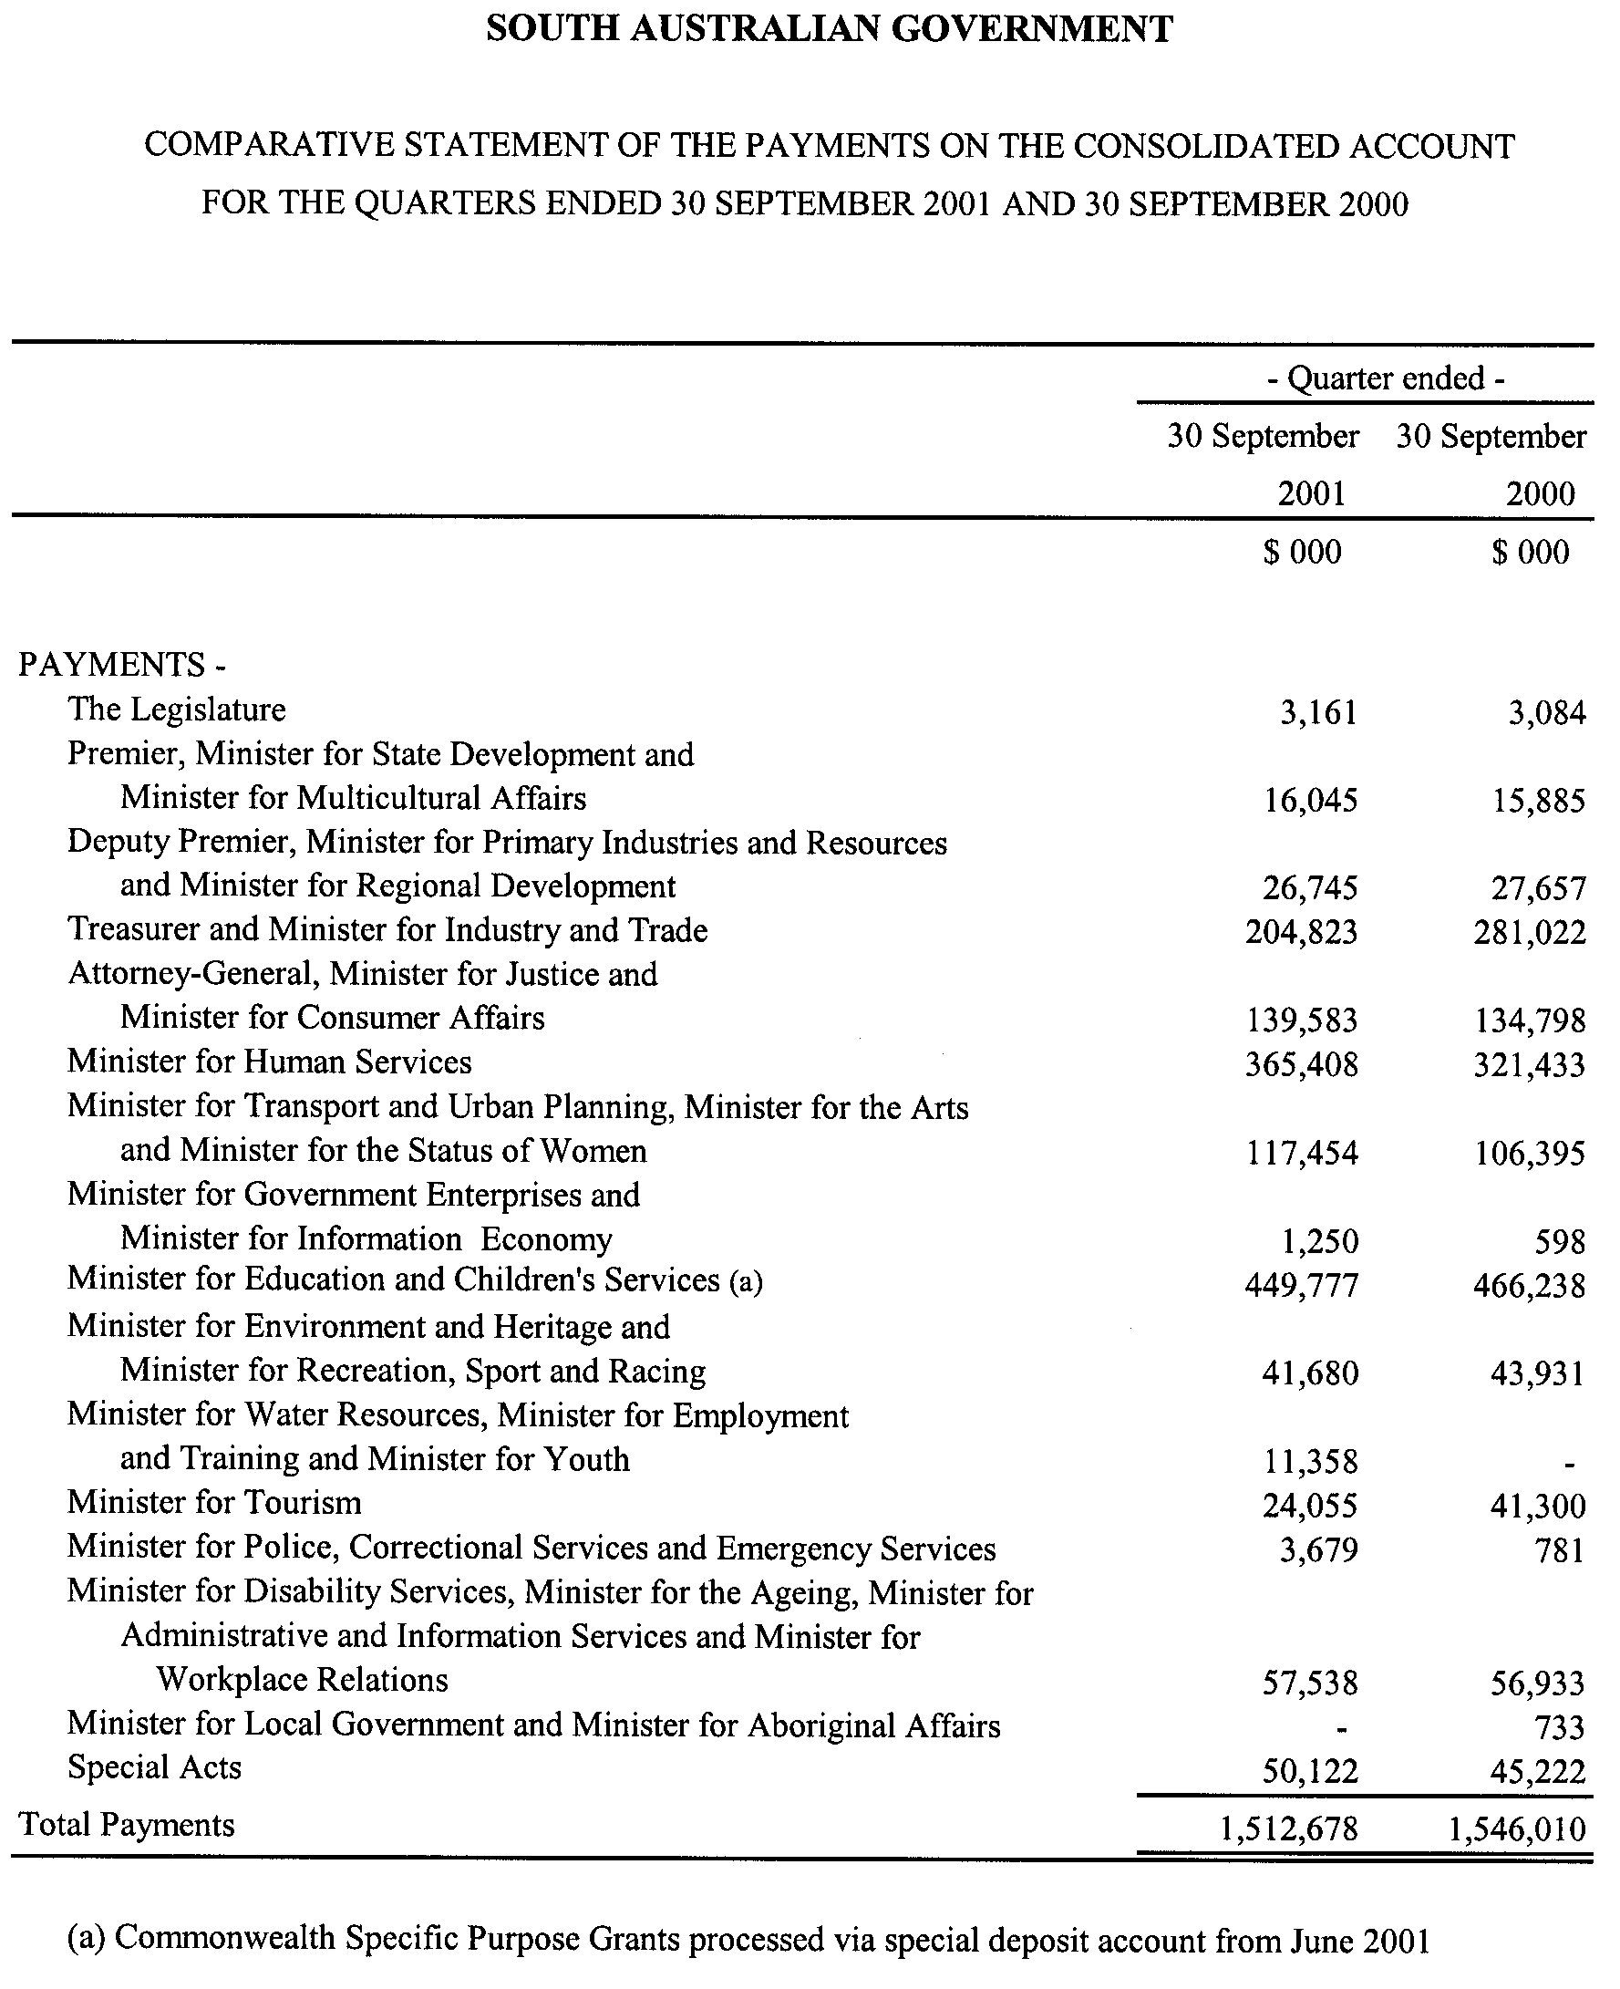
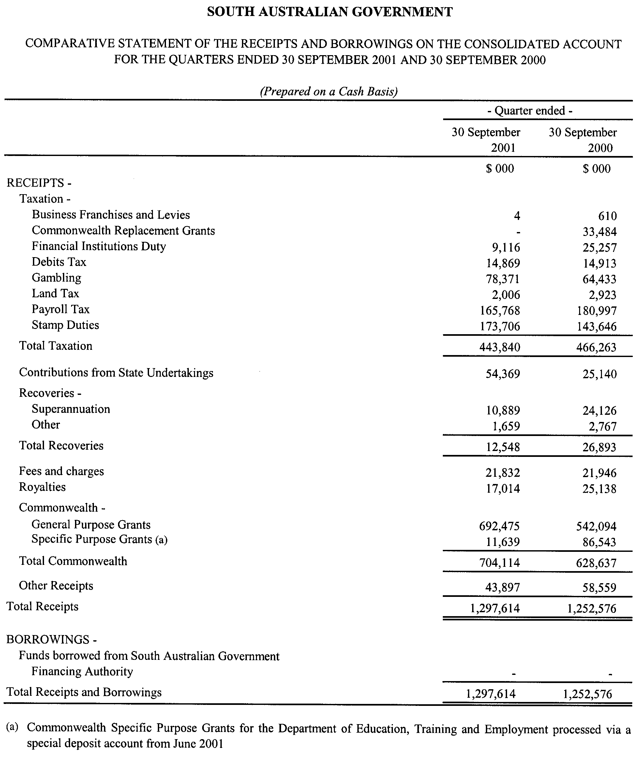
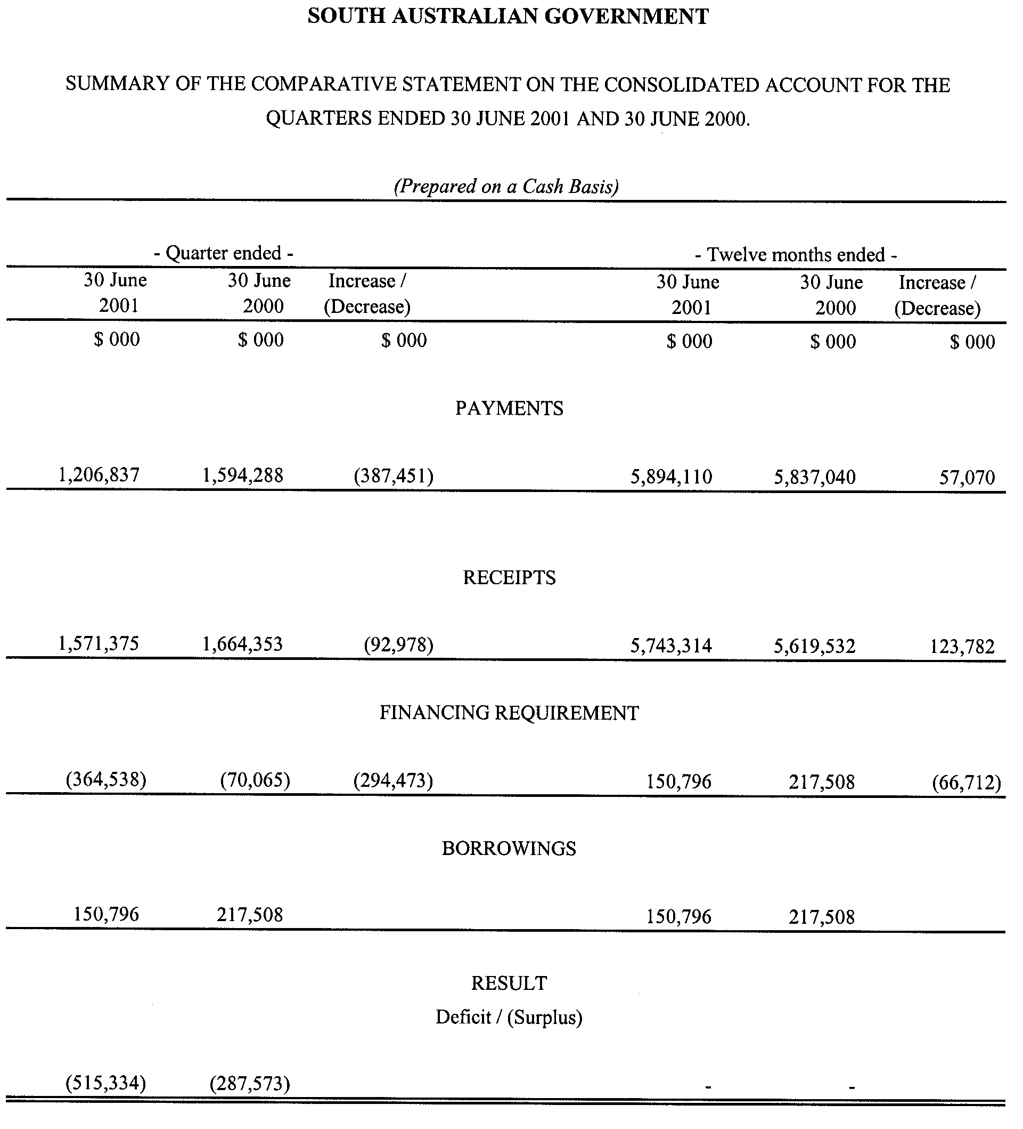
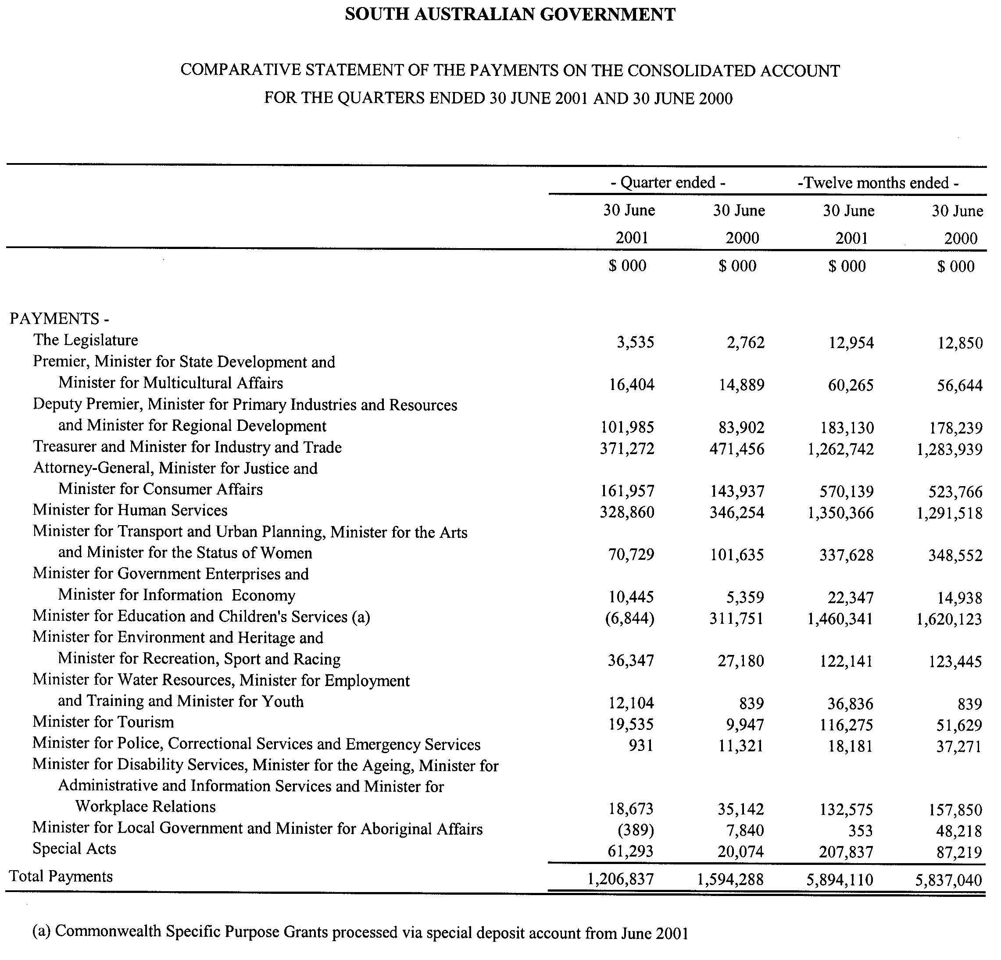
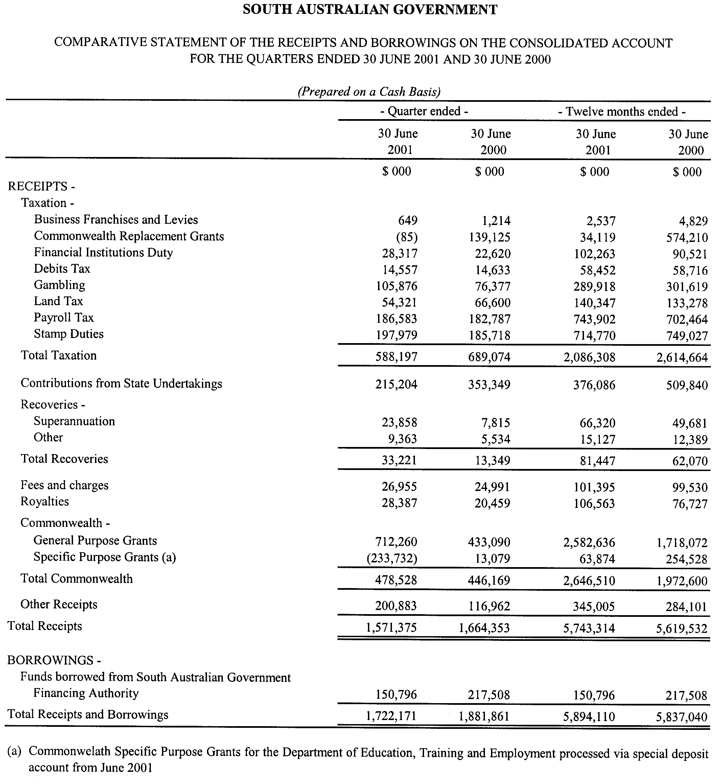
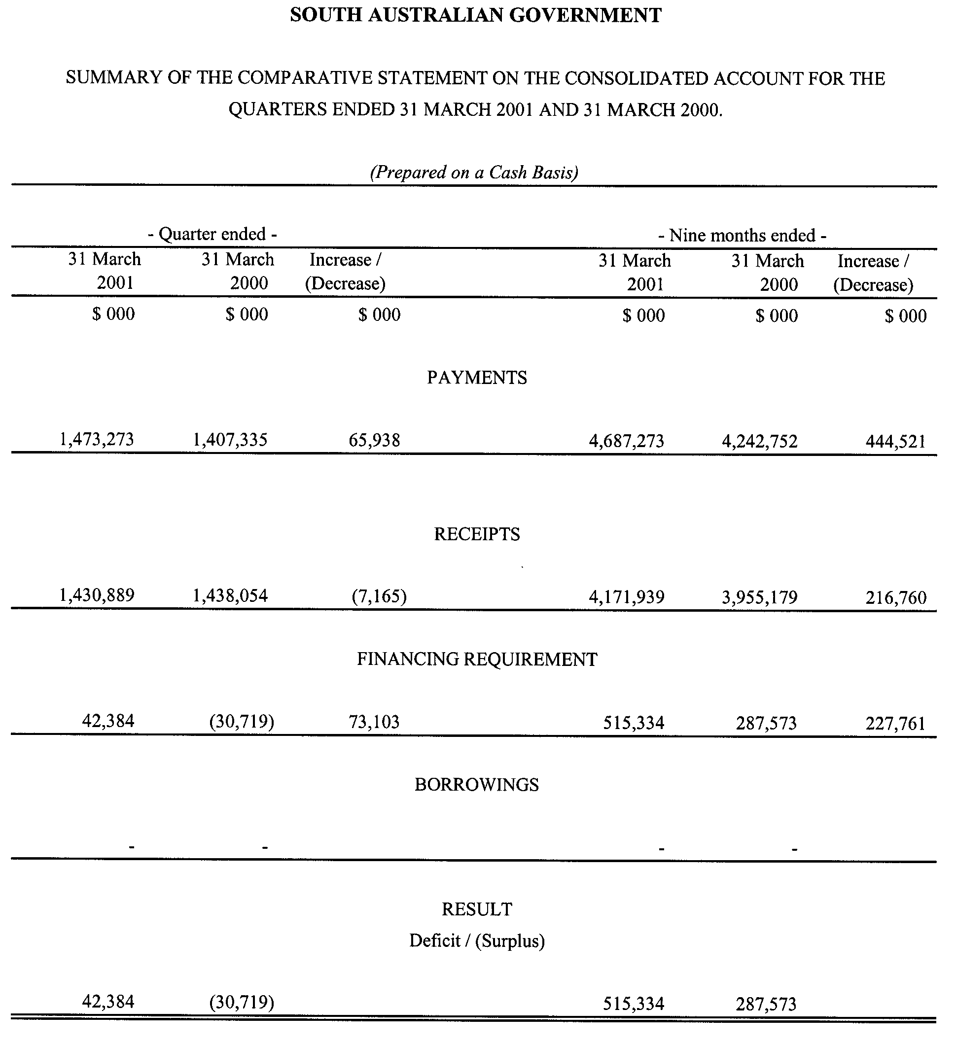
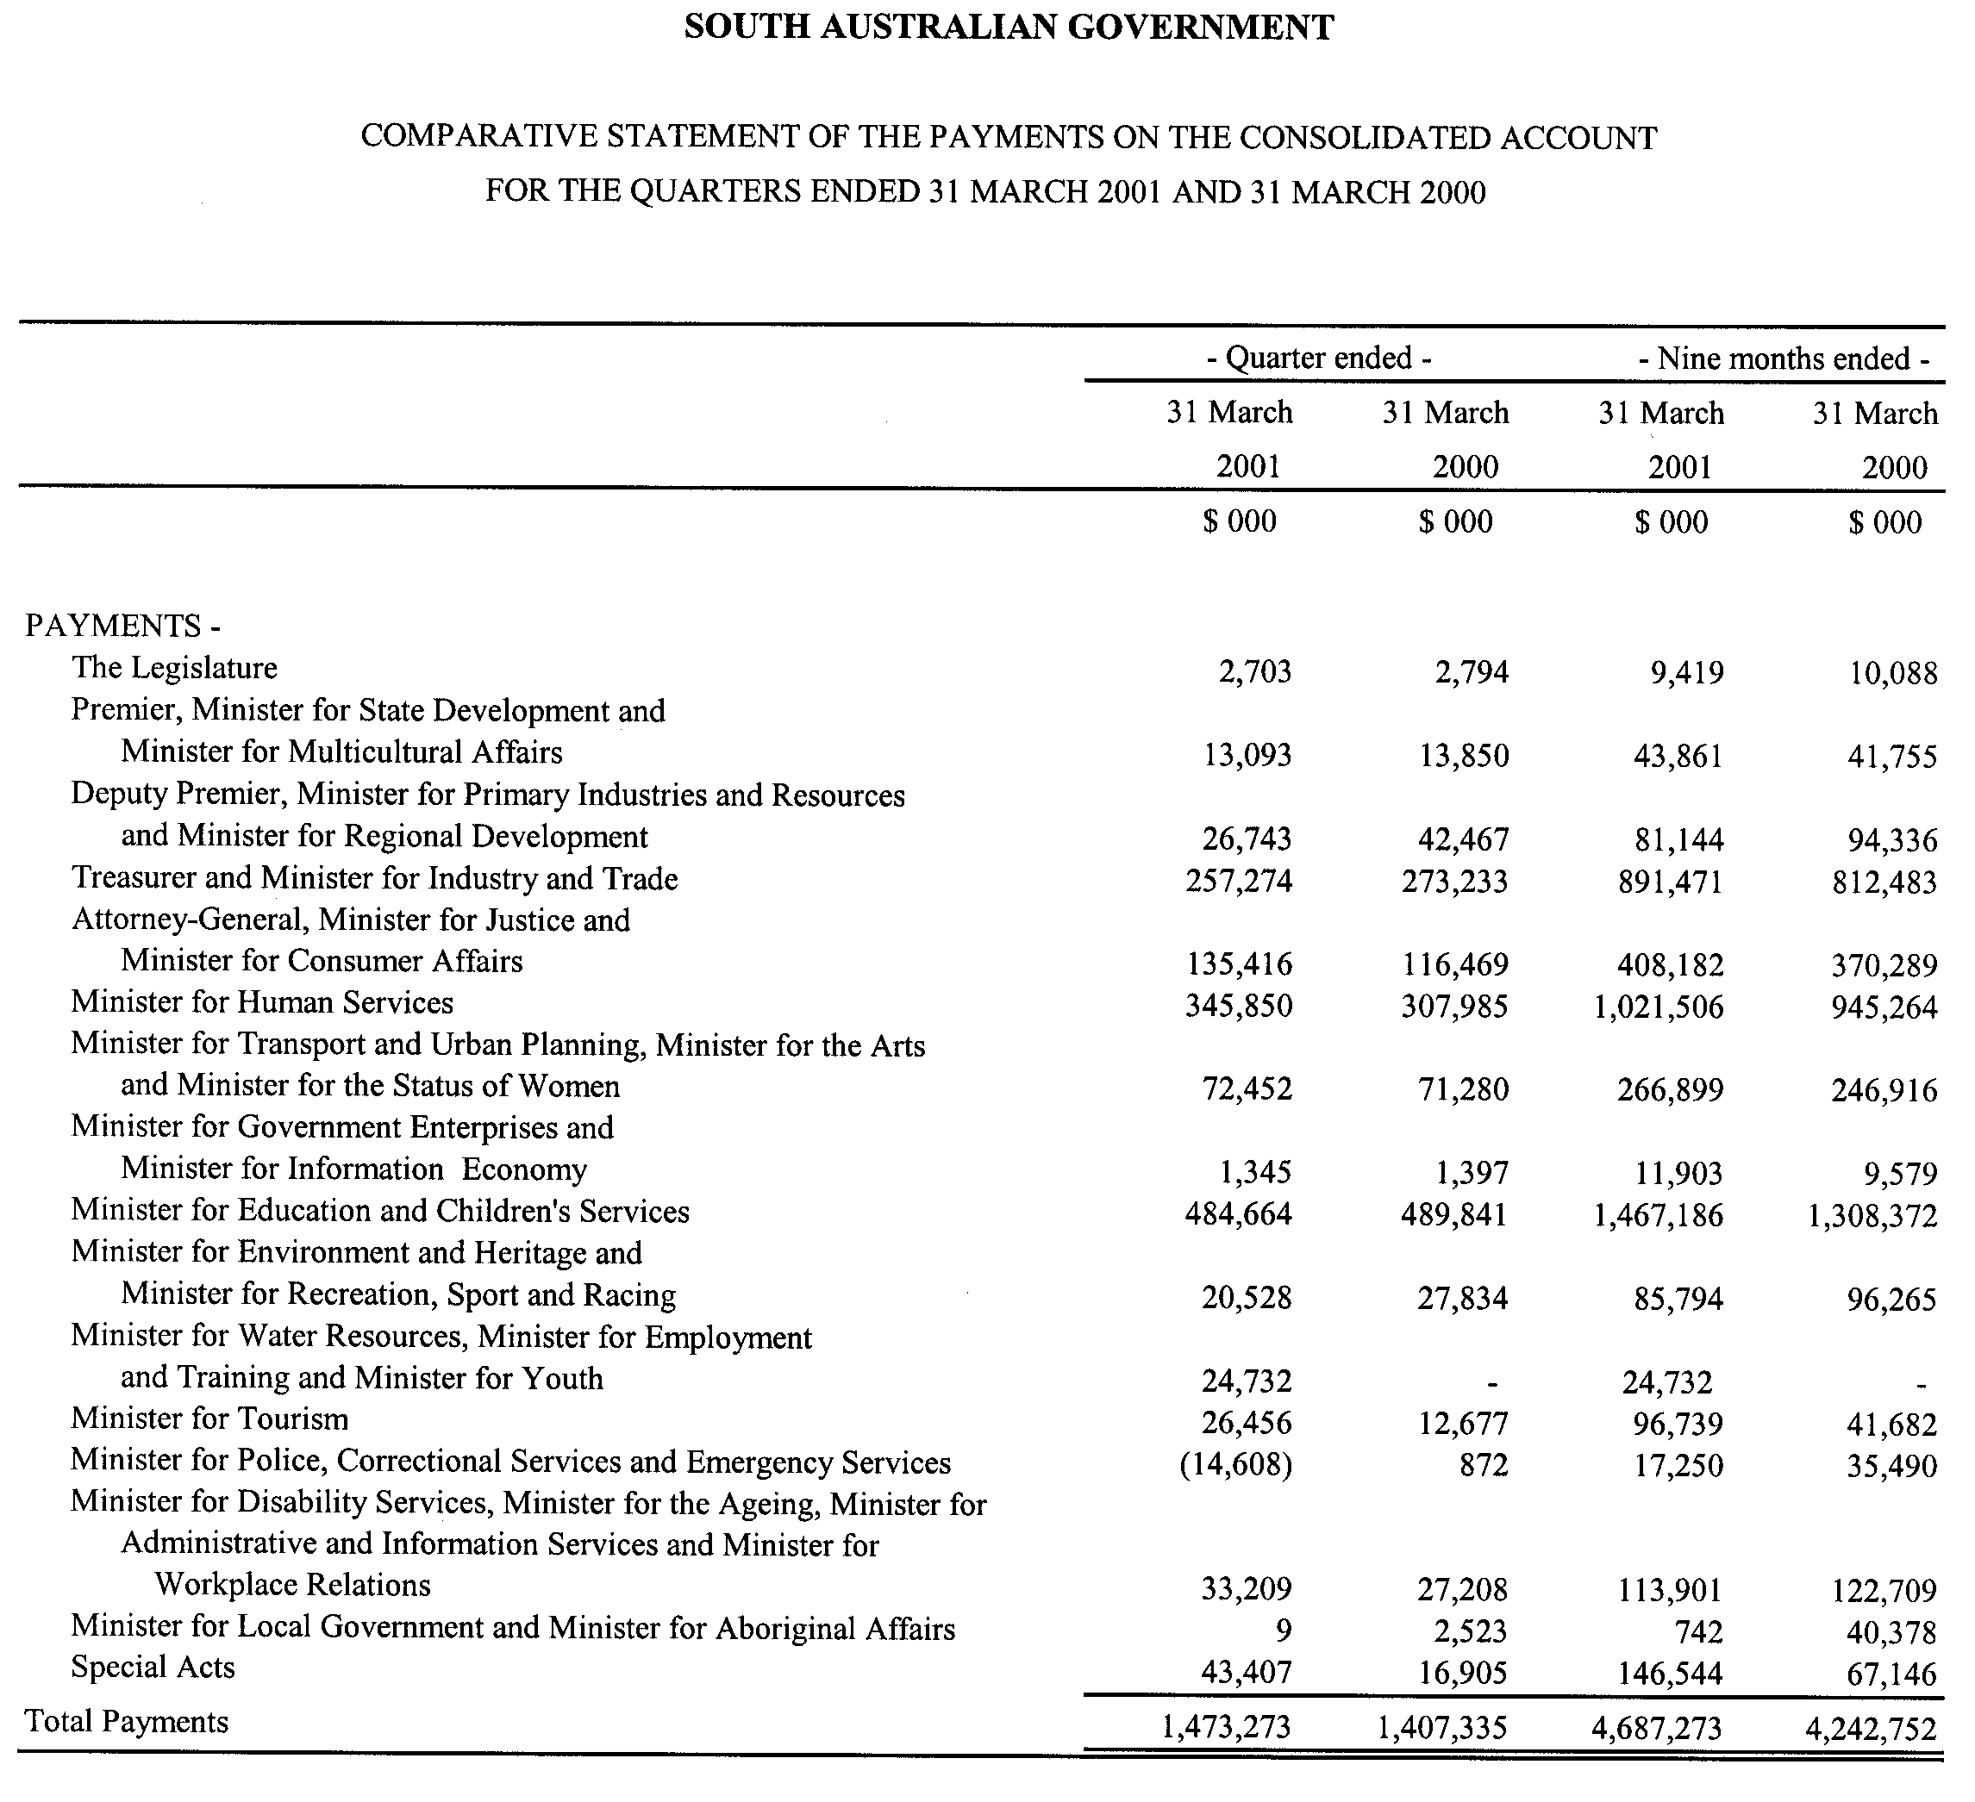
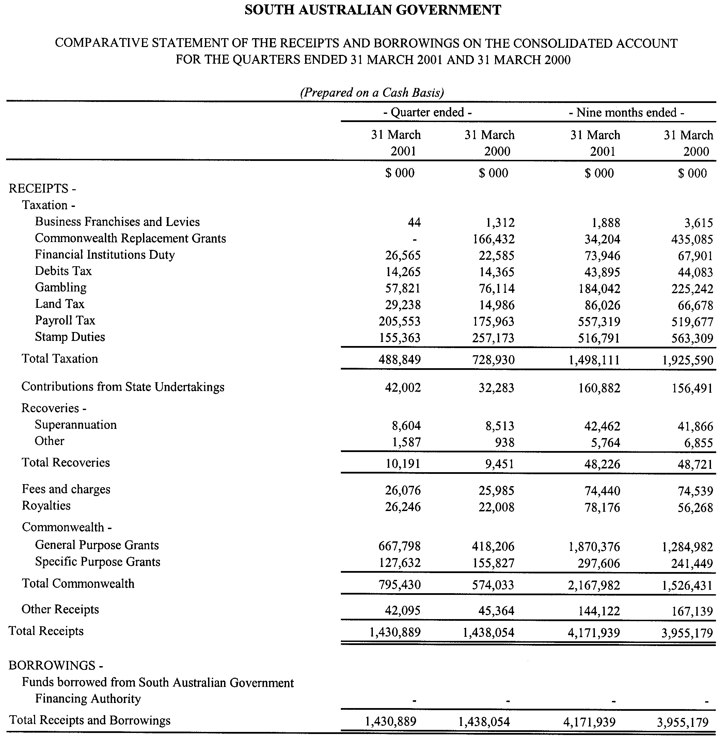
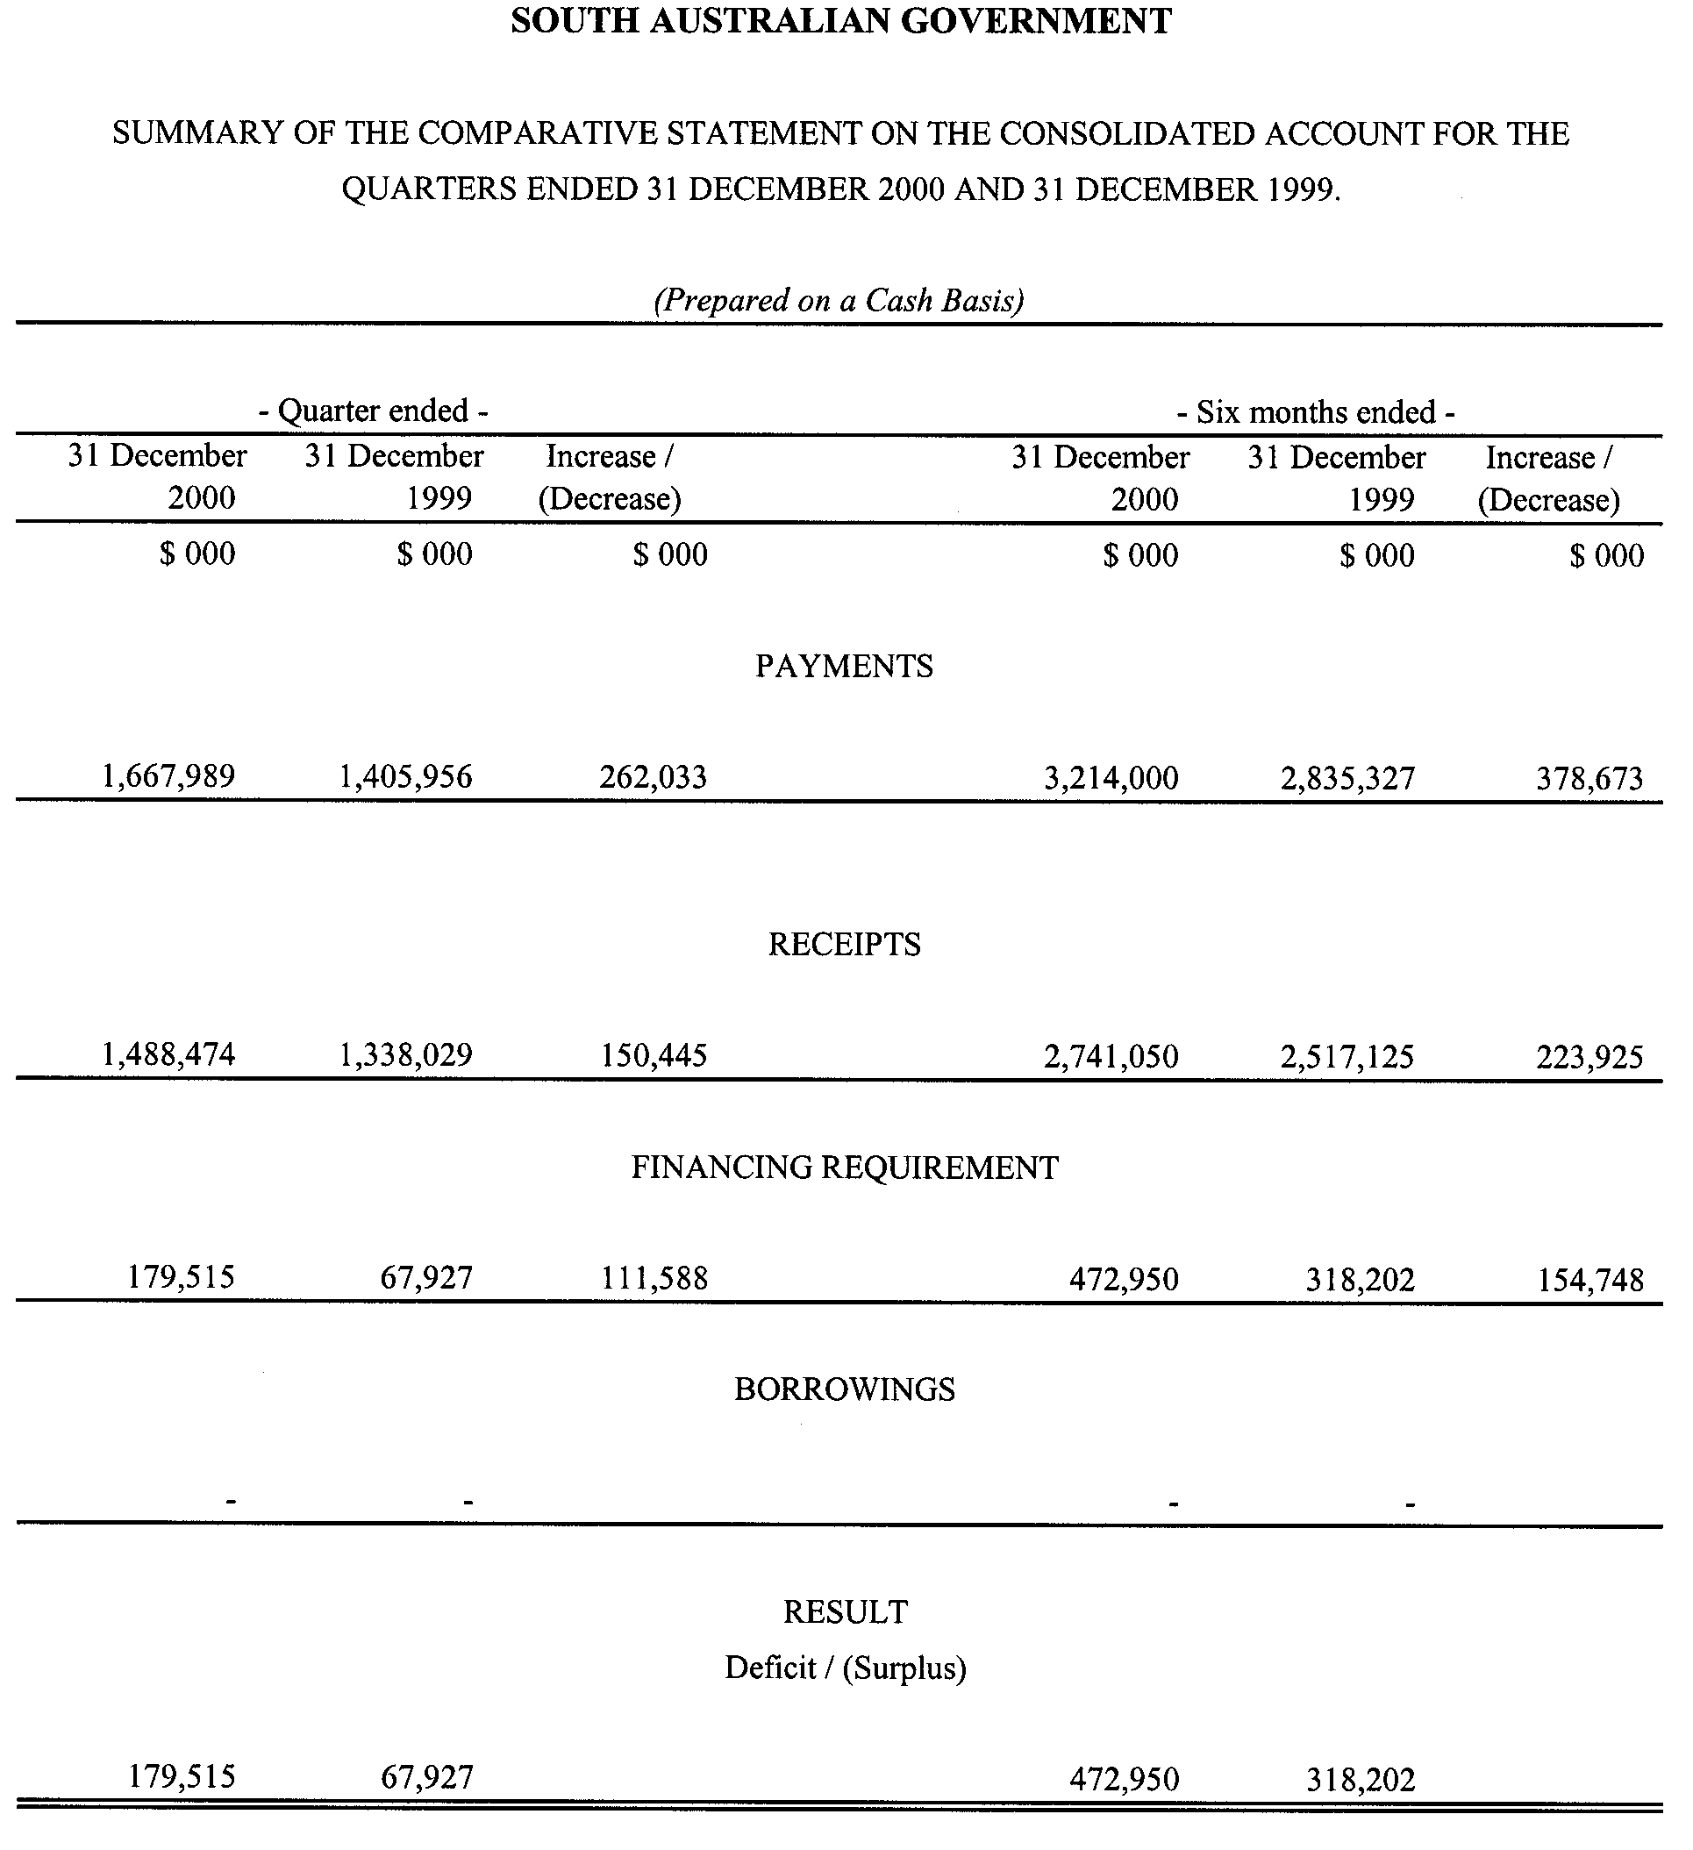
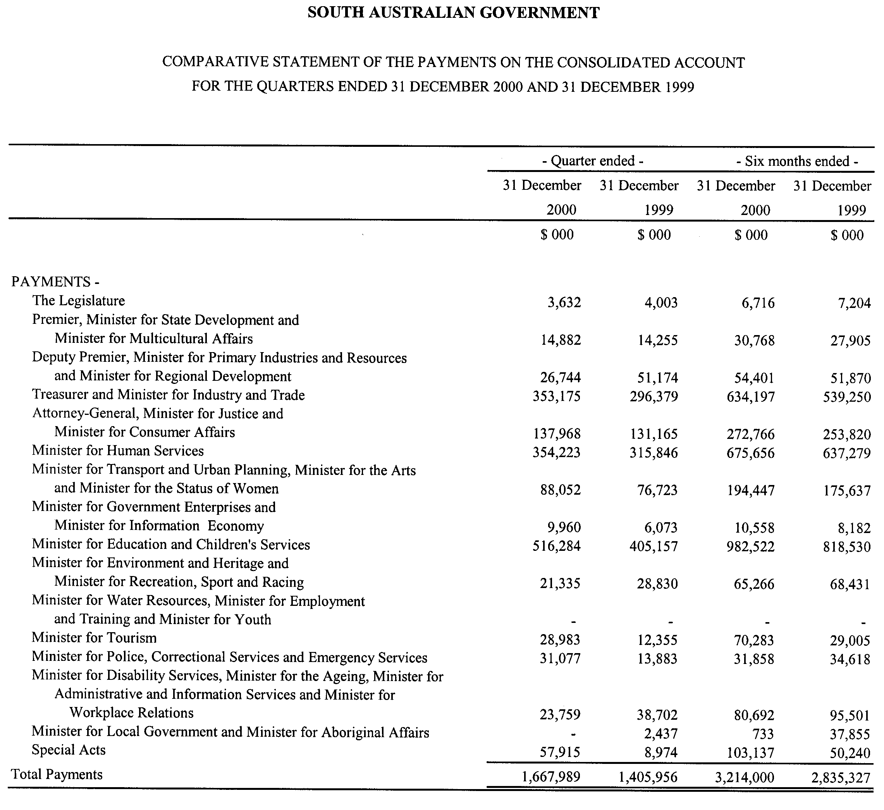
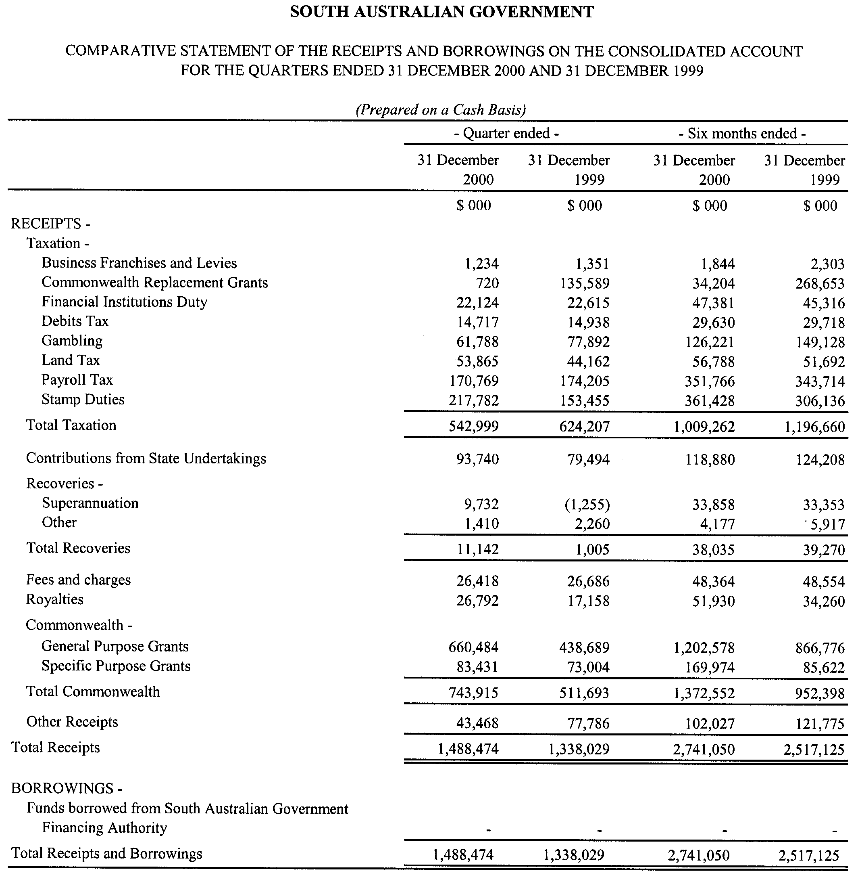
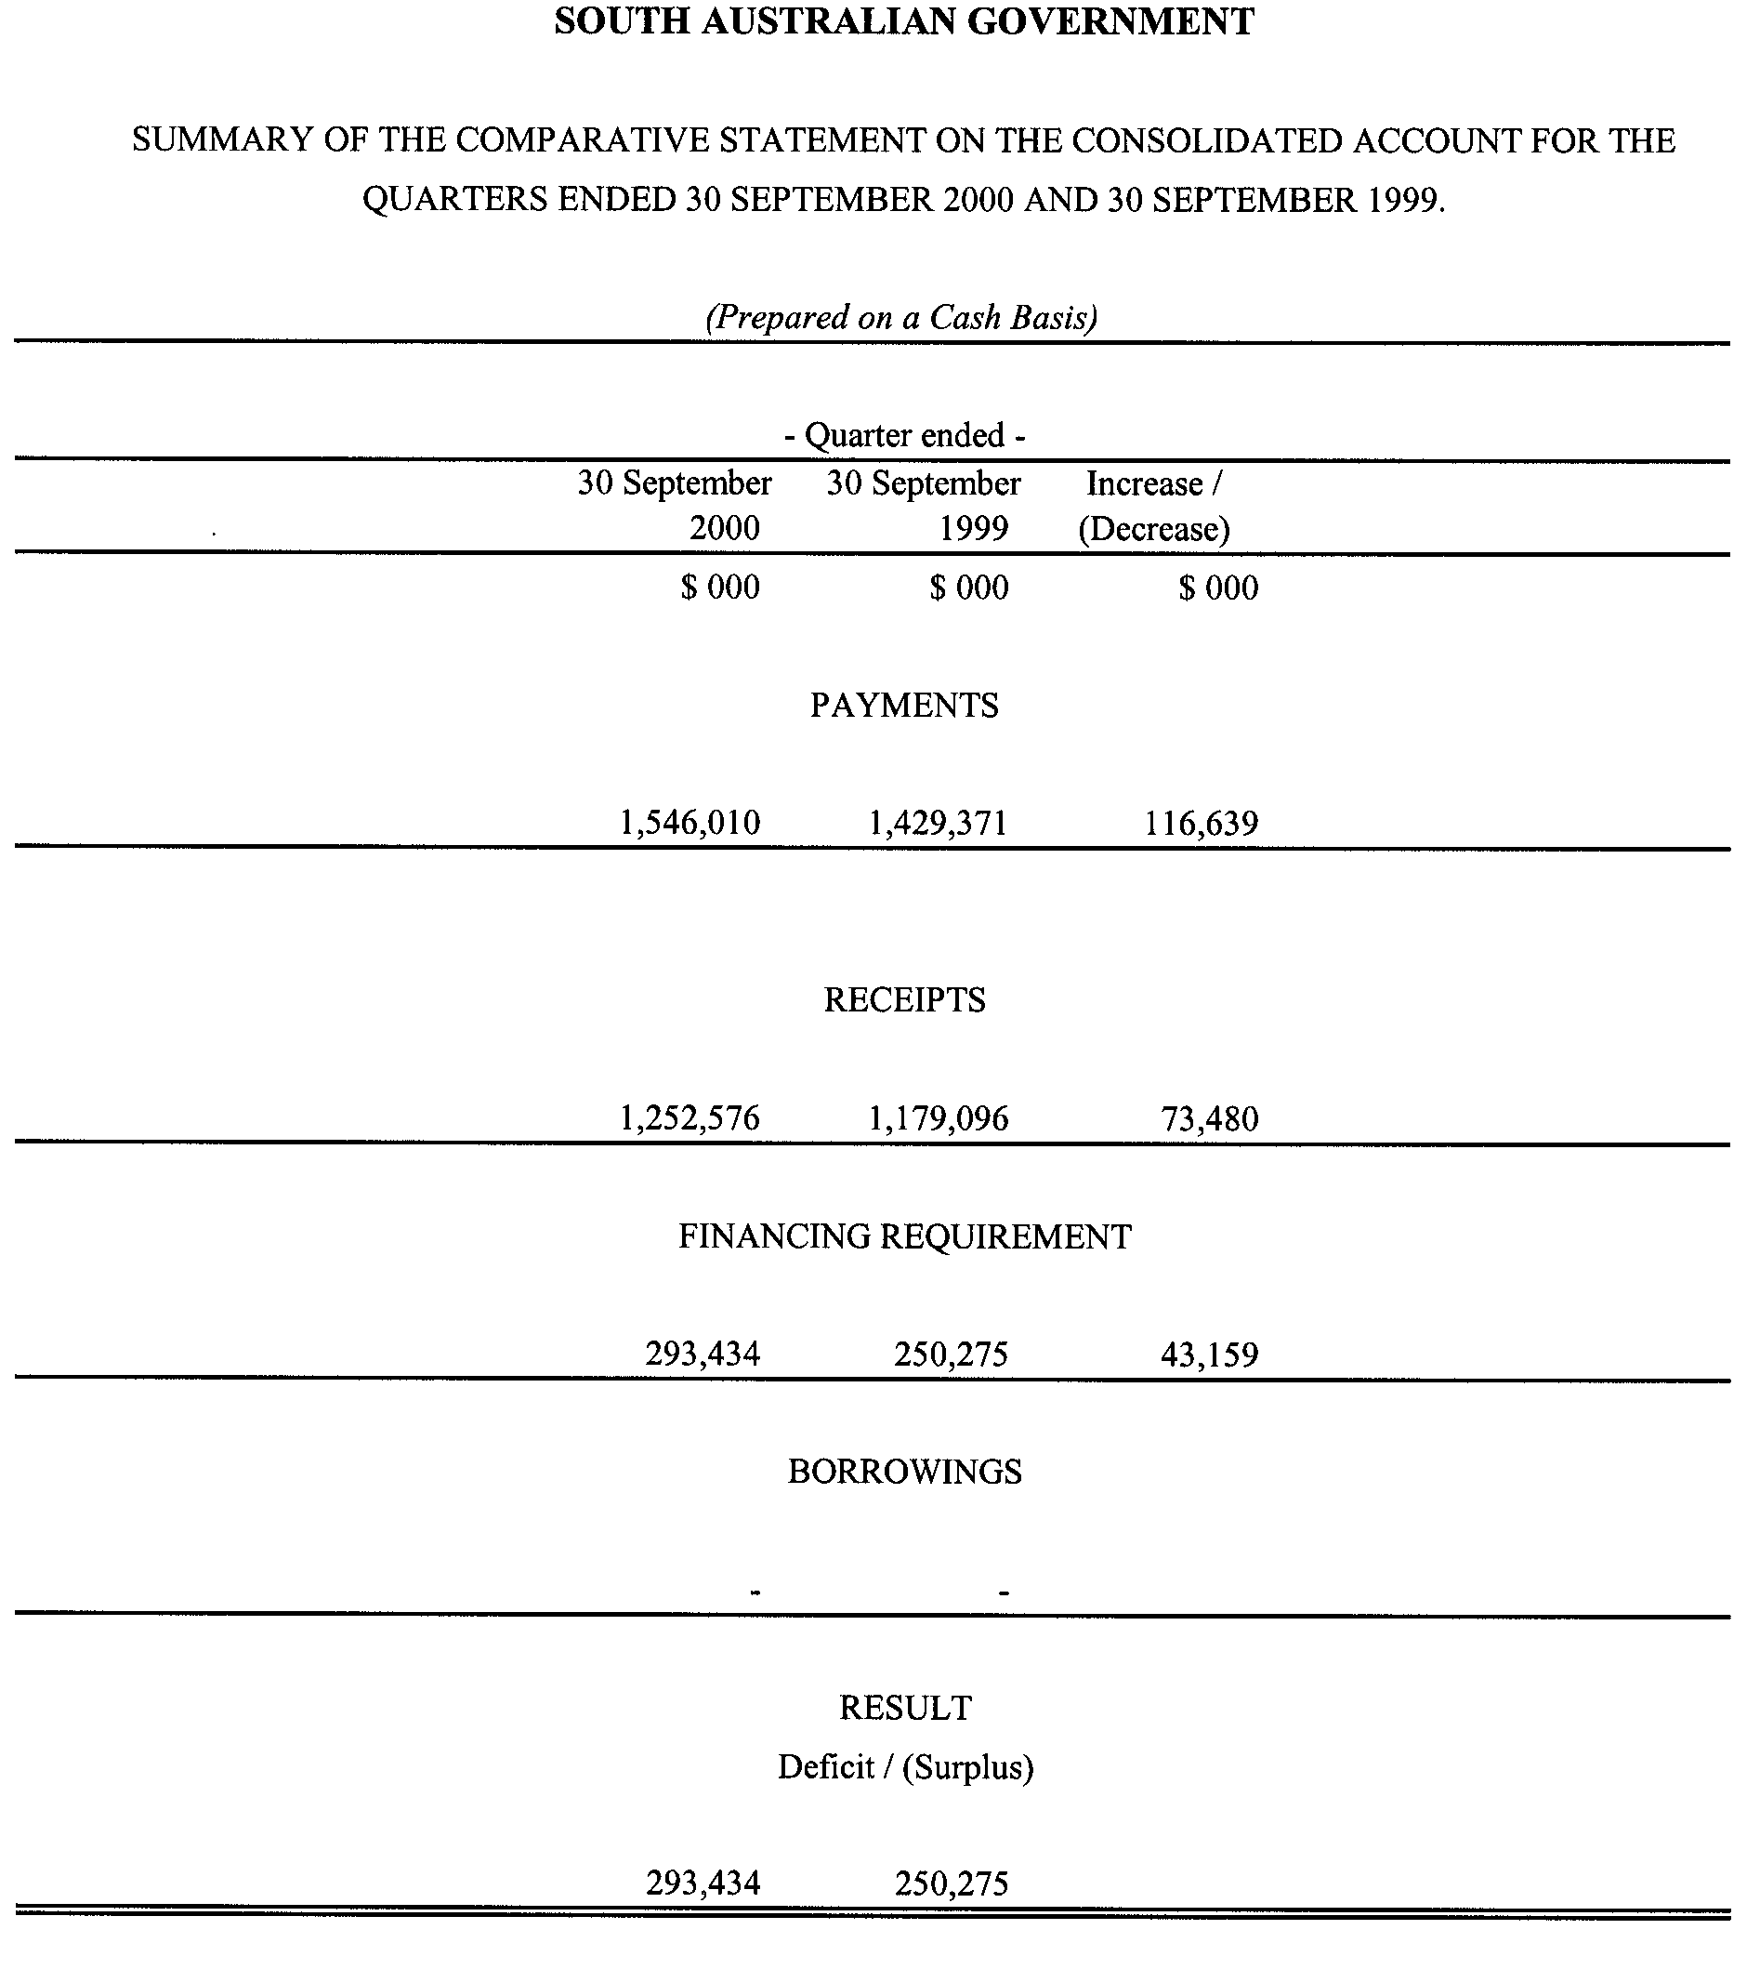
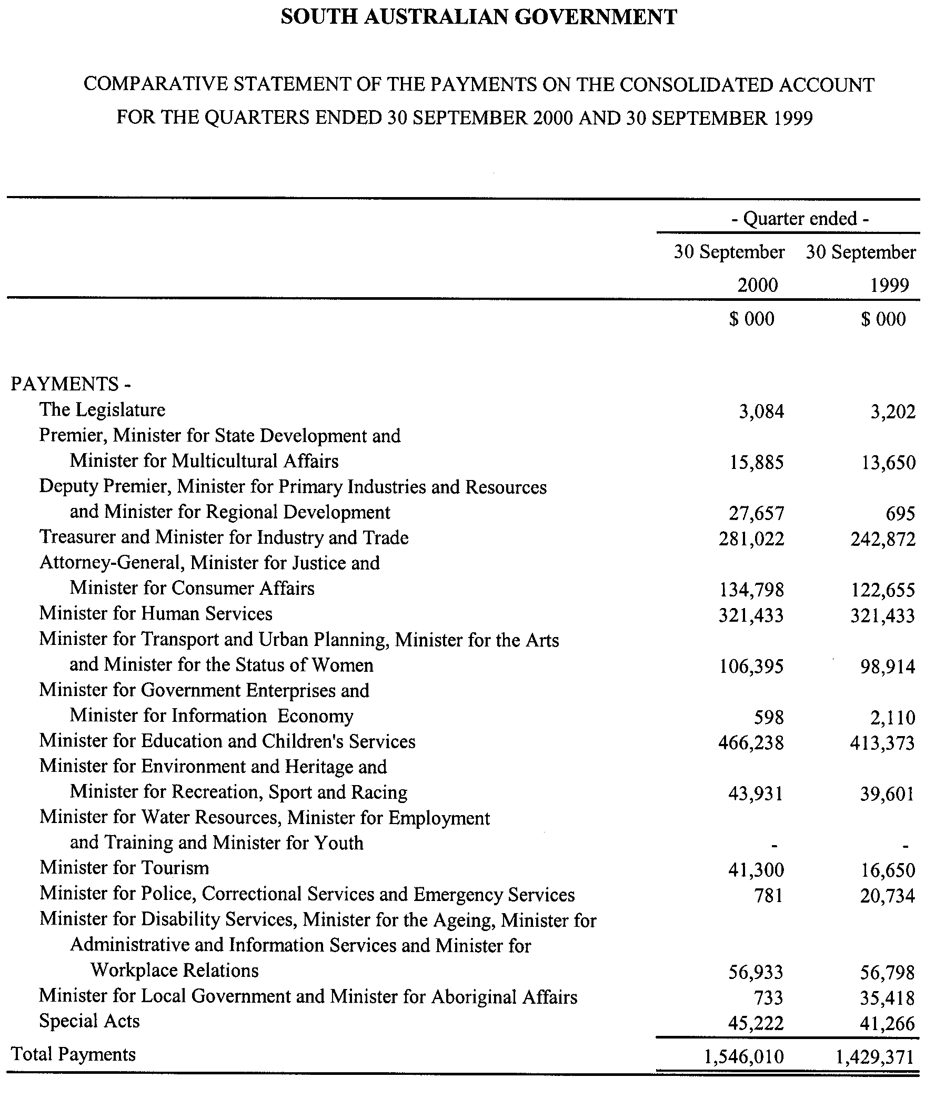
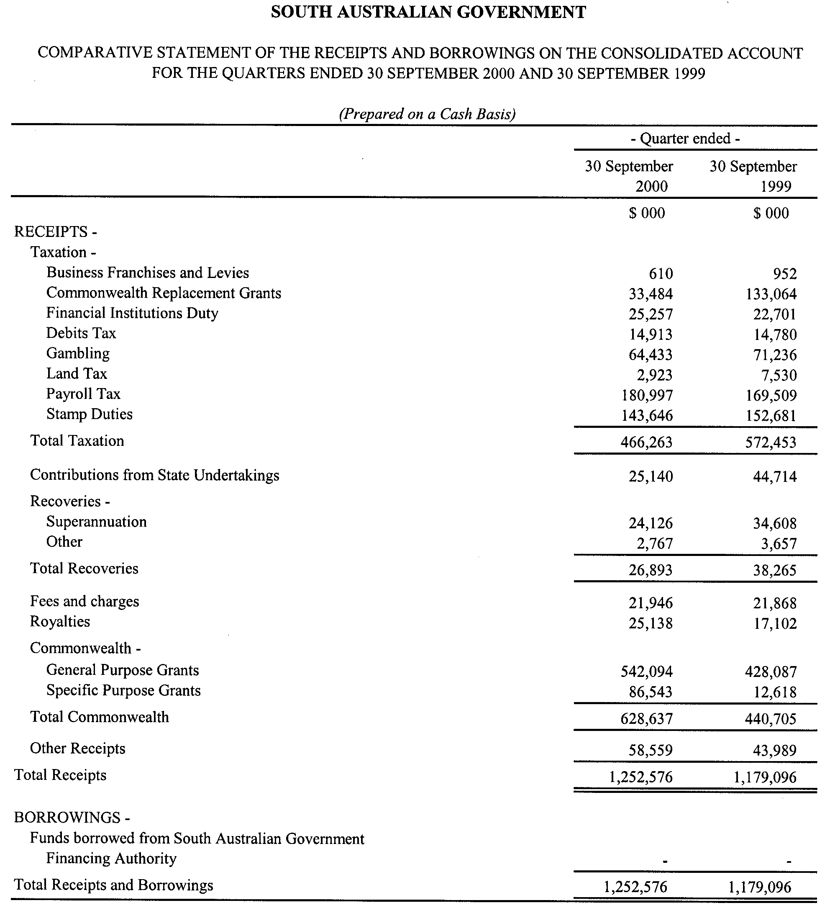
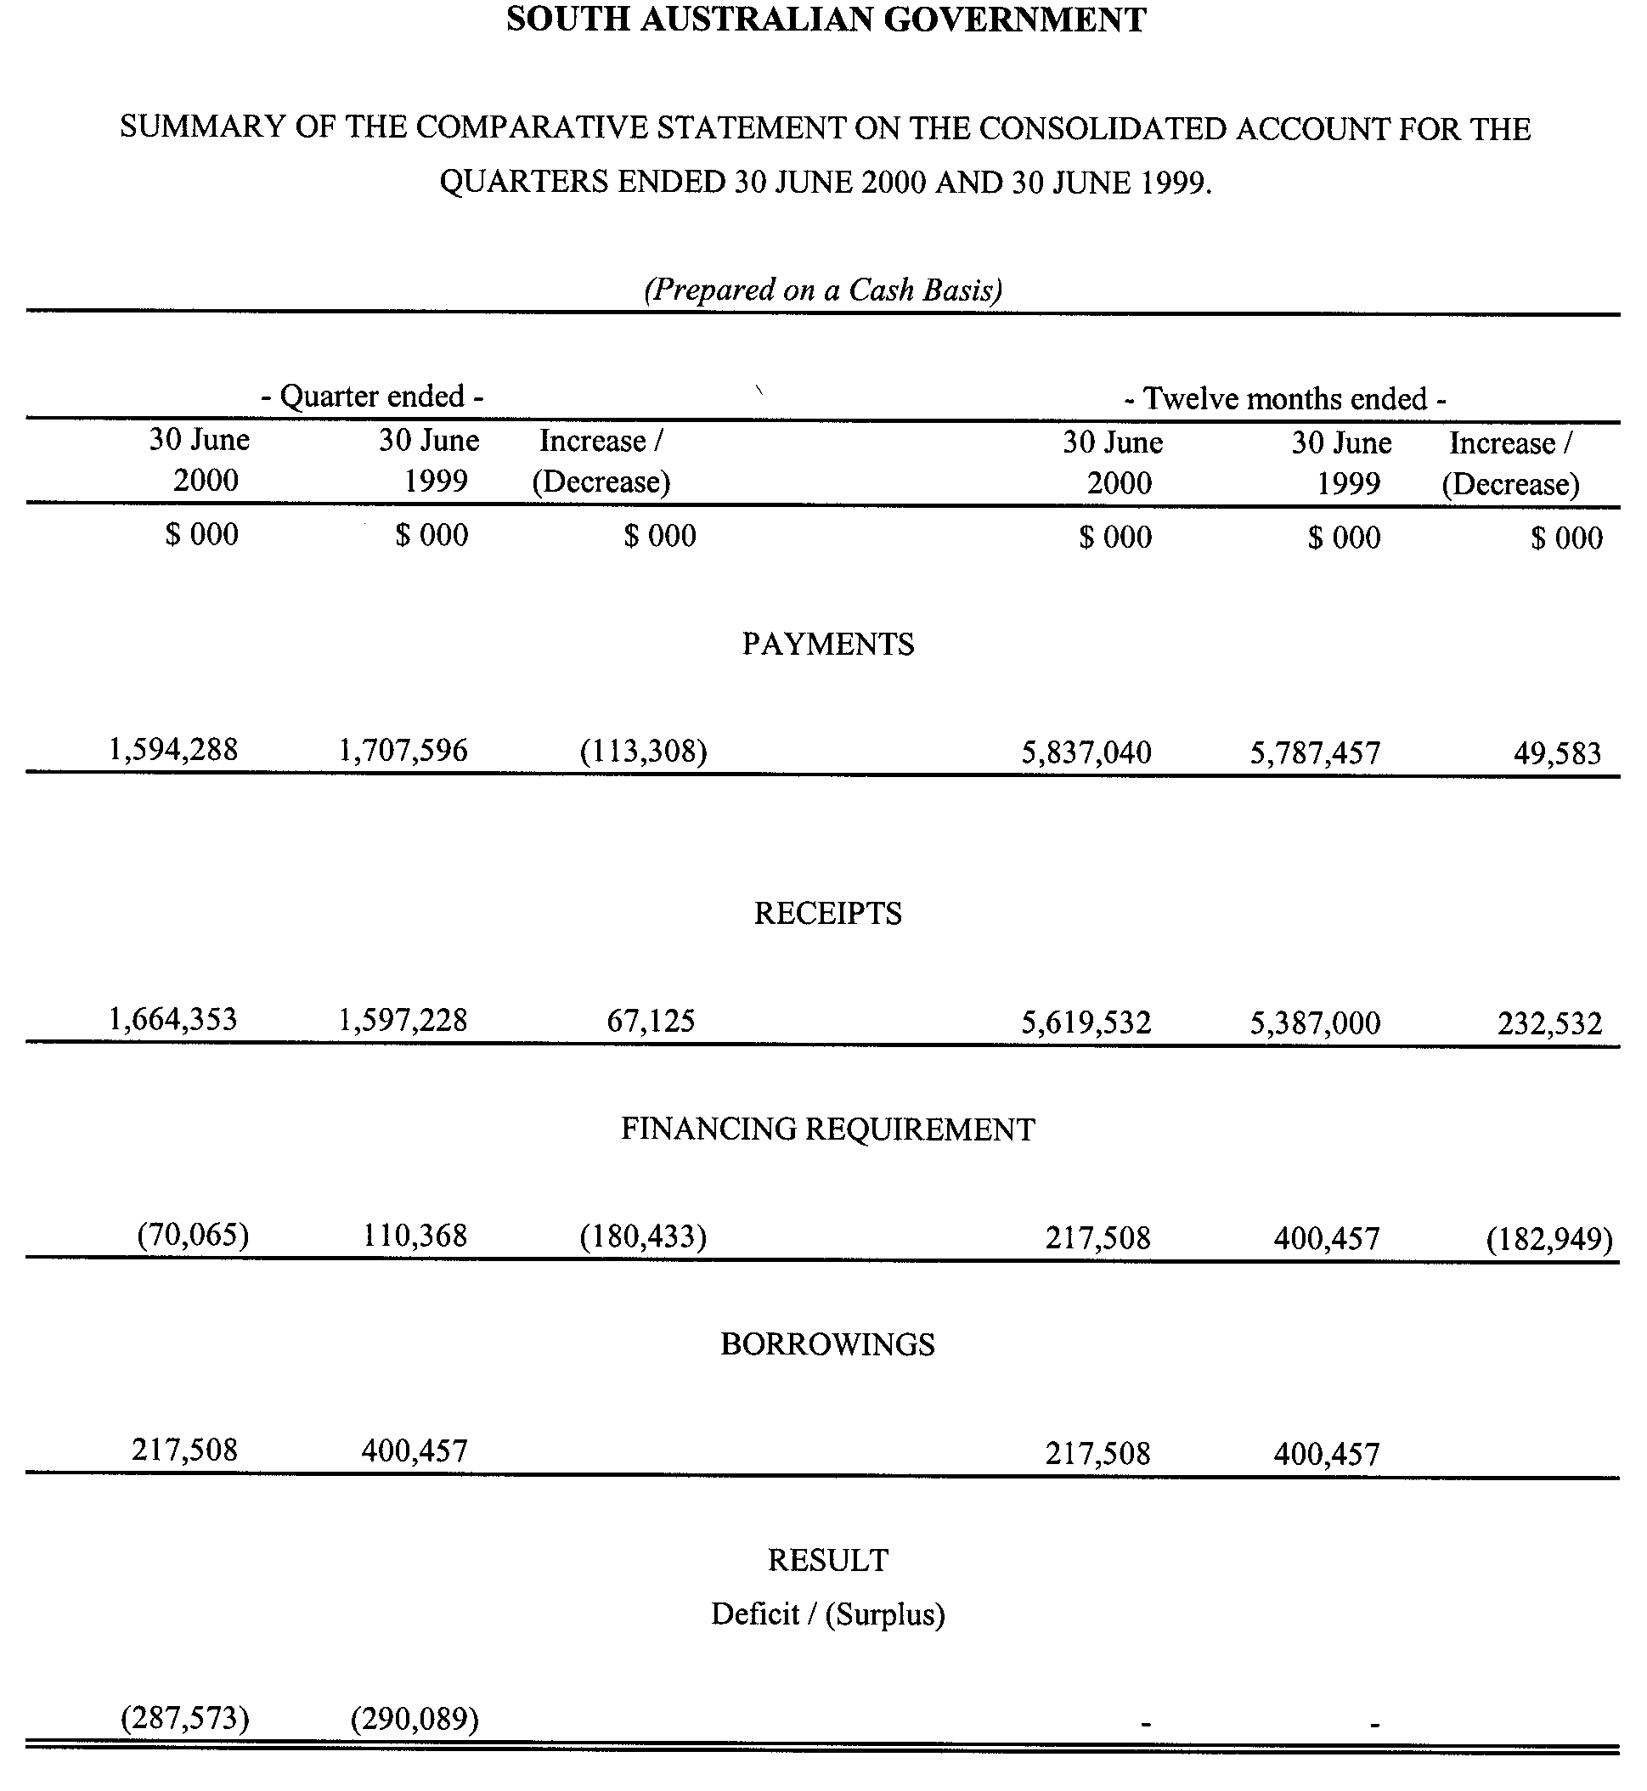
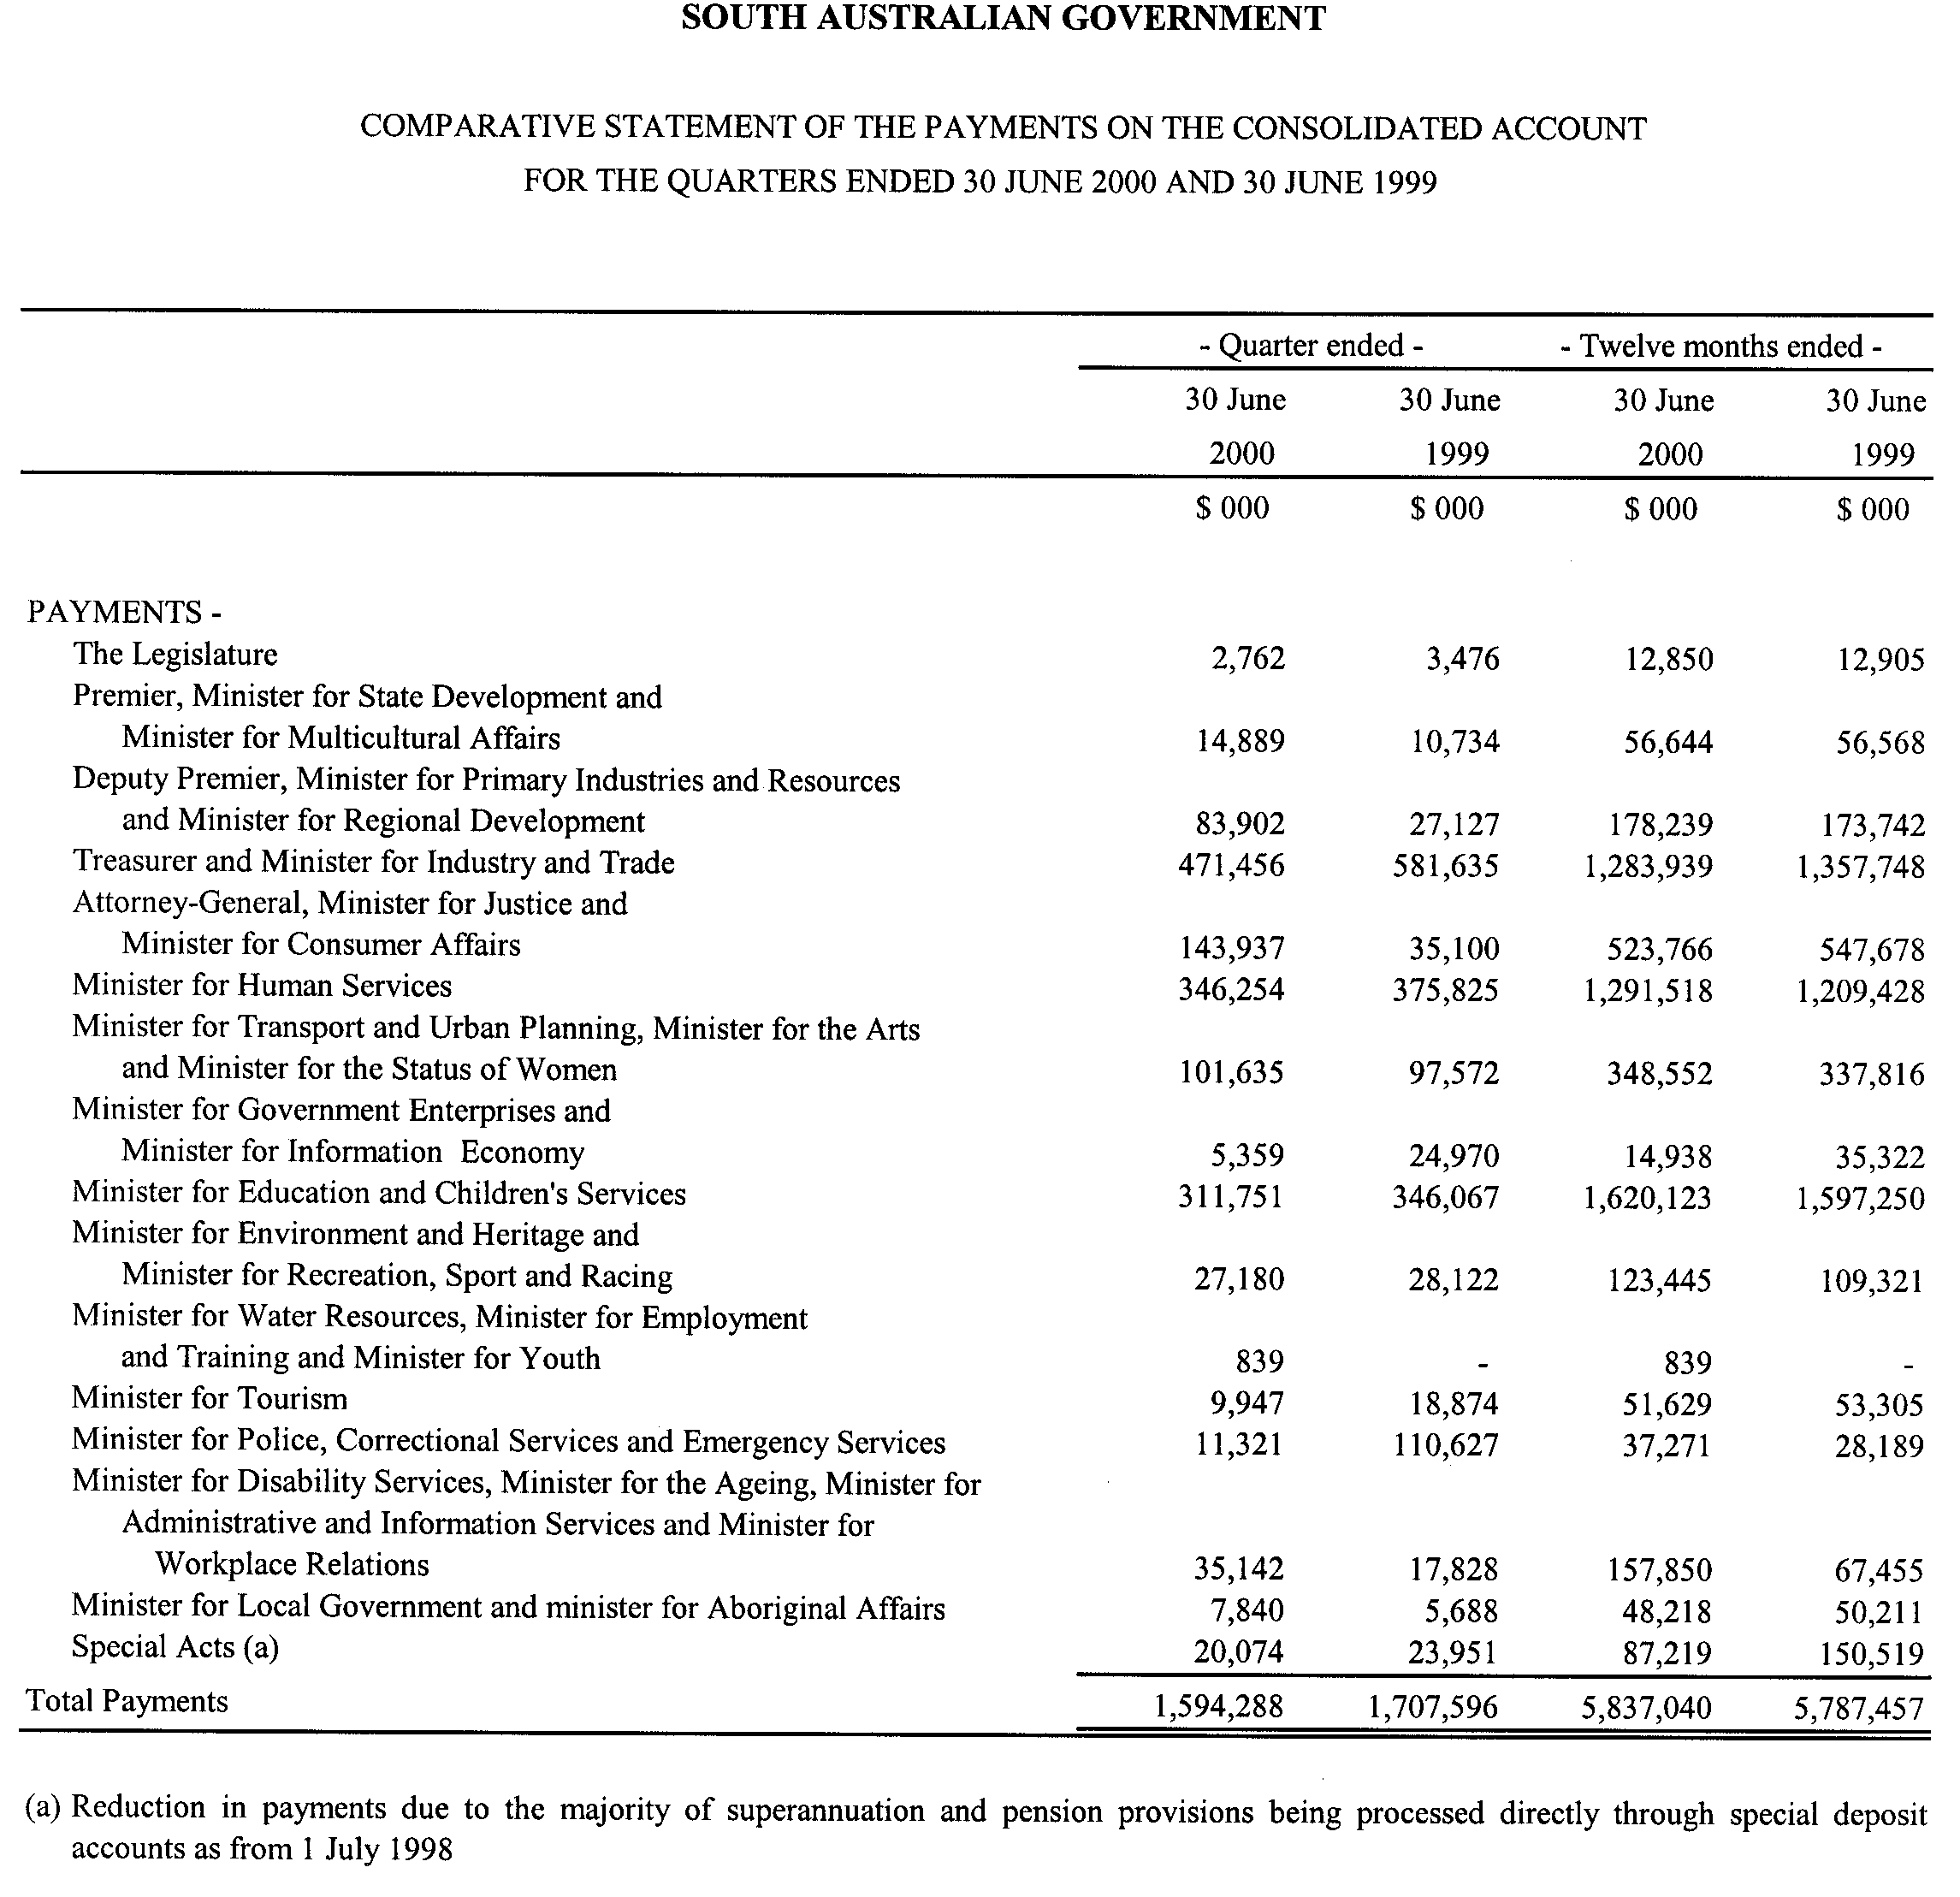
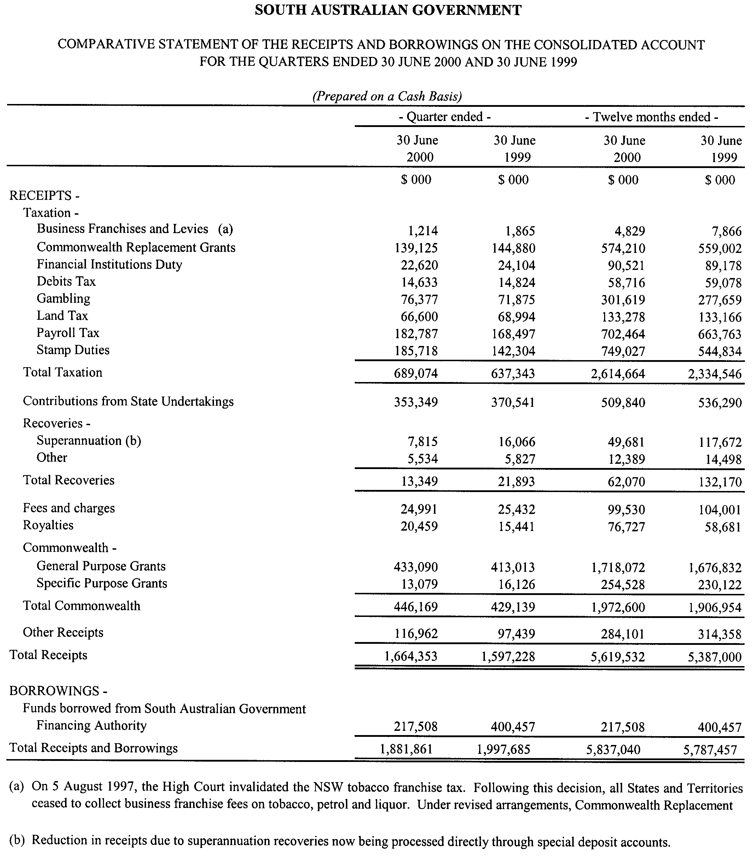
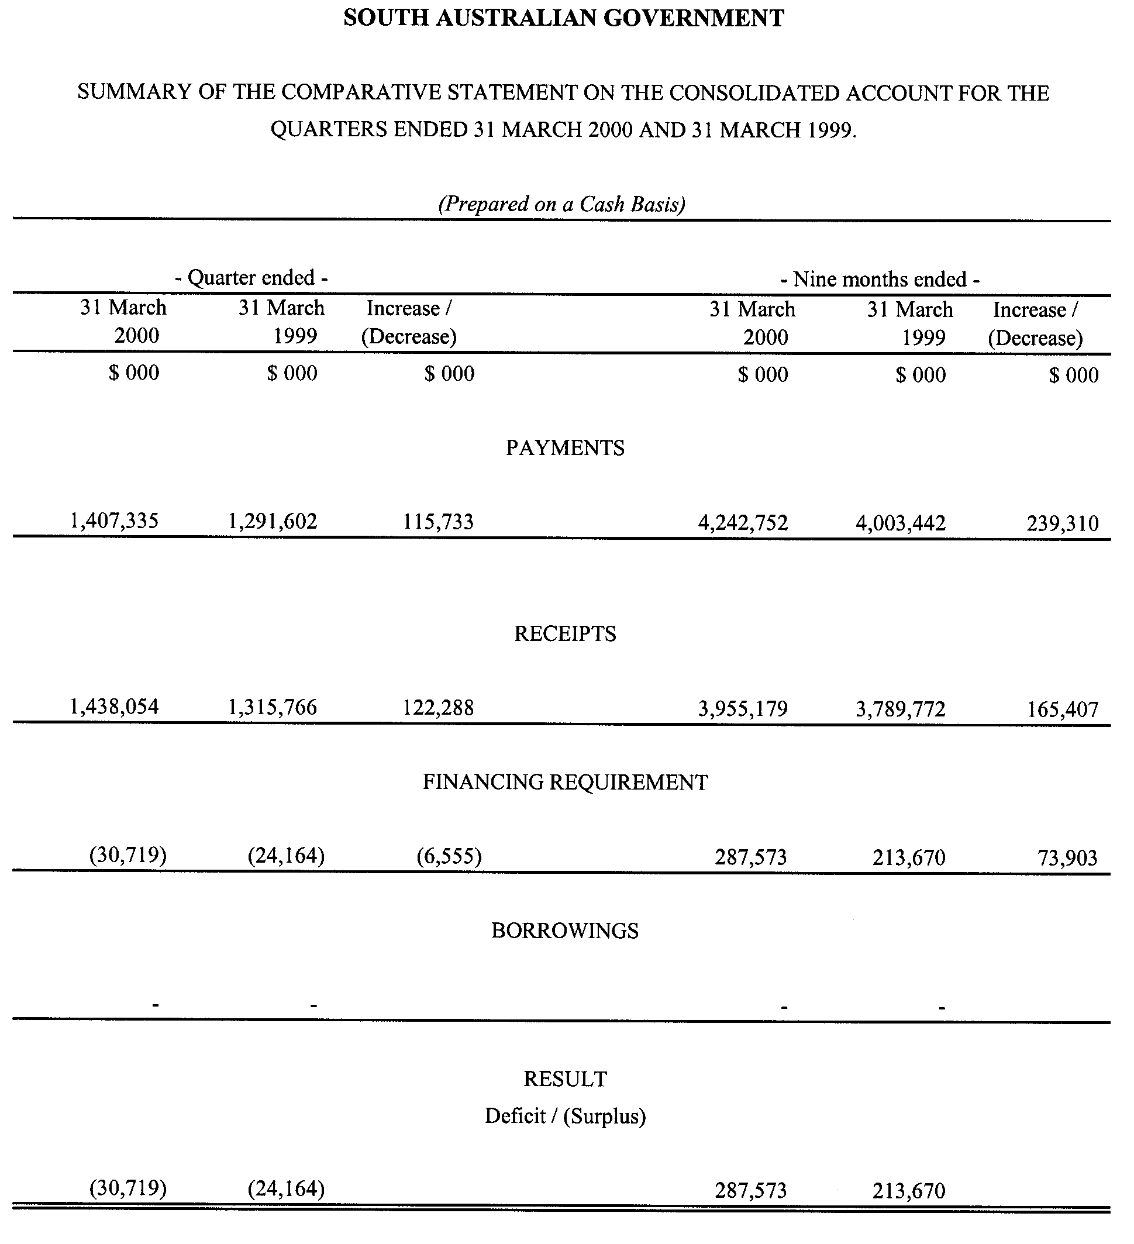
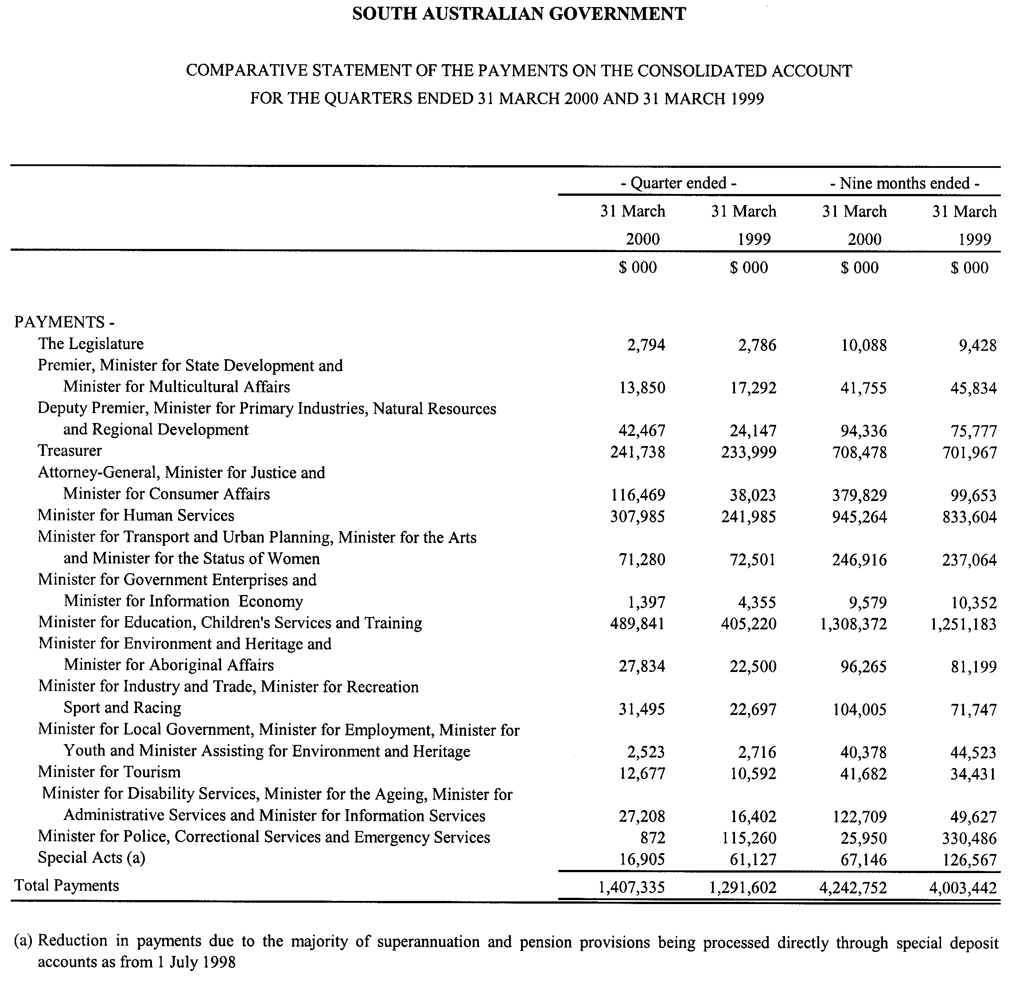
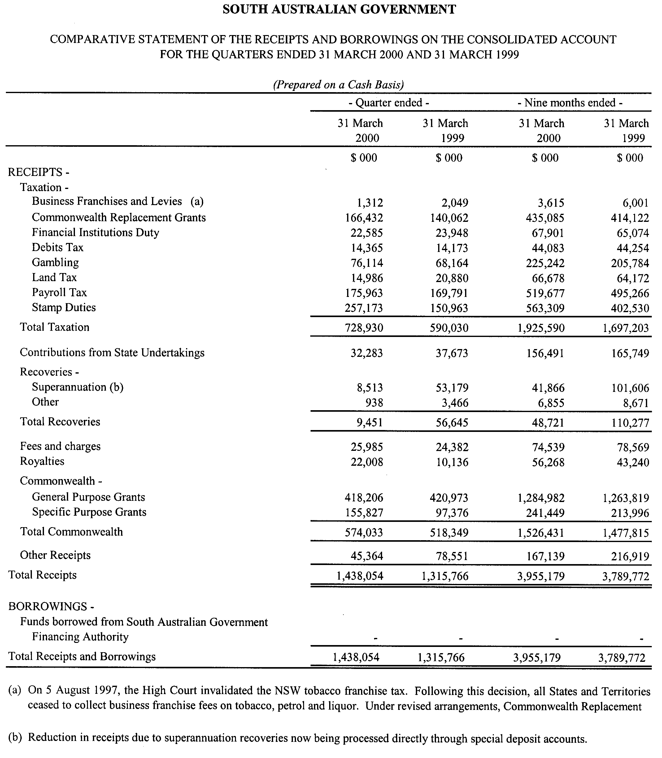
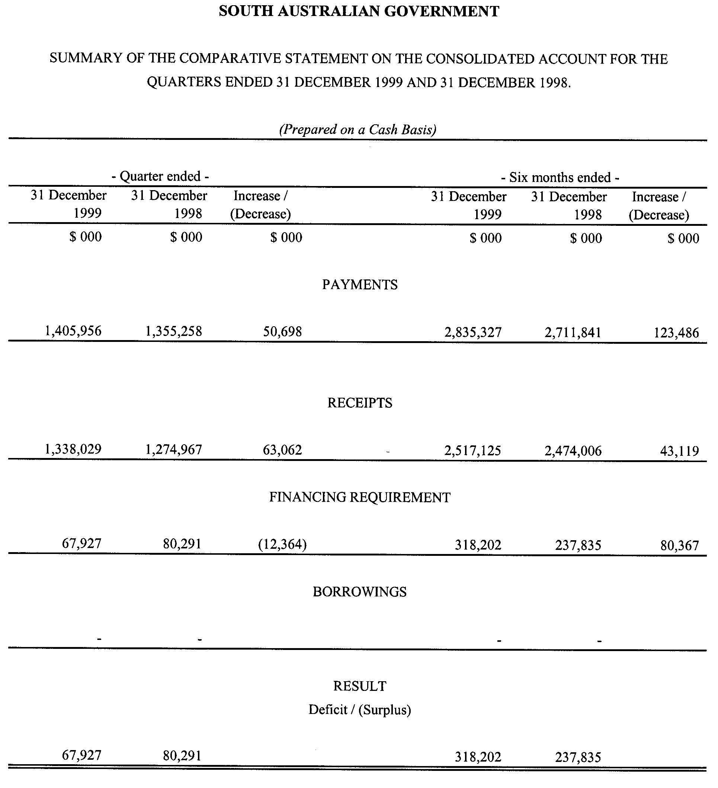
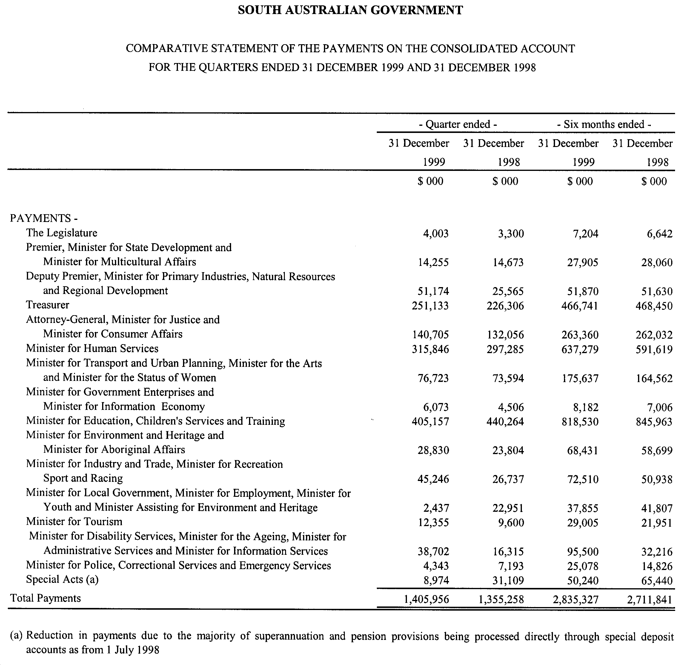
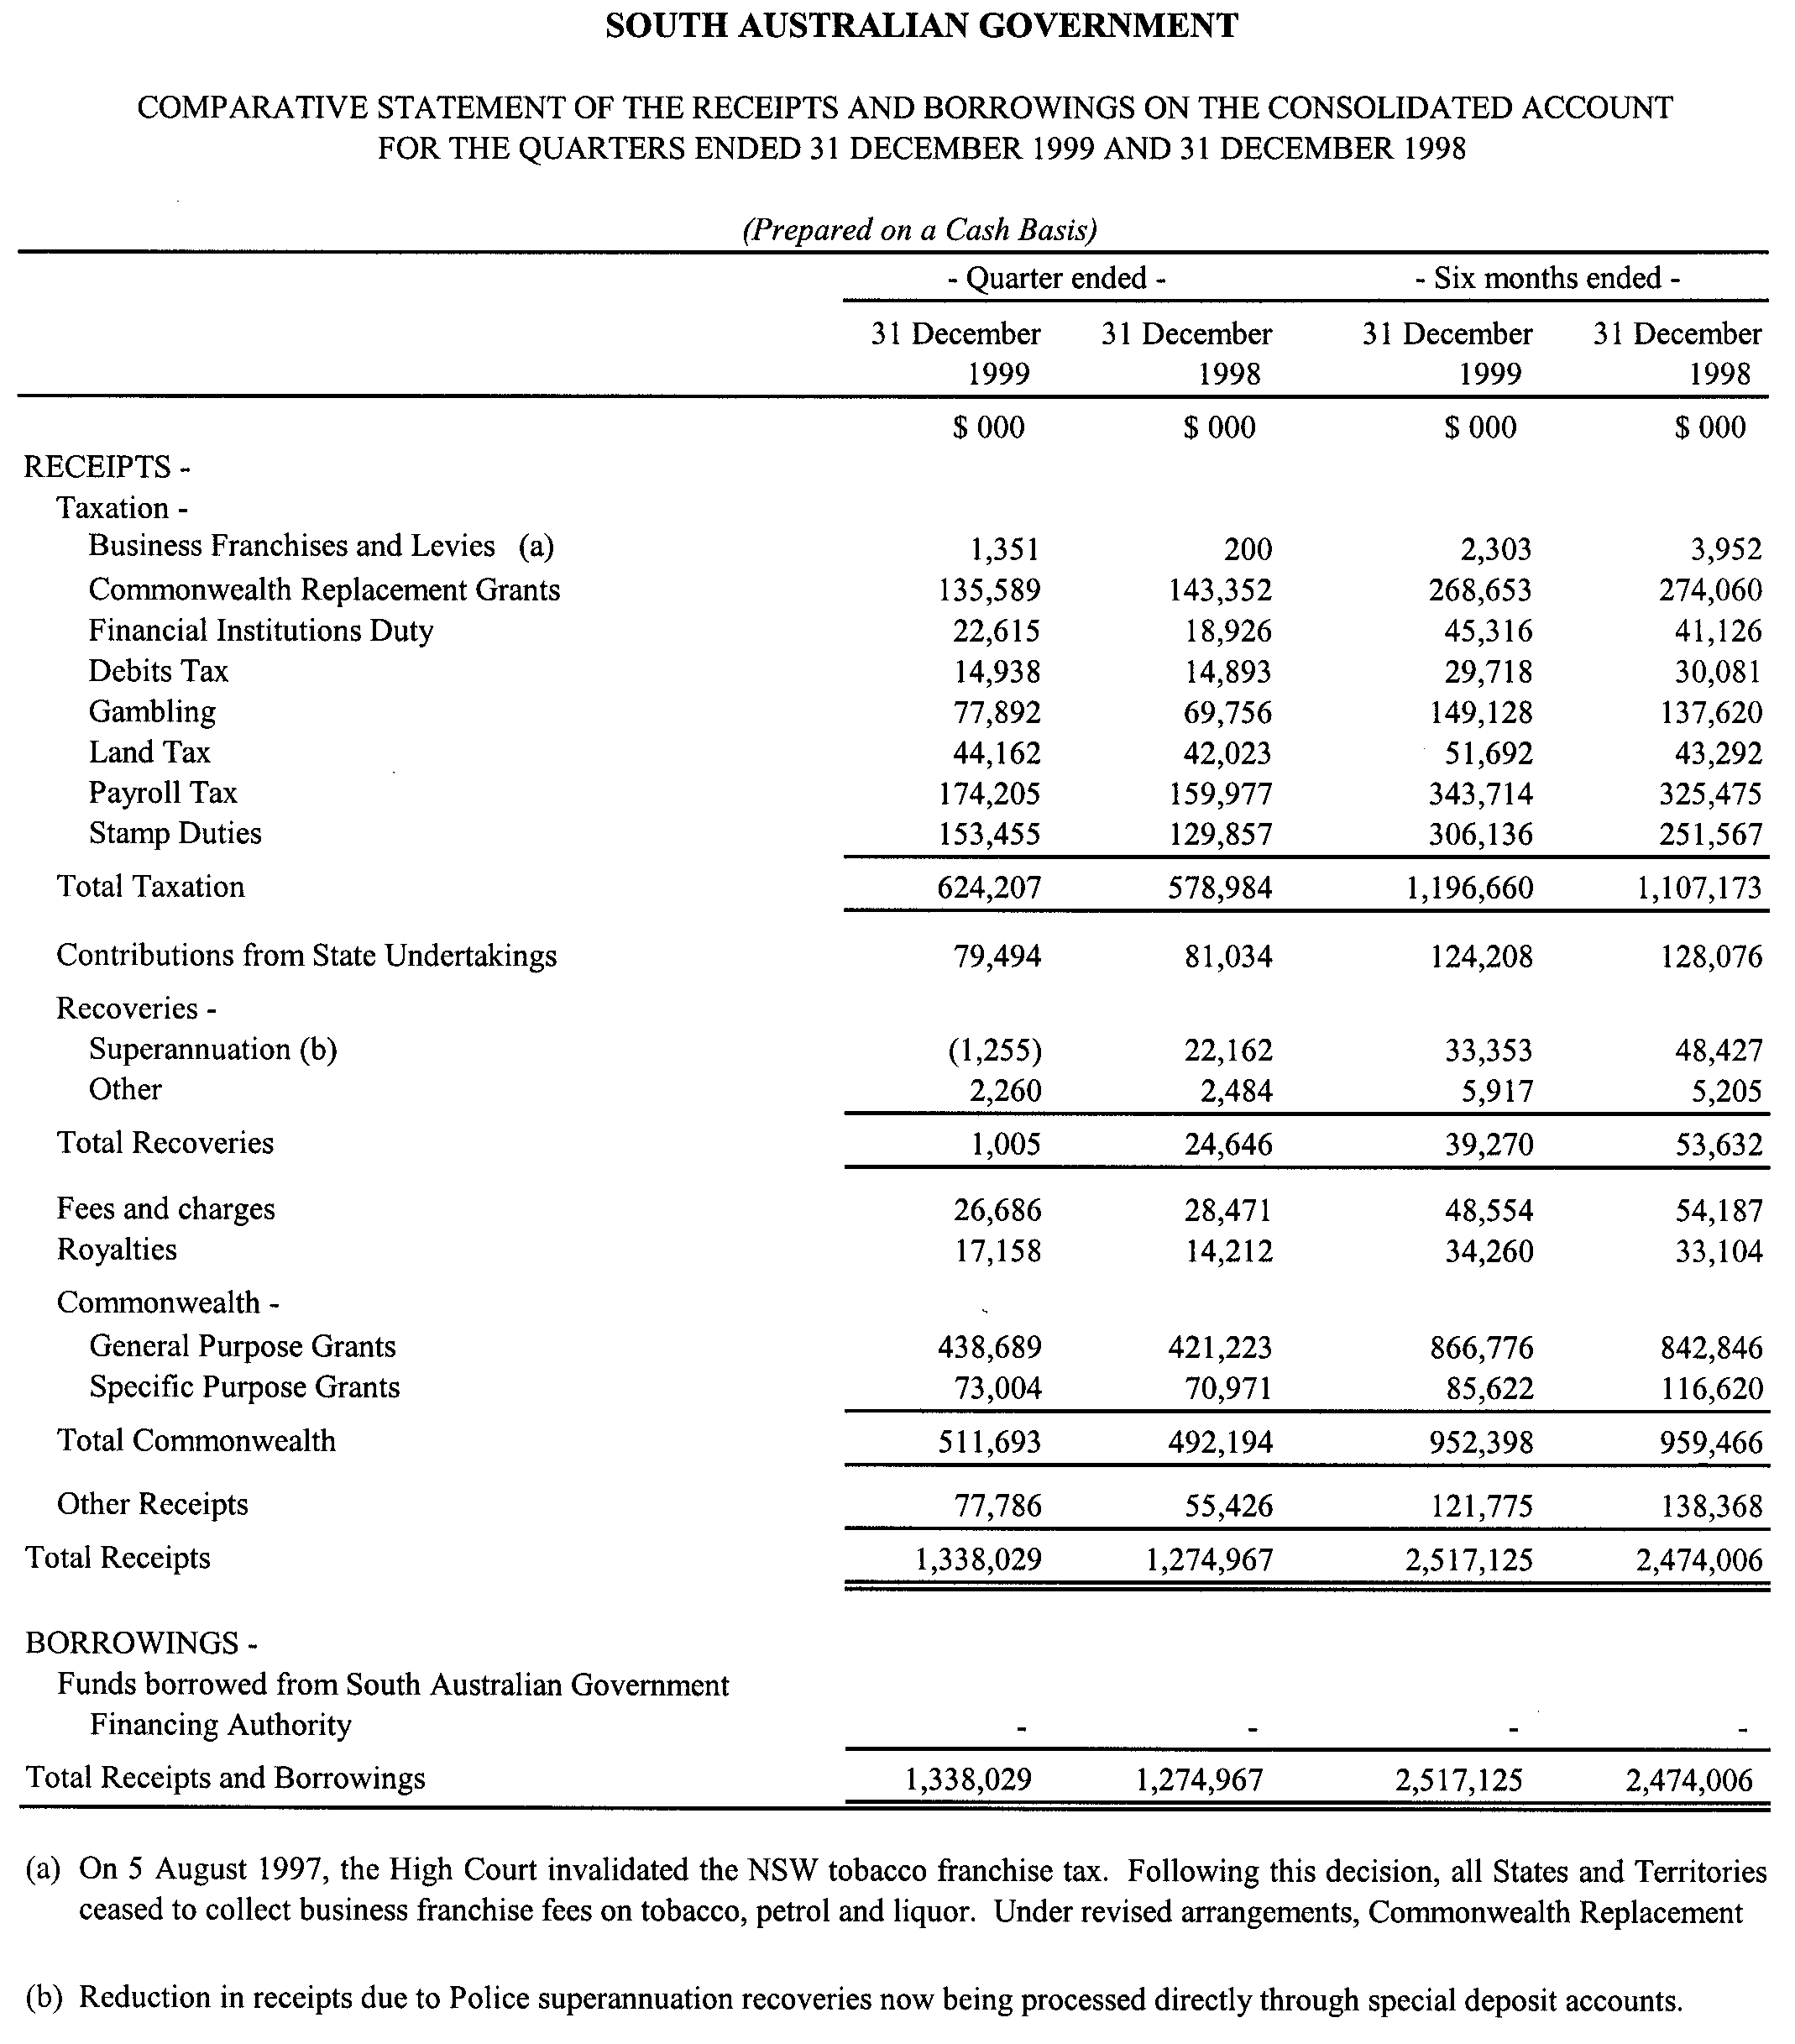
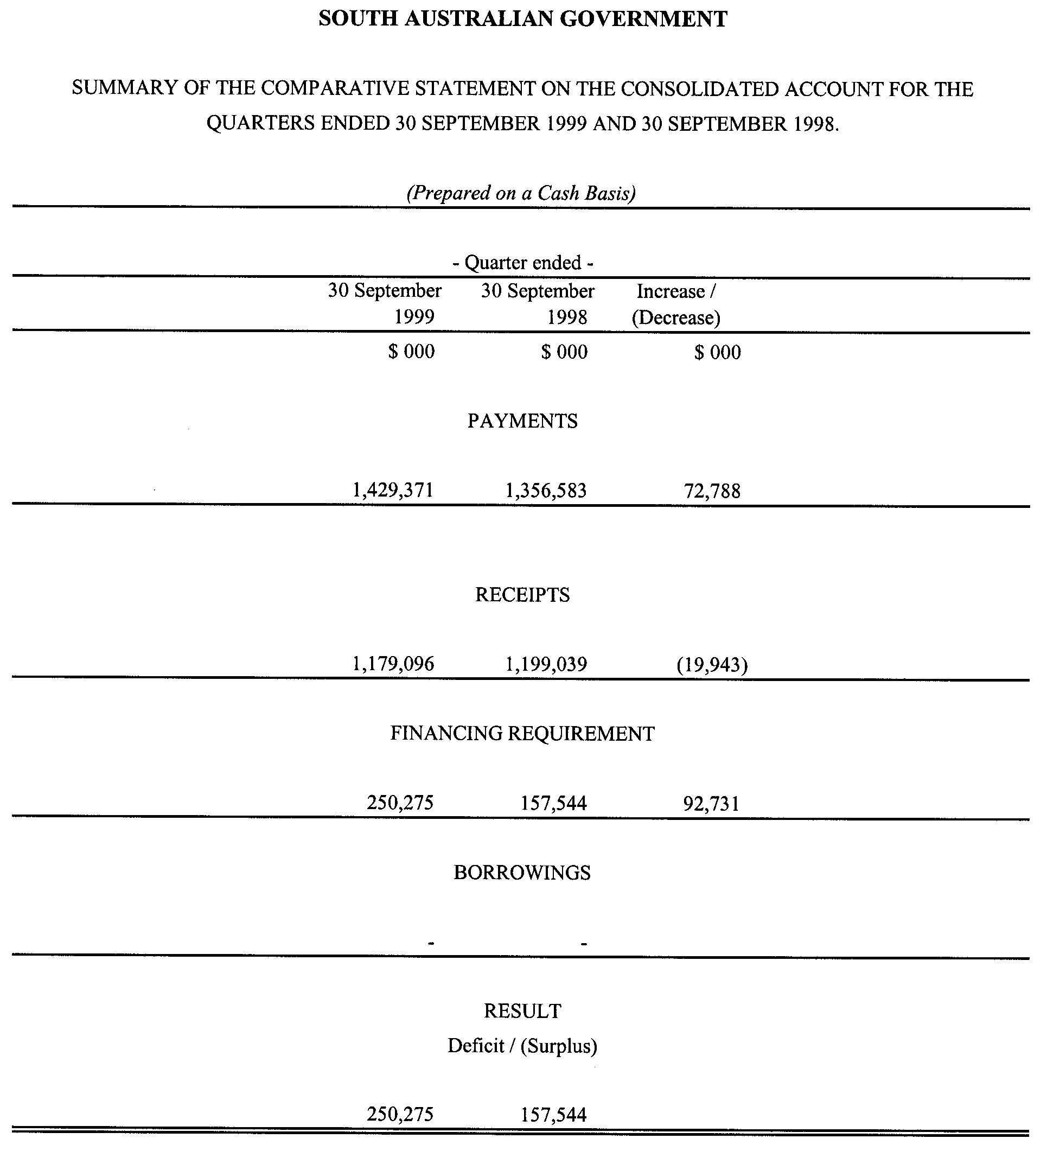
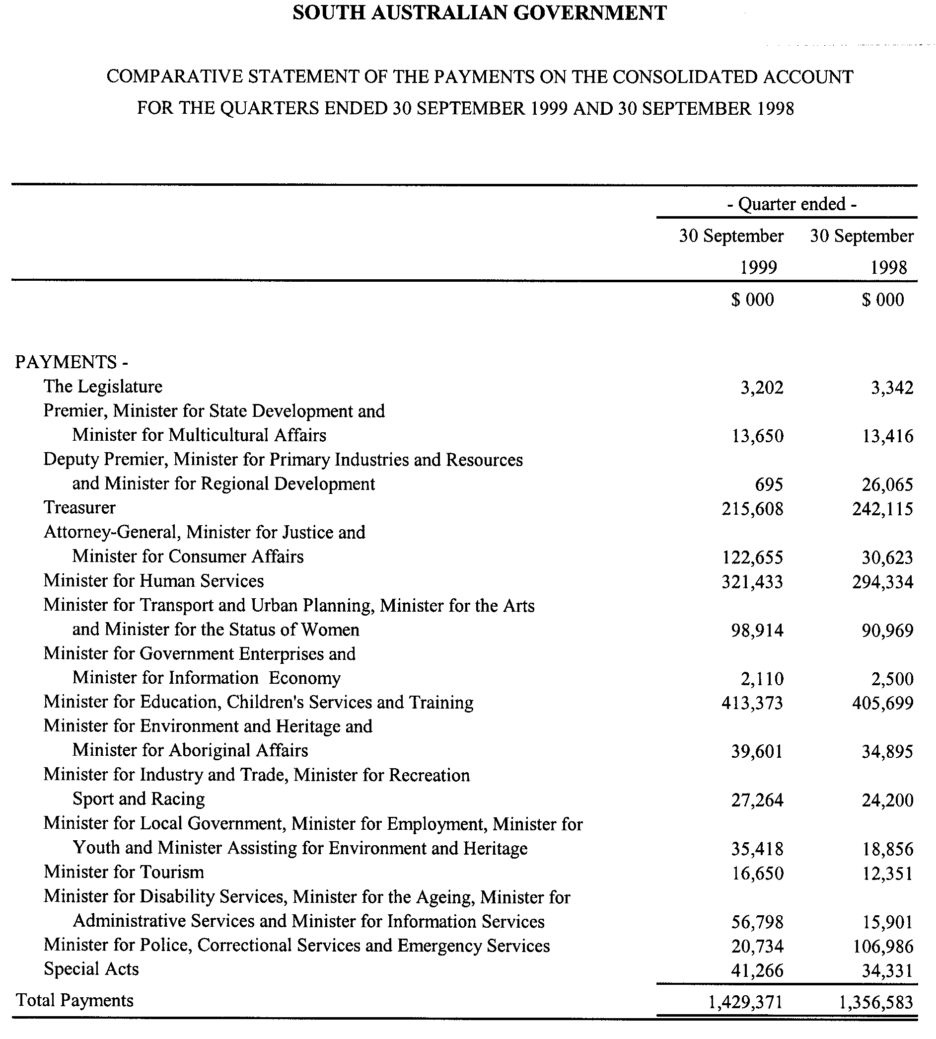
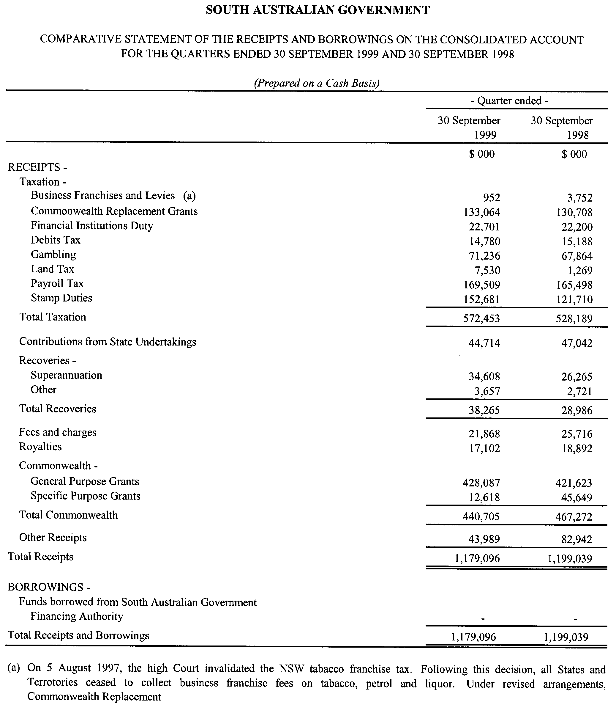
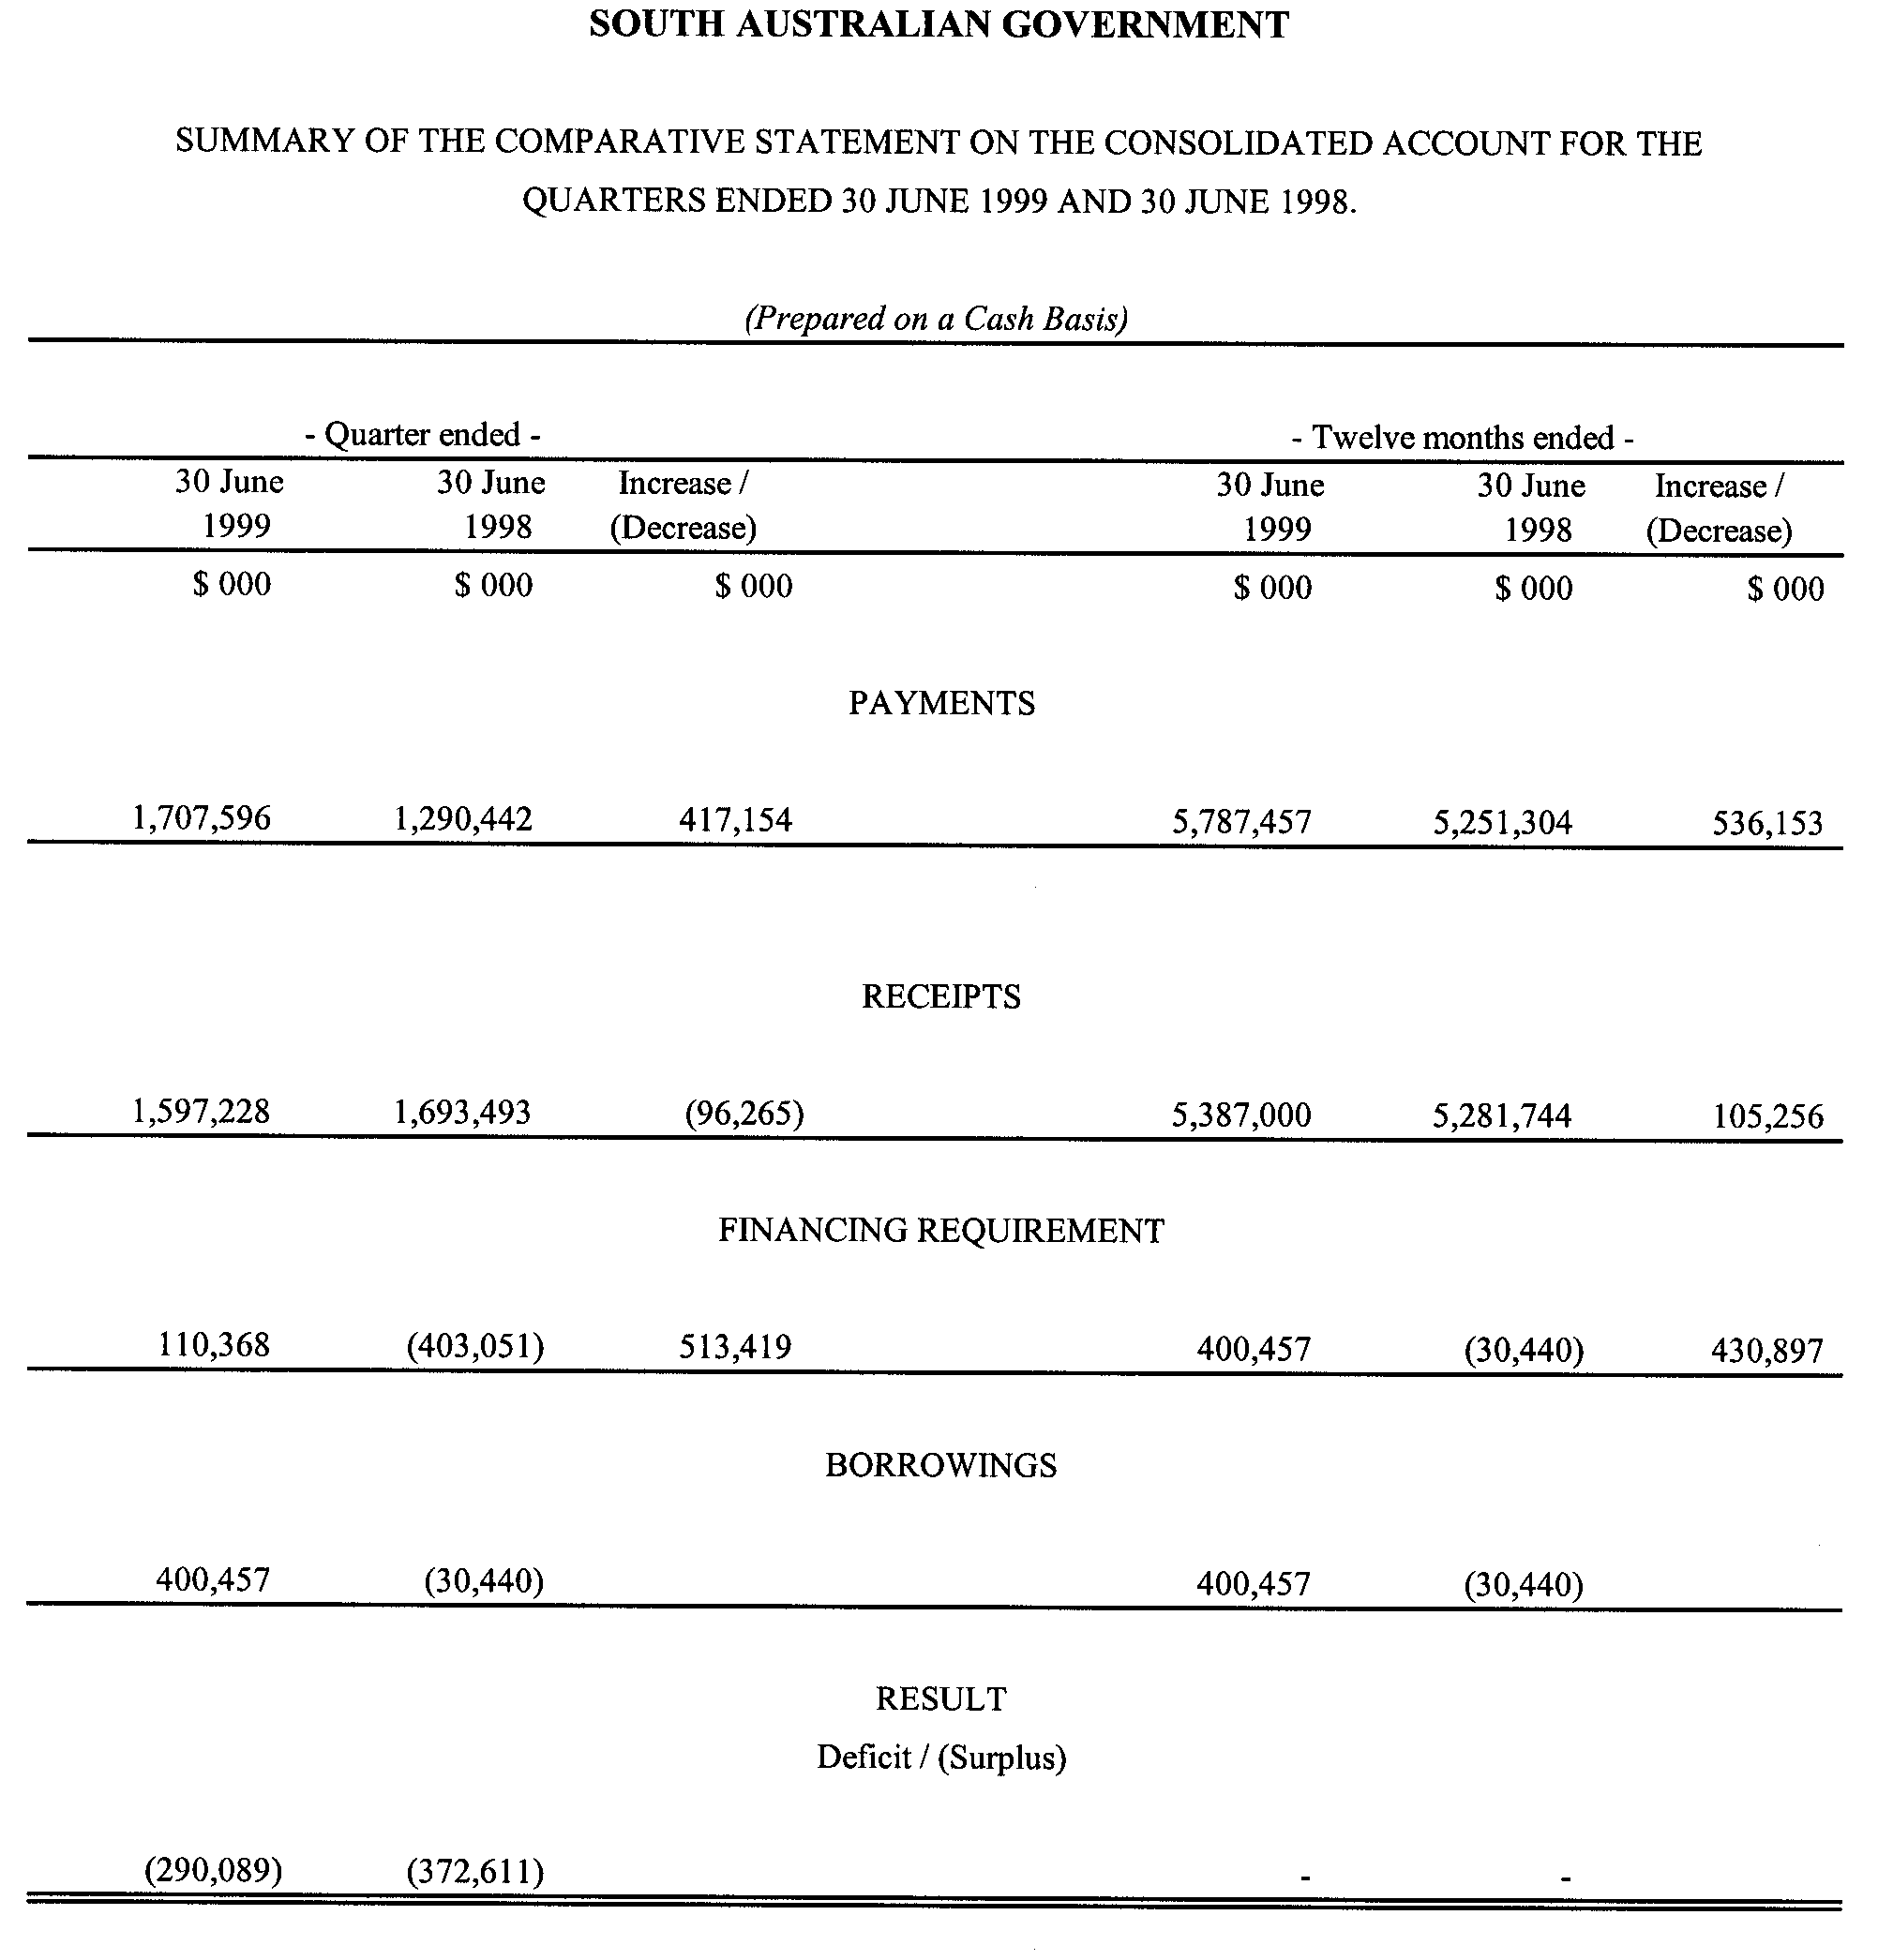
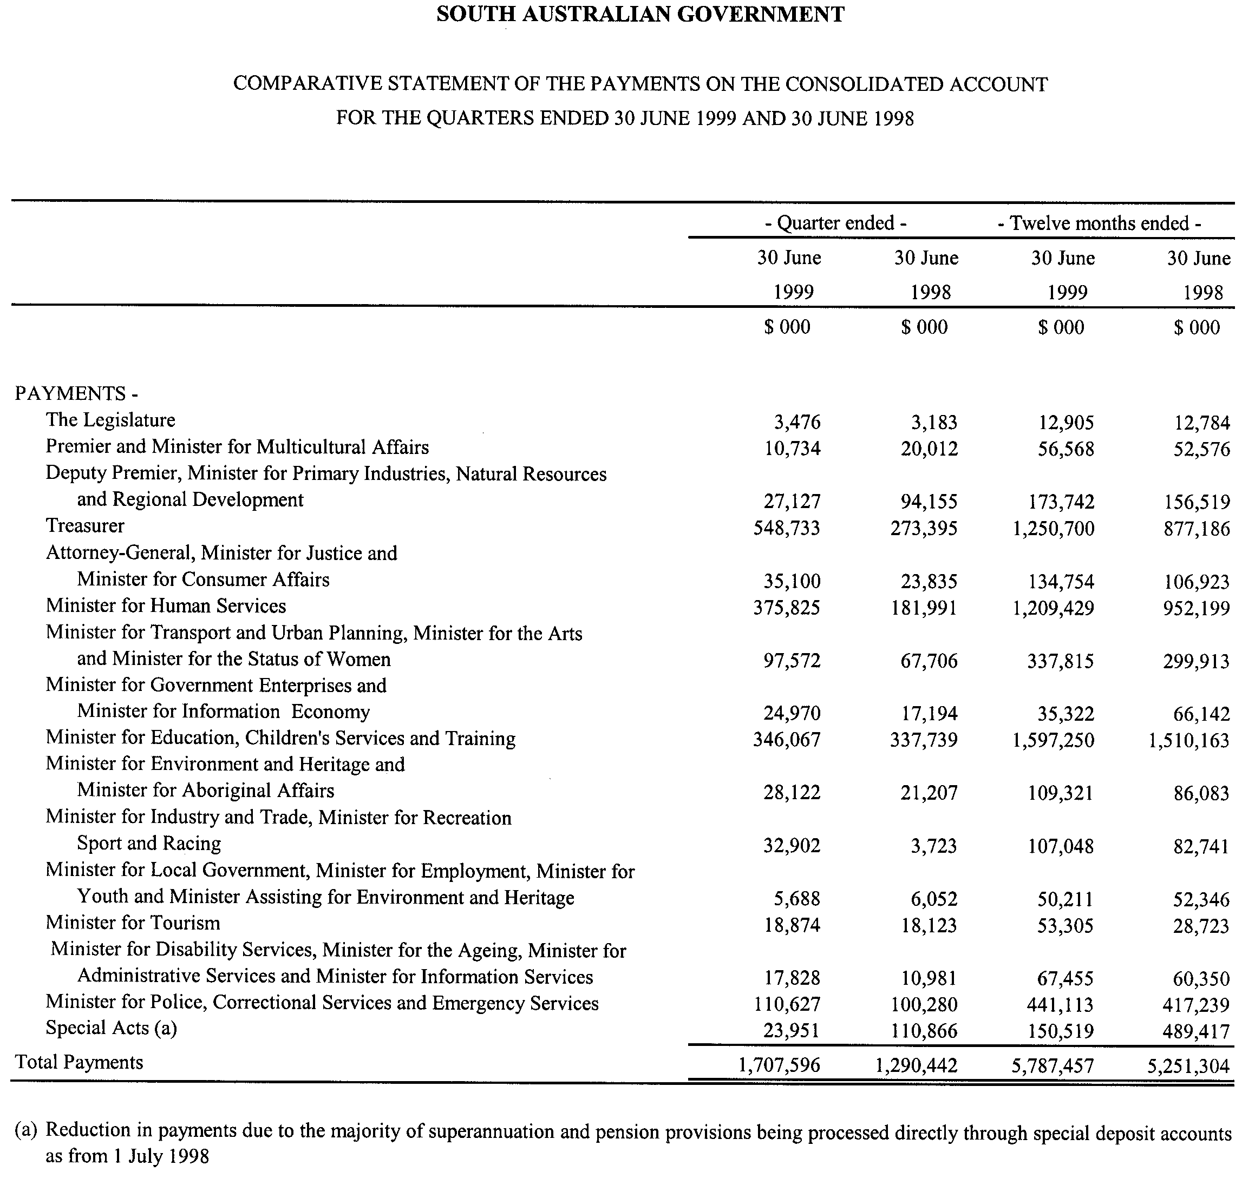

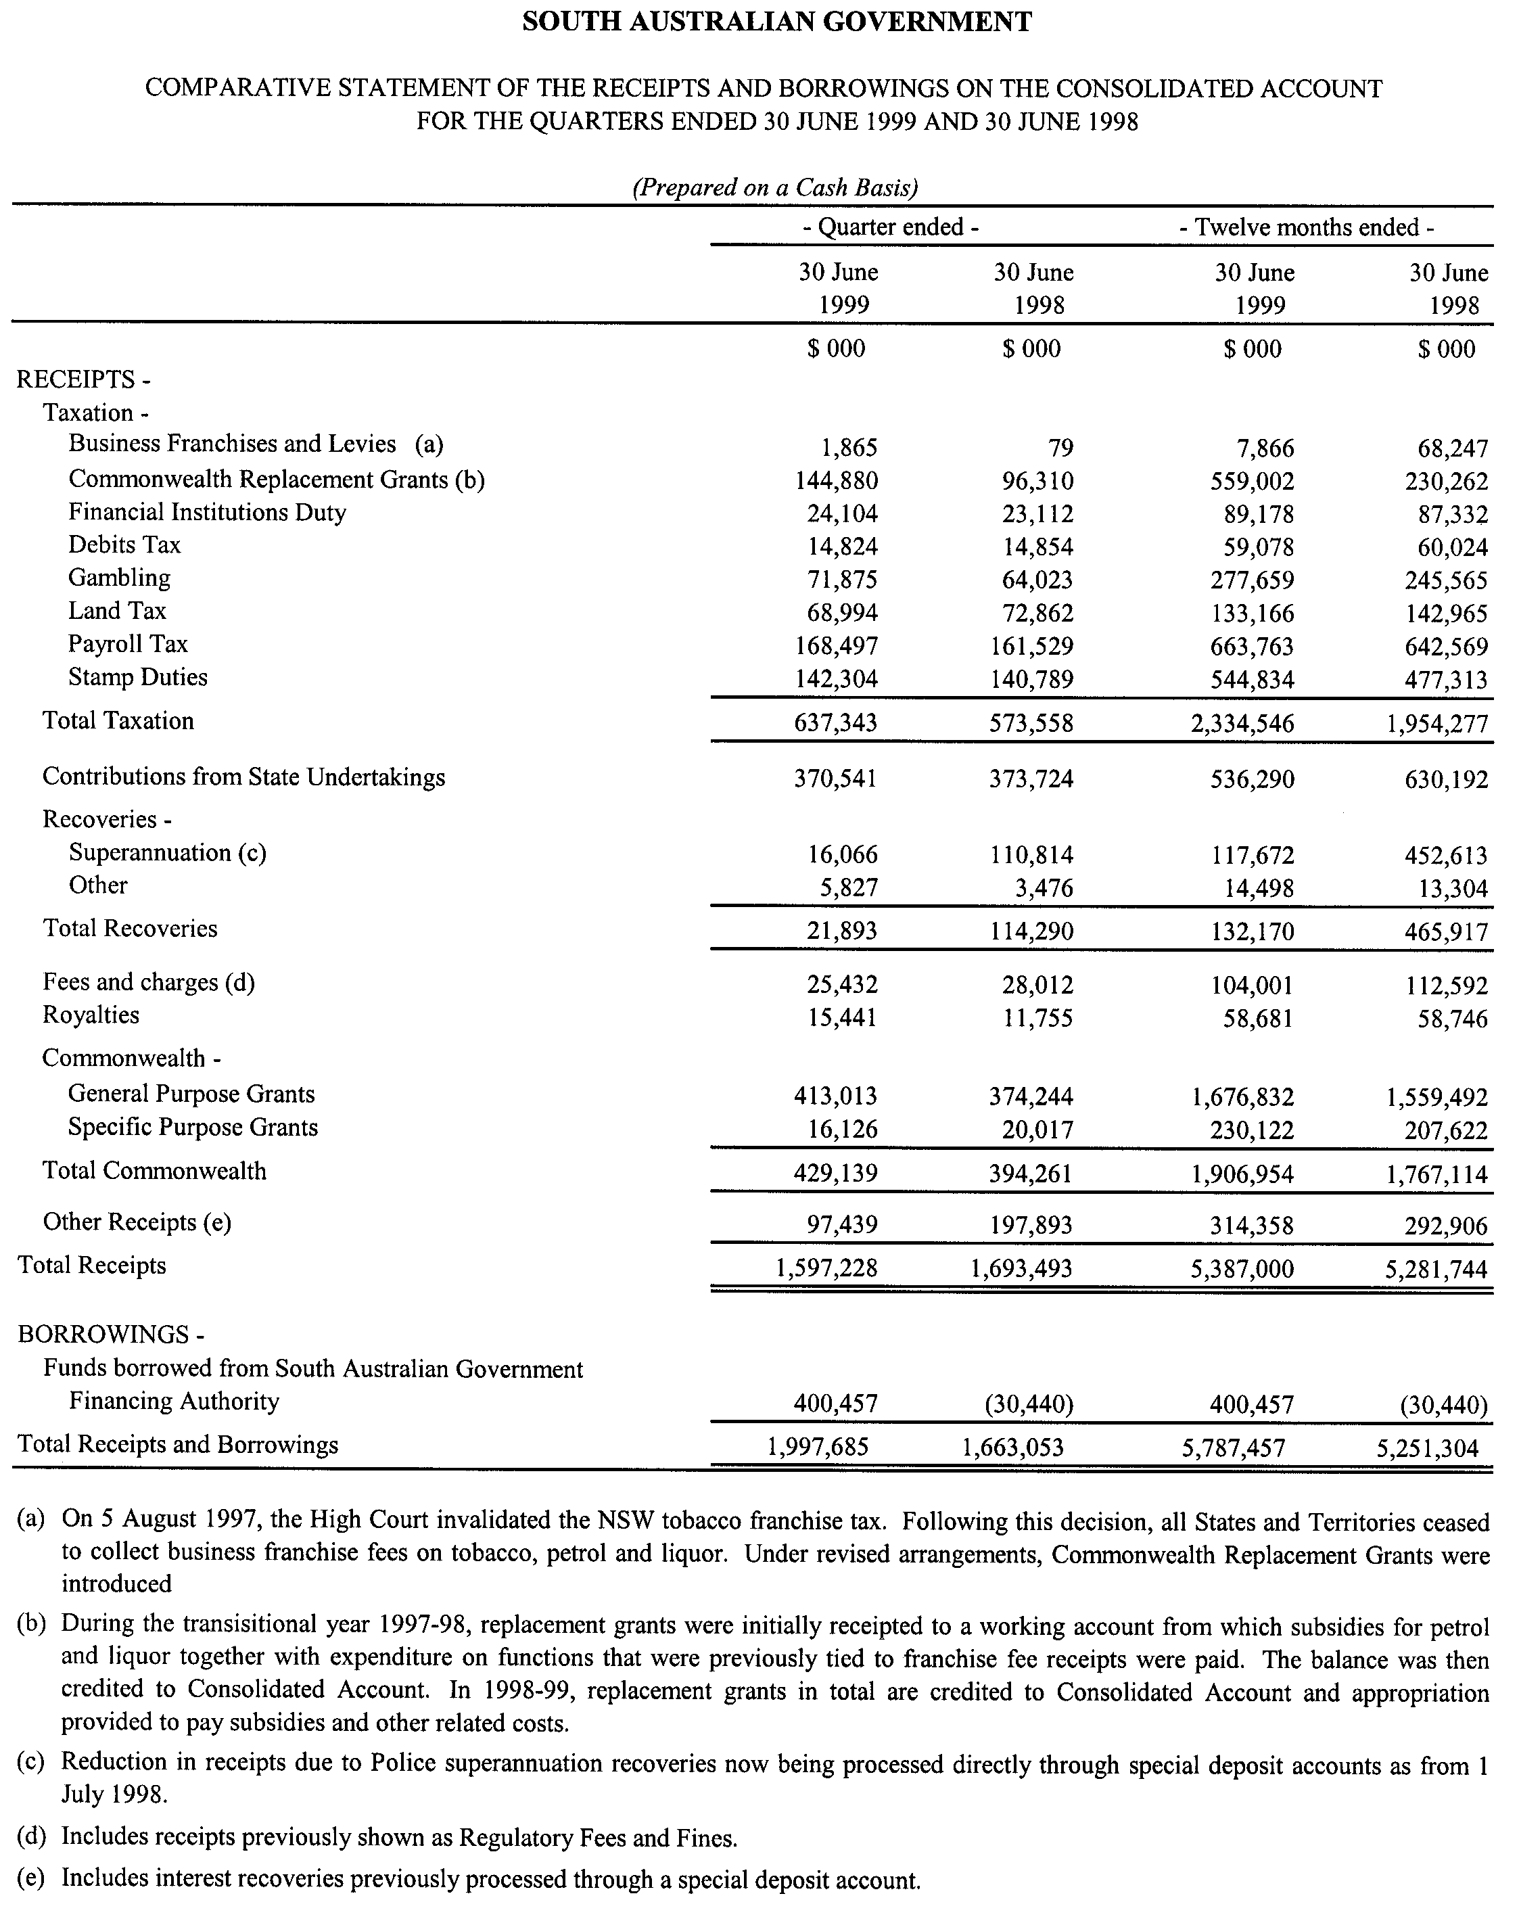

Dated 25 August 2003.
K. Foley, Treasurer

SEWERAGE ACT 1929
Addition of Land to Port Augusta Country Drainage Area
PURSUANT to section 18 of the Sewerage Act 1929, the South Australian Water Corporation:
(a) adds to the Port Augusta Country Drainage Area all the land contained in allotment 703 in Filed Plan 186405; and
(b) declares that this notice has effect from the commencement of the financial year in which it is published in the Gazette.
Dated 2 September 2003.
Signed for and on behalf of the South Australian Water Corporation by a person duly authorised so to do:
A. Popplewell, General Manager Shared Services
In the presence of:
P. M. Rucioch, Manager Billing and Collection
SAWATER 03/04965 D1182

STATE EMERGENCY SERVICE ACT 1987
Registration of SES Unit
NOTICE is hereby given that pursuant to section 9 (1) of the State Emergency Service Act 1987, the following unit is registered as an SES Unit:
Eyre Headquarters SES Unit
Dated 4 September 2003.
B. F. Lancaster, Director

WATERWORKS ACT 1932
Addition of land to Adelaide Water District
PURSUANT to section 6 of the Waterworks Act 1932, the South Australian Water Corporation:
(a) adds to the Adelaide Water District all the land contained in allotment 3 in Deposited Plan 14981; and
(b) declares that this notice has effect from the commencement of the financial year in which it is published in the Gazette.
Dated 2 September 2003.
Signed for and on behalf of the South Australian Water Corporation by a person duly authorised so to do:
A. Popplewell, General Manager Shared Services
In the presence of:
C. J. McNamara, Billing Manager
SAWATER 98/00280 W1039

WATERWORKS ACT 1932
Addition of Land to, and Removal of Land from,
Adelaide Water District
PURSUANT to section 6 of the Waterworks Act 1932, the South Australian Water Corporation:
(a) adds to the Adelaide Water District all the land contained in allotment 300 in Deposited Plan 57287 (except the portion of that land already in the Adelaide Water District); and
(b) removes from the Adelaide Water District all the land contained in piece 302 in Deposited Plan 57287 (except the portion of that land already outside the Adelaide Water District); and
(c) declares that this notice has effect from the commencement of the financial year in which it is published in the Gazette.
Dated 2 September 2003.
Signed for and on behalf of the South Australian Water Corporation by a person duly authorised so to do:
A. Popplewell, General Manager Shared Services
In the presence of:
C. J. McNamara, Billing Manager
SAWATER 01/01066 W1147

WATERWORKS ACT 1932
Removal of Land from Mundallio Country Lands Water District
and Addition to Port Augusta Water District
PURSUANT to section 6 of the Waterworks Act 1932, the South Australian Water Corporation:
(a) removes from the Mundallio Country Lands Water District and adds to the Port Augusta Water District all the land contained in allotment 703 in Filed Plan 186405; and
(b) declares that this notice has effect from the commencement of the financial year in which it is published in the Gazette.
Dated 20 August 2003.
Signed for and on behalf of the South Australian Water Corporation by a person duly authorised so to do:
A. Popplewell, General Manager Shared Services
In the presence of:
C. J. McNamara, Billing Manager
SAWATER 03/04964 W1180

WATERWORKS ACT 1932
Removal of Land from Warren Country Lands Water District
and Addition to Rowland Flat Water District
PURSUANT to section 6 of the Waterworks Act 1932, the South Australian Water Corporation:
(a) removes from the Warren Country Lands Water District and adds to the Rowland Flat Water District all the land contained in allotments 201 and 205 in Deposited Plan 51185; and
(b) declares that this notice has effect from the commencement of the financial year in which it is published in the Gazette.
Dated 2 September 2003.
Signed for and on behalf of the South Australian Water Corporation by a person duly authorised so to do:
A. Popplewell, General Manager Shared Services
In the presence of:
C. J. McNamara, Billing Manager
SAWATER 03/05067 W1185

WATERWORKS ACT 1932
Removal of Land from Yorke Peninsula Country Lands Water District and Addition to Port Victoria Water District
PURSUANT to section 6 of the Waterworks Act 1932, the South Australian Water Corporation:
(a) removes from the Yorke Peninsula Country Lands Water District and adds to the Port Victoria Water District all the land contained in allotments 22 to 26 inclusive in Deposited Plan 61018; and
(b) declares that this notice has effect from the commencement of the financial year in which it is published in the Gazette.
Dated 2 September 2003.
Signed for and on behalf of the South Australian Water Corporation by a person duly authorised so to do:
A. Popplewell, General Manager Shared Services
In the presence of:
C. J. McNamara, Billing Manager
SAWATER 03/05068 W1186

WATERWORKS ACT 1932
Addition of Land to Township of Clare Water District
PURSUANT to section 6 of the Waterworks Act 1932, the South Australian Water Corporation:
(a) adds to the Township of Clare Water District all the land contained in allotment 100 in Deposited Plan 60901 (except the portion of that land already in the Township of Clare Water District); and
(b) declares that this notice has effect from the commencement of the financial year in which it is published in the Gazette.
Dated 2 September 2003.
Signed for and on behalf of the South Australian Water Corporation by a person duly authorised so to do:
A. Popplewell, General Manager Shared Services
In the presence of:
C. J. McNamara, Billing Manager
SAWATER 03/05070 W1187

WATERWORKS ACT 1932
Removal of Land from Beetaloo Country Lands Water District and Addition to Wallaroo Water District
PURSUANT to section 6 of the Waterworks Act 1932, the South Australian Water Corporation:
(a) removes from the Beetaloo Country Lands Water District and adds to the Wallaroo Water District all the land contained in:
(i) allotment 111 in Filed Plan 18793; and
(ii) allotments 1 to 4 inclusive in Deposited Plan 22193; and
(b) declares that this notice has effect from the commencement of the financial year in which it is published in the Gazette.
Dated 2 September 2003.
Signed for and on behalf of the South Australian Water Corporation by a person duly authorised so to do:
A. Popplewell, General Manager Shared Services
In the presence of:
C. J. McNamara, Billing Manager
SAWATER 03/05069 W1188

WATERWORKS ACT 1932
Addition of Land to Mannum-Adelaide Country Lands Water District
PURSUANT to section 6 of the Waterworks Act 1932, the South Australian Water Corporation:
(a) adds to the Mannum-Adelaide Country Lands Water District all the land contained in allotment 619 in Filed Plan 169558; and
(b) declares that this notice has effect from the commencement of the financial year in which it is published in the Gazette.
Dated 2 September 2003.
Signed for and on behalf of the South Australian Water Corporation by a person duly authorised so to do:
A. Popplewell, General Manager Shared Services
In the presence of:
C. J. McNamara, Billing Manager
SAWATER 03/06366 W1189

South Australia
Development (Revocation of Regulation 18A) Variation Regulations 2003
under the Development Act 1993

Contents
Part 1—Preliminary
1 Short title
2 Commencement
3 Variation provisions
Part 2—Variation of Development Regulations 1993
4 Revocation of regulation 18A

Part 1—Preliminary
1—Short title
These regulations may be cited as the Development (Revocation of Regulation 18A) Variation Regulations 2003.
2—Commencement
These regulations come into operation on the day on which they are made.
3—Variation provisions
In these regulations, a provision under a heading referring to the variation of specified regulations varies the regulations so specified.
Part 2—Variation of Development Regulations 1993
4—Revocation of regulation 18A
Regulation 18A—delete the regulation
Note—
As required by section 10AA(2) of the Subordinate Legislation Act 1978, the Minister has certified that, in the Minister's opinion, it is necessary or appropriate that these regulations come into operation as set out in these regulations.
Made by the Governor
with the advice and consent of the Executive Council
on 11 September 2003.
No. 191 of 2003
CPSA2003/00001

FAXING COPY?

IF you fax copy to Government Publishing SA for inclusion in the Government Gazette, there is no need to send a Confirmation Copy to us as well.

This creates confusion and may well result in your notice being printed twice.

Please use the following fax number:

Fax transmission: (08) 8207 1040
Phone Inquiries: (08) 8207 1045

Please include a contact person, phone number and order number so that we can phone back with any queries we may have regarding the fax copy.

NOTE: Closing time for lodging new copy (either fax or hard copy) is 4 p.m. on Tuesday preceding the day of publication.

Government Gazette notices can be E-mailed.

The address is:

governmentgazette@saugov.sa.gov.au

Documents should be sent as attachments in Word format.

When sending a document via E-mail, please confirm your transmission with a faxed copy of your document, including the date the notice is to be published.

Fax transmission: (08) 8207 1040
Enquiries: (08) 8207 1045

CITY OF PORT ADELAIDE ENFIELD
Conversion of Private Road to Public Road
NOTICE is hereby given pursuant to section 210 (5) of the abovementioned Act, that the City of Port Adelaide Enfield at its meeting held on 2 September 2003 declared the private road identified as allotment 158 in Deposited Plan 505, contained within Certificate of Title volume 5479, folio 224, to be a public road.
H. J. Wierda, City Manager

ADELAIDE HILLS COUNCIL
Roads (Opening and Closing) Act 1991
Cox Creek Road, Crafers
NOTICE is hereby given that, pursuant to section 10 of the Roads (Opening and Closing) Act 1991, the Adelaide Hills Council hereby gives notice of its intent to implement a Road Process to close and sell to Guy Uren (Certificate of Title Volume 5427, Folio 722) the portion marked ‘A’, on Preliminary Plan No. 03/0082 in the Hundred of Noarlunga being portion of Public Road, Cox Creek Road, generally situated at Crafers.
A statement of persons affected by the road process together with a copy of the preliminary plan are available for public inspection at the Council Offices, Mount Barker Road, Stirling, and Main Street, Woodside, between the hours of 9 a.m. and 5 p.m. week days only. Copies may also be inspected at the Adelaide Office of the Surveyor-General during normal working hours.
Any person who may wish to object to the proposed road process must lodge with the said council a notice of objection within 28 days of the date of this notice.
All objections shall be in writing giving the objector’s full name and address, reasons for the objection and whether the objector wishes to appear in person or be represented at the subsequent meeting when the objection will be determined by council.
An application for an easement shall be in writing giving the full name and address of the person applying for the grant, full details of the nature and location of the requested easement whether it will be in favour of the owner of adjoining or nearby land and if so specify the land to which the easement will be annexed and reasons for the grant of easement.
A copy of any submission must be forwarded to the Surveyor-General in Adelaide.
Dated 4 September 2003.
P. Peppin, Chief Executive Officer

CLARE & GILBERT VALLEYS COUNCIL
Roads (Opening and Closing) Act 1991
Public Road—Mintaro
NOTICE is hereby given pursuant to section 10 of the Roads (Opening and Closing) Act 1991, that the Clare & Gilbert Valleys Council proposes to make a Road Process Order to close a portion of public road between Allotment 1 in Deposited Plan 38355 and Allotment 109 in Filed Plan 170301, more particularly delineated and marked ‘A’ in Preliminary Plan No. 03/0081. The portion marked ‘A’ is to be transferred and merged with adjoining Allotment 1 in Deposited Plan 38355.
A copy of the Preliminary Plan and statement of persons affected is available for public inspection at the Council Office, 4 Gleeson Street, Clare or at the Adelaide office of the Surveyor-General, during normal office hours.
Any person affected may object to the proposed road process, or apply for an easement to be granted in that person’s favour over land subject to the proposed road closure. Such objection, or application for an easement, must set out the full name and address of the person, and reason for making the objection or application. Any application for an easement must give full particulars of the nature and location of the easement and, where made by a person as the owner of adjoining or nearby land, specify the land to which the easement is to be annexed.
An objection, or application for an easement, must be lodged in writing to the Clare & Gilbert Valleys Council, 4 Gleeson Street, Clare, S.A. 5453 and a copy lodged with the Surveyor-General, Department of Administrative and Information Services, G.P.O. Box 1354, Adelaide, S.A. 5001, within 28 days of publication of this notice.
Where an objection or application for an easement is made, the Council will give notification of a meeting at which the matter will be considered, so that the person making the objection or application may attend, if desired, personally or by a representative.
M. A. Goldstone, Chief Executive Officer

LIGHT REGIONAL COUNCIL
Change of Road Name
NOTICE is hereby given that pursuant to section 219 of the Local Government Act 1999, Light Regional Council, at its meeting held on 19 August 2003, passed a resolution to change the name of the public road in the Hundred of Nuriootpa, suburb of Hewett, presently named Falcon Close and renamed this road Falcon Drive. This road divides Allotment 123 in Deposited Plan 42399 from Allotments 122 and 2000 in Deposited Plan 42399.
P. J. Beare, Chief Executive Officer

IN the matter of the estates of the undermentioned deceased persons:
Brown, Edith Jessica, late of 40 Winchester Street, Malvern, of no occupation, who died on 6 August 2003.
Byrne, Jane, late of 6 Hampton Street North, Goodwood, retired nurse, who died on 26 June 2003.
Celia, Giovanna, late of 98A Hawker Street, Ridleyton, of no occupation, who died on 16 July 2003.
Cleator, James Lewis, late of 46 Francis Street, Clarence Park, retired public servant, who died on 10 July 2003.
Edwards, Colin Stanley, late of 52 Baloo Street, Ingle Farm, retired tram driver, who died on 4 August 2003.
Gowland, Keith Williams, late of 5 Elijah Street, Morphett Vale, retired security officer, who died on 1 July 2003.
Gray, Lilley Catherine, late of Lock, widow, who died on 3 July 2002.
Grindlay, Lawrence Roy, late of 7 Victoria Street, Goodwood, retired supervisor/leading hand, who died on 28 July 2002.
Haywood, Louis William, late of 50 Gulfview Road, Christies Beach, retired metal moulder, who died on 2 August 2003.
King, Lionel James, late of 58 Main Road, Woodside, retired linesman, who died on 1 July 2003.
Koster, Gordon Ronald, late of 16 Albion Avenue, Glandore, retired tiler, who died on 20 June 2003.
Morgan, Helen, late of Leighton Avenue, Klemzig, widow, who died on 25 July 2003.
Patmore, Molly Josephine May, late of 20 Oronga Street, Salisbury North, home duties, who died on 7 August 2003.
Romaniuk, Maria, late of Everard Street, Largs Bay, of no occupation, who died on 15 July 2003.
Rusby, Graham Lloyd, late of 7 Railway Terrace, Old Reynella, retired springsmith, who died on 18 July 2003.
Smith, Kevin Philip John, late of 8 Kelsey Street, Kidman Park, retired electrician, who died on 16 June 2003.
Spooner, Jane, late of 4 Adelaide Street, Magill, home duties, who died on 4 August 2003.
Suzuki, Takako, late of 89 Esplanade, Henley Beach South, sales assistant, who died on 30 May 2003.
Weddle, Joan Kathleen, late of 437 Salisbury Highway, Parafield Gardens, of no occupation, who died on 8 June 2003.
Notice is hereby given pursuant to the Trustee Act 1936, as amended, the Inheritance (Family Provision) Act 1972, and the Family Relationships Act 1975, that all creditors, beneficiaries, and other persons having claims against the said estates are required to send, in writing, to the Public Trustee, 25 Franklin Street, Adelaide 5000, full particulars and proof of such claims, on or before 10 October 2003, otherwise they will be excluded from the distribution of the said estate; and notice is also hereby given that all persons who are indebted to the said estates are required to pay the amount of their debts to the Public Trustee or proceedings will be taken for the recovery thereof; and all persons having any property belonging to the said estates are forthwith to deliver the same to the Public Trustee.
Dated 11 September 2003.
C. J. O’Loughlin, Public Trustee

ATTENTION

CUSTOMERS requiring a proof of their notice for inclusion in the Government Gazette, please note that the onus is on you to inform Government Publishing SA of any subsequent corrections by 10 a.m. on Thursday, which is our publication deadline.

For any corrections to your notice please phone 8207 1045 or Fax 8207 1040 before 10 a.m. on Thursday.

If we do not receive any communication by 10 a.m. on Thursday (day of publication) we will presume the notice is correct and will print it as it is.

Remember—the onus is on you to inform us of any corrections necessary to your notice.

NOTE: Closing time for lodging new copy (electronically, fax or hard copy) is 4 p.m. on Tuesday preceding the day of publication. Phone 8207 1045—Fax 8207 1040.
Email: governmentgazette@saugov.sa.gov.au

Printed and published by authority every Thursday by J. D. FERGUSON, Government Printer, South Australia
Price: $4.70, plus postage; to subscribers, $238.00 per annum.
(The above prices are inclusive of GST)

