No. 91 3615

THE SOUTH AUSTRALIAN

GOVERNMENT GAZETTE

PUBLISHED BY AUTHORITY

ALL PUBLIC ACTS appearing in this GAZETTE are to be considered official, and obeyed as such

ADELAIDE, THURSDAY, 25 SEPTEMBER 2003

CONTENTS

Page
Appointments, Resignations, Etc. 3616
Corporations and District Councils—Notices 3655
Crown Lands Act 1929—Notices 3616
Development Act 1993—Notice 3617
Equal Opportunity Act 1984—Erratum 3616
Firearms Act 1977—Notice 3617
Fisheries Act 1982—Notice 3617
Geographical Names Act 1991—Notices 3617
Housing Improvement Act 1940—Notices 3619
Land and Business (Sale and Conveyancing) Act 1994—
Notice 3621
Liquor Licensing Act 1997—Notices 3621
Mining Act 1971—Notices 3625
Petroleum Act 2000—Notice 3626
Private Advertisements 3656

Page
Public Trustee Office—Administration of Estates 3655

REGULATIONS
Southern State Superannuation Variation Regulations 2003 (No. 194 of 2003) 3642
Superannuation (Julia Farr Services Employees)
Regulations 2003 (No. 195 of 2003) 3644
Public Corporations (Austrics) (Dissolution and
Revocation) Regulations 2003 (No. 196 of 2003) 3650
Optometrists Variation Regulations 2003—
(No. 197 of 2003) 3652
Roads (Opening and Closing) Act 1991—Notices 3626
Rules of Court 3630
Transport, Department of—Notice to Mariners 3625
Water Resources Act 1997—Notice. 3641

GOVERNMENT GAZETTE NOTICES
ALL poundkeepers’ and private advertisements forwarded for publication in the South Australian Government Gazette must be PAID FOR PRIOR TO INSERTION; and all notices, from whatever source, should be legibly written on one side of the paper only and sent to Government Publishing SA so as to be received no later
than 4 p.m. on the Tuesday preceding the day of publication. Phone 8207 1045 or Fax 8207 1040. E-mail: governmentgazette@saugov.sa.gov.au. Send as attachments in Word format and please confirm your transmission with a faxed copy of your document, including the date the notice is to be published and to whom the notice will be charged.

Department of the Premier and Cabinet
Adelaide, 25 September 2003
HIS Excellency the Governor’s Deputy in Executive Council has been pleased to appoint the undermentioned to the Passenger Transport Board, pursuant to the provisions of the Passenger Transport Act 1994:
Member: (from 1 October 2003 until 30 December 2003)
Dagmar Egen
Rodney John Payze
Chair: (from 1 October 2003 until 30 December 2003)
Dagmar Egen
By command,
J. W. Weatherill, for Premier
PTB 0006/03CS

Department of the Premier and Cabinet
Adelaide, 25 September 2003
HIS Excellency the Governor’s Deputy in Executive Council has been pleased to designate Judge Patricia Kelly as a Judge of the Environment, Resources and Development Court from 25 September 2003, pursuant to section 8 (6) of the Environment, Resources and Development Court Act 1993.
By command,
J. W. Weatherill, for Premier
ATTG 00083/03CS

Department of the Premier and Cabinet
Adelaide, 25 September 2003
HIS Excellency the Governor’s Deputy in Executive Council has been pleased to appoint Oleg Morozow as a Native Title Commissioner being a part-time Commissioner, from 25 September 2003 until 1 July 2005, pursuant to section 10 of the Environment, Resources and Development Court Act 1993.
By command,
J. W. Weatherill, for Premier
ATTG 0150/03CS

Department of the Premier and Cabinet
Adelaide, 25 September 2003
HIS Excellency the Governor’s Deputy in Executive Council has been pleased to appoint the Honourable Jay Wilson Weatherill, MP, Minister for Urban Development and Planning, Minister for Administrative Services and Minister for Gambling to be also Acting Minister for Transport, Acting Minister for Industrial Relations and Acting Minister for Recreation, Sport and Racing for the period from 28 September 2003 to 11 October 2003 inclusive, during the absence of the Honourable Michael John Wright, MP.
By command,
J. W. Weatherill, for Premier
MTRA 001/2003CS

Department of the Premier and Cabinet
Adelaide, 25 September 2003
HIS Excellency the Governor’s Deputy in Executive Council has been pleased to appoint the Honourable John David Hill, MP, Minister for Environment and Conservation, Minister for the River Murray, Minister for the Southern Suburbs and Minister Assisting the Premier in the Arts to be also Acting Minister for Education and Children’s Services for the period from 1 October 2003 to 10 October 2003 inclusive, during the absence of the Honourable Patricia Lynne White, MP.
By command,
J. W. Weatherill, for Premier
MECS 21/03CS

Department of the Premier and Cabinet
Adelaide, 25 September 2003
HIS Excellency the Governor’s Deputy in Executive Council has been pleased to appoint the persons listed as Justices of the Peace for South Australia, pursuant to section 4 of the Justices of the Peace Act 1991:
Andrew Paul Chambers
Ian Malcolm Cooper
Mark Andrew Hayes
Dallas Marie Hill
David John Holden
Susan Michelle Green
Patricia Lorraine MacAskill
Maureen Rimmington
Michelle Jacqueline Storie
Jennifer Ann Vincent
Robert Douglas Yarrow
Zyta Zieleniecki
By command,
J. W. Weatherill, for Premier
ATTG 0039/03CS

EQUAL OPPORTUNITY ACT 1984
Erratum
IN Government Gazette of 18 September 2003, page 3586, third notice appearing, for Susan Denise Cole read Susanne Denise Cole.

CROWN LANDS ACT 1929: SECTION 5
TAKE NOTICE that pursuant to the Crown Lands Act 1929, I, JOHN HILL, Minister for Environment and Conservation, Minister of the Crown to whom the administration of the Crown Lands Act 1929 is committed DO HEREBY:
1. Resume the lands defined in The First Schedule.
2. Dedicate the Crown Land defined in The Second Schedule as a Public Road.
3. Dedicate the Crown Land defined in The Third Schedule as Park Lands and declare that such land shall be under the care, control and management of the District Council of Orroroo/Carrieton.
The First Schedule
1. Reserve for Park Lands, now numbered as section 826, adjacent to the Town of Carrieton, Hundred of Eurelia, the proclamation of which was published in the Government Gazette of 10 October 1907 at page 854, and amended by proclamation published in the Government Gazette of 30 November 1911 at pages 1182 and 1183, being the whole of the land contained in Crown Record Volume 5755 Folio 843.
2. Water Reserve (Yanyarrie Well Reserve), now numbered as section 837, Hundred of Eurelia, the proclamation of which was published in the Government Gazette of 30 November 1911 at pages 1182 and 1183, being the whole of the land contained in Crown Record Volume 5759 Folio 899.
The Second Schedule
Allotment 259, Town of Carrieton, allotment 14 of DP 62595 and allotments 11 and 12 of DP 62596, Hundred of Eurelia, County of Dalhousie, being within the district of Orroroo/ Carrieton.
The Third Schedule
Allotment 10 of DP 62596, adjacent to the Town of Carrieton, Hundred of Eurelia, County of Dalhousie, exclusive of all necessary roads.
Dated 25 September 2003.
J. Hill, Minister for Environment and Conservation
DEHAA 13/0685

CROWN LANDS ACT 1929: SECTION 5
TAKE NOTICE that pursuant to the Crown Lands Act 1929, I, JOHN HILL, Minister for Environment and Conservation, Minister of the Crown to whom the administration of the Crown Lands Act 1929 is committed DO HEREBY dedicate the Crown Land defined in The Schedule as a Community Purposes Reserve and declare that such land shall be under the care, control and management of the District Council of Grant.
The Schedule
Allotment 1 of DP 62346, Hundred of Caroline, County of Grey, exclusive of all necessary roads.
Dated 25 September 2003.
J. Hill, Minister for Environment and Conservation
DEHAA 09/2065

DEVELOPMENT ACT 1993, SECTION 25 (17): DISTRICT COUNCIL OF MALLALA—GAWLER RIVER FLOOD PLAIN FLOOD MITIGATION PLAN AMENDMENT
Preamble
1. The Development Plan amendment entitled ‘District Council of Mallala—Gawler River Flood Plain Flood Mitigation Plan Amendment’ (the Plan Amendment) has been finalised in accordance with the provisions of the Development Act 1993.
2. The Minister for Urban Development and Planning has decided to approve the Plan Amendment.
Notice
PURSUANT to section 25 of the Development Act 1993, I—
(a) approve the Plan Amendment; and
(b) fix the day on which this notice is published in the Gazette as the day on which the Plan Amendment will come into operation.
Dated 25 September 2003.
J. Weatherill, Minister for Urban Development and Planning
PLN 01/0228

FIREARMS ACT 1977
Declaration of a General Amnesty
TAKE notice that with the approval of the Minister and pursuant to section 37 of the Firearms Act 1977, I, Malcolm Arthur Hyde, Registrar of Firearms, do hereby declare a General Amnesty from those provisions of the Firearms Act 1977 and Firearms Regulations 1993, specified in Schedule 1, subject to the conditions specified in Schedule 2.
The amnesty shall commence on 1 October 2003 and remain in force until midnight on 31 March 2004.
Schedule 1
1. The amnesty relates to the following provisions of the Firearms Act 1977:
Sections 11 (1), 15B, 21A, 21B, 21BB (2), 23 (1), 23 (3), 24A, 26, 29A (1) and 29A (2).
2. The amnesty relates to the following provisions of the Firearms Regulations 1993:
Regulations 28A, 32 (2) and 32 (3).
Schedule 2
1. The amnesty relates to all firearms, receivers, firearm parts, fittings, mechanisms and ammunition.
2. The amnesty relates only to persons who are in possession of a firearm, ammunition, a receiver or a firearm part, fitting or mechanism for the purpose of surrendering that item to a member of the police force, or persons who are otherwise attempting to comply with provisions of the Act.
Dated 23 September 2003.
M. A. Hyde, Registrar of Firearms

FISHERIES ACT 1982: SECTION 59
TAKE notice that pursuant to section 59 of the Fisheries Act 1982, Dr Rob Day, Department of Zoology, The University of Melbourne, Parkville, Vic. 3010 or his agents (the ‘exemption holder’) is exempted from the provisions of the Fisheries Act 1982 in that the exemption holder shall not be guilty of an offence when engaging in the activities specified in Schedule 1 (the ‘exempted activity’) subject to the conditions specified in Schedule 2 from the date of gazettal of this notice until 31 October 2003.
Schedule 1
As part of a SPIRT grant entitled “The potential for enhanced sustainable productivity of greenlip abalone via density experiments” carry out research on greenlip abalone (Haliotis laevigata) in conjunction with the South Australian Abalone Industry Association of SA.
Specifically:
• Harvest of up to a maximum of 750 greenlip abalone of any size that have been tagged and seeded pursuant to the research project, from the waters of the central zone as defined in the Scheme of Management (Abalone Fisheries) Regulations 1991 for fecundity and growth analysis.
Schedule 2
1. Whilst engaged in the exempted activity, the exemption holder may only take greenlip abalone (Haliotis laevigata). All abalone must be landed in the shell.
2. The exemption holder must notify PIRSA Fisheries Compliance Unit on 1800 065 522 prior to conducting any fishing activity.
3. The exemption holder may conduct the exempted activity from boats registered pursuant to the Fisheries Act 1982.
4. The exemption holder must complete the activity form provided by the Director of Fisheries and forward it to the PIRSA Fisheries Compliance Unit by facsimile (8449 1646) prior to engaging in the exempted activity with the following information:
(a) the name of the person completing the application;
(b) the name(s) of the diver(s) who will be conducting the exempted activity on that day;
(c) the registration number of the boat(s) to be used to conduct the permitted activity.
(d) the date on which the exempted activity will take place;
(e) the port of departure; and
(f) the designated area(s) to be fished.
5. Fish harvested pursuant to this notice must not be sold or traded. Fish must not be returned to the water.
6. The exemption holder must deliver all fish harvested pursuant to this notice to a premises as directed by Dr Steven Mayfield, the South Australian Aquatic Sciences Centre, Hamra Avenue, West Beach within 24 hours of capture.
7. The exemption holder shall not contravene or fail to comply with the Fisheries Act 1982, or any other regulations made under that Act except where specifically exempted by this notice.
8. Whilst engaged in the exempted activity the exemption holder must have in his possession a copy of this notice and produce a copy of the notice if required by a PIRSA Fisheries Compliance Officer.
Dated 23 September 2003.
W. Zacharin, Director of Fisheries

GEOGRAPHICAL NAMES ACT 1991
Notice of Declaration of Names of Places
NOTICE is hereby given pursuant to section 8 (1) of the Geographical Names Act 1991, that the names of those places
set out in The Schedule hereunder shall be the geographical names of those said places. Precise location of the said features can be obtained from the South Australian Gazette at www.placenames.sa.gov.au or by contacting the Geographical Names Unit, DAIS on (08) 8463 4727.
The Schedule

MAPSHEET FEATURE

1:50 000 Mapsheet 6531-4 (Pirie) Back Creek
1:50 000 Mapsheet 6631-2 (Hallett) McVittie Flat
1:50 000 Mapsheet 6829-1 (Cadell) The Bend Flat
1:50 000 Mapsheet 6929-1 (Overland
Corner) Cobdogla Reach
1:50 000 Mapsheet 6929-1 (Loxton) Shoal Reach
Shallow Reach
1:50 000 Mapsheet 7029-1 (Paringa) Whirlpool Corner
Murtho Creek
1:50 000 Mapsheet 6627-2 (Milang) Jackson Creek
Pinky Creek
1:50 000 Mapsheet 6526-1 (Torrens
Vale) North Page
South Page
NOTE: Words shown in parentheses are not part of the name.
Chairman, Geographical Names Advisory Committee
Certified that the above names have been examined in line with the policies of the Geographical Names Advisory Committee, and that they comply with section 8 (1) of the Geographical Names Act 1991.
Dated 10 September 2003.
J. Clarke, Acting Secretary, Geographical Names Advisory Committee
Approved:
Dated 18 September 2003.
P. M. Kentish, Surveyor-General, Department for Administrative and Information Services
DAIS 04/0455

GEOGRAPHICAL NAMES ACT 1991
Corrigendum
Notice to Assign Names and Boundaries to a Place
IN Government Gazette of 27 March 2003, page 1184, fifth notice appearing:
2. Assign the names . . . should include the rural locality of Julanka Holdings.
Dated 19 September 2003.
P. M. Kentish, Surveyor-General
04/0201

HOUSING IMPROVEMENT ACT 1940
WHEREAS by notice published in the Government Gazette on the dates mentioned in the following table the South Australian Housing Trust did declare the houses described in the said table to be substandard for the purposes of Part 7 of the Housing Improvement Act 1940, the South Australian Housing Trust in the exercise of the powers conferred by the said Part, does hereby fix as the maximum rental per week which shall be payable subject to section 55 of the Residential Tenancies Act 1995, in respect of each house described in the following table the amount shown in the said table opposite the description of such house and this notice shall come into force on the date of this publication in the Gazette.
Address of House | Allotment, Section, etc. | Certificate of Title  Volume Folio | Date and page of Government Gazette in which notice declaring house to be substandard published | Maximum rental per week payable in respect of each house  $

Unit 1/45 Allinga Avenue, Glenside |  | Unit 1 Strata Plan 851, Hundred of Adelaide | 5050 | 17 |  | 26.6.03, page 2710 | 140.00
16 High Street, Kensington |  | Allotment 12 in Filed Plan 139092, Hundred of Adelaide | 5601 | 464 |  | 12.9.68, page 776 | 280.00
Unit 1/452 Portrush Road, Linden Park |  | Allotment 358 in Filed Plan 18505, Hundred of Adelaide | 5467 | 897 |  | 27.2.03, page 793 | 140.00
Unit 3/452 Portrush Road, Linden Park |  | Allotment 358 in Filed Plan 18505, Hundred of Adelaide | 5467 | 897 |  | 27.2.03, page 793 | 80.00
10 Hender Avenue, Magill |  | Allotment 137 in Deposited Plan 3574, Hundred of Adelaide | 5848 | 307 |  | 26.6.03, page 2710 | 155.00
13 Langman Avenue, Magill |  | Allotment 94 in Deposited Plan 3375, Hundred of Adelaide | 5718 | 529 |  | 4.5.95, page 1714 | 140.00
5 Russell Street, Magill |  | Allotment 42 in Deposited Plan 3471, Hundred of Adelaide | 5220 | 973 |  | 24.7.03, page 3086 | 120.00
12 Rose Street, Mile End |  | Allotment 13 in Filed Plan 106612, Hundred of Adelaide | 5175 | 275 |  | 8.4.82, page 1224 | 140.00
12A Rose Street, Mile End |  | Allotment 13 in Filed Plan 106612, Hundred of Adelaide | 5175 | 275 |  | 8.4.82, page 1224 | 140.00
34 Ann Street, Salisbury |  | Allotment 85 in Filed Plan 113889, Hundred of Yatala | 5821 | 709 |  | 29.8.96, page 820 | 120.00
A detached house at Western Boundary of Lot 18C of Part Section 176, O’Loughlin Road, Virginia |  | Allotment 242 of Part Section 176, Hundred of Port Adelaide | 5806 | 108 |  | 25.6.92, page 2055 | 75.00
Detached timber-framed house at rear of main house, Lot 18C of Part Section 176, O’Loughlin Road, Virginia |  | Allotment 242 of Part Section 176, Hundred of Port Adelaide | 5806 | 108 |  | 28.5.92, page 1571 | 67.00
6 Elizabeth Street, Wallaroo |  | Portion of Allotment 197, Hundred of Wallaroo | 5270 | 409 |  | 23.12.93, page 3050 | 90.00  (per unit)  $150 (for  both and unfurnished)
434-442 Yatala Vale Road, Yatala Vale |  | Allotment 4 in Filed Plan 3449, Hundred of Yatala | 5160 | 849 |  | 24.7.03, page 3086 | 55.00

Dated at Adelaide, 25 September 2003. M. Downie, General Manager, Housing Trust

HOUSING IMPROVEMENT ACT 1940
NOTICE is hereby given that the South Australian Housing Trust in the exercise of the powers conferred by the Housing Improvement Act 1940, does hereby declare the houses described in the table hereunder to be substandard for the purposes of Part 7 of the Housing Improvement Act 1940.
No. of House and Street | Locality | Allotment, Section, etc. | Certificate of Title  Volume Folio

26 Calton Road (also known as 26-28 Calton Road) |  | Gawler East | Allotment 1 in Deposited Plan 37633, Hundred of Nuriootpa | 5168 | 228
8 Whysall Road |  | Greenacres | Allotment 394 in Deposited Plan 3732, Hundred of Yatala | 5345 | 875
26 Bradford Road |  | Goolwa Beach | Allotment 820 in Deposited Plan 6596, Hundred of Goolwa | 5252 | 61
26 Gymea Way |  | Ingle Farm | Allotment 981 in Deposited Plan 9189, Hundred of Yatala | 5563 | 614
31 Christie Street |  | Kadina | Allotment 1 in Filed Plan 107272, Hundred of Wallaroo | 5180 | 589
Section 481 Port Road, (also known as Tankhill Road) |  | Kadina | Section 481, Hundred of Wallaroo | 5347 | 61
Lot 4, North Terrace |  | Kulpara | Allotment 4, Town of Kulpara, Hundred of Kulpara | 5690 | 280
16 Hill Road (Lot 731) |  | Mallala | Allotment 731 in Filed Plan 175198, Hundred of Grace | 5436 | 340
4 Cobby Drive |  | Modbury Heights | Allotment 222 in Deposited Plan 9754, Hundred of Yatala | 5405 | 45
Unit 4/3-9 George Street |  | Moonta | Allotment 373 in Filed Plan 198554, Hundred of Wallaroo | 5746 | 688
Units 2 and 3/3-9 George Street |  | Moonta | Allotment 373 in Filed Plan 198554, Hundred of Wallaroo | 5746 | 688
86 Wallaroo Road |  | North Moonta | Allotment 8 in Deposited Plan 609, Hundred of Wallaroo | 5218 | 629
113 May Terrace |  | Ottoway | Allotment 8 in Deposited Plan 3147, Hundred of Adelaide | 5694 | 729
34A Gracechurch Street, (also known as 32-34 Gracechurch Street) |  | Port Adelaide | Allotment 41 in Filed Plan 142382, Hundred of Yatala | 5699 | 475
3 Lydia Avenue |  | Surrey Downs | Allotment 7 in Deposited Plan 7615, Hundred of Yatala | 5510 | 984
Lot 95, Taylors Road |  | Waterloo Corner | Allotment 95 in Filed Plan 114809, Hundred of Munno Para | 5573 | 41

Dated at Adelaide, 25 September 2003. M. Downie, General Manager, Housing Trust

HOUSING IMPROVEMENT ACT 1940
WHEREAS by notice published in the Government Gazette on the dates mentioned in the following table the South Australian Housing Trust did declare the houses described in the following table to be substandard for the purposes of Part 7 of the Housing Improvement Act 1940, and whereas the South Australian Housing Trust is satisfied that each of the houses described hereunder has ceased to be substandard, notice is hereby given that, in exercise of the powers conferred by the said Part, the South Australian Housing Trust does hereby revoke the said declaration in respect of each house.
Address of House | Allotment, Section, etc. | Certificate of Title  Volume Folio | Date and page of Government Gazette in which notice declaring house to be substandard published

21A Tomsey Street, Adelaide |  | Portion of Town Acre 509 | 5871 | 626 |  | 2.12.65, page 1962
A detached timber-framed asbestos clad house at Section 94, Sturt Highway, Berri |  | Block 94 in the Berri Irrigation Area, County of Hamley | Cro  612 | wn Lease  2 |  | 25.6.87, page 1676
Shack dwelling at Section 1120, Sturt Highway, Berri (also known as Fuller Road) |  | Block Nos 81 and 1120 in the Berri Irrigation Area in the County of Hamley | 5662  5662 | 443  444 |  | 7.5.92, page 1352
Rear Flat, 86 Richmond Avenue, Colonel Light Gardens |  | Allotment 268, Hundred of Adelaide | 5823 | 941 |  | 26.10.95, page 1185
Front Flat, 86 Richmond Avenue, Colonel Light Gardens |  | Allotment 268, Hundred of Adelaide | 5823 | 941 |  | 26.10.95, page 1185
5 Floriedale Road, Greenacres |  | Allotment 16 in Filed Plan 127250, Hundred of Yatala | 5816 | 782 |  | 24.7.03, page 3086
Flat 4/9 Wilkinson Road, Parkside |  | Allotment 3 in Filed Plan 14920, Hundred of Adelaide | 5561 | 301 |  | 8.2.01, page 521
20 Marian Road (18-20), Payneham |  | Allotment 20 in Deposited Plan 2098, Hundred of Adelaide | 5837 | 660 |  | 13.8.87, page 494

Dated at Adelaide, 25 September 2003. M. Downie, General Manager, Housing Trust

LAND AND BUSINESS (SALE AND CONVEYANCING) ACT 1994
Exemption
TAKE notice that, pursuant to section 23 (3) of the Land and Business (Sale and Conveyancing) Act 1994, I, Michael John Atkinson, Minister for Consumer Affairs, do hereby exempt the person named in Schedule 1 from the application of section 23 (2) of the Act in relation to the purchase of the land specified in Schedule 2.
Schedule 1
Lucy Elizabeth McEwen, an employee of Brock Partners Real Estate Pty Ltd.
Schedule 2
The whole of the land described in certificate of title register book volume 5890, folio 21, situated at 53/274 South Terrace, Adelaide, S.A. 5000.
Dated 25 September 2003.
Signed for and on behalf of the Minister for Consumer Affairs by the Commissioner for Consumer Affairs:
M. Bodycoat, Commissioner

LIQUOR LICENSING ACT 1997
Notice of Application
NOTICE is hereby given, pursuant to section 52 (2) (b) of the Liquor Licensing Act 1997, that Mandamo Pty Ltd has applied to the Licensing Authority for alterations to the licensed premises and redefinition of licensed area (Bottle Shop) in respect of premises situated at 9 Bagot Street, Wallaroo, S.A. 5556 and known as Angler’s Inn Hotel Motel.
The application has been set down for hearing on 10 October 2003 at 9 a.m.
Any person may object to the application by lodging a notice of objection in the prescribed form with the Licensing Authority, and serving a copy of the notice on the applicant at the applicant’s address given above, at least seven days before the hearing date.
Plans in respect of the premises the subject of the application are open to public inspection without fee at the Office of the Liquor and Gaming Commissioner, 9th Floor, East Wing, 50 Grenfell Street, Adelaide, S.A. 5000.
Dated 19 September 2003.
Applicant

LIQUOR LICENSING ACT 1997
Notice of Application
NOTICE is hereby given, pursuant to section 52 (2) (b) of the Liquor Licensing Act 1997, that Geoffrey Guy Blackwell has applied to the Licensing Authority for the transfer of a Restaurant Licence and a variation to conditions in respect of premises situated at 9 Jetty Road, Largs Bay, S.A. 5016 and known as Largs Cafe Restaurant.
The application has been set down for hearing on 24 October 2003 at 9 a.m.
Conditions
The following licence conditions are sought:
The applicant seeks a section 34 (1) (c) Authorisation for consumption on the licensed premises by persons:
(a) seated at a table; or
(b) attending a function at which food is provided.
Delete the following conditions:
Hours of trading:
Sunday to Wednesday: 11 a.m. to midnight;
Thursday to Saturday: 11 a.m. to 2 a.m. the following day.
Any person may object to the application by lodging a notice of objection in the prescribed form with the Licensing Authority, and serving a copy of the notice on the applicant at the applicant’s address given above, at least seven days before the hearing date.
Plans in respect of the premises the subject of the application are open to public inspection without fee at the Office of the Liquor and Gaming Commissioner, 9th Floor, East Wing, 50 Grenfell Street, Adelaide, S.A. 5000.
Dated 15 September 2003.
Applicant

LIQUOR LICENSING ACT 1997
Notice of Application
NOTICE is hereby given, pursuant to section 52 (2) (b) of the Liquor Licensing Act 1997, that Billiards & Snooker Association of South Australia Inc. has applied to the Licensing Authority for the removal of a Club Licence and the grant of a Gaming Machine Licence in respect of premises situated at 176 Pulteney Street, Adelaide, S.A. 5000 to premises situated at 13-33 Shannon Place, Adelaide, S.A. 5000 and known as Billiards and Snooker Assoc. of SA.
The application has been set down for hearing on 24 October 2003 at 9 a.m.
Any person may object to the application by lodging a notice of objection in the prescribed form with the Licensing Authority, and serving a copy of the notice on the applicant at the applicant’s address given above, at least seven days before the hearing date.
Plans in respect of the premises the subject of the application are open to public inspection without fee at the Office of the Liquor and Gaming Commissioner, 9th Floor, East Wing, 50 Grenfell Street, Adelaide, S.A. 5000.
Dated 12 September 2003.
Applicant

LIQUOR LICENSING ACT 1997
Notice of Application
NOTICE is hereby given, pursuant to section 52 (2) (b) of the Liquor Licensing Act 1997, that Big River Golf & Country Club Pty Ltd has applied to the Licensing Authority for a variation to the Extended Trading Authorisation in respect of premises situated at Shiell Road, Berri, S.A. 5343 and known as Big River Tavern.
The application has been set down for hearing on 24 October 2003 at 9 a.m.
Conditions
The following licence conditions are sought:
To vary the Extended Trading Authorisation:
Thursday to Saturday: Midnight to 1.30 a.m. the follow-ing day.
The current Entertainment Consent is to apply to the new areas as depicted in the plan as a result of the alterations undertaken to the premises and to include the hours sought in the application.
Any person may object to the application by lodging a notice of objection in the prescribed form with the Licensing Authority, and serving a copy of the notice on the applicant at the applicant’s address given above, at least seven days before the hearing date.
Plans in respect of the premises the subject of the application are open to public inspection without fee at the Office of the Liquor and Gaming Commissioner, 9th Floor, East Wing, 50 Grenfell Street, Adelaide, S.A. 5000.
Dated 16 September 2003.
Applicant

LIQUOR LICENSING ACT 1997
Notice of Application
NOTICE is hereby given, pursuant to section 52 (2) (b) of the Liquor Licensing Act 1997, that Zhivago Pty Ltd as Trustee for the Zhivago Family Trust has applied to the Licensing Authority for an Entertainment Venue Licence in respect of premises situated at Ground Floor, 155 Waymouth Street, Adelaide, S.A. 5000 and to be known as Zhivago.
The application has been set down for hearing on 24 October 2003 at 9 a.m.
Any person may object to the application by lodging a notice of objection in the prescribed form with the Licensing Authority, and serving a copy of the notice on the applicant at the applicant’s address given above, at least seven days before the hearing date.
Plans in respect of the premises the subject of the application are open to public inspection without fee at the Office of the Liquor and Gaming Commissioner, 9th Floor, East Wing, 50 Grenfell Street, Adelaide, S.A. 5000.
Dated 16 September 2003.
Applicant

LIQUOR LICENSING ACT 1997
Notice of Application
NOTICE is hereby given, pursuant to section 52 (2) (b) of the Liquor Licensing Act 1997, that Andrew Ivan Bell and Craig Anthony Martin, c/o Lynch Meyer have applied to the Licensing Authority for a Restaurant Licence in respect of premises situated at 45 Commercial Road, Port Adelaide, S.A. 5015 and to be known as the Ozone Cafe.
The application has been set down for hearing on 24 October 2003 at 9 a.m.
Conditions
The following licence conditions are sought:
For consumption on the licensed premises by persons:
(a) seated at a table; or
(b) attending a function at which food is provided.
Any person may object to the application by lodging a notice of objection in the prescribed form with the Licensing Authority, and serving a copy of the notice on the applicants at the applicants’ address given above, at least seven days before the hearing date.
Plans in respect of the premises the subject of the application are open to public inspection without fee at the Office of the Liquor and Gaming Commissioner, 9th Floor, East Wing, 50 Grenfell Street, Adelaide, S.A. 5000.
Dated 17 September 2003.
Applicants

LIQUOR LICENSING ACT 1997
Notice of Application
NOTICE is hereby given, pursuant to section 52 (2) (b) of the Liquor Licensing Act 1997, that Amin Francis and Phillip Mellick Chehade have applied to the Licensing Authority for the transfer of a Special Circumstances Licence, a variation to the Extended Trading Authorisation, a variation to the Entertainment Consent and a variation to the Licence Conditions in respect of premises situated at 1st Floor, 106 O’Connell Street, North Adelaide, S.A. 5006 and known as Smooth Omnibar.
The application has been set down for hearing on 24 October 2003 at 9 a.m.
Conditions
The following licence conditions are sought:
• A variation to the trading hours (including Extended Trading Authorisation) from:
Wednesday: 5 p.m. to 1 a.m. the following day;
Thursday to Sunday: 5 p.m. to 2 a.m. the following day.
to:
Monday to Sunday: 11 a.m. to 2 a.m. the following day.
• A variation to the current Entertainment Consent to include the hours sought in the application.
• A variation to Condition 1 which reads—‘The premises must be used predominantly as a Piano Bar and Pool Hall’ to read ‘The premises must be used predominantly as a Piano Bar/Lounge Bar’.
• A variation to Condition 2 which reads—‘The licensee shall at any time provide no less than four good quality pool tables and maintain them in good condition’ to read ‘The licensee shall at any time provide no less than one good quality pool table and maintain it in good condition’.
Any person may object to the application by lodging a notice of objection in the prescribed form with the Licensing Authority, and serving a copy of the notice on the applicants at the applicants’ address given above, at least seven days before the hearing date.
Plans in respect of the premises the subject of the application are open to public inspection without fee at the Office of the Liquor and Gaming Commissioner, 9th Floor, East Wing, 50 Grenfell Street, Adelaide, S.A. 5000.
Dated 17 September 2003.
Applicants

LIQUOR LICENSING ACT 1997
Notice of Application
NOTICE is hereby given, pursuant to section 52 (2) (b) of the Liquor Licensing Act 1997, that Carpac Pty Ltd, c/o Wallmans Lawyers, 173 Wakefield Street, Adelaide, S.A. 5000 has applied to the Licensing Authority for a Direct Sales Licence in respect of premises situated at 18 John Street, Flinders Park, S.A. 5025 and to be known as Carpac Pty Ltd.
The application has been set down for hearing on 24 October 2003 at 9 a.m.
Any person may object to the application by lodging a notice of objection in the prescribed form with the Licensing Authority, and serving a copy of the notice on the applicant at the applicant’s address given above, at least seven days before the hearing date.
Plans in respect of the premises the subject of the application are open to public inspection without fee at the Office of the Liquor and Gaming Commissioner, 9th Floor, East Wing, 50 Grenfell Street, Adelaide, S.A. 5000.
Dated 18 September 2003.
Applicant

LIQUOR LICENSING ACT 1997
Notice of Application
NOTICE is hereby given, pursuant to section 52 (2) (b) of the Liquor Licensing Act 1997, that Michael Boerema and Margaret Kellett, c/o David Watts and Associates have applied to the Licensing Authority for a Special Circumstances Licence in respect of premises situated at 13 High Street, Willunga, S.A. 5172 and to be known as Southern Fleurieu Wines.
The application has been set down for hearing on 24 October 2003 at 9 a.m.
Conditions
The following licence conditions are sought:
Wines produced by producers from grapes grown in the designated grape growing region known as the Southern Fleurieu from only those wine producers not having a separate cellar door sales outlet. Such sale and supply to take place between the hours of 9 a.m. and 9 p.m. on any day (including extended trading authorisation on Sundays between 8 p.m. and 9 p.m.).
Any person may object to the application by lodging a notice of objection in the prescribed form with the Licensing Authority, and serving a copy of the notice on the applicants at the applicants’ address given above, at least seven days before the hearing date.
Plans in respect of the premises the subject of the application are open to public inspection without fee at the Office of the Liquor and Gaming Commissioner, 9th Floor, East Wing, 50 Grenfell Street, Adelaide, S.A. 5000.
Dated 19 September 2003.
Applicants

LIQUOR LICENSING ACT 1997
Notice of Application
NOTICE is hereby given, pursuant to section 52 (2) (b) of the Liquor Licensing Act 1997, that the Island Wine Company Pty Ltd, c/o Edgley Lawyers has applied to the Licensing Authority for a Producer’s Licence in respect of premises situated at Lot 1 Section 707, Rifle Range Road, Willunga, S.A. 5172 and to be known as the Island Wine Company.
The application has been set down for hearing on 24 October 2003 at 9 a.m.
Any person may object to the application by lodging a notice of objection in the prescribed form with the Licensing Authority, and serving a copy of the notice on the applicant at the applicant’s address given above, at least seven days before the hearing date.
Plans in respect of the premises the subject of the application are open to public inspection without fee at the Office of the Liquor and Gaming Commissioner, 9th Floor, East Wing, 50 Grenfell Street, Adelaide, S.A. 5000.
Dated 12 September 2003.
Applicant

LIQUOR LICENSING ACT 1997
Notice of Application
NOTICE is hereby given, pursuant to section 52 (2) (b) of the Liquor Licensing Act 1997, that Bronte Marc Andrewartha has applied to the Licensing Authority for the transfer and redefinition of a Restaurant Licence in respect of premises situated at Shop 12, Balhannah Junction Shopping Centre, Balhannah, S.A. 5242 and known as Fresh Temptations.
The application has been set down for hearing on 24 October 2003 at 9 a.m.
Condition
The following licence condition is sought:
To redefine the licensed area to include an outdoor dining section as depicted on the plan lodged.
Any person may object to the application by lodging a notice of objection in the prescribed form with the Licensing Authority, and serving a copy of the notice on the applicant at the applicant’s address given above, at least seven days before the hearing date.
Plans in respect of the premises the subject of the application are open to public inspection without fee at the Office of the Liquor and Gaming Commissioner, 9th Floor, East Wing, 50 Grenfell Street, Adelaide, S.A. 5000.
Dated 12 September 2003.
Applicant

LIQUOR LICENSING ACT 1997
Notice of Application
NOTICE is hereby given, pursuant to section 52 (2) (b) of the Liquor Licensing Act 1997, that Gregory Douglas Cooley has applied to the Licensing Authority for a Producer’s Licence in respect of premises situated at Lot 105, Government Road, Clare, S.A. 5453 and known as Greg Cooley Wines.
The application has been set down for hearing on 24 October 2003 at 9 a.m.
Any person may object to the application by lodging a notice of objection in the prescribed form with the Licensing Authority, and serving a copy of the notice on the applicant at the applicant’s address given above, at least seven days before the hearing date.
Plans in respect of the premises the subject of the application are open to public inspection without fee at the Office of the Liquor and Gaming Commissioner, 9th Floor, East Wing, 50 Grenfell Street, Adelaide, S.A. 5000.
Dated 12 September 2003.
Applicant

LIQUOR LICENSING ACT 1997
Notice of Application
NOTICE is hereby given, pursuant to section 52 (2) (b) of the Liquor Licensing Act 1997, that Terry John and Helen Mary Strickland have applied to the Licensing Authority for a Producer’s Licence in respect of premises situated at Norman Road, Yahl, S.A. 5291 and known as Caroline Vineyard.
The application has been set down for hearing on 24 October 2003 at 9 a.m.
Any person may object to the application by lodging a notice of objection in the prescribed form with the Licensing Authority, and serving a copy of the notice on the applicants at the applicants’ address given above, at least seven days before the hearing date.
Plans in respect of the premises the subject of the application are open to public inspection without fee at the Office of the Liquor and Gaming Commissioner, 9th Floor, East Wing, 50 Grenfell Street, Adelaide, S.A. 5000.
Dated 12 September 2003.
Applicants

LIQUOR LICENSING ACT 1997
Notice of Application
NOTICE is hereby given, pursuant to section 52 (2) (b) of the Liquor Licensing Act 1997, that Catherine Harbison, Jane Knight and Helen Gillett have applied to the Licensing Authority for the transfer of a Restaurant Licence, redefinition of the licensed premises and a variation to the Entertainment Consent in respect of premises situated at 2-4 Sunnydale Road, Gawler East, S.A. 5118 and known as Wheatsheaf Inn Restaurant.
The application has been set down for hearing on 24 October 2003 at 9 a.m.
Conditions
The following licence conditions are sought:
The redefinition of the licensed premises to include the undercover outdoor dining area as per the plans lodged.
A variation to the current Entertainment Consent to be included in the area sought in the redefinition.
Entertainment will consist of musicians and/or bands playing jazz/folk music.
Any person may object to the application by lodging a notice of objection in the prescribed form with the Licensing Authority, and serving a copy of the notice on the applicants at the applicants’ address given above, at least seven days before the hearing date.
Plans in respect of the premises the subject of the application are open to public inspection without fee at the Office of the Liquor and Gaming Commissioner, 9th Floor, East Wing, 50 Grenfell Street, Adelaide, S.A. 5000.
Dated 22 September 2003.
Applicants

LIQUOR LICENSING ACT 1997
Notice of Application
NOTICE is hereby given, pursuant to section 52 (2) (b) of the Liquor Licensing Act 1997, that Karan & Kunal Pty Ltd has applied to the Licensing Authority for the transfer of a Restaurant Licence in respect of premises situated at 1/40 Jetty Road, Glenelg, S.A. 5045, known as Streets of Asia and now to be known as Glenelg Indian Cuisine.
The application has been set down for hearing on 27 October 2003 at 10 a.m.
Any person may object to the application by lodging a notice of objection in the prescribed form with the Licensing Authority, and serving a copy of the notice on the applicant at the applicant’s address given above, at least seven days before the hearing date.
Plans in respect of the premises the subject of the application are open to public inspection without fee at the Office of the Liquor and Gaming Commissioner, 9th Floor, East Wing, 50 Grenfell Street, Adelaide, S.A. 5000.
Dated 16 September 2003.
Applicant

LIQUOR LICENSING ACT 1997
Notice of Application
NOTICE is hereby given, pursuant to section 52 (2) (b) of the Liquor Licensing Act 1997, that William Arthur and Mary Elsie Hall, c/o Jeff Stevens & Associates have applied to the Licensing Authority for the transfer of a Restaurant Licence in respect of premises situated at Main Street, Point Pass, S.A. 5380 and known as Point Pass Hotel.
The application has been set down for hearing on 27 October 2003 at 10.30 a.m.
Any person may object to the application by lodging a notice of objection in the prescribed form with the Licensing Authority, and serving a copy of the notice on the applicants at the applicants’ address given above, at least seven days before the hearing date.
Plans in respect of the premises the subject of the application are open to public inspection without fee at the Office of the Liquor and Gaming Commissioner, 9th Floor, East Wing, 50 Grenfell Street, Adelaide, S.A. 5000.
Dated 16 September 2003.
Applicants

LIQUOR LICENSING ACT 1997
Notice of Application
NOTICE is hereby given, pursuant to section 52 (2) (b) of the Liquor Licensing Act 1997, that Gaetano Maniscalco, Urszula Anna Mandryk and Robin Holdsworth, c/o Lynch Meyer have applied to the Licensing Authority for the transfer of a Restaurant Licence in respect of premises situated at Diagonal Road, Pooraka, S.A. 5095 and known as Markett Cafe.
The application has been set down for hearing on 27 October 2003 at 9.30 a.m.
Any person may object to the application by lodging a notice of objection in the prescribed form with the Licensing Authority, and serving a copy of the notice on the applicants at the applicants’ address given above, at least seven days before the hearing date.
Plans in respect of the premises the subject of the application are open to public inspection without fee at the Office of the Liquor and Gaming Commissioner, 9th Floor, East Wing, 50 Grenfell Street, Adelaide, S.A. 5000.
Dated 19 September 2003.
Applicants

LIQUOR LICENSING ACT 1997
Notice of Application
NOTICE is hereby given, pursuant to section 52 (2) (b) of the Liquor Licensing Act 1997, that Nasar Najafi has applied to the Licensing Authority for the transfer of a Restaurant Licence in respect of premises situated at 18A Jetty Road, Glenelg, S.A. 5045 and known as Yiros 777 Restaurant.
The application has been set down for hearing on 28 October 2003 at 9 a.m.
Any person may object to the application by lodging a notice of objection in the prescribed form with the Licensing Authority, and serving a copy of the notice on the applicant at the applicant’s address given above, at least seven days before the hearing date.
Plans in respect of the premises the subject of the application are open to public inspection without fee at the Office of the Liquor and Gaming Commissioner, 9th Floor, East Wing, 50 Grenfell Street, Adelaide, S.A. 5000.
Dated 18 September 2003.
Applicant

LIQUOR LICENSING ACT 1997
Notice of Application
NOTICE is hereby given, pursuant to section 52 of the Liquor Licensing Act 1997 that Tandice Pty Ltd as trustee of the Tanunda Hotel Trust, c/o Fisher Jeffries, Level 15, 211 Victoria Square, Adelaide, S.A. 5000 has applied to the Licensing Authority for the transfer of a Hotel Licence and a Gaming Machine Licence in respect of premises situated at 16 Main Street, Lobethal, S.A. 5241 and known as Alma Hotel.
The applications have been set down for hearing on 28 October 2003 at 11 a.m.
Any person may object to the application by lodging a notice of objection in the prescribed form with the Licensing Authority, and serving a copy of the notice on the applicant at the applicant’s address given above, at least seven days before the hearing date.
Plans in respect of the premises the subject of the application are open to public inspection without fee at the Office of the Liquor and Gaming Commissioner, 9th Floor, East Wing, 50 Grenfell Street, Adelaide, S.A. 5000.
Dated 18 September 2003.
Applicant

LIQUOR LICENSING ACT 1997
Notice of Application
NOTICE is hereby given, pursuant to section 52 (2) (b) of the Liquor Licensing Act 1997, that Waikerie Murray River Queen Pty Ltd has applied to the Licensing Authority for the transfer of a Special Circumstances Licence in respect of premises situated at the Main Wharf, Goolwa, S.A. 5214, to be situated at Moorings Murray River, Waikerie, S.A. 5330 and known as
PS Murray River Queen.
The application has been set down for hearing on 28 October 2003 at 10 a.m.
Any person may object to the application by lodging a notice of objection in the prescribed form with the Licensing Authority, and serving a copy of the notice on the applicant at the applicant’s address given above, at least seven days before the hearing date.
Plans in respect of the premises the subject of the application are open to public inspection without fee at the Office of the Liquor and Gaming Commissioner, 9th Floor, East Wing, 50 Grenfell Street, Adelaide, S.A. 5000.
Dated 19 September 2003.
Applicant

LIQUOR LICENSING ACT 1997
Notice of Application
NOTICE is hereby given, pursuant to section 52 (2) (b) of the Liquor Licensing Act 1997, that Goodearth Hotels Management (Adelaide) Pty Ltd and Tambusu Pty Ltd, c/o Camatta Lempens have applied to the Licensing Authority for the transfer of a Hotel Licence in respect of premises situated at 65 Hindley Street, Adelaide, S.A. 5000 and known as Novotel Adelaide.
The application has been set down for hearing on 29 October 2003 at 9.30 a.m.
Any person may object to the application by lodging a notice of objection in the prescribed form with the Licensing Authority, and serving a copy of the notice on the applicants at the applicants’ address given above, at least seven days before the hearing date.
Plans in respect of the premises the subject of the application are open to public inspection without fee at the Office of the Liquor and Gaming Commissioner, 9th Floor, East Wing, 50 Grenfell Street, Adelaide, S.A. 5000.
Dated 18 September 2003.
Applicants

LIQUOR LICENSING ACT 1997
Notice of Application
NOTICE is hereby given, pursuant to section 52 of the Liquor Licensing Act 1997 that Wisdom Creek Wines Pty Ltd, c/o Kelly & Co., has applied to the Licensing Authority for a Producer’s Licence in respect of premises situated at 121 Ral Ral Avenue, Renmark, S.A. 5341 and to be known as Wisdom Creek Wines.
The application has been set down for hearing on 17 October 2003 at 9 a.m.
Any person may object to the application by lodging a notice of objection in the prescribed form with the Licensing Authority, and serving a copy of the notice on the applicant at the applicant’s address given above, at least seven days before the hearing date.
Plans in respect of the premises the subject of the application are open to public inspection without fee at the Office of the Liquor and Gaming Commissioner, 9th Floor, East Wing, 50 Grenfell Street, Adelaide, S.A. 5000.
Dated 24 September 2003.
Applicant

NOTICE TO MARINERS
No. 42 of 2003
South Australia—Gulf of St Vincent—Ardrossan—Flare Demonstrations
FLARE demonstrations consisting of hand held flares from the boat ramp and parachute flares from three boats positioned between three and eight nautical miles east of Ardrossan and will be conducted by Ardrossan Sea Searchers on 4 October 2003, weather permitting: the hand flares demonstrations between 1830 and 2100 hours and the parachute flares between 1930 and 2000 hours.
Mariners are advised to exercise caution when navigating in the area.
Navy chart affected: Aus 781.

South Australia—O’Sullivans Beach Boat Ramp—
Flare Demonstrations
Flare demonstrations consisting of hand flares, hand held orange smoke signals and rocket parachute flares will be conducted at O’Sullivans Beach Boat ramp in approximately 35°07.145′S, 138°28.010′E on 15 September 2003 between 1830 and 2050 hours. Mariners are advised to exercise caution when navigating in the area.
Adelaide, 10 September 2003.
M. Wright, Minister for Transport, Industrial Relations, Recreation, Sport and Racing
TSA 2003/00738

NOTICE TO MARINERS
No. 43 of 2003
South Australia—Gulf of St Vincent—Wallaroo Marina—
Lights Established
THE following lights have been established on the Wallaroo Marina breakwater:
1. Northern Breakwater: 33°55.389′S, 137°37.435′E—Flashing Red every 5 seconds.
2. Southern Breakwater: 33°55.393′S, 137°37.380′E—Flashing Green every 5 seconds.
Navy chart affected: Aus 777.
Publication affected: Australia Pilot Volume 1 (Seventh Edition 1992) pages 97 and 98.
Adelaide, 15 September 2003.
M. Wright, Minister for Transport, Industrial Relations, Recreation, Sport and Racing
TSA 2003/00738

NOTICE TO MARINERS
No. 44 of 2003
South Australia—Gulf of St Vincent—Port Giles and Port Alfred—Buoys Removed
THE following unlit yellow buoys in approximate WGS positions have been removed permanently:
1. Port Giles: 35°02.717′S, 137°47.639′E.
2. Port Alfred—off Black Point: 34°36.027′S, 137°53.367′E.
3. Port Alfred—off Black Point: 34°36.259′S, 137°54.544′E.
Navy charts affected: Aus 781 and Aus 127.
Adelaide, 18 September 2003.
M. Wright, Minister for Transport, Industrial Relations, Recreation, Sport and Racing
TSA 2003/00738

NOTICE TO MARINERS
No. 45 of 2003
South Australia—Gulf of St Vincent—Stanvac Refineries—Single Point Mooring and Exclusion Zone
THE Single Point mooring located in position 35°05.9′S, 138°26.28′E has been removed. The sub-sea pipeline and the pipeline end manifold (PLEM) remain on the seabed.
Mariners are advised that the 500 m radius exclusion zone around the above location remains in force.
Navy chart affected: Aus 125.
Adelaide, 17 September 2003.
M. Wright, Minister for Transport, Industrial Relations, Recreation, Sport and Racing
TSA 2003/00738

MINING ACT 1971
NOTICE is hereby given in accordance with section 28 (5) of the Mining Act 1971, that the Minister for Mineral Resources Development proposes to grant an Exploration Licence over the undermentioned area:
Applicant: Carbotech 2000 Pty Ltd
Location: Murnpeowie area⎯Approximately 100 km east of Marree.
Term: 1 year
Area in km²: 524
Ref.: 116/2003
Plans and co-ordinates can be found on the PIRSA Sarig website http://www.minerals.pir.sa.gov.au/sarig or by phoning Mineral Tenements on (08) 8463 3103.
Dated 25 September 2003.
H. Tyrteos, Mining Registrar

MINING ACT 1971
NOTICE is hereby given in accordance with section 28 (5) of the Mining Act 1971, that the Minister for Mineral Resources Development proposes to grant an Exploration Licence over the undermentioned area:
Applicant: Minex (SA) Pty Ltd
Location: Point Lowly area⎯Approximately 30 km south of Port Augusta.
Term: 1 year
Area in km²: 137
Ref.: 147/2002
Plans and co-ordinates can be found on the PIRSA Sarig website http://www.minerals.pir.sa.gov.au/sarig or by phoning Mineral Tenements on (08) 8463 3103.
Dated 25 September 2003.
H. Tyrteos, Mining Registrar

PETROLEUM ACT 2000
Suspension of Exploration Licence PEL 82
PURSUANT to section 90 of the Petroleum Act 2000, notice is hereby given that the abovementioned Exploration Licence has been suspended under the provisions of the Petroleum Act 2000, from and including 21 September 2003 to 20 March 2004, pursuant to delegated powers dated 28 March 2002, Gazetted 11 April 2002, page 1573.
The expiry date of Exploration Licence PEL 82 is now determined to be 21 March 2007.
Dated 20 September 2003.
B. A. Goldstein, Director Petroleum
Minerals and Energy Division
Primary Industries and Resources SA
Delegate of the Minister for Mineral Resources Development

ROADS (OPENING AND CLOSING) ACT 1991:
SECTION 24
NOTICE OF CONFIRMATION OF ROAD
PROCESS ORDER
Attiwill Road, Hundred of Gambier
Deposited Plan 62577
BY Road Process Order made on 6 June 2003, the District Council of Grant ordered that:
1. Portion of the Public Road (Attiwill Road), adjacent to Piece 1 in Deposited Plan 42516, more particularly delineated and lettered ‘A’ in Preliminary Plan No. 02/0138 be closed.
2. The whole of the land subject to closure be transferred to the MOUNT GAMBIER RACING CLUB INC. in accordance with agreement for transfer dated 14 April 2003 entered into between the District Council of Grant and the Mount Gambier Racing Club Inc.
On 17 September 2003, that order was confirmed by the Minister for Administrative Services, conditionally on approval and deposit of the survey plan by the Registrar-General. The condition has now been fulfilled.
Pursuant to section 24 (5) of the Roads (Opening and Closing) Act 1991, NOTICE of the order referred to above and its confirmation is hereby given.
Dated 25 September 2003.
P. M. Kentish, Surveyor-General

ROADS (OPENING AND CLOSING) ACT 1991:
SECTION 24
NOTICE OF CONFIRMATION OF ROAD
PROCESS ORDER
Argosy Road, Birdwood
Deposited Plan 62124
BY Road Process Order made on 21 April 2003 the Adelaide Hills Council ordered that:
1. Portion of Argosy Road, dividing Section 6397, Hundred of Talunga from Allotment 5 in Filed Plan 155220 and Allotment 7 in Filed Plan 155222, more particularly delineated and lettered ‘A’ in Preliminary Plan No. 02/0143 be closed.
2. The whole of the land subject to closure be transferred to ADELAIDE BRIGHTON CEMENT LIMITED in accordance with agreement for transfer dated 21 April 2003 entered into between the Adelaide Hills Council and Adelaide Brighton Cement Limited.
On 11 July 2003 that order was confirmed by the Minister for Administrative Services, conditionally on approval and deposit of the survey plan by the Registrar-General. The condition has now been fulfilled.
Pursuant to section 24 (5) of the Roads (Opening and Closing) Act 1991, NOTICE of the order referred to above and its confirmation is hereby given.
Dated 25 September 2003.
P. M. Kentish, Surveyor-General

ROADS (OPENING AND CLOSING) ACT 1991:
SECTION 24
NOTICE OF CONFIRMATION OF ROAD
PROCESS ORDER
Public Road, Sellicks Hill
Deposited Plan 62466
BY Road Process Order made on 26 May 2003, The District Council of Yankalilla ordered that:
1. The whole of the unnamed public road between piece 94 and allotments 91 and 92 in Filed Plan 200082 more particularly lettered ‘A’ in Preliminary Plan No. 03/0028 be closed.
2. The whole of the land subject to closure be transferred to Koraleigh Pty Ltd in accordance with agreement for transfer dated 21 May 2003 entered into between The District Council of Yankalilla and Koraleigh Pty Ltd.
On 10 September 2003, that order was confirmed by the Minister for Administrative Services conditionally on approval and deposit of the survey plan by the Registrar-General. The condition has now been fulfilled.
Pursuant to section 24 (5) of the Roads (Opening and Closing) Act 1991, NOTICE of the order referred to above and its confirmation is hereby given.
Dated 25 September 2003.
P. M. Kentish, Surveyor-General

ROADS (OPENING AND CLOSING) ACT 1991:
SECTION 24
NOTICE OF CONFIRMATION OF ROAD
PROCESS ORDER
Public Road, Goolwa Beach
Deposited Plan 62798
BY Road Process Order made on 7 July 2003, the Alexandrina Council ordered that:
1. The whole of the unnamed public road (allotment 231 in Deposited Plan 9092) adjoining Birchall and Willmett Roads and allotments 223, 224 and 225 in Deposited Plan 9092 more particularly lettered ‘A’, ‘B’ and ‘C’ in Preliminary Plan No. 03/0001 be closed.
2. The whole of the land subject to closure lettered ‘A’ and ‘C’ be transferred to Paolo Giuseppe Gavini and Daphne Irene Ruth Westley in accordance with agreement for transfer dated 20 January 2003 entered into between the Alexandrina Council and P. G. Gavini and D. I. R. Westley.
3. The whole of the land subject to closure lettered ‘B’ be transferred to Daphne Irene Ruth Westley in accordance with agreement for transfer dated 20 January 2003 entered into between the Alexandrina Council and D. I. R. Westley.
On 17 September 2003, that order was confirmed by the Minister for Administrative Services conditionally on approval and deposit of the survey plan by the Registrar-General. The condition has now been fulfilled.
Pursuant to section 24 (5) of the Roads (Opening and Closing) Act 1991, NOTICE of the order referred to above and its confirmation is hereby given.
Dated 25 September 2003.
P. M. Kentish, Surveyor-General

ROADS (OPENING AND CLOSING) ACT 1991:
SECTION 24
NOTICE OF CONFIRMATION OF ROAD
PROCESS ORDER
Kangaroo Hill Road, Robe
Deposited Plan 62476
BY Road Process Order made on 29 March 2003, The District Council of Robe ordered that:
1. Portion of sections 53 and 54 in the Hundred of Waterhouse and portion of allotment 10 in Filed Plan 35739, more particularly delineated and numbered ‘1’, ‘2’ and ‘3’ in Preliminary Plan No. 32/0333 be opened as road, forming a re-alignment of the adjoining Kangaroo Hill Road.
2. Portion of the public road (Kangaroo Hill Road) between allotment 10 in Filed Plan 35739 and sections 53 and 54 in the Hundred of Waterhouse more particularly lettered ‘A’ and ‘B’ in Preliminary Plan No. 32/0333 be closed.
3. The whole of the land subject to closure lettered ‘A’ be transferred to William Hamilton Varcoe in accordance with agreement for exchange dated 10 December 2002, entered into between The District Council of Robe and W. H. Varcoe.
4. The whole of the land subject to closure lettered ‘B’ be transferred to A. P. & M. Dawson Pty Ltd in accordance with agreement for exchange dated 8 January 1999, entered into between The District Council of Robe and A. P. & M. Dawson Pty Ltd.
On 11 July 2003 that order was confirmed by the Minister for Administrative Services conditionally on approval and deposit of the survey plan by the Registrar-General. The condition has now been fulfilled.
Pursuant to section 24 (5) of the Roads (Opening and Closing) Act 1991, NOTICE of the order referred to above and its confirmation is hereby given.
Dated 25 September 2003.
P. M. Kentish, Surveyor-General

ROADS (OPENING AND CLOSING) ACT 1991:
SECTION 24
NOTICE OF CONFIRMATION OF ROAD
PROCESS ORDER
Public Road, Pooraka
Deposited Plan 62562
BY Road Process Order made on 6 June 2003, the City of Salisbury ordered that:
1. The whole of the unnamed public road between Main North Road and Diagonal Road adjoining allotment 101 in Filed Plan 24320 more particularly lettered ‘A’ and ‘C’ in Preliminary Plan No. 02/0032 be closed.
2. Issue a Certificate of Title to the City of Salisbury for the whole of the land subject to closure lettered ‘C’, which land is being retained by the council to merge with the adjoining council reserve.
3. Sell the whole of the land subject to closure lettered ‘A’ by public tender.
On 10 September 2003, that order was confirmed by the Minister for Administrative Services conditionally on approval and deposit of the survey plan by the Registrar-General. The condition has now been fulfilled.
Pursuant to section 24 (5) of the Roads (Opening and Closing) Act 1991, NOTICE of the order referred to above and its confirmation is hereby given.
Dated 25 September 2003.
P. M. Kentish, Surveyor-General

ROADS (OPENING AND CLOSING) ACT 1991:
SECTION 24
NOTICE OF CONFIRMATION OF ROAD
PROCESS ORDER
Public Road, Mount Torrens
Deposited Plan 62967
BY Road Process Order made on 5 August 2003, The Adelaide Hills Council ordered that:
1. The whole of the unnamed public road between Lobethal-Mount Torrens Road and allotment 3 in Filed Plan 632 more particularly lettered ‘A’ in Preliminary Plan No. 03/0035 be closed.
2. The whole of the land subject to closure be transferred to Philip Ronald Morrell and Yvonne Margarette Morrell in accordance with agreement for transfer dated 25 May 2003 entered into between The Adelaide Hills Council and P. R. and Y. M. Morrell.
On 17 September 2003, that order was confirmed by the Minister for Administrative Services conditionally on approval and deposit of the survey plan by the Registrar-General. The condition has now been fulfilled.
Pursuant to section 24 (5) of the Roads (Opening and Closing) Act 1991, NOTICE of the order referred to above and its confirmation is hereby given.
Dated 25 September 2003.
P. M. Kentish, Surveyor-General

GOVERNMENT GAZETTE ADVERTISEMENT RATES

To apply from 1 July 2002

$  Agents, Ceasing to Act as 34.10  Associations:  Incorporation 17.40  Intention of Incorporation 43.00  Transfer of Properties 43.00  Attorney, Appointment of 34.10  Bailiff’s Sale 43.00  Cemetery Curator Appointed 25.50  Companies:  Alteration to Constitution 34.10  Capital, Increase or Decrease of 43.00  Ceasing to Carry on Business 25.50  Declaration of Dividend 25.50  Incorporation 34.10  Lost Share Certificates:  First Name 25.50  Each Subsequent Name 8.75  Meeting Final 28.75  Meeting Final Regarding Liquidator’s Report on  Conduct of Winding Up (equivalent to ‘Final  Meeting’)  First Name 34.10  Each Subsequent Name 8.75  Notices:  Call 43.00  Change of Name 17.40  Creditors 34.10  Creditors Compromise of Arrangement 34.10  Creditors (extraordinary resolution that ‘the Com-pany be wound up voluntarily and that a liquidator be appointed’) 43.00  Release of Liquidator⎯Application⎯Large Ad. 68.00  ⎯Release Granted 43.00  Receiver and Manager Appointed 39.75  Receiver and Manager Ceasing to Act 34.10  Restored Name 32.25  Petition to Supreme Court for Winding Up 59.50  Summons in Action 51.00  Order of Supreme Court for Winding Up Action 34.10  Register of Interests⎯Section 84 (1) Exempt 77.00  Removal of Office 17.40  Proof of Debts 34.10  Sales of Shares and Forfeiture 34.10  Estates:  Assigned 25.50  Deceased Persons⎯Notice to Creditors, etc. 43.00  Each Subsequent Name 8.75  Deceased Persons⎯Closed Estates 25.50  Each Subsequent Estate 1.10  Probate, Selling of 34.10  Public Trustee, each Estate 8.75 |  | $  Firms:  Ceasing to Carry on Business (each insertion) 22.70  Discontinuance Place of Business 22.70  Land⎯Real Property Act:  Intention to Sell, Notice of 43.00  Lost Certificate of Title Notices 43.00  Cancellation, Notice of (Strata Plan) 43.00  Mortgages:  Caveat Lodgment 17.40  Discharge of 18.30  Foreclosures 17.40  Transfer of 17.40  Sublet 8.75  Leases⎯Application for Transfer (2 insertions) each 8.75  Lost Treasury Receipts (3 insertions) each 25.50  Licensing 51.00  Municipal or District Councils:  Annual Financial Statement⎯Forms 1 and 2 481.00  Electricity Supply⎯Forms 19 and 20 341.00  Default in Payment of Rates:  First Name 68.00  Each Subsequent Name 8.75  Noxious Trade 25.50  Partnership, Dissolution of 25.50  Petitions (small) 17.40  Registered Building Societies (from Registrar-  General) 17.40  Register of Unclaimed Moneys⎯First Name 25.50  Each Subsequent Name 8.75  Registers of Members⎯Three pages and over:  Rate per page (in 8pt) 218.00  Rate per page (in 6pt) 288.00  Sale of Land by Public Auction 43.50  Advertisements 2.40  Advertisements, other than those listed are charged at $2.40 per column line, tabular one-third extra.  Notices by Colleges, Universities, Corporations and District Councils to be charged at $2.40 per line.  Where the notice inserted varies significantly in length from that which is usually published a charge of $2.40 per column line will be applied in lieu of advertisement rates listed.  South Australian Government publications are sold on the condition that they will not be reproduced without prior permission from the Government Printer.
All the above prices include GST

GOVERNMENT GAZETTE NOTICES
ALL private advertisements forwarded for publication in the South Australian Government Gazette must be PAID FOR PRIOR TO INSERTION; and all notices, from whatever source, should be legibly written on one side of the paper only and sent to Government Publishing SA so as to be received no later than 4 p.m. Tuesday preceding the day of publication. Phone 8207 1045 or Fax 8207 1040. E-mail: governmentgazette@saugov.sa.gov.au. Send as attachments in Word format and please confirm your transmission with a faxed copy of your document, including the date the notice is to be published and to whom the notice will be charged.

MISCELLANEOUS LEGISLATION AND GOVERNMENT PUBLICATIONS PRICES AS FROM 1 JULY 2003

Acts, Bills, Rules, Parliamentary Papers and Regulations
Pages | Main | Amends | Pages | Main | Amends

1-16 | 2.05 | 0.90 | 497-512 | 29.20 | 28.00
17-32 | 2.80 | 1.75 | 513-528 | 30.00 | 28.80
33-48 | 3.65 | 2.60 | 529-544 | 30.90 | 29.90
49-64 | 4.60 | 3.50 | 545-560 | 31.70 | 30.90
65-80 | 5.40 | 4.45 | 561-576 | 32.50 | 31.70
81-96 | 6.25 | 5.20 | 577-592 | 33.60 | 32.20
97-112 | 7.15 | 6.05 | 593-608 | 34.40 | 33.25
113-128 | 8.00 | 7.00 | 609-624 | 35.20 | 34.30
129-144 | 9.00 | 7.95 | 625-640 | 35.90 | 34.80
145-160 | 9.85 | 8.80 | 641-656 | 36.80 | 35.85
161-176 | 10.80 | 9.65 | 657-672 | 37.40 | 36.60
177-192 | 11.60 | 10.60 | 673-688 | 39.00 | 37.40
193-208 | 12.50 | 11.50 | 689-704 | 39.80 | 38.40
209-224 | 13.30 | 12.25 | 705-720 | 40.30 | 39.50
225-240 | 14.20 | 13.10 | 721-736 | 41.80 | 40.00
241-257 | 15.10 | 13.80 | 737-752 | 42.30 | 41.30
258-272 | 16.00 | 14.75 | 753-768 | 43.40 | 41.80
273-288 | 16.90 | 15.80 | 769-784 | 43.90 | 43.10
289-304 | 17.60 | 16.60 | 785-800 | 44.70 | 43.90
305-320 | 18.60 | 17.50 | 801-816 | 45.50 | 44.40
321-336 | 19.40 | 18.30 | 817-832 | 46.50 | 45.50
337-352 | 20.40 | 19.30 | 833-848 | 47.50 | 46.25
353-368 | 21.20 | 20.20 | 849-864 | 48.30 | 47.00
369-384 | 22.10 | 21.10 | 865-880 | 49.00 | 48.30
385-400 | 22.90 | 21.90 | 881-896 | 49.60 | 48.80
401-416 | 23.70 | 22.60 | 897-912 | 51.20 | 49.60
417-432 | 24.80 | 23.60 | 913-928 | 51.70 | 51.20
433-448 | 25.60 | 24.50 | 929-944 | 52.50 | 51.70
449-464 | 26.50 | 25.30 | 945-960 | 53.50 | 52.20
465-480 | 27.00 | 26.20 | 961-976 | 54.50 | 53.25
481-496 | 28.20 | 27.00 | 977-992 | 55.60 | 54.00

Legislation—Acts, Regulations, etc: $
Subscriptions:
Acts 180.00
All Bills as Laid 431.00
Rules and Regulations 431.00
Parliamentary Papers 431.00
Bound Acts 199.00
Index 99.00
Government Gazette
Copy 4.70
Subscription 238.00
Hansard
Copy 13.00
Subscription—per session (issued weekly) 374.00
Cloth bound—per volume 161.00
Subscription—per session (issued daily) 374.00
Legislation on Disk
Whole Database 2 763.00
Annual Subscription for fortnightly updates 849.00
Individual Act(s) including updates POA
Compendium
Subscriptions:
New Subs 1 638.00
Updates 578.00
(All the above prices include GST)

All Legislation, Government Gazette, Hansard and Legislation on disk are available from:
Counter Sales Service SA, Government Information Centre
and Mail Orders: Ground Floor, 77 Grenfell Street, Adelaide, S.A. 5000
Phone: 13 23 24 (local call cost), Fax: (08) 8204 1909
TTY (Hearing Impaired): (08) 8204 1923

Online Shop: www.info.sa.gov.au

Subscriptions and Government Publishing SA
Standing Orders: Box 9, Plaza Level, Riverside Centre, North Terrace, Adelaide, S.A. 5000
Phone: (08) 8207 0908, (08) 8207 0910, Fax: (08) 8207 1040

RULES OF COURT
Magistrates Court of South Australia
Addendum to Amendment No. 20 to the Magistrates Court Rules
PURSUANT to section 49 of the Magistrates Court Act 1991, and all other enabling powers, we, the undersigned, do hereby make the following amendments to the Magistrates Court Rules 1992, as amended:
1. These Rules may be cited as the Magistrates Court Rules 1992, addendum to Amendment 20 (published in the Government Gazette on 11 September 2003, page 3510).
2. Paragraph 7 of Amendment 20 is deleted and replaced with the following:
‘The following subrule is added to Rule 49:
49.04 A warrant issues pursuant to either section 15 (5) or section 31 (5) of the Criminal Law (Forensic Procedures) Act shall comply with form 74.’
3. Paragraph 8 of Amendment 20 is deleted and replaced with the following:
‘The following form 51 shall replace the existing form 51 and the following form 74 shall be added.’
Dated 18 September 2003.
K. J. PRESCOTT, Chief Magistrate
A. J. CANNON, Deputy Chief Magistate
A. R. NEWMAN, Magistrate
G. F. HISKEY, Magistrate

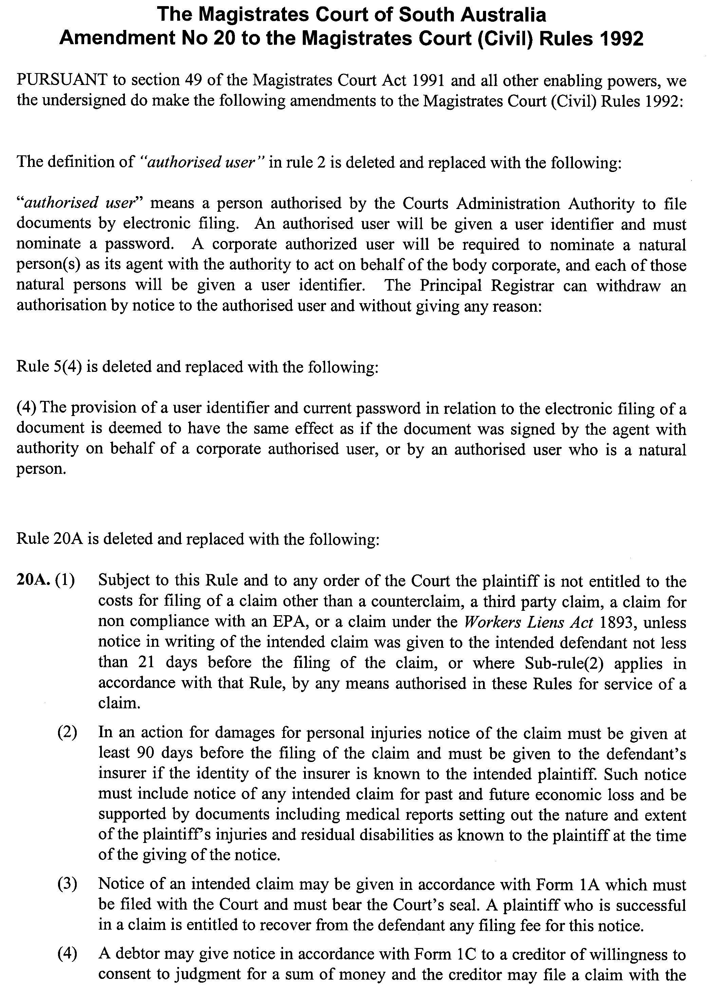
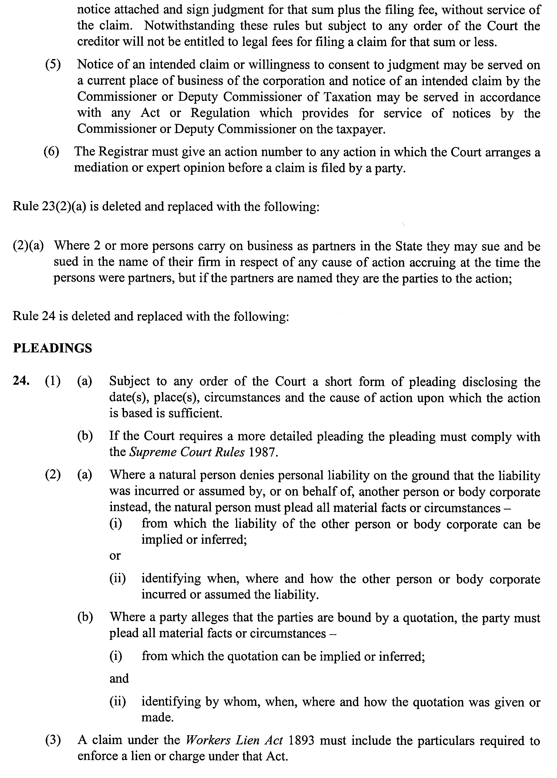
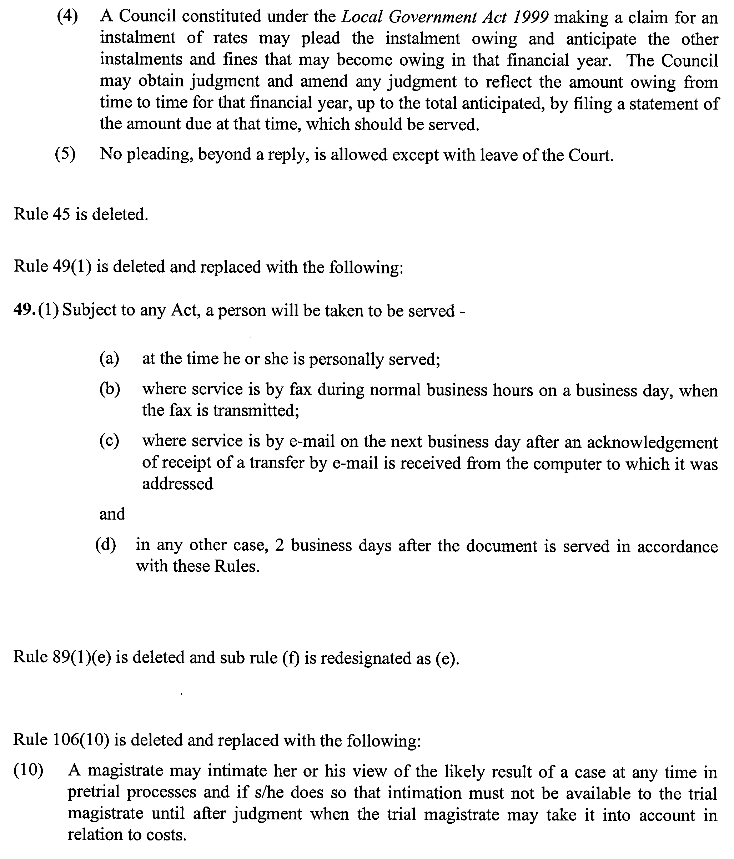
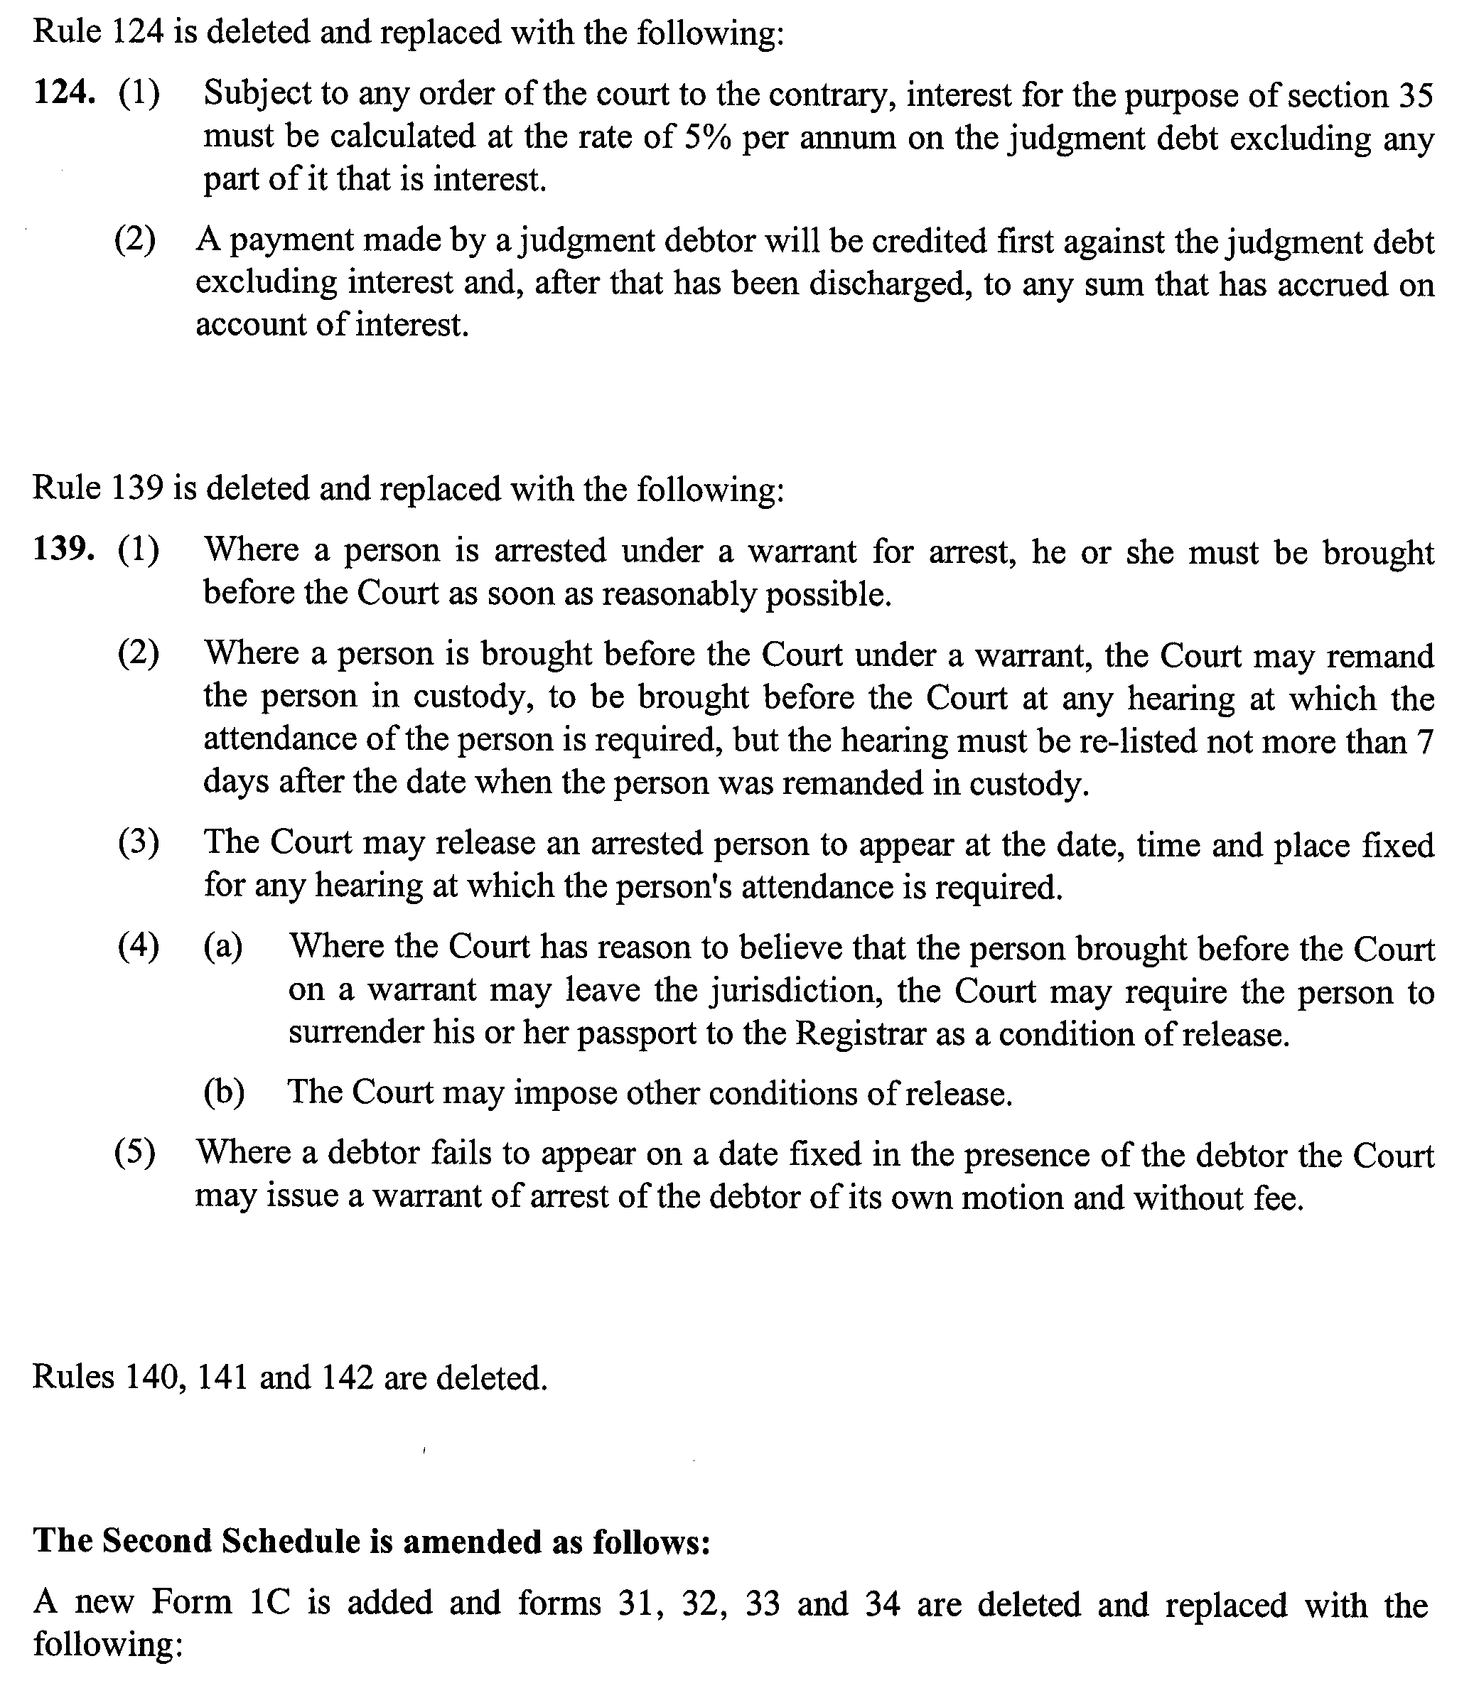

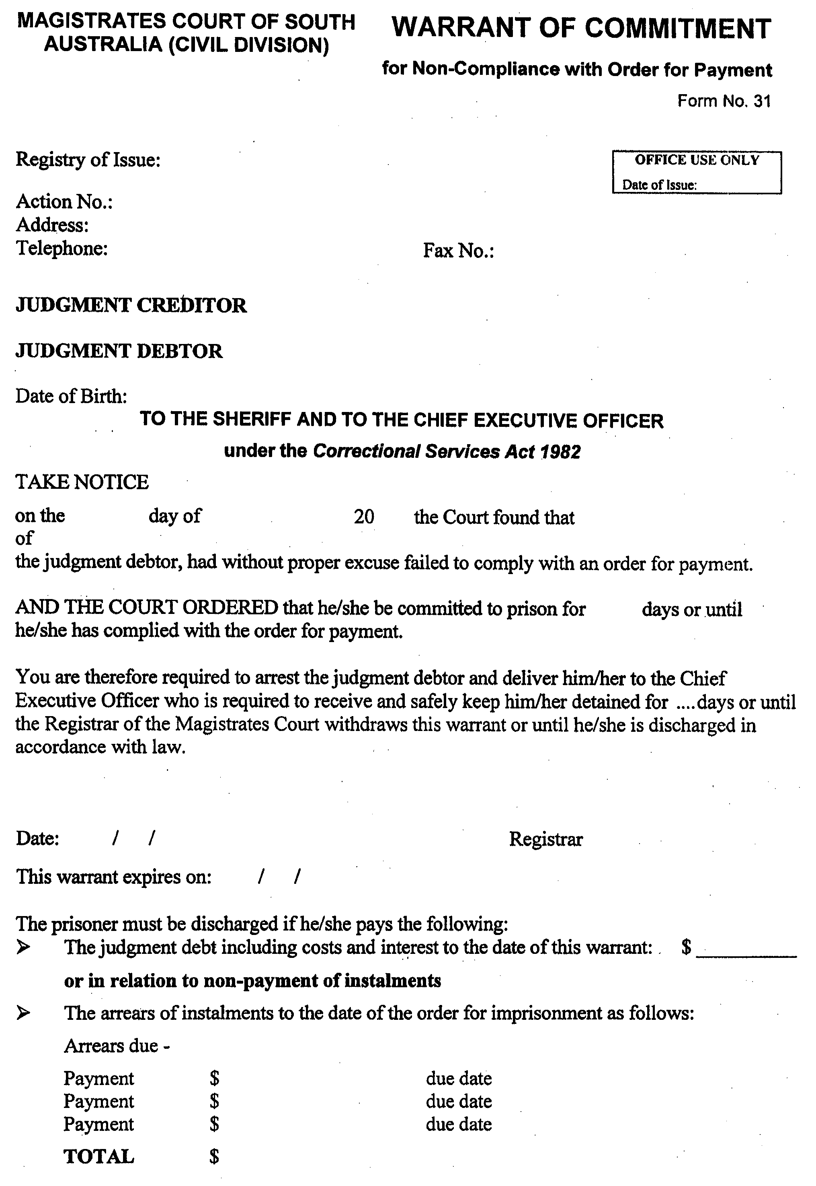
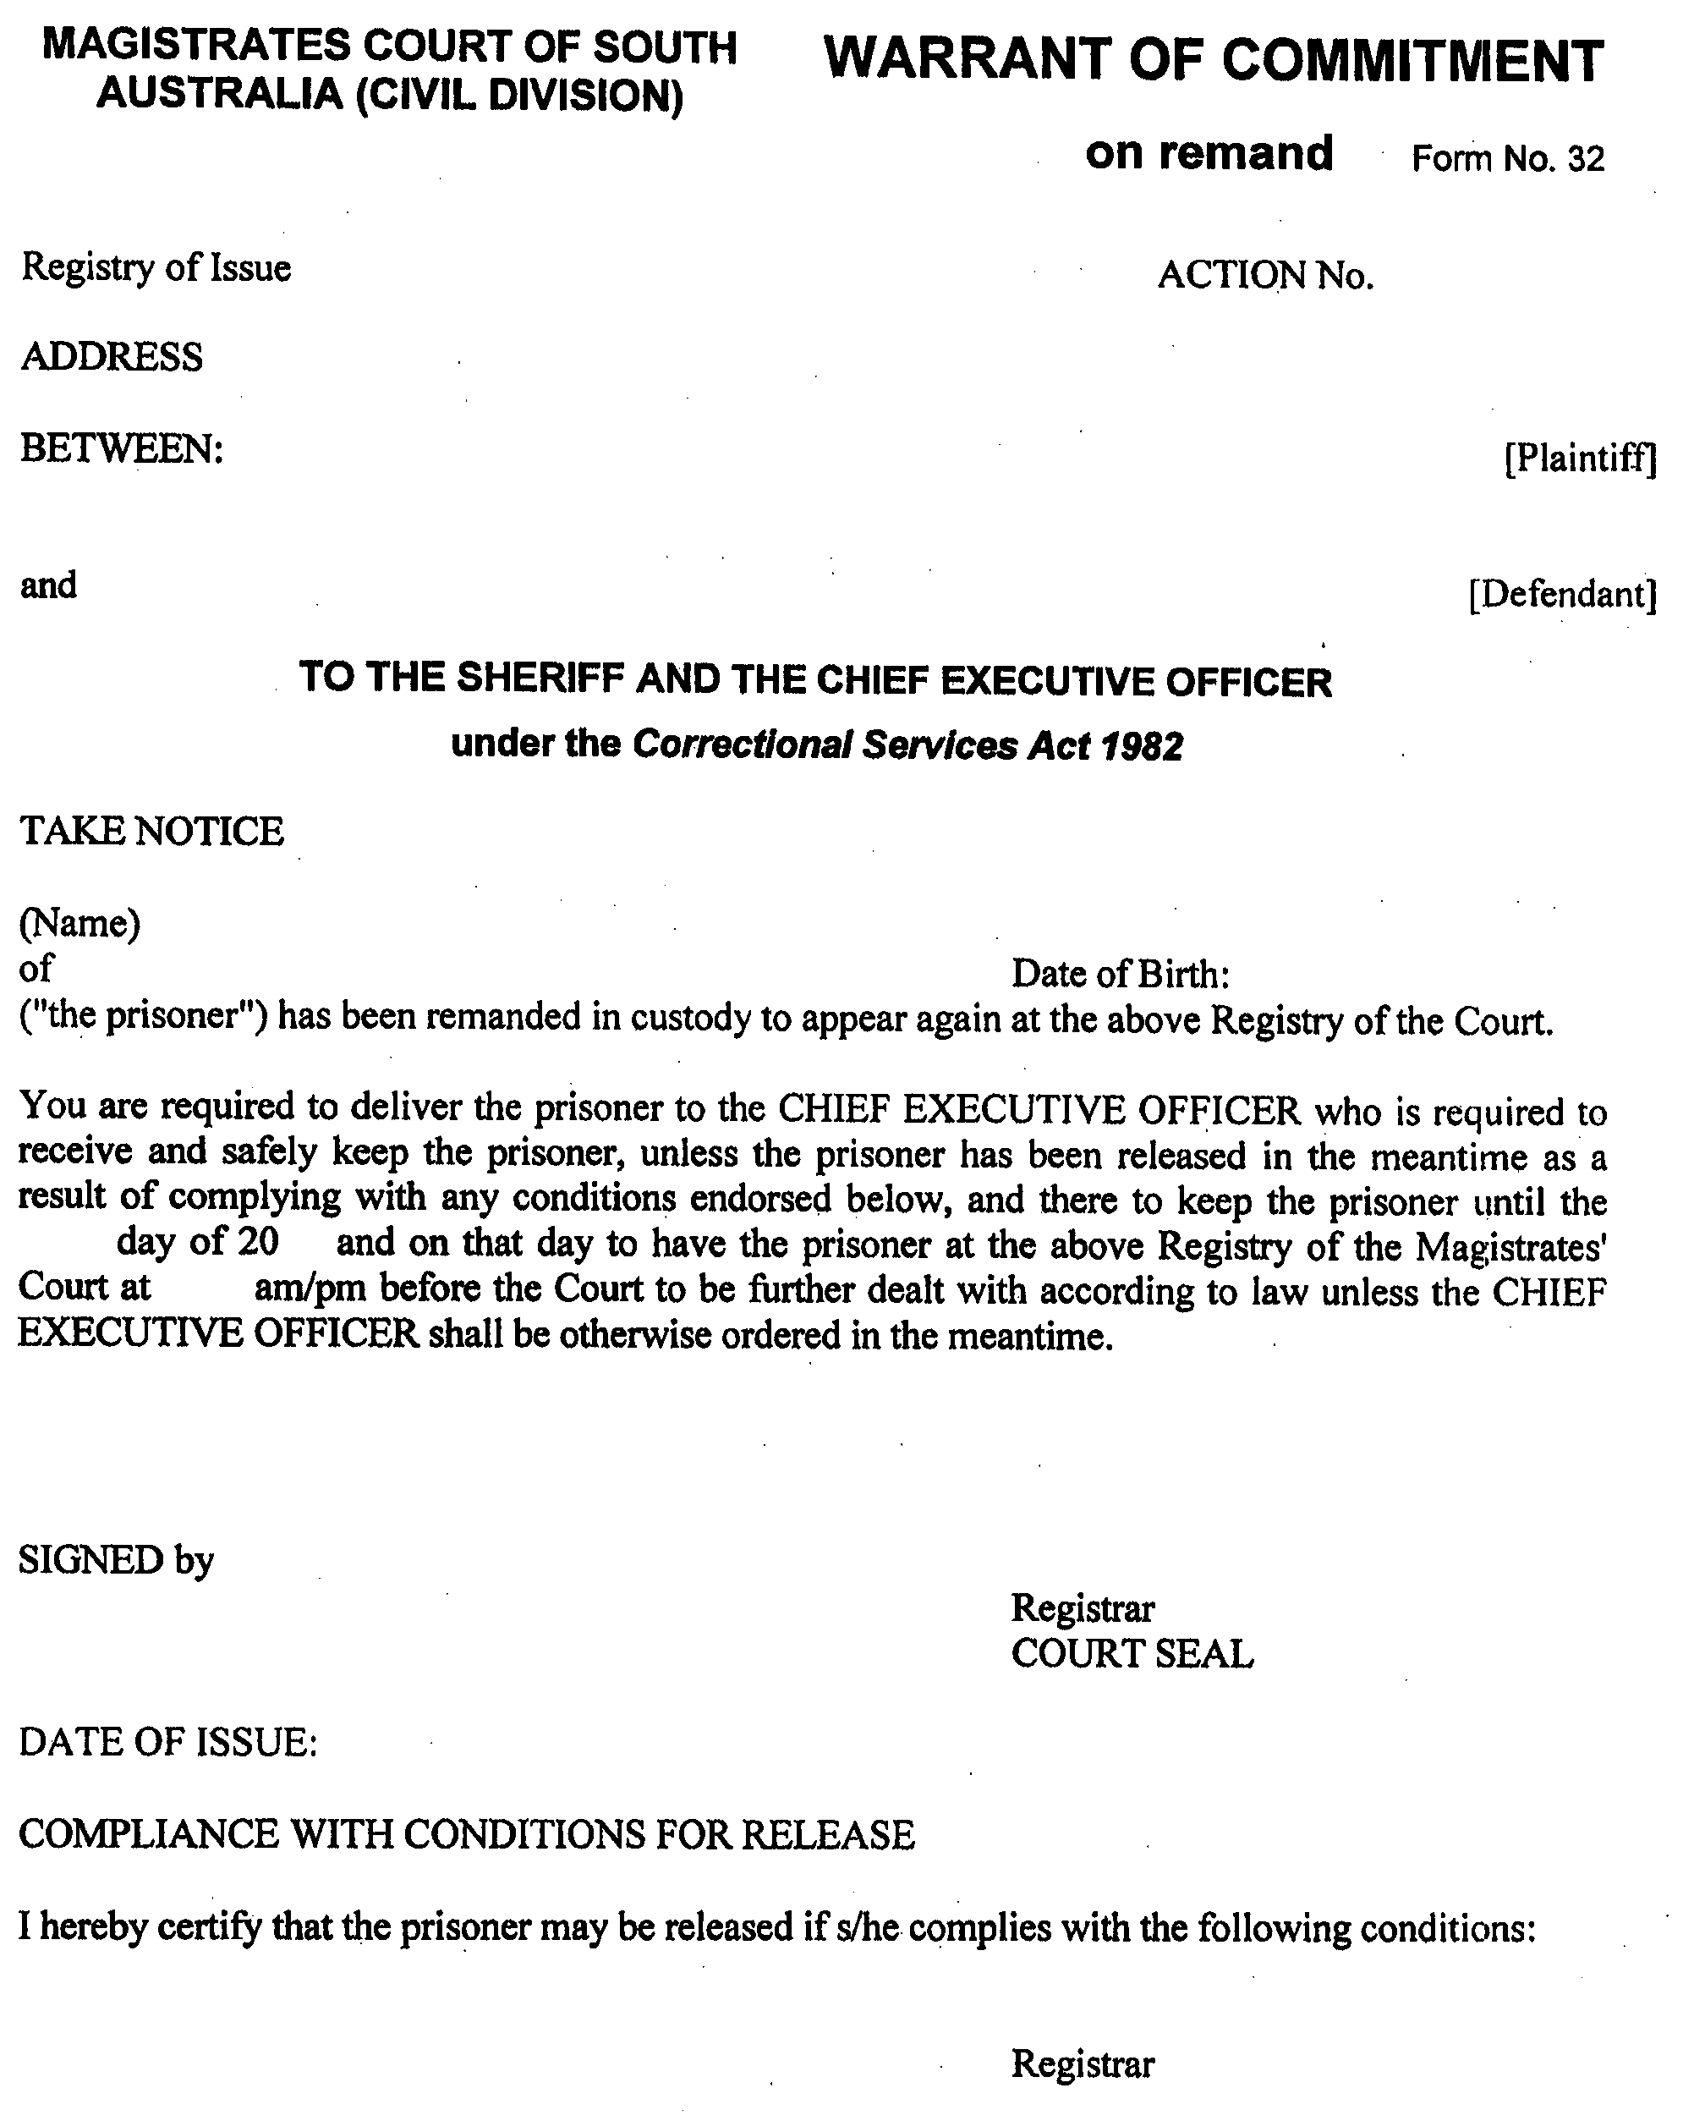
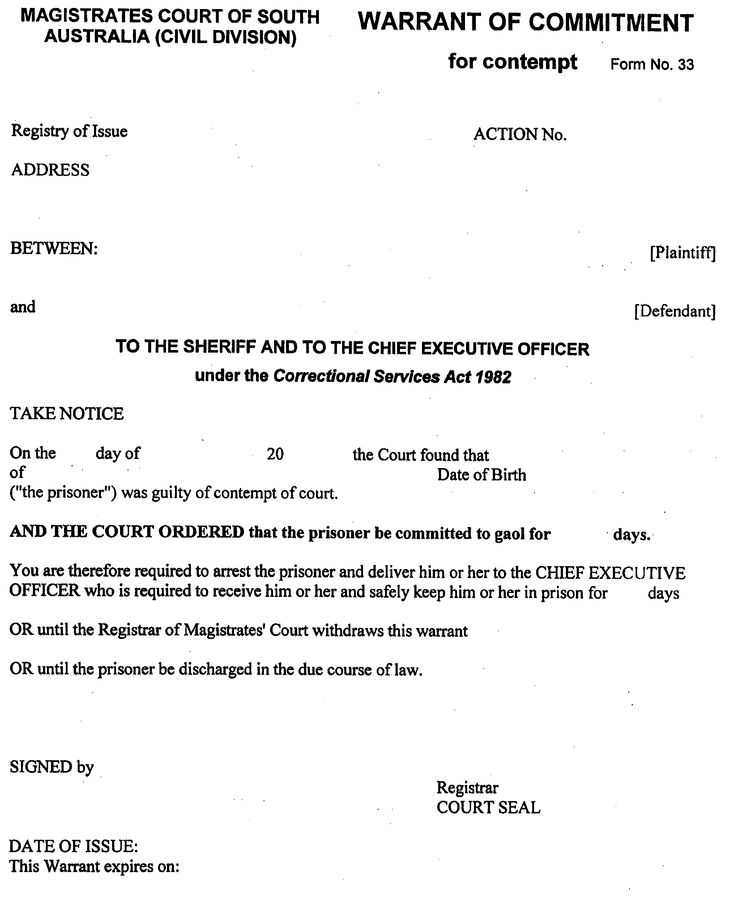
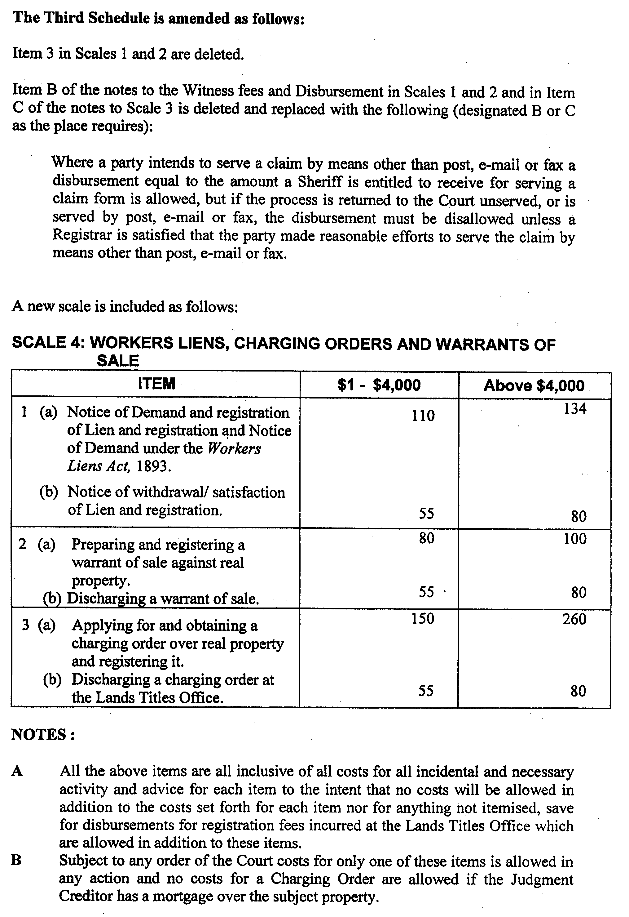
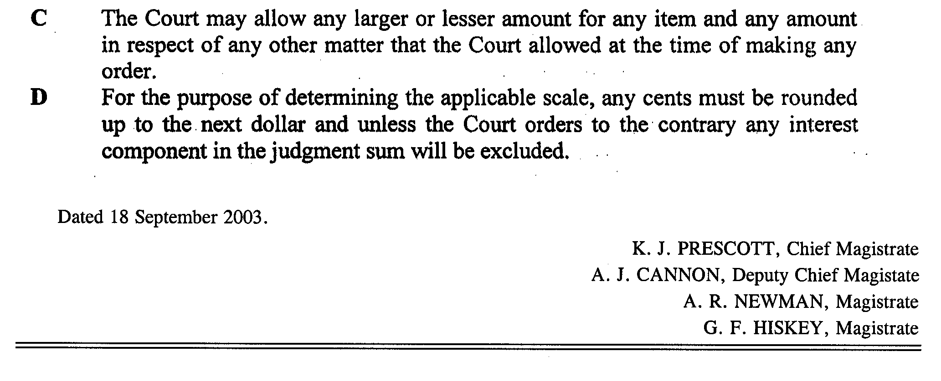

WATER RESOURCES ACT 1997
Variation to the Notice of Restriction on the taking of Water from the River Murray Prescribed Watercourse
PURSUANT to section 16 (9) of the Water Resources Act 1997 (‘the Act’), I, John David Hill, Minister for Environment and Conservation in the State of South Australia, and Minister to whom the administration of the Water Resources Act 1997 is committed, hereby vary the notice dated 13 June 2003 published pursuant to section 16 (1) of the Act in the Government Gazette on 24 June 2003 at pages 2627 and 2628 (‘the Notice’) in accordance with Schedule 1.
Schedule 1
The notice is varied by amending clauses 3 (a), 3 (c) and 3 (d) and adding clause 3 (e) as follows:
3. An authorisation under this notice may be granted to:
(a) A person who holds an authorisation issued under the notice to take water from the River Murray Prescribed Watercourse for the same purposes and subject to the same conditions as specified in that authorisation but at:
• a quantity of water equivalent to 75% of the water (taking) allocation endorsed on the water licence, excluding water allocations for the purposes specified in clause 7 and subject to the provisions of clause 4 of the notice.
(c) A person who holds an authorisation issued under the notice to take water from the River Murray Prescribed Watercourse for urban water supply through reticulated water supply infrastructure under the Waterworks Act 1932 (Country Towns) is now authorised to take:
• 31.5 Gigalitres.
(d) A person who during the period of this notice, receives approval to convert a water (holding) allocation to a water (taking) allocation under the Water Resources Act 1997 entitling that person to take:
• a quantity of water equivalent to 75% of the water (taking) allocation endorsed on the water licence after conversion, excluding water allocations for purposes specified in clause 7 and subject to the provisions of clause 4 of the notice.
(e) A person who was entitled to an authorisation under the notice, that is still to be issued, to take water from the River Murray Prescribed Watercourse at:
• a quantity of water equivalent to 75% of the water (taking) allocation endorsed on the water licence, excluding water allocations for the purposes specified in clause 7 and subject to the provisions of clause 4 of the notice.
This notice will remain in effect until 1 July 2004, unless earlier varied or revoked.
Dated 25 September 2003.
John Hill, Minister for Environment and Conservation

South Australia
Southern State Superannuation Variation Regulations 2003
under the Southern State Superannuation Act 1994

Contents
Part 1—Preliminary
1 Short title
2 Commencement
3 Variation provisions
Part 2—Variation of Southern State Superannuation Regulations 1995
4 Variation of regulation 11—Section 14(6) members

Part 1—Preliminary
1—Short title
These regulations may be cited as the Southern State Superannuation Variation Regulations 2003.
2—Commencement
These regulations will come into operation on 1 October 2003.
3—Variation provisions
In these regulations, a provision under a heading referring to the variation of specified regulations varies the regulations so specified.
Part 2—Variation of Southern State Superannuation Regulations 1995
4—Variation of regulation 11—Section 14(6) members
Regulation 11(1)—after paragraph (g) insert:
(h) those persons whose names appear in Schedule 1 of the Superannuation (Julia Farr Services Employees) Regulations 2003.
Note—
As required by section 10AA(2) of the Subordinate Legislation Act 1978, the Minister has certified that, in the Minister's opinion, it is necessary or appropriate that these regulations come into operation as set out in these regulations.
Made by the Governor’s Deputy
with the advice and consent of the Executive Council
on 25 September 2003.
No. 194 of 2003
T&F 03/037 CS

South Australia
Superannuation (Julia Farr Services Employees) Regulations 2003
under the Superannuation Act 1988

Contents
Part 1—Preliminary
1 Short title
2 Commencement
3 Interpretation
Part 2—Miscellaneous
4 Transfer of assets
5 Declaration of contributors
6 Payment of benefits
7 Contributor taken to remain in employment
Part 3—Modification of Superannuation Act 1988
8 Modification of Act
9 Amendment of section 4—Interpretation
10 Substitution of sections 23, 24 and 25
11 Substitution of sections 27, 28, 28A, 28B, 28C and 29
12 Substitution of section 30
13 Substitution of sections 31 and 32
14 Repeal of section 32A
Schedule 1—Contributors

Part 1—Preliminary
1—Short title
These regulations may be cited as the Superannuation (Julia Farr Services Employees) Regulations 2003.
2—Commencement
These regulations will come into operation on 1 October 2003.
3—Interpretation
In these regulations, unless the contrary intention appears—
Act means the Superannuation Act 1988;
contributor means a person whose name appears in Schedule 1;
Plan means the Julia Farr Centre Staff Provident Plan.
Part 2—Miscellaneous
4—Transfer of assets
The assets of the Plan are transferred to the Fund.
5—Declaration of contributors
A contributor is declared to be a new scheme contributor for the purposes of the Act.
6—Payment of benefits
Despite section 20B of the Act, any benefit or other entitlement payable under the Act as modified by Part 3 of these regulations must be paid out of the Fund.
7—Contributor taken to remain in employment
(1) Subject to subregulation (2), for the purposes of these regulations, a contributor who, within 1 month of ceasing employment with Julia Farr Services Incorporated, commences employment with a health sector agency will be taken, for the duration of the contributor's employment with a health sector agency, to have continued his or her employment with Julia Farr Services Incorporated.
(2) A contributor's period of employment with Julia Farr Services incorporated is taken to have ceased if there is a break in the contributor's employment with a health sector agency (or a series of health sector agencies) of 1 month or more.
(3) In addition, if a contributor transfers to employment within a public sector agency because the contributor's position with Julia Farr Services Incorporated has become redundant, the contributor will be taken, for the duration of his or her employment within the public sector, to have continued his or her employment with Julia Farr Services Incorporated.
(4) In this regulation—
health sector agency means—
(a) an agency within the Department of Human Services; or
(b) a hospital or health centre incorporated under the South Australian Health Commission Act 1976.
Part 3—Modification of Superannuation Act 1988
8—Modification of Act
For the purposes of clause 1(1)(b) of Schedule 1A of the Act, the provisions of the Act are modified in their application to the employees declared to be new scheme contributors under regulation 5 in the manner described in the following provisions of this Part.
9—Amendment of section 4—Interpretation
(1) Section 4(1), definition of age of retirement—delete the definition and substitute:
age of retirement means 65 years;
(2) Section 4(1), definition of contributor—delete the definition and substitute:
contributor means a person whose name appears in Schedule 1 of the Superannuation (Julia Farr Services Employees) Regulations 2003;
(3) Section 4(1)—after the definition of pension period insert:
Plan means the Julia Farr Centre Staff Provident Plan;
prescribed employment means employment, or notional employment, with Julia Farr Services Incorporated (see regulation 7 of the Superannuation (Julia Farr Services Employees) Regulations 2003);
(4) Section 4(1)—after the definition of salary insert:
Schedule means Schedule 1 of the Superannuation (Julia Farr Services Employees) Regulations 2003;
10—Substitution of sections 23, 24 and 25
Sections 23, 24 and 25—delete the sections and substitute:
23—Contributors
A contributor is not required to make contributions to the Treasurer for the duration of his or her prescribed employment.
11—Substitution of sections 27, 28, 28A, 28B, 28C and 29
Sections 27, 28, 28A, 28B, 28C and 29—delete the sections and substitute:
27—Retirement
(1) A contributor who retires from prescribed employment at or over the age of retirement is entitled to a superannuation payment determined as follows:
Where—
A is the amount
FS is the contributor's actual or attributed salary immediately before retirement (expressed as an annual amount)
BM is the sum of the amount of the retirement benefit multiple (RBM) and the amount of the additional benefit multiple (ABM) (if any) appearing in the Schedule opposite the contributor's name.
(2) A contributor who retires from prescribed employment before attaining the age of retirement is entitled to a superannuation payment determined as follows:
Where—
A is the amount
FS is the contributor's actual or attributed salary immediately before retirement (expressed as an annual amount)
M is the actual period of membership (being membership of the Plan or as a contributor in prescribed employment) to the date of ceasing service (in completed months)
PM is the period of membership (as described in item M) that the contributor would have completed at the age of retirement (in completed months)
RBM is the retirement benefit multiple (RBM) appearing in the Schedule opposite the contributor's name
ABM is the additional benefit multiple (ABM) (if any) appearing in the Schedule opposite the contributor's name.
28—Resignation and preservation of benefits
(1) If a contributor resigns from prescribed employment before reaching the age of 55 years, the contributor—
(a) is entitled to superannuation benefits determined in accordance with the formula described in section 27(2) (as if he or she had retired); and
(b) is taken to have elected to preserve his or her superannuation benefits.
(2) The contributor may at any time after reaching the age of 55 years require the Board to pay the superannuation benefits preserved under this section to the contributor and, if no such requirement has been made on or before the date on which the contributor reaches the age of retirement, the Board will make the payment.
(3) If the contributor has become incapacitated and satisfies the Board that his or her incapacity for all kinds of work is 60 per cent or more of total incapacity and is likely to be permanent, the Board will pay the preserved superannuation benefits to the contributor.
(4) If the contributor dies, the preserved superannuation benefits will be paid to the spouse of the deceased contributor or, if he or she left no surviving spouse, to the contributor's estate.
(5) A payment made under any of the above subsections excludes further rights so that a claim cannot be subsequently made under some other subsection.
12—Substitution of section 30
Section 30—delete the section and substitute:
30—Disability pension
(1) Subject to this section, a contributor who is temporarily or permanently incapacitated for work in prescribed employment, and has not reached the age of retirement, is entitled to a disability pension.
(2) A disability pension is not payable in respect of—
(a) a period in respect of which the contributor is entitled to sick leave; or
(b) a period in respect of which the contributor is entitled to weekly payments of workers compensation; or
(c) a period for which the contributor is on recreation leave or long service leave.
(3) The Board will not pay a disability pension in respect of a period of incapacity unless and until the contributor has been absent from work as a result of the incapacity for a period of 3 months.
(4) The amount of a disability pension will be 75 per cent of the contributor's notional salary.
(5) A disability pension cannot be paid, in respect of the same incapacity, for an aggregate period of more than 2 years.
13—Substitution of sections 31 and 32
Sections 31 and 32—delete the sections and substitute:
31—Termination of employment on invalidity
If—
(a) a contributor's prescribed employment terminates on account of invalidity before the contributor reaches the age of retirement; and
(b) the Board is satisfied that the contributor's incapacity for all kinds of work is 60 per cent or more of total incapacity and is likely to be permanent,
the contributor is entitled to a superannuation payment determined in accordance with the following formula:
Where—
A is the amount
FS is the contributor's actual or attributed salary immediately before termination (expressed as an annual amount)
BM is the sum of the amount of the retirement benefit multiple (RBM) and the amount of the additional benefit multiple (ABM) (if any) appearing in the Schedule opposite the contributor's name.
32—Death of contributor
(1) If a contributor's prescribed employment is terminated by the contributor's death—
(a) if the contributor is survived by a spouse—a lump sum payment will be made to the spouse;
(b) if the contributor is not survived by a spouse—a lump sum payment will be made to the contributor's estate.
(2) The lump sum to be paid to a surviving spouse or to the contributor's estate is to be determined in accordance with the following formula:
Where—
A is the amount
FS is the contributor's actual or attributed salary immediately before the contributor's death (expressed as an annual amount)
BM is the sum of the amount of the retirement benefit multiple (RBM) and the amount of the additional benefit multiple (ABM) (if any) appearing in the Schedule opposite the contributor's name.
14—Repeal of section 32A
Section 32A—delete the section
Schedule 1—Contributors
Name | Retirement Benefit Multiple (RBM) | Additional Benefit Multiple (ABM)
Byerley, John Charles | 7.30 | —
Capozzo, Pasquale | 6.88 | 0.71
Grous, Fani | 4.74 | —
Johnson, Gwenda Mary | 4.95 | —
Klose, Karin | 7.30 | —
Medder, Brigid Hannah | 5.42 | —
O'Grady, Mary Louise | 7.84 | —
Rougasche, Josephine Georgina | 6.53 | 0.66
Note—
As required by section 10AA(2) of the Subordinate Legislation Act 1978, the Minister has certified that, in the Minister's opinion, it is necessary or appropriate that these regulations come into operation as set out in these regulations.
Made by the Governor’s Deputy
with the advice and consent of the Executive Council
on 25 September 2003.
No. 195 of 2003
T&F 03/037 CS
South Australia
Public Corporations (Austrics) (Dissolution and Revocation) Regulations 2003
under the Public Corporations Act 1993

Contents
Part 1—Preliminary
1 Short title
2 Commencement
3 Interpretation
Part 2—Dissolution of Austrics
4 Dissolution and transfer of assets and liabilities of Austrics
Part 3—Revocation of Public Corporations (State Transport Authority) Regulations 1993
5 Revocation of regulations

Part 1—Preliminary
1—Short title
These regulations may be cited as the Public Corporations (Austrics) (Dissolution and Revocation) Regulations 2003.
2—Commencement
These regulations come into operation on the day on which they are made.
3—Interpretation
In these regulations—
Act means the Public Corporations Act 1993.
Part 2—Dissolution of Austrics
4—Dissolution and transfer of assets and liabilities of Austrics
Pursuant to section 25 of the Act—
(a) Austrics, established by regulation under the Act as a subsidiary of Transadelaide, is dissolved; and
(b) the assets and liabilities of Austrics immediately before its dissolution are transferred to and vested in or attached to TransAdelaide.
Part 3—Revocation of Public Corporations (State Transport Authority) Regulations 1993
5—Revocation of regulations
The Public Corporations (State Transport Authority) Regulations 1993 are revoked.
Note—
As required by section 10AA(2) of the Subordinate Legislation Act 1978, the Minister has certified that, in the Minister's opinion, it is necessary or appropriate that these regulations come into operation as set out in these regulations.
Made by the Governor’s Deputy
with the advice and consent of the Executive Council
on 25 September 2003.
No. 196 of 2003
CTAD2003/1

South Australia
Optometrists Variation Regulations 2003
under the Optometrists Act 1920

Contents
Part 1—Preliminary
1 Short title
2 Commencement
3 Variation provisions
Part 2—Variation of Optometrists Regulations 1996
4 Variation of Schedule 5—Fees

Part 1—Preliminary
1—Short title
These regulations may be cited as the Optometrists Variation Regulations 2003.
2—Commencement
These regulations come into operation on the day on which they are made.
3—Variation provisions
In these regulations, a provision under a heading referring to the variation of specified regulations varies the regulations so specified.
Part 2—Variation of Optometrists Regulations 1996
4—Variation of Schedule 5—Fees
(1) Schedule 5, clause 1—delete "$260.00" and substitute:
$280.00
(2) Schedule 5, clause 3(a)—delete "$260.00" and substitute:
$280.00
Note—
As required by section 10AA(2) of the Subordinate Legislation Act 1978, the Minister has certified that, in the Minister's opinion, it is necessary or appropriate that these regulations come into operation as set out in these regulations.
Made by the Governor’s Deputy
on the recommendation of the Optometrists Board and with the advice and consent of the Executive Council
on 25 September 2003.
No. 197 of 2003
CAB/MGR/0034

FAXING COPY?

IF you fax copy to Government Publishing SA for inclusion in the Government Gazette, there is no need to send a Confirmation Copy to us as well.

This creates confusion and may well result in your notice being printed twice.

Please use the following fax number:

Fax transmission: (08) 8207 1040
Phone Inquiries: (08) 8207 1045

Please include a contact person, phone number and order number so that we can phone back with any queries we may have regarding the fax copy.

NOTE: Closing time for lodging new copy (either fax or hard copy) is 4 p.m. on Tuesday preceding the day of publication.

Government Gazette notices can be E-mailed.

The address is:

governmentgazette@saugov.sa.gov.au

Documents should be sent as attachments in Word format.

When sending a document via E-mail, please confirm your transmission with a faxed copy of your document, including the date the notice is to be published.

Fax transmission: (08) 8207 1040
Enquiries: (08) 8207 1045

CITY OF BURNSIDE
Roads (Opening and Closing) Act 1991
Road Closure, Portion of St Albans Drive, Burnside
NOTICE is hereby given, pursuant to section 10 of the said Act, that council proposes to make a Road Process Order to close and sell to S. K. and A. F. Walker, S. J. Logan and C. N. and E. M. Collie the 5.87 m strip of St Albans Drive adjoining each property, shown as ‘B’, ‘A’ and ‘C’ (respectively) on Preliminary Plan No. 03/0077.
A copy of the plan and statement of persons affected are available for public inspection at the Council Office, Civic Centre, 401 Greenhill Road, Tusmore and the office of the Surveyor-General, 101 Grenfell Street, Adelaide during normal office hours.
Any application for easement or objections must be made in writing within 28 days from 25 September 2003, to the Council, P.O. Box 9, Glenside, S.A. 5065 and the Surveyor-General, G.P.O. Box 1354, Adelaide, S.A. 5001, setting out full details.
Where a submission is made, council will give notification of a meeting to deal with the matter.
J. Hanlon, Chief Executive Officer

CITY OF HOLDFAST BAY
Declaration of Public Road
NOTICE is hereby given pursuant to section 210 of the Local Government Act 1999, the City of Holdfast Bay at its meeting of 22 July 2003 declared the whole of the land in Certificates of Title volume 1384, folios 181 and 182, being private roads in the vicinity of Marlborough Street, Brighton to be public road.
S. Gawler, Chief Executive Officer

THE RURAL CITY OF MURRAY BRIDGE
Naming of Roads
NOTICE is hereby given that at the council meeting held on Monday, 22 September 2003, the following resolution was adopted:
That The Rural City of Murray Bridge pursuant to powers contained in the Local Government Act 1999, section 219 hereby declares that the following roads be known as:
Annie Lane, adjacent the north side of Allotments 2, 3, 4, 5, FP10180;
Arty Road, adjacent the north side of sections 129, 130, 188, H170700 and Allotment 91, FP170593;
Field Road, adjacent the west side of section 484, H170700;
White Sands Road, adjacent the east side of Allotment 1, FP3440 and section 701, H170200;
Mangelsdorf Lane, adjacent the west side of Allotment 82, TP170701;
Tower Road, adjacent the south side of Allotment 3, FP15519, Allotment 4, FP15648, Allotment 500, FP13685 and section 489, H170700;
Temora Lane, adjacent the north side of section 30, H170700, Allotment 26, FP35677 and Allotment 101, FP209641;
Sunnyside Road, adjacent the south side of allotment 100, DP54972.
R. J. Foster, Chief Executive Officer

CITY OF SALISBURY
Roads (Opening and Closing) Act 1991
Sanderling Circuit, Mawson Lakes
NOTICE is hereby given pursuant to section 10 of the Roads (Opening and Closing) Act 1991, that council proposes to make a Road Process Order to close, sell and transfer to Trinity Green Nominees Pty Ltd the whole of Sanderling Circuit south of Shearwater Drive, more particularly delineated ‘A’ on Preliminary Plan No. 03/0048.
A copy of the plan and statement of persons affected are available for public inspection at the Council Office, 12 James Street, Salisbury and the office of the Surveyor-General, 101 Grenfell Street, Adelaide during normal office hours.
Any application for easement or objections must set out the full name, address and details of the submission and must be fully supported by reasons.
The application for easement or objections must be made in writing within 28 days of this notice to the Council, P.O. Box 8, Salisbury, S.A. 5108 and the Surveyor-General, G.P.O. Box 1354, Adelaide, S.A. 5001, setting out full details.
Where a submission is made, council will give notification of a meeting at which the matter will be considered.
Enquiries relating to this matter may be directed to Elisa Perry (phone 8406 8451) or Julie Bond (phone 8406 8306).
Dated 24 September 2003.
S. Hains, City Manager

CITY OF WEST TORRENS
Naming of Private Road
PUBLIC notice is hereby given that at its meeting held on 16 September 2003, the City of West Torrens decided, pursuant to section 219 (1) of the Local Government Act 1999, to assign the name Sir Reginald Ansett Drive to the private road on Commonwealth land leading to the Brand Outlet Centre, Adelaide Airport, directly opposite West Beach Road, West Beach.
T. M. Starr, Chief Executive Officer

DISTRICT COUNCIL OF KAROONDA EAST MURRAY
Fire Prevention Officer
NOTICE is hereby given that pursuant to section 34 of the Country Fire Services Act 1989 the District Council of Karoonda East Murray at its meeting held on 9 September 2003, appointed Donald Albert Loller as Fire Prevention Officer.
Authorised Officer
Notice is hereby given that the District Council of Karoonda East Murray at its meeting held on 9 September 2003, appointed John Thomas Claydon and Dionie Sue Kerr as Authorised Officers, pursuant to section 38 of the Country Fires Act 1989 subject to the approval of the Country Fires Board.
R. Smithson, District Clerk

DISTRICT COUNCIL OF KIMBA
Appointment
NOTICE is hereby given that pursuant to section 102 of the Local Government Act 1999, that Elizabeth Anne Byrne be appointed Acting Chief Executive Officer for the period from Monday, 6 October 2003, until Friday, 17 October 2003, being a two-week period, vide Chief Executive Officer on annual leave.
S. R. Cheriton, Chief Executive Officer

IN the matter of the estates of the undermentioned deceased persons:
Anderson, Leonard James, late of 13 Rayne Avenue, Linden Park, retired professional sheep classer, who died on 20 August 2003.
Archdall, Mervyn Nugent, late of 31 Millswood Crescent, Millswood, retired agency manager, who died on 27 July 2003.
Bell, Colin Gordon, late of Lawrie Terrace, Waikerie, retired liquor trade worker, who died on 14 June 2003.
Brown, William, late of 20 Milan Street, Elizabeth East, retired gardener, who died on 26 May 2003.
Bruni, Edward Charles, late of 52 Esplanade, Semaphore, retired packer, who died on 18 December 2002.
Cam, Lancelot Charles, late of 30 Nelson Street, South Plympton, retired carpenter, who died on 16 August 2003.
Cook, Mary Catherine Roma, late of 35 Manly Circuit, West Lakes Shore, retired clerk, who died on 28 July 2003.
Eddleston, Nellie Edith, late of 122 Esplanade, Semaphore, of no occupation, who died on 26 July 2003.
Floyd, Eileen Mary, late of 80 Moseley Street, Glenelg South, widow, who died on 22 July 2003.
Ganley, Marguerite Nell, late of 66 Nelson Road, Valley View, of no occupation, who died on 22 July 2003.
Haynish, Roswita, late of 103 Fisher Street, Fullarton, of no occupation, who died on 20 August 2003.
Holker, Henrietta Frances, late of 6 Ranelagh Street, Woodville, home duties, who died on 30 June 2003.
Killicoat, Mary Bowen, late of 285 Goodwood Road, Kings Park, retired senior clerk, who died on 9 June 2003.
Klasen, Margaret Ellen, late of Ernest Drive, Beverley, Western Australia, widow, who died on 27 July 2003.
Martini, Gilda, late of 6 Mumford Avenue, St Agnes, of no occupation, who died on 13 July 2003.
Moll, Jacqueline Jean, late of 22 Moorland Road, Hectorville, home duties, who died on 11 August 2003.
Moran, Stanley Roy, late of 67 Porter Street, Salisbury, retired mechanical inspector, who died on 20 July 2003.
Payne, Helen Frances, late of 2 Patawilya Grove, Glenelg South, retired clerk, who died on 2 July 2003.
Polgreen, Stephen John, late of 13 Constellation Street, Hallett Cove, retired public servant, who died on 16 June 2003.
Taylor, Frank, late of 80 Ashbrook Avenue, Payneham, retired cleaner, who died on 31 July 2003.
Vears, Mary Lucy, late of Webb Street, Clare, retired department store manageress, who died on 31 July 2003.
Wilkinson, Mavis Ethel Marion, late of 50 Gulfview Road, Christies Beach, of no occupation, who died on 3 August 2003.
Willson, Christina Violet, late of Grainger Road, Somerton Park, of no occupation, who died on 25 July 2003.
Wishart, Gwenyth Eveline Maud, late of Everard Street, Largs Bay, of no occupation, who died on 30 July 2003.
Woodroffe, Barbara Constance, late of 34 Norman Terrace, Everard Park, widow, who died on 25 June 2003.
Notice is hereby given pursuant to the Trustee Act 1936, as amended, the Inheritance (Family Provision) Act 1972, and the Family Relationships Act 1975, that all creditors, beneficiaries, and other persons having claims against the said estates are required to send, in writing, to the Public Trustee, 25 Franklin
Street, Adelaide, S.A. 5000, full particulars and proof of such claims, on or before 24 October 2003, otherwise they will be excluded from the distribution of the said estate; and notice is also hereby given that all persons who are indebted to the said estates are required to pay the amount of their debts to the Public Trustee or proceedings will be taken for the recovery thereof; and all persons having any property belonging to the said estates are forthwith to deliver the same to the Public Trustee.
Dated 25 September 2003.
C. J. O’Loughlin, Public Trustee

IWARA KUTJU INCORPORATED
(IN LIQUIDATION)
Corporations Act 2001
Notice of Intention to Declare a Dividend
A FIRST and final dividend is to be declared on 12 October 2003 for the association. Creditors whose debts or claims have not already been admitted are required on or before 24 September 2003 formally to prove their debts or claims. If they do not, they will be excluded from the benefit of the dividend.
Dated 17 September 2003.
J. Irving, Liquidator

SOUTH AUSTRALIA—In the Supreme Court. No. 878 of 2001. In the matter of Port Wakefield Road Bottle and Can Pty Ltd (ACN 073 936 731) and in the matter of WorkCover Corporation of South Australia (ABN 83 687 563 395).
Notice of Release of Liquidator
Take notice that by an order of the Supreme Court of South Australia dated 12 September 2003, I, Mark Christopher Hall, 10th Floor, 26 Flinders Street, Adelaide, S.A. 5000, the liquidator of the abovenamed company was granted by release as liquidator.
Dated 18 September 2003.
M. C. Hall, Liquidator

ATTENTION

CUSTOMERS requiring a proof of their notice for inclusion in the Government Gazette, please note that the onus is on you to inform Government Publishing SA of any subsequent corrections by 10 a.m. on Thursday, which is our publication deadline.

For any corrections to your notice please phone 8207 1045 or Fax 8207 1040 before 10 a.m. on Thursday.

If we do not receive any communication by 10 a.m. on Thursday (day of publication) we will presume the notice is correct and will print it as it is.

Remember—the onus is on you to inform us of any corrections necessary to your notice.

NOTE: Closing time for lodging new copy (electronically, fax or hard copy) is 4 p.m. on Tuesday preceding the day of publication. Phone 8207 1045—Fax 8207 1040.
Email: governmentgazette@saugov.sa.gov.au

Printed and published by authority every Thursday by J. D. FERGUSON, Government Printer, South Australia
Price: $4.70, plus postage; to subscribers, $238.00 per annum.
(The above prices are inclusive of GST)

