No. 34 1071

THE SOUTH AUSTRALIAN

GOVERNMENT GAZETTE
www.governmentgazette.sa.gov.au

PUBLISHED BY AUTHORITY

ALL PUBLIC ACTS appearing in this GAZETTE are to be considered official, and obeyed as such

ADELAIDE, THURSDAY, 22 APRIL 2004

CONTENTS

Page
Appointments, Resignations, Etc. 1072
Corporations and District Councils—Notices 1106
Crown Lands Act 1929—Notices 1073
Development Act 1993—Notice 1073
Environment Protection Act 1993—Notice 1074
Fisheries Act 1982—Notices 1075
Geographical Names Act 1991—Notices 1075
Land and Business (Sale and Conveyancing) Act 1994—
Notices 1076
Liquor Licensing Act 1997—Notices 1077
Mining Act 1971—Notices 1080
National Electricity (South Australia) Act 1996—Notice 1080
Outback Areas Community Development Trust—Notice 1081
Proclamations 1086
Public Trustee Office—Administration of Estates 1108
Page
Real Property Act 1886—Notice 1084
REGULATIONS
Genetically Modified Crops Management Act 2004
(No. 17 of 2004) 1092
Legislation Revision and Publication Act 2002
(No. 19 of 2004) 1096
Liquor Licensing Act 1997—
(No. 18 of 2004) 1093
(No. 20 of 2004) 1098
Residential Tenancies Act 1995—Notice 1081
Retirement Villages Act 1987—Notice 1084
Roads (Opening and Closing) Act 1991—Notices 1084
Supported Residential Facilities Act 1992—Notice 1085
Survey Act 1992—Notices 1085
Water Resources Act 1997—Notice 1085

GOVERNMENT GAZETTE NOTICES
ALL poundkeepers’ and private advertisements forwarded for publication in the South Australian Government Gazette must be PAID FOR PRIOR TO INSERTION; and all notices, from whatever source, should be legibly written on one side of the paper only and sent to Government Publishing SA so as to be received no later
than 4 p.m. on the Tuesday preceding the day of publication. Phone 8207 1045 or Fax 8207 1040. E-mail: governmentgazette@saugov.sa.gov.au. Send as attachments in Word format and please confirm your transmission with a faxed copy of your document, including the date the notice is to be published and to whom the notice will be charged. The Government Gazette is available online at: www.governmentgazette.sa.gov.au

Department of the Premier and Cabinet
Adelaide, 22 April 2004
HER Excellency the Governor in Executive Council has been pleased to appoint the undermentioned to the Medical Practitioners Professional Conduct Tribunal, pursuant to the provisions of the Medical Practitioners Act 1983:
Deputy Member: (from 22 April 2004 until 22 March 2006)
Aileen Forsyth Connon (Deputy to Wicks)
By command,
John Hill, for Premier
MHEA-MGR 0053CS

Department of the Premier and Cabinet
Adelaide, 22 April 2004
HER Excellency the Governor in Executive Council has been pleased to appoint the undermentioned to the State Theatre Company of South Australia—Board of Governors, pursuant to the provisions of the State Theatre Company of South Australia Act 1972:
Governor: (from 22 April 2004 until 30 June 2004)
Nicola Rosemary Downer
By command,
John Hill, for Premier
ASA 00004/02CS

Department of the Premier and Cabinet
Adelaide, 22 April 2004
HER Excellency the Governor in Executive Council has been pleased to appoint the undermentioned to the Adelaide Festival Corporation Board, pursuant to the provisions of the Adelaide Festival Corporation Act 1998:
Member: (from 22 April 2004 until 21 April 2007)
Colin Dunsford
Amanda Blair
By command,
John Hill, for Premier
ASACAB 001/02CS

Department of the Premier and Cabinet
Adelaide, 22 April 2004
HER Excellency the Governor in Executive Council has revoked the appointment of the officers of the Crown for the purpose of providing the range of custodial services for Prisoner Movement and In-Court Management Services, the former staff of Group 4 Correction Services Pty Ltd as listed, pursuant to section 68 of the Constitution Act 1934:
Jennifer Anne Selth
Wayne Eric Wehrmann
Michael Joseph Casey
Rosemary Helen Butler
Bruno Georg Kranich
Brett John Bury
Graeme McSporran
Natalie Lambi
John Horlor
Kerry Linda Jane Hockey
Kevin Russell Smith
Christopher James Neil Komparcmi
Roderick John St George
Michael Brian Mildren
Michael William Penglase
Rex Greeneklee
John Gibson Sloan
Lisa Jane Kotz
Geoffrey Kevin Medwin
Monica Glennese Jacques
David James Stewart
Pauline Louise Waite
Susan Michelle Preece
Sharyn Jayne Chandler
Lisa Anne Shiers
Lily Kalikas
Paul Adrian Fleming
Norman Trubik
Simon James Baker
Lisa Yvette Savage
Colin Maxwell Crafter
Diane Amanda Ellbourne
Anita Lynne Fryer
Dean Norman O’Hara
Frank Tuip
Christopher David Delahunt
Noel Richard Saxby
Neville John Frahn
Shannon Carlyle Nankivell
Gillian Ann Dean
Geoffrey Frederick Harvey
Ensar Cutahija
Jann Marie Iles
John Clifford Knutsen
Paul James Harris
Gary Frew
Henri Jose Van Praet
Badyn James Sinclair
Gordon Lindsay Gray
By command,
John Hill, for Premier
MCS 0006/04CS

Department of the Premier and Cabinet
Adelaide, 22 April 2004
HER Excellency the Governor in Executive Council has been pleased to appoint as officers of the Crown for the purpose of providing the range of custodial services for Prisoner Movement and In-Court Management Services, in accordance with the South Australian Prisoner Movement In-Court Management contract, without pay or other industrial entitlement, staff of Group 4 Correction Services Pty Ltd, pursuant to section 68 of the Constitution Act 1934:
Richard John Beinke
Erica Dale Hoffmann
Trevor Kingsley Little
Sara Jane Mary Simmonds
John Andrew Vlachoulis
Margaret Alison Walsh
Sarah Wilsdon
By command,
John Hill, for Premier
MCS 0006/04CS

Department of the Premier and Cabinet
Adelaide, 22 April 2004
HER Excellency the Governor in Executive Council has been pleased to appoint the people listed as Justices of the Peace for South Australia, pursuant to section 4 of the Justices of the Peace Act 1991:
Dragan Bekric
David Charles Boothey
Justine Susan Bourke
Thomas Ronald Buzzacott
Derek Chapman
Constantinos Michael Finos
Peter Ralph May
Deborah Anne Muller
Sharon Louise Reinke
Margret Christina Scheil
Bronwyn Ann Semmler
Heather Louise Webster
Vivienne Frances Zastera
By command,
John Hill, for Premier
ATTG 0082/03CS

CROWN LANDS ACT 1929: SECTION 5
TAKE NOTICE that pursuant to the Crown Lands Act 1929, I, JOHN HILL, Minister for Environment and Conservation, Minister of the Crown to whom the administration of the Crown Lands Act 1929 is committed DO HEREBY:
1. Resume the land defined in The First Schedule.
2. Dedicate the Crown Land defined in The Second Schedule as an Emergency Services Reserve and declare that such land shall be under the care, control and management of the Minister for Emergency Services.
3. Dedicate the Crown Land defined in The Third Schedule as a Reserve for Recreation and Community Purposes and declare that such land shall be under the care, control and management of The District Council of Mount Barker.
The First Schedule
Recreation and Community Centre Reserve, section 26, Hundred of Kanmantoo, the proclamation of which was published in the Government Gazette of 4 March 1954 at page 464, The Second Schedule, being the land contained in Crown Record Volume 5755 Folio 770.
The Second Schedule
Allotment 400 of DP 64002, Hundred of Kanmantoo, County of Sturt, exclusive of all necessary roads.
The Third Schedule
Allotment 401 of DP 64002, Hundred of Kanmantoo, County of Sturt, exclusive of all necessary roads.
Dated 22 April 2004.
J. Hill, Minister for Environment and Conservation
DEH 17/1390

CROWN LANDS ACT 1929: SECTION 5
TAKE NOTICE that pursuant to the Crown Lands Act 1929, I, JOHN HILL, Minister for Environment and Conservation, Minister of the Crown to whom the administration of the Crown Lands Act 1929 is committed DO HEREBY dedicate the Crown Land defined in The Schedule as a Reserve for Café and Life Saving Club Purposes and declare that such land shall be under the care, control and management of the District Council of Yankalilla.
The Schedule
Allotment 100 of DP 51256, Hundred of Yankalilla, County of Hindmarsh, exclusive of all necessary roads.
Dated 22 April 2004.
J. Hill, Minister for Environment and Conservation
DEHAA 12/0512

CROWN LANDS ACT 1929: SECTION 5
TAKE NOTICE that pursuant to the Crown Lands Act 1929, I, JOHN HILL, Minister for Environment and Conservation, Minister of the Crown to whom the administration of the Crown Lands Act 1929 is committed DO HEREBY dedicate the Crown Land defined in The Schedule as a Hospital Reserve and declare that such land shall be under the care, control and management of the Port Broughton District Hospital and Health Services Incorporated.
The Schedule
Allotment 1 of DP 62726, Town of Port Broughton, Hundred of Mundoora, County of Daly, exclusive of all necessary roads, subject nevertheless to:
1. a free and unrestricted right of way over that portion of allotment 1 marked B on DP 62726 and appurtenant to allotment 2 (DP 62726).
2. an easement to the District Council of Barunga West for drainage purposes over that portion of allotment 1 marked C on DP 62726.
Dated 22 April 2004.
J. Hill, Minister for Environment and Conservation
DL 4003/1987

DEVELOPMENT ACT 1993
Alteration to the Building Code of Australia
Preamble
1. The Building Code of Australia as in force from time to time is adopted by the Development Regulations 1993 as part of the Building Rules under the Development Act 1993.
2. The Building Code of Australia has been altered.
3. The Development Act 1993 requires that notice of the alteration must be published before the alteration can take effect.
Notice
PURSUANT to sections 4 (7) and 108 (7) of the Development Act 1993, notice is given of an alteration to the 1996 Edition of the Building Code of Australia. The Code has been amended and republished as BCA 2004 by the Australian Building Codes Board.
BCA 2004 as modified by the variations and additions for South Australia contained in the appendix to that Code (other than SA F1.7; SA Part H3 in Volume One and Part 3.8.1 Volume Two) will take effect for the purposes of the Development Act 1993 on
1 May 2004.
The SA Addition Clause SA F1.7; SA Part H3 in Volume One and Part 3.8.1 Volume Two will take effect for the purposes of the Development Act on 1 July 2004.
Dated 15 April 2004.
B. Halliday, as Minister’s Delegate, Executive Director, Planning SA

ENVIRONMENT PROTECTION ACT 1993
Revocation of the Approvals of Classes of Category B Containers
I, STEPHEN RICHARD SMITH, Senior Adviser, Container Deposit Legislation and Delegate of the Environment Protection Authority (‘the Authority’), pursuant to section 69 (8) of the Environment Protection Act 1993 (SA) (‘the Act’) hereby revoke the approvals of the classes of Category B containers sold in South Australia as identified by reference to the following matters, which are described in the first 4 columns of Schedule 1 of this Notice:
(a) the product which each class of containers shall contain;
(b) the size of the containers;
(c) the type of containers;
(d) the name of the holders of these approvals.
These approvals are revoked as the Authority is satisfied that the following conditions of these approvals have been contravened:
(i) Subsection 69 (3) Arrangements:
The holders of these approvals must ensure that the empty containers which belong to their respective class of containers hereby approved as Category B Containers are collected from collection depots approved under section 69 of the Act by the party named in column 5 of Schedule 1 of this Notice.
Schedule 1

Column 1 | Column 2 | Column 3 | Column 4 | Column 5
Product Name | Container  Size (mL) | Container Type | Approval Holder | Collection  Arrangements
Red Bull Energy Drink | 250 | Can | Red Bull Australia Pty Ltd | Statewide Recycling
Red Bull Energy Drink | 330 | Glass | Red Bull Australia Pty Ltd | Statewide Recycling
Glass Mountain Classic Spritz | 250 | Glass | Southcorp Wines Pty Ltd | Statewide Recycling
Tropicana Fizz | 250 | Glass | Southcorp Wines Pty Ltd | Statewide Recycling
ERA Sparkling Mineral Water | 330 | Glass | Southcorp Wines Pty Ltd | Statewide Recycling
ERA Still Spring Water | 330 | Glass | Southcorp Wines Pty Ltd | Statewide Recycling
Glass Mountain Classic Spritz | 250 | Glass | Southcorp Wines Pty Ltd | Statewide Recycling
Tropicana Fizz | 250 | Glass | Southcorp Wines Pty Ltd | Statewide Recycling
ERA Sparkling Mineral Water | 330 | Glass | Southcorp Wines Pty Ltd | Statewide Recycling
ERA Still Spring Water | 330 | Glass | Southcorp Wines Pty Ltd | Statewide Recycling
NEKTA Liquid Kiwi Fruit | 2 000 | PET | Merenda Wholesalers Adelaide | Statewide Recycling
NEKTA Liquid Kiwi Fruit | 375 | PET | Merenda Wholesalers Adelaide | Statewide Recycling
Budweiser Beer | 355 | Glass | Quality Brands International (Aust) Pty Ltd | Statewide Recycling
Hatuey Beer | 355 | Glass | Quality Brands International (Aust) Pty Ltd | Statewide Recycling
Hoopers Hooch Alcoholic Blackcurrant Drink | 330 | Glass | Quality Brands International (Aust) Pty Ltd | Statewide Recycling
Hoopers Hooch Alcoholic Lemon Drink | 330 | Glass | Quality Brands International (Aust) Pty Ltd | Statewide Recycling
Hoopers Hooch Alcoholic Orange Drink | 330 | Glass | Quality Brands International (Aust) Pty Ltd | Statewide Recycling
Bacardi Breezer Lemon | 275 | Glass | Quality Brands International (Aust) Pty Ltd | Statewide Recycling
Bacardi Breezer Orange | 275 | Glass | Quality Brands International (Aust) Pty Ltd | Statewide Recycling
Bacardi Breezer Watermelon | 275 | Glass | Quality Brands International (Aust) Pty Ltd | Statewide Recycling
Bacardi & Cola | 375 | Can | Quality Brands International (Aust) Pty Ltd | Statewide Recycling
Metz Ice | 255 | Glass | Quality Brands International (Aust) Pty Ltd | Statewide Recycling
Metz Storm | 255 | Glass | Quality Brands International (Aust) Pty Ltd | Statewide Recycling
Yuracowee Sacred Spring Water | 1 500 | Plastic | Yuracowee Pty Ltd | Statewide Recycling
Yuracowee Sacred Spring Water | 600 | Plastic | Yuracowee Pty Ltd | Statewide Recycling
IRN BRU | 600 | PET | British Soft Drinks | Statewide Recycling
IRN BRU | 1 250 | PET | British Soft Drinks | Statewide Recycling
IRN BRU | 310 | Glass | British Soft Drinks | Statewide Recycling
IRN BRU | 750 | Glass | British Soft Drinks | Statewide Recycling
Dandelion & Burdock | 310 | Glass | British Soft Drinks | Statewide Recycling
Tizer | 310 | Glass | British Soft Drinks | Statewide Recycling
L. & P. Lemon and Paeroa | 600 | PET | Vilisoni Malupo | Statewide Recycling
L. & P. Lemon and Paeroa | 1 500 | PET | Vilisoni Malupo | Statewide Recycling
L. & P. Lemon and Paeroa | 2 250 | PET | Vilisoni Malupo | Statewide Recycling
L. & P. Lemon and Paeroa | 355 | Can—Aluminium | Vilisoni Malupo | Statewide Recycling
Mount Jagged Rainwater | 600 | Plastic | Phillip O’Loughlin | Statewide Recycling
Mount Jagged Rainwater | 1 500 | Plastic | Phillip O’Loughlin | Statewide Recycling
Drinx Aranciata | 1 500 | PET | Australis Import Export International Service Pty Ltd | Statewide Recycling
Drinx Gassosa | 1 500 | PET | Australis Import Export International Service Pty Ltd | Statewide Recycling
S. Luigi Aqua Minerale Mineral Water | 500 | Glass | Australis Import Export International Service Pty Ltd | Statewide Recycling
S. Luigi Aqua Minerale Mineral Water | 1 500 | Plastic | Australis Import Export International Service Pty Ltd | Statewide Recycling
Viper Energy Drink | 250 | Can | Tilt Group Pty Ltd | Statewide Recycling

FISHERIES ACT 1982, SECTION 43
Declaration
TAKE notice that pursuant to section 43 of the Fisheries Act 1982 I hereby declare it unlawful for any person to engage in the taking of fish or any act preparatory to or involved in the taking of fish including, but not limited to scalefish, molluscs, crustaceans, aquatic plants and algae from the waters of the Port River between Bower Road and the Birkenhead Bridge from the date of gazettal of this notice until midnight on 30 June 2004, unless varied or revoked earlier.
Dated 21 April 2004.
K. Crosthwaite, Manager, Legal Services

FISHERIES ACT 1982: SECTION 59
TAKE notice that pursuant to section 59 of the Fisheries Act 1982, Michael Harper, of the Department of Environment and Heritage, 28 Vaughan Terrace, Berri, S.A. 5343 (the ‘exemption holder’), or persons acting as his agents, are exempt from section 41 of the Fisheries Act 1982 but only insofar as they may engage in the collection of fish from the waters described in Schedule 1, using the gear specified in Schedule 2 (the ‘exempted activity’), subject to the conditions set out in Schedule 3 from the date of gazettal of this notice until 30 April 2006, unless varied or revoked earlier.
Schedule 1
Pilby Creek | Lake Littra | Lake Limbra
Morgan Lagoon | Slaney Creek | Werta Wert
Coppermine Waterhole | Little Duck Lagoon | Boat Creek
Pipeclay Creek | Causeway Lagoon | Boat Creek Swamp
Slaney Weir Billabong | Winding Creek | Ngak Indau Wetland
Schedule 2
• 12 fyke nets (minimum mesh of 5 mm, maximum leader of 5 m and maximum opening of 60 cm).
• 1 seine net (minimum mesh of 5 mm and maximum length of 12 m).
• 12 shrimp traps.
• 1 dip net per person.
Schedule 3
1. The specimens collected by the exemption holders are for scientific and research purposes only and must not be sold.
2. All native fish taken pursuant to the exempted activity must be immediately returned to the water unless retained for the purpose of species identification.
3. Before conducting the exempted activity, the exemption holder must advise the PIRSA Fisheries Compliance Unit on 1800 065 522 and provide the name of the person or persons who will be conducting the exempted activity, details of the proposed locations and the dates on which the activity will be undertaken.
4. The exemption holder must provide a written report detailing the outcomes of the collection of organisms pursuant to this notice to the Director of Fisheries, (G.P.O. Box 1625, Adelaide, S.A. 5001) by 31 July 2007, giving the following details:
• the date and time of collection;
• the description of all species collected; and
• the number of each species collected.
5. While engaged in the exempted activity, the exemption holder must be in possession of a copy of this notice. Such notice must be produced to a PIRSA Fisheries Compliance Officer if requested.
6. The exemption holder must not contravene or fail to comply with the Fisheries Act 1982 or any regulations made under that Act, except where specifically exempted by this notice.
Dated 22 April 2004.
W. Zacharin, Director of Fisheries

GEOGRAPHICAL NAMES ACT 1991
For Public Consultation
Notice of Intention to Assign a Name and Boundary to a Place
NOTICE is hereby given pursuant to the provisions of the above Act, that the Minister for Administrative Services seeks public comment on a proposal to assign the name IRON KNOB to the area shown on the plan below.
The Plan
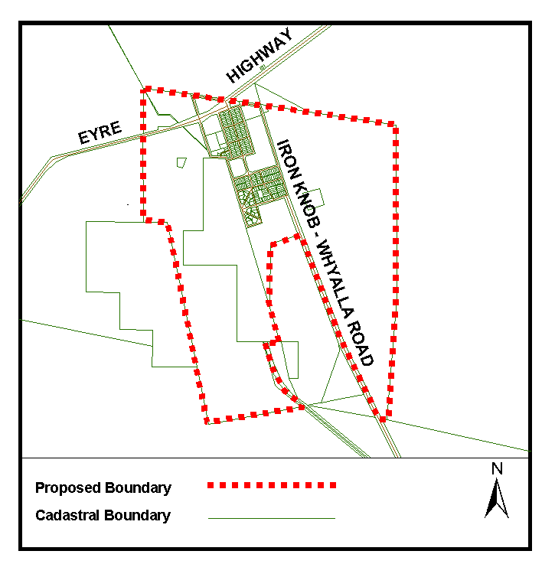
Submissions in writing regarding this proposal may be lodged with the Secretary, Geographical Names Advisory Committee, G.P.O. Box 1354, Adelaide, S.A. 5001 within one month of the publication of this notice.
Dated 19 April 2004.
P. M. Kentish, Surveyor-General, Department for Administrative and Information Services
DAIS 04/0429

GEOGRAPHICAL NAMES ACT 1991
Notice to Alter the Boundary of Suburbs
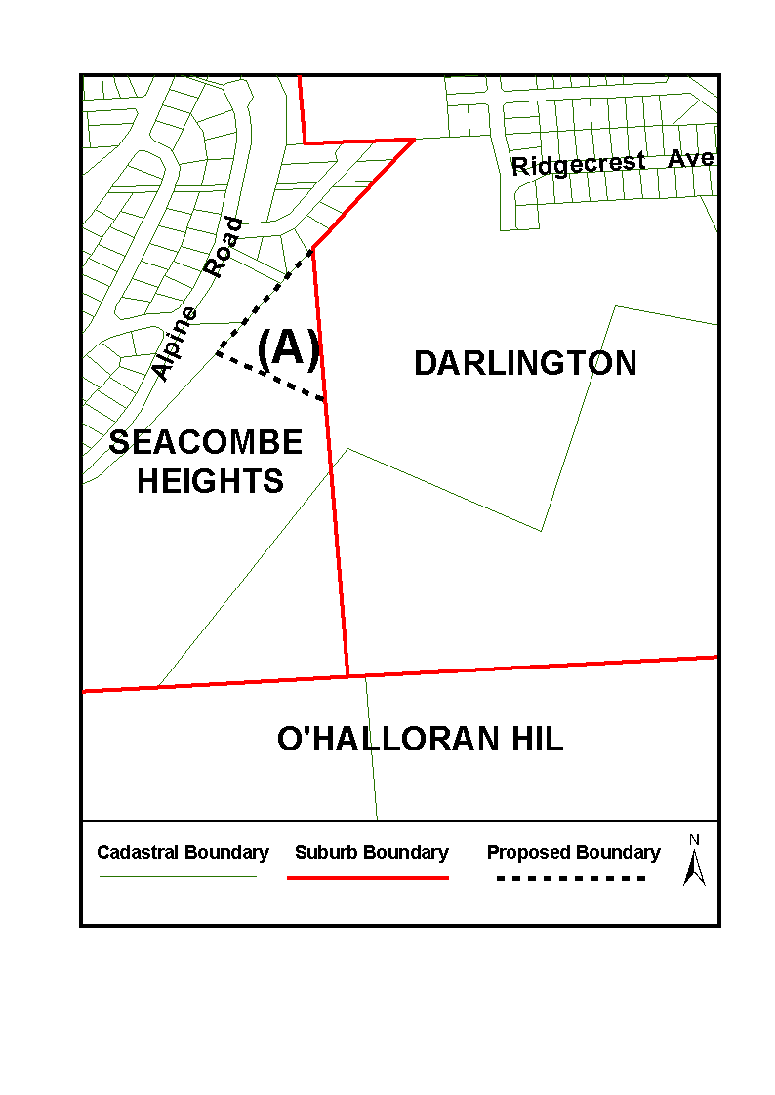
NOTICE is hereby given pursuant to section 11B (4) of the Geographical Names Act 1991, that I, PETER MACLAREN KENTISH, Surveyor-General and Delegate appointed by Michael Wright, Minister for Administrative Services, Minister of the Crown to whom the administration of the Geographical Names Act 1991, is committed, DO HEREBY exclude from the suburb of SEACOMBE HEIGHTS and include into the suburb of DARLINGTON the area marked (A) on the plan below.
The Plan
Dated 19 April 2004.
P. M. Kentish, Surveyor-General, Department for Administrative and Information Services
DAIS 22-413/04/0005

LAND AND BUSINESS (SALE AND CONVEYANCING)
ACT 1994
Exemption
TAKE notice that, pursuant to section 23 (3) of the Land and Business (Sale and Conveyancing) Act 1994, I, Michael John Atkinson, Minister for Consumer Affairs, do hereby exempt the person named in Schedule 1 from the application of section 23 (2) of the Act in relation to the purchase of the land specified in Schedule 2.
Schedule 1
David Patrick Guidera, an employee of Lindsay John Gordon.
Schedule 2
The whole of the land described in certificate of title register book volume 5781, folio 263 and book volume 5781, folio 264, situated at 42-44 Railway Terrace, Cummins, S.A. 5631.
Dated 22 April 2004.
Signed for and on behalf of the Minister for Consumer Affairs by the Commissioner for Consumer Affairs:
M. Bodycoat, Commissioner

LAND AND BUSINESS (SALE AND CONVEYANCING)
ACT 1994
Exemption
TAKE notice that, pursuant to section 23 (3) of the Land and Business (Sale and Conveyancing) Act 1994, I, Michael John Atkinson, Minister for Consumer Affairs, do hereby exempt the person named in Schedule 1 from the application of section 23 (2) of the Act in relation to the purchase of the land specified in Schedule 2.
Schedule 1
Earl Robert Longstaff, an employee of Overall and Brammer Real Estate Pty Ltd.
Schedule 2
The whole of the land described in certificate of title register book volume 5900, folio 279, situated at Lot 34, Federation Drive, Naracoorte, S.A. 5271.
Dated 22 April 2004.
Signed for and on behalf of the Minister for Consumer Affairs by the Commissioner for Consumer Affairs:
M. Bodycoat, Commissioner

LAND AND BUSINESS (SALE AND CONVEYANCING)
ACT 1994
Exemption
TAKE notice that, pursuant to section 23 (3) of the Land and Business (Sale and Conveyancing) Act 1994, I, Michael John Atkinson, Minister for Consumer Affairs, do hereby exempt the person named in Schedule 1 from the application of section 23 (2) of the Act in relation to the purchase of the land specified in Schedule 2.
Schedule 1
Natasha Lee Bawden, an employee of Mervyn James Pallant.
Schedule 2
The whole of the land described in certificate of title register book volume 5447, folio 503, situated at 10 Black Street, Port Lincoln, S.A. 5606.
Dated 22 April 2004.
Signed for and on behalf of the Minister for Consumer Affairs by the Commissioner for Consumer Affairs:
M. Bodycoat, Commissioner

LAND AND BUSINESS (SALE AND CONVEYANCING)
ACT 1994
Exemption
TAKE notice that, pursuant to section 23 (3) of the Land and Business (Sale and Conveyancing) Act 1994, I, Michael John Atkinson, Minister for Consumer Affairs, do hereby exempt the person named in Schedule 1 from the application of section 23 (2) of the Act in relation to the purchase of the land specified in Schedule 2.
Schedule 1
Christine Robinson, an employee of Homburg Group Pty Ltd.
Schedule 2
The whole of the land described in certificate of title register book volume 5294, folio 173, situated at 4 College Street, Tanunda, S.A. 5352.
Dated 22 April 2004.
Signed for and on behalf of the Minister for Consumer Affairs by the Commissioner for Consumer Affairs:
M. Bodycoat, Commissioner

LIQUOR LICENSING ACT 1997
Notice of Application
NOTICE is hereby given, pursuant to section 52 (2) (b) of the Liquor Licensing Act 1997, that S. & W. Trading Pty Ltd has applied to the Licensing Authority for a Producer’s Licence in respect of premises situated at 25 Breakers Street, St Morris, S.A. 5068 and to be known as Braeside Wines.
The application has been set down for hearing on 28 May 2004 at 9 a.m.
Any person may object to the application by lodging a notice of objection in the prescribed form with the Licensing Authority, and serving a copy of the notice on the applicant at the applicant’s address given above, at least seven days before the hearing date.
Plans in respect of the premises the subject of the application are open to public inspection without fee at the Office of the Liquor and Gaming Commissioner, 9th Floor, East Wing, 50 Grenfell Street, Adelaide, S.A. 5000.
Dated 20 April 2004.
Applicant

LIQUOR LICENSING ACT 1997
Notice of Application
NOTICE is hereby given, pursuant to section 52 (2) (b) of the Liquor Licensing Act 1997, that Cela’dor Pty Ltd has applied to the Licensing Authority for a Producer’s Licence in respect of premises situated at 6 The Parkway, Leabrook, S.A. 5068, and known as Cela’dor.
The application has been set down for hearing on 21 May 2004 at 9 a.m.
Any person may object to the application by lodging a notice of objection in the prescribed form with the Licensing Authority, and serving a copy of the notice on the applicant at the applicant’s address given above, at least seven days before the hearing date.
Plans in respect of the premises the subject of the application are open to public inspection without fee at the Office of the Liquor and Gaming Commissioner, 9th Floor, East Wing, 50 Grenfell Street, Adelaide, S.A. 5000.
Dated 16 April 2004.
Applicant

LIQUOR LICENSING ACT 1997
Notice of Application
NOTICE is hereby given, pursuant to section 52 (2) (b) of the Liquor Licensing Act 1997, that R. & M. Hotels Pty Ltd, as trustee for the Brooks Family Trust, c/o Fisher Jefferies, Level 15, 211 Victoria Square, Adelaide, S.A. 5000 has applied to the Licensing Authority for the transfer of a Hotel and Gaming Machine Licence in respect of premises situated at Gardner Street, Price, S.A. 5570 and known as Wheatsheaf Hotel.
The application has been set down for hearing on 25 May 2004 at 11.30 a.m.
Any person may object to the application by lodging a notice of objection in the prescribed form with the Licensing Authority, and serving a copy of the notice on the applicant at the applicant’s address given above, at least seven days before the hearing date.
Plans in respect of the premises the subject of the application are open to public inspection without fee at the Office of the Liquor and Gaming Commissioner, 9th Floor, East Wing, 50 Grenfell Street, Adelaide, S.A. 5000.
Dated 16 April 2004.
Applicant

LIQUOR LICENSING ACT 1997
Notice of Application
NOTICE is hereby given, pursuant to section 52 (2) (b) of the Liquor Licensing Act 1997, that G. and H. Hindmarsh, as trustee for the Hindmarsh Holdings Family Trust, have applied to the Licensing Authority for the transfer of a Restaurant Licence in respect of premises situated at 56 Jetty Road, Glenelg, S.A. 5045 and known as Cafe Viva.
The application has been set down for hearing on 25 May 2004 at 10.30 a.m.
Any person may object to the application by lodging a notice of objection in the prescribed form with the Licensing Authority, and serving a copy of the notice on the applicants at the applicants’ address given above, at least seven days before the hearing date.
Plans in respect of the premises the subject of the application are open to public inspection without fee at the Office of the Liquor and Gaming Commissioner, 9th Floor, East Wing, 50 Grenfell Street, Adelaide, S.A. 5000.
Dated 16 April 2004.
Applicants

LIQUOR LICENSING ACT 1997
Notice of Application
NOTICE is hereby given, pursuant to section 52 (2) (b) of the Liquor Licensing Act 1997, that Bend Hotel Pty Ltd, c/o Fisher Jeffries, Level 15, 211 Victoria Square, Adelaide, S.A. 5000 has applied to the Licensing Authority for the transfer of a Hotel and Gaming Machine Licence in respect of premises situated at 187 Angas Street, Adelaide, S.A. 5000 and known as Angas on Angas.
The application has been set down for hearing on 24 May 2004 at 11 a.m.
Any person may object to the application by lodging a notice of objection in the prescribed form with the Licensing Authority, and serving a copy of the notice on the applicant at the applicant’s address given above, at least seven days before the hearing date.
Plans in respect of the premises the subject of the application are open to public inspection without fee at the Office of the Liquor and Gaming Commissioner, 9th Floor, East Wing, 50 Grenfell Street, Adelaide, S.A. 5000.
Dated 16 April 2004.
Applicant

LIQUOR LICENSING ACT 1997
Notice of Application
NOTICE is hereby given, pursuant to section 52 (2) (b) of the Liquor Licensing Act 1997, that Peter Robert Dennis, Beverley Lorraine Dennis, Robert Edgar Dennis and Michelle Elizabeth Dennis have applied to the Licensing Authority for a Producer’s Licence in respect of premises situated at Lot 297, part Section 36, Hundred of Baroota, S.A. 5495.
The application has been set down for hearing on 21 May 2004 at 9 a.m.
Any person may object to the application by lodging a notice of objection in the prescribed form with the Licensing Authority, and serving a copy of the notice on the applicants at the applicants’ address given above, at least seven days before the hearing date.
Plans in respect of the premises the subject of the application are open to public inspection without fee at the Office of the Liquor and Gaming Commissioner, 9th Floor, East Wing, 50 Grenfell Street, Adelaide, S.A. 5000.
Dated 14 April 2004.
Applicants

LIQUOR LICENSING ACT 1997
Notice of Application
NOTICE is hereby given, pursuant to section 52 (2) (b) of the Liquor Licensing Act 1997, that Brian Richard West and Susan Elaine Putnam Bastian have applied to the Licensing Authority for the removal of a Producer’s Licence in respect of premises situated at 26 Thomas Street, Unley, S.A. 5061 and known as Bastian West Wines to 11 Onkaparinga Valley Road, Balhannah, S.A. 5242.
The application has been set down for hearing on 21 May 2004 9 a.m.
Any person may object to the application by lodging a notice of objection in the prescribed form with the Licensing Authority, and serving a copy of the notice on the applicants at the applicants’ address given above, at least seven days before the hearing date.
Plans in respect of the premises the subject of the application are open to public inspection without fee at the Office of the Liquor and Gaming Commissioner, 9th Floor, East Wing, 50 Grenfell Street, Adelaide, S.A. 5000.
Dated 14 April 2004.
Applicants

LIQUOR LICENSING ACT 1997
Notice of Application
NOTICE is hereby given, pursuant to section 52 (2) (b) of the Liquor Licensing Act 1997, that Ochota Pty Ltd, as trustee for Avenue Trust, has applied to the Licensing Authority for a Producer’s Licence in respect of premises situated at 124 Seventh Avenue, Joslin, S.A. 5070 and to be known as Avenue Wines.
The application has been set down for hearing on 21 May 2004 at 9 a.m.
Any person may object to the application by lodging a notice of objection in the prescribed form with the Licensing Authority, and serving a copy of the notice on the applicant at the applicant’s address given above, at least seven days before the hearing date.
Plans in respect of the premises the subject of the application are open to public inspection without fee at the Office of the Liquor and Gaming Commissioner, 9th Floor, East Wing, 50 Grenfell Street, Adelaide, S.A. 5000.
Dated 14 April 2004.
Applicant

LIQUOR LICENSING ACT 1997
Notice of Application
NOTICE is hereby given, pursuant to section 52 (2) (b) of the Liquor Licensing Act 1997, that Bottin Investments Pty Ltd, as Trustee for the Paul Bottin Family Trust, has applied to the Licensing Authority for a Producer’s Licence in respect of premises situated at 14 Clifton Court, McLaren Vale, S.A. 5172 and known as Bottin Wines.
The application has been set down for hearing on 28 May 2004 at 9 a.m.
Any person may object to the application by lodging a notice of objection in the prescribed form with the Licensing Authority, and serving a copy of the notice on the applicant at the applicant’s address given above, at least seven days before the hearing date.
Plans in respect of the premises the subject of the application are open to public inspection without fee at the Office of the Liquor and Gaming Commissioner, 9th Floor, East Wing, 50 Grenfell Street, Adelaide, S.A. 5000.
Dated 8 April 2004.
Applicant

LIQUOR LICENSING ACT 1997
Notice of Application
NOTICE is hereby given, pursuant to section 52 (2) (b) of the Liquor Licensing Act 1997, that Semaphore Club Inc. has applied to the Licensing Authority for an Extended Trading Authorisation, variation to the Entertainment Consent, variation to Conditions of the Licence and redefinition of Licensed Area in respect of premises situated at 93 Esplanade, Semaphore, S.A. 5019 and known as Semaphore Workers Club.
The application has been set down for hearing on 21 May 2004 at 9 a.m.
Conditions
The following licence conditions are sought:
The licensee is authorised to sell liquor for consumption on the licensed premises during the following times:
Friday and Saturday: Midnight to 1 a.m. the following day;
Sunday: 8 p.m. to 10 p.m.
Entertainment Consent is sought during the Extended Trading Authorisation seeking variation of licence conditions to delete the following:
‘All persons must vacate the premises and adjacent areas by 12.30 a.m. excepting band members and committee members engaged in clearing or loading of equipment duties, in which case such persons must vacate the pemises by 1 a.m. sharp’.
Redefinition of licensed premises as per plans lodged with this office.
Any person may object to the application by lodging a notice of objection in the prescribed form with the Licensing Authority, and serving a copy of the notice on the applicant at the applicant’s address given above, at least seven days before the hearing date.
Plans in respect of the premises the subject of the application are open to public inspection without fee at the Office of the Liquor and Gaming Commissioner, 9th Floor, East Wing, 50 Grenfell Street, Adelaide, S.A. 5000.
Dated 13 April 2004.
Applicant

LIQUOR LICENSING ACT 1997
Notice of Application
NOTICE is hereby given, pursuant to section 52 (2) (b) of the Liquor Licensing Act 1997, that Trans-it Freighters Pty Ltd (as Trustee for the Pollard Family Trust) has applied to the Licensing Authority for a Resaurant Licence with Extended Trading Authorisation and Entertainment Consent in respect of premises situated at 20 Jetty Road, Glenelg, S.A. 5045 and to be known as Billy Baxter’s.
The application has been set down for hearing on 21 May 2004 at 9 a.m.
Conditions
The following licence conditions are sought:
The licence authorises the licensee to sell liquor on any day except Good Friday and Christmas Day for consumption on the licensed premises by persons:
(a) seated at a table; or
(b) attending a function at which food is provided.
Extended Trading Authorisation:
Monday to Saturday: Midnight to 2 a.m. the following day;
Sunday: 8 a.m. to 11 a.m. and 8 p.m. to 2 a.m. the follow-ing day;
Any day preceding a Public Holiday: Midnight to 2 a.m. the following day.
Entertainment Consent is sought for the trading hours listed above.
Any person may object to the application by lodging a notice of objection in the prescribed form with the Licensing Authority, and serving a copy of the notice on the applicant at the applicant’s address given above, at least seven days before the hearing date.
Plans in respect of the premises the subject of the application are open to public inspection without fee at the Office of the Liquor and Gaming Commissioner, 9th Floor, East Wing, 50 Grenfell Street, Adelaide, S.A. 5000.
Dated 14 April 2004.
Applicant

LIQUOR LICENSING ACT 1997
Notice of Application
NOTICE is hereby given, pursuant to section 52 (2) (b) of the Liquor Licensing Act 1997, that Aroma SA Pty Ltd (ACN 089 245 045) has applied to the Licensing Authority for the transfer of a Hotel Licence, Extension of Trading Area and variation to the Extended Trading Authorisation in respect of premises situated at Ground Floor, 104 North Terrace, Adelaide, S.A. 5000, known as Ramada Adelaide and to be known as Aroma Cafe + Bar.
The application has been set down for hearing on 21 May 2004 at 9 a.m.
Conditions
The following licence conditions are sought:
An extension of the licensed trading area to include the footpath area at the front of the premises as per plans lodged with this office.
Variation to the Extended Trading Authorisation to include footpath area.
Currently approved hours are as follows:
Monday to Saturday: Midnight to 5 a.m. the following day;
Sunday: 8 a.m. to 11 a.m. and 8 p.m. to 5 a.m. the follow-ing day;
Christmas Day: Midnight to 2 a.m. the following day.
Any person may object to the application by lodging a notice of objection in the prescribed form with the Licensing Authority, and serving a copy of the notice on the applicant at the applicant’s address given above, at least seven days before the hearing date.
Plans in respect of the premises the subject of the application are open to public inspection without fee at the Office of the Liquor and Gaming Commissioner, 9th Floor, East Wing, 50 Grenfell Street, Adelaide, S.A. 5000.
Dated 15 April 2004.
Applicant

LIQUOR LICENSING ACT 1997
Notice of Application
NOTICE is hereby given, pursuant to section 52 (2) (b) of the Liquor Licensing Act 1997, that Naracoorte United Soccer Club Inc. has applied to the Licensing Authority for a Limited Club Licence with Entertainment Consent in respect of premises situated at Section 1115, Parklands, Stewart Terrace, Naracoorte, S.A. 5271 and to be known as Naracoorte United Soccer Club.
The application has been set down for hearing on 21 May 2004 at 9 a.m.
Conditions
The following licence conditions are sought:
• Entertainment Consent:
Saturday: 11 a.m. to midnight;
Sunday: 11 a.m. to midnight.
• Entertainment Consent is sought in areas shown on the plan lodged with this office.
Any person may object to the application by lodging a notice of objection in the prescribed form with the Licensing Authority, and serving a copy of the notice on the applicant at the applicant’s address given above, at least seven days before the hearing date.
Plans in respect of the premises the subject of the application are open to public inspection without fee at the Office of the Liquor and Gaming Commissioner, 9th Floor, East Wing, 50 Grenfell Street, Adelaide, S.A. 5000.
Dated 15 April 2004.
Applicant

LIQUOR LICENSING ACT 1997
Notice of Application
NOTICE is hereby given, pursuant to section 52 (2) (b) of the Liquor Licensing Act 1997, that Blockhead Developments Pty Ltd, c/o Meister Belperio Clark, has applied to the Licensing Authority for a Restaurant Licence with Extended Trading Authorisation and Entertainment Consent in respect of premises situated at 280 Rundle Street, Adelaide, S.A. 5000 and to be known as Blue Note Restaurant.
The application has been set down for hearing on 21 May 2004 at 9 a.m.
Conditions
The following licence conditions are sought:
The licence authorises the licensee to sell liquor for consump-tion on any day except Good Friday and Christmas Day for consumption on the licensed premises by persons:
(a) seated at a table; or
(b) attending a function at which food is provided.
Extended Trading Authorisation:
Monday to Saturday: Midnight to 3 a.m. the following day;
Sunday: 8 a.m. to 11 a.m. and 8 p.m. to 3 a.m. the follow-ing day;
Christmas Eve: Midnight to 2 a.m. the following day;
Christmas Eve (Sunday): Midnight to 2 a.m. the following day;
New Year’s Eve: Midnight to 5 a.m. the following day;
Days preceding Public Holidays: Midnight to 3 a.m. the following day;
Sundays preceding Public Holidays: 8 p.m. to 3 a.m. the following day.
Entertainment Consent is sought for the following:
Monday to Sunday (including Public Holidays): Noon to 1 a.m. the following day;
New Year’s Eve: Noon to 5 a.m. the following day.
Any person may object to the application by lodging a notice of objection in the prescribed form with the Licensing Authority, and serving a copy of the notice on the applicant at the applicant’s address given above, at least seven days before the hearing date.
Plans in respect of the premises the subject of the application are open to public inspection without fee at the Office of the Liquor and Gaming Commissioner, 9th Floor, East Wing, 50 Grenfell Street, Adelaide, S.A. 5000.
Dated 19 April 2004.
Applicant

LIQUOR LICENSING ACT 1997
Notice of Application
NOTICE is hereby given, pursuant to section 52 (2) (b) of the Liquor Licensing Act 1997, that Reserve Hotels Pty Ltd (ACN 077 623 271) (as Trustee for the NBF Trust), Lamb Spit Restaurant Pty Ltd (ACN 062 264 993) (as Trustee for the Lamb Spit Trading Trust) and Paul Mjaskalo (as Trustee for the Mjaskalo Family Trust), 82 Halifax Street, Adelaide, S.A. 5000 have applied to the Licensing Authority for the transfer of a Hotel Licence and Gaming Machine Licence in respect of premises situated at 16 Arcadia Court, North Haven, S.A. 5018 and known as Sailmaster Tavern.
The application has been set down for hearing on 25 May 2004 at 10 a.m.
Any person may object to the application by lodging a notice of objection in the prescribed form with the Licensing Authority, and serving a copy of the notice on the applicants at the applicants’ address given above, at least seven days before the hearing date.
Plans in respect of the premises the subject of the application are open to public inspection without fee at the Office of the Liquor and Gaming Commissioner, 9th Floor, East Wing, 50 Grenfell Street, Adelaide, S.A. 5000.
Dated 15 April 2004.
Applicants

LIQUOR LICENSING ACT 1997 AND GAMING MACHINES ACT 1992
Notice of Application
NOTICE is hereby given, pursuant to section 52 of the Liquor Licensing Act 1997 and section 29 of the Gaming Machines Act 1992, that Kellow Enterprises Pty Ltd (ACN 100 275 527), c/o Piper Alderman, 167 Flinders Street, Adelaide, S.A. 5000 has applied to the Liquor and Gaming Commissioner for the transfer of a Hotel Licence and Gaming Machine Licence and the grant of an Extended Trading Authorisation in respect of premises situated at Fifth Street, Elliston, S.A. 5670 and known as Elliston Hotel.
The applications have been set down for hearing on 21 May 2004.
Conditions
The following licence conditions are sought:
1. An Extended Trading Authorisation to include:
Thursday to Saturday: Midnight to 2 a.m. the following day;
Sunday: 8 a.m. to 11 a.m. and 8 p.m. to midnight;
Public Holidays, Good Friday Eve and Christmas Eve: Midnight to 2 a.m. the following day.
2. That the Extended Trading Authorisation shall apply to the whole of the licensed premises.
Any person may object to the application by lodging a notice of objection in the prescribed form with the Licensing Authority, and serving a copy of the notice on the applicant at the applicant’s address given above, at least seven days before the hearing date.
Plans in respect of the premises the subject of the application are open to public inspection without fee at the Office of the Liquor and Gaming Commissioner, 9th Floor, East Wing, 50 Grenfell Street, Adelaide, S.A. 5000.
Dated 15 March 2004.
Applicant

MINING ACT 1971
NOTICE is hereby given in accordance with section 28 (5) of the Mining Act 1971, that the Minister for Mineral Resources Development proposes to grant an Exploration Licence over the undermentioned area:
Applicant: Marathon Resources Ltd
Location: Mulga Well area—Approximately 90 km south-east of Tarcoola.
Term: 1 year
Area in km²: 609
Ref: 2003/00250
Plan and co-ordinates can be found on the PIRSA Sarig website: http://www.minerals.pir.sa.gov.au/sarig or by phoning Mineral Tenements on (08) 8463 3103.
H. Tyrteos, Mining Registrar, Department of Primary Industries and Resources

MINING ACT 1971
NOTICE is hereby given in accordance with section 35A (1) of the Mining Act 1971, that applications for three Extractive Mineral Leases over the undermentioned mineral claims have been received. Details of the proposals may be inspected at the Department of Primary Industries and Resources, Mineral Resources Group, Level 5, 101 Grenfell Street, Adelaide, S.A. 5000:
Applicant: Linke Contracting Pty Ltd.
Claim Numbers: 3288, 3289 and 3290.
Location: In Piece 93, Filed Plan 210062, Hundred of Paisley, approximately 7 km east of Blanchetown.
Purpose: The recovery of Gypsum and Limestone.
Reference: T02293, 2314 and 2315.
A copy of the proposal has been provided to the District Council of Loxton Waikerie.
Written submissions in relation to the granting of these Extractive Mineral Leases are invited to be received at the Department of Primary Industries and Resources, Mineral Resources Group, Level 5, 101 Grenfell Street, Adelaide, S.A. 5000 or G.P.O. Box 1671, Adelaide, S.A. 5001 no later than 7 May 2004.
H. Tyrteos, Mining Registrar, Department of Primary Industries and Resources

NATIONAL ELECTRICITY (SOUTH AUSTRALIA)
ACT 1996
Notice Under Section 6 (2) of the National Electricity Law and National Electricity Code—Inter-regional settlements agreements Code Changes
NOTICE is hereby given pursuant to section 6 (2) of the National Electricity Law, which forms the Schedule to the National Electricity (South Australia) Act 1996 and clause 8.3.9 (d) of the National Electricity Code approved under section 6 of the National Electricity Law.
Amendments have been made to clause 3.6.5 in Chapter 3 of the National Electricity Code. These amendments to the National Electricity Code commence on 22 April 2004. As required by clause 8.3.9 (d) of the National Electricity Code, a copy of the ACCC’s letter granting authorisation dated 25 March 2004 is set out below.
The amendments referred to above and a copy of the ACCC’s letter dated 25 March 2004, can be viewed on the Internet website of National Electricity Code Administrator Limited (ACN 073 942 775) (‘NECA’) at www.neca.com.au under ‘The Code—Gazette notices’ section of that website.
The National Electricity Code can be viewed on the NECA Internet website at www.neca.com.au and at the offices of NECA and National Electricity Market Management Company Limited (ACN 072 010 327). A list of addresses where the Code can be viewed is available on the NECA website.
Dated 22 April 2004.

ACCC Letter of Authorisation
25 March 2004
Mr Stephen Kelly
Managing Director
National Electricity Code Administrator
Level 4, 41 Currie Street
ADELAIDE S.A. 5000
Dear Stephen
Final Determination—Inter-regional settlements agreements
On 16 December 2003, the National Electricity Code Administrator (NECA) lodged applications for authorisation (Nos A90889, A90890 and A90891) of proposed amendments to the National Electricity Code (Code).

On 3 March 2004 the Australian Competition and Consumer Commission (ACCC) released its draft determination, outlining its analysis and views on the proposed Code changes.
The ACCC invited NECA and other interested persons to notify it by 19 March whether they wanted the ACCC to hold a conference in relation to the draft determination, or make a further submission. However, no such request or submissions were received. Therefore the draft determination has become the final determination.
Please find attached a copy of the ACCC’s final determination, which outlines its analysis and views on the proposed amendments.
A person dissatisfied with the final determination may apply to the Australian Competition Tribunal for its review.
If you have any enquiries please contact me on (03) 9290 1867.
Yours sincerely,
Sebastian Roberts, General Manager Regulatory Affairs—Electricity

OUTBACK AREAS COMMUNITY DEVELOPMENT TRUST
Appointment of Registrar of Dogs
NOTICE is hereby given that the Outback Areas Community Development Trust has appointed Mark Robert Sutton as the Registrar of Dogs for that portion of the Out-of-Councils areas of South Australia under its jurisdiction, pursuant to section 26 of the Dog and Cat Management Act 1995.
W. R. McIntosh, Chairman

RESIDENTIAL TENANCIES ACT 1995
Exemption
PURSUANT to section 118 of the Residential Tenancies Act 1995 (‘the Act’), I, the Honourable Michael Atkinson, Minister for Consumer Affairs of the State of South Australia, do hereby vary an exemption from the provision of the Act, granted by order Gazetted on 8 August 1996, so that the exemption applies to the extent and subject to the conditions set out below.
This exemption applies to residential tenancy agreements where the Minister for Administrative Services whose agent is Real Estate Management, Housing Services, is the landlord and a public employee as defined in the Public Employees Housing Act 1987, is the tenant:
1. Section 4 shall not apply, provided that the forms required by regulation are served on the tenant, notwithstanding that the tenant does not sign and return them.
2. Section 55 (2) (c) of the Act shall not apply with respect to the period of notice for any rent increase and with respect to any rent increase reflecting an alteration in concessional entitlements, provided that, other than with respect to alterations to concessional entitlements, increases shall take effect no more than twice in any one calendar year and operate generally to all housing subject to the scheme.
3. Section 58 of the Act shall not apply, provided that rent is payable in arrears and the amount of rent paid and the pay period is recorded on the pay slip provided to the tenant.
4. Section 83 is modified so that the period of notice that is required to be given is not less than 21 days in the following circumstances:
(a) That the tenant has ceased to be a public employee;
(b) That the tenant has been transferred in his employment to another location in the State.
In all other cases the landlord is required to comply with the periods of termination provided by the Act.
Dated 8 March 2004.
M. J. Atkinson, Minister for Consumer Affairs

GOVERNMENT GAZETTE ADVERTISEMENT RATES

To apply from 1 July 2002

$  Agents, Ceasing to Act as 34.10  Associations:  Incorporation 17.40  Intention of Incorporation 43.00  Transfer of Properties 43.00  Attorney, Appointment of 34.10  Bailiff’s Sale 43.00  Cemetery Curator Appointed 25.50  Companies:  Alteration to Constitution 34.10  Capital, Increase or Decrease of 43.00  Ceasing to Carry on Business 25.50  Declaration of Dividend 25.50  Incorporation 34.10  Lost Share Certificates:  First Name 25.50  Each Subsequent Name 8.75  Meeting Final 28.75  Meeting Final Regarding Liquidator’s Report on  Conduct of Winding Up (equivalent to ‘Final  Meeting’)  First Name 34.10  Each Subsequent Name 8.75  Notices:  Call 43.00  Change of Name 17.40  Creditors 34.10  Creditors Compromise of Arrangement 34.10  Creditors (extraordinary resolution that ‘the Com-pany be wound up voluntarily and that a liquidator be appointed’) 43.00  Release of Liquidator⎯Application⎯Large Ad. 68.00  ⎯Release Granted 43.00  Receiver and Manager Appointed 39.75  Receiver and Manager Ceasing to Act 34.10  Restored Name 32.25  Petition to Supreme Court for Winding Up 59.50  Summons in Action 51.00  Order of Supreme Court for Winding Up Action 34.10  Register of Interests⎯Section 84 (1) Exempt 77.00  Removal of Office 17.40  Proof of Debts 34.10  Sales of Shares and Forfeiture 34.10  Estates:  Assigned 25.50  Deceased Persons⎯Notice to Creditors, etc. 43.00  Each Subsequent Name 8.75  Deceased Persons⎯Closed Estates 25.50  Each Subsequent Estate 1.10  Probate, Selling of 34.10  Public Trustee, each Estate 8.75 |  | $  Firms:  Ceasing to Carry on Business (each insertion) 22.70  Discontinuance Place of Business 22.70  Land⎯Real Property Act:  Intention to Sell, Notice of 43.00  Lost Certificate of Title Notices 43.00  Cancellation, Notice of (Strata Plan) 43.00  Mortgages:  Caveat Lodgment 17.40  Discharge of 18.30  Foreclosures 17.40  Transfer of 17.40  Sublet 8.75  Leases⎯Application for Transfer (2 insertions) each 8.75  Lost Treasury Receipts (3 insertions) each 25.50  Licensing 51.00  Municipal or District Councils:  Annual Financial Statement⎯Forms 1 and 2 481.00  Electricity Supply⎯Forms 19 and 20 341.00  Default in Payment of Rates:  First Name 68.00  Each Subsequent Name 8.75  Noxious Trade 25.50  Partnership, Dissolution of 25.50  Petitions (small) 17.40  Registered Building Societies (from Registrar-  General) 17.40  Register of Unclaimed Moneys⎯First Name 25.50  Each Subsequent Name 8.75  Registers of Members⎯Three pages and over:  Rate per page (in 8pt) 218.00  Rate per page (in 6pt) 288.00  Sale of Land by Public Auction 43.50  Advertisements 2.40  Advertisements, other than those listed are charged at $2.40 per column line, tabular one-third extra.  Notices by Colleges, Universities, Corporations and District Councils to be charged at $2.40 per line.  Where the notice inserted varies significantly in length from that which is usually published a charge of $2.40 per column line will be applied in lieu of advertisement rates listed.  South Australian Government publications are sold on the condition that they will not be reproduced without prior permission from the Government Printer.
All the above prices include GST

GOVERNMENT GAZETTE NOTICES
ALL private advertisements forwarded for publication in the South Australian Government Gazette must be PAID FOR PRIOR TO INSERTION; and all notices, from whatever source, should be legibly written on one side of the paper only and sent to Government Publishing SA so as to be received no later than 4 p.m. Tuesday preceding the day of publication. Phone 8207 1045 or Fax 8207 1040. E-mail: governmentgazette@saugov.sa.gov.au. Send as attachments in Word format and please confirm your transmission with a faxed copy of your document, including the date the notice is to be published and to whom the notice will be charged.

MISCELLANEOUS LEGISLATION AND GOVERNMENT PUBLICATIONS PRICES AS FROM 1 JULY 2003

Acts, Bills, Rules, Parliamentary Papers and Regulations
Pages | Main | Amends | Pages | Main | Amends

1-16 | 2.05 | 0.90 | 497-512 | 29.20 | 28.00
17-32 | 2.80 | 1.75 | 513-528 | 30.00 | 28.80
33-48 | 3.65 | 2.60 | 529-544 | 30.90 | 29.90
49-64 | 4.60 | 3.50 | 545-560 | 31.70 | 30.90
65-80 | 5.40 | 4.45 | 561-576 | 32.50 | 31.70
81-96 | 6.25 | 5.20 | 577-592 | 33.60 | 32.20
97-112 | 7.15 | 6.05 | 593-608 | 34.40 | 33.25
113-128 | 8.00 | 7.00 | 609-624 | 35.20 | 34.30
129-144 | 9.00 | 7.95 | 625-640 | 35.90 | 34.80
145-160 | 9.85 | 8.80 | 641-656 | 36.80 | 35.85
161-176 | 10.80 | 9.65 | 657-672 | 37.40 | 36.60
177-192 | 11.60 | 10.60 | 673-688 | 39.00 | 37.40
193-208 | 12.50 | 11.50 | 689-704 | 39.80 | 38.40
209-224 | 13.30 | 12.25 | 705-720 | 40.30 | 39.50
225-240 | 14.20 | 13.10 | 721-736 | 41.80 | 40.00
241-257 | 15.10 | 13.80 | 737-752 | 42.30 | 41.30
258-272 | 16.00 | 14.75 | 753-768 | 43.40 | 41.80
273-288 | 16.90 | 15.80 | 769-784 | 43.90 | 43.10
289-304 | 17.60 | 16.60 | 785-800 | 44.70 | 43.90
305-320 | 18.60 | 17.50 | 801-816 | 45.50 | 44.40
321-336 | 19.40 | 18.30 | 817-832 | 46.50 | 45.50
337-352 | 20.40 | 19.30 | 833-848 | 47.50 | 46.25
353-368 | 21.20 | 20.20 | 849-864 | 48.30 | 47.00
369-384 | 22.10 | 21.10 | 865-880 | 49.00 | 48.30
385-400 | 22.90 | 21.90 | 881-896 | 49.60 | 48.80
401-416 | 23.70 | 22.60 | 897-912 | 51.20 | 49.60
417-432 | 24.80 | 23.60 | 913-928 | 51.70 | 51.20
433-448 | 25.60 | 24.50 | 929-944 | 52.50 | 51.70
449-464 | 26.50 | 25.30 | 945-960 | 53.50 | 52.20
465-480 | 27.00 | 26.20 | 961-976 | 54.50 | 53.25
481-496 | 28.20 | 27.00 | 977-992 | 55.60 | 54.00

Legislation—Acts, Regulations, etc: $
Subscriptions:
Acts 180.00
All Bills as Laid 431.00
Rules and Regulations 431.00
Parliamentary Papers 431.00
Bound Acts 199.00
Index 99.00
Government Gazette
Copy 4.70
Subscription 238.00
Hansard
Copy 13.00
Subscription—per session (issued weekly) 374.00
Cloth bound—per volume 161.00
Subscription—per session (issued daily) 374.00
Legislation on Disk
Whole Database 2 763.00
Annual Subscription for fortnightly updates 849.00
Individual Act(s) including updates POA
Compendium
Subscriptions:
New Subs 1 638.00
Updates 578.00
(All the above prices include GST)

All Legislation, Government Gazette, Hansard and Legislation on disk are available from:
Counter Sales Service SA, Government Legislation⁺ Outlet
and Mail Orders: Lands Titles Office, 101 Grenfell Street, Adelaide
Phone: 13 23 24 (local call cost), Fax: (08) 8204 1909
Postal: G.P.O. Box 1707, Adelaide, S.A. 5001

Online Shop: www.shop.service.sa.gov.au

Subscriptions and Government Publishing SA
Standing Orders: Box 9, Plaza Level, Riverside Centre, North Terrace, Adelaide, S.A. 5000
Phone: (08) 8207 0908, (08) 8207 0910, Fax: (08) 8207 1040

REAL PROPERTY ACT NOTICE
WHEREAS the persons named at the foot hereof have each respectively for himself made application to have the land set forth and described before his name at the foot hereof brought under the operation of the Real Property Act: Notice is hereby given that unless caveat be lodged with the Registrar-General by some person having estate or interest in the said lands on or before the expiration of the period herein below for each case specified, the said several pieces of land will be brought under the operation of the said Act as by law directed. Diagrams delineating these parcels of land may be inspected at the Lands Titles Registration Office, Adelaide, and in the offices of the several corporations or district councils in which the lands are situated.

The Schedule
No. of  Applica-  tion | Description of Property |  | Name |  | Residence | Date up to and  inclusive of which  caveat may be  lodged

31048 | A free and unrestricted right of way over portion of Section 261, Hundred of Adelaide, being that portion of Allotment 100, marked A in Filed Plan No. 44399 to be held appurtenant to the whole of the land comprised in certificate of title volume 5079, folio 781 |  | Citiwed Pty Ltd |  | 2/2 Glen Osmond Road, Parkside, S.A. 5063 | 23 June 2004
Dated 22 April 2004, at the Lands Titles Registration Office, Adelaide. J. Zaccaria, Deputy Registrar-General

RETIREMENT VILLAGES ACT 1987
Notice of Exemption
TAKE notice that I, Jay Wilson Weatherill, Minister for Ageing, pursuant to subsection (2) of section 4 of the Retirement Villages Act 1987 (‘the Act’) hereby exempt the organisation specified in Schedule 1 from subsection (1) of section 8 of the Act subject to the conditions set out in Schedule 2.
Schedule 1
City of Charles Sturt.
Schedule 2
1. This exemption only applies in respect of those prospective residents of a retirement village scheme administered by the City of Charles Sturt:
1.1 Who have been provided a resident’s contract containing a clause in the following form:
‘If after signing this Contract, the resident exercised “cooling off rights” as permitted under the Retirement Villages Act 1987 or the resident is unable to enter into occupation of the unit, then the Council will refund the moneys paid to the Council by that resident’;
1.2 Who have been provided prior to, or at the time of, payment of any deposit, to the City of Charles Sturt, with a written and signed statement from the City of Charles Sturt to the effect that the Council only requires $1 000 by way of deposit from the resident until such time that they enter into occupation of the unit and that the resident is not required to pay any remaining portion of the loan prior to occupation;
1.3 To whom the City of Charles Sturt has provided, prior to the payment of any deposit and a written and signed statement that:
1.3.1 Interprets the phrase “the resident is unable to enter into occupation of the unit” in the following form:
‘If after signing this Contract, you are unable to enter into occupation of the unit because the sale of your home does not realise sufficient funds then you are entitled to a full refund of any deposit paid. This is in addition to the normal “cooling off” rights under the Retire-ment Villages Act 1987’, and
1.3.2 The deposit will be returned within no more than 28 days of the City of Charles Sturt being notified that the resident will not enter into occupation of a unit.
2. Deposits received by the City of Charles Sturt from prospective residents are returned to residents within the time specified in and in accordance with, the signed statement referred to in conditions 1.3 above.
Dated 22 April 2004.
J. W. Weatherill, Minister for Ageing

ROADS (OPENING AND CLOSING) ACT 1991:
SECTION 24
NOTICE OF CONFIRMATION OF ROAD
PROCESS ORDER
Mawson Road, Salisbury
Deposited Plan 56247
BY Road Process Order made on 1 February 2001, the City of Salisbury ordered that:
1. Portion of the public road (Mawson Road) south of Park Terrace and adjoining allotment 95 in Filed Plan 200543, more particularly being portion of the land lettered ‘A’ in Preliminary Plan No. 32/0455 be closed.
2. The whole of the land subject to closure be transferred to Foresight Pty Ltd in accordance with agreement for transfer dated 3 April 2000 entered into between the City of Salisbury and the Foresight Pty Ltd.
3. The following easements are granted over the land subject to that closure.
Grant to the Distribution Lessor Corporation an easement for underground electricity supply purposes over portion of the land.
Grant to the South Australian Water Corporation easements for water supply and sewerage purposes over the whole of the land.
On 2 March 2001 that order was confirmed by the Minister for Administrative and Information Services conditionally on approval and deposit of the survey plan by the Registrar-General. The condition has now been fulfilled.
Pursuant to section 24 (5) of the Roads (Opening and Closing) Act 1991, NOTICE of the order referred to above and its confirmation is hereby given.
Dated 22 April 2004.
P. M. Kentish, Surveyor-General

ROADS (OPENING AND CLOSING) ACT 1991:
SECTION 24
NOTICE OF CONFIRMATION OF ROAD
PROCESS ORDER
Caithness Avenue, Beaumont
Deposited Plan 64536
BY Road Process Order made on 24 March 2004, the City of Burnside ordered that:
1. Portion of the public road (Caithness Avenue) adjoining allotments 200 and 201 in Deposited Plan 51081 more particularly lettered ‘A’ in Preliminary Plan No. 04/0010 be closed.
2. The whole of the land subject to closure be transferred to David Andrew and Megan Louise Jeary in accordance with agreement for transfer dated 24 March 2004 entered into between the City of Burnside and D. A. and M. L. Jeary.
On 15 April 2004 that order was confirmed by the Minister for Administrative Services conditionally on approval and deposit of the survey plan by the Registrar-General. The condition has now been fulfilled.
Pursuant to section 24 (5) of the Roads (Opening and Closing) Act 1991, NOTICE of the order referred to above and its confirmation is hereby given.
Dated 22 April 2004.
P. M. Kentish, Surveyor-General

SUPPORTED RESIDENTIAL FACILITIES ACT 1992
Appointment
PURSUANT to section 21 of the Supported Residential Facilities Act 1992, the following person is appointed as an authorised officer of the Department of Human Services:
Barbara Reay
Dated 23 March 2004.
J. Weatherill, Minister for Housing

SURVEY ACT 1992
Levy Increase
NOTICE is hereby given that under the provisions of the Survey Act 1992, section 58, the Institution of Surveyors, Australia, South Australia Division Inc. may, with the approval of the Minister for Administrative Services. imposes a levy on each plan certified correct and lodged in the Lands Titles Registration Office.
The Minister has approved the levy being increased from $44 to $46 effective from 1 July 2004.
J. M. Schaefer, Registrar, Surveyors Board of South Australia

SURVEY ACT 1992
Register of Surveyors
IT is hereby notified for general information that the name of the undermentioned person is duly licensed under the above act:
Name Address Date of Licence
Hall, Colin James 60 Albert Road, South 19.2.04
Melbourne, Vic 3205
J. M. Schaefer, Registrar, Surveyors Board of South Australia

WATER RESOURCES ACT 1997
Notice of Authorisation to Take Water for Branched
Broomrape Control
PURSUANT to section 11 of the Water Resources Act 1997 (the ‘Act’), I, John David Hill, Minister for Environment and Conservation, hereby authorise the taking of water for the purpose of Branched Broomrape (Orobanche ramosa) control, from any prescribed watercourse, lake or well in the State, or from any surface water prescribed area in the State by officers of the Department of Water Land and Biodiversity Conservation who are part of the Branched Broomrape Eradication Program. All water taken pursuant to this notice must only be used for the purpose of Branched Broomrape control, unless otherwise authorised. This notice will remain in effect until varied or revoked.
Dated 19 April 2004.
John Hill, Minister for Environment and Conservation

South Australia
Genetically Modified Crops Management Act (Commencement) Proclamation 2004
1—Short title
This proclamation may be cited as the Genetically Modified Crops Management Act (Commencement) Proclamation 2004.
2—Commencement of Act
The Genetically Modified Crops Management Act 2004 (No 8 of 2004) will come into operation on 29 April 2004.
Made by the Governor
with the advice and consent of the Executive Council
on 22 April 2004.
MAFF0010/04CS

South Australia
Statutes Amendment (Computer Offences) Act (Commencement) Proclamation 2004
under the Statutes Amendment (Computer Offences) Act 2004
1—Short title
This proclamation may be cited as the Statutes Amendment (Computer Offences) Act (Commencement) Proclamation 2004.
2—Commencement of Act
The Statutes Amendment (Computer Offences) Act 2004 (No 2 of 2004) will come into operation on 30 May 2004.
Made by the Governor
with the advice and consent of the Executive Council
on 22 April 2004.
AGO0235/03 CS

South Australia
Summary Offences (Consumption of Dogs and Cats) Amendment Act (Commencement) Proclamation 2004
1—Short title
This proclamation may be cited as the Summary Offences (Consumption of Dogs and Cats) Amendment Act (Commencement) Proclamation 2004.
2—Commencement of Act
The Summary Offences (Consumption of Dogs and Cats) Amendment Act 2004 (No 4 of 2004) will come into operation on 3 May 2004.
Made by the Governor
with the advice and consent of the Executive Council
on 22 April 2004.
AGO00101/03CS

South Australia
Administrative Arrangements (Administration of Genetically Modified Crops Management Act)
Proclamation 2004
under section 5 of the Administrative Arrangements Act 1994
1—Short title
This proclamation may be cited as the Administrative Arrangements (Administration of Genetically Modified Crops Management Act) Proclamation 2004.
2—Commencement
This proclamation comes into operation on the day on which it is made.
3—Administration of Act committed to Minister for Agriculture, Food and Fisheries
The administration of the Genetically Modified Crops Management Act 2004 is committed to the Minister for Agriculture, Food and Fisheries.
Made by the Governor
with the advice and consent of the Executive Council
on 22 April 2004.
MAFF0010/04CS

South Australia
Gas Pipelines Access (South Australia) (Regulator under Natural Gas Pipelines Access Act) Proclamation 2004
under section 50 of the Gas Pipelines Access (South Australia) Act 1997 and section 5 of the Natural Gas Pipelines Access Act 1995

Preamble
1 Pursuant to section 50 of the Gas Pipelines Access (South Australia) Act 1997, arbitration or legal proceedings under the repealed Natural Gas Pipelines Access Act 1995 that have commenced but not been completed when an access arrangement is approved in relation to a pipeline under the Gas Pipelines Access (South Australia) Act 1997 may be continued under the repealed Natural Gas Pipelines Access Act 1995 as if an access arrangement had not been so approved.
2 For the purposes of the continuation of such proceedings, it is necessary that a person exercise the functions of regulator under the repealed Natural Gas Pipelines Access Act 1995.
3 This proclamation revokes an earlier assignment under section 5 of the repealed Natural Gas Pipelines Access Act 1995 of the functions of regulator to the Chief Executive of the Office of Energy Policy as that office has been restructured and reassigns the functions of regulator to the Executive Director, Minerals and Energy in the Department of Primary Industries and Resources.

1—Short title
This proclamation may be cited as the Gas Pipelines Access (South Australia) (Regulator under Natural Gas Pipelines Access Act) Proclamation 2004.
2—Commencement
This proclamation comes into operation on the day on which it is made.
3—Assignment of functions of regulator
(1) The assignment of functions of the regulator under the Natural Gas Pipelines Access Act 1995 made on 31 July 1997 (see Gazette 31.7.1997 p236) is revoked.
(2) The functions of the regulator under the Natural Gas Pipelines Access Act 1995 are assigned to the person for the time being appointed to, or assigned to act in, the position of Executive Director, Minerals and Energy in the Department of Primary Industries and Resources.
Made by the Governor
with the advice and consent of the Executive Council
on 22 April 2004.
MEN04/008CS

South Australia
Highways (Control of Access—Beach Road, Noarlunga Centre) Proclamation 2004
under section 30A(1)(a) of the Highways Act 1926
1—Short title
This proclamation may be cited as the Highways (Control of Access—Beach Road, Noarlunga Centre) Proclamation 2004.
2—Commencement
This proclamation comes into operation on the day on which it is made.
3—Controlled-access road
The land shaded in grey on the plan in Schedule 1 is a controlled-access road.
4—Routes and means of access
The routes and means of access by which persons and vehicles may enter or leave the controlled-access road declared in clause 3 are as shown on the plan referred to in that clause.
Schedule 1—Plan
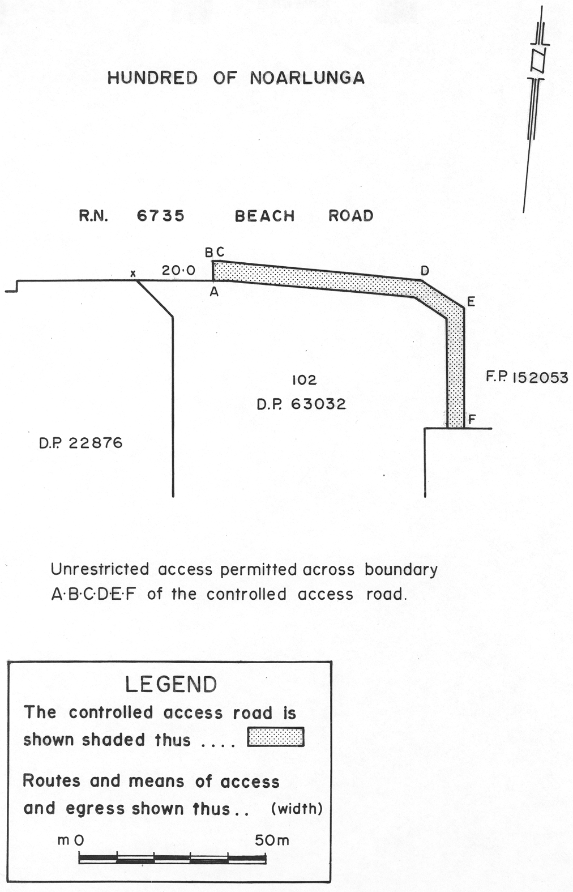
Made by the Governor
on the recommendation of the Commissioner of Highways and with the advice and consent of the Executive Council
on 22 April 2004.
2004/01476/CTS01

South Australia
Genetically Modified Crops Management (Designation of Areas) Regulations 2004
under the Genetically Modified Crops Management Act 2004

Contents
1 Short title
2 Commencement
3 Designation of area in which cultivation of genetically modified food crops is prohibited

1—Short title
These regulations may be cited as the Genetically Modified Crops Management (Designation of Areas) Regulations 2004.
2—Commencement
These regulations will come into operation on the day on which the Genetically Modified Crops Management Act 2004 comes into operation.
3—Designation of area in which cultivation of genetically modified food crops is prohibited
The whole of the State is designated as an area in which no genetically modified food crops may be cultivated.
Note—
As required by section 10AA(2) of the Subordinate Legislation Act 1978, the Minister has certified that, in the Minister's opinion, it is necessary or appropriate that these regulations come into operation as set out in these regulations.
Made by the Governor
with the advice and consent of the Executive Council
on 22 April 2004.
No. 17 of 2004
MAFF0010/04CS

South Australia
Liquor Licensing (Dry Areas—Long Term) Variation Regulations 2004
under the Liquor Licensing Act 1997

Contents
Part 1—Preliminary
1 Short title
2 Commencement
3 Variation provisions
Part 2—Variation of Liquor Licensing (Dry Areas—Long Term) Regulations 1997
4 Variation of Schedule 1—Long term dry areas
5 Variation of Schedule 2—Plans of long term dry areas
Schedule 1—Plan to be substituted

Part 1—Preliminary
1—Short title
These regulations may be cited as the Liquor Licensing (Dry Areas—Long Term) Variation Regulations 2004.
2—Commencement
These regulations come into operation on the day on which they are made.
3—Variation provisions
In these regulations, a provision under a heading referring to the variation of specified regulations varies the regulations so specified.
Part 2—Variation of Liquor Licensing (Dry Areas—Long Term) Regulations 1997
4—Variation of Schedule 1—Long term dry areas
Schedule 1, item headed "Normanville—Area 1", column headed "Period"—delete "25 February 2004" and substitute:
8 April 2006
5—Variation of Schedule 2—Plans of long term dry areas
Schedule 2, plan headed "Normanville—Plan No 1"—delete the plan and substitute the plan headed "Normanville—Plan No 1" in Schedule 1 of these regulations.
Schedule 1—Plan to be substituted
Normanville—Plan No 1
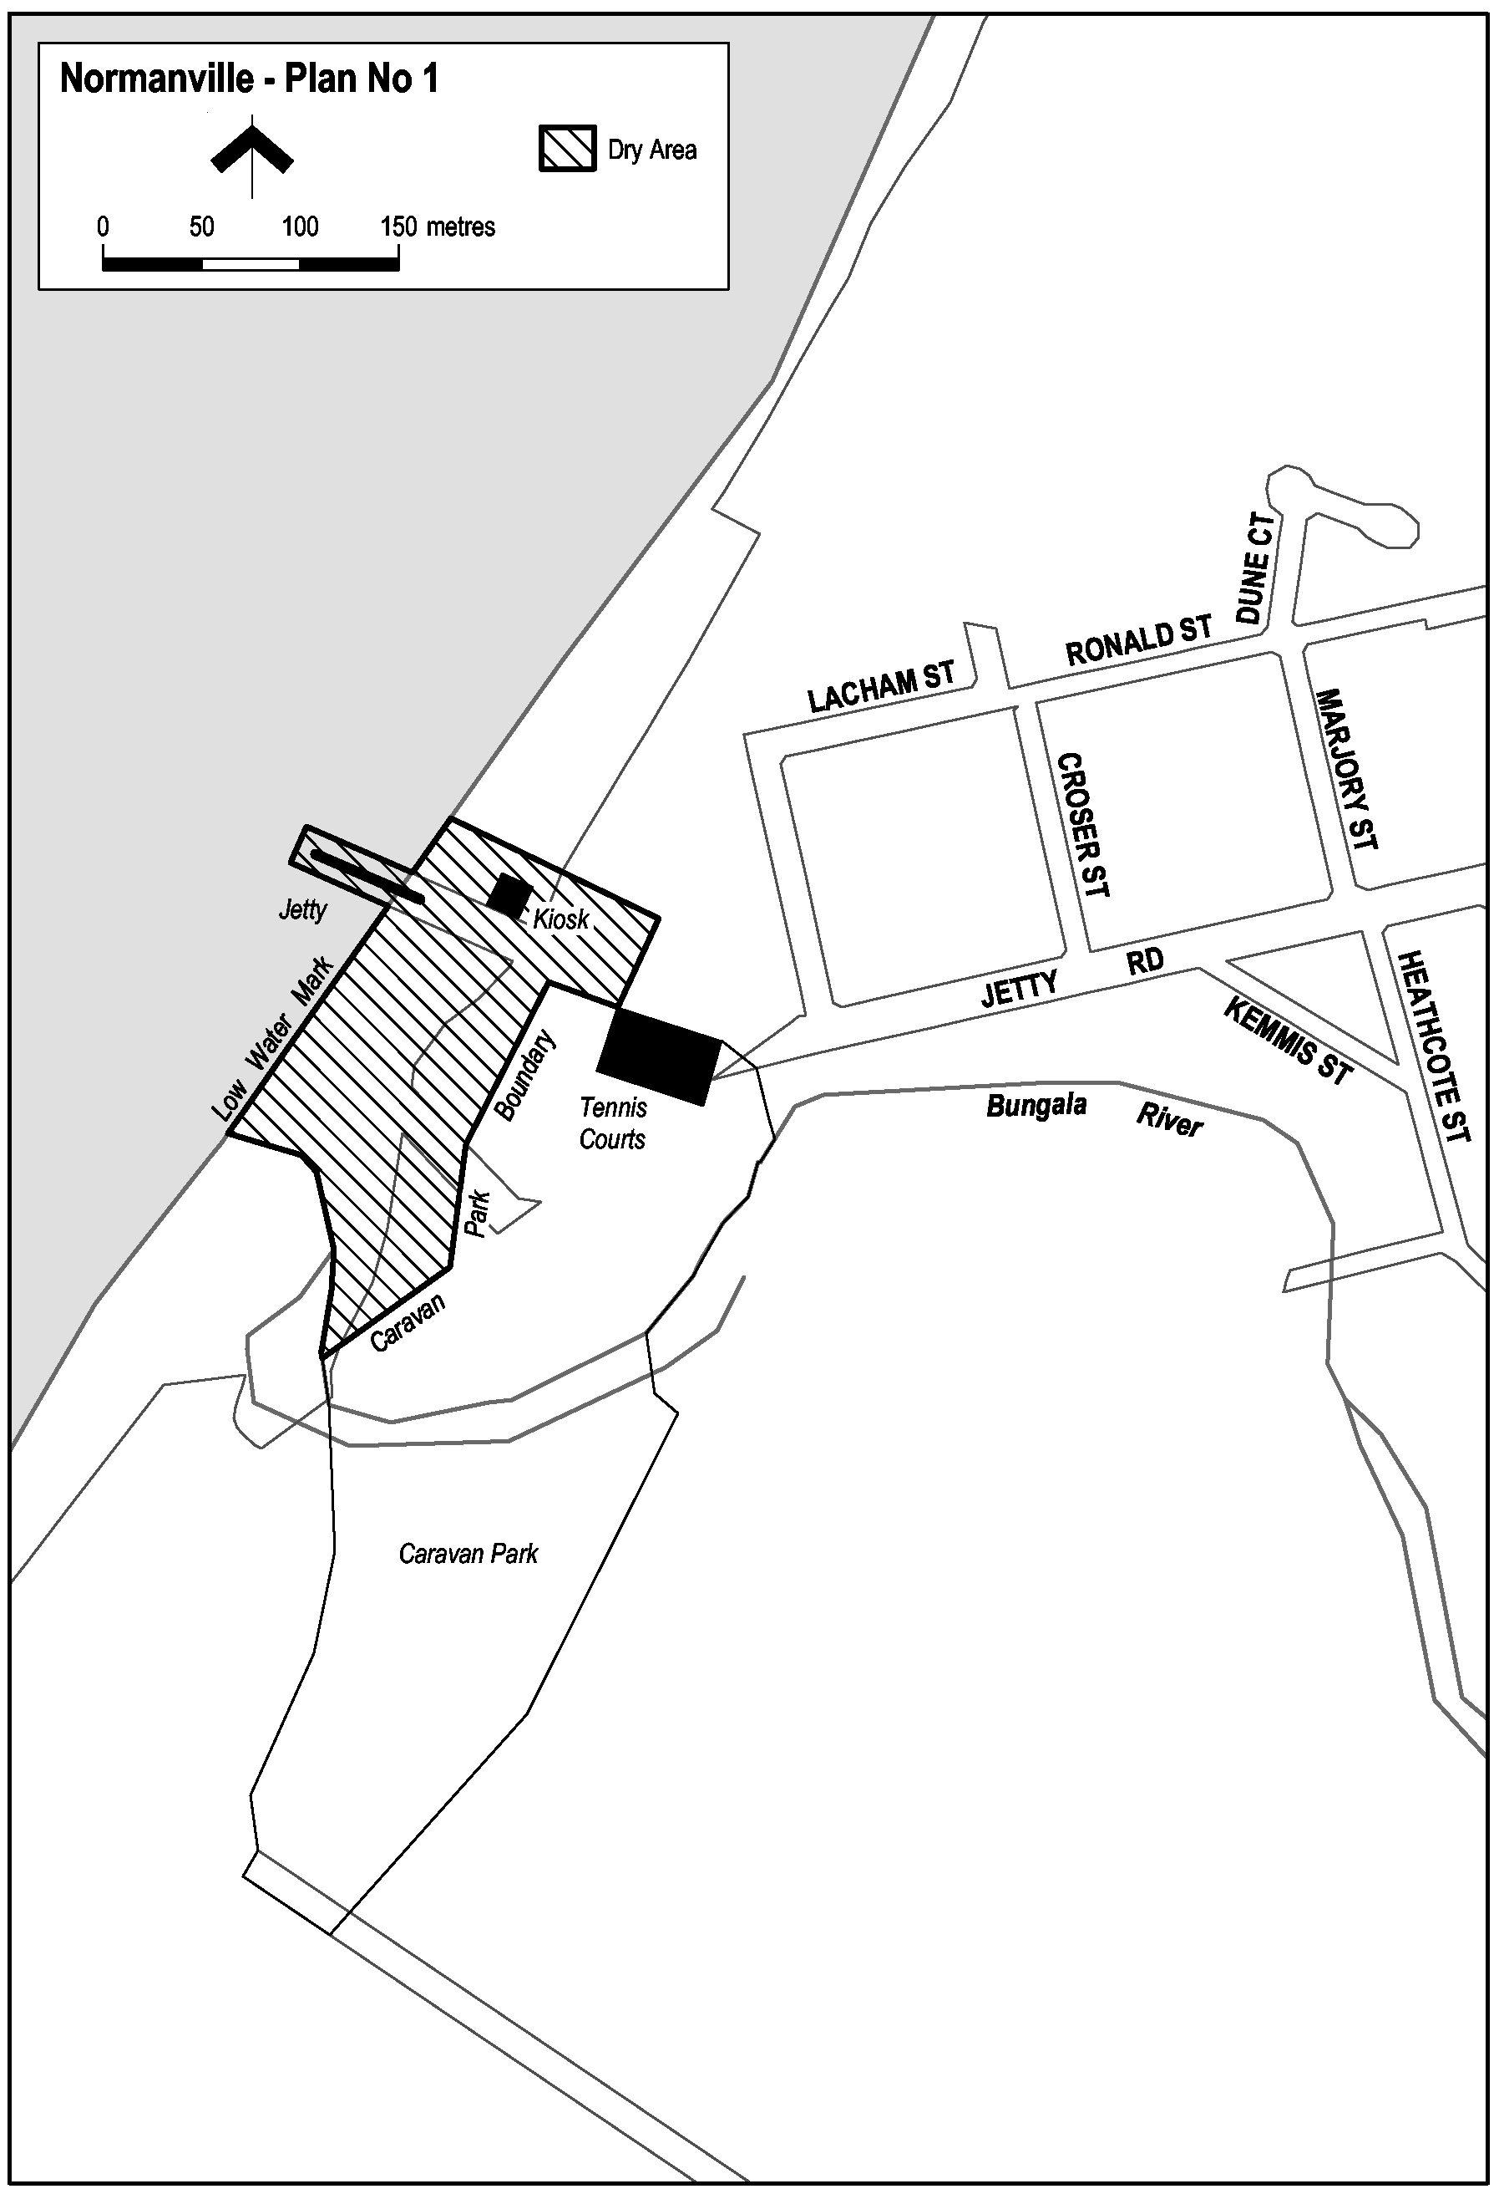
Note—
As required by section 10AA(2) of the Subordinate Legislation Act 1978, the Minister has certified that, in the Minister's opinion, it is necessary or appropriate that these regulations come into operation as set out in these regulations.
Made by the Governor
with the advice and consent of the Executive Council
on 22 April 2004.
No. 18 of 2004
OLGC1/2004

South Australia
Legislation Revision and Publication Variation Regulations 2004
under the Legislation Revision and Publication Act 2002

Contents
Part 1—Preliminary
1 Short title
2 Commencement
3 Variation provisions
Part 2—Variation of Legislation Revision and Publication Regulations 2002
4 Substitution of regulation 4
4 Definition of legislation

Part 1—Preliminary
1—Short title
These regulations may be cited as the Legislation Revision and Publication Variation Regulations 2004.
2—Commencement
These regulations come into operation on the day on which they are made.
3—Variation provisions
In these regulations, a provision under a heading referring to the variation of specified regulations varies the regulations so specified.
Part 2—Variation of Legislation Revision and Publication Regulations 2002
4—Substitution of regulation 4
Regulation 4—delete the regulation and substitute:
4—Definition of legislation
For the purposes of paragraph (c) of the definition of legislation in section 3 of the Act, the following are instruments of a prescribed kind:
(a) an environment protection policy made under Part 5 of the Environment Protection Act 1993;
(b) a rule made under the Road Traffic Act 1961.
Note—
As required by section 10AA(2) of the Subordinate Legislation Act 1978, the Minister has certified that, in the Minister's opinion, it is necessary or appropriate that these regulations come into operation as set out in these regulations.
Made by the Governor
with the advice and consent of the Executive Council
on 22 April 2004.
No. 19 of 2004
AGO0234/02CS

South Australia
Liquor Licensing (Dry Areas—Long Term) Variation Regulations 2004
under the Liquor Licensing Act 1997

Contents
Part 1—Preliminary
1 Short title
2 Commencement
3 Variation provisions
Part 2—Variation of Liquor Licensing (Dry Areas—Long Term) Regulations 1997
4 Variation of Schedule 1—Long term dry areas
5 Variation of Schedule 2—Plans of long term dry areas
Schedule 1—Plans to be substituted

Part 1—Preliminary
1—Short title
These regulations may be cited as the Liquor Licensing (Dry Areas—Long Term) Variation Regulations 2004.
2—Commencement
These regulations come into operation on the day on which they are made.
3—Variation provisions
In these regulations, a provision under a heading referring to the variation of specified regulations varies the regulations so specified.
Part 2—Variation of Liquor Licensing (Dry Areas—Long Term) Regulations 1997
4—Variation of Schedule 1—Long term dry areas
(1) Schedule 1, item headed "Grange—Area 1", column headed "Period"—delete "13 March 2004" and substitute:
1 April 2007
(2) Schedule 1, item headed "Henley Beach—Area 1", column headed "Period"—delete "13 March 2004" and substitute:
1 April 2007
(3) Schedule 1, item headed "Henley Beach—Area 2", column headed "Period"—delete "13 March 2004" and substitute:
1 April 2007
(4) Schedule 1, item headed "Henley Beach South—Area 1", column headed "Period"—delete "13 March 2004" and substitute:
1 April 2007
(5) Schedule 1, item headed "West Beach—Area 1", column headed "Period"—delete "13 March 2004" and substitute:
1 April 2007
5—Variation of Schedule 2—Plans of long term dry areas
(1) Schedule 2, plan headed "Grange—Plan No 1"—delete the plan and substitute the plan headed "Grange—Plan No 1" in Schedule 1 of these regulations.
(2) Schedule 2, plan headed "Henley Beach—Plan No 1"—delete the plan and substitute the plan headed "Henley Beach—Plan No 1" in Schedule 1 of these regulations.
(3) Schedule 2, plan headed "Henley Beach South—Plan No 1"—delete the plan and substitute the plan headed "Henley Beach South—Plan No 1" in Schedule 1 of these regulations.
(4) Schedule 2, plan headed "West Beach—Plan No 1"—delete the plan and substitute the plan headed "West Beach—Plan No 1" in Schedule 1 of these regulations.
Schedule 1—Plans to be substituted
Grange—Plan No 1
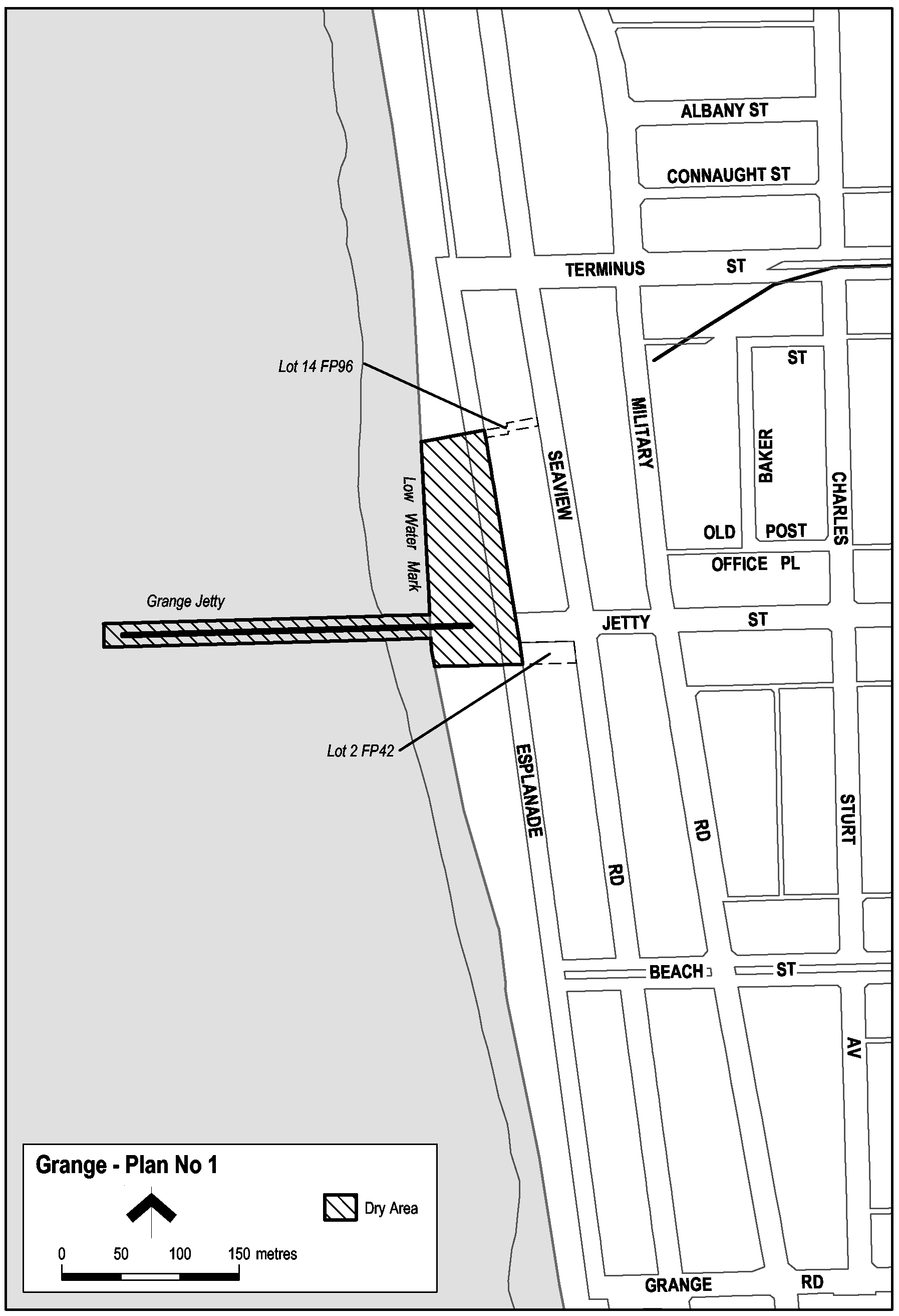
Henley Beach—Plan No 1
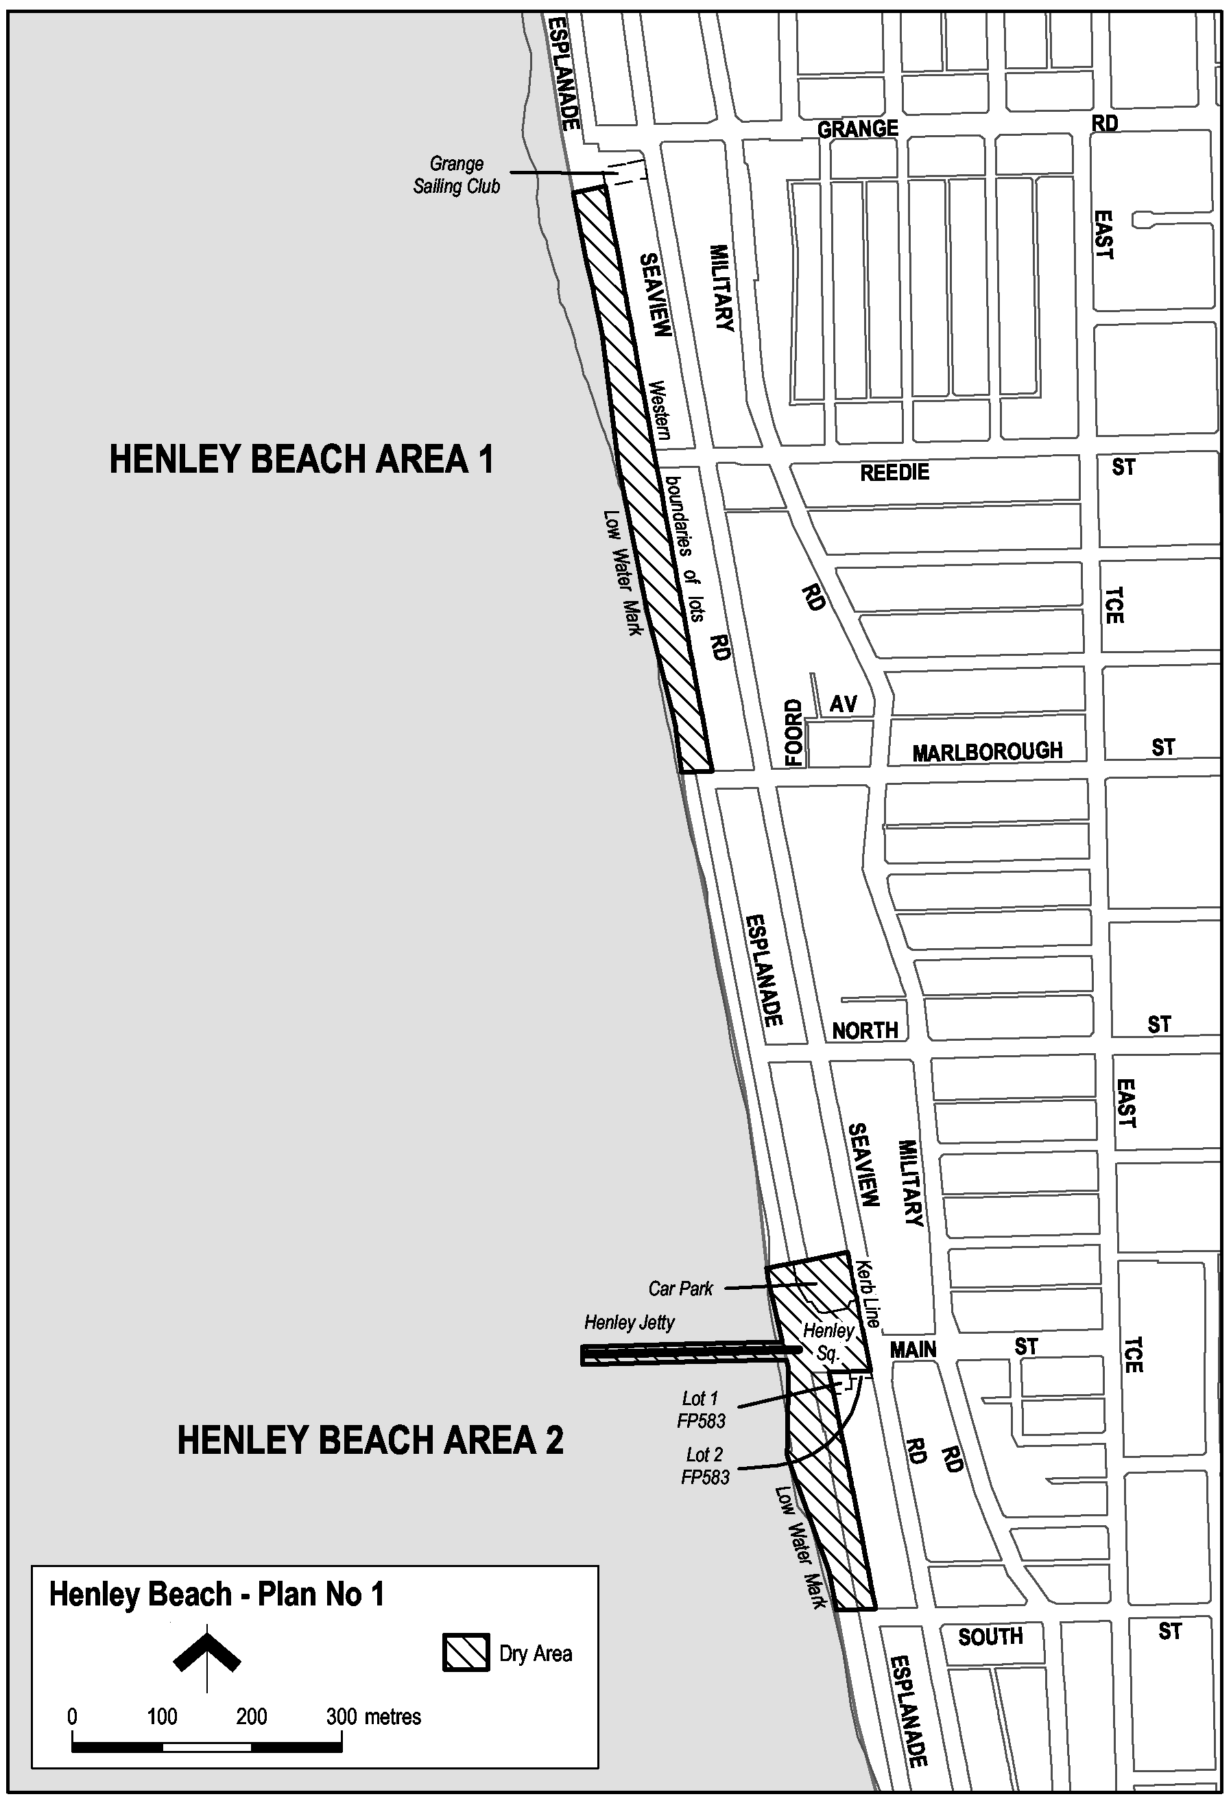
Henley Beach South—Plan No 1
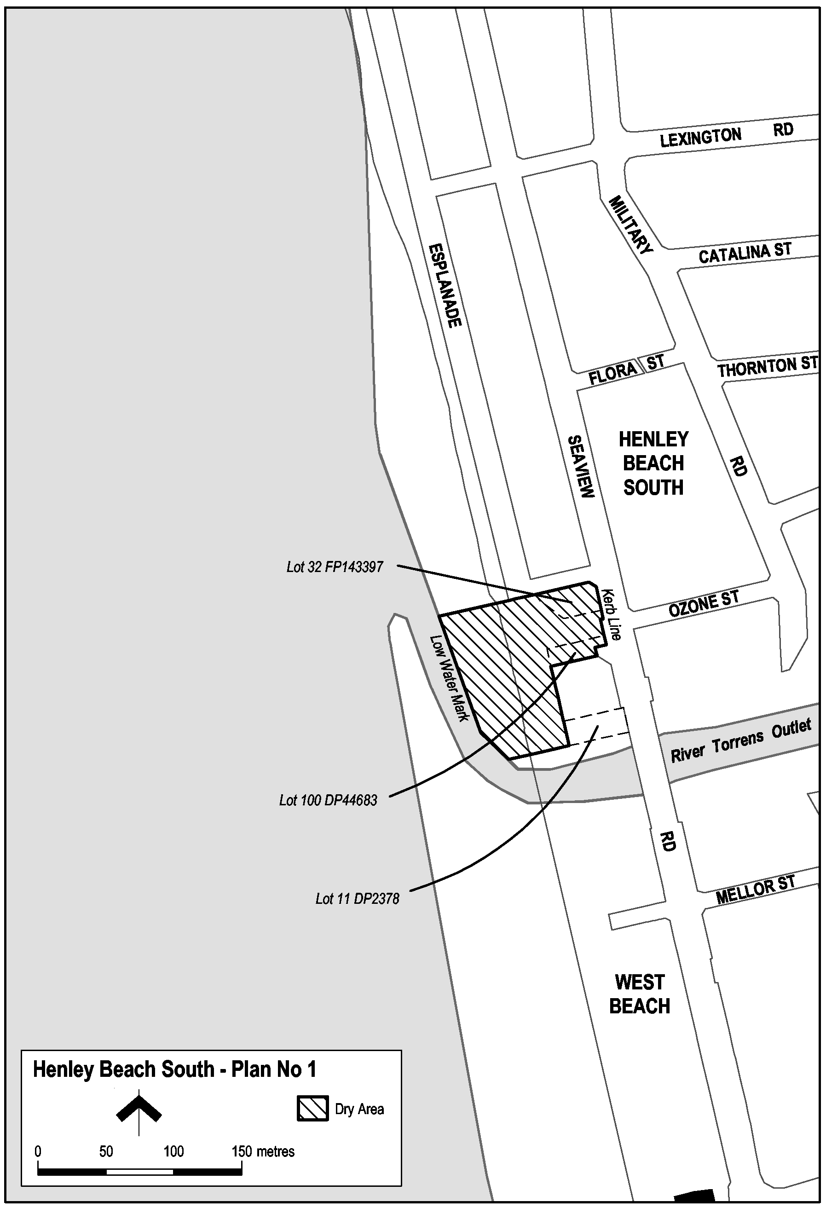
West Beach—Plan No 1
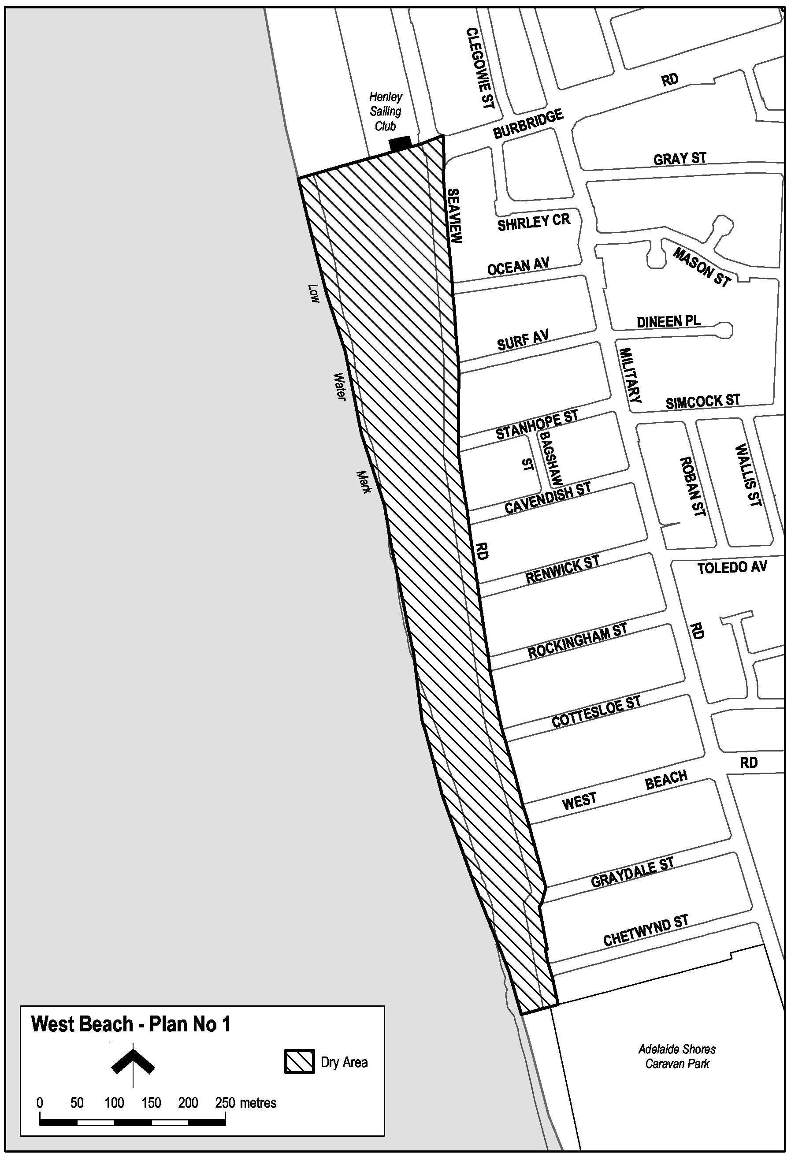
Note—
As required by section 10AA(2) of the Subordinate Legislation Act 1978, the Minister has certified that, in the Minister's opinion, it is necessary or appropriate that these regulations come into operation as set out in these regulations.
Made by the Governor
with the advice and consent of the Executive Council
on 22 April 2004.
No. 20 of 2004
OLGC3/2004

FAXING COPY?
IF you fax copy to Government Publishing SA for inclusion in the Government Gazette, there is no need to send a Confirmation Copy to us as well.
This creates confusion and may well result in your notice being printed twice.
Please use the following fax number:
Fax transmission: (08) 8207 1040
Phone Inquiries: (08) 8207 1045
Please include a contact person, phone number and order number so that we can phone back with any queries we may have regarding the fax copy.
NOTE: Closing time for lodging new copy (fax, hard copy or email) is 4 p.m. on Tuesday preceding the day of publication.

Government Gazette notices can be E-mailed.
The address is:
governmentgazette@saugov.sa.gov.au
Documents should be sent as attachments in Word format.
When sending a document via E-mail, please confirm your transmission with a faxed copy of your document, including the date the notice is to be published.
Fax transmission: (08) 8207 1040
Enquiries: (08) 8207 1045
NOTE: Closing time for lodging new copy (fax, hard copy or email) is 4 p.m. on Tuesday preceding the day of publication.

CITY OF ADELAIDE
Development Act 1993
Adelaide (City) Development Plan—General Plan Amendment Report—Draft for Public Consultation
NOTICE is hereby given that the City of Adelaide has prepared a draft General Plan Amendment Report to amend the Adelaide (City) Development Plan.
The Plan Amendment Report is proposing to make significant changes to its Development Plan (including Park Lands policies). These changes include the introduction of a new performance based system and updating policies relating to economic, residential development, transport and access, Park Lands, urban form, design and environmental issues. The changes also include the conversion of Districts and Precincts into Zones and Policy Areas and introduction of the Centres Policy in line with State Government legislation.
The draft General PAR and Explanatory Statement will be available for inspection or purchase from the Adelaide City Council Customer Centre, 25 Pirie Street, Adelaide or can be viewed on www.adelaidecitycouncil.com/news by selecting ‘Public Consultation and Communication’ from Monday, 19 April 2004 (copies of the draft PAR are available free of charge in CD format). Copies are also available for inspection at all council libraries.
Comments on the draft General PAR (including amended Park Lands policies) can be submitted through email by Council’s web- site by selecting ‘Public Consultation and Communication’ at www.adelaidecitycouncil.com/news or in writing to the Chief Executive Officer, Adelaide City Council (Draft General PAR), G.P.O. Box 2252, Adelaide, S.A. 5001.
All submissions should be received by 5 p.m. on Friday, 23 July 2004 and should clearly indicate whether you wish to be heard by Council at the public hearing in support of your submission and what hearing date you wish to attend.
The public hearings will be held in the Adelaide Town Hall at 6 p.m. on Wednesday, 4 August 2004 and at 6 p.m. on Wednesday, 11 August 2004.
Copies of all submissions received will be available for inspection by interested persons at the Adelaide City Council Customer Centre, 25 Pirie Street, Adelaide from Tuesday, 27 July 2004 until the date of the first public hearing.
M. Hemmerling, Chief Executive Officer

CITY OF BURNSIDE
Declaration of Public Roads
NOTICE is hereby given that the City of Burnside at its meeting held on 16 March 2004, resolved pursuant to section 210 of the Local Government Act 1999, that the following two roads be declared public roads:
• Allotment 203 in Filed Plan 15713, in the area named Dulwich, Hundred of Adelaide, certificate of title register book volume 5478, folio 29, known as Hector Lane;
• Allotment 110 in Filed Plan 30731 in the area named Beulah Park, Hundred of Adelaide, certificate of title register book volume 370, folio 105, known as King Lane.
J. Hanlon, Chief Executive Officer

CITY OF CHARLES STURT
Roads (Opening and Closing) Act 1991
Road Closure—Coglin Street, Brompton
NOTICE is hereby given pursuant to section 10 of the said Act, that the City of Charles Sturt proposes to make a Road Process Order to close, sell and transfer to John D. Robinson and Claudia Esau the portion of public road (known as Coglin Street) on the south-western corner of Hawker Street and Coglin Street adjoining allotment 1 in FP 2533 marked ‘A’ on Preliminary Plan No. 04/0017.
A copy of the plan and statement of persons affected are available for public inspection at Council’s Office, 72 Woodville Road, Woodville and the office of the Surveyor-General at Adelaide during normal office hours.
Any application for easement or objections must be made in writing within 28 days from this notice to the Council, P.O. Box 1, Woodville, S.A. 5011 and the Surveyor-General, G.P.O. Box 1354, Adelaide, S.A. 5001, setting out full details.
Where a submission is made, Council will give notification of a meeting to deal with the matter.
Dated 29 April 2004.
P. Lockett, Chief Executive Officer

CITY OF ONKAPARINGA
Roads (Opening and Closing) Act 1991
NOTICE is hereby given, pursuant to section 10 of the Roads (Opening and Closing) Act 1991, that the City of Onkaparinga proposes to make a Road Process Order to close and transfer those portions of Gulf Parade and Right-of-Way marked ‘A’, ‘B’, ‘C’, ‘D’, ‘E’, ‘F’, ‘G’, ‘H’, ‘J’ and ‘K’ on Preliminary Plan No. 04/0029.
Transfer ‘A’ and ‘H’ to Ernavon Pty Ltd and Tarca Building Co. Pty Ltd, P.O. Box 283, McLaren Vale, S.A. 5171 and to merge that portion with certificate of title volume 5075, folio 62.
Transfer ‘B’ and ‘G’ to Ernavon Pty Ltd and Tarca Building Co. Pty Ltd, P.O. Box 283, McLaren Vale, S.A. 5171 and to merge that portion with certificate of title volume 5505, folio 777.
Transfer ‘C’ and ‘F’ to S.J.T. Pty Ltd, c/o Deloitte Touche Tohmatsu, 190 Flinders Street, Adelaide, S.A. 5000 and to merge that portion with certificate of title volume 5508, folio 654.
Transfer ‘D’ and ‘E’ to Jaak Oks, 137 MacKinnon Parade, North Adelaide, S.A. 5006 and to merge that portion with certificate of title volume 5505, folio 539.
Transfer ‘J’ to Ernavon Pty Ltd and Tarca Building Co. Pty Ltd, P.O. Box 283, McLaren Vale, S.A. 5171 and to merge that portion with certificate of title volume 5075, folio 61.
Transfer ‘K’ to Ernavon Pty Ltd and Tarca Building Co. Pty Ltd, P.O. Box 283, McLaren Vale, S.A. 5171 and to merge that portion with certificate of title volume 5875, folio 795.
A statement of persons affected by the proposed road process together with a copy of the Preliminary Plan is available for inspection at the offices of the City of Onkaparinga, Ramsay Place, Noarlunga Centre, during normal office hours. Copies may also be inspected at the Adelaide office of the Surveyor-General, 101 Grenfell Street, Adelaide, during normal office hours.
Any person is entitled to object to the proposed road process, or any person affected by the proposed closure is entitled to apply for an easement to be granted in that person’s favour over the land subject to the proposed closure. Such objection or application for an easement must set out the full name and address of the person making the objection or application and must be fully supported by reasons. Any application for an easement must give full particulars of the nature and location of the easement land, and where made by a person as the owner of adjoining or nearby land, specify the land to which the easement is to be annexed.
The objection or application for an easement must be made in writing to the City of Onkaparinga, P.O. Box 1, Noarlunga Centre, S.A. 5168, within 28 days of this notice, and a copy shall be forwarded to the Adelaide office of the Surveyor-General, G.P.O. Box 1354, Adelaide, S.A. 5001. Where a submission is made, the City of Onkaparinga will give notification of a meeting at which the matter will be considered, so that the person making the submission or a representative may attend, if desired.
Dated 22 April 2004.
J. Tate, City Manager

CLARE AND GILBERT VALLEYS COUNCIL
Exclusion of Land from Classification as Community Land
NOTICE is hereby given that the Clare and Gilbert Valleys Council at its meeting held on 16 February 2004, resolved pursuant to section 193 of the Local Government Act 1999, to exclude the following parcel of land from classification as community land:
Land situated at Farrell Flat Road, Clare, Lot 1, Deposited Plan 58677, Hundred of Clare in the area named Clare, being the land comprised in Certificate of Title 5866/790.
M. A. Goldstone, Chief Executive Officer

REGIONAL COUNCIL OF GOYDER
Supplementary Election for Robertstown Ward—
Nominations Received
AT the close of nominations, 12 noon on Thursday, 15 April 2004, one nomination only was received for the vacancy of Councillor for Robertstown Ward.
In accordance with section 25 (1) of the Local Government (Elections) Act 1999 and in my capacity as Returning Officer, I declare Peter John Niemz elected to the vacancy of Councillor for the duration of the term of the current Council.
Campaign Donations Return
The candidate must forward a campaign donations return to the Council Chief Executive Officer within six weeks after the conclusion of the election.
Steve Tully, Returning Officer

DISTRICT COUNCIL OF KAROONDA EAST MURRAY
Final adoption of Community Land Management Plans
NOTICE is hereby given pursuant to section 197 (3) of the Local Government Act 1999 that the council of the District Council of Karoonda East Murray, at its meeting held on Tuesday, 13 April 2004 adopted a Management Plan for the following Community Land:
Recreation Reserves
Galga, Copeville, Mindarie, Yurgo, Marama, Borrika, Lowaldie, Wynarka, Karoonda Recreation Reserve and Apex Park.
Cemeteries
Karoonda, Wynarka, Lowaldie, Borrika, Marama, Wanbi, Sandalwood, Bakara and Perponda.
Parklands
Karoonda Parklands, Karoonda Golf Course, Halidon, Sandalwood, Mantung, Wanbi, Marama, Borrika, Lowaldie, Perponda and Wynarka.
Water Conservation Reserves
Karoonda, Wynarka, Halidon, Mindarie, Lowaldie and Borrika.
Other
Karoonda Institute and Carpark, Karoonda Masonic Lodge, Karoonda Pioneer Park Historical Museum, Karoonda RSL Playground, Wanbi Soldiers Memorial Playground, Borrika Ex CFS facility Lot 7, Hundred of Wilson.
For further information, please contact John Claydon, Accountant, on 8578 1004.
P. Smithson, Chief Executive Officer

DISTRICT COUNCIL OF KIMBA
Appointment
NOTICE is hereby given that pursuant to section 98 of the Local Government Act 1999, David John Lane be appointed acting Chief Executive Officer for the period commencing on Tuesday, 27 April 2004 until such time that the vacancy in the office of Council’s Chief Executive Officer is filled.
S. R. Cheriton, Chief Executive Officer

DISTRICT COUNCIL OF PETERBOROUGH
Resignation of Councillor
NOTICE is hereby given in accordance with section 54 (6) of the Local Government Act 1999, that a vacancy has occurred in the office of Area Councillor, due to the resignation of Councillor Anthony Berryman, to take effect from 5 April 2004.
T. D. Barnes, Chief Executive Officer

DISTRICT COUNCIL OF PETERBOROUGH
Close of Roll for Supplementary Election
NOTICE is hereby given that due to the resignation of a member of the Council, a supplementary election will be necessary to fill the vacancy of Area Councillor for the District Council of Peterborough.
The voters roll to conduct this supplementary election will close at 5.00 p.m. on Friday, 30 April 2004.
Nominations to fill the vacancy will open on Thursday, 27 May 2004 and will be received up until 12 noon on Thursday, 17 June 2004.
The election will be conducted entirely by post with the return of ballot material to reach the Returning Officer no later than 12 noon on Monday, 19 July 2004.
Steve Tully, Returning Officer

DISTRICT COUNCIL OF ROBE
Development Act 1993
Robe (DC) Development Plan Miscellaneous Plan Amendment Report—Draft for Public Consultation
NOTICE is hereby given that the District Council of Robe has prepared a draft Plan Amendment Report to amend its current Development Plan as it affects the total area of the Council.
The Plan Amendment Report will amend the Development Plan to include:
• additional and amended residential provisions;
• additional Rural Living Zones and amended provisions for existing rural areas;
• additional and amended tourism and advertising sign provisions;
• introduction of provisions relating to seasonal workers’ accommodation;
• alteration of the Rural Zone to a Primary Industry Zone and inclusion of new and additional provisions;
• inclusion of new provisions relating to natural resource management;
• inclusion of a Conservation Zone;
• introduction of new and additional provisions relating to Lake Butler;
• alteration of Recreation Zone to a Special Use Zone and introduction of new provisions;
• inclusion of a Primary Industry (Deferred Urban) Zone;
• additional and amended provisions relating to wind farms; and
• inclusion of new and updated concept plans within various zones.
The draft Plan Amendment Report and statement will be available for public inspection and purchase during normal office hours at the Council Offices, Royal Circus, Robe from Thursday, 22 April 2004 to Friday, 25 June 2004. A copy of the Plan Amendment Report can be purchased from the council in a hard copy form for $20 each or a CD version for $10 each. The PAR may also be accessed on the council website at:
www.council.robe.sa.gov.au.
Written submissions regarding the draft amendment will be accepted by the District Council of Robe until Friday, 25 June 2004. The written submission should also clearly indicate whether you wish to speak at the public hearing regarding your submission. All submissions should be addressed to the Chief Executive Officer of the District Council of Robe, P.O. Box 1, Robe, S.A. 5276.
Copies of all submissions received will be available for inspection by interested persons at the council office, Royal Circus, Robe from Monday, 28 June 2004 until the date of the public hearing.
A public hearing will be held in the Council Chambers, Royal Circus, Robe at 7.30 p.m. on Wednesday, 14 July 2004. The public hearing may not be held if no submission indicates an interest in speaking at the public hearing.
Dated 21 April 2004.
R. J. Kay, Chief Executive Officer

DISTRICT COUNCIL OF TATIARA
Supplementary Election for West Ward
NOMINATIONS are hereby invited and will be received at District Council of Tatiara located at 43 Woolshed Street, Bordertown and 34 Hender Street, Keith from Thursday, 22 April until 12 noon on Thursday, 13 May 2004, from any person eligible to be a candidate for election to the vacancy.
Nomination forms and candidate’s handbooks are available from 43 Woolshed Street, Bordertown and 34 Hender Street, Keith.
A candidate must submit a profile of not more than 150 words with the nomination form.
A candidate photograph of predominantly the head and shoulders, taken within the preceding 12 months, may also be submitted.
A briefing session for prospective candidates will be conducted at 5.30 p.m. on Wednesday, 28 April 2004 at 34 Hender Street, Keith.
If more than the required number of nominations are received for the vacancy, an election will be conducted entirely by postal
ballot with the return of the completed ballot papers to reach the Returning Officer no later than 12 noon on Tuesday, 15 June 2004.
Steve Tully, Returning Officer

WAKEFIELD REGIONAL COUNCIL
Exclusion of Land from Classification as Community Land
NOTICE is hereby given that the council at its meeting held on 14 April 2004, resolved pursuant to section 193 (4) (a) of the Local Government Act 1999, to exclude the following parcel of land from classification as community land for the purpose of future light industrial land development:
Section 479, Hundred of Blyth (formerly being a Railway Reserve) described as CR56650427.
P. J. Barry, Chief Executive Officer

IN the matter of the estates of the undermentioned deceased persons:
Bain, Earnest Clifton, late of 67 Arnold Drive, Hackham, retired process worker, who died on 26 February 2004.
Betts, Arthur Ross, late of 6 Ellis Street, Enfield, retired driver, who died on 1 February 2004.
Curnow, Clarice Victoria, late of 437 Salisbury Highway, Parafield Gardens, widow, who died on 18 February 2004.
Hille, Madge Robertina, late of 160 Walkerville Terrace, Walkerville, of no occupation, who died on 29 February 2004.
Jordan, Sylvia Eileen, late of 38 Nairne Road, Woodside, of no occupation, who died on 19 November 2003.
Lillebo, Wallace Alfred, late of 150 Reynell Road, Woodcroft, retired soldier, who died on 18 February 2004.
Sherrah, Vera, late of 2 Jean Street, Oaklands Park, of no occupation, who died on 16 October 2003.
Starr, Joan Jessamy, late of Thomas Street, Virginia, of no occupation, who died on 24 January 2004.
Szymanski, Ilona, late of 75-79 Hilltop Drive, Oakden, of no occupation, who died on 28 January 2004.
Notice is hereby given pursuant to the Trustee Act 1936, as amended, the Inheritance (Family Provision) Act 1972, and the Family Relationships Act 1975, that all creditors, beneficiaries, and other persons having claims against the said estates are required to send, in writing, to the Public Trustee, 25 Franklin Street, Adelaide 5000, full particulars and proof of such claims, on or before 21 May 2004, otherwise they will be excluded from the distribution of the said estate; and notice is also hereby given that all persons who are indebted to the said estates are required to pay the amount of their debts to the Public Trustee or proceedings will be taken for the recovery thereof; and all persons having any property belonging to the said estates are forthwith to deliver the same to the Public Trustee.
Dated 22 April 2004.
C. J. O’Loughlin, Public Trustee

ATTENTION

CUSTOMERS requiring a proof of their notice for inclusion in the Government Gazette, please note that the onus is on you to inform Government Publishing SA of any subsequent corrections by 10 a.m. on Thursday, which is our publication deadline.

For any corrections to your notice please phone 8207 1045 or Fax 8207 1040 before 10 a.m. on Thursday.

If we do not receive any communication by 10 a.m. on Thursday (day of publication) we will presume the notice is correct and will print it as it is.

Remember—the onus is on you to inform us of any corrections necessary to your notice.

NOTE: Closing time for lodging new copy (electronically, fax or hard copy) is 4 p.m. on Tuesday preceding the day of publication. Phone 8207 1045—Fax 8207 1040.
Email: governmentgazette@saugov.sa.gov.au

Printed and published by authority every Thursday by J. D. FERGUSON, Government Printer, South Australia
Price: $4.70, plus postage; to subscribers, $238.00 per annum.
(The above prices are inclusive of GST)

