No. 36 1113

THE SOUTH AUSTRALIAN

GOVERNMENT GAZETTE
www.governmentgazette.sa.gov.au

PUBLISHED BY AUTHORITY

ALL PUBLIC ACTS appearing in this GAZETTE are to be considered official, and obeyed as such

ADELAIDE, THURSDAY, 29 APRIL 2004

CONTENTS

Page
Appointments, Resignations, Etc. 1114
Associations Incorporation Act 1985—Notice 1114
Building Work Contractors Act 1995—Notices 1114
Corporations and District Councils—Notices 1195
Development Act 1993—Notices 1115
Fisheries Act 1982—Notices 1120
Genetically Modified Crops Management Act 2004—
Notice 1123
Housing Improvement Act 1940—Notices 1133
Liquor Licensing Act 1997—Notices 1135
National Parks Regulations 2001—Notices 1137
Petroleum Act 2000—Notice 1138
Phylloxera and Grape Industry Act 1995—Notice 1170
Proclamations 1172
Public Trustee Office—Administration of Estates 1196
Rules of Court 1139
Page
REGULATIONS
Electronic Transactions Act 2000 (No. 21 of 2004) 1174
Public Sector Management Act 1995 (No. 22 of 2004) 1177
National Electricity (South Australia) Act 1996
(No. 23 of 2004) 1179
Limitations of Actions Act 1936 (No. 24 of 2004) 1183
Liquor Licensing Act 1997—
(No. 25 of 2004) 1185
(No. 26 of 2004) 1187
Sewerage Act 1929—Notice 1143
Transport, Department of—Notices to Mariners 1138
Unclaimed Moneys Act 1891—Notice 1196
Veterinary Surgeons Board of South Australia—Register 1144
Water Mains and Sewers—Mains Laid, Replaced, Etc. 1170
Waterworks Act 1932—Notices 1169

GOVERNMENT GAZETTE NOTICES
ALL poundkeepers’ and private advertisements forwarded for publication in the South Australian Government Gazette must be PAID FOR PRIOR TO INSERTION; and all notices, from whatever source, should be legibly written on one side of the paper only and sent to Government Publishing SA so as to be received no later
than 4 p.m. on the Tuesday preceding the day of publication. Phone 8207 1045 or Fax 8207 1040. E-mail: governmentgazette@saugov.sa.gov.au. Send as attachments in Word format and please confirm your transmission with a faxed copy of your document, including the date the notice is to be published and to whom the notice will be charged. The Government Gazette is available online at: www.governmentgazette.sa.gov.au

Department of the Premier and Cabinet
Adelaide, 29 April 2004
HER Excellency the Governor in Executive Council has been pleased to appoint the undermentioned to the Residential Tenancies Tribunal, pursuant to the provisions of the Residential Tenancies Act 1995:
Bailiff: (from 3 May 2004 until 1 May 2009)
Robert Paul Loveday
By command,
J. D. Lomax-Smith, for Premier
OCBA 05/04CS

Department of the Premier and Cabinet
Adelaide, 29 April 2004
HER Excellency the Governor in Executive Council has been pleased to appoint the undermentioned to the Coast Protection Board, pursuant to the provisions of the Coast Protection Act 1972:
Member: (from 29 April 2004 until 28 April 2008)
Walter Iasiello
Brian Caton
Peri Sharon Jane Coleman
Graham Foreman
Presiding Member: (from 29 April 2004 until 28 April 2008)
Graham Foreman
By command,
J. D. Lomax-Smith, for Premier
MEC 0030/04CS

Department of the Premier and Cabinet
Adelaide, 29 April 2004
HER Excellency the Governor in Executive Council has been pleased to appoint the undermentioned to the Land Board, pursuant to the provisions of the Crown Lands Act 1929:
Member: (from 29 April 2004 until 28 April 2006)
Peter Edwin Croft
Jack Anthony Nicolaou
Merridie Shepherd Martin
Chairman: (from 29 April 2004 until 28 April 2006)
Peter Edwin Croft
Deputy Chairman: (from 29 April 2004 until 28 April 2006)
Jack Anthony Nicolaou
By command,
J. D. Lomax-Smith, for Premier
MEC 0029/04CS

Department of the Premier and Cabinet
Adelaide, 29 April 2004
HER Excellency the Governor in Executive Council has been pleased to appoint Bruno Krumins, Member of the Order of Australia, as Governor’s Deputy of South Australia for the period from 10.30 a.m. on Thursday, 6 May 2004 until 1 p.m. on Friday, 7 May 2004, and for the period from 5 p.m. on Monday, 10 May 2004 until 1 p.m. on Thursday, 13 May 2004.
By command,
J. D. Lomax-Smith, for Premier

Department of the Premier and Cabinet
Adelaide, 29 April 2004
HER Excellency the Governor in Executive Council has removed Ronald Arthur Clement from the office of Justice of the Peace for South Australia, pursuant to section 6 of the Justices of the Peace Act 1991.
By command,
J. D. Lomax-Smith, for Premier
ATTG 0053/03 TC1CS

ASSOCIATIONS INCORPORATION ACT 1985
Dissolution of Defunct Association
PURSUANT to section 44 (1) of the Associations Incorporation Act 1985, notice is hereby given that the Corporate Affairs Commission is of the opinion that the Mayfair Theatre Company Incorporated an association incorporated under the Act is defunct and upon publication of this notice the association is dissolved.
Given at Adelaide, 27 April 2004.
B. Colquist, a Delegate of the Corporate Affairs Commission

BUILDING WORK CONTRACTORS ACT 1995
Exemption
TAKE notice that, pursuant to section 45 of the Building Work Contractors Act 1995, I, Michael John Atkinson, Minister for Consumer Affairs, do hereby exempt the licensee named in Schedule 1 from the application of Division 3 of Part 5 of the Act in relation to domestic building work described in Schedule 2 and subject to the conditions specified in Schedule 3.
Schedule 1
Ben Ursini, BLD 3098
Schedule 2
Domestic building work for an extension of the licensee’s home at 3A Schebella Court, Beaumont.
Schedule 3
That the licensee does not transfer his interest in the land prior to five years from the date of completion of the building work, the subject of this exemption, without the authorisation of the Commissioner for Consumer Affairs.
Dated 23 January 2004.
M. J. Atkinson, Minister for Consumer Affairs
Ref: 610/04-00002

BUILDING WORK CONTRACTORS ACT 1995
Exemption
TAKE notice that, pursuant to section 45 of the Building Work Contractors Act 1995, I, Michael John Atkinson, Minister for Consumer Affairs, do hereby exempt the licensee named in Schedule 1 from the application of Division 3 of Part 5 of the Act in relation to domestic building work described in Schedule 2 and subject to the conditions specified in Schedule 3.
Schedule 1
George Karvountzis, BLD 179717
Schedule 2
Domestic building work performed by the licensee for the property owner Caleah Pty Ltd to construct a solid two-storey dwelling at 1 Ian Showell Drive, Renmark.
Schedule 3
That the licensee, in his capacity as sole director of Caleah Pty Ltd, does not permit the owner to transfer its interest in the land prior to five years from the date of completion of the building work, the subject of this exemption, without the authorisation of the Commissioner for Consumer Affairs.
Dated 23 January 2004.
M. J. Atkinson, Minister for Consumer Affairs
Ref: 610/03-00114

BUILDING WORK CONTRACTORS ACT 1995
Exemption
TAKE notice that, pursuant to section 45 of the Building Work Contractors Act 1995, I, Michael John Atkinson, Minister for Consumer Affairs, do hereby exempt the licensee named in Schedule 1 from the application of Division 3 of Part 5 of the above Act in relation to domestic building work described in Schedule 2 and subject to the conditions specified in Schedule 3.
Schedule 1
Fairmont Homes Proprietary Limited, BLD 4575
Schedule 2
Domestic building work performed by the licensee for a retirement village known as ‘The Ferns’ at the corner of Main North and Smith Roads, Salisbury North.
Schedule 3
1. The licensee must, prior to commencement of the building works, effect an amendment to the contracts between the building company and the property owner(s) such that the latter are required to inform prospective residents of the properties that a policy of building indemnity insurance has not been issued in respect of the properties.
2. The licensee must, prior to commencement of the building works, effect an amendment to the contracts between the building company and the property owner(s) such that the owners will not transfer their interest in the land prior to the date of completion of the building work, or within five years of its completion, without the authorisation of the Commissioner for Consumer Affairs.
3. The licensee must, prior to commencement of the building works, provide a copy of amended contracts between the building company and the property owner(s) such that a certified copy of this Certificate of Exemption is to be provided to each resident of the properties for the five year warranty period to which it applies.
4. The licensee must, prior to commencement of the building works, provide a copy of amended contracts between the building company and the property owner(s) such that they abide by these exemption conditions for each project to the Commissioner for Consumer Affairs.
Dated 6 April 2004.
M. J. Atkinson, Minister for Consumer Affairs
Ref: 610/04-00003

BUILDING WORK CONTRACTORS ACT 1995
Exemption
TAKE notice that, pursuant to section 45 of the Building Work Contractors Act 1995, I, Michael John Atkinson, Minister for Consumer Affairs, do hereby exempt the licensee named in Schedule 1 from the application of Division 3 of Part 5 of the Act in relation to domestic building work described in Schedule 2 and subject to the conditions specified in Schedule 3.
Schedule 1
Craig Hannam, BLD 49915
Schedule 2
Domestic building work performed by the licensee for the construction of a swimming pool at the licensee’s existing family residence at 3 Kings Avenue, Burnside.
Schedule 3
That the licensee does not transfer his interest in the land prior to five years from the date of completion of the building work, the subject of this exemption, without the authorisation of the Commissioner for Consumer Affairs.
Dated 15 April 2004.
M. J. Atkinson, Minister for Consumer Affairs
Ref: 610/04-00042

BUILDING WORK CONTRACTORS ACT 1995
Exemption
TAKE notice that, pursuant to section 45 of the Building Work Contractors Act 1995, I, Michael John Atkinson, Minister for Consumer Affairs, do hereby exempt the licensee named in Schedule 1 from the application of Division 3 of Part 5 of the Act in relation to domestic building work described in Schedule 2 and subject to the conditions specified in Schedule 3.
Schedule 1
George Gatsios, BLD 55400
Schedule 2
Domestic building work performed by the licensee for the construction of an upper storey addition extension to the licensee’s family residence at 5 Galway Avenue, Seacombe Heights.
Schedule 3
That the licensee does not transfer his interest in the land prior to five years from the date of completion of the building work, the subject of this exemption, without the authorisation of the Commissioner for Consumer Affairs.
Dated 13 April 2004.
M. J. Atkinson, Minister for Consumer Affairs
Ref: 610/04-00004

DEVELOPMENT ACT 1993, SECTION 48: DECISION BY THE DEVELOPMENT ASSESSMENT COMMISSION AS DELEGATE OF THE GOVERNOR
Preamble
1. The decision of the Governor under section 48 of the Development Act 1993, to approve the development of Holdfast Shores Stage 2B development located adjacent to Colley Terrace, Glenelg was published in the Gazette on 19 February 2004.
2. On 3 October 1997, and pursuant to section 48 of the Development Act 1993, the Governor granted development approval for the new marina, marina pier building platform, offshore reef structure for sand trapping and other works in the area of the Glenelg Foreshore and Environs. The development was subject to an Environmental Impact Statement and Assessment Report, pursuant to section 46 and 46B of the Development Act 1993 (and as officially recognised under the Planning Act 1982).
3. On 8 June 2000 and pursuant to section 48 of the Development Act 1993, the Governor granted a development approval for the Holdfast Shores 2A development, comprising a hotel, car parking, landscaping and associated works, adjacent to Chappell Drive, Glenelg. The development was subject to a Development Report and an Assessment Report, pursuant to section 46 of the Development Act 1993. Amendments to the Holdfast Shores Stage 2A proposal relating primarily to design, car parking, land division and signage issues, were subsequently granted approval by the Development Assessment Commission (as the Governor’s delegate on 7 December 2000; 1 March 2001; 17 May 2001; 28 February 2002; 3 October 2002; 20 March 2003 and 4 March 2004.
4. A proposal for the development of the Holdfast Shores 2B proposal at Glenelg, comprising the construction of the Glenelg Surf Life Saving Club, demolition of the existing GSLSC building and the Magic Mountain building; and the construction of a rock sea wall, an apartment building, and an entertainment and retail precinct, has been considered under Division 2, Part 4 of the Development Act 1993.
5. Application was made to the Governor under section 48 of the Development Act, for a development authorisation for the proposed Holdfast Shores Stage 2B development at Glenelg. The development application, as it relates to the Holdfast Shores Stage 2B development was amended and expanded upon by the amended Development Report, dated 18 September 2003, the Applicant’s Response to submissions, dated 17 December 2003 and the following updated documents and drawings:
Documents
• The letter from Woodhead International to Planning SA titled Further Information and Clarification, dated 22 January 2004 and accompanying documents.
Drawings:
• Drawing Titled: ‘Car park ventilation supplementary plan’; Drawing Number: 155.
• Drawing Titled: ‘Civil stormwater supplementary plan’; Drawing Number: 156.
• Drawing Titled: ‘Civil stormwater supplementary plan’; Drawing Number: 157.
• Drawing Titled: ‘Oil pipeline supplementary plan’; Drawing Number: 158.
6. The Governor was satisfied that an appropriate Amended Development Report and an Amended Assessment Report have been prepared in relation to the development, in accordance with the requirements of Division 2 of Part 4 of the Development Act 1993.
7. The Governor had, in considering the application, regard to all relevant matters under section 48 (5) of the Development Act 1993.
8. Pursuant to section 48 of the Development Act 1993 and Regulation 64 (1) of the Development Regulations 1993, the Governor has the right to reserve matters for further decision-making. The Governor decided to grant a provisional development authorisation, with a view to the following matters being considered for further decision-making.
9. Application has now been made to the Development Assessment Commission as delegate of the Governor under section 48 of the Development Act 1993 for the approval of a land division to establish separate parcels of land for the beach and the development area of Stage 2B.
10. The amendments to the development are contained in:
(a) Plan of division of allotments 800 and 5 in Deposited Plan 60805 of part section 1623 Hundred of Noarlunga and of portion of seabed, foreshore and closed road by Alexander & Symonds Pty Ltd received by Planning SA on 4 February 2004 held in Development Assess-ment Commission docket number 110/D012/04.
11. The Development Assessment Commission has, in considering the application, had regard to all relevant matters under section 48 (5) of the Development Act 1993.
12. The Development Assessment Commission is satisfied that the amendments do not require the preparation of a further or amended Development Report.
Decision
PURSUANT to section 48 of the Development Act 1993, the Development Assessment Commission, as delegate of the Governor, grants development approval to the amended Holdfast Shores Stage 2B proposal at Glenelg, I:
(a) grant provisional development authorisation for the Holdfast Shores Stage 2B development at Glenelg, subject to the conditions and notes to the applicant below;
(b) specify all matters relating to this provisional development plan authorisation as matters in respect of which conditions of this authorisation may be varied or revoked, or new conditions attached;
(c) pursuant to section 48 and Regulation 64 (1) of the Development Act 1993, and as noted in the Preamble to this provisional development authorisation, reserve the following matters for further decision-making at a later stage (refer ‘notes to the applicant’):
(a) further assessment and certification in respect of the Building Rules, in relation to the:
• Construction of the Glenelg Surf Life Saving Club and demolition of the existing GSLSC building.
• Demolition of the Magic Mountain.
• Services infrastructure and site preparation.
• Construction of the rock sea wall.
• Early works for the Apartment Building, including excavation, piling, retaining walls, columns and in-ground services.
• Early works for the Entertainment and Retail Building, including excavation, piling, retaining walls, columns and in-ground services.
• Superstructure for the Apartment Building (and/or components of the Apartment Building), including related works.
• Superstructure for the Entertainment and Retail Building (and/or components of the Entertainment and Retail Building), including related works.
(b) redesign of the roofline to reduce the perceived height of the building from adjacent public spaces (in consultation with Planning SA);
(c) redesign of the frontages of buildings facing Moseley Square (including balconies) to ensure an appropriate relationship with the adjacent Glenelg Town Hall (in consultation with Planning SA and the Heritage Branch of the Department for Environment and Heritage);
(d) any external advertising signage.
(d) Approve the land division application 110/D012/04, lodged on 4 February 2004.
Conditions of Approval
1. Except where minor amendments may be required by other Acts and/or legislation or by conditions imposed herein, the Holdfast Shores 2B development shall be undertaken in strict accordance with:
(a) The following drawings contained in the Amended Development Report for Holdfast Shores Stage 2B, dated September 2003, except to the extent that they are varied by the plans described in paragraph 1 (b):
• Drawing Titled: ‘Site plan level B2’; Drawing Number: 111.
• Drawing Titled: ‘Site plan level 1’; Drawing Number: 112.
• Drawing Titled: ‘Site plan level 2’; Drawing Number: 113.
• Drawing Titled: ‘Entertainment building basement’; Drawing Number: 114.
• Drawing Titled: ‘Entertainment building level 1’; Drawing Number: 115.
• Drawing Titled: ‘Entertainment building level 2’; Drawing Number: 116.
• Drawing Titled: ‘Entertainment building levels 3 and 4’; Drawing Number: 117.
• Drawing Titled: ‘Entertainment building elevations’; Drawing Number: 118.
• Drawing Titled: ‘Entertainment building elevations’; Drawing Number: 119.
• Drawing Titled: ‘Entertainment building sections’; Drawing Number: 120.
• Drawing Titled: ‘Apartment Plans B2 and B1’; Drawing Number: 121.
• Drawing Titled: ‘Apartment Plans L1, L2, L3-4, and L5’; Drawing Number: 122.
• Drawing Titled: ‘Apartment plans L6-8, L9, and roof plan’; Drawing Number: 123.
• Drawing Titled: ‘Apartment elevations—north and east’; Drawing Number: 124.
• Drawing Titled: ‘Apartment elevations—west and south’; Drawing Titled: 125.
• Drawing Titled: ‘Apartment Sections’; Drawing Number: 126.
• Drawing Titled: ‘Land Use’; Drawing Number: 127.
• Drawing Titled: ‘Built form’; Drawing Number: 128.
• Drawing Titled: ‘Urban Spaces’; Drawing Number: 129.
• Drawing Titled: ‘Open space/vegetation’; Drawing Number: 130.
• Drawing Titled: ‘View Corridor’; Drawing Number: 131.
• Drawing Titled: ‘Climate’; Drawing Number: 132.
• Drawing Titled: ‘Microclimate’; Drawing Number: 133.
• Drawing Titled: ‘Links to surrounding areas’; Drawing Number: 134.
• Drawing Titled: ‘Pedestrian Movement’; Drawing Number: 135.
• Drawing Titled: ‘Vehicle Movement’; Drawing Number: 136.
• Drawing Titled: ‘Concourse study pedestrian movement’; Drawing Number: 137.
• Drawing Titled: ‘Concourse study vehicle movement’; Drawing Number: 138.
• Drawing Titled: ‘Moseley Square study’; Drawing Number: 139.
• Drawing Titled: ‘Town Hall opportunities’; Drawing Number: 140.
• Drawing Titled: ‘Foreshore open space study’; Drawing Number: 141.
• Drawing Titled: ‘Apartment building study’; plan number: 142.
• Drawing Titled: ‘Entertainment precinct east plaza study’; Drawing Number: 143.
• Drawing Titled: ‘Sun diagrams summer’; Drawing Number: 144.
• Drawing Titled: ‘Sun diagrams winter’; Drawing Number: 145.
• Drawing Titled: ‘Landscaping’; Drawing Number: 146.
• Drawing Titled: ‘Construction Stage 1’; Drawing Number: 147.
• Drawing Titled: ‘Construction Stage 2’; Drawing Number: 148.
• Drawing Titled: ‘Construction Stage 3’; Drawing Number: 149.
• Drawing Titled: ‘Construction Stage 4’; Drawing Number: 150.
(b) the following drawings accompanying the Response by Proponent to submissions 3. City of Holdfast Bay Submission, dated 17 December 2003 as they relate to the proposal for Holdfast Shores Stage 2B, except to the extent that they are varied by the plans as described in paragraph (c):
• Drawing Titled: ‘Sun diagrams summer’; Drawing Number: 144 Rev. A.
• Drawing Titled: ‘Sun diagrams winter’; Drawing Number: 145 Rev. A.
• Drawing Titled: ‘Entertainment building basement supplementary plan’; Drawing Number: 151 Rev. A.
• Drawing Titled: ‘Entertainment building level 1 supplementary plan’; Drawing Number: 152 Rev. A.
• Drawing Titled: ‘Entertainment building level 2 supplementary plan’; Drawing Number: 153 Rev. A.
• Drawing Titled: ‘Entertainment building levels 3 and 4 supplementary plan’; Drawing Number 154.
• Drawing Titled: ‘Entertainment building levels 3 and 4 supplementary plan’; Drawing Number: 154 Rev. A.
(c) the following drawings accompanying the Further Information and Clarification letter dated 22 January 2004 as they relate to the proposal for Holdfast Shores Stage 2B:
• Drawing Titled: ‘Car park ventilation supplementary plan’; Drawing Number: 155.
• Drawing Titled: ‘Civil stormwater supplementary plan’; Drawing Number: 156.
• Drawing Titled: ‘Civil stormwater supplementary plan’ Drawing Number: 157.
• Drawing Titled: ‘Oil pipeline supplementary plan’; Drawing Number: 158.
(d) the land division plan lodged with the Development Assessment Commission on 4 February 2004:
Application number 110/D012/04.
(e) the following documents, except to the extent that they are varied by the plans described in paragraphs (a) and (c):
• Amended Development Report for Stage 2B, Volumes 1 and 2 by the Holdfast Shores Consortium, dated 18 September 2003 (except to the extent that it may be varied by a subsequent document in this paragraph).
• The letter from Woodhead International to Planning SA titled Response by proponent to submissions, 3. City of Holdfast Bay Submission, dated 17 December 2003 (except to the extent that it may be varied by a subsequent document in this paragraph).
• The Amended Assessment Report prepared by the Minister for Aboriginal Affairs and Reconciliation (as delegate Minister for the Minister for Urban Development and Planning), for the Holdfast Shores 2B development, dated February 2004 (except to the extent that it may be varied by a subsequent document in this paragraph).
• The letter from Woodhead International to Planning SA, titled Further Information and Clarification, dated 22 January 2004.

2. A Construction Environmental Management Plan (CEMP) shall be prepared, in consultation with the Environment Protection Authority, Coast Protection Board and the City of Holdfast Bay, to address the management issues during construction. Matters to be addressed in the CEMP must include:
• Traffic management during construction, including transport beyond the site;
• Control and management of construction noise;
• Dust and mud control;
• Working hours;
• Stormwater and groundwater management during con-struction;
• Site security and fencing;
• Disposal of building waste and refuse;
• Protection and cleaning of roads and pathways;
• Site clean up;
• Adherence to all relevant Environment Protection authority policies and codes of practice for construction sites;
• Identification and management of potential and actual acid sulphate soils (should these be encountered); and
• Identification and management of contaminated soils and groundwater (should these be encountered).
3. The applicant shall submit further information and application(s) in relation to the matters that have been reserved for further decision-making by the Governor (or her delegate) (as referred to in the Preamble and Decision of this provisional development authorisation).
4. No building works shall commence until a decision has been made by the Governor (or her delegate), involving matters relating to the Building Rules assessment and certification requirements and any other reserved matters that are subject to further development application.
5. No works shall commence unless, and until, legal rights to develop the Magic Mountain site have been secured.
6. The car parking areas shall be designed in accordance with Australian Standards 2890 1-1993 and line markings shall be maintained in good and substantial condition at all times.
7. Access for service deliveries and waste disposal vehicles at the Holdfast Promenade shall only be allowed between 7 a.m. and 10 a.m. daily.
8. Stormwater from the Holdfast Shores Stage 2B site shall not be disposed of by way of a pipe or similar structure that conveys the stormwater to the beach.
9. Site works, construction work and truck movements to and from the site shall only be carried out between 7 a.m. and 6 p.m., Monday to Saturday, inclusive.
10. Pedestrian access ways, from Moseley Square to the entertainment plaza and from Hope Street through the ‘air lock’, shall remain open to the public at all times.
11. Landscaping shall be provided in accordance with the authorised plans and shall be maintained and nurtured, with any diseased or dying plants being replaced.
12. The waste storage and service area at the rear of the buildings shall be kept in a neat, tidy and healthy condition at all times and the service area access door shall remain closed at all times, other than when loading or unloading is taking place.
13. Machinery, plant operating equipment, lighting or sound devices shall not impair or impinge upon the enjoyment of adjoining properties or occupiers thereof.
14. All drainage, finished floor levels, and public works associated with the development, including the disposal of stormwater, shall be carried out in accordance with accepted engineering standards and to the reasonable satisfaction of the City of Holdfast Bay.
Notes to Applicant
• A decision on the reserved matters relating to Building Rules assessment and certification requirements will only be made by the Governor (or her delegate) after a Building Rules assessment and certification has been undertaken and issued by the City of Holdfast Bay, or a private certifier, as required by the Development Act 1993; and after the Minister for Urban Development and Planning receives a copy of all relevant certification documentation, as outlined in Regulation 64 of the Development Regulations 1993.
• If the Building Rules assessment process demonstrates that the Holdfast Shores Stage 2B development complies with the Building Rules pursuant to the Development Act 1993 and Development Regulations 1993, the City of Holdfast Bay, or private certifier conducting the Building Rules assessment, must:
(a) provide to the Minister the certification in the form set out in Schedule 12A of the Development Regulations 1993; and
(b) to the extent that may be relevant and appropriate:
(i) issue a schedule of essential safety provisions under Division 4 of Part 12;
(ii) assign a classification of the building under these regulations; and
(iii) ensure that the appropriate levy has been paid under the Construction Industry Training Fund 1993.
Regulation 64 of the Development Regulations 1993 provides further information about the type and quantity of all building certification documentation required for referral to the Minister.
• The City of Holdfast Bay, or private certifier undertaking the Building Rules assessment and certification for the Holdfast Shores Stage 2B development, must ensure that any assessment and certification is consistent with this provisional development authorisation (including any conditions or notes that apply in relation to this provisional development authorisation).
• Should the applicant wish to vary the application or the staging of any reserved matters, as outlined in this provisional development authorisation, a variation to the application may be submitted, pursuant to section 48B of the Development Act 1993, provided that the development application variation remains within the ambit of the Amended Development Report and Amendment Assessment Report referred to in this provisional development authorisation.
• The applicant is advised of the requirement to comply with the Environment Protection Authority’s (EPA) ‘Stormwater Pollution Prevention Code of Practice for the Building and Construction Industry’ during demolition and construction of the development.
• Noise emissions from the Holdfast Shores Stage 2B development will be subject to the Environment Protection (Industrial Noise) Policy 1994 and the Environment Protection Authority (EPA) Guidelines and the Environ-ment Protection Act 1993.
• Prior to any construction, the applicant should consult with Adelaide Airport Ltd, about crane operations.
• The Heritage Branch of the Department for Environment and Heritage, should be consulted if there is to be any physical intervention to the structures on the adjacent State Heritage place (Glenelg Town Hall). Any such work must be executed in accordance with advice arising from such consultation.
• The proponent is reminded of the General Environmental Duty under section 25 of the Environment Protection Act 1993, which requires that a person must not undertake any activity, which pollutes, or may pollute; without taking all reasonable and practical measures to prevent or minimise harm to the environment.
• If the Holdfast Shores 2B development is not substantially commenced within two years of the date of any reserved matter decisions, the Governor may cancel this provisional development authorisation and any subsequent decisions on reserved matters (where relevant).
• The Minister has a specific power to require testing, monitoring and auditing under section 48 (c) of the Development Act 1993.
Dated 29 April 2004.
P. Cockrum, Secretary, Development Assessment Commission

DEVELOPMENT ACT 1993, SECTION 48: DECISION BY THE DEVELOPMENT ASSESMENT COMMISSION AS DELEGATE OF THE GOVERNOR
Preamble
1. The decision by the Governor under section 48 of the Development Act 1993, to approve the development of an Organics Waste Treatment and Recycling Research Facility at Buckland Park was published in the Gazette on 5 December 2003.
2. The development was the subject of a Public Environmental Report and an Assessment Report under sections 46 and 46C of the Development Act 1993.
3. An amendment to the development approval has been under consideration by the Development Assessment Commission as delegate of the Governor under Division 2 of Part 4 of the Development Act.
4. The proposed amendments include; the receipt of oversized compost material containing plastic material, from stockpiles at the Jeffries Garden Soils operations located at the Wingfield Waste Management Centre for use in the construction of mounds; the receipt of oversized compost material that has been processed at the Jeffries Garden Soils operations located at the Wingfield Waste Management Centre to remove plastic material and other contaminants; and the receipt and stockpile of un-processed oversize compost material located at the Jeffries Garden Soils operations at the Wingfield Waste Management Centre for future processing to remove plastic material and other contaminants.
5. The amendments to the development are contained in letters from Jeffries Garden Soils dated 21 March 2004 and 5 April 2004.
6. The Development Assessment Commission is satisfied that the amendments do not require the preparation of a further or amended Public Environmental Report.
7. The Development Assessment Commission has, in con-sidering the matter, had regard to all relevant matters under section 48 (5) of the Development Act 1993.
Decision
PURSUANT to section 48 of the Development Act 1993, the Development Assessment Commission, as delegate of the Governor, grants development approval to the amended Organics Waste Treatment and Recycling Research Facility at Buckland Park, subject to conditions.
Conditions of approval
1. The Organics Waste Treatment and Recycling Research Facility, Buckland Park shall be undertaken in accordance with:
(a) the following documents and drawings as they relate to the Organics Waste Treatment and Recycling Research Facility, Buckland Park:
Documents:
(i) the Public Environmental Report prepared by Jeffries Garden Soils dated January 2003;
(ii) the Response Document prepared by Jeffries Garden Soils dated May 2003;
(iii) Environmental Management Plan for a Resource Organics Resource Centre at Buckland Park, prepared by Rodenburg Davey & Associates Pty Ltd, dated 6 August 2003, Revision 1 (enclosing final drawings);
(iv) the letter from Finlaysons Lawyers, titled Jeffries Organics Recycling Facility Proposal—Final Development Application, dated 26 September 2003;
(v) the Assessment Report prepared by the Minister for Urban Development and Planning dated November 2003;
(vi) the letter from Jeffries Garden Soils dated 21 March 2004;
(vii) the letter from Jeffries Garden Soils dated 5 April 2004.
Drawings:
(i) Drawing Titled: Jeffries Group Recycled Organics Resource Centre Buckland Park, SA, Drawing Number: AEV318-C-SK-008 (dated 26 September 2003).
2. The quantity of feedstock to be received or processed at the site shall not exceed 150 000 tonnes per annum.
3. The raw materials for composting shall comprise green organics (foliage, grass cuttings, prunings, branches), saw dust, timber (pallets, boxes), and wet organics (processed grease trap residue, street sweepings).
4. All incoming feedstock material shall be unloaded, stored and processed (screened and shredded) in the receival shed within 24 hours of being received.
5. The construction of the processing areas (windrowing and final product), wheel wash bay area and surface water storage area shall be to the specifications listed in the ‘Environmental Manage-ment Plan for a Recycled Organics Resource Centre at Buckland Park, dated 6 August 2003, Revision 1’.
6. Construction of all stages for the windrowing areas and wastewater areas shall be to Level 1 Supervision as set out in Australian Standard 3798-1996. Daily logs and the final supervision report shall be forwarded to the Environment Protection Authority.
7. A minimum of 1 m separation distance shall be maintained between the groundwater level and the underside of all liners on the site.
8. The location and decommission status of old wells located on the site shall be confirmed and the operational wells decommis-sioned in accordance with the requirements of the Water Resources Act 1997.
9. Work constituting building work under the Development Act 1993, shall be certified by a private certifier as complying with the Building Rules, prior to any building work commencing.
10. Design specifications of the receival shed shall be forwarded to the Environment Protection Authority prior to construction and approved by the Development Assessment Commission prior to its construction. The receival shed shall be fully enclosed and have a concrete floor.
11. The design and construction of the road access junction to the site from Port Wakefield Road shall be to the reasonable satisfaction of Transport SA, and at the cost of the proponent.
12. Prior to commencing operation at the site McEvoy Road must be sealed to the standard agreed between the proponent and the City of Playford, and at the cost of the proponent.
13. The proponent must install a meteorological monitoring station in accordance with ‘Meteorological Monitoring Guidance for Regulatory Modelling Applications, US EPA, February 2000’, and be operational before operations at the site commence. It shall be to such a standard that it produces data suitable for air pollution modelling and complaint resolution. Note: The parameters that should be recorded are wind speed and direction at 10 m height, standard deviation of wind direction, temperature at both 2 m and 10 m heights, solar radiation and rainfall.
Unless varied by the following conditions:
14. The mounds constructed up to 15 March 2004, with compost material contaminated with plastics shall be covered with a minimum of 300 mm of topsoil and maintained to ensure no plastic material is exposed.
15. Compost material used for the construction of the mounds or used on site may only contain an incidental amount of plastic fragments or other contaminants after processing with the Hurrikan, with the exception of mounds constructed up to 15 March 2004.
16. The compost material containing plastics, currently located at the Jeffries Wingfield facility shall be allowed to be stockpiled adjacent to the proposed Primary Processing Building at the Jeffries Buckland Park site to enable future processing with the Hurrikan to remove the plastic and other contaminants prior to use on the site in future mound construction.
17. A topsoil cover of a minimum of 300 mm shall be maintained over the stockpile to ensure there is no litter.
Notes:
1. The proponent has an obligation under the Aboriginal Heritage Act 1988, whereby any ‘clearance’ work, which may require permission to disturb, damage or destroy Aboriginal Sites, must be undertaken with the full authorisation of the Minister for Aboriginal Affairs, according to section 23 of the Aboriginal Heritage Act.
2. An environmental authorisation granted by the Environment Protection Authority will include conditions requiring compliance with the standards of site preparation, management and maintenance detailed in the Environmental Management Plan, dated 6 August 2003 and the following requirements:
• The monitoring of the separation distance between ground-water and underside of the clay liner. Measures will be required to be put in place to ensure corrective actions being activated prior to the separation distance being at, or less than 1.00 m. It is proposed to set a trigger level at 1.10 m separation distance for more frequent level monitoring (minimum daily) and a second one at 1.05 m separation distance to activate corrective actions. The Environment Protection Authority licence condition will require water levels to be measured weekly and assessed and reported monthly to the Environment Protection Authority for the first year of operation.
• The maintenance of all drains and ponds.
• The specific nature and quantities of wastes to be com-posted on the site, including composting trials.
3. The Minister has a specific power to require testing, monitor-ing and auditing under section 48 (c) of the Development Act 1993.
Dated 29 April 2004.
P. Cockrum, Secretary, Development Assessment Commission

FISHERIES ACT 1982: SECTION 59
TAKE notice that, pursuant to section 59 of the Fisheries Act 1982, South Australian Abalone Developments Pty Ltd (the ‘exemption holder’), P.O. Box 1579, Port Lincoln, S.A. 5606, is exempt from sections 34 and 41 of the Fisheries Act 1982, but only insofar as it may take greenlip abalone for the purpose of aquaculture broodstock (hereinafter referred to as the ‘exempted activity’) in the waters specified in Schedule 1, subject to the conditions in Schedule 2 from 1 July 2004 until 30 June 2005.
Schedule 1
South Australian coastal waters south and east of a line drawn due south through Point Brown (latitude 32°32.6′S, longitude 133°50.8′E) and west of the meridian of longitude 136°30′E.
Schedule 2
1. The exemption holder may take a maximum of 200 greenlip abalone.
2. All abalone taken pursuant to this notice must not be sold or transferred to another party.
3. All abalone taken pursuant to this notice must be delivered to and retained on the registered aquaculture site of land-based Aquaculture Licence Number FT00158.
4. The exempted activity may only be conducted on the exemption holder’s behalf by Dominic Henderson, Jay Haagmans, John Haagmans, Tony Kingdom, Barry Mattner, Douglas Graskie, Jonas Woolford, Tobin Woolford, Milton Hunt, Darcy Eldridge, Howard Rodd and Peter Clarkson.
5. The exemption holder must notify the PIRSA Fisheries Compliance Unit on 1800 065 522 at least 24 hours prior to conducting the exempted activity with the following information:
• details of the boat that will be used to engage in the exempted activity;
• the name of the person who will be conducting the exempted activity;
• the intended place and time of launching and retrieval of the nominated boat for that day; and
• the intended area of conducting the exempted activity.
6. The exemption holder must, within 50 m of the point of landing of any abalone taken pursuant to this notice, complete
the PIRSA Fisheries form ‘Abalone Broodstock Collection Statement’. Immediately upon arrival at the exemption holder’s registered aquaculture site, this form must be faxed to PIRSA Fisheries on (08) 8347 6150. Prior to release into the registered aquaculture site, all abalone taken pursuant to this notice must be tagged so as to be clearly identified as wild broodstock.
7. The exemption holder shall record the number of wild broodstock held pursuant to this notice in a register to be maintained at the registered aquaculture site, which must be made available for inspection by a PIRSA Fisheries Compliance Officer upon request.
8. The PIRSA Fisheries Compliance Unit retains the right for a Fisheries Officer to accompany the exemption holder at any time during the exempted activity.
9. While engaged in the exempted activity the exemption holder must carry or have about or near his person a copy of this notice. Such notice must be produced to a PIRSA Fisheries Compliance Officer upon request.
10. The exemption holder must not contravene or fail to comply with the Fisheries Act 1982 or any regulations made under that Act, except where specifically exempted by this notice.
Dated 22 April 2004.
W. Zacharin, Director of Fisheries

FISHERIES ACT 1982: SECTION 59
TAKE notice that pursuant to section 59 of the Fisheries Act 1982, Pang Quong of PQ Aquatics, 4 Burrawong Avenue, Seaford, Vic. 3198 (the ‘exemption holder’), or a person acting as his agent, is exempt from paragraph 6 (c) of the Fisheries (General) Regulations 2000 but only insofar as the exemption holder shall not be guilty of an offence when taking and possessing one egg-bearing male leafy seadragon (the ‘exempted
activity’) from the waters described in Schedule 1, subject to the conditions specified in Schedule 2, from the date of gazettal of this notice until 31 March 2005, unless varied or revoked earlier.
Schedule 1
South Australian coastal waters excluding waters within one nautical mile of the jetties at Rapid Bay and Second Valley.
Schedule 2
1. Any specimen collected pursuant to this exemption must be retained by the exemption holder.
2. At least 24 hours prior to engaging in the exempted activity, the exemption holder must contact the PIRSA Fisheries Compliance Unit on 1800 065 522 and provide the following information:
• the name of the person who will be conducting the exempted activity;
• the intended location for conducting the exempted activity;
• the method of conducting the exempted activity; and
• if using a boat to conduct the exempted activity, the description of the boat and the intended area of launching and retrieval.
3. The exemption holder must provide a written report to the Director of Fisheries (G.P.O. Box 1625, Adelaide, S.A. 5001) within 7 days of collecting a leafy sea dragon pursuant to this exemption, providing details of the location, time and conditions of the collection.
4. The exemption holder must also provide a written report to the Director of Fisheries (G.P.O. Box 1625, Adelaide, S.A. 5001) by 30 April 2005, providing the following information:
• the number of eggs hatched from the specimen collected pursuant to this notice;
• the number of animals hatched from these eggs and an indication of survival rate;
• the number of surviving animals kept as broodstock and the number of animals sold domestically, exported or given away;
• a status report on the breeding program of the leafy sea dragon.
5. Whilst engaged in the exempted activity the exemption holder or his agents must be in possession of a copy of this notice which must be produced to a PIRSA Fisheries Compliance Officer if requested.
6. The exemption holder must not contravene or fail to comply with the Fisheries Act 1982 or any regulations made under that Act, except where specifically exempted by this notice.
Dated 22 April 2004.
W. Zacharin, Director of Fisheries

FISHERIES ACT 1982: SECTION 43
TAKE note that the notice number P024/04 made under section 43 of the Fisheries Act 1982, and published in the South Australian Government Gazette, page 1051, dated 15 April 2004 being the fourth notice on that page, referring to the Spencer Gulf prawn fishery, is hereby revoked as of 2359 hours on 20 April 2004.
Dated 23 April 2004.
J. Presser, Principal Fisheries Manager
R011/04

FISHERIES ACT 1982: SECTION 43
TAKE notice that it is hereby declared that it shall be unlawful for any person to engage in the class of fishing activity specified in Schedule 1 during the periods specified in Schedule 2.
Schedule 1
The act of taking or the act preparatory to or involved in the taking of western king prawn (Penaeus latisulcatus) in waters of Spencer Gulf north of the line commencing at position latitude 33°46.00′S, longitude 137°44.00′E, then to position latitude 33°37.00′S, longitude 137°33.00′E, then to position latitude 33°44.00′S, longitude 137°30.00′E, then to position latitude 33°40.00′S, longitude 137°12.00′E.
Schedule 2
2359 hours on 20 April 2004 to 0630 hours on 21 April 2004.
Dated 23 April 2004.
J. Presser, Principal Fisheries Manager
P025/04

FISHERIES ACT 1982: SECTION 43
TAKE notice that it is hereby declared that it shall be unlawful for any person to engage in the class of fishing activity specified in Schedule 1 during the periods specified in Schedule 2.
Schedule 1
The act of taking or the act preparatory to or involved in the taking of western king prawn (Penaeus latisulcatus) in waters of Spencer Gulf within the area commencing at position latitude 33°53.00′S, longitude 137°36.00′E, then to position latitude 33°47.00′S, longitude 137°27.00′E, then to position latitude 33°51.00′S, longitude 137°23.00′E, then to position latitude 33°58.00′S, longitude 137°34.00′E.
Schedule 2
2359 hours on 20 April 2004 to 0630 hours on 21 April 2004.
Dated 23 April 2004.
J. Presser, Principal Fisheries Manager
P026/04

FISHERIES ACT 1982: SECTION 43
TAKE notice that it is hereby declared that it shall be unlawful for any person to engage in the class of fishing activity specified in Schedule 1 during the periods specified in Schedule 2.
Schedule 1
The act of taking or the act preparatory to or involved in the taking of western king prawn (Penaeus latisulcatus) in waters of Spencer Gulf north of the line commencing at position latitude 33°40.00′S, longitude 137°10.00′E, then to position latitude 33°50.00′S, longitude 137°21.00′E, then to position latitude 33°54.00′S, longitude 137°08.00′E, then to position latitude 34°00.00′S, longitude 137°13.00′E, then to position latitude 34°09.00′S, longitude 137°06.00′E, then to position latitude 34°27.00′S, longitude 137°06.00′E, then to position latitude 34°27.00′S, longitude 136°39.00′E, then to position latitude 34°06.00′S, longitude 136°47.00′E, then to position latitude 33°55.00′S, longitude 136°34.00′E.
Schedule 2
2359 hours on 20 April 2004 to 0630 hours on 21 April 2004.
Dated 23 April 2004.
J. Presser, Principal Fisheries Manager
P027/04

FISHERIES ACT 1982: SECTION 43
TAKE notice that it is hereby declared that it shall be unlawful for any person to engage in the class of fishing activity specified in Schedule 1 during the periods specified in Schedule 2.
Schedule 1
The act of taking or the act preparatory to or involved in the taking of western king prawn (Penaeus latisulcatus) in waters of Spencer Gulf within the area commencing at position latitude 33°52.320′S, longitude 137°33.656′E, then to position latitude 33°52.270′S, longitude 137°34.428′E, then to position latitude 33°51.090′S, longitude 137°34.971′E, then to position latitude 33°51.150′S, longitude 137°34.428′E, then to position latitude 33°52.320′S, longitude 137°33.656′E.
Schedule 2
2359 hours on 20 April 2004 to 0630 hours on 21 April 2004.
Dated 23 April 2004.
J. Presser, Principal Fisheries Manager
P028/04

FISHERIES ACT 1982: SECTION 43
TAKE notice that it is hereby declared that it shall be unlawful for any person to engage in the class of fishing activity specified in Schedule 1 during the periods specified in Schedule 2.
Schedule 1
The act of taking or the act preparatory to or involved in the taking of western king prawn (Penaeus latisulcatus) in waters of Spencer Gulf within the area commencing at position latitude 33°43.410′S, longitude 137°23.060′E, then to position latitude 33°43.460′S, longitude 137°25.370′E, then to position latitude 33°47.250′S, longitude 137°23.150′E, then to position latitude 33°47.250′S, longitude 137°20.810′E, then to position latitude 33°43.410′S, longitude 137°23.060′E.
Schedule 2
2359 hours on 20 April 2004 to 0630 hours on 21 April 2004.
Dated 23 April 2004.
J. Presser, Principal Fisheries Manager
P029/04

FISHERIES ACT 1982: SECTION 43
TAKE notice that it is hereby declared that it shall be unlawful for any person to engage in the class of fishing activity specified in Schedule 1 during the periods specified in Schedule 2.
Schedule 1
The act of taking or the act preparatory to or involved in the taking of western king prawn (Penaeus latisulcatus) in waters of Spencer Gulf north of the line commencing at position latitude 33°46.00′S, longitude 137°44.00′E, then to position latitude 33°37.00′S, longitude 137°33.00′E, then to position latitude 33°44.00′S, longitude 137°30.00′E, then to position latitude 33°40.00′S, longitude 137°12.00′E.
Schedule 2
2100 hours on 21 April 2004 to 0630 hours on 22 April 2004.
Dated 23 April 2004.
J. Presser, Principal Fisheries Manager
P031/04

FISHERIES ACT 1982: SECTION 43
TAKE notice that it is hereby declared that it shall be unlawful for any person to engage in the class of fishing activity specified in Schedule 1 during the periods specified in Schedule 2.
Schedule 1
The act of taking or the act preparatory to or involved in the taking of western king prawn (Penaeus latisulcatus) in waters of Spencer Gulf within the area commencing at position latitude 33°53.00′S, longitude 137°36.00′E, then to position latitude 33°47.00′S, longitude 137°27.00′E, then to position latitude 33°51.00′S, longitude 137°23.00′E, then to position latitude 33°58.00′S, longitude 137°34.00′E.
Schedule 2
2100 hours on 21 April 2004 to 0630 hours on 22 April 2004.
Dated 23 April 2004.
J. Presser, Principal Fisheries Manager
P032/04

FISHERIES ACT 1982: SECTION 43
TAKE notice that it is hereby declared that it shall be unlawful for any person to engage in the class of fishing activity specified in Schedule 1 during the periods specified in Schedule 2.
Schedule 1
The act of taking or the act preparatory to or involved in the taking of western king prawn (Penaeus latisulcatus) in waters of Spencer Gulf north of the line commencing at position latitude 33°40.00′S, longitude 137°10.00′E, then to position latitude 33°50.00′S, longitude 137°21.00′E, then to position latitude 33°54.00′S, longitude 137°08.00′E, then to position latitude 34°00.00′S, longitude 137°13.00′E, then to position latitude 34°09.00′S, longitude 137°06.00′E, then to position latitude 34°27.00′S, longitude 137°06.00′E, then to position latitude 34°27.00′S, longitude 136°39.00′E, then to position latitude 34°06.00′S, longitude 136°47.00′E, then to position latitude 33°55.00′S, longitude 136°34.00′E.
Schedule 2
2100 hours on 21 April 2004 to 0630 hours on 22 April 2004.
Dated 23 April 2004.
J. Presser, Principal Fisheries Manager
P033/04

FISHERIES ACT 1982: SECTION 59
TAKE notice that pursuant to section 59 of the Fisheries Act 1982, persons of the class described in Schedule 1 are exempt from paragraph 8 (2) (b) of the Fisheries (General) Regulations 2000 insofar as they are exempt from paying the fee for renewal of registration of a recreational mesh net, if the application for renewal is received during the period commencing on 1 May 2004 and ending on 31 December 2005.
Schedule 1
A person who currently holds a registration in accordance with regulation 8 of the Fisheries (General) Regulations 2000 that allows the holder of the registration to use a mesh net for purposes other than trade or business in the waters of Lake George only.
Dated 21 April 2004.
R. McEwen, Minister for Agriculture, Food and Fisheries

FISHERIES ACT 1982
Notice to Licence Holders in The Southern Zone Rock Lobster Fishery Arrangements for Fishing in May
AS you are aware, support has been provided for to undertake a commercial fishing trial in May 2004. This notice is to advise that an exemption from the winter seasonal closure has been implemented to allow fishing in May 2004 in the Southern Zone Rock Lobster Fishery. A copy of the exemption is attached. Please read it carefully as the Fisheries Act 1982 provides that it is an offence to breach a condition of an exemption.
Only fishing activity undertaken pursuant to your SZRLF licence is authorised by this exemption, therefore you must comply with your normal licence conditions. In particular, you are reminded that this means that you may only fish if there are uncaught quota entitlements endorsed on your licence. No new quota entitlements have been issued for the May fishing trial. The dockside monitoring arrangements continue to apply as they do throughout the normal season.
In addition to normal licence conditions, the exemption also provides that licence holders or registered masters must make a prior-to-fishing report to PIRSA Fishwatch on 1800 065 522 and provide the following information:
• the name of the licence holder or registered master making the call;
• the licence number of the licence pursuant to which the exempted activity is to be undertaken;
• an estimated time of landing and place of landing;
• the time and date the exempted activity will commence; and
• the time and date the exempted activity will cease.
You must not land any rock lobster before your estimated time of landing. If the estimated time of landing or place changes during the fishing trip, you must make another report, on the same number (1800 065 522) at least 1 hour prior to landing, and provide a new landing time and/or place.
SARDI Aquatic Sciences will be doing some at-sea monitoring and sampling during the May trial. Your co-operation with this monitoring is encouraged and will be appreciated.
If you have any questions about these arrangements, please contact Sean Sloan, Fisheries Manager, on (08) 8226 0219, or your local Fisheries Office.
Yours sincerely,
W. Zacharin, Director of Fisheries

FISHERIES ACT 1982: SECTION 59
TAKE notice that pursuant to section 59 of the Fisheries Act 1982, the class of persons described in Schedule 1 (the ‘exemption holders’) are exempted from the provisions of clause 87 of Schedule 1 of the Fisheries (General) Regulations 2000 in that an exemption holder shall not be guilty of an offence when taking lobster in the waters of the Southern Zone Rock Lobster Fishery (the ‘exempted activity’), subject to the conditions specified in Schedule 2, from 1800 hours on 30 April 2004 to 1800 hours on 31 May 2004, unless this notice is varied or revoked earlier.
Schedule 1
The holder of a Southern Zone Rock Lobster Fishery licence issued pursuant to the Fisheries (Scheme of Management—Rock Lobster Fisheries) Regulations 1991.
Schedule 2
1. The exempted activity may only be undertaken when engaging in permitted fishing activity pursuant to a Southern Zone Rock Lobster Fishery licence.
2. The exemption holder, or a registered master endorsed on the exemption holder’s licence, must notify PIRSA Fishwatch prior to engaging in the exempted activity by calling 1800 065 522 and providing the following information:
• the name of the licence holder or registered master making the call;
• the licence number of the licence pursuant to which the exempted activity is to be undertaken;
• an estimated time of landing and place of landing;
• the time and date the exempted activity will commence; and
• the time and date the exempted activity will cease.
3. If the exemption holder, or a registered master endorsed on the exemption holder’s licence, is not able to land rock lobster at the estimated time or the place notified in accordance with condition 2 above, they must notify PIRSA Fishwatch by calling 1800 065 522 at least 1 hour prior to landing rock lobster and provide a time of landing and place of landing.
4. An exemption holder must not contravene or fail to comply with the Fisheries Act 1982, or any other regulations made under that Act except where specifically exempted by this notice.
Dated 28 April 2004.
W. Zacharin, Director of Fisheries

GENETICALLY MODIFIED CROPS MANAGEMENT ACT 2004
Exemption Notice
PURSUANT to the Genetically Modified Crops Management Act 2004, I, Rory John McEwen, Minister for Agriculture Food and Fisheries, issue the following Exemption Notice to Bayer CropScience Pty Ltd under
section 6 (2) (a) (ii) for the purposes of breeding and seed multiplication of genetically modified oilseed Brassica cultivars associated with the production of InVigor Canola (hereafter the GMO) in areas of the State designated as areas where cultivation of GM food crops is not permitted.
This exemption remains in force until varied or revoked.
Bayer CropScience Pty Ltd (hereafter the Company) are required to observe the following conditions in relation to any cultivation of GM crops undertaken in South Australia by their employees or their agents, or any person engaged to undertake any activity in relation to the GMO at a Location.
For the purpose of this Notice, I nominate the following person as the Nominated Officer within PIRSA to whom communication should be directed:
Program Leader
State Quarantine Inspection Service
PIRSA
46 Prospect Road
Prospect, S.A. 5082
Phone (08) 8168 5203
Fax (08) 8344 6033
For Definitions of Terms see Section 3.
SECTION 1: GENERAL CONDITIONS
The Company and persons covered by these conditions must comply with these conditions.
1. Notification of Project Supervisor
1.1 The Company must inform the Nominated Officer in writing of the contact details of the Project Supervisor before any further cultivation of the GMO occurs.
1.2 The Company must immediately notify the Nominated Officer in writing if any of the contact details of the Project Supervisor change.
2. Informing people of their obligations
2.1 The Company must inform each person covered by these conditions of the obligations imposed on them by these conditions.
2.2 The Company must provide the Nominated Officer, on the Nominated Officer’s written request, a signed statement from each person covered by these conditions that the Company has informed the person of the conditions of these conditions that apply to that person.
3. Material Changes in circumstances
3.1 The Company must immediately, by notice in writing, inform the Nominated Officer of:
(a) any relevant conviction of the Company occurring after the commencement of these conditions;
(b) any event or circumstances occurring after the commencement of these conditions that would affect the capacity of the holder of his agreement to meet the conditions in it.
4. Remaining an Accredited organisation
4.1 The Company must, at all times, remain an accredited organisation with the OGTR and comply with any conditions of accreditation set out in the OGTR’s Guidelines for Accreditation of Organisations.
SECTION 2: SPECIFIC CONDITIONS
1. Locations and size of release
1.1 The exemption granted does not permit the cultivation of any GMO in the Areas of:
(a) Eyre Peninsula as comprised of the areas of the District Council of Lower Eyre Peninsula, The District Council of Tumby Bay, The District Council of Elliston, The District Council of Cleve, The District Council of Franklin Harbour, The Corporation of the City of Whyalla, The Corporation of the City of Port Augusta, The City of Port Lincoln, The District Council of Kimba, The District Council of Le Hunte, The District Council of Streaky Bay and The District Council of Ceduna.
(b) Kangaroo Island as comprised of the area of The Kangaroo Island Council.
1.2 The maximum area of any single site must not exceed 10 ha.
2. Control of Locations and other areas used in connection with these conditions
2.1 The Company must be able to access and control a Location or other area used in connection with these conditions to the extent necessary to comply with these conditions.
2.2 Conditions of access negotiated by the Company must include:
(a) The landowner’s agreement that the Company will provide contact details to the Nominated Officer.
(b) The landowner’s agreement that potential purchasers will be notified of any current sites or past sites that are not signed off.
3. Notification of Plantings
3.1 That before the commencement of the winter seeding program and the summer seeding program, an overview of each season’s planting schedule be provided to the Nominated Officer in writing.
3.2 Before planting the following information for each site should be provided to the Nominated Officer:
(a) The GPS co-ordinates to identify the perimeter of every area, using the GDA 94 datum (or nominated equivalent that allows conversion to this datum).
(b) The contact details of the landowner or his representative to enable authorised officers to seek consent to entry.
(c) Identification of the GMO type proposed to be grown at the area, and the area of each that is to be sown.
(d) Estimated date of planting, flowering and harvest of the site.
4. Measures to manage gene flow
4.1 For each Location, one of the following methods for managing gene flow must be adopted:
(a) The GMO at the Location must be male sterile types only. It must be surrounded by an Isolation Zone extending outwards by 400 m in all directions from the outer edge of the Location.
(b) All flowering heads of the GMO at the Location must be covered by selfing bags at least 7 days prior to flowering. The bags must remain on the GMO for the duration of the flowering of the GMO. The Location must be surrounded by an Isolation Zone extending outwards by 400 m in all directions from the outer edge of the Location.
(c) The GMO at the Location must be housed in an insect-proof tent. The tent must be erected at least 7 days prior to flowering of the GMO and remain in place for the duration of flowering of the GMO. The Location must be surrounded by an Isolation Zone extending outwards by 400 m in all directions from the outer edge of the Location.
(d) The Location must be surrounded by an Isolation zone extending outwards by 1km in all directions from the outer edge of the Location; or
(e) The Location must be surrounded by a Pollen Trap. The Pollen Trap must be surrounded by an Isolation Zone extending outwards by 400 m in all directions from the outer edge of the Pollen Trap.
5. Conditions relating to Isolation Zones
5.1 No Brassica crop may be grown in an Isolation Zone while the GMO is being grown at the Location, if there is a risk of outcrossing from the GMO to the crop through pollination synchronicity.
5.2 Where a risk exists, either the Brassica crop or the GMO in the Location (and its Pollen Trap, if any) must be destroyed prior to flowering.
5.3 If the GMO at the Location (and Pollen Trap, if any) is destroyed pursuant to this condition, the destruction of the GMO (and Pollen Trap, if any) is taken to be a harvest for the purposes of this condition.
Note: If a Location (and Pollen Trap, if any) has to be destroyed because a Brassica Crop is planted in the Isolation Zone, the Location is taken to have been harvested. Cleaning of the Location and Pollen Trap must occur soon afterwards (see the conditions below about cleaning Locations post harvest) and post harvest monitoring of the Location and Pollen Trap must be commenced.
6. Conditions relating to Pollen Traps
6.1 Once planted, Pollen Trap plants must be handled and controlled as if they are GMO, and Material from Pollen Trap plants must be handled and controlled as if it is Material from the GMO.
6.2 A Pollen Trap must be able to be accessed and controlled by the Company to an extent that is commensurate with the Company’s rights to access and control the Location within it.
Note: Conditions about Cleaning Pollen Traps occur elsewhere in these conditions.
7. Monitoring during growing the GMO
7.1 Each Monitoring Zone must be monitored for the presence of Canola at least once every 35 days from the planting of the GMO until either harvest of the GMO or the Location is Cleaned. Any Canola detected during monitoring must be destroyed before seed maturity.
7.2 Each Isolation Zone must be monitored to satisfy conditions 5.1 and 5.2, at least once every 35 days commencing 14 days prior to flowering of the GMO and concluding when the GMO has completed flowering.
7.3 The results of monitoring activities must be reported to the Nominated Officer in writing. Results must be reported to the Nominated Officer within 35 days of any day on which monitoring occurs. Results of reporting must include:
(a) identification details of the areas monitored;
(b) details of the date of monitoring;
(c) the names of the person or persons who undertook the monitoring and details of the experience, training or qualification that enabled them to recognise Volunteer plants and Brassica plants;
(d) the number of Volunteer plants and Brassica plants if any;
(e) details of whether the Volunteer plants and Brassica plants observed, if any, occurred in the Location, the Pollen Trap or the Monitoring Zone;
(f) details of the development stages reached by the Volunteer plants and Brassica plants, if any;
(g) details of methods used to destroy Volunteer plants and Brassica plants identified if any; and
(h) details of the date on which Volunteer plants and Brassica plants were cleaned.
8. Harvest of GMO
8.1 Subject to Condition 8.5 below, the GMO at a Location and Pollen Trap plants may be harvested for seed only.
8.2 Subject to Condition 8.5 below, following harvest of the GMO and Pollen Trap plants (if any):
(a) Any harvested seed must be immediately, or as soon as is reasonably practicable:
(i) stored in a sealed container that is signed so as to indicate that it contains GM Canola seed, within a locked facility that is signed so as to indicate that genetically modified Canola seed is stored within the facility; or
(ii) exported; or
(iii) rendered unviable by autoclaving; or
(iv) destroyed by burning; or
(v) destroyed by burial under 1 m of soil.
8.3 Subject to Condition 8.5 below, any Canola seed obtained from harvest may only be transported to the extent necessary for seed cleaning or treating, to store it, export it or destroy it.
8.4 An amount of harvested Canola seed and/or Material from the GMO, obtained from harvest, may be saved and transported to the Seed Services Centre and SARDI Field Crops Pathology Unit, Primary Industries and Resources South Australia at Urrbrae, South Australia, where:
8.4.1 testing may be done, including:
(a) germination analyses may be conducted on the harvested Canola seed;
(b) purity analysis may be conducted on the harvested Canola seed; and
(c) analysis of the presence of weed seed may be conducted on the harvested Canola seed;
(d) compositional analyses may be conducted on Material from the GMO; and
(e) pathogen analyses may be conducted on the harvested Canola seed.
8.4.2 Canola plants that develop in the course of the germination analyses must be destroyed prior to flowering.
8.4.3 The amount of harvested Canola seed and/or Material from the GMO that may be saved and transported is the amount necessary to perform the analyses.
8.4.4 Harvested Canola seed and/or Material from the GMO may be stored during the course of performing the analyses. Where Harvested Canola seed and/or Material from the GMO is stored for the purpose of analysis, it must be stored in a locked room. Within the room, the stored material must be stored in a sealed container that is signed so as to indicate that it contains GM Canola seed and/or Material from the GMO.
8.4.5 Once the analyses authorised by these agreement conditions have been completed and any other analyses have been completed, all GM Canola seed, Material from the GMO used in the analyses must be destroyed by either autoclaving, incineration, or autoclaving followed by incineration. Canola plants that are grown in the course of the germination analyses must be destroyed prior to flowering. All GM Canola seed not used in the analyses must be returned to the Company or destroyed as above.
9. Conditions relating to destruction by burial
9.1 Subject to condition 9.2 below, if the GMO, Pollen Trap plants, Material from the GMO or Material from Pollen Trap plants are destroyed by burial, the Company must:
(a) within 30 days of burial, provide the Nominated Officer by notice in writing of the precise location of the Burial site (GPS coordinates and either a street address or other directions to the Location) and the date on which it was buried. The notice must identify the GMO or Pollen Trap plant, buried at the Burial site;
(b) any emergence of Volunteer plants. If Volunteer plants are identified, the Burial site must be cleaned.
9.2 Monitoring of the Burial site is not required if burial takes place at a Municipal or commercial land fill and the Nominated Officer is provided with a written notice from the manager of the land fill undertaking:
(a) not to disturb the Burial site for a period of at least 3 years from the date of burial; and
(b) to notify both the Company and the Nominated Officer in writing of any significant disturbance of the Burial site that may affect the emergence of Volunteer plants.
10. Cleaning—post harvest and generally
10.1 Where Equipment, a Location or other area is used pursuant to these conditions in respect of GMOs, Material from GMOs, Pollen Trap plants or Material from Pollen Trap plants, it must be Cleaned.
10.2 Subject to condition 10.5, for each Location, either within 14 days of harvest of the GMO or 9 months after planting, the Location must be Cleaned.
10.3 Within 14 days of either harvest or Cleaning of the GMO at a Location, the Pollen Trap in respect of that Location, if any, must be Cleaned.
10.4 When Equipment is Cleaned, the area in which the Equipment is Cleaned must also be Cleaned.
Note: For the sake of clarity, it is not necessary for Equipment to be Cleaned only at a Location.
10.5 Cleaning must occur immediately or as soon as practicable after the use and before it is used for any other purpose.
10.6 Note: For example, if seed is harvested with a mechanical harvester, the harvester must be Cleaned immediately following its use and before any other Canola is harvested.
10.7 On the request of the Nominated Officer, the Nominated Officer must be provided with written documentation of the procedures in place to ensure continuing compliance with the Cleaning conditions in these conditions.
Note: Burning and light tillage are strongly favoured as methods to Clean Locations and Pollen Traps post-harvest.
11. Conditions relating to Grazing
11.1 The company must inform the owner of the land on which the location is situated of the marketing implications of any grazing of GM canola before commencement of the trial.
11.2 Evidence that the owner has been adequately informed must be presented to the nominated officer on request.
12. Reduction of the seed bank and secondary dormancy
12.1 Following Cleaning of any Location or Pollen Trap, light tillage must be carried out on each Location and Pollen Trap.
12.2 Subject to condition 12.4, light tillage must occur on at least two separate occasions in such a way as to promote the growth of any remaining Canola and to reduce onset of secondary dormancy of Canola seed.
12.3 The two occasions must be carried out at least 2 weeks apart.
12.4 If light tillage is used to Clean a Location or Pollen Trap, then only one subsequent occasion of light tilling must be performed.
12.5 All light tillage obligations must be performed within 12 months of harvest of the GMO or Pollen Trap.
12.6 The soil at the Location (and Pollen Trap, if any) must not be disturbed in a way that would bury plant material in that area to a depth of more than 50 mm, until at least 14 days after all light tillage obligations have been performed.
Note: This condition prohibits ‘deep tillage’ (i.e., deep soil disturbance that would bury the GMO to a depth of more than 50 mm) to occur at the location or pollen trap until after light tillage obligations have been performed.
12.7 A report on light tilling activities undertaken must be reported to the Nominated Officer in writing. Results must be reported to the Nominated Officer within 35 days of any day on which light tilling occurs. Results of reporting must include:
(a) details of the Location (and Pollen Trap, if any) tilled; and
(b) details of the tillage methods used.
13. Conditions relating to light tillage
13.1 Light tillage may only be adopted as a method for destruction in conditions where germination of the GMO is reasonably likely to ensue (for example, immediately after rain or irrigation).
Note: The incorporation of light tillage methods at times when germination of the GMO is not likely to ensue as a result (e.g., during a drought) will not be considered sufficient to satisfy light tillage conditions.
14. Monitoring—post harvest and generally
14.1 Following Cleaning of each Location, the following places must be monitored for the existence of Volunteer plants:
(a) the Location;
(b) the Pollen Trap in respect of the Location, if any; and
(c) any areas used to Clean Equipment used in connection with the GMO or to destroy the GMO, Material from the GMO, Pollen Trap plants or Material from Pollen Trap plants.
14.2 Following Cleaning of each Location, the Monitoring Zone in respect of the Location must be monitored for the existence of Volunteer plants of the GMO.
14.3 Monitoring must be performed by a person who is able to recognise Volunteer plants and Brassica plants.
14.4 Any Volunteer plants detected during monitoring must be Cleaned before seed maturity.
14.5 All the places required to be monitored must be monitored, with at least three site inspections to be undertaken during the April to November period. Additional monitoring may be required if conditions are conducive to growth outside traditional Canola growing periods.
14.6 The monitoring shall continue from the last day of Cleaning of the Location, and thereafter, until such time as the place to be monitored can meet site sign-off criteria, subject to condition 14.7. The site sign-off criteria is met when the aggregate GM Canola volunteers present in the previous 12 months are less than 50 per ha (equivalent to 1 per 200 m²) or if the site is less than 1 ha in size, a maximum number of 20 volunteers per site. Monitoring may cease when the Nominated Officer has provided a site sign-off notice in writing to the Company that further monitoring of the specified site is no longer required.
14.7 Where post-harvest site is planted to long-term pasture in the first year post-harvest, and continues as a regenerating pasture in the second, third and subsequent years post-harvest, the monitoring shall continue from the last day of Cleaning of the Location, and thereafter, until such time as the place to be monitored can meet site sign-off criteria. Active monitoring on these sites must resume when the site is next cultivated and the monitoring shall continue until such time as the place to be monitored can meet site sign-off criteria.
14.8 The results of monitoring activities must be reported to the Nominated Officer in writing. Results must be reported to the Nominated Officer within 35 days of any day on which monitoring occurs. Results of reporting must include:
(a) details of the areas monitored;
(b) details of the date of monitoring;
(c) the names of the person or persons who undertook the monitoring and details of the experience, training or qualification that enabled them to recognise Volunteer plants and Brassica plants;
(d) the number of Volunteer plants observed, if any;
(e) details of whether the Volunteer plants observed, if any, occurred in the Location, the Pollen Trap or the Monitoring Zone;
(f) details of the development stages reached by the Volunteer plants, if any;
(g) details of methods used to destroy Volunteer plants identified, if any; and
(h) details of the date on which Volunteer plants were Cleaned.
15. Use of Locations post-harvest
15.1 If the GMO is grown at a Location, no other Canola or Brassica plant of any kind may be planted at the location, or Pollen Trap in respect of the Location, if any, after harvest of the GMO, until monitoring obligations are satisfied, unless the brassica crop is for research trial purposes (e.g., to assess canola blackleg resistance).
15.2 If the GMO is grown at a Location, no other Canola may be grown at the Monitoring Zone in respect of the Location until monitoring obligations are satisfied, unless the brassica crop is for research trial purposes (e.g., to assess canola blackleg resistance).
15.3 Other crops may be grown at the site following harvest provided the company controls post harvest volunteers to the extent required under this order.
16. Transportation of the GMO, Material from GMO, Pollen Trap plants and Material from Pollen Trap plants
16.1 The GMO, Material from the GMO, Pollen Trap plants and Material from Pollen Trap plants must not be transported unless it is contained within a sealed durable container.
16.2 Every container used to transport the GMO, Material from the GMO, Pollen Trap plants or Material from Pollen Trap plants must be labelled:
(a) to indicate that it contains genetically modified plant material; and
(b) with telephone contact numbers for the Company and instructions to contact the Company in the event that the container is broken or misdirected.
16.3 The Company must have in place accounting procedures to verify whether the same quantity of GMO, Material from the GMO, Pollen Trap Plant or Material from Pollen Trap plants sent is delivered and must document methods and procedures used for transportation of GMOs, Material from GMOs, Pollen Trap plants and Material from Pollen Trap plants.
17. Contingency Plans
17.1 Within 30 days of the date of the commencement of these conditions, a written Contingency Plan must be submitted to the Nominated Officer detailing measures to be taken in the event of the unintended presence of the GMO, Material from the GMO, Pollen Trap plants and Material from Pollen Trap plants, outside a Location, or Pollen Trap in respect of a Location, that must be monitored.
17.2 The Contingency Plan must include details of procedures to:
(a) ensure the Nominated Officer is notified immediately if the Company becomes aware of the event;
(b) to destroy any of the GMOs, Material from the GMOs, Pollen Trap plants or Material from Pollen Trap plants; and
17.3 Monitor and destroy any Volunteer plants that may exist as a result of the event.
17.4 The Contingency Plan must be implemented in the event that the unintended presence of the GMO, Material from the GMO, Pollen Trap plants or Material from Pollen Trap plants is discovered outside an area that must be monitored.
18. Compliance Management Plan
18.1 Prior to growing the GMO, a written Compliance Management Plan must be provided to the Nominated Officer on request. The Compliance Management Plan must describe in detail how the Company intends to ensure compliance with these conditions and document that compliance.
SECTION 3: INTERPRETATION AND DEFINITIONS
Words and phrases used in these conditions have the same meanings as they do in the Gene Technology Act 2000 (Cth) and the Gene Technology Regulations 2001.
Words importing a gender include any other gender.
Words in the singular include the plural and words in the plural include the singular.
Words importing persons include a partnership and a body whether corporate or otherwise.
References to any statute or other legislation (whether primary or subordinate) is to a statute or other legislation of the Commonwealth of Australia as amended or replaced from time to time unless the contrary intention appears.
Where any word or phrase is given a defined meaning, any other part of speech or other grammatical form in respect of that word or phrase has a corresponding meaning.
In this agreement:
‘Brassica crops’ means any crop of Brassica plants or Canola (and includes commercial Brassica crops).
‘Brassica plants’ means the species listed in the table at Table 1.
‘Burial site’ means a site at which the GMO or GM material from the GMO is destroyed by burial under at least 1 m of soil.
‘Canola’ means plants of the species Brassica napus.
‘Clean’ (or ‘Cleaned’), as the case requires, means:
(a) in relation to a Location or other area (including a Pollen Trap, Monitoring Zone or Isolation Zone), the destruction of the GMO, Material from the GMO, Pollen Trap plants or Material from Pollen Trap plants in that Location or area, to the reasonable satisfaction of the Minister; or
(b) in relation to Equipment, the removal and destruction of the GMO and Material from the GMO, Pollen Trap plants or Material from Pollen Trap plants from the Equipment, to the reasonable satisfaction of the Minister.
‘Department’ means the Department of Primary Industries and Resources in South Australia.
‘Destroy’, (or ‘Destroyed’ or ‘Destruction’), as the case requires, means killed by one or more of the following methods:
(a) stalk pulling; or
(b) light tillage; or
(c) burning; or
(d) treatment with herbicide; or
(e) slashing; or
(f) mowing; or
(g) hand weeding; or
(h) burial under 1 metre of soil; or
(i) grazing; or
(j) a combination of the above.
Note (1): ‘As the case requires’ has the effect that, depending on the circumstances, one or more of these techniques may not be appropriate. For example, in the case of killing the remains of harvest of the GMO, treatment of post harvest remains by herbicide would not be a sufficient mechanism.
Note (2): Where method (b) is adopted, this agreement contains additional conditions relating to light tillage as a method for destruction.
Note (3): Where method (h) is adopted, this agreement contains additional conditions relating to burial as a method for destruction.
Note (4): Where method (i) is adopted, this agreement contains additional conditions relating to grazing as a method for destruction.
‘Equipment’ includes harvesters, seeders, storage equipment, transport equipment (e.g., bags, containers, trucks), clothing and tools.
‘GM’ means genetically modified.
‘Isolation Zone’, means, in respect of a Location, an area of land surrounding either the Location, or the Location’s Pollen Trap (if the Location is surrounded by a Pollen Trap) that is known not to contain any Brassica crops when the GMO is planted at the Location.
‘Light tillage’ or ‘lightly tilled’ means the use of a technique to disturb the soil in an area so as not to bury plant material in the area to a depth of more than 50 mm and can include harrowing or mulching down to the soil surface.
‘Location’ means an area of land where the GMO is planted and grown.
Note: Generally, before the GMO is planted and grown in a field, this agreement refers to the field as an area or place. After the GMO is planted in a field and while it is being grown, this agreement refers to the field as a ‘Location’.
‘Material from Pollen Trap plants’ means seed, stubble, pollen or any other GM material (including parts of a plant) that is derived from or produced by Canola from a Pollen Trap.
‘Material from the GMO’ means GM seed, stubble, pollen or any other GM material (including part of a GMO) that is derived from or produced by the GMO.
‘Minister’ means the Minister of Agriculture, Food and Fisheries in South Australia.
‘Monitoring Zone’ means an area extending outwards by 50 m in all directions from the outer edge of a Location, or the Location’s Pollen Trap (if the Location is surrounded by a Pollen Trap).
‘OGTR’ means the Office of the Gene Technology Regulator.
‘Pollen Trap’ means an area of land, extending at least 15 m in all directions from the outside edge of a Location, containing non-genetically modified Canola or genetically modified male sterile Canola that is grown in such a way as to reasonably promote a dense and vigorous growth and flowering of the non-genetically modified Canola at the same time as the GMO.
‘Pollen Trap plant’ means Canola from a Pollen Trap.
‘Post-harvest Monitoring Period’ means the period that any Location, Pollen Trap in respect of a Location, and Monitoring Zone in respect of a Location must be monitored after harvest or after destruction of the GMO, either prior to seed set or at maturity.
‘Volunteer plants’ means progeny of the GMO or a Pollen Trap plant growing in the Location, its Pollen Trap, if any, or the Monitoring Zone for the Location, during the Post-Harvest Monitoring Period.
Table 1. Brassicaceous Plant categories
Type | Brassicaceae
Weeds | Brassica rapa  Brassica juncea
Condiment,  Fodder,  Vegetable spp. | Forage B. napus  Vegetable B. napus  Vegetable B. rapa  Condiment B. juncea

Dated 29 April 2004.
Rory McEwen, Minister for Agriculture Food and Fisheries

GOVERNMENT GAZETTE ADVERTISEMENT RATES

To apply from 1 July 2002

$  Agents, Ceasing to Act as 34.10  Associations:  Incorporation 17.40  Intention of Incorporation 43.00  Transfer of Properties 43.00  Attorney, Appointment of 34.10  Bailiff’s Sale 43.00  Cemetery Curator Appointed 25.50  Companies:  Alteration to Constitution 34.10  Capital, Increase or Decrease of 43.00  Ceasing to Carry on Business 25.50  Declaration of Dividend 25.50  Incorporation 34.10  Lost Share Certificates:  First Name 25.50  Each Subsequent Name 8.75  Meeting Final 28.75  Meeting Final Regarding Liquidator’s Report on  Conduct of Winding Up (equivalent to ‘Final  Meeting’)  First Name 34.10  Each Subsequent Name 8.75  Notices:  Call 43.00  Change of Name 17.40  Creditors 34.10  Creditors Compromise of Arrangement 34.10  Creditors (extraordinary resolution that ‘the Com-pany be wound up voluntarily and that a liquidator be appointed’) 43.00  Release of Liquidator⎯Application⎯Large Ad. 68.00  ⎯Release Granted 43.00  Receiver and Manager Appointed 39.75  Receiver and Manager Ceasing to Act 34.10  Restored Name 32.25  Petition to Supreme Court for Winding Up 59.50  Summons in Action 51.00  Order of Supreme Court for Winding Up Action 34.10  Register of Interests⎯Section 84 (1) Exempt 77.00  Removal of Office 17.40  Proof of Debts 34.10  Sales of Shares and Forfeiture 34.10  Estates:  Assigned 25.50  Deceased Persons⎯Notice to Creditors, etc. 43.00  Each Subsequent Name 8.75  Deceased Persons⎯Closed Estates 25.50  Each Subsequent Estate 1.10  Probate, Selling of 34.10  Public Trustee, each Estate 8.75 |  | $  Firms:  Ceasing to Carry on Business (each insertion) 22.70  Discontinuance Place of Business 22.70  Land⎯Real Property Act:  Intention to Sell, Notice of 43.00  Lost Certificate of Title Notices 43.00  Cancellation, Notice of (Strata Plan) 43.00  Mortgages:  Caveat Lodgment 17.40  Discharge of 18.30  Foreclosures 17.40  Transfer of 17.40  Sublet 8.75  Leases⎯Application for Transfer (2 insertions) each 8.75  Lost Treasury Receipts (3 insertions) each 25.50  Licensing 51.00  Municipal or District Councils:  Annual Financial Statement⎯Forms 1 and 2 481.00  Electricity Supply⎯Forms 19 and 20 341.00  Default in Payment of Rates:  First Name 68.00  Each Subsequent Name 8.75  Noxious Trade 25.50  Partnership, Dissolution of 25.50  Petitions (small) 17.40  Registered Building Societies (from Registrar-  General) 17.40  Register of Unclaimed Moneys⎯First Name 25.50  Each Subsequent Name 8.75  Registers of Members⎯Three pages and over:  Rate per page (in 8pt) 218.00  Rate per page (in 6pt) 288.00  Sale of Land by Public Auction 43.50  Advertisements 2.40  Advertisements, other than those listed are charged at $2.40 per column line, tabular one-third extra.  Notices by Colleges, Universities, Corporations and District Councils to be charged at $2.40 per line.  Where the notice inserted varies significantly in length from that which is usually published a charge of $2.40 per column line will be applied in lieu of advertisement rates listed.  South Australian Government publications are sold on the condition that they will not be reproduced without prior permission from the Government Printer.
All the above prices include GST

GOVERNMENT GAZETTE NOTICES
ALL private advertisements forwarded for publication in the South Australian Government Gazette must be PAID FOR PRIOR TO INSERTION; and all notices, from whatever source, should be legibly written on one side of the paper only and sent to Government Publishing SA so as to be received no later than 4 p.m. Tuesday preceding the day of publication. Phone 8207 1045 or Fax 8207 1040. E-mail: governmentgazette@saugov.sa.gov.au. Send as attachments in Word format and please confirm your transmission with a faxed copy of your document, including the date the notice is to be published and to whom the notice will be charged.

MISCELLANEOUS LEGISLATION AND GOVERNMENT PUBLICATIONS PRICES AS FROM 1 JULY 2003

Acts, Bills, Rules, Parliamentary Papers and Regulations
Pages | Main | Amends | Pages | Main | Amends

1-16 | 2.05 | 0.90 | 497-512 | 29.20 | 28.00
17-32 | 2.80 | 1.75 | 513-528 | 30.00 | 28.80
33-48 | 3.65 | 2.60 | 529-544 | 30.90 | 29.90
49-64 | 4.60 | 3.50 | 545-560 | 31.70 | 30.90
65-80 | 5.40 | 4.45 | 561-576 | 32.50 | 31.70
81-96 | 6.25 | 5.20 | 577-592 | 33.60 | 32.20
97-112 | 7.15 | 6.05 | 593-608 | 34.40 | 33.25
113-128 | 8.00 | 7.00 | 609-624 | 35.20 | 34.30
129-144 | 9.00 | 7.95 | 625-640 | 35.90 | 34.80
145-160 | 9.85 | 8.80 | 641-656 | 36.80 | 35.85
161-176 | 10.80 | 9.65 | 657-672 | 37.40 | 36.60
177-192 | 11.60 | 10.60 | 673-688 | 39.00 | 37.40
193-208 | 12.50 | 11.50 | 689-704 | 39.80 | 38.40
209-224 | 13.30 | 12.25 | 705-720 | 40.30 | 39.50
225-240 | 14.20 | 13.10 | 721-736 | 41.80 | 40.00
241-257 | 15.10 | 13.80 | 737-752 | 42.30 | 41.30
258-272 | 16.00 | 14.75 | 753-768 | 43.40 | 41.80
273-288 | 16.90 | 15.80 | 769-784 | 43.90 | 43.10
289-304 | 17.60 | 16.60 | 785-800 | 44.70 | 43.90
305-320 | 18.60 | 17.50 | 801-816 | 45.50 | 44.40
321-336 | 19.40 | 18.30 | 817-832 | 46.50 | 45.50
337-352 | 20.40 | 19.30 | 833-848 | 47.50 | 46.25
353-368 | 21.20 | 20.20 | 849-864 | 48.30 | 47.00
369-384 | 22.10 | 21.10 | 865-880 | 49.00 | 48.30
385-400 | 22.90 | 21.90 | 881-896 | 49.60 | 48.80
401-416 | 23.70 | 22.60 | 897-912 | 51.20 | 49.60
417-432 | 24.80 | 23.60 | 913-928 | 51.70 | 51.20
433-448 | 25.60 | 24.50 | 929-944 | 52.50 | 51.70
449-464 | 26.50 | 25.30 | 945-960 | 53.50 | 52.20
465-480 | 27.00 | 26.20 | 961-976 | 54.50 | 53.25
481-496 | 28.20 | 27.00 | 977-992 | 55.60 | 54.00

Legislation—Acts, Regulations, etc: $
Subscriptions:
Acts 180.00
All Bills as Laid 431.00
Rules and Regulations 431.00
Parliamentary Papers 431.00
Bound Acts 199.00
Index 99.00
Government Gazette
Copy 4.70
Subscription 238.00
Hansard
Copy 13.00
Subscription—per session (issued weekly) 374.00
Cloth bound—per volume 161.00
Subscription—per session (issued daily) 374.00
Legislation on Disk
Whole Database 2 763.00
Annual Subscription for fortnightly updates 849.00
Individual Act(s) including updates POA
Compendium
Subscriptions:
New Subs 1 638.00
Updates 578.00
(All the above prices include GST)

All Legislation, Government Gazette, Hansard and Legislation on disk are available from:
Counter Sales Service SA, Government Legislation⁺ Outlet
and Mail Orders: Lands Titles Office, 101 Grenfell Street, Adelaide
Phone: 13 23 24 (local call cost), Fax: (08) 8204 1909
Postal: G.P.O. Box 1707, Adelaide, S.A. 5001

Online Shop: www.shop.service.sa.gov.au

Subscriptions and Government Publishing SA
Standing Orders: Box 9, Plaza Level, Riverside Centre, North Terrace, Adelaide, S.A. 5000
Phone: (08) 8207 0908, (08) 8207 0910, Fax: (08) 8207 1040

HOUSING IMPROVEMENT ACT 1940
WHEREAS by notice published in the Government Gazette on the dates mentioned in the following table the South Australian Housing Trust did declare the houses described in the said table to be substandard for the purposes of Part 7 of the Housing Improvement Act 1940, and whereas the South Australian Housing Trust is satisfied that each of the houses described hereunder has ceased to be substandard, notice is hereby given that, in exercise of the powers conferred by the said Part, the South Australian Housing Trust does hereby revoke the said declaration in respect of each house.
Address of House | Allotment, Section, etc. | Certificate of Title  Volume Folio | Date and page of Government Gazette in which notice declaring house to be substandard published

8 Gulfview Road, Christies Beach |  | Allotment 307 of the subdivision of portion of sections 657 and 658, Hundred of Noarlunga | 5586 | 260 |  | 2.2.95, page 207
14 Noble Street, Ovingham |  | Allotment 39 in Filed Plan 122086, Hundred of Yatala | 5327 | 895 |  | 29.10.92, page 1439
17 May Street, Port Pirie West |  | Allotment 42 of subdivision of section 545 | 5132 | 303 |  | 11.7.91, page 273
9 Monmouth Street, Ridleyton |  | Allotment 85 of subdivision of section 371 | 5616 | 953 |  | 30.3.95, page 1141
A detached timber framed house at Lot 1, Section 7569 Stanton Road, Virginia |  | Allotment 1 of portion of section 7569 | 5361 | 152 |  | 14.11.91, page 1296

Dated at Adelaide, 29 April 2004. M. Downie, General Manager, Housing Trust

HOUSING IMPROVEMENT ACT 1940
NOTICE is hereby given that the South Australian Housing Trust in the exercise of the powers conferred by the Housing Improvement Act 1940, does hereby declare the houses described in the table hereunder to be substandard for the purposes of Part 7 of the Housing Improvement Act 1940.
No. of House and Street | Locality | Allotment, Section, etc. | Certificate of Title  Volume Folio

Unit 1/11 Norman Street |  | Woodville Park | Allotment 64 in Filed Plan 123858, Hundred of Yatala | 5549 | 225
Unit 2/11 Norman Street |  | Woodville Park | Allotment 64 in Filed Plan 123858, Hundred of Yatala | 5549 | 225
4 Brooker Court |  | Woodville Park | Allotment 2 in Filed Plan 123796, Hundred of Yatala | 5360 | 718

Dated at Adelaide, 29 April 2004. M. Downie, General Manager, Housing Trust

HOUSING IMPROVEMENT ACT 1940
WHEREAS by notice published in the Government Gazette on the dates mentioned in the following table the South Australian Housing Trust did declare the houses described in the said table to be substandard for the purposes of Part 7 of the Housing Improvement Act 1940, the South Australian Housing Trust in the exercise of the powers conferred by the said Part, does hereby fix as the maximum rental per week which shall be payable subject to section 55 of the Residential Tenancies Act 1995, in respect of each house described in the following table the amount shown in the said table opposite the description of such house and this notice shall come into force on the date of this publication in the Gazette.
Address of House | Allotment, Section, etc. | Certificate of Title  Volume Folio | Date and page of Government Gazette in which notice declaring house to be substandard published | Maximum rental per week payable in respect of each house  $

66 Galway Avenue, Broadview |  | Allotment 70 of portion of Section 327, Hundred of Yatala | 5501 | 807 |  | 26.1.89, page 227 | 80
8 Kingsbury Street, Davoren Park |  | Allotment 6 in Deposited Plan 32850, Hundred of Munno Para | 5059 | 894 |  | 28.3.02, page 1451 | 125
386 Grand Junction Road, Enfield |  | Allotment 6 in Deposited Plan 4685, Hundred of Yatala | 5622 | 35 |  | 26.2.04, page 568 | 110
Lot 16 Nottle Road, Gawler Belt |  | Allotment 16 in Deposited Plan 16367, Hundred of Mudla Wirra | 5237 | 818 |  | 29.1.04, page 274 | 110
2 Short Street, Gawler East |  | Allotment 6 in Filed Plan 143360, Hundred of Nuriootpa | 5264 | 340 |  | 1.5.03, page 1835 | 125
2 Mildura Court, Hope Valley |  | Allotment 16 in Deposited Plan 5692, Hundred of Yatala | 5325 | 81 |  | 29.1.04, page 274 | 113
31 Payne Street, Hope Valley |  | Allotment 33 of Portion of Section 822, Hundred of Yatala | 5840 | 622 |  | 26.1.89, page 227 | 75
Section 727 White Hut Road, (timber-framed with fibrous cement) Mypolonga |  | Block 727 in the Mypolonga Irrigation Area in the Hundred of Mobilong | Cro  642 | wn Lease  73 |  | 29.1.04, page 274 | 135
9 Main Street, Owen |  | Section No. 56 in Township of Owen, County of Gawler | 5156 | 461 |  | 25.2.93, page 745 | 104
31 Albert Terrace, Port Pirie (Solomontown) |  | Allotment 263 in Filed Plan 184345, Hundred of Pirie | 5706 | 905 |  | 26.2.04, page 568 | 60
12 Thomas Street, Port Pirie West |  | Allotment 25 in Deposited Plan 1493, Hundred of Pirie | 5801 | 56 |  | 29.10.92, page 1439 | 110
16 East Street, Port Wakefield |  | Allotment 140 in Filed Plan 175460, Hundred of Inkerman | 5818 | 621 |  | 26.7.90, page 426 | 135
Lots 92, 93 and 94 Prescott Street, Tarlee |  | Allotment 93 in Deposited Plan 251, Hundred of Gilbert  Allotment 94 in Deposited Plan 251, Hundred of Gilbert | 5132  5132 | 664  665 | ⎫  ⎪  ⎩  ⎧  ⎪  ⎭ | 29.4.93, page 1556 | 85
32 Wilsden Street, Walkerville |  | Allotment 25 in Filed Plan 100385, Hundred of Yatala | 5097 | 429 |  | 29.4.99, page 2375 | 115

Dated at Adelaide, 29 April 2004. M. Downie, General Manager, Housing Trust

LIQUOR LICENSING ACT 1997 AND GAMING MACHINES ACT 1992
Notice of Application
NOTICE is hereby given, pursuant to section 52 of the Liquor Licensing Act 1997 and section 29 of the Gaming Machines Act 1992, that Jansim Hotels Pty Ltd (ACN 108 475 921), c/o Piper Alderman, 167 Flinders Street, Adelaide has applied to the Liquor and Gaming Commissioner for the transfer of a Hotel Licence and a Gaming Machine Licence in respect of premises situated at Eggerton Street, Blanchetown, S.A. 5357 and known as Blanchetown Hotel.
The applications have been set down for hearing on 31 May 2004.
Any person may object to the application by lodging a notice of objection in the prescribed form with the Licensing Authority, and serving a copy of the notice on the applicant at the applicant’s address given above, at least seven days before the hearing date.
Plans in respect of the premises the subject of the application are open to public inspection without fee at the Office of the Liquor and Gaming Commissioner, 9th Floor, East Wing, 50 Grenfell Street, Adelaide, S.A. 5000.
Dated 22 April 2004.
Applicant

LIQUOR LICENSING ACT 1997
Notice of Application
NOTICE is hereby given, pursuant to section 52 (2) (b) of the Liquor Licensing Act 1997, that Seven Under Pty Ltd (ACN 107 546 921), c/o Fisher Jeffries, Level 15, 211 Victoria Square, Adelaide, S.A. 5000 has applied to the Licensing Authority for a Special Circumstances Licence, Extended Trading Authorisation and Entertainment Consent in respect of premises situated at Golf Links Road, Tanunda, S.A. 5352 and known as Tanunda Golf Club.
The application has been set down for hearing on 21 May 2004 at 9 a.m.
Conditions
The following licence conditions are sought:
1. That liquor may be sold for consumption on the licensed premises:
(a) Monday to Thursday: 5 a.m. to midnight;
(b) Friday, Saturday and any other day preceding a public holiday: 5 a.m. to 1 a.m. the following day;
(c) Sunday: 8 a.m. to 11 p.m.;
(d) New Year’s Day and Good Friday: Midnight to 2 a.m.;
(e) Christmas Day: Midnight to 2 a.m. and 9 a.m. to 11 a.m.;
(f) at any time in a designated dining area with or ancillary to a meal provided by the licensee in that area.
2. That liquor may be sold for consumption off the licensed premises:
(a) Monday to Saturday: 5 a.m. to midnight;
(b) Sunday: 8 a.m. to 9 p.m.
3. That entertainment may be provided in Areas 1 and 2 of the licensed premises during all approved trading hours.
4. That the licensed area includes the whole of the golf course but only while the licensee is conducting business under the licence in that area. At all other times the licensed area is limited to Areas 1, 2 and 3.
Any person may object to the application by lodging a notice of objection in the prescribed form with the Licensing Authority, and serving a copy of the notice on the applicant at the applicant’s address given above, at least seven days before the hearing date.
Plans in respect of the premises the subject of the application are open to public inspection without fee at the Office of the Liquor and Gaming Commissioner, 9th Floor, East Wing, 50 Grenfell Street, Adelaide, S.A. 5000.
Dated 13 April 2004.
Applicant

LIQUOR LICENSING ACT 1997
Notice of Application
NOTICE is hereby given, pursuant to section 52 (2) (b) of the Liquor Licensing Act 1997, that Seven Under Pty Ltd (ACN 107 546 921), c/o Fisher Jeffries, Level 15, 211 Victoria Square, Adelaide, S.A. 5000 has applied to the Licensing Authority for a Hotel Licence, Extended Trading Authorisation and Entertainment Consent in respect of premises situated at Golf Links Road, Tanunda, S.A. 5352 and known as Tanunda Golf Club.
The application has been set down for hearing on 21 May 2004 at 9 a.m.
Conditions
The following licence conditions are sought:
1. That liquor may be sold for consumption on the licensed premises during the following extended trading hours:
Friday, Saturday and any other day preceding a public holiday: Midnight to 1 a.m.;
Sunday: 8 a.m. to 11 a.m. and 8 p.m. to midnight;
Good Friday: Midnight to 2 a.m.;
Christmas Day: Midnight to 2 a.m..
2. That liquor may be sold for consumption off the licensed premises on Sunday between 8 a.m. and 11 a.m. and 8 p.m. and 9 p.m.
3. That entertainment may be provided in Areas 1 and 2 of the licensed premises during all approved trading hours.
4. That the licensed area includes the whole of the golf course but only while the licensee is conducting business under the licence in that area. At all other times the licensed area is limited to Areas 1, 2 and 3.
Any person may object to the application by lodging a notice of objection in the prescribed form with the Licensing Authority, and serving a copy of the notice on the applicant at the applicant’s address given above, at least seven days before the hearing date.
Plans in respect of the premises the subject of the application are open to public inspection without fee at the Office of the Liquor and Gaming Commissioner, 9th Floor, East Wing, 50 Grenfell Street, Adelaide, S.A. 5000.
Dated 13 April 2004.
Applicant

LIQUOR LICENSING ACT 1997
Notice of Application
NOTICE is hereby given, pursuant to section 52 (2) (b) of the Liquor Licensing Act 1997, that Wilman Nominees Pty Ltd has applied to the Licensing Authority to vary the Extended Trading Authorisation and Entertainment Consent in force in respect of premises situated at 246 North East Road, Klemzig, S.A. 5087 and known as O.G. Hotel.
The application has been set down for hearing on 28 May 2004 at 9 a.m.
Conditions
The following licence conditions are sought:
To vary the current Extended Trading Authorisation and Entertainment Consent to include the following trading hours:
Thursday, Friday and Saturday: Midnight to 4 a.m. the following day (currently 3 a.m.).
Any person may object to the application by lodging a notice of objection in the prescribed form with the Licensing Authority, and serving a copy of the notice on the applicant at the applicant’s address given above, at least seven days before the hearing date.
Plans in respect of the premises the subject of the application are open to public inspection without fee at the Office of the Liquor and Gaming Commissioner, 9th Floor, East Wing, 50 Grenfell Street, Adelaide, S.A. 5000.
Dated 21 April 2004.
Applicant

LIQUOR LICENSING ACT 1997
Notice of Application
NOTICE is hereby given, pursuant to section 52 (2) (b) of the Liquor Licensing Act 1997, that Flics Pty Ltd has applied to the Licensing Authority for the grant of an Entertainment Consent in respect of premises situated at 58 Finniss Street, North Adelaide, S.A. 5006 and known as British Hotel North Adelaide.
The application has been set down for hearing on 28 May 2004 at 9 a.m.
Conditions
The following licence conditions are sought:
Entertainment Consent to apply during all current trading hours in Areas 6, 7, 8 and 9 as per plans held at the office of the Liquor and Gaming Commissioner.
Any person may object to the application by lodging a notice of objection in the prescribed form with the Licensing Authority, and serving a copy of the notice on the applicant at the applicant’s address given above, at least seven days before the hearing date.
Plans in respect of the premises the subject of the application are open to public inspection without fee at the Office of the Liquor and Gaming Commissioner, 9th Floor, East Wing, 50 Grenfell Street, Adelaide, S.A. 5000.
Dated 22 April 2004.
Applicant

LIQUOR LICENSING ACT 1997
Notice of Application
NOTICE is hereby given, pursuant to section 52 (2) (b) of the Liquor Licensing Act 1997, that Woolworths Limited has applied to the Licensing Authority for the transfer and removal of a Retail Liquor Merchant’s Licence in respect of premises currently situated at Shop 1067B, Westfield Marion and known as Marion Cellars to premises situated at Shop GL1A, Westfield Marion, 297 Diagonal Road, Oaklands Park, S.A. 5046 and to be known as Dan Murphy’s.
The application has been set down for hearing on 28 May 2004 at 9 a.m.
Any person may object to the application by lodging a notice of objection in the prescribed form with the Licensing Authority, and serving a copy of the notice on the applicant at the applicant’s address given above, at least seven days before the hearing date.
Plans in respect of the premises the subject of the application are open to public inspection without fee at the Office of the Liquor and Gaming Commissioner, 9th Floor, East Wing, 50 Grenfell Street, Adelaide, S.A. 5000.
Dated 22 April 2004.
Applicant

LIQUOR LICENSING ACT 1997
Notice of Application
NOTICE is hereby given, pursuant to section 52 (2) (b) of the Liquor Licensing Act 1997, that Fourmat Pty Ltd (ACN 108 548 821) and Jasspar Pty Ltd (ACN 108 547 762), c/o Wallmans Lawyers, 173 Wakefield Street, Adelaide, S.A. 5000, have applied to the Licensing Authority for the transfer in respect of premises situated at 142 Hindley Street, Adelaide, S.A. 5000 and to be known as Minke Bar.
The application has been set down for hearing on 28 May 2004.
Conditions
The following licence conditions are sought:
The Extended Trading Authorisation and Conditions of Licence are sought to be varied to permit trading:
(a) pursuant to section 35 (1) (c); and
(b) between midnight and 2 a.m. on Good Friday and Christmas Day.
Any person may object to the application by lodging a notice of objection in the prescribed form with the Licensing Authority, and serving a copy of the notice on the applicants at the applicants’ address given above, at least seven days before the hearing date.
Plans in respect of the premises the subject of the application are open to public inspection without fee at the Office of the Liquor and Gaming Commissioner, 9th Floor, East Wing, 50 Grenfell Street, Adelaide, S.A. 5000.
Dated 22 April 2004.
Applicants

LIQUOR LICENSING ACT 1997
Notice of Application
NOTICE is hereby given, pursuant to section 52 (2) (b) of the Liquor Licensing Act 1997, that Kings Head Pub Pty Ltd has applied to the Licensing Authority for a variation to the current Extended Trading Authorisation in respect of premises situated at 357 King William Street, Adelaide, S.A. 5000 and known as King’s Head Hotel.
The application has been set down for hearing on 28 May 2004 at 9 a.m.
Conditions
The following licence conditions are sought:
• Variation to the current Extended Trading Authorisation for consumption on the licensed premises:
From:
Sunday: 8 a.m. to 11 a.m. and 8 p.m. to midnight;
To:
Sunday: 8 a.m. to 11 a.m. and 8 p.m. to 4 a.m. the following day.
• Variation to the current Entertainment Consent to include the area marked 2 on the deposited plan and to apply to the abovementioned hours.
Any person may object to the application by lodging a notice of objection in the prescribed form with the Licensing Authority, and serving a copy of the notice on the applicant at the applicant’s address given above, at least seven days before the hearing date.
Plans in respect of the premises the subject of the application are open to public inspection without fee at the Office of the Liquor and Gaming Commissioner, 9th Floor, East Wing, 50 Grenfell Street, Adelaide, S.A. 5000.
Dated 22 April 2004.
Applicant

LIQUOR LICENSING ACT 1997
Notice of Application
NOTICE is hereby given, pursuant to section 52 (2) (b) of the Liquor Licensing Act 1997, that Influence Presentations Pty Ltd, c/o Fisher Jeffries, Level 15, 211 Victoria Square, Adelaide, S.A. 5000 has applied to the Licensing Authority for a Special Circumstances Licence in respect of premises situated at 40 Worthing Drive, Sheidow Park, S.A. 5158 and to be known as It’s a Wine Game.
The application has been set down for hearing on 28 May 2004 at 9 a.m.
Conditions
The following licence conditions are sought:
The applicant seeks that the licence authorise the sale and supply of liquor on the licensed premises on any day and at any time for consumption at a place other than the licensed premises provided that such consumption is only by persons attending a pre-booked function.
Any person may object to the application by lodging a notice of objection in the prescribed form with the Licensing Authority, and serving a copy of the notice on the applicant at the applicant’s address given above, at least seven days before the hearing date.
Plans in respect of the premises the subject of the application are open to public inspection without fee at the Office of the Liquor and Gaming Commissioner, 9th Floor, East Wing, 50 Grenfell Street, Adelaide, S.A. 5000.
Dated 23 April 2004.
Applicant

LIQUOR LICENSING ACT 1997
Notice of Application
NOTICE is hereby given, pursuant to section 52 (2) (b) of the Liquor Licensing Act 1997, that Nashly Pty Ltd has applied to the Licensing Authority for a Producer’s Licence in respect of premises situated at Section 237, Hundred of Cadell, Cadell, S.A. 5330 and known as Nashly Pty Ltd.
The application has been set down for hearing on 28 May 2004 at 9 a.m.
Any person may object to the application by lodging a notice of objection in the prescribed form with the Licensing Authority, and serving a copy of the notice on the applicant at the applicant’s address given above, at least seven days before the hearing date.
Plans in respect of the premises the subject of the application are open to public inspection without fee at the Office of the Liquor and Gaming Commissioner, 9th Floor, East Wing, 50 Grenfell Street, Adelaide, S.A. 5000.
Dated 22 April 2004.
Applicant

LIQUOR LICENSING ACT 1997
Notice of Application
NOTICE is hereby given, pursuant to section 52 (2) (b) of the Liquor Licensing Act 1997, that Bottin Investments Pty Ltd, as Trustee for the Paul Bottin Family Trust has applied to the Licensing Authority for a Producer’s Licence in respect of premises situated at 14 Clifton Court, McLaren Vale, S.A. 5172 and known as Bottin Wines.
The application has been set down for hearing on 28 May 2004 at 9 a.m.
Any person may object to the application by lodging a notice of objection in the prescribed form with the Licensing Authority, and serving a copy of the notice on the applicant at the applicant’s address given above, at least seven days before the hearing date.
Plans in respect of the premises the subject of the application are open to public inspection without fee at the Office of the Liquor and Gaming Commissioner, 9th Floor, East Wing, 50 Grenfell Street, Adelaide, S.A. 5000.
Dated 8 April 2004.
Applicant

LIQUOR LICENSING ACT 1997
Notice of Application
NOTICE is hereby given, pursuant to section 52 (2) (b) of the Liquor Licensing Act 1997, that S. & W. Trading Pty Ltd has applied to the Licensing Authority for a Producer’s Licence in respect of premises situated at 25 Breaker Street, St Morris, S.A. 5068 and to be known as Braeside Wines.
The application has been set down for hearing on 28 May 2004 at 9 a.m.
Any person may object to the application by lodging a notice of objection in the prescribed form with the Licensing Authority, and serving a copy of the notice on the applicant at the applicant’s address given above, at least seven days before the hearing date.
Plans in respect of the premises the subject of the application are open to public inspection without fee at the Office of the Liquor and Gaming Commissioner, 9th Floor, East Wing, 50 Grenfell Street, Adelaide, S.A. 5000.
Dated 20 April 2004.
Applicant

LIQUOR LICENSING ACT 1997
Notice of Application
NOTICE is hereby given, pursuant to section 52 (2) (b) of the Liquor Licensing Act 1997, that Timothy Peter Pritchard has applied to the Licensing Authority for the transfer of a Residential Licence in respect of premises situated at Princes Highway, Meningie, S.A. 5264 and known as Meningie Waterfront Motel.
The application has been set down for hearing on 31 May 2004 at 10 a.m.
Any person may object to the application by lodging a notice of objection in the prescribed form with the Licensing Authority, and serving a copy of the notice on the applicant at the applicant’s address given above, at least seven days before the hearing date.
Plans in respect of the premises the subject of the application are open to public inspection without fee at the Office of the Liquor and Gaming Commissioner, 9th Floor, East Wing, 50 Grenfell Street, Adelaide, S.A. 5000.
Dated 21 April 2004.
Applicant

LIQUOR LICENSING ACT 1997
Notice of Application
NOTICE is hereby given, pursuant to section 52 (2) (b) of the Liquor Licensing Act 1997, that Geoffrey Keith and Nigelle-Ann Blaser, c/o Fisher Jeffries, Level 15, 211 Victoria Square, Adelaide, S.A. 5000 have applied to the Licensing Authority for the transfer of a Hotel Licence in respect of premises situated at Patterson Terrace, Farrell Flat, S.A. 5416 and known as Farrell Flat Hotel.
The application has been set down for hearing on 2 June 2004 at 9.30 a.m.
Any person may object to the application by lodging a notice of objection in the prescribed form with the Licensing Authority, and serving a copy of the notice on the applicants at the applicants’ address given above, at least seven days before the hearing date.
Plans in respect of the premises the subject of the application are open to public inspection without fee at the Office of the Liquor and Gaming Commissioner, 9th Floor, East Wing, 50 Grenfell Street, Adelaide, S.A. 5000.
Dated 23 April 2004.
Applicants

NATIONAL PARKS REGULATIONS 2001
Closure of Dutchman’s Stern Conservation Park
PURSUANT to Regulation 8 (3) (d) of the National Parks Regulations 2001, I, Edward Gregory Leaman, the Director of National Parks and Wildlife, close to the public the whole of Dutchman’s Stern Conservation Park from sunrise on Monday, 10 May 2004 until sunset on Friday, 14 May 2004.
The purpose of the closure is to ensure the safety of the public during a pest control and monitoring program within the reserve during the period indicated.
Use of firearms within the Reserve
Pursuant to Regulations 8 (4), 20 (1) and 41 of the National Parks Regulations 2001, I, Edward Gregory Leaman, Director of National Parks and Wildlife grant permission to members of the Sporting Shooters Association of South Australia (S.A. Branch) in possession of both a current Hunting Permit and a firearm to enter and remain in Dutchman’s Stern Conservation Park from sunrise on Monday, 10 May 2004 until sunset on Friday, 14 May 2004 for the purpose of taking feral animals.
This permission is conditional upon the observance by each of those persons of the requirement of the National Parks and Wildlife Act 1972, National Parks Regulations 2001, and the National Parks and Wildlife (Hunting) Regulations 1996, including those requiring compliance with the Director’s requests, requirements and orders of a Warden.
Dated 23 April 2004.
E. G. Leaman, Director, National Parks and Wildlife

NATIONAL PARKS REGULATIONS 2001
Closure of Chowilla Game Reserve
PURSUANT to Regulation 8 (3) (d) of the National Parks Regulations 2001, I, Edward Gregory Leaman, the Director of National Parks and Wildlife, close to the public the whole of Chowilla Game Reserve from 5 p.m. on Friday, 7 May 2004 until 8 a.m. on Monday, 10 May 2004.
The purpose of the closure is to ensure the safety of the public during a pest control and monitoring program within the reserve during the period indicated.
Use of Firearms Within the Reserve
Pursuant to Regulations 8 (4), 20 (1) and 41 of the National Parks Regulations 2001, I, Edward Gregory Leaman, Director of National Parks and Wildlife grant permission to members of the Sporting Shooters Association of South Australia (SA Branch) in possession of both a current Hunting Permit and a firearm to enter and remain in Chowilla Game Reserve from 5 p.m. on Friday, 7 May 2004 until 8 a.m. on Monday, 10 May 2004 for the purpose of taking feral animals.
This permission is conditional upon the observance by each of those persons of the requirement of the National Parks and Wildlife Act 1972, National Parks Regulations 2001 and the National Parks and Wildlife (Hunting) Regulations 1996, including those requiring compliance with the Director’s requests, requirements and orders of a Warden.
Dated 20 April 2004.
E. G. Leaman, Director, National Parks and Wildlife

NOTICE TO MARINERS
No. 14 of 2004
(Amendment to NM 8 of 2004)
South Australia—River Murray—Paringa Bridge Painting Project
MARINERS are advised that the work to be carried out on the bridge has been extended beyond 30 June 2004 for a further period of ten weeks until 10 September 2004. The proposed work will be to the lifting span and will affect the main navigation channel. During this time the pre-determined lifts will not be able to be achieved.
Dated 22 April 2004.
Trish White, Minister for Transport and Urban Planing
TSA 2004/00541

NOTICE TO MARINERS
No. 15 of 2004
THE NATIONAL MARINE SAFETY COMMITTEE has released a Draft of National Standard for Commercial Vessels Part E—Operational Practices for public comment.
The Draft will be of interest to all owners and operators of domestic commercial vessels in Australia as it sets operational requirements for those vessels.
All owners and operators or fishing vessels, charter vessels, vessels providing tourism services, port services including towage and ferries should make themselves aware of the draft and have their input into the process.
The document is available from the NMSC Website or can be requested by email or printed version from NMSC:
NMSC Secretariat
P.O Box 1773
Rozelle N.S.W. 2039
Tel: (02) 9247 2124
Fax: (02) 9247 5203
Email: secretariat@nmsc.gov.au
Internet: www.nmsc.gov.au
Transport SA Marine Group encourages owners and operators to participate in responding to the Draft Operational Practices to improve the basic safety of domestic commercial vessels.
Dated 29 April 2004.
Trish White, Minister for Transport and Urban Planing
TSA 2004/00541

PETROLEUM ACT 2000: SECTION 25 (5) (b)
Variation of Petroleum Exploration Licence—PEL 101
NOTICE is hereby given that under the provisions of the Petroleum Act 2000, pursuant to delegated powers dated 28 March 2002, Gazetted 11 April 2002, page 1573, the conditions of the abovementioned Exploration Licence have been varied as follows:
Condition 1 of the licence is omitted and the following substituted:
“1. During the term of the licence, the Licensee shall carry out or cause to be carried out exploratory operations on the area comprised in the licence in accordance with such work programs as are approved by the Minister from time to time. Year one to two exploratory operations are guaranteed. These exploratory operations shall include but not necessarily be limited to:
Year of Term of Licence | Minimum Work Requirements
One to Two | Drill 2 wells; 100 km 2D Seismic Acquisition
Three | Drill 2 wells
Four | Drill 2 wells
Five | Drill 3 wells | ”
The variation provides some flexibility in the timing of wells and substitutes new 2D seismic for reprocessing of seismic data. The revised work requirements as a result of this variation would not have altered the outcome of the original competitive tender process.
Dated 22 April 2004.
T. Aust, Acting Director Petroleum
Minerals and Energy Division
Primary Industries and Resources SA
Delegate of the Minister for Mineral
Resources Development

RULES OF COURT
Amending the Supreme Court Rules 1987
Amendment No. 94 to the Supreme Court Rules
BY virtue and in pursuance of section 72 of the Supreme Court Act 1935, and all other enabling powers, We, the Judges of the Supreme Court of South Australia, make the following Rules to take effect as amendments to the Supreme Court Rules 1987, as amended:
1. These Rules may be cited as the ‘Supreme Court Rules 1987, Amendment No. 94’.
2. The Supreme Court Rules 1987, as amended, by these Rules may be cited as the ‘Supreme Court Rules 1987’.
3. Rule 101A.01 be amended by adding the following subparagraph:
‘g In respect of work done on and after 3 May 2004, costs shall be allowed and paid in accordance with the scale of costs in the Tenth Schedule to these Rules.’
4. The following schedule is added immediately after the Ninth Schedule:
‘TENTH SCHEDULE
PLEASE READ NOTES ATTACHED TO THIS SCHEDULE
 | Documents | $
1. | Drawing any document which is necessary to originate, or for use in, or in connection with, any proceeding or in a matter whether litigious or otherwise including the engrossment of the original per A4 page PROVIDED THAT a greater amount may be allowed where the matter is of importance and/or difficulty.  (See Notes D, E and G) | 62.00
2. | Where any document is partly printed and partly drawn, the drawing fee for the drawn part shall be allowed and, in addition, for the printed matter (including all perusals thereof) per A4 page.  (See Notes D and E) | 14.00
3. | Engrossing the original of any document where no allowance is made for such engrossment elsewhere, including the solicitor’s own copy, per A4 page.  (See Notes D and E) | 14.00
4. | Photocopying or printing any document, including printing any e-mail (sent or received) per sheet.  (See Note L) | 0.80
5. | Perusing any document, per A4 page or the equivalent thereof.  If of substance, not exceeding per A4 page.  (See Notes D and J) | 7.00  19.00
6. | Scanning of documents including e-mails where full perusal is not justified, per A4 page or the equivalent thereof.  (See Note D) | 1.80
 | Attendances (See Note C)
7. | The attendance of a solicitor where the nature of the work requires the exercise of special skill or legal knowledge, per hour.  (See Note K) | 250.00
8. | The attendance of a solicitor where work done does not require special skills or legal knowledge, but where it is proper that a solicitor should personally attend, and travelling time, per hour.  (See Note K) | 154.00
9. | Attending on any application, matter or taxation in chambers or on a pre-trial conference, or a settlement conference (not certified fit for counsel) or any callover:  (a) if short or matter adjourned without substantial argument;  (b) if ordinary;  (c) if protracted or of difficulty, per hour—in a range. | 90.00  155.00  250.00

10. | Attendance of a clerk on work not properly able to be carried out by a junior clerk, including travelling time, per hour. | 120.00
11. | Attending at Court to file or lodge documents or papers, or to set down, attendance to deliver documents or any other attendance capable of performance by a junior clerk, including attending to set down any Chamber application and to search the list for Chamber appointments and all attendances necessary to settle and seal an order or other document and including filing or lodging documents or papers at Court electronically, per attendance or lodgement. | 20.00
12. | An attendance by telephone of a solicitor, for each six minutes interval or part thereof. | 25.00
13. | An attendance by telephone of a clerk:  (a) on a matter of substance;  (b) on a short call where a message is left. | 12.50  3.00
14. | An attendance on the swearing of an affidavit:  (a) of a solicitor to be sworn to an affidavit;  (b) of a solicitor to take an affidavit where he or his firm has prepared the affidavit;  (c) of a clerk to be sworn to an affidavit;  (d) of a solicitor on any other person to be sworn to an affidavit where no charge is made under (b),  (such fee is to include all charges for marking exhibits and for perusing or reading over the affidavit when the attendance properly does not exceed 15 minutes. If the attendance exceeds 15 minutes, the attendance will be allowed proportionately, at the rate fixed by Item 7 of the Scale) | 36.00  20.00  20.00  38.00
 | Letters
15. | Any letter (including an e-mail letter):  (a) per A4 page, provided that letters of less than one page and the first page of any letter are to be charged proportionally;  (b) circular letters after the first (including the cost of copying/printing per A4 page.  (See Notes D and E) | 62.00  8.00
16. | For receiving and sending facsimile transmissions and e-mails and the electronic scanning of documents:  (a) for incoming facsimile transmissions per printed page;  (b) for outgoing facsimile transmissions:  for the first page  for each subsequent page  (c) for outgoing e-mails (not charged under item 15):  for each attachment  (d) for electronically scanning documents:  for the first sheet  for each subsequent sheet  Where applicable, STD and ISD charges will be allowed as a disbursement. | 1.00  9.00  2.00  6.50  6.50  6.50  2.00
17. | For the payment of any account where an account in writing has been rendered and which is in order, including any letter sent with the payment of that account, if the letter relates solely to the account, and to include all disbursements on cheques. | 8.00
 | Registration of Certificate of Judgment Under Service and Execution of Process Act
18. | Instructions for and attending to registration of a certificate of judgment pursuant to the Service and Execution of Process Act including all correspondence, documents, attendances in relation thereto as assessed pursuant to section 22A (1) of the Act but not exceeding. | 345.00

 | Miscellaneous
19. | Paging, collating, binding and indexing copy documents for use of the Trial Judge, including the index:  (a) where the copy documents are 10 x A4 pages or less;  (b) more than 10 x A4 pages. | 9.00  17.00
20. | Paging, collating, binding and indexing a brief of:  (a) 10 pages or less;  (b) from 11 to 50 pages;  (c) from 51 to 100 pages;  (d) from 101 to 200 pages;  (e) more than 200 pages.  Where it is proper to deliver more than one brief, and in respect of appeal books after the first, an additional amount of one half of the amount allowable under this item for the first copy of the brief or appeal book for each additional brief or appeal book will be allowed.  Where a brief or appeal book exceeds 300 pages, the pages in excess of 300 pages may be treated as a separate brief of appeal book. | 18.00  70.00  116.00  185.00  270.00
21. | Care and consideration in the preparation of a brief to be an amount in the discretion of the taxing Master but in cases where oral evidence is to be called on disputed matters or where there is to be substantial argument on legal matters. | 80.00
22. | Preparation of short form bill of costs, per A4 page. | 62.00
23. | Drawing and the engrossment of the original, and of the solicitor’s own copy of:  (a) a proof of a witness for a brief, where it is not necessary substantially to recast any notes made of the statement of the witness or to collate any number of previous statements;  (b) indices (where not otherwise provided);  (c) formal lists;  (d) copies of extracts from other documents, per A4 page. | 30.00

NOTES
A | The amount allowed for each of the above items is to be at the discretion of the taxing officer, who shall be at liberty in the particular circumstances of the matter to disallow any item entirely or to allow a greater or lesser amount for any item AND PROVIDED THAT a greater amount may be allowed where the matter is of importance or difficulty.
B | Each bill of costs (other than a short form bill of costs) must show:  (1) the time spent on any attendance;  (2) the number of A4 pages (or the equivalent thereof) contained in any document for which a charge is made;  (3) the name of any solicitor and the status of any clerk in respect of whom any attendance is charged;  (4) a separate identifying number for each item and the date thereof;  (5) the items of work and disbursements in chronological order.
C | Where the time for any attendance is only a portion of an hour, such amount may be allowed in accordance with the scale as the proportion of the hour bears to the amount allowed for the whole of an hour.
D | Where in this schedule fees (other than for photocopying, printing, electronically scanning, or sending and receiving by facsimile transmission) are set by reference to an A4 page, such fees are fixed (except in the case of correspondence) on the basis that the typed or printed content of each page consists of 30 lines of 12 size print with margins approximately the minimum referred to in R 102.02 (b). Where correspondence is concerned, the fee is fixed on the basis that the typed content of each page consists of 45 lines in 12 size print with margins approximately the minimum referred to in R 102.02 (b). The fee allowable may be adjusted by the taxing officer depending on whether the document in question exceeds or falls short of those standards.  Where the contents of a document (or page thereof) are less than one A4 page in length the fee allowed is therefore to be at the discretion of the taxing officer.
E | Where a document is prepared on other than A4 paper the amounts to be allowed under items 1, 2, 3 and 15 may be increased or decreased in the discretion of the taxing officer.
F | Only the amount of disbursements actually paid or payable are to be shown in the bill as disbursements. Where a disbursement is yet to be paid, this must be specially stated.
G | For drawing of any bill of costs (not including a short form bill of costs) the taxing officer may allow an additional 50 per cent on all drawing fees.
H | Such allowance for kilometreage by motor vehicle or other conveyance will be made as the taxing officer shall consider reasonable.
I | Where the Court orders a party, or a party or person is otherwise required, to tax costs both as between party and party and solicitor and client, Form 37 of the Supreme Court Rules shall be modified by the applicant so as to provide for the inclusion of both party and party and solicitor and client costs and the respondent’s respective responses thereto.
J | The maximum rate for perusal is appropriate for documents such as pleadings, particulars, advices and opinions and for the more complicated medical and expert reports. A middle range figure will be appropriate for standard expert reports, lists of documents and medical reports. The lower rate will apply to appearances, ordinary correspondence, special damages, vouchers and the like. In cases where a large volume of documents is required to be perused, an hourly rate may be allowed by the taxing officer in lieu of a perusal fee.
K | When an instructing solicitor is in Court the lower attendance rate should be allowed if the solicitor is merely assisting counsel by being present, but the higher rate should be allowed if the solicitor is more actively involved, e.g. by proofing witnesses, preparing indices, etc.
L | Where a substantial number of sheets are or should be photocopied at the same time, in respect of multiple copies of the same document for each sheet after the first regard may be had to commercial photocopying rates.
M | The costs allowed in scale do not include the Goods and Services Tax (GST) which is to be added except in the following circumstances.  The GST should not be included in a claim for costs in a party/party Bill of Costs if the receiving party is able to recover the GST as an input tax credit. Where the receiving party is able to obtain an input tax credit for a proportion of GST only, only the portion which is not eligible for credit should be claimed in the party/party bill.  Where there is a dispute as to whether the GST is properly claimed in the party/ party Bill of Costs, the receiving party must provide a certificate signed by the solicitors or the auditors of the receiving party as to the extent of any input tax credit available to the receiving party.

GIVEN under our hands and the Seal of the Supreme Court of South Australia this 29th day of March 2004.
(l.s.) J. DOYLE, CJ
G. C. PRIOR, J
J. W. PERRY, J
K. P. DUGGAN, J
B. M. DEBELLE, J
M. J. NYLAND, J
D. J. BLEBY, J
A. BESANKO, J
J. R. SULAN, J
A. M. VANSTONE, J

SEWERAGE ACT 1929
Addition of Land to Murray Bridge Country Drainage Area
PURSUANT to section 18 of the Sewerage Act 1929, the South Australian Water Corporation:
(a) adds to the Murray Bridge Country Drainage Area the land shown on the plan in the schedule; and
(b) declares that this notice will have effect from 1 July 2004.
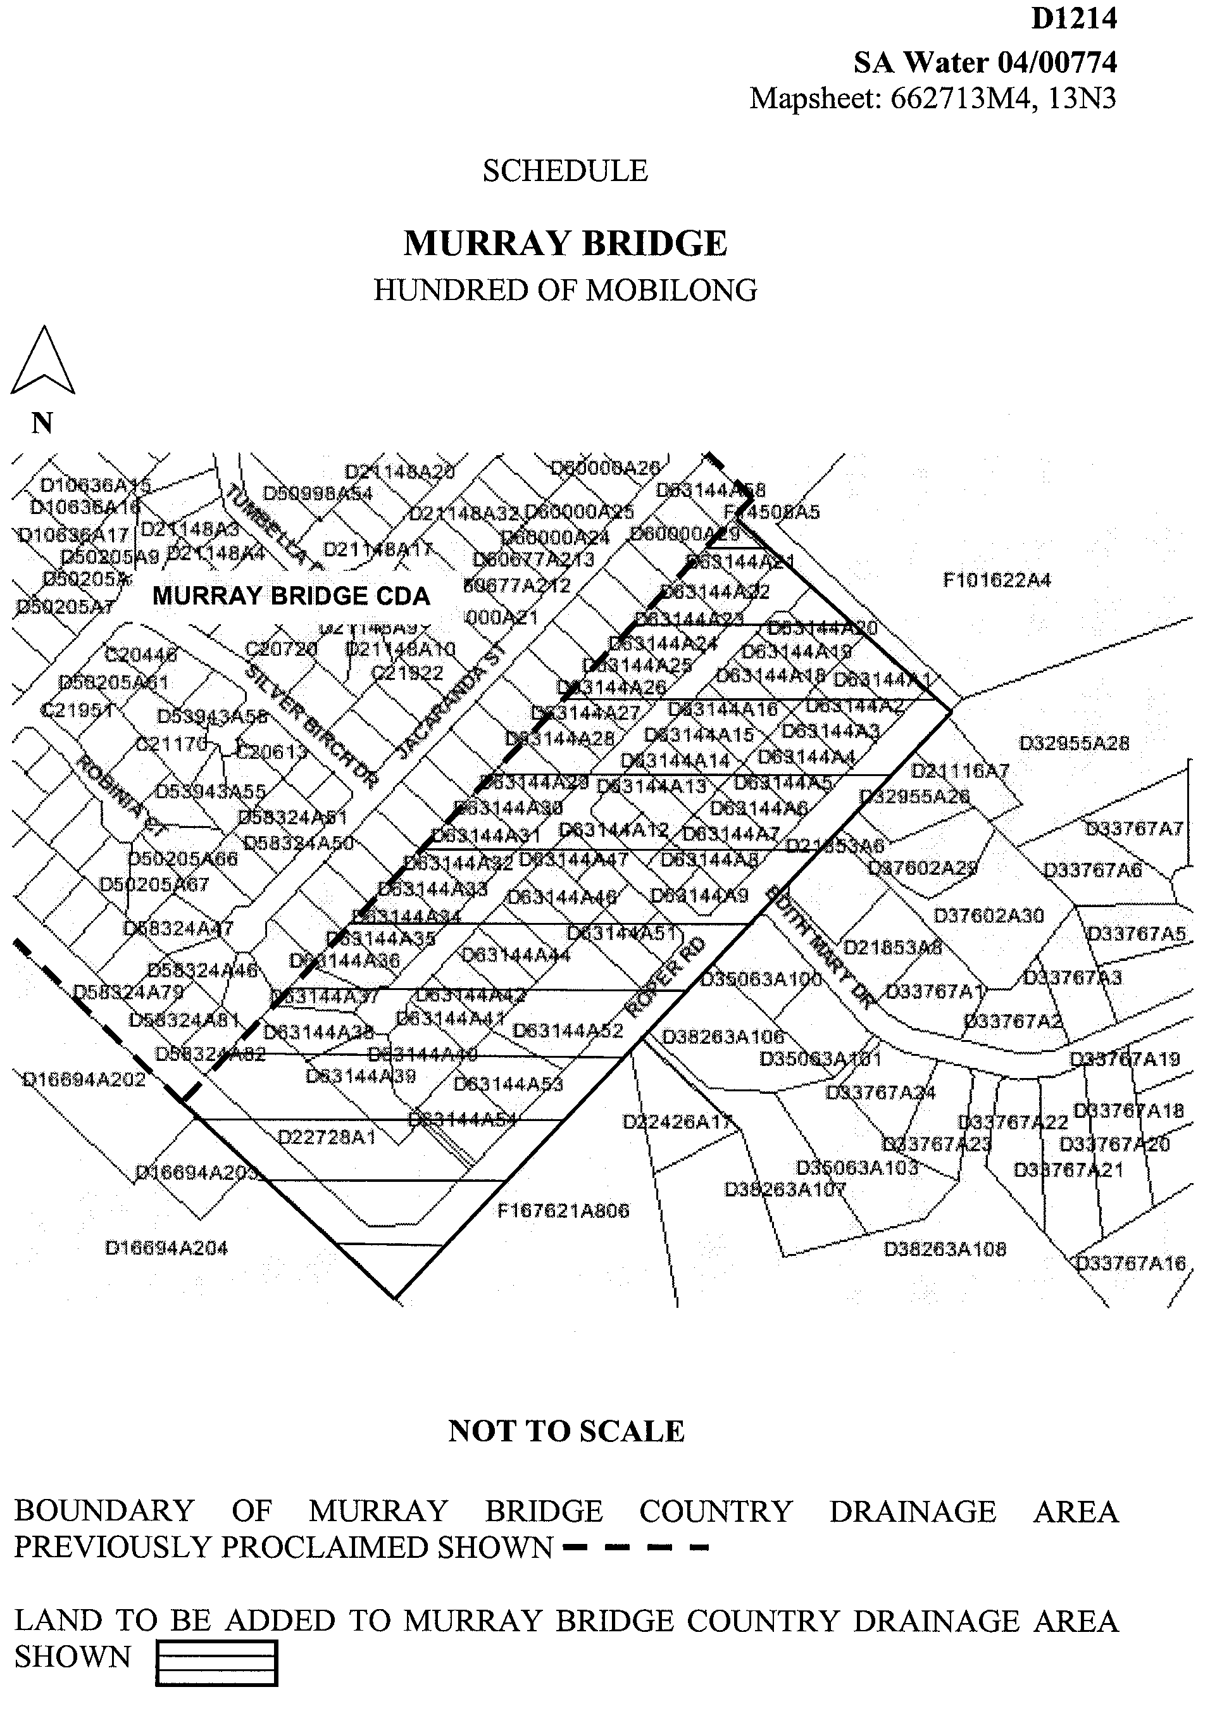

Dated 21 April 2004.
Signed for and on behalf of the South Australian Water Corporation by a person duly authorised so to do:
A. Popplewell, General Manager Shared Services
In the presence of:
C. J. McNamara, Billing Manager
SAWATER 04/00774 D1214

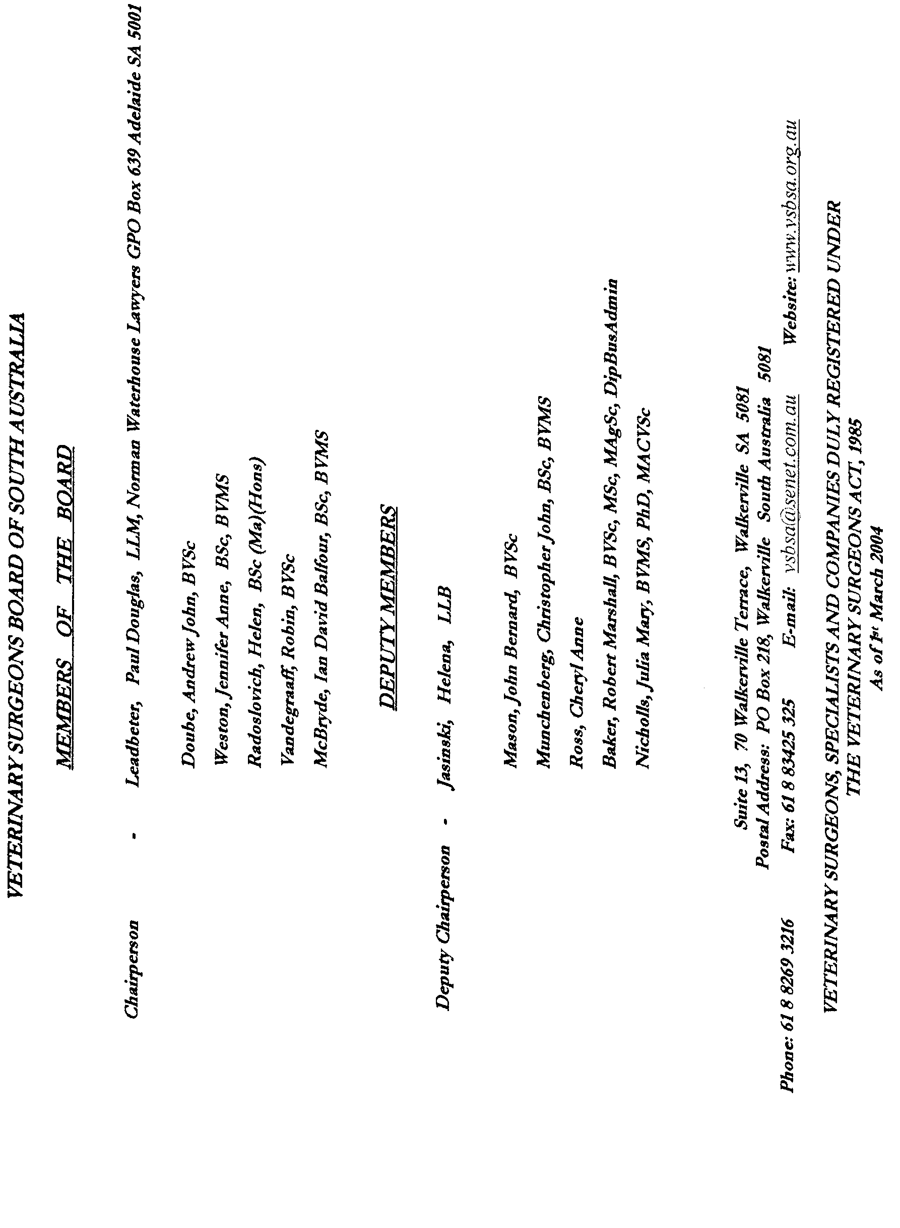
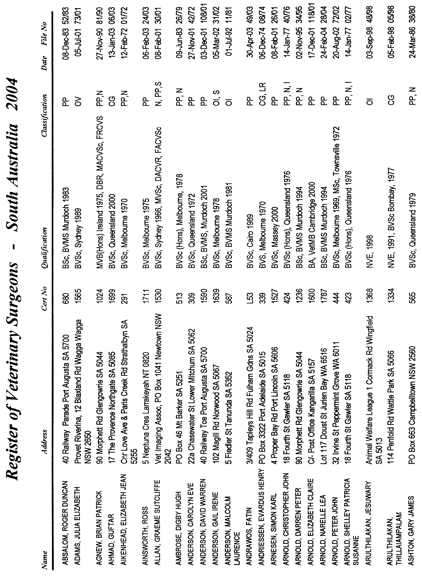
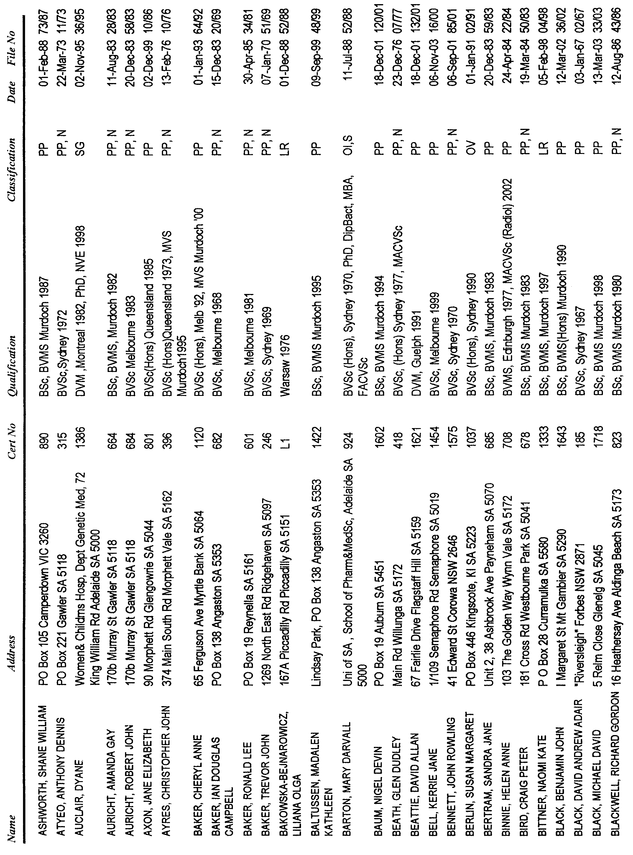
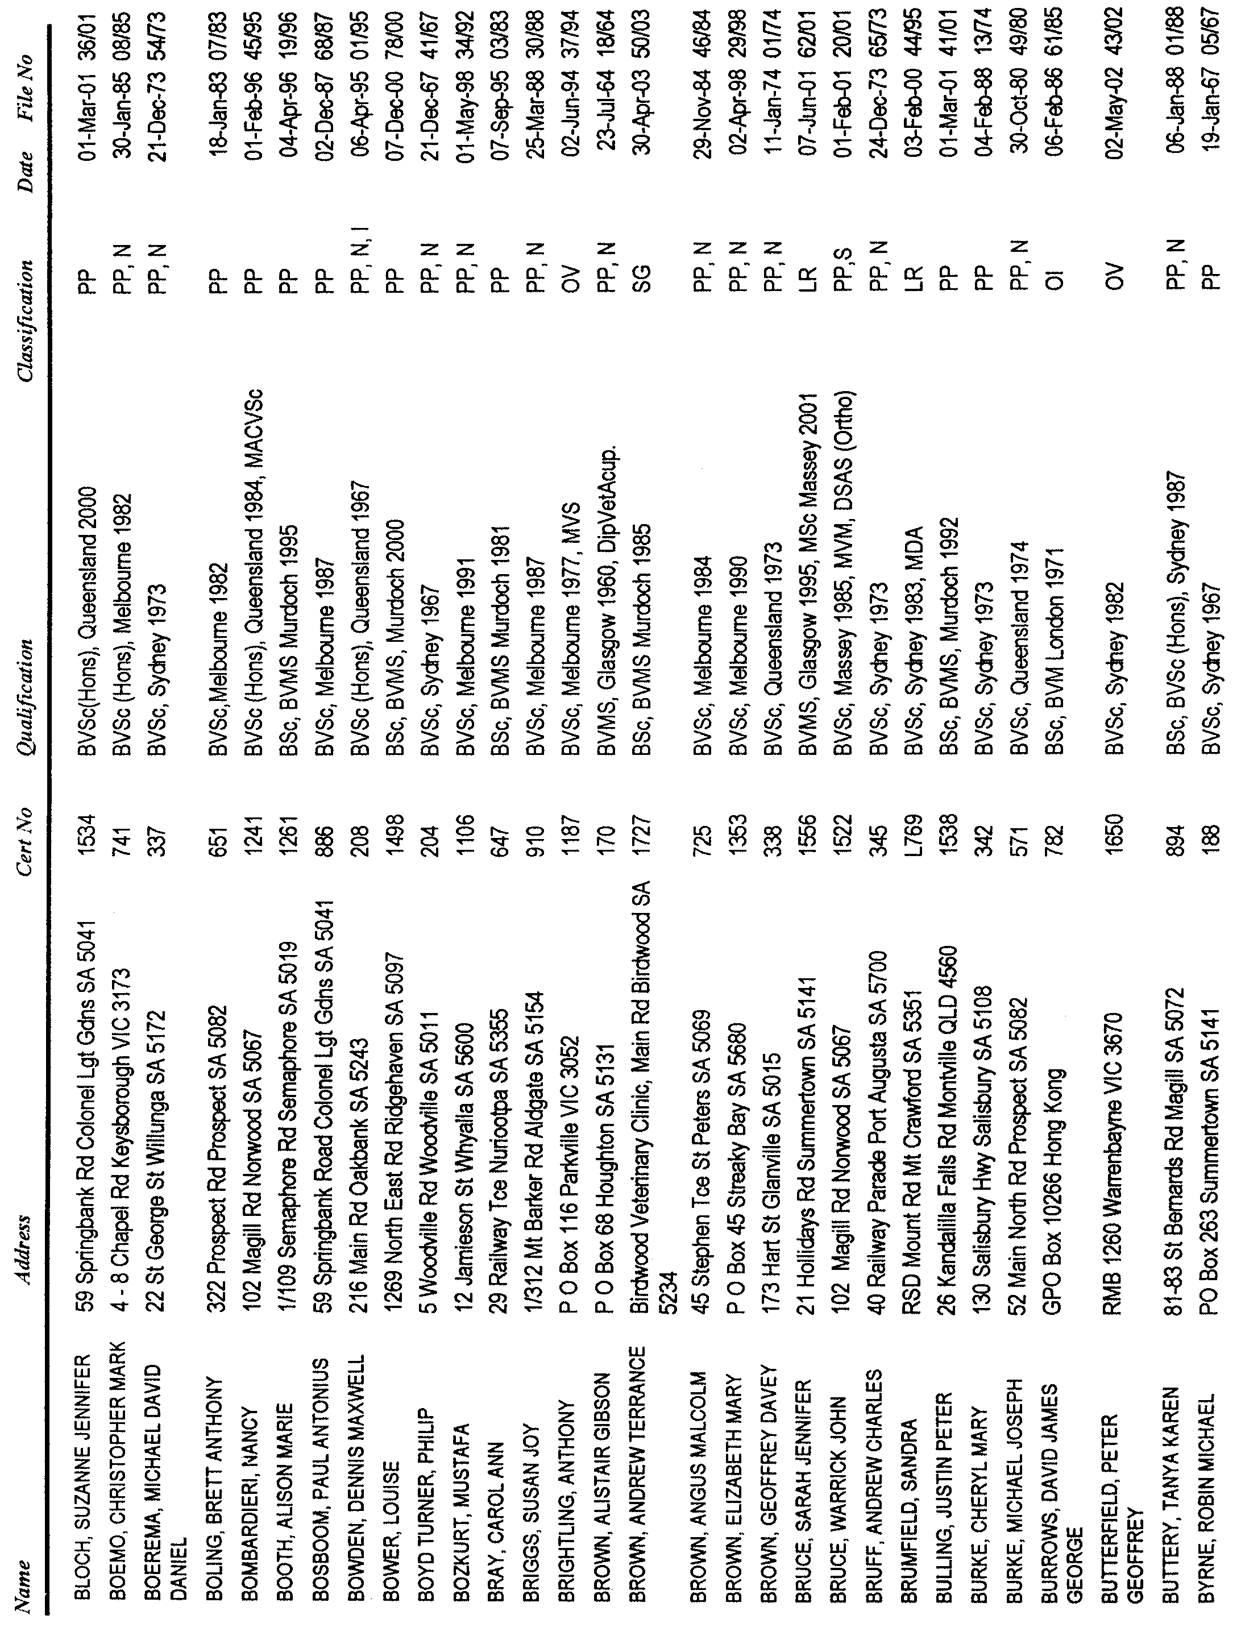
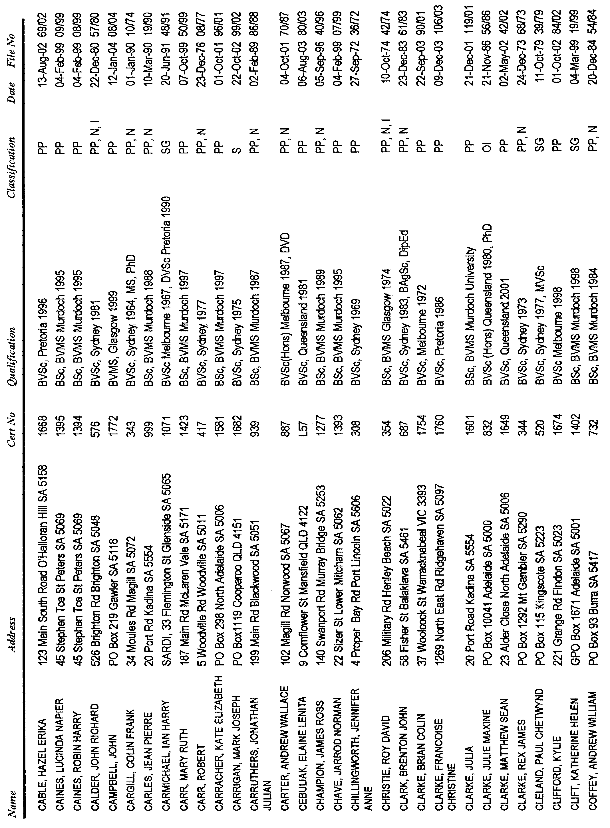
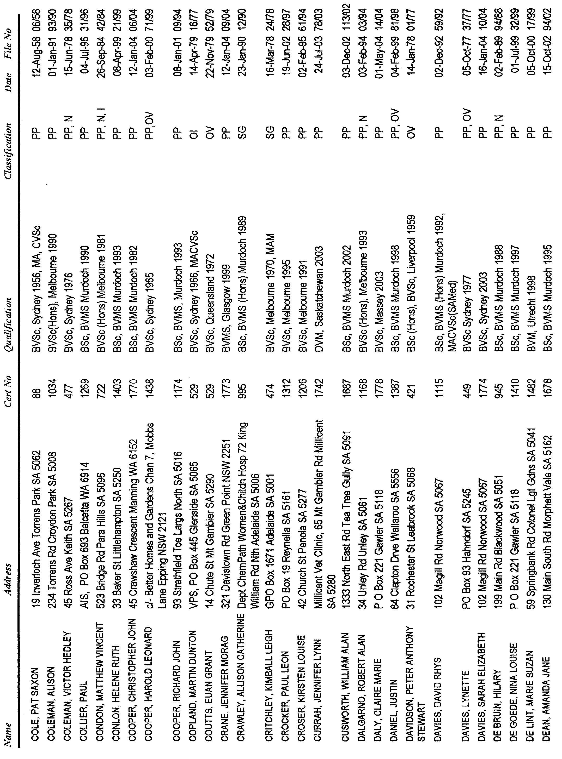
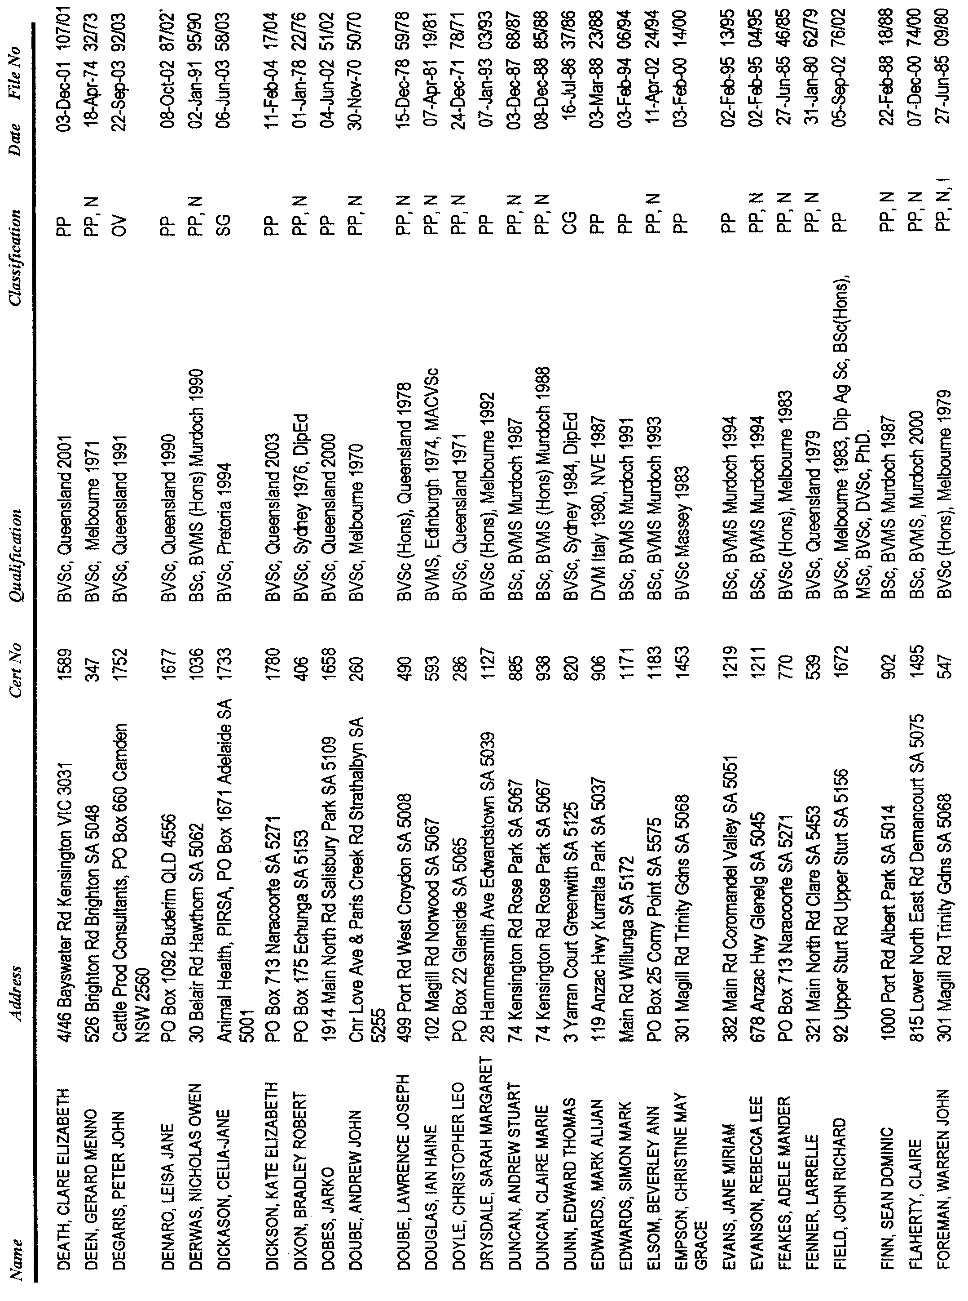
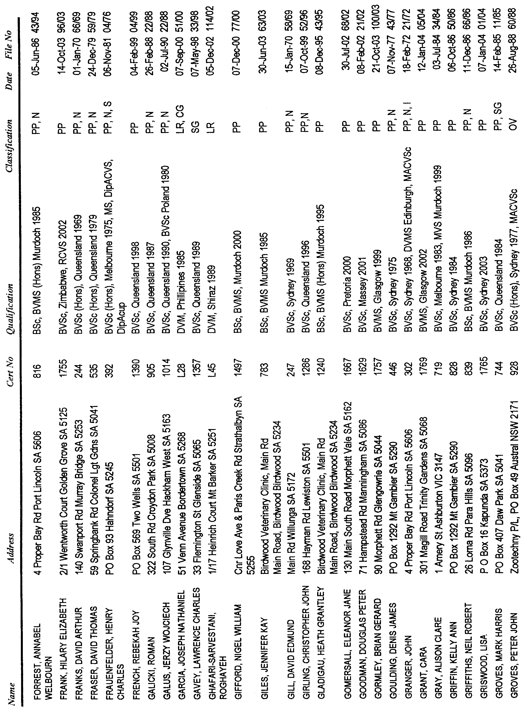
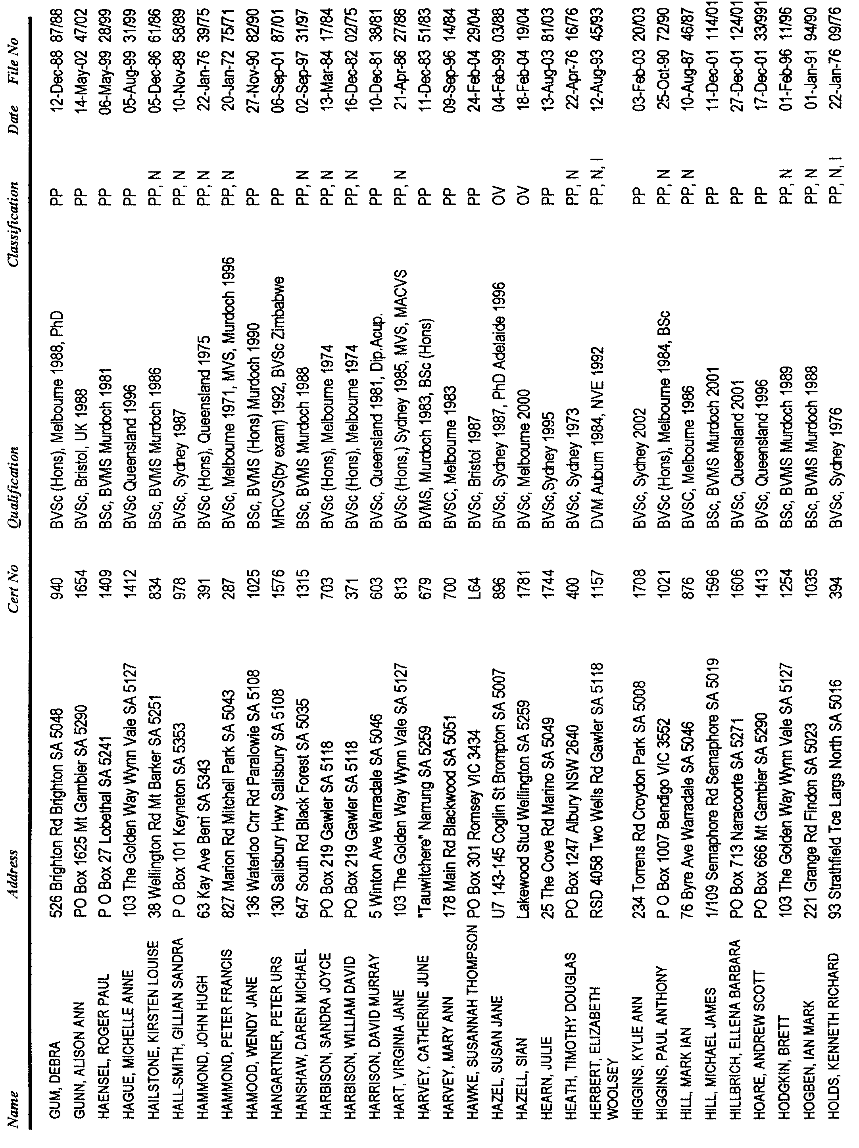
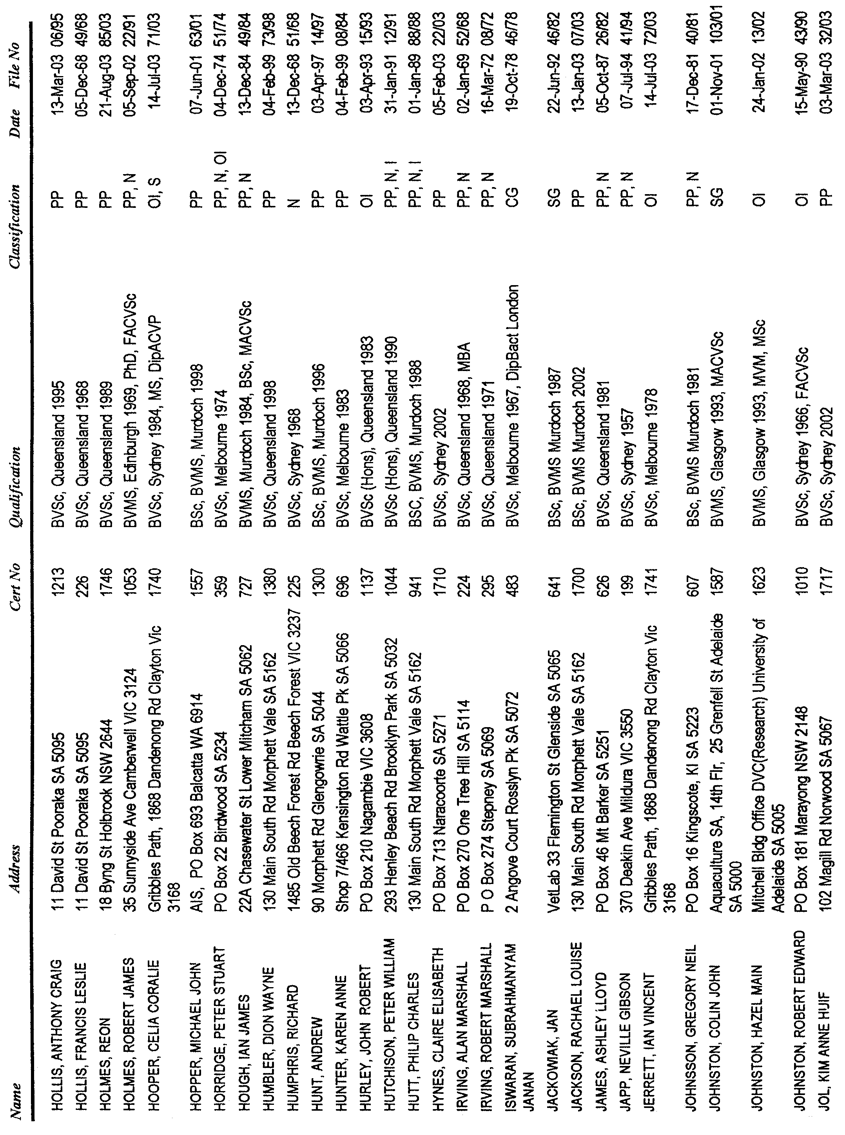
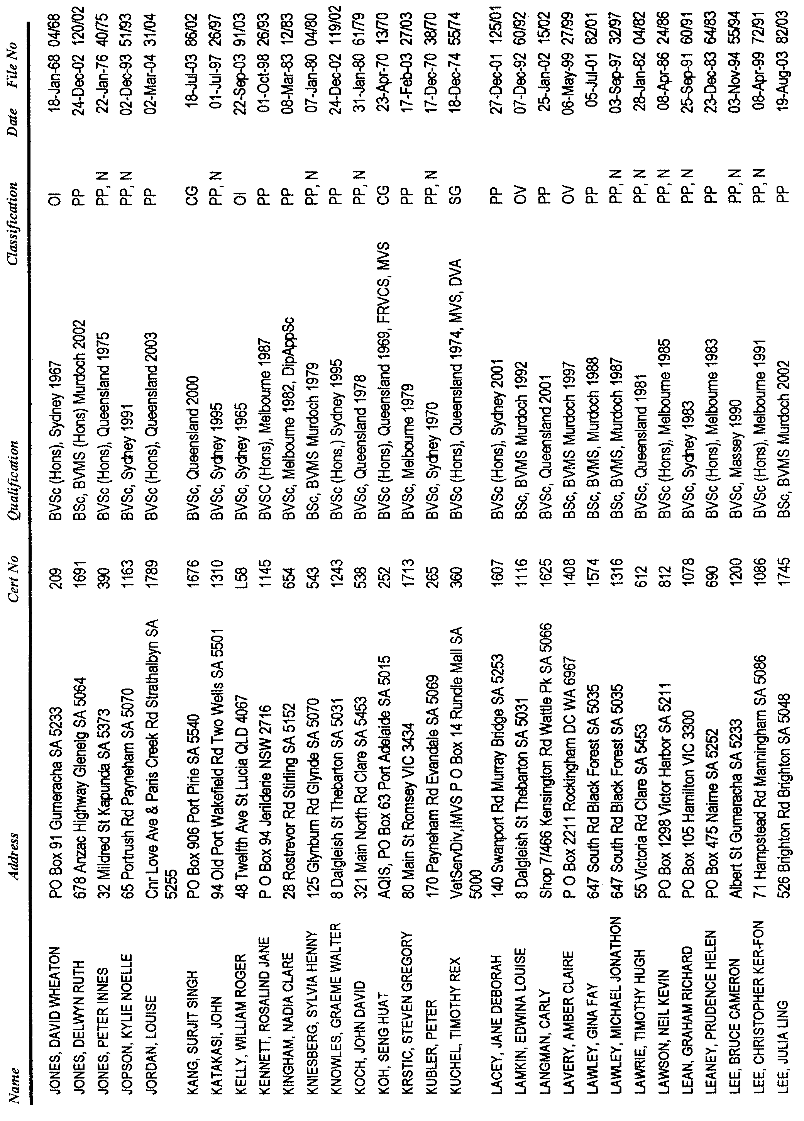
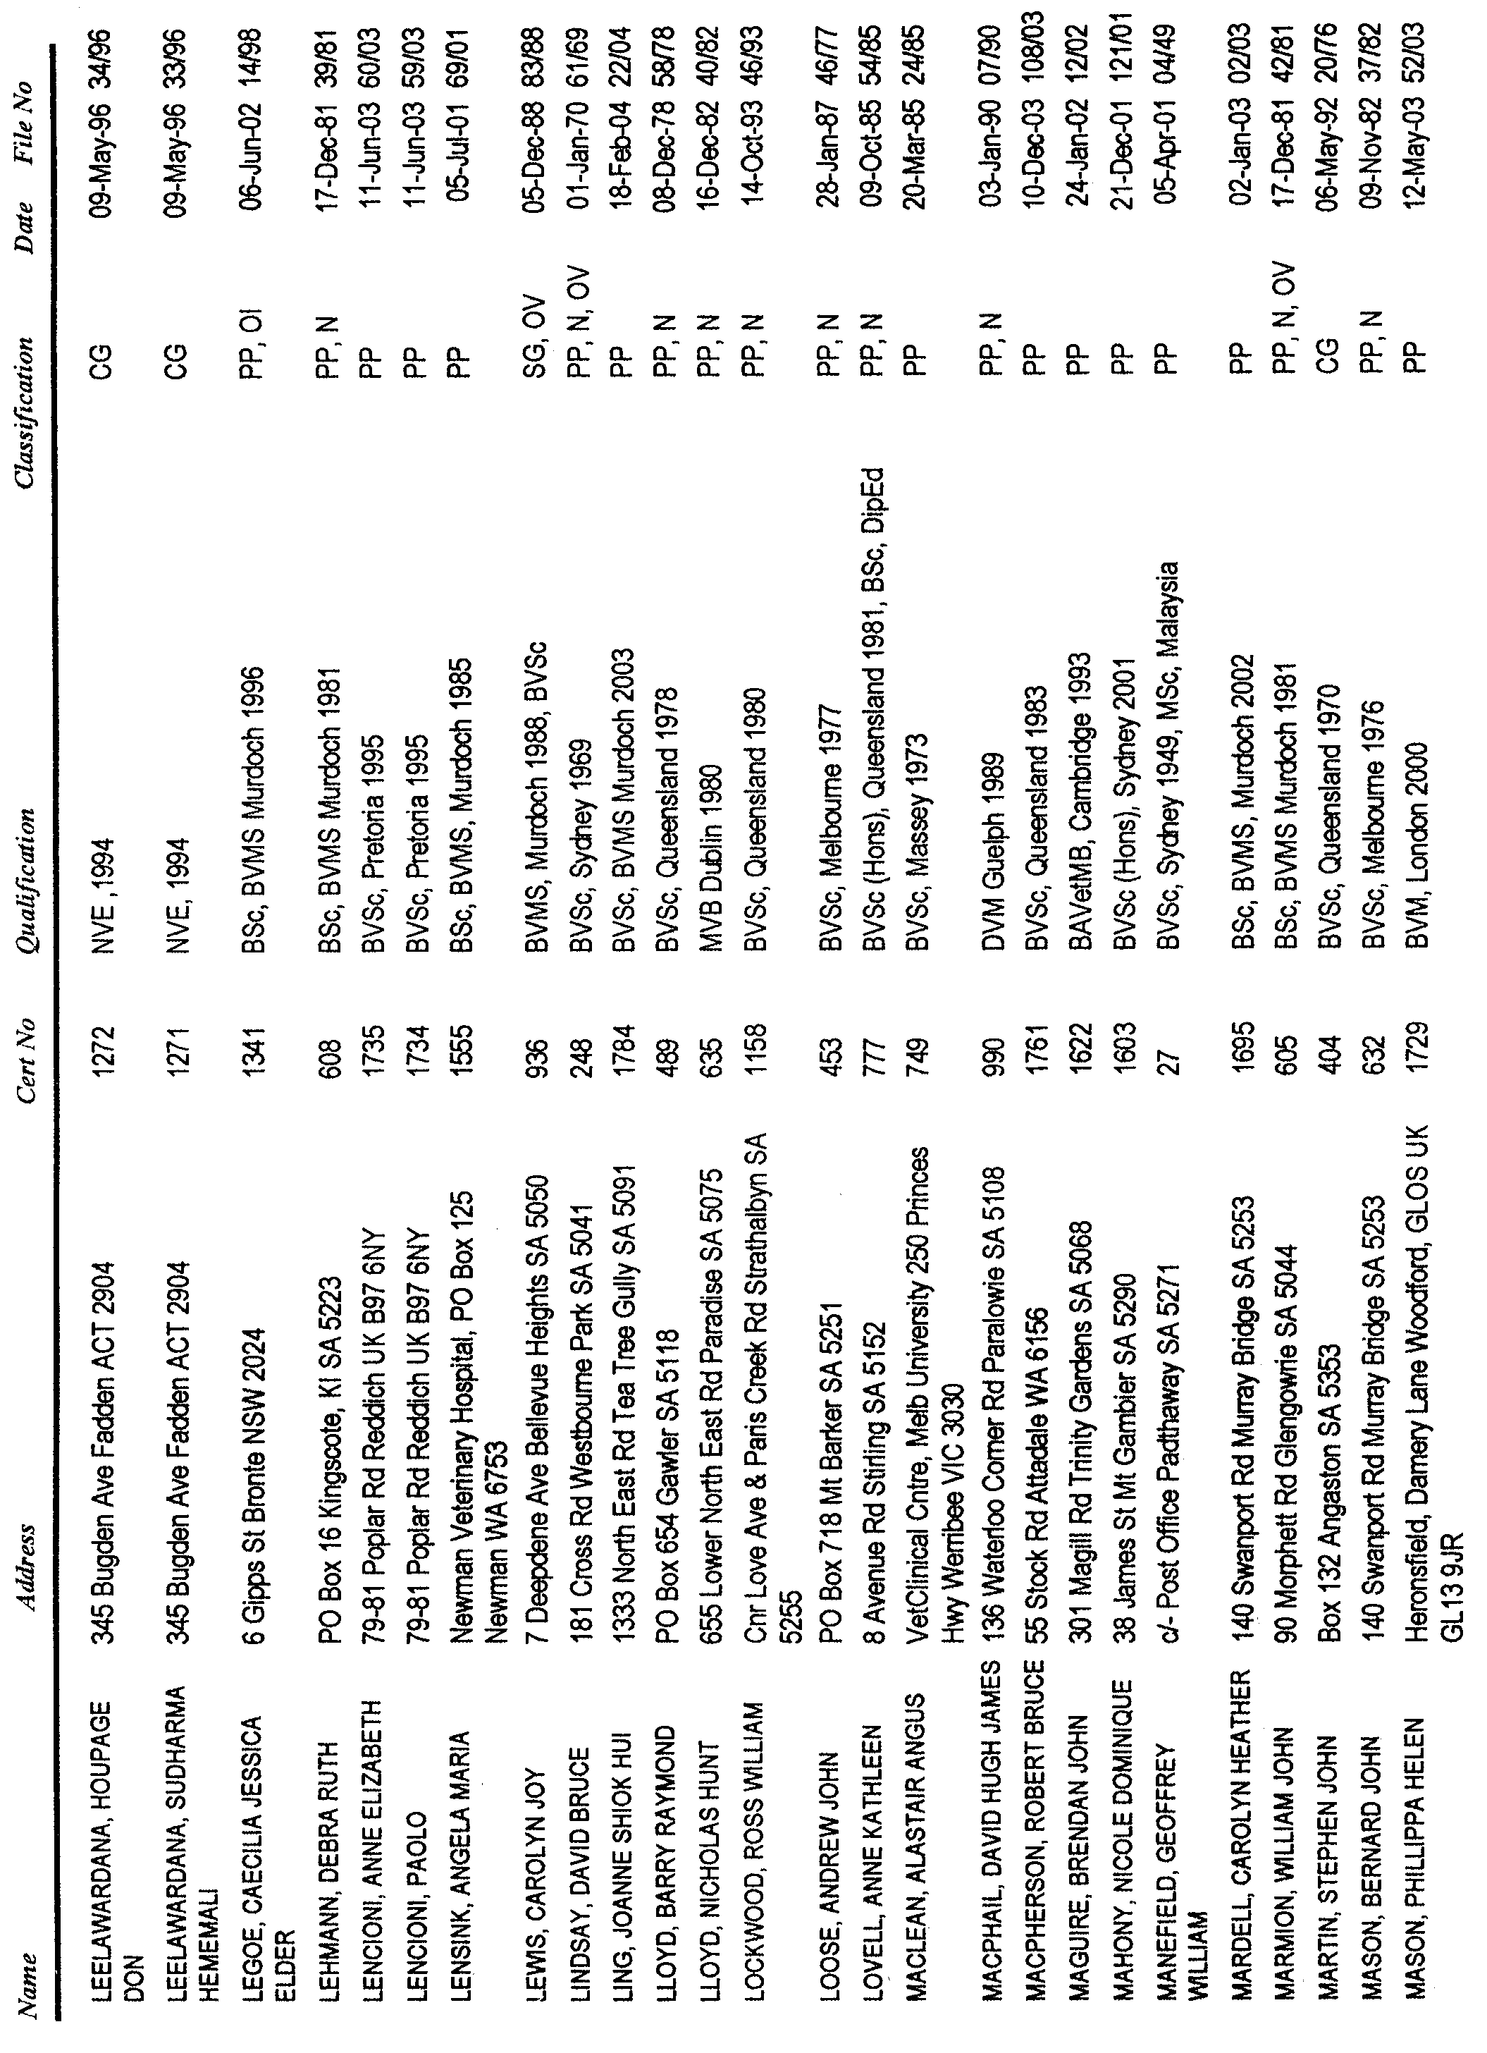
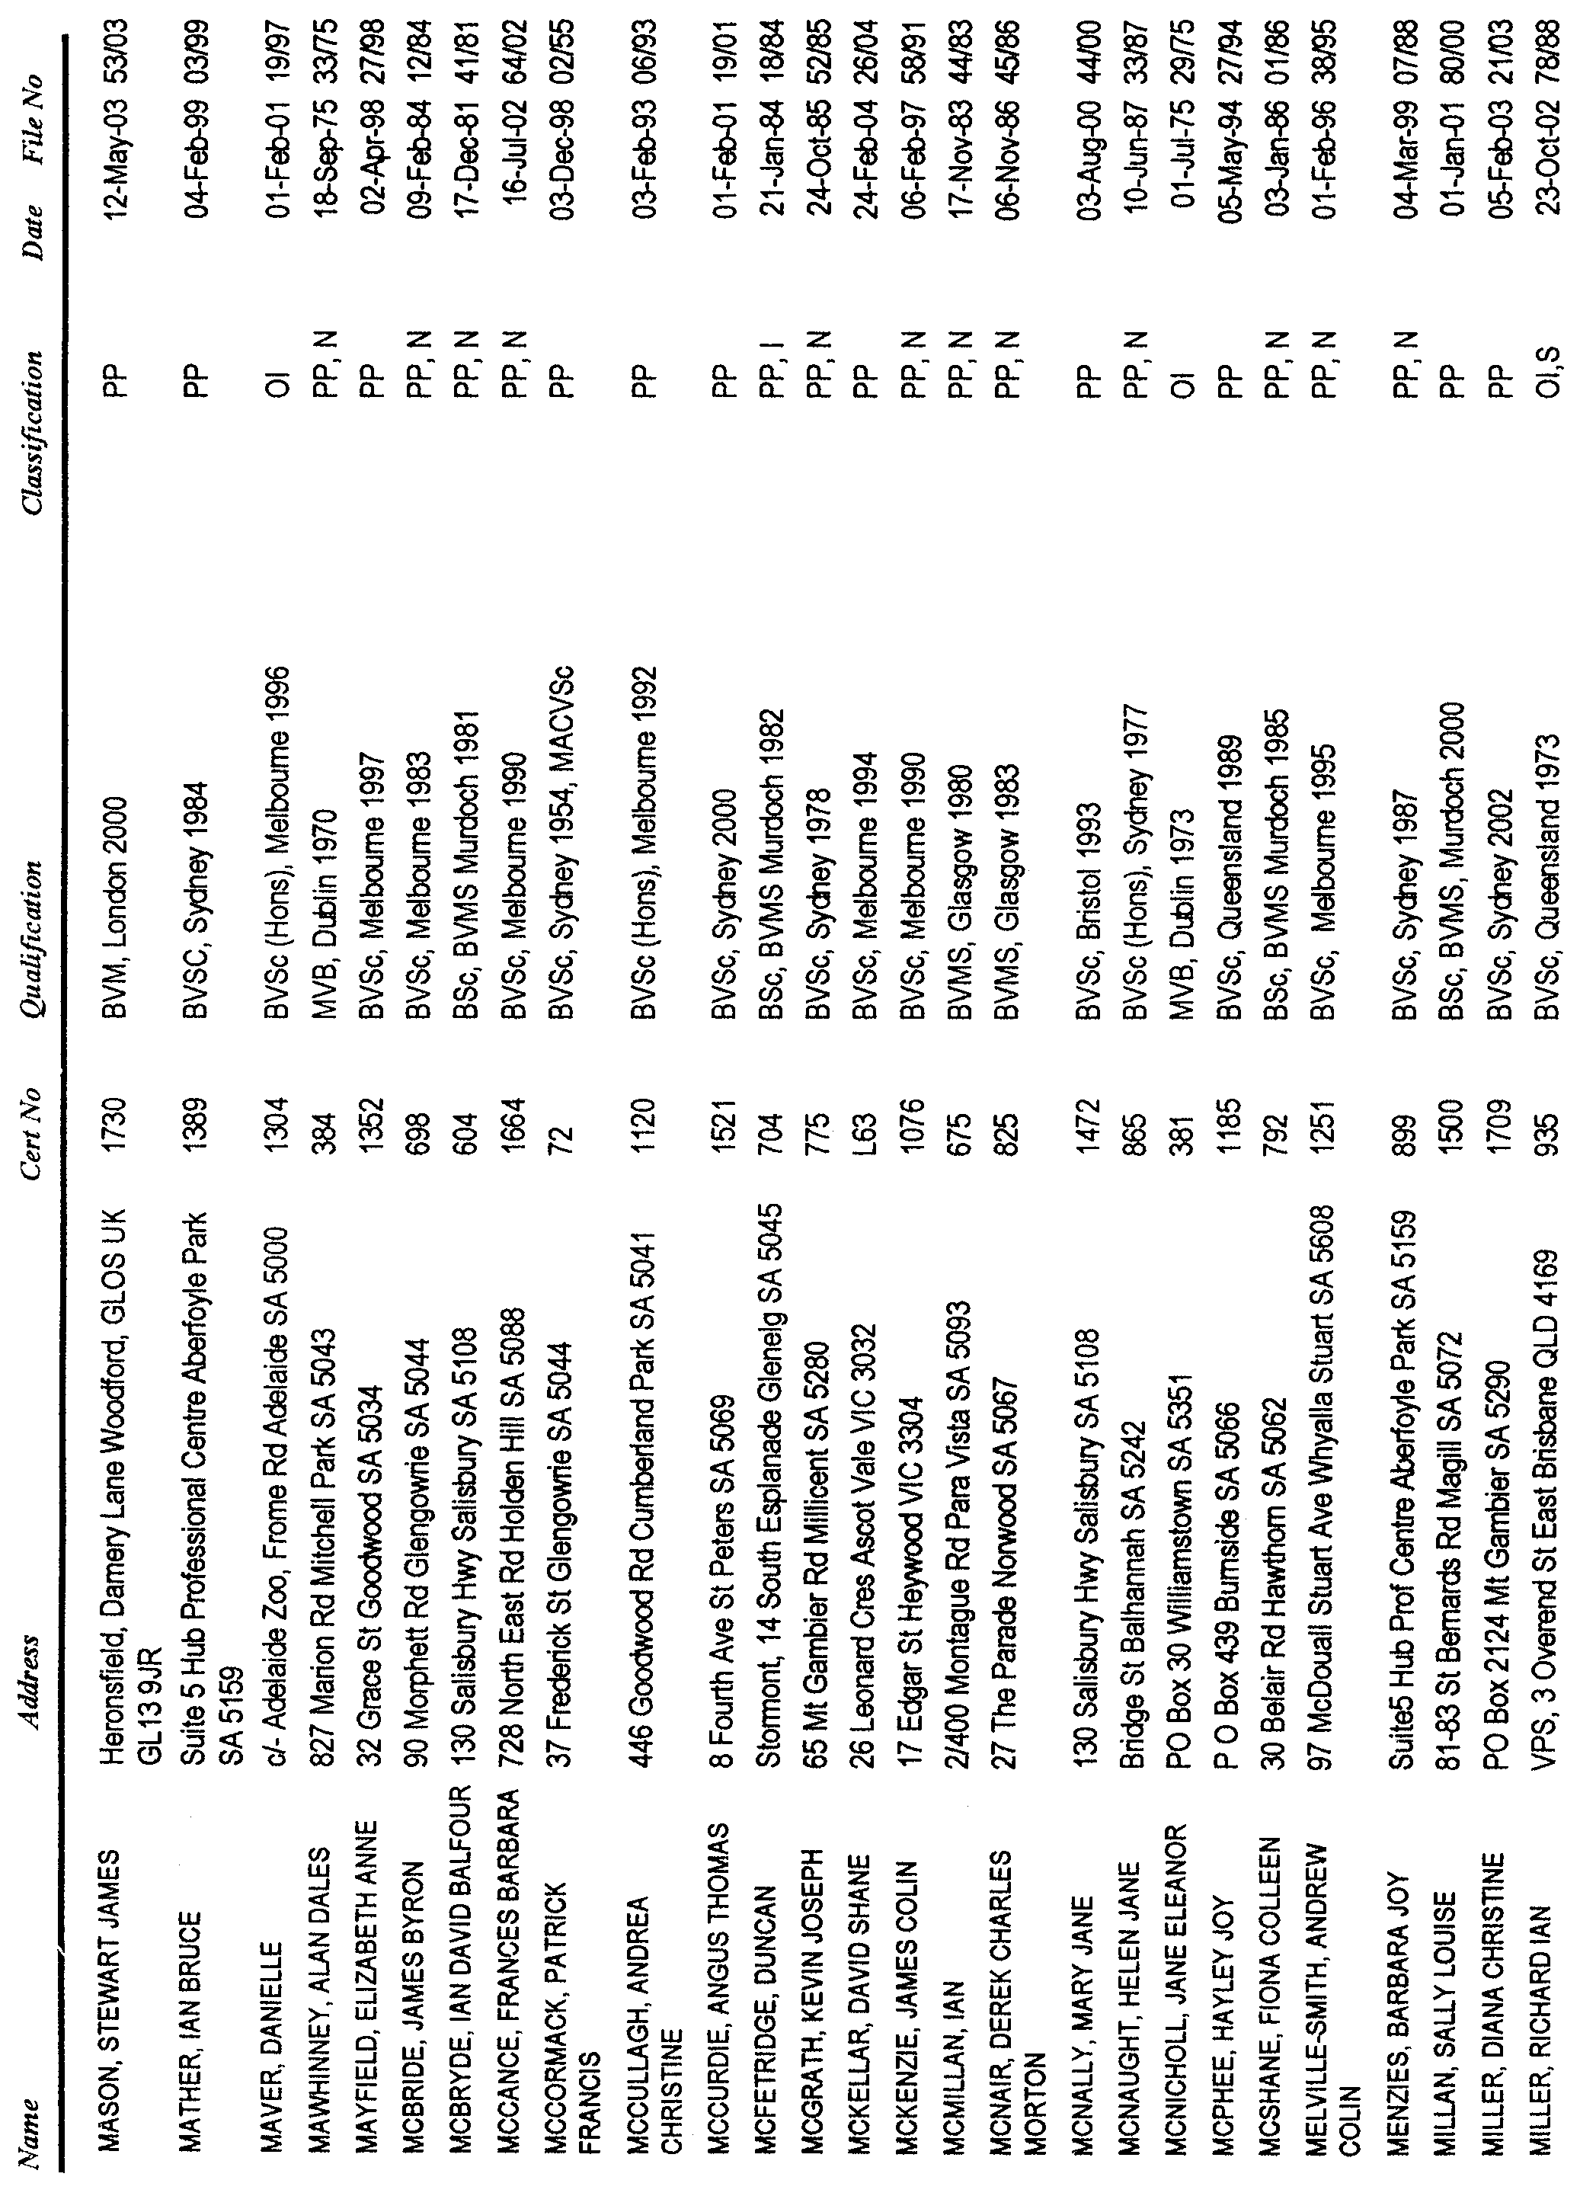
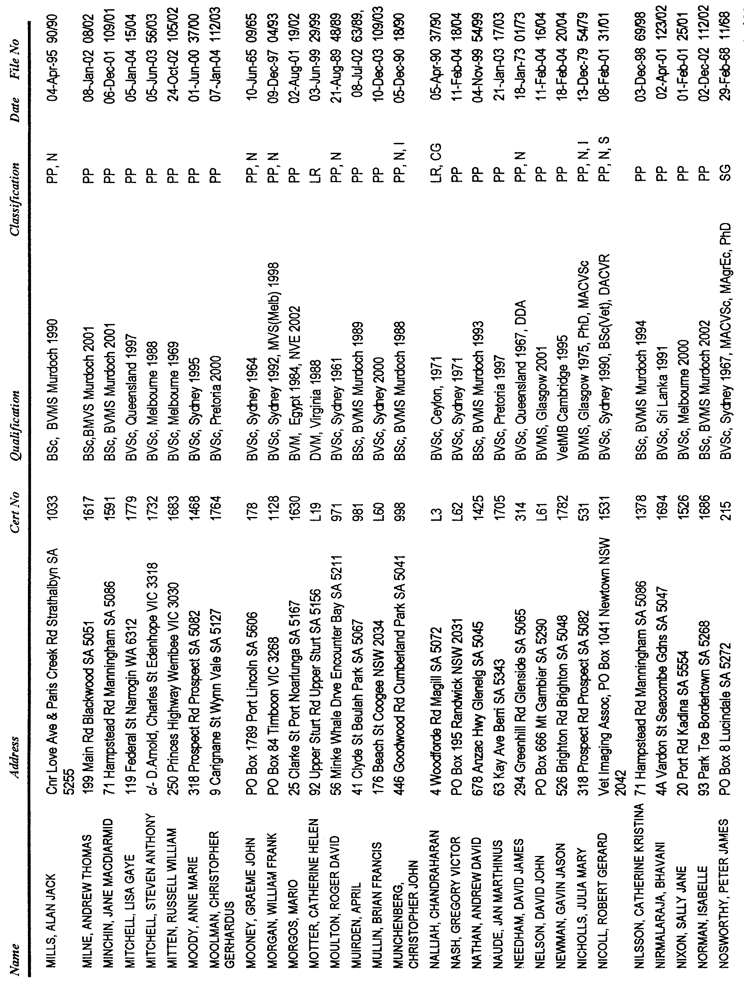
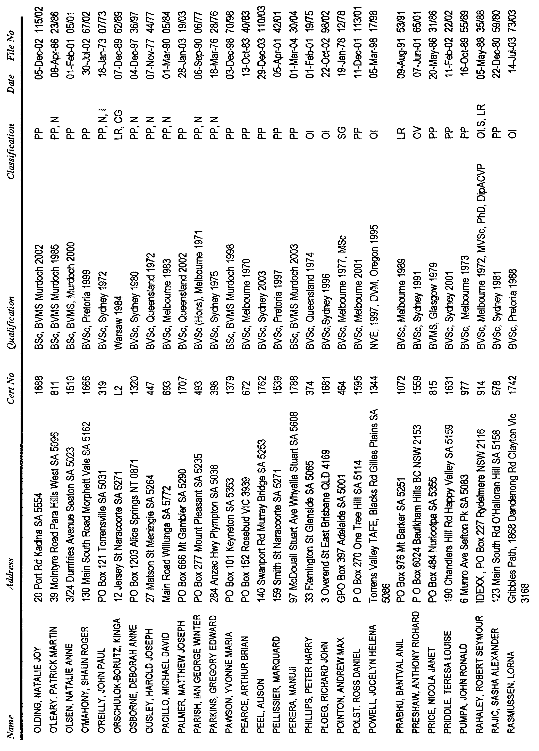
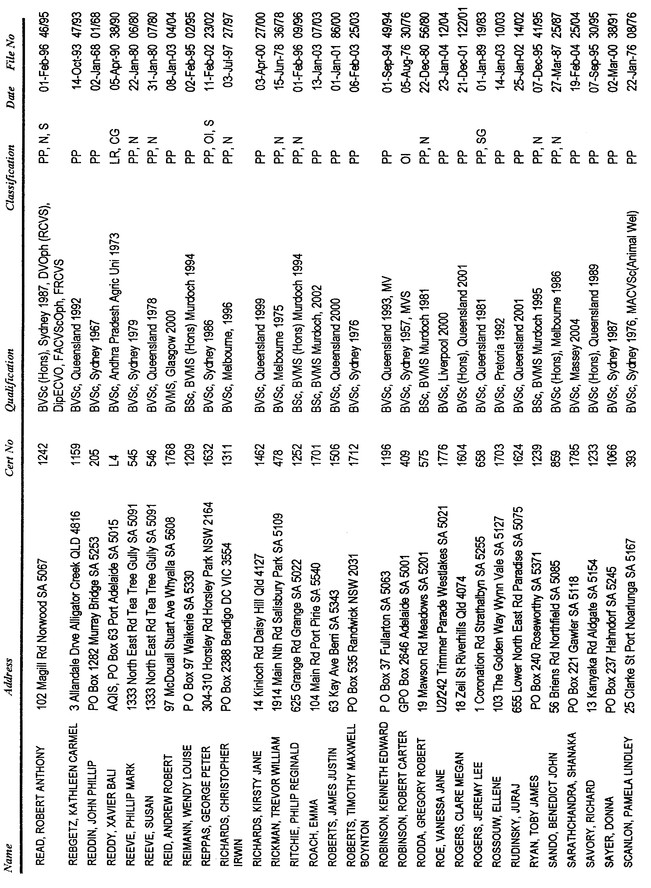
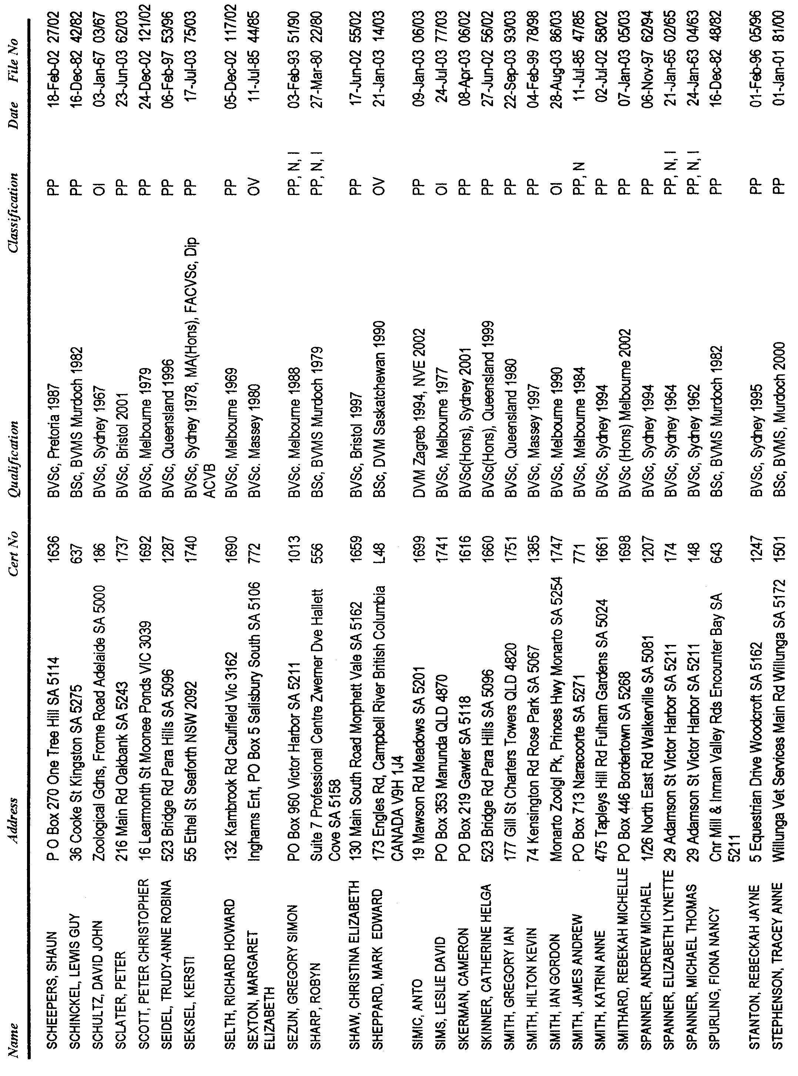
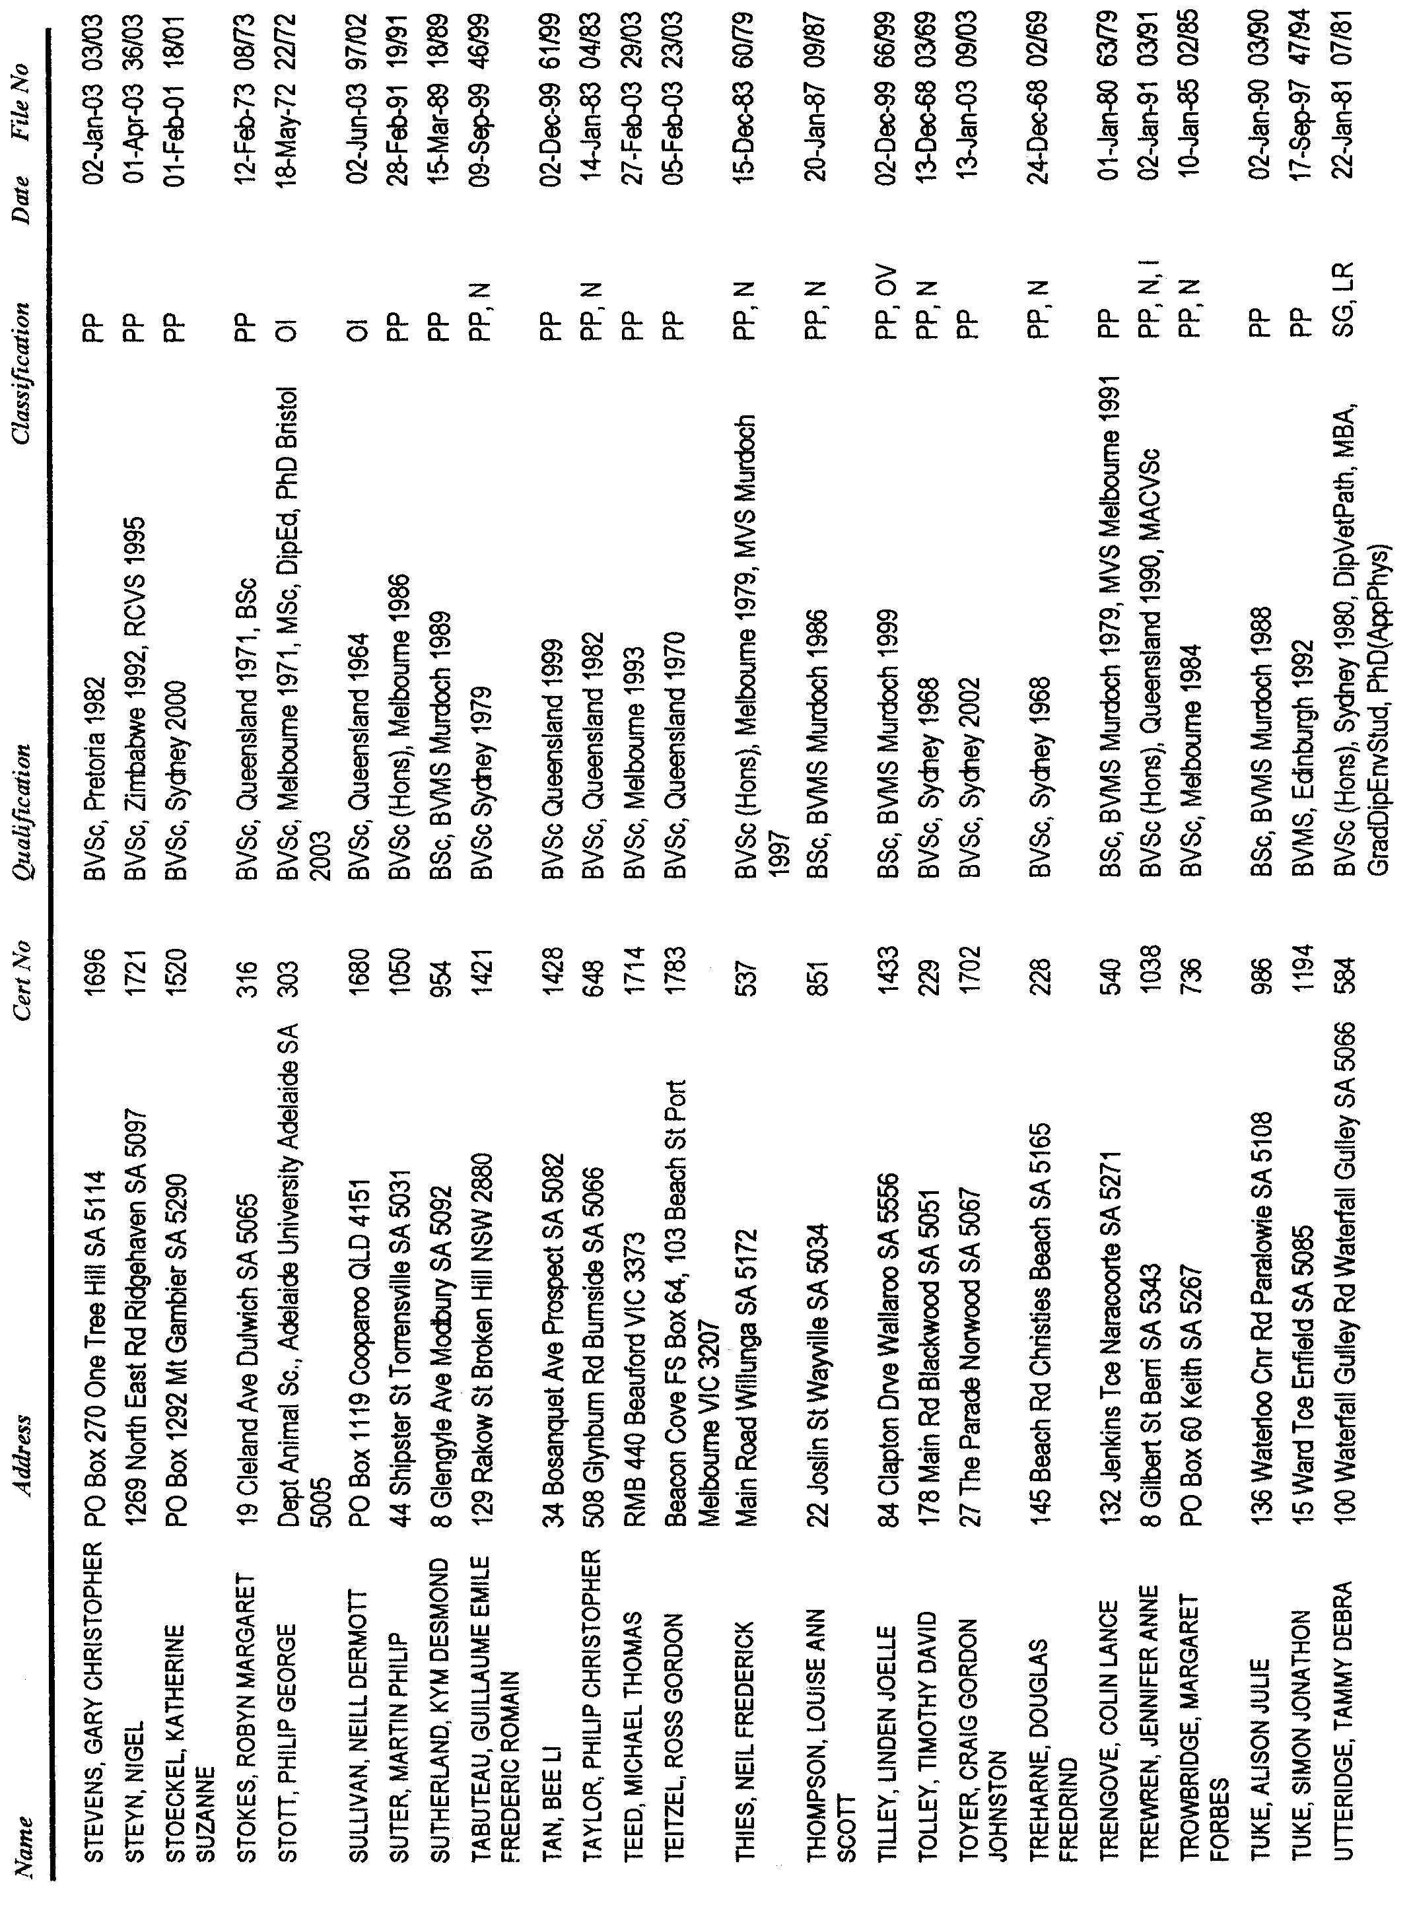
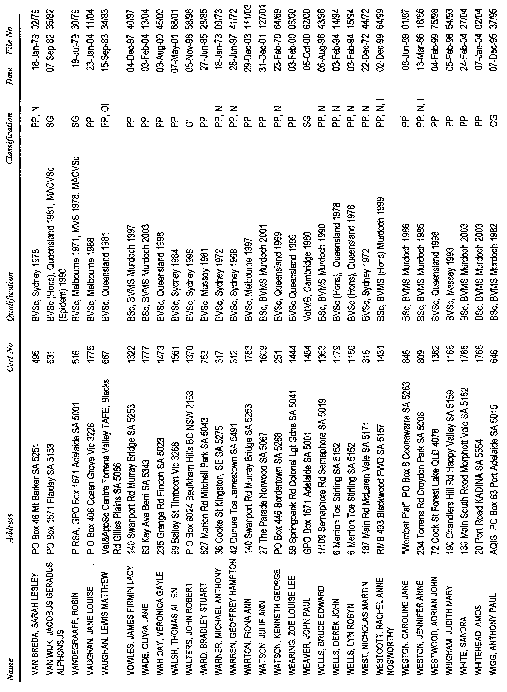
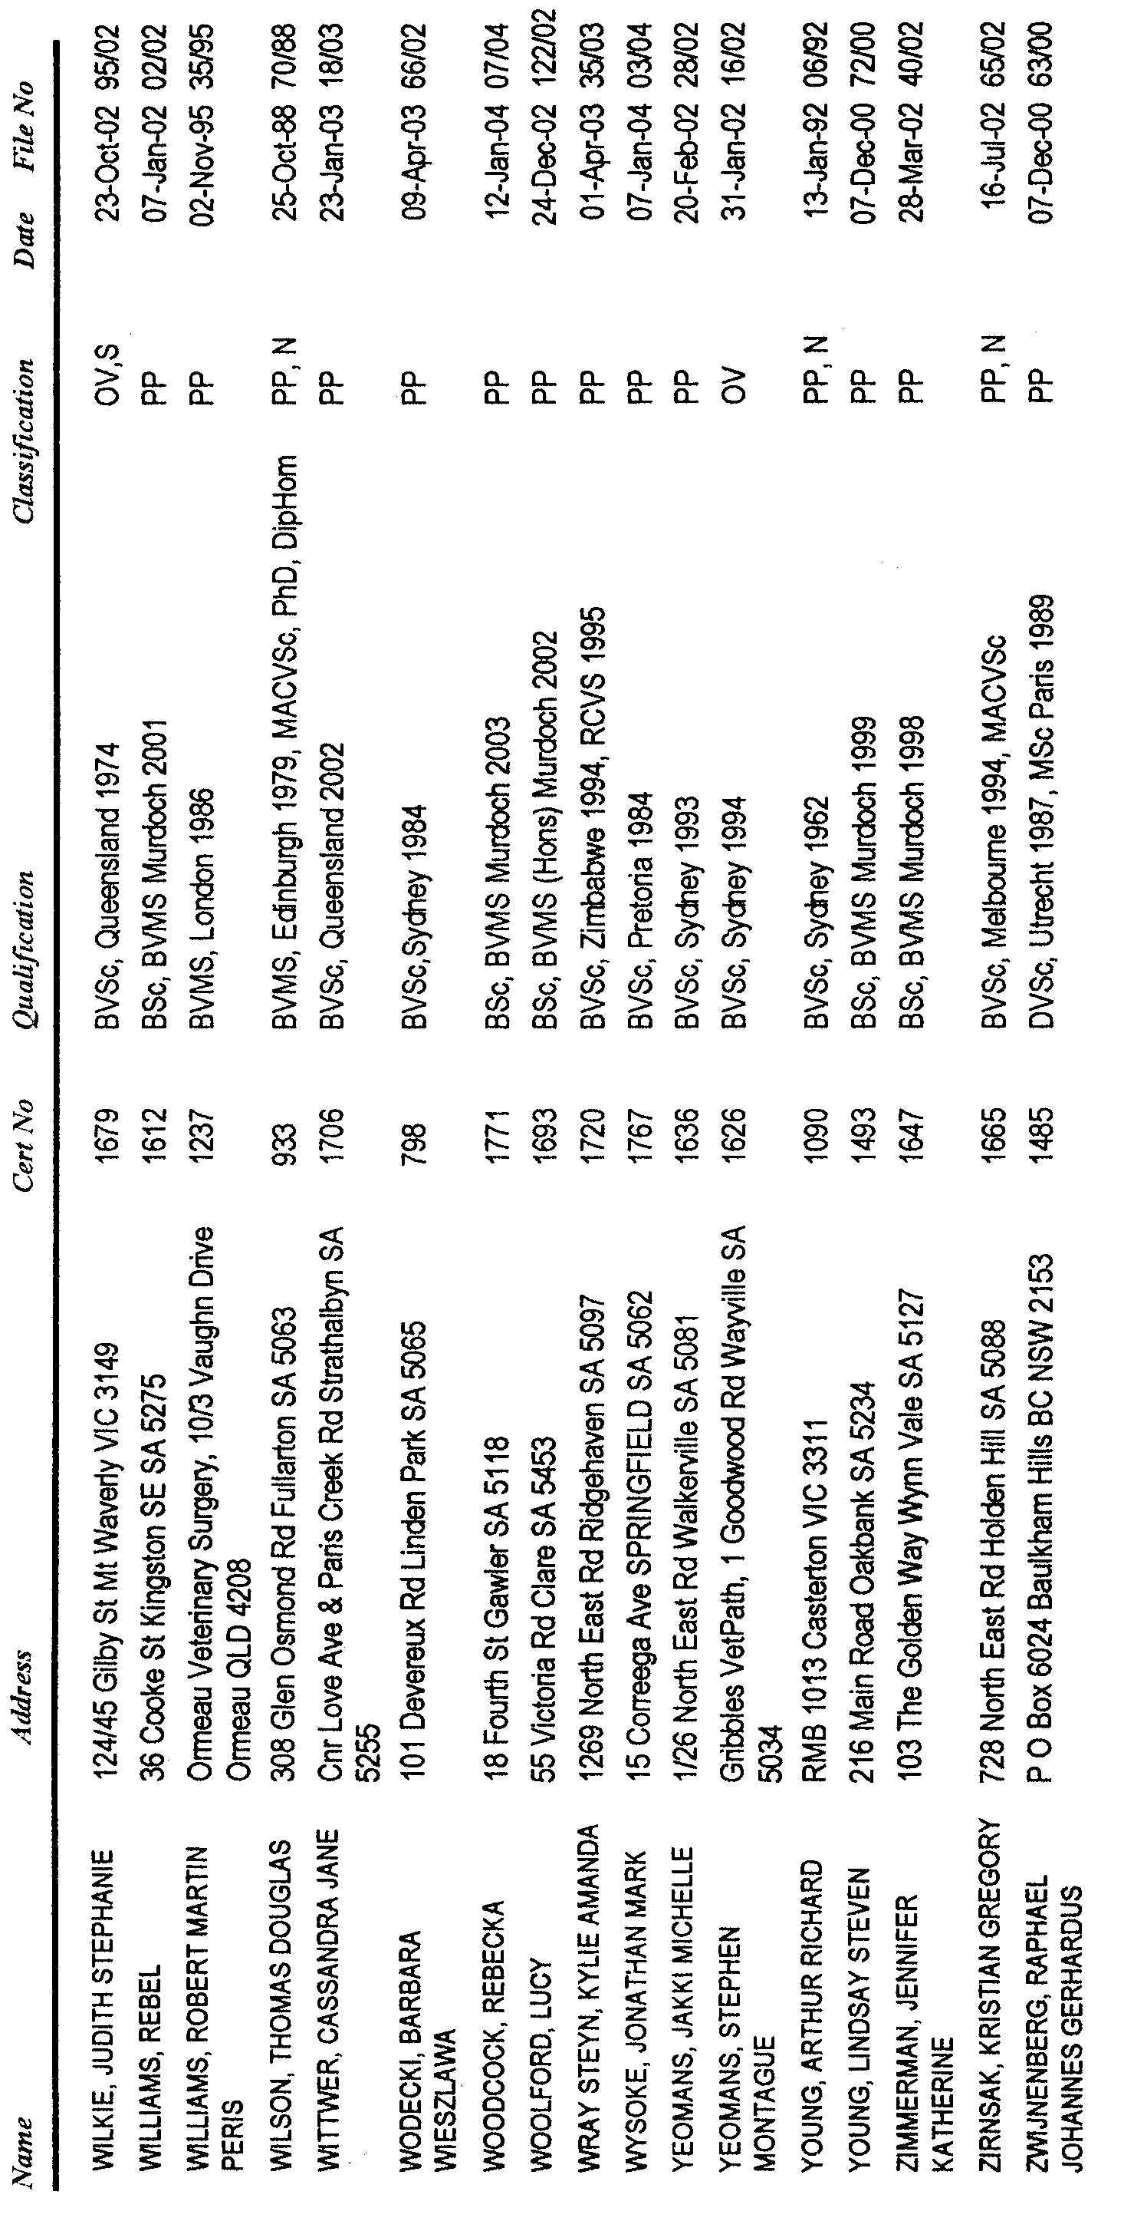

Classification Symbols:
PP Private Practitioner
N Principal or Partner
SG State Govt Employee
CG Commonwealth Govt Employee
I Director of a Registered Veterinary Company
S Registered Specialist
OI Other Institution
OV Other Veterinary Pursuit
LR Limited Registration
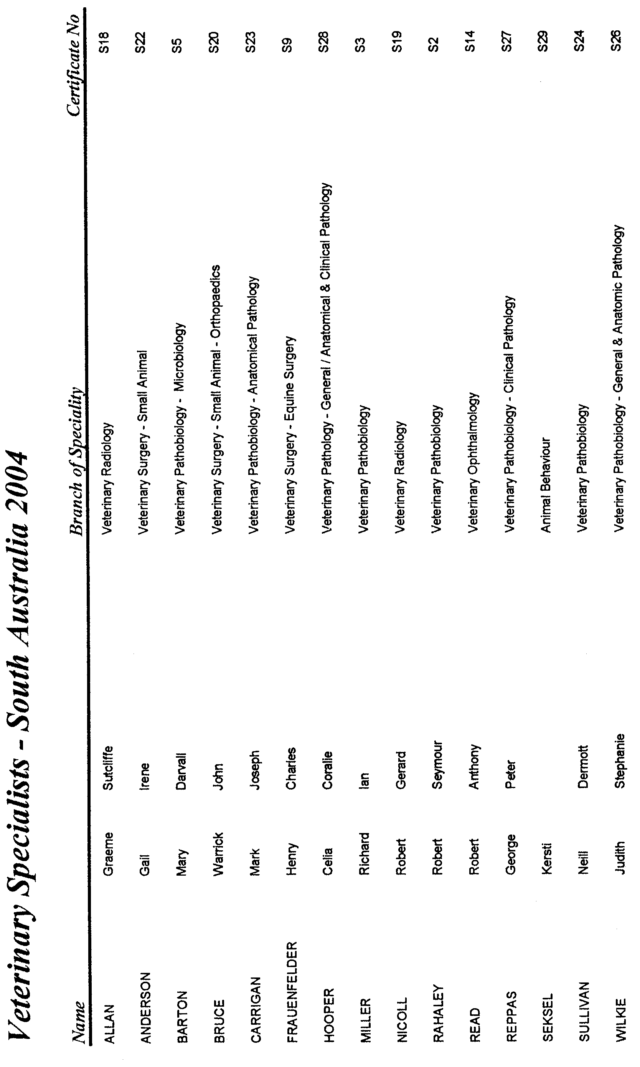
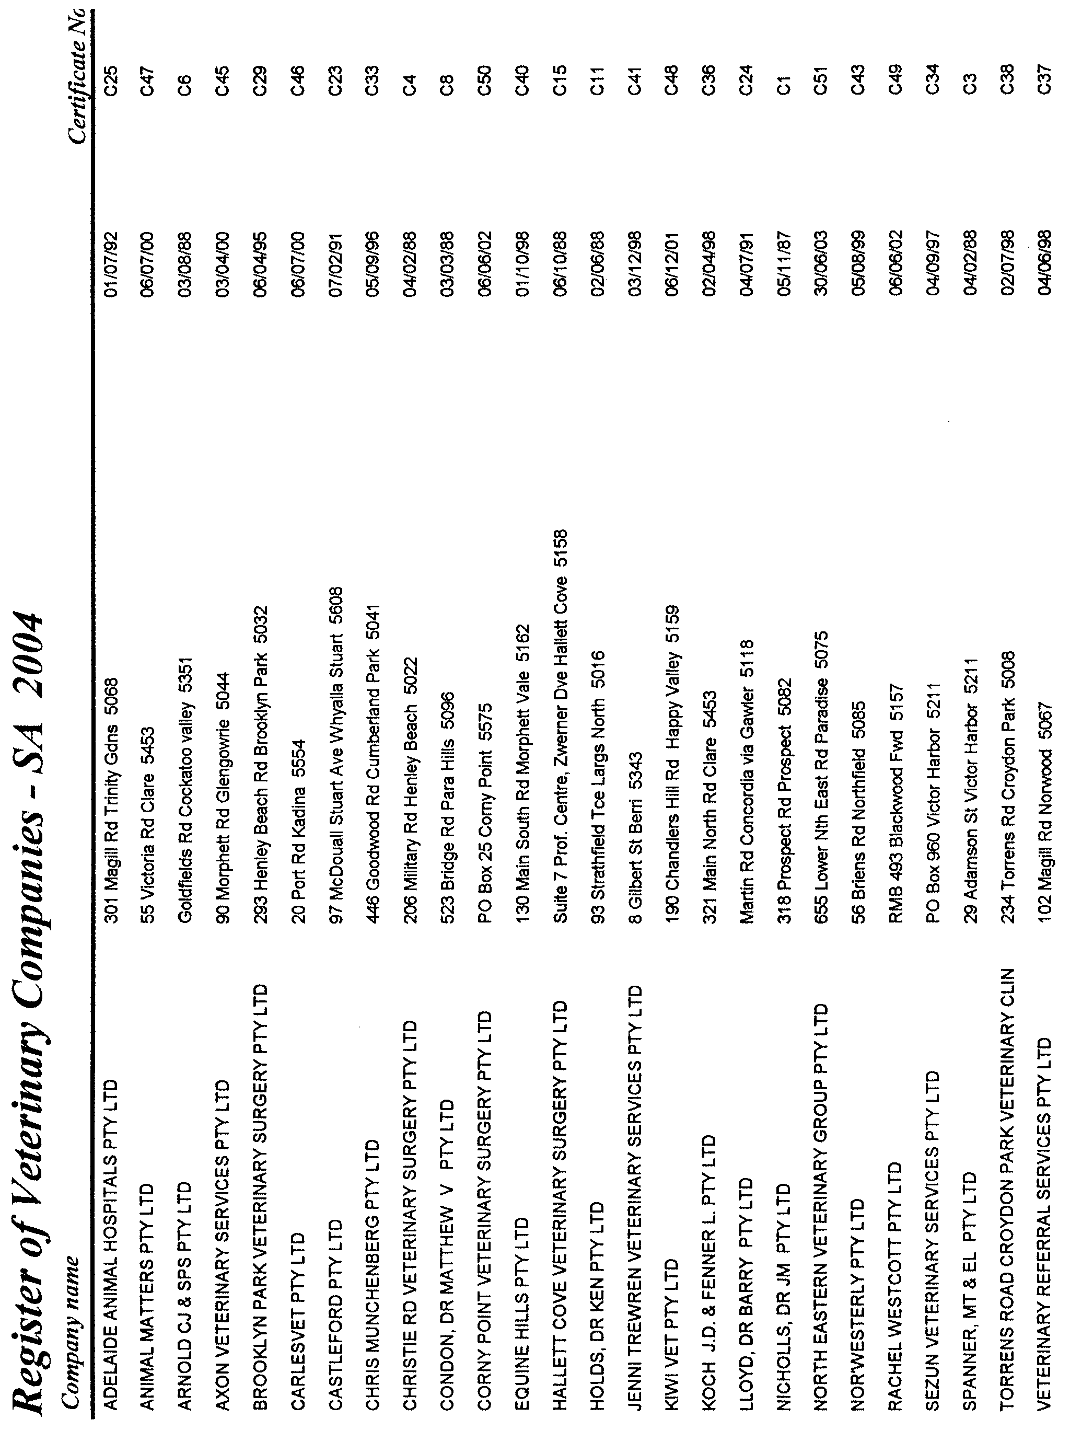
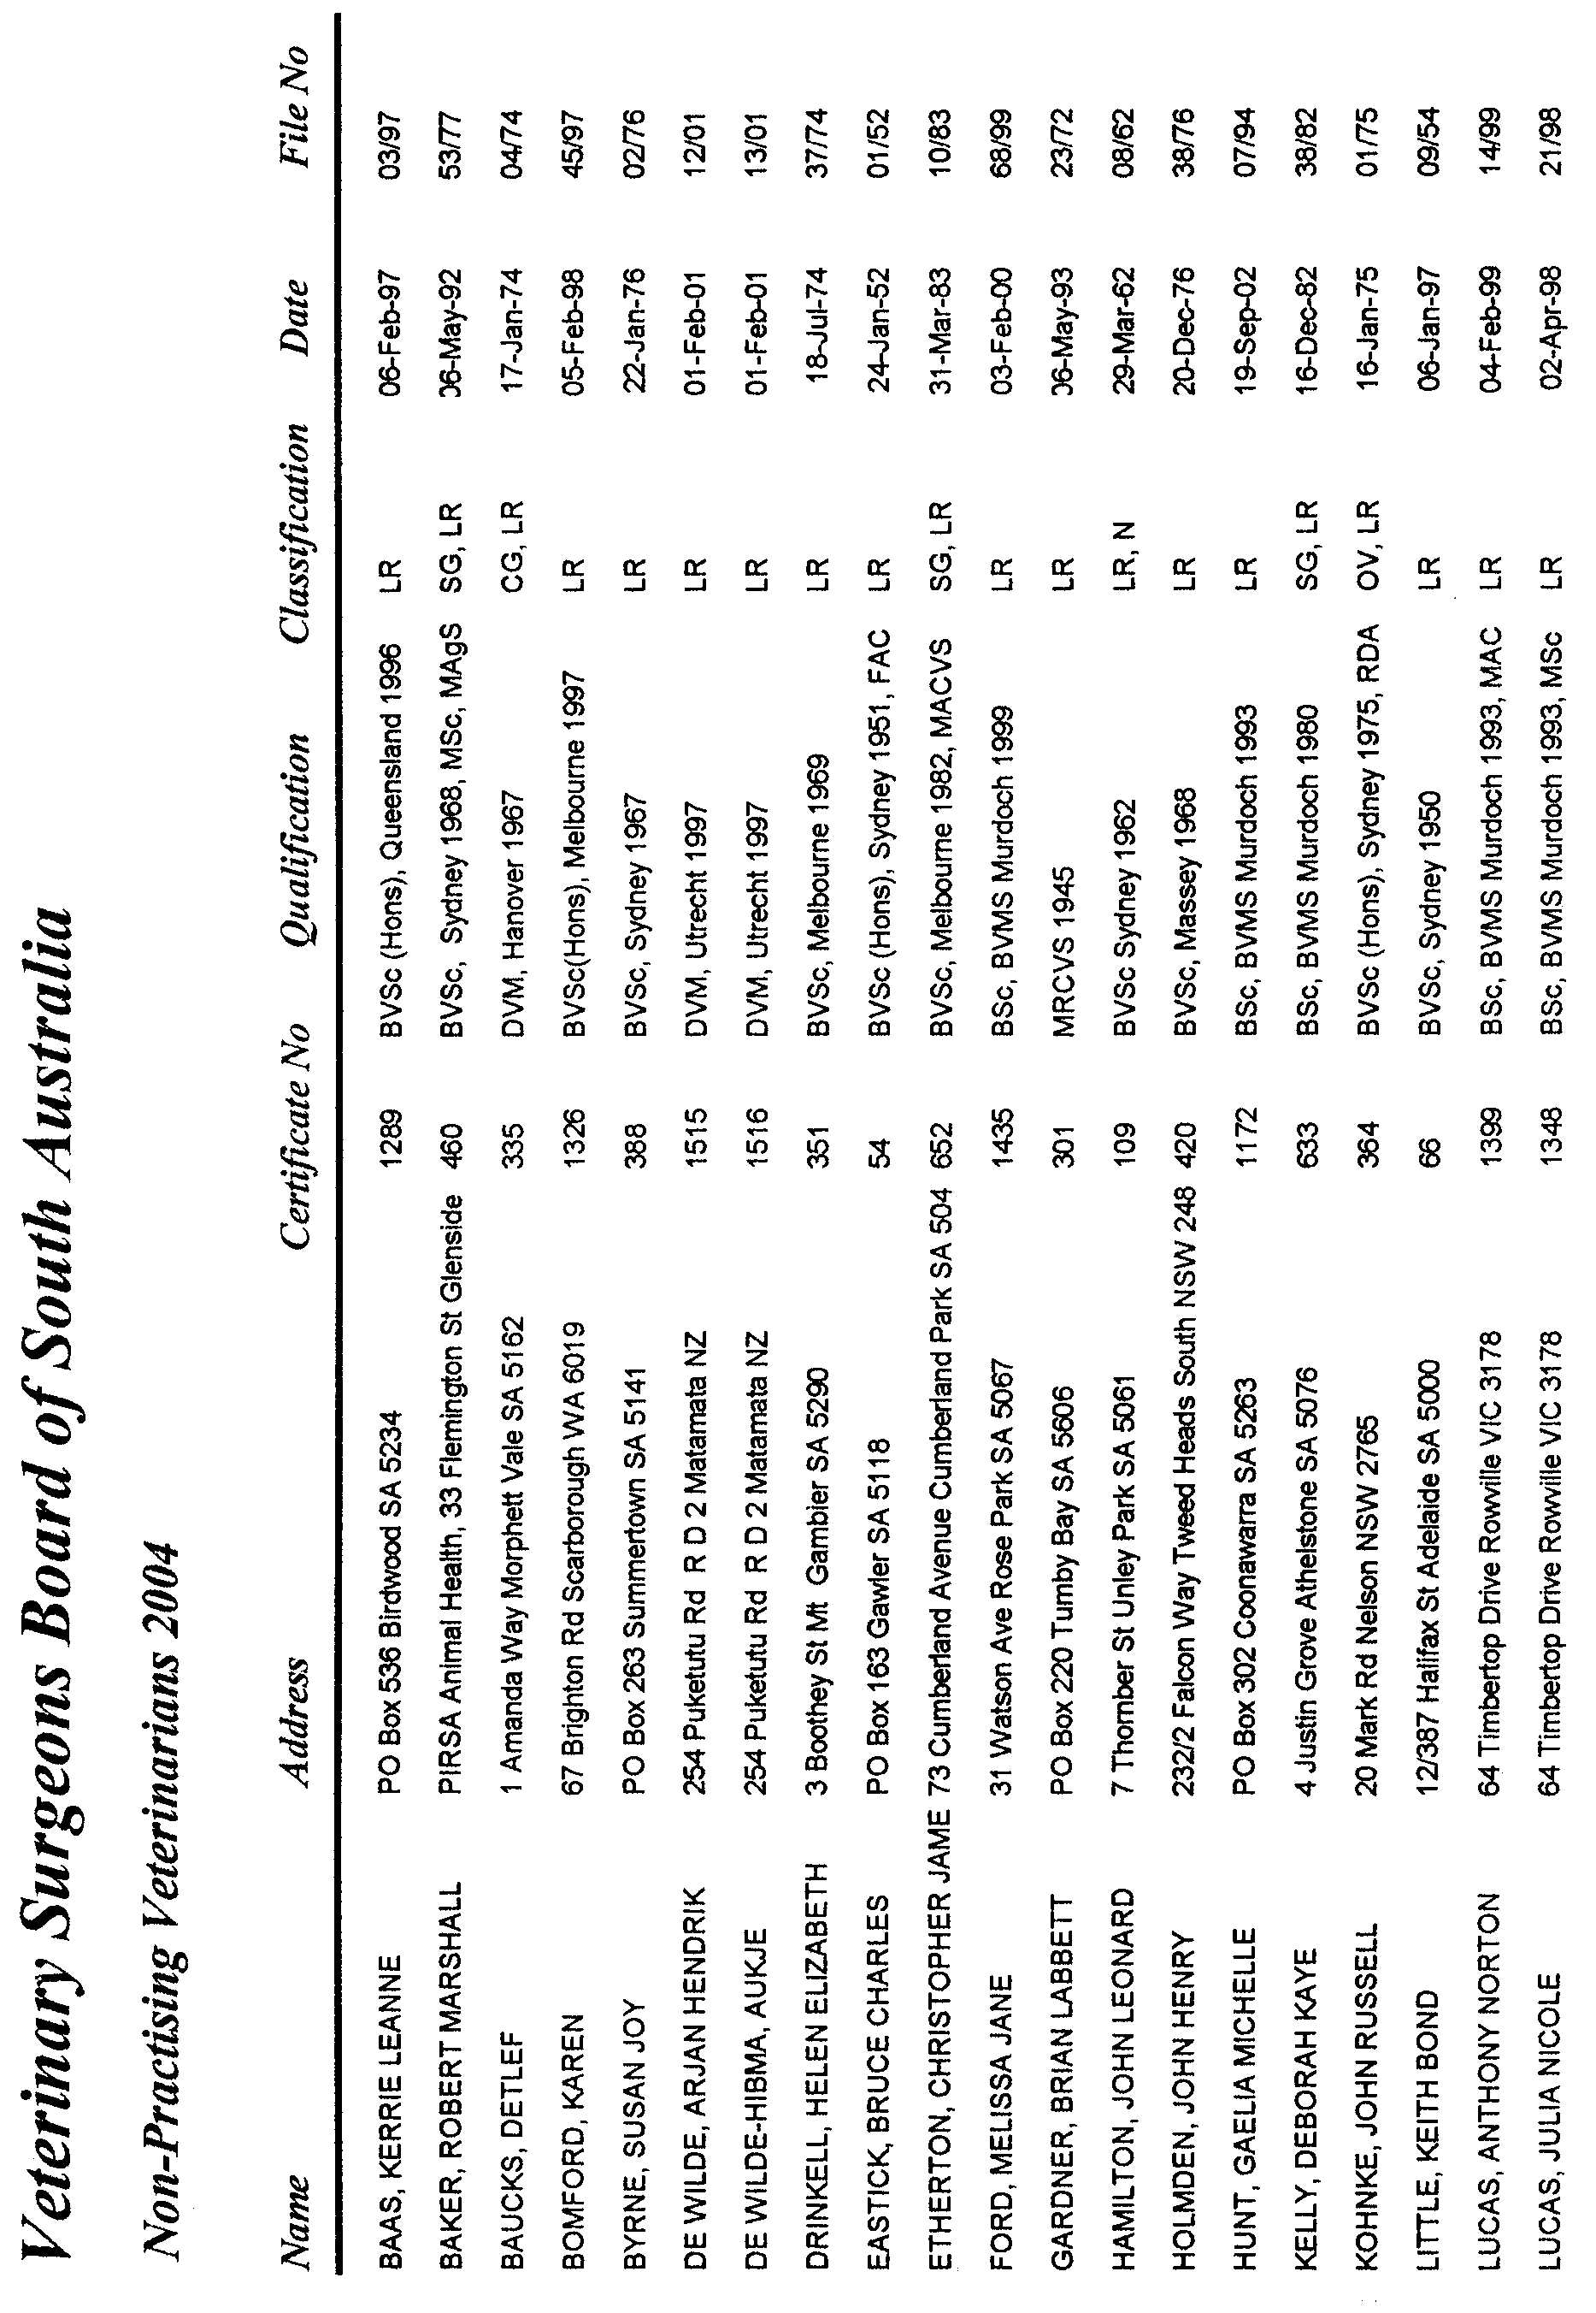

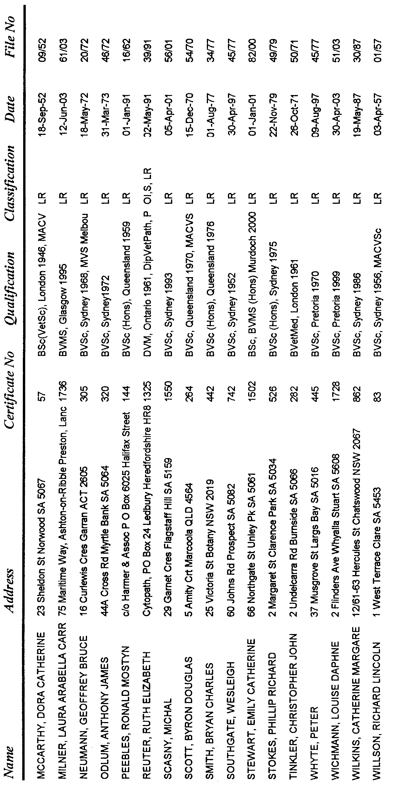

WATERWORKS ACT 1932
Removal of Land from Beetaloo Country Lands Water District and Addition to Port Hughes Water District
PURSUANT to section 6 of the Waterworks Act 1932, the South Australian Water Corporation:
(a) removes from the Beetaloo Country Lands Water District and adds to the Port Hughes Water District the land shown on the plan in the schedule; and
(b) declares that this notice will have effect from 1 July 2004.
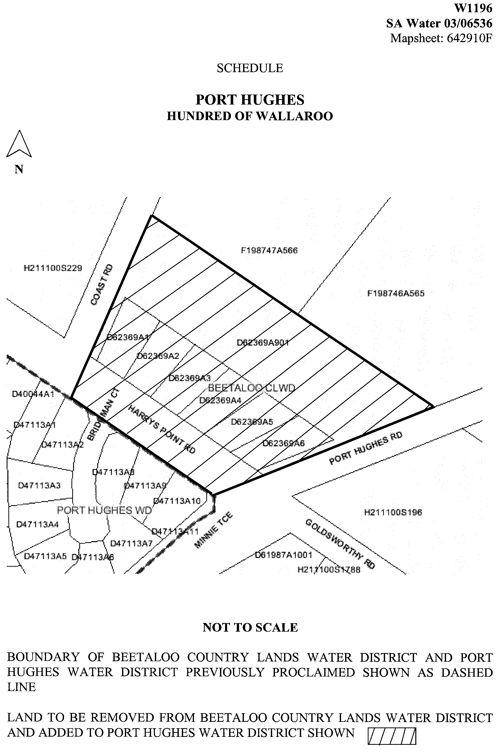

Dated 21 April 2004.
Signed for and on behalf of the South Australian Water Corporation by a person duly authorised so to do:
A. Popplewell, General Manager Shared Services
In the presence of:
C. J. McNamara, Billing Manager
SAWATER 03/06536 W1196

WATERWORKS ACT 1932
Removal of Land from Streaky Bay Country Lands Water District
and Addition to Streaky Bay Township Water District
PURSUANT to section 6 of the Waterworks Act 1932, the South Australian Water Corporation:
(a) removes from the Streaky Bay Country Lands Water District and adds to the Streaky Bay Township Water District all the land contained in allotments 49 to 67 inclusive, 89 to 103 inclusive, 302 (road), 304 (road), 305 (road), 306 (road), 401 (reserve), 402 (reserve) and 403 (reserve) in Deposited Plan 63153; and
(b) declares that this notice will have effect from 1 July 2004.
Dated 21 April 2004.
Signed for and on behalf of the South Australian Water Corporation by a person duly authorised so to do:
A. Popplewell, General Manager Shared Services
In the presence of:
C. J. McNamara, Billing Manager
SAWATER 04/00699 W1210

WATERWORKS ACT 1932
Removal of Land from Beetaloo Country Lands Water District
and Addition to Port Hughes Water District
PURSUANT to section 6 of the Waterworks Act 1932, the South Australian Water Corporation:
(a) removes from the Beetaloo Country Lands Water District and adds to the Port Hughes Water District all the land contained in Community Plan 22020; and
(b) declares that this notice will have effect from 1 July 2004.
Dated 21 April 2004.
Signed for and on behalf of the South Australian Water Corporation by a person duly authorised so to do:
A. Popplewell, General Manager Shared Services
In the presence of:
C. J. McNamara, Billing Manager
SAWATER 04/00764 W1211

PHYLLOXERA AND GRAPE INDUSTRY ACT 1995
Contributions towards Primary Functions Under the Act for year, 2003-2004
PURSUANT to section 23 of the above Act, the Phylloxera and Grape Industry Board gives notice that registered persons (being persons who are recorded in the Register established by the Board as owners of 0.5 hectares, or more of planted vines) must contribute to the costs of the Board’s primary functions for the year ended 30 April 2003.
The rules of calculation of such contributions are as follows:
(1) Calculations will be based on the area of vines recorded in the Register as being owned by each person.
(2) The rate per hectare of vines will be $9.50 with a minimum contribution of $50.
(3) Any fee for default or delay in contribution payment will be calculated on a per hectare basis.
(4) The levy will be collected or recovered by the Commis-sioner of Land Tax on behalf of the board as if the contribution were land tax, and will be subject to the same penalties for delay or default in payment (section 23 (3) of the Act).
Notices of contributions will be forwarded by post to registered persons.
P. Hackworth, Executive Officer

WATER MAINS AND SEWERS

Office of the South Australian Water Corporation
Adelaide, 29 April 2004

WATER MAINS LAID

Notice is hereby given that the following main pipes or parts of main pipes have been laid down by the South Australian Water Corporation in or near the undermentioned water districts and are now available for a constant supply of water to adjacent land.

ADELAIDE WATER DISTRICT

TOWN OF GAWLER
Across Barossa Valley Highway, Gawler East. p7

CITY OF HOLDFAST BAY
Mills Street, South Brighton. p3

CITY OF NORWOOD PAYNEHAM AND ST PETERS
Ninth Avenue, St Peters. p15

CITY OF PORT ADELAIDE ENFIELD
Lawrence Avenue, Ferryden Park. p19

CITY OF WEST TORRENS
Wyatt Street, North Plympton. p2

BAROSSA COUNTRY LANDS WATER DISTRICT

LIGHT REGIONAL COUNCIL
Boundary Road, Pinkerton Plains. p10-12

DISTRICT COUNCIL OF MALLALA
In and across Port Wakefield Road, Windsor. p20-22

BEETALOO COUNTRY LANDS WATER DISTRICT

DISTRICT COUNCIL OF BARUNGA WEST
In and across Abbotts Road, Paskeville. p13

KADINA WATER DISTRICT

DISTRICT COUNCIL OF THE COPPER COAST
Roach Street, Kadina. p9

MURRAY BRIDGE WATER DISTRICT

THE RURAL CITY OF MURRAY BRIDGE
Bradley Court, Murray Bridge. p1

PORT LINCOLN WATER DISTRICT

CITY OF PORT LINCOLN
Cove View Drive, Port Lincoln. p5 and 6

ROWLAND FLAT WATER DISTRICT

BAROSSA COUNCIL
Easements in allotment piece 51 in LTRO DP 60049, Barossa Valley Highway, Rowland Flat. p25

TAILEM BEND WATER DISTRICT

COORONG DISTRICT COUNCIL
Blue Gum Place, Tailem Bend. p8

TWO WELLS WATER DISTRICT

DISTRICT COUNCIL OF MALLALA
Garden Avenue, Two Wells. This main is available on application only. p24

WARREN COUNTRY LANDS WATER DISTRICT

LIGHT REGIONAL COUNCIL
Hawkers Creek Road, Kapunda. p23

WATER MAINS ABANDONED

Notice is hereby given that the undermentioned water mains have been abandoned by the South Australian Water Corporation.

ADELAIDE WATER DISTRICT

CITY OF HOLDFAST BAY
Mills Street, South Brighton. p3

CITY OF NORWOOD PAYNEHAM AND ST PETERS
Ninth Avenue, St Peters. p15

CITY OF PORT ADELAIDE ENFIELD
Lawrence Avenue, Ferryden Park. p19

BAROSSA COUNTRY LANDS WATER DISTRICT

LIGHT REGIONAL COUNCIL
Boundary Road, Pinkerton Plains. p10-12

DISTRICT COUNCIL OF MALLALA
In and across Port Wakefield Road, Windsor. p20-22

BEETALOO COUNTRY LANDS WATER DISTRICT

DISTRICT COUNCIL OF BARUNGA WEST
Abbotts Road, Paskeville. p13

ROWLAND FLAT WATER DISTRICT

BAROSSA COUNCIL
Easement in allotment piece 51 in LTRO DP 60049, Barossa Valley Highway, Rowland Flat. p25

WARREN COUNTRY LANDS WATER DISTRICT

LIGHT REGIONAL COUNCIL
Hawkers Creek Road, Kapunda. p23

WATER MAINS LAID

Notice is hereby given that the undermentioned water mains have been laid down by the South Australian Water Corporation and are not available for a constant supply of water to adjacent land.

ADELAIDE WATER DISTRICT

CITY OF ONKAPARINGA
Chandlers Hill Road, Happy Valley. p26-28
Waterworks land (lot 61 in LTRO DP 26726 and lot 96 in LTRO FP 151498), Herrings Lane, Happy Valley. p29
Across Herrings Lane, Happy Valley. p29
Easement in lot 6 in LTRO DP 51548, Herrings Lane, Happy Valley. p29
Bishops Hill Road, Happy Valley. p29-31
Kenihans Road, Happy Valley. p31-33
Byards Road, Happy Valley and Reynella East. p33-35, 38 and 39
Easements in sections 1660 and 1661, hundred of Noarlunga, Byards Road, Reynella East. p35-37
Easements in lot 22 in LTRO FP 12776, Byards Road, Reynella East. p38-40
Across Hewlett Packard Street, Reynella East. p40
Easements in lot 8 in LTRO DP 13367, Hewlett Packard Street, Reynella East. p40
Across Reynell Road, Reynella East and Woodcroft. p40
Easement in lot 51 in LTRO FP 15307, Reynell Road, Woodcroft. p40
Rolton Avenue, Woodcroft. p41-43
Sir James Hardy Way, Woodcroft. p43-47
In and across Knox Drive, Woodcroft. p48, 49 and 57
Waterworks land (lot 12 in LTRO DP 22268), Knox Drive, Woodcroft. p57
Baudin Street, Woodcroft. p49-51
Investigator Drive, Woodcroft. p51-55
Bains Road, Woodcroft. p55
Waterworks land (lot 1001 in LTRO DP 48014), Bains Road, Woodcroft. p56

SEWERS LAID

Notice is hereby given that the following sewers have been laid down by the South Australian Water Corporation in the under-mentioned drainage areas and are now available for house connections.

ADELAIDE DRAINAGE AREA

CITY OF MARION
Folkestone Road, Dover Gardens. FB 1123 p29 and 33

CITY OF SALISBURY
Delamere Drive, Paralowie. FB 1123 p31

CITY OF WEST TORRENS
Whyatt Street, North Plympton. FB 1123 p28
Avon Street, Kurralta Park. FB 1123 p30
Fashoda Avenue, Camden Park. FB 1123 p32

STIRLING COUNTRY DRAINAGE AREA

ADELAIDE HILLS COUNCIL
Easements in lot 1 in LTRO FP 8657, and lot 11 in LTRO FP 105474, Bradshaw Avenue, and lot 4 in LTRO DP 10454, Valleyside Drive, Crafers. FB 1124 p3-5
Across and in Valleyside Drive, Crafers. FB 1124 p3 and 4
Easements in lot 1 in LTRO FP 158147, and lot 6 in LTRO FP 126933, Valleyside Drive, and lots 3 and 4 in LTRO DP 6650, Piccadilly Road, Crafers. FB 1124 p3 and 4
Easements in lot 5 in LTRO DP 10454, and lots 51 and 52 in LTRO DP 29486, Valleyside Drive, Crafers. FB 1124 p3 and 5
Easements in lot 8 in LTRO DP 6650, Valleyside Drive, and lot 1 in LTRO DP 6650, Piccadilly Road, Crafers. FB 1124 p3 and 5
Easement in lot 2 in LTRO FP 158148, Piccadilly Road, Crafers. FB 1124 p3 and 5

WHYALLA COUNTRY DRAINAGE AREA

THE CORPORATION OF THE CITY OF WHYALLA
Cook Street, Whyalla Norrie. FB 1123 p35

A. Howe, Chief Executive Officer, South Australian Water Corporation.

South Australia
Administrative Arrangements (Administration of Ambulance Services Act) Proclamation 2004
under section 5 of the Administrative Arrangements Act 1994
1—Short title
This proclamation may be cited as the Administrative Arrangements (Administration of Ambulance Services Act) Proclamation 2004.
2—Commencement
This proclamation comes into operation on the day on which it is made.
3—Administration of Act committed to Minister for Health
The administration of the Ambulance Services Act 1992 is committed to the Minister for Health.
Made by the Governor
with the advice and consent of the Executive Council
on 29 April 2004.
MES04/007CS

South Australia
Law Reform (Ipp Recommendations) Act (Commencement) Proclamation 2004
1—Short title
This proclamation may be cited as the Law Reform (Ipp Recommendations) Act (Commencement) Proclamation 2004.
2—Commencement of Act
The Law Reform (Ipp Recommendations) Act 2004 (No 9 of 2004) will come into operation on 1 May 2004.
Made by the Governor
with the advice and consent of the Executive Council
on 29 April 2004.
AGO0144/04CS

South Australia
Statutes Amendment (Honesty and Accountability in Government) Act (Commencement) Proclamation 2004
1—Short title
This proclamation may be cited as the Statutes Amendment (Honesty and Accountability in Government) Act (Commencement) Proclamation 2004.
2—Commencement of Act and suspension of certain provisions
(1) The Statutes Amendment (Honesty and Accountability in Government) Act 2003 (No 36 of 2003) (the Amendment Act) will come into operation on 29 April 2004.
(2) The operation of—
(a) sections 6H and 6L of the Public Sector Management Act 1995 (inserted into the Public Sector Management Act 1995 by section 21 of the Amendment Act); and
(b) section 28 of the Amendment Act,
is suspended until a day or days to be fixed by subsequent proclamation or proclamations.
Made by the Governor
with the advice and consent of the Executive Council
on 29 April 2004.
DPC016/04CS

South Australia
Electronic Transactions Variation Regulations 2004
under the Electronic Transactions Act 2000

Contents
Part 1—Preliminary
1 Short title
2 Commencement
3 Variation provisions
Part 2—Variation of Electronic Transactions Regulations 2002
4 Variation of regulation 4—Certain transactions excluded from section 7(1) of Act
5 Variation of regulation 5—Certain requirements and permissions excluded from Part 2 Division 2 of Act

Part 1—Preliminary
1—Short title
These regulations may be cited as the Electronic Transactions Variation Regulations 2004.
2—Commencement
These regulations come into operation on the day on which they are made.
3—Variation provisions
In these regulations, a provision under a heading referring to the variation of specified regulations varies the regulations so specified.
Part 2—Variation of Electronic Transactions Regulations 2002
4—Variation of regulation 4—Certain transactions excluded from section 7(1) of Act
(1) Regulation 4—delete "Section 7(1)" and substitute:
Subject to subregulation (2), section 7(1)
(2) Regulation 4—after its present contents as varied by this regulation (now to be designated as subregulation (1)) insert:
(2) Paragraphs (a) and (b) of subregulation (1) do not apply to a law relating to—
(a) an application for a development authorisation relating to the proposed division of land under section 33(1) of the Development Act 1993; or
(b) a certificate relating to the proposed division of land under section 51 of the Development Act 1993 (including where the certificate is being used for the purposes of another Act); or
(c) a plan relating to the division of land or the amalgamation of allotments under Part 19AB of the Real Property Act 1886; or
(d) a plan relating to the division of land or the amalgamation of 2 or more deposited community plans under Part 3 or 7 of the Community Titles Act 1996 (including a plan for the amendment, substitution or cancellation of an existing plan); or
(e) a plan relating to the division of land or the amalgamation of 2 or more deposited strata plans under Part 2 of the Strata Titles Act 1988 (including a plan for the amendment, substitution or cancellation of an existing plan); or
(f) a certificate of a licensed surveyor required under the Real Property Act 1886, the Community Titles Act 1996 or the Strata Titles Act 1988; or
(g) a certificate of a land valuer required under the Community Titles Act 1996 or the Strata Titles Act 1988.
5—Variation of regulation 5—Certain requirements and permissions excluded from Part 2 Division 2 of Act
(1) Regulation 5(1)—delete "Division 2" and substitute:
Subject to subregulation (3), Division 2
(2) Regulation 5—after subregulation (2) insert:
(3) Paragraphs (a) and (b) of subregulation (1) do not apply to a law relating to—
(a) an application for a development authorisation relating to the proposed division of land under section 33(1) of the Development Act 1993; or
(b) a certificate relating to the proposed division of land under section 51 of the Development Act 1993 (including where the certificate is being used for the purposes of another Act); or
(c) a plan relating to the division of land or the amalgamation of allotments under Part 19AB of the Real Property Act 1886; or
(d) a plan relating to the division of land or the amalgamation of 2 or more deposited community plans under Part 3 or 7 of the Community Titles Act 1996 (including a plan for the amendment, substitution or cancellation of an existing plan); or
(e) a plan relating to the division of land or the amalgamation of 2 or more deposited strata plans under Part 2 of the Strata Titles Act 1988 (including a plan for the amendment, substitution or cancellation of an existing plan); or
(f) a certificate of a licensed surveyor required under the Real Property Act 1886, the Community Titles Act 1996 or the Strata Titles Act 1988; or
(g) a certificate of a land valuer required under the Community Titles Act 1996 or the Strata Titles Act 1988.
Note—
As required by section 10AA(2) of the Subordinate Legislation Act 1978, the Minister has certified that, in the Minister's opinion, it is necessary or appropriate that these regulations come into operation as set out in these regulations.
Made by the Governor
with the advice and consent of the Executive Council
on 29 April 2004.
No 21 of 2004.
AGO0193/02CS

South Australia
Public Sector Management Variation Regulations 2004
under the Public Sector Management Act 1995

Contents
Part 1—Preliminary
1 Short title
2 Commencement
3 Variation provisions
Part 2—Variation of Public Sector Management Regulations 1995
4 Variation of regulation 5
5 Variation of regulation 18—Annual reports by public sector agencies (s 6B)

Part 1—Preliminary
1—Short title
These regulations may be cited as the Public Sector Management Variation Regulations 2004.
2—Commencement
These regulations will come into operation on the day on which they are made.
3—Variation provisions
In these regulations, a provision under a heading referring to the variation of specified regulations varies the regulations so specified.
Part 2—Variation of Public Sector Management Regulations 1995
4—Variation of regulation 5
(1) Regulation 5(1)(a)—delete paragraph (a) and substitute:
(a) the pecuniary interests to be disclosed by a senior official for the purposes of section 6Q of the Act; and
(2) Regulation 5(1)(b)—delete "Chief Executive or the Commissioner" and substitute:
senior official
5—Variation of regulation 18—Annual reports by public sector agencies (s 6B)
Regulation 18—delete "66" and substitute:
6B
Note—
As required by section 10AA(2) of the Subordinate Legislation Act 1978, the Minister has certified that, in the Minister's opinion, it is necessary or appropriate that these regulations come into operation as set out in these regulations.
Made by the Governor
with the advice and consent of the Executive Council
on 29 April 2004.
No. 22 of 2004
DPC016/04CS

South Australia
National Electricity (South Australia) Variation Regulations 2004
under the National Electricity (South Australia) Act 1996

Contents
Part 1—Preliminary
1 Short title
2 Commencement
3 Variation provisions
Part 2—Variation of National Electricity (South Australia) Regulations
4 Variation of Schedule—Classification of provisions of Code and Class A civil penalties

Part 1—Preliminary
1—Short title
These regulations may be cited as the National Electricity (South Australia) Variation Regulations 2004.
2—Commencement
These regulations come into operation on the day on which they are made.
3—Variation provisions
In these regulations, a provision under a heading referring to the variation of specified regulations varies the regulations so specified.
Part 2—Variation of National Electricity (South Australia) Regulations
4—Variation of Schedule—Classification of provisions of Code and Class A civil penalties
(1) Schedule, table—after the entry relating to 2.2.4(d) insert:
2.2.6(g) (1)-(2) | C
2.2.6(g) 4 | C
2.2.6(h) | C
(2) Schedule, table—after the entry relating to 2.3.4(h) insert:
2.3.5(g)(1)-(2) | C
2.3.5(g)(4) | C
2.3.5(h) | C
(3) Schedule, table, entry relating to 3.6.3(f)(3)—delete the entry
(4) Schedule, table—after the entry relating to 3.8.20(g) insert:
3.8.22(c)(1)-(3) | B
(5) Schedule, table—after the entry relating to 3.9.7(a) insert:
3.11.4(j) | C
3.11.5(i) | C
3.11.7(a) | C
(6) Schedule, table, entries relating to 3.12.2(c), 3.12.5(e) and 3.12.9(c)—delete the entries
(7) Schedule, table, entry relating to 3.12.11(1)—delete the entry and substitute:
3.12A.4 | C
3.12A.7(e) | C
3.12A.7(i1) | A | $5 000
3.12A.7(n)(1) | C
(8) Schedule, table—after the entry relating to 3.13.3(p) insert:
3.13.12(f) | A | $5 000
3.13.12(g) | A | $10 000
(9) Schedule, table, entry relating to 3.15.9(i)—delete the entry and substitute:
3.15.11A(b)(2) | C
(10) Schedule, table—after the entry relating to 3.18.4(e) insert:
3.19(c) | C
(11) Schedule, table, entry relating to 4.8.5(d)—delete the entry
(12) Schedule, table, entry relating to 4.9.2a(c)—delete the entry and substitute:
4.9.2A(c) | C
(13) Schedule, table—after the entry relating to 4.9.3(d) insert:
4.9.3A(c)-(d) | C
4.9.3B(b) | C
(14) Schedule, table, entry relating to 4.9.4a(a)-(b)—delete the entry and substitute:
4.9.4A(a)-(b) | C
(15) Schedule, table, entry relating to 4.9.8(a)-(c)—delete the entry and substitute:
4.9.8(a)-(d) | C
(16) Schedule, table, entry relating to 4.9.9a—delete the entry and substitute:
4.9.9A | A | $10 000
4.9.9B | A | $10 000
(17) Schedule, table, entry relating to 4.11.1(b)-(c)—delete the entry and substitute:
4.11.1(a)-(c) | C
(18) Schedule, table—after the entry relating to 5.2.2(a) insert:
5.2.3(a1)-(a2) | A | $10 000
(19) Schedule, table, entry relating to 5.3.6(c)—delete the entry and substitute:
5.3.6(c)-(c1) | B
(20) Schedule, table—after the entry relating to 5.3.6(h) insert:
5.3.6(j) | B
(21) Schedule, table—after the entry relating to 5.4.2(a)-(b) insert:
5.5(h) | C
5.5A(j) | C
(22) Schedule, table, entry relating to 7.2.5(a)-(c)—delete the entry and substitute:
7.2.5(a)-(bc) | A | $10 000
(23) Schedule, table—after the entry relating to 7.2.5(d) insert:
7.2.8(d) | B
(24) Schedule, table, entry relating to 7.3.1(a)(8)-(9)—delete the entry and substitute:
7.3.1(a)(8)-(12) | A | $10 000
7.3.1(da)-(db) | A | $20 000
7.3.1A(a) | A | $10 000
(25) Schedule, table, entry relating to 7.3.5(a)—delete the entry and substitute:
7.3.4(d) | A | $5 000
(26) Schedule, table, entry relating to 7.4.2(c)—delete the entry and substitute:
7.4.2(c)-(ca) | B
(27) Schedule, table, entries relating to 7.8.2(g), 8.2.5(g), 9.9.2(b), 9.9.3(b), 9.9.6(b), 9.9.7(b) and 9.9.8(b)—delete the entries
(28) Schedule, table, entries under the heading "SCHEDULE 9A1.1"—delete the entries and substitute:
9.37.15 | C
9.37.19(b1) | C
Made by the Governor
on the unanimous recommendation of the Ministers of the participating jurisdictions and with the advice and consent of the Executive Council
on 29 April 2004.
No 23 of 2004.
MEN03/017CS

South Australia
Limitation of Actions (Section 45A Notice) Regulations 2004
under the Limitation of Actions Act 1936

Contents
1 Short title
2 Commencement
3 Interpretation
4 Section 45A notice

1—Short title
These regulations may be cited as the Limitation of Actions (Section 45A Notice) Regulations 2004.
2—Commencement
These regulations will come into operation on 1 May 2004.
3—Interpretation
In these regulations—
Act means the Limitation of Actions Act 1936.
4—Section 45A notice
Notice of an intended action for damages required to be given under section 45A of the Act must contain—
(a) the name and date of birth of the person who has suffered personal injury (the plaintiff); and
(b) if the plaintiff is still a child as at the date of the notice—the name of the person giving notice on behalf of the plaintiff and the relationship of that person to the plaintiff; and
(c) the address to which correspondence with, or on behalf of, the plaintiff must be directed; and
(d) the following details about the incident out of which it is alleged the personal injury arose:
(i) the date of the incident;
(ii) the place at which the incident occurred;
(iii) a brief description of the circumstances of the incident;
(e) the name of the person or persons alleged to be liable in damages (the defendant) for the personal injury suffered by the plaintiff; and
(f) a statement that the plaintiff intends to take action for damages against the defendant.
Note—
As required by section 10AA(2) of the Subordinate Legislation Act 1978, the Minister has certified that, in the Minister's opinion, it is necessary or appropriate that these regulations come into operation as set out in these regulations.
Made by the Governor
with the advice and consent of the Executive Council
on 29 April 2004.
No. 24 of 2004
AGO0144/04CS

South Australia
Liquor Licensing (Dry Areas—Long Term) Variation Regulations 2004
under the Liquor Licensing Act 1997

Contents
Part 1—Preliminary
1 Short title
2 Commencement
3 Variation provisions
Part 2—Variation of Liquor Licensing (Dry Areas—Long Term) Regulations 1997
4 Variation of Schedule 1—Long term dry areas

Part 1—Preliminary
1—Short title
These regulations may be cited as the Liquor Licensing (Dry Areas—Long Term) Variation Regulations 2004.
2—Commencement
These regulations come into operation on the day on which they are made.
3—Variation provisions
In these regulations, a provision under a heading referring to the variation of specified regulations varies the regulations so specified.
Part 2—Variation of Liquor Licensing (Dry Areas—Long Term) Regulations 1997
4—Variation of Schedule 1—Long term dry areas
Schedule 1, item headed "Coober Pedy—Area 1", column headed "Period"—delete "30 April 2004" and substitute:
30 April 2005
Note—
As required by section 10AA(2) of the Subordinate Legislation Act 1978, the Minister has certified that, in the Minister's opinion, it is necessary or appropriate that these regulations come into operation as set out in these regulations.
Made by the Governor
with the advice and consent of the Executive Council
on 29 April 2004.
No 25 of 2004.
OLGC7/2004

South Australia
Liquor Licensing (Dry Areas—Long Term) Variation Regulations 2004
under the Liquor Licensing Act 1997

Contents
Part 1—Preliminary
1 Short title
2 Commencement
3 Variation provisions
Part 2—Variation of Liquor Licensing (Dry Areas—Long Term) Regulations 1997
4 Variation of Schedule 1—Long term dry areas
5 Variation of Schedule 2—Plans of long term dry areas
Schedule 1—Plans to be substituted

Part 1—Preliminary
1—Short title
These regulations may be cited as the Liquor Licensing (Dry Areas—Long Term) Variation Regulations 2004.
2—Commencement
These regulations come into operation on the day on which they are made.
3—Variation provisions
In these regulations, a provision under a heading referring to the variation of specified regulations varies the regulations so specified.

Part 2—Variation of Liquor Licensing (Dry Areas—Long Term) Regulations 1997
4—Variation of Schedule 1—Long term dry areas
(1) Schedule 1, items headed "Gawler—Area 1", "Gawler—Area 2" and "Gawler—Area 3"—delete these items and substitute:
Gawler—Area 1
(see Schedule 2: Gawler—Plan No 1)
The area in Gawler bounded as follows:  Commencing at the point at which the western boundary of Julian Terrace intersects the northern boundary of Bridge Street South, then south-westerly along that boundary of Bridge Street South to the western bank of the South Para River, then generally northerly, north-easterly, north-westerly, south-westerly and northerly along that same bank of the River to the point at which it crosses Fourteenth Street, then south-easterly, easterly and north-easterly along the southern boundary of Fourteenth Street to the point at which it meets the south-western boundary of Lot 675 FP211461, then generally south-easterly, easterly and north-easterly along the south-western, southern and eastern boundaries of that Lot to the southern boundary of Scheibener Terrace, then generally easterly and north-easterly along that boundary of Scheibener Terrace to the southern boundary of Tod Street, then easterly along that boundary of Tod Street to the point at which it meets the south-western boundary of Whitelaw Terrace, then generally south-easterly and southerly along that boundary of Whitelaw Terrace and Julian Terrace to the point of commencement. | 7 p.m. on each day to 7 a.m. on the following day, until 7 a.m. on 30 April 2007. | The consumption and possession of liquor are prohibited.
Gawler—Area 2
(see Schedule 2: Gawler—Plan No 1)
The area in Gawler bounded on the south by the northern boundary of Walker Place and the north-eastern boundary of Whitelaw Terrace, on the west by the eastern boundary of Reid Street, on the north by the southern boundary of Finniss Street, and on the east by the western boundary of Murray Street. | 7 p.m. on each day to 7 a.m. on the following day, until 7 a.m. on 30 April 2007. | The consumption and possession of liquor are prohibited.
Gawler—Area 3
(see Schedule 2: Gawler—Plan No 2)
The area hatched in Gawler—Plan No 2 in Schedule 2. | 7 p.m. on each day to 7 a.m. on the following day, until 7 a.m. on 30 April 2007. | The consumption and possession of liquor are prohibited.
(2) Schedule 1, item headed "Gawler—Area 4", column headed "Period"—delete "30 April 2004" and substitute:
30 April 2007
(3) Schedule 1—after item headed "Gawler—Area 4" insert:
Gawler—Area 5
(see Schedule 2: Gawler—Plan No 3)
The area hatched in Gawler—Plan No 3 in Schedule 2. | 8 p.m. on each day to 7 a.m. on the following day, until 7 a.m. on 30 April 2007. | The consumption and possession of liquor are prohibited.
5—Variation of Schedule 2—Plans of long term dry areas
Schedule 2, plans headed "Gawler—Plan No 1", "Gawler—Plan No 2" and "Gawler—Plan No 3"—delete the plans and substitute the plans headed "Gawler—Plan No 1", "Gawler—Plan No 2" and "Gawler—Plan No 3" in Schedule 1 of these regulations.

Schedule 1—Plans to be substituted
Gawler—Plan No 1
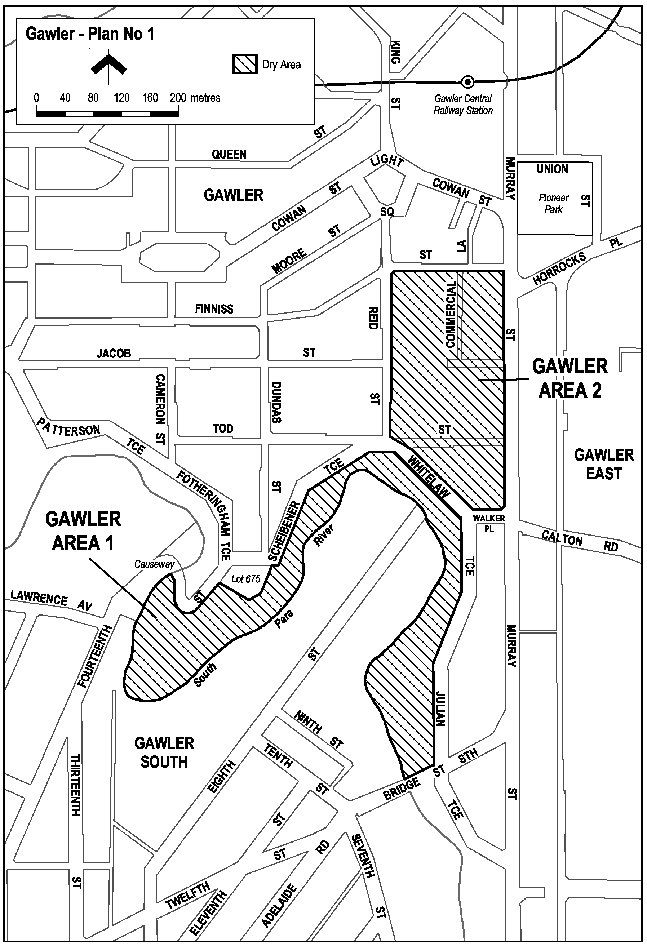
Gawler—Plan No 2
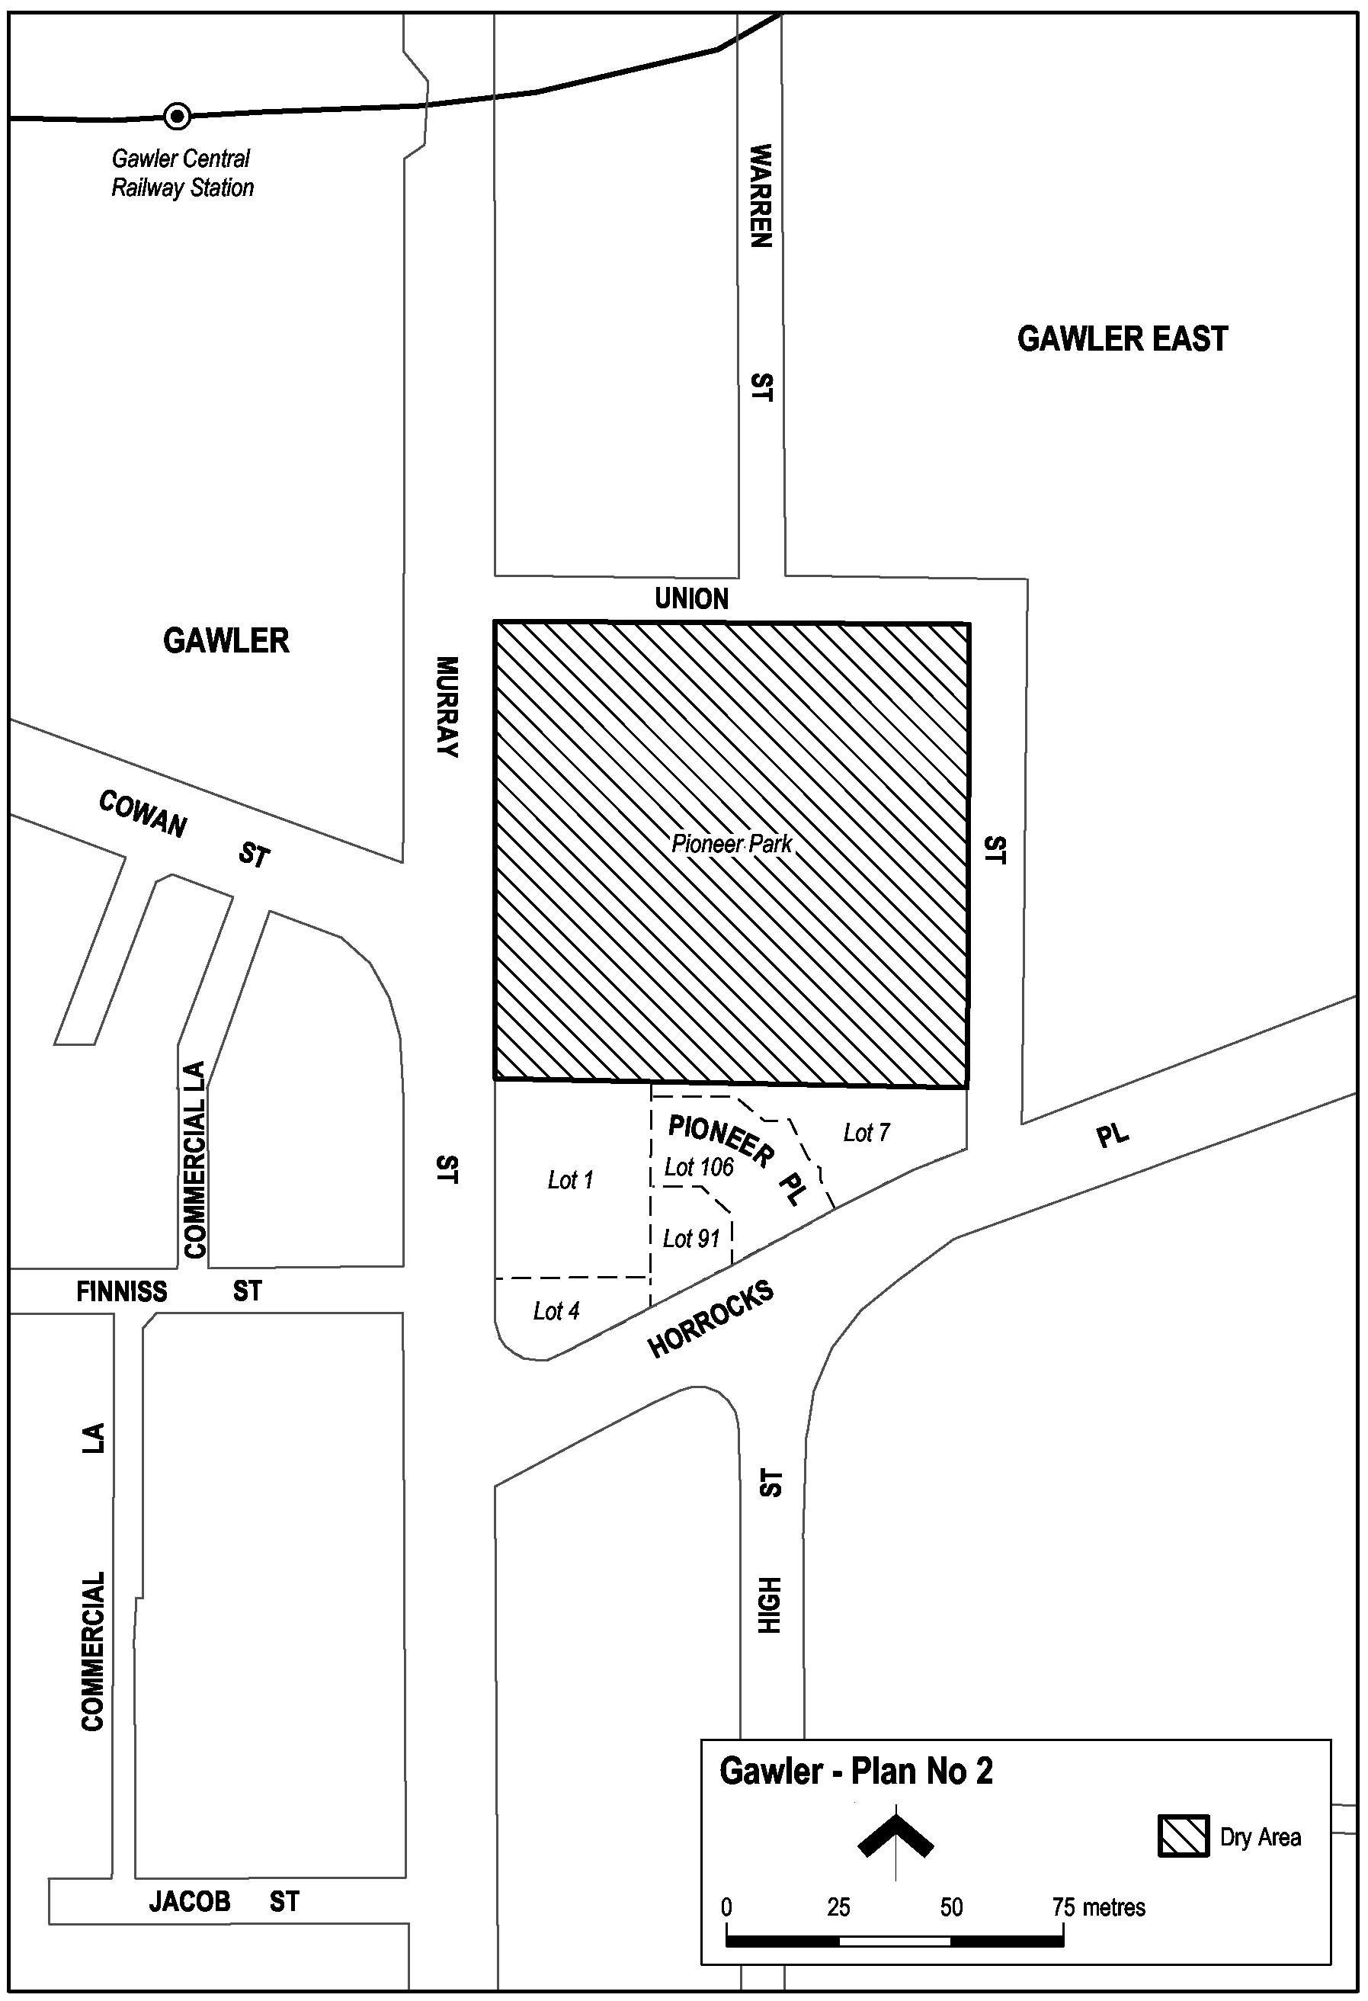
Gawler—Plan No 3
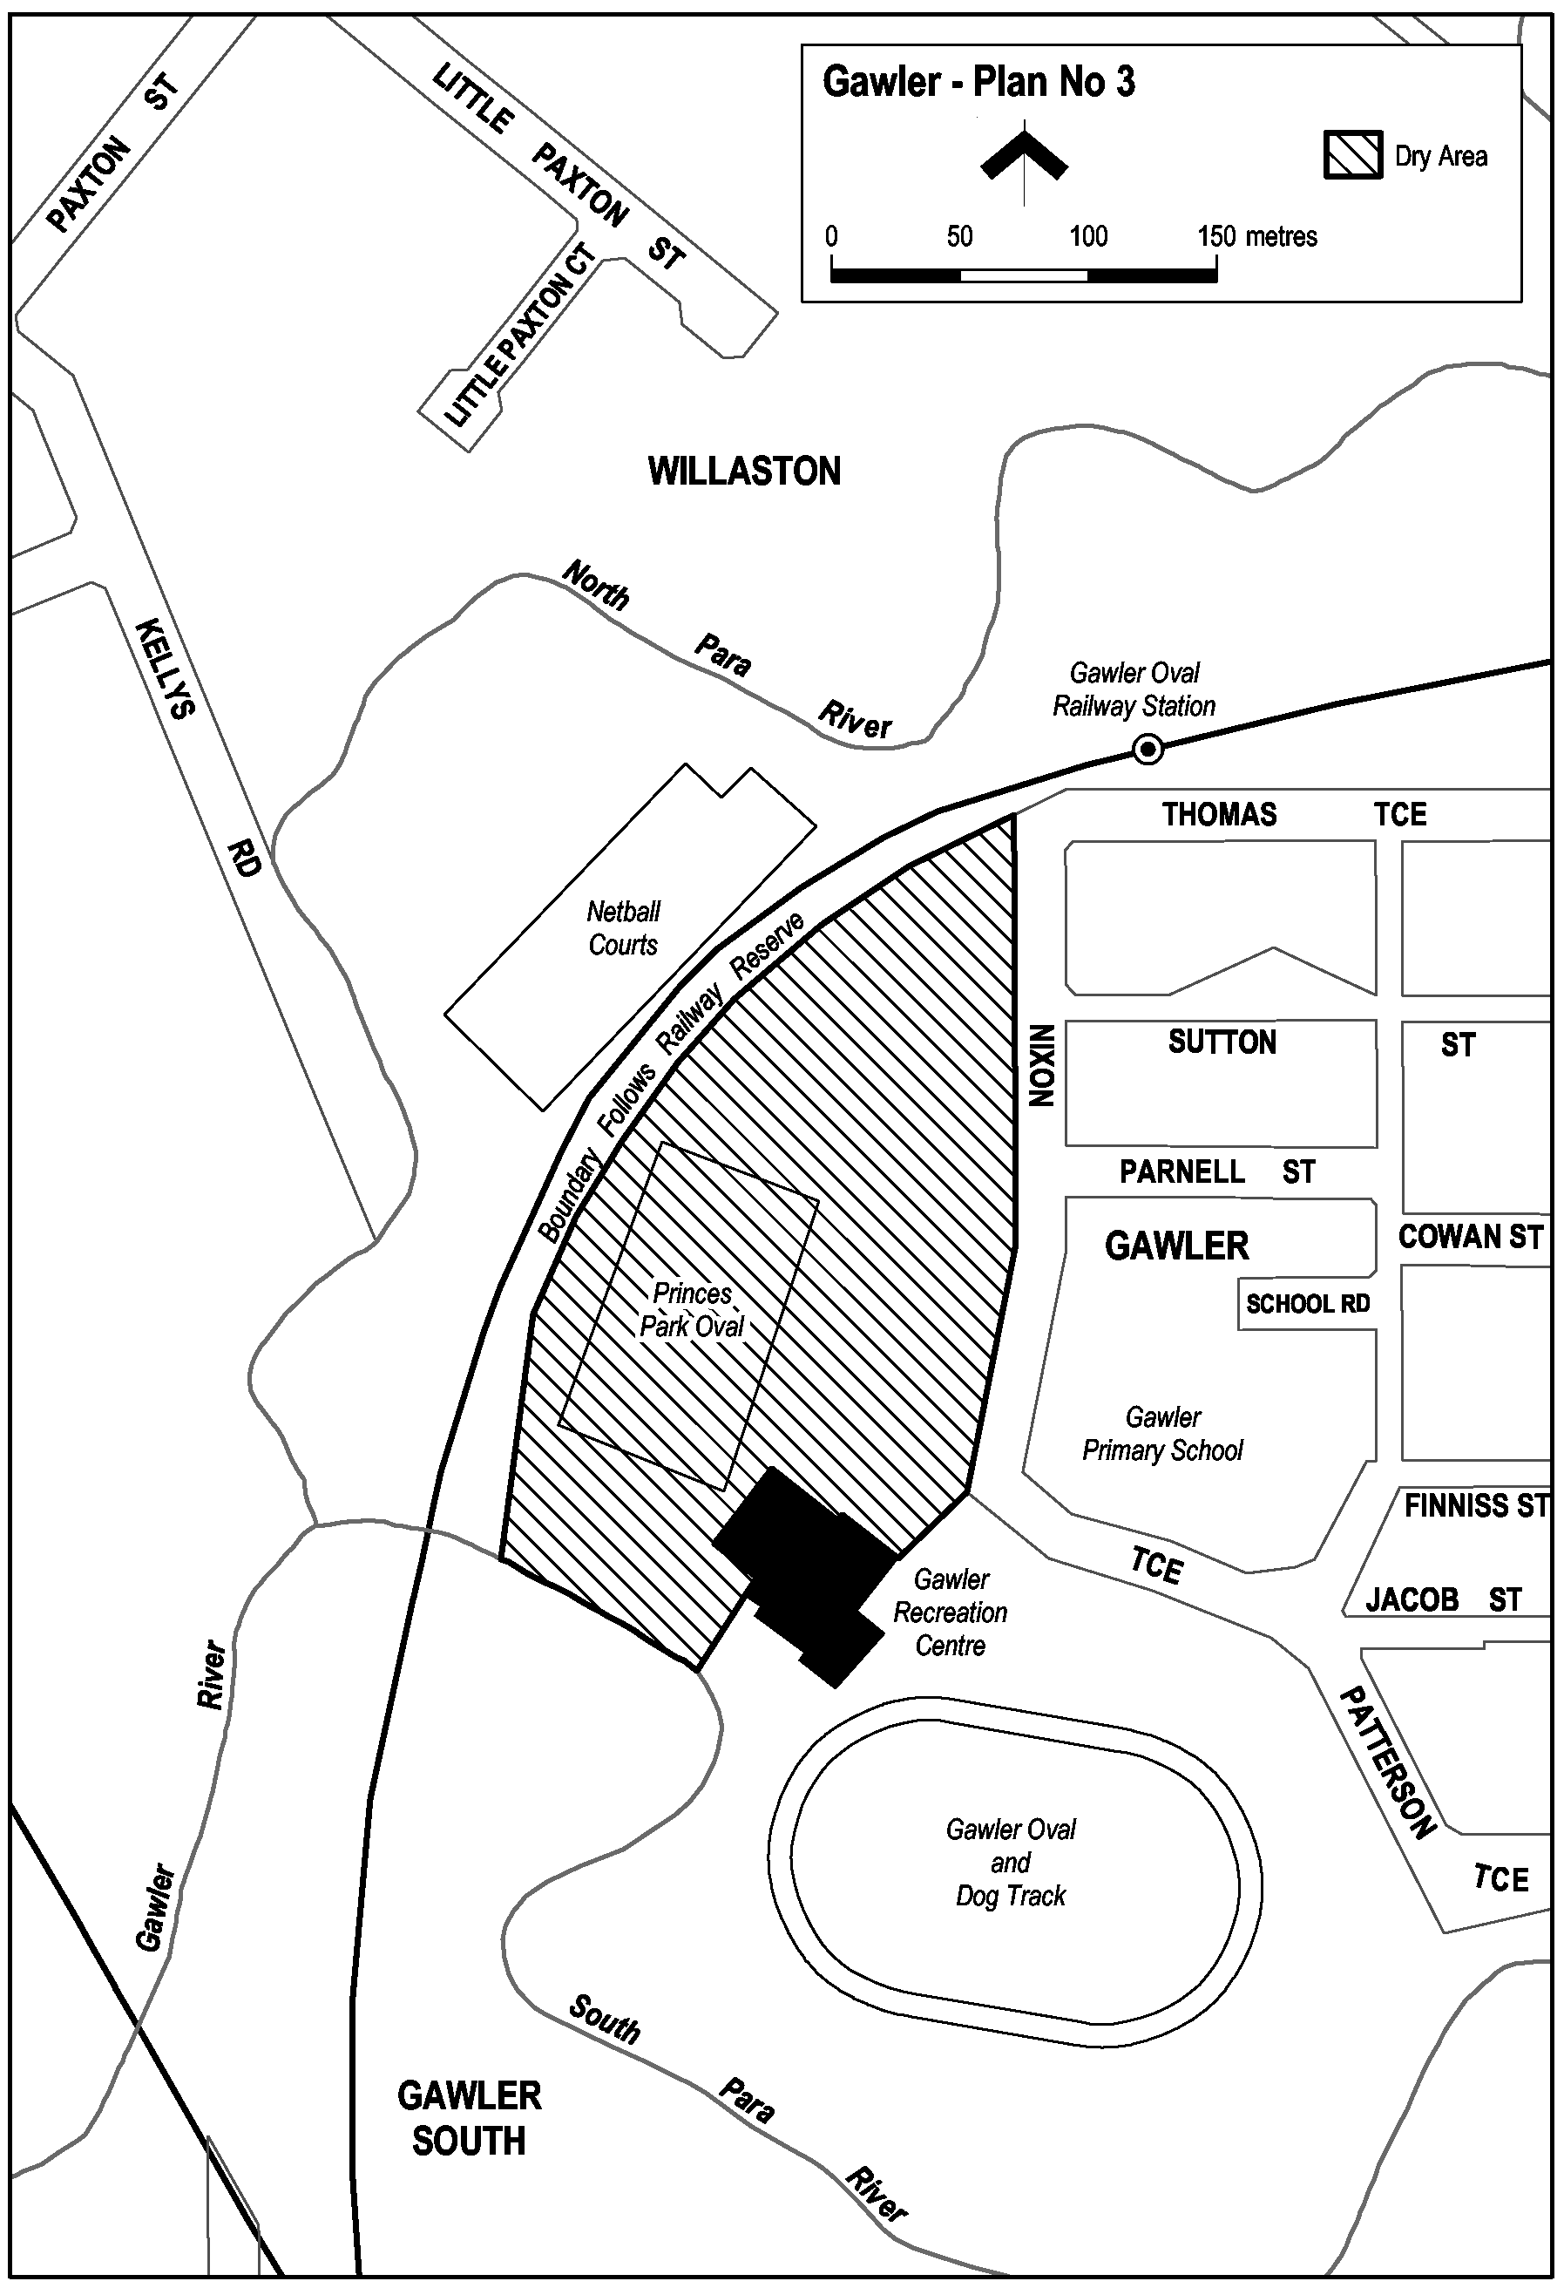
Note—
As required by section 10AA(2) of the Subordinate Legislation Act 1978, the Minister has certified that, in the Minister's opinion, it is necessary or appropriate that these regulations come into operation as set out in these regulations.
Made by the Governor
with the advice and consent of the Executive Council
on 29 April 2004.
No 26 of 2004.
OLGC 2/2004

FAXING COPY?
IF you fax copy to Government Publishing SA for inclusion in the Government Gazette, there is no need to send a Confirmation Copy to us as well.
This creates confusion and may well result in your notice being printed twice.
Please use the following fax number:
Fax transmission: (08) 8207 1040
Phone Inquiries: (08) 8207 1045
Please include a contact person, phone number and order number so that we can phone back with any queries we may have regarding the fax copy.
NOTE: Closing time for lodging new copy (fax, hard copy or email) is 4 p.m. on Tuesday preceding the day of publication.

Government Gazette notices can be E-mailed.
The address is:
governmentgazette@saugov.sa.gov.au
Documents should be sent as attachments in Word format.
When sending a document via E-mail, please confirm your transmission with a faxed copy of your document, including the date the notice is to be published.
Fax transmission: (08) 8207 1040
Enquiries: (08) 8207 1045
NOTE: Closing time for lodging new copy (fax, hard copy or email) is 4 p.m. on Tuesday preceding the day of publication.

CITY OF ADELAIDE
Declaration as Public Road
NOTICE is hereby given pursuant to section 210 of the Local Government Act 1999, that at its meeting held on 27 October 2003, council declared as Public Road the portions of Vaughan Place contained in certificates of title volume 268, folios 205, 206 and 207 and volume 269, folio 47 and designated AZ on Lands Titles Office Deposited Plan 61170.
M. Hemmerling, Chief Executive Officer

CITY OF HOLDFAST BAY
Results of Supplementary Election for Brighton Ward Councillor Conducted on Monday 19 April
Quota: 1 035
Candidates | First  Preference  Votes |  | Result After Distribution  of Preferences
Challans, Garth | 340
Donaldson, John | 606 |  | (elected)
Nield, Melanie | 623
Johnstone, Pat | 144
Ryan, Margret | 355
Informal | 2
Total | 2 068
Steve Tully, Returning Officer

CITY OF MOUNT GAMBIER
Resignation of Councillor
NOTICE is hereby given that Councillor Melanie Freeman, councillor for the East Ward has resigned from council as of 19 April 2004. A Supplementary Election process to fill the vacancy will now take place.
G. Muller, Chief Executive Officer

DISTRICT COUNCIL OF BARINGA WEST
Development Act 1993
Port Broughton and Tickera Plan Amendment Report (PAR)—Draft for Public Consultation
NOTICE is hereby given that the District Council of Barunga West has prepared a draft Plan Amendment Report to amend the Barunga West (DC) Development Plan.
The Plan Amendment Report will amend the Development Plan to alter and expand the township boundaries of Port Broughton and Tickera in order to supply additional land for residential and industrial purposes. The PAR has also considered:
• The adequacy of minimum allotment sizes, particularly in the existing Residential Zone in Port Broughton;
• The adequacy of existing Residential and Industrial Zone policies generally; and
• The impact upon areas zoned for rural living (in Port Broughton) as a result of this township expansion.
The changes affect the township of Port Broughton, both within the existing township, and areas to the north, south and east of the township.
The changes relating to Tickera are to the north of the settlement area between North Gully Road, and Coast Road.
The draft Plan Amendment Report will be available for public inspection during normal office hours at the Barunga West Council Offices; Head Office—Bay Street, Port Broughton or Bute Office—Railway Terrace, Bute from 6 May 2004 to 8 July 2004. Copies of the Plan Amendment Report can be purchased at the Council offices at $10 each.
Written submissions regarding the draft amendment will be accepted until 4.45 p.m. on 8 July 2004. All submissions should be addressed to:
Marcus Howard
c/o QED Pty Ltd
P.O. Box 7088
Hutt Street
Adelaide, S.A. 5001.
Copies of all written submissions received will be available for inspection by interested persons at the Council offices from 8 July to 21 July 2004.
A public hearing will be held on Wednesday, 21 July 2004 from 6:00 p.m. at the Barunga West, Bute Office, Railway Terrace, Bute.
The public hearing will enable people to speak to the joint Council committee and Elected Members in relation to the PAR and submissions.
For further information, please contact Lyn Addison at Council on (08) 8635 2107 or Marcus Howard at QED Planning Consultants on (08) 8227 0188.
Dated 23 April 2004.
N. Hand, Chief Executive Officer

WAKEFIELD REGIONAL COUNCIL
Roads (Opening and Closing) Act 1991
Public Road—In the Area of Goyder
NOTICE is hereby given, pursuant to section 10 of the Roads (Opening and Closing) Act 1991, that the Wakefield Regional Council proposes to make a Road Process Order to close a portion of public road between sections 276 and 605, Hundred of Goyder, more particularly delineated and marked ‘A’ in Preliminary Plan No. 04/0030. The portion marked ‘A’ is to be transferred and merged with adjoining section 276.
A copy of the preliminary plan and statement of persons affected is available for public inspection at the Council Office, Scotland Place, Balaklava or at the Adelaide office of the Surveyor-General, during normal office hours.
Any person affected may object to the proposed road process, or apply for an easement to be granted in that person’s favour over land subject to the proposed road closure. Such objection, or application for an easement, must set out the full name and address of the person, and reason for making the objection or application. Any application for an easement must give full particulars of the nature and location of the easement and, where made by a person as the owner of adjoining or nearby land, specify the land to which the easement is to be annexed.
An objection or application for an easement, must be lodged in writing to the Wakefield Regional Council, P.O. Box 167, Balak-lava, and a copy lodged with the Surveyor-General, Department of Administrative and Information Services, G.P.O. Box 1354, Adelaide, S.A. 5001, within 28 days of this notice.
Where an objection, or application for an easement is made, the council will give notification of a meeting at which the matter will be considered, so that the person making the objection or applica-tion may attend, if desired personally or by a representative.
P. J. Barry, Chief Executive Officer

IN the matter of the estates of the undermentioned deceased persons:
Barnett, Glen William James, late of 13 Alma Street, Hectorville, retired truck driver, who died on 28 February 2004.
Carpenter, Doris Elsie, late of Shackleton Avenue, Ingle Farm, of no occupation, who died on 28 February 2004.
Coombs, Edith Alma, late of 18 Cudmore Terrace, Marleston, widow, who died on 10 March 2004.
Dodson, Joan Mary, late of 214 East Terrace, Henley Beach, retired teacher, who died on 6 March 2004.
Gray, Helen Roscoe, late of 9 Luhrs Road, Payneham South, of no occupation, who died on 9 February 2004.
Johnson, Gladys Pearl, late of 51 Eighth Avenue, St Peters, of no occupation, who died on 6 March 2004.
Nicks, Ronald John, late of 51 Eve Road, Bellevue Heights, retired barman, who died on 23 February 2004.
Tarrant, Dorothy Sarah, late of 86 Oaklands Road, Glengowrie, widow, who died on 4 February 2004.
Trezise, William Nelson, late of 6 Booth Avenue, Linden Park, retired business proprietor, who died on 3 July 2002.
Triggs, Colin Edward, late of 17 Verdale Avenue, Linden Park, retired accountant, who died on 14 March 2004.
Venables, Albert Dean, late of 16 Walditch Street, Elizabeth Downs, retired groundsman, who died on 28 February 2004.
Walladge, Ellen Mary, late of 34 Molesworth Street, North Adelaide, of no occupation, who died on 6 May 2002.
Zindulis, John, late of 26 Byron Street, Glenelg, of no occupation, who died on 13 September 2003.
Notice is hereby given pursuant to the Trustee Act 1936, as amended, the Inheritance (Family Provision) Act 1972, and the Family Relationships Act 1975, that all creditors, beneficiaries, and other persons having claims against the said estates are required to send, in writing, to the Public Trustee, 25 Franklin Street, Adelaide 5000, full particulars and proof of such claims, on or before 28 May 2004, otherwise they will be excluded from the distribution of the said estate; and notice is also hereby given that all persons who are indebted to the said estates are required to pay the amount of their debts to the Public Trustee or proceedings will be taken for the recovery thereof; and all persons having any property belonging to the said estates are forthwith to deliver the same to the Public Trustee.
Dated 29 April 2004.
C. J. O’Loughlin, Public Trustee

UNCLAIMED MONEYS ACT 1891
Register of Unclaimed Moneys Held by K & S. Group Ltd (Unclaimed by January 2005 will be due to the Treasurer)

Name of Owner  on Books |  |  | Total Amount  Due to  Owner  $ | Description of  Unclaimed Moneys  (Dividend on  Shares) |  |  |  |  | Date of  Last Claim
James Margules |  | 66.00 |  |  |  | April 1995 Dividend on 1 100 Shares |  | 21.4.95
Bruce McKenzie |  | 60.00 |  |  |  | April 1995 Dividend on 1 000 Shares |  | 21.4.95
Donald Wyatt |  | 12.00 |  |  |  | April 1995 Dividend on 200 Shares |  | 21.4.95
Jonathon Baxter |  | 39.60 |  |  |  | April 1995 Dividend on 660 Shares |  | 21.4.95
David Charles Jackson |  | 123.72 |  |  |  | April 1995 Dividend on 2 062 Shares |  | 21.4.95
Graeme Mendoza |  | 60.00 |  |  |  | April 1995 Dividend on 1 000 Shares |  | 21.4.95
James Margules |  | 66.00 |  |  |  | October 1995 Dividend on 1 100 Shares |  | 21.10.95
Kathleen Hingston |  | 12.00 |  |  |  | October 1995 Dividend on 200 Shares |  | 21.10.95
Jonathan N. E. Baxter |  | 39.60 |  |  |  | October 1995 Dividend on 660 Shares |  | 21.10.95
Graeme Robert Mendoza |  | 60.00 |  |  |  | October 1995 Dividend on 1 000 Shares |  | 21.10.95

ATTENTION

CUSTOMERS requiring a proof of their notice for inclusion in the Government Gazette, please note that the onus is on you to inform Government Publishing SA of any subsequent corrections by 10 a.m. on Thursday, which is our publication deadline.

For any corrections to your notice please phone 8207 1045 or Fax 8207 1040 before 10 a.m. on Thursday.

If we do not receive any communication by 10 a.m. on Thursday (day of publication) we will presume the notice is correct and will print it as it is.

Remember—the onus is on you to inform us of any corrections necessary to your notice.

NOTE: Closing time for lodging new copy (electronically, fax or hard copy) is 4 p.m. on Tuesday preceding the day of publication. Phone 8207 1045—Fax 8207 1040.
Email: governmentgazette@saugov.sa.gov.au

Printed and published by authority every Thursday by J. D. FERGUSON, Government Printer, South Australia
Price: $4.70, plus postage; to subscribers, $238.00 per annum.
(The above prices are inclusive of GST)

