No. 73 3205

THE SOUTH AUSTRALIAN

GOVERNMENT GAZETTE
www.governmentgazette.sa.gov.au

PUBLISHED BY AUTHORITY

ALL PUBLIC ACTS appearing in this GAZETTE are to be considered official, and obeyed as such

ADELAIDE, THURSDAY, 12 AUGUST 2004

CONTENTS

Page
Acts Assented To 3206
Appointments, Resignations, Etc. 3206
Aquaculture Act 2001—Notices 3206
Corporations and District Councils—Notices 3244
Crown Lands Act 1929—Notice 3206
Development Act 1993—Notice 3210
Environment Protection Act 1993—Notice 3211
Harbors and Navigation Act 1993—Notices 3206
House of Assembly—Resolution 3207
Juries (Remuneration for Jury Service) Regulations 2002—
Notices 3213
Land and Business (Sale and Conveyancing) Act 1994—
Notices 3213
Liquor Licensing Act 1997—Notices 3213
Mining Act 1971—Notices 3217

Page
National Parks and Wildlife Act 1972—Notice 3217
Proclamations 3219
Public Trustee Office—Administration of Estates 3250
REGULATIONS
Passenger Transport Act 1994—
(No. 166 of 2004) 3222
(No. 167 of 2004) 3225
Occupational Health, Safety and Welfare Act 1986—
(No. 168 of 2004) 3227
Road Traffic Act 1961 (No. 169 of 2004) 3230
Liquor Licensing Act 1997 (No. 170 of 2004) 3231
Roads (Opening and Closing) Act 1991—Notice 3217
Road Traffic Act 1961—Notices 3218
Trade Standards Act 1979—Regulations 3217
Transport, Department of—Notice to Mariners 3218

GOVERNMENT GAZETTE NOTICES
ALL poundkeepers’ and private advertisements forwarded for publication in the South Australian Government Gazette must be PAID FOR PRIOR TO INSERTION; and all notices, from whatever source, should be legibly written on one side of the paper only and sent to Government Publishing SA so as to be received no later
than 4 p.m. on the Tuesday preceding the day of publication. Phone 8207 1045 or Fax 8207 1040. E-mail: governmentgazette@saugov.sa.gov.au. Send as attachments in Word format and please confirm your transmission with a faxed copy of your document, including the date the notice is to be published and to whom the notice will be charged. The Government Gazette is available online at: www.governmentgazette.sa.gov.au

Department of the Premier and Cabinet
Adelaide, 12 August 2004
HER Excellency the Governor directs it to be notified for general information that she has in the name and on behalf of Her Majesty The Queen, this day assented to the undermentioned Act passed by the Legislative Council and House of Assembly in Parliament assembled, viz.:
No. 39 of 2004—Parliamentary Remuneration (Non-monetary Benefits) Amendment Act 2004. An Act to amend the Parliamentary Remuneration Act 1990.
By command,
J. D. Lomax-Smith, for Premier
DPC 02/0586

Department of the Premier and Cabinet
Adelaide, 12 August 2004
HER Excellency the Governor in Executive Council has been pleased to appoint Peter Dennis Hannon as a Judge of the District Court of South Australia from 23 August 2004, pursuant to section 12 of the District Court Act 1991.
By command,
J. D. Lomax-Smith, for Premier
MIR 020/04CS

Department of the Premier and Cabinet
Adelaide, 12 August 2004
HER Excellency the Governor in Executive Council has amended the instrument of appointment of Carloyn Joy Lewis as a Deputy Member of the Controlled Substances Advisory Council signed on 5 August 2004 and the Minutes of the Executive Council meeting held on 5 August 2004 by changing Ms Lewis’s name from Carloyn Joy Lewis to Carolyn Joy Lewis.
By command,
J. D. Lomax-Smith, for Premier
MHEA-MGR0029CS

AQUACULTURE ACT 2001
Commencement of Aquaculture Resource Management Framework and Ecologically Sustainable Development Policy
PURSUANT to the provisions of sections 12 and 13 of the Aquaculture Act 2001, I, Rory McEwen, Minister for Agriculture, Food and Fisheries, hereby approve the Aquaculture Resource Management Framework and Ecologically Sustainable Develop-ment Policy.
The Aquaculture Resource Management Framework and Ecologically Sustainable Development Policy will come into operation from the date this notice is published in the South Australian Government Gazette.
Rory McEwen, Minister for Agriculture, Food and Fisheries

AQUACULTURE ACT 2001
Commencement of Aquaculture Environmental Management Framework Policy
PURSUANT to the provisions of sections 12 and 13 of the Aquaculture Act 2001, I, Rory McEwen, Minister for Agriculture, Food and Fisheries, hereby approve the Aquaculture Environ-mental Management Framework Policy.
The Aquaculture Environmental Management Framework Policy will come into operation from the date this notice is published in the South Australian Government Gazette.
Rory McEwen, Minister for Agriculture, Food and Fisheries

CROWN LANDS ACT 1929: SECTION 5
TAKE notice that pursuant to the Crown Lands Act 1929, I, JOHN HILL, Minister for Environment and Conservation, Minister of the Crown to whom the administration of the Crown Lands Act 1929 is committed DO HEREBY dedicate the Crown Land defined in The Schedule as a Tree Planting Reserve and declare that such land shall be under the care, control and management of the Aboriginal Lands Trust.
The Schedule
Allotment 1164, Town of Coober Pedy, Out of Hundreds (Coober Pedy), exclusive of all necessary roads, being the whole of the land comprised in Crown Record Volume 5747, Folio 848.
Dated 12 August 2004.
J. Hill, Minister for Environment and Conservation
DENR 14/0189

HARBORS AND NAVIGATION ACT 1993
Determination of State Crewing Committee
THE following determination made on 25 June 2004, by the State Crewing Committee is published pursuant to part 6, section 45 of the Harbors and Navigation Act 1993.
Trish White, Minister for Transport
SEAWAY

HARBORS AND NAVIGATION ACT 1993
Determination of State Crewing Committee in respect of the
‘Seaway’
THE following determination is made by the State Crewing Committee pursuant to part 6, section 45 of the Harbors and Navigation Act 1993, in respect of the Seaway whilst operating within the following limits:
Operational Limits
Within designated inshore waters between Penneshaw, Cape Jervis and Port Adelaide.
Minimum Complement
From 1-200 passengers
Five persons—Master, Mate, Chief Engineer, 1st Engineer and GP (General Purpose Person).
From 201-250 passengers
Six persons—Master, Mate, Chief Engineer, 1st Engineer and two GPs (General Purpose Persons).
From 251-260 passengers
Seven persons—Master, Mate, Chief Engineer, 1st Engineer and three GPs (General Purpose Persons).
Minimum Qualifications of Crew
Master⎯Certificate of Competency as a Master Class 4.
Mate—Certificate of Competency as a Master Class 5.
Chief Engineer and 1st Engineer—Certificate of Competency as Marine Engine Driver Grade 1.
GP—General purpose person, an able bodied person not less than 16 years of age with not less than 3 months experience and has successfully completed an approved Occupational Health and Safety at Sea course.
Please Note: No amendments will be made under any other law or authority to crewing without the State Crewing Committee’s approval.
Approval is subject to survey requirements as determined by Transport SA for SA Waters.
Capt. W. Ferrao, Presiding Member, State Crewing Committee.

HARBORS AND NAVIGATION ACT 1993
Determination of State Crewing Committee
THE following determination made by the State Crewing Committee is published pursuant to part 6, section 45 of the Harbors and Navigation Act 1993.
Trish White, Minister for Transport
TSA V28542

HARBORS AND NAVIGATION ACT 1993
Determination of State Crewing Committee in respect of the
M.V. ‘Swivel Action’
THE following determination is made by the State Crewing Committee pursuant to part 6, section 45 of the Harbors and Navigation Act 1993, in respect of the Swivel Action.
Operational Limits
Within the waters of Spencer Gulf north of a line drawn from Cape Catastrophe on Eyre Peninsula to Waterhouse Point on Thistle Island and then to Corny Point on Yorke Peninsula and Gulf St Vincent north of a line drawn from Troubridge Point on Yorke Peninsula to Rapid Head on Fleurieu Peninsula, not more than 15 nautical miles from the coastline and within a 20 nautical mile radius of an operational VHF radio coast or limited coast station.
Minimum Complement
One person—Master.
Minimum Qualifications of Crew
Master⎯Certificate of Competency as a Coxswain and has successfully completed Occupational Health and Safety at Sea course and Restricted Radio Telephony Course.
Capt. W. Ferrao, Presiding Member, State Crewing Committee.

House of Assembly, 28 July 2004
FORWARDED to the Honourable the Premier the following Resolution, passed by the House of Assembly on 20 July 2004:
That for the purposes of section 14 of the Botanic Gardens and State Herbarium Act 1978, this House resolves that the Board of the Botanic Gardens and State Herbarium may dispose of any interest in, and be divested of any control of, any of the following land:
(a) certificate of title register book volume 5862, folio 262 (formerly volume 4175, folio 187); and
(b) certificate of title register book volume 5133, folio 747 (formerly volume 4175, folio 188).
D. A. Bridges, Clerk of the House of Assembly

GOVERNMENT GAZETTE ADVERTISEMENT RATES

To apply from 1 July 2004

$  Agents, Ceasing to Act as 35.50  Associations:  Incorporation 18.10  Intention of Incorporation 44.75  Transfer of Properties 44.75  Attorney, Appointment of 35.50  Bailiff’s Sale 44.75  Cemetery Curator Appointed 26.50  Companies:  Alteration to Constitution 35.50  Capital, Increase or Decrease of 44.75  Ceasing to Carry on Business 26.50  Declaration of Dividend 26.50  Incorporation 35.50  Lost Share Certificates:  First Name 26.50  Each Subsequent Name 9.10  Meeting Final 29.75  Meeting Final Regarding Liquidator’s Report on  Conduct of Winding Up (equivalent to ‘Final  Meeting’)  First Name 35.50  Each Subsequent Name 9.10  Notices:  Call 44.75  Change of Name 18.10  Creditors 35.50  Creditors Compromise of Arrangement 35.50  Creditors (extraordinary resolution that ‘the Com-pany be wound up voluntarily and that a liquidator be appointed’) 44.75  Release of Liquidator⎯Application⎯Large Ad. 70.50  ⎯Release Granted 44.75  Receiver and Manager Appointed 41.25  Receiver and Manager Ceasing to Act 35.50  Restored Name 33.50  Petition to Supreme Court for Winding Up 62.00  Summons in Action 53.00  Order of Supreme Court for Winding Up Action 35.50  Register of Interests⎯Section 84 (1) Exempt 80.00  Removal of Office 18.10  Proof of Debts 35.50  Sales of Shares and Forfeiture 35.50  Estates:  Assigned 26.50  Deceased Persons⎯Notice to Creditors, etc. 44.75  Each Subsequent Name 9.10  Deceased Persons⎯Closed Estates 26.50  Each Subsequent Estate 1.15  Probate, Selling of 35.50  Public Trustee, each Estate 9.10 |  | $  Firms:  Ceasing to Carry on Business (each insertion) 23.60  Discontinuance Place of Business 23.60  Land⎯Real Property Act:  Intention to Sell, Notice of 44.75  Lost Certificate of Title Notices 44.75  Cancellation, Notice of (Strata Plan) 44.75  Mortgages:  Caveat Lodgment 18.10  Discharge of 19.00  Foreclosures 18.10  Transfer of 18.10  Sublet 9.10  Leases⎯Application for Transfer (2 insertions) each 9.10  Lost Treasury Receipts (3 insertions) each 26.50  Licensing 53.00  Municipal or District Councils:  Annual Financial Statement⎯Forms 1 and 2 499.00  Electricity Supply⎯Forms 19 and 20 354.00  Default in Payment of Rates:  First Name 70.50  Each Subsequent Name 9.10  Noxious Trade 26.50  Partnership, Dissolution of 26.50  Petitions (small) 18.10  Registered Building Societies (from Registrar-  General) 18.10  Register of Unclaimed Moneys⎯First Name 26.50  Each Subsequent Name 9.10  Registers of Members⎯Three pages and over:  Rate per page (in 8pt) 226.00  Rate per page (in 6pt) 299.00  Sale of Land by Public Auction 45.25  Advertisements 2.50  Advertisements, other than those listed are charged at $2.50 per column line, tabular one-third extra.  Notices by Colleges, Universities, Corporations and District Councils to be charged at $2.50 per line.  Where the notice inserted varies significantly in length from that which is usually published a charge of $2.50 per column line will be applied in lieu of advertisement rates listed.  South Australian Government publications are sold on the condition that they will not be reproduced without prior permission from the Government Printer.
All the above prices include GST

GOVERNMENT GAZETTE NOTICES
ALL private advertisements forwarded for publication in the South Australian Government Gazette must be PAID FOR PRIOR TO INSERTION; and all notices, from whatever source, should be legibly written on one side of the paper only and sent to Government Publishing SA so as to be received no later than 4 p.m. Tuesday preceding the day of publication. Phone 8207 1045 or Fax 8207 1040. E-mail: governmentgazette@saugov.sa.gov.au. Send as attachments in Word format. Please include date the notice is to be published and to whom the notice will be charged. The Government Gazette is available online at: www.governmentgazette.sa.gov.au.

MISCELLANEOUS LEGISLATION AND GOVERNMENT PUBLICATIONS PRICES AS FROM 1 JULY 2004

Acts, Bills, Rules, Parliamentary Papers and Regulations
Pages | Main | Amends | Pages | Main | Amends

1-16 | 2.15 | 0.95 | 497-512 | 30.25 | 29.00
17-32 | 2.90 | 1.80 | 513-528 | 31.25 | 29.90
33-48 | 3.80 | 2.70 | 529-544 | 32.00 | 31.00
49-64 | 4.75 | 3.65 | 545-560 | 33.00 | 32.00
65-80 | 5.60 | 4.60 | 561-576 | 33.75 | 33.00
81-96 | 6.50 | 5.40 | 577-592 | 34.75 | 33.50
97-112 | 7.40 | 6.30 | 593-608 | 35.75 | 34.50
113-128 | 8.30 | 7.25 | 609-624 | 36.50 | 35.50
129-144 | 9.35 | 8.25 | 625-640 | 37.25 | 36.10
145-160 | 10.20 | 9.10 | 641-656 | 38.25 | 37.20
161-176 | 11.20 | 10.00 | 657-672 | 38.75 | 38.00
177-192 | 12.00 | 11.00 | 673-688 | 40.50 | 38.80
193-208 | 13.00 | 11.90 | 689-704 | 41.25 | 39.90
209-224 | 13.80 | 12.70 | 705-720 | 41.75 | 41.00
225-240 | 14.70 | 13.60 | 721-736 | 43.50 | 41.50
241-257 | 15.70 | 14.30 | 737-752 | 44.00 | 42.90
258-272 | 16.60 | 15.30 | 753-768 | 45.00 | 43.40
273-288 | 17.50 | 16.40 | 769-784 | 45.50 | 44.70
289-304 | 18.30 | 17.20 | 785-800 | 46.50 | 45.60
305-320 | 19.30 | 18.20 | 801-816 | 47.25 | 46.00
321-336 | 20.10 | 19.00 | 817-832 | 48.25 | 47.25
337-352 | 21.20 | 20.00 | 833-848 | 49.25 | 48.00
353-368 | 22.00 | 21.00 | 849-864 | 50.00 | 48.80
369-384 | 22.90 | 21.90 | 865-880 | 51.00 | 50.00
385-400 | 23.80 | 22.70 | 881-896 | 51.50 | 50.50
401-416 | 23.70 | 23.50 | 897-912 | 53.00 | 51.50
417-432 | 25.75 | 24.50 | 913-928 | 53.50 | 53.00
433-448 | 26.60 | 25.50 | 929-944 | 54.50 | 53.50
449-464 | 27.50 | 26.25 | 945-960 | 55.50 | 54.00
465-480 | 28.00 | 27.25 | 961-976 | 56.50 | 55.00
481-496 | 29.25 | 28.00 | 977-992 | 57.50 | 56.00

Legislation—Acts, Regulations, etc: $
Subscriptions:
Acts 187.00
All Bills as Laid 447.00
Rules and Regulations 447.00
Parliamentary Papers 447.00
Bound Acts 207.00
Index 103.00
Government Gazette
Copy 4.85
Subscription 247.00
Hansard
Copy 13.50
Subscription—per session (issued weekly) 388.00
Cloth bound—per volume 167.00
Subscription—per session (issued daily) 388.00
Legislation on Disk
Whole Database 2 868.00
Annual Subscription for fortnightly updates 881.00
Individual Act(s) including updates POA
Compendium
Subscriptions:
New Subs 1 700.00
Updates 600.00
(All the above prices include GST)

All Legislation, Government Gazette, Hansard and Legislation on disk are available from:
Counter Sales Service SA, Government Legislation⁺ Outlet
and Mail Orders: Lands Titles Office, 101 Grenfell Street, Adelaide
Phone: 13 23 24 (local call cost), Fax: (08) 8204 1909
Postal: G.P.O. Box 1707, Adelaide, S.A. 5001

Online Shop: www.shop.service.sa.gov.au

Subscriptions and Government Publishing SA
Standing Orders: Box 9, Plaza Level, Riverside Centre, North Terrace, Adelaide, S.A. 5000
Phone: (08) 8207 0908, (08) 8207 0910, Fax: (08) 8207 1040

DEVELOPMENT ACT 1993, SECTION 29 (2) (b) (ii): AMENDMENT TO THE FRANKLIN HARBOUR (DC)
DEVELOPMENT PLAN
Preamble
It is necessary to amend the Franklin Harbour (DC) Development Plan dated 12 August 2004.
Notice
PURSUANT to section 29 (2) (b) (ii) of the Development Act 1993, I, Trish White, being the Minister administering the Act, amend The Franklin Harbour (DC) Development Plan dated 12 August 2004 as follows:
Attachment A
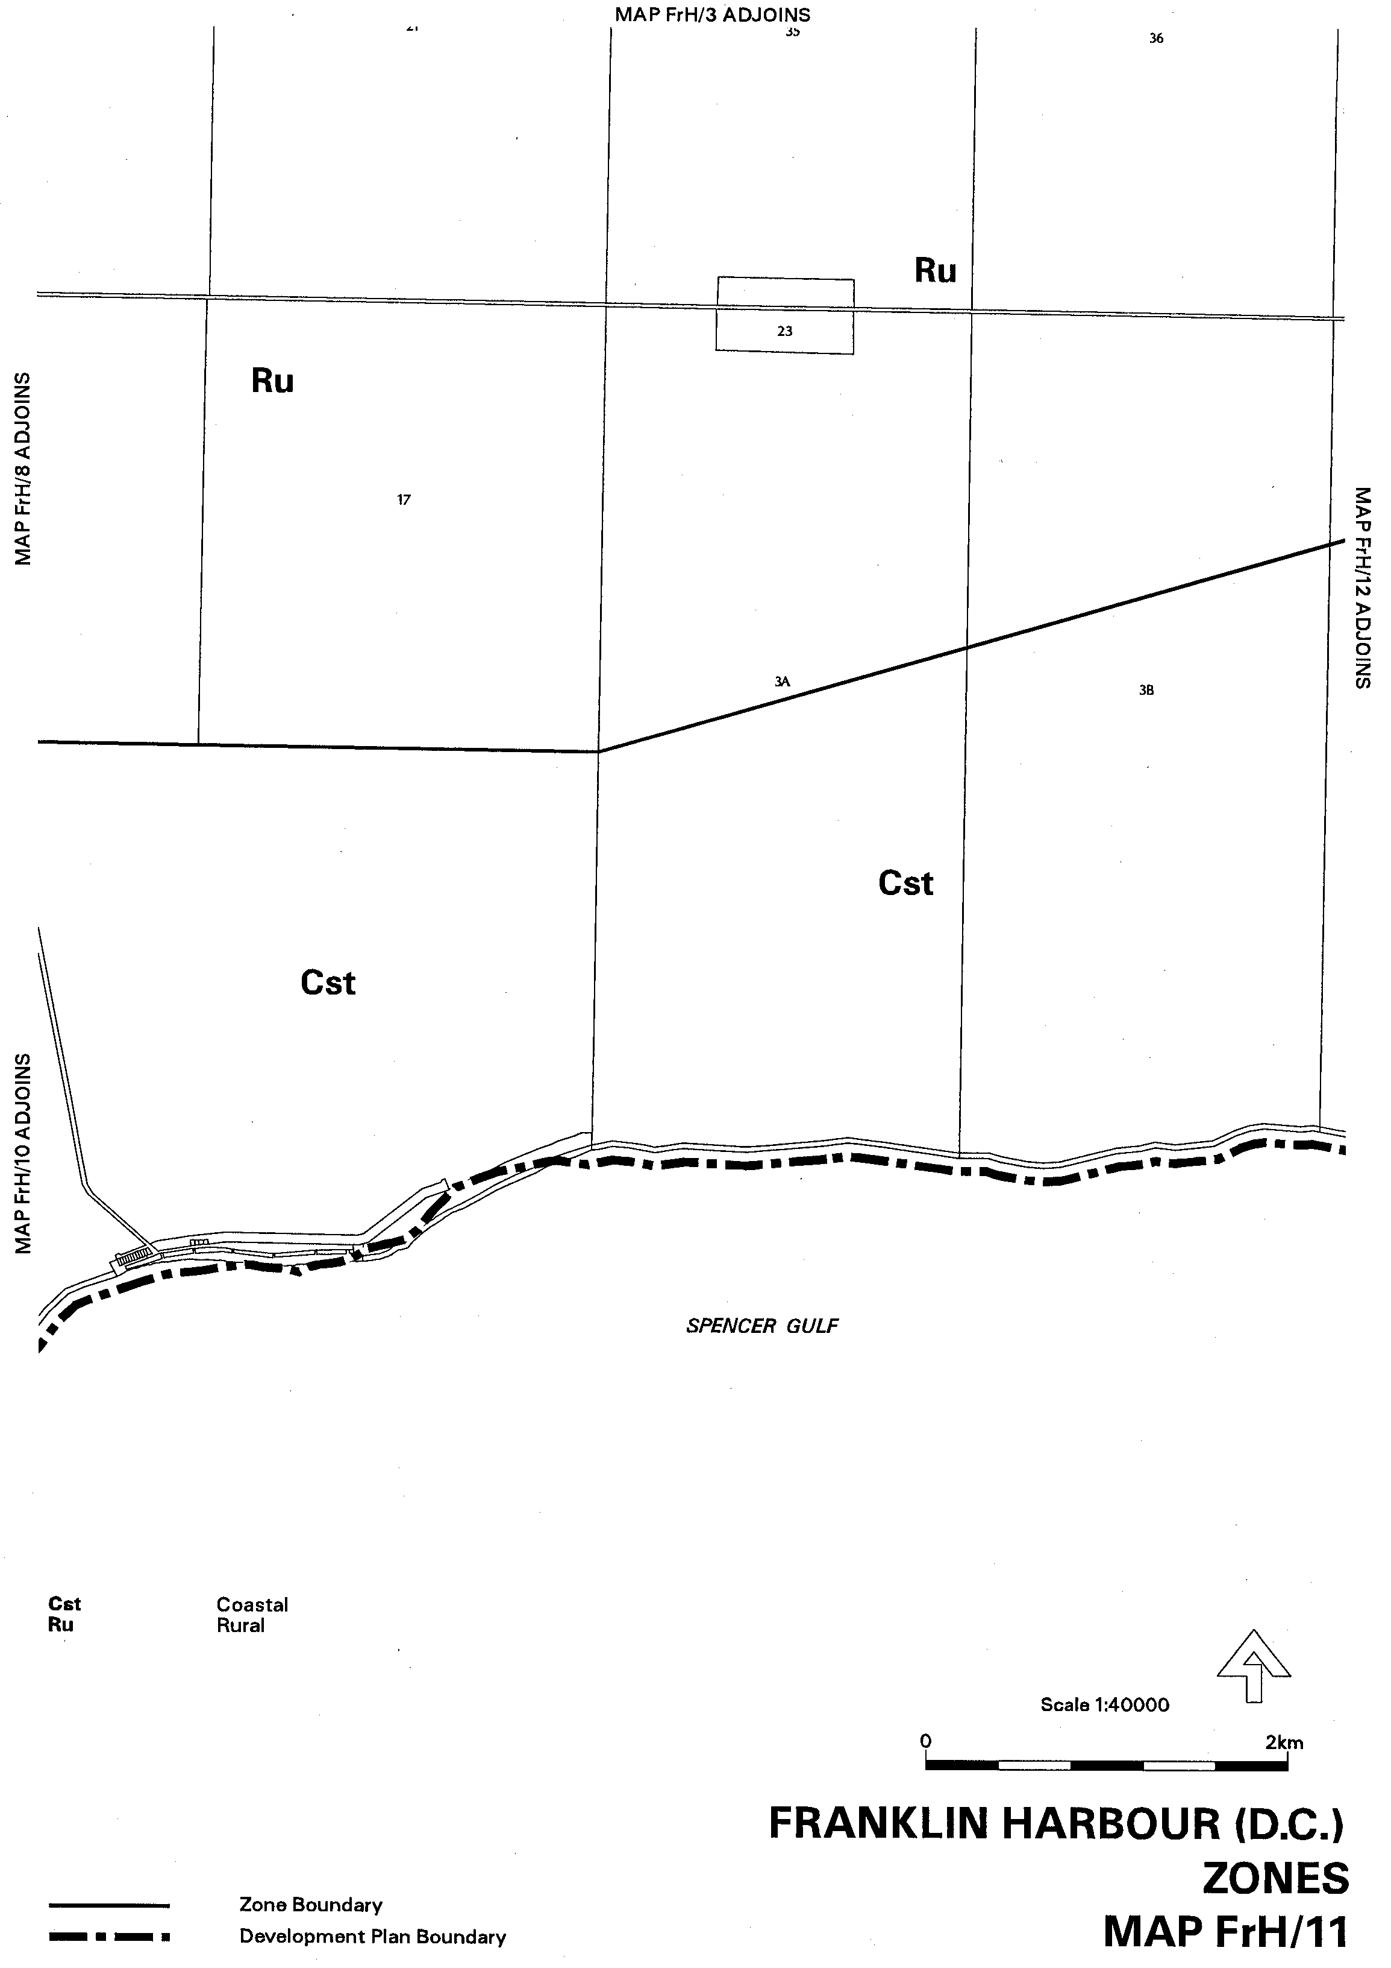

Dated 12 August 2004.
Trish White, Minister for Urban Developmentand Planning
PLN 99/0308

ENVIRONMENT PROTECTION ACT 1993
Approval of Category B Containers
I, STEPHEN RICHARD SMITH, Senior Adviser, Container Deposit Legislation and Delegate of the Environment Protection Authority (‘the Authority’), pursuant to section 69 of the Environment Protection Act 1993 (SA) (‘the Act’) hereby:
Approval of Category B Containers:
Approve as Category B Containers, subject to the conditions in subclauses (i) and (ii) below, each of the classes of containers identified by reference to the following matters described in the first 4 columns of Schedule 1 of this Notice which are sold in South Australia:
(a) the product which each class of containers shall contain;
(b) the size of the containers;
(c) the type of containers;
(d) the name of the holders of these approvals.
(i) Subsection 69 (3) Arrangements:
The holders of these approvals must ensure that the empty containers which belong to their respective class of containers hereby approved as Category B Containers are collected from collection depots approved under section 69 of the Act by the party named in Column 5 of Schedule 1 of this Notice; and
(ii) Approved Refund Markings:
(a) The holders of these approvals must ensure that each container which belongs to their respective class of containers hereby approved as Category B Containers bears the refund marking approved by the Authority in respect of that class of containers.
(b) The refund marking that appears on each container that belongs to the class of containers hereby approved, must be a minimum 1.5 mm for the smallest letter in the statement and a minimum 3 mm for the numeric (‘5’) in the statement.

Column 1 | Column 2 | Column 3 | Column 4 | Column 5
Product Name | Container  Size (mL) | Container Type | Approval Holder | Collection  Arrangements
Fruto Exotic | 350 | Glass with Polypro-pylene Label | Alnigma Enterprises Pty Ltd | Marine Stores Ltd
Fruto Guava | 350 | Glass with Polypro-pylene Label | Alnigma Enterprises Pty Ltd | Marine Stores Ltd
Fruto Mango | 350 | Glass with Polypro-pylene Label | Alnigma Enterprises Pty Ltd | Marine Stores Ltd
Fruto Orange | 350 | Glass with Polypro-pylene Label | Alnigma Enterprises Pty Ltd | Marine Stores Ltd
Fruto Orange & Carrot | 350 | Glass with Polypro-pylene Label | Alnigma Enterprises Pty Ltd | Marine Stores Ltd
Fruto Pineapple | 350 | Glass with Polypro-pylene Label | Alnigma Enterprises Pty Ltd | Marine Stores Ltd
Fruto Strawberry | 350 | Glass with Polypro-pylene Label | Alnigma Enterprises Pty Ltd | Marine Stores Ltd
Aquaqueen Australian Spring Water | 1 500 | PET with Polypro-pylene Label | Aquaqueen International Pty Ltd | Statewide Recycling
Schweppes Pink Lemonade Strawberry & Lemon Flavoured Drink | 1 250 | PET with Polypro-pylene Label | Cadbury Schweppes Pty Ltd | Statewide Recycling
Schweppes Pink Lemonade Strawberry & Lemon Flavoured Drink | 600 | PET with Polypro-pylene Label | Cadbury Schweppes Pty Ltd | Statewide Recycling
Asahi Super Dry | 330 | Glass with Paper Label | Carlton & United Breweries Ltd | Visy CDL Recycling Services
Belle Vue Kriek | 375 | Glass with Paper Label | Carlton & United Breweries Ltd | Visy CDL Recycling Services
Black Douglas 100% Scotch Whisky & Dry | 440 | Can—Aluminium | Carlton & United Breweries Ltd | Statewide Recycling
Cougar & Cola Bourbon Whiskey | 375 | Glass with Paper Label | Carlton & United Breweries Ltd | Visy CDL Recycling Services
Cougar & Dry Bourbon Whiskey | 375 | Glass with Paper Label | Carlton & United Breweries Ltd | Visy CDL Recycling Services
Cougar XS & Cola Bourbon Whiskey | 375 | Glass with Paper Label | Carlton & United Breweries Ltd | Visy CDL Recycling Services
Mount Franklin Lightly Sparkling | 250 | Glass with Polypro-pylene Label | Coca Cola Amatil (Aust) Pty Ltd | Statewide Recycling
Mount Franklin Lightly Sparkling | 500 | Glass with Polypro-pylene Label | Coca Cola Amatil (Aust) Pty Ltd | Statewide Recycling
Recharge By Sprite | 300 | Can—Aluminium | Coca Cola Amatil (Aust) Pty Ltd | Statewide Recycling
Recharge By Sprite | 330 | Glass with PET Sleeve | Coca Cola Amatil (Aust) Pty Ltd | Statewide Recycling
Amsterdam Mariner Premium Lager | 500 | Can—Aluminium | Dan Murphys | Marine Stores Ltd
Gordons G & T Gin & Tonic with a twist of Lemon | 250 | Glass with PVC Label | Diageo Australia Pty Ltd | Statewide Recycling
Amstel Beer | 330 | Glass with Paper Label | Heineken Australia Pty Ltd | Marine Stores Ltd
Birra Moretti | 330 | Glass with Paper Label | Heineken Australia Pty Ltd | Marine Stores Ltd
A Marca Bravara Beer | 330 | Glass with Paper Label | Independent Distillers Australia | Statewide Recycling
Carling Black Label Premium Beer | 375 | Can—Aluminium | Independent Distillers Australia | Statewide Recycling
Haagen Premium Light Lager Beer | 330 | Glass with Paper Label | Independent Distillers Australia | Statewide Recycling
Kingfisher Premium Lager Beer | 330 | Glass with Paper Label | Independent Distillers Australia | Statewide Recycling
The Claymore Scotch Whisky & Cola | 375 | Can—Aluminium | Independent Distillers Australia | Statewide Recycling
Tuborg Pilsner Beer | 330 | Glass with Paper Label | Independent Distillers Australia | Statewide Recycling
Vodka Mudshake Honeycomb | 270 | Glass with Paper Label | Independent Distillers Australia | Statewide Recycling
Sapporo Draft Beer | 334 | Glass with Paper Label | Japan Food Corp (Aust) Pty Ltd | Marine Stores Ltd
Yebisu Premium All Malt Beer | 334 | Glass with Paper Label | Japan Food Corp (Aust) Pty Ltd | Marine Stores Ltd
Coles Natural Spring Water | 1 500 | PET with Paper Label | Mountain H₂O Pty Ltd | Statewide Recycling
Coles Natural Spring Water | 600 | PET with Paper Label | Mountain H₂O Pty Ltd | Statewide Recycling
Mountain H₂O Premium Organic Natural Spring Water | 1 500 | PET with Paper Label | Mountain H₂O Pty Ltd | Statewide Recycling
Mountain H₂O Premium Organic Natural Spring Water | 600 | PET with Paper Label | Mountain H₂O Pty Ltd | Statewide Recycling
Diet Waterfords Natural Mineral Water Apple Berry | 1 500 | PET with Paper Label | P & N Beverages Australia Pty Limited | Flagcan Distributors
Diet Waterfords Natural Mineral Water Lemon Lime & Bitters | 1 500 | PET with Paper Label | P & N Beverages Australia Pty Limited | Flagcan Distributors
Diet Waterfords Natural Mineral Water Lemon Lime Orange | 1 250 | PET with Paper Label | P & N Beverages Australia Pty Limited | Flagcan Distributors
Diet Waterfords Natural Mineral Water Lemon Lime & Orange | 1 500 | PET with Paper Label | P & N Beverages Australia Pty Limited | Flagcan Distributors
Diet Waterfords Natural Mineral Water Melon Mango | 1 250 | PET with Paper Label | P & N Beverages Australia Pty Limited | Flagcan Distributors
Diet Waterfords Natural Mineral Water Melon Mango | 1 500 | PET with Paper Label | P & N Beverages Australia Pty Limited | Flagcan Distributors
Diet Waterfords Natural Mineral Water Peach Passion | 1 500 | PET with Paper Label | P & N Beverages Australia Pty Limited | Flagcan Distributors
LA Maxi Ice Cola | 300 | PET with Paper Label | P & N Beverages Australia Pty Limited | Flagcan Distributors
P & N Blackcurrant Delight | 1 200 | PET with Paper Label | P & N Beverages Australia Pty Limited | Flagcan Distributors
P & N Cranberry Delight | 1 200 | PET with Paper Label | P & N Beverages Australia Pty Limited | Flagcan Distributors
P & N Lido Lemonade | 300 | PET with Paper Label | P & N Beverages Australia Pty Limited | Flagcan Distributors
Waterfords Hi Juice Lemon Natural Mineral Water | 1 250 | PET with Paper Label | P & N Beverages Australia Pty Limited | Flagcan Distributors
Waterfords Hi Juice Orange Lemon Lime Natural Mineral Water | 1 250 | PET with Paper Label | P & N Beverages Australia Pty Limited | Flagcan Distributors
Waterfords Hi Juice Orange Mango Natural Mineral Water | 1 250 | PET with Paper Label | P & N Beverages Australia Pty Limited | Flagcan Distributors
Waterfords Hi Juice Orange Passionfruit Natural Mineral Water | 1 250 | PET with Paper Label | P & N Beverages Australia Pty Limited | Flagcan Distributors
Waterfords Sparkling Mineral Water | 1 500 | PET with Paper Label | P & N Beverages Australia Pty Limited | Flagcan Distributors
Waterfords Sparkling Natural Mineral  Water | 1 250 | PET with Paper Label | P & N Beverages Australia Pty Limited | Flagcan Distributors
Panther Premium Lager Beer with Guarana | 330 | Glass with Paper Label | Panther Beer Pty Ltd | Statewide Recycling
Weihenstephaner Hefe Weissbier | 500 | Glass with Paper Label | Phoenix Beers | Marine Stores Ltd
Weihenstephaner Hefeweissbier Dunkel | 500 | Glass with Paper Label | Phoenix Beers | Marine Stores Ltd
Weihenstephaner Kristall Weissbier | 500 | Glass with Paper Label | Phoenix Beers | Marine Stores Ltd
Weihenstephaner Original Bayrisch Mild | 500 | Glass with Paper Label | Phoenix Beers | Marine Stores Ltd
Weihenstephaner Pilsner | 500 | Glass with Paper Label | Phoenix Beers | Marine Stores Ltd
Weihenstephaner Tradition Bayrisch Dunkel | 500 | Glass with Paper Label | Phoenix Beers | Marine Stores Ltd
Traffic Stoppers Lemonade Soft Drink | 2 000 | PET | Pure & Natural Beverages Pty Ltd | Flagcan Distributors
Heineken Beer | 330 | Can—Aluminium | South Australian Brewing Company Limited | Marine Stores Ltd
Heineken Beer | 330 | Glass with Paper Label | South Australian Brewing Company Limited | Marine Stores Ltd
Heineken Beer | 500 | Can—Aluminium | South Australian Brewing Company Limited | Marine Stores Ltd
Heineken Beer | 640 | Glass with Paper Label | South Australian Brewing Company Limited | Marine Stores Ltd
Tiger Beer | 330 | Can—Aluminium | South Australian Brewing Company Limited | Marine Stores Ltd
Tiger Beer | 330 | Glass with Paper Label | South Australian Brewing Company Limited | Marine Stores Ltd
Southern Comfort & Cola | 275 | Glass with Polypro-pylene Label | Swift & Moore Pty Ltd | Statewide Recycling
Southern Comfort & Dry | 275 | Glass with Polypro-pylene Label | Swift & Moore Pty Ltd | Statewide Recycling
Southern Comfort & Lemonade | 275 | Glass with Polypro-pylene Label | Swift & Moore Pty Ltd | Statewide Recycling
Alhambra Reserva 1925 | 330 | Glass with Paper Label | Toro Wines & Spirits | Statewide Recycling

JURIES (REMUNERATION FOR JURY SERVICE) REGULATIONS 2002
Declaration of Long Trial
PURSUANT to Regulation 5 (2) of the Juries (Remuneration for Jury Service) Regulations 2002 and on the advice of the relevant Court, I, Paul Holloway, Acting Attorney-General, do hereby declare the criminal trial of R. v. Mark Ray Haydon to be a long trial for the purposes of those regulations.
Dated 9 August 2004.
P. Holloway, Acting Attorney-General

JURIES (REMUNERATION FOR JURY SERVICE) REGULATIONS 2002
Declaration of Long Trial
PURSUANT to Regulation 5 (2) of the Juries (Remuneration for Jury Service) Regulations 2002 and on the advice of the relevant Court, I, Paul Holloway, Acting Attorney-General, do hereby declare the criminal trial of R. v. Jean Eric Gassey to be a long trial for the purposes of those regulations.
Dated 9 August 2004.
P. Holloway, Acting Attorney-General

LAND AND BUSINESS (SALE AND CONVEYANCING)
ACT 1994
Exemption
TAKE notice that, pursuant to section 23 (3) of the Land and Business (Sale and Conveyancing) Act 1994, I, John David Hill, Minister for Consumer Affairs, do hereby exempt the person named in Schedule 1 from the application of section 23 (2) of the Act in relation to the purchase of the land specified in Schedule 2.
Schedule 1
Anna De Palma, an employee of Toop Real Estate Group Pty Ltd.
Schedule 2
The whole of the land described in certificate of title register book volume 5814, folio 297, situated at 28 Woodfield Avenue, Fullarton, S.A. 5063.
Dated 12 August 2004.
Signed for and on behalf of the Minister for Consumer Affairs by the Commissioner for Consumer Affairs:
M. Bodycoat, Commissioner

LAND AND BUSINESS (SALE AND CONVEYANCING)
ACT 1994
Exemption
TAKE notice that, pursuant to section 23 (3) of the Land and Business (Sale and Conveyancing) Act 1994, I, John David Hill, Minister for Consumer Affairs, do hereby exempt the person named in Schedule 1 from the application of section 23 (2) of the Act in relation to the purchase of the land specified in Schedule 2.
Schedule 1
Richard John Connock, an employee of Barrie Magain Realty (The Hub) Pty Ltd.
Schedule 2
A portion of the land described in certificate of title register book volume 5761, folio 839, situated at 1/13 (Lot 100) Third Avenue, Ascot Park, S.A. 5043.
Dated 12 August 2004.
Signed for and on behalf of the Minister for Consumer Affairs by the Commissioner for Consumer Affairs:
M. Bodycoat, Commissioner

LIQUOR LICENSING ACT 1997
Notice of Application
NOTICE is hereby given, pursuant to section 52 (2) (b) of the Liquor Licensing Act 1997, that John Duval Wines Pty Ltd as Trustee for John Duval Wine Trust, has applied to the Licensing Authority for a Producer’s Licence in respect of premises situated at 9 Park Street, Tanunda, S.A. 5352 and to be known as John Duval Wines.
The application has been set down for hearing on 10 September 2004 at 9 a.m.
Any person may object to the application by lodging a notice of objection in the prescribed form with the Licensing Authority, and serving a copy of the notice on the applicant at the applicant’s address given above, at least seven days before the hearing date (viz: 2 September 2004).
The applicant’s address for service is c/o Hynd & Co. Pty Ltd, (Attention: Darren Foeng), Level 2, 66 Wyatt Street, Adelaide, S.A. 5000.
Plans in respect of the premises the subject of the application are open to public inspection without fee at the Office of the Liquor and Gambling Commissioner, 9th Floor, East Wing, 50 Grenfell Street, Adelaide, S.A. 5000. Phone 8226 8410, Fax:
8226 8512. Email: olgc@agd.sa.gov.au.
Dated 4 August 2004.
Applicant

LIQUOR LICENSING ACT 1997
Notice of Application
NOTICE is hereby given, pursuant to section 52 (2) (b) of the Liquor Licensing Act 1997, that Tarca Investments Pty Ltd has applied to the Licensing Authority for the transfer of a Hotel Licence and Extended Trading Authorisation in respect of premises situated at 36 First Street, Ardrossan, S.A. 5571 and known as Ardrossan Motel Hotel.
The application has been set down for hearing on 10 September 2004 at 9 a.m.
Conditions
The following licence conditions are sought:
Extended Trading Authorisation:
Monday to Thursday: Midnight to 1 a.m. the following day;
Friday: Midnight to 2 a.m. the following day;
Saturday: Midnight to 3 a.m. the following day;
Sunday: 8 a.m. to 11 a.m. and 8 p.m. to 2 a.m. the following day;
Maundy Thursday and Christmas Eve: Midnight to 2 a.m. the following day;
New Year’s Eve: 2 a.m. the following day to 3 a.m. the following day;
Days preceding other Public Holidays: Midnight to 2 a.m. the following day;
Sundays preceding Public Holidays: 8 p.m. to 2 a.m. the following day.
Any person may object to the application by lodging a notice of objection in the prescribed form with the Licensing Authority, and serving a copy of the notice on the applicant at the applicant’s address given above, at least seven days before the hearing date (viz: 2 September 2004).
The applicant’s address for service is c/o David Tillett, Duncan Basheer Hannon, 66 Wright Street, Adelaide, S.A. 5000.
Plans in respect of the premises the subject of the application are open to public inspection without fee at the Office of the Liquor and Gambling Commissioner, 9th Floor, East Wing, 50 Grenfell Street, Adelaide, S.A. 5000. Phone 8226 8410, Fax:
8226 8512. Email: olgc@agd.sa.gov.au.
Dated 2 August 2004.
Applicant

LIQUOR LICENSING ACT 1997
Notice of Application
NOTICE is hereby given, pursuant to section 52 (2) (b) of the Liquor Licensing Act 1997, that David and Rebecca Lonie and Roger Dix have applied to the Licensing Authority for a Producer’s Licence in respect of premises situated at Lot 1, Bald Hill Road, Prospect Hill, S.A. 5201 and known as Battunga Park Wines.
The application has been set down for hearing on 10 September 2004 at 9 a.m.
Any person may object to the application by lodging a notice of objection in the prescribed form with the Licensing Authority, and serving a copy of the notice on the applicants at the applicants’ address given above, at least seven days before the hearing date (viz: 2 September 2004).
The applicants’ address for service is c/o David Lonie, Box 208, Meadows, S.A. 5201.
Plans in respect of the premises the subject of the application are open to public inspection without fee at the Office of the Liquor and Gambling Commissioner, 9th Floor, East Wing, 50 Grenfell Street, Adelaide, S.A. 5000. Phone 8226 8410, Fax:
8226 8512. Email: olgc@agd.sa.gov.au.
Dated 4 August 2004.
Applicants

LIQUOR LICENSING ACT 1997
Notice of Application
NOTICE is hereby given, pursuant to section 52 (2) (b) of the Liquor Licensing Act 1997, that Magpie Estate Pty Ltd has applied to the Licensing Authority for a Producer’s Licence in respect of premises situated at Lot 841, corner Stelzer and Seppeltsfield Roads, Dorrein, S.A. 5355 and to be known as Magpie Estate.
The application has been set down for hearing on 10 September 2004 at 9 a.m.
Any person may object to the application by lodging a notice of objection in the prescribed form with the Licensing Authority, and serving a copy of the notice on the applicant at the applicant’s address given above, at least seven days before the hearing date (viz: 2 September 2004).
The applicant’s address for service is c/o Rolf Binder, P.O. Box 126, Tanunda, S.A. 5352.
Plans in respect of the premises the subject of the application are open to public inspection without fee at the Office of the Liquor and Gambling Commissioner, 9th Floor, East Wing, 50 Grenfell Street, Adelaide, S.A. 5000. Phone 8226 8410, Fax:
8226 8512. Email: olgc@agd.sa.gov.au.
Dated 4 August 2004.
Applicant

LIQUOR LICENSING ACT 1997
Notice of Application
NOTICE is hereby given, pursuant to section 52 (2) (b) of the Liquor Licensing Act 1997, that The Lane Wine Company Pty Ltd has applied to the Licensing Authority for a Producer’s Licence in respect of premises situated at Lot 22, Paech Brothers Road, Hahndorf, S.A. 5245 and to be known as The Lane Wine Company.
The application has been set down for hearing on 10 September 2004 at 9 a.m.
Any person may object to the application by lodging a notice of objection in the prescribed form with the Licensing Authority, and serving a copy of the notice on the applicant at the applicant’s address given above, at least seven days before the hearing date (viz: 2 September 2004).
The applicant’s address for service is c/o Duncan Basheer Hannon, Barristers & Solicitors, (Attention: Max Basheer/David Tillett), G.P.O. Box 2, Adelaide, S.A. 5001.
Plans in respect of the premises the subject of the application are open to public inspection without fee at the Office of the Liquor and Gambling Commissioner, 9th Floor, East Wing, 50 Grenfell Street, Adelaide, S.A. 5000. Phone 8226 8410, Fax:
8226 8512. Email: olgc@agd.sa.gov.au.
Dated 5 August 2004.
Applicant

LIQUOR LICENSING ACT 1997
Notice of Application
NOTICE is hereby given, pursuant to section 52 (2) (b) of the Liquor Licensing Act 1997, that Koonara Wines Pty Ltd has applied to the Licensing Authority for a Producer’s Licence and a Direct Sales Licence in respect of premises situated at Church Street, Penola, S.A. 5277 and to be known as Koonara Wines.
The application has been set down for hearing on 10 September 2004 at 9 a.m.
Any person may object to the application by lodging a notice of objection in the prescribed form with the Licensing Authority, and serving a copy of the notice on the applicant at the applicant’s address given above, at least seven days before the hearing date (viz: 2 September 2004).
The applicant’s address for service is c/o Dru Reschke, Box 5, Coonawarra, S.A. 5263.
Plans in respect of the premises the subject of the application are open to public inspection without fee at the Office of the Liquor and Gambling Commissioner, 9th Floor, East Wing, 50 Grenfell Street, Adelaide, S.A. 5000. Phone 8226 8410, Fax:
8226 8512. Email: olgc@agd.sa.gov.au.
Dated 5 August 2004.
Applicant

LIQUOR LICENSING ACT 1997
Notice of Application
NOTICE is hereby given, pursuant to section 52 (2) (b) of the Liquor Licensing Act 1997, that Malcolm Bruce Coleman has applied to the Licensing Authority for a Direct Sales Licence in respect of premises situated at Lot 26, Koch Road, Gomersall, S.A. 5352 and to be known as Edenville Wines.
The application has been set down for hearing on 10 September 2004 at 9 a.m.
Any person may object to the application by lodging a notice of objection in the prescribed form with the Licensing Authority, and serving a copy of the notice on the applicant at the applicant’s address given above, at least seven days before the hearing date (viz: 2 September 2004).
The applicant’s address for service is c/o Kelly & Co., Level 17, Santos House, 91 King William Street, Adelaide, S.A. 5000.
Plans in respect of the premises the subject of the application are open to public inspection without fee at the Office of the Liquor and Gambling Commissioner, 9th Floor, East Wing, 50 Grenfell Street, Adelaide, S.A. 5000. Phone 8226 8410, Fax:
8226 8512. Email: olgc@agd.sa.gov.au.
Dated 5 August 2004.
Applicant

LIQUOR LICENSING ACT 1997
Notice of Application
NOTICE is hereby given, pursuant to section 52 (2) (b) of the Liquor Licensing Act 1997, that Jeremiah One Wine Company Pty Ltd has applied to the Licensing Authority for a Producer’s Licence in respect of premises situated at Lot 13, Tynan Road, Kuitpo, S.A. 5172 and to be known as Jeremiah One Wine Company.
The application has been set down for hearing on 10 September 2004 at 9 a.m.
Any person may object to the application by lodging a notice of objection in the prescribed form with the Licensing Authority, and serving a copy of the notice on the applicant at the applicant’s address given above, at least seven days before the hearing date (viz: 2 September 2004).
The applicant’s address for service is c/o Duncan Basheer Hannon, Barristers & Solicitors (Attention: Max Basheer/David Tillett), G.P.O. Box 2, Adelaide, S.A. 5001.
Plans in respect of the premises the subject of the application are open to public inspection without fee at the Office of the Liquor and Gambling Commissioner, 9th Floor, East Wing, 50 Grenfell Street, Adelaide, S.A. 5000. Phone 8226 8410, Fax:
8226 8512. Email: olgc@agd.sa.gov.au.
Dated 6 August 2004.
Applicant

LIQUOR LICENSING ACT 1997
Notice of Application
NOTICE is hereby given, pursuant to section 52 (2) (b) of the Liquor Licensing Act 1997, that George and Sandra Camilleri have applied to the Licensing Authority for the transfer of a Hotel Licence, Entertainment Consent and Extended Trading Authorisation in respect of premises situated at Main Road, Tungkillo, S.A. 5236 and known as District Hotel.
The application has been set down for hearing on 10 September 2004 at 9 a.m.
Conditions
The following licence conditions are sought:
Extended Trading Authorisation:
Wednesday to Saturday: Midnight to 2 a.m. the following day;
Sunday: 9 a.m. to 11 a.m. and 8 p.m. to midnight;
Maundy Thursday: Midnight to 2 a.m. the following day;
Christmas Eve: Midnight to 2 a.m. the following day;
Sunday Christmas Eve: 8 p.m. to 2 a.m. the following day;
New Year’s Eve: 2 a.m. the following day to 3 a.m. the following day;
Days preceding other Public Holidays: Midnight to 1 a.m. the following day;
Sundays preceding Public Holidays: 8 p.m. to 1 a.m. the following day;
Sundays for consumption off the Licensed Premises: 8 p.m. to midnight.
Entertainment Consent is sought for the whole of the licensed premises and during the hours sought.
Any person may object to the application by lodging a notice of objection in the prescribed form with the Licensing Authority, and serving a copy of the notice on the applicants at the applicants’ address given above, at least seven days before the hearing date (viz: 2 September 2004).
The applicants’ address for service is Sandra Camilleri, 5 Main Road, Tungkillo, S.A. 5236.
Plans in respect of the premises the subject of the application are open to public inspection without fee at the Office of the Liquor and Gambling Commissioner, 9th Floor, East Wing, 50 Grenfell Street, Adelaide, S.A. 5000. Phone 8226 8410, Fax:
8226 8512. Email: olgc@agd.sa.gov.au.
Dated 6 August 2004.
Applicants

LIQUOR LICENSING ACT 1997
Notice of Application
NOTICE is hereby given, pursuant to section 52 (2) (b) of the Liquor Licensing Act 1997, that Michael James and Susan Kaye Alexander have applied to the Licensing Authority for a Producer’s Licence in respect of premises situated at Lot 46, Beaumonts Road, Balhannah, S.A. 5242 and to be known as Michael James Alexander & Susan Kaye Alexander.
The application has been set down for hearing on 10 September 2004 at 9 a.m.
Any person may object to the application by lodging a notice of objection in the prescribed form with the Licensing Authority, and serving a copy of the notice on the applicants at the applicants’ address given above, at least seven days before the hearing date (viz: 2 September 2004).
The applicants’ address for service is Michael Alexander, P.O. Box 18, Glen Osmond, S.A. 5064.
Plans in respect of the premises the subject of the application are open to public inspection without fee at the Office of the Liquor and Gambling Commissioner, 9th Floor, East Wing, 50 Grenfell Street, Adelaide, S.A. 5000. Phone 8226 8410, Fax:
8226 8512. Email: olgc@agd.sa.gov.au.
Dated 6 August 2004.
Applicants

LIQUOR LICENSING ACT 1997
Notice of Application
NOTICE is hereby given, pursuant to section 52 (2) (b) of the Liquor Licensing Act 1997, that Jeremy Charles and Heidi Susanne Holmes as Trustee for the D’or to Door Wines Direct have applied to the Licensing Authority for a Direct Sales Licence in respect of premises situated at 7A Murray Street, Tanunda, S.A. 5352 and known as D’or to Door Wines Direct.
The application has been set down for hearing on 10 September 2004 at 9 a.m.
Any person may object to the application by lodging a notice of objection in the prescribed form with the Licensing Authority, and serving a copy of the notice on the applicants at the applicants’ address given above, at least seven days before the hearing date (viz: 2 September 2004).
The applicants’ address for service is c/o Attention: Jack Clarke, Hunt & Hunt Lawyers, Level 12, 26 Flinders Street, Adelaide, S.A. 5000.
Plans in respect of the premises the subject of the application are open to public inspection without fee at the Office of the Liquor and Gambling Commissioner, 9th Floor, East Wing, 50 Grenfell Street, Adelaide, S.A. 5000. Phone 8226 8410, Fax:
8226 8512. Email: olgc@agd.sa.gov.au.
Dated 9 August 2004.
Applicants

LIQUOR LICENSING ACT 1997
Notice of Application
NOTICE is hereby given, pursuant to section 52 (2) (b) of the Liquor Licensing Act 1997, that Mailord Pty Ltd has applied to the Licensing Authority for the transfer of a Residential Licence in respect of premises situated at corner Gover and O’Connell Streets, North Adelaide, S.A. 5006 and known as Old Adelaide Inn.
The application has been set down for hearing on 13 September 2004 at 9 a.m.
Any person may object to the application by lodging a notice of objection in the prescribed form with the Licensing Authority, and serving a copy of the notice on the applicant at the applicant’s address given above, at least seven days before the hearing date (viz: 3 September 2004).
The applicant’s address for service is c/o Ian Edgley, Edgley Lawyers, Level 8, 185 Victoria Square, Adelaide, S.A. 5000.
Plans in respect of the premises the subject of the application are open to public inspection without fee at the Office of the Liquor and Gambling Commissioner, 9th Floor, East Wing, 50 Grenfell Street, Adelaide, S.A. 5000. Phone 8226 8410, Fax:
8226 8512. Email: olgc@agd.sa.gov.au.
Dated 2 August 2004.
Applicant

LIQUOR LICENSING ACT 1997
Notice of Application
NOTICE is hereby given, pursuant to section 52 (2) (b) of the Liquor Licensing Act 1997, that Adelaide Windmill Pty Ltd has applied to the Licensing Authority for the transfer of a Hotel and Gaming Machine Licence in respect of premises situated at 94 Main North Road, Prospect, S.A. 5082 and known as Windmill Hotel.
The application has been set down for hearing on 13 September 2004 at 9.30 a.m.
Any person may object to the application by lodging a notice of objection in the prescribed form with the Licensing Authority, and serving a copy of the notice on the applicant at the applicant’s address given above, at least seven days before the hearing date (viz: 3 September 2004).
The applicant’s address for service is c/o Duncan Basheer Hannon, Barristers & Solicitors (Attention: Max Basheer/David Tillett), G.P.O. Box 2, Adelaide, S.A. 5001.
Plans in respect of the premises the subject of the application are open to public inspection without fee at the Office of the Liquor and Gambling Commissioner, 9th Floor, East Wing, 50 Grenfell Street, Adelaide, S.A. 5000. Phone 8226 8410, Fax:
8226 8512. Email: olgc@agd.sa.gov.au.
Dated 30 July 2004.
Applicant

LIQUOR LICENSING ACT 1997
Notice of Application
NOTICE is hereby given, pursuant to section 52 (2) (b) of the Liquor Licensing Act 1997, that Astor Hotel (S.A.) Pty Ltd has applied to the Licensing Authority for the transfer of a Hotel Licence in respect of premises situated at 437 Pulteney Street, Adelaide, S.A. 5000 and known as Astor Restaurant & Bar.
The application has been set down for hearing on 13 September 2004 at 10 a.m.
Any person may object to the application by lodging a notice of objection in the prescribed form with the Licensing Authority, and serving a copy of the notice on the applicant at the applicant’s address given above, at least seven days before the hearing date (viz: 3 September 2004).
The applicant’s address for service is c/o Ben Allen, Wallmans, 173 Wakefield Street, Adelaide, S.A. 5000.
Plans in respect of the premises the subject of the application are open to public inspection without fee at the Office of the Liquor and Gambling Commissioner, 9th Floor, East Wing, 50 Grenfell Street, Adelaide, S.A. 5000. Phone 8226 8410, Fax:
8226 8512. Email: olgc@agd.sa.gov.au.
Dated 5 August 2004.
Applicant

LIQUOR LICENSING ACT 1997
Notice of Application
NOTICE is hereby given, pursuant to section 52 (2) (b) of the Liquor Licensing Act 1997, that Anthony Mark Searle as Nominee for the Corporation of the City of Marion has applied to the Licensing Authority for the transfer of a Special Circumstances Licence in respect of premises situated at 287 Diagonal Road, Oaklands Park, S.A. 5046 and known as Signature’s Cafe.
The application has been set down for hearing on 13 September 2004 at 10.30 a.m.
Any person may object to the application by lodging a notice of objection in the prescribed form with the Licensing Authority, and serving a copy of the notice on the applicant at the applicant’s address given above, at least seven days before the hearing date (viz: 3 September 2004).
The applicant’s address for service is c/o City of Marion, (Attention Bill Oddy), P.O. Box 21, Oaklands Park, S.A. 5046.
Plans in respect of the premises the subject of the application are open to public inspection without fee at the Office of the Liquor and Gambling Commissioner, 9th Floor, East Wing, 50 Grenfell Street, Adelaide, S.A. 5000. Phone 8226 8410, Fax:
8226 8512. Email: olgc@agd.sa.gov.au.
Dated 6 August 2004.
Applicant

LIQUOR LICENSING ACT 1997
Notice of Application
NOTICE is hereby given, pursuant to section 52 (2) (b) of the Liquor Licensing Act 1997, that Gassip Pty Ltd has applied to the Licensing Authority for the transfer of a Restaurant Licence in respect of premises situated at 61C Jetty Road, Glenelg, S.A. 5045 and known as Glenelg Pizza House.
The application has been set down for hearing on 14 September 2004 at 9 a.m.
Any person may object to the application by lodging a notice of objection in the prescribed form with the Licensing Authority, and serving a copy of the notice on the applicant at the applicant’s address given above, at least seven days before the hearing date (viz: 6 September 2004).
The applicant’s address for service is c/o Nicholas Kernahan, 61C Jetty Road, Glenelg, S.A. 5045.
Plans in respect of the premises the subject of the application are open to public inspection without fee at the Office of the Liquor and Gambling Commissioner, 9th Floor, East Wing, 50 Grenfell Street, Adelaide, S.A. 5000. Phone 8226 8410, Fax:
8226 8512. Email: olgc@agd.sa.gov.au.
Dated 5 August 2004.
Applicant

LIQUOR LICENSING ACT 1997
Notice of Application
NOTICE is hereby given, pursuant to section 52 (2) (b) of the Liquor Licensing Act 1997, that Chichi Cocktail Party Catering Pty Ltd has applied to the Licensing Authority for the transfer of an Entertainment Venue Licence in respect of premises situated at 41 Gouger Street, Adelaide, S.A. 5000 and known as Riffs Music Lounge.
The application has been set down for hearing on 15 September 2004 at 9 a.m.
Conditions
The following licence conditions are sought:
Approval under section 35 (1) (c) to sell liquor on any day except Good Friday and Christmas Day for consumption on the licenced premises by persons:
(a) seated at a table; or
(b) attending a function at which food is provided.
Any person may object to the application by lodging a notice of objection in the prescribed form with the Licensing Authority, and serving a copy of the notice on the applicant at the applicant’s address given above, at least seven days before the hearing date (viz: 7 September 2004).
The applicant’s address for service is c/o Rowland Hall, 41 Gouger Street, Adelaide, S.A. 5000.
Plans in respect of the premises the subject of the application are open to public inspection without fee at the Office of the Liquor and Gambling Commissioner, 9th Floor, East Wing, 50 Grenfell Street, Adelaide, S.A. 5000. Phone 8226 8410, Fax:
8226 8512. Email: olgc@agd.sa.gov.au.
Dated 5 August 2004.
Applicant

MINING ACT 1971
NOTICE is hereby given in accordance with section 35A (1) of the Mining Act 1971, that an application for an Extractive Mineral Lease over the undermentioned mineral claim has been received. Details of the proposal may be inspected at the Department of Primary Industries and Resources, Mineral Resources Group, Level 5, 101 Grenfell Street, Adelaide, S.A. 5000:
Applicant: D., E., K. and E. Wenham
Claim Number: 3459
Location: In allotment 57, DP 59245, Hundred of Myponga—Approximately 5 km north-east of Yankalilla.
Purpose: Excavate gravel, sand, quartzite and shale quarry products.
Reference: T02438
A copy of the proposal has been provided to the District Council of Yankalilla.
Written submissions in relation to the granting of the mining lease are invited to be received at the Department of Primary Industries and Resources, Mineral Resources Group, Level 5, 101 Grenfell Street, Adelaide, S.A. 5000 or G.P.O. Box 1671, Adelaide, S.A. 5001 no later than 17 September 2004.
H. Tyrteos, Mining Registrar

MINING ACT 1971
NOTICE is hereby given in accordance with section 35A (1) of the Mining Act 1971, that an application for an extractive minerals lease over the undermentioned mineral claim has been received. Details of the proposal may be inspected at the Department of Primary Industries and Resources, Mineral Resources Group, Level 5, 101 Grenfell Street, Adelaide, S.A. 5000:
Applicant: Alawoona Dale Pty Ltd
Claim Number: 3150
Location: Section 590, Hundred of Mayurra—Approximately 5 km south-east of Millicent.
Purpose: Recovery of sand.
Reference: T02185
A copy of the proposal has been provided to the Wattle Range District Council.
Written submissions in relation to the granting of the extractive minerals lease are invited to be received at the Department of Primary Industries and Resources, Mineral Resources Group, Level 5, 101 Grenfell Street, Adelaide, S.A. 5000 or G.P.O. Box 1671, Adelaide, S.A. 5001 no later than 24 September 2004.
H. Tyrteos, Mining Registrar

NATIONAL PARKS AND WILDLIFE ACT 1972
Onkaparinga River Reserve Management Plan
I, JOHN HILL, Minister for Environment and Conservation, hereby give notice under the provisions of section 38 of the National Parks and Wildlife Act 1972, that I have adopted a plan of management for the Onkaparinga River Reserve, incorporating Onkaparinga National Park and Onkaparinga Recreation Park.
Copies of the plan may be inspected at or obtained from the offices of the Department for Environment and Heritage, 1 Richmond Road, Keswick, S.A. 5035 (G.P.O. Box 1047, Adelaide, S.A. 5001), telephone (08) 8124 4946, the Belair National Park Office of DEH, Upper Sturt Road, Belair, S.A. 5052, telephone (08) 8278 5477 or on the departmental website:
http://www.environment.sa.gov.au/parks/management_plans.html.
Copies of this publication can be purchased at a cost of $15 per copy (plus $2 postage within South Australia) from the addresses above.
John Hill, Minister for Environment and Conservation

REGULATIONS UNDER THE TRADE STANDARDS
ACT 1979
Exemption
TAKE notice that, pursuant to clause 3 of Schedule 1 of the Regulations under the Trade Standards Act 1979, I, Mark Ian Bodycoat, Commissioner for Consumer Affairs, do hereby exempt the article named in Schedule 1 from the application of those sections of the Regulations in relation to the trapping space described in Schedule 2.
The chair incorporates features, which significantly reduce the risk of entrapment.
Schedule 1
FUNTASTIC LIMITED, children’s folding chair, licence description: Barbie Junior Camping Chair (C12013), Toy Story Junior Camping Chair (C27004), Bob the Builder Junior Camping Chair (C12014), Winnie the Pooh Camping Chair (C12012), Care Bears Junior Camping Chair (C27003), Barbie Eco Fresh Camping Chair (C27008), Rex Hunt Father and Child Camping Set (C27006), Winnie the Pooh Bubbles Junior Camping Chair (C27009), Teddy Junior Camping Chair, Spiderman 2 Camping Chair (C27014), Batman Camping Chair, Buzz Light Year Camping Chair (C27018), Thunderbirds Camping Chair, Teenage Mutant Ninja Turtles Camping Chair (C27007), The Incredibles Camping Chair, Disney Princesses Camping Chair and Sesame Street Camping Chair.
Schedule 2
Exemption from complying with the provisions of Clause 2 (1). A children’s folding chair must be so constructed that the minimum distance between components forming a trapping space is 5 mm.
Dated 29 July 2004.
M. Bodycoat, Commissioner for Consumer Affairs
Ref: PS 118/86

ROADS (OPENING AND CLOSING) ACT 1991:
SECTION 24
NOTICE OF CONFIRMATION OF ROAD
PROCESS ORDER
Public Road, Gillman
Deposited Plan 64880
BY Road Process Order made on 14 April 2004, the City of Port Adelaide Enfield ordered that:
1. The whole of the public road between Evans Street and Norfolk Street and adjoining the southern boundary of allotment 11 in Filed Plan 126591, more particularly lettered ‘A’ in Preliminary Plan No. 03/0110 be closed.
2. The whole of the land subject to closure be transferred to Betty Annette Blackwood and William Lawrence Blackwood in accordance with agreement for transfer dated 1 July 2003 entered into between the City of Port Adelaide Enfield and
B. A. and W. L. Blackwood.
3. The following easement be granted over portion of the land subject to that closure:
Grant to the South Australian Water Corporation an easement for sewerage purposes.
On 1 July 2004, that order was confirmed by the Minister for Administrative Services conditionally on approval and deposit of the survey plan by the Registrar-General. The condition has now been fulfilled.
Pursuant to section 24 (5) of the Roads (Opening and Closing) Act 1991, NOTICE of the order referred to above and its confirmation is hereby given.
Dated 12 August 2004.
P. M. Kentish, Surveyor-General

ROAD TRAFFIC ACT 1961
Exemption for Single Axle Pig Trailers to Exceed the Maximum Mass Limit of 8.5 tonnes
PURSUANT to section 163AA of the Road Traffic Act 1961, I hereby exempt pig trailers fitted with a single axle from the maximum mass limit requirement of 8.5 tonnes specified in Schedule 1, Table 1 ‘Mass limits for single axles and axle groups’, of the Road Traffic (Mass and Loading Requirements) Regulations 1999:
Subject to the following conditions:
1. The single axle is fitted with dual tyres.
2. That the wheels and tyres fitted to the axle of the vehicle must be of sufficient size and capacity to carry the part of the vehicle’s gross mass transmitted to the ground through the axle.
3. The pig trailer was manufactured prior to 1 December 1999.
4. The mass carried on the pig trailer does not exceed the least of:
4.1 the manufacturer’s specified Aggregate Trailer Mass; or
4.2 the manufacturer’s specified Gross Trailer Mass; or
4.3 the Gross Trailer Mass specified by the Registering Authority; or
4.4 9.0 tonnes.
This exemption expires at midnight on 30 September 2005.
The notice titled ‘Exemption for single axle pig trailers to exceed the maximum mass limit of 8.5 tonnes’, appearing in the South Australian Government Gazette, dated 4 September 2003, is hereby revoked.
Executive Director, Transport SA

ROAD TRAFFIC ACT 1961
Exemption for Tandem Axle Pig Trailers to Exceed the Maximum Mass limit of 15 tonnes
PURSUANT to section 163AA of the Road Traffic Act 1961, I hereby exempt pig trailers fitted with a tandem axle group from the maximum mass limit requirement of 15 tonnes specified in Schedule 1, Table 1 ‘Mass limits for single axles and axle groups’, of the Road Traffic (Mass and Loading Requirements) Regulations 1999:
Subject to the following conditions:
1. The pig trailer is fitted with a load sharing tandem axle group.
2. Both axles are fitted with dual tyres.
3. The wheels and tyres fitted to an axle of the vehicle must be of sufficient size and capacity to carry the part of the vehicle’s gross mass transmitted to the ground through the axle.
4. The pig trailer was manufactured prior to 1 December 1999.
5. The mass carried on the pig trailer does not exceed the least of:
5.1 the manufacturer’s specified Aggregate Trailer Mass; or
5.2 the manufacturer’s specified Gross Trailer Mass; or
5.3 the Gross Trailer Mass specified by the Registering Authority; or
5.4 16.5 tonnes.
This exemption expires at midnight on 30 September 2005.
The notice titled ‘Exemption for Tandem Axle Pig Trailers to Exceed the Maximum Mass Limit of 15 tonnes’, appearing in the South Australian Government Gazette, dated 4 September 2003, is hereby revoked.
Executive Director, Transport SA

NOTICE TO MARINERS
No. 23 of 2004
South Australia—River Murray—Coring Sites—Scientific Investigation
DWLBC will be conducting hydrogeological investigations by drilling and taking cores of sediment from the riverbed between Loxton and Bookpurnong between 23 August 2004 and 6 September 2004. A barge/platform will be in attendance and will operate the coring equipment.
Mariners are advised to exercise caution when navigating in the vicinity.
Adelaide, 6 August 2004.
Trish White, Minister for Transport
TSA 2004/00541

South Australia
Authorised Betting Operations (Betting Review) Amendment Act (Commencement) Proclamation 2004
1—Short title
This proclamation may be cited as the Authorised Betting Operations (Betting Review) Amendment Act (Commencement) Proclamation 2004.
2—Commencement of suspended provisions
The remaining provisions of the Authorised Betting Operations (Betting Review) Amendment Act 2004 (No 11 of 2004) will come into operation on 1 September 2004.
Made by the Governor
with the advice and consent of the Executive Council
on 12 August 2004.
T&F04/040CS
South Australia
Constitution (Fourth Session of the Fiftieth Parliament) Proclamation 2004
under section 6 of the Constitution Act 1934
1—Short title
This proclamation may be cited as the Constitution (Fourth Session of the Fiftieth Parliament) Proclamation 2004.
2—Commencement
This proclamation comes into operation on the day on which it is made.
3—Prorogation of Parliament
I prorogue the Parliament of South Australia.
4—Fourth session of the Fiftieth Parliament
(1) I fix 12 noon on 14 September 2004 as the time for holding the fourth session of the Fiftieth Parliament.
(2) I declare that the place for holding the Parliament will be the building known as Parliament House at North Terrace, Adelaide.
(3) I summon the Parliament to meet for the dispatch of business at the time and place stated above and require all honourable members of the Legislative Council and the House of Assembly, and all officers of the Parliament, to attend accordingly.
Made by the Governor
with the advice and consent of the Executive Council
on 12 August 2004.
DPC037/99CS

South Australia
Industrial and Employee Relations (Assignment of Judge) Proclamation 2004
under sections 19 and 20 of the Industrial and Employee Relations Act 1994
1—Short title
This proclamation may be cited as the Industrial and Employee Relations (Assignment of Judge) Proclamation 2004.
2—Commencement
This proclamation will come into operation on 23 August 2004.
3—Interpretation
In this proclamation—
Act means the Industrial and Employee Relations Act 1994;
IR Court means the Industrial Relations Court of South Australia.
4—Assignment and classification of Judge
(1) Pursuant to section 19 of the Act, Peter Dennis Hannon, a Judge of the District Court of South Australia from 23 August 2004, is assigned to be a Judge of the IR Court.
(2) Pursuant to section 20 of the Act, Peter Dennis Hannon is classified as a member of the IR Court's principal judiciary.
Made by the Governor
after consultation by the Attorney-General with the Senior Judge of the Industrial Relations Court of South Australia and the Chief Judge of the District Court of South Australia and with the advice and consent of the Executive Council
on 12 August 2004.
MIR04/020CS

South Australia
Passenger Transport (General) Variation Regulations 2004
under the Passenger Transport Act 1994

Contents
Part 1—Preliminary
1 Short title
2 Commencement
3 Variation provisions
Part 2—Variation of Passenger Transport (General) Regulations 1994
4 Variation of regulation 31—Conditions and change of information
5 Variation of regulation 57—Duty to accept or continue hiring
6 Variation of regulation 61J—Signs
7 Variation of Schedule 7

Part 1—Preliminary
1—Short title
These regulations may be cited as the Passenger Transport (General) Variation Regulations 2004.
2—Commencement
These regulations will come into operation on the day on which they are made.
3—Variation provisions
In these regulations, a provision under a heading referring to the variation of specified regulations varies the regulations so specified.
Part 2—Variation of Passenger Transport (General) Regulations 1994
4—Variation of regulation 31—Conditions and change of information
Regulation 31(1)(d)—after subparagraph (i) insert:
(ia) that the taxi to which the licence relates (the standby taxi) cannot be used in place of a taxi operated—
(A) under a general taxi licence that requires the taxi to be suitable to carry persons who use wheelchairs, scooters or other large (ride-on) mobility aids; or
(B) under a special vehicle licence,
unless the standby taxi is also suitable to carry persons who use wheelchairs, scooters or other large (ride-on) mobility aids; and
5—Variation of regulation 57—Duty to accept or continue hiring
(1) Regulation 57(3)(e)—delete " a guide dog for the blind or deaf" and substitute:
a working animal
(2) Regulation 57—after subregulation (8) insert:
(9) In this regulation—
disability has the same meaning as in the Disability Discrimination Act 1992 of the Commonwealth;
working animal means—
(a) a guide dog trained to assist a person with a visual disability; or
(b) a dog trained to assist a person with a hearing disability; or
(c) any other animal trained to assist a person to alleviate the effect of a disability.
(10) If, in relation to a particular animal, a person has an authorisation, issued in a manner and form determined by the Minister, certifying—
(a) that the animal has been trained to assist the person to alleviate the effect of a particular disability; and
(b) that evidence has been provided that indicates that the animal is able to behave in a safe and appropriate manner on public transport,
then it will be taken that the animal falls within the ambit of paragraph (c) of the definition of working animal under subregulation (9).
6—Variation of regulation 61J—Signs
Regulation 61J(1)—delete all material in subregulation (1) appearing below "approved by the Minister:" and substitute:
FOR PASSENGER AND DRIVER SAFETY THIS TAXI IS FITTED WITH A SECURITY SAFETY SYSTEM. BY HIRING THIS TAXI YOU CONSENT TO YOUR IMAGE BEING RECORDED AT ANY TIME AND A RECORDING OF SOUND ACTIVATED IN AN EMERGENCY SITUATION.
7—Variation of Schedule 7
Schedule 7, item 7—delete "Board's policies" and substitute:
policies determined by the Minister
Note—
As required by section 10AA(2) of the Subordinate Legislation Act 1978, the Minister has certified that, in the Minister's opinion, it is necessary or appropriate that these regulations come into operation as set out in these regulations.
Made by the Governor
with the advice and consent of the Executive Council
on 12 August 2004
No 166 of 2004
OPT001/2004CS

South Australia
Passenger Transport (Regular Passenger Services; Conduct of Passengers) Variation Regulations 2004
under the Passenger Transport Act 1994

Contents
Part 1—Preliminary
1 Short title
2 Commencement
3 Variation provisions
Part 2—Variation of Passenger Transport (Regular Passenger Services; Conduct of Passengers) Regulations 1994
4 Variation of regulation 23—Prohibition of animals in vehicles
5 Variation of regulation 38—Exclusion or removal of persons by authorised persons

Part 1—Preliminary
1—Short title
These regulations may be cited as the Passenger Transport (Regular Passenger Services; Conduct of Passengers) Variation Regulations 2004.
2—Commencement
These regulations will come into operation on the day on which they are made.
3—Variation provisions
In these regulations, a provision under a heading referring to the variation of specified regulations varies the regulations so specified.
Part 2—Variation of Passenger Transport (Regular Passenger Services; Conduct of Passengers) Regulations 1994
4—Variation of regulation 23—Prohibition of animals in vehicles
Regulation 23(2)—delete subregulation (2) and substitute:
(2) This regulation does not apply in relation to a working animal accompanying a person with a disability.
(3) In this regulation—
working animal means—
(a) a guide dog trained to assist a person with a visual disability; or
(b) a dog trained to assist a person with a hearing disability; or
(c) any other animal trained to assist a person to alleviate the effect of a disability.
(4) If, in relation to a particular animal, a person has an authorisation, issued in a manner and form determined by the Minister, certifying—
(a) that the animal has been trained to assist the person to alleviate the effect of a particular disability; and
(b) that evidence has been provided that indicates that the animal is able to behave in a safe and appropriate manner on public transport,
then it will be taken that the animal falls within the ambit of paragraph (c) of the definition of working animal under subregulation (3).
5—Variation of regulation 38—Exclusion or removal of persons by authorised persons
Regulation 38(1)(b)—after "drug" insert:
and the authorised person believes that, because of this condition, the person is likely to be offensive or to cause discomfort or embarrassment to another person.
Note—
As required by section 10AA(2) of the Subordinate Legislation Act 1978, the Minister has certified that, in the Minister's opinion, it is necessary or appropriate that these regulations come into operation as set out in these regulations.
Made by the Governor
with the advice and consent of the Executive Council
on 12 August 2004
No 167 of 2004
OPT 001/2004 CS

South Australia
Occupational Health, Safety and Welfare (Asbestos) Variation Regulations 2004
under the Occupational Health, Safety and Welfare Act 1986

Contents
Part 1—Preliminary
1 Short title
2 Commencement
3 Variation provisions
Part 2—Variation of Occupational Health, Safety and Welfare Regulations 1995
4 Variation of regulation 4.2.4—Licence to carry out asbestos removal work
5 Variation of regulation 4.2.7—General duty
6 Variation of regulation 4.2.8—Duties of employers

Part 1—Preliminary
1—Short title
These regulations may be cited as the Occupational Health, Safety and Welfare (Asbestos) Variation Regulations 2004.
2—Commencement
These regulations will come into operation on the day on which they are made.
3—Variation provisions
In these regulations, a provision under a heading referring to the variation of specified regulations varies the regulations so specified.
Part 2—Variation of Occupational Health, Safety and Welfare Regulations 1995
4—Variation of regulation 4.2.4—Licence to carry out asbestos removal work
(1) Regulation 4.2.4(2)(c)—delete "200" and substitute:
10
(2) Regulation 4.2.4(4)—delete subregulation (4) and substitute:
(4) The Director may grant an asbestos removal licence if the Director is satisfied—
(a) that the applicant is suitably qualified, or has 1 or more supervisors who are suitably qualified, (through having appropriate qualifications and experience) to supervise or direct any asbestos removal work carried out under the licence; and
(b) that the applicant has systems in place to ensure—
(i) that any person who undertakes the asbestos removal work is properly trained in the performance of the relevant work; and
(ii) that the asbestos removal work will be carried out in a safe and proper manner.
(3) Regulation 4.2.4(5)—after paragraph (b) insert:
(ba) that the licensee will not commence asbestos removal work at a particular site (being work for which a licence is required) without having a written plan outlining the measures and processes that are to be adopted by the licensee to ensure that the work is carried out safely and in accordance with the requirements of these regulations and the conditions of the licence, and that the licensee will ensure that a copy of that plan is retained at the site (while work is being carried out) until the completion of the work; and
(bb) that the licensee will ensure that any asbestos removal work is carried out under the supervision or direction of a person who has such qualifications and experience as are necessary to ensure that the work is carried out in a safe and proper manner; and
(4) Regulation 4.2.4—after subregulation (6) insert:
(6a) A licensee is not required to comply with subregulation (5)(b) in an emergency situation involving an immediate risk to health or safety where the licensee is unable to contact an inspector in order to obtain the approval of the Director in the immediate circumstances but, in such a case, the licensee must, at the earliest practicable opportunity, apply to the Director for the relevant approval (which may be given subject to conditions).
(5) Regulation 4.2.4—after subregulation (10) insert:
(11) A person who contravenes or fails to comply with a requirement of this regulation is guilty of an offence.
Penalty: Division 6 fine.
5—Variation of regulation 4.2.7—General duty
Regulation 4.2.7(4)—at the foot of subregulation (4) insert:
Penalty: Division 6 fine.
6—Variation of regulation 4.2.8—Duties of employers
(1) Regulation 4.2.8(3)(b)—delete "30" and substitute:
40
(2) Regulation 4.2.8—after subregulation (6) insert:
(7) An employer who contravenes or fails to comply with a requirement of this regulation is guilty of an offence.
Penalty: Division 6 fine.
Made by the Governor
with the advice and consent of the Executive Council
on 12 August 2004
No 168 of 2004
MIR-WPS012/04CS

South Australia
Road Traffic (Miscellaneous) Variation Regulations 2004
under the Road Traffic Act 1961

Contents
Part 1—Preliminary
1 Short title
2 Commencement
3 Variation provisions
Part 2—Variation of Road Traffic (Miscellaneous) Regulations 1999
4 Variation of Schedule 9—Expiation fees

Part 1—Preliminary
1—Short title
These regulations may be cited as the Road Traffic (Miscellaneous) Variation Regulations 2004.
2—Commencement
These regulations will come into operation on 1 September 2004.
3—Variation provisions
In these regulations, a provision under a heading referring to the variation of specified regulations varies the regulations so specified.
Part 2—Variation of Road Traffic (Miscellaneous) Regulations 1999
4—Variation of Schedule 9—Expiation fees
Schedule 9, Part 3, item relating to rule 182(1)—delete "$29" and substitute:
$47
Note—
As required by section 10AA(2) of the Subordinate Legislation Act 1978, the Minister has certified that, in the Minister's opinion, it is necessary or appropriate that these regulations come into operation as set out in these regulations.
Made by the Governor
with the advice and consent of the Executive Council
on 12 August 2004
No 169 of 2004
MTRAN10/04CS
South Australia
Liquor Licensing (Dry Areas—Long Term) Variation Regulations 2004
under the Liquor Licensing Act 1997

Contents
Part 1—Preliminary
1 Short title
2 Commencement
3 Variation provisions
Part 2—Variation of Liquor Licensing (Dry Areas—Long Term) Regulations 1997
4 Variation of Schedule 1—Long term dry areas
5 Variation of Schedule 2—Plans of long term dry areas
Schedule 1—Plans to be substituted

Part 1—Preliminary
1—Short title
These regulations may be cited as the Liquor Licensing (Dry Areas—Long Term) Variation Regulations 2004.
2—Commencement
These regulations come into operation on the day on which they are made.
3—Variation provisions
In these regulations, a provision under a heading referring to the variation of specified regulations varies the regulations so specified.
Part 2—Variation of Liquor Licensing (Dry Areas—Long Term) Regulations 1997
4—Variation of Schedule 1—Long term dry areas
(1) Schedule 1, item headed "Aberfoyle Park—Area 1", column headed "Area"—delete "Taylors Road East" and substitute:
Taylors Road
(2) Schedule 1, item headed "Aberfoyle Park—Area 1", column headed "Area"—delete "the road dividing the Sports Centre from the adjacent church and primary school" and substitute:
Park Avenue
(3) Schedule 1, item headed "Aberfoyle Park—Area 1", column headed "Period"—delete "31 March 2004" and substitute:
15 July 2005
(4) Schedule 1, item headed "Christies Beach—Area 1", column headed "Area", description of area—delete the description and substitute:
The area at Christies Beach bounded as follows: commencing at the point at which the prolongation in a straight line of the southern boundary of Benny Avenue intersects the low water mark of Gulf St. Vincent, then generally north-easterly and northerly along the low water mark to the mouth of Christie Creek, then generally easterly and north-easterly along the southern bank of Christie Creek to its intersection with the prolongation in a straight line of the eastern boundary of Fletcher Drive, then south-westerly and southerly along that prolongation and the eastern boundary of Fletcher Drive to the northern boundary of Gulfview Road, then easterly along that boundary of Gulfview Road to its intersection with the prolongation in a straight line of the eastern boundary of Grundy Terrace, then generally southerly along that prolongation and the eastern boundary of Grundy Terrace, Sydney Crescent, Grundy Terrace and Witton Road to the intersection between the eastern boundary of Witton Road and the southern boundary of Benny Avenue, then westerly along that southern boundary of Benny Avenue and the prolongation in a straight line of that boundary to the point of commencement, but excluding the Christies Beach Caravan Park.
(5) Schedule 1, item headed "Christies Beach—Area 1", column headed "Period"—delete "31 March 2004" and substitute:
15 July 2005
(6) Schedule 1, item headed "Moana—Area 1", column headed "Area"—delete "to its intersection with the prolongation in a straight line of the eastern boundary of Moana Crescent Reserve, then southerly along that prolongation to its intersection with the southern boundary of Moana Crescent, then generally south-westerly and westerly along that southern boundary of Moana Crescent to its intersection with" and substitute:
to the point at which it meets the eastern boundary of Griffiths Drive, then in a straight line by the shortest route across Nashwauk Crescent to the southern boundary of the car park and reserve area opposite the southern end of Griffiths Drive, then generally south-westerly and westerly along that boundary of the car park and reserve area and the southern boundary of Moana Crescent to
(7) Schedule 1, item headed "Moana—Area 1", column headed "Period"—delete "31 March 2004" and substitute:
15 July 2005
(8) Schedule 1, item headed "Moana—Area 2", column headed "Area", description of area—delete the description and substitute:
The part of Section 589, Hundred of Willunga, west of the portion of the Esplanade that lies between the Moana Sands Conservation Park and Wentworth Street, that is constructed as carparks, together with the toilet block situated between the carparks.
(9) Schedule 1, item headed "Moana—Area 2", column headed "Period"—delete "31 March 2004" and substitute:
15 July 2005
(10) Schedule 1, item headed "Morphett Vale—Area 1", column headed "Area"—delete "Part Lot 12, Main South Road, then north-easterly along the southern boundary of that allotment to the commencement of the eastern boundary of the allotment (the eastern boundary approximately indicated by a fence at the eastern end of the carpark), then northerly and easterly along that boundary of the allotment to the point at which it meets" and substitute:
Lot 12, Main South Road, then north-easterly and northerly along the southern and eastern boundaries of Lot 12 to the point at which the eastern boundary meets
(11) Schedule 1, item headed "Morphett Vale—Area 1", column headed "Period"—delete "31 March 2004" and substitute:
15 July 2005
(12) Schedule 1, item headed "Noarlunga Centre—Area 1", column headed "Period"—delete "31 March 2004" and substitute:
15 July 2005
(13) Schedule 1, item headed "Port Noarlunga—Area 1", column headed "Period"—delete "31 March 2004" and substitute:
15 July 2005
(14) Schedule 1, item headed "Port Noarlunga—Area 2", column headed "Period"—delete "31 March 2004" and substitute:
15 July 2005
(15) Schedule 1, item headed "Port Noarlunga—Area 3", column headed "Period"—delete "31 March 2004" and substitute:
15 July 2005
(16) Schedule 1, item headed "Woodcroft—Area 1", column headed "Period"—delete "31 March 2004" and substitute:
15 July 2005
5—Variation of Schedule 2—Plans of long term dry areas
(1) Schedule 2, plan headed "Aberfoyle Park—Plan No 1"—delete the plan and substitute the plan headed "Aberfoyle Park—Plan No 1" in Schedule 1 of these regulations
(2) Schedule 2, plan headed "Christies Beach—Plan No 1"—delete the plan and substitute the plan headed "Christies Beach—Plan No 1" in Schedule 1 of these regulations
(3) Schedule 2, plans headed "Moana—Plan No 1" and "Moana—Plan No 2"—delete the plans and substitute the plans headed "Moana—Plan No 1" and "Moana—Plan No 2" in Schedule 1 of these regulations
(4) Schedule 2, plan headed "Morphett Vale—Plan No 1"—delete the plan and substitute the plan headed "Morphett Vale—Plan No 1" in Schedule 1 of these regulations
(5) Schedule 2, plan headed "Noarlunga Centre—Plan No 1"—delete the plan and substitute the plan headed "Noarlunga Centre—Plan No 1" in Schedule 1 of these regulations
(6) Schedule 2, plan headed "Port Noarlunga—Plan No 1"—delete the plan and substitute the plan headed "Port Noarlunga—Plan No 1" in Schedule 1 of these regulations
(7) Schedule 2, plan headed "Woodcroft—Plan No 1"—delete the plan and substitute the plan headed "Woodcroft—Plan No 1" in Schedule 1 of these regulations
Schedule 1—Plans to be substituted
Aberfoyle Park—Plan No 1
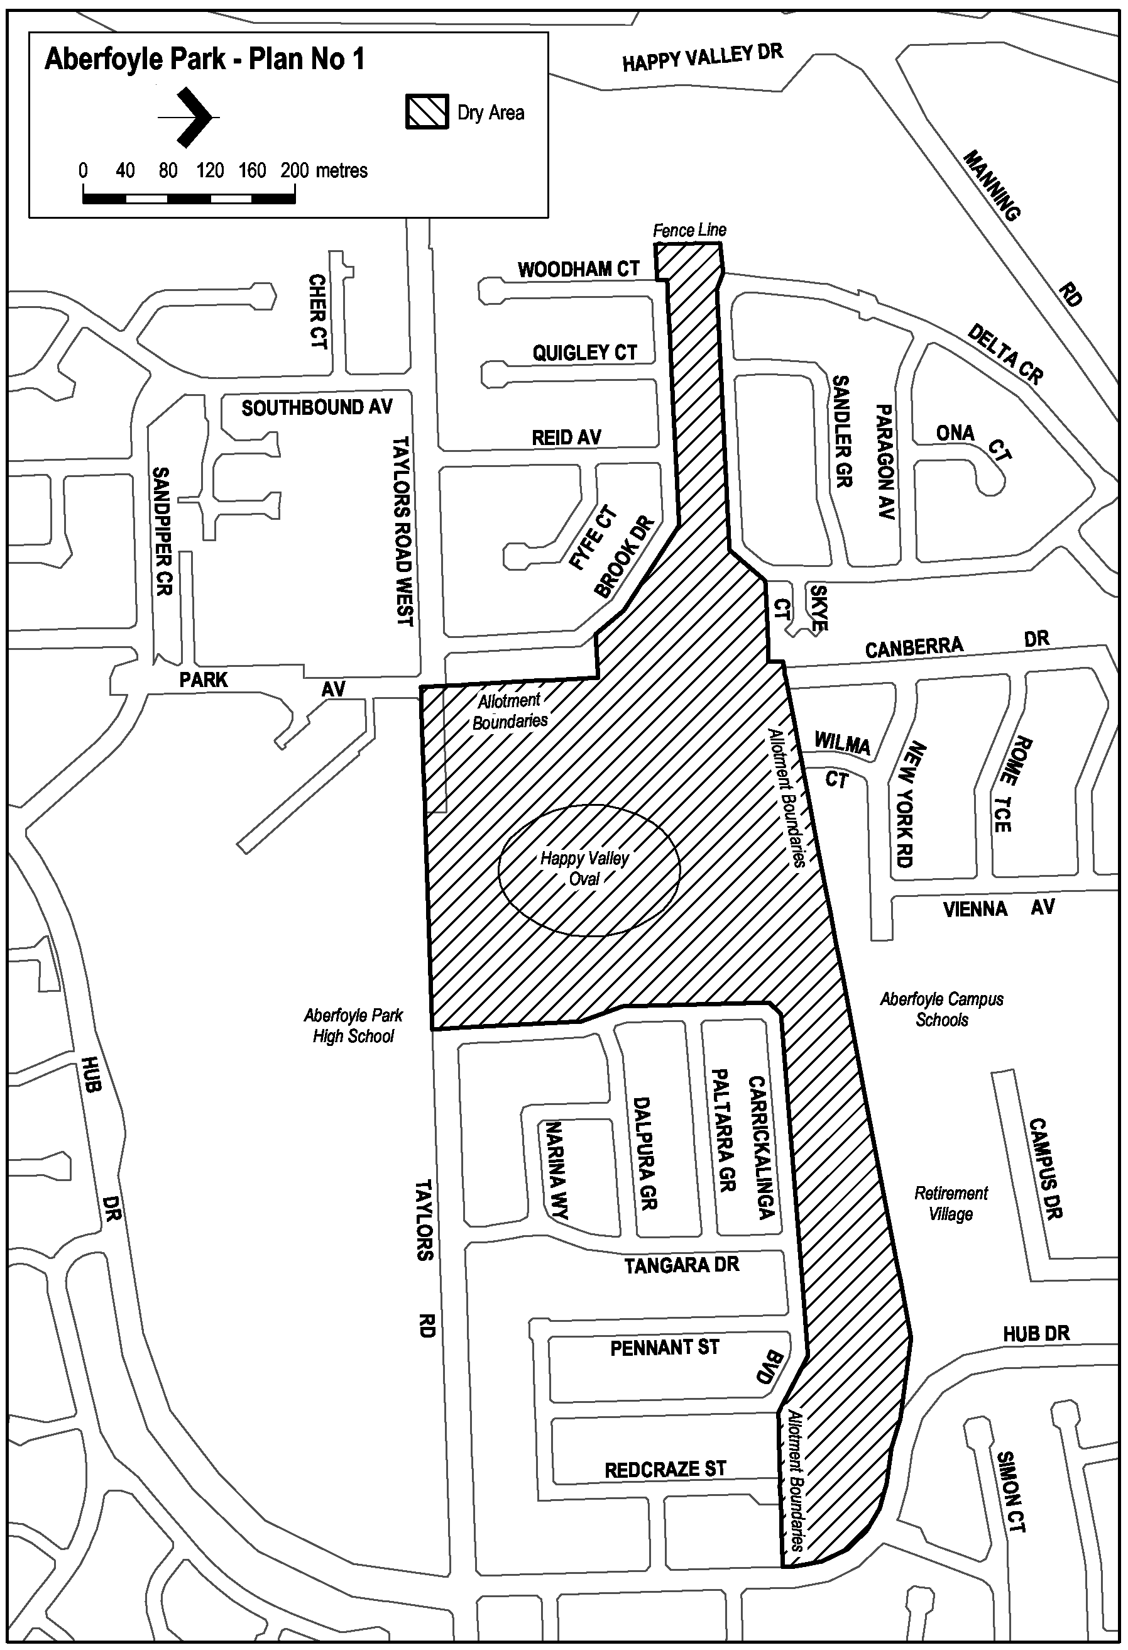
Christies Beach—Plan No 1
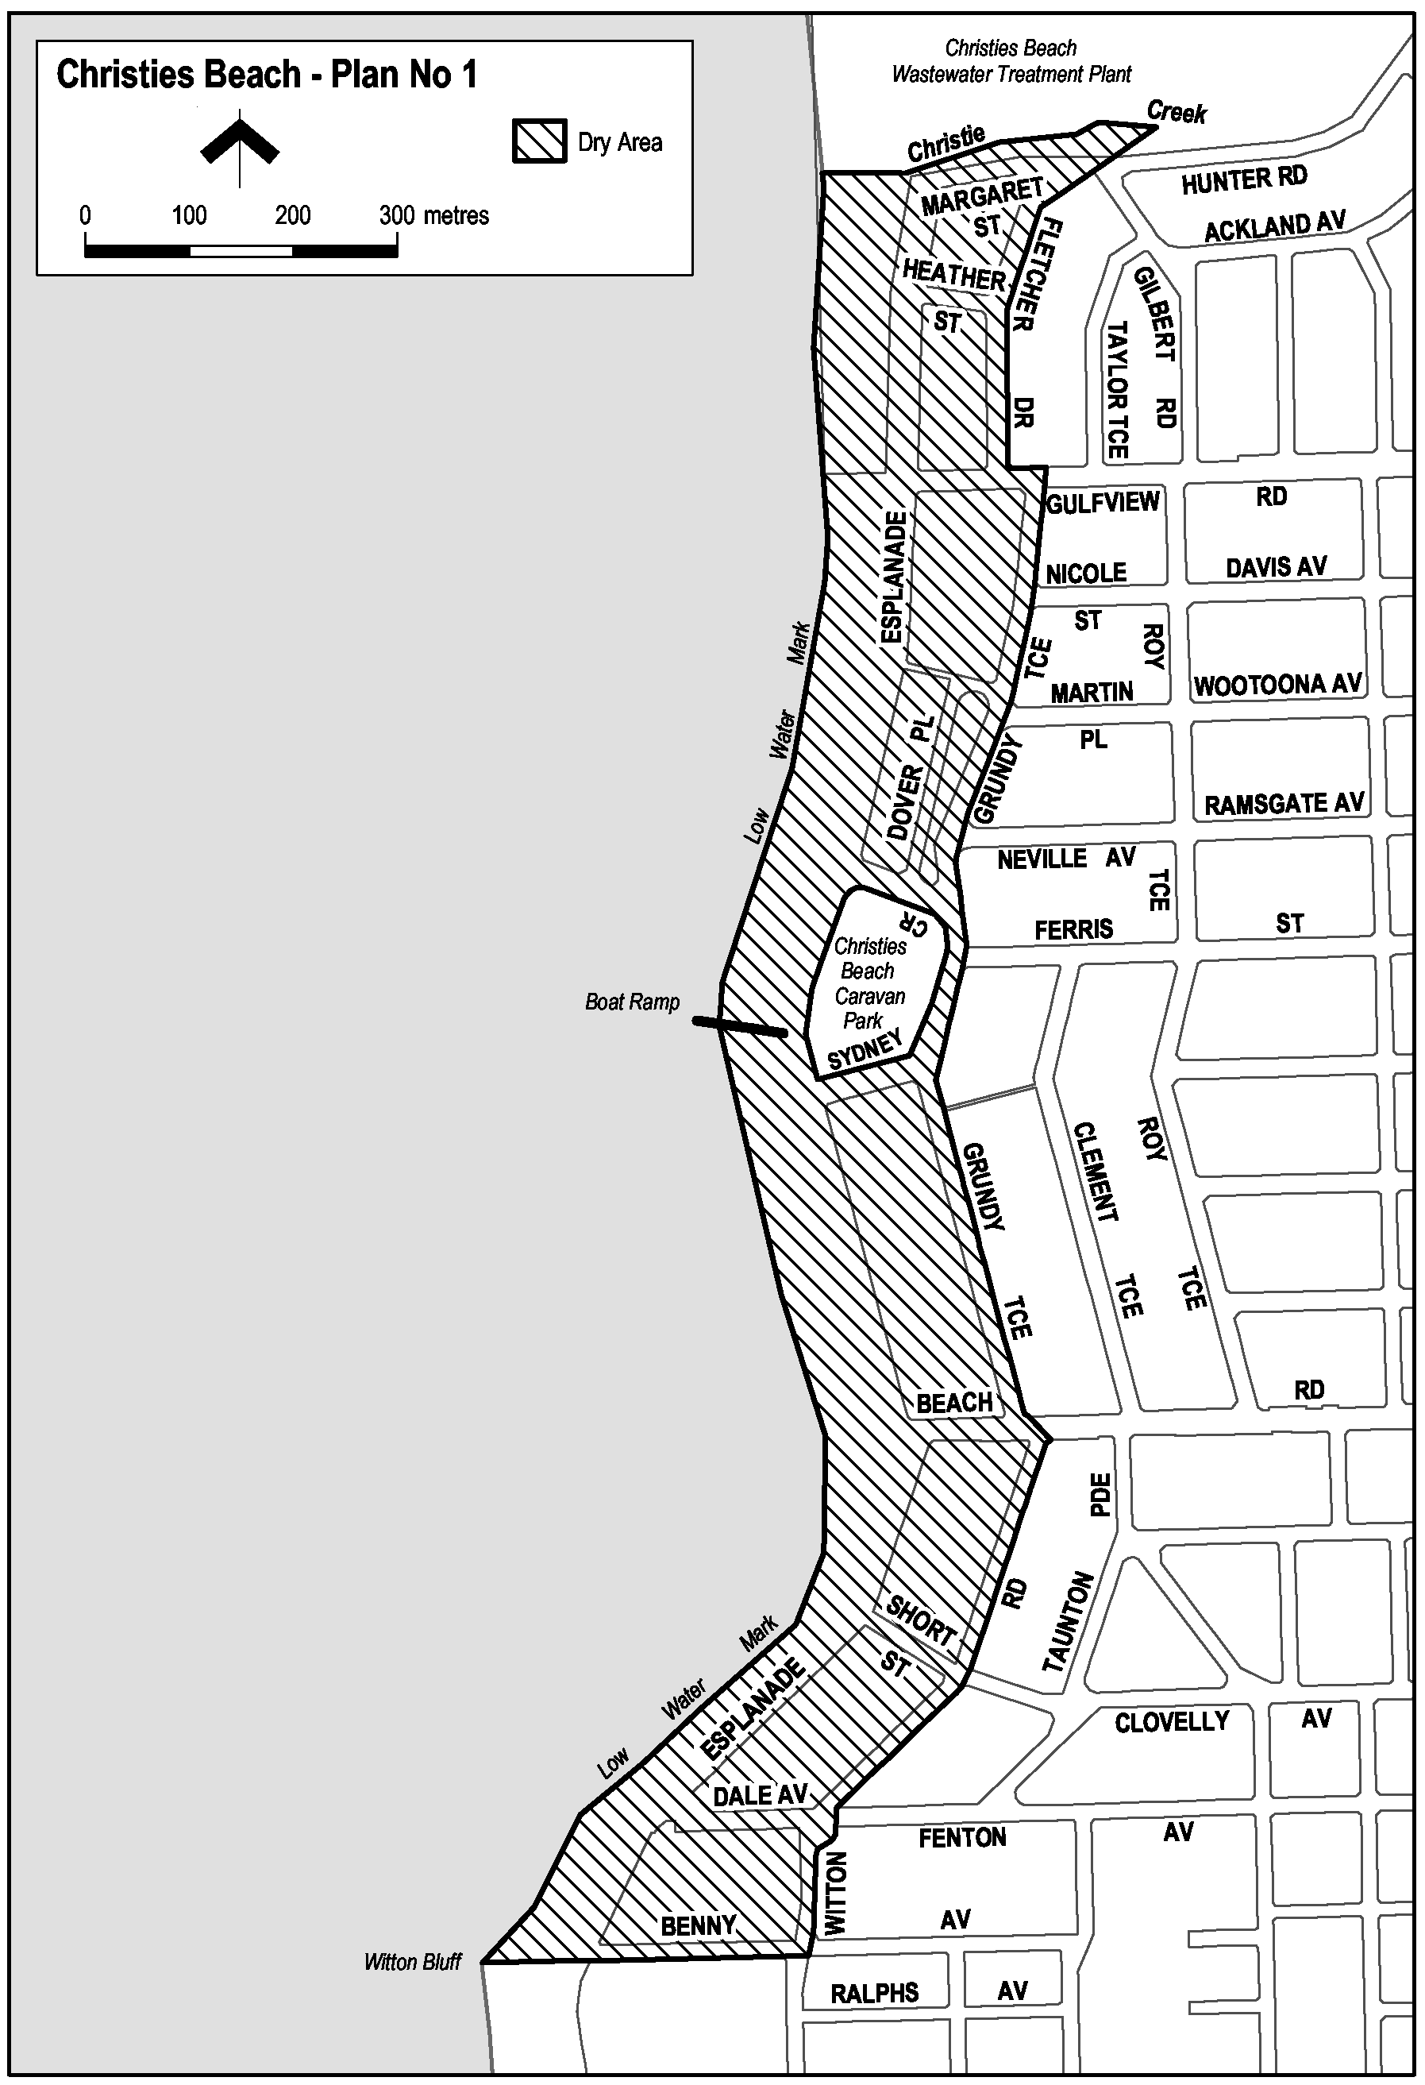
Moana—Plan No 1
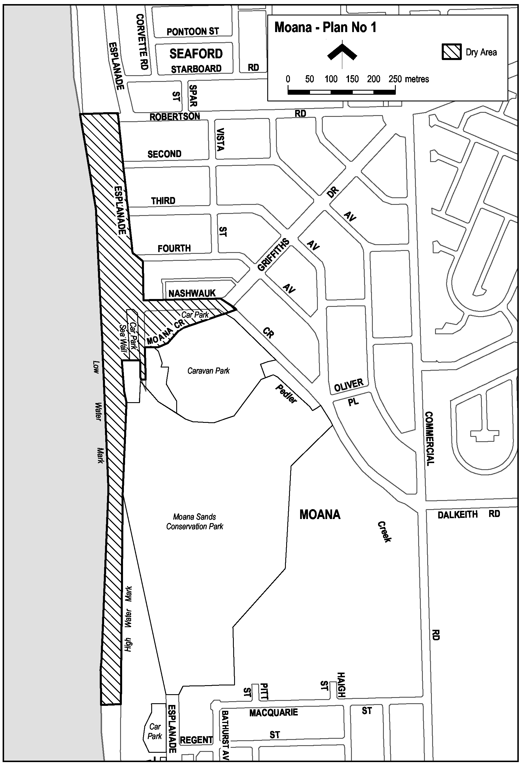
Moana—Plan No 2
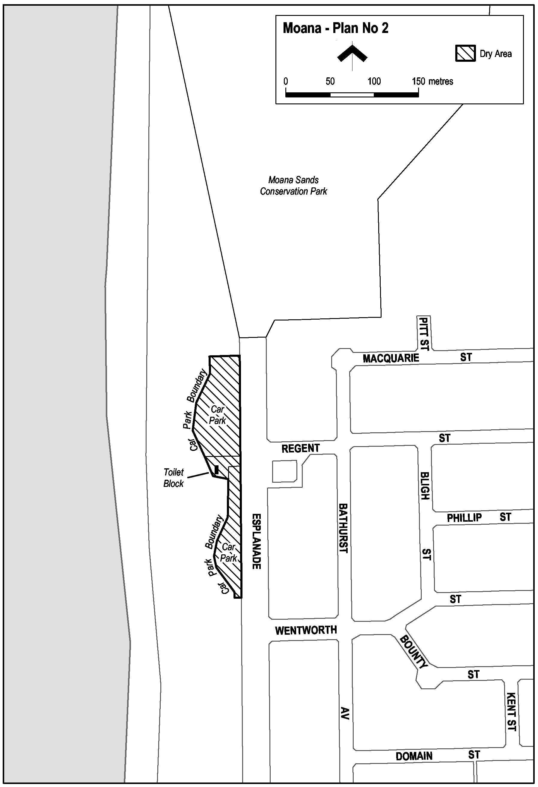
Morphett Vale—Plan No 1
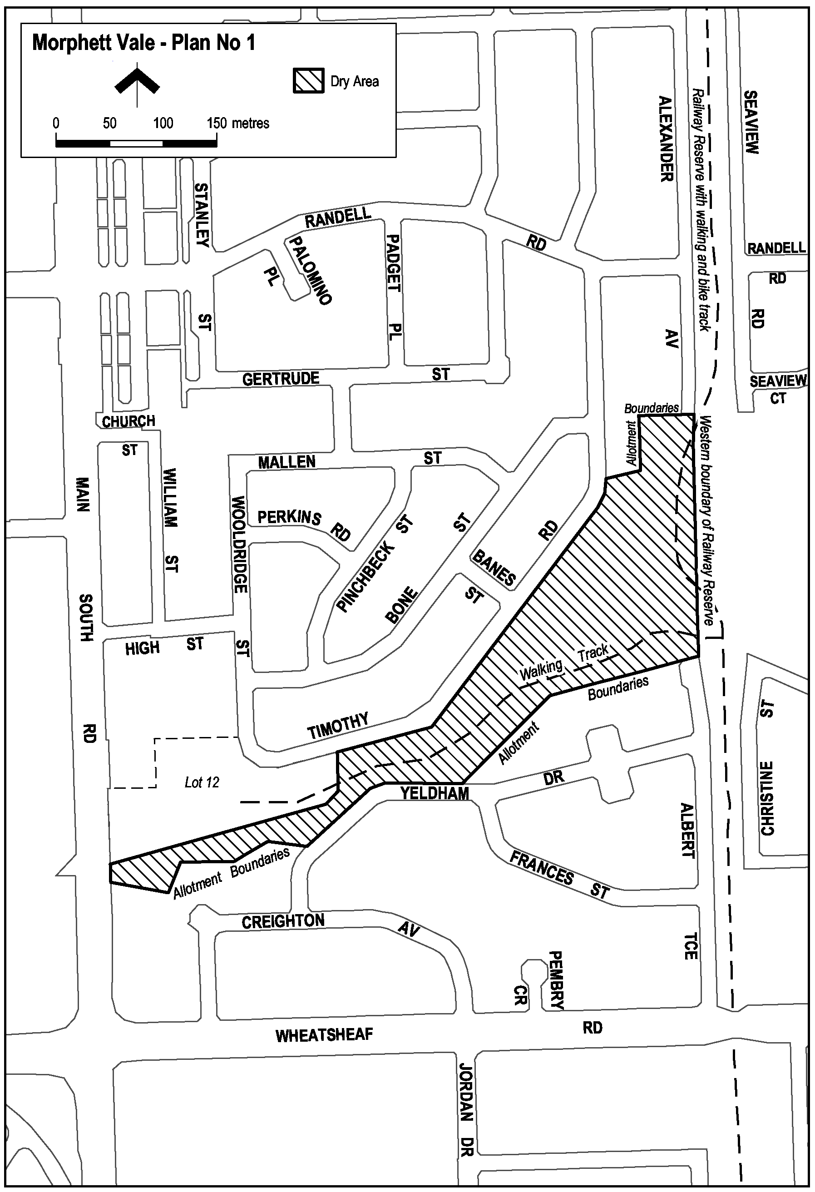
Noarlunga Centre—Plan No 1
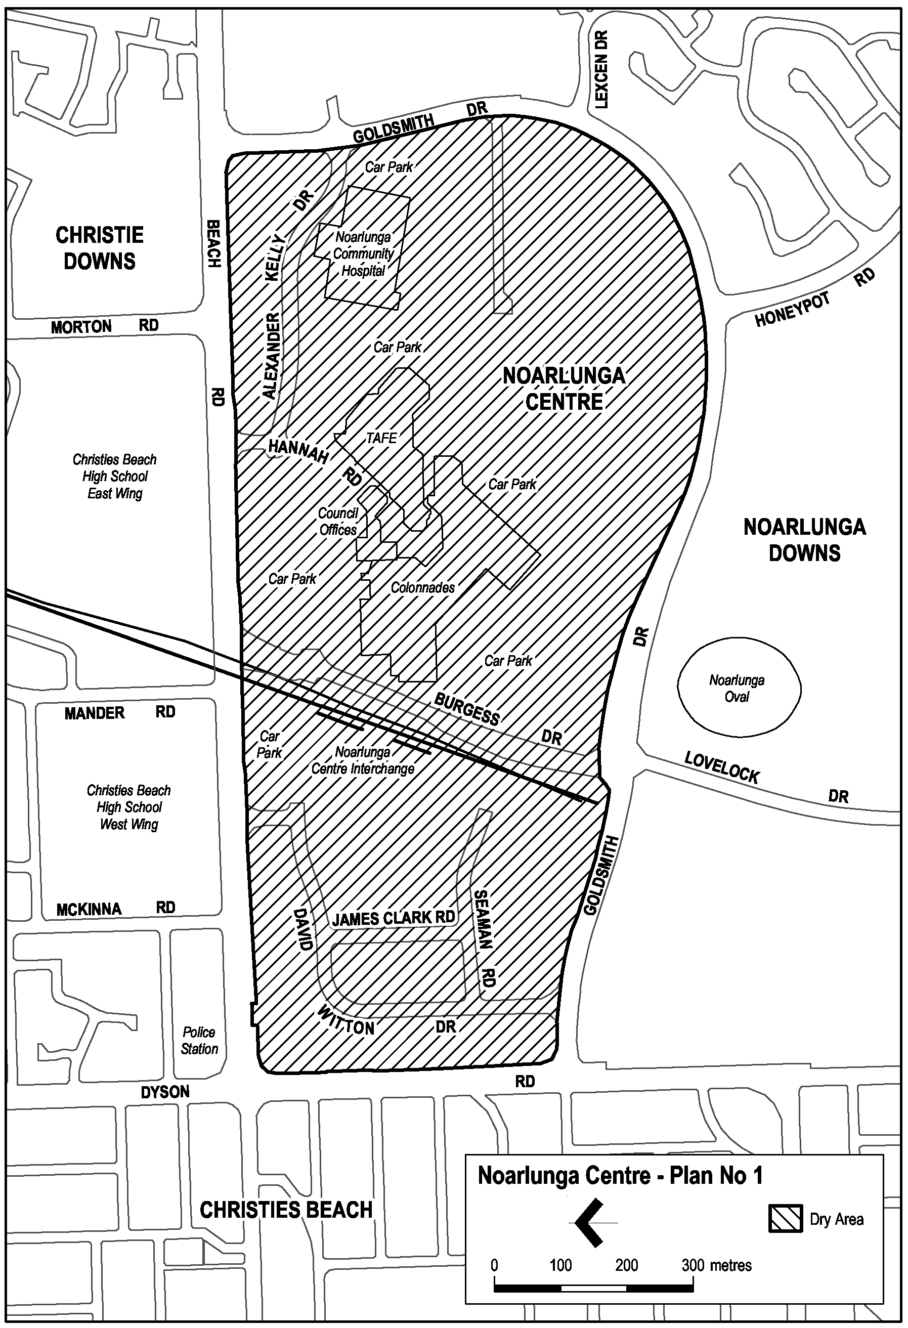
Port Noarlunga—Plan No 1
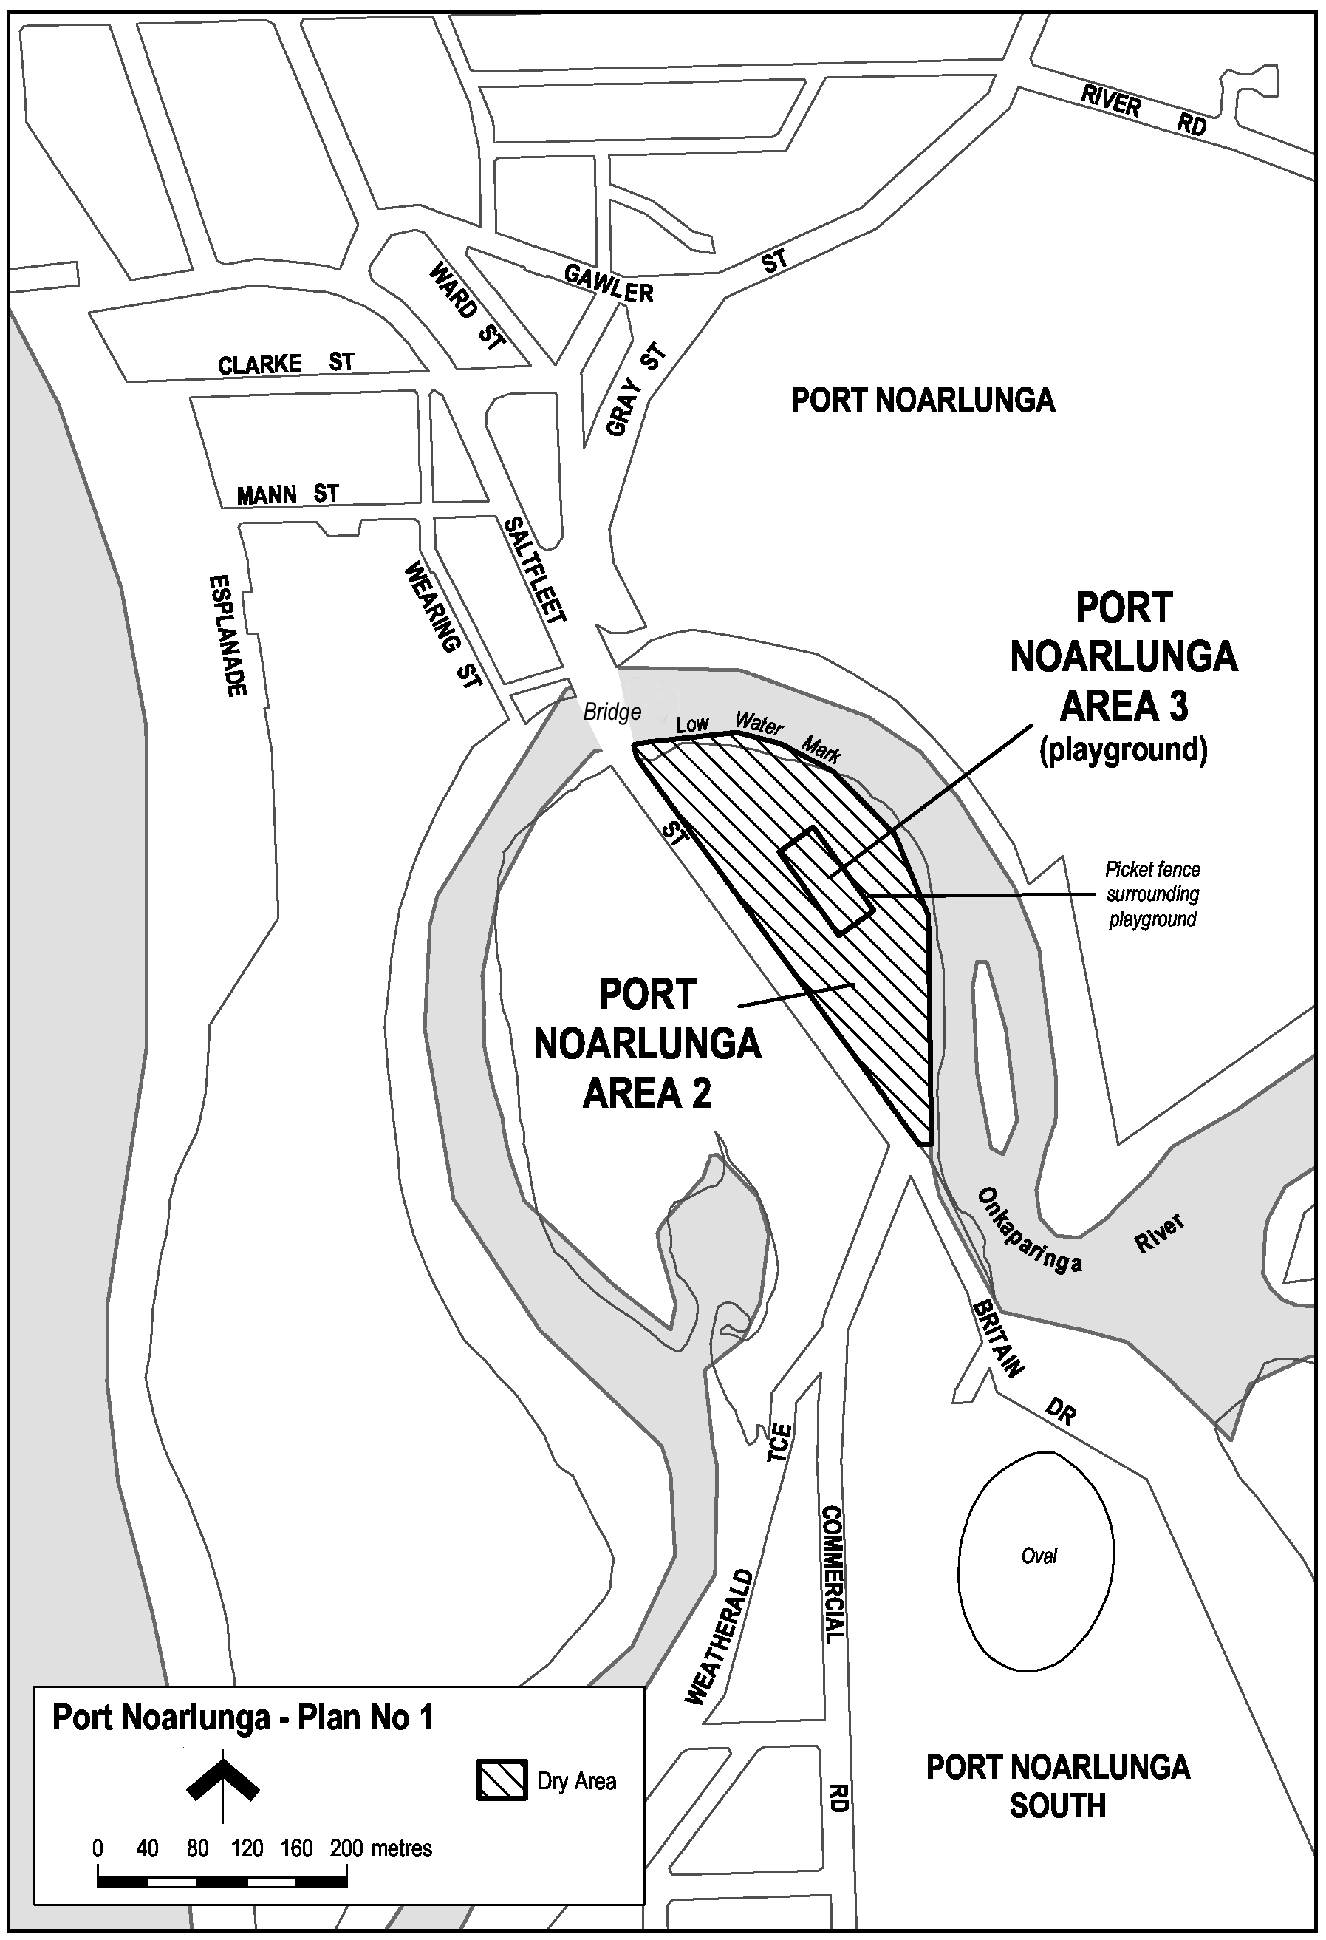
Woodcroft—Plan No 1
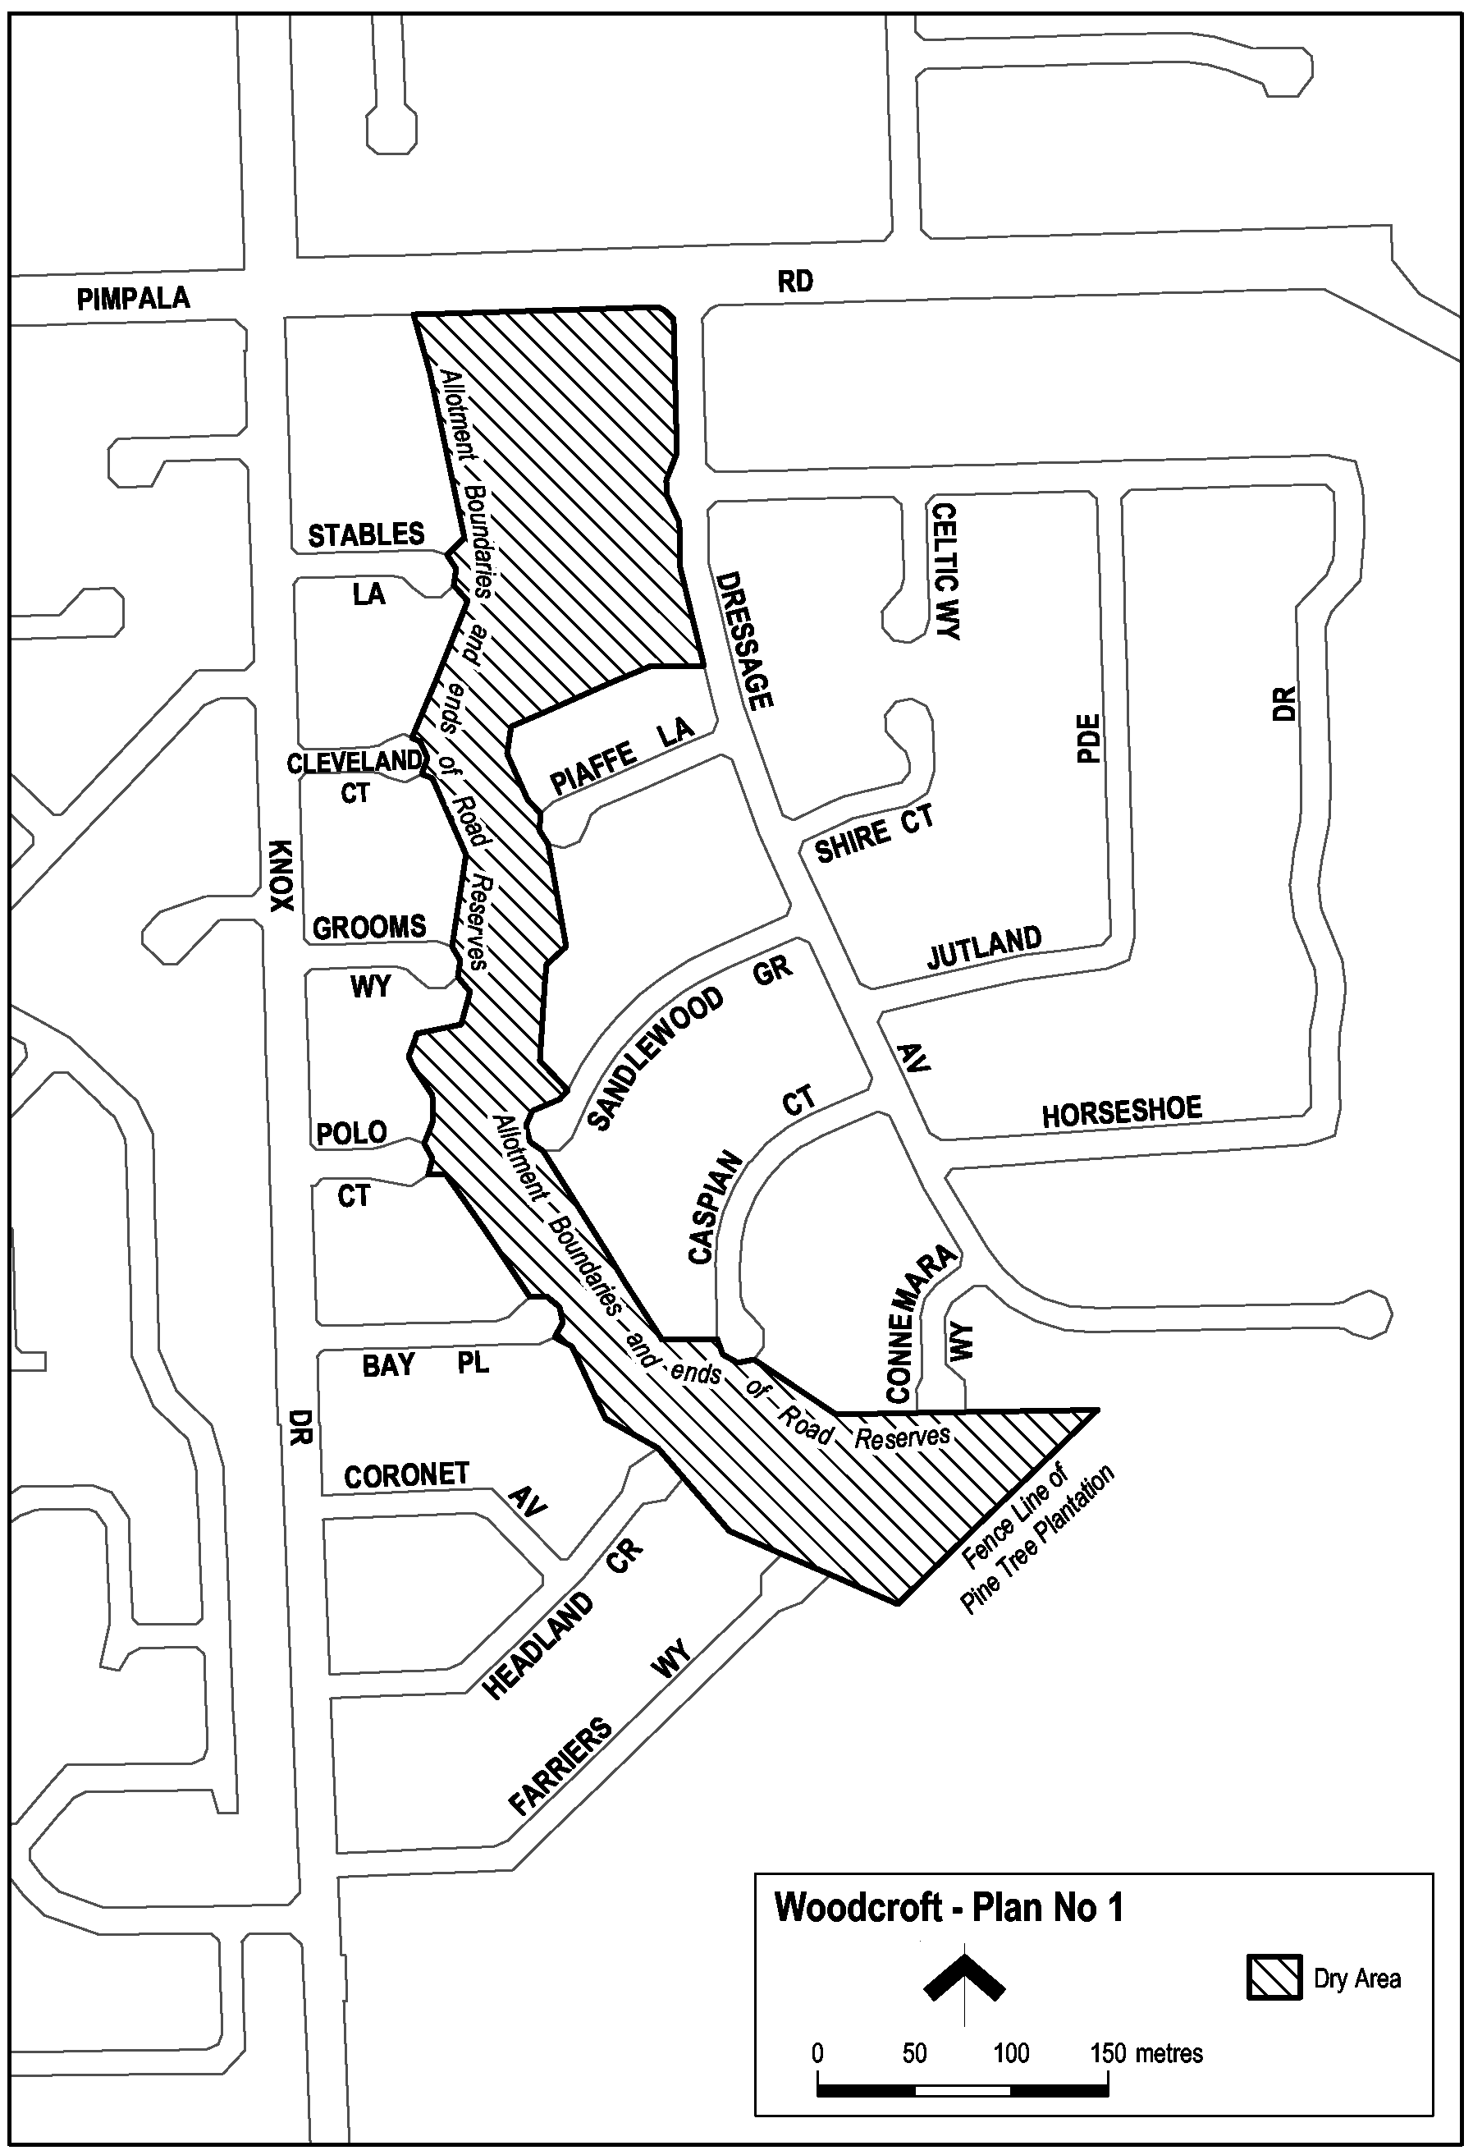
Note—
As required by section 10AA(2) of the Subordinate Legislation Act 1978, the Minister has certified that, in the Minister's opinion, it is necessary or appropriate that these regulations come into operation as set out in these regulations.
Made by the Governor
with the advice and consent of the Executive Council
on 12 August 2004
No 170 of 2004
OLGC9/2004

FAXING COPY?
IF you fax copy to Government Publishing SA for inclusion in the Government Gazette, there is no need to send a Confirmation Copy to us as well.
This creates confusion and may well result in your notice being printed twice.
Please use the following fax number:
Fax transmission: (08) 8207 1040
Phone Inquiries: (08) 8207 1045
Please include a contact person, phone number and order number so that we can phone back with any queries we may have regarding the fax copy.
NOTE: Closing time for lodging new copy (fax, hard copy or email) is 4 p.m. on Tuesday preceding the day of publication.

Government Gazette notices can be E-mailed.
The address is:
governmentgazette@saugov.sa.gov.au
Documents should be sent as attachments in Word format.
When sending a document via E-mail, please confirm your transmission with a faxed copy of your document, including the date the notice is to be published.
Fax transmission: (08) 8207 1040
Enquiries: (08) 8207 1045
NOTE: Closing time for lodging new copy (fax, hard copy or email) is 4 p.m. on Tuesday preceding the day of publication.

THE RURAL CITY OF MURRAY BRIDGE
Revocation of Land from Classification as Community Land
NOTICE is hereby given that The Rural City of Murray Bridge at its meeting held on 26 July 2004 resolved, pursuant to section 194 of the Local Government Act 1999, to revoke the following land from the classification as community land:
Portion of Allotment 194, Narooma Boulevard, Murray Bridge, Hundred of Mobilong, being portion of the land contained in Certificate of Title Register Book Volume 5538, Folio 214, with an area totalling approximately 3 526 m².
D. Altmann, Chief Executive Officer

THE RURAL CITY OF MURRAY BRIDGE
Exclusion of Land from Classification as Community Land
NOTICE is hereby given that the Rural City of Murray Bridge at its meeting held on 20 January 2004 resolved, pursuant to section 193 (4) of the Local Government Act 1999, to exclude the following parcel of land from classification as community land:
Allotment 25 in Deposited Plan D64348, Hawke Place, Hundred of Mobilong, being the whole of the land comprised in Certificate of Title Register Book Volume 5917, Folio 592.
D. Altmann, Chief Executive Officer

THE RURAL CITY OF MURRAY BRIDGE
Exclusion of Land from Classification as Community Land
NOTICE is hereby given that the Rural City of Murray Bridge at its meeting held on 22 September 2003 resolved, pursuant to section 193 (4) of the Local Government Act 1999, to exclude the following parcel of land from classification as community land:
Allotment 58 in Deposited Plan D63144, Jacaranda Street, Hundred of Mobilong, being the whole of the land comprised in Certificate of Title Register Book Volume 5908, Folio 784.
D. Altmann, Chief Executive Officer

THE BAROSSA COUNCIL
Development Act 1993
Minor Amendments Plan Amendment Report (PAR)—
Draft for Public and Agency Consultation
NOTICE is hereby given that The Barossa Council has prepared a draft Plan Amendment Report to amend The Barossa Council Development Plan.
The purpose of the PAR is to:
1. Amend policies for the control of Sheds and Outbuildings.
2. Amend policies in the flood prone portion of the Recreation Zone.
3. Amend all references to Watershed and Water Protection Areas to reflect current official designations and boundaries.
4. Introduce new policies to control ‘frost fans’ in the Valley Floor.
5. Several other minor amendments.
Public and Agency consultation for the PAR will be for a two month period from Monday, 16 August 2004 until Friday, 22 October 2004. During this time any interested person is invited to make written submissions on the subject of the PAR. Any person who makes a written submission in response to this invitation will also be given an opportunity to appear personally or by a representative before council or a council committee to be heard on their submission.
Copies of the PAR will be available for inspection or purchase from the Council Offices, 1 Washington Street, Angaston during normal office hours throughout the consultation period.
Written submissions regarding the Development Plan Review must be forwarded to The Barossa Council by no later than 5 p.m. on Friday, 22 October 2004. Persons making written submissions should indicate whether they wish to be heard on their submission at the subsequent public hearing and if so, contact details should be provided.
All submissions should be directed to:
The Chief Executive Officer
The Barossa Council
P.O. Box 295
Angaston, S.A. 5353
A public hearing will be held, commencing at 7.00 p.m. on Tuesday, 9 November 2004, if required, at The Barossa Council Chambers, 1 Washington Street, Angaston, for persons who indicate a wish to be heard on their written submissions. Any interested persons are welcome to attend the public hearing however, confirmation of attendance is necessary.
Copies of all written submissions received will be available for inspection by interested persons at the council offices from Monday, 1 November 2004 to Tuesday, 9 November 2004.
J. G. Jones, Chief Executive Officer

DISTRICT COUNCIL OF BARUNGA WEST
Adoption of Valuation and Declaration of Rates
NOTICE is hereby given that at a meeting of council held on 13 July 2004, it was resolved that the council of the District Council of Barunga West adopts the most recent capital valuation of the Valuer-General that is to apply to the area for rating purposes for the 2004-2005 financial year, being capital valuation totalling $566 903 420, comprising $551 057 900 for rateable land and $15 845 520 for non-rateable land.
Adoption of Rates
1. Notice is hereby given that by virtue of the powers vested in it by the Local Government Act 1999, and all other powers thereunto enabling the council of the District Council of Barunga West (hereinafter called ‘the Council’) at a meeting held on 13 July 2004 resolves:
(a) That an amount of $200 be a fixed charge on each separate piece of rateable land in the area of the council for the purposes of rates pursuant to section 152 of the Local Government Act 1999, for the year ending 30 June 2005.
(b) That the differential general rates on capital value of rateable land within the area of the council be declared for the financial year ending 30 June 2005, which differential general rates are pursuant to section 152 (1) (c) based on two components:
(i) one being the value of the rateable land; and
(ii) the other being the fixed charge applicable to the rateable land and which differential general rates vary according to the use in accordance with section 156 (1) (a).
(c) That the amounts of differential general rates are as follows:
(i) that the differential general rate for all rateable land within the area of the council which has a land designated as Category 1 (Residential) be fixed at 0.258 cents in the dollar;
(ii) that the differential general rate for all rateable land within the area of the council which has a land use designated as Categories 2, 3 or 4 (Commercial—Shop, Office or Other) or Categories 5 or 6 (Industry—Light or Other) be fixed at 0.525 cents in the dollar;
(iii) that the differential general rate for all rateable land within the area of the council which has a land use designated as Category 7 (Primary Production) be fixed and rated at 0.248 cents in the dollar; and
(iv) that the differential general rate for all rateable land within the area of the council which has a land use designated as Category 8 (Vacant) be fixed and rated at 0.170 cents in the dollar.
Payment of Rates
2. Notice is hereby given that the requirements for the payment of rates as follows:
(a) Rates (i.e. Differential General Rates plus Fixed Charges, Service Charges and Separate Rates) declared by council for the financial year ending 30 June 2005 will fall due in four equal or approximately equal instalments.
(b) The said four instalments shall be payable on or before 1 September 2004, 1 December 2004, 1 March 2005 and 1 June 2005 failing which the said rates shall be regarded as being in arrears and subject to the imposition of fines, as prescribed.
Service Charge
3. Pursuant to section 155 of the Local Government Act 1999, council declares a service charge being levied on buildings and vacant properties being serviced by:
The Bute Common Effluent Scheme:
Building—$95
Vacant—$55
The Port Broughton Common Effluent Scheme:
Building—$290
Vacant—$205
Separate Rates
4. Pursuant to section 154 of the Local Government Act 1999, council hereby declares that a separate rate of $12 per assessment being levied on properties within the Port Broughton and Fisherman’s Bay townships for the purpose of mosquito control.
Rating Policy
5. Pursuant to section 171 (1) of the Local Government Act 1999, council adopts the rating policy for the 2004-2005 financial year.
N. Hand, District Manager

DISTRICT COUNCIL OF ELLISTON
Adoption of Valuation and Declaration of Rates
NOTICE is hereby given that the District Council of Elliston, at a meeting held on 2 July 2004, by virtue of the powers contained in section 167 (2) (a) of the Act, the council resolved to adopt, for rating purposes for the financial year ending 30 June 2005, the Valuer-General’s valuation of capital values applicable to land within the area of council, totalling $184 980 920 as at 19 June 2004.
Declaration of Rates
Notice is hereby given that in exercise of the powers contained in section 123 (2) (b), 152 (1) (c), 152 (2), 153 (1) (a) and 155 of the Local Government Act 1999, the District Council of Elliston, after considering and adopting the budget, financial statements and statements for the financial year ending 30 June 2005 and adopting valuations that are to apply to the land within council’s area, resolved to declare the following rates:
(a) A general rate of 0.5098 cents in the dollar on the basis of capital value of that land and a fixed charge of $290 applying equally to each separate piece of rateable land in its area.
(b) A service charge of $35 for each occupied allotment within the township of Lock and the subdivision of part section 55 in Deposited Plan 8406, Hundred of McLachlan served by septic tank effluent drainage scheme an additional annual service charge on occupied allotments in that area taking into account the level of usage, as follows:
• Business usage $55;
• Combined business and residential usage $85;
• Lock Hotel/Motel usage $135;
• South Australian Housing Trust $135;
• Lock Area School usage $315.
An annual service charge for the service of the Port Kenny Water Supply to allotments within the township of Port Kenny and sections 21, 72 and 102, Hundred of Wright, taking into account the level of usage as follows:
Domestic:
Up to 138 kL—$1.50 per kL
above 138 kL—$5 per kL
Commercial:
Up to 249 kL—$1.50 per kL; 250 - 350 kL—$2 per kL
above 350 kL—$5 per kL.
An annual service charge of $50 on each premise within the township of Elliston, and its environs, receiving the service of television transmission from the facility of Bramfield Hill, section 122, Hundred of Colton.
The council resolved to declare that pursuant to section 182 (1) (b) of the Act, it will consider applications for a remission of this service charge, where appropriate, in circumstances where a ratepayer can establish exemption on the basis that the television transmission from the facility is not received.
Payment of Rates
Notice is hereby given that pursuant to section 181 of the Act, the District Council of Elliston resolved to declare that the rates and charges payable in respect of the financial year ending
30 June 2005 are payable in approximately four equal instalments (unless otherwise agreed with the principal ratepayer) and in exercise of the powers contained in section 44 of the Act, the Chief Executive Officer is the delegated authority pursuant to section 181 (2) (a) of the Act to determine the days upon which the four instalments will fall due.
Rebate of Rates
That pursuant to sections 159 (3) and 166 (1) (j) of the Act, the council resolved to grant a rebate of 100% of the rates and service charges payable for the financial year ending 30 June 2005, in respect of the following organisations, on the basis that they provide a benefit or service to the community:
Mount Damper Hall Trust Lock & District Sport Centre
Port Kenny Hall Committee Lock Bowling Club
Elliston Hall Committee Lock Football Club
Sheringa Hall Committee Lock Racing Club
Tooligie Hall Committtee Lock Golf Club
Murdinga Hall Committee Elliston CWA
Tooligie Hill Rec. Grounds Murdinga Tennis & Cricket
Lock Hall Committee Elliston Community Sports Centre
Port Kenny Community Sport Lock, Murdinga,Tooligie Progress
Elliston Golf Club Lock Swimming Pool
Elliston Hospital
Separate Rate—Water Catchment Levy
Notice is hereby given that in exercise of the powers contained in section 138 of the Water Resources Act 1997, and section 154 of the Local Government Act 1999, the District Council of Elliston at a meeting held on 2 July 2004, declared a separate rate being a fixed water levy of $31.54 on all rateable property in the council area. The fixed water levy was declared in order to reimburse to the council the amount of $25 454 which council is required to contribute towards the cost of operating the Eyre Peninsula Catchment Water Management Board for the 2004-
2005 financial year.
R. Gregor, Chief Executive Officer

DISTRICT COUNCIL OF ELLISTON
Appointment
NOTICE is hereby given that at the ordinary meeting of council held on 16 July 2004, Joss Joseph John Heinen was appointed as an authorised officer for carrying out the powers, functions and duties required pursuant to:
(a) The provisions of the Local Government Act 1999.
(b) The provisions of the Development Act 1993.
(c) Public Environment Health Act 1987.
(d) Food Act 1985.
(e) Meat Hygiene Act 1994.
(f) Public and Environmental Health (Waste Control) Variation Regulations 2004. (Under the Public and Environmental Health Act 1987).
(g) Fences Act 1975.
R. Gregor, Chief Executive Officer

LIGHT REGIONAL COUNCIL
Adoption of Valuation and Declaration of Rates and Charges
NOTICE is hereby given that at its meeting held on 20 July 2004, in relation to the financial year ending 30 June 2005, the Light Regional Council, in exercise of the powers contained within Chapters 8, 9 and 10 of the Local Government Act 1999, made the following resolutions:
Adoption of Valuation
To adopt for rating purposes the Valuer-General’s valuations of capital value in relation to the area of the council, such valuations to apply to the council area from 1 July 2004, and specifies that the total of the values that are to apply within the area is $1 719 869 020 of which $1 693 677 361 is rateable.
Declaration of Differential General Rates
To declare the following differential general rates on rateable land within its area based upon the capital value of the land, the rates varying by reference to land use category:
(1) on rateable land with land use of Category 1 (Residential) and Category 9 (Other), a rate of 0.37545 cents in the dollar of the capital value of such land;
(2) on rateable land with land use of Category 2 (Commercial—Shop) and Category 3 (Commercial—Office), a rate of 0.60072 cents in the dollar of the capital value of such land;
(3) on rateable land with land use of Category 4 (Commercial—Other), a rate of 0.657038 cents in the dollar of the capital value of such land;
(4) on rateable land with land use of Category 5 (Industrial—Light), and Category 6 (Industrial—Other), a rate of 0.938625 cents in the dollar of the capital value of such land;
(5) on rateable land with land use of Category 7 (Primary Production), a rate of 0.30036 cents in the dollar of the capital value of such land;
(6) on rateable land with land use of Category 8 (Vacant Land), a rate of 0.469313 cents in the dollar of the capital value of such land.
Imposition of a Minimum Rate
To declare that the minimum amount payable by way of general rates upon each separately valued piece of rateable land within the council area shall be $500.
Imposition of Waste Collection Service Charge
In order to meet the costs of refuse collection in the area, to impose a service charge of $141.40 on each assessment being provided with a refuse collection service.
Imposition of Septic Tank Effluent Disposal Service Charge
To impose the following service charges per unit on each assessment in the following townships, to which the council makes available a septic tank effluent disposal service:
$
Kapunda 288
Freeling 288
Greenock 288
Roseworthy 338
Imposition of Water Catchment Levy
To declare a separate rate of 0.009452 cents in the dollar of the capital value of land, on all rateable land in the council area in the catchment area of the Northern Adelaide and Barossa Catchment Water Management Board.
P. J. Beare, Chief Executive Officer

PORT PIRIE REGIONAL COUNCIL
Adoption of Valuation and Declaration of Rates
NOTICE is hereby given that at its special meeting of council held on Wednesday, 14 July 2004, council resolved the following:
Adoption of Valuation
1. That in accordance with section 167 of the Act that the most recent valuations of the Valuer-General available to the council for capital values of land within the area of the council:
(a) known as the former area of the City of Port Pirie $664 964 800;
(b) known as the former area of the District Council of Pirie $117 733 440;
(c) known as the former area of the District Council of Crystal Brook-Redhill Ward $197 737 500,
amounting to total values of $960 435 740, be adopted for rating purposes for the financial year ending 30 June 2005.
Adoption of Annual Statement/Budget
2. That in accordance with section 123 of the Local Govern-ment Act 1999 and Regulation 5 of the Local Government (Financial Management) Regulations 1999 the Annual State-ment/Budget including:
(a) a budgeted operating statement;
(b) a budgeted statement of financial position;
(c) a budgeted statement of changes in equity;
(d) a budgeted statement of cash flows;
(e) a rates determination statement,
for the year 2004-2005 as laid before the council at this meeting involving:
(a) a total estimated expenditure of $11 840 801;
(b) a total estimated income from sources other than rates of $6 132 806; and
(c) a total amount required to be raised from general rates of $5 707 995.
Determination of the Basis for Differential Rates
3. (a) That pursuant to section 156 (1) (c) of the Act the council determines that the basis for differential rates shall be according to the locality of the land and its use.
(b) There shall be differentiation according to use in accordance with various categories of land use prescribed by Regulation 10 the Local Government (General) Regulations 1999.
(c) There shall be differentiation according to whether land is within or outside a township as defined by the Local Government Act or as referred to as a township in the Development Plan.
Attribution of Land Uses
4. (a) That the numbers indicated against various categories of the land use prescribed by the Local Government (General) Regulations 1999, be used to designate land uses in the Assessment Record.
(b) The use indicated by those numbers in respect of each separate assessment of land described in the Assess-ment Record on this date (as laid before the council) be attributed to each such assessment respectively.
(c) Reference in this resolution to land being of a certain category use means the use indicated by that category number in the Regulations.
Consistency and Comparability of Rates
5. That in accordance with section 153 (2) of the Local Government Act 1999, council has considered issues of consistency and comparability (Rate Burden) in fixing the rates for the financial year 2004-2005 and has determined the rates to be raised are consistent and comparable with the financial year 2003-2004.
Declaration of Rates
6. That in accordance with section 153 of the Local Govern-ment Act 1999, in order to raise the amount in paragraph 2 (c) above, differential general rates be declared on rateable land as follows:
(a) in the area of the former City of Port Pirie:
• 0.3100 cents in the dollar on all rateable land of Category 1 (Residential);
• 0.9500 cents in the dollar on all rateable land of Categories 2, 3, 4 and 5 (Commercial—Shops, Offices, Light Industry);
• 4.2550 cents in the dollar on all rateable land of Category 6 (Industrial—Other);
• 0.1500 cents in the dollar on all rateable land of Category 7 (Primary Industries);
• 1.0000 cents in the dollar on all rateable land of Categories 8 and 9 (Vacant Land, Other).
(b) in the area of the former District Council of Pirie on all rateable land 0.1500 cents in the dollar;
(c) in the area of the former District Council of Crystal Brook-Redhill:
• on all rateable land situated within the defined townships of Crystal Brook, Redhill, Koolunga and Mundoora a rate of 0.3100 cents in the dollar;
• on all other rateable land within the area a rate of 0.1500 cents in the dollar.
Fixed Charge
7. That pursuant to section 152 of the Act, a fixed charge of $260 for the Port Pirie Regional Council area, be imposed on each separately valued piece of rateable land.
Rates Payment
8. That pursuant to section 181 of the Act all rates be payable by four equal or approximately equal instalments on
3 September 2004, 3 December 2004, 4 March 2005 and
3 June 2005.
Service Charges
9. That pursuant to section 155 of the Act the following service charges be imposed for the 2004-2005 financial year on each assessment in the following areas, to which the council makes available a septic tank effluent disposal service:
Per STEDS
Unit
Crystal Brook: $
Occupied land 135.00
Vacant land 77.50
Napperby:
Occupied land 285.00
Vacant land 180.00
Rate Relief Policy
10. That council adopt the following Rate Relief options:
(a) Deduction from Centrelink benefit payments (by mutual agreement).
(b) Special arrangement payments, either weekly or fortnightly, without fines being added, on application by the ratepayer.
(c) Monthly payments, without fines being added for monthly paid employees at Pasminco or elsewhere in the community, on application.
Rate Policy Statement
11. That council adopt the Rating Policy Statement for the 2004-2005 financial year.
J. Vucic, Chief Executive Officer

WATTLE RANGE COUNCIL
Adoption of Valuation and Declaration of Rates
NOTICE is hereby given that at its meeting held on 4 August 2004, the council in exercise of the powers contained in Part 1 of Chapter 10 of the Local Government Act 1999:
1. Adopted the valuations that are to apply in its area for rating purposes for the 2004-2005 financial year, being
the capital valuations of the Valuer-General, totalling $2 215 517 900 comprising $2 168 923 400 in respect of rateable land and $46 594 500 in respect of non-rateable land before alteration.
2. Declared differential general rates on rateable land within its area for the year ending 30 June 2005 as follows:
(a) (i) Townships: In respect of land within the Millicent, Beachport, Southend, Tantanoola, Mount Burr and Rendelsham township areas not otherwise referred to below—0.5680 cents in the dollar.
(ii) Penola Township: In respect of land within the Township Zone, Town Centre Zone, State Heritage (Petticoat Lane/Woods MacKillop School House) Area Zone, Residential Zone, Commercial Zone and Country Living Zone, the boundaries of which are described in that part of the Development Plan (refer to Maps Pen/8, Pen/9, Pen/10 and Pen/11) under the Develop-ment Act 1993 applicable to the former District Council of Penola—0.5680 cents in the dollar.
(iii) Penola Industrial Zone and Water Protection Zone: In respect of land within the Industry (Penola) Zone and Water Protection (Penola) Zone, the boundaries of which are described in that part of the Development Plan (refer to Maps Pen/8, Pen/9 and Pen/10) under the Development Act 1993, applicable to the former District Council of Penola:
• for properties having a land use code of 7 (Primary Production)—0.4180 cents in the dollar;
• for all other properties—0.5680 cents in the dollar.
(iv) Coonawarra Township: In respect of land within the township of Coonawarra, the boundaries of which are described in that part of the Develop-ment Plan under the Development Act 1993, applicable to the former District Council of Penola area—0.5680 cents in the dollar.
(v) Kalangadoo Township: In respect of land within the Country Township (Kalangadoo) Zone, the boundaries of which are described in that part of the Development Plan (refer to Map Pen/12) under the Development Act 1993, applicable to the former District Council of Penola area—0.5680 cents in the dollar.
(vi) Kalangadoo General Industry Zone: In respect of land within the General Industry (Kalangadoo) Zone the boundaries of which are described in that part of the Development Plan (refer to Map Pen/12) under the Development Act 1993, applicable to the former District Council of Penola area:
• for properties having a land use code of 6 (Industrial—Other)—0.5680 cents in the dollar;
• for all other properties—0.4180 cents in the dollar.
(vii) Nangwarry Township: In respect of land within the Country Township (Nangwarry) Zone, the boundaries of which are described in that part of the Development Plan (refer to Map Pen/13) under the Development Act 1993, applicable to the former District Council of Penola area—0.5680 cents in the dollar.
(viii) Nangwarry Industry Zone: In respect of land within the Industry (Nangwarry) Zone, the boundaries of which are described in that part of the Development Plan (refer to Map Pen/13) under the Development Act 1993, applicable to the former District Council of Penola area—0.5680 cents in the dollar.
(b) (i) Rural Living (Millicent): For properties within the Rural Living (Millicent) Zone as described in that part of the Development Plan (refer to Maps Mil/14, Mil/35, Mil/36, Mil/37, Mil/40, Mil/41, Mil/42, Mil/45, Mil/46 and Mil/49) under the Development Act 1993, applicable to the former District Council of Millicent area:
• for properties located within the Millicent township area—0.5680 cents in the dollar;
• for properties located outside the Millicent township area and having a land code use of 7 (Primary Production)—0.4180 cents in the dollar;
• for all other properties—0.5070 cents in the dollar.
(ii) Beachport Rural Living: In respect of land in the former District Council of Beachport area within the Beachport Rural Living Policy Area as described in that part of the Development Plan (refer to Map Bea/18) under the Development Act 1993, applicable to the former District Council of Beachport—0.5070 cents in the dollar.
(c) General Industrial: For properties within the General Industrial Zone as described in that part of the Development Plan (refer to Maps Mil/36, Mil/37 and Mil/42) under the Development Act 1993, applicable to the former District Council of Millicent area:
(i) for properties located within the Millicent township area—0.5680 cents in the dollar;
(ii) for properties located outside the Millicent township area and having a land use code of 7 (Primary Production)—0.4180 cents in the dollar;
(iii) for all other properties—0.5680 cents in the dollar.
(d) Country Living: For properties within the Country Living Zone as described in that part of the Development Plan (refer to Maps Mil/36, Mil/37, Mil/38, Mil/42 and Mil/43) under the Development Act 1993, applicable to the former District Council of Millicent area:
(i) for properties having a land use code of 1 (Residential)—0.5680 cents in the dollar;
(ii) for all other properties—0.5680 cents in the dollar.
(e) In respect of all other property not hereinbefore referred to in the council area—0.4180 cents in the dollar.
3. Declared a minimum amount payable by way of general rates on rateable land in its area of $375.
4. Declared a service charge (Garbage Collection Service) of $70 in the following areas:
(a) Townships—for all occupied properties within the townships of Millicent, Rendelsham, Tantanoola, Beachport, Kalangadoo, Penola, Coonawarra, Mount Burr, Nangwarry, Hatherleigh and Southend.
(b) For all occupied properties within the General Industrial Zone, Country Living Zone, Rural Living (Millicent) Zone, Rural Living (Glencoe) Zone and Country Township (Hatherleigh) Zone as described in that part of the Development Plan under the Development Act 1993, applicable to the former District Council of Millicent area.
(c) For all occupied properties within the Rural Living and Beachport Industrial Zone as described in that part of the Development Plan under the Development Act 1993, applicable to the former District Council of Beachport area.
5. Declared the following separate rates:
(a) Mount Burr Recreation Area Facilities—a separate rate of $10 on all properties within the Mount Burr Township for the purpose of funding the provision of recreational facilities in Mount Burr.
(b) Penola Medical Support Fund—a separate rate of $10 on all properties within the former District Council of Penola areas for the purpose of planning, carrying out, making available, supporting, maintaining and improving the provision of medical services, including the attraction of and maintaining of doctors, to serve the area.
(c) Sheoak Lodge Nursing Home—a separate rate of $16 on all properties within the former District Council of Beachport and District Council of Millicent areas for the purpose of supporting, maintaining and improving the provision of nursing home accommodation at the Sheoak Lodge Nursing Home, Millicent.
(d) South East Water Catchment Management Board Levy—a separate rate of $13.65, pursuant to section 138 of the Water Resources Act 1997, all rateable land within the council area excluding those properties paying a water based levy.
6. Declared service charges on all properties serviced by septic tank effluent disposal schemes within its area as follows:
Southend Township $
(a) Occupied Unit 285
(b) Occupied Unit—Yates Court only 205
(c) Vacant Unit 230
(d) Vacant Unit—Yates Court only 155
(e) Occupied Unit which requires pump 215
Penola Township
(a) Occupied Unit 125
(b) Occupied Unit in respect of land serviced by Extension 1 of the Penola Common Effluent Drainage System 100
(c) Vacant Unit 95
Kalangadoo Township
(a) Occupied Unit 115
(b) Vacant Unit (Unit as defined by Local
Government Bulletin 114) 65
7. Declared that all rates are payable in four equal or approximately equal instalments, with the first instalment payable on or before 17 September 2004; second instalment on or before 1 December 2004; third instalment on or before 1 March 2005 and the fourth instalment on or before 1 June 2005.
F. N. Brennan, Chief Executive Officer

DISTRICT COUNCIL OF YANKALILLA
Adoption of Valuation and Declaration of Rates
NOTICE is hereby given that the District Council of Yankalilla at its meeting held on 15 July 2004, passed the following resolutions:
Adoption of Valuation
That the District Council of Yankalilla, pursuant to section 167 of the Local Government Act 1999, adopts the most recent capital valuation of the Valuer-General that is to apply to the area for rating purposes for the 2004-2005 financial year, being a capital valuation totalling $1 020 586 760 comprising $980 827 980 for rateable land and $39 758 780 for non-rateable land.
Adoption of Budget
That the District Council of Yankalilla adopts a budget for the year ending 30 June 2005 comprising of:
• total budgeted expenditure of $8 094 566;
• total budgeted revenue, excluding rates of $3 899 623;
• total revenue to be raised from rates of $4 239 667.10.
Declaration of Rates
Resolved that the District Council of Yankalilla in exercise of the powers contained in Chapter 10 of the Local Government Act 1999, declares rates as follows:
(a) differential general rates to be declared for the year ending 30 June 2005 on the capital valuation of all rateable property within the area of the council and the said differential general rates to vary by reference to the locality in which the rateable property is situated;
(b) for the purposes of section 156 of the said Act, council hereby resolves that the locality differentiating factor for the basis of differential general rates shall be according to the zone in which the land is situated and in this context zone means a zone defined as a zone by or under the Development Act 1993; and
(c) the said differential general rates shall be and are hereby declared as follows:
(i) in respect of such rateable property which is located within the Residential, Commercial, Town Centre, Cape Jervis Port, Rural Living, Coastal, Country Township, Tourist Accommodation, Wirrina Cove, Historic (Conservation) Rapid Bay, Extractive Industry and Historic Conservation Randalsea zones a differential general rate of 0.444 cents in the dollar on the capital valuation of such rateable property; and
(ii) in respect of such rateable property which is located in all other zones within the area of the District Council of Yankalilla a differential general rate of 0.3775 cents in the dollar on the capital valuation of such rateable property;
(d) in respect of the 2004-2005 financial year and pursuant to section 158 of the Local Government Act 1999, the council hereby fixes the sum of $485 as the minimum amount payable by way of rates in respect of rateable land within the area.
Declaration of Service Charges
Resolved that pursuant to the provisions of section 155 of the Local Government Act 1999, the District Council of Yankalilla declares the following service charges for septic tank effluent disposal for the year ending 30 June 2005:
(a) in respect to all occupied properties serviced by the Yankalilla-Normanville, Links Lady Bay, Beachside Caravan Park and Lady Bay Shores STEDS, a service charge of $295 per unit;
(b) in respect of each vacant allotment within Yankalilla-Normanville, Links Lady Bay, Beachside Caravan Park and Lady Bay Shores STEDS to which land STEDS is available, a service charge of $240 per unit;
(c) in respect of all occupied properties serviced by STEDS within the Carrickalinga Sands subdivision, a service charge of $295 per unit;
(d) in respect of each vacant allotment within the Carrickalinga Sands subdivision to which land STEDS is available, a service charge of $240 per unit;
(e) in respect of all occupied properties serviced by STEDS at Second Valley, a service charge of $150 per unit;
(f) in respect of each vacant allotment at Second Valley to which land STEDS is available, a service charge of $120 per unit;
(g) in respect of all occupied properties at Myponga Beach to which land STEDS is available, a service charge of $250 per unit;
(h) in respect of each vacant allotment at Myponga Beach to which land STEDS is available, a service charge of $180 per unit.
‘Unit’ being as set out in the ‘Determination of Service Charges—Septic Tank Effluent Disposal Schemes’ issued by the STEDS Advisory Committee.
Declaration of Water Catchment Levy
Resolved that pursuant to section 135 of the Water Resources Act 1997 and the Local Government Act 1999, the District Council of Yankalilla in respect of the financial year ending 30 June 2005, declares a catchment environment levy of 0.0147 cents in the dollar on capital value of rateable land situated within the Onkaparinga Catchment Management Board area within the District Council of Yankalilla.
Payment of Rates
Resolved that pursuant to section 181 of the Local Government Act 1999, all rates will be payable by four equal or approximately equal instalments falling due on 7 September 2004, 1 December 2004, 1 March 2005 and 1 June 2005.
Council’s Rating Policy
Council’s rating policy, which provides in detail the process undertaken by council in setting its rates and charges for the 2004-2005 financial year is available for inspection at the Council office during office hours.
R. D. Sweetman, Chief Executive Officer

DISTRICT COUNCIL OF YORKE PENINSULA
Roads (Opening And Closing) Act 1991
Road Closure, Portion of The Esplanade, Balgowan
NOTICE is hereby given pursuant to section 10 of the said Act, that council proposes to make a Road Process Order to close and vest in the Crown an irregularly-shaped strip of The Esplanade extending from section 362 Hundred of Kilkerran to the south-eastern boundary of section 358 shown as ‘A’ on Preliminary Plan No. 04/0043.
A copy of the plan and statement of persons affected are available for public inspection at Council’s Office, 8 Elizabeth Street, Maitland, and the office of the Surveyor-General, 101 Grenfell Street, Adelaide, during normal office hours.
Any application for easement or objections must be made in writing within 28 days from 12 August 2004, to the Council, P.O. Box 88, Minlaton, S.A. 5575 and the Surveyor-General, G.P.O. Box 1354, Adelaide, S.A. 5001, setting out full details.
Where a submission is made, council will give notification of a meeting to deal with the matter.
S. Griffiths, Chief Executive Officer

DISTRICT COUNCIL OF YORKE PENINSULA
Development Act 1993
Corny Point Plan Amendment Report prepared by the Council—Draft for Public Consultation
NOTICE is hereby given that the District Council of Yorke Peninsula has prepared a draft Plan Amendment Report as it affects the Holiday Settlement of Corny Point.
The draft Plan Amendment Report seeks to include additional 38 hectares of land adjoining Burford Road into the Holiday Settlement zone.
The draft Plan Amendment Report and Statement of Investi-gations will be available for public inspection during normal working hours at the Council’s Principal Office, 8 Elizabeth Street, Maitland, and Branch Offices, 18 Main Street, Minlaton, 15 Edithburgh Road, Yorketown and 3 Player Street, Warooka.
The Plan Amendment Report will also be available on the Council website at www.yorke.sa.gov.au.
The Plan will be on display from 12 August 2004 to 15 October 2004.
Written submissions regarding the draft amendment should be lodged no later than 5 p.m. on 15 October 2004. All submissions should be addressed to The Chief Executive Officer, District Council of Yorke Peninsula, P.O. Box 88, Minlaton, S.A. 5575, and should clearly indicate whether you wish to be heard in support of your submission.
Copies of all submissions will be available for public viewing by interested persons at the Council offices from 15 October 2004 until the public hearing.
A public meeting will be held at 7.30 p.m. on Wednesday, 20 October 2004 in the Council Chambers, Yorketown Town Hall, 15 Edithburgh Road, Yorketown.
The public meeting will not be held if no submissions are received or if no submission has a request to be heard.
S. P. Griffiths, Chief Executive Officer

IN the matter of the estates of the undermentioned deceased persons:
Baddack, Judith Rita, late of 6 Anderson Street, Elizabeth East, retired retail assistant, who died on 20 May 2004.
Blackwell, Frank James, late of 49 Buxton Street, North Adelaide, retired tool maker, who died on 9 June 2004.
Brown, Melva Elizabeth, late of 34 Molesworth Street, North Adelaide, of no occupation, who died on 24 June 2004.
Cremer, Edna Elizabeth Trenery, late of 56 High Street, Grange, of no occupation, who died on 13 March 2004.
Day, Jean Elizabeth, late of 34 Grange Road, West Hindmarsh, of no occupation, who died on 15 June 2004.
Emes, Robert Andrew, late of 47 Glen Osmond Road, Eastwood, retired railway employee, who died on 13 May 2004.
Foreman, Stewart, late of 29 Austral Terrace, Morphettville, retired caretaker, who died on 17 June 2004.
Greaves, Viola Joyce, late of 45 Avenue Road, Payneham, of no occupation, who died on 9 May 2004.
Hayward, Thomas Ronald, late of 2 Marea Court, Campbelltown, retired Minister of Religion, who died on 7 June 2004.
Hoare, Geoffrey Randall, late of 8 Selkirk Avenue, Clearview, clerk who died on 3 September 2003.
Holly, Lillian May, late of 23 South Terrace, Bordertown, of no occupation, who died on 6 May 2004.
Jennings, Shirley Alice, late of 3 Parkmore Avenue, Sturt, home duties, who died on 17 June 2004.
Jordon, Robert James, late of 23 Karyn Crescent, Reynella, retired electrical fitter, who died on 27 June 2004.
Kunoth, Kenneth James, late of 29 Austral Terrace, Morphettville, of no occupation, who died on 7 January 2004.
Mayne, Margaret Lesley, late of 3 North Street, Frewville, widow, who died on 6 May 2004.
Mullett, George Alfred, late of 13 Parkview Drive, Blakeview, retired electrician, who died on 19 June 2004.
Short, Dorothy Joyce, late of 2 Penault Avenue, Katoomba, New South Wales, retired secretary, who died on 24 December 2003.
Stanway, Margaret, late of 1075 Grand Junction Road, Hope Valley, of no occupation, who died on 14 May 2004.
Walkley, Madeline Martha, late of 48 Waratah Street, Seacliff, retired nurse, who died on 25 May 2004.
Watkins, Josephine Marie, late of 51 Eighth Avenue, St Peters, retired domestic helper, who died on 18 February 2004.
Wiles, Elsie Lillian Mary, late of 54 Leslie Avenue, Blair Athol, widow, who died on 8 June 2004.
Notice is hereby given pursuant to the Trustee Act 1936, as amended, the Inheritance (Family Provision) Act 1972, and the Family Relationships Act 1975, that all creditors, beneficiaries, and other persons having claims against the said estates are required to send, in writing, to the Public Trustee, 25 Franklin Street, Adelaide, S.A. 5000, full particulars and proof of such claims, on or before 10 September 2004, otherwise they will be excluded from the distribution of the said estate; and notice is also hereby given that all persons who are indebted to the said estates are required to pay the amount of their debts to the Public Trustee or proceedings will be taken for the recovery thereof; and all persons having any property belonging to the said estates are forthwith to deliver the same to the Public Trustee.
Dated 12 August 2004.
C. J. O’Loughlin, Public Trustee

ATTENTION

CUSTOMERS requiring a proof of their notice for inclusion in the Government Gazette, please note that the onus is on you to inform Government Publishing SA of any subsequent corrections by 10 a.m. on Thursday, which is our publication deadline.

For any corrections to your notice please phone 8207 1045 or Fax 8207 1040 before 10 a.m. on Thursday.

If we do not receive any communication by 10 a.m. on Thursday (day of publication) we will presume the notice is correct and will print it as it is.

Remember—the onus is on you to inform us of any corrections necessary to your notice.

NOTE: Closing time for lodging new copy (electronically, fax or hard copy) is 4 p.m. on Tuesday preceding the day of publication. Phone 8207 1045—Fax 8207 1040.
Email: governmentgazette@saugov.sa.gov.au

Printed and published by authority every Thursday by J. D. FERGUSON, Government Printer, South Australia
Price: $4.85, plus postage; to subscribers, $247.00 per annum.
(The above prices are inclusive of GST)

