No. 117 4521

THE SOUTH AUSTRALIAN

GOVERNMENT GAZETTE
www.governmentgazette.sa.gov.au

PUBLISHED BY AUTHORITY

ALL PUBLIC ACTS appearing in this GAZETTE are to be considered official, and obeyed as such

ADELAIDE, THURSDAY, 16 DECEMBER 2004

CONTENTS

Page
Acts Assented To 4522
Appointments, Resignations, Etc. 4522
Agricultural and Veterinary Products (Control of Use)
Regulations 2004 4526
Associations Incorporation Act 1985—Notice 4526
Corporations and District Councils—Notices 4626
Crown Lands Act 1929—Notices 4527
Department of Further Education, Employment,
Science and Technology—Notice 4527
Development Act 1993—Notices 4527
Environment Protection (Motor Vehicle Fuel Quality)
Policy Variation Notice 2004 4590
Firearms Act 1977—Notices 4533
Housing Improvement Act 1940—Notices 4533
Land and Business (Sale and Conveyancing) Act 1994—
Notice 4535
Legislative Council—Disallowance 4535
Liquor Licensing Act 1997—Notices 4535
Mining Act 1971—Notice 4541
National Electricity (South Australia) Act 1996—Notice 4540
National Parks and Wildlife Act 1972—Notice 4540
Petroleum Act 2000—Notice 4541

Page
Private Advertisement 4629
Proclamations 4591
Public Sector Management Act 1995—Notices 4541, 4547
Public Trustee Office—Administration of Estates 4629

REGULATIONS
Electricity Act 1996 (No. 252 of 2004) 4593
Senior Secondary Assessment Board of South
Australia Act 1983 (No. 253 of 2004) 4611
Liquor Licensing Act 1997—
(No. 254 of 2004) 4615
(No. 255 of 2004) 4617
Road Traffic Act 1961—Notice 4557
Roads (Opening and Closing) Act 1991—Notices 4545
Rules of Court 4558
South Australian Motor Sport Act 1984—Notice 4584
South Australian Motor Sport Regulations 1999—
Notice 4583
South Australian Police—Notice 4586
Survey Act 1992—Notice 4546
Training and Skills Development Act 2003—Notices 4587
Transport, Department of—Notices to Mariners 4546

GOVERNMENT GAZETTE NOTICES
ALL poundkeepers’ and private advertisements forwarded for publication in the South Australian Government Gazette must be PAID FOR PRIOR TO INSERTION; and all notices, from whatever source, should be legibly written on one side of the paper only and sent to Government Publishing SA so as to be received no later
than 4 p.m. on the Tuesday preceding the day of publication. Phone 8207 1045 or Fax 8207 1040. E-mail: governmentgazette@saugov.sa.gov.au. Send as attachments in Word format and please confirm your transmission with a faxed copy of your document, including the date the notice is to be published and to whom the notice will be charged. The Government Gazette is available online at: www.governmentgazette.sa.gov.au

Department of the Premier and Cabinet
Adelaide, 16 December 2004
HER Excellency the Governor directs it to be notified for general information that she has in the name and on behalf of Her Majesty The Queen, this day assented to the undermentioned Acts passed by the Legislative Council and House of Assembly in Parliament assembled, viz.:
No. 48 of 2004—Controlled Substances (Repeal of Sunset Provision) Amendment Act 2004. An Act to amend the Controlled Substances Act 1984.
No. 49 of 2004—First Home Owner Grant (Miscellaneous) Amendment Act 2004. An Act to amend the First Home Owner Grant Act 2000.
No. 50 of 2004—Petroleum (Submerged Lands) (Miscellan-eous) Amendment Act 2004. An Act to amend the Petroleum (Submerged Lands) Act 1982 and to make related amendments to the Off-Shore Waters (Application of Laws) Act 1976.
No. 51 of 2004—Statutes Amendment (Miscellaneous Superannuation Measures No. 2) Act 2004. An Act to amend the Judges’ Pensions Act 1971, the Police Act 1998, the Police Superannuation Act 1990, the Southern State Superannuation Act 1994 and the Superannuation Act 1988.
No. 52 of 2004—Criminal Law Consolidation (Child Pornography) Amendment Act 2004. An Act to amend the Criminal Law Consolidation Act 1935 and to make consequen-tial amendments to the Criminal Law (Forensic Procedures) Act 1998, the Summary Offences Act 1953 and the Summary Procedure Act 1921.
No. 53 of 2004—Medical Practice Act 2004. An Act to protect the health and safety of the public by providing for the registration of medical practitioners and medical students; to regulate the provision of medical treatment for the purpose of maintaining high standards of competence and conduct by the persons who provide it; to repeal the Medical Practitioners Act 1983; and for other purposes.
No. 54 of 2004—Motor Vehicles (Fees) Amendment Act 2004. An Act to amend the Motor Vehicles Act 1959.
No. 55 of 2004—Statutes Amendment (Legal Assistance Costs) Act 2004. An Act to amend the Criminal Law (Legal Representation) Act 2001 and the Legal Services Commission Act 1977.
No. 56 of 2004—Statutes Amendment (Misuse of Motor Vehicles) Act 2004. An Act to amend the Road Traffic Act 1961 and the Summary Offences Act 1953.
No. 57 of 2004—Teachers Registration and Standards Act 2004. An Act to regulate the teaching profession.
By command,
J. D. Lomax-Smith, for Acting Premier
DPC 02/0586

Department of the Premier and Cabinet
Adelaide, 16 December 2004
HER Excellency the Governor in Executive Council has revoked the appointment of Oswald Marino Petrucco as a Deputy Member to Robert John Norman and Robert Pollnitz as a Deputy Member to John Irving Fleming of the South Australian Council on Reproductive Technology, effective from 16 December 2004, pursuant to the Reproductive Technology (Clinical Practices) Act 1988 and the Acts Interpretation Act 1915.
By command,
J. D. Lomax-Smith, for Acting Premier
MHEA-MGR 0009PT2CS

Department of the Premier and Cabinet
Adelaide, 16 December 2004
HER Excellency the Governor in Executive Council has been pleased to appoint the undermentioned to the Country Fire Service Board, pursuant to the provisions of the Country Fires Act 1989:
Member: (from 23 December 2004 until 22 December 2005)
Russell Peate
Brian Treloar
Russell Branson
Patrick Forster
Raymond Laurence Dundon
Lisien Loan
Presiding Member: (from 23 December 2004 until 22 December 2005)
Raymond Laurence Dundon
Deputy Presiding Member: (from 23 December 2004 until 22 December 2005)
Russell Branson
By command,
J. D. Lomax-Smith, for Acting Premier
MES 016/04CS

Department of the Premier and Cabinet
Adelaide, 16 December 2004
HER Excellency the Governor in Executive Council has been pleased to appoint the undermentioned to the South Australian Health Commission, pursuant to the provisions of the South Australian Health Commission Act 1976:
Member: (from 16 December 2004 until 15 December 2007) or until she ceases to hold a position in the Department of Health)
Ingrid Haythorpe
By command,
J. D. Lomax-Smith, for Acting Premier
MHEA 0001/02CS

Department of the Premier and Cabinet
Adelaide, 16 December 2004
HER Excellency the Governor in Executive Council has been pleased to appoint the undermentioned to the South Australian Council on Reproductive Technology, pursuant to the provisions of the Reproductive Technology (Clinical Practices) Act 1988:
Member: (from 16 December 2004 until 28 January 2007)
Oswald Marino Petrucco
Robert Pollnitz
Deputy Member: (from 16 December 2004 until 28 January 2007)
Robert John Norman (Deputy to Petrucco)
Gregory Kym Pike (Deputy to Pollnitz)
By command,
J. D. Lomax-Smith, for Acting Premier
MHEA-MGR 0009PT2CS

Department of the Premier and Cabinet
Adelaide, 16 December 2004
HER Excellency the Governor in Executive Council has been pleased to appoint the undermentioned to the Public and Environmental Health Council, pursuant to the provisions of the Public and Environmental Health Act 1987:
Member: (from 28 January 2005 until 27 January 2008)
Kevin James Buckett
Nancy Judith Cromar
Deputy Member: (from 28 January 2005 until 27 January 2008)
Angela McLean (Deputy to Buckett)
Patricia Smith (Deputy to Cromar)
Presiding Member: (from 28 January 2005 until 27 January 2008)
Kevin James Buckett
By command,
J. D. Lomax-Smith, for Acting Premier
MHEA-MGR 003CS

Department of the Premier and Cabinet
Adelaide, 16 December 2004
HER Excellency the Governor in Executive Council has been pleased to appoint the undermentioned to the Nurses Board of South Australia, pursuant to the provisions of the Nurses Act 1999:
Special Member: (from 16 December 2004 until 15 December 2007)
Debra Thoms
David Cyril Gurry
By command,
J. D. Lomax-Smith, for Acting Premier
MHEA-MGR 0026CS

Department of the Premier and Cabinet
Adelaide, 16 December 2004
HER Excellency the Governor in Executive Council has been pleased to appoint the undermentioned to the Public Housing Appeal Panel, pursuant to the provisions of the Constitution Act 1934:
Member: (from 1 February 2005 until 31 January 2006)
Margaret Amelia Castles
Ursula Mary Dahl
Chris Finn
Kathleen McEvoy
Frances Meredith
By command,
J. D. Lomax-Smith, for Acting Premier
MFC 019/04CS

Department of the Premier and Cabinet
Adelaide, 16 December 2004
HER Excellency the Governor in Executive Council has been pleased to appoint the undermentioned to the Outback Areas Community Development Trust, pursuant to the provisions of the Outback Areas Community Development Trust Act 1978:
Member: (from 1 February 2005 until 31 January 2007)
William Raymond McIntosh
Nancy Joy Baluch
Gary Colin Fuller
Allan Wilson
Bernadette Elizabeth Giles
Deputy Member: (from 1 February 2005 until 31 January 2007
Stuart Knox (Deputy to McIntosh, Wilson and Fuller)
Patricia Leila Katnich (Deputy to Baluch and Giles)
Chairman: (from 1 February 2005 until 31 January 2007)
William Raymond McIntosh
By command,
J. D. Lomax-Smith, for Acting Premier
OLG 0017/2004CS

Department of the Premier and Cabinet
Adelaide, 16 December 2004
HER Excellency the Governor in Executive Council has been pleased to appoint the undermentioned to the Optometrists Board, pursuant to the provisions of the Optometrists Act 1920:
Member: (from 17 December 2004 until 16 June 2006)
Jennifer Anne Lanham
Andrew Thomas
John Henry Pellew
Stuart William Aitchison
Mark Philip William Parsons
Michelle Clark
By command,
J. D. Lomax-Smith, for Acting Premier
MHEA-MGR 0057CS

Department of the Premier and Cabinet
Adelaide, 16 December 2004
HER Excellency the Governor in Executive Council has been pleased to appoint the undermentioned to the Animal And Plant Control Commission, pursuant to the provisions of the Animal And Plant Control (Agricultural Protection and Other Purposes) Act 1986:
Member: (from 16 December 2004 until 15 December 2007)
Roger Barrington Wickes
Elizabeth Inglis Nicholls
Ian Kenneth Trengove
Deputy Member: (from 16 December 2004 until 15 December 2007)
Brenda Joan Anderson (Deputy to Wickes)
John Anthony Mundy (Deputy to Nicholls)
Monica Dodd (Deputy to Trengove)
Presiding Officer: (from 16 December 2004 until 15 December 2007
Roger Barrington Wickes
By command,
J. D. Lomax-Smith, for Acting Premier
MEC 0096/04CS

Department of the Premier and Cabinet
Adelaide, 16 December 2004
HER Excellency the Governor in Executive Council has been pleased to appoint the undermentioned to the Teachers Registration Board, pursuant to the provisions of the Education Act 1972:
Member: (from 1 January 2005 until 31 December 2005)
Carmel Anne Kerin
Helen Fay O’Brien
Roger Neil Anderson
Susan Mavis Fox
Beryl Lorraine Kennedy
Jeanette Mary Turner
Julie Elizabeth Lundberg
Julie Ann Haar
Jennifer Noelene Hocking
Keith Renny Parkinson
Robert Charles Woodbury
Jacqueline Diane Bone-George
Julie Anne Muirson
Robert Samuel Matthews
Deputy Member: (from 1 January 2005 until 31 December 2005)
Yvonne Mary Webb
Garry Raymond Le Duff
Barry John Thompson
Gerardine Mary Mulhearn
Frank Cairns
Thomas Vincent Greenwell
Lynette Marjorie Castle
Murray Henderson
Helen Mellory Daisy Koppan
Jonathon Law
Michael Wohltmann
Stephen David Andrews
Felicity-Ann Lewis
Chairperson: (from 1 January 2005 until 31 December 2005)
Carmel Anne Kerin
By command,
J. D. Lomax-Smith, for Acting Premier
MECS 19/04CS

Department of the Premier and Cabinet
Adelaide, 16 December 2004
HER Excellency the Governor in Executive Council has been pleased to appoint the undermentioned to the Soil Conservation Council, pursuant to the provisions of the Soil Conservation and Land Care Act 1989:
Member: (from 1 January 2005 until 30 June 2005)
William Raymond McIntosh
Ann Sharon Oldfield
Yvonne Smith
Joseph Lindsay Keynes
Robert Norman Cleveland Smyth
Iain Thomas Grierson
Gerard Francis Butler
Roger Ernest Nield
Peter James Alexander
Michael Phillip McBride
Roger Barrington Wickes
Michael John Good
Deputy Member: (from 1 January 2005 until 30 June 2005)
John Anthony Berger (Deputy to McIntosh)
Richard Marchant Warwick (Deputy to Oldfield)
John Anthony Mundy (Deputy to Y. Smith)
James Beaumont Mitchell (Deputy to Keynes)
Mourilyan Frances Nicholls (Deputy to R. N. C. Smyth)
Dean Richard Cresswell (Deputy to Grierson)
Jolyon Anne Gemmell (Deputy to Nield)
Mark David Ramsey (Deputy to Wickes)
Darryl Bryan Harvey (Deputy to Good)
Presiding Member: (from 1 January 2005 until 30 June 2005)
William Raymond McIntosh
By command,
J. D. Lomax-Smith, for Acting Premier
MEC 0095/04CS

Department of the Premier and Cabinet
Adelaide, 16 December 2004
HER Excellency the Governor in Executive Council has been pleased to appoint the undermentioned to the Radiation Protection Committee, pursuant to the provisions of the Radiation Protection and Control Act 1982:
Member: (from 1 January 2005 until 31 December 2007)
Paul Vogel
Timothy Mark Cain
Lynne Michelle Ingram
Sharon Maree Paulka
Gerald Steven Laurence
Jane Shearer
Michael Innes Kitchener
Serge Caplygin
Pamela Joy Sykes
Peter Dolan
Deputy Member: (from 1 January 2005 until 31 December 2007)
Charles Weetman Lott (Deputy to Cain)
Con Kapsis (Deputy to Ingram)
Kenneth Graham Smith (Deputy to Paulka)
Peter James Collins (Deputy to Laurence)
Keith Henry Lokan (Deputy to Shearer)
Barry Ernest Chatterton (Deputy to Kitchener)
Trina Lee Jensen (Deputy to Caplygin)
Michael Trent Lardelli (Deputy to Sykes)
Thomas Frank Whitworth (Deputy to Dolan)
Chairman: (from 1 January 2005 until 31 December 2007)
Paul Vogel
By command,
J. D. Lomax-Smith, for Acting Premier
MEC 0099/04CS

Department of the Premier and Cabinet
Adelaide, 16 December 2004
HER Excellency the Governor in Executive Council has been pleased to appoint the undermentioned to the South Australian Multicultural and Ethnic Affairs Commission, pursuant to the provisions of the South Australian Multicultural And Ethnic Affairs Commission Act 1980:
Member: (from 1 January 2005 until 31 December 2005)
John Antoine Kiosoglous
Hieu Van Le
Chair: (from 1 January 2005 until 31 December 2005)
John Antoine Kiosoglous
Deputy Chair: (from 1 January 2005 until 31 December 2005)
Hieu Van Le
By command,
J. D. Lomax-Smith, for Acting Premier
ATTG 0433/02TC1CS

Department of the Premier and Cabinet
Adelaide, 16 December 2004
HER Excellency the Governor in Executive Council has been pleased to appoint the undermentioned to the South Australian Housing Trust Board of Management, pursuant to the provisions of the South Australian Housing Trust Act 1995:
Member: (from 3 January 2005 until 2 January 2006)
Suzanne Elizabeth Herzberg
Member: (from 3 January 2005 until 13 January 2005)
Graham Foreman
Presiding Member: (from 3 January 2005 until 13 January 2005)
Graham Foreman
By command,
J. D. Lomax-Smith, for Acting Premier
MFC 0020/04CS

Department of the Premier and Cabinet
Adelaide, 16 December 2004
HER Excellency the Governor in Executive Council has been pleased to appoint Bruno Krumins, Member of the Order of Australia, as Governor’s Deputy of South Australia for the period from 9 a.m. on Tuesday, 4 January 2005 until 9 a.m. on Friday,
21 January 2005.
By command,
J. D. Lomax-Smith, for Acting Premier

Department of the Premier and Cabinet
Adelaide, 16 December 2004
HER Excellency the Governor in Executive Council has been pleased to appoint the following Acting Ministers:
Honourable Patrick Frederick Conlon, MP, Minister for Infrastructure, Minister for Energy and Minister for Emergency Services to be also Acting Deputy Premier, Acting Treasurer, Acting Minister Assisting the Premier in Economic Develop-ment, Acting Minister for Police and Acting Minister for Federal/State Relations for the period 16 January 2005 to 29 January 2005 inclusive, during the absence of the Honourable Kevin Owen Foley, MP.
Honourable Michael John Atkinson, MP, Attorney-General, Minister for Justice and Minister for Multicultural Affairs to be also Acting Minister for Transport, Acting Minister for Urban Development and Planning and Acting Minister for Science and Information Economy for the period 22 December 2004 to
14 January 2005 inclusive, during the absence of the Honourable Patricia Lynne White, MP.
Honourable Michael John Atkinson, MP, Attorney-General, Minister for Justice and Minister for Multicultural Affairs to be also Acting Minister for Administrative Services, Acting Minister for Industrial Relations, Acting Minister for Recreation, Sport and Racing and Acting Minister for Gambling for the period 29 December 2004 to 23 January 2005 inclusive, during the absence of the Honourable Michael John Wright, MP.
Honourable Lea Stevens, MP, Minister for Health and Minister Assisting the Premier in Social Inclusion to be also Acting Minister for Families and Communities, Acting Minister for Housing, Acting Minister for Ageing and Acting Minister for Disability for the period 10 January 2005 to 28 January 2005 inclusive, during the absence of the Honourable Jay Wilson Weatherill, MP.
Honourable John David Hill, MP, Minister for Environment and Conservation, Minister for the Southern Suburbs and Minister Assisting the Premier in the Arts to be also Acting Deputy Premier, Acting Treasurer, Acting Minister Assisting the Premier in Economic Development, Acting Minister for Police and Acting Minister for Federal/State Relations for the period 1 January 2005 to 15 January 2005 inclusive, during the absence of the Honourable Kevin Owen Foley, MP.
Honourable John David Hill, MP, Minister for Environment and Conservation, Minister for the Southern Suburbs and Minister Assisting the Premier in the Arts to be also Acting Minister for Education and Children’s Services and Acting Minister for Tourism for the period 26 December 2004 to 16 January 2005 inclusive, during the absence of the Honourable Jane Diane Lomax-Smith, MP.
Honourable Stephanie Wendy Key, MP, Minister for Employment, Training and Further Education, Minister for Youth and Minister for the Status of Women to be also Acting Minister for Agriculture, Food and Fisheries, Acting Minister for State/Local Government Relations and Acting Minister for Forests for the period 11 January 2005 to 16 January 2005 inclusive, during the absence of the Honourable Rory John McEwen, MP.
Honourable Karlene Ann Maywald, MP, Minister for the River Murray, Minister for Regional Development, Minister for Small Business and Minister for Consumer Affairs to be also Acting Premier, Acting Minister for Economic Development, Acting Minister for Social Inclusion, Acting Minister for the Arts and Acting Minister for Volunteers for the period 15 January 2005 to 16 January 2005 inclusive, during the absence of the Honourable Michael David Rann, MP.
Honourable Terance Gerald Roberts, MLC, Minister for Aboriginal Affairs and Reconciliation, Minister for Correctional Services and Minister Assisting the Minister for Environment and Conservation to be also Acting Minister for Environment and Conservation, Acting Minister for the Southern Suburbs and Acting Minister Assisting the Premier in the Arts for the period 13 March 2005 to 31 March 2005 inclusive, during the absence of the Honourable John David Hill, MP.
By command,
J. D. Lomax-Smith, for Acting Premier
DPC 082/94PT1CS
MEC 0085/04CS

Department of the Premier and Cabinet
Adelaide, 16 December 2004
HER Excellency the Governor in Executive Council has revoked the appointment of Joslene Mazel as a Clerk of Executive Council, pursuant to the Letters Patent, section 68 of the Constitution Act 1934 and the Acts Interpretation Act 1915.
By command,
J. D. Lomax-Smith, for Acting Premier
DPC 41/94CS

Department of the Premier and Cabinet
Adelaide, 16 December 2004
HER Excellency the Governor in Executive Council has been pleased to appoint Adam Graycar and Melanie Amy Hazell as Clerks of Executive Council, pursuant to the Letters Patent and section 68 of the Constitution Act 1934.
By command,
J. D. Lomax-Smith, for Acting Premier
DPC 41/94CS

Department of the Premier and Cabinet
Adelaide, 16 December 2004
HER Excellency the Governor in Executive Council has been pleased to appoint the Presiding Members to the Regional Natural Resources Management Boards set out below for a term of
three years commencing on 16 December 2004 and expiring on
15 December 2007, pursuant to the Natural Resources Manage-ment Act 2004:
Charles Ronald Jackson: Presiding Member, Alintjara Wilurara Natural Resources Management Board.
Janice Roslyn Kelly: Presiding Member, Kangaroo Island Natural Resources Management Board.
Brian James Foster: Presiding Member, Eyre Peninsula Natural Resources Management Board.
Mervyn John Lewis: Presiding Member, Northern and Yorke Natural Resources Management Board.
Christopher Malcolm Reed: Presiding Member, South Australian Arid Lands Natural Resources Management Board.
David Charles Wotton: Presiding Member, South Australian Murray Darling Basin Natural Resources Management Board.
David James Geddes: Presiding Member, South East Natural Resources Management Board.
Yvonne Sneddon: Presiding Member, Adelaide and Mount Lofty Ranges Natural Resources Management Board.
By command,
J. D. Lomax-Smith, for Acting Premier
MEC 0094/04CS

Department of the Premier and Cabinet
Adelaide, 16 December 2004
HER Excellency the Governor in Executive Council has been pleased to approve the changes set out below to the list of persons and groups authorised to access confidential information, pursuant to section 64D of the South Australian Health Commission Act 1976.

SOUTH AUSTRALIAN HEALTH COMMISSION ACT 1976
Authorisation of Access to Confidential Information
Authorisation By The Governor
PURSUANT to section 64D of the South Australian Health Commission Act 1976 and with the advice and consent of the Executive Council, I authorise the persons listed below and the members from time to time of a group or body listed below to have access to confidential information and authorise the changes listed below, in accordance with that section.
Additional Authorisations:
Groups that assess and improve the quality of specified health services at the hospitals named:
Children, Youth and Women’s Health Service Incorporated: Women’s and Children’s Hospital
• Significant Event Review Committee
The Whyalla Hospital and Health Services Inc.
• Clinical Risk Committee
Mount Gambier and Districts Health Service Incorporated
• Clinical Incident Review Subcommittee
Groups that assess and improve the quality of specified health services at the entity named:
S.A. Ambulance Service
• Root Cause Analysis Quality Assurance Committee
Deletion of Authorisations:
Children, Youth and Women’s Health Service Incorporated: Women’s and Children’s Hospital
• Director of Oncology (ACH Campus).
• Mortality Committee (ACH Campus).
• Tumour Advisory Committee (ACH Campus).
• Perinatal Mortality/Morbidity Committee (QVH Campus).
• Antenatal Diagnosis and Counselling Service (WACH: QVH).
• The Drug and Therapeutics Committee.
• Medical Chiefs Group.
By command,
J. D. Lomax-Smith, for Acting Premier
DHS 14/02CS

Department of the Premier and Cabinet
Adelaide, 16 December 2004
HER Excellency the Governor in Executive Council has been pleased to approve Amendment No. 2 to the Probate Rules 1998, with effect from 1 March 2005, pursuant to the Adminis-tration and Probate Act 1919.
By command,
J. D. Lomax-Smith, for Acting Premier
ATTG 0331/04CS

Department of the Premier and Cabinet
Adelaide, 16 December 2004
HER Excellency the Governor in Executive Council has been pleased to allow and countersign the proposed repeal of Statute Chapter 3, the repeal and replacement of Statute Chapter 91 and the amendments of Statute Chapters 1 and 1A of the Statutes of the University of Adelaide, approved by the Council of the University on 26 July 2004, pursuant to section 22 (3) of The University of Adelaide Act 1971.
By command,
J. D. Lomax-Smith, for Acting Premier
METFE 39/04CS

ASSOCIATIONS INCORPORATION ACT 1985
Deregistration of Associations
NOTICE is hereby given that the Corporate Affairs Commission approves the applications for deregistration received from the associations named below pursuant to section 43A of the Associations Incorporation Act 1985. Deregistration takes effect on the date of publication of this notice.
Adelaide Independent Radio Incorporated
Australian Bible Society Incorporated
Australian Sheaf Tossers Association Incorporated
Animals Asia Foundation Incorporated
National Association for Loss and Grief (Australia) Incorporated
Noarlunga Judo Club Incorporated
Peterborough Junior Motor Cycle Club Incorporated
The Artillery Display Team S.A. Incorporated
The Interim Itab Chairs Forum Incorporated
The Ulysses Club—Adelaide Branch Incorporated
Given at Adelaide, 13 December 2004.
B. Colquist, a delegate of the Corporate Affairs Commission

AGRICULTURAL AND VETERINARY PRODUCTS (CONTROL OF USE) REGULATIONS 2004
Approval of Quality Assurance Schemes
I, RORY McEWEN, MP, Minister for Agriculture, Food and Fisheries, pursuant to Regulation 7 (2) of the Agricultural and Veterinary Products (Control of Use) Regulations 2004, approve the quality assurance schemes listed in Column A for the specified crops listed opposite in Column B. A person is an accredited participant of a particular scheme only if he or she satisfies the requirements specified in Column C.

Column A | Column B | Column C
A scheme established by the Freshcare Code of Practice On-farm Food Safety Program for Fresh Produce, Based on HACCP Principles, published by Freshcare Ltd, NSW, Australia. | cucumber | A current certification of Freshcare for the supply of a crop of a kind for which the scheme is approved, issued by Freshcare Ltd (ABN 4509 287 9082).
A scheme established by the SQF 2000 Code, A HACCP Supplier Assurance Code for the Food Industry, 5th edition, published by Food Marketing Institute, Washington DC, USA. | basil, chard, chervil, chives, coriander, cucumber, dill, lettuce, marjoram, mint, oregano, parsley, rocket, sage, sorrel, tarragon, thyme. | A current certification (to Levels 1, 2 or 3) of an SQF 2000 system for the supply of a crop of a kind for which the scheme is approved, issued in accordance with the SQF 2000 Code.
A scheme established by the Woolworths Vendor Quality Management Standard (WVQMS) Version 10; or  Woolworths Quality Assurance (WQA) Standard Version 1; published by Woolworths Supermarkets. | basil, chard, chervil, chives, coriander, dill, marjoram, mint, oregano, parsley, rocket, sage, sorrel, tarragon, thyme. | A current certification of WVQMS Version 10 or WQA Version 1 for the supply of a crop of a kind for which the scheme is approved, issued in accordance with the relevant standard.
A scheme established by the Recommended International Code of Practice General Principles of Food Hygiene CAC/RCP 1-1969 including Annex on Hazard Analysis and Critical Control Point (HACCP) System and Guidelines for its application, as adopted by the Codex Alimentarius Commission in 1997. | cucumber, lettuce | A current certification meeting the requirements of Codex Alimentarius Alinorm: 97/13A for the supply of a crop of a kind for which the scheme is approved.

Dated 14 December 2004.
Rory McEwen, Minister for Agriculture, Food and Fisheries

CROWN LANDS ACT 1929: SECTION 5
TAKE NOTICE that pursuant to the Crown Lands Act 1929, I, JOHN HILL, Minister for Environment and Conservation, Minister of the Crown to whom the administration of the Crown Lands Act 1929 is committed DO HEREBY dedicate the Crown Land defined in The Schedule as a Metropolitan Open Space System Recreation Reserve and declare that such land shall be under the care, control and management of the City of Tea Tree Gully, subject to the condition that no dealing with or development of the land will be undertaken without the prior approval of the Minister for Urban Development and Planning or his/her successor as the Minister responsible for the Planning and Development Fund.
The Schedule
Allotment 30 of Deposited Plan 31699, Hundred of Yatala, County of Adelaide, exclusive of all necessary roads, being the whole of the land comprised in Crown Record Volume 5904 Folio 712.
Dated 16 December 2004.
J. Hill, Minister for Environment and Conservation
PLN 02/0378

CROWN LANDS ACT 1929: SECTION 5
TAKE NOTICE that pursuant to the Crown Lands Act 1929, I, JOHN HILL, Minister for Environment and Conservation, Minister of the Crown to whom the administration of the Crown Lands Act 1929 is committed DO HEREBY dedicate the Crown Land defined in The Schedule as a Reserve for Scouts Purposes and declare that such land shall be under the care, control and management of The Scout Association of Australia, South Australian Branch.
The Schedule
Section 59, Hundred of Scott, County of Robinson, exclusive of all necessary roads, being the whole of the land comprised in Crown Record Volume 5746 Folio 500.
Dated 16 December 2004.
J. Hill, Minister for Environment and Conservation
DL 2115/1988

CROWN LANDS ACT 1929: SECTION 5
TAKE NOTICE that pursuant to the Crown Lands Act 1929, I, JOHN HILL, Minister for Environment and Conservation, Minister of the Crown to whom the administration of the Crown Lands Act 1929 is committed DO HEREBY resume the land defined in The Schedule.
The Schedule
Portion of Reserve for Rubbish Disposal Purposes, being that portion of Allotment 1512, now identified as Allotment 100 of Deposited Plan 65662, Town of Coober Pedy, Out of Hundreds (Coober Pedy), the notice of which was published in the Government Gazette of 24 August 1989 at page 640, being portion of the land comprised in Crown Record Volume 5755 Folio 190.
Dated 16 December 2004.
J. Hill, Minister for Environment and Conservation
DENR 14/0230

DEPARTMENT OF FURTHER EDUCATION, EMPLOYMENT, SCIENCE AND TECHNOLOGY
Employment and Skills Formation
Government Youth Traineeship Program (National Trainee Wage) 2002-2003 Intake
THE Department of Further Education, Employment, Science and Technology as at 1 January 2005 will be financially closing the 2002-2003 intake of the Government Youth Traineeship Program. All outstanding reimbursement claims for this intake must be
lodged with the program by 20 December 2004. Payment will not be made for any claims received after this date for trainees placed during the 2002-2003 intake except for those few trainees who have not yet completed their training.
T. Downing, Employment and Skills Formation

DEVELOPMENT ACT 1993, SECTION 25 (17): DISTRICT COUNCIL OF YORKE PENINSULA—MISCELLANEOUS AMENDMENTS PLAN AMENDMENT
Preamble
1. The Development Plan amendment entitled ‘District Council of Yorke Peninsula—Miscellaneous Amendments Plan Amend-ment’ (the Plan Amendment) has been finalised in accordance with the provisions of the Development Act 1993.
2. The Minister for Urban Development and Planning has decided to approve the Plan Amendment.
Notice
PURSUANT to section 25 of the Development Act 1993, I—
(a) approve the Plan Amendment; and
(b) fix the day on which this notice is published in the Gazette as the day on which the Plan Amendment will come into operation.
Dated 16 December 2004.
Trish White, Minister for Urban Development and Planning
PLN 02/0001

DEVELOPMENT ACT 1993, SECTION 48: DECISION BY THE DEVELOPMENT ASSESSMENT COMMISSION AS DELEGATE OF THE GOVERNOR
Preamble
1. The decision of the Governor under section 48 of the Development Act 1993, to grant provisional development authorisation of the Beringer Blass Wine Bottling and Storage Facility at Nuriootpa was published in the Gazette on 23 September 2004.
2. The development was the subject of a Development Report and an Assessment Report under sections 46 and 46D of the Development Act 1993.
3. Pursuant to section 48 of the Development Act 1993 and Regulation 64 (1) of the Development Regulations 1993, the Governor reserved certain matters for further decision making.
4. On 14 October 2004 the Development Assessment Commis-sion, as delegate of the Governor, and on advice from the Environment Protection Authority, granted development authori-sation for the reserved matter of the Environmental Management and Monitoring Plan (EMMP).
5. Application has now been made to the Development Assessment Commission, as delegate of the Governor, for a further decision regarding amendments to the building layout and a revision to the EMMP to enable construction hours for Stage 1 to occur between 6 a.m. and 10 p.m. from Monday to Saturday.
6. The amendments to the development are contained in the letter and plans from Nolan Rumsby Planners dated 11 November 2004 and the letter from Nolan Rumsby Planners dated
23 November 2004.
7. The Development Assessment Commission has, in con-sidering the application, had regard to all relevant matters under section 48 (5) of the Development Act 1993 and advice from the Environment Protection Authority and the Barossa Council.
8. The Development Assessment Commission is satisfied that the amendment does not require the preparation of a further or amended Development Report.
Decision
PURSUANT to section 48 of the Development Act 1993, the Development Assessment Commission, as delegate of the Governor, grants development authorisation to the amended Beringer Blass Wine Bottling and Storage Facility subject to the Conditions and Notes to the applicant below:
(a) reserve a decision on the following matter (upon application of further information) pursuant to section 48 (6) and Regulation 64 (1):
(i) further assessment and certification in respect of the Building Rules for the development (refer to Conditions and Notes to Applicant below);
(b) specify all matters relating to this provisional develop-ment authorisation as matters in respect of which conditions of this authorisation may be varied or revoked, or new conditions attached;
(c) specify, for the purposes of section 48 (11) (b) of the Development Act 1993, the period of two years from the date hereof, as the time within which substantial work must be commenced on site, failing which I may cancel this authorisation.
Conditions of Approval
1. Except where minor amendments may be required by other legislation, or by conditions imposed herein, the proposed Major Development shall be undertaken in strict accordance with:
(a) the following drawings contained within the Develop-ment Report, ‘Proposed Wine Bottling and Storage Facility, Light Pass Road/Pipeline Road, Barossa Valley’, lodged by Beringer Blass Wine Estates, dated May 2004:
• Drawing Titled: ‘Proposed Bottling Facility, Land-scape Plan’; Drawing Number: N080-SK01 A.
• Drawing Titled: ‘Proposed Bottling Facility, Eleva-tions’; Drawing Number: N080-SK02 A.
(b) the following drawings contained within the letter from Nolan Rumsby Planners dated 11 November 2004 insofar as they are varied by the drawings indicated in paragraph (d):
• Drawing Titled: ‘Wine Bottling and Storage Facility, Development Consent Amendment, Proposed Bottling, Storage and Winery Facility, Final Development Site Plan’; Drawing Number: WLF04-000-0265 B.
• Drawing Titled: ‘Wine Bottling and Storage Facility, Development Consent Amendment, Proposed Bottling and Storage Facility Stage 1A Development Plan
(2 Bottling Lines)’; Drawing Number: WLF04-000-0260 C.
• Drawing Titled: ‘Wine Bottling and Storage Facility, Development Consent Amendment, Proposed Bottling and Storage Facility Stage 1B Development Plan
(4 Bottling Lines)’; Drawing Number: WLF04-000-0262 B.
• Drawing Titled: ‘Wine Bottling and Storage Facility, Development Consent Amendment, Proposed Bottling and Storage Facility Final Development Plan
(8 Bottling Lines)’; Drawing Number: WLF04-000-0263 B.
• Drawing Titled: ‘Wine Bottling and Storage Facility, Development Consent Amendment, Proposed Bottling and Storage Facility Final Development Plans Over-layed’; Drawing Number: WLF04-000-0266 B.
• Drawing Titled: ‘Wine Bottling and Storage Facility, Development Consent Amendment, Proposed Bottling and Storage Facility Stages 1A and 1B Development Elevations’; Drawing Number: WLF04-000-0261 A.
• Drawing Titled: ‘Wine Bottling and Storage Facility, Development Consent Amendment, Proposed Bottling and Storage Facility Final Development Elevations’; Drawing Number: WLF04-000-0264 A.
• Drawing Titled: ‘Wine Bottling and Storage Facility, Development Consent Amendment, Proposed Bottling and Storage Facility Final Development Elevations Overlayed’; Drawing Number: WLF04-000-0267 A.
(c) the following documents insofar as they are varied by the document indicated in paragraphs (e) and (f):
• Development application, ‘Proposed Wine Bottling and Storage Facility (in association with the existing Beringer Blass Winery, Sturt Highway, Light Pass Road/Pipeline Road) at Light Pass Road/Pipeline Road, Barossa Valley’, prepared by Nolan Rumsby Planners (for Beringer Blass Wine Estates), dated
3 December 2003 (except to the extent that it may be varied by a subsequent document in this paragraph).
• Development Report, ‘Proposed Wine Bottling and Storage Facility, Light Pass Road/Pipeline Road, Barossa Valley’, lodged by Beringer Blass Wine Estates, dated May 2004 (except to the extent that it may be varied by a subsequent document in this paragraph).
• Response to Submissions, ‘Response Document: Proposed Wine Bottling and Storage Facility, Light Pass Road/Pipeline Road, Barossa Valley’, lodged by Beringer Blass Wine Estates, dated July 2004 (contained within an appendix to the Assessment Report noted below) (except to the extent that it may be varied by a subsequent document in this paragraph).
• Correspondence from Nolan Rumsby Planners (for Beringer Blass Wine Estates) to Planning SA, dated
13 August 2004, confirming the storage volumes for the stormwater dam.
• Correspondence from Nolan Rumsby Planners (for Beringer Blass Wine Estates) to Planning SA, dated
19 August 2004, confirming details relating to finishing colour selections, landscaping, building layouts, and the establishment of a frost fan (except to the extent that it may be varied by a subsequent document in this paragraph).
• Correspondence from Nolan Rumsby Planners (for Beringer Blass Wine Estates) to Planning SA, dated
31 August 2004, confirming the relevant and revised plans for assessment and consideration by the Governor (except to the extent that it may be varied by a subsequent document in this paragraph).
• Assessment Report prepared by the Minister for Urban Development and Planning dated September 2004.
(d) the following drawings:
• Drawing Titled: ‘Wolf Blass Packaging Facility, Architectural Site Plan’; Drawing Number: WLF05-200-1001, 250401-00-1-101 Rev 0C.
• Drawing Titled: ‘Wolf Blass Packaging Facility, Architectural General Arrangement’; Drawing Number: WLF05-200-1002, 250401-00-1-102 Rev 0E.
• Drawing Titled: ‘Wolf Blass Packaging Facility, Architectural Elevations’; Drawing Number: WLF05-200-1003, 250401-00-1-103 Rev D.
• Drawing Titled: ‘Wolf Blass Packaging Facility, Concrete Footing Plan’; Drawing Number: WLF05-200-3000, 250401-00-3-300 Rev A.
• Drawing Titled: ‘Wolf Blass Packaging Facility, Footing Detail Sheet’: Drawing Number: WLF05-200-3005, 250401-00-3-305 Rev A.
(e) The Environmental Management and Monitoring Plan prepared by Parsons Brinckerhoff on behalf of Beringer Blass Wine Estates Limited (Report No. 2102542A-04-0600-02) dated October 2004 and as amended by the letter from Nolan Rumsby Planners dated 23 November 2004.
(f) The letters from Nolan Rumsby Planners dated 11 Nov-ember 2004 and 23 November 2004.
2. The applicant shall submit further information and application(s) in relation to the matters that have been reserved for further decision-making.
3. No works on any part of the proposed Major Development shall commence until a favourable decision has been notified to the applicant by me or my delegate in respect of the reserved matter referred to in subparagraph (i) in paragraph (a) of the Decision section above (refer also to Condition 7).
4. No construction activities or building works shall commence until a heritage survey has been completed to identify any Aboriginal Sites, Objects or Remains in the site area, and monitoring shall be undertaken during construction to enable the development to proceed without a breach of the Aboriginal Heritage Act 1988. Details of the applicant’s Heritage Agreement and consultation with the Ngadjuri Heritage Association shall also be provided to the Development Assessment Commission and the Department of Aboriginal Affairs and Reconciliation prior to construction commencing.
5. Subject to conditions 3, 4 and 7, the applicant may stage building works, and, if so, may commence an approved stage before receiving my decision concerning building rules compliance for other stages (refer reserved matter (i) in paragraph (a) of the Decision section above). No building works shall commence on a stage of the development, however, until a favourable decision in relation to building rules compliance in respect of that stage has been notified in writing to the applicant by me or my delegate.
6. A decision on building rules compliance will only be made after a Building Rules assessment and certification has been undertaken and issued by the Barossa Council, or a private certifier, in accordance with the provisions of the Development Act 1993, and after the Minister for Urban Development and Planning receives a copy of all relevant certification documentation, as outlined in Regulation 64 of the Development Regulations 1993 (refer to ‘Notes to Applicant’ below for further information).
7. The management and monitoring of the pre-construction, construction and operational phases of the wine bottling and storage facility shall be undertaken in accordance with the Environmental Management and Monitoring Plan, prepared by Parsons Brinckerhoff on behalf of Beringer Blass Wine Estates Limited (Report No. 2102542A-04-0600-02), dated October 2004, and as amended by the letter from Nolan Rumsby Planners dated 23 November 2004.
8. The wastewater collection and treatment system shall be designed to ensure that the general obligations of the Environment Protection (Water Quality) Policy 2003 are met, and to ensure that effluent does not overflow or escape from drains, pipes, sumps, tanks, storage/treatment basins into any watercourse, or into stormwater drains which do not drain into the effluent collection, treatment and disposal system, except where the effluent complies with criteria in the above Policy.
9. In accordance with commitments by the applicant, wastewater shall not be stored in open storage ponds until it is first treated to reduce the potential for odours to occur.
10. The applicant shall ensure that stormwater, which does not comply with the Environment Protection (Water Quality) Policy 2003 criteria, is not discharged from the site without prior effective treatment.
11. Noise from the development shall be in accordance with the following:
Construction Activities—Mondays to Saturdays:
(a) not exceed 52 dB(A) between the hours of 7 a.m. and 10 p.m. measured and adjusted at the nearest existing residential property;
(b) not exceed 45 dB(A) between the hours of 6 a.m. and 7 a.m. measured and adjusted at the nearest existing residential property;
(c) shall be in accordance with the Environment Protection (Industrial Noise) Policy 1994;
(d) site deliveries and other noisier construction activities shall be scheduled to minimise noise impacts;
(e) all other aspects of construction activities shall be undertaken in accordance with the Environmental Management and Monitoring Plan.
Operation of the development:
(a) shall not exceed 52 dB(A) between the hours of 7 a.m. and 10 p.m. measured and adjusted at the nearest existing residential property in accordance with the Environment Protection (Industrial Noise) Policy 1994.
(b) shall not exceed 45 dB(A) between the hours of 10 p.m. and 7 a.m. measured and adjusted at the nearest existing residential property in accordance with the Environment Protection (Industrial Noise) Policy 1994.
(c) a short term typical maximum noise level of 60 dB(A) when measured at the nearest existing residential property.
12. The proponent shall, subject to obtaining the landowner’s consent in relation thereto, install, operate and maintain frost fans on the property located north of the proposed development site either in accordance with the recommendations in the Develop-ment Report and assessed in the Acoustic Report on frost fan impacts and in accordance with the Environment Protection Authority’s standards for their operation, siting and distance from potential receptors, or in accordance with any alternative arrange-ment negotiated with the landowner. If the landowner refuses consent for the establishment of frost fans on the property located to the north of the proposed development, the proponent is excused from compliance with this condition.
13. Landscaping of the site shall commence prior to construc-tion of the proposed Major Development, and when established must be maintained in good health and condition at all times. A plant must be replaced if or when it dies or becomes seriously diseased within the first growing season after the plant dies or becomes seriously diseased.
14. In accordance with commitments by the applicant, building walls up to 3 m shall be clad in colorbond ‘ironstone’ (or similar), and walls above 3 m shall be clad in colorbond ‘paperbark’ (or similar).
15. All lighting must be directed and shielded in such a way as to prevent glare from the site, and any lighting that is not in use for operational or security reasons must be switched off.
16. In accordance with EPA recommendations, no trucks or heavy vehicles shall access the site from the portion of Light Pass Road, south of the access point for the proposed Major Development.
Notes to Applicant
• Pursuant to Development Regulation 64, the applicant is advised that the Barossa Council or private certifier con-ducting a Building Rules assessment must:
(a) provide to the Minister a certification in the form set out in Schedule 12A of the Development Regulations 1993 in relation to the building works in question; and
(b) to the extent that may be relevant and appropriate:
(i) issue a Schedule of Essential Safety Provisions under Division 4 of Part 12;
(ii) assign a classification of the building under these regulations; and
(iii) ensure that the appropriate levy has been paid under the Construction Industry Training Fund 1993.
Regulation 64 of the Development Regulations 1993 provides further information about the type and quantity of all Building Rules certification documentation for Major Developments required for referral to the Minister for Urban Development and Planning.
• The Barossa Council or private certifier undertaking Building Rules assessments must ensure that the assessment and certification are consistent with this provisional development authorisation (including any Conditions or Notes that apply in relation to this provisional development authorisation).
• Should the applicant wish to vary the Major Development or any of the components of the Major Development, an application may be submitted, provided that the development application variation remains within the ambit of the Development Report and Assessment Report referred to in this provisional development authorisation. If an application variation involves substantial changes to the proposal, pursuant to section 47 of the Development Act 1993, the applicant may be required to prepare an amended Development Report for public inspection and purchase. An amended Assessment Report may also be required to assess any new issues not covered by the original Assessment Report and a decision made by the Governor pursuant to section 48 of the Development Act 1993.
• It is recommended that the applicant finalise the required water licence arrangements pursuant to the Water Resources Act 1997, for the construction of the proposed water storage dam and subsequent re-use of water, prior to construction of the proposed Major Development (in order for operations to proceed). The applicant is also advised to submit information on the water licence arrangements to Planning SA, together with final details on the design of the stormwater dam and associated release mechanism(s) and infrastructure.
• The proponent is advised of the General Environmental Duty under section 25 of the Environment Protection Act 1993, which requires that a person must not undertake any activity, which pollutes, or may pollute without taking all reasonable and practical measures to prevent or minimise harm to the environment.
• The applicant’s EMMP should be prepared taking into consideration, and with explicit reference to, relevant EPA policies and guideline documents, including, but not limited to the Environment Protection (Air Quality) Policy 1994, the Environment Protection (Water Quality) Policy 2003, the Occupational Health and Safety Regulations, EPA Guidelines on Odour Assessment, using odour source modelling 2003, EPA Handbook for Pollution Avoidance on Commercial and Residential Building Sites 2004 and the EPA Stormwater Pollution Prevention Code of Practice for the Building and Construction Industry, in addition to other legislative require-ments and Guidelines/Australian Standards requiring com-pliance.
• The applicant is reminded of its obligations under the Aboriginal Heritage Act 1988 whereby any ‘clearance’ work, which may require permission to disturb, damage or destroy Aboriginal Sites, must be undertaken with the full authorisation of the Minister for Aboriginal Affairs and Reconciliation, according to section 23 of the Aboriginal Heritage Act 1988.
• It is recommended that the applicant ensure there are measures in place to promote staff vehicle access to the site from the northern end of Light Pass Road.
• The applicant is advised that a further development application and authorisation will be required pursuant to
Part 4, Division 2 of the Development Act 1993, for the following matters:
– Prior to commencement of Stage 2, if the applicant proposes to treat wastewater at the existing Wolf Blass winery wastewater treatment system.
– For the establishment of any additional frost fans that may be required as part of Stage 2.
– If the external advertising signage is amended from that indicated in the Development Report, or additional advertising signage is proposed.
• The applicant is advised that any construction activities proposed to be undertaken on Sundays shall be subject to EPA requirements and further approval.
• The Minister has a specific power to require testing, moni-toring and auditing under section 48C of the Development Act 1993.
Dated 16 December 2004.
P. Cockrum, Secretary Development Assessment Commission

DEVELOPMENT ACT 1993, SECTION 48: DECISION BY THE DEVELOPMENT ASSESSMENT COMMISSION AS DELEGATE OF THE GOVERNOR
Preamble
1. The decision of the Governor under section 48 of the Development Act 1993, to grant provisional development authorisation of the Beringer Blass Wine Bottling and Storage Facility at Nuriootpa was published in the Gazette on 23 September 2004.
2. The development was the subject of a Development Report and an Assessment Report under sections 46 and 46D of the Development Act 1993.
3. Pursuant to section 48 of the Development Act 1993 and Regulation 64 (1) of the Development Regulations 1993, the Governor reserved certain matters for further decision-making.
4. On 14 October 2004 the Development Assessment Commis-sion, as delegate of the Governor, and on advice from the Environ-ment Protection Authority, granted development authorisation for the reserved matter of the Environmental Management and Monitoring Plan.
5. On 14 December 2004, the Development Assessment Commission, as delegate of the Governor, resolved that develop-ment authorisation be granted to amendments to the building layout and amendment to construction hours provided in the Environmental Management and Monitoring Plan.
6. A further application has been made to the Development Assessment Commission, as delegate of the Governor, for a further decision regarding the reserved matter of Building Rules Certification for a portion of Stage 1 (warehouse footings) of the development.
7. The Development Assessment Commission has, in con-sidering the application, had regard to all relevant matters under section 48 (5) of the Development Act 1993 and advice from the Environment Protection Authority.
8. The Development Assessment Commission is satisfied that the amendments as a result of Building Rules Certification do not require the preparation of a further or amended Development Report.
Decision
PURSUANT to section 48 of the Development Act 1993, the Development Assessment Commission, as delegate of the Governor, grants development authorisation to the amended Beringer Blass Wine Bottling and Storage Facility subject to the Conditions and Notes to the applicant below:
(a) reserve a decision on the following matter (upon application of further information) pursuant to section 48 (6) and Regulation 64 (1):
(i) further assessment and certification in respect of the Building Rules, for additional packages for Stage 1 and Stage 2 of the development (refer to Conditions and Notes to Applicant below);
(b) specify all matters relating to this provisional develop-ment authorisation as matters in respect of which con-ditions of this authorisation may be varied or revoked, or new conditions attached;
(c) specify, for the purposes of section 48 (11) (b) of the Development Act 1993, the period of two years from the date hereof, as the time within which substantial work must be commenced on site, failing which I may cancel this authorisation.
Conditions of Approval
1. Except where minor amendments may be required by other legislation, or by conditions imposed herein, the proposed Major Development shall be undertaken in strict accordance with:
(a) the following drawings contained within the Develop-ment Report, ‘Proposed Wine Bottling and Storage Facility, Light Pass Road/Pipeline Road, Barossa Valley’, lodged by Beringer Blass Wine Estates, dated May 2004:
• Drawing Titled: ‘Proposed Bottling Facility, Land-scape Plan’; Drawing Number: N080-SK01 A.
• Drawing Titled: ‘Proposed Bottling Facility, Eleva-tions’; Drawing Number: N080-SK02 A.
(b) the following drawings contained within the letter from Nolan Rumsby Planners dated 11 November 2004, insofar as they are varied by the drawings indicated in paragraph (d):
• Drawing Titled: ‘Wine Bottling and Storage Facility, Development Consent Amendment, Proposed Bottling, Storage and Winery Facility, Final Development Site Plan’; Drawing Number: WLF04-000-0265 B.
• Drawing Titled: ‘Wine Bottling and Storage Facility, Development Consent Amendment, Proposed Bottling and Storage Facility Stage 1A Development Plan (2 Bottling Lines)’; Drawing Number: WLF04-000-0260 C.
• Drawing Titled: ‘Wine Bottling and Storage Facility, Development Consent Amendment, Proposed Bottling and Storage Facility Stage 1B Development Plan (4 Bottling Lines)’; Drawing Number: WLF04-000-0262 B.
• Drawing Titled: ‘Wine Bottling and Storage Facility, Development Consent Amendment, Proposed Bottling and Storage Facility Final Development Plan (8 Bottling Lines)’; Drawing Number: WLF04-000-0263 B.
• Drawing Titled: ‘Wine Bottling and Storage Facility, Development Consent Amendment, Proposed Bottling and Storage Facility Final Development Plans Over-layed’; Drawing Number: WLF04-000-0266 B.
• Drawing Titled: ‘Wine Bottling and Storage Facility, Development Consent Amendment, Proposed Bottling and Storage Facility Stages 1A and 1B Development Elevations’; Drawing Number: WLF04-000-0261 A.
• Drawing Titled: ‘Wine Bottling and Storage Facility, Development Consent Amendment, Proposed Bottling and Storage Facility Final Development Elevations’; Drawing Number: WLF04-000-0264 A.
• Drawing Titled: ‘Wine Bottling and Storage Facility, Development Consent Amendment, Proposed Bottling and Storage Facility Final Development Elevations Overlayed’; Drawing Number: WLF04-000-0267 A.
(c) the following documents insofar as they are varied by the document indicated in paragraphs (e), (f) and (g):
• Development application, ‘Proposed Wine Bottling and Storage Facility (in association with the existing Beringer Blass Winery, Sturt Highway, Light Pass Road/Pipeline Road) at Light Pass Road/Pipeline Road, Barossa Valley’, prepared by Nolan Rumsby Planners (for Beringer Blass Wine Estates), dated 3 December 2003 (except to the extent that it may be varied by a subsequent document in this paragraph).
• Development Report, ‘Proposed Wine Bottling and Storage Facility, Light Pass Road/Pipeline Road, Barossa Valley’, lodged by Beringer Blass Wine Estates, dated May 2004 (except to the extent that it may be varied by a subsequent document in this paragraph).
• Response to Submissions, ‘Response Document: Proposed Wine Bottling and Storage Facility, Light Pass Road/Pipeline Road, Barossa Valley’, lodged by Beringer Blass Wine Estates, dated July 2004 (con-tained within an Appendix to the Assessment Report noted below) (except to the extent that it may be varied by a subsequent document in this paragraph).
• Correspondence from Nolan Rumsby Planners (for Beringer Blass Wine Estates) to Planning SA, dated 13 August 2004, confirming the storage volumes for the stormwater dam.
• Correspondence from Nolan Rumsby Planners (for Beringer Blass Wine Estates) to Planning SA, dated 19 August 2004, confirming details relating to finishing colour selections, landscaping, building layouts, and the establishment of a frost fan (except to the extent that it may be varied by a subsequent document in this paragraph).
• Correspondence from Nolan Rumsby Planners (for Beringer Blass Wine Estates) to Planning SA, dated 31 August 2004, confirming the relevant and revised plans for assessment and consideration by the Governor (except to the extent that it may be varied by a subsequent document in this paragraph).
• Assessment Report prepared by the Minister for Urban Development and Planning dated September 2004.
(d) the following drawings:
• Drawing Titled: ‘Wolf Blass Packaging Facility, Architectural Site Plan’; Drawing Number: WLF05-200-1001, 250401-00-1-101 Rev 0C.
• Drawing Titled: ‘Wolf Blass Packaging Facility, Architectural General Arrangement’; Drawing Number: WLF05-200-1002, 250401-00-1-102 Rev 0E.
• Drawing Titled: ‘Wolf Blass Packaging Facility, Architectural Elevations’; Drawing Number: WLF05-200-1003, 250401-00-1-103 Rev D.
• Drawing Titled: ‘Wolf Blass Packaging Facility, Concrete Footing Plan’; Drawing Number: WLF05-200-3000, 250401-00-3-300 Rev A.
• Drawing Titled: ‘Wolf Blass Packaging Facility, Footing Detail Sheet’; Drawing Number: WLF05-200-3005, 250401-00-3-305 Rev A.
(e) the Environmental Management and Monitoring Plan prepared by Parsons Brinckerhoff on behalf of Beringer Blass Wine Estates Limited (Report No. 2102542A-04-0600-02) dated October 2004 and as amended by the letter from Nolan Rumsby Planners dated 23 November 2004;
(f) the letters from Nolan Rumsby Planners dated 11 November 2004 and 23 November 2004;
(g) the letter from Nolan Rumsby Planners dated 13 December 2004, including Building Rules Certification by McKenzie Group Consulting.
2. The applicant shall submit further information and appli-cation(s) in relation to the matters that have been reserved for further decision-making.
3. No works on any part of the proposed Major Development shall commence until a favourable decision has been notified to the applicant by me or my delegate in respect of the reserved matter referred to in subparagraph (i) in paragraph (a) of the Decision section above (refer also to Condition 7).
4. No construction activities or building works shall commence until a heritage survey has been completed to identify any Aboriginal Sites, Objects or Remains in the site area, and monitoring shall be undertaken during construction to enable the development to proceed without a breach of the Aboriginal Heritage Act 1988. Details of the applicant’s Heritage Agreement and consultation with the Ngadjuri Heritage Association shall also be provided to the Development Assessment Commission and the Department of Aboriginal Affairs and Reconciliation prior to construction commencing.
5. Subject to conditions 3, 4 and 7, the applicant may stage building works, and, if so, may commence an approved stage before receiving my decision concerning building rules compliance for other stages (refer reserved matter (i) in paragraph (b) of the Decision section above). No building works shall commence on a stage of the development, however, until a favourable decision in relation to building rules compliance in respect of that stage has been notified in writing to the applicant by me or my delegate.
6. A decision on building rules compliance will only be made after a Building Rules assessment and certification has been undertaken and issued by the Barossa Council, or a private certifier, in accordance with the provisions of the Development Act 1993, and after the Minister for Urban Development and Planning receives a copy of all relevant certification docu-mentation, as outlined in Regulation 64 of the Development Regulations 1993 (refer to ‘Notes to Applicant’ below for further information).
7. The management and monitoring of the pre-construction, construction and operational phases of the wine bottling and storage facility shall be undertaken in accordance with the Environmental Management and Monitoring Plan, prepared by Parsons Brinckerhoff on behalf of Beringer Blass Wine Estates Limited (Report No. 2102542A-04-0600-02), dated October 2004, and as amended by the letter from Nolan Rumsby Planners dated 23 November 2004.
8. The wastewater collection and treatment system shall be designed to ensure that the general obligations of the Environment Protection (Water Quality) Policy 2003 are met, and to ensure that effluent does not overflow or escape from drains, pipes, sumps, tanks, storage/treatment basins into any watercourse, or into stormwater drains which do not drain into the effluent collection, treatment and disposal system, except where the effluent complies with criteria in the above Policy.
9. In accordance with commitments by the applicant, waste-water shall not be stored in open storage ponds until it is first treated to reduce the potential for odours to occur.
10. The applicant shall ensure that stormwater, which does not comply with the Environment Protection (Water Quality) Policy 2003 criteria, is not discharged from the site without prior effective treatment.
11. Noise from the development shall be in accordance with the following:
Construction Activities—Mondays to Saturdays:
(a) not exceed 52 dB(A) between the hours of 7 a.m. and 10 p.m. measured and adjusted at the nearest existing residential property;
(b) not exceed 45 dB(A) between the hours of 6 a.m. and 7 a.m. measured and adjusted at the nearest existing residential property;
(c) shall be in accordance with the Environment Protec-tion (Industrial Noise) Policy 1994;
(d) site deliveries and other noisier construction activities shall be scheduled to minimise noise impacts;
(e) all other aspects of construction activities shall be undertaken in accordance with the Environmental Management and Monitoring Plan.
Operation of the development:
(a) shall not exceed 52 dB(A) between the hours of 7 a.m. and 10 p.m. measured and adjusted at the nearest existing residential property in accordance with the Environment Protection (Industrial Noise) Policy 1994;
(b) shall not exceed 45 dB(A) between the hours of 10 p.m. and 7 a.m. measured and adjusted at the nearest existing residential property in accordance with the Environment Protection (Industrial Noise) Policy 1994;
(c) a short term typical maximum noise level of 60 dB(A) when measured at the nearest existing residential property.
12. The proponent shall, subject to obtaining the landowner’s consent in relation thereto, install, operate and maintain frost fans on the property located north of the proposed development site either in accordance with the recommendations in the Develop-ment Report and assessed in the Acoustic Report on frost fan impacts and in accordance with the Environment Protection Authority’s standards for their operation, siting and distance from potential receptors, or in accordance with any alternative arrangement negotiated with the landowner. If the landowner refuses consent for the establishment of frost fans on the property located to the north of the proposed development, the proponent is excused from compliance with this condition.
13. Landscaping of the site shall commence prior to construc-tion of the proposed Major Development, and when established must be maintained in good health and condition at all times. A plant must be replaced if or when it dies or becomes seriously diseased within the first growing season after the plant dies or becomes seriously diseased.
14. In accordance with commitments by the applicant, building walls up to 3 m shall be clad in colorbond ‘ironstone’ (or similar), and walls above 3 m shall be clad in colorbond ‘paperbark’ (or similar).
15. All lighting must be directed and shielded in such a way as to prevent glare from the site, and any lighting that is not in use for operational or security reasons must be switched off.
16. In accordance with EPA recommendations, no trucks or heavy vehicles shall access the site from the portion of Light Pass Road, south of the access point for the proposed Major Development.
Notes to Applicant
• Pursuant to Development Regulation 64, the applicant is advised that the Barossa Council or private certifier con-ducting a Building Rules assessment must:
(a) provide to the Minister a certification in the form set out in Schedule 12A of the Development Regulations 1993 in relation to the building works in question; and
(b) to the extent that may be relevant and appropriate:
(i) issue a Schedule of Essential Safety Provisions under Division 4 of Part 12;
(ii) assign a classification of the building under these regulations; and
(iii) ensure that the appropriate levy has been paid under the Construction Industry Training Fund 1993.
Regulation 64 of the Development Regulations 1993 provides further information about the type and quantity of all Building Rules certification documentation for Major Developments required for referral to the Minister for Urban Development and Planning.
• The Barossa Council or private certifier undertaking Building Rules assessments must ensure that the assessment and certification are consistent with this provisional development authorisation (including any Conditions or Notes that apply in relation to this provisional development authorisation).
• Should the applicant wish to vary the Major Development or any of the components of the Major Development, an application may be submitted, provided that the development application variation remains within the ambit of the Development Report and Assessment Report referred to in this provisional development authorisation. If an application variation involves substantial changes to the proposal, pursuant to section 47 of the Development Act 1993, the applicant may be required to prepare an amended Develop-ment Report for public inspection and purchase. An amended Assessment Report may also be required to assess any new issues not covered by the original Assessment Report and a decision made by the Governor pursuant to section 48 of the Development Act 1993.
• It is recommended that the applicant finalise the required water licence arrangements pursuant to the Water Resources Act 1997, for the construction of the proposed water storage dam and subsequent re-use of water, prior to construction of the proposed Major Development (in order for operations to proceed). The applicant is also advised to submit information on the water licence arrangements to Planning SA, together with final details on the design of the stormwater dam and associated release mechanism(s) and infrastructure.
• The proponent is advised of the General Environmental Duty under section 25 of the Environment Protection Act 1993, which requires that a person must not undertake any activity, which pollutes, or may pollute without taking all reasonable and practical measures to prevent or minimise harm to the environment.
• The applicant’s EMMP should be prepared taking into consideration, and with explicit reference to, relevant EPA policies and guideline documents, including, but not limited to the Environment Protection (Air Quality) Policy 1994, the Environment Protection (Water Quality) Policy 2003, the Occupational Health and Safety Regulations, EPA Guidelines on Odour Assessment, using odour source modelling 2003, EPA Handbook for Pollution Avoidance on Commercial and Residential Building Sites 2004, and the EPA Stormwater Pollution Prevention Code of Practice for the Building and Construction Industry, in addition to other legislative require-ments and Guidelines/Australian Standards requiring com-pliance.
• The applicant is reminded of its obligations under the Aboriginal Heritage Act 1988 whereby any ‘clearance’ work, which may require permission to disturb, damage or destroy Aboriginal Sites, must be undertaken with the full authorisation of the Minister for Aboriginal Affairs and Reconciliation, according to section 23 of the Aboriginal Heritage Act 1988.
• It is recommended that the applicant ensure there are measures in place to promote staff vehicle access to the site from the northern end of Light Pass Road.
• The applicant is advised that a further development applica-tion and authorisation will be required pursuant to Part 4, Division 2 of the Development Act 1993, for the following matters:
– Prior to commencement of Stage 2, if the applicant proposes to treat wastewater at the existing Wolf Blass winery wastewater treatment system.
– For the establishment of any additional frost fans that may be required as part of Stage 2.
– If the external advertising signage is amended from that indicated in the Development Report, or additional adver-tising signage is proposed.
• The applicant is advised that any construction activities proposed to be undertaken on Sundays shall be subject to EPA requirements and further approval.
• The Minister has a specific power to require testing, monitoring and auditing under section 48C of the Develop-ment Act 1993.
Dated 16 December 2004.
P. Cockrum, Secretary Development Assessment Commission

FIREARMS ACT 1977
Recognised Paintball Operators
I DECLARE the Adrenaline Paintball Sportz to be a recognised paintball operator pursuant to section 26B of the Firearms Act 1977.
Dated 13 October 2004.
Kevin Foley, Minister for Police

FIREARMS ACT 1977
Recognised Paintball Operation
PURSUANT to the Firearms Act 1977, I, the Honourable Kevin Owen Foley, the Minister of the Crown to whom the administration of the Firearms Act 1977 (hereinafter referred to as the ‘said Act’) is for the time being committed by the Governor, as a result of changes to its name and constitution, the paintball operation mentioned in the Second Schedule, previously recognised in Government Gazette notices referred to in the First Schedule, do hereby declare that the paintball operation mentioned in the Second Schedule is a recognised paintball operation for the purposes of the said Act.
First Schedule
Gazette References

Date Paintball Operator Page

30 November 2000 Tactical Advantage, Arid
Lands Paintball 3358

Second Schedule
Roxby Paintball.
Dated 19 August 2004.
Kevin Foley, Minister for Police

FIREARMS ACT 1977
Recognised Firearms Club
PURSUANT to the Firearms Act 1977, I, the Honourable Kevin Owen Foley, the Minister of the Crown to whom the administration of the Firearms Act 1977, (hereinafter referred to as the ‘said Act’) is for the time being committed by the Governor, as a result of changes to their names and constitutions, the clubs mentioned in the Second Schedule, previously recognised in Government Gazette notices referred to in the First Schedule, do hereby declare that the clubs mentioned in the Second Schedule are recognised rifle, pistol or gun clubs for the purposes of the said Act.
First Schedule
Gazette References

Date Club Page

22 May 1980 Goodwood United Rifle Club 1375
22 May 1980 Metropolitan Rifle Club 1375

Second Schedule
Light River Club Incorporated.
Dated 11 August 2003.
Kevin Foley, Minister for Police

HOUSING IMPROVEMENT ACT 1940
WHEREAS by notice published in the Government Gazette on the dates mentioned in the following table the South Australian Housing Trust did declare the houses described in the said table to be substandard for the purposes of Part 7 of the Housing Improvement Act 1940, the South Australian Housing Trust in the exercise of the powers conferred by the said Part, does hereby fix as the maximum rental per week which shall be payable subject to section 55 of the Residential Tenancies Act 1995, in respect of each house described in the following table the amount shown in the said table opposite the description of such house and this notice shall come into force on the date of this publication in the Gazette.
Address of House | Allotment, Section, etc. | Certificate of Title  Volume Folio | Date and page of Government Gazette in which notice declaring house to be substandard published | Maximum rental per week payable in respect of each house  $

86 Coglin Street, Brompton (now one house) |  | Allotments 47, 48 and 49 of subdivision of portion of section 370 | 5509 | 56 |  | 10.11.66, page 1909 | 170.00
20 Ballville Street, Prospect |  | Allotment 12 of portion of section 349 | 5249 | 611 |  | 28.10.93, page 2118 | 96.00
11 Rosetta Street, Rosewater |  | Allotment 58 of portion of section 699, Hundred of Port Adelaide | 5181 | 666 |  | 25.11.93, page 2605 | 166.00
40 York Terrace, Salisbury |  | Allotment 36 in Deposited Plan 3993, Hundred of Yatala | 5715 | 383 |  | 30.9.04, page 3763 | 95.00
23 Symes Road, Waterloo Corner (Lot B, Section 5028) |  | Allotment 49 in Filed Plan 114510, Hundred of Port Adelaide | 5862 | 981 |  | 29.6.95, page 3061 | 90.00

Dated at Adelaide, 16 December 2004. M. Downie, General Manager, Housing Trust

HOUSING IMPROVEMENT ACT 1940
WHEREAS by notice published in the Government Gazette on the dates mentioned in the following table the South Australian Housing Trust did declare the houses described in the following table to be substandard for the purposes of Part 7 of the Housing Improvement Act 1940, and whereas the South Australian Housing Trust is satisfied that each of the houses described hereunder has ceased to be substandard, notice is hereby given that, in exercise of the powers conferred by the said Part, the South Australian Housing Trust does hereby revoke the said declaration in respect of each house.
Address of House | Allotment, Section, etc. | Certificate of Title  Volume Folio | Date and page of Government Gazette in which notice declaring house to be substandard published

12 Eleventh Street, Bowden |  | Allotment 69 in Filed Plan 121916, Hundred of Yatala | 5884 | 346 |  | 6.10.66, page 1568
45 Kent Avenue, Clearview |  | Allotment 97 in Deposited Plan 5453, Hundred of Yatala | 5618 | 296 |  | 24.5.01, page 1868
17 Hampton Road, Keswick |  | Allotment 112 of portion of section 45, Hundred of Adelaide | 5376 | 774 |  | 25.11.76, page 1751
18 Surrey Road, Keswick |  | Allotment 303 in Filed Plan 19503, Hundred of Adelaide | 5651 | 137 |  | 29.6.00, page 3453
41 Diercks Road, Mannum |  | Allotment 421 of portion of section 114, Hundred of Finniss | 5741 | 471 |  | 25.6.81, page 2006
32 King Street, Norwood |  | Allotment 76 of portion of section 260, Hundred of Adelaide | 5248 | 943 |  | 19.10.78, page 1288
34 King Street, Norwood |  | Allotment 76 of portion of section 260, Hundred of Adelaide | 5248 | 943 |  | 19.10.78, page 1288
31 Albert Terrace, Port Pirie (and known as Solomontown) |  | Allotment 263 in Filed Plan 184345, Hundred of Pirie | 5706 | 905 |  | 26.2.04, page 568
27 Alpha Terrace, Port Pirie |  | Allotment 853 in Filed Plan 209229, Hundred of Pirie | 5809 | 684 |  | 5.1.78, page 21
51 John Street, Port Pirie |  | Allotment 6 of portion of section 163, Hundred of Pirie | 5708 | 298 |  | 28.7.88, page 533
Lot 8, Section 7, Block E, Ral Ral Avenue, Renmark Irrigation Area, Renmark (and known as Lot 725) |  | Allotment 720 in Filed Plan 177926, Renmark Irrigation District | 5623 | 567 |  | 15.8.85, page 485
Block 22E, Section 283, Darling Street, Renmark North |  | Section 283, Valuation No. 7514319002, Hundred Renmark Irrigation District | 5674 | 392 |  | 10.11.83, page 1425
Unit 1/26 Quorn Road, Stirling North (and known as Unit 24/26 Quorn Road) |  | Allotments 103 and 104 of portion of section 870 in the area named Stirling North, Hundred of Davenport | 5431  5431 | 137  138 |  | 30.8.01, page 3431
Flat at rear 77 King William Road, Unley |  | Allotment 204 of portion of section 238, Hundred of Adelaide | 5733 | 524 |  | 30.1.92, page 283

Dated at Adelaide, 16 December 2004. M. Downie, General Manager, Housing Trust

HOUSING IMPROVEMENT ACT 1940
NOTICE is hereby given that the South Australian Housing Trust in the exercise of the powers conferred by the Housing Improvement Act 1940, does hereby declare the houses described in the table hereunder to be substandard for the purposes of Part 7 of the Housing Improvement Act 1940.
No. of House and Street | Locality | Allotment, Section, etc. | Certificate of Title  Volume Folio

9 Viaduct Road |  | Eden Hills | Allotment 9 in Filed Plan 105592, Hundred of Adelaide | 5161 | 550
112 Cedar Avenue |  | Royal Park | Allotment 128 in Deposited Plan 1375, Hundred of Yatala | 5133 | 782
26 Mawson Avenue |  | Tailem Bend | Allotment 39 in Deposited Plan 1802, Hundred of Seymour | 5563 | 310

Dated at Adelaide, 16 December 2004. M. Downie, General Manager, Housing Trust

LAND AND BUSINESS (SALE AND CONVEYANCING)
ACT 1994
Exemption
TAKE notice that, pursuant to section 23 (3) of the Land and Business (Sale and Conveyancing) Act 1994, I, Karlene Maywald, Minister for Consumer Affairs, do hereby exempt the person named in Schedule 1 from the application of section 23 (2) of the Act in relation to the purchase of the land specified in Schedule 2.
Schedule 1
Laetitia Helen Vearing, an employee of Elders Ltd.
Schedule 2
The whole of the land described in certificate of title register book volume 1135, folio 45, situated at Section 106, Princes Highway, Clay Wells via Millicent, S.A. 5280.
Dated 16 December 2004.
Signed for and on behalf of the Minister for Consumer Affairs by the Commissioner for Consumer Affairs:
M. Bodycoat, Commissioner

Legislative Council Office, 8 December 2004
FORWARDED to the Honourable the Premier the following Resolution, passed by the Legislative Council on 8 December 2004:
That the Regulations under the Plumbers, Gasfitters and Electricians Act 1995, concerning Apprentices, made on 9 September 2004 and laid on the table of this Council on 15 September 2004, be disallowed.
J. M. Davis, Clerk

LIQUOR LICENSING ACT 1997
Notice of Application
NOTICE is hereby given, pursuant to section 52 (2) (b) of the Liquor Licensing Act 1997, that Hemant Gusain has applied to the Licensing Authority for the transfer of a Restaurant Licence in respect of premises situated at 482 Goodwood Road, Cumberland Park, S.A. 5041 and known as Geeta’s Indian Restaurant and to be known as Clay and Coal Indian Restaurant.
The application has been set down for hearing on 19 January 2005 at 10 a.m.
Any person may object to the application by lodging a notice of objection in the prescribed form with the Licensing Authority, and serving a copy of the notice on the applicant at the applicant’s address given above, at least seven days before the hearing date (viz: 11 January 2005).
The applicant’s address for service is c/o Hemant Gusain, 3 Dennis Court, Clarence Gardens, S.A. 5039.
Plans in respect of the premises the subject of the application are open to public inspection without fee at the Office of the Liquor and Gambling Commissioner, 9th Floor, East Wing, 50 Grenfell Street, Adelaide, S.A. 5000. Phone 8226 8410, Fax: 8226 8512. Email: olgc@agd.sa.gov.au.
Dated 8 December 2004.
Applicant

LIQUOR LICENSING ACT 1997
Notice of Application
NOTICE is hereby given, pursuant to section 52 (2) (b) of the Liquor Licensing Act 1997, that Truong Phuc Australia Pty Ltd, Ky Thai Lu, Hue Hghi Tran and Cassbar Pty Ltd as trustee for D. & T. Pham Family Trust, Lu Ky Family Trust and Cassbar Trust have applied to the Licensing Authority for the transfer of a Restaurant Licence in respect of premises situated at 187 Rundle Street, Adelaide, S.A. 5000 and known as Red Rock Noodle Bar.
The application has been set down for hearing on 19 January 2005 at 11 a.m.
Any person may object to the application by lodging a notice of objection in the prescribed form with the Licensing Authority, and serving a copy of the notice on the applicants at the applicants’ address given above, at least seven days before the hearing date (viz: 11 January 2005).
The applicants’ address for service is c/o Moody Rossi & Co., Barristers and Solicitors, 7th Floor, 185 Victoria Square, Adelaide, S.A. 5000 (attention: Bill Moody).
Plans in respect of the premises the subject of the application are open to public inspection without fee at the Office of the Liquor and Gambling Commissioner, 9th Floor, East Wing, 50 Grenfell Street, Adelaide, S.A. 5000. Phone 8226 8410, Fax: 8226 8512. Email: olgc@agd.sa.gov.au.
Dated 13 December 2004.
Applicants

LIQUOR LICENSING ACT 1997
Notice of Application
NOTICE is hereby given, pursuant to section 52 (2) (b) of the Liquor Licensing Act 1997, that Two Heads Pty Ltd as trustee for Two Heads Family Trust has applied to the Licensing Authority for the transfer of a Hotel Licence in respect of premises situated at 20 Queen Street, Williamstown, S.A. 5351 and known as Williamstown Hotel.
The application has been set down for hearing on 20 January 2005 at 11 a.m.
Any person may object to the application by lodging a notice of objection in the prescribed form with the Licensing Authority, and serving a copy of the notice on the applicant at the applicant’s address given above, at least seven days before the hearing date (viz: 12 January 2005).
The applicant’s address for service is c/o Piper Alderman Lawyers, 167 Flinders Street, Adelaide, S.A. 5000 (attention: Geoff Forbes).
Plans in respect of the premises the subject of the application are open to public inspection without fee at the Office of the Liquor and Gambling Commissioner, 9th Floor, East Wing, 50 Grenfell Street, Adelaide, S.A. 5000. Phone 8226 8410, Fax: 8226 8512. Email: olgc@agd.sa.gov.au.
Dated 9 December 2004.
Applicant

LIQUOR LICENSING ACT 1997
Notice of Application
NOTICE is hereby given, pursuant to section 52 (2) (b) of the Liquor Licensing Act 1997, that Larizza Investments Pty Ltd has applied to the Licensing Authority for the transfer of a Restaurant Licence in respect of premises situated at 489 Brighton Road, Brighton, S.A. 5048 and known as Orchid Inn Restaurant and to be known as Don Arturo Restaurant.
The application has been set down for hearing on 20 January 2005 at 9 a.m.
Any person may object to the application by lodging a notice of objection in the prescribed form with the Licensing Authority, and serving a copy of the notice on the applicant at the applicant’s address given above, at least seven days before the hearing date (viz: 12 January 2005).
The applicant’s address for service is c/o Dangelo Kavanagh, Barristers and Solicitors, P.O. Box 94, Daw Park, S.A. 5041 (attention: Terrence Kavanagh).
Plans in respect of the premises the subject of the application are open to public inspection without fee at the Office of the Liquor and Gambling Commissioner, 9th Floor, East Wing, 50 Grenfell Street, Adelaide, S.A. 5000. Phone 8226 8410, Fax: 8226 8512. Email: olgc@agd.sa.gov.au.
Dated 9 December 2004.
Applicant

LIQUOR LICENSING ACT 1997
Notice of Application
NOTICE is hereby given, pursuant to section 52 (2) (b) of the Liquor Licensing Act 1997, that Compass Group (Australia) Pty Ltd has applied to the Licensing Authority for the transfer of a Special Circumstances Licence in respect of premises situated at Olympic Dam, via Andamooka, S.A. 5725 and known as Olympic Dam Village.
The application has been set down for hearing on 20 January 2005 at 10 a.m.
Any person may object to the application by lodging a notice of objection in the prescribed form with the Licensing Authority, and serving a copy of the notice on the applicant at the applicant’s address given above, at least seven days before the hearing date (viz: 12 January 2005).
The applicant’s address for service is c/o Griffin Hilditch, Lawyers, Level 14, 26 Flinders Street, S.A. 5000 (Greg Griffin).
Plans in respect of the premises the subject of the application are open to public inspection without fee at the Office of the Liquor and Gambling Commissioner, 9th Floor, East Wing, 50 Grenfell Street, Adelaide, S.A. 5000. Phone 8226 8410, Fax: 8226 8512. Email: olgc@agd.sa.gov.au.
Dated 9 December 2004.
Applicant

LIQUOR LICENSING ACT 1997
Notice of Application
NOTICE is hereby given, pursuant to section 52 (2) (b) of the Liquor Licensing Act 1997, that Norman and Marjorie Sidebotham have applied to the Licensing Authority for the transfer of a Residential Licence in respect of premises situated at the corner of The Parade and Second Street, Brownlow, Kangaroo Island, S.A. 5223 and known as Correa Corner Bed & Breakfast.
The application has been set down for hearing on 18 January 2005 at 10 a.m.
Any person may object to the application by lodging a notice of objection in the prescribed form with the Licensing Authority, and serving a copy of the notice on the applicants at the applicants’ address given above, at least seven days before the hearing date (viz: 10 January 2005).
The applicants’ address for service is c/o David McAdam Conveyancers, 23 Portrush Road, Payneham, S.A. 5070.
Plans in respect of the premises the subject of the application are open to public inspection without fee at the Office of the Liquor and Gambling Commissioner, 9th Floor, East Wing, 50 Grenfell Street, Adelaide, S.A. 5000. Phone 8226 8410, Fax:
8226 8512. Email: olgc@agd.sa.gov.au.
Dated 8 December 2004.
Applicants

LIQUOR LICENSING ACT 1997
Notice of Application
NOTICE is hereby given, pursuant to section 52 (2) (b) of the Liquor Licensing Act 1997, that Port Noarlunga Cafe Pty Ltd (ACN 111 641 322) has applied to the Licensing Authority for the transfer of the Restaurant Licence in respect of premises situated at Port Noarlunga Foreshore, Port Noarlunga, S.A. 5167, known as Foreshore Restaurant and to be known as Port Noarlunga Cafe.
The application has been set down for hearing on 18 January 2005 at 11.30 a.m.
Condition
The following licence condition is sought:
Extension of the licensed area to include outdoor area as outlined on plans lodged with this office.
Any person may object to the application by lodging a notice of objection in the prescribed form with the Licensing Authority, and serving a copy of the notice on the applicant at the applicant’s address given above, at least seven days before the hearing date (viz: 10 January 2005).
The applicant’s address for service is c/o Harry Patsouris, 82 Halifax Street, Adelaide, S.A. 5000.
Plans in respect of the premises the subject of the application are open to public inspection without fee at the Office of the Liquor and Gambling Commissioner, 9th Floor, East Wing, 50 Grenfell Street, Adelaide, S.A. 5000. Phone 8226 8410, Fax:
8226 8512. Email: olgc@agd.sa.gov.au.
Dated 10 December 2004.
Applicant

LIQUOR LICENSING ACT 1997
Notice of Application
NOTICE is hereby given, pursuant to section 52 (2) (b) of the Liquor Licensing Act 1997, that Waikerie Hotel Motel Ltd has applied to the Licensing Authority for a variation to the Extended Trading Authorisation and variation to Entertainment Consent in respect of premises situated at 2 McCoy Street, Waikerie, S.A. 5330 and known as Waikerie Hotel.
The application has been set down for hearing on 14 January 2005 at 9 a.m.
Conditions
The following licence conditions are sought:
• Variation to Extended Trading Authorisation to apply to the whole of the licensed premises for Areas 1 to 8 for all of the approved trading hours.
• Variation to Extended Trading Authorisation for consump-tion on the whole of the licensed premises:
Good Friday: Midnight to 2 a.m.
• Variation to Entertainment Consent to apply to the abovementioned hours.
Any person may object to the application by lodging a notice of objection in the prescribed form with the Licensing Authority, and serving a copy of the notice on the applicant at the applicant’s address given above, at least seven days before the hearing date (viz: 6 January 2005).
The applicant’s address for service is c/o Wallmans Lawyers, 173 Wakefield Street, Adelaide, S.A. 5000. Contact Peter Hoban.
Plans in respect of the premises the subject of the application are open to public inspection without fee at the Office of the Liquor and Gambling Commissioner, 9th Floor, East Wing, 50 Grenfell Street, Adelaide, S.A. 5000. Phone 8226 8410, Fax:
8226 8512. Email: olgc@agd.sa.gov.au.
Dated 14 December 2004.
Applicant

LIQUOR LICENSING ACT 1997
Notice of Application
NOTICE is hereby given, pursuant to section 52 (2) (b) of the Liquor Licensing Act 1997, that Gaetano Ceravolo and Maria Angela Homan have applied to the Licensing Authority for the transfer of a Restaurant Licence in respect of premises situated at 69 Main Street, Woodside, S.A. 5244 and known as Squizy Restaurant Cafe.
The application has been set down for hearing on 17 January 2005 at 10.30 a.m.
Any person may object to the application by lodging a notice of objection in the prescribed form with the Licensing Authority, and serving a copy of the notice on the applicants at the applicants’ address given above, at least seven days before the hearing date (viz: 9 January 2005).
The applicants’ address for service is c/o Gaetano Ceravolo, 69 Main Street, Woodside, S.A. 5244.
Plans in respect of the premises the subject of the application are open to public inspection without fee at the Office of the Liquor and Gambling Commissioner, 9th Floor, East Wing, 50 Grenfell Street, Adelaide, S.A. 5000. Phone 8226 8410, Fax: 8226 8512. Email: olgc@agd.sa.gov.au.
Dated 7 December 2004.
Applicants

LIQUOR LICENSING ACT 1997
Notice of Application
NOTICE is hereby given, pursuant to section 52 (2) (b) of the Liquor Licensing Act 1997, that Le Rox Night Club Pty Ltd has applied to the Licensing Authority for the transfer of an Entertainment Venue Licence in respect of premises situated at 26 Blyth Street, Adelaide, S.A. 5000 and known as O2 Nightclub and to be known as Earth Night Club.
The application has been set down for hearing on 17 January 2005 at 11.30 a.m.
Any person may object to the application by lodging a notice of objection in the prescribed form with the Licensing Authority, and serving a copy of the notice on the applicant at the applicant’s address given above, at least seven days before the hearing date (viz: 9 January 2005).
The applicant’s address for service is c/o Rino Cufone, 12 Bridge Street, Salisbury, S.A. 5108.
Plans in respect of the premises the subject of the application are open to public inspection without fee at the Office of the Liquor and Gambling Commissioner, 9th Floor, East Wing, 50 Grenfell Street, Adelaide, S.A. 5000. Phone 8226 8410, Fax: 8226 8512. Email: olgc@agd.sa.gov.au.
Dated 7 December 2004.
Applicant

LIQUOR LICENSING ACT 1997
Notice of Application
NOTICE is hereby given, pursuant to section 52 (2) (b) of the Liquor Licensing Act 1997, that Peter William Von Karparten has applied to the Licensing Authority for the transfer of a Hotel Licence and Extended Trading Authorisation in respect of the premises situated at 1 Bruce Street, Eudunda, S.A. 5374 and known as Light Hotel.
The application has been set down for hearing on 17 January 2005 at 10 a.m.
Conditions
The following licence conditions are sought:
Liquor may be sold for consumption on the licensed premises between the following hours:
Thursday to Saturday—midnight to 2 a.m. the following day.
Sunday—8 a.m. to 11 a.m. and 8 p.m. to midnight.
Any day preceding a public holiday—midnight to 2 a.m. the following day.
Christmas day and Good Friday—midnight to 2 a.m. the following day.
Liquor may be sold for consumption off the licensed premises between the following hours:
Sunday—8 a.m. to 11 a.m. and 8 p.m. to 9 p.m.
Any person may object to the application by lodging a notice of objection in the prescribed form with the Licensing Authority, and serving a copy of the notice on the applicant at the applicant’s address given above, at least seven days before the hearing date (viz: 9 January 2005).
The applicant’s address for service is c/o Craig Vozzo, SGIC Building, Level 15, 211 Victoria Square, Adelaide, S.A. 5000.
Plans in respect of the premises the subject of the application are open to public inspection without fee at the Office of the Liquor and Gambling Commissioner, 9th Floor, East Wing, 50 Grenfell Street, Adelaide, S.A. 5000. Phone 8226 8410, Fax: 8226 8512. Email: olgc@agd.sa.gov.au.
Dated 13 December 2004.
Applicant

LIQUOR LICENSING ACT 1997
Notice of Application
NOTICE is hereby given, pursuant to section 52 (2) (b) of the Liquor Licensing Act 1997, that Matrix Wines Pty Ltd has applied to the Licensing Authority for a Producer’s Licence in respect of premises situated at 27 Sandow Crescent, Coromandel Valley, S.A. 5051 and to be known as Matrix Wines.
The application has been set down for hearing on 14 January 2005 at 9 a.m.
Any person may object to the application by lodging a notice of objection in the prescribed form with the Licensing Authority, and serving a copy of the notice on the applicant at the applicant’s address given above, at least seven days before the hearing date (viz: 6 January 2005).
The applicant’s address for service is c/o Brad Perks, P.O. Box 300, Moonta, S.A. 5558.
Plans in respect of the premises the subject of the application are open to public inspection without fee at the Office of the Liquor and Gambling Commissioner, 9th Floor, East Wing, 50 Grenfell Street, Adelaide, S.A. 5000. Phone 8226 8410, Fax: 8226 8512. Email: olgc@agd.sa.gov.au.
Dated 9 December 2004.
Applicant

LIQUOR LICENSING ACT 1997
Notice of Application
NOTICE is hereby given, pursuant to section 52 (2) (b) of the Liquor Licensing Act 1997, that United Cellars Australia Pty Ltd has applied to the Licensing Authority for a Direct Sales Licence in respect of premises situated at Level 11, 50 Pirie Street, Adelaide, S.A. 5000 and to be known as United Cellars Australia.
The application has been set down for hearing on 14 January 2005 at 9 a.m.
Any person may object to the application by lodging a notice of objection in the prescribed form with the Licensing Authority, and serving a copy of the notice on the applicant at the applicant’s address given above, at least seven days before the hearing date (viz: 6 January 2005).
The applicant’s address for service is c/o Thomson Playford, 101 Pirie Street, Adelaide, S.A. 5000 (attention: Scott Lumsden).
Plans in respect of the premises the subject of the application are open to public inspection without fee at the Office of the Liquor and Gambling Commissioner, 9th Floor, East Wing, 50 Grenfell Street, Adelaide, S.A. 5000. Phone 8226 8410, Fax: 8226 8512. Email: olgc@agd.sa.gov.au.
Dated 9 December 2004.
Applicant

LIQUOR LICENSING ACT 1997
Notice of Application
NOTICE is hereby given, pursuant to section 52 (2) (b) of the Liquor Licensing Act 1997, that A. G. & K. J. Walters Pty Ltd has applied to the Licensing Authority for a variation to the Extended Trading Authorisation and variation to an Entertainment Consent in respect of the premises situated at 16 Albyn Terrace, Strathalbyn, S.A. 5255 and known as Walter’s Victoria Hotel.
The application has been set down for hearing on 14 January 2005 at 9 a.m.
Conditions
The following licence conditions are sought:
Variation to the Extended Trading Authorisation:
Good Friday—midnight to 2 a.m. the following day.
Christmas Day—midnight to 2 a.m. the following day.
Sunday Christmas Eve—8 p.m. to 2 a.m. the following day.
Days preceding other public holidays—midnight to 2 a.m. the following day.
Sundays preceding other public holidays—8 p.m. to 2 a.m. the following day.
Variation to Entertainment Consent to apply to the above-mentioned hours.
Any person may object to the application by lodging a notice of objection in the prescribed form with the Licensing Authority, and serving a copy of the notice on the applicant at the applicant’s address given above, at least seven days before the hearing date (viz: 6 January 2005).
The applicant’s address for service is c/o Clelands Lawyers,
208 Carrington Street, Adelaide, S.A. 5000 (attention: Rinaldo D’Aloia).
Plans in respect of the premises the subject of the application are open to public inspection without fee at the Office of the Liquor and Gambling Commissioner, 9th Floor, East Wing, 50 Grenfell Street, Adelaide, S.A. 5000. Phone 8226 8410, Fax: 8226 8512. Email: olgc@agd.sa.gov.au.
Dated 13 December 2004.
Applicant

LIQUOR LICENSING ACT 1997
Notice of Application
NOTICE is hereby given, pursuant to section 52 (2) (b) of the Liquor Licensing Act 1997, that Roy David and Courtney Skye Christie have applied to the Licensing Authority for a Producer’s Licence in respect of premises situated at 206 Military Road, Henley Beach, S.A. 5022 and to be known as the Outback Wine Company.
The application has been set down for hearing on 14 January 2005 at 9 a.m.
Any person may object to the application by lodging a notice of objection in the prescribed form with the Licensing Authority, and serving a copy of the notice on the applicants at the applicants’ address given above, at least seven days before the hearing date (viz: 6 January 2005).
The applicants’ address for service is c/o David Watts and Associates, 1 Cator Street, Glenside, S.A. 5065 (attention: David Watts).
Plans in respect of the premises the subject of the application are open to public inspection without fee at the Office of the Liquor and Gambling Commissioner, 9th Floor, East Wing, 50 Grenfell Street, Adelaide, S.A. 5000. Phone 8226 8410, Fax: 8226 8512. Email: olgc@agd.sa.gov.au.
Dated 9 December 2004.
Applicants

LIQUOR LICENSING ACT 1997
Notice of Application
NOTICE is hereby given, pursuant to section 52 (2) (b) of the Liquor Licensing Act 1997, that Matrix Wines Pty Ltd has applied to the Licensing Authority for a Direct Sales Licence in respect of premises situated at 27 Sandow Crescent, Coromandel Valley, S.A. 5051 and to be known as Matrix Wines.
The application has been set down for hearing on 14 January 2005 at 9 a.m.
Any person may object to the application by lodging a notice of objection in the prescribed form with the Licensing Authority, and serving a copy of the notice on the applicant at the applicant’s address given above, at least seven days before the hearing date (viz: 6 January 2005).
The applicant’s address for service is c/o Brad Perks, P.O. Box 300, Moonta, S.A. 5558.
Plans in respect of the premises the subject of the application are open to public inspection without fee at the Office of the Liquor and Gambling Commissioner, 9th Floor, East Wing, 50 Grenfell Street, Adelaide, S.A. 5000. Phone 8226 8410, Fax: 8226 8512. Email: olgc@agd.sa.gov.au.
Dated 9 December 2004.
Applicant

LIQUOR LICENSING ACT 1997
Notice of Application
NOTICE is hereby given, pursuant to section 52 (2) (b) of the Liquor Licensing Act 1997, that Penola Investments Pty Ltd has applied to the Licensing Authority for a Residential Licence and Entertainment Consent in respect of premises situated at 23-25 Church Street, Penola, S.A. 5277 and to be known as Alexander Cameron Motel and Apartments.
The application has been set down for hearing on 14 January 2005 at 9 a.m.
Conditions
The following licence conditions are sought:
Approval under section 33 (1) (b) to sell liquor for con-sumption on the licensed premises by persons:
(a) seated at a table; or
(b) attending a function at which food is provided.
Entertainment consent is sought in the area shown on the plan lodged with this office and marked ‘BBQ Area’.
Any person may object to the application by lodging a notice of objection in the prescribed form with the Licensing Authority, and serving a copy of the notice on the applicant at the applicant’s address given above, at least seven days before the hearing date (viz: 6 January 2005).
The applicant’s address for service is c/o Fisher Jeffries, Level 15, 211 Victoria Square, Adelaide, S.A. 5000.
Plans in respect of the premises the subject of the application are open to public inspection without fee at the Office of the Liquor and Gambling Commissioner, 9th Floor, East Wing, 50 Grenfell Street, Adelaide, S.A. 5000. Phone 8226 8410, Fax: 8226 8512. Email: olgc@agd.sa.gov.au.
Dated 10 December 2004.
Applicant

LIQUOR LICENSING ACT 1997
Notice of Application
NOTICE is hereby given, pursuant to section 52 (2) (b) of the Liquor Licensing Act 1997, that The Lucky Country Wines Pty Ltd has applied to the Licensing Authority for a Producer’s Licence in respect of premises situated at Neldner Road, Marananga, S.A. 5355 and to be known as the Lucky Country Wines.
The application has been set down for hearing on 14 January 2005 at 9 a.m.
Any person may object to the application by lodging a notice of objection in the prescribed form with the Licensing Authority, and serving a copy of the notice on the applicant at the applicant’s address given above, at least seven days before the hearing date (viz: 6 January 2005).
The applicant’s address for service is c/o Claire Randall, P.O. Box 100, Greenock, S.A. 5360.
Plans in respect of the premises the subject of the application are open to public inspection without fee at the Office of the Liquor and Gambling Commissioner, 9th Floor, East Wing, 50 Grenfell Street, Adelaide, S.A. 5000. Phone 8226 8410, Fax: 8226 8512. Email: olgc@agd.sa.gov.au.
Dated 8 December 2004.
Applicant

LIQUOR LICENSING ACT 1997
Notice of Application
NOTICE is hereby given, pursuant to section 52 (2) (b) of the Liquor Licensing Act 1997, that Riviera Wines Pty Ltd has applied to the Licensing Authority for a Wholesale Liquor Merchant’s Licence in respect of premises situated at 4 Heron Place, Flagstaff Hill, S.A. 5159 and to be known as Riviera Wines Pty Ltd.
The application has been set down for hearing on 14 January 2005 at 9 a.m.
Any person may object to the application by lodging a notice of objection in the prescribed form with the Licensing Authority, and serving a copy of the notice on the applicant at the applicant’s address given above, at least seven days before the hearing date (viz: 6 January 2005).
The applicant’s address for service is c/o Peter Nicolaidis, 4 Heron Place, Flagstaff Hill, S.A. 5159.
Plans in respect of the premises the subject of the application are open to public inspection without fee at the Office of the Liquor and Gambling Commissioner, 9th Floor, East Wing, 50 Grenfell Street, Adelaide, S.A. 5000. Phone 8226 8410, Fax: 8226 8512. Email: olgc@agd.sa.gov.au.
Dated 8 December 2004.
Applicant

LIQUOR LICENSING ACT 1997
Notice of Application
NOTICE is hereby given, pursuant to section 52 (2) (b) of the Liquor Licensing Act 1997, that The Opal Inn Pty Ltd has applied to the Licensing Authority for a variation to the Extended Trading Authorisation and Entertainment Consent in respect of the premises situated at Coober Pedy, S.A. 5723 and known as Opal Inn.
The application has been set down for hearing on 14 January 2005 at 9 a.m.
Conditions
The following licence conditions are sought:
Variation to the Extended Trading Authorisation to apply to areas outlined in pink on the plans lodged with the application as follows:
Monday to Saturday—midnight to 2 a.m. the following day.
Sunday—8 a.m. to 11 a.m. and 8 p.m. to 2 a.m. the following day for on licence consumption.
Sunday—8 a.m. to 11 a.m. and 8 p.m. to 9 p.m. for off licence consumption.
Christmas Day—midnight to 2 a.m. the following day.
Good Friday—midnight to 2 a.m. the following day.
Variation to Entertainment Consent to apply to the areas outlined in blue on the plans lodged with the Application including the hours sought above.
Any person may object to the application by lodging a notice of objection in the prescribed form with the Licensing Authority, and serving a copy of the notice on the applicant at the applicant’s address given above, at least seven days before the hearing date (viz: 6 January 2005).
The applicant’s address for service is c/o Wallmans Lawyers, 173 Wakefield Street, Adelaide, S.A. 5000 (attention: Ben Allen).
Plans in respect of the premises the subject of the application are open to public inspection without fee at the Office of the Liquor and Gambling Commissioner, 9th Floor, East Wing, 50 Grenfell Street, Adelaide, S.A. 5000. Phone 8226 8410, Fax: 8226 8512. Email: olgc@agd.sa.gov.au.
Dated 14 December 2004.
Applicant

LIQUOR LICENSING ACT 1997
Notice of Application
NOTICE is hereby given, pursuant to section 52 (2) (b) of the Liquor Licensing Act 1997, that Christopher James March and Nathan Christopher Crudden have applied to the Licensing Authority for the removal of a Special Circumstances Licence in respect of premises situated at 104 Fisher Street, Fullarton, S.A. 5063 and to be situated at 149 Waymouth Street, Adelaide, S.A. 5000 and known as Are You Being Served.
The application has been set down for hearing on 14 January 2005 at 9 a.m.
Any person may object to the application by lodging a notice of objection in the prescribed form with the Licensing Authority, and serving a copy of the notice on the applicants at the applicants’ address given above, at least seven days before the hearing date (viz: 6 January 2005).
The applicants’ address for service is c/o David Watts and Associates, 1 Cator Street, Glenside, S.A. 5065.
Plans in respect of the premises the subject of the application are open to public inspection without fee at the Office of the Liquor and Gambling Commissioner, 9th Floor, East Wing, 50 Grenfell Street, Adelaide, S.A. 5000. Phone 8226 8410, Fax: 8226 8512. Email: olgc@agd.sa.gov.au.
Dated 7 December 2004.
Applicants

LIQUOR LICENSING ACT 1997
Notice of Application
NOTICE is hereby given, pursuant to section 52 (2) (b) of the Liquor Licensing Act 1997, that The Tiers Wine Co. (Aust) Pty Ltd has applied to the Licensing Authority for a Wholesale Liquor Merchant’s Licence in respect of premises situated at Lot 501, Tatachilla Road, McLaren Vale, S.A. 5171 and to be known as The Tiers Wine Co. (Aust) Pty Ltd.
The application has been set down for hearing on 14 January 2005 at 9 a.m.
Any person may object to the application by lodging a notice of objection in the prescribed form with the Licensing Authority, and serving a copy of the notice on the applicant at the applicant’s address given above, at least seven days before the hearing date (viz: 6 January 2005).
The applicant’s address for service is c/o Southern Vales Legal, P.O. Box 693, McLaren Vale, S.A. 5171.
Plans in respect of the premises the subject of the application are open to public inspection without fee at the Office of the Liquor and Gambling Commissioner, 9th Floor, East Wing, 50 Grenfell Street, Adelaide, S.A. 5000. Phone 8226 8410, Fax: 8226 8512. Email: olgc@agd.sa.gov.au.
Dated 7 December 2004.
Applicant

LIQUOR LICENSING ACT 1997
Notice of Application
NOTICE is hereby given, pursuant to section 52 (2) (b) of the Liquor Licensing Act 1997, that Warm Autumn Pty Ltd has applied to the Licensing Authority for a variation to the Extended Trading Authorisation and variation to the Entertainment Consent in respect of the premises situated at 172 Richmond Road, Marleston, S.A. 5033 and known as Rex Hotel.
The application has been set down for hearing on 14 January 2005 at 9 a.m.
Conditions
The following licence conditions are sought:
Variation to the Extended Trading Authorisation:
Monday to Wednesday—midnight to 2 a.m. the follow-ing day.
Thursday to Saturday—midnight to 3 a.m. the following day.
Sunday Christmas Eve—8 p.m. to 2 a.m. the following day.
Variation to Entertainment Consent to apply to the above-mentioned hours.
Any person may object to the application by lodging a notice of objection in the prescribed form with the Licensing Authority, and serving a copy of the notice on the applicant at the applicant’s address given above, at least seven days before the hearing date (viz: 6 January 2005).
The applicant’s address for service is c/o Rex Hotel, 172 Richmond Road, Marleston, S.A. 5033 (attention: Trevor Smith).
Plans in respect of the premises the subject of the application are open to public inspection without fee at the Office of the Liquor and Gambling Commissioner, 9th Floor, East Wing, 50 Grenfell Street, Adelaide, S.A. 5000. Phone 8226 8410, Fax: 8226 8512. Email: olgc@agd.sa.gov.au.
Dated 13 December 2004.
Applicant

LIQUOR LICENSING ACT 1997
Notice of Application
NOTICE is hereby given, pursuant to section 52 (2) (b) of the Liquor Licensing Act 1997, that Jajoh Nominees Pty Ltd as trustee for John Osborn Family Trust has applied to the Licensing Authority for a Producer’s Licence in respect of premises situated at 280 East Terrace, Adelaide, S.A. 5000 and to be known as Jajoh.
The application has been set down for hearing on 14 January 2005 at 9 a.m.
Any person may object to the application by lodging a notice of objection in the prescribed form with the Licensing Authority, and serving a copy of the notice on the applicant at the applicant’s address given above, at least seven days before the hearing date (viz: 6 January 2005).
The applicant’s address for service is c/o John Osborn, 280 East Terrace, Adelaide, S.A. 5000.
Plans in respect of the premises the subject of the application are open to public inspection without fee at the Office of the Liquor and Gambling Commissioner, 9th Floor, East Wing, 50 Grenfell Street, Adelaide, S.A. 5000. Phone 8226 8410, Fax: 8226 8512. Email: olgc@agd.sa.gov.au.
Dated 14 December 2004.
Applicant

LIQUOR LICENSING ACT 1997
Notice of Application
NOTICE is hereby given, pursuant to section 52 (2) (b) of the Liquor Licensing Act 1997, that Falanga Enterprises Pty Ltd as trustee for the Falanga Family Trust has applied to the Licensing Authority for the transfer of a Special Circumstances Licence in respect of premises situated at 7 Church Street, Port Adelaide, S.A. 5015, known as Starlight Reception and Function Centre and to be known as Marina Conventions.
The application has been set down for hearing on 14 January 2005 at 9 a.m.
Any person may object to the application by lodging a notice of objection in the prescribed form with the Licensing Authority, and serving a copy of the notice on the applicant at the applicant’s address given above, at least seven days before the hearing date (viz: 6 January 2005).
The applicant’s address for service is c/o Clelands Lawyers, 208 Carrington Street, Adelaide, S.A. 5000 (attention: Leon McEvoy).
Plans in respect of the premises the subject of the application are open to public inspection without fee at the Office of the Liquor and Gambling Commissioner, 9th Floor, East Wing, 50 Grenfell Street, Adelaide, S.A. 5000. Phone 8226 8410, Fax: 8226 8512. Email: olgc@agd.sa.gov.au.
Dated 14 December 2004.
Applicant

LIQUOR LICENSING ACT 1997
Notice of Application
NOTICE is hereby given, pursuant to section 52 (2) (b) of the Liquor Licensing Act 1997, that Barreau Birkenhead Pty Ltd and Jake Barreau Investments Pty Ltd have applied to the Licensing Authority for a variation to the Extended Trading Authorisation in respect of premises situated at 3 Elder Road, Birkenhead, S.A. 5015 and known as Birkenhead Tavern.
The application has been set down for hearing on 14 January 2005 at 9 a.m.
Conditions
The following licence conditions are sought:
• That the licensee be permitted to sell liquor for consumption on the licensed premises from 2 a.m. to 5 a.m. of the morning following each Monday to Saturday inclusive and on each Sunday immediately preceding a public holiday from midnight to 5 a.m. the following morning.
• That the Extended Trading Authorisation shall apply to the whole of the licensed premises (excluding the outdoor area referred to as Area 6) during the days and times sought in this application and all other days and times currently authorised for Extended Trading.
• That entertainment will not be provided during the Extended Trading Hours.
Any person may object to the application by lodging a notice of objection in the prescribed form with the Licensing Authority, and serving a copy of the notice on the applicants at the applicants’ address given above, at least seven days before the hearing date (viz: 6 January 2005).
The applicants’ address for service is c/o Australian Hotels Association, 4th Floor, 60 Hindmarsh Square, Adelaide, S.A. 5000 (attention: Michael Jeffries).
Plans in respect of the premises the subject of the application are open to public inspection without fee at the Office of the Liquor and Gambling Commissioner, 9th Floor, East Wing, 50 Grenfell Street, Adelaide, S.A. 5000. Phone 8226 8410, Fax: 8226 8512. Email: olgc@agd.sa.gov.au.
Dated 14 December 2004.
Applicants

NATIONAL PARKS AND WILDLIFE ACT 1972
Newland Head Conservation Park Management Plan
I, JOHN HILL, Minister for Environment and Conservation, hereby give notice under the provisions of section 38 of the National Parks and Wildlife Act 1972, that I have adopted a plan of management for Newland Head Conservation Park.
Copies of the plan may be inspected at or obtained from the offices of the Department for Environment and Heritage, 1 Rich-mond Road, Keswick, S.A. 5035 (G.P.O. Box 1047, Adelaide, S.A. 5001), telephone (08) 8124 4946 or at the Fleurieu District Office, 41 Victoria Street, Victor Harbor, S.A. 5211 (P.O. Box 721, Victor Harbor, S.A. 5211), telephone (08) 8552 3677 or on the internet at:
http://www.environment.sa.gov.au/parks/management_plans.html
Copies of this publication can be purchased at a cost of $10 per copy (plus $2 postage within South Australia) from the addresses above.
John Hill, Minister for Environment and Conservation

NATIONAL ELECTRICITY (SOUTH AUSTRALIA) ACT 1996
Notice under Section 6 (2) of the National Electricity Law and National Electricity Code
Despatching the Market—Interim Arrangements
Derogation Extension
NOTICE is hereby given pursuant to section 6 (2) of the National Electricity Law, which forms the Schedule to the National Electricity (South Australia) Act 1996 and clause 8.3.9 (d) of the National Electricity Code approved under section 6 of the National Electricity Law, that Part 8, Network Constraint Formulation, of Chapter 8 of the National Electricity Code has be amended. These amendments to the National Electricity Code commence on 16 December 2004.
As required by clause 8.3.9 (d) of the National Electricity Code, a copy of the ACCC’s letter granting interim authorisation dated
1 December 2004 is set out below.
The amendments referred to above and a copy of the ACCC’s letter dated 1 December 2004 can be viewed on the Internet website of National Electricity Code Administrator Limited (ACN 073 942 775) (‘NECA’) at www.neca.com.au under ‘The Code—Gazette notices’ section of that website.
The National Electricity Code can be viewed on the NECA Internet website at www.neca.com.au and at the offices of NECA and National Electricity Market Management Company Limited (ACN 072 010 327). A list of addresses where the Code can be viewed is available on the NECA website.
Dated 16 December 2004.

ACCC Letter of Authorisation
1 December 2004
John Eastham
Director
National Electricity Code Administrator
Level 5, 41 Currie Street
ADELAIDE, S.A. 5000
Dear John
Request for Interim Authorisation of National Electricity Code Changes—Chapter 8 Derogation—Despatching the market: Interim arrangements extension (A90938, A90939, A90940)
I refer to the above applications for authorisation of amendments to the National Electricity Code, lodged with the ACCC on 16 November 2004. Specifically, I note your request for interim authorisation of the proposed changes.
The ACCC has considered this request and has decided, pursuant to subsection 91 (2) of the Trade Practices Act 1974, to grant interim authorisation to the application.
This interim authorisation comes into force on Wednesday,
1 December 2004 and will lapse when the ACCC’s final deter-mination in regard to each application comes into force, unless revoked before this date. Please note that under subsection 91 (2) of the Trade Practices Act 1974, the ACCC may revoke an interim authorisation at any time.
If you have any queries about any issue raised in this letter, please feel free to contact me on (03) 9290 1812.
S. Roberts, General Manager, Regulatory Affairs—Electricity.

MINING ACT 1971
NOTICE is hereby given in accordance with section 28 (5) of the Mining Act 1971, that the Minister for Mineral Resources Development proposes to grant an Exploration Licence over the undermentioned area:
Applicant: Minotaur Exploration Pty Ltd
Location: Ediacara area—Approximately 40 km south-west of Leigh Creek.
Term: 1 year
Area in km²: 53
Ref: 2004/00775
Plan and co-ordinates can be found on the PIRSA Sarig website: http://www.minerals.pir.sa.gov.au/sarig or by phoning Mineral Tenements on (08) 8463 3103.
H. Tyrteos, Mining Registrar

MINING ACT 1971
NOTICE is hereby given in accordance with section 35A (1) of the Mining Act 1971, that an application for a mining lease over the undermentioned mineral claim has been received. Details of the proposal may be inspected at the Department of Primary Industries and Resources, Mineral Resources Group, Level 5, 101 Grenfell Street, Adelaide, S.A. 5000:
Applicant: Clay & Mineral Sales Pty Ltd
Claim Number: 3358
Location: Section 371, Hundred of Hall—Approximately 11 km north-east of Balaklava.
Area: 7.2 ha
Purpose: Recovery of sand
Reference: T02372
A copy of the proposal has been provided to the Wakefield Regional Council.
Written submissions in relation to the granting of the mining lease are invited to be received at the Department of Primary Industries and Resources, Mineral Resources Group, Level 5, 101 Grenfell Street, Adelaide, S.A. 5000 or G.P.O. Box 1671, Adelaide, S.A. 5001 no later than 14 January 2005.
H. Tyrteos, Mining Registrar

PETROLEUM ACT 2000
Statement of Environmental Objectives for Existing Regulated Activities
PURSUANT to section 6 (1) of the Schedule and 134 (1) to the Petroleum Act 2000 (the Act) I, Barry Goldstein, Director Petroleum, Minerals and Energy Division, Department of Primary Industries and Resources SA, Delegate of the Minister for Mineral Resources Development, pursuant to Delegation dated 28 March 2002, Gazetted 11 April 2002, do hereby publish the following document as having been approved as a statement of environmental objectives under the Act.
Document:
1. Statement of Environmental Objectives for the Production and Processing of Petroleum Products and Associated Activities at the Katnook and Ladbroke Grove Gas Plants, December 2004.
This document is available for public inspection on the Environmental Register section of PIRSA Petroleum Group’s website (www.pir.sa.gov.au/petrol/envreg) or at the Public Office determined pursuant to section 107 (1) of the Act to be at:
Minerals and Petroleum Centre
Office of Minerals and Energy Resources
Ground Floor
101 Grenfell Street
Adelaide SA 5000
Dated 16 December 2004.
B. Goldstein, Director Petroleum, Delegate of the Minister for Mineral Resources Development

PUBLIC SECTOR MANAGEMENT ACT 1995
Availability of Services 2004
THE following offices will be open and their services available to the public on Wednesday, 29 December, Thursday, 30 December and Friday, 31 December 2004.
Administrative and Information Services—Department for
State Procurement and Business Services
Business Services Telephone
No.
Finance 8226 5060
Bureau Services 8226 5980
Information Services 8226 5654
Human Resources Account Management 8226 5581
OHS&W 8226 5948
Corporate Projects 8226 5681
Procurement Support 8226 1876
Employee and Information Services 8226 7620
Placement Services 8463 4440
Human Resource Development 8226 7537
Contract Services 8226 5666
Supply SA Warehouse 8350 4100
Government Information and
Communication Technology Services 8226 3558
Industrial Relations Court and Commission and
Workers Compensation Tribunal 8207 0999
Forensic Science 8226 7700
Telephone
Fleet SA No.
Short Term Hire Booking Office 8226 7800
Vehicle Distribution, Netley 8226 8040
Accident Management, Netley 8226 8045
Repair Authorisation, Netley 8226 4633
Country Toll Fee 1800 800 649
Administration 8226 5800
Building Management
FM Contract Hotline only BMS 8226 5293
or 8226 5294
Spotless/Assets 8226 5295
Transfield 8226 5296
Real Estate Management 8226 5050
Building Maintenance, Netley 8226 4943
Office for Racing
Open Wednesday, 29 and
Thursday, 30 December only 8204 8188
Policy Planning and Community Services
Land Services Group
General Enquiries 8226 3983
Valuation Enquiries 1300 653 346
State Records
Agency Services 8343 6800
Research Centres
Open 9.30 a.m. to 3.30 p.m. Tuesday to Friday
except Public Holidays (calls redirected through
Service SA) 8226 7750
Government Publishing SA
Subscriptions and Government Gazette 8207 1043
Service SA
Call Centre (Monday to Friday, 8 a.m. to 6 p.m.) 13 23 24
Customer Service Centre
Monday to Wednesday and Friday (9 a.m. to 5 p.m.)
and Thursday (9 a.m. to 6 p.m.) 13 23 24
Government Legislation Outlet
Monday to Friday (9 a.m. to 5 p.m.) 13 23 24
Government Information and
Communication Services 8226 3558
Public Sector Workforce Relations 8226 2700
Workplace Services
Workplace Information Service 1300 365 255
Emergency After Hours (for serious workplace
accidents or incidents only) 24 hours all days
(including Public Holidays) 1800 777 209
Adelaide Metro Office 8303 0400
Mount Gambier Regional Office 8735 1199
Port Pirie Regional Office 8638 4778
Port Lincoln Office 8688 3057
Whyalla Regional Office 8648 8151
Berri Regional Office 8595 2199
Policy and Strategy Group 8303 0276
Education and Children’s Services—Department of
State Office, 31 Flinders Street 8226 1000
Government Switchboard 8226 1000
To report incidents 13 1444
Police emergencies 000
Police Security Control Room 8226 0888
Office of the Chief Executive
Office of the Chief Executive 8226 1540
Legislation and Legal Services Unit 8226 1555
Public Relations Unit 8226 1527
Country Callers Free Call 1800 088 158
Office of Business Improvement and
Strategic Financial Management
Directorate Support Office 8226 1050
Accounting Services 8226 3324
Telephone
No.
Payroll Services 8226 1198
or Toll Free Number (Payroll Services) 1800 620 425
Resource Allocation Strategy 8226 1025
School Card (Toll Free) 1800 672 758
Site Financial Policy 8226 1381
Taxation Policy 8226 1241
Transport 8226 1217
Technology and Knowledge Management Services
(General Enquiries) 8226 1145
Customer Support Centre (Metropolitan) 8204 1866
Customer Support Centre (Country) 1300 363 227
Office of Learning and Service Delivery
Executive Services 8226 0044
Licensing and Standards, Standards and
Investigations 8226 0077
or 8226 1270
Family Day Care and Support Services
Family Day Care (General Enquiries) 8226 0044
Berri 8595 2415
Elizabeth, Langford Drive 8207 9100
Felixstow 8366 8800
Maitland 8832 2825
Morphett Vale 8392 0520
Norwich Centre, North Adelaide 8226 8700
Port Augusta 8648 5370
Port Lincoln 8682 5908
Port Pirie 8638 4712
Whyalla 8645 6568
Learning Improvement and Support Services
Executive Services, Disability and Professional
Services, Futures Connect and Special Services 8226 1755
Children’s Services 8226 0044
Learning Outcomes and Curriculum Group
State Office 8226 4393
Office of People and Culture
General Enquiries, Corporate HR Services 8226 1397
Executive Director’s Office 8226 4084
Health and Safety Services 8226 1440
Human Resources and Industrial Relations 8226 1858
Environment and Heritage—Department for
Minister’s Office 8463 5680
DEH Information Hotline 8204 1910
Office of the Chief Executive 8204 9323
Business Services 8204 9339
Office of Sustainability 8204 2156
Environmental Information 8226 4858
Science and Conservation 8222 9311
Regional Conservation 8124 4713
Natural and Cultural Heritage 8214 4700
Coast and Marine Branch
Land Administration Branch
Animal Welfare Unit (Duty Officer) 0417 801 094
Perpetual Lease and Free Holding Unit
Botanic Gardens of Adelaide
Adelaide Plains 8222 9311
Mount Lofty Botanic Gardens 8370 8370
Wittunga Botanic Gardens 8370 8370
Adelaide Region Parks
Cleland Wildlife Park 8339 2444
Belair National Park 8278 5477
Morialta Conservation Park 8336 0915
Lofty/Barossa (including Para Wirra and
Fort Glanville) (Quote 46528 Duty Officer) 1300 650 411
Fleurieu District Office 8552 3677
Adelaide Gaol 8231 4062
West Region
Port Lincoln Office 8688 3111
Ceduna Office 8625 3144
Venus Bay 8625 5110
Telephone
South East Region No.
Canunda 8735 6053
Robe 8768 2543
Tantanoola Caves 8734 4153
Naracoorte Caves District Office 8762 3412
Naracoorte Caves Wonambi Centre 8762 2340
Salt Creek 8575 7014
Wyndgate 8555 3022
Mount Gambier Regional Office 8735 1111
Meningie 8575 1200
Outback/Ranges Region
Port Augusta Office 8648 5300
Kangaroo Island Parks
Seal Bay Conservation Park 8559 4207
Kelly Hill Caves 8559 7231
Flinders Chase Visitor Centre 8559 7235
Kingscote Office 8553 2381
Cape Borda Light Station 8559 3257
Cape Willoughby Light Station 8553 1191
Yorke/Mid North
Innes Visitor Centre 8854 3200
Southern Flinders Office 0429 692 926
Environment Protection Authority
Environment Protection Authority Hot Line and
(Pollution Incidents) operated by Link
Telecommunications 8204 2004
or Free Call (Country) 1800 623 445
Families and Communities—Department for
Office of the Chief Executive 8226 8800
Aboriginal Housing Authority 8235 4333
Accommodation and Support Services 8226 7199
Community Services 8226 6466
Disability Services 8226 6052
Children, Youth and Family Services 8226 7000
HomeStart Finance 8210 0500
(Free Call) 1800 018 788
Office for Women 8303 0961
Office for Youth 8207 0660
SA Community Housing Authority (SACHA) 8207 0233
SA Housing Trust 8207 0211
Further Education, Employment, Science and
Technology—Department of
Office of the Chief Executive 8226 3821
Office of the Deputy Chief Executive 8226 3337
Traineeship and Apprenticeship Services
(phone only) 1800 673 097
Quality Branch (phone only) 8226 3035
Training Advocate (phone only) 1800 006 488
Austraining International (phone only) 8232 3050
Bio Innovation SA 8217 6400
Health—Department of
All offices in the Department of Health will be open
during the Christmas/New Year period 8226 6000
SA Ambulance Services
For emergency calls only 000
Non-emergency bookings 1300 881 770
Customer Service General Enquiries
(8.30 a.m. to 3.30 p.m.) 1300 136 272
Justice—Department of
Attorney-General’s Department
Chief Executive’s Office 8207 1771
Crown Solicitor’s Office 8207 1720
Government Investigations Unit 8207 1554
Director of Public Prosecutions 8207 1529
Equal Opportunity Commission 8207 1977
Justice Portfolio Services (including Human
Resources Management, Administration, Customer
Service Technology, Library and Information,
Services Information and Knowledge
Management) 8207 1555
Justice Technology Services 8226 5115
Telephone
No.
Policy and Legislation 8207 1723
Minister for Aboriginal Affairs and Reconciliation, ⎫
Minister for Correctional Services, ⎬ 8463 6560
Minister Assisting the Minister for Environment ⎭
Attorney-General’s Office 8207 1723
Minister for Emergency Services 8226 1210
Multicultural SA 8226 1944
Interpreting and Translating Centre 8226 1990
Victims of Crime Co-ordinator 8207 1723
Ombudsman’s Office 8226 8699
Office of the Public Advocate 8269 7575
Guardianship Board 8368 5600
Office of Consumer and Business Affairs
Births, Deaths and Marriages 8204 9599
Business Names and Associations 8204 9779
Education, Media and Public Relations 8204 9516
Fair Trading Advisory Service 8204 9777
Product Safety 8152 0732
Licensing of Occupations 8204 9696
Residential Tenancies Tribunal 8226 8989
Tenancies (Advice) 8204 9544
Tenancies (Bonds) 8204 9555
Trade Measurement 8234 2036
Executive 8204 9588
Berri 8595 2343
Mount Gambier 8735 1377
Port Augusta 8648 5150
Port Pirie 8638 4782
Whyalla 8648 8140
Legal Services Commission
Head Office 8463 3555
Elizabeth 8207 9292
Whyalla 8648 8060
Adelaide Youth Court 8463 3533
Adelaide Magistrates Court 8204 2444
Office of the Liquor and Gambling Commissioner 8226 8410
Public Trustee 8226 9200
Emergency Services
Country Fire Service
CFS Headquarters 8463 4200
State Operations Centre (24 hours) 8463 4222
Regional Duty Officers are on call 24 hours a day
through the State Operations Centre 8463 4222
SA Metropolitan Fire Services
For emergency calls only 000
All Metropolitan and Country Stations will be open
Fire Safety Department 8204 3611
Training Department 8243 6500
Head Office 8204 3600
SA Police
For emergency calls only 000
For Police Attendance 131 444
Local Service Area Headquarter Stations, will
provide Front Office Service
State Emergency Services
For emergency calls only 1300 300 177
State Emergency Services—State Headquarters 8463 4288
SA Fire and Emergency Services Commission
Head Office (Administrative Services Only) 8463 4050
Correctional Services, Department of
Head Office 8226 9000
Adelaide Community Correctional Centre 8224 2500
Adelaide Pre-Release Centre 8343 0100
Adelaide Remand Centre 8216 3200
Adelaide Women’s Prison 8343 0100
Berri Community Correctional Centre 8595 2366
Cadell Training Centre 8540 3600
Ceduna Community Correctional Centre 8625 2655
Central Office 8226 9099
Coober Pedy Community Correctional Centre 8672 3091
Telephone
No.
Courts Unit 8204 0638
Elizabeth Community Correctional Centre 8282 7020
Marla Community Correctional Centre 8670 7131
Mobilong Prison 8532 8911
Mount Gambier Community Correctional Centre 8725 0266
Mount Gambier Prison 8723 8000
Murray Bridge Community Correctional Centre 8531 0433
Noarlunga Community Correctional Centre 8326 0355
North East Community Correctional Centre 8406 3850
Northern Country Regional Office 8641 1899
Parole Board 8224 2555
Port Adelaide Community Correctional Centre 8440 3600
Port Augusta Community Correctional Centre 8648 5350
Port Augusta Prison 8648 5400
Port Lincoln Community Correctional Centre 8683 0266
Port Lincoln Prison 8683 0766
Port Pirie Community Correctional Centre 8633 0930
Prisoner Assessment Unit 8343 0257
South Western Community Correctional Centre 8229 6900
Volunteer Unit 8447 5776
Whyalla Community Correctional Centre 8645 7400
Yatala Labour Prison 8262 2421
Courts Administration Authority
Coroner’s Office 8204 0600
Youth Court 8204 0331
All Magistrates Courts and Fine Payment Units
including:
Adelaide 8204 2444
Berri 8595 2060
Ceduna 8625 2520
Christies Beach 8204 2444
Coober Pedy 8672 5601
Elizabeth 8204 2444
Holden Hill 8204 2444
Kadina 8821 2626
Mount Barker 8391 0255
Mount Gambier 8735 1060
Murray Bridge 8535 6060
Naracoorte 8762 2174
Port Adelaide 8204 2444
Port Augusta 8648 5120
Port Lincoln 8688 3060
Port Pirie 8632 3266
Tanunda 8563 2026
Whyalla 8648 8120
Premier and Cabinet—Department of
Office of the Premier 8463 3166
Aboriginal Affairs and Reconciliation,
Department of (DAARE) 8226 8900
Art Gallery of SA (10 a.m. to 5 p.m.) 8207 7000
Carrick Hill (10 a.m. to 5 p.m.) 8379 3886
Executive 8226 3560
Cabinet Office 8226 2013
Commissioner for Public Employment 8226 2941
Corporate and State Services 8226 3560
Immigration SA 8204 9250
Migration Museum public area (10 a.m. to 5 p.m.) 8207 6265
National Motor Museum public area
(9 a.m. to 5 p.m.) 8568 5006
Plain Central Services (9 a.m. to 5 p.m.) 8348 2311
SA Maritime Museum public area (10 a.m. to 5 p.m.)
Public Area 8207 6265
SA Museum (10 a.m. to 5 p.m.) main building only 8207 7500
Social Inclusion Unit 8226 2456
State Library of SA (9.30 a.m. to 5 p.m.) 8207 7200
Primary Industries and Resources SA
Primary Industries and Resources SA
Office for the Minister for Agriculture, Food and
Fisheries 8226 0322
Corporate
Communications and Marketing (Emergency only) 8226 0338
Corporate Strategy and Policy 8226 0516
Telephone
Finance and Business Services No.
Accounts Payable 8226 0298
Business Services 8226 0463
Corporate Finance—Receiver of Revenue 8226 0296
Human Resources (Emergency contact only) 0412 343 199
Information Management
Customer Services, Ground Floor, 101 Grenfell
Street 8463 3000
Helpdesk (for internal staff) 8204 2200
Agriculture and Wine
Ceduna Road Block (24 hours per day service) 8625 2108
Oodlawirra Road Block (24 hours per day service) 8650 5930
Plant Health Operations, Prospect 1300 666 010
Pinnaroo Road Block (variable shifts) 8577 3281
Yamba Roadblock (24 hours per day service) 8595 5026
Fisheries/Rural Solutions SA
Adelaide 8463 3335
Kadina 8821 1555
Kingscote 8553 4949
Port Lincoln 8688 3400
Streaky Bay 8626 1108
Struan Service Centre 8762 9100
Minerals and Energy
Directorate 8463 3204
Mineral Resources Group 8463 3103
Petroleum Group 8463 3204
Coober Pedy 8672 5018
Jamestown 8664 1408
Energy Advisory Centre 8204 1888
Country Free Calls 1800 671 907
Energy SA (including Office of the Technical
Regulator) 8226 5500
Electricity and Gas emergency 1800 558 811
Mineral Resources
Andamooka 8672 7017
Marla 8670 7005
SA Research and Development Institute
(Emergencies Only)
Aquatic Sciences, Port Lincoln—Lincoln Marine
Science Centre 0401 122 109
Aquatic Sciences, West Beach—Facility Manager 0418 831 458
or Pager 8378 1111 (ask for pager number 114736
and leave a message)
Executive Director SARDI 0418 847 950
Flaxley Agricultural Centre—Farm Manager 0401 122 194
Lenswood Agricultural Centre—Farm Manager 8389 8810
or 0419 848 731
Loxton Centre—Technical Officer, Farm
Operations 0427 200 677
Minnipa Agricultural Centre 0427 806 206
Nuriootpa Centre—Farm Manager 0419 863 537
Pig and Poultry Production Institute, Roseworthy—
Security 24 hours 8303 7999
Plant Research Centre, Urrbrae—Security 24 hours 8303 7200
or 8303 5444
Facilities Manager 0418 853 461
Plant Research Centre—Greenhouse Services 0418 849 083
Struan Research Centre—Farm Manager 0428 608 307
Turretfield Research Centre—Farm Manager 0429 095 103
or 0428 853 354
Emergency numbers can be found in both city and
country editions of the White Pages.
Trade and Economic Development—Department of
All Offices of the Department of Trade and
Economic Development will remain open during
the Christmas period.
General Enquiries 8303 2400
Transport and Urban Planning—Department of
Office of the Chief Executive 8204 8200
Transport Services 8343 2400
Transport Planning 8204 8170
Telephone
No.
Corporate Services Division 8343 2400
TransAdelaide 8218 2200
Office of Local Government 8204 8700
Office of Public Transport 8303 0822
Office of Transport open from 9 a.m. to 5 p.m. on
non-Public Holidays.
Information Line open from 7 a.m. to 8 p.m. every
day with the exception of New Year’s Eve which
will remain open for 24 hours.
Information Centre open from 8 a.m. to 6 p.m. on
Weekdays, 9 a.m. to 5 p.m. on Saturdays and
11 a.m. to 4 p.m. on Sundays. The Information
Centre does not open on Public Holidays.
Office of the Murray 8463 3166
Office of the Upper Spencer Gulf, Flinders
Ranges and Outback 8463 3166
Planning SA 8303 0601
Treasury and Finance—Department of
Finance Branch 8226 0535
Corporate Services 8226 9500
Revenue and Economics Branch 8226 9578
Executive 8226 9869
SA Government Financing Authority 8226 9444
Revenue SA—Land Tax 8204 9870
Payroll Tax 8204 9880
Stamp Duties 8226 3750
Micro-Economic Reform and Infrastructure 8204 1775
Tobacco Licensing 8204 9888
Financial Institutions Duty (FID) 8204 9888
Debits Tax 8204 9888
Petrol Licensing 8204 9888
Compliance/Recovery 8226 3725
First Home Owner Grant 8226 3750
Super SA 8207 2094
or 1300 369 315
SA Government Insurance Corporation (SAICORP) 8204 1540
Policy Analysis 8226 9895
Project Analysis 8226 2829
Treasurer’s Office 8226 1866
Funds SA 8204 2355
Motor Accident Commission 8221 6377
SA Asset Management Corporation 8226 3670
Essential Services Commission of SA 8463 4444
Government Accounting and Reporting Branch 8226 3059
Emergency Services Levy 1300 366 150
Government Business Enterprises
Adelaide Shores/West Beach Trust
Corporate Services 8355 7300
Adelaide Shores Golf Park 8356 4811
The Holiday Village 8355 7360
The Caravan Resort 8355 7320
Forestry SA
Fire Protection:
Mount Gambier Plantation Products Office 8724 2887
or Fire Protection 0407 719 087
Mount Burr Forest Depot 8733 3866
or Fire Protection 0408 849 846
Penola Forest Depot 8739 7355
or Fire Protection 0418 849 570
Noolook Forest Fire Protection 0408 838 076
Kuitpo Forest Information Centre 8391 8800
Mount Crawford Forest Information Centre 8524 6004
Wirrabara Forest Depot 8668 4163
Rangers are on duty every day at Mount Crawford
and Kuitpo.
Office hours—9 a.m. to 11 a.m.
24 hour emergency numbers—Kuitpo Forest
Information Centre 8391 8800
Mobile numbers are for fire protection only.
Telephone
SA Lotteries No.
Head Office Administration 8205 5555
Head Office Selling Area Agents (at their discretion)
SA Water
Service difficulties and emergencies
Metropolitan 8381 0300
Country 1300 880 337
Accounts and General Enquiries 1300 650 950
Australian Water Quality Centre 8259 0215
Water and Sewer Connections 1300 650 951
Water Restrictions Hotline 1800 130 952
WorkCover
General Enquiries 131 855
‘Teletype’ 8223 2574
Water, Land and Biodiversity Conservation—
Department of
General Enquiries 8463 6800
Water Licence and Well Construction Permit
Enquiries 8463 6864
Corporate Communications 8463 7915
State Flora, Belair National Park 8278 7777
Dated 16 December 2004.
Kevin Foley, Acting Premier

ROADS (OPENING AND CLOSING) ACT 1991:
SECTION 24
NOTICE OF CONFIRMATION OF ROAD
PROCESS ORDER
Walkway—Rushall Crescent/Winklebury Road, Elizabeth Vale
Deposited Plan 64971
BY Road Process Order made on 17 March 2004, the City of Playford ordered that:
1. The whole of the walkway between Rushall Crescent and Winklebury Road adjoining allotments 720 and 732 in Deposited Plan 6900 more particularly lettered ‘D’ in Preliminary Plan No. 04/0004 be closed.
2. Issue a Certificate of Title to the City of Playford for the whole of the land subject to closure which land is being retained by council for Reserve Purposes.
3. The following easements are granted over portion of the land subject to that closure:
Grant to the Distribution Lessor Corporation an easement for electricity supply purposes.
Grant to the South Australian Water Corporation an ease-ment for sewerage purposes.
On 3 December 2004 that order was confirmed by the Minister for Administrative Services conditionally on approval and deposit of the survey plan by the Registrar-General. The condition has now been fulfilled.
Pursuant to section 24 (5) of the Roads (Opening and Closing) Act 1991, NOTICE of the order referred to above and its confirmation is hereby given.
Dated 16 December 2004.
P. M. Kentish, Surveyor-General

ROADS (OPENING AND CLOSING) ACT 1991:
SECTION 24
NOTICE OF CONFIRMATION OF ROAD
PROCESS ORDER
Walkway—John Rice Avenue/Rollison Road, Elizabeth Vale
Deposited Plan 64972
BY Road Process Order made on 5 May 2004, the City of Playford ordered that:
1. The whole of the walkway between John Rice Avenue and Rollison Road adjoining allotments 201 and 216 in Deposited Plan 6813 more particularly lettered ‘E’ in Preliminary Plan No. 04/0005 be closed.
2. Issue a Certificate of Title to the City of Playford for the whole of the land subject to closure which land is being retained by council for Reserve Purposes.
3. The following easements are granted over the land subject to that closure:
Grant to the Distribution Lessor Corporation an easement for underground electricity supply purposes over the whole of the land.
Grant to the South Australian Water Corporation an ease-ment for sewerage purposes over portion of the land.
On 8 December 2004 that order was confirmed by the Minister for Administrative Services conditionally on approval and deposit of the survey plan by the Registrar-General. The condition has now been fulfilled.
Pursuant to section 24 (5) of the Roads (Opening and Closing) Act 1991, NOTICE of the order referred to above and its confirmation is hereby given.
Dated 16 December 2004.
P. M. Kentish, Surveyor-General

ROADS (OPENING AND CLOSING) ACT 1991:
SECTION 24
NOTICE OF CONFIRMATION OF ROAD
PROCESS ORDER
Public Road, Nildottie
Deposited Plan 65280
BY Road Process Order made on 15 June 2004, the Mid Murray Council ordered that:
1. Portion of the unnamed public road south of Arnold Court adjoining the northern boundary of allotment 153 in Filed Plan 209339, more particularly lettered ‘A’ in Preliminary Plan No. 02/0055 be closed.
2. The whole of the land subject to closure be transferred to Gysbertus Johannius Antonius Van Den Brink and Beverley June Van Den Brink in accordance with agreement for transfer dated 15 March 2004 entered into between the Mid Murray Council and G. J. A. and B. J. Van Den Brink.
On 3 December 2004 that order was confirmed by the Minister for Administrative Services conditionally on approval and deposit of the survey plan by the Registrar-General. The condition has now been fulfilled.
Pursuant to section 24 (5) of the Roads (Opening and Closing) Act 1991, NOTICE of the order referred to above and its confirmation is hereby given.
Dated 16 December 2004.
P. M. Kentish, Surveyor-General

NOTICE TO MARINERS
No. 38 of 2004
South Australia—Kangaroo Island—Hog Bay—Penneshaw Harbour—Ferry Berth—Dredging Works
MARINERS are advised that dredging works will be taking place within Penneshaw Harbour in an area extending southwards from the Ferry Wharf to the southern shore of Hog Bay. Commencing on Wednesday, 8 December 2004, weather permitting, for a period of approximately two weeks.
Mariners are further advised that these works will be carried out from two hours after sunset until three hours prior to sunrise. The dredge is a cutter suction type with a trailing pipeline and will be lit and display daytime signals, in accordance with International Collision Regulations and mariners should pass this dredge in accordance with those regulations.
Navy charts affected: Aus 346 and Aus 780
Publication affected: Australia Pilot Vol 1. page 120.
Adelaide, 3 December 2004.
Trish White, Minister for Transport.
TSA 2004/00541

NOTICE TO MARINERS
No. 39 of 2004
South Australia—Port Augusta—Approach Channel—Unlit Starboard Hand Beacon No. 39—Damaged and Missing
MARINERS are advised that the Starboard Hand Beacon No. 39 is reported to have been damaged and subsequently collapsed, as a result of adverse weather conditions. Mariners are further advised to use extreme care when navigating in the vicinity of the damaged beacon.
The beacon is in position:
Latitude 32°31.761 S
Longitude 137°45.675 E
Mariners will be advised when the beacon is re-established.
Navy chart affected: Aus 778.
Publication affected: Australia Pilot Vol 1. page 109.
Adelaide, 3 December 2004.
Trish White, Minister for Transport.
TSA 2004/00541

SURVEY ACT 1992
Confused Boundary Area
PURSUANT to section 50 (3) of the Survey Act 1992, notice is given that the Confused Boundary Area at Port Vincent bounded by Kempe Street, Lime Kiln Road, Marine Parade and Way Street is revoked.
Dated 16 December 2004.
P. M. Kentish, Surveyor-General
REF: LTO 355/2000

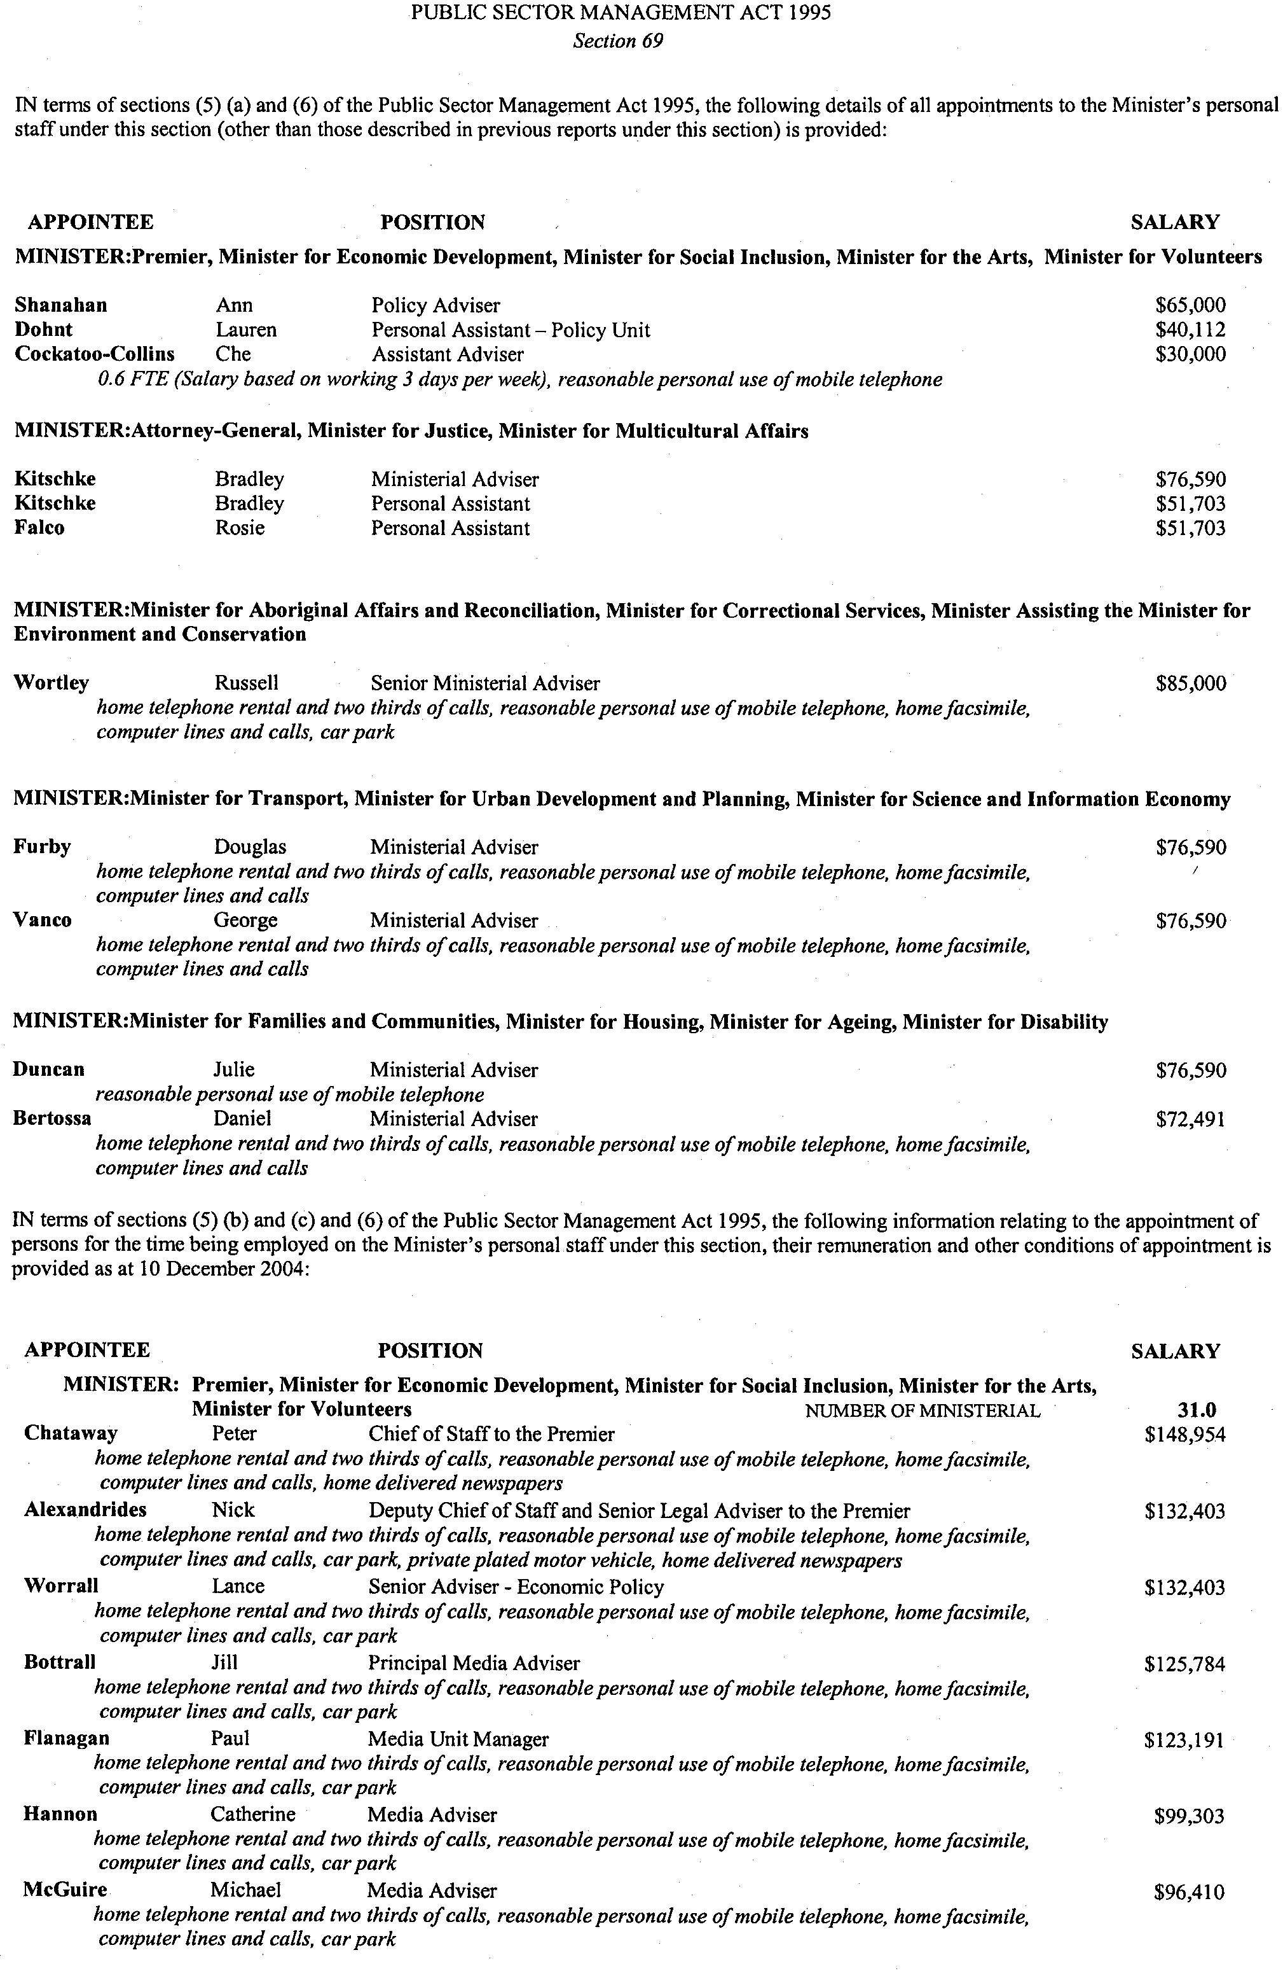
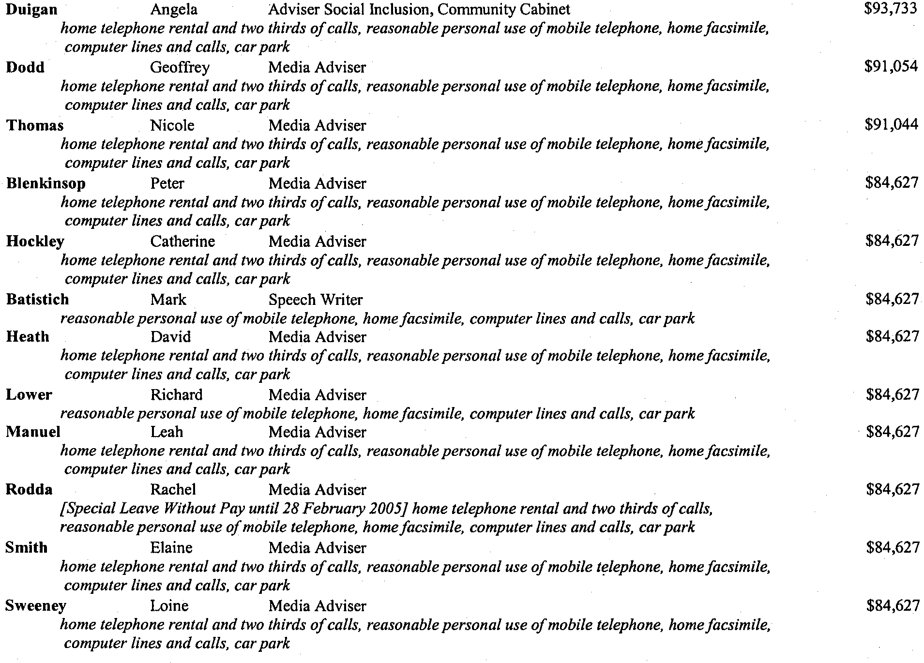
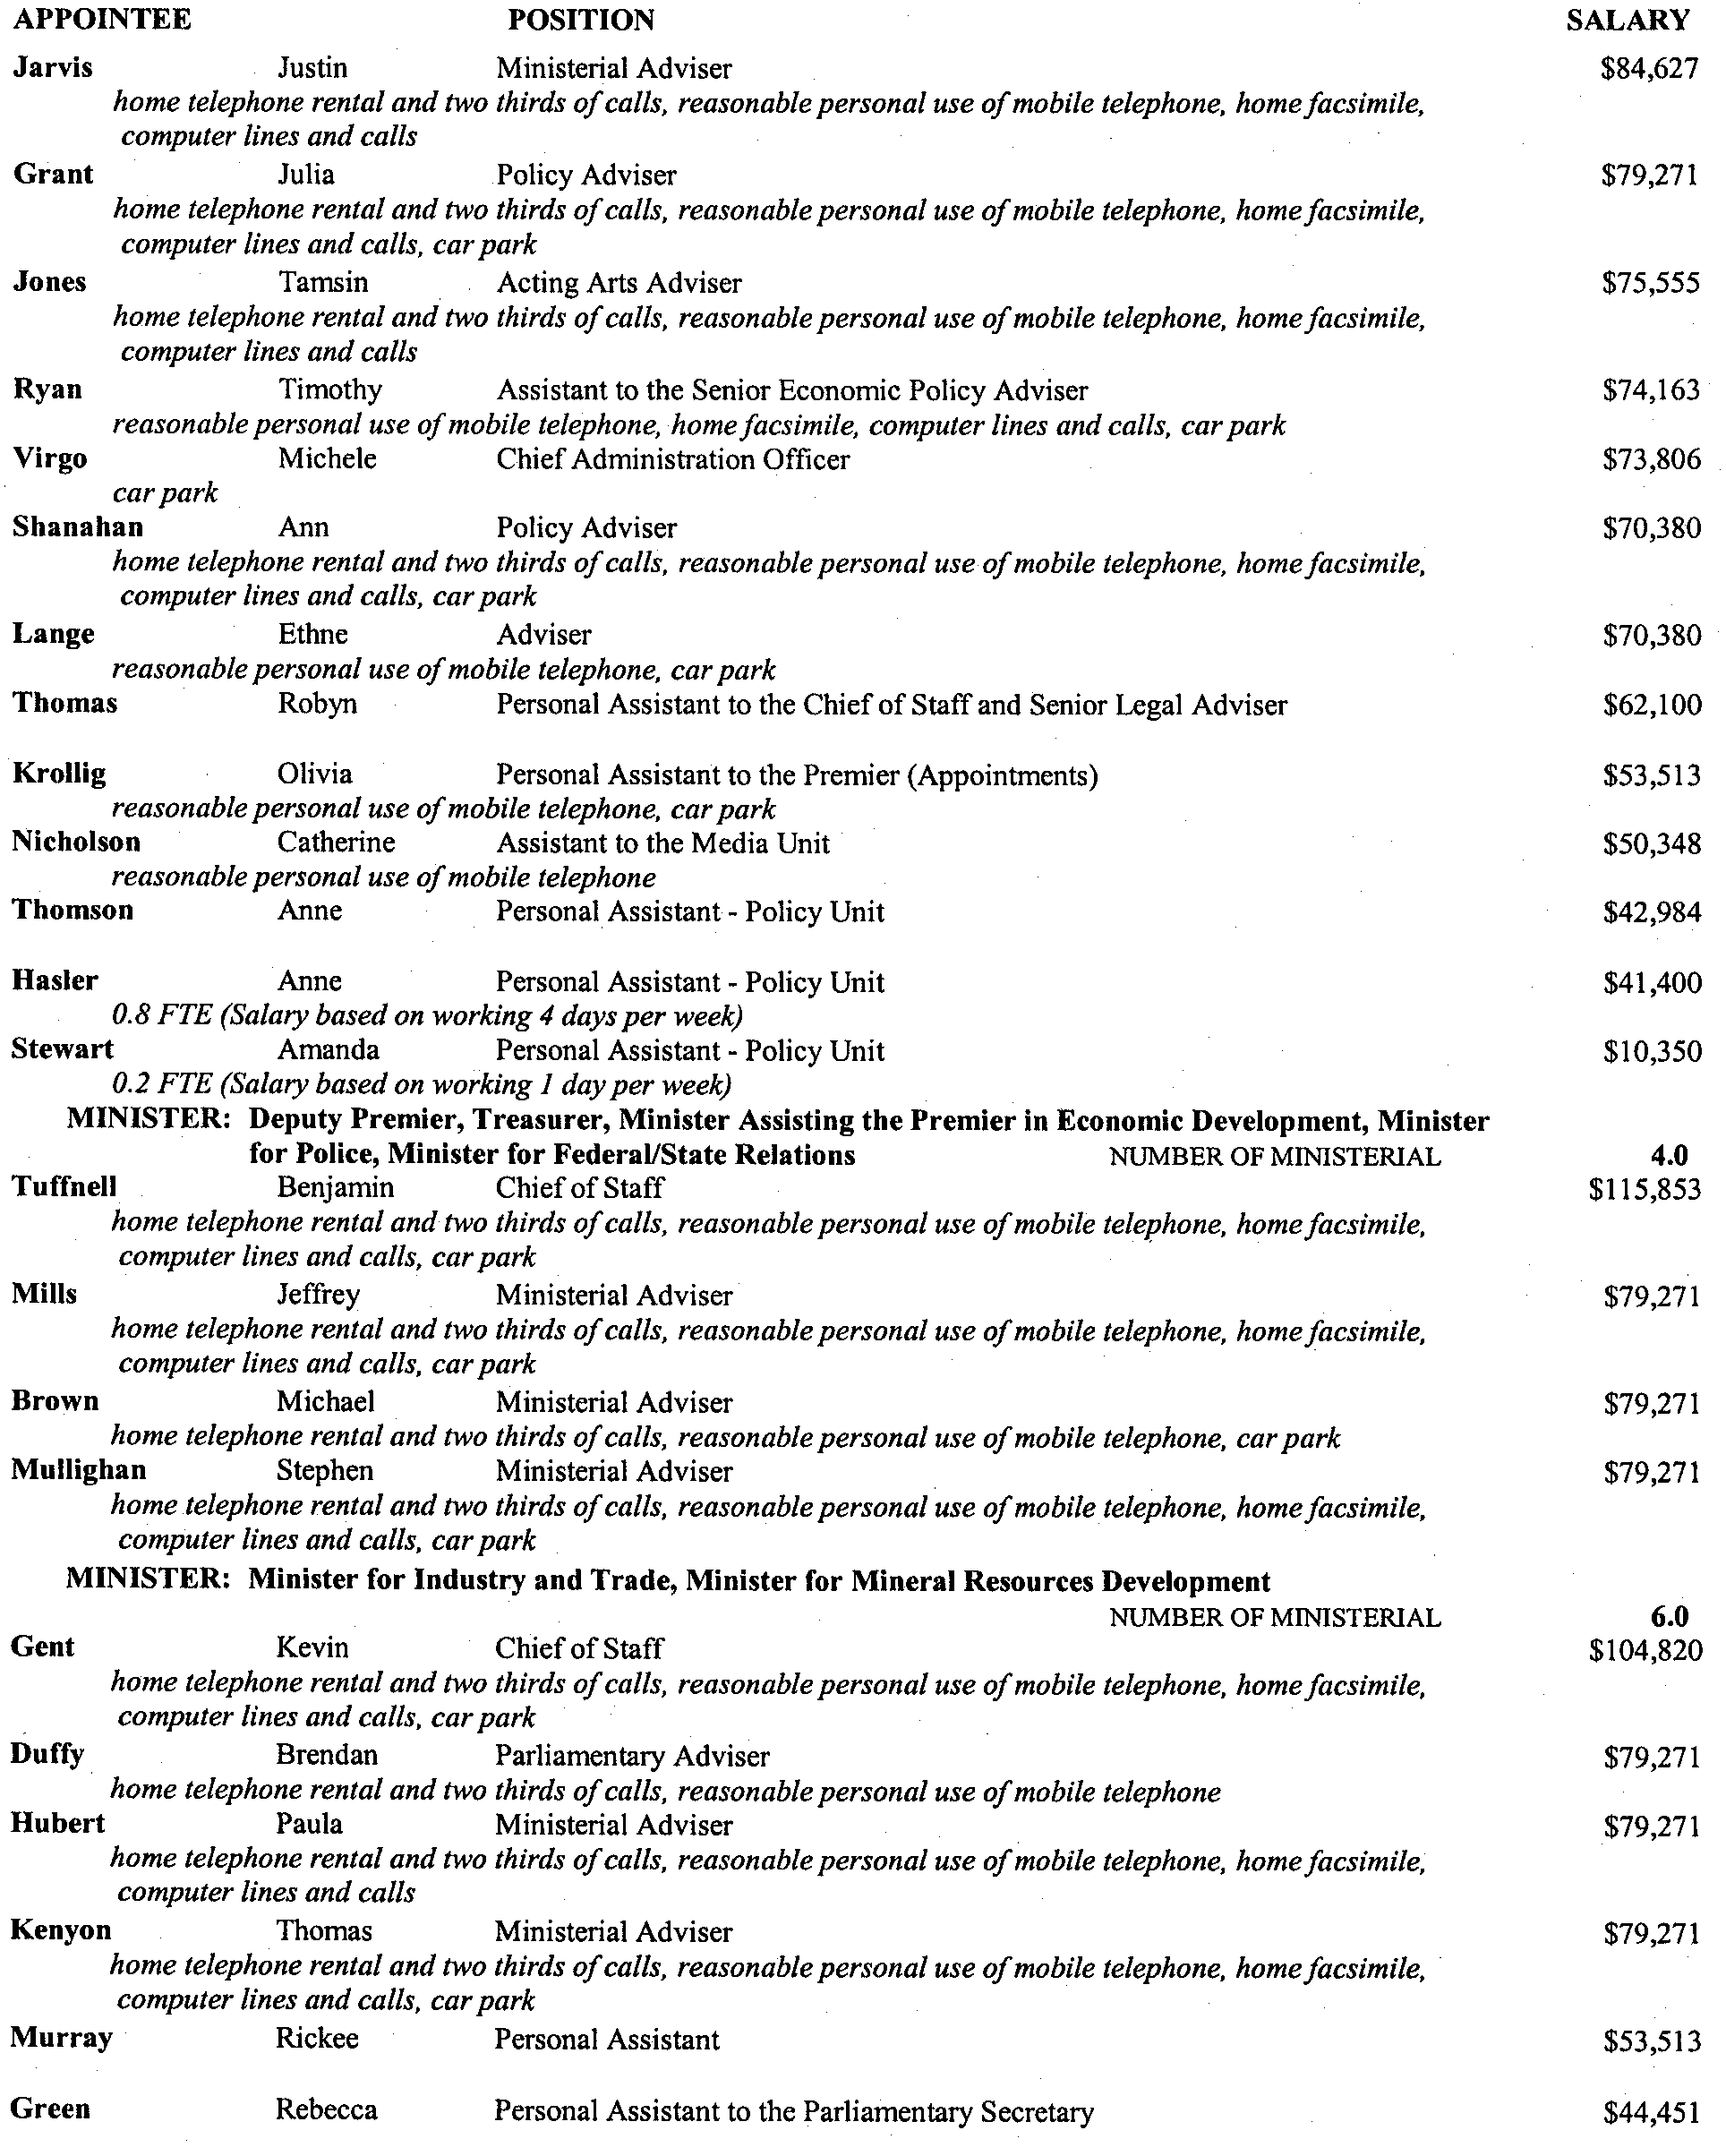
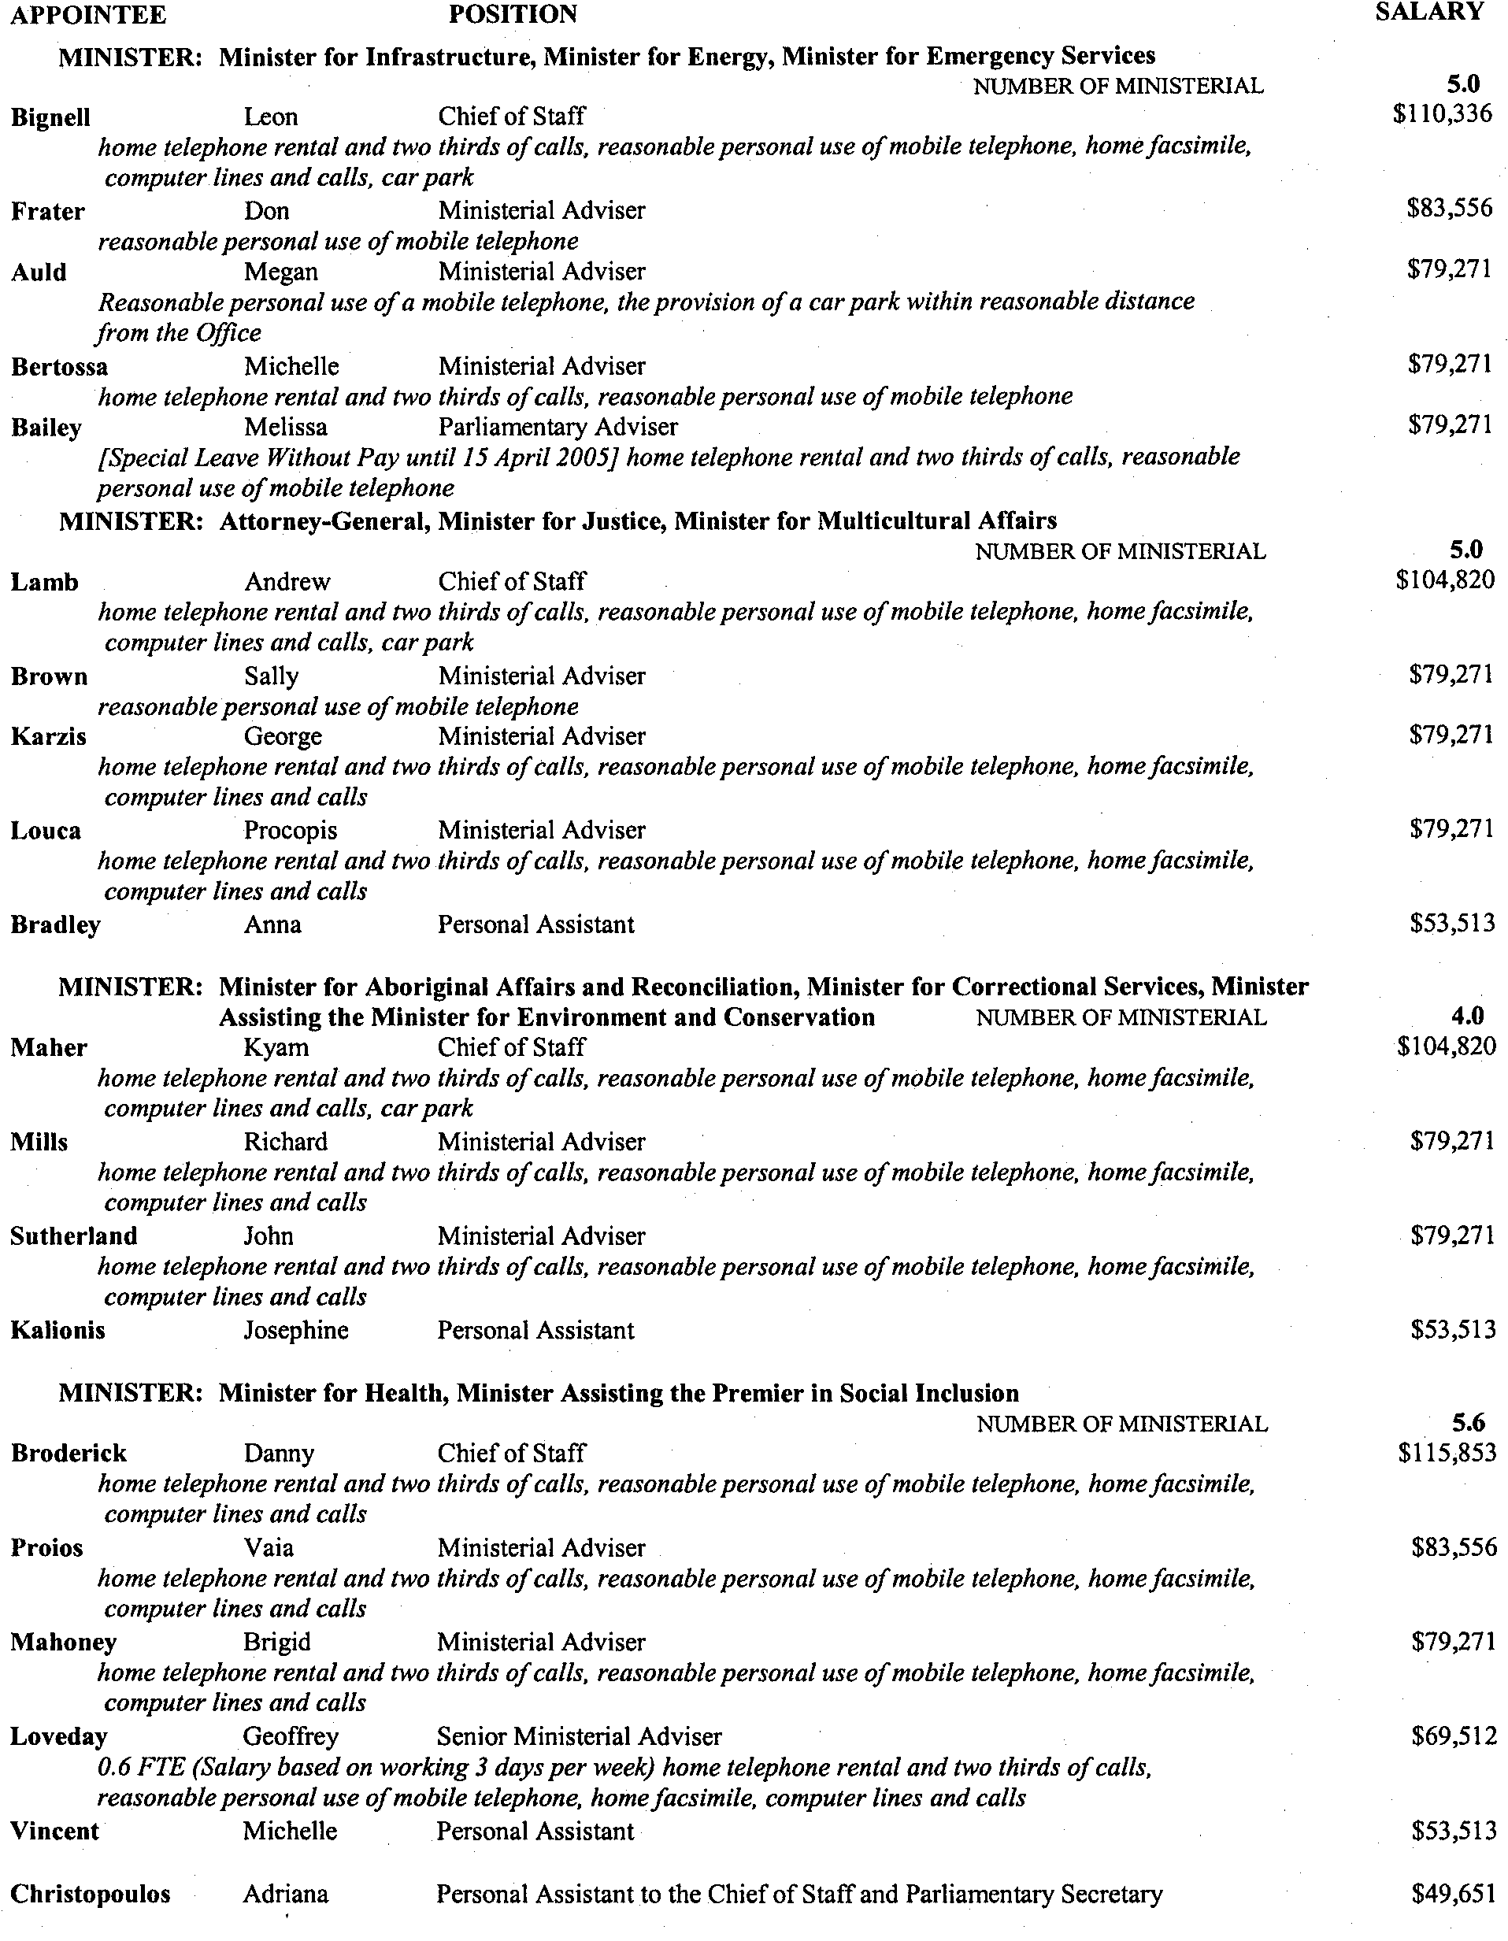
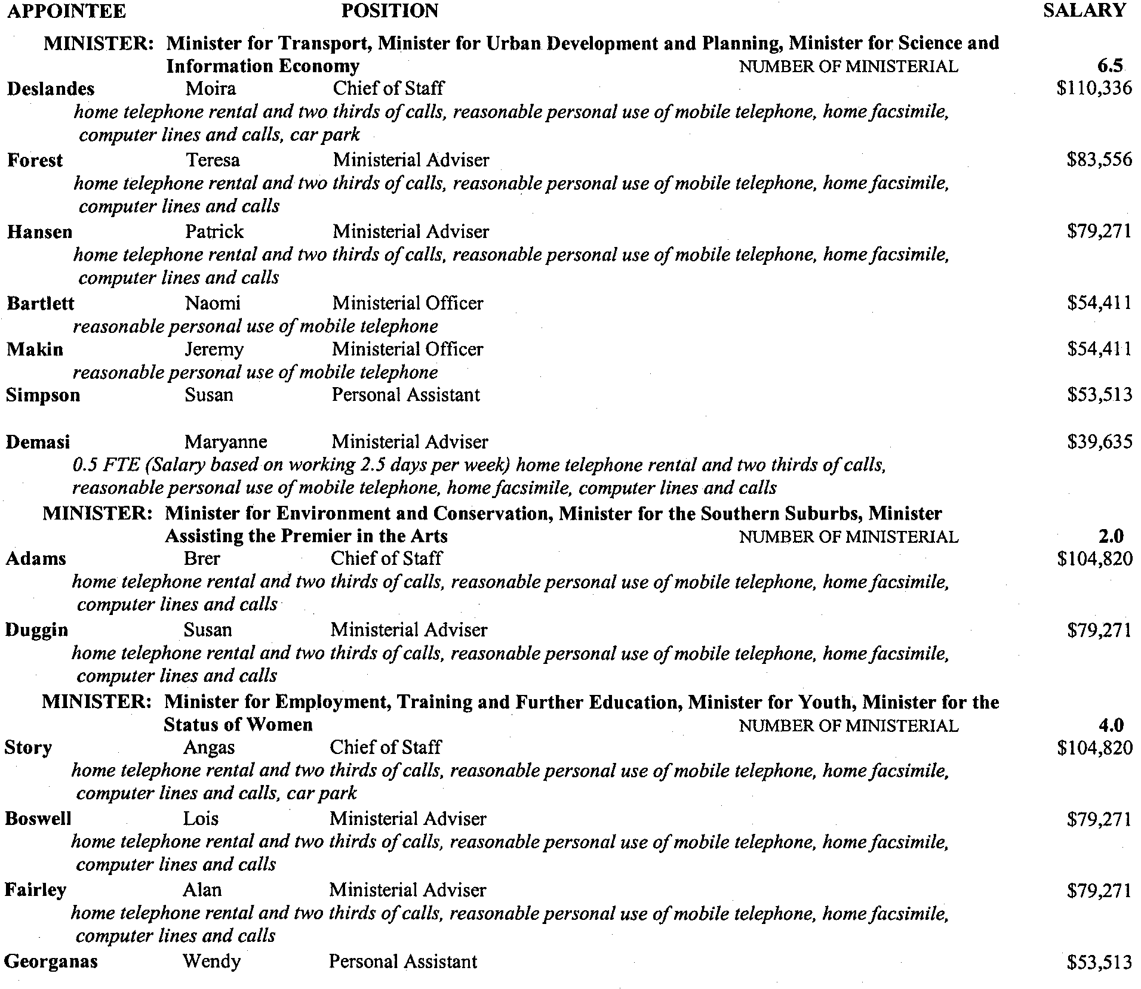
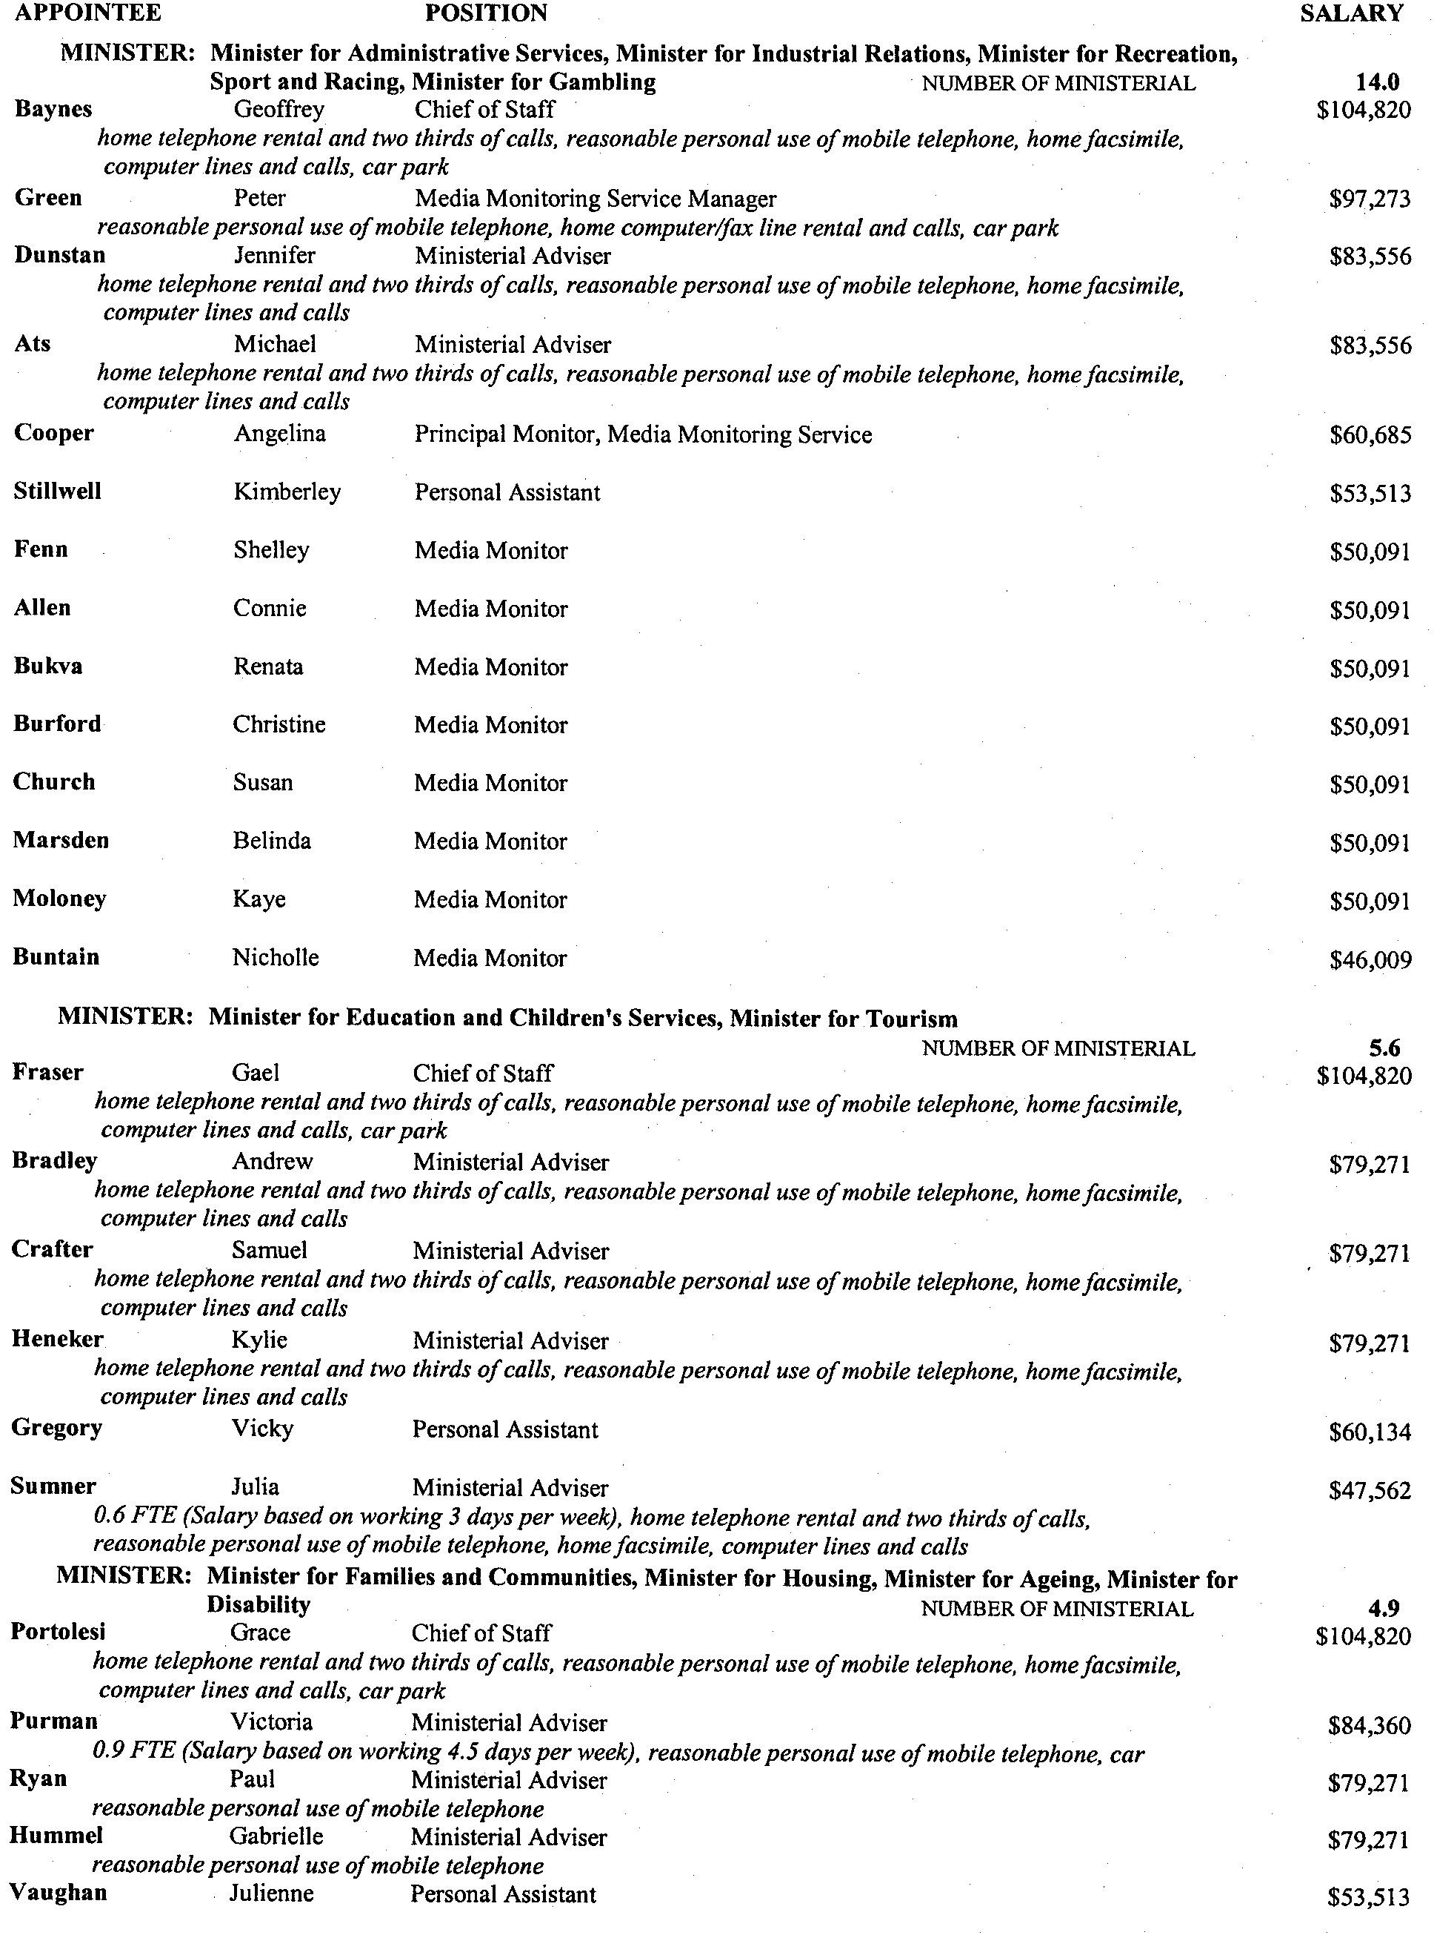
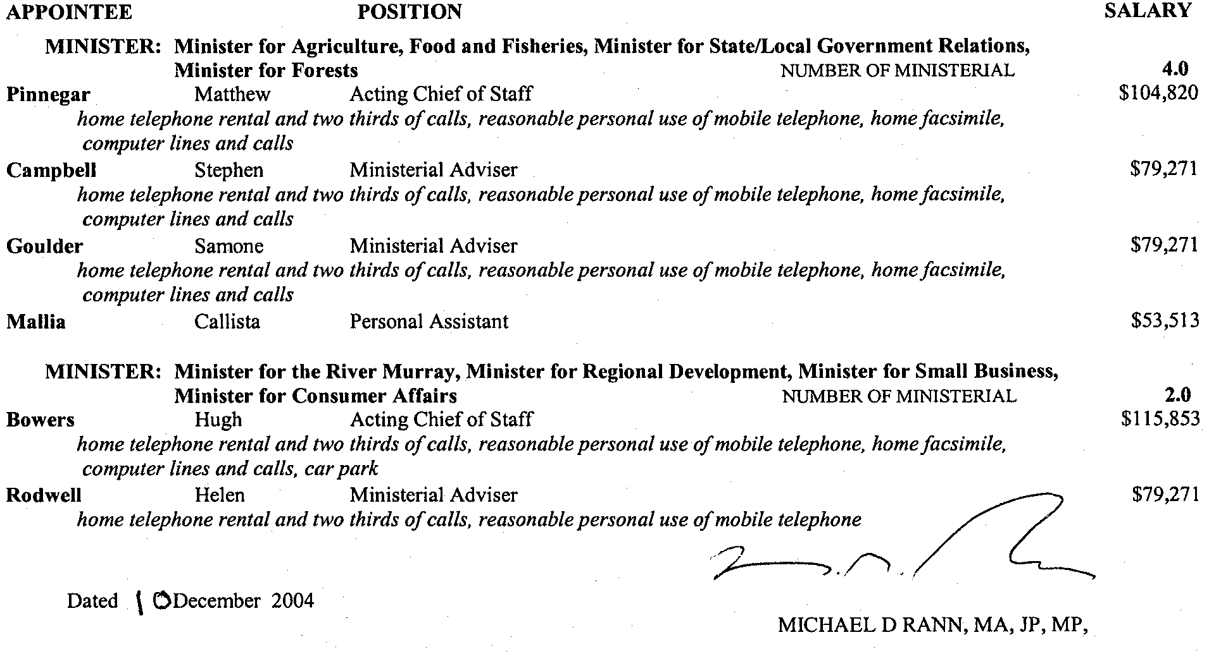

GOVERNMENT GAZETTE ADVERTISEMENT RATES

To apply from 1 July 2004

$  Agents, Ceasing to Act as 35.50  Associations:  Incorporation 18.10  Intention of Incorporation 44.75  Transfer of Properties 44.75  Attorney, Appointment of 35.50  Bailiff’s Sale 44.75  Cemetery Curator Appointed 26.50  Companies:  Alteration to Constitution 35.50  Capital, Increase or Decrease of 44.75  Ceasing to Carry on Business 26.50  Declaration of Dividend 26.50  Incorporation 35.50  Lost Share Certificates:  First Name 26.50  Each Subsequent Name 9.10  Meeting Final 29.75  Meeting Final Regarding Liquidator’s Report on  Conduct of Winding Up (equivalent to ‘Final  Meeting’)  First Name 35.50  Each Subsequent Name 9.10  Notices:  Call 44.75  Change of Name 18.10  Creditors 35.50  Creditors Compromise of Arrangement 35.50  Creditors (extraordinary resolution that ‘the Com-pany be wound up voluntarily and that a liquidator be appointed’) 44.75  Release of Liquidator⎯Application⎯Large Ad. 70.50  ⎯Release Granted 44.75  Receiver and Manager Appointed 41.25  Receiver and Manager Ceasing to Act 35.50  Restored Name 33.50  Petition to Supreme Court for Winding Up 62.00  Summons in Action 53.00  Order of Supreme Court for Winding Up Action 35.50  Register of Interests⎯Section 84 (1) Exempt 80.00  Removal of Office 18.10  Proof of Debts 35.50  Sales of Shares and Forfeiture 35.50  Estates:  Assigned 26.50  Deceased Persons⎯Notice to Creditors, etc. 44.75  Each Subsequent Name 9.10  Deceased Persons⎯Closed Estates 26.50  Each Subsequent Estate 1.15  Probate, Selling of 35.50  Public Trustee, each Estate 9.10 |  | $  Firms:  Ceasing to Carry on Business (each insertion) 23.60  Discontinuance Place of Business 23.60  Land⎯Real Property Act:  Intention to Sell, Notice of 44.75  Lost Certificate of Title Notices 44.75  Cancellation, Notice of (Strata Plan) 44.75  Mortgages:  Caveat Lodgment 18.10  Discharge of 19.00  Foreclosures 18.10  Transfer of 18.10  Sublet 9.10  Leases⎯Application for Transfer (2 insertions) each 9.10  Lost Treasury Receipts (3 insertions) each 26.50  Licensing 53.00  Municipal or District Councils:  Annual Financial Statement⎯Forms 1 and 2 499.00  Electricity Supply⎯Forms 19 and 20 354.00  Default in Payment of Rates:  First Name 70.50  Each Subsequent Name 9.10  Noxious Trade 26.50  Partnership, Dissolution of 26.50  Petitions (small) 18.10  Registered Building Societies (from Registrar-  General) 18.10  Register of Unclaimed Moneys⎯First Name 26.50  Each Subsequent Name 9.10  Registers of Members⎯Three pages and over:  Rate per page (in 8pt) 226.00  Rate per page (in 6pt) 299.00  Sale of Land by Public Auction 45.25  Advertisements 2.50  Advertisements, other than those listed are charged at $2.50 per column line, tabular one-third extra.  Notices by Colleges, Universities, Corporations and District Councils to be charged at $2.50 per line.  Where the notice inserted varies significantly in length from that which is usually published a charge of $2.50 per column line will be applied in lieu of advertisement rates listed.  South Australian Government publications are sold on the condition that they will not be reproduced without prior permission from the Government Printer.
All the above prices include GST

GOVERNMENT GAZETTE NOTICES
ALL private advertisements forwarded for publication in the South Australian Government Gazette must be PAID FOR PRIOR TO INSERTION; and all notices, from whatever source, should be legibly written on one side of the paper only and sent to Government Publishing SA so as to be received no later than 4 p.m. Tuesday preceding the day of publication. Phone 8207 1045 or Fax 8207 1040. E-mail: governmentgazette@saugov.sa.gov.au. Send as attachments in Word format. Please include date the notice is to be published and to whom the notice will be charged. The Government Gazette is available online at: www.governmentgazette.sa.gov.au.

MISCELLANEOUS LEGISLATION AND GOVERNMENT PUBLICATIONS PRICES AS FROM 1 JULY 2004

Acts, Bills, Rules, Parliamentary Papers and Regulations
Pages | Main | Amends | Pages | Main | Amends

1-16 | 2.15 | 0.95 | 497-512 | 30.25 | 29.00
17-32 | 2.90 | 1.80 | 513-528 | 31.25 | 29.90
33-48 | 3.80 | 2.70 | 529-544 | 32.00 | 31.00
49-64 | 4.75 | 3.65 | 545-560 | 33.00 | 32.00
65-80 | 5.60 | 4.60 | 561-576 | 33.75 | 33.00
81-96 | 6.50 | 5.40 | 577-592 | 34.75 | 33.50
97-112 | 7.40 | 6.30 | 593-608 | 35.75 | 34.50
113-128 | 8.30 | 7.25 | 609-624 | 36.50 | 35.50
129-144 | 9.35 | 8.25 | 625-640 | 37.25 | 36.10
145-160 | 10.20 | 9.10 | 641-656 | 38.25 | 37.20
161-176 | 11.20 | 10.00 | 657-672 | 38.75 | 38.00
177-192 | 12.00 | 11.00 | 673-688 | 40.50 | 38.80
193-208 | 13.00 | 11.90 | 689-704 | 41.25 | 39.90
209-224 | 13.80 | 12.70 | 705-720 | 41.75 | 41.00
225-240 | 14.70 | 13.60 | 721-736 | 43.50 | 41.50
241-257 | 15.70 | 14.30 | 737-752 | 44.00 | 42.90
258-272 | 16.60 | 15.30 | 753-768 | 45.00 | 43.40
273-288 | 17.50 | 16.40 | 769-784 | 45.50 | 44.70
289-304 | 18.30 | 17.20 | 785-800 | 46.50 | 45.60
305-320 | 19.30 | 18.20 | 801-816 | 47.25 | 46.00
321-336 | 20.10 | 19.00 | 817-832 | 48.25 | 47.25
337-352 | 21.20 | 20.00 | 833-848 | 49.25 | 48.00
353-368 | 22.00 | 21.00 | 849-864 | 50.00 | 48.80
369-384 | 22.90 | 21.90 | 865-880 | 51.00 | 50.00
385-400 | 23.80 | 22.70 | 881-896 | 51.50 | 50.50
401-416 | 23.70 | 23.50 | 897-912 | 53.00 | 51.50
417-432 | 25.75 | 24.50 | 913-928 | 53.50 | 53.00
433-448 | 26.60 | 25.50 | 929-944 | 54.50 | 53.50
449-464 | 27.50 | 26.25 | 945-960 | 55.50 | 54.00
465-480 | 28.00 | 27.25 | 961-976 | 56.50 | 55.00
481-496 | 29.25 | 28.00 | 977-992 | 57.50 | 56.00

Legislation—Acts, Regulations, etc: $
Subscriptions:
Acts 187.00
All Bills as Laid 447.00
Rules and Regulations 447.00
Parliamentary Papers 447.00
Bound Acts 207.00
Index 103.00
Government Gazette
Copy 4.85
Subscription 247.00
Hansard
Copy 13.50
Subscription—per session (issued weekly) 388.00
Cloth bound—per volume 167.00
Subscription—per session (issued daily) 388.00
Legislation on Disk
Whole Database 2 868.00
Annual Subscription for fortnightly updates 881.00
Individual Act(s) including updates POA
Compendium
Subscriptions:
New Subs 1 700.00
Updates 600.00
(All the above prices include GST)

All Legislation, Government Gazette, Hansard and Legislation on disk are available from:
Counter Sales Service SA, Government Legislation⁺ Outlet
and Mail Orders: Lands Titles Office, 101 Grenfell Street, Adelaide
Phone: 13 23 24 (local call cost), Fax: (08) 8204 1909
Postal: G.P.O. Box 1707, Adelaide, S.A. 5001

Online Shop: www.shop.service.sa.gov.au

Subscriptions and Government Publishing SA
Standing Orders: Box 9, Plaza Level, Riverside Centre, North Terrace, Adelaide, S.A. 5000
Phone: (08) 8207 0908, (08) 8207 0910, Fax: (08) 8207 1040




Christmas/New Year Holiday Publishing Information

Last Gazette for 2004 will be Thursday, 23 December 2004

Closing date for notices for publication will be
4 p.m. Tuesday, 21 December 2004

First Gazette for 2005 will be Thursday, 6 January 2005

Closing date for notices for publication will be
4 p.m. Tuesday, 4 January 2005

(There will not be a Gazette in the period between these two dates)

It would be appreciated if Government Gazette notices for publication be addressed to:

Government Publishing SA
Box 9
Plaza Level
Riverside Centre
North Terrace, Adelaide 5000

AusDoc subscribers:

Government Publishing SA
DX 56508

Facsimile transmission of notices:
(08) 8207 1040
Attention: Government Gazette Section

Inquiries telephone: 8207 1045

Email address for Government Gazette notices:

governmentgazette@saugov.sa.gov.au

When sending a document via Email please confirm your transmission with a faxed copy, including the date the notice is to be published.
ROAD TRAFFIC ACT 1961
Transporting 2.9 m High Containers
1. Approval
1.1 Pursuant to section 161A of the Road Traffic Act 1961, and Regulation 35 of the Road Traffic (Miscellaneous) Regulations 1999, I hereby approve:
1.1.1 Articulated Motor Vehicles, which exceed 4.3 m in height when carrying 2.9 m high containers to operate in South Australia subject to the conditions specified in this notice.
2. Exemption
2.1 Pursuant to section 163AA of the Road Traffic Act 1961, I hereby exempt:
2.1.1 Articulated Motor Vehicles carrying 2.9 m high containers from the following provisions of the:
(i) Road Traffic (Vehicle Standards) Rules 1999:
• Rule 72 (1)—Height
Subject to the conditions specified in this notice.
3. Conditions Applying to this Approval and Exemption
3.1 The containers shall have a maximum overall height not exceeding 2.9 m.
3.2 The overall height of the vehicle and load shall not exceed 4.6 m.
3.3 The overall width of all axles or axle groups of the vehicle carrying the load, excluding the front axle or front axle group, when measured between two vertical parallel planes located at the outer extremities of the tyres, shall not be less than 2.1 m.
3.4 The conditions set out in this notice apply to the vehicles operating under this notice and does not relieve the owner and/or driver of the duty to observe all other provisions of the Road Traffic Act and Regulations.
3.5 The conditions set out in this notice may be overridden by a limitation fixed at any time on a bridge, culvert, causeway road or road ferry.
3.6 When operating under this notice, the driver must carry a legible, current and complete copy of this notice and produce this document when requested by a Transport SA Inspector appointed under the Road Traffic Act 1961 and/or the Motor Vehicles Act 1959, or a Police Officer.
3.7 Except as otherwise specified in this notice, the Standard Form Conditions prescribed in the Road Traffic (Oversize or Overmass Vehicle Exemptions) Regulations 1999, for the purposes of section 115 of the Road Traffic Act 1961, shall not apply.
3.8 This notice shall stand alone. It cannot be used in conjunction with any other exemption, notice or permit.
4. Commencement and Expiry of this Notice
4.1 This notice is valid from 1 January 2005 and expires at midnight on 31 December 2006. The notice appearing in the South Australian Government Gazette dated 27 March 2003 is revoked at midnight on 31 December 2004.

Explanatory Notes
- Some parts of the road system, such as bridges, overhead services and wires, roadside furniture (signs, traffic lights etc.) and vegetation, may not provide sufficient clearance for a vehicle and load travelling under this notice.
- Section 106 of the Road Traffic Act, Damage to roads and works, requires the driver to notify the Police, Transport SA or Office of Public Transport if the driver causes damage to roads, bridges and culverts, or interferes with roadside furniture.
- If the driver causes anything to fall on to the road that may obstruct, damage or cause injury to people or vehicles, Australian Road Rule 293 requires the driver to remove it or take action to have it removed. Examples include tree branches or damaged traffic signs.
- This concession has been provided to allow time for the transport industry to re-equip with low profile vehicles so that these containers can be carried within an overall vehicle height limit of 4.3 m. However, this concession has been extended pending the national implementation of the Performance Based Standards Scheme, which may allow the long-term transport of these containers on some vehicles (up to a height of 4.6 m) that meet specified Performance Based Standards.

Executive Director, Transport Services, Authorised delegate for the Minister for Transport

RULES OF COURT
Amending The Probate Rules 1998
Amendment No. 2 to the Probate Rules
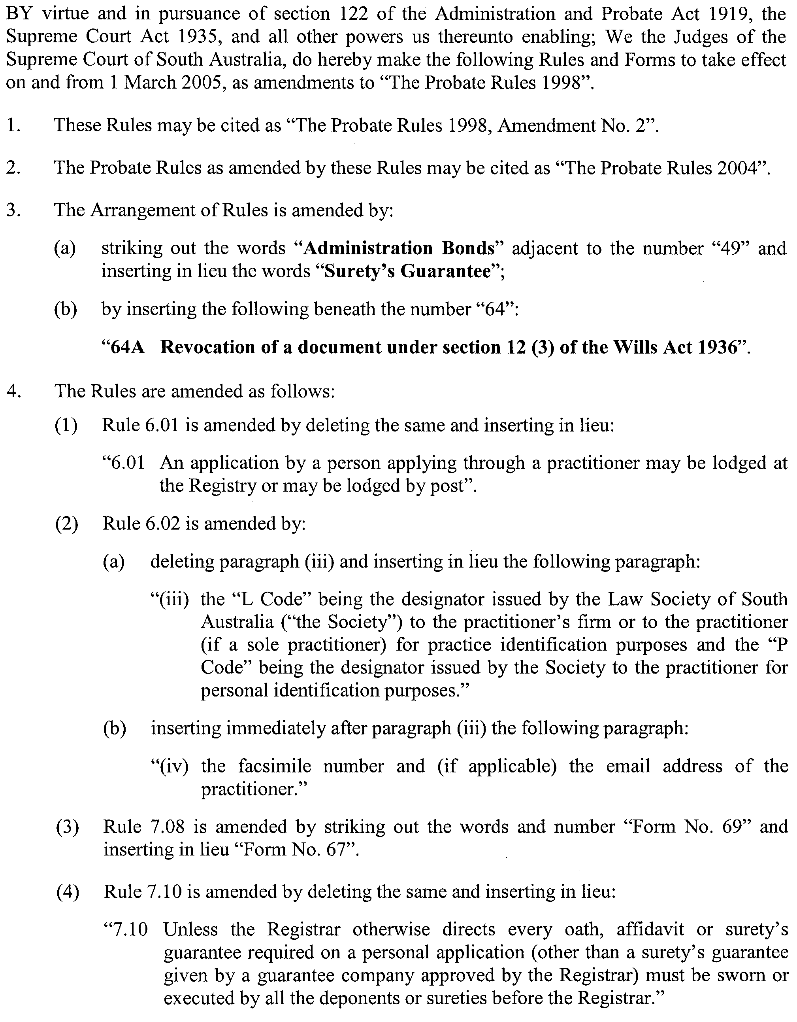
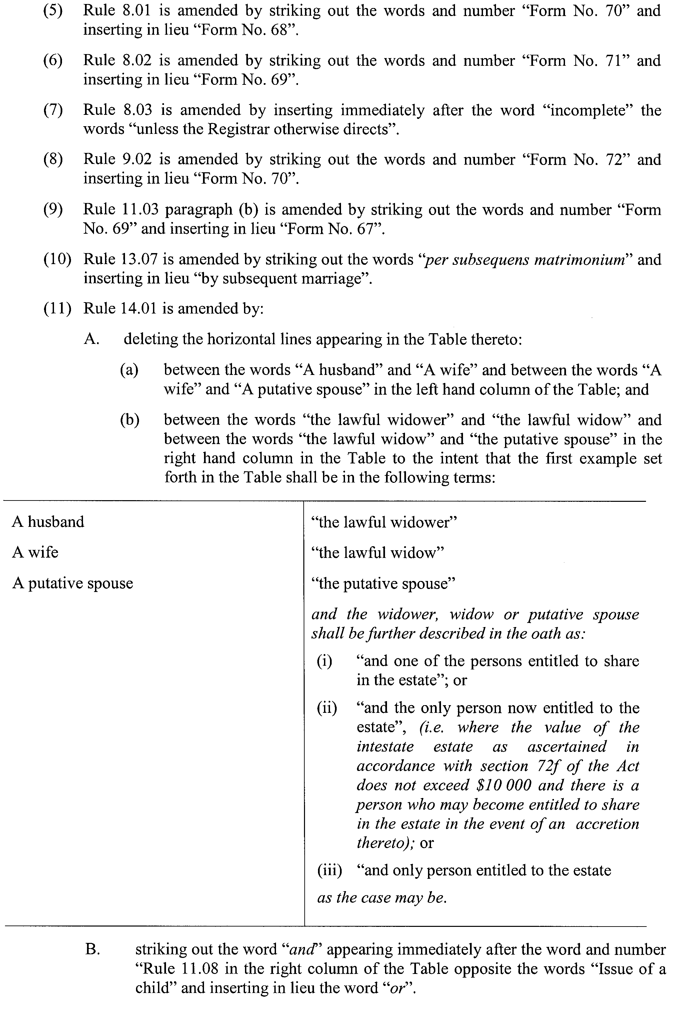
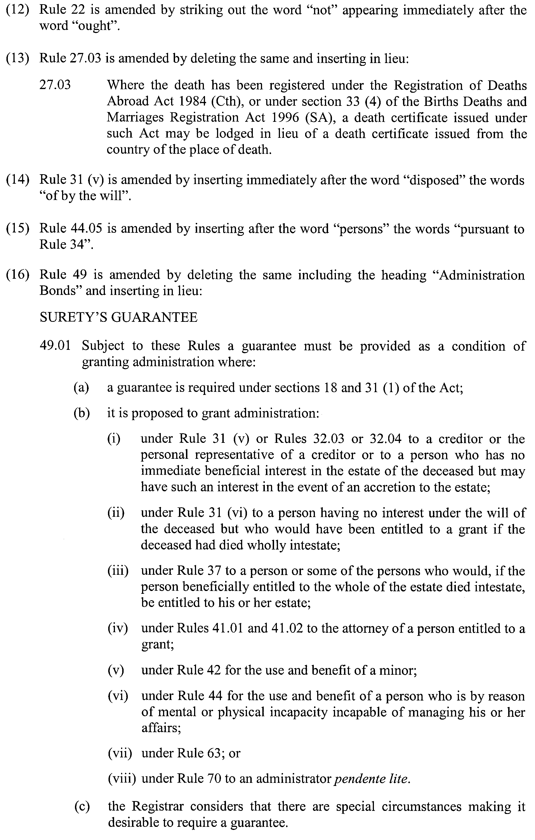
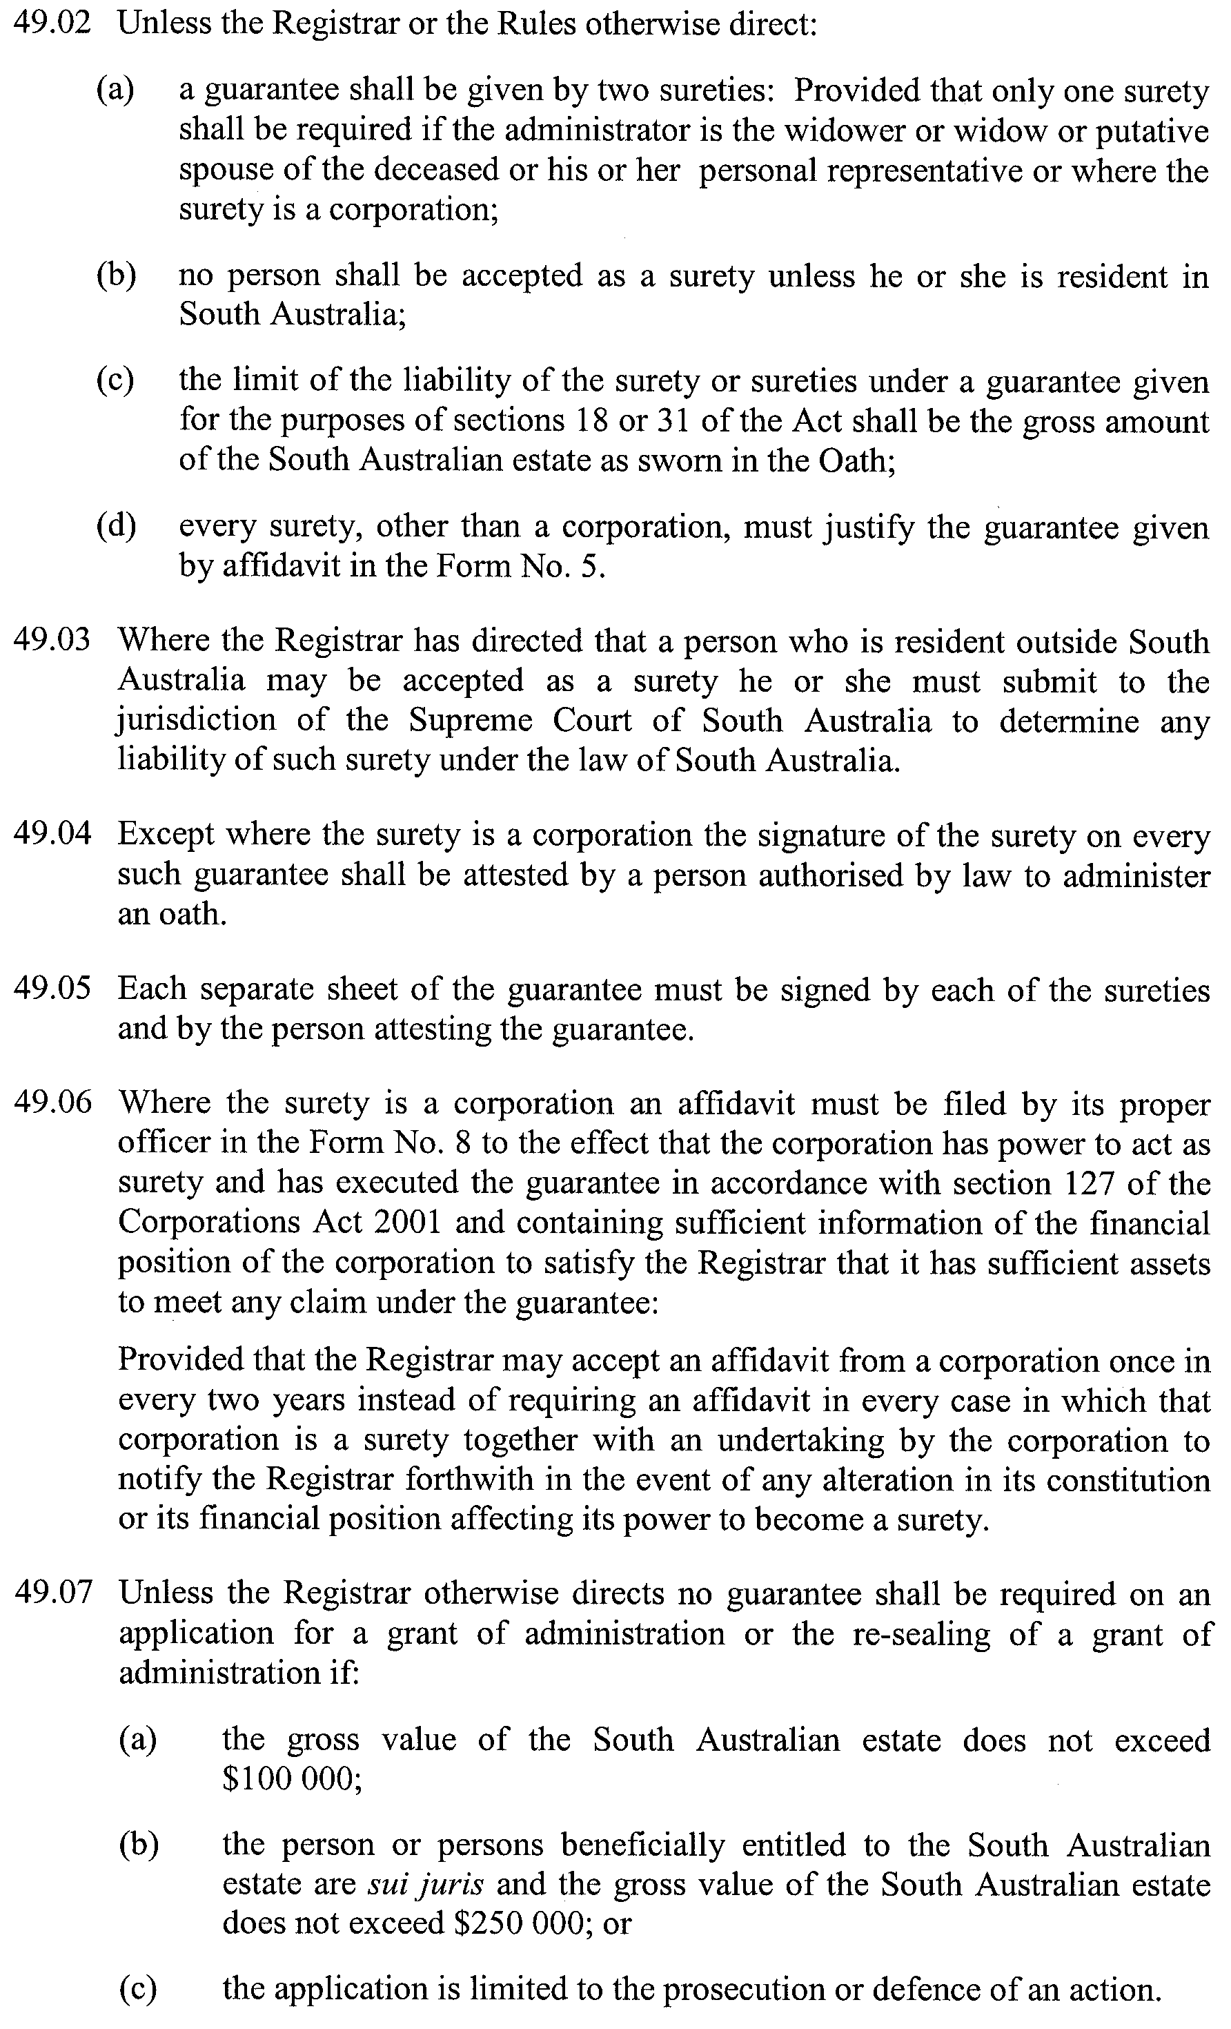
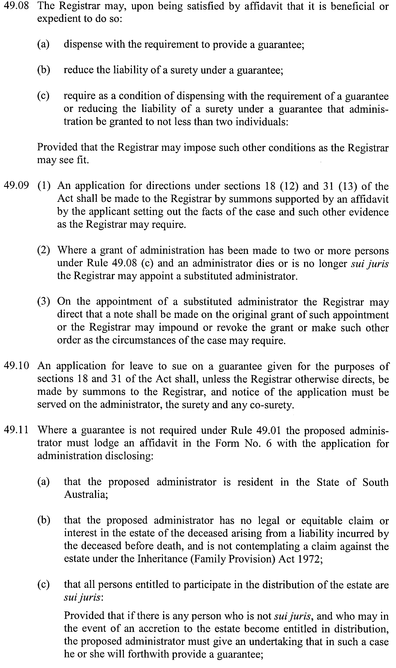
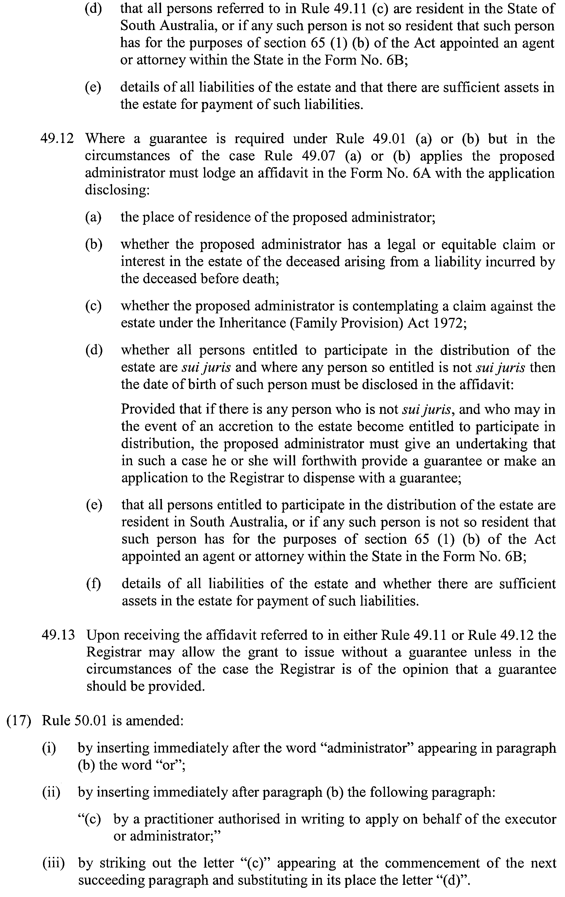
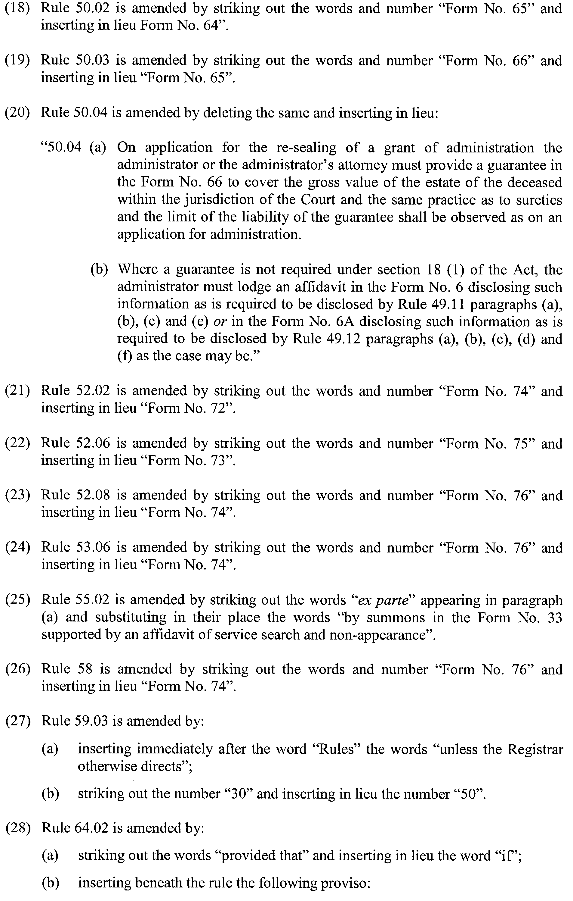
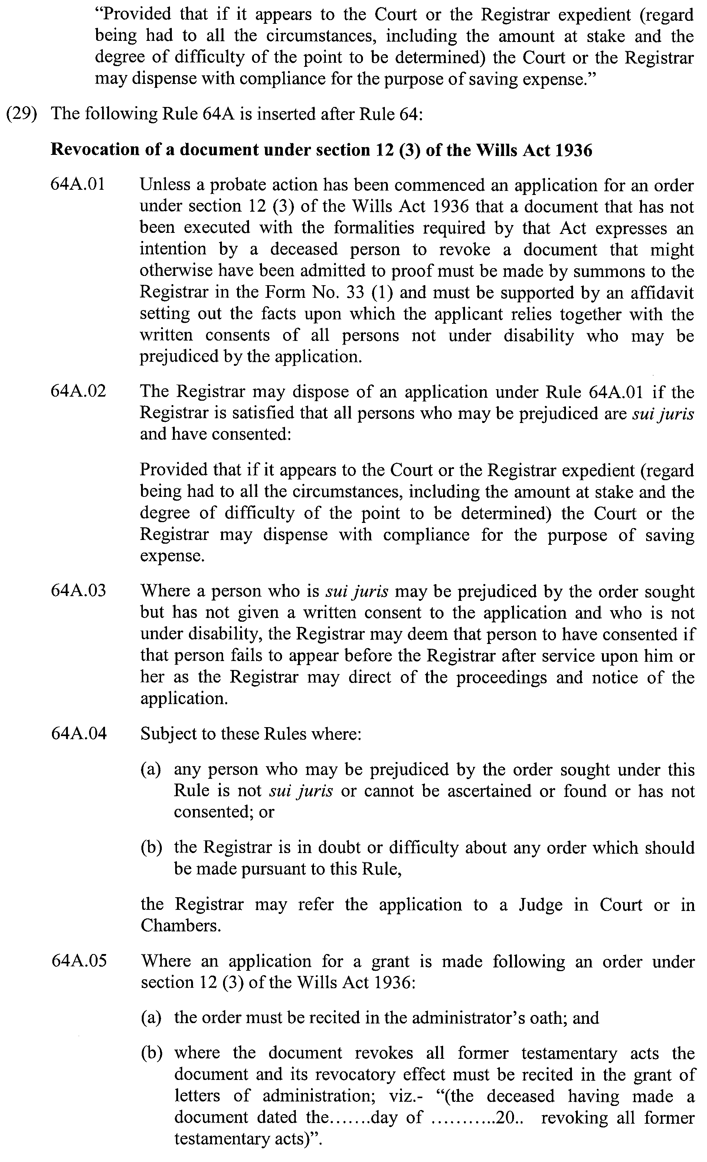
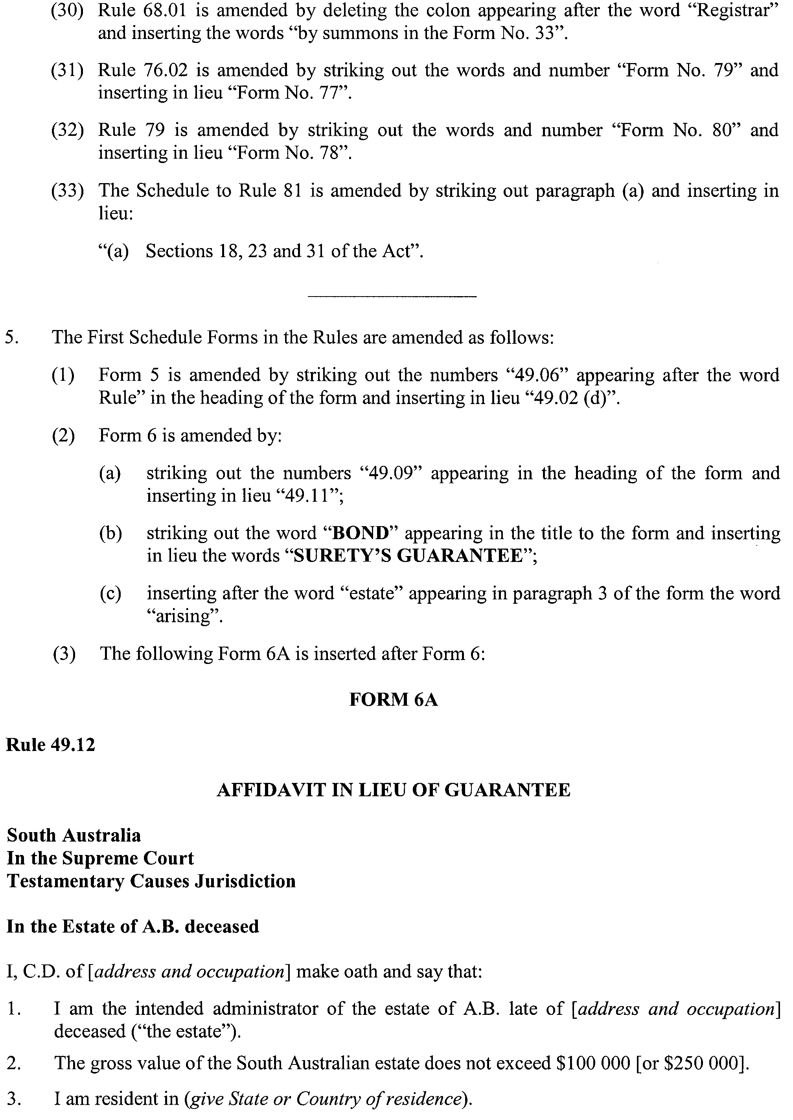

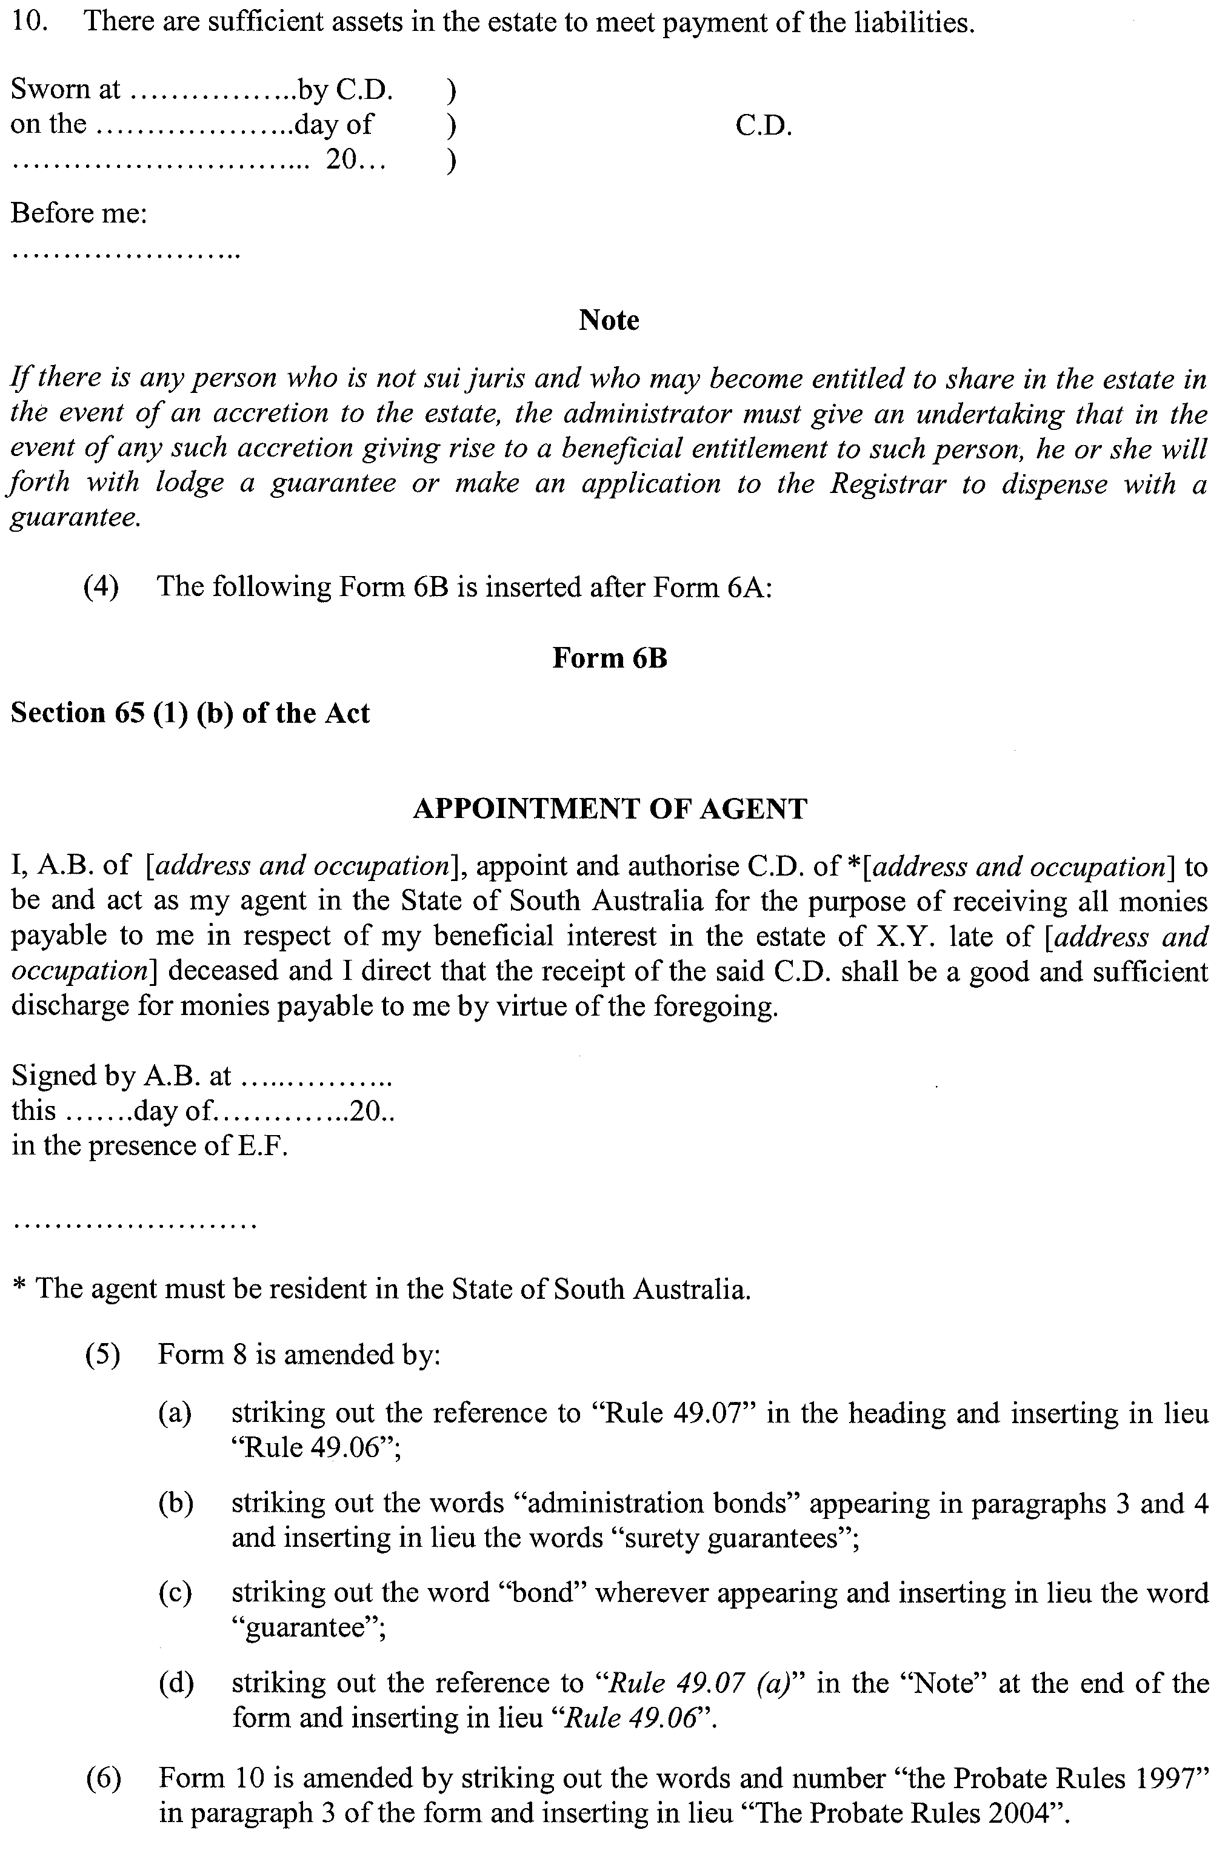
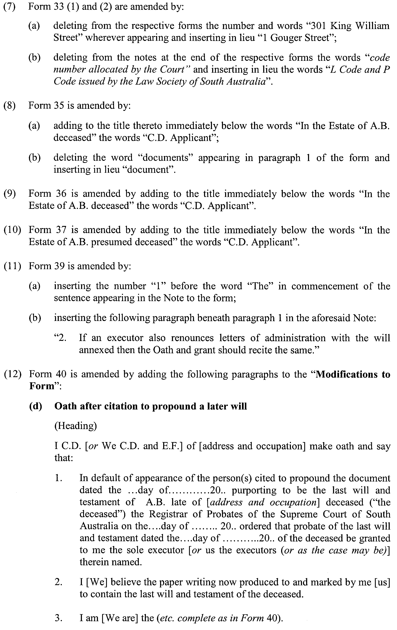
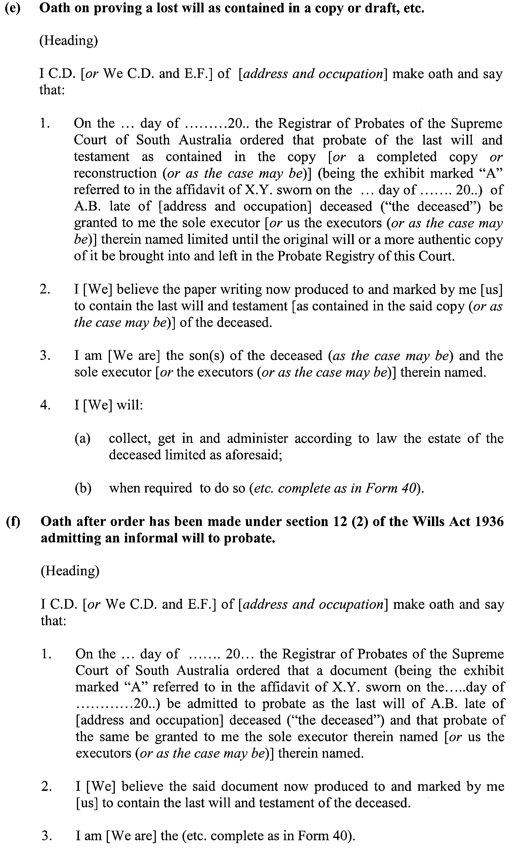
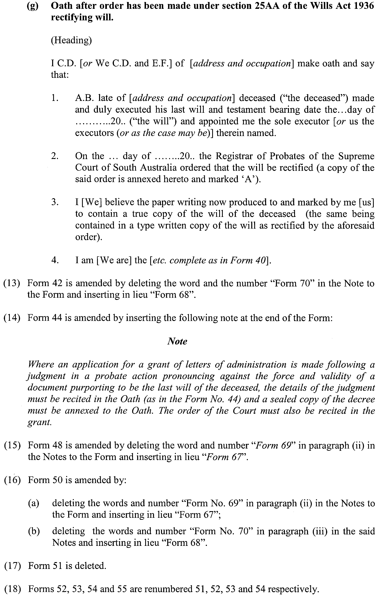
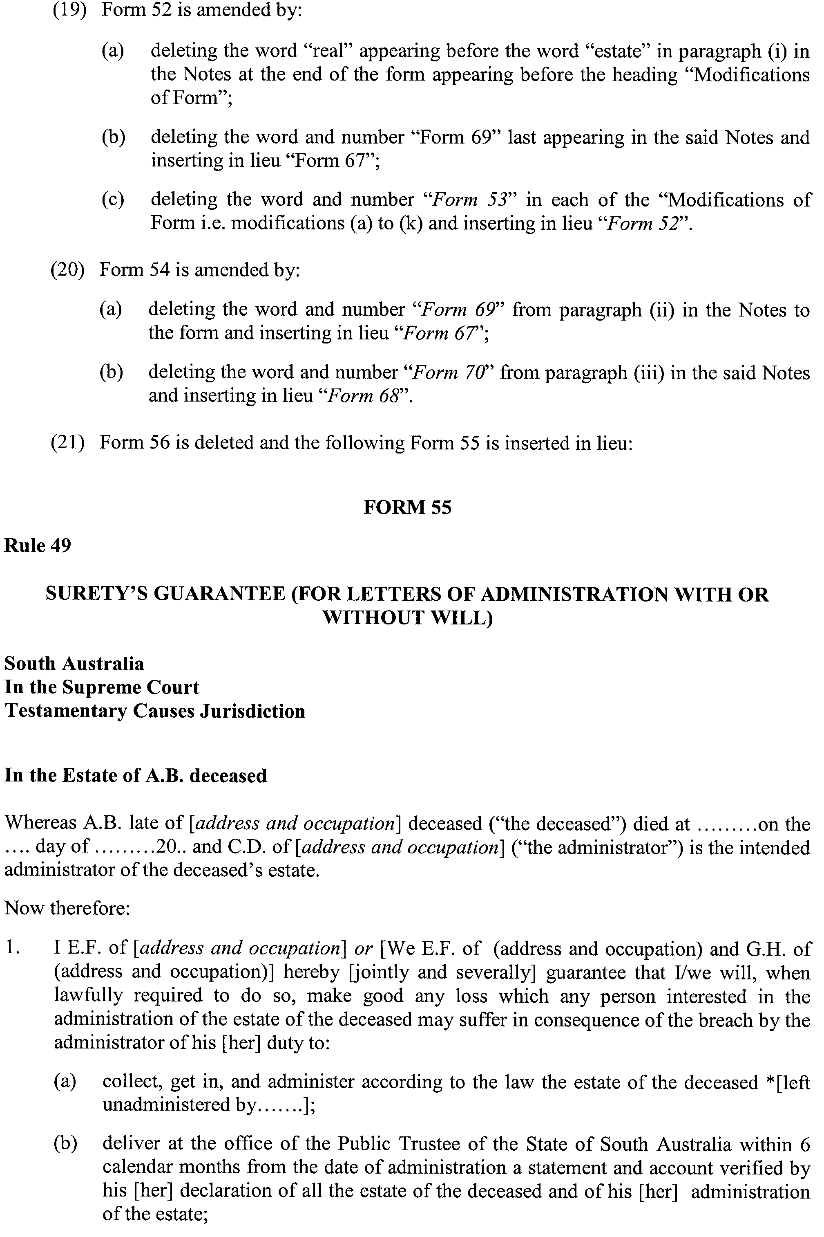
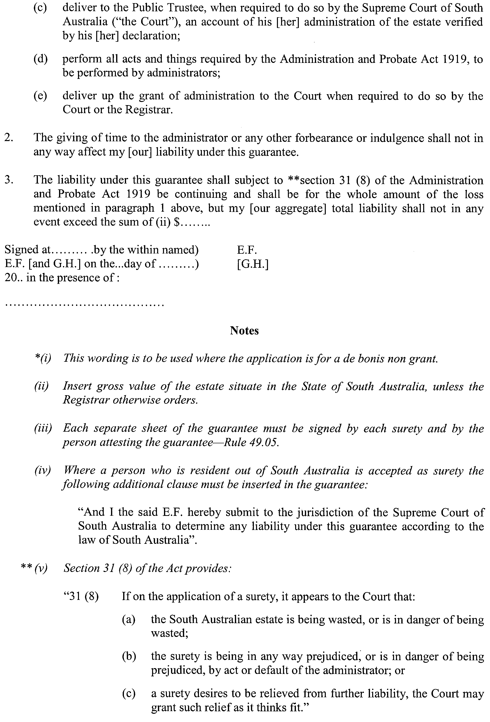
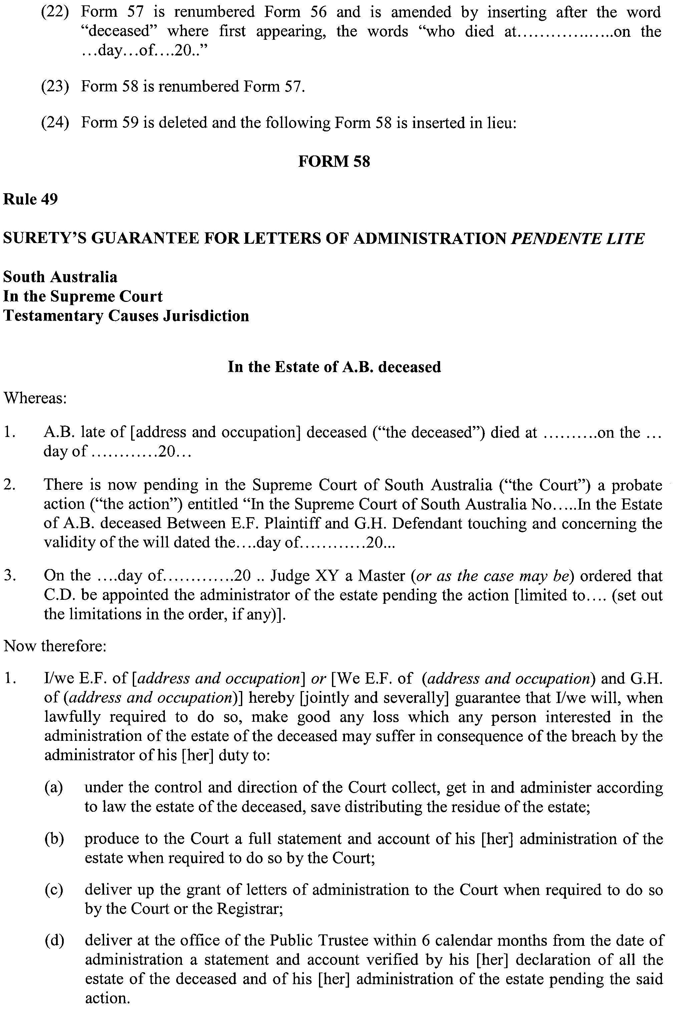
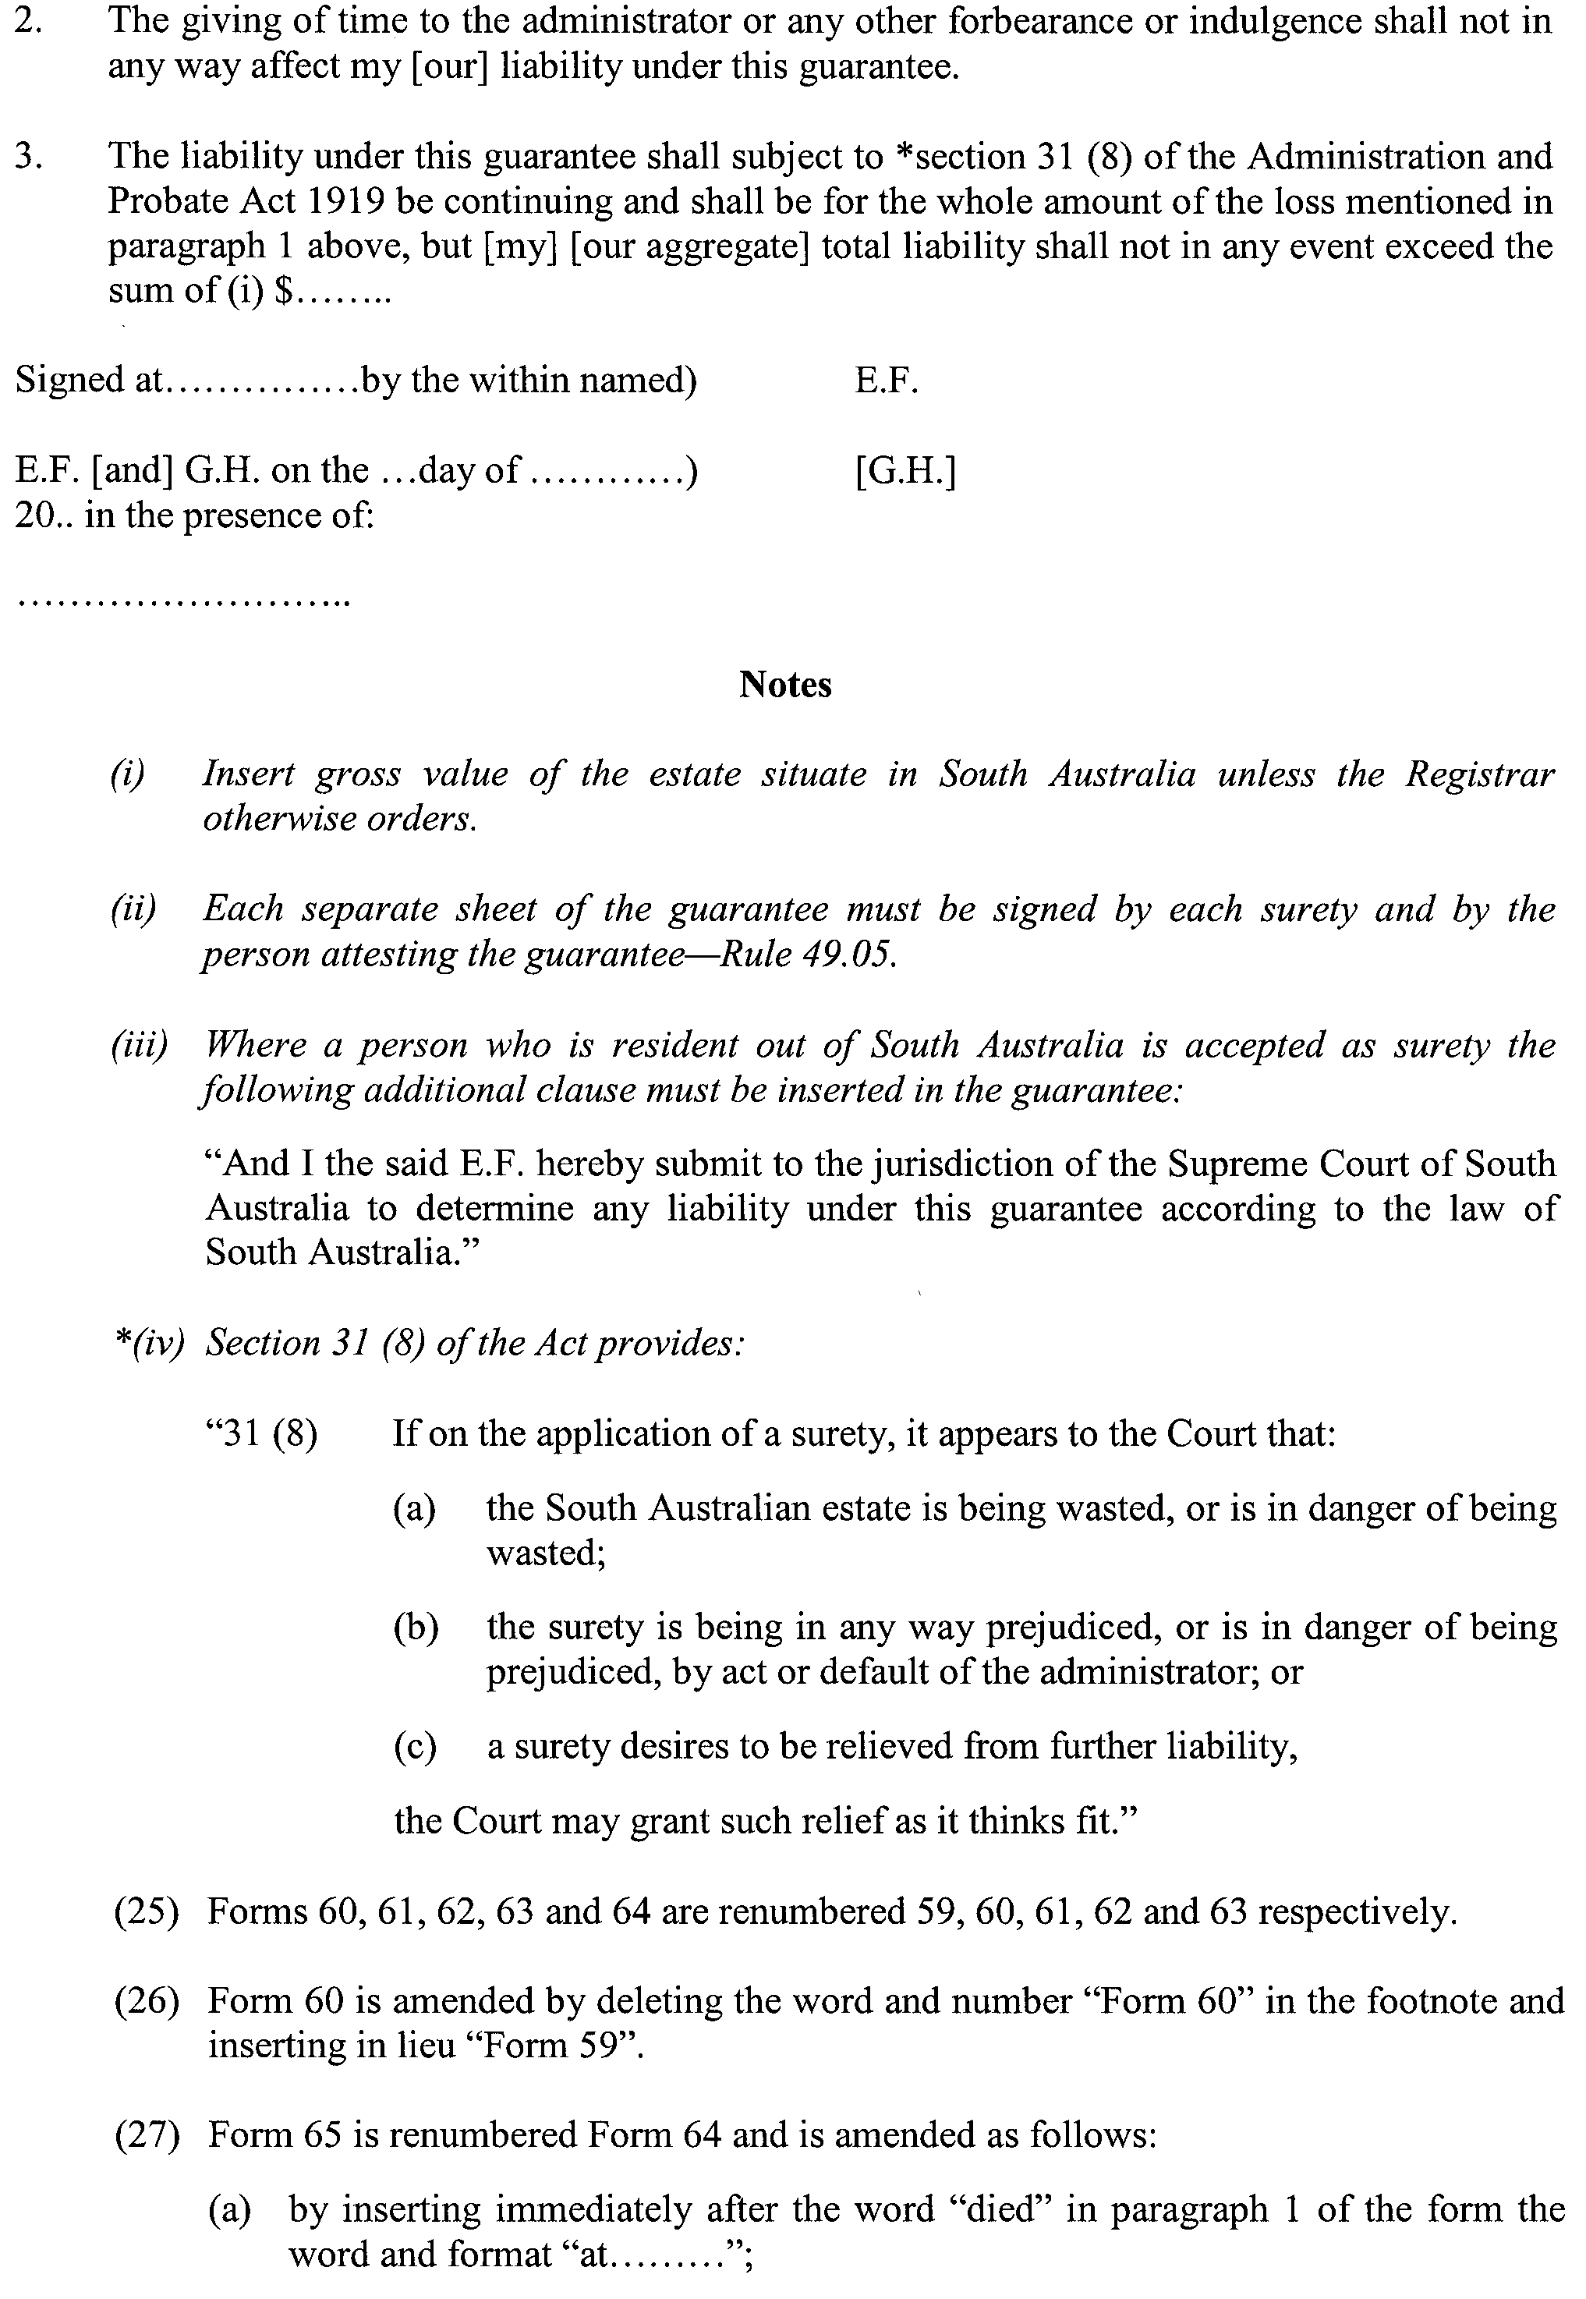
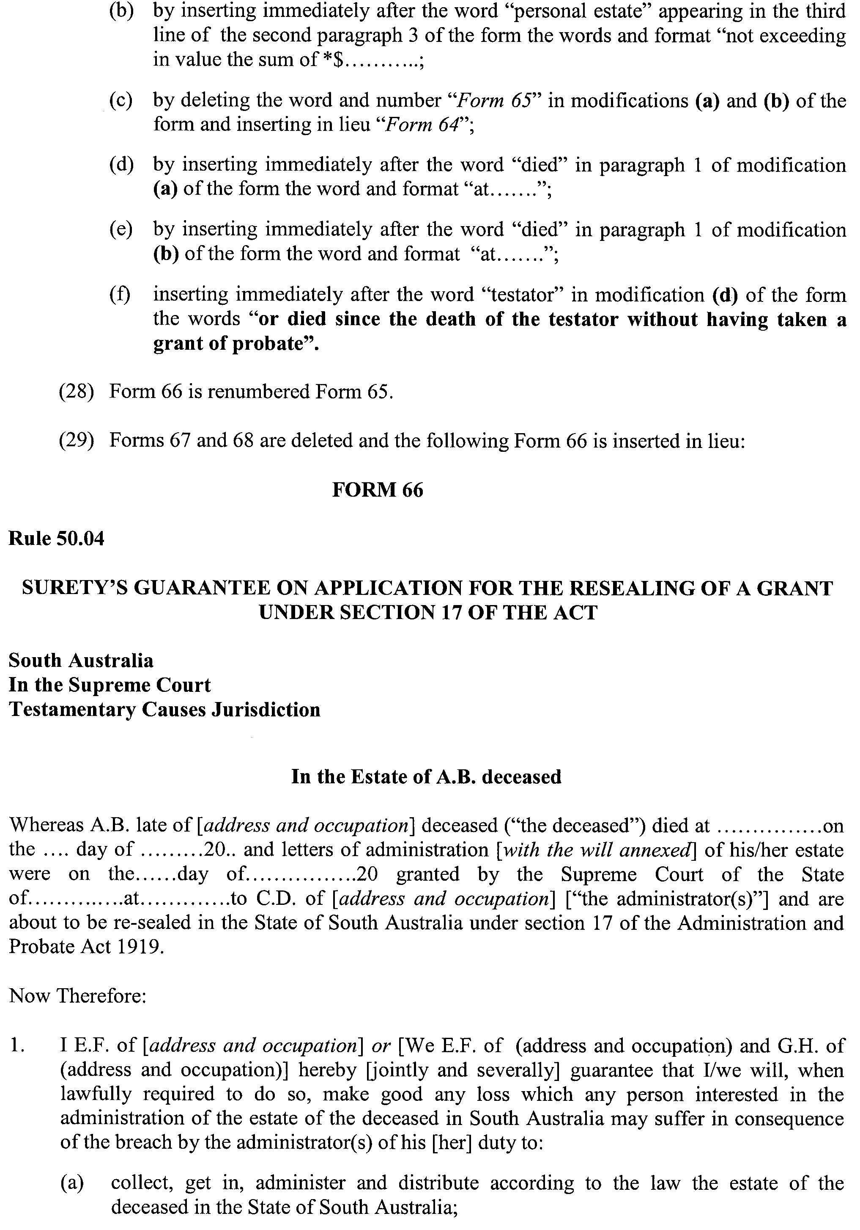
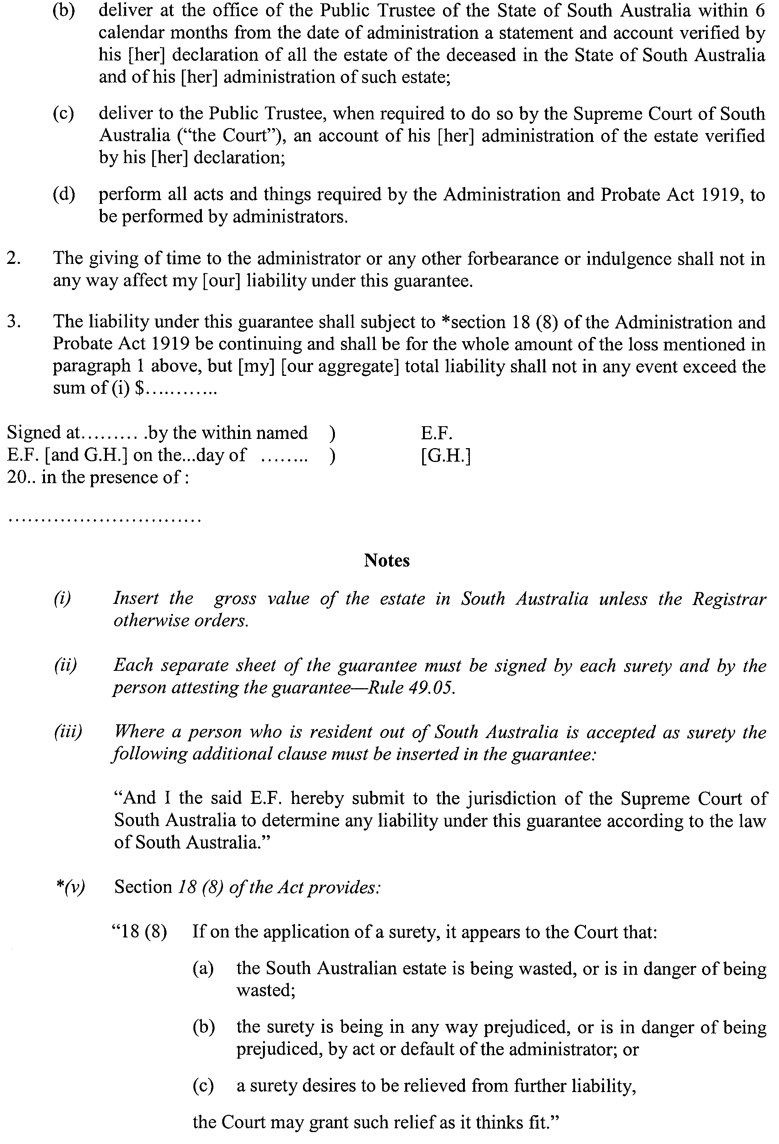
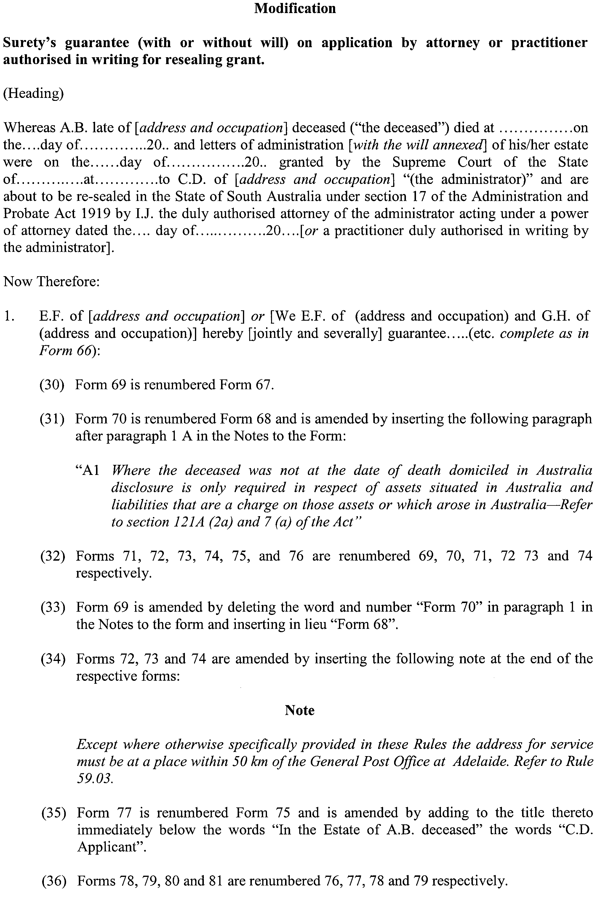
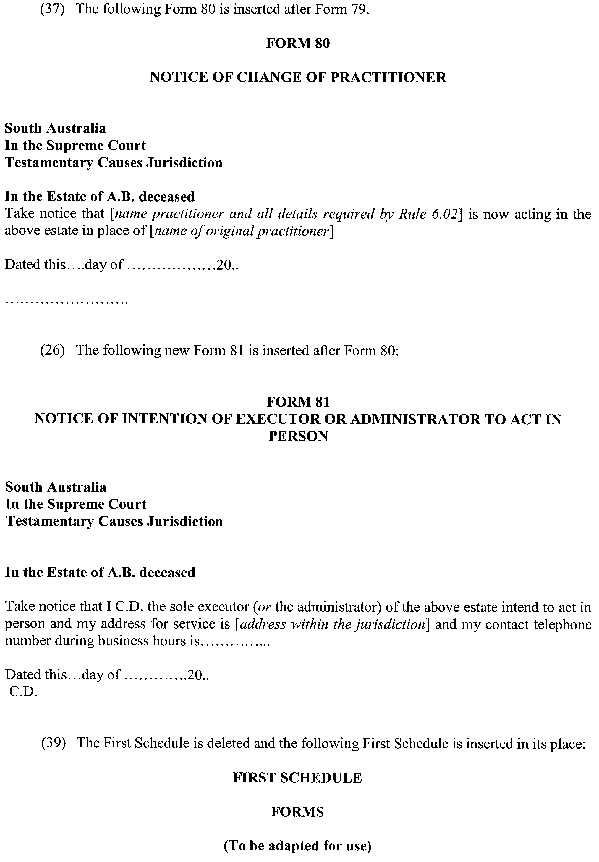
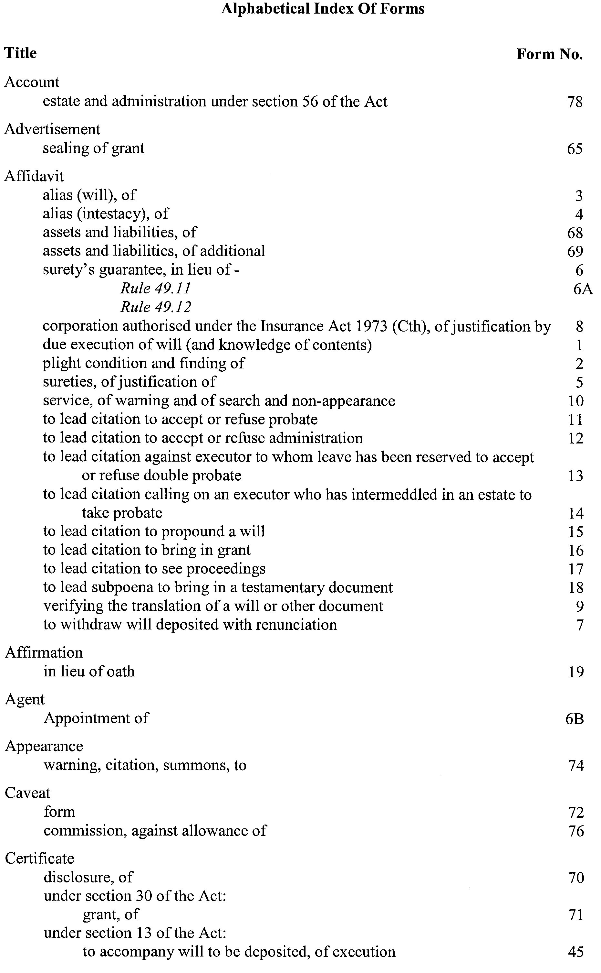
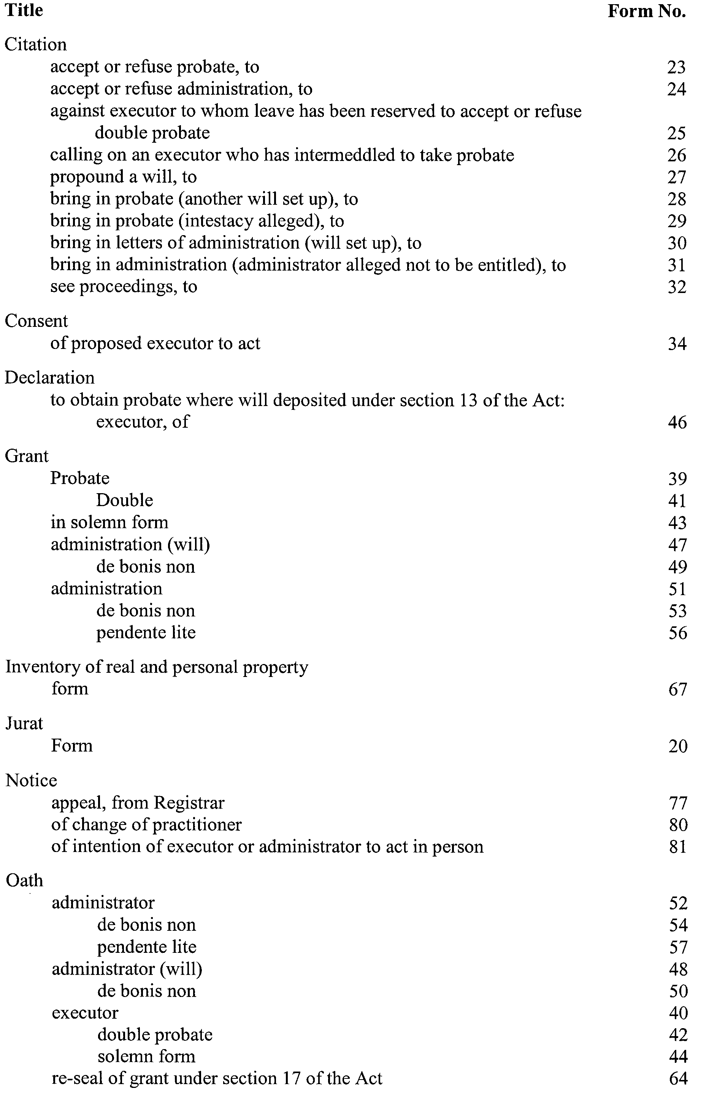

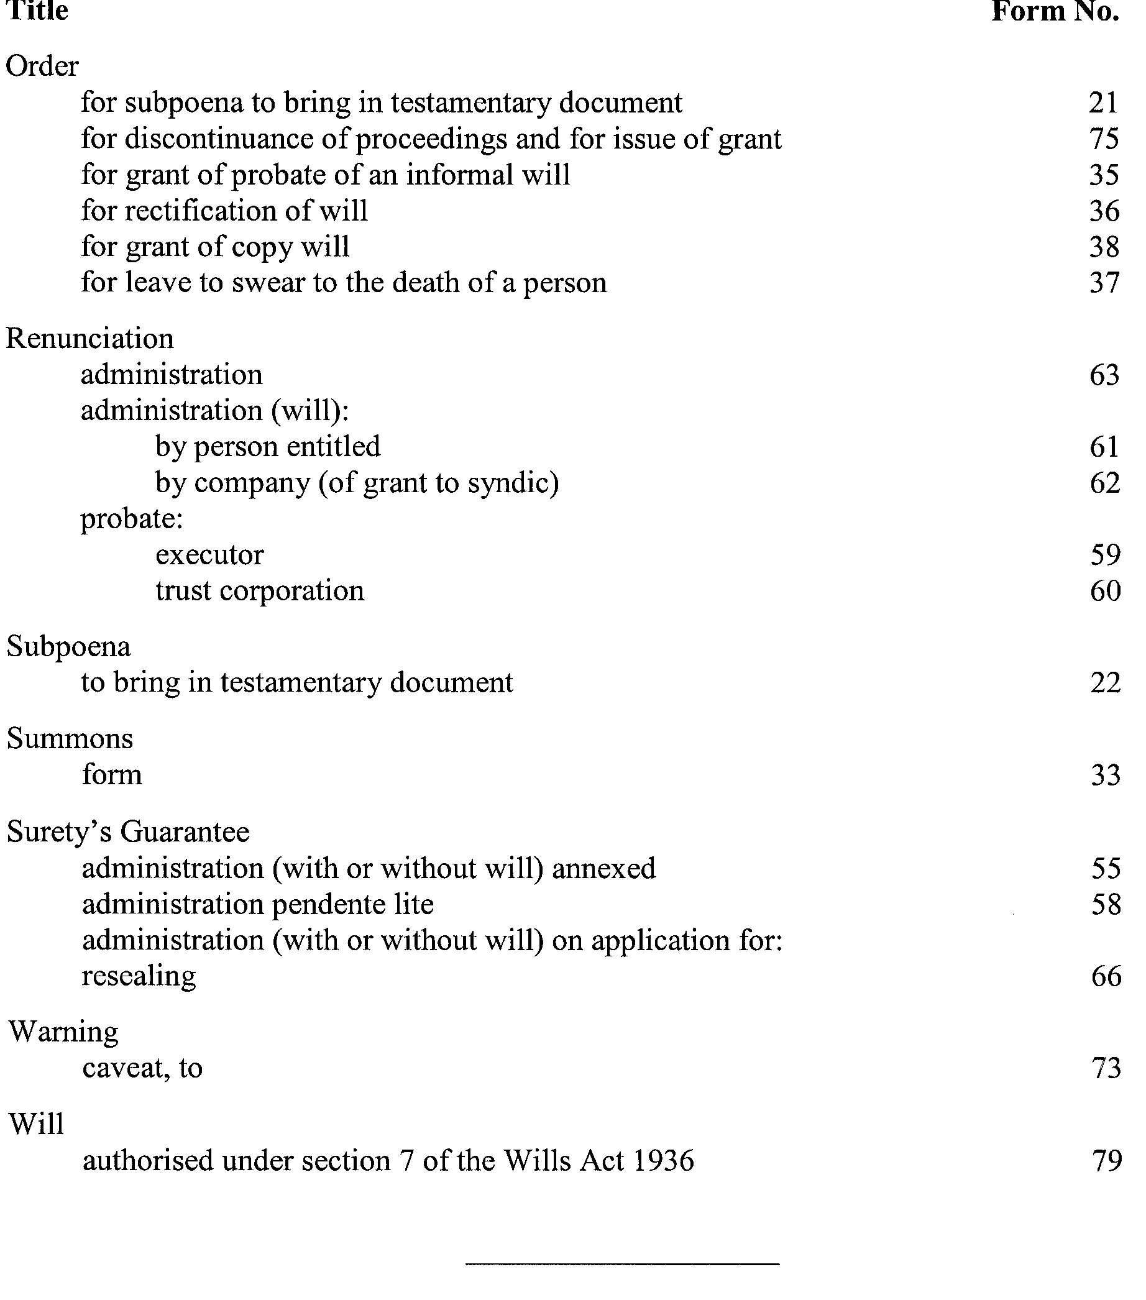
GIVEN under our hands and the Seal of the Supreme Court of South Australia this 25th day of October 2004.
(l.s.) J. DOYLE, CJ
J. W. PERRY, J
K. P. DUGGAN, J
E. P. MULLIGHAN, J
B. M. DEBELLE, J
D. J. BLEBY, J
A. BESANKO, J
J. R. SULAN, J
J. ANDERSON, J
R.C. WHITE, J

SOUTH AUSTRALIAN MOTOR SPORT REGULATIONS 1999: REGULATION 12—CONDITIONS IMPOSED ON TICKETS
Notice by the South Australian Motor Sport Board
PURSUANT to Regulation 12 of the South Australian Motor Sport Regulations 1999, the Minister, to whom the administration of that Act has been committed, hereby impose the following conditions in respect of each of the permits, authorisations and tickets to the event known as the ‘Clipsal 500 Adelaide’ in addition to the terms and conditions contained on the back of each ticket:
CONDITIONS OF SALE
In addition to the terms and conditions contained on the back of each ticket, the following conditions and rules shall apply:
Except to the extent permitted by the Trade Practices Act 1974, tickets cannot be exchanged or refunded after purchase. Tickets are non-transferable on the day or during the day of presentation. Upon exit, the Ticketholder’s hand must be stamped to regain entry on the same day. The stamp must be shown along with the valid ticket clipped for that day to regain entry. The South Australian Motor Sport Board (‘the Board’) reserves the right to refuse admittance to or evict from the event any person with reasonable cause.
The Board reserves the right to add, withdraw or substitute any drivers, performers or activities associated with the event, vary programs, seating arrangements and audience capacity and determine and publish additional conditions from time to time.
A person cannot make, reproduce or use any form of still or moving picture or any sound recording (footage) of the motor sport event as defined in the South Australian Motor Sport Act 1984 or any part of it for profit, gain, public advertisement, display or for any other purpose except for the private enjoyment of the person making the footage, without the consent of the Board and will on demand assign all rights thereto to the Board or its nominees.
Any ticket purchased and the Ticketholder’s entry to and presence at the event is subject to these conditions of sale, conditions of entry displayed at the event entrances and the South Australian Motor Sport Act 1984 as amended and its Regulations. Details are freely available from Clipsal 500 Adelaide, P.O. Box V8, Kent Town SA 5071.
Patrons may not, without prior written consent of the Board bring any of the following items into the Event: any alcoholic beverages; any glass bottles or containers or glass objects (excluding sunglasses, binoculars and prescription glasses); any beverage container with the manufacturer’s seal broken; any drinks coolers or ice boxes (other than one predominantly constructed of polystyrene); any structure or item that may be used to erect a structure, or which is capable of supporting the weight of a person including, without limitation, any chairs, lounges, benches or stools (other than a folding chair or stool); no animals; no weapons of any kind; no fireworks.
CONDITIONS OF ENTRY
THE SA MOTOR SPORT BOARD (the Board) WILL NOT BE LIABLE FOR PERSONAL INJURY OR PROPERTY DAMAGE
The Ticketholder attending the motor race and other associated events (Events) hereby acknowledges and agrees as follows:
The Ticketholder has read and understood the Conditions of Sale and Conditions of Entry (Conditions) and agrees to be bound by the Conditions; and intends the Conditions to have full contractual effect. Where relevant, the Ticketholder and any third party who purchases a ticket on behalf of the Ticketholder (‘the third party’) each warrant that the third party had the Ticketholder’s full authority to act as the Ticketholder’s agent for the purposes of buying the ticket and accepting the Conditions.
MOTOR SPORT IS DANGEROUS
In exchange for being able to attend or participate in the event, (and as a condition of the purchase or issue of a ticket): You agree to release Confederation of Australian Motor Sport Ltd (‘CAMS’) and Australian Motor Sport Commission Ltd., promoters, sponsor organisations, land owners and lessees, organisers of the event, their respective servants, officials, representatives and agents (collectively, the ‘Associated Entities’) from all liability for your death, personal injury (including burns), psychological trauma, loss or damage (including property damage) (‘harm’) howsoever arising from your participation in or attendance at the event, except to the extent prohibited by law; you agree that CAMS and Associated Entities do not make any warranty, implied or express, that the event services will be provided with due care and skill or that any materials provided in connection with the services will be fit for the purpose for which they are supplied; and you agree to attend or participate in the event at your own risk.
You acknowledge that the risks associated with attending or participating in the event include the risk that you may suffer harm as a result of: motor vehicles (or parts of them) colliding with other motor vehicles, persons or property; acts of violence and other harmful acts (whether intentional or inadvertent) committed by persons attending or participating in the event; and the failure or unsuitability of facilities (including grand-stands, fences and guard rails) to ensure the safety of persons or property at the event.
You acknowledge that motor sport is dangerous and that accidents causing harm can and do happen and may happen to you.
You accept the conditions of, and acknowledge the risks arising from, attending or participating in the event and being provided with the event services by CAMS and the Associated Entities.
HIGH DANGER AREAS
The Ticketholder on entering into pit lane and/or pit paddock: is fully aware and recognises that pit lane and pit paddock are extremely dangerous and there is a real possibility of an accident causing injury, death, property damage or other losses in those areas; is fully aware that it is a condition of entry that they enter the pit lane and pit paddock and other high danger areas of the events ground at their own risk.
CHILDREN ARE TO BE SUPERVISED BY ADULTS
The Ticketholder acknowledges that all children attending the Events must be under the supervision of an adult guardian at all times.
SEVERANCE
If anything in these Conditions of Entry is unenforceable, illegal or void then it is severed and the rest of the Conditions of Entry remain in force.
Kevin Foley, Deputy Premier

SOUTH AUSTRALIAN MOTOR SPORT ACT 1984: SECTION 26—AVAILABILITY OF PLANS FOR PUBLIC INSPECTION
Notice by the Deputy Premier
PURSUANT to Section 26 of the South Australian Motor Sport Act 1984, the Minister to whom the administration of that Act has been committed, hereby designates the offices of Kellogg Brown & Root Pty Ltd located at 186 Greenhill Road, Parkside as the place at which may be inspected by members of the public plans of all works proposed to be carried out by the South Australian Motor Sport Board in relation to the event known as the ‘Clipsal 500 Adelaide’.
Kevin Foley, Deputy Premier

SOUTH AUSTRALIAN MOTOR SPORT REGULATIONS 1999: REGULATION 11—OPENING AND CLOSING TIME OF THE DECLARED AREA
Notice by the South Australian Motor Sport Board
PURSUANT to Regulation 11 of the South Australian Motor Sport Regulations 1999, I, the Minister to whom the administration of that Act has been committed, hereby fix the following opening and closing times in respect of declared areas for each day of the declared period:
Day Opening Time Closing Time
Thursday, 17 March 2005 8 a.m. 11 p.m.
Friday, 18 March 2005 8 a.m. 11 p.m.
Saturday, 19 March 2005 8 a.m. 11 p.m.
Sunday, 20 March 2005 8 a.m. 11 p.m.
Kevin Foley, Deputy Premier

SOUTH AUSTRALIAN MOTOR SPORT ACT 1984: SECTION 20 (1)—DECLARATION OF AREA AND PERIOD
Notice by the Deputy Premier
PURSUANT to section 20 (1) of the South Australian Motor Sport Act 1984, I, the Minister to whom the administration of that Act has been committed, in respect of the motor sport event promoted by the South Australian Motor Sport Board under the name ‘2005 Clipsal 500 Adelaide’, acting on the recommendation of the Board, declare:
(a) That the area delineated on the plan in the schedule will be a declared area under the Act for the purposes of the event; and
(b) That the period commencing on 16 March 2005 and ending on 20 March 2005 (both days inclusive) will be a declared period under the Act for the purposes of the event.
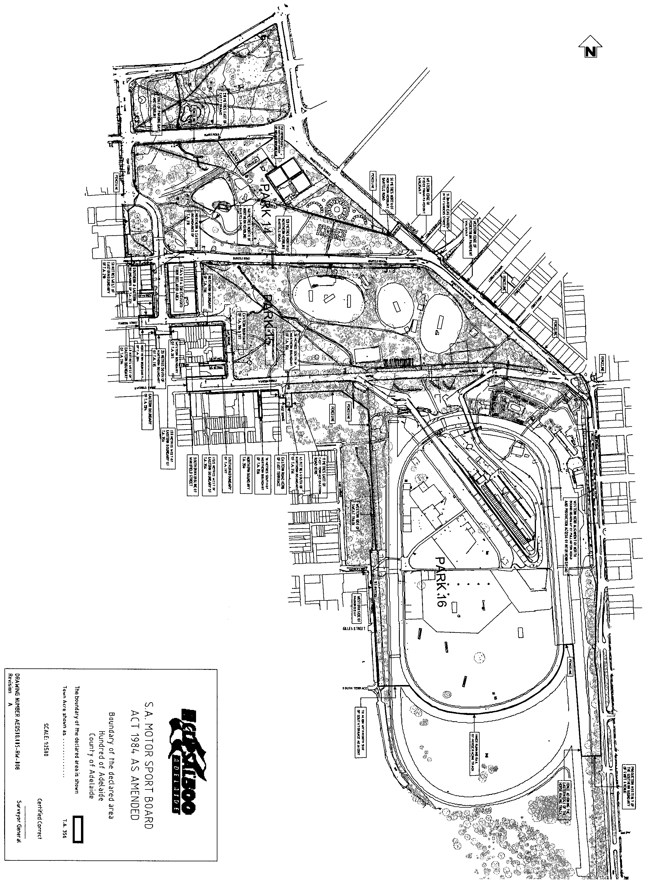
Kevin Foley, Deputy Premier

SOUTH AUSTRALIAN POLICE
2004-2005 Fees and Charges for Information Release Services
I, KEVIN FOLEY, Minister for Police approve the Fees and Charges for the following South Australian Police information release services:
Police Checks (National Police Certificates and Memorandum of Understanding Checks)
Individual | $42
Individual Concession | $30 | Applicant must provide proof of financial disadvantage by providing a copy of at least one of the following attached to their application:  • Current State concession card issued by the SA Government.  • Totally and permanently incapacitated disability pensioner.  • Receipt of Commonwealth unemployment or sickness benefits or State financial assistance.  • Holder of a student identification card issued under the State Transport Authority Act 1974 or proof of full-time student status.  • Holder of a current pensioner health benefits or concession card issued by the Commonwealth Government.  • Proof of financial hardship by providing evidence of receiving one of the following benefits from Centrelink not more than 4 weeks ago: Crisis Payment, Special Benefit Payment or Exceptional Circumstances Relief Payment.
Volunteer | No  Charge | Individual is undertaking largely unsupervised contact with vulnerable groups; and not receiving any payment for work (except out of pocket expenses); and the work provides a charity or community service good.  Applicant must provide written proof from the organisation they are authorised to receive this concession. An Authorisation Number must be provided with the application.  The fee for the check is $28 however the check is provided at no charge to the individual. The cost is met by either the government agency where the individual is volunteering, or the South Australian Government for those volunteering within the community.
Employee—Government | $42 | Government agencies include Commonwealth, State and Local.
Employee—Commercial | $45 | Commercial agencies include all non-government organisations.
Vehicle Collision, Police Incident Reports, Other Police Information
All applicants | $49 | No concessions apply.  Each report attracts the gazetted fee and no concessions apply, however a maximum fee of four times the fee gazetted for each report is to be charged in the cases of complex requests.  All other material is provided at the gazetted rate, e.g. copies of photographs, videos etc.

Dated 12 December 2004.
Kevin Foley, Minister for Police

TRAINING AND SKILLS DEVELOPMENT ACT 2003

Part 4 – Apprenticeships/Traineeships

PURSUANT to the provision of the Training and Skills Development Act 2003, the Training and Skills Commission (TaSC) gives notice that determines the following:

Trades, Declared Vocations or Other Occupations

The following schedule is additional to the gazettals of:

- 5 February 2004 | - 19 February 2004 | - 11 March 2004
- 1 April 2004 | - 1 July 2004 | - 15 July 2004
- 22 July 2004 | - 30 September 2004

which set out the Trades, Declared Vocations or Other Occupations and the terms and conditions applicable to the Trades, Declared Vocations or other Occupations.

Trades, Declared Vocations or Other Occupations, required Qualifications and Contract
of Training Conditions

*Trade/  # Declared  Vocation/Other  Occupation | National  Code | Qualification | Nominal Term  of Contract of  Training | Probationary  Period
#Clerical  Processing (Office Admin.) | PRD30101 | Certificate III in Property (Real Estate) | 12 months | 1 month
The Commission has determined that the following ratio will apply for employers respondent to awards or registered enterprise agreements in the real estate sales sector as follows:

- One to one relationship between a trainer* and a trainee.

* Trainer is to have a minimum of two years experience as a qualified sales representative.

#Customer  Services (Real  Estate Operations – Sales) | PRD40101 | Certificate IV in Property (Real Estate) | 12 months | 1 month

Gazettal of these arrangements is effective from 1 January 2005 to 31 December 2006

TRAINING AND SKILLS DEVELOPMENT ACT 2003

Part 4 – Apprenticeships/Traineeships

PURSUANT to the provision of the Training and Skills Development Act 2003, the Training and Skills Commission (TaSC) gives notice that determines the following:

Trades, Declared Vocations or Other Occupations

The following schedule is additional to the gazettals of:

- 5 February 2004 | - 19 February 2004 | - 11 March 2004
- 1 April 2004 | - 1 July 2004 | - 15 July 2004
- 22 July 2004 | - 30 September 2004

which set out the Trades, Declared Vocations or Other Occupations and the terms and conditions applicable to the Trades, Declared Vocations or other Occupations.

Trades, Declared Vocations or Other Occupations, required Qualifications and Contract
of Training Conditions
Animal Care and Management Training Package RUV04
*Trade/ #Declared Vocation/Other Occupation | National Code | Qualification | Nominal Term of Contract of Training | Probationary Period
#Veterinary Animal Attendant | RUV20104 | Certificate II in Animal Studies | 12 months | 1 month
#Veterinary Nursing  (Level 1) | RUV40404 | Certificate IV in Veterinary Nursing  Total nominal duration includes the 12 months duration from Cert II in Animal Studies | 36 months | 3 months
#Veterinary Nursing  (Level 2) | RUV50204 | Diploma of Veterinary Nursing (Surgical)  Total nominal duration includes the 36 months from the Cert IV in Veterinary Nursing | 48 months | 3 months
 | RUV50304 | Diploma of Veterinary Nursing (Dental)  Total nominal duration includes the 36 months from the Cert IV in Veterinary Nursing | 48 months | 3 months
 | RUV50404 | Diploma of Veterinary Nursing (Emergency and Critical Care)  Total nominal duration includes the 36 months from the Cert IV in Veterinary Nursing | 48 months | 3 months

IMPORTANT NOTICE
Government Gazette Publication

********************

Australia Day Holiday Week Publishing Information

Government Gazette Notices
Publishing Date: Thursday, 27 January 2005

Closing date for notices for publication will be
4 p.m. Monday, 24 January 2005

********************

South Australia
Environment Protection (Motor Vehicle Fuel Quality) Policy Variation Notice 2004
under section 32 of the Environment Protection Act 1993 and clause 15 of the Environment Protection (Motor Vehicle Fuel Quality) Policy 2002

Contents
Part 1—Preliminary
1 Short title
2 Commencement
3 Variation provisions
Part 2—Variation of Environment Protection (Motor Vehicle Fuel Quality) Policy 2002
4 Variation of Schedule 1—Characteristics of fuel, and standards for batch measurements, average batch measurements, and the pool average ATI
5 Variation of Schedule 3—Octane extenders that may be added to petrol

Part 1—Preliminary
1—Short title
This notice may be cited as the Environment Protection (Motor Vehicle Fuel Quality) Policy Variation Notice 2004.
2—Commencement
The amendment of the environment protection policy effected by this notice comes into operation on the day on which this notice is made.
3—Variation provisions
In this notice, a provision under a heading referring to the variation of a specified environment protection policy varies the policy so specified.
Part 2—Variation of Environment Protection (Motor Vehicle Fuel Quality) Policy 2002
4—Variation of Schedule 1—Characteristics of fuel, and standards for batch measurements, average batch measurements, and the pool average ATI
Schedule 1, Part 1, Characteristics—after paragraph (k) insert:
(l) Ethanol: maximum percentage proportion by volume of 10 %
5—Variation of Schedule 3—Octane extenders that may be added to petrol
Schedule 3—after its present contents insert:
Ethanol : maximum percentage proportion by volume of 10%
Made by the Minister
On 16 December 2004
EPA05/11386

South Australia
Administration and Probate (Administration Guarantees) Amendment Act (Commencement) Proclamation 2004
1—Short title
This proclamation may be cited as the Administration and Probate (Administration Guarantees) Amendment Act (Commencement) Proclamation 2004.
2—Commencement of Act
The Administration and Probate (Administration Guarantees) Amendment Act 2003 (No 40 of 2003) will come into operation on 1 March 2005.
Made by the Governor
with the advice and consent of the Executive Council
on 16 December 2004
AGO0331/04CS

South Australia
First Home Owner Grant (Miscellaneous) Amendment Act (Commencement) Proclamation 2004
1—Short title
This proclamation may be cited as the First Home Owner Grant (Miscellaneous) Amendment Act (Commencement) Proclamation 2004.
2—Commencement of Act
The First Home Owner Grant (Miscellaneous) Amendment Act 2004 (No 49 of 2004) will come into operation on 1 January 2005.
Made by the Governor
with the advice and consent of the Executive Council
on 16 December 2004
T&F04/092CS

South Australia
Petroleum (Submerged Lands) (Miscellaneous) Amendment Act (Commencement) Proclamation 2004
1—Short title
This proclamation may be cited as the Petroleum (Submerged Lands) (Miscellaneous) Amendment Act (Commencement) Proclamation 2004.
2—Commencement
The Petroleum (Submerged Lands) (Miscellaneous) Amendment Act 2004 (No 50 of 2004) will come into operation on 1 January 2005.
Made by the Governor
with the advice and consent of the Executive Council
on 16 December 2004
MMRD04/0018CS

South Australia
Electricity (General) Variation Regulations 2004
under the Electricity Act 1996

Contents
Part 1—Preliminary
1 Short title
2 Commencement
3 Variation provisions
Part 2—Variation of Electricity (General) Regulations 1997
4 Variation of regulation 4—Interpretation
5 Insertion of regulation 5AC
5AC Compliance with standards that are varied or substituted
6 Variation of regulation 6—Exemptions from requirement to be licensed
7 Variation of regulation 17—Electrical installations
8 Variation of regulation 18—Certain electrical installation work and certificates of compliance
9 Substitution of heading to Part 4 Division 5
10 Variation of regulations 31C—Safety, reliability, maintenance and technical management plans
11 Variation of regulation 31D—Safety, reliability, maintenance and technical management reports
12 Variation of regulation 39—Erection of buildings in proximity to aerial lines
13 Variation of Schedule 2—Requirements for aerial lines
14 Variation of Schedule 3—Requirements for underground lines and certain other powerlines
15 Variation of Schedule 4—Requirements for substations
16 Variation of Schedule 5—Requirements for earthing and electrical protection systems

Part 1—Preliminary
1—Short title
These regulations may be cited as the Electricity (General) Variation Regulations 2004.
2—Commencement
These regulations come into operation on the day on which they are made.
3—Variation provisions
In these regulations, a provision under a heading referring to the variation of specified regulations varies the regulations so specified.
Part 2—Variation of Electricity (General) Regulations 1997
4—Variation of regulation 4—Interpretation
(1) Regulation 4(1), definition of AS or Australian Standard—delete the definition and substitute:
AS or Australian Standard, followed by a number, or AS/NZS or Australian/New Zealand Standard followed by a number, is a reference to the standard published by Standards Australia as in force from time to time;
centre-line, in relation to an aerial line, means a notional vertical plane extending upwards from any point on the ground and running through, and connecting, the centre of each structure that supports the aerial line;
(2) Regulation 4(1)—after the definition of connection point insert:
facade mounted line means an aerial line attached to a building;
(3) Regulation 4(1), definition of low voltage or LV—delete "AS" and substitute:
AS/NZS
(4) Regulation 4(1), definition of multiple earthed neutral system or MEN system—delete "AS" and substitute:
AS/NZS
(5) Regulation 4(2)—delete subregulation (2)
(6) Regulation 4(4)—delete "subregulations (2) and (3)" and substitute:
subregulation (3)
5—Insertion of regulation 5AC
After regulation 5AB insert:
5AC—Compliance with standards that are varied or substituted
(1) Despite a requirement of these regulations for work to be carried out in accordance with a standard as in force from time to time, where the standard is varied or substituted, work for the installation, commissioning or modification of electricity infrastructure or an electrical installation may be carried out in accordance with the old standard—
(a) if—
(i) design work for that installation, commissioning or modification had been completed before (but not more than 1 month before) the publication of the new standard; or
(ii) the work (disregarding design or other preparatory work) had commenced before the publication of the new standard; or
(iii) the work commenced after the publication of the new standard and is to be completed within 6 months after that publication; or
(iv) the work is connected with the construction of premises and construction work had commenced before the publication of the new standard; or
(b) in any other case—with the approval of the Technical Regulator, on terms and conditions the Technical Regulator considers appropriate.
(2) If—
(a) pursuant to subregulation (1) work is purportedly carried out in accordance with an old standard; and
(b) the work complies with that old standard,
an approval or certification that the work complies with the standard may be given for the purposes of these regulations.
(3) In this regulation—
(a) a reference to a standard includes a reference to—
(i) a code, guide or other document; and
(ii) a part of a standard, code, guide or other document; and
(b) a standard as in force following the variation or substitution of the standard is referred to as the new standard; and
(c) a standard as in force immediately prior to the variation or substitution of the standard is referred to as the old standard; and
(d) a reference to work includes a reference to examinations and tests related to the work.
(4) This regulation does not apply in relation to the National Electricity Code or a code made by the Commission under the Essential Services Commission Act 2002.
6—Variation of regulation 6—Exemptions from requirement to be licensed
Regulation 6(6)—delete subregulation (6) and substitute:
(6) An exemption from subregulation (5), or from specified requirements referred to in that subregulation, may be granted by—
(a) in relation to Part 6 of the Act or Parts 4, 5 and 6 of these regulations or any safety requirement—the Technical Regulator, on terms and conditions the Technical Regulator considers appropriate; or
(b) in any other case—the Commission, on terms and conditions the Commission considers appropriate.
7—Variation of regulation 17—Electrical installations
(1) Regulation 17—delete "AS" wherever occurring and substitute in each case:
AS/NZS
(2) Regulation 17—after "Australian Standard" insert:
or Australian/New Zealand Standard
(3) Regulation 17—after its present contents as amended by this regulation (now to be designated as subregulation (1)) insert:
(2) Despite any other regulation—
(a) aerial lines, underground lines or other powerlines; and
(b) earthing and electrical protection systems,
that form part of an electrical installation and that comply with AS/NZS 3000 and any other Australian Standard or Australian/New Zealand Standard called up by AS/NZS 3000, will be taken to comply with these regulations.
8—Variation of regulation 18—Certain electrical installation work and certificates of compliance
(1) Regulation 18(1)(a)—delete "AS" wherever occurring and substitute in each case:
AS/NZS
(2) Regulation 18(1)(a)—after "Australian Standard" wherever occurring insert in each case:
or Australian/New Zealand Standard
9—Substitution of heading to Part 4 Division 5
Heading to Part 4 Division 5—delete the heading and substitute:
Division 5—Safety, reliability, maintenance and technical management plans and reports
10—Variation of regulations 31C—Safety, reliability, maintenance and technical management plans
Regulation 31C—delete "safety and technical management plan" wherever occurring and substitute in each case:
safety, reliability, maintenance and technical management plan
11—Variation of regulation 31D—Safety, reliability, maintenance and technical management reports
(1) Regulation 31D(2)—delete "Subclause" and substitute:
Subregulation
(2) Regulation 31D(3)(c)—delete "safety and technical management plan" and substitute:
safety, reliability, maintenance and technical management plan
(3) Regulation 31D—after subregulation (3) insert:
(4) However, this regulation only applies to a person who is exempted from the requirement to hold a licence to the extent specified by the Technical Regulator by notice in writing to the person.
12—Variation of regulation 39—Erection of buildings in proximity to aerial lines
(1) Regulation 39(1)—delete subregulation (1) and substitute:
(1) For the purposes of section 86 of the Act, a person must not, except as approved by the Technical Regulator, erect a building or structure in proximity to an aerial line as follows:
(a) in the case of an aerial line (other than a facade mounted line) constructed to operate at a voltage of more than 33kV—
(i) under the aerial line; or
(ii) so that the horizontal distance from any part of the building or structure to the centre-line of any such aerial line is less than the relevant distance as set out in Table 1 in Schedule 2;
(b) in the case of an aerial line (other than a facade mounted line) or other cable system constructed to operate at a voltage of 33kV or less—so that the vertical or horizontal distance from any part of the building or structure to any position to which a conductor in the aerial line or other cable system may sag at maximum design temperature, or move as a result of normal prevailing wind pressures, is less than the relevant distance as set out in Table 1 in Schedule 2.
Note—
The figures following Table 1 are to be used to assist in understanding the information contained in the Table.
(2) Regulation 39(1a)—delete "subregulation (1)(b)" and substitute:
subregulation (1)
13—Variation of Schedule 2—Requirements for aerial lines
(1) Schedule 2, clause 10(4)(a) to (c)—delete paragraphs (a) to (c) and substitute:
(a) for an aerial line (other than a facade mounted line) constructed to operate at a voltage of 33kV or less—so that the vertical or horizontal distance from any building or structure (other than a support to which the aerial line is attached or a support of another overhead line which crosses the aerial line) to any position to which a conductor in the aerial line may sag at maximum design temperature, or move as a result of normal prevailing wind pressures, is not less than the relevant distance as set out in Table 1;
Note—
The figures following Table 1 are to be used to assist in understanding the information contained in the Table.
(ab) for an aerial line (other than a facade mounted line) constructed to operate at a voltage of more than 33kV—so that the horizontal distance from any building or structure (other than a support to which the aerial line is attached or a support of another overhead line which crosses the aerial line) to the centre-line of the aerial line is not less than the relevant distance as set out in Table 1;
Note—
The figures following Table 1 are to be used to assist in understanding the information contained in the Table.
(b) for an aerial line (other than a service line, other cable system or aerial line within a substation)—so that the distance to the ground in any direction from a position to which any part of the aerial line may sag at maximum design temperature, or move as a result of normal prevailing wind pressures, is not less than the relevant distance as set out in Table 2;
(c) for a service line or other cable system—so that the distance to the ground in any direction from a position to which any part of the service line or cable system may sag at maximum design temperature, or move as a result of normal prevailing wind pressures, is not less than the relevant distance as set out in Table 3;
(2) Schedule 2, clause 13, table 1—delete "from centre of pole" and substitute:
from centre-line of aerial line
(3) Schedule 2, clause 13, table 1—delete "In any other direction" and substitute:
Horizontally
(4) Schedule 2, clause 13, table 1—delete "In any direction" first occurring and substitute:
Horizontally
(5) Schedule 2, clause 13, table 1—delete "(G)"
(6) Schedule 2, clause 13, figure 1 (following table 1)—delete everything relating to figure 1 and substitute:

Table 1 figures—
1 Figures (a) and (b) will assist in understanding the required minimum safety clearance for aerial lines constructed to operate at a voltage of more than 33kV.
2 Figure (c) will assist in understanding the required minimum safety clearance for aerial lines constructed to operate at a voltage of 33kV or less (that is, minimum safety clearance from nearest conductor (maximum swing and sag)).
(a)
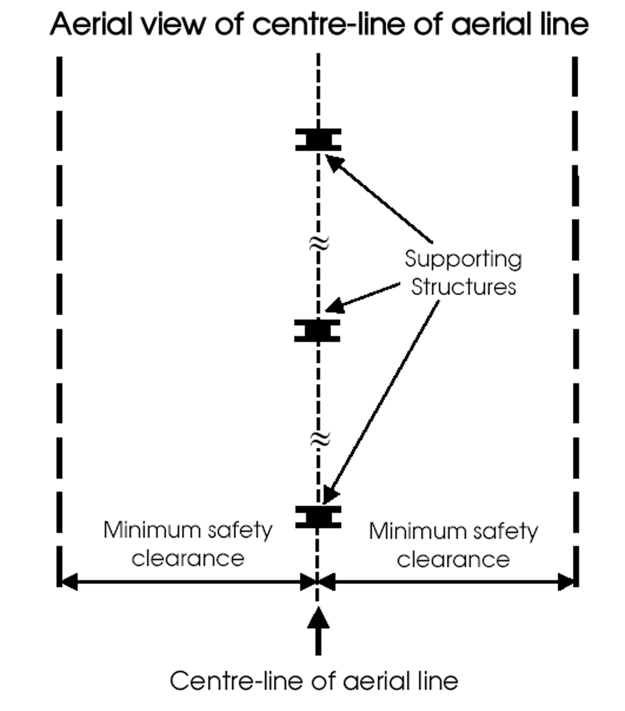

(b)
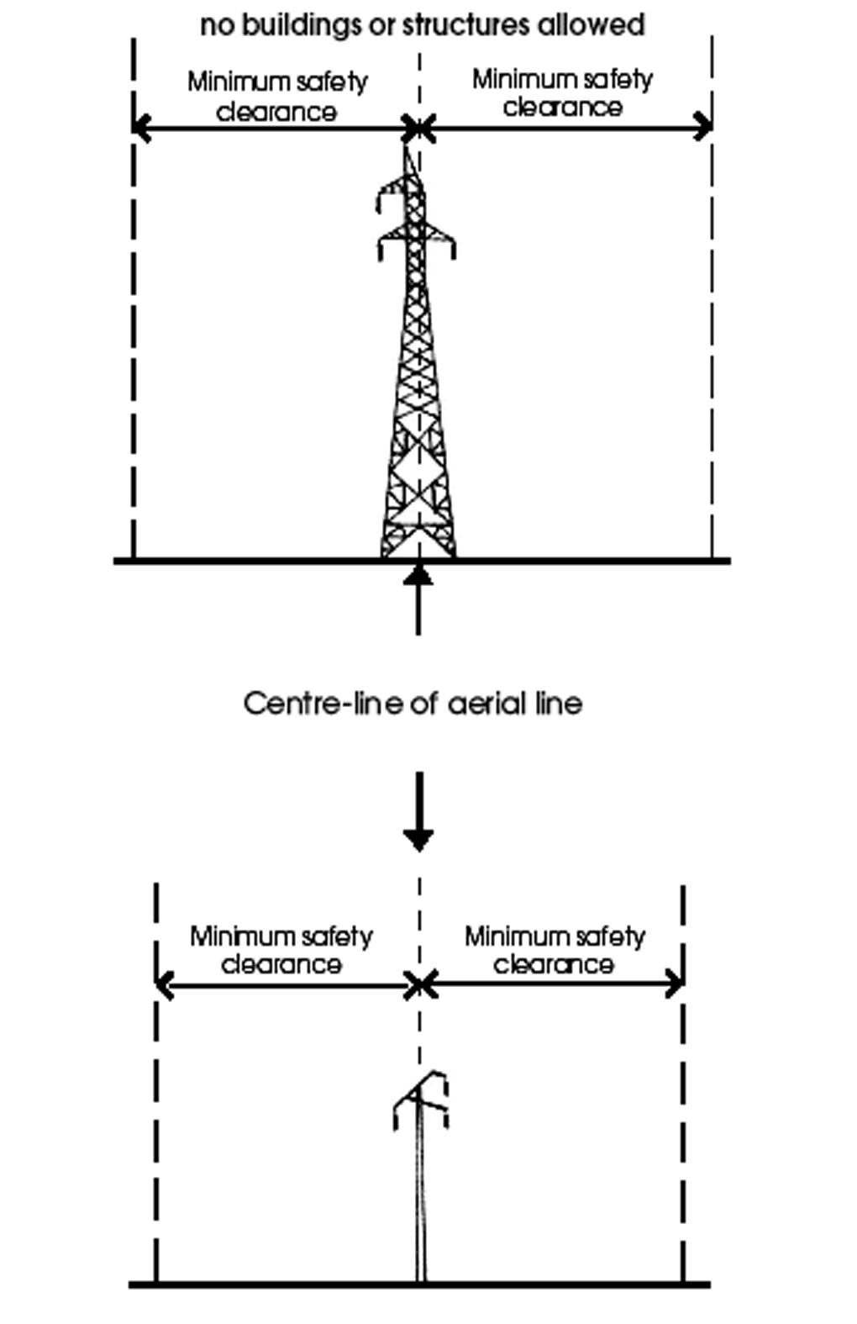

(c)
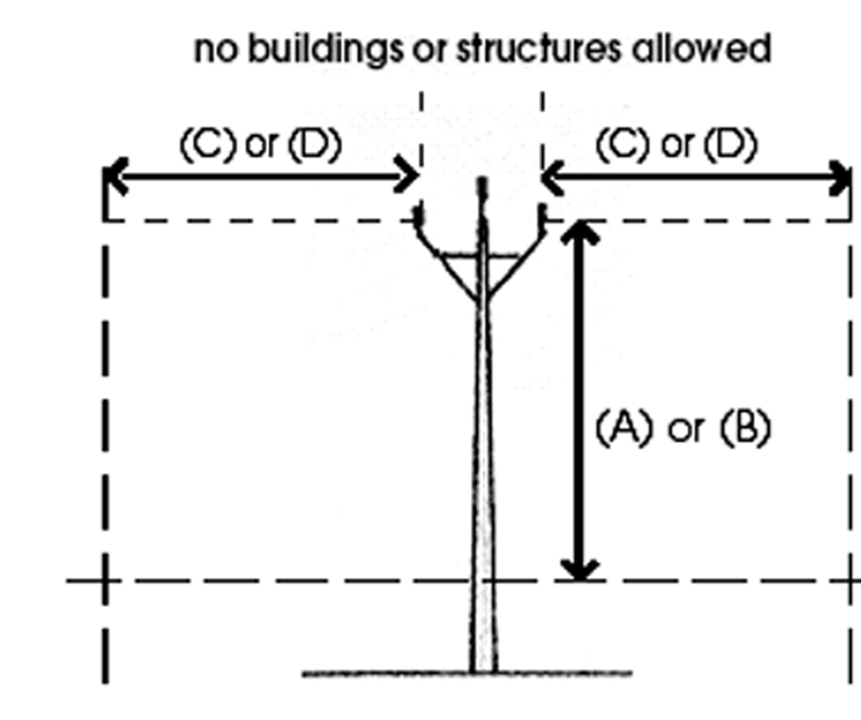
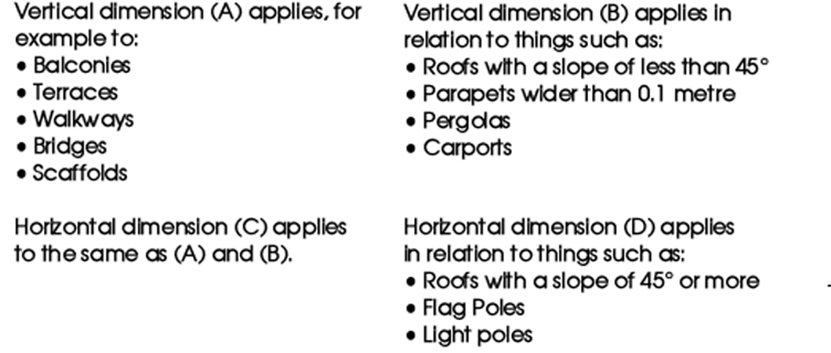
(7) Schedule 2, clause 13, heading to figure 2—delete the heading to figure 2 and substitute:
Table 4 figures—
(8) Schedule 2, clause 13, figure 2—delete "Figure 2 is to be used" and substitute:
The following figures will assist
(9) Schedule 2, appendix—delete the appendix and substitute:

Appendix—Standards, codes, guides and other documents relating to aerial lines
In this Appendix—
ESAA means Electricity Supply Association of Australia.
Conductors
Conductor - Bare overhead - Hard - drawn copper | AS 1746
Conductor - Bare overhead - Aluminium and aluminium alloy | AS 1531
Conductor - Bare overhead, aluminium and aluminium alloy - Steel reinforced | AS 3607
Steel conductors and stays - Bare overhead - Galvanised (SC/GZ) | AS 1222
Steel conductors and stays - Bare overhead - Aluminium clad (SC/AC) | AS 1222
Galvanised steel wire strand | AS 2841
Insulated cables
Electric cables - Polymeric insulated - For working voltages up to and including 0.6/1(1.2)kV | AS/NZS 5000
Electric cables - Polymeric insulated - For distribution and service applications | AS/NZS 4961
Electric cables - Cross-linked polyethylene insulated - Aerial bundled - For working voltages up to and including 0.6/1(1.2)kV | AS/NZS 3560
Mechanical fittings for low voltage aerial bundled cable | AS 3766
Electric cables - Aerial bundled - Polymeric insulated - Voltages 6.35/11(12)kV and 12.7/22(24)kV - Metallic screened | AS/NZS 3599
Electric cables - Aerial bundled - Polymeric insulated - Voltages 6.35/11(12)kV and 12.7/22(24)kV - Non-metallic screened | AS/NZS 3599
Conductors - Covered overhead - For working voltages 6.35/11(12)kV up to and including 19/33(36)kV | AS/NZS 3675
Insulators
Insulators - Ceramic or glass - Station post for indoor and outdoor use - Voltages greater than 1000V ac | AS 4398
Insulators - Porcelain and glass for overhead powerlines - Voltages greater than 1000V ac - Test methods - Insulator units | AS/NZS 2947
Insulators - Porcelain and glass for overhead powerlines - Voltages greater than 1000V ac | AS/NZS 2947
Insulators - Porcelain and glass for overhead powerlines - Voltages greater than 1000V ac - Couplings | AS 2947
Insulators - Porcelain and glass for overhead powerlines - Voltages greater than 1000V ac - Test methods - Insulator strings and insulator sets | AS/NZS 2947
Insulators - Porcelain and glass, pin and shackle type - Voltages not exceeding 1000V ac | AS 3608
Insulators - Porcelain stay type - Voltages greater than 1000V ac | AS 3609
Guidelines for the design and maintenance of overhead distribution and transmission lines—
Selection | ESAA C(b)1
Insulator and conductor fittings
Insulator and conductor fittings for overhead powerlines - Performance, material, general requirements and dimensions | AS 1154
Insulator and conductor fittings for overhead powerlines - Performance and general requirements for helical fittings | AS 1154
Thermal limits
Guidelines for the design and maintenance of overhead distribution and transmission lines—
Thermal limits | ESAA C(b)1
Current rating of bare overhead line conductors | ESAA D(b)5
Short circuit capacity
Guidelines for the design and maintenance of overhead distribution and transmission lines—
Fault ratings | ESAA C(b)1
Mechanical loading conditions
Guidelines for the design and maintenance of overhead distribution and transmission lines—
Mechanical loading conditions | ESAA C(b)1
Structural design actions - General principles | AS/NZS 1170
Structural design actions - Permanent, imposed and other actions | AS/NZS 1170
Structural design actions - Wind actions | AS/NZS 1170
Minimum design loads on structures (known as the SAA Loading Code) - Earthquake loads | AS 1170
Conductor tensions
Guidelines for the design and maintenance of overhead distribution and transmission lines—
General | ESAA C(b)1
Calculations | ESAA C(b)1
Structures and footings
Guidelines for the design and maintenance of overhead distribution and transmission lines—
General | ESAA C(b)1
Methods of testing soils for engineering purposes | AS 1289 Series
Piling - Design and installation | AS 2159
Design of steel lattice towers and masts | AS 3995
Steel structures | AS 4100
Concrete structures | AS 3600
Clearances from ground
Guidelines for the design and maintenance of overhead distribution and transmission lines—
Environmental and loading conditions | ESAA C(b)1
Clearances from structures
Guidelines for the design and maintenance of overhead distribution and transmission lines—
Environmental and loading conditions | ESAA C(b)1
Spacing of conductors
Guidelines for the design and maintenance of overhead distribution and transmission lines—
Clearances | ESAA C(b)1
Environmental and loading conditions | ESAA C(b)1
Maintenance
Guidelines for the design and maintenance of overhead distribution and transmission lines—
Maintenance and inspection procedures | ESAA C(b)1
14—Variation of Schedule 3—Requirements for underground lines and certain other powerlines
(1) Schedule 3, clause 2—delete paragraph (d) and substitute:
(d) the required clearances between a building or structure and an underground powerline as prescribed by regulation 39A are maintained,
(2) Schedule 3, clause 7(2)(a)—delete "AS 1480" and substitute:
AS 3600
(3) Schedule 3, clause 7(2)(b)—delete "AS 1480" and substitute:
AS 3600
(4) Schedule 3, clause 7(3)—delete "AS 2053" and substitute:
AS/NZS 2053
(5) Schedule 3, clause 8(2)(a)—delete "AS 1650" and substitute:
AS/NZS 4680, AS/NZS 4791 or AS/NZS 4792
(6) Schedule 3, clause 8(3)(a)—delete "AS 2607" and substitute:
AS 2067
(7) Schedule 3, appendix—delete the appendix and substitute:

Appendix—Standards, codes, guides and other documents relating to underground lines
In this Appendix—
ANSI means American National Standards Institute;
ESAA means Electricity Supply Association of Australia;
IEC means International Electrotechnical Commission;
IEEE means Institute of Electrical and Electronic Engineers.
High voltage cables
Electric cables - Polymeric insulated - For working voltages 1.9/3.3(3.6)kV up to and including 19/33(36)kV | AS/NZS 1429
Electric cables - Impregnated paper insulated - For working voltages up to and including 19/33(36)kV | AS/NZS 1026
Electric cables - For underground residential distribution systems | AS/NZS 4026
Power cables with extruded insulation and their accessories for rated voltages from 1kV up to 30kV | IEC 60502
Power cables with extruded insulation and their accessories for rated voltages above 30kV up to 150kV - Test methods and requirements | IEC 60840
Low voltage cables
Electric cables - Impregnated paper insulated - For working voltages up to and including 19/33(36)kV | AS/NZS 1026
Conductors in insulated electric cables and flexible cords | AS/NZS 1125
Electric cables - Polymeric insulated - For distribution and service applications | AS/NZS 4961
Electric cables - Polymeric insulated - For working voltages up to and including 0.6/1(1.2)kV | AS/NZS 5000
Electric cables - For underground residential distribution systems | AS/NZS 4026
High voltage cable accessories
High Voltage Cable Terminations | ANSI/IEEE 48
High Voltage Cable Joints | ANSI/IEEE 404
Separable insulated connectors for power distribution systems above 1kV | AS 2629
Continuous cable ratings
Electric cables - Calculation of the current rating | IEC 60287
Electrical installations - Selection of cables - Cables for alternating voltages up to and including 0.6/1kV | AS/NZS 3008
Short circuit currents
Calculation of short circuit currents | IEC 60949
Installation
ESAA Guide to the Installation of Cables Underground | C(b)2
ESAA Guide to the Use of Separable Connectors | D(b)30
Services in Streets—A Code for the Placement of Infrastructure Services in New and Existing Streets (prepared for PUACC and published September 1997)
Maintenance
ESAA Guide for the Maintenance of High Voltage Paper/Oil Insulated Cables and Accessories | D(b)31
15—Variation of Schedule 4—Requirements for substations
(1) Schedule 4, clause 8(4)—after "barbed wire" insert:
, or razor wire,
(2) Schedule 4, clause 8(4)—after "0.15 m" insert:
or tiger tape flat loops
(3) Schedule 4, appendix—delete the appendix and substitute:

APPENDIX—Standards, codes, guides and other documents relating to substations
In this Appendix—
ESAA means Electricity Supply Association of Australia;
IEC means International Electrotechnical Commission;
IP Code means International Protection Code.
Electrical design
Switchgear assemblies & ancillary equipment for alternating voltages above 1kV | AS 2067
Circuit breakers and ancillary equipment
Degrees of protection provided by enclosures (IP Code) | AS 60529
High voltage ac switchgear and controlgear - Circuit breakers for rated voltages above 1000 V | AS 2006
Switchgear assemblies and ancillary equipment
High voltage switches - Switches for rated voltages above 1kV and less than 52kV | AS/NZS 60265
High voltage, ac switchgear and controlgear - Switches and switch-disconnectors - For rated voltages of 52kV and above | AS 1025
High voltage ac switchgear and controlgear - Disconnectors (isolators) and earthing switches | AS 1306
High voltage ac switchgear and controlgear - Switch-fuse combinations | AS 2024
Common specifications for high-voltage switchgear and controlgear standards | AS/NZS 2650
AC metal-enclosed switchgear and controlgear for rated voltages above 1kV and up to and including 72.5kV | AS 2086
AC insulation-enclosed switchgear and controlgear for rated voltages above 1kV and up to and including 38kV | AS 2264
Switchgear assemblies and ancillary equipment for alternating voltages above 1 kV | AS 2067
Degrees of protection provided by enclosures (IP Code) | AS 60529
Insulating liquids - Specifications for unused mineral insulating oils for transformers and switchgear | AS 1767
Control equipment
Low-voltage switchgear and controlgear -General rules | AS 60947
Low-voltage switchgear and controlgear -Switches, disconnectors, switch-disconnectors and fuse combination units | AS/NZS 3947
Low-voltage switchgear and controlgear -Contactors and motor starters: Electromechanical contactors and motor starters | AS 60947
Low-voltage switchgear and controlgear -Circuit control devices and switching elements - Electromechanical control circuit devices | AS 60947
Low-voltage switchgear and controlgear -Control circuit devices and switching elements - Proximity switches | AS 60947
Insulating panels
Sheets and boards for electrical purposes - Classification and general requirements | AS 1795
Sheets and boards for electrical purposes -Dimensions of switchboard panels | AS 1795
Power transformers
Power transformers - General | AS 2374
Power transformers - Temperature rise | AS 2374
Power transformers - Insulation levels and dielectric tests - General requirements | AS 2374
Power transformers - Insulation levels and dialectric tests - External clearances in air | AS 2374
Power transformers - Ability to withstand short circuit | AS 2374
Power transformers - Determination of transformer and reactor sound levels | AS 2374
Insulating liquids - Specification for unused mineral insulating oils for transformers and switchgear | AS 1767
Bushings
Bushings for alternating voltages above 1000 V | AS 1265
Surge arresters
Surge arresters (diverters) - Silicon carbide type for ac systems | AS 1307
Surge arresters - Metal-oxide surge arresters without gaps for ac systems | AS 1307
Batteries
Stationary batteries - Lead-acid - Vented type | AS 4029
Stationary batteries - Lead-acid - Valve-regulated type | AS/NZS 4029
Stationary batteries - Lead-acid - Pure lead positive pasted plate type | AS 4029
Insulation coordination
Insulation coordination - Definitions, principles and rules | AS 1824
Insulation coordination (phase-to-earth and phase-to-phase, above 1 kV) - Application Guide | AS 1824
Insulation coordination for equipment within Low Voltage systems: Principles, requirements and tests | IEC 60664
Safety clearances
Degrees of protection provided by enclosures (IP Code) | AS 60529
Switchgear assemblies and ancillary equipment for alternating voltages above 1kV | AS 2067
Buildings and enclosures
Building Code of Australia
Fixed platforms, walkways, stairways and ladders: Design construction and installation | AS 1657
The use of ventilation and air conditioning in buildings -Ventilation design for indoor air contaminant control | AS 1668
The use of ventilation and air conditioning in buildings - Fire and smoke control in multi-compartment buildings | AS/NZS 1668
Degrees of protection provided by enclosures (IP Code) | AS 60529
The storage and handling of flammable and combustible liquids | AS 1940
Oil containment | Environment Protection Authority
Electrical installations - Secondary batteries installed in buildings - Vented cells | AS 3011
Electrical installations -Secondary batteries installed in buildings - Sealed cells | AS 3011
Switchyard structures, footings and foundations
Structural design actions - General principles | AS/NZS 1170
Structural design actions - Permanent, imposed and other actions | AS/NZS 1170
Structural design actions - Wind actions | AS/NZS 1170
Minimum design loads on structures (known as the SAA Loading Code) - Earthquake loads | AS 1170
Design of steel lattice towers and masts | AS 3995
Steel structures | AS 4100
Concrete structures | AS 3600
Maintenance
Guide to maintenance and supervision of insulating oils in service | AS 1883
Maintenance of electrical switchgear | AS 2467
Guide to the installation, maintenance, testing and replacement of secondary batteries in buildings - Vented cells | AS 2676
Guide to the installation, maintenance, testing and replacement of secondary batteries in buildings - Sealed Cells | AS 2676
16—Variation of Schedule 5—Requirements for earthing and electrical protection systems
(1) Schedule 5, clause 5—delete "AS" wherever occurring and substitute in each case:
AS/NZS
(2) Schedule 5, clause 8—delete "of Clause 12"
(3) Schedule 5, appendix—delete the appendix and substitute:

Appendix—Standards, codes, guides and other documents relating to earthing and electrical protection systems
In this Appendix—
ESAA means Electricity Supply Association of Australia;
IEEE means Institute of Electrical and Electronic Engineers.
Protection
All or nothing relays | AS 2481
Voltage transformers for measurement and protection | AS 1243
Current transformers for measurement and protection | AS 1675
Low voltage switchgear and controlgear - General rules | AS 60947
Low voltage switchgear and controlgear - Switches, disconnectors, switch-disconnectors and fuse-combination units | AS/NZS 3947
Low voltage switchgear and controlgear - Contactors and motor starters - Electromechanical contactors and motor starters | AS 60947
Low voltage switchgear and controlgear - Control circuit devices and switching elements - Electromechanical control circuit devices | AS 60947
Low voltage switchgear and controlgear - Control circuit devices and switching elements - Proximity switches | AS 60947
Earthing
Switchgear assemblies and ancillary equipment for alternating voltages above 1kV | AS 2067
Guide for safety in AC substation grounding | IEEE 80
Electrical installations | AS/NZS 3000
Relocatable premises (including caravans and tents) and their site installations | AS/NZS 3001
Guidelines for the design and maintenance of overhead distribution and transmission lines—
Stay wires | ESAA C(b)1
Step and touch potentials | ESAA C(b)1
Switchgear assemblies and ancillary equipment for alternating voltages above 1kV | AS 2067
ESAA - Earth Potential Rise Code of Practice
ESAA - Earth Return High Voltage Power Lines Code of Practice
Maintenance
Switchgear assemblies and ancillary equipment for alternating voltages above 1kV | AS 2067
Electrical installations | AS/NZS 3000
Guide to safety in AC substation grounding | IEEE 80
Guidelines for the design and maintenance of overhead distribution and transmission lines | ESAA C(b)1
ESAA - Earth Potential Rise Code of Practice
ESAA - Earth Return High Voltage Power Lines Code of Practice
Testing
Electrical installations - Earthing | AS/NZS 3000
Guide for safety in AC substation grounding | IEEE 80
ESAA Guidelines for the design and maintenance of overhead distribution and transmission lines | ESAA C(b)1
Note—
As required by section 10AA(2) of the Subordinate Legislation Act 1978, the Minister has certified that, in the Minister's opinion, it is necessary or appropriate that these regulations come into operation as set out in these regulations.
Made by the Governor
with the advice and consent of the Executive Council
on 16 December 2004
No 252 of 2004
MENE021/04CS

South Australia
Senior Secondary Assessment Board of South Australia Variation Regulations 2004
under the Senior Secondary Assessment Board of South Australia Act 1983

Contents
Part 1—Preliminary
1 Short title
2 Commencement
3 Variation provisions
Part 2—Variation of Senior Secondary Assessment Board of South Australia Regulations 2000
4 Variation of Schedule 1—Year 11 subjects
5 Variation of Schedule 2—Year 12 subjects
6 Substitution of Schedule 3
Schedule 3—Fees

Part 1—Preliminary
1—Short title
These regulations may be cited as the Senior Secondary Assessment Board of South Australia Variation Regulations 2004.
2—Commencement
These regulations come into operation on the day on which they are made.
3—Variation provisions
In these regulations, a provision under a heading referring to the variation of specified regulations varies the regulations so specified.
Part 2—Variation of Senior Secondary Assessment Board of South Australia Regulations 2000
4—Variation of Schedule 1—Year 11 subjects
(1) Schedule 1, Group 1—delete "Ancient Studies" and substitute:
Ancient and Classical Studies
Australian and International Politics
(2) Schedule 1, Group 1—delete the entry relating to "Community Studies" and substitute:
Community Studies
(3) Schedule 1, Group 1—delete "Outdoor Education" and substitute:
Outdoor and Environmental Education
(4) Schedule 1, Group 1—delete "Politics"
(5) Schedule 1, Group 1—delete the entry relating to "Technology Studies"
(6) Schedule 1, Group 2—delete the entry relating to "Community Studies" and substitute:
Community Studies
5—Variation of Schedule 2—Year 12 subjects
(1) Schedule 2, Group 1—after "Aboriginal Studies" insert:
Ancient and Classical Studies
(2) Schedule 2, Group 1—after "Art Practical" insert:
Australian and International Politics
(3) Schedule 2, Group 1—delete "The Australian Legal System"
(4) Schedule 2, Group 1—delete "Classical Studies"
(5) Schedule 2, Group 1—delete the entry relating to "Community Studies" and substitute:
Community Studies
(6) Schedule 2, Group 1—delete "Outdoor Education" and substitute:
Outdoor and Environmental Education
(7) Schedule 2, Group 1—delete "Politics"
(8) Schedule 2, Group 1—delete the entry relating to "Work Education" and substitute:
Work Education
(9) Schedule 2, Group 2—delete "Accounting"
(10) Schedule 2, Group 2—delete the entry relating to "Community Studies" and substitute:
Community Studies
(11) Schedule 2, Group 2—delete the entry relating to "Work Education" and substitute:
Work Education
6—Substitution of Schedule 3
Schedule 3—delete the Schedule and substitute:
Schedule 3—Fees

1 | Registration fee  For registration as an assessment centre of an educational institution not in receipt of financial assistance from the State | $1 398.75 per year
 | (Registration entitles the institution to services similar to that extended by the Board to educational institutions in receipt of financial assistance from the State.)
2 | Student fee  For enrolment for assessment and certification of completion of prescribed certification requirements by a student of an educational institution not in receipt of financial assistance from the State or a full fee paying overseas student (within the meaning of the Education Act 1972)—
 | (a) in the case of a student at Year 11 level | $151.35 per student
 | (b) in the case of a student at Year 12 level | $157.60 per student plus $34 per subject per student
3 | Late enrolment fee  For enrolment of a student for assessment of completion of prescribed certification requirements after the closing date for receipt of enrolments set by the Board in any year | $72.35 per student
4 | Clerical check fee  For checking, at the request of a student, the clerical processes and procedures involved in determining a result in a subject | $8.40 per subject
5 | Candidate record fee  For access to information about the contribution of examination marks and moderated school assessment marks to the final result of a Year 12 level subject | $7.25 per subject
6 | Script access fee  For access of students to their assessment materials | $14.50 per subject
7 | Statement fee  For a statement or certified record replacing— | $17 per record or statement
 | (a) a statement of results awarded in a specified year; or
 | (b) a certified record of studies undertaken towards completion of the prescribed certification requirements (SACE Record of Achievement); or
 | (c) a certified record of results in individual subjects or requirements comprised in the prescribed certification requirements (SACE Statement of Results) issued
8 | Replacement fee for SACE Certificate  For a replacement copy of a South Australian Certificate of Education | $29
9 | Curriculum statement fee  For a copy of a curriculum statement | $6.90 if 80 pages or less  $11.10 if more than 80 pages
Note—
As required by section 10AA(2) of the Subordinate Legislation Act 1978, the Minister has certified that, in the Minister's opinion, it is necessary or appropriate that these regulations come into operation as set out in these regulations.
Made by the Governor
on the recommendation of the Senior Secondary Assessment Board of South Australia and with the advice and consent of the Executive Council
on 16 December 2004
No 253 of 2004
MECS15/04CS

South Australia
Liquor Licensing (Dry Areas—Long Term) Variation Regulations 2004
under the Liquor Licensing Act 1997

Contents
Part 1—Preliminary
1 Short title
2 Commencement
3 Variation provisions
Part 2—Variation of Liquor Licensing (Dry Areas—Long Term) Regulations 1997
4 Variation of Schedule 1—Long term dry areas

Part 1—Preliminary
1—Short title
These regulations may be cited as the Liquor Licensing (Dry Areas—Long Term) Variation Regulations 2004.
2—Commencement
These regulations come into operation on the day on which they are made.
3—Variation provisions
In these regulations, a provision under a heading referring to the variation of specified regulations varies the regulations so specified.
Part 2—Variation of Liquor Licensing (Dry Areas—Long Term) Regulations 1997
4—Variation of Schedule 1—Long term dry areas
Schedule 1, item headed "Port Lincoln—Area 1", column headed "Period"—delete "Continuous until 18 December 2004." and substitute:

Continuous until 18 December 2007, provided that where—
(a) an event of historic, cultural, traditional or major community significance is held within the area; and
(b) the consumption and possession of liquor within the area (or a defined portion of the area) are authorised for a specified period during the event by the City of Port Lincoln,
the prohibition does not apply in the area (or defined portion of the area) during that specified period.
The City of Port Lincoln may not grant authorisations in relation to more than 3 events in a calendar year.
Note—
As required by section 10AA(2) of the Subordinate Legislation Act 1978, the Minister has certified that, in the Minister's opinion, it is necessary or appropriate that these regulations come into operation as set out in these regulations.
Made by the Governor
with the advice and consent of the Executive Council
on 16 December 2004
No 254 of 2004
OLGC 97/0401

South Australia
Liquor Licensing (Dry Areas—Short Term) Variation Regulations 2004
under the Liquor Licensing Act 1997

Contents
Part 1—Preliminary
1 Short title
2 Commencement
3 Variation provisions
Part 2—Variation of Liquor Licensing (Dry Areas—Short Term) Regulations 1997
4 Variation of Schedule 1—Short term dry areas
5 Variation of Schedule 2—Plans of short term dry areas
Schedule 1—Plans to be inserted

Part 1—Preliminary
1—Short title
These regulations may be cited as the Liquor Licensing (Dry Areas—Short Term) Variation Regulations 2004.
2—Commencement
These regulations come into operation on the day on which they are made.
3—Variation provisions
In these regulations, a provision under a heading referring to the variation of specified regulations varies the regulations so specified.
Part 2—Variation of Liquor Licensing (Dry Areas—Short Term) Regulations 1997
4—Variation of Schedule 1—Short term dry areas
(1) Schedule 1, items headed "Adelaide—Area 1" and "Adelaide—Area 2"—delete the items
(2) Schedule 1, item headed "Alexandrina Council—Area 1 (Chiton Rocks)", column headed "Period"—delete the period and substitute:

6.00 p.m. on 31 December 2004 to 6.00 a.m. on 1 January 2005.
(3) Schedule 1, item headed "Alexandrina Council—Area 2 (Port Elliot)", column headed "Period"—delete the period and substitute:

6.00 p.m. on 31 December 2004 to 6.00 a.m. on 1 January 2005.
(4) Schedule 1, item headed "Alexandrina Council—Area 3 (Middleton)", column headed "Period"—delete the period and substitute:

6.00 p.m. on 31 December 2004 to 6.00 a.m. on 1 January 2005.
(5) Schedule 1, item headed "Alexandrina Council—Area 4 (Goolwa Beach Carpark)", column headed "Period"—delete the period and substitute:

6.00 p.m. on 31 December 2004 to 6.00 a.m. on 1 January 2005.
(6) Schedule 1, item headed "Alexandrina Council—Area 5 (Rotunda Reserve Area)", column headed "Period"—delete the period and substitute:

6.00 p.m. on 31 December 2004 to 6.00 a.m. on 1 January 2005.
(7) Schedule 1—after item headed "Alexandrina Council—Area 5 (Rotunda Reserve Area)" insert:

Alexandrina Council—Area 6 (Basham Beach Area)
(see Schedule 2: Alexandrina Council— Plan 6)
Commencing at the point at which the western boundary of Basham Beach Road, Middleton, intersects the southern boundary of the railway reserve for the Victor Harbor Tourist Railway, then south-easterly along that boundary of Basham Beach Road to the northern boundary of Lot 96 FP 166155, then south-westerly, south-easterly and north-easterly along the northern, western and southern boundaries of Lot 96 to the western boundary of Basham Beach Road, then south-easterly along that boundary of Basham Beach Road and the prolongation in a straight line of that boundary to the low water mark of Encounter Bay, then generally south-westerly, southerly, south-easterly, easterly, southerly, south-westerly and north-westerly along the low water mark to the prolongation in a straight line of the western boundary of Lot 2 DP 52281, then northerly along that prolongation and boundary of Lot 2 to the southern boundary of Lot 1 DP 52281 (the southern boundary of the Port Elliot Caravan Park), then generally easterly, south-easterly, north-easterly and northerly along that boundary of Lot 1 and the eastern boundary of Lot 858 FP 166107 to the northern boundary of Lot 858, then south-westerly along the northern boundary of Lot 858 and the northern boundaries of the adjoining allotments to the eastern boundary of the railway reserve for the Victor Harbor Tourist Railway, then generally north-easterly along that boundary of the railway reserve to the point of commencement. | 6.00 p.m. on 31 December 2004 to 6.00 a.m. on 1 January 2005. | The consumption of liquor is prohibited and the possession of liquor is prohibited.
(8) Schedule 1, item headed "Beachport—Area 1", column headed "Period"—delete the period and substitute:

12.00 noon on 31 December 2004 to 12.00 noon on 2 January 2005.
(9) Schedule 1, item headed "Glenelg—Area 1", column headed "Period"—delete the period and substitute:

9.00 p.m. on 31 December 2004 to 6.00 a.m. on 1 January 2005.
(10) Schedule 1, items headed "Millicent—Area 1", "Normanville—Area 1", Peterborough—Area 1", "Peterborough—Area 2", "Port Augusta—Area 1" and "Port Augusta—Area 2"—delete the items and substitute:

Port Vincent—Area 1
(see Schedule 2: Port Vincent—Plan 1)
The area in Port Vincent bounded as follows: commencing at the point at which the south-western boundary of Marine Parade meets the south-eastern boundary of Way Street, then south-easterly along that boundary of Marine Parade to the point at which it meets the south-eastern boundary of Curramulka Road, then north-easterly along the prolongation in a straight line of that boundary of Curramulka Road to the north-eastern boundary of Marine Parade, then south-easterly along that road boundary to the eastern boundary of Lot 7 (the western boundary of the entrance to the boat ramp), then northerly along that boundary of Lot 7 and the prolongation in a straight line of that boundary to the low water mark of Gulf St. Vincent, then generally north-westerly along the low water mark and around the outer boundary of any wharf or other structure extending into Gulf St. Vincent beyond the low water mark (so as to include the wharf or other structure within the area) to the point at which the low water mark intersects the prolongation in a straight line of the south-eastern boundary of Way Street, then south-westerly along that prolongation and boundary to the point of commencement, together with—  (a) Cameron Street between the south-western boundary of Marine Parade and the south-western boundary of Germein Street; and  (b) Germein Street between the north-western boundary of Cameron Street and north-western boundary of Main Street; and  (c) Main Street between the south-western boundary of Germein Street and the south-western boundary of Marine Parade; and  (d) Ramsay Street between the south-eastern boundary of Main Street and the south-eastern boundary of Curramulka Road; and  (e) Curramulka Road between the south-western boundary of Ramsay Street and the south-western boundary of Marine Parade. | From 10.00 p.m. on each day to 8.00 a.m. the following day, from 10.00 p.m. on 24 December 2004 to 8.00 a.m. on 2 January 2005. | The consumption of liquor is prohibited and the possession of liquor is prohibited.
(11) Schedule 1, item headed "Robe—Area 1", column headed "Period"—delete the period and substitute:

1.00 p.m. on 31 December 2004 to 9.00 a.m. on 2 January 2005.
(12) Schedule 1, item headed "Robe—Area 2", column headed "Period"—delete the period and substitute:

1.00 p.m. on 31 December 2004 to 9.00 a.m. on 2 January 2005.
(13) Schedule 1, item headed "Robe—Area 3", column headed "Period"—delete the period and substitute:

1.00 p.m. on 31 December 2004 to 9.00 a.m. on 2 January 2005.
(14) Schedule 1, item headed "Robe—Area 4", column headed "Period"—delete the period and substitute:

1.00 p.m. on 31 December 2004 to 9.00 a.m. on 2 January 2005.
(15) Schedule 1, item headed "Robe—Area 5", column headed "Period"—delete the period and substitute:

1.00 p.m. on 31 December 2004 to 9.00 a.m. on 2 January 2005.
(16) Schedule 1, item headed "Roxby Downs—Area 1"—delete the item
(17) Schedule 1, item headed "Tumby Bay—Area 1", column headed "Period"—delete the period and substitute:

6.00 p.m. on 10 January 2005 to 6.00 a.m. on 15 January 2005.
5—Variation of Schedule 2—Plans of short term dry areas
(1) Schedule 2, plans headed "Adelaide—Plan No 1" and "Adelaide—Plan No 2"—delete the plans
(2) Schedule 2—after the plan headed "Alexandrina Council—Plan No 5 (Rotunda Reserve Area)" insert the plan headed "Alexandrina Council—Plan 6" in Schedule 1 of these regulations
(3) Schedule 2, plans headed "Normanville—Plan No 1", "Port Augusta—Plan No 1" and "Port Augusta—Plan No 2"—delete the plans and substitute the plan headed "Port Vincent—Plan 1" in Schedule 1 of these regulations
Schedule 1—Plans to be inserted
Alexandrina Council—Plan 6
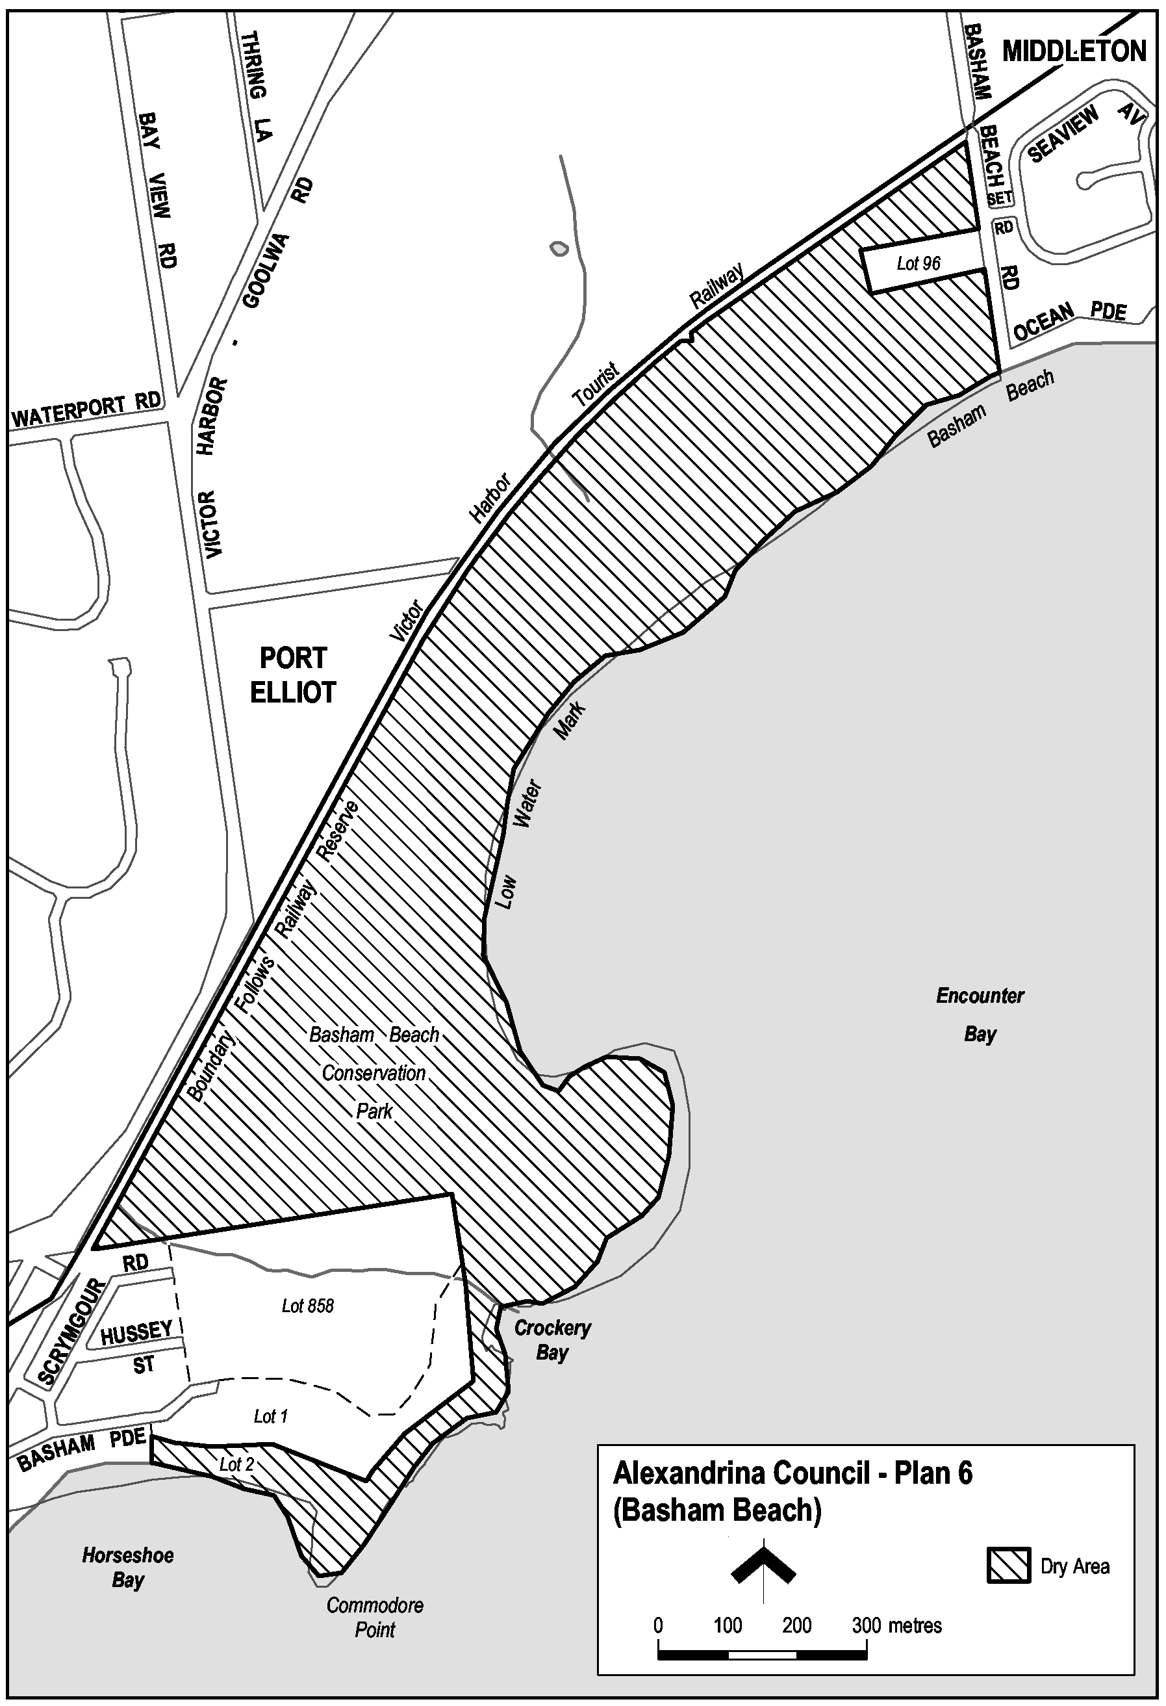
Port Vincent—Plan 1
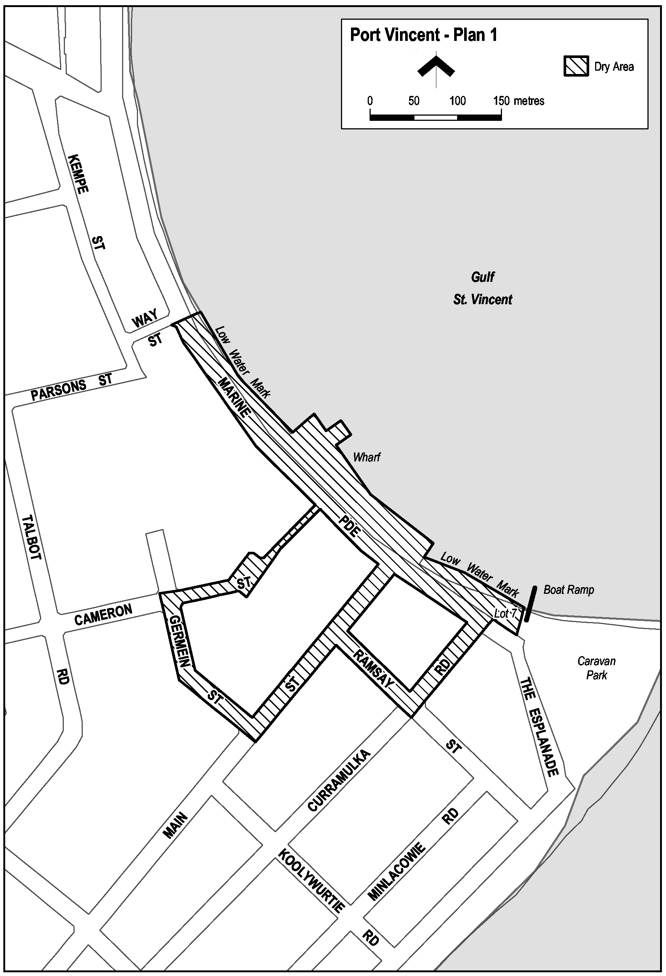
Note—
As required by section 10AA(2) of the Subordinate Legislation Act 1978, the Minister has certified that, in the Minister's opinion, it is necessary or appropriate that these regulations come into operation as set out in these regulations.
Made by the Governor
with the advice and consent of the Executive Council
on 16 December 2004
No 255 of 2004
OLGC 97/0156; OLGC 97/0144; OLGC 86/99; OLGC 125/04; OLGC 99/67; OLGC 463/97

FAXING COPY?
IF you fax copy to Government Publishing SA for inclusion in the Government Gazette, there is no need to send a Confirmation Copy to us as well.
This creates confusion and may well result in your notice being printed twice.
Please use the following fax number:
Fax transmission: (08) 8207 1040
Phone Inquiries: (08) 8207 1045
Please include a contact person, phone number and order number so that we can phone back with any queries we may have regarding the fax copy.
NOTE: Closing time for lodging new copy (fax, hard copy or email) is 4 p.m. on Tuesday preceding the day of publication.

Government Gazette notices can be E-mailed.
The address is:
governmentgazette@saugov.sa.gov.au
Documents should be sent as attachments in Word format.
When sending a document via E-mail, please confirm your transmission with a faxed copy of your document, including the date the notice is to be published.
Fax transmission: (08) 8207 1040
Enquiries: (08) 8207 1045
NOTE: Closing time for lodging new copy (fax, hard copy or email) is 4 p.m. on Tuesday preceding the day of publication.

CITY OF HOLDFAST BAY
Adoption of Community Land Management Plans
NOTICE is hereby given that following relevant consultation pursuant to Section 197 of the Local Government Act 1999, the City of Holdfast Bay at its meeting held on 7 December 2004, resolved to adopt Community Land Management Plans for Council’s Sporting Reserves, Regional Open Spaces, Local Parks, Natural Reserves, Community Facilities, Cemeteries and Utilities.
D. G. Chamberlain, Acting Chief Executive Officer

THE RURAL CITY OF MURRAY BRIDGE
Office Closure—Christmas/New Year Period
NOTICE is hereby given that at a meeting held on 27 September 2004, council resolved that the Local Government Centre will be closed over the Christmas/New Year period from 1 p.m. on Friday, 24 December 2004 until 8.30 a.m. on Tuesday, 4 January 2005.
D. J. Altmann, Chief Executive Officer

CITY OF NORWOOD, PAYNEHAM AND ST PETERS
Adoption of Community Land Management Plans
NOTICE is hereby given that at the council meeting held on
6 December 2004 the Corporation of the City of Norwood, Payneham and St Peters adopted the following community land management plans pursuant to Chapter 11 of the Local Government Act 1999:
• CLMP-102400 Dunstone Grove—Linde Reserve
• CLMP-100700 Norwood Oval
• CLMP-111900 Memorial Gardens
Copies of the plans are available from the Norwood Town Hall, 175 The Parade, Norwood, S.A. 5067.
M. Barone, Chief Executive Officer

Naming of Public Places
At the council meeting held on 6 December 2004 the Corporation of the City of Norwood, Payneham and St Peters assigned the respective names to the following public places situated within the City, pursuant to section 219 of the Local Government Act 1999:
Dunstone Grove—48-70 Nelson Street, Stepney
That portion of community land contained within the allotments listed below and situated east-north-east of the centreline of Second Creek:
Allotment 75 in FP 134917 (C.T. 2301/54)
Allotment 66 in FP 134924 (C.T. 5774/726)
Allotment 73 in FP 134815 (C.T. 5888/52)
Allotment 64 in FP 134925 (C.T. 5888/44)
Allotment 74 in FP 134922 (C.T. 5825/860)
Allotment 71 in FP 134923 (C.T. 5612/599)
Allotment 72 in FP 134921 (C.T. 5799/121)
Allotment 70 in FP 134919 (C.T. 5799/119)
Allotment 68 in FP 134916 (C.T. 5799/115)
Allotment 65 in RP 3402 (C.T. 5799/117)
Piece ‘A’ in FP 4431 (C.T. 615/200)
Linde Reserve—41-45 Stepney Street, Stepney
That portion of community land contained within the allotments listed below and situated west-south-west of the centreline of Second Creek:
Allotment 127 in FP 4431 (C.T. 5495/429)
Allotment 128 in FP 4431 (C.T. 5515/208)
Allotment 130 in FP 4431 (C.T. 5694/773)
Allotment 129 in FP 134926 (C.T. 989/10)
Allotment 66 in FP 134924 (C.T. 5774/726)
Allotment 64 in FP 134925 (C.T. 5888/44)
Allotment 71 in FP 134923 (C.T. 5612/599)
Norwood Oval—4 Woods Street, Norwood
Those pieces of land shown as ‘S’, ‘T’ and ‘U’ in the Plan to Define Community Land Forming Norwood Oval and Memorial Gardens (Rev.1 28/9/04), comprised in Certificates of Title Volume 5247, Folio 442; Volume 5419, Folio 588 (part only); Volume 5416, Folio 398 and Volume 5093, Folio 364.
Memorial Gardens—75 The Parade, Norwood
That piece of land shown as ‘R’ in the Plan to Define Community Land Forming Norwood Oval and Memorial Gardens (Rev.1 28/9/04), comprised in Certificate of Title Volume 5419, Folio 588 (part only).
Further information is available from the Norwood Town Hall, 175 The Parade, Norwood, S.A. 5067.
M. Barone, Chief Executive Officer

CITY OF ONKAPARINGA
Load Limit
NOTICE is hereby given that the council of the City of Onkaparinga at its meeting held on 16 November 2004, resolved pursuant to section 359 of the Local Government Act 1934 as amended, to enforce a 12 tonne load limit on the Lower Esplanade, Aldinga Beach from its junction with Norman Road to the south side of the boat ramp west of Morgan Street with exemptions for emergency vehicles, buses and vehicles displaying a valid exemption permit.
J. Tate, City Manager

CITY OF PORT ADELAIDE ENFIELD
Development Act 1993
Port Adelaide Enfield (City) Development Plan
Marina (North Haven) Zone Plan Amendment Report—
Draft for Public Consultation
NOTICE is hereby given that the City of Port Adelaide Enfield has prepared a draft Plan Amendment Report to amend the Port Adelaide Enfield (City) Development Plan as it affects the Marina (North Haven) Zone.
The Plan Amendment Report is seeking to amend the Marina (North Haven) Zone by:
• Introducing a range of Principles of Development Control that:
(i) clarify the location and nature of over-water develop-ment;
(ii) protect existing developments with respect to existing amenity;
(iii) promote better stormwater management;
(iv) promote the protection of revetment walls; and
(v) introduce car parking standards relating to boat storage and berthing facilities.
• Amending the Objectives of the Zone in order to preserve the safety and structural integrity of the revetment walls and the need to address stormwater and wastewater issues.
• Expanding the Desired Future Character Statement of the Zone.
• Deleting the ‘Proposals’ and ‘Notes’ section in the Zone.
The draft Plan Amendment Report including the Statement of Investigations will be available for public inspection and purchase for $10 during normal office hours at:
City of Port Adelaide Enfield Civic Centre
163 St Vincent Street, Port Adelaide
www.portenf.sa.gov.au
The draft Plan Amendment Report is also available at council’s libraries and the mentioned website from Thursday, 16 December 2004 to Monday, 14 March 2005.
During the statutory consultation process, interested persons can attend an informal community information evening to be held on Wednesday, 16 February 2005 at the Port Adelaide Town Hall, 34 Nile Street, Port Adelaide from 7 p.m.
Written submissions regarding the draft amendment will be accepted by council until the close of business on Monday, 14 March 2005. Written submissions should also clearly indicate whether you wish to speak at the public hearing on your submission. All submissions should be addressed to the City Manager, City of Port Adelaide Enfield, P.O. Box 110, Port Adelaide, S.A. 5015.
Copies of all submissions received will be available for inspection by interested persons at the City of Port Adelaide Enfield Civic Centre from Tuesday, 15 March 2005 until the date of the public hearing.
The public hearing will be held at the City of Port Adelaide Enfield Town Hall, 34 Nile Street, Port Adelaide on Wednesday, 23 March 2005 from 7 p.m.
A public hearing may not be held if submissions indicate no interest in speaking at the public hearing.
Dated 16 December 2004.
H. Wierda, City Manager

THE BAROSSA COUNCIL
Notice of Cancellation of Council Meeting
NOTICE is hereby given that the ordinary council meeting scheduled to be held on Tuesday, 4 January 2005, has been cancelled.
All business will be transacted at the meeting to be held on Tuesday, 18 January 2005.
J. G. Jones, Chief Executive Officer

COORONG DISTRICT COUNCIL
Periodical Review of Elector Representation
PURSUANT to section 12 of the Local Government Act 1999, notice is hereby given that the Coorong District Council is to carry out a review to ensure that all aspects of the composition of the council, and the issue of the division, or potential division of the area of the council into wards is comprehensively reviewed.
Information regarding the nature of the periodical review is available from the offices of the council situated at:
49 Princes Highway, Meningie
95 Railway Terrace, Tailem Bend
37 Becker Terrace, Tintinara
during normal opening hours.
Interested persons are invited to make written submissions to the council on the subject of the review. Submissions should be directed to The Chief Executive Officer, P.O. Box 28, Meningie, S.A. 5264, (marked ‘Periodical Review’) to be received by 5 p.m. on Wednesday, 2 February 2005.
Any persons making a written submission will also be invited to appear personally or by representative before the council, or a council committee and to be heard on those submissions.
W. R. Paterson, Chief Executive Officer

COORONG DISTRICT COUNCIL
Roads (Opening and Closing) Act 1991
Road Closure—Loveday Road, Narrung
NOTICE is hereby given, pursuant to section 10 of the Roads (Opening and Closing) Act 1991, that the Coorong District Council proposes to make a Road Process Order to:
(i) open as road portion of Piece 91 in FP 200256 shown more particularly delineated and numbered ‘1’ on the Preliminary Plan No. 04/0055, forming re-alignment of Loveday Bay Road;
(ii) close and transfer to Yalkuri Pty Limited in exchange for the above road opening, portion of Loveday Bay Road and the whole of the un-named public road adjoining Pieces 91 and 93 in FP 200256, more particularly delineated and lettered ‘A’ in Preliminary Plan No. 04/0055;
(iii) close and transfer to W. P. and M. E. Sanders portion of Loveday Bay Road adjoining Piece 4 in DP 47168 and Piece 7 in DP 51028 more particularly delineated and lettered ‘B’ in Preliminary Plan No. 04/0055.
A copy of the plan and a statement of persons affected are available for public inspection at the offices of the Council, Princes Highway, Meningie and the Adelaide office of the Surveyor-General, 101 Grenfell Street, Adelaide during normal office hours.
Any person is entitled to object to the proposed road process, or any person affected by the proposed closure is entitled to apply for an easement to be granted in that person’s favour over the land subject to the proposed closure. Such objection or application for an easement must set out the full name and address of the person making the objection or application and must be fully supported by reasons. Any application for an easement must give full particulars of the nature and location of the easement and where made by a person as the owner of adjoining or nearby land, specify the land to which the easement is to be annexed.
The objection or application for an easement must be made in writing to the Council, 49 Princes Highway, Meningie, S.A. 5264 within 28 days of this notice and a copy shall be forwarded to the Surveyor-General, G.P.O. Box 1354, Adelaide, S.A. 5001. Where a submission is made, the council will give notification of a meeting at which the matter will be considered, so that the person making the submission or a representative may attend, if so desired.
Dated 16 December 2004.
W. R. Paterson, Chief Executive Officer

COORONG DISTRICT COUNCIL
Community Land Management Plans
NOTICE is hereby given that pursuant to the Local Government Act 1999, section 197 (3):
• Council at its meeting held on 11 November 2004, resolved to adopt Community Land Management Plans for the following groups of Community Land:
Depots
Soldiers’ Memorial Park
Camping and Caravan Park Reserves
Roadside Reserves
Community Halls
Reserve and Drainage Reserves
Parkland and Foreshore Reserves
Cemetery Reserves
Community and Health Purpose Lands
Leased Land
Reserves
Effluent Drainage
Sporting Grounds
Parklands
Waste Depot and Vacant Land
Council Office
Parklands and Reserves
Reserves—Tailem Bend
Cemetery Reserve—Cooke Plains
Parklands—Tintinara
Community Centre and Memorial Hall
Drainage Reserves
• Council at its meeting held on 13 July 2004, resolved to adopt Community Land Management Plans to the following groups of Community Land:
Depots
• Council at its meeting held on 14 October 2003, resolved to adopt Community Land Management Plans for the following Community Land:
Leased Land—Tailem Bend Railway Station
• Council at its meeting held on 12 November 2002, resolved to adopt Community Land Management Plans for the following Community Land:
Community Recreation Reserve—Murrayview
• Council at its meeting held on 13 August 2002, resolved to adopt Community Land Management Plans for the following Community Land:
Reserve—Lot 9 Hundred of Seymour, Hector Road
• Council at its meeting held on 9 June 2002, resolved to adopt Community Land Management Plans for the following Community Land:
Leased Land—Tintinara Railway Station.
Dated 14 December 2004.
W. R. Paterson, Chief Executive Officer

DISTRICT COUNCIL OF GRANT
Adoption of Generic Community Land Management Plans
NOTICE is hereby given that at the meeting of council held on
3 May 2004, following public consultation council adopted, in accordance with its Public Consultation Policy, Generic Comm-unity Land Management Plans for land contained in the District Council of Grant Community Land Register categorised as:
Sportsgrounds
Parks
General Community Use
Vacant
Emergency Services
In accordance with the Local Government Act 1999, the Community Land Register is incorporated within the Generic Community Land Management Plan and is available for public inspection during normal office hours at Council’s Principal Office, 324 Commercial Street West, Mount Gambier and the sub-office, 7 Charles Street, Port McDonnell or viewed on the council website: www.dcgrant.sa.gov.au.
R. Peate, Chief Executive Officer

DISTRICT COUNCIL OF KAROONDA EAST MURRAY
Temporary Road Closure
NOTICE is hereby given that at its meeting held on 9 November, 2004, council resolved to exercise the powers pursuant to section 33 of the Road Traffic Act 1961 and Clause F of the Instrument of General Approval of the Minister dated 12 March 2001. Accordingly, council pursuant to section 33 (1) (a) of the Road Traffic Act 1961, declares that the event to be conducted, being a Christmas Street Party is an event to which section 33 of the Road Traffic Act 1961 applies and as such, makes an order that Railway Terrace, Karoonda, between Bodey Street and East Terrace, will be closed to traffic from 7 p.m. to 10.30 p.m. on Sunday, 19 December 2004 and 5 p.m. to 10.30 p.m. on Friday, 24 December 2004.
Pursuant to section 33 (1) (b) of the Road Traffic Act 1961, council made an order directing that persons taking part in the event be exempted, in relation to roads, from the duty to observe the Australian Road Rules specified and attached to the exemption:
Rule 230—Crossing a Road—General.
P. Smithson, Chief Executive Officer

DISTRICT COUNCIL OF KIMBA
Change of Council/Committee Meeting Date
NOTICE is hereby given that at a meeting held on 8 December 2004, it was resolved that the Council/Committee meetings for January 2005 be held on Wednesday, 19 January 2005, commencing at 1 p.m.

Road Closures
Notice is hereby given that at a meeting held on 8 December 2004, Council resolved that in accordance with section 359 of the Local Government Act 1934, as amended, High Street from the northern side of Cross Street to the southern side of North Terrace be closed to all vehicles, except emergency service vehicles, between 4.45 p.m. and midnight on Saturday, 18 December 2004 for the purpose of holding Christmas festivities.
Notice is hereby given that at a meeting held on 8 December 2004, Council resolved that in accordance with section 359 of the Local Government Act 1934, as amended, Martin Terrace from the western side of Jacobs Way to the eastern side of High Street and High Street from the southern side of Martin Terrace to the northern side of Cross Street be temporarily closed on Saturday, 18 December 2004 for the purpose of holding the Kimba Christmas Pageant. Pursuant to Council’s resolution suitable barriers and notices will be erected giving effect to this closure.
D. A. Cearns, Chief Executive Officer

DISTRICT COUNCIL OF LOXTON WAIKERIE
Land Excluded from Classification of Community Land
NOTICE is hereby given that at a special meeting of council held on 7 December 2004, council resolved that sections 349, 350 and 937, in the Hundred of Bookpurnong, locally known as the Loxton Ausbulk Bunker site, located on the corner of Badcoe Road and Robertson Avenue be purchased and that the land be not classified as community land pursuant to section 193 (4) of the Local Government Act 1999 as it is proposed to be used for operational purposes and portion held for resale.
P. D. Ackland, Chief Executive Officer

MID MURRAY COUNCIL
Appointment
NOTICE is hereby given that at a meeting of council, held on 13 December 2004, Dean Hillary Gollan was appointed to the position of Chief Executive Officer as from 6 December 2004, in accordance with the provisions of section 96 of the Local Government Act 1999, vide the resignation of the previous Chief Executive Officer, Glenn Rodney Brus.
I. R. Mann, Mayor

SOUTHERN MALLEE DISTRICT COUNCIL
Adoption of Community Land Management Plans
NOTICE is hereby given that pursuant to section 197 (3) of the Local Government Act 1999, that the Southern Mallee District Council did, at the council meeting held on 8 December 2004, adopt Management Plans for the Community Land.
P. Wood, Chief Executive Officer

[Republished]
WATTLE RANGE COUNCIL
Roads (Opening and Closing) Act 1991
Road Closures—Public Road, Nangwarry
PURSUANT to section 10 of the Roads (Opening and Closing) Act 1991, The Wattle Range Council hereby gives notice of its intent to implement a Road Process Order to:
(i) Close portion of Public Road, Hundred of Nangwarry and merge with adjoining section 41 held in certificate of title volume 5406, folio 830 in the name of Nangwarry Pastoral Company Ltd more particularly delineated and lettered ‘A’ on Preliminary Plan No. PP01/0710.
(ii) Close portion of Public Road, Hundred of Nangwarry and merge with adjoining section 42 held in certificate of title volume 5406, folio 830 in the name of Nangwarry Pastoral Company Ltd more particularly delineated and lettered ‘B’ on Preliminary Plan No. PP01/0710.
(iii) Close portion of Public Road, Hundred of Nangwarry and merge with adjoining section 44 held in certificate of title volume 5406, folio 830 in the name of Nangwarry Pastoral Company Ltd more particularly delineated and lettered ‘C’ on Preliminary Plan No. PP01/0710.
(iv) Close portion of Public Road, Hundred of Nangwarry and merge with adjoining section 45 held in certificate of title volume 5406, folio 830 in the name of Nangwarry Pastoral Company Ltd more particularly delineated and lettered ‘D’ on Preliminary Plan No. PP01/0710.
(v) Close portion of Public Road, Hundred of Nangwarry and merge with adjoining section 46 held in certificate of title volume 5406, folio 830 in the name of Nangwarry Pastoral Company Ltd more particularly delineated and lettered ‘E’ on Preliminary Plan No. PP01/0710.
A statement of persons affected by the Road Process Order, together with a copy of the above drawing is available for inspection at the Council Offices, George Street, Millicent, between the hours of 9 a.m. and 5 p.m. weekdays only. Copies may also be inspected at the Adelaide office of the Surveyor-General, during normal office hours.
Any person who may wish to object to the proposed road process order or any person affected by the proposed road closure who may wish to apply for an easement to be granted in that person’s favour over the land subject to the proposed road closure must lodge with the said council a notice of objection or an application for an easement within 28 days of the date of this notice.
Any objections lodged shall be in writing giving the objector’s full name and address, reasons for the objection and whether the objector wishes to appear in person or be represented at the subsequent meeting when the objection will be determined by council. A copy of such objection shall also be forwarded to the Surveyor-General, G.P.O. Box 1354, Adelaide, S.A. 5001.
An application for grant of easement shall be in writing giving full name and address of the person applying for the grant, full details of the nature and location of the requested easement, whether it will be in favour of the owner of the adjoining or nearby land and if so specify the land to which the easement will be annexed and reasons for the application for grant of easement.
Dated 16 December 2004.
F. Brennan, Chief Executive Officer

IN the matter of the estates of the undermentioned deceased persons:
Bowns, Amy, late of 32 Cross Road, Myrtle Bank, married woman, who died on 7 September 2004.
De Garis, Marie Pearl, late of 53-59 Austral Terrace, Morphettville, of no occupation, who died on 27 September 2004.
Eager, John, late of 75 Edward Beck Drive, Sheidow Park, retired fitter and turner, who died on 3 October 2004.
Green, Rhonda Dawn, late of 29 Gambia Avenue, Hampstead Gardens, home duties, who died on 2 September 2004.
Hewitt, Margaret Teresa, late of 342 Marion Road, North Plympton, of no occupation, who died on 19 October 2004.
Hofmeyer, Gwendolyn Madge, late of 6 Devon Street, South Brighton, retired school teacher, who died on 30 September 2004.
Holden, John William, late of 34 Molesworth Street, North Adelaide, retired storeman, who died on 28 August 2004.
Jennings, Mamie Beatrice, late of Mozart Court, Somerton Park, married woman, who died on 15 September 2004.
Lake, Doreen Glenenia, late of Shackleton Avenue, Ingle Farm, of no occupation, who died on 9 October 2004.
Langdon, Arthur Roy, late of 27A Adam Street, Hindmarsh, retired storeman, who died on 8 September 2004.
Lister, Isabella Flockhart, late of 20 Norseman Avenue, Westbourne Park, retired nursing sister, who died on 26 August 2004.
Nixson, Madge Elizabeth Ann, late of 60 States Road, Morphett Vale, of no occupation, who died on 18 August 2004.
Reimann, Rawley Conrad, late of 173 Brighton Road, Somerton Park, retired storeman, who died on 20 October 2004.
Rowlands, Mavis Lorraine, late of Gadd Avenue, Crystal Brook, retired officer worker, who died on 7 October 2004.
Russell, Iris Jean, late of 114 May Street, Woodville West, widow, who died on 5 October 2004.
Notice is hereby given pursuant to the Trustee Act 1936, as amended, the Inheritance (Family Provision) Act 1972, and the Family Relationships Act 1975, that all creditors, beneficiaries, and other persons having claims against the said estates are required to send, in writing, to the Public Trustee, 25 Franklin Street, Adelaide, S.A. 5000, full particulars and proof of such claims, on or before 21 January 2005, otherwise they will be excluded from the distribution of the said estate; and notice is also hereby given that all persons who are indebted to the said estates are required to pay the amount of their debts to the Public Trustee or proceedings will be taken for the recovery thereof; and all persons having any property belonging to the said estates are forthwith to deliver the same to the Public Trustee.
Dated 16 December 2004.
C. J. O’Loughlin, Public Trustee

LOST WILL
IF anyone knows the whereabouts of a will made by Dorothy June Owen, late of Parklyn Nursing Home, 6 Booth Avenue, Linden Park, S.A. 5065, who died on 30 April 2004, please contact:
The Estates Manager
Finlaysons (Lawyers)
81 Flinders Street,
Adelaide, S.A. 5000
Phone 8235 7400

ATTENTION

CUSTOMERS requiring a proof of their notice for inclusion in the Government Gazette, please note that the onus is on you to inform Government Publishing SA of any subsequent corrections by 10 a.m. on Thursday, which is our publication deadline.

For any corrections to your notice please phone 8207 1045 or Fax 8207 1040 before 10 a.m. on Thursday.

If we do not receive any communication by 10 a.m. on Thursday (day of publication) we will presume the notice is correct and will print it as it is.

Remember—the onus is on you to inform us of any corrections necessary to your notice.

NOTE: Closing time for lodging new copy (electronically, fax or hard copy) is 4 p.m. on Tuesday preceding the day of publication. Phone 8207 1045—Fax 8207 1040.
Email: governmentgazette@saugov.sa.gov.au

Printed and published by authority every Thursday by J. D. FERGUSON, Government Printer, South Australia
Price: $4.85, plus postage; to subscribers, $247.00 per annum.
(The above prices are inclusive of GST)

