No. 118 4631

THE SOUTH AUSTRALIAN

GOVERNMENT GAZETTE
www.governmentgazette.sa.gov.au

PUBLISHED BY AUTHORITY

ALL PUBLIC ACTS appearing in this GAZETTE are to be considered official, and obeyed as such

ADELAIDE, THURSDAY, 23 DECEMBER 2004

CONTENTS

Page
Administrative Arrangements Act 1994—Notice 4638
Authorised Betting Operations Act 2000—Rules 4632
Corporations and District Councils—Notices 4736
Development Act 1993—Notice 4638
Environment Protection Act 1993—Notice 4635
Essential Services Commission Act 2002—Notices 4638
Fisheries Act 1982—Notices 4638
Irrigation Act 1994—Notice 4643
Land and Business (Sale and Conveyancing) Act 1994—
Notices 4643
Liquor Licensing Act 1997—Notices 4643
Local Government Act 1999—Charters 4649
Mining Act 1971—Notices 4671
National Electricity (South Australia) Act 1996—
Notice 4671

Page
Passenger Transport Act 1994—Notices 4672
Petroleum Act 2000—Notice 4673
Public Trustee Office—Administration of Estates 4738
Radiation Protection and Control Act 1982—Notice 4673
Remuneration Tribunal—Determinations and Reports 4674
Roads (Opening and Closing) Act 1991—Notices 4682
Road Traffic Act 1961—Notice 4684
Sewerage Act 1929—Notices 4727
Soil Conservation and Land Care Act 1989—Notices 4728
South Australian Co-operative and Community Housing
Act 1991—Notice 4731
Supported Residential Facilities Act 1992—Notice 4731
Transport, Department of—Notice to Mariners 4731
Water, Mains and Sewers—Mains Laid, Replaced, Etc. 4731
Waterworks Act 1932—Notices 4734

GOVERNMENT GAZETTE NOTICES
ALL poundkeepers’ and private advertisements forwarded for publication in the South Australian Government Gazette must be PAID FOR PRIOR TO INSERTION; and all notices, from whatever source, should be legibly written on one side of the paper only and sent to Government Publishing SA so as to be received no later
than 4 p.m. on the Tuesday preceding the day of publication. Phone 8207 1045 or Fax 8207 1040. E-mail: governmentgazette@saugov.sa.gov.au. Send as attachments in Word format and please confirm your transmission with a faxed copy of your document, including the date the notice is to be published and to whom the notice will be charged. The Government Gazette is available online at: www.governmentgazette.sa.gov.au

AUTHORISED BETTING OPERATIONS ACT 2000
THE Independent Gambling Authority, having made rules under section 62 of the Authorised Betting Operations Act 2000 on
20 December 2004, hereby publishes those rules for the purposes of section 11 of the Subordinate Legislation Act 1978.
Note:
As required by section 10AA (2) of the Subordinate Legislation Act 1978, the Minister for the time being administering section 62 of the Authorised Betting Operations Act 2000, has certified that, in the Minister’s opinion, it is necessary or appropriate that these rules come into operation as set out in the rules.
R. C. J. Chappell, Secretary to the Authority

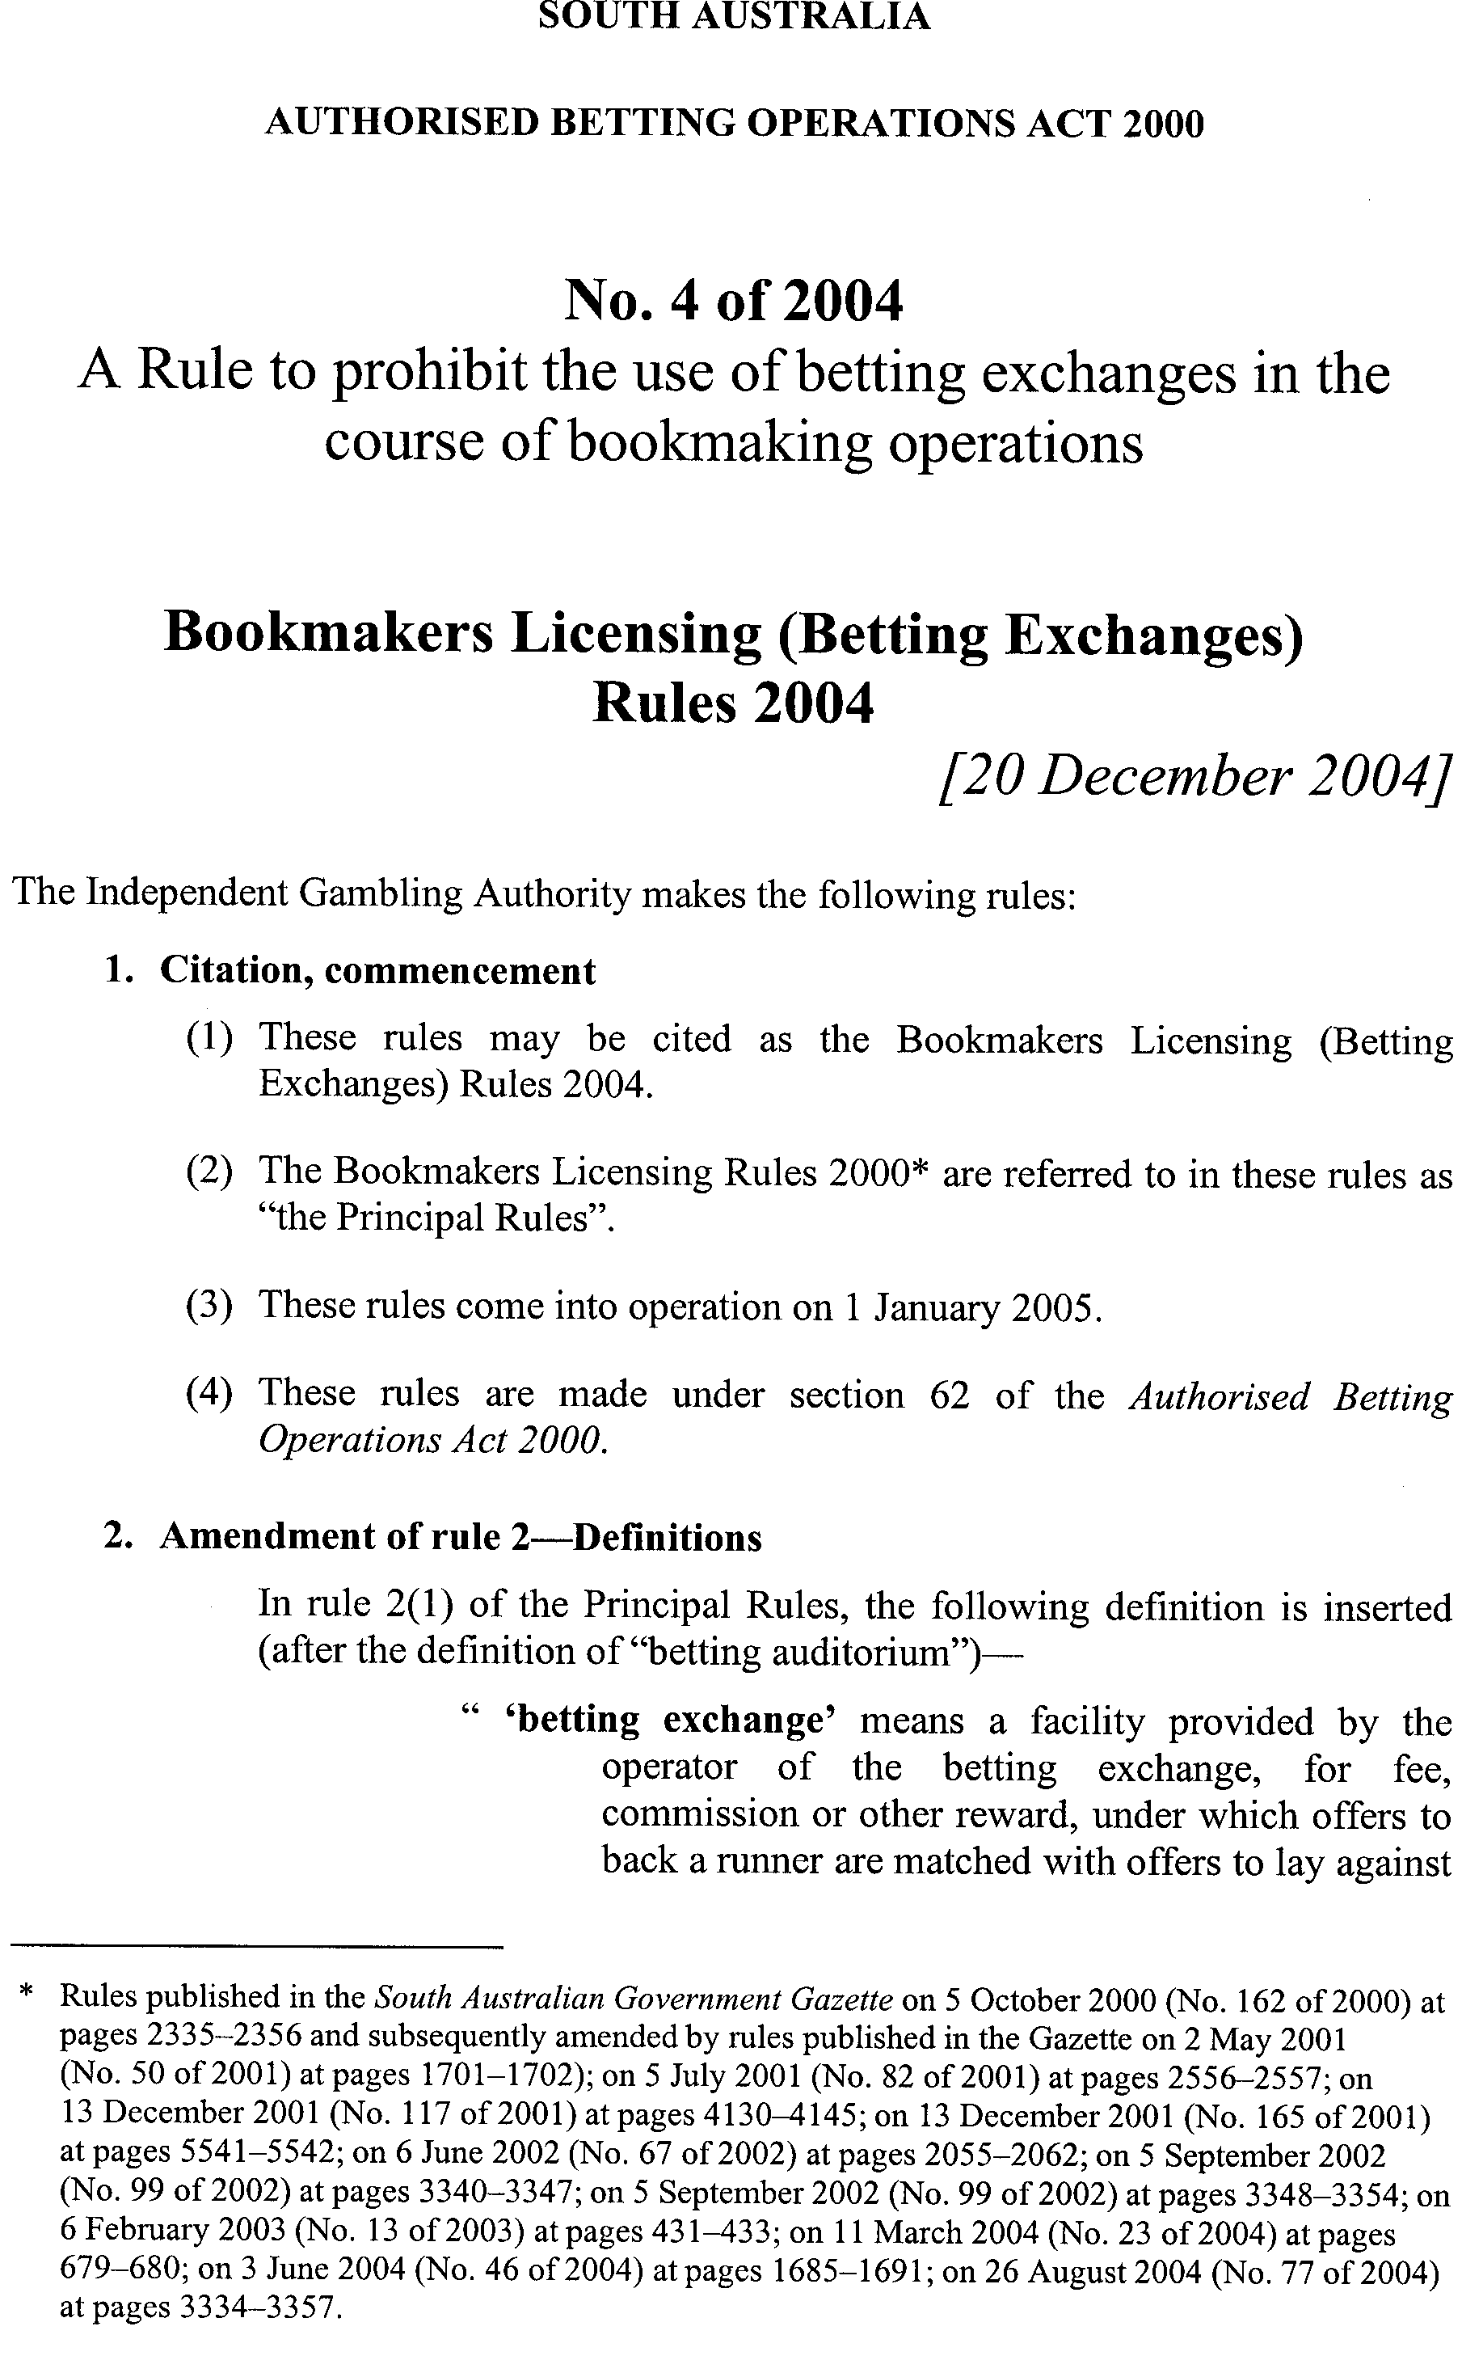
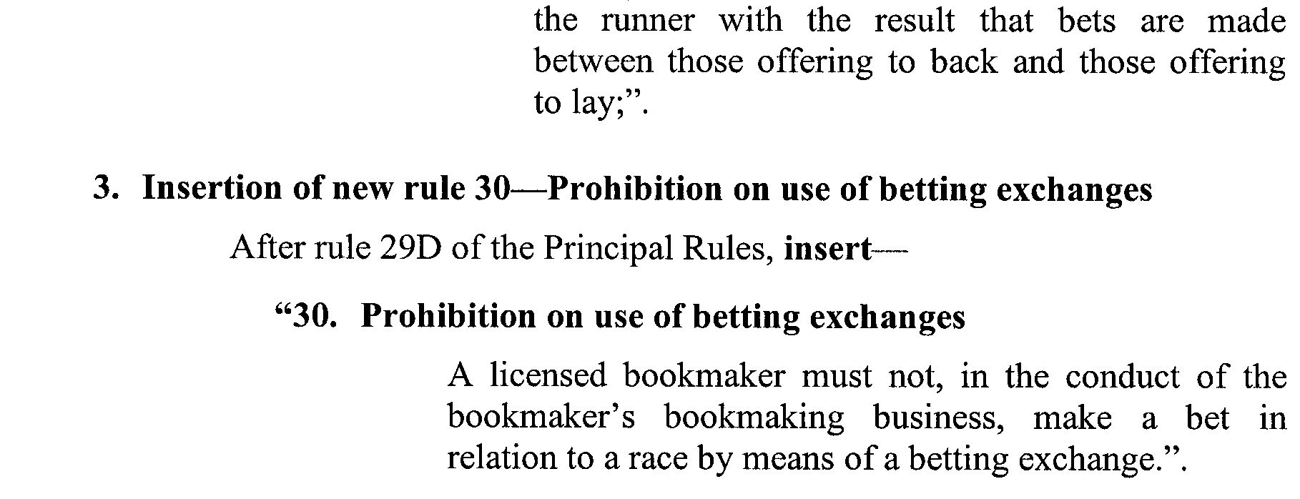

ENVIRONMENT PROTECTION ACT 1993
Approval of Category B Containers
I, STEPHEN RICHARD SMITH, Senior Adviser, Container Deposit Legislation and Delegate of the Environment Protection Authority (‘the Authority’), pursuant to section 69 of the Environment Protection Act 1993 (SA) (‘the Act’) hereby:
Approval of Category B Containers
Approve as Category B Containers, subject to the conditions in subclauses (i) and (ii) below, each of the classes of containers identified by reference to the following matters described in the first 4 columns of Schedule 1 of this Notice which are sold in South Australia:
(a) the product which each class of containers shall contain;
(b) the size of the containers;
(c) the type of containers;
(d) the name of the holders of these approvals.
(i) Subsection 69 (3) Arrangements
The holders of these approvals must ensure that the empty containers which belong to their respective class of containers hereby approved as Category B Containers are collected from collection depots approved under section 69 of the Act by the party named in Column 5 of Schedule 1 of this Notice; and
(ii) Approved Refund Markings
(a) The holders of these approvals must ensure that each container which belongs to their respective class of containers hereby approved as Category B Containers bears the refund marking approved by the Authority in respect of that class of containers;
(b) the refund marking that appears on each container that belongs to the class of containers that is hereby approved, must be a minimum 1.5 mm for the smallest letter in the statement and a minimum 3 mm for the numeric (‘5’) in the statement.
(c) The holder of these approvals must ensure that if a sticker bearing the refund marking has been approved, and is applied to the container, then the sticker must not be placed on any portion of the opening mechanism or in any other place that would require complete or partial removal of the sticker before the contents may be consumed.

Column 1 | Column 2 | Column 3 | Column 4 | Column 5
Product Name | Container  Size (mL) | Container Type | Approval Holder | Collection  Arrangements
Robinvale Passion Grape Juice Drink | 750 | Glass | Robinvale Organic & Bio Dynamic Wines Australia | Statewide Recycling
Robinvale Passion Grape Juice Drink | 330 | Glass | Robinvale Organic & Bio Dynamic Wines Australia | Statewide Recycling
Robinvale Ginger Grape Juice Drink | 750 | Glass | Robinvale Organic & Bio Dynamic Wines Australia | Statewide Recycling
Robinvale Ginger Grape Juice Drink | 330 | Glass | Robinvale Organic & Bio Dynamic Wines Australia | Statewide Recycling
Robinvale Cooler Grape Juice Drink | 750 | Glass | Robinvale Organic & Bio Dynamic Wines Australia | Statewide Recycling
Robinvale Cooler Grape Juice Drink | 330 | Glass | Robinvale Organic & Bio Dynamic Wines Australia | Statewide Recycling
Robinvale Strawberry Grape Juice Drink | 750 | Glass | Robinvale Organic & Bio Dynamic Wines Australia | Statewide Recycling
Robinvale Strawberry Grape Juice Drink | 330 | Glass | Robinvale Organic & Bio Dynamic Wines Australia | Statewide Recycling
Robinvale Mango Grape Juice Drink | 750 | Glass | Robinvale Organic & Bio Dynamic Wines Australia | Statewide Recycling
Robinvale Mango Grape Juice Drink | 330 | Glass | Robinvale Organic & Bio Dynamic Wines Australia | Statewide Recycling
Robinvale Premium Muscat Grape Juice Drink | 750 | Glass | Robinvale Organic & Bio Dynamic Wines Australia | Statewide Recycling
Robinvale Premium Muscat Grape Juice Drink | 330 | Glass | Robinvale Organic & Bio Dynamic Wines Australia | Statewide Recycling
Robinvale Lambrusco Grape Juice Drink | 750 | Glass | Robinvale Organic & Bio Dynamic Wines Australia | Statewide Recycling
Robinvale Lambrusco Grape Juice Drink | 330 | Glass | Robinvale Organic & Bio Dynamic Wines Australia | Statewide Recycling
Robinvale Big Grape Springwater Drink White | 330 | Glass | Robinvale Organic & Bio Dynamic Wines Australia | Statewide Recycling
Robinvale Big Grape Springwater Drink Red | 330 | Glass | Robinvale Organic & Bio Dynamic Wines Australia | Statewide Recycling
7 Up Cherry | 330 | Can—Aluminium (Sticker) | Funworks | Flagcan Distributors
Vimto Sparkling Grape Blackcurrant & Raspberry Juice Drink | 330 | Can—Aluminium (Sticker) | Funworks | Flagcan Distributors
Cherry Coke | 330 | Can—Aluminium (Sticker) | Funworks | Flagcan Distributors
Tizer | 330 | Can—Aluminium (Sticker) | Funworks | Flagcan Distributors
Lift | 330 | Can—Aluminium (Sticker) | Funworks | Flagcan Distributors
Ben Shaws Dandelions & Burdock | 330 | Can—Aluminium (Sticker) | Funworks | Flagcan Distributors
Tango Cherry | 330 | Can—Aluminium (Sticker) | Funworks | Flagcan Distributors
Tango Apple | 330 | Can—Aluminium (Sticker) | Funworks | Flagcan Distributors
Tango Fruit Fling | 330 | Can—Aluminium (Sticker) | Funworks | Flagcan Distributors
Tango Orange | 330 | Can—Aluminium (Sticker) | Funworks | Flagcan Distributors
Tango Orange Light | 330 | Can—Aluminium (Sticker) | Funworks | Flagcan Distributors
R Whites Lemonade | 330 | Can—Aluminium (Sticker) | Funworks | Flagcan Distributors
Shandy Bass Beer | 330 | Can—Aluminium (Sticker) | Funworks | Flagcan Distributors
Shandy Bass Beer | 330 | Can—Aluminium (Sticker) | Funworks | Flagcan Distributors
Firey Ginger Beer | 330 | Can—Aluminium (Sticker) | Funworks | Flagcan Distributors
Fanta Zesty Berry | 330 | Can—Aluminium (Sticker) | Funworks | Flagcan Distributors
Squirt | 355 | Can—Aluminium (Sticker) | Funworks | Flagcan Distributors
A. & W. Sparkling Vanilla Creamy Soda | 355 | Can—Aluminium (Sticker) | Funworks | Flagcan Distributors
A. & W. Root Beer | 355 | Can—Aluminium (Sticker) | Funworks | Flagcan Distributors
Coca Cola Classic | 355 | Can—Aluminium (Sticker) | Funworks | Flagcan Distributors
Welchs Sparkling Grape Soda | 355 | Can—Aluminium (Sticker) | Funworks | Flagcan Distributors
James Squire Limited Release Golden Ale | 345 | Brown Glass with Paper Label | South Australian Brewing Company Pty Ltd | Marine Stores Ltd
Egeria Aqua Minerale Naturale Natural | 1 500 | PET with Paper Label | Imperiale Pty Ltd | Statewide Recycling
Egeria Aqua Minerale Naturale Sparkling | 1 500 | PET with Paper Label | Imperiale Pty Ltd | Statewide Recycling
Egeria Aqua Minerale Naturale Sparkling | 1 000 | Glass with Paper Label | Imperiale Pty Ltd | Statewide Recycling
Egeria Aqua Minerale Naturale Natural | 1 000 | Glass with Paper Label | Imperiale Pty Ltd | Statewide Recycling
Egeria Aqua Minerale Naturale Natural | 500 | Glass with Paper Label | Imperiale Pty Ltd | Statewide Recycling
Egeria Aqua Minerale Naturale Sparkling | 500 | Glass with Paper Label | Imperiale Pty Ltd | Statewide Recycling
Egeria Aqua Minerale Naturale Sparkling | 500 | PET with Paper Label | Imperiale Pty Ltd | Statewide Recycling
Egeria Aqua Minerale Naturale Natural | 500 | PET with Paper Label | Imperiale Pty Ltd | Statewide Recycling
Halida Beer | 330 | Brown Glass with Paper Label (Sticker) | Po Kwong Trading Pty Ltd | Marine Stores Ltd
Cocos Brand Land Coconut Syrup | 325 | Brown Glass with Paper Label (Sticker) | Po Kwong Trading Pty Ltd | Marine Stores Ltd
Norganic Just 2 Good Strawberry Brekky Drink | 250 | LPB—Aseptic | Norganic Foods Australia Pty Ltd | Statewide Recycling
Norganic Just 2 Good Chocolate Brekky Drink | 250 | LPB—Aseptic | Norganic Foods Australia Pty Ltd | Statewide Recycling
EKO The Biological Beer | 330 | Green Glass with Paper Label (Sticker) | Santucci Organic Enterprises Pty Ltd | Statewide Recycling
Alpha 72 Natural Ionic Minerals | 600 | PET with Paper Label (Sticker) | Alpha Lyte Pty Ltd | Flagcan Distributors
Skyy Platinum 7% Skyy Vodka infused with Citrus | 275 | Blue Glass with PET Label | Carlton & United Breweries Ltd | Visy Recycling CDL Services
Yakult Light | 65 | Polystyrene with PVC Label | Yakult Australia Pty Ltd | Statewide Recycling
Trumer Pils | 330 | Green Glass with Paper Label | Tucker Seabrook SA | Statewide Recycling
Sass Strawberry Bubbly | 200 | Green Glass with PET Label | Carlton & United Breweries Ltd | Visy Recycling CDL Services
Sass Melon Bubbly | 200 | Green Glass with PET Label | Carlton & United Breweries Ltd | Visy Recycling CDL Services
Sass Peach Bubbly | 200 | Green Glass with PET Label | Carlton & United Breweries Ltd | Visy Recycling CDL Services
Newcastle Brown Ale | 330 | Clear Glass with Paper Label | Carlton & United Breweries Ltd | Visy Recycling CDL Services
Cape Byron Natural Spring Water | 1 500 | PET with Coated Paper Label | Cape Byron | Visy Recycling CDL Services
Cape Byron Natural Spring Water | 600 | PET with Coated Paper Label | Cape Byron | Visy Recycling CDL Services
Nudie Crushie Raspberry Mulberry Cherry & More | 250 | PET with Polypropylene Label | Nudie Pty Ltd | Statewide Recycling
Nudie Crushie Strawberry Rhubarb & More | 250 | PET with Polypropylene Label | Nudie Pty Ltd | Statewide Recycling
Nudie Crushie Peach Pineapple Mango & Coconut | 250 | PET with Polypropylene Label | Nudie Pty Ltd | Statewide Recycling
Nudie Crushie Apricot Peach & More | 250 | PET with Polypropylene Label | Nudie Pty Ltd | Statewide Recycling
Fanta Spider Choc Orange | 600 | PET with Polyethylene Label | Coca Cola Amatil (Aust.) Pty Ltd | Statewide Recycling
Fanta Spider Choc Orange | 1 250 | PET with Polyethylene Label | Coca Cola Amatil (Aust.) Pty Ltd | Statewide Recycling
Fanta Spider Strawberry | 1 250 | PET with Polyethylene Label | Coca Cola Amatil (Aust.) Pty Ltd | Statewide Recycling
Fanta Spider Strawberry | 600 | PET with Polyethylene Label | Coca Cola Amatil (Aust.) Pty Ltd | Statewide Recycling
Powerade Active Water Lemon | 600 | PET with Polyethylene Label | Coca Cola Amatil (Aust.) Pty Ltd | Statewide Recycling
Powerade Active Water Lime | 600 | PET with Polyethylene Label | Coca Cola Amatil (Aust.) Pty Ltd | Statewide Recycling
Powerade Active Water Mandarin | 600 | PET with Polyethylene Label | Coca Cola Amatil (Aust.) Pty Ltd | Statewide Recycling
Sprite Zero | 600 | PET with Polyethylene Label | Coca Cola Amatil (Aust.) Pty Ltd | Statewide Recycling
Sprite Zero | 390 | PET with Polyethylene Label | Coca Cola Amatil (Aust.) Pty Ltd | Statewide Recycling
Sprite Zero | 1 250 | PET with Polyethylene Label | Coca Cola Amatil (Aust.) Pty Ltd | Statewide Recycling
Sprite Zero | 2 000 | PET with Polyethylene Label | Coca Cola Amatil (Aust.) Pty Ltd | Statewide Recycling
Santa Croce Natural Mineral Water | 1 000 | PET with Paper Label | Global Food Distributors Pty Ltd | Statewide Recycling
Santa Croce Sparkling Mineral Water | 1 000 | PET with Paper Label | Global Food Distributors Pty Ltd | Statewide Recycling
Woodroofe Lemonade | 600 | PET with Polypropylene Label | Cadbury Schweppes Pty Ltd | Statewide Recycling
Fuze Box Very Vanilla | 375 | LPB—Aseptic | Australasian Pacific Foods | Statewide Recycling
Fuze Box Fudge Chocolate | 375 | LPB—Aseptic | Australasian Pacific Foods | Statewide Recycling
Beamish Irish Stout | 500 | Can—Aluminium | Beer Importers & Distributors Pty Ltd | Statewide Recycling
Berri Harmonics Cranberry Drink | 1 000 | PET with Paper Label | Berri Limited | Statewide Recycling
Wild Water Rockmelon | 330 | Clear Glass with Paper Label | Bentcorp Pty Ltd | Statewide Recycling
Wild Water Lemon Lime | 330 | Clear Glass with Paper Label | Bentcorp Pty Ltd | Statewide Recycling
Wild Natural Spring Water | 330 | Clear Glass with Paper Label | Bentcorp Pty Ltd | Statewide Recycling
Wild Natural Watermelon | 330 | Clear Glass with Paper Label | Bentcorp Pty Ltd | Statewide Recycling
Aqua Plus Natural Water | 1 500 | PET with Paper Label | Bentcorp Pty Ltd | Statewide Recycling
Furstenberg Premium Lager | 330 | Brown Glass with Paper Label | Phoenix Beers | Marine Stores Ltd
Homebrand Tomato Juice | 850 | Can—Steel with Paper Label | SPC Ardmona Operations Limited | Statewide Recycling
Coles Farmland Tomato Juice | 850 | Can—Steel with Paper Label | SPC Ardmona Operations Limited | Statewide Recycling
Bi Lo Tomato Juice | 850 | Can—Steel with Paper Label | SPC Ardmona Operations Limited | Statewide Recycling

ADMINISTRATIVE ARRANGEMENTS ACT 1994
Delegation
PURSUANT to subsection 9 (1) of the Administrative Arrange-ments Act 1994, I, John David Hill, Minister for Environment and Conservation, delegate my functions and powers under the Irrigation Act 1994 to the Minister for the River Murray, but only in so far as the exercise of those functions and powers relate to the Lower Murray Reclaimed Areas Zone as defined in the Water Allocation Plan for the River Murray Prescribed Watercourse.
Dated 12 December 2004.
John Hill, Minister for Environment and Conservation

DEVELOPMENT ACT 1993, SECTION 25 (17): TOWN OF GAWLER—RESIDENTIAL 1 ZONE—ORDERLY DEVELOP-MENT PLAN AMENDMENT
Preamble
1. The Development Plan amendment entitled ‘Town of Gawler—Residential 1 Zone—Orderly Development Plan Amend-ment’ (the Plan Amendment) has been finalised in accordance with the provisions of the Development Act 1993.
2. The Minister for Urban Development and Planning has decided to approve the Plan Amendment.
Notice
PURSUANT to section 25 of the Development Act 1993, I—
(a) approve the Plan Amendment; and
(b) fix the day on which this notice is published in the Gazette as the day on which the Plan Amendment will come into operation.
Dated 23 December 2004.
Trish White, Minister for Urban Development and Planning
PLN 04/0018

ESSENTIAL SERVICES COMMISSION ACT 2002
Energy Price Disclosure Code
NOTICE is hereby given that:
1. Pursuant to section 28 (1) of the Essential Services Commission Act 2002, section 24 (2) (d) of the Electricity Act 1996 and section 26 (A) (2) (d) of the Gas Act 1997, the Essential Services Commission has made the Energy Price Disclosure Code to apply to the gas and electricity supply industries, regulated industries under the Gas Act 1997 and the Electricity Act 1996, respectively, to have effect on and from 1 January 2005.
2. This Code revokes and replaces the Electricity Price Disclosure Code, made on 8 July 2004.
3. A copy of the Energy Price Disclosure Code may be inspected or obtained from the Essential Services Commission, 8th Floor, 50 Pirie Street, Adelaide and is also available at http://www.escosa.sa.gov.au/.
4. Queries in relation to the Energy Price Disclosure Code may be directed to the Essential Services Commission, 8th Floor, 50 Pirie Street, Adelaide. Telephone (08) 8463 4444 or Freecall 1800 633 592.
Execution:
The seal of the Essential Services Commission was affixed with due Authority by the Chairperson of the Essential Services Commission.
Dated 23 December 2004.
(l.s.) L. W. Owens, Chairperson, Essential Services Commission

ESSENTIAL SERVICES COMMISSION ACT 2002
Price Determination
NOTICE is hereby given that:
1. On 17 December 2004 the Essential Services Commission made a price determination under the Essential Services Commission Act 2002, as authorised by sections 36AA and 35A (1) (a) of the Electricity Act 1996, fixing the electricity standing contract price for the purposes of section 36AA of the Electricity Act 1996.
2. The electricity standing contract price determination will take effect on 1 January 2005 and cease to have effect on 31 December 2007.
3. The electricity standing contract price determination revokes and replaces the electricity standing contract price determination made by the Commission on 31 October 2002 (as last varied by the Commission on 25 June 2004).
4. A copy of the electricity standing contract price determination and statement of reasons may be inspected or obtained from the Essential Services Commission, 8th Floor,
50 Pirie Street, Adelaide and is also available at www.escosa.sa.gov.au.
5. Queries in relation to the price determination may be directed to the Essential Services Commission, 8th Floor, 50 Pirie Street, Adelaide. Telephone (08) 8463 4444, Freecall 1800 633 592 or email escosa@escosa.sa.gov.au.
Execution:
The seal of the Essential Services Commission was affixed with due Authority by the Chairperson of the Essential Services Commission.
Dated 23 December 2004.
(l.s.) L. W. Owens, Chairperson, Essential Services Commission

FISHERIES ACT 1982: SECTION 59
TAKE notice that pursuant to section 59 of the Fisheries Act 1982, Dr John Chuk, 10 Smeaton Road, Clunes, Vic. 3370 (the ‘exemp-tion holders’) or a person acting as his agent, is exempt from sections 41 and 48G of the Fisheries Act 1982 and the Fisheries (General) Regulations 2000, insofar as he may engage in the collection of flatworm (Phylum plathelminthes) (the ‘exempted activity’) from South Australian coastal waters (including intertidal rocky reefs and aquatic reserves), subject to the conditions set out in Schedule 1, from 1 January 2005 until 31 December 2005, unless varied or revoked earlier.
Schedule 1
1. The specimens collected by the exemption holders are for scientific and research purposes only and must not be sold.
2. A maximum of three specimens of any species per location may be taken for the purpose of species identification.
3. Specimens collected pursuant to this notice must only be collected by hand.
4. The only person who may act as an agent of the exemption holder pursuant to this notice is Dr Leslie Newman.
5. Before conducting the exempted activity, the exemption holder must advise the PIRSA Fisheries Compliance Unit on
1800 065 522 with the name of the person who will be conducting the exempted activity, details of the proposed locations and the dates on which the collections are to be made.
6. The exemption holder must provide an annual report in writing detailing the collection of organisms pursuant to this notice to the Director of Fisheries, (P.O. Box 1625, Adelaide, S.A. 5001), giving the following details:
• the date, time and location of collection;
• the description of all species collected; and
• the number of each species collected.
7. While engaged in the exempted activity, the exemption holder must be in possession of a copy of this notice. Such notice must be produced to a PIRSA Fisheries Compliance Officer if such an officer requests that it be produced.
8. The exemption holder must not contravene or fail to comply with the Fisheries Act 1982 or any regulations made under that Act, except where specifically exempted by this notice.
Dated 21 December 2004.
W. Zacharin, Director of Fisheries

FISHERIES ACT 1982: SECTION 59
TAKE notice that pursuant to section 59 of the Fisheries Act 1982, Jeffrey How, 6 Caffrey Crescent, Port Willunga, S.A. 5173 (the ‘exemption holder’), is exempt from the provisions of Regulation 15 (2) of the Fisheries (Scheme of Management—Marine Scale-fish Fishery) Regulations 1991, but only insofar as the exemption holder shall not be guilty of an offence when permitting more than two persons to act as his agents when taking Australian salmon (Arripis trutaceus), mullet (Family Mugilidae) and silver whiting (Sillago bassensis) from the shore for the purposes of trade or business (the ‘exempted activity’), subject to the conditions specified in Schedule 1, from 1 January 2005 until 31 December 2005, unless varied or revoked earlier.
Schedule 1
1. The exemption holder may not use more than nine persons acting as his agents at any one time when engaged in the exempted activity.
2. The exempted activity may only be undertaken using gear endorsed on Marine Scalefish Fishery Licence No. M217.
3. The exemption holder must be within 700 m of all agents conducting fishing activities pursuant to this exemption.
4. While engaged in the exempted activity, the exemption holder must carry or have about or near their person, a copy of this notice. Such notice must be produced to a PIRSA Fisheries Compliance Officer upon request.
5. The exemption holder must not contravene or fail to comply with the Fisheries Act 1982, or any regulation made under that Act, except where specifically exempted by this notice.
Dated 21 December 2004.
W. Zacharin, Director of Fisheries

FISHERIES ACT 1982: SECTION 59
TAKE notice that pursuant to section 59 of the Fisheries Act 1982, Andrew Ferguson, holder of Northern Zone Rock Lobster Fishery Licence No. N032 (the ‘exemption holder’) is exempted from clause 90 of Schedule 1 of the Fisheries (General) Regulations 2000, insofar as he is permitted to undertake fishing activity pursuant to the licence using experimental rock lobster pots with dimensions that are different to those prescribed in the Fisheries (General) Regulations 2000 for the Northern Zone Rock Lobster Fishery (‘the exempted activity’). This exemption is granted subject to the conditions set out in Schedule 1, and has effect from 1 January 2005 until 31 May 2005, unless this notice is varied or revoked earlier.
Schedule 1
1. The exempted activity may only be undertaken when fishing pursuant to Northern Zone Rock Lobster Fishery Licence No. N032, and in accordance with the rock lobster pot entitlement endorsed on that licence.
2. The exempted activity may only be conducted during the current 2004-2005 Northern Zone Rock Lobster Season (1200 hours on 1 November 2004 through to 1800 hours on 31 May 2005).
3. Only the following two experimental pot types may be used to undertake the exempted activity:
• Trap 1—Two milk crates welded together with two entrances at either side, with a bottom hinged access gate that has a corrodible safety release latch (made from zinc) that snaps open after 6-7 days to allow animals to escape if the trap is lost.
• Trap 2—Two milk crates welded together as with Trap 1. The internal area of the trap contains two chambers, one with the main entrance and the second internal chamber linked by a cane funnel, which acts as a maze to slow down lobsters exiting the trap.
4. Experimental pots used in accordance with this exemption must have escape gaps that comply with current regulations.
5. The exemption holder must complete a report on the form provided by SARDI Aquatic Sciences called ‘NZRL experimental pot design data sheet’ at the completion of each day of fishing during which the exempted activity is undertaken. Within 15 days of the end of each calendar month, the exemption holder must submit a copy of each completed form for each day in that calendar month to SARDI Aquatic Sciences.
6. A final report on the success, catch rates, mortality and any other relevant information is required to be submitted to the Director of Fisheries upon completion of the experimental pot trials following the season.
7. Whilst engaged in the exempted activity the exemption holder or a registered master conducting the activity must have in their possession a copy of this notice and produce a copy of the notice if required by a PIRSA Fisheries Compliance Officer.
8. An exemption holder must not contravene or fail to comply with the Fisheries Act 1982, or any other regulations made under that Act except where specifically exempted by this notice.
Dated 22 December 2004.
W. Zacharin, Director of Fisheries

FISHERIES ACT 1982: SECTION 59
TAKE notice that, pursuant to section 59 of the Fisheries Act 1982, Lakkana Boonmarajoen, P.O. Box 2013, Port Lincoln, S.A. 5607 (the ‘exemption holder’) is exempt from section 34 of the Fisheries Act 1982, insofar as the exemption holder or a registered master endorsed on Marine Scalefish Fishery Licence No. M172 shall not be guilty of an offence when taking red bait (Emmelichthys nitidus) for the purpose of trade or business in the waters described in Schedule 1 (the ‘exempted activity’) subject to the conditions contained in Schedule 2.
Schedule 1
Coastal waters adjacent to South Australia excluding State internal waters.
Schedule 2
1. The exempted activity may be undertaken from 1 January 2005 until 30 June 2005, unless this notice is revoked earlier by the Director of Fisheries.
2. This exemption is valid only in respect of the fishing boat Seatas 3 (the ‘permitted boat’) and only while that boat is registered and endorsed on the exemption holder’s Marine Scalefish Fishery Licence No. M172.
3. The exempted activity may only be undertaken using a registered pilchard net that is endorsed on Marine Scalefish Fishery Licence No. M172 and which is being used pursuant to that licence and the conditions on that licence.
4. The exempted activity must not be undertaken in waters less than 10 m in depth.
5. The exempted activity may only be undertaken using one pilchard net at any one time.
6. Whilst engaged in the exempted activity the exemption holder or a registered master endorsed on Marine Scalefish Fishery Licence No. M172 must not conduct any other fishing activity and must not use any other registered devices endorsed on Marine Scalefish Fishery Licence No. M172.
7. The exemption holder or a registered master endorsed on Marine Scalefish Fishery Licence No. M172 must provide a separate statistical catch and effort written report, clearly marked with catches of red bait (Emmelichthys nitidus) (including zero returns if no fish have been taken during that calendar month) for each calendar month. The report must be submitted within 15 days of the completion of each calendar month. This report is to include the following information:
• Dates of fishing activity.
• Exact locations of fishing activity.
• Total weight of fish collected.
• Mean size of fish collected.
• Weight and use of any fish sold.
• Any other information as requested from time to time by the Director of Fisheries.
8. The exemption holder or a registered master endorsed on Marine Scalefish Fishery Licence No. M172 must notify the PIRSA Fisheries Compliance Unit on 1800 065 522 prior to conducting the exempted activity and provide the following information:
• the intended area of conducting the exempted activity; and
• the place and time of departure and landing.
9. While engaged in the exempted activity the exemption holder or a registered master endorsed on Marine Scalefish Fishery Licence No. M172 must have in their possession a copy of this notice, and produce that notice to a PIRSA Fisheries Compliance Officer upon request.
10. The exemption holder or a registered master endorsed on Marine Scalefish Fishery Licence No. M172 must not contravene or fail to comply with the Fisheries Act 1982, or any regulations made under that Act, except where specifically exempted by this notice.
Dated 22 December 2004.
W. Zacharin, Director of Fisheries

FISHERIES ACT 1982: SECTION 59
TAKE notice that, pursuant to section 59 of the Fisheries Act 1982, Zorica Lukin, P.O. Box 2073, Port Lincoln, S.A. 5607 (the ‘exemption holder’) is exempt from section 34 of the Fisheries Act 1982, insofar as the exemption holder or a registered master endorsed on Marine Scalefish Fishery Licence No. M324 shall not be guilty of an offence when taking red bait (Emmelichthys nitidus) and mackerel (Trachurus declivis, T. symmetricus, T. novaezelandiae and Scomber australasicus) for the purpose of trade or business in the waters described in Schedule 1 (the ‘exempted activity’) subject to the conditions contained in Schedule 2.
Schedule 1
Coastal waters adjacent to South Australia excluding State internal waters.
Schedule 2
1. The exempted activity may be undertaken from 1 January 2005 until 30 June 2005, unless this notice is revoked earlier by the Director of Fisheries.
2. This exemption is valid only in respect of the fishing boat Violet (the ‘permitted boat’) and only while that boat is registered and endorsed on the exemption holder’s Marine Scalefish Fishery Licence No. M324.
3. The exempted activity may only be undertaken using a registered pilchard net that is endorsed on Marine Scalefish Fishery Licence No. M324 and which is being used pursuant to that licence and the conditions on that licence.
4. The exempted activity must not be undertaken in waters less than 10 m in depth.
5. The exempted activity may only be undertaken using one pilchard net at any one time.
6. Whilst engaged in the exempted activity the exemption holder or a registered master endorsed on Marine Scalefish Fishery Licence No. M324 must not conduct any other fishing activity and must not use any other registered devices endorsed on Marine Scalefish Fishery Licence No. M324.
7. The exemption holder or a registered master endorsed on Marine Scalefish Fishery Licence No. M324 must provide a separate statistical catch and effort written report, clearly marked with catches of redbait and mackerel (Emmelichthys nitidus, Trachurus declivis, T. symmetricus, T. novaezelandiae and Scomber australasicus) (including zero returns if no fish have been taken during that calendar month) for each calendar month. The report must be submitted within 15 days of the completion of each calendar month. This report is to include the following information:
• Dates of fishing activity.
• Exact locations of fishing activity.
• Total weight of fish collected.
• Mean size of fish collected.
• Weight and use of any fish sold.
• Any other information as requested from time to time by the Director of Fisheries.
8. The exemption holder or a registered master endorsed on Marine Scalefish Fishery Licence No. M324 must notify the PIRSA Fisheries Compliance Unit on 1800 065 522 prior to conducting the exempted activity and provide the following information:
• the intended area of conducting the exempted activity; and
• the place and time of departure and landing.
9. While engaged in the exempted activity the exemption holder or a registered master endorsed on Marine Scalefish Fishery Licence No. M324 must have in their possession the copy of this notice, and produce that notice to a PIRSA Fisheries Compliance Officer upon request.
10. The exemption holder or a registered master endorsed on Marine Scalefish Fishery Licence No. M324 must not contravene or fail to comply with the Fisheries Act 1982, or any regulations made under that Act, except where specifically exempted by this notice.
Dated 22 December 2004.
W. Zacharin, Director of Fisheries

FISHERIES ACT 1982: SECTION 59
TAKE notice that, pursuant to section 59 of the Fisheries Act 1982, Elida Sarin, P.O. Box 1073, Port Lincoln, S.A. 5607 (the ‘exemption holder’) is exempt from section 34 of the Fisheries Act 1982, insofar as the exemption holder or a registered master endorsed on Marine Scalefish Fishery Licence No. M329 shall not be guilty of an offence when taking red bait (Emmelichthys nitidus) and mackerel (Trachurus declivis, T. symmetricus,
T. novaezelandiae and Scomber australasicus) for the purpose of trade or business in the waters described in Schedule 1 (the ‘exempted activity’) subject to the conditions contained in Schedule 2.
Schedule 1
Coastal waters adjacent to South Australia excluding State internal waters.
Schedule 2
1. The exempted activity may be undertaken from 1 January 2005 until 30 June 2005, unless this notice is revoked earlier by the Director of Fisheries.
2. This exemption is valid only in respect of the fishing boat Appolo’s (the ‘permitted boat’) and only while that boat is registered and endorsed on the exemption holder’s Marine Scalefish Fishery Licence No. M329.
3. The exempted activity may only be undertaken using a registered pilchard net that is endorsed on Marine Scalefish Fishery Licence No. M329 and which is being used pursuant to that licence and the conditions on that licence.
4. The exempted activity must not be undertaken in waters less than 10 m in depth.
5. The exempted activity may only be undertaken using one pilchard net at any one time.
6. Whilst engaged in the exempted activity the exemption holder or a registered master endorsed on Marine Scalefish Fishery Licence No. M329 must not conduct any other fishing activity and must not use any other registered devices endorsed on Marine Scalefish Fishery Licence No. M329.
7. The exemption holder or a registered master endorsed on Marine Scalefish Fishery Licence No. M329 must provide a separate statistical catch and effort written report, clearly marked with catches of red bait (Emmelichthys nitidus) and mackerel (Trachurus declivis, T. symmetricus, T. novaezelandiae and Scomber australasicus) (including zero returns if no fish have been taken during that calendar month) for each calendar month. The report must be submitted within 15 days of the completion of each calendar month. This report is to include the following information:
• Dates of fishing activity.
• Exact locations of fishing activity.
• Total weight of fish collected.
• Mean size of fish collected.
• Weight and use of any fish sold.
• Any other information as requested from time to time by the Director of Fisheries.
8. The exemption holder or a registered master endorsed on Marine Scalefish Fishery Licence No. M329 must notify the PIRSA Fisheries Compliance Unit on 1800 065 522 prior to conducting the exempted activity and provide the following information:
• the intended area of conducting the exempted activity; and
• the place and time of departure and landing.
9. While engaged in the exempted activity the exemption holder or a registered master endorsed on Marine Scalefish Fishery Licence No. M329 must have in their possession a copy of this notice, and produce that notice to a PIRSA Fisheries Compliance Officer upon request.
10. The exemption holder or a registered master endorsed on Marine Scalefish Fishery Licence No. M329 must not contravene or fail to comply with the Fisheries Act 1982, or any regulations made under that Act, except where specifically exempted by this notice.
Dated 22 December 2004.
W. Zacharin, Director of Fisheries

FISHERIES ACT 1982: SECTION 59
TAKE notice that, pursuant to section 59 of the Fisheries Act 1982, any person who is the holder of a commercial fishery licence granted pursuant to the Fisheries Act 1982 (the ‘exemption holder’) is exempt from the provisions of clause 9, Schedule 1 of the Fisheries (General) Regulations 2000, in that they shall not be guilty of an offence when using longlines whilst not attending those longlines, in the waters specified in Schedule 1, from
1 January 2005 until 31 December 2005.
Schedule 1
The waters of Spencer Gulf north of the parallel latitude 34°00′S.
Dated 21 December 2004.
W. Zacharin, Director of Fisheries

FISHERIES ACT 1982: SECTION 59
TAKE notice that pursuant to section 59 of the Fisheries Act 1982, Craig Fletcher and Wallaroo Fishing Charters, 17 Athena Drive, Wallaroo, S.A. 5556 (the ‘principal exemption holder’), and the class of persons specified in Schedule 1 (the ‘other exemption holders’), are exempt from clause 66, of Schedule 1 of the Fisheries (General) Regulations 2000, but only insofar as the exemption holders may exceed the prescribed boat limits during a chartered fishing trip on the Caitlin Star in accordance with the allowable limits specified in Schedule 2 (the ‘exempted activity’), subject to the conditions specified in Schedule 3, from the date of gazettal of this notice until 30 June 2005, unless varied or revoked earlier.
Schedule 1
Any person or persons who charter the boat Caitlin Star from Craig Fletcher or Wallaroo Fishing Charters for the purpose of recreational fishing.
Schedule 2
1. Where the number of ‘other exemption holders’ exceeds six, all of the ‘other exemption holders’ on board the boat are each restricted to taking no more than one half of the daily bag limit (rounded up to the nearest whole number if necessary) for those species of scalefish (except King George whiting) subject to a limit as specified in the Fisheries (General) Regulations 2000 in any one day.
2. Where the number of ‘other exemption holders’ exceeds three, all of the ‘other exemption holders’ on board the boat are each restricted to taking no more than 10 King George whiting in any one day.
Schedule 3
1. The principal exemption holder, its employees or agents must not take any fish during the chartered fishing trip.
2. The principal exemption holder must not use any boat other than the Caitlin Star for the purpose of engaging in the exempted activity.
3. Neither the principal exemption holder nor the other exemption holders may sell any fish taken pursuant to this notice.
4. The principal exemption holder must not accept any fish taken by the other exemption holders as all or part of the consideration for the charter agreement.
5. The principal exemption holder must contact PIRSA Fishwatch on 1800 065 522 at least 24 hours prior to commencing the exempted activity and advise the time and date of departure of the Caitlin Star and the estimated time of return to port.
6. While engaged in the exempted activity the principal exemption holder must have in their possession a copy of this notice. Such notice must be produced to a PIRSA Fisheries Officer if requested.
7. The exemption holders must not contravene or fail to comply with the Fisheries Act 1982, or any regulations made under that Act, except where specifically exempted by this notice.
Dated 15 December 2004.
W. Zacharin, Director of Fisheries

FISHERIES ACT 1982: SECTION 59
TAKE notice that, pursuant to section 59 of the Fisheries Act 1982, Peter Brierley, Flinders Seafoods Pty Ltd, P.O. Box 481, Nelson, New Zealand, (the ‘exemption holder’) or a person acting as his agent, is exempt from the provisions of section 41 of the Fisheries Act 1982, insofar as they may engage in the collection of spat of the species European mussels (Mytilus edulis) (the ‘exempted activity’) from the waters described in Schedule 1, using the gear specified in Schedule 2, subject to the conditions set out in Schedule 3, from 1 February 2005 until 31 January 2006, unless varied or revoked earlier.
Schedule 1
The exempted activity may be undertaken within the following area:
• An area within Proper Bay (Mid point 34°47.00′S, 135°53.80′E) that does not exceed 1.25 ha or 180 m x 70 m.
• An area within Boston Bay (Mid point 34°40.52′S, 135°52.00′E) that does not exceed 1.25 ha or 180 m x 70 m.
Schedule 2
No more than two longline spat collectors with a maximum length of 100 m each to be used per hectare.
Schedule 3
1. The exempted activity may only be conducted on the exemption holder’s behalf by Ron Beech and Craig Beech. No other person may act as his agent.
2. All fish taken pursuant to this notice must be relocated to aquaculture site FS00071 and/or FS00074 (Flinders Seafood Pty Ltd).
3. The spat collection sites must be marked with appropriate markings (e.g St Andrews Crosses) as required for all offshore aquaculture sites including spat collection areas. All dimensions and requirements can be located on the PIRSA Aquaculture website (www.pir.sa.gov.au).
4. The exemption holder must notify PIRSA Fishwatch on 1800 065 522 at least two hours prior to the commencement of the exempted activity and two hours prior to lifting the spat collecting longlines, and answer a series of questions about the exempted activity. The exemption holder will need to have a copy of the exemption at the time of making the call, and be able to provide information about the area and time of the exempted activity, the boats involved, the number of agents undertaking the exempted activity and other related questions.
5. While engaged in the exempted activity the person undertaking the activity must have in their possession a copy of this notice and produce that notice to a PIRSA Fisheries Compliance Officer if requested.
6. The exemption holder must not contravene or fail to comply with the Fisheries Act 1982, or any regulations made under that Act, except where specifically exempted by this notice.
Dated 17 December 2004.
W. Zacharin, Director of Fisheries

FISHERIES ACT 1982: SECTION 59
TAKE notice that pursuant to section 59 of the Fisheries Act 1982, Mark West and Mark West Fishing Charters, 59 Kohinor Road, Kingscote, S.A. 5223 (the ‘principal exemption holder’), and the class of persons specified in Schedule 1 (the ‘other exemption holders’), are exempt from clause 66, of Schedule 1 of the Fisheries (General) Regulations 2000, but only insofar as the exemption holders may exceed the prescribed boat limits during a chartered fishing trip on the Sharron Lee in accordance with the allowable limits specified in Schedule 2 (the ‘exempted activity’), subject to the conditions specified in Schedule 3, from the date of gazettal of this notice until 30 June 2005, unless varied or revoked earlier.
Schedule 1
Any person or persons who charter the boat Sharron Lee from Mark West or Mark West Fishing Charters for the purpose of recreational fishing.
Schedule 2
1. Where the number of ‘other exemption holders’ exceeds six, all of the ‘other exemption holders’ on board the boat are each restricted to taking no more than one half of the daily bag limit (rounded up to the nearest whole number if necessary) for those species of scalefish (except King George whiting) subject to a limit as specified in the Fisheries (General) Regulations 2000 in any one day.
2. Where the number of ‘other exemption holders’ exceeds three, all of the ‘other exemption holders’ on board the boat are each restricted to taking no more than 10 King George whiting in any one day.
Schedule 3
1. The principal exemption holder, its employees or agents must not take any fish during the chartered fishing trip.
2. The principal exemption holder must not use any boat other than the Sharron Lee for the purpose of engaging in the exempted activity.
3. Neither the principal exemption holder nor the other exemption holders may sell any fish taken pursuant to this notice.
4. The principal exemption holder must not accept any fish taken by the other exemption holders as all or part of the consideration for the charter agreement.
5. The principal exemption holder must contact PIRSA Fishwatch on 1800 065 522 at least 24 hours prior to commencing the exempted activity and advise the time and date of departure of the Sharron Lee and the estimated time of return to port.
6. While engaged in the exempted activity the principal exemption holder must have in their possession a copy of this notice. Such notice must be produced to a PIRSA Fisheries Officer if requested.
7. The exemption holders must not contravene or fail to comply with the Fisheries Act 1982, or any regulations made under that Act, except where specifically exempted by this notice.
Dated 15 December 2004.
W. Zacharin, Director of Fisheries

FISHERIES ACT 1982: SECTION 43
TAKE note that the notice number V014/04 made under section 43 of the Fisheries Act 1982, and published in the South Australian Government Gazette, page 4519, dated 15 December 2004 being the first notice on that page, referring to the Gulf St Vincent prawn fishery, is hereby revoked as of 2030 hours on
17 December 2004.
Dated 17 December 2004.
J. Presser, Principal Fisheries Manager
R022-04

FISHERIES ACT 1982: SECTION 43
TAKE notice that it is hereby declared that it shall be unlawful for any person to engage in the class of fishing activity specified in Schedule 1 during the periods specified in Schedule 2.
Schedule 1
The act of taking or the act preparatory to or involved in the taking of western king prawn (Penaeus latisulcatus) in waters of Gulf St Vincent outside the area commencing at position latitude 35°00.62′S, longitude 138°14.10′E, then to the position latitude 35°04.90′S, longitude 138°07.14′E, then to the position latitude 35°13.25′S, longitude 138°01.00′E, then to the position latitude 35°17.10′S, longitude 138°15.50′E, then to the position latitude 35°10.00′S, longitude 138°19.00′E, then to the point of com-mencement position latitude 35°00.62′S, longitude 138°14.10′E.
Schedule 2
From 2030 hours on 17 December 2004 to 0600 hours on
20 December 2004.
Dated 17 December 2004.
J. Presser, Principal Fisheries Manager
V015/04

FISHERIES ACT 1982: SECTION 43
TAKE notice that it is hereby declared that it shall be unlawful for any person to engage in the class of fishing activity specified in Schedule 1 during the periods specified in Schedule 2.
Schedule 1
The act of taking or the act preparatory to or involved in the taking of western king prawn (Penaeus latisulcatus) in waters of Gulf St Vincent within the area commencing at position latitude 35°09.70′S, longitude 138°10.90′E, then to the position latitude 35°12.50′S, longitude 138°10.60′E, then to the position latitude 35°12.40′S, longitude 138°08.70′E, then to the position latitude 35°09.70′S, longitude 138°09.12′E, then to the point of com-mencement position latitude 35°09.70′S, longitude 138°10.90′E.
Schedule 2
From 2030 hours on 17 December 2004 to 0600 hours on
20 December 2004.
Dated 17 December 2004.
J. Presser, Principal Fisheries Manager
V016/04

FISHERIES ACT 1982: SECTION 43
TAKE notice that it is hereby declared that it shall be unlawful for any person to engage in the class of fishing activity specified in Schedule 1 during the periods specified in Schedule 2.
Schedule 1
The act of taking or the act preparatory to or involved in the taking of western king prawn (Penaeus latisulcatus) in all waters of the Gulf St Vincent prawn fishery.
Schedule 2
Between 0600 hours and 2030 hours between and including
17 December 2004 to 19 December 2004.
Dated 17 December 2004.
J. Presser, Principal Fisheries Manager
V017/04

FISHERIES ACT 1982: SECTION 43
TAKE notice that it is hereby declared that it shall be unlawful for any person to engage in the class of fishing activity specified in Schedule 1 during the periods specified in Schedule 2.
Schedule 1
The act of taking or the act preparatory to or involved in the taking of western king prawn (Penaeus latisulcatus) in all waters of Gulf St Vincent.
Schedule 2
From 0600 hours on 20 December 2004 to 2359 hours on
31 December 2005.
Dated 17 December 2004.
J. Presser, Principal Fisheries Manager
V018/04

IRRIGATION ACT 1994
Revocation of Delegation
PURSUANT to subsection 40 (3) of the Irrigation Act 1994,
I, John David Hill, Minister for Environment and Conservation, revoke the delegation published in the Government Gazette on
11 November 2004 at page 4290, by which I delegated to the Minister for the River Murray my functions and powers under Part 4 only of the Irrigation Act 1994—‘Conversion from Government Irrigation District to Private Irrigation District’.
Dated 17 December 2004.
John Hill, Minister for Environment and Conservation

LAND AND BUSINESS (SALE AND CONVEYANCING)
ACT 1994
Exemption
TAKE notice that, pursuant to section 23 (3) of the Land and Business (Sale and Conveyancing) Act 1994, I, Karlene Maywald, Minister for Consumer Affairs, do hereby exempt the person named in Schedule 1 from the application of section 23 (2) of the Act in relation to the purchase of the land specified in Schedule 2.
Schedule 1
Hugh John Bygott, an employee of Elders Limited.
Schedule 2
The whole of the land described in certificate of title register book volume 5168, folio 574, situated at Lot 2, South Para Road, Warren, S.A. 5233.
Dated 23 December 2004.
Signed for and on behalf of the Minister for Consumer Affairs by the Commissioner for Consumer Affairs:
M. Bodycoat, Commissioner

LAND AND BUSINESS (SALE AND CONVEYANCING)
ACT 1994
Exemption
TAKE notice that, pursuant to section 23 (3) of the Land and Business (Sale and Conveyancing) Act 1994, I, Karlene Maywald, Minister for Consumer Affairs, do hereby exempt the person named in Schedule 1 from the application of section 23 (2) of the Act in relation to the purchase of the land specified in Schedule 2.
Schedule 1
Amanda Margaret Hole, an employee of Neil Ottoson First National Robe Pty Ltd.
Schedule 2
The whole of the land described in certificate of title register book volume 5912, folio 287, situated at Lot 1, Ti Tree Close, Robe, S.A. 5276.
Dated 23 December 2004.
Signed for and on behalf of the Minister for Consumer Affairs by the Commissioner for Consumer Affairs:
M. Bodycoat, Commissioner

LIQUOR LICENSING ACT 1997
Notice of Application
NOTICE is hereby given, pursuant to section 52 (2) (b) of the Liquor Licensing Act 1997, that Austwine Brokers Pty Ltd has applied to the Licensing Authority for the removal of a Wholesale Liquor Merchant’s Licence in respect of premises situated at 239 Magill Road, Maylands, S.A. 5069 and to be situated at Unit 5, 7 Union Street, Stepney, S.A. 5067 and known as Austwine Brokers.
The application has been set down for hearing on 21 January 2005 at 9 a.m.
Any person may object to the application by lodging a notice of objection in the prescribed form with the Licensing Authority, and serving a copy of the notice on the applicant at the applicant’s address given above, at least seven days before the hearing date (viz: 13 January 2005).
The applicant’s address for service is c/o Michelle Thompson, P.O. Box 1039, Kent Town S.A. 5067.
Plans in respect of the premises the subject of the application are open to public inspection without fee at the Office of the Liquor and Gambling Commissioner, 9th Floor, East Wing, 50 Grenfell Street, Adelaide, S.A. 5000. Phone 8226 8410, Fax: 8226 8512. Email: olgc@agd.sa.gov.au.
Dated 16 December 2004.
Applicant

LIQUOR LICENSING ACT 1997
Notice of Application
NOTICE is hereby given, pursuant to section 52 (2) (b) of the Liquor Licensing Act 1997, that Ardill Services Pty Ltd as trustee for the Austin Trust has applied to the Licensing Authority for a Producer’s Licence in respect of premises situated at 39/34 East Terrace, Adelaide, S.A. 5000 and to be known as Reillys Wines.
The application has been set down for hearing on 21 January 2005 at 9 a.m.
Any person may object to the application by lodging a notice of objection in the prescribed form with the Licensing Authority, and serving a copy of the notice on the applicant at the applicant’s address given above, at least seven days before the hearing date (viz: 13 January 2005).
The applicant’s address for service is c/o Justin Ardill, P.O. Box 374, Kent Town S.A. 5071.
Plans in respect of the premises the subject of the application are open to public inspection without fee at the Office of the Liquor and Gambling Commissioner, 9th Floor, East Wing, 50 Grenfell Street, Adelaide, S.A. 5000. Phone 8226 8410, Fax: 8226 8512. Email: olgc@agd.sa.gov.au.
Dated 20 December 2004.
Applicant

LIQUOR LICENSING ACT 1997
Notice of Application
NOTICE is hereby given, pursuant to section 52 (2) (b) of the Liquor Licensing Act 1997, that Gavin Rodrick Allen Davis has applied to the Licensing Authority for the transfer of a Hotel Licence and variation to Extended Trading Authorisation in respect of premises situated at Main Road, Marrabel, S.A. 5413 and known as Marrabel Hotel.
The application has been set down for hearing on 21 January 2005 at 9 a.m.
Conditions
The following licence conditions are sought:
• Variation to Extended Trading Authorisation:
Friday and Saturday—midnight to 2 a.m. the following day;
Christmas Day—midnight to 2 a.m.
Any person may object to the application by lodging a notice of objection in the prescribed form with the Licensing Authority, and serving a copy of the notice on the applicant at the applicant’s address given above, at least seven days before the hearing date (viz: 13 January 2005).
The applicant’s address for service is c/o Foreman Legal, 69 Mount Barker Road, Stirling, S.A. 5152
Plans in respect of the premises the subject of the application are open to public inspection without fee at the Office of the Liquor and Gambling Commissioner, 9th Floor, East Wing, 50 Grenfell Street, Adelaide, S.A. 5000. Phone 8226 8410, Fax: 8226 8512. Email: olgc@agd.sa.gov.au.
Dated 20 December 2004.
Applicant

LIQUOR LICENSING ACT 1997
Notice of Application
NOTICE is hereby given, pursuant to section 52 (2) (b) of the Liquor Licensing Act 1997, that Kirkbee Pty Ltd has applied to the Licensing Authority for a variation to Extended Trading Authorisation and variation to Entertainment Consent in respect of premises situated at Main Street, Hahndorf, S.A. 5245 and known as Hahndorf Inn.
The application has been set down for hearing on 21 January 2005 at 9 a.m.
Conditions
The following licence conditions are sought:
• Variation to Extended Trading Authorisation to delete from Condition 1 in the licence:
There will be no live bands.
• Variation to Extended Trading Authorisation:
Good Friday—midnight to 2 a.m.
Christmas Day—midnight to 2 a.m.
• Variation to Entertainment Consent to apply to the above-mentioned hours.
Any person may object to the application by lodging a notice of objection in the prescribed form with the Licensing Authority, and serving a copy of the notice on the applicant at the applicant’s address given above, at least seven days before the hearing date (viz: 13 January 2005).
The applicant’s address for service is c/o Foreman Legal, 69 Mount Barker Road, Stirling, S.A. 5152.
Plans in respect of the premises the subject of the application are open to public inspection without fee at the Office of the Liquor and Gambling Commissioner, 9th Floor, East Wing, 50 Grenfell Street, Adelaide, S.A. 5000. Phone 8226 8410, Fax:
8226 8512. Email: olgc@agd.sa.gov.au.
Dated 21 December 2004.
Applicant

LIQUOR LICENSING ACT 1997
Notice of Application
NOTICE is hereby given, pursuant to section 52 (2) (b) of the Liquor Licensing Act 1997, that Kathleen Anne Keogh has applied to the Licensing Authority for a Restaurant Licence with Entertainment Consent in respect of premises situated at Flinders Highway, Sheringa, S.A. 5607 and known as Sheringa Roadhouse.
The application has been set down for hearing on 21 January 2005 at 9 a.m.
Condition
The following licence condition is sought:
• Entertainment consent is sought on the licensed premises as per plans lodged with this office.
Any person may object to the application by lodging a notice of objection in the prescribed form with the Licensing Authority, and serving a copy of the notice on the applicant at the applicant’s address given above, at least seven days before the hearing date (viz: 13 January 2005).
The applicant’s address for service is c/o Kathleen Anne Keogh, Flinders Highway, Sheringa, S.A. 5607.
Plans in respect of the premises the subject of the application are open to public inspection without fee at the Office of the Liquor and Gambling Commissioner, 9th Floor, East Wing, 50 Grenfell Street, Adelaide, S.A. 5000. Phone 8226 8410, Fax:
8226 8512. Email: olgc@agd.sa.gov.au.
Dated 17 December 2004.
Applicant

LIQUOR LICENSING ACT 1997
Notice of Application
NOTICE is hereby given, pursuant to section 52 (2) (b) of the Liquor Licensing Act 1997, that Ditara Pty Ltd, c/o Wallmans Lawyers has applied to the Licensing Authority for a variation to Extended Trading Authorisation and redefinition of licence in respect of premises situated at 1 Kensington Road, Norwood, S.A. 5067 and known as Britannia Hotel.
The application has been set down for hearing on 21 January 2005 at 9 a.m.
Conditions
The following licence conditions are sought:
Variation to Extended Trading Authorisation to apply to the whole of the licensed premises (excluding Area 4) at the following times:
Monday to Wednesday, midnight to 4 a.m. the following day; Thursday to Saturday, midnight to 5 a.m. the following day; Sunday, 8 a.m. to 11 a.m. and 8 p.m. to 4 a.m. the following day for on-licence consumption; Good Friday, midnight to 2 a.m.
Designation of dining areas to include Area 2 as outlined in green on the plans lodged with this application.
Designation of reception areas to apply to Areas 1 and 2 as outlined in brown on the plan lodged with this application.
Any person may object to the application by lodging a notice of objection in the prescribed form with the Licensing Authority, and serving a copy of the notice on the applicant at the applicant’s address given above, at least seven days before the hearing date (viz: 13 January 2005).
The applicant’s address for service is c/o Wallmans Lawyers, 173 Wakefield Street, Adelaide, S.A. 5000. (Attention: Ben Allen).
Plans in respect of the premises the subject of the application are open to public inspection without fee at the Office of the Liquor and Gambling Commissioner, 9th Floor, East Wing, 50 Grenfell Street, Adelaide, S.A. 5000. Phone 8226 8410, Fax:
8226 8512. Email: olgc@agd.sa.gov.au.
Dated 17 December 2004.
Applicant

LIQUOR LICENSING ACT 1997
Notice of Application
NOTICE is hereby given, pursuant to section 52 (2) (b) of the Liquor Licensing Act 1997, that Renmark Hotel Inc. has applied to the Licensing Authority for a variation to Extended Trading Authorisation and redefinition of Licensed Area in respect of premises situated at Murray Avenue, Renmark, S.A. 5341 and known as Renmark Hotel Motel.
The application has been set down for hearing on 21 January 2005 at 9 a.m.
Conditions
The following licence conditions are sought:
• Variation to Extended Trading Authorisation to apply to the whole of the licensed premises at the following times:
Sunday: Midnight to 2 a.m. the following day;
Monday: Midnight to 2 a.m. the following day;
Good Friday: Midnight to 2 a.m. the following day.
• Designation of dining areas to apply to areas 8, 10, 11 and 13 and the outdoor area adjacent to areas 3, 10 and 11.
• Redefinition of the licensed premises to include the First Floor balcony to operate whenever the hotel is permitted to trade (including Extended Trading Authorisation) desig-nation of dining area is sought for the balcony, however no Entertainment Consent is sought.
Any person may object to the application by lodging a notice of objection in the prescribed form with the Licensing Authority, and serving a copy of the notice on the applicant at the applicant’s address given above, at least seven days before the hearing date (viz: 13 January 2005).
The applicant’s address for service is c/o Wallmans Lawyers, 173 Wakefield Street, Adelaide, S.A. 5000. (Attention: Ben Allen).
Plans in respect of the premises the subject of the application are open to public inspection without fee at the Office of the Liquor and Gambling Commissioner, 9th Floor, East Wing, 50 Grenfell Street, Adelaide, S.A. 5000. Phone 8226 8410, Fax:
8226 8512. Email: olgc@agd.sa.gov.au.
Dated 16 December 2004.
Applicant

LIQUOR LICENSING ACT 1997
Notice of Application
NOTICE is hereby given, pursuant to section 52 (2) (b) of the Liquor Licensing Act 1997, that Sharyn Lesley Hamence has applied to the Licensing Authority for a Restaurant Licence with Section 34 (1) (c) Authorisation, Extended Trading Authorisation and Entertainment Consent in respect of premises situated at Main Road, McLaren Vale, S.A. 5171 and known as The Almond Train Carriage Cafe.
The application has been set down for hearing on 21 January 2005 at 9 a.m.
Conditions
The following licence conditions are sought:
• Approval under Section 34 (1) (c) to sell liquor on any day except Good Friday and Christmas Day for consumption on the licensed premises by persons:
(a) seated at a table; or
(b) attending a function at which food is provided.
• Extended Trading Authorisation is sought for the following hours:
Monday to Saturday: Midnight to 1 a.m. the following day;
Sunday: 8 p.m. to midnight;
Public Holidays: Midnight to 1 a.m. the following day.
• Entertainment Consent is sought in the areas shown on plans lodged with this office.
Any person may object to the application by lodging a notice of objection in the prescribed form with the Licensing Authority, and serving a copy of the notice on the applicant at the applicant’s address given above, at least seven days before the hearing date (viz: 13 January 2005).
The applicant’s address for service is c/o Sharyn Lesley Hamence, P.O. Box 738, McLaren Vale, S.A. 5171.
Plans in respect of the premises the subject of the application are open to public inspection without fee at the Office of the Liquor and Gambling Commissioner, 9th Floor, East Wing, 50 Grenfell Street, Adelaide, S.A. 5000. Phone 8226 8410, Fax:
8226 8512. Email: olgc@agd.sa.gov.au.
Dated 16 December 2004.
Applicant

LIQUOR LICENSING ACT 1997 AND GAMING MACHINES ACT 1992
Notice of Application
NOTICE is hereby given, pursuant to section 52 of the Liquor Licensing Act 1997 and section 29 of the Gaming Machines Act 1992, that Tercor Pty Ltd as trustee for Tercor Family Trust has applied to the Licensing Authority for the transfer of a Hotel Licence and Gaming Machine Licence in respect of premises situated at 1 Best Place, Burra North, S.A. 5417 and known as Royal Exchange Hotel.
The application has been set down for hearing on 24 January 2005 at 10.30 a.m.
Any person may object to the application by lodging a notice of objection in the prescribed form with the Licensing Authority, and serving a copy of the notice on the applicant at the applicant’s address given above, at least seven days before the hearing date (viz: 16 January 2005).
The applicant’s address for service is c/o Piper Alderman, 167 Flinders Street, Adelaide, S.A. 5000. (Attention: Geoff Forbes)
Plans in respect of the premises the subject of the application are open to public inspection without fee at the Office of the Liquor and Gaming Commissioner, 9th Floor, East Wing, 50 Grenfell Street, Adelaide, S.A. 5000. Phone 8226 8410, Fax: 8226 8512. Email: olgc@agd.sa.gov.au.
Dated 17 December 2004.
Applicant

LIQUOR LICENSING ACT 1997 AND GAMING MACHINES ACT 1992
Notice of Application
NOTICE is hereby given, pursuant to section 52 of the Liquor Licensing Act 1997 and section 29 of the Gaming Machines Act 1992, that Tannenberg Pty Ltd has applied to the Licensing Authority for the transfer of a Hotel Licence and Gaming Machine Licence in respect of premises situated at Murray Street, Greenock, S.A. 5360 and known as Greenock Creek Tavern.
The application has been set down for hearing on 24 January 2005 at 9.30 a.m.
Any person may object to the application by lodging a notice of objection in the prescribed form with the Licensing Authority, and serving a copy of the notice on the applicant at the applicant’s address given above, at least seven days before the hearing date (viz: 16 January 2005).
The applicant’s address for service is c/o Piper Alderman, 167 Flinders Street, Adelaide, S.A. 5000. (Attention: Geoff Forbes/
Ashley Thompson).
Plans in respect of the premises the subject of the application are open to public inspection without fee at the Office of the Liquor and Gaming Commissioner, 9th Floor, East Wing, 50 Grenfell Street, Adelaide, S.A. 5000. Phone 8226 8410, Fax: 8226 8512. Email: olgc@agd.sa.gov.au.
Dated 17 December 2004.
Applicant

GOVERNMENT GAZETTE ADVERTISEMENT RATES

To apply from 1 July 2004

$  Agents, Ceasing to Act as 35.50  Associations:  Incorporation 18.10  Intention of Incorporation 44.75  Transfer of Properties 44.75  Attorney, Appointment of 35.50  Bailiff’s Sale 44.75  Cemetery Curator Appointed 26.50  Companies:  Alteration to Constitution 35.50  Capital, Increase or Decrease of 44.75  Ceasing to Carry on Business 26.50  Declaration of Dividend 26.50  Incorporation 35.50  Lost Share Certificates:  First Name 26.50  Each Subsequent Name 9.10  Meeting Final 29.75  Meeting Final Regarding Liquidator’s Report on  Conduct of Winding Up (equivalent to ‘Final  Meeting’)  First Name 35.50  Each Subsequent Name 9.10  Notices:  Call 44.75  Change of Name 18.10  Creditors 35.50  Creditors Compromise of Arrangement 35.50  Creditors (extraordinary resolution that ‘the Com-pany be wound up voluntarily and that a liquidator be appointed’) 44.75  Release of Liquidator⎯Application⎯Large Ad. 70.50  ⎯Release Granted 44.75  Receiver and Manager Appointed 41.25  Receiver and Manager Ceasing to Act 35.50  Restored Name 33.50  Petition to Supreme Court for Winding Up 62.00  Summons in Action 53.00  Order of Supreme Court for Winding Up Action 35.50  Register of Interests⎯Section 84 (1) Exempt 80.00  Removal of Office 18.10  Proof of Debts 35.50  Sales of Shares and Forfeiture 35.50  Estates:  Assigned 26.50  Deceased Persons⎯Notice to Creditors, etc. 44.75  Each Subsequent Name 9.10  Deceased Persons⎯Closed Estates 26.50  Each Subsequent Estate 1.15  Probate, Selling of 35.50  Public Trustee, each Estate 9.10 |  | $  Firms:  Ceasing to Carry on Business (each insertion) 23.60  Discontinuance Place of Business 23.60  Land⎯Real Property Act:  Intention to Sell, Notice of 44.75  Lost Certificate of Title Notices 44.75  Cancellation, Notice of (Strata Plan) 44.75  Mortgages:  Caveat Lodgment 18.10  Discharge of 19.00  Foreclosures 18.10  Transfer of 18.10  Sublet 9.10  Leases⎯Application for Transfer (2 insertions) each 9.10  Lost Treasury Receipts (3 insertions) each 26.50  Licensing 53.00  Municipal or District Councils:  Annual Financial Statement⎯Forms 1 and 2 499.00  Electricity Supply⎯Forms 19 and 20 354.00  Default in Payment of Rates:  First Name 70.50  Each Subsequent Name 9.10  Noxious Trade 26.50  Partnership, Dissolution of 26.50  Petitions (small) 18.10  Registered Building Societies (from Registrar-  General) 18.10  Register of Unclaimed Moneys⎯First Name 26.50  Each Subsequent Name 9.10  Registers of Members⎯Three pages and over:  Rate per page (in 8pt) 226.00  Rate per page (in 6pt) 299.00  Sale of Land by Public Auction 45.25  Advertisements 2.50  Advertisements, other than those listed are charged at $2.50 per column line, tabular one-third extra.  Notices by Colleges, Universities, Corporations and District Councils to be charged at $2.50 per line.  Where the notice inserted varies significantly in length from that which is usually published a charge of $2.50 per column line will be applied in lieu of advertisement rates listed.  South Australian Government publications are sold on the condition that they will not be reproduced without prior permission from the Government Printer.
All the above prices include GST

GOVERNMENT GAZETTE NOTICES
ALL private advertisements forwarded for publication in the South Australian Government Gazette must be PAID FOR PRIOR TO INSERTION; and all notices, from whatever source, should be legibly written on one side of the paper only and sent to Government Publishing SA so as to be received no later than 4 p.m. Tuesday preceding the day of publication. Phone 8207 1045 or Fax 8207 1040. E-mail: governmentgazette@saugov.sa.gov.au. Send as attachments in Word format. Please include date the notice is to be published and to whom the notice will be charged. The Government Gazette is available online at: www.governmentgazette.sa.gov.au.

MISCELLANEOUS LEGISLATION AND GOVERNMENT PUBLICATIONS PRICES AS FROM 1 JULY 2004

Acts, Bills, Rules, Parliamentary Papers and Regulations
Pages | Main | Amends | Pages | Main | Amends

1-16 | 2.15 | 0.95 | 497-512 | 30.25 | 29.00
17-32 | 2.90 | 1.80 | 513-528 | 31.25 | 29.90
33-48 | 3.80 | 2.70 | 529-544 | 32.00 | 31.00
49-64 | 4.75 | 3.65 | 545-560 | 33.00 | 32.00
65-80 | 5.60 | 4.60 | 561-576 | 33.75 | 33.00
81-96 | 6.50 | 5.40 | 577-592 | 34.75 | 33.50
97-112 | 7.40 | 6.30 | 593-608 | 35.75 | 34.50
113-128 | 8.30 | 7.25 | 609-624 | 36.50 | 35.50
129-144 | 9.35 | 8.25 | 625-640 | 37.25 | 36.10
145-160 | 10.20 | 9.10 | 641-656 | 38.25 | 37.20
161-176 | 11.20 | 10.00 | 657-672 | 38.75 | 38.00
177-192 | 12.00 | 11.00 | 673-688 | 40.50 | 38.80
193-208 | 13.00 | 11.90 | 689-704 | 41.25 | 39.90
209-224 | 13.80 | 12.70 | 705-720 | 41.75 | 41.00
225-240 | 14.70 | 13.60 | 721-736 | 43.50 | 41.50
241-257 | 15.70 | 14.30 | 737-752 | 44.00 | 42.90
258-272 | 16.60 | 15.30 | 753-768 | 45.00 | 43.40
273-288 | 17.50 | 16.40 | 769-784 | 45.50 | 44.70
289-304 | 18.30 | 17.20 | 785-800 | 46.50 | 45.60
305-320 | 19.30 | 18.20 | 801-816 | 47.25 | 46.00
321-336 | 20.10 | 19.00 | 817-832 | 48.25 | 47.25
337-352 | 21.20 | 20.00 | 833-848 | 49.25 | 48.00
353-368 | 22.00 | 21.00 | 849-864 | 50.00 | 48.80
369-384 | 22.90 | 21.90 | 865-880 | 51.00 | 50.00
385-400 | 23.80 | 22.70 | 881-896 | 51.50 | 50.50
401-416 | 23.70 | 23.50 | 897-912 | 53.00 | 51.50
417-432 | 25.75 | 24.50 | 913-928 | 53.50 | 53.00
433-448 | 26.60 | 25.50 | 929-944 | 54.50 | 53.50
449-464 | 27.50 | 26.25 | 945-960 | 55.50 | 54.00
465-480 | 28.00 | 27.25 | 961-976 | 56.50 | 55.00
481-496 | 29.25 | 28.00 | 977-992 | 57.50 | 56.00

Legislation—Acts, Regulations, etc: $
Subscriptions:
Acts 187.00
All Bills as Laid 447.00
Rules and Regulations 447.00
Parliamentary Papers 447.00
Bound Acts 207.00
Index 103.00
Government Gazette
Copy 4.85
Subscription 247.00
Hansard
Copy 13.50
Subscription—per session (issued weekly) 388.00
Cloth bound—per volume 167.00
Subscription—per session (issued daily) 388.00
Legislation on Disk
Whole Database 2 868.00
Annual Subscription for fortnightly updates 881.00
Individual Act(s) including updates POA
Compendium
Subscriptions:
New Subs 1 700.00
Updates 600.00
(All the above prices include GST)

All Legislation, Government Gazette, Hansard and Legislation on disk are available from:
Counter Sales Service SA, Government Legislation⁺ Outlet
and Mail Orders: Lands Titles Office, 101 Grenfell Street, Adelaide
Phone: 13 23 24 (local call cost), Fax: (08) 8204 1909
Postal: G.P.O. Box 1707, Adelaide, S.A. 5001

Online Shop: www.shop.service.sa.gov.au

Subscriptions and Government Publishing SA
Standing Orders: Box 9, Plaza Level, Riverside Centre, North Terrace, Adelaide, S.A. 5000
Phone: (08) 8207 0908, (08) 8207 0910, Fax: (08) 8207 1040




Christmas/New Year Holiday Publishing Information

Last Gazette for 2004 will be Thursday, 23 December 2004

Closing date for notices for publication will be
4 p.m. Tuesday, 21 December 2004

First Gazette for 2005 will be Thursday, 6 January 2005

Closing date for notices for publication will be
4 p.m. Tuesday, 4 January 2005

(There will not be a Gazette in the period between these two dates)

It would be appreciated if Government Gazette notices for publication be addressed to:

Government Publishing SA
Box 9
Plaza Level
Riverside Centre
North Terrace, Adelaide 5000

AusDoc subscribers:

Government Publishing SA
DX 56508

Facsimile transmission of notices:
(08) 8207 1040
Attention: Government Gazette Section

Inquiries telephone: 8207 1045

Email address for Government Gazette notices:

governmentgazette@saugov.sa.gov.au

When sending a document via Email please confirm your transmission with a faxed copy, including the date the notice is to be published.

LOCAL GOVERNMENT ACT 1999
Eastern Waste Management Authority Regional Subsidiary
Amended Charter of a Regional Subsidiary
THE City of Burnside, City of Norwood Payneham & St Peters, Corporation of the Town of Walkerville, City of Mitcham, City of Campbelltown and Adelaide Hills Councils (the Constituent Councils) have resolved to amend the charter of the Eastern Waste Management Authority Regional Subsidiary to take effect from 1 January 2005.
This Subsidiary is established pursuant to section 43 of the Local Government Act 1999, for the purposed of the collection and disposal of all waste within the areas of the Constituent Councils and the collection and disposal of waste outside the areas of the Constituent Councils.
The amended charter of the Eastern Waste Management Authority Regional Subsidiary is set out below.

EASTERN WASTE MANAGEMENT AUTHORITY REGIONAL SUBSIDIARY
Amended Charter
The Constituent Councils of the Eastern Waste Management Authority, a regional subsidiary pursuant to section 43 of the Local Government Act 1999, have resolved to amend the Charter. The amended Charter is as follows:
1. INTRODUCTION
1.1 Name
The name of the subsidiary shall be the Eastern Waste Management Authority (referred to as ‘the Authority’ in this Charter).
1.2 Establishment
The Authority is a regional subsidiary established by the:
1.2.1 City of Burnside;
1.2.2 City of Norwood, Payneham and St Peters;
1.2.3 Corporation of the Town of Walkerville;
1.2.4 City of Mitcham;
1.2.5 City of Campbelltown; and
1.2.6 Adelaide Hills Council.
(referred to as ‘the Constituent Councils’ in this Charter) pursuant to section 43 of the Local Govern-ment Act 1999.
1.3 Local Government Act 1999
This Charter must be read in conjunction with Schedule 2 to the Local Government Act 1999. The Authority shall conduct its affairs in accordance with Schedule 2 to the Act except as modified by this Charter in a manner permitted by Schedule 2.
1.4 Interpretation
1.4.1 ‘Act’ means the Local Government Act 1999;
1.4.2 ‘Board’ means the Board of Management established under Clause 2 of this Charter;
1.4.3 ‘Constituent Councils’ means those Councils named in Clause 1.2 of this Charter;
1.4.4 ‘Financial Year’ means 1 July in each year to 30 June in the subsequent year;
1.4.5 ‘Gazette’ means the South Australia Government Gazette;
1.4.6 ‘Minister’ means the Minister for State/Local Government Relations.
1.5 Purpose for which the Authority is Established
The Authority is established for the following objects and purposes:
1.5.1 the collection and disposal of all waste within the areas of the Constituent Councils;
1.5.2 the collection and disposal of waste outside the areas of the Constituent Councils.
1.6 Powers and Functions of the Authority
The powers, functions and duties of the Authority are to be exercised in the performance of the Authority’s objects and purposes. The Authority shall have those powers, functions and duties delegated to it by the Constituent Councils from time to time which include but are not limited to:
1.6.1 the power to accumulate surplus funds for investment purposes;
1.6.2 the power to establish a reserve fund or funds clearly identified for the upkeep and/or replace-ment of fixed assets of the Authority or meeting any deferred liability of the Authority;
1.6.3 in addition to overdraft facilities that may be required from time to time (and which must not exceed $50 000 in total without the approval of the Constituent Councils), the power to borrow funds from a registered bank or financial institution within Australia. Borrowings must not exceed 25% of net assets without the prior approval of the Constituent Councils and must not be used for the purpose of funding operational costs;
1.6.4 entering into contracts, purchasing, selling, leasing, hiring, renting or otherwise acquiring or disposing of any personal property or interests therein;
1.6.5 purchasing, selling, leasing, hiring, renting or otherwise acquiring or disposing of any real property or interests therein, provided that it shall be a condition precedent, that the written approval of all of the Constituent Councils is first had and obtained;
1.6.6 employing, engaging, remunerating, removing, suspending or dismissing the Manager of the Authority;
1.6.7 employing, engaging or retaining professional advisers to the Authority;
1.6.8 charging whatever fees the Authority considers appropriate for services rendered to any person, body or Council (other than a Constituent Council) provided that such fees charged by the Authority shall be sufficient to cover the cost to the Authority of providing the service;
1.6.9 charging the Constituent Councils fees for services that cover the cost to the Authority of providing the services;
1.6.10 determining the types of waste which shall be received and the method of collection and disposal of that waste;
1.6.11 undertaking all manner of things relating and incidental to the collection and disposal of waste;
1.6.12 pursuing the concept of co-operative regionalism in the collection and disposal of waste for which the Constituent Councils are or may become responsible and to cause all refuse and waste collected by the Authority to be disposed of in a sanitary and environmentally acceptable way;
1.6.13 providing a forum for the discussion and consideration of topics related to the Constituent Councils’ obligations and responsibilities in respect of waste;
1.6.14 opening and operating bank accounts;
1.6.15 the power to invest any of the funds of the Authority in any investment authorised by the Trustee Act 1936 or with the Local Government Finance Authority provided that:
1.6.15.1 in exercising this power of investment the Authority must exercise the care, diligence and skill that a prudent person of business would exercise in managing the affairs of other persons; and
1.6.15.2 the Authority must avoid investments that are speculative or hazardous in nature;
1.6.16 the power to adopt and use a trading name provided that the Authority shall first register the trading name with the Office of Consumer and Business Affairs in accordance with the requirements of the Business Names Act 1996; and
1.6.17 the power to do anything else necessary or convenient for or incidental to the exercise, performance or discharge of the Authority’s powers, functions or duties.
1.7 Property
1.7.1 All property held by the Authority is held by it on behalf of the Constituent Councils.
1.7.2 No person may sell, encumber or otherwise deal with any property of the Authority without the approval of the Board by way of a Board resolution.
1.8 Delegation by the Authority
The Authority may by resolution delegate to the Manager or to any officer of the Authority any of its powers, functions and duties under this Charter but may not delegate:
1.8.1 the power to impose charges;
1.8.2 the power to enter into transactions in excess of $50 000;
1.8.3 the power to borrow money or obtain any other form of financial accommodation;
1.8.4 the power to approve expenditure of money on the works, services or operations of the Authority not set out in a budget approved by the Authority or where required by this Charter approved by the Constituent Councils;
1.8.5 the power to approve the reimbursement of expenses or payment of allowances to members of the Board of Management;
1.8.6 the power to adopt budgets;
1.8.7 the power to adopt or revise financial estimates and reports; and
1.8.8 the power to make any application or recommendation to the Minister.
A delegation is revocable at will and does not prevent the Board from acting in a matter.
1.9 National Competition Policy
The Authority may undertake commercial activities which constitute a significant business activity of the Authority and to which the principles of competitive neutrality will apply. The Authority has adopted a National Competition Policy Statement in relation to completive neutrality which it will adhere to in undertaking any activity which constitutes a significant business activity.
2. BOARD OF MANAGEMENT
The Authority is a body corporate and is governed by a Board of Management which shall have the respon-sibility to manage the business and other affairs of the Authority ensuring that the Authority acts in accordance with this Charter. All meetings of the Authority shall be meetings of the Board.
2.1 Functions of the Board
2.1.1 The formulation of strategic plans and strategies aimed at improving the business of the Authority.
2.1.2 To provide professional input and policy direction to the Authority.
2.1.3 Monitoring, overseeing and measuring the performance of the Manager of the Authority.
2.1.4 Ensuring that a code of ethical behaviour and integrity is established and implemented in all business dealing of the Authority.
2.1.5 Subject to subclause 2.5.16 ensuring that the business of the Authority is undertaken in an open and transparent manner.
2.1.6 Assisting in the development of strategic and business plans.
2.1.7 Exercising the care, diligence and skill that a prudent person of business would exercise in managing the affairs of other persons.
2.1.8 Developing and giving effect to policies that reflect the Authority’s responsibilities under the National Competition Policy and Trade Practices Act 1974.
2.2 Membership of the Board
2.2.1 The Board shall consist of up to eight members appointed as follows:
2.2.1.1 one person appointed by each Constituent Council;
2.2.1.2 board member shall, subject to this Charter, be appointed for a term not exceeding three years specified in the instrument of appointment and at the expiration of the term of office will be eligible for re-appointment.
2.2.3 Each Constituent Council must give notice in writing to the Manager of the Authority of the persons appointed as Board Members and of any revocation of those appointments.
2.2.4 The term of office of a member of the Board will cease upon the Council providing written notice to the Board Member or upon the happening of any other event through which the Board Member would be ineligible to remain as a member of the Board.
2.2.5 The appointment of a Board Member shall terminate upon any of the grounds set out at clause 20, Part 2, Schedule 2 of the Act arising, or otherwise:
2.2.5.1 if the Board Member has been appointed under clause 2.2.1.1:
(i) upon the Council which appointed him/her ceasing to be a Constituent Council;
(ii) if the Board Member is an elected member of a Constituent Council, upon ceasing to be an elected member; or
(iii) if the Board Member is an employee of a Constituent Council, upon ceasing to be employed by the Council which appointed him/her;
2.2.5.2 in respect of any Board appointment, upon the happening of any other event through which the Board Member would be ineligible to remain as a member of the Board;
(See clause 20, Part 2, Schedule 2 of the Act for the grounds which give rise to a vacancy).
2.2.6 The Board may by a two thirds majority vote of the members present (excluding the member subject to this Clause 2.2.6) make a recommendation to the Constituent Councils seeking the Councils’ approval to terminate the appointment of the member in the event of:
2.2.6.1 any behaviour of the member which in the opinion of the Board amounts to impropriety;
2.2.6.2 serious neglect of duty in attending to the responsibilities of a member of the Board;
2.2.6.2 breach of fiduciary duty to the Board or the Constituent Council(s);
2.2.6.3 breach of the duty of confidentiality to the Board and/or the Constituent Council(s);
2.2.6.4 breach of the conflict of interest rules of the Board; or
2.2.6.5 any other behaviour which may discredit the Board.
2.2.7 A member may be removed from office as a member of the Board prior to the expiration of a term of appointment only in accordance with the following:
2.2.7.1 a member appointed by a Constituent Council pursuant to Clause 2.2.1.1, by resolution of the Constituent Council which originally appointed the member;
2.2.7.2 a member appointed jointly by the Constituent Councils pursuant to Clause 2.2.1.2 by a joint resolution being a resolution passed by each of the Constituent Councils.
2.2.8 If any casual vacancy occurs in the membership of the Board it will be filled in the same manner as the original appointment.
2.2.9 Board Members shall be eligible for such allowances from the funds of the Authority as the Board shall determine from time to time by a majority resolution of two-thirds of the whole number of Board members.
2.2.10 Each Constituent Council may appoint a deputy Board Member to act in place of that Constituent Council’s Board Member appointed pursuant to Clause 2.2.1.1, where the Board Member will not be present at a meeting of the Board.
2.2.11 In the absence of the Board Member, a deputy Board Member will be deemed to be the Board Member and can exercise all rights, privileges and obligations of the Board Member during the absence of that Board Member.
2.3 Propriety of Members of the Board
2.3.1 The principles regarding conflict of interest prescribed in the Act will apply to all Board Members as if they were elected members of a council.
(See Chapter 5, Part 4, Division 3 of the Act for conflict of interest provisions).
2.3.2 The Board Members are not required to comply with Division 2, Chapter 5 (Register of Interests) of the Local Government Act 1999.
2.3.3 The Board Members will at all times act in accordance with their duties of confidence and confidentiality and individual fiduciary duties including honesty and the exercise of reasonable care and diligence with respect to the performance and discharge of official functions and duties as required by Part 4, Division 1, Chapter 5 of the Act and Clause 23 of Part 2 of Schedule 2 to the Local Government Act 1999.
2.4 Chair of the Board
2.4.1 The Board shall elect from amongst the Members appointed by the Constituent Councils pursuant to Clause 2.2.1.1, a Chair who shall hold office for a term of three years or if the Member is an Elected Member of a Constituent Council for a period coinciding with his/her term of office as an Elected Member of the Constituent Council, whichever is the lesser, unless he/she resigns or is removed from office pursuant to this Charter or is otherwise no longer eligible to act as a Board Member.
2.4.2 In the event that the appointed Chair either resigns or is no longer eligible to act as a Board Member prior to the expiration of that person’s term, then the Board shall elect from amongst the Members appointed by the Constituent Councils a new Chair who shall hold office for the duration of the original appointment.
2.4.3 The Chair shall preside at all meetings of the Board and, in the event of the Chair being absent from a meeting, the members present shall appoint a member from amongst the Elected Members present, for the purposes of that meeting, who shall preside for that meeting or until the Chair is present.
2.5 Meetings of the Board
2.5.1 The provisions of Part 2 of the Local Government (Procedures at Meetings) Regulations 2000 shall, insofar as the same may be applicable and not inconsistent with this Charter, apply to the proceedings at and conduct of all meetings of the Board.
2.5.2 Ordinary meeting of the Board must take place at such times and places as may be fixed by the Board or the Manager of the Authority from time to time. There shall be at least one ordinary meeting of the Board held in each calendar month. Meetings shall not be held before 5 p.m. unless the Board resolves otherwise by resolution supported unanimously by all Board Members.
2.5.3 An ordinary meeting of the Board will constitute an ordinary meeting of the Authority. The Board shall administer the business of the ordinary meeting.
2.5.4 Notice of ordinary meetings of the Board must be given by the Manager to each Board Member and to each Constituent Council not less than three clear days prior to the holding of the meeting and shall be accompanied by the agenda for the meeting and any written reports.
2.5.5 For the purposes of this subclause, the contemporary linking together by telephone, audio-visual or other instantaneous means (‘telecommunications meeting’) of a number of the members of the Board provided that at least a quorum is present, is deemed to constitute a meeting of the Board. Each of the Board members taking part in the telecommunications meeting, must at all times during the telecommunications meeting be able to hear and be heard by each of the other Board members present. At the commencement of the meeting, each Board member must announce his/her presence to all other Board members taking part in the meeting. A Board member must not leave a telecommunications meeting by disconnecting his/her telephone, audio visual or other communication equipment, unless that Board member has previously notified the Chair of the meeting.
2.5.6 A proposed resolution in writing and given to all Board Members in accordance with proceedings determined by the Board will be a valid decision of the Board where a majority of Board members vote in favour of the resolution by signing and returning the resolution to the Manager or otherwise giving written notice of their consent and setting out the terms of the resolution to the Manager. The resolution shall thereupon be as valid and effectual as if it had been passed at a meeting of the Board duly convened and held.
2.5.7 Any Constituent Council or Board Member may by delivering written notice to the Manager of the Authority require a special meeting of the Board to be held. On receipt of the notice the Manager shall send a notice of the special meeting to all Board Members and to each Constituent Council at least four hours prior to the commencement of the special meeting. Such notice shall specify the date, time and place of the special meeting and be signed by the Manager, and contain, or be accompanied by, the agenda for the meeting.
2.5.8 The notice to the Manager requiring a special meeting to be held must be accompanied by the agenda for the meeting and any written reports intended to be considered at the meeting.
2.5.9 The quorum for any meeting of the Board is determined by dividing the number of members by two ignoring any fraction resulting from the division and adding one.
2.5.10 Every member of the Board, including the Chair, shall have a deliberative vote. The Chair shall not in the event of an equality of votes have a casting vote.
2.5.11 All matters will be decided by a majority of votes of the Board Members present except where this Charter provides otherwise.
2.5.12 Subject to subclause 2.3.1, all members present at a meeting shall vote.
2.5.13 Any meeting of the Board may be adjourned from time to time and from place to place.
2.5.14 Subject to Clause 2.5.16, meetings of the Board must be conducted in a place open to the public.
2.5.15 All Board Members must keep confidential all documents and any information provided to them for their consideration prior to a meeting of the Board.
2.5.16 The Board may order that the public be excluded from attendance at any meeting in order to enable the Board to consider in confidence any information or matter listed in section 90 (3) of the Act (after taking into account any relevant consideration under that subsection).
This exercise of this power does not exclude Board Members and any other person permitted by the Board to remain in the room.
2.5.17 Where an order is made under Clause 2.5.16, a note must be made in the minutes of the making of the order and of the grounds on which it was made.
2.5.18 The Manager must cause minutes to be kept of the proceedings at every meeting of the Board.
2.5.19 Where the Manager is excluded from attendance at a meeting of the Board pursuant to Clause 2.5.16, the person presiding at the meeting shall cause the minutes to be kept.
2.5.20 Each member of the Board and each Constituent Council must, notwithstanding an order made pursuant to Clause 2.5.16 be supplied with a copy of all minutes of the proceedings of the meeting.
2.5.21 Subject to Clause 2.5.23 a person is entitled to inspect, without payment of a fee, at the office of the Authority:
2.5.21.1 minutes of a Board Meeting;
2.5.21.2 reports to the Board received at a meeting of the Board;
2.5.21.3 recommendations presented to the Board in writing and adopted by resolution of the Board.
2.5.22 Subject to Clause 2.5.23, a person is entitled, on payment of a fee fixed by the Board, to obtain a copy of any documents available for inspection under Clause 2.5.21.
2.5.23 Clauses 2.5.21 and 2.5.22 do not apply in relation to a document or part of a document if:
2.5.23.1 the document or part of the document relates to a matter of a kind referred to in Clause 2.5.16; and
2.5.23.2 the Board orders that the document or part of the document be kept confidential.
3. STAFFING ISSUES
3.1 The Board must appoint a Manager of the Authority to manage the business of the Authority on terms agreed between the Manager and the Board. The Manager may be a natural person or a body corporate.
3.2 If the Manager is a natural person, he/she shall be appointed on a fixed term performance based employment contract which does not exceed five years in duration. The Board may at the end of the contract term enter into a new contract not exceeding five years in duration with the same person.
3.3 The Manager shall cause records to be kept of the business and financial affairs of the Authority in accordance with this Charter, in addition to other duties provided for by this Charter and those specified in the terms and conditions of appointment.
3.4 In the absence of the Manager for any period exceeding one week, a suitable person to act in the position of Manager of the Authority must be appointed by the Board.
3.5 The Board shall delegate responsibility for the day to day management of the Authority to the Manager, who will ensure that sound business and human resource management practices are applied in the efficient and effective management of the operations of the Authority.
3.6 The functions of the Manager shall include but are not limited to:
3.6.1 attending at all meetings of the Board unless excluded by resolution of the Board;
3.6.2 ensuring that the decisions of the Board are implemented in a timely and efficient manner;
3.6.3 providing information to assist the Board to assess the Authority’s performance against its Strategic and Business Plans;
3.6.4 appointing, managing, suspending and dismissing all other employees of the Authority;
3.6.5 determining the conditions of employment of all other employees of the Authority, within budgetary constraints set by the Board;
3.6.6 providing advice and reports to the Board on the exercise and performance of its powers and functions under this Charter or any Act;
3.6.7 co-ordinating and initiating proposals for consideration of the Board including but not limited to continuing improvement of the operations of the Authority;
3.6.8 ensuring that the assets and resources of the Authority are properly managed and maintained;
3.6.9 ensuring that records required under the Act or any other legislation are properly kept and maintained;
3.6.10 exercising, performing or discharging other powers, functions or duties conferred on the Manager by or under the Act or any other Act, and performing other functions lawfully directed by the Board; and
3.6.11 achieving financial outcomes in accordance with adopted plans and budgets of the Authority.
3.7 The Manager may delegate or sub-delegate to an employee of the Authority or a committee comprising employees of the Authority, any power or function vested in the Manager. Such delegation or sub-delegation may be subject to any conditions or limitations as determined by the Manager.
3.8 Where a power or function is delegated to an employee, the employee is responsible to the Manager for the efficient and effective exercise or performance of that power or function.
3.9 A written record of all delegations and sub-delegations must be kept by the Manager at all times.
4. MANAGEMENT
4.1 Financial Management
4.1.1 The Board shall keep proper books of accounts in accordance with the requirements of the Local Government (Financial Management) Regulations 1999.
4.1.2 The Authority must reconsider its budget at least three times in each Financial Year at intervals of not less than three months between 30 September and 31 May (inclusive) in accordance with the requirements of the Local Government (Financial Management) Regulations 1999.
4.1.3 The Authority’s Books of account must be available for inspection by any member of the Board or authorised representative of any Constituent Council at any reasonable time on request.
4.1.4 The Authority must establish and maintain a bank account with such banking facilities and at a bank to be determined by the Board.
4.1.5 The Authority shall appoint no less than two Board Members, the Manager, and the Chair as authorised operators of the bank accounts. A minimum of two authorised operators are required to deal with the bank account at any one time.
4.1.6 All cheques must be signed by two persons authorised by resolution of the Board.
4.1.7 All payments made by Electronic Funds Transfer must be made in accordance with procedures which have received the prior approval of the Audit Committee and endorsement by the Auditor.
The Manager must act prudently in the handling of all financial transactions for the Authority and must provide quarterly financial and corporate reports to the Board and if requested, the Constituent Councils.
4.2 Auditor
4.2.1 The Board shall appoint an auditor in accordance with the Local Government (Financial Management) Regulations 1999.
4.2.2 The Auditor shall hold office until the appointment is rescinded by a resolution of the Board at an ordinary meeting.
4.2.3 The Auditor will have the same powers and responsibilities as set out in the Act in relation to a Council.
4.2.4 The audit of Financial Statements of the Authority, together with the accompanying report from the Auditor, shall be submitted to both the Board and the Constituent Councils.
4.2.5 The books of account and financial statements shall be audited at least once per year.
4.2.6 Audit Committee
The Authority shall have an Audit Committee comprising three Members of the Board. The functions of the Audit Committee include:
4.2.6.1 reviewing annual financial statements to ensure that they provide a timely and fair view of the state of affairs of the subsidiary;
4.2.6.2 liaising with external auditors; and
4.2.6.3 reviewing the adequacy of the accounting, internal auditing, reporting and other financial management systems and practices of the subsidiary on a regular basis.
4.3 Business Plan
The Authority shall:
4.3.1 prepare a three year Business Plan linking the core business activities of the Authority to strategic, operational and organisational requirements with supporting financial projections setting out the estimates of revenue and expenditure as necessary for the period;
4.3.2 in consultation with the Constituent Councils review the Business Plan annually; and
4.3.3 submit the Business Plan to the Constituent Councils for their approval.
(See Clause 24, Part 2, Schedule 2 to the Act for the contents of the Business Plan).
4.4 Annual Budget
4.4.1 The Authority shall, prepare and after 31 May of each year adopt, an annual budget for the ensuing financial year in accordance with the Local Government Act 1999.
4.4.2 The Authority must provide a copy of its annual budget to the Chief Executive Officer of each Constituent Council within five business days after adoption.
4.4.3 Monthly reports summarising the financial position and performance of the Authority shall be prepared and presented to the Board and copies provided to the Chief Executive Officer of each Constituent Council.
(See Clause 25, Part 2, Schedule 2 to the Act for the contents of the budget).
4.5 Reporting
4.5.1 The Authority must submit to the Constituent Councils, by 30 September in each Financial Year a report on the work and operations of the Authority detailing achievement of the aims and objectives of its Business Plan and incorporating the audited Financial Statements of the Authority and any other information or reports as required by the Constituent Councils.
4.5.2 On or before the second Friday in September of each year the Board shall present to the Constituent Councils a balance sheet and full financial report in respect of the previous operating year.
4.5.3 The Board shall present financial statements in accordance with the Local Government (Financial Management) Regulations 1999, to the Constituent Councils at the end of each Financial Year.
4.5.4 The Financial Year for the Authority shall be 1 July to 30 June.
5. MISCELLANEOUS
5.1 Equitable Interest
The equitable interest of the Constituent Councils in the Authority is agreed as follows:
• City of Burnside—18.90324%.
• City of Norwood, Payneham & St Peters—16.93593%.
• Corporation of the Town of Walkerville—3.229053%.
• City of Campbelltown—19.82879%.
• Adelaide Hills Council—14.86693%.
• City of Mitcham—26.23606%.
5.2 Withdrawal
5.2.1 A Constituent Council may not withdraw from the Authority except with the approval of the Minister and subject to the Local Government Act and this Charter.
5.2.2 A Constituent Council which intends to withdraw from the Authority shall give to the Board written notice of such intention, specifying the date of intended withdrawal. The notice shall be a minimum of 24 months notice expiring on 30 June of the subsequent financial year.
5.2.3 The withdrawal of any Constituent Council does not extinguish the liability of that Constituent Council for the payment of its contribution towards any actual or contingent deficiency in the net assets of the Authority at the end of the financial year in which such withdrawal occurs.
5.2.4 The withdrawal of any Constituent Council does not extinguish the liability of that Constituent Council to contribute to any loss or liability incurred by the Authority at any time before or after such withdrawal in respect of any act or omission by the Authority prior to such withdrawal.
5.2.5 Payment by or to the withdrawing Constituent Council must be fully paid by 30 June of the financial year following 30 June of the year in which the withdrawal occurs unless there is common agreement of alternative payment arrangements by the Constituent Councils.
5.3 New Members
Subject to the provisions of the Act and in particular the consent of the Minister to the admission of a new Constituent Council or Councils, this Charter may be amended by unanimous agreement of the Constituent Councils to provide for the admission of a new Constituent Council or Councils, with or without conditions of membership.
5.4 Financial Contribution by the Authority
The Authority shall pay to each of the Constituent Councils an annual debt guarantee fee in respect of any outstanding loan liability (including overdraft) of the Authority of an amount determined by the Constituent Councils on account of the Constituent Councils statutory guarantee of the liabilities incurred or assumed by the Authority.
5.5 Insurance and Superannuation Requirements
5.5.1 The Authority shall register with the Local Government Mutual Liability Scheme and the Local Government Workers Compensation Scheme and comply with the rules of those Schemes.
5.5.2 The Authority shall advise the Local Government Risk Management Services of its insurance requirements relating to Local Government Special Risks including buildings, structures, vehicles and equipment under the management, care and control of the Authority.
5.5.3 The Authority shall register with the Local Government Superannuation Scheme and comply with the rules of the Scheme.
5.6 Winding Up
5.6.1 The Subsidiary may be wound up by the Minister acting upon a unanimous resolution of the Constituent Councils or by the Minister in accordance with Schedule 2, Part 2, clause 33 (1) (b) of the Act.
5.6.2 On winding up of the Authority, the surplus assets or liabilities of the Authority, as the case may be, shall be distributed between or become the responsibility of the Constituent Councils in the proportions of their equitable interest in the Authority in accordance with Clause 5.1.
5.6.3 If there are insufficient funds to pay all expenses due by the Authority on winding up, a levy shall be imposed on all Constituent Councils in proportion to the equity share of the Constituent Councils in the Financial Year prior to the passing of the resolution to wind up.
5.7 Non-Derogation and Direction by Constituent Councils
5.7.1 The establishment of the Authority does not derogate from the power of any of the Constituent Councils to act independently in relation to a matter within the jurisdiction of the Authority.
5.7.2 Provided that the Constituent Councils have all first agreed unanimously as to the action to be taken, the Constituent Councils may direct and control the Authority.
5.7.3 For the purpose of subclause 5.7.2, any direction given by the Constituent Councils must be given in writing to the Manager of the Authority.
5.8 Review of Charter
5.8.1 The amended charter is operational from 1 January 2005. This Charter will be reviewed by the Constituent Councils acting in concurrence at least once in every three years.
5.8.2 This Charter may be amended by a resolution passed by each of the Constituent Councils.
5.8.3 The Manager must ensure that the amended Charter is published in the Gazette and a copy of the amended Charter provided to the Minister.
5.8.4 Before the Constituent Councils vote on a proposal to alter this Charter they must take into account any recommendation of the Board.
5.9 Disputes Between Constituent Councils
5.9.1 The Constituent Councils agree to work together in good faith to resolve any matter requiring their direction or resolution.
5.9.2 Where the Constituent Councils are unable to resolve a matter within 21 days of the matter being presented to them, the matter will be referred for arbitration by the President (or his/her nominee) of the Institute of Arbitrations and Mediators Australia.
5.9.3 Notwithstanding subclause 5.9.2 the Constituent Councils agree to be bound by the decision of the Arbitrator (except in relation to any decision relating to the acquisition or disposal of any real property) and will endeavour to work together in good faith in the implementation of that decision.
5.9.4 The costs of arbitration shall be borne equally by the Constituent Councils.
5.10 Committees
5.10.1 The Board may establish a committee of Board Members for the purpose of:
5.10.1.1 enquiring into and reporting to the Board on any matter within the Authority’s functions and powers and as detailed in the terms of reference given by the Board to the committee;
5.10.1.2 exercising, performing or discharging delegated powers, functions or duties.
5.10.2 A member of a committee established under this clause holds office at the pleasure of the Board.
5.10.3 The Board may establish advisory committees consisting of or including persons who are not Board Members for enquiring into and reporting to the Board on any matter within the Authority’s functions and powers and as detailed in the terms of reference which must be given by the Board to the advisory committee.
5.10.4 A member of an advisory committee established under this clause holds office at the pleasure of the Board.
5.10.5 The Chair of the Board is ex-officio a member of any advisory committee established by the Board.
5.11 Common Seal
5.11.1 The Authority will have a common seal, which may be affixed to documents requiring execution under seal and where affixed must be witnessed by the Chair of the Board and the Manager.
5.11.2 The common seal must not be affixed to a document except to give effect to a resolution of the Board.
5.11.3 The Manager must maintain a register which records the resolutions of the Board giving authority to affix the common seal and details of the documents to which the common seal has been affixed with the particulars of persons who witnessed the fixing of the seal and the date that the seal was affixed.
5.11.4 The Board may by instrument under seal authorise a person to execute documents on behalf of the Authority.
5.12 Circumstances Not Provided For
5.12.1 If any circumstance arises about which this Charter is silent, incapable of taking effect or being implemented according to its strict provisions, the Chair may decide the action to be taken to ensure achievement of the objects of the Authority and its effective administration.
5.12.2 The Chair shall report any such decision at the next ordinary meeting of the Authority.
Dated 10 December 2004.
Rory McEwen, Minister for State/Local Government Relations

LOCAL GOVERNMENT ACT 1999
Robe Marina Corporation
Notice of Approval of a Single Council Subsidiary
THE District Council of Robe establishes a subsidiary pursuant to Section 43 of the Local Government Act 1999 in order to develop, maintain and operate the facilities and services comprising a Marina, market the berths, services and associated facilities offered and further develop and implement relationships reflecting a co-operative approach to the development, maintenance and operation of the Marina and efficient and effective provision, planning, funding and management of facilities and services for the benefit of berth holders, users of the facilities and services, the Council and the community.
Pursuant to Clause 1 of Part 2 of Schedule 2 of the Local Government Act 1999, I approve the establishment of the Robe Marina Corporation effective from 21 July 2004.
The charter of the Robe Marina Corporation Single Council Subsidiary is set out below.

ROBE MARINA CORPORATION CHARTER
1. INTRODUCTION
1.1 Name
The name of the subsidiary is the ‘Robe Marina Corporation’ (referred to as ‘the Subsidiary’ in this Charter).
1.2 Definitions
1.2.1 ‘absolute majority’ means a majority of the whole number of the Board members;
1.2.2 ‘Act’ means the Local Government Act 1999 and all relevant Regulations made there under;
1.2.3 ‘Board’ means the Board of Management established under clause 4.2 of this Charter;
1.2.4 ‘Council’ means the District Council of Robe;
1.2.5 ‘deliberative vote’ means a vote cast by each member of the Board (including the Chair-person) for the purpose of deciding a matter under deliberation;
1.2.6 ‘Financial Year’ means 1 July in each year to 30 June in the subsequent year;
1.2.7 ‘Gazette’ means the South Australian Government Gazette;
1.2.8 ‘Marina’ means the proposed marina and the services and facilities comprising the Marina to be developed and constructed by the Council and to be known as the Robe Marina, Lake Butler, Robe, South Australia; and
1.2.9 ‘simple majority’ means a majority of those present and entitled to vote.
1.3 Establishment
The Subsidiary is a subsidiary established pursuant to Section 42 of the Act by the Council and notwithstanding the ‘objects and purposes’ specified in Clause 1.5 below, the Subsidiary is established for the purpose of operating, maintaining and running the day to day activities, facilities and services that comprise the Marina.
1.4 Local Government Act 1999
This Charter must be read in conjunction with Parts 1 and 3 of Schedule 2 of the Act. The Subsidiary shall conduct its affairs in accordance with Schedule 2 to the Act except as modified by this Charter in a manner permitted by Schedule 2.
1.5 Objects and Purposes
The Subsidiary is established to:
1.5.1 develop, maintain and operate the facilities and services to comprise the Marina;
1.5.2 market the Marina berths, services and associated facilities to be offered by the Marina;
1.5.3 further develop and implement relationships reflecting a co-operative approach to the development, maintenance and operation of the Marina and efficient and effective provision, planning, funding and management of facilities and services for the benefit of berth holders, users of the Marina’s facilities and services, the Council and the community;
1.5.4 initiating specific actions on individual issues that the Subsidiary considers relevant to the Marina and the Council; and
1.5.5 addressing the long term sustainability, viability and financial viability of the Marina,
and in so doing the Subsidiary will give due weight to economic, social and environmental considerations.
1.6 Powers Functions and Duties
The powers, functions and duties of the Subsidiary are to be exercised in the performance of the Subsidiary’s objects and purposes. The Subsidiary shall have those powers, functions and duties delegated to it by the Council from time to time which include but are not limited to:
1.6.1 becoming a member or co-operating or contracting with any other association or organisation;
1.6.2 entering into contracts or arrangements with any government agency or authority, including but not limited to the entry into a lease (or sublease as the case may be) from the Council in respect of the area to comprise the Marina;
1.6.3 entering into contracts with any person or body for the acquisition or provision of goods and services;
1.6.4 entering into contracts with any person or body for the sale, leasing or licensing of Marina berths or for the provision of services or facilities offered by the Marina;
1.6.5 appointing, employing, remunerating, removing or suspending officers, managers, employees or agents;
1.6.6 acquiring, holding, dealing with and disposing of any real or personal property;
1.6.7 opening and operating bank accounts;
1.6.8 accumulating surplus funds for investment purposes;
1.6.9 subject to Clause 1.7, borrowing money;
1.6.10 printing and publishing any reports, articles, books, leaflets, statistics or other like writings;
1.6.11 providing a forum for the discussion and consideration of topics related to the Councils’ obligations and responsibilities in respect of the Subsidiary’s objects; and
1.6.12 the power to do anything else necessary or convenient for or incidental to the exercise, performance or discharge of the Subsidiary’s powers, functions or duties.
1.7 Borrowing Money
The Subsidiary has the power to borrow money conferred by Clause 1.6.9.
1.7.1 Subject to Clause 1.7.4, if the Subsidiary intends to borrow money, the Subsidiary must make a proposal in writing to the Council outlining the amount of money proposed to be borrowed, the terms of conditions of the loan and the purpose to which the money will be put.
1.7.2 The Council will vote on the proposal at its next general meeting.
1.7.3 To authorise the borrowing of money by the Subsidiary, there must be an absolute majority of the Council voting in favour of it.
1.7.4 The Subsidiary shall not be required to make a proposal to the Council in accordance with Clause 1.7.1 if:
1.7.4.1 the amount the Subsidiary is borrowing is not more than $50 000;
1.7.4.2 the terms and conditions of the loan are of a usual and commercial standard; and
1.7.4.3 the purpose of the loan is consistent with the objects and purposes of the Subsidiary as specified in Clause 1.5.
1.8 Delegation by the Subsidiary
The Board may by resolution delegate any of its powers, functions and duties under this Charter but may not delegate:
1.8.1 Subject to clause 1.7, the power to borrow money, or obtain any form of financial accommodation;
1.8.2 the power to approve expenditure of money on the works, services or operations of the Subsidiary not set out or included in a budget approved by the Council; and
1.8.3 the power to approve the reimbursement of expenses or payment of allowances to members of the Board.
A delegation is revocable at will and does not prevent the Subsidiary from acting in a matter.
1.9 Property
1.9.1 All property held by the Subsidiary is held by it on behalf of the Council.
1.9.2 No person may sell, encumber or otherwise deal with any property without the approval of the Board by way of resolution at a Board meeting.
1.10 National Competition Policy
1.10.1 The Subsidiary must undertake any commercial activities that constitute a significant business activity of the Subsidiary, in accordance with the principles of competitive neutrality.
1.10.2 Where the Subsidiary does not undertake a significant business activity it will implement the principles of competitive neutrality by way of annual review of its business operations in the market place and application of the relevant principles, or principles where that is appropriate to do so, unless the benefits to be realised through the application of the principles of competitive neutrality outweigh the costs associated with the implementation as provided for in Part 4 of the Government Business Enterprises (Competition) Act 1996.
(See Clause 15, Part 1, Schedule 2 of the Act)
2. STRUCTURE
2.1 The Subsidiary is a body corporate and is governed, (subject to the Act over this Charter), by its Board, which has the responsibility to manage the business and other affairs of the Subsidiary ensuring that the Subsidiary acts in accordance with this Charter, with any relevant State legislation and with any conditions attached to grants received from the Commonwealth or South Australian Government or other parties.
2.2 All meetings of the Subsidiary shall be meetings of the Board.
2.3 All Board Meetings shall be open to the public unless the Board in accordance with Clause 3.5.16 of this Charter makes an order to the contrary. Members of the public may upon approval of the Board address the Board on issues on the agenda of the Board meeting but will not have voting rights and may not debate issues.
2.4 The Board will be entitled to make decisions in accordance with the powers and functions of the Subsidiary established in this Charter.
3. BOARD OF MANAGEMENT
The Board shall have the responsibility to manage all of the activities of the Subsidiary ensuring that the Subsidiary acts in accordance with this Charter.
3.1 Functions of the Board
3.1.1 The formulation of strategic plans and strategies aimed at improving the activities and ensuring financial viability of the Subsidiary.
3.1.2 To provide professional input and policy direction to the Subsidiary.
3.1.3 Monitoring, overseeing and evaluating the performance of the Executive Officer of the Subsidiary.
3.1.4 Ensuring that ethical behaviour and integrity is established and maintained by the Subsidiary and its Board Members in all activities undertaken by the Subsidiary.
3.1.5 Subject to subclause 3.5.16 ensuring that the activities of the Subsidiary are undertaken in an open and transparent manner.
3.1.6 The preparation and development of Business Plans (specified in Clause 5.3 of this Charter) to be considered in consultation with the Council.
3.1.7 Exercising the care, diligence and skill that a prudent person of business would exercise in managing the affairs of other persons.
3.2 Membership of the Board
3.2.1 Subject to subclause 3.2.2 the Board shall consist of five members appointed by the Council.
3.2.2 The Council shall appoint its members to the Board immediately after it has held its general election.
3.2.3 The five Board Members shall be comprised of people, being experienced and suitably qualified and having either current or recent:
(a) legal expertise;
(b) local government experience at a management level;
(c) marketing experience;
(d) finance experience at a senior management level with project experience;
(e) local knowledge of the fishing (and in particular crayfish) industry at a senior management level; or
(f) engineering experience.
3.2.4 Subject to this clause 3.2, a Board Member shall be appointed for a term of three years specified in the instrument of appointment except during the first term of office during which a Board Member shall be appointed for the period until the first general election of the Council immediately following the establishment of the Subsidiary.
3.2.5 At the expiration of the term of office a Board Member will be eligible for re-appointment, but shall only hold office for a maximum of three consecutive terms.
3.2.6 The appointment of a Board Member shall terminate upon any of the grounds set out at Clause 4, Part 1, Schedule 2 of the Act arising or otherwise in respect of any Board appointment upon the happening of any other event through which the Board Member would be ineligible to remain as a member of the Board.
(See clause 4, Part 1, Schedule 2 of the Act for the grounds which give rise to a vacancy).
3.2.7 The Board may by a two thirds majority vote of the Board Members present (excluding the Board Member subject to this clause 3.2.5) make a recommendation to the Council requesting the Council to terminate the appointment of a Board Member that it has appointed under clause 3.2.1 or terminate the appointment of a Board Member appointed under clause 3.4 for:
(a) any behaviour of the Board Member which in the opinion of the Board amounts to impropriety;
(b) serious neglect of duty in attending to his/her responsibilities as a Board Member;
(c) breach of fiduciary duty to the Subsidiary or the Council;
(d) breach of the duty of confidentiality to the Subsidiary or the Council;
(e) breach of the conflict of interest provisions (referred to in Clause 3.3.1 of this Charter); or
any other behaviour which may discredit the Subsidiary.
3.2.8 A Board Member may be removed from office as a Board Member prior to the expiration of a term of appointment by the Council by resolution.
3.2.9 If any casual vacancy occurs in the membership of the Board it will be filled in the same manner as the original appointment. The person appointed to the Board to fill a casual vacancy must have the same (or similar) qualifications as the Board Member’s position which gave rise to the casual vacancy and will be appointed for the balance of the term of the original appointment.
3.2.10 A Board Member shall be eligible for such allowance from the funds of the Subsidiary as the Board shall determine from time to time.
3.3 Propriety of Members of the Board
3.3.1 The principles regarding conflict of interest prescribed in the Act apply to all Board Members in the same manner as if they were elected members of the Council.
(See Chapter 5, Part 4, Division 3 of the Act for Conflict of Interest Provisions).
3.3.2 The Board Members are not required to comply with Division 2, Chapter 5 (Register of Interests) of the Act.
3.3.3 The Board Members will at all times act in accordance with their duties of confidence and confidentiality and individual fiduciary duties including honesty and the exercise of reason-able care and diligence with respect to the performance and discharge of official functions and duties as required by Chapter 5, Part 4, Division 1 of the Act and Section 7 of Part 1 of Schedule 2 to the Act.
3.4 Chairperson of the Board
3.4.1 The Chairperson of the Board shall be appointed by the Council and shall hold office for a term of three years, unless he/she resigns or is removed from office pursuant to a resolution of the Board or until he/she is otherwise no longer eligible to act as a Board Member.
3.4.2 There shall also be a Deputy Chairperson of the Board who shall be appointed by the Board from amongst its members and shall hold office for a term of three years, unless he/she resigns or is removed from office pursuant to a resolution of the Board or until he/she is otherwise no longer eligible to act as a Board Member.
3.4.3 The Chairperson and the Deputy Chairperson are eligible for re-appointment at the expiration of their terms of office but shall only hold office for a maximum of three consecutive terms.
3.4.4 In the event that the appointed Chairperson either resigns or is no longer eligible to act as a Board Member prior to the expiration of that person’s term, then the Deputy Chairperson shall act in that office or in the event of the Deputy Chairperson refusing or being unable to so act the Board shall elect from amongst the other Board Members a new Deputy Chairperson who shall hold office until a further appointment is made pursuant to clause 3.4.1 whereupon the person so appointed will hold office for the duration of the original appointment.
3.4.5 The Chairperson shall preside at all meetings of the Board and, in the event of the Chairperson being absent from a meeting, the Deputy Chairperson shall preside and in the event of both the Chairperson and the Deputy Chairperson being absent from a meeting the Board Members present shall appoint a member from amongst them, who shall preside for that meeting or until the Chairperson or the Deputy Chairperson is present.
3.5 Meetings of the Board
3.5.1 The Board may determine procedures, in addition to but not inconsistent with those specified in this Charter, to apply at or in relation to its meetings.
3.5.2 Ordinary meetings of the Board must take place at such times and places as may be fixed by the Board or the Executive Officer of the Subsidiary from time to time, and in any event not less than four times per financial year.
3.5.3 An ordinary meeting of the Board will constitute an ordinary meeting of the Subsidiary. The Board shall administer the business of the ordinary meeting.
3.5.4 For the purposes of this subclause, the contemporary linking together by telephone, audio-visual or other instantaneous means (‘telecommunications meeting’) of a number of the Board Members provided that at least a quorum is present, is deemed to constitute a meeting of the Board. Each of the Board Members taking part in the telecommunications meeting, must at all times during the telecommunications meeting, be able to hear and be heard by each of the other Board Members present. At the commencement of the meeting, each Board Member must announce his/her presence to all other Board Members taking part in the meeting. A Board Member must not leave a telecommunications meeting by disconnecting his/her telephone, audio-visual or other communication equipment, unless that Board Member has previously notified the Chairperson of the meeting.
3.5.5 Subject to Clause 3.5.6 a proposed resolution in writing and given to all Board Members in accordance with proceedings determined by the Board will be a valid decision of the Board where a majority of Board members vote in favour of the resolution by signing and returning the resolution to the Executive Officer or otherwise giving written notice of their consent and setting out the terms of the resolution to the Executive Officer. The resolution shall thereupon be as valid and effectual as if it had been passed at a meeting of the Board duly convened and held.
3.5.6 If the meeting is being held in accordance with Clause 3.5.4 and is a special meeting of the Board or an urgent general meeting of the Board constituted in accordance with Clauses 3.5.9, 3.5.10 and 3.5.11, a proposed resolution need not be in writing such that a valid decision of the Board will be made where a majority of the Board members vote in favour of the resolution by indicating at that time whether they are in favour or not. The resolution shall thereupon be as valid and effectual as if it had been passed at a meeting of the Board duly convened and held.
3.5.7 Notice of ordinary meetings of the Board must be given by the Executive Officer to each Board Member not less than 14 clear business days prior to the holding of the meeting and the agenda must be given not less than three clear business days prior to the holding of the meeting.
3.5.8 Notice of a meeting for the purpose of making a recommendation to wind up the Subsidiary will be sent to Board Members and to the Chief Executive Officer of the Council at least six weeks before the date of the meeting at which the recommendation will be considered.
3.5.9 The Executive Officer, the Chairperson, or any three Board Members (not including the Chairperson) may by delivering a written request to the Executive Officer of the Subsidiary require a special meeting of the Board to be held. On receipt of the request the Executive Officer shall send a notice of the special meeting to all Board Members and the Chief Executive Officer of the Council at least 24 hours prior to the commencement of the special meeting. Such notice shall specify the date, time and place of the special meeting and be signed by the Executive Officer of the Subsidiary, and contain, or be accompanied by, the agenda for the meeting.
3.5.10 The request by any Board Member to the Executive Officer of the Subsidiary requiring a special meeting to be held must be accompanied by the proposed agenda for the meeting and any written reports intended to be considered at the meeting (and if the proposed agenda is not provided the request is of no effect).
3.5.11 The Chairperson may convene urgent general meetings of the Board at the Chairperson’s discretion.
3.5.12 The Chairperson shall convene other general meetings of the Board as the Board may direct.
3.5.13 A majority of the Board Members present at a meeting of the Board may adjourn the meeting from time to time and from place to place.
3.5.14 Subject to clause 3.5.16 meetings of the Board must be conducted in a place open to the public.
3.5.15 All Board Members must keep confidential all documents and any information provided to them on a confidential basis for their consideration prior to a meeting of the Board.
3.5.16 The Board may order that the public be excluded from attendance at any meeting in order to enable the Board to consider in confidence any information or matter listed in Section 90 (3) of the Act (after taking into account any relevant consideration under that subsection) and without limiting the generality of this clause, to enable the Board to consider in confidence:
(a) Legal or other professional advice;
(b) Complaints against an officer or employee of the Subsidiary;
(c) Proposals for the appointment, suspension, demotion disciplining or dismissal of an officer or employee of the Subsidiary;
(d) Proposals relating to the remuneration or conditions of service of an officer or employee of the Subsidiary;
(e) Tenders for the supply of goods and services;
(f) Matters that the Board considers to be of a commercial and/or confidential nature;
(g) Proposals relating to the acquisition or disposal of land;
(h) Information relating to the health or financial position of any person; and
(i) Information given to the Subsidiary on the understanding that it would be treated as confidential.
3.5.17 Matters relating to actual or possible litigation involving the Subsidiary or an officer or employee of the Subsidiary.
This exercise of this power does not exclude Board Members and any other person permitted by the Board to remain in the room.
3.5.18 Where an order is made under clause 3.5.16, a note must be made in the minutes of the making of the order and of the grounds on which it was made.
3.5.19 Where the Board has considered any information or a matter in confidence under clause 3.5.16 it may subsequently resolve to keep minutes and/or documents considered during that part of the meeting as confidential in accordance with Section 91 of the Act.
3.5.20 The Executive Officer must cause minutes to be kept of the proceedings at every meeting of the Board and ensure that the minutes are presented to the next ordinary meeting of the Board for confirmation and adoption.
3.5.21 Where the Executive Officer is excluded from attendance at a meeting of the Board pursuant to clause 3.5.16, the person presiding at the meeting shall cause the minutes to be kept.
3.5.22 The Board may invite any person to attend at a meeting of the Board to act in an advisory capacity.
3.6 Quorum
3.6.1 The quorum for any meeting of the Board is a majority of the number of Board Members in office being a number ascertained by dividing the total number of Board Members for the time being in office by two, ignoring any fraction resulting from the division, and adding one and no business will be transacted at a meeting of the Board unless a quorum is present.
3.6.2 In the matter of a meeting for the purpose of recommending the winding up of the Subsidiary, a quorum will be constituted by the attendance of all Board Members.
3.7 Voting
3.7.1 Every Board Member, including the Chairperson, shall have a deliberative vote. The Chair-person shall not in the event of an equality of votes have a second or casting vote.
3.7.2 All matters will be decided by a simple majority of votes of the Board Members present except where this Charter provides otherwise. In the event of an equality of votes the matter will lapse.
3.7.3 A recommendation to the Council to wind up the Subsidiary requires a majority of the votes of the Board Members of the Subsidiary.
3.7.4 Subject to conflicts of interest, each Board Member validly present at a meeting must vote on a matter arising for decision at the meeting. Failure by any Board Member to vote other than in conflict of interest situations will be deemed to be a negative vote in relation to the question for decision.
3.7.5 A majority of the Board Members present at a meeting of the Board may adjourn the meeting from time to time and from place to place.
3.7.6 Subject to this Charter and to any direction of the Council the Board may determine its own procedures for voting which must be fair and contribute to free and open decision making.
3.8 Minutes
3.8.1 Subject to clause 3.8.3 (a) person is entitled to inspect, without payment of a fee:
(a) minutes of a Board Meeting;
(b) reports to the Board received at a meeting of the Board; and
(c) recommendations presented to the Board in writing and adopted by resolution of the Board.
3.8.2 Subject to clause 3.8.3, a person is entitled, on payment of a fee fixed by the Board, to obtain a copy of any documents available for inspection under clause 3.8.1.
3.8.3 Clauses 3.8.1 and 3.8.2 do not apply in relation to a document or part of a document if:
3.8.1.1 the document or part of the document relates to a matter of a kind referred to in clause 3.5.16; and
3.8.1.2 the Board has ordered in accordance with clause 3.5.19 that the document or part of the document be kept confidential (provided that in so ordering the Board must specify the duration of the order or the circumstances in which it will cease to apply or a period after which it must be reviewed).
4. EMPLOYEES OF THE SUBSIDIARY
4.1 The Board must appoint an Executive Officer of the Subsidiary to manage the business of the Board on terms agreed between the Executive Officer and the Board. The Executive Officer may be a natural person or a body corporate approved by the Board.
4.2 The Board shall determine the Executive Officer’s terms and conditions of engagement and remuneration as part of its Business Plan and Budget (as referred to in Clauses 5.3. and 5.4 respectively).
4.3 The Executive Officer shall cause records to be kept of the business and financial affairs of the Subsidiary in accordance with this Charter, in addition to other duties provided for by this Charter and those specified in the terms and conditions of appointment.
4.4 In the absence of the Executive Officer for any period exceeding six weeks a suitable person to act in the position of Executive Officer of the Subsidiary must be appointed by the Board.
4.5 The Board shall delegate responsibility for the day to day management of the Subsidiary to the Executive Officer, who will ensure that sound business and human resource management practices are applied in the efficient and effective management of the operations of the Subsidiary.
4.6 The functions of the Executive Officer shall be specified in the terms and conditions of appointment and shall include but are not limited to:
4.6.1 attending at all meetings of the Board unless excluded by resolution of the Board;
4.6.2 ensuring that the decisions of the Board are implemented in a timely and efficient manner;
4.6.3 providing information to assist the Board to assess the Subsidiary’s performance against its Business Plans;
4.6.4 providing advice and reports to the Board on the exercise and performance of its powers and functions under this Charter or any Act;
4.6.5 ensuring that the Subsidiary is at all times complying with Schedule 2 to the Act;
4.6.6 ensuring that the Subsidiary’s reporting requirements under the Act are complied with and the requisite reports are distributed to the Council in time to be incorporated in its annual report;
4.6.7 co-ordinating and initiating proposals for consideration of the Board including but not limited to continuing improvement of the operations of the Subsidiary;
4.6.8 ensuring that the assets and resources of the Subsidiary are properly managed and maintained;
4.6.9 exercising, performing or discharging other powers, functions or duties conferred on the Executive Officer by or under the Act or any other Act, and performing other functions lawfully directed by the Board; and
4.6.10 invite any person to attend at a meeting of the Board to act in an advisory capacity.
4.7 The Executive Officer shall provide a report on his/her activities to the Board every Board Meeting.
4.8 The Executive Officer may delegate or subdelegate to:
(a) an employee of the Subsidiary;
(b) an employee of the Council; or
(c) a person from time to time being occupying a particular office or position,
any power or function vested in the Executive Officer. Such delegation or sub-delegation may be subject to any conditions or limitations as determined by the Executive Officer and/or the Board.
4.9 Where a power or function is delegated to an employee, or a person occupying a particular office or position, that employee or person is responsible to the Executive Officer for the efficient and effective exercise or performance of that power or function.
4.10 A written record of all delegations and sub-delegations must be kept by the Executive Officer at all times.
5. MANAGEMENT
5.1 Financial Management
5.1.1 The Subsidiary shall keep proper books of accounts in accordance with the requirements of the Local Government (Financial Management) Regulations 1999.
5.1.2 The Subsidiary must reconsider its Budget at least three times in each Financial Year at intervals of not less than three months between 30 September and 31 May (inclusive) in accordance with the requirements of the Local Government (Financial Management) Regulations 1999.
5.1.3 The Subsidiary’s books of account must be available for inspection by any Board Member or authorised representative of the Council at any reasonable time on request.
5.1.4 The Subsidiary must establish and maintain a bank account with such banking facilities and at a bank to be determined by the Board.
5.1.5 The Subsidiary shall appoint Board Members, including but not limited to the Chairperson and the Deputy Chairperson and the Executive Officer, as authorised operators of the bank accounts. A minimum of two authorised operators must be required to deal with the bank account at any one time.
5.1.6 All cheques must be signed by two persons authorised by resolution of the Board.
5.1.7 Any payments made by Electronic Funds Transfer must be made in accordance with procedures which have received the prior approval of the Auditor.
The Executive Officer must act prudently in the handling of all financial transactions for the Subsidiary and must provide quarterly financial and corporate reports to the Board and if requested, the Council.
5.2 Audit
5.2.1 The Board shall appoint an auditor in accordance with the Local Government (Financial Management) Regulations 1999, being the auditor used by the Council from time to time.
5.2.2 The Auditor shall hold office until the appointment is rescinded by a resolution of the Board at an ordinary meeting.
5.2.3 The Auditor will have the same powers and responsibilities as set out in the Act in relation to the Council.
5.2.4 The audit of financial statements of the Subsidiary, together with the accompanying report from the Auditor, shall be submitted to both the Board and the Council.
5.2.5 The books of account and financial statements shall be audited at least once per year.
5.2.6 The Subsidiary is not required to establish an audit committee.
5.3 Business Plan
5.3.1 The Subsidiary shall, in conjunction with the Council, prepare a Business Plan every three years consequent upon clause 5.3.2.
5.3.2 The initial Business Plan must be prepared within six months of establishment of the Subsidiary.
5.3.3 The Business Plan must:
5.3.3.1 link the core activities of the Subsidiary to strategic, operational and organisational requirements with supporting financial projections setting out the estimates of revenue and expenditure as necessary for the period;
5.3.3.2 include the performance targets of the Subsidiary; and
5.3.3.3 include those measures to be employed to monitor and assess performance and achievement of targets.
5.3.4 The Board shall compare the Business Plan against performance targets at least twice every Financial Year.
5.3.5 In conjunction with the Council, the Board shall review the contents of the Business Plan annually.
(See clause 8, Part 1, Schedule 2 to the Act for the contents of the Business Plan).
5.4 Budget
5.4.1 Before the end of June in each Financial Year, in accordance with the Act and the Local Government (Financial Management) Regulations 1999, a proposed Budget detailing those items required, including but not limited to the estimated revenues and costs for the forthcoming Financial Year, shall be submitted by the Executive Officer to the Board.
5.4.2 The proposed Budget must be referred to Council at the same time as the Executive Officer submits its to the Board Members.
5.4.3 The Council may comment in writing to the Executive Officer on the Budget at least three business days before the Board meeting at which the Budget will be considered by the Board for adoption.
5.4.4 The Board shall adopt the Budget after 31 May for the ensuing Financial Year and before a date fixed by Council.
5.4.5 The Board must provide a copy of the adopted Budget to the Chief Executive Officer of the Council within five business days after the adoption.
5.4.6 The Board shall review and reconsider the adopted Budget at least three times in the Financial Year and in accordance with the Local Government (Financial Management) Regulations 1999, must include, in its first reconsideration of the Budget, a review in relation to the audited financial statements of the Subsidiary for the previous Financial Year.
5.4.7 Reports summarising the financial position and performance of the Subsidiary against the Budget shall be prepared and presented to the Board every three calendar months and copies provided to the Council within five days of the Board meeting to which they have been presented.
(See clause 9, Part 1, Schedule 2 to the Act for the contents of the budget).
5.5 Reporting
5.5.1 The Executive Officer shall ensure the Chief Executive Officer of the Council shall receive a copy of the minutes from each Board meeting for distribution to the elected members of the Council.
5.5.2 The Board must submit to the Council by 30 September in each Financial Year a report on the work and operations of the Subsidiary detailing achievement of the aims and objectives of its Business Plan and incorporating the audited Financial Statements of the Subsidiary and any other information or reports required by the Council.
5.5.3 The Board shall present financial statements in accordance with the Local Government (Financial Management) Regulations 1999 to the Council at the end of each Financial Year.
6. MISCELLANEOUS
6.1 Insurance and Superannuation Requirements
6.1.1 The Subsidiary shall register with the Local Government Mutual Liability Scheme and comply with the Rules of that Scheme.
6.1.2 If the Subsidiary employs any person it shall register with the Local Government Superan-nuation Scheme and the Local Government Workers Compensation Scheme and comply with the Rules of those Schemes.
6.2 Winding-up
6.2.1 The Subsidiary may be wound-up by the Minister acting upon a unanimous resolution of the Council or by the Minister in accordance with Schedule 2, Part 1, Section 16 (1) (b) of the Act.
6.2.2 In the event of a winding-up of the Subsidiary, any surplus assets after payment of all expenses shall be returned to the Council prior to the passing of the resolution to wind-up.
6.3 Non-Derogation and Direction by the Council
6.3.1 The establishment of the Subsidiary does not derogate from the power of the Council to act independently in relation to a matter within the jurisdiction of the Subsidiary.
6.3.2 For the purpose of clause 6.3.1, any decision of the Council under this Charter and/or direction given or control exercised by the Council must be given in writing to the Executive Officer of the Subsidiary.
6.4 Alteration and Review of Charter
6.4.1 This Charter will be reviewed by the Council acting in concurrence at least once in every five years.
6.4.2 This Charter may be amended by a resolution passed by the Council.
6.4.3 The Executive Officer must ensure that the amended Charter is published in the Gazette and a copy of the amended Charter provided to the Minister.
6.5 Committees
6.6.1 The Board may establish a committee of Board Members for the purpose of:
6.5.1.1 enquiring into and reporting to the Board on any matter within the Subsidiary’s functions and powers and as detailed in the terms of reference given by the Board to the committee;
6.5.1.2 exercising, performing or discharging delegated powers, functions or duties.
6.5.2 A member of a committee established under clause 6.5.1 holds office at the pleasure of the Board.
6.5.3 The Board may establish advisory committees consisting of or including persons who are not Board Members for enquiring into and reporting to the Board on any matter within the Subsidiary’s functions and powers and as detailed in the terms of reference which must be given by the Board to the advisory committee.
6.5.4 The Chairperson of the Board is an ex-officio member of any committee or advisory committee established by the Board.
6.6 Common Seal
6.6.1 The Subsidiary shall have a common seal upon which its corporate name shall appear in legible characters.
6.6.2 The common seal shall not be used without the express authorisation of a resolution of the Subsidiary and every use of the common seal shall be recorded in the minute book of the Subsidiary.
6.6.3 The affixing of the common seal shall be witnessed by the Chairperson or the Deputy Chairperson and the Executive Officer or such other person as the Subsidiary may appoint for the purpose.
6.6.4 The common seal shall be kept in the custody of the Executive Officer or such other person as the Subsidiary may from time to time decide.
6.7 Circumstances Not Provided For
6.7.1 If any circumstance arises about which this Charter is either incapable of taking effect in relation to, or any action is incapable of being implemented according to its strict provisions, the Chairperson may decide the action to be taken to ensure achievement of the objects of the Subsidiary and its effective administration.
6.7.2 The Chairperson shall report any such decision at the next ordinary meeting of the Subsidiary.
Dated 23 December 2004.
Rory McEwen, Minister for State/Local Government Relations

MINING ACT 1971
NOTICE is hereby given in accordance with section 28 (5) of the Mining Act 1971, that the Minister for Mineral Resources Development proposes to grant an Exploration Licence over the undermentioned area:
Applicant: Polymetals Australia Pty Ltd (60%) and Exco Resources NL (40%)
Location: Drew Hill area—Approximately 20 km north of Olary.
Term: 1 year
Area in km²: 343
Ref.: 2004/00897
Plan and co-ordinates can be found on the PIRSA Sarig website: http://www.minerals.pir.sa.gov.au/sarig or by phoning Mineral Tenements on (08) 8463 3103.
H. Tyrteos, Mining Registrar

MINING ACT 1971
NOTICE is hereby given in accordance with section 28 (5) of the Mining Act 1971, that the Minister for Mineral Resources Development proposes to grant an Exploration Licence over the undermentioned area:
Applicant: Resource Holdings (WA) Pty Ltd
Location: Mount Frome area—Approximately 90 km south-east of Leigh Creek.
Term: 1 year
Area in km²: 953
Ref.: 2004/00898
Plan and co-ordinates can be found on the PIRSA Sarig website: http://www.minerals.pir.sa.gov.au/sarig or by phoning Mineral Tenements on (08) 8463 3103.
H. Tyrteos, Mining Registrar

MINING ACT 1971
NOTICE is hereby given in accordance with section 28 (5) of the Mining Act 1971, that the Minister for Mineral Resources Development proposes to grant an Exploration Licence over the undermentioned area:
Applicant: Perilya Ltd
Location: Yandina Hill area—Approximately 50 km north-east of Leigh Creek.
Term: 1 year
Area in km²: 1 257
Ref.: 2004/00899
Plan and co-ordinates can be found on the PIRSA Sarig website: http://www.minerals.pir.sa.gov.au/sarig or by phoning Mineral Tenements on (08) 8463 3103.
H. Tyrteos, Mining Registrar

NATIONAL ELECTRICITY (SOUTH AUSTRALIA)
ACT 1996
Notice Under Section 6 (2) of the National Electricity Law—
New South Wales derogation relating to full retail
competition metering arrangements
NOTICE is hereby given pursuant to section 6 (2) of the National Electricity Law, which forms the Schedule to the National Electricity (South Australia) Act 1996, that Chapter 9, Part B (‘Transitional Arrangements for New South Wales’) of the National Electricity Code approved under section 6 of the National Electricity Law is amended.
A change has been made to clause 9.17A. These Code changes relate principally to the metering arrangements supporting full retail competition in New South Wales.
The change to the National Electricity Code commences at the beginning of 24 December 2004.
A copy of the ACCC’s letter dated 2 December 2004 granting interim authorisation for the change is set out below. Both the change and a copy of the ACCC’s letter can be viewed in full
in the document entitled ‘New South Wales FRC metering arrangements derogation’ on the internet website of NECA at www.neca.com.au under ‘The Code’—‘Gazette notices’ section of that website.
The National Electricity Code can be viewed on the internet website of NECA at www.neca.com.au and at the offices of NECA and the National Electricity Market Management Company Limited (ACN 072 010 327). A list of addresses where the Code can be viewed is available on the NECA website.
Dated 23 December 2004.

ACCC Letter of Authorisation
2 December 2004
The Hon. Frank Sartor, MP
Minister for Energy and Utilities
Level 17, 227 Elizabeth Street
SYDNEY, N.S.W. 2001
Dear Minister
Draft Determination and Interim Authorisation of New South Wales Full Retail Competition Derogations
On 27 August 2004, the Australian Competition and Consumer Commission (ACCC) received applications for authorisation (Nos A90928, A90929 and A90930) of derogations from Chapter 7 of the National Electricity Code. The applications were made by the National Electricity Code Administrator (NECA) on behalf of the New South Wales Department of Energy Utilities and Sustain-ability under Part VII of the Trade Practices Act 1974 (TPA). The stated purpose of the applications is to reinstate New South Wales’s previous derogations from Chapter 7 of the National Electricity Code regarding the metering arrangements in New South Wales.
I also note that your Department requested interim authorisation of the applications. The ACCC has considered this request and has decided, pursuant to section 91 (2) of the TPA, to grant interim authorisation of these applications. The interim authorisation becomes effective from 1 December 2004 and will lapse on the earlier of 31 March 2005, or when the ACCC’s Final Deter-mination in regard to each application comes into force, unless this interim authorisation is revoked before this date. Please note that under subsection 91 (2) of the TPA, the ACCC may revoke an interim authorisation at any time. A copy of the ACCC’s letter advising NECA of the interim authorisation is enclosed.
The ACCC has also made a draft Determination on the New South Wales applications for authorisation. The draft Deter-mination outlines the ACCC’s proposal to grant authorisation of the derogations, subject to a condition of authorisation. Chapter 5 of the draft Determination outlines the condition of authorisation. A copy of the draft Determination is enclosed.
The ACCC now invites the Department and other interested parties to notify it within 14 days of 3 December 2004 as to whether they wish the ACCC to hold a pre-determination conference. If a conference is requested on the draft Deter-mination, the ACCC will hold a conference at its Sydney office on Friday, 14 January 2005.
The applicant and interested parties who receive a copy of the draft Determination, and any other interested parties whose presence the ACCC considers appropriate are entitled to partici-pate in any such conference. Following the conference, the ACCC will take into account issues raised at the conference and any related submissions, and will issue a Final Determination. Submissions on the draft Determination will close on 21 January 2005.
If no pre-determination conference is called, or written submissions received, then the draft Determination will form the basis of the Final Determination. A person dissatisfied with the Final Determination may apply to the Australian Competition Tribunal for its review.
If you have any queries about any issue raised in this letter, please contact Sebastian Roberts on (03) 9290 1867 or Fiona Walker on (03) 9290 1988.
Yours sincerely,
B. Cassidy, Chief Executive Officer

PASSENGER TRANSPORT ACT 1994
Authorisation of Persons to Issue Expiation Notices
NOTICE is hereby given that the following persons have been authorised by the Minister for Transport to issue expiation notices under Regulation 90A of the Passenger Transport (General) Regulations 1994 and Regulation 39 of the Passenger Transport (Regular Passenger Services: Conduct of Passengers) Regulations 1994:
Persons Employed by TransAdelaide | Ray Thomas  Lester Tyler
Brian Higgins | Robert van Loggem
John Angelakos | Gerry Vines
Gary Barnett | David Wallis
Lisa Barter | Michael Williams
Stuart Bastin | Sean Jaede
Shirley Bates | Angelo Jung
Malcolm Battersby | Theo Kapetanos
Kenneth Bell | Darryl Keane
Kevin Boehm | Eddie Kilcullen
Samantha Brown | Greg Kinross
Ben Catalano | Jim Krinas
Paul Catley | Bill Lavington
Joanne Christopoulos | Tu Le
Terrence Coates | John Leaver
Damian Cook | Perry Ledger
Duane Cremer | Paul Marsden
Frank Daniele | Wayne Marshall
Chris Dimotriou | Jeff Uppington
Christopher Dokowicz | Michael Terreri
Vaughn Edson | Gavin Scragg
Peter Elverd | Trevor Quemard
Daniel Esplin | Bill Pourniotis
Scott Fauser | Gerard Lobow
Craig Foster | Martin Gruber
Enzo Fregona | Nick Dolinis
Peter Gardner  Mark Gilligan | Persons Employed by Transport SA
Caroline Meridew | Colin Burfitt
Igor Gordeev | Andrew Chambers
Matteo Granozio | Paul Clifford
Dirk Groeneweg | Randall Cocks
Brian Haynes | Ilario Cutufia
Paul Henderson | John Davies
Mike Holdernesse | Tony Defazio
Joe Caruso | David Farrimond
Wade Marshall | Robert Faulkner
Richard Matheson | Agostino Franze
Bruce McIntyre | Edward Gilbert
Susan Nunn | Yolande Gower
Michael Pascoe | Dean Holloway
Roslyn Peel | Phil Hudson
Oreste Perrotta | Colin Jones
Darren Phillips | Michael King
Bart Piccolo | Ken Kite
Anton Podolak | Adrian Lee
Jacques Porc | John Lindner
Ron Potts | Greg Mahon
Gerry Prideaux | Natasha Mallen
Trevor Quemard | Richard Frederick Pahl
Gerald Robb | Russell Parkins
Bohdan Rudko | Ian Pulford
Peter Ruggiero | Kylie Remington
Eduardo Ruiz | Brenton Richards
Luciano Sbisa | Vic Sfreddo
Perry Schaedel | Patrick Sparks
John Schweiger | Phillip Stubbs
Angelo Scoleri | Bernard Swan
Peter Sidlo | Peter Thomas
Dominic Simone | Matthew Tonkin
Lorenzo Simone | Peter Train
Steven Spier | Abigail Walters
Clayton Sutton | Colin Wright
Cathy Swirski | Stephen Smith
Harry Taylor
Dated 15 December 2004.
T. O’Loughlin, Chief Executive, Department of Transport and Urban Planning

PASSENGER TRANSPORT ACT 1994
Prescribed Officers
NOTICE is hereby given that the following persons have been authorised by the Minister for Transport to perform the duties of Prescribed Officers under section 57 of the Passenger Transport Act 1994:
Paul Clifford
Randall Cocks
Bradley Eccles
Dean Holloway
Colin Jones
Kenton Kite
Kylie Mancini
Anthony Petrie
Brenton Richards
Victor Sfreddo
Patrick Sparks
Peter Thomas
Kathryn Walker
Dated 15 December 2004.
T. O’Loughlin, Chief Executive, Department of Transport and Urban Planning

PASSENGER TRANSPORT ACT 1994
Approved Vehicle Inspectors
NOTICE is hereby given that the following persons have been authorised by the Minister for Transport as Approved Vehicle Inspectors under section 54 of the Passenger Transport Act 1994:
Colin Burfitt
Randall Cocks
John Davies
Bradley Eccles
David Farrimond
Edward Gilbert
Yolande Gower
John Lindner
Ian Pulford
Kylie Mancini
Anthony Petrie
Brenton Richards
Patrick Sparks
Philip Stubbs
Bernard Swan
Peter Thomas
Matthew Tonkin
Peter Train
Kathryn Walker
Colin Wright
Dated 15 December 2004.
T. O’Loughlin, Chief Executive, Department of Transport and Urban Planning

PASSENGER TRANSPORT ACT 1994
Appointment of Authorised Officers
NOTICE is hereby given that the following persons have been appointed by the Minister for Transport as Authorised Officers under section 53 of the Passenger Transport Act 1994:
Bradley Eccles
Kylie Mancini
Anthony Petrie
Kathryn Walker
Dated 15 December 2004.
T. O’Loughlin, Chief Executive, Department of Transport and Urban Planning

PASSENGER TRANSPORT ACT 1994
Approved Prescribed Officers and Inspectors
Approved Vehicle Inspectors:
Colin Burfitt
Randall Cocks
John Davies
Bradley Eccles
David Farrimond
Edward Gilbert
Yolande Gower
John Lindner
Ian Pulford
Kylie Mancini
Anthony Petrie
Brenton Richards
Patrick Sparks
Philip Stubbs
Bernard Swan
Peter Thomas
Matthew Tonkin
Peter Train
Kathryn Walker
Colin Wright
Prescribed Officers:
Paul Clifford
Randall Cocks
Bradley Eccles
Dean Holloway
Colin Jones
Kenton Kite
Kylie Mancini
Anthony Petrie
Brenton Richards
Victor Sfreddo
Patrick Sparks
Peter Thomas
Kathryn Walker
All persons have completed the relevant training and are considered to be suitable for appointment.
Dated 14 December 2004.
J. Steele, Executive Director, Transport SA

PASSENGER TRANSPORT ACT 1994
Appointment of Prescribed Officers
NOTICE is hereby given that the following persons have been appointed by the Minister for Transport under section 57 of the Passenger Transport Act 1994 to be Prescribed Officers under the Act:
John Tselekidis
Paul Arnold
Paul Holiday
Richard Paul Tate
David Moyse
Kym Bailey
Robin Kym Anderson
Neil Edwards
Jeff Nicholls
Brian Fenton
Dated 15 December 2004.
T. O’Loughlin, Chief Executive, Department of Transport and Urban Planning

PASSENGER TRANSPORT ACT 1994
Appointment of Authorised and Prescribed Officer
NOTICE is hereby given that the following person has been appointed by the Minister for Transport as an Authorised and Prescribed Officer under sections 53 and 57 of the Passenger Transport Act 1994:
Stephen Smith
Dated 15 December 2004.
T. O’Loughlin, Chief Executive, Department of Transport and Urban Planning

PETROLEUM ACT 2000
Section 25 (5) (b)
Variation of Petroleum Exploration Licence—PEL 66
NOTICE is hereby given that under the provisions of the Petroleum Act 2000, pursuant to delegated powers dated 28 March 2002, Gazetted 11 April 2002, page 1573, the conditions of the abovementioned Exploration Licence have been varied as follows:
Condition 2 of the licence is omitted and the following substituted:
‘2. During the term of the licence, the Licensee shall carry out or cause to be carried out exploratory operations on the area comprised in the licence in accordance with such work programs as are approved by the Minister from time to time. These exploratory operations shall include but not necessarily be limited to:
Year of Term of Licence | Minimum Work Requirements
One | Geological and geophysical studies
Two | Geological and geophysical studies
Three | Geological and geophysical studies
Four | Geological and geophysical studies
Five | Drill 1 well
Dated 15 December 2004. ’
B. A. Goldstein, Director Petroleum
Minerals and Energy Division
Primary Industries and Resources SA
Delegate of the Minister for Mineral
Resources Development

RADIATION PROTECTION AND CONTROL ACT 1982
Approvals—Personal Radiation Monitoring Devices
Notice by Delegate of the Minister for Environment and Conservation
PURSUANT to Part 2, Division 4 of the Radiation Protection and Control (Ionising Radiation) Regulations 2000, I, Keith Baldry, Director of the Radiation Protection Division of the Environment Protection Authority, being a person to whom the powers of the Minister under that section have been delegated under the Act, approve the following kinds of personal monitoring devices issued by the organisations listed in Column 1 of the Schedule below to be an approved monitoring device for detecting and measuring external exposure to the type of ionising radiations listed in Column 2, subject to the following conditions:
(1) all measurements must remain traceable to Australian standards, or international standards in the absence of an Australian standard;
(2) relevant NATA or equivalent accreditation of the measurement system must be maintained; and
(3) the organisation must supply free of charge to the Radiation Protection Division, measurements of radiation workers’ exposures.
The approved personal monitoring devices are also to be used in accordance with any instructions given by the respective organi-sations including the maximum wearing period that a specific monitoring device may be used to monitor a radiation worker’s exposure before its return to the respective organisation for measurement.
The Schedule
Column 1 | Column 2
TLD Badge ARPANSA* | beta, gamma, X-ray
Special TLD Badge ARPANSA | beta, gamma, X-ray
Neutron Badge ARPANSA | beta, gamma, X-ray, neutron
Finger Satchet ARPANSA | beta, gamma, X-ray
Pa Badge Radiation-Wise/Landauer | beta, gamma, X-ray
Ta Badge Radiation-Wise/Landauer | beta, gamma, X-ray, neutron
U Badge (Ring) Radiation-Wise/Landauer | beta, gamma, X-ray
Film + Orange holder ARS/NZNRL# | gamma, X-ray
Film + Yellow holder ARS/NZNRL | gamma, X-ray
Film + Blue holder ARS/NZNRL | gamma, X-ray
TLD + PB5 holder ARS/NZNRL | gamma, X-ray
TLD + Ring holder ARS/NZNRL | gamma, X-ray
The personal monitoring devices (issued by the former Australian Radiation Laboratory prior to its name change to ARPANSA) approved on 18 July 1991, for use in SA in respect of the requirements of Part I, Division VII of the Ionizing Radiation Regulations 1985 is hereby revoked.
(*ARPANSA—Australian Radiation Protection and Nuclear Safety Agency).
(#ARS/NZNRL—Australian Radiation Services/New Zealand National Radiation Laboratory).
Dated 17 December 2004.
K. Baldry, Delegate of the Minister for Environment and Conservation.

DETERMINATION OF THE REMUNERATION TRIBUNAL
No. 1 of 2004
Auditor-General, Electoral Commissioner, Deputy Electoral Commissioner, Employee Ombudsman, Ombudsman, and Health and Community Services Complaints Commissioner
1. Scope of Determination
This Determination applies to the separate offices of Auditor-General, Electoral Commissioner, Deputy Electoral Commis-sioner, Employee Ombudsman, Ombudsman, and Health and Community Services Complaints Commissioner.
2. Salary
2.1 Auditor-General
The salary of the office of Auditor-General shall be $225 000 per annum.
2.2 Electoral Commissioner
The salary of the office of Electoral Commissioner shall be $131 000 per annum.
2.3 Deputy Electoral Commissioner
The salary of the office of Deputy Electoral Commissioner shall be $95 700 per annum, except when acting as Electoral Commissioner for a continuous period of more than one week, in which case the Deputy Electoral Commissioner will be paid for the acting period at the rate of the salary for the Electoral Commissioner.
2.4 Employee Ombudsman
The salary of the office of Employee Ombudsman shall be $98 000 per annum.
2.5 Ombudsman
The salary of the office of Ombudsman shall be $167 500 per annum.
2.6 Health and Community Services Complaints Commissioner
The salary of the office of Health and Community Services Complaints Commissioner shall be $151 000 per annum.
3. Telephone Rental and Calls Allowance
When a person to whom this Determination applies is required to have a telephone at home for official purposes, that person shall be paid the whole of the telephone rental for a single point connection without extra services and one-third of the cost of metered local calls. Reimbursement should be made for International, STD and mobile official calls on the basis of actual costs incurred.
4. Travelling and Accommodation Allowances
Allowances to be paid will be in accordance with the Tribunal’s most recent Determination on these allowances as amended from time to time.
5. Conveyance Allowances
Allowances to be paid will be in accordance with the Tribunal’s most recent Determination on these allowances as amended from time to time.
6. Date of Operation
The salaries prescribed in Clause 2 are operative from 1 July 2004 and supersede those of all previous Determinations covering persons whose office is listed herein.
Dated 20 December 2004.
H. R. Bachmann, President
J. A. Meeking, Member
D. Smythe, Member

REMUNERATION TRIBUNAL
Report Relating to Determination No. 1 of 2004
1. Introduction
1.1 In accordance with the provisions of the Remuneration Act 1990, the Remuneration Tribunal by letters dated 7 September 2004 invited the Auditor-General, Electoral Commissioner, Deputy Electoral Commissioner, Employee Ombudsman and the Ombudsman to make submissions in relation to the remuneration of those respective office holders. The Tribunal also invited the Minister to make submissions in the public interest.
1.2 On 15 September 2004 the following notice was published in The Advertiser newspaper:
REMUNERATION TRIBUNAL
Review of Salaries for Statutory Office Holders
Section 8 (2) of the Remuneration Act 1990 requires the Tribunal to sit at least once in each year to review its previous determinations. Accordingly, the Tribunal is conducting a review of the determination incorporating the salaries payable to the following statutory office holders:
• Auditor-General;
• Electoral Commissioner;
• Deputy Electoral Commissioner;
• Employee Ombudsman; and
• Ombudsman
Interested persons, organisations and associations are invited to submit in writing any views they consider should be taken into account in the above review.
The closing date is 27 September 2004 and submissions should be forwarded to:
The Secretary
Remuneration Tribunal
G.P.O. Box 1072
Adelaide, S.A. 5001
or alternatively submissions can be forwarded via the Tribunal’s website:
www.remtribunal.sa.gov.au.
Telephone: (08) 8226 4013
Facsimile: (08) 8226 4174
1.3 The Tribunal received oral and written submissions from the Auditor-General, the Ombudsman and a joint written and oral submission from the Electoral Commissioner and Deputy Electoral Commissioner. The Employee Ombuds-man forwarded a written submission. In addition, the Minister’s representative made written and oral submis-sions in relation to all of the positions being considered. The oral submissions were made to the Tribunal on 29 October 2004, and a further oral submission from the Auditor-General was heard on 14 December 2004.
1.4 The Tribunal did not receive any written submissions from the public.
2. Auditor-General
2.1 The remuneration of the Auditor-General was last determined in Determination No. 7 of 2003 and the salary is currently $217 000 per annum operative from 1 July 2003.
2.2 The Auditor-General’s submission to the Tribunal requested that the changes associated with the role of the Office of Auditor-General be considered on the basis of a significant work value change.
2.3 He provided an overview of the current political environ-ment, including the requirement for Ministers to now give evidence on oath for audit processes.
2.4 A number of other audit risks and matters were presented, including issues that were either Parliamentary related, public sector management related, Government policy initiatives or changes in the political environment.
2.5 The Minister submitted, ‘a salary increase should be granted to Statutory Officer Holders (being the Auditor-General, Electoral Commissioner, Deputy Electoral Commissioner, Employee Ombudsman and Ombudsman) that is consistent with the broad background of movements in Public Sector Executive remuneration in 2003 in particular, and in the public sector generally.’
2.6 In previous submissions the Government has submitted that ‘given the nature and status of the Statutory Offices, it is in the public interest that the salaries for these officers keep pace with, but do not significantly exceed, increases applicable to other public sector positions of similar status’.
2.7 The Tribunal was advised that an increase of 3.5% on Public Sector Executive’s Total Employment Cost packages was effective from 1 July 2004 and that the salaries for senior public sector employees, covered by the SA Government (Public Sector Salaried Employees) Salaries Interim Award 2004 were increased by 3.5% from the first pay period on or after 1 October 2004.
2.8 The Minister’s representative acknowledged the date of operation of 1 July for the annual review and that this date is also applied to the review of executive salaries within the SA public sector.
2.9 The Tribunal has had regard to all submissions made and recognises the changes made to the Office, however the Tribunal did not consider the changes made were signifi-cant enough for a variation to be made on a work value basis. The Tribunal has therefore determined the salary for the Office of Auditor-General will be $225 500 per annum. Telephone rental and calls allowance for this Office will remain unaffected by this Determination.
3. Electoral Commissioner
3.1 The remuneration of the Electoral Commissioner was last determined in Determination No. 7 of 2003 and the salary is currently $126 000 per annum operative from 1 July 2003.
3.2 The joint submission from the Electoral Commissioner and Deputy Electoral Commissioner submitted that the Tribunal needs to take a more robust approach in determining salaries for the Office of Electoral Commissioner and Deputy Electoral Commissioner. It was submitted that such an approach needs to take into account forces such as market rates; attraction and retention; the fact that electoral administrators suffer career limitations by vigorously main-taining their independence; the pressure of continuously running elections and the high levels of performance and competence. It was noted that the Tribunal had made judgements on a number of work value changes and had made some changes, however it was submitted that the process had not kept pace with the market forces.
3.3 At the hearing, the Electoral Commissioner indicated that historically the Tribunal had not been prepared to entertain interstate comparisons for the Office of Electoral Commis-sioner or Deputy Electoral Commissioner, although it was noted that for the judiciary and members of Parliament the only source of comparison is interstate relativities. Consequently, the Tribunal was asked to note the New South Wales Electoral Commissioner was recently filled on a package of $260 000 and the Northern Territory Electoral Commissioner at a package of at least $180 000.
3.4 It was again submitted that the Tribunal should fully consider the public sector comparisons of Public Trustee; Liquor Licensing and Gambling Commissioner; Commis-sioner for Equal Opportunity and Commissioner for Public and Consumer Affairs, given they were once all set at the same amount as the Electoral Commissioner, but now receive significantly higher recognition. Total employment packages of the holders (tenured and untenured) of these positions range from $163 922 to $182 054. Having regard to the current remuneration and issues of tenure, the Tribunal is satisfied that its current determination for the Electoral Commissioner is fair and reasonable.
3.5 The Tribunal was advised of the roles and responsibilities of the Electoral Commissioner, with the support of the Deputy Electoral Commissioner, and in particular, those undertaken in the last year. These included the following:
• All state and local government electoral events;
• A range of government and non-government agency ballots, including enterprise bargaining ballots;
• Certifying local government and elector representation reviews;
• Implementing state and local government elector redistri-butions;
• Providing a range of customised products for the courts and relevant health authorities;
• A strong public education program and leading edge research program;
• Developing the Office’s Strategic Plan;
• Providing information regarding amendments to either the State Electoral Act or local government legislation;
• Responding to Parliament’s requirements to conduct APY Executive and SACHA; and
• Increasing the number of non-government electoral clients such as the University of Adelaide and the Olive Growers’ Association.
3.6 The Minister’s submissions for the remuneration for the position of Electoral Commissioner mirrored those made in respect to the Auditor-General.
3.7 The Tribunal has had regard to the submissions made and recognises the changes made to this Office. However the Tribunal did not consider the changes made were signifi-cant enough for a variation to be made on a work value basis. The Tribunal has therefore determined the salary for the Office of Electoral Commissioner will be $131 000 per annum. Telephone rental and calls allowance for this Office will remain unaffected by this Determination.
4. Deputy Electoral Commissioner
4.1 The remuneration of the Deputy Electoral Commissioner was last determined in Determination No. 7 of 2003 and the salary is currently $92 000 per annum, operative from 1 July 2003.
As previously stated, the submissions presented for the Electoral Commissioner and the Deputy Electoral Commis-sioner were as a joint submission and therefore their submissions, as detailed at clauses 3.2 to 3.7 are reiterated.
4.2 The Government submissions for the remuneration for the Office of Deputy Electoral Commissioner mirrored those made in respect to the Auditor-General.
4.3 The Tribunal has had regard to the submissions made and recognises the changes made to this Office. However the Tribunal did not consider the changes made were significant enough for a variation to be made on a work value basis. The Tribunal has therefore determined the salary for the Office of Deputy Electoral Commissioner will be $95 700 per annum. Telephone rental and calls allowance for this Office will remain unaffected by this Determination.
5. Employee Ombudsman
5.1 The remuneration of the Employee Ombudsman was last determined in Determination No. 7 of 2003 and the salary is currently $94 000 per annum, operative from 1 July 2003.
5.2 Whilst no oral submission was received from the Employee Ombudsman, his written submission requested, “that the salary of the Employee Ombudsman should be increased by an amount of 4% based on a likely average increase for public sector salaried employees and the average increase in enterprise agreements in the private sector across the State.
5.3 The Minister’s submission in relation to the position of Employee Ombudsman mirrored that made in respect to the Auditor-General.
5.4 The Tribunal has considered the submissions made and has determined that the salary for this Office will be $98 000 per annum. Telephone rental and calls allowance for this Office will remain unaffected by this Determination.
6. Ombudsman
6.1 The remuneration of the Ombudsman was last determined in Determination No. 7 of 2003 and the salary is currently $161 000 per annum, operative from 1 July 2003.
6.2 The Ombudsman’s written and oral submission to the Tribunal requested that consideration be given to his salary on the basis of work value change. Four main areas of change were presented to the Tribunal which were:
6.2.1 The implementation of the Ombudsman (Honesty and Accountability in Government) Amendment Act 2002, operative from 1 July 2004. It was submitted that the statutory definition of ‘agency to which the act applies’ and ‘administrative act’ considerably extended the jurisdiction of the Ombudsman with a greater impact on workloads of the Office and more ‘jurisdictional questions’ for the Ombudsman to determine.
6.2.2 The requirement that the State Ombudsman act as a review body for any person aggrieved by the actions of the Health and Community Services Complaints (HCSC) Commissioner, being an office created under the new Health and Community Service Complaints Act 2004. The HSCS Commissioner will consider complaints and actions of health and community service providers, including public health providers and complaints against the service provided by public hospitals. However, despite any provision in the HCSC Act or the Ombudsman Act 1972, a matter dealing with an administrative act of an agency may still be referred to the State Ombuds-man on the basis of a significant issue of public safety, interest or importance.
6.2.3 The introduction of a new audit role of the Ombudsman under section 14 of the Ombudsman Act and section 93A of the Local Government Act. It was submitted that there would be an appreciable impact of work value considerations arising out of the ‘audit’ role, the operation of this function being on the predicted ‘public interest’ determinations of the Ombudsman himself. It was claimed that this audit role will have factual complexity, conceptual complexity (law, policy, practices, procedures); effect positive change improvements across administrative agencies and be predicated on a comprehensive regard to integrated principles of good governance across all affected agencies.
6.2.4 Changes made to the Freedom of Information Act 1991—It was submitted that in addition to an increase of 60% in applications for review by the State Ombudsman a significant work value difference has occurred. The Ombudsman equated his role in this context to that of a Tribunal and described as having a ‘quasi-judicial’ power, wherein he exercises powers of a Royal Commis-sion and decides questions of law, Parliamentary privilege, legal professional privilege, breach of confidence, functus officio etc. While decisions by the Ombudsman at the conclusion of a review are binding on the agency an amendment to the Act in July 2002 allows for decisions to be appealed on a point of law to the District Court.
6.3 The Minister’s submission in relation to the position of Ombudsman mirrored that made in respect to the Auditor-General.
6.4 The Tribunal has had regard to the submissions made and recognises the changed responsibilities applicable to this Office. However the Tribunal did not consider the changes made were of such magnitude as to constitute a significant increase in work value as required by the State Wage Fixation Principles. The Tribunal has therefore determined the salary for the Office of Ombudsman will be $167 500 per annum. Telephone rental and calls allowance for this Office will remain unaffected by this Determination.
7. Health and Community Services Complaints Commissioner
7.1 The Health and Community Services Complaints (HCSC) Act 2004 was assented to on 8 July 2004. The Act requires that the salary of the position of Health and Community Services Complaints Commissioner be determined by the Governor of South Australia. On 28 October 2004 the Governor made a proclamation under Section 14 (2) of the Remuneration Act 1990, conferring jurisdiction on the Remuneration Tribunal to determine the remuneration payable in respect to the Office of HCSC Commissioner.
7.2 Consequently, on the 14 December 2004 the Minister provided a submission to the Tribunal for consideration on behalf of Government in respect to the remuneration for the Office of HCSC Commissioner. The submission identified the role of the HCSC Commissioner and made comparison with other state and interstate statutory offices and the current executive structure within the South Australian public service. It also provided comments on the allowances and expenses required for the Office. A summary of the submission is as follows:
7.2.1 Reporting/Tenure/Responsibilities and Functions
The Office is subject to a contract appointment and is an untenured position for a term not exceeding seven years, and with a maximum of two terms. The incumbent is required to act independently, impartially and in the public interest. The Office is responsible for identifying, investigating and reporting on systemic issues concerning the delivery of health and community services. In particular the Office is responsible for the following functions:
• Preparing and reviewing the Charter of Health and Community Services Rights, including the provision of information, education and advice regarding the charter and the responsibilities and procedures for resolving complaints;
• Identifying, reviewing and making recommen-dations for improvements in health and com-munity services;
• Receiving, assessing, and resolving complaints;
• Reviewing and identifying causes of complaints to make recommendations for improvement for providers and complainants;
• Providing advice and reports to the Minister on matters relating to health and community services and administration of the HCSC Act;
• Providing advice and information to registration authorities and work with those authorities to improve procedures relating to assessment and investigation of complaints and grievances;
• Maintaining links with health or community service providers, organisations that have an interest in health or community services and organisations that represent the interests of the users of health or community services; and
• Consulting and co-operating with other agencies and authorities that are involved in protecting the interests and rights of members of the community in the area of the provision of health or com-munity services including the State Ombudsman and the Human Rights and Equal Opportunity Commission of the Commonwealth.
7.2.2 Comparison with State and Interstate Offices
Comparisons were made with the office of Employee Ombudsman, Equal Opportunity Com-missioner and other positions interstate. However the Office was considered to be most similar to the position of State Ombudsman, albeit with significant differences in terms of the Office, powers and scope of the function.
The Ombudsman Act provides for an appointment to the Office up to the time that he or she attains the age of 65 years. The Ombudsman is independent of any Ministerial direction, has a direct reporting relationship to the Parliament and must provide an annual report to the Parliament and the Attorney-General.
It was submitted that the powers of the State Ombudsman were considered to be greater, and in particular due to the higher level of reporting relationship and power to investigate the adminis-tration and processes of the HCSC Commissioner. It was acknowledged however, that the HCSC Commissioner deals with both public and private sector health and community services issues whilst the Ombudsman deals solely with public sector issues.
In summary, the Minister submitted that the duties and responsibilities of the HSCS Commissioner would equate in work value terms to 90% of the duties and responsibilities of the State Ombudsman.
7.2.3 South Australian Public Service Executive Structure
The Tribunal was advised that a preliminary assessment of the Office of HCSC Commissioner was undertaken by the Office for the Commissioner for Public Employment in May 2004 using the Cullen Egan Dell job evaluation system. This system is used for evaluation of public service executive positions. Based on the information available at that time the Office was assessed to be in the level B executive range. The total employ-ment cost (TEC) range for an untenured position within that level is currently $142 870 to $181 968.
7.2.4 Allowances and Expenses
As the HSCS Commissioner would be expected to attend out of office functions and meetings on a regular basis, therefore it was submitted that a car would be necessary to perform the functions of this Office, and consistent with the State Ombudsman, a private plated Holden Berlina vehicle should be provided for Government and private use. However, should the occupant of the office not wish to take up the option of the vehicle, a conveyance allowance consistent with the current arrangements for other Statutory Officers should be provided.
It was further submitted that the standard coverage for travel and allowances applied to other statutory officers would also be required of this Office.
7.3 Tribunal’s Determination
The Tribunal has had regard to the submissions made by the Minister in regards to the newly created Office of Health and Community Services Complaints Commissioner and having had the opportunity to consider all the information provided determines the salary for this Office as $151 000 per annum.
Telephone rental and calls allowance for this Office will be consistent with those determined for other Statutory Officers to whom this Determination applies.
Travel and Accommodation allowances and Conveyance Allowances are to be paid in accordance with the Tribunal’s most recent Determinations on these allowances and as amended from time to time. Separate determinations giving effect to this decision have been made.
8. Conclusion
8.1 The Tribunal thinks it timely to restate the requirements of the state wage case principles in relation to changes in work value. These are ‘Changes in work value may arise from changes in the nature of work, skill and responsibility required or the conditions under which work is performed. Changes in work by themselves may not lead to a change in wage rates. The strict test for an alteration in wage rates is that the change in the nature of the work should constitute such a significant net addition to work requirements as to warrant the creation of a new classification or upgrading to a higher classification.’
8.2 Salaries determined will operate from 1 July 2004.
Dated 20 December 2004.
H. R. Bachmann, President

DETERMINATION AND REPORT OF THE REMUNERATION TRIBUNAL
No. 2 of 2004
Alternative Vehicle Request—Master Anne Bampton
1. The Remuneration Tribunal has received a request from Master Anne Bampton in relation to the use of the conveyance allowance to obtain a vehicle from Fleet SA, which is not manufactured in South Australia. The request is due to her family circumstances as none of the vehicles made in South Australia have a large enough seating capacity to accommodate her family responsibilities.
2. Chief Judge Worthington forwarded a letter of support to the Tribunal for Master Bampton’s request. Last year the Tribunal dealt with a similar request.
3. The current determination relating to Conveyance Allow-ances (Determination 5 of 2001) states:
‘an alternative vehicle may be supplied where required because of a Judge’s, Court Officer’s or Statutory Officer’s disability. The annual charge for the use of the vehicle will be calculated on the same basis as the calculation made by the Commissioner for annual charges for use of motor vehicles by Executives.’
4. The Remuneration Tribunal has considered Master Bampton’s request and the comments of Chief Judge Worthington. Having regard to similar circumstances dealt with last year, the Tribunal has no objection to the proposal. However, as the requested vehicle is not in the schedule of vehicles in the current Conveyance Allowance Determination of the Tribunal, the Tribunal makes this specific determination to allow Master Bampton to be supplied with a Chrysler Grand Voyager. Master Bampton will be required to pay the difference between the annual charge payable determined by the Commissioner for Public Employment for an Executive Magna, less the sum of $758 and the annual charge payable determined for the Chrysler Grand Voyager LWB LX, less the sum of $758.
5. The current annual charges payable, as determined by Commissioner for Public Employment, are $11 373 for an Executive Magna and $21 050 for a Chrysler Grand Voyager LWB LX.
6. All other conditions of the current Conveyance Allowance (Determination 5 of 2001) as amended from time to time continue to apply.
Date of Operation
This determination will come into operation as from 20 December 2004.
Dated 20 December 2004.
H. R. Bachmann, President
J. A. Meeking, Member
D. Smythe, Member

DETERMINATION OF THE REMUNERATION TRIBUNAL
No. 3 of 2004
Members of the Judiciary, Members of the Industrial Relations Commission, the State Coroner, Commissioners of the Environment, Resources and Development Court
1. Scope of Determination
This Determination applies to the undermentioned Members of the Judiciary and to the undermentioned Statutory Office Holders.
2. Salary
2.1 Members of the Judiciary
2.1.1 The annual salaries and allowances for the members of the judiciary will be as follows:
$ per
annum
Chief Justice of the Supreme Court | 315 400
Puisne Judges of the Supreme Court | 281 620
Masters of the Supreme Court | 248 700
Chief Judge of the District Court | 281 620
Other District Court Judges | 248 700
Masters of the District Court | 219 640
Chief Magistrate | 232 650
Deputy Chief Magistrate | 216 900
Supervising Magistrates | 211 490
Assisting Supervising Magistrate of the Adelaide Magistrates Court | 207 260
Stipendiary Magistrates | 197 190
Supervising Industrial Magistrate | 197 190
Other Industrial Magistrates | 197 190
Stipendiary Magistrate directed by  the Chief Magistrate with the concurrence of the Attorney-General to perform special administrative duties in a region (Regional Manager) or in a residential country area (Country Resident Magistrate) paid the allowance shown for as long as that person continues to perform such duties | 14 300
Stipendiary Magistrate directed by  the Chief Magistrate with the concurrence of the Attorney-General to perform special administrative duties at a particular court (Magistrate-in-Charge) paid the allowance shown for as long as that person continues to perform such duties | 5 550
Stipendiary Magistrate appointed Warden under the Mining Act 1971 as amended and performing the duties of Senior Warden paid the salary shown for as long as that person continues to perform such duties | 207 740
$ per
annum
His Honour Judge WD Jennings, Senior Judge of the Industrial Relations Court and President of the Industrial Relations Commission paid the salary shown for as long as he continues to perform both functions | 274 430
Other Judges of the Industrial Relations Court who hold joint commissions in the Australian Industrial Relations Commission and the Industrial Relations Commission of South Australia | 248 700
2.1.2 Where a person is appointed as Acting Chief Justice of the Supreme Court or as Acting Chief Judge of the District Court and such appointment extends for a continuous period of more than one week, the person appointed shall be paid a salary equal to
the salary specified herein for the Chief Justice or the Chief Judge, as appropriate, for the whole of the period the appointment is in effect
2.2 Statutory Office Holder
The annual salaries for the following statutory office holders will be as follows:
Salary
$ per annum
Mr W Chivell, State Coroner whilst he continues to perform this function under his current conditions of employment | 230 060
Deputy Presidents of the Industrial Relations Commission | 217 370
Commissioners of the Industrial Relations Commission | 189 020
Commissioners of the Environment, Resources and Development Court | 189 020
3. Travelling and Accommodation Allowances
Allowances to be paid will be in accordance with the Tribunal’s most recent Determination on these allowances as amended from time to time.
4. Telephone Rental and Calls Allowance
When a person to whom this Determination applies is required to have a telephone at home for official purposes, that person shall be paid the whole of the telephone rental for a single point connection without extra services and one-third of the cost of metered local calls. Reimbursement should be made for International and STD official calls on the basis of actual costs incurred.
5. Conveyance Allowances
Allowances to be paid will be in accordance with the Tribunal’s most recent Determination on these allowances as amended from time to time.
6. Date of Operation
Salaries and allowances prescribed in Clause 2 are operative on and from 1 November 2004, and supersede those of all previous Determinations covering persons whose office is listed herein.
Dated 20 December 2004.
H. R. Bachmann, President
J. A. Meeking, Member
D. Smythe, Member

REMUNERATION TRIBUNAL
Report Relating to Determination No. 3 of 2004
1. Introduction
1.1 In accordance with the provisions of the Remuneration Act 1990, the Remuneration Tribunal by letters dated 15 October 2004 invited those members of the judiciary and statutory office holders whose offices are listed under Section 13 of the Act, as well as those covered by relevant sections of the Industrial and Employee Relations Act 1994 to make submissions in relation to the remuneration of members of the judiciary and those office holders. The Tribunal also invited the Minister to make submissions in the public interest.
1.2 On 27 October 2004 the following notice was published in The Advertiser newspaper.
REMUNERATION TRIBUNAL
Review of Remuneration for Members of the Judiciary and other Statutory Officers
Section 8(2) of the Remuneration Act 1990 requires the Tribunal to sit at least once a year to review its previous Determinations. Accordingly, the Tribunal is conducting a review of the salaries payable to members of the Judiciary and other Statutory Officers.
Interested persons, organisations and associations are invited to submit in writing any views they consider should be taken into account in the above review.
The closing date is Monday, 8 November 2004 and submissions should be forwarded to:
The Secretary
Remuneration Tribunal
G.P.O. Box 1072
Adelaide S.A. 5001
or alternatively submissions can be forwarded via the Tribunal’s website:
www.remtribunal.sa.gov.au.
Telephone (08) 8226 4013
Facsimile (08) 8226 4174
2. Submissions
2.1 The Tribunal received ten written submissions. They were from:
• Justice Bleby, Chair of the Judicial Remuneration Co-ordinating Committee (JRCC), on behalf of all the Justices and Masters of the Supreme Court, the Judges and Masters of the District Court, the Judges of the Industrial Relations Court, Stipendiary and Industrial Magistrates, the Lay Deputy Presidents and Commissioners of the Industrial Relations Commission, the Commissioners of the Environment Resources and Development Court and the State Coroner;
• Judge Rice, on behalf of District Court Judges;
• Kelvyn Prescott, Chief Magistrate;
• Mr Eardly SM, C. Kitchin SM and Mr Field SM; current Country Resident Magistrates;
• G. R. Clark SM, to be appointed as the Resident Magistrate at Mount Gambier from February 2005;
• Kym Millard SM
• Magistrates Association of South Australia;
• College of Magistrates South Australia Incorporate;
• Wayne Chivell, State Coroner; and
• David Watts on behalf of the Minister, and in the public interest.
No submissions were received from the public in response to the notice.
2.2 The Tribunal convened a hearing on 23 November 2004 to hear oral submissions on this matter. The following attended:
• Justice Bleby on behalf of the JRCC;
• Judge Rice, on behalf of District Court Judges;
• Kelvyn Prescott, Chief Magistrate;
• Charles Eardly SM, on behalf of Country Resident Magistrates, the Magistrates Association of South Australia, and Mr Millard SM;
• Greg Clark SM;
• Ted Iuliano SM on behalf of the Magistrates Association of South Australia;
• Susan O’Connor SM; and Kent Patrick SM;
• Mr Moloney (Counsel) representing the College of Magistrates, South Australia Incorporated and Susan O’Connor, SM; and
• David Watts on behalf of the Minister, in the public interest.
2.3 The Tribunal heard submissions from Justice Bleby, Chair of the JRCC, and David Watts presenting on behalf of the Minister.
2.4 In summary, the JRCC submissions discussed:
• judicial remuneration, remuneration-related conditions, leave entitlements and judicial numbers in South Australia, the Federal jurisdiction and other States and Territories. Copies of the most recent determinations of other Tribunals were included as part of the submissions;
• the reiteration of the concerns expressed in last year’s submission regarding recruitment and retention of judicial officers both in the short and long term;
• the relevance of the use of the ABS Survey of Average Weekly Ordinary Time Earnings, Wage Cost Index, the SA public sector salaries and the South Australian economic climate;
• the proposed operative date for any determined increase in salaries, which it was submitted should be 1 July 2004 to align with the Federal Courts, the Territories, Queensland, Victoria and Tasmania.
No submission was made by the JRCC with respect to the allowance paid to Regional Magistrates and Country Resident Magistrates, the subject of a submission from the College of Magistrates.
2.5 Mr Watts presented submissions on behalf of the Minister. He discussed relevant factors that the Tribunal has previously considered when making judicial determinations, including judicial independence, comparison of Federal, State and Territory judicial salaries, attention and retention factors; South Australia’s economic circumstances and the operative date of any Determination. It was submitted that the Government supports the continuance of this approach, but with an emphasis on the economic factors and indicators applicable to South Australia.
The submission also included specific information relating to:
• South Australian economic factors, and a submission that ‘it would be appropriate that any increase in judicial salaries determined by the Tribunal be in line with increases approved by the Industrial Relations Commission for the public sector generally: namely 3.5%’; and
• the date of operation and in the context of a requirement for an annual review, it was considered reasonable that there be at least 12 months between increases, and that there should be no basis for any retrospectivity. It was therefore submitted that the operative date should be the first pay period on or after 1 November 2004.
3. Comparison of Federal, State and Territory Judicial Salaries
3.1 As in previous reviews the Tribunal examined the Federal and other State and Territory judicial salaries. As indicated above, the JRCC submission also provided salaries presently payable in other relevant jurisdictions to the office of Puisne Judge.
3.2 The Tribunal is aware of the Determination made by the Commonwealth Tribunal in November 2002, in relation to its major review of judicial and related offices’ remuneration. This determination awarded a three stage increase for High Court, Federal Court and Family Court
judges, the first stage being 7% to operate from 1 July 2002, 5% to operate from 1 July 2003 and 5% payable from 1 July 2004, with the latter two increases being in addition to any annual review based on economic indices.
3.3 In June 2004 the Commonwealth Tribunal issued Determination 2004/17 that provided for a 3.9% increase for Commonwealth judicial and related offices as part of the 2004 annual review in addition to the 5% also payable from 1 July 2004, determined in 2002. This resulted in a cumulative increase of 9.1% which has also been granted in several other jurisdictions.
3.4 The Tribunal is advised that the present relevant judicial salaries (for the Puisne Judges in States and Territories) are as follows:
Court/State/Territory | Salary | Operative  Date
Commonwealth—Federal and Family Court | $282 470 | 1.7.2004
New South Wales | $282 475 | 1.10.2004
Northern Territory | $282 470 | 1.7.2004
Australian Capital Territory | $282 470 | 1.7.2004
Western Australia | $288 962 | 1.1.2005
Tasmania | $264 549 | 1.7.2004
Queensland | $253 025 | 1.7.2003
Victoria | $241 000 | 1.7.2004
South Australia | $258 140 | 1.11.2003
3.5 The Tribunal is aware that Queensland is currently considering the Commonwealth Tribunal Determination in their annual review of State judicial remuneration. The Victorian Parliament has enacted legislation to determine Victorian Judges’ salaries equate to the Commonwealth.
4. Attraction and Retention Factors
4.1 Attraction and retention factors were again highlighted by the JRCC and referral was made to its previous submission of 2003. Particular reference was made to part 4 of that submission, where great concern was expressed at ‘the lowering of judicial standards in superior courts of the State by the loss of experienced Judges and senior barristers to Federal and Territory courts of equivalent jurisdiction because of a disparity in remuneration adversely affecting South Australian Judges’. The sub-mission was not repeated, however the Tribunal was reminded of it, and the adverse effects such disparity causes.
Consequently, in order to address this issue, the JRCC submitted that ‘it is essential that remuneration (not merely salary) for Judges of State courts does not fall or remain below that generally applicable in other courts of equivalent jurisdiction’.
4.2 The Tribunal therefore reiterates that its past approach of setting salaries in a ‘national framework’ continues to be appropriate and in the public interest to ensure that the JRCC’s assertions do not further materialise.
5. South Australian Economic Circumstances
5.1 As stated earlier, the submission from the Minister stated that ‘it would be appropriate that any increase in judicial salaries determined by the Tribunal be in line with increases approved by the Industrial Relations Commission for the public sector generally, namely 3.5%.’
5.2 The JRCC again referred to its previous 2003 submission on this matter and repeated that reliance of absolute levels of Average Weekly Ordinary Time Earnings as a reason for resisting parity with other jurisdictions could not be used for such purpose. It was further submitted that public sector salaries in South Australia and their rates of salary increase have never been relevant to the fixation of judicial salaries and that the State’s economy and capacity to pay are not relevant to the fixing of salaries for a particular occupational group. However, should the State’s economy be relevant to any extent, particular note was made of media reports of a buoyant economy and the regaining of the State’s ‘AAA’ credit rating.
5.3 The Tribunal was informed of the following statistical data, provided by the Australian Bureau of Statistics:
• The Adelaide Consumer Price Index between the September Quarter 2003 and the September Quarter 2004 increased by 2.5% which was 0.2 of a percentage point higher than the national average;
• Through the year to the September Quarter 2004, wages growth as measured by the ABC Wage Cost Index in South Australia was 3.3%, 0.2 of a percentage point below national growth of 3.5%;
• Estimates of the level of earnings are available in the ABS Survey of Average Weekly Earnings. The survey shows that for the August 2004 Quarter, the average weekly ordinary time earnings for full-time adult employees for the total of both private and public sectors, increased by 3.0% in South Australia, compared with 3.2% nationally.
5.4 Having regard to the significant increases awarded to Judges elsewhere and the recruitment and retention factors, the Tribunal does not accept the Minister’s submission to limit increases to 3.5% based on South Australian economic factors.
6. Comparative Conditions
The JRCC drew attention to the definition of ‘remuneration’ payable to judicial officers as provided for in Section 13 of the Remuneration Act 1990. The submission again quoted the Commonwealth Tribunal from its 2002/21 Reasons for Determinations, where it has stated, that the significance of the pensions should not be dismissed. ‘The Tribunal considers that reference to the salary components alone does not provide an accurate picture of the true level of judicial remuneration’.
The JRCC therefore submitted that ‘it follows, that if remuneration is to be properly considered by the Tribunal it cannot, when comparing remuneration in other jurisdictions, limit itself to salary components of remuneration alone. It must compare total remuneration, including the effect of judicial pensions, being part of remuneration.’ The Tribunal has considered similar submissions from the JRCC in each of the last six years and repeats that it is not prepared to set an allowance or provide for any other remuneration for such differences in entitlements over which it has no control. If South Australia is so out of line with other jurisdictions it seems more appropriate for these issues to be considered by the Parliament or other determining authorities as appropriate. The Tribunal repeats its concern that this issue is continuously raised in lieu of it being addressed by Parliament or other appropriate authority. It is the Tribunal’s view that these disparities should be considered by the Government and/or the Parliament.
7. Productivity
The JRCC drew two matters of concern relating to productivity improvements to the attention of the Tribunal. Whilst the JRCC acknowledged it was not generally relevant to refer to issues solely dictated by the provision of resources by the Courts Administration Authority, or Government funding, they were brought to the attention of the Tribunal due to the impact on the work of Judges and the appropriate level of salary. The two matters were as follows:
• The amount of annual leave South Australian Judges are entitled to compared with other jurisdictions, and assuming similar working hours, the consequential effect that this State’s Judges are more productive than in any other jurisdiction, and which is therefore relevant to fixation of salary and to salary comparisons in other jurisdictions. South Australian Judges have an entitlement of 5 to 6 weeks annual leave (depending on which day Christmas Day falls), compared to Judges in the Federal Courts, NSW, ACT and Tasmania Judges having 10 weeks, Victoria, Queensland and Western Australia Judges having 8 weeks and the Judges in Western Australia 7 weeks.
• The reduction in judicial numbers. It was submitted that the judicial numbers within the Supreme Court and District Court had both fallen by one and that anecdotal evidence suggests that this has effected the work of the courts and the load placed on Judges. As a result of delays within the judicial system, many Judges have been placed under greater strain and work longer hours (some up to 60 hours per week) to try and cope with the backlog.
It was therefore submitted by the JRCC that the substantial differences effecting South Australian Judges justified a higher level of salary and departure from the 85% formula agreed to at the Premier’s Conference in 1990. Reference was made to the proper recognition given to Western Australian Judges and it was submitted that because South Australian Judges also have unique circumstances it would be unlikely to cause the leap-frogging effect that the 1990 agreement was designed to curb.
8. Other Issues Before The Tribunal
8.1 District Court Judges’ Relativities
8.1.1 A submission was made by Judge Rice for an increase in the relativity of the salary of District Court Judges to that of a Puisne Judge of the Supreme Court, from 88.314% to 90%.
In summary the submission discussed:
• the current relativity that was established in 1992 and reviewed in 1996, 1998 and 2000;
• comparisons of salary relativities in this State and other States and a broad description of the civil and criminal jurisdictions exercised. It was submitted that this State exercises a broader civil jurisdiction that other States; and
• the previous regard had to the jurisdiction exercised by the District Court with that of the Supreme Court in this State.
8.1.2 The Minister’s representative neither supported nor opposed the submission.
8.1.3 In Determination No. 2 of 2000 when this issue was last considered, the Tribunal stated in paragraph 5.1.4 that it ‘is not prepared to alter the existing relativity and would not do so without conducting a total work value study and comparison with other jurisdictions and within the South Australian jurisdictions.’ Whilst it noted the submission made by Judge Rice on behalf of District Court Judges, the Tribunal is unable on the submission presented to vary the conclusion it reached in 2000. It must be remembered that changes in work value must be significant to warrant any change to existing relativities.
8.2 Stipendiary Magistrates
8.2.1 On the day of the Tribunal hearing, and prior to oral submissions in relation to the magistracy being heard, a request was received from Messrs Stanley and Hunt on behalf of The Advertiser to hear a submission to have the hearing open to the public. Due to its time constraints, the Tribunal advised those representatives that the submission could not be heard at that time, and advised of the Tribunal’s current policy not to hold sittings in public. The Tribunal advised that written public submissions are invited from interested persons by placement of a notice in The Advertiser (refer to paragraph 1.2 for specific details). The Tribunal also advised that should a written request be forwarded to the Tribunal in relation to future hearings being open to the public, that request would be given due consideration.
8.2.2 Mr Moloney appeared for the College of Magistrates and requested that the Tribunal reconsider Determination No. 8 of 2003. He stated that if the Tribunal so decided, the College would seek an adjournment to prepare witnesses. Upon questioning from the Tribunal, the College was unable to say what witnesses it would or could call, what evidence would or could be adduced or whether the evidence would or could add to the College’s written submission. After considering the matter and the time available to the College to have prepared their evidence, the Tribunal rejected the request for an adjournment.
Following a question from the Tribunal, Mr Moloney stated that the College comprised six magistrates, not the eight that had been recently reported in the media.
The College submitted that the Magistrates Act gave no power to a Chief Magistrate to create the offices of Regional Manager or Resident Magistrate nor did the Tribunal have the jurisdiction to determine whether such were ‘titles’ or ‘local offices’. The College also submitted that there had been no evidence produced to show that the Chief Magistrate had made a valid delegation or if there were delegations, that they had the Attorney-General’s approval. The Tribunal noted that it was in possession of the delegations and evidence that the Attorney-General had approved them.
8.2.3 Mr Watts presented a further submission on behalf of the Minister that traced the amendments to the Magistrates Act that had been found necessary to administer the Magistracy and cope with changing workloads. These culminated in the 1995 amendments that enabled the Chief Magistrate to delegate his administrative duties and functions to any Stipendiary Magistrate. Mr Watts referred to a Minute dated 5 October 1995 where J. M. A. Cramond, the then Chief Magistrate, stated that, with the approval of the Attorney-General, he was delegating some of his powers and functions to certain Magistrates to better administer the various Courts and that those Magistrates were to be known as Regional Managers. The practice is still continuing.
8.2.4 Mr Eardley, SM presented a submission from the Resident Magistrates asking that the Tribunal reject the College’s submissions. He also read a letter from Mr Millard, SM, the Regional Manager at the Elizabeth Magistrates Court in which Mr Millard explained the workload of Regional Managers and expressed concern at the accuracy of the information about that workload being provided to the Tribunal by the College. Mr Clark SM supported Mr Eardley and also asked the Tribunal to reject the College submission.
8.2.5 The Tribunal is satisfied that its current prescription in relation to allowances for Stipendiary Magistrates performing special administrative duties is appropriate, as are current Tribunal procedures.
8.2.6 Mr Clark, SM in addition asked the Tribunal to reconsider the use of a 4WD motor vehicle at Mount Gambier due to his concerns for his safety and the safety of his staff when travelling to and from country courts in the south-east region. He supported his vehicle request with statistical infor-mation provided by the Police Department detailing the number of vehicle accidents in the region.
In response to the vehicle request, the Tribunal sought additional information from other agencies within the region, State Fleet and the Police Department. The statistical information provided by the Police Department was clarified and following reconsideration of this issue the Tribunal reaffirms its original decision on this matter in determining that a 4WD vehicle at Mount Gambier is not warranted.
8.2.7 Ted Iuliano SM asked the Tribunal to consider an increase in the conveyance allowance payable to Magistrates which is currently based on use of the Magna vehicle. Having considered the issue the Tribunal has concluded that the current conveyancing allowance provided for in its Determination No. 5 of 2001 remains appropriate.
9. Telephone Rental and Calls Allowance
The Telephone Rental and Calls Allowance for members of the Judiciary, members of the Industrial Relations Commission, the State Coroner, and Commissioners of the Environment, Resources and Development Court are currently prescribed in Determination No. 3 of 2001. These allowances, as adjusted in February 2001, will remain unaffected by this Determination.
10. Conveyance Allowance
Conveyance Allowances for Judges, Statutory Officers and Court Officers are currently prescribed in Determination No. 5 of 2001. These allowances were last adjusted in August 2001 and will remain unaffected by this Determination.
11. Travelling and Accommodation Allowances
Travelling and Accommodation Allowances for Judges, Statutory Officers and Court Officers are currently prescribed in Determination No. 2 of 2002. These allowances were adjusted in April 2002 and will remain unaffected by this Determination.
12. Operative Date
12.1 The JRCC submitted that the date of operation for the Determination should be 1 July 2004. It submitted that:
‘The Tribunal in the recent past has made its Determinations operative from 1 November. This, in itself, creates a substantial and further disadvantage when compared with the date of operation now applied to all Federal Courts, those of the Territories, Queensland and New South Wales. All now back date the whole or part of the increase awarded to the same date, namely 1 July.’ Further, it was pointed out, that a ‘9% increase operative from 1 July becomes only a 6% increase for the same period if the same increase is awarded to another group from 1 November.’
12.2 The Minister submitted that the Tribunal has in the past fixed operative dates having regard to the particular requirement of each hearing. Against the background of the requirement for an annual review as set out in section 8 (2) of the Remuneration Act 1990, and the Government submitted that it is reasonable that the 2004 Deter-mination have an operative date of at least 12 months. It was submitted that there was no basis for any substantive period of retrospectivity and that an operative date of the first pay period commencing on or after 1 November 2004 would be appropriate.
12.3 The Tribunal was not persuaded to change its current practice regarding the operative date.
13. Determination
13.1 Having regard to all the submissions made to the Tribunal and section 15 of the Remuneration Act which requires the Tribunal when determining remuneration under this Act to have regard to the constitutional principle of judicial independence and the current salary levels in other jurisdictions the Tribunal has determined, that the salary of the Puisne Judge of the Supreme Court will be $281 620 per annum from 1 November 2004.
13.2 The salaries for all other judicial officers listed in the Determination have also been increased, from the same date to the annual amounts shown in the Determination being pro-rata increases.
13.3 The salaries of W. Chivell, State Coroner (for as long as he continues to perform this function with his current conditions of employment), Lay Deputy Presidents and Commissioners of the Industrial Relations Commission and Commissioners of the Environment, Resources and Development Court have also been increased, from the same date to the annual amounts shown in the Determination being pro-rata increases.
Dated 20 December 2004.
H. R. Bachmann, President

DETERMINATION AND REPORT OF THE REMUNERATION TRIBUNAL
No. 4 of 2004
Amendments to Determination No. 5 of 2001—
Conveyance Allowances
1. In Determination No. 1 of 2004, the Remuneration Tribunal determined the salary and allowances for the newly created Office of Health and Community Services Complaints Commissioner, and as such provided for the Office to be paid a conveyance allowance in accordance with its most recent determination of these allowances as amended from time to time.
2. Consequently, an amendment to the Tribunal’s most recent determination relating to conveyance allowances in Determination No. 5 of 2001 is necessary to enable this to occur.
3. The Tribunal therefore amends Determination No. 5 of 2001 by adding ‘the Health and Community Services Complaints Commissioner’ to the Interpretation and list of ‘Statutory Officers’ at paragraph 2.1 and to the list of office holders at paragraph 3.1.2.
4. This determination will come into operation as from 20 December 2004.
Dated 20 December 2004.
H. R. Bachmann, President
J. A. Meeking, Member
D. Smythe, Member

DETERMINATION AND REPORT OF THE REMUNERATION TRIBUNAL
No. 5 of 2004
Amendments to Determination No. 2 of 2002—Travelling and Accommodation Allowances
1. In Determination No. 1 of 2004, the Remuneration Tribunal determined the salary and allowances for the newly created Office of Health and Community Services Complaints Commissioner, and as such provided for the Office to be paid a conveyance allowance in accordance with its most recent determination of these allowances as amended from time to time.
2. Consequently, an amendment to the Tribunal’s most recent determination relating to travelling and accommodation in Determination No. 2 of 2002 is necessary to enable this to occur.
3. The Tribunal therefore amends Determination No. 2 of 2002 by adding ‘the Health and Community Services Complaints Commissioner’ to the interpretation and list of ‘Statutory Officers’ at paragraph 2.1.
4. This determination will come into operation as from 20 December 2004.
Dated 20 December 2004.
H. R. Bachmann, President
J. A. Meeking, Member
D. Smythe, Member

ROADS (OPENING AND CLOSING) ACT 1991:
SECTION 24
NOTICE OF CONFIRMATION OF ROAD
PROCESS ORDER
Walford Road, Back Valley
Deposited Plan 66375
BY Road Process Order made on 27 July 2004, the City of Victor Harbor ordered that:
1. Portion of section 418 and portions of sections 671 and 672, Hundred of Encounter Bay, more particularly delineated and numbered ‘1’, ‘2’, ‘3’, ‘4’ and land being portion of ‘5’ in Preliminary Plan No. 03/0083 be opened as road forming a re-alignment of Walford Road.
2. Portions of Walford Road north of Kirk Road and between sections 418, 671 and 672 more particularly lettered ‘A’, ‘B’ and land being portion of ‘C’ in Preliminary Plan No. 03/0083 be closed.
3. The whole of the land subject to closure be transferred to Staplebear Pty Ltd in accordance with agreement for exchange dated 21 October 2003 entered into between the City of Victor Harbor and Staplebear Pty Ltd.
4. The following easement be granted over portion of the land subject to that closure:
Grant to the Distribution Lessor Corporation an easement for overhead electricity supply purposes.
On 3 December that order was confirmed by the Minister for Administrative Services conditionally on approval and deposit of the survey plan by the Registrar-General. The condition has now been fulfilled.
Pursuant to section 24 (5) of the Roads (Opening and Closing) Act 1991, NOTICE of the order referred to above and its confirmation is hereby given.
Dated 23 December 2004.
P. M. Kentish, Surveyor-General

ROADS (OPENING AND CLOSING) ACT 1991:
SECTION 24
NOTICE OF CONFIRMATION OF ROAD
PROCESS ORDER
Public Road, Adelaide
Deposited Plan 65585
BY Road Process Order made on 2 July 2004, The Corporation of the City of Adelaide ordered that:
1. The whole of the unnamed public road adjoining Elisa Street and allotment 467 in Filed Plan 181309 more particularly lettered ‘A’ in Preliminary Plan No. 04/0015 be closed.
2. The whole of the land subject to closure be transferred to Brilaide Pty Ltd in accordance with agreement for transfer dated 21 June 2004 entered into between The Corporation of the City of Adelaide and Brilaide Pty Ltd.
On 26 October 2004 that order was confirmed by the Minister for Administrative Services conditionally on approval and deposit of the survey plan by the Registrar-General. The condition has now been fulfilled.
Pursuant to section 24 (5) of the Roads (Opening and Closing) Act 1991, NOTICE of the order referred to above and its confirmation is hereby given.
Dated 23 December 2004.
P. M. Kentish, Surveyor-General

ROADS (OPENING AND CLOSING) ACT 1991:
SECTION 24
NOTICE OF CONFIRMATION OF ROAD
PROCESS ORDER
Public Road, Goyder
Deposited Plan 66206
BY Road Process Order made on 23 September 2004, the Wakefield Regional Council ordered that:
1. The whole of the unnamed public road adjoining Beaufort-Balaklava Road and between sections 276 and 605, Hundred of Goyder, more particularly delineated and lettered ‘A’ in Preliminary Plan No. 04/0030 be closed.
2. The whole of the land subject to closure be transferred to Peter Raymond Taylor in accordance with agreement for transfer dated 23 September 2004 entered into between Wake-field Regional Council and P. R. Taylor.
On 3 December 2004 that order was confirmed by the Minister for Administrative Services conditionally on approval and deposit of the survey plan by the Registrar-General. The condition has now been fulfilled.
Pursuant to section 24 (5) of the Roads (Opening and Closing) Act 1991, NOTICE of the order referred to above and its confirmation is hereby given.
Dated 23 December 2004.
P. M. Kentish, Surveyor-General

ROADS (OPENING AND CLOSING) ACT 1991:
SECTION 24
NOTICE OF CONFIRMATION OF ROAD
PROCESS ORDER
Advertiser Lane, Adelaide
Deposited Plan 66654
BY Road Process Order made on 13 December 2004, The Corporation of the City of Adelaide ordered that:
1. The whole of the public road (Advertiser Lane) between Advertiser Place and Post Office Place more particularly lettered ‘A’ in Preliminary Plan No. 03/0099 be closed.
2. The whole of the land subject to closure be transferred to Caversham Property Developments Pty Ltd in accordance with agreement for transfer dated 13 December 2004 entered into between The Corporation of the City of Adelaide and Caversham Property Developments Pty Ltd.
3. The following easements are granted over the land subject to that closure:
Grant to the South Australian Water Corporation easements for water supply and sewerage purposes over the whole of the land.
Grant to the Distribution Lessor Corporation an easement for electricity supply purposes over portion of the land.
On 20 December 2004 that order was confirmed by the Minister for Administrative Services conditionally on approval and deposit of the survey plan by the Registrar-General. The condition has now been fulfilled.
Pursuant to section 24 (5) of the Roads (Opening and Closing) Act 1991, NOTICE of the order referred to above and its confirmation is hereby given.
Dated 23 December 2004.
P. M. Kentish, Surveyor-General

ROAD TRAFFIC ACT 1961

Operation of B-Double Vehicles up to 25m in Length

Approval and Exemption

UNDER the provisions of Section 161A of the Road Traffic Act 1961 and Regulation 35 of the Road Traffic (Miscellaneous) Regulations 1999, I hereby approve B-Double Vehicles up to an overall length not exceeding 25m, to operate on routes specified by this Notice and in accordance with the document titled Operation of Medium Combination Vehicles in South Australia, Edition No. 1 (clauses 1-6 and 8-10 only), issued by Transport SA; and

UNDER the provisions of Section 163AA of the Road Traffic Act 1961, I hereby exempt B-Doubles transporting baled wool from Rule 72 Height of the Road Traffic (Vehicle Standards) Rules 1999.

Conditions

Both the exemption and approval are subject to the following conditions:
1. Special Conditions

1.1 This Notice and the document titled ‘Operation of Medium Combination Vehicles in South Australia’, Edition 1 (clauses 1-6 and 8-10 only), issued by Transport SA or a legible copy of each shall be carried by the driver of the vehicle at all times when operating under this approval and exemption and be produced when requested by an Inspector appointed under the Road Traffic Act 1961 and/or Motor Vehicles Act 1959, or a Police Officer.

1.2 This Notice shall stand alone unless it is called up or referred to in any individual permit issued by Transport SA.

1.3 The vehicle is not under ‘Notice of Suspension to Operate as a Medium Combination Vehicle’ issued by the Minister for Transport.

1.4 When the B-Double is travelling along Main South Road between Cape Jervis and Delamere, the drive axle group of a tandem drive prime mover shall have a mass of not less than 14 tonnes when the B-Double is carrying a load of more than 10 tonnes.

1.5 After disembarking from the ferry at Cape Jervis, the B-Double must allow all other passenger vehicles disembarking from the ferry to proceed towards Myponga before the B-Double proceeds.

2. Definitions

For the purpose of this Notice the following definitions shall apply:

2.1 ‘B-Double’ means a combination consisting of a prime mover towing 2 semi-trailers where the first semi-trailer is connected to the prime mover by a fifth wheel coupling and the second semi-trailer is connected to the first semi-trailer by a fifth wheel coupling.

2.2 ‘Maintenance Management Scheme’ means a scheme that is recognised by Transport SA as meeting the requirement of the maintenance management module (including audit requirements) of the National Heavy Vehicle Accreditation Scheme (NHVAS).

2.3 ‘National Heavy Vehicle Accreditation Scheme’ (NHVAS) means the comprehensive accreditation package developed by the National Road Transport Commission and approved by the Australian Transport Council on 14 November 1997.

2.4 ‘valid National Heavy Vehicle Accreditation Scheme (Mass Module) label’ means a label:
(a) issued to a scheme member (whose accreditation status has not been suspended or cancelled); and

(b) that is legible and displayed on the nominated vehicle (owned or captured by the operator), for which the label was originally issued by the accrediting authority.

3. General Conditions

3.1 The vehicles defined herein are operated in accordance with the conditions specified in the document titled ‘Operation of Medium Combination Vehicles in South Australia’ Edition 1, (clauses 1-6, 8-10 only) issued by Transport SA and as amended by this Notice.

3.2 Where a B-Double is carrying dangerous goods on the Adelaide-Crafers Highway the vehicle com-bination shall be fitted with an approved anti-lock brake system in accordance with Transport SA’s specifications. Refer to Permit Information Bulletin titled ‘B-Double Anti-lock Brake Systems’.

3.3 The gross mass of the vehicle and/or combination does not exceed the gross vehicle and/or gross combination mass limits specified in the document titled ‘Operation of Medium Combination Vehicles in South Australia’, Edition 1 (clauses 1-6 and 8-10 only), issued by Transport SA.

4. Inspection and Maintenance Accreditation Requirements

4.1 All South Australian registered vehicle units (prime movers and semi-trailers) must be either:

(a) inspected and display a current inspection label as detailed in the document titled ‘Operation of Medium Combination Vehicles in South Australia’ Edition 1, issued by Transport SA; or

(b) accredited under a Maintenance Management Scheme and display a valid National Heavy Vehicle Accreditation Maintenance Module label.

4.2 Vehicles registered in New South Wales, Victoria, Queensland, Western Australia and Australian Capital Territory must comply with specified inspection and accreditation requirements of their home state or territory.

4.3 Vehicles registered in the Northern Territory must display either current South Australian inspection labels or current Northern Territory inspection and rating labels in accordance with the Mutual Recognition Agreement between South Australia and the Northern Territory, or be accredited under a Maintenance Management Scheme and display either a valid National Heavy Vehicle Accreditation Maintenance Module labels.

5. Registration Categories

5.1 Vehicles operating under this Notice shall be registered in accordance with the Charge Codes shown in Table 1.
Table 1
Vehicle Configuration Charge Code

Two Axle Prime Mover hauling two semi-trailers  Three Axle Prime Mover hauling two semi-trailers | MP2  MP3
One Axle trailer  Two Axle trailer  Three Axle trailer | T1  T2  T3
Note: A charge code is displayed on the truck and prime mover registration certificate and registration label.

6. Transport of Baled Wool

6.1 Baled wool may be carried subject to the following conditions:

6.1.1 The baled wool shall not be loaded more than four layers high.

6.1.2 The maximum overall vehicle height including the baled wool shall not exceed 4.6m.

6.1.3 The overall width of all axles or axle groups of the vehicle carrying the load, excluding the front axle or axle group, when measured between two vertical parallel planes located at the outer extremities of the tyres, shall not be less than 2.1m.

6.1.4 Hauliers operating under provisions of this Notice should be aware that some bridges, signs, overhead wires, trees and signals may not provide sufficient clearance for the passage of a 4.6m high vehicle.

Information Note

Persons operating under the provisions of this Notice are advised that some parts of the road system, bridges, signs, roadside furniture and vegetation may not provide sufficient clearance for the passage of a vehicle and load at the dimensions permitted by this notice.

Section 106 of the Road Traffic Act—Damage to roads and works, includes provisions concerning damage to roads, bridges and culverts, interference with roadside furniture and the obligations of persons causing such damage to notify the appropriate authority.

7. Routes

7.1 B-Double Vehicles up to 25m in length, operating in accordance with this Notice, shall operate only on the approved routes and in accordance with the additional conditions specified in the maps ‘Route Network for B-Double Vehicles up to 25m in Length’ as included in this Notice.

7.2 B-Doubles are not permitted to assemble or disassemble along the route, or otherwise deviate from the route unless allowed by this Notice or under an individually issued permit.

7.3 B-Doubles may only stop in parking bays showing a ‘Truck Parking Area’ sign for rest purposes or vehicle checks but not for assembly or disassembly purposes. The sign shall comply with Australian Standard AS 1742.6 service symbol sign S13. The signs display a white ‘P’ and symbolic articulated vehicle on a blue background.

7.4 Approval to operate B-Double Vehicles up to 25 metres in length in accordance with the route maps ‘Medium Combination Vehicles Route Network’ included in the document ‘Operation of Medium Combination Vehicles in South Australia’ Edition 1, issued by Transport SA, is revoked.

Commencement of this Notice

This Notice is valid from midnight 5 January 2005.

This exemption may be varied or revoked at any time by notice in writing.

Revocation of previous Notice

The Notice titled ‘Operation of B-Double Vehicles up to 25m in Length’ that appeared in the South Australian Government Gazette dated 1 July 2004 is revoked at midnight on 5 January 2005.

Executive Director, Transport SA
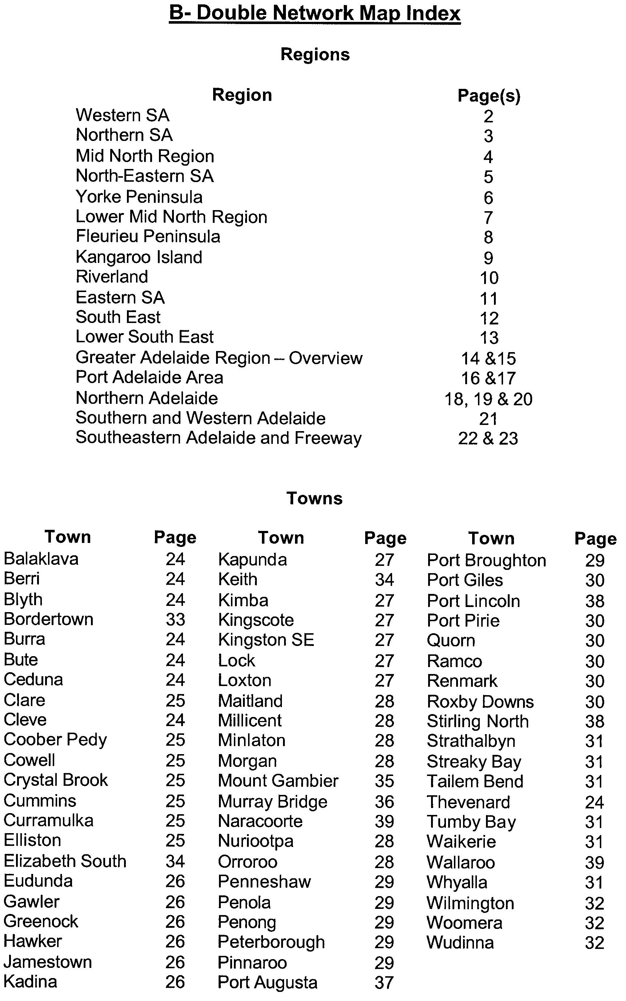
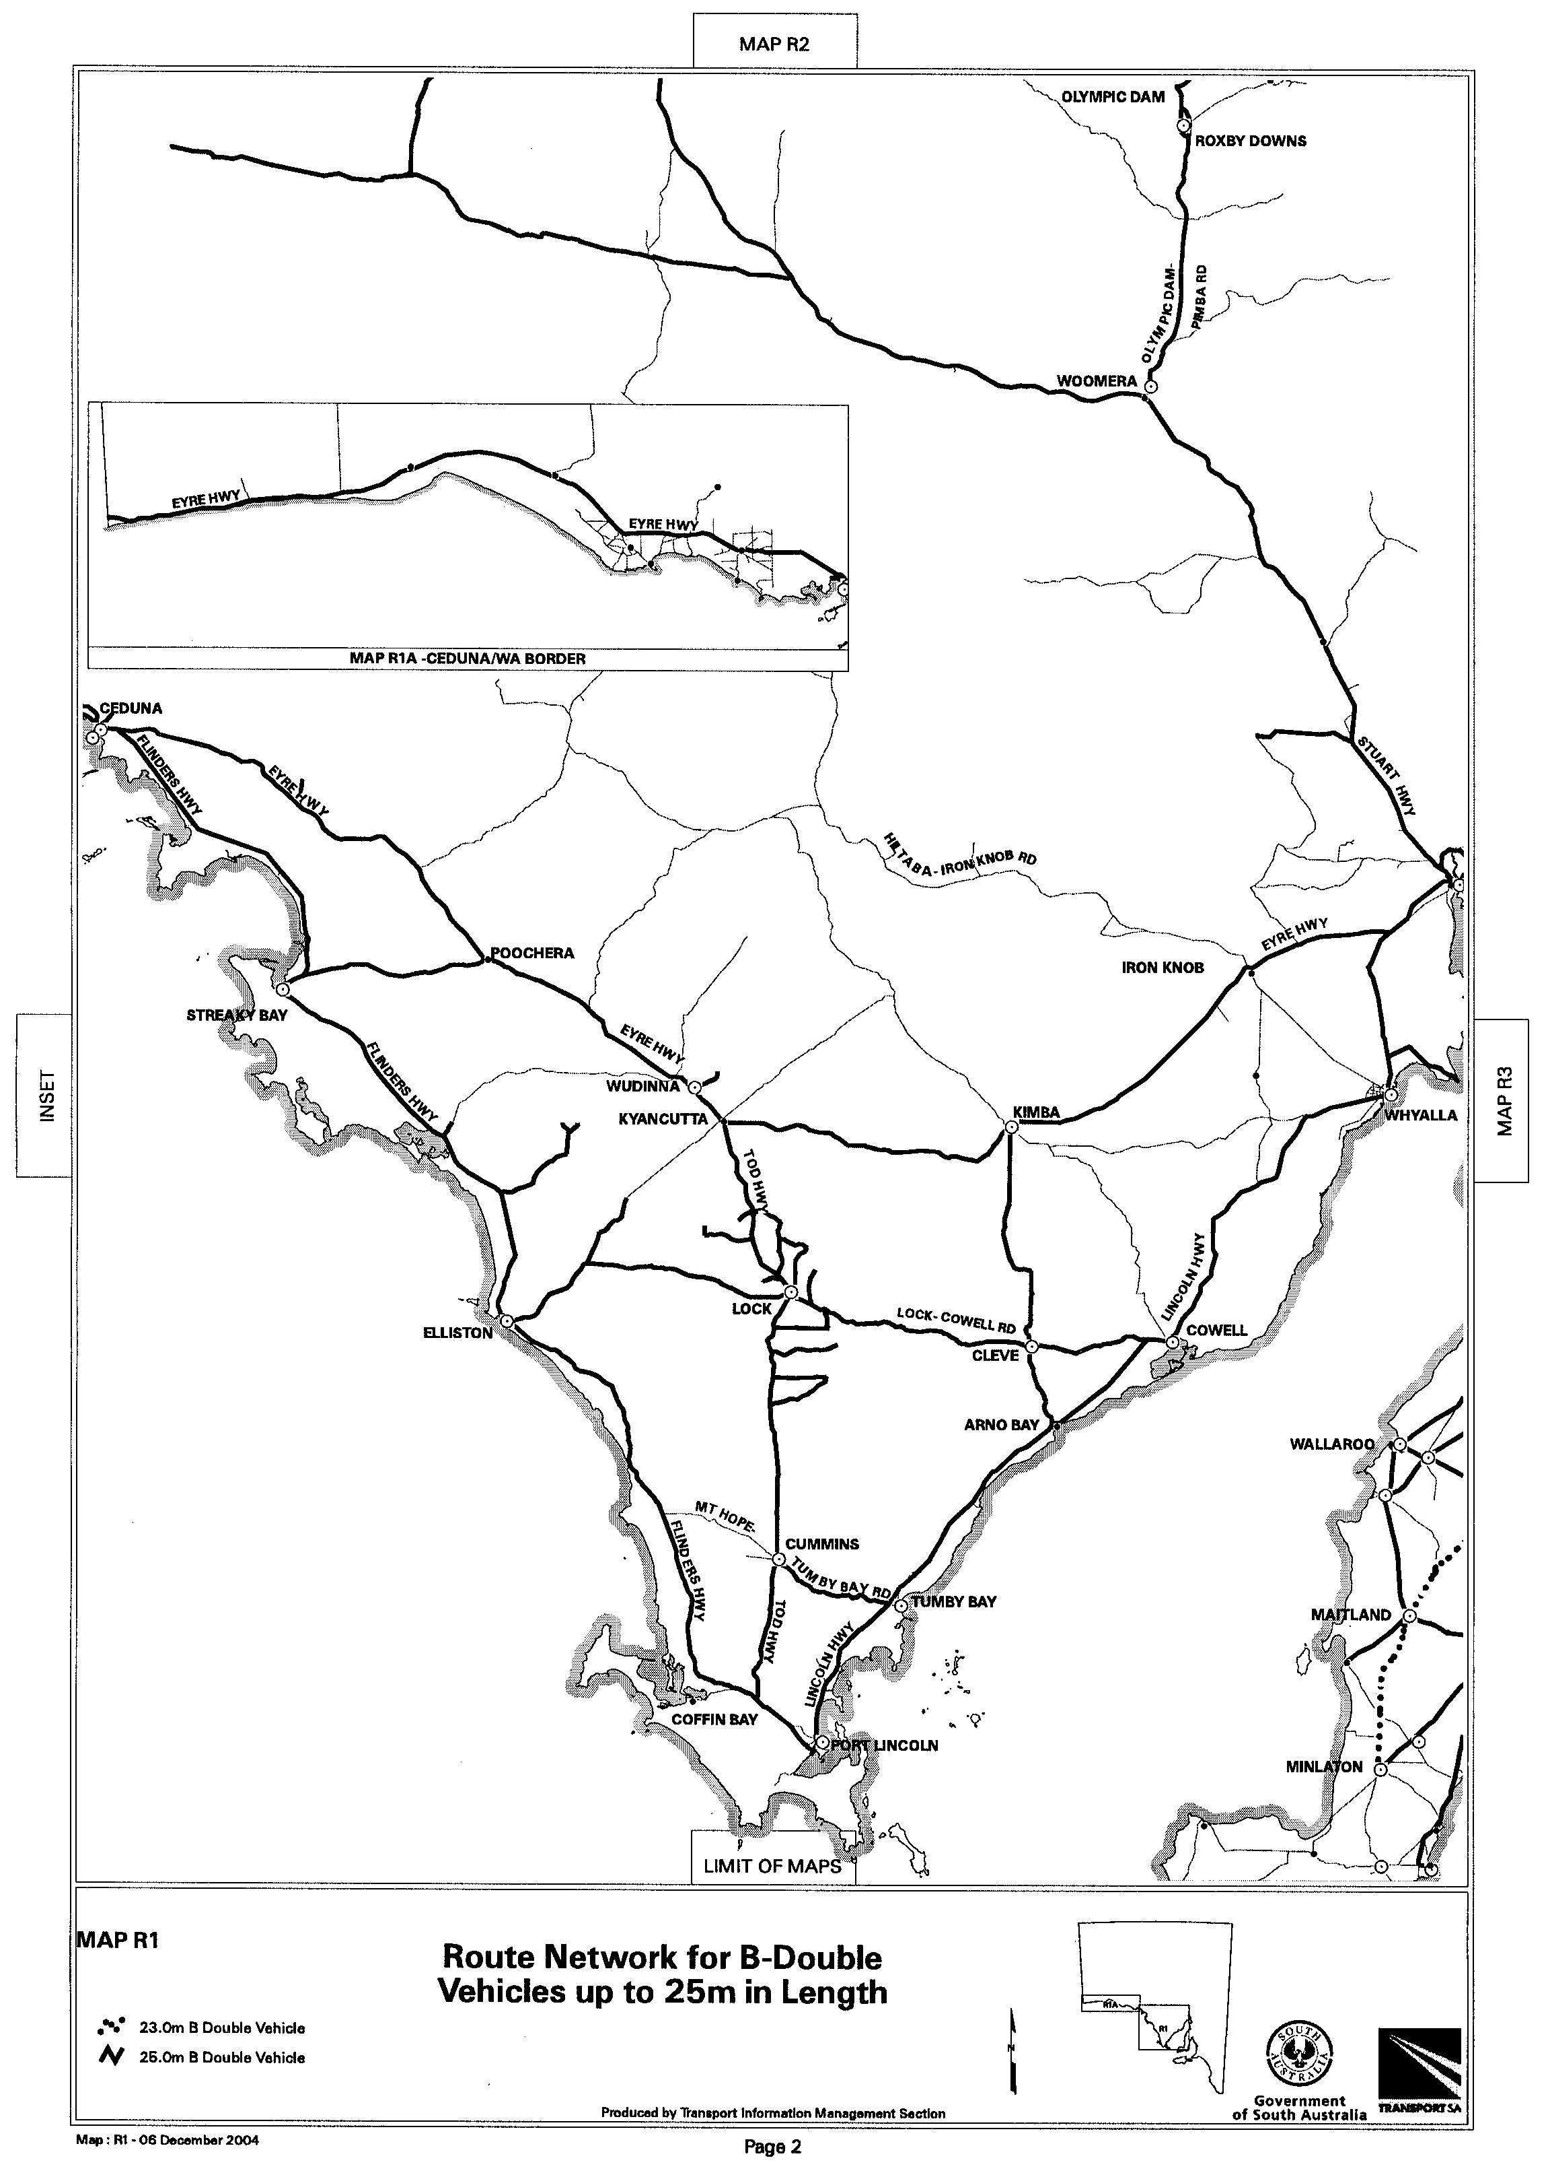
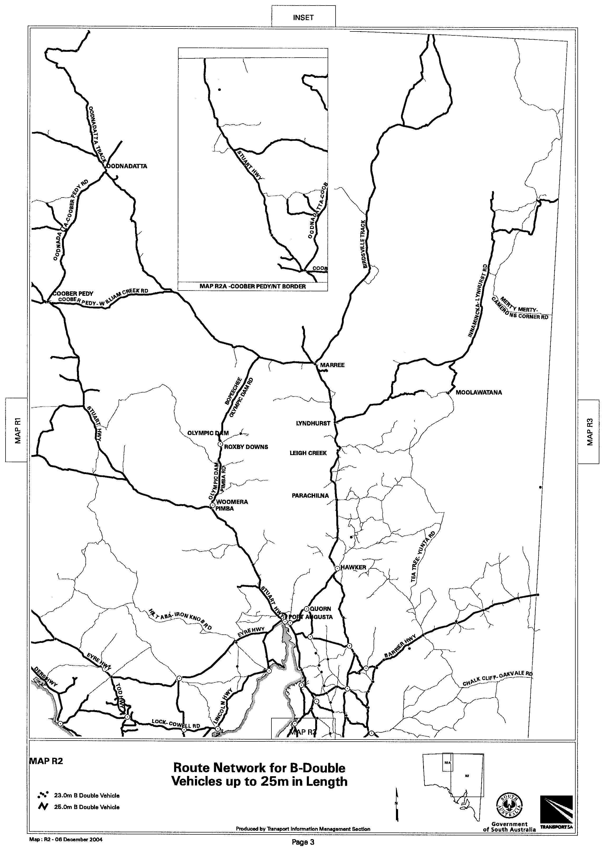
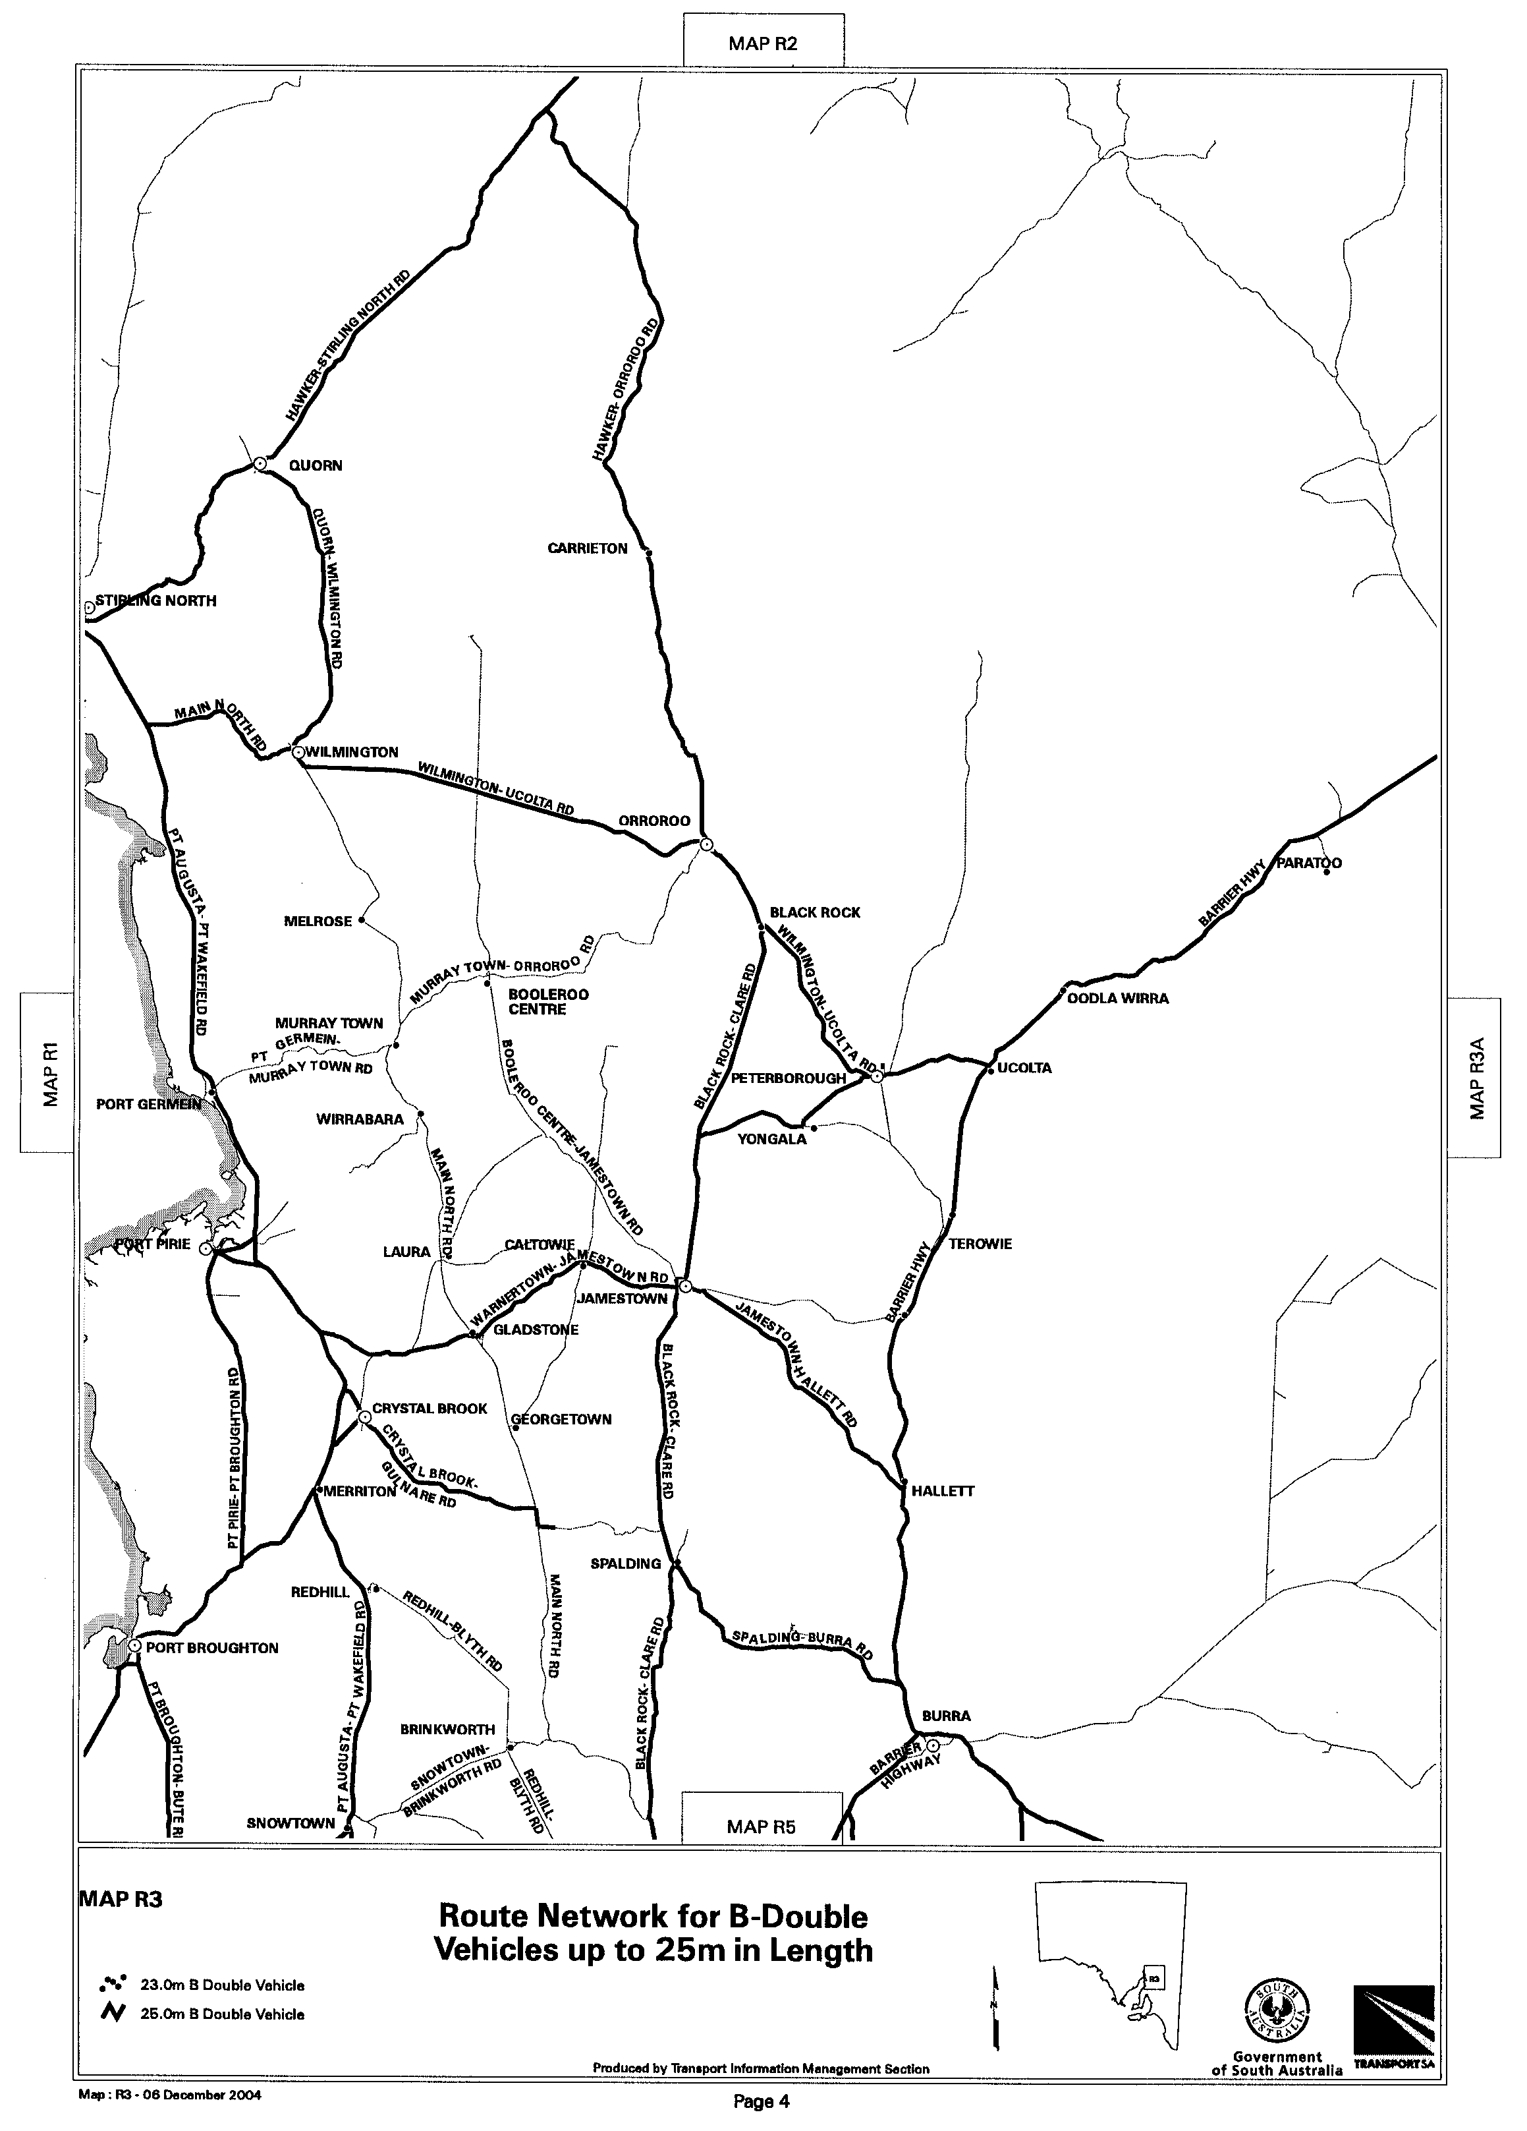
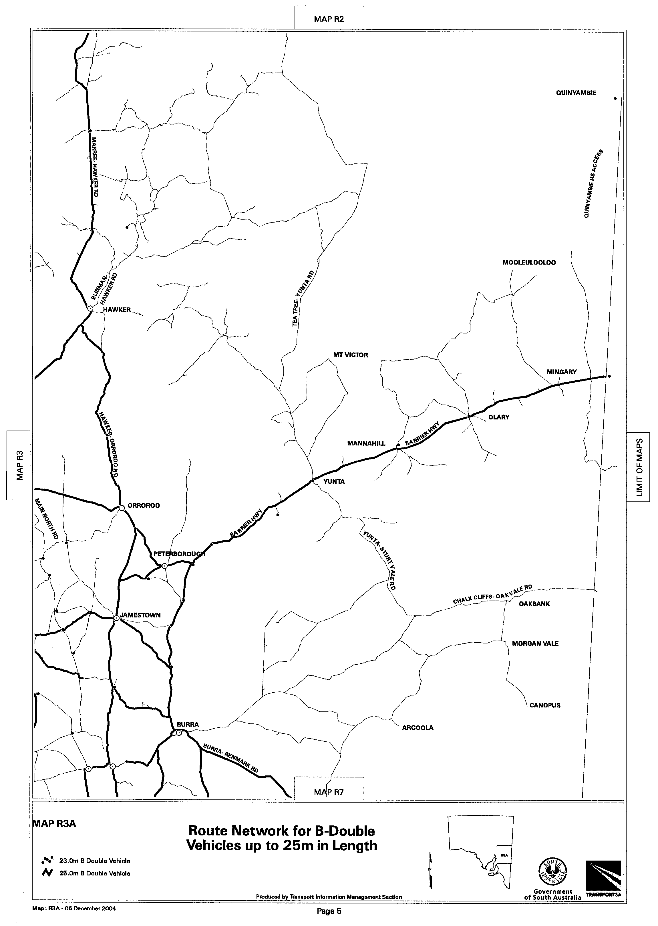
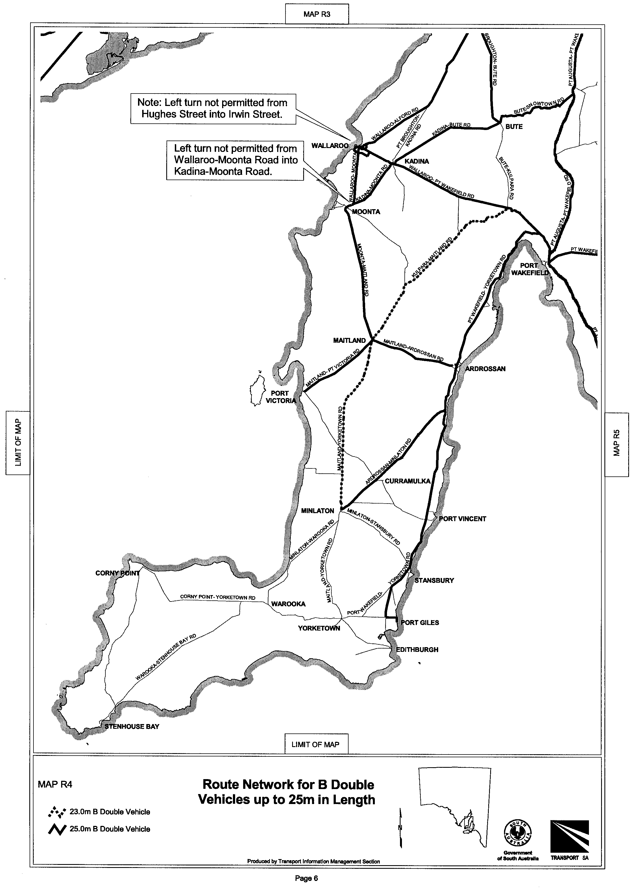
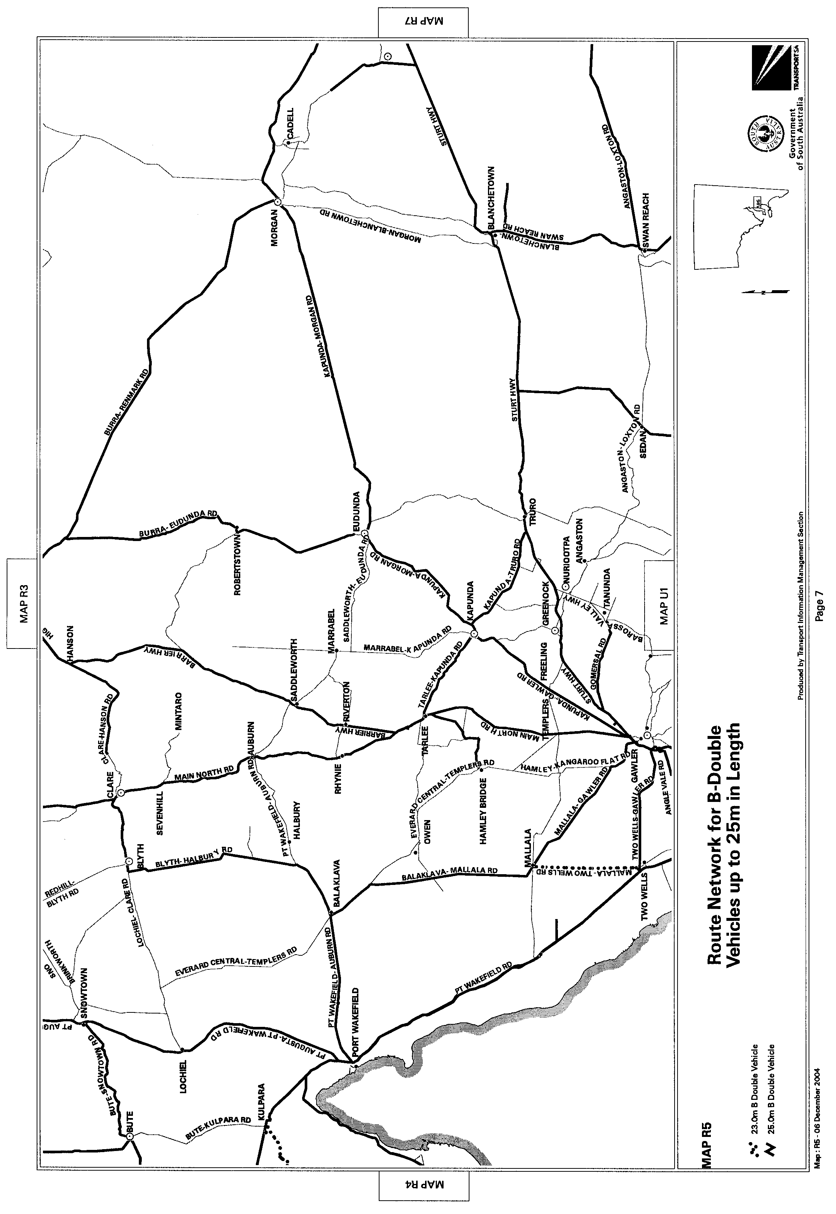
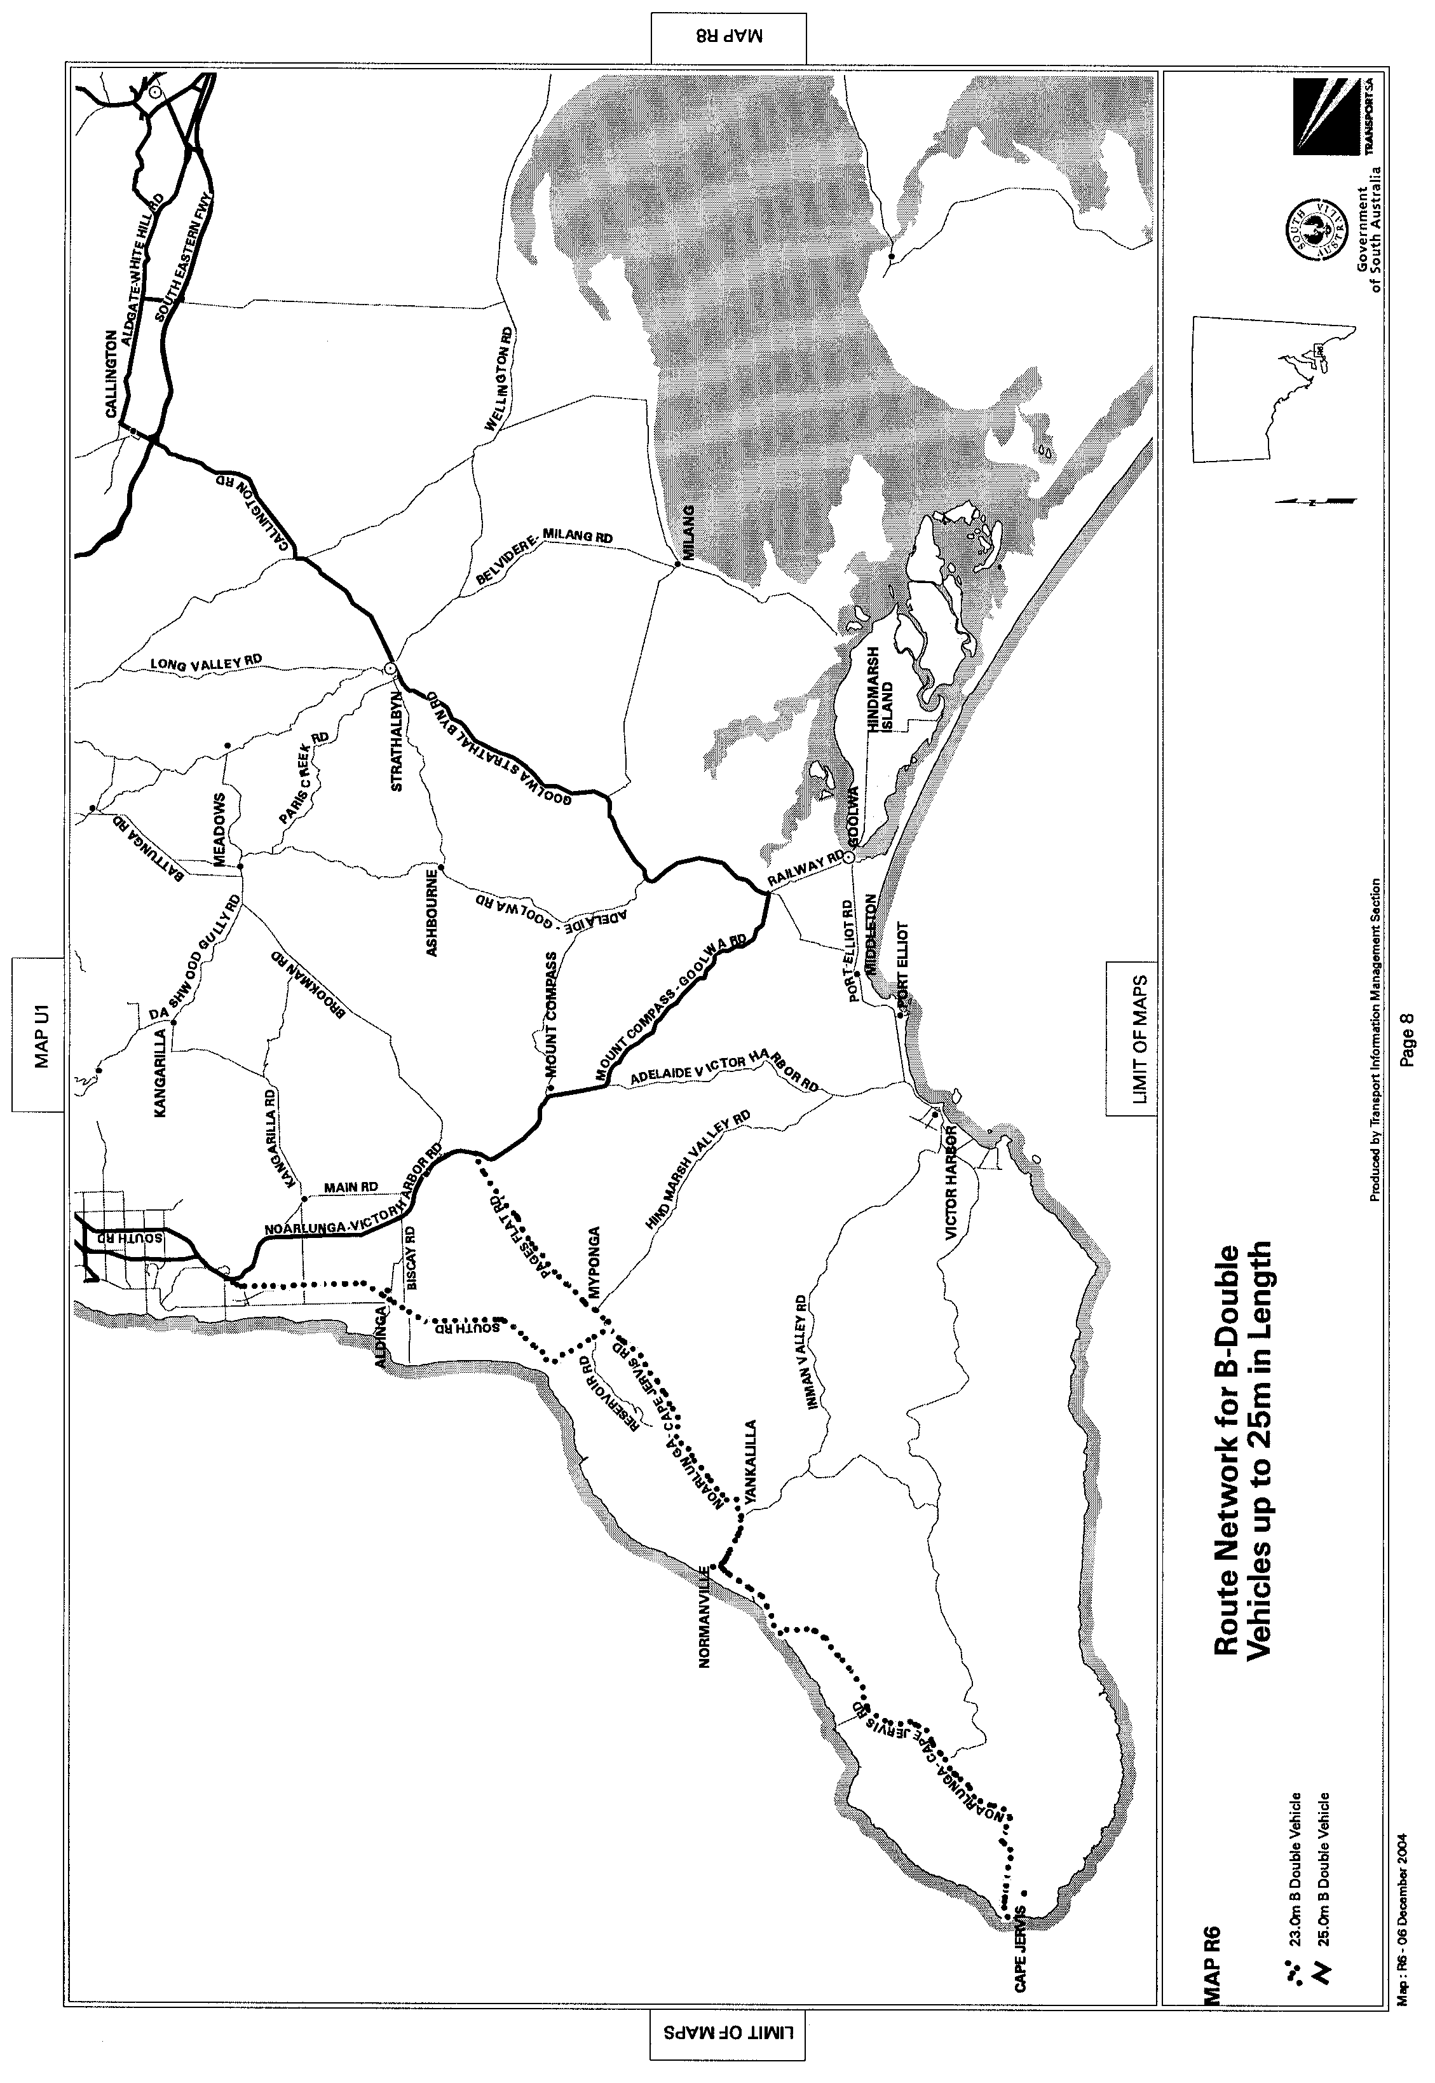
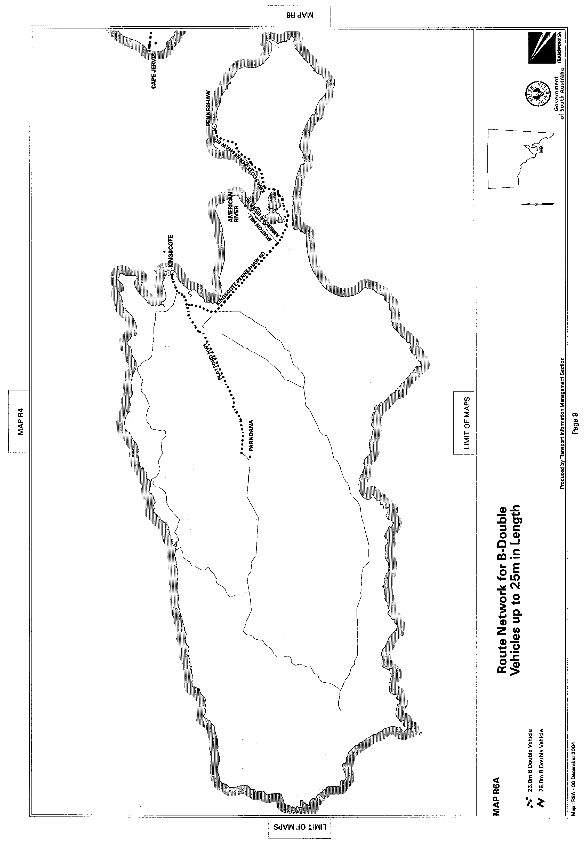
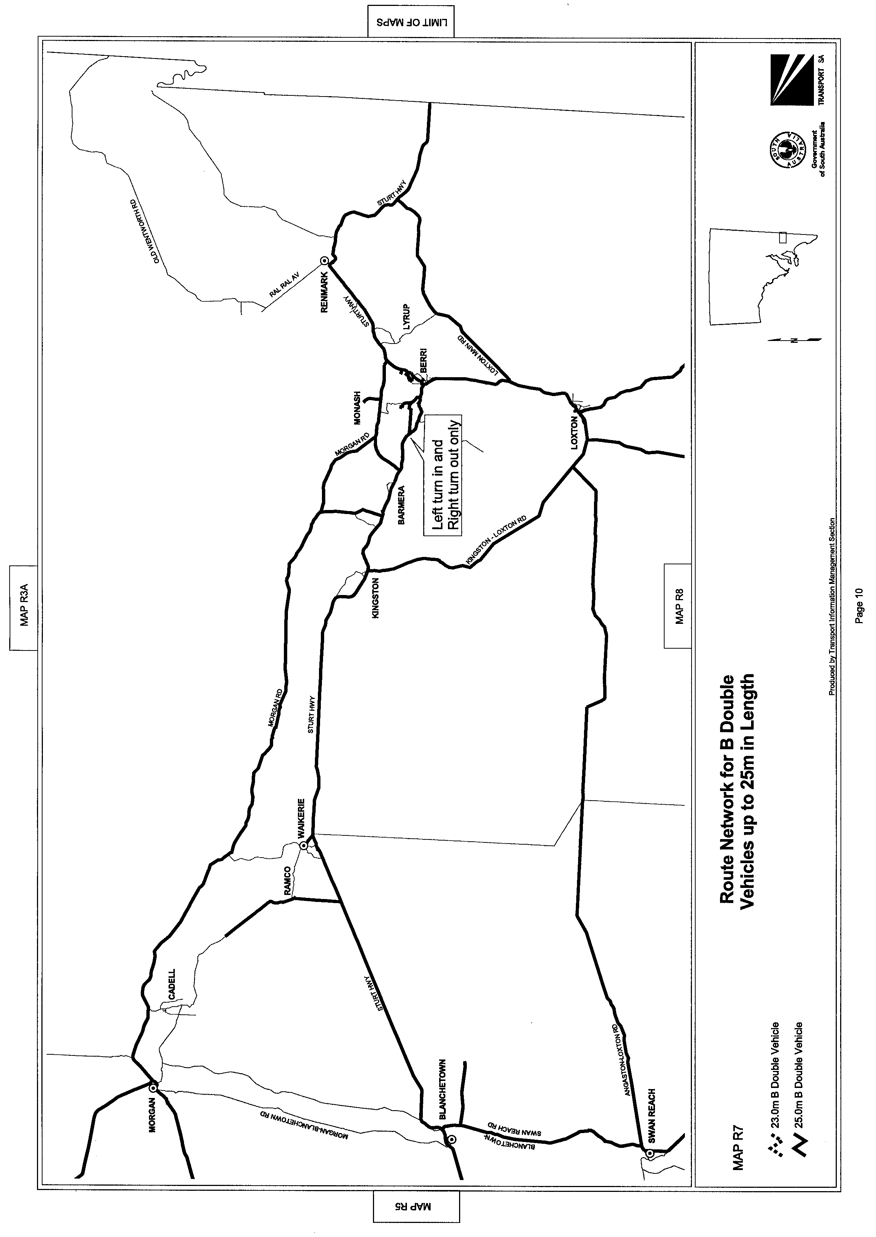
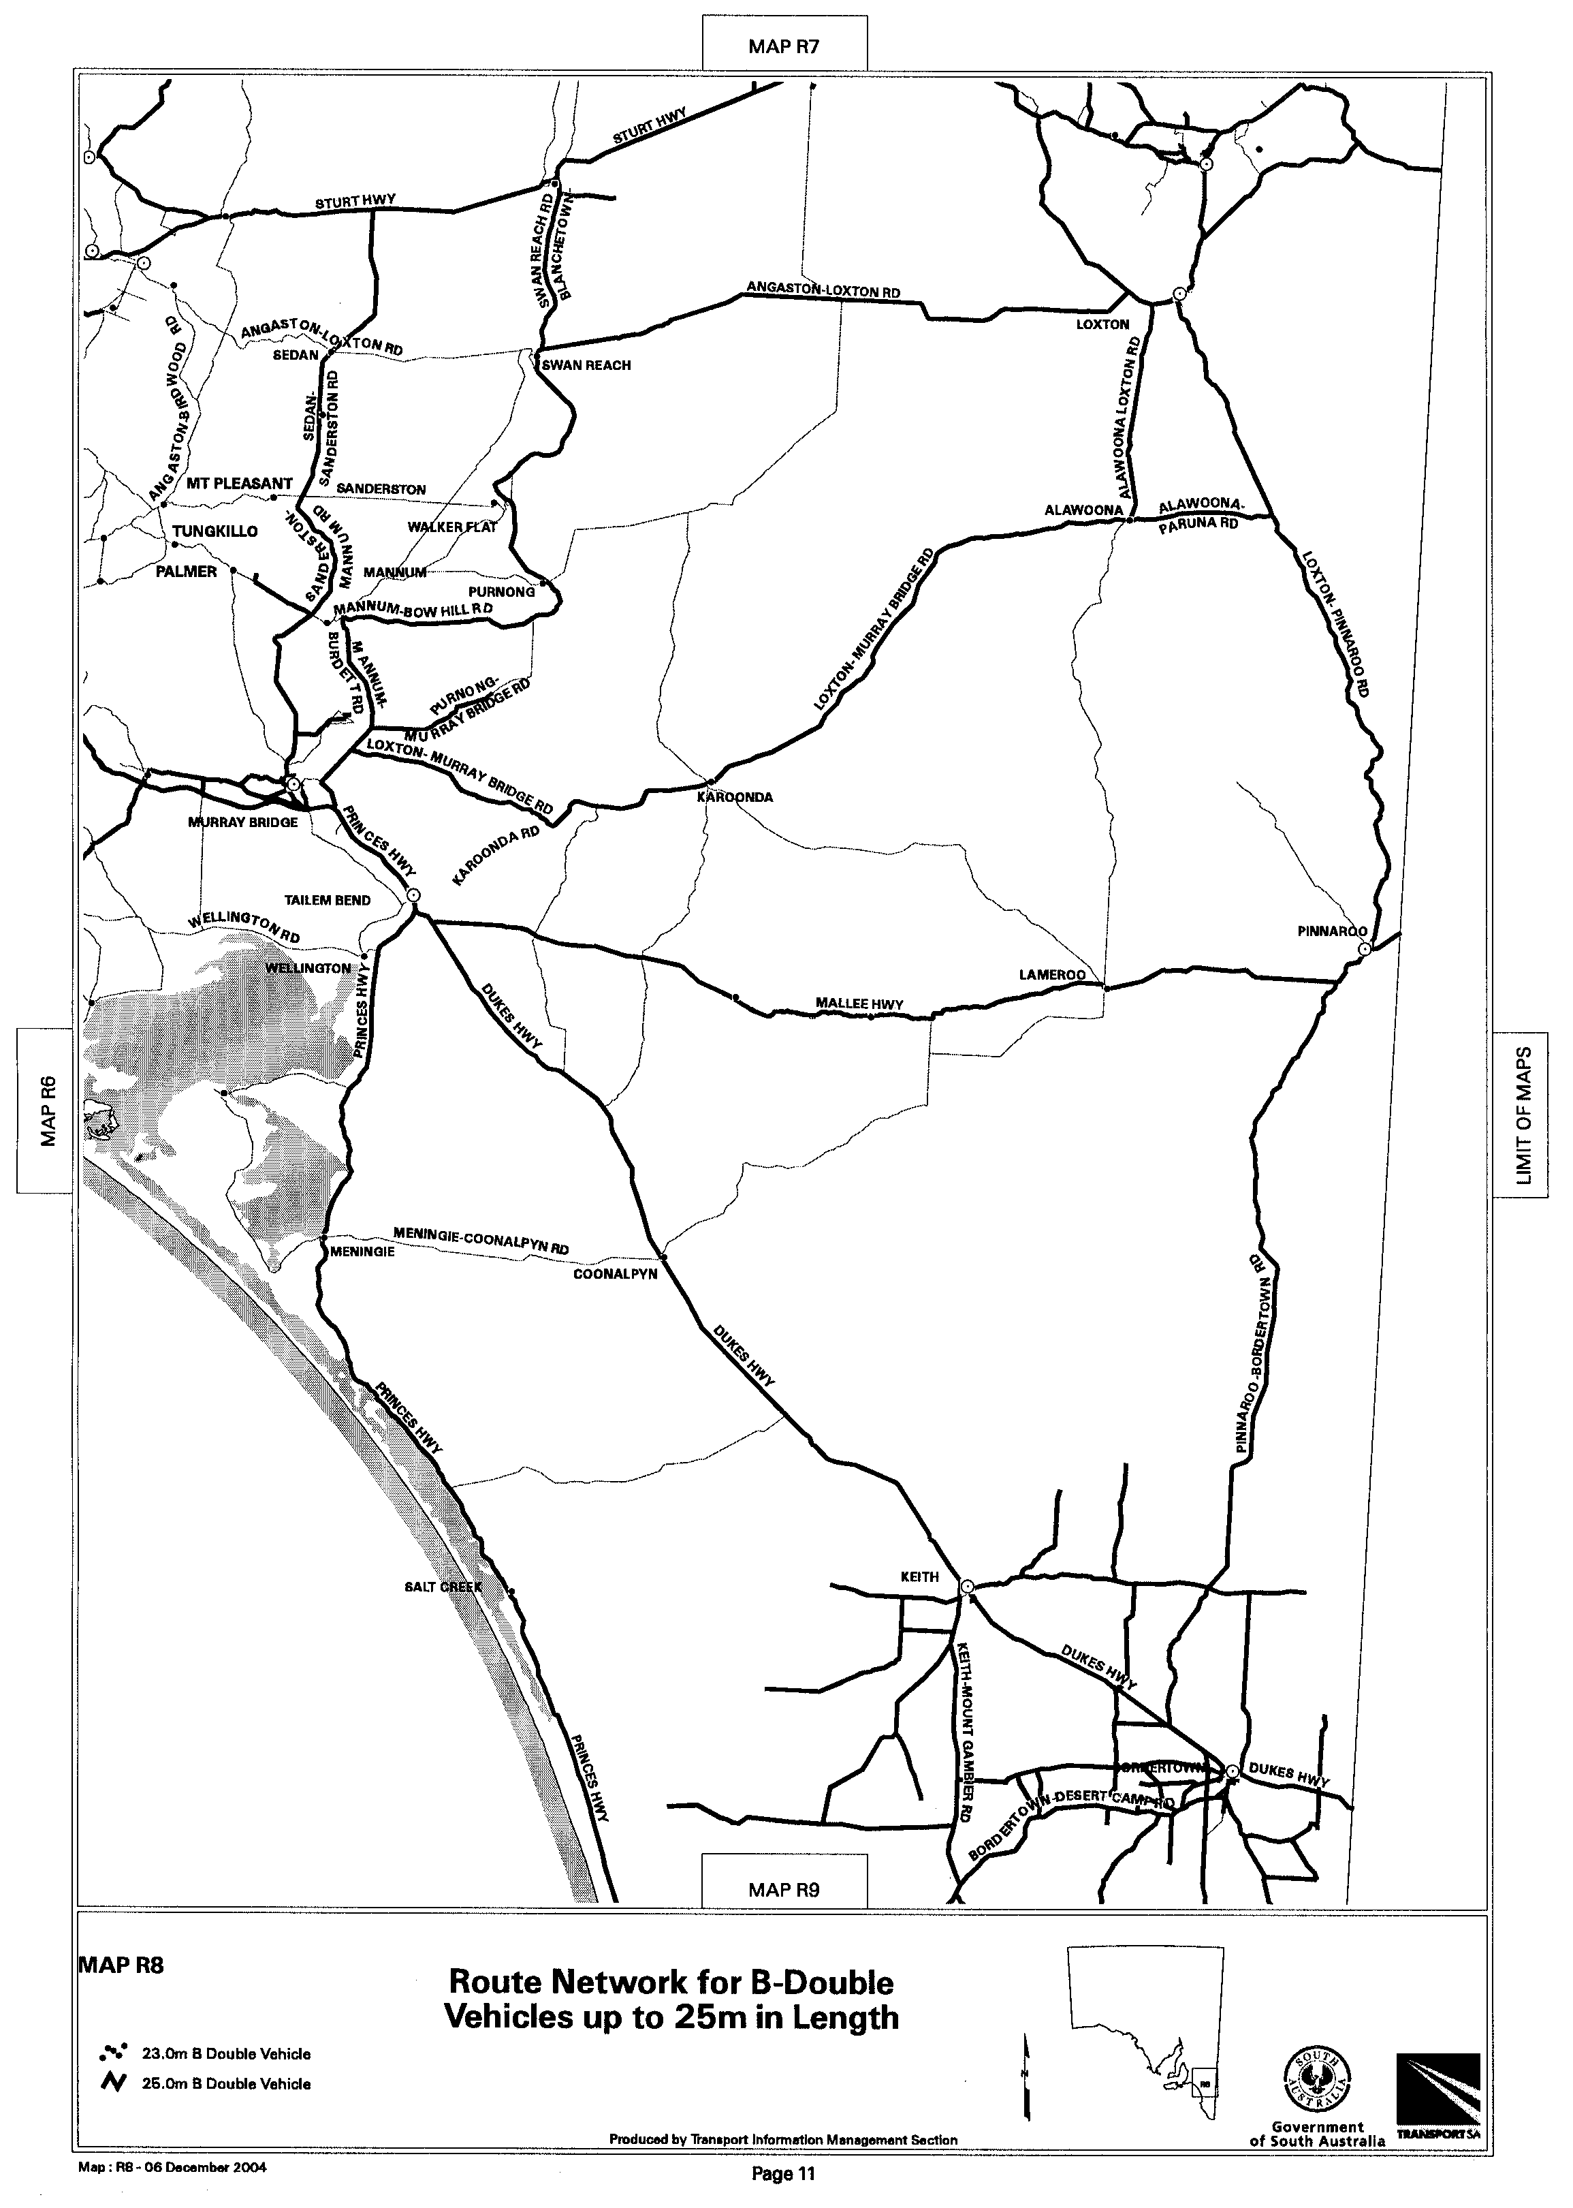
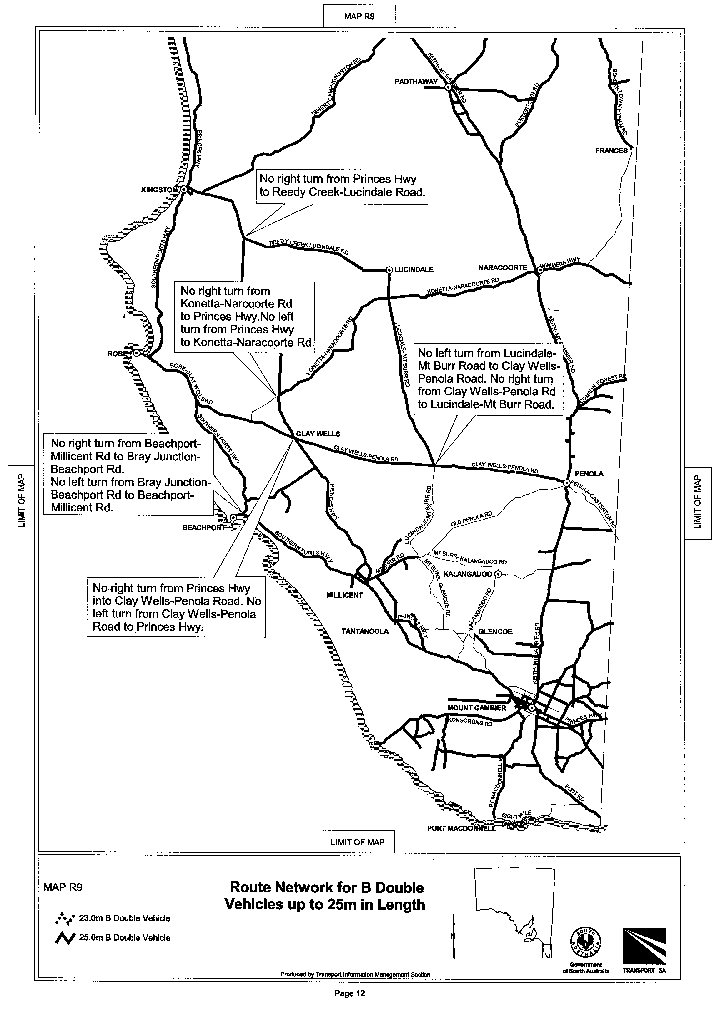
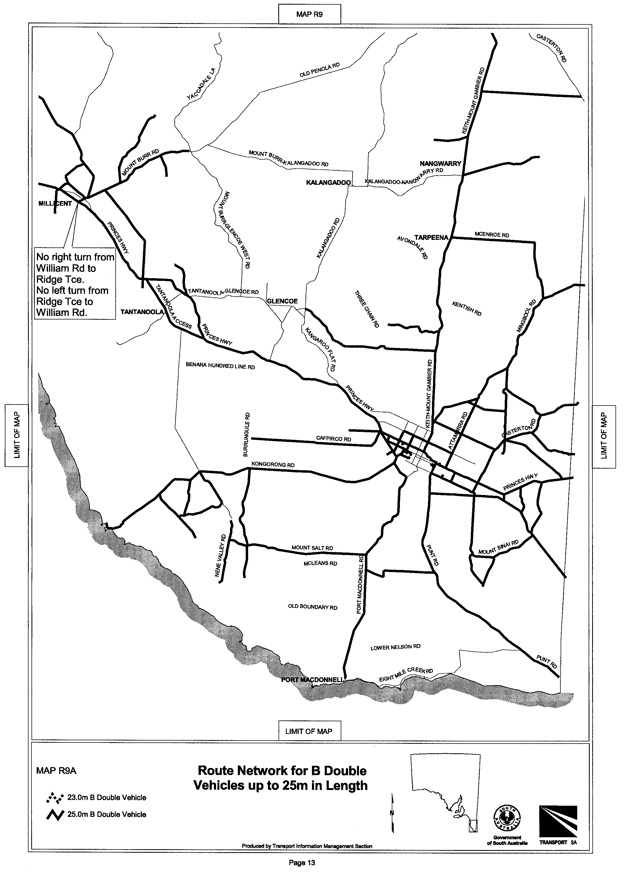
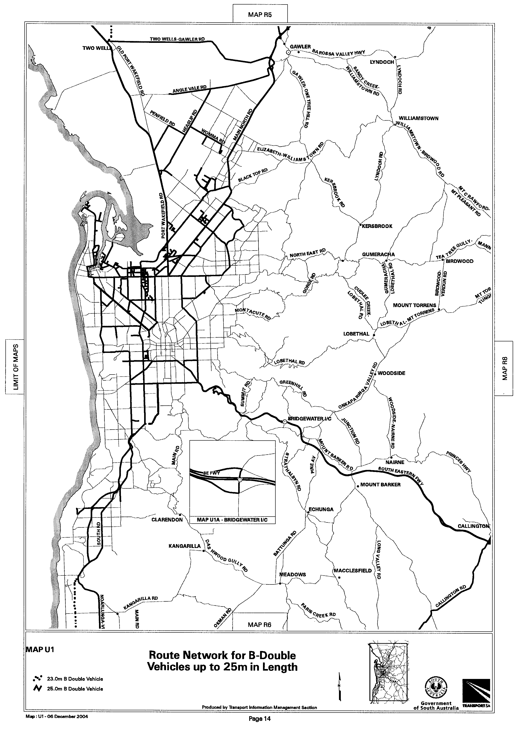
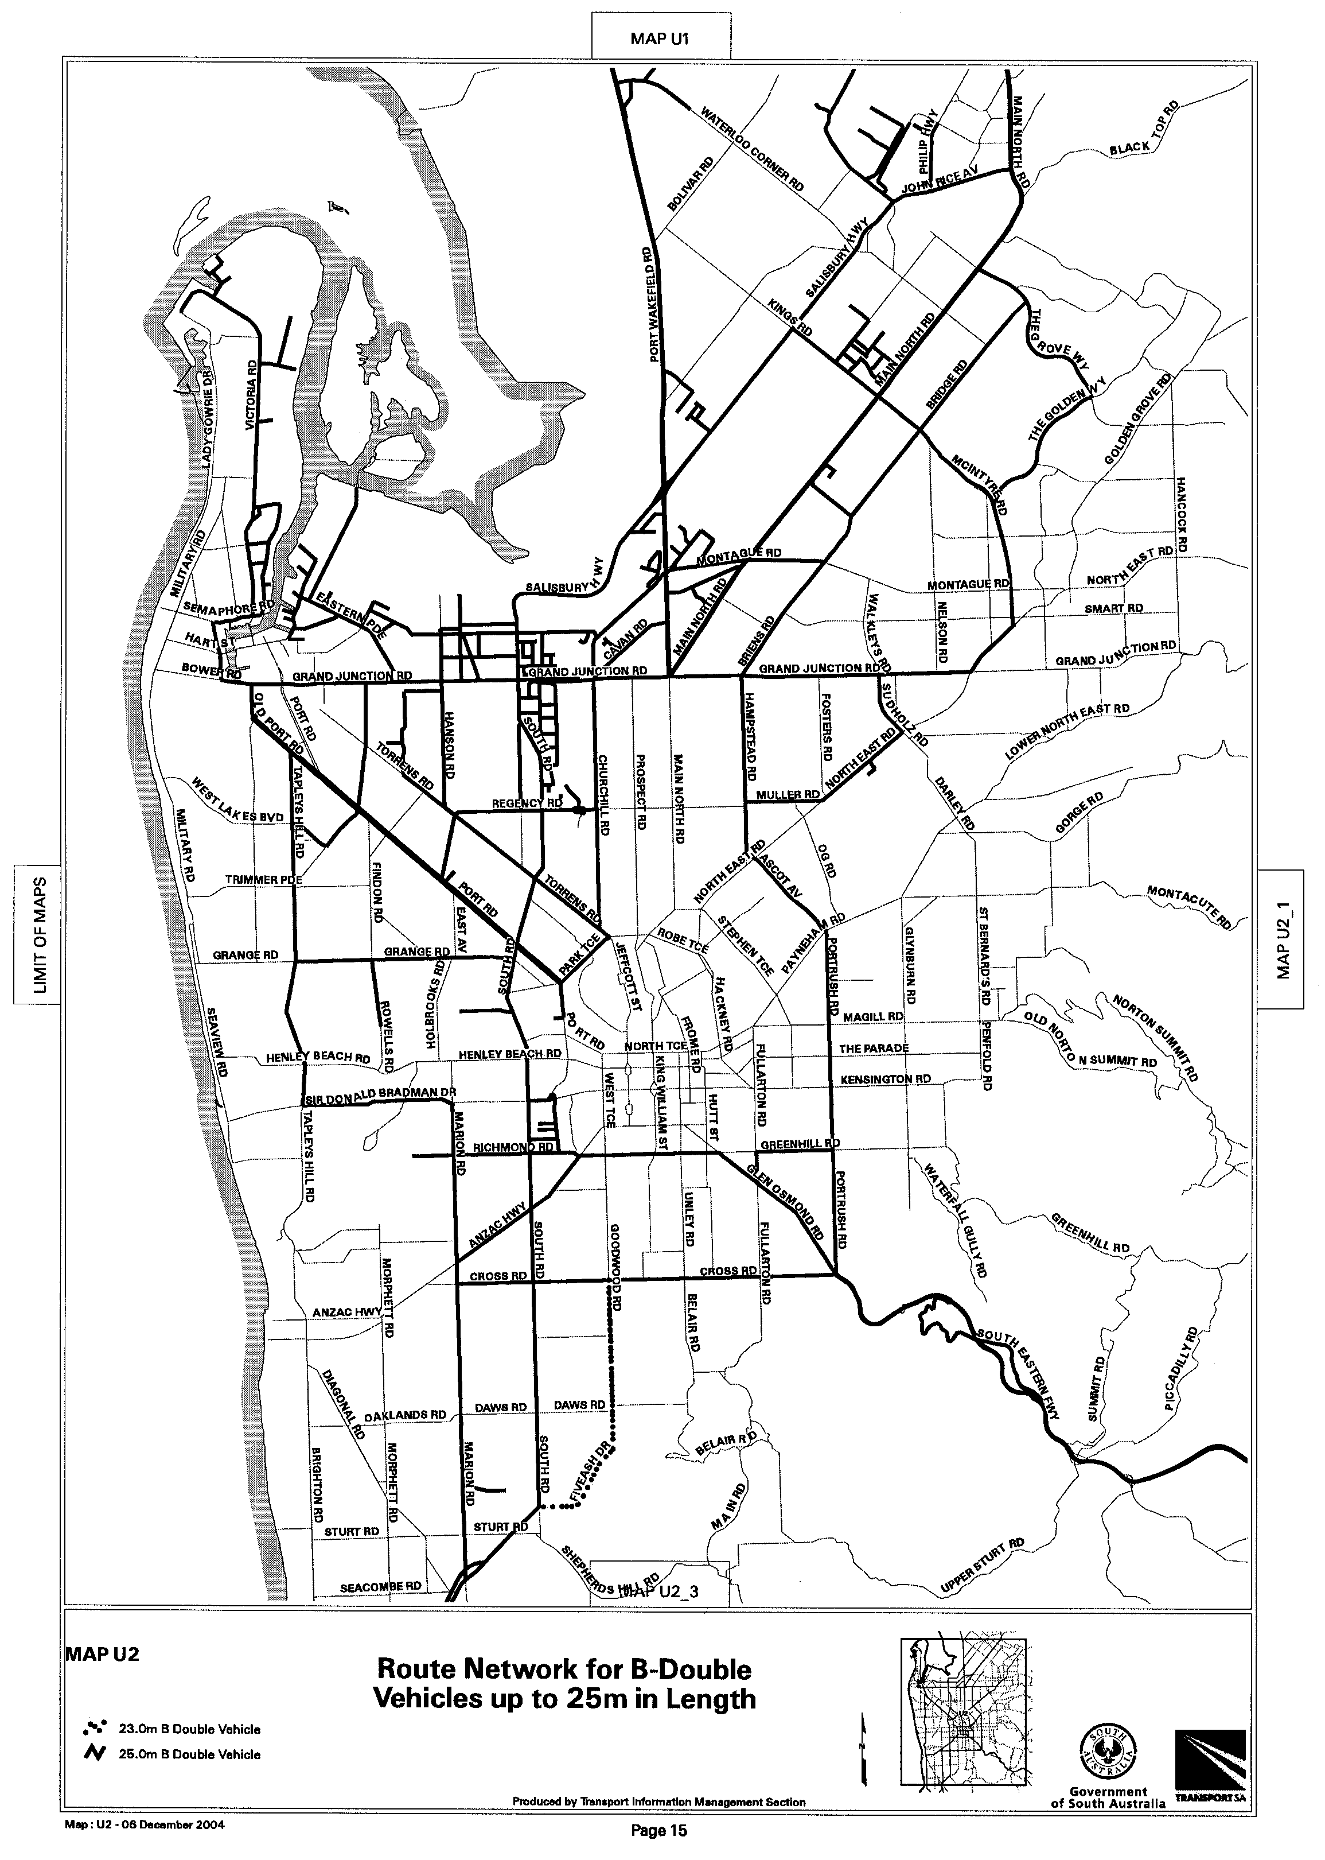
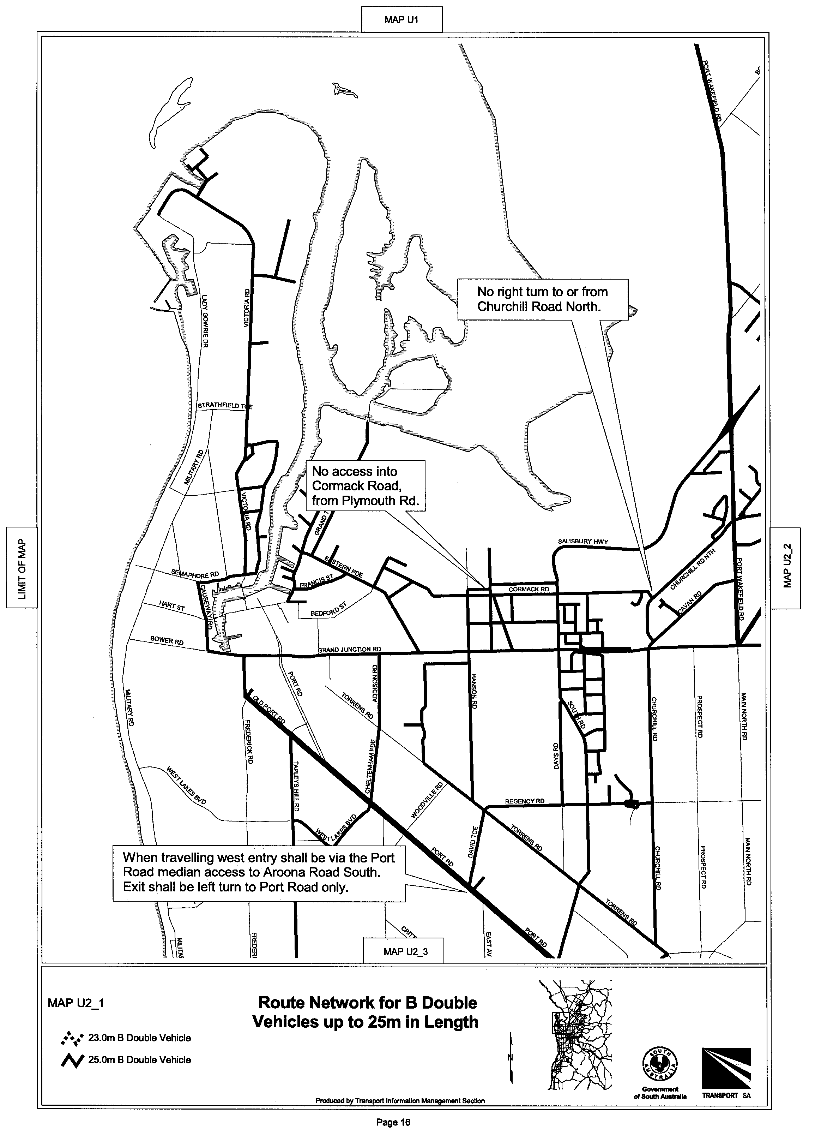
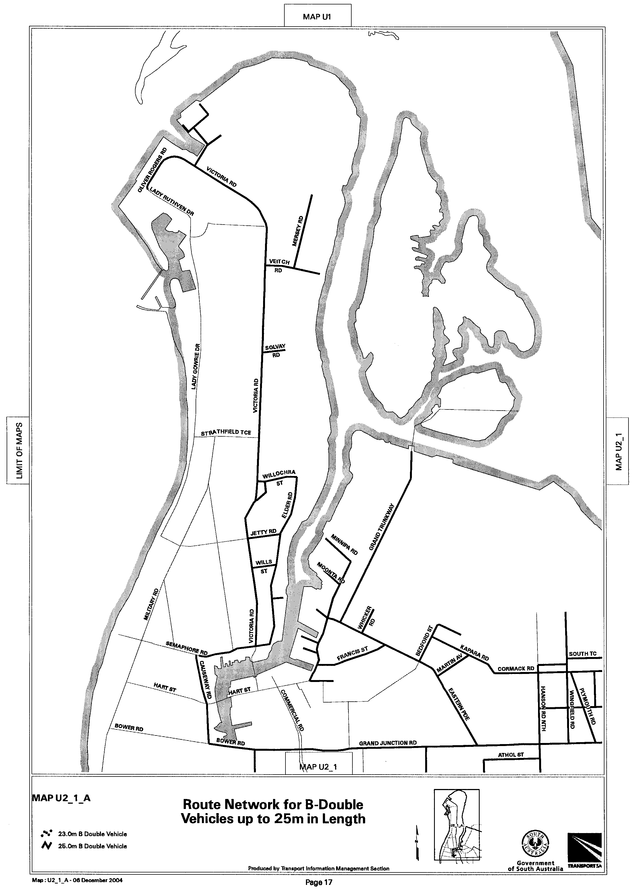
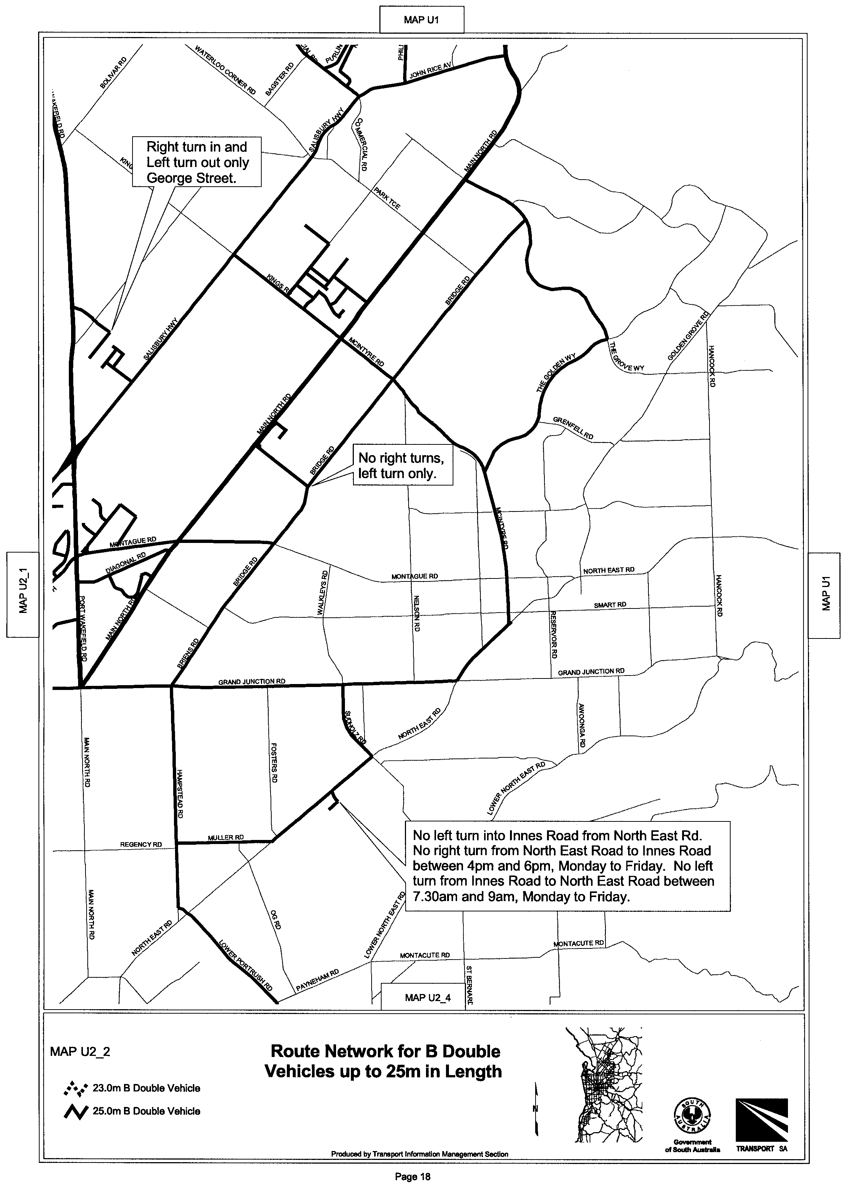
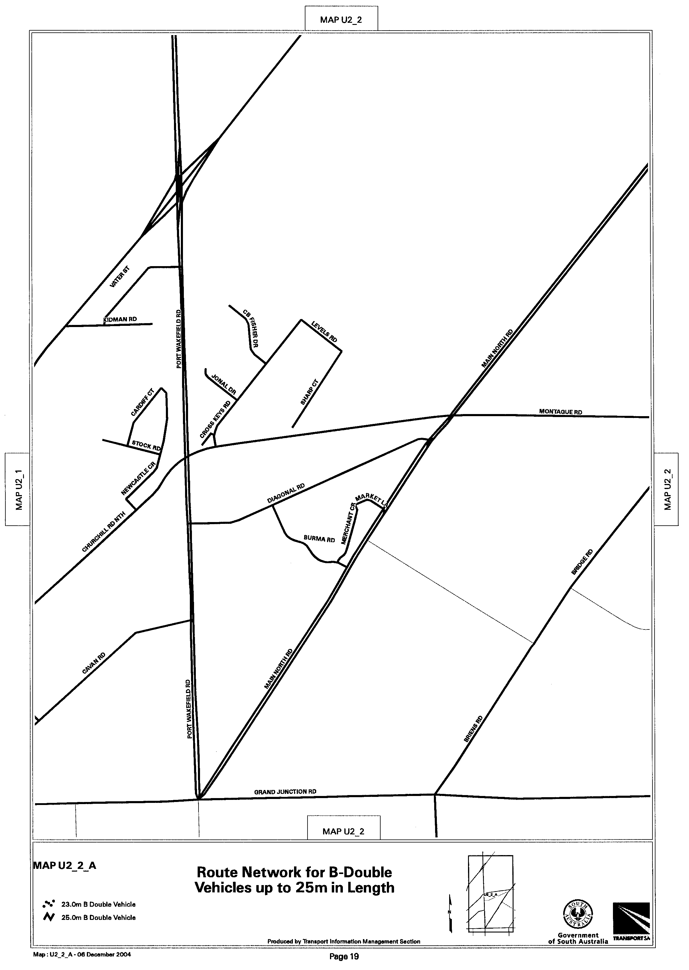
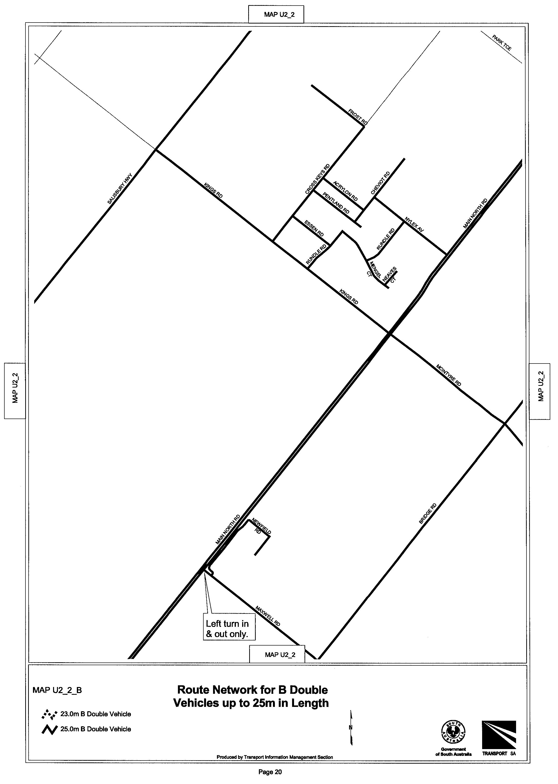
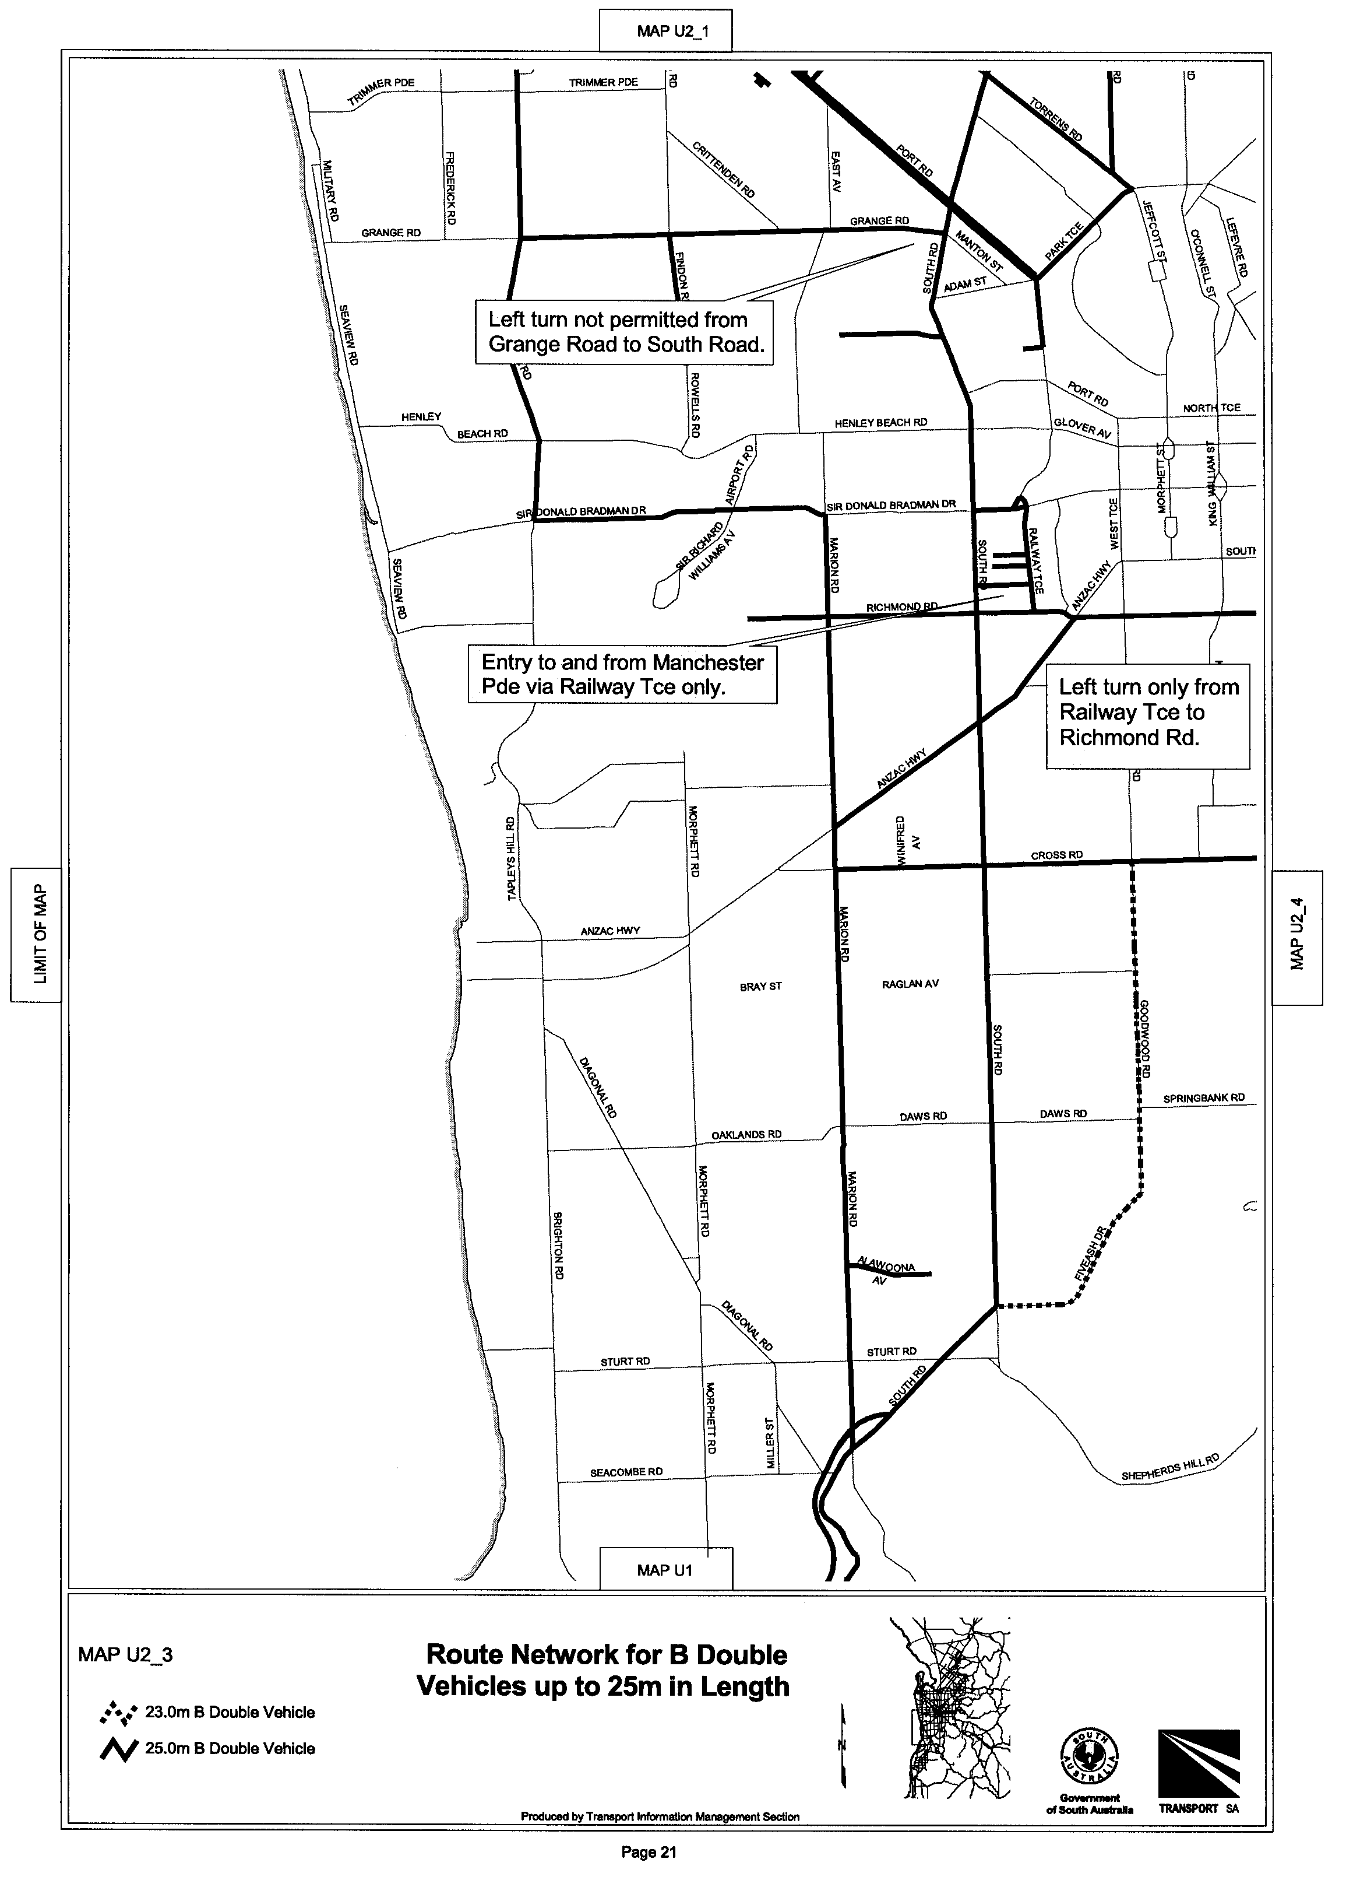
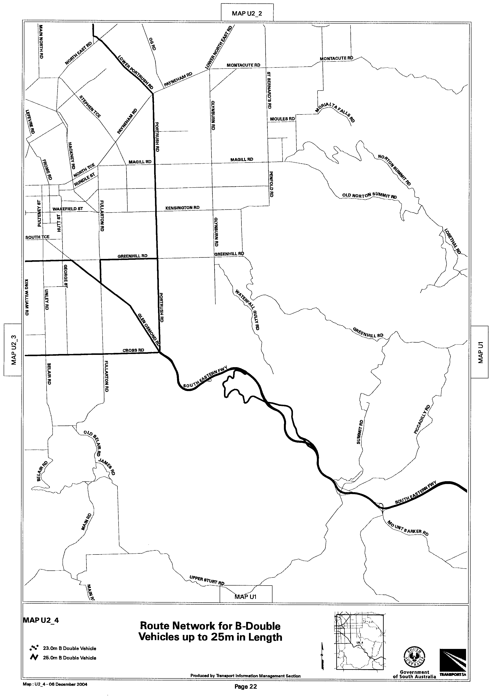
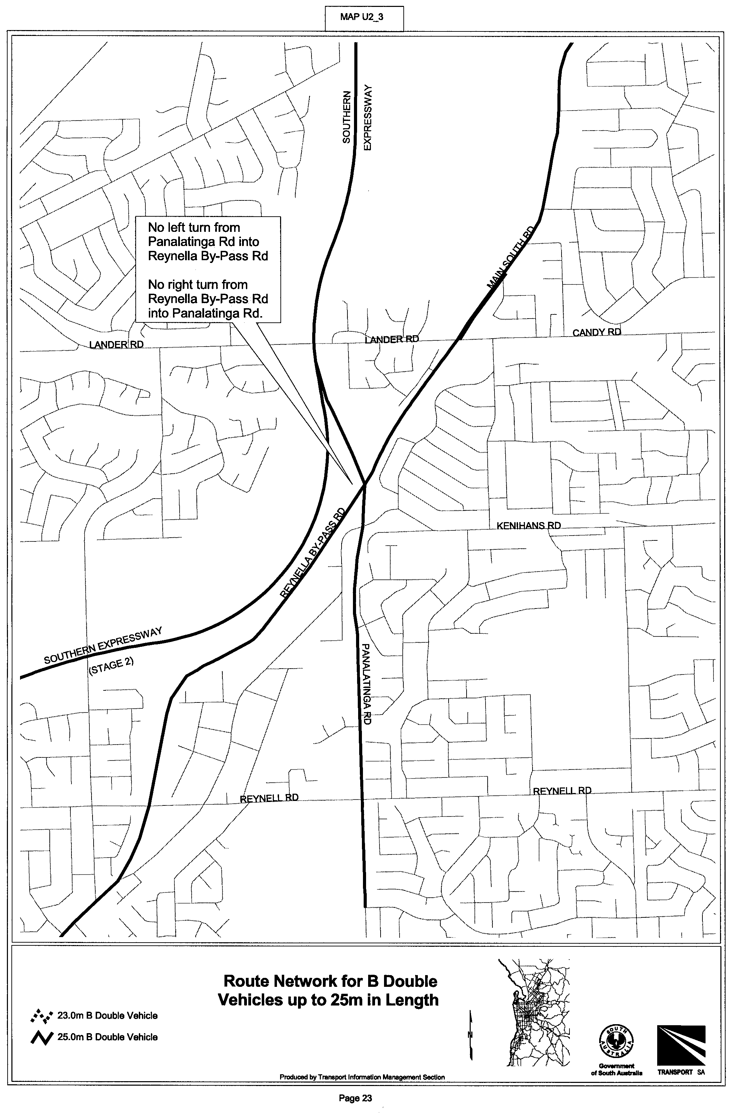
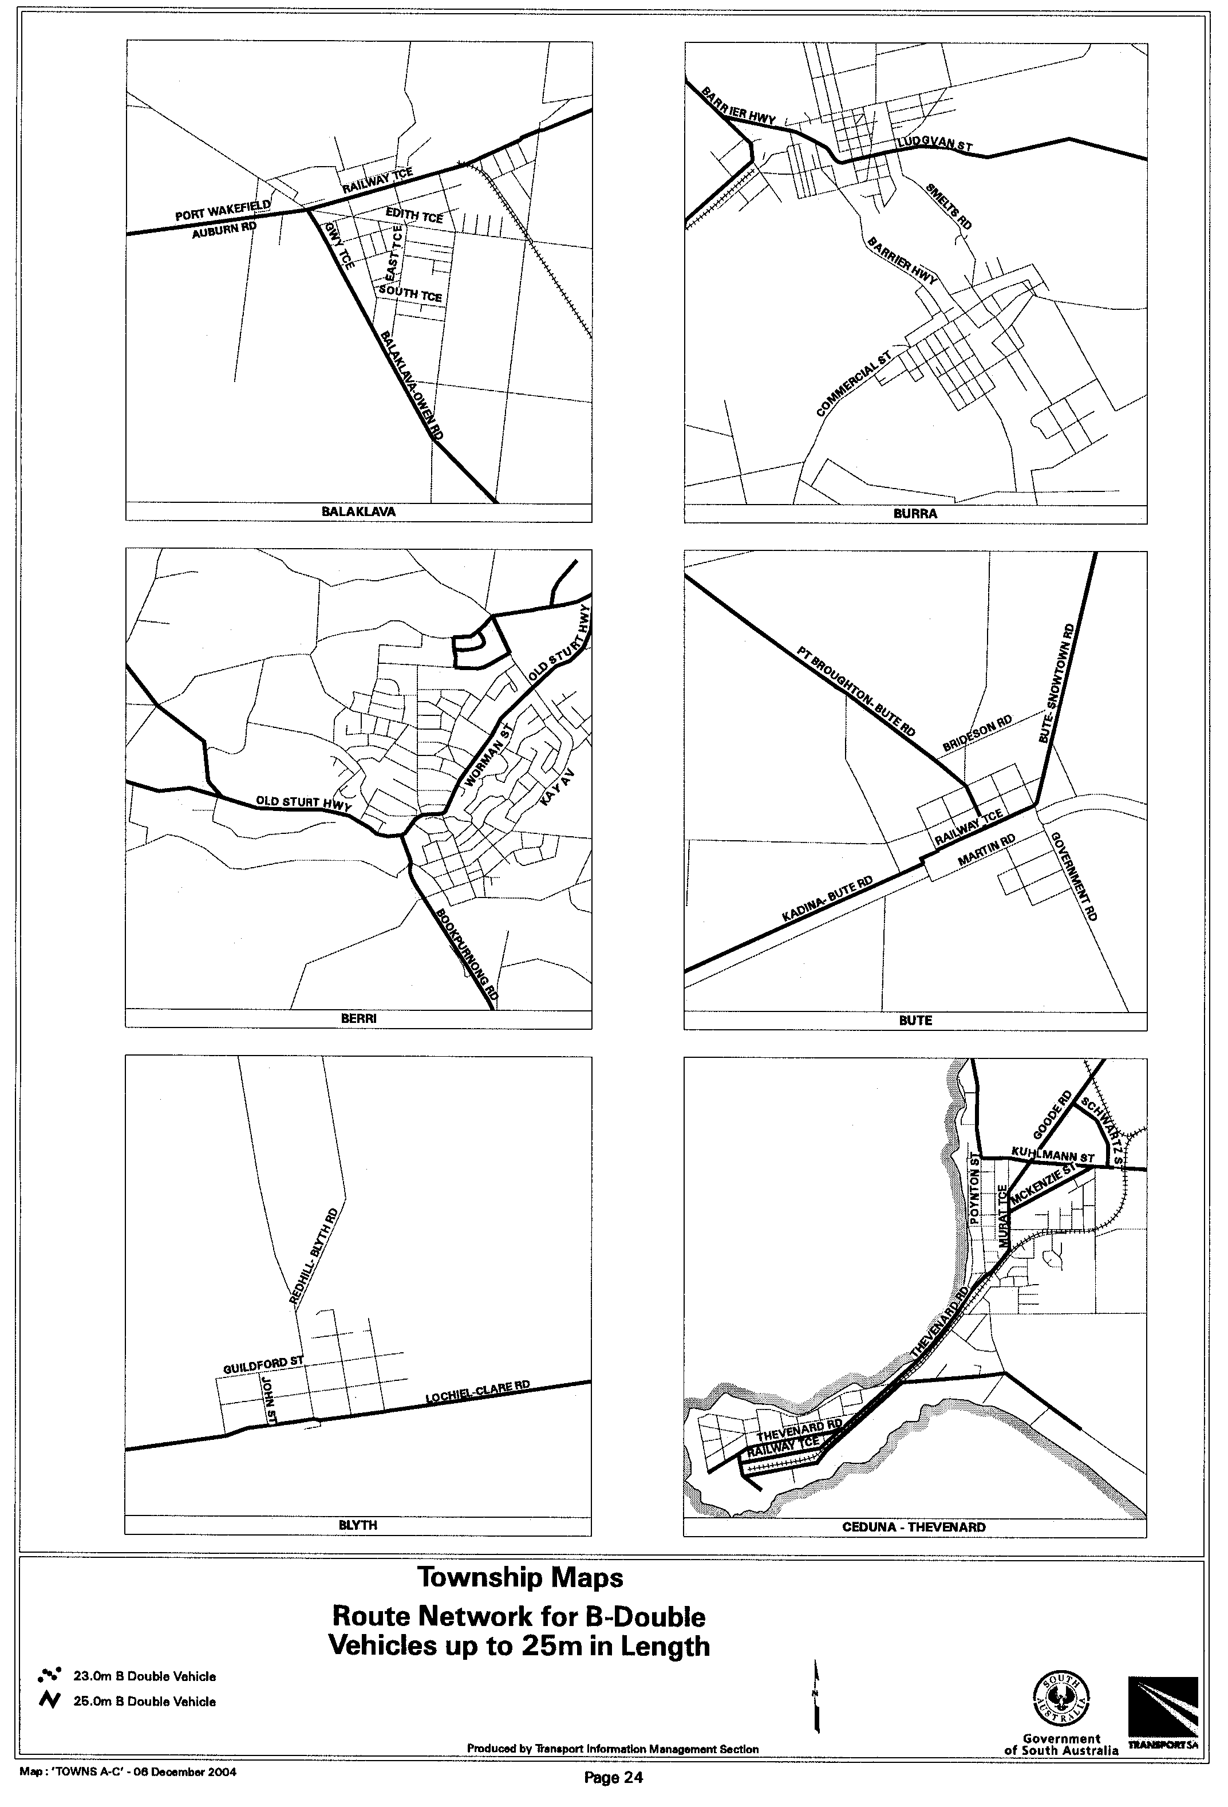
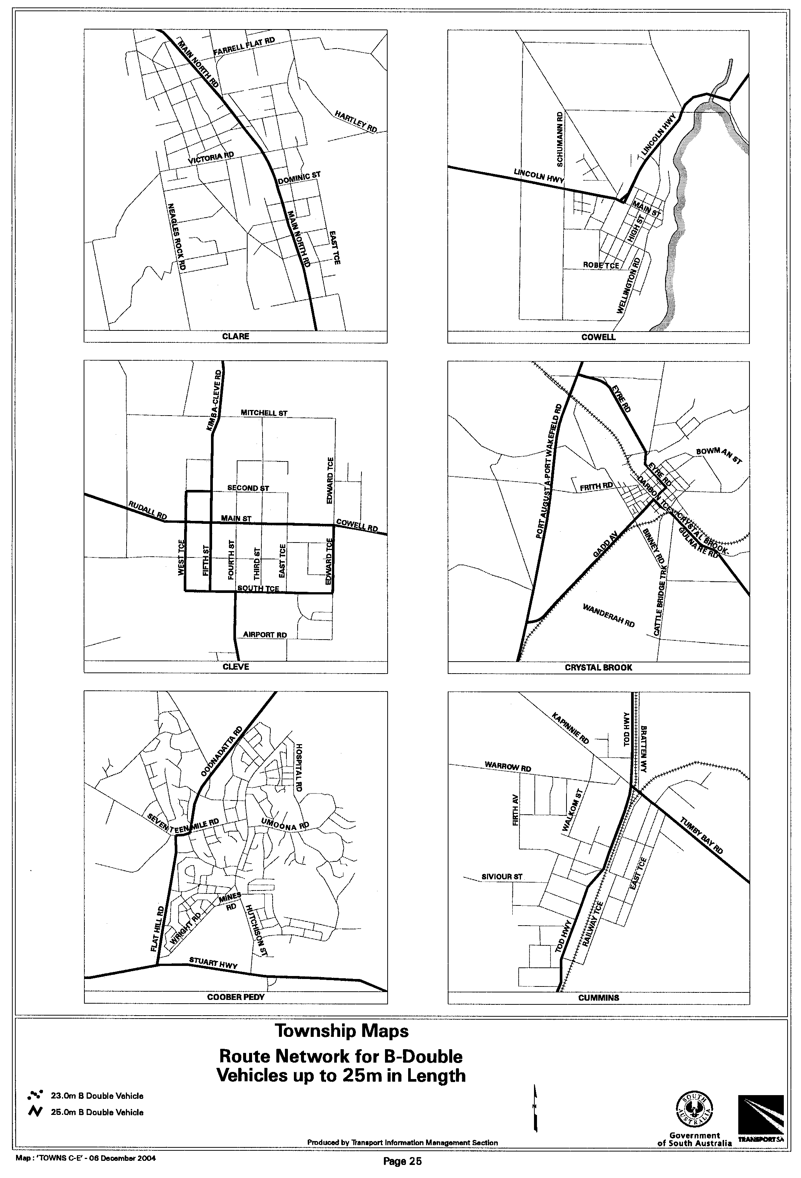
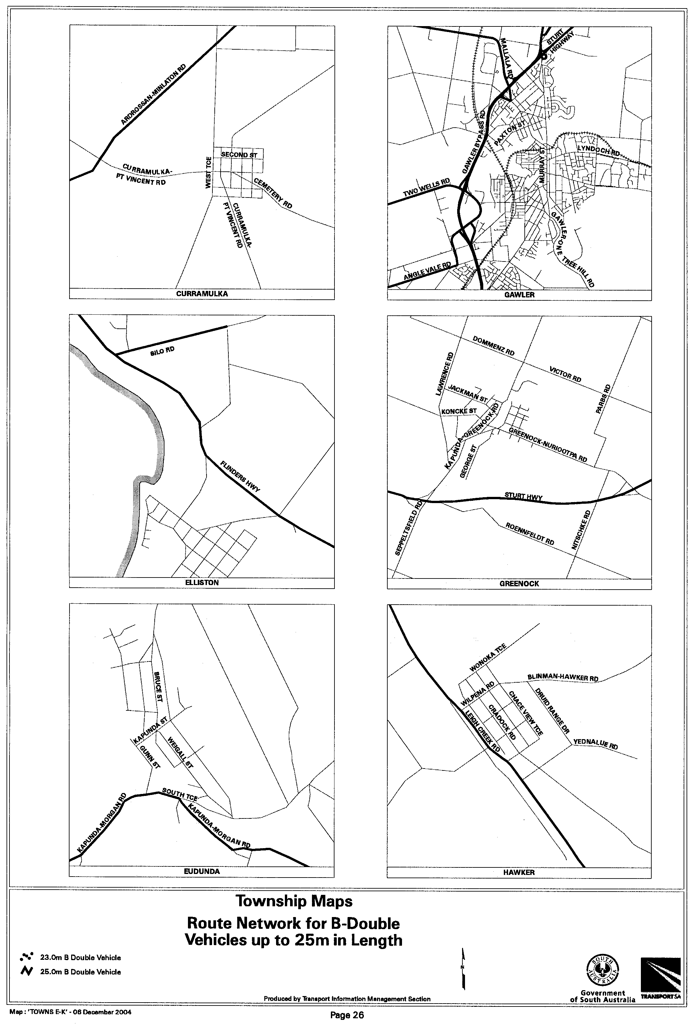
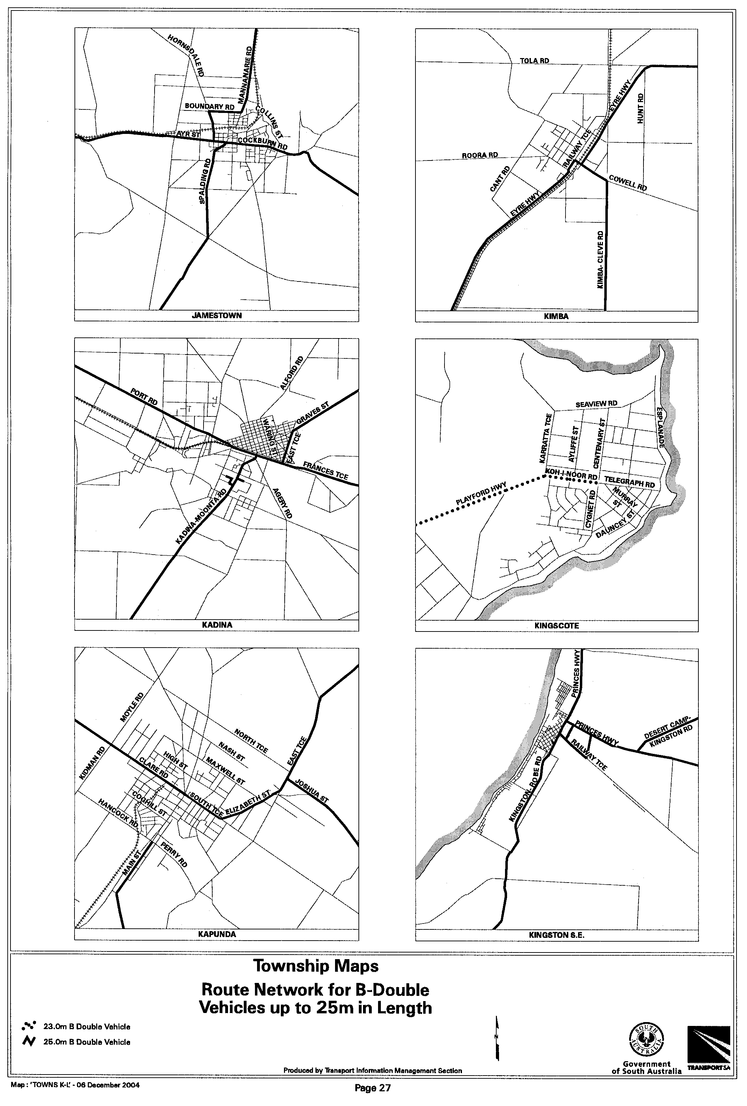
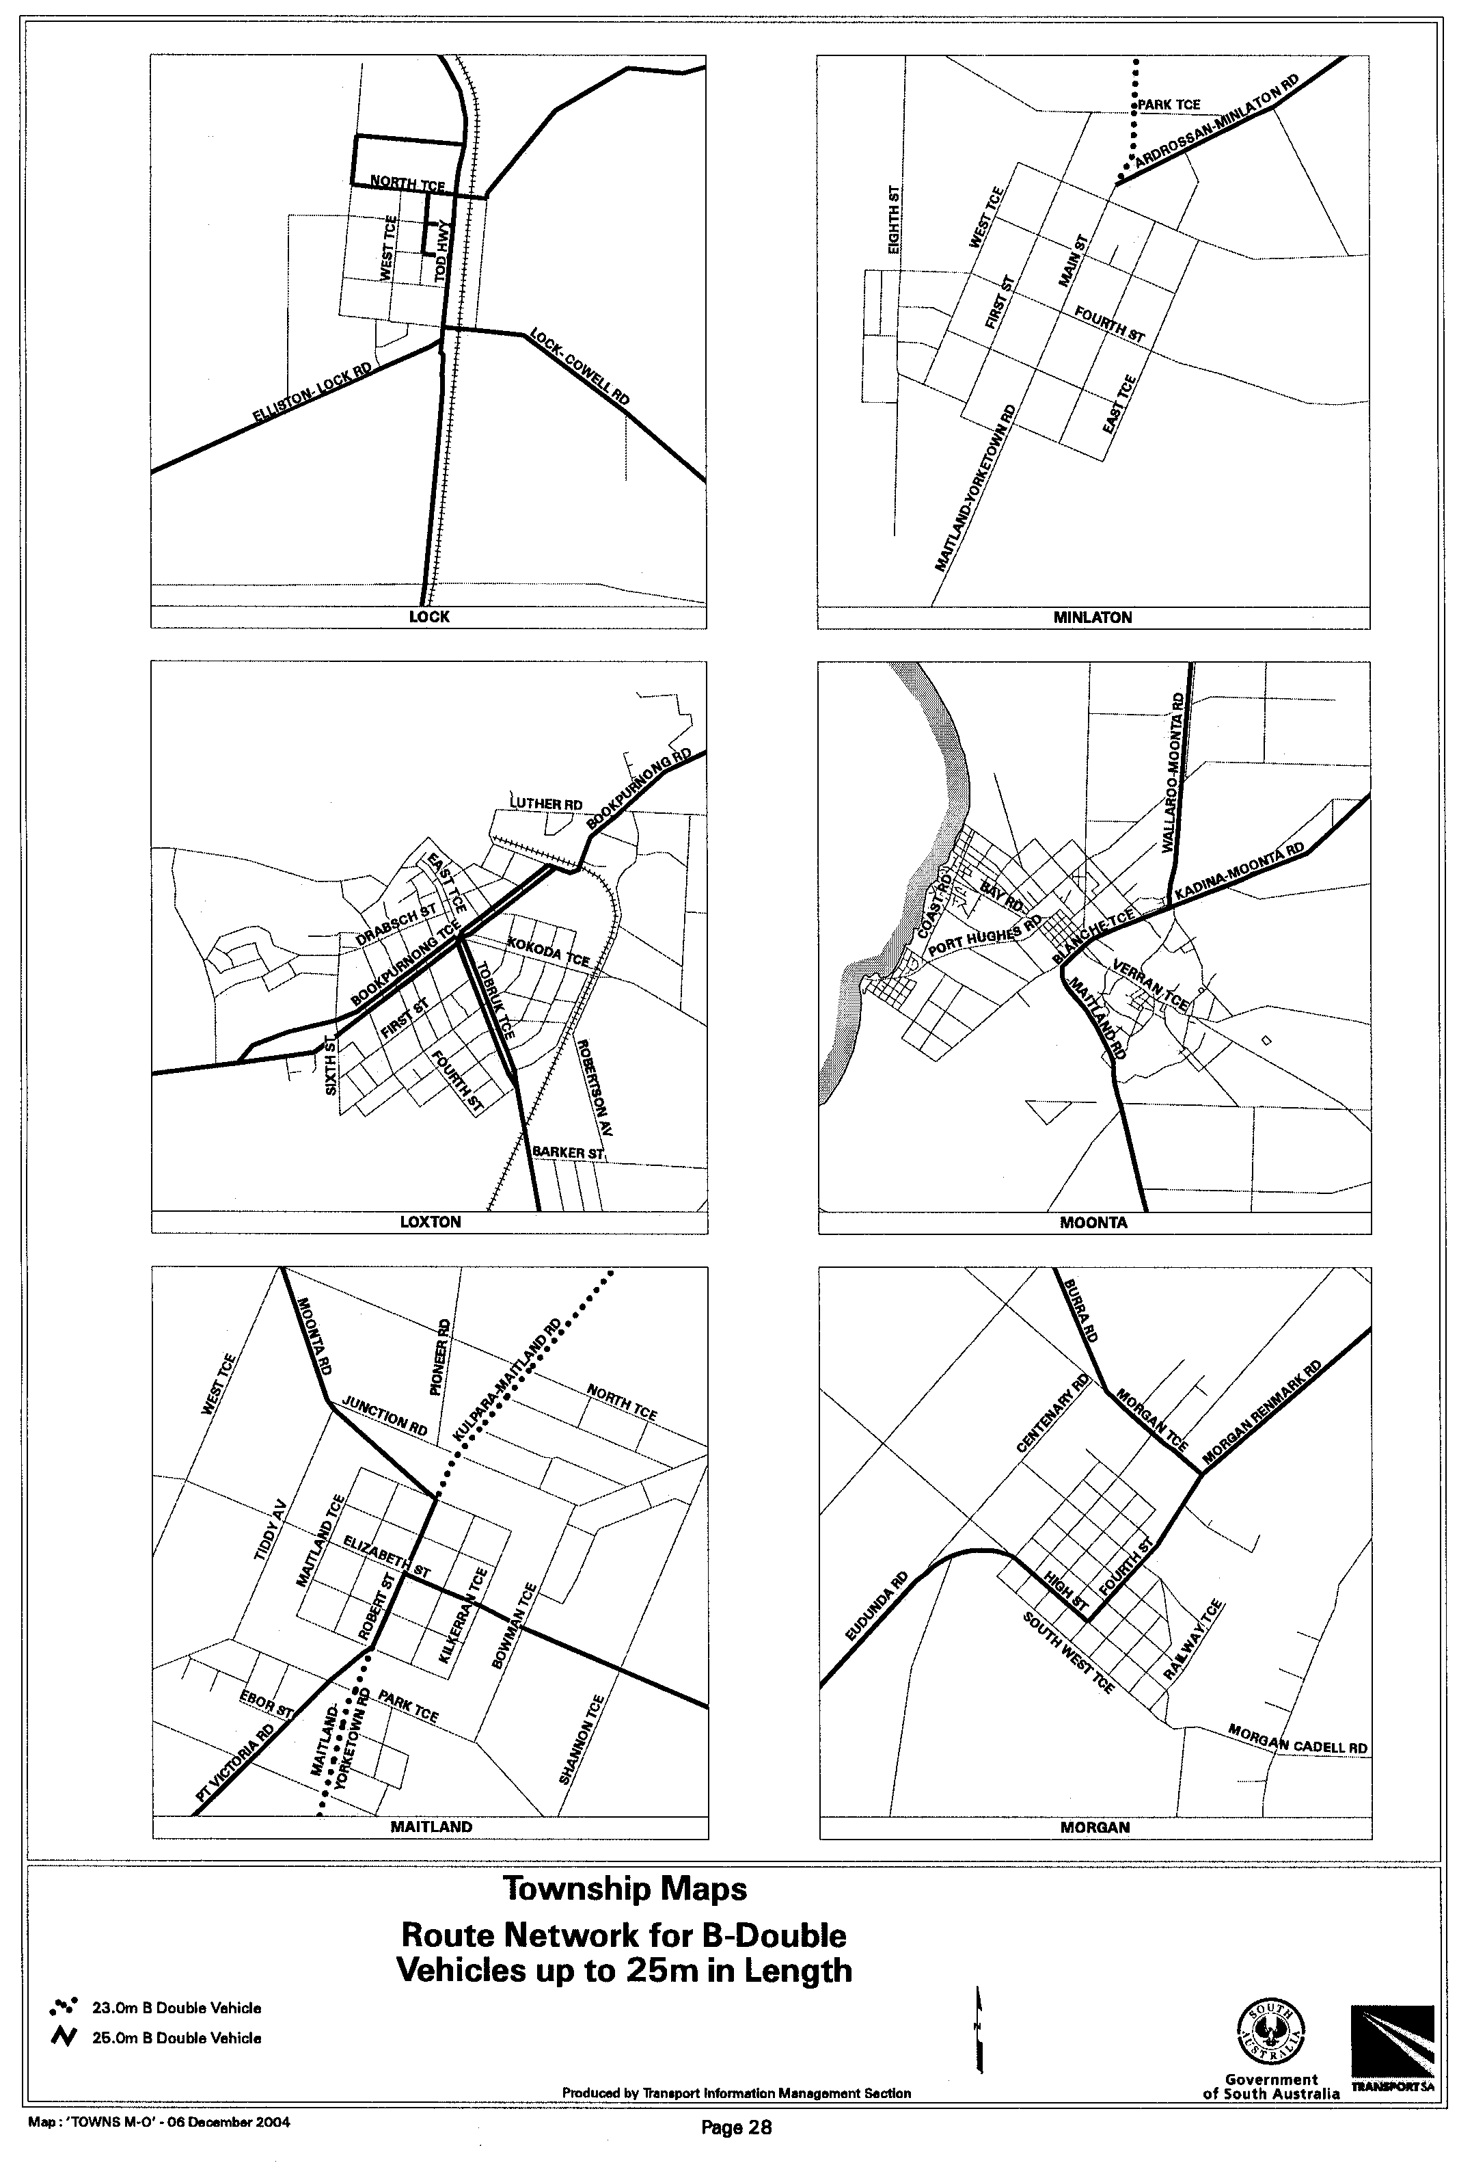
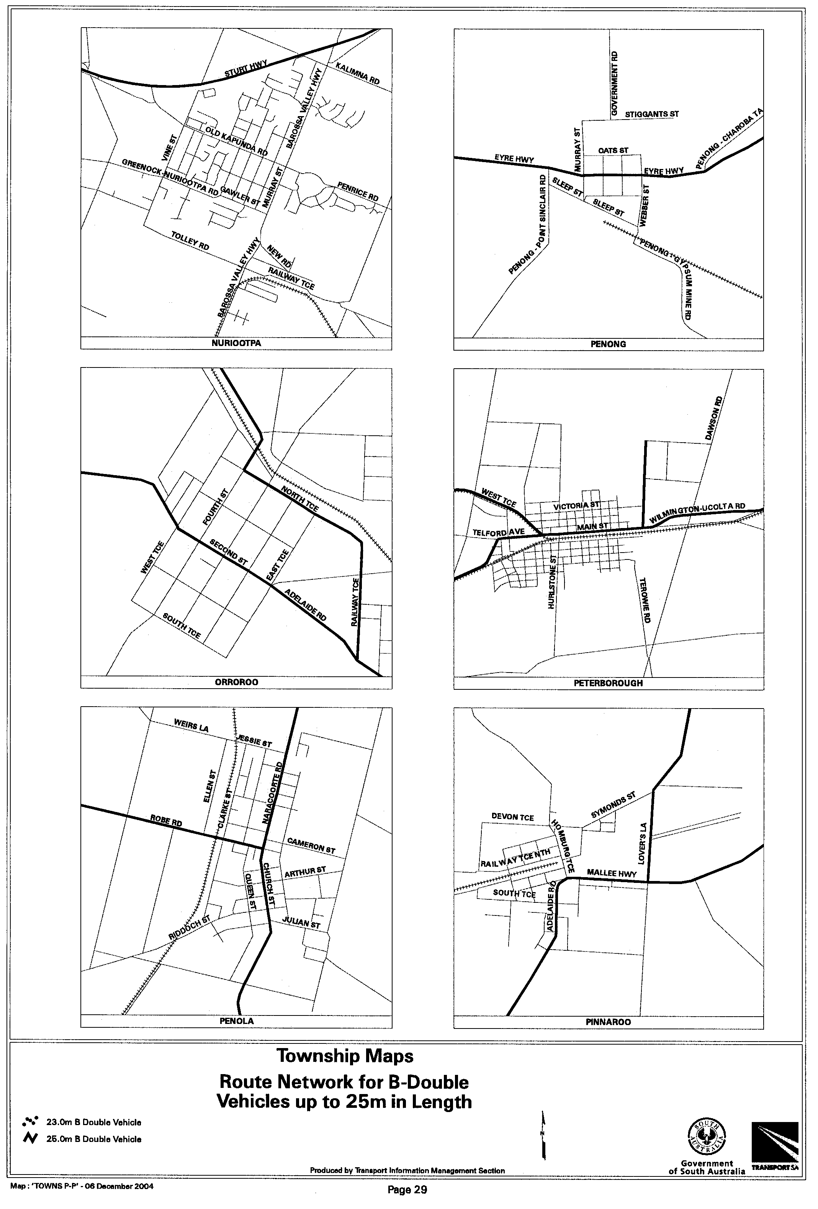
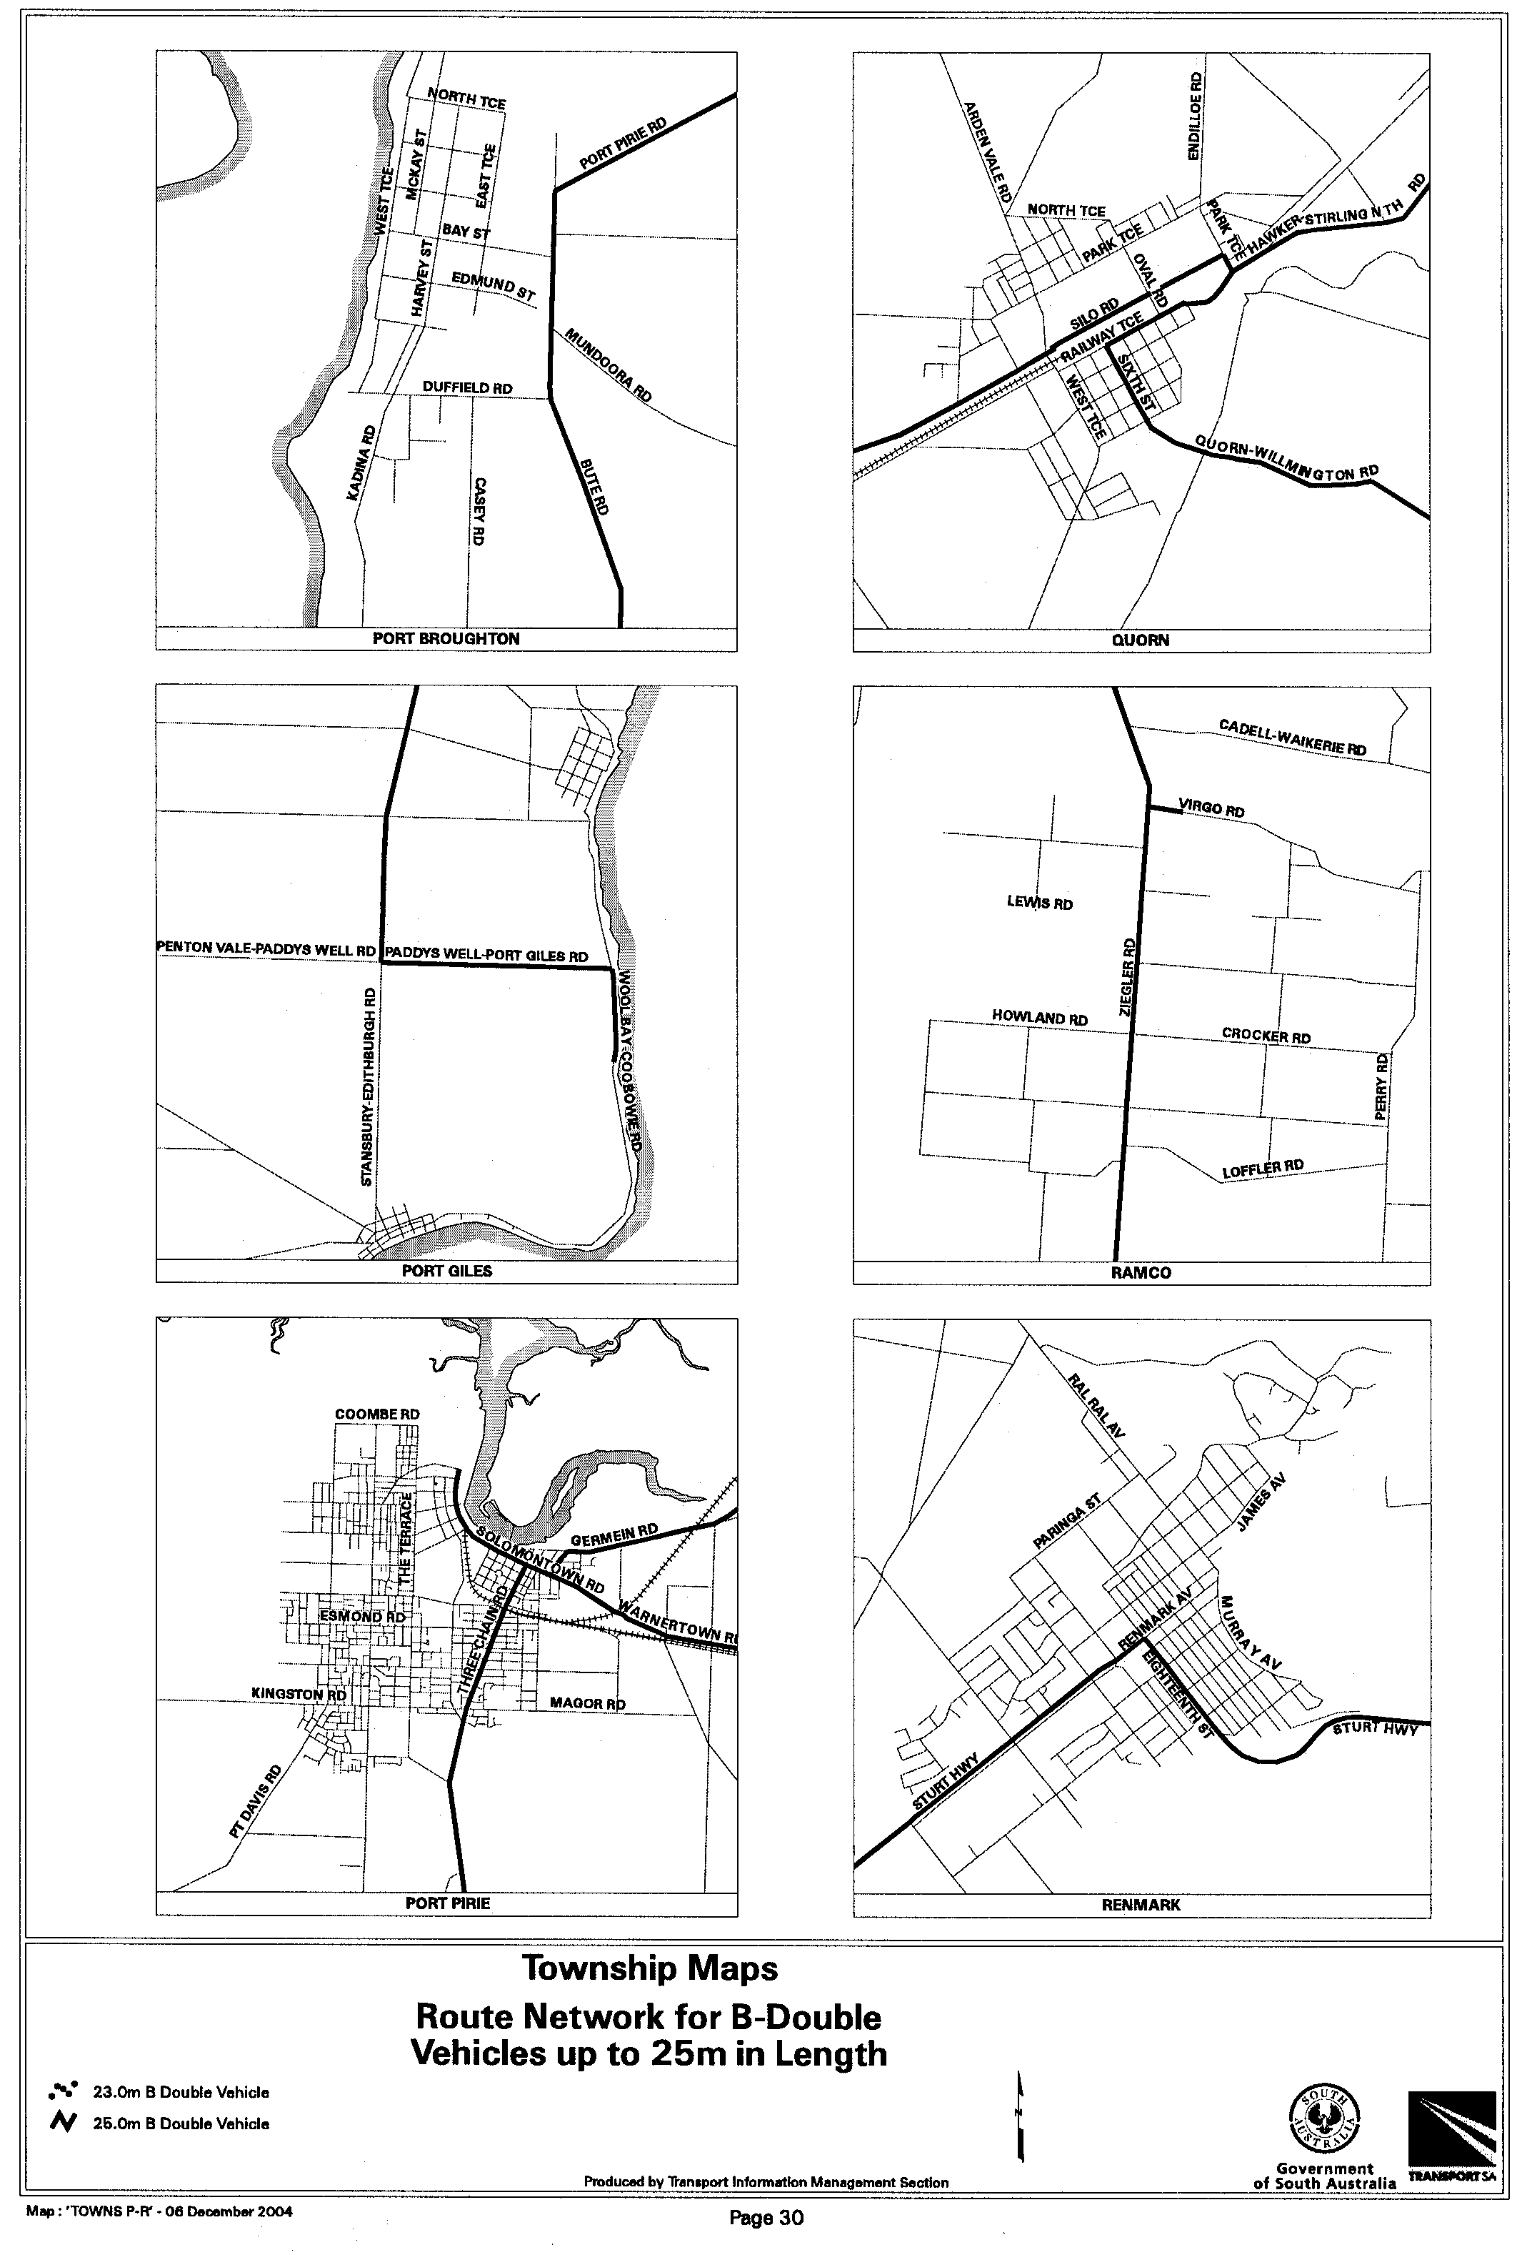
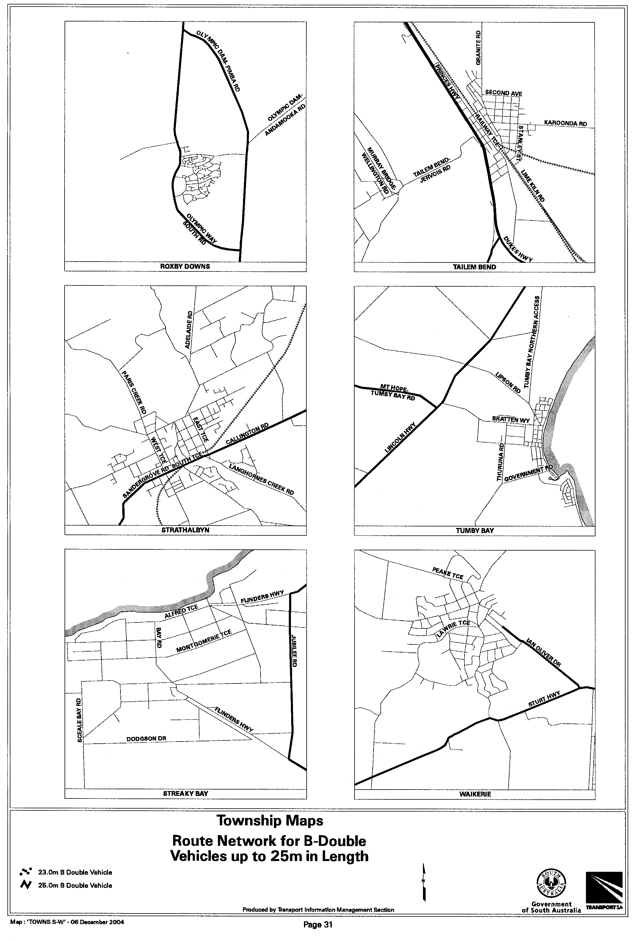
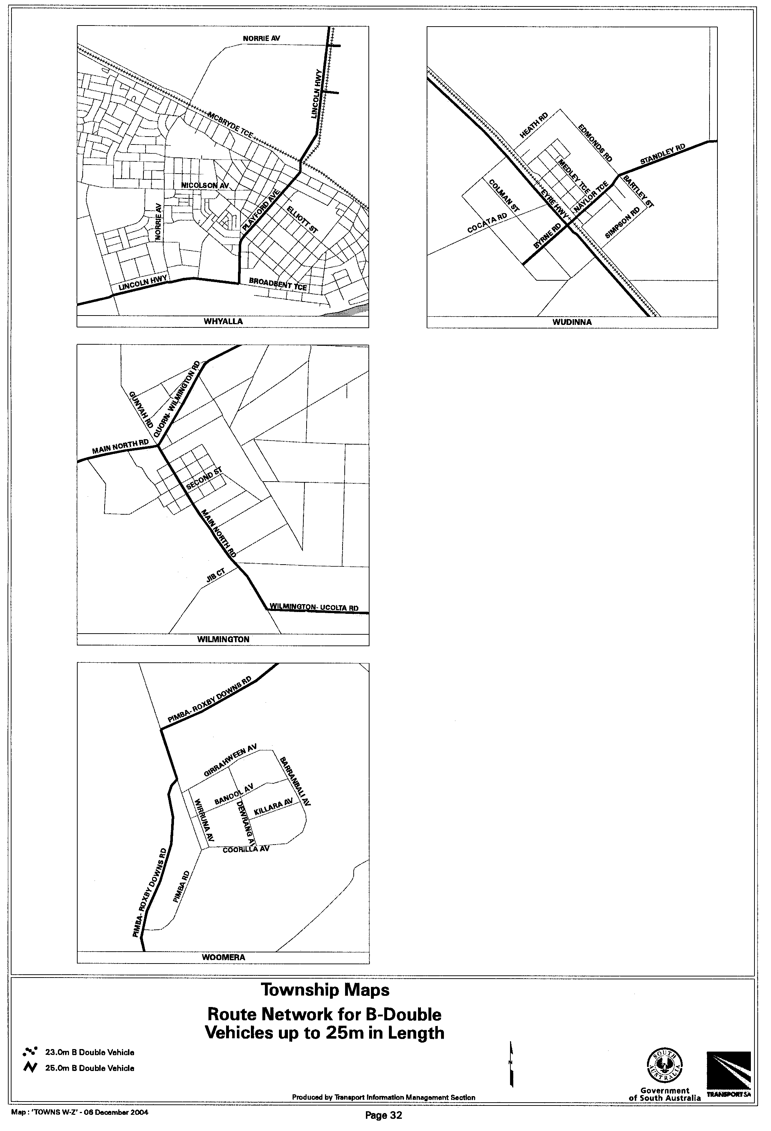
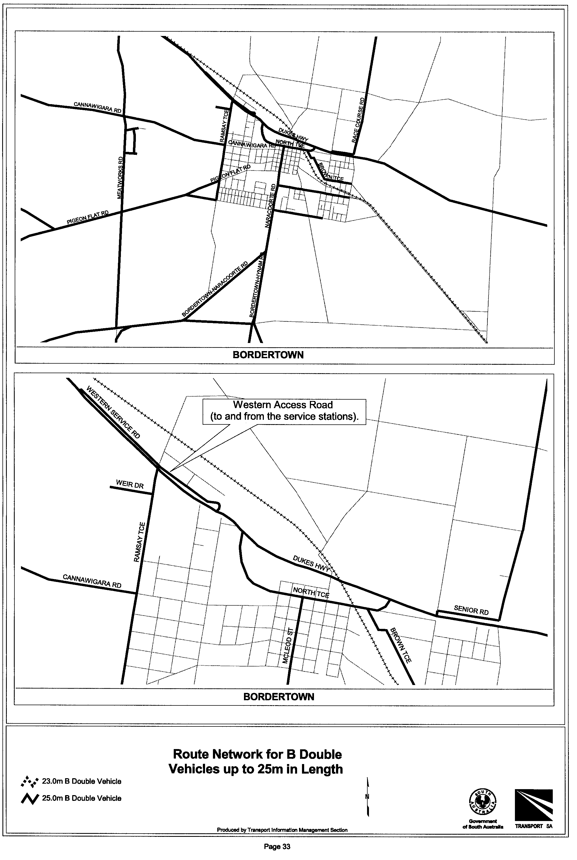
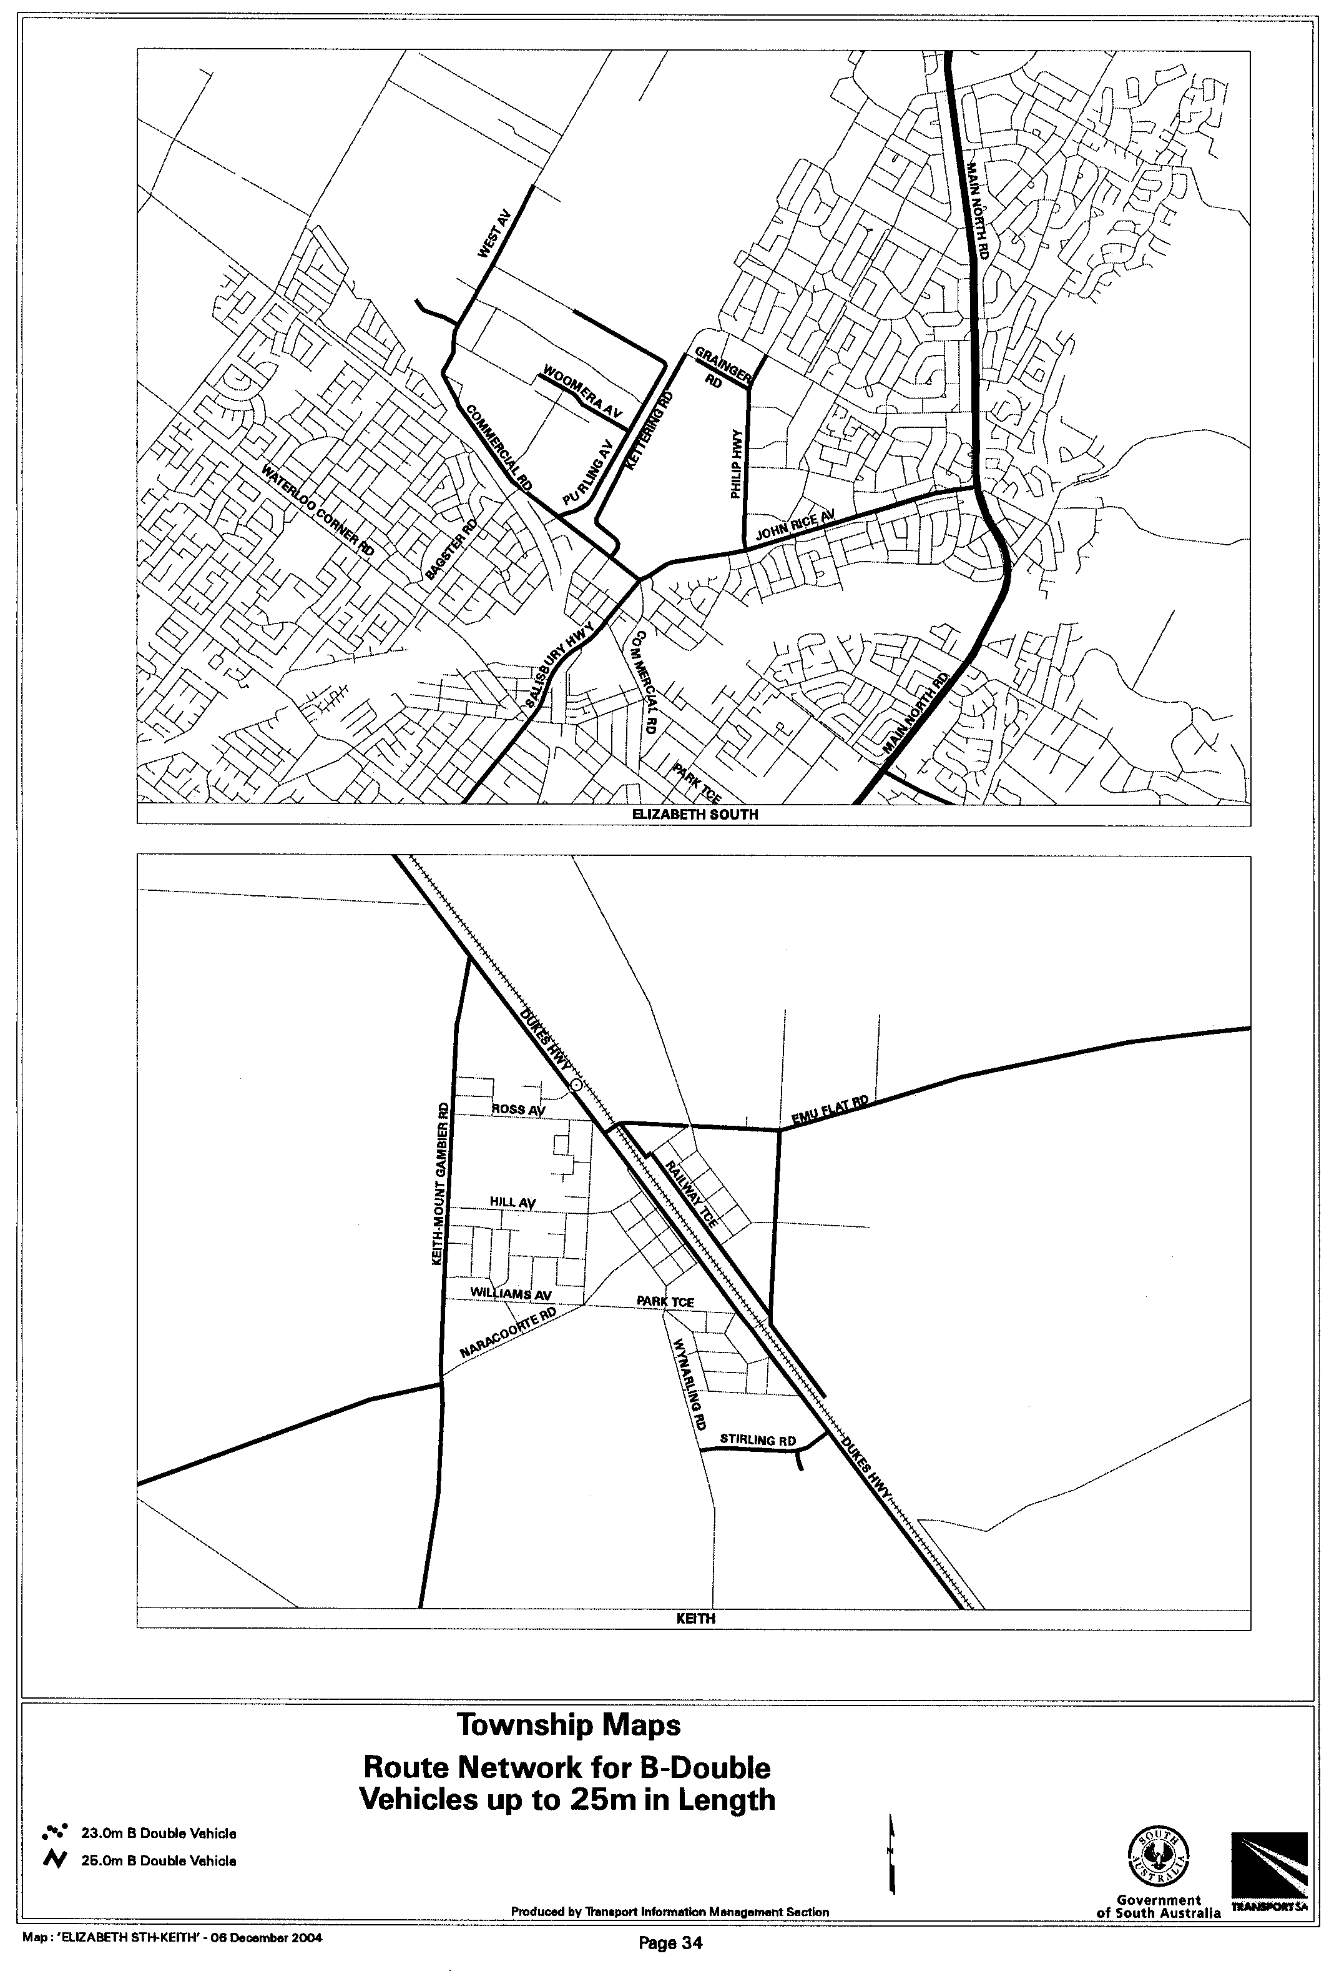
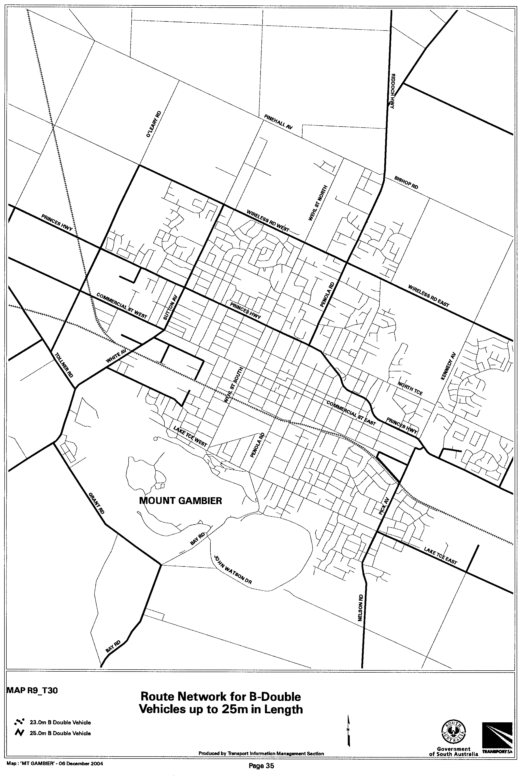
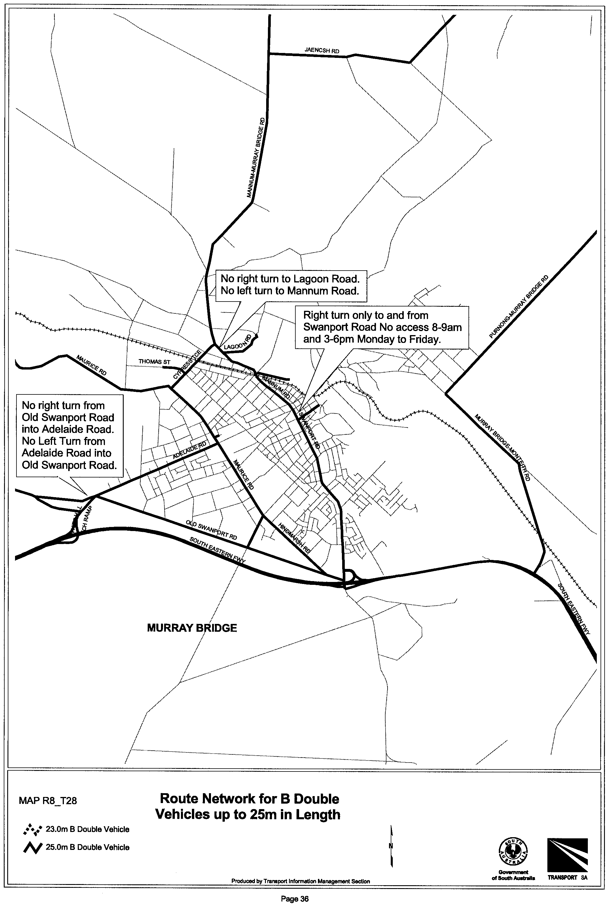
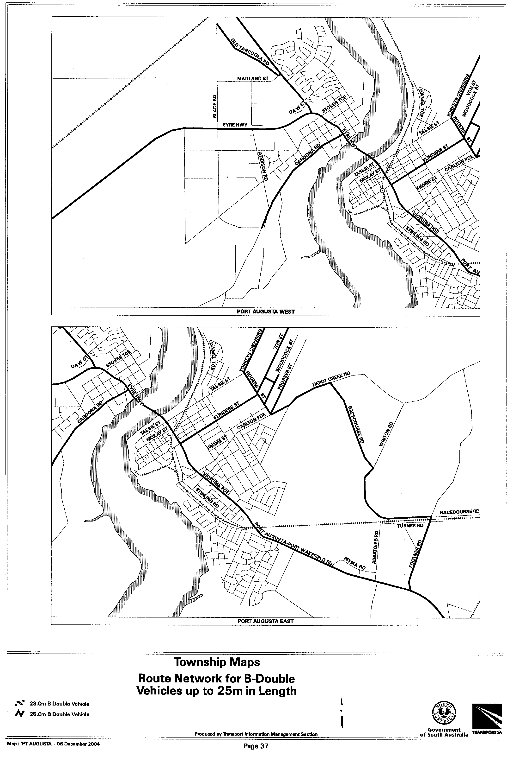
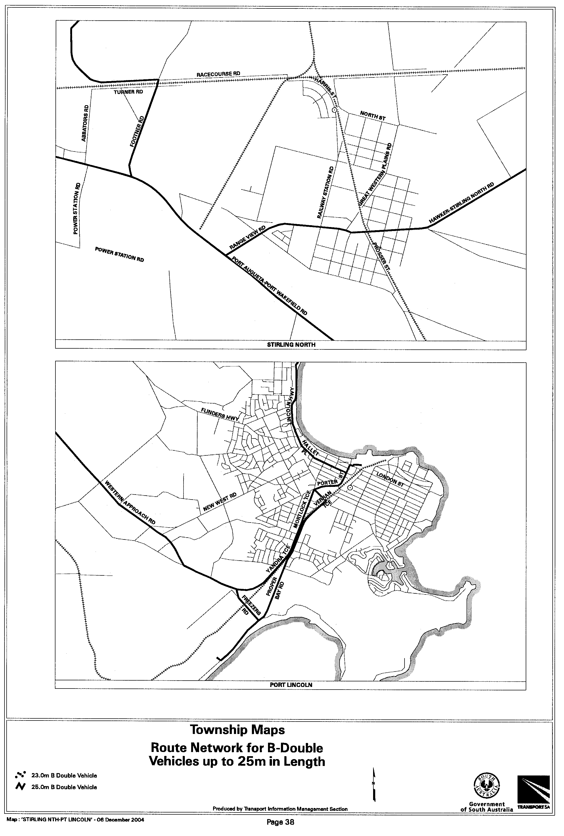
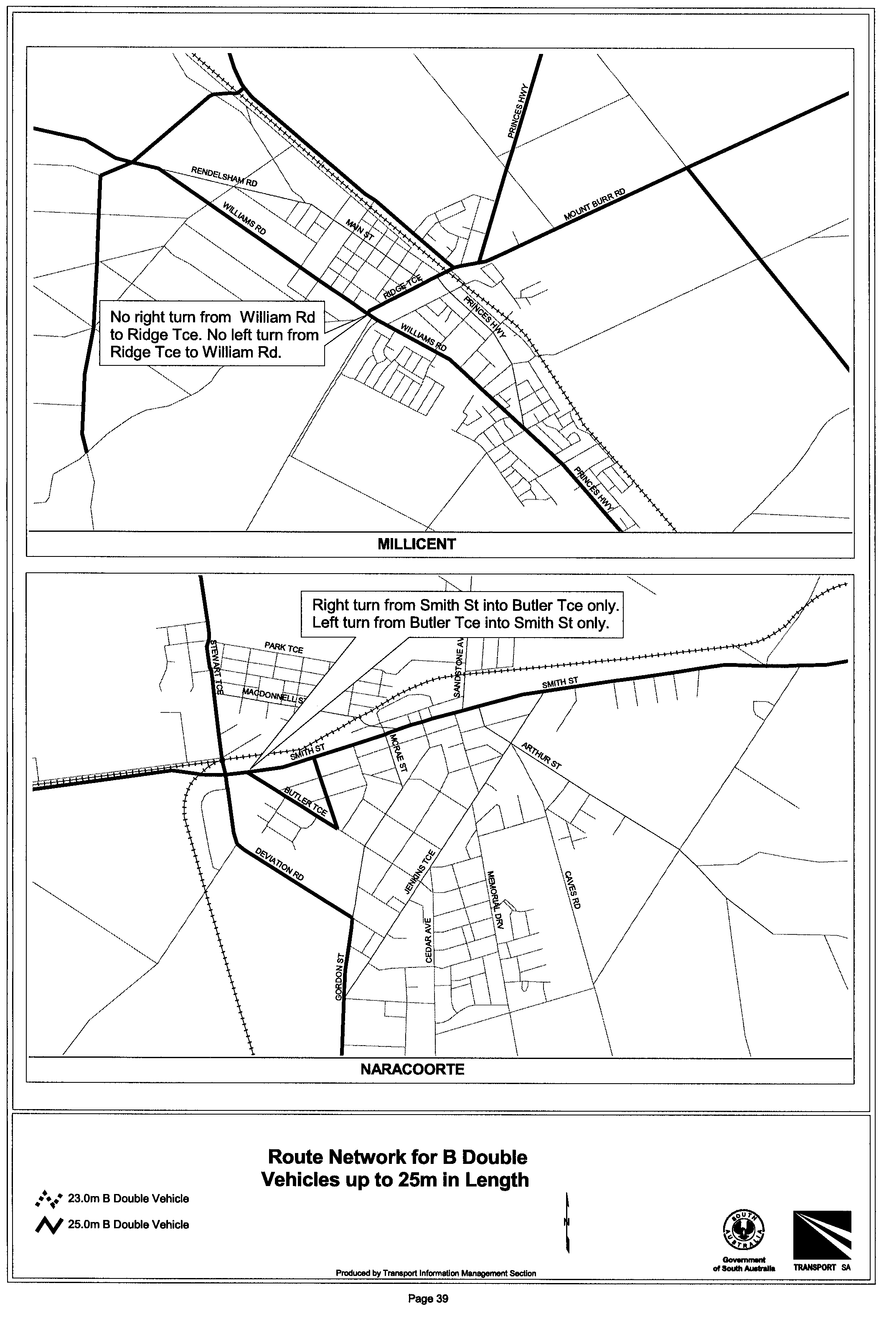

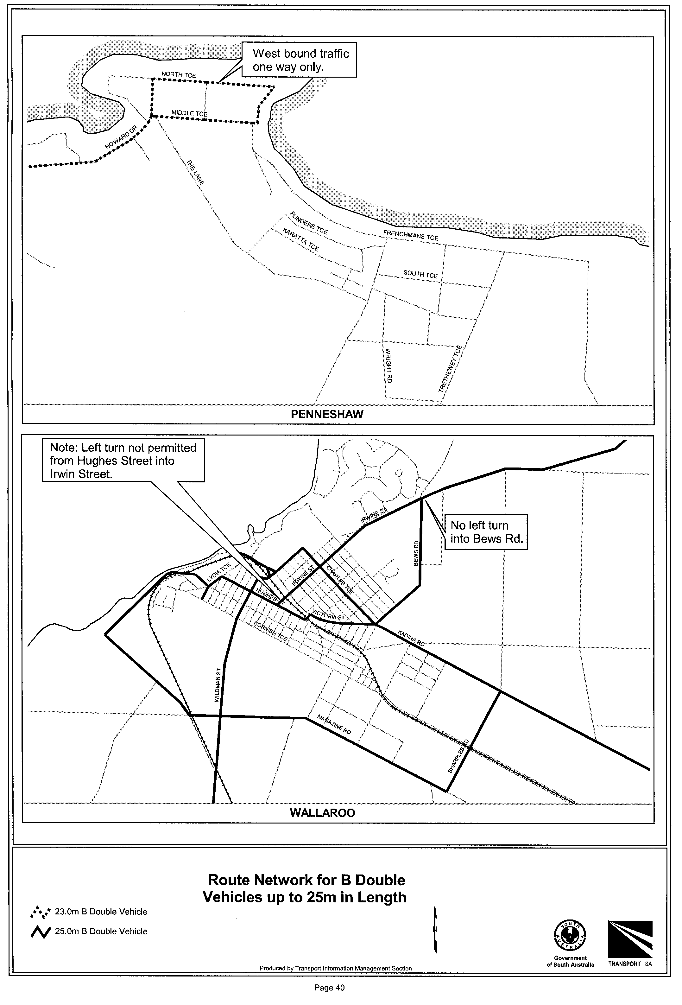

SEWERAGE ACT 1929
Addition of Land to Angaston Country Drainage Area
PURSUANT to section 18 of the Sewerage Act 1929, the South Australian Water Corporation:
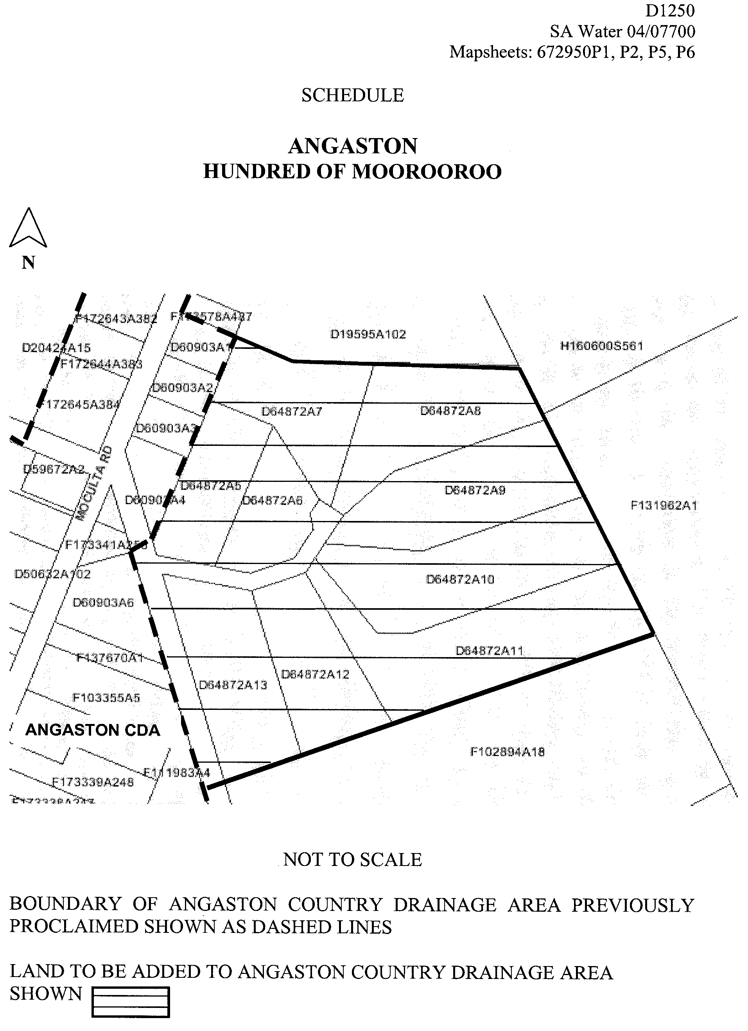
(a) adds to the Angaston Country Drainage Area the land shown on the plan in the schedule; and
(b) declares that this notice has effect from the commencement of the financial year in which it is published in the Gazette.

Dated 20 December 2004.
Signed for and on behalf of the South Australian Water Corporation by a person duly authorised so to do:
A. Popplewell, General Manager Shared Services
In the presence of:
C. J. McNamara, Billing Manager
SAWATER 04/07700 D1250

SEWERAGE ACT 1929
Addition of Land to Mannum Country Drainage Area
PURSUANT to section 18 of the Sewerage Act 1929, the South Australian Water Corporation:
(a) adds to the Mannum Country Drainage Area all the land contained in:
(i) allotment 1 in Deposited Plan 57368 (reserve) [except the portion of that land already in the Mannum Country Drainage Area];
(ii) allotments 15 to 21 inclusive in Filed Plan 39788 [except the portion of that land already in the Mannum Country Drainage Area]; and
(b) declares that this notice has effect from the commence-ment of the financial year in which it is published in the Gazette.
Dated 20 December 2004.
Signed for and on behalf of the South Australian Water Corporation by a person duly authorised so to do:
A. Popplewell, General Manager Shared Services
In the presence of:
C. J. McNamara, Billing Manager
SAWATER 04/09601 D1252

SOIL CONSERVATION AND LAND CARE ACT 1989
Appointments
I, JOHN HILL, Minister for Environment and Conservation in the State of South Australia to whom the administration of the Soil Conservation and Land Care Act 1989 has been committed, do hereby appoint the following people as members of the Southern Hills Soil Conservation Board pursuant to section 24 of the Act until 31 October 2005:
Peter John Michelmore
Beryl Rachel Belford
Victor Lawrence Walter
Roger David Farley
May Ann Crawford
Tim Dunstan
Dated 15 December 2004.
John Hill, Minister for Environment and Conservation

SOIL CONSERVATION AND LAND CARE ACT 1989
Appointments
I, JOHN HILL, Minister for Environment and Conservation in the State of South Australia to whom the administration of the Soil Conservation and Land Care Act 1989 has been committed, do hereby appoint the following people as members of the Lower Eyre Peninsula Soil Conservation Board pursuant to section 24 of the Act until 31 October 2005:
Freeman John Puckridge
Max Roland Wilksch
Ian Reginald Charlton
Peter Andrew Treloar
Dated 15 December 2004.
John Hill, Minister for Environment and Conservation

SOIL CONSERVATION AND LAND CARE ACT 1989
Appointments
I, JOHN HILL, Minister for Environment and Conservation in the State of South Australia to whom the administration of the Soil Conservation and Land Care Act 1989 has been committed, do hereby appoint the following people as members of the Kingoonya Soil Conservation Board pursuant to section 24 of the Act until 31 October 2005:
John Read
Richard Giles Mound
Michael Andrew Simons
Julie Mould
Matthew Kerin
Dated 15 December 2004.
John Hill, Minister for Environment and Conservation

SOIL CONSERVATION AND LAND CARE ACT 1989
Appointments
I JOHN HILL, Minister for Environment and Conservation in the State of South Australia to whom the administration of the Soil Conservation and Land Care Act 1989 has been committed, do hereby appoint the following people as members of the Far West Coast Soil Conservation Board pursuant to section 24 of the Act until 31 October 2005:
Peter Wallace Polkinghorne
Bronte James Warmington
Teresa Kay Gurney
Richard Koch
Dated 15 December 2004.
John Hill, Minister for Environment and Conservation

SOIL CONSERVATION AND LAND CARE ACT 1989
Appointments
I, JOHN HILL, Minister for Environment and Conservation in the State of South Australia to whom the administration of the Soil Conservation and Land Care Act 1989 has been committed, do hereby appoint the following people as members of the Coorong District Soil Conservation Board pursuant to section 24 of the Act until 31 October 2005:
Stephen Rostron Murray
Margaret Joan Brookman
Henry Stuart Fife Angas
Allan Malcolm Piggott
Gordon Warren Stopp
Kenneth Norman Strother
with Keith Scobie as the Local Government representative.
Dated 15 December 2004.
John Hill, Minister for Environment and Conservation

SOIL CONSERVATION AND LAND CARE ACT 1989
Appointments
I, JOHN HILL, Minister for Environment and Conservation in the State of South Australia to whom the administration of the Soil Conservation and Land Care Act 1989 has been committed, do hereby appoint the following people as members of the Murray Plains Soil Conservation Board pursuant to section 24 of the Act until 31 October 2005:
Neil Richard Burbidge
Barbara Dawn Afford
Timothy James Starkey
Maurice A. Collins
Stephen Martin Hein
Robert Eric Graetz
with Peter Dabinett as the Local Government representative.
Dated 15 December 2004.
John Hill, Minister for Environment and Conservation

SOIL CONSERVATION AND LAND CARE ACT 1989
Appointments
I, JOHN HILL, Minister for Environment and Conservation in the State of South Australia to whom the administration of the Soil Conservation and Land Care Act 1989 has been committed, do hereby appoint the following people as members of the Murray Mallee Soil Conservation Board pursuant to section 24 of the Act until 31 October 2005:
Neville Andrew Wurst
Trevor Harold Schiller
Rodney Malcolm Brown
Damian Robert Berger
Gemmell Keith Payne
with Daryl McNeilly as the Local Government representative.
Dated 15 December 2004.
John Hill, Minister for Environment and Conservation

SOIL CONSERVATION AND LAND CARE ACT 1989
Appointments
I, JOHN HILL, Minister for Environment and Conservation in the State of South Australia to whom the administration of the Soil Conservation and Land Care Act 1989 has been committed, do hereby appoint the following people as members of the Central Flinders Ranges Soil Conservation Board pursuant to section 24 of the Act until 31 October 2005:
Adrian Richie Paynter
Jane Luckraft
Grant Allan Chapman
Brian Peter Thomas
Modris Heinrich Ozolins
Roger Phillip Mortimer
with John Malcolm Byerlee as the Local Government repre-sentative.
Dated 15 December 2004.
John Hill, Minister for Environment and Conservation

SOIL CONSERVATION AND LAND CARE ACT 1989
Appointments
I, JOHN HILL, Minister for Environment and Conservation in the State of South Australia to whom the administration of the Soil Conservation and Land Care Act 1989 has been committed, do hereby appoint the following people as members of the Central Hills Soil Conservation Board pursuant to section 24 of the Act until 31 October 2005:
Archibald Stewart Fraser
Douglas John McCarty
Margaret Ann Wilsch
Lois Jean Klaebsch
Wayne Robert Quine
Don Cranwell
with Bill Gale as the Local Government representative.
Dated 15 December 2004.
John Hill, Minister for Environment and Conservation

SOIL CONSERVATION AND LAND CARE ACT 1989
Appointments
I, JOHN HILL, Minister for Environment and Conservation in the State of South Australia to whom the administration of the Soil Conservation and Land Care Act 1989 has been committed, do hereby appoint the following people as members of the Eastern Districts Soil Conservation Board pursuant to section 24 of the Act until 31 October 2005:
Jonathon David Lindner
Paul Arnott Williams
Dudley Cockington
Victor George William Breeding
Ann Breeding
with Christopher Malcolm Reed as the Local Government representative.
Dated 15 December 2004.
John Hill, Minister for Environment and Conservation

SOIL CONSERVATION AND LAND CARE ACT 1989
Appointments
I, JOHN HILL, Minister for Environment and Conservation in the State of South Australia to whom the administration of the Soil Conservation and Land Care Act 1989 has been committed, do hereby appoint the following people as members of the Eastern Eyre Peninsula Soil Conservation Board pursuant to section 24 of the Act until 31 October 2005:
Aileen Margaret Woolford
Geoffrey Wayne Bammann
Roger Ernest Nield
Rodney James Herde
Garry J. Grund
with Steven Edwin Edwards as the Local Government repre-sentative.
Dated 15 December 2004.
John Hill, Minister for Environment and Conservation

SOIL CONSERVATION AND LAND CARE ACT 1989
Appointments
I, JOHN HILL, Minister for Environment and Conservation in the State of South Australia to whom the administration of the Soil Conservation and Land Care Act, 1989 has been committed, do hereby appoint the following people as members of the Gawler Ranges Soil Conservation Board pursuant to section 24 of the Act until 31 October 2005:
Andrew Heaslip Smart
Christina Louise Haigh
Angus Neil McTaggart
Jane Marie Anderson
Alexander Charles Morris
with Craig Leslie Nixon as the Local Government representative.
Dated 15 December 2004.
John Hill, Minister for Environment and Conservation

SOIL CONSERVATION AND LAND CARE ACT 1989
Appointments
I, JOHN HILL, Minister for Environment and Conservation in the State of South Australia to whom the administration of the Soil Conservation and Land Care Act 1989 has been committed, do hereby appoint the following people as members of the Hummocks Soil Conservation Board pursuant to section 24 of the Act until 31 October 2005:
Mourilyan Francis Nicholls
Jennifer Ruth Ottens
Peter Pawelski
Kerry Mark Ward
Philip David Harris
with Kevin Jaeschke as the Local Government representative.
Dated 15 December 2004.
John Hill, Minister for Environment and Conservation

SOIL CONSERVATION AND LAND CARE ACT 1989
Appointments
I, JOHN HILL, Minister for Environment and Conservation in the State of South Australia to whom the administration of the Soil Conservation and Land Care Act 1989 has been committed, do hereby appoint the following people as members of the Kangaroo Island Soil Conservation Board pursuant to section 24 of the Act until 31 October 2005:
Malcolm Bruce Schaefer
Christine Denman
William John Roper
Anthony Harris
with Graham Neil Smith as the Local Government representative.
Dated 15 December 2004.
John Hill, Minister for Environment and Conservation

SOIL CONSERVATION AND LAND CARE ACT 1989
Appointments
I, JOHN HILL, Minister for Environment and Conservation in the State of South Australia to whom the administration of the Soil Conservation and Land Care Act 1989 has been committed, do hereby appoint the following people as members of the Lower North Soil Conservation Board pursuant to section 24 of the Act until 31 October 2005:
Robin Manley
Robert Tilley
Helen Thomas
Peter Heinjus
James Mitchell
David Laws
with Merton Neindorf as the Local Government representative.
Dated 15 December 2004.
John Hill, Minister for Environment and Conservation

SOIL CONSERVATION AND LAND CARE ACT 1989
Appointments
I, JOHN HILL, Minister for Environment and Conservation in the State of South Australia to whom the administration of the Soil Conservation and Land Care Act 1989 has been committed, do hereby appoint the following people as members of the Lower South East Soil Conservation Board pursuant to section 24 of the Act until 31 October 2005:
Maxwell John Arney
David Cresswell Brown
Peter Colin Feast
Nicholas John Hunt
Nancy Alice Marion Mann
Detlev Andreas Vogt
with Ronald Weston Ellis as the Local Government representative.
Dated 15 December 2004.
John Hill, Minister for Environment and Conservation

SOIL CONSERVATION AND LAND CARE ACT 1989
Appointments
I, JOHN HILL, Minister for Environment and Conservation in the State of South Australia to whom the administration of the Soil Conservation and Land Care Act 1989 has been committed, do hereby appoint the following people as members of the Marree Soil Conservation Board pursuant to section 24 of the Act until 31 October 2005:
Catriona Ruth McTaggart
Josephine Maree Morton
Shane Michael Oldfield
Kenneth David Ogilvy
Janet Crommelin Brook
Anne Elizabeth Scammell
with Christine Mary Crafter as the Local Government repre-sentative.
Dated 15 December 2004.
John Hill, Minister for Environment and Conservation

SOIL CONSERVATION AND LAND CARE ACT 1989
Appointments
I, JOHN HILL, Minister for Environment and Conservation in the State of South Australia to whom the administration of the Soil Conservation and Land Care Act 1989 has been committed, do hereby appoint the following people as members of the Northern Hills Soil Conservation Board pursuant to section 24 of the Act until 31 October 2005:
Wesley Allen Seeliger
Sydney Ronald Kyloh
Timothy Richard Barritt
Helen Bourne
Richard Philip Underdown
with Timothy Potter as the Local Government representative.
Dated 15 December 2004.
John Hill, Minister for Environment and Conservation

SOIL CONSERVATION AND LAND CARE ACT 1989
Appointments
I, JOHN HILL, Minister for Environment and Conservation in the State of South Australia to whom the administration of the Soil Conservation and Land Care Act 1989 has been committed, do hereby appoint the following people as members of the West Broughton Soil Conservation Board pursuant to section 24 of the Act until 31 October 2005:
Donald Steward Bottrall
Andrea Hamilton Smith Catford
Trevor Havelock Crawford
Peter Sydney Gill
Philip Stanley Johns
Stephen Price Wicks
with Neville Kevin Wilson as the Local Government repre-sentative.
Dated 15 December 2004.
John Hill, Minister for Environment and Conservation

SOIL CONSERVATION AND LAND CARE ACT 1989
Appointments
I, JOHN HILL, Minister for Environment and Conservation in the State of South Australia to whom the administration of the Soil Conservation and Land Care Act 1989 has been committed, do hereby appoint the following people as members of the Western Eyre Peninsula Soil Conservation Board pursuant to section 24 of the Act until 31 October 2005:
Peter Robert Kuhlmann
Mark John Hoffrichter
Brett Dalzell
Stephen James Wilson
with Ross Fuller as the Local Government representative.
Dated 15 December 2004.
John Hill, Minister for Environment and Conservation

SOIL CONSERVATION AND LAND CARE ACT 1989
Appointments
I, JOHN HILL, Minister for Environment and Conservation in the State of South Australia to whom the administration of the Soil Conservation and Land Care Act 1989 has been committed, do hereby appoint the following people as members of the Yorke Peninsula Soil Conservation Board pursuant to section 24 of the Act until 31 October 2005:
Nora Marie Holliday
Rodney George Davies
Wolford John Parsons
Debra Clare Agnew
Allan Martin Twartz
with Lachlan David Morphett as the Local Government representative.
Dated 15 December 2004.
John Hill, Minister for Environment and Conservation

SOUTH AUSTRALIAN CO-OPERATIVE AND
COMMUNITY HOUSING ACT 1991
Cancellation of Co-operatives
NOTICE is hereby given that the South Australian Community Housing Authority by virtue of the powers conferred by section 78 (2) of the South Australian Co-operative and Community Housing Act 1991 has declared the:
Emohruo Housing Co-operative Inc.
Sustainable Urban Site Housing Co-operative Inc.
Betel Housing Co-operative Inc.
Andes Housing Co-operative Inc.
Simon Bolivar Housing Co-operative Inc.
Mision Centro Americana Housing Co-operative Inc.
Loxton Housing Co-operative Inc.
defunct and has cancelled the incorporation of the co-operatives whereupon the registered housing co-operatives are dissolved.
B. Moran, General Manager

SUPPORTED RESIDENTIAL FACILITIES ACT 1992
Appointment of Assessors
PURSUANT to division 3 of the Supported Residential Facilities Act 1992 (SRF Act) provides for the selection and appointment of Assessors by the Supported Residential Facilities Advisory Committee. This committee is appointed by the Governor of South Australia:
19 (2) states that the Advisory Committee will, for the purpose of this section, establish a panel of persons (who may, or may not be, members of the committee) who may act as assessors.
Assessors’ appointments are valid for three years. The last appointments expired in August 2004.
At the 8 December meeting of the Supported Residential Facilities Advisory Committee a new panel of assessors was nominated.
The committee determined, given the varied nature of the SRF sector, that a number of assessors would be best to ensure that the appropriate expertise was available to assist in any court matter.
The committee decided to nominate the following members of the committee to be assessors to ensure that in the event that their area of expertise was warranted it could be provided:
Disability Action Inc. Phillip Beddall
Council on the Ageing Marilyn Crabtree
Industry (SRF Proprietors) Paul Pledger
Local Government Cr Peter Smith OAM
Cr Keith Morman
Alison Creaser
Medical Practitioner Dr Chris Wurm
UTLC Adrian Butterworth
Dated 21 December 2004.
B. Reay, Senior Project Officer, Residential Services and Support Unit Accommo-dation and Support Services Branch.

NOTICE TO MARINERS
No. 40 of 2004 (formerly notice No. 29)
South Australia—Warning—Access Past River Murray Mouth
MARINERS are advised to exercise extreme caution as restric-tions on access through the Murray Mouth Dredging Exclusion Zone will be temporarily lifted during daylight hours from 8 a.m. on Saturday, 1 January 2005 until 5.30 p.m. on Monday, 3 January 2005.
Boat operators should be aware of the possibility of varying water depths, strong tidal currents, waves, shifting sandbars and shallow water. Existing channels may shift or close in the course of a single day making return passage impossible. Dangerous conditions may prevail.
Dredging of the Murray Mouth area has been undertaken to protect the Coorong ecosystem and not to facilitate navigation. The dredges have been moved to one side of the dredged area for this period and must be avoided. Dredging may have caused parts of the area to have different depths and may have created steeply shelved sections.
Mariners are further advised that anchoring is prohibited in the area. This will be strictly enforced and non-compliance will result in a prosecution in accordance with Harbors and Navigation Act Regulations 1994. A speed limit of 4 knots and restrictions on boating activities apply in accordance with the Harbors and Navigation Regulations 1994.
Trish White, Minister for Transport
TSA 2004/00541

WATER MAINS AND SEWERS

Office of the South Australian Water Corporation
Adelaide, 23 December 2004

WATER MAINS LAID

Notice is hereby given that the following main pipes or parts of main pipes have been laid down by the South Australian Water Corporation in or near the undermentioned water districts and are now available for a constant supply of water to adjacent land.

ADELAIDE WATER DISTRICT

CAMPBELLTOWN CITY COUNCIL
Junction Road, Paradise. p31
Glamis Avenue, Tranmere. p34
Reynolds Road, Campbelltown. p42

CITY OF MARION
Young Street, Reynella and Sheidow Park. p12

CITY OF ONKAPARINGA
Across and in Young Street, Reynella. p12
Across and in Flaxmill Road, Christie Downs and Morphett Vale. p13
Easements in lot 334 in LTRO DP 9525, Flaxmill Road, Christie Downs and Morphett Vale. p13
O’Sullivan Beach Road, Lonsdale and Morphett Vale. p14
Elizabeth Road, Christie Downs and Morphett Vale. p15
Hall Road, Willunga. p39
Coach Court, Willunga. p39

CITY OF PLAYFORD
Charta Circuit, Smithfield and Smithfield Plains. p1

CITY OF PORT ADELAIDE ENFIELD
Prescott Street, Clearview and Enfield. p33
Frome Avenue, Hampstead Gardens. p35

CITY OF SALISBURY
Spencer Court, Mawson Lakes. p2
Baird Street, Mawson Lakes. p2
Merino Lane, Mawson Lakes. p2
The Walk, Mawson Lakes. p2
Petrel Crescent, Mawson Lakes. p3
Swan Circuit, Mawson Lakes. p3
Market Lane, Mawson Lakes. p3
Creekview Drive, Mawson Lakes. p4
Avocet Drive, Mawson Lakes. p4
Ibis Street, Mawson Lakes. p4
Hollywood Boulevard, Salisbury Downs. p38

CITY OF WEST TORRENS
Moore Lane, Mile End. p32

GOOLWA WATER DISTRICT

ALEXANDRINA COUNCIL
William Street, Goolwa. p41

KADINA WATER DISTRICT

DISTRICT COUNCIL OF THE COPPER COAST
Easement in lot 20 in LTRO DP 53501, Gurner Street, Kadina. p40

MANNUM WATER DISTRICT

MID MURRAY COUNCIL
Public road north east of lot 61 in LTRO DP 56840, Port Mannum. p5
Easements in lot 1 in LTRO DP 57368, Port Mannum. p5

MILANG WATER DISTRICT

ALEXANDRINA COUNCIL
Stirling Street, Milang. p43

PORT ELLIOT WATER DISTRICT

ALEXANDRINA COUNCIL
Young Street, Port Elliot. p37

PORT LINCOLN WATER DISTRICT

CITY OF PORT LINCOLN
Coral Street, Port Lincoln. p11

PORT VICTOR WATER DISTRICT

CITY OF VICTOR HARBOR
Tudor Avenue, Victor Harbor. p36
TWO WELLS WATER DISTRICT

DISTRICT COUNCIL OF MALLALA
Gameau Road, Two Wells. This main is available to allotment piece 58 in LTRO DP 64975 by application only. p6-8
Walter Avenue, Two Wells. This main is available to lot 14 in LTRO FP 101636 by application only. p7
Kay Avenue, Two Wells. This main is available to lot 14 in LTRO FP 101636 by application only. p8
Jean Avenue, Two Wells. This main is available to lot 14 in LTRO FP 101636 by application only. p8
Hayman Road, Two Wells. p9

WATER MAINS ABANDONED

Notice is hereby given that the undermentioned water mains have been abandoned by the South Australian Water Corporation.

ADELAIDE WATER DISTRICT

CITY OF MARION
Young Street, Reynella and Sheidow Park. p12

CITY OF ONKAPARINGA
Across and in Young Street, Reynella. p12
Flaxmill Road, Christie Downs and Morphett Vale. p13
Easement in lot 334 in LTRO DP 9525, Flaxmill Road, Christie Downs and Morphett Vale. p13
O’Sullivan Beach Road, Lonsdale and Morphett Vale. p14
Elizabeth Road, Christie Downs and Morphett Vale. p15
Brodie Road, Morphett Vale. p16

WATER MAINS LAID

Notice is hereby given that the undermentioned water mains have been laid down by the South Australian Water Corporation and are not available for a constant supply of water to adjacent land.

ADELAIDE WATER DISTRICT

TOWN OF GAWLER
Millers Road, Evanston Park. p10
Chambers Road, Evanston Park. p10
Cavallaro Place, Evanston Park. p10

CITY OF MITCHAM
Waterworks land (lot 1 in LTRO DP 39697), Grandview Drive, Pasadena. p20-30
Across Gunther Parade, Pasadena. p20, 21 and 23

CITY OF ONKAPARINGA
Brodie Road, Morphett Vale. p16
Tatachilla Road, Tatachilla. p44-48
Waterworks land (lot 9 in LTRO FP 10509), Tatachilla Road, Tatachilla. p44-48

SEWERS LAID

Notice is hereby given that the following sewers have been laid down by the South Australian Water Corporation in the under-mentioned drainage areas and are now available for house connections.

ADELAIDE DRAINAGE AREA

CAMPBELLTOWN CITY COUNCIL
Dawn Avenue, Hectorville. FB 1128 p38
Facit Avenue, Newton. FB 1128 p44
Junction Road, Paradise. FB 1128 p39
Glamis Avenue, Tranmere. FB 1128 p43

CITY OF PLAYFORD
Charta Circuit, Smithfield Plains and Smithfield. FB 1132 p34-36
Moulds Crescent, Smithfield. FB 1132 p34-36
Coventry Road, Smithfield Plains. FB 1132 p37
Curtis Road, Smithfield Plains and Munno Para. FB 1132 p37
Blight Street, Davoren Park. FB 1128 p48

CITY OF PORT ADELAIDE ENFIELD
Floriedale Road, Greenacres. FB 1128 p41
Frome Avenue, Hampstead Gardens. FB 1128 p46

CITY OF SALISBURY
Spencer Court, Mawson Lakes. FB 1132 p15 and 16
Baird Street, Mawson Lakes. FB 1132 p15 and 16
Merino Lane, Mawson Lakes. FB 1132 p15 and 16
The Walk, Mawson Lakes. FB 1132 p15 and 16
Mawson Lakes Boulevard, Mawson Lakes. FB 1132 p17 and 18, and FB 1117 p32 and 33
Plover Street, Mawson Lakes. FB 1117 p32 and 33, and FB 1110 p52
Pomarine Street, Mawson Lakes. FB 1117 p32 and 33
Kingfisher Avenue, Mawson Lakes. FB 1110 p52
Swan Circuit, Mawson Lakes. FB 1110 p52, 50 and 51, and FB 1132 p19 and 20
Market Lane, Mawson Lakes. FB 1132 p19 and 20
Creekview Drive, Mawson Lakes. FB 1132 p21-23
Avocet Drive, Mawson Lakes. FB 1132 p21-23
Ibis Street, Mawson Lakes. FB 1132 p21-23
Newfield Rd, Para Hills West. FB 1128 p42
Amanda Street, Salisbury. FB 1131 p1
Easements in lot 162, Finchley Court, and allotment piece 15 in LTRO DP 62605, Hollywood Boulevard, Salisbury Downs. FB 1128 p52

CITY OF WEST TORRENS
Moore Lane, Mile End. FB 1128 p40

LOBETHAL COUNTRY DRAINAGE AREA

ADELAIDE HILLS COUNCIL
Church Street, Lobethal. FB 1128 p45

MOUNT GAMBIER COUNTRY DRAINAGE AREA

CITY OF MOUNT GAMBIER
Heriot Street, Mount Gambier. FB 1114 p32

MURRAY BRIDGE COUNTRY DRAINAGE AREA

THE RURAL CITY OF MURRAY BRIDGE
Lugard Street, Murray Bridge. FB 1127 p35 and 36
Easement in lot 1 in LTRO DP 40450, Edmund Terrace, Murray Bridge. FB 1127 p35 and 36
Across and in Edmund Terrace, Murray Bridge. FB 1127 p35-38
Easement in lot 46, Edmund Terrace, Murray Bridge. FB 1127 p35 and 37
Alma Avenue, Murray Bridge. FB 1127 p35 and 37

STIRLING COUNTRY DRAINAGE AREA

ADELAIDE HILLS COUNCIL
Heathfield Road, Heathfield. FB 1128 p1

VICTOR HARBOR COUNTRY DRAINAGE AREA

CITY OF VICTOR HARBOR
Easements in lots 1 and 5, Whalers Road, Encounter Bay. FB 1128 p47
Somers Road, Victor Harbor. FB 1128 p49

SEWERS ABANDONED

Notice is hereby given that the undermentioned sewer has been abandoned by the South Australian Water Corporation.

ADELAIDE DRAINAGE AREA

CITY OF SALISBURY
Barndioota Road, Salisbury Plain and Salisbury Park. FB 1131 p17

SEWERS LAID

Notice is hereby given that the undermentioned sewers have been laid down by the South Australian Water Corporation and are not available for house connections.

STIRLING COUNTRY DRAINAGE AREA

ADELAIDE HILLS COUNCIL
In and across Heathfield Road, Heathfield—two 200 mm MSCL pumping mains. FB 1128 p1
Miels Road, Stirling—80 mm and 150 mm PVC pumping mains. FB 1131 p19 and 21
Rudall Avenue, Stirling and Crafers—80 mm and 150 mm PVC pumping mains. FB 1131 p19, 21 and 22
Easement in lot 4 in LTRO DP 55112, Wright Road, Crafers—80 mm and 150 mm PVC pumping mains. FB 1131 p19 and 22
Wright Road, Stirling and Crafers—80 mm and 150 mm PVC pumping mains. FB 1131 p19 and 22

OUTSIDE STIRLING COUNTRY DRAINAGE AREA

ADELAIDE HILLS COUNCIL
Easements in lot 13 in LTRO DP 4271, Old Carey Gully Road, Piccadilly—80 mm and 150 mm PVC pumping mains. FB 1131 p19, 20, 23 and 24
Old Carey Gully Road, Piccadilly and Stirling—80 mm and 150 mm PVC pumping mains. FB 1131 p19 and 20
South Eastern Freeway, Stirling—80 mm and 150 mm PVC pumping mains. FB 1131 p19 and 20
Nara Road, Stirling—80 mm and 150 mm PVC pumping mains. FB 1131 p19-21

CORRECTIONS

Correction to notice in “Government Gazette” of 20 October 1983.

“SEWERS LAID”

“Notice is hereby given that the following sewers have been laid down by the Minister of Water Resources in the undermentioned drainage areas and are now available for house connections.”

“STIRLING COUNTRY DRAINAGE AREA”

“DISTRICT OF STIRLING”
“Heathfield Road, Heathfield—10.8 m of 225 mm PVC sewer and 27.3 m of 150 mm PVC sewer from pumping station running easterly, southerly across road and again easterly to Erica Road.”

For “running easterly, southerly across road and again easterly to Erica Road.” read “running southerly across road and easterly to Erica Road.”

Correction to notice in “Government Gazette” of 9 December 2004.

“SEWERS LAID”

“Notice is hereby given that the following sewers have been laid down by the South Australian Water Corporation in the under-mentioned drainage areas and are now available for house connections.”

“ADELAIDE DRAINAGE AREA”

“CITY OF ONKAPARINGA”
“Easements in lots 4 and 5, Summerhill Close, lots 6, 7, reserve (lot 203), lots 8-12, Mornington Place, and lot 34, Longwood Close, Reynella. FB 1132 p26, 27 and 29
For “lots 4 and 5, Summerhill Close” read “lots 4-2 and 5, Summerhill Close”

A. Howe, Chief Executive Officer, South Australian Water Corporation.

WATERWORKS ACT 1932
Removal of Land from Barossa Country Lands Water District
and Addition to Lyndoch Water District
PURSUANT to section 6 of the Waterworks Act 1932, the South Australian Water Corporation:
(a) removes from the Barossa Country Lands Water District and adds to the Lyndoch Water District all the land contained in allotment 10 in Deposited Plan 61002; and
(b) declares that this notice has effect from the commence-ment of the financial year in which it is published in the Gazette.
Dated 20 December 2004.
Signed for and on behalf of the South Australian Water Corporation by a person duly authorised so to do:
A. Popplewell, General Manager Shared Services
In the presence of:
C. J. McNamara, Billing Manager
SAWATER 04/09195 W1249

WATERWORKS ACT 1932
Removal of Land from Mannum-Adelaide Country Lands Water District and Addition to Mannum Water District
PURSUANT to section 6 of the Waterworks Act 1932, the South Australian Water Corporation:
(a) removes from the Mannum-Adelaide Country Lands Water District and adds to the Mannum Water District all the land contained in:
(i) allotment 1 in Deposited Plan 57368 (reserve) [except the portion of that land already in the Mannum Water District];
(ii) allotments 15 to 21 inclusive in Filed Plan 39788 [except the portion of that land already in the Mannum Water District]; and
(b) declares that this notice has effect from the commence-ment of the financial year in which it is published in the Gazette.
Dated 20 December 2004.
Signed for and on behalf of the South Australian Water Corporation by a person duly authorised so to do:
A. Popplewell, General Manager Shared Services
In the presence of:
C. J. McNamara, Billing Manager
SAWATER 04/09200 W1251

FAXING COPY?
IF you fax copy to Government Publishing SA for inclusion in the Government Gazette, there is no need to send a Confirmation Copy to us as well.
This creates confusion and may well result in your notice being printed twice.
Please use the following fax number:
Fax transmission: (08) 8207 1040
Phone Inquiries: (08) 8207 1045
Please include a contact person, phone number and order number so that we can phone back with any queries we may have regarding the fax copy.
NOTE: Closing time for lodging new copy (fax, hard copy or email) is 4 p.m. on Tuesday preceding the day of publication.

Government Gazette notices can be E-mailed.
The address is:
governmentgazette@saugov.sa.gov.au
Documents should be sent as attachments in Word format.
When sending a document via E-mail, please confirm your transmission with a faxed copy of your document, including the date the notice is to be published.
Fax transmission: (08) 8207 1040
Enquiries: (08) 8207 1045
NOTE: Closing time for lodging new copy (fax, hard copy or email) is 4 p.m. on Tuesday preceding the day of publication.

CITY OF BURNSIDE
Local Government Act 1999
Adoption of Community Land Management Plans
NOTICE is hereby given that pursuant to section 197 (3) of the Local Government Act 1999, the Council having complied with section 197 (1) (a) and (b), at its meeting held on 7 December 2004, resolved to adopt the following management plans for its community land:
Neighbourhood Parks
Pocket Parks
Local Sports and Recreation Areas
Tusmore Park
Hazelwood Park
Kensington Gardens Reserve
Kensington Park Reserve
Special Feature Reserves
Hills Face Reserves
Drainage Reserves
Walkways and Screening Reserves
Community Centres
Magill Cemetery
Kindergartens
Car Parks
J. Hanlon, Chief Executive Officer

CITY OF PORT LINCOLN
Adoption of Community Lands Management Plans
NOTICE is hereby given that pursuant to the Local Government Act 1999, section 197 (3), council at its meeting held on 20 December 2004, resolved to adopt Community Land Management Plans for the following groups of Community Land:
Recreation, Sports Grounds and Community Facilities
Parks, Gardens and Reserves
Dated 20 December 2004.
- I. Burfitt, Chief Executive Officer

CITY OF VICTOR HARBOR
Adoption of Community Land Management Plans
NOTICE is hereby given, pursuant to section 197 (3) of the Local Government Act 1999 and having complied with the provisions of section 197 (1) (a) and (b), that the City of Victor Harbor at its meeting held on 13 December 2004 adopted the following Community Land Management Plans relating to Community Land held in its ownership and land under its care, control and management:
Open Space Reserves
Encounter Lakes
Leased Land
Cemeteries
Car Parking
Community Facilities
Commercial Lease/Licence
G. K. Maxwell, City Manager

CITY OF VICTOR HARBOR
Exclusion of Classification as Community Land
NOTICE is hereby given, pursuant to section 193 (4) of the Local Government Act 1999, that the City of Victor Harbor at its meeting held on 8 November 2004, resolved that the following land be excluded from Classification as Community Land:
Lot 13, CT 5100/217, 15 Bay Road, Victor Harbor.
Lot 12, CT 5358/701, 17 Bay Road, Victor Harbor.
G. K. Maxwell, City Manager

CITY OF WEST TORRENS
Adoption of Community Land Management Plans
NOTICE is hereby given that pursuant to section 197 (3) of the Local Government Act 1999, and having complied with the provisions of section 197 (1) (a) and (b) the Council of the City of West Torrens at its meeting held on 7 December 2004, adopted 12 Community Land Management Plans relating to community land held in its ownership or under its care, control and management.
T. M. Starr, Chief Executive Officer

THE BAROSSA COUNCIL
Adoption of Community Land Management Plans
NOTICE is hereby given, pursuant to section 197 (3) of the Local Government Act 1999, that The Barossa Council at its meeting held on 7 December 2004, adopted Community Land Management Plans held in its ownership and land under its care, control and management for the following categories:
Management  Plan No. | Category
1. | Council Reserves and Gardens—Developed
2. | Council Reserves and Gardens—  Undeveloped with minor improvements
3. | Recreation Reserves
4. | Institutes and Community Halls
5. | Carpark Land
6. | Cemeteries
7. | Established Trials and Bikeways
8. | Talunga Village
Dated 23 December 2004.
J. G. Jones, Chief Executive Officer

THE FLINDERS RANGES COUNCIL
NOTICE is hereby given that at its meeting held on 14 December 2004, the Council made the following by-laws:
By-law Made Under the Local Government Act 1999
By-law No. 1—Permits and Penalties
TO provide for a permit system and continuing penalties in Council by-laws, to clarify the construction of such by-laws, and to repeal by-laws.
A. All previous by-laws made or adopted by the Council, prior to the date this by-law is made, are hereby repealed effective from the day on which this by-law comes into operation.
1. Permits
1.1 In any by-law of the Council, unless the contrary inten-tion is clearly indicated, the word ‘permission’ means the permission of the Council given in writing.
1.2 In any by-law of the Council, ‘the Council’ means the Flinders Ranges Council.
1.3 The Council may attach such conditions to a grant of permission as it thinks fit, and may vary or revoke such conditions or impose new conditions by notice in writing to the permit holder.
1.4 Any permit holder shall comply with every such con-dition.
1.5 The Council may revoke such grant of permission at any time by notice in writing to the permit holder.
2. Offences and Penalties
2.1 Any person who commits a breach of any by-law of the Council shall be guilty of an offence and shall be liable to a maximum penalty being the maximum penalty referred to in the Local Government Act 1999, that may be fixed by by-law for any breach of a by-law.
2.2 Any person who commits a breach of any by-law of the Council of a continuing nature shall be guilty of an offence and, in addition to any other penalty that may be imposed, shall be liable to a further penalty for every day
on which the offence is continued, such penalty being the maximum amount referred to in the Local Government Act 1934 and/or Local Government Act 1999, which may be prescribed by by-law for offences of a continuing nature.
3. Construction
Every by-law of the Council shall be subject to any Act of Parliament and Regulations made thereunder.
The foregoing by-law was duly made and passed at a meeting of The Flinders Ranges Council held on 14 December 2004, by an absolute majority of the members for the time being constituting the Council, there being at least two-thirds of the members present.
L. E. Connors, Chief Executive Officer

THE FLINDERS RANGES COUNCIL
By-law Made Under the Local Government Act 1999
By-law No. 2—Moveable Signs
TO set standards for moveable signs on roads and to provide conditions for and the placement of such signs.
1. Definitions
In this by-law:
1.1 ‘footpath area’ means that part of a road between the boundary of the road and the edge of the carriageway on the same side as that boundary;
1.2 ‘moveable sign’ has the same meaning as in the Local Government Act 1999;
1.3 ‘boundary’ means that line between private property and the road related area;
1.4 ‘road’ means a public or private street, road or thorough-fare to which public access is available on a continuous or substantially continuous basis to vehicles or pedes-trians or both and includes:
1.4.1 a bridge, viaduct or subway; or
1.4.2 an alley, laneway or walkway;
1.5 ‘authorised person’ means a person appointed by the Council as an authorised person pursuant to section 260 of the Local Government Act 1999.
2. Construction
A moveable sign displayed on a road shall:
2.1 be of a kind known as an ‘A’ frame or Sandwich Board sign, an ‘inverted “T”’ sign, or a flat sign;
2.2 be designed, constructed and maintained in good quality and condition so as not to present a hazard to any member of the public;
2.3 be of strong construction so as to be stable when in position and to be able to keep its position in adverse weather conditions with no sharp or jagged edges or corners;
2.4 not be unsightly or offensive in appearance or content;
2.5 be constructed of timber, metal, plastic or plastic coated cardboard, or a mixture of such materials and shall not contain flashing parts;
2.6 not exceed 900 mm in height, 600 mm in width or 600 mm in depth;
2.7 in the case of an ‘A’ Frame or Sandwich Board sign:
2.7.1 be hinged or joined at the top;
2.7.2 be of such construction that its sides shall be securely fixed or locked in position when erected;
2.8 in the case of an ‘inverted “T”’ sign, shall contain no struts or supports that run between the display area and the base of the sign.
3. Position
A moveable sign shall not be positioned on a road:
3.1 other than abutting the boundary of the road;
3.2 on a footpath area that is less than 2 m wide;
3.3 on a footpath area at a closer distance than 1.5 m to any other structure, fixed object, tree, bush or plant;
3.4 within 1 m of an entrance to premises adjacent thereto;
3.5 within 3 m from the corner of a building immediately adjacent to a road;
3.6 in a location that interferes with the reasonable move-ment of persons using the area or footpath in the vicinity of or adjacent to where the moveable sign is positioned.
4. Restrictions
A moveable sign shall:
4.1 display material which advertises a business being con-ducted on premises which is immediately adjacent to the sign, or the products available from that business;
4.2 be limited to one per business;
4.3 only be displayed when the business is open;
4.4 be securely fixed in position such that it cannot be blown over or swept away;
4.5 not be in such a position or in such circumstances that the safety of any user of the road is at risk;
4.6 not be displayed during the hours of darkness unless it is in a clearly lit area and clearly visible;
4.7 not be displayed on a median strip, traffic island or on a carriageway of a road.
5. Further Restrictions
If in the opinion of the Council, a footpath area or other area forming the boundary of any road is declared to be unsafe for any movable sign to be displayed, the Council may by resolution restrict the display of a moveable sign or the times of display of a moveable sign in that area.
6. Exemptions
6.1 Subparagraph 4.1 does not apply to a moveable sign which is used:
6.1.1 by a Land Agent to indicate only that a residential property is open for inspection for sale at the time;
6.1.2 to advertise a garage sale taking place from residential premises;
6.1.3 as a directional sign to a short term (less than three days) event run by a community/charitable body or an incorporated association; or
6.1.4 with permission.
6.2 Subparagraphs 4.1, 4.2 and 4.3 do not apply to a flat sign the message of which only contains newspaper or magazine headlines and the name of a newspaper or magazine.
7. Application
This by-law does not apply if:
7.1 the moveable sign is placed pursuant to an authorisation under another Act;
7.2 the moveable sign is designed to direct people to the open inspection or auction of any land or building that is available for purchase or lease; or
7.3 the moveable sign is related to a Local Government, State or Commonwealth election and is displayed during the period commencing on the issue of the writ or writs for the election and ending at the close of polls on polling days.
8. Construction
This by-law is subject to any Act of Parliament and Regulations made thereunder.
The foregoing by-law was duly made and passed at a meeting of The Flinders Ranges Council held on 14 December 2004, by an absolute majority of the members for the time being constituting the Council, there being at least two-thirds of the members present.
L. E. Connors, Chief Executive Officer

DISTRICT COUNCIL OF KIMBA
Adoption of Community Land Management Plans
NOTICE is hereby given that pursuant to section 197 (3) of the Local Government Act 1999, the District Council of Kimba at its meeting held on Wednesday, 8 December 2004, adopted Manage-ment Plans for the following Community Land:
• Parklands and Reserves.
• Kimba Refuse Depot.
• Cemetery.
• Kimba Pioneer Memorial Village.
D. A. Cearns, Chief Executive Officer

NORTHERN AREAS COUNCIL
Adoption of Community Lands Management Plans
NOTICE is hereby given that pursuant to section 197 (3) of the Local Government Act 1999, the Northern Areas Council did, at the council meeting held on 14 December 2004, adopt Management Plans for all council Community Lands.
P. McInerney, Chief Executive Officer

DISTRICT COUNCIL OF PETERBOROUGH
Community Land Classification Exclusions
NOTICE is hereby given in accordance with section 193 of the Local Government Act 1999, that the following land has, by resolution of Council at the meetings held on 5 April and 7 June 2004, been excluded from the Classification of Community Land:
(1) Allotments 133 and 192 in Deposited Plan 1050 in certificate of title volume 5106, folio 980;
(2) Allotments 134 and 193 in Deposited Plan 1050 in certificate of title volume 5106, folio 982;
(3) Allotment 840 Filed Plan 185732 in certificate of title volume 5774, folio 835
T. D. Barnes, Chief Executive Officer

DISTRICT COUNCIL OF TATIARA
Adoption of Community Land Management Plans
NOTICE is hereby given, pursuant to section 197 (3) of the Local Government Act 1999, and having complied with the provisions of section 197 (1) (a) and (b), that the District Council of Tatiara at its meetings held on 11 November 2003, 9 December 2003,
10 February 2004 and 14 December 2004 adopted Management Plans for the following Community Land:
Tatiara Council Office, Bordertown Aerodrome, Makins Quarry, Keith Aerodrome, Keith Waste Depot, Bordertown Effluent Lagoons and Wetlands, Keith Institute, Wirrega Council Chambers, Padthaway Cemetery, Wolseley Recreation Centre and Oval, Wolseley STEDS Scheme, Mundulla Cemetery, Keith Council Depot, Bordertown Council Depot, Keith Cemetery, Bordertown Cemetery, Bordertown Waste Depot, Bordertown Caravan Park, Clayton Farm and Generic Plan over all remaining Community Land.
R. J. Harkness, Chief Executive Officer

DISTRICT COUNCIL OF YANKALILLA
Adoption of Community Land Management Plans
NOTICE is hereby given, pursuant to section 197 (3) of the Local Government Act 1999, that the District Council of Yankalilla at its meeting held on 16 December 2004, resolved to adopt Manage-ment Plans for the following Community Land:
Reserves
• Town Reserves—General
• Town Buffer Reserves
• Town Drainage Reserves
• Coastal Reserves
• Broadacre Reserves
• Broadacre Reserves—Native Vegetation
Community Facilities
• Second Valley Soldiers Memorial Hall
• Bullaparinga Cemetery
Commercial and Business Facilities
• Normanville Beach Cafe and Surf Life Saving Club
• Normanville Beach Camping Area ‘The Basin’
• Rapid Bay Camping Ground
Not otherwise classified
• Operational
• Country Fire Service
• Land with no restrictions
R. Sweetman, Chief Executive Officer

IN the matter of the estates of the undermentioned deceased persons:
Abbott, Kathleen Risely, late of Grainger Road, Somerton Park, of no occupation, who died on 29 October 2004.
Ayliffe, Kevin, late of 22 Cambridge Street, North Adelaide, retired plasterer, who died on 4 June 2004.
Clark, Trevor Wayne, late of 67 Porter Street, Salisbury, of no occupation, who died on 13 November 2003.
Davis, Elvie Jean, late of 1215 Grand Junction Road, Hope Valley, home duties, who died on 26 October 2004.
Day, Graham William, late of 18 Cross Road, Myrtle Bank, retired storeman, who died on 20 October 2004.
Evans, Nora Merle, late of 70 Glenburnie Street, Seaton, of no occupation, who died on 15 September 2004.
Ferguson, Eva Bine, late of 29 Windsor Avenue, Magill, widow, who died on 15 October 2004.
Hagel, Victor George, late of 12 Nevis Street, West Beach, retired engineer, who died on 10 October 2004.
Hoskin, Doris May, late of Towers Road, Millicent, of no occupation, who died on 25 August 2004.
Howland, Elizabeth Ann, late of 4 Jessie Street, Seacliff Park, teacher, who died on 6 October 2004.
Klingberg, Margaret Beatrix Irene Mary, late of 35 Davenport Street, Port Augusta, home duties, who died on 2 October 2004.
Leslie, Jean Kaye, late of 44A Skyline Drive, Flagstaff Hill, of no occupation, who died on 27 August 2004.
Long, Kathleen Mary Elsie, late of 1099 Grand Junction Road, Hope Valley, of no occupation, who died on 20 September 2004.
Moffat, Constance Julia, late of 51 Eve Road, Bellevue Heights, retired secretary, who died on 10 September 2004.
Phillips, Jean, late of 164 O.G. Road, Felixstow, of no occupation, who died on 20 October 2004.
Richardson, Dorothy Ruby Olive, late of Third Street, Cleve, of no occupation, who died on 6 September 2004.
Storey, David Reginald, late of Everard Street, Largs Bay, retired typesetter, who died on 13 November 2004.
Tweeddale, Doreen Joan, late of 20 Third Avenue, St Peters, widow, who died on 22 October 2004.
Wagener, Percy Louis James, late of 101 Lake Terrace East, Mount Gambier, retired pine faller, who died on 20 September 2004.
Walters, Cyril Horace, late of 150 Adams Road, Craigmore, retired accountant, who died on 2 July 2004.
Wood, Edna May, late of 110 Strathfield Terrace, Largs North, of no occupation, who died on 1 September 2004.
Notice is hereby given pursuant to the Trustee Act 1936, as amended, the Inheritance (Family Provision) Act 1972, and the Family Relationships Act 1975, that all creditors, beneficiaries, and other persons having claims against the said estates are required to send, in writing, to the Public Trustee, 25 Franklin Street, Adelaide, S.A. 5000, full particulars and proof of such claims, on or before 28 January 2005, otherwise they will be excluded from the distribution of the said estate; and notice is also hereby given that all persons who are indebted to the said estates are required to pay the amount of their debts to the Public Trustee or proceedings will be taken for the recovery thereof; and all persons having any property belonging to the said estates are forthwith to deliver the same to the Public Trustee.
Dated 23 December 2004.
C. J. O’Loughlin, Public Trustee

ATTENTION

CUSTOMERS requiring a proof of their notice for inclusion in the Government Gazette, please note that the onus is on you to inform Government Publishing SA of any subsequent corrections by 10 a.m. on Thursday, which is our publication deadline.

For any corrections to your notice please phone 8207 1045 or Fax 8207 1040 before 10 a.m. on Thursday.

If we do not receive any communication by 10 a.m. on Thursday (day of publication) we will presume the notice is correct and will print it as it is.

Remember—the onus is on you to inform us of any corrections necessary to your notice.

NOTE: Closing time for lodging new copy (electronically, fax or hard copy) is 4 p.m. on Tuesday preceding the day of publication. Phone 8207 1045—Fax 8207 1040.
Email: governmentgazette@saugov.sa.gov.au

Printed and published by authority every Thursday by J. D. FERGUSON, Government Printer, South Australia
Price: $4.85, plus postage; to subscribers, $247.00 per annum.
(The above prices are inclusive of GST)

