No. 5 169

THE SOUTH AUSTRALIAN

GOVERNMENT GAZETTE
www.governmentgazette.sa.gov.au

PUBLISHED BY AUTHORITY

ALL PUBLIC ACTS appearing in this GAZETTE are to be considered official, and obeyed as such

ADELAIDE, THURSDAY, 15 JANUARY 2004

CONTENTS

Page
Appointments, Resignations, Etc. 170
Erratum 170
Building Work Contractors Act 1995—Notice 171
Corporations and District Councils—Notices 217
Crown Lands Act 1929—Notices 171
Development Act 1993—Notices 172
Fisheries Act 1982—Notices 188
Geographical Names Act 1991—Notice 190
Liquor Licensing Act 1997—Notices 190
Mining Act 1971—Notices 193
Proclamations 197
Radiation Protection and Control Act 1982—Notice 193
REGULATIONS
Liquor Licensing Act 1997 (No. 1 2004) 200
Public Corporations Act 1993 (No. 2 of 2004) 202
Retail and Commercial Leases Act 1995 (No. 3 of 2004) 211
Gas Act 1997 (No. 4 of 2004) 213
Roads (Opening and Closing) Act 1991—Notices 196
Sale of Property 220
Transport, Department of—Notice to Mariners 196
Unclaimed Moneys Act 1891—Notices 222
Water Resources Act 1997—Notice 196

GOVERNMENT GAZETTE NOTICES
ALL poundkeepers’ and private advertisements forwarded for publication in the South Australian Government Gazette must be PAID FOR PRIOR TO INSERTION; and all notices, from whatever source, should be legibly written on one side of the paper only and sent to Government Publishing SA so as to be received no later
than 4 p.m. on the Tuesday preceding the day of publication. Phone 8207 1045 or Fax 8207 1040. E-mail: governmentgazette@saugov.sa.gov.au. Send as attachments in Word format and please confirm your transmission with a faxed copy of your document, including the date the notice is to be published and to whom the notice will be charged. The Government Gazette is available online at: www.governmentgazette.sa.gov.au

Department of the Premier and Cabinet
Adelaide, 15 January 2004
HIS Excellency the Governor’s Deputy in Executive Council has been pleased to appoint the undermentioned to the Pharmacy Board of South Australia, pursuant to the provisions of the Pharmacists Act 1991:
Member: (from 1 February 2004 until 31 January 2007)
Rosemary Joy Batt
William Bentley Dollman
Trevor Charles Draysey
Member: (from 1 February 2004 until 31 July 2005)
Andrew Leigh Gilbert
Debra Rowett
Michele Elizabeth Rowett
Barry Marsden Wilmot
Member: (from 19 March 2004 until 18 March 2007)
Polly Sumner
Deputy Member: (from 1 February 2004 until 31 January 2007)
Denise Jean Watkins (Deputy to Batt)
Elizabeth Anne Hender (Deputy to Dollman)
Ian Todd (Deputy to Draysey)
Deputy Member: (from 1 February 2004 until 31 July 2005)
Allan Evans (Deputy to Gilbert)
Christopher Doecke (Deputy to D. Rowett)
Peter Bayly (Deputy to M. Rowett)
Bronwyn Ruth Perry (Deputy to Wilmot)
Deputy Member: (from 19 March 2004 until 18 March 2007)
Susan Joan Pluck (Deputy to Sumner)
By command,
J. Weatherill, for Premier
MHEA MGR0008CS

Department of the Premier and Cabinet
Adelaide, 15 January 2004
HIS Excellency the Governor’s Deputy in Executive Council has been pleased to appoint the undermentioned to the South Australian Multicultural and Ethnic Affairs Commission, pursuant to the provisions of the South Australian Multicultural and Ethnic Affairs Commission Act 1980:
Member: (from 15 January 2004 until 31 December 2006)
Malgorzata Skalban
Marie Stella Alvino
Maria Barredo
Member: (from 15 January 2004 until 31 December 2004)
Anthony Nemer
Hieu Van Le
Member: (from 15 January 2004 until 31 December 2006)
Teodoro Mauro Spiniello
Tilahun Mengesha Afrassa
By command,
J. Weatherill, for Premier
ATTG 0433/02CS

Department of the Premier and Cabinet
Adelaide, 15 January 2004
HIS Excellency the Governor’s Deputy in Executive Council has been pleased to appoint the undermentioned to the TransAdelaide Board, pursuant to the provisions of the TransAdelaide (Corporate Structure) Act 1998:
Director: (from 15 January 2004 until 12 February 2004)
Rex John Phillips
By command,
J. Weatherill, for Premier
DTUP OCE00011/2003CS

Department of the Premier and Cabinet
Adelaide, 15 January 2004
HIS Excellency the Governor’s Deputy in Executive Council has been pleased to appoint the Honourable Paul Holloway, MLC, Minister for Agriculture, Food and Fisheries and Minister for Mineral Resources Development to be also Acting Minister for Health and Acting Minister Assisting the Premier in Social Inclusion for the period 19 January 2004 to 1 February 2004, inclusive, during the absence of the Honourable Lea Stevens, MP.
By command,
J. Weatherill, for Premier
DPC 082/94PT1CS

Department of the Premier and Cabinet
Adelaide, 15 January 2004
HIS Excellency the Governor’s Deputy in Executive Council has revoked the appointment of the Honourable Paul Holloway, MLC, Minister for Agriculture, Food and Fisheries and Minister for Mineral Resources Development as Acting Minister for Infrastructure and Acting Minister for Emergency Services for the period 19 January 2004 to 6 February 2004, inclusive, during the absence of the Honourable Patrick Frederick Conlon, MP.
By command,
J. Weatherill, for Premier
MINF 006/04CS

Department of the Premier and Cabinet
Adelaide, 15 January 2004
HIS Excellency the Governor’s Deputy in Executive Council has been pleased to appoint the Honourable John David Hill, MP, Minister for Environment and Conservation, Minister for the River Murray, Minister for the Southern Suburbs and Minister Assisting the Premier in the Arts to be also Acting Minister for Infrastructure and Acting Minister for Emergency Services for the period 19 January 2004 to 8 February 2004, inclusive, during the absence of the Honourable Patrick Frederick Conlon, MP.
By command,
J. Weatherill, for Premier
MINF 006/04CS

Department of the Premier and Cabinet
Adelaide, 15 January 2004
HIS Excellency the Governor’s Deputy in Executive Council has been pleased to appoint the Honourable Paul Holloway, MLC, Minister for Agriculture, Food and Fisheries and Minister for Mineral Resources Development to be also Acting Minister for Energy for the period 7 February 2004 to 8 February 2004, inclusive, during the absence of the Honourable Patrick Frederick Conlon, MP.
By command,
J. Weatherill, for Premier
MINF 006/04CS

Department of the Premier and Cabinet
Adelaide, 15 January 2004
Erratum
ON 21 August 2003, appointments to the Training and Skills Commission were published in the Government Gazette, page 3258, Faith Helen Elly Trent (Deputy to Winchester) should read Faith Helen Elly Trent AM (Deputy to Winchester).

BUILDING WORK CONTRACTORS ACT 1995
Exemption
TAKE notice that, pursuant to section 45 of the Building Work Contractors Act 1995, I, Patricia White, Minister for Consumer Affairs, do hereby exempt the licensee named in Schedule 1 from the application of Division 3 of Part 5 of the above Act in relation to domestic building work described in Schedule 2 and subject to the conditions specified in Schedule 3.
Schedule 1
Mossop Group Pty Ltd, BLD 41495.
Schedule 2
The exemption is limited to domestic building work performed by the licensee for the construction of a two-storey solid brick family home and four-car garage/workshop for company directors, Neil and Maria Mossop, to reside in at Lot 52, Anaconda Drive, North Haven.
Schedule 3
The licensee must, prior to commencement of the building works, effect an amendment to the contract between the building company and the property owners, such that the owners will not transfer their interest in the land prior to the date of completion of the building work, or within five years of its completion, without the authorisation of the Commissioner for Consumer Affairs.
Dated 19 December 2003.
Trish White, Acting Minister for Consumer Affairs
Ref: 610/03-00107

CROWN LANDS ACT 1929: SECTION 5
TAKE NOTICE that pursuant to the Crown Lands Act 1929, I, JOHN HILL, Minister for Environment and Conservation, Minister of the Crown to whom the administration of the Crown Lands Act 1929 is committed DO HEREBY:
1. Resume the land defined in the First Schedule.
2. Dedicate the Crown Land defined in The Second Schedule as an Emergency Services Reserve and declare that such land shall be under the care, control and management of the Minister for Emergency Services.
3. Dedicate the Crown Land defined in The Third Schedule as a Depot Purposes Reserve and declare that such land shall be under the care, control and management of the Wattle Range Council.
The First Schedule
Depot Reserve, section 995, Hundred of Mount Muirhead, County of Grey, the proclamation of which was published in the Government Gazette of 27 August 1970 at page 902, The Third Schedule, being the whole of the land contained in Crown Record Volume 5665 Folio 426.
The Second Schedule
Allotment 1 of DP 62873, Hundred of Mount Muirhead, County of Grey, exclusive of all necessary roads, together with a free and unrestricted right of way over that portion of allotment 2 marked A on DP 62873.
The Third Schedule
Allotment 2 of DP 62873, Hundred of Mount Muirhead, County of Grey, exclusive of all necessary roads, subject to a free and unrestricted right of way over that portion of allotment 2 marked A on DP 62873 and appurtenant to allotment 1 (DP 62873).
Dated 15 January 2004.
J. Hill, Minister for Environment and Conservation
DEHAA 09/2020

CROWN LANDS ACT 1929: SECTION 5
TAKE NOTICE that pursuant to the Crown Lands Act 1929, I, JOHN HILL, Minister for Environment and Conservation, Minister of the Crown to whom the administration of the Crown Lands Act 1929 is committed DO HEREBY:
1. Resume the land defined in The First Schedule.
2. Dedicate the Crown Land defined in The Second Schedule as an Emergency Services Reserve and declare that such land shall be under the care, control and management of the Minister for Emergency Services.
3. Dedicate the Crown Land defined in The Third Schedule as a Community Purposes Reserve and declare that such land shall be under the care, control and management of The District Council of Tatiara.
The First Schedule
Fire Station and Community Purposes Reserve, allotment 2 of DP 48801, Hundred of Beeamma, County of MacDonnell, notice of which was published in the Government Gazette of 5 November 1998 at page 1304, being the whole of the land contained in Crown Record Volume 5621 Folio 881.
The Second Schedule
Allotment 4 of DP 62870, Hundred of Beeamma, County of MacDonnell, exclusive of all necessary roads.
The Third Schedule
Allotment 3 of DP 62870, Hundred of Beeamma, County of MacDonnell, exclusive of all necessary roads.
Dated 15 January 2004.
J. Hill, Minister for Environment and Conservation
DEHAA 09/2055

CROWN LANDS ACT 1929: SECTION 5
TAKE NOTICE that pursuant to the Crown Lands Act 1929, I, JOHN HILL, Minister for Environment and Conservation, Minister of the Crown to whom the administration of the Crown Lands Act 1929 is committed DO HEREBY:
1. Resume the land defined in The First Schedule.
2. Dedicate the Crown Land defined in The Second Schedule as an Emergency Services Reserve and declare that such land shall be under the care, control and management of the Minister for Emergency Services.
3. Dedicate the Crown Land defined in The Third Schedule as a District Council Purposes Reserve and declare that such land shall be under the care, control and management of the Wattle Range Council.
The First Schedule
District Council Reserve, allotment 200, Town of Mount Burr, Hundred of Riddoch, County of Grey, the notice of which was published in the Government Gazette of 8 March 1984 at page 548, being the whole of the land contained in Crown Record Volume 5661 Folio 95.
The Second Schedule
Allotment 1 of DP 62874, Town of Mount Burr, Hundred of Riddoch, County of Grey, exclusive of all necessary roads.
The Third Schedule
Allotment 2 of DP 62874, Town of Mount Burr, Hundred of Riddoch, County of Grey, exclusive of all necessary roads.
Dated 15 January 2004.
J. Hill, Minister for Environment and Conservation
DEHAA 09/2021

DEVELOPMENT ACT 1993, SECTION 29 (2) (a): AMENDMENT TO THE MOUNT BARKER (DC) DEVELOPMENT PLAN
Preamble
It is necessary to amend the Mount Barker (DC) Development Plan dated 30 January 2003.
Notice
PURSUANT to section 29 (2) (a) of the Development Act 1993, I, Jay Weatherill MP, being the Minister administering the Act, amend The Mount Barker (DC) Development Plan dated 30 January 2003, as follows:
(a) Delete Maps MtB/1 (Overlay 3) Part A, MtB/1 (Overlay 3) Part B, MtB/1 (Overlay 3) Enlargement A, MtB/1 (Overlay 3) Enlargement B, MtB/1 (Overlay 3) Enlargement C, MtB/1 (Overlay 3) Enlargement D, MtB/1 (Overlay 3) Enlargement E, MtB/1 (Overlay 3) Enlargement F, MtB/1 (Overlay 3) Enlargement G, MtB/1 (Overlay 3) Enlargement H, MtB/1 (Overlay 3) Enlargement I, MtB/1 (Overlay 3) Enlargement J and MtB/1 (Overlay 3) Enlargement K; and
(b) insert the figures contained in Attachment A.
(c) Under Rural Living Zone Introduction delete the wording ‘Map MtB/1 (Overlay 3) Part A and Part B’; and
(d) insert the wording ‘MtB/1 (Overlay 3), MtB/1 (Overlay 3) Enlargement A, MtB/1 (Overlay 3) Enlargement B, MtB/1 (Overlay 3) Enlargement C, MtB/1 (Overlay 3) Enlargement D, MtB/1 (Overlay 3) Enlargement E, MtB/1 (Overlay 3) Enlargement F, MtB/1 (Overlay 3) Enlargement G, MtB/1 (Overlay 3) Enlargement H, MtB/1 (Overlay 3) Enlargement I, MtB/1 (Overlay 3) Enlargement J and MtB/1 (Overlay 3) Enlargement K’.
(e) Under Landscape Zone Introduction delete the wording ‘Map MtB/1 (Overlay 3) Part A and Part B’; and
(f) insert the wording ‘MtB/1 (Overlay 3), MtB/1 (Overlay 3) Enlargement A, MtB/1 (Overlay 3) Enlargement B, MtB/1 (Overlay 3) Enlargement C, MtB/1 (Overlay 3) Enlargement D, MtB/1 (Overlay 3) Enlargement E, MtB/1 (Overlay 3) Enlargement F, MtB/1 (Overlay 3) Enlargement G, MtB/1 (Overlay 3) Enlargement H, MtB/1 (Overlay 3) Enlargement I, MtB/1 (Overlay 3) Enlargement J and MtB/1 (Overlay 3) Enlargement K’.
(g) Under Historic Township (Rural Setting Heritage Area) Zone (HT(4)) Introduction delete the wording ‘Map MtB/1 (Overlay 3) Part A and Part B’; and
(h) insert the wording ‘MtB/1 (Overlay 3), MtB/1 (Overlay 3) Enlargement A, MtB/1 (Overlay 3) Enlargement B, MtB/1 (Overlay 3) Enlargement C, MtB/1 (Overlay 3) Enlargement D, MtB/1 (Overlay 3) Enlargement E, MtB/1 (Overlay 3) Enlargement F, MtB/1 (Overlay 3) Enlargement G, MtB/1 (Overlay 3) Enlargement H, MtB/1 (Overlay 3) Enlargement I, MtB/1 (Overlay 3) Enlargement J and MtB/1 (Overlay 3) Enlargement K’.
(i) Under Rural Watershed Protection Zone Introduction delete the wording ‘Map MtB/1 (Overlay 3) Part A and Part B’; and
(j) insert the wording ‘MtB/1 (Overlay 3), MtB/1 (Overlay 3) Enlargement A, MtB/1 (Overlay 3) Enlargement B, MtB/1 (Overlay 3) Enlargement C, MtB/1 (Overlay 3) Enlargement D, MtB/1 (Overlay 3) Enlargement E, MtB/1 (Overlay 3) Enlargement F, MtB/1 (Overlay 3) Enlargement G, MtB/1 (Overlay 3) Enlargement H, MtB/1 (Overlay 3) Enlargement I, MtB/1 (Overlay 3) Enlargement J and MtB/1 (Overlay 3) Enlargement K’.
(k) Under Rural (Mount Barker) Zone Introduction delete the wording ‘Map MtB/1 (Overlay 3) Part A and Part B’; and
(l) insert the wording ‘MtB/1 (Overlay 3), MtB/1 (Overlay 3) Enlargement A, MtB/1 (Overlay 3) Enlargement B, MtB/1 (Overlay 3) Enlargement C, MtB/1 (Overlay 3) Enlargement D, MtB/1 (Overlay 3) Enlargement E, MtB/1 (Overlay 3) Enlargement F, MtB/1 (Overlay 3) Enlargement G, MtB/1 (Overlay 3) Enlargement H, MtB/1 (Overlay 3) Enlargement I, MtB/1 (Overlay 3) Enlargement J and MtB/1 (Overlay 3) Enlargement K’.
(m) Under Rural (Kanmantoo and Kondoparinga) Zones Introduction delete the wording ‘Map MtB/1 (Overlay 3) Part A and Part B’; and
(n) insert the wording ‘MtB/1 (Overlay 3), MtB/1 (Overlay 3) Enlargement A, MtB/1 (Overlay 3) Enlargement B, MtB/1 (Overlay 3) Enlargement C, MtB/1 (Overlay 3) Enlargement D, MtB/1 (Overlay 3) Enlargement E, MtB/1 (Overlay 3) Enlargement F, MtB/1 (Overlay 3) Enlargement G, MtB/1 (Overlay 3) Enlargement H, MtB/1 (Overlay 3) Enlargement I, MtB/1 (Overlay 3) Enlargement J and MtB/1 (Overlay 3) Enlargement K’.

Attachment A

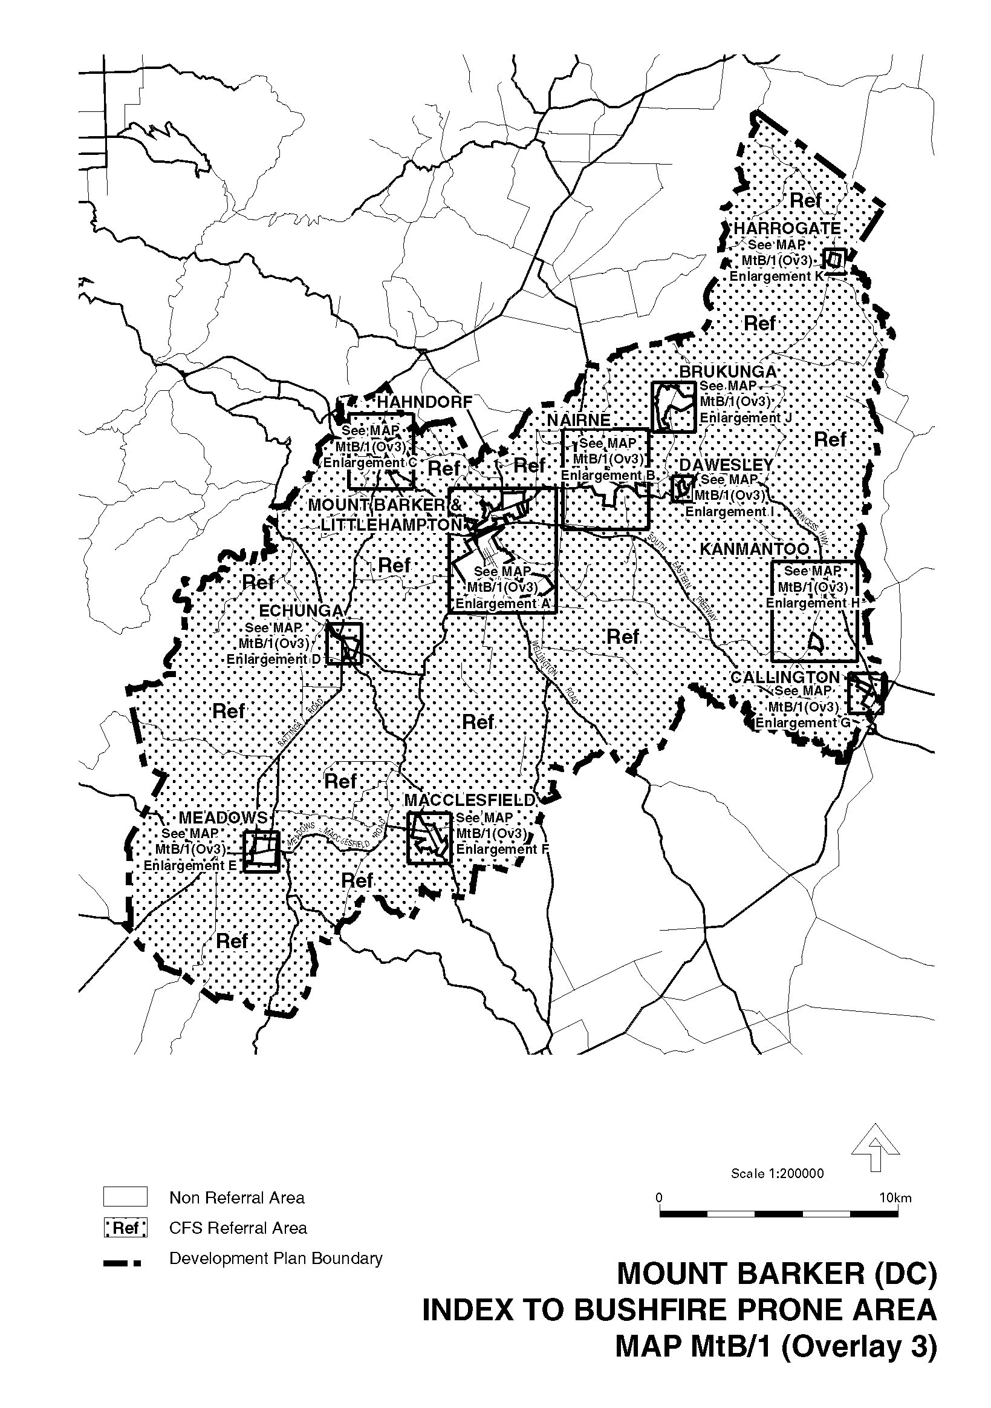
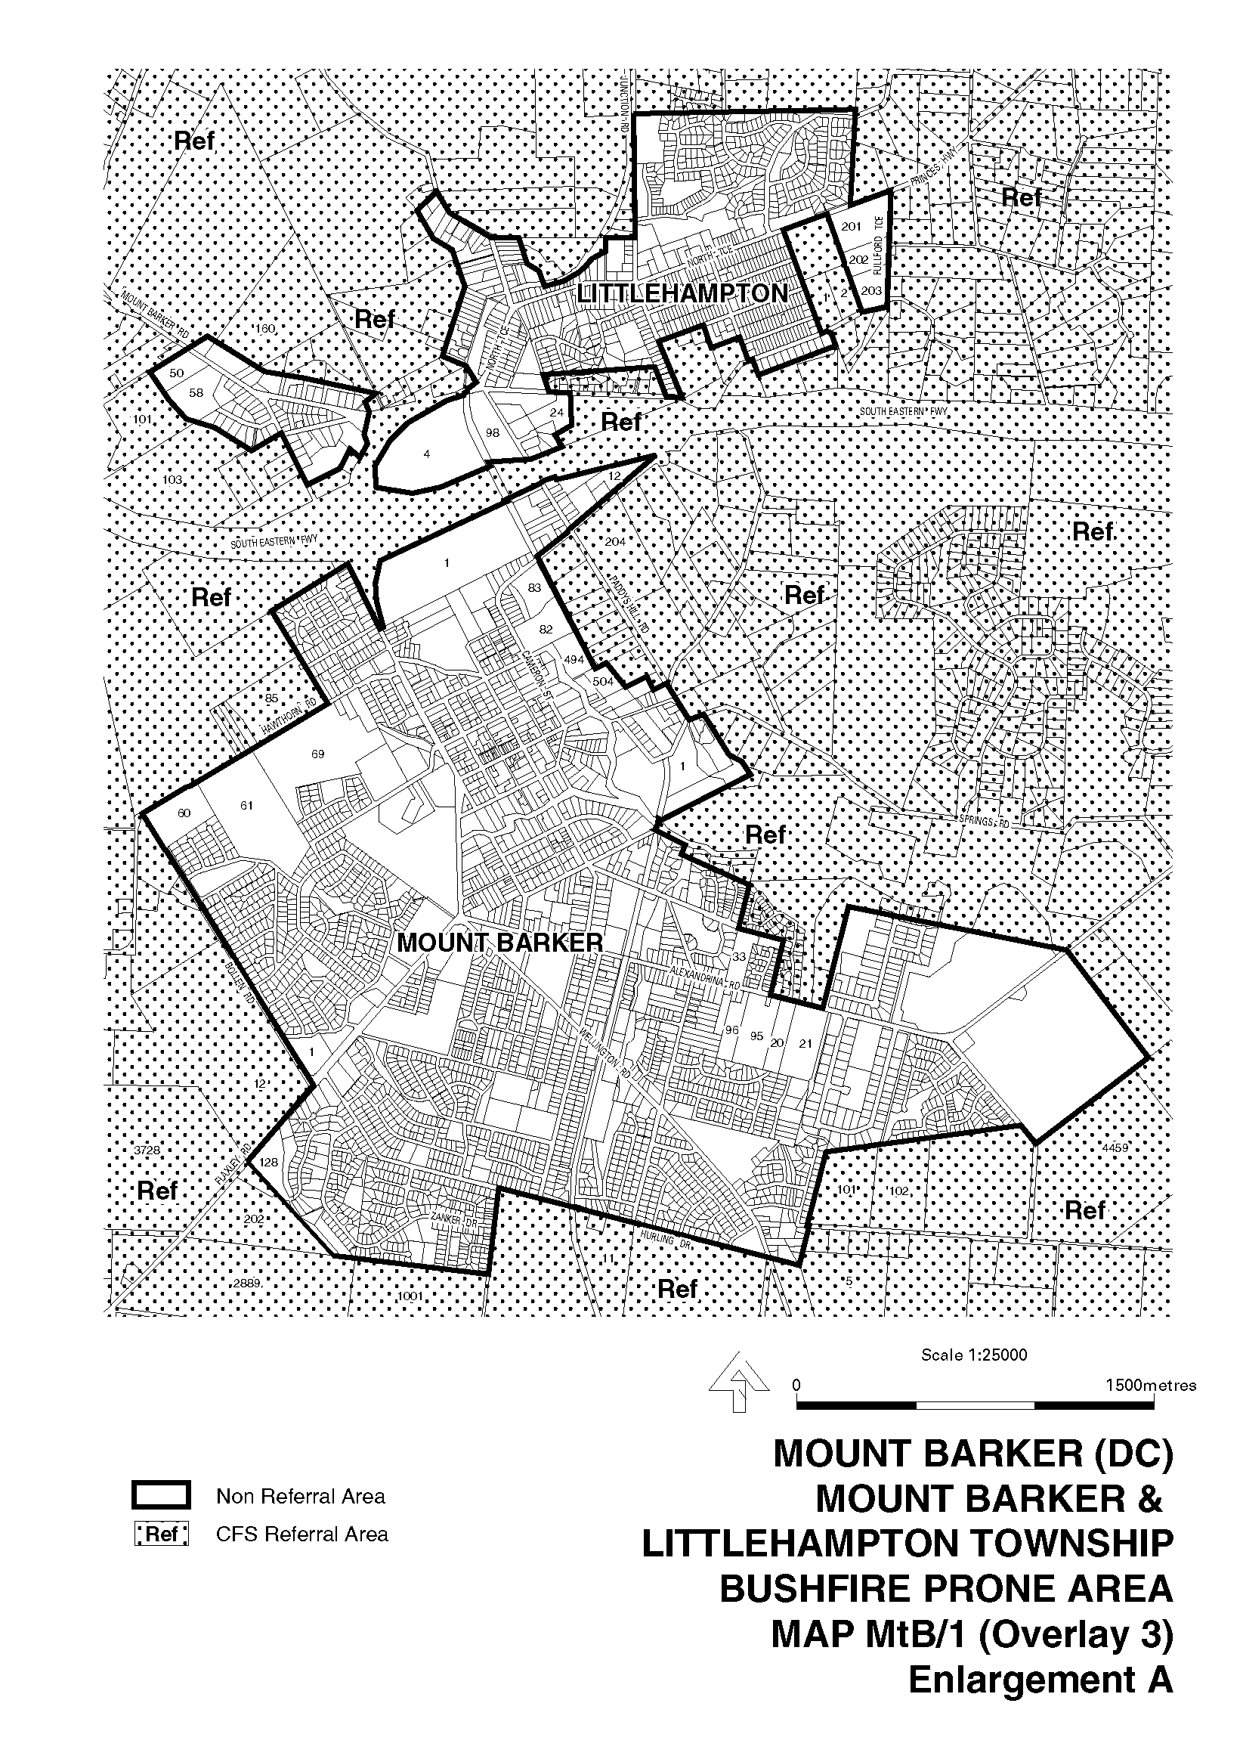
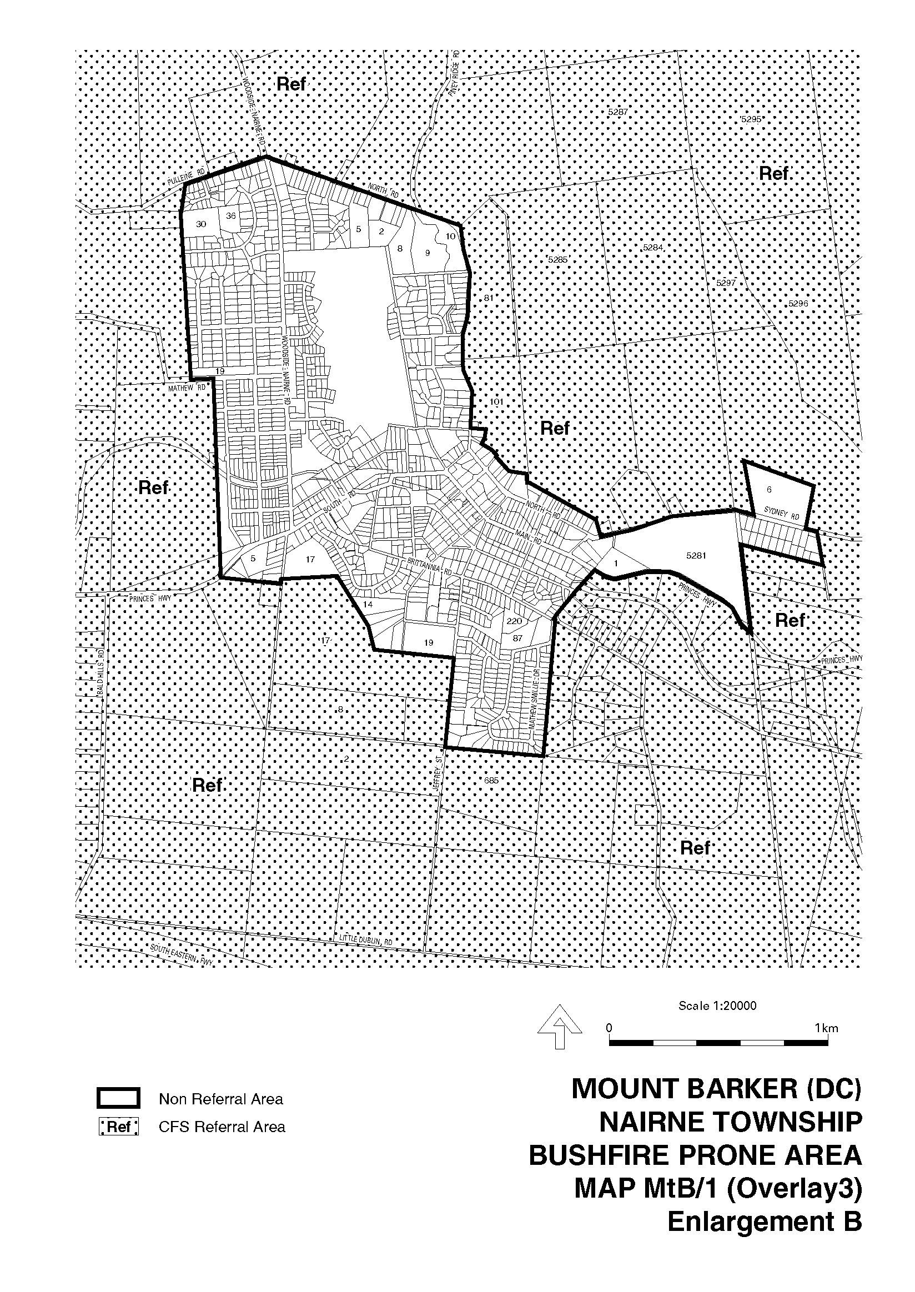
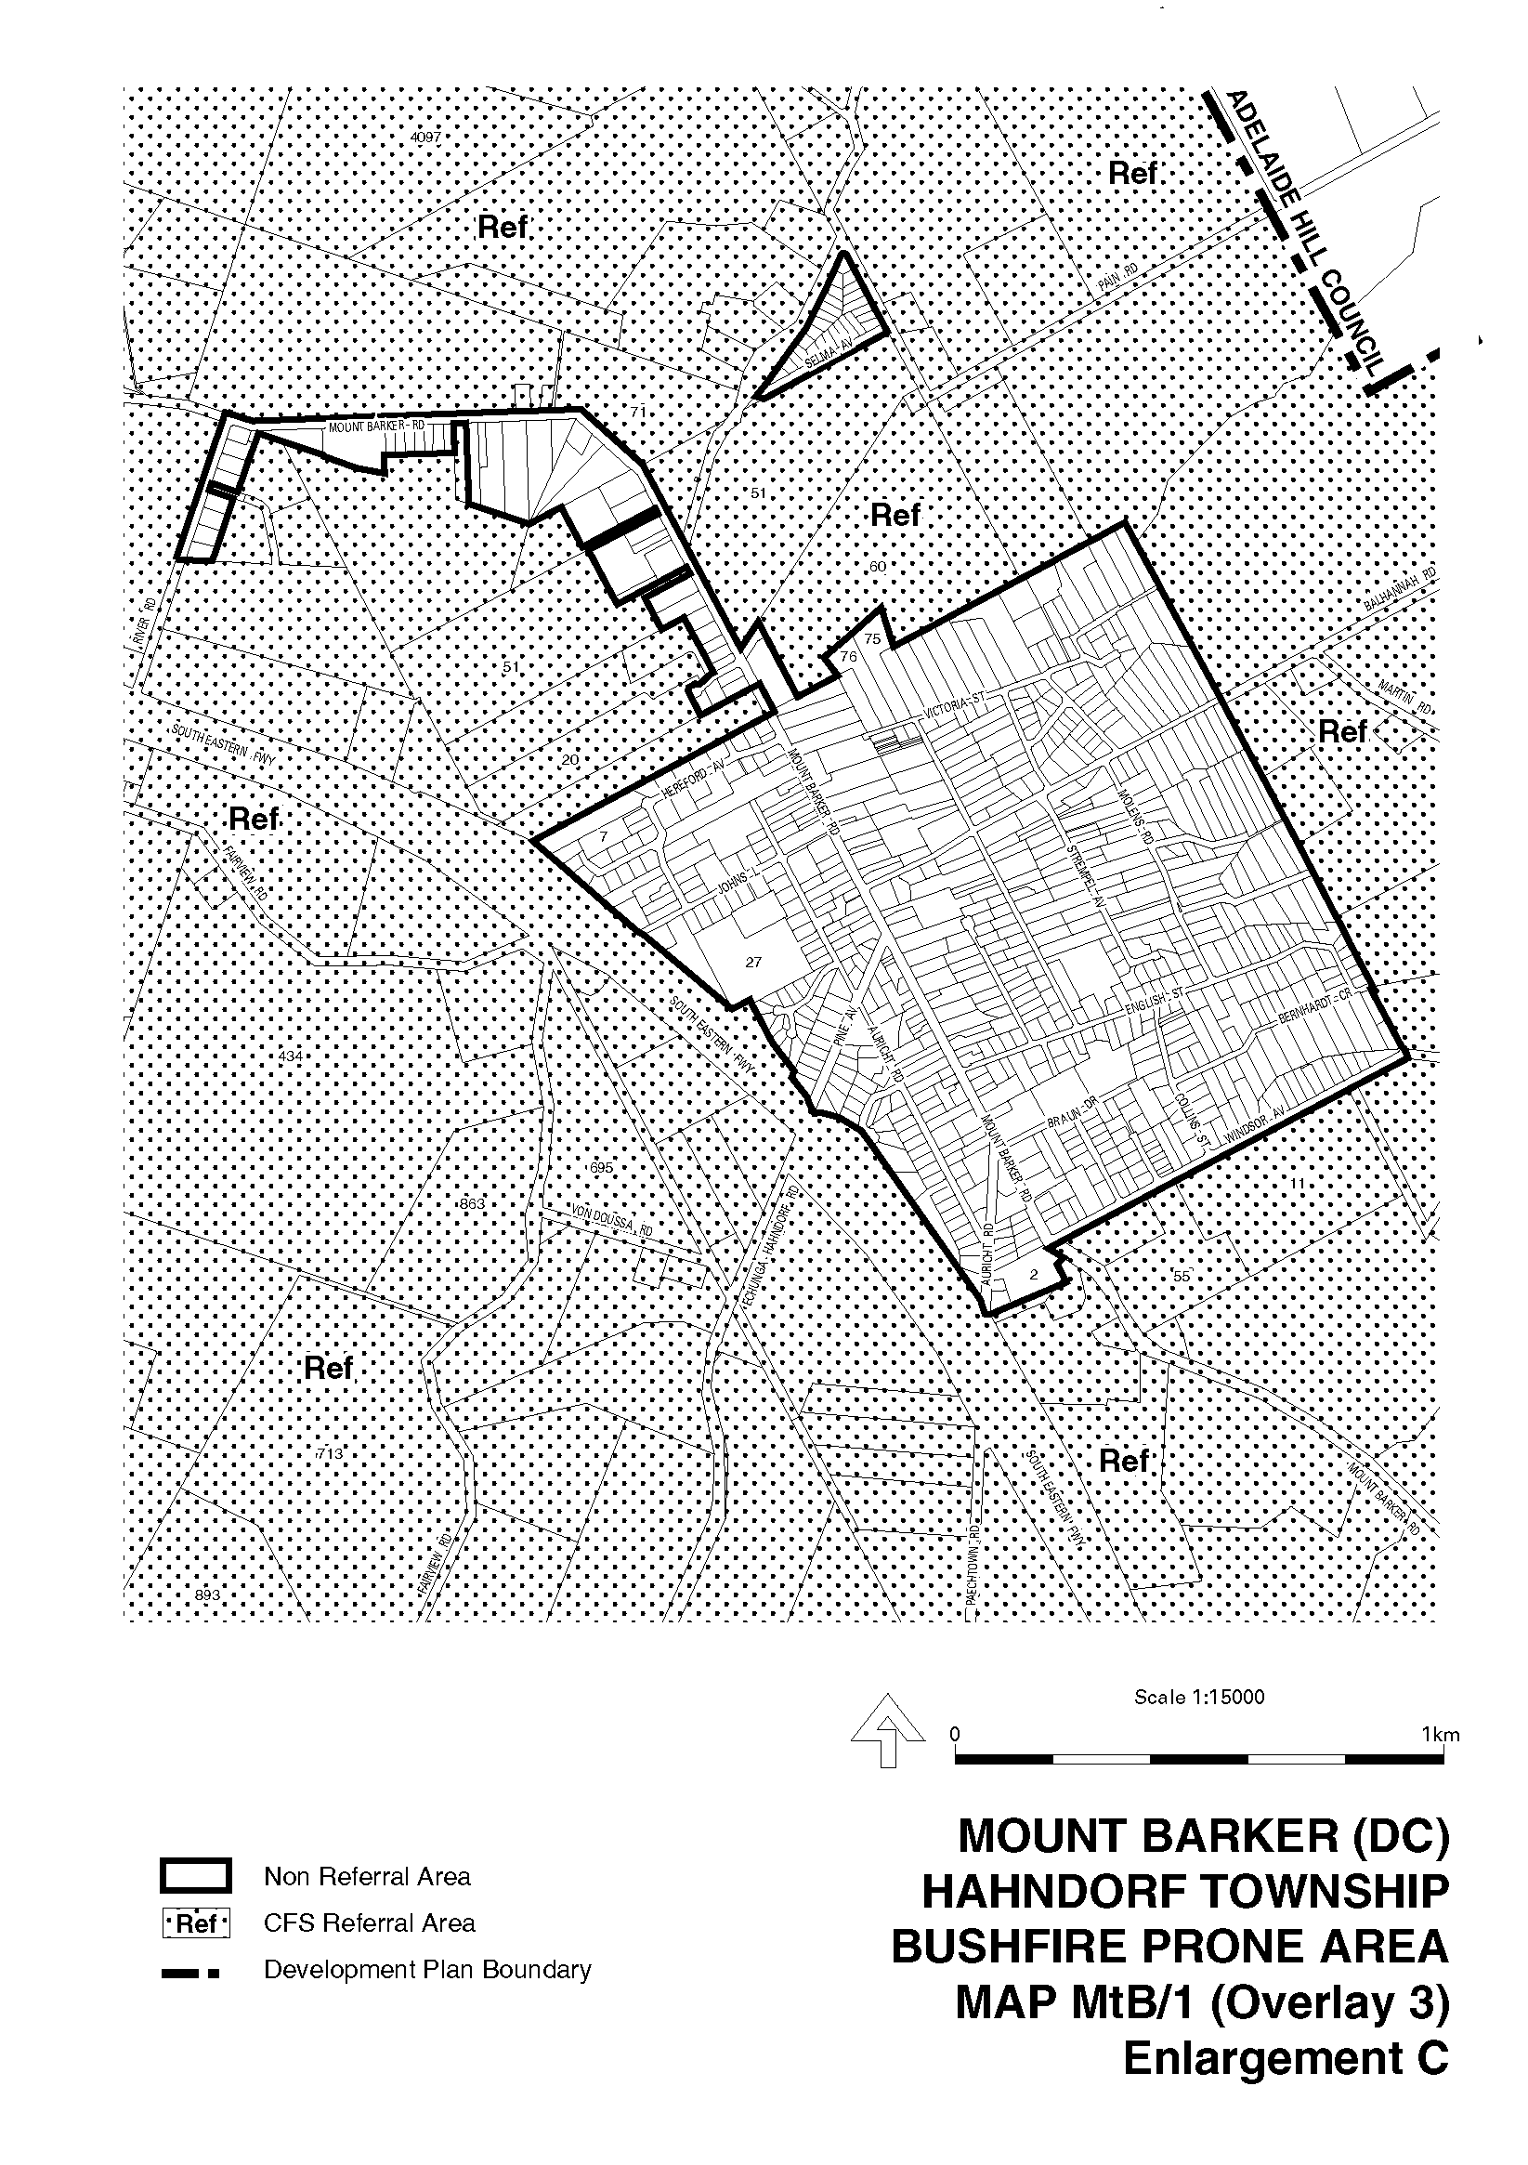
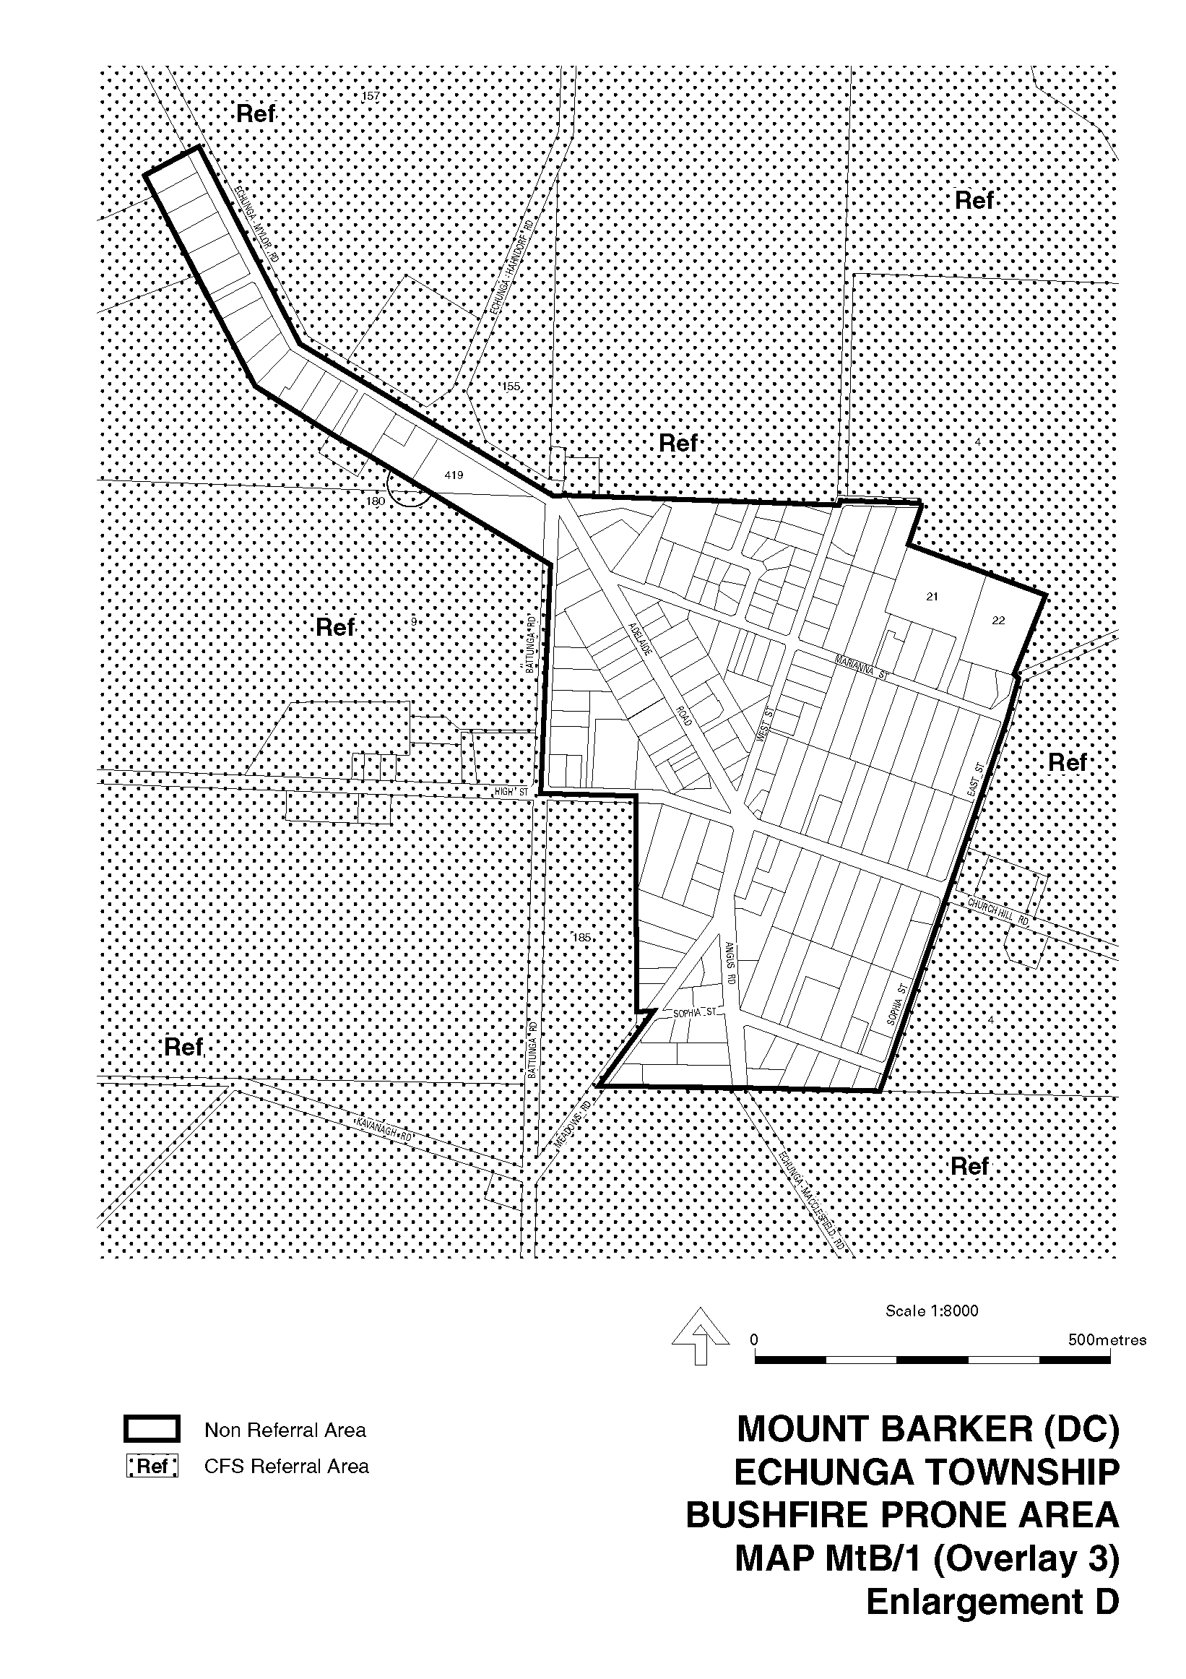
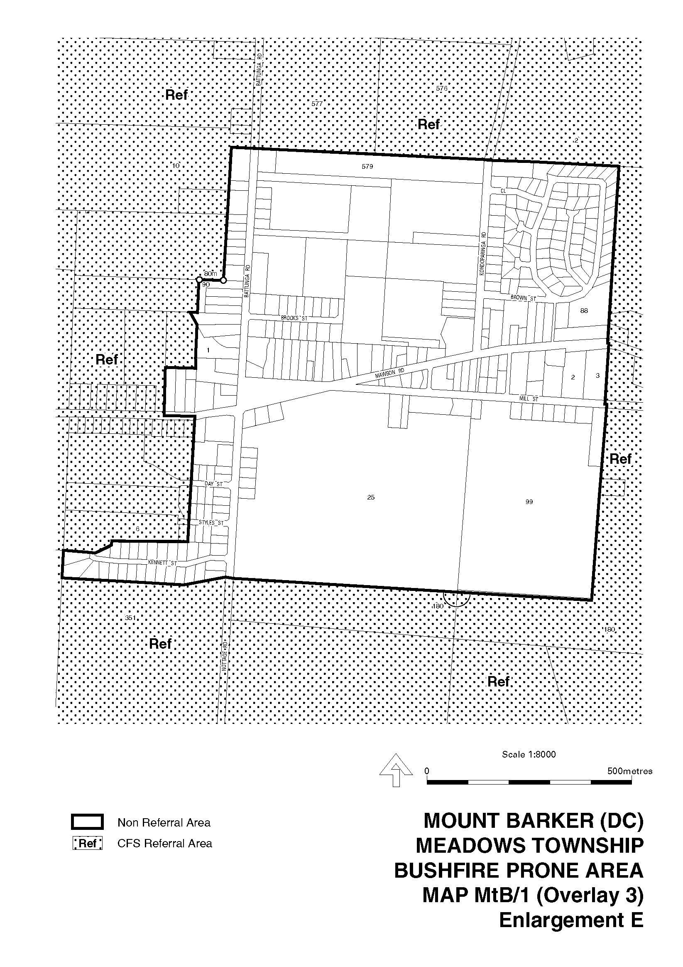
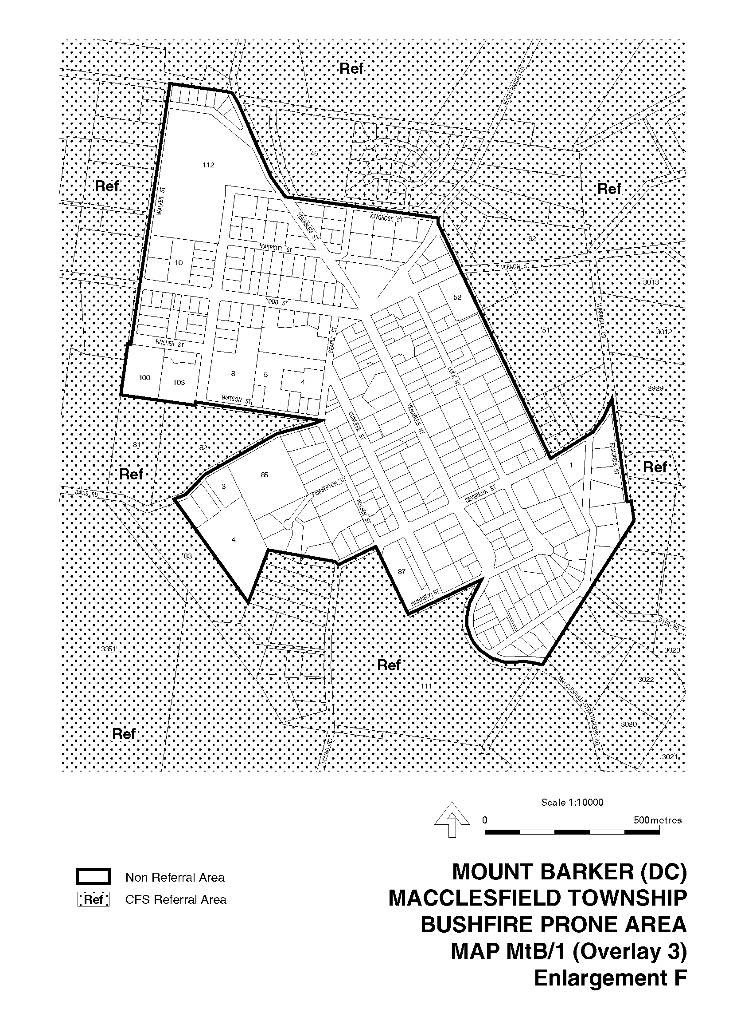
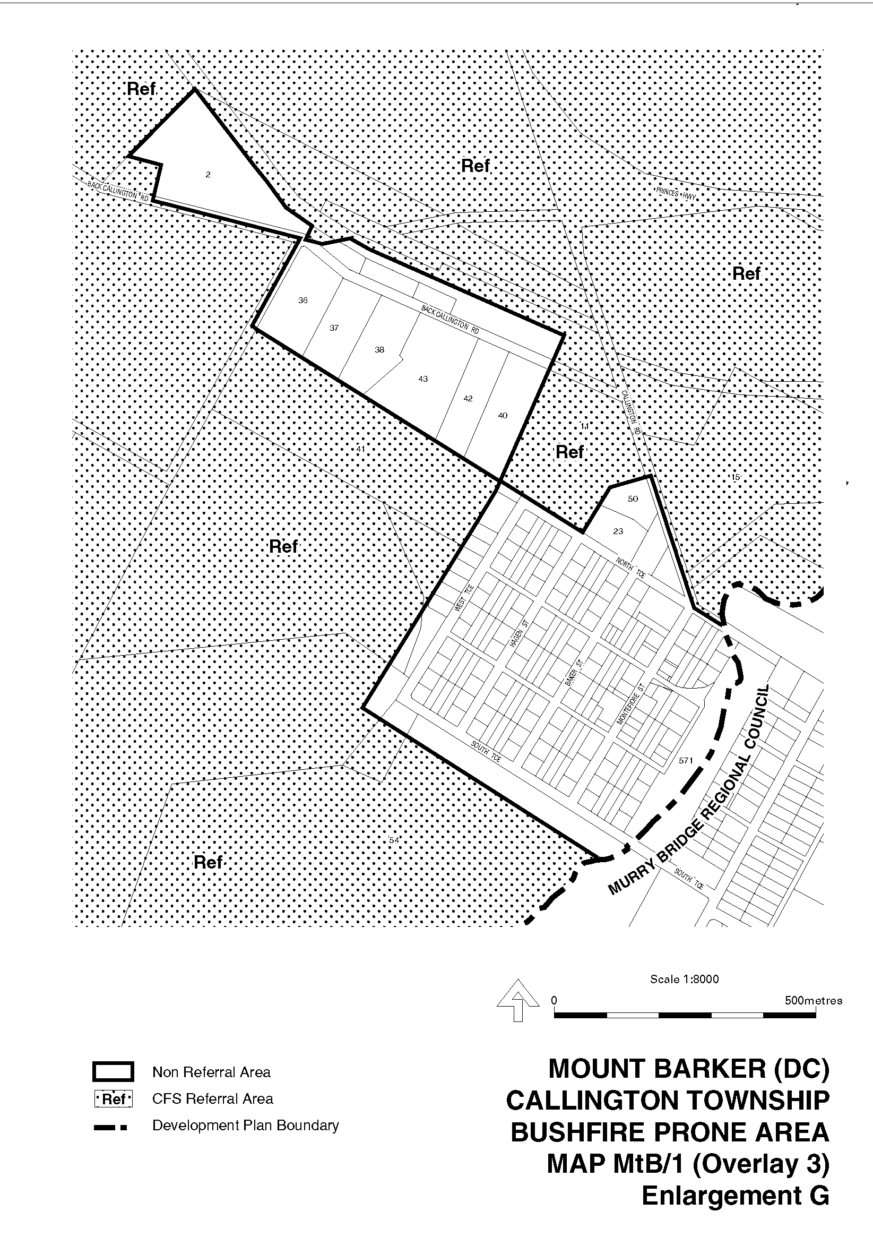
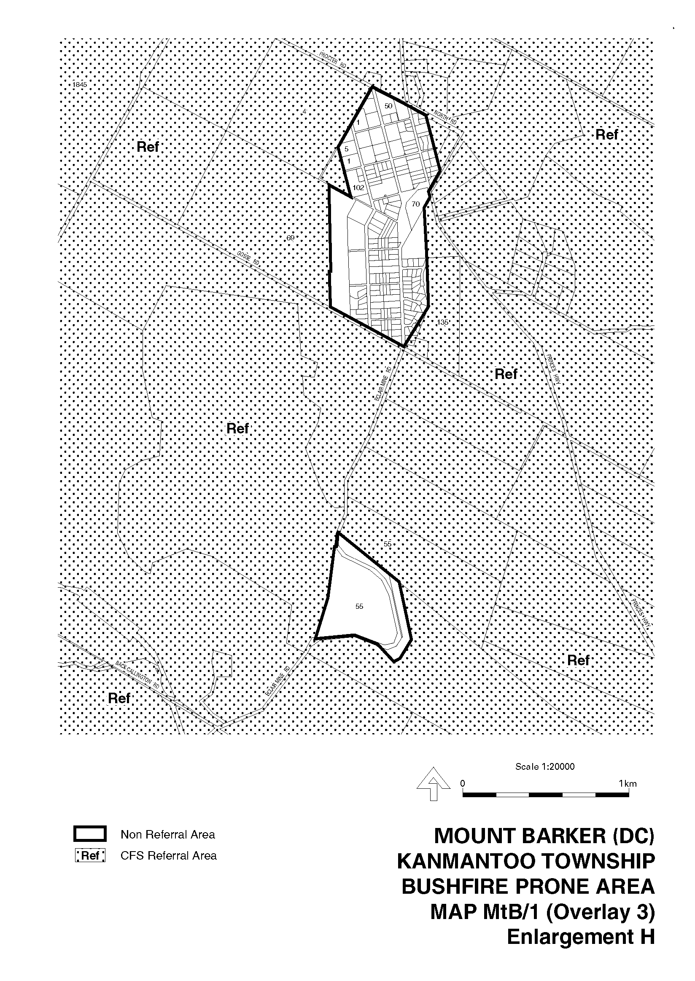
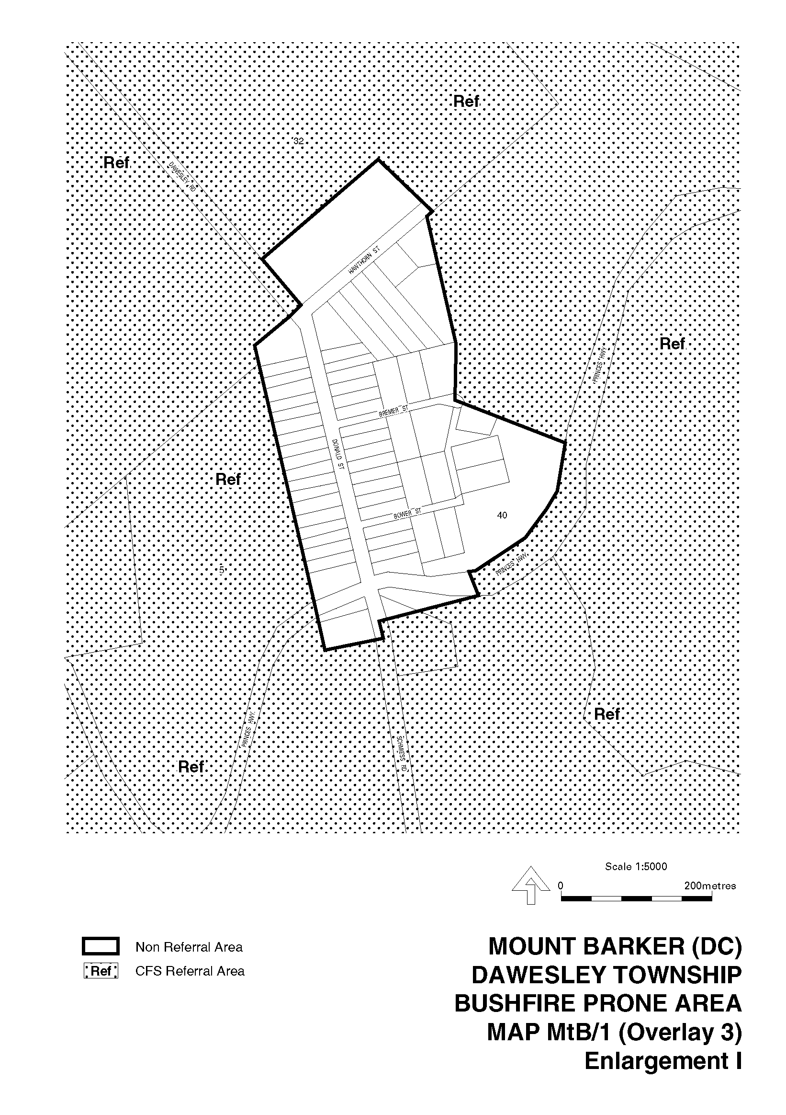
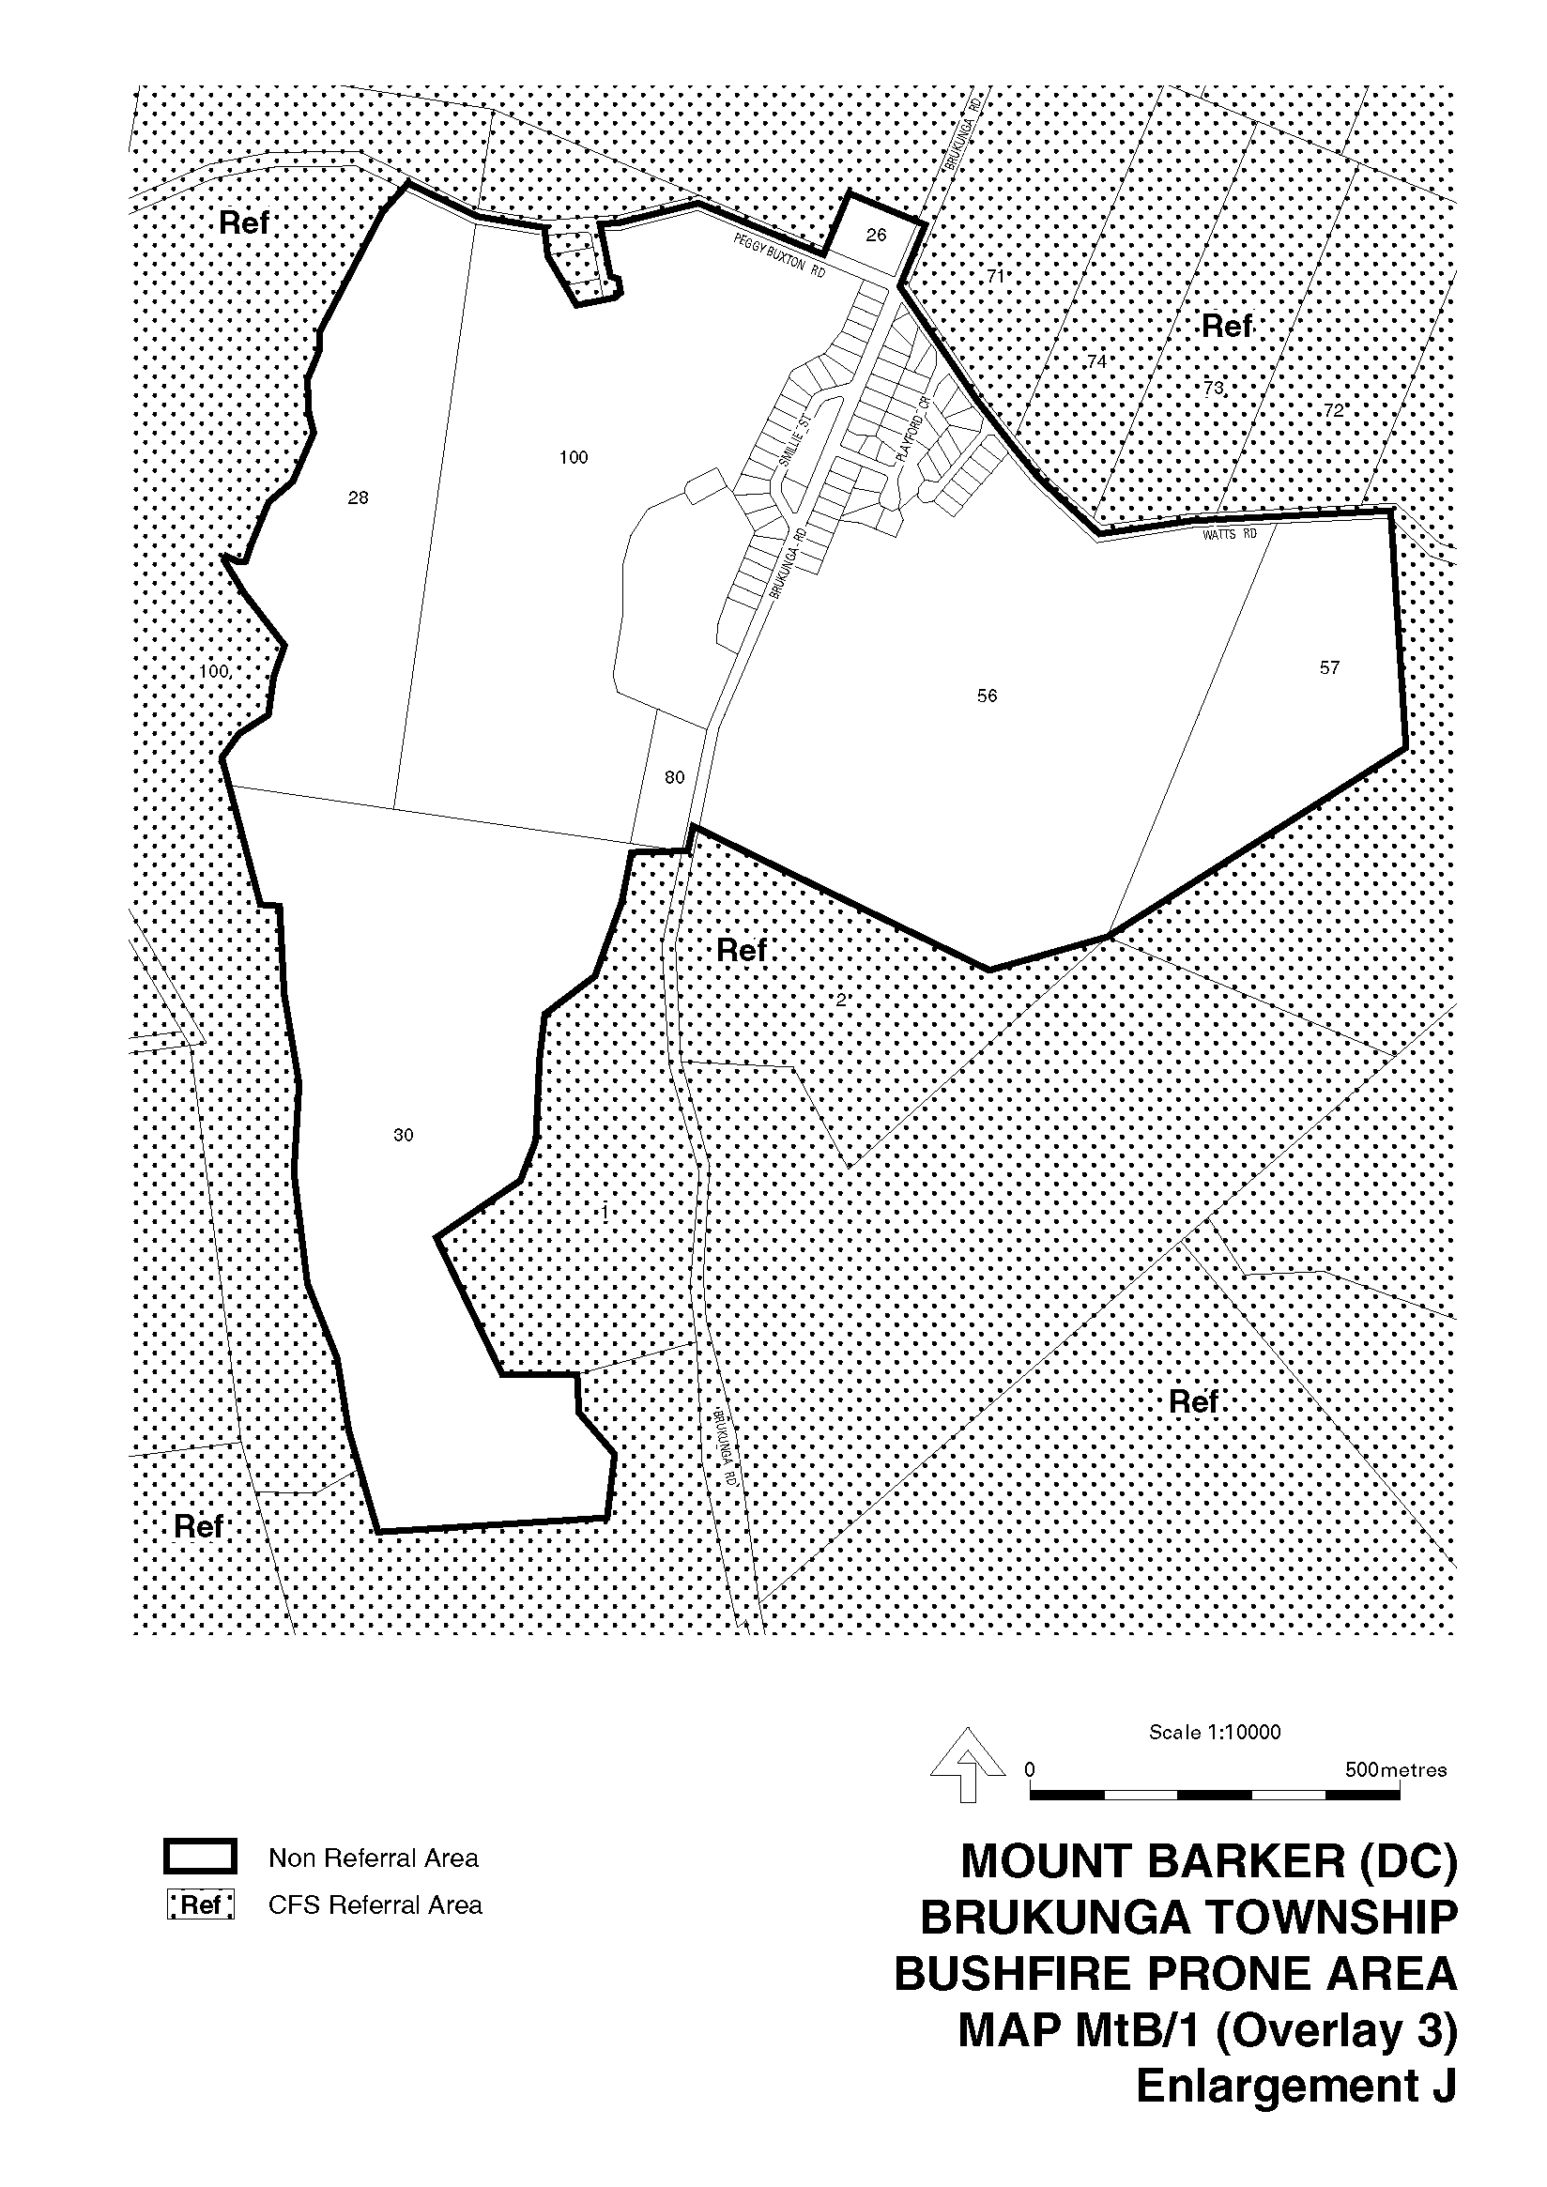
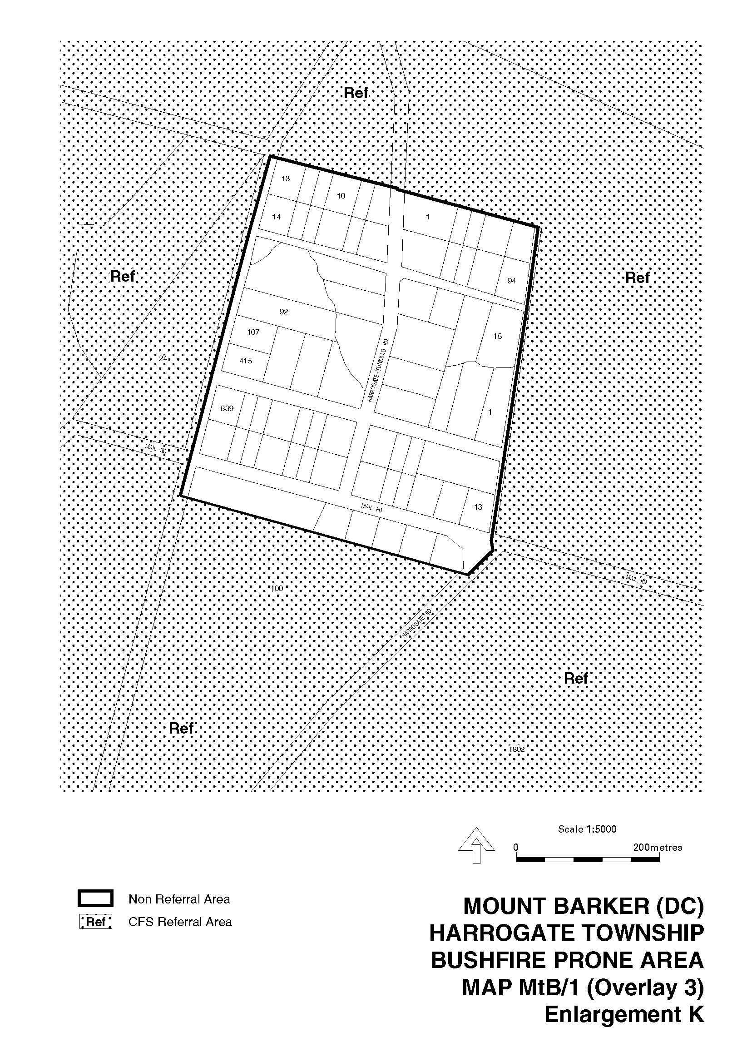
Dated 15 January 2004.
J. Weatherill, Minister for Urban Development and Planning
PLN 99/0367

DEVELOPMENT ACT 1993, SECTION 48 (2) (a)
Notice by the Governor’s Deputy
Preamble
1. Pursuant to subsection (1) of section 46 of the Development Act 1993, being of the opinion that a declaration was appropriate or necessary for the proper assessment of development of major environmental, social or economic importance, the Minister for Urban Development and Planning declared that section 46 of the Act applies to a proposed solid waste landfill facility at Allendale Road, Kalbeeba (see Gazette 31 July 2003 at page 3152).
2. An application for a proposed development within the ambit of the declaration was lodged with The Barossa Council on 20 March 2003 (see Development Application 960/00769) and received by the Development Assessment Commission on 15 April 2003 (and also see letters relating to the proposed development from Access Planning (SA) Pty Ltd dated 25 June 2003 and 28 October 2003).
3. I have decided to indicate pursuant to section 48 (2) (a) of the Development Act 1993, that I will not, in relation to the proposed development referred to in clause 2, grant a develop-ment authorisation for the development.
Notice
PURSUANT to section 48 (2) (a) of the Development Act 1993 and with the advice and consent of the Executive Council, I indicate that I will not, in relation to the proposed development referred to in clause 2 of the preamble, grant a development authorisation for the development.
Given under my hand at Adelaide, 15 January 2004.
Bruno Krumins, Governor’s Deputy

DEVELOPMENT ACT 1993, SECTION 26 (8): MOUNT BARKER (DC) DEVELOPMENT PLAN—KANMANTOO AND CALLINGTON INDUSTRY PLAN AMENDMENT
Preamble
1. The Development Plan amendment entitled ‘Mount Barker (DC) Development Plan—Kanmantoo and Callington Industry Plan Amendment’ (the Plan Amendment) has been finalised in accordance with the provisions of the Development Act 1993.
2. The Minister for Urban Development and Planning has decided to approve the Plan Amendment.
Notice
PURSUANT to section 26 of the Development Act 1993, I—
(a) approve the Plan Amendment; and
(b) fix the day on which this notice is published in the Gazette as the day on which the Plan Amendment will come into operation.
Dated 15 January 2004.
J. Weatherill, Minister for Urban Development and Planning
PLN 01/0043

DEVELOPMENT ACT 1993, SECTION 25 (17): CITY OF PLAYFORD—RESIDENTIAL DESIGN PLAN AMENDMENT
Preamble
1. The Development Plan amendment entitled ‘City of Playford—Residential Design Plan Amendment’ (the Plan Amendment) has been finalised in accordance with the provisions of the Development Act 1993.
2. The Minister for Urban Development and Planning has decided to approve the Plan Amendment.
Notice
PURSUANT to section 25 of the Development Act 1993, I—
(a) approve the Plan Amendment; and
(b) fix the day on which this notice is published in the Gazette as the day on which the Plan Amendment will come into operation.
Dated 15 January 2004.
J. Weatherill, Minister for Urban Development and Planning
PLN 00/0491

DEVELOPMENT ACT 1993, SECTION 48
Decision by the Development Assessment Commission as Delegate of the Governor
1. The decision of the Governor under section 48 of the Development Act 1993, to approve the development of a Magnesium Processing Facility and Gas-Fired Power Station located approximately 8 km north-east of Port Pirie was published in the Gazette on 5 July 2001.
2. On request from the proponent the period of substantial commencement was extended to 5 July 2004 by the Development Assessment Commission as delegate of the Governor.
3. Application has now been made to the Development Assessment Commission as delegate of the Governor under section 48 of the Development Act 1993 for the approval of a land division to establish separate parcels of land for the Magnesium Processing Facility and Gas-Fired Power Station respectively.
4. The Development Assessment Commission has, in consider-ing the application, had regard to all relevant matters under section 48 (5) of the Development Act 1993.
5. The Development Assessment Commission is satisfied that the amendments do not require the preparation of a further or amended Environmental Impact Statement.
Decision
PURSUANT to section 48 of the Development Act 1993, the Development Assessment Commission, as delegate of the Governor, grants development approval to the amended develop-ment of a site approximately 8 km north-east of Port Pirie for a Magnesium Processing Facility and Gas-Fired Power Station proposal (but not including the boat ramp), as described in the application submitted by SAMAG 11 August 2000 (as amended by the Environmental Impact Statement dated November 2000, the Response Document dated May 2001, plans submitted to Planning SA on 7 June 2001, the revised application dated 8 June 2001, and documents dated 8 June 2001, 13 June 2001, and 14 June 2001) and subsequently amended in the land division application 354/D515/03, lodged on 29 October 2003, subject to conditions.
Conditions of Approval:
1. The development must be undertaken in accordance with:
(a) The following plans contained in the Environmental Impact Statement dated November 2000, except to the extent that they are varied by the plans described in paragraph 1 (b) and 1 (c):
• Drawing Titled: Weeroona Island Access, Causeway and Services; Drawing Number: Figure 2.9.
• Drawing Titled: CW Inlet and Outlet Arrangement with Outlet Plume (Three Port Diffuser); Drawing Number: Figure 7.4.5.
• Drawing Titled: Residue Pond, Boron Pond and Sodium Sulphate Pond—Concept Design; Drawing Number: Figure 7.6.1.
• Drawing Titled: Isometric Site Layout, East Elevation; Drawing Number: Figure 7.11.1.
(b) The following plans contained in the Response Document dated May 2001, except to the extent that they are varied by the plans described in paragraph 1 (c):
• Drawing Titled: SAMAG Weeroona S.A. Cooling Water Concept Pump Chamber, Details; Drawing Number: Figure R2.1.
• Drawing Titled: SAMAG Weeroona S.A. Pump Chamber and Inlet Channel, Detail—Isometric; Drawing Number: Figure R2.3.
• Drawing Titled: SAMAG Weeroona S.A. Pump Chamber and Inlet Channel, Indicative Plan; Drawing Number: Figure R2.2.
• Drawing Titled: SAMAG Weeroona S.A. Pump Chamber and Inlet Channel, Arrangement—Isometric; Drawing Number: Figure R2.4.
(c) The following plans lodged with Planning SA on 7 June 2001:
• Drawing Titled: Site Layout Plan; Drawing Number: Map 2A (no date).
• Drawing Titled: Overall Site Plan; Drawing Number: S1001-006, Revision D (dated 6 June 2001).
• Drawing Titled: Turbine Hall, Structural Isometric; Drawing Number: 100200-SK509, Issue B (dated 26 February 2001).
• Drawing Titled: Store/Workshop Building, Elevations and Sections; Drawing Number: 100200-SK044, Issue A (dated August 2000).
• Drawing Titled: Site Layout Plan, Option B; Drawing Number: 100200-SK101, Issue M (dated August 1999).
• Drawing Titled: Cell House, General Sections 1: Drawing Number: S1001-204, Revision E (dated 6 June 2001).
• Drawing Titled: Cell House, General Isometric; Drawing Number: S1001-201, Revision D (dated 8 November 2000).
• Drawing Titled: Cast House, Crucible Maintenance Building; Drawing Number: 9312-SK105, Revision B (dated March 2001).
• Drawing Titled: Cast House, Equipment Arrangement Plan; Drawing Number: 9312-SK102, Revision C (dated March 2001).
• Drawing Titled: Cell House, Cast House, Roadway Access; Drawing Number: 9312-SK101, Revision E (dated March 2001).
• Drawing Titled: Prill Handling, Bin Details; Drawing Number: S1001-405, Revision C (dated September 2000).
• Drawing Titled: Ore Receival and Crushing, Storage Shed Details; Drawing Number: 9312-SK110, Revision B (dated May 2001).
• Drawing Titled: Arrangement Plan, Process Unit; Drawing Number: D35296-0, Revision K (dated 6 June 2001).
• Drawing Titled: Process Unit 20 Leaching, 21 MG(OH)2 Treatment and Slag Dissolving, 22 Leaching; Drawing Number: D35300-1, Revision C (31 October 2000).
• Drawing Titled: Process Unit 20 Leaching, 23 Brine Pretreatment; Drawing Number: D35301-1, Revision C (dated 31 October 2000).
• Drawing Titled: Process Unit 30 Brine Purification, 34 Pure Brine Storage; Drawing Number: D35302-1, Revision C (dated 31 October 2000).
• Drawing Titled: Process Unit 30 Brine Purification, 31 SO4-Removal, 32 BaC12-Recovery, 33 Boron-Removal; Drawing Number: D35303-1, Revision B (dated 30 October 2000).
• Drawing Titled: Process Unit 70 Acid Plant and Gas Treatment; Drawing Number: D35304-1, Revision B (dated 30 October 2000).
• Drawing Titled: Process Unit 40 Brine Concentration, 41 Evaporation, 42 Drying; Drawing Number: D35305-1, Revision C (dated 31 October 2000).
• Drawing Titled: Process Unit 73, 74 Waste Gas Treatment Unit 73, HCL Storage Unit 74 and Activated Carbon Filter; Drawing Number: D35306-1, Revision 2 (dated 31 October 2000).
(d) The land division plan lodged with the Development Assessment Commission on 29 October 2003: Application Number 354/D515/03.
(e) The following documents:
• Environmental Impact Statement, proposed Mag-nesium Processing Facility and Gas-Fired Power Station, Sinclair Knight Merz (for SAMAG Ltd), dated November 2000 (except to the extent that it may be varied by a subsequent document in this paragraph).
• Response Document, proposed Magnesium Proces-sing Facility and Gas-Fired Power Station, Sinclair Knight Merz (for SAMAG Ltd), dated May 2001 (except to the extent that it may be varied by a subsequent document in this paragraph).
• Assessment Report, Magnesium Processing Facility and Gas-Fired Power Station, Minister for Transport and Urban Planning, dated June 2001.
• Letter dated 8 June 2001 from SAMAG Ltd to the Minister for Transport and Urban Planning regarding a revised application and plans.
• Letter dated 8 June 2001 from SAMAG Ltd to Department for Water Resources regarding the leach residue pond and discharge of the boron waste stream.
• Letter dated 14 June 2001 from the Department for Water Resources to Planning SA regarding the solid waste disposal pond and protection of groundwater resources.
• Letter dated 13 June 2001 from Transport SA to SAMAG Ltd regarding the access road from National Highway One.
• Letter dated 14 June 2001 from SAMAG Ltd to the Minister for Transport and Urban Planning regarding the access road from National Highway One.
2. No works may be commenced unless and until a private certifier, or the Port Pirie Regional Council and The District Council of Mount Remarkable, have certified to the Develop-ment Assessment Commission that all work that constitutes building work under the Development Act 1993, complies with the Building Rules.
3. The proponent must construct the intake/outfall pipes during the months of March, April and May (to minimise the disruption to migratory bird species; and to minimise the impact of dredging on marine native vegetation communities, thus avoiding stressful conditions during summer and low growth rates/ productivity in winter, and reduce the effects of turbidity).
4. Construction of the development hereby authorised must not be commenced until:
(a) The Marine Environmental Management and Monitor-ing Plan (Construction and Operational Phases) has been developed to the satisfaction of the Coast Protection Board and approved by the Development Assessment Commission.
(b) The Environmental Management and Monitoring Plan has been developed to the satisfaction of the Environ-ment Protection Authority and approved by the Development Assessment Commission.
(c) The artefacts in the two identified archaeological sites on the plant site have been collected and recorded by representatives of the Nukunu People’s Council.
(d) The proponent has reached agreement with the Nukunu People’s Council regarding the monitoring of earth-works and other activities likely to disturb the dune area lying between the two identified archaeological sites and along the transmission line and pipeline corridors, and notified the Development Assessment Commission of such an agreement.
5. The proponent must not blast for the purpose of construct-ing the pipe trench, unless explosion vibration characteristics and monitoring requirements have been agreed with the Environment Protection Authority and The District Council of Mount Remarkable. Blasting must be carried out in compliance with Australian Standard 2187.
6. The typical operation of the proposed development must not exceed an equivalent noise level of 35 dB(A) at the nearest occupied residences when measured in accordance with the Environment Protection (Industrial Noise) Policy 1994. Compliance with this condition must be achieved for worst-case weather conditions (those conducive to noise propagation) equivalent to a Class F Pasquill-Gifford stability category.
7. The environmental noise assessment associated with the construction phase of the project must be repeated following final selection of the construction equipment. The environmental noise assessment must identify the noise reduction measures that are reasonable and practicable. The noise assessment report must be submitted to the Environment Protection Authority, together with the name of the person who will be responsible for ensuring that the measures outlined in the report will be implemented. The relevant content of the assessment must be shown to have been included within an approved construction plan, and this construction plan must be implemented. The measures that are reasonable and practicable (to be listed in the construction plan) must include as a minimum:
• Restriction of activities that will not achieve Condition 6 to Monday through Saturday (7 a.m. to 6 p.m.) or Sunday (9 a.m. to 6 p.m.).
• Provision of maintained proprietary sound reduction measures such as mufflers and enclosures to all relevant equipment for which proprietary treatment is available.
• Provision of a monitoring program to ensure Condition 6 is achieved.
• Guidance within the construction plan of the steps to be taken should the monitoring program indicate an activity being undertaken that exceeds Condition 6.
• Community notification of proposed start and finish times of construction activities and identification of any activities that may have a greater impact.
8. The environmental noise assessment associated with the operational phase of separate major items of plant and equipment must be repeated following final selection of the plant and equipment to be used. The extent and technical details of the noise reduction measures to achieve Condition 6 shall be provided within this assessment and certified by an acoustic engineer (who must be eligible for membership of both the Institution of Engineers Australia and the Australian Acoustical Society), prior to the installation of the said plant equipment.
9. The proponent must undertake background ambient air monitoring at the plant site and inside and outside of the buffer zone for a period of 12 months prior to the commencement of operation. The monitoring must be undertaken to standards prescribed by the Environment Protection Authority. The following analytes must be sampled at each site for the 12 month period:
Particulate matter (PM₁₀ and TSP)
NOx
Cl₂
HCl
SO₂
Dioxins and Furans
PCB’s
HCB’s
The location of the monitoring sites must be to the reasonable satisfaction of the Environment Protection Authority, and the results of monitoring must be provided to the Environment Protection Authority.
10. The proponent must install a meteorological monitoring station within the plant site, and properly operate and record data from that monitoring station for a period of at least 12 months prior to the commencement of operation. The monitoring must be undertaken to standards prescribed by the Environment Protection Authority. The location of the monitoring site must be to the reasonable satisfaction of the Environment Protection Authority, and the results of monitoring must be provided to the Environment Protection Authority.
11. The proponent shall lodge two copies of a certified survey plan of the land division numbered 354/D515/03 with the Development Assessment Commission for certificate purposes.
Notes to Applicant:
• The Marine Environmental Management and Monitoring Plan (Construction and Operational phases) requires further development in order to receive approval, by the addition of further particulars of monitoring and dredging.
• The Environmental Management and Monitoring Plan requires further development in order to receive approval, by the addition of requirements outlined in the Assessment Report.
• If the development is not commenced by substantial work on the site by 5 July 2004, unless an additional extension of time is granted by the Development Assessment Commission as delegate of the Governor, this develop-ment authorisation may be cancelled by the Governor.
• The proponent should undertake the project in compliance with all relevant State and Commonwealth legislation (and as amended from time to time) as it affects the develop-ment site, including pipelines, power transmission lines and water intake and discharge areas.
• If during the construction or operation of the development the proponent discovers evidence of an Aboriginal site or any Aboriginal objects or remains, the proponent is required by the Aboriginal Heritage Act 1988 to report particulars of such discovery as soon as practicable to the Minister administering that Act and thereafter comply with any directions given by that Minister.
• The proponent has an obligation under the Aboriginal Heritage Act 1988, whereby any ‘clearance’ work which may require permission to disturb, damage or destroy Aboriginal Sites, must be undertaken with the full authorisation of the Minister for Aboriginal Affairs, according to section 23 of the Aboriginal Heritage Act 1988.
• During the detailed design stage, the proponent should investigate the option of locating the discharge pipeline under the intake trench in a single ‘disturbance corridor’, as opposed to establishing two separate corridors.
• A Landscaping Plan should be prepared that indicates the areas to be revegetated, species to be planted, methodologies and monitoring. The Plan should include a section on the management and protection of remnant native vegetation found on the site, especially to integrate existing stands with boundary plantings (for example, understorey plantings may be needed to increase screening effectiveness). Pest plant and animal control aspects should also be addressed. The plan should be prepared in consultation with relevant government agencies (e.g. Department for Environment and Heritage and Primary Industries and Resources SA), and be incorporated into the Environmental Management and Monitoring Plan.
• If the proponent intends to proceed with the proposed boat ramp improvements, an application should be lodged for development authorisation of the boat ramp improve-ments. Detailed design plans and cross-sections should be provided for consent. The public boat ramp facility should be generally designed in accordance with the South Australian Boating Advisory Committee’s Guidelines for Planning, Design and Construction of Boat Launching Facilities and be independently certified by a registered engineer, to the reasonable satisfaction of Transport SA (Marine Facilities), prior to construction commencing. Final design and construction of the boat ramp facility should ensure that any run-off or accidental spills are prevented from entering the basin without suitable prior treatment to reduce pollutants.
• In the event of a failure of the SA Water supply, the Magnesium Plant would need to instigate a controlled shut down of critical sections of the operation which rely on a continuous supply of water. An on-site storage of sufficient size to mitigate the risk to the Plant should be considered. If the currently disused Nelshaby Reservoir is to be considered as an emergency supply (an off-site storage), this water cannot be introduced into a potable water supply system due to potential contamination, and therefore would require a dedicated line at additional cost.
• A Soil Erosion and Drainage Management Plan should be prepared in accordance with the EPA Stormwater Pollution Prevention Code of Practice for the Building and Construction Industry (1999) for the site.
• Any proposal to clear native vegetation on the land, unless the proposed clearance is subject to an exemption under the Regulations of the Native Vegetation Act 1991, requires the approval of the Native Vegetation Council.
The Environment Protection Authority recommends that the following notes and proposed licence conditions are attached to any development authorisation which may be granted in relation to this proposal:
General Environmental Duty
• The applicant is reminded of its general environmental duty, as required by section 25 of the Environment Protection Act 1993, to take all reasonable and practical measures to ensure that its activities on the whole site, including during con-struction, do not pollute the environment in a way that causes or that may cause environmental harm.
Licence Requirements
• An environmental authorisation in the form of a licence is required for the operation of this development. Scheduled activities under the Environment Protection Act 1993, that will occur as a result of this proposal include:
• Chemical Storage and Warehousing Facilities;
• Chemical Works;
• Metallurgical Works;
• Mineral Works;
• Incineration;
• Waste or Recycling Depot;
• Activities Producing Listed Wastes;
• Crushing, Grinding or Milling;
• Fuel Burning;
• Discharges to Marine or Inland Waters;
• Dredging (required during construction phase);
• Earthworks Drainage (required during construction phase);
• Concrete Batching Works (required during construction phase).
• The proponent is required to submit a licence application to the Environment Protection Agency a minimum of 12 months prior to the commencement of operation. Conditions of licence will be related to the ongoing management of the operation to ensure its environmental suitability.
• A licence may be refused where the applicant has failed to comply with the development authorisation.
• The Environment Protection Authority is likely to impose conditions of licence to the following effect:
(a) Proposed Noise Licence Condition 1: Noise monitoring shall occur during commissioning and annually thereafter at positions nominated by the Environment Protection Authority. The indices L_{amax}, L_{Aeq} and L_{A90} shall be measured as a minimum over consecutive 15 minute periods to record at least the equivalent of 7 days of data. Weather conditions sufficient to determine the Pasquill-Gifford stability category shall be recorded for the measurement period. Attended measurements of the above indices shall occur on two separate occasions during the automatic logging night period. The attended measurements shall also include measurements of the indices in 1/3 octave band spectrum format. A report
summarising the results of the noise monitoring shall be submitted to the nominated Environment Protection Agency Licence Co-ordinator within 14 days of completion of the monitoring.
(b) Proposed Noise Licence Condition 2: Where the noise monitoring indicates that operation of facility and ancillary equipment exceeds an equivalent noise level of 35 dB(A) when measured in accordance with the Environment Protection (Industrial Noise) Policy 1994, a noise reduction program shall be carried out. The noise reduction program will comprise identification of the responsible noise sources, determination of the reasonable and practicable measures available, and implementation of these measures following approval of the report by the Environment Protection Authority. The program shall be managed by an acoustic engineer.
• The assessment conducted by the Environment Protection Authority of the proposed project has been completed based upon the environmental standards at the time of assessment. It is recognised that environmental standards are changing rapidly in a number of areas, particularly in regard to the regulation and control of organochlorine emissions. Any improvements that are required as a result of these changing standards will be managed via conditions of the licence required under the Environment Protection Act 1993.
P Cockrum, Secretary, Development Assessment Commission

FISHERIES ACT 1982: SECTION 59
TAKE notice that pursuant to section 59 of the Fisheries Act 1982, Brian Corkhill and Just Cruisin Fish & Dive Charters, 7 Simpson Court, Morphett Vale, S.A. 5162 (the ‘principal exemption holder’), and the class of persons specified in Schedule 1 (the ‘other exemption holders’), are exempt from clauses 66, 73, 77A, 77B and 77C of Schedule 1 of the Fisheries (General) Regulations 2000, but only insofar as the exemption holders may exceed the prescribed boat limits during a chartered fishing trip on the Lady Penn in accordance with the allowable limits specified in Schedule 2 (the ‘exempted activity’), subject to the conditions specified in Schedule 3, from 15 January 2004 until 30 June 2004, unless varied or revoked earlier.
Schedule 1
Any person or persons who charter the boat Lady Penn from Brian Corkhill and/or Just Cruisin Fish & Dive Charters for the purpose of recreational fishing.
Schedule 2
1. Where the number of ‘other exemption holders’ exceeds six, all of the ‘other exemption holders’ on board the boat are each restricted to taking no more than one half of the daily bag limit (rounded up to nearest whole number if necessary) for those species of scalefish subject to a limit as specified in the Fisheries (General) Regulations 2000 in any one day.
2. Where the number of ‘other exemption holders’ exceeds six, each ‘other exemption holder’ may take no more than a combined total of 20 blue crabs and sand crabs in any one day.
3. Where the number of ‘other exemption holders’ exceeds six, all of the ‘other exemption holders’ on board the boat are each restricted to taking no more than 8 cuttlefish or 8 calamary or 8 cuttlefish and/or calamary in combination, in any one day.
4. Where the number of ‘other exemption holders’ exceeds six, all of the ‘other exemption holders’ on board the boat are each restricted to taking either 1 gummy shark or 1 school shark in any one day.
5. Where the number of ‘other exemption holders’ exceeds eight, each ‘other exemption holder’ may take no more than one rock lobster in any one day.
Schedule 3
1. The principal exemption holder, its employees or agents must not take any fish during the chartered fishing trip.
2. The principal exemption holder must not use any boat other than the Lady Penn for the purpose of engaging in the exempted activity.
3. Neither the principal exemption holder nor the other exemption holders may sell any fish taken pursuant to this notice.
4. The principal exemption holder must not accept any fish taken by the other exemption holders as all or part of the consideration for the charter agreement.
5. The principal exemption holder must contact PIRSA Fishwatch on 1800 065 522 at least 24 hours prior to commencing the exempted activity and advise the time and date of departure of the Lady Penn and the estimated time of return to port.
6. While engaged in the exempted activity the principal exemption holder must have in their possession a copy of this notice. Such notice must be produced to a PIRSA Fisheries Officer if requested.
7. The exemption holders must not contravene or fail to comply with the Fisheries Act 1982, or any regulations made under that Act except where specifically exempted by this notice.
Dated 7 January 2004.
J. Presser, Principal Fisheries Manager

FISHERIES ACT 1982: SECTION 59
TAKE notice that pursuant to section 59 of the Fisheries Act 1982, Jonnie Newton, P.O. Box 1130, Elliston, S.A. 5670 (the ‘principal exemption holder’), and the class of persons specified in Schedule 1 (the ‘other exemption holders’), are exempt from clauses 66, 77A and 77C of Schedule 1 of the Fisheries (General) Regulations 2000, but only insofar as the exemption holders may exceed the prescribed boat limits during a chartered fishing trip on the Apache in accordance with the allowable limits specified in Schedule 2 (the ‘exempted activity’), subject to the conditions specified in Schedule 3, from 15 January 2004 until 30 June 2004, unless varied or revoked earlier.
Schedule 1
Any person or persons who charter the boat Apache from Jonnie Newton for the purpose of recreational fishing.
Schedule 2
1. Where the number of ‘other exemption holders’ exceeds six, all of the ‘other exemption holders’ on board the boat are each restricted to taking no more than one half of the daily bag limit (rounded up to nearest whole number if necessary) for those species of scalefish subject to a limit as specified in the Fisheries (General) Regulations 2000 in any one day.
2. Where the number of ‘other exemption holders’ exceeds six, all of the ‘other exemption holders’ on board the boat are each restricted to taking no more than 8 cuttlefish or 8 calamary or 8 cuttlefish and/or calamary in combination, in any one day.
3. Where the number of ‘other exemption holders’ exceeds six, all of the ‘other exemption holders’ on board the boat are each restricted to taking either 1 gummy shark or 1 school shark in any one day.
Schedule 3
1. The principal exemption holder, its employees or agents must not take any fish during the chartered fishing trip.
2. The principal exemption holder must not use any boat other than the Apache for the purpose of engaging in the exempted activity.
3. Neither the principal exemption holder nor the other exemption holders may sell any fish taken pursuant to this notice.
4. The principal exemption holder must not accept any fish taken by the other exemption holders as all or part of the consideration for the charter agreement.
5. The principal exemption holder must contact PIRSA Fishwatch on 1800 065 522 at least 24 hours prior to commencing the exempted activity and advise the time and date of departure of the Apache and the estimated time of return to port.
6. While engaged in the exempted activity the principal exemption holder must have in their possession a copy of this notice. Such notice must be produced to a PIRSA Fisheries Officer if requested.
7. The exemption holders must not contravene or fail to comply with the Fisheries Act 1982, or any regulations made under that Act except where specifically exempted by this notice.
Dated 7 January 2004.
J. Presser, Principal Fisheries Manager

FISHERIES ACT 1982: SECTION 59
TAKE notice that pursuant to section 59 of the Fisheries Act 1982, Gary Steele, P.O. Box 100, Kingston SE, S.A. 5275 (the ‘principal exemption holder’), and the class of persons specified in Schedule 1 (the ‘other exemption holders’), are exempt from clauses 66, 77A and 77C of Schedule 1 of the Fisheries (General) Regulations 2000, but only insofar as the exemption holders may exceed the prescribed boat limits during a chartered fishing trip on the Cutloose in accordance with the allowable limits specified in Schedule 2 (the ‘exempted activity’), subject to the conditions specified in Schedule 3, from 15 January 2004 until 30 June 2004, unless varied or revoked earlier.
Schedule 1
Any person or persons who charter the boat Cutloose from Gary Steele for the purpose of recreational fishing.
Schedule 2
1. Where the number of ‘other exemption holders’ exceeds six, all of the ‘other exemption holders’ on board the boat are each restricted to taking no more than one half of the daily bag limit (rounded up to nearest whole number if necessary) for those species of scalefish subject to a limit as specified in the Fisheries (General) Regulations 2000 in any one day.
2. Where the number of ‘other exemption holders’ exceeds six, all of the ‘other exemption holders’ on board the boat are each restricted to taking no more than 8 cuttlefish or 8 calamary or 8 cuttlefish and/or calamary in combination, in any one day.
3. Where the number of ‘other exemption holders’ exceeds six, all of the ‘other exemption holders’ on board the boat are each restricted to taking either 1 gummy shark or 1 school shark in any one day.
Schedule 3
1. The principal exemption holder, its employees or agents must not take any fish during the chartered fishing trip.
2. The principal exemption holder must not use any boat other than the Cutloose for the purpose of engaging in the exempted activity.
3. Neither the principal exemption holder nor the other exemption holders may sell any fish taken pursuant to this notice.
4. The principal exemption holder must not accept any fish taken by the other exemption holders as all or part of the consideration for the charter agreement.
5. The principal exemption holder must contact PIRSA Fishwatch on 1800 065 522 at least 24 hours prior to commencing the exempted activity and advise the time and date of departure of the Cutloose and the estimated time of return to port.
6. While engaged in the exempted activity the principal exemption holder must have in their possession a copy of this notice. Such notice must be produced to a PIRSA Fisheries Officer if requested.
7. The exemption holders must not contravene or fail to comply with the Fisheries Act 1982, or any regulations made under that Act except where specifically exempted by this notice.
Dated 7 January 2004.
J. Presser, Principal Fisheries Manager

DEPARTMENT OF PRIMARY INDUSTRIES AND RESOURCES SA—FISHERIES DIVISION
NOTICE is hereby given pursuant to section 28 (10) (b) of the Fisheries Act 1982, that the following items have been seized by officers of the Department of Primary Industries and Resources SA, Fisheries Division:
1 rock lobster pot, red plastic neck, white rope/small blue rope; 4 L red buoy (faded).
The above items were suspected to have been used or intended to be used, in contravention of the Fisheries Act 1982, and were taken into possession at Southend on 5 January 2004.
After the expiration of one month from the date of this notice the items listed above shall, on the order of the Minister for Primary Industries, be forfeited to the Crown and shall be either disposed of by sale or destruction.
The above items may be viewed at the Mount Gambier office of the Department of Primary Industries and Resources SA, Fisheries Division.
Dated 13 January 2004.
M. Lewis, General Manager Fisheries Services

DEPARTMENT OF PRIMARY INDUSTRIES AND RESOURCES SA—FISHERIES DIVISION
NOTICE is hereby given pursuant to section 28 (10) (b) of the Fisheries Act 1982, that the following items have been seized by officers of the Department of Primary Industries and Resources SA, Fisheries Division:
1 drop net, two wire hoops with black string netting, green rope and a juice container float.
The above items were suspected to have been used or intended to be used, in contravention of the Fisheries Act 1982, and were taken into possession at Streaky Bay on 18 December 2003.
After the expiration of one month from the date of this notice the items listed above shall, on the order of the Minister for Primary Industries, be forfeited to the Crown and shall be either disposed of by sale or destruction.
The above items may be viewed at the Streaky Bay office of the Department of Primary Industries and Resources SA, Fisheries Division.
Dated 13 January 2004.
M. Lewis, General Manager Fisheries Services

DEPARTMENT OF PRIMARY INDUSTRIES AND RESOURCES SA—FISHERIES DIVISION
NOTICE is hereby given pursuant to section 28 (10) (b) of the Fisheries Act 1982, that the following items have been seized by officers of the Department of Primary Industries and Resources SA, Fisheries Division:
1 mono filament net 2-7 m in length with 5 cm mesh, weighted at one end with a 3 kg sledge hammer head and the other with a house brick.
The above items were suspected to have been used or intended to be used, in contravention of the Fisheries Act 1982, and were taken into possession at Port Lincoln on 2 January 2004.
After the expiration of one month from the date of this notice the items listed above shall, on the order of the Minister for Primary Industries, be forfeited to the Crown and shall be either disposed of by sale or destruction.
The above items may be viewed at the Port Lincoln office of the Department of Primary Industries and Resources SA, Fisheries Division.
Dated 13 January 2004.
M. Lewis, General Manager Fisheries Services

GEOGRAPHICAL NAMES ACT 1991
For Public Consultation
Notice of Intention to Alter the Name of a Place
NOTICE is hereby given pursuant to the provisions of the above Act, that the Minister for Administrative Services seeks public comment on a proposal to assign the name PEEP HILL to that feature currently identified as WATCH BOX HILL located on the 1:50 000 Eudunda Mapsheet (6729-4) and marked (A) on the plan below. The feature currently identified as PEEP HILL on the 1:50 000 Eudunda Mapsheet (6729-4) will be removed.
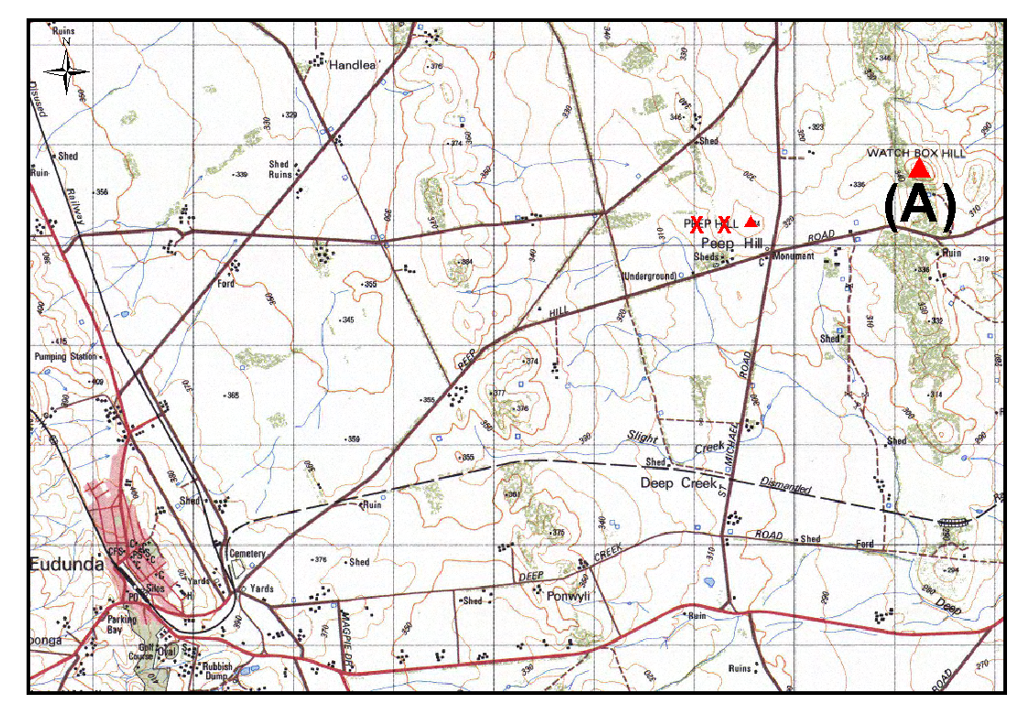
The Plan
Submissions in writing regarding this proposal may be lodged with the Secretary, Geographical Names Advisory Committee, Third Floor, 50 Grenfell Street, Adelaide, S.A. 5000, (G.P.O. Box 1354, Adelaide, S.A. 5001) within one month of the publication of this notice.
Dated 19 December 2003.
P. M. Kentish, Surveyor-General, Department for Administrative and Information Services
DAIS 22-413/03/0017

LIQUOR LICENSING ACT 1997
Notice of Application
NOTICE is hereby given, pursuant to section 52 (2) (b) of the Michael Van Den Kieboom and Anne Van Den Kieboom, as Trustees for the Michael Van Den Kieboom Family Trust and David Peter Terminello, as Trustee for the David Terminello Family Trust, c/o Fisher Jeffries, have applied to the Licensing Authority for the transfer of a Hotel and Gaming Machine Licence with variation to Entertainment Consent and Extended Trading Authorisation in respect of premises situated at 39 Commercial Road, Port Augusta, S.A. 5700 and known as Hotel Flinders.
The application has been set down for hearing on 20 February 2004 at 9 a.m.
Conditions
The following licence conditions are sought:
That liquor may be sold for consumption on the licensed premises during the following extended hours:
Thursday, Friday, Saturday and any other day preceding a Public Holiday: Midnight to 2 a.m. the following day;
Sunday: 8 a.m. to 11 a.m. and 8 p.m. to midnight;
Christmas Day: Midnight to 2 a.m.
That liquor may be sold for consumption off the licensed premises on Sundays: 8 a.m. to 11 a.m. and 8 p.m. to 9 p.m.
That the Entertainment Consent in respect of premises apply during all approved trading hours.
Any person may object to the application by lodging a notice of objection in the prescribed form with the Licensing Authority, and serving a copy of the notice on the applicants at the applicants’ address given above, at least seven days before the hearing date.
Plans in respect of the premises the subject of the application are open to public inspection without fee at the Office of the Liquor and Gaming Commissioner, 9th Floor, East Wing, 50 Grenfell Street, Adelaide, S.A. 5000.
Dated 13 January 2004.
Applicants

LIQUOR LICENSING ACT 1997
Notice of Application
NOTICE is hereby given, pursuant to section 52 (2) (b) of the Liquor Licensing Act 1997, that Kelmac Holdings Pty Ltd has applied to the Licensing Authority for the transfer of a Hotel and Gaming Machine Licence in respect of premises situated at Alexander Terrace, Jamestown, S.A. 5491 and known as Railway Hotel.
The application has been set down for hearing on 23 February 2004 at 10.30 a.m.
Any person may object to the application by lodging a notice of objection in the prescribed form with the Licensing Authority, and serving a copy of the notice on the applicant at the applicant’s address given above, at least seven days before the hearing date.
Plans in respect of the premises the subject of the application are open to public inspection without fee at the Office of the Liquor and Gaming Commissioner, 9th Floor, East Wing, 50 Grenfell Street, Adelaide, S.A. 5000.
Dated 12 January 2004.
Applicant

LIQUOR LICENSING ACT 1997
Notice of Application
NOTICE is hereby given, pursuant to section 52 (2) (b) of the Liquor Licensing Act 1997, that Karen Sallis has applied to the Licensing Authority for the transfer of a Restaurant Licence with variation to Licence Conditions in respect of premises situated at 74 Port Wakefield Road, Dublin, S.A. 5501, known as Veronika’s Restaurant and to be known as Dublin Roadhouse.
The application has been set down for hearing on 13 February 2004 at 9 a.m.
Conditions
The following licence conditions are sought:
Variation to Trading Hours:
Current Trading Hours: 7 a.m. to 10 p.m.
Proposed Trading Hours: 7 a.m. to midnight
Any person may object to the application by lodging a notice of objection in the prescribed form with the Licensing Authority, and serving a copy of the notice on the applicant at the applicant’s address given above, at least seven days before the hearing date.
Plans in respect of the premises the subject of the application are open to public inspection without fee at the Office of the Liquor and Gaming Commissioner, 9th Floor, East Wing, 50 Grenfell Street, Adelaide, S.A. 5000.
Dated 13 January 2004.
Applicant

LIQUOR LICENSING ACT 1997
Notice of Application
NOTICE is hereby given, pursuant to section 52 (2) (b) of the Liquor Licensing Act 1997, that Istavist Pty Ltd has applied to the Licensing Authority for the transfer of a Restaurant Licence in respect of premises situated at 235 Greenhill Road, Dulwich, S.A. 5065, known as Mangiamo Cafe Pizzeria and to be known as La Porchetta.
The application has been set down for hearing on 16 February 2004 at 9.30 a.m.
Any person may object to the application by lodging a notice of objection in the prescribed form with the Licensing Authority, and serving a copy of the notice on the applicant at the applicant’s address given above, at least seven days before the hearing date.
Plans in respect of the premises the subject of the application are open to public inspection without fee at the Office of the Liquor and Gaming Commissioner, 9th Floor, East Wing, 50 Grenfell Street, Adelaide, S.A. 5000.
Dated 9 January 2004.
Applicant

LIQUOR LICENSING ACT 1997
Notice of Application
NOTICE is hereby given, pursuant to section 52 (2) (b) of the Liquor Licensing Act 1997, that Links Lady Bay Pty Ltd, as trustee for the Links Lady Bay Unit Trust, c/o Wallmans Lawyers, has applied to the Licensing Authority for a Hotel Licence with Extended Trading Authorisation and Entertainment Consent in respect of premises situated at St Andrew Boulevard, Normanville, S.A. 5204 and known as The Links Lady Bay.
The application has been set down for hearing on 13 February 2004 at 9 a.m.
Conditions
The following licence conditions are sought:
Extended Trading Authorisation (including Entertainment Consent) to apply to the whole of the licensed premises at the following times:
Monday to Saturday: Midnight to 2 a.m. the following day;
Sunday: 8 a.m. to 11 a.m. and 8 p.m. to 2 a.m. the following day and 8 p.m. to 9 p.m. for off licence consumption;
Christmas Day: Midnight to 2 a.m. the following day.
Any person may object to the application by lodging a notice of objection in the prescribed form with the Licensing Authority, and serving a copy of the notice on the applicant at the applicant’s address given above, at least seven days before the hearing date.
Plans in respect of the premises the subject of the application are open to public inspection without fee at the Office of the Liquor and Gaming Commissioner, 9th Floor, East Wing, 50 Grenfell Street, Adelaide, S.A. 5000.
Dated 8 January 2004.
Applicant

LIQUOR LICENSING ACT 1997
Notice of Application
NOTICE is hereby given, pursuant to section 52 (2) (b) of the Liquor Licensing Act 1997, that Darkhorse Trading Pty Ltd has applied to the Licensing Authority for the variation of conditions of the Entertainment Venue Licence in respect of premises situated at 29 and 29A Twin Street, Adelaide, S.A. 5000 and known as The Jade Monkey.
The application has been set down for hearing on 13 February 2004.
Conditions
The following licence conditions are sought:
Approval under section 35 (1) (c) to sell liquor on any day except Good Friday and Christmas Day for consumption on the licensed premises by persons:
(a) seated at a table; or
(b) attending a function at which food is provided.
Any person may object to the application by lodging a notice of objection in the prescribed form with the Licensing Authority, and serving a copy of the notice on the applicant at the applicant’s address given above, at least seven days before the hearing date.
Plans in respect of the premises the subject of the application are open to public inspection without fee at the Office of the Liquor and Gaming Commissioner, 9th Floor, East Wing, 50 Grenfell Street, Adelaide, S.A. 5000.
Dated 8 January 2004.
Applicant

LIQUOR LICENSING ACT 1997
Notice of Application
NOTICE is hereby given, pursuant to section 52 (2) (b) of the Liquor Licensing Act 1997, that Kermode Street Company Pty Ltd, c/o Wallmans Lawyers, has applied to the Licensing Authority for an Extended Trading Authorisation, Entertainment Consent and redefinition of licence in respect of premises situated at 117 Kermode Street, North Adelaide, S.A. 5006 and known as Queens Head Hotel.
The application has been set down for hearing on 13 February 2004 at 9 a.m.
Conditions
The following licence conditions are sought:
Extended Trading Authorisation to apply to the whole of the licensed premises at the following times:
Sunday—8 a.m. to 11 a.m. and 8 p.m. to midnight for on licence consumption and 8 p.m. to 9 p.m. for off licence consumption.
Christmas Day—midnight to 2 p.m. the following day.
Entertainment Consent to apply to the whole of the licensed premises, including the hours sought for Extended Trading Authorisation.
Designation of reception areas for the whole of the licensed premises.
Extension of trading area to include the area adjacent to the licensed premises as per plans lodged with this office.
Any person may object to the application by lodging a notice of objection in the prescribed form with the Licensing Authority, and serving a copy of the notice on the applicant at the applicant’s address given above, at least seven days before the hearing date.
Plans in respect of the premises the subject of the application are open to public inspection without fee at the Office of the Liquor and Gaming Commissioner, 9th Floor, East Wing, 50 Grenfell Street, Adelaide, S.A. 5000.
Dated 8 January 2004.
Applicant

LIQUOR LICENSING ACT 1997
Notice of Application
NOTICE is hereby given, pursuant to section 52 (2) (b) of the Liquor Licensing Act 1997, that Eileen Stephanie and Robert William Blunden (as trustees for Blunden Aldinga Trust) have applied to the Licensing Authority for a Restaurant Licence in respect of premises situated at 163 Esplanade, Aldinga Beach, S.A. 5123 and to be known as Reef Raff.
The application has been set down for hearing on 13 February 2004 at 9 a.m.
Any person may object to the application by lodging a notice of objection in the prescribed form with the Licensing Authority, and serving a copy of the notice on the applicants at the applicants’ address given above, at least seven days before the hearing date.
Plans in respect of the premises the subject of the application are open to public inspection without fee at the Office of the Liquor and Gaming Commissioner, 9th Floor, East Wing, 50 Grenfell Street, Adelaide, S.A. 5000.
Dated 8 January 2004.
Applicants

LIQUOR LICENSING ACT 1997
Notice of Application
NOTICE is hereby given, pursuant to section 52 (2) (b) of the Liquor Licensing Act 1997, that Redlegs Club Inc. has applied to the Licensing Authority for a redefinition of licence in respect of premises situated at 21 Woods Street, Norwood, S.A. 5067 and known as Redlegs Club.
The application has been set down for hearing on 13 February 2004 at 9 a.m.
Conditions
The following licence conditions are sought:
To exclude the clubrooms on the western side of Woods Street from the licence.
To extend the trading rights of the bar area located in the south-west corner of the oval as per plans lodged with this office, the applicant seeks to trade in this area at the following times:
Monday to Saturday—4 p.m. to 9 p.m.
When South Australian Football League matches or any other sporting events authorised by the Redlegs Club Inc. are conducted at the oval, the redefined area will trade under the conditions of the current licence conditions.
Any person may object to the application by lodging a notice of objection in the prescribed form with the Licensing Authority, and serving a copy of the notice on the applicant at the applicant’s address given above, at least seven days before the hearing date.
Plans in respect of the premises the subject of the application are open to public inspection without fee at the Office of the Liquor and Gaming Commissioner, 9th Floor, East Wing, 50 Grenfell Street, Adelaide, S.A. 5000.
Dated 8 January 2004.
Applicant

LIQUOR LICENSING ACT 1997
Notice of Application
NOTICE is hereby given, pursuant to section 52 (2) (b) of the Liquor Licensing Act 1997, that K. & B.’s Nominees Pty Ltd, c/o David Watts and Associates, Liquor Licensing Consultants, has applied to the Licensing Authority for a variation of conditions of Licence in respect of premises situated at 257 Henley Beach Road, Henley Beach, S.A. 5022 and known as Zootz.
The application has been set down for hearing on 13 February 2004 at 9 a.m.
Condition
The following licence condition is sought:
Variation sought:
Trading to commence at 8 a.m. in lieu of 12 noon on each authorised trading day.
Any person may object to the application by lodging a notice of objection in the prescribed form with the Licensing Authority, and serving a copy of the notice on the applicant at the applicant’s address given above, at least seven days before the hearing date.
Plans in respect of the premises the subject of the application are open to public inspection without fee at the Office of the Liquor and Gaming Commissioner, 9th Floor, East Wing, 50 Grenfell Street, Adelaide, S.A. 5000.
Applicant

LIQUOR LICENSING ACT 1997 AND GAMING MACHINES ACT 1992
Notice of Application
NOTICE is hereby given, pursuant to section 52 of the Liquor Licensing Act 1997 and section 29 of the Gaming Machines Act 1992, that Gunabee Pty Ltd (ACN 102 521 602), c/o Wallmans Lawyers, 173 Wakefield Street, Adelaide, S.A. 5000 has applied to the Liquor and Gaming Commissioner for the transfer of a Hotel Licence and a Gaming Machine Licence in respect of premises situated at Main Road, Tungkillo, S.A. 5236 and known as District Hotel.
The applications have been set down for hearing on 13 February 2004.
Conditions
The following licence conditions are sought:
1. Extended Trading Authorisation to authorise the sale of liquor on the following days in the whole of the licensed premises:
Hours of Operation: Friday, midnight to 2 a.m. the following day; Saturday, midnight to 2 a.m. the following day; Sunday, 8 a.m. to 11 a.m. and 8 p.m. to midnight; Christmas Day, midnight to 2 a.m.
2. Entertainment Consent to apply to the areas outlined in blue on the plan lodged with the application (including during those hours sought for Extended Trading Authorisation).
3. Redefinition of the licensed premises as outlined in red on the plan lodged with the application.
Any person may object to the application by lodging a notice of objection in the prescribed form with the Licensing Authority, and serving a copy of the notice on the applicant at the applicant’s address given above, at least seven days before the hearing date.
Plans in respect of the premises the subject of the application are open to public inspection without fee at the Office of the Liquor and Gaming Commissioner, 9th Floor, East Wing, 50 Grenfell Street, Adelaide, S.A. 5000.
Dated 6 January 2004.
Applicant

LIQUOR LICENSING ACT 1997 AND GAMING MACHINES ACT 1992
Notice of Application
NOTICE is hereby given, pursuant to section 52 of the Liquor Licensing Act 1997 and section 29 of the Gaming Machines Act 1992, that Gojowist Nominees Pty Ltd has applied to the Liquor and Gaming Commissioner for the transfer of a Hotel Licence and a Gaming Machine Licence in respect of premises situated at Railway Terrace, North Lameroo, S.A. 5302 and known as Lameroo Hotel Motel.
The applications have been set down for hearing on 16 February 2004 at 10 a.m.
Any person may object to the application by lodging a notice of objection in the prescribed form with the Licensing Authority, and serving a copy of the notice on the applicant at the applicant’s address given above, at least seven days before the hearing date.
Plans in respect of the premises the subject of the application are open to public inspection without fee at the Office of the Liquor and Gaming Commissioner, 9th Floor, East Wing, 50 Grenfell Street, Adelaide, S.A. 5000.
Dated 6 January 2004.
Applicant

MINING ACT 1971
NOTICE is hereby given in accordance with section 28 (5) of the Mining Act 1971, that the Minister for Mineral Resources Development proposes to grant an Exploration Licence over the undermentioned area:
Applicant: Minex (SA) Pty Ltd
Location: Childara Well area⎯Approximately 100 km north-east of Ceduna.
Term: 1 year
Area in km²: 878
Ref.: 2003/00166
Plan and co-ordinates can be found on the PIRSA Sarig website: http://www.minerals.pir.sa.gov.au/sarig or by phoning Mineral Tenements on (08) 8463 3103.
Dated 15 January 2004.
H. Tyrteos, Mining Registrar

MINING ACT 1971
NOTICE is hereby given in accordance with section 28 (5) of the Mining Act 1971, that the Minister for Mineral Resources Development proposes to grant an Exploration Licence over the undermentioned area:
Applicant: Rio Tinto Exploration Pty Ltd
Location: Pine Ridge area⎯Approximately 140 km north-west of Marla.
Term: 1 year
Area in km²: 1 382
Ref.: 2003/00368
Plan and co-ordinates can be found on the PIRSA Sarig website: http://www.minerals.pir.sa.gov.au/sarig or by phoning Mineral Tenements on (08) 8463 3103.
Dated 15 January 2004.
H. Tyrteos, Mining Registrar

RADIATION PROTECTION AND CONTROL ACT 1982
Section 44
Notice by Delegate of the Minister for Environment and Conservation
PURSUANT to section 44 of the Radiation Protection and Control Act 1982, I, Jill Fitch, Acting Director of the Radiation Protection Division of the Environment Protection Authority, being a person to whom the powers of the Minister under that section have been delegated under the Act, exempt the specified employer, Flinders Medical Centre from the requirements of Regulation 18 of the Radiation Protection and Control (Ionising Radiation) Regulations 2000, insofar as that regulation applies to staff in the Histopathology Laboratory who are involved in the irradiation of cells using a Hewlett-Packard Faxitron X-ray unit, subject to the following conditions:
(1) that the X-ray unit is maintained in good working order and condition; and
(2) that the specified employer issues a personal monitoring device to a radiation worker if directed in writing by
the Radiation Protection Division of the Environment Protection Authority to do so.
Dated 8 January 2004.
J. Fitch, Delegate of the Minister for Environment and Conservation.

GOVERNMENT GAZETTE ADVERTISEMENT RATES

To apply from 1 July 2002

$  Agents, Ceasing to Act as 34.10  Associations:  Incorporation 17.40  Intention of Incorporation 43.00  Transfer of Properties 43.00  Attorney, Appointment of 34.10  Bailiff’s Sale 43.00  Cemetery Curator Appointed 25.50  Companies:  Alteration to Constitution 34.10  Capital, Increase or Decrease of 43.00  Ceasing to Carry on Business 25.50  Declaration of Dividend 25.50  Incorporation 34.10  Lost Share Certificates:  First Name 25.50  Each Subsequent Name 8.75  Meeting Final 28.75  Meeting Final Regarding Liquidator’s Report on  Conduct of Winding Up (equivalent to ‘Final  Meeting’)  First Name 34.10  Each Subsequent Name 8.75  Notices:  Call 43.00  Change of Name 17.40  Creditors 34.10  Creditors Compromise of Arrangement 34.10  Creditors (extraordinary resolution that ‘the Com-pany be wound up voluntarily and that a liquidator be appointed’) 43.00  Release of Liquidator⎯Application⎯Large Ad. 68.00  ⎯Release Granted 43.00  Receiver and Manager Appointed 39.75  Receiver and Manager Ceasing to Act 34.10  Restored Name 32.25  Petition to Supreme Court for Winding Up 59.50  Summons in Action 51.00  Order of Supreme Court for Winding Up Action 34.10  Register of Interests⎯Section 84 (1) Exempt 77.00  Removal of Office 17.40  Proof of Debts 34.10  Sales of Shares and Forfeiture 34.10  Estates:  Assigned 25.50  Deceased Persons⎯Notice to Creditors, etc. 43.00  Each Subsequent Name 8.75  Deceased Persons⎯Closed Estates 25.50  Each Subsequent Estate 1.10  Probate, Selling of 34.10  Public Trustee, each Estate 8.75 |  | $  Firms:  Ceasing to Carry on Business (each insertion) 22.70  Discontinuance Place of Business 22.70  Land⎯Real Property Act:  Intention to Sell, Notice of 43.00  Lost Certificate of Title Notices 43.00  Cancellation, Notice of (Strata Plan) 43.00  Mortgages:  Caveat Lodgment 17.40  Discharge of 18.30  Foreclosures 17.40  Transfer of 17.40  Sublet 8.75  Leases⎯Application for Transfer (2 insertions) each 8.75  Lost Treasury Receipts (3 insertions) each 25.50  Licensing 51.00  Municipal or District Councils:  Annual Financial Statement⎯Forms 1 and 2 481.00  Electricity Supply⎯Forms 19 and 20 341.00  Default in Payment of Rates:  First Name 68.00  Each Subsequent Name 8.75  Noxious Trade 25.50  Partnership, Dissolution of 25.50  Petitions (small) 17.40  Registered Building Societies (from Registrar-  General) 17.40  Register of Unclaimed Moneys⎯First Name 25.50  Each Subsequent Name 8.75  Registers of Members⎯Three pages and over:  Rate per page (in 8pt) 218.00  Rate per page (in 6pt) 288.00  Sale of Land by Public Auction 43.50  Advertisements 2.40  Advertisements, other than those listed are charged at $2.40 per column line, tabular one-third extra.  Notices by Colleges, Universities, Corporations and District Councils to be charged at $2.40 per line.  Where the notice inserted varies significantly in length from that which is usually published a charge of $2.40 per column line will be applied in lieu of advertisement rates listed.  South Australian Government publications are sold on the condition that they will not be reproduced without prior permission from the Government Printer.
All the above prices include GST

GOVERNMENT GAZETTE NOTICES
ALL private advertisements forwarded for publication in the South Australian Government Gazette must be PAID FOR PRIOR TO INSERTION; and all notices, from whatever source, should be legibly written on one side of the paper only and sent to Government Publishing SA so as to be received no later than 4 p.m. Tuesday preceding the day of publication. Phone 8207 1045 or Fax 8207 1040. E-mail: governmentgazette@saugov.sa.gov.au. Send as attachments in Word format and please confirm your transmission with a faxed copy of your document, including the date the notice is to be published and to whom the notice will be charged.

MISCELLANEOUS LEGISLATION AND GOVERNMENT PUBLICATIONS PRICES AS FROM 1 JULY 2003

Acts, Bills, Rules, Parliamentary Papers and Regulations
Pages | Main | Amends | Pages | Main | Amends

1-16 | 2.05 | 0.90 | 497-512 | 29.20 | 28.00
17-32 | 2.80 | 1.75 | 513-528 | 30.00 | 28.80
33-48 | 3.65 | 2.60 | 529-544 | 30.90 | 29.90
49-64 | 4.60 | 3.50 | 545-560 | 31.70 | 30.90
65-80 | 5.40 | 4.45 | 561-576 | 32.50 | 31.70
81-96 | 6.25 | 5.20 | 577-592 | 33.60 | 32.20
97-112 | 7.15 | 6.05 | 593-608 | 34.40 | 33.25
113-128 | 8.00 | 7.00 | 609-624 | 35.20 | 34.30
129-144 | 9.00 | 7.95 | 625-640 | 35.90 | 34.80
145-160 | 9.85 | 8.80 | 641-656 | 36.80 | 35.85
161-176 | 10.80 | 9.65 | 657-672 | 37.40 | 36.60
177-192 | 11.60 | 10.60 | 673-688 | 39.00 | 37.40
193-208 | 12.50 | 11.50 | 689-704 | 39.80 | 38.40
209-224 | 13.30 | 12.25 | 705-720 | 40.30 | 39.50
225-240 | 14.20 | 13.10 | 721-736 | 41.80 | 40.00
241-257 | 15.10 | 13.80 | 737-752 | 42.30 | 41.30
258-272 | 16.00 | 14.75 | 753-768 | 43.40 | 41.80
273-288 | 16.90 | 15.80 | 769-784 | 43.90 | 43.10
289-304 | 17.60 | 16.60 | 785-800 | 44.70 | 43.90
305-320 | 18.60 | 17.50 | 801-816 | 45.50 | 44.40
321-336 | 19.40 | 18.30 | 817-832 | 46.50 | 45.50
337-352 | 20.40 | 19.30 | 833-848 | 47.50 | 46.25
353-368 | 21.20 | 20.20 | 849-864 | 48.30 | 47.00
369-384 | 22.10 | 21.10 | 865-880 | 49.00 | 48.30
385-400 | 22.90 | 21.90 | 881-896 | 49.60 | 48.80
401-416 | 23.70 | 22.60 | 897-912 | 51.20 | 49.60
417-432 | 24.80 | 23.60 | 913-928 | 51.70 | 51.20
433-448 | 25.60 | 24.50 | 929-944 | 52.50 | 51.70
449-464 | 26.50 | 25.30 | 945-960 | 53.50 | 52.20
465-480 | 27.00 | 26.20 | 961-976 | 54.50 | 53.25
481-496 | 28.20 | 27.00 | 977-992 | 55.60 | 54.00

Legislation—Acts, Regulations, etc: $
Subscriptions:
Acts 180.00
All Bills as Laid 431.00
Rules and Regulations 431.00
Parliamentary Papers 431.00
Bound Acts 199.00
Index 99.00
Government Gazette
Copy 4.70
Subscription 238.00
Hansard
Copy 13.00
Subscription—per session (issued weekly) 374.00
Cloth bound—per volume 161.00
Subscription—per session (issued daily) 374.00
Legislation on Disk
Whole Database 2 763.00
Annual Subscription for fortnightly updates 849.00
Individual Act(s) including updates POA
Compendium
Subscriptions:
New Subs 1 638.00
Updates 578.00
(All the above prices include GST)

All Legislation, Government Gazette, Hansard and Legislation on disk are available from:
Counter Sales Service SA, Government Legislation⁺ Outlet
and Mail Orders: Lands Titles Office, 101 Grenfell Street, Adelaide
Phone: 13 23 24 (local call cost), Fax: (08) 8204 1909
Postal: G.P.O. Box 1707, Adelaide, S.A. 5001

Online Shop: www.shop.service.sa.gov.au

Subscriptions and Government Publishing SA
Standing Orders: Box 9, Plaza Level, Riverside Centre, North Terrace, Adelaide, S.A. 5000
Phone: (08) 8207 0908, (08) 8207 0910, Fax: (08) 8207 1040

ROADS (OPENING AND CLOSING) ACT 1991:
SECTION 24
NOTICE OF CONFIRMATION OF ROAD
PROCESS ORDER
Esplanade, Port Vincent
Deposited Plan 63697
BY Road Process Order made on 4 August 2003, the District Council of Yorke Peninsula ordered that:
1. Portion of the Esplanade (formerly Marine Parade) adjoining the southern boundary of allotment 5 in Filed Plan 146373 and allotment 6 in Filed Plan 146374 more particularly delineated and lettered ‘A’ and ‘B’, in Preliminary Plan No. 03/0042 be closed.
2. The whole of the land subject to closure be transferred to Steve Deak and Cindy Chynoweth in accordance with agree-ment for transfer dated 14 July 2003 entered into between the District Council of Yorke Peninsula and S. Deak and C. Chynoweth.
On 7 January 2004 that order was confirmed by the Minister for Administrative Services conditionally on approval and deposit of the survey plan by the Registrar-General. The condition has now been fulfilled.
Pursuant to section 24 (5) of the Roads (Opening and Closing) Act 1991, notice of the order referred to above and its confirmation is hereby given.
Dated 15 January 2004.
P. M. Kentish, Surveyor-General

ROADS (OPENING AND CLOSING) ACT 1991:
SECTION 24
NOTICE OF CONFIRMATION OF ROAD
PROCESS ORDER
Tiverton Street, Goolwa
Deposited Plan 61548
BY Road Process Order made on 18 November 2002, the Alexandrina Council ordered that:
1. The whole of Tiverton Street between Coddington Street and Allotment 237 (Railway) in Filed Plan 11292, more particularly delineated and lettered ‘A’ in Preliminary Plan No. 02/0073 be closed.
2. The whole of the land subject to closure be transferred to STRATCO (SA) PTY LTD in accordance with agreement for transfer dated 10 October 2002, entered into between the Alexandrina Council and Stratco (SA) Pty Ltd.
3. The following easement be granted over the land subject to that closure:
Grant to Distribution Lessor Corporation an easement for electricity supply purposes.
On 3 March 2003 that order was confirmed by the Minister for Administrative Services, conditionally on approval and deposit of the survey plan by the Registrar-General. The condition has now been fulfilled.
Pursuant to section 24 (5) of the Roads (Opening and Closing) Act 1991, NOTICE of the order referred to above and its confirmation is hereby given.
Dated 15 January 2004.
P. M. Kentish, Surveyor-General

NOTICE TO MARINERS
No. 1 of 2004
Former Notice No. 59 of 2001
South Australia—Gulf St Vincent—Port Adelaide River—
Channel Width Restrictions
SHIPS’ Masters are reminded that the silting referred to in the previous notice is still in existence and that the width restrictions imposed in the main channel of the Port Adelaide River between No. 34 beacon and No. 37 beacon remain in force until further notice.
Mariners should avoid the western side of the main channel and should navigate with extreme caution in this part of the river as the available navigable channel is now only 90 m wide measured from the eastern edge of the channel.
Mariners intending to transit this section of the river should contact the Manager Marine Operations, Flinders Ports Pty Ltd on (08) 8447 0622 to confirm maximum width.
Navy chart affected: Aus 137.
Local chart affected: Port Adelaide and approaches.
Publication affected: Australian Pilot, Volume 1 (Seventh Edition, 1992) pages 125-130.
Adelaide, 7 January 2004.
M. Wright, Minister for Transport
FP 2001/1439
TSA 2003/00738

WATER RESOURCES ACT 1997
Notice of Intent to Prescribe the Watercourses, Wells and Surface Water in the Eastern Mount Lofty Ranges—Extension of Deadline
IN reference to the Notice of Intent to Prescribe the Watercourses, Wells and Surface Water in the Eastern Mount Lofty Ranges, published in the Government Gazette on 16 October 2003, The Advertiser and The Courier on 22 October 2003 and The Times, Southern Argus, Murray Valley Standard and the Stock Journal on 23 October 2003, the date for receiving written submissions has been extended until 12 March 2004.
I invite all interested persons to make written submissions to me in relation to this proposal.
All submissions should be addressed to:
The Minister for Environment and Conservation,
c/o Diane Favier,
Senior Catchment Management Officer,
Department of Water, Land and Biodiversity Conservation,
G.P.O. Box 2834,
Adelaide, S.A. 5001.
Dated 12 January 2004.
J. Hill, Minister for Environment and Conservation

South Australia
Statutes Amendment (Anti-Fortification) Act (Commencement) Proclamation 2004
1—Short title
This proclamation may be cited as the Statutes Amendment (Anti-Fortification) Act (Commencement) Proclamation 2004.
2—Commencement of Act
The Statutes Amendment (Anti-Fortification) Act 2003 (No 46 of 2003) will come into operation on 1 February 2004.
Made by the Governor’s Deputy
with the advice and consent of the Executive Council
on 15 January 2004.
AGO0299/02CS

South Australia
Government Financing Authority (Declaration of Semi-Government Authority) Proclamation 2004
under section 4(2) of the Government Financing Authority Act 1982
1—Short title
This proclamation may be cited as the Government Financing Authority (Declaration of Semi-Government Authority) Proclamation 2004.
2—Commencement
This proclamation comes into operation on the day on which it is made.
3—Declaration of semi-government authority
The following body corporate is declared to be a semi-government authority for the purposes of the Government Financing Authority Act 1982:
Land Management Corporation
Made by the Governor’s Deputy
with the advice and consent of the Executive Council
on 15 January 2004.
T&F03/108CS

South Australia
Public Finance and Audit (Declaration of Semi-Government Authorities) Variation Proclamation 2004
under section 17(3) of the Public Finance and Audit Act 1987
Part 1—Preliminary
1—Short title
This proclamation may be cited as the Public Finance and Audit (Declaration of Semi-Government Authorities) Variation Proclamation 2004.
2—Commencement
This proclamation comes into operation on the day on which it is made.
3—Variation provisions
In this proclamation, a provision under a heading referring to the variation of a specified proclamation varies the proclamation so specified.
Part 2—Variation of proclamation under Public Finance and Audit Act 1987 declaring certain bodies corporate to be semi-government authorities (Gazette 25.6.1987 p1634) as varied
4—Variation of Schedule
Schedule—insert alphabetically:
Land Management Corporation
Made by the Governor’s Deputy
with the advice and consent of the Executive Council
on 15 January 2004.
T&F03/108CS

South Australia
Liquor Licensing (General) Variation Regulations 2004
under the Liquor Licensing Act 1997

Contents
Part 1—Preliminary
1 Short title
2 Commencement
3 Variation provisions
Part 2—Variation of Liquor Licensing (General) Regulations 1997
4 Variation of regulation 8—Cases where licence is not required

Part 1—Preliminary
1—Short title
These regulations may be cited as the Liquor Licensing (General) Variation Regulations 2004.
2—Commencement
These regulations come into operation on the day on which they are made.
3—Variation provisions
In these regulations, a provision under a heading referring to the variation of specified regulations varies the regulations so specified.
Part 2—Variation of Liquor Licensing (General) Regulations 1997
4—Variation of regulation 8—Cases where licence is not required
Regulation 8(2)(j)—after "by or on behalf of" insert:
Blackfriars Priory School,
Note—
As required by section 10AA(2) of the Subordinate Legislation Act 1978, the Minister has certified that, in the Minister's opinion, it is necessary or appropriate that these regulations come into operation as set out in these regulations.
Made by the Governor’s Deputy
with the advice and consent of the Executive Council
on 15 January 2004.
No. 1 of 2004
OLGC26/2003

South Australia
Public Corporations (South Australian Infrastructure Corporation) Regulations 2004
under the Public Corporations Act 1993

Contents
Part 1—Preliminary
1 Short title
2 Commencement
3 Interpretation
Part 2—Application of Act to Minister
4 Application of Act to Minister
Part 3—South Australian Infrastructure Corporation
Division 1—Establishment and constitution of subsidiary
5 Establishment of subsidiary (section 24)
6 Establishment of board
7 Composition of board
8 Conditions of membership
9 Vacancies or defects in appointment of directors
10 Remuneration
11 Proceedings
12 Disclosure
Division 2—Functions and performance
13 Functions of subsidiary
14 Charter
15 Performance statement
16 Subsidiary companies
17 Indirect or joint operations by subsidiary
Division 3—Financial and related matters
18 Internal audit
19 Quarterly reports
20 Loans etc require approval
21 Provision of information
22 Dividends
23 Common seal and execution of documents
24 Annual report

Part 1—Preliminary
1—Short title
These regulations may be cited as the Public Corporations (South Australian Infrastructure Corporation) Regulations 2004.
2—Commencement
These regulations come into operation on the day on which they are made.
3—Interpretation
In these regulations, unless the contrary intention appears—
Act means the Public Corporations Act 1993;
board means the board of directors established as the governing body of the subsidiary under Part 3;
director means a person appointed or holding office as a member of the board under Part 3;
Minister means the Minister for Infrastructure;
subsidiary means the South Australian Infrastructure Corporation established under Part 3.
Part 2—Application of Act to Minister
4—Application of Act to Minister
The following provisions of the Act apply to the Minister:
(a) Part 1 (Preliminary);
(b) section 24 (Formation of subsidiary by legislation);
(c) section 25 (Dissolution of subsidiary established by regulation);
(d) the Schedule (Provisions applicable to subsidiaries).
Part 3—South Australian Infrastructure Corporation
Division 1—Establishment and constitution of subsidiary
5—Establishment of subsidiary (section 24)
(1) The South Australian Infrastructure Corporation is established as a subsidiary of the Minister.
(2) The subsidiary—
(a) is a body corporate; and
(b) has perpetual succession and a common seal; and
(c) is capable of suing and being sued in its corporate name.
6—Establishment of board
(1) A board of directors is established as the governing body of the subsidiary.
(2) Anything done by the board in the administration of the subsidiary's affairs is binding on the subsidiary.
7—Composition of board
(1) The board consists of at least 3 but not more than 5 members appointed by the Minister.
(2) One director will be appointed by the Minister to chair meetings of the board.
(3) The Minister may appoint a director to be the deputy of the director appointed to chair the board and the deputy may perform or exercise the functions and powers of that director in his or her absence.
(4) On the office of a director becoming vacant, a person may be appointed in accordance with this regulation to the vacant office.
(5) The Minister may appoint a suitable person to be deputy of a member of the board during any period of absence of the member (and any reference to a director in these regulations will be taken to include, unless the contrary intention appears, a reference to a deputy while acting as a member of the board).
8—Conditions of membership
(1) A director will be appointed for a term, not exceeding 3 years, specified in the instrument of appointment and, at the expiration of a term of appointment, will be eligible for reappointment.
(2) The office of a director becomes vacant if the director—
(a) dies; or
(b) completes a term of office and is not reappointed; or
(c) resigns by written notice to the Minister; or
(d) becomes bankrupt or applies to take the benefit of a law for the relief of insolvent debtors; or
(e) is convicted of an indictable offence; or
(f) is removed from office by the Minister by written notice.
9—Vacancies or defects in appointment of directors
An act of the board is not invalid by reason only of a vacancy in its membership or a defect in the appointment of a director.
10—Remuneration
A director is entitled to be paid from the funds of the subsidiary such remuneration, allowances and expenses as may be determined by the Minister.
11—Proceedings
(1) A quorum of the board consists of one half of the total number of its directors (ignoring any fraction resulting from the division) plus one.
(2) The director appointed to chair the board will preside at meetings of the board at which he or she is present.
(3) If the director appointed to chair the board is absent from a meeting of the board—
(a) if another director has been appointed as that director's deputy and is present at the meeting—the deputy; or
(b) in any other case—a director chosen by the directors present at the meeting,
will preside.
(4) A decision carried by a majority of the votes cast by directors at a meeting is a decision of the board.
(5) Each director present at a meeting of the board has one vote on a question arising for decision and, if the votes are equal, the director presiding at the meeting may exercise a casting vote.
(6) A telephone or video conference between directors will, for the purposes of this regulation, be taken to be a meeting of the board at which the participating directors are present if—
(a) a notice of the conference is given to all directors in the manner determined by the board for that purpose; and
(b) each participating director is capable of communicating with every other participating director during the conference.
(7) A proposed resolution of the board becomes a valid decision of the board despite the fact that it is not voted on at a meeting of the board if—
(a) a notice of the proposed resolution is given to all directors in accordance with procedures determined by the board; and
(b) a majority of the directors express their concurrence in the proposed resolution by letter, facsimile transmission or other written communication setting out the terms of the resolution.
(8) The board must cause accurate minutes to be kept of its proceedings.
(9) A person authorised in writing by the Treasurer may attend (but not participate in) a meeting of the board and may have access to papers provided to directors for the purpose of the meeting.
(10) If the board considers that a matter dealt with at a meeting attended by a representative of the Treasurer should be treated as confidential, the board may advise the Treasurer of that opinion giving the reason for the opinion and the Treasurer may, subject to subregulation (11), act on that advice as the Treasurer thinks fit.
(11) If the Treasurer is satisfied on the basis of the board's advice under subregulation (10) that the subsidiary owes a duty of confidence in respect of a matter, the Treasurer must ensure the observance of that duty in respect of the matter, but this subregulation does not prevent a disclosure as required in the proper performance of ministerial functions or duties.
(12) Subject to these regulations, the board may determine its own procedures.
12—Disclosure
(1) Where the subsidiary discloses to the Minister or the Treasurer in pursuance of the Act or these regulations a matter in respect of which the subsidiary owes a duty of confidence, the subsidiary must give notice in writing of the disclosure to the person to whom the duty is owed.
(2) A director of the subsidiary does not commit any breach of duty by reporting a matter relating to the affairs of the subsidiary to the Minister or the Treasurer.
Division 2—Functions and performance
13—Functions of subsidiary
(1) The functions of the subsidiary are limited to the following:
(a) to carry out the Port River Expressway Project or any other authorised project, responsibility for which is assigned to the Minister (under Part 3A of the Highways Act 1926);
(b) to carry out other public infrastructure projects and, in so doing—
(i) to design, plan, establish, extend, improve, maintain, repair or operate public infrastructure; and
(ii) for the purposes of establishing, extending or improving public infrastructure—to acquire, hold, manage, lease or dispose of land or other property held by or on behalf of the Crown; and
(iii) to finance the establishment, extension, improvement, maintenance, repair or operation of public infrastructure;
(c) to carry out other functions conferred on the subsidiary by the Minister.
(2) In this regulation—
public infrastructure means—
(a) infrastructure, equipment, structures, works and other facilities used in or in connection with—
(i) the supply of water; or
(ii) the supply of electricity, gas or other forms of energy; or
(iii) the drainage or treatment of waste water or sewage; or
(b) roads, railways, tramways, busways, ports, wharfs, jetties and their related or supporting structures and works; or
(c) facilities for education or health; or
(d) any other facilities that have traditionally been provided by the State (but not necessarily only by the State) as community or public facilities.
(3) The subsidiary must obtain the approval of the Minister before it makes a material change to its policy direction or budget.
14—Charter
(1) The Minister and the Treasurer must prepare a charter for the subsidiary.
(2) The charter must address—
(a) the nature and scope of the subsidiary's operations;
(b) the subsidiary's obligations to report on its operations;
(c) the form and contents of the subsidiary's accounts and financial statements;
(d) any accounting, internal auditing or financial systems or practices to be established or observed by the subsidiary;
(e) the acquisition or disposal of capital or assets.
(3) The charter may deal with any other matter not specifically referred to in subregulation (2).
(4) The charter must be reviewed by the Minister at the end of each financial year.
(5) The Minister and the Treasurer may amend the charter at any time.
(6) The charter, or an amendment to the charter, comes into force and is binding on the subsidiary on a day specified in the charter or amendment (but without affecting any contractual obligations previously incurred by the subsidiary).
(7) On the charter or an amendment to the charter coming into force, the Minister must, within 12 sitting days, have copies of the charter, or the charter in its amended form, laid before both Houses of Parliament.
15—Performance statement
(1) The Minister must, when preparing the charter for the subsidiary, also prepare, after consultation with the subsidiary and the Treasurer, a performance statement setting the various performance targets that the subsidiary is to pursue in the coming financial year or other period specified in the statement and dealing with such other matters as the Minister considers appropriate.
(2) The Minister must, after consultation with the subsidiary and the Treasurer, review the performance statement when reviewing the subsidiary's charter.
(3) The Minister may, after consultation with the subsidiary and the Treasurer, amend the performance statement at any time.
16—Subsidiary companies
(1) The subsidiary must not, without the approval of the Treasurer—
(a) form a subsidiary company; or
(b) acquire, or enter into any arrangement under which it will at a future time or would on the happening of some contingency hold, relevant interests in shares in a company such that the company becomes a subsidiary of the subsidiary.
(2) The Treasurer may, as a condition of approval under this section, or by direction, require the subsidiary to take steps to include in a subsidiary company's memorandum or articles of association such provisions as the Treasurer considers appropriate—
(a) imposing limitations on the nature or scope of the company's operations; or
(b) imposing other controls or practices,
consistent with those applicable to the subsidiary.
17—Indirect or joint operations by subsidiary
The subsidiary must not, without the approval of the Treasurer, establish a trust scheme or a partnership or other scheme or arrangement for sharing of profits or joint venture with another person or undertake any operations or transactions pursuant to such a scheme or arrangement.
Division 3—Financial and related matters
18—Internal audit
(1) The subsidiary must establish and maintain effective internal auditing of its operations.
(2) The subsidiary must, unless exempted by the Treasurer, establish an audit committee.
(3) The audit committee will comprise—
(a) a member of the board of the subsidiary, or such members of the board as the board may from time to time determine; and
(b) such other person or persons as the board may from time to time appoint,
but may not include the chief executive of the subsidiary.
(4) The functions of the audit committee include—
(a) reviewing annual financial statements to ensure that they provide a true and fair view of the state of affairs of the subsidiary; and
(b) liaising with external auditors; and
(c) reviewing the adequacy of the accounting, internal auditing, reporting and other financial management systems and practices of the subsidiary on a regular basis.
19—Quarterly reports
The subsidiary must report to the Minister on the subsidiary's financial position on a quarterly basis.
20—Loans etc require approval
(1) The subsidiary must not lend or advance to any person any money, securities or property without the prior written approval of the Treasurer.
(2) The subsidiary must not undertake commercial borrowings without the prior written approval of the Treasurer.
21—Provision of information
(1) The subsidiary must, at the request in writing of the Treasurer, furnish the Treasurer with such information or records in the possession or control of the subsidiary as the Treasurer may require in such manner and form as the Treasurer may require.
(2) If a record in the possession or control of the subsidiary is furnished to the Treasurer under this regulation, the Treasurer may make, retain and deal with copies of the record as the Treasurer thinks fit.
(3) If the board considers that information or a record furnished under this regulation contains matters that should be treated as confidential, the board may advise the Treasurer of that opinion giving the reason for the opinion and the Treasurer may, subject to subregulation (4), act on that advice as the Treasurer thinks fit.
(4) If the Treasurer is satisfied on the basis of the board's advice under subregulation (3) that the subsidiary owes a duty of confidence in respect of a matter, the Treasurer must ensure the observance of that duty in respect of the matter, but this subregulation does not prevent a disclosure as required in the proper performance of ministerial functions or duties.
(5) The subsidiary must notify the Minister if a request is made under this regulation.
22—Dividends
(1) The subsidiary must, before the end of each financial year, after consultation with the Minister, recommend by writing to the Treasurer that the subsidiary pay a specified dividend, or not pay any dividend, for that financial year, as the subsidiary considers appropriate.
(2) The Treasurer may, after consultation with the Minister, by notice in writing to the subsidiary—
(a) approve a recommendation of the subsidiary under subregulation (1); or
(b) determine that a dividend specified by the Treasurer be paid, or that no dividend be paid,
as the Treasurer considers appropriate.
(3) The subsidiary must, if so required by the Treasurer by notice in writing to the subsidiary at any time during a financial year, after consultation with the Minister, recommend by writing to the Treasurer that a specified interim dividend or specified interim dividends be paid by the subsidiary for that financial year, or that no such dividend or dividends be paid by the subsidiary as the subsidiary considers appropriate.
(4) The Treasurer may, after consultation with the Minister, by notice in writing to the subsidiary—
(a) approve a recommendation of the subsidiary under subregulation (3); or
(b) determine that an interim dividend or interim dividends specified by the Treasurer be paid, or that no interim dividend be paid,
as the Treasurer considers appropriate.
(5) If the Treasurer approves a recommendation or determines under this regulation that a dividend or interim dividend or dividends be paid by the subsidiary, the dividend or interim dividend or dividends must be paid at the direction of the Treasurer, in the manner and at the time or times determined by the Treasurer, after consultation with the subsidiary and the Minister.
(6) A recommendation under this regulation must be made by the board and may not be made by any person or committee pursuant to a delegation.
23—Common seal and execution of documents
(1) The common seal of the subsidiary must not be affixed to a document except in pursuance of a decision of the board, and the affixing of the seal must be attested by the signatures of 2 directors.
(2) The board may, by instrument under the common seal of the subsidiary, authorise a director, an employee of the subsidiary (whether nominated by name or by office or title) or any other person to execute documents on behalf of the subsidiary subject to limitations (if any) specified in the instrument of authority.
(3) Without limiting subregulation (2), an authority may be given so as to authorise 2 or more persons to execute documents jointly on behalf of the subsidiary.
(4) A document is duly executed by the subsidiary if—
(a) the common seal of the subsidiary is affixed to the document in accordance with this regulation; or
(b) the document is signed on behalf of the subsidiary by a person or persons in accordance with authority conferred under this regulation.
24—Annual report
(1) The subsidiary must, within 3 months after the end of each financial year, deliver to the Minister a report on the operations of the subsidiary during that financial year.
(2) The Minister must cause a copy of the report to be laid before both Houses of Parliament within 12 sitting days after receipt of the report.
Note—
As required by section 10AA(2) of the Subordinate Legislation Act 1978, the Minister has certified that, in the Minister's opinion, it is necessary or appropriate that these regulations come into operation as set out in these regulations.
Made by the Governor’s Deputy
with the advice and consent of the Executive Council
on 15 January 2004.
No. 2 of 2004
2003/04697/CTSA01/T01

South Australia
Retail and Commercial Leases Variation Regulations 2004
under the Retail and Commercial Leases Act 1995

Contents
Part 1—Preliminary
1 Short title
2 Commencement
3 Variation provisions
Part 2—Variation of Retail and Commercial Leases Regulations 1995
4 Variation of regulation 6—Minimum 5 year term

Part 1—Preliminary
1—Short title
These regulations may be cited as the Retail and Commercial Leases Variation Regulations 2004.
2—Commencement
These regulations will come into operation four months after the day on which they are made (see Subordinate Legislation Act 1978 section 10AA).
3—Variation provisions
In these regulations, a provision under a heading referring to the variation of specified regulations varies the regulations so specified.
Part 2—Variation of Retail and Commercial Leases Regulations 1995
4—Variation of regulation 6—Minimum 5 year term
Regulation 6(2)—after paragraph (c) insert:
(d) if—
(a) the lessor is—
(i) an incorporated association within the meaning of the Associations Incorporation Act 1985; or
(ii) a body established on a non-profit basis for a purpose of a kind referred to in section 18(1) of that Act; and
(b) the right of occupation granted under the lease is for less than an average of 15 hours in each week over the term of the lease.
Made by the Governor’s Deputy
with the advice and consent of the Executive Council
on 15 January 2004.
No. 3 of 2004
OCBA CS 010/03

South Australia
Gas Variation Regulations 2004
under the Gas Act 1997

Contents
Part 1—Preliminary
1 Short title
2 Commencement
3 Variation provisions
Part 2—Variation of Gas Regulations 1997
4 Insertion of regulation 22

Part 1—Preliminary
1—Short title
These regulations may be cited as the Gas Variation Regulations 2004.
2—Commencement
These regulations will come into operation on the day after these regulations are made.
3—Variation provisions
In these regulations, a provision under a heading referring to the variation of specified regulations varies the regulations so specified.
Part 2—Variation of Gas Regulations 1997
4—Insertion of regulation 22
After regulation 21 insert:
22—Sale of gas where supply affected by gas rationing direction under section 37 of Act
(1) Subject to this regulation, if—
(a) a retailer to which a rationing direction applies on a gas day (an affected retailer) has a quantity of gas available for supply to an affected customer on that day that exceeds the allocated quantity for the customer for that day; and
(b) the affected retailer has made an offer to supply an additional quantity of gas to the affected customer on that day in accordance with approved terms that has been accepted by the customer,
then—
(c) the affected retailer must, on that day—
(i) supply the affected customer with the allocated quantity for that day in accordance with the pre-existing terms; and
(ii) supply the affected customer with the additional quantity of gas in accordance with the approved terms; and
(d) the affected retailer will be taken to incur no contractual liability by reason of the fact that the retailer has supplied only the allocated quantity for that day to the affected customer under the pre-existing terms.
(2) The Minister may, by written notice to a retailer, exclude the retailer from the application of this regulation from a day specified in the notice.
(3) The Minister may, by written notice to a retailer, vary or revoke a previous notice to the retailer under this regulation.
(4) In this regulation—
additional quantity of gas, in relation to an affected customer and a gas day, means a quantity of gas in addition to the allocated quantity for the customer for that day;
affected customer means a customer whose entitlement to the supply of gas is affected by a rationing direction;
allocated quantity for an affected customer for a gas day, means the quantity of gas to which the customer is entitled for that day under the rationing direction;
approved terms, in relation to the supply by an affected retailer of an additional quantity of gas to an affected customer on a gas day, means contractual terms governing that supply that—
(a) fix as the unit price (exclusive of GST) for the additional quantity on that day—
(i) if the Minister has, by written notice to the retailer, approved a unit price for that quantity on that day—a price not more than the price approved by the Minister; or
(ii) in any other case—a price not more than the unit price for the supply of gas on that day under the pre-existing terms increased by the amount (if any) by which the average unit price for the purchase by the retailer of all additional gas for supply to affected customers on that day exceeds the average unit price for the purchase by the retailer of all gas for supply to affected customers on that day under pre-existing terms; and
(b) require the retailer to use its best endeavours to supply additional quantities of gas to the customer but allow the retailer to interrupt or withhold supply of an additional quantity as necessary in circumstances where the retailer experiences a shortfall in the additional quantities of gas available to the retailer for its affected customers and apportions the shortfall amongst those customers in a manner approved by the Minister by written notice to the retailer; and
(c) are in other respects no more favourable to the retailer than the pre-existing terms;
gas day means a period of 24 hours commencing at 6.00 a.m.;
pre-existing terms, in relation to the supply of gas by a retailer to an affected customer on a gas day, means the contractual terms that would have applied to that supply of gas if the rationing direction had not been given and this regulation had not been made;
rationing direction means a direction given by the Minister to a retailer under section 37 of the Act governing the supply of gas by the retailer to customers of the retailer.
Note—
As required by section 10AA(2) of the Subordinate Legislation Act 1978, the Minister has certified that, in the Minister's opinion, it is necessary or appropriate that these regulations come into operation as set out in these regulations.
Made by the Governor’s Deputy
with the advice and consent of the Executive Council
on 15 January 2004.
No. 4 of 2004
MME 04/0003 CS

FAXING COPY?
IF you fax copy to Government Publishing SA for inclusion in the Government Gazette, there is no need to send a Confirmation Copy to us as well.
This creates confusion and may well result in your notice being printed twice.
Please use the following fax number:
Fax transmission: (08) 8207 1040
Phone Inquiries: (08) 8207 1045
Please include a contact person, phone number and order number so that we can phone back with any queries we may have regarding the fax copy.
NOTE: Closing time for lodging new copy (fax, hard copy or email) is 4 p.m. on Tuesday preceding the day of publication.

Government Gazette notices can be E-mailed.
The address is:
governmentgazette@saugov.sa.gov.au
Documents should be sent as attachments in Word format.
When sending a document via E-mail, please confirm your transmission with a faxed copy of your document, including the date the notice is to be published.
Fax transmission: (08) 8207 1040
Enquiries: (08) 8207 1045
NOTE: Closing time for lodging new copy (fax, hard copy or email) is 4 p.m. on Tuesday preceding the day of publication.

CITY OF ADELAIDE
Revocation of Community Land Classification—Wingfield and Port Adelaide
NOTICE is hereby given that at a special meeting of the Adelaide City Council held on 16 December 2003, Council approved the revocation from the classification as community land, pursuant to section 194 of the Local Government Act 1999, of the Wingfield Waste Management Centre and Council’s equitable interest as joint tenant in Dean Rifle Range located at Wingfield Road, Wingfield and Eastern Parade, Port Adelaide comprised in the following Certificates of Title:
• Allotment 2 in Filed Plan DP 18683 in certificate of title volume 5887, folio 176.
• Allotment 1001 in Filed Plan DP 50514 in certificate of title volume 5620, folio 146.
• Allotment 108 in Filed Plan DP 45483 in certificate of title volume 5349, folio 823.
• Allotment 107 in Filed Plan DP 45483 in certificate of title volume 5886, folio 160.
M. Hemmerling, Chief Executive Officer

CITY OF ADELAIDE
Roads (Opening and Closing) Act 1991
Unnamed Road off Wright Court, Adelaide
NOTICE is hereby given pursuant to section 10 of the Roads (Opening and Closing) Act 1991, that Council proposes to make a Road Process Order to close, sell and transfer portion of the unnamed road off Wright Court adjoining allotments 1 to 3 in Deposited Plan 902, more particularly delineated ‘A’ on Preliminary Plan No. 03/0097. The public road to be closed marked ‘A’ is to be merged with the adjoining land (allotment 588 in Filed Plan 183050).
A copy of the plan and statement of persons affected are available for public inspection at the Council office, Customer Centre, 25 Pirie Street, Adelaide and the office of the Surveyor-General, 101 Grenfell Street, Adelaide during normal office hours.
Any application for easement or objection must set out the full name, address and details of the submission and must be fully supported by reasons.
The application for easement or objection must be made in writing within 28 days of this notice to the Council, G.P.O. Box 2252, Adelaide, S.A. 5001 and the Surveyor-General, G.P.O. Box 1354, Adelaide, S.A. 5001, setting out full details. Where a submission is made, council will give notification of a meeting at which the matter will be considered.
Enquiries relating to this matter may be directed to Graham Lunn phone 8203 7417.
Dated 14 January 2004.
M. Hemmerling, Chief Executive Officer

CITY OF BURNSIDE
Roads (Opening and Closing) Act 1991
Road Closure—Caithness Avenue, Beaumont
NOTICE is hereby given, pursuant to section 10 of the Roads (Opening and Closing) Act 1991, that the City of Burnside proposes to make a Road Process Order to close and merge with the adjoining Allotment 200 in Deposited Plan 51081 portion of the public road (Caithness Avenue), shown more particularly delineated and lettered ‘A’ on Preliminary Plan No. 04/0010.
Closed road ‘A’ is to be transferred to David Andrew and Megan Louise Jeary.
A copy of the plan and a statement of persons affected are available for public inspection at the offices of the Council, 401 Greenhill Road, Tusmore, S.A. 5065 and at the Adelaide office of the Surveyor-General during normal working hours.
Any application for easement or objection must set out the full name, address and details of the submission and must be fully supported by reasons.
The application for easement or objection must be made in writing to the Council, P.O. Box 9, Glenside, S.A. 5065 within 28 days of this notice and a copy must be forwarded to the Surveyor-General, G.P.O. Box 1354, Adelaide, S.A. 5001. Where a submission is made, the Council will give notification of a meeting at which time the matter will be considered.
Dated 23 December 2003.
J. Hanlon, Chief Executive Officer

CITY OF SALISBURY
Roads (Opening and Closing) Act 1991
Ghent Street, Salisbury North
NOTICE is hereby given pursuant to section 10 of the Roads (Opening and Closing) Act 1991, that council proposes to make a Road Process Order to close, sell and transfer to the South Australian Housing Trust the whole of Ghent Street between Harcourt Terrace and Horton Avenue, more particularly delineated ‘A’ on Preliminary Plan No. 03/0032. The public road to be closed marked ‘A’ is to be merged with the adjoining land (allotment 303 in Deposited Plan 4892).
A copy of the plan and statement of persons affected are available for public inspection at the Council office, 12 James Street, Salisbury and the office of the Surveyor-General, 101 Grenfell Street, Adelaide, during normal office hours.
Any application for easement or objection must set out the full name, address and details of the submission and must be fully supported by reasons.
The application for easement or objection must be made in writing within 28 days of this notice to the Council, P.O. Box 8, Salisbury, S.A. 5108 and the Surveyor-General, G.P.O. Box 1354, Adelaide, S.A. 5001, setting out full details. Where a submission is made, council will give notification of a meeting at which the matter will be considered.
Enquiries relating to this matter may be directed to Julie Bond (ph 8406 8306) or Elisa Perry (ph 8406 8451).
Dated 15 January 2004.
P. Fairlie-Jones, Acting City Manager

CITY OF SALISBURY
Roads (Opening and Closing) Act 1991
Grovely Avenue and Stella Court, Salisbury North
NOTICE is hereby given pursuant to section 10 of the Roads (Opening and Closing) Act 1991, that council proposes to make a Road Process Order to close and retain portions of Grovely Avenue and Stella Court adjoining council reserve, allotment 563 in Deposited Plan 4599, more particularly delineated ‘A’ and ‘B’ on Preliminary Plan No. 03/0050.
A copy of the plan and statement of persons affected are available for public inspection at the Council office, 12 James Street, Salisbury and the office of the Surveyor-General, 101 Grenfell Street, Adelaide, during normal office hours.

Any application for easement or objection must set out the full name, address and details of the submission and must be fully supported by reasons.
The application for easement or objection must be made in writing within 28 days of this notice to the Council, P.O. Box 8, Salisbury, S.A. 5108 and the Surveyor-General, G.P.O. Box 1354, Adelaide, S.A. 5001, setting out full details. Where a submission is made, council will give notification of a meeting at which the matter will be considered.
Enquiries relating to this matter may be directed to Julie Bond (ph 8406 8306) or Elisa Perry (ph 8406 8451).
Dated 14 January 2004.
P. Fairlie-Jones, Acting City Manager

CITY OF VICTOR HARBOR
Temporary Road Closure—Jacob’s Creek Tour Down Under
NOTICE is hereby given that the City of Victor Harbor at a meeting of council held on Monday, 15 December 2003, members resolved pursuant to section 359 of the Local Government Act 1934, as amended, that all vehicles, other than emergency, public utility and council vehicles, be excluded from the roads specified below, on Thursday, 22 January 2004 between the hours of 6 a.m. and 6 p.m., for the purpose of the Jacob’s Creek Tour Down Under event:
Island Street—from Victoria Street to the Esplanade.
King Street—from Victoria Street to the Esplanade.
Wills Street—from Victoria Street to the Esplanade.
Albert Place—south of the Hotel Victor bottle department entrance to the Esplanade.
The Esplanade—west of Island Street to Flinders Parade.
The Esplanade Car Park.
Flinders Parade—from the Esplanade to south of the Coral Street and Flinders Parade intersection.
Suitable barriers and notices will be erected giving effect to these closures.
J. Bohnsack, Acting City Manager

DISTRICT COUNCIL OF CEDUNA
Change of Meeting Time
NOTICE is hereby given that council advises that ordinary meetings of council will now be held at 4 p.m. on the third Wednesday of each month.
A. J. Irvine, Chief Executive Officer

CLARE AND GILBERT VALLEYS COUNCIL
Expansion of the Township Boundary
NOTICE is hereby given that the Clare and Gilbert Valleys Council at a meeting held on 16 June 2003, resolved to expand the township boundary of Mintaro to include the land bounded by Burton Street, Catholic Church Road and Burra Street including the six surveyed blocks in the south-east corner of Mintaro, within the Clare and Gilbert Valleys Council in accordance with section 4 of the Local Government Act 1999, as defined in the Schedule.
The Schedule
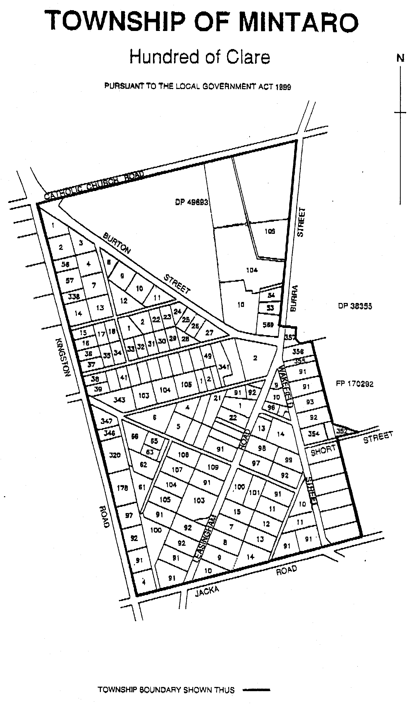
The area of the township of Mintaro shall be that land situated in the Hundred of Clare, more particularly delineated on the plan published herewith.

M. A. Goldstone, Chief Executive Officer

DISTRICT COUNCIL OF COOBER PEDY
General Plan Amendment Report—Draft for Public Consultation
NOTICE is hereby given that the District Council of Coober Pedy has, pursuant to section 25 of the Development Act 1993, prepared a draft Plan Amendment Report.
The draft Plan Amendment Report will replace the Develop-ment Plan for the District Council of Coober Pedy.
Copies of this draft Plan Amendment Report will be available for public inspection and purchase during normal office hours at the District Council of Coober Pedy or can be sent by email by contacting lfreeman@cpcouncil.sa.gov.au.
The draft Plan Amendment Report will be on display from the date of this notice until 29 March 2004.
Persons interested in doing so are invited to make written submissions on the draft Plan Amendment Report to the Council.
Written submissions regarding the draft Plan Amendment Report should be submitted no later than 29 March 2004. All submissions should be addressed to the District Council of Coober Pedy, P.O. Box 425, Coober Pedy, S.A. 5723 and should clearly indicate whether you wish to be heard in support of your submission.
Copies of all submissions will be available for inspection by interested persons at the District Council of Coober Pedy from 30 March 2004 until the conclusion of the public hearing.
The public hearing will be held on 5 May 2004, in the offices of the District Council of Coober Pedy, Hutchison Street, Coober Pedy, commencing at 6 p.m., at which time interested persons may appear to be heard in relation to the draft General Plan Amendment Report and the submissions. The public hearing will not be held if no submissions are received, or no submission makes a request to be heard.
T. McLeod, Chief Executive Officer

REGIONAL COUNCIL OF GOYDER
Road Naming
NOTICE is hereby given that on 21 October 2003, council named the public road between section 892, F176964 and section 108, F178492, Hundred of Neales, as Bunker Road.
S. Kerrigan, Chief Executive Officer

KINGSTON DISTRICT COUNCIL
Roads (Opening and Closing) Act 1991
Corner of Pinks Beach Road and Southern Ports Highway, Hundred of Lacepede
PURSUANT to section 10 of the Roads (Opening and Closing) Act 1991, the Kingston District Council hereby gives notice of its intent to implement a Road Process Order to close and transfer portion of public road (Southern Ports Highway), and merge with adjoining allotment 4 in Filed Plan 122537 in the name of David Stuart Gibbs, shown delineated as ‘A’ on Preliminary Plan No. 03/0107.
A copy of the plan and a statement of persons affected are available for public inspection at the office of the Council, 29 Holland Street, Kingston, S.E. and the Adelaide office of the Surveyor-General during normal office hours.
Any application for easement or objection must set out the full name, address and details of the submission and must be fully supported by reasons.
The application for easement or objection must be made in writing to the council, P.O. Box 321, Kingston, S.E. S.A. 5275, within 28 days of the publication of this notice and a copy must be forwarded to the Surveyor-General, G.P.O. Box 1354, Adelaide, S.A. 5001. Where a submission is made, the council will give notification of a meeting at which the matter will be considered.
Dated 15 January 2004.
S. Rufus, Chief Executive Officer

LIGHT REGIONAL COUNCIL
Traffic Prohibition
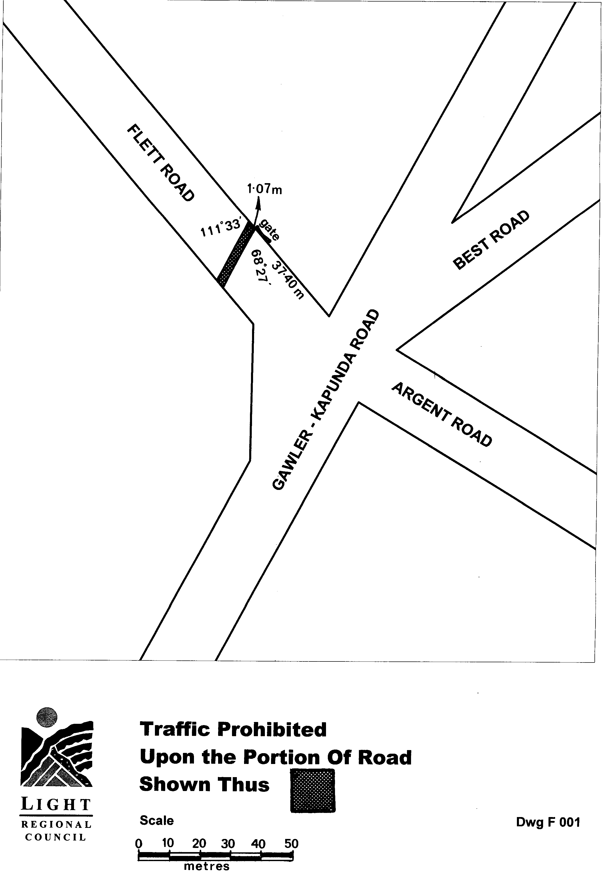
NOTICE is hereby given that Light Regional Council, at its meeting held on 9 December 2003, resolved that pursuant to the provisions of Section 359 of the Local Government Act 1934, as amended, all vehicles be excluded, until further notice, from that portion of Flett Road, Roseworthy, shown shaded and described as Traffic Prohibited Upon the Portion of Road Shown Thus, on the following plan (Dwg F001).
P. J. Beare, Chief Executive Officer

SALE OF PROPERTY
Auction Date: Wednesday, 11 February 2004 at 11 a.m.
Location: Lot 401, plan 2470, Hundred of Yatala, Parafield Gardens
NOTICE is hereby given that on the above date at the time and place stated, by virtue of the Warrant of Sale issued out of the Magistrates Court of South Australia, Action No. AMCCI 6931 of 2001, directed to the Sheriff of South Australia in an action wherein South Australian Water Corporation is the Plaintiff and Ly Chau is the Defendant, I, Tim Goodes, Sheriff, of the State of South Australia, will by my auctioneers, Griffin Real Estate, make sale of the estate, right, title or interest whatsoever it may be of the Defendant Ly Chau as the registered proprietor of an estate in fee simple in the following:
That piece of land situated in the area named Parafield Gardens, being Lot 401, Plan 2470, Hundred of Yatala, being the property comprised in certificate of title register book volume 5516, folio 23.
Further particulars from the auctioneers:
Griffin Real Estate
179 King William Road
Hyde Park, S.A. 5061
Telephone (08) 8357 3177

SALE OF PROPERTY
Auction Date: Friday, 13 February 2004 at 11 a.m.
Location: Lot 21, Gawler Road, Virginia
NOTICE is hereby given that on the above date at the time and place stated, by virtue of the Warrant of Sale issued out of the Magistrates Court of South Australia, Action No. AMCCI 13217 of 2001, directed to the Sheriff of South Australia in an action wherein South Australian Water Corporation is the Plaintiff and Thanh Van Dinh is the Defendant, I, Tim Goodes, Sheriff, of the State of South Australia, will by my auctioneers, Griffin Real Estate, make sale of the estate, right, title or interest whatsoever it may be of the Defendant Thanh Van Dinh as the registered proprietor of an estate in fee simple in the following:
That piece of land situated in the area named Virginia, being Lot 21 Gawler Road, being the property comprised in certificate of title register book volume 5277, folio 875.
Further particulars from the auctioneers:
Griffin Real Estate
179 King William Road
Hyde Park, S.A. 5061
Telephone (08) 8357 3177

SALE OF PROPERTY
Auction Date: Thursday, 12 February 2004 at 11.30 a.m.
Location: 10-14 Sir John Cowan Avenue, Murray Bridge.
NOTICE is hereby given that on the above date at the time and place stated, by virtue of the Warrant of Sale issued out of the District Court of South Australia, Action No. 980 of 2003, directed to the Sheriff of South Australia in an action wherein Bank of Western Australia is the Plaintiff and Peter Maxwell Arthur is the Defendant, I, Tim Goodes, Sheriff, of the State of South Australia, will by my auctioneers, Griffin Real Estate, make sale of the estate, right, title or interest whatsoever it may be of the Defendant Peter Maxwell Arthur as the registered proprietor of an estate in fee simple in the following:
That piece of land situated in the area named Murray Bridge, being 10-14 Sir John Cowan Avenue, being the property comprised in certificate of title register book volume 5809, folio 400.
Further particulars from the auctioneers:
Griffin Real Estate
179 King William Road
Hyde Park, S.A. 5061
Telephone (08) 8357 3177

SALE OF PROPERTY
Auction Date: Tuesday, 10 February 2004 at 11 a.m.
Location: 6 Eliza Street, Williamstown.
NOTICE is hereby given that on the above date at the time and place stated, by virtue of the Warrant of Sale issued out of the Magistrates Court of South Australia, Action No. ELCCI 1735 of 2003, directed to the Sheriff of South Australia in an action wherein CPS Credit Union (SA) Ltd is the Plaintiff and Darryl Bruce and Valerie Kay Gardner are the Defendants, I, Tim Goodes, Sheriff, of the State of South Australia, will by my auctioneers, Griffin Real Estate, make sale of the estate, right, title or interest whatsoever it may be of the Defendants Darryl Bruce and Valerie Kay Gardner as the registered proprietors of an estate in fee simple in the following:
That piece of land situated in the area named Williamstown, being 6 Eliza Street, being the property comprised in certificate of title register book volume 5215, folio 732.
Further particulars from the auctioneers:
Griffin Real Estate
179 King William Road
Hyde Park, S.A. 5061
Telephone (08) 8357 3177

UNCLAIMED MONEYS ACT 1891
Register of Unclaimed Moneys held by Austereo Pty Ltd—NAB Dividend Account. Unpresented Cheque Listing
as at 31 December 2003

Name of Owner  on Books | Cheque No. | Amount  Due  $ | Description  of Moneys | Date of Last  Claim
Aldbury Investments Pty Ltd | 002338 | 2.60 | Dividend Payment | 31.10.96
Aldbury Investments Pty Ltd | 003310 | 2.60 | Dividend Payment | 27.3.97
Atkinson, Michael and Young, Christine | 000033 | 70.00 | Dividend Payment | 10.4.95
Bain, Alexandra Jane | 000900 | 3.10 | Dividend Payment | 9.4.96
Bain, Alexandra Jane | 002362 | 3.10 | Dividend Payment | 31.10.96
Bain, Alexandra Jane | 003335 | 3.10 | Dividend Payment | 27.3.97
Best, Rosa and Daryl | 003362 | 63.36 | Dividend Payment | 27.3.97
Bradley, John Michael | 003391 | 80.00 | Dividend Payment | 27.3.97
Buckingham, Lesley Karen | 000103 | 1.88 | Dividend Payment | 10.4.95
Buckingham, Lesley Karen | 001575 | 2.25 | Dividend Payment | 20.11.95
Burrows, James | 000111 | 10.00 | Dividend Payment | 10.4.95
Burrows, James | 001581 | 12.00 | Dividend Payment | 20.11.95
Burrows, James | 000954 | 16.00 | Dividend Payment | 9.4.96
Cameron, Grant Thomas | 000958 | 3.00 | Dividend Payment | 9.4.96
Cameron, Grant Thomas | 002451 | 3.00 | Dividend Payment | 31.10.96
Cameron, Grant Thomas | 003429 | 3.00 | Dividend Payment | 27.3.97
Cooper, Matthew Simon | 001627 | 54.00 | Dividend Payment | 20.11.95
Cox, Jeremy James | 003505 | 40.00 | Dividend Payment | 27.3.97
Day, David John | 002542 | 4.74 | Dividend Payment | 31.10.96
Della, Mark | 002548 | 0.40 | Dividend Payment | 31.10.96
Della, Mark | 003534 | 0.40 | Dividend Payment | 27.3.97
Diamanti, Barbara | 001666 | 3.00 | Dividend Payment | 20.11.95
Grimes, Mark Baily | 000319 | 4.03 | Dividend Payment | 10.4.95
Grimes, Mark Baily | 001757 | 4.83 | Dividend Payment | 20.11.95
Grimes, Mark Baily | 001125 | 3.54 | Dividend Payment | 9.4.96
Guest, Adrian | 001758 | 3.00 | Dividend Payment | 20.11.95
Guest, Adrian | 001126 | 4.00 | Dividend Payment | 9.4.96
Guest, Adrian | 003654 | 4.00 | Dividend Payment | 27.3.97
Hodyl, Alicja Maria | 000363 | 6.68 | Dividend Payment | 10.4.95
Hodyl, Alicja Maria | 001158 | 5.83 | Dividend Payment | 9.4.96
Hodyl, Alicja Maria | 002707 | 5.83 | Dividend Payment | 31.10.96
Hodyl, Alicja Maria | 003697 | 5.83 | Dividend Payment | 27.3.97
Holdsworth, Sarah Emily | 001795 | 86.40 | Dividend Payment | 20.11.95
Jones, Richard Forrester | 001833 | 2.25 | Dividend Payment | 20.11.95
Jones, Richard Forrester | 003758 | 1.55 | Dividend Payment | 27.3.97
Kestles, David Ross | 000419 | 7.55 | Dividend Payment | 10.4.95
Lang, Marianne Jane | 000433 | 8.55 | Dividend Payment | 10.4.95
Lee, Carolyn Jennifer | 002812 | 12.04 | Dividend Payment | 31.10.96
Long, Christopher Michael | 000469 | 50.00 | Dividend Payment | 10.4.95
Long, Christopher Michael | 003834 | 80.00 | Dividend Payment | 27.3.97
McClure, Anna Forde | 001294 | 6.84 | Dividend Payment | 9.4.96
McClure, James Thomas | 000515 | 4.28 | Dividend Payment | 10.4.95
McClure, James Thomas | 002875 | 6.84 | Dividend Payment | 31.10.96
McClure, James Thomas | 003872 | 6.84 | Dividend Payment | 27.3.97
McClure, Katherine Patricia | 000516 | 4.28 | Dividend Payment | 10.4.95
McClure, Katherine Patricia | 001929 | 5.14 | Dividend Payment | 20.11.95
McClure, Samual James | 001930 | 5.14 | Dividend Payment | 20.11.95
McClure, Samual James | 001298 | 6.84 | Dividend Payment | 9.4.96
McClure, Samual James | 002877 | 6.84 | Dividend Payment | 31.10.96
Meads, Leonie June | 003891 | 52.00 | Dividend Payment | 27.3.97
Meyer, Gregory Peter | 003901 | 4.00 | Dividend Payment | 27.3.97
Munns, Bradley Douglas | 000871 | 40.00 | Dividend Payment | 10.4.95
Noble, Susan Margaret | 003950 | 24.00 | Dividend Payment | 27.3.97
Nosworthy, Janet Mary | 001361 | 400.00 | Dividend Payment | 9.4.96
O’Connell, Francis Patrick | 002965 | 0.08 | Dividend Payment | 31.10.96
O’Connell, Francis Patrick | 003959 | 0.08 | Dividend Payment | 27.3.97
O’Connor, Catherine | 000585 | 50.00 | Dividend Payment | 10.4.95
Perso, Michael John | 001381 | 24.00 | Dividend Payment | 9.4.96
Rezzonico Pty Ltd | 000657 | 500.00 | Dividend Payment | 10.4.95
Rezzonico Pty Ltd | 002051 | 547.60 | Dividend Payment | 20.11.95
Sharpe, Lyndell Merle | 000717 | 2.18 | Dividend Payment | 10.4.95
Simons, Anthony and Graham | 001483 | 64.00 | Dividend Payment | 9.4.96
Sweetman, Marion | 003158 | 100.00 | Dividend Payment | 31.10.96
Sweetman, Marion | 004168 | 100.00 | Dividend Payment | 27.3.97
Ung, Lee Yong | 002258 | 98.90 | Dividend Payment | 9.4.96
Worthington, Gregory Gerard | 002301 | 2.85 | Dividend Payment | 9.4.96
Worthington, Gregory Gerard | 003272 | 2.85 | Dividend Payment | 31.10.96
Worthington, Gregory Gerard | 004290 | 2.85 | Dividend Payment | 27.3.97
 | Total | 2 745.87

UNCLAIMED MONEYS ACT 1891
Register of Unclaimed Moneys Held by Bridgestone Australia Ltd as at January 2004

Name and Address of Owner on Books | Total Amount  Due to  Owner  $
Leila M. Avery, P.O. Box 190, Mittagong, N.S.W. 2575 | 20.30
Leila M. Avery, P.O. Box 190, Mittagong, N.S.W. 2575 | 35.53
Leila M. Avery, P.O. Box 190, Mittagong, N.S.W. 2575 | 20.30
Leila M. Avery, P.O. Box 190, Mittagong, N.S.W. 2575 | 30.45
Alan Gordon Bennett, c/o S. Bennett, 68 Eldorado Street, Tuart Hill, W.A. 6060 | 15.32
Doris Bland, 37 Golflands Terrace, Glenelg North, S.A. 5045 | 10.00
David Kim Boddice, 26 Bond Street, Enoggera Qld, 4051 | 35.00
Claire L. Bohlens, 13 Vincent Street, Adelaide, S.A. 5000 | 27.05
Claire L. Bohlens, 13 Vincent Street, Adelaide, S.A. 5000 | 27.05
Peter John Cruise and Brenton Phillip Lynch, 268 Coombe Street, Nangwarry, S.A. 5277 | 50.00
Peter John Cruise and Brenton Phillip Lynch, 268 Coombe Street, Nangwarry, S.A. 5277 | 87.50
Peter John Cruise and Brenton Phillip Lynch, 268 Coombe Street, Nangwarry, S.A. 5277 | 50.00
Peter John Cruise and Brenton Phillip Lynch, 268 Coombe Street, Nangwarry, S.A. 5277 | 75.00
April Joy Davey, c/o 15 Condada Avenue, Park Holme, S.A. 5043 | 15.00
April Joy Davey, c/o 15 Condada Avenue, Park Holme, S.A. 5043 | 26.25
April Joy Davey, c/o 15 Condada Avenue, Park Holme, S.A. 5043 | 15.00
April Joy Davey, c/o 15 Condada Avenue, Park Holme, S.A. 5043 | 22.50
Ninette Clarice F. Dutton, 35 Esperance Street, Red Hill, A.C.T. 2603 | 31.10
Mary Bergin Cleary (deceased), c/o Perpetual Trustee Co. Ltd, G.P.O. Box 4172, Sydney, N.S.W. 2001 | 77.40
Linda Karen, Craig Andrew and Martin Peter Frost, 34 University Way, Bellevue Heights, S.A. 5050 | 30.00
Noriyuki Kawaguchi, 6353-26 Yamato Nishimuta, Chikugo-Shi, Fukuoka Prefecture, Japan | 100.00
Noriyuki Kawaguchi, 6353-26 Yamato Nishimuta, Chikugo-Shi, Fukuoka Prefecture, Japan | 175.00
Noriyuki Kawaguchi, 6353-26 Yamato Nishimuta, Chikugo-Shi, Fukuoka Prefecture, Japan | 100.00
Noriyuki Kawaguchi, 6353-26 Yamato Nishimuta, Chikugo-Shi, Fukuoka Prefecture, Japan | 150.00
Jane Merrigan, 59 Grant Avenue, Toorak Gardens, S.A. 5065 | 11.30
Jane Merrigan, 59 Grant Avenue, Toorak Gardens, S.A. 5065 | 19.76
Jane Merrigan, 59 Grant Avenue, Toorak Gardens, S.A. 5065 | 11.30
Jane Merrigan, 59 Grant Avenue, Toorak Gardens, S.A. 5065 | 18.95
Claire M. Moir, Unit 13, 19 Broome Street, Cottlesloe, W.A. 6011 | 102.00
Claire M. Moir, Unit 13, 19 Broome Street, Cottlesloe, W.A. 6011 | 153.00
Raffaele and Vittoria Nisco, 103 Hill Street, Murray Bridge, S.A. 5253 | 10.00
John O’Brien, 245 Lygon Street, East Brunswick, Vic, 3057 | 13.10
John O’Brien, 245 Lygon Street, East Brunswick, Vic, 3057 | 11.25
Jessie N. O’Farrel (deceased), Unit 6, 23-25 Apsley Street, Penhurst, N.S.W. 2222 | 264.25
Karina Nicole Pinksterboer, 9 Lilac Street, Tea Tree Gully, S.A. 5091 | 10.00
Karina Nicole Pinksterboer, 9 Lilac Street, Tea Tree Gully, S.A. 5091 | 15.00
Jane and Doreen Ridgley, 54 Wellington Circuit, Torquay, Qld 4655 | 15.00
Michela V. Skerbec, 10 Wright Street, Balmoral, Qld 4171 | 70.00
Michela V. Skerbec, 10 Wright Street, Balmoral, Qld 4171 | 122.50
Michela V. Skerbec, 10 Wright Street, Balmoral, Qld 4171 | 70.00
Michela V. Skerbec, 10 Wright Street, Balmoral, Qld 4171 | 105.00
Alicia C. Sutton (deceased), c/o Thompson Playford, G.P.O. Box 1683 Adelaide, S.A. 5000 | 150.00
John G. Wilson (deceased), 46 Kent Road, North Ryde, N.S.W. 2113 | 13.55
John G. Wilson (deceased), 46 Kent Road, North Ryde, N.S.W. 2113 | 23.72
John G. Wilson (deceased), 46 Kent Road, North Ryde, N.S.W. 2113 | 13.55
John G. Wilson (deceased), 46 Kent Road, North Ryde, N.S.W. 2113 | 20.33
Unicut Pty Ltd, 185 Balaclava Road, Shepparton, Vic. 3630 | 75.00

ATTENTION

CUSTOMERS requiring a proof of their notice for inclusion in the Government Gazette, please note that the onus is on you to inform Government Publishing SA of any subsequent corrections by 10 a.m. on Thursday, which is our publication deadline.

For any corrections to your notice please phone 8207 1045 or Fax 8207 1040 before 10 a.m. on Thursday.

If we do not receive any communication by 10 a.m. on Thursday (day of publication) we will presume the notice is correct and will print it as it is.

Remember—the onus is on you to inform us of any corrections necessary to your notice.

NOTE: Closing time for lodging new copy (electronically, fax or hard copy) is 4 p.m. on Tuesday preceding the day of publication. Phone 8207 1045—Fax 8207 1040.
Email: governmentgazette@saugov.sa.gov.au

Printed and published by authority every Thursday by J. D. FERGUSON, Government Printer, South Australia
Price: $4.70, plus postage; to subscribers, $238.00 per annum.
(The above prices are inclusive of GST)

