No. 47 1769

THE SOUTH AUSTRALIAN

GOVERNMENT GAZETTE
www.governmentgazette.sa.gov.au

PUBLISHED BY AUTHORITY

ALL PUBLIC ACTS appearing in this GAZETTE are to be considered official, and obeyed as such

ADELAIDE, THURSDAY, 10 JUNE 2004

CONTENTS

Page
Act Assented To 1770
Appointments, Resignations, Etc. 1770
Authorised Betting Operations Act 2000—Notice 1770
Corporations and District Councils—Notices 1806
Environment Protection Act 1993—Notices 1772
Geographical Names Act 1991—Notice 1775
House of Assembly—Resolution 1786
Land and Business (Sale and Conveyancing) Act 1994—
Notices 1786
Legislative Council—Resolution 1786
Libraries Board of South Australia—Notice 1778
Liquor Licensing Act 1997—Notices 1786
Mining Act 1971—Notices 1790
New Zealand Trans-Tasman Mutual Recognition
Act 1997—Notice 1791

Page
Passenger Transport Act 1994—Notice 1794
Petroleum Act 2000—Notices 1796
Prevention of Cruelty to Animals Act 1985—
Notice 1800
Public Finance and Audit Act 1987—Notice 1800
Public Sector Management Act 1995—Notice 1800
Public Trustee Office—Administration of Estates 1806
Rail Safety Act 1996—Notice 1800
Roads (Opening and Closing) Act 1991—
Notices 1801
Survey Act 1992—Notice 1801
Transport, Department of—Notice to Mariners 1802
Transport SA—Notice 1798
Water Mains and Sewers—Mains Laid, Replaced, Etc. 1802
Water Resources Act 1997—Notices 1803

GOVERNMENT GAZETTE NOTICES
ALL poundkeepers’ and private advertisements forwarded for publication in the South Australian Government Gazette must be PAID FOR PRIOR TO INSERTION; and all notices, from whatever source, should be legibly written on one side of the paper only and sent to Government Publishing SA so as to be received no later
than 4 p.m. on the Tuesday preceding the day of publication. Phone 8207 1045 or Fax 8207 1040. E-mail: governmentgazette@saugov.sa.gov.au. Send as attachments in Word format and please confirm your transmission with a faxed copy of your document, including the date the notice is to be published and to whom the notice will be charged. The Government Gazette is available online at: www.governmentgazette.sa.gov.au

Department of the Premier and Cabinet
Adelaide, 10 June 2004
HER Excellency the Governor directs it to be notified for general information that she has in the name and on behalf of Her Majesty The Queen, this day assented to the undermentioned Act passed by the Legislative Council and House of Assembly in Parliament assembled, viz.:
No. 19 of 2004—Supply Act 2004. An Act for the appropriation of money from the Consolidated Account for the financial year ending on 30 June 2005.
By command,
J. D. Lomax-Smith, for Acting Premier
DPC 02/0586

Department of the Premier and Cabinet
Adelaide, 10 June 2004
HER Excellency the Governor in Executive Council has been pleased to appoint the undermentioned to the South East Catchment Water Management Board, pursuant to the provisions of the Water Resources Act 1997:
Member: (from 10 June 2004 until 9 June 2008)
Robert Cowan
By command,
J. D. Lomax-Smith, for Acting Premier
MEC 0051/04 CS

Department of the Premier and Cabinet
Adelaide, 10 June 2004
HER Excellency the Governor in Executive Council has been pleased to appoint the undermentioned to the Arid Areas Catchment Water Management Board, pursuant to the provisions of the Water Resources Act 1997:
Member: (from 10 June 2004 until 9 June 2008)
Lynn Albert Brake
Maurice Kenworthy Francis
Anthony James Williams
Frederick George Tanner
John Clive Radcliffe
Presiding Member: (from 10 June 2004 until 9 June 2008)
Lynn Albert Brake
By command,
J. D. Lomax-Smith, for Acting Premier
MEC 0050/04 CS

Department of the Premier and Cabinet
Adelaide, 10 June 2004
HER Excellency the Governor in Executive Council has been pleased to appoint the undermentioned to the Residential Tenancies Tribunal, pursuant to the provisions of the Residential Tenancies Act 1995:
Bailiff: (from 14 June 2004 until 10 June 2009)
Colin Basil Allchurch
By command,
J. D. Lomax-Smith, for Acting Premier
OCBA 05/04 CS

Department of the Premier and Cabinet
Adelaide, 10 June 2004
HER Excellency the Governor in Executive Council has been pleased to appoint the undermentioned to the Petroleum Products Retail Outlets Board, pursuant to the provisions of the Petroleum Products Regulation Act 1995:
Member: (from 1 July 2004 until 30 June 2005)
Robert Louis Dahlenburg
Jillian Mary Hamilton
Nick Thredgold
Chair: (from 1 July 2004 until 30 June 2005)
Robert Louis Dahlenburg
By command,
J. D. Lomax-Smith, for Acting Premier
MIR 011/04 CS

AUTHORISED BETTING OPERATIONS ACT 2000
Section 4 (1) (b)
Notice of Approval of Contingencies
No. 6 of 2004
INDEPENDENT GAMBLING AUTHORITY, by this notice, approves contingencies relating to sporting or other events within Australia:
1. Citation
This notice may be cited as the Approved Contingencies (Marree Picnic Races—Galloping) Notice 2004.
2. Approval
(1) The contingencies listed in the table are approved in respect of fixed odds betting by licensed bookmakers.
(2) This approval is subject to the provisions of the Authorised Betting Operations Act 2000 (‘Act’), the Bookmakers Licensing Rules 2000, any other rules made under section 62 of the Act, and the conditions to which a licence or permit are subject.
(3) This approval of contingencies may be amended or revoked by further notice.
3. Definitions
In this Notice:
‘Event’—
(a) means a race on the flat for horses where each animal is ridden by a person;
(b) includes, in relation to an event mentioned in paragraph (a) for which there were more accepters than places, a division of that event offering the same prize as the event.
‘Place’ means the contingency that a specified Entrant will place either first, second or third (or, if applicable, fourth) in a specified Event (including where different odds are offered by a bookmaker for first place vis-a-vis any of second, third or, if applicable, fourth place).
‘race’, with respect to horses, includes—
(a) a race conducted by a licensed racing club; and
(b) a race at a picnic race meeting or a gymkhana.
‘Win’ means the contingency that a specified Entrant will place first in or win a specified Event.

Table
Picnic race meeting conducted by or on behalf of the Marree Picnic Race Club at the Marree Racecourse on 12 June 2004 and such later date to which the meeting may be adjourned
No. | Description of Event | Prizes | Approved  Contingencies
1. | Open sprint over 400 metres for horses | First—$400  Second—$200  Third—$100 | Win, place or derivative
2. | Open race over 1 000 metres for horses | First—$600 and bracelet  Second—$400  Third—$200 | Win, place or derivative
3. | District bred race over 800 metres for horses—open only to horses bred in the district | First—$400 and cup  Second—$200  Third—$100 | Win, place or derivative
4. | Open sprint over 400 metres for horses | First—$400  Second—$200  Third—$100 | Win, place or derivative
5. | Open race over 1 600 metres for horses | First—$1 500 and cup  Second—$500  Third—$250 | Win, place or derivative
6. | District bred race over 1 400 metres for horses—open only to horses bred in the district | First—$400  Second—$200  Third—$100 | Win, place or derivative
7. | Open race over 1 400 metres for horses | First—$450  Second—$250  Third—$150 | Win, place or derivative
8. | Consolation race over 600 metres for horses—open to horses which have started, but not won, on the day | First—$400  Second—$200  Third—$100 | Win, place or derivative
Dated 8 June 2004.
R. C. J. Chappell, Secretary to the Independent Gambling Authority

ENVIRONMENT PROTECTION ACT 1993
Approval of Category A Containers
I, STEPHEN RICHARD SMITH, Senior Adviser, Container Deposit Legislation and Delegate of the Environment Protection Authority (‘the Authority’), pursuant to section 69 of the Environment Protection Act 1993 (SA) (‘the Act’) hereby:
Approval of Category A Containers:
Approve as Category A Containers, as identified in column 5 of the Schedule, subject to the conditions in subclauses (i) and (ii) below, each of the classes of containers identified by reference to the following matters described in the first 4 columns of Schedule 1 of this Notice which are sold in South Australia:
(a) the product which each class of containers shall contain;
(b) the size of the containers;
(c) the type of containers;
(d) the name of the holders of these approvals.
(i) Subsection 69 (3) Arrangements:
The holders of these approvals must ensure that the empty containers which belong to their respective class of containers hereby approved as Category A Containers are collected from the retailers that sell them, and recycled in an appropriate manner. Disposal at landfill is not considered an appropriate method of disposal.
(ii) Approved Refund Markings:
(a) The holders of these approvals must ensure that each container which belongs to their respective class of containers hereby approved as Category A Containers bears the refund marking approved by the Authority in respect of that class of containers.
(b) The refund marking that appears on each container that belongs to the class of containers hereby approved, must be a minimum 1.5 mm for the smallest letter in the statement and a minimum 3 mm for the numeric (‘5’) in the statement.

Column 1 | Column 2 | Column 3 | Column 4 | Column 5
Product Name | Container  Size (mL) | Container Type | Approval Holder | Collection  Arrangements
Cider Mineral Water | 340 | Glass (Sticker) | Byong Kil Chai t/as Seoul Grocery | Return at Point of Sale
Sunny 10 Grape | 250 | Can—Aluminium (Sticker) | Byong Kil Chai t/as Seoul Grocery | Return at Point of Sale
Mc Col Barley Flavoured Soda | 250 | Can—Aluminium (Sticker) | Byong Kil Chai t/as Seoul Grocery | Return at Point of Sale
Bonbon Grape | 238 | Can—Aluminium (Sticker) | Byong Kil Chai t/as Seoul Grocery | Return at Point of Sale
Nostalgia Drink Soojeonggwa | 238 | Can—Aluminium (Sticker) | Byong Kil Chai t/as Seoul Grocery | Return at Point of Sale
Ohen Crushed Pear Juice | 238 | Can—Aluminium (Sticker) | Byong Kil Chai t/as Seoul Grocery | Return at Point of Sale
Wang Carbonated Soft Drink | 250 | Can—Aluminium (Sticker) | Byong Kil Chai t/as Seoul Grocery | Return at Point of Sale
Korean Original Ginseng Drink | 120 | Glass (Sticker) | Byong Kil Chai t/as Seoul Grocery | Return at Point of Sale
Bacchus F Soln | 100 | Glass (Sticker) | Byong Kil Chai t/as Seoul Grocery | Return at Point of Sale
Wonbi D | 100 | Glass (Sticker) | Byong Kil Chai t/as Seoul Grocery | Return at Point of Sale
Maxwell House Coffee Original | 180 | Can—Steel (Sticker) | Byong Kil Chai t/as Seoul Grocery | Return at Point of Sale
Cappuccino Regular | 175 | Can—Steel (Sticker) | Byong Kil Chai t/as Seoul Grocery | Return at Point of Sale
OKF Aloe Vera Juice | 500 | PET (Sticker) | Byong Kil Chai t/as Seoul Grocery | Return at Point of Sale
Lotte Lets Be Mild Coffee | 175 | Can—Steel (Sticker) | Byong Kil Chai t/as Seoul Grocery | Return at Point of Sale

ENVIRONMENT PROTECTION ACT 1993
Approval of Category B Containers
I, STEPHEN RICHARD SMITH, Senior Adviser, Container Deposit Legislation and Delegate of the Environment Protection Authority (‘the Authority’), pursuant to section 69 of the Environment Protection Act 1993 (SA) (‘the Act’) hereby:
Approval of Category B Containers:
Approve as Category B Containers, subject to the conditions in subclauses (i) and (ii) below, each of the classes of containers identified by reference to the following matters described in the first 4 columns of Schedule 1 of this Notice which are sold in South Australia:
(a) the product which each class of containers shall contain;
(b) the size of the containers;
(c) the type of containers;
(d) the name of the holders of these approvals.
(i) Subsection 69 (3) Arrangements:
The holders of these approvals must ensure that the empty containers which belong to their respective class of containers hereby approved as Category B Containers are collected from collection depots approved under section 69 of the Act by the party named in Column 5 of Schedule 1 of this Notice; and
(ii) Approved Refund Markings:
(a) The holders of these approvals must ensure that each container which belongs to their respective class of containers hereby approved as Category B Containers bears the refund marking approved by the Authority in respect of that class of containers.
(b) The refund marking that appears on each container that belongs to the class of containers hereby approved, must be a minimum 1.5 mm for the smallest letter in the statement and a minimum 3 mm for the numeric (‘5’) in the statement.

Column 1 | Column 2 | Column 3 | Column 4 | Column 5
Product Name | Container  Size (mL) | Container Type | Approval Holder | Collection  Arrangements
Kirin Ichiban | 330 | Glass with Paper Label | South Australian Brewing Company Pty Ltd | Marine Stores Ltd
Pilsner Urquell | 330 | Glass with Paper Label | South Australian Brewing Company Pty Ltd | Marine Stores Ltd
Berri Multi V Breakfast Juice with Folate Vitamin A & C | 400 | PET with Paper Label | Berri Limited | Statewide Recycling
Berri Multi V Apple & Mango Juice with Antioxidants Vitamin A C & E | 400 | PET with Paper Label | Berri Limited | Statewide Recycling
Berri Multi V Apple Juice with Fibre Vitamin C & E and Folate | 400 | PET with Paper Label | Berri Limited | Statewide Recycling
Chin Chin Grass Jelly S | 320 | Can—Steel | New World Trading Company Pty Ltd | Statewide Recycling
Pikes New Oakbank Beer | 330 | Glass with Paper Label | Tucker Seabrook (Aust) Pty Ltd | Statewide Recycling
Schweppes Dry Ginger Ale Diet | 315 | Glass with Paper Label | Cadbury Schweppes Pty Ltd | Statewide Recycling
Schweppes Indian Tonic Water Diet | 315 | Glass with Paper Label | Cadbury Schweppes Pty Ltd | Statewide Recycling
Chin Chin Aloe Vera Juice | 250 | Can—Steel | New World Trading Company Pty Ltd | Statewide Recycling
Chin Chin Sterlhia With Basil Seed | 350 | Can—Steel | New World Trading Company Pty Ltd | Statewide Recycling
Chin Chin Grass Jelly Coconut | 320 | Can—Steel | New World Trading Company Pty Ltd | Statewide Recycling
Chin Chin Grass Jelly Lychee | 320 | Can—Steel | New World Trading Company Pty Ltd | Statewide Recycling
Chin Chin Green Tea | 340 | Can—Steel | New World Trading Company Pty Ltd | Statewide Recycling
Chin Chin Green Tea | 500 | PET | New World Trading Company Pty Ltd | Statewide Recycling
Chin Chin Genesis Coffee | 350 | Can—Steel | New World Trading Company Pty Ltd | Statewide Recycling
Wonderfarm Tamerind Drink | 325 | Can—Steel | New World Trading Company Pty Ltd | Statewide Recycling
Yida Almond Juice | 240 | Can—Steel | New World Trading Company Pty Ltd | Statewide Recycling
Sagiko Chrysanthemum Drink | 320 | Can—Steel | New World Trading Company Pty Ltd | Statewide Recycling
Sagiko Soursop Juice Drink | 320 | Can—Steel | New World Trading Company Pty Ltd | Statewide Recycling
Nekta Liquid Kiwi Fruit | 1 000 | PET with Paper Label | Kevron Australia Pty Ltd | Marine Stores Ltd
Nekta Liquid Kiwi Fruit | 375 | PET with Paper Label | Kevron Australia Pty Ltd | Marine Stores Ltd
Powerade Green & Gold Spirit Flat Cap | 600 | PET with Polyethylene Label | Coca Cola Amatil (Aust) Pty Ltd | Statewide Recycling
Powerade Green & Gold Spirit Sipper Cap | 600 | PET with Polyethylene Label | Coca Cola Amatil (Aust) Pty Ltd | Statewide Recycling
Diet Coke with Lime Flavour | 600 | PET with Polyethylene Label | Coca Cola Amatil (Aust) Pty Ltd | Statewide Recycling
Diet Coke with Lime Flavour | 390 | PET with Polyethylene Label | Coca Cola Amatil (Aust) Pty Ltd | Statewide Recycling
Diet Coke with Lime Flavour | 1 250 | PET with Polyethylene Label | Coca Cola Amatil (Aust) Pty Ltd | Statewide Recycling
Diet Coke with Lime Flavour | 2 000 | PET with Polyethylene Label | Coca Cola Amatil (Aust) Pty Ltd | Statewide Recycling
Kirks Cream & Soda | 2 000 | PET with Polyethylene Label | Coca Cola Amatil (Aust) Pty Ltd | Statewide Recycling
Kirks Pasito Passion Fruit Flavour | 2 000 | PET with Polyethylene Label | Coca Cola Amatil (Aust) Pty Ltd | Statewide Recycling
Deep Spring Natural Mineral Water | 600 | PET with Polyethylene Label | Coca Cola Amatil (Aust) Pty Ltd | Statewide Recycling
Deep Spring Orange & Passionfruit Natural Mineral Water | 600 | PET with Polyethylene Label | Coca Cola Amatil (Aust) Pty Ltd | Statewide Recycling
Deep Spring Orange & Mango Natural Mineral Water | 600 | PET with Polyethylene Label | Coca Cola Amatil (Aust) Pty Ltd | Statewide Recycling
Deep Spring Lemon Natural Mineral Water | 600 | PET with Polyethylene Label | Coca Cola Amatil (Aust) Pty Ltd | Statewide Recycling
Deep Spring Lemon Natural Mineral Water | 1 250 | PET with Polyethylene Label | Coca Cola Amatil (Aust) Pty Ltd | Statewide Recycling
Lift 5% Lemon Juice | 250 | Glass Ink Jetted | Coca Cola Amatil (Aust) Pty Ltd | Statewide Recycling
Black & Gold Lemonade Flavoured Soft Drink | 350 | PET with Polypropylene Label | Chandru International Pty Ltd | Visy CDL Recycling Services
Black & Gold Pineapple Flavoured Soft Drink | 350 | PET with Polypropylene Label | Chandru International Pty Ltd | Visy CDL Recycling Services
Black & Gold Orange Flavoured Soft Drink | 350 | PET with Polypropylene Label | Chandru International Pty Ltd | Visy CDL Recycling Services
Black & Gold Lime Flavoured Soft Drink | 350 | PET with Polypropylene Label | Chandru International Pty Ltd | Visy CDL Recycling Services
Black & Gold Raspberry Flavoured Soft Drink | 350 | PET with Polypropylene Label | Chandru International Pty Ltd | Visy CDL Recycling Services
Black & Gold Cola Flavoured Soft Drink | 350 | PET with Polypropylene Label | Chandru International Pty Ltd | Visy CDL Recycling Services
Brownes Coffee Strong Percolated Iced Coffee Blast | 750 | LPB—Gable Top | PB Foods Ltd | Statewide Recycling
Brownes Lite Coffee No Added Sugar Blast | 750 | LPB—Gable Top | PB Foods Ltd | Statewide Recycling
Brownes Mocha Real Choc Coffee Taste Blast | 750 | LPB—Gable Top | PB Foods Ltd | Statewide Recycling
Bacos Apple Tree Apple & Banana Juice | 375 | Glass with Paper Label | Baco Pty Ltd | Visy CDL Recycling Services
Wild Potion Wort Organic Berry & Ginger | 300 | PET with Paper Label | Wort Organic Pty Ltd | Marine Stores Ltd
Wort Organic Traveleasy Peppermint & Ginger | 330 | Glass with Paper Label | Wort Organic Pty Ltd | Marine Stores Ltd
Bacos Apple Tree Apple & Blackcurrant Juice | 375 | Glass with Paper Label | Baco Pty Ltd | Visy CDL Recycling Services
Bacos Apple Tree Apple & Mango Juice | 375 | Glass with Paper Label | Baco Pty Ltd | Visy CDL Recycling Services
Bacos Apple Tree Apple & Passionfruit Juice | 375 | Glass with Paper Label | Baco Pty Ltd | Visy CDL Recycling Services
Wort Organic Lemon & Ginger Wort | 330 | Glass with Paper Label | Wort Organic Pty Ltd | Marine Stores Ltd
Bacos Apple Tree Apple & Pineapple Juice | 375 | Glass with Paper Label | Baco Pty Ltd | Visy CDL Recycling Services
Bacos Apple Tree Apple & Tropical Juice | 375 | Glass with Paper Label | Baco Pty Ltd | Visy CDL Recycling Services

ENVIRONMENT PROTECTION ACT 1993
Exemption
THE following people are exempt from section 75 of the Environment Protection Act 1993, subject to the provisions of Regulation 6 of the Regulations under the Environment Protection Act 1993 dated 27 October 1994, by virtue of owning or possessing equipment containing ozone depleting substances.

Exemptee | Exemption  Number
Rocca Domenico t/a Rocca’s Auto Electrical |  | 1
Fiebiger Motors Pty Ltd |  | 9
Paul and David Berry t/a Northern Refrigeration Service |  | 117
Paul Clarke |  | 178
P. R. & K. R. Hood Pty Ltd t/a Peter Hood Holden & Machinery |  | 307
Graham Edwards Crash Repairs Pty Ltd |  | 363
The Miners Store Pty Ltd |  | 376
Merabar Pty Ltd |  | 382
Clisby Electrical Pty Ltd |  | 468
Richard James McInerney t/a Ricks Mechanical Repairs |  | 538
Christopher P Black t/a Chris's Electrical and Communications |  | 563
Ian Leslie Dreckow |  | 598
Adelaide Motors Pty Ltd |  | 994
John Tremaine |  | 999
David Stehbens |  | 1016
Flinders Medical Centre |  | 1106
John and Rosemary Turner |  | 1147
PBS Refrigeration & Air Conditioning Pty Ltd |  | 1225
Hugh David Magarey |  | 1240
Brenton Keith Turner |  | 1248
Clenton Evans t/a Evans Refrigeration & Airconditioning |  | 1293
Quality Container Management Pty Ltd t/a Pitstop Refrigeration |  | 1360
M. J. Murdock Pty Ltd |  | 1470
Leslie Rodway and Nellie Madge Rees t/a L. R. & N. M. Rees Electrical Engineers |  | 1475
David Barnes |  | 1543
Adelaide Community Healthcare Alliance Incorporated t/a Ashford Private Hospital |  | 1586
Wickham Flower & Co. Pty Ltd |  | 1661
Stephen Malcolm Munn |  | 1815
North Western Adelaide Health Service t/a Lyell McEwin Health Service |  | 1838
Trevor John Greening |  | 1848
Reginald Allan Sparrow |  | 2152
Pfitzner Motor Co. Pty Ltd |  | 2192
Brenton Wickham |  | 2301
Mark Andrew Weedon |  | 2303
Adelaide Brighton Cement Ltd |  | 2314
Gilbert Geral Erskine |  | 2436
Stephen Crowdey |  | 2441
Hills Auto Electrical Pty Ltd |  | 2449
Bradbill Pty Ltd t/a Cain Electrical |  | 2454
Graham Walter Kent |  | 2531
A. B. and S. Martin t/a Auto Brake Service |  | 2621
Stanley Frederick Hawkins |  | 2896
Lancer Pacific Pty Ltd |  | 3340
C. & C. Ioanni Nominees Pty Ltd t/a Torrensville Motor Centre |  | 3475
J. V. Crash Repairs Pty Ltd |  | 3669
Cecilio Gaviola t/a C. & C. Refrigeration Air-Conditioning Services |  | 3706
Cut Price Car & Truck Rentals Pty Ltd |  | 3803
McAlpine Hussmann Pty Ltd |  | 4771
L. R. & M. P. Ahrens Pty Ltd |  | 4855
Paul Salter t/a Clare Valley Auto Electrical |  | 4962
Silvo Stepan |  | 5058
Graham Diment |  | 5188
Paul John Fitzgerald |  | 5269
Dosill Pty Ltd t/a Nairne Complete Auto Care |  | 5292
Streaky Bay Crash Repairs Pty Ltd |  | 5351
City of Tea Tree Gully |  | 5588
Daryl Alan Newbold |  | 6434
Douglas Brian Falland |  | 6460
Neil Amos |  | 6553
Anthony D Marafioti t/a A & T Auto Electrical |  | 6700
Llewelyn Transport Pty Ltd t/a Arno Bay Motors |  | 6754
P. & M. Grosvenor t/a Profix Service Centre |  | 7047
Neil L Baragwanath |  | 7078
Gregory Robert Parsons |  | 7123
Mitci Antoni Bialkowski |  | 7194
John and Lee Ann Guerin t/a J. M. & L. J. Guerin |  | 7321
John Kouts t/a Power Electrical Air-Conditioning |  | 7442
Michael John Rushton t/a North East Auto Air |  | 7480
Peter Anthony Mowbray |  | 7485
Feliba Pty Ltd |  | 10039
Leon Crowhurst t/a Whyalla & District Refrigeration |  | 10066
R., B. J., G. R. Simmonds Pty Ltd |  | 10435
Norman Angus Bain |  | 10960
Shane Donavon Kidd |  | 10961
Ramin Samie |  | 10962
Dale Layton t/a Quantum Refrigeration and Airconditioning Services |  | 10989
MS Aircon Pty Ltd |  | 11136
Darren Allan and Julie Kaye Hogben t/a Eyre Refrigeration |  | 11141
Derek Lindsay Packer t/a DLP Airconditioning |  | 11195
Colin Ronald Smith |  | 11280
Greg Kostopoulos |  | 11289
Nigel Williams |  | 11298
Westside Mechanical Contracting Pty Ltd |  | 11302
Michael Reginald Leithboro |  | 11315
Stan Szalbot |  | 11323
Malcolm Darren Schupelius |  | 11327
The Coolman S.A. |  | 11339

G. C. Sclare, Manager, Licensing and Operations Services

GEOGRAPHICAL NAMES ACT 1991
Notice of Intention to Assign a Name and Boundary to a Place
NOTICE is hereby given pursuant to the provisions of the above Act, that the Minister for Administrative Services seeks public comment on a proposal to assign the name PIMBA, TARCOOLA and WOOMERA to the areas shown numbered 1 to 3 on Rack Plan 857 (Sheet 1).
Copies of Rack Plan 857 (Sheet 1) can be viewed at the office of the Surveyor-General, 101 Grenfell Street, Adelaide, S.A. 5000 and the relevant progress associations.
Submissions in writing regarding this proposal may be lodged with the Secretary, Geographical Names Advisory Committee, (G.P.O. Box 1354, Adelaide, S.A. 5001) within one month of the publication of this notice.
Dated 4 June 2004.
P. Smith, Acting Surveyor-General, Department for Administrative and Information Services
DAIS 04/0429

GOVERNMENT GAZETTE ADVERTISEMENT RATES

To apply from 1 July 2002

$  Agents, Ceasing to Act as 34.10  Associations:  Incorporation 17.40  Intention of Incorporation 43.00  Transfer of Properties 43.00  Attorney, Appointment of 34.10  Bailiff’s Sale 43.00  Cemetery Curator Appointed 25.50  Companies:  Alteration to Constitution 34.10  Capital, Increase or Decrease of 43.00  Ceasing to Carry on Business 25.50  Declaration of Dividend 25.50  Incorporation 34.10  Lost Share Certificates:  First Name 25.50  Each Subsequent Name 8.75  Meeting Final 28.75  Meeting Final Regarding Liquidator’s Report on  Conduct of Winding Up (equivalent to ‘Final  Meeting’)  First Name 34.10  Each Subsequent Name 8.75  Notices:  Call 43.00  Change of Name 17.40  Creditors 34.10  Creditors Compromise of Arrangement 34.10  Creditors (extraordinary resolution that ‘the Com-pany be wound up voluntarily and that a liquidator be appointed’) 43.00  Release of Liquidator⎯Application⎯Large Ad. 68.00  ⎯Release Granted 43.00  Receiver and Manager Appointed 39.75  Receiver and Manager Ceasing to Act 34.10  Restored Name 32.25  Petition to Supreme Court for Winding Up 59.50  Summons in Action 51.00  Order of Supreme Court for Winding Up Action 34.10  Register of Interests⎯Section 84 (1) Exempt 77.00  Removal of Office 17.40  Proof of Debts 34.10  Sales of Shares and Forfeiture 34.10  Estates:  Assigned 25.50  Deceased Persons⎯Notice to Creditors, etc. 43.00  Each Subsequent Name 8.75  Deceased Persons⎯Closed Estates 25.50  Each Subsequent Estate 1.10  Probate, Selling of 34.10  Public Trustee, each Estate 8.75 |  | $  Firms:  Ceasing to Carry on Business (each insertion) 22.70  Discontinuance Place of Business 22.70  Land⎯Real Property Act:  Intention to Sell, Notice of 43.00  Lost Certificate of Title Notices 43.00  Cancellation, Notice of (Strata Plan) 43.00  Mortgages:  Caveat Lodgment 17.40  Discharge of 18.30  Foreclosures 17.40  Transfer of 17.40  Sublet 8.75  Leases⎯Application for Transfer (2 insertions) each 8.75  Lost Treasury Receipts (3 insertions) each 25.50  Licensing 51.00  Municipal or District Councils:  Annual Financial Statement⎯Forms 1 and 2 481.00  Electricity Supply⎯Forms 19 and 20 341.00  Default in Payment of Rates:  First Name 68.00  Each Subsequent Name 8.75  Noxious Trade 25.50  Partnership, Dissolution of 25.50  Petitions (small) 17.40  Registered Building Societies (from Registrar-  General) 17.40  Register of Unclaimed Moneys⎯First Name 25.50  Each Subsequent Name 8.75  Registers of Members⎯Three pages and over:  Rate per page (in 8pt) 218.00  Rate per page (in 6pt) 288.00  Sale of Land by Public Auction 43.50  Advertisements 2.40  Advertisements, other than those listed are charged at $2.40 per column line, tabular one-third extra.  Notices by Colleges, Universities, Corporations and District Councils to be charged at $2.40 per line.  Where the notice inserted varies significantly in length from that which is usually published a charge of $2.40 per column line will be applied in lieu of advertisement rates listed.  South Australian Government publications are sold on the condition that they will not be reproduced without prior permission from the Government Printer.
All the above prices include GST

GOVERNMENT GAZETTE NOTICES
ALL private advertisements forwarded for publication in the South Australian Government Gazette must be PAID FOR PRIOR TO INSERTION; and all notices, from whatever source, should be legibly written on one side of the paper only and sent to Government Publishing SA so as to be received no later than 4 p.m. Tuesday preceding the day of publication. Phone 8207 1045 or Fax 8207 1040. E-mail: governmentgazette@saugov.sa.gov.au. Send as attachments in Word format and please confirm your transmission with a faxed copy of your document, including the date the notice is to be published and to whom the notice will be charged.

MISCELLANEOUS LEGISLATION AND GOVERNMENT PUBLICATIONS PRICES AS FROM 1 JULY 2003

Acts, Bills, Rules, Parliamentary Papers and Regulations
Pages | Main | Amends | Pages | Main | Amends

1-16 | 2.05 | 0.90 | 497-512 | 29.20 | 28.00
17-32 | 2.80 | 1.75 | 513-528 | 30.00 | 28.80
33-48 | 3.65 | 2.60 | 529-544 | 30.90 | 29.90
49-64 | 4.60 | 3.50 | 545-560 | 31.70 | 30.90
65-80 | 5.40 | 4.45 | 561-576 | 32.50 | 31.70
81-96 | 6.25 | 5.20 | 577-592 | 33.60 | 32.20
97-112 | 7.15 | 6.05 | 593-608 | 34.40 | 33.25
113-128 | 8.00 | 7.00 | 609-624 | 35.20 | 34.30
129-144 | 9.00 | 7.95 | 625-640 | 35.90 | 34.80
145-160 | 9.85 | 8.80 | 641-656 | 36.80 | 35.85
161-176 | 10.80 | 9.65 | 657-672 | 37.40 | 36.60
177-192 | 11.60 | 10.60 | 673-688 | 39.00 | 37.40
193-208 | 12.50 | 11.50 | 689-704 | 39.80 | 38.40
209-224 | 13.30 | 12.25 | 705-720 | 40.30 | 39.50
225-240 | 14.20 | 13.10 | 721-736 | 41.80 | 40.00
241-257 | 15.10 | 13.80 | 737-752 | 42.30 | 41.30
258-272 | 16.00 | 14.75 | 753-768 | 43.40 | 41.80
273-288 | 16.90 | 15.80 | 769-784 | 43.90 | 43.10
289-304 | 17.60 | 16.60 | 785-800 | 44.70 | 43.90
305-320 | 18.60 | 17.50 | 801-816 | 45.50 | 44.40
321-336 | 19.40 | 18.30 | 817-832 | 46.50 | 45.50
337-352 | 20.40 | 19.30 | 833-848 | 47.50 | 46.25
353-368 | 21.20 | 20.20 | 849-864 | 48.30 | 47.00
369-384 | 22.10 | 21.10 | 865-880 | 49.00 | 48.30
385-400 | 22.90 | 21.90 | 881-896 | 49.60 | 48.80
401-416 | 23.70 | 22.60 | 897-912 | 51.20 | 49.60
417-432 | 24.80 | 23.60 | 913-928 | 51.70 | 51.20
433-448 | 25.60 | 24.50 | 929-944 | 52.50 | 51.70
449-464 | 26.50 | 25.30 | 945-960 | 53.50 | 52.20
465-480 | 27.00 | 26.20 | 961-976 | 54.50 | 53.25
481-496 | 28.20 | 27.00 | 977-992 | 55.60 | 54.00

Legislation—Acts, Regulations, etc: $
Subscriptions:
Acts 180.00
All Bills as Laid 431.00
Rules and Regulations 431.00
Parliamentary Papers 431.00
Bound Acts 199.00
Index 99.00
Government Gazette
Copy 4.70
Subscription 238.00
Hansard
Copy 13.00
Subscription—per session (issued weekly) 374.00
Cloth bound—per volume 161.00
Subscription—per session (issued daily) 374.00
Legislation on Disk
Whole Database 2 763.00
Annual Subscription for fortnightly updates 849.00
Individual Act(s) including updates POA
Compendium
Subscriptions:
New Subs 1 638.00
Updates 578.00
(All the above prices include GST)

All Legislation, Government Gazette, Hansard and Legislation on disk are available from:
Counter Sales Service SA, Government Legislation⁺ Outlet
and Mail Orders: Lands Titles Office, 101 Grenfell Street, Adelaide
Phone: 13 23 24 (local call cost), Fax: (08) 8204 1909
Postal: G.P.O. Box 1707, Adelaide, S.A. 5001

Online Shop: www.shop.service.sa.gov.au

Subscriptions and Government Publishing SA
Standing Orders: Box 9, Plaza Level, Riverside Centre, North Terrace, Adelaide, S.A. 5000
Phone: (08) 8207 0908, (08) 8207 0910, Fax: (08) 8207 1040

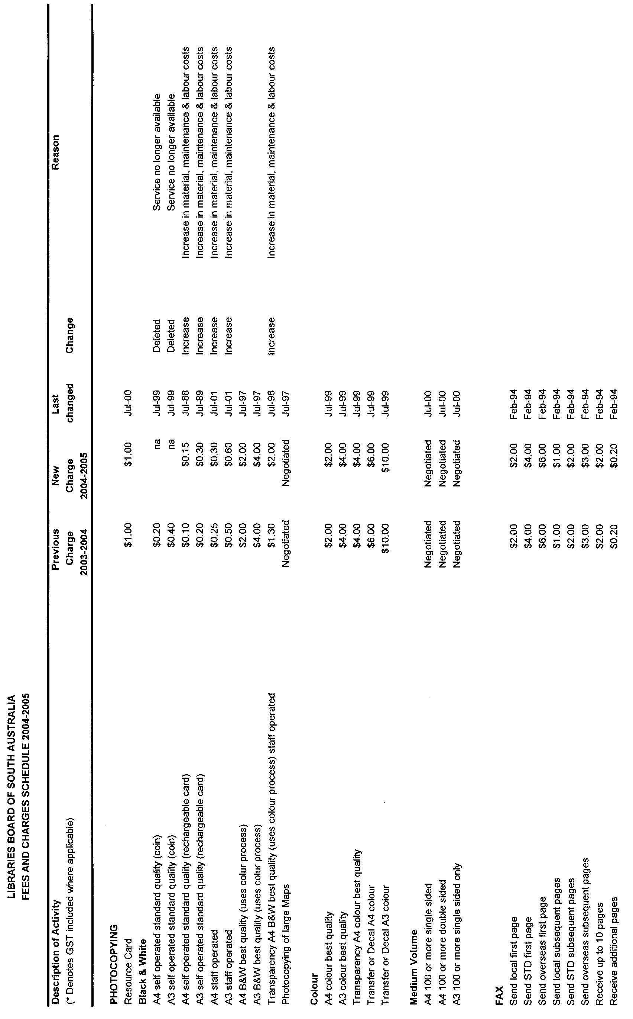
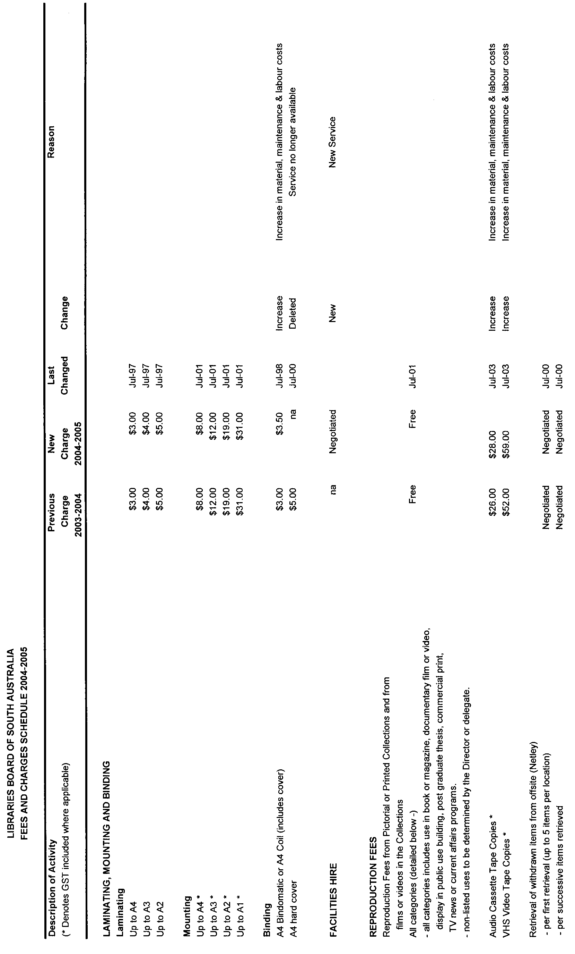
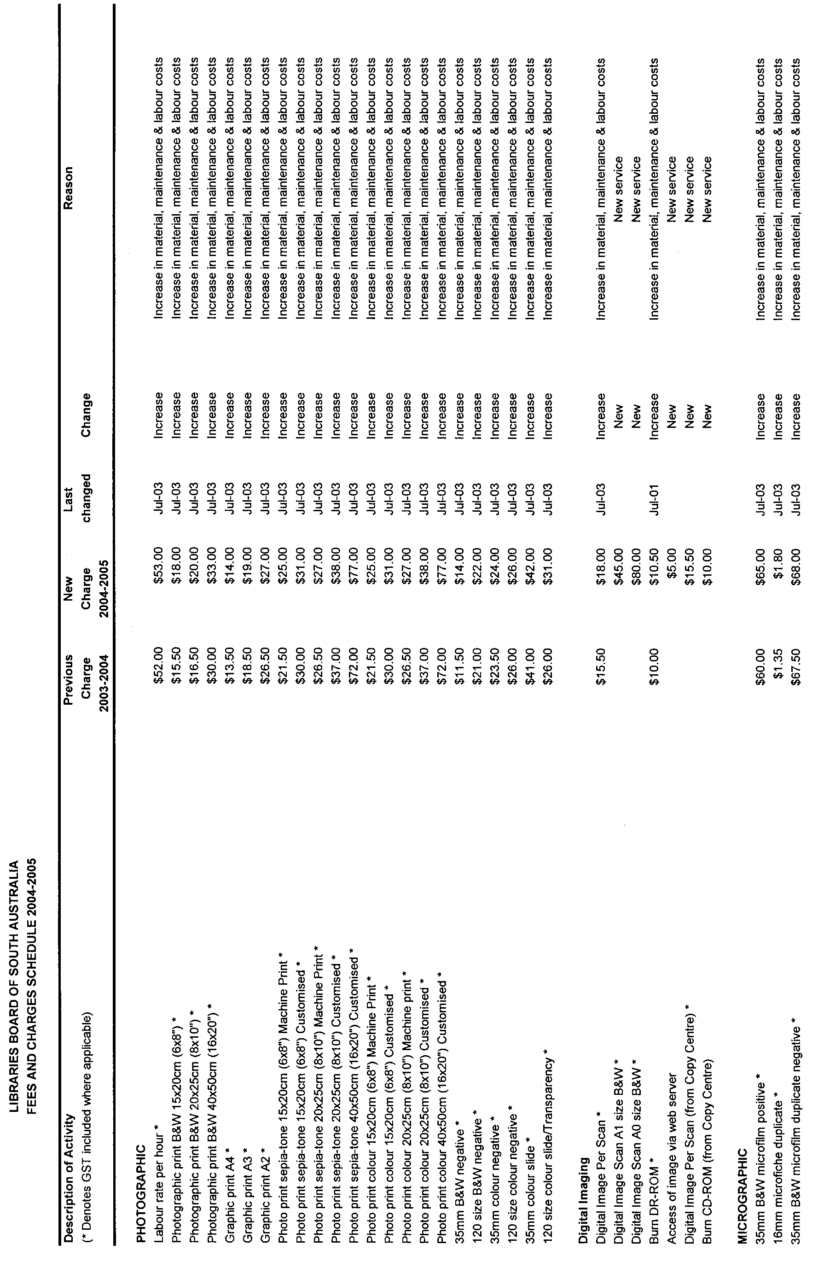
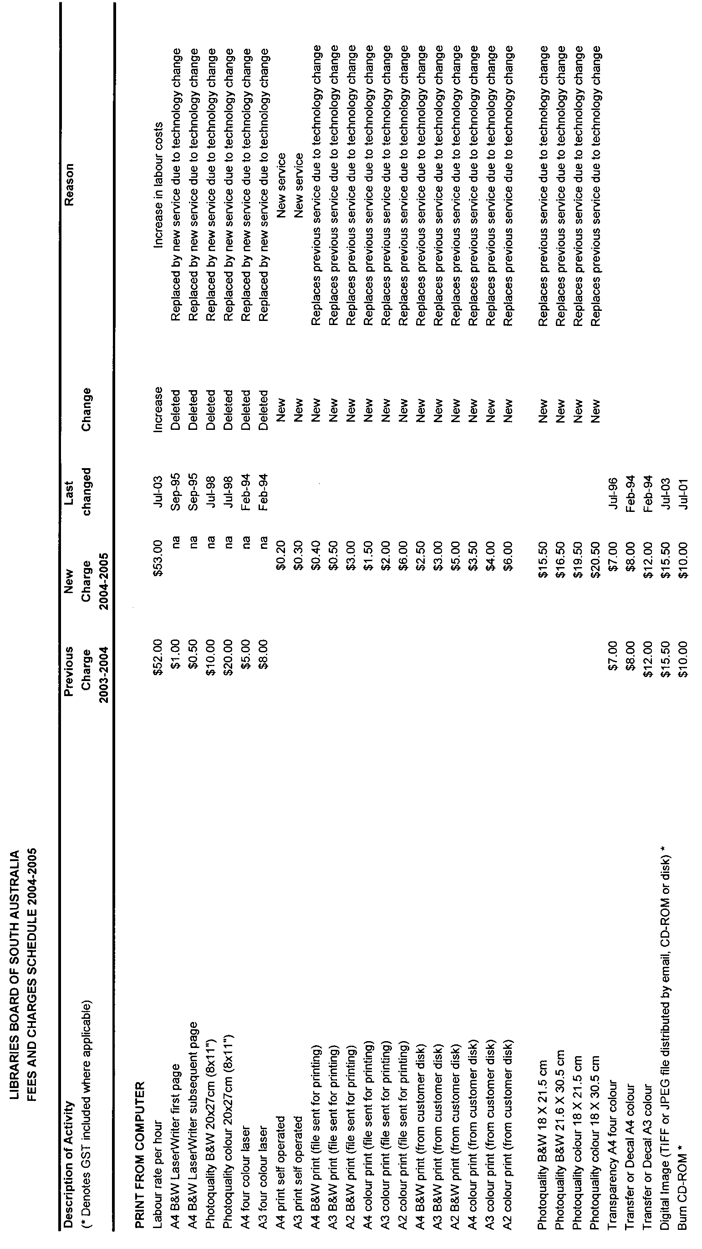
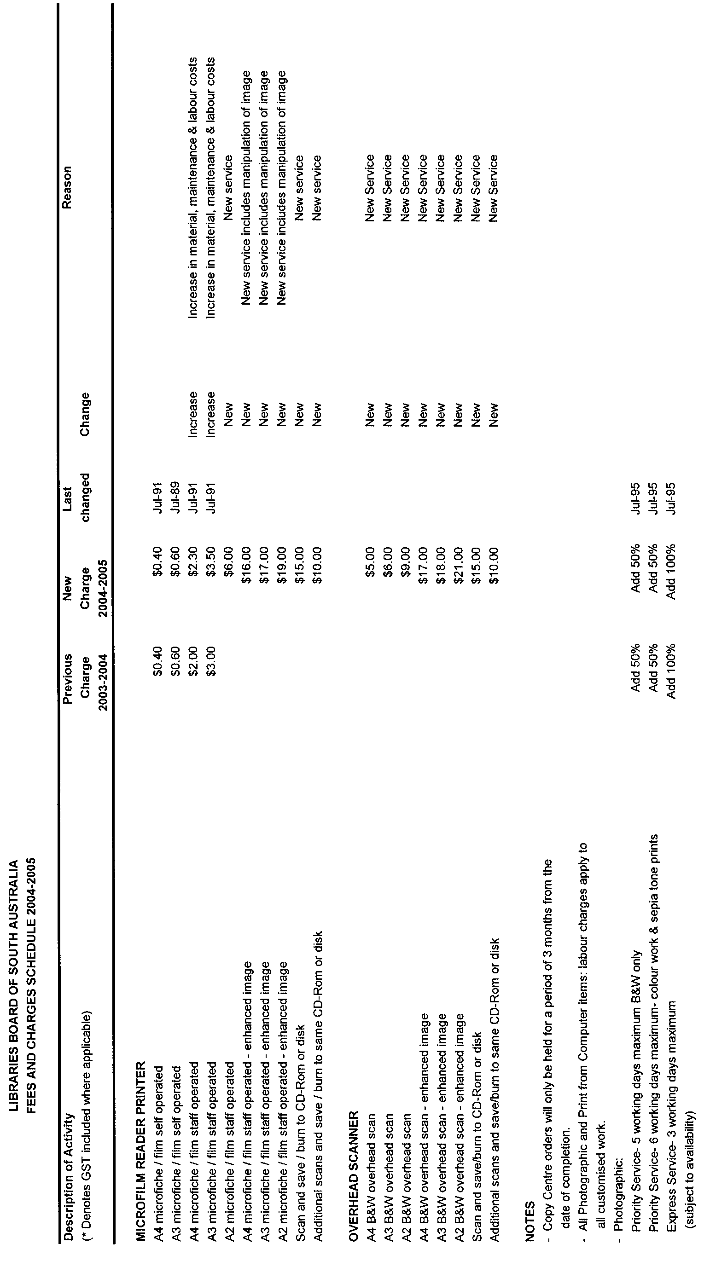
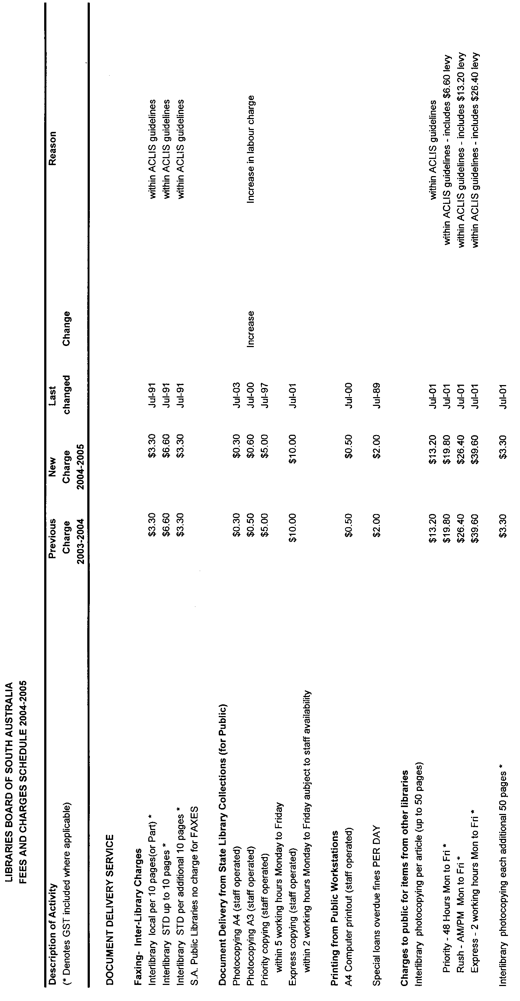
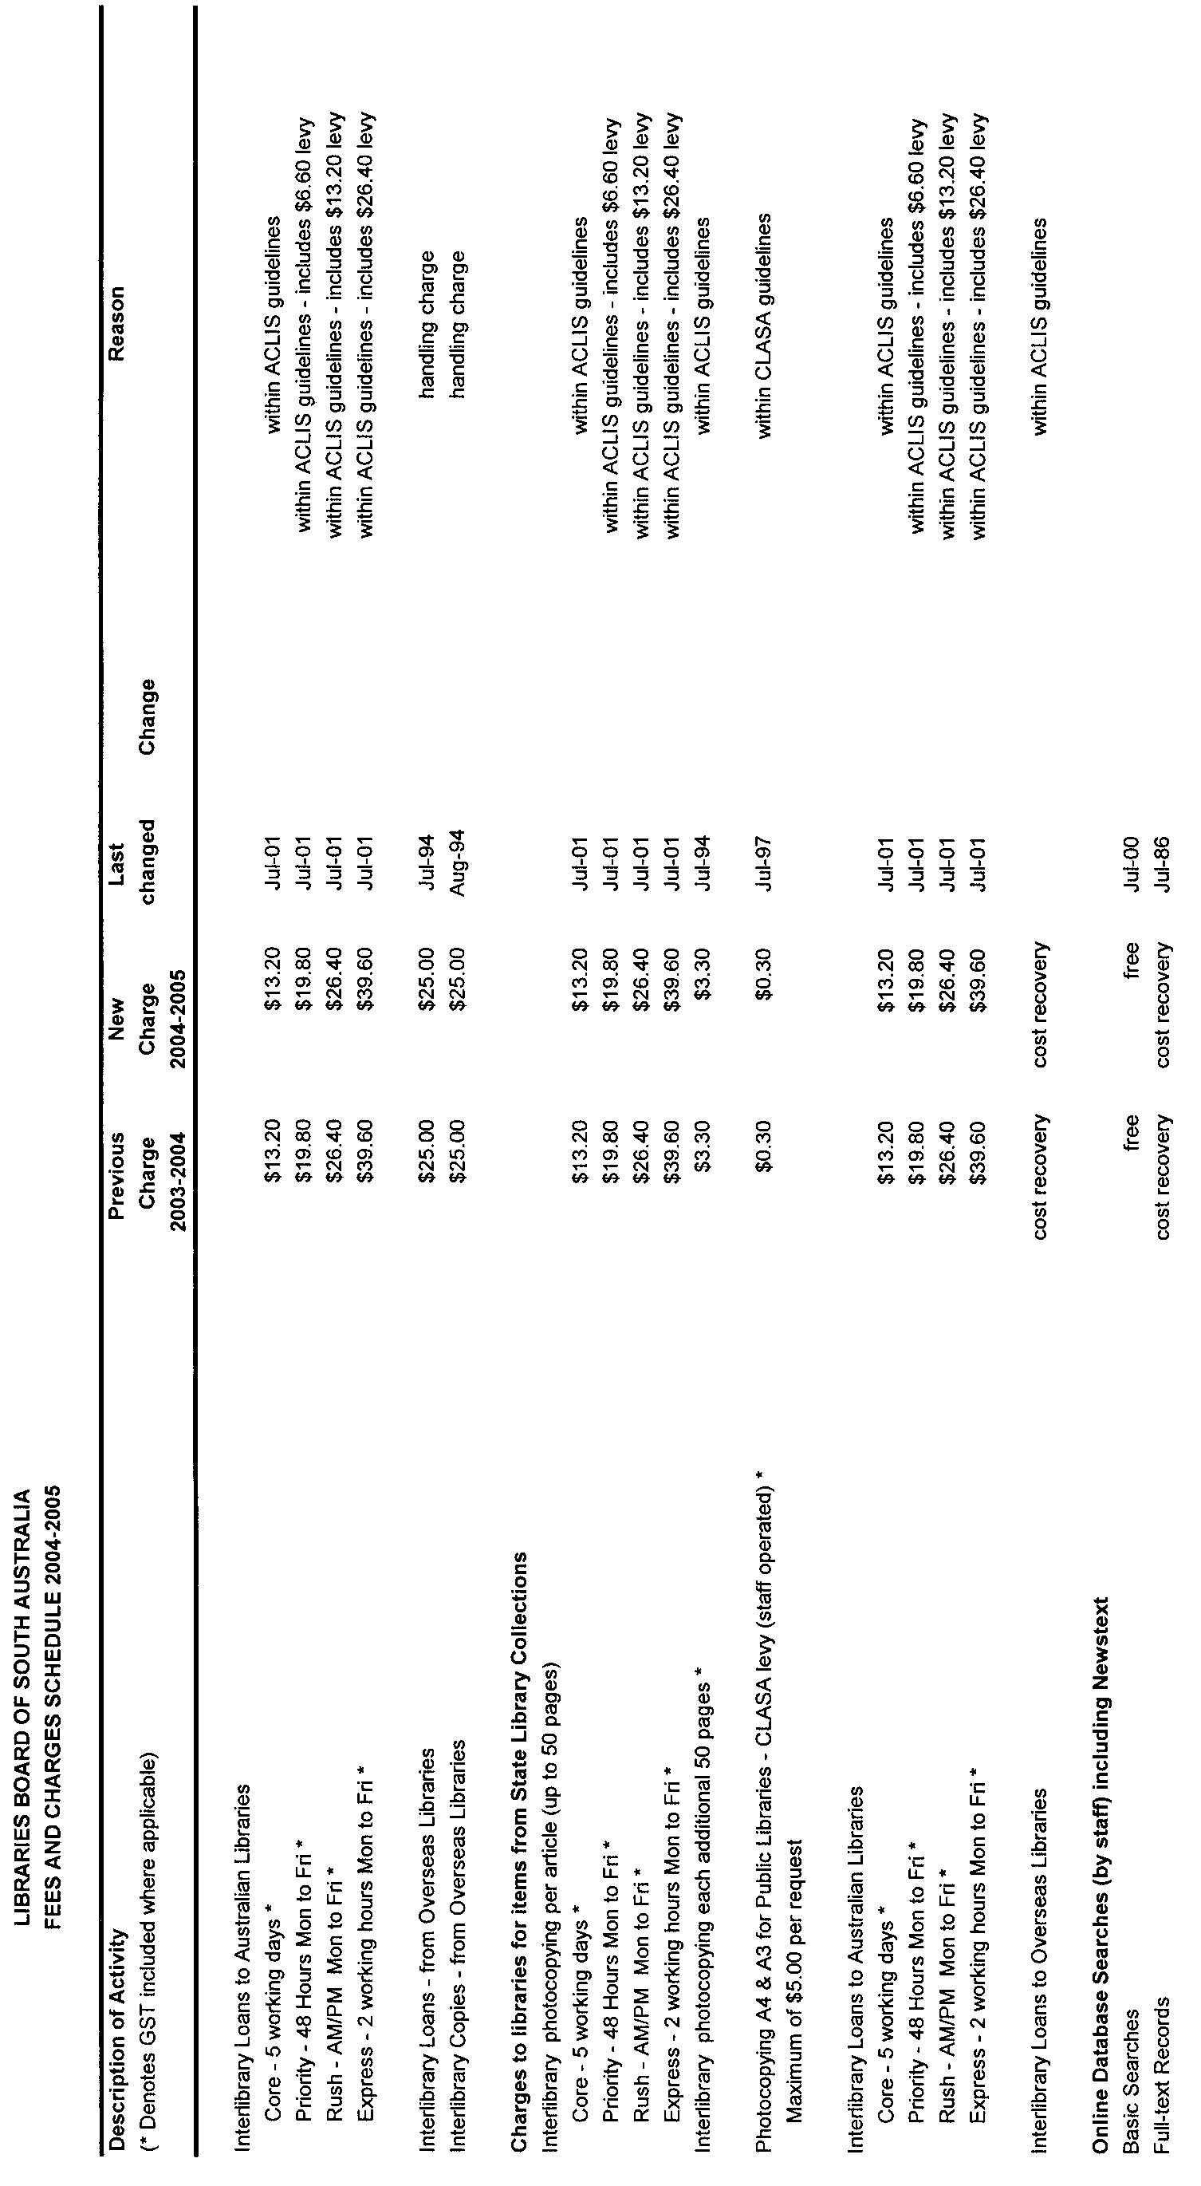

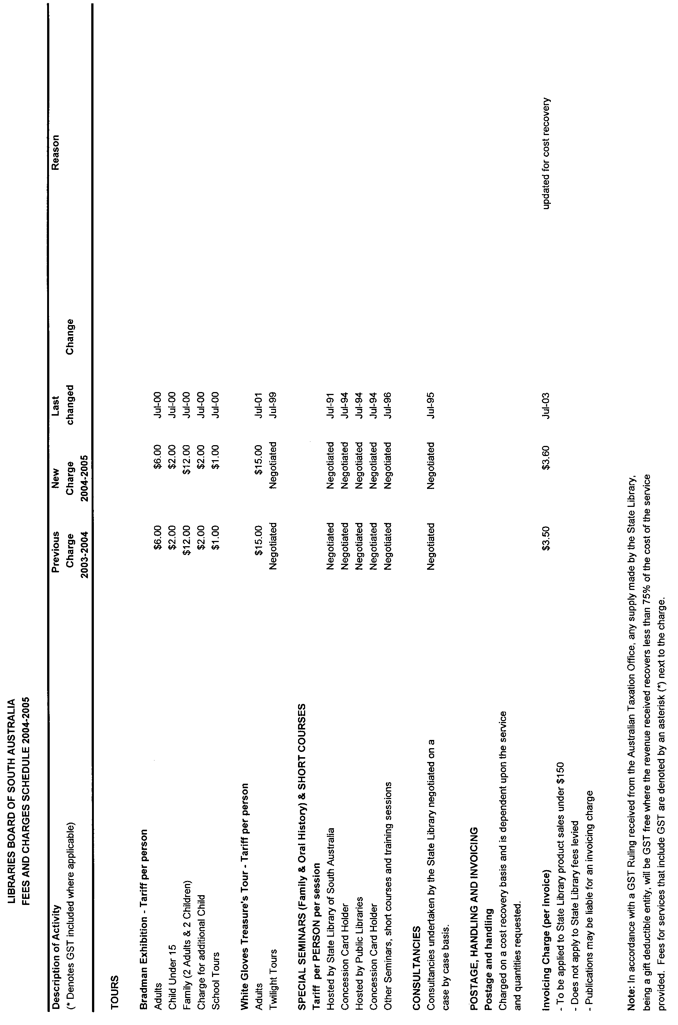
Dated 10 June 2004.
M. Allen, Acting Director, State Library of South Australia

House of Assembly Office, 26 May 2004
FORWARDED to the Honourable the Premier the following Resolution, passed by the House of Assembly on 26 May 2004:
That the Regulations under the Plumbers, Gas Fitters and Electricians Act 1995 entitled Exemptions, made on 18 December 2003, and Laid on the Table of this House on 17 February 2004, be disallowed.
D. A. Bridges, Clerk

LAND AND BUSINESS (SALE AND CONVEYANCING)
ACT 1994
Exemption
TAKE notice that, pursuant to section 23 (3) of the Land and Business (Sale and Conveyancing) Act 1994, I, Michael John Atkinson, Minister for Consumer Affairs, do hereby exempt the person named in Schedule 1 from the application of section 23 (2) of the Act in relation to the purchase of the land specified in Schedule 2.
Schedule 1
Mardi Elizabeth Haynes, an employee of Naracoorte First National Pty Ltd.
Schedule 2
The whole of the land described in certificate of title register book volume 5333, folio 709, situated at 69 Memorial Drive, Naracoorte, S.A. 5271.
Dated 10 June 2004.
Signed for and on behalf of the Minister for Consumer Affairs by the Commissioner for Consumer Affairs:
M. Bodycoat, Commissioner

LAND AND BUSINESS (SALE AND CONVEYANCING)
ACT 1994
Exemption
TAKE notice that, pursuant to section 23 (3) of the Land and Business (Sale and Conveyancing) Act 1994, I, Michael John Atkinson, Minister for Consumer Affairs, do hereby exempt the person named in Schedule 1 from the application of section 23 (2) of the Act in relation to the purchase of the land specified in Schedule 2.
Schedule 1
Wayne Robert White, an employee of Elders Ltd.
Schedule 2
The whole of the land described in certificate of title register book volume 5585, folio 144, situated at 6 Branford Street, Port Pirie, S.A. 5540.
Dated 10 June 2004.
Signed for and on behalf of the Minister for Consumer Affairs by the Commissioner for Consumer Affairs:
M. Bodycoat, Commissioner

Legislative Council Office, 2 June 2004
FORWARDED to the Honourable the Premier the following Resolution, passed by the Legislative Council on 2 June 2004:
That the Regulations under the Victims of Crime Act 2001, concerning Victims Compensation, made on 20 May 2004 and Laid on the Table of this Council on 25 May 2004, be disallowed.
J. M. Davis, Clerk

LIQUOR LICENSING ACT 1997
Notice of Application
NOTICE is hereby given, pursuant to section 52 (2) (b) of the Liquor Licensing Act 1997, that Southcorp Wines Pty Ltd has applied to the Licensing Authority for the transfer of a Wholesale Liquor Merchant’s Licence in respect of premises situated at 14 Ingoldby Road, McLaren Flat, S.A. 5171 and known as Rosemount Wholesaling Rosemount Estate.
The application has been set down for hearing on 14 July 2004 at 10 a.m.
Any person may object to the application by lodging a notice of objection in the prescribed form with the Licensing Authority, and serving a copy of the notice on the applicant at the applicant’s address given above, at least seven days before the hearing date (viz: 6 July 2004).
The applicant’s address for service is c/o Paula Stirling, Finlaysons Lawyers, 81 Flinders Street, Adelaide, S.A. 5000.
Plans in respect of the premises the subject of the application are open to public inspection without fee at the Office of the Liquor and Gambling Commissioner, 9th Floor, East Wing, 50 Grenfell Street, Adelaide, S.A. 5000.
Dated 3 June 2004.
Applicant

LIQUOR LICENSING ACT 1997
Notice of Application
NOTICE is hereby given, pursuant to section 52 (2) (b) of the Liquor Licensing Act 1997, that International Motel Mount Gambier Pty Ltd as trustee for International Motel Mount Gambier Trust has applied to the Licensing Authority for the transfer of a Residential Licence in respect of premises situated at Millicent Road, Mount Gambier, S.A. 5290 and known as Mount Gambier International Motel.
The application has been set down for hearing on 14 July 2004 at 9.30 a.m.
Any person may object to the application by lodging a notice of objection in the prescribed form with the Licensing Authority, and serving a copy of the notice on the applicant at the applicant’s address given above, at least seven days before the hearing date (viz: 1 July 2004).
The applicant’s address for service is c/o Lisa Shoemark, Millicent Road, Mount Gambier, S.A. 5290.
Plans in respect of the premises the subject of the application are open to public inspection without fee at the Office of the Liquor and Gambling Commissioner, 9th Floor, East Wing, 50 Grenfell Street, Adelaide, S.A. 5000.
Dated 2 June 2004.
Applicant

LIQUOR LICENSING ACT 1997
Notice of Application
NOTICE is hereby given, pursuant to section 52 (2) (b) of the Liquor Licensing Act 1997, that Benjamin Reusch and Hollie Petros have applied to the Licensing Authority for the transfer of a Hotel Licence in respect of premises situated at North Terrace, Mount Mary, via Morgan, S.A. 5320 and known as Mount Mary Hotel.
The application has been set down for hearing on 14 July 2004 at 9 a.m.
Any person may object to the application by lodging a notice of objection in the prescribed form with the Licensing Authority, and serving a copy of the notice on the applicants at the applicants’ address given above, at least seven days before the hearing date (viz: 6 July 2004).
The applicants’ address for service is c/o Bruce Lehmann, Teusner & Co., P.O. Box 70, Tanunda, S.A. 5352.
Plans in respect of the premises the subject of the application are open to public inspection without fee at the Office of the Liquor and Gambling Commissioner, 9th Floor, East Wing, 50 Grenfell Street, Adelaide, S.A. 5000.
Dated 3 June 2004.
Applicants

LIQUOR LICENSING ACT 1997
Notice of Application
NOTICE is hereby given, pursuant to section 52 (2) (b) of the Liquor Licensing Act 1997, that King Cool Pty Ltd as a trustee for the Seymour Family Trust has applied to the Licensing Authority for the transfer of a Restaurant Licence in respect of premises situated at Greenhill Road, Summertown, S.A. 5141 and known as Summertown Cafe.
The application has been set down for hearing on 13 July 2004 at 10 a.m.
Any person may object to the application by lodging a notice of objection in the prescribed form with the Licensing Authority, and serving a copy of the notice on the applicant at the applicant’s address given above, at least seven days before the hearing date (viz: 5 July 2004).
The applicant’s address for service is c/o Tracey Seymour, Lot 50, Collins Road, Ashton, S.A. 5137.
Plans in respect of the premises the subject of the application are open to public inspection without fee at the Office of the Liquor and Gambling Commissioner, 9th Floor, East Wing, 50 Grenfell Street, Adelaide, S.A. 5000.
Dated 3 June 2004.
Applicant

LIQUOR LICENSING ACT 1997
Notice of Application
NOTICE is hereby given, pursuant to section 52 (2) (b) of the Liquor Licensing Act 1997, that Rock Brockman Pty Ltd has applied to the Licensing Authority for the transfer of a Hotel Licence in respect of premises situated at 63 Light Square, Adelaide, S.A. 5000 and known as Cobbs.
The application has been set down for hearing on 13 July 2004 at 9 a.m.
Any person may object to the application by lodging a notice of objection in the prescribed form with the Licensing Authority, and serving a copy of the notice on the applicant at the applicant’s address given above, at least seven days before the hearing date (viz: 5 July 2004).
The applicant’s address for service is c/o Rock Brockman Pty Ltd, P.O. Box 10077, Adelaide BC, Adelaide, S.A. 5000.
Plans in respect of the premises the subject of the application are open to public inspection without fee at the Office of the Liquor and Gambling Commissioner, 9th Floor, East Wing, 50 Grenfell Street, Adelaide, S.A. 5000.
Dated 2 June 2004.
Applicant

LIQUOR LICENSING ACT 1997
Notice of Application
NOTICE is hereby given, pursuant to section 52 (2) (b) of the Liquor Licensing Act 1997, that Hasto Pty Ltd has applied to the Licensing Authority for the transfer of a Residential Licence in respect of premises situated at 445-447 Torrens Road, Woodville Park, S.A. 5011 and known as Lindy Lodge Motel.
The application has been set down for hearing on 13 July 2004 at 9.30 a.m.
Any person may object to the application by lodging a notice of objection in the prescribed form with the Licensing Authority, and serving a copy of the notice on the applicant at the applicant’s address given above, at least seven days before the hearing date (viz: 5 July 2004).
The applicant’s address for service is c/o Philip Foreman, Foreman Legal, 69 Mount Barker Road, Stirling, S.A. 5152.
Plans in respect of the premises the subject of the application are open to public inspection without fee at the Office of the Liquor and Gambling Commissioner, 9th Floor, East Wing, 50 Grenfell Street, Adelaide, S.A. 5000.
Dated 2 June 2004.
Applicant

LIQUOR LICENSING ACT 1997
Notice of Application
NOTICE is hereby given, pursuant to section 52 (2) (b) of the Liquor Licensing Act 1997, that Beit Rav Pty Ltd has applied to the Licensing Authority for the transfer of a Restaurant Licence in respect of premises situated at 27 Valley Road, Angaston, S.A. 5353 and known as The Company Kitchen.
The application has been set down for hearing on 12 July 2004 at 10.30 a.m.
Any person may object to the application by lodging a notice of objection in the prescribed form with the Licensing Authority, and serving a copy of the notice on the applicant at the applicant’s address given above, at least seven days before the hearing date (viz: 2 July 2004).
The applicant’s address for service is c/o Beit Rav Pty Ltd, P.O. Box 47, Angaston, S.A. 5353.
Plans in respect of the premises the subject of the application are open to public inspection without fee at the Office of the Liquor and Gambling Commissioner, 9th Floor, East Wing, 50 Grenfell Street, Adelaide, S.A. 5000.
Dated 2 June 2004.
Applicant

LIQUOR LICENSING ACT 1997
Notice of Application
NOTICE is hereby given, pursuant to section 52 (2) (b) of the Liquor Licensing Act 1997, that KT & Grace Pty Ltd has applied to the Licensing Authority for the transfer of a Restaurant Licence in respect of premises situated at 65 Hyde Street, Adelaide, S.A. 5000 and known as Seoul Restaurant.
The application has been set down for hearing on 12 July 2004 at 10 a.m.
Any person may object to the application by lodging a notice of objection in the prescribed form with the Licensing Authority, and serving a copy of the notice on the applicant at the applicant’s address given above, at least seven days before the hearing date (viz: 2 July 2004).
The applicant’s address for service is c/o 65 Hyde Street, Adelaide, S.A. 5000.
Plans in respect of the premises the subject of the application are open to public inspection without fee at the Office of the Liquor and Gambling Commissioner, 9th Floor, East Wing, 50 Grenfell Street, Adelaide, S.A. 5000.
Dated 1 June 2004.
Applicant

LIQUOR LICENSING ACT 1997
Notice of Application
NOTICE is hereby given, pursuant to section 52 (2) (b) of the Liquor Licensing Act 1997, that Rocco Sinopoli has applied to the Licensing Authority for the transfer of a Restaurant Licence in respect of premises situated at 48 Cliff Avenue, Port Noarlunga South, S.A. 5167 and known as Cliff Pizza Bar Restaurant & Take Away.
The application has been set down for hearing on 12 July 2004 at 9.30 a.m.
Any person may object to the application by lodging a notice of objection in the prescribed form with the Licensing Authority, and serving a copy of the notice on the applicant at the applicant’s address given above, at least seven days before the hearing date (viz: 2 July 2004).
The applicant’s address for service is c/o Mary Hannigan, Kelly & Co., Level 17, 91 King William Street, Adelaide, S.A. 5000.
Plans in respect of the premises the subject of the application are open to public inspection without fee at the Office of the Liquor and Gambling Commissioner, 9th Floor, East Wing, 50 Grenfell Street, Adelaide, S.A. 5000.
Dated 1 June 2004.
Applicant

LIQUOR LICENSING ACT 1997
Notice of Application
NOTICE is hereby given, pursuant to section 52 (2) (b) of the Liquor Licensing Act 1997, that SA Export Wines Pty Ltd has applied to the Licensing Authority for the transfer of a Restaurant Licence in respect of premises situated at Shop 3-4, Mount Barker Road, Stirling, S.A. 5152 and known as Rennies Cafe.
The application has been set down for hearing on 12 July 2004 at 9 a.m.
Any person may object to the application by lodging a notice of objection in the prescribed form with the Licensing Authority, and serving a copy of the notice on the applicant at the applicant’s address given above, at least seven days before the hearing date (viz: 2 July 2004).
The applicant’s address for service is c/o 3 Dorset Court, Flagstaff Hill, S.A. 5159.
Plans in respect of the premises the subject of the application are open to public inspection without fee at the Office of the Liquor and Gambling Commissioner, 9th Floor, East Wing, 50 Grenfell Street, Adelaide, S.A. 5000.
Dated 1 June 2004.
Applicant

LIQUOR LICENSING ACT 1997
Notice of Application
NOTICE is hereby given, pursuant to section 52 (2) (b) of the Liquor Licensing Act 1997, that Chapel Hill Winery Pty Ltd has applied to the Licensing Authority for a Residential Licence in respect of premises situated at 1 Chapel Hill Road, McLaren Vale, S.A. 5171 and known as Chapel Hill Winery Gourmet Retreat.
The application has been set down for hearing on 9 July 2004 at 9 a.m.
Any person may object to the application by lodging a notice of objection in the prescribed form with the Licensing Authority, and serving a copy of the notice on the applicant at the applicant’s address given above, at least seven days before the hearing date (viz: 1 July 2004).
The applicant’s address for service is c/o Fisher Jeffries, (Attention: Craig Vozzo or Adrian Battiston), SGIC Building, Level 15, 211 Victoria Square, Adelaide, S.A. 5000.
Plans in respect of the premises the subject of the application are open to public inspection without fee at the Office of the Liquor and Gambling Commissioner, 9th Floor, East Wing, 50 Grenfell Street, Adelaide, S.A. 5000.
Dated 3 June 2004.
Applicant

LIQUOR LICENSING ACT 1997
Notice of Application
NOTICE is hereby given, pursuant to section 52 (2) (b) of the Liquor Licensing Act 1997, that Geoffrey Peter and Daphne Margaret Schiller have applied to the Licensing Authority for a Producer’s Licence in respect of premises situated at Lot 218, Truro Road, Moculta, S.A. 5353 and known as Stone Hut Creek.
The application has been set down for hearing on 9 July 2004 at 9 a.m.
Any person may object to the application by lodging a notice of objection in the prescribed form with the Licensing Authority, and serving a copy of the notice on the applicants at the applicants’ address given above, at least seven days before the hearing date (viz: 1 July 2004).
The applicants’ address for service is c/o Teusner & Co.,
4 Elizabeth Street, Tanunda, S.A. 5352.
Plans in respect of the premises the subject of the application are open to public inspection without fee at the Office of the Liquor and Gambling Commissioner, 9th Floor, East Wing, 50 Grenfell Street, Adelaide, S.A. 5000.
Dated 1 June 2004.
Applicants

LIQUOR LICENSING ACT 1997
Notice of Application
NOTICE is hereby given, pursuant to section 52 (2) (b) of the Liquor Licensing Act 1997, that Kim Chau Pty Ltd, c/o Wallmans Lawyers has applied to the Licensing Authority for the transfer of a Restaurant Licence in respect of premises situated at Main North Road, Clare, S.A. 5453 and known as Clare Dragon Restaurant.
The application has been set down for hearing on 30 June 2004 at 11.30 a.m.
Any person may object to the application by lodging a notice of objection in the prescribed form with the Licensing Authority, and serving a copy of the notice on the applicant at the applicant’s address given above, at least seven days before the hearing date (viz: 28 June 2004).
The applicant’s address for service is c/o Wallmans Lawyers, (Attention: Ben Allen or Peter Hoban), 173 Wakefield Street, Adelaide, S.A. 5000.
Plans in respect of the premises the subject of the application are open to public inspection without fee at the Office of the Liquor and Gambling Commissioner, 9th Floor, East Wing, 50 Grenfell Street, Adelaide, S.A. 5000.
Dated 31 May 2004.
Applicant

LIQUOR LICENSING ACT 1997
Notice of Application
NOTICE is hereby given, pursuant to section 52 (2) (b) of the Liquor Licensing Act 1997, that Trevor Lawrence and Roseanne Lorraine Gill have applied to the Licensing Authority for a variation to Extended Trading Authorisation and variation to Entertainment Consent in respect of premises situated at 73 Commercial Road, Port Augusta, S.A. 5700 and known as Hotel Commonwealth.
The application has been set down for hearing on 9 July 2004 at 9 a.m.
Conditions
The following licence conditions are sought:
• Extended Trading Authorisation to vary:
From:
Friday and Saturday: Midnight to 2 a.m. the following day.
To:
Friday and Saturday: Midnight to 3 a.m. the following day.
• Entertainment Consent to apply during the abovementioned hours sought and in the additional area shown on the plans lodged with this office.
Any person may object to the application by lodging a notice of objection in the prescribed form with the Licensing Authority, and serving a copy of the notice on the applicants at the applicants’ address given above, at least seven days before the hearing date (viz: 1 July 2004).
The applicants’ address for service is c/o Darren Searle, 73 Commercial Road, Port Augusta, S.A. 5700.
Plans in respect of the premises the subject of the application are open to public inspection without fee at the Office of the Liquor and Gambling Commissioner, 9th Floor, East Wing, 50 Grenfell Street, Adelaide, S.A. 5000.
Dated 4 June 2004.
Applicants

LIQUOR LICENSING ACT 1997
Notice of Application
NOTICE is hereby given, pursuant to section 52 (2) (b) of the Liquor Licensing Act 1997, that Allister Graham and Tenney Jean Parker have applied to the Licensing Authority for a Restaurant Licence, Extended Trading Authorisation and Entertainment Consent in respect of premises situated at 1 Charles Street, Middleton, S.A. 5213 and known as Blues Restaurant.
The application has been set down for hearing on 9 July 2004 at 9 a.m.
Conditions
The following licence conditions are sought:
• Extended Trading Authorisation:
Monday to Saturday: Midnight to 2 a.m. the following day;
Sunday: 9 a.m. to 11 a.m. and 8 p.m. to midnight;
Christmas Eve: Midnight to 2 a.m. the following day;
Sunday Christmas Eve: 8 p.m. to 2 a.m. the following day;
Days preceding other Public Holidays: Midnight to 2 a.m. the following day;
Sundays preceding Public Holidays: 8 p.m. to 2 a.m. the following day.
• Approval under section 34 (1) (c) to sell liquor for consumption on the licensed premises by persons:
(a) seated at a table; or
(b) attending a function at which food is provided.
• Entertainment Consent:
Monday to Saturday: 9 a.m. to midnight;
Public Holidays: 9 a.m. to midnight.
• Entertainment Consent is sought in areas shown on the plan lodged with this office.
Any person may object to the application by lodging a notice of objection in the prescribed form with the Licensing Authority, and serving a copy of the notice on the applicants at the applicants’ address given above, at least seven days before the hearing date (viz: 1 July 2004).
The applicants’ address for service is c/o Allister and Tenney Parker, P.O. Box 196, Victor Harbor, S.A. 5211.
Plans in respect of the premises the subject of the application are open to public inspection without fee at the Office of the Liquor and Gambling Commissioner, 9th Floor, East Wing, 50 Grenfell Street, Adelaide, S.A. 5000.
Dated 3 June 2004.
Applicants

LIQUOR LICENSING ACT 1997
Notice of Application
NOTICE is hereby given, pursuant to section 52 (2) (b) of the Liquor Licensing Act 1997, that Park Social Club Inc. has applied to the Licensing Authority for a Limited Club Licence and Entertainment Consent in respect of premises situated at Andrews Road, Penfield, S.A. 5121 and known as Park Social Club.
The application has been set down for hearing on 9 July 2004 at 9 a.m.
Conditions
The following licence conditions are sought:
• Entertainment Consent:
Monday to Sunday: Midday to midnight.
Public Holidays: Midday to midnight.
• Entertainment Consent is sought in areas shown on the plan lodged with this office.
Any person may object to the application by lodging a notice of objection in the prescribed form with the Licensing Authority, and serving a copy of the notice on the applicant at the applicant’s address given above, at least seven days before the hearing date (viz: 1 July 2004).
The applicant’s address for service is c/o John Arthur Unstead, Locked Bag 1 RSD, Smithfield, S.A. 5114.
Plans in respect of the premises the subject of the application are open to public inspection without fee at the Office of the Liquor and Gambling Commissioner, 9th Floor, East Wing, 50 Grenfell Street, Adelaide, S.A. 5000.
Dated 1 June 2004.
Applicant

LIQUOR LICENSING ACT 1997
Notice of Application
NOTICE is hereby given, pursuant to section 52 (2) (b) of the Liquor Licensing Act 1997, that John Haldane and Jennine Patricia Sinclair have applied to the Licensing Authority for an Entertainment Consent in respect of premises situated at the corner of Edith and Blanche Streets, Edithburgh, S.A. 5583 and known as The Location at the Burgh.
The application has been set down for hearing on 9 July 2004 at 9 a.m.
Conditions
The following licence conditions are sought:
• Entertainment Consent:
Monday to Wednesday: Midday to midnight;
Thursday to Saturday: Midday to 1 a.m. the following day;
Sunday: Midday to midnight;
Public Holidays: Midday to 1 a.m. the following day.
• Entertainment Consent is sought in areas shown on the plan lodged with this office.
Any person may object to the application by lodging a notice of objection in the prescribed form with the Licensing Authority, and serving a copy of the notice on the applicants at the applicants’ address given above, at least seven days before the hearing date (viz: 1 July 2004).
The applicants’ address for service is c/o John Sinclair, P.O. Box 176, Edithburgh, S.A. 5583.
Plans in respect of the premises the subject of the application are open to public inspection without fee at the Office of the Liquor and Gambling Commissioner, 9th Floor, East Wing, 50 Grenfell Street, Adelaide, S.A. 5000.
Dated 1 June 2004.
Applicants

MINING ACT 1971
NOTICE is hereby given in accordance with section 28 (5) of the Mining Act 1971, that the Minister for Mineral Resources Development proposes to grant an Exploration Licence over the undermentioned area:
Applicant: Alliance Craton Explorer Pty Ltd
Location: Sabrina Bore area—Approximately 20 km north of Coober Pedy
Term: 1 year
Area in km²: 383
Ref: 2004/00335
Plan and co-ordinates can be found on the PIRSA Sarig website: http://www.minerals.pir.sa.gov.au/sarig or by phoning Mineral Tenements on (08) 8463 3103.
H. Tyrteos, Mining Registrar

MINING ACT 1971
NOTICE is hereby given in accordance with section 28 (5) of the Mining Act 1971, that the Minister for Mineral Resources Development proposes to grant an Exploration Licence over the undermentioned area:
Applicant: Agricola Mining Pty Ltd
Location: Locheber area—Approximately 26 km north-west of Naracoorte
Term: 1 year
Area in km²: 11
Ref: 2004/00326
Plan and co-ordinates can be found on the PIRSA Sarig website: http://www.minerals.pir.sa.gov.au/sarig or by phoning Mineral Tenements on (08) 8463 3103.
H. Tyrteos, Mining Registrar

MINING ACT 1971
NOTICE is hereby given in accordance with section 28 (5) of the Mining Act 1971, that the Minister for Mineral Resources Development proposes to grant an Exploration Licence over the undermentioned area:
Applicant: Alphadale Pty Ltd
Location: Eurinilla area—Approximately 100 km north of Olary
Term: 1 year
Area in km²: 70
Ref: 2004/00336
Plan and co-ordinates can be found on the PIRSA Sarig website: http://www.minerals.pir.sa.gov.au/sarig or by phoning Mineral Tenements on (08) 8463 3103.
H. Tyrteos, Mining Registrar

MINING ACT 1971
NOTICE is hereby given in accordance with section 28 (5) of the Mining Act 1971, that the Minister for Mineral Resources Development proposes to grant an Exploration Licence over the undermentioned area:
Applicant: Flinders Power Partnership
Location: Orroroo area—Approximately 50 km north-west of Peterborough
Term: 1 year
Area in km²: 313
Ref: 2004/00086
Plan and co-ordinates can be found on the PIRSA Sarig website: http://www.minerals.pir.sa.gov.au/sarig or by phoning Mineral Tenements on (08) 8463 3103.
H. Tyrteos, Mining Registrar

MINING ACT 1971
NOTICE is hereby given in accordance with section 28 (5) of the Mining Act 1971, that the Minister for Mineral Resources Development proposes to grant an Exploration Licence over the undermentioned area:
Applicant: Redport Ltd and Intermoco Ltd
Location: Commonwealth Hill area—Approximately 90 km north of Tarcoola
Term: 1 year
Area in km²: 898
Ref: 2004/00236
Plan and co-ordinates can be found on the PIRSA Sarig website: http://www.minerals.pir.sa.gov.au/sarig or by phoning Mineral Tenements on (08) 8463 3103.
H. Tyrteos, Mining Registrar

MINING ACT 1971
NOTICE is hereby given in accordance with section 35A (1) of the Mining Act 1971, that an application for a mining lease over the undermentioned mineral claim has been received. Details of the proposal may be inspected at the Department of Primary Industries and Resources, Mineral Resources Group, Level 5, 101 Grenfell Street, Adelaide, S.A. 5000:
Applicant: David Creagh Watkins
Claim Number: 3417
Location: Allotment 204 of Filed Plan 43315, Out of Hundreds Copley—Approximately 75 km east-north-east of Leigh Creek.
Purpose: Remove marble from an open cut operation.
Reference: T02387
Written submissions in relation to the granting of the mining lease are invited to be received at the Department of Primary Industries and Resources, Mineral Resources Group, Level 5, 101 Grenfell Street, Adelaide, S.A. 5000 or G.P.O. Box 1671, Adelaide, S.A. 5001 no later than 9 July 2004.
H. Tyrteos, Mining Registrar

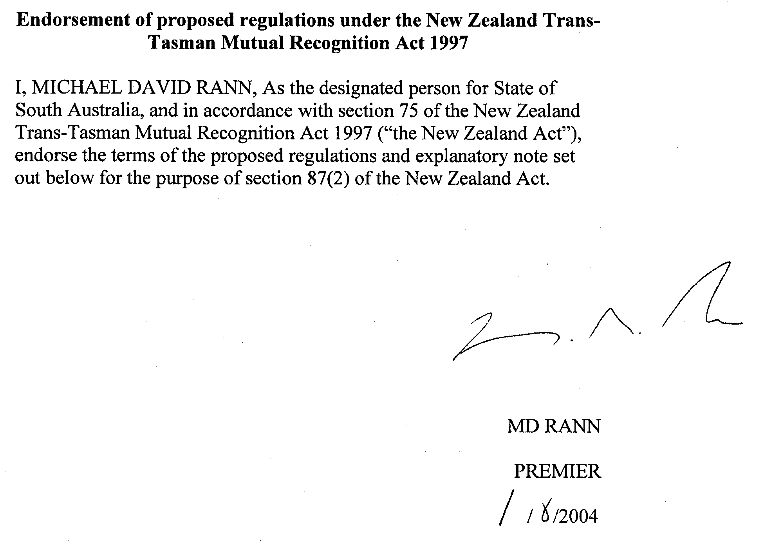

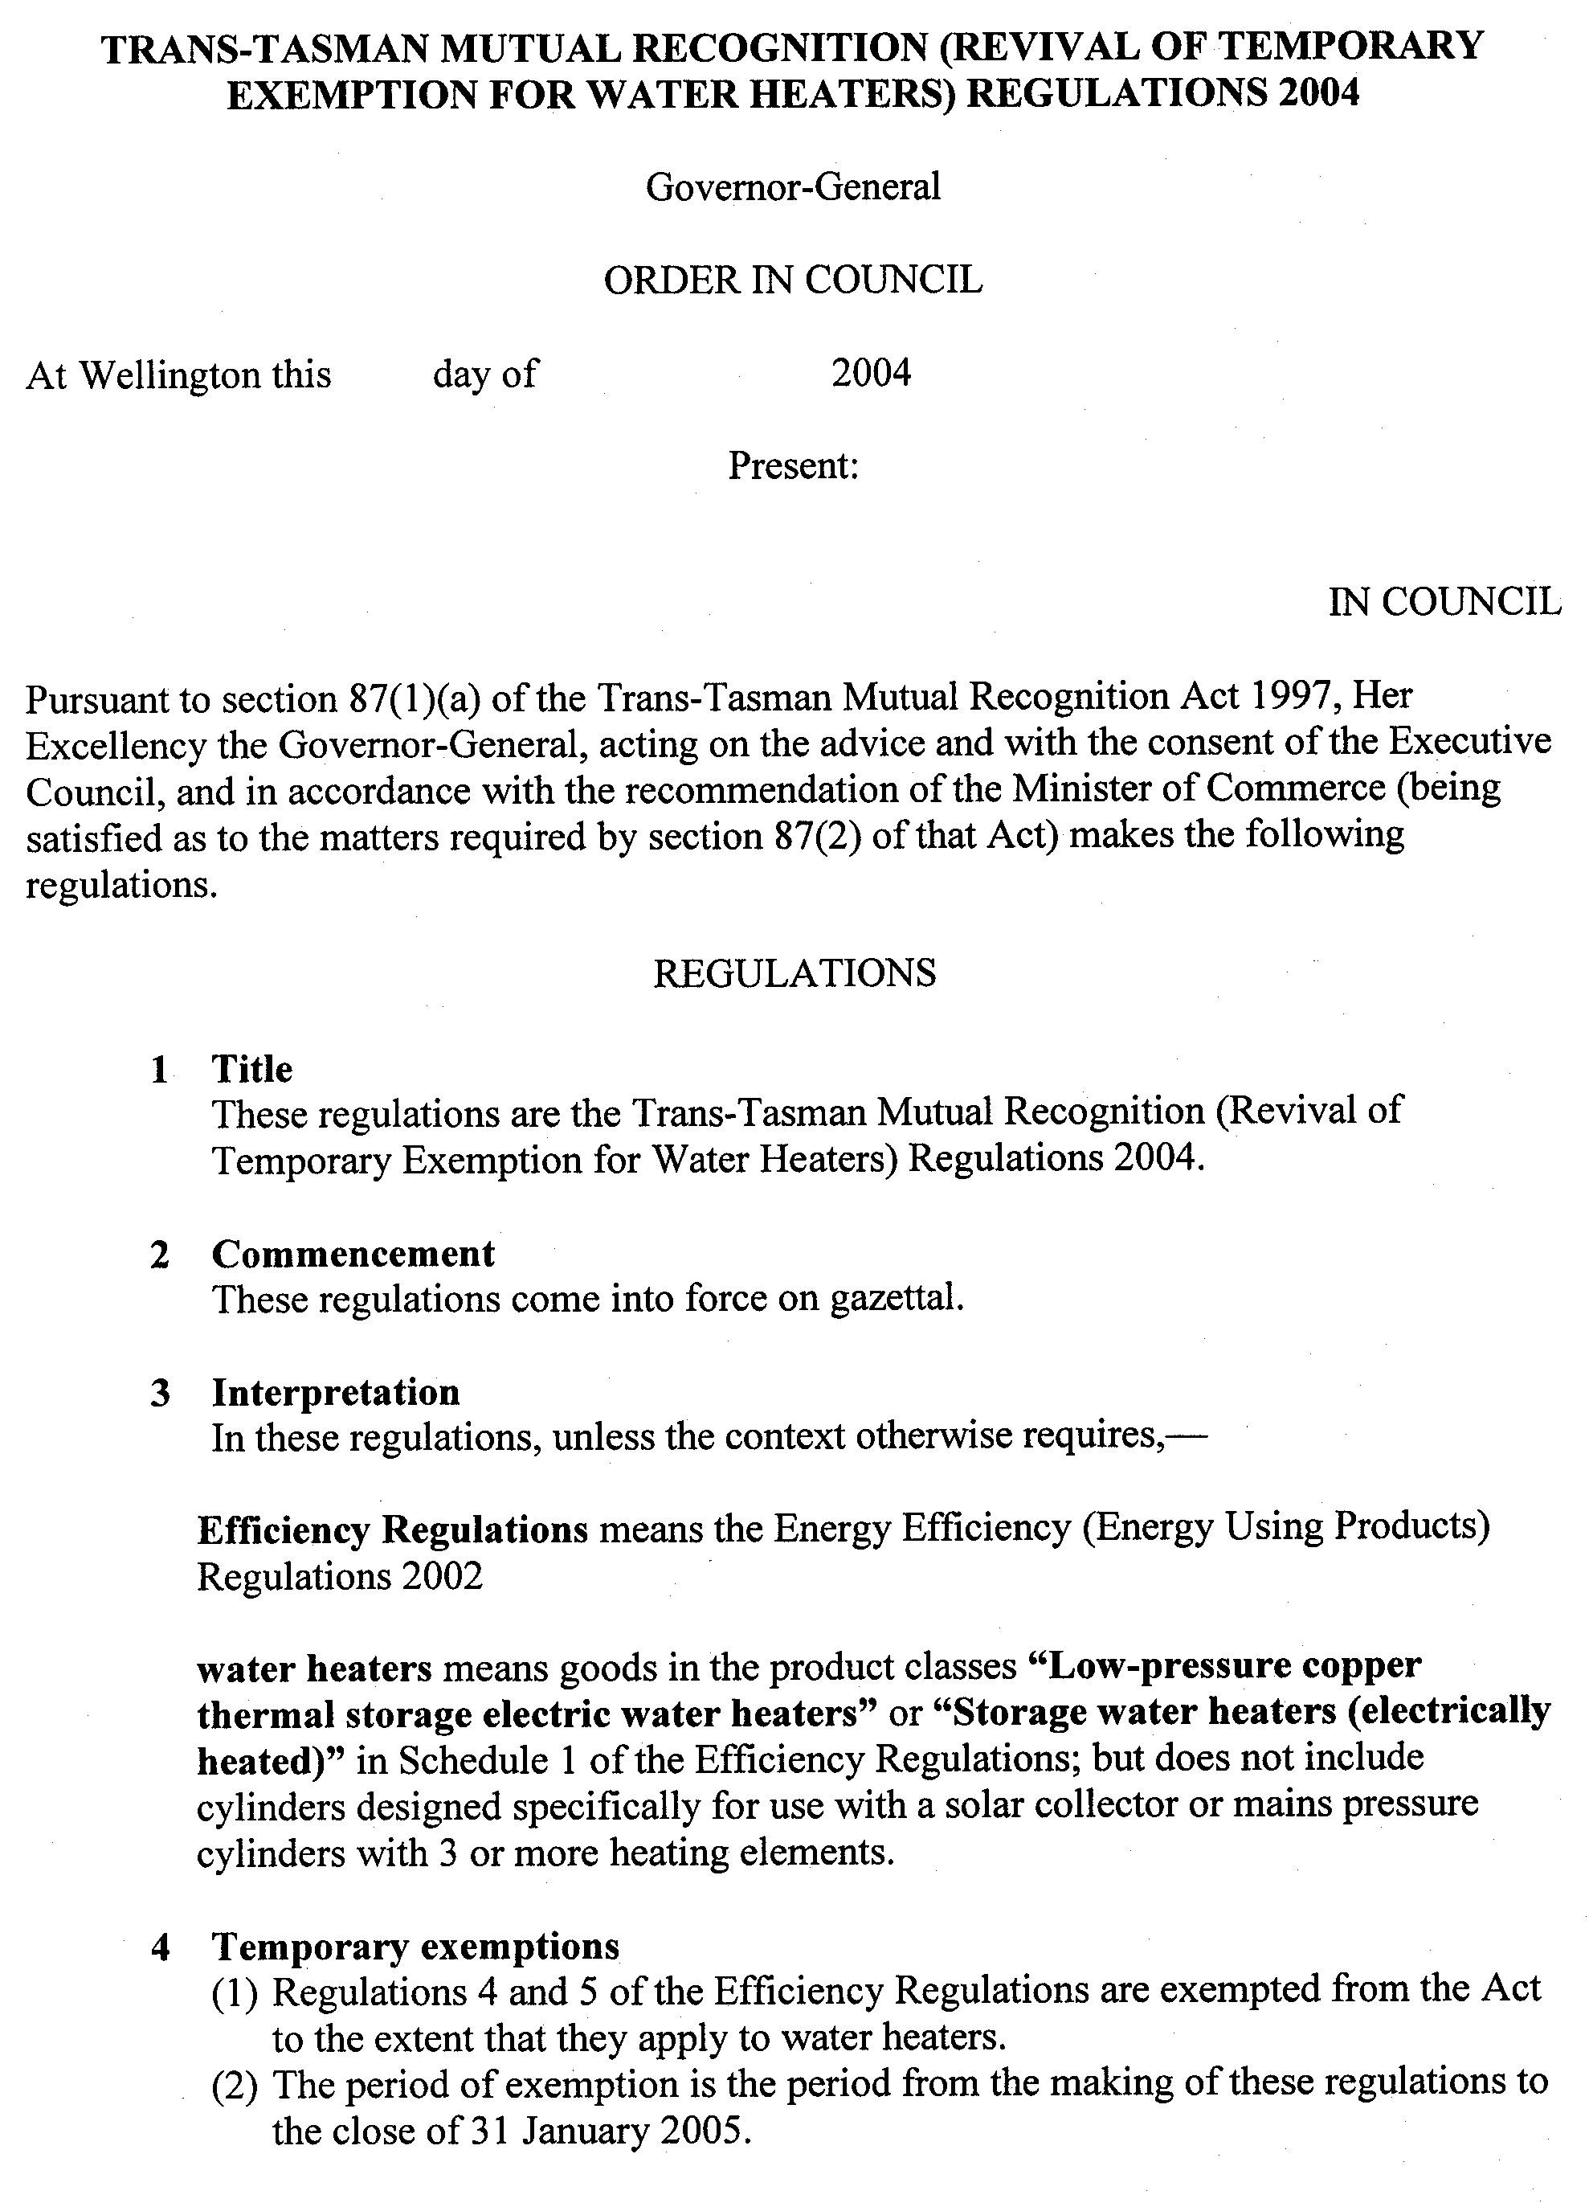
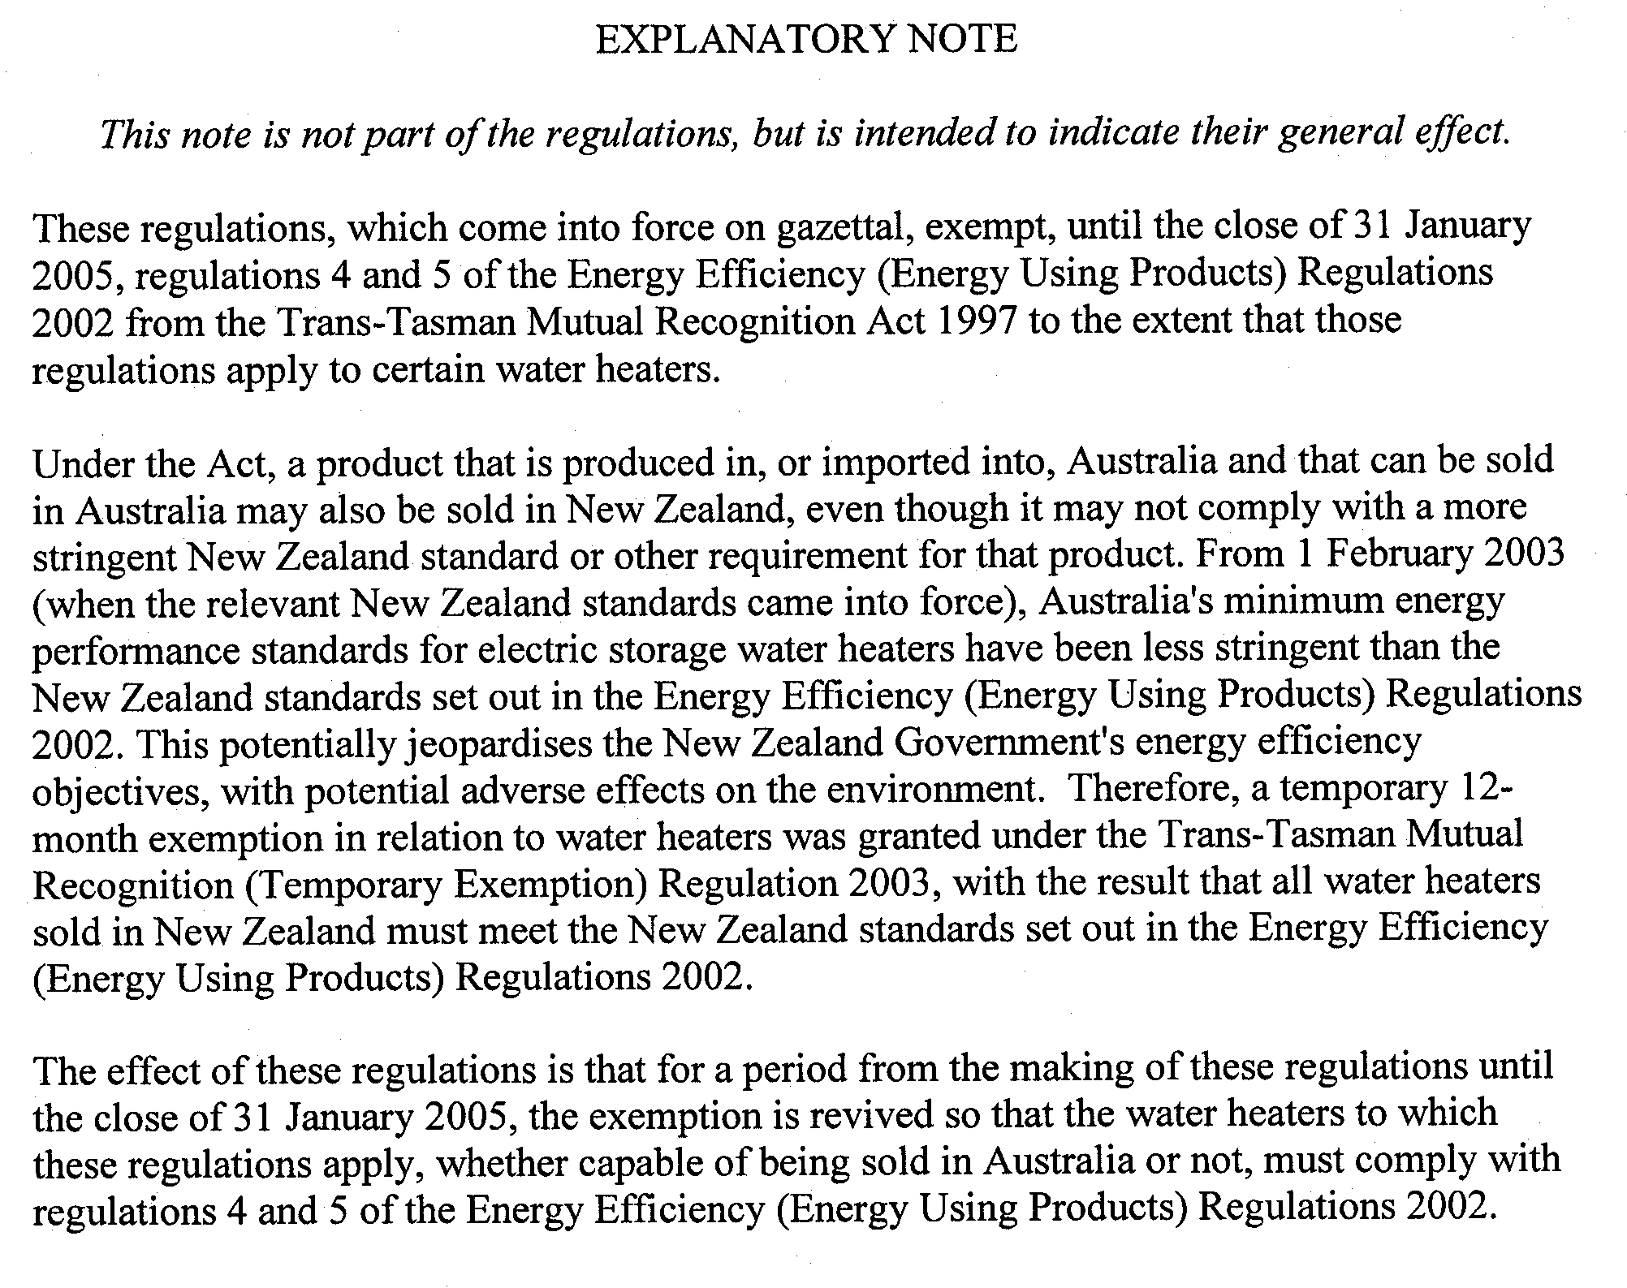

Passenger Transport Act 1994
Passenger Transport (Regular Passenger Service, Fares and Charges)
NOTICE
PURSUANT to its powers under the Passenger Transport Act 1994, and Regulations the Minister has determined that the fares and charges to be paid by passengers on regular passenger services within Metropolitan Adelaide will be the fares and charges in Schedule 1 below.
These fares and charges will be effective from 4 July 2004.
Heather Webster, Executive Director, Office of Public Transport

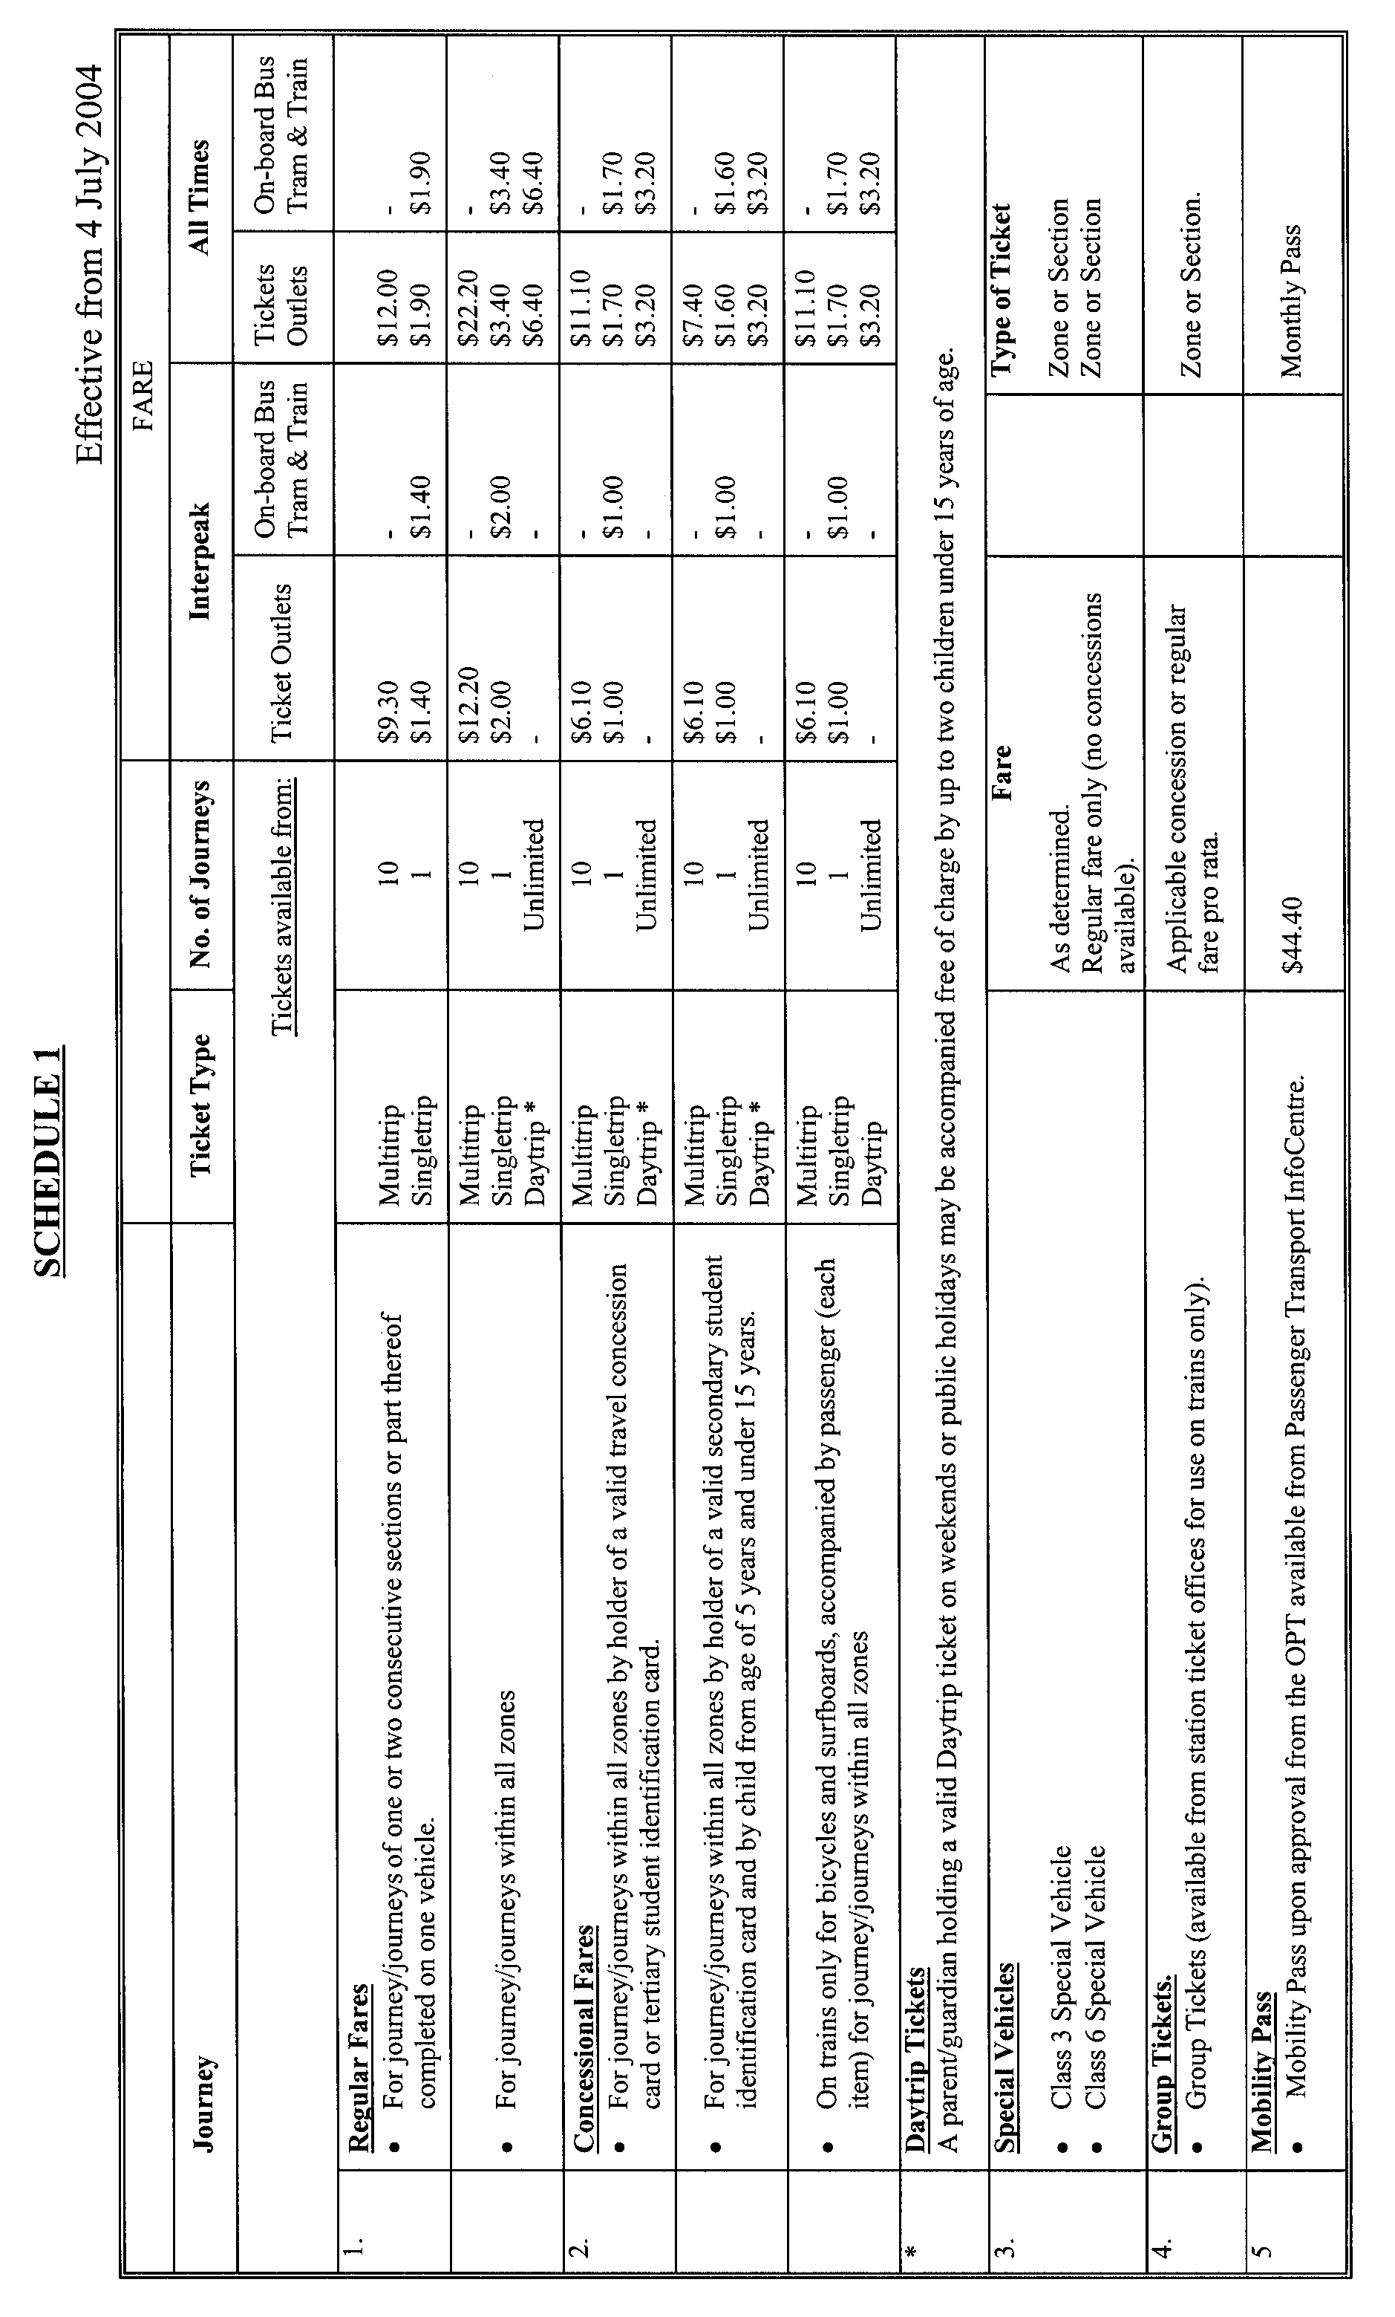

PETROLEUM ACT 2000
Grant of Geothermal Exploration Licences
Gel 128, Gel 129, Gel 161, Gel 162 and Gel 163
NOTICE is hereby given that the undermentioned Geothermal Exploration Licences have been granted under the provisions of the Petroleum Act 2000, pursuant to delegated powers dated 28 March 2002, Gazetted 11 April 2002, page 1573.

No. of Licence | Licensee | Locality | Area in km² | Reference
GEL 128 | Perilya Limited,  Green Rock Energy Pty Ltd | Roxby Downs, South Australia | 308 | 27/02/230
GEL 129 | Perilya Limited,  Green Rock Energy Pty Ltd | Roxby Downs, South Australia | 408 | 27/02/231
GEL 161 | Perilya Limited,  Green Rock Energy Pty Ltd | Roxby Downs, South Australia | 496 | 27/02/275
GEL 162 | Perilya Limited,  Green Rock Energy Pty Ltd | Roxby Downs, South Australia | 488 | 27/02/276
GEL 163 | Perilya Limited,  Green Rock Energy Pty Ltd | Roxby Downs, South Australia | 497 | 27/02/277

Description of Area—GEL 128
All that part of the State of South Australia, bounded as follows:
Commencing at a point being the intersection of latitude 30°20′00″S GDA94 and longitude 136°47′00″E GDA94, thence east to longitude 137°02′42″E GDA94, south to latitude 30°30′45″S GDA94, west to longitude 136°47′00″E GDA94, and north to point of commencement but excluding Special Mining Lease No.1 and that area reserved under certain provisions of the Mining Act 1971 (Government Gazette, 11 December 1986 at page 1820)—Roxby Downs Town Area.
Area: 308 km² approximately.
Description of Area—GEL 129
All that part of the State of South Australia, bounded as follows:
Commencing at a point being the intersection of latitude 30°30′45″S GDA94 and longitude 136°47′00″E GDA94, thence east to longitude 137°02′42″E GDA94, south to latitude 30°41′30″S GDA94, west to longitude 136°47′00″E GDA94 and north to point of commencement but excluding that area reserved under certain provisions of the Mining Act 1971 (Government Gazette, 11 December 1986 at page 1820)—Roxby Downs Town Area.
Area: 408 km² approximately.
Description of Area—GEL 161
All that part of the State of South Australia, bounded as follows:
Commencing at a point being the intersection of latitude 30°14′40″S GDA94 and longitude 136°41′06″E GDA94, thence east to longitude 136°48′45″E GDA94, south to latitude 30°20′00″S GDA94, west to longitude 136°47′00″E GDA94, south to latitude 30°41′30″S GDA94, west to longitude 136°41′06″E GDA94 and north to point of commencement.
Area: 496 km² approximately.
Description of Area—GEL 162
All that part of the State of South Australia, bounded as follows:
Commencing at a point being the intersection of latitude 30°14′40″S GDA94 and longitude 136°48′45″E GDA94, thence east to longitude 137°12′24″E GDA94, south to latitude 30°24′10″S GDA94, west to longitude 137°02′42″E GDA94, north to latitude 30°20′00″S GDA94, west to longitude 136°48′45″E GDA94 and north to point of commencement but excluding Lake Torrens National Park.
Area: 488 km² approximately.
Description of Area—GEL 163
All that part of the State of South Australia, bounded as follows:
Commencing at a point being the intersection of latitude 30°24′10″S GDA94 and longitude 137°02′42″E GDA94, thence east to longitude 137°12′24″E GDA94, south to latitude 30°41′30″S GDA94, west to longitude 137°02′42″E GDA94 and north to point of commencement.
Area: 497 km² approximately.
Dated 2 June 2004.
T. Aust, A/Director Petroleum
Minerals and Energy Division
Primary Industries and Resources SA
Delegate of the Minister for Mineral Resources Development

PETROLEUM ACT 2000
Grant of Associated Facilities Licence—AFL 12
NOTICE is hereby given that the undermentioned Associated Facilities Licence has been granted under the provisions of the Petroleum Act 2000, pursuant to delegated powers dated 28 March 2002, Gazetted 11 April 2002, page 1573.

No. of Licence | Licensee | Locality | Area in km² | Reference
AFL 12 | Liberty Petroleum Corporation | Cooper Basin of South Australia | 0.51 | 27/02/286

Description of Area
All that part of the State of South Australia, bounded as follows:
A 50 m buffer around line segments defined by the following pairs of co-ordinates (GDA 94), adjacent to Petroleum Exploration Licence PEL 100—

From |  | To
460282E | 7013667N | 462086E | 7014547N
458561E | 7014634N | 459023E | 7013659N
455821E | 6995190N | 456670E | 6993506N

Dated 7 June 2004.
T. Aust, Acting Director Petroleum
Minerals and Energy Division
Primary Industries and Resources SA
Delegate of the Minister for Mineral Resources Development

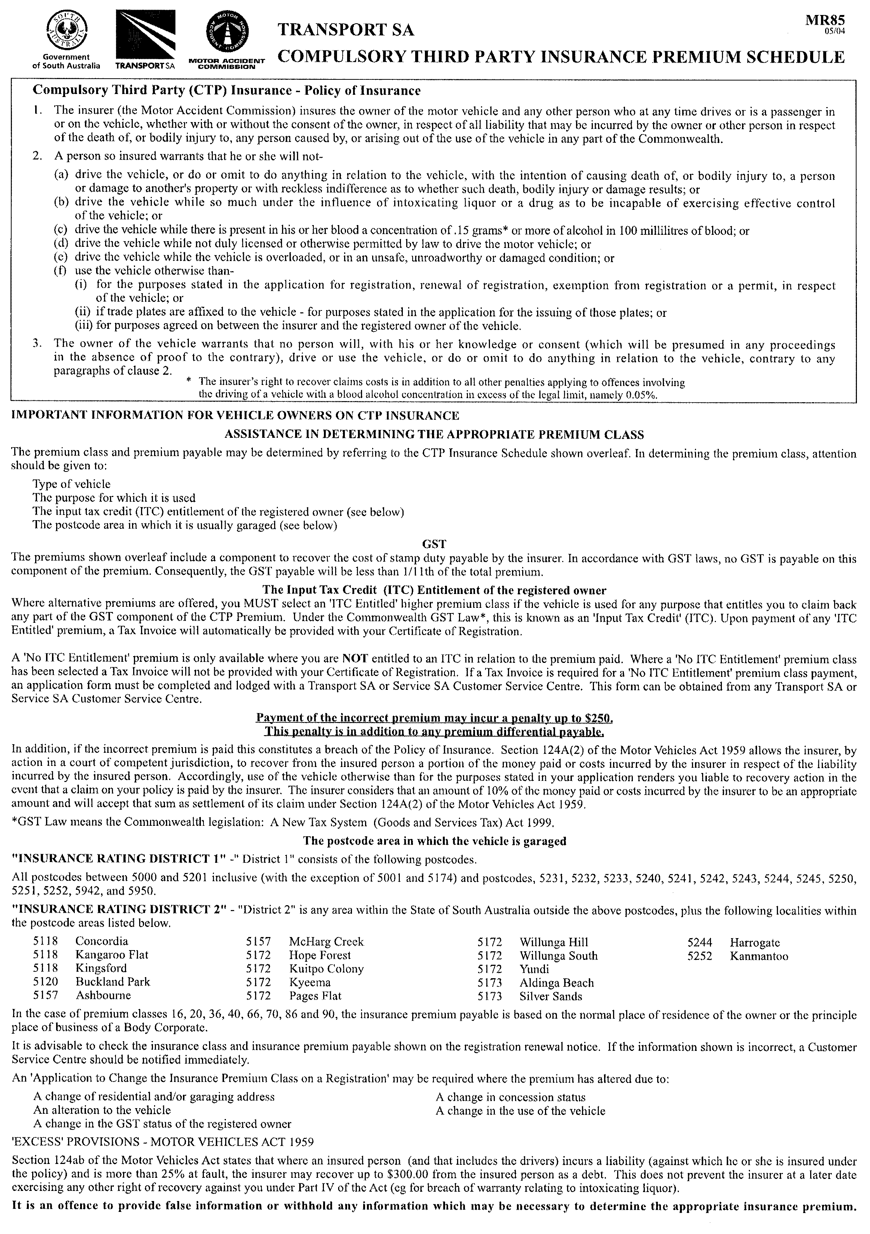
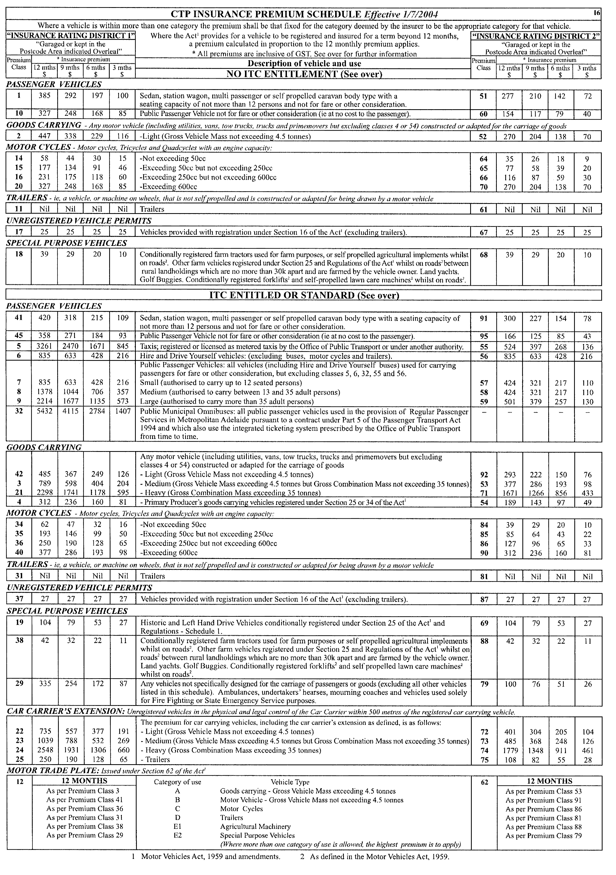

PREVENTION OF CRUELTY TO ANIMALS ACT 1985
Appointment
NOTICE is hereby given that pursuant to section 28 of the Prevention of Cruelty to Animals Act 1985, I, John Hill, Minister for Environment and Conservation, appoint the following person nominated by the Royal Society for the Prevention of Cruelty to Animals South Australia Incorporated to be an Inspector for the purposes of the Act:
Andrea Gai Lewis
Dated 10 June 2004.
J. Hill, Minister for Environment and Conservation

PUBLIC FINANCE AND AUDIT ACT 1987
Regulation 5A—Governor’s Appropriation Fund
Form 1
Approval to Appropriate Funds from the Consolidated Account
PURSUANT to Section 12 of the Act, I appropriate from the Consolidated Account to the public purposes of the State an amount of $186 510 000 for the financial year ending 30 June 2005.
Given under my hand, 10 June 2004.
Marjorie Jackson-Nelson, Governor

PUBLIC SECTOR MANAGEMENT ACT 1995
Notice by the Premier
WHEREAS the Premier, being the Minister responsible for the Public Sector Management Act 1995, may publish in the Gazette an equal employment opportunity program designed to ensure that persons of a defined class have equal opportunities in relation to employment in the public sector with persons not of that class and whereas the Premier may make special provision for persons of a defined class employed in the public sector to compete for employment in the public sector as effectively as persons not of that class, I, Mike Rann, Premier, do hereby vary the equal employment opportunity program ‘South Australian Public Sector Aboriginal Recruitment and Career Development Strategy’ previously published in the Gazette of 27 June 2002 and publish the amended program set out in the Schedule.
The Schedule
South Australian Public Sector Aboriginal Recruitment and Career Development Strategy
Object
To increase the representation of Aboriginal people in the South Australian Public Sector to better reflect their representation in the South Australian population.
Special Provision
Pursuant to section 67 (2) (a) and (b) of the Public Sector Management Act 1995, I make special provisions to achieve the object as follows:
(a) the Department of Further Education, Employment, Science and Technology may seek applications from Aboriginal people residing in South Australia for inclusion on an Aboriginal Register, in accordance with the processes agreed by the Commissioner for Public Employment. The Commissioner may determine on a case by case basis that Aboriginal persons residing outside of South Australia are eligible to be included on the Register;
(b) persons on the Aboriginal Register may be provided with temporary employment opportunities in positions for periods up to 12 months duration in public sector agencies, in accordance with processes agreed by the Commissioner for Public Employment;
(c) persons on the Aboriginal Register who are not currently employed within the public sector will be eligible to apply for all positions advertised in the Notice of Vacancies and to compete for such positions on the basis of merit, in accordance with processes agreed by the Commissioner for Public Employment; and
(d) public sector agencies may provide training and development opportunities to Aboriginal employees of the South Australian public sector to assist them to effectively compete on the basis of merit for future positions in the public sector.
Dated 4 June 2004.
Mike Rann, Premier

RAIL SAFETY ACT 1996
Fees Payable by Accredited Railway Owners and Operators and Owners of Registered Private Railway Sidings
I, TRISH WHITE, the Minister for Transport, pursuant to sections 21 and 22 of the said Act, do hereby fix the following fees.
Dated 2 June 2004.
Trish White, Minister for Transport

Effective 1 July 2004
Schedule of Fees
Fees Payable by Accredited Railway Owners and Operators and Owners of Registered Private Railway Sidings
Application Fees
No fee payable.
Annual Fee—Commercial Railway Owners and Operators
An accredited person shall pay annual accreditation fees according to their accreditation category or categories.
A person accredited as both an owner and an operator shall pay an annual fee equal to the total of both the owner and operator annual fee. A person accredited as both a category 4 owner and a category 4 operator shall pay a maximum combined annual fee of $6 979.
For temporary accreditation the amount payable shall be based on the estimated annual fee proportionally adjusted on a pro rata basis to reflect the actual number of weeks, or part thereof, that the accreditation will remain in force. A minimum fee of $139 applies for temporary accreditation.
Commercial Railway Owner and Operator Annual Fee:
Accreditation  Category | Owner  Annual Fee  ($) | Operator  Annual Fee  ($)
1  2  3  4 (minimum fee) | 38 792  25 861  12 931  6 979 | 38 792  25 861  12 931  6 979

Annual Fee—Not-for-Profit Heritage/Tourist Owners and Operators
No fee payable.
Annual Fee—Owner of a Registered Private Siding
No fee payable
Fee for Late Payment of Annual Fees
Where payment of fees is made after the due date, then payment must be accompanied by a late payment fee of 5 per cent of the amount outstanding on the due date.
Commercial Railway Owner and Operator Accreditation Category
Historical information, where available, will be used for the purpose of determining the accreditation category. Where his-torical information is not available, a projected assessment will be used.
Owner Criteria
Track Owned  (Main Line Kilometres) | Accreditation  Category
Greater than 1 000  Greater than 500 up to 1 000  Greater than 50 up to 500  From 0 to 50 and/or passenger or freight  terminal/marshalling yard owner, or rail infra-structure maintainer only | 1  2  3  4

Operator Criteria
Train Kilometres Operated  (Main Line) | Accreditation  Category
(including train kilometres operated as a hook-and-pull provider)  Greater than 3 million per annum  Greater than 1 million up to 3 million per annum  Greater than 50 000 up to 1 million per annum  Up to 50 000 per annum, or rolling stock  maintainer and/or provider only, or train operator which only contracts other accredited operators to hook-and-pull its trains. | 1  2  3  4

ROADS (OPENING AND CLOSING) ACT 1991:
SECTION 24
NOTICE OF CONFIRMATION OF ROAD
PROCESS ORDER
Wheelton Street, Kingscote
Deposited Plan 64328
BY Road Process Order made on 27 February 2004, the Kangaroo Island Council ordered that:
1. Portion of the public road (Wheelton Street) adjoining allotment 500 in Deposited Plan 47409, more particularly lettered ‘A’ in Preliminary Plan No. 03/0104 be closed.
2. The whole of the land subject to closure be transferred to Kangaroo Island Health Service in accordance with agreement for transfer dated 21 January 2004 entered into between the Kangaroo Island Council and Kangaroo Island Health Service.
3. The following easement be granted over portion of the land subject to that closure.
Grant to the Distribution Lessor Corporation an easement for overhead and underground electricity supply purposes.
On 16 March 2004 that order was confirmed by the Minister for Administrative Services conditionally on approval and deposit of the survey plan by the Registrar-General. The condition has now been fulfilled.
Pursuant to section 24 (5) of the Roads (Opening and Closing) Act 1991, NOTICE of the order referred to above and its confirmation is hereby given.
Dated 10 June 2004.
P. M. Kentish, Surveyor-General

ROADS (OPENING AND CLOSING) ACT 1991:
SECTION 24
NOTICE OF CONFIRMATION OF ROAD
PROCESS ORDER
Middle Row, Salisbury
Deposited Plan 63864
BY Road Process Order made on 17 December 2003, the City of Salisbury ordered that:
1. Portion of the public road (Middle Row) situated south of Commercial Road and adjoining the eastern boundary of allotment 603 in Deposited Plan 53873, more particularly delineated and lettered ‘A’, ‘B’ and ‘C’ in Preliminary Plan No. 03/000075 be closed.
2. The whole of the land subject to closure lettered ‘A’ be transferred to Ilario Portaro in accordance with agreement for transfer dated 14 October 2003 entered into between the City of Salisbury and I. Portaro.
3. The whole of the land subject to closure lettered ‘B’ be transferred to Antonio and Adele Barone in accordance with agreement for transfer dated 9 December 2003 entered into between the City of Salisbury and A. and A. Barone.
4. The whole of the land subject to closure lettered ‘C’ be transferred to Joan Patricia Allwright in accordance with agreement for transfer dated 9 October 2003 entered into between the City of Salisbury and J. P. Allwright.
5. The following easement be granted over portion of the land subject to that closure.
Grant to the City of Salisbury an easement for drainage purposes.
On 29 January 2004 that order was confirmed by the Minister for Administrative Services, conditionally on approval and deposit of the survey plan by the Registrar-General. The condition has now been fulfilled.
Pursuant to section 24 (5) of the Roads (Opening and Closing) Act 1991, NOTICE of the order referred to above and its confirmation is hereby given.
Dated 10 June 2004.
P. S. Smith, Acting Surveyor-General

SURVEY ACT 1992
Revocation of Confused Boundary Area
NOTICE is hereby given that pursuant to section 50 (3) of the Survey Act 1992, the Confused Boundary Area is revoked for the area bounded by Wauraltee Road, Curramulka Road, Koolywurtie Road and Minlacowie Road in the area of Port Vincent.
Dated 10 June 2004.
P. M. Kentish, Surveyor-General
REF: LTO 14/2003

NOTICE TO MARINERS
No. 20 of 2004
Beacon Movements—South Australia—Thevenard—Yatala Channel—Beacon Replaced, Buoy Removed and Buoy Placed
Former Notice No. 29 of 2000
MARINERS are advised that the temporary buoy referred to in the previous notice will be replaced by the original No. 6 Channel Beacon in the approximate AGD 84 co-ordinate position latitude 32°11′07.172″S, longitude 133°36′06.875″E on or about 5 June 2004. The light characteristics of this channel marker are flashing red every 3 seconds (Fl R 3s).

Mariners are advised that a lit buoy will be placed at approximate WGS 84 position latitude 32°08′53.46″S, longitude 133°38′16.27″E on or about 5 June 2004. The light characteristics of this buoy are flashing red every 3 seconds (Fl R 3s).
Navy chart affected: Aus 120.
Publications affected: Australian Pilot, Volume 1 (Seventh Edition, 1992) pages 72-74
Admiralty List of Lights & Fog Signals, Volume K, No. 1826.5

South Australia—Gulf St Vincent—Port Adelaide—Outer Harbor—Beacon Moved
MARINERS are advised that on or about 5 June 2004 the No. 13 Port Adelaide River Channel Beacon at Outer Harbor will be moved to approximate WGS 84 position 34°45′51.509″S, 138°29′41.947″E. All other characteristics remain unchanged.
Navy chart affected: Aus 137.
Publications affected: Australian Pilot, Volume 1 (Seventh Edition, 1992) pages 125-130
Admiralty List of Lights & Fog Signals, Volume K, No. 2061
Adelaide, 3 June 2004.
Trish White, Minister for Transport and Urban Planning
FP 2001/1439
TSA 2004/00541

WATER MAINS AND SEWERS

Office of the South Australian Water Corporation
Adelaide, 10 June 2004

WATER MAINS LAID

Notice is hereby given that the following main pipes or parts of main pipes have been laid down by the South Australian Water Corporation in or near the undermentioned water districts and are now available for a constant supply of water to adjacent land.

ADELAIDE WATER DISTRICT

CITY OF ONKAPARINGA
Parrot Road, Aldinga Beach. p1
Plaza Avenue, Sellicks Beach. p2
Armstrong Street, Sellicks Beach. p3
Bowering Road, Port Willunga. p4

CITY OF PLAYFORD
Wallace Drive, Craigmore. p8
Bower Avenue, Craigmore. p8
Mary Crescent, Craigmore. p8
Solaprobe Close, Craigmore. p8
Fradd Court, Angle Vale. p9
Harradine Court, Angle Vale. p9

CITY OF PORT ADELAIDE ENFIELD
Dodson Court, Ferryden Park. p7

CITY OF SALISBURY
Stanford Road, Salisbury Heights. p14

CITY OF WEST TORRENS
Deeds Road, North Plympton and Camden Park. p17

CURRAMULKA WATER DISTRICT

DISTRICT COUNCIL OF YORKE PENINSULA
First Street, Curramulka. p6

NURIOOTPA WATER DISTRICT

BAROSSA COUNCIL
Kaesler Drive, Nuriootpa. p10
Jonathan Avenue, Nuriootpa. p10
Robin Avenue, Nuriootpa. p10
Moorpark Street, Nuriootpa. p10
In and across Barossa Street, Nuriootpa. p11

QUORN WATER DISTRICT

THE FLINDERS RANGES COUNCIL
Brougham Place, Quorn. p12
Jervois Street, Quorn. p12
Francis Street, Quorn. p13

ROBE WATER DISTRICT

DISTRICT COUNCIL OF ROBE
Birmingham Crescent, Robe. p5
Adam Lindsay Gordon Drive, Robe. p5
Moorakyne Drive, Robe. p5

SEWERS LAID

Notice is hereby given that the following sewers have been laid down by the South Australian Water Corporation in the undermentioned drainage areas and are now available for house connections.

ADELAIDE DRAINAGE AREA

CAMPBELLTOWN CITY COUNCIL
Moore Street, Tranmere. FB 1123 p60

CITY OF PLAYFORD
Campese Chase, Craigmore. FB 1124 p21 and 22
Beckham Rise, Craigmore. FB 1124 p21-23, and FB 1110 p8-10
Giggs Glen, Craigmore. FB 1124 p21 and 22
Warne Way, Craigmore. FB 1110 p8-10
Easement in lots 110-112, Beckham Rise, Craigmore. FB 1110 p8 and 9
Easement in lot 154, Beckham Rise, Craigmore. FB 1110 p8 and 10
Cathy Mews, Craigmore. FB 1110 p8 and 10
Easement in lot 136, Cathy Mews, and lot 120, Warne Way, Craigmore. FB 1110 p8 and 10
Wallace Drive, Craigmore. FB 1124 p24 and 25
Bower Avenue, Craigmore. FB 1124 p24 and 25
Mary Crescent, Craigmore. FB 1124 p24 and 25
Solaprobe Close, Craigmore. FB 1124 p24 and 25
Easements in reserve (lot 989), and lots 147 and 117, Christine Circuit, Craigmore. FB 1124 p24 and 25

CITY OF PORT ADELAIDE ENFIELD
Dodson Court, Ferryden Park. FB 1124 p19 and 20
Reynolds Street, Ferryden Park. FB 1124 p19 and 20
Romney Avenue, Ferryden Park. FB 1124 p19 and 20
Carlisle Street, Northfield. FB 1125 p5

CITY OF SALISBURY
Easement in lot 24 in LTRO DP 37843, Stanford Road, Salisbury Heights. FB 1125 p1

CITY OF TEA TREE GULLY
Easement in lot 53 in LTRO DP 6406, Trafford Road, Highbury. FB 1123 p59

VICTOR HARBOR COUNTRY DRAINAGE AREA

CITY OF VICTOR HARBOR
Giles Street, Encounter Bay. FB 1125 p3

SEWERS ABANDONED

Notice is hereby given that the undermentioned sewers have been abandoned by the South Australian Water Corporation.

ADELAIDE DRAINAGE AREA

CITY OF MARION
Sewerage land (lot 27 in LTRO DP 10694), Yartoo Street, Hallett Cove—100 mm PVC pumping main. FB 1125 p24
Grantala Court, Hallett Cove—100 mm PVC pumping main. FB 1125 p24
Walkway (lot 811 in LTRO DP 10694), Grantala Court, Hallett Cove—100 mm PVC pumping main. FB 1125 p24

CITY OF ONKAPARINGA
Karawi Parade, Morphett Vale—100 mm PVC pumping main. FB 1125 p25
Allinga Road, Morphett Vale—100 mm PVC pumping main. FB 1125 p25
Brigalow Road, Morphett Vale—100 mm PVC pumping main. FB 1125 p25

SEWERS LAID

Notice is hereby given that the undermentioned sewers have been laid down by the South Australian Water Corporation and are not available for house connections.

STIRLING COUNTRY DRAINAGE AREA

ADELAIDE HILLS COUNCIL
Hill View Road, Bridgewater—63 mm MDPE low pressure sewerage system main. FB 1123 p34
Lot 261, Hill View Road, Bridgewater—40 mm MDPE low pressure sewerage system main. FB 1123 p34

A. Howe, Chief Executive Officer, South Australian Water Corporation

WATER RESOURCES ACT 1997
Notice of Restriction on the Taking of Water from the River Murray Prescribed Watercourse
PURSUANT to section 16 (1) of the Water Resources Act 1997 (‘the Act’), I, John David Hill, Minister for Environment and Conservation in the State of South Australia, and Minister to whom administration of the Water Resources Act 1997 is committed, being of the opinion that the rate at which water is being taken from the River Murray Prescribed Watercourse as described in Schedule 1:
• is such that the quantity of water available can no longer meet the demand; and
• there is a risk that the available water will not be sufficient to meet future demand; and
• is affecting the quality of water in the watercourse;
hereby restrict the taking of water from the River Murray Prescribed Watercourse, in the manner and subject to the conditions, specified in Schedule 2.
Schedule 1
The River Murray Prescribed Watercourse established by proclamation under the Water Resources Act 1976 and continued in existence as if it had been proclaimed under the Water Resources Act 1990 and continued as a regulation under the Water Resources Act by virtue of clause 2 (1) (a) of Schedule 3 of the Water Resources Act 1997, and described in the General Registry Office Plan No. 926/78, sheets 1 to 13.
Schedule 2
1. A person may only take water from the River Murray Prescribed Watercourse in accordance with the terms of a written authorisation granted under this Notice by me or my authorised agent.
2. An authorisation terminates according to its terms, or upon expiry or revocation of this Notice, whichever is the earliest.
3. An authorisation under this Notice may be granted to:
(a) A person holding a water licence endorsed with a water (taking) allocation to take water from the River Murray Prescribed Watercourse entitling that person to take:
• a quantity of water equivalent to 70% of the water (taking) allocation endorsed on the water licence, excluding water allocations for the purposes specified in clause 7 and subject to the provision of clause 4.
(b) A person holding a water licence endorsed with a water (taking) allocation for the taking of water for urban water supply through reticulated water supply infrastructure under the Waterworks Act 1932 (Metropolitan Adelaide) entitling that person to take:
• 136 gigalitres.
(c) A person holding a water licence endorsed with a water (taking) allocation for the taking of water for urban water supply through reticulated water supply infrastructure under the Waterworks Act 1932 (Country Towns) entitling that person to take:
• a quantity of water equivalent to 70% of the water (taking) allocation endorsed on the water licence, excluding water allocations for the purposes specified in clause 7 and subject to the provision of clause 4.
(d) A person who during the period of this Notice, receives approval to convert a water (holding) allocation to a water (taking) allocation under the Water Resources Act 1997 entitling that person to take:
• a quantity of water equivalent to 70% of the water (taking) allocation endorsed on the water licence after conversion, excluding water allocations for purposes specified in clause 7 and subject to the provision of clause 4.
4. Where a water allocation is transferred to the State of South Australia for taking purposes from interstate the total volume transferred may be taken by the transferee.
5. The following condition applies to the taking of water in accordance with this Notice:
• The water may only be taken through a meter that accurately measures the quantity of water taken and is at all times in good working condition, unless water is taken to irrigate reclaimed land within the Lower Murray Reclaimed Irrigation Management Zone as defined in the Water Allocation Plan for the River Murray Prescribed Watercourse adopted on 1 July 2002.
6. An authorisation granted under this Notice will terminate if the person to whom the authorisation was granted no longer holds a licence endorsed with a water (taking) allocation.
7. This Notice of Restriction does not apply:
• to the taking of water pursuant to section 7 (5) of the Act for domestic purposes or for watering stock; or
• to the taking of water for animal health and welfare; or
• to the taking of water for fire fighting purposes.
This notice will remain in effect for one year unless earlier varied or revoked.
Dated 8 June 2004.
John Hill, Minister for Environment and Conservation

WATER RESOURCES ACT 1997
Notice of Basis of Levy for 2004-2005 in the Eyre Peninsula Catchment Water Management Board’s Catchment Area
I, JOHN DAVID HILL, Minister for Environment and Conservation, have determined pursuant to section 138 (3) of the Water Resources Act 1997, that the basis for the levy in the catchment area of the Eyre Peninsula Catchment Water Management Board for the 2004-2005 financial year will be a fixed levy of the same amount on all rateable land.
Her Excellency the Governor gave her approval of the method referred to in the above paragraph on 10 June 2004.
Dated 10 June 2004.
John Hill, Minister for Environment and Conservation

WATER RESOURCES ACT 1997
Notice of Contributions in 2004-2005 by Constituent Councils
of the Eyre Peninsula Catchment Water Management
Board’s Catchment Area
I, JOHN DAVID HILL, Minister for Environment and Conservation, have determined pursuant to section 135 of the Water Resources Act 1997 that:
(a) the total amount to be contributed by constituent councils of the catchment area of the Eyre Peninsula Catchment Water Management Board in respect of the 2004-2005 financial year is to be the sum of five hundred and eighty-seven thousand and three hundred eighty-four dollars; and
(b) constituent councils of the Board’s area will share the liability for the payment of that amount as follows:

Constituent Councils Amount
$

Ceduna 53 835
Cleve 32 581
Elliston 25 454
Franklin Harbour 26 568
Kimba 21 286
Le Hunte 22 400
Lower Eyre Peninsula 81 421
Port Lincoln 231 537
Streaky Bay 41 617
Tumby Bay 50 685

Total $587 384

Her Excellency the Governor gave her approval of the amounts referred to above on 10 June 2004.
Dated 10 June 2004.
John Hill, Minister for Environment and Conservation

FAXING COPY?
IF you fax copy to Government Publishing SA for inclusion in the Government Gazette, there is no need to send a Confirmation Copy to us as well.
This creates confusion and may well result in your notice being printed twice.
Please use the following fax number:
Fax transmission: (08) 8207 1040
Phone Inquiries: (08) 8207 1045
Please include a contact person, phone number and order number so that we can phone back with any queries we may have regarding the fax copy.
NOTE: Closing time for lodging new copy (fax, hard copy or email) is 4 p.m. on Tuesday preceding the day of publication.

Government Gazette notices can be E-mailed.
The address is:
governmentgazette@saugov.sa.gov.au
Documents should be sent as attachments in Word format.
When sending a document via E-mail, please confirm your transmission with a faxed copy of your document, including the date the notice is to be published.
Fax transmission: (08) 8207 1040
Enquiries: (08) 8207 1045
NOTE: Closing time for lodging new copy (fax, hard copy or email) is 4 p.m. on Tuesday preceding the day of publication.

CITY OF BURNSIDE
Adoption of Valuations and Declaration of Rates
NOTICE is hereby given that the council in exercise of the powers contained in Chapters 8, 9 and 10 of the Local Government Act 1999 and the Water Resources Act 1997.
1. At a meeting held on 1 June 2004:
1.1 Adoption of Valuations
Adopted for rating purposes for the year ending 30 June 2005, the capital valuations of the Valuer-General totalling $8 711 270 600.
1.2 Declaration of General Rate
Declared a general rate of 0.2392 cents in the dollar on the capital value of all rateable land within its area.
1.3 Declaration of Separate Rates
Declared separate rates on rateable land within the area as follows:
1.3.1. 0.00808 cents in the dollar based on capital values on all rateable land in the area of the River Torrens Catchment Water Management Board.
1.3.2. 0.00618 cents in the dollar based on capital values on all rateable land in the area of the Patawalonga Catchment Water Management Board.
1.4 Minimum Rate
Declared a minimum amount payable by way of general rates on rateable land in its area of $509.
J. Hanlon, Chief Executive Officer

ALEXANDRINA COUNCIL
Roads (Opening and Closing) Act 1991
Unmade Portion of Lindsay Parade, Goolwa
NOTICE is hereby given pursuant to section 10 of the said Act, that the Alexandrina Council proposes to make a Road Process Order to close and retain that portion of Lindsay Parade generally between Washington Street and Johnston Street, shown lettered ‘A’ and ‘B’ on Preliminary Plan No. 04/0025.
Unmade Portion of Davies Street, Goolwa
Notice is hereby given pursuant to section 10 of the said Act, that the Alexandrina Council proposes to make a Road Process Order to close and retain that portion of Davies Street between Harris Street and Partridge Street, shown lettered ‘A’ and ‘B’ on Preliminary Plan No. 04/0026.
Copies of the plans and statements of persons affected are available for public inspection at Council’s Office, 16 Dawson Street, Goolwa and the office of the Surveyor-General, 101 Grenfell Street, Adelaide during normal office hours.
Any application for easement or objections must be made in writing within 28 days from 10 June 2004, to the Council, P.O. Box 21, Goolwa, S.A. 5214 and the Surveyor-General, G.P.O. Box 1354, Adelaide, S.A. 5001, setting out full details.
Where a submission is made, council will give notification of a meeting to deal with the matter.
J. L. Coombe, Chief Executive Officer

THE FLINDERS RANGES COUNCIL
Council Meeting
NOTICE is hereby given that pursuant to section 81 (4) (b) of the Local Government Act 1999, ordinary meetings of the council will be held on the second Tuesday of each month commencing at 6.45 p.m.
L. E. Connors, Chief Executive Officer

THE FLINDERS RANGES COUNCIL
Development Assessment Panel Meeting
NOTICE is hereby given that pursuant to section 56A of the Development Act 1993, ordinary meetings of the Development Assessment Panel will be held on the second Tuesday of each month commencing at 6.30 p.m.
L. E. Connors, Chief Executive Officer

RENMARK PARINGA COUNCIL
Development Act 1993
Country Living Zone (Paringa North Policy Area) PAR
Amendment Notice—Availability of PAR Copies
NOTICE is hereby given that the Renmark Paringa Council has prepared a draft Plan Amendment Report to amend the Renmark Paringa (DC) Development Plan (as detailed in Gazette notice printed on 3 June 2004). It is advised copies of the PAR can be viewed and purchased ($15) from Council’s Office, 8 Ral Ral Avenue, Renmark, from 7 June 2004 to 16 August 2004.
Dated 10 June 2004.
B. Hurst, Chief Executive Officer

DISTRICT COUNCIL OF MOUNT REMARKABLE
Notice of Exclusion of Land from Classification
as Community Land
NOTICE is hereby given that the District Council of Mount Remarkable at its meeting held on 11 May 2004 resolved, pursuant to section 193 (4) of the Local Government Act 1999, to exclude the following parcel of land from classification as community land:
Allotment 217 in the Town of Port Germein, Hundred of Telowie, being the whole of the land comprised in Certificate of Title, Register Book, Volume 5321, Folio 235.
S. R. Cheriton, Chief Executive Officer

NARACOORTE LUCINDALE COUNCIL
Appointments
NOTICE is hereby given that at a meeting of council held on 25 May 2004, the council resolved:
That Shane Henry Francis be appointed as a Ranger pursuant to section 4 (1) of the Impounding Act 1920.
That Shane Henry Francis be appointed as a Dog Management Officer pursuant to section 27 (1) of the Dog and Cat Management Act 1995.
That Shane Henry Francis be appointed as an Authorised Officer pursuant to section 260 of the Local Government Act 1999.
D. A. Hovenden, Chief Executive Officer

IN the matter of the estates of the undermentioned deceased persons:
Beckwith, John George, late of 20 Norseman Avenue, Westbourne Park, retired fitter, who died on 15 April 2004.
Bitmead, James, late of 80 Moseley Street, Glenelg South, retired station master, who died on 26 March 2004.
Brook, Louis Kenneth, late of 53-59 Austral Terrace, Morphettville, retired chief metallurgist, who died on 27 July 2003.
Burridge, Doris Ada, late of 53 Swanport Road, Murray Bridge, of no occupation, who died on 10 September 2003.
Carr, Harry Ernest, late of 1 Croser Avenue, Aldinga Beach, retired metal machinist, who died on 4 May 2004.
Downton, Margaret Rosetta, late of 29 Austral Terrace, Morphettville, of no occupation, who died on 18 April 2004.

Duck, Allen Edward, late of 7 Partridge Street, Goolwa, retired supervisor, who died on 3 May 2004.
Edwards, Reece William, late of 40 Newton Street, Whyalla, retired technical officer, who died on 22 March 2004.
Hancock, Lawrence Oswald, late of 8 Thomas Street, Saddleworth, retired truck driver, who died on 12 March 2004.
Kavanagh, Irene, late of 336 Kensington Road, Leabrook, of no occupation, who died on 4 May 2004.
Knevitt, Donald Robert, late of 1 Cameron Road, Klemzig, retired storeman, who died on 13 March 2004.
Neale, Allan John Wilfred, late of 10 Nicholas Drive, Tea Tree Gully, retired foreman, who died on 26 April 2004.
Pearce, Esme Gladys, late of 276 Portrush Road, Beulah Park, retired teacher, who died on 15 March 2004.
Pugh, Mona Ruby, late of 89 Clifton Street, Kelmscott, Western Australia, of no occupation, who died on 19 March 2004.
Shaw, Mona Kathleen, late of 39 Finniss Street, Marion, retired tailoress, who died on 2 April 2004.
Short, Lorna Ivy, late of 9 Frederick Street, Welland, home duties, who died on 10 February 2004.
Streater, Allan Elliot, late of 16 Seventh Avenue, Woodville Gardens, retired tram driver, who died on 1 March 2004.
Surman, Ronald, late of 110 Strathfield Terrace, Largs North, retired slaughterman, who died on 13 April 2004.
Thiele, Doris May, late of 77 Sydenham Road, Norwood, of no occupation, who died on 22 August 2003.
Tretheway, Rosemary Elizabeth, late of 82 Newland Avenue, Marino, home duties, who died on 25 March 2004.
Williams, Dora May, late of 1215 Grand Junction Road, Hope Valley, home duties, who died on 14 January 2004.
Notice is hereby given pursuant to the Trustee Act 1936, as amended, the Inheritance (Family Provision) Act 1972, and the Family Relationships Act 1975, that all creditors, beneficiaries, and other persons having claims against the said estates are required to send, in writing, to the Public Trustee, 25 Franklin Street, Adelaide, S.A. 5000, full particulars and proof of such claims, on or before 9 July 2004, otherwise they will be excluded from the distribution of the said estate; and notice is also hereby given that all persons who are indebted to the said estates are required to pay the amount of their debts to the Public Trustee or proceedings will be taken for the recovery thereof; and all persons having any property belonging to the said estates are forthwith to deliver the same to the Public Trustee.
Dated 10 June 2004.
C. J. O’Loughlin, Public Trustee

ATTENTION

CUSTOMERS requiring a proof of their notice for inclusion in the Government Gazette, please note that the onus is on you to inform Government Publishing SA of any subsequent corrections by 10 a.m. on Thursday, which is our publication deadline.

For any corrections to your notice please phone 8207 1045 or Fax 8207 1040 before 10 a.m. on Thursday.

If we do not receive any communication by 10 a.m. on Thursday (day of publication) we will presume the notice is correct and will print it as it is.

Remember—the onus is on you to inform us of any corrections necessary to your notice.

NOTE: Closing time for lodging new copy (electronically, fax or hard copy) is 4 p.m. on Tuesday preceding the day of publication. Phone 8207 1045—Fax 8207 1040.
Email: governmentgazette@saugov.sa.gov.au

Printed and published by authority every Thursday by J. D. FERGUSON, Government Printer, South Australia
Price: $4.70, plus postage; to subscribers, $238.00 per annum.
(The above prices are inclusive of GST)

