No. 50 2189

THE SOUTH AUSTRALIAN

GOVERNMENT GAZETTE
www.governmentgazette.sa.gov.au

PUBLISHED BY AUTHORITY

ALL PUBLIC ACTS appearing in this GAZETTE are to be considered official, and obeyed as such

ADELAIDE, THURSDAY, 17 JUNE 2004

CONTENTS

Page
Appointments, Resignations, Etc. 2190
Corporations and District Councils—Notices 2246
Crown Lands Act 1929—Notice 2191
Development Act 1993—Notice 2191
Environment Protection Authority—
Notices 2192
Fisheries Act 1982—Notices 2196
Harbors and Navigation Act 1993—Notice 2199
Liquor Licensing Act 1997—Notices 2199
Local Government Act 1999—Notice 2203
Mining Act 1971—Notices 2213
Mount Gambier Circuit Court—Notice 2213
Petroleum Act 2000—Notices 2215
Proclamations 2227
Public Trustee Office—Administration of Estates 2248
Page
REGULATIONS
Liquor Licensing Act 1997 (No. 132 of 2004) 2231
Legal Practitioners Act 1981 (No. 133 of 2004) 2235
Southern State Superannuation Act 1994—
(No. 134 of 2004) 2237
National Parks and Wildlife Act 1972—
(No. 135 of 2004) 2239
Dog and Cat Management Act 1995—
(No. 136 of 2004) 2242
Roads (Opening and Closing) Act 1991—Notices 2214
Road Traffic Act 1961—Notice 2217
Sewerage Act 1929—Notice 2222
Tobacco Products Regulation Act 1997—Notices 2225
Water Resources Act 1997—Notices 2225
Waterworks Act 1932—Notices 2223

GOVERNMENT GAZETTE NOTICES
ALL poundkeepers’ and private advertisements forwarded for publication in the South Australian Government Gazette must be PAID FOR PRIOR TO INSERTION; and all notices, from whatever source, should be legibly written on one side of the paper only and sent to Government Publishing SA so as to be received no later
than 4 p.m. on the Tuesday preceding the day of publication. Phone 8207 1045 or Fax 8207 1040. E-mail: governmentgazette@saugov.sa.gov.au. Send as attachments in Word format and please confirm your transmission with a faxed copy of your document, including the date the notice is to be published and to whom the notice will be charged. The Government Gazette is available online at: www.governmentgazette.sa.gov.au

Department of the Premier and Cabinet
Adelaide, 17 June 2004
HER Excellency the Governor in Executive Council has been pleased to appoint the undermentioned to the Motor Accident Commission, pursuant to the provisions of the Motor Accident Commission Act 1992:
Director: (from 1 July 2004 until 30 June 2007)
Roger Cook
Christopher Lee Harris
Yvonne Sneddon
Brett Gregory Rowse
Kym Albert Weir
Juliet Brown
Roger Neil Sexton
Director: (from 1 July 2004 until 30 June 2006)
Richard Joseph McKay
Chair: (from 1 July 2004 until 30 June 2006)
Richard Joseph McKay
By command,
J. D. Lomax-Smith, for Premier
DTF 044/04 CS

Department of the Premier and Cabinet
Adelaide, 17 June 2004
HER Excellency the Governor in Executive Council has been pleased to appoint the undermentioned to the Medical Practitioners Professional Conduct Tribunal, pursuant to the provisions of the Medical Practitioners Act 1983:
Deputy Member: (from 17 June 2004 until 22 March 2006)
Margaret Heylen (Deputy to Chessell)
By command,
J. D. Lomax-Smith, for Premier
MHEA-MGR 0053 CS

Department of the Premier and Cabinet
Adelaide, 17 June 2004
HER Excellency the Governor in Executive Council has been pleased to appoint the undermentioned to the Chiropractors Board of South Australia, pursuant to the provisions of the Chiropractors Act 1991:
Member: (from 16 July 2004 until 15 July 2006)
Annette Joan Shelley
Phillip Raymond Donato
Kendall Ward Leembruggen
Charles Fred Williamson
Caroline Christie
Dennis Furniss
Norman Forest
By command,
J. D. Lomax-Smith, for Premier
MHEA-MGR 0013 CS

Department of the Premier and Cabinet
Adelaide, 17 June 2004
HER Excellency the Governor in Executive Council has been pleased to appoint the undermentioned to the Residential Tenancies Tribunal, pursuant to the provisions of the Residential Tenancies Act 1995:
Deputy Registrar: (from 17 June 2004 until 27 August 2004)
Mardi Narelle Concannon
By command,
J. D. Lomax-Smith, for Premier
OCBA 008/03 TC1 CS

Department of the Premier and Cabinet
Adelaide, 17 June 2004
HER Excellency the Governor in Executive Council has been pleased to appoint Bruno Krumins, Member of the Order of Australia, as Governor’s Deputy of South Australia for the period from 8.30 a.m. on Monday, 21 June 2004 until 2 p.m. on Wednesday, 23 June 2004 and for the period from 8 a.m. on Saturday, 3 July 2004 until 1 p.m. on Sunday, 4 July 2004.
By command,
J. D. Lomax-Smith, for Premier

Department of the Premier and Cabinet
Adelaide, 17 June 2004
HER Excellency the Governor in Executive Council has been pleased to appoint the Honourable Jane Diane Lomax-Smith, MP, Minister for Education and Children’s Services and Minister for Tourism to be also Acting Minister for Environment and Conservation, Acting Minister for the River Murray, Acting Minister for the Southern Suburbs and Acting Minister Assisting the Premier in the Arts for the period 24 July 2004 to 5 August 2004 inclusive, during the absence of the Honourable John David Hill, MP.
By command,
J. D. Lomax-Smith, for Premier
MEC 0015/04 CS

Department of the Premier and Cabinet
Adelaide, 17 June 2004
HER Excellency the Governor in Executive Council has been pleased to appoint the Honourable Jay Wilson Weatherill, MP, Minister for Families and Communities, Minister for Housing, Minister for Ageing and Minister for Disability to be also Acting Minister for Aboriginal Affairs and Reconciliation, Acting Minister for Correctional Services and Acting Minister Assisting the Minister for Environment and Conservation, for the period 30 July 2004 to 20 August 2004 inclusive, during the absence of the Honourable Terance Gerald Roberts, MLC.
By command,
J. D. Lomax-Smith, for Premier
MAAR 0002/04 CS

Department of the Premier and Cabinet
Adelaide, 17 June 2004
HER Excellency the Governor in Executive Council has been pleased to appoint Judith Worrall as a Commissioner of Charitable Funds for the period 1 July 2004 to 30 June 2007, pursuant to Sections 5 and 6 of the Public Charities Funds Act 1935.
By command,
J. D. Lomax-Smith, for Premier
MHEA/MGR 005 CS

Department of the Premier and Cabinet
Adelaide, 17 June 2004
HER Excellency the Governor in Executive Council has been pleased to appoint Robert Alan Freeman, Chief Executive of the Department of Water, Land and Biodiversity Conservation and James Vincent Hallion, Chief Executive of the Department of Primary Industries and Resources SA, as Commissioners representing South Australia on the Murray-Darling Basin Commission for a period of five years commencing on 20 June 2004 and expiring on 19 June 2009, pursuant to Section 6 (1) of the Murray-Darling Basin Act 1993.
By command,
J. D. Lomax-Smith, for Premier
MRM 0003/04 CS

Department of the Premier and Cabinet
Adelaide, 17 June 2004
HER Excellency the Governor in Executive Council has been pleased to appoint Allan Norman Holmes, Chief Executive of the Department for Environment and Heritage and Anne Dorothy Howe, Chief Executive of the South Australian Water Corporation as Deputy Commissioners representing South Australia on the Murray-Darling Basin Commission for a period of five years commencing on 20 June 2004 and expiring on 19 June 2009, pursuant to Section 6 (1) of the Murray-Darling Basin Act 1993.
By command,
J. D. Lomax-Smith, for Premier
MRM 0003/04 CS

CROWN LANDS ACT 1929: SECTION 5
TAKE notice that pursuant to the Crown Lands Act 1929, I, JOHN HILL, Minister for Environment and Conservation, Minister of the Crown to whom the administration of the Crown Lands Act 1929 is committed DO HEREBY dedicate the Crown Land defined in The Schedule as a Metropolitan Open Space System Recreation Reserve and declare that such land shall be under the care, control and management of the City of Tea Tree Gully, subject to the following condition: that no dealing with or development of the land will be undertaken without the prior approval of the Minister for Urban Development and Planning or his successor as the Minister responsible for the Planning and Development Fund.
The Schedule
Allotment 103 in Deposited Plan 42197 and Allotment 1000 in Deposited Plan 64405, Hundred of Yatala, County of Adelaide, exclusive of all necessary roads, subject nevertheless to:
1. Easements to the Minister for Infrastructure over those portions of Allotment 103 marked A, B and D in Deposited Plan 42197.
2. An easement to the Minister for Infrastructure over that portion of Allotment 1000 marked A in Deposited Plan 64405.
3. A service easement for Sewerage Purposes over that portion of Allotment 1000 marked B in Deposited Plan 64405.
Dated 17 June 2004.
J. Hill, Minister for Environment and Conservation
DEHAA 17/1187

DEVELOPMENT ACT 1993: SECTION 48
Decision By The Development Assessment Commission
Preamble
1. The decision by the Governor under section 48 of the Development Act 1993, to approve the development of a waste management facility in the form of a solid waste landfill (Northward Fill (Inkerman Landfill Depot)) at Inkerman was published in the Gazette on 21 January 1999.
2. The development was the subject of an Environmental Impact Statement under section 46 of the Development Act 1993 and amended under section 47 of the Development Act 1993.
3. An amendment to the development approval has been under consideration by the Development Assessment Commission as delegate of the Governor under Division 2 of Part 4 of the Development Act 1993.
4. The proposed amendments include; alteration to the method of transport of waste to the landfill following processing at Environment Protection Authority (EPA) licensed resource recovery and waste transfer facilities; the transfer of waste to the disposal area at the landfill, alteration of the maintenance workshop and removal of the long haul vehicle fuel storage area.
5. The amendments to the development are contained in a letter from Waste Management Pacific Pty Ltd dated 19 May 2004.
6. The Development Assessment Commission is satisfied that the amendments do not require the preparation of a further or amended Environmental Impact Statement.
7. The Development Assessment Commission has, in considering the matter, had regard to all relevant matters under section 48 (5) of the Development Act 1993.
Decision
PURSUANT to section 48 of the Development Act 1993, the Development Assessment Commission, as delegate of the Governor, grants development approval to the amended waste management facility in the form of a solid waste landfill (Northward Fill (Inkerman Landfill Depot)) at Inkerman, subject to conditions.
Conditions
1. The work must be carried out as shown on the plans in the application (dated 4 March 1997 and ‘Supporting Documentation for Development Application’ dated 24 November 1998), except as varied by the conditions listed below, the letter from Waste Management Pacific Pty Ltd dated 19 May 2004, or varied directly in consequence to any subsequent licence requirement of the EPA.
Groundwater
2. Monitoring must be undertaken over two successive winter seasons to determine the maximum seasonal watertable level for that period starting prior to the landfill operations starting.
3. An internal leachate-level monitoring bore network within each stage of the landfill must be established to allow early identification of any problem with the leachate collection system before excessive leachate heads develop.
4. Groundwater monitoring bores must be established down gradient of the leachate collection ponds to the satisfaction of the Environment Protection Authority.
Leachate Management
5. A construction report must be provided to the Environment Protection Authority by a geotechnical consultant certifying that the liner and drainage system has been constructed in accordance with the design principles together with in-situ testing to demonstrate that the required permeability has been achieved prior to operations commencing.
Landfill Gas
6. Landfill gas extraction wells must be installed progressively as filling of the cell proceeds, to the satisfaction of the Environment Protection Authority.
7. All fire control measures proposed at the site must be approved by the Country Fire Service prior to operations commencing.
Buffers and Landscaping
8. The maximum height of the landfill including rehabilitation must be restricted to 27 m AHD (generally 7 m above the existing natural surface) to be consistent with the existing maximum topographic levels in the region.
9. All perimeter plantings must be started as early as practicable after the date of this approval to achieve maximum amelioration of visual impacts.
10. Screening by suitable plantings where adequate natural screening is not provided, must be provided for the perimeter fence, all built structures, stockpiles and internal roads (where practicable) using suitable species in accordance with the Vegetation Management and Revegetation Plan proposed as part of the Landfill Environmental Management Plan (LEMP).
Noise and Dust
11. The proponent must comply with the provisions of the Environment Protection (Industrial Noise) Policy (1994, SA Government).
12. The maximum hours of operation must be 6 a.m. to 7.30 p.m., seven days per week and waste must only be received between 7 a.m. and 7 p.m.
Infrastructure
13. The proponent must pay all reasonable costs of the detailed design and construction of any public roadworks made necessary by this development and to the satisfaction of Transport SA.
Building Rules
14. Work constituting building work under the Development Act 1993, must be certified by a private certifier as complying with the Building Rules, prior to any building work commencing.
Heritage
15. The party with the benefit of this approval must ensure that operators and construction personnel are made aware of the requirements under the Aboriginal Heritage Act 1988 that any burial site skeletal material or significant artefact discovery is reported to the Division of State Aboriginal Affairs, Department of Environment, Heritage and Aboriginal Affairs.
Wastes
16. No Listed Waste as prescribed in Schedule 1, Part B of the Environment Protection Act 1993, or contaminated soil and material or asbestos containing material, will be permitted to be disposed of without further development authorisation.
NOTES
1. The Environment Protection Authority will require the proponent to prepare a Landfill Environmental Management Plan (LEMP) to satisfy the Authority’s licensing requirements. Such a plan will be required to include provisions for the review, from time to time, of waste treatment and disposal methods to facilitate implementation of continuous improvement programs. The LEMP will be required to incorporate specific plans in relation to groundwater and leachate management, surface water management, vegetation and revegetation, soil erosion and drainage and the management of pest plants and animals as outlined in the amendment to the Assessment Report. It will also be required to include provisions for implementation of corrective actions in the event of any failure of the leachate and groundwater management systems.
2. Control over the types of waste to be received at the site will be exercised by the Environment Protection Authority. This will be done through conditions of environmental authorisation or requirements under a relevant Environment Protection Policy rather than through conditions of development authorisation (see condition 16).
3. A financial assurance in accordance with the provisions of section 51 of the Environment Protection Act 1993 will be required by the Environment Protection Authority as a condition of licence.
4. The outstanding stormwater management issues discussed in relation to section 25 of the Environment Protection Act 1993 must be clarified as part of the LEMP if approval is given to the project.
5. A comprehensive proposed groundwater monitoring and protection system would need to be finalised in the LEMP.
6. A landfill gas monitoring program should be prepared to the satisfaction of the Environment Protection Authority and incorporated into the LEMP.
7. As part of the LEMP a contingency plan for landfill gas extraction and combustion systems would be required.
8. A low flame multi-burn flaring system to be incorporated in the landfill gas management system would be required. The flaring system should be enclosed in a cage unit to prevent debris from going through the flame.
9. The acceptance criteria and frequency of monitoring for odours needs to be specified in the development of the LEMP based on the conduct of modelling and approved management practices.
10. In order to achieve satisfactory environmental outcomes the use of a force-fed mechanical waste shredding system at the transfer station (as a means of reducing the potential for litter) is recommended. The Authority will require all waste to go through an Environment Protection Authority approved resource recovery centre which has a high percentage of re-use and resource recovery.
11. The Environment Protection Authority as part of the licence condition will state that litter will not be allowed to discharge off the proponent’s property.
12. As part of the LEMP a surface water management system, which collects run-off from road surfaces, stockpile areas and other locations where saline water has been used for dust suppression, should be prepared. This water is to be directed to specific ponds for collection and disposal into the leachate collection system or alternative treatment approved by the Environment Protection Authority.
Dated 17 June 2004.
P. Cockrum, Secretary, Development Assessment Commission

ENVIRONMENT PROTECTION ACT 1993
Exemption
THE following people are exempt from section 75 of the Environment Protection Act 1993, subject to the provisions of Regulation 6 of the Regulations under the Environment Protection Act 1993 dated 27 October 1994, by virtue of owning or possessing equipment containing ozone depleting substances.

Exemptee |  | Exemption  Number
John Frederick Bowes t/a John The Fridge Man | 55
Rosenthal Motors Pty Ltd | 72
David Thomas Welsby | 105
John Delaine t/a Hahndorf Venison Supply | 113
Watkinson Enterprises Pty Ltd | 319
PJL Holdings Pty Ltd t/a Plush Cars Crash Repairs | 343
Thakral Operations Pty Ltd t/a Novotel Adelaide | 357
Dean Mason t/a Dean Mason Refrigeration | 501
Frank Agostino Nominees Pty Ltd t/a Agostino Mitsubishi | 556
Laszlo and Roslyn Jean Purczel t/a North East Refrigeration | 588
Sitehost Pty Ltd t/a Hilton International Adelaide | 1139
Alfred George Dennis | 1534
Airservices Australia | 1742
Penrice Soda Products Pty Ltd | 2865
Douglas Breet Hartshome and Ivan Leo Smith t/a Smithart Auto Services | 2906
South Australian Brewing Company Limited | 2952
Warwick Joyce t/a Highgate Industries (Wholesale) | 2958
K. Mathew | 3100
Povey Motors | 3471
A. P. V. Australia Pty Ltd | 3668
Warwick Stallard t/a A Rapid Electrical and Refrigeration Services | 4901
Sanbry Pty Ltd and B. Atkinson t/a Smithfield Mechanical Repairs | 5489
Balaklava Motors Pty Ltd | 5918
Penrice Soda Products Pty Ltd | 6829
Gordon Ian King | 6836
Peter James Oates | 7066
Ridgydidge (SA) Pty Ltd t/a J W Lawrence Auto Electrical | 7093
Graham Martin Harding | 7258
Peter Mandalios | 7483
Applied Potential Pty Ltd t/a Eurosport Automotive | 7541
Air-Command Australia Pty Ltd | 10026
Ian Geoffrey Thorley | 10250
David Short | 10273
Peter and Janine Bernhart t/a Barossa Appliance Services | 10898
Michael McGuire | 11115
K. Dunling | 11224

G. C. Sclare, Manager, Licensing and Operations Services

ENVIRONMENT PROTECTION ACT 1993
Approval of Additional Collection Depot
I, STEPHEN RICHARD SMITH, Senior Adviser, Container Deposit Legislation and Delegate of the Environment Protection Authority (‘the Authority’), pursuant to section 69 of the Environment Protection Act 1993 (SA) (‘the Act’) hereby:
Approval of Collection Depot:
Approve the collection depot identified by reference to the following matters, to receive all containers belonging to a class of containers which is, at or subsequent to the date of this Notice, approved as Category B Containers:
(a) the name of the collection depot described in Column 1 of Schedule 1 of this Notice;
(b) the name of the proprietor of the depot identified in Column 3 of Schedule 1 of this Notice;
(c) the location of the depot described in Columns 4-6 of Schedule 1 of this Notice; and
(d) the collection area in relation to which the collection depot is approved referred to in Column 7 of Schedule 1 of this Notice.
Conditions of Approval:
Impose the following conditions on these approvals:
(a) the person in charge of a collection depot shall ensure the depot premises complies with Council planning regulations and shall be kept in an orderly condition;
(b) the person in charge of a collection depot who wishes to transfer the operation of a depot to another person or intends to change the location of a depot shall notify the Authority in writing within one month of the change occurring;
(c) the person in charge of a collection depot who wishes to cease operation of that depot shall give notice in writing to the Authority;
(d) the person in charge of a collection depot shall take such measures as are necessary in the operation and maintenance of the depot to prevent or control:
(i) a nuisance or offensive condition;
(ii) a risk to health or safety;
(iii) damage to the environment.
(e) the person in charge of a collection depot is reminded of the general environmental duty, as required by section 25 of the Environment Protection Act, to take all reasonable and practical measures to ensure that the activities on the whole site, do not pollute the environment in a way which causes or may cause environmental harm.
Schedule 1

Column 1 | Column 2 | Column 3 | Column 4 | Column 5 | Column 6 | Column 7
Depot Name | Company/Trading Name | Proprietors | Depot Location  Street | Depot Location  Suburb | Certificate of Title No. Volume/Folio Number | Collection  Area
Cummins Recyclers | Norton Super Fund | Glyn and Heather Norton | 3 Walter Street | Cummins | — | Southern

GOVERNMENT GAZETTE ADVERTISEMENT RATES

To apply from 1 July 2002

$  Agents, Ceasing to Act as 34.10  Associations:  Incorporation 17.40  Intention of Incorporation 43.00  Transfer of Properties 43.00  Attorney, Appointment of 34.10  Bailiff’s Sale 43.00  Cemetery Curator Appointed 25.50  Companies:  Alteration to Constitution 34.10  Capital, Increase or Decrease of 43.00  Ceasing to Carry on Business 25.50  Declaration of Dividend 25.50  Incorporation 34.10  Lost Share Certificates:  First Name 25.50  Each Subsequent Name 8.75  Meeting Final 28.75  Meeting Final Regarding Liquidator’s Report on  Conduct of Winding Up (equivalent to ‘Final  Meeting’)  First Name 34.10  Each Subsequent Name 8.75  Notices:  Call 43.00  Change of Name 17.40  Creditors 34.10  Creditors Compromise of Arrangement 34.10  Creditors (extraordinary resolution that ‘the Com-pany be wound up voluntarily and that a liquidator be appointed’) 43.00  Release of Liquidator⎯Application⎯Large Ad. 68.00  ⎯Release Granted 43.00  Receiver and Manager Appointed 39.75  Receiver and Manager Ceasing to Act 34.10  Restored Name 32.25  Petition to Supreme Court for Winding Up 59.50  Summons in Action 51.00  Order of Supreme Court for Winding Up Action 34.10  Register of Interests⎯Section 84 (1) Exempt 77.00  Removal of Office 17.40  Proof of Debts 34.10  Sales of Shares and Forfeiture 34.10  Estates:  Assigned 25.50  Deceased Persons⎯Notice to Creditors, etc. 43.00  Each Subsequent Name 8.75  Deceased Persons⎯Closed Estates 25.50  Each Subsequent Estate 1.10  Probate, Selling of 34.10  Public Trustee, each Estate 8.75 |  | $  Firms:  Ceasing to Carry on Business (each insertion) 22.70  Discontinuance Place of Business 22.70  Land⎯Real Property Act:  Intention to Sell, Notice of 43.00  Lost Certificate of Title Notices 43.00  Cancellation, Notice of (Strata Plan) 43.00  Mortgages:  Caveat Lodgment 17.40  Discharge of 18.30  Foreclosures 17.40  Transfer of 17.40  Sublet 8.75  Leases⎯Application for Transfer (2 insertions) each 8.75  Lost Treasury Receipts (3 insertions) each 25.50  Licensing 51.00  Municipal or District Councils:  Annual Financial Statement⎯Forms 1 and 2 481.00  Electricity Supply⎯Forms 19 and 20 341.00  Default in Payment of Rates:  First Name 68.00  Each Subsequent Name 8.75  Noxious Trade 25.50  Partnership, Dissolution of 25.50  Petitions (small) 17.40  Registered Building Societies (from Registrar-  General) 17.40  Register of Unclaimed Moneys⎯First Name 25.50  Each Subsequent Name 8.75  Registers of Members⎯Three pages and over:  Rate per page (in 8pt) 218.00  Rate per page (in 6pt) 288.00  Sale of Land by Public Auction 43.50  Advertisements 2.40  Advertisements, other than those listed are charged at $2.40 per column line, tabular one-third extra.  Notices by Colleges, Universities, Corporations and District Councils to be charged at $2.40 per line.  Where the notice inserted varies significantly in length from that which is usually published a charge of $2.40 per column line will be applied in lieu of advertisement rates listed.  South Australian Government publications are sold on the condition that they will not be reproduced without prior permission from the Government Printer.
All the above prices include GST

GOVERNMENT GAZETTE NOTICES
ALL private advertisements forwarded for publication in the South Australian Government Gazette must be PAID FOR PRIOR TO INSERTION; and all notices, from whatever source, should be legibly written on one side of the paper only and sent to Government Publishing SA so as to be received no later than 4 p.m. Tuesday preceding the day of publication. Phone 8207 1045 or Fax 8207 1040. E-mail: governmentgazette@saugov.sa.gov.au. Send as attachments in Word format and please confirm your transmission with a faxed copy of your document, including the date the notice is to be published and to whom the notice will be charged.

MISCELLANEOUS LEGISLATION AND GOVERNMENT PUBLICATIONS PRICES AS FROM 1 JULY 2003

Acts, Bills, Rules, Parliamentary Papers and Regulations
Pages | Main | Amends | Pages | Main | Amends

1-16 | 2.05 | 0.90 | 497-512 | 29.20 | 28.00
17-32 | 2.80 | 1.75 | 513-528 | 30.00 | 28.80
33-48 | 3.65 | 2.60 | 529-544 | 30.90 | 29.90
49-64 | 4.60 | 3.50 | 545-560 | 31.70 | 30.90
65-80 | 5.40 | 4.45 | 561-576 | 32.50 | 31.70
81-96 | 6.25 | 5.20 | 577-592 | 33.60 | 32.20
97-112 | 7.15 | 6.05 | 593-608 | 34.40 | 33.25
113-128 | 8.00 | 7.00 | 609-624 | 35.20 | 34.30
129-144 | 9.00 | 7.95 | 625-640 | 35.90 | 34.80
145-160 | 9.85 | 8.80 | 641-656 | 36.80 | 35.85
161-176 | 10.80 | 9.65 | 657-672 | 37.40 | 36.60
177-192 | 11.60 | 10.60 | 673-688 | 39.00 | 37.40
193-208 | 12.50 | 11.50 | 689-704 | 39.80 | 38.40
209-224 | 13.30 | 12.25 | 705-720 | 40.30 | 39.50
225-240 | 14.20 | 13.10 | 721-736 | 41.80 | 40.00
241-257 | 15.10 | 13.80 | 737-752 | 42.30 | 41.30
258-272 | 16.00 | 14.75 | 753-768 | 43.40 | 41.80
273-288 | 16.90 | 15.80 | 769-784 | 43.90 | 43.10
289-304 | 17.60 | 16.60 | 785-800 | 44.70 | 43.90
305-320 | 18.60 | 17.50 | 801-816 | 45.50 | 44.40
321-336 | 19.40 | 18.30 | 817-832 | 46.50 | 45.50
337-352 | 20.40 | 19.30 | 833-848 | 47.50 | 46.25
353-368 | 21.20 | 20.20 | 849-864 | 48.30 | 47.00
369-384 | 22.10 | 21.10 | 865-880 | 49.00 | 48.30
385-400 | 22.90 | 21.90 | 881-896 | 49.60 | 48.80
401-416 | 23.70 | 22.60 | 897-912 | 51.20 | 49.60
417-432 | 24.80 | 23.60 | 913-928 | 51.70 | 51.20
433-448 | 25.60 | 24.50 | 929-944 | 52.50 | 51.70
449-464 | 26.50 | 25.30 | 945-960 | 53.50 | 52.20
465-480 | 27.00 | 26.20 | 961-976 | 54.50 | 53.25
481-496 | 28.20 | 27.00 | 977-992 | 55.60 | 54.00

Legislation—Acts, Regulations, etc: $
Subscriptions:
Acts 180.00
All Bills as Laid 431.00
Rules and Regulations 431.00
Parliamentary Papers 431.00
Bound Acts 199.00
Index 99.00
Government Gazette
Copy 4.70
Subscription 238.00
Hansard
Copy 13.00
Subscription—per session (issued weekly) 374.00
Cloth bound—per volume 161.00
Subscription—per session (issued daily) 374.00
Legislation on Disk
Whole Database 2 763.00
Annual Subscription for fortnightly updates 849.00
Individual Act(s) including updates POA
Compendium
Subscriptions:
New Subs 1 638.00
Updates 578.00
(All the above prices include GST)

All Legislation, Government Gazette, Hansard and Legislation on disk are available from:
Counter Sales Service SA, Government Legislation⁺ Outlet
and Mail Orders: Lands Titles Office, 101 Grenfell Street, Adelaide
Phone: 13 23 24 (local call cost), Fax: (08) 8204 1909
Postal: G.P.O. Box 1707, Adelaide, S.A. 5001

Online Shop: www.shop.service.sa.gov.au

Subscriptions and Government Publishing SA
Standing Orders: Box 9, Plaza Level, Riverside Centre, North Terrace, Adelaide, S.A. 5000
Phone: (08) 8207 0908, (08) 8207 0910, Fax: (08) 8207 1040

FISHERIES ACT 1982: SECTION 43
TAKE notice that it is hereby declared that it shall be unlawful for any person to engage in the class of fishing activity specified in Schedule 1 during the periods specified in Schedule 2.
Schedule 1
The act of taking or the act preparatory to or involved in the taking of western king prawn (Penaeus latisulcatus) in waters of Spencer Gulf north of the line commencing at position latitude 33°32.50′S, longitude 137°15.00′E then to position latitude 33°32.50′S, longitude 137°33.00′E then to position latitude 33°37.00′S, longitude 137°33.00′E then to position latitude 33°46.00′S, longitude 137°44.00′E.
Schedule 2
From 1800 hours on 16 June 2004 to 0700 hours on 17 June 2004.
Dated 16 June 2004.
J. Presser, Principal Fisheries Manager
P068/04

FISHERIES ACT 1982: SECTION 43
TAKE notice that it is hereby declared that it shall be unlawful for any person to engage in the class of fishing activity specified in Schedule 1 during the periods specified in Schedule 2.
Schedule 1
The act of taking or the act preparatory to or involved in the taking of western king prawn (Penaeus latisulcatus) in waters of Spencer Gulf within the area commencing at position latitude 33°47.50′S, longitude 137°27.90′E, then to position latitude 33°50.60′S, longitude 137°33.20′E, then to position latitude 33°56.10′S, longitude 137°30.00′E, then to position latitude 33°52.00′S, longitude 137°23.30′E, then back to the point of commencement.
Schedule 2
From 1800 hours on 16 June 2004 to 0700 hours on 17 June 2004.
Dated 16 June 2004.
J. Presser, Principal Fisheries Manager
P069/04

FISHERIES ACT 1982: SECTION 43
TAKE note that the Notice No. P050/04 made under section 43 of the Fisheries Act 1982, and published in the South Australian Government Gazette, page 1247, dated 13 May 2004 being the first notice on that page, referring to the Spencer Gulf prawn fishery, is hereby revoked as of 2100 hours on 20 May 2004.
Dated 11 June 2004.
J. Presser, Principal Fisheries Manager
R014/04

FISHERIES ACT 1982: SECTION 43
TAKE note that the Notice No. V006/04 made under section 43 of the Fisheries Act 1982, and published in the South Australian Government Gazette, page 1247, dated 13 May 2004 being the third notice on that page, referring to the Gulf St Vincent prawn fishery, is hereby revoked as of 1830 hours on 15 June 2004.
Dated 11 June 2004.
J. Presser, Principal Fisheries Manager
R015/04

FISHERIES ACT 1982: SECTION 43
TAKE notice that it is hereby declared that it shall be unlawful for any person to engage in the class of fishing activity specified in Schedule 1 during the periods specified in Schedule 2.
Schedule 1
The act of taking or the act preparatory to or involved in the taking of western king prawn (Penaeus latisulcatus) in all waters of Gulf St Vincent north of the geodesic latitude 35°00′S.
Schedule 2
From 1830 hours on 15 June 2004 to 0630 hours on 27 June 2004.
Dated 11 June 2004.
J. Presser, Principal Fisheries Manager
V007/04

FISHERIES ACT 1982: SECTION 43
TAKE notice that it is hereby declared that it shall be unlawful for any person to engage in the class of fishing activity specified in Schedule 1 during the periods specified in Schedule 2.
Schedule 1
The act of taking or the act preparatory to or involved in the taking of western king prawn (Penaeus latisulcatus) in all waters of the Gulf St Vincent prawn fishery.
Schedule 2
Between 0630 hours and 1830 hours between and including 16 June 2004 to 26 June 2004.
Dated 11 June 2004.
J. Presser, Principal Fisheries Manager
V008/04

FISHERIES ACT 1982: SECTION 43
TAKE notice that it is hereby declared that it shall be unlawful for any person to engage in the class of fishing activity specified in Schedule 1 during the periods specified in Schedule 2.
Schedule 1
The act of taking or the act preparatory to or involved in the taking of western king prawn (Penaeus latisulcatus) in all waters of Gulf St Vincent.
Schedule 2
From 0630 hours on 27 June 2004 to 2359 hours on 31 December 2004.
Dated 11 June 2004.
J. Presser, Principal Fisheries Manager
V009/04

FISHERIES ACT 1982: SECTION 43
TAKE notice that it is hereby declared that it shall be unlawful for any person to engage in the class of fishing activity specified in Schedule 1 during the periods specified in Schedule 2.
Schedule 1
The act of taking or the act preparatory to or involved in the taking of western king prawn (Penaeus latisulcatus) in all waters of Spencer Gulf.
Schedule 2
From 0630 hours on 28 May 2004 to 1800 hours on 15 June 2004.
Dated 11 June 2004.
J. Presser, Principal Fisheries Manager
P057/04

FISHERIES ACT 1982: SECTION 43
TAKE notice that it is hereby declared that it shall be unlawful for any person to engage in the class of fishing activity specified in Schedule 1 during the periods specified in Schedule 2.
Schedule 1
The act of taking or the act preparatory to or involved in the taking of western king prawn (Penaeus latisulcatus) in waters of Spencer Gulf north of the line commencing at position latitude 33°32.50′S, longitude 137°15.00′E then to position latitude 33°32.50′S, longitude 137°33.00′E then to position latitude 33°37.00′S, longitude 137°33.00′E then to position latitude 33°46.00′S, longitude 137°44.00′E.
Schedule 2
From 1800 hours on 16 June 2004 to 0700 hours on 16 June 2004.
Dated 11 June 2004.
J. Presser, Principal Fisheries Manager
P061/04

FISHERIES ACT 1982: SECTION 43
TAKE notice that it is hereby declared that it shall be unlawful for any person to engage in the class of fishing activity specified in Schedule 1 during the periods specified in Schedule 2.
Schedule 1
The act of taking or the act preparatory to or involved in the taking of western king prawn (Penaeus latisulcatus) in waters of Spencer Gulf within the area commencing at position latitude 33°47.50′S, longitude 137°27.90′E, then to position latitude 33°50.60′S, longitude 137°33.20′E, then to position latitude 33°56.10′S, longitude 137°30.00′E, then to position latitude 33°52.00′S, longitude 137°23.30′E, then back to the point of commencement.
Schedule 2
From 1800 hours on 15 June 2004 to 0700 hours on 16 June 2004.
Dated 11 June 2004.
J. Presser, Principal Fisheries Manager
P062/04

FISHERIES ACT 1982: SECTION 43
TAKE notice that it is hereby declared that it shall be unlawful for any person to engage in the class of fishing activity specified in Schedule 1 during the periods specified in Schedule 2.
Schedule 1
The act of taking or the act preparatory to or involved in the taking of western king prawn (Penaeus latisulcatus) in waters of Spencer Gulf within the area commencing at position latitude 33°40.00′S, longitude 137°10.00′E, then to position latitude 33°49.90′S, longitude 137°21.30′E, then to position latitude 33°51.20′S, longitude 137°16.50′E, then to position latitude 33°55.60′S, longitude 137°18.80′E, then to position latitude 33°57.20′S, longitude 137°15.60′E, then to position latitude 34°09.00′S, longitude 137°06.00′E, then to position latitude 34°27.00′S, longitude 137°06.00′E, then to position latitude 34°27.00′S, longitude 136°39.00′E, then to position latitude 34°06.00′S, longitude 136°47.00′E, then to position latitude 33°55.00′S, longitude 136°34.00′E.
Schedule 2
From 1800 hours on 15 June 2004 to 0700 on 25 June 2004.
Dated 11 June 2004.
J. Presser, Principal Fisheries Manager
P063/04

FISHERIES ACT 1982: SECTION 43
TAKE notice that it is hereby declared that it shall be unlawful for any person to engage in the class of fishing activity specified in Schedule 1 during the periods specified in Schedule 2.
Schedule 1
The act of taking or the act preparatory to or involved in the taking of western king prawn (Penaeus latisulcatus) in waters of Spencer Gulf within the area commencing at position latitude 34°56.00′S, longitude 136°06.00′E, then to position latitude 34°41.00′S, longitude 136°21.00′E, then to position latitude 34°51.00′S, longitude 136°45.00′E, then to position latitude 34°57.00′S, longitude 136°40.00′E, then to position latitude 35°03.00′S, longitude 136°11.00′E.
Schedule 2
From 1800 hours on 15 June 2004 to 0700 hours on 25 June 2004.
Dated 11 June 2004.
J. Presser, Principal Fisheries Manager
P064/04

FISHERIES ACT 1982: SECTION 43
TAKE notice that it is hereby declared that it shall be unlawful for any person to engage in the class of fishing activity specified in Schedule 1 during the periods specified in Schedule 2.
Schedule 1
The act of taking or the act preparatory to or involved in the taking of western king prawn (Penaeus latisulcatus) in waters of Spencer Gulf within the area commencing at position latitude 34°19.00′S, longitude 137°30.00′E then to position latitude 34°19.00′S, longitude 137°20.00′E then to position latitude 34°23.00′S, longitude 137°15.00′E then to position latitude 34°54.00′S, longitude 137°15.00′E.
Schedule 2
From 1800 hours on 15 June 2004 to 0700 hours on 25 June 2004.
Dated 11 June 2004.
J. Presser, Principal Fisheries Manager
P065/04

FISHERIES ACT 1982: SECTION 43
TAKE notice that it is hereby declared that it shall be unlawful for any person to engage in the class of fishing activity specified in Schedule 1 during the periods specified in Schedule 2.
Schedule 1
The act of taking or the act preparatory to or involved in the taking of western king prawn (Penaeus latisulcatus) in all waters of Spencer Gulf.
Schedule 2
From 0600 hours to 1800 hours from 16 June 2004 to 24 June 2004.
Dated 11 June 2004.
J. Presser, Principal Fisheries Manager
P066/04

FISHERIES ACT 1982: SECTION 43
TAKE notice that it is hereby declared that it shall be unlawful for any person to engage in the class of fishing activity specified in Schedule 1 during the periods specified in Schedule 2.
Schedule 1
The act of taking or the act preparatory to or involved in the taking of western king prawn (Penaeus latisulcatus) in all waters of Spencer Gulf.
Schedule 2
From 0630 hours on 25 June 2004 to 2359 hours on 31 December 2004.
Dated 11 June 2004.
J. Presser, Principal Fisheries Manager
P067/04

FISHERIES ACT 1982: SECTION 59
TAKE notice that pursuant to section 59 of the Fisheries Act 1982, the class of persons described in Schedule 1 (the ‘exemption holders’) are exempted from the provisions of clause 123 of Schedule 1 of the Fisheries (General) Regulations 2000 in that an exemption holder shall not be guilty of an offence when using a registered boat that is endorsed on the licence to undertake fishing activity for purposes other than trade or business (the ‘exempted activity’), subject to the conditions specified in Schedule 2, from 1 July 2004 until 30 June 2005, unless this notice is varied or revoked earlier.
Schedule 1
The holder of a licence issued pursuant to the Fisheries (Scheme of Management—Marine Scalefish Fisheries) Regulations 1991, the Fisheries (Scheme of Management—Miscellaneous Fishery) Regulations 2000, the Fisheries (Scheme of Management—Blue Crab Fishery) Regulations 1998, the Fisheries (Scheme of Management—Prawn Fisheries) Regulations 1991, the Fisheries (Scheme of Management—Abalone Fisheries) Regulations 1991, the Fisheries (Scheme of Management—River Fishery) Regulations 1991, the Fisheries (Scheme of Management—Lakes and Coorong Fishery) Regulations 1991 and the Fisheries (Scheme of Management—Rock Lobster Fisheries) Regulations 1991.
Schedule 2
1. The exempted activity may only be undertaken if the registered boat is also registered for recreational use in accordance with regulations made under the Harbours and Navigation Act 1993.
2. An exemption holder must ensure that the commercial boat registration number marked on a boat that is used to undertake the exempted activity is covered over during the exempted activity, and any recreational registration numbers are displayed as required by regulations made under the Harbours and Navigation Act 1993.
3. The exemption holder must notify PIRSA Fishwatch by calling 1800 065 522 prior to engaging in the exempted activity and providing the following information:
• the name of the licence holder making the call;
• the fishery licence number(s) of the licence(s) on which the registered boat is endorsed;
• the name of the boat and the commercial boat registration number;
• the recreational boat registration number of the boat;
• registration numbers of recreational devices (rock lobster pots or nets) that will be on board the boat;
• the time and date the exempted activity will commence; and
• the time and date the exempted activity will cease.
4. At any time during the exempted activity, an exemption holder must not have on board the registered boat any registered fishing device that is endorsed on the fishery licence on which the registered boat is also endorsed.
5. An exemption holder who is the holder of a licence issued pursuant to the Fisheries (Scheme of Management—Rock Lobster Fisheries) Regulations 1991 must ensure that no recreational rock lobster pots are on board a registered boat that is endorsed on a rock lobster fishery licence at any time during the exempted activity.
6. An exemption holder who is the holder of a licence issued pursuant to the Fisheries (Scheme of Management—Rock Lobster Fisheries) Regulations 1991 must not take or have on board the registered boat any rock lobster during the exempted activity.
7. All fish taken in the course of the exempted activity must be removed from the boat at the end of the exempted activity.
8. An exemption holder must not contravene or fail to comply with the Fisheries Act 1982, or any other regulations made under that Act, except where specifically exempted by this notice.
Dated 9 June 2004.
W. Zacharin, Director of Fisheries

FISHERIES ACT 1982: SECTION 43
TAKE notice that pursuant to section 43 of the Fisheries Act 1982, I hereby declare it unlawful for any person to engage in the taking of any fish or aquatic organism or any act preparatory to or involved in the taking of fish or aquatic organism from the waters described in the Schedule from 1 July 2004 until midnight on 30 June 2005, unless varied or revoked earlier.
Schedule
All waters of that section of the Port River adjacent to Garden Island commonly known as Eastern Passage with the following boundaries:
• Northern boundary—Line from the black triangular channel marker labelled No. 29 (co-ordinates 34°8038′S, 138°5481′E) east to the high water mark (co-ordinates 34°8039′S, 138°5683′E).
• Eastern boundary—Line following high water mark between 34°8039′S, 138°5683′E and a point adjacent to the southern leg of the high tension pylon (co-ordinates 34°8078′S, 138°5495′E).
• Southern boundary—Line from high water mark adjacent to the southern leg of the high tension pylon (co-ordinates 34°8078′S, 138°5495′E) west to 34°8078′S, 138°5481′E.
• Western boundary—Line from 34°8078′S, 138°5481′E north to the black triangular channel marker labelled No. 29 (co-ordinates 34°8038′S, 138°5481′E).
Dated 8 June 2004.
W. Zacharin, Director of Fisheries

FISHERIES ACT 1982: SECTION 43
TAKE notice that pursuant to section 43 of the Fisheries Act 1982, I hereby declare it unlawful for any person to engage in the taking of any fish or aquatic organism or any act preparatory to or involved in the taking of fish or aquatic organism from the waters of the Port River between Bower Road and the Birkenhead Bridge from July 2004 until midnight on 30 June 2005, unless varied or revoked earlier.
Dated 8 June 2004.
W. Zacharin, Director of Fisheries

FISHERIES ACT 1982: SECTION 59
TAKE notice that pursuant to section 59 of the Fisheries Act 1982, the Director of Fisheries is exempt from subsection 36 (2) of the Fisheries Act 1982 and subregulation 12 (2) of the Scheme of Management (Marine Scalefish Fishery) Regulations 1991, insofar as the Director may, upon application, grant registration of a person as the master of a registered boat in relation to a licence of a class listed in Schedule 1 to a person that is not the holder of the licence, from the date of gazettal of this notice until 30 June 2005.
Schedule 1
Marine Scalefish Fishery licences endorsed to allow the use of sand crab pots.
Dated 26 May 2004.
R. McEwen, Minister For Agriculture, Food And Fisheries

FISHERIES ACT 1982: SECTION 59
TAKE notice that pursuant to section 59 of the Fisheries Act 1982, the Director of Fisheries is exempt from subsection 36 (2) of the Fisheries Act 1982 and regulation 12 of the Scheme of Management (Marine Scalefish Fishery) Regulations 1991, insofar as the Director may, upon application, grant registration of a person as the master of a registered boat in relation to a licence of a class listed in Schedule 1 to a person that is not the holder of the licence, from the date of gazettal of this notice until 30 June 2005.
Schedule 1
Marine Scalefish Fishery licences endorsed to allow the use of a pilchard net.
Marine Scalefish Fishery licences endorsed to allow the use of an ocean leather jacket trap.
Dated 26 May 2004.
R. McEwen, Minister For Agriculture, Food And Fisheries

HARBORS AND NAVIGATION ACT 1993
Determination of the State Crewing Committee
THE following determination made on 29 March 2004, by the State Crewing Committee is published pursuant to part 6, section 45 of the Harbors and Navigation Act 1993.
Trish White, Minister for Transport
TSA V28676

HARBORS AND NAVIGATION ACT 1993
Determination of the State Crewing Committee in respect of the
M.V. ‘Breakwater Bay’
THE following determination is made by the State Crewing Committee pursuant to part 6, section 45 of the Harbors and Navigation Act 1993, in respect of the Breakwater Bay whilst operating within the following limits:
Operational Limits
Limit 1—Coast of South Australia Offshore Operational areas out to 200 nautical miles.
Limit 2—Coast of South Australia Offshore Operational areas out to 30 nautical miles.
Minimum Complement
Limit 1—Journey over 12 hours
3 persons—Master, Mate and GP (General Purpose Person)
Journey less then 12 hours
2 persons—Master and Mate
Limit 2—Journey over 12 hours
3 persons, Master, Mate and GP (General Purpose Person)
Journey less than 12 hours
2 persons—Master and Mate
Minimum Qualifications of Crew
Limit 1—Master—Master Class 4 Trading
Mate—Master Class 5 Trading
Limit 2—Master—Master Class 5 Trading
Mate—Coxswain
GP—General purpose person, an able-bodied person not less than 16 years of age with not less than 3 months experience and has successfully completed an approved Occupational Health and Safety at Sea course.
Note: Either the Master, Mate or GP must possess a Certificate of Competency as Marine Engine Driver.
Limit 1—Marine Engine Driver 2
Limit 2—Marine Engine Driver 3
Capt. W. Ferrao, Acting Presiding Member, State Crewing Committee

LIQUOR LICENSING ACT 1997
Notice of Application
NOTICE is hereby given, pursuant to section 52 (2) (b) of the Liquor Licensing Act 1997, that Mad If We Don’t Pty Ltd has applied to the Licensing Authority for a Variation to Extended Trading Authorisation, Variation to Entertainment Consent and Variation to Conditions in respect of premises situated at Murray Street, Gawler, S.A. 5118 and known as Fibber Magee’s.
The application has been set down for hearing on 16 July 2004 at 9 a.m.
Conditions
The following licence conditions are sought:
• Extended Trading Authorisation and Entertainment Consent is sought for first floor, balcony and outside area at rear of premises as shown on the plan lodged with this office.
• Variation to conditions:
Increase overall premises capacity to 200 persons;
Delete condition: music is prohibited for the Extended Trading hours from 1 a.m. on the morning following Thursday, Friday and Saturday and from 10 p.m. on Sunday.
• Entertainment Consent is to apply during the current Extended Trading Authorisation.
Any person may object to the application by lodging a notice of objection in the prescribed form with the Licensing Authority, and serving a copy of the notice on the applicant at the applicant’s address given above, at least seven days before the hearing date (viz: 8 July 2004).
The applicant’s address for service is c/o Tom Andrews, Murray Street, Gawler, S.A. 5118.
Plans in respect of the premises the subject of the application are open to public inspection without fee at the Office of the Liquor and Gambling Commissioner, 9th Floor, East Wing, 50 Grenfell Street, Adelaide, S.A. 5000.
Dated 8 June 2004.
Applicant

LIQUOR LICENSING ACT 1997
Notice of Application
NOTICE is hereby given, pursuant to section 52 (2) (b) of the Liquor Licensing Act 1997, that Janet Cunningham has applied to the Licensing Authority for a Restaurant Licence in respect of premises situated at 2/22 Main Road, Mount Compass, S.A. 5210 and to be known as Compass Pizza.
The application has been set down for hearing on 16 July 2004 at 9 a.m.
Conditions
The following licence conditions are sought:
Approval under section 34 (1) (c) to sell liquor for consumption on the licensed premises by persons:
(a) seated at a table; or
(b) attending a function at which food is provided.
Any person may object to the application by lodging a notice of objection in the prescribed form with the Licensing Authority, and serving a copy of the notice on the applicant at the applicant’s address given above, at least seven days before the hearing date (viz: 8 July 2004).
The applicant’s address for service is c/o Janet Cunningham, P.O. Box 129, Mount Compass, S.A. 5210.
Plans in respect of the premises the subject of the application are open to public inspection without fee at the Office of the Liquor and Gambling Commissioner, 9th Floor, East Wing, 50 Grenfell Street, Adelaide, S.A. 5000.
Dated 8 June 2004.
Applicant

LIQUOR LICENSING ACT 1997
Notice of Application
NOTICE is hereby given, pursuant to section 52 (2) (b) of the Liquor Licensing Act 1997, that Steinborner Family Vineyards Pty Ltd has applied to the Licensing Authority for a Producer’s Licence in respect of premises situated at 91 Siegersdorf Road, Tanunda, S.A. 5352 and known as Steinborner Family Vineyards.
The application has been set down for hearing on 16 July 2004 at 9 a.m.
Any person may object to the application by lodging a notice of objection in the prescribed form with the Licensing Authority, and serving a copy of the notice on the applicant at the applicant’s address given above, at least seven days before the hearing date (viz: 8 July 2004).
The applicant’s address for service is c/o David Reynolds, 91 Siegersdorf Road, Tanunda, S.A. 5352.
Plans in respect of the premises the subject of the application are open to public inspection without fee at the Office of the Liquor and Gambling Commissioner, 9th Floor, East Wing, 50 Grenfell Street, Adelaide, S.A. 5000.
Dated 10 June 2004.
Applicant

LIQUOR LICENSING ACT 1997
Notice of Application
NOTICE is hereby given, pursuant to section 52 (2) (b) of the Liquor Licensing Act 1997, that Jeffrey Francis and Joan Patricia Mason have applied to the Licensing Authority for a Producer’s Licence in respect of premises situated at 4 Rivers Lane, McLaren Vale, S.A. 5171 and to be known as J. & J. Vineyards.
The application has been set down for hearing on 16 July 2004 at 9 a.m.
Any person may object to the application by lodging a notice of objection in the prescribed form with the Licensing Authority, and serving a copy of the notice on the applicants at the applicants’ address given above, at least seven days before the hearing date (viz: 8 July 2004).
The applicants’ address for service is c/o Jeffrey Mason, P.O. Box 516, McLaren Vale, S.A. 5171.
Plans in respect of the premises the subject of the application are open to public inspection without fee at the Office of the Liquor and Gambling Commissioner, 9th Floor, East Wing, 50 Grenfell Street, Adelaide, S.A. 5000.
Dated 10 June 2004.
Applicants

LIQUOR LICENSING ACT 1997
Notice of Application
NOTICE is hereby given, pursuant to section 52 (2) (b) of the Liquor Licensing Act 1997, that Brian and Avril Rolfe have applied to the Licensing Authority for the transfer of a Hotel Licence in respect of premises situated at Terminus Street, Hoyleton, S.A. 5463 and known as Hoyleton Hotel.
The application has been set down for hearing on 19 July 2004 at 10 a.m.
Any person may object to the application by lodging a notice of objection in the prescribed form with the Licensing Authority, and serving a copy of the notice on the applicants at the applicants’ address given above, at least seven days before the hearing date (viz: 9 July 2004).
The applicants’ address for service is c/o Jeff Stevens and Associates, 1/86 Pirie Street, Adelaide, S.A. 5000.
Plans in respect of the premises the subject of the application are open to public inspection without fee at the Office of the Liquor and Gambling Commissioner, 9th Floor, East Wing, 50 Grenfell Street, Adelaide, S.A. 5000.
Dated 7 June 2004.
Applicants

LIQUOR LICENSING ACT 1997
Notice of Application
NOTICE is hereby given, pursuant to section 52 (2) (b) of the Liquor Licensing Act 1997, that Des’s Transport Pty Ltd has applied to the Licensing Authority for the transfer of a Special Circumstances Licence in respect of premises situated at 146 Lacey Street, Whyalla, S.A. 5600 and to operate from 5 Oborn Street, Whyalla Norrie, S.A. 5608 known as Whyalla City Transport and to be known as Des’s Transport.
The application has been set down for hearing on 19 July 2004 at 9 a.m.
Any person may object to the application by lodging a notice of objection in the prescribed form with the Licensing Authority, and serving a copy of the notice on the applicant at the applicant’s address given above, at least seven days before the hearing date (viz: 9 July 2004).
The applicant’s address for service is c/o Brett Brougham, P.O. Box 209, Whyalla, S.A. 5600.
Plans in respect of the premises the subject of the application are open to public inspection without fee at the Office of the Liquor and Gambling Commissioner, 9th Floor, East Wing, 50 Grenfell Street, Adelaide, S.A. 5000.
Dated 4 June 2004.
Applicant

LIQUOR LICENSING ACT 1997
Notice of Application
NOTICE is hereby given, pursuant to section 52 (2) (b) of the Liquor Licensing Act 1997, that G.N.L.J. Pty Ltd has applied to the Licensing Authority for the transfer of a Restaurant Licence in respect of premises situated at 81 Jetty Road, Brighton, S.A. 5048 and known as Cafe Del Mare Ristorante.
The application has been set down for hearing on 19 July 2004 at 9.30 a.m.
Any person may object to the application by lodging a notice of objection in the prescribed form with the Licensing Authority, and serving a copy of the notice on the applicant at the applicant’s address given above, at least seven days before the hearing date (viz: 9 July 2004).
The applicant’s address for service is c/o Daniel Nemer, Cowell Clarke Solicitors, Level 5, 63 Pirie Street, Adelaide, S.A. 5000.
Plans in respect of the premises the subject of the application are open to public inspection without fee at the Office of the Liquor and Gambling Commissioner, 9th Floor, East Wing, 50 Grenfell Street, Adelaide, S.A. 5000.
Dated 10 June 2004.
Applicant

LIQUOR LICENSING ACT 1997
Notice of Application
NOTICE is hereby given, pursuant to section 52 (2) (b) of the Liquor Licensing Act 1997, that Domenica Barbaro has applied to the Licensing Authority for the transfer of a Restaurant Licence in respect of premises situated at 373 Glen Osmond Road, Glen Osmond, S.A. 5064 and known as Seafood Restaurant Suzuki.
The application has been set down for hearing on 20 July 2004 at 9 a.m.
Any person may object to the application by lodging a notice of objection in the prescribed form with the Licensing Authority, and serving a copy of the notice on the applicant at the applicant’s address given above, at least seven days before the hearing date (viz: 12 July 2004).
The applicant’s address for service is c/o John Randall, 373 Glen Osmond Road, Glen Osmond, S.A. 5064.
Plans in respect of the premises the subject of the application are open to public inspection without fee at the Office of the Liquor and Gambling Commissioner, 9th Floor, East Wing, 50 Grenfell Street, Adelaide, S.A. 5000.
Dated 7 June 2004.
Applicant

LIQUOR LICENSING ACT 1997
Notice of Application
NOTICE is hereby given, pursuant to section 52 (2) (b) of the Liquor Licensing Act 1997, that 2 North Terrace Pty Ltd as a trustee for the Karpluk (Royal Hotel) Discretionary Trust, The Lyell Wilson (Royal Hotel) Discretionary Trust, The Warren Wilson (Royal Hotel) Discretionary Trust, The Marker (Royal Hotel) Discretionary Trust, The Sparr (Royal Hotel) Discretionary Trust, The Spagnoletti (Royal Hotel) Discretionary Trust has applied to the Licensing Authority for the transfer of a Hotel Licence in respect of premises situated at 2 North Terrace, Kent Town, S.A. 5067 and known as Royal Hotel.
The application has been set down for hearing on 20 July 2004 at 9.30 a.m.
Any person may object to the application by lodging a notice of objection in the prescribed form with the Licensing Authority, and serving a copy of the notice on the applicant at the applicant’s address given above, at least seven days before the hearing date (viz: 12 July 2004).
The applicant’s address for service is c/o Jarrod Ryan or Mary Hannigan, Level 17, 91 King William Street, Adelaide, S.A. 5000.
Plans in respect of the premises the subject of the application are open to public inspection without fee at the Office of the Liquor and Gambling Commissioner, 9th Floor, East Wing, 50 Grenfell Street, Adelaide, S.A. 5000.
Dated 7 June 2004.
Applicant

LIQUOR LICENSING ACT 1997
Notice of Application
NOTICE is hereby given, pursuant to section 52 (2) (b) of the Liquor Licensing Act 1997, that Anh Tuyet Thi Nguyen has applied to the Licensing Authority for the transfer of a Restaurant Licence in respect of premises situated at 98 O’Connell Street, North Adelaide, S.A. 5006 and known as Co Co Corner.
The application has been set down for hearing on 20 July 2004 at 10 a.m.
Any person may object to the application by lodging a notice of objection in the prescribed form with the Licensing Authority, and serving a copy of the notice on the applicant at the applicant’s address given above, at least seven days before the hearing date (viz: 12 July 2004).
The applicant’s address for service is c/o Huu Nguyen, 32 Rosedale Avenue, Blair Athol, S.A. 5084.
Plans in respect of the premises the subject of the application are open to public inspection without fee at the Office of the Liquor and Gambling Commissioner, 9th Floor, East Wing, 50 Grenfell Street, Adelaide, S.A. 5000.
Dated 10 June 2004.
Applicant

LIQUOR LICENSING ACT 1997
Notice of Application
NOTICE is hereby given, pursuant to section 52 (2) (b) of the Liquor Licensing Act 1997, that Jonathon Dean and Sally-Ann Green have applied to the Licensing Authority for the transfer of a Hotel Licence in respect of premises situated at Railway Parade, Mount Bryan, S.A. 5418 and known as Mount Bryan Hotel.
The application has been set down for hearing on 21 July 2004 at 10 a.m.
Any person may object to the application by lodging a notice of objection in the prescribed form with the Licensing Authority, and serving a copy of the notice on the applicants at the applicants’ address given above, at least seven days before the hearing date (viz: 13 July 2004).
The applicants’ address for service is c/o Jeff Stevens & Associates, Level 1, 86 Pirie Street, Adelaide, S.A. 5000.
Plans in respect of the premises the subject of the application are open to public inspection without fee at the Office of the Liquor and Gambling Commissioner, 9th Floor, East Wing, 50 Grenfell Street, Adelaide, S.A. 5000.
Dated 10 June 2004.
Applicants

LIQUOR LICENSING ACT 1997
Notice of Application
NOTICE is hereby given, pursuant to section 52 (2) (b) of the Liquor Licensing Act 1997, that Statewide Catering Service Pty Ltd has applied to the Licensing Authority for the transfer of a Restaurant Licence in respect of premises situated at 199 Hutt Street, Adelaide, S.A. 5000 and known as Citrus Restaurant.
The application has been set down for hearing on 21 July 2004 at 9 a.m.
Any person may object to the application by lodging a notice of objection in the prescribed form with the Licensing Authority, and serving a copy of the notice on the applicant at the applicant’s address given above, at least seven days before the hearing date (viz: 13 July 2004).
The applicant’s address for service is c/o Kristian Livolsi, 23 Hackney Road, Hackney, S.A. 5069.
Plans in respect of the premises the subject of the application are open to public inspection without fee at the Office of the Liquor and Gambling Commissioner, 9th Floor, East Wing, 50 Grenfell Street, Adelaide, S.A. 5000.
Dated 9 June 2004.
Applicant

LIQUOR LICENSING ACT 1997
Notice of Application
NOTICE is hereby given, pursuant to section 52 (2) (b) of the Liquor Licensing Act 1997, that Stockland Hotel Group Pty Ltd has applied to the Licensing Authority for the transfer of a Restaurant Licence in respect of premises situated at 253-255 Hindley Street, Adelaide, S.A. 5000 and known as Nautilus Restaurant.
The application has been set down for hearing on 21 July 2004 at 9.30 a.m.
Any person may object to the application by lodging a notice of objection in the prescribed form with the Licensing Authority, and serving a copy of the notice on the applicant at the applicant’s address given above, at least seven days before the hearing date (viz: 13 July 2004).
The applicant’s address for service is c/o Ben Allen, 173 Wakefield Street, Adelaide, S.A. 5000.
Plans in respect of the premises the subject of the application are open to public inspection without fee at the Office of the Liquor and Gambling Commissioner, 9th Floor, East Wing, 50 Grenfell Street, Adelaide, S.A. 5000.
Dated 10 June 2004.
Applicant

LIQUOR LICENSING ACT 1997
Notice of Application
NOTICE is hereby given, pursuant to section 52 (2) (b) of the Liquor Licensing Act 1997, that Giancarlo and Peter Raschella and Peter Robert Nuita have applied to the Licensing Authority for a Redefinition and Entertainment Consent in respect of premises situated at 636 Lower North East Road, Campbelltown, S.A. 5074 and known as Cafe Va Bene.
The application has been set down for hearing on 16 July 2004 at 9 a.m.
Conditions
The following licence conditions are sought:
• Redefinition of the licensed premises to include the additional areas as shown on the plan lodged with this office.
• Entertainment Consent is sought in areas shown on the plan lodged with this office during the following times:
Monday to Sunday, Midday to 1 a.m. the following day; Public Holidays, Midday to 1 a.m. the following day.
Any person may object to the application by lodging a notice of objection in the prescribed form with the Licensing Authority, and serving a copy of the notice on the applicants at the applicants’ address given above, at least seven days before the hearing date (viz: 8 July 2004).
The applicants’ address for service is c/o John Raschella, 636 Lower North East Road, Campbelltown, S.A. 5074.
Plans in respect of the premises the subject of the application are open to public inspection without fee at the Office of the Liquor and Gambling Commissioner, 9th Floor, East Wing, 50 Grenfell Street, Adelaide, S.A. 5000.
Dated 11 June 2004.
Applicants

LOCAL GOVERNMENT ACT 1999
Centennial Park Cemetery Authority Charter
Amended Charter of a Regional Subsidiary
1. CENTENNIAL PARK CEMETERY AUTHORITY
1.1 Name
The name of the subsidiary shall be Centennial Park Cemetery Authority (hereinafter called ‘the Authority’).
1.2 Establishment
The Authority is a regional subsidiary established by the City of Mitcham and the Corporation of the City of Unley (hereinafter called ‘the Constituent Councils’) pursuant to section 43 of the Local Government Act 1999 (hereinafter referred to as ‘the Act’).
1.3 Purpose for which the Authority is Established
The Authority is charged with responsibility for the care, protection, management, operation and improvement of the Centennial Park Cemetery (‘Centennial Park’) and associated services, in an efficient and effective manner. It is the intention of the Constituent Councils that the Authority shall be self-funding and with sound business management shall provide for an annual financial contribution to the Constituent Councils.
1.4 Centennial Park Cemetery
The Centennial Park Cemetery (hereinafter called ‘Centennial Park’) property is defined as being all the land comprised in certificates of title register book volume 2689, folio 41, volume 2689, folio 42, volume 3243, folio 122, volume 3597, folio 16 and volume 5565, folio 7.
1.5 Reference to Local Government Act 1999 (‘the Act’)
This Charter must be read in conjunction with Schedule 2 to the Act. The Authority shall conduct its affairs in accordance with Schedule 2 except as modified by this Charter.
1.6 Objectives of the Authority
The primary objective of the Authority is to ensure that the assets and facilities at Centennial Park are maintained and operated in an efficient manner, delivering effective and sustainable service provision for the Constituent Councils and customers of Centennial Park. In achieving this primary objective the Authority will:
1.6.1 undertake the care, protection, management operation and improvement of Centennial Park;
1.6.2 manage Centennial Park facilities and services utilising sound business concepts;
1.6.3 establish and demonstrate ethical policies and standards, in accordance with the rights of customers and industry standards;
1.6.4 provide security of tenure for all interment licences through sound financial and business management;
1.6.5 pro-actively manage the business of Centennial Park in a competitive and changing environment;
1.6.6 undertake key strategic and policy decisions for the purpose of enhancing and developing Centennial Park; and
1.6.7 be financially self-sufficient.
1.7 Functions of the Authority
The functions of the Authority shall be to undertake any action, as appropriate, in pursuance of the objectives outlined in this Charter. Such actions will include, but not be limited to:
1.7.1 providing, equipping, operating and maintaining one or more public cemetery facilities, crematoriums, mausoleums and mortuaries;
1.7.2 providing, selling, leasing or hiring monuments, tombstones, trees, flowers and other things incidental to interment and memorialisation of cremated remains and burials;
1.7.3 promoting the services and facilities and carrying out any business or operation the Authority considers can enhance the value and render profitable any of the property, facilities or services;
1.7.4 establishing other works or understandings incidental to the establishment of cemetery, crematoriums, mortuaries and mausoleums; and
1.7.5 undertaking any or all of the functions set out in this Clause 1.7 beyond the area of the Constituent Councils, subject to the prior approval of the Constituent Councils.
1.8 Powers of the Authority
The powers of the Authority are those appropriate to the development and continuation of its objectives, consistent with its Strategic and Business Plans and directly related to its functions, inclusive of the following:
1.8.1 accumulation of surplus funds for investment purposes;
1.8.2 setting aside a reserve fund or funds clearly identified for the upkeep and/or replacement of fixed assets of the Authority or meeting any deferred liability of the Authority;
1.8.3 providing for a cash reserve development fund or funds clearly identified for future initiatives supported by the Strategic Plan;
1.8.4 entering into contracts, purchasing, selling, leasing, hiring, renting or otherwise acquiring or disposing of any personal property or interests therein;
1.8.5 purchasing, selling, leasing, hiring, renting or otherwise acquiring or disposing of any real property or interests therein, provided that it shall be a condition precedent, that the written approval of the Constituent Councils is first had and obtained;
1.8.6 in addition to overdraft facilities that may be required from time to time (and which must not exceed $50 000 or such other amounts as may from time to time be approved by the Constituent Councils), the Authority may borrow funds from a registered bank or financial institution within Australia. Unless approved in writing in advance by the Constituent Councils any such borrowings must be matched by either an increase in recurrent revenue capable of fully servicing the borrowings and/or a reduction in ongoing operating costs equivalent to the cost of servicing the borrowings. Borrowings must not exceed $300 000 or such other amount as may from time to time be approved by the Constituent Councils and must not be used for the purpose of funding operational costs unless approved in writing in advance by the Constituent Councils;
1.8.7 employing, engaging or dismissing the Chief Executive Officer of the Authority;
1.8.8 employing, engaging or retaining professional advisers to the Authority;
1.8.9 directly marketing the skills and expertise of its employees and its products and services;
1.8.10 charging fees for its services as established by resolution of the Board from time to time;
1.8.11 undertaking research, inspecting other facilities and undertaking study tours, provided that it shall be a condition precedent that Board Members undertaking travel at the expense of the Authority must obtain the prior approval of the Constituent Councils; and
1.8.12 the power to do anything else necessary or convenient for or incidental to the exercise, performance or discharge of its powers, functions or duties.
1.9 Common Seal
1.9.1 The Authority will have a common seal, which may be affixed to documents requiring execution under seal and where affixed by the Board, must be witnessed by the Chair of the Board and the Chief Executive Officer.
1.9.2 The common seal must not be affixed to a document except to give effect to a resolution of the Board.
1.9.3 The Chief Executive Officer must maintain a register which records the resolutions of the Board giving authority to affix the common seal and details of the documents to which the common seal has been affixed with the particulars of persons who witnessed the fixing of the seal and the date that the seal was affixed.
1.9.4 The Board may by instrument under seal authorise a person to execute documents on behalf of the Authority.
1.10 National Competition Policy
1.10.1 The Authority is involved in a significant business activity as defined in the Clause 7 Statement prepared under the Competition Principles Agreement of the National Competition Policy.
1.10.2 The Authority will implement the principles of competitive neutrality by way of annual review of its business operations in the market place and application of the relevant principle or principles where that is appropriate to do so, unless the benefits to be realised through the application of the principles of competitive neutrality outweigh the costs associated with implementation as provided for in Part 4 of the Government Business Enterprises (Competition) Act 1996.
2. BOARD OF MANAGEMENT
The Constituent Councils understand the need for Centennial Park to continuously adjust to a highly competitive environment. The purpose of the Constituent Councils in establishing and maintaining the Authority is to create stakeholder value by creating an operating environment that will enable the Authority to focus on its business needs and re-establish a foundation for future growth and prosperity. Accordingly the Authority’s corporate governance and management practices will continue to evolve as a publicly owned organisation competing in a changing commercial and competitive environment and governed by a Board.
2.1 Role of the Board
The Authority is a body corporate and in all things is governed by a Board, which is charged with the responsibility to manage the business and affairs of the Authority, ensuring that the Authority observes the objectives set out in this Charter.
2.2 Functions of the Board
2.2.1 Striving to position the Authority as the premier provider of cemetery services.
2.2.2 Formulating strategic plans and strategies aimed at improving the business of Centennial Park.
2.2.3 Providing professional input and policy direction to the Authority.
2.2.4 Ensuring strong accountability and stewardship of the Authority.
2.2.5 Monitoring, overseeing and measuring the performance of the Chief Executive Officer of the Authority.
2.2.6 Ensuring that a code of ethical behaviour and integrity is established and implemented in all business dealing of the Authority.
2.2.7 Subject to subclause 2.6.12, ensuring that the business of the Authority is undertaken in an open and transparent manner.
2.2.8 Allocating a financial contribution to the Constituent Councils in accordance with responsible business management practices.
2.2.9 Assisting in the development of strategic and business plans.
2.2.10 Developing and adopting a governance policy.
2.2.11 Exercising the care, diligence and skill that a prudent person of business would exercise in managing the affairs of other persons.
2.2.12 Avoiding investments that are speculative or hazardous by nature.
2.2.13 Developing and giving effect to policies that reflect the Authority’s responsibilities under the National Competition Policy and Trade Practices Act.
2.3 Membership of the Board
2.3.1 The Board shall consist of seven members who shall be appointed as follows:
2.3.1.1 two representatives from amongst the elected members of the City of Mitcham—by resolution of their Council;
2.3.1.2 two representatives from amongst the elected members of the City of Unley—by resolution of their Council;
2.3.1.3 three independent representatives—appointed by a five member Panel (hereinafter called ‘the Panel’) comprised from time to time of the Mayors, or if a Mayor is or is to be a member of the Board then another elected representative of the relevant Constituent Council, and the Chief Executive Officers of the Constituent Councils and a principal partner in a leading Adelaide Law Firm agreed to by the Chief Executive Officers of the Constituent Councils and engaged for the purpose—who in the opinion of the Panel will add value by their abilities and experience to the effective performance of the Authority’s business and management obligations.
2.3.2 Members appointed pursuant to subclauses 2.3.1.1 and 2.3.1.2 (hereinafter called ‘elected members’) shall be appointed for a term of three years provided that such appointment shall terminate upon an elected member ceasing to hold office as an elected member of one of the Constituent Councils.
2.3.3 Members appointed pursuant to subclause 2.3.1.3 (hereinafter called ‘non-elected members’) shall be appointed for a term of three years provided that the appointment of the first three non-elected members shall be for terms of two, three and four years respectively.
2.3.4 Should any casual vacancy occur it will be filled in the same manner as the original appointment.
2.3.5 The term of office of a member of the Board will cease upon the Council providing written notice to the Board member and the Board, or upon the happening of any other event which would preclude the member remaining as a member of the Board in the same way as a member of a Council would be precluded by such event from holding office as an elected member of a Council.
2.3.6 By resolution of two-thirds of the members present the Board may recommend—to the Constituent Councils in the case of elected members, and—to the Panel in the case of non-elected members, that the appointment of a member be terminated in the event of:
2.3.6.1 any behaviour of the member which in the opinion of the Board amounts to impropriety;
2.3.6.2 serious neglect of duty in attending to the responsibilities of a member of the Board;
2.3.6.3 breach of fiduciary duty to the Board;
2.3.6.4 breach of the duty of confidentiality to the Board;
2.3.6.5 breach of the conflict of interest rules of the Board; or
2.3.6.6 any other behaviour which may discredit the Board.
2.3.7 Notwithstanding subclause 2.3.6 a member may at any time be removed from office as a member of the Board prior to the expiration of a term of appointment as follows:
2.3.7.1 an elected member—by resolution of the Constituent Council that appointed the member;
2.3.7.2 a non-elected member—by resolution of the Panel.
2.3.8 Notwithstanding subclauses 2.3.6 and 2.3.7 the office of a member of the Board becomes vacant if the member:
2.3.8.1 dies; or
2.3.8.2 completes a term of office and is not reappointed; or
2.3.8.3 resigns by written notice addressed to the Constituent Councils and served on either of them; or
2.3.8.4 becomes bankrupt or applies for the benefit of a law for the relief of insolvent debtors.
2.3.9 Members of the Board shall receive a fee for rendering service as a member of the Board determined by reference to the Guidelines for Agencies and Board Directors published from time to time by the Department of Premier and Cabinet for Government Boards and Committees (or such publication as may succeed such Guidelines). Such determination shall be made by the Panel upon recommendation of the Department and the fee shall be paid by the Authority.
2.3.10 Members of the Board shall receive from the Authority reimbursement of expenses properly incurred in performing or discharging official functions and duties as determined by the Board.
2.3.11 The Authority shall cause to be taken out a suitable policy of insurance insuring members of the Board and their spouses or another person who may be accompanying a member of the Board, against risks associated with the performance or discharge of their duties at official functions or on official business.
2.4 Propriety of Members of the Board
2.4.1 The principles regarding conflict of interest prescribed in the Act will apply to all members of the Board as if they were elected members of a Council.
2.4.2 The members of the Board will not be required to comply with Division 2, Chapter 5 (Register of Interests) of the Act.
2.4.3 The members of the Board will at all times act in accordance with their duties of confidence and confidentiality and individual fiduciary duties including honesty and the exercise of reasonable care and diligence with respect to the Board as required, by Part 4, Division 1, Chapter 5 of the Act and Clause 23 of Part 2 of Schedule 2 to the Act.
2.5 Chair of the Board
2.5.1 The Panel shall appoint from amongst the non-elected members a Chair who shall hold office for a term of three years, unless that person resigns or an event occurs which would preclude that person remaining as a Board member in the same way as such event would preclude an elected member from holding office as an elected member of a council, provided that the appointment by the Panel of the first Chair shall be for a term of four years and take with it the four year term prescribed in subclause 2.3.3 hereof.
2.5.2 In the event that the Chair resigns or is no longer eligible to act as a Board member prior to the expiration of that person’s term, then the Panel shall appoint a new Chair who shall hold office for the balance of the original term.
2.5.3 The Chair shall preside at all meetings of the Board and, in the event of the Chair being absent from a meeting, the members present shall appoint a member from amongst the non-elected members present to preside.
2.5.4 In the event that the Chair is to be absent for an extended period (being a period in excess of two months), then the Board shall appoint a member from amongst the non-elected members to act as Chair in the absence of absent Chair for the period of the absence, such Acting Chair during such period to have the same powers, duties and obligations of the Chair in this Charter.
2.6 Meetings of the Board
2.6.1 The Board shall meet at least once every two months.
2.6.2 For the purpose of this subclause, the contemporary linking together by telephone, audio-visual or other instantaneous means (‘telecommunications meeting’) of a number of the members of the Board provided that at least a quorum is present, is deemed to constitute a meeting of the Board. Each of the Board members taking part in the telecommunications meeting, must at all times during the telecommunications meeting be able to hear and be heard by each of the other Board members present. At the commencement of the meeting, each Board member must announce his/her presence to all other Board members taking part in the meeting. A Board member must not leave a telecommunications meeting by disconnecting his/her telephone, audio-visual or other communication equipment, unless that Board member has previously notified the Chair of the meeting.
Meetings of the Board will not be open to the public unless the Board so resolves.
2.6.3 The Chief Executive Officer shall within one calendar month following a local government periodical election, call a meeting of the members of the Board at which meeting:
2.6.3.1 the time, date and place of regular bi-monthly meetings shall be determined; and
2.6.3.2 the appointment of the Chair by the Panel recognised.
2.6.4 Subject to subclause 2.6.5, notice of every meeting shall be given in writing by the Chief Executive Officer to every member at least three clear working days prior to such meeting. The notice shall be accompanied by an agenda as provided for in the Act as if the Board were a council and shall include at least the following standing items of business:
2.6.4.1 Strategic Performance and Chief Executive Officer’s report;
2.6.4.2 Business Investment and Financial Monitoring and Control;
2.6.4.3 Operational Management reports; and
2.6.4.4 Governance and Compliance.
2.6.5 The Chief Executive Officer must at the written request of the Chair or any two members of the Board, call a special meeting of the Board. Notice of a special meeting must be given to all members of the Board at least four hours before the commencement of the meeting and must be accompanied by the agenda for such meeting and any written reports.
2.6.6 The Board may by resolution from time to time adjourn a meeting to a date and time to be fixed.
2.6.7 Every member of the Board, including the Chair, shall have a deliberative vote. The Chair shall not in the event of an equality of votes have a casting vote.
2.6.8 All matters must be decided by a majority of votes.
2.6.9 In the event of an equality of votes, the motion shall be lost.
2.6.10 Subject to subclause 2.4.1, all members present at a meeting shall vote.
2.6.11 The quorum of the Board or any committee appointed by the Board is ascertained by dividing the number of members in office by two, ignoring any fraction resulting from the division, and adding one.
2.6.12 The general provisions of Part 2 of the Local Government (Procedures at Meetings) Regulations, shall insofar as the same may be applicable and not inconsistent with this Charter, apply to the proceedings at and conduct of all meetings of the Board.
2.6.13 The Board may appoint Committees as it considers necessary and shall specifically define the duties of such Committees. Committees may consist wholly or partly of persons who are not members of the Board.
2.6.14 All Board members must keep confidential all documents and any information provided to them for their consideration prior to a meeting of the Board.
2.6.15 The Chief Executive Officer must cause minutes to be kept of the proceedings of every meeting of the Board.
2.6.16 Where the Chief Executive Officer is excluded from attendance at a meeting of the Board, the person presiding at the meeting shall cause the minutes to be kept.
2.6.17 Any elected member from a Constituent Council may attend as an observer only, subject to any decision of the Board to consider any matter in confidence and to exclude such elected members from the meeting.
3. CHIEF EXECUTIVE OFFICER AND APPOINTMENT OF OTHER STAFF
In recognition that we operate in a highly competitive environment, the provision of executive leadership and management skills is critical to the ongoing well being of the Authority.
3.1 The Board shall appoint a Chief Executive Officer on a fixed term performance based employment contract, which does not exceed five years in duration. The Board may at the end of the contract term enter into a new contract not exceeding five years in duration with the same person.
3.2 In the absence of the Chief Executive Officer for any period exceeding one week, the Chief Executive Officer shall appoint a suitable person as Acting Chief Executive Officer. If the Chief Executive Officer does not make or is incapable of making such an appointment a suitable person must be appointed by the Board.
3.3 The Board delegates responsibility for day to day management of the Authority to the Chief Executive Officer, who will ensure that sound business and human resource management practices are applied in the efficient and effective management of the operations of the Authority.
3.4 The functions of the Chief Executive Officer shall include:
3.4.1 ensuring that the decisions of the Board are implemented in a timely and efficient manner;
3.4.2 providing information to assist the Board to assess the Authority’s performance against its Strategic and Business Plans;
3.4.3 appointing, managing, suspending and dismissing the other employees of the Authority;
3.4.4 providing advice and reports to the Board on the exercise and performance of its powers and functions under this Charter or any Act;
3.4.5 co-ordinating and initiating proposals for consideration of the Board including but not limited to continuing improvement of the operations of the Authority;
3.4.6 ensuring that the assets and resources of the Authority are properly managed and maintained;
3.4.7 ensuring that records required under the Act or any other legislation are properly kept and maintained;
3.4.8 exercising, performing or discharging other powers, functions or duties conferred on the Chief Executive Officer by or under the Act or any other Act, and performing other functions lawfully directed by the Board; and
3.4.9 achieving financial outcomes in accordance with adopted plans and budgets.
3.5 The Chief Executive Officer may Delegate or Sub-delegate
3.5.1 The Chief Executive Officer may delegate or sub-delegate to an employee of the Authority or a committee comprising employees of the Authority, any power or function vested in the Chief Executive Officer. Such delegation or sub-delegation may be subject to conditions or limitations as determined by the Chief Executive Officer.
3.5.2 Where a power or function is delegated to an employee, the employee is responsible to the Chief Executive Officer for the efficient and effective exercise or performance of that power or function.
3.5.3 A written record of delegations and sub-delegations must be kept by the Chief Executive Officer at all times.
4. MANAGEMENT FRAMEWORK
In recognition of its corporate responsibilities the Authority will develop and implement management practices that will reflect a planned approach in the conduct of its business affairs.
4.1 Strategic Plan
The Authority shall:
4.1.1 prepare a Strategic Plan with a minimum operational period of three years which sets out the goals, objectives, strategies and priorities of the Authority;
4.1.2 control and administer the functions and powers of the Authority having regard to the Strategic Plan;
4.1.3 review the Strategic Plan annually and adding a further year to the plan in accordance with subclause 4.1.1; and
4.1.4 submit the Strategic Plan, including outcomes of the annual review to the Constituent Councils for their approval.
4.2 Business Plan
The Authority shall:
4.2.1 prepare a Business Plan for at least the following three year period linking the core business activities of Centennial Park to strategic, operational and organisational requirements with supporting financial projections setting out the estimates of revenue and expenditure as necessary for the period;
4.2.2 review the Business Plan annually; and
4.2.3 submit the Business Plan to the Constituent Councils for their approval.
(See Clause 24, Part 2, Schedule 2 to the Act for the contents of the Business Plan.)
4.3 Annual Budget
4.3.1 The Authority shall prepare and, after 31 May but before 30 June in each year, adopt an annual operating budget to give a financial effect to its Strategic and Business Plan for the ensuing year.
4.3.2 The Authority must submit the draft budget to the Constituent Councils in time for it to receive appropriate consideration by the Councils prior to adoption by the Authority.
4.3.3 The Authority must provide a copy of its budget to the Constituent Councils within five business days after adoption.
4.3.4 Monthly reports summarising the financial position, performance and explanation of variations shall be prepared and presented to the Board and copies provided to the Constituent Councils.
4.3.5 From 30 September to 31 May (both dates inclusive) in the relevant financial year the Authority must reconsider its annual budget at least three times at intervals of not less than 3 months. The first such meeting shall consider the audited Financial Statements prepared under clause 4.5.
4.3.6 Operating Surplus and Financial Contributions:
4.3.6.1 Prior to the end of each financial year the Authority shall make provision for the payment of a financial contribution to the Constituent Councils with the amount to be determined each year based on the projected business needs and provisions for the deferred liability and fixed assets.
4.3.6.2 The extent of any financial contribution in anyone year shall not exceed a maximum of one half of the anticipated operating surplus and any financial contribution shall be distributed equally amongst the Constituent Councils.
4.3.6.3 The Constituent Councils shall be invited to consider a proposal from the Board not later than 31 May in each year at the time when the Authority forwards its draft budget to the Constituent Councils for consideration and adoption. At such time the Board shall make a submission indicating any sound business reasons as to why the allocated portion of any operating surplus should not be distributed in accordance with subclause 4.3.6.2.
(See Clause 25, Part 2; Schedule 2 to the Act for the contents of the Budget.)
4.4 Performance Progress Reports
In addition to its Annual Report the Authority shall submit to the Constituent Councils as soon as possible after 31 December in each year a Performance Progress Report detailing achievement against its Strategic and Business Plans and its Budget for the first half of the financial year.
4.5 Financial Standards and Reporting
4.5.1 The Authority will have prepared annually audited Financial Statements comprising a Balance Sheet, Operating Statement and Funds Statement in accordance with Australian Accounting Standards and Regulations.
4.5.2 The Financial Statements shall be on a consolidated basis and forwarded to the Constituent Councils by no later than 30 September following the preceding financial year.
(See Regulations 8 and 9, Local Government (Financial Management) Regulations 1999 in relation to particular accounting practices.)
4.6 Annual Report
4.6.1 The Authority shall before 31 October each year, produce an Annual Report summarising the activities, achievements and financial performance of Centennial Park.
4.6.2 The Annual Report shall have reasonable regard to the need to protect commercial advantage whilst recognising a responsibility to ensure adequate public disclosure and accountability.
4.6.3 Copies will be forwarded to the Constituent Councils and shall be made available to the public on request.
4.7 Audit
4.7.1 The Authority shall appoint a duly registered Auditor in accordance with the Act and Regulations.
4.7.2 The Auditor will have the same powers and responsibilities as set out in the Act in relation to a Council.
4.7.3 The audit of Financial Statements of the Authority, together with the accompanying report from the Auditor, shall be submitted to both the Board and the Constituent Councils by 30 September in each year.
4.7.4 The Authority must cause adequate and proper books of account to be kept in relation to all the affairs of the Authority.
4.7.5 The books of account, accounting practices and management shall be audited at least once per year.
4.7.6 The Authority’s books of account must be available for inspection by any member of the Board or representative of any Constituent Council at any reasonable time on request.
4.7.7 The Board shall establish an audit committee to be comprised of five persons nominated by the Board and approved by the Constituent Councils, two of whom must be professionally qualified officers, one each from the staff of the Constituent Councils. The Audit Committee shall function in respect to the Authority in the same way, the context permitting, as section 126 (4) of the Act applies to Councils.
4.8 Insurance and Superannuation Requirements
4.8.1 The Authority shall register with the Local Government Mutual Liability Scheme and the Local Government Workers Compensation Scheme and comply with the rules of the schemes.
4.8.2 The Authority shall advise Local Government Risk Management Services of its insurance requirements relating to Local Government Special Risks including buildings, structures, vehicles and equipment under the management, care and control of the Authority.
4.8.3 The Authority shall register with the Local Government Superannuation Scheme and comply with the rules of the Scheme.
4.9 Finance
4.9.1 The Authority must establish and maintain a bank account with such banking facilities and at a bank to be determined by the Board.
4.9.2 The Board will develop and maintain appropriate policies for all financial transactions.
4.9.3 The Chief Executive Officer must act prudently in the handling of all financial transactions for the Authority and must provide quarterly financial and corporate reports to the Board and if requested, the Constituent Councils.
5. GENERAL PROVISION
5.1 Withdrawal
5.1.1 Subject to the Act and this Charter a Constituent Council may withdraw from the Authority with the approval of the Minister.
5.1.2 A Constituent Council which intends to withdraw from the Authority shall give to the Board written notice of such intention, specifying the date of intended withdrawal. The notice shall be a minimum three months notice expiring on 30 June of the subsequent financial year.
5.1.3 The withdrawal of any Constituent Council does not extinguish the liability of that Constituent Council for the payment of its contribution towards any actual or contingent deficiency in the net assets of the Authority at the end of the financial year in which such withdrawal occurs.
5.1.4 The withdrawal of any Constituent Council does not extinguish the liability of that Constituent Council to contribute to any loss or liability incurred by the Authority at any time before or after such withdrawal in respect of any act or omission by the Authority prior to such withdrawal.
5.1.5 In determining the benefit to or obligation of the withdrawing Constituent Council a qualified valuer, who is a member of the Australian Property Institute agreed to by the Constituent Councils, shall in valuing the Authority take into account, in addition to all other relevant matters, the assets held by the Authority and the future earning capacity of the Authority.
5.1.6 Payment by or to the withdrawing Constituent Council must be fully paid by 30 June of the financial year following 30 June of the year in which the withdrawal occurs unless there is common agreement of alternative payment arrangements by the Constituent Councils.
5.2 New Members
Subject to the provisions of the Local Government Act 1999, this Charter may be amended by the Constituent Councils to provide for the admission of a new Constituent Council or Councils, with or without conditions, in accordance with section 43 of the Act.
5.3 Winding-Up
5.3.1 Subject to the provisions of the Act, the Authority shall not be wound-up except by a resolution of each of the Constituent Councils passed at respective special meetings, of which one month’s notice has been given, called for the purpose and agreed to by a two-thirds majority of members present at each meeting.
5.3.2 Should the Board of the Authority request the Constituent Councils to consider dissolving the Authority or should one of the Constituent Councils request the other Constituent Council to consider dissolving the Authority then the Councils or Council as the case may be shall call a special meeting in accordance with subclause 5.3.1 hereof.
5.3.3 On a winding-up of the Authority, the surplus assets or liabilities of the Authority, as the case may be, shall be distributed between or become the responsibility of the Constituent Councils equally.
5.4 Direction by Constituent Councils
5.4.1 The establishment of the Authority does not derogate from the power of the Constituent Councils to jointly act in any manner prudent to the sound management and operation of the Authority, provided that the Constituent Councils have first agreed by resolution of each Constituent Council as to the action to be taken.
5.4.2 For the purpose of subclause 5.4.1, any direction given by the Constituent Councils must be in writing to the Chief Executive Officer of the Authority.
5.5 Outsourcing
In the observance of the objectives of the Authority, the discharge of its functions and the exercise of its powers, the Board may, with the agreement of each of the Constituent Councils, outsource all or part of the management of Centennial Park or any of the other assets of the Authority.
5.6 Review of Charter
5.6.1 The Authority must review this Charter at least once in every three years.
5.6.2 This Charter may be amended by resolution of the Constituent Councils.
5.6.3 The Chief Executive Officer must ensure that the amended Charter is published in the Gazette and a copy of the amended Charter provided to the Minister.
5.6.4 Before the Constituent Councils vote on a proposal to alter this Charter they must take into account any recommendation of the Board.
5.7 Disputes Between Constituent Councils
5.7.1 The Constituent Councils agree to work together in good faith to resolve matters requiring their direction or resolution.
5.7.2 Should the Constituent Councils be unable to resolve a matter within 21 days of the matter being presented, the matter will be referred for arbitration by the President or nominee of the Institute of Arbitration.
5.7.3 Notwithstanding subclause 5.7.2 the Constituent Councils will be bound by the decision of the Arbitrator (except in relation to any decision relating to the acquisition or disposal of any real property) and will endeavour to work together in good faith in the implementation of that decision.
5.8 Suspension of Constituent Council
Should either Constituent Council be suspended by the Minister of Local Government and an Administrator appointed then such Administrator shall either in person or by proxy exercise the same number of votes on the Board and on the Panel as if the Council was not a suspended Constituent Council.
Dated 25 May 2004.
R. Bowey, Acting Chief Executive Officer, City of Mitcham
R. Green, City Manager, City of Unley

MINING ACT 1971
NOTICE is hereby given in accordance with section 28 (5) of the Mining Act 1971, that the Minister for Mineral Resources Development proposes to grant an Exploration Licence over the undermentioned area:
Applicant: Red Metal Ltd
Location: Algebuckina area⎯Approximately 140 km north-east of Coober Pedy.
Term: 1 year
Area in km²: 992
Ref.: 2004/00198
Plan and co-ordinates can be found on the PIRSA Sarig website: http://www.minerals.pir.sa.gov.au/sarig or by phoning Mineral Tenements on (08) 8463 3103.
Dated 17 June 2004.
H. Tyrteos, Mining Registrar

MINING ACT 1971
NOTICE is hereby given in accordance with section 28 (5) of the Mining Act 1971, that the Minister for Mineral Resources Development proposes to grant an Exploration Licence over the undermentioned area:
Applicant: Red Metal Ltd
Location: Peake area⎯Approximately 140 km north-east of Coober Pedy.
Term: 1 year
Area in km²: 646
Ref.: 2004/00207
Plan and co-ordinates can be found on the PIRSA Sarig website: http://www.minerals.pir.sa.gov.au/sarig or by phoning Mineral Tenements on (08) 8463 3103.
Dated 17 June 2004.
H. Tyrteos, Mining Registrar

MINING ACT 1971
NOTICE is hereby given in accordance with section 28 (5) of the Mining Act 1971, that the Minister for Mineral Resources Development proposes to grant an Exploration Licence over the undermentioned area:
Applicant: I. Filsell (25%), M. Filsell (25%), W. Filsell (25%) and J. Simnovec (25%)
Location: Nackara area⎯Approximately 40 km north-east of Peterborough.
Term: 1 year
Area in km²: 986
Ref.: 2004/00272
Plan and co-ordinates can be found on the PIRSA Sarig website: http://www.minerals.pir.sa.gov.au/sarig or by phoning Mineral Tenements on (08) 8463 3103.
Dated 17 June 2004.
H. Tyrteos, Mining Registrar

MOUNT GAMBIER CIRCUIT
District Court Of South Australia
Sheriff’s Office, Adelaide, 10 June 2004
IN pursuance of a precept from the District Court to me directed, I do hereby give notice that the said Court will sit as a Court of Oyer and Terminer and General Gaol Delivery at the Courthouse at Mount Gambier on the day and time undermentioned and all parties bound to prosecute and give evidence and all jurors summoned and all others having business at the said Court are required to attend the sittings thereof and the order of such business will be unless a Judge otherwise orders as follows:
Monday, 5 July 2004 at 10 a.m. the first day of the sittings the only business taken will be the arraignment of prisoners in gaol and the passing of sentences on prisoners in gaol committed for sentence; the surrender of prisoners on bail committed for sentence; the surrender of persons in response to ex officio informations or of persons on bail and committed for trial who have signified their intentions to plead guilty and the passing of sentences for all matters listed for disposition by the District Court.
Juries will be summoned for Tuesday, 6 July 2004 and persons will be tried on this and subsequent days of the sittings.
Prisoners in H.M. Gaol and on Bail for Sentence and for Trial at the Sittings of the Mount Gambier Courthouse, commencing Monday, 5 July 2004.
Banks, Benjamin Peter |  | Aggravated serious criminal trespass (non-residential); dishonestly take property without owner’s consent | On bail
Berkefeld, Shirley |  | Make false entry in accounts (8); dishonest dealings with documents (15) | On bail
Birkholz, Michael |  | Non-aggravated serious criminal trespass (non-residential); common assault on person other than family member; damaging property | On bail
Brennan, Lucas Benjamin |  | Aggravated serious criminal trespass (non-residential) (14); dishonestly take property without owner’s consent (3) | On bail
Mulraney, Shaun Michael |  | Aggravated serious criminal trespass (non-residential) (14); dishonestly take property without owner’s consent (3) | On bail
McGrath, Brett Steven |  | Aggravated serious criminal trespass (non-residential) (14); dishonestly take property without owner’s consent (3) | On bail
Brockie, Waylon Christopher |  | Application for enforcement of a breached bond; common assault (2); property damage (3) | On bail
Burford, David Conway |  | False imprisonment; assault with intent to commit offence | On bail
Cameron, Lochiel Craig |  | Indecent assault (2) | On bail
Deverell, Daniel Nathan |  | Fail to comply with directions for regulation of traffic; drive in reckless or dangerous manner; endangering life; drive with excess blood alcohol; drive under disqualification | On bail
Egan, Justin Robert |  | Aggravated robbery with offensive weapon | On bail
Golding, Edward Heath |  | Threatening life | On bail
Greenfield, Samuel James |  | Producing cannabis oil; taking part in the production of cannabis oil | On bail
Gurney, Shane Vincent |  | Manufacturing a controlled substance | On bail
Klatt, Michael Leigh |  | Taking part in the production of a controlled substance | In gaol
Lynch, Ian Craig |  | Taking part in the production of a controlled substance | On bail
McKenna, Tony Michael Edward |  | Aggravated robbery in company (2) | On bail
Day, Trevor John |  | Aggravated robbery in company (2) | On bail
Morris, Daniel Kym Malcolm |  | Common assault on person other than family member; aggravated serious criminal trespass—Residence occupied | On bail
Richardson, Jason Peter William |  | Common assault on person other than family member; aggravated serious criminal trespass—Residence occupied | On bail
Notais, John Otto |  | Producing a controlled substance | On bail
Oakford, Peter Charles |  | Taking part in the manufacture of a controlled substance; possessing a controlled substance for sale | On bail
Kocsis, Emilia |  | Taking part in the manufacture of a controlled substance; possessing a controlled substance for sale | On bail
Peters, Bevan John |  | Aggravated serious criminal trespass—Residence occupied; common assault on person other than family member; threatening to cause harm | On bail
Rose, Michael Paul |  | Unlawful sexual intercourse | On bail
Stemm, Texas William Charles |  | Rape | On bail
Strong, Gary |  | Commit common assault on member of own family; false imprisonment; threatening life; demand money with menaces | On bail
Trevorrow, Thomas Lawrence |  | Rape (2) | In gaol
Upton, Damian Richard |  | Aggravated serious criminal trespass—Residence occupied; commit common assault on member of own family | On bail
Versteegh, Aaron Peter |  | Aggravated serious criminal trespass—Residence not occupied | On bail
Prisoners on bail must surrender at 10 a.m. of the day appointed for their respective trials. If they do not appear when called upon their recognizances and those of their bail will be estreated and a bench warrant will be issued forthwith.
By order of the Court,
M. A. Stokes, Sheriff

ROADS (OPENING AND CLOSING) ACT 1991:
SECTION 37
NOTICE is hereby given pursuant to section 37 (1) of the Roads (Opening and Closing) Act 1991, that:
WHEREAS it is considered that WILLIAM BOWMAN of Finniss was entitled to a Certificate of Title over the closed road ‘X’ in exchange for portion of section 2415, Hundred of Alexandrina, opened as road and marked ‘6’ in Road Plan No. 2893, deposited in the Office of the Surveyor-General at Adelaide vide notice of confirmation of road order published in the Government Gazette of 14 June 1877 at page 1426:
AND whereas no Certificate of Title was issued in respect of the said closed road and the said WILLIAM BOWMAN is believed to be dead or unknown:
AND whereas application is made by MAINTIME HOLDINGS PTY LTD, P.O. Box 188, Clarendon, S.A. 5157 and JON WARREN and ANNE MEREDITH LOVEJOY, both of 27 Prescott Terrace, Rose Park, S.A. 5067 for the issue of a Certificate of Title over the said closed road by virtue of possession:
AND whereas I am satisfied that the applicants are in possession of the said closed road and that there is apparently no other known person entitled to possession thereof:
TAKE NOTICE that unless objection by any person claiming any interest in the said land is made in writing to me within one month from the date of this notice, I propose to issue a Certificate of Title for the said land to the said applicants.
Objections should be addressed to the Surveyor-General, Department for Administrative and Information Services, G.P.O. Box 1354, Adelaide, S.A. 5001.
Dated 17 June 2004.
P. S. Smith, Acting Surveyor-General
DAIS 04/0050

ROADS (OPENING AND CLOSING) ACT 1991:
SECTION 37
NOTICE is hereby given pursuant to section 37 (1) of the Roads (Opening and Closing) Act 1991, that:
WHEREAS it is considered that WILLIAM SANDERGROVE and EDWIN ROGERS of Finniss was entitled to a Certificate of Title over the closed road ‘C’ in exchange for portion of section 2425, Hundred of Kondoparinga, opened as road and marked ‘3’ in Road Plan No. 2981, deposited in the Office of the Surveyor-General at Adelaide vide notice of confirmation of road order published in the Government Gazette of 20 February 1879 at page 544:
AND whereas no Certificate of Title was issued in respect of the said closed road and the said WILLIAM SANDERGROVE and EDWIN ROGERS are believed to be dead or unknown:
AND whereas application is made by JON WARREN and ANNE MEREDITH LOVEJOY, both of 27 Prescott Terrace, Rose Park, S.A. 5067 for the issue of a Certificate of Title over the said closed road by virtue of possession:
AND whereas I am satisfied that the applicants are in possession of the said closed road and that there is apparently no other known person entitled to possession thereof:
TAKE NOTICE that unless objection by any person claiming any interest in the said land is made in writing to me within one month from the date of this notice, I propose to issue a Certificate of Title for the said land to the said applicants.
Objections should be addressed to the Surveyor-General, Department for Administrative and Information Services, G.P.O. Box 1354, Adelaide, S.A. 5001.
Dated 17 June 2004.
P. S. Smith, Acting Surveyor-General
DAIS 04/0050

ROADS (OPENING AND CLOSING) ACT 1991:
SECTION 24
NOTICE OF CONFIRMATION OF ROAD
PROCESS ORDER
Cadell Street and Goolwa Terrace, Goolwa
Deposited Plan 61467
BY Road Process Order made on 18 November 2002, the Alexandrina Council ordered that:
1. Portion of the public roads (Cadell Street and Goolwa Terrace) adjoining the western boundary of section 90 in Hundred of Goolwa more particularly lettered ‘A’ and ‘B’ (respectively) in the Preliminary Plan No. 02/0060 be closed.
2. Issue Certificates of Title to the Alexandrina Council for the whole of the land subject to closure which land is being retained by Council for Public Purposes.
On 10 April 2003 that order was confirmed by the Minister for Administrative Services conditionally on approval and deposit of the survey plan by the Registrar-General. The condition has now been fulfilled.
Pursuant to section 24 (5) of the Roads (Opening and Closing) Act 1991, NOTICE of the order referred to above and its confirmation is hereby given.
Dated 17 June 2004.
P. S. Smith, Acting Surveyor-General

PETROLEUM ACT 2000: SECTION 25 (5) (b)
Variation of Petroleum Exploration Licence—PEL 106
NOTICE is hereby given that under the provisions of the Petroleum Act 2000, pursuant to delegated powers dated 28 March 2002, Gazetted 11 April 2002, page 1573, the conditions of the abovementioned Exploration Licence have been varied as follows:
Condition 1 of the licence is omitted and the following substituted:
“1. During the term of the licence, the Licensee shall carry out or cause to be carried out exploratory operations on the area comprised in the licence in accordance with such work programs as are approved by the Minister from time to time. Years one to three exploratory operations area guaranteed. These exploratory operations shall include but not necessarily be limited to:
Year of Term of Licence | Minimum Work Requirements
One | 2 wells; 90 km 2D Seismic; Geological and Geophysical review; Seismic reprocessing
Two | 2 wells; 110 km 2D Seismic or detailed 3D seismic program
Three | 3 wells; 100 km 2D Seismic or detailed 3D seismic program
Four | 3 wells
Five | 3 wells | ”
The variation provides some flexibility in the timing of seismic acquisition. The revised work requirements as a result of this variation would not have altered the outcome of the original competitive tender process.
Dated 9 June 2004.
T. Aust, Acting Director Petroleum
Minerals and Energy Division
Primary Industries and Resources SA
Delegate of the Minister for Mineral
Resources Development

PETROLEUM ACT 2000
Grant of Associated Facilities Licence—AFL 13
NOTICE is hereby given that the undermentioned Associated Facilities Licence has been granted under the provisions of the Petroleum Act 2000, pursuant to delegated powers dated 28 March 2002, Gazetted 11 April 2002, page 1573.

No. of Licence | Licensee | Locality | Area in km² | Reference
AFL 13 | Beach Petroleum Limited  Cooper Energy NL | Cooper Basin of South Australia | 0.2 | 27/02/287

Description of Area
All that part of the State of South Australia, bounded as follows:
Commencing at point #1 as defined in the following table, thence east to point #2, south-easterly to point #3, southerly to point #4, north-westerly to point #5, westerly to point #6 and north to the point of commencement.

Boundary Point | Easting (GDA94) | Northing (GDA94)
1 | 352 400 | 6 899 350
2 | 353 367 | 6 899 350
3 | 354 412 | 6 898 728
4 | 354 412 | 6 898 612
5 | 353 339 | 6 899 250
6 | 352 400 | 6 899 250

Dated 9 June 2004.
T. Aust, Acting Director Petroleum
Minerals and Energy Division
Primary Industries and Resources SA
Delegate of the Minister for Mineral Resources Development

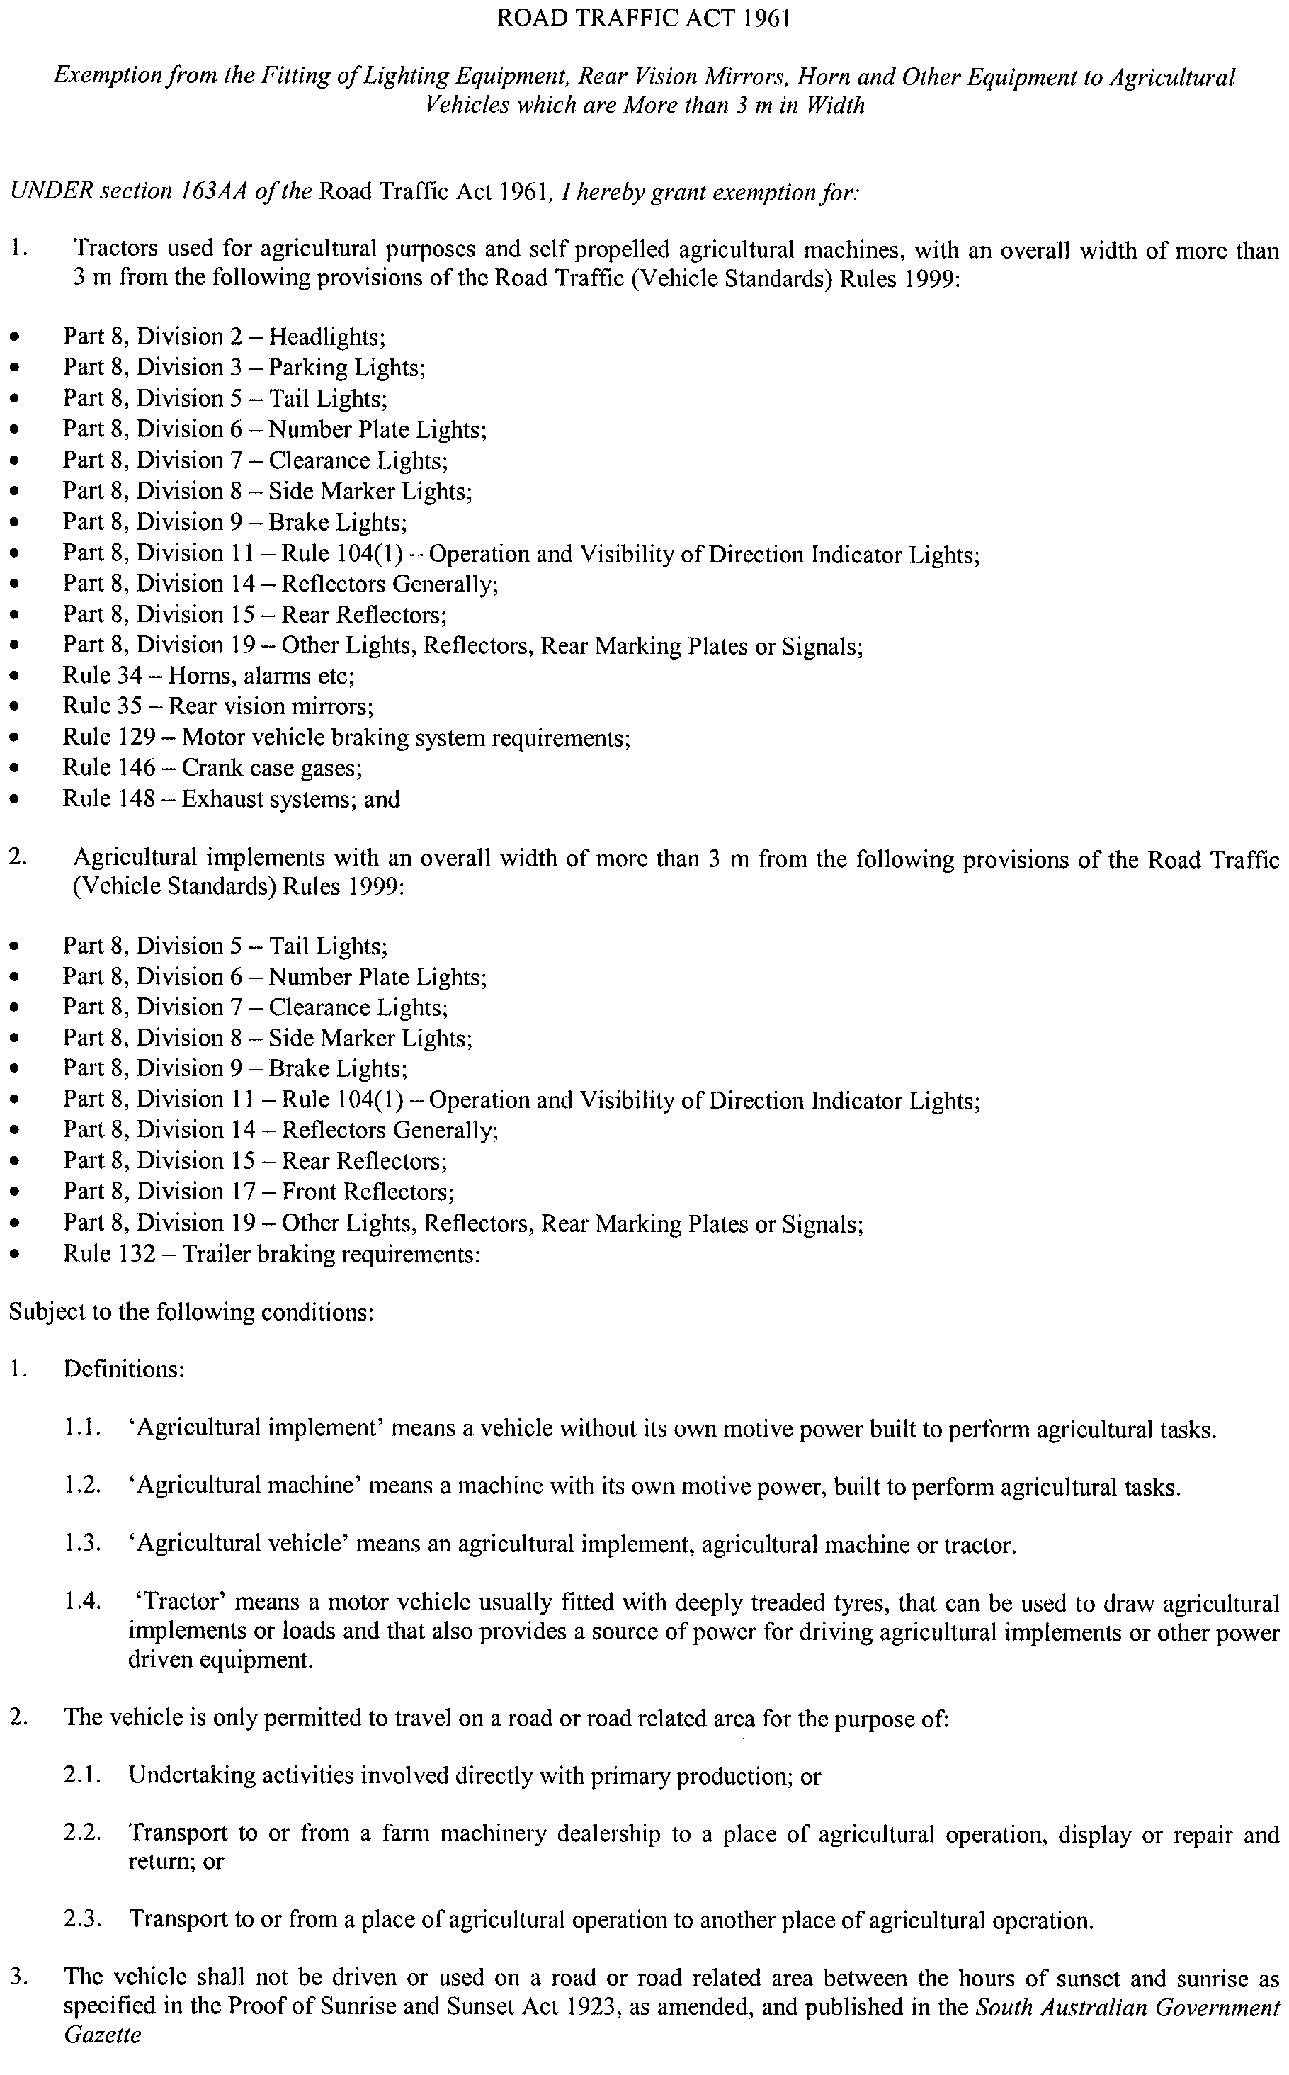
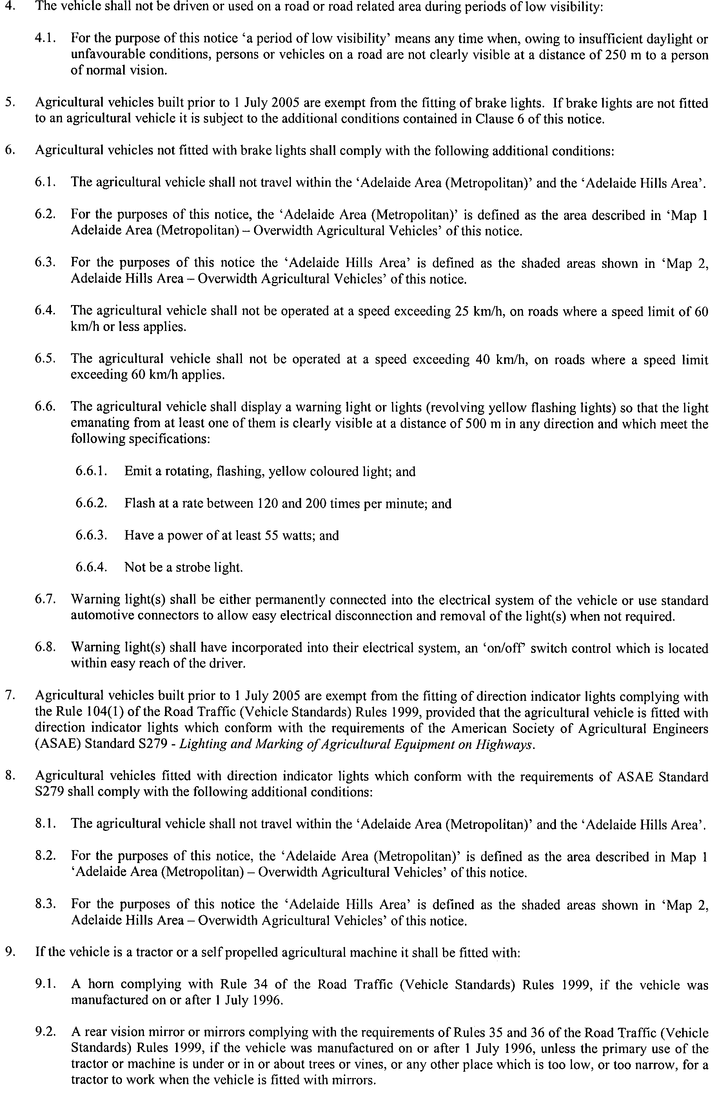
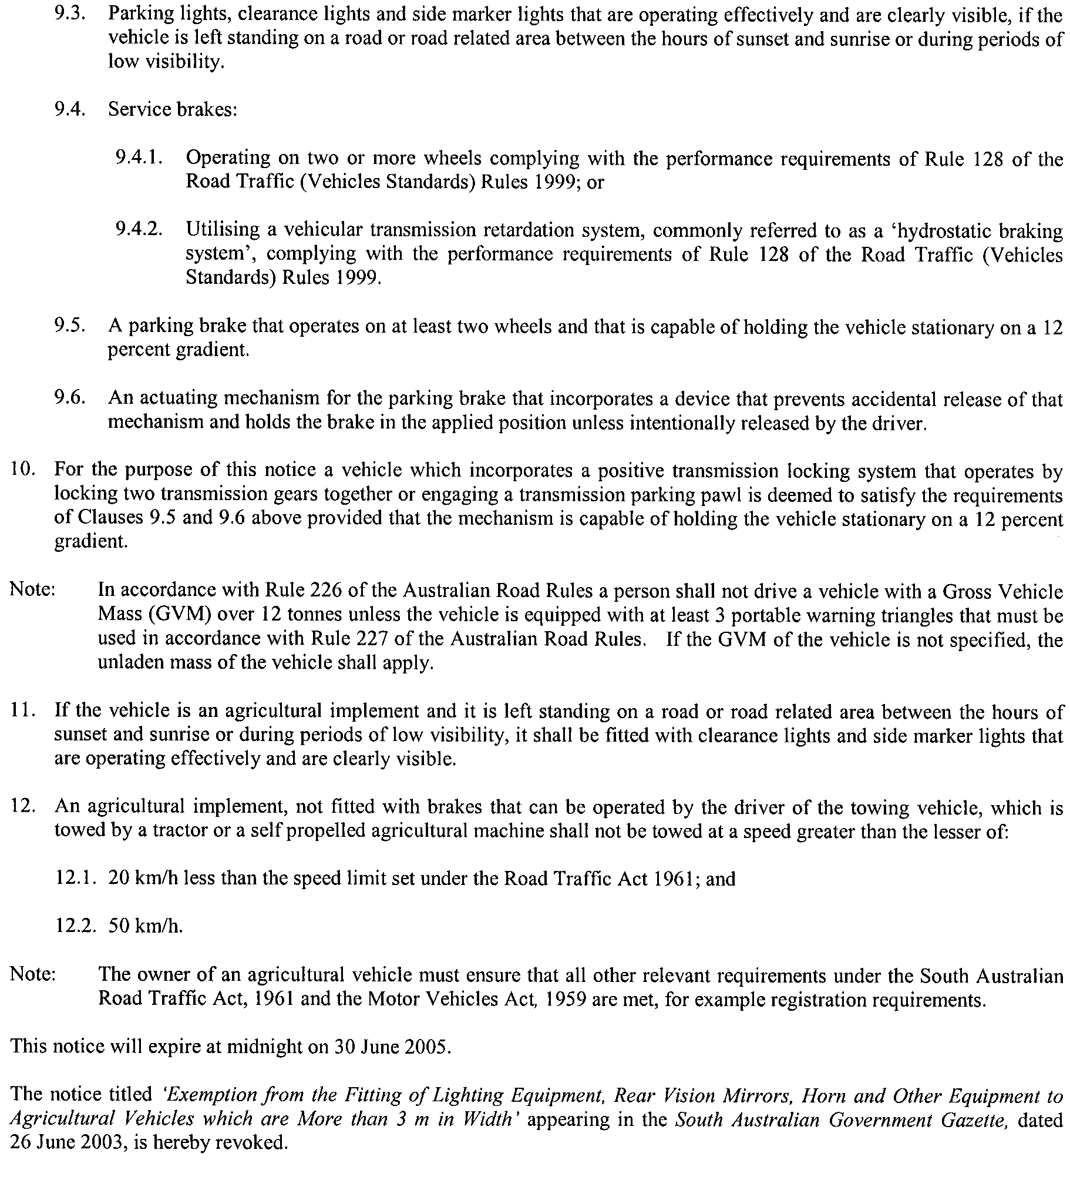
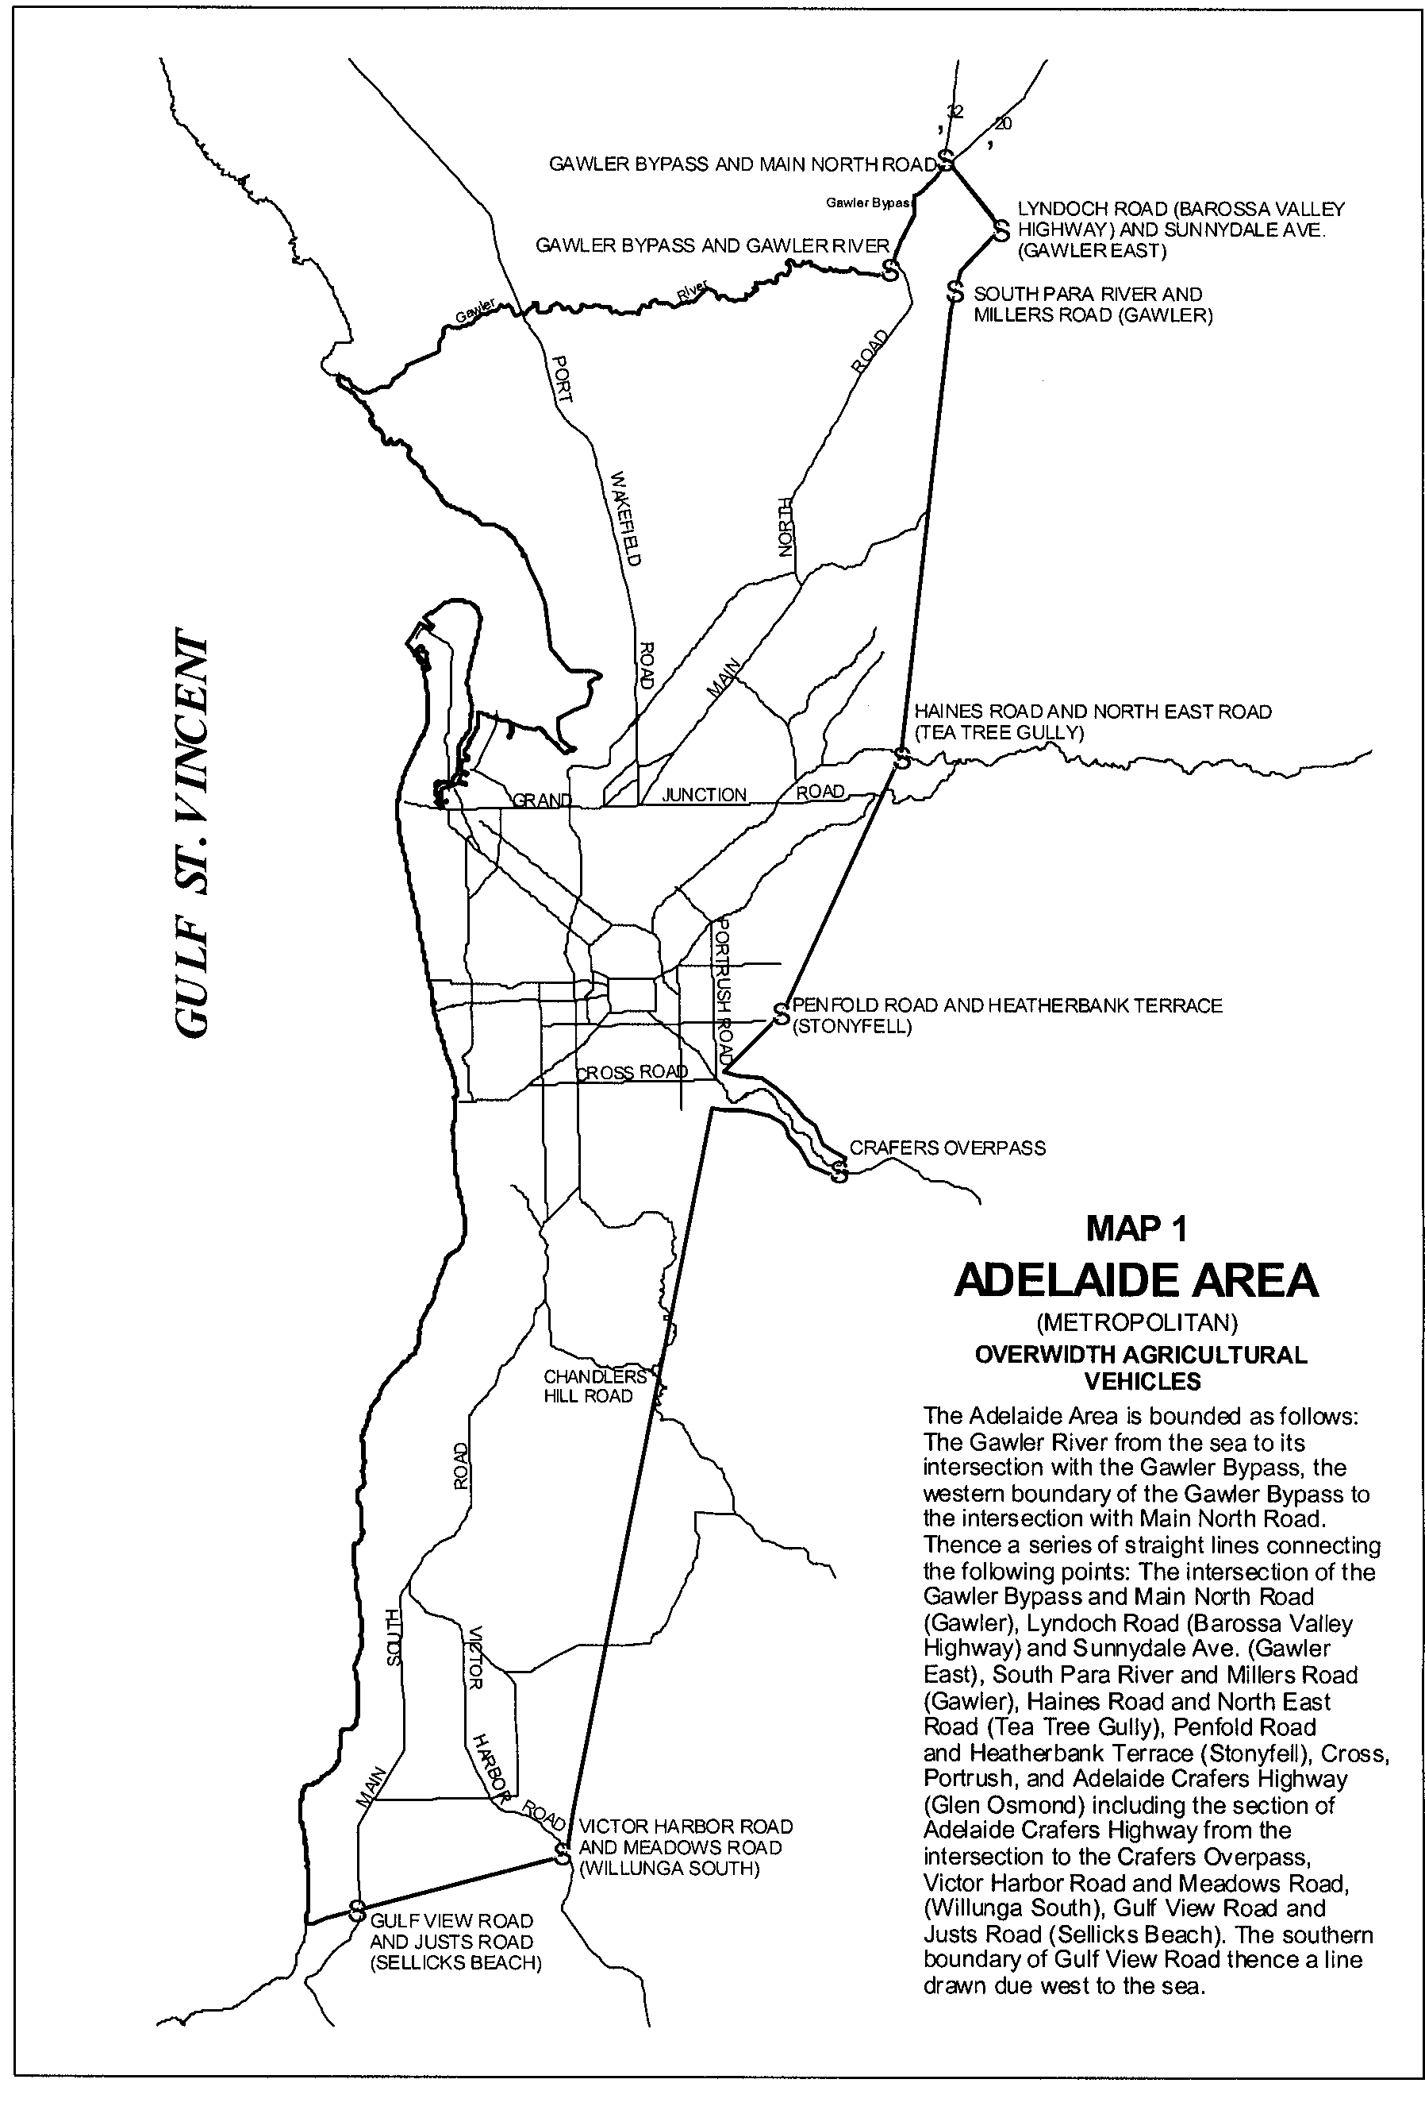
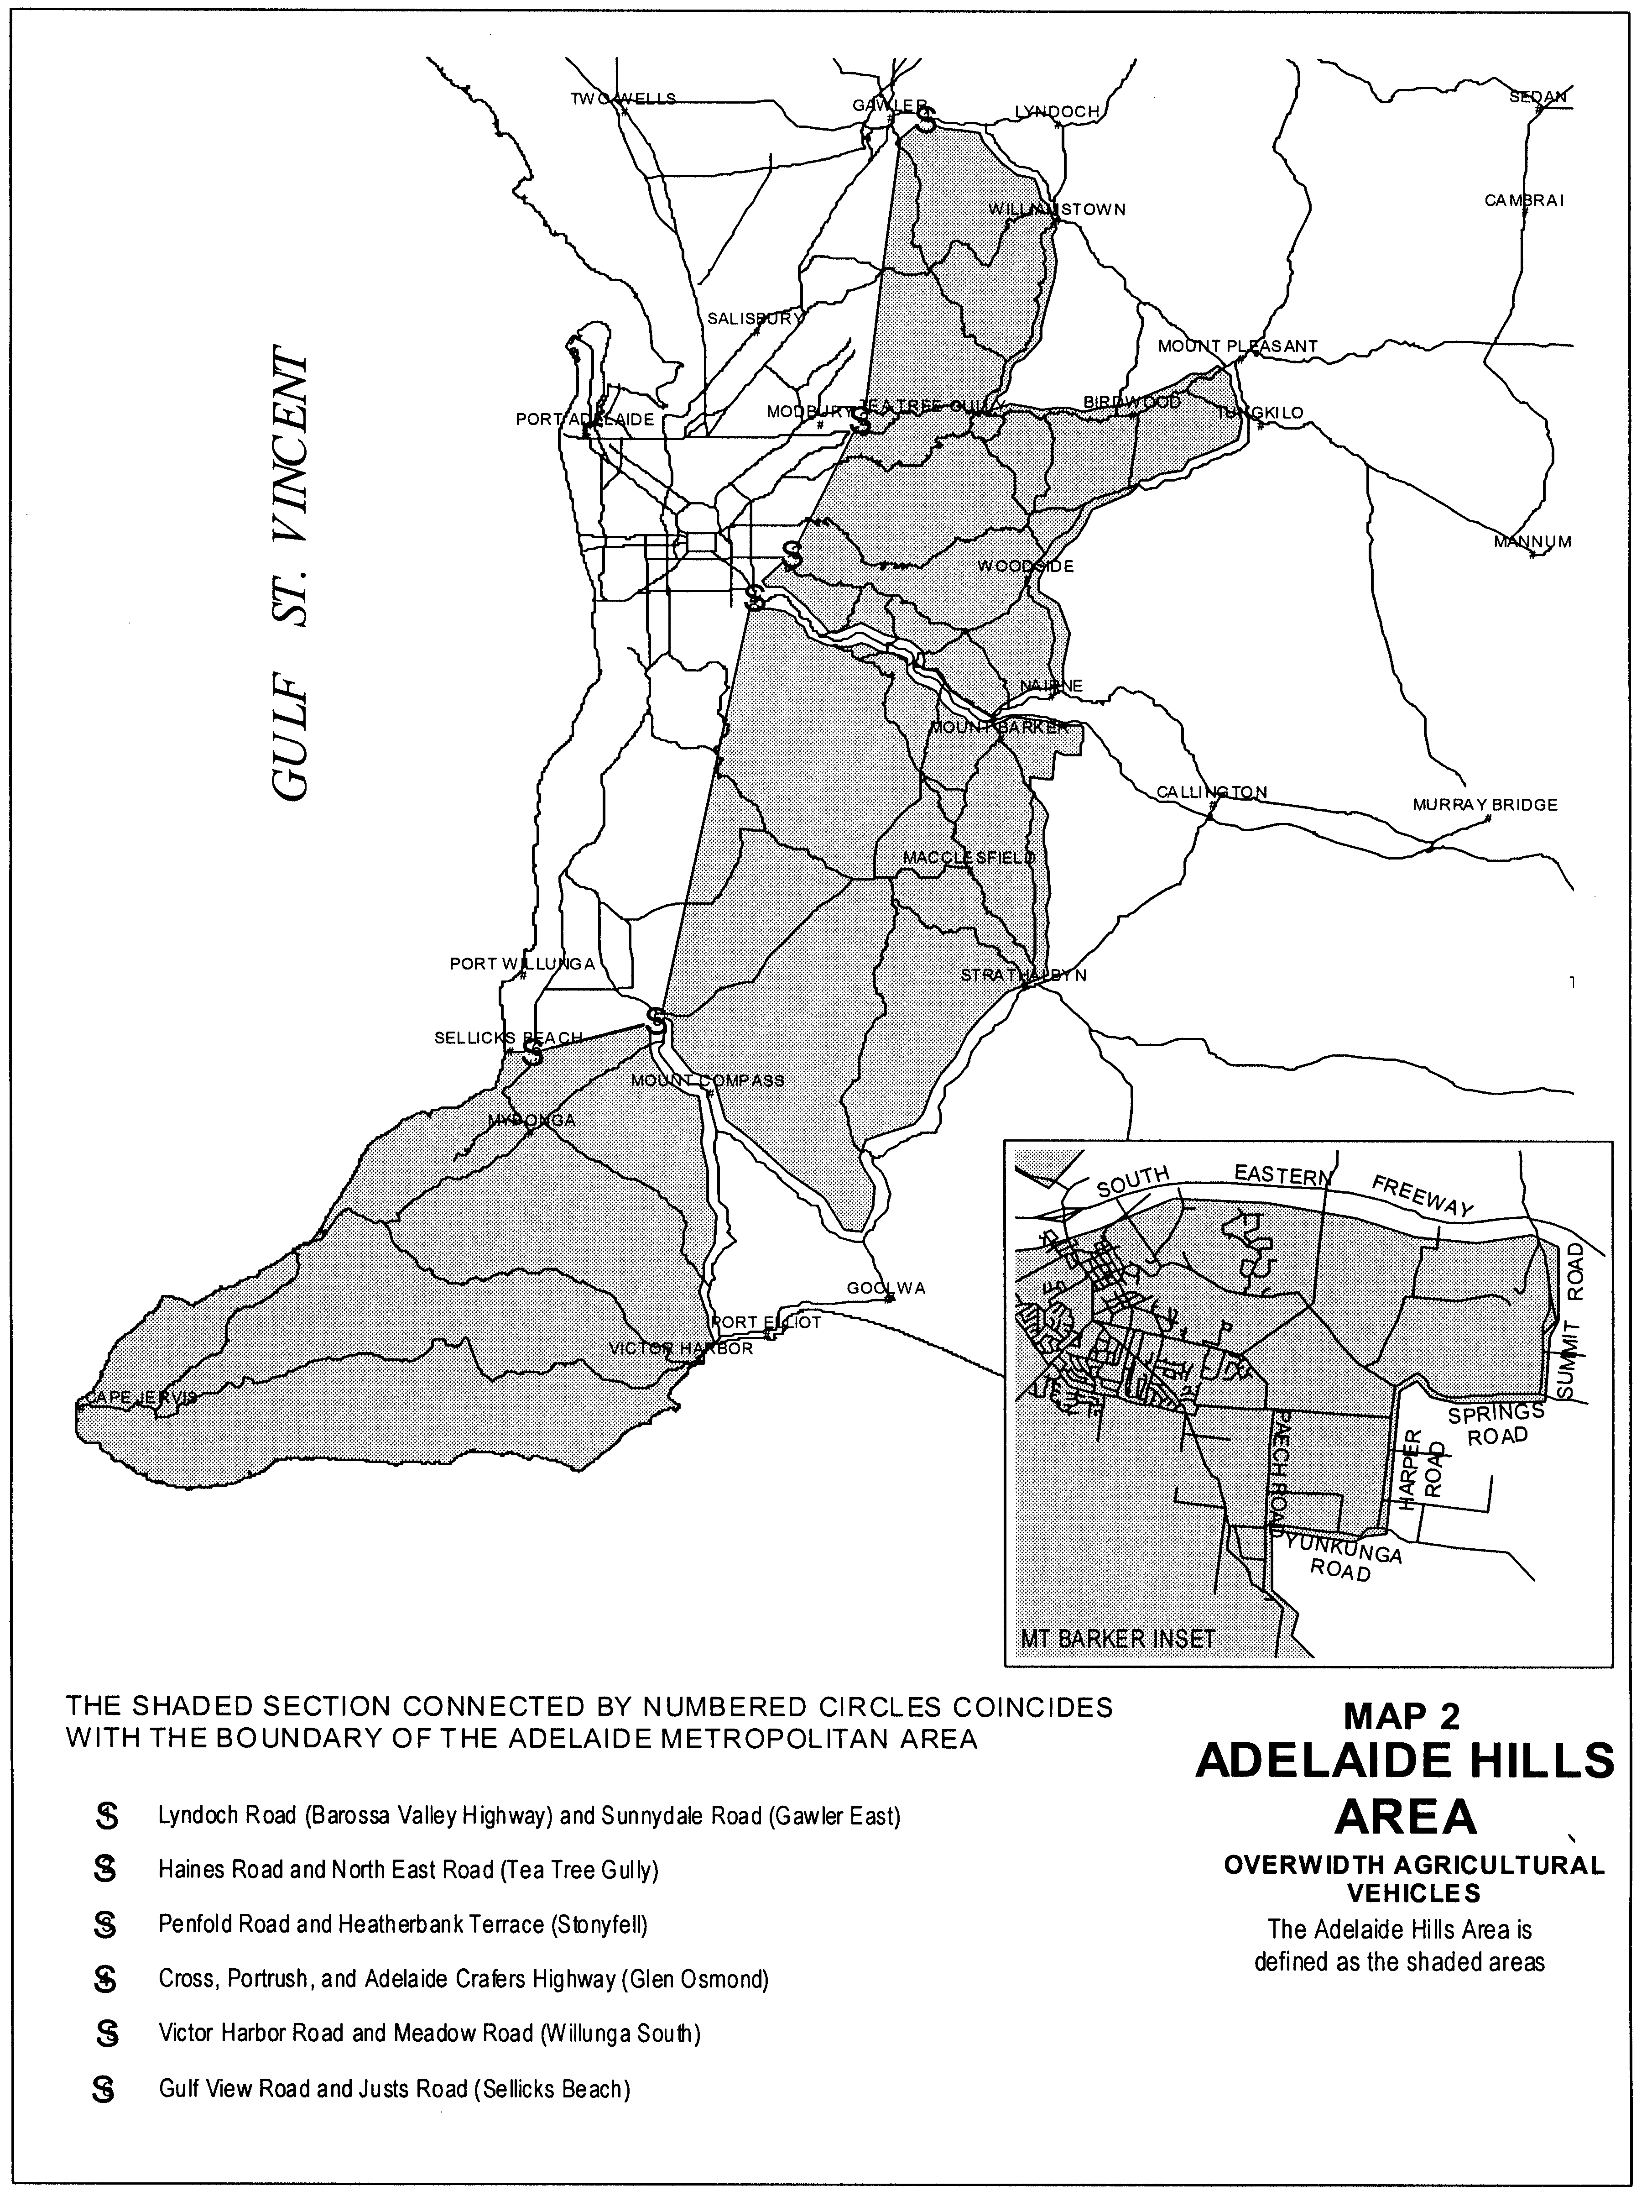

Dated 17 June 2004.
Executive Director, Transport SA
Authorised delegate for the Minister for Transport

SEWERAGE ACT 1929
Addition of Land to Murray Bridge Country Drainage Area
Variation of Notice
PURSUANT to section 18 (2) of the Sewerage Act 1929, the South Australian Water Corporation:
(a) varies the notice dated 21 April 2004 and published in the Government Gazette of 29 April 2004 at page 1143, more particularly set forth in the Schedule hereto, by deleting Mapsheet: 662713M4, 13N3 and substituting with Mapsheets: 672713M4, 13N3; and
(b) declares that this notice will have effect from 1 July 2004.
D1214
SA Water 04/00774
Mapsheets: 672713M4, 13N3
Schedule
MURRAY BRIDGE
HUNDRED OF MOBILONG

N
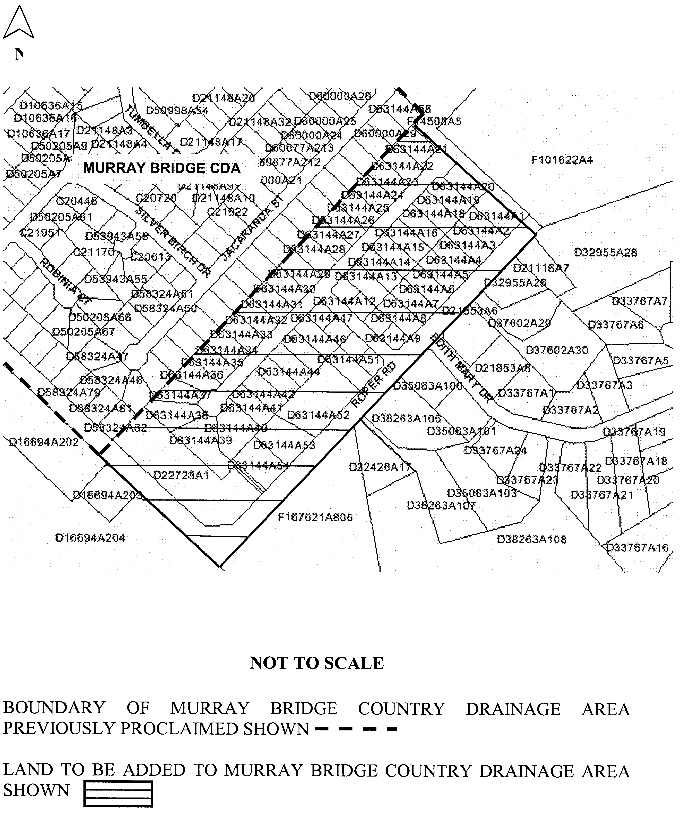
Dated 11 June 2004.
Signed for and on behalf of the South Australian Water Corporation by a person duly authorised so to do:
A. Popplewell, General Manager Shared Services
In the presence of:
C. J. McNamara, Billing Manager
SAWATER 04/00774 D1214

WATERWORKS ACT 1932
Addition of Land to Township of Clare Water District
PURSUANT to section 6 of the Waterworks Act 1932, the South Australian Water Corporation:
(a) adds to the Township of Clare Water District the land shown on the plan in the Schedule; and
(b) declares that this notice will have effect from 1 July 2004.
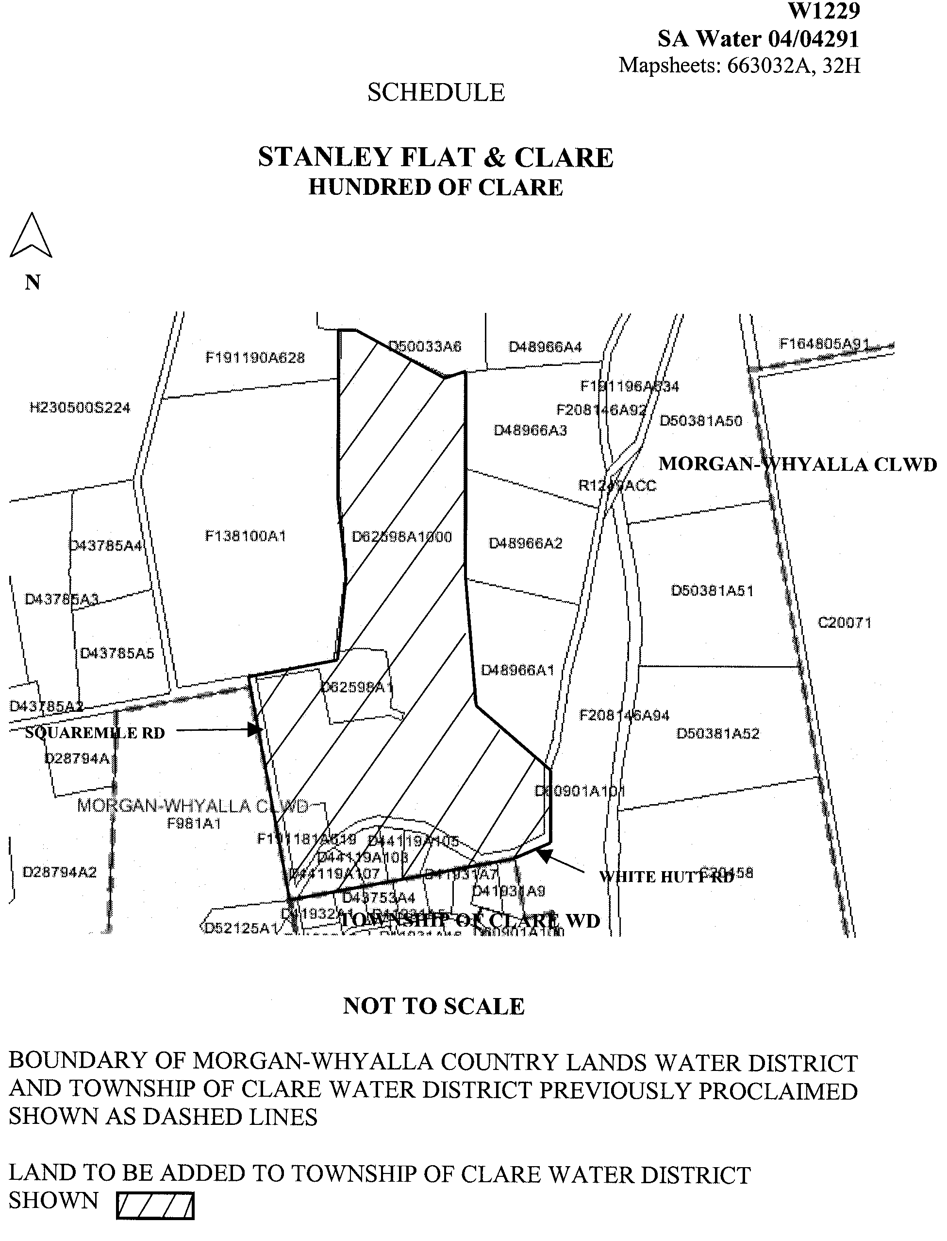
Dated 11 June 2004.
Signed for and on behalf of the South Australian Water Corporation by a person duly authorised so to do:
A. Popplewell, General Manager Shared Services
In the presence of:
C. J. McNamara, Billing Manager
SAWATER 04/04291 W1229

WATERWORKS ACT 1932
Addition of Land to Renmark Water District
PURSUANT to section 6 of the Waterworks Act 1932, the South Australian Water Corporation:
(a) adds to the Renmark Water District all the land contained in:
(i) allotment 99 in Filed Plan 207319; and
(ii) the portion of Twentyfirst Street, Renmark abutting allotment 99 in Filed Plan 207319 not already in the Renmark Water District; and
(b) declares that this notice will have effect from 1 July 2004.
Dated 11 June 2004.
Signed for and on behalf of the South Australian Water Corporation by a person duly authorised so to do:
A. Popplewell, General Manager Shared Services
In the presence of:
C. J. McNamara, Billing Manager
SAWATER 04/04382 W1216

WATERWORKS ACT 1932
Addition of Land to Adelaide Water District
PURSUANT to section 6 of the Waterworks Act 1932, the South Australian Water Corporation:
(a) adds to the Adelaide Water District all the land contained in:
(i) allotment 64 in Deposited Plan 13440 (except the portion of that land already in the Adelaide Water District); and
(ii) allotment 5 in Filed Plan 35719 (except the portion of that land already in the Adelaide Water District); and
(iii) the portion of Lower Hermitage Road, Lower Hermitage abutting allotment 6 in Filed Plan 35719 and allotment 27 in Filed Plan 155642 not already in the Adelaide Water District; and
(b) declares that this notice has effect from the commencement of the financial year in which it is published in the Gazette.
Dated 11 June 2004.
Signed for and on behalf of the South Australian Water Corporation by a person duly authorised so to do:
A. Popplewell, General Manager Shared Services
In the presence of:
C. J. McNamara, Billing Manager
SAWATER 04/03784 W1228

WATERWORKS ACT 1932
Removal of Land from Warren Country Lands Water District and Addition to Stockwell Water District
PURSUANT to section 6 of the Waterworks Act 1932, the South Australian Water Corporation:
(a) removes from the Warren Country Lands Water District and adds to the Stockwell Water District all the land contained in:
(i) allotment 4 in Filed Plan 891; and
(ii) allotment 155 in Deposited Plan 48609; and
(iii) the portion of Duck Ponds Road, Stockwell abutting allotment 4 in Filed Plan 891; and
(b) declares that this notice will have effect from 1 July 2004.
Dated 11 June 2004.
Signed for and on behalf of the South Australian Water Corporation by a person duly authorised so to do:
A. Popplewell, General Manager Shared Services
In the presence of:
C. J. McNamara, Billing Manager
SAWATER 04/04148 W1230

WATERWORKS ACT 1932
Removal of Land from Beetaloo Country Lands Water District and Addition to Port Hughes Water District
PURSUANT to section 6 of the Waterworks Act 1932, the South Australian Water Corporation:
(a) removes from the Beetaloo Country Lands Water District and adds to the Port Hughes Water District all the land contained in:
(i) allotments 8 to 35 inclusive, 906 (walkway) and 907 (reserve) in Deposited Plan 64124; and
(ii) Trenerry Place, Port Hughes in Deposited Plan 64124 and the portion of Cormac Street, Port Hughes abutting allotments 28 and 29 in Deposited Plan 64124; and
(b) declares that this notice will have effect from 1 July 2004.
Dated 11 June 2004.
Signed for and on behalf of the South Australian Water Corporation by a person duly authorised so to do:
A. Popplewell, General Manager Shared Services
In the presence of:
C. J. McNamara, Billing Manager
SAWATER 04/04292 W1231

WATERWORKS ACT 1932
Removal of Land from Barossa Country Lands Water District and Addition to Two Wells Water District
PURSUANT to section 6 of the Waterworks Act 1932, the South Australian Water Corporation:
(a) removes from the Barossa Country Lands Water District and adds to the Two Wells Water District all the land contained in:
(i) allotment piece 26 in Deposited Plan 56870;
(ii) allotments 20, 21 and 23 (reserve) in Deposited Plan 38050;
(iii) allotment 22 in Deposited Plan 38050 (except the portion of that land already in the Two Wells Water District);
(iv) allotments 17 to 19 inclusive in Deposited Plan 24836; and
(v) the portion of Mallala Road, Two Wells abutting allotment piece 26 in Deposited Plan 56870; and
(b) declares that this notice will have effect from 1 July 2004.
Dated 11 June 2004.
Signed for and on behalf of the South Australian Water Corporation by a person duly authorised so to do:
A. Popplewell, General Manager Shared Services
In the presence of:
C. J. McNamara, Billing Manager
SAWATER 04/04293 W1233

WATER RESOURCES ACT 1997
Notice of Basis of Levy for 2004-2005 in the South East
Catchment Water Management Board’s Catchment Area
I, JOHN DAVID HILL, Minister for Environment and Conservation, have determined pursuant to section 138 (3) of the Water Resources Act 1997, that the basis for the levy in the catchment area of the South East Catchment Water Management Board for the 2004-2005 financial year will be a fixed levy of the same amount on all rateable land.
Her Excellency the Governor gave her approval of the method referred to in the above paragraph on 17 June 2004.
Dated 17 June 2004.
John Hill, Minister for Environment and Conservation

WATER RESOURCES ACT 1997
Notice of Contributions in 2004-2005 by Constituent Councils
of the South East Catchment Water Management
Board’s Catchment Area
I, JOHN DAVID HILL, Minister for Environment and Conservation, have determined pursuant to section 135 of the Water Resources Act 1997 that:
(a) the total amount to be contributed by constituent councils of the catchment area of the South East Catchment Water Management Board in respect of the 2004-2005 financial year is to be the sum of four hundred and ninety thousand, two hundred and eighty dollars; and
(b) constituent councils of the Board’s area will share the liability for the payment of that amount as follows:

Constituent Councils Amount
$

Coorong 11 189
Grant 60 692
Kingston 23 616
Mount Gambier 159 085
Naracoorte Lucindale 63 194
Robe 22 379
Southern Mallee 190
Tatiara 59 278
Wattle Range 90 657

Total $490 280

Her Excellency the Governor gave her approval of the amounts referred to above on 17 June 2004.
Dated 17 June 2004.
John Hill, Minister for Environment and Conservation

WATER RESOURCES ACT 1997
Notice of Prohibition on Water Use in the Baroota Area
PURSUANT to section 16 (1) of the Water Resources Act 1997, I, John David Hill, Minister for Environment and Conservation in the State of South Australia, being of the opinion that the rate at which water is taken from wells that source water from the Quaternary sands and gravels in the Baroota area is such that there is a risk that the available water will not be sufficient to meet future demand; hereby prohibit the taking of water from wells in the area bounded by the bold line in GRO Plan No. 213/00 (the ‘defined area’).
The taking of water in the defined area is subject to the exceptions specified in Schedule 1.
Schedule 1
1. A person may continue to take water in accordance with the terms of a written authorisation granted by the Minister for Water Resources or his delegate, issued pursuant to the Notice of Prohibition of Water Use in the Baroota Area published in the Government Gazette on 8 June 2000 at page 3097, for the same purpose and subject to the same conditions as are endorsed on that authorisation, and in accordance with the Guidelines for Authorisation in the Baroota Area dated 3 June 2000 and signed by the Minister for Water Resources (‘the Guidelines’).
2. A person may take water in accordance with the terms of a written authorisation granted by me or my delegate, pursuant to the Revised Guidelines for Authorisation in the Baroota Area dated 11 June 2002 and signed by me (‘the Revised Guidelines’).
3. Any authorisation to take water from the wells in the defined area may be varied by further written authorisation issued by me or my delegate in accordance with the Revised Guidelines.
4. This restriction does not apply to the taking of water pursuant to section 7 (5) of the Act for domestic purposes or watering stock (other than stock subject to intensive farming), or to the taking of water for firefighting, public road making, or reticulating supplies of potable water for townships in the defined area.
This notice will remain in effect until 29 June 2006, unless earlier varied or revoked.
Dated 15 June 2004.
J. D. Hill, Minister for Environment and Conservation

TOBACCO PRODUCTS REGULATION ACT 1997
Section 72
THE Treasurer for the State of South Australia, hereby delegates, pursuant to section 72 of the Tobacco Products Regulation Act 1997, to the person for the time being holding or acting in the position of Commissioner of State Taxation all of the powers and functions of the Minister, express or implied, under the following Parts and sections of, and Schedules to, the Tobacco Products Regulation Act 1997:
Part 2:
Section 7;
Section 8;
Section 9;
Section 10;
Section 11;
Section 12;
Section 13.
Part 5:
Section 63;
Section 65.
Part 7:
Section 73;
Section 76;
Section 77;
Section 85 (1) (a) and (b).
The aforementioned powers and functions may be further delegated by the Commissioner of State Taxation, pursuant to section 72 (2) of the Tobacco Products Regulation Act 1997.
Dated 17 June 2004.
The Common Seal of the Treasurer was hereunto affixed in the presence of:
K. Foley, Treasurer

TOBACCO PRODUCTS REGULATION ACT 1997
Section 72
THE Minister for Health, being the Minister to whom the administration of the Tobacco Products Regulation Act 1997 has been committed, hereby:
1. Revokes the delegations by the Treasurer on 5 June 1997, pursuant to section 72 of the Tobacco Products Regulation Act 1997 of powers and functions under the Tobacco Products Regulation Act 1997 (see Government Gazette, 5 June 1997, page 2952) to the:
Deputy Commissioner of State Taxation;
Liquor Licensing Commissioner;
Commissioner of State Taxation;
Minister of Health.
2. Delegates pursuant to section 72 of the Tobacco Products Regulation Act 1997, to the Treasurer for the State of South Australia all of the powers and functions of the Minister, express or implied, under the following Parts and sections of, and Schedules to, the Tobacco Products Regulation Act 1997:
Part 2:
Section 7;
Section 8;
Section 9;
Section 10;
Section 11;
Section 12;
Section 13.
Part 5:
Section 63;
Section 65.
Part 7:
Section 73;
Section 76;
Section 77;
Section 85 (1) (a) and (b).
The aforementioned powers and functions may be further delegated by the Treasurer, pursuant to section 72 (2) of the Tobacco Products Regulation Act 1997.
Dated 17 June 2004.
Lea Stevens, Minister for Health, Minister Assisting the Premier in Social Inclusion

South Australia
Administrative Arrangements (Administration of Tobacco Products Regulation Act) Proclamation 2004
under section 5 of the Administrative Arrangements Act 1994
1—Short title
This proclamation may be cited as the Administrative Arrangements (Administration of Tobacco Products Regulation Act) Proclamation 2004.
2—Commencement
This proclamation comes into operation on the day on which it is made.
3—Administration of Act committed to Minister for Health
The administration of the Tobacco Products Regulation Act 1997 is committed to the Minister for Health.
Made by the Governor
with the advice and consent of the Executive Council
on 17 June 2004
DHS69/03PT2CS

South Australia
Dried Fruits Repeal Act (Commencement) Proclamation 2004
1—Short title
This proclamation may be cited as the Dried Fruits Repeal Act (Commencement) Proclamation 2004.
2—Commencement of Act
The Dried Fruits Repeal Act 2003 (No 42 of 2003) will come into operation on 24 June 2004.
Made by the Governor
with the advice and consent of the Executive Council
on 17 June 2004
MAFF03/0014CS

South Australia
Dog and Cat Management (Miscellaneous) Amendment Act (Commencement) Proclamation 2004
1—Short title
This proclamation may be cited as the Dog and Cat Management (Miscellaneous) Amendment Act (Commencement) Proclamation 2004.
2—Commencement of Act
(1) Subject to subclause (2), the Dog and Cat Management (Miscellaneous) Amendment Act 2004 (No 18 of 2004) (the amendment Act) will come into operation on 1 July 2004.
(2) Sections 10 and 11 of the amendment Act, and clause 3 of Schedule 1 of the Dog and Cat Management Act 1995 inserted by section 44 of the amendment Act, will come into operation on 1 October 2004.
Made by the Governor
with the advice and consent of the Executive Council
on 17 June 2004
EC04/0033CS

South Australia
National Parks and Wildlife (Exclusion of Species) Variation Proclamation 2004
under section 58(5) of the National Parks and Wildlife Act 1972
Part 1—Preliminary
1—Short title
This proclamation may be cited as the National Parks and Wildlife (Exclusion of Species) Variation Proclamation 2004.
2—Commencement
This proclamation will come into operation on 30 June 2004.
3—Variation provisions
In this proclamation, a provision under a heading referring to the variation of a specified proclamation varies the proclamation so specified.
Part 2—Variation of proclamation under National Parks and Wildlife Act 1972 excluding certain species from the operation of section 58(1), (2) and (3) of the Act (Gazette 27.5.1999 p2656) as varied
4—Variation of Schedule—Excluded Species
(1) Schedule, list of items headed "Birds"—after item relating to Elegant Parrot insert:
E0670 | Gouldian Finch | Erythrura gouldiae
(2) Schedule, list of items headed "Birds"—after item relating to Rainbow Lorikeet insert:
W0255 | Red-collared Lorikeet | Trichoglossus rubritorquis
(3) Schedule, list of items headed "Birds"—after item relating to Red-rumped Parrot insert:
A0256 | Scaly-breasted Lorikeet | Trichoglossus chlorolepidotus
Made by the Governor
with the advice and consent of the Executive Council
on 17 June 2004
EC 04/0037 CS

South Australia
Liquor Licensing (Dry Areas—Long Term) Variation Regulations 2004
under the Liquor Licensing Act 1997

Contents
Part 1—Preliminary
1 Short title
2 Commencement
3 Variation provisions
Part 2—Variation of Liquor Licensing (Dry Areas—Long Term) Regulations 1997
4 Variation of Schedule 1—Long term dry areas
5 Variation of Schedule 2—Plans of long term dry areas
Schedule 1—Plan to be inserted

Part 1—Preliminary
1—Short title
These regulations may be cited as the Liquor Licensing (Dry Areas—Long Term) Variation Regulations 2004.
2—Commencement
These regulations come into operation on the day on which they are made.
3—Variation provisions
In these regulations, a provision under a heading referring to the variation of specified regulations varies the regulations so specified.
Part 2—Variation of Liquor Licensing (Dry Areas—Long Term) Regulations 1997
4—Variation of Schedule 1—Long term dry areas
Schedule 1—after item headed "Mount Gambier—Area 4" insert:

Mount Gambier—Area 5
(see Schedule 2: Mount Gambier—Plan No 4)
The area in Mount Gambier, known as A F Sutton Park, bounded on the north by Wireless Road West, on the east by Acacia Street, on the south and south-east by O'Connor Drive, on the south by Creek Street and on the west by Perriam Street. | Continuous until 10 June 2005. | The consumption and possession of liquor are prohibited.
5—Variation of Schedule 2—Plans of long term dry areas
Schedule 2—after plan headed "Mount Gambier—Plan No 3" insert the plan headed "Mount Gambier—Plan No 4" in Schedule 1 of these regulations.
Schedule 1—Plan to be inserted
Mount Gambier—Plan No 4
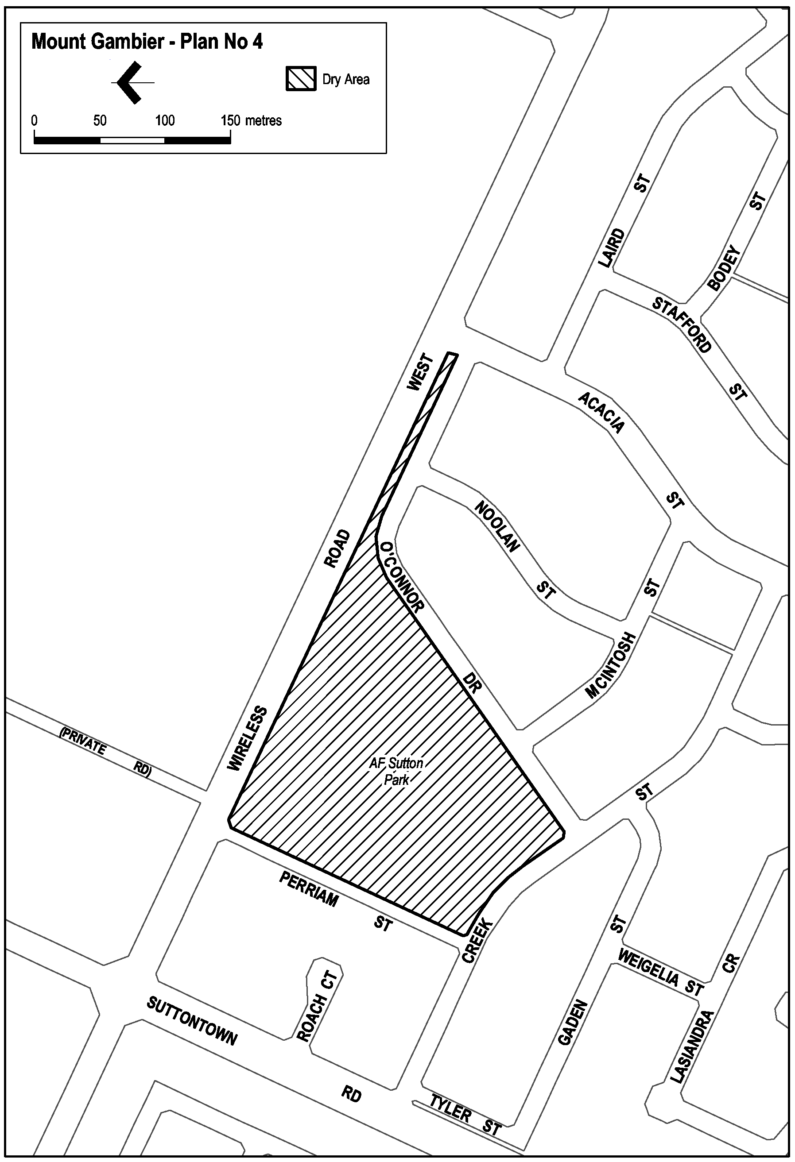
Note—
As required by section 10AA(2) of the Subordinate Legislation Act 1978, the Minister has certified that, in the Minister's opinion, it is necessary or appropriate that these regulations come into operation as set out in these regulations.
Made by the Governor
with the advice and consent of the Executive Council
on 17 June 2004
No 132 of 2004
OLGC 5/2004
South Australia
Legal Practitioners (Fees) Variation Regulations 2004
under the Legal Practitioners Act 1981

Contents
Part 1—Preliminary
1 Short title
2 Commencement
3 Variation provisions
Part 2—Variation of Legal Practitioner Regulations 1994
4 Substitution of Schedule 2
Schedule 2—Fees

Part 1—Preliminary
1—Short title
These regulations may be cited as the Legal Practitioners (Fees) Variation Regulations 2004.
2—Commencement
These regulations will come into operation on 1 July 2004.
3—Variation provisions
In these regulations, a provision under a heading referring to the variation of specified regulations varies the regulations so specified.
Part 2—Variation of Legal Practitioner Regulations 1994
4—Substitution of Schedule 2
Schedule 2—delete the Schedule and substitute:
Schedule 2—Fees
1 | For the issue or renewal of a practising certificate—
 | (a) for more than 6 months | $283 fee  $50 levy
 | (b) for 6 months or less | $166 fee  $25 levy
2 | Fee to accompany an annual return lodged under section 24 of the Act | $30
Note—
As required by section 10AA(2) of the Subordinate Legislation Act 1978, the Minister has certified that, in the Minister's opinion, it is necessary or appropriate that these regulations come into operation as set out in these regulations.
Made by the Governor
with the advice and consent of the Executive Council
on 17 June 2004
No 133 of 2004
AGO0151/04CS

South Australia
Southern State Superannuation Variation Regulations 2004
under the Southern State Superannuation Act 1994

Contents
Part 1—Preliminary
1 Short title
2 Commencement
3 Variation provisions
Part 2—Variation of Southern State Superannuation Regulations 1995
4 Variation of regulation 3A—Prescription of enterprise agreements
5 Variation of regulation 11A—Minimum amount of contribution under section 25A

Part 1—Preliminary
1—Short title
These regulations may be cited as the Southern State Superannuation Variation Regulations 2004.
2—Commencement
These regulations come into operation on the day on which they are made.
3—Variation provisions
In these regulations, a provision under a heading referring to the variation of specified regulations varies the regulations so specified.
Part 2—Variation of Southern State Superannuation Regulations 1995
4—Variation of regulation 3A—Prescription of enterprise agreements
(1) Regulation 3A(aa), (a), (b) and (c)—redesignate these paragraphs as paragraphs (a), (b), (c) and (d) respectively
(2) Regulation 3A(d)—delete paragraph (d) and substitute:
(e) the Department of Human Services Salaried Medical Officers Enterprise Agreement 2003;
(3) Regulation 3A(da), (e), (f), (faa), (fa) and (fab)—redesignate these paragraphs as paragraphs (f), (g), (h), (i), (j) and (k) respectively
(4) Regulation 3A—after paragraph (fab) (now designated as paragraph (k)—see subregulation (3)) insert:
(l) Personal Assistants to the Members of the South Australian Parliament Enterprise Agreement 2003;
(5) Regulation 3A(g), (h), (ha), (hb), (i), (j), (ja), (k), (l), (m), (n) and (o)—redesignate these paragraphs as paragraphs (m), (n), (o), (p), (q), (r), (s), (t), (u), (v), (w) and (x) respectively
5—Variation of regulation 11A—Minimum amount of contribution under section 25A
Regulation 11A—delete "$1 000" and substitute:
$50
Note—
As required by section 10AA(2) of the Subordinate Legislation Act 1978, the Minister has certified that, in the Minister's opinion, it is necessary or appropriate that these regulations come into operation as set out in these regulations.
Made by the Governor
with the advice and consent of the Executive Council
on 17 June 2004
No 134 of 2004
T&F04/033CS

South Australia
National Parks and Wildlife (Wildlife) Variation Regulations 2004
under the National Parks and Wildlife Act 1972

Contents
Part 1—Preliminary
1 Short title
2 Commencement
3 Variation provisions
Part 2—Variation of National Parks and Wildlife (Wildlife) Regulations 2001
4 Variation of regulation 9—Records and returns in relation to sections 58 and 60C permits
5 Substitution of regulation 15
15 Dealing in juvenile birds or mammals
6 Variation of regulation 18—Standards for keeping protected animals
7 Variation of Schedule 6—Prescribed species: section 58(1)(a) and definition of Class 1 permit
8 Variation of Schedule 7—Species excluded by proclamation under section 58(4) of the Act

Part 1—Preliminary
1—Short title
These regulations may be cited as the National Parks and Wildlife (Wildlife) Variation Regulations 2004.
2—Commencement
These regulations will come into operation on 1 July 2004.
3—Variation provisions
In these regulations, a provision under a heading referring to the variation of specified regulations varies the regulations so specified.
Part 2—Variation of National Parks and Wildlife (Wildlife) Regulations 2001
4—Variation of regulation 9—Records and returns in relation to sections 58 and 60C permits
(1) Regulation 9(8)—delete "as soon as reasonably practicable" and substitute:
within 48 hours
(2) Regulation 9(10)—after "the record book or copies of returns" insert:
(including a person who has custody or control as agent or employee of the permit holder)
5—Substitution of regulation 15
Regulation 15—delete the regulation and substitute:
15—Dealing in juvenile birds or mammals
(1) Subject to this regulation, a person must not sell a bird or mammal that is a protected animal or is of a species listed in Schedule 10 of the Act if—
(a) in the case of a bird—the bird is too young to fly or to feed itself; or
(b) in the case of a mammal—the mammal is unweaned.
(2) Subregulation (1) does not apply—
(a) to the sale of an emu pursuant to a section 60C permit; or
(b) if the sale is made pursuant to a permit granted under the Act that expressly authorises the sale of such a young bird or unweaned mammal.
6—Variation of regulation 18—Standards for keeping protected animals
(1) Regulation 18(1)(a) and (b)—delete paragraphs (a) and (b) and substitute:
(a) keep the animal in a cage or enclosure that is adequate in size and is constructed and maintained so as to—
(i) provide adequate shelter in all circumstances; and
(ii) prevent the animal from escaping; and
(iii) protect the animal against predators; and
(iv) enable the cage or enclosure to be locked or otherwise secured against intruders; and
(v) as far as is practicable, facilitate the inspection of the animal by a warden under the Act; and
(b) ensure that the cage or enclosure in which the animal is kept—
(i) is maintained in a clean and sanitary condition; and
(ii) except when the person is present—is securely locked or otherwise secured against intruders; and
(2) Regulation 18(1)—after paragraph (f) insert:
(fa) provide the animal with adequate heat or ultra-violet light from an artificial source if the animal is of a species that requires such heat or light for its well-being; and
(3) Regulation 18(1)—after paragraph (g) insert:
(h) produce the animal for inspection at the request of a warden.
7—Variation of Schedule 6—Prescribed species: section 58(1)(a) and definition of Class 1 permit
(1) Schedule 6, list of items headed "Birds", item relating to Gouldian Finch—delete the item and substitute:
A0300 | Golden-shouldered Parrot | Psephotus chrysopterygius
(2) Schedule 6, list of items headed "Birds", items relating to Red-collared Lorikeet and Scaly-breasted Lorikeet—delete the items
8—Variation of Schedule 7—Species excluded by proclamation under section 58(4) of the Act
(1) Schedule 7, list of items headed "Birds"—after item relating to Elegant Parrot insert:
E0670 | Gouldian Finch | Erythrura gouldiae
(2) Schedule 7, list of items headed "Birds"—after item relating to Rainbow Lorikeet insert:
W0255 | Red-collared Lorikeet | Trichoglossus rubritorquis
(3) Schedule 7, list of items headed "Birds"—after item relating to Red-rumped Parrot insert:
A0256 | Scaly-breasted Lorikeet | Trichoglossus chlorolepidotus
Note—
As required by section 10AA(2) of the Subordinate Legislation Act 1978, the Minister has certified that, in the Minister's opinion, it is necessary or appropriate that these regulations come into operation as set out in these regulations.
Made by the Governor
with the advice and consent of the Executive Council
on 17 June 2004
No 135 of 2004
EC 04/0037 CS
South Australia
Dog and Cat Management Variation Regulations 2004
under the Dog and Cat Management Act 1995

Contents
Part 1—Preliminary
1 Short title
2 Commencement
3 Variation provisions
Part 2—Variation of Dog and Cat Management Regulations 1995
4 Variation of regulation 4—Interpretation
5 Substitution of regulation 7
7 Identification of dogs
6 Variation of regulation 8—Guard dogs
7 Variation of regulation 10—Offences related to marking of cats
8 Substitution of Schedule 1
Schedule 1—Councils contributing 20% of dog registration fees to Fund
9 Revocation of Schedule 2

Part 1—Preliminary
1—Short title
These regulations may be cited as the Dog and Cat Management Variation Regulations 2004.
2—Commencement
These regulations will come into operation on 1 July 2004.
3—Variation provisions
In these regulations, a provision under a heading referring to the variation of specified regulations varies the regulations so specified.
Part 2—Variation of Dog and Cat Management Regulations 1995
4—Variation of regulation 4—Interpretation
Regulation 4, definition of prescribed person—delete the definition
5—Substitution of regulation 7
Regulation 7—delete the regulation and substitute:
7—Identification of dogs
(1) For the purposes of section 40 of the Act, a dog must wear a collar around its neck that—
(a) in the case of a dog that is individually registered—has securely attached to it the registration disc last issued for the dog;
(b) in the case of a dog usually kept at a kennel or used in connection with a business registered under the Act—has marked on it, or on a disc or tag securely attached to it, the name and telephone number of the owner or operator of the business or other mark identifying the business as approved by the council of the area in which the business is registered.
(2) However, a dog need not wear a collar while the dog is suffering from injury, disease or sickness to the extent that the wearing of a collar would be injurious to the health of the dog.
(3) This regulation does not apply—
(a) to a dog that is not required to be registered under the Act; or
(b) to a dog while effectively confined to premises occupied by a person who owns or is responsible for the control of the dog; or
(c) to a dog while under the effective control of a person by command, the dog being in close proximity to the person and—
(i) being used in the droving or tending of stock or going to or returning from a place where it will be, or has been, so used; or
(ii) being trained for, or participating in, an organised activity being a race, trial, class or show or in retrieving, hunting or other sporting exercise customarily involving the running of one or more dogs.
6—Variation of regulation 8—Guard dogs
Regulation 8(1), penalty provision and expiation fee—delete the penalty provision and expiation fee and substitute:
Maximum penalty: $250.
Expiation fee: $80.
7—Variation of regulation 10—Offences related to marking of cats
(1) Regulation 10(1), penalty provision—delete the penalty provision and substitute:
Maximum penalty: $2 500.
(2) Regulation 10(2), penalty provision—delete the penalty provision and substitute:
Maximum penalty: $2 500.
8—Substitution of Schedule 1
Schedule 1—delete the Schedule and substitute:
Schedule 1—Councils contributing 20% of dog registration fees to Fund
The Councils listed in this Schedule must pay 20% of dog registration fees received into the Fund:
Adelaide, The Corporation of the City of
Burnside, City of
Campbelltown, The Corporation of the City of
Charles Sturt, City of
Gawler, Town of
Holdfast Bay, City of
Marion, The Corporation of the City of
Mitcham, City of
Norwood Payneham & St Peters, The Corporation of the City of
Onkaparinga, City of
Playford, City of
Port Adelaide Enfield, City of
Prospect, City of
Salisbury, City of
Tea Tree Gully, City of
Unley, The Corporation of the City of
Walkerville, The Corporation of the Town of
West Torrens, City of
9—Revocation of Schedule 2
Schedule 2—delete the Schedule
Note—
As required by section 10AA(2) of the Subordinate Legislation Act 1978, the Minister has certified that, in the Minister's opinion, it is necessary or appropriate that these regulations come into operation as set out in these regulations.
Made by the Governor
on the recommendation of the Dog and Cat Management Board and with the advice and consent of the Executive Council
on 17 June 2004
No 136 of 2004
EC04/0033CS

FAXING COPY?
IF you fax copy to Government Publishing SA for inclusion in the Government Gazette, there is no need to send a Confirmation Copy to us as well.
This creates confusion and may well result in your notice being printed twice.
Please use the following fax number:
Fax transmission: (08) 8207 1040
Phone Inquiries: (08) 8207 1045
Please include a contact person, phone number and order number so that we can phone back with any queries we may have regarding the fax copy.
NOTE: Closing time for lodging new copy (fax, hard copy or email) is 4 p.m. on Tuesday preceding the day of publication.

Government Gazette notices can be E-mailed.
The address is:
governmentgazette@saugov.sa.gov.au
Documents should be sent as attachments in Word format.
When sending a document via E-mail, please confirm your transmission with a faxed copy of your document, including the date the notice is to be published.
Fax transmission: (08) 8207 1040
Enquiries: (08) 8207 1045
NOTE: Closing time for lodging new copy (fax, hard copy or email) is 4 p.m. on Tuesday preceding the day of publication.

CITY OF CHARLES STURT
Supplementary Election for Councillor in Cheltenham Ward
NOMINATIONS are hereby invited and will be received at the City of Charles Sturt located at 72 Woodville Road, Woodville, from Thursday, 24 June 2004 until 12 noon Thursday, 15 July 2004, from any person eligible to be a candidate for election to the vacancy.
Nomination forms and candidate’s handbooks are available from 72 Woodville Road, Woodville.
A candidate must submit a profile of not more than 150 words with the nomination form.
A candidate photograph of predominantly the head and shoulders, taken within the preceding 12 months, may also be submitted.
A briefing session for prospective candidates will be conducted at 7 p.m. on Tuesday, 29 June 2004 at City of Charles Sturt, 72 Woodville Road, Woodville.
If more than the required number of nominations are received for the vacancy, an election will be conducted entirely by postal ballot with the return of the completed ballot papers to reach the Returning Officer no later than 12 noon on Monday, 16 August 2004.
Steve Tully, Returning Officer

CITY OF MOUNT GAMBIER
Supplementary Election for Councillor in East Ward
NOMINATIONS are hereby invited and will be received at the Australian Electoral Commission, Divisional Office of Barker located at 2 Mitchell Street, Mount Gambier, from Thursday, 24 June 2004 until 12 noon Thursday, 15 July 2004, from any person eligible to be a candidate for election to the vacancy.
Nomination forms and candidate’s handbooks are available from Australian Electoral Commission, Divisional Office of Barker, 2 Mitchell Street, Mount Gambier.
A candidate must submit a profile of not more than 150 words with the nomination form.
A candidate photograph of predominantly the head and shoulders, taken within the preceding 12 months, may also be submitted.
A briefing session for prospective candidates will be conducted at 5.30 p.m. on Tuesday, 29 June 2004 at the City of Mount Gambier, Civic Centre, 10 Watson Terrace, Mount Gambier.
If more than the required number of nominations are received for the vacancy, an election will be conducted entirely by postal ballot with the return of the completed ballot papers to reach the Deputy Returning Officer no later than 12 noon on Monday,
16 August 2004.
Steve Tully, Returning Officer

CITY OF PORT ADELAIDE ENFIELD
Change of Name of Public Road
NOTICE is hereby given that the council of the City of Port Adelaide Enfield at its meeting held on 2 June 2004 resolved that pursuant to section 219 (1) of the Local Government Act 1999, that a certain public road, being Hanson Road North, Wingfield, be changed to Hanson Road, Wingfield.
A plan which delineates the public road which is subject to the change of street name, together with a copy of the council’s resolution is available for inspection at the Council’s Principal Office, 163 St Vincent Street, Port Adelaide, S.A. 5015, during the hours of 9 a.m. and 5 p.m. on weekdays.
H. J. Wierda, City Manager

CITY OF PORT ADELAIDE ENFIELD
Review of Composition of the Council
NOTICE is hereby given pursuant to the provisions of section 12 (5) of the Local Government Act 1999 that the Port Adelaide Enfield Council has resolved to undertake a review of its composition to determine whether the council should be constituted on the basis that its principal member (Mayor) continue to be elected as a representative of the area as a whole or whether (from the next general election) it should be constituted on the basis that the principal member is chosen by the members of the council from amongst their own number.
Information regarding this review is available from:
• the Council Offices, 163 St Vincent Street, Port Adelaide.
• Greenacres Library—Council Office, 2 Fosters Road, Greenacres.
• Enfield Library—Council Office, Kensington Crescent, Enfield.
• Parks Library—Council Office, 2-46 Cowan Street, Angle Park.
• Semaphore Library, 14 Semaphore Road, Semaphore.
• Port Adelaide Library, 2 Church Street, Port Adelaide,
or by contacting Mal Jonas on telephone (08) 8405 6778 or by email on custserv@portenf.sa.gov.au during normal business hours (8.30 a.m.-5 p.m., Monday to Friday inclusive).
Written submissions are invited from interested persons to
be addressed to the City Manager and to be received no later
than 5 p.m. on Friday, 13 August 2004 at the Council Offices,
163 St Vincent Street, Port Adelaide or by email to
custserv@portenf.sa.gov.au or by fax to (08) 8405 6666.
Persons making a submission will also be invited to appear personally or by representative at a future special meeting of the council to be heard in respect of their submission.
H. J. Wierda, City Manager

TOWN OF GAWLER
Resignation of Councillor
NOTICE is hereby given in accordance with section 54 (6) of the Local Government Act 1999, that a vacancy has occurred in the office of Area Councillor, due to the resignation of Councillor Robert Richter, to take effect from 11 June 2004.
Dated 17 June 2004.
J. McEachen, Town Manager

DISTRICT COUNCIL OF CEDUNA
Supplementary Election
NOMINATIONS are hereby invited and will be received at the Council Administration Centre, 44 O’Loughlin Terrace, Ceduna, from Thursday, 24 June 2004 until 12 noon on Thursday, 15 July 2004, from any person eligible to be a candidate for election to the vacancy of:
Councillor: (1 vacancy).
Nomination forms and candidate’s handbooks are available from the Council Administration Centre, 44 O’Loughlin Terrace, Ceduna.
A candidate must submit a profile of not more than 150 words with the nomination form. A candidate photograph of predominantly the head and shoulders, taken within the preceding 12 months, may also be submitted.
A briefing for prospective candidates will be conducted on Monday, 12 July 2004 at 6 p.m. in the District Council of Ceduna Council Chambers, 44 O’Loughlin Terrace, Ceduna.
If more than the required number of nominations are received for the vacancy, an election will be conducted entirely by postal ballot with the return of the completed ballot papers to reach the Deputy Returning Officer no later than 12 noon on Monday, 16 August 2004.
Steve Tully, Returning Officer

CLARE & GILBERT VALLEYS COUNCIL
Roads (Opening and Closing) Act 1991
Hayward Street, Armagh
NOTICE is hereby given, pursuant to section 10 of the Roads (Opening and Closing) Act 1991, that the Clare & Gilbert Valleys Council proposes to make a Road Process Order to close a portion of public road (Hayward Street) between Allotment 91 in Filed Plan 171484, Allotments 93 and 94 in Filed Plan 212755 and Allotments 91 to 95 in Filed Plan 171451, more particularly delineated and marked ‘A’ in Preliminary Plan No. 04/0035. The portion marked ‘A’ is to be transferred and merged with adjoining Allotment 95 in Filed Plan 171451.
A copy of the Preliminary Plan and statement of persons affected is available for public inspection at the Council Office, 4 Gleeson Street, Clare, or at the Adelaide office of the Surveyor-General, during normal office hours.
Any person affected may object to the proposed road process, or apply for an easement to be granted in the person’s favour over land subject to the proposed road closure. Such objection, or application for an easement, must set out the full name and address of the person, and reason for making the objection or application. Any application for an easement must give full particulars of the nature and location of the easement and where made by a person as the owner of adjoining or nearby land, specify the land to which the easement is to be annexed.
An objection or application for an easement, must be lodged in writing to the Clare & Gilbert Valleys Council, 4 Gleeson Street, Clare, S.A. 5453 and a copy lodged with the Surveyor-General, Department of Administrative and Information Services, G.P.O. Box 1354, Adelaide, S.A. 5001, within 28 days of this notice.
Where an objection or application for an easement is made, the council will give notification of a meeting at which the matter will be considered, so that the person making the objection or application may attend, if desired, personally or by a representa-tive.
M. A. Goldstone, Chief Executive Officer

THE FLINDERS RANGES COUNCIL
Adoption of Valuations
NOTICE is hereby given that The Flinders Ranges Council, at a meeting held on Tuesday, 8 June 2004, pursuant to its powers contained in section 167 of the Local Government Act 1999, adopted the most recent capital valuations of the Valuer-General available to the council, totalling $109 299 900 for the financial year ending 30 June 2005.
Declaration of Rates
Notice is hereby given that, pursuant to sections 153 and 156 of the Local Government Act 1999, council declared the differential general rates for the year ending 30 June 2005 on the capital values of all rateable property by reference to land use as follows:
(a) 0.7689 cents in the dollar on rateable land in the council’s area of Category 1 (Residential) Use;
(b) 0.8489 cents in the dollar on rateable land in the council’s area of Categories 2, 3 or 4 (Commercial) Use;
(c) 0.5235 cents in the dollar on rateable land in the council’s area of Category 7 (Primary Production) Use;
(d) 0.8489 cents in the dollar on rateable land in the council’s area of Category 5 (Industry—Light) Use;
(e) 0.7689 cents in the dollar on rateable land in the council’s area of Category 8 (Vacant Land) Use;
(f) 0.8489 cents in the dollar on rateable land in the council’s area of Category 6 (Industry—Other) Use.
Minimum Amount Payable
Notice is hereby given that, pursuant to section 158 of the Local Government Act 1999, council declared the following minimum amount payable by way of rates $345.
Annual Service Charges
Pursuant to section 155 of the Local Government Act 1999, council declared the following services charges for the year ending 30 June 2005.
Septic Tank Effluent Drainage Scheme and Disposal costs:
(a) $90 per unit for occupied land in the Hawker Scheme;
(b) $70 per unit for vacant land in the Hawker Scheme;
(c) $188 per unit for occupied land in the Quorn Scheme;
(d) $168 per unit for vacant land in the Quorn Scheme.
Refuse Collection Charges:
(a) Hawker Hospital $480;
(b) Hawker Area School $480;
(c) Flinders House $365;
(d) Quorn Hospital $720;
(e) Quorn Area School $720.
Refuse Collection and Disposal Charges:
Annual Service charge for Refuse Collection and Disposal for the year ending 30 June 2005;
Occupied residential properties in the townships of Hawker and Quorn $75 occupied commercial properties in the township of Hawker and Quorn $110.
L. Connors, Chief Executive Officer

DISTRICT COUNCIL OF KAROONDA EAST MURRAY
Adoption of Valuation and Declaration of Rates
NOTICE is hereby given that at its meeting held on Tuesday, 8 June 2004, the council in accordance with section 167 (2) (a) of the Local Government Act 1999, made a valuation of all properties within the district for the year ending 30 June 2005, by adopting the most recent capital valuation as supplied by the Valuer-General and that such valuation will become and be the valuation of the council for the 2004-2005 financial year:
$
Rateable 109 825 805
Non-rateable 5 051 016
Total 114 876 821
Service Charge—Common Effluent Drainage Scheme
Pursuant to section 155 of the Local Government Act 1999, the council declared the following service charges to be payable by owners or occupiers as set out thereunder, in respect to the financial year ending 30 June 2005:
Occupied properties $70
Vacant properties $45
Declaration of Rates
Pursuant to section 153 of the Local Government Act 1999, the council did on 8 June 2004, declare a general rate of 0.6412 cents in the dollar on the capital value of all rateable land within the area for the 2004-2005 financial year.
Minimum Amount Payable
Pursuant to section 158 (1) of the Local Government Act 1999, the council resolved that the minimum amount payable by way of rates in respect of rateable land within the area for the 2004-2005 financial year shall be $100.
Payment of Rates
Pursuant to section 181 (a) of the Local Government Act 1999, rates will fall due in four instalments on 10 September 2004, 10 December 2004, 11 March 2005 and 10 June 2005.
To encourage prompt payment of rates, council offers a discount of 5 per cent on all rates paid in full by 10 September 2004.
P. Smithson, Chief Executive Officer

DISTRICT COUNCIL OF LE HUNTE
Road Naming
NOTICE is hereby given that pursuant to section 219 of the Local Government Act 1999, the council has resolved to make the following road name changes:
Change a Name—Township of Wudinna
To change the name of the portion of ‘Burton Terrace’, Township of Wudinna which lies between Gooch Terrace and Heath Street to be renamed ‘Tree Road’.
Assign a Name—Kattata Well Road
To assign the name ‘Kattata Well Road’ to that portion of the road in Le Hunte which adjoins Kattata Well Road in the District Council of Streaky Bay.
A. F. McGuire, Chief Executive Officer

DISTRICT COUNCIL OF LOWER EYRE PENINSULA
Development Act 1993
Lower Eyre Peninsula (DC) Development Plan—
General Plan Amendment Report—Draft for Public Consultation
NOTICE is hereby given that the District Council of Lower Eyre Peninsula has prepared a draft Plan Amendment Report to amend its current Development Plan as it affects the total area of the council.
The Plan Amendment Report will amend the Development Plan to include:
• An Expansion of Special Use Zone around Coffin Bay Septic Tank Effluent Disposal Scheme Waste Water Treatment Plant.
• Incorporation of new provisions with regard to development adjacent arterial roads.
• Amendment to the existing airport building height map to reflect the Obstacle Limitation Surface catering for expansion of the existing runways.
• Inclusion of a concept plan for the development of the airport in accordance with the endorsed master plan.
• Expand the zone boundaries of the Boston Rural Living Zone.
• Amend the design criteria for residential development in the Coastal (Coffin Bay) Zone.
• Expansion of the Residential Zone at Coffin Bay.
• Amend Residential Zone provisions to allow for compatible tourist accommodation providing definition for tourism accommodation of different scale.
• Incorporation of new residential design development provisions.
• Addition of Recreation, Sport and Open Space Council-wide Principles with specific reference to the Eyre trail and development of community based sport and recreation facilities.
• Expansion of Coastal (Settlement) Zone at Mount Dutton Bay and Tulka.
• Expansion of Industry Zone at Cummins.
• Inclusion of Council-wide objective to prevent development in adjacent zones compromising bulk handling operations.
• Amend zone provisions to allow Light Industry, where it applies to the value adding of farm components in the Commercial (Bulk Handling) Zone.
• Amendment to General Farming Zone provisions removing Horticulture from the complying development list.
• Introduction of additional provisions into the Water Protection Zone, consistent with the Objectives and Principles of the Water Allocation Plan for the Southern Basins Prescribed Wells Area.
• Incorporate amended policy as recommended by the Department of Environment and Heritage.
The draft Plan Amendment Report and Statement will be available for public inspection and purchase during normal office hours at the Council Offices, Railway Terrace, Cummins and 38 Washington Street, Port Lincoln from Thursday, 17 June 2004 to Friday, 20 August 2004. A copy of the Plan Amendment Report can be purchased from the council in a hard copy form for $20 each or a CD version for $10 each.
Written submissions regarding the draft amendment will be accepted by the District Council of Lower Eyre Peninsula until Friday, 20 August 2004. The written submission should also clearly indicate whether you will wish to speak at the public hearing regarding your submission. All submissions should be addressed to the Chief Executive Officer of the District Council of Lower Eyre Peninsula, P.O. Box 41, Cummins, S.A. 5631.
Copies of all submissions received will be available for inspection by interested persons at Railway Terrace, Cummins and 38 Washington Street, Port Lincoln from Monday, 23 August 2004 until the date of public hearings.
Public hearings will be held in the Council Chamber, Railway Terrace, Cummins at 9 a.m. on Friday, 3 September 2004. The public hearing may not be held if no submission indicates an interest in speaking at the public hearing.
Dated 17 June 2004.
P. Aird, Chief Executive Officer

DISTRICT COUNCIL OF YORKE PENINSULA
Roads (Opening and Closing) Act 1991
Yorke Terrace/Melville Street, Yorketown
NOTICE is hereby given pursuant to section 10 of the Roads (Opening and Closing) Act 1991, that the District Council of Yorke Peninsula proposes to make a Road Process Order to close a portion of public road being Allotment 1 in Filed Plan 7215 (Yorke Terrace and Melville Street, Yorketown), more particularly delineated and marked ‘A’ in Preliminary Plan No. 04/0039. The portion marked ‘A’ is to be sold by public auction or tender.
A copy of the Preliminary Plan and statement of persons affected is available for public inspection at the Council Office, 15 Edithburgh Road, Yorketown or at the Adelaide office of the Surveyor-General, during normal office hours.
Any person affected may object to the proposed road process, or apply for an easement to be granted in the person’s favour over land subject to the proposed road closure. Such objection, or application for an easement, must set out the full name and address of the person and reason for making the objection or application. Any application for an easement must give full particulars of the nature and location of the easement and where made by a person as the owner of adjoining or nearby land, specify the land to which the easement is to be annexed.
An objection or application for an easement, must be lodged in writing to the District Council of Yorke Peninsula, P.O. Box 88, Minlaton, S.A. 5575 and a copy lodged with the Surveyor-General, Department of Administrative and Information Services, G.P.O. Box 1354, Adelaide, S.A. 5001, within 28 days of this notice.
Where an objection or application for an easement is made, the council will give notification of a meeting at which the matter will be considered, so that the person making the objection or application may attend, if desired, personally or by a represent-ative.
S. Griffiths, Chief Executive Officer

IN the matter of the estates of the undermentioned deceased persons:
Atterton, Lloyd Arthur, late of 18 Cross Road, Myrtle Bank, retired salesperson, who died on 15 February 2004.
Charles, Jessie Florence, late of 72 Harvey Street, Collinswood, widow, who died on 21 April 2004.
Hefford, Charles Cameron, late of 5 Mitchell Street, Hyde Park, retired hiring contractor, who died on 15 March 2004.
Nikolic, Evica, late of 8 Jeanette Street, Woodville Park, home duties, who died on 8 October 2002.
Peel, Cecilia, late of Everard Street, Largs Bay, of no occupation, who died on 26 April 2004.
Ploksts, Evards, late of 77 Sydenham Road, Norwood, retired ticket checker, who died on 15 February 2004.
Simpson, Percival Harold, late of 7 Carlisle Street, Ethelton, retired controller, who died on 28 March 2004.
Taverner, Betty Aileen, late of 73 Coorara Avenue, Payneham South, widow, who died on 17 April 2004.
Williams, Francis Maxwell, late of 6 Downer Street, Kilkenny, retired clerk, who died on 7 February 2004.
Notice is hereby given pursuant to the Trustee Act 1936, as amended, the Inheritance (Family Provision) Act 1972, and the Family Relationships Act 1975, that all creditors, beneficiaries, and other persons having claims against the said estates are required to send, in writing, to the Public Trustee, 25 Franklin Street, Adelaide, S.A. 5000, full particulars and proof of such claims, on or before 16 July 2004, otherwise they will be excluded from the distribution of the said estate; and notice is also hereby given that all persons who are indebted to the said estates are required to pay the amount of their debts to the Public Trustee or proceedings will be taken for the recovery thereof; and all persons having any property belonging to the said estates are forthwith to deliver the same to the Public Trustee.
Dated 17 June 2004.
C. J. O’Loughlin, Public Trustee

ATTENTION

CUSTOMERS requiring a proof of their notice for inclusion in the Government Gazette, please note that the onus is on you to inform Government Publishing SA of any subsequent corrections by 10 a.m. on Thursday, which is our publication deadline.

For any corrections to your notice please phone 8207 1045 or Fax 8207 1040 before 10 a.m. on Thursday.

If we do not receive any communication by 10 a.m. on Thursday (day of publication) we will presume the notice is correct and will print it as it is.

Remember—the onus is on you to inform us of any corrections necessary to your notice.

NOTE: Closing time for lodging new copy (electronically, fax or hard copy) is 4 p.m. on Tuesday preceding the day of publication. Phone 8207 1045—Fax 8207 1040.
Email: governmentgazette@saugov.sa.gov.au

Printed and published by authority every Thursday by J. D. FERGUSON, Government Printer, South Australia
Price: $4.70, plus postage; to subscribers, $238.00 per annum.
(The above prices are inclusive of GST)

