No. 101 4149

THE SOUTH AUSTRALIAN

GOVERNMENT GAZETTE
www.governmentgazette.sa.gov.au

PUBLISHED BY AUTHORITY

ALL PUBLIC ACTS appearing in this GAZETTE are to be considered official, and obeyed as such

ADELAIDE, THURSDAY, 4 NOVEMBER 2004

CONTENTS

Page
Acts Assented To 4150
Appointments, Resignations, Etc. 4150
Aquaculture Act 2001—Notice 4150
Corporations and District Councils—Notices 4239
Crown Lands Act 1929—Notices 4150
Development Act 1993—Notice 4151
Electricity Act 1996—Contract 4154
Environment Protection Act 1993—Notices 4164
Fisheries Act 1982—Notices 4165
Harbors and Navigation Act 1993—Notices 4166
Erratum 4167
Land and Business (Sale and Conveyancing) Act 1994—
Notices 4167
Legislative Council—Disallowance 4150
Liquor Licensing Act 1997—Notices 4167
Mining Act 1971—Notices 4172
National Parks and Wildlife Act 1972—Notice 4172

Page
Petroleum Act 2000—Notices 4172
Proclamations 4183
Public Sector Management Act 1995—Notice 4173
Public Trustee Office—Administration of Estates 4242
Radiation Protection and Control Act 1982—Notice 4173

REGULATIONS
Liquor Licensing Act 1997 (No. 230 of 2004) 4185
Harbors and Navigation Act 1993 (No. 231 of 2004) 4190
Road Traffic Act 1961—
(No. 232 of 2004) 4205
(No. 233 of 2004) 4230
(No. 234 of 2004) 4232
Motor Vehicles Act 1959 (No. 235 of 2004) 4236
Second-Hand Vehicles Dealers Act 1995—Notices 4173
Treasury—Quarterly Statement 4174
Water Resources Act 1997—Notices 4182

GOVERNMENT GAZETTE NOTICES
ALL poundkeepers’ and private advertisements forwarded for publication in the South Australian Government Gazette must be PAID FOR PRIOR TO INSERTION; and all notices, from whatever source, should be legibly written on one side of the paper only and sent to Government Publishing SA so as to be received no later
than 4 p.m. on the Tuesday preceding the day of publication. Phone 8207 1045 or Fax 8207 1040. E-mail: governmentgazette@saugov.sa.gov.au. Send as attachments in Word format and please confirm your transmission with a faxed copy of your document, including the date the notice is to be published and to whom the notice will be charged. The Government Gazette is available online at: www.governmentgazette.sa.gov.au

Department of the Premier and Cabinet
Adelaide, 4 November 2004
HER Excellency the Governor directs it to be notified for general information that she has in the name and on behalf of Her Majesty The Queen, this day assented to the undermentioned Acts passed by the Legislative Council and House of Assembly in Parliament assembled, viz.:
No. 40 of 2004—Criminal Law Consolidation (Intoxication) Amendment Act 2004. An Act to amend the Criminal Law Consolidation Act 1935.
No. 41 of 2004—Stamp Duties (Miscellaneous) Amendment Act 2004. An Act to amend the Stamp Duties Act 1923.
No. 42 of 2004—Tobacco Products Regulation (Further Restrictions) Amendment Act 2004. An Act to amend the Tobacco Products Regulation Act 1997.
By command,
J. D. Lomax-Smith, for Acting Premier
DPC 02/0586

Department of the Premier and Cabinet
Adelaide, 9 September 2004
HER Excellency the Governor in Executive Council has been pleased to appoint Henry Andryszczak as an Inspector of Mines, pursuant to section 6 of the Mines and Works Inspection Act 1920.
By command,
J. D. Hill, for Premier
MMRD 0024/04CS

Department of the Premier and Cabinet
Adelaide, 4 November 2004
HER Excellency the Governor in Executive Council has been pleased to appoint the undermentioned to the South Australian Psychological Board, pursuant to the provisions of the Psychological Practices Act 1973:
Member: (from 4 November 2004 until 3 November 2006)
Meredith Gwendoline Dickson
Peter Nicholas Gilchrist
Anthony Harold Winefield
Angela Marie Davis
Anne Gannoni
Marie Jose O’Neill
Radomir Stratil
Chair: (from 4 November 2004 until 3 November 2006)
Meredith Gwendoline Dickson
By command,
P. Holloway, for Acting Premier
MHEA MGR0031CS

Department of the Premier and Cabinet
Adelaide, 4 November 2004
HER Excellency the Governor in Executive Council has been pleased to appoint the undermentioned to the State Heritage Authority, pursuant to the provisions of the Heritage Act 1993:
Member: (from 4 November 2004 until 26 June 2005)
Mario Barone
Christine Garnaut
Elizabeth Ho
Carolyn Wigg
Deputy Member: (from 4 November 2004 until 26 June 2005)
Judith Brine (Deputy to Barone)
Justin McCarthy (Deputy to Wigg)
Noris Ioannou (Deputy to Ho)
By command,
P. Holloway, for Acting Premier
MEC 0081/04CS

Legislative Council Office, 28 October 2004
FORWARDED to the Honourable the Premier the following Resolution, passed by the Legislative Council on 28 October 2004:
That the Regulations under the Fisheries Act 1982 concerning King George Whiting—Prescribed Quantities, made on 23 September 2004 and laid on the table of this council on 12 October 2004, be disallowed.
J. M. Davis, Clerk

AQUACULTURE ACT 2001
Commencement of Fitzgerald Bay Aquaculture
Management Policy
PURSUANT to the provisions of sections 12 and 13 of the Aquaculture Act 2001, I, Rory McEwen, Minister for Agriculture, Food and Fisheries, hereby approve the Fitzgerald Bay Aquaculture Management Policy.
The Fitzgerald Bay Aquaculture Management Policy will come into operation from the date it is published in the South Australian Government Gazette.
R. McEwen, Minister for Agriculture, Food and Fisheries

CROWN LANDS ACT 1929: SECTION 5
TAKE notice that pursuant to the Crown Lands Act 1929, I, JOHN HILL, Minister for Environment and Conservation, Minister of the Crown to whom the administration of the Crown Lands Act 1929 is committed DO HEREBY dedicate the Crown Land defined in The Schedule as a Wetland Reserve and declare that such land shall be under the care, control and management of The Corporation of the City of Marion.
The Schedule
Allotment 2 in Deposited Plan 55941, Hundred of Adelaide, County of Adelaide, exclusive of all necessary roads, being the whole of the land comprised in Crown Record Volume 5877 Folio 926, subject nevertheless to an existing easement to The Corporation of the City of Marion for drainage purposes (RLG 9295556) over that portion of Allotment 2 marked A in Deposited Plan 55941.
Dated 4 November 2004.
J. Hill, Minister for Environment and Conservation
DEH 17/1422

CROWN LANDS ACT 1929: SECTION 5
TAKE notice that pursuant to the Crown Lands Act 1929, I, JOHN HILL, Minister for Environment and Conservation, Minister of the Crown to whom the administration of the Crown Lands Act 1929 is committed DO HEREBY dedicate the Crown Land defined in The Schedule as a Recreation Reserve and declare that such land shall be under the care, control and management of the Southern Mallee District Council.
The Schedule
Section 99, Hundred of Parilla, County of Chandos, exclusive of all necessary roads, being the whole of the land comprised in Crown Record Volume 5924 Folio 859.
Dated 4 November 2004.
J. Hill, Minister for Environment and Conservation
DEHAA 11/2754

DEVELOPMENT ACT 1993, SECTION 25 (17): TATIARA DISTRICT COUNCIL—MISCELLANEOUS PLAN AMEND-MENT
Preamble
1. The Development Plan amendment entitled ‘Tatiara District Council—Miscellaneous Plan Amendment’ (the Plan Amend-ment) has been finalised in accordance with the provisions of the Development Act 1993.
2. The Minister for Urban Development and Planning has decided to approve the Plan Amendment.
Notice
PURSUANT to section 25 of the Development Act 1993, I—
(a) approve the Plan Amendment; and
(b) fix the day on which this notice is published in the Gazette as the day on which the Plan Amendment will come into operation.
Dated 4 November 2004.
Trish White, Minister for Urban Development and Planning
PLN 02/0204

GOVERNMENT GAZETTE ADVERTISEMENT RATES

To apply from 1 July 2004

$  Agents, Ceasing to Act as 35.50  Associations:  Incorporation 18.10  Intention of Incorporation 44.75  Transfer of Properties 44.75  Attorney, Appointment of 35.50  Bailiff’s Sale 44.75  Cemetery Curator Appointed 26.50  Companies:  Alteration to Constitution 35.50  Capital, Increase or Decrease of 44.75  Ceasing to Carry on Business 26.50  Declaration of Dividend 26.50  Incorporation 35.50  Lost Share Certificates:  First Name 26.50  Each Subsequent Name 9.10  Meeting Final 29.75  Meeting Final Regarding Liquidator’s Report on  Conduct of Winding Up (equivalent to ‘Final  Meeting’)  First Name 35.50  Each Subsequent Name 9.10  Notices:  Call 44.75  Change of Name 18.10  Creditors 35.50  Creditors Compromise of Arrangement 35.50  Creditors (extraordinary resolution that ‘the Com-pany be wound up voluntarily and that a liquidator be appointed’) 44.75  Release of Liquidator⎯Application⎯Large Ad. 70.50  ⎯Release Granted 44.75  Receiver and Manager Appointed 41.25  Receiver and Manager Ceasing to Act 35.50  Restored Name 33.50  Petition to Supreme Court for Winding Up 62.00  Summons in Action 53.00  Order of Supreme Court for Winding Up Action 35.50  Register of Interests⎯Section 84 (1) Exempt 80.00  Removal of Office 18.10  Proof of Debts 35.50  Sales of Shares and Forfeiture 35.50  Estates:  Assigned 26.50  Deceased Persons⎯Notice to Creditors, etc. 44.75  Each Subsequent Name 9.10  Deceased Persons⎯Closed Estates 26.50  Each Subsequent Estate 1.15  Probate, Selling of 35.50  Public Trustee, each Estate 9.10 |  | $  Firms:  Ceasing to Carry on Business (each insertion) 23.60  Discontinuance Place of Business 23.60  Land⎯Real Property Act:  Intention to Sell, Notice of 44.75  Lost Certificate of Title Notices 44.75  Cancellation, Notice of (Strata Plan) 44.75  Mortgages:  Caveat Lodgment 18.10  Discharge of 19.00  Foreclosures 18.10  Transfer of 18.10  Sublet 9.10  Leases⎯Application for Transfer (2 insertions) each 9.10  Lost Treasury Receipts (3 insertions) each 26.50  Licensing 53.00  Municipal or District Councils:  Annual Financial Statement⎯Forms 1 and 2 499.00  Electricity Supply⎯Forms 19 and 20 354.00  Default in Payment of Rates:  First Name 70.50  Each Subsequent Name 9.10  Noxious Trade 26.50  Partnership, Dissolution of 26.50  Petitions (small) 18.10  Registered Building Societies (from Registrar-  General) 18.10  Register of Unclaimed Moneys⎯First Name 26.50  Each Subsequent Name 9.10  Registers of Members⎯Three pages and over:  Rate per page (in 8pt) 226.00  Rate per page (in 6pt) 299.00  Sale of Land by Public Auction 45.25  Advertisements 2.50  Advertisements, other than those listed are charged at $2.50 per column line, tabular one-third extra.  Notices by Colleges, Universities, Corporations and District Councils to be charged at $2.50 per line.  Where the notice inserted varies significantly in length from that which is usually published a charge of $2.50 per column line will be applied in lieu of advertisement rates listed.  South Australian Government publications are sold on the condition that they will not be reproduced without prior permission from the Government Printer.
All the above prices include GST

GOVERNMENT GAZETTE NOTICES
ALL private advertisements forwarded for publication in the South Australian Government Gazette must be PAID FOR PRIOR TO INSERTION; and all notices, from whatever source, should be legibly written on one side of the paper only and sent to Government Publishing SA so as to be received no later than 4 p.m. Tuesday preceding the day of publication. Phone 8207 1045 or Fax 8207 1040. E-mail: governmentgazette@saugov.sa.gov.au. Send as attachments in Word format. Please include date the notice is to be published and to whom the notice will be charged. The Government Gazette is available online at: www.governmentgazette.sa.gov.au.

MISCELLANEOUS LEGISLATION AND GOVERNMENT PUBLICATIONS PRICES AS FROM 1 JULY 2004

Acts, Bills, Rules, Parliamentary Papers and Regulations
Pages | Main | Amends | Pages | Main | Amends

1-16 | 2.15 | 0.95 | 497-512 | 30.25 | 29.00
17-32 | 2.90 | 1.80 | 513-528 | 31.25 | 29.90
33-48 | 3.80 | 2.70 | 529-544 | 32.00 | 31.00
49-64 | 4.75 | 3.65 | 545-560 | 33.00 | 32.00
65-80 | 5.60 | 4.60 | 561-576 | 33.75 | 33.00
81-96 | 6.50 | 5.40 | 577-592 | 34.75 | 33.50
97-112 | 7.40 | 6.30 | 593-608 | 35.75 | 34.50
113-128 | 8.30 | 7.25 | 609-624 | 36.50 | 35.50
129-144 | 9.35 | 8.25 | 625-640 | 37.25 | 36.10
145-160 | 10.20 | 9.10 | 641-656 | 38.25 | 37.20
161-176 | 11.20 | 10.00 | 657-672 | 38.75 | 38.00
177-192 | 12.00 | 11.00 | 673-688 | 40.50 | 38.80
193-208 | 13.00 | 11.90 | 689-704 | 41.25 | 39.90
209-224 | 13.80 | 12.70 | 705-720 | 41.75 | 41.00
225-240 | 14.70 | 13.60 | 721-736 | 43.50 | 41.50
241-257 | 15.70 | 14.30 | 737-752 | 44.00 | 42.90
258-272 | 16.60 | 15.30 | 753-768 | 45.00 | 43.40
273-288 | 17.50 | 16.40 | 769-784 | 45.50 | 44.70
289-304 | 18.30 | 17.20 | 785-800 | 46.50 | 45.60
305-320 | 19.30 | 18.20 | 801-816 | 47.25 | 46.00
321-336 | 20.10 | 19.00 | 817-832 | 48.25 | 47.25
337-352 | 21.20 | 20.00 | 833-848 | 49.25 | 48.00
353-368 | 22.00 | 21.00 | 849-864 | 50.00 | 48.80
369-384 | 22.90 | 21.90 | 865-880 | 51.00 | 50.00
385-400 | 23.80 | 22.70 | 881-896 | 51.50 | 50.50
401-416 | 23.70 | 23.50 | 897-912 | 53.00 | 51.50
417-432 | 25.75 | 24.50 | 913-928 | 53.50 | 53.00
433-448 | 26.60 | 25.50 | 929-944 | 54.50 | 53.50
449-464 | 27.50 | 26.25 | 945-960 | 55.50 | 54.00
465-480 | 28.00 | 27.25 | 961-976 | 56.50 | 55.00
481-496 | 29.25 | 28.00 | 977-992 | 57.50 | 56.00

Legislation—Acts, Regulations, etc: $
Subscriptions:
Acts 187.00
All Bills as Laid 447.00
Rules and Regulations 447.00
Parliamentary Papers 447.00
Bound Acts 207.00
Index 103.00
Government Gazette
Copy 4.85
Subscription 247.00
Hansard
Copy 13.50
Subscription—per session (issued weekly) 388.00
Cloth bound—per volume 167.00
Subscription—per session (issued daily) 388.00
Legislation on Disk
Whole Database 2 868.00
Annual Subscription for fortnightly updates 881.00
Individual Act(s) including updates POA
Compendium
Subscriptions:
New Subs 1 700.00
Updates 600.00
(All the above prices include GST)

All Legislation, Government Gazette, Hansard and Legislation on disk are available from:
Counter Sales Service SA, Government Legislation⁺ Outlet
and Mail Orders: Lands Titles Office, 101 Grenfell Street, Adelaide
Phone: 13 23 24 (local call cost), Fax: (08) 8204 1909
Postal: G.P.O. Box 1707, Adelaide, S.A. 5001

Online Shop: www.shop.service.sa.gov.au

Subscriptions and Government Publishing SA
Standing Orders: Box 9, Plaza Level, Riverside Centre, North Terrace, Adelaide, S.A. 5000
Phone: (08) 8207 0908, (08) 8207 0910, Fax: (08) 8207 1040

ELECTRICITY ACT 1996
POWERDIRECT PTY LTD
Default Contract Terms and Conditions Applicable from 1 November 2004
PREAMBLE
Please note: This contract is about the sale of electricity to you as a customer at your current supply address (but only if this contract is expressed to apply to you in relation to that supply address). It does not deal with how that electricity is supplied to your supply address. You have a separate contract with your distributor dealing with the connection of your supply address to the distribution network and the supply of electricity to your supply address.
These standard terms and conditions are published in accordance with section 36 of the South Australian Electricity Act 1996 and will come into operation on 1 November 2004.
When in force these standard terms and conditions will by law be binding on us and any customer to whom they are expressed to apply without the need for us or that customer to sign a document containing these terms and conditions.
1. THE PARTIES
This contract is between:
Powerdirect Pty Ltd (ABN 28 067 609 803) of Complex 1, 303 Burwood Highway, Burwood East, Victoria, 3151 (in this customer sale contract referred to as “we”, “our” or “us”); and you, the customer to whom this customer sale contract is expressed to apply (in this customer sale contract referred to as “you” or “your”).
2. DEFINITIONS
Words appearing in bold type like this are defined in Schedule 1 to this contract.
3. DO THESE TERMS AND CONDITIONS APPLY TO YOU?
3.1 These are our terms and conditions
This document sets out our current default contract terms and conditions for the purposes the Electricity Act.
3.2 Default contracts
These terms and conditions apply to you (and as a consequence you will be deemed by section 36 of the Electricity Act to have a default contract with us) if:
(a) you are a small customer in relation to your supply address;
(b) you commenced taking a supply of electricity at that supply address after 1 January 2003 without first entering into a standing contract or a market contract for that supply address with us or another retailer; and
(c) we were the last retailer to have a contract with a customer for the sale of electricity for that supply address.
4. WHAT IS THE TERM OF THIS CONTRACT?
4.1 When does this contract start?
Your contract with us for your supply address will start when you first start using electricity at that supply address.
4.2 When does this contract end?
Subject to clause 4.3, your contract will end when:
(a) you enter into a different customer sale contract with us or another retailer for your supply address;
(b) another customer enters into a customer sale contract with us or another retailer for that supply address;
(c) if you have vacated or intend to vacate your supply address, on the day you cease to be responsible to pay for electricity supplied to that supply address under clause 17; or
(d) on the day after you cease to have the right under the Energy Retail Code to have your supply address reconnected following disconnection in accordance with clause 16.
4.3 Rights on the contract ending
The ending of this contract does not affect any rights or obligations which have accrued under this contract prior to that time.
5. SCOPE OF THIS CONTRACT
5.1 What is covered by this contract?
This contract applies only to the sale of electricity to you at your supply address. We agree to sell to you electricity supplied to your supply address (by your distributor) and perform the other obligations set out in this contract.
In return, you are required to pay the amount billed by us under clause 10 of this contract, and perform your other obligations under this contract.
5.2 What is not covered by this contract
We do not operate the electricity network to which your supply address is connected. This is the role of your distributor.
You have a separate connection and supply contract with your distributor. Your distributor is responsible for:
(a) the connection of your supply address to the electricity network;
(b) the maintenance of that connection;
(c) the supply of electricity to your supply address; and
(d) the quality and other characteristics of electricity.
Unless you negotiate a different arrangement with your distributor, your connection and supply contract will automatically come into place by operation of law.
5.3 Quality of electricity supplied to your supply address
We cannot regulate the quality or reliability of electricity supplied to your supply address. You should also be aware that electricity suffers fluctuations and interruptions from time to time for a number of reasons, including:
(a) the location of the supply address;
(b) whether your supply address is served by underground or overhead mains;
(c) the weather conditions;
(d) animals, vegetation, the actions of vandals and other people;
(e) the existence of emergency or dangerous conditions;
(f) damage to an electricity network;
(g) the design and technical limitations of the electricity network; and
(h) the demand for electricity at any point in time.
You should understand that unexpected fluctuations or interruptions may cause damage to your equipment or cause it to malfunction. We recommend that you give careful consideration to taking out insurance or installing devices to protect your equipment and property when these fluctuations or interruptions do occur.
6. OUR LIABILITY
6.1 How this clause operates with the Trade Practices Act etc.
The Trade Practices Act 1974 (Cth) and other laws imply certain conditions, warranties and rights into contracts that cannot be excluded or limited.
Unless one of these laws requires it, we give no condition, warranty or undertaking, and we make no representation to you about the condition or suitability of electricity, its quality, fitness or safety, other than those set out in this contract.
Any liability we have to you under these laws that cannot be excluded but that can be limited is (at our option) limited to:
(a) providing equivalent goods or services provided under this contract to your supply address; or
(b) paying you the cost of replacing the goods or services provided under this contract to your supply address, or acquiring equivalent goods or services.
6.2 Not liable
So far as the law allows, we are not liable for any loss or damage you suffer (whether due to negligence or otherwise), because of the electricity we sell to you under this contract.
In particular, we are not liable for any loss or damage you may suffer because:
(a) there is a failure of electricity supply, or there is a defect in the electricity supplied (however caused); or
(b) some characteristic of the electricity (for example, voltage or frequency) makes it unsuitable for some purpose.
6.3 National Electricity Law
This clause 6 applies in addition to, and does not vary or exclude, the operation of section 78 of the National Electricity Law.
6.4 Survival of this clause
This clause 6 survives the termination of this customer sale contract.
7. APPOINTMENTS
We will do our best to be on time for any appointment with you. Unless due to circumstances beyond our reasonable control, if we are more than 15 minutes late we will credit your next bill with $20 (including GST) and phone you to apologise.
8. PRICE FOR ELECTRICITY AND OTHER SERVICES
8.1 What are our tariffs and charges?
Our current tariffs and charges for the electricity and other services are set out in the price list. Some of the tariffs and charges are regulated by law.
Other amounts relating to the sale of electricity to you, including special meter readings, street lighting, account application fees and fixed charges for special purpose electricity sales will be separately itemised on your bill.
At your request, we must provide you with reasonable information setting out the components of the charges which appear on a bill.
8.2 Which tariff applies to you?
Our price list explains the conditions that need to be satisfied for each tariff and charge.
In some cases, you will be able to select a tariff to apply to you. In those cases, if you do not choose a tariff, we will assign one to you.
8.3 Variations to the customer’s tariffs and charges
We may only vary our tariffs and charges in accordance with the requirements of the Electricity Act or other applicable regulatory instruments and any variation will be published on our website and in the South Australian Government Gazette.
If the conditions applying to our tariffs and charges change so that your previous tariff and charges no longer apply to you at your supply address, we can decide which tariffs and charges will apply.
8.4 Switching tariffs
You must tell us if your circumstances relating to your eligibility for a tariff or charge change. If you think you satisfy all of the conditions applying to another tariff or charge, you can ask us to review your current circumstances to see whether that tariff or charge can apply to you.
8.5 Changes to the tariff rates and charges during a billing cycle
If a tariff rate or charge applying to you changes during a billing cycle, your bill for that billing cycle will be calculated on a pro-rata basis using:
(a) the old tariff or charge up to and including the date of change; and
(b) the new tariff or charge from that date to the end of the billing cycle.
8.6 Changes to the tariff type during a billing cycle
If the type of tariff or charge applying to you changes during a billing cycle, your bill for that billing cycle will be calculated using:
(a) the old tariff or charge up to and including the date of change; and
(b) the new tariff or charge from that date to the end of the billing cycle.
8.7 Pass through of taxes and other charges
In some cases we can pass through to you certain taxes and other charges in accordance with applicable regulatory instruments. We can do this by either changing the tariffs and charges, or including the amount as a separate item in your bill.
8.8 GST
Certain amounts in this contract are (or will be) stated to be inclusive of GST.
These are:
(a) the amounts specified in our price list from time to time; and
(b) the amount specified in clause 9.
Apart from these amounts, there may be other amounts paid by you or by us under this contract that are payments for “taxable supplies” as defined for GST purposes. To the extent permitted by law, these other payments will be increased so that the GST payable on the taxable supply is passed on to the recipient of that taxable supply.
Any adjustments for GST under this clause will be made in accordance with the requirements of the Trade Practices Act 1974.
9. BILLING
9.1 When bills are sent
We will send a bill to you as soon as possible after the end of each billing cycle.
If we fail to issue a bill following the end of a billing cycle, we will offer you the option of paying for any electricity used during the relevant billing cycle under an instalment plan. The maximum period of that instalment plan will be the greater of the period during which we did not bill you or twelve months.
9.2 Payments to the distributor
We will arrange for one bill to be sent to you for each billing cycle covering tariffs and charges due to us and those tariffs and charges due to your distributor under your connection and supply contract. We will arrange for payment to the distributor.
9.3 Calculating the bill
(a) We will calculate at the end of each billing cycle:
(b) the bill for electricity sold during that billing cycle (using information obtained from reading your meter or using an approved estimating system); and
the amount for any other services supplied under this contract during the billing cycle.
The bill will also include amounts due to the distributor under your connection and supply contract.
9.4 Estimating the electricity usage
If your meter is unable to be read, or your metering data is not obtained, for any reason (for example, if access to the meter cannot be gained, or the meter breaks down or is faulty), the amount of electricity which was purchased from us at your supply address may be estimated.
When your meter is subsequently read, the bill will be adjusted for the difference between the estimate and the actual amount of electricity used, based on the reading of the meter. When you have received an estimated bill due to the absence of metering data and a subsequent meter reading shows that you have been undercharged, we will offer you option of paying for the amount undercharged under an instalment plan.
If the meter is unable to be read due to your actions, we can bill you any charges we incur in arranging for a meter reader returning to your supply address to read the meter.
9.5 How bills are issued
We must send a bill:
(a) to you at the address nominated by you; or
(b) to a person authorised in writing by you to act on your behalf at the address specified by you.
9.6 Contents of a bill
The bill will be in a form and contain such information as is required by the Energy Retail Code.
10. PAYING YOUR BILL
10.1 What you have to pay
You must pay to us the amount shown on each bill by the date shown on the bill as the date for payment.
10.2 How the bill is paid
You can pay the bill using any of the payment methods listed on the bill. If a payment you make is dishonoured (eg where a cheque or credit card payment is not honoured), and we incur a fee as a result, you must reimburse us the amount of that fee.
10.3 Late payments
If you do not pay your bill on time, we may require you to pay our reasonable costs of recovering that amount from you. If your are a business customer, you may also be required to pay interest on the outstanding amount as set out in the price list.
This clause does not affect our right to arrange for your supply address to be disconnected under clause 15 of this contract.
10.4 Difficulties in paying
If you have difficulties paying your bill, you should contact us as soon as possible. We will provide you with information about various payment options and, where applicable, payment assistance, in accordance with the Energy Retail Code.
We are required by the Energy Retail Code to identify situations where you may be experiencing difficulties in paying your bill. In such cases, we will offer you the opportunity to pay your bill under an instalment plan and provide you with information about various payment options and, where applicable, payment assistance, in accordance with the Energy Retail Code.
11. METERS
You must allow safe and convenient access to your supply address for the purposes of reading the relevant meters.
12. OVERCHARGING AND UNDERCHARGING
12.1 Undercharging
We may recover from you any amount you have been undercharged.
Where you have been undercharged as a result of our error or the distributor’s error, we can only recover the amount undercharged in the 12 months prior to the meter reading date on the last bill sent to you. We must offer you the opportunity to pay this amount in instalments over the same period of time during which you were undercharged.
12.2 Overcharging
Where you have been overcharged, we must tell you and follow the procedures set out in the Energy Retail Code for repaying the money. Where the amount overcharged is $100 or less, and you have already paid that amount, the amount will be credited to your next bill, or, if you have subsequently ended this contract, we will pay you that amount within 10 business days.
Where the amount overcharged is more than $100, and you have already paid that amount, we must ask you whether the amount should be credited to your account, repaid to you or paid to another person, and pay the amount in accordance with your instructions within 10 business days.
12.3 Reviewing your bill
If you disagree with the amount you have been charged, you can ask us to review your bill. The review will be undertaken in accordance with the requirements of the Energy Retail Code.
If your bill is being reviewed, you are still required to pay the greater of:
(a) the portion of the bill which you do not dispute; or
(b) an amount equal to the average of your bills in the last 12 months.
You must also pay any future bills.
13. SECURITY DEPOSITS
13.1 Interest on security deposits
Where you have paid a security deposit, we must pay you interest on the deposit at a rate and on terms required by the Energy Retail Code.
13.2 Use of a security deposit
We may use your security deposit, and any interest earned on the security deposit, to offset any amount you owe under this contract or under your connection and supply contract with your distributor:
(a) if you fail to pay a bill and, as a result, we arrange for the disconnection of your supply address; or
(b) in relation to a final bill (i.e., the bill we issue when you stop buying electricity from us at your supply address).
13.3 Business customers
If you are purchasing electricity for business use, we may request that you increase the amount of your security deposit in accordance with the Energy Retail Code.
14. DISCONNECTION OF SUPPLY
14.1 When can we arrange for disconnection?
Subject to us satisfying the requirements in the Energy Retail Code, we can arrange for the disconnection of your supply address if:
(a) you do not pay your bill by the last day for payment and, in the case of residential customers, you refuse to agree to an instalment plan or payment option offered by us;
(b) you fail to comply with the terms of an agreed instalment plan or payment option;
(c) you use electricity illegally or breach clause 19 of this contract;
(d) we are otherwise entitled or required to do so under the Energy Retail Code or by law.
You should be aware that there are other circumstances in which your distributor can arrange for disconnection under your connection and supply contract, such as in cases of emergency or for safety reasons. These are detailed in your connection and supply contract.
14.2 Comply with the Energy Retail Code
We must comply with the provisions of the Energy Retail Code (such as giving you the required notices and warnings) before arranging for the disconnection of your supply address.
15. RECONNECTION AFTER DISCONNECTION
If you request us to arrange reconnection of your supply address and you pay to us all of our and the distributor’s reconnection charges in advance, we will arrange for the reconnection of your supply address.
We may refuse to arrange reconnection and terminate your customer sale contract if we are allowed to do so under the Energy Retail Code (such as where the circumstances leading to your disconnection have not been fixed within a period of 10 business days after the date on which you were disconnected).
16. VACATING A SUPPLY ADDRESS
You must give us at least 3 business days’ notice of your intention to vacate your supply address, together with a forwarding address for your final bill.
When we receive the notice, we must use our best endeavours to arrange that the relevant meters are read on the date specified in your notice (or as soon as possible after that date if you do not provide access to your meter on that date) and send a final bill to you at the forwarding address stated in your notice.
If you do not provide the required notice, or if you do not provide access to your meter, you will be responsible for all electricity purchased at the supply address until:
(a) we become aware that you have vacated your supply address and the relevant meters have been read; or
(b) you give us the required notice; or
(c) someone else commences purchasing electricity from us or another retailer for that supply address.
17. USE OF ELECTRICITY AND ILLEGAL USE
17.1 Use of electricity
You must not:
(a) allow electricity purchased from us to be used other than in accordance with this contract or the Energy Retail Code; or
(b) tamper with, or permit tampering with, any meters or associated equipment.
17.2 Illegal use
If you have breached clause 17.1 of this contract, we may, in accordance with the Energy Retail Code:
(a) estimate the amount of the electricity so obtained and bill you or take debt recovery action against you for that amount; and
(b) arrange for the immediate disconnection of your supply address.
18. INFORMATION WE NEED
You must provide us with all information we reasonably require for the purposes of this contract. All information must be correct. We have rights under the Electricity Act and the Energy Retail Code if information you provide is incorrect. You must tell us if information you have provided to us changes (for example, if your address changes, or the purpose for which you are buying electricity changes).
19. WE CAN AMEND THIS CONTRACT
We can only amend our contract with you in accordance with the Electricity Act and the requirements of the Energy Retail Code. Any amendment will take effect from the date referred to in the South Australian Government Gazette.
20. NOTICES
Unless this document or the Energy Retail Code says otherwise (for example, where phone calls are allowed), all notices must be sent in writing. We can send to you notices at the address at which you buy electricity from us or the most recent address that we have for you. If a notice is sent by post, we can assume that you have received the notice on the second business day after it was sent.
21. PRIVACY AND CONFIDENTIALITY
21.1 Privacy of information
Subject to clauses 21.2 and 25 of this contract we must keep your information about you confidential.
21.2 Disclosure
We may, however, disclose information about you:
(a) if required or permitted by law to do so;
(b) if we are required or permitted by our licence to do so, such as to a law enforcement agency;
(c) where you give us written consent; or
(d) to your distributor or a metering provider to the extent that information is for the purposes of arranging connection, disconnection, reconnection, testing of a meter and billing.
22. QUERIES AND COMPLAINTS
If you have a query or a complaint relating to the sale of electricity by us to you, or this contract generally, you may contact us as follows (as updated and notified to you from time to time): General Queries 1300 307 966.
23. FORCE MAJEURE
23.1 Effect of force majeure event
If, but for this clause 23, either party would breach this contract due to the occurrence of a force majeure event:
(a) The obligations of the party under this contract, other than any obligation to pay money, are suspended to the extent to which they are affected by the force majeure event for so long as the force majeure event continues; and
(b) The affected party must use its best endeavours to give the other prompt notice of that fact including full particulars of the force majeure event, an estimate of its likely duration, the obligations affected by it and the extent of its effects on those obligations and the steps taken to remove, overcome or minimise those effects.
23.2 Deemed prompt notice
For the purposes of this clause 23, if the effects of a force majeure event are widespread we will be deemed to have given you prompt notice if we make the necessary information available by way of a 24 hour telephone service within 30 minutes of being advised of the force majeure event or otherwise as soon as practicable.
23.3 Obligation to overcome or minimise effects of force majeure event
Either party relying on this clause 23 by claiming a force majeure event must use its best endeavours to remove, overcome or minimize the effects of that force majeure event as quickly as practicable.
23.4 Settlement of industrial disputes
Nothing in this clause 23 will require either party to settle an industrial dispute which constitutes a force majeure event in any manner other than the manner preferred by that party.
23.5 Non-exclusion of National Electricity Law
Nothing in this clause 23 varies or excludes the operation of section 78 of the National Electricity Law.
24. APPLICABLE LAW
We, as your retailer, and you, as our customer, agree to comply with any applicable requirements of any codes or guidelines issued by the Commission from time to time.
The laws of South Australia govern this contract.
25. LAST RESORT EVENT
If we are no longer entitled under the Electricity Act to sell electricity to you due to a last resort event occurring in relation to us, we are required by the Energy Retail Code to provide your name, billing address and NMI to the electricity entity appointed as the retailer of last resort under the Electricity Act and this contract will come to an end.
Schedule 1: Definitions
“applicable regulatory instruments” means any Act or regulatory instrument made under an Act, or regulatory instrument issued by the Commission, which applies to us as a retailer;
“billing cycle” means the regular recurrent period for which you receive a bill from us;
“best endeavours” means to act in good faith and use all reasonable efforts, skill and resources;
“business customer” means a small customer who is not a residential customer;
“business day” means a day on which banks are open for general banking business in Adelaide, other than a Saturday, or a Sunday;
“connection and supply contract” means the contract you have with your distributor to connect and supply electricity to your supply address;
“connection point” means the agreed point of supply between your electrical installation and the distribution network;
“customer” means a customer as defined in the Electricity Act who buys or proposes to buy electricity from a retailer;
“customer sale contract” means a standing contract, a market contract or a default contract;
“date of receipt” means, in relation to the receipt by you of a notice (including a disconnection warning) given by us:
(a) in the case where we hand the notice to you, the date we do so;
(b) in the case where we send a notice by facsimile or by e-mail before 5 p.m. on a business day, on that business day, otherwise on the next business day;
(c) in the case where we leave the notice at your supply address, the date we do so;
(d) in the case where we give the notice by post or, registered mail or lettergram, a date two business days after the date we sent the notice.
“default contract” means the customer sale contract between a retailer and a default customer arising in accordance with the regulations under the Electricity Act;
“default customer” means, in relation to a connection point, a person who is deemed pursuant to the regulations under the Electricity Act to have a default contract with a retailer in relation to that connection point;
“disconnection warning” means a notice in writing issued in accordance with clause 9;
“distributor” means a holder of a licence to operate a distribution network under Part 3 of the Act;
“Electricity Act” means the Electricity Act 1996;
“force majeure event” means an event outside the control of you or us;
“in-situ termination” means a termination made where you are not vacating a supply address;
“last resort event” means an event which triggers the operation of the retailer of last resort scheme approved by the Commission;
“market contract” means a customer sale contract which complies with Part A of the Energy Retail Code other than a standing contract or a default contract;
“metering data” has the meaning given that term in the National Electricity Code;
“NEMMCO” means the National Electricity Market Management Company Limited (ACN 072 010 327), the company which operates and administers the wholesale electricity market in accordance with the National Electricity Code;
“NMI” means a National Metering Identifier assigned to a metering installation at an electricity customer’s supply address;
“prescribed distribution services” has the same meaning as is given to that term in the Electricity Pricing Order;
“price list” means our list of current tariffs and charges applying to you from time to time;
“quarterly” means the period of days represented by 365 days divided by 4;
“residential customer” means a small customer who acquires electricity for domestic use;
“retailer” means a person licensed under the Electricity Act to retail electricity;
“security deposit” means an amount of money or other arrangement acceptable to the retailer as a security against a customer defaulting on a bill;
“small customer” has the same meaning as is given to that term in the Energy Retail Code;
“standing contract” has the same meaning as is given to that term in the Energy Retail Code;
“standing offer” means the offer to sell electricity made in accordance with our standing offer obligation;
“standing offer obligation” means the obligation imposed on a retailer under the Electricity Act to agree to sell electricity to a small customer in accordance with the retailer’s standing contract terms and conditions when requested to do so by that small customer;
“supply” means the delivery of electricity;
“supply address” means:
(a) the address for which you purchase electricity from us where there is only one connection point at that address; or
(b) where there is more than one connection point at that address, each connection point through which you purchase electricity from us.
Dated 27 October 2004.
Andrew Bonwick, Chief Executive Officer

ENVIRONMENT PROTECTION ACT 1993
Variation to Existing Approval of Collection Depot
I, STEPHEN RICHARD SMITH, Senior Adviser, Container Deposit Legislation and Delegate of the Environment Protection Authority (‘the Authority’), pursuant to section 69 of the Environment Protection Act 1993 (SA) (‘the Act’) hereby:
Variation to Existing Approval of Collection Depot
Vary the approval of the collection depot, listed at Schedule 1 of this notice, that was granted under the Act prior to the date of this notice and impose the conditions of this approval to be as follows:
Approval of Collection Depot
The collection depot identified by reference to the following matters is approved:
(a) the name of the collection depot described in Column 1 of Schedule 1 of this notice;
(b) the name of the proprietor of the depot identified in Column 3 of Schedule 1 of this notice;
(c) the location of the depot described in Columns 4 and 5 of Schedule 2 of this notice; and
(d) the collection area in relation to which the collection depot is approved referred to in Column 6 of Schedule 2 of this notice.
The collection depot listed at Schedule 1 of this notice is approved in relation to all classes of containers which were approved under the Act, at or subsequent to the date of this notice, as Category B Containers.
Conditions of Approval
Impose the following conditions on this approval:
(a) The person in charge of a collection depot shall ensure the depot premises complies with Council Planning Regulations and shall be kept in an orderly condition.
(b) The person in charge of the collection depot who wishes to transfer the operation of a depot to another person or intends to change the location of a depot shall notify the Authority in writing within one month of the change occurring.
(c) The person in charge of a collection depot who wishes to cease operation of that depot shall give notice in writing to the Authority.
(d) The person in charge of a collection depot shall take such measures as are necessary in the operation and maintenance of the depot to prevent or control:
(i) A nuisance or offensive condition.
(ii) A risk to health or safety.
(iii) Damage to the environment.
(e) The person in charge of a collection depot is reminded of the general environmental duty, as required by section 25 of the Environment Protection Act, to take all reasonable and practical measures to ensure that the activities on the whole site, do not pollute the environment in a way which causes or may cause environmental harm.
Schedule 1
Variation to Approved Collection Depot

Column 1 | Column 2 | Column 3 | Column 4 | Column 5 | Column 6 | Column 7
Depot Name | Company/  Trading Name | Proprietors | Depot Location  Street | Depot Location Suburb | Certificate of  Title No. Volume/Folio No. | Collection Area
Hall Recycling | A. S. and B. L. K. Hall | Anthony and Barbara Hall | 19 Alexander Street | Royal Park | 5258/48 | Southern

ENVIRONMENT PROTECTION ACT 1993
Exemption
THE Environment Protection Authority has issued an Exemption to EDL LFG (S.A.) Pty Ltd, who is exempted from section 34 of the Environment Protection Act 1993 in respect of the requirements of Clause 4 (1) of the Environment Protection (Air Quality) Policy 1994. EDL LFG (S.A.) Pty Ltd is authorised to exceed the emission limits of carbon monoxide, as set out in schedule 1 of the Air Quality Policy, for the specified activity of power generation using fuel fired plant, subject to conditions of this authorisation.
Commencement Date: 1 September 2004.
Expiry Date: 31 August 2006.
Premises: Lot 2, Wingfield Road, Dry Creek, S.A. 5094.
G. Sclare, Delegate, Environment Protection Authority

FISHERIES ACT 1982: SECTION 59
TAKE notice that, pursuant to section 59 of the Fisheries Act 1982, any holder of a licence issued pursuant to the Fisheries (Scheme of Management—Abalone Fisheries) Regulations 1991, or the registered master endorsed on that licence (the ‘exemption holder’), is exempt from:
• section 34 of the Fisheries Act 1982 and the Fisheries (Scheme of Management—Abalone Fisheries) Regulations 1991; and
• clause 1 of Schedule 6 of the Fisheries (General) Regulations 2000,
but only insofar as the exemption holder may take blacklip abalone (Haliotis rubra) and greenlip abalone (Haliotis laevigata) including undersized abalone of those species, from South Australian coastal waters (the ‘exempted activity’), subject to the conditions in schedule 1, from the date of the Gazettal of this notice until 31 December 2004, unless varied or revoked earlier.
Schedule 1
1. The exempted activity may only be conducted by the exemption holder as a participant in FRDC Project 2001/201.
2. The exemption holder may only engage in the exempted activity at the direction of Dr Marty Deveney of PIRSA Aquaculture or Dr Stephen Mayfield of SARDI Aquatic Sciences.
3. A total of 240 blacklip and 240 greenlip abalone may be taken pursuant to this notice. Individual exemption holders must seek direction from Dr Marty Deveney of PIRSA Aquaculture or Dr Stephen Mayfield of SARDI Aquatic Sciences prior to engaging in the exempted activity regarding the numbers of each species of abalone to be collected and the location from which they may be collected.
4. Abalone taken pursuant to this notice may only be used for scientific purposes and must not be sold or traded.
5. All abalone taken pursuant to this notice must be transferred to Gribbles VetLab (formerly IDEXX VetLab), 33 Flemington Street, Glenside (phone: (08) 8202 3333 or 1300 307 190) for the purposes of disease and pathogen investigation.
6. The exemption holder must notify PIRSA Fishwatch on 1800 065 522 prior to commencing the exempted activity on the day the activity occurs.
7. While engaged in the exempted activity the exemption holder must carry or have about or near their person a copy of this notice. Such notice must be produced to a PIRSA Fisheries Compliance Officer upon request.
8. The exemption holder must not contravene or fail to comply with the Fisheries Act 1982 or any regulations made under that Act, except where specifically exempted by this notice.
Dated 29 October 2004.
W. Zacharin, Director of Fisheries

FISHERIES ACT 1982: SECTION 59
TAKE notice that, pursuant to section 59 of the Fisheries Act 1982, Louth Bay Abalone Pty Ltd (the ‘exemption holder’), P.O. Box 2946, Port Lincoln, S.A. 5607 is exempt from sections 34 and 41 of the Fisheries Act 1982, but only insofar as it may take greenlip abalone for the purpose of aquaculture broodstock (hereinafter referred to as the ‘exempted activity’) in the waters specified in Schedule 1, subject to the conditions in Schedule 2 from the date of Gazettal of this notice until 31 December 2004.
Schedule 1
Taylor Island and The Passage (between Point Donington and Taylor Island) near Port Lincoln.
Schedule 2
1. The exemption holder may take a maximum of 140 greenlip abalone.
2. All abalone taken pursuant to this notice must not be sold or transferred to another party.
3. All abalone taken pursuant to this notice must be delivered to and retained on the registered aquaculture site of Landbased Aquaculture Licence No. FT00620.
4. The exempted activity may only be conducted on the exemption holder’s behalf by Anthony Oslesnicki and Douglas Graske.
5. The exemption holder must notify the PIRSA Fisheries Compliance Unit on 1800 065 522 at least 24 hours prior to conducting the exempted activity with the following information:
• details of the boat that will be used to engage in the exempted activity;
• the name of the person who will be conducting the exempted activity;
• the intended place and time of launching and retrieval of the nominated boat for that day; and
• the intended area of conducting the exempted activity.
6. The exemption holder must, within 50 m of the point of landing of any abalone taken pursuant to this notice, complete the PIRSA Fisheries form Abalone Broodstock Collection Statement. Immediately upon arrival at the exemption holder’s registered aquaculture site, this form must be faxed to PIRSA Fisheries on (08) 8347 6150. Prior to release into the registered aquaculture site, all abalone taken pursuant to this notice must be tagged so as to be clearly identified as wild broodstock.
7. The exemption holder shall record the number of wild broodstock held pursuant to this notice in a register to be maintained at the registered aquaculture site, which must be made available for inspection by a PIRSA Fisheries Compliance Officer upon request.
8. The PIRSA Fisheries Compliance Unit retains the right for a fisheries officer to accompany the exemption holder at any time during the exempted activity.
9. While engaged in the exempted activity the exemption holder must carry or have about or near their person a copy of this notice. Such notice must be produced to a PIRSA Fisheries Compliance Officer upon request.
10. The exemption holder must not contravene or fail to comply with the Fisheries Act 1982 or any regulations made under that Act, except where specifically exempted by this notice.
Dated 29 October 2004.
W. Zacharin, Director of Fisheries

HARBORS AND NAVIGATION ACT 1993
Determination of the State Crewing Committee
THE following determination made on 25 June 2004, by the State Crewing Committee is published pursuant to part 6, section 45 of the Harbors and Navigation Act 1993.
Trish White, Minister for Transport
V28785

HARBORS AND NAVIGATION ACT 1993
Determination of the State Crewing Committee in respect of
the Old Mate Cobba
THE following determination is made by the State Crewing Committee, pursuant to part 6, section 45 of the Harbors and Navigation Act 1993 in respect of the Old Mate Cobba whilst operating within the following limits:
Operational Limits
Within 15 nautical miles of the coast of South Australia.
Minimum Complement
Journey over 12 hours.
Two persons—Master and Mate.
Journey less than 12 hours.
One person—Master.
Dive Charter Operation less than 12 hours.
Two persons—Master and GP (General Purpose Person).
Minimum Qualifications of Crew
Master and Mate—As a Coxswain and has successfully completed Occupational Health and Safety at Sea and Restricted Radio Telephony Course.
GP—(General Purpose Person) and has successfully completed Occupational Health and Safety at Sea and Restricted Radio Telephony Course.
Captain W. Ferrao, Presiding Member, State Crewing Committee

HARBORS AND NAVIGATION ACT 1993
Determination of the State Crewing Committee
THE following determination is made by the State Crewing Committee pursuant to part 6, section 45 of the Harbors and Navigation Act 1993 in respect of the Summer Breeze whilst operating in the following limits.
Trish White, Minister for Transport
TSA V28775

HARBORS AND NAVIGATION ACT 1993
Determination of the State Crewing Committee in respect of
the M.V. Summer Breeze
THE following determination is made by the State Crewing Committee, pursuant to part 6, section 45 of the Harbors and Navigation Act 1993 in respect of the Summer Breeze whilst operating within the following limits:
Operational Limits
Limit 1: Smooth Waters.
Limit 2: Partially Smooth Water Limits.
Minimum Complement
Limits 1 and 2—Master and GP (General Purpose Person).
Minimum Qualifications of Crew
Master—Certificate of Competency as a Coxswain.
GP—General Purpose Person, an able-bodied person not less than 16 years of age with not less than three months experience and has successfully completed an approved Occupational Health and Safety at Sea course.
Captain W. Ferrao, Presiding Member, State Crewing Committee

HARBORS AND NAVIGATION ACT 1993
Determination of the State Crewing Committee
THE following determination is made by the State Crewing Committee pursuant to part 6, section 45 of the Harbors and Navigation Act 1993 in respect of the Janelle owned by Michael Nourse.
Trish White, Minister for Transport
TSA V20735

HARBORS AND NAVIGATION ACT 1993
Determination of the State Crewing Committee in respect of
the M.V. Janelle
THE following determination is made by the State Crewing Committee, pursuant to part 6, section 45 of the Harbors and Navigation Act 1993 in respect of the Janelle whilst operating within the following limits:
Operational Limits
Within the waters of Spencer Gulf north of a line from Cape Catastrophe on Eyre Peninsula to Waterhouse Point on Thistle Island to Corny Point on Yorke Peninsula and not more than 15 nautical miles from the coastline and within a 20 nautical mile radius of an operational VHF Radio coast or limited coast station.
Minimum Complement
One Person—Master.
Minimum Qualifications of Crew
Master—Certificate of Competency as a Coxswain and has successfully completed Occupational Health and Safety at Sea Course and Restricted Radio Telephony Course.
Captain W. Ferrao, Presiding Member, State Crewing Committee

HARBORS AND NAVIGATION ACT 1993
Determination of the State Crewing Committee
THE following determination is made by the State Crewing Committee pursuant to part 6, section 45 of the Harbors and Navigation Act 1993 in respect of the Warren whilst operating off the coast of South Australia.
Trish White, Minister for Transport
TSA V28210

HARBORS AND NAVIGATION ACT 1993
Determination of the State Crewing Committee in respect of
the M.V. Warren
THE following determination is made by the State Crewing Committee, pursuant to part 6, section 45 of the Harbors and Navigation Act 1993 in respect of the Warren whilst operating within the following limits:
Operational Limits
Limit 1: 200 nautical miles to seaward.
Minimum Complement
Towing
Six Persons—Two Masters, First Engineer, Second Engineer and two Integrated Rating Persons.
Normal Operations
Six Persons—One Master, one Mate, First Engineer, Second Engineer and two Integrated Rating Persons.
Minimum Qualifications of Crew
1. Master—Certificate of Competency as a Master Class 4, Engineer Class 3, Marine Engine Driver Grade 2 and Integrated Rating Persons.
2. Master—Certificate of Competency as a Master Class 4, Master Class 5, Engineer Class 3, Marine Engine Driver Grade 2 and Integrated Rating Person.
Captain W. Ferrao, Presiding Member, State Crewing Committee

HARBORS AND NAVIGATION ACT 1993
Erratum
Determination of the State Crewing Committee in
respect of the M.V. Investigator
IN notice appearing in Government Gazette of 6 May 2004, in respect of the vessel Investigator, delete Coxswain River Murray and Inland Waters and replace with the following:
Master—Certificate of Competency as Coxswain.
HARBORS AND NAVIGATION ACT 1993
THE following determination made on 18 December 2003, by the State Crewing Committee is published pursuant to part 6, section 45 of the Harbors and Navigation Act 1993.
Trish White, Minister for Transport
TSA V28689

LAND AND BUSINESS (SALE AND CONVEYANCING)
ACT 1994
Exemption
TAKE notice that, pursuant to section 23 (3) of the Land and Business (Sale and Conveyancing) Act 1994, I, Karlene Maywald, Minister for Consumer Affairs, do hereby exempt the person named in Schedule 1 from the application of section 23 (2) of the Act in relation to the purchase of the land specified in Schedule 2.
Schedule 1
Pamela Kaye Holland, an employee of Naracoorte First National Pty Ltd.
Schedule 2
The whole of the land described in certificate of title register book volume 5135, folio 176, situated at 15 Freeling Street, Naracoorte, S.A. 5271.
Dated 4 November 2004.
Signed for and on behalf of the Minister for Consumer Affairs by the Commissioner for Consumer Affairs duly authorised in that regard:
M. Bodycoat, Commissioner

LAND AND BUSINESS (SALE AND CONVEYANCING)
ACT 1994
Exemption
TAKE notice that, pursuant to section 23 (3) of the Land and Business (Sale and Conveyancing) Act 1994, I, Karlene Maywald, Minister for Consumer Affairs, do hereby exempt the person named in Schedule 1 from the application of section 23 (2) of the Act in relation to the purchase of the land specified in Schedule 2.
Schedule 1
Martin Howard Shephard, an employee of D. M. Fimmell & Co. Pty Ltd.
Schedule 2
The whole of the land described in certificate of title register book volume 5914, folio 559, situated at Lot 105, Boddington Court, Mount Gambier, S.A. 5290.
Dated 4 November 2004.
Signed for and on behalf of the Minister for Consumer Affairs by the Commissioner for Consumer Affairs duly authorised in that regard:
M. Bodycoat, Commissioner

LAND AND BUSINESS (SALE AND CONVEYANCING)
ACT 1994
Exemption
TAKE notice that, pursuant to section 23 (3) of the Land and Business (Sale and Conveyancing) Act 1994, I, Karlene Maywald, Minister for Consumer Affairs, do hereby exempt the person named in Schedule 1 from the application of section 23 (2) of the Act in relation to the purchase of the land specified in Schedule 2.
Schedule 1
Michael Kendall, an employee of Delfin Realty Pty Ltd.
Schedule 2
The portion of the land described in certificate of title register book volume 5919, folio 29, situated at Lot 33, Reunion Lane, Mawson Lakes, S.A. 5095.
Dated 4 November 2004.
Signed for and on behalf of the Minister for Consumer Affairs by the Commissioner for Consumer Affairs duly authorised in that regard:
M. Bodycoat, Commissioner

LIQUOR LICENSING ACT 1997
Notice of Application
NOTICE is hereby given, pursuant to section 52 (2) (b) of the Liquor Licensing Act 1997, that Finerange Pty Ltd, Imirogen Pty Ltd, Jurack Pty Ltd and Katalee Pty Ltd have applied to the Licensing Authority for a variation to the Extended Trading Authorisation and variation to Entertainment Consent in respect of premises situated at 246 Rundle Street, Adelaide, S.A. 5000 and known as Exeter Hotel.
The application has been set down for hearing on 3 December 2004 at 9 a.m.
Conditions
The following licence conditions are sought:
• Variation to Extended Trading Authorisation for the whole of the licensed premises:
Good Friday: Midnight to 2 a.m.
• Variation to Entertainment Consent for Areas 1 to 3:
Good Friday: Midnight to 1 a.m.
• Variation to Entertainment Consent to include Area 4.
• Exemption from the obligation to provide meals on Saturdays from midday to 2 p.m.
Any person may object to the application by lodging a notice of objection in the prescribed form with the Licensing Authority, and serving a copy of the notice on the applicants at the applicants’ address given above, at least seven days before the hearing date (viz: 25 November 2004).
The applicants’ address for service is c/o Wallmans Lawyers, 173 Wakefield Street, Adelaide, S.A. 5000 (Contact: Peter Hoban).
Plans in respect of the premises the subject of the application are open to public inspection without fee at the Office of the Liquor and Gambling Commissioner, 9th Floor, East Wing, 50 Grenfell Street, Adelaide, S.A. 5000. Phone 8226 8410, Fax:
8226 8512. Email: olgc@agd.sa.gov.au.
Dated 26 October 2004.
Applicants

LIQUOR LICENSING ACT 1997
Notice of Application
NOTICE is hereby given, pursuant to section 52 (2) (b) of the Liquor Licensing Act 1997, that A. & E. Wines Pty Ltd has applied to the Licensing Authority for the removal of a Direct Sales Licence in respect of premises situated at 14 Auricht Avenue, Tanunda, S.A. 5352 and to be situated at 39 Lehmann Road, Tanunda, S.A. 5352 and known as A. & E. Wines Pty Ltd.
The application has been set down for hearing on 3 December 2004 at 9 a.m.
Any person may object to the application by lodging a notice of objection in the prescribed form with the Licensing Authority, and serving a copy of the notice on the applicant at the applicant’s address given above, at least seven days before the hearing date (viz: 25 November 2004).
The applicant’s address for service is c/o Teusner & Co., 4 Elizabeth Street, Tanunda, S.A. 5352.
Plans in respect of the premises the subject of the application are open to public inspection without fee at the Office of the Liquor and Gambling Commissioner, 9th Floor, East Wing, 50 Grenfell Street, Adelaide, S.A. 5000. Phone 8226 8410, Fax:
8226 8512. Email: olgc@agd.sa.gov.au.
Dated 26 October 2004.
Applicant

LIQUOR LICENSING ACT 1997
Notice of Application
NOTICE is hereby given, pursuant to section 52 (2) (b) of the Liquor Licensing Act 1997, that Manac Services Pty Ltd has applied to the Licensing Authority for a variation to Extended Trading Authorisation and variation to Entertainment Consent in respect of premises situated at 700 Lower North East Road, Paradise, S.A. 5075 and known as Paradise Hotel.
The application has been set down for hearing on 3 December 2004 at 9 a.m.
Conditions
The following licence conditions are sought:
• Variation to Extended Trading Authorisation for the whole of the licensed premises:
Good Friday: Midnight to 2 a.m.
• Variation to Entertainment Consent for Areas 1 to 3:
Good Friday: Midnight to 2 a.m.
• Variation to Entertainment Consent to include Areas 4
and 5.
• Designation of dining areas to include Area 2.
• Designation of reception areas to apply to Areas 1 and 4.
Any person may object to the application by lodging a notice of objection in the prescribed form with the Licensing Authority, and serving a copy of the notice on the applicant at the applicant’s address given above, at least seven days before the hearing date (viz: 25 November 2004).
The applicant’s address for service is c/o Wallmans Lawyers, 173 Wakefield Street, Adelaide, S.A. 5000 (Contact: Peter Hoban).
Plans in respect of the premises the subject of the application are open to public inspection without fee at the Office of the Liquor and Gambling Commissioner, 9th Floor, East Wing, 50 Grenfell Street, Adelaide, S.A. 5000. Phone 8226 8410, Fax:
8226 8512. Email: olgc@agd.sa.gov.au.
Dated 26 October 2004.
Applicant

LIQUOR LICENSING ACT 1997
Notice of Application
NOTICE is hereby given, pursuant to section 52 (2) (b) of the Liquor Licensing Act 1997, that Hans-Gustav and Ursula Ulrike Zimmermann have applied to the Licensing Authority for a Producer’s Licence in respect of premises situated at 6/7 Newman Close, Willunga, S.A. 5172 and to be known as Green Hills Vineyard.
The application has been set down for hearing on 3 December 2004 at 9 a.m.
Any person may object to the application by lodging a notice of objection in the prescribed form with the Licensing Authority, and serving a copy of the notice on the applicants at the applicants’ address given above, at least seven days before the hearing date (viz: 25 November 2004).
The applicants’ address for service is c/o P.O. Box 359, Willunga, S.A. 5172.
Plans in respect of the premises the subject of the application are open to public inspection without fee at the Office of the Liquor and Gambling Commissioner, 9th Floor, East Wing, 50 Grenfell Street, Adelaide, S.A. 5000. Phone 8226 8410, Fax:
8226 8512. Email: olgc@agd.sa.gov.au.
Dated 27 October 2004.
Applicants

LIQUOR LICENSING ACT 1997
Notice of Application
NOTICE is hereby given, pursuant to section 52 (2) (b) of the Liquor Licensing Act 1997, that Adams Brothers Wines Pty Ltd has applied to the Licensing Authority for a Producer’s Licence in respect of premises situated at Lot 18, Gawler Park Road, Angaston, S.A. 5353 and to be known as Adams Brothers Wines.
The application has been set down for hearing on 3 December 2004 at 9 a.m.
Any person may object to the application by lodging a notice of objection in the prescribed form with the Licensing Authority, and serving a copy of the notice on the applicant at the applicant’s address given above, at least seven days before the hearing date (viz: 25 November 2004).
The applicant’s address for service is c/o Teusner & Co., 4 Elizabeth Street, Tanunda, S.A. 5352.
Plans in respect of the premises the subject of the application are open to public inspection without fee at the Office of the Liquor and Gambling Commissioner, 9th Floor, East Wing, 50 Grenfell Street, Adelaide, S.A. 5000. Phone 8226 8410, Fax:
8226 8512. Email: olgc@agd.sa.gov.au.
Dated 28 October 2004.
Applicant

LIQUOR LICENSING ACT 1997
Notice of Application
NOTICE is hereby given, pursuant to section 52 (2) (b) of the Liquor Licensing Act 1997, that Craneford Nominees Pty Ltd as trustee for Craneford Nominees Unit Trust has applied to the Licensing Authority for the transfer and removal of a Producer’s Licence in respect of premises situated at 27 Moorundie Street, Truro, S.A. 5356 and to be situated at 31 Moorundie Street, Truro, S.A. 5356 and known as Craneford Wine Co.
The application has been set down for hearing on 3 December 2004 at 9 a.m.
Any person may object to the application by lodging a notice of objection in the prescribed form with the Licensing Authority, and serving a copy of the notice on the applicant at the applicant’s address given above, at least seven days before the hearing date (viz: 25 November 2004).
The applicant’s address for service is c/o Greg Kentwell, Suite 64, 36 Franklin Street, Adelaide, S.A. 5000.
Plans in respect of the premises the subject of the application are open to public inspection without fee at the Office of the Liquor and Gambling Commissioner, 9th Floor, East Wing, 50 Grenfell Street, Adelaide, S.A. 5000. Phone 8226 8410, Fax:
8226 8512. Email: olgc@agd.sa.gov.au.
Dated 28 October 2004.
Applicant

LIQUOR LICENSING ACT 1997
Notice of Application
NOTICE is hereby given, pursuant to section 52 (2) (b) of the Liquor Licensing Act 1997, that W. J. Joyce Nominees Pty Ltd and Pike Wines Pty Ltd have applied to the Licensing Authority for the removal of a Producer’s Licence in respect of premises situated at Polish Hill River Road, Sevenhill, S.A. 5453, to be situated at 83 Main Road, Balhannah, S.A. 5242 and known as Pike & Joyce Wines.
The application has been set down for hearing on 3 December 2004 at 9 a.m.
Any person may object to the application by lodging a notice of objection in the prescribed form with the Licensing Authority, and serving a copy of the notice on the applicants at the applicants’ address given above, at least seven days before the hearing date (viz: 25 November 2004).
The applicants’ address for service is c/o Andrew Pike, P.O. Box 54, Sevenhill, via Clare, S.A. 5453.
Plans in respect of the premises the subject of the application are open to public inspection without fee at the Office of the Liquor and Gambling Commissioner, 9th Floor, East Wing, 50 Grenfell Street, Adelaide, S.A. 5000. Phone 8226 8410, Fax:
8226 8512. Email: olgc@agd.sa.gov.au.
Dated 29 October 2004.
Applicants

LIQUOR LICENSING ACT 1997
Notice of Application
NOTICE is hereby given, pursuant to section 52 (2) (b) of the Liquor Licensing Act 1997, that Andrew Stankovitch has applied to the Licensing Authority for a Special Circumstances Licence, Extended Trading Authorisation and Entertainment Consent in respect of premises situated at 1203 Greenhill Road, Uraidla, S.A. 5142 and to be known as St Stephens Function Centre.
The application has been set down for hearing on 3 December 2004 at 9 a.m.
Conditions
The following licence conditions are sought:
• To sell and supply liquor for consumption to persons attending a pre-booked function at which food is provided.
• To sell liquor for consumption on the licensed premises during the following times including Extended Trading Authorisation: On any day from 11 a.m. to 1 a.m. the following day.
• Entertainment consent is sought for the abovementioned hours and for the areas depicted on the plan lodged with this office.
Any person may object to the application by lodging a notice of objection in the prescribed form with the Licensing Authority, and serving a copy of the notice on the applicant at the applicant’s address given above, at least seven days before the hearing date (viz: 25 November 2004).
The applicant’s address for service is c/o David Watts and Associates, 1 Cator Street, Glenside, S.A. 5065.
Plans in respect of the premises the subject of the application are open to public inspection without fee at the Office of the Liquor and Gambling Commissioner, 9th Floor, East Wing, 50 Grenfell Street, Adelaide, S.A. 5000. Phone 8226 8410, Fax:
8226 8512. Email: olgc@agd.sa.gov.au.
Dated 29 October 2004.
Applicant

LIQUOR LICENSING ACT 1997
Notice of Application
NOTICE is hereby given, pursuant to section 52 (2) (b) of the Liquor Licensing Act 1997, that Jason Tranter No. 1 Pty Ltd as trustee for Tranter Class Trust and Jason Oakley Tranter has applied to the Licensing Authority for a Producer’s Licence in respect of premises situated at Sydney Road, Coonawarra, S.A. 5263 and to be known as Great Stone Winery.
The application has been set down for hearing on 3 December 2004 at 9 a.m.
Any person may object to the application by lodging a notice of objection in the prescribed form with the Licensing Authority, and serving a copy of the notice on the applicant at the applicant’s address given above, at least seven days before the hearing date (viz: 25 November 2004).
The applicant’s address for service is c/o 2 Grenfell Street, Kent Town, S.A. 5067.
Plans in respect of the premises the subject of the application are open to public inspection without fee at the Office of the Liquor and Gambling Commissioner, 9th Floor, East Wing, 50 Grenfell Street, Adelaide, S.A. 5000. Phone 8226 8410, Fax:
8226 8512. Email: olgc@agd.sa.gov.au.
Dated 1 November 2004.
Applicant

LIQUOR LICENSING ACT 1997
Notice of Application
NOTICE is hereby given, pursuant to section 52 (2) (b) of the Liquor Licensing Act 1997, that Danniel Cajetan Delano Amadio has applied to the Licensing Authority for the removal of a Producer’s Licence, known as Daniel Amadio Estate, from 413 Payneham Road, Felixstow, S.A. 5070 to 633 Lower North East Road, Campbelltown, S.A. 5074 and for the removal of a Wholesale Liquor Merchant’s Licence known as Daniel Amadio Wines and Spirits from 34 Payton Street, Dernancourt, S.A. 5075 to 633 Lower North East Road, Campbelltown, S.A. 5074, both licensed premises to be known as Moving Juice.
The application has been set down for hearing on 3 December 2004 at 9 a.m.
Condition
The following licence condition is sought:
• Approval is sought to sell or supply liquor by way of sample for consumption on the whole of the licensed premises relevant to the Wholesale Liquor Merchant’s Licence.
Any person may object to the application by lodging a notice of objection in the prescribed form with the Licensing Authority, and serving a copy of the notice on the applicant at the applicant’s address given above, at least seven days before the hearing date (viz: 25 November 2004).
The applicant’s address for service is c/o David Watts and Associates, 1 Cator Street, Glenside, S.A. 5065.
Plans in respect of the premises the subject of the application are open to public inspection without fee at the Office of the Liquor and Gambling Commissioner, 9th Floor, East Wing, 50 Grenfell Street, Adelaide, S.A. 5000. Phone 8226 8410, Fax:
8226 8512. Email: olgc@agd.sa.gov.au.
Dated 1 November 2004.
Applicant

LIQUOR LICENSING ACT 1997
Notice of Application
NOTICE is hereby given, pursuant to section 52 (2) (b) of the Liquor Licensing Act 1997, that T. S. & D. T. Parish have applied to the Licensing Authority for a variation to the current Entertainment Consent in respect of premises situated at 1074-1076 South Road, Edwardstown, S.A. 5039 and known as Break 147.
The application has been set down for hearing on 3 December 2004 at 9 a.m.
Condition
The following licence conditions is sought:
• Variation to the current entertainment consent to permit live bands during the existing trading hours.
Any person may object to the application by lodging a notice of objection in the prescribed form with the Licensing Authority, and serving a copy of the notice on the applicants at the applicants’ address given above, at least seven days before the hearing date (viz: 25 November 2004).
The applicants’ address for service is c/o Tom Parish, 1074-1076 South Road, Edwardstown, S.A. 5039.
Plans in respect of the premises the subject of the application are open to public inspection without fee at the Office of the Liquor and Gambling Commissioner, 9th Floor, East Wing, 50 Grenfell Street, Adelaide, S.A. 5000. Phone 8226 8410, Fax:
8226 8512. Email: olgc@agd.sa.gov.au.
Dated 1 November 2004.
Applicants

LIQUOR LICENSING ACT 1997
Notice of Application
NOTICE is hereby given, pursuant to section 52 (2) (b) of the Liquor Licensing Act 1997, that Munno Para City Soccer & Sports Club Inc. has applied to the Licensing Authority for a Club Licence and Entertainment Consent in respect of premises situated at Lot 100 Uley Road, Elizabeth Downs, S.A. 5113 and to be known as Munno Para City Soccer & Sports Club.
The application has been set down for hearing on 3 December 2004 at 9 a.m.
Conditions
The following condition is sought:
• Entertainment consent: Friday and Saturday, 6 p.m. to midnight; Christmas Eve, 6 p.m. to midnight; New Year’s Eve, 6 p.m. to 1 a.m. the following day.
Any person may object to the application by lodging a notice of objection in the prescribed form with the Licensing Authority, and serving a copy of the notice on the applicant at the applicant’s address given above, at least seven days before the hearing date (viz: 25 November 2004).
The applicant’s address for service is c/o Peter Lockett, 10 The Grove, Andrews Farm, S.A. 5114.
Plans in respect of the premises the subject of the application are open to public inspection without fee at the Office of the Liquor and Gambling Commissioner, 9th Floor, East Wing, 50 Grenfell Street, Adelaide, S.A. 5000. Phone 8226 8410, Fax:
8226 8512. Email: olgc@agd.sa.gov.au.
Dated 1 November 2004.
Applicant

LIQUOR LICENSING ACT 1997
Notice of Application
NOTICE is hereby given, pursuant to section 52 (2) (b) of the Liquor Licensing Act 1997, that Craneford Nominees Pty Ltd as trustee for Craneford Nominees Unit Trust has applied to the Licensing Authority for a Wholesale Liquor Merchant’s Licence in respect of premises situated at 31 Moorundie Street, Truro, S.A. 5356 and to be known as Craneford Wine Co.
The application has been set down for hearing on 3 December 2004 at 9 a.m.
Any person may object to the application by lodging a notice of objection in the prescribed form with the Licensing Authority, and serving a copy of the notice on the applicant at the applicant’s address given above, at least seven days before the hearing date (viz: 25 November 2004).
The applicant’s address for service is c/o Greg Kentwell, Suite 64, 36 Franklin Street, Adelaide, S.A. 5000.
Plans in respect of the premises the subject of the application are open to public inspection without fee at the Office of the Liquor and Gambling Commissioner, 9th Floor, East Wing, 50 Grenfell Street, Adelaide, S.A. 5000. Phone 8226 8410, Fax:
8226 8512. Email: olgc@agd.sa.gov.au.
Dated 2 November 2004.
Applicant

LIQUOR LICENSING ACT 1997
Notice of Application
NOTICE is hereby given, pursuant to section 52 (2) (b) of the Liquor Licensing Act 1997, that Brendon Wayne and Robyn Dianne Smart have applied to the Licensing Authority for a Producer’s Licence in respect of premises situated at Lot 44B, Kenny Road, Hindmarsh Valley, S.A. 5211 and to be known as Peeralilla Hill.
The application has been set down for hearing on 3 December 2004 at 9 a.m.
Any person may object to the application by lodging a notice of objection in the prescribed form with the Licensing Authority, and serving a copy of the notice on the applicants at the applicants’ address given above, at least seven days before the hearing date (viz: 25 November 2004).
The applicants’ address for service is c/o Brendon Smart, P.O. Box 800, Victor Harbor, S.A. 5211.
Plans in respect of the premises the subject of the application are open to public inspection without fee at the Office of the Liquor and Gambling Commissioner, 9th Floor, East Wing, 50 Grenfell Street, Adelaide, S.A. 5000. Phone 8226 8410, Fax:
8226 8512. Email: olgc@agd.sa.gov.au.
Dated 28 October 2004.
Applicants

LIQUOR LICENSING ACT 1997
Notice of Application
NOTICE is hereby given, pursuant to section 52 (2) (b) of the Liquor Licensing Act 1997, that Oaks Hotels & Resorts Pty Ltd has applied to the Licensing Authority for the transfer of a Residential Licence in respect of premises situated at Level 3-17, 104 North Terrace, Adelaide, S.A. 5000 and known as Ramada Adelaide.
The application has been set down for hearing on 6 December 2004 at 9.30 a.m.
Any person may object to the application by lodging a notice of objection in the prescribed form with the Licensing Authority, and serving a copy of the notice on the applicant at the applicant’s address given above, at least seven days before the hearing date (viz: 26 November 2004).
The applicant’s address for service is c/o O’Loughlins Lawyers, Level 2, 99 Frome Street, Adelaide, S.A. 5000.
Plans in respect of the premises the subject of the application are open to public inspection without fee at the Office of the Liquor and Gambling Commissioner, 9th Floor, East Wing, 50 Grenfell Street, Adelaide, S.A. 5000. Phone 8226 8410, Fax:
8226 8512. Email: olgc@agd.sa.gov.au.
Dated 28 October 2004.
Applicant

LIQUOR LICENSING ACT 1997
Notice of Application
NOTICE is hereby given, pursuant to section 52 (2) (b) of the Liquor Licensing Act 1997, that Oaks Hotels & Resorts Pty Ltd has applied to the Licensing Authority for the transfer of a Residential Licence in respect of premises situated at 92 North Terrace, Adelaide, S.A. 5000, known as Embassy International Apartments and to be known as the Embassy Hotel.
The application has been set down for hearing on 6 December 2004 at 10 a.m.
Any person may object to the application by lodging a notice of objection in the prescribed form with the Licensing Authority, and serving a copy of the notice on the applicant at the applicant’s address given above, at least seven days before the hearing date (viz: 26 November 2004).
The applicant’s address for service is c/o O’Loughlins Lawyers, Level 2, 99 Frome Street, Adelaide, S.A. 5000.
Plans in respect of the premises the subject of the application are open to public inspection without fee at the Office of the Liquor and Gambling Commissioner, 9th Floor, East Wing, 50 Grenfell Street, Adelaide, S.A. 5000. Phone 8226 8410, Fax:
8226 8512. Email: olgc@agd.sa.gov.au.
Dated 28 October 2004.
Applicant

LIQUOR LICENSING ACT 1997
Notice of Application
NOTICE is hereby given, pursuant to section 52 (2) (b) of the Liquor Licensing Act 1997, that Janet May Lock has applied to the Licensing Authority for the transfer of a Restaurant Licence in respect of premises situated at Lot 439, Mullaquana Road, Whyalla Norrie, S.A. 5600 and known as Lazy Gardener Cafe.
The application has been set down for hearing on 7 December 2004 at 9.30 a.m.
Any person may object to the application by lodging a notice of objection in the prescribed form with the Licensing Authority, and serving a copy of the notice on the applicant at the applicant’s address given above, at least seven days before the hearing date (viz: 29 November 2004).
The applicant’s address for service is c/o Johnston Withers, P.O. Box 2070, Port Augusta, S.A. 5700.
Plans in respect of the premises the subject of the application are open to public inspection without fee at the Office of the Liquor and Gambling Commissioner, 9th Floor, East Wing, 50 Grenfell Street, Adelaide, S.A. 5000. Phone 8226 8410, Fax:
8226 8512. Email: olgc@agd.sa.gov.au.
Dated 28 October 2004.
Applicant

LIQUOR LICENSING ACT 1997
Notice of Application
NOTICE is hereby given, pursuant to section 52 (2) (b) of the Liquor Licensing Act 1997, that George Ludwig Jagielski has applied to the Licensing Authority for the transfer of a Special Circumstances Licence in respect of premises situated at Wellington Road, Langhorne Creek, S.A. 5255 and known as the Bremer Restaurant and Cellar Door.
The application has been set down for hearing on 8 December 2004 at 9 a.m.
Any person may object to the application by lodging a notice of objection in the prescribed form with the Licensing Authority, and serving a copy of the notice on the applicant at the applicant’s address given above, at least seven days before the hearing date (viz: 30 November 2004).
The applicant’s address for service is c/o George Ludwig Jagielski, 36 Jervois Street, Hawthorn, S.A. 5062.
Plans in respect of the premises the subject of the application are open to public inspection without fee at the Office of the Liquor and Gambling Commissioner, 9th Floor, East Wing, 50 Grenfell Street, Adelaide, S.A. 5000. Phone 8226 8410, Fax:
8226 8512. Email: olgc@agd.sa.gov.au.
Dated 29 October 2004.
Applicant

LIQUOR LICENSING ACT 1997
Notice of Application
NOTICE is hereby given, pursuant to section 52 (2) (b) of the Liquor Licensing Act 1997, that Three Harmony (Australia) Pty Ltd has applied to the Licensing Authority for the transfer of a Restaurant Licence in respect of premises situated at 304-306 Glen Osmond Road, Fullarton, S.A. 5063 and known as Red Rock Noodle Bar & Restaurant—Glen Osmond.
The application has been set down for hearing on 9 December 2004 at 9 a.m.
Any person may object to the application by lodging a notice of objection in the prescribed form with the Licensing Authority, and serving a copy of the notice on the applicant at the applicant’s address given above, at least seven days before the hearing date (viz: 1 December 2004).
The applicant’s address for service is c/o Donaldson Walsh Lawyers, Kings Chambers, 320 King William Street, Adelaide, S.A. 5000.
Plans in respect of the premises the subject of the application are open to public inspection without fee at the Office of the Liquor and Gambling Commissioner, 9th Floor, East Wing, 50 Grenfell Street, Adelaide, S.A. 5000. Phone 8226 8410, Fax:
8226 8512. Email: olgc@agd.sa.gov.au.
Dated 29 October 2004.
Applicant

MINING ACT 1971
NOTICE is hereby given in accordance with section 28 (5) of the Mining Act 1971, that the Minister for Mineral Resources Development proposes to grant an Exploration Licence over the undermentioned area:
Applicant: Westover Holdings Pty Ltd
Location: Carl Dour Tank area, approximately 10 km south-west of Coober Pedy
Term: 1 year
Area in km²: 286
Ref: 2004/00430
Plan and co-ordinates can be found on the PIRSA Sarig website: http://www.minerals.pir.sa.gov.au/sarig or by phoning Mineral Tenements on (08) 8463 3103.
H Tyrteos, Mining Registrar

MINING ACT 1971
NOTICE is hereby given in accordance with section 28 (5) of the Mining Act 1971, that the Minister for Mineral Resources Development proposes to grant an Exploration Licence over the undermentioned area:
Applicant: Havilah Resources NL (70%) and Lynch Mining Pty Ltd (30%)
Location: Billeroo West area, approximately 100 km north of Olary.
Term: 1 year
Area in km²: 176
Ref: 2004/00676
Plan and co-ordinates can be found on the PIRSA Sarig website: http://www.minerals.pir.sa.gov.au/sarig or by phoning Mineral Tenements on (08) 8463 3103.
H Tyrteos, Mining Registrar

MINING ACT 1971
NOTICE is hereby given in accordance with section 28 (5) of the Mining Act 1971, that the Minister for Mineral Resources Development proposes to grant an Exploration Licence over the undermentioned area:
Applicant: Hillgrove Copper Pty Ltd
Location: Kanmantoo area, approximately 45 km south-east of Adelaide.
Term: 1 year
Area in km²: 1.5
Ref: 2004/00726
Plan and co-ordinates can be found on the PIRSA Sarig website: http://www.minerals.pir.sa.gov.au/sarig or by phoning Mineral Tenements on (08) 8463 3103.
H Tyrteos, Mining Registrar

NATIONAL PARKS AND WILDLIFE ACT 1972
Innes National Park Management Plan Amendment
I, JOHN HILL, Minister for Environment and Conservation, hereby give notice under the provisions of section 38 of the National Parks and Wildlife Act 1972, that I have adopted the Innes National Park Management Plan Amendment.
Copies of the plan may be inspected at or obtained from
the offices of the Department for Environment and Heritage,
1 Richmond Road, Keswick, S.A. 5035 (G.P.O. Box 1047, Adelaide, S.A. 5001), telephone (08) 8124 4946 or at the Yorke District Office, Innes National Park, CMB, Stenhouse Bay, S.A. 5076, telephone (08) 8854 3200 or on the internet at:
http://www.environment.sa.gov.au/parks/management_plans.html
Copies of this publication can be purchased at a cost of $4 per copy (plus $2 postage within South Australia) from the addresses above.
J. Hill, Minister for Environment and Conservation

PETROLEUM ACT 2000
Suspension of Exploration Licence PEL 72
PURSUANT to section 90 of the Petroleum Act 2000, notice is hereby given that the abovementioned Exploration Licence has been suspended under the provisions of the Petroleum Act 2000, from and including 25 October 2004 to 24 January 2005, pursuant to delegated powers dated 28 March 2002, Gazetted 11 April 2002, page 1573.
The expiry date of Exploration Licence PEL 72 is now determined to be 25 January 2008.
Dated 1 November 2004.
Barry A. Goldstein
Director Petroleum
Minerals and Energy Division
Primary Industries and Resources SA
Delegate of the Minister for Mineral Resources
Development

PETROLEUM ACT 2000
Variation of Pipeline Licence PL13
NOTICE is hereby given that under the provisions of the Petroleum Act 2000, pursuant to delegated powers dated 28 March 2002, Gazetted 11 April 2002, page 1573, the conditions of the abovementioned Pipeline Licence held by South East Australia Gas Pty Ltd have been varied as follows:
The pipeline licence is varied by amending the licence granted 12 February 2002 and varied by instrument dated 30 September 2002, 6 February 2003, 12 March 2003, 1 September 2003 and 19 October 2004 as follows:
(i) adding subclause 4.11, with the following:
4.11 a 60.3 mm outside diameter (OD) steel pipeline approximately 1.5 km in length (herein called the ‘Naracoorte Lateral’) connecting from the offtake valve at KP286.3 on PL 13 and terminating at the outlet of the meter/regulator station located at Teys Bros Abattoir (located approximately 8 km east of Naracoorte);
(ii) adding subclause 4.12, with the following:
‘4.12 a gas delivery meter/regulator station located at Teys Bros Abattoir.’;
(iii) replacing Schedule 1 with the new Schedule 1;
(iv) replacing page 36 of Schedule 2 with a new page 36 of Schedule 2;
(v) replacing maps 1 to 6 of Schedule 2 with new maps 1 to 6.
Dated 29 October 2004.
B. A. Goldstein, Director Petroleum
Minerals and Energy Division
Primary Industries and Resources SA
Delegate of the Minister for Mineral
Resources Development

PUBLIC SECTOR MANAGEMENT ACT 1995
Notice by the Premier
AS Minister responsible for the Public Sector Management Act 1995, I hereby declare pursuant to section 3 (2) (a) of the Public Sector Management Act, that the Australian Energy Market Commission established under the Australian Energy Market Commission Establishment Act 2004 is not a public sector agency for the purposes of the Public Sector Management Act.
Dated 4 November 2004.
Mike Rann, Premier

RADIATION PROTECTION AND CONTROL ACT 1982
Notice by Delegate of the Minister for Environment and Conservation
PURSUANT to section 44 of the Radiation Protection and Control Act 1982, I, Keith Baldry Director of the Radiation Protection Division of the Environment Protection Authority, being a person to whom the powers of the Minister under that section have been delegated under the Act, exempt urologists from the requirement to hold a licence under section 28 of the Act, to the extent that they may use or handle radioactive iodine-125, while assisting radiation oncologists in a brachytherapy procedure involving implantation of the prostate with iodine-125 seeds at the Royal Adelaide Hospital. The exemption is subject to the following conditions:
1. The urologist must have received appropriate training in the principles and practices of radiation protection in relation to the use or handling of the radioactive iodine-125 seeds; and
2. The urologist must only use or handle the radioactive iodine-125 seeds under the direct supervision of a licensed radiation oncologist, and with the assistance of a licensed medical physicist.
Dated 1 November 2004.
K. Baldry, Delegate of the Minister for Environment and Conservation

SECOND-HAND VEHICLE DEALERS ACT 1995
Exemption
TAKE notice that pursuant to section 38 (1) of the Second-Hand Vehicle Dealers Act 1995, I, Karlene Maywald, Minister for Consumer Affairs, do hereby exempt the company named in Schedule 1 from the application of section 9 (2) (b) (i) of the Act in relation to relevant offences described in Schedule 2. This exemption may be varied or revoked at my discretion.
Schedule 1
Ducati Adelaide Pty Ltd
Schedule 2
One count of false pretences, for which director Mark James Simpson was convicted in August 1988.
Dated 26 October 2004.
K. Maywald, Minister for Consumer Affairs
Ref: 181341

SECOND-HAND VEHICLE DEALERS ACT 1995
Exemption
TAKE notice that pursuant to section 38 (1) of the Second-Hand Vehicle Dealers Act 1995, I, Karlene Maywald, Minister for Consumer Affairs, do hereby exempt the person named in Schedule 1 from the application of section 9 (1) (b) of the Act in relation to the offence described in Schedule 2. This exemption may be varied or revoked at my discretion.
Schedule 1
Mark James Simpson
Schedule 2
One count of false pretences, for which the person named in Schedule 1 was convicted in August 1988.
Dated 26 October 2004.
K. Maywald, Minister for Consumer Affairs
Ref: 131342

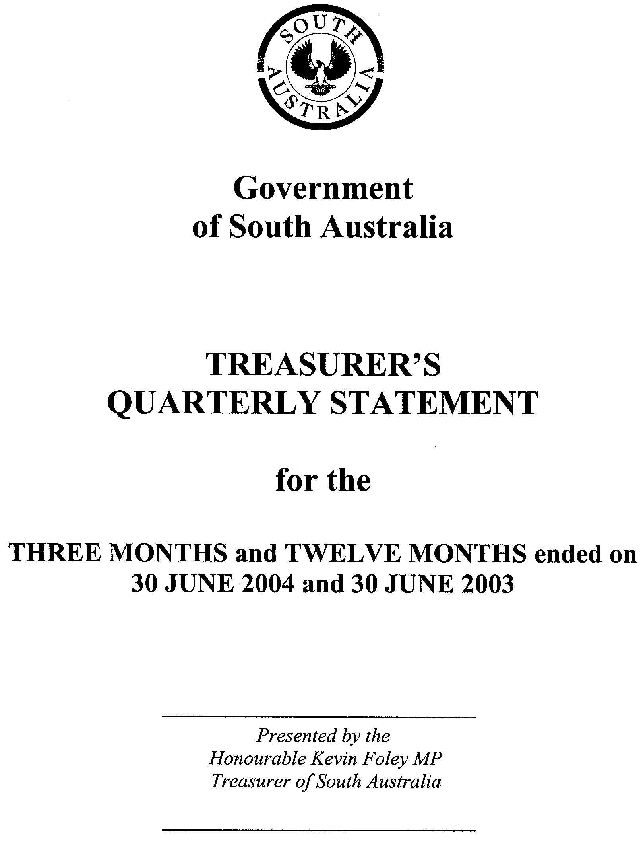
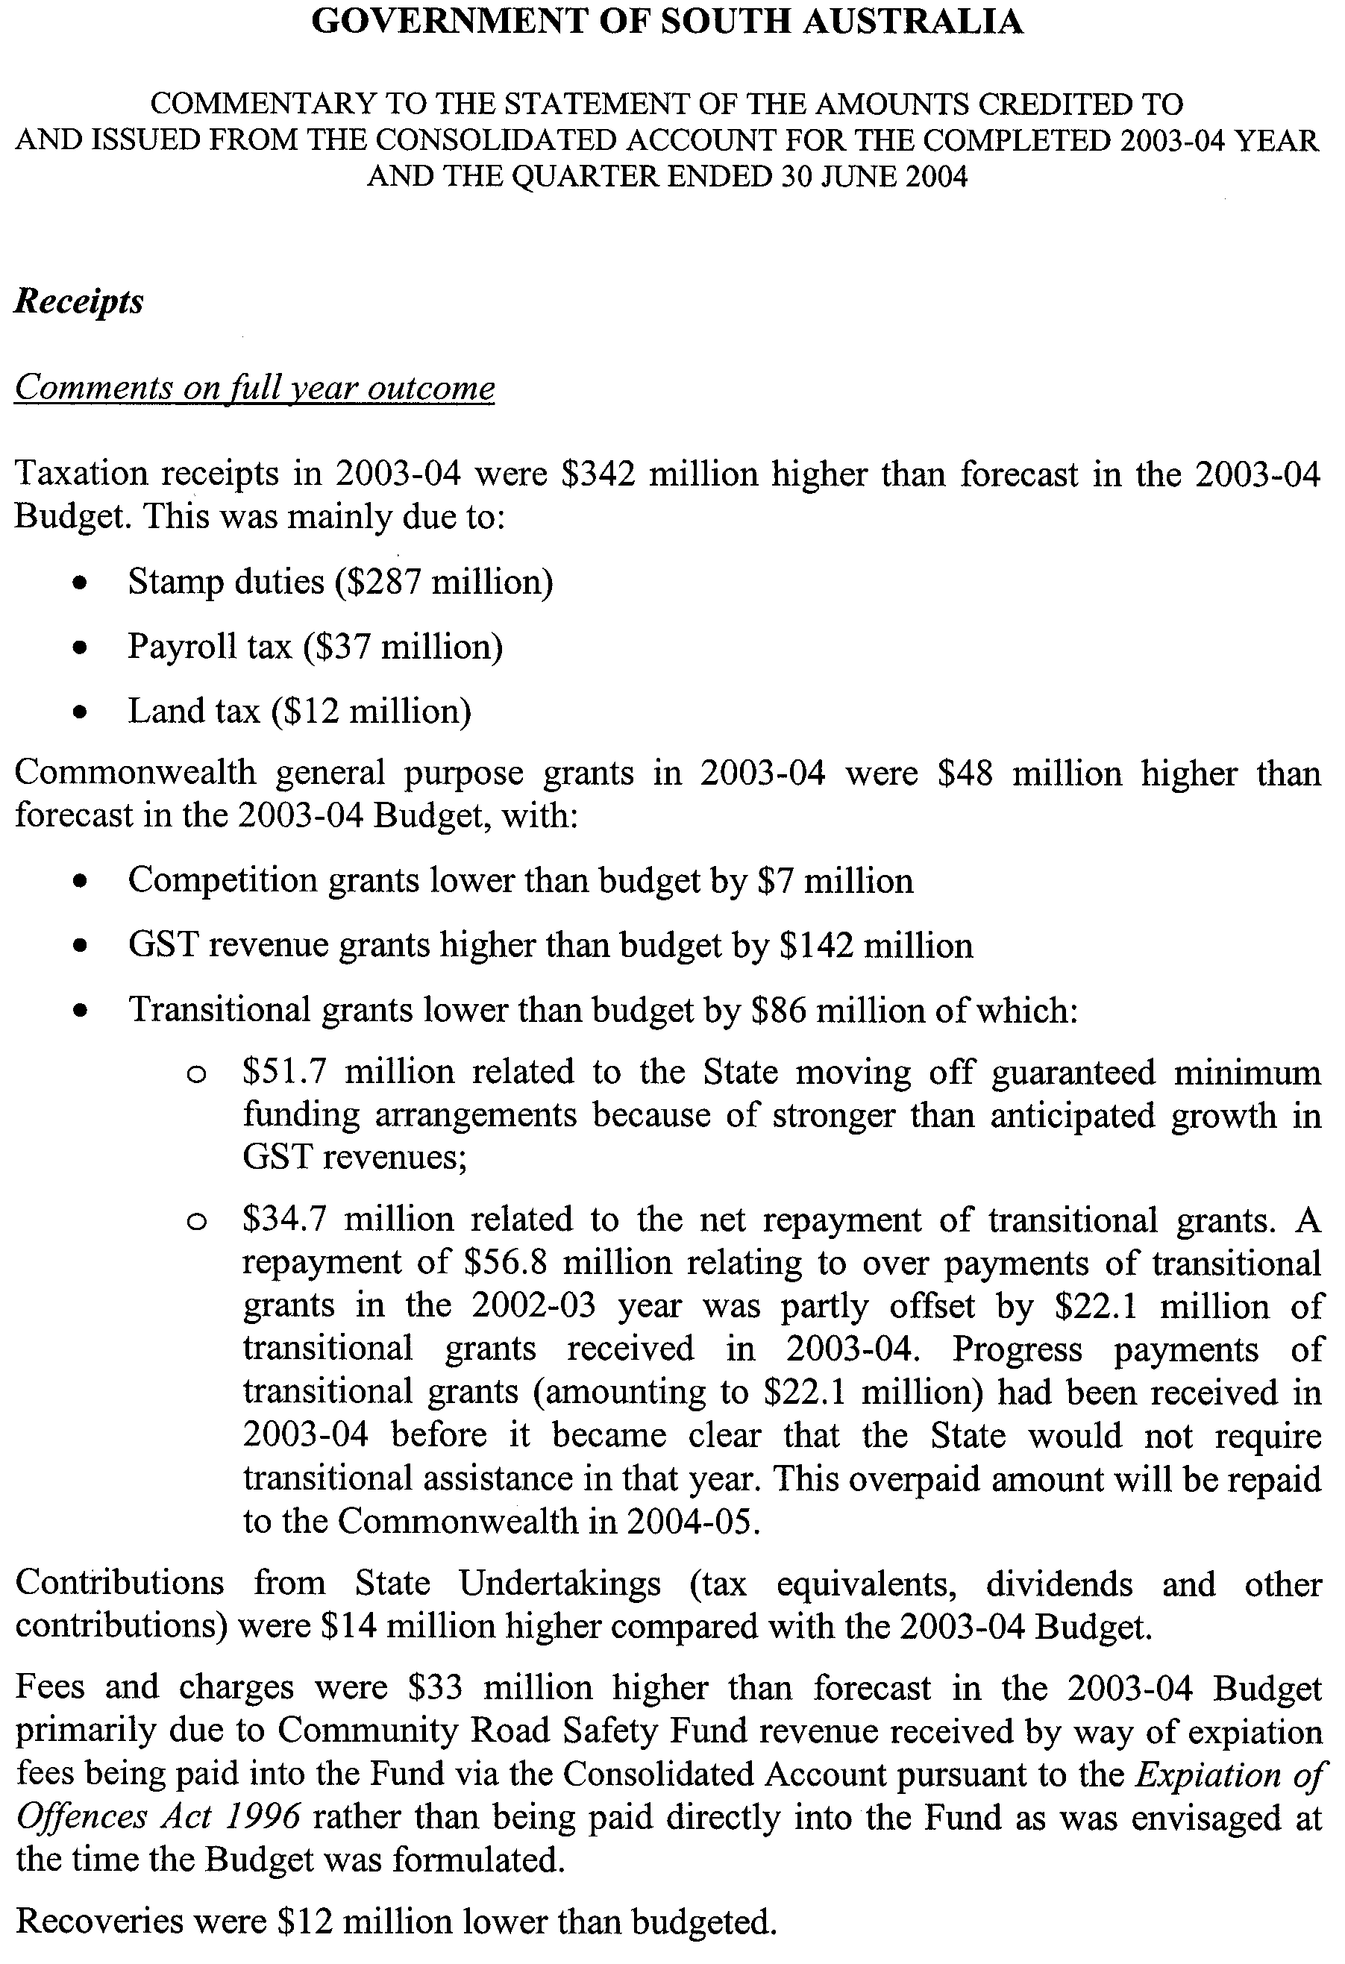
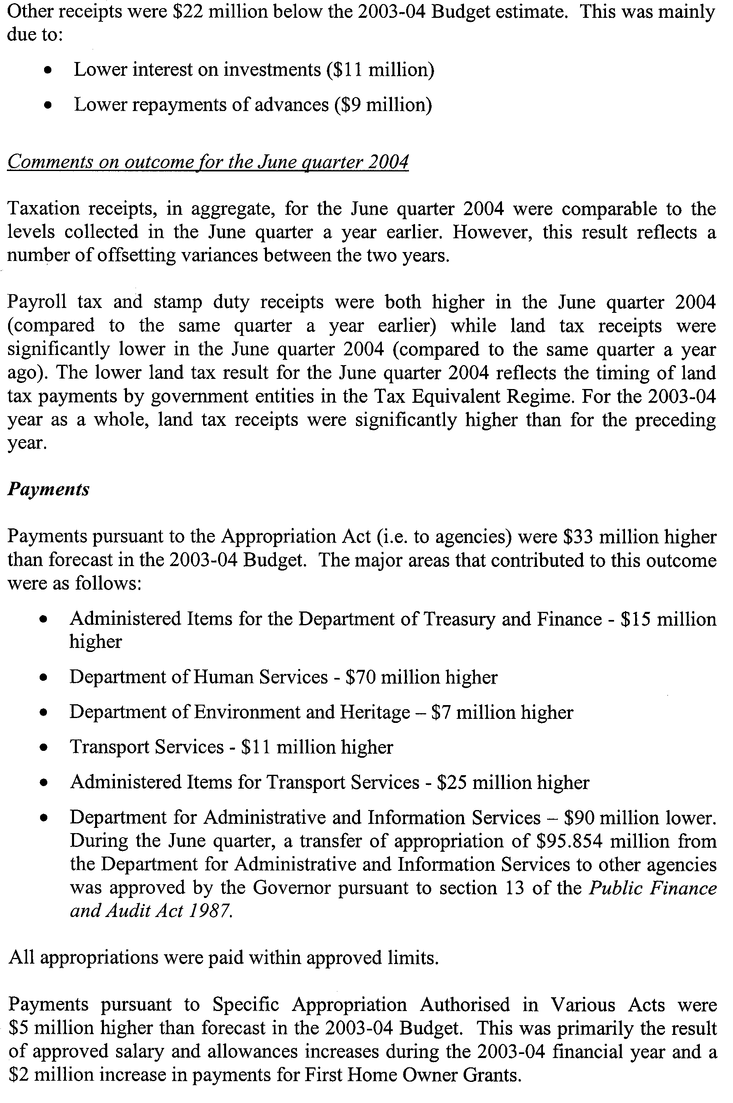
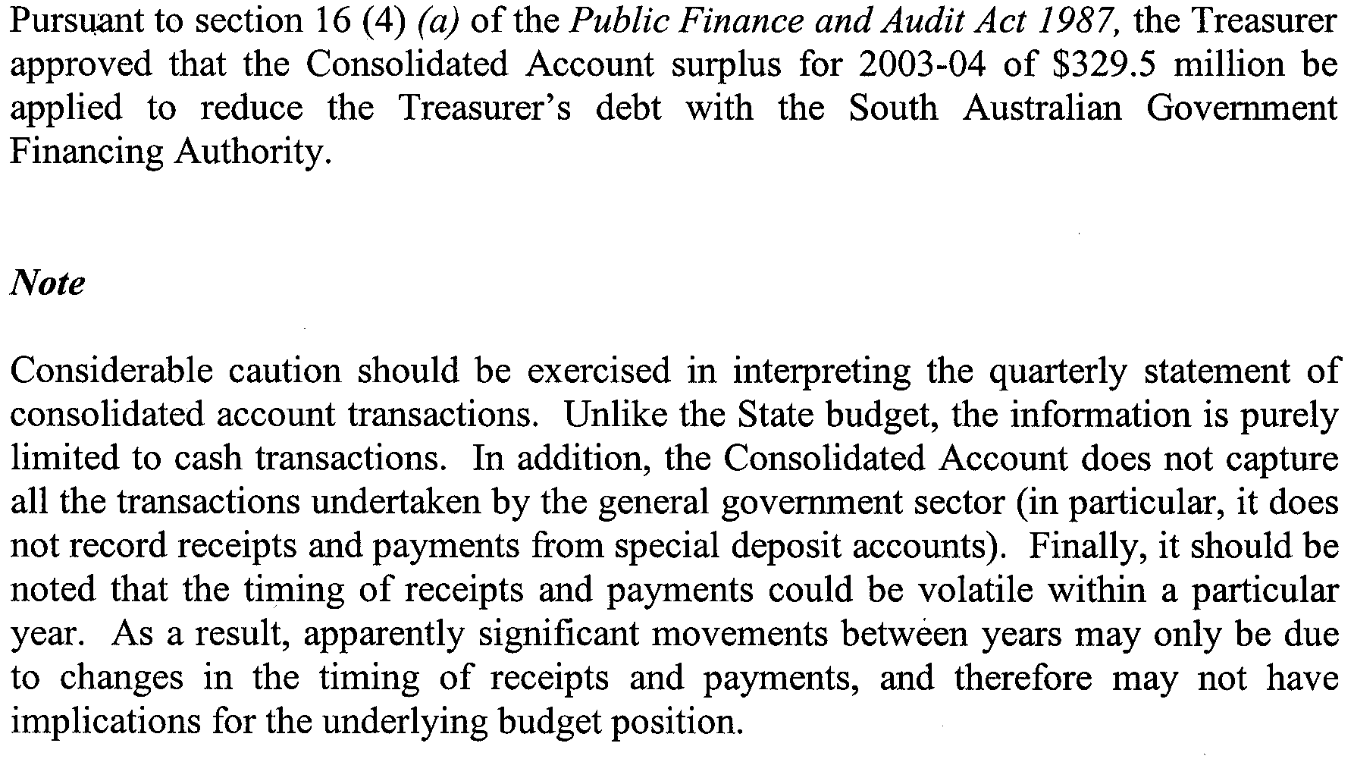
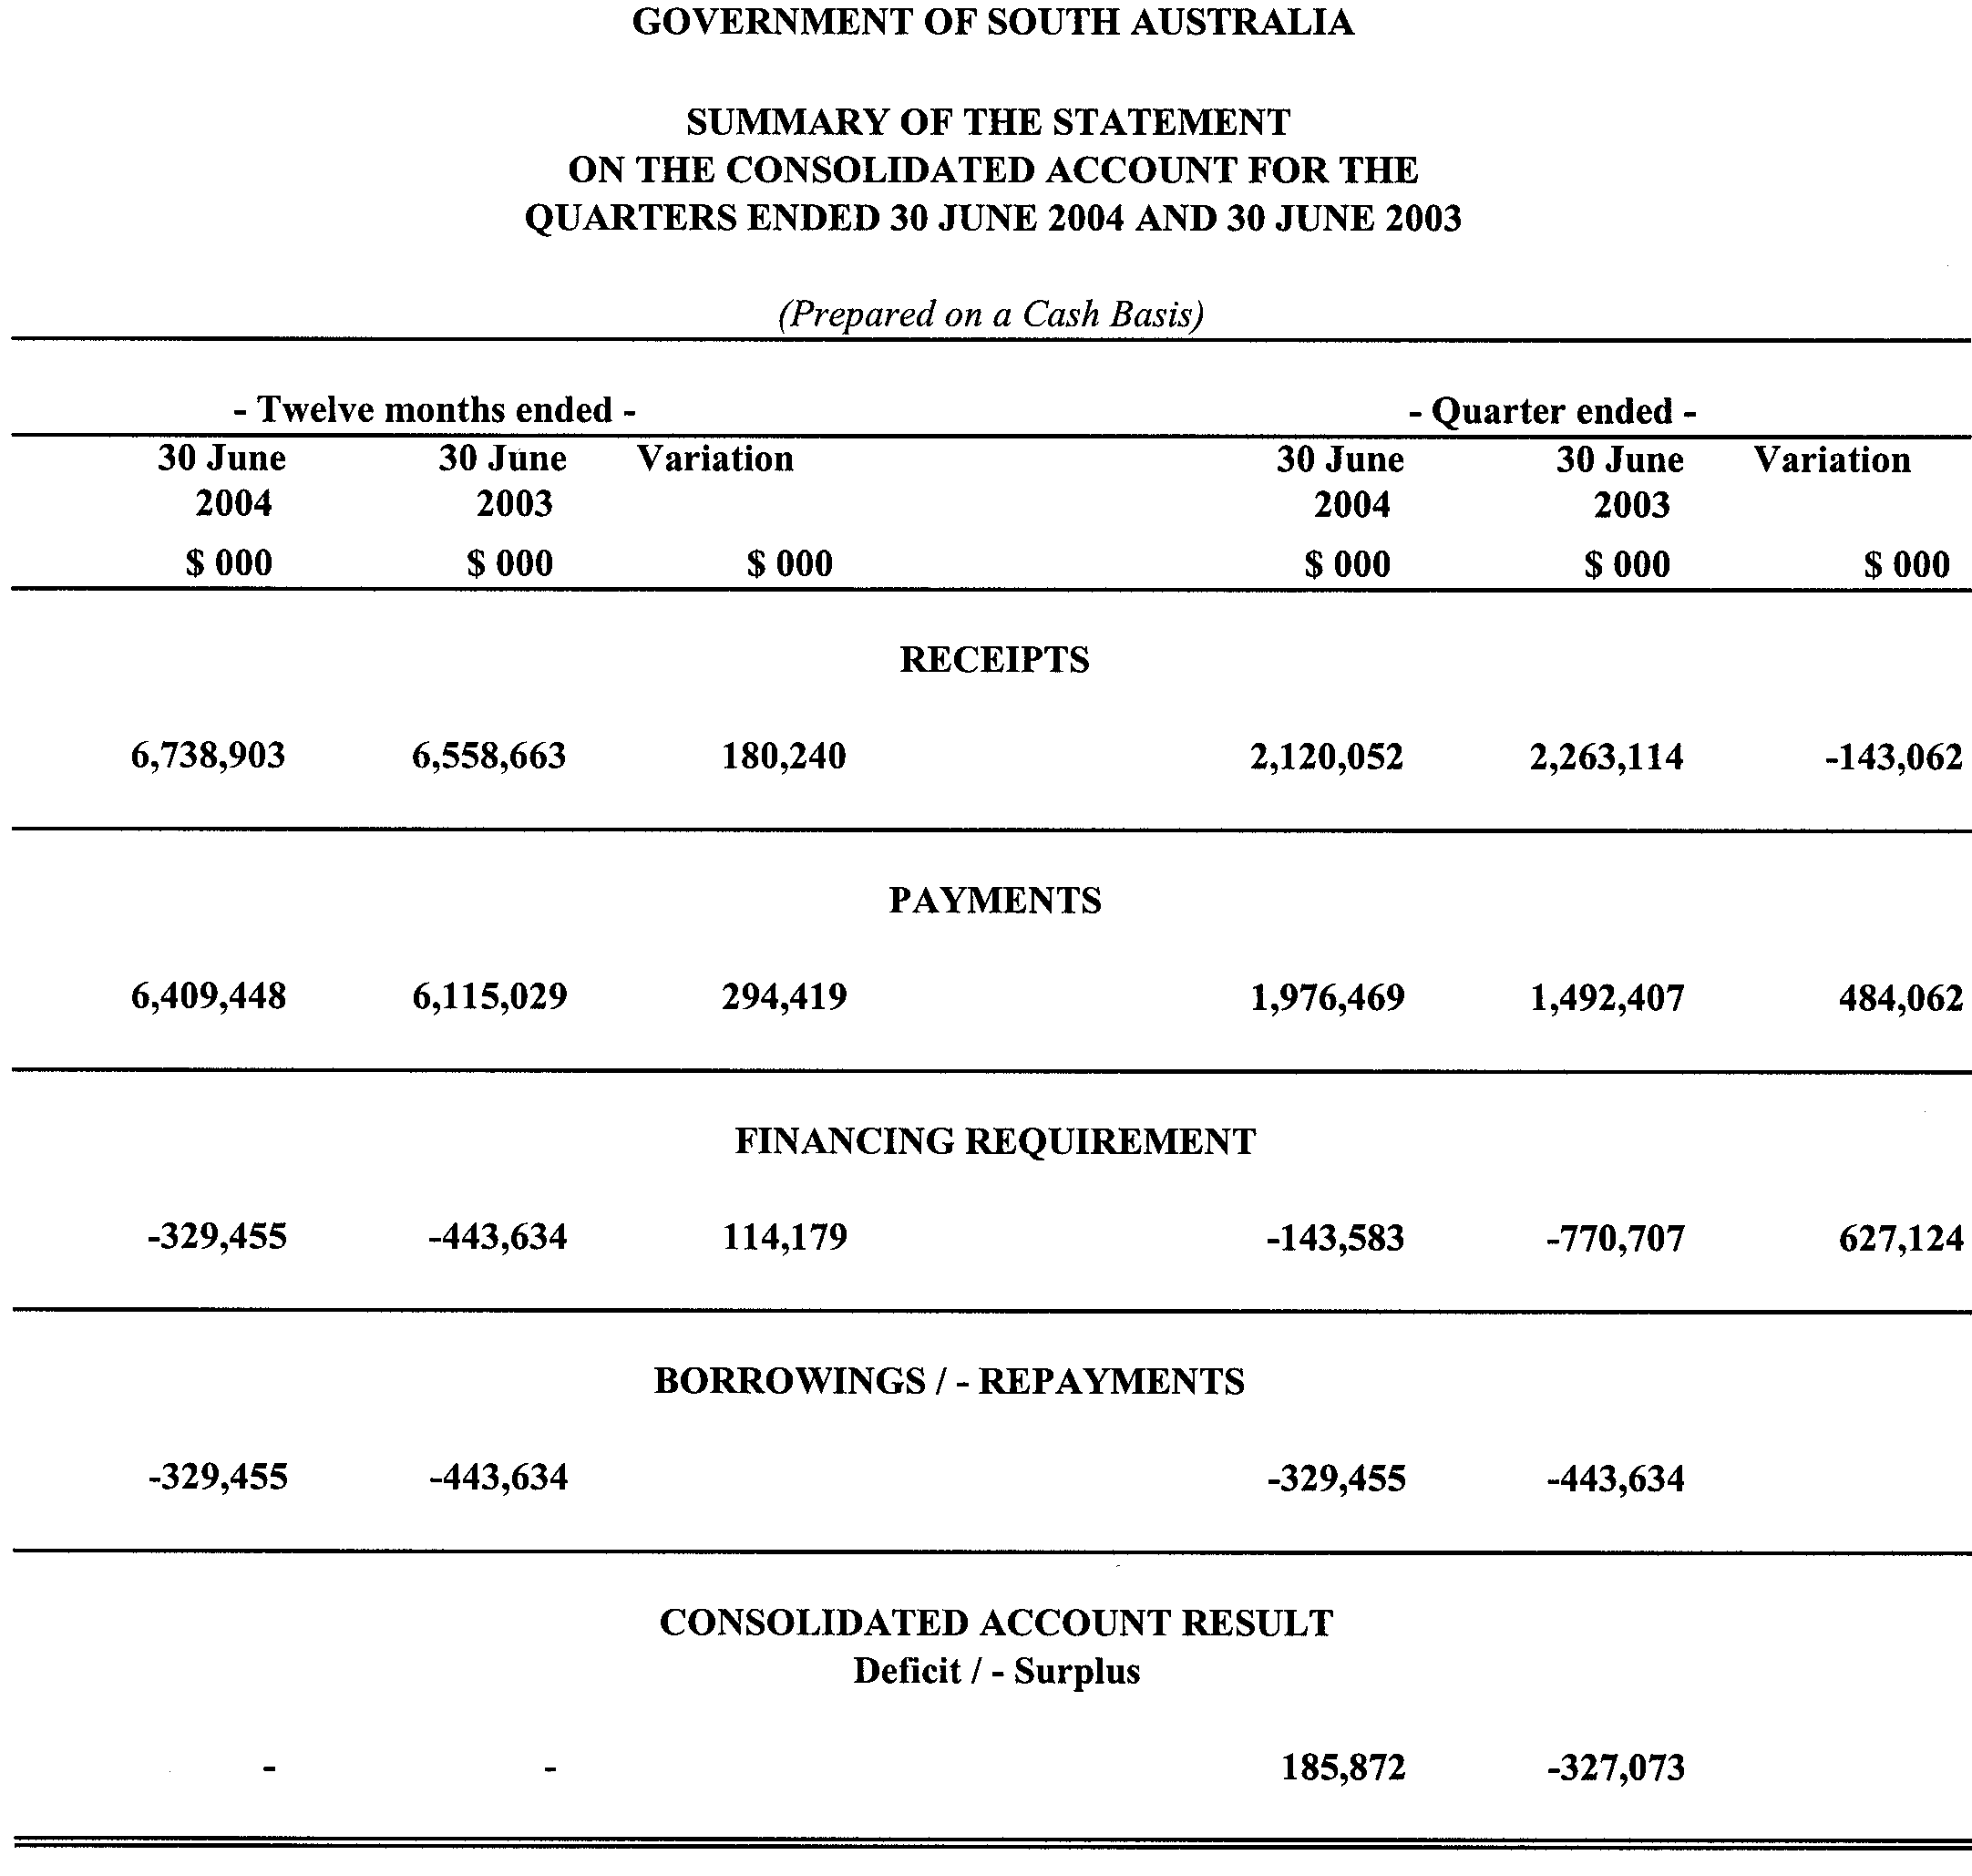
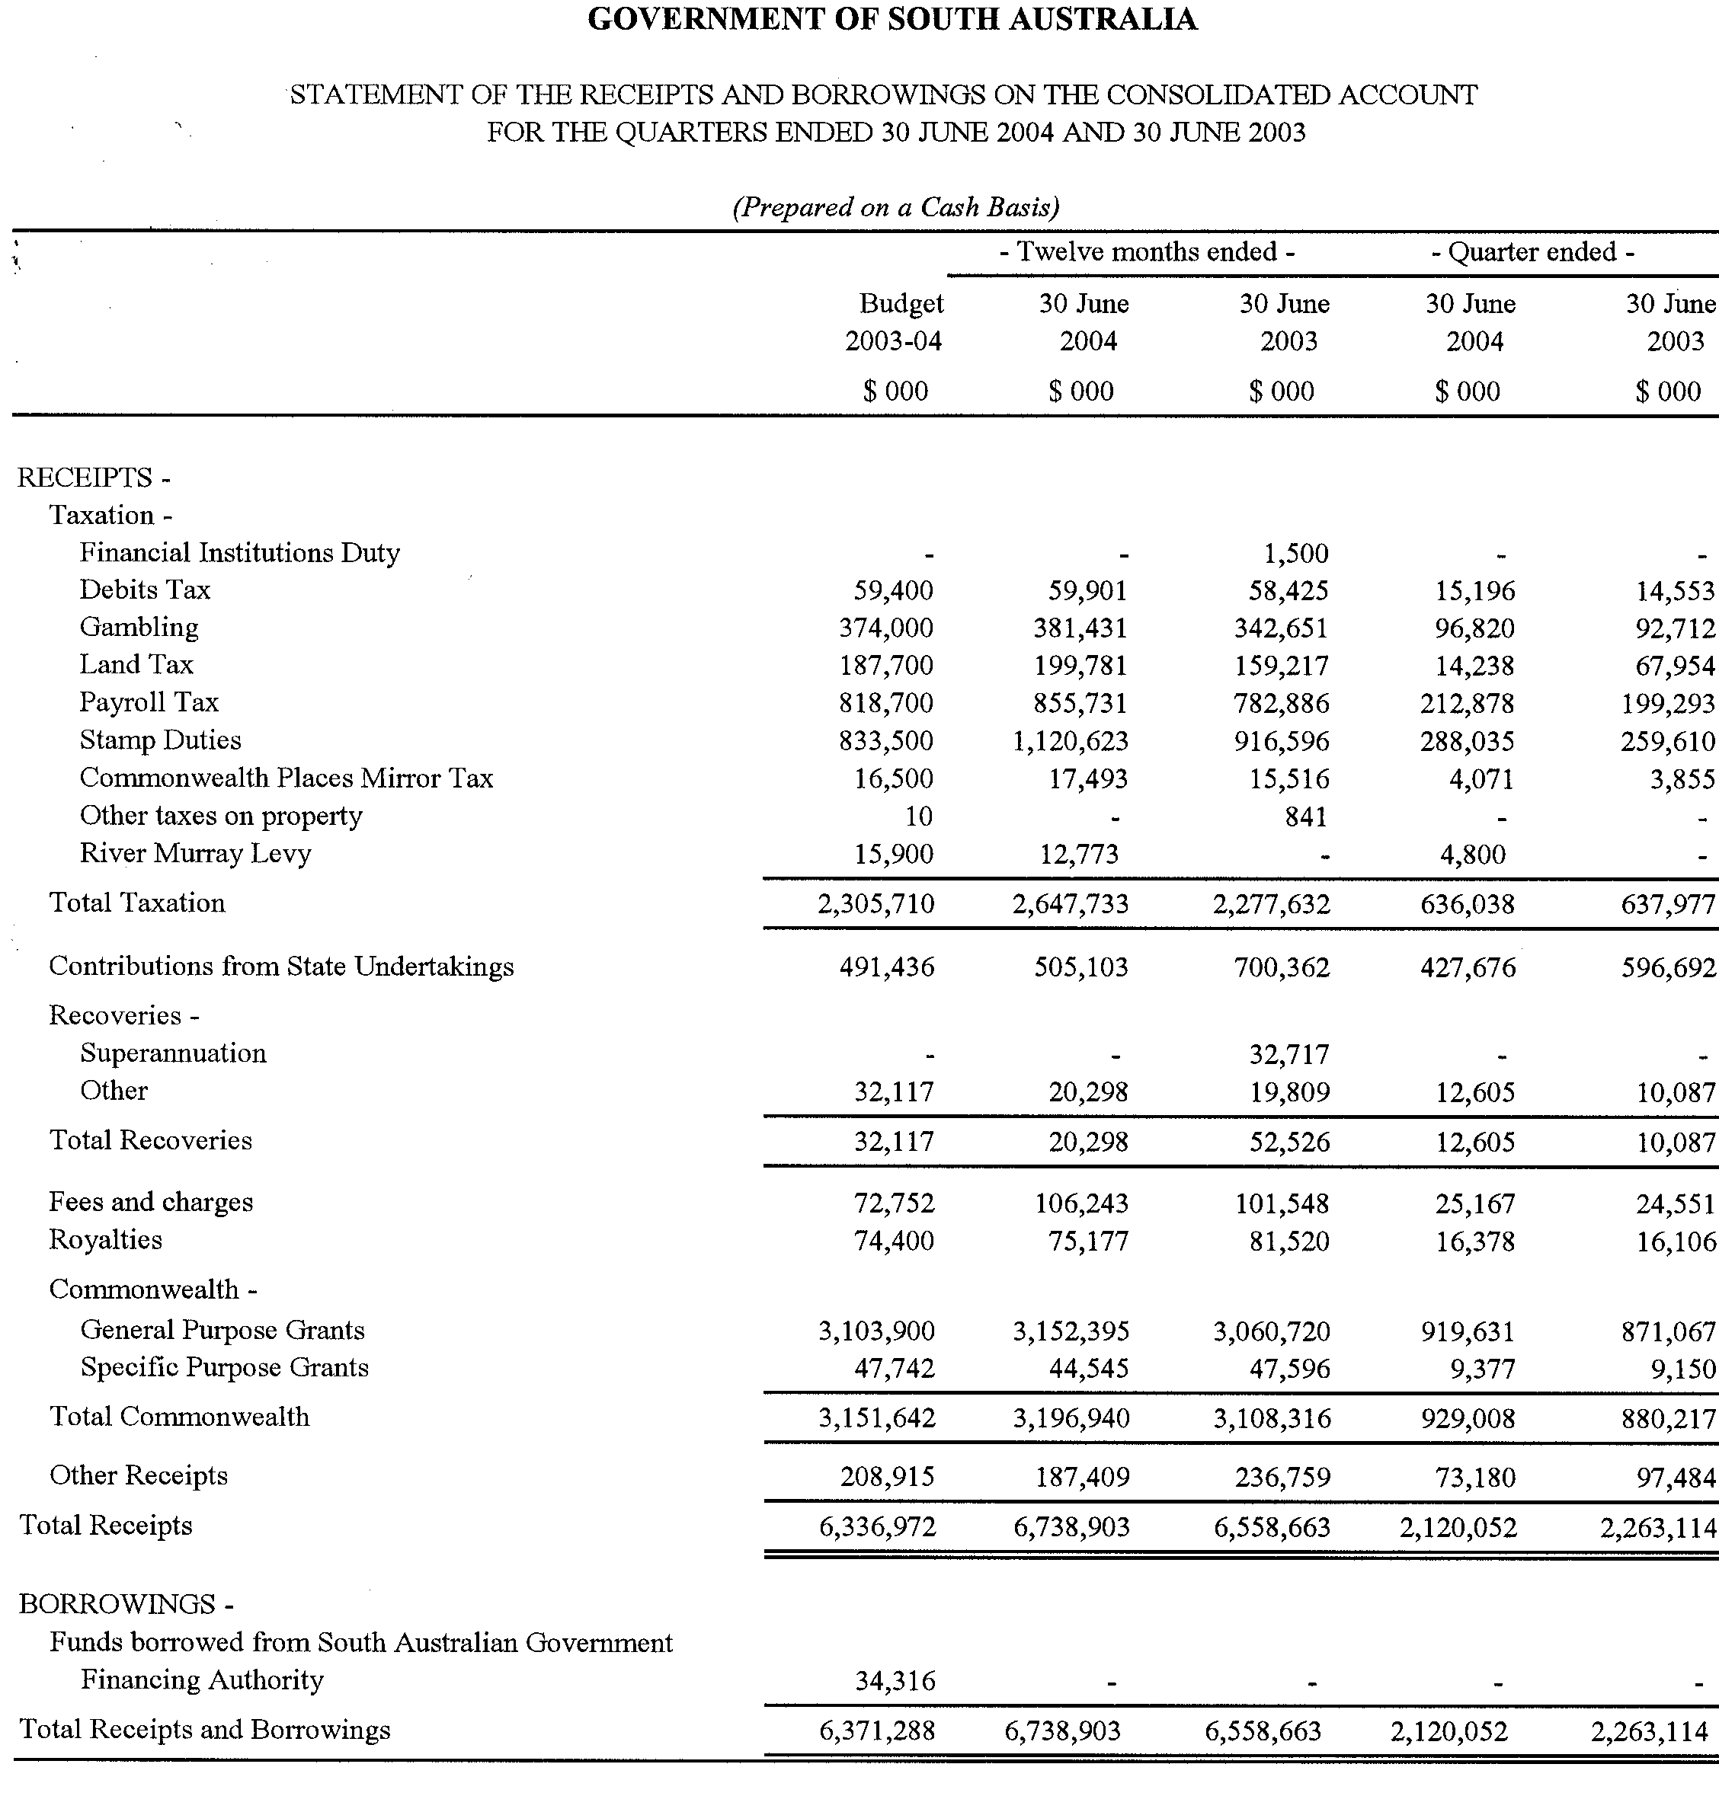
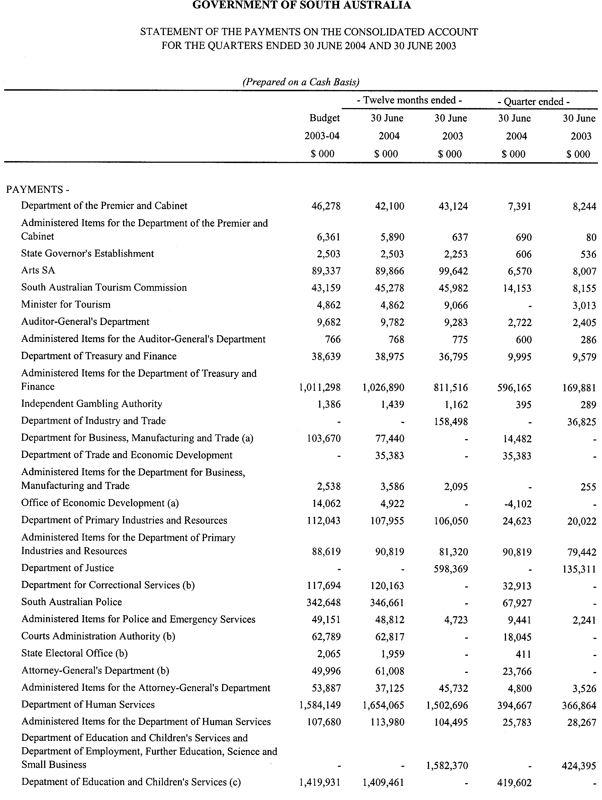
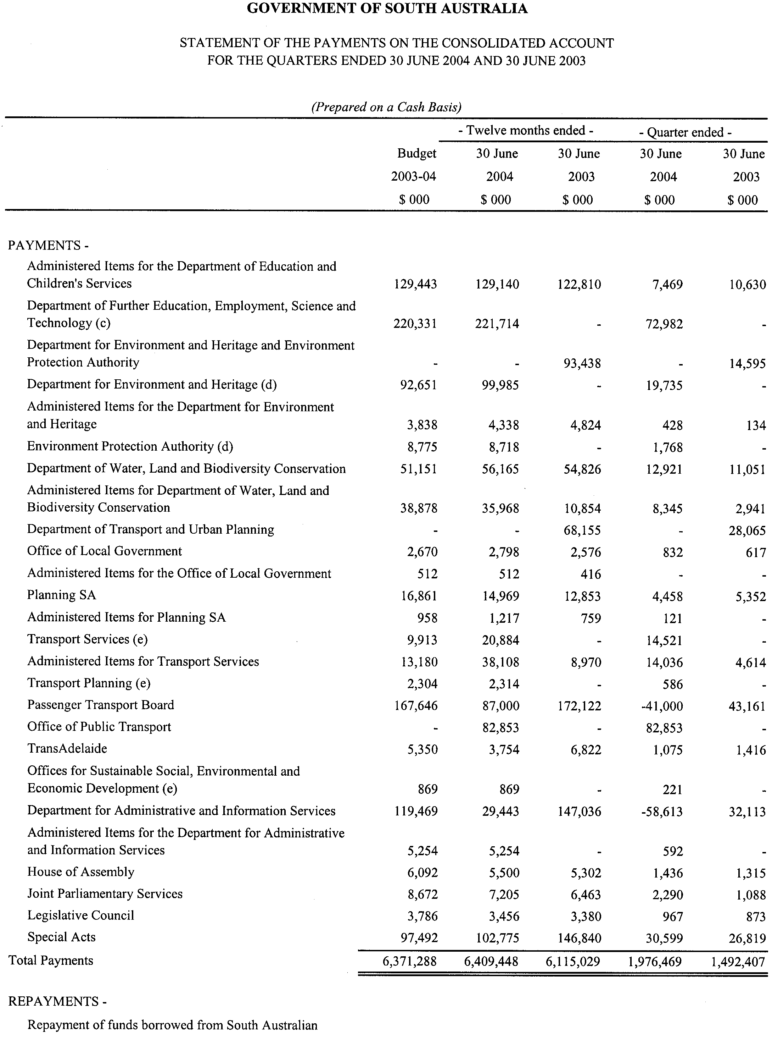
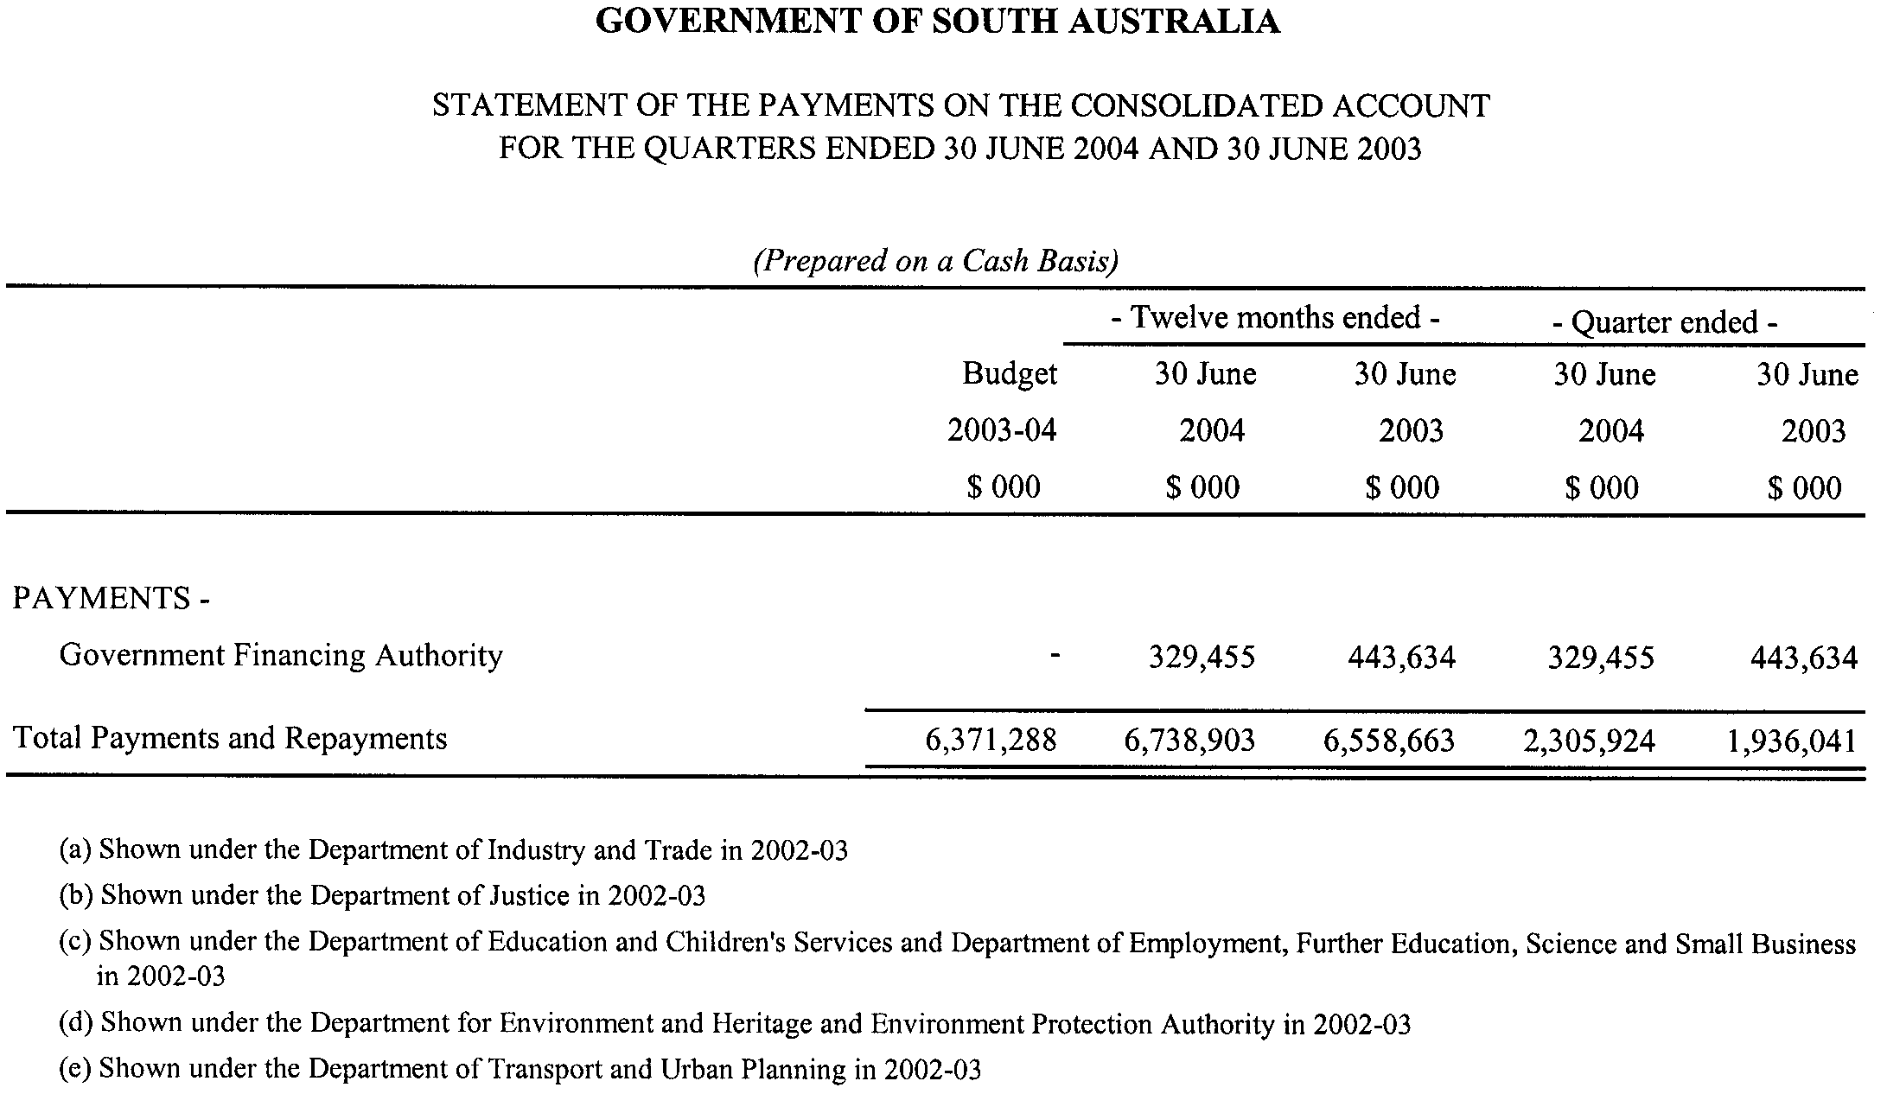

WATER RESOURCES ACT 1997
Water Allocation Plan
I, JOHN HILL, Minister for Environment and Conservation, hereby give notice for the purposes of the Water Allocation Plan for the Musgrave Prescribed Wells Area, prepared pursuant to Part 7, Division 3 of the Water Resources Act 1997, of the ‘recent recharge rate of the lens’ as set out below:
Recent Recharge Rate of the Lens
Quaternary Aquifer 2005-2006 (expressed as millimetres
per annum)
Bramfield 25
Kappawanta 22
Polda 20
Polda North 18
Polda East 8
Sheringa A 20
Sheringa B 20
Talia 21
Tinline 23
Minor Lenses 19
Dated 1 November 2004.
John Hill, Minister for Environment and Conservation

WATER RESOURCES ACT 1997
Water Allocation Plan
I, JOHN HILL, Minister for Environment and Conservation, hereby give notice for the purposes of the Water Allocation Plan for the Southern Basins Prescribed Wells Area, prepared pursuant to Part 7, Division 3 of the Water Resources Act 1997, of the ‘recent recharge rate of the lens’ as set out below:
Recent Recharge Rate of the Lens
Quaternary Aquifer 2005-2006 (expressed as millimetres
per annum)
Coffin Bay A (West) 31
Coffin Bay B (Central) 8
Coffin Bay C (East) 12
Uley Wanilla 16
Wanilla 9
Uley East 28
Uley South 140
Lincoln A, B and C 52
Lincoln D 10
Lincoln D West 10
Minor Lenses 16
Dated 1 November 2004.
John Hill, Minister for Environment and Conservation

South Australia
Forestry (Forest Reserve—Mount Burr Forest District) Variation Proclamation 2004
under section 3(3) of the Forestry Act 1950

Preamble
It is intended that the following Crown land be declared to be forest reserve as part of the Mount Burr Forest District:
Allotments 200 and 201 of Deposited Plan No. 50492, Hundred of Mount Muirhead, County of Grey.

Part 1—Preliminary
1—Short title
This proclamation may be cited as the Forestry (Forest Reserve—Mount Burr Forest District) Variation Proclamation 2004.
2—Commencement
This proclamation comes into operation on the day on which it is made.
3—Variation provisions
In this proclamation, a provision under a heading referring to the variation of a specified proclamation varies the proclamation so specified.
Part 2—Variation of proclamation under Forestry Act 1950 declaring forest reserve (Gazette 19.3.1992 p877) as varied
4—Variation of Schedule
Schedule, clause 7(d)—after "Lot 4 of Plan No. DP 60851, accepted for deposit in the Lands Titles Registration Office at Adelaide" insert:
, Lots 200 and 201 Deposited Plan 50492
Made by the Governor
with the advice and consent of the Executive Council
on 4 November 2004
MFOR008/04CS

South Australia
Mining (Revocation of Private Mine) Proclamation 2004
under section 73N of the Mining Act 1971

Preamble
1 The following area was declared to be a private mine by proclamation on 22 March 1973 (Gazette 22.3.1973 p1006):
Section 39w, Hundred of Wauraltee, County of Fergusson.
2 The Warden's Court has declared (on 18 August 2004 in Action No 342 of 2004) that proper grounds exist for revoking the declaration referred to in clause 1.

1—Short title
This proclamation may be cited as the Mining (Revocation of Private Mine) Proclamation 2004.
2—Commencement
This proclamation comes into operation on the day on which it is made.
3—Revocation of private mine
The declaration referred to in clause 1 of the preamble is revoked.
Made by the Governor
on the basis of the declaration of the Warden's Court referred to in clause 2 of the preamble and with the advice and consent of the Executive Council
on 4 November 2004
AGO0047/02CS

South Australia
Liquor Licensing (Dry Areas—Long Term) Variation Regulations 2004
under the Liquor Licensing Act 1997

Contents
Part 1—Preliminary
1 Short title
2 Commencement
3 Variation provisions
Part 2—Variation of Liquor Licensing (Dry Areas—Long Term) Regulations 1997
4 Variation of Schedule 1—Long term dry areas
5 Variation of Schedule 2—Plans of long term dry areas
Schedule 1—Plans to be substituted

Part 1—Preliminary
1—Short title
These regulations may be cited as the Liquor Licensing (Dry Areas—Long Term) Variation Regulations 2004.
2—Commencement
These regulations come into operation on the day on which they are made.
3—Variation provisions
In these regulations, a provision under a heading referring to the variation of specified regulations varies the regulations so specified.
Part 2—Variation of Liquor Licensing (Dry Areas—Long Term) Regulations 1997
4—Variation of Schedule 1—Long term dry areas
(1) Schedule 1, item headed "Mount Gambier—Area 1", column headed "Period"—delete "6 November 2004" and substitute:
7 November 2007
(2) Schedule 1, item headed "Mount Gambier—Area 2", column headed "Area"—delete ", Area "A""
(3) Schedule 1, item headed "Mount Gambier—Area 2", column headed "Period"—delete "6 November 2004" and substitute:
7 November 2007
(4) Schedule 1, item headed "Mount Gambier—Area 3", column headed "Area"—delete ", Area "B""
(5) Schedule 1, item headed "Mount Gambier—Area 3", column headed "Period"—delete "6 November 2004" and substitute:
7 November 2007
5—Variation of Schedule 2—Plans of long term dry areas
Schedule 2, plans headed "Mount Gambier—Plan No 1" and "Mount Gambier—Plan No 2"—delete the plans and substitute the plans headed "Mount Gambier—Plan No 1" and "Mount Gambier—Plan No 2" in Schedule 1 of these regulations
Schedule 1—Plans to be substituted
Mount Gambier—Plan No 1
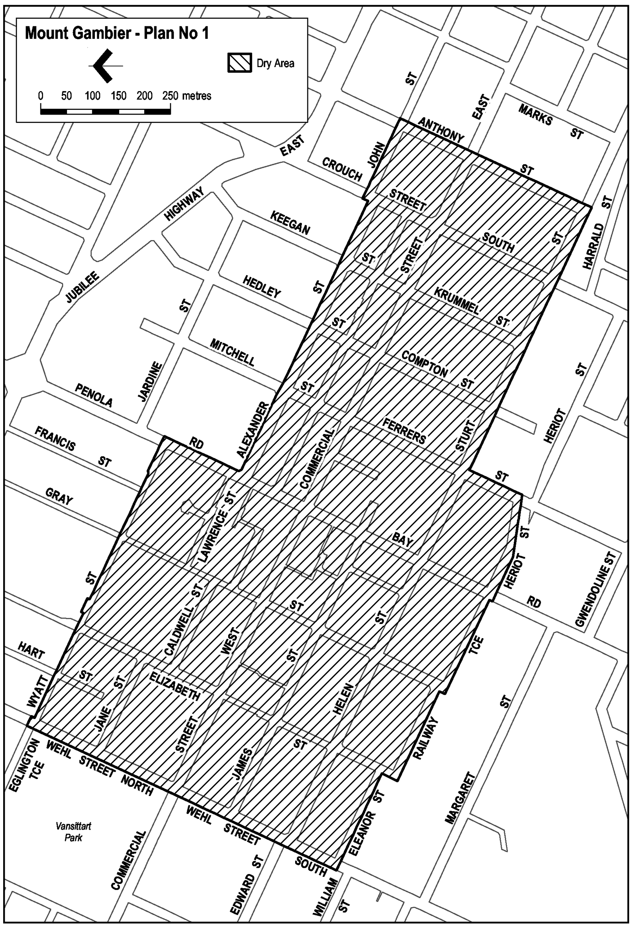
Mount Gambier—Plan No 2
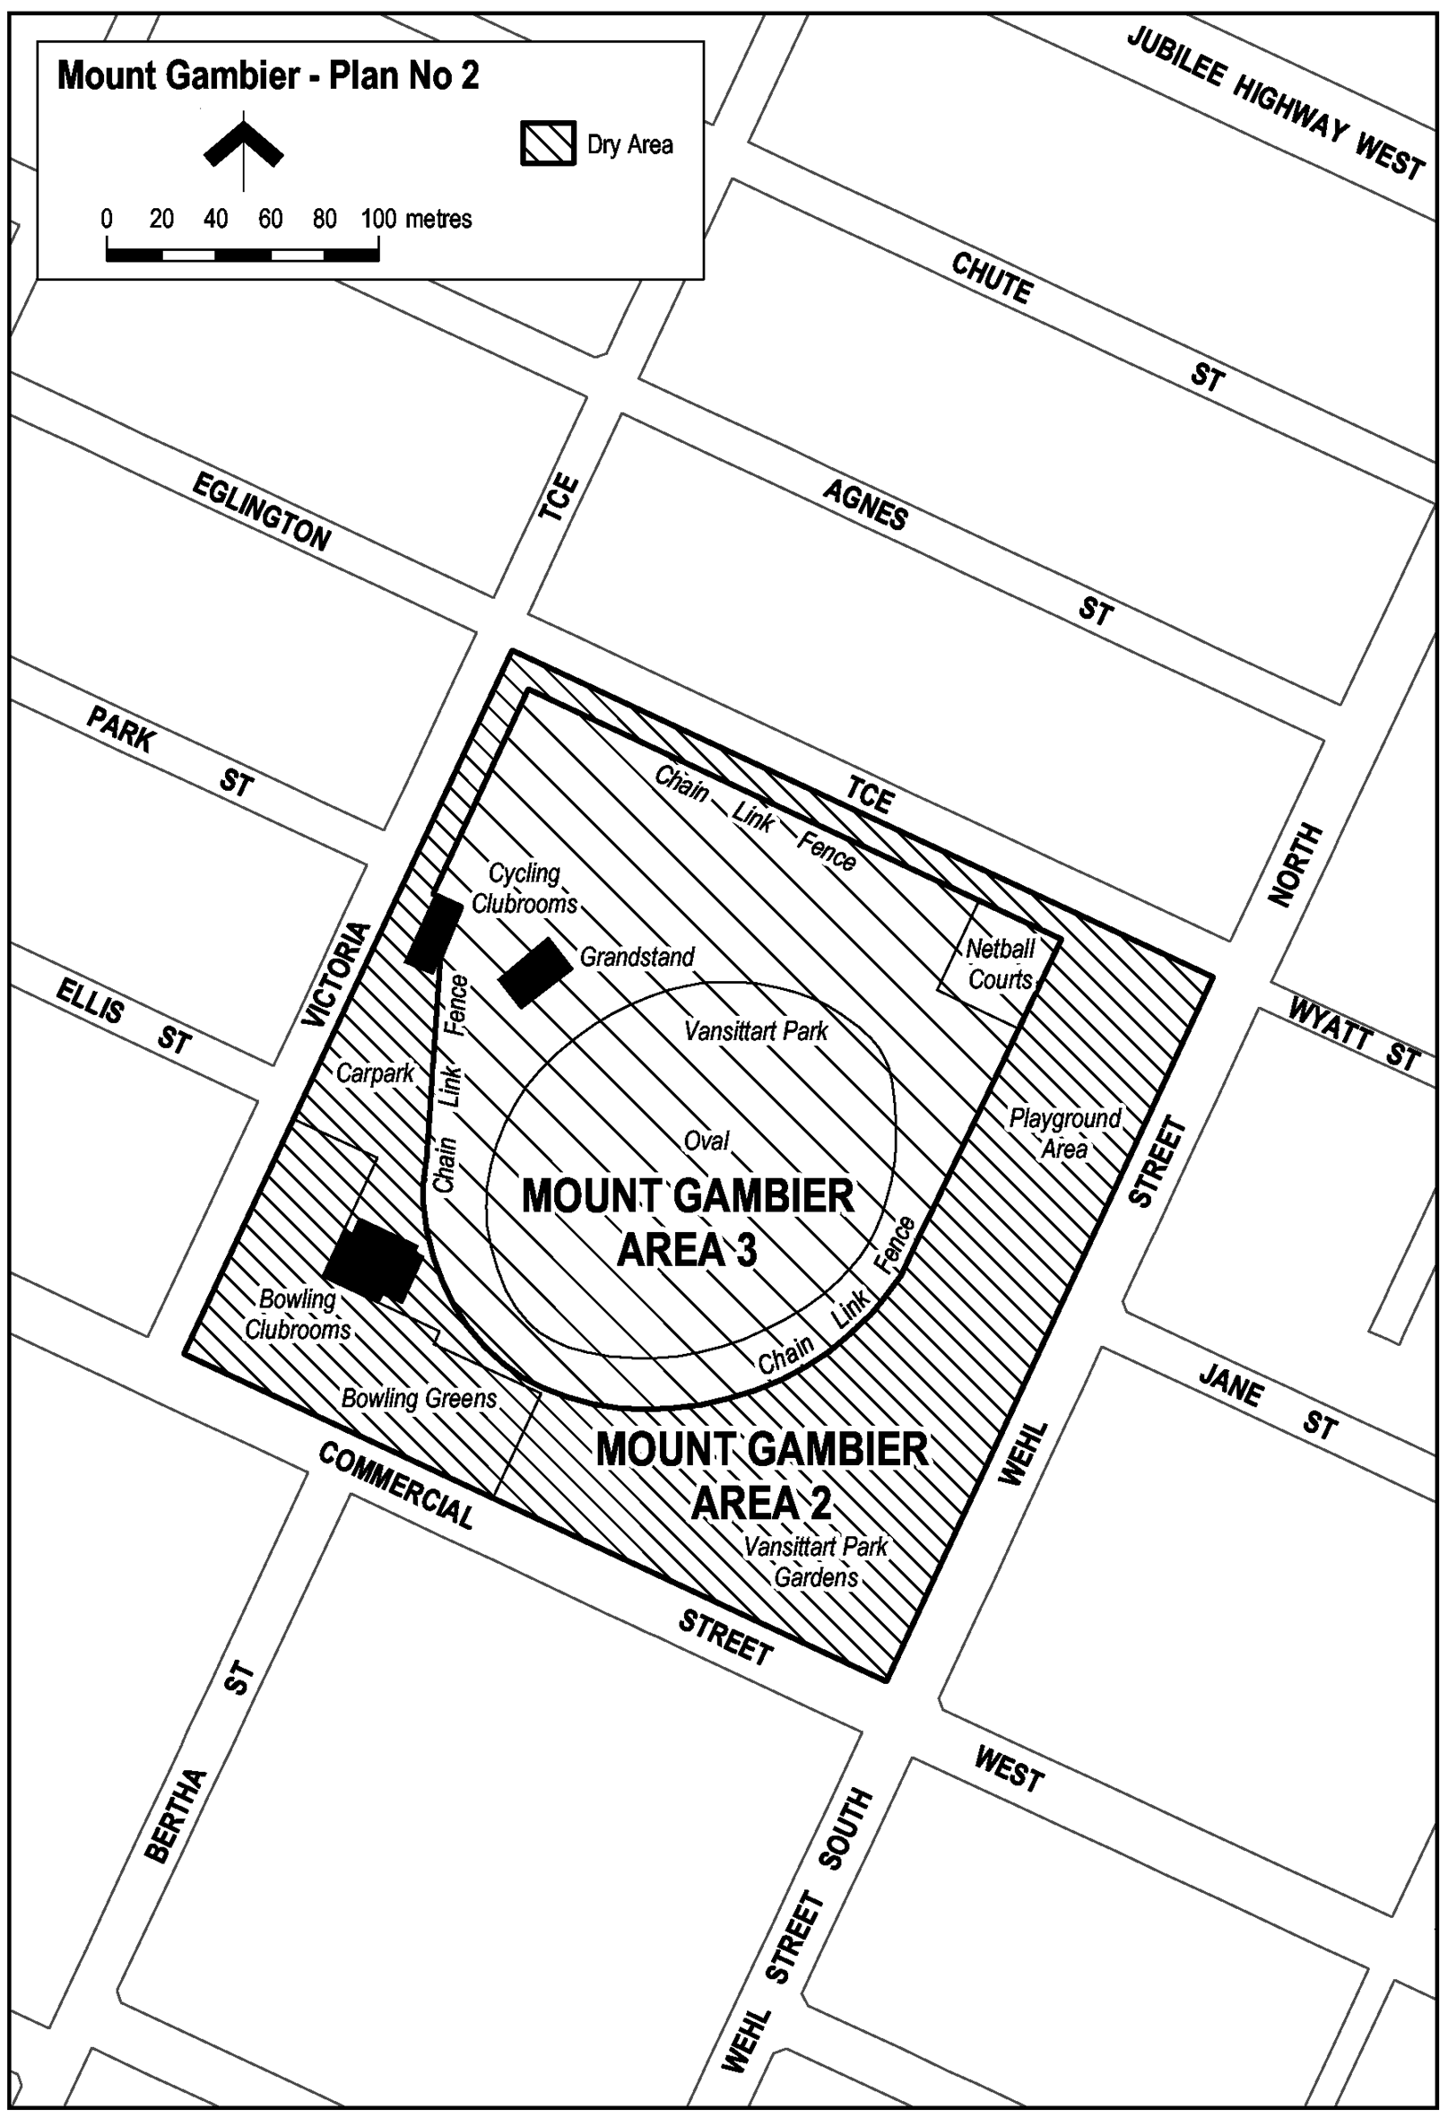
Note—
As required by section 10AA(2) of the Subordinate Legislation Act 1978, the Minister has certified that, in the Minister's opinion, it is necessary or appropriate that these regulations come into operation as set out in these regulations.
Made by the Governor
with the advice and consent of the Executive Council
on 4 November 2004
No 230 of 2004
OLGC15/2004

South Australia
Harbors and Navigation Variation Regulations 2004
under the Harbors and Navigation Act 1993

Contents
Part 1—Preliminary
1 Short title
2 Commencement
3 Variation provisions
Part 2—Variation of Harbors and Navigation Regulations 1994
4 Variation of regulation 73—Special permits for recreational vessels: section 47(3) and (4)
5 Variation of regulation 74A—Issue of temporary Boat Operator's Licence
6 Variation of regulation 100—Grant of registration
7 Variation of regulation 106—Transfer of registration
8 Variation of regulation 126—Navigation at sea
9 Variation of regulation 127—Navigation in inland waters
10 Variation of regulation 128—Navigation in rivers and channels
11 Variation of Schedule 3—Definition of harbors
12 Variation of Schedule 3A—Ports
13 Variation of Schedule 4—Restricted areas—controls (Part 4)
14 Variation of Schedule 5—Restricted areas—delineation
15 Variation of Schedule 10—Speed restrictions in certain waters (Part 10 Division 2)

Part 1—Preliminary
1—Short title
These regulations may be cited as the Harbors and Navigation Variation Regulations 2004.
2—Commencement
These regulations will come into operation on 1 December 2004.
3—Variation provisions
In these regulations, a provision under a heading referring to the variation of specified regulations varies the regulations so specified.
Part 2—Variation of Harbors and Navigation Regulations 1994
4—Variation of regulation 73—Special permits for recreational vessels: section 47(3) and (4)
Regulation 73(5), penalty provision—after the existing penalty insert:
Expiation fee: $105.
5—Variation of regulation 74A—Issue of temporary Boat Operator's Licence
(1) Regulation 74A(1)(a)—delete paragraph (a)
(2) Regulation 74A—after subregulation (1) insert:
(1a) A temporary Boat Operator's Licence may be issued subject to such conditions as the CEO thinks fit.
(1b) If the holder of a temporary Boat Operator's Licence contravenes or fails to comply with a condition of the Licence, he or she is guilty of an offence.
Maximum penalty: $750
Expiation fee: $105.
(3) Regulation 74A(2)(a)—delete "of 2 weeks" and substitute:
of one month
6—Variation of regulation 100—Grant of registration
(1) Regulation 100(1a)(b)—delete paragraph (b) and substitute:
(b) grant an application to transfer the registration of a recreational vessel fitted with an engine or to re-register a recreational vessel fitted with an engine,
(2) Regulation 100—after subregulation (1a) insert:
(1b) Where more than one person is registered as the owner of a recreational vessel fitted with an engine and an application is made to transfer the registration to one or more of those registered owners or to re-register the vessel in the name of one or more of those registered owners, subsection (1a) does not apply.
7—Variation of regulation 106—Transfer of registration
(1) Regulation 106(2)(c)—before "must" insert:
subject to subregulation (2a),
(2) Regulation 106—after subregulation (2) insert:
(2a) Without limiting the power of the CEO to waive or reduce fees in accordance with Schedule 14, the CEO must, where he or she is satisfied that an application for transfer of registration of a vessel has been lodged only for the purpose of transferring registration of the vessel into the name of one or more of the vessel's joint owners following the death of a joint owner of the vessel, waive the fee fixed by Schedule 14 in respect of the application.
8—Variation of regulation 126—Navigation at sea
(1) Regulation 126(2)—delete "(but it is a defence to a charge of such an offence brought against the owner for the owner to prove that the vessel was operated without the owner's consent)"
(2) Regulation 126—after subregulation (2) insert:
(3) If—
(a) a vessel fitted with navigation lights is operated in any part of the jurisdiction (other than inland waters); and
(b) the navigation lights are not fitted and exhibited in accordance with the Prevention of Collisions at Sea Regulations,
the owner of the vessel, and the master or operator of the vessel, are each guilty of an offence.
Maximum penalty: $4 000
Expiation fee: $300.
(4) It is a defence to a charge of an offence against this regulation brought against the owner for the owner to prove that the vessel was operated without the owner's consent.
9—Variation of regulation 127—Navigation in inland waters
(1) Regulation 127(2)—delete "(but it is a defence to a charge of such an offence brought against the owner for the owner to prove that the vessel was operated without the owner's consent)"
(2) Regulation 127—after subregulation (2) insert:
(3) If—
(a) a vessel fitted with navigation lights is operated in inland waters; and
(b) the navigation lights are not fitted and exhibited in accordance with section 17 of the Code (River Murray Traffic Regulations),
the owner of the vessel, and the master or operator of the vessel, are each guilty of an offence.
Maximum penalty: $4 000
Expiation fee: $300.
(4) It is a defence to a charge of an offence against this regulation brought against the owner for the owner to prove that the vessel was operated without the owner's consent.
10—Variation of regulation 128—Navigation in rivers and channels
Regulation 128(2) to (7)—after each penalty provision insert:
Expiation fee: $300.
11—Variation of Schedule 3—Definition of harbors
Schedule 3, entry relating to Ardrossan—delete "BHP jetty" and substitute:
Ausbulk jetty
12—Variation of Schedule 3A—Ports
(1) Schedule 3A, entry relating to Ardrossan—delete "BHP jetty" and substitute:
Ausbulk jetty
(2) Schedule 3A, entry relating to Ardrossan—delete the map and substitute:
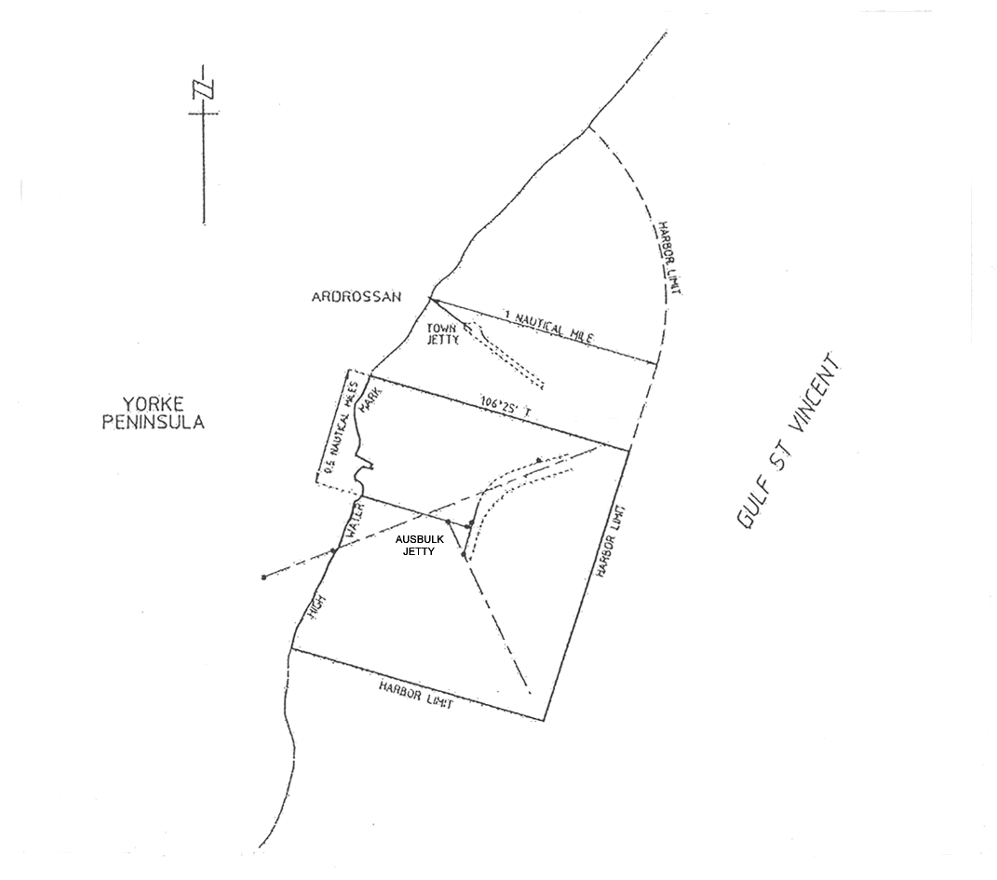
13—Variation of Schedule 4—Restricted areas—controls (Part 4)
(1) Schedule 4, clause 1(2)—after the item numbered 8 insert:
8A. A person must not operate a vessel fitted with an engine in the specified waters during the period between 1 October and 1 April (inclusive) in any year.
(2) Schedule 4, clause 1(2)—after the item numbered 9 insert:
9A. A person must not leave any fishing apparatus unattended in the specified waters.
(3) Schedule 4, clause 2, entry relating to Point Turton—delete the entry and substitute:

Point Turton Area1 | Controls 1 and 4
Point Turton Area 2 | Control 2
Port Adelaide | Control 9A

(4) Schedule 4, clause 2—after the entry in the table relating to Porter Bay insert:

Port Hughes | Control 6
(5) Schedule 4, clause 2, entry relating to Port Vincent Area 2—delete "Controls 1, 4 and 10" and substitute:
Control 8A
(6) Schedule 4, clause 2—after the entry in the table relating to Victor Harbor insert:

Wallaroo Bay Area 1 | Controls 2, 4 and 6
Wallaroo Bay Area 2 | Controls 1 and 4
(7) Schedule 4, clause 2—after the entry in the table relating to Whyalla Area 2 insert:

Whyalla Areas 4 and 5 | Controls 1 and 4
Yatco Lagoon | Control 2
(8) Schedule 4, clause 3—delete "and to Port Stanvac Areas 1 and 2" and substitute:
, Port Stanvac Areas 1 and 2 and Whyalla Areas 4 and 5
14—Variation of Schedule 5—Restricted areas—delineation
(1) Schedule 5, entry relating to Ardrossan—delete "B.H.P. loading jetty" wherever occurring and substitute in each case:
Ausbulk jetty
(2) Schedule 5, entry relating to Ardrossan—delete the plan and substitute:
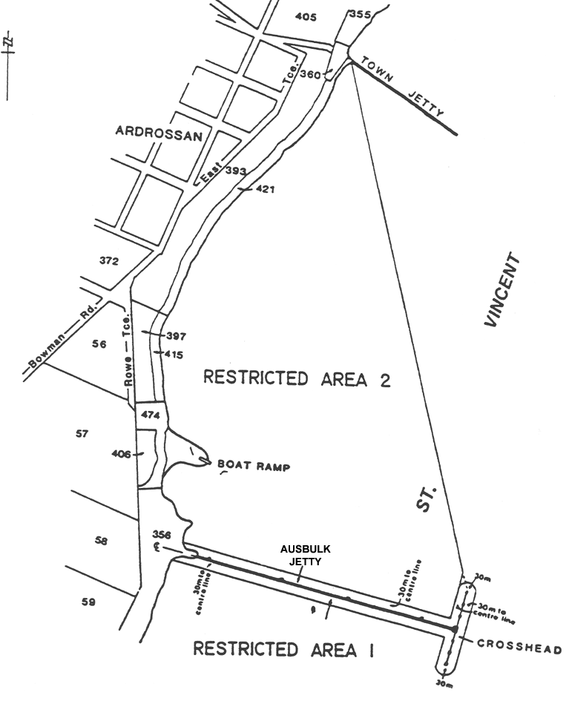
(3) Schedule 5, entry relating to Goolwa, Area 2—delete "ferry crossing" and substitute:
Hindmarsh Island Bridge
(4) Schedule 5, entry relating to Goolwa, Area 8—delete the entry relating to Goolwa, Area 8 and substitute:
Area 8:the portion of the River Murray at Goolwa bounded as follows:
• on the south by a straight line from a point on the edge of the water at Goolwa 100 metres downstream from the southern end of the Goolwa wharf to a point on the western side of Hindmarsh Island, 70 metres south of the northern corner of the Hindmarsh Island end of the causeway;
• on the east by the edge of the water on the western side of Hindmarsh Island;
• on the north by a line from a point on the edge of the water at Goolwa 100 metres upstream from the northern face of the Hindmarsh Island Bridge, then parallel to the northern face of the Bridge to the point at which that line intersects a line perpendicular to the Bridge extending from the tip of the causeway in a generally north-easterly direction, then along the latter line to the tip of the causeway, then along the northern face of the causeway;
• on the west by the face of the Goolwa wharf and the edge of the water.
(5) Schedule 5, entry relating to Goolwa, plan showing restricted areas 2, 3 and 8—delete the plan and substitute:
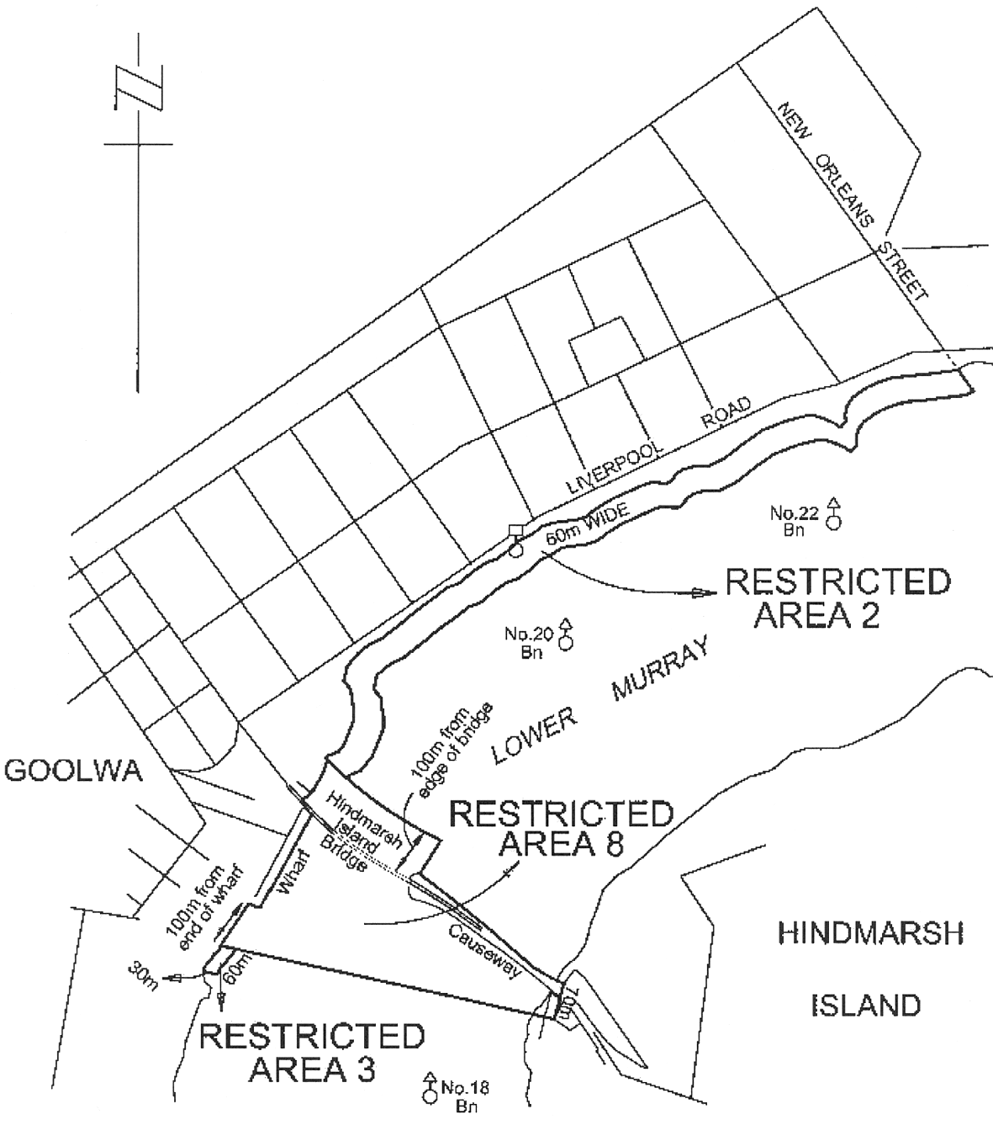
(6) Schedule 5, entry relating to Point Turton—before "The portion" insert:
Area 1:
(7) Schedule 5, entry relating to Point Turton—after the existing entry insert:
Area 2: The portion of the waters of Gulf of St Vincent described as "Area 2" on the plan below:
(8) Schedule 5, entry relating to Point Turton—after the plan insert:
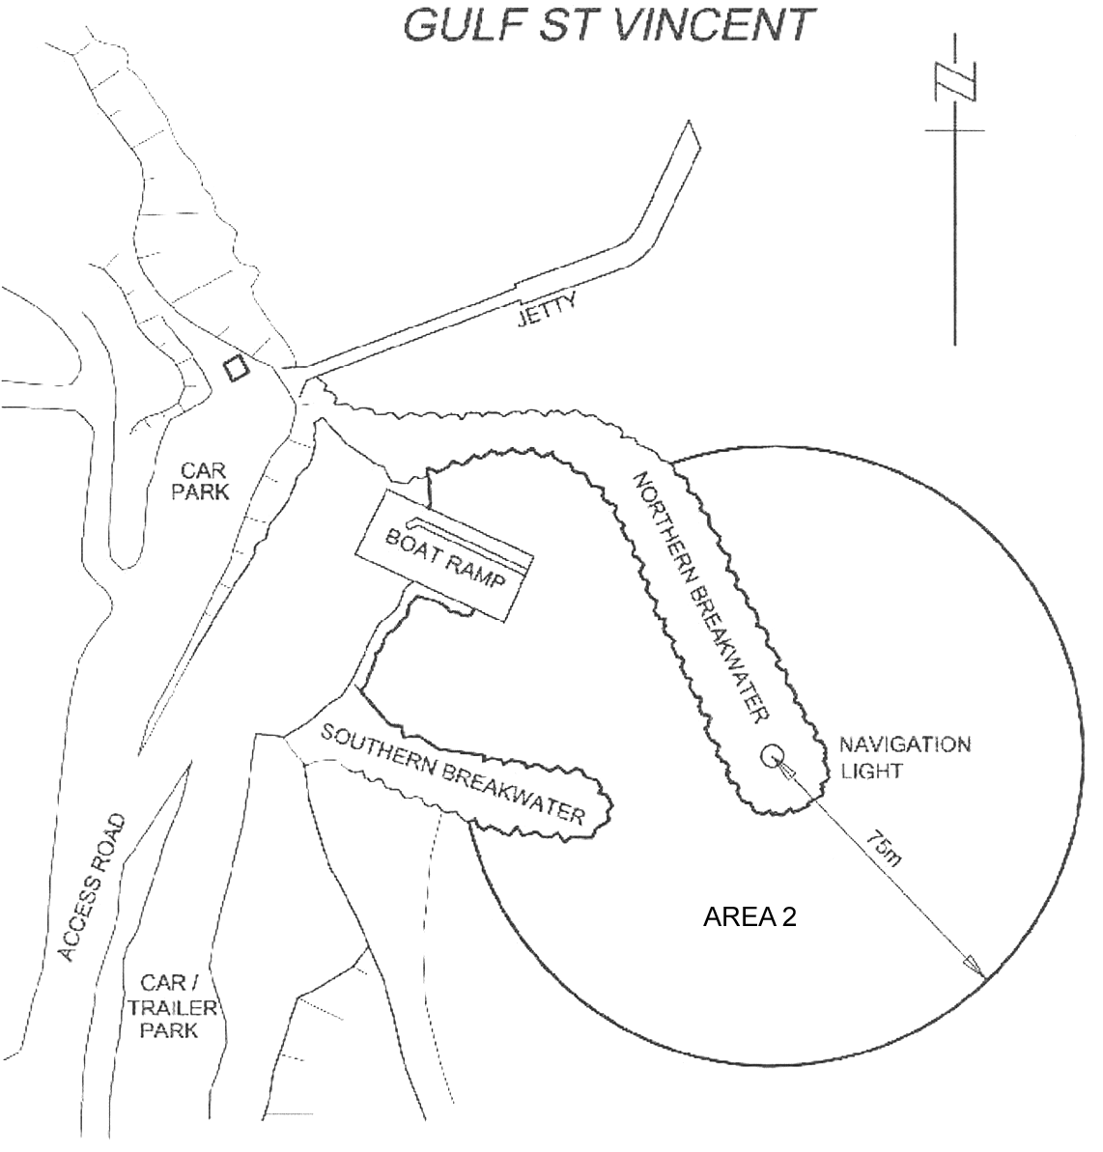
(9) Schedule 5—after the entry relating to Point Turton insert:
Port Adelaide
The portion of the sea at Port Adelaide bounded as follows:
• on the north by a straight line commencing at a point at latitude 34°46′35″.67 south, longitude 138°21′33″.51 east and extending to a point at latitude 34°47′05″.59 south, longitude 138°24′35″.57 east;
• on the east by a straight line commencing at a point at latitude 34°47′05″.59 south, longitude 138°24′35″.57 east and extending to a point at latitude 34°47′18″.57 south, longitude 138°24′35″.56 east;
• on the south by a straight line commencing at a point at latitude 34°47′18″.57 south, longitude 138°24′35″.56 east and extending to a point at latitude 34°47′54″.08 south, longitude 138°21′33″.38 east;

• on the west by a straight line commencing at a point at latitude 34°47′54″.08 south, longitude 138°21′33″.38 east and extending to a point at latitude 34°46′35″.67 south, longitude 138°21′33″.51 east.
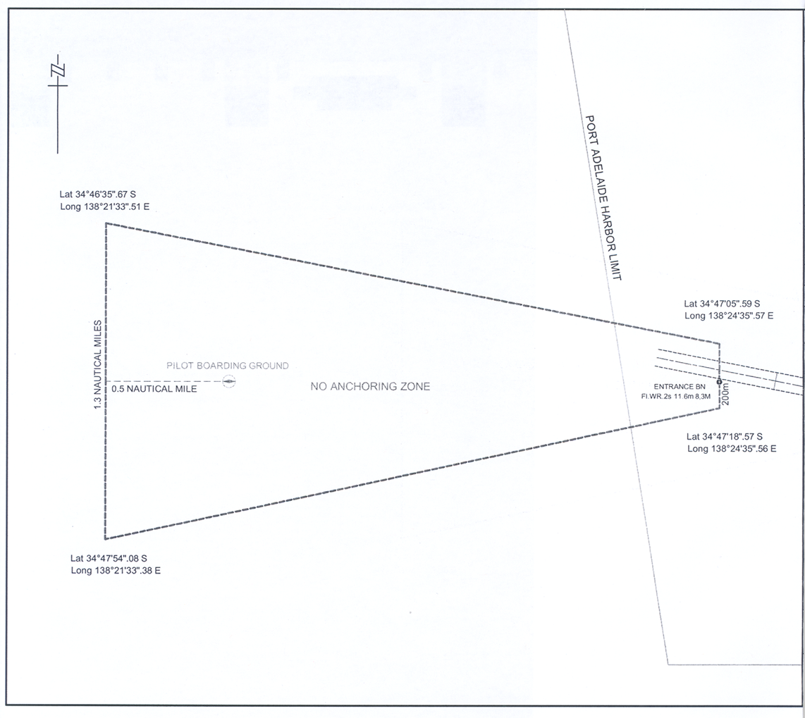
(10) Schedule 5—after the entry relating to Porter Bay insert:
Port Hughes
The portion of the waters of the sea at Port Hughes within the Moonta Bay boat ramp basin, landward of the northern and southern breakwater (shown as a shaded area on the plan below).
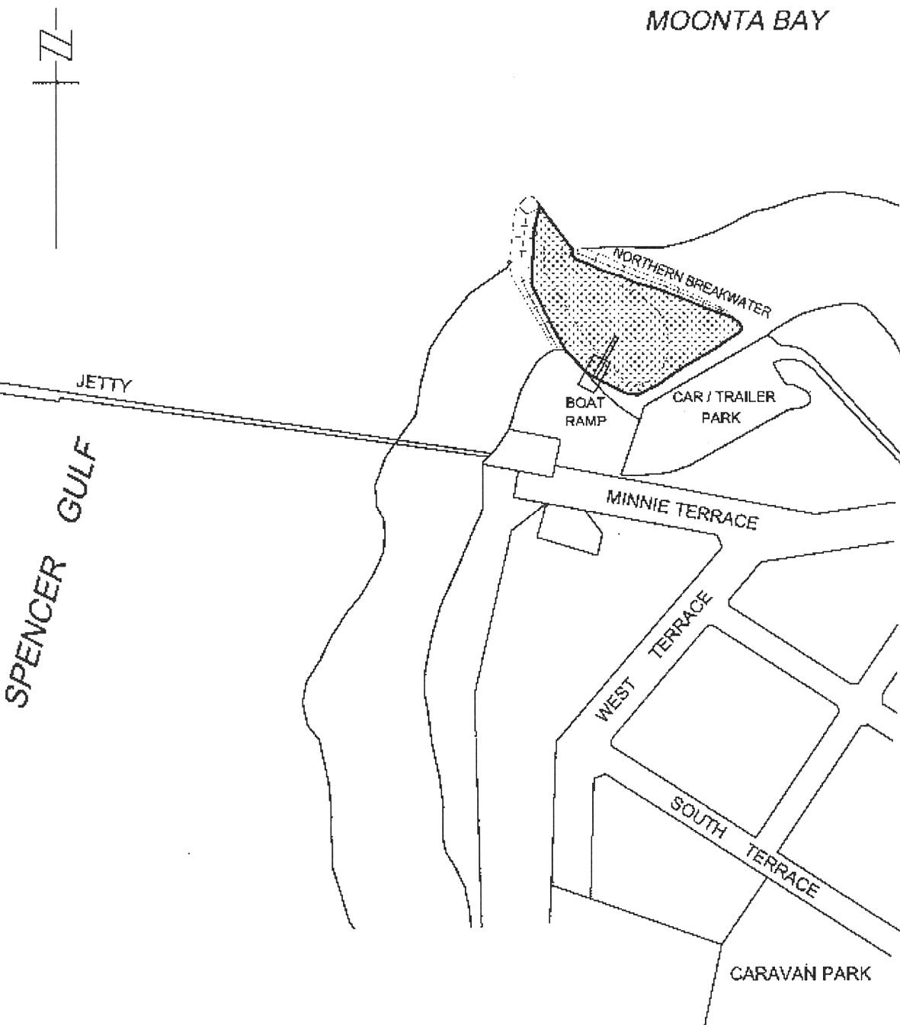
(11) Schedule 5, entry relating to Port Vincent—delete the entry relating to Port Vincent Area 2 and the plan following that entry and substitute:
Area 2: the portion of the waters of Gulf St. Vincent at Port Vincent bounded as follows:
• on the north-west by a straight line being the prolongation seaward of the south-eastern boundary of Main Street;
• on the north-east by a line 60 metres seaward of, and parallel to, the sea wall;
• on the south-east by a straight line being the prolongation seaward of the north-western boundary of Curramulka Road;
• on the south-west by the edge of the water.
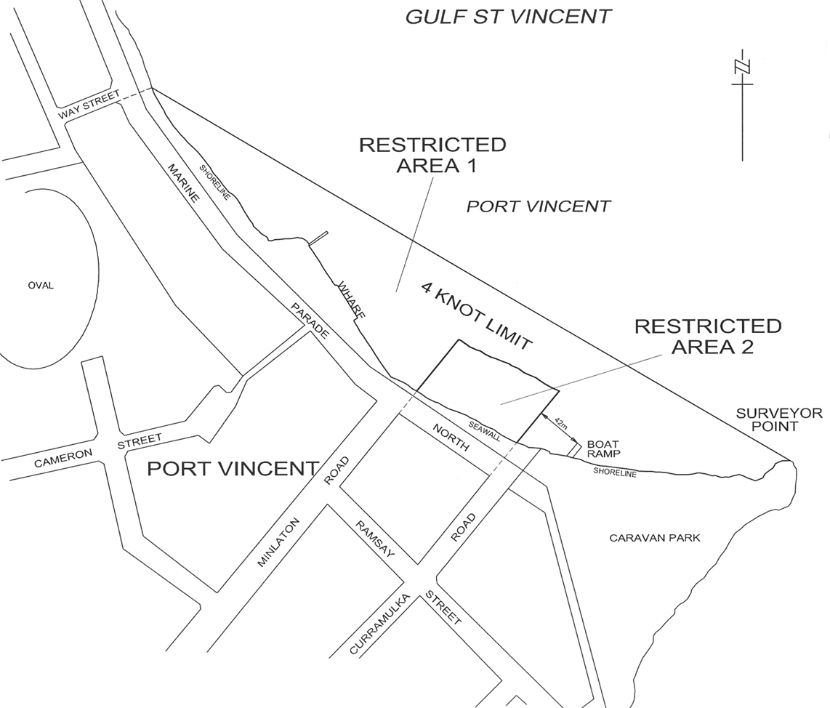
(12) Schedule 5—after the entry relating to Victor Harbor insert:
Wallaroo Bay
Area 1: The portion of the waters of the sea at Wallaroo described as "Area 1" on the plan below.
Area 2:The portion of the waters of the sea at Wallaroo described as "Area 2" on the plan below.
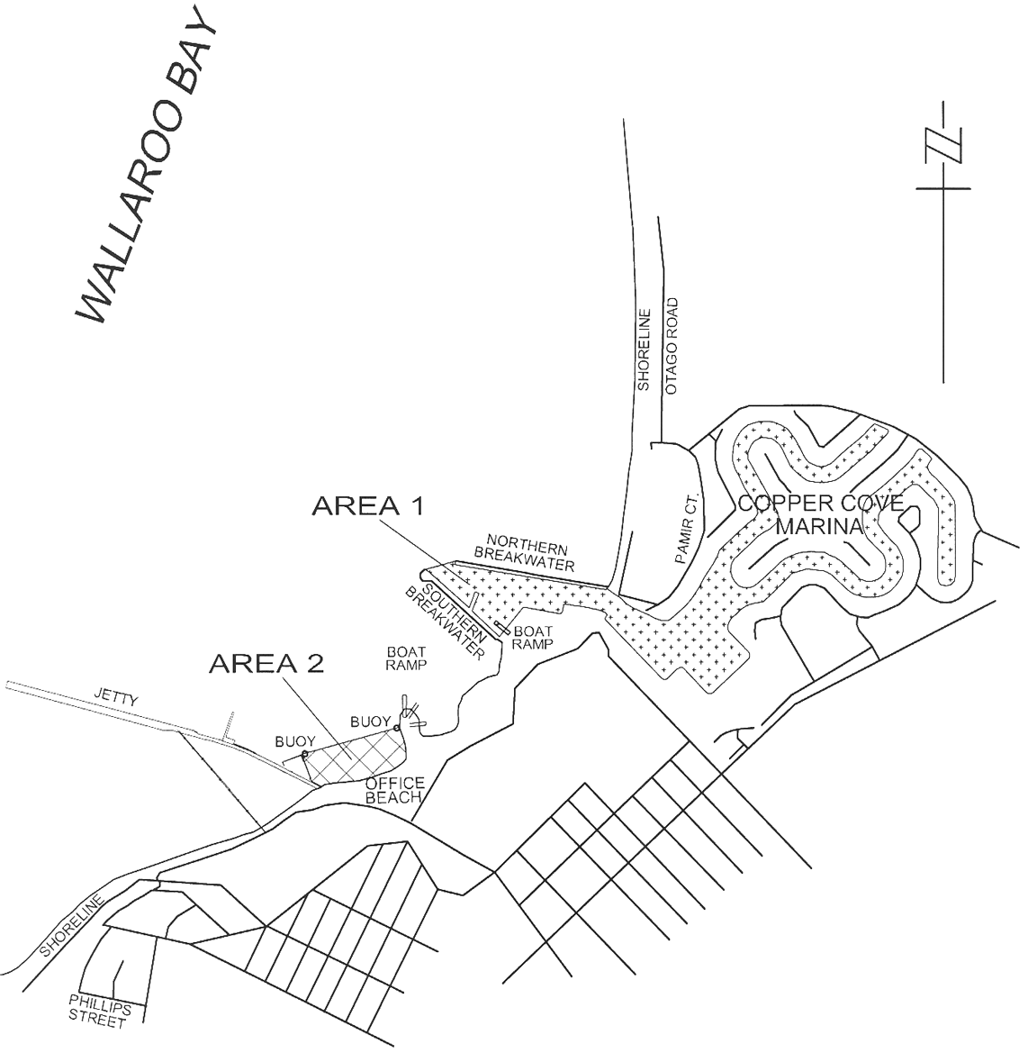
(13) Schedule 5, entry relating to Whyalla—after the entry relating to Whyalla Area 3 insert:
Area 4: the portion of False Bay at Whyalla described as "Area 4" on the plan below.
Area 5: the portion of False Bay at Whyalla described as "Area 5" on the plan below.
(14) Schedule 5, entry relating to Whyalla—after the plan showing Areas 1, 2 and 3 insert:
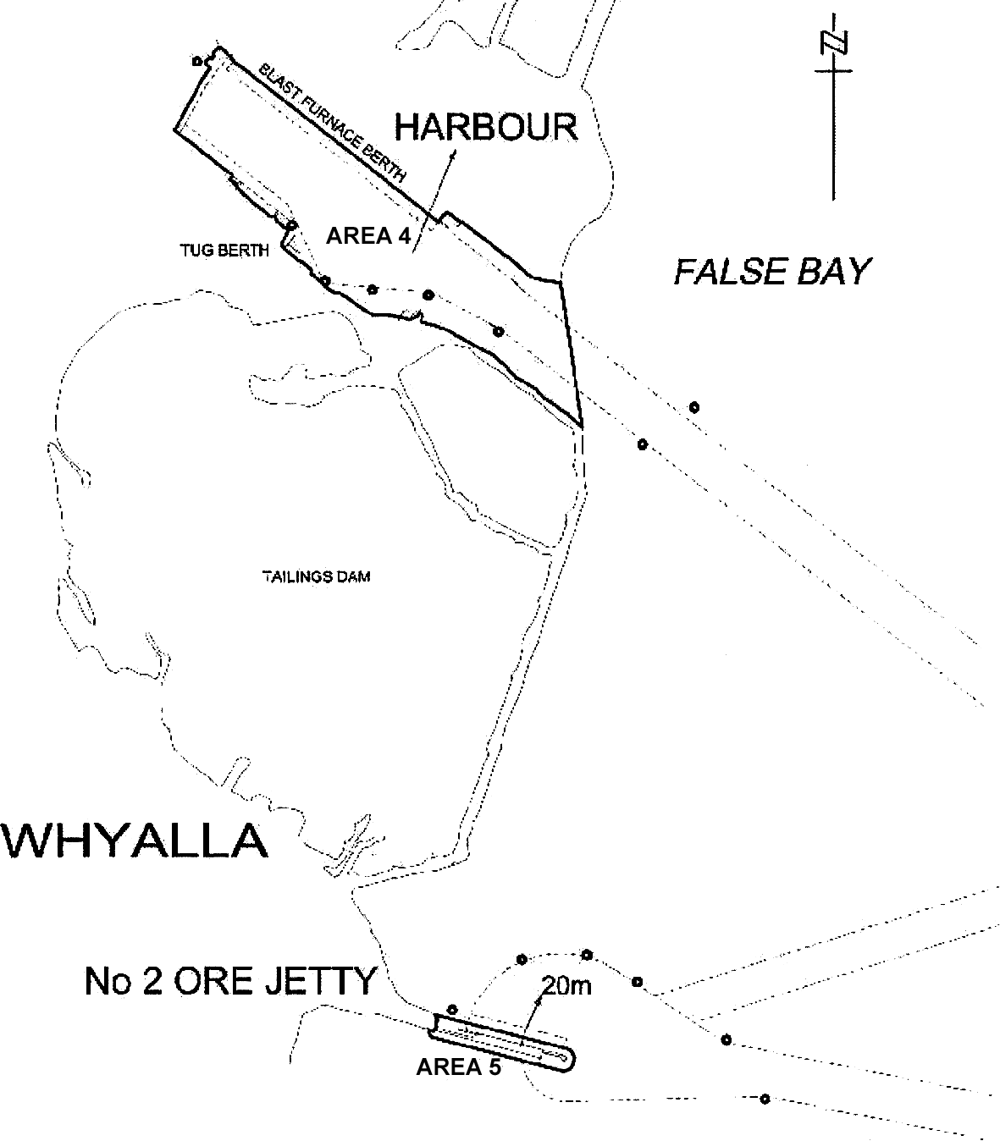

(15) Schedule 5—after the entry relating to Whyalla insert:
Yatco Lagoon
The whole of the waters of Yatco Lagoon, being all of the waters to the south of a straight line from the south-eastern corner of Section 188 to the northern-most point of the headland comprising Section 329.
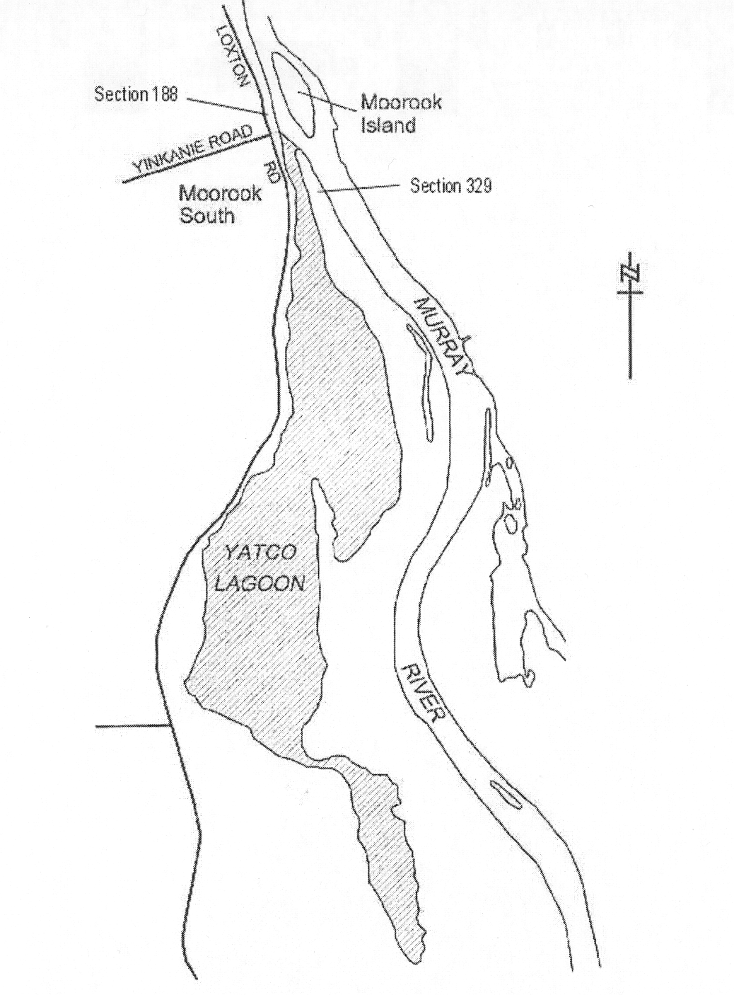
15—Variation of Schedule 10—Speed restrictions in certain waters (Part 10 Division 2)
(1) Schedule 10, clause 2—after paragraph (a) insert:
(aa) Kingston
That portion of the waters of Maria Creek seaward of a line 50 metres upstream of, and parallel to, the eastern boundary of the boat ramp, that portion of the waters of Lacipede Bay in the channel between the northern groyne and the southern groyne (extending from Maria Creek to a line drawn between the western-most end of the northern groyne and the navigation light at the western end of the southern groyne) and that portion of the waters of Lacipede Bay within a 75 metre radius of the midpoint of that line.
(2) Schedule 10, clause 2—after paragraph (b) insert:
(ba) Moonta Bay/Port Hughes
That portion of the waters of Spencer Gulf between the prolongation seaward of the northern boundary of North Terrace, Moonta Bay, and the prolongation seaward of the southern boundary of the Copper Coast District Council (at South Beach) and within 200 metres seaward of high water mark.
(3) Schedule 10, clause 2—after paragraph (d) insert:
(da) Wallaroo Bay
(i) That portion of the waters of Wallaroo Bay between the prolongation seaward of the southern boundary of Phillips Street, Wallaroo, and the southern breakwater of Copper Cove Marina and within 200 metres seaward of highwater mark;
(ii) That portion of the waters of Wallaroo Bay between the northern breakwater of Copper Cove Marina and a line extending due west from the northern end of Otago Road, North Beach, and within 200 metres seaward of highwater mark;
(iii) That portion of the waters of Wallaroo Bay between the prolongation seaward of the southern boundary of Oceanview Drive, North Beach, and the prolongation seaward of the northern boundary of North Beach Road, North Beach.
Note—
As required by section 10AA(2) of the Subordinate Legislation Act 1978, the Minister has certified that, in the Minister's opinion, it is necessary or appropriate that these regulations come into operation as set out in these regulations.
Made by the Governor
with the advice and consent of the Executive Council
on 4 November 2004
No 231 of 2004
2003/09079/CTSA01

South Australia
Australian Road Rules Variation Rules 2004
under the Road Traffic Act 1961

Contents
Part 1—Preliminary
1 Short title
2 Commencement
3 Variation provisions
Part 2—Variation of Australian Road Rules
4 Variation of rule 25—Speed-limit elsewhere
5 Variation of rule 29—Making a left turn as indicated by a road marking
6 Variation of rule 33—Making a right turn
7 Variation of rule 48—Giving a right change of direction signal
8 Variation of rule 56—Stopping for a red traffic light or arrow
9 Substitution of rule 57
57 Stopping for a yellow traffic light or arrow
10 Variation of rule 59—Proceeding through a red traffic light
11 Variation of rule 61—Proceeding when traffic lights or arrows at an intersection change to yellow or red
12 Variation of rule 69—Giving way at a give way sign or give way line at an intersection (except a roundabout)
13 Variation of rule 74—Giving way when entering a road from a road-related area or adjacent land
14 Variation of rule 77—Giving way to buses
15 Variation of rule 91—No left turn and no right turn signs
16 Variation of rule 104—No trucks signs
17 Variation of rule 109—What is a roundabout
18 Variation of rule 111—Entering a roundabout from a multi-lane road or a road with 2 or more lines of traffic travelling in the same direction
19 Variation of rule 117—Giving a change of direction signal when changing marked lanes or lines of traffic in a roundabout
20 Variation of rule 119—Giving way by the rider of a bicycle or animal to a vehicle leaving a roundabout
21 Insertion of rule 128A
128A Entering blocked crossings
22 Variation of rule 129—Keeping to the far left side of a road
23 Variation of rule 134—Exceptions to keeping to the left of a dividing line
24 Variation of rule 136—Driving on a one-way service road
136 Driving on a one-way service road
25 Variation of rule 138—Keeping off a painted island
26 Variation of rule 141—No overtaking etc to the left of a vehicle
27 Variation of rule 148—Giving way when moving from one marked lane or line of traffic to another marked lane or line of traffic
28 Variation of rule 150—Driving on or across a continuous white edge line
29 Variation of rule 158—Exceptions to driving in special purpose lanes etc
30 Variation of rule 160—Passing or overtaking a tram that is not at or near the left side of a road
31 Variation of rule 165—Stopping in an emergency etc or to comply with another rule
32 Variation of rule 170—Stopping in or near an intersection
33 Variation of rule 176—Stopping on a clearway
34 Variation of rule 179—Stopping in a loading zone
35 Variation of rule 198—Obstructing access to and from a footpath, driveway etc
36 Variation of rule 200—Stopping on roads—heavy and long vehicles
37 Insertion of rule 203A
203A Stopping in a slip lane
38 Variation of rule 205—Parking for longer than indicated
39 Variation of rule 208—Parallel parking on a road (except in a median strip parking area)
40 Variation of rule 209—Parallel parking in a median strip parking area
41 Variation of rule 210—Angle parking
42 Substitution of rule 213
213 Making a motor vehicle secure
43 Variation of rule 235—Crossing a level crossing
44 Variation of rule 240—Wheeled recreational devices and toys not to be used on certain roads
45 Variation of rule 242—Travelling in or on a wheeled recreational device or toy on a footpath or shared path
46 Substitution of rule 244
244 Wheeled recreational devices or wheeled toys being towed etc
47 Variation of rule 246—Carrying people on a bicycle
48 Substitution of rule 248
248 No riding across a road on a crossing
49 Variation of rule 268—How persons must travel in or on a motor vehicle
50 Variation of rule 270—Wearing motor bike helmets
51 Variation of rule 271—Riding on motor bikes
52 Variation of rule 287—Duties of a driver involved in a crash
53 Insertion of rule 313A
313A Exemption for garbage truck drivers etc
54 Variation of rule 322—References to traffic control devices and traffic-related items on a road etc
55 Variation of rule 334—How parking control signs apply to a length of road
56 Variation of rule 341—Road markings
57 Variation of Schedule 3—Other permitted traffic signs
58 Variation of Dictionary

Part 1—Preliminary
1—Short title
These rules may be cited as the Australian Road Rules Variation Rules 2004.
2—Commencement
These rules come into operation on the day on which they are made.
3—Variation provisions
In these rules, a provision under a heading referring to the variation of specified rules varies the rules so specified.
Part 2—Variation of Australian Road Rules
4—Variation of rule 25—Speed-limit elsewhere
Rule 25(2)—delete "60" and substitute:
50
5—Variation of rule 29—Making a left turn as indicated by a road marking
Rule 29—after "as indicated by the road marking" insert:
unless the driver is turning, at B lights or traffic arrows, in accordance with Division 2 of Part 17
6—Variation of rule 33—Making a right turn
Rule 33(1)—after "this rule" insert:
unless the driver is turning, at B lights or traffic arrows, in accordance with Division 2 of Part 17
7—Variation of rule 48—Giving a right change of direction signal
Rule 48—after subrule (3) insert:
(3A) Subrule (3) does not apply to the rider of a bicycle that is stopped in traffic but not parked.
8—Variation of rule 56—Stopping for a red traffic light or arrow
(1) Rule 56(1)(c)—delete "nearest or only traffic lights." and substitute:
nearest or only traffic lights;
(2) Rule 56(1)—after paragraph (c) insert:
and must not proceed past the stop line, stop here on red signal sign or nearest or only traffic lights (as the case may be) until the traffic lights show a green or flashing yellow traffic light or no traffic light.
(3) Rule 56(1), example—delete the example and substitute:
Example for subrule (1) (b)—
Stopping at a stop here on red signal sign
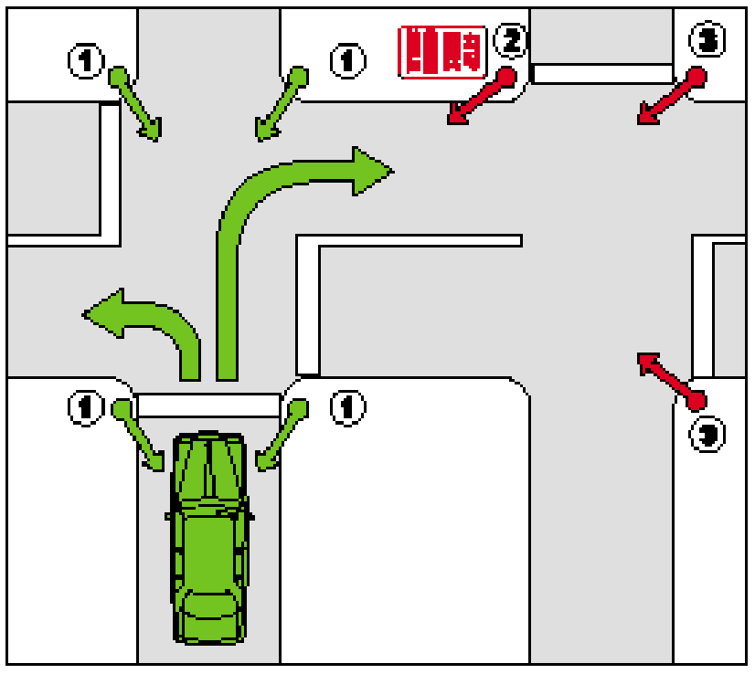
In this example the driver may go straight ahead, or turn right or left, if there is a green traffic light showing at 1. However, the driver must not go beyond the stop here on red signal sign at 2 if there is a red traffic light showing on the road the driver is entering (see 2 and 3).
(4) Rule 56—after subrule (1), including the example, insert:
(1A) However, if the traffic lights are at an intersection with a left turn on red after stopping sign and the driver is turning left at the intersection, the driver may turn left after stopping.
Note—
Rule 62 deals with the give way rules applying to a driver turning left at an intersection after stopping at a left turn on red after stopping sign.
(5) Rule 56(2)(c)—delete "nearest or only traffic arrows." and substitute:
nearest or only traffic arrows;
(6) Rule 56(2)—after paragraph (c) insert:
and must not proceed past the stop line, stop here on red arrow sign or nearest or only traffic arrows (as the case may be) until the traffic arrows show a green or flashing yellow traffic arrow or no traffic arrow.
9—Substitution of rule 57
Rule 57—delete the rule and substitute:
57—Stopping for a yellow traffic light or arrow
(1) A driver approaching or at traffic lights showing a yellow traffic light must stop:
(a) if there is a stop line at or near the traffic lights and the driver can stop safely before reaching the stop line—as near as practicable to, but before reaching, the stop line; or
(b) if there is no stop line at or near the traffic lights and the driver can stop safely before reaching the traffic lights—as near as practicable to, but before reaching, the nearest or only traffic lights; or
(c) if the traffic lights are at an intersection and the driver cannot stop safely in accordance with paragraph (a) or (b), but can stop safely before entering the intersection—before entering the intersection;
and must not proceed past the stop line or nearest or only traffic lights, or into the intersection (as the case may be), until the traffic lights show a green or flashing yellow traffic light or no traffic light.
Offence provision.
Note—
Enter, intersection, stop line and yellow traffic light are defined in the dictionary.
(2) A driver approaching or at traffic arrows showing a yellow traffic arrow who is turning in the direction indicated by the arrow must stop:
(a) if there is a stop line at or near the traffic arrows and the driver can stop safely before reaching the stop line—as near as practicable to, but before reaching, the stop line; or
(b) if there is no stop line at or near the traffic arrows and the driver can stop safely before reaching the traffic arrows—as near as practicable to, but before reaching, the nearest or only traffic arrows; or
(c) if the traffic arrows are at an intersection and the driver cannot stop safely in accordance with paragraph (a) or (b), but can stop safely before entering the intersection—before entering the intersection;
and must not proceed past the stop line or nearest or only traffic arrows, or into the intersection (as the case may be), until the traffic arrows show a green or flashing yellow traffic arrow or no traffic arrow.
Offence provision.
Note—
Enter, intersection, stop line and yellow traffic arrow are defined in the dictionary.
(3) If the traffic lights or traffic arrows (as the case may be) are at an intersection and the driver is not able to stop safely under subrule (1) or (2) (as the case may be) and enters the intersection, the driver must leave the intersection as soon as the driver can do so safely.
Offence provision.
Note 1—
Intersection does not include a road-related area—see the definition in the Dictionary.
Note 2—
This rule applies to a driver turning left using a slip lane only if the yellow traffic light or yellow traffic arrow (as the case may be) applies to the slip lane—see Part 20, Divisions 2 and 3, especially rules 330 and 345.
Note 3—
Rule 58 deals with when a driver does not have to stop at a yellow traffic light.
10—Variation of rule 59—Proceeding through a red traffic light
(1) Rule 59(1), including the notes—delete subrule (1), including the notes, and substitute:
(1) If traffic lights at an intersection or marked foot crossing are showing a red traffic light, a driver must not enter the intersection or marked foot crossing.
Offence provision.
Note 1—
Enter, intersection, marked foot crossing and red traffic light are defined in the dictionary.
Note 2—
Rules 56 and 57 deal with stopping for a red or yellow traffic light, and proceeding while the light remains red or yellow. Rule 60 deals with proceeding through a red traffic arrow.
(2) Rule 59(3)—delete "subrule 58(1)" and substitute:
rule 58(1)
11—Variation of rule 61—Proceeding when traffic lights or arrows at an intersection change to yellow or red
(1) Rule 61(2)—delete "or arrows" and substitute:
or traffic arrows (as the case may be)
(2) Rule 61(4)—delete "subrule 58(1)" and substitute:
rule 58(1)
(3) Rule 61(5)—delete "or arrows" and substitute:
or traffic arrows (as the case may be)
12—Variation of rule 69—Giving way at a give way sign or give way line at an intersection (except a roundabout)
(1) Rule 69(1)—after "intersection" insert:
(except a roundabout)
(2) Rule 69(1), note 1—delete note 1 and substitute:
Note 1—
Give way line and intersection are defined in the dictionary, and roundabout is defined in rule 109. This rule also applies to T-intersections—see the definition of intersection.
(3) Rule 69(2)—delete "The driver" and substitute:
Unless the driver is turning left using a slip lane, the driver
(4) Rule 69—after subrule (2) insert:
(2A) If the driver is turning left using a slip lane, the driver must give way to:
(a) any vehicle on the road the driver is entering, or turning right at the intersection into the road the driver is entering (except a vehicle making a U-turn at the intersection); and
(b) any other vehicle or pedestrian on the slip lane.
13—Variation of rule 74—Giving way when entering a road from a road-related area or adjacent land
Rule 74(1)(d)—delete paragraph (d) and substitute:
(d) for a driver entering the road from a road-related area:
(i) any pedestrian on the road-related area; and
(ii) any other vehicle ahead of the driver’s vehicle or approaching from the left or right.
14—Variation of rule 77—Giving way to buses
Rule 77(1)—after "or left line of traffic," insert:
or in a bicycle lane on the far left side of the road,
15—Variation of rule 91—No left turn and no right turn signs
Rule 91—after subrule (2) insert:
(3) However, a driver may make a U-turn at the intersection if there is a U-turn permitted sign at the intersection.
16—Variation of rule 104—No trucks signs
Rule 104—after subrule (3) insert:
(4) However, a driver may drive a truck on a road past a no trucks sign if the destination of the truck lies beyond that sign and:
(a) there is no other route by which the truck could reach that destination; or
(b) any other route by which the truck could reach that destination would require the truck to pass another no trucks sign.
17—Variation of rule 109—What is a roundabout
Rule 109(a)—delete paragraph (a) and substitute:
(a) either:
(i) one or more marked lanes, all of which are for the use of vehicles travelling in the same direction around a central traffic island; or
(ii) room for 1 or more lines of traffic travelling in the same direction around a central traffic island; and
18—Variation of rule 111—Entering a roundabout from a multi-lane road or a road with 2 or more lines of traffic travelling in the same direction
(1) Rule 111(1)—delete "2 or more lines of traffic" and substitute:
room for 2 or more lines of traffic (other than motor bikes, bicycles, motorised wheelchairs or animals)
(2) Rule 111(2)—delete "or left line of traffic" and substitute:
or, if the road is not a multi-lane road, as near as practicable to the left side of the road
(3) Rule 111(2), example—delete the example and substitute:
Example—
Example 1
Leaving a roundabout less than halfway around it
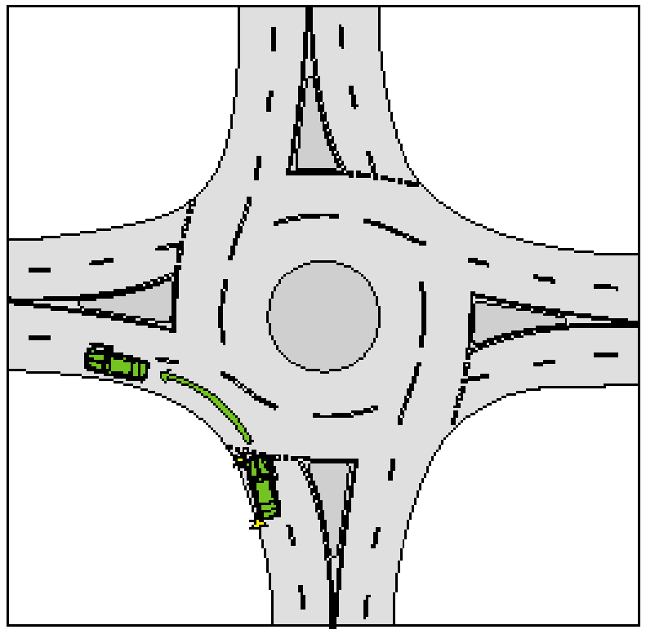
(4) Rule 111(3)—delete "or right line of traffic" and substitute:
or, if the road is not a multi-lane road, from the left of, parallel to, and as near as practicable to, the dividing line or median strip
(5) Rule 111(3), example—delete the example and substitute:
Example—
Example 2
Leaving a roundabout more than halfway around it
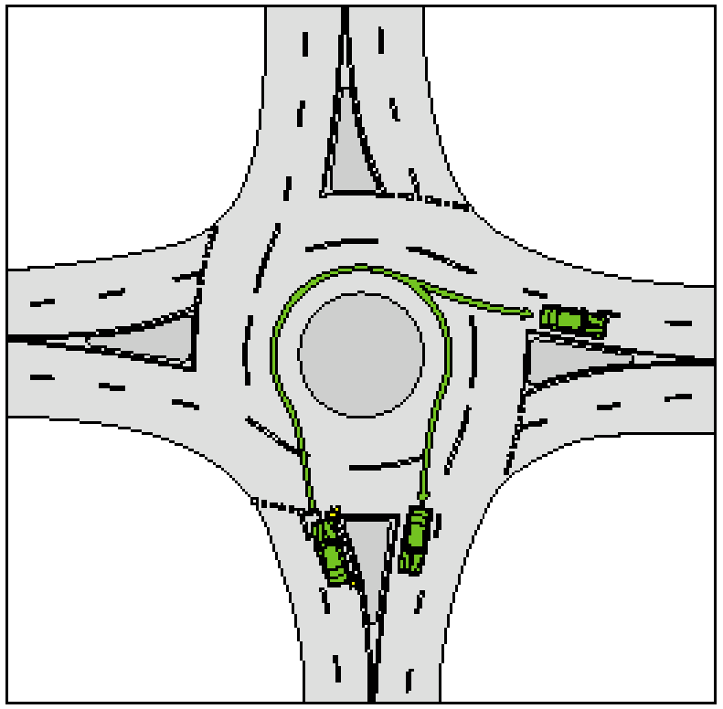
(6) Rule 111(4)—delete "or line of traffic" and substitute:
or, if the road is not a multi-lane road, anywhere on the part of the road on which vehicles travelling in the same direction as the driver may travel
(7) Rule 111(4), example—delete the example and substitute:
Example—
Example 3
Leaving a roundabout halfway around it
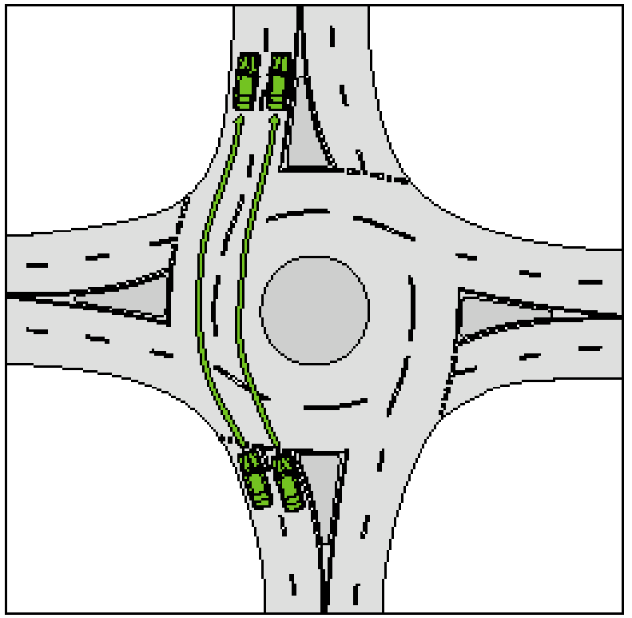
(8) Rule 111(5)—at the foot insert:
Examples—
Example 4
Roundabout with 3 entry points
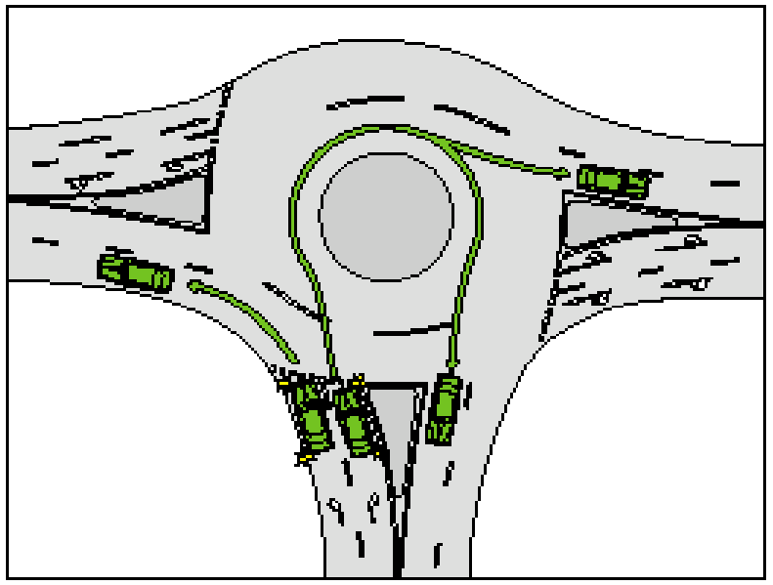
Example 5
Roundabout with 5 entry points
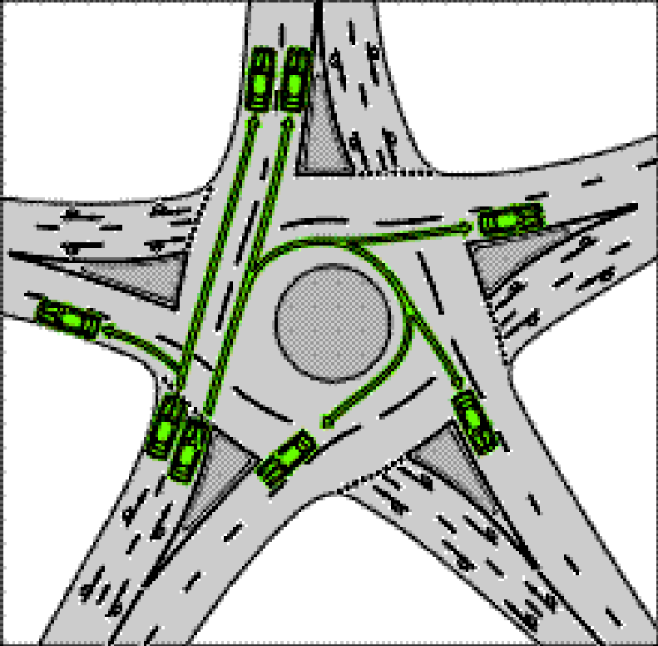
Note 1 for examples 4 and 5—
Rule 116 requires a driver to obey traffic lane arrows when driving in or leaving a roundabout.
Note 2 for examples 4 and 5—
The rules in Part 11 about driving in marked lanes, and moving from one marked lane or line of traffic to another marked lane or line of traffic, apply to a driver driving in a roundabout—see rules 146 to 148.
(9) Rule 111(7), examples and notes—delete the examples and notes
(10) Rule 111—after subrule (7) insert:
(8) Despite subrule (2), a driver may approach and enter the roundabout from the marked lane next to the left lane as well as, or instead of, the left lane if:
(a) the driver’s vehicle, together with any load or projection, is 7.5 metres long, or longer; and
(b) the vehicle displays a do not overtake turning vehicle sign; and
(c) any part of the vehicle is within 50 metres of the nearest point of the roundabout; and
(d) it is not practicable for the driver to leave the roundabout less than halfway around it from within the left lane; and
(e) the driver can safely occupy the next marked lane and can safely leave the roundabout less than halfway around it by occupying the next marked lane, or both lanes.
(9) Despite subrule (3), a driver may approach and enter the roundabout from the marked lane next to the right lane as well as, or instead of, the right lane if:
(a) the driver’s vehicle, together with any load or projection, is 7.5 metres long, or longer; and
(b) the vehicle displays a do not overtake turning vehicle sign; and
(c) any part of the vehicle is within 50 metres of the nearest point of the roundabout; and
(d) it is not practicable for the driver to leave the roundabout more than halfway around it from within the right lane; and
(e) the driver can safely occupy the next marked lane and can safely leave the roundabout more than halfway around it by occupying the next marked lane, or both lanes.
(10) In this rule:
left lane means:
(a) the marked lane nearest to the far left side of the road; or
(b) if there is an obstruction (for example, a parked car or roadworks) in that marked lane—the marked lane nearest to that marked lane that is not obstructed.
marked lane, for a driver, does not include a special purpose lane in which the driver is not permitted to drive.
right lane means:
(a) the marked lane nearest to the dividing line or median strip on the road; or
(b) if there is an obstruction (for example, a parked car or roadworks) in that marked lane—the marked lane nearest to that marked lane that is not obstructed.
19—Variation of rule 117—Giving a change of direction signal when changing marked lanes or lines of traffic in a roundabout
(1) Rule 117(1)—delete "a line of traffic" and substitute:
a part of the roundabout where there is room for another line of traffic
(2) Rule 117(2)—delete "a line of traffic" and substitute:
a part of the roundabout where there is room for another line of traffic
20—Variation of rule 119—Giving way by the rider of a bicycle or animal to a vehicle leaving a roundabout
Rule 119—delete "2 or more lines of traffic," and substitute:
room for 2 or more lines of traffic (other than motor bikes, bicycles, motorised wheelchairs or animals),
21—Insertion of rule 128A
After rule 128 insert in Division 1:
128A—Entering blocked crossings
A driver must not enter a children’s crossing, marked foot crossing or pedestrian crossing if the driver cannot drive through the crossing because the crossing, or a road beyond the crossing, is blocked.
Offence provision.
Examples—
The crossing, or a road beyond the crossing, may be blocked by congested traffic, a disabled vehicle, a collision between vehicles or between a vehicle and a pedestrian, or by a fallen load on the road.
Note—
Children’s crossing, enter, marked foot crossing and pedestrian crossing are defined in the dictionary.
22—Variation of rule 129—Keeping to the far left side of a road
Rule 129(1)—delete "(except a multi-lane road or a road with 2 or more lines of traffic travelling in the same direction as the driver)" and substitute:
(except a multi-lane road)
23—Variation of rule 134—Exceptions to keeping to the left of a dividing line
Rule 134(2), except the notes—delete subrule (2), except the notes, and substitute:
(2) If the dividing line is a broken dividing line only, or a broken dividing line to the left of a single continuous dividing line, the driver may drive to the right of the dividing line:
(a) to overtake another driver; or
(b) to perform a U-turn, unless another rule would prohibit the driver performing the U-turn.
24—Variation of rule 136—Driving on a one-way service road
Rule 136, except the diagram and the note for the diagram—delete the rule, except the diagram and the note for the diagram, and substitute:
136—Driving on a one-way service road
A driver on the part of the road that is a service road (except a service road to which a two-way sign applies) must drive in the same direction as a vehicle travelling on the part of the road closest to the service road is required to travel.
Offence provision.
Note—
Service road is defined in the dictionary.
25—Variation of rule 138—Keeping off a painted island
Rule 138(2)—delete "a painted island" and substitute:
a painted island for up to 50 metres
26—Variation of rule 141—No overtaking etc to the left of a vehicle
Rule 141(1)—after paragraph (b) insert:
or
(c) the vehicle is stationary and it is safe to overtake to the left of the vehicle.
27—Variation of rule 148—Giving way when moving from one marked lane or line of traffic to another marked lane or line of traffic
(1) Rule 148(1), example—delete the example and substitute:
Examples—
Giving way when moving from one marked lane to another marked lane

Example 1  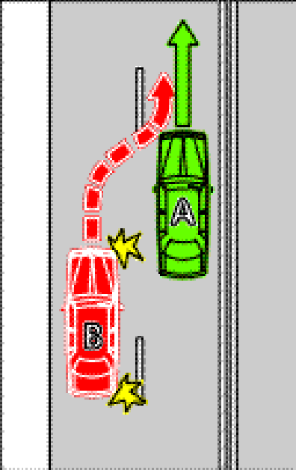 | Example 2  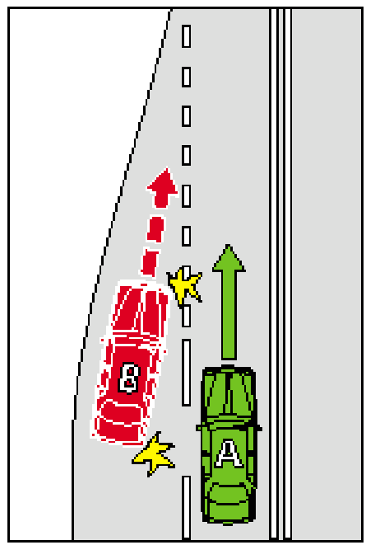
In these examples, vehicle B must give way to vehicle A
(2) Rule 148(2)—delete "(whether or not the line of traffic is ending)"
28—Variation of rule 150—Driving on or across a continuous white edge line
Rule 150—after subrule (2) insert:
(3) For this rule, a driver drives over a continuous white edge line on a road if:
(a) for a line on the far left side of the road—the driver’s vehicle is wholly or partly to the left of the line; or
(b) for a line on the far right side of the road—the driver’s vehicle is wholly or partly to the right of the line.
29—Variation of rule 158—Exceptions to driving in special purpose lanes etc
Rule 158(1)(d)—delete "or a line of traffic," and substitute:
or part of the road where there is room for a line of traffic (other than motor bikes, bicycles, motorised wheelchairs or animals),
30—Variation of rule 160—Passing or overtaking a tram that is not at or near the left side of a road
Rule 160(2)—delete "of the tram" and substitute:
of the tram, unless the driver is permitted to do so by a traffic sign or road marking
31—Variation of rule 165—Stopping in an emergency etc or to comply with another rule
(1) Rule 165(c)—after "emergency," insert:
or to assist a disabled vehicle,
(2) Rule 165, note—delete the note and substitute:
Note 1—
See rule 125 (in Part 11) for the offence of unreasonably obstructing the path of another vehicle or a pedestrian.
Note 2—
Driver’s vehicle is defined in the dictionary.
32—Variation of rule 170—Stopping in or near an intersection
Rule 170(1)—delete subrule (1) and substitute:
(1) A driver must not stop in an intersection unless:
(a) the driver is permitted to stop at that place under the Australian Road Rules; or
(b) the intersection is a T-intersection without traffic lights and the driver stops along the continuous side of the continuing road at the intersection.
Offence provision.
Note—
Continuing road, intersection and T-intersection are defined in the dictionary.
33—Variation of rule 176—Stopping on a clearway
Rule 176—after subrule (1) insert:
(1A) In subrule (1):
road does not include a road-related area.
Note—
Road-related area is defined in rule 13.
34—Variation of rule 179—Stopping in a loading zone
Rule 179(2)—after paragraph (b) insert:
or
(c) for a driver who is permitted to stop in the loading zone under another law of this jurisdiction that provides for a shorter period—that period.
35—Variation of rule 198—Obstructing access to and from a footpath, driveway etc
(1) Rule 198(2)(a)—delete paragraph (a) and substitute:
(a) the driver:
(i) is dropping off, or picking up, passengers; and
(ii) does not leave the vehicle unattended; and
(iii) completes the dropping off, or picking up, of the passengers, and drives on, as soon as possible and, in any case, within 2 minutes after stopping; or
(2) Rule 198—after subrule (2), including the example, insert:
(3) For this rule, a driver leaves a vehicle unattended if the driver leaves the vehicle so that the driver is over 3 metres from the closest point of the vehicle.
36—Variation of rule 200—Stopping on roads—heavy and long vehicles
(1) Rule 200(2)—after "under" insert:
subrule (2A) or
(2) Rule 200—after subrule (2) insert:
(2A) The driver of a heavy vehicle, or long vehicle, other than a bus, is permitted to stop on a length of road in a built up area for longer than 1 hour if, throughout the period when the vehicle is stopped on the length of road, the driver is engaged in dropping off, or picking up, goods.
37—Insertion of rule 203A
After rule 203 insert:
203A—Stopping in a slip lane
A driver must not stop in a slip lane unless:
(a) a parking control sign applies to the place where the driver stops; and
(b) the driver is permitted to stop at that place under the Australian Road Rules.
Offence provision.
Note—
Parking control sign and slip lane are defined in the dictionary.
38—Variation of rule 205—Parking for longer than indicated
Rule 205—after its present contents (now to be designated as subrule (1)) insert:
(2) For subrule (1), a driver parks continuously on a length of road, or in an area, to which a permissive parking sign applies, from the time when the driver parks on the length of road, or in the area, until the driver, or another driver, moves the vehicle off the length of road, or out of the area, to which the permissive parking sign applies.
39—Variation of rule 208—Parallel parking on a road (except in a median strip parking area)
Rule 208(2), except the note—delete subrule (2), except the note, and substitute:
(2) The driver must position the vehicle to face:
(a) in the direction of travel of vehicles in the marked lane or line of traffic on, or next to, the part of the road where the driver parks; or
(b) if there is no traffic on, or next to, that part of the road—in the direction in which vehicles could lawfully travel on that part of the road.
40—Variation of rule 209—Parallel parking in a median strip parking area
Rule 209(2)(a)—delete paragraph (a) and substitute:
(a) to face:
(i) in the direction of travel of vehicles in the marked lane or line of traffic to the left of the driver; or
(ii) if there is no traffic to the left of the driver—in the direction in which vehicles could lawfully travel on that part of the road; and
41—Variation of rule 210—Angle parking
(1) Rule 210(1), except the notes—delete subrule (1), except the notes, and substitute:
(1) If a driver parks in a parking area on the side of a road, or in a median strip parking area:
(a) to which a parking control sign with the words ‘angle parking’ or ‘angle’ applies; or
(b) to which a road marking indicating an angle applies;
the driver must position the driver’s vehicle in accordance with subrules (2) to (4).
Offence provision.
(2) Rule 210(2), including the note and examples—delete subrule (2), including the note and examples, and substitute:
(2) If the parking control sign or road marking indicates that the vehicle must be positioned at a specified angle (other than 90°), the driver must position the vehicle:
(a) so that the vehicle is at an angle as near as practicable to the specified angle; and
(b) if the vehicle is parked on the side of the road—with the rear of the vehicle nearest to the centre of the road.
(2A) If the parking control sign or road marking does not indicate the angle at which the vehicle must be positioned, the driver must position the vehicle:
(a) so that the vehicle is at an angle as near as practicable to 45°, as shown in example 1 or 2; and
(b) if the vehicle is parked on the side of the road—with the rear of the vehicle nearest to the centre of the road.
Examples—

Example 1  Parking at 45° at the side of a two-way road  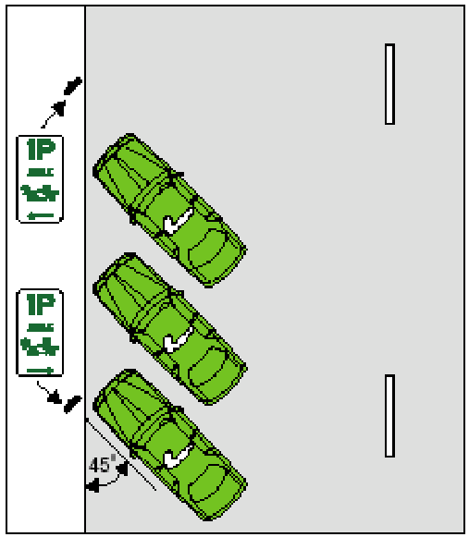 | Example 2  Parking at 45° at the side of a one-way road  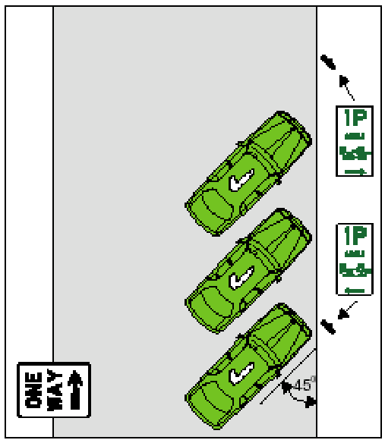
(2B) Subrules (2) and (2A) do not apply if the road marking, or information on the parking control sign, includes the words ‘rear in’ or similar words.
(3) Rule 210(3)—delete "information on or with"
(4) Rule 210(3)(b)—delete paragraph (b) and substitute:
(b) if the vehicle is parked on the side of the road:
(i) if the road marking, or information on the parking control sign, includes the words ‘rear in’ or ‘front in’, or similar words—must position the vehicle so that the front of the vehicle is nearest the centre of the road, or the rear of the vehicle is nearest the centre of the road, in accordance with the road marking or sign; or
(ii) otherwise—may position the vehicle either way around.
(5) Rule 210(4), including the examples—delete subrule (4), including the examples, and substitute:
(4) If the road marking, or information on the parking control sign, includes the words ‘rear in’, or similar words, the driver must position the driver’s vehicle:
(a) so that the vehicle is at an angle as near as practicable to:
(i) the angle indicated by the road marking or parking control sign; or
(ii) if the road marking or parking control sign does not indicate an angle—45°; and
(b) if the vehicle is parked on the side of the road—with the front of the vehicle nearest to the centre of the road.
(4A) Subrule (4) does not apply if the parking control sign or road marking indicates that the vehicle must be positioned at an angle of 90°.
Examples for subrule (4)—

Example 5  Parking ‘rear in’ at 30° at the side of a road  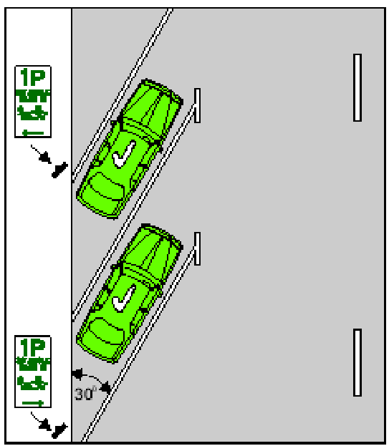 | Example 6  Parking ‘rear in’ at 30° in a median strip parking area  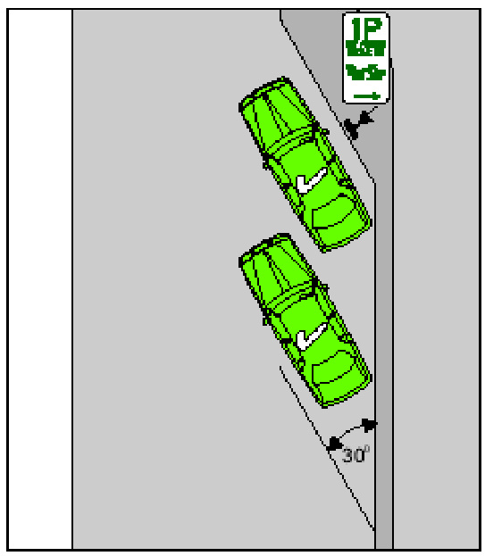
Example 7  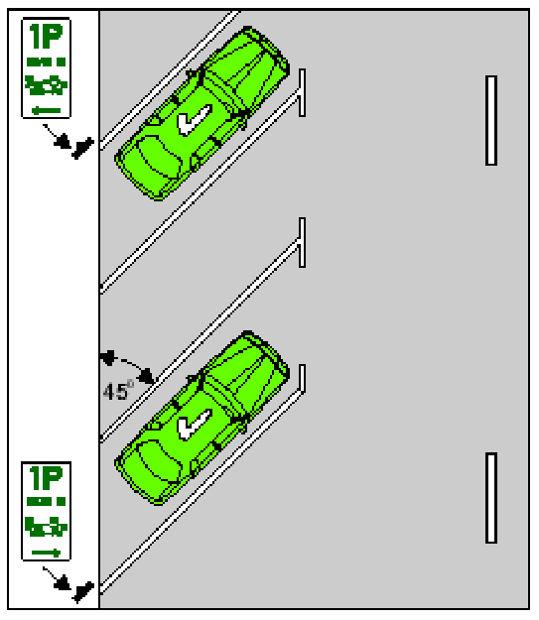 | Example 8  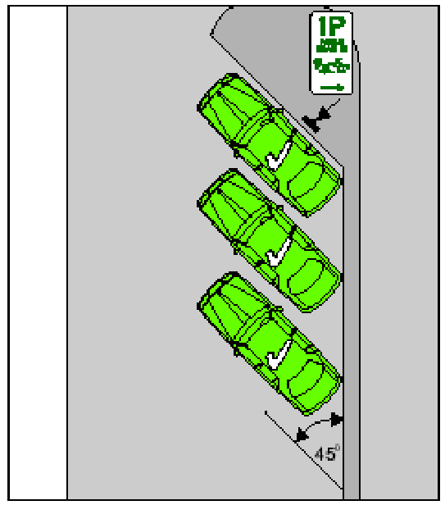
Example 9  Parking 'rear in' at 60° at the side of a road  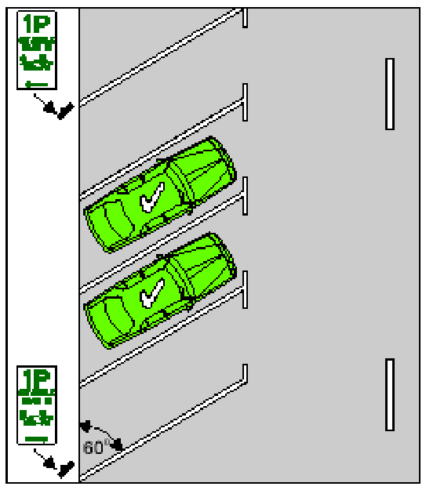 | Example 10  Parking 'rear in' at 60º in a median strip parking area  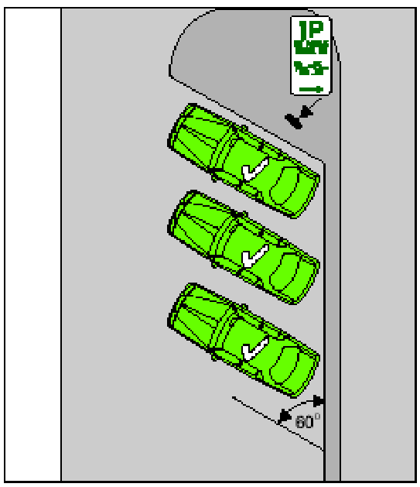
42—Substitution of rule 213
Rule 213—delete the rule and substitute:
213—Making a motor vehicle secure
(1) This rule applies to the driver of a motor vehicle who stops and leaves the vehicle on a road, except so far as the driver is exempt from this rule under another law of this jurisdiction.
Note—
Motor vehicle is defined in the dictionary.
(2) Before leaving the vehicle, the driver must apply the parking brake effectively or, if weather conditions (for example, snow) would prevent the effective operation of the parking brake, effectively restrain the motor vehicle’s movement in another way.
Offence provision.
(3) If the driver will be over 3 metres from the closest part of the vehicle, the driver must switch off the engine before leaving the vehicle.
Offence provision.
(4) If the driver will be over 3 metres from the closest part of the vehicle, and:
(i) there is no-one left in the vehicle; or
(ii) there is only a child or children under 16 years old left in the vehicle;
the driver must remove the ignition key before leaving the vehicle.
Offence provision.
(5) If:
(a) the driver will be over 3 metres from the closest part of the vehicle; and
(b) there is no-one left in the vehicle; and
(c) the doors of the vehicle can be locked;
the driver must also lock the doors of the vehicle immediately after leaving the vehicle.
Offence provision.
43—Variation of rule 235—Crossing a level crossing
Rule 235(2), example heading—delete example heading and substitute:
Example for subrule (2)(e)—
44—Variation of rule 240—Wheeled recreational devices and toys not to be used on certain roads
Rule 240(1), except the note—delete subrule (1), except the note, and substitute:
(1) A person must not travel in or on a wheeled recreational device or wheeled toy on:
(a) a road with a dividing line or median strip; or
(b) a road on which the speed-limit is greater than 60 kilometres per hour; or
(c) a one-way road with more than 1 marked lane.
Offence provision.
45—Variation of rule 242—Travelling in or on a wheeled recreational device or toy on a footpath or shared path
(1) Rule 242(2)—after "a shared path sign" insert:
or shared path road marking
(2) Rule 242(2)(a)—after "sign" insert:
or end shared path road marking
(3) Rule 242(2)(c)—after "sign" insert:
or bicycle path road marking
(4) Rule 242(2), note—delete the note and substitute:
Note—
Bicycle and no bicycles road marking are defined in the dictionary, road-related area is defined in rule 13, and bicycle path road marking and separated footpath are defined in rule 239.
(5) Rule 242—after subrule (2), including the diagrams and notes, insert:
(3) In this rule:
end shared path road marking means a shared path road marking with the word ‘end’.
shared path road marking means a road marking consisting of a pedestrian symbol above a bicycle symbol.
46—Substitution of rule 244
Rule 244—delete the rule and substitute:
244—Wheeled recreational devices or wheeled toys being towed etc
(1) A person must not travel in or on a wheeled recreational device or wheeled toy that is being towed by a vehicle.
Offence provision.
(2) A person travelling in or on a wheeled recreational device or wheeled toy must not hold onto a vehicle while the vehicle is moving.
Offence provision.
(3) A person travelling in or on a wheeled recreational device or wheeled toy must not travel within 2 metres of the rear of a moving motor vehicle continuously for more than 200 metres.
Offence provision.
Note—
Vehicle is defined in rule 15.
47—Variation of rule 246—Carrying people on a bicycle
Rule 246—insert at the foot:
Example—
A single-seat bicycle with a child’s seat attached is designed to carry 2 people, 1 on the bicycle seat and 1 on the attached child’s seat.
48—Substitution of rule 248
Rule 248—delete the rule and substitute:
248—No riding across a road on a crossing
(1) The rider of a bicycle must not ride across a road, or part of a road, on a children’s crossing or pedestrian crossing.
Offence provision.
Note—
Children’s crossing is defined in rule 80, and pedestrian crossing is defined in rule 81.
(2) The rider of a bicycle must not ride across a road, or part of a road, on a marked foot crossing, unless there are bicycle crossing lights at the crossing showing a green bicycle crossing light.
Offence provision.
Note—
Marked foot crossing is defined in the dictionary.
49—Variation of rule 268—How persons must travel in or on a motor vehicle
Rule 268—after subrule (4) insert:
(4A) The driver of a motor vehicle must not drive with a passenger who is under 16 years old in or on a part of the vehicle that is not a part designed primarily for the carriage of passengers or goods.
Offence provision.
(4B) The driver of a motor vehicle must not drive with a passenger who is under 16 years old in or on a part of the vehicle that is a part designed primarily for the carriage of goods if the part is:
(a) not enclosed; or
(b) declared under another law of this jurisdiction to be a part of the vehicle in or on which persons must not be carried.
Offence provision.
50—Variation of rule 270—Wearing motor bike helmets
Rule 270(3), definition of passenger—delete the definition and substitute:
passenger, of a motor bike, includes a person on a passenger seat of the motor bike (including the pillion seat), or in a sidecar.
51—Variation of rule 271—Riding on motor bikes
(1) Rule 271(2)—delete "sidecar)" and substitute:
sidecar or on a seat designed for a passenger, other than a pillion seat)
(2) Rule 271(3)—delete "sidecar)" and substitute:
sidecar or other seat designed for a passenger)
(3) Rule 271(4)—delete "sidecar)" and substitute:
sidecar or other seat designed for a passenger, other than a pillion seat)
(4) Rule 271(5)—delete subrule (5) and substitute:
(5) The rider of a motor bike must not ride with more passengers in a sidecar, or on a seat designed for a passenger, than the sidecar, or seat, is designed to carry.
Offence provision.
52—Variation of rule 287—Duties of a driver involved in a crash
(1) Rule 287(2)—delete "(or the driver's representative) must give" and substitute:
must stop at the scene of the crash and give
(2) Rule 287(3)—delete "(or the driver's representative)"
53—Insertion of rule 313A
After rule 313 insert in Part 19:
313A—Exemption for garbage truck drivers etc
Another law of this jurisdiction may provide that a provision of the Australian Road Rules that is specified in the other law does not apply to the driver of a garbage or waste disposal truck while:
(a) the driver is engaged in the collection of waste or garbage; and
(b) the driver is unable to comply with the provision; and
(c) the garbage or waste disposal truck is displaying a flashing light; and
(d) the driver is acting safely.
54—Variation of rule 322—References to traffic control devices and traffic-related items on a road etc
Rule 322(1)—after example 2 insert:
3 A do not overtake turning vehicle sign attached to a vehicle on a road is taken to be a do not overtake turning vehicle sign on the road.
55—Variation of rule 334—How parking control signs apply to a length of road
(1) Rule 334(1)—delete "parking control sign" and substitute:
permissive parking sign, bicycle parking sign or motor bike parking sign, or a zone sign mentioned in Division 5 of Part 12,
(2) Rule 334(1) note—delete the note and substitute:
Note 1—
Parking bay and with are defined in the dictionary.
Note 2—
Rule 201 deals with bicycle parking signs, rule 202 deals with motor bike parking signs, and rule 204 deals with permissive parking signs.
56—Variation of rule 341—Road markings
Rule 341—after example 2 insert:
3 At an intersection, or on a roundabout, road markings indicating the edge of a marked lane for use by traffic coming from another direction do not apply to the driver.
57—Variation of Schedule 3—Other permitted traffic signs
(1) Schedule 3—before the item headed "Separated footpath sign" insert:
School zone sign
(rule 23)

(2) Schedule 3, item headed "Speed-limit sign"—delete the item
58—Variation of Dictionary
(1) Dictionary, definition of bicycle—delete "1 or more" and substitute:
2 or more
(2) Dictionary, definition of bicycle, (a)—delete paragraph (a) and substitute:
(a) includes a pedicab, penny-farthing and tricycle; but
(3) Dictionary, definition of intersection, (b)—delete paragraph (b) and substitute:
(b) the place where any slip lane between the roads meets the road into which traffic on the slip lane may turn;
(4) Dictionary—after definition of level crossing insert:
line of traffic means:
(a) 2 or more vehicles travelling in line along a road (whether or not the vehicles are actually moving, but not including vehicles in a marked lane); or
(b) a single vehicle, other than a vehicle that is part of a line of traffic under paragraph (a), that is travelling along a road (whether or not the vehicle is actually moving, but not including a vehicle in a marked lane).
Examples—
1 A vehicle travelling along a road (except in a marked lane) in line behind another vehicle (the leading vehicle) forms part of a line of traffic with the leading vehicle.
2 A vehicle travelling along a road (except in a marked lane) with no other vehicles in the vicinity constitutes a line of traffic by itself.
3 Two vehicles travelling in the same direction on a road (except in a marked lane), but not in line, are 2 lines of traffic.
(5) Dictionary, definition of overtake, (b)—delete paragraph (b) and substitute:
(b) moving into an adjacent marked lane or part of the road on which there is room for a line of traffic (whether or not the lane or part of the road is for drivers travelling in the same direction); and
(6) Dictionary, definition of T-intersection—after "an intersection" insert:
, other than a roundabout,
(7) Dictionary—after definition of tram lane insert:
tram stop means a portion of a road that is designated by a public transport operator as a tram stop, and near which is erected a sign inscribed with the words ‘tram stop’ or ‘hail trams here’, or words to similar effect.
(8) Dictionary, definition of wheeled recreational device, (a)—after "skateboard" insert:
, scooter, unicycle
(9) Dictionary, definition of wheeled recreational device, (b)—after "trolley," insert:
a motor-assisted device (whether or not the motor is operating),
Note—
As required by section 10AA(2) of the Subordinate Legislation Act 1978, the Minister has certified that, in the Minister's opinion, it is necessary or appropriate that these rules come into operation as set out in these rules.
Made by the Governor
with the advice and consent of the Executive Council
on 4 November 2004
No 232 of 2004
MTRAN15/04CS

South Australia
Road Traffic (Road Rules—Ancillary and Miscellaneous Provisions) Variation Regulations 2004
under the Road Traffic Act 1961

Contents
Part 1—Preliminary
1 Short title
2 Commencement
3 Variation provisions
Part 2—Variation of Road Traffic (Road Rules—Ancillary and Miscellaneous Provisions) Regulations 1999
4 Revocation of regulation 9B
5 Revocation of regulation 17
6 Variation of regulation 30—Certain crashes required to be reported to police

Part 1—Preliminary
1—Short title
These regulations may be cited as the Road Traffic (Road Rules—Ancillary and Miscellaneous Provisions) Variation Regulations 2004.
2—Commencement
These regulations come into operation on the day on which they are made.
3—Variation provisions
In these regulations, a provision under a heading referring to the variation of specified regulations varies the regulations so specified.
Part 2—Variation of Road Traffic (Road Rules—Ancillary and Miscellaneous Provisions) Regulations 1999
4—Revocation of regulation 9B
Regulation 9B—delete the regulation
5—Revocation of regulation 17
Regulation 17—delete the regulation
6—Variation of regulation 30—Certain crashes required to be reported to police
Regulation 30—delete "(or the driver's representative)"
Note—
As required by section 10AA(2) of the Subordinate Legislation Act 1978, the Minister has certified that, in the Minister's opinion, it is necessary or appropriate that these regulations come into operation as set out in these regulations.
Made by the Governor
with the advice and consent of the Executive Council
on 4 November 2004
No 233 of 2004
MTRAN15/04CS

South Australia
Road Traffic (Miscellaneous) Variation Regulations 2004
under the Road Traffic Act 1961

Contents
Part 1—Preliminary
1 Short title
2 Commencement
3 Variation provisions
Part 2—Variation of Road Traffic (Miscellaneous) Regulations 1999
4 Variation of regulation 4—Interpretation
5 Variation of regulation 8—Offences included as ground for alcotest or breath analysis
6 Variation of regulation 15—Prescribed provisions for purposes of section 79B
7 Variation of regulation 18—Operation and testing of certain photographic detection devices for certain red light offences committed at intersections or marked foot crossings
8 Variation of Schedule 9—Expiation fees

Part 1—Preliminary
1—Short title
These regulations may be cited as the Road Traffic (Miscellaneous) Variation Regulations 2004.
2—Commencement
These regulations come into operation on the day on which they are made.
3—Variation provisions
In these regulations, a provision under a heading referring to the variation of specified regulations varies the regulations so specified.
Part 2—Variation of Road Traffic (Miscellaneous) Regulations 1999
4—Variation of regulation 4—Interpretation
Regulation 4, definition of speeding offence, (b)—delete "9A(1), 9A(2) or 9B(1)" and substitute:
9A(1) or 9A(2)
5—Variation of regulation 8—Offences included as ground for alcotest or breath analysis
Regulation 8(c)—delete ", 9B"
6—Variation of regulation 15—Prescribed provisions for purposes of section 79B
Regulation 15(c)(iii)—delete subparagraph (iii)
7—Variation of regulation 18—Operation and testing of certain photographic detection devices for certain red light offences committed at intersections or marked foot crossings
(1) Regulation 18(a)—after "into the intersection" insert:
, or over the marked foot crossing, as the case may be,
(2) Regulation 18(a)—delete "at the intersection"
(3) Regulation 18(a)—after "towards the intersection" insert:
or crossing
(4) Regulation 18(b)—after "intersection" insert:
or marked foot crossing
(5) Regulation 18(c)(iii)—after "intersection" insert:
or marked foot crossing
8—Variation of Schedule 9—Expiation fees
(1) Schedule 9, clause 2(2)(c)—delete "244" and substitute:
244(2)
(2) Schedule 9, Part 2, item relating to section 164A(1) of the Road Traffic Act 1961, description of offence, item relating to section 83A(2) of the Road Traffic Act 1961—delete "in contravention of rule 83A(1)" and substitute:
in contravention of section 83A(1)
(3) Schedule 9, Part 3, item relating to rule 57(2) of the Australian Road Rules—delete the item and substitute:

57(1) | Failing to stop for yellow traffic light | $243
57(2) | Failing to stop for yellow traffic arrow | $243
(4) Schedule 9, Part 3, item relating to rule 69(1) of the Australian Road Rules, description of offence—after "at intersection" insert:
(except roundabout)
(5) Schedule 9, Part 3—after item relating to rule 128 of the Australian Road Rules insert:

128A | Entering blocked crossing | $124
(6) Schedule 9, Part 3—after item relating to rule 203(1) of the Australian Road Rules insert:

203A | Stopping in slip lane | $47
(7) Schedule 9, Part 3, item relating to rule 205 of the Australian Road Rules, number of rule—delete "205" and substitute:
205(1)
(8) Schedule 9, Part 3, item relating to rule 240(1) of the Australian Road Rules, description of offence—delete the description and substitute:
Travelling in or on wheeled recreational device or wheeled toy on certain types of roads
(9) Schedule 9, Part 3, item relating to rule 240(2) of the Australian Road Rules, description of offence—delete "certain roads" and substitute:
declared roads
(10) Schedule 9, Part 3, item relating to rule 240(3) of the Australian Road Rules, description of offence—delete "certain road" and substitute:
declared roads
(11) Schedule 9, Part 3, item relating to rule 244 of the Australian Road Rules—delete the item and substitute:

244(1) | Travelling in or on wheeled recreational device or wheeled toy that is being towed by vehicle | $21
244(2) | Travelling in or on wheeled recreational device or wheeled toy while holding onto moving vehicle | $52
244(3) | Travelling in or on wheeled recreational device or wheeled toy too close to rear of moving motor vehicle | $21
(12) Schedule 9, Part 3, item relating to rule 248 of the Australian Road Rules—delete the item and substitute:

248(1) | Riding bicycle across road on children's crossing or pedestrian crossing | $21
248(2) | Riding bicycle across road on marked foot crossing | $21
(13) Schedule 9, Part 3—after item relating to rule 268(4) of the Australian Road Rules insert:

268(4A) | Driving motor vehicle with passenger under 16 in or on part of vehicle not designed primarily for carriage of passengers or goods | $120
268(4B) | Driving motor vehicle with passenger under 16 in or on part of vehicle designed primarily for carriage of goods that is not enclosed etc | $120
(14) Schedule 9, Part 3, item relating to rule 271(4) of the Australian Road Rules, description of offence—delete the description and substitute:
Riding on motor bike—riding with more than one passenger (excluding passenger in sidecar or on seat other than pillion seat)
(15) Schedule 9, Part 3, item relating to rule 271(5) of the Australian Road Rules, description of offence—delete the description and substitute:
Riding on motor bike—riding with more than permitted number of passengers in sidecar or on seat
(16) Schedule 9, Part 6, item relating to regulation 9B(1) of the Road Traffic (Road Rules—Ancillary and Miscellaneous Provisions) Regulations 1999—delete the item.
Note—
As required by section 10AA(2) of the Subordinate Legislation Act 1978, the Minister has certified that, in the Minister's opinion, it is necessary or appropriate that these regulations come into operation as set out in these regulations.
Made by the Governor
with the advice and consent of the Executive Council
on 4 November 2004
No 234 of 2004
MTRAN15/04CS

South Australia
Motor Vehicles Variation Regulations 2004
under the Motor Vehicles Act 1959

Contents
Part 1—Preliminary
1 Short title
2 Commencement
3 Variation provisions
Part 2—Variation of Motor Vehicles Regulations 1996
4 Variation of Schedule 7—Demerit points

Part 1—Preliminary
1—Short title
These regulations may be cited as the Motor Vehicles Variation Regulations 2004.
2—Commencement
These regulations come into operation on the day on which they are made.
3—Variation provisions
In these regulations, a provision under a heading referring to the variation of specified regulations varies the regulations so specified.
Part 2—Variation of Motor Vehicles Regulations 1996
4—Variation of Schedule 7—Demerit points
(1) Schedule 7, Part 1, Division 2, item relating to rule 57(2) of the Australian Road Rules—delete the item and substitute:

57(1) | Failing to stop for yellow traffic light | 3
57(2) | Failing to stop for yellow traffic arrow | 3
(2) Schedule 7, Part 1, Division 2, item relating to rule 69(1) of the Australian Road Rules, description of offence—after "at intersection" insert:
(except roundabout)
(3) Schedule 7, Part 2, Division 1, item relating to section 79B(2) of the Road Traffic Act 1961, description of offence, item relating to regulation 9B(1) of the Road Traffic (Road Rules—Ancillary and Miscellaneous Provisions) Regulations 1999—delete the item relating to regulation 9B(1)
(4) Schedule 7, Part 2, Division 2—after item relating to rule 128 of the Australian Road Rules insert:

128A | Entering blocked crossing | 3
(5) Schedule 7, Part 2, Division 2—after item relating to rule 268(4) of the Australian Road Rules insert:

268(4A) | Driving motor vehicle with passenger under 16 in or on part of vehicle not designed primarily for carriage of passengers or goods | 3
268(4B) | Driving motor vehicle with passenger under 16 in or on part of vehicle designed primarily for carriage of goods that is not enclosed etc | 3
(6) Schedule 7, Part 2, Division 3, item relating to regulation 9B(1) of the Road Traffic (Road Rules—Ancillary and Miscellaneous Provisions) Regulations 1999—delete the item
Note—
As required by section 10AA(2) of the Subordinate Legislation Act 1978, the Minister has certified that, in the Minister's opinion, it is necessary or appropriate that these regulations come into operation as set out in these regulations.
Made by the Governor
with the advice and consent of the Executive Council
on 4 November 2004
No 235 of 2004
MTRAN15/04CS

FAXING COPY?
IF you fax copy to Government Publishing SA for inclusion in the Government Gazette, there is no need to send a Confirmation Copy to us as well.
This creates confusion and may well result in your notice being printed twice.
Please use the following fax number:
Fax transmission: (08) 8207 1040
Phone Inquiries: (08) 8207 1045
Please include a contact person, phone number and order number so that we can phone back with any queries we may have regarding the fax copy.
NOTE: Closing time for lodging new copy (fax, hard copy or email) is 4 p.m. on Tuesday preceding the day of publication.

Government Gazette notices can be E-mailed.
The address is:
governmentgazette@saugov.sa.gov.au
Documents should be sent as attachments in Word format.
When sending a document via E-mail, please confirm your transmission with a faxed copy of your document, including the date the notice is to be published.
Fax transmission: (08) 8207 1040
Enquiries: (08) 8207 1045
NOTE: Closing time for lodging new copy (fax, hard copy or email) is 4 p.m. on Tuesday preceding the day of publication.

CITY OF ADELAIDE
Land Acquisition Act 1969 (Section 16)
Notice of Acquisition
NOTICE is hereby given that the Corporation of the City of Adelaide, 25 Pirie Street, Adelaide, S.A. 5000 (the ‘Authority’) acquires the following interests in the following land:
An estate in fee simple in the whole of the land comprised in certificate of title volume 5884, folio 361.
This notice is given under section 16 of the Land Acquisition Act 1969.
Compensation
A person who has or had an interest in the land that is divested or diminished by the acquisition or the enjoyment of which is adversely affected by the acquisition who does not receive an offer of compensation from the Authority may apply to the Authority for compensation.
Inquiries
Inquiries should be directed to:
Hendry Hollow
Strategic Property Officer
Corporation of the City of Adelaide
G.P.O. Box 2252
Adelaide, S.A. 5001
Telephone: (08) 8203 7333
Dated 4 November 2004.
M. Hemmerling, Chief Executive Officer

CITY OF HOLDFAST BAY
Roads (Opening and Closing) Act 1991
NOTICE is hereby given that in accordance with section 10 of the Roads (Opening and Closing) Act 1991, the City of Holdfast Bay proposes to make a Road Process Order to close the following road:
In the Hundred of Noarlunga, being an irregularly-shaped portion of Cameron Avenue, Kingston Park generally situate adjoining the southern boundaries of allotment 86 in Filed Plan 146520 and marked ‘A’ on Preliminary Plan No. 04/0103.
It is proposed that the portion of road to be closed marked ‘A’ be transferred to T. M. and R. M. Norman and merged with said allotment 86 in Filed Plan 146520.
A preliminary plan of the proposal and a statement, are available for public inspection at the City of Holdfast Bay Council Office, 24 Jetty Road, Brighton, between the hours of 9 a.m. and 4.45 p.m., Monday to Friday or at the Adelaide office of the Surveyor-General during normal office hours.
Any person may object to the proposal and any adjoining landowner or other person substantially affected by the proposed road closure may apply for an easement relative to the closure. Such objection (or application for an easement) must be made in writing to the City of Holdfast Bay within 28 days of the date of this notice.
If a submission is made, the City of Holdfast Bay is required to give notice of a time and place at which a meeting will be held to consider the matter, so that the person making the submission (or a representative) may attend to support the submission, if desired. Any submission must set out the full name and address of the person making the submission and must be fully supported by reasons (and any application for the grant of an easement must give full particulars of the nature and location of the easement and where made by a person as the owner of adjoining or nearby land, specify the land to which the easement is to be annexed). A copy of the submission must be forwarded to the Surveyor-General at Adelaide.
Dated 4 November 2004.
R. Donaldson, Chief Executive Officer

CITY OF ONKAPARINGA
Road Closure
NOTICE is hereby given that the Council of the City of Onkaparinga at its meeting held on 19 October 2004 resolved pursuant to section 359 of the Local Government Act 1934, as amended, to exclude all vehicles except horses, emergency vehicles, and vehicles being used to launch boats, from the section of Aldinga Beach that extends 200 m north of the extension of the northern boundary of the road alignment of Cowrie Road, Aldinga Beach. Pursuant to Council’s resolution suitable barriers and notices will be erected giving effect to this closure.
J. Tate, City Manager

CITY OF ONKAPARINGA
Road Closure
NOTICE is hereby given that the Council of the City of Onkaparinga at its meeting held on 19 October 2004 resolved pursuant to section 359 of the Local Government Act 1934, as amended, to exclude all vehicles except horses, emergency vehicles, and vehicles being used to launch boats, from the section of Aldinga Beach that extends from the extension of the southern boundary of Dingo Road, Aldinga Beach to the extension of the southern most point of the Aldinga Beach Vehicle Access Ramp for the months of May to October inclusive of each year. Pursuant to Council’s resolution suitable barriers and notices will be erected giving effect to this closure.
J. Tate, City Manager

CITY OF PROSPECT
Declaration of Public Road
NOTICE is hereby given that the City of Prospect, at its meeting held on 2 November 2004, resolved pursuant to section 210 of the Local Government Act 1999 that the following road be declared public road:
Allotment 837 within DP 2417, in the area named Broadview, Hundred of Yatala, Certificate of Title Register Book Volume 1316 Folio 48 and known as Brooke Street.
R. Pincombe, City Manager

CITY OF SALISBURY
Adoption of Community Land Management Plans
NOTICE is hereby given pursuant to section 197 (3) of the Local Government Act 1999 and having complied with the provisions of section 197 (1) (a) and (b), that the council of the City of Salisbury at its meeting held on 25 October 2004, adopted Community Land Management Plans 1 and 2 relating to community land held in its ownership and under its care, control and management.
S. Hains, City Manager

ADELAIDE HILLS COUNCIL
Roads (Opening and Closing) Act 1991
Road Process Order—Steer Road, Boundary Road and Deviation Road in the Areas of Basket Range and Carey Gully
NOTICE is hereby given, pursuant to section 10 of the Roads (Opening and Closing) Act 1991, that, Adelaide Hills Council proposes to make a Road Process Order to close and sell the following portions of public road:
Boundary Drive, adjoining the western boundary of allotment 34 in Filed Plan 129788 to J. Knox lettered ‘A’, portion of Boundary Road adjoining the western boundary of allotment 35 in Filed Plan 129789 to R. Hartridge lettered ‘B’, portion of Steer Road adjoining the south-western boundary of allotment 2 in Filed Plan 13661 to G. Szyndler and others lettered ‘C’,
portion of Steer Road adjoining the southern side of allotment 64 in Filed Plan 129818 to K. and G. Bau lettered ‘D’, portion of unmade Public Road between allotment piece 53 and piece 54 in Deposited Plan 61432 to W. J. Bishop Pty Ltd lettered ‘E’, portion of Deviation Road adjoining the eastern boundary of allotment 2 in Filed Plan 13661 to G. Szyndler and others lettered ‘F’ in Preliminary Plan No. 04/0071 and Open as Road the following: portions of allotment 2 in Filed Plan 13661 numbered 1, 2, 5 and 7; portion of allotment 34 in Filed Plan 129788 numbered 3; portion of allotment 35 in Filed Plan 129789 numbered 4; portion of allotment 3 in Filed Plan 13661 numbered 6; portion of allotment piece 52 in Deposited Plan 61432 numbered 8; portion of allotment 64 in Filed Plan 129818 numbered 9 and portion of allotment piece 53 in Deposited Plan 61432 numbered 10, all delineated in Preliminary Plan No. 04/0071.
A statement of persons affected by the road process together with a copy of the preliminary plan are available for public inspection at the Council Offices, Onkaparinga Valley Road, Woodside and Mount Barker Road, Stirling, between 8.30 a.m. and 5 p.m. weekdays only. Copies may also be inspected at the Adelaide Office of the Surveyor-General, during normal working hours.
Any person who may wish to object to the proposed road process must lodge with the said council a Notice of Objection within 28 days of the date of this notice.
All objections shall be in writing giving the objector’s full name and address, reasons for the objection and whether the objector wishes to appear in person or be represented at the subsequent meeting when the objection will be determined by council.
An application for an easement shall be in writing giving the full name and address of the person applying for the grant, full details of the nature and location of the requested easement whether it will be in favour of the owner of adjoining or nearby land and if so specify the land to which the easement will be annexed and reasons for the grant of easement.
A copy of any submission must be forwarded to the Surveyor-General in Adelaide.
Dated 4 November 2004.
P. Peppin, Chief Executive Officer

ALEXANDRINA COUNCIL
Roads (Opening and Closing) Act 1991
NOTICE is hereby given, pursuant to section 10 of the Roads (Opening and Closing) Act 1991, that the Alexandrina Council proposes to make a Road Process Order to close Kurramin Court adjacent to section 276, Hundred of Goolwa and vest in the Crown the portion marked ‘A’ as delineated on Preliminary Plan No. 04/0091.
A copy of the plan and a statement of persons affected are available for public inspection at the Alexandrina Council, Dawson Street, Goolwa, S.A. 5214 and the Adelaide Office of the Surveyor-General during normal office hours.
Any application for easement or objection must be made in writing to the Council, Dawson Street, Goolwa, S.A. 5214 within 28 days of this notice and a copy must be forwarded to the Surveyor-General, G.P.O. Box 1354, Adelaide, S.A. 5001. Where a submission is made, the council will give notification of a meeting at which the matter will be considered.
Dated 4 November 2004.
D. Commerford, Acting Chief Executive Officer

THE BAROSSA COUNCIL
Development Act 1993
The Barossa Council Development Plan
South East Nuriootpa Commercial Plan Amendment Report—
Draft for Public Consultation
NOTICE is hereby given that The Barossa Council has prepared a draft Plan Amendment Report to amend its current Development Plan as it affects the south eastern area of Nuriootpa.
The Plan Amendment Report will amend the Development Plan to include:
• Rezoning of the Barossa Valley Way and Railway Terrace frontages and adjoining land to a new Commercial Zone;
• Provision of policy that promotes the Barossa Valley Way and Railway Terrace as a gateway to the town and to include appropriate traffic management and amenity provisions at the interface;
• Amendments to the remaining Light Industry and Residential zoning containing railway land to recognise existing use and include appropriate buffer and landscape policy; and
• Other associated amendments.
The draft Plan Amendment Report will be available for public inspection and purchase during normal office hours from branch offices and the Council offices, 1 Washington Street, Angaston from Thursday, 4 November 2004 to Thursday, 13 January 2005. Copies of the draft Plan Amendment Report can be purchased for $5.60 each. The Report may also be accessed on the Council’s website at www.barossa.sa.gov.au.
Written submissions regarding the draft Plan Amendment Report can be made to The Barossa Council until Thursday, 13 January 2005. The written submission should also clearly indicate whether you wish to speak at a public hearing regarding your submission. All submissions should be addressed to the Chief Executive Officer of The Barossa Council, P.O. Box 295, Angaston, S.A. 5353.
Copies of all submissions received will be available for inspection by interested persons at the Council offices from Friday, 14 January 2005 until the date of the public hearing.
If necessary a public hearing may be held in the Council Chamber, 1 Washington Street, Angaston at 7.30 p.m. on Wednesday, 2 February 2005. The public hearing may not be held if no submission is made indicating an interest in speaking at the public hearing.
Dated 3 November 2004.
J. Jones, Chief Executive Officer

DISTRICT COUNCIL OF BARUNGA WEST
Change of Meeting Date
NOTICE is hereby given that the meeting of council scheduled to be held on Tuesday, 9 November 2004, has been re-scheduled to Tuesday, 16 November 2004, commencing at the normal time of 7 p.m.
N. Hand, District Manager

COORONG DISTRICT COUNCIL
Exclusion of Vehicles over Weight
PURSUANT to section 359 (2) of the Local Government Act 1934, as amended, Council has by resolution determined that all types of vehicles in excess of 8 tonne gross mass with the exception of the vehicles described in Schedule 1 are excluded from those streets designated in Schedule 2.
Schedule 1
Vehicles exempted from the exclusion:
• All emergency vehicles
• Any Council or Council contractor vehicle used in the construction or maintenance of the infrastructure in the area
• Council’s garbage compactor
• Any service pickup or delivery vehicle that may be servicing a property within the area
• Any vehicle that may be required to access the railway land and railway infrastructure in the area
Schedule 2
Roads to which the restrictions apply in the Township of Tailem Bend.
• Webb Street
• Carter Street
• Gollan Street
• Jervois Terrace
• Manning Street
• Cooke Terrace
• Seymour Street
W. R. Paterson Chief Executive Officer

[Republished]
KANGAROO ISLAND COUNCIL
Roads (Opening and Closing ) Act 1991
Road Closure—Public Road, Kangaroo Island
NOTICE is hereby given, pursuant to section 10 of the Roads (Opening and Closing) Act 1991, that the Kangaroo Island Council proposes to make a Road Process Order to:
(i) open as road portion of section 418 (Reserve) in the Hundred of Menzies, more particularly delineated and numbered as ‘1’, in Preliminary Plan No. 04/0089, forming a re-alignment of the adjoining Millers Road; and
(ii) to close portion of the public road (Millers Road) adjoining Springs Road, section 418 in the Hundred of Menzies and section 99 in the Hundred of Cassini, more particularly delineated and lettered ‘A’ in Preliminary Plan No. 04/0089 and added to section 418 which land is dedicated under the Crown Lands Act 1929 for water purposes.
A statement of persons affected by the proposed road process together with a copy of the Preliminary Plan is available for inspection at the offices of the Kangaroo Island Council, Dauncey Street, Kingscote, S.A. 5223, during normal office hours. Copies may also be inspected at the Adelaide office of the Surveyor-General, 101 Grenfell Street, Adelaide, during normal office hours.
Any person is entitled to object to the proposed road process, or any person affected by the proposed closure is entitled to apply for an easement to be granted in that person’s favour over the land subject to the proposed closure. Such objection or application for an easement must set out the full name and address of the person making the objection or application and must be fully supported by reasons. Any application for an easement must give full particulars of the nature and location of the easement land and where made by a person as the owner of adjoining land or nearby land and specify the land to which the easement is to be annexed.
The objection or application for and easement must be made in writing to the Kangaroo Island Council, P.O. Box 121, Kingscote, S.A. 5223 within 28 days of this notice and a copy shall be
forwarded to the Adelaide office of the Surveyor-General, G.P.O. Box 1354, Adelaide, S.A. 5001. Where a submission is made, the Kangaroo Island Council will give notification of a meeting at which the matter will be considered, so that the person making the submission or a representative may attend, if desired.
Dated 4 November 2004.
M. Dilena, Chief Executive Officer

DISTRICT COUNCIL OF KAROONDA EAST MURRAY
Naming of Roads
NOTICE is hereby given that at the council meeting held on Tuesday, 12 October 2004, the following resolution was adopted:
That the District Council of Karoonda East Murray pursuant to powers contained in Section 219 of the Local Government Act 1999, hereby declares that the following roads be known as:
H.S. Green Avenue, segment No. 540 adjacent to the north side of allotments 154 and reserve 15 in the Hundred of Hooper H720400.
Mickan Court segment No. 524 adjacent to the north side of allotment 191 Coads Road, Karoonda.
Miell Avenue segment Nos 536 and 538 adjacent to the eastern side of allotments 9, 1, 103 and 104 in the Hundred of Hooper contained in FP 16364 and FP 9984.
Tower Drive segment Nos 546 and 548 adjacent to the north side of reserves 13 and 14 in plan No. H720800 and east side of reserve 14 in plan No. H720800.
Golf View Drive segment No. 566, north side of FP 113358/1 in the Hundred of Marmon Jabuk.
P. Smithson, Chief Executive Officer

KINGSTON DISTRICT COUNCIL
Appointment
NOTICE is hereby given that pursuant to section 102 of the Local Government Act 1999, Malcolm Robert Bates be appointed Acting Chief Executive Officer of the Kingston District Council for the period 1 November 2004 to 3 December 2004.
A. Martin, Acting Chief Executive Officer

MID MURRAY COUNCIL
Part Road Closure
NOTICE is hereby given that at a meeting of council held on 11 October 2004, the following resolution was adopted by council, that pursuant to section 359 of the Local Government Act 1934, as amended, vehicles be excluded from the following part of Pearson Street, Mannum; that part of the street which is situated on the eastern side of River Lane from a point commencing 20 m from the River Lane road boundary to the edge of the River Murray and that an appropriate vehicle barricade be erected for the purpose of preventing the public from using a section of the river bank as a boat ramp.
G. R. Brus, Chief Executive Officer

WATTLE RANGE COUNCIL
Naming of Road—Samuel Way Drive
NOTICE is hereby given that at a meeting of Wattle Range Council held on 12 October 2004, the council ratified to name the road adjacent to Piece 3 of Section 20 in DP 44395, Hundred of Lake George and Allotment 2 of Section 359 in DP 54171, Hundred or Rivoli Bay as Samuel Way Drive.
F. N. Brennan, Chief Executive Officer

IN the matter of the estates of the undermentioned deceased persons:
Allen, Doris Eileen, late of 320 Victoria Road, Largs North, widow, who died on 29 August 2004.
Brown, Phyllis Lucy, late of 170 Oaklands Road, Glengowrie, of no occupation, who died on 10 September 2004.
Castle, Jean Marie, late of 9 Luhrs Road, Payneham South, of no occupation, who died on 27 May 2004.
Chapman, John Patrick, late of 328 Fullarton Road, Fullarton, of no occupation, who died on 14 July 2004.
Dolan, Horace Leslie, late of 55-59 Ferguson Avenue, Myrtle Bank, of no occupation, who died on 9 September 2004.
Doman, Clement George, late of 54 Kurrajong Street, Mount Gambier, retired courier, who died on 4 July 2004.
Endersbee, Hazel Violet, late of 3 Pine Court, Croydon, Victoria, home duties, who died on 25 August 2004.
Evans, Trevor Allan, late of Newton Street, Whyalla, retired machine room attendant, who died on 24 August 2004.
Jeffries, Arnold Seymour, late of 160 O.G. Road, Felixstow, retired diecaster, who died on 25 August 2004.
Peters, Noel Gray, late of 12 Barker Grove, Toorak Gardens, of no occupation, who died on 6 July 2004.
Popplewell, Ruby Dorothy, late of 2 Nildottie Road, Swan Reach, retired postmistress, who died on 13 August 2004.
Powlesland, Frederick James, late of 1 Steele Street, Campbelltown, retired cook, who died on 9 August 2004.
Sklarenko, Daria, late of 35 Park Street, Woodville, widow, who died on 20 June 1998.
Snowball, Norma, late of 10 Morton Road, Christie Downs, of no occupation, who died on 14 July 2004.
Thurgood, Cyril Ernest, late of 9 Luhrs Road, Payneham South, retired aircraft refueller, who died on 26 July 2004.
Wilton, Ellen Henrietta, late of 14-22 King William Road, Wayville, of no occupation, who died on 20 September 2004.
Notice is hereby given pursuant to the Trustee Act 1936, as amended, the Inheritance (Family Provision) Act 1972, and the Family Relationships Act 1975, that all creditors, beneficiaries, and other persons having claims against the said estates are required to send, in writing, to the Public Trustee, 25 Franklin Street, Adelaide, S.A. 5000, full particulars and proof of such claims, on or before 3 December 2004, otherwise they will be excluded from the distribution of the said estate; and notice is also hereby given that all persons who are indebted to the said estates are required to pay the amount of their debts to the Public Trustee or proceedings will be taken for the recovery thereof; and all persons having any property belonging to the said estates are forthwith to deliver the same to the Public Trustee.
Dated 4 November 2004.
C. J. O’Loughlin, Public Trustee

ATTENTION

CUSTOMERS requiring a proof of their notice for inclusion in the Government Gazette, please note that the onus is on you to inform Government Publishing SA of any subsequent corrections by 10 a.m. on Thursday, which is our publication deadline.

For any corrections to your notice please phone 8207 1045 or Fax 8207 1040 before 10 a.m. on Thursday.

If we do not receive any communication by 10 a.m. on Thursday (day of publication) we will presume the notice is correct and will print it as it is.

Remember—the onus is on you to inform us of any corrections necessary to your notice.

NOTE: Closing time for lodging new copy (electronically, fax or hard copy) is 4 p.m. on Tuesday preceding the day of publication. Phone 8207 1045—Fax 8207 1040.
Email: governmentgazette@saugov.sa.gov.au

Printed and published by authority every Thursday by J. D. FERGUSON, Government Printer, South Australia
Price: $4.85, plus postage; to subscribers, $247.00 per annum.
(The above prices are inclusive of GST)

