No. 102 4245

THE SOUTH AUSTRALIAN

GOVERNMENT GAZETTE
www.governmentgazette.sa.gov.au

PUBLISHED BY AUTHORITY

ALL PUBLIC ACTS appearing in this GAZETTE are to be considered official, and obeyed as such

ADELAIDE, THURSDAY, 11 NOVEMBER 2004

CONTENTS

Page
Administrative Arrangements Act 1994—Notice 4246
Appointments, Resignations, Etc. 4246
Brands Act 1933—Notices 4252
Corporations and District Councils—Notices 4320
Crown Lands Act 1929—Notices 4246
Development Act 1993—Notices 4246
Environment Protection Act 1993—Notice 4284
Fisheries Act 1982—Notices 4289
House of Assembly—Resolution 4246
Irrigation Act 1994—Notice 4290
Land and Business (Sale and Conveyancing) Act 1994—
Notices 4290
Liquor Licensing Act 1997—Notices 4290
Mining Act 1971—Notices 4295
Motor Vehicles Act 1959—Notices 4295
National Parks and Wildlife Act 1972—Notice 4295

Page
National Parks Regulations 2001—Notice 4295
Pastoral Land Management and Conservation Act 1989—
Notices 4295
Petroleum Act 2000—Notices 4296
Proclamation 4305
Proof of Sunrise and Sunset Act 1923—Almanac 4300
Public Trustee Office—Administration of Estates 4327
Rail Safety Act 1996—Notice 4296
REGULATIONS
Liquor Licensing Act 1997 (No. 236 of 2004) 4307
Workers Rehabilitation and Compensation Act 1986—
(No. 237 of 2004) 4312
Roads (Opening and Closing) Act 1991—Corrigendum 4297
Sale of Property 4327
Water Mains and Sewers—Mains Laid, Replaced, Etc. 4297
Waterworks Act 1932—Notice 4304

GOVERNMENT GAZETTE NOTICES
ALL poundkeepers’ and private advertisements forwarded for publication in the South Australian Government Gazette must be PAID FOR PRIOR TO INSERTION; and all notices, from whatever source, should be legibly written on one side of the paper only and sent to Government Publishing SA so as to be received no later
than 4 p.m. on the Tuesday preceding the day of publication. Phone 8207 1045 or Fax 8207 1040. E-mail: governmentgazette@saugov.sa.gov.au. Send as attachments in Word format and please confirm your transmission with a faxed copy of your document, including the date the notice is to be published and to whom the notice will be charged. The Government Gazette is available online at: www.governmentgazette.sa.gov.au

Department of the Premier and Cabinet
Adelaide, 11 November 2004
HER Excellency the Governor in Executive Council has been pleased to appoint His Honour Robert Martin Lunn and Brian Withers to the office of Master of the Supreme Court from 11 November 2004, pursuant to section 9 of the Supreme Court Act 1935.
By command,
J. D. Lomax-Smith, for Premier
ATTG 0244/04CS

Department of the Premier and Cabinet
Adelaide, 11 November 2004
HER Excellency the Governor in Executive Council has been pleased to appoint the Honourable Rory John McEwen, MP, Minister for Agriculture, Food and Fisheries, Minister for State/Local Government Relations and Minister for Forests, to be also Acting Minister for Employment, Training and Further Education, Acting Minister for Youth and Acting Minister for the Status of Women for the period 12 November 2004 to 18 November 2004 inclusive, during the absence of the Honourable Stephanie Wendy Key, MP.
By command,
J. D. Lomax-Smith, for Premier
METFE 15/04CS

House of Assembly Office, 13 October 2004
FORWARDED to the Honourable the Premier the following Resolution, passed by the House of Assembly on 13 October 2004:
That the Regulations under the Victims of Crime Act 2001 entitled Allowable Victim Compensation, made on 29 July 2004, and laid on the table of this house on 15 September 2004, be disallowed.
D. A. Bridges, Clerk

ADMINISTRATIVE ARRANGEMENTS ACT 1994
Delegation
PURSUANT to section 9 (1) of the Administrative Arrangements Act 1994, I, John Hill, Minister for Environment and Conservation, delegate my functions and powers under section 16 of the Water Resources Act 1997 to the Minister for the River Murray but only in so far as the exercise of those functions and powers relate to the River Murray prescribed watercourse.
Dated 8 November 2004.
J. Hill, Minister for Environment and Conservation

CROWN LANDS ACT 1929: SECTION 5
TAKE NOTICE that pursuant to the Crown Lands Act 1929, I JOHN HILL, Minister for Environment and Conservation, Minister of the Crown to whom the administration of the Crown Lands Act 1929 is committed DO HEREBY dedicate the Crown Land defined in The Schedule as a Wetlands Interpretative Centre, Maintenance Depot and Drainage Reserve and declare that such land shall be under the care, control and management of the City of Salisbury.
The Schedule
Allotment 1 of Deposited Plan 63323, Hundred of Port Adelaide, County of Adelaide, exclusive of all necessary roads.
Dated 11 November 2004.
J. Hill, Minister for Environment and Conservation
DEH 17/1279

CROWN LANDS ACT 1929: SECTION 5
TAKE NOTICE that pursuant to the Crown Lands Act 1929, I, JOHN HILL, Minister for Environment and Conservation, Minister of the Crown to whom the administration of the Crown Lands Act 1929 is committed DO HEREBY:
1. Resume the land defined in The First Schedule.
2. Dedicate the Crown Land defined in The Second Schedule as a Pumping Station Reserve and declare that such land shall be under the care, control and management of the Loxton Irrigation Trust Incorporated.
3. Dedicate the Crown Land defined in The Third Schedule as a Drainage Reserve and declare that such land shall be under the care, control and management of the District Council of Loxton Waikerie.
The First Schedule
Pumping Station Reserve, Allotment 4 of Deposited Plan 48423, Hundred of Gordon, County of Alfred, the notice of which was published in the Government Gazette of 18 June 1998 at page 2574, The First Schedule, and amended by the notice published in the Government Gazette of 4 July 2002 at page 2795, The First Schedule, being the whole of the land comprised in Crown Record Volume 5627 Folio 945.
The Second Schedule
Allotment 11 of Deposited Plan 65261, Hundred of Gordon, County of Alfred, exclusive of all necessary roads, subject nevertheless to an existing easement to Distribution Lessor Corporation (subject to Lease 8890000) more particularly described in Land Grant Volume 4401 Folio 119 over those portions of Allotment 11 marked A and B on Deposited Plan 65261.
The Third Schedule
Allotment 12 of Deposited Plan 65261, Hundred of Gordon, County of Alfred, exclusive of all necessary roads.
Dated 11 November 2004.
J. Hill, Minister for Environment and Conservation
DEH 12/1035

DEVELOPMENT ACT 1993, SECTION 48: DECISION BY THE DEVELOPMENT ASSESSMENT COMMISSION AS DELEGATE OF THE GOVERNOR
Preamble
1. The decision of the Governor under section 48 of the Development Act 1993, to approve the development of Holdfast Shores Stage 2B development located adjacent to Colley Terrace, Glenelg was published in the Gazette on 19 February 2004.
2. On 3 October 1997, and pursuant to section 48 of the Development Act 1993, the Governor granted development approval for the new marina, marina pier building platform, offshore reef structure for sand trapping and other works in the area of the Glenelg Foreshore and Environs. The development was subject to an Environmental Impact Statement and Assessment Report, pursuant to sections 46 and 46B of the Development Act 1993 (and as officially recognised under the Planning Act 1982).
3. On 8 June 2000 and pursuant to section 48 of the Develop-ment Act 1993, the Governor granted a development approval for the Holdfast Shores 2A development, comprising a hotel, car parking, landscaping and associated works, adjacent to Chappell Drive, Glenelg. The development was subject to a Development Report and an Assessment Report, pursuant to section 46 of the Development Act 1993. Amendments to the Holdfast Shores Stage 2A proposal relating primarily to design, car parking, land division, signage issues and Building Rules, were subsequently granted approval by the Development Assessment Commission (as the Governor’s delegate) on 7 December 2000, 1 March 2001, 17 May 2001, 28 February 2002, 3 October 2002, 20 March 2003 and Stage 2B amendments dated 4 March 2004, 15 July 2004 and 26 August 2004.
4. A proposal for the development of the Holdfast Shores 2B proposal at Glenelg, comprising the construction of the Glenelg Surf Life Saving Club, demolition of the existing GSLSC building, the Magic Mountain building and the construction of a rock seawall, an apartment building, and an entertainment and retail precinct, has been considered under Division 2, Part 4 of the Development Act 1993.
5. Application was made to the Governor under section 48 of the Development Act 1993, for a development authorisation for the proposed Holdfast Shores Stage 2B development at Glenelg. The development application, as it relates to the Holdfast Shores Stage 2B development was amended and expanded upon by the amended Development Report, dated 18 September 2003, the Applicant’s Response to submissions, dated 17 December 2003 and the following updated documents and drawings:
Documents:
• Letter from Woodhead International to Planning SA, titled Packages 3 and 4 Building Rules Certification, dated 28 September 2004.
• Letter from Woodhead International to Planning SA, Amendment No. 2 to Provisional Development Authori-sation, dated 17 August 2004.
• Letter from Woodhead International to Planning SA, Amendment No. 1 to Provisional Development Authori-sation, dated 1 June 2004.
• Letter from Woodhead International to Planning SA titled Early Works Package 2B Building Rules Certification, dated 15 July 2004.
• Letter from Woodhead International to Planning SA titled Packages 1 and 2A Building Rules Certification, dated 21 June 2004.
• The letter from Woodhead International to Planning SA titled Further Information and Clarification, dated 22 January 2004 and accompanying documents.
Drawings:
• Drawing Titled: ‘Stage 2B Entertainment Building Base-ment Carpark’; Supplementary Plan Number: 187.
• Drawing Titled: ‘GSLSC Beach Tower’; Supplementary Plan Number: 186.
• Drawing Titled: ‘Car park ventilation supplementary plan’; Drawing Number: 155.
• Drawing Titled: ‘Civil stormwater supplementary plan’; Drawing Number: 156.
• Drawing Titled: ‘Civil stormwater supplementary plan’; Drawing Number: 157.
• Drawing Titled: ‘Oil pipeline supplementary plan’; Drawing Number: 158.
6. The Governor was satisfied that an appropriate Amended Development Report and an Amended Assessment Report have been prepared in relation to the development, in accordance with the requirements of Division 2 of Part 4 of the Development Act 1993.
7. The Governor had, in considering the application, regard to all relevant matters under section 48 (5) of the Development Act 1993.
8. Pursuant to section 48 of the Development Act 1993 and Regulation 64 (1) of the Development Regulations 1993, the Governor has the right to reserve matters for further decision-making. The Governor decided to grant a provisional development authorisation, with a view to certain matters being considered for further decision-making.
9. Application was made to the Governor under section 48 of the Development Act 1993 to give an approval for the reserved matters for the roofline of the Platinum Apartments and the balconies fronting Moseley Square.
10. The amendments to the development are contained in a letter received from Woodhead International of 1 June 2004.
11. The Governor has, in considering the application, had regard to all relevant matters under section 48 (5) of the Development Act 1993.
12. The Governor was satisfied that the amendments do not require the preparation of a further or amended Development Report and granted provisional development authorisation on 28 October 2004.
13. Application has now been made to the Development Assess-ment Commission as delegate of the Governor under section 48 of the Development Act 1993, to give an approval for the Building Rules Certification for Packages 3 and 4, and underground extension to the car park and the construction of a beach hut/ observation tower.
14. The amendments to the development are contained in the letter received by Woodhead International dated 17 August 2004 and 28 September 2004. The letter of 28 September 2004 contains accompanying Building Rules documentation from Katnich Dodd. The letter contains the signed approval by Katnich Dodd of the Building Rules Certificate for Packages 3 and 4.
15. The Development Assessment Commission has in con-sidering the application had regard to all relevant matters under section 48 (5) of the Development Act 1993.
16. The Development Assessment Commission is satisfied that the variations do not require the preparation of a further amended Development Report.
Decision
PURSUANT to section 48 of the Development Act 1993, the Development Assessment Commission as delegate of the Governor, in relation to a proposal submitted by Holdfast Shores Consortium to develop the Holdfast Shores Stage 2B at Glenelg:
(a) grant provisional development authorisation for the Holdfast Shores Stage 2B development at Glenelg, subject to the conditions and notes to the applicant below;
(b) grant development authorisation for Building Rules Certification for the demolition of Magic Mountain and the use of the Police Station building by the Glenelg Surf Life Saving Club;
(c) grant development authorisation for Building Rules Certification for Early Works Package 2B of the development. These apply to bulk excavation, piling, footings, retaining walls, stormwater disposal system, rock seawall extension, base for site paving, car park entry and Hope Street entry, oil pipeline diversion around the basement car park and site utilities infra-structure;
(d) grant development authorisation for Building Rules Certification for Packages 3 and 4 of the development. These apply to early works for the Apartment Building and for the Entertainment and Retail Building, including excavation, piling, retaining walls, columns and in-ground services;
(e) grant provisional development authorisation for the variation relating to an additional underground carpark in the Entertainment Building;
(f) grant provisional development authorisation for the variation relating to a beach observation tower for the Glenelg Surf Life Saving Club;
(g) specify all matters relating to this development plan authorisation as matters in respect of which conditions of this authorisation may be varied or revoked, or new conditions attached;
(h) pursuant to section 48 and Regulation 64 (1) of the Development Act 1993, reserve the following matters for further decision-making at a later stage (refer ‘notes to the applicant’):
(i) further assessment and certification in respect of the Building Rules, in relation to the:
• superstructure for the Apartment Building (and/or components of the Apartment Building), includ-ing related works;
• superstructure for the Entertainment and Retail Building (and/or components of the Entertainment and Retail Building), including related works;
(ii) any external advertising signage;
(i) approve the land division application 110/D012/04, lodged on 4 February 2004.
Conditions of Approval
1. Except where minor amendments may be required by other Acts and/or legislation or by conditions imposed herein, the Holdfast Shores 2B development shall be undertaken in strict accordance with:
(a) The following drawings contained in the Amended Development Report for Holdfast Shores Stage 2B, dated September 2003, except to the extent that they are varied by the plans described in paragraph 1 (b):
• Drawing Titled: ‘Site plan level B2’; Drawing Number: 111.
• Drawing Titled: ‘Site plan level 1’; Drawing Number: 112.
• Drawing Titled: ‘Site plan level 2’; Drawing Number: 113.
• Drawing Titled: ‘Entertainment building basement’; Drawing Number: 114.
• Drawing Titled: ‘Entertainment building level 1’; Drawing Number: 115.
• Drawing Titled: ‘Entertainment building level 2’; Drawing Number: 116.
• Drawing Titled: ‘Entertainment building levels 3 and 4’; Drawing Number: 117.
• Drawing Titled: ‘Entertainment building elevations’; Drawing Number: 118.
• Drawing Titled: ‘Entertainment building elevations’; Drawing Number: 119
• Drawing Titled: ‘Entertainment building sections’; Drawing Number: 120.
• Drawing Titled: ‘Apartment Plans B2 and B1’; Drawing Number: 121.
• Drawing Titled: ‘Apartment Plans L1, L2, L3-4 and L5’; Drawing Number: 122.
• Drawing Titled: ‘Apartment Plans L6-8 and L9, roof plan’; Drawing Number: 123.
• Drawing Titled: ‘Apartment elevations—north and east’; Drawing Number: 124.
• Drawing Titled: ‘Apartment elevations—west and south’; Drawing Number: 125.
• Drawing Titled: ‘Apartment sections’; Drawing Number: 126.
• Drawing Titled: ‘Land use’; Drawing Number: 127.
• Drawing Titled: ‘Built form’; Drawing Number: 128.
• Drawing Titled: ‘Urban spaces’; Drawing Number: 129.
• Drawing Titled: ‘Open space/vegetation’; Drawing Number: 130.
• Drawing Titled: ‘View corridor’; Drawing Number: 131.
• Drawing Titled: ‘Climate’; Drawing Number: 132.
• Drawing Titled: ‘Microclimate’; Drawing Number: 133.
• Drawing Titled: ‘Links to surrounding areas’; Drawing Number: 134.
• Drawing Titled: ‘Pedestrian movement’; Drawing Number: 135.
• Drawing Titled: ‘Vehicle movement’; Drawing Number: 136.
• Drawing Titled: ‘Concourse study—pedestrian move-ment’; Drawing Number: 137.
• Drawing Titled: ‘Concourse study—vehicle move-ment’; Drawing Number: 138.
• Drawing Titled: ‘Moseley Square study’; Drawing Number: 139.
• Drawing Titled: ‘Town Hall opportunities’; Drawing Number: 140.
• Drawing Titled: ‘Foreshore open space study’; Drawing Number: 141.
• Drawing Titled: ‘Apartment building study’; Drawing Number: 142.
• Drawing Titled: ‘Entertainment precinct—east plaza study’; Drawing Number: 143.
• Drawing Titled: ‘Sun diagrams summer’; Drawing Number: 144.
• Drawing Titled: ‘Sun diagrams winter’; Drawing Number: 145.
• Drawing Titled: ‘Landscaping’; Drawing Number: 146.
• Drawing Titled: ‘Construction Stage 1’; Drawing Number: 147.
• Drawing Titled: ‘Construction Stage 2’; Drawing Number: 148.
• Drawing Titled: ‘Construction Stage 3’; Drawing Number: 149.
• Drawing Titled: ‘Construction Stage 4’; Drawing Number: 150.
(b) The following drawings accompanying the Response by proponent to submissions, 3. City of Holdfast Bay Submission, dated 17 December 2003 as they relate to the proposal for Holdfast Shores Stage 2B, except to the extent that they are varied by the plans as described in paragraph (c):
• Drawing Titled: ‘Sun diagrams summer’; Drawing Number: 144 rev. A.
• Drawing Titled: ‘Sun diagrams winter’; Drawing Number: 145 rev. A.
• Drawing Titled: ‘Entertainment building basement supplementary plan’; Drawing Number: 151 rev. A.
• Drawing Titled: ‘Entertainment building level 1 supplementary plan’; Drawing Number: 152 rev. A.
• Drawing Titled: ‘Entertainment building level 2 supplementary plan’; Drawing Number: 153 rev. A.
• Drawing Titled: ‘Entertainment building levels 3 and 4 supplementary plan’; Drawing Number 154.
• Drawing Titled: ‘Entertainment building levels 3 and 4 supplementary plan’; Drawing Number: 154 rev. A.
(c) The following drawings accompanying the further information and Clarification letter dated 22 January 2004 as they relate to the proposal for Holdfast Shores Stage 2B:
• Drawing Titled: ‘Car park ventilation supplementary plan’; Drawing Number: 155.
• Drawing Titled: ‘Civil stormwater supplementary plan’; Drawing Number: 156.
• Drawing Titled: ‘Civil stormwater supplementary plan’ Drawing Number: 157.
• Drawing Titled: ‘Oil pipeline supplementary plan’; Drawing Number: 158.
(d) The land division plan lodged with the Develop-
ment Assessment Commission on 4 February 2004: Application number 110/D012/04.
(e) The following documents, except to the extent that they are varied by the plans described in paragraphs (a) and (c):
• Amended Development Report for Stage 2B, Volumes 1 and 2 by the Holdfast Shores Consortium, dated 18 September 2003 (except to the extent that it may be varied by a subsequent document in this paragraph).
• The letter from Woodhead International to Planning SA, titled Response by proponent to submissions, 3. City of Holdfast Bay submission, dated 17 December 2003 (except to the extent that it may be varied by a subsequent document in this paragraph).
• The Amended Assessment Report prepared by the Minister for Aboriginal Affairs and Reconciliation (as delegate Minister for the Minister for Urban Develop-ment & Planning), for the Holdfast Shores 2B development, dated February 2004 (except to the extent that it may be varied by a subsequent document in this paragraph).
• The letter from Woodhead International to Planning SA, titled Further Information and Clarification, dated 22 January 2004.
• The letter from Woodhead International to Planning SA, titled Packages 1 and 2A Building Rules Certification, dated 21 June 2004.
• The letter from Woodhead International to Planning SA, titled Early Works Package 2B Building Rules Certification, dated 15 July 2004.
• The letter from Woodhead International to Planning SA, titled Amendment No. 1 to Provisional Develop-ment Authorisation (reserved matters), dated 1 June 2004.
• The letter from Woodhead International to Planning SA, titled Amendment No. 2 to Provisional Develop-ment Authorisation (reserved matters), dated 17 August 2004.
• The letter from Woodhead International to Planning SA, titled Building Rules Certification for Packages 3 and 4, dated 28 September 2004.
2. A Construction Environmental Management Plan (CEMP) shall be prepared, in consultation with the Environment Protection Authority, Coast Protection Board and the City of Holdfast Bay, to address the management issues during construction. Matters to be addressed in the CEMP must include:
• traffic management during construction, including transport beyond the site;
• control and management of construction noise;
• dust and mud control;
• working hours;
• stormwater and groundwater management during construc-tion;
• site security and fencing;
• disposal of building waste and refuse;
• protection and cleaning of roads and pathways;
• site clean-up;
• adherence to all relevant Environment Protection authority policies and codes of practice for construction sites;
• identification and management of potential and actual acid sulphate soils (should these be encountered); and
• identification and management of contaminated soils and groundwater (should these be encountered).
3. The applicant shall submit further information and appli-cation(s) in relation to the matters that have been reserved for further decision-making by the Governor (or her delegate).
4. No building works shall commence on subsequent stages of the development until a decision has been made by the Governor (or her delegate), involving matters relating to the Building Rules assessment and certification requirements and any other reserved matters that are subject to further development application.
5. No works shall commence unless, and until, legal rights to develop the Magic Mountain site have been secured.
6. The car parking areas shall be designed in accordance with Australian Standards 2890 1-1993 and line markings shall be maintained in good and substantial condition at all times.
7. Access for service deliveries and waste disposal vehicles at the Holdfast Promenade shall only be allowed between 7 a.m. and 10 a.m. daily.
8. Stormwater from the Holdfast Shores Stage 2B site shall not be disposed of by way of a pipe or similar structure that conveys the stormwater to the beach.
9. Site works, construction work and truck movements to and from the site shall only be carried out between 7 a.m. and 6 p.m., Monday to Saturday, inclusive.
10. Pedestrian access ways, from Moseley Square to the Entertainment plaza and from Hope Street through the ‘air lock’, shall remain open to the public at all times.
11. Landscaping shall be provided in accordance with the authorised plans and shall be maintained and nurtured, with any diseased or dying plants being replaced.
12. The waste storage and service area at the rear of the buildings shall be kept in a neat, tidy and healthy condition at all times and the service area access door shall remain closed at all times, other than when loading or unloading is taking place.
13. Machinery, plant operating equipment, lighting or sound devices shall not impair or impinge upon the enjoyment of adjoining properties or occupiers thereof.
14. All drainage, finished floor levels, and public works associated with the development, including the disposal of stormwater, shall be carried out in accordance with accepted engineering standards and to the reasonable satisfaction of the City of Holdfast Bay.
15. The period of time for which the building (the Police Station building) shall be used as clubrooms shall be 18 months from the date of Development Authorisation of 15 July 2004 after which period the building shall be vacated.
16. The clubrooms (in the Police Station building) will not be used as a nightclub or discotheque or the like.
17. The door to the accessible male toilet (in the Police Station building) shall be handed to provide latch side clearance in accordance with Fig. 12 of AS1428.1. BCA-Part D3.2.
18. The levels of any openings to the basement car park, including ventilation outlets, inlets and the like shall be in accord with those previously proposed in section 4.1Q of the Amended Development Report for Stage 2B dated 18 September 2003.
Notes on Building Rules Certification (for demolition of Magic Mountain and use of the Police Station Building by GSLSC.
The Early Fire Hazard Indices of wall, floor and ceiling linings, and air-handling ductwork shall comply with Clause C1.10 of the BCA.
Notes on Building Rules Certification (for the Platinum Apartments Basement and Entertainment Precinct Basement).
The application does not include the superstructure works which shall be the subject of a separate application.
This consent is issued on the understanding that the proprietary type materials and products as specified either on the architectural plans or specifications are to be selected and installed in accordance with the manufacturers’ recommendations and relevant standards.
Fire precautions must be taken during construction in accordance with BCA-E1.9. The builder must also ensure, once the method of construction has been determined, that the design of the building/structure adequately accommodates the anticipated construction activity actions.
The person proposing to undertake building work on land (or who is in charge of such work) is warned of their obligation to give Council notice at stages prescribed in Regulation 74.
SCHEDULE OF ESSENTIAL SAFETY PROVISIONS: Regulation 76 requires that the relevant authority on granting provisional building rules consent, issue a schedule that specifies the essential safety provisions for the building and the standards or requirements for the maintenance and testing in respect of each of those essential safety provisions set out in Minister’s Specification SA 76. The items to be inspected or tested will be detailed on a schedule to be issued with the superstructure consent(s).
For building work prescribed in Regulation 75, the building owner must, at least 28 days before the building work is commenced cause to be served on the owner of the affected land or premises a notice of intention to perform the building work and the nature of that work as required by section 60.
Pursuant to section 53A of the Development Act 1993, the relevant authority must form an opinion as to whether the existing building is unsafe or structurally unsound. It is considered that although there are/may be items or matters that are not in strict conformity with the Building Rules, or other matters of non-compliance that cannot be identified from the information supplied by the applicant, that the proposed upgrading measures will render the building safe.
Wet areas details including floor grades, set-downs and impervious surfaces shall comply with Minister’s specification SA F1.7; including provision of drainage flanges.
Existing glass in doors, side panels and other human impact areas shall be assessed by the glazier for compliance with Section 5 of AS 1288-1994 Glass in Buildings. The applicant is advised that to comply with the Occupational Health, Safety and Welfare Act 1986 any glass that does not meet current requirements should be replaced.
Important: The Building Rules Certification does not imply compliance with the Electricity Act 1996 (building within prescribed distances of adjacent power lines), Occupational Health, Safety and Welfare Act 1986, the (State) Equal Opportunity Act 1984, or with the Commonwealth Disability Discrimination Act as amended or any of the regulations under those Acts. It is the responsibility of the owner and the person erecting the building to ensure compliance with same.
Notes to Applicant
• A decision on the reserved matters relating to Building Rules assessment and certification requirements for further stages will only be made by the Governor (or her delegate) after a Building Rules assessment and certification has been undertaken and issued by the City of Holdfast Bay, or a private certifier, as required by the Development Act 1993 and after the Minister for Urban Development & Planning receives a copy of all relevant certification documentation, as outlined in Regulation 64 of the Development Regulations 1993.
• If the Building Rules assessment process demonstrates that the Holdfast Shores Stage 2B development complies with the Building Rules pursuant to the Development Act 1993 and Development Regulations 1993, the City of Holdfast Bay, or a private certifier conducting the Building Rules assessment, must:
(a) provide to the Minister the certification in the form set out in Schedule 12A of the Development Regulations 1993; and
(b) to the extent that may be relevant and appropriate:
(i) issue a schedule of essential safety provisions under Division 4 of Part 12;
(ii) assign a classification of the building under these regulations; and
(iii) ensure that the appropriate levy has been paid under the Construction Industry Training Fund 1993.
Regulation 64 of the Development Regulations 1993 provides further information about the type and quantity of all building certification documentation required for referral to the Minister:
• The City of Holdfast Bay, or a private certifier undertaking the Building Rules assessment and certification for the Holdfast Shores Stage 2B development, must ensure that any assessment and certification is consistent with this provisional development authorisation (including any conditions or notes that apply in relation to this provisional development authorisation).
• Should the applicant wish to vary the application or the staging of any reserved matters, as outlined in this provisional development authorisation, a variation to the application may be submitted, pursuant to section 48B of the Development Act 1993, provided that the development
application variation remains within the ambit of the Amended Development Report and Amendment Assess-ment Report referred to in this provisional development authorisation.
• The applicant is advised of the requirement to comply with the Environment Protection Authority’s (EPA) ‘Stormwater Pollution Prevention Code of Practice for the Building and Construction Industry’ during demolition and construction of the development.
• Noise emissions from the Holdfast Shores Stage 2B development will be subject to the Environment Protection (Industrial Noise) Policy 1994 and the Environment Protection Authority (EPA) Guidelines and the Environ-ment Protection Act 1993.
• Prior to any construction, the applicant should consult with Adelaide Airport Ltd, about crane operations.
• The Heritage Branch of the Department for Environment and Heritage, should be consulted if there is to be any physical intervention to the structures on the adjacent State Heritage place (Glenelg Town Hall). Any such work must be executed in accordance with advice arising from such consultation.
• The proponent is reminded of the General Environmental Duty under section 25 of the Environment Protection Act 1993, which requires that a person must not undertake any activity, which pollutes, or may pollute, without taking all reasonable and practical measures to prevent or minimise harm to the environment.
• If the Holdfast Shores 2B development is not substantially commenced within two years of the date of any reserved matter decisions, the Governor may cancel this provisional development authorisation and any subsequent decisions on reserved matters (where relevant).
• The Minister has a specific power to require testing, monitoring and auditing under section 48 (c) of the Development Act 1993.
• Final details on the size and construction of the beach tower and confirmation that ownership and maintenance is to be by the Surf Life Saving Club to be provided, to the satisfaction of the City of Holdfast Bay.
• The precise location of the beach tower needs to allow for future volleyball courts and be to the satisfaction of Council’s Holdfast Shores Stage 2B Project Board Steering Committee.
Dated 11 November 2004.
P. Cockrum, Secretary, Development Assessment Commission

DEVELOPMENT ACT 1993, SECTION 25 (17): VICTOR HARBOR (DC)—LOCAL HERITAGE REVIEW PLAN AMENDMENT
Preamble
1. The Development Plan amendment entitled ‘Victor Harbor (DC)—Local Heritage Review Plan Amendment’ (the Plan Amendment) has been finalised in accordance with the provisions of the Development Act 1993.
2. The Minister for Urban Development and Planning has decided to approve the Plan Amendment.
Notice
PURSUANT to section 25 of the Development Act 1993, I—
(a) approve the Plan Amendment; and
(b) fix the day on which this notice is published in the Gazette as the day on which the Plan Amendment will come into operation.
Dated 11 November 2004.
Trish White, Minister for Urban Development and Planning
PLN 03/0333

DEVELOPMENT ACT 1993, SECTION 25 (17): CITY OF CHARLES STURT—HINDMARSH URBAN VILLAGE PLAN AMENDMENT
Preamble
1. The Development Plan amendment entitled ‘City of Charles Sturt—Hindmarsh Urban Village Plan Amendment’ (the Plan Amendment) has been finalised in accordance with the provisions of the Development Act 1993.
2. The Minister for Urban Development and Planning has decided to approve the Plan Amendment.
Notice
PURSUANT to section 25 of the Development Act 1993, I—
(a) approve the Plan Amendment; and
(b) fix the day on which this notice is published in the Gazette as the day on which the Plan Amendment will come into operation.
Dated 11 November 2004.
Trish White, Minister for Urban Development and Planning
PLN/00/0196

DEVELOPMENT ACT 1993, SECTION 25 (17): DISTRICT COUNCIL OF MOUNT REMARKABLE—GENERAL REVIEW AND CONSOLIDATION PLAN AMENDMENT
Preamble
1. The Development Plan amendment entitled ‘District Council of Mount Remarkable—General Review and Consolidation Plan Amendment’ (the Plan Amendment) has been finalised in accordance with the provisions of the Development Act 1993.
2. The Minister for Urban Development and Planning has decided to approve the Plan Amendment.
Notice
PURSUANT to section 25 of the Development Act 1993, I—
(a) approve the Plan Amendment; and
(b) fix the day on which this notice is published in the Gazette as the day on which the Plan Amendment will come into operation.
Dated 11 November 2004.
Trish White, Minister for Urban Development and Planning
PLN/00/0231

DEVELOPMENT ACT 1993, SECTION 25 (17): CITY OF WEST TORRENS—UNDERDALE CAMPUS PLAN AMENDMENT
Preamble
1. The Development Plan amendment entitled ‘City of West Torrens—Underdale Campus Plan Amendment’ (the Plan Amend-ment) has been finalised in accordance with the provisions of the Development Act 1993.
2. The Minister for Urban Development and Planning has after consultation with the council altered the amendment and has decided to approve the Plan Amendment.
Notice
PURSUANT to section 25 of the Development Act 1993, I—
(a) after consultation with the council alter the amendment;
(b) approve the Plan Amendment as altered; and
(c) fix the day on which this notice is published in the Gazette as the day on which the Plan Amendment will come into operation.
Dated 11 November 2004.
Trish White, Minister for Urban Development and Planning
PLN 04/0051

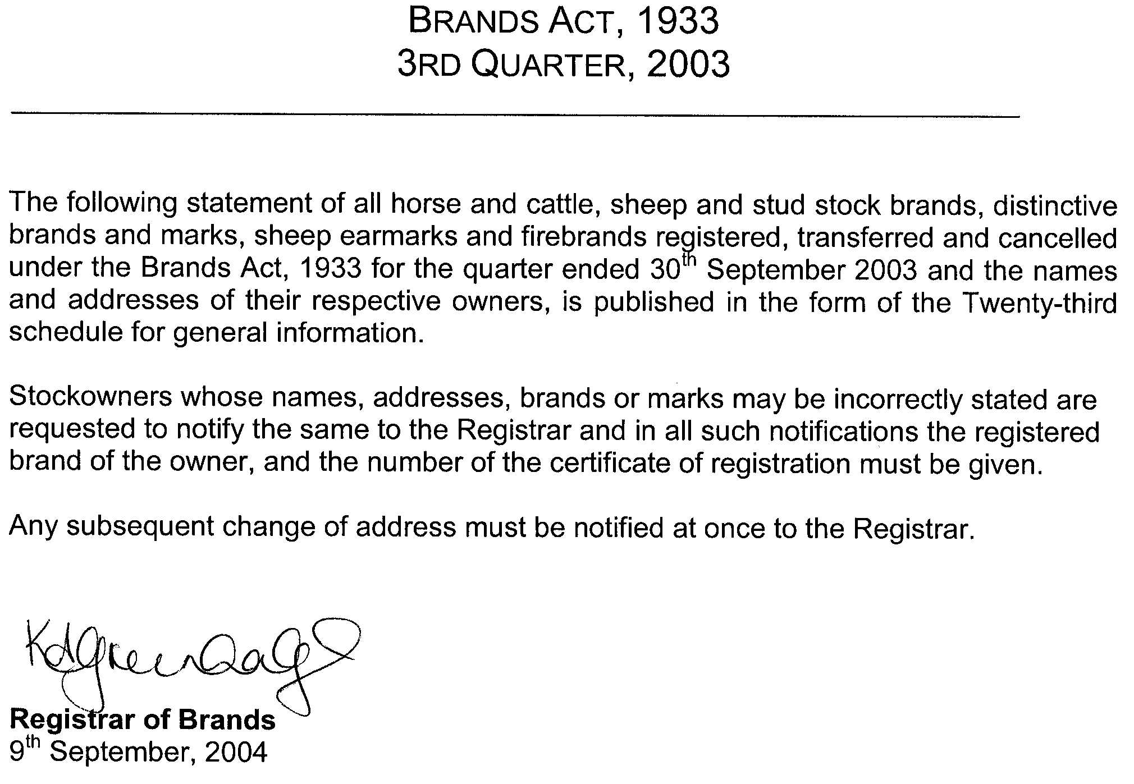
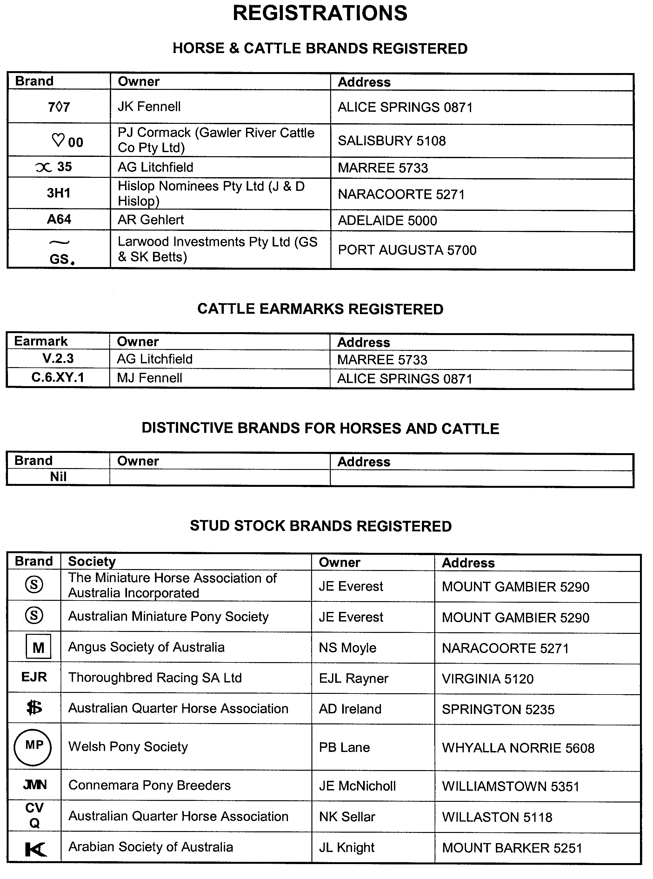
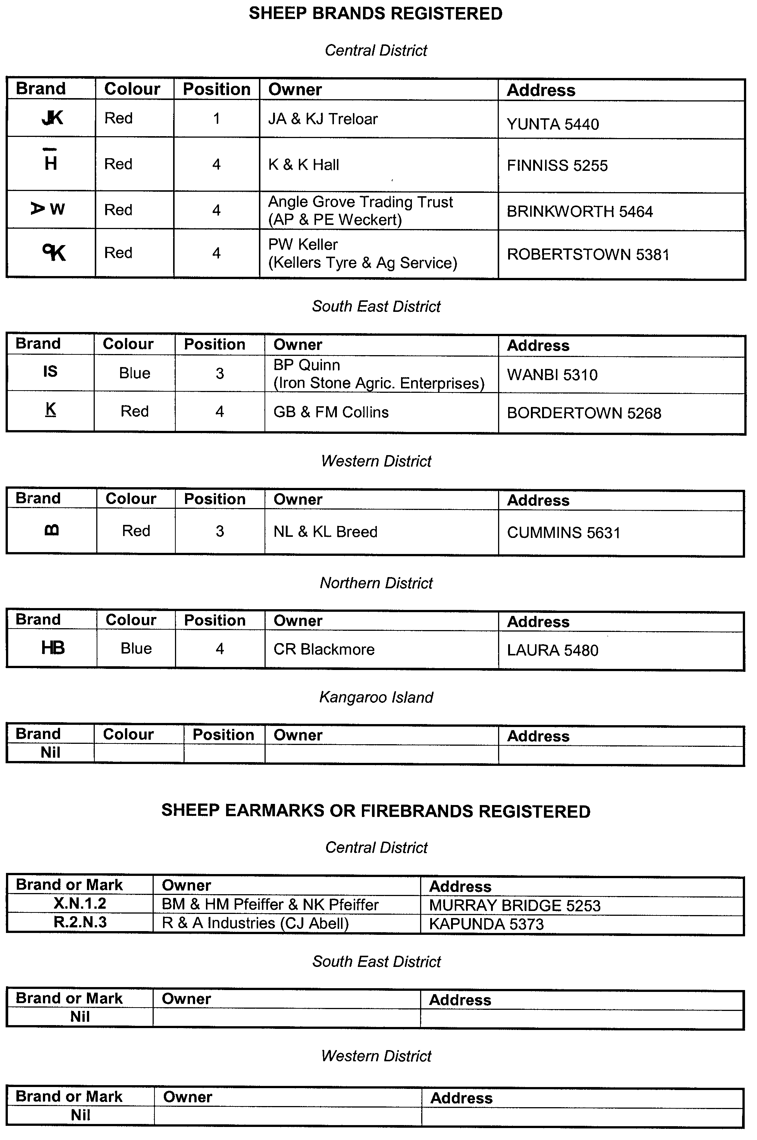
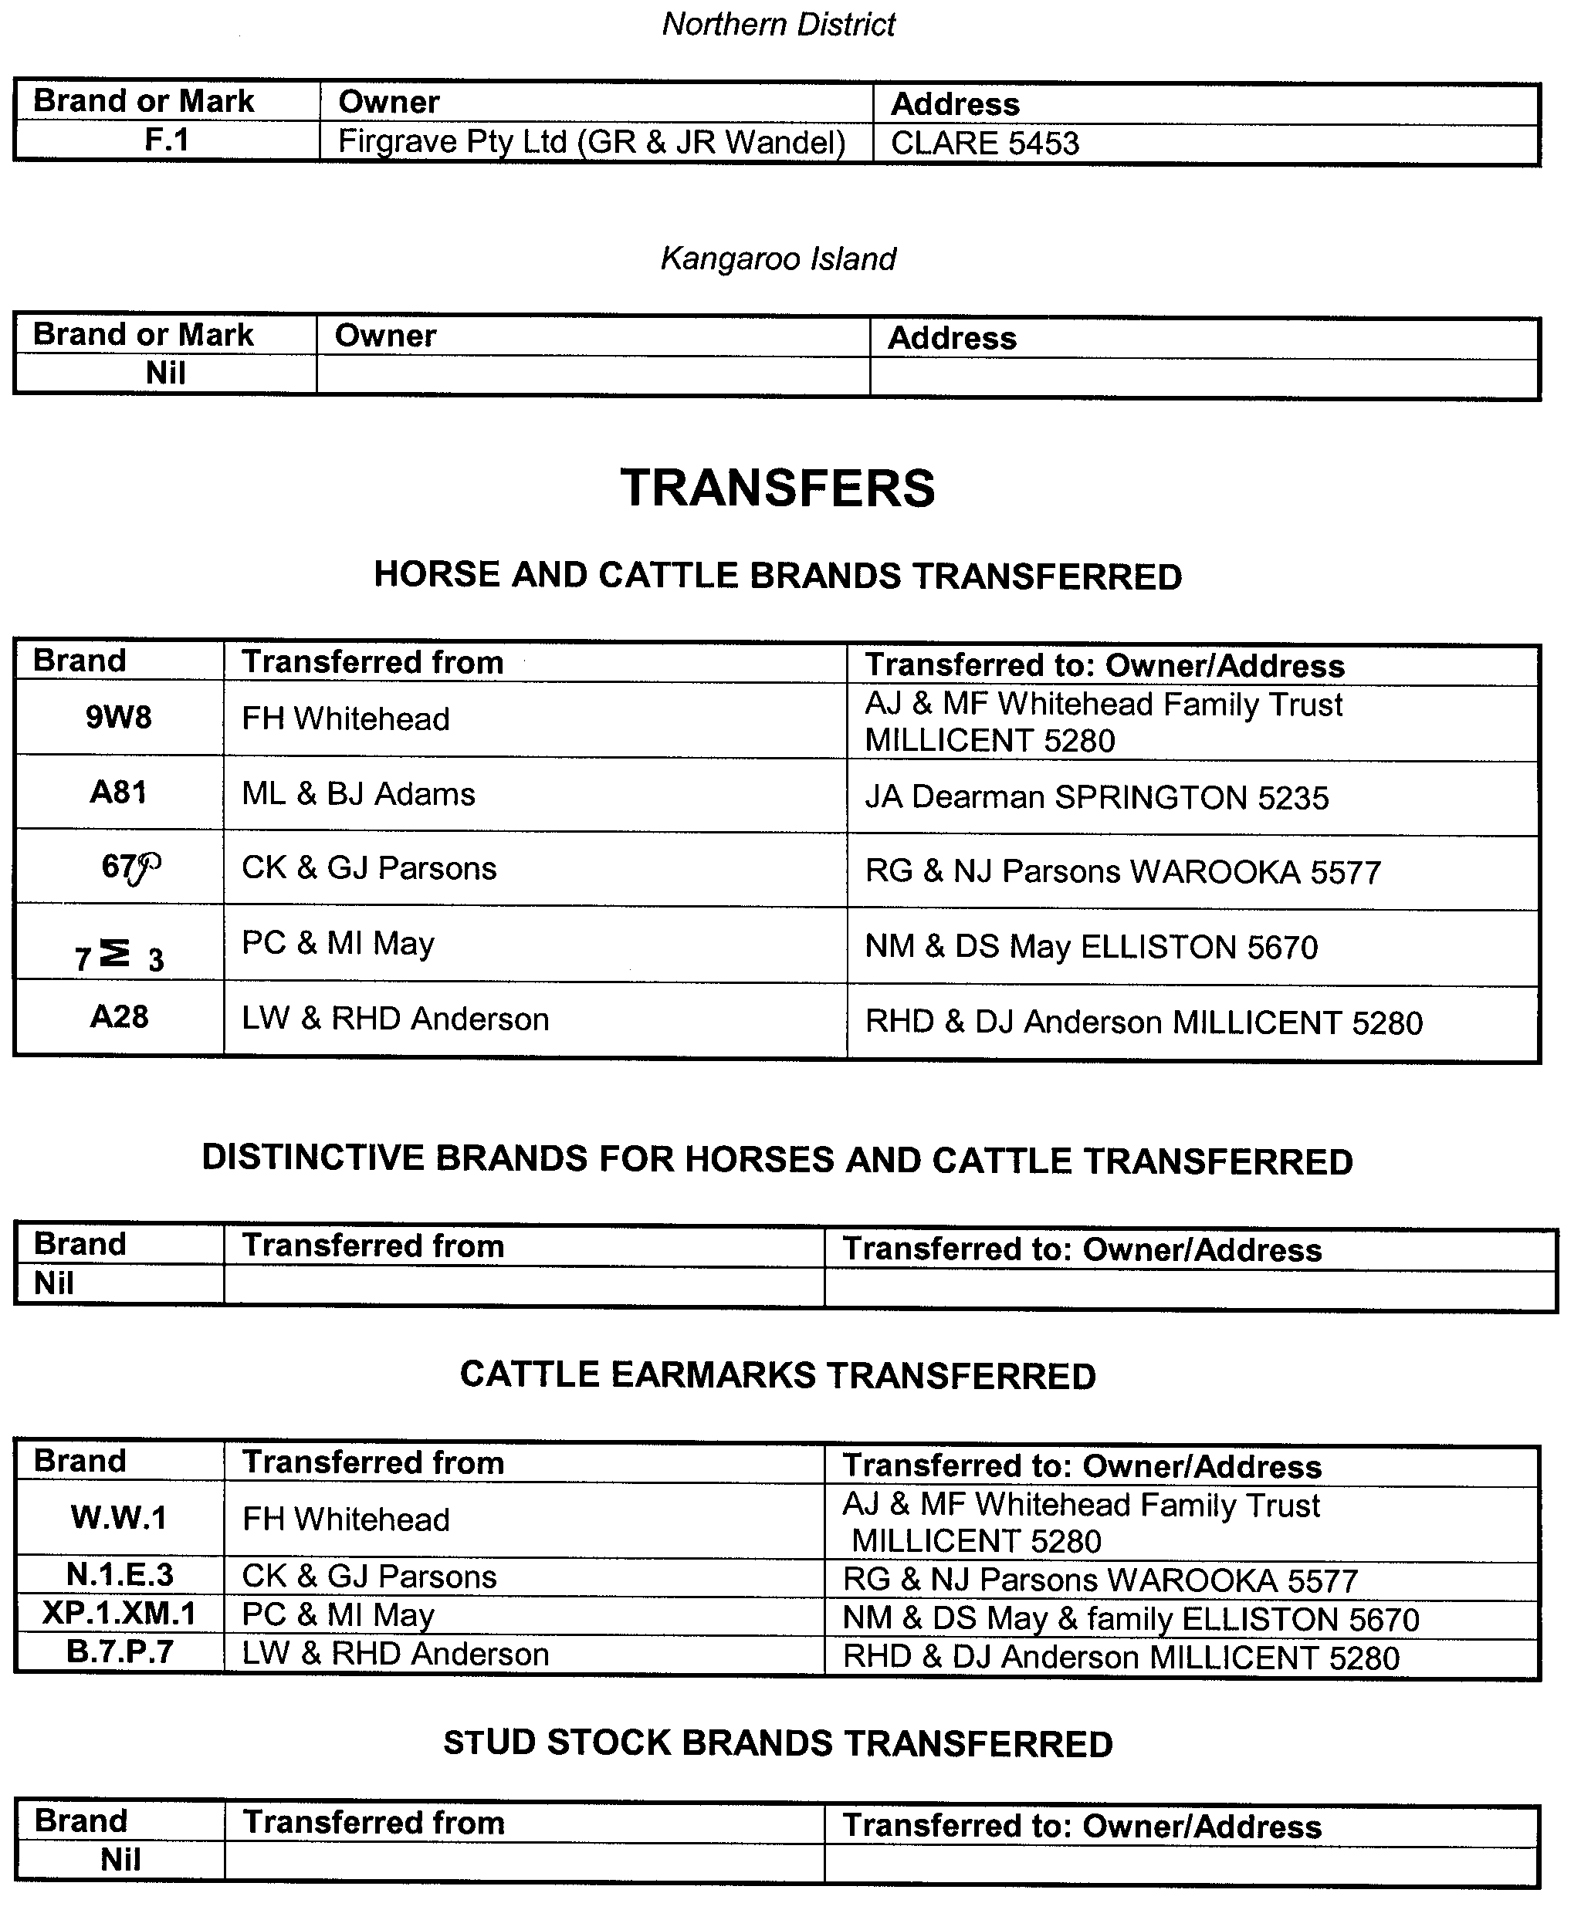
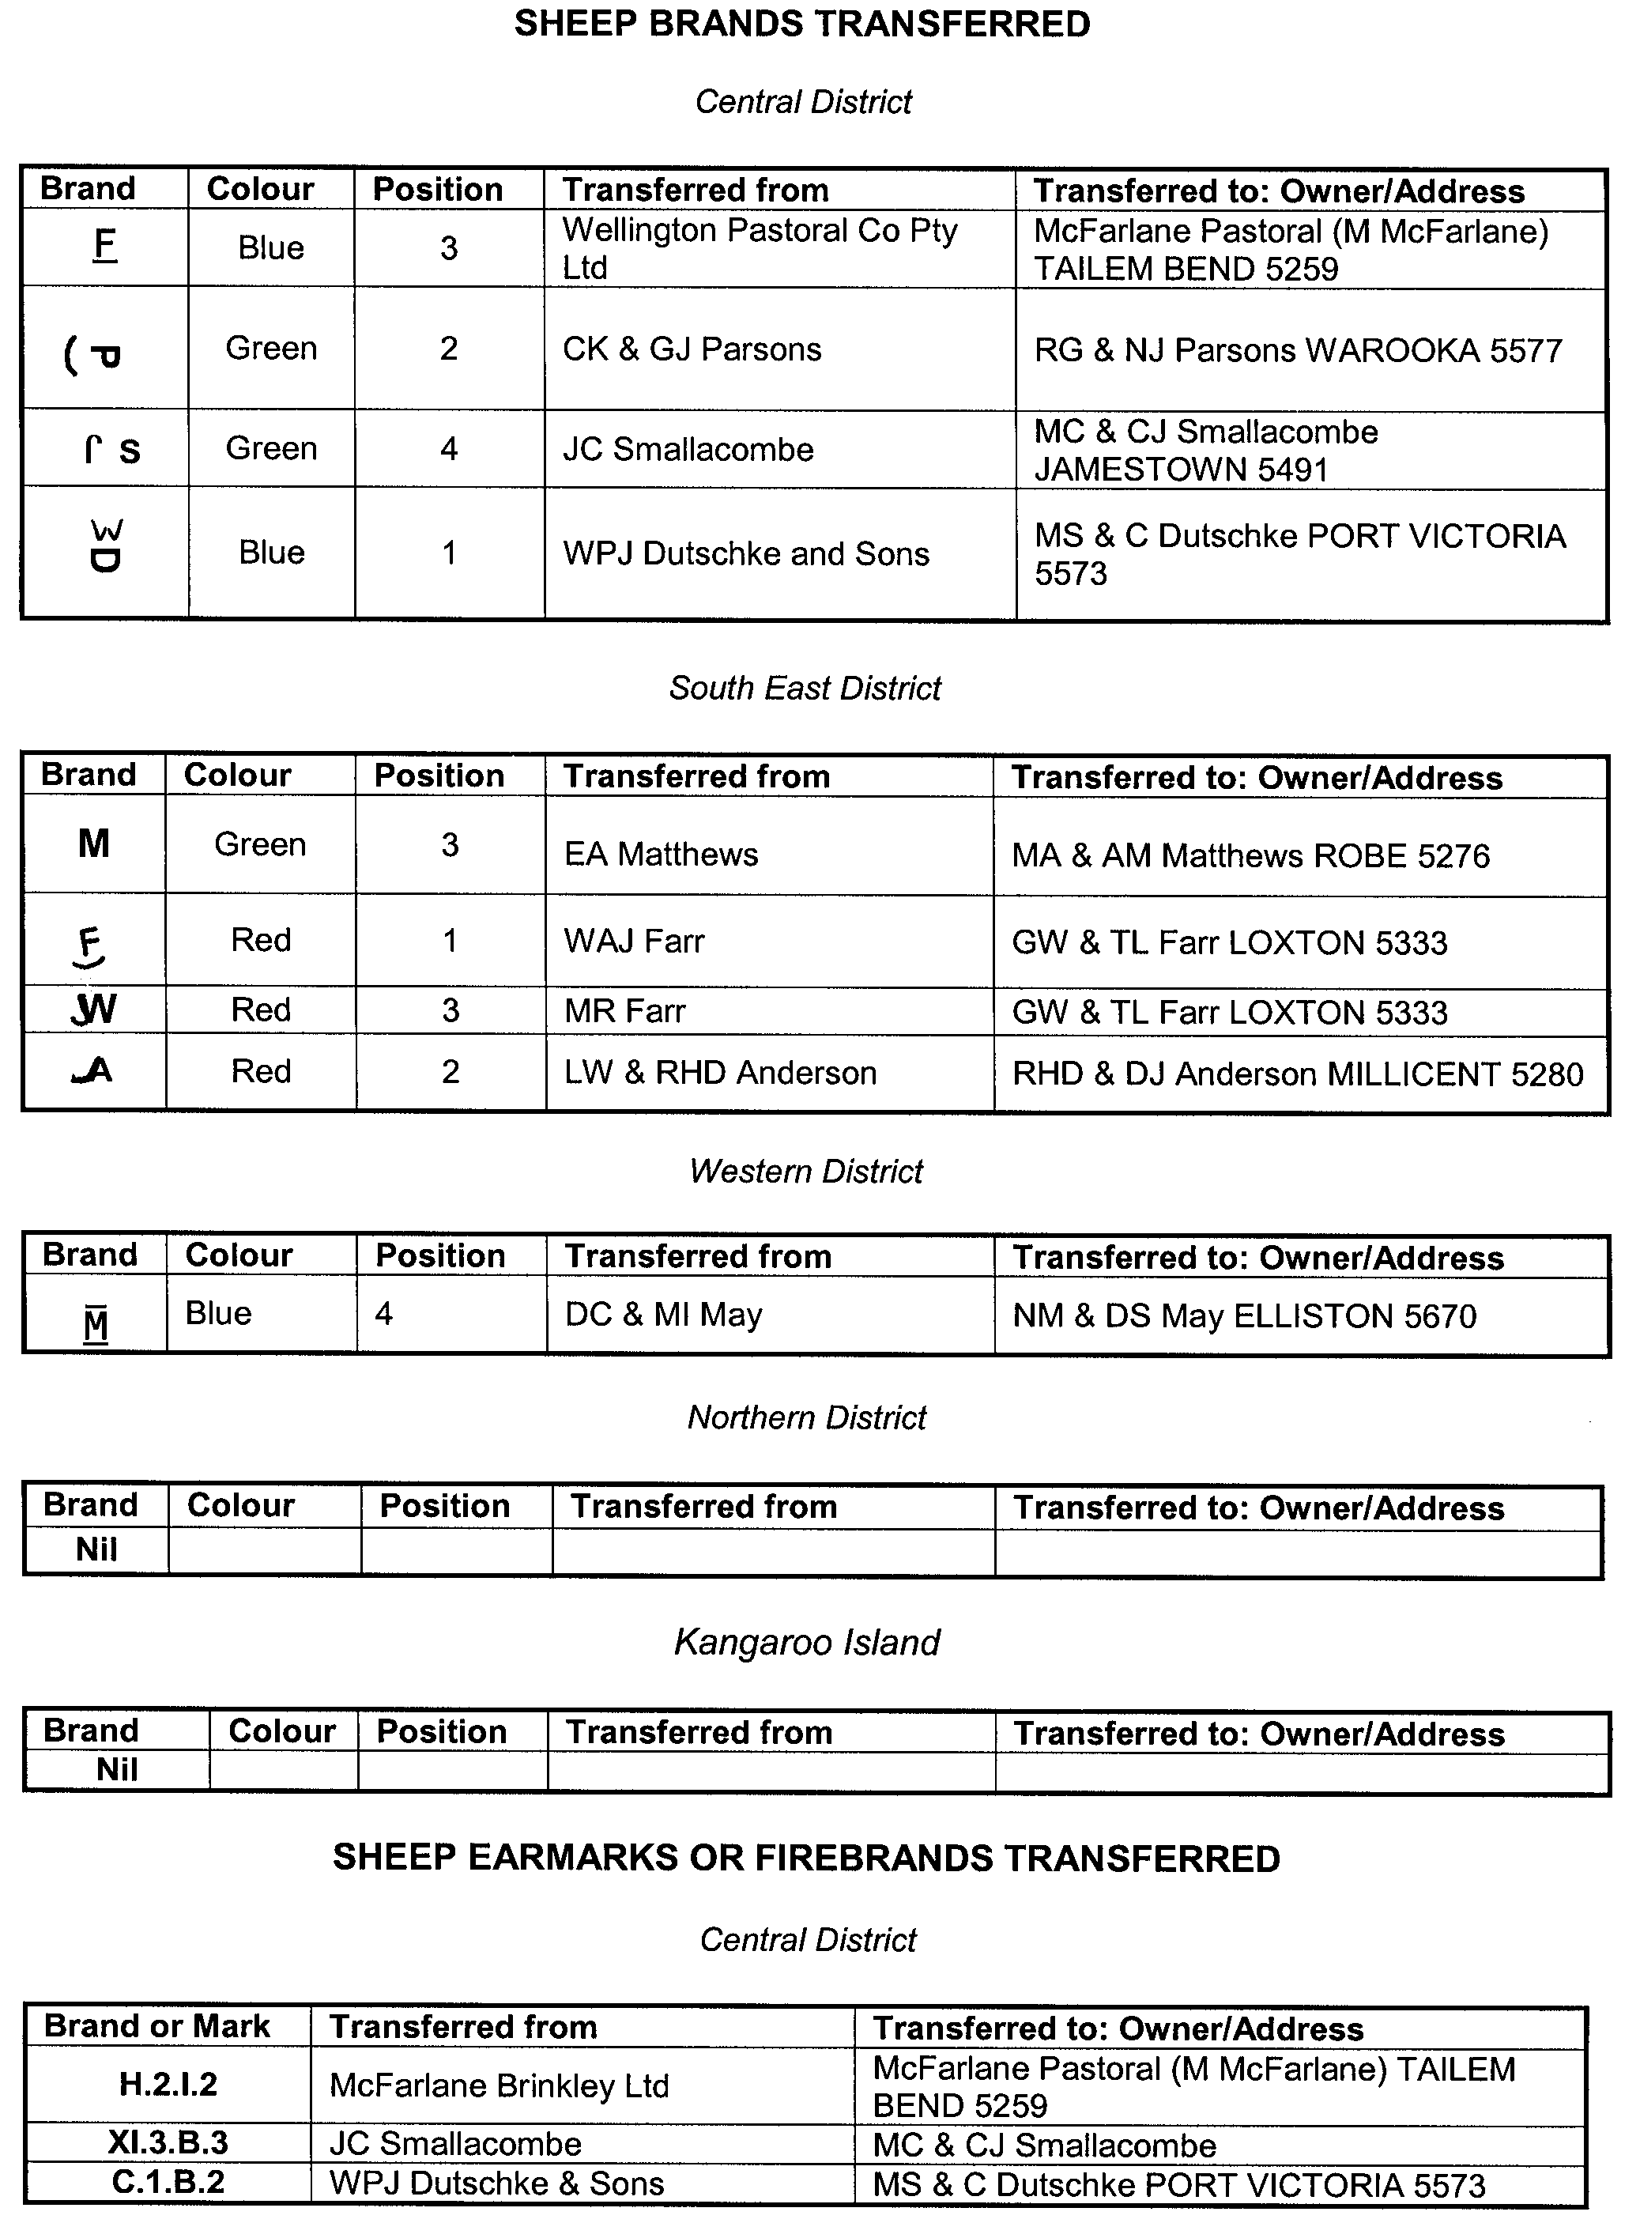
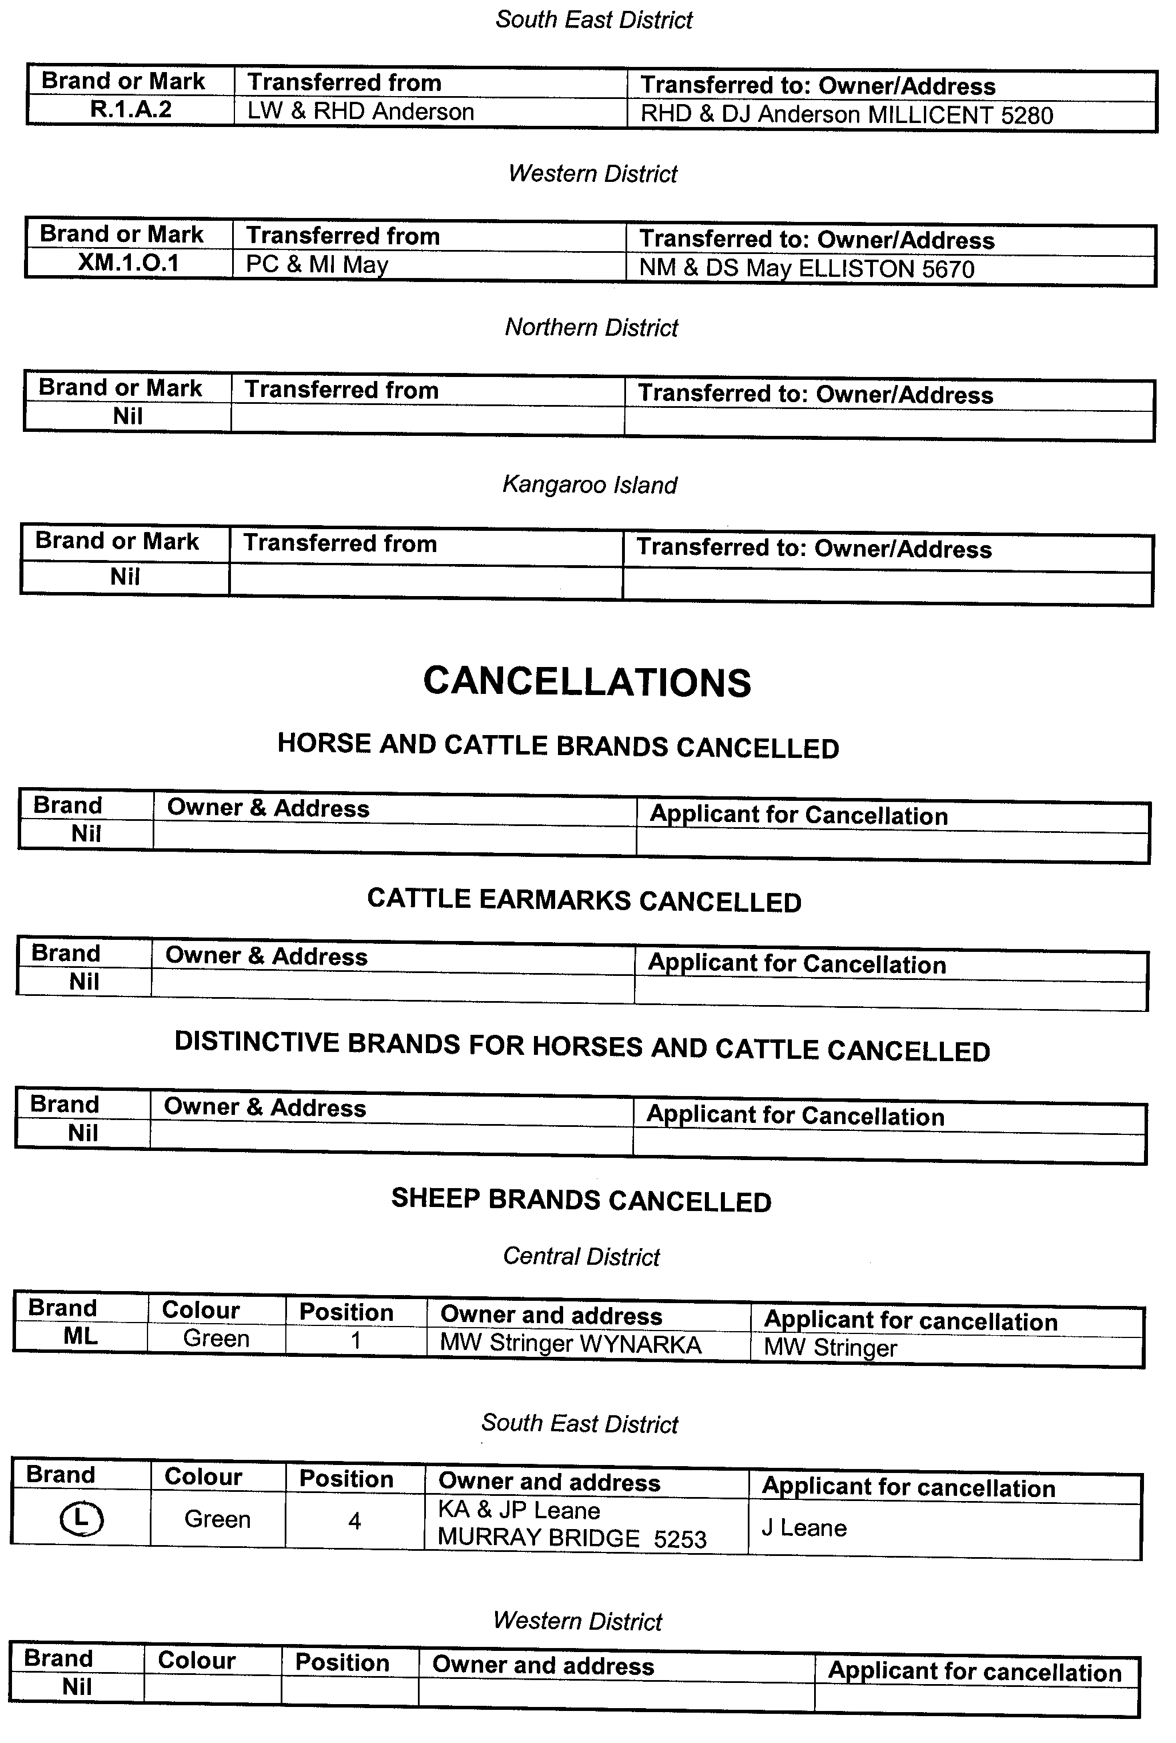
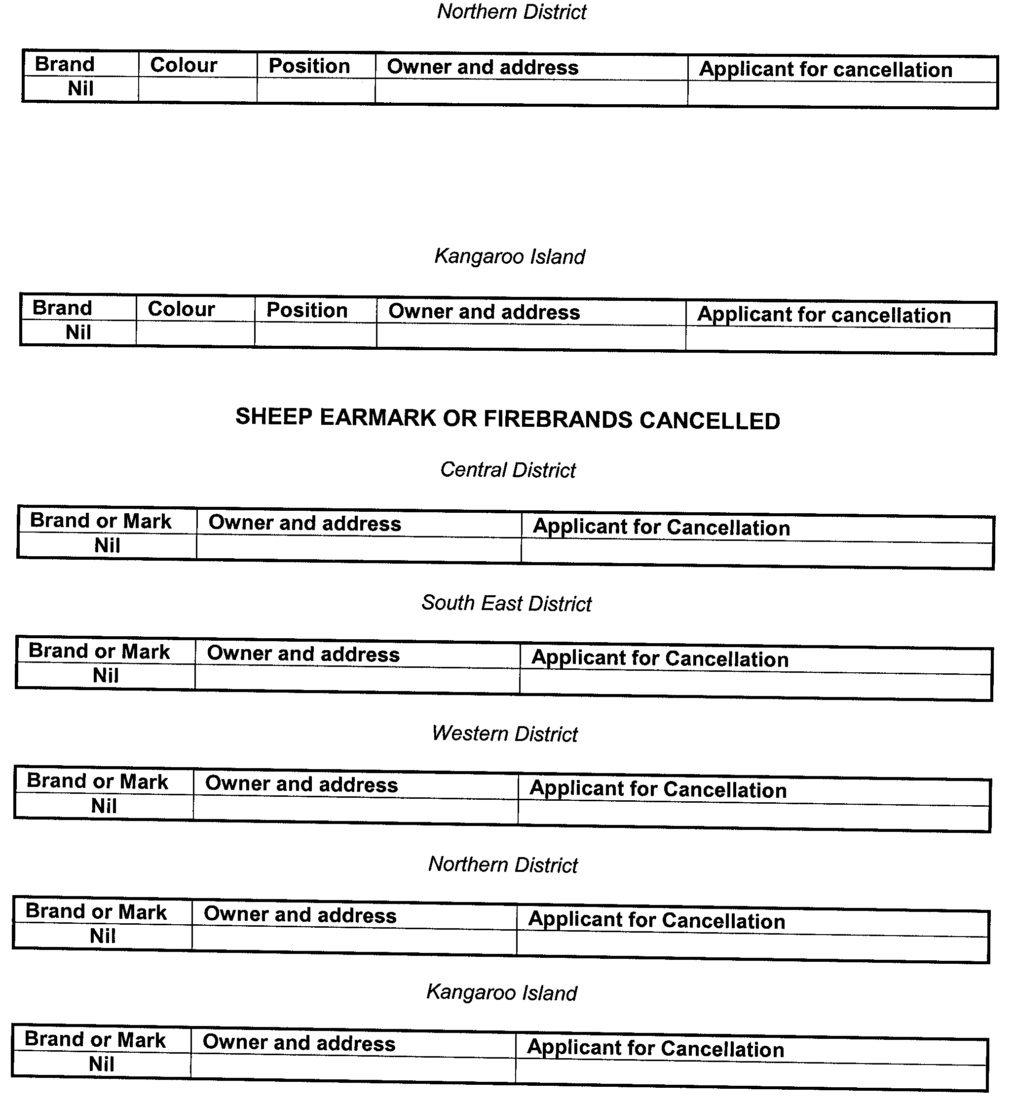
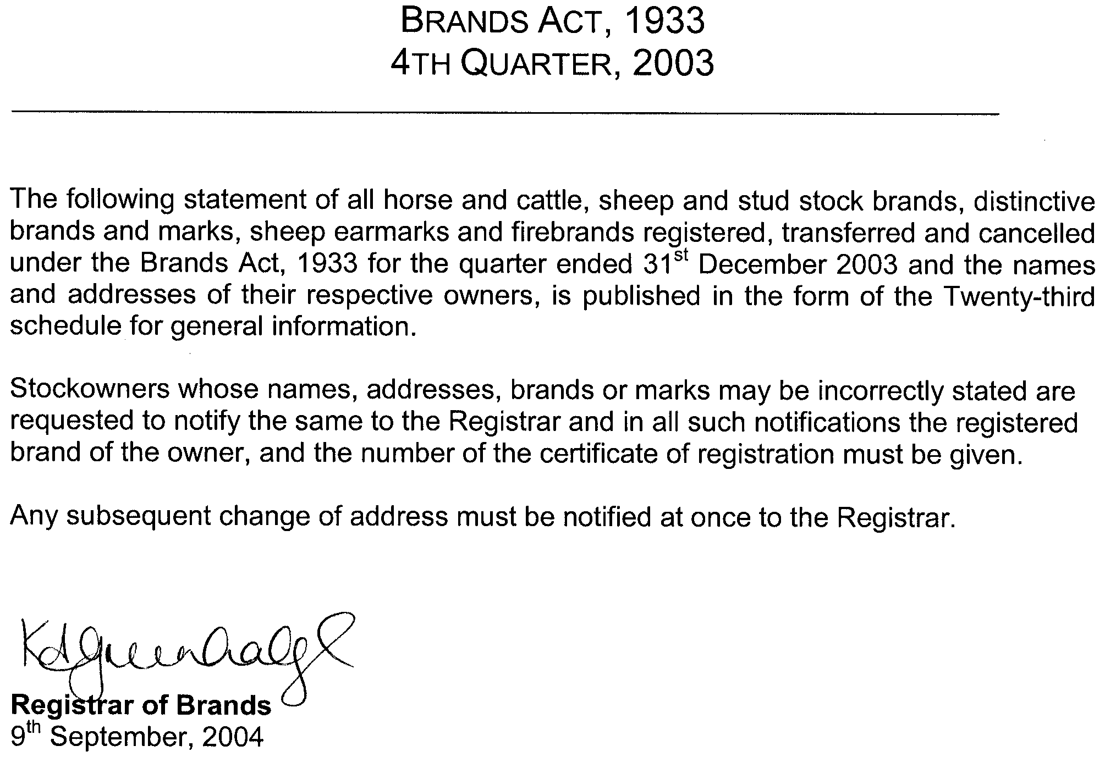
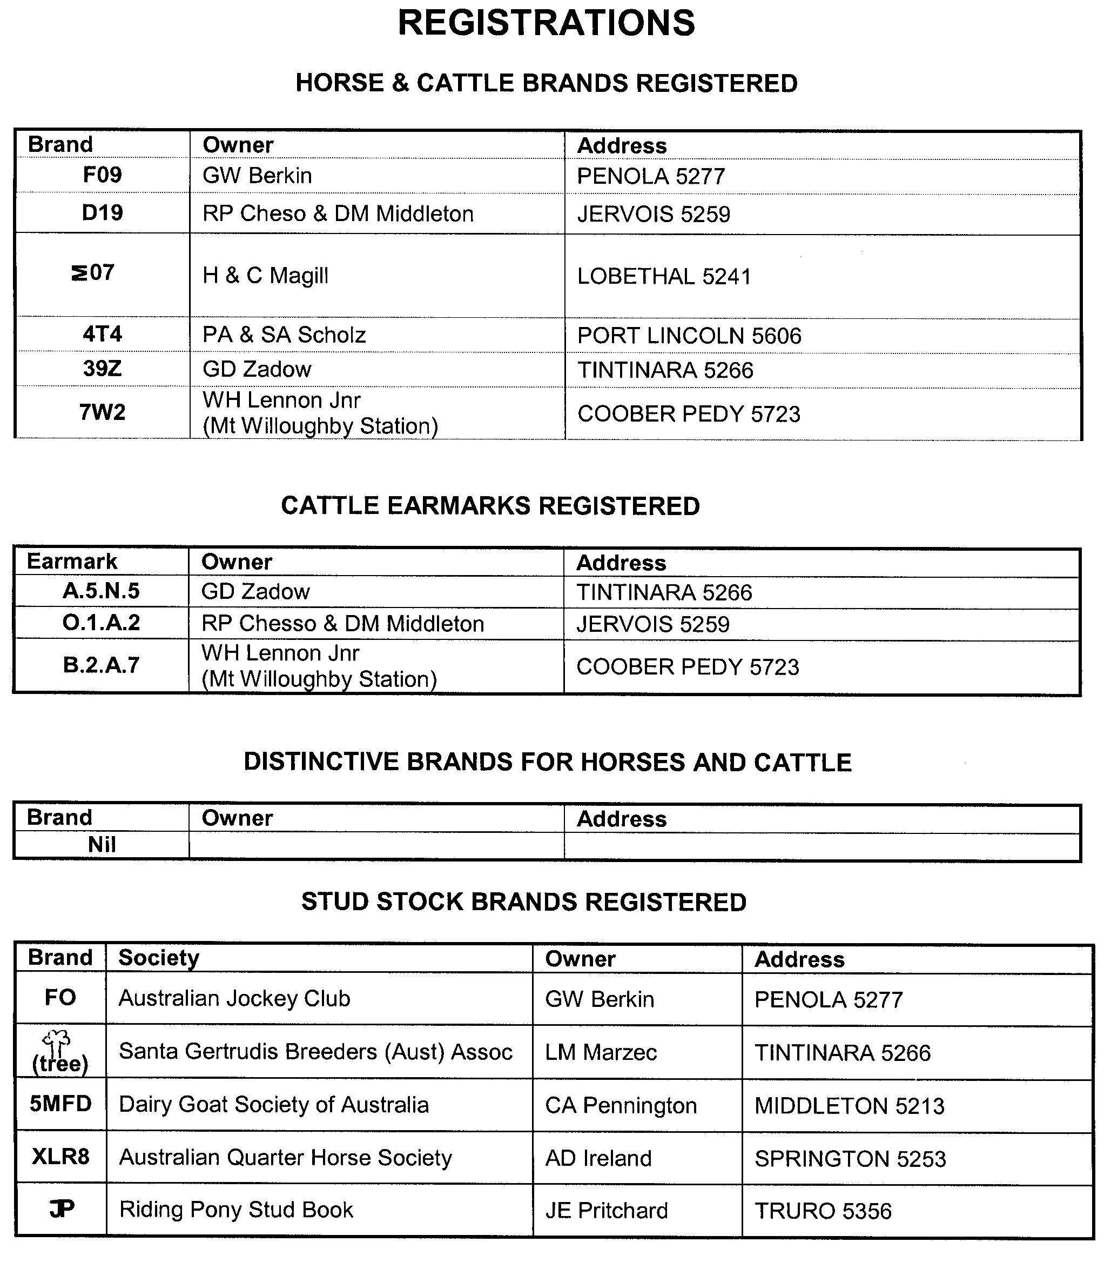
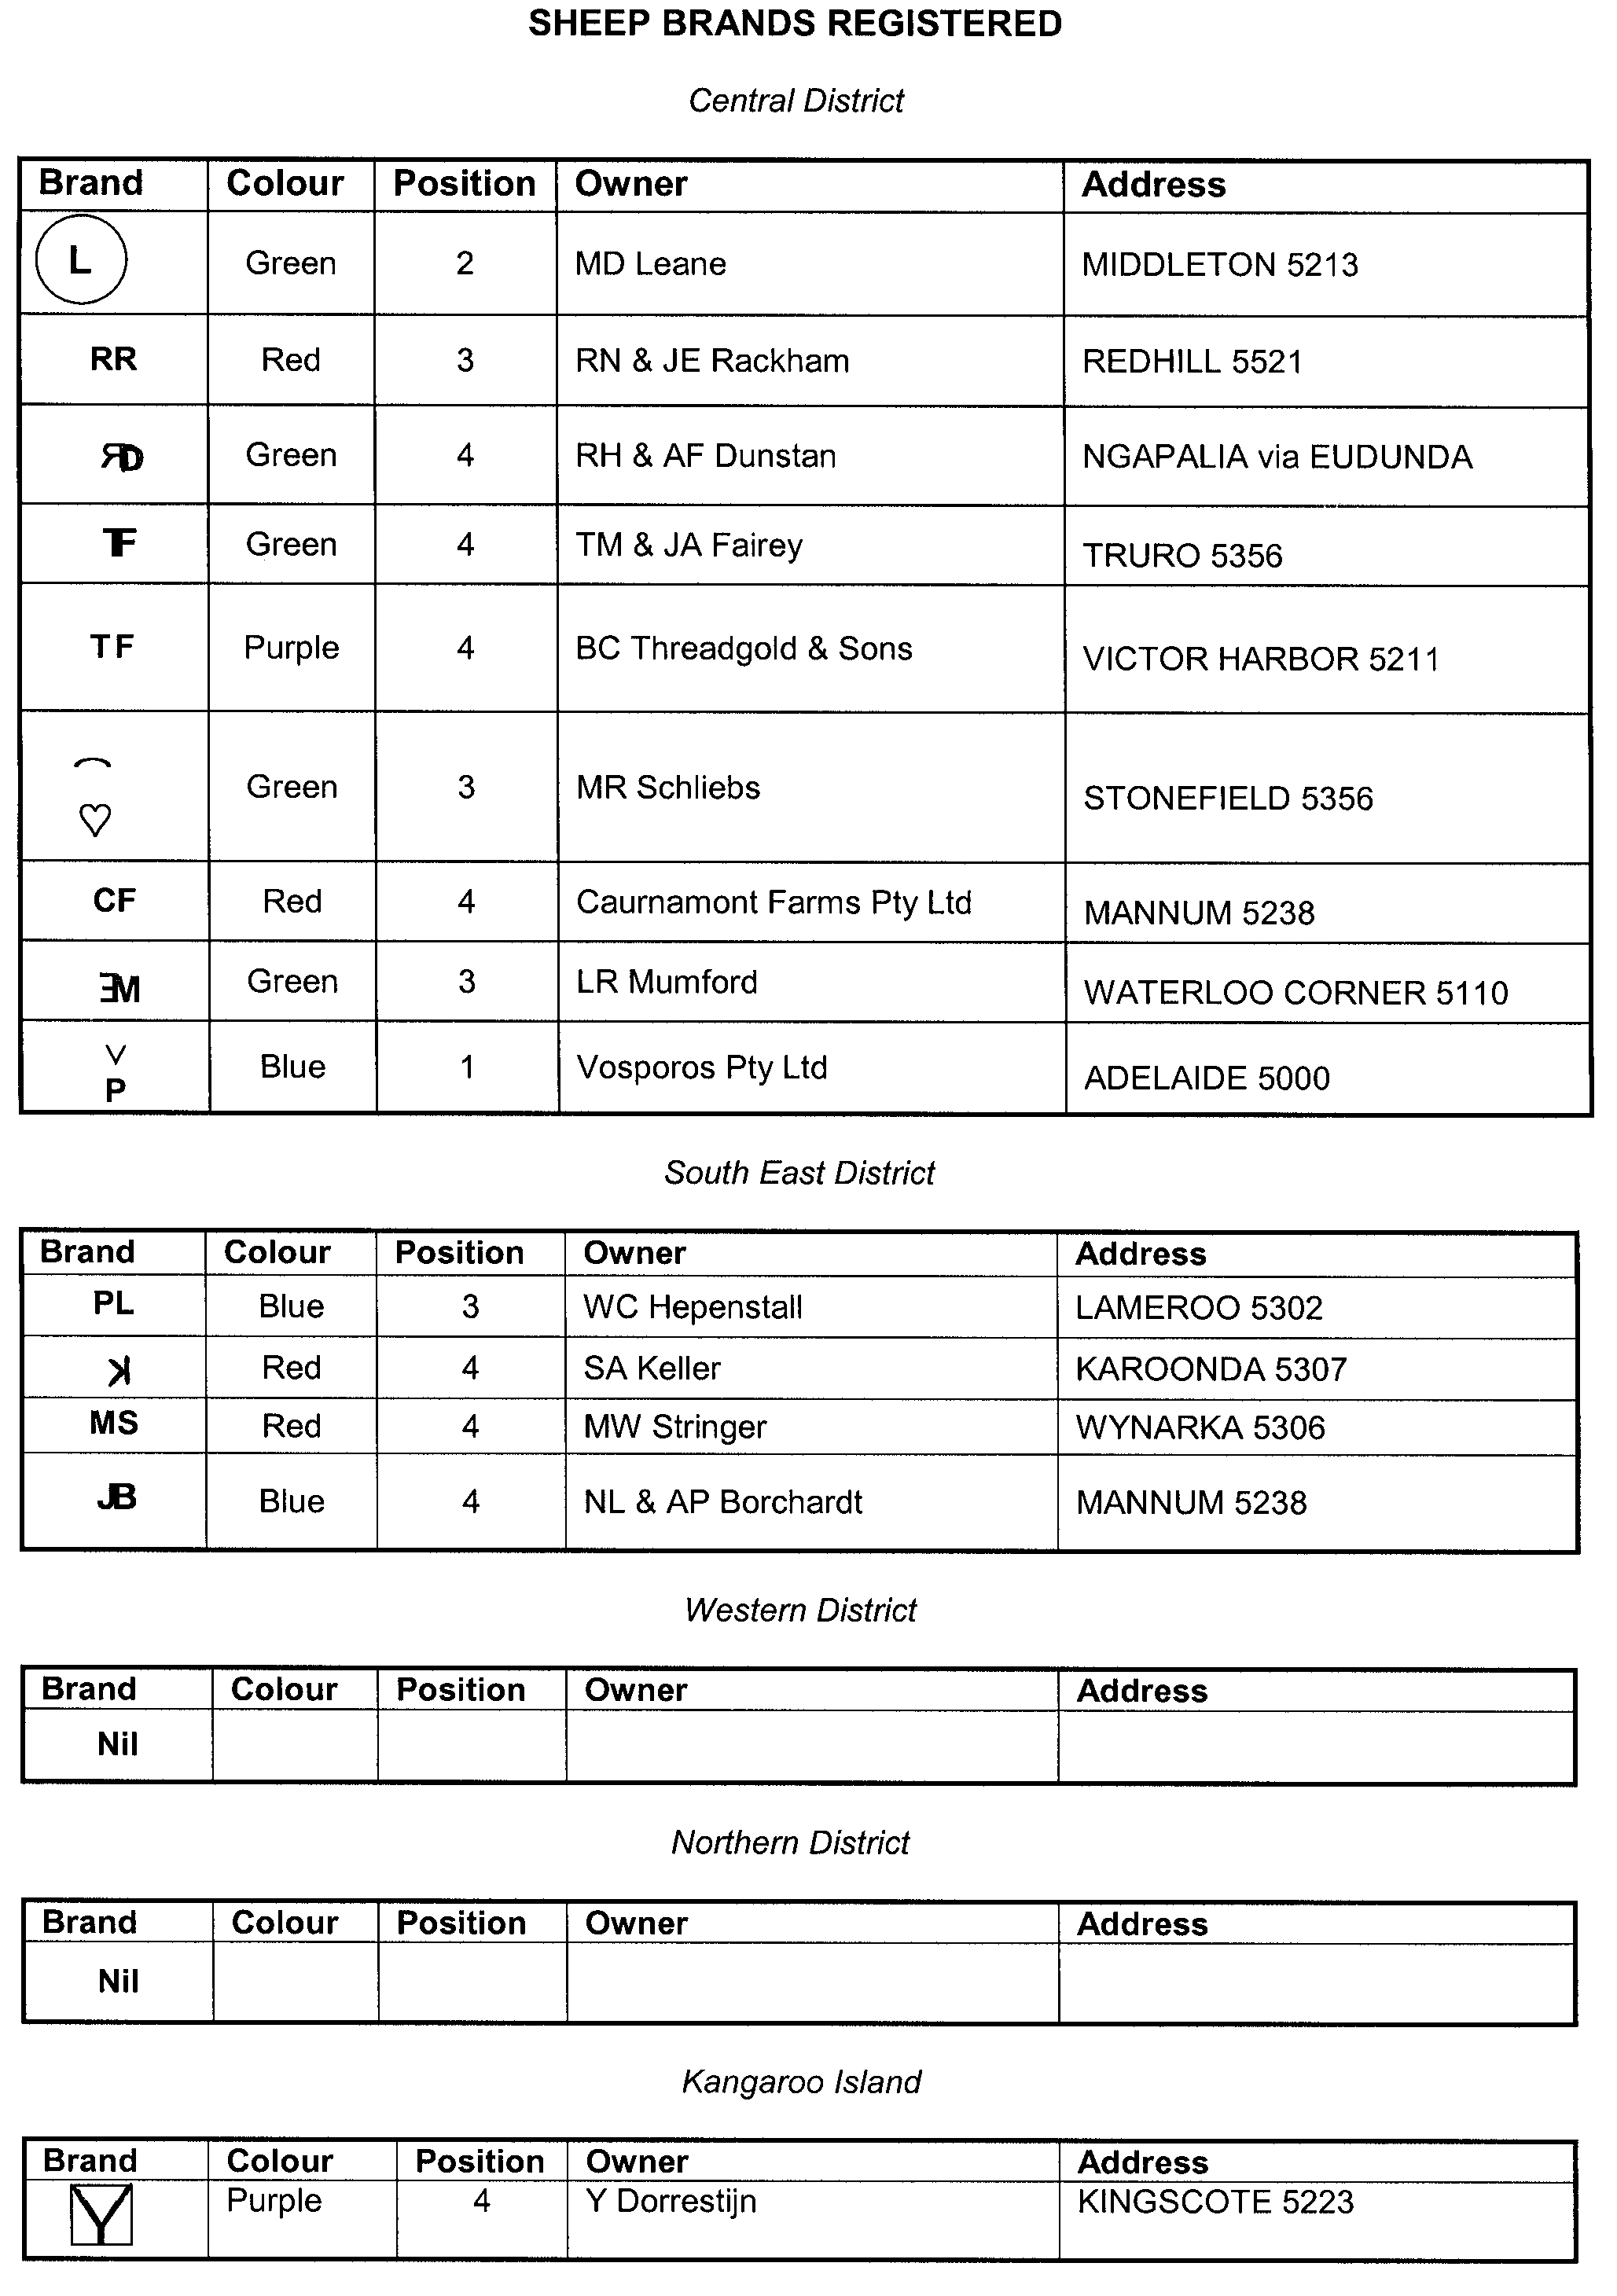
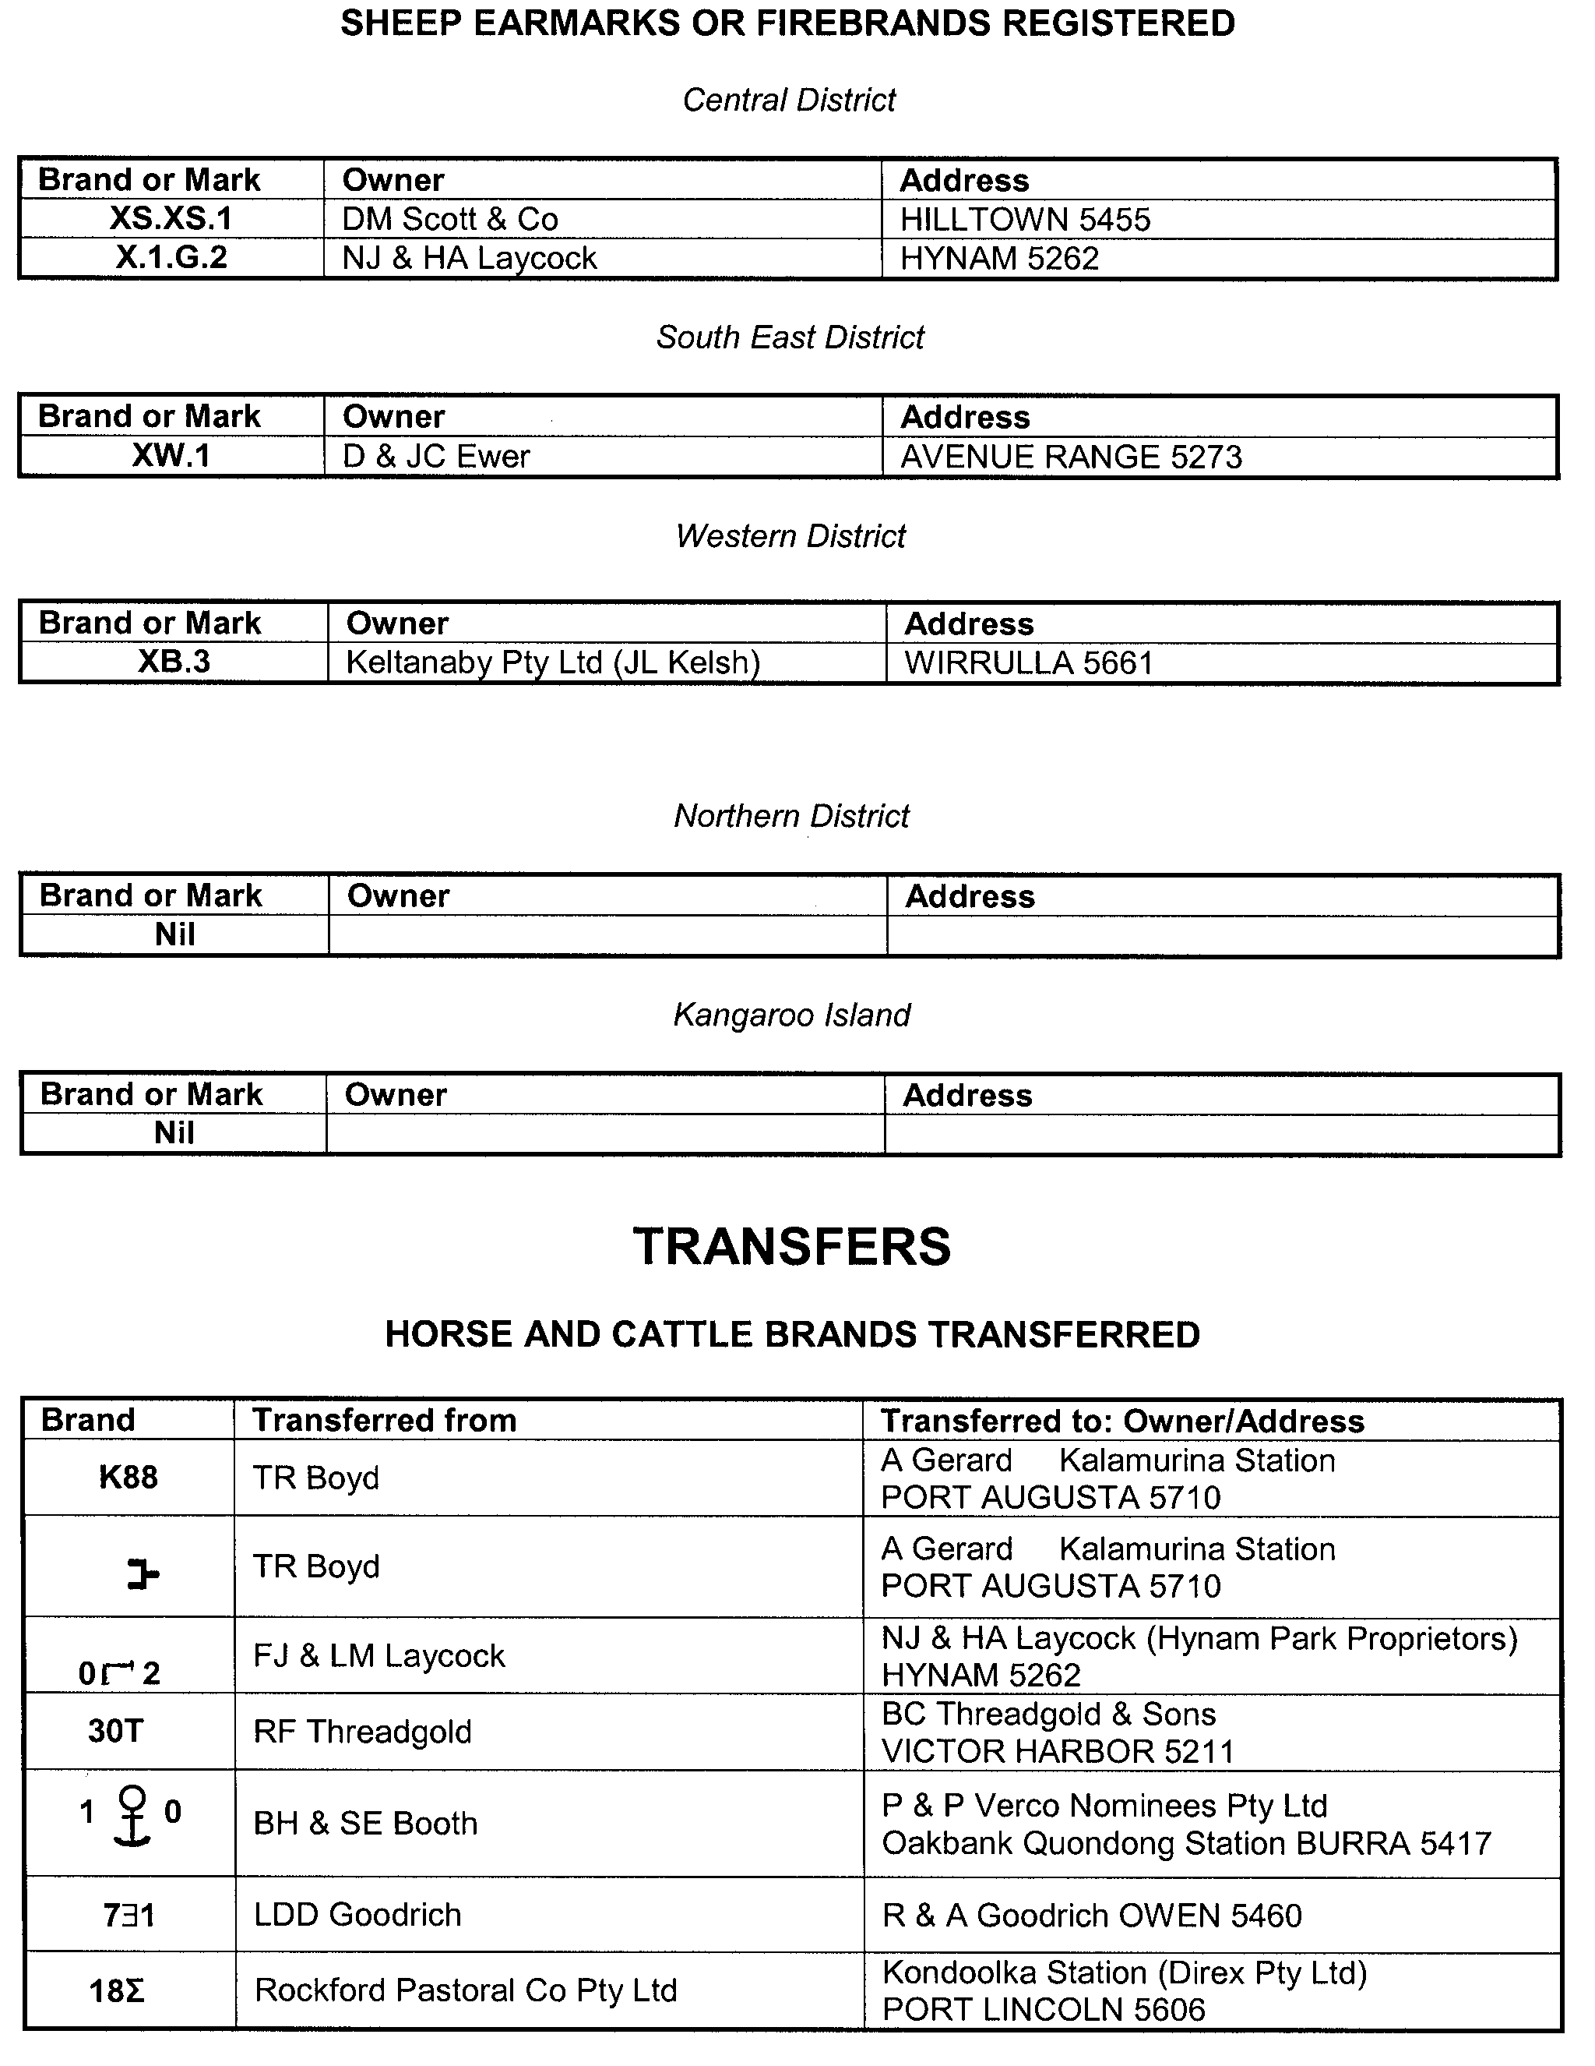
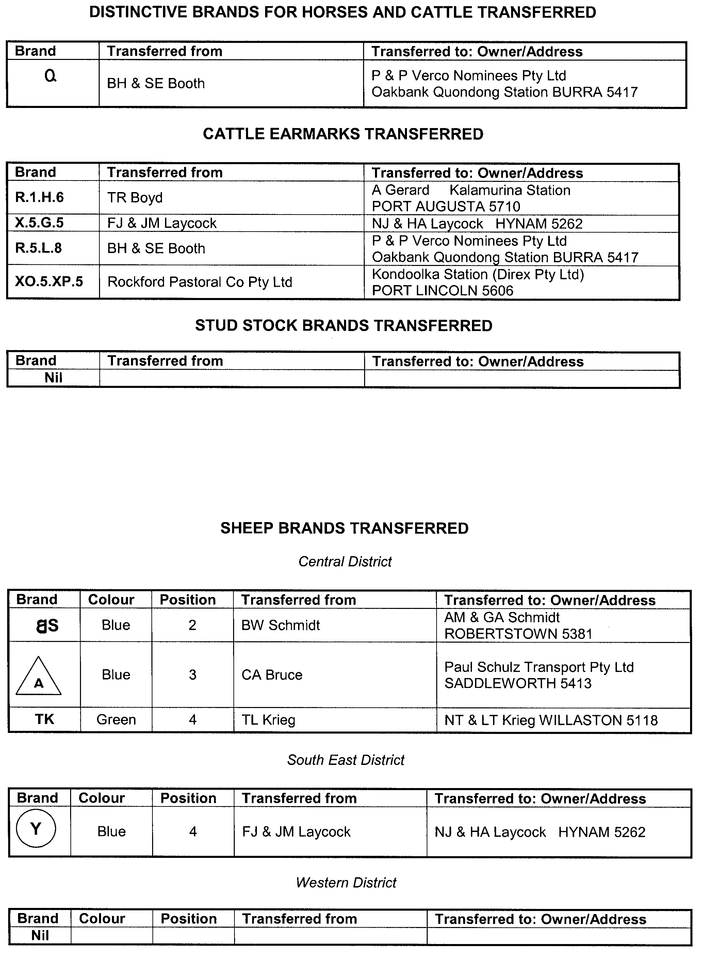
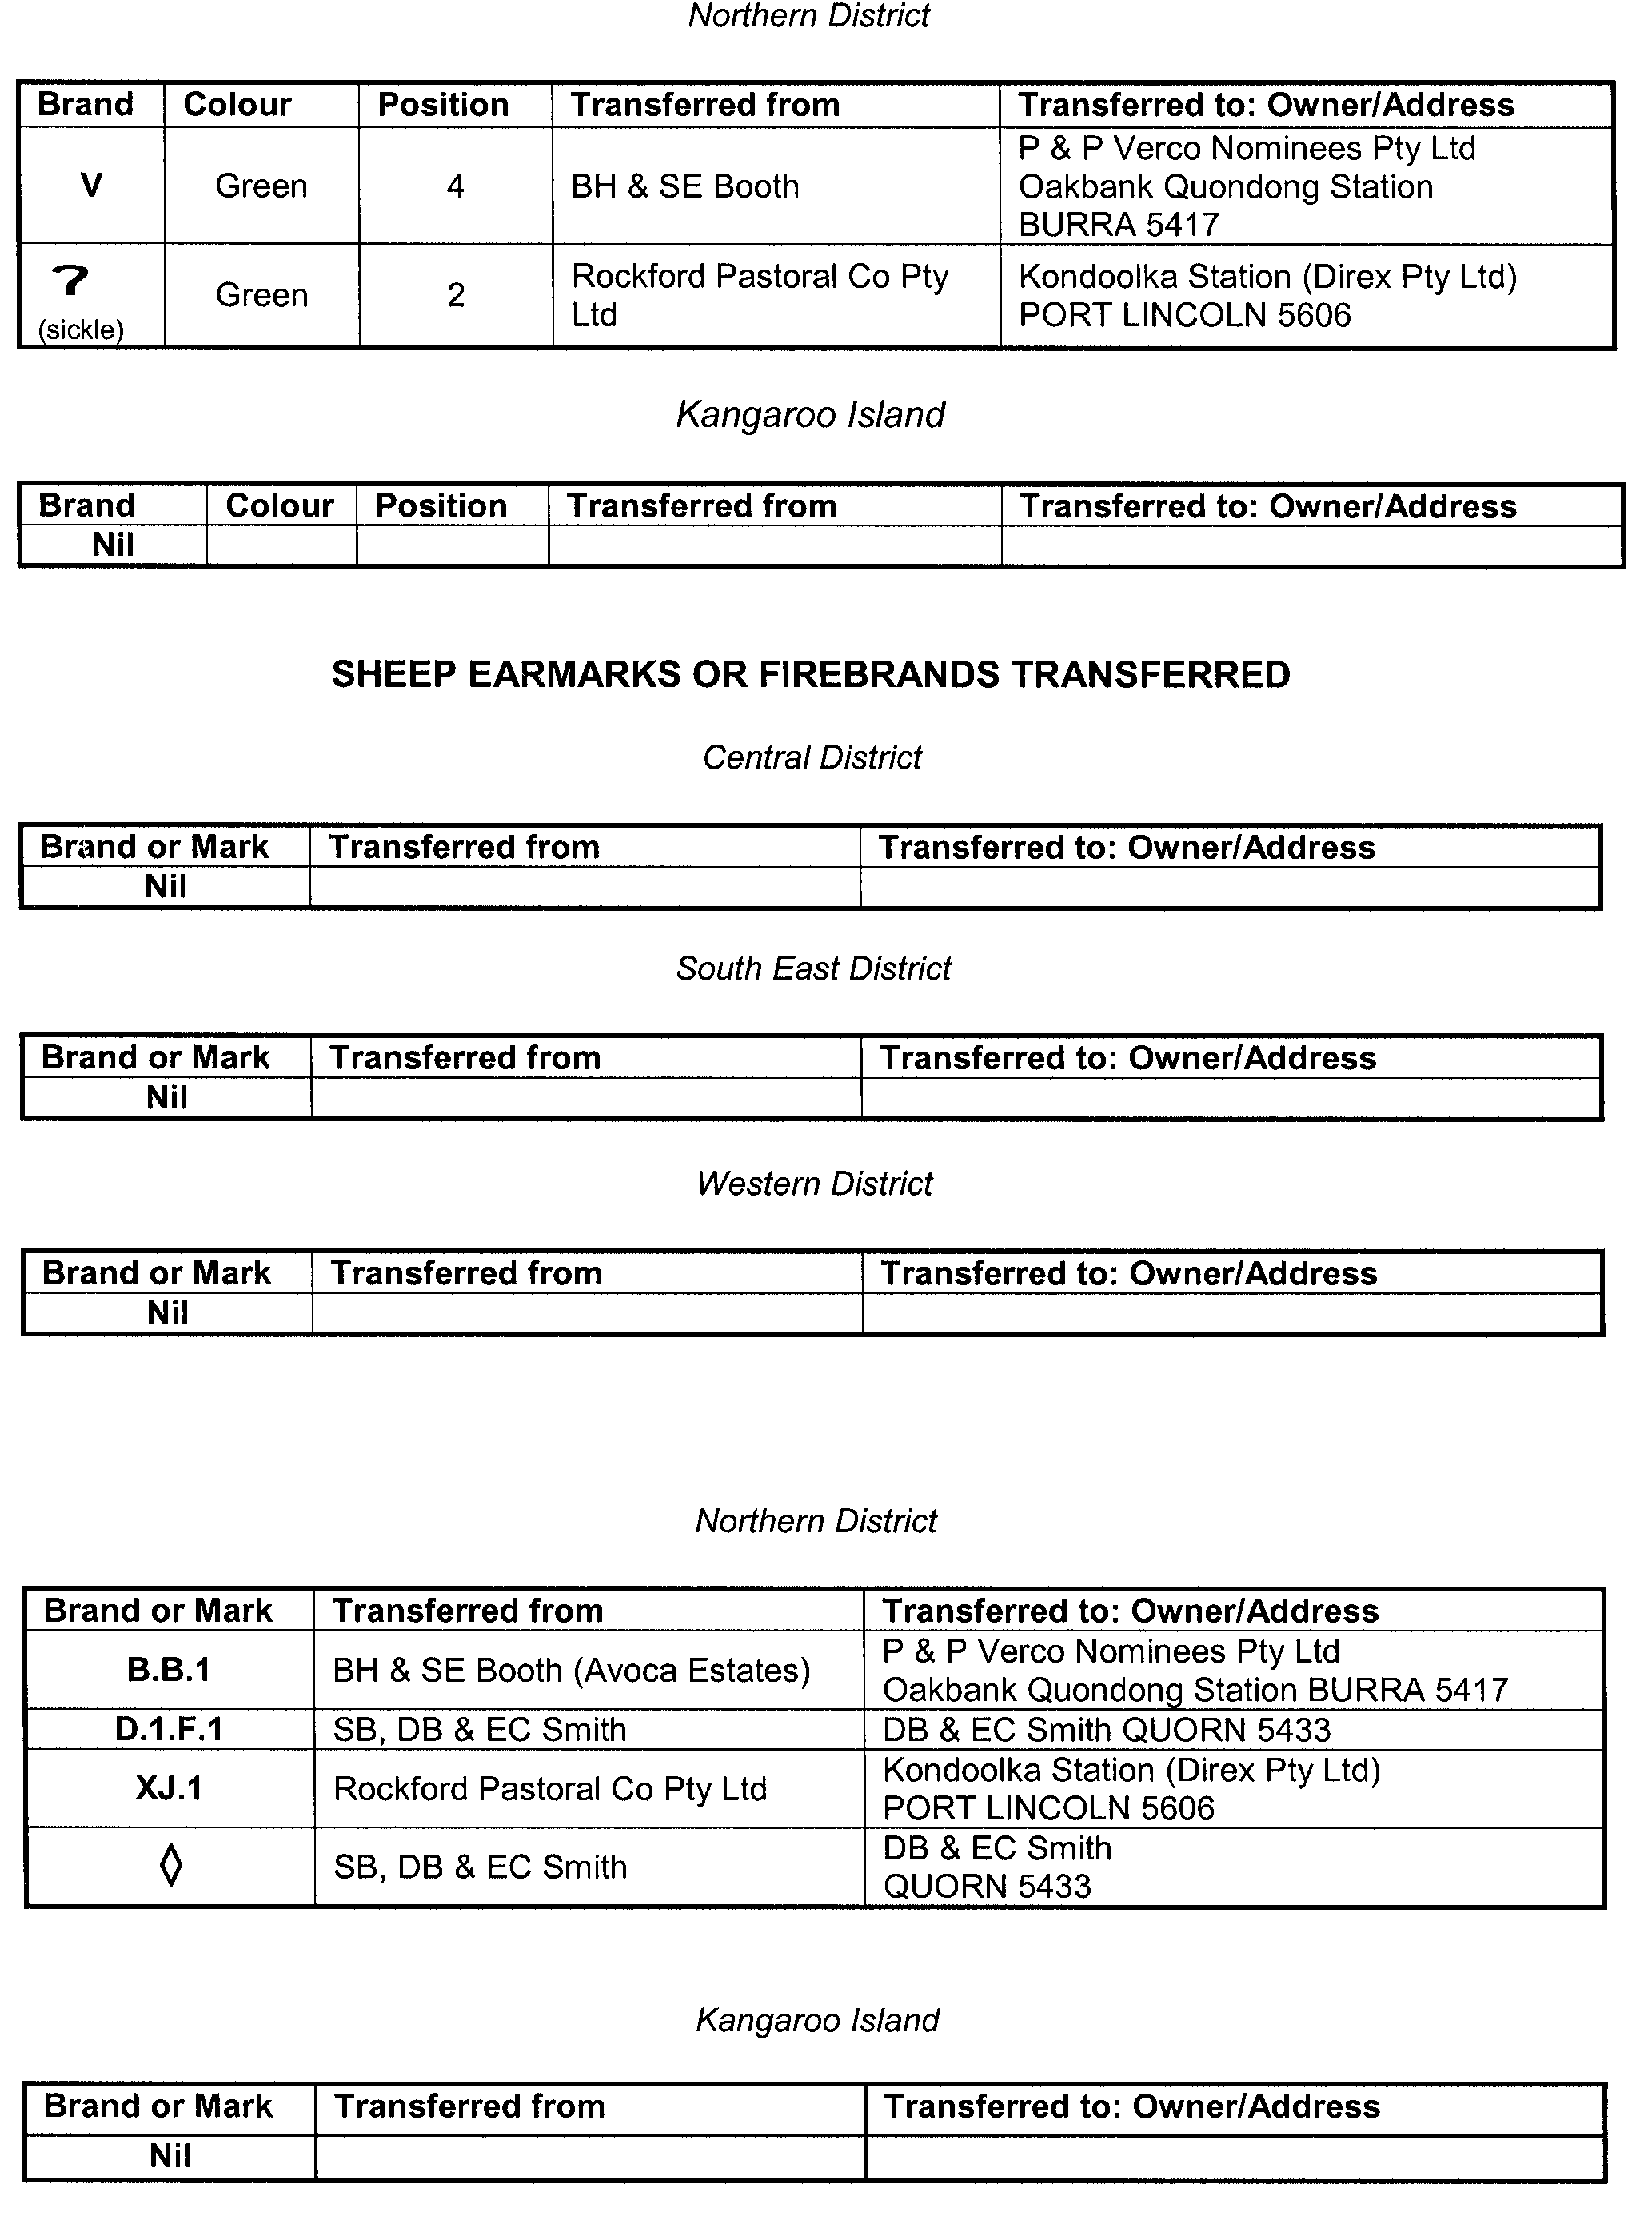
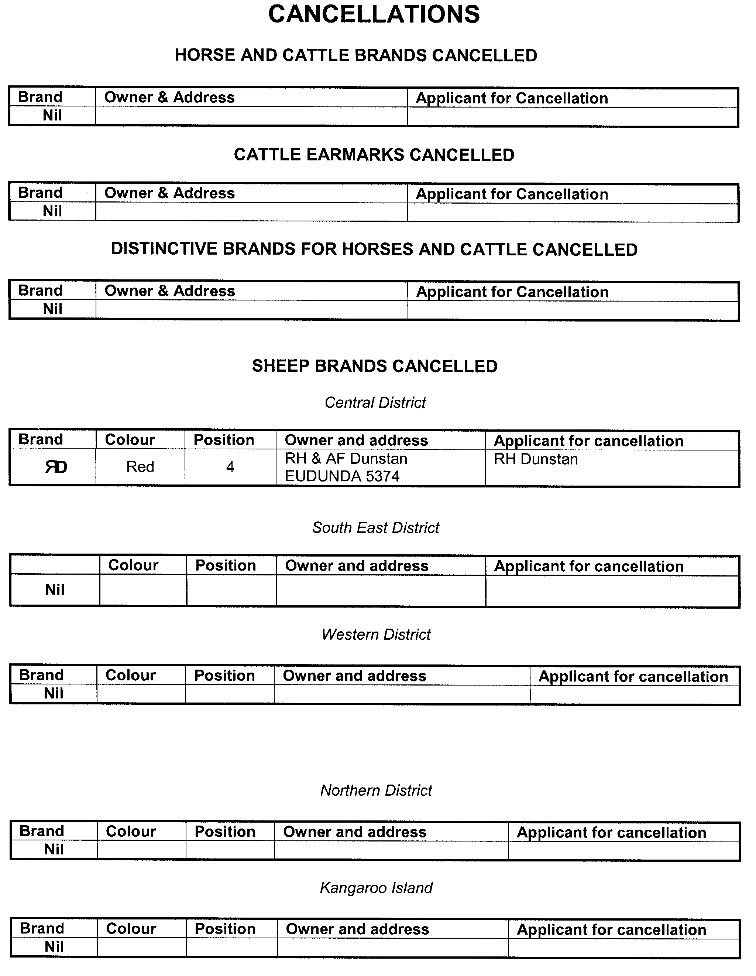
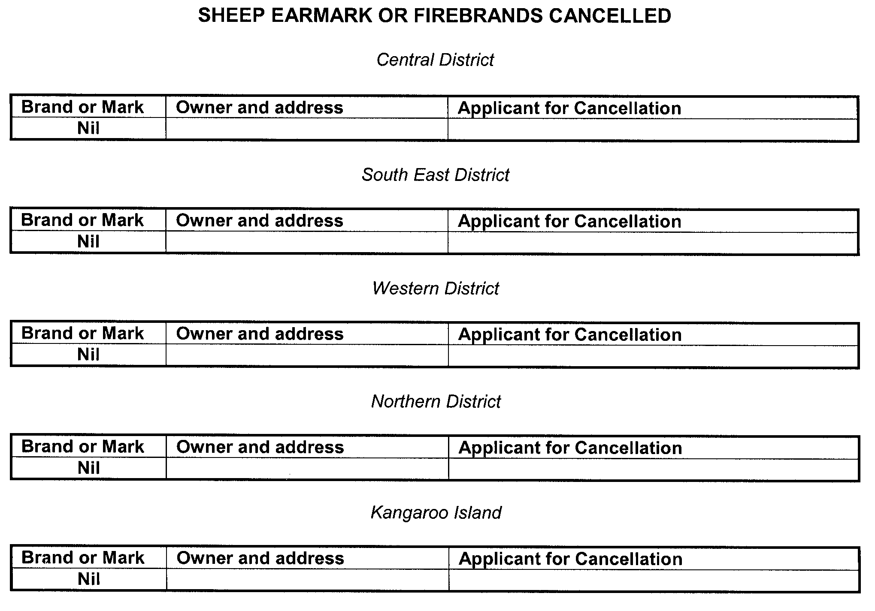
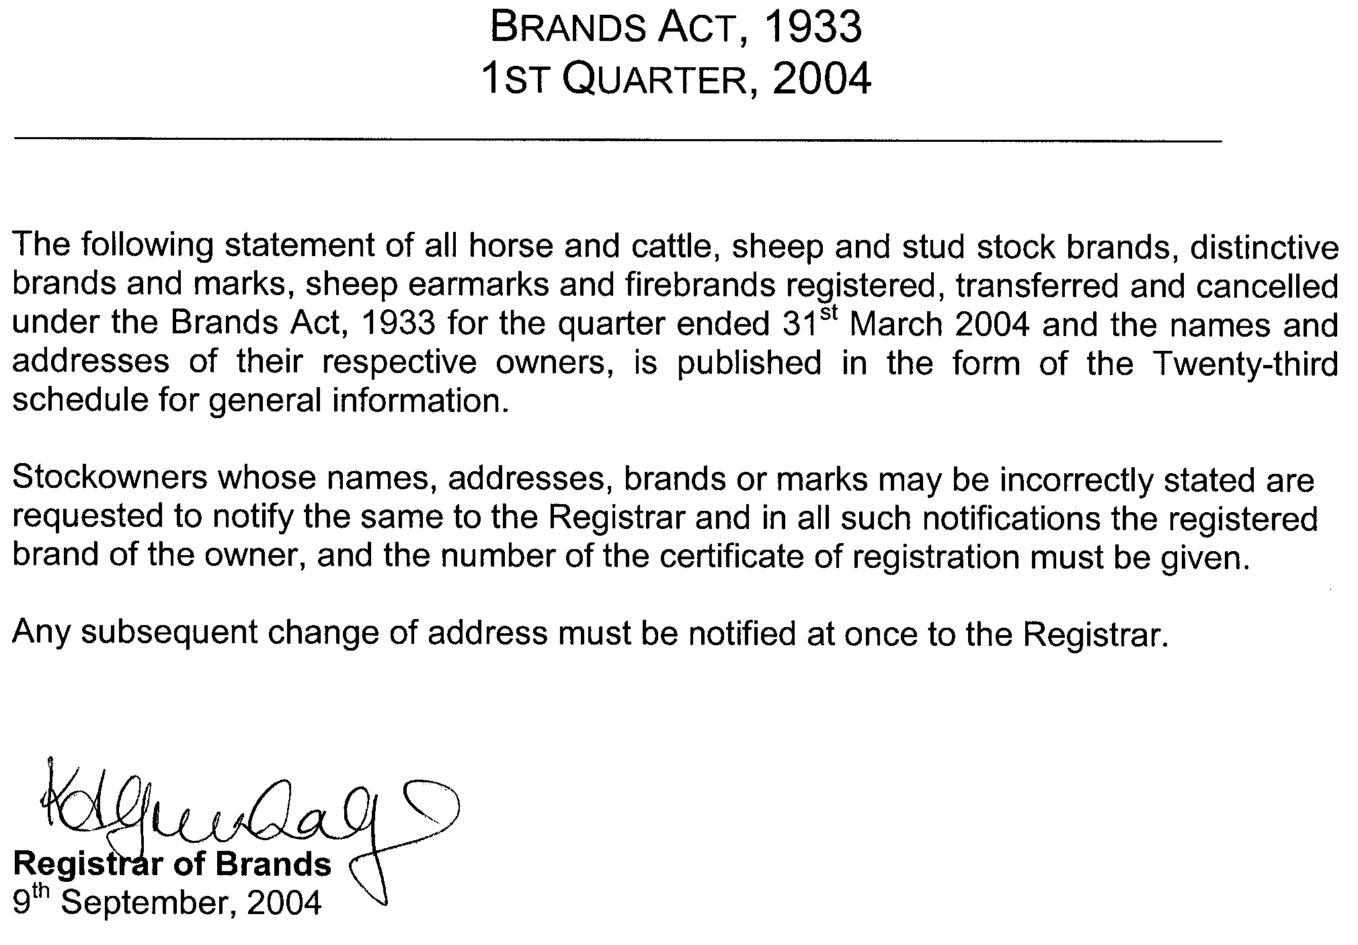
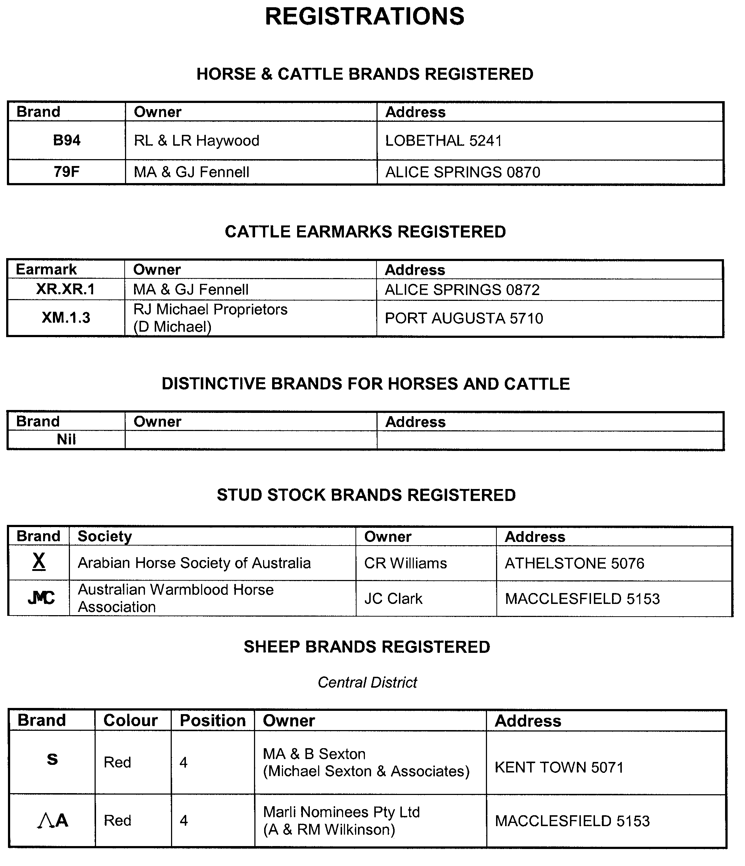
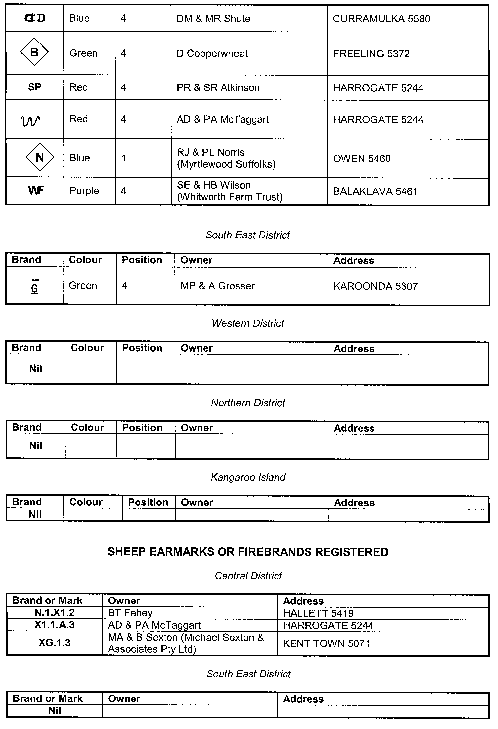
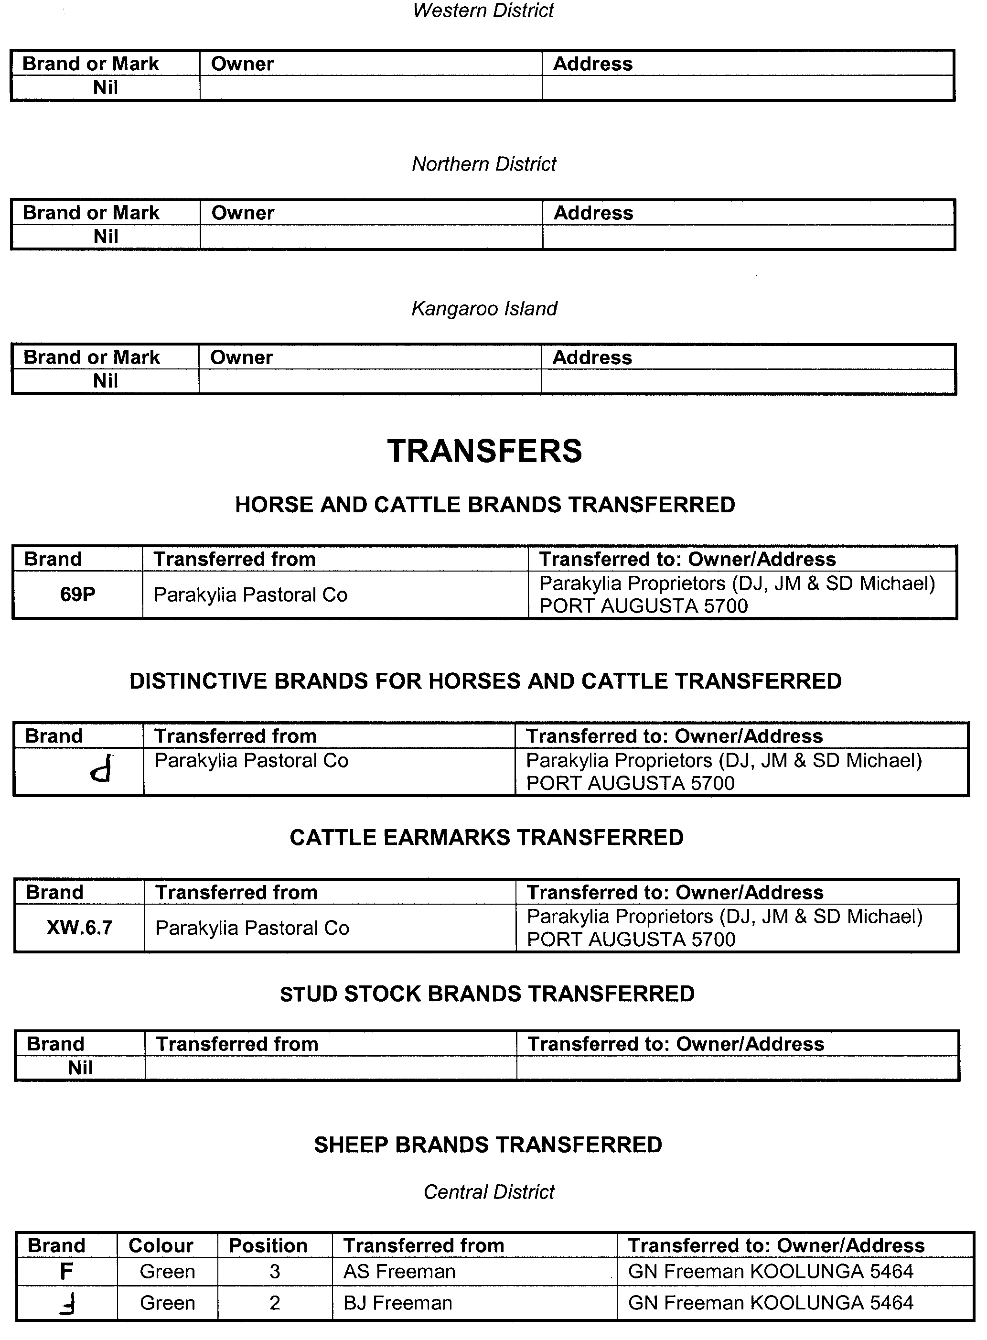
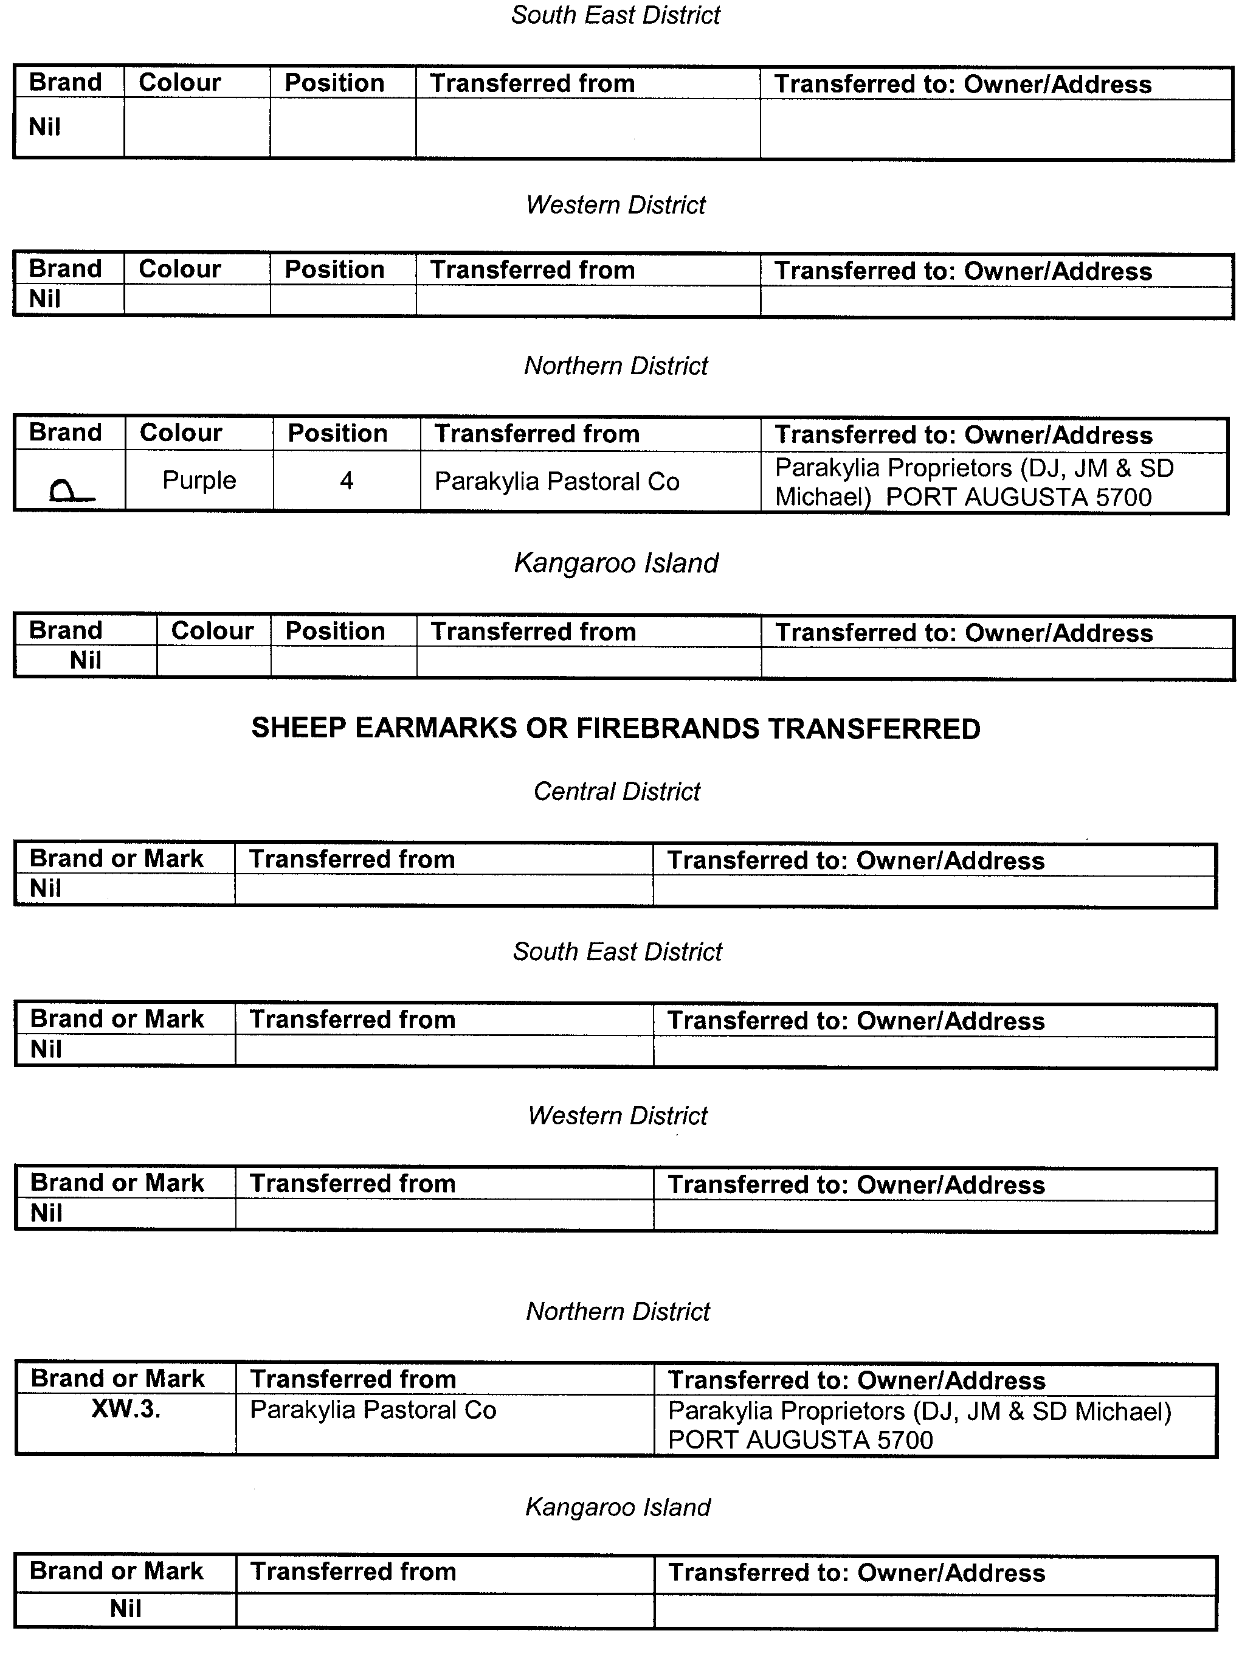

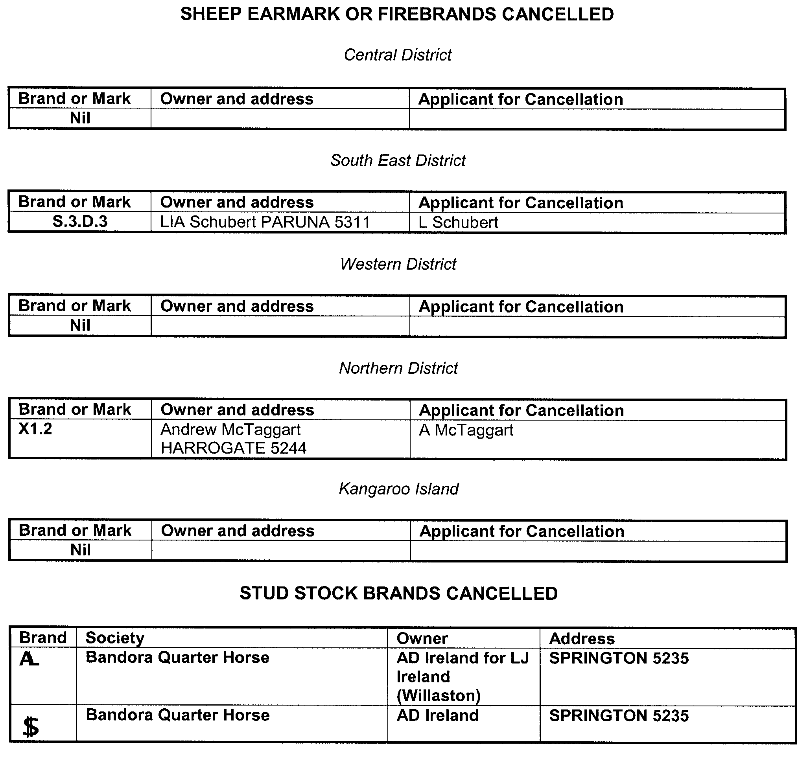

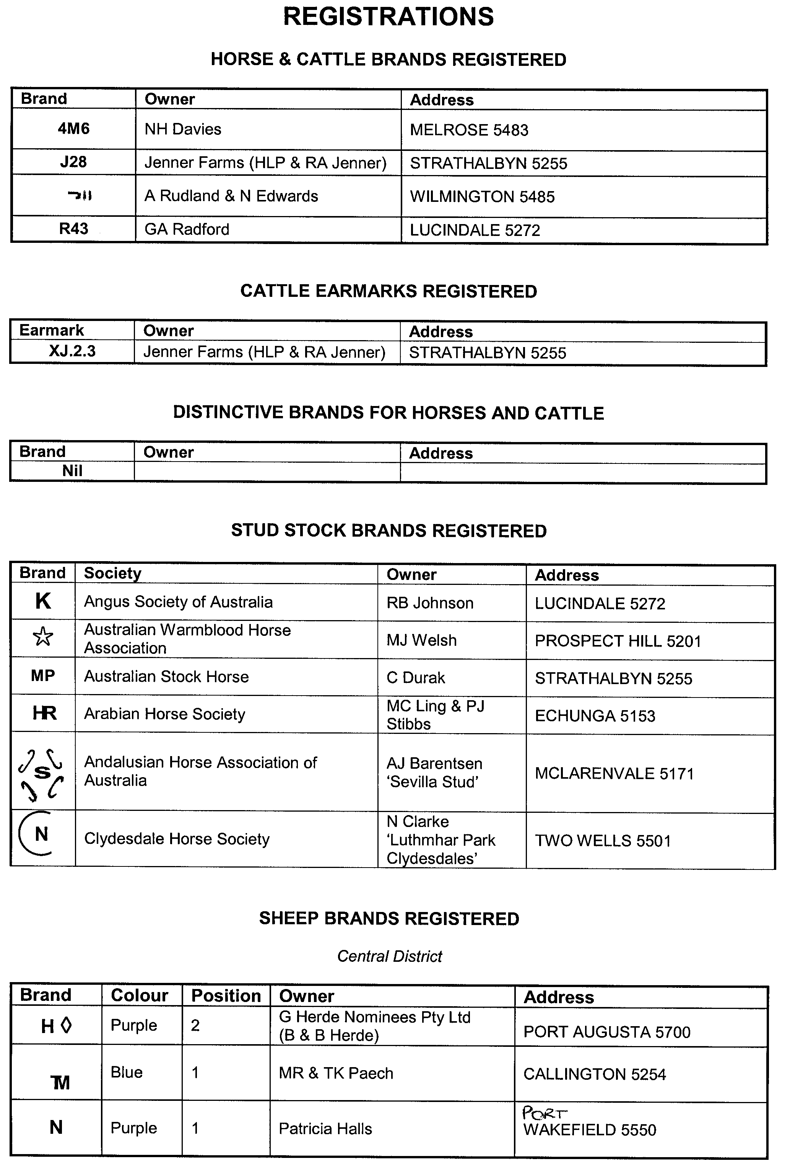
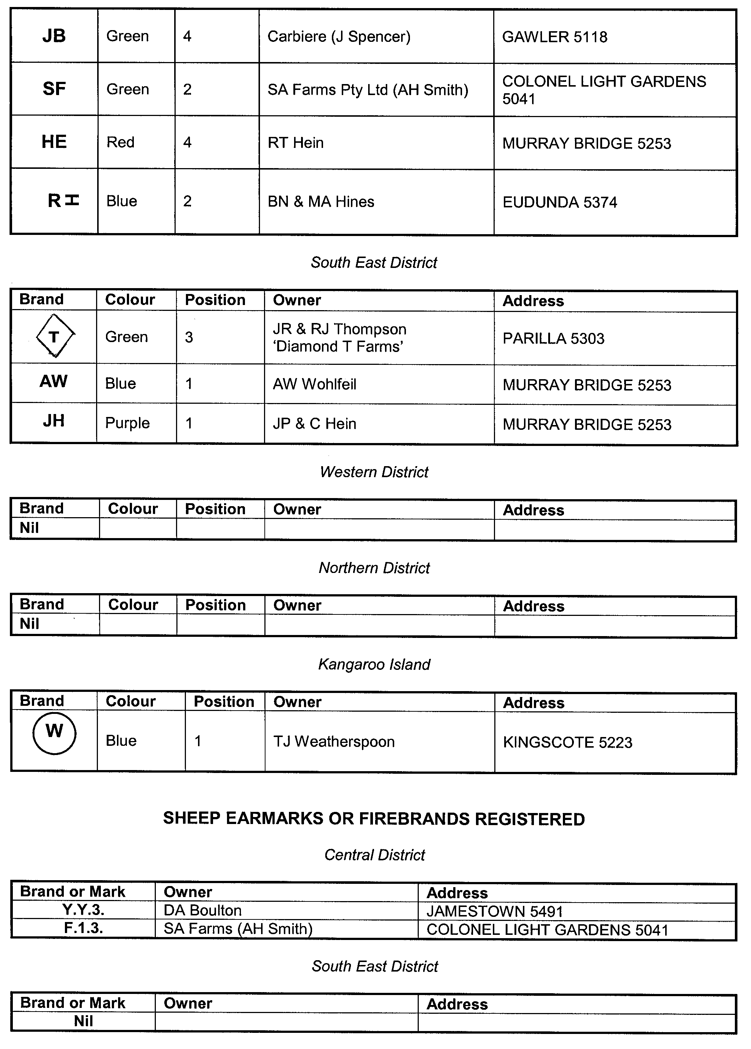
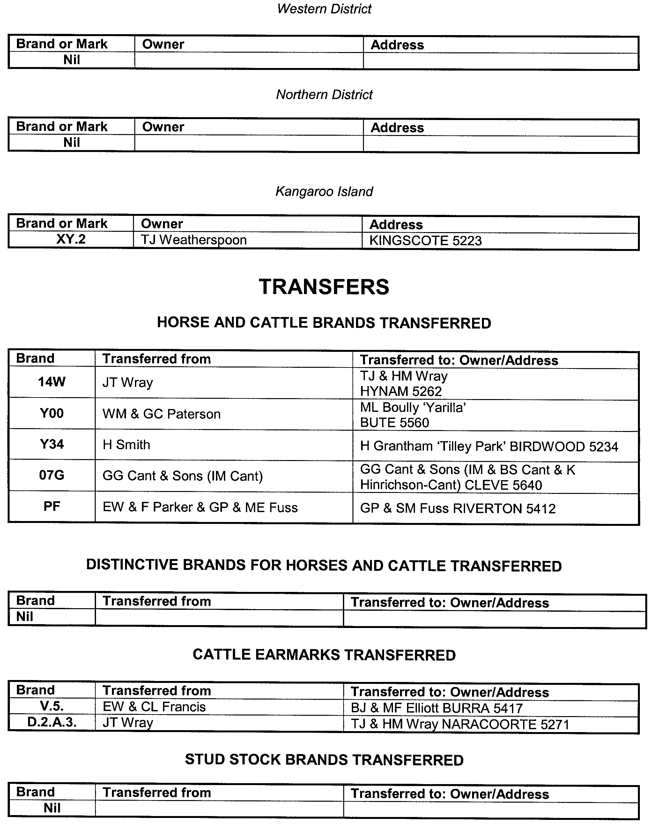
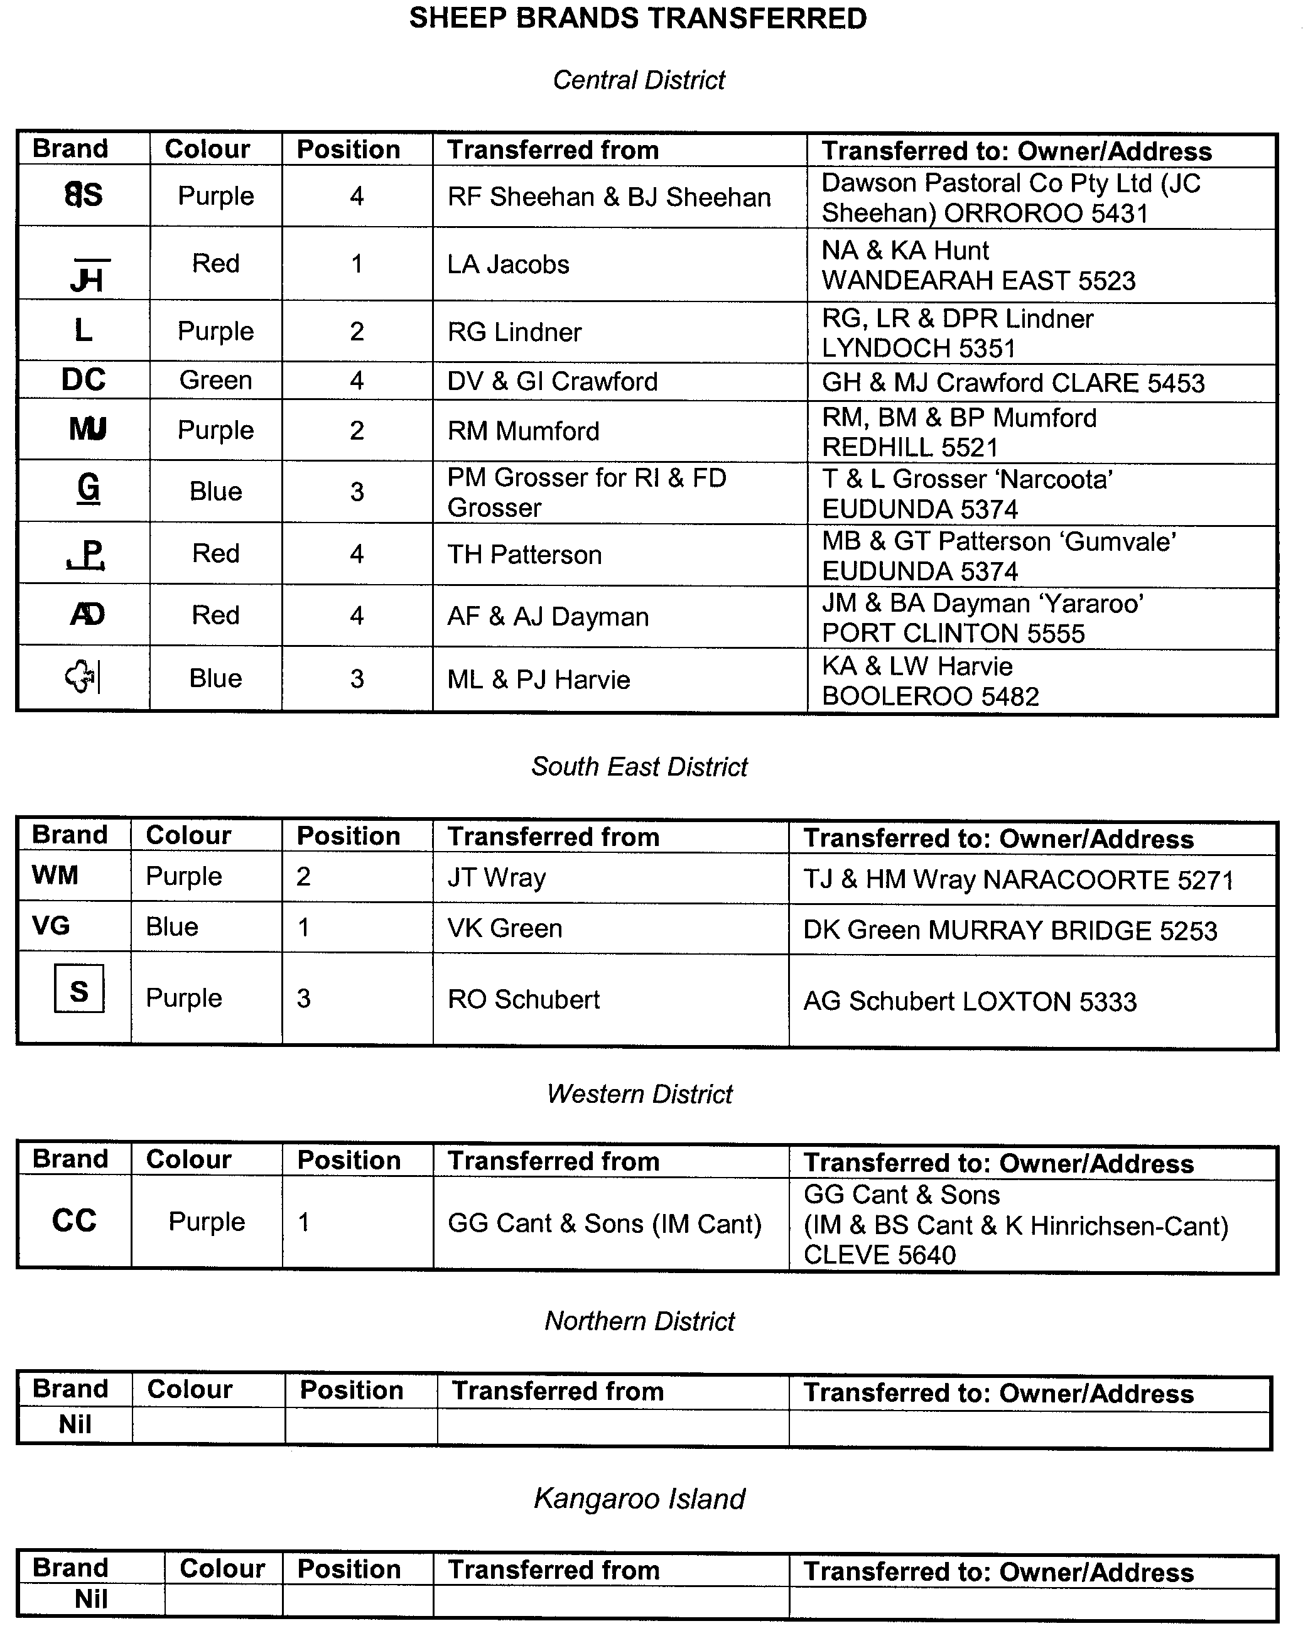
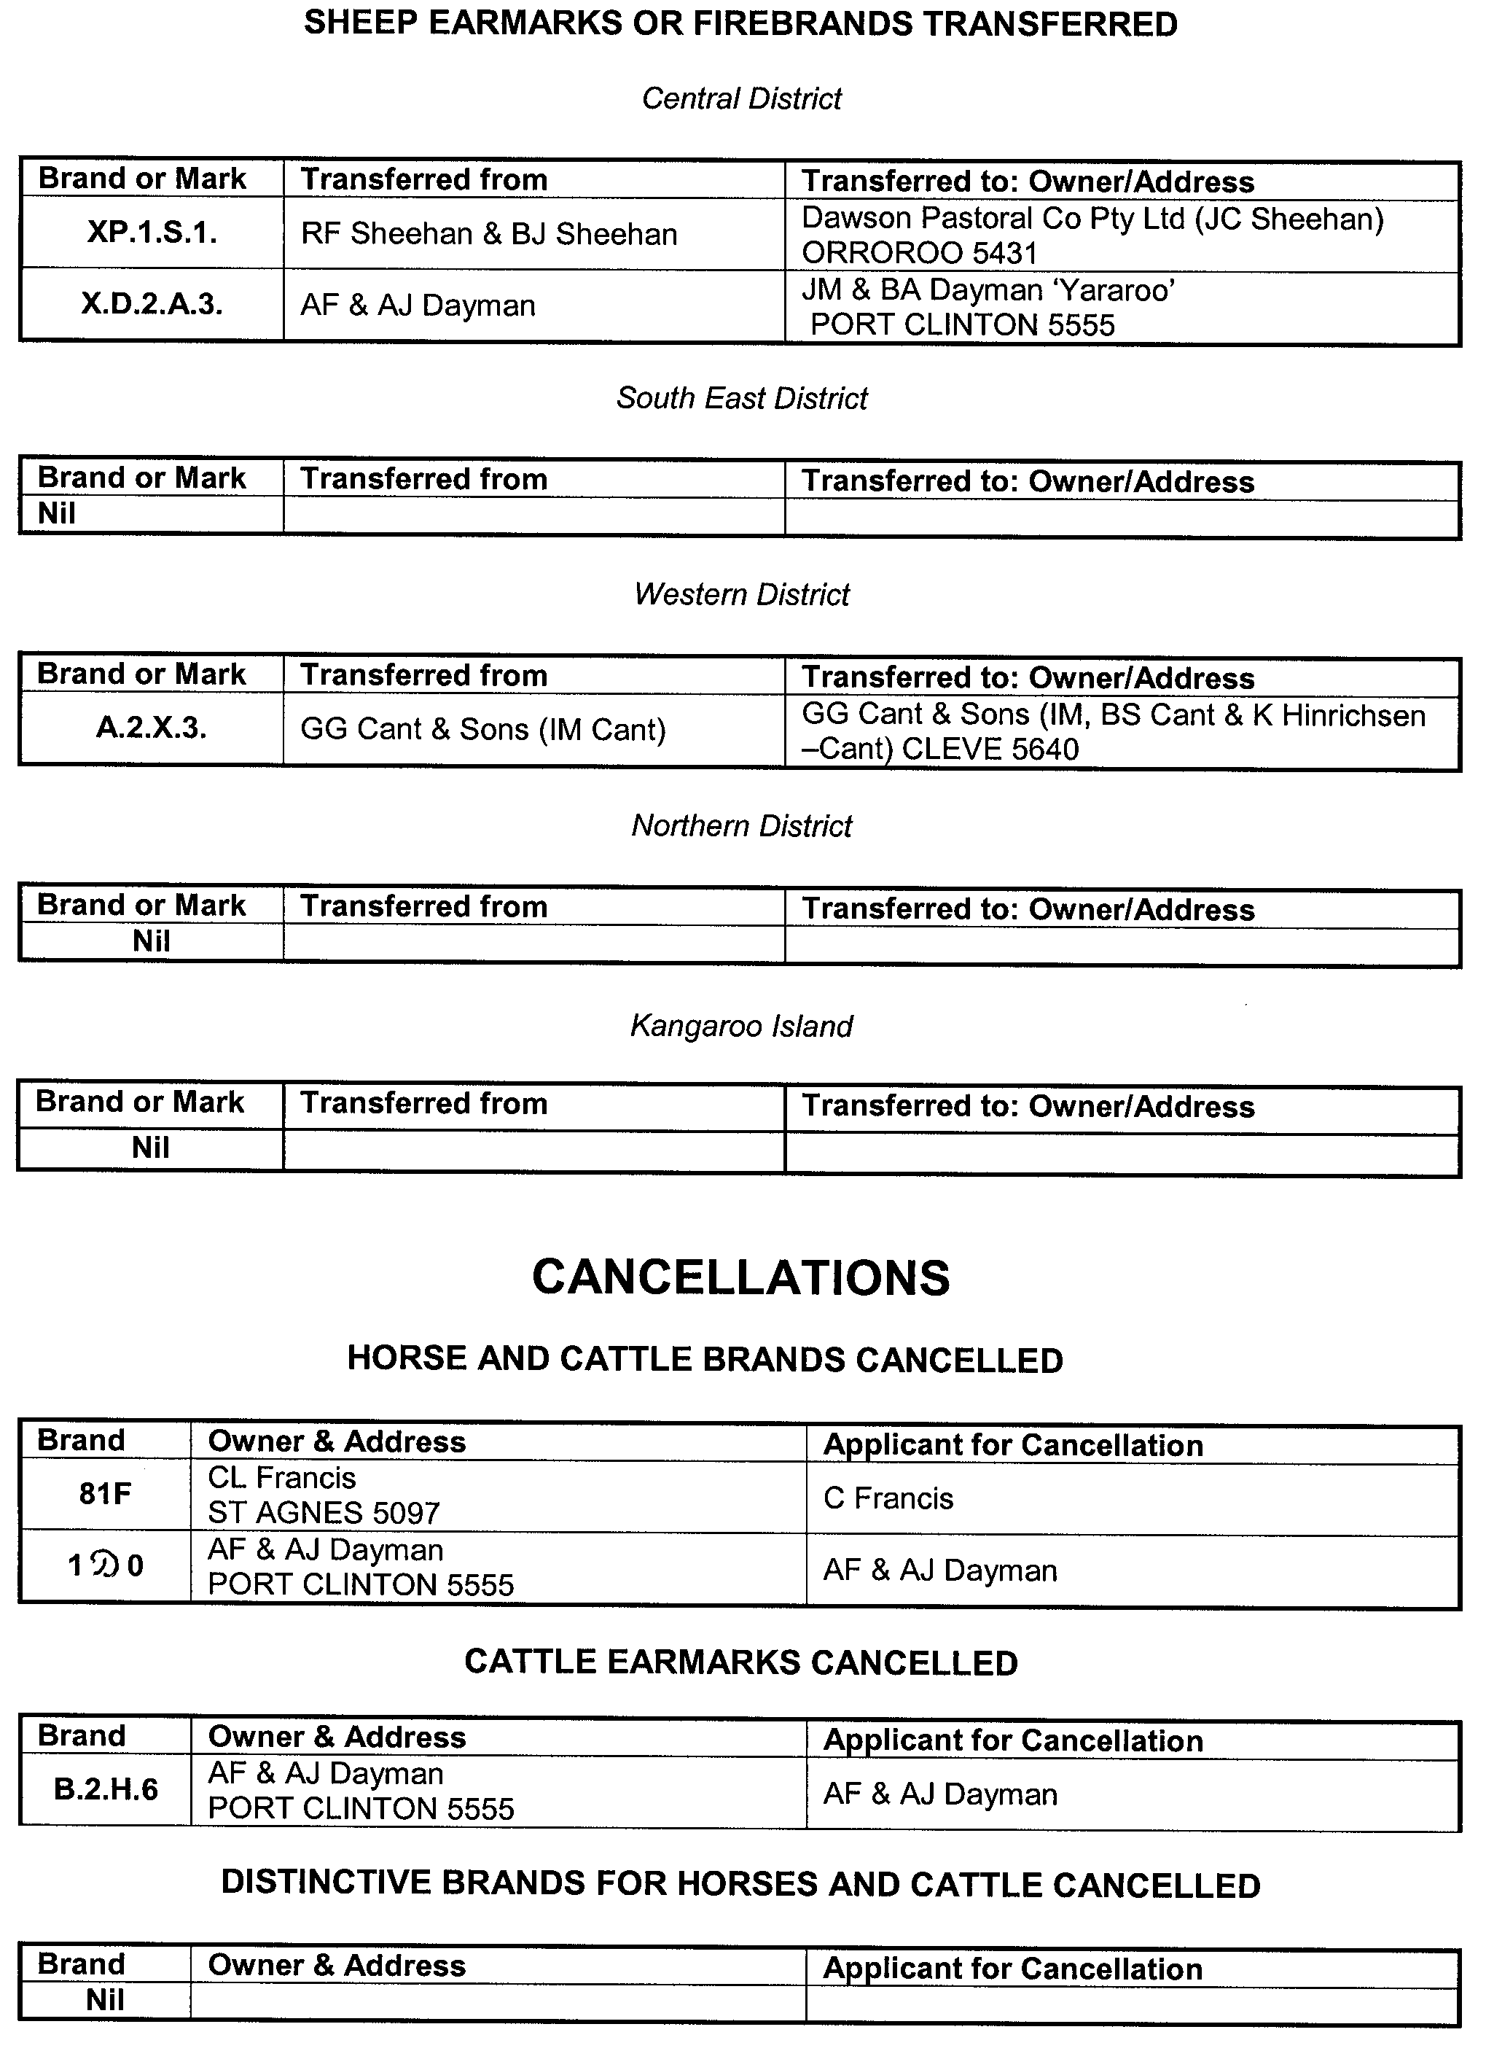
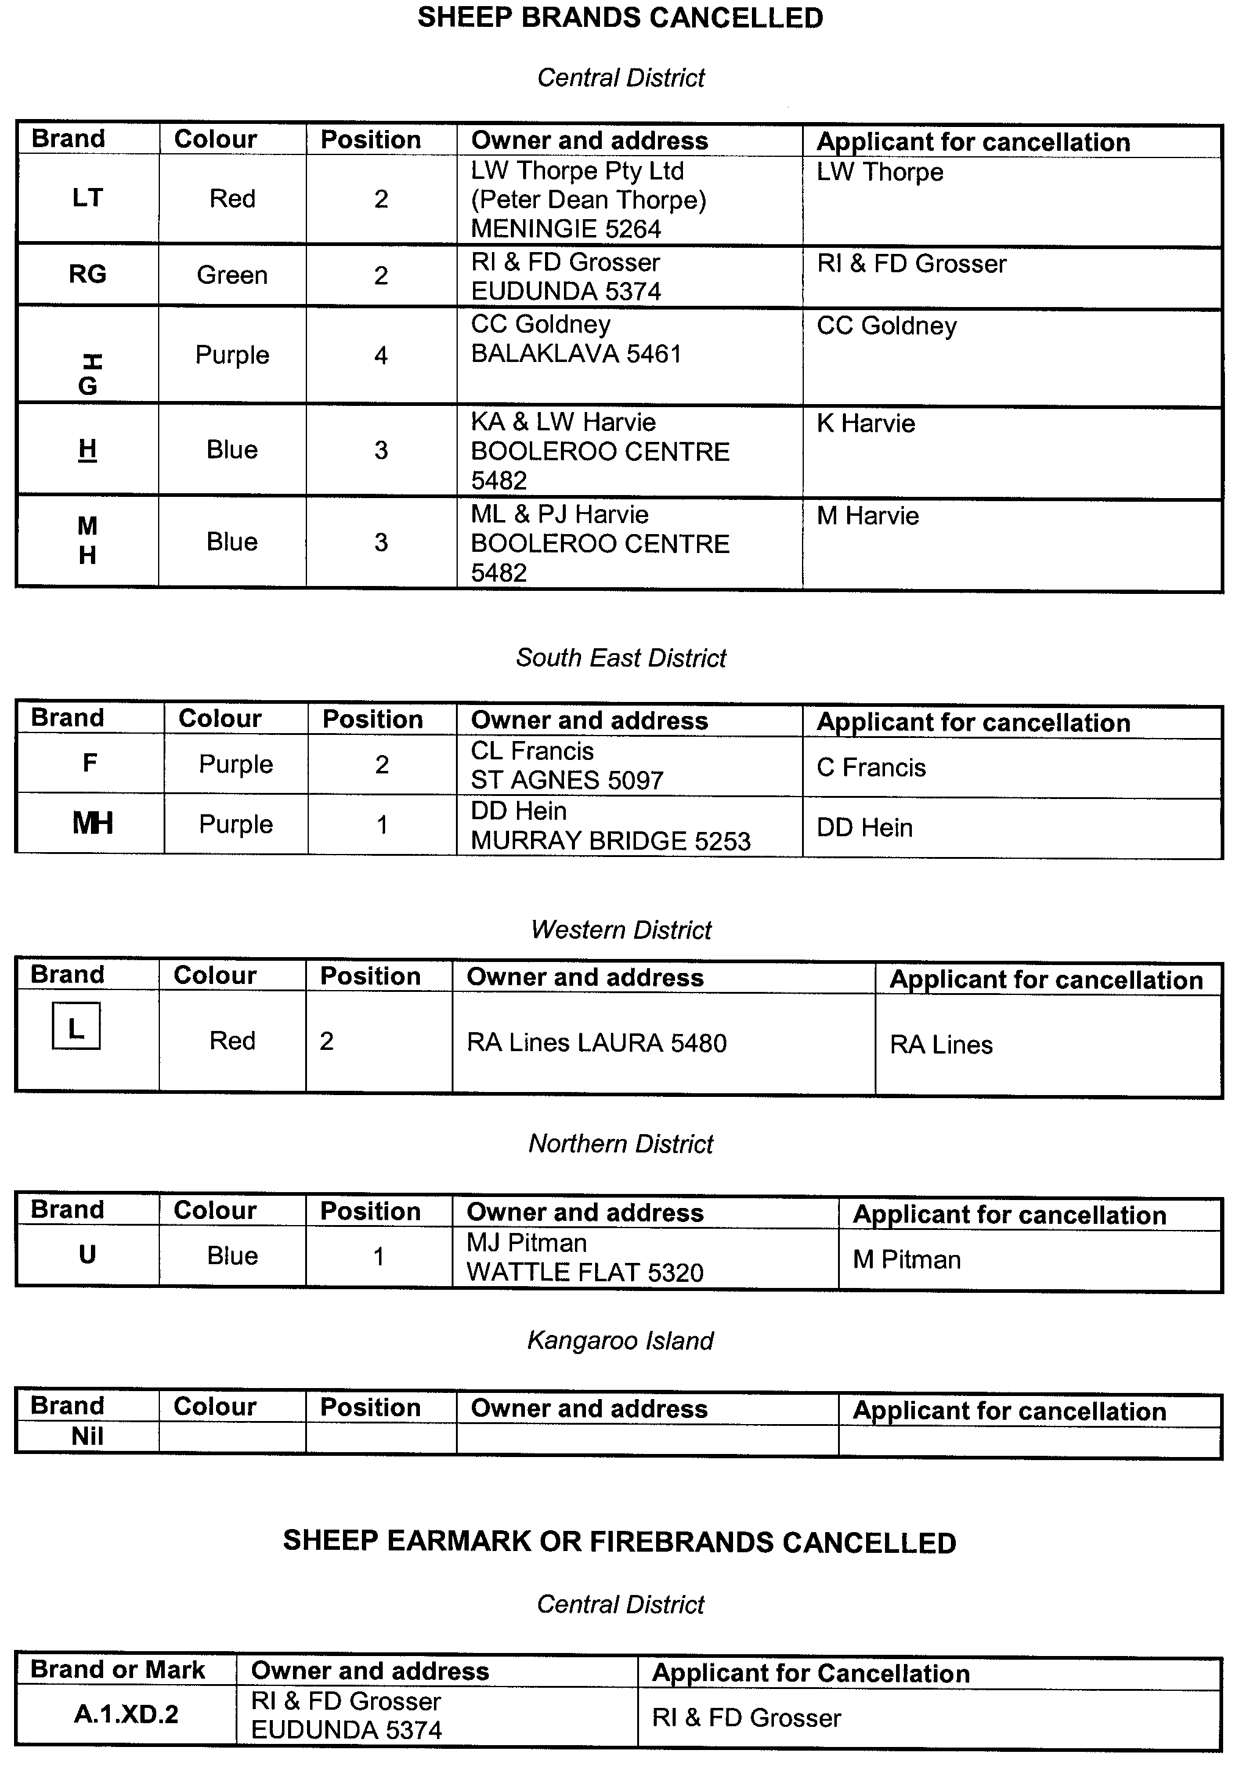
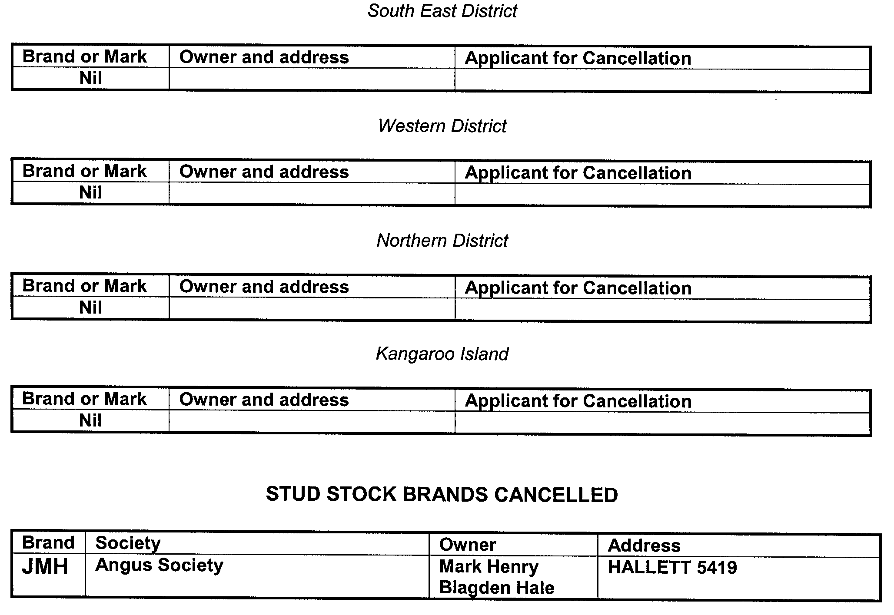

GOVERNMENT GAZETTE ADVERTISEMENT RATES

To apply from 1 July 2004

$  Agents, Ceasing to Act as 35.50  Associations:  Incorporation 18.10  Intention of Incorporation 44.75  Transfer of Properties 44.75  Attorney, Appointment of 35.50  Bailiff’s Sale 44.75  Cemetery Curator Appointed 26.50  Companies:  Alteration to Constitution 35.50  Capital, Increase or Decrease of 44.75  Ceasing to Carry on Business 26.50  Declaration of Dividend 26.50  Incorporation 35.50  Lost Share Certificates:  First Name 26.50  Each Subsequent Name 9.10  Meeting Final 29.75  Meeting Final Regarding Liquidator’s Report on  Conduct of Winding Up (equivalent to ‘Final  Meeting’)  First Name 35.50  Each Subsequent Name 9.10  Notices:  Call 44.75  Change of Name 18.10  Creditors 35.50  Creditors Compromise of Arrangement 35.50  Creditors (extraordinary resolution that ‘the Com-pany be wound up voluntarily and that a liquidator be appointed’) 44.75  Release of Liquidator⎯Application⎯Large Ad. 70.50  ⎯Release Granted 44.75  Receiver and Manager Appointed 41.25  Receiver and Manager Ceasing to Act 35.50  Restored Name 33.50  Petition to Supreme Court for Winding Up 62.00  Summons in Action 53.00  Order of Supreme Court for Winding Up Action 35.50  Register of Interests⎯Section 84 (1) Exempt 80.00  Removal of Office 18.10  Proof of Debts 35.50  Sales of Shares and Forfeiture 35.50  Estates:  Assigned 26.50  Deceased Persons⎯Notice to Creditors, etc. 44.75  Each Subsequent Name 9.10  Deceased Persons⎯Closed Estates 26.50  Each Subsequent Estate 1.15  Probate, Selling of 35.50  Public Trustee, each Estate 9.10 |  | $  Firms:  Ceasing to Carry on Business (each insertion) 23.60  Discontinuance Place of Business 23.60  Land⎯Real Property Act:  Intention to Sell, Notice of 44.75  Lost Certificate of Title Notices 44.75  Cancellation, Notice of (Strata Plan) 44.75  Mortgages:  Caveat Lodgment 18.10  Discharge of 19.00  Foreclosures 18.10  Transfer of 18.10  Sublet 9.10  Leases⎯Application for Transfer (2 insertions) each 9.10  Lost Treasury Receipts (3 insertions) each 26.50  Licensing 53.00  Municipal or District Councils:  Annual Financial Statement⎯Forms 1 and 2 499.00  Electricity Supply⎯Forms 19 and 20 354.00  Default in Payment of Rates:  First Name 70.50  Each Subsequent Name 9.10  Noxious Trade 26.50  Partnership, Dissolution of 26.50  Petitions (small) 18.10  Registered Building Societies (from Registrar-  General) 18.10  Register of Unclaimed Moneys⎯First Name 26.50  Each Subsequent Name 9.10  Registers of Members⎯Three pages and over:  Rate per page (in 8pt) 226.00  Rate per page (in 6pt) 299.00  Sale of Land by Public Auction 45.25  Advertisements 2.50  Advertisements, other than those listed are charged at $2.50 per column line, tabular one-third extra.  Notices by Colleges, Universities, Corporations and District Councils to be charged at $2.50 per line.  Where the notice inserted varies significantly in length from that which is usually published a charge of $2.50 per column line will be applied in lieu of advertisement rates listed.  South Australian Government publications are sold on the condition that they will not be reproduced without prior permission from the Government Printer.
All the above prices include GST

GOVERNMENT GAZETTE NOTICES
ALL private advertisements forwarded for publication in the South Australian Government Gazette must be PAID FOR PRIOR TO INSERTION; and all notices, from whatever source, should be legibly written on one side of the paper only and sent to Government Publishing SA so as to be received no later than 4 p.m. Tuesday preceding the day of publication. Phone 8207 1045 or Fax 8207 1040. E-mail: governmentgazette@saugov.sa.gov.au. Send as attachments in Word format. Please include date the notice is to be published and to whom the notice will be charged. The Government Gazette is available online at: www.governmentgazette.sa.gov.au.

MISCELLANEOUS LEGISLATION AND GOVERNMENT PUBLICATIONS PRICES AS FROM 1 JULY 2004

Acts, Bills, Rules, Parliamentary Papers and Regulations
Pages | Main | Amends | Pages | Main | Amends

1-16 | 2.15 | 0.95 | 497-512 | 30.25 | 29.00
17-32 | 2.90 | 1.80 | 513-528 | 31.25 | 29.90
33-48 | 3.80 | 2.70 | 529-544 | 32.00 | 31.00
49-64 | 4.75 | 3.65 | 545-560 | 33.00 | 32.00
65-80 | 5.60 | 4.60 | 561-576 | 33.75 | 33.00
81-96 | 6.50 | 5.40 | 577-592 | 34.75 | 33.50
97-112 | 7.40 | 6.30 | 593-608 | 35.75 | 34.50
113-128 | 8.30 | 7.25 | 609-624 | 36.50 | 35.50
129-144 | 9.35 | 8.25 | 625-640 | 37.25 | 36.10
145-160 | 10.20 | 9.10 | 641-656 | 38.25 | 37.20
161-176 | 11.20 | 10.00 | 657-672 | 38.75 | 38.00
177-192 | 12.00 | 11.00 | 673-688 | 40.50 | 38.80
193-208 | 13.00 | 11.90 | 689-704 | 41.25 | 39.90
209-224 | 13.80 | 12.70 | 705-720 | 41.75 | 41.00
225-240 | 14.70 | 13.60 | 721-736 | 43.50 | 41.50
241-257 | 15.70 | 14.30 | 737-752 | 44.00 | 42.90
258-272 | 16.60 | 15.30 | 753-768 | 45.00 | 43.40
273-288 | 17.50 | 16.40 | 769-784 | 45.50 | 44.70
289-304 | 18.30 | 17.20 | 785-800 | 46.50 | 45.60
305-320 | 19.30 | 18.20 | 801-816 | 47.25 | 46.00
321-336 | 20.10 | 19.00 | 817-832 | 48.25 | 47.25
337-352 | 21.20 | 20.00 | 833-848 | 49.25 | 48.00
353-368 | 22.00 | 21.00 | 849-864 | 50.00 | 48.80
369-384 | 22.90 | 21.90 | 865-880 | 51.00 | 50.00
385-400 | 23.80 | 22.70 | 881-896 | 51.50 | 50.50
401-416 | 23.70 | 23.50 | 897-912 | 53.00 | 51.50
417-432 | 25.75 | 24.50 | 913-928 | 53.50 | 53.00
433-448 | 26.60 | 25.50 | 929-944 | 54.50 | 53.50
449-464 | 27.50 | 26.25 | 945-960 | 55.50 | 54.00
465-480 | 28.00 | 27.25 | 961-976 | 56.50 | 55.00
481-496 | 29.25 | 28.00 | 977-992 | 57.50 | 56.00

Legislation—Acts, Regulations, etc: $
Subscriptions:
Acts 187.00
All Bills as Laid 447.00
Rules and Regulations 447.00
Parliamentary Papers 447.00
Bound Acts 207.00
Index 103.00
Government Gazette
Copy 4.85
Subscription 247.00
Hansard
Copy 13.50
Subscription—per session (issued weekly) 388.00
Cloth bound—per volume 167.00
Subscription—per session (issued daily) 388.00
Legislation on Disk
Whole Database 2 868.00
Annual Subscription for fortnightly updates 881.00
Individual Act(s) including updates POA
Compendium
Subscriptions:
New Subs 1 700.00
Updates 600.00
(All the above prices include GST)

All Legislation, Government Gazette, Hansard and Legislation on disk are available from:
Counter Sales Service SA, Government Legislation⁺ Outlet
and Mail Orders: Lands Titles Office, 101 Grenfell Street, Adelaide
Phone: 13 23 24 (local call cost), Fax: (08) 8204 1909
Postal: G.P.O. Box 1707, Adelaide, S.A. 5001

Online Shop: www.shop.service.sa.gov.au

Subscriptions and Government Publishing SA
Standing Orders: Box 9, Plaza Level, Riverside Centre, North Terrace, Adelaide, S.A. 5000
Phone: (08) 8207 0908, (08) 8207 0910, Fax: (08) 8207 1040

ENVIRONMENT PROTECTION ACT 1993
Approval of Category B Containers
I, STEPHEN RICHARD SMITH, Senior Adviser, Container Deposit Legislation and Delegate of the Environment Protection Authority (‘the Authority’), pursuant to section 69 of the Environment Protection Act 1993 (SA) (‘the Act’) hereby:
Approval of Category B Containers
Approve as Category B Containers, subject to the conditions in subclauses (i) and (ii) below, each of the classes of containers identified by reference to the following matters described in the first 4 columns of Schedule 1 of this Notice which are sold in South Australia:
(a) the product which each class of containers shall contain;
(b) the size of the containers;
(c) the type of containers;
(d) the name of the holders of these approvals.
(i) Subsection 69 (3) Arrangements
The holders of these approvals must ensure that the empty containers which belong to their respective class of containers hereby approved as Category B Containers are collected from collection depots approved under section 69 of the Act by the party named in column 5 of Schedule 1 of this Notice; and
(ii) Approved Refund Markings
(a) The holders of these approvals must ensure that each container which belongs to their respective class of containers hereby approved as Category B Containers bears the refund marking approved by the Authority in respect of that class of containers;
(b) The refund marking that appears on each container that belongs to the class of containers hereby approved, must be a minimum 1.5 mm for the smallest letter in the statement and a minimum 3 mm for the numeric (‘5’) in the statement.
(c) The holder of these approvals must ensure that if a sticker bearing the refund marking has been approved, and is applied to the container, then the sticker must not be placed on any portion of the opening mechanism or in any other place that would require complete or partial removal of the sticker before the contents may be consumed.

Column 1 | Column 2 |  | Column 3 | Column 4 | Column 5
Product Name | Container  Size (mL) |  | Container Type | Applicant | Collection  Arrangements
Saxbys Ye Olde Original Stone Ginger Beer | 750 | Glass |  | C & S Marketing Pty Ltd | Statewide Recycling
Tuborg | 330 | Glass |  | Heron Tower Pty Ltd | Visy Recycling CDL Services
Castle Lager | 330 | Glass with Paper Label |  | Empire Liquor | Statewide Recycling
Budejovicky Budvar Czech Premium Lager | 330 | Glass with Paper Label |  | Empire Liquor | Statewide Recycling
Kriska Beer Aromatisee Vodka Flavoured | 330 | Glass with Paper Label |  | Empire Liquor | Statewide Recycling
Ambar | 330 | Amber Glass with Paper Label |  | Empire Liquor | Statewide Recycling
Grolsch Premium Lager | 355 | Green Glass with Paper Label |  | Tucker Seabrook (Aust) Pty Ltd | Statewide Recycling
Grolsch Premium Lager | 500 | Can—Aluminium |  | Tucker Seabrook (Aust) Pty Ltd | Statewide Recycling
Grolsch Premium Lager | 330 | Green Glass with Paper Label |  | Tucker Seabrook (Aust) Pty Ltd | Statewide Recycling
Boags Draught | 375 | Brown Glass with Paper Label |  | Carlton & United Breweries Ltd | Visy Recycling CDL Services
XXXX Gold Australian Lager | 250 | Amber Glass with Paper Label |  | Castlemaine Perkins Pty Ltd | Marine Stores Ltd
The Max Iced Coffee Oak | 300 | HDPE with Polypropylene Label |  | Dairy Vale Foods Limited | Statewide Recycling
Dare Wicked Mocha Mudslide | 500 | PET with Polypropylene Label |  | Dairy Vale Foods Limited | Statewide Recycling
Wasser Pink Guava Fruit Drink | 310 | PET with Paper Label |  | Merco Trading | Statewide Recycling
Wasser Pineapple Fruit Drink | 310 | PET with Paper Label |  | Merco Trading | Statewide Recycling
Wasser Orange Fruit Drink | 310 | PET with Paper Label |  | Merco Trading | Statewide Recycling
Wasser Lime Fruit Drink | 310 | PET with Paper Label |  | Merco Trading | Statewide Recycling
Wasser Mixed Fruit Drink | 310 | PET with Paper Label |  | Merco Trading | Statewide Recycling
Wasser Mango Fruit Drink | 310 | PET with Paper Label |  | Merco Trading | Statewide Recycling
Wasser Lychee Fruit Drink | 310 | PET with Paper Label |  | Merco Trading | Statewide Recycling
Wasser Blackcurrant Fruit Drink | 310 | PET with Paper Label |  | Merco Trading | Statewide Recycling
Wasser Apple Fruit Drink | 310 | PET with Paper Label |  | Merco Trading | Statewide Recycling
Wasser Apple Blackcurrant Fruit Drink | 310 | PET with Paper Label |  | Merco Trading | Statewide Recycling
Wasser Strawberry Fruit Drink | 310 | PET with Paper Label |  | Merco Trading | Statewide Recycling
Koya Aloe | 500 | PET with Paper Label |  | Rockman (Australia) Pty Ltd | Statewide Recycling
Koya Aloe Sugar Free | 500 | PET with Paper Label |  | Rockman (Australia) Pty Ltd | Statewide Recycling
Koya Aloe | 180 | Glass with Paper Label |  | Rockman (Australia) Pty Ltd | Statewide Recycling
Koya Aloe Sugar Free | 180 | Glass with Paper Label |  | Rockman (Australia) Pty Ltd | Statewide Recycling
Paldo Aloe | 1 500 | PET with Paper Label |  | Rockman (Australia) Pty Ltd | Statewide Recycling
Paldo Aloe Sugar Free | 1 500 | PET with Paper Label |  | Rockman (Australia) Pty Ltd | Statewide Recycling
Paldo Aloe | 500 | PET with Paper Label |  | Rockman (Australia) Pty Ltd | Statewide Recycling
Paldo Aloe | 180 | Glass with Paper Label |  | Rockman (Australia) Pty Ltd | Statewide Recycling
Paldo Aloe Sugar Free | 180 | Glass with Paper Label |  | Rockman (Australia) Pty Ltd | Statewide Recycling
Dede Pennywort Drink | 280 | Glass with Paper Label |  | Rockman (Australia) Pty Ltd | Statewide Recycling
Dede Basil Seed Drink | 280 | Glass with Paper Label |  | Rockman (Australia) Pty Ltd | Statewide Recycling
Dede Coconut Drink | 280 | Glass with Paper Label |  | Rockman (Australia) Pty Ltd | Statewide Recycling
Dede Lychee Drink | 280 | Glass with Paper Label |  | Rockman (Australia) Pty Ltd | Statewide Recycling
Watsons Lemon Tea Drink | 345 | Can—Aluminium |  | Rockman (Australia) Pty Ltd | Statewide Recycling
Watsons Peach Tea Drink | 345 | Can—Aluminium |  | Rockman (Australia) Pty Ltd | Statewide Recycling
Watsons Sarsae | 345 | Can—Aluminium |  | Rockman (Australia) Pty Ltd | Statewide Recycling
Herco Coconut Drink | 350 | Can—Aluminium |  | Rockman (Australia) Pty Ltd | Statewide Recycling
Famous House Soy Bean Drink | 340 | Can—Aluminium |  | Rockman (Australia) Pty Ltd | Statewide Recycling
Famous House Ching Poo | 380 | Can—Aluminium |  | Rockman (Australia) Pty Ltd | Statewide Recycling
Famous House Guava Juice | 340 | Can—Aluminium |  | Rockman (Australia) Pty Ltd | Statewide Recycling
Famous House Mixed Congee | 380 | Can—Aluminium |  | Rockman (Australia) Pty Ltd | Statewide Recycling
Hong Da Ma Mandarin Lemon | 500 | PET with Paper Label |  | Rockman (Australia) Pty Ltd | Statewide Recycling
Hong Da Ma Green Tea | 600 | PET with Paper Label |  | Rockman (Australia) Pty Ltd | Statewide Recycling
Hong Da Ma Pearl Milk Tea | 320 | Can—Aluminium |  | Rockman (Australia) Pty Ltd | Statewide Recycling
Hong Da Ma Taro Milk Tea | 320 | Can—Aluminium |  | Rockman (Australia) Pty Ltd | Statewide Recycling
Schweppes Cream Soda | 350 | Can—Aluminium |  | Rockman (Australia) Pty Ltd | Statewide Recycling
Hung Fook Tong American Ginseng With Honey | 500 | PET with Paper Label |  | Rockman (Australia) Pty Ltd | Statewide Recycling
Hung Fook Tong Ginseng Chrysanthemum With Honey | 500 | PET with Paper Label |  | Rockman (Australia) Pty Ltd | Statewide Recycling
Hung Fook Tong Common Selheal Fruit | 500 | PET with Paper Label |  | Rockman (Australia) Pty Ltd | Statewide Recycling
Hung Fook Tong Canton Love Pes Vine | 500 | PET with Paper Label |  | Rockman (Australia) Pty Ltd | Statewide Recycling
Hung Fook Tong Chrysanthemum With Honey | 500 | PET with Paper Label |  | Rockman (Australia) Pty Ltd | Statewide Recycling
Hung Fook Tong Wild Dates Juice | 500 | PET with Paper Label |  | Rockman (Australia) Pty Ltd | Statewide Recycling
Hung Fook Tong Mandarin With Honey | 500 | PET with Paper Label |  | Rockman (Australia) Pty Ltd | Statewide Recycling
Hung Fook Tong Pear Juice With Honey | 500 | PET with Paper Label |  | Rockman (Australia) Pty Ltd | Statewide Recycling
Hung Fook Tong Fresh Lemon With Honey | 500 | PET with Paper Label |  | Rockman (Australia) Pty Ltd | Statewide Recycling
Hung Fook Tong Ginseng With Honey | 500 | PET with Paper Label |  | Rockman (Australia) Pty Ltd | Statewide Recycling
Hung Fook Tong American Ginseng With Honey | 1 500 | PET with Paper Label |  | Rockman (Australia) Pty Ltd | Statewide Recycling
Hung Fook Tong Common Selheal Fruit | 1 500 | PET with Paper Label |  | Rockman (Australia) Pty Ltd | Statewide Recycling
Hung Fook Tong Canton Love Pes Vine | 1 500 | PET with Paper Label |  | Rockman (Australia) Pty Ltd | Statewide Recycling
Hung Fook Tong Chrysanthemum With Honey | 1 500 | PET with Paper Label |  | Rockman (Australia) Pty Ltd | Statewide Recycling
Hung Fook Tong Mandarin Lemon With Honey | 1 500 | PET with Paper Label |  | Rockman (Australia) Pty Ltd | Statewide Recycling
Hung Fook Tong Pear Juice With Honey | 1 500 | PET with Paper Label |  | Rockman (Australia) Pty Ltd | Statewide Recycling
Hung Fook Tong Sour Plum Drink | 1 500 | PET with Paper Label |  | Rockman (Australia) Pty Ltd | Statewide Recycling
Hung Fook Tong Sour Plum Drink | 330 | PET with Paper Label |  | Rockman (Australia) Pty Ltd | Statewide Recycling
Hung Fook Tong Fresh Aloe Pulp | 330 | Glass with Paper Label |  | Rockman (Australia) Pty Ltd | Statewide Recycling
Hung Fook Tong Sugar Cane Juice | 375 | Glass with Paper Label |  | Rockman (Australia) Pty Ltd | Statewide Recycling
Koya Aloe | 1 500 | PET with Paper Label |  | Rockman (Australia) Pty Ltd | Statewide Recycling
Koya Aloe Sugar Free | 1 500 | PET with Paper Label |  | Rockman (Australia) Pty Ltd | Statewide Recycling
Breaka Strawberry | 600 | LPB—Gable Top |  | Parmalat Australia Pty Ltd | Statewide Recycling
Breaka Chocolate | 600 | LPB—Gable Top |  | Parmalat Australia Pty Ltd | Statewide Recycling
Breaka Vanilla | 600 | LPB—Gable Top |  | Parmalat Australia Pty Ltd | Statewide Recycling
Pauls Iced Coffee | 600 | LPB—Gable Top |  | Parmalat Australia Pty Ltd | Statewide Recycling
Pauls Lite Iced Coffee | 600 | LPB—Gable Top |  | Parmalat Australia Pty Ltd | Statewide Recycling
Pauls Premium 100% Orange Juice | 500 | PET with Paper Label (Sticker) |  | Parmalat Australia Pty Ltd | Statewide Recycling
Pauls Premium 100% Orange & Mango Juice | 500 | PET with Paper Label (Sticker) |  | Parmalat Australia Pty Ltd | Statewide Recycling
Pauls Premium 100% Apple Juice | 500 | PET with Paper Label (Sticker) |  | Parmalat Australia Pty Ltd | Statewide Recycling
Pauls Premium 100% Pineapple Juice | 500 | PET with Paper Label (Sticker) |  | Parmalat Australia Pty Ltd | Statewide Recycling
Bundaberg Rum & Cola 5.0% | 345 | Glass with Paper Label |  | Diageo Australia Pty Ltd | Statewide Recycling
Bundaberg Rum Dry & Lime 5.0% | 345 | Glass with Paper Label |  | Diageo Australia Pty Ltd | Statewide Recycling
Bundaberg Rum MID 3.5 & Cola 5.0% | 345 | Glass with Paper Label |  | Diageo Australia Pty Ltd | Statewide Recycling
XS Energy Citrus Blast Drink | 250 | Can—Aluminium |  | Amway of Australia | Visy Recycling CDL Services
XS Energy Grape Berry Drink | 250 | Can—Aluminium |  | Amway of Australia | Visy Recycling CDL Services
Aussie Bodies Lo Carb Protein Revival Dutch Chocolate | 375 | LPB—Aseptic |  | Aussie Bodies Pty Ltd | Statewide Recycling
Santa Croce Natural Mineral Water | 750 | PET with Paper Label |  | Global Food Distributors Pty Ltd | Statewide Recycling
Santa Croce Carbonated Natural Mineral Water | 750 | PET with Paper Label |  | Global Food Distributors Pty Ltd | Statewide Recycling
Water + Lemon Lime | 710 | PET with PVC Label |  | Bickfords Australia Pty Ltd | Statewide Recycling
Water + Melon | 710 | PET with PVC Label |  | Bickfords Australia Pty Ltd | Statewide Recycling
Water + Mandarin | 710 | PET with PVC Label |  | Bickfords Australia Pty Ltd | Statewide Recycling
Water + Peach | 710 | PET with PVC Label |  | Bickfords Australia Pty Ltd | Statewide Recycling
Water + Lemon | 710 | PET with PVC Label |  | Bickfords Australia Pty Ltd | Statewide Recycling
Esprit Green Tea Lemon Flavour | 500 | PET with PVC Label |  | Bickfords Australia Pty Ltd | Statewide Recycling
Esprit Green Tea Honey Flavour | 500 | PET with PVC Label |  | Bickfords Australia Pty Ltd | Statewide Recycling
Esprit Green Oolong Tea Lightly Sweetened | 500 | PET with PVC Label |  | Bickfords Australia Pty Ltd | Statewide Recycling
Cafecino Double Shot Espresso | 190 | Can—Steel with Aluminium Lid |  | Bickfords Australia Pty Ltd | Statewide Recycling
Cafecino Double Shot Espresso & Milk | 190 | Can—Steel with Aluminium Lid |  | Bickfords Australia Pty Ltd | Statewide Recycling
Ocean Spray White Cranberry Peach | 1 500 | Glass with Paper Label |  | Ocean Spray International Inc | Visy Recycling CDL Services
Ocean Spray White Cranberry Strawberry | 1 500 | Glass with Paper Label |  | Ocean Spray International Inc | Visy Recycling CDL Services
Ocean Spray White Cranberry | 1 500 | Glass with Paper Label |  | Ocean Spray International Inc | Visy Recycling CDL Services
Ocean Spray White Cranberry Light | 1 500 | PET with Paper Label |  | Ocean Spray International Inc | Visy Recycling CDL Services
Ribena Blackcurrant Fruit Drink | 500 | PET with PVC Label |  | GlaxoSmithKline | Statewide Recycling
Ribena Blackcurrant & Apple Fruit Drink | 1 000 | LPB—Aseptic |  | GlaxoSmithKline | Statewide Recycling
Ribena Blackcurrant & Apple Fruit Drink | 250 | LPB—Aseptic |  | GlaxoSmithKline | Statewide Recycling
Juice Bar No. 1 Apple Blueberry Banana Boysenberry | 250 | PET with Polypropylene Label |  | Berri Limited | Statewide Recycling
Juice Bar No. 2 Apple Lemon Honey Ginger | 250 | PET with Polypropylene Label |  | Berri Limited | Statewide Recycling
Juice Bar No. 3 Mandarin Mango | 250 | PET with Polypropylene Label |  | Berri Limited | Statewide Recycling
Juice Bar No. 4 Pineapple Banana Coconut Lime | 250 | PET with Polypropylene Label |  | Berri Limited | Statewide Recycling
Juice Bar No. 5 Apple Banana Mango Orange Passionfruit | 250 | PET with Polypropylene Label |  | Berri Limited | Statewide Recycling
Juice Bar No. 6 Apple Banana Raspberry Strawberry | 250 | PET with Polypropylene Label |  | Berri Limited | Statewide Recycling
Juice Bar No. 7 Apple Strawberry Rhubarb Lemon | 250 | PET with Polypropylene Label |  | Berri Limited | Statewide Recycling
Vodka Mudshake Original Caramel | 200 | Brown Glass with Paper Label |  | Independent Distillers Australia | Statewide Recycling
Vodka Mudshake Original Cappuccino | 200 | Brown Glass with Paper Label |  | Independent Distillers Australia | Statewide Recycling
Vodka Mudshake Exotique Banane | 200 | Brown Glass with Paper Label |  | Independent Distillers Australia | Statewide Recycling
Vodka Mudshake Original Strawberry | 200 | Brown Glass with Paper Label |  | Independent Distillers Australia | Statewide Recycling
Vodka Mudshake Original Honeycomb | 200 | Brown Glass with Paper Label |  | Independent Distillers Australia | Statewide Recycling
Vodka Mudshake Original Chocolate | 200 | Brown Glass with Paper Label |  | Independent Distillers Australia | Statewide Recycling
San Benedetto Ice Tea Lemon | 1 500 | PET with Paper Label |  | Four Seasons Wholesale Fresh Produce | Statewide Recycling
San Benedetto Ice Tea Peach | 1 500 | PET with Paper Label |  | Four Seasons Wholesale Fresh Produce | Statewide Recycling
San Benedetto Peach Ice Tea | 500 | PET with Paper Label |  | Four Seasons Wholesale Fresh Produce | Statewide Recycling
San Benedetto Lemon Ice Tea | 500 | PET with Paper Label |  | Four Seasons Wholesale Fresh Produce | Statewide Recycling
San Benedetto Orange Soda | 250 | Glass with Paper Label |  | Four Seasons Wholesale Fresh Produce | Statewide Recycling
San Benedetto Red Orange Soda | 250 | Glass with Paper Label |  | Four Seasons Wholesale Fresh Produce | Statewide Recycling
San Benedetto Lemon Soda | 250 | Glass with Paper Label |  | Four Seasons Wholesale Fresh Produce | Statewide Recycling
San Benedetto Chinotto Soda | 250 | Glass with Paper Label |  | Four Seasons Wholesale Fresh Produce | Statewide Recycling
Naturale San Benedetto Aqua Minerale Naturale | 250 | Glass with Paper Label |  | Four Seasons Wholesale Fresh Produce | Statewide Recycling
Frizzante San Benedetto Aqua Minerale Naturale | 250 | Glass with Paper Label |  | Four Seasons Wholesale Fresh Produce | Statewide Recycling
San Benedetto Frizzante Mineral Water | 500 | Glass with Paper Label |  | Four Seasons Wholesale Fresh Produce | Statewide Recycling
San Benedetto Naturale Mineral Water | 500 | Glass with Paper Label |  | Four Seasons Wholesale Fresh Produce | Statewide Recycling
San Benedetto Natural Mineral Water | 1 500 | PET with Paper Label |  | Four Seasons Wholesale Fresh Produce | Statewide Recycling
San Benedetto Sparkling Natural Mineral Water | 1 500 | PET with Paper Label |  | Four Seasons Wholesale Fresh Produce | Statewide Recycling
San Benedetto Aqua Minerale Naturale Frizzante | 1 000 | Glass with Paper Label |  | Four Seasons Wholesale Fresh Produce | Statewide Recycling
San Benedetto Aqua Minerale Naturale | 1 000 | Glass with Paper Label |  | Four Seasons Wholesale Fresh Produce | Statewide Recycling
Frizzante San Benedetto Aqua Minerale Naturale | 750 | Glass with Paper Label |  | Four Seasons Wholesale Fresh Produce | Statewide Recycling
Naturale San Benedetto Aqua Minerale Naturale | 750 | Glass with Paper Label |  | Four Seasons Wholesale Fresh Produce | Statewide Recycling
San Benedetto Natural Mineral Water | 500 | PET with Paper Label |  | Four Seasons Wholesale Fresh Produce | Statewide Recycling
Vimto Fruit Flavoured Drink | 250 | Glass with Paper Label (Sticker) |  | Adelaide Lebanese Bakery | Marine Stores Ltd
Pampa Tamarin Fruit Flavoured Drink | 300 | Glass with Paper Label (Sticker) |  | Adelaide Lebanese Bakery | Marine Stores Ltd
Junal Jellab Fruit Flavoured Drink | 250 | Glass with Paper Label (Sticker) |  | Adelaide Lebanese Bakery | Marine Stores Ltd
Almaza Non Alcoholic Malt Beverage | 280 | Glass Green with Paper Label (Sticker) |  | Adelaide Lebanese Bakery | Marine Stores Ltd
Moussy Non Alcoholic Malt Beverage | 330 | Glass Green with Paper Label (Sticker) |  | Adelaide Lebanese Bakery | Marine Stores Ltd
Mango Fruit Drink | 240 | Glass with Paper Label (Sticker) |  | Adelaide Lebanese Bakery | Marine Stores Ltd
Guava Fruit Drink | 235 | Glass with Paper Label (Sticker) |  | Adelaide Lebanese Bakery | Marine Stores Ltd
Mecca Cola | 330 | Can—Aluminium |  | Adelaide Lebanese Bakery | Marine Stores Ltd
Lipton Ice Tea Diet Lemon Flavour | 1 250 | PET with Paper Label |  | Unilever Australia Ltd | Statewide Recycling
Lipton Ice Tea Diet Peach Flavour | 1 250 | PET with Paper Label |  | Unilever Australia Ltd | Statewide Recycling
Lipton Ice Tea Peach Flavour | 1 250 | PET with Paper Label |  | Unilever Australia Ltd | Statewide Recycling
Lipton Ice Tea Lemon Flavour | 1 250 | PET with Paper Label |  | Unilever Australia Ltd | Statewide Recycling
Summer Fruits Apple Fruit Drink | 3 000 | PET with Paper Label |  | Pure & Natural Beverages Pty Ltd | Flagcan Distributors
Summer Fruits Orange Fruit Drink | 3 000 | PET with Paper Label |  | Pure & Natural Beverages Pty Ltd | Flagcan Distributors
Saxbys Ye Olde Original Stone Ginger Beer | 375 | Glass |  | C & S Marketing Pty Ltd | Statewide Recycling
Saxbys Diet Ginger Beer | 375 | Glass |  | C & S Marketing Pty Ltd | Statewide Recycling
Saxbys Diet Ginger Beer | 750 | Glass |  | C & S Marketing Pty Ltd | Statewide Recycling
St Agnes & Cola | 375 | Can—Aluminium |  | Angoves Pty Ltd | Statewide Recycling
St Agnes & Dry | 375 | Can—Aluminium |  | Angoves Pty Ltd | Statewide Recycling
St Agnes Lime & Soda | 375 | Can—Aluminium |  | Angoves Pty Ltd | Statewide Recycling
Cutolo Aranciata | 180 | Glass with Paper Label (Sticker) |  | Food & Wine Connection Pty Ltd | Statewide Recycling
Cutolo Chinotto | 180 | Glass with Paper Label (Sticker) |  | Food & Wine Connection Pty Ltd | Statewide Recycling
Cutolo Gassosa | 180 | Glass with Paper Label (Sticker) |  | Food & Wine Connection Pty Ltd | Statewide Recycling
Cutolo Limonata | 180 | Glass with Paper Label (Sticker) |  | Food & Wine Connection Pty Ltd | Statewide Recycling
Cutolo Mineral Water | 180 | Glass with Paper Label (Sticker) |  | Food & Wine Connection Pty Ltd | Statewide Recycling
Cutolo Apple Nectar | 125 | Glass with Paper Label (Sticker) |  | Food & Wine Connection Pty Ltd | Statewide Recycling
Cutolo Apricot Nectar | 125 | Glass with Paper Label (Sticker) |  | Food & Wine Connection Pty Ltd | Statewide Recycling
Cutolo Peach Nectar | 125 | Glass with Paper Label (Sticker) |  | Food & Wine Connection Pty Ltd | Statewide Recycling
Cutolo Pear Nectar | 125 | Glass with Paper Label (Sticker) |  | Food & Wine Connection Pty Ltd | Statewide Recycling
EKO Organic Italian Beer | 330 | Glass with Paper Label (Sticker) Amber |  | Food & Wine Connection Pty Ltd | Statewide Recycling
Radenska Iced Tea Lemon | 500 | PET Paper Label |  | Marco Polo Foods Pty Ltd | Statewide Recycling
Radenska Iced Tea Peach | 500 | PET Paper Label |  | Marco Polo Foods Pty Ltd | Statewide Recycling

FISHERIES ACT 1982: SECTION 59
TAKE notice that pursuant to section 59 of the Fisheries Act 1982, Greg Noble, P.O. Box 394, Brighton, S.A. 5048 (the ‘principal exemption holder’) and the class of persons specified in Schedule 1 (the ‘other exemption holders’), are exempt from clauses 66, 73 and 77B of Schedule 1 of the Fisheries (General) Regulations 2000, but only insofar as the exemption holders may exceed the prescribed boat limits during a chartered fishing trip on the Why Not in accordance with the allowable limits specified in Schedule 2 (the ‘exempted activity’), subject to the conditions specified in Schedule 3, from the date of gazettal until 30 June 2005, unless varied or revoked earlier.
Schedule 1
Any person or persons who charter the boat Why Not from Greg Noble for the purpose of recreational fishing.
Schedule 2
1. Where the number of ‘other exemption holders’ exceeds six, all of the ‘other exemption holders’ on board the boat are each restricted to taking no more than one half of the daily bag limit (rounded up to the nearest whole number if necessary) for those species of scalefish (except King George whiting) subject to a limit as specified in the Fisheries (General) Regulations 2000 in any one day.
2. Where the number of ‘other exemption holders’ exceeds three, all of the ‘other exemption holders’ on board the boat are each restricted to taking no more than 10 King George whiting in any one day.
3. Where the number of ‘other exemption holders’ exceeds six, each ‘other exemption holder’ may take no more than a combined total of 20 blue crabs and sand crabs each in any one day.
4. Where the number of ‘other exemption holders’ exceeds eight, each ‘other exemption holder’ may take no more than one rock lobster (Jasus edwardsii) in any one day.
Schedule 3
1. The principal exemption holder, its employees or agents must not take any fish during the chartered fishing trip.
2. The principal exemption holder must not use any boat other than the Why Not for the purpose of engaging in the exempted activity.
3. Neither the principal exemption holder or the other exemption holders may sell any fish taken pursuant to this notice.
4. The principal exemption holder must not accept any fish taken by the other exemption holders as all or part of the consideration for the charter agreement.
5. The principal exemption holder must contact PIRSA Fishwatch on 1800 065 522 at least 24 hours prior to commencing the exempted activity and advise the time and date of departure of the Why Not and the estimated time of return to port.
6. While engaged in the exempted activity the principal exemption holder must have in their possession a copy of this notice. Such notice must be produced to a PIRSA Fisheries Officer if requested.
7. The exemption holders must not contravene or fail to comply with the Fisheries Act 1982, or any regulations made under that Act except where specifically exempted by this notice.
Dated 10 November 2004.
W. Zacharin, Director of Fisheries

FISHERIES ACT 1982: SECTION 59
TAKE notice that pursuant to section 59 of the Fisheries Act 1982, the holder of a prawn fishery licence issued pursuant to the Scheme of Management (Prawn Fisheries) Regulations 1991 (the ‘exemption holder’) or their agent are exempt from the notices made under section 43 of the Fisheries Act 1982 prohibiting the taking of western king prawns (Penaeus latisulcatus) in the waters specified in Schedule 1, in that the exemption holder shall not be guilty of an offence when using prawn trawl nets in accordance with the conditions of their fishery licence for the purpose of gear trials (the ‘exempted activity’) subject to the conditions contained in Schedule 2.
Schedule 1
The waters of Spencer Gulf and Gulf St Vincent contained within the following co-ordinates:
Port Lincoln
Those waters of Spencer Gulf bounded by a line commencing at position latitude 34°42.00′S, longitude 135°52.70′E then to position latitude 34°41.70′S, longitude 135°53.40′E then to position latitude 34°43.40′S, longitude 135°54.50′E then to position latitude 34°43.70′S, longitude 135°53.80′E then to the point of commencement.
Wallaroo
Those waters of Spencer Gulf bounded by a line commencing at position latitude 33°53.20′S, longitude 137°22.00′E then to position latitude 33°53.50′S, longitude 137°32.50′E then to position latitude 35°55.00′S, longitude 137°31.50′E then to position latitude 33°54.70′S, longitude 137°31.00′E then to the point of commencement.
Port Pirie
Those waters of Spencer Gulf bounded by a line commencing at position latitude 33°07.90′S, longitude 137°46.50′E then to position latitude 33°08.10′S, longitude 137°46.70′E then to position latitude 33°10.10′S, longitude 137°45.80′E then to position latitude 33°09.90′S, longitude 137°45.60′E then to the point of commencement.
Port Adelaide
Those waters of Gulf St Vincent commencing at position latitude 34°45.00′S, longitude 138°17.00′E then to position latitude 34°47.00′S, longitude 138°17.00′E then to position latitude 34°47.00′S, longitude 138°15.00′E then to position latitude 34°45.00′S, longitude 138°15.00′E then to the point of commencement.
Schedule 2
1. The exemption is valid from the date of gazettal of this notice until 30 June 2005, unless varied or revoked.
2. The exemption holder may only conduct the exempted activity between 0900 hours and 1700 hours.
3. The exemption holder may only engage in the exempted activity in those waters of Spencer Gulf or Gulf St Vincent greater than 10 m in depth.
4. Any fish taken during the exempted activity are to be returned to the water immediately.
5. The exemption holder must contact the PIRSA Fisheries Compliance Unit on 1800 065 522 not less than one hour prior to departure from port and provide them with the following information:
• a description of the boat to be used along with any registration number marked on that boat;
• an estimated time of departure from port;
• the area in which the gear trials are to be conducted;
• the estimated time of return to port; and
• the nominated agent to conduct the exempted activity.
6. The exemption holder must contact the PIRSA Fisheries Compliance Unit on 1800 065 522 less than an hour prior to the boat returning to port and provide them with the following information:
• a description of the boat along with any registration number marked on that boat; and
• the estimated time of return to port.
7. The exemption holder shall not contravene or fail to comply with Fisheries Act 1982, or any other regulations made under that Act except whereby specifically exempted by this notice.
Dated 8 November 2004.
W. Zacharin, Director of Fisheries

IRRIGATION ACT 1994
Delegation
PURSUANT to section 40 of the Irrigation Act 1994, I, John David Hill, Minister for Environment and Conservation, delegate my functions and powers under Part 4—‘Conversion from Government Irrigation District to Private Irrigation District’ to the Minister for the River Murray, but only in so far as the exercise of those functions and powers relate to the River Murray Prescribed Watercourse.
Dated 4 November 2004.
J. D. Hill, Minister for Environment and Conservation

LAND AND BUSINESS (SALE AND CONVEYANCING)
ACT 1994
Exemption
TAKE notice that, pursuant to section 23 (3) of the Land and Business (Sale and Conveyancing) Act 1994, I, Karlene Maywald, Minister for Consumer Affairs, do hereby exempt the person named in Schedule 1 from the application of section 23 (2) of the Act in relation to the purchase of the land specified in Schedule 2.
Schedule 1
Michael James Kies, an officer of Kies Real Estate Pty Ltd.
Schedule 2
The whole of the land described in certificate of title register book volume 5834, folio 13, situated at 6 Kauffmann Avenue, Lyndoch, S.A. 5371.
Dated 11 November 2004.
Signed for and on behalf of the Minister for Consumer Affairs by the Commissioner for Consumer Affairs duly authorised in that regard:
M. Bodycoat, Commissioner

LAND AND BUSINESS (SALE AND CONVEYANCING)
ACT 1994
Exemption
TAKE notice that, pursuant to section 23 (3) of the Land and Business (Sale and Conveyancing) Act 1994, I, Karlene Maywald, Minister for Consumer Affairs, do hereby exempt the person named in Schedule 1 from the application of section 23 (2) of the Act in relation to the purchase of the land specified in Schedule 2.
Schedule 1
Matthew Richard Walsh, an employee of Adelaide Living Pty Ltd.
Schedule 2
The whole of the land described in certificate of title register book volume 5050, folio 865, situated at 5/191 North East Road, Hampstead Gardens, S.A. 5086.
Dated 11 November 2004.
Signed for and on behalf of the Minister for Consumer Affairs by the Commissioner for Consumer Affairs duly authorised in that regard:
M. Bodycoat, Commissioner

LAND AND BUSINESS (SALE AND CONVEYANCING)
ACT 1994
Exemption
TAKE notice that, pursuant to section 23 (3) of the Land and Business (Sale and Conveyancing) Act 1994, I, Karlene Maywald, Minister for Consumer Affairs, do hereby exempt the person named in Schedule 1 from the application of section 23 (2) of the Act in relation to the purchase of the land specified in Schedule 2.
Schedule 1
Phillip John McMahon, an officer of Phil McMahon Real Estate Pty Ltd.
Schedule 2
The whole of the land described in certificate of title register book volume 5632, folio 37, situated at 3 Beatty Avenue, Christies Beach, S.A. 5165.
Dated 11 November 2004.
Signed for and on behalf of the Minister for Consumer Affairs by the Commissioner for Consumer Affairs duly authorised in that regard:
M. Bodycoat, Commissioner

LAND AND BUSINESS (SALE AND CONVEYANCING)
ACT 1994
Exemption
TAKE notice that, pursuant to section 23 (3) of the Land and Business (Sale and Conveyancing) Act 1994, I, Karlene Maywald, Minister for Consumer Affairs, do hereby exempt the person named in Schedule 1 from the application of section 23 (2) of the Act in relation to the purchase of the land specified in Schedule 2.
Schedule 1
Andrew John Parkinson, an employee of Redden Agencies Pty Ltd.
Schedule 2
The whole of the land described in certificate of title register book volume 5428, folio 361, situated at Section 208, Golf Course Road, Saddleworth, S.A. 5413.
Dated 11 November 2004.
Signed for and on behalf of the Minister for Consumer Affairs by the Commissioner for Consumer Affairs duly authorised in that regard:
M. Bodycoat, Commissioner

LAND AND BUSINESS (SALE AND CONVEYANCING)
ACT 1994
Exemption
TAKE notice that, pursuant to section 23 (3) of the Land and Business (Sale and Conveyancing) Act 1994, I, Karlene Maywald, Minister for Consumer Affairs, do hereby exempt the person named in Schedule 1 from the application of section 23 (2) of the Act in relation to the purchase of the land specified in Schedule 2.
Schedule 1
Melissa Leggett, an employee of Redden Agencies Pty Ltd.
Schedule 2
The whole of the land described in certificate of title register book volume 5428, folio 361, situated at Section 208, Golf Course Road, Saddleworth, S.A. 5413.
Dated 11 November 2004.
Signed for and on behalf of the Minister for Consumer Affairs by the Commissioner for Consumer Affairs duly authorised in that regard:
M. Bodycoat, Commissioner

LIQUOR LICENSING ACT 1997
Notice of Application
NOTICE is hereby given, pursuant to section 52 (2) (b) of the Liquor Licensing Act 1997, that Bungala Hill Pty Ltd has applied to the Licensing Authority for a Producer’s Licence in respect of premises situated at 18 Sheffield Street, Malvern, S.A. 5061 and to be known as Bungala Hill.
The application has been set down for hearing on 10 December 2004 at 9 a.m..
Any person may object to the application by lodging a notice of objection in the prescribed form with the Licensing Authority, and serving a copy of the notice on the applicant at the applicant’s address given above, at least seven days before the hearing date (viz: 2 December 2004).
The applicant’s address for service is c/o David Watts & Associates, 1 Cator Street, Glenside, S.A. 5065.
Plans in respect of the premises the subject of the application are open to public inspection without fee at the Office of the Liquor and Gambling Commissioner, 9th Floor, East Wing, 50 Grenfell Street, Adelaide, S.A. 5000. Phone 8226 8410, Fax:
8226 8512. Email: olgc@agd.sa.gov.au.
Dated 1 November 2004.
Applicant

LIQUOR LICENSING ACT 1997
Notice of Application
NOTICE is hereby given, pursuant to section 52 (2) (b) of the Liquor Licensing Act 1997, that Hermitage Premium Wines Pty Ltd has applied to the Licensing Authority for a Producer’s Licence in respect of premises situated at Glen Ewin, Lower Hermitage Road, Houghton, S.A. 5131 and to be known as Hermitage Premium Wines.
The application has been set down for hearing on 10 December 2004 at 9 a.m.
Any person may object to the application by lodging a notice of objection in the prescribed form with the Licensing Authority, and serving a copy of the notice on the applicant at the applicant’s address given above, at least seven days before the hearing date (viz: 2 December 2004).
The applicant’s address for service is c/o David Watts & Associates, 1 Cator Street, Glenside, S.A. 5065.
Plans in respect of the premises the subject of the application are open to public inspection without fee at the Office of the Liquor and Gambling Commissioner, 9th Floor, East Wing, 50 Grenfell Street, Adelaide, S.A. 5000. Phone 8226 8410, Fax:
8226 8512. Email: olgc@agd.sa.gov.au.
Dated 1 November 2004.
Applicant

LIQUOR LICENSING ACT 1997
Notice of Application
NOTICE is hereby given, pursuant to section 52 (2) (b) of the Liquor Licensing Act 1997, that Flaschengeist (Aust) Pty Ltd has applied to the Licensing Authority for the removal of a Retail Liquor Merchant’s Licence in respect of premises situated at 25 Sir Donald Bradman Drive, Mile End, S.A. 5031 and to be situated at Shop 252A, West Lakes Mall, West Lakes, S.A. 5021 and known as Flaschengeist.
The application has been set down for hearing on 10 December 2004 at 9 a.m.
Any person may object to the application by lodging a notice of objection in the prescribed form with the Licensing Authority, and serving a copy of the notice on the applicant at the applicant’s address given above, at least seven days before the hearing date (viz: 2 December 2004).
The applicant’s address for service is c/o Milton Karan, 26 Sunbeam Road, Glynde, S.A. 5070.
Plans in respect of the premises the subject of the application are open to public inspection without fee at the Office of the Liquor and Gambling Commissioner, 9th Floor, East Wing, 50 Grenfell Street, Adelaide, S.A. 5000. Phone 8226 8410, Fax:
8226 8512. Email: olgc@agd.sa.gov.au.
Dated 2 November 2004.
Applicant

LIQUOR LICENSING ACT 1997
Notice of Application
NOTICE is hereby given, pursuant to section 52 (2) (b) of the Liquor Licensing Act 1997, that John Russell Wines Pty Ltd has applied to the Licensing Authority for a Producer’s Licence in respect of premises situated at 45 Murray Street, Angaston, S.A. 5353 and to be known as John Russell Wines Pty Ltd.
The application has been set down for hearing on 10 December 2004 at 9 a.m.
Any person may object to the application by lodging a notice of objection in the prescribed form with the Licensing Authority, and serving a copy of the notice on the applicant at the applicant’s address given above, at least seven days before the hearing date (viz: 2 December 2004).
The applicant’s address for service is c/o John Fitzpatrick, P.O. Box 488, Kent Town, S.A. 5071.
Plans in respect of the premises the subject of the application are open to public inspection without fee at the Office of the Liquor and Gambling Commissioner, 9th Floor, East Wing, 50 Grenfell Street, Adelaide, S.A. 5000. Phone 8226 8410, Fax:
8226 8512. Email: olgc@agd.sa.gov.au.
Dated 3 November 2004.
Applicant

LIQUOR LICENSING ACT 1997
Notice of Application
NOTICE is hereby given, pursuant to section 52 (2) (b) of the Liquor Licensing Act 1997, that Andrew Gregory Ian Osborn Pty Ltd as trustee for the Kuno Family Trust has applied to the Licensing Authority for a Restaurant Licence in respect of premises situated at 55 Melbourne Street, North Adelaide, S.A. 5006 and to be known as Yakitori Daikichi.
The application has been set down for hearing on 10 December 2004 at 9 a.m.
Any person may object to the application by lodging a notice of objection in the prescribed form with the Licensing Authority, and serving a copy of the notice on the applicant at the applicant’s address given above, at least seven days before the hearing date (viz: 2 December 2004).
The applicant’s address for service is c/o Andrew Osborn, 23/41 Hurtle Square, Adelaide, S.A. 5000.
Plans in respect of the premises the subject of the application are open to public inspection without fee at the Office of the Liquor and Gambling Commissioner, 9th Floor, East Wing, 50 Grenfell Street, Adelaide, S.A. 5000. Phone 8226 8410, Fax:
8226 8512. Email: olgc@agd.sa.gov.au.
Dated 3 November 2004.
Applicant

LIQUOR LICENSING ACT 1997
Notice of Application
NOTICE is hereby given, pursuant to section 52 (2) (b) of the Liquor Licensing Act 1997, that Wayne Victor Underwood and Heather Mary Frances Greengrass have applied to the Licensing Authority for a Special Circumstances Licence in respect of premises situated at 54 Ackland Avenue, Christies Beach, S.A. 5165 and to be known as The Old South Caterers.
The application has been set down for hearing on 10 December 2004 at 9 a.m.
Condition
The following licence conditions is sought:
The licence shall authorise the sale of liquor on the licensed premises for consumption at a place other than the licensed premises, provided that such consumption is only by a person (other than a minor) with or ancillary to food provided by the licensee.
Any person may object to the application by lodging a notice of objection in the prescribed form with the Licensing Authority, and serving a copy of the notice on the applicants at the applicants’ address given above, at least seven days before the hearing date (viz: 2 December 2004).
The applicants’ address for service is c/o David Watts & Associates, 1 Cator Street, Glenside, S.A. 5065.
Plans in respect of the premises the subject of the application are open to public inspection without fee at the Office of the Liquor and Gambling Commissioner, 9th Floor, East Wing, 50 Grenfell Street, Adelaide, S.A. 5000. Phone 8226 8410, Fax:
8226 8512. Email: olgc@agd.sa.gov.au.
Dated 3 November 2004.
Applicants

LIQUOR LICENSING ACT 1997
Notice of Application
NOTICE is hereby given, pursuant to section 52 (2) (b) of the Liquor Licensing Act 1997, that Lower Eyre Enterprises Pty Ltd as trustee for Lower Eyre Enterprises Investment Trust has applied to the Licensing Authority for a Direct Sales Licence in respect of premises situated at 22 Lincoln Highway, Port Lincoln, S.A. 5606 and to be known as Lower Eyre Enterprises.
The application has been set down for hearing on 10 December 2004 at 9 a.m.
Any person may object to the application by lodging a notice of objection in the prescribed form with the Licensing Authority, and serving a copy of the notice on the applicant at the applicant’s address given above, at least seven days before the hearing date (viz: 2 December 2004).
The applicant’s address for service is c/o Dieare Turvey, 22 Lincoln Highway, Port Lincoln, S.A. 5606.
Plans in respect of the premises the subject of the application are open to public inspection without fee at the Office of the Liquor and Gambling Commissioner, 9th Floor, East Wing, 50 Grenfell Street, Adelaide, S.A. 5000. Phone 8226 8410, Fax:
8226 8512. Email: olgc@agd.sa.gov.au.
Dated 5 November 2004.
Applicant

LIQUOR LICENSING ACT 1997
Notice of Application
NOTICE is hereby given, pursuant to section 52 (2) (b) of the Liquor Licensing Act 1997, that Hog Bay Stores Pty Ltd has applied to the Licensing Authority for the removal of a Retail Liquor Merchant’s Licence in respect of premises situated at Lot 21, Third Terrace, Penneshaw, Kangaroo Island, S.A. 5222 and to be situated at Lot 149, Middle Terrace, Penneshaw, Kangaroo Island, S.A. 5222 and known as Hog Bay Liquor Store.
The application has been set down for hearing on 10 December 2004 at 9 a.m.
Any person may object to the application by lodging a notice of objection in the prescribed form with the Licensing Authority, and serving a copy of the notice on the applicant at the applicant’s address given above, at least seven days before the hearing date (viz: 2 December 2004).
The applicant’s address for service is c/o Wallmans Lawyers (Attention: Peter Hoban), 173 Wakefield Street, Adelaide, S.A. 5000.
Plans in respect of the premises the subject of the application are open to public inspection without fee at the Office of the Liquor and Gambling Commissioner, 9th Floor, East Wing, 50 Grenfell Street, Adelaide, S.A. 5000. Phone 8226 8410, Fax:
8226 8512. Email: olgc@agd.sa.gov.au.
Dated 5 November 2004.
Applicant

LIQUOR LICENSING ACT 1997
Notice of Application
NOTICE is hereby given, pursuant to section 52 (2) (b) of the Liquor Licensing Act 1997, that Laval Pty Ltd has applied to the Licensing Authority for variation to the current Extended Trading Authorisation in respect of premises situated at 108 Main South Road, Hackham, S.A. 5163 and known as Aussie Inn.
The application has been set down for hearing on 10 December 2004 at 9 a.m.
Condition
The following licence condition is sought:
• Variation to the current Extended Trading Authorisation:
Good Friday: Midnight to 2 a.m.
Any person may object to the application by lodging a notice of objection in the prescribed form with the Licensing Authority, and serving a copy of the notice on the applicant at the applicant’s address given above, at least seven days before the hearing date (viz: 2 December 2004).
The applicant’s address for service is c/o Wallmans Lawyers (Attention: Peter Hoban), 173 Wakefield Street, Adelaide, S.A. 5000.
Plans in respect of the premises the subject of the application are open to public inspection without fee at the Office of the Liquor and Gambling Commissioner, 9th Floor, East Wing, 50 Grenfell Street, Adelaide, S.A. 5000. Phone 8226 8410, Fax:
8226 8512. Email: olgc@agd.sa.gov.au.
Dated 5 November 2004.
Applicant

LIQUOR LICENSING ACT 1997
Notice of Application
NOTICE is hereby given, pursuant to section 52 (2) (b) of the Liquor Licensing Act 1997, that The Wine Suite Pty Ltd has applied to the Licensing Authority for the removal of a Direct Sales Licence in respect of premises situated at 306 Young Street, Wayville, S.A. 5034 and to be situated at 6 Lucas Street, Kapunda, S.A. 5373 and known as The Wine Suite.
The application has been set down for hearing on 10 December 2004 at 9 a.m.
Any person may object to the application by lodging a notice of objection in the prescribed form with the Licensing Authority, and serving a copy of the notice on the applicant at the applicant’s address given above, at least seven days before the hearing date (viz: 2 December 2004).
The applicant’s address for service is c/o Jennifer Elmslie, 11 Coke Street, Norwood, S.A. 5067.
Plans in respect of the premises the subject of the application are open to public inspection without fee at the Office of the Liquor and Gambling Commissioner, 9th Floor, East Wing, 50 Grenfell Street, Adelaide, S.A. 5000. Phone 8226 8410, Fax:
8226 8512. Email: olgc@agd.sa.gov.au.
Dated 5 November 2004.
Applicant

LIQUOR LICENSING ACT 1997
Notice of Application
NOTICE is hereby given, pursuant to section 52 (2) (b) of the Liquor Licensing Act 1997, that Kava 5068 Pty Ltd has applied to the Licensing Authority for a Restaurant Licence in respect of premises situated at 242-248 Kensington Road, Marryatville, S.A. 5068 and to be known as Kava 5068.
The application has been set down for hearing on 10 December 2004 at 9 a.m.
Conditions
The following licence conditions are sought:
Approval under section 34 (1) (c) to sell liquor for consumption on the licensed premises by persons:
(a) seated at a table; or
(b) attending a function at which food is provided.
Any person may object to the application by lodging a notice of objection in the prescribed form with the Licensing Authority, and serving a copy of the notice on the applicant at the applicant’s address given above, at least seven days before the hearing date (viz: 2 December 2004).
The applicant’s address for service is c/o Camatta Lempens Pty Ltd Lawyers (Attention Bob Lempens), Level 1, 345 King William Street, Adelaide, S.A. 5000.
Plans in respect of the premises the subject of the application are open to public inspection without fee at the Office of the Liquor and Gambling Commissioner, 9th Floor, East Wing, 50 Grenfell Street, Adelaide, S.A. 5000. Phone 8226 8410, Fax:
8226 8512. Email: olgc@agd.sa.gov.au.
Dated 8 November 2004.
Applicant

LIQUOR LICENSING ACT 1997
Notice of Application
NOTICE is hereby given, pursuant to section 52 (2) (b) of the Liquor Licensing Act 1997, that Arbutus Hospitality (Marananga) Pty Ltd has applied to the Licensing Authority for the transfer of a Residential Licence in respect of premises situated at corner Seppeltsfield and Stonewell Roads, Marananga, S.A. 5355 and known as Peppers Hermitage.
The application has been set down for hearing on 13 December 2004 at 10.30 a.m.
Any person may object to the application by lodging a notice of objection in the prescribed form with the Licensing Authority, and serving a copy of the notice on the applicant at the applicant’s address given above, at least seven days before the hearing date (viz: 3 December 2004).
The applicant’s address for service is c/o Scott Lumsden, 101 Pirie Street, Adelaide, S.A. 5000.
Plans in respect of the premises the subject of the application are open to public inspection without fee at the Office of the Liquor and Gambling Commissioner, 9th Floor, East Wing, 50 Grenfell Street, Adelaide, S.A. 5000. Phone 8226 8410, Fax:
8226 8512. Email: olgc@agd.sa.gov.au.
Dated 3 November 2004.
Applicant

LIQUOR LICENSING ACT 1997
Notice of Application
NOTICE is hereby given, pursuant to section 52 (2) (b) of the Liquor Licensing Act 1997, that Guerilla Management Pty Ltd as trustee for the Hay Family Trust has applied to the Licensing Authority for the transfer of a Residential Licence in respect of premises situated at 30 Cadell Street, Goolwa, S.A. 5214 and known as Murphy’s Inn.
The application has been set down for hearing on 13 December 2004 at 9 a.m.
Any person may object to the application by lodging a notice of objection in the prescribed form with the Licensing Authority, and serving a copy of the notice on the applicant at the applicant’s address given above, at least seven days before the hearing date (viz: 3 December 2004).
The applicant’s address for service is c/o Shirley Beecroft, RMB 228, Ironbank Road, Ironbank, S.A. 5153.
Plans in respect of the premises the subject of the application are open to public inspection without fee at the Office of the Liquor and Gambling Commissioner, 9th Floor, East Wing, 50 Grenfell Street, Adelaide, S.A. 5000. Phone 8226 8410, Fax:
8226 8512. Email: olgc@agd.sa.gov.au.
Dated 3 November 2004.
Applicant

LIQUOR LICENSING ACT 1997
Notice of Application
NOTICE is hereby given, pursuant to section 52 (2) (b) of the Liquor Licensing Act 1997, that Rocky Castle Pty Ltd has applied to the Licensing Authority for the transfer of a Special Circumstances Licence in respect of premises situated at 114 Church Street, Penola, S.A. 5271 and known as Coonawarra Motor Lodge.
The application has been set down for hearing on 14 December 2004 at 9.30 a.m.
Any person may object to the application by lodging a notice of objection in the prescribed form with the Licensing Authority, and serving a copy of the notice on the applicant at the applicant’s address given above, at least seven days before the hearing date (viz: 6 December 2004).
The applicant’s address for service is c/o Peter Westley, P.O. Box 1265, Naracoorte, S.A. 5271.
Plans in respect of the premises the subject of the application are open to public inspection without fee at the Office of the Liquor and Gambling Commissioner, 9th Floor, East Wing, 50 Grenfell Street, Adelaide, S.A. 5000. Phone 8226 8410, Fax:
8226 8512. Email: olgc@agd.sa.gov.au.
Dated 4 November 2004.
Applicant

LIQUOR LICENSING ACT 1997
Notice of Application
NOTICE is hereby given, pursuant to section 52 (2) (b) of the Liquor Licensing Act 1997, that Mirambeena Lodge Whyalla Pty Ltd has applied to the Licensing Authority for the transfer of a Residential Licence in respect of premises situated at 27 Essington Lewis Avenue, Whyalla, S.A. 5600 and known as Mirambeena Lodge.
The application has been set down for hearing on 14 December 2004 at 9.30 a.m.
Any person may object to the application by lodging a notice of objection in the prescribed form with the Licensing Authority, and serving a copy of the notice on the applicant at the applicant’s address given above, at least seven days before the hearing date (viz: 6 December 2004).
The applicant’s address for service is c/o Johnston Withers Solicitors, 14-16 Gibson Street, Port Augusta, S.A. 5700.
Plans in respect of the premises the subject of the application are open to public inspection without fee at the Office of the Liquor and Gambling Commissioner, 9th Floor, East Wing, 50 Grenfell Street, Adelaide, S.A. 5000. Phone 8226 8410, Fax:
8226 8512. Email: olgc@agd.sa.gov.au.
Dated 4 November 2004.
Applicant

LIQUOR LICENSING ACT 1997
Notice of Application
NOTICE is hereby given, pursuant to section 52 (2) (b) of the Liquor Licensing Act 1997, that Tanamera Pty Ltd has applied to the Licensing Authority for the transfer of a Restaurant Licence in respect of premises situated at 29A Hindley Street, Adelaide, S.A. 5000 and known as Dragon Inn Restaurant and to be known as Happy Valley Restaurant.
The application has been set down for hearing on 15 December 2004 at 10 a.m.
Any person may object to the application by lodging a notice of objection in the prescribed form with the Licensing Authority, and serving a copy of the notice on the applicant at the applicant’s address given above, at least seven days before the hearing date (viz: 7 December 2004).
The applicant’s address for service is c/o Gordon Cheng, Gordon Cheng Solicitor, 186 Pulteney Street, Adelaide, S.A. 5000.
Plans in respect of the premises the subject of the application are open to public inspection without fee at the Office of the Liquor and Gambling Commissioner, 9th Floor, East Wing, 50 Grenfell Street, Adelaide, S.A. 5000. Phone 8226 8410, Fax:
8226 8512. Email: olgc@agd.sa.gov.au.
Dated 4 November 2004.
Applicant

LIQUOR LICENSING ACT 1997
Notice of Application
NOTICE is hereby given, pursuant to section 52 (2) (b) of the Liquor Licensing Act 1997, that LCH Hospitality Pty Ltd has applied to the Licensing Authority for the transfer of a Special Circumstances Licence in respect of premises situated at 265 Rundle Street, Adelaide, S.A. 5000 and known as The Red Sea on Rundle and to be known as Silk Restaurant and Bar.
The application has been set down for hearing on 16 December 2004 at 9.30 a.m.
Any person may object to the application by lodging a notice of objection in the prescribed form with the Licensing Authority, and serving a copy of the notice on the applicant at the applicant’s address given above, at least seven days before the hearing date (viz: 8 December 2004).
The applicant’s address for service is c/o Kelly Wong, 12 Coventry Lane, Morphettville, S.A. 5043.
Plans in respect of the premises the subject of the application are open to public inspection without fee at the Office of the Liquor and Gambling Commissioner, 9th Floor, East Wing, 50 Grenfell Street, Adelaide, S.A. 5000. Phone 8226 8410, Fax:
8226 8512. Email: olgc@agd.sa.gov.au.
Dated 5 November 2004.
Applicant

LIQUOR LICENSING ACT 1997
Notice of Application
NOTICE is hereby given, pursuant to section 52 (2) (b) of the Liquor Licensing Act 1997, that Philip Anthony and Maxine Elaine Reichstein have applied to the Licensing Authority for the transfer of a Residential Licence in respect of premises situated at 15 Torrens Street, Victor Harbor, S.A. 5211 and known as Apollon Motor Inn.
The application has been set down for hearing on 16 December 2004 at 10 a.m.
Any person may object to the application by lodging a notice of objection in the prescribed form with the Licensing Authority, and serving a copy of the notice on the applicants at the applicants’ address given above, at least seven days before the hearing date (viz: 8 December 2004).
The applicants’ address for service is c/o Wallmans Lawyers (Attention: Peter Hoban), 173 Wakefield Street, Adelaide, S.A. 5000.
Plans in respect of the premises the subject of the application are open to public inspection without fee at the Office of the Liquor and Gambling Commissioner, 9th Floor, East Wing, 50 Grenfell Street, Adelaide, S.A. 5000. Phone 8226 8410, Fax:
8226 8512. Email: olgc@agd.sa.gov.au.
Dated 5 November 2004.
Applicants

LIQUOR LICENSING ACT 1997 AND GAMING MACHINES ACT 1992
Notice of Application
NOTICE is hereby given, pursuant to section 52 of the Liquor Licensing Act 1997 and section 29 of the Gaming Machines Act 1992, that North Adelaide Football Club Inc. has applied to the Licensing Authority for the transfer of a Hotel Licence and Gaming Machine Licence in respect of premises situated at 269 Main North Road, Enfield, S.A. 5085 and known as Northern Tavern.
The applications have been set down for hearing on 13 December 2004 at 9 a.m.
Any person may object to the application by lodging a notice of objection in the prescribed form with the Licensing Authority, and serving a copy of the notice on the applicant at the applicant’s address given above, at least seven days before the hearing date (viz: 3 December 2004).
The applicant’s address for service is c/o Griffin Hilditch Lawyers, Level 14, 26 Flinders Street, Adelaide, S.A. 5000.
Plans in respect of the premises the subject of the application are open to public inspection without fee at the Office of the Liquor and Gambling Commissioner, 9th Floor, East Wing, 50 Grenfell Street, Adelaide, S.A. 5000. Phone 8226 8410, Fax:
8226 8512. Email: olgc@agd.sa.gov.au.
Dated 8 November 2004.
Applicant

LIQUOR LICENSING ACT 1997 AND GAMING MACHINES ACT 1992
Notice of Application
NOTICE is hereby given, pursuant to section 52 of the Liquor Licensing Act 1997 and section 29 of the Gaming Machines Act 1992, that Kevronmede Pty Ltd has applied to the Licensing Authority for the transfer of a Hotel and Gaming Machine Licence in respect of premises situated at 46 Grote Street, Adelaide, S.A. 5000 and known as Metropolitan Hotel.
The applications have been set down for hearing on 13 December 2004 at 11.30 a.m.
Any person may object to the application by lodging a notice of objection in the prescribed form with the Licensing Authority, and serving a copy of the notice on the applicant at the applicant’s address given above, at least seven days before the hearing date (viz: 3 December 2004).
The applicant’s address for service is c/o Ron Hall, 61 Jervois Street, South Plympton, S.A. 5038.
Plans in respect of the premises the subject of the application are open to public inspection without fee at the Office of the Liquor and Gambling Commissioner, 9th Floor, East Wing, 50 Grenfell Street, Adelaide, S.A. 5000. Phone 8226 8410, Fax:
8226 8512. Email: olgc@agd.sa.gov.au.
Dated 3 November 2004.
Applicant

MINING ACT 1971
NOTICE is hereby given in accordance with section 28 (5) of the Mining Act 1971, that the Minister for Mineral Resources Development proposes to grant an Exploration Licence over the undermentioned area:
Applicant: Anthony LeBrun (33.333%), James Allender (33.334%) and Anthony Hosking (33.333%)
Location: Mount Freeling area—Approximately 100 km north-east of Leigh Creek.
Term: 1 year
Area in km²: 932
Ref: 2004/00354
Plan and co-ordinates can be found on the PIRSA Sarig website: http://www.minerals.pir.sa.gov.au/sarig or by phoning Mineral Tenements on (08) 8463 3103.
H. Tyrteos, Mining Registrar

MINING ACT 1971
NOTICE is hereby given in accordance with section 28 (5) of the Mining Act 1971, that the Minister for Mineral Resources Development proposes to grant an Exploration Licence over the undermentioned area:
Applicant: Hiltaba Gold Pty Ltd
Location: Tintinara area—Approximately 170 km south-east of Adelaide.
Term: 1 year
Area in km²: 312
Ref: 2004/00630
Plan and co-ordinates can be found on the PIRSA Sarig website: http://www.minerals.pir.sa.gov.au/sarig or by phoning Mineral Tenements on (08) 8463 3103.
H. Tyrteos, Mining Registrar

MOTOR VEHICLES ACT 1959
Recognised Historic Motor Vehicle Club
NOTICE is hereby given that the undermentioned club is recognised as an historic motor vehicle club in accordance with Schedule 1 Clause 3 (3) (a) of the Motor Vehicles Regulations, for the purposes of section 25 of the Motor Vehicles Act 1959:
Holden Torana Club of SA Inc.
Dated 25 October 2004.
R. J. Frisby, Registrar of Motor Vehicles

MOTOR VEHICLES ACT 1959
Recognised Historic Motor Vehicle Club
NOTICE is hereby given that the undermentioned club is recognised as an historic motor vehicle club in accordance with Schedule 1 Clause 3 (3) (a) of the Motor Vehicles Regulations, for the purposes of section 25 of the Motor Vehicles Act 1959:
Australian Muscle Car Club of South Australia Inc.
Dated 25 October 2004.
R. J. Frisby, Registrar of Motor Vehicles

NATIONAL PARKS AND WILDLIFE ACT 1972
Co-management Agreement—Unnamed Conservation Park
I, JOHN HILL, Minister for Environment and Conservation, hereby give notice under section 43F (6) of the National Parks and Wildlife Act 1972, that on 24 August 2004, a co-management agreement was entered into for the Unnamed Conservation Park between the State of South Australia and Maralinga Tjarutja and the Pila Nguru Aboriginal Corporation.
Dated 8 November 2004.
J. Hill, Minister for Environment and Conservation

NATIONAL PARKS REGULATIONS 2001
Closure of Chowilla Game Reserve
PURSUANT to Regulation 8 (3) (d) of the National Parks Regulations 2001, I, Edward Gregory Leaman, the Director of National Parks and Wildlife, close to the public the whole of Chowilla Game Reserve from 6 p.m. on Friday, 26 November 2004 until 6 a.m. on Monday, 29 November 2004.
The purpose of the closure is to ensure the safety of the public during a pest control and monitoring program within the reserve during the period indicated.
Use of Firearms within the Reserve
Pursuant to Regulations 8 (4), 20 (1) and 41 of the National Parks Regulations 2001, I, Edward Gregory Leaman, Director of National Parks and Wildlife grant permission to members of the Sporting Shooters Association of South Australia (SA Branch) in possession of both a current Hunting Permit and a firearm to enter and remain in Chowilla Game Reserve from 6 p.m. on Friday, 26 November 2004 until 6 a.m. on Monday, 29 November 2004 for the purpose of taking feral animals.
This permission is conditional upon the observance by each of those persons of the requirement of the National Parks and Wildlife Act 1972, National Parks Regulations 2001, and the National Parks and Wildlife (Hunting) Regulations 1996, including those requiring compliance with the Director’s requests, requirements and orders of a Warden.
Dated 3 November 2004.
E. G. Leaman, Director, National Parks and Wildlife

PASTORAL LAND MANAGEMENT AND CONSERVATION ACT 1989: SECTION 45
TAKE notice that pursuant to the Pastoral Land Management and Conservation Act 1989, I, John Chappel, Manager, Pastoral Program, Delegate appointed by the Pastoral Board, do hereby dedicate the Pastoral Land defined in The Schedule as a Public Access Route.
The Schedule
Public Access Route No. 20 (Beresford Bore)—That portion of Pastoral Blocks 2433, Out of Hundreds (Oodnadatta) situated between MGA Co-ordinates E0660949, N6764012 and E0661151, N6764465 delineated in pastoral map ‘Anna Creek’ deposited in the Department of Water Land and Biodiversity Conservation.
Dated 8 November 2004.
J. Chappel, Manager, Pastoral Program

PASTORAL LAND MANAGEMENT AND CONSERVATION ACT 1989: SECTION 45
TAKE notice that pursuant to the Pastoral Land Management and Conservation Act 1989, I, John Chappel, Manager, Pastoral Program, Delegate appointed by the Pastoral Board, do hereby dedicate the Pastoral Land defined in The Schedule as a Public Access Route.
The Schedule
Public Access Route No. 21 (Mungeranni Bore)—That portion of Pastoral Blocks 2407, Out of Hundreds (Kopperamanna) situated between MGA Co-ordinates E0272053, N6898300 and E0270491, N6898443 delineated in pastoral map ‘Mungerannie’ deposited in the Department of Water Land and Biodiversity Conservation.
Dated 8 November 2004.
J. Chappel, Manager, Pastoral Program

PETROLEUM ACT 2000
Grant of Petroleum Production Licence PPL 207
PURSUANT to section 92(1) of the Petroleum Act 2000, notice is hereby given that the undermentioned Petroleum Production Licence has been granted under the provisions of the Petroleum Act 2000, pursuant to delegated powers dated 28 March 2002, Gazetted 11 April 2002, page 1573.
Description of Area
No. of Licence | Licensee | Locality | Area in km² | Reference
PPL 207 | Stuart Petroleum Limited  Cooper Energy NL | Cooper Basin of South Australia | 6.4 | 28/01/379
All that part of the State of South Australia, bounded as follows:
Commencing at a point being the intersection of latitude 28°24′15″S GDA94 and longitude 139°48′15″E GDA94, thence east to longitude 139°48′55″E GDA94, south to latitude 28°24′10″S GDA94, east to longitude 139°49′05″E GDA94, south to latitude 28°24′30″S GDA94, east to longitude 139°49′30″E GDA94, south to latitude 28°24′35″S GDA94, east to longitude 139°49′40″E GDA94, south to latitude 28°24′55″S GDA94, west to longitude 139°49′35″E GDA94, south to latitude 28°25′00″S GDA94, west to longitude 139°49′30″E GDA94, south to latitude 28°25′10″S GDA94, west to longitude 139°49′25″E GDA94, south to latitude 28°25′15″S GDA94, west to longitude 139°49′20″E GDA94, south to latitude 28°25′20″S GDA94, west to longitude 139°49′10″E GDA94, south to latitude 28°25′25″S GDA94, west to longitude 139°49′00″E GDA94, south to latitude 28°25′30″S GDA94, west to longitude 139°48′50″E GDA94, south to latitude 28°25′35″S GDA94, west to longitude 139°48′25″E GDA94, south to latitude 28°25′40″S GDA94, west to longitude 139°47′55″E GDA94, north to latitude 28°25′35″S GDA94, west to longitude 139°47′50″E GDA94, north to latitude 28°25′25″S GDA94, east to longitude 139°47′55″E GDA94, north to latitude 28°25′15″S GDA94, west to longitude 139°47′45″E GDA94, north to latitude 28°24′45″S GDA94, east to longitude 139°47′50″E GDA94, north to latitude 28°24′40″S GDA94, east to longitude 139°47′55″E GDA94, north to latitude 28°24′35″S GDA94, east to longitude 139°48′00″E GDA94, north to latitude 28°24′30″S GDA94, east to longitude 139°48′05″E GDA94, north to latitude 28°24′25″S GDA94, east to longitude 139°48′10″E GDA94, north to latitude 28°24′20″S GDA94, east to longitude 139°48′15″E GDA94, and north to the point of commencement.
AREA 6.4 km² approximately.
Dated 4 November 2004.
B. A. Goldstein, Director Petroleum
Minerals and Energy Division
Primary Industries and Resources SA
Delegate of the Minister for Mineral Resources Development

PETROLEUM ACT 2000
Application for Grant of a Production Licence—PPL 210
PURSUANT to section 65 (6) of the Petroleum Act 2000 (the Act) and Delegation dated 28 March 2002, Gazetted 11 April 2002, page 1573, notice is hereby given that an application for the grant of a production licence over the area described below, which falls within the area of petroleum exploration licence PEL 95 has been received from Beach Petroleum Limited and Magellan Petroleum (NT) Pty Ltd.
Description of Application Area
All that part of the State of South Australia, bounded as follows:
Commencing at a point being the intersection of latitude 28°43′55″S GDA94 and longitude 140°20′05″E GDA94, thence east to longitude 140°21′45″E GDA94, south to latitude 28°44′40″S GDA94, west to longitude 140°20′05″E GDA94, and north to the point of commencement.
Area: 3.76 km² approximately.
Dated 9 November 2004.
B. A. Goldstein, Director Petroleum
Minerals and Energy Division
Primary Industries and Resources SA
Delegate of the Minister for Mineral
Resources Development

RAIL SAFETY ACT 1996
Appointment
I, TRISH WHITE, Minister for Transport, in accordance with the powers contained in section 45 of the Act hereby appoint the person referred to in the Schedule to be an Authorised Officer for the purposes of the Act subject to the following conditions:
1. The appointment of the person referred to in the Schedule as an Authorised Officer, pursuant to this notice shall be automatically revoked without the necessity for a further notice in the event that the person ceases to hold a position in the Rail Services Section (RSS) or any succeeding section or unit performing similar functions to the RSS.
The appointment of the person referred to in the Schedule may be revoked or varied by the Minister by further notice in writing.
Schedule
Philip Burrows.
Dated 29 October 2004.
Trish White, Minister for Transport

ROADS (OPENING AND CLOSING) ACT 1991
Corrigendum
NOTICE OF CONFIRMATION OF ROAD
PROCESS ORDER
Willison Road, Hillbank/Gould Creek
Deposited Plan 60493
IN notice appearing in Government Gazette dated 28 October 2004 on page 4080, pursuant to section 24 (5) of the Roads (Opening and Closing) Act 1991 for the City of Playford the section reading:
Grant a right of way appurtenant to Certificate of Title Volume 5920 Folio 363 should read as follows:
Grant a right of way appurtenant to Certificate of Title Volume 5786 Folio 421…
Dated 11 November 2004.
P. M. Kentish, Surveyor-General

WATER MAINS AND SEWERS

Office of the South Australian Water Corporation
Adelaide, 11 November 2004

WATER MAINS LAID

Notice is hereby given that the following main pipes or parts of main pipes have been laid down by the South Australian Water Corporation in or near the undermentioned water districts and are now available for a constant supply of water to adjacent land.

ADELAIDE WATER DISTRICT

CITY OF MARION
Across Shaftesbury Terrace, Marino. p22
Right of way (lot 257 in LTRO DP 3146), Marino. p22
Esplanade, Marino. p22

CITY OF PLAYFORD
Beckham Rise, Craigmore. p1
Marston Drive, Craigmore. p1
Winchester Street, Craigmore. p1
Devon Court, Craigmore. p1
Exford Boulevard, Craigmore. p1
Easement in lot 1002 in LTRO DP 65833, Exford Boulevard, Craigmore. p1

CITY OF PORT ADELAIDE ENFIELD
Constable Street, Ferryden Park. p2
Stonewell Common, Northgate. p4
Sevenhill Way, Northgate. p4 and 5
Stonehaven Lane, Northgate. p4
Heathcote Avenue, Northgate. p4
Swanbourne Drive, Northgate. p5
Wakefield Place, Northgate. p5
Salmon Pocket, Northgate. p5
Powell Street, Gilles Plains. p20
Hendry Court, Gilles Plains. p20

CITY OF SALISBURY
Nathan Street, Parafield Gardens. p6
Joes Court, Parafield Gardens. p6
In and across Mawson Lakes Boulevard, Mawson Lakes. p8-10 and 14
Kingfisher Avenue, Mawson Lakes. p9
Grasswren Way, Mawson Lakes. p9, 15 and 17
The Parkway, Mawson Lakes. p8 and 9
Baird Street, Mawson Lakes. p9 and 12
Magenta Court, Mawson Lakes. p8 and 12
The Walk, Mawson Lakes. p8 and 11
The Mews, Mawson Lakes. p11
Merino Lane, Mawson Lakes. p12
Cormorant Way, Mawson Lakes. p13
Blue Wren Circuit, Mawson Lakes. p13
Portsmouth Lane, Mawson Lakes. p13
Easements in reserve (lot 725), Mawson Lakes Boulevard, Mawson Lakes. p14
Bittern Place, Mawson Lakes. p14
Swan Circuit, Mawson Lakes. p14
Avocet Drive, Mawson Lakes. p15-17
Oriole Walk, Mawson Lakes. p15 and 16
Easement in reserve (lot 917), Grasswren Way, Mawson Lakes. p15
Shipsters Lane, Mawson Lakes. p15 and 17
Greenfinch Place, Mawson Lakes. p16
Creekview Drive, Mawson Lakes. p17

TOWNSHIP OF CLARE WATER DISTRICT

CLARE AND GILBERT VALLEYS COUNCIL
Sabine Street, Clare. p27

KAPUNDA WATER DISTRICT

LIGHT REGIONAL COUNCIL
Tod Street, Kapunda. p23

MOUNT GAMBIER WATER DISTRICT

CITY OF MOUNT GAMBIER
Pettingill Lane, Mount Gambier. p19
Kyrenia Court, Mount Gambier. p21
Ellwood Court, Mount Gambier. p21

MURRAY BRIDGE WATER DISTRICT

THE RURAL CITY OF MURRAY BRIDGE
Warner Road, Murray Bridge. p24

NURIOOTPA WATER DISTRICT

BAROSSA COUNCIL
South Terrace, Nuriootpa. p7

PORT ELLIOT WATER DISTRICT

CITY OF VICTOR HARBOR
Heysen Parade, Hayborough. This main is available to section 87, hundred of Goolwa by application only. p3
Missen Avenue, Hayborough. p3

WALLAROO WATER DISTRICT

DISTRICT COUNCIL OF THE COPPER COAST
John Lloyd Street, Wallaroo. p25
Thompson Street, Wallaroo. p25
WATER MAINS ABANDONED

Notice is hereby given that the undermentioned water mains have been abandoned by the South Australian Water Corporation.

ADELAIDE WATER DISTRICT

CITY OF PORT ADELAIDE ENFIELD
Easement in lots 90 and 91, McKinlay Avenue, Gilles Plains. p20
Across and in Hendry Court, Gilles Plains. p20
Powell Street, Gilles Plains. p20
Easement in reserve (lot 201), McKinlay Avenue, Gilles Plains. p20

CITY OF SALISBURY
In and across The Parkway, Mawson Lakes. p8 and 9
Easements in lots 278 and 302, The Mews, Mawson Lakes. p8
Across The Mews, Mawson Lakes. p8
Easements in lots 283 and 284, The Mews, and lots 287-285, The Walk, Mawson Lakes. p8
Across The Walk, Mawson Lakes. p8
Easement in lots 205 and 206, The Walk, lots 207, 245-247, 234 and 248, Baird Street, lot 249, Mawson Lakes Boulevard, lots 251 and 250, Baird Street and reserve (lot 934), The Parkway, Mawson Lakes. p8
Mawson Lakes Boulevard, Mawson Lakes. p9
Easements in lots 141, 142 and 943, Grasswren Way, Mawson Lakes. p9
Across Grasswren Way, Mawson Lakes. p9 and 10
Easements in lot 94, Grasswren Way, and lot 85, Shipsters Lane, Mawson Lakes. p9
Easements in lots 60, 61, 64-66, 71, 76 and 72, Grasswren Way, Mawson Lakes. p10
Easement in lot 74, Mawson Lakes Boulevard, Mawson Lakes. p10

NURIOOTPA WATER DISTRICT

BAROSSA COUNCIL
South Terrace, Nuriootpa. p7

WATER MAINS LAID

Notice is hereby given that the undermentioned water mains have been laid down by the South Australian Water Corporation and are not available for a constant supply of water to adjacent land.

BERRI WATERWORKS

OUTSIDE BERRI WATER DISTRICT

THE BERRI BARMERA COUNCIL
Easement in lot 21 in LTRO DP 62337, Bosman Drive, Berri. p26

OUTSIDE LOXTON WATER DISTRICT

DISTRICT COUNCIL OF LOXTON WAIKERIE
Bookpurnong Road, Loxton. p18

SEWERS LAID

Notice is hereby given that the following sewers have been laid down by the South Australian Water Corporation in the undermentioned drainage areas and are now available for house connections.

ADELAIDE DRAINAGE AREA

CITY OF HOLDFAST BAY
Gilbert Road, Somerton Park. FB 1128 p14

CITY OF MARION
Scott Street, South Plympton. FB 1128 p15

CITY OF ONKAPARINGA
Easements in lot 209 in LTRO DP 61802, Main South Road, Hackham. FB 1127 p60
Moncur Street, Woodcroft. FB 1128 p13

CITY OF PLAYFORD
Beckham Rise, Craigmore. FB 1129 p14, 15, 17 and 18
Easement in lot 318, Beckham Rise, and lot 1003 in LTRO DP 65833, Hampshire Drive, Craigmore. FB 1129 p14, 15 and 17
Marston Drive, Craigmore. FB 1129 p14, 15 and 17
Easement in lots 323 and 324, Beckham Rise, Craigmore. FB 1129 p14, 15 and 17
Winchester Street, Craigmore. FB 1129 p14-17
Devon Court, Craigmore. FB 1129 p14-18
Exford Boulevard, Craigmore. FB 1129 p14, 16 and 18
Easement in lot 304, Winchester Street, Craigmore. FB 1129 p14, 16 and 18
Easement in lot 1002 in LTRO DP 65833, Exford Boulevard, Craigmore. FB 1129 p14, 16 and 18

CITY OF PORT ADELAIDE ENFIELD
Constable Street, Ferryden Park. FB 1129 p19 and 20
McCrostie Street, Ferryden Park. FB 1129 p19 and 20
Easement in reserve (lot 4009), Stonewell Common, Northgate. FB 1129 p26, 27 and 29
Stonewell Common, Northgate. FB 1129 p26, 27 and 29
Sevenhill Way, Northgate. FB 1129 p26, 27, 29 and 30
Stonehaven Lane, Northgate. FB 1129 p26, 27 and 29
Heathcote Avenue, Northgate. FB 1129 p26, 27 and 30
In and across Swanbourne Drive, Northgate. FB 1129 p26, 28 and 30
Salmon Pocket, Northgate. FB 1129 p26, 28 and 31
Easement in lot 1117, Swanbourne Drive, Northgate. FB 1129 p26, 28 and 30
Wakefield Place, Northgate. FB 1129 p26, 28 and 31
Powell Street, Gilles Plains. FB 1124 p15, 16 and 18
Hendry Court, Gilles Plains. FB 1124 p15, 16 and 18
Bracken Avenue, Gilles Plains. FB 1124 p15, 16 and 18
Grant Avenue, Gilles Plains. FB 1124 p15, 16 and 18
Hood Street, Hillcrest. FB 1128 p10

CITY OF SALISBURY
Nathan Street, Parafield Gardens. FB 1129 p32 and 33
Joes Court, Parafield Gardens. FB 1129 p32 and 33
Beechwood Avenue, Mawson Lakes. FB 1129 p1, 2, 38, 40 and 41
Easement in reserve (lot 725), Mawson Lakes Boulevard, Mawson Lakes. FB 1129 p1 and 2
Bittern Place, Mawson Lakes. FB 1129 p1 and 2
Swan Circuit, Mawson Lakes. FB 1129 p1 and 2
Mawson Lakes Boulevard, Mawson Lakes. FB 1129 p38-42
Grasswren Way, Mawson Lakes. FB 1129 p38, 39, 41, 43-46 and 6-8
Easement in lot 943, Grasswren Way, Mawson Lakes. FB 1129 p43-45
Shipsters Lane, Mawson Lakes. FB 1129 p43-45 and 6-8
Oriole Walk, Mawson Lakes. FB 1129 p43, 44, 46 and 3-5
Avocet Drive, Mawson Lakes. FB 1129 p43, 44, 46 and 3-8
Greenfinch Place, Mawson Lakes. FB 1129 p3-5
Creekview Drive, Mawson Lakes. FB 1129 p6-8

MOUNT GAMBIER COUNTRY DRAINAGE AREA

CITY OF MOUNT GAMBIER
Kyrenia Court, Mount Gambier. FB 1114 p14 and 15
Ellwood Court, Mount Gambier. FB 1114 p14 and 15
Easement in lot 56, Ellwood Court, Mount Gambier. FB 1114 p14, 15, 42 and 43
Easement in lot 51, Ellwood Court, and lot 500 in LTRO DP 60570, Saint Martins Drive, Mount Gambier. FB 1114 p14 and 15
Easement in lot 62, Ellwood Court, Mount Gambier. FB 1114 p14 and 15
Easements in lots 103 and 102 Boddington Court, Mount Gambier. FB 1114 p42 and 43
Boddington Court, Mount Gambier. FB 1114 p42 and 43

MURRAY BRIDGE COUNTRY DRAINAGE AREA

THE RURAL CITY OF MURRAY BRIDGE
Christian Road, Murray Bridge. FB 1124 p60

VICTOR HARBOR COUNTRY DRAINAGE AREA

CITY OF VICTOR HARBOR
Easement in lots 29 and 300, Dwiar Road, Victor Harbor. FB 1128 p11
First Avenue, Hayborough. FB 1128 p12

SEWERS ABANDONED

Notice is hereby given that the undermentioned sewers have been abandoned by the South Australian Water Corporation.

ADELAIDE DRAINAGE AREA

CITY OF PORT ADELAIDE ENFIELD
Easement in lots 277-282, Constable Street, Ferryden Park. FB 1129 p19
Easements in lots 1076-1078, and 1043-1050, and 1117, Swanbourne Drive, Northgate. FB 1129 p26 and 27
Easement in lot 91 in LTRO DP 65192, McKinlay Avenue, Gilles Plains. FB 1124 p15 and 16

A. Howe, Chief Executive Officer, South Australian Water Corporation.

PROOF OF SUNRISE AND SUNSET ACT 1923—ALMANAC FOR YEAR 2005
PURSUANT to the requirements of the Proof of Sunrise and Sunset Act 1923, I, Tim O’Loughlin, Commissioner of Highways, at the direction of the Honourable the Minister for Transport and Urban Planning, publish in the schedule hereto an almanac setting out the times of sunrise and sunset on every day for the year 2005.
Dated at Adelaide, 4 November 2004.
T. O’Loughlin, Commissioner of Highways
97/03263

The Schedule
Times of sunrise and sunset during the months of January, February and March 2005 for Adelaide: latitude 34°56′S longitude 138°36′E, GMT +09h30m.
Month | January |  | February |  |  | March
Date | Sunrise  hr min | Sunset  hr min |  | Sunrise  hr min | Sunset  hr min |  | Sunrise  hr min | Sunset  hr min

1 | 06 05 | 20 33 | 06 35 | 20 23 | 07 02 | 19 53
2 | 06 06 | 20 33 | 06 36 | 20 22 | 07 03 | 19 52
3 | 06 07 | 20 33 | 06 37 | 20 21 | 07 04 | 19 51
4 | 06 08 | 20 33 | 06 38 | 20 20 | 07 05 | 19 49
5 | 06 08 | 20 33 | 06 39 | 20 20 | 07 06 | 19 48
6 | 06 09 | 20 33 | 06 40 | 20 19 | 07 07 | 19 47
7 | 06 10 | 20 33 | 06 41 | 20 18 | 07 08 | 19 45
8 | 06 11 | 20 33 | 06 42 | 20 17 | 07 08 | 19 44
9 | 06 12 | 20 33 | 06 43 | 20 16 | 07 09 | 19 43
10 | 06 13 | 20 33 | 06 44 | 20 15 | 07 10 | 19 41
11 | 06 14 | 20 33 | 06 45 | 20 14 | 07 11 | 19 40
12 | 06 15 | 20 33 | 06 46 | 20 13 | 07 12 | 19 38
13 | 06 16 | 20 33 | 06 47 | 20 12 | 07 13 | 19 37
14 | 06 17 | 20 32 | 06 48 | 20 11 | 07 14 | 19 36
15 | 06 18 | 20 32 | 06 49 | 20 10 | 07 14 | 19 34
16 | 06 19 | 20 32 | 06 50 | 20 09 | 07 15 | 19 33
17 | 06 19 | 20 31 | 06 51 | 20 08 | 07 16 | 19 32
18 | 06 20 | 20 31 | 06 52 | 20 06 | 07 17 | 19 30
19 | 06 21 | 20 31 | 06 53 | 20 05 | 07 18 | 19 29
20 | 06 22 | 20 30 | 06 54 | 20 04 | 07 18 | 19 27
21 | 06 24 | 20 30 | 06 55 | 20 03 | 07 19 | 19 26
22 | 06 25 | 20 29 | 06 56 | 20 02 | 07 20 | 19 25
23 | 06 26 | 20 29 | 06 57 | 20 01 | 07 21 | 19 23
24 | 06 27 | 20 28 | 06 58 | 19 59 | 07 22 | 19 22
25 | 06 28 | 20 28 | 06 59 | 19 58 | 07 22 | 19 20
26 | 06 29 | 20 27 | 07 00 | 19 57 | 07 23 | 19 19
27 | 06 30 | 20 26 | 07 00 | 19 56 | 06 24 | 18 18
28 | 06 31 | 20 26 | 07 01 | 19 54 | 06 25 | 18 16
29 | 06 32 | 20 25 |  |  | 06 26 | 18 15
30 | 06 33 | 20 24 |  |  | 06 26 | 18 13
31 | 06 34 | 20 24 |  |  | 06 27 | 18 12

Note: The prescribed period of Daylight Saving for 2005 is subject to change.

Times of sunrise and sunset during the months of April, May and June 2005 for Adelaide: latitude 34°56′S longitude 138°36′E, GMT +09h30m.
Month | April |  | May |  |  | June
Date | Sunrise  hr min | Sunset  hr min |  | Sunrise  hr min | Sunset  hr min |  | Sunrise  hr min | Sunset  hr min

1 | 06 28 | 18 11 | 06 52 | 17 33 | 07 14 | 17 12
2 | 06 29 | 18 09 | 06 52 | 17 32 | 07 15 | 17 12
3 | 06 30 | 18 08 | 06 53 | 17 31 | 07 16 | 17 12
4 | 06 30 | 18 06 | 06 54 | 17 30 | 07 16 | 17 11
5 | 06 31 | 18 05 | 06 55 | 17 29 | 07 17 | 17 11
6 | 06 32 | 18 04 | 06 56 | 17 28 | 07 17 | 17 11
7 | 06 33 | 18 02 | 06 56 | 17 28 | 07 18 | 17 11
8 | 06 33 | 18 01 | 06 57 | 17 27 | 07 18 | 17 11
9 | 06 34 | 18 00 | 06 58 | 17 26 | 07 19 | 17 11
10 | 06 35 | 17 58 | 06 59 | 17 25 | 07 19 | 17 11
11 | 06 36 | 17 57 | 06 59 | 17 24 | 07 20 | 17 10
12 | 06 37 | 17 56 | 07 00 | 17 23 | 07 20 | 17 10
13 | 06 37 | 17 54 | 07 01 | 17 22 | 07 21 | 17 10
14 | 06 38 | 17 53 | 07 02 | 17 22 | 07 21 | 17 11
15 | 06 39 | 17 52 | 07 03 | 17 21 | 07 21 | 17 11
16 | 06 40 | 17 51 | 07 03 | 17 20 | 07 22 | 17 11
17 | 06 41 | 17 49 | 07 04 | 17 20 | 07 22 | 17 11
18 | 06 41 | 17 48 | 07 05 | 17 19 | 07 22 | 17 11
19 | 06 42 | 17 47 | 07 06 | 17 18 | 07 23 | 17 11
20 | 06 43 | 17 46 | 07 06 | 17 18 | 07 23 | 17 11
21 | 06 44 | 17 45 | 07 07 | 17 17 | 07 23 | 17 11
22 | 06 44 | 17 43 | 07 08 | 17 16 | 07 23 | 17 12
23 | 06 45 | 17 42 | 07 08 | 17 16 | 07 24 | 17 12
24 | 06 46 | 17 41 | 07 09 | 17 15 | 07 24 | 17 12
25 | 06 47 | 17 40 | 07 10 | 17 15 | 07 24 | 17 13
26 | 06 48 | 17 39 | 07 11 | 17 14 | 07 24 | 17 13
27 | 06 48 | 17 38 | 07 11 | 17 14 | 07 24 | 17 13
28 | 06 49 | 17 37 | 07 12 | 17 13 | 07 24 | 17 14
29 | 06 50 | 17 35 | 07 13 | 17 13 | 07 24 | 17 14
30 | 06 51 | 17 34 | 07 13 | 17 13 | 07 24 | 17 14
31 |  |  | 07 14 | 17 12

Times of sunrise and sunset during the months of July, August and September 2005 for Adelaide: latitude 34°56′S longitude 138°36′E, GMT +09h30m.
Month | July |  | August |  |  | September
Date | Sunrise  hr min | Sunset  hr min |  | Sunrise  hr min | Sunset  hr min |  | Sunrise  hr min | Sunset  hr min

1 | 07 24 | 17 15 | 07 10 | 17 34 | 06 35 | 17 57
2 | 07 24 | 17 15 | 07 09 | 17 35 | 06 34 | 17 57
3 | 07 24 | 17 16 | 07 09 | 17 35 | 06 32 | 17 58
4 | 07 24 | 17 16 | 07 08 | 17 36 | 06 31 | 17 59
5 | 07 24 | 17 17 | 07 07 | 17 37 | 06 30 | 17 59
6 | 07 24 | 17 17 | 07 06 | 17 38 | 06 28 | 18 00
7 | 07 23 | 17 18 | 07 05 | 17 38 | 06 27 | 18 01
8 | 07 23 | 17 18 | 07 04 | 17 39 | 06 26 | 18 02
9 | 07 23 | 17 19 | 07 03 | 17 40 | 06 24 | 18 02
10 | 07 23 | 17 19 | 07 02 | 17 41 | 06 23 | 18 03
11 | 07 22 | 17 20 | 07 01 | 17 41 | 06 21 | 18 04
12 | 07 22 | 17 20 | 07 00 | 17 42 | 06 20 | 18 05
13 | 07 22 | 17 21 | 06 59 | 17 43 | 06 18 | 18 05
14 | 07 21 | 17 22 | 06 57 | 17 44 | 06 17 | 18 06
15 | 07 21 | 17 22 | 06 56 | 17 44 | 06 16 | 18 07
16 | 07 21 | 17 23 | 06 55 | 17 45 | 06 14 | 18 07
17 | 07 20 | 17 23 | 06 54 | 17 46 | 06 13 | 18 08
18 | 07 20 | 17 24 | 06 53 | 17 46 | 06 11 | 18 09
19 | 07 19 | 17 25 | 06 52 | 17 47 | 06 10 | 18 10
20 | 07 19 | 17 25 | 06 51 | 17 48 | 06 08 | 18 10
21 | 07 18 | 17 26 | 06 49 | 17 49 | 06 07 | 18 11
22 | 07 17 | 17 27 | 06 48 | 17 49 | 06 06 | 18 12
23 | 07 17 | 17 28 | 06 47 | 17 50 | 06 04 | 18 12
24 | 07 16 | 17 28 | 06 46 | 17 51 | 06 03 | 18 13
25 | 07 16 | 17 29 | 06 44 | 17 52 | 06 01 | 18 14
26 | 07 15 | 17 30 | 06 43 | 17 52 | 06 00 | 18 15
27 | 07 14 | 17 30 | 06 42 | 17 53 | 05 58 | 18 15
28 | 07 13 | 17 31 | 06 40 | 17 54 | 05 57 | 18 16
29 | 07 13 | 17 32 | 06 39 | 17 54 | 05 56 | 18 17
30 | 07 12 | 17 32 | 06 38 | 17 55 | 05 54 | 18 18
31 | 07 11 | 17 33 | 06 37 | 17 56

Times of sunrise and sunset during the months of October, November and December 2005 for Adelaide: latitude 34°56′S longitude 138°36′E, GMT +09h30m.
Month | October |  | November |  |  | December
Date | Sunrise  hr min | Sunset  hr min |  | Sunrise  hr min | Sunset  hr min |  | Sunrise  hr min | Sunset  hr min

1 | 05 53 | 18 19 | 06 14 | 19 45 | 05 55 | 20 14
2 | 05 51 | 18 19 | 06 13 | 19 46 | 05 55 | 20 15
3 | 05 50 | 18 20 | 06 12 | 19 47 | 05 55 | 20 16
4 | 05 49 | 18 21 | 06 11 | 19 48 | 05 55 | 20 17
5 | 05 47 | 18 22 | 06 10 | 19 49 | 05 55 | 20 18
6 | 05 46 | 18 22 | 06 09 | 19 50 | 05 55 | 20 19
7 | 05 44 | 18 23 | 06 08 | 19 51 | 05 55 | 20 19
8 | 05 43 | 18 24 | 06 07 | 19 52 | 05 55 | 20 20
9 | 05 42 | 18 25 | 06 06 | 19 53 | 05 55 | 20 21
10 | 05 40 | 18 26 | 06 06 | 19 54 | 05 55 | 20 22
11 | 05 39 | 18 26 | 06 05 | 19 55 | 05 55 | 20 23
12 | 05 38 | 18 27 | 06 04 | 19 56 | 05 55 | 20 23
13 | 05 36 | 18 28 | 06 03 | 19 57 | 05 55 | 20 24
14 | 05 35 | 18 29 | 06 03 | 19 58 | 05 56 | 20 25
15 | 05 34 | 18 30 | 06 02 | 19 59 | 05 56 | 20 25
16 | 05 32 | 18 31 | 06 01 | 20 00 | 05 56 | 20 26
17 | 05 31 | 18 32 | 06 01 | 20 01 | 05 57 | 20 27
18 | 05 30 | 18 32 | 06 00 | 20 02 | 05 57 | 20 27
19 | 05 29 | 18 33 | 05 59 | 20 03 | 05 57 | 20 28
20 | 05 27 | 18 34 | 05 59 | 20 04 | 05 58 | 20 28
21 | 05 26 | 18 35 | 05 58 | 20 05 | 05 58 | 20 29
22 | 05 25 | 18 36 | 05 58 | 20 06 | 05 59 | 20 29
23 | 05 24 | 18 37 | 05 58 | 20 07 | 05 59 | 20 30
24 | 05 23 | 18 38 | 05 57 | 20 08 | 06 00 | 20 30
25 | 05 21 | 18 39 | 05 57 | 20 09 | 06 00 | 20 31
26 | 05 20 | 18 40 | 05 56 | 20 10 | 06 01 | 20 31
27 | 05 19 | 18 40 | 05 56 | 20 11 | 06 02 | 20 31
28 | 05 18 | 18 41 | 05 56 | 20 12 | 06 02 | 20 32
29 | 05 17 | 18 42 | 05 56 | 20 12 | 06 03 | 20 32
30 | 06 16 | 19 43 | 05 55 | 20 13 | 06 04 | 20 32
31 | 06 15 | 19 44 |  |  | 06 04 | 20 33

Note: The prescribed period of Daylight Saving for 2005 is subject to change.

WATERWORKS ACT 1932
Clare Valley Water Supply Scheme Charges
1. Despite anything else in this determination, the charges specified in this determination do not apply in respect of a connection, or a supply of water:
(a) to which rates apply under Part 5 of the Waterworks Act 1932;
(b) to the extent that the Corporation agrees in writing that those charges do not apply, or that other charges apply; or
(c) to the extent that the Corporation determines pursuant to the Waterworks Act 1932 that those charges do not apply or that other charges apply.
2. The supply charge specified in item 1 of the Schedule is payable in respect of each connection to the Pipeline pursuant to an Irrigation Agreement existing at any time during the Notice Period, through which water is, or is capable of being, supplied to the Clare Valley Water Supply Scheme Area, whether or not water is so supplied during the notice period.
3. The charges per kilolitre specified in the Schedule apply in respect of water taken during the notice period.
4. In this determination:
(a) ‘Clare Valley Water Supply Scheme Area’ means the Hundred of Upper Wakefield, Hundred of Clare or Hundred of Stanley;
(b) ‘Contract Quantity’ means water determined to constitute the Contract Quantity under an Irrigation Agreement, pursuant to section 37 of the Waterworks Act 1932 and supplied from the Pipeline to land located in the Clare Valley Water Supply Scheme Area in accordance with that agreement;
(c) ‘Irrigation Agreement’ means an agreement with the Corporation entered into on or after (insert date) that provides for the taking of water from the Pipeline for irrigation;
(d) ‘Notice Period’ means the period on and from the date of this notice until and including 30 June 2005;
(e) ‘Pipeline’ means any pipe connected directly or indirectly to the Morgan to Whyalla Main Pipe or the Swan Reach to Paskeville Main Pipe.
Schedule
1. Supply charge |  | $155
2. Charge per kilolitre for Contract Quantity |  | $1.03
3. Charge per kilolitre for water other than Contract Quantity supplied from the Pipeline during the notice period to land located in the Clare Valley Water Supply Scheme Area in accordance with an Irrigation Agreement |  | $1.03
4. Charge per kilolitre for water taken from the Pipeline during the notice period other than in accordance with an agreement with the Corporation |  | $1.03

Dated 25 October 2004.
Signed for and on behalf of the South Australian Water Corporation by a person duly authorised so to do:
Anne Howe, Chief Executive
In the presence of: Geoff Henstock, Corporation Secretary

South Australia
Local Government (Boundary Adjustment—City of Prospect and City of Charles Sturt) Proclamation 2004
under sections 9 and 11 of the Local Government Act 1999
1—Short title
This proclamation may be cited as the Local Government (Boundary Adjustment—City of Prospect and City of Charles Sturt) Proclamation 2004.
2—Commencement
This proclamation comes into operation on the day on which it is made.
3—Boundary adjustment
The boundaries of the areas of the City of Prospect and the City of Charles Sturt are altered in the manner indicated in the map in Schedule 1 (and consequential amendments are made to the boundaries of any relevant ward).
Schedule 1—Boundary alteration
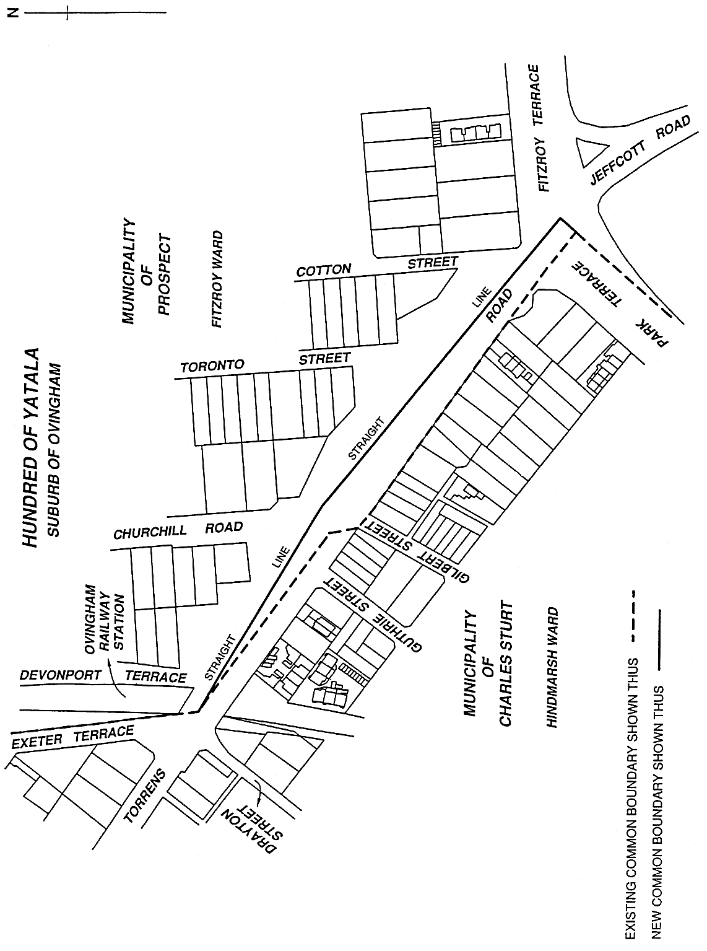
Made by the Governor
on the recommendation of the Boundary Adjustment Facilitation Panel and with the advice and consent of the Executive Council
on 11 November 2004
COLG2004/0014

South Australia
Liquor Licensing (Dry Areas—Short Term) Variation Regulations 2004
under the Liquor Licensing Act 1997

Contents
Part 1—Preliminary
1 Short title
2 Commencement
3 Variation provisions
Part 2—Variation of Liquor Licensing (Dry Areas—Short Term) Regulations 1997
4 Variation of Schedule 1—Short term dry areas
5 Variation of Schedule 2—Plans of short term dry areas
Schedule 1—Plan to be substituted

Part 1—Preliminary
1—Short title
These regulations may be cited as the Liquor Licensing (Dry Areas—Short Term) Variation Regulations 2004.
2—Commencement
These regulations come into operation on the day on which they are made.
3—Variation provisions
In these regulations, a provision under a heading referring to the variation of specified regulations varies the regulations so specified.

Part 2—Variation of Liquor Licensing (Dry Areas—Short Term) Regulations 1997
4—Variation of Schedule 1—Short term dry areas
(1) Schedule 1, item headed "Victor Harbor—Area 1"—delete the item and substitute:

Victor Harbor—Area 1
(see Schedule 2: Victor Harbor—Plan 1)
Area | Period | Extent of prohibition
The area in Victor Harbor bounded as follows: commencing at the point at which the north-western boundary of Hindmarsh Road intersects the southern bank of the Hindmarsh River, then generally north-easterly and south-westerly along that bank of the Hindmarsh River to the low water mark of Encounter Bay, then generally south-westerly, southerly, westerly and south-westerly along the low water mark to the northern bank of the Inman River, then generally westerly along that bank of the Inman River to the eastern boundary of the Victor Harbor Beach Front Caravan Park, then north-easterly along that boundary to the western boundary of Inman Street, then north-westerly along that boundary of Inman Street and the prolongation in a straight line of that boundary to the north-western boundary of Victoria Street, then north-easterly along that boundary of Victoria Street to its intersection with the western boundary of Torrens Street, then north-westerly and north-easterly along that boundary of Torrens Street to its intersection with the north-eastern boundary of Crozier Road, then north-westerly along that boundary of Crozier Road to its intersection with the south-eastern boundary of Acraman Street, then north-easterly along that boundary of Acraman Street and Carlyle Street to its intersection with the south-western boundary of Cornhill Road, then south-easterly along that boundary of Cornhill Road to the north-western boundary of Hindmarsh Road, then generally north-easterly along that boundary of Hindmarsh Road to the point of commencement. | (a) From 12.01 a.m. on 19 November 2004 to 12.01 a.m. on 28 November 2004; and  (b) From 3 p.m on 31 December 2004 to 8 a.m. on 1 January 2005. | The consumption of liquor is prohibited and the possession of liquor is prohibited.
(2) Schedule 1, item headed "Victor Harbor—Area 2", column headed "Period"—delete the column and substitute:

Period
(a) From 12.01 a.m. on 19 November 2004 to 12.01 a.m. on 28 November 2004; and
(b) From 3 p.m. on 31 December 2004 to 8 a.m. on 1 January 2005.
5—Variation of Schedule 2—Plans of short term dry areas
Schedule 2, plan headed "Victor Harbor—Plan 1"—delete the plan and substitute the plan headed "Victor Harbor—Plan 1" in Schedule 1 of these regulations.
Schedule 1—Plan to be substituted
Victor Harbor—Plan 1
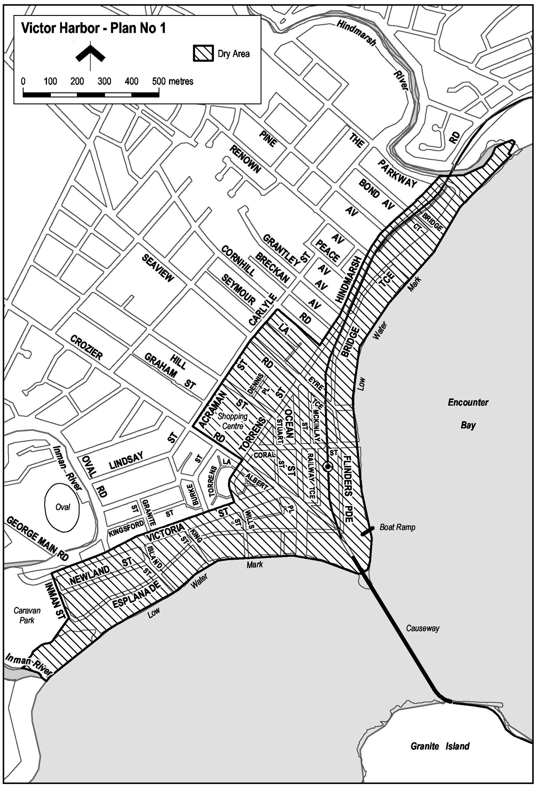
Note—
As required by section 10AA(2) of the Subordinate Legislation Act 1978, the Minister has certified that, in the Minister's opinion, it is necessary or appropriate that these regulations come into operation as set out in these regulations.
Made by the Governor
with the advice and consent of the Executive Council
on 11 November 2004
No 236 of 2004
OLGC14/2004

South Australia
Workers Rehabilitation and Compensation (Scales of Medical and Other Charges) Variation Regulations 2004
under the Workers Rehabilitation and Compensation Act 1986

Contents
Part 1—Preliminary
1 Short title
2 Commencement
3 Variation provisions
Part 2—Variation of Workers Rehabilitation and Compensation (Scales of Medical and Other Charges) Regulations 1995
4 Variation of regulation 3—Interpretation
5 Insertion of regulation 10
10 WorkCover may issue guidelines
6 Substitution of Schedule 5
Schedule 5—Scales of charges—Registered occupational therapists

Part 1—Preliminary
1—Short title
These regulations may be cited as the Workers Rehabilitation and Compensation (Scales of Medical and Other Charges) Variation Regulations 2004.
2—Commencement
These regulations will come into operation on 11 November 2004.
3—Variation provisions
In these regulations, a provision under a heading referring to the variation of specified regulations varies the regulations so specified.
Part 2—Variation of Workers Rehabilitation and Compensation (Scales of Medical and Other Charges) Regulations 1995
4—Variation of regulation 3—Interpretation
Regulation 3—after its present contents (now to be designated as subregulation (1)) insert:
(2) A reference in these regulations to specified schedule guidelines is a reference to the guidelines of the specified name issued by WorkCover, as in force from time to time.
5—Insertion of regulation 10
After regulation 9 insert:
10—WorkCover may issue guidelines
WorkCover may issue guidelines from time to time for the purposes of these regulations.
6—Substitution of Schedule 5
Schedule 5—delete the Schedule and substitute:
Schedule 5—Scales of charges—Registered occupational therapists

Item No | Service Description | Charge
 | OCCUPATIONAL THERAPY CORE SCHEDULE SERVICES
 | Refer to the Occupational Therapy Fee Schedule Guidelines for requirements regarding the delivery of core schedule services.
 | INITIAL AND SUBSEQUENT CONSULTATIONS (INDIVIDUAL CLIENT)
The following services may be delivered as a component of an initial and subsequent consultation:
• clinical assessment
• clinical treatment
• graded activity/exercise
• pain management
• stress management
• relaxation training
• biomechanical education
• independent living skills training.
Refer to section 1 of the Occupational Therapy Fee Schedule Guidelines for further details regarding the provision of the initial and subsequent consultations.
 | Initial consultation (individual client)
OT 105 | Initial consultation, history, examination and treatment | $105.60 per hour
 | Subsequent consultations (individual client)
OT 205 | Subsequent consultations and treatment | $105.60 per hour
 | CORRECTIVE/SERIAL SPLINTING
 | Refer to section 2 of the Occupational Therapy Fee Schedule Guidelines for the types of splints available to the occupational therapist and the conditions associated with the provision of these splints.
OT 300 | Fabrication/fitting/adjustment of splint | $105.60 per hour
OT 390 | Materials used to construct or modify a splint | derived fee
 | TREATMENT REVIEW
OT 780 | Independent clinical assessment (ICA) | $107.80 per hour
 | Includes a review of medical history, functional capacity and a clinical examination to provide a differential diagnosis and/or make recommendations regarding ongoing treatment goals, return to work and/or any other criteria as appropriate.
The report must be requested in writing and may be requested by:
• a claims agent or self-insured employer; or
• a worker or worker’s representative.
 | This service is NOT to be performed by the treating occupational therapist.
 | Refer to section 3 of the Occupational Therapy Fee Schedule Guidelines for service standards and indicators for use regarding independent clinical assessment.
OT 785 | Occupational therapy functional estimation form (FEF) | $15.00 per form
 | The Functional Estimation Form (FEF) will be initiated by the treating occupational therapist when information is identified from a clinical consultation which impacts upon the worker’s capacity to return to work. This form must be forwarded directly to the certifying medical practitioner.
 | This form must only be completed when it complies with the criteria specified within the Occupational Therapy Fee Schedule Guidelines, Section 4.
 | PAIN MANAGEMENT (GROUP PROGRAM)
 | Pain management, group program, minimum of 2 clients, maximum of 5 clients.
OT 602 | Pain management, group program, per client | $30.00 per hour
 | Refer to section 5 of the Occupational Therapy Fee Schedule Guidelines for further details regarding the delivery of pain management services.
 | ACTIVITIES OF DAILY LIVING ASSESSMENT
OT 760 | Activities of daily living assessment (ADL) | $107.80 per hour
 | An activities of daily living assessment is an assessment of the worker’s level of functioning in regard to personal care, household tasks, and recreational and social activities. Generally conducted in the worker’s home environment, an activities of daily living assessment is utilised to reduce the impact of the injury, and facilitate early return to normal activity. Assessed levels of performance in daily activities can be used as an indicator of functional tolerances for determining work capacity.
 | Refer to section 6 of the Occupational Therapy Fee Schedule Guidelines for further details regarding the provision of an activities of daily living assessment.
 | REPORTS
OT 810 | Comprehensive report | $103.40 per hour
 | A claims agent, self-insured employer or worker’s representative may request a comprehensive report. A report will be taken to be comprehensive when re-examination of the patient is a pre-requisite for the preparation of the report.
 | All reports referred to under this item are chargeable on an hourly basis with a maximum time chargeable of 1.5 hours.
 | Refer to section 7 of the Occupational Therapy Fee Schedule Guidelines for further detail regarding comprehensive reports.
OT 820 | Standard report | $103.40 per hour
 | A claims agent, self-insured employer or worker’s representative may request a standard report. A report will be taken to be standard when re-examination of the worker is not required and the report is based on a transcription of existing clinical records.
 | All reports referred to under this item are chargeable on an hourly basis with a maximum time chargeable of 1 hour.
 | Refer to section 8 of the Occupational Therapy Fee Schedule Guidelines for further detail regarding standards required for report writing.
 | TELEPHONE CALLS
OT 552 | Telephone call | $15.00 each
 | Calls of a case specific nature made to or received from the worker’s referring/treating medical expert, rehabilitation provider, claims agent or self-insured employer, WorkCover provider consultant or worker’s representative.
 | Excludes calls made during consultation and calls to or from the worker.
 | Telephone calls of a duration of 3 minutes or less are not chargeable.
 | Refer to section 9 of the Occupational Therapy Fee Schedule Guidelines for further details regarding telephone calls.
 | TRAVEL
 | All travel items refer to an approved return trip from the treating occupational therapist’s rooms for the purpose of a home, hospital or worksite visit or case conference.
OT 905 | Travel in area 100km or less from Adelaide GPO | $90.00 per hour
OT 900 | Travel in area more than 100km from Adelaide GPO | $100.00 per hour
 | Refer to section 10 of the Occupational Therapy Fee Schedule Guidelines for further details regarding travel.
CURAP | Therapeutic aids and appliances | derived fee
 | Includes an appliance or aid for reducing the extent of a compensable disability or enabling a patient to overcome in whole or in part the effects of a compensable disability.
 | Refer to section 11 of the Occupational Therapy Fee Schedule Guidelines for details regarding therapeutic appliances.
 | OCCUPATIONAL THERAPY SUPPLEMENTARY SCHEDULE SERVICES
 | REHABILITATION AND RETURN TO WORK SERVICES
 | Refer to section 12 of the Occupational Therapy Fee Schedule Guidelines for service requirements and indicators for use of each rehabilitation and return to work service listed within the supplementary schedule.
 | WORK SIMULATION - OFF SITE (GROUP PROGRAM)
 | A graduated program of supervised activities used to simulate work conditions and the physical demands of duties. It is highly structured, goal-orientated and individualised and is designed to maximise the worker’s ability to return to work. The program is usually contracted with the worker so that attendance patterns and work behaviours are normalised.
 | Work simulation, at rooms, group program, minimum of 2 clients, maximum of 5 clients.
OT 502 | Work simulation, group program, per client | $30.00 per hour
OT 519 | Work simulation, materials | derived fee
OT 700 | FUNCTIONAL CAPACITY EVALUATION (FCE) | $107.80 per hour
 | Maximum time – 7 hours including report preparation with an executive summary form outlining the major components of the service and relevant findings.
 | Functional capacity evaluation is an assessment of the worker’s physical capabilities. The evaluation consists of a series of standardised tests focussed on selected work tolerances. Work tolerances are the observed and measured physical capabilities that affect the individual’s ability to perform the physical demands of specified work tasks. They are assessed as the ability to sustain a given work effort, i.e. work capacity at a prescribed frequency over a given period of time, and ability to maintain a specified rate of production at a pace compatible with the specified job. Work capacity is inferred based upon the work tolerance data gathered.
OT 730 | WORKSITE ASSESSMENT (WSA) | $107.80 per hour
 | A visit to the workplace to determine the availability of duties for an injured worker and/or comment on the suitability of the workplace for that worker.
OT 740 | JOB ANALYSIS (JA) | $107.80 per hour
 | The service includes the preparation of a report with an executive summary form outlining the major components of the service and relevant findings.
 | A job analysis involves analysis of the critical physical demands of a task, tasks or occupations to ascertain if they are within the worker’s capacity. The job analysis is undertaken based on available medical guidelines or given the medical expert’s knowledge of the worker’s diagnosis, pathology and prognosis.
 | The occupational therapist will also provide recommendations regarding modifications to elements of the job to enable the worker to safely and effectively perform the task, the provision of aids or equipment which will assist the worker to perform the task and work practice guidelines to ensure that appropriate body mechanics are utilised by the worker in the performance of the task.
OT 750 | WORK HARDENING ON SITE | $107.80 per hour
 | Work hardening (on-site) is the process of increasing on a graduated basis the physical tolerances of a worker through the use of actual and productive work duties. This process is essential in assisting the worker to maintain his/her employment through the period of rehabilitation, by ensuring that identified duties are within the worker’s capacity and guidelines relevant to the nature of the injury.
OT 870 | CASE CONFERENCE | $103.40 per hour
 | This service must be authorised by the claims manager or self-insured employer.
Case conferences are used for the purpose of determining:
• details of limitations/recommendations relating to a sustainable return to work
• options for management of a worker’s recovery
• other related information
A case conference may be requested by:
• a treating medical expert
• an employer
• a worker or worker’s representative
• a claims agent or self-insured employer
• a rehabilitation provider contracted by WorkCover.
 | Refer to section 13 of the Occupational Therapy Fee Schedule Guidelines for further details regarding case conferences.
 | NON SCHEDULED ITEMS
OT 999 | NON SCHEDULED SERVICES | $103.40 per hour
 | The use of this item number requires the approval of the claims agent or self-insured employer prior to the delivery of the service.
 | This item is used when the provision of services not listed on the Core or Supplementary Fee Schedule is necessary, appropriate and reasonably required.
 | Refer to section 14 of the Occupational Therapy Fee Schedule Guidelines for further details regarding non scheduled services.
INTERPRETATION
In this Schedule—
derived fee means that each claim under that item will be considered on its merits.
Note—
As required by section 10AA(2) of the Subordinate Legislation Act 1978, the Minister has certified that, in the Minister's opinion, it is necessary or appropriate that these regulations come into operation as set out in these regulations.
Made by the Governor
with the advice and consent of the Executive Council
on 11 November 2004
No 237 of 2004
04WKC003CS

FAXING COPY?
IF you fax copy to Government Publishing SA for inclusion in the Government Gazette, there is no need to send a Confirmation Copy to us as well.
This creates confusion and may well result in your notice being printed twice.
Please use the following fax number:
Fax transmission: (08) 8207 1040
Phone Inquiries: (08) 8207 1045
Please include a contact person, phone number and order number so that we can phone back with any queries we may have regarding the fax copy.
NOTE: Closing time for lodging new copy (fax, hard copy or email) is 4 p.m. on Tuesday preceding the day of publication.

Government Gazette notices can be E-mailed.
The address is:
governmentgazette@saugov.sa.gov.au
Documents should be sent as attachments in Word format.
When sending a document via E-mail, please confirm your transmission with a faxed copy of your document, including the date the notice is to be published.
Fax transmission: (08) 8207 1040
Enquiries: (08) 8207 1045
NOTE: Closing time for lodging new copy (fax, hard copy or email) is 4 p.m. on Tuesday preceding the day of publication.

CITY OF BURNSIDE
By-law Made under the Local Government Act 1999
By-law No. 1—Permits and Penalties
TO provide for a permit system and continuing penalties in Council by-laws, to clarify the construction of such by-laws and to repeal by-laws.
A. All previous by-laws made or adopted by the Council, prior to the date this by-law is made, are hereby repealed effective from the day on which this by-law comes into operation.
1. Permits
1.1 In any by-law of the Council unless the contrary intention is clearly indicated the word ‘permission’ means the permission of the Council given in writing.
1.2 In any by-law of the City of Burnside the word ‘Council’ means the City of Burnside.
1.3 The Council may attach such conditions to a grant of permission as it thinks fit, and may vary or revoke such conditions or impose new conditions by notice in writing to the permit holder.
1.4 Any permit holder shall comply with every such condition.
1.5 The Council may revoke such grant of permission at any time by notice in writing to the permit holder.
2. Penalties
2.1 Any person who commits a breach of any by-law of the Council shall be guilty of an offence and shall be liable to a maximum penalty being the maximum penalty referred to in the Local Government Act 1999 that may be fixed by by-law for any breach of a by-law.
2.2 Any person who commits a breach of any by-law of the Council of a continuing nature shall be guilty of an offence and, in addition to any other penalty that may be imposed, shall be liable to a further penalty for every day on which the offence is continued, such penalty being the maximum amount referred to in the Local Government Act 1934 and/or the Local Government Act 1999 which may be prescribed by by-law for offences of a continuing nature.
3. Construction
Every by-law of the Council shall be subject to any Act of Parliament and Regulations made thereunder.
The foregoing by-law was duly made and passed at a meeting of the City of Burnside held on 2 November 2004 by an absolute majority of the members for the time being constituting the Council, there being at least two-thirds of the members present.
J. Hanlon, Chief Executive Officer

CITY OF BURNSIDE
By-law Made under the Local Government Act 1999
By-law No. 2—Moveable Signs
TO set standards for moveable signs on roads and to provide conditions for and the placement of such signs.
1. Definitions
In this by-law:
1.1 ‘footpath area’ means that part of the road between the property boundary of the road and the edge of the carriageway on the same side as that boundary;
1.2 ‘authorised officer’ means a person appointed as an authorised person pursuant to section 260 of the Local Government Act 1999;
1.3 ‘business premises’ means the premises from which a business, trade or calling is conducted;
1.4 ‘moveable sign’ has the same meaning as in the Local Government Act 1999;
1.5 ‘road’ means public streets and public roads.
2. Construction
A moveable sign displayed on a road shall:
2.1 be of a kind known as ‘A’ frame or sandwich board sign, an ‘inverted “T”’ sign or a flat sign;
2.2 be well constructed and maintained in good condition so as not to present a hazard to any member of the public;
2.3 be of strong construction so as to be stable when in position and to be able to keep its position in adverse weather conditions with no sharp or jagged edges or corners;
2.4 not be unsightly or offensive in appearance or content;
2.5 not rotate or contain flashing parts;
2.6 be constructed of timber, metal, plastic or plastic coated cardboard, or a mixture of such materials;
2.7 not be more than 1 m high, 600 mm wide or 600 mm deep;
2.8 not have a display area exceeding 700 mm square in total or, if the sign is two sided, 700 mm square on each side;
2.9 be stable when in position;
2.10 in case of an ‘A’ frame or sandwich board sign:
2.10.1 be hinged or joined at the top;
2.10.2 be of such construction that its sides shall be securely fixed or locked in position when erected; and
2.11 in the case of an ‘inverted “T”’ sign, contain no struts or supports that run between the display area and the base of the sign.
3. Placement
A moveable sign shall only be positioned on a road on the footpath area subject to the following conditions:
3.1 where there is no kerb to define the footpath, a set back of 400 mm from the edge of the carriageway is required;
3.2 in the case of a flat sign, the message of which only contains newspaper headlines and the name of a news-paper, the sign must be in line with and against the business to which it relates;
3.3 there must be no less than 2 m distance from any structure, fixed object, tree, bush or plant (including another moveable sign);
3.4 the sign must not be placed on a sealed part of any footpath area unless the sealed part is wide enough to contain the sign and still leave a clear thoroughfare at least 1.8 m wide;
3.5 the sign must not be placed within 10 m of the corner of a road;
3.6 the sign must be adjacent to the premises of the business to which it relates;
3.7 the sign must not be placed on a landscaped area;
3.8 the sign must not be placed on a designated parking area or within 1 m of an entrance to or exit from premises; and
3.9 must not unreasonably restrict the use of the footpath area.
4. Restrictions
A moveable sign displayed on a road shall:
4.1 display material which advertises a business being con-ducted on commercial premises adjacent to the sign or the products available from that business;
4.2 be limited in number to one per business premises;
4.3 only be displayed when the business is open to the public;
4.4 be securely fixed in position such that it cannot be blown over or swept away;
4.5 not be placed in such a position or in such circumstances that the safety of any user of the road is at risk;
4.6 not be displayed during the hours of darkness; and
4.7 not to be displayed on a median strip, traffic island or on a carriageway of a street or road.
5. Exemptions
5.1 Paragraph 3.6 and paragraph 4.1 do not apply to a moveable sign which is used:
5.1.1 to advertise a garage sale taking place from residential premises;
5.1.2 as a directional sign to an event run by an incor-porated association or a charitable body; or
5.1.3 with permission of the Council.
5.2 Paragraphs 4.1, 4.2 and 4.3 do not apply to a flat sign, the message of which only contains newspaper headlines and the name of a newspaper and which must be displayed and located flat against a wall of the business premises at all times.
6. Application
This by-law does not apply if:
6.1 the moveable sign is placed on a public street or road pursuant to an authorisation under another Act; or
6.2 the moveable sign is designed to direct people to the open inspection of any land or building that is available for purchase or lease; or
6.3 a moveable sign that is related to a Commonwealth, State or Local Government election and is displayed during the period commencing on the issue of the writ or writs for the election and ending at the close of polls on polling days.
7. Construction
This by-law is subject to any Act of Parliament and Regulations made thereunder.
The foregoing by-law was duly made and passed at a meeting of the City of Burnside held on 2 November 2004 by an absolute majority of the members for the time being constituting the Council, there being at least two-thirds of the members present.
J. Hanlon, Chief Executive Officer

CITY OF BURNSIDE
By-law Made under the Local Government Act 1999
By-law No. 3—Local Government Land
FOR the management and regulation of the use of and access to local government land vested in or under the control of Council, including the prohibition and regulation of particular activities on local government land.
1. Definitions
In this by-law:
1.1 ‘authorised person’ means a person appointed an authorised person pursuant to section 260 of the Local Government Act 1999;
1.2 ‘electoral matter’ has the meaning as in the Electoral Act 1995 provided that such electoral matter is not capable of causing physical damage or injury to any person within its immediate vicinity;
1.3 ‘liquor’ has the same meaning as defined in the Liquor Licensing Act 1997;
1.4 ‘local government land’ means land owned by the Council or under the Council’s care, control and manage-ment;
1.5 ‘open container’ means a container which:
1.5.1 after the contents thereof have been sealed at the time of manufacture and:
1.5.1.1 being a bottle, has had its cap, cork or top removed (whether or not it has since been replaced);
1.5.1.2 being a can, it has been opened or punctured;
1.5.1.3 being a cask, has had its tap placed in a position to allow it to be used;
1.5.1.4 being any form of container, it has been opened, broken, punctured or manipu-lated in such a way as to allow access to the contents thereof; or
1.5.2 is a flask, glass or mug or other container used for drinking purposes;
1.6 ‘park’ means community land reserved or delineated as a park or designated by the Council as a park;
1.7 ‘public place’ means a place (including a place on private land) to which the public has access (except a street or road) but does not include any part of a community parcel divided by a plan or community division under the Community Titles Act 1996;
1.8 ‘reserve’ means community land reserved or dedicated as a reserve or designated by the Council as a reserve.
2. Activities Requiring Permission
No person shall without permission on any local government land:
2.1 Repairs to Vehicles
perform the work of repairing, washing, painting, panel beating or other work of any nature on or to any vehicle, except for running repairs in the case of breakdown;
2.2 Entertaining
sing, busk or play a musical instrument for the purpose of or so as to appear to be for the purpose of, entertaining others whether or not receiving money;
2.3 Preaching
preach or harangue;
2.4 Horses, Cattle, etc.
ride, lead or drive any horse, cattle, sheep or other like animal except where the Council has set aside a track or other area for use by or in connection with animals of that kind;
2.5 Donations
ask for or receive, or indicate that he or she desires, a donation of money or any other valuable item or thing;
2.6 Amplification
use an amplifier or other device, whether mechanical or electrical, for the purpose of amplifying sound;
2.7 Distributing
give out or distribute to any bystander or passer-by any handbill, book, notice or other printed matter, provided that this restriction shall not apply to any electoral matter given out or distributed by or with the authority of a candidate during the course of a Federal, State or Local Government Election or Referendum in accordance with the Electoral Act 1995;
2.8 Handbills on Cars
place or put on any vehicle any handbill, advertisement, notice or printed matter except for any electoral matter posted on a vehicle with the authority of a candidate during the course of a Federal, State or Local Govern-ment Election or Referendum in accordance with the Electoral Act 1995;
2.9 Canvassing
convey any advertising, religious or other message to any bystander, passer-by or person provided that this restriction shall not apply to any electoral matter given out or distributed with the authority of a candidate during the course of a Federal, State or Local Government Election or Referendum in accordance with the Electoral Act 1995;
2.10 Advertising
display any sign for the purpose of commercial adver-tising other than a moveable sign which is displayed in accordance with Council’s moveable sign by-law;
2.11 Fires
light any fires except:
2.11.1 in a place provided by the Council for that purpose; or
2.11.2 in a portable barbecue, as long as the barbecue is used in an area that is clear of flammable material; and
2.11.3 in accordance with the provision of the Country Fires Act 1989;
2.12 Fireworks
ignite, explode or use any fireworks/rockets;
2.13 Attachments to Trees
attach, hang or fix any rug, blanket, sheet, rope or other material to any tree, shrub, plant, tree guard, notice board, seat fence, post or other item or structure which is the property of the Council;
2.14 Overhanging Articles
suspend or hang any article or thing from any building, verandah, pergola, post or other structure where it might present a nuisance or danger to any person using local government land;
2.15 Removing Soil
carry away or remove any soil, sand, clay, timber, stones, pebbles, gravel, other organic or inorganic materials or any part of the land;
2.16 Picking Fruit
pick fruit, nuts or berries from any trees or bushes;
2.17 Flora and Fauna
subject to the Native Vegetation Act 1991 and the National Parks and Wildlife Act 1972:
2.17.1 damage, pick, or interfere with any plant or flower thereon; or
2.17.2 tease, interfere or cause harm to any animal, bird or marine creature, or any burrow, nest or habitat of such animal;
2.18 Games
2.18.1 promote, organise, participate in any game, recreation or amusement which involves the use of a ball, missile or other object which by the use thereof may cause or be likely to cause injury or discomfort to any person being on or in the vicinity of that land or detract from or be likely to detract from another person’s lawful use and enjoyment of that land;
2.18.2 fly any model aircraft or operate any power model boat from or on any local government land;
2.18.3 participate in any game, recreation or amuse-ment which is likely to cause damage to lawns, gardens, trees or other property; or
2.18.4 participate in any game, recreation or event where the Council has caused a notice to be erected indicating the playing of such a game is prohibited;
2.19 Athletic and Ball Sports
2.19.1 promote, organise or take part in any organised athletic sport;
2.19.2 play any organised competition sport, as distinct from organised social play;
2.19.3 play or practice the game of golf;
2.20 No Liquor
2.20.1 consume, carry or be in possession or charge of any liquor between the hours of 9 p.m. on any day and 9 a.m. on the day immediately following (provided the land constitutes a park or reserve) except on premises in respect of which a licence is in force pursuant to the Liquor Licensing Act 1997;
2.20.2 excepting sealed containers, consume, carry or be in possession or charge of any liquor in an open container between the hours of 9 p.m. on any day and 9 a.m. on the day immediately following (provided the land constitutes a park or reserve) except on premises in respect of which a licence is in force pursuant to the Liquor Licensing Act 1997;
2.21 Weddings
conduct or participate in a marriage ceremony;
2.22 Encroachment
erect or place any fencing, posts or other structures or any other items or substance such as to encroach onto the land;
2.23 Closed Lands
2.23.1 at any time during which the Council has declared that it shall be closed to the public and which closure is indicated by a sign to that effect;
2.23.2 where land is enclosed with fences and/or walls and gates, at any time when the gates have been closed and locked; or
2.23.3 where admission charges are payable to enter without paying those charges;
2.24 Rubbish Dumps and Rubbish Bins
2.24.1 interfere with, remove or take away any rubbish that has been discarded at any rubbish dump on local government land;
2.24.2 remove, dispense or interfere with any rubbish (including bottles, newspapers, cans, containers or packaging) that has been discarded in a Council rubbish bin on local government land;
2.25 Dispose of Dead Animals
dispose any dead animals or part thereof in any Council rubbish bin;
2.26 Cemeteries
comprising a cemetery:
2.26.1 bury or inter any human or animal remains;
2.26.2 erect any memorial;
2.26.3 drive or propel any vehicle except on paths or road constructed and set aside for that purpose and in compliance with any signs that have been erected;
2.27 Camping and Tents
2.27.1 camp or stay overnight; or
2.27.2 erect any tent, booth, marquee or other structure for the purpose of habitation for a period of 24 hours or more (except entities authorised to do so under section 209 of the Local Government Act 1999);
2.28 Smoking
smoke tobacco or any other substance in any building or part of any building;
2.29 Structures
erect or allow to remain erected any shed, tent, hut or other structure with the exception of the Council or the Federal or State Government;
2.30 Toilets
in any public convenience:
2.30.1 urinate other than in a urinal or pan or defecate other than in a pan set apart for that purpose;
2.30.2 smoke tobacco or any other substance;
2.30.3 deposit anything in a pan, urinal or drain which is likely to cause a blockage;
2.30.4 use it for a purpose for which it was not designed or constructed;
2.30.5 enter any toilet set aside for use of the opposite sex except where:
2.30.5.1 accompanying a child under the age of five; and/or
2.30.5.2 providing assistance to a disabled person;
2.31 Swimming and Aquatic Activity
enter, swim or engage in any aquatic activity in or on any body of water except:
2.31.1 a body of water that Council has set aside for that purpose; or
2.31.2 in an area where a nearby sign states that such activity is allowed and in accordance with any conditions stated in the sign.
3. Posting of Bills Etc.
No person shall, without the Council’s permission, post any bills, advertisements or other papers or items on a building, structure, stobie pole or tree on local government land or other public place except for any electoral matter posted on a building or structure with the authority of a candidate during the course of a Federal, State or Local Government Election or Referendum and in accordance with the Electoral Act 1995.
4. Prohibited Activities
No person shall on local government land:
4.1 Use of Equipment
4.1.1 use any item of equipment and/or facilities or other Council property:
4.1.1.1 other than in the manner and for the purpose for which it was designed or set aside; and
4.1.1.2 where any nearby sign states the con-ditions of use, except in accordance with such conditions;
4.2 Annoyances
4.2.1 annoy or commit any nuisance or unreasonably interfere with any other person’s use of local government land by making a noise or by creating a disturbance that has not been authorised by the Council;
4.2.2 spit, urinate or defecate other than in provided toilets; or
4.2.3 conduct themselves in such a manner as to cause discomfort, inconvenience, annoyance or offence to any other person;
4.3 Interference with Permitted Use
interrupt, disrupt or interfere with any person’s use of parks or reserves for which permission has been granted;
4.4 Obstruction
obstruct:
4.4.1 any path or cycle tracks;
4.4.2 any door, entrance, stairway or aisle in any building; or
4.4.3 any gate or entrance to the local government land;
4.5 Interference with Land
4.5.1 interfere with the land such as levelling or flattening land, planting grass, lawn or other vegetation, paving the land, or otherwise use the land in a manner contrary to the purpose for which the land was designed to be used; or
4.5.2 destroy, damage or deface or cause or permit to be destroyed, damaged or defaced any article, structure, building or thing fixed to local govern-ment land;
4.6 Defacing Land
deface, paint, write, make marks on or fix bills or advertisements to any tree, rock, gate, fence, building, sign or other property except for any electoral matter posted on a building or structure with the authority of a candidate during the course of a Federal, State or Local Government Election or Referendum and in accordance with the Electoral Act 1995;
4.7 Missiles
throw, roll or discharge any stone, substance or missile to the danger of any person or animal;
4.8 Glass
wilfully break any glass, china or other brittle material.
5. Removal of Encroachment or Interference
Any person who encroaches onto or interferes with local government land contrary to this by-law must at the request in writing of an authorised person, cease the encroachment or interference and remove the source of the encroachment or interference, and reinstate the land to the same standard as the state of the land prior to the encroachment or interference.
6. Council may do Work
If a person fails to remove an encroachment or interference on local government land in accordance with a request of an authorised officer pursuant to Clause 5 of this by-law, the Council may:
6.1 undertake the work itself; and
6.2 recover the cost of doing so from that person.
7. Directions
7.1 Any person on local government land must comply with any reasonable direction or request from an authorised person relating to:
7.1.1 that person’s use of the land;
7.1.2 that person’s conduct and behaviour on the land;
7.1.3 that person’s safety on the land;
7.1.4 the safety of other persons on the land;
7.1.5 the enjoyment of the land by other persons; and
7.1.6 the possible damage to lawn, grass, trees, shrubs, building, structure or object on the land.
8. Removal of Animals and Directions to Persons
8.1 If any animal is found on local government land in breach of a by-law:
8.1.1 any person in charge of the animal shall remove it on the request of an authorised person; and
8.1.2 an authorised person may remove the animal if a person fails to comply with the request, or if no person is in charge of the animal.
8.2 Any authorised person may direct any person who is considered to be committing or has committed a breach of these by-laws to cease the action and to leave that part of the local government land or to take specified action to remedy the breach.
9. Exemptions
The restrictions in this by-law do not apply to any Police Officer, Council Officer or employee acting in the course and within the scope of that person’s normal duties, or to a contractor while performing work for the Council and while acting under the supervision of a Council Officer.
10. Application
Paragraphs 2.4, 2.19 and 2.31 of this by-law shall apply only in such portion or portions of the area as the Council may by resolution direct in accordance with section 246 (3) (e) of the Local Government Act 1999.
The foregoing by-law was duly made and passed at a meeting of the City of Burnside held on 2 November 2004 by an absolute majority of the members for the time being constituting the Council, there being at least two-thirds of the members present.
J. Hanlon, Chief Executive Officer

CITY OF BURNSIDE
By-law Made under the Local Government Act 1999
By-law No. 4—Roads
FOR the management, control and regulation of activities on roads.
1. Definitions
In this by-law:
1.1 ‘authorised person’ means a person appointed an authorised person pursuant to section 260 of the Local Government Act 1999;
1.2 ‘electoral matter’ has the same meaning as in the Electoral Act 1995, provided that such electoral matter is not capable of causing physical damage or injury to any person within its immediate vicinity;
1.3 ‘emergency vehicle’ has the same meaning as in the Australian Road Rules 1999 and the Road Traffic
(Road Rules—Ancillary and Miscellaneous Provisions) Regulations 1999;
1.4 ‘road’ has the same meaning as in the Local Government Act 1999.
2. Activities Requiring Permission
No person shall without permission on any road:
2.1 Repairs to Vehicles
perform the work of repairing, washing, painting, panel-beating or other work of any nature on or to any vehicle, provided that this paragraph shall not extend to running repairs in the case of breakdown;
2.2 Horses, Cattle, Sheep, etc.
ride, lead or drive any horse, cattle, sheep or other like animal on any road in those areas that the Council has designated by resolution;
2.3 Preaching
preach or harangue;
2.4 Donations
ask for or receive or indicate that he or she desires a donation of money or any other thing;
2.5 Amplification
use an amplifier or other device whether mechanical or electrical for the purpose of amplifying sound or broad-casting announcements or advertisements;
2.6 Canvassing
convey any advertising, religious or other message to any bystander, passer-by or other person provided that this restriction shall not apply to the conveyance of any electoral matter given out with the authority of a candidate during the course of a Federal, State or Local Government Election or Referendum in accordance with the Electoral Act 1995;
2.7 Advertising
display any sign for the purpose of commercial adver-tising, other than a moveable sign which is displayed on a public road in accordance with Council’s moveable signs by-law;
2.8 Camping
camp or remain overnight;
2.9 Exhibition or Display
conduct or allow any public exhibition or display to occur.
3. Posting of Bills Etc.
No person shall, without the Council’s permission, post any bills, other papers, advertisements or items on a building or structure or tree on a road except for any electoral matter posted on a building or structure with the authority of a candidate during the course of a Federal, State or Local Government Election or Referendum in accordance with the Electoral Act 1995.
4. Removal of Animals and Directions to Persons
4.1 If any animal is found on a road in breach of a by-law any person in charge of the animal shall remove it on the request of an authorised person.
4.2 An authorised person may remove the animal if a person fails to comply with the request, or if no person is in charge of the animal.
4.3 An authorised person may direct any person who is considered to be committing or has committed a breach of this by-law to leave that part of the road. Failure to comply with that direction forthwith is a breach of this by-law.
4.4 An authorised person may direct any person who is considered to be committing or has committed a breach of this by-law to cease that action and to take specified action to remedy the breach.
5. Exemptions
The restrictions in this by-law do not apply to any Police Officer, Council Officer or employee acting in the course and within the scope of that person’s normal duties, or to a contractor while performing work for the Council and while acting under the supervision of a Council Officer or an emergency worker when driving an emergency vehicle while driving that vehicle in relation to an emergency situation.
6. Application of Paragraphs
Paragraph 2.2 of this by-law shall apply only in such portion or portions of the area as the Council may by resolution direct in accordance with section 246 (3) (e) of the Local Government Act 1999.
7. Construction
This by-law is subject to any Act of Parliament and Regulations made thereunder.
The foregoing by-law was duly made and passed at a meeting of the City of Burnside held on 2 November 2004 by an absolute majority of the members for the time being constituting the Council, there being at least two-thirds of the members present.
J. Hanlon, Chief Executive Officer

CITY OF BURNSIDE
By-law Made under the Dog and Cat Management Act 1995 and the Local Government Act 1999
By-law No. 5—Dogs
FOR the management and control of dogs within the Council’s area.
1. Definitions
In this by-law unless the context otherwise requires:
1.1 ‘approved kennel establishment’ means a building, structure or area approved by the relevant authority, pursuant to the Development Act 1993 for the keeping of cats and/or dogs on a temporary or permanent basis;
1.2 ‘council land’ means all land vested in or under the control of the Council;
1.3 ‘dog’ means an animal of the species canis familiaris but does not include a dingo or a cross of a dingo;
1.4 ‘effective control’ has the same meaning as that contained within section 8 of the Dog and Cat Manage-ment Act 1995;
1.5 ‘premises’ means any domestic and non-domestic premises, except a kennel establishment in respect of which a development authorisation is in force under the Development Act 1993;
1.6 ‘public place’ has the same meaning as that contained in the Local Government Act 1999.
2. Dog Free Areas
No person shall on any Council land to which this paragraph applies, in accordance with paragraph 5 of this by-law cause, suffer or permit any dog under that person’s control, charge or authority to be, or remain in that place.
3. Dogs on Leash Areas
No person shall on any Council land to which this paragraph applies, in accordance with paragraph 5 of this by-law, cause, suffer or permit any dog under that person’s control, charge or authority to be or remain in that public place unless such dog is restrained by a strong leash not exceeding 2 m in length and either tethered securely to a fixed object or held by a person capable of controlling the dog and preventing it from being a nuisance or a danger to other persons.
4. Dog Exercise Areas
4.1 any person may enter upon any part of Council land to which this paragraph applies in accordance with paragraph 5 of this by-law, for the purpose of exercising a dog under his or her effective control;
4.2 where a person enters upon such part of Council land for that purpose, he or she shall ensure that the dog or dogs under his or her control remain under effective control while on the land;
4.3 signs shall be erected to denote the land to which this paragraph applies and information shall be provided to the public in a manner determined by the Council’s Chief Executive Officer to inform the public about such land.
5. Application of Paragraphs
Any of paragraphs 2, 3 and subparagraph 4.1 of this by-law shall apply only in such portion or portions of Council land as the Council may by resolution direct in accordance with section 246 (3) (e) of the Local Government Act 1999.
6. Construction
This by-law is subject to any Act of Parliament and Regulations made thereunder.
The foregoing by-law was duly made and passed at a meeting of the City of Burnside held on 2 November 2004 by an absolute majority of the members for the time being constituting the Council, there being at least two-thirds of the members present.
J. Hanlon, Chief Executive Officer

CITY OF BURNSIDE
By-law Made under the Local Government Act 1999
By-law No. 6—Waste Management
TO regulate and control the removal of domestic, recyclable and green organic waste from premises, for the prevention and suppression of nuisances and for regulating the management of Council property.
1. Definitions
In this by-law:
1.1 ‘household waste’ means any kind of domestic and kitchen waste generated from residences, but excludes liquids, metals (other than food containers), building materials, stones, bricks, soil, lead acid batteries and any dangerous or toxic waste;
1.2 ‘recyclables’ means newspapers, magazines, clean paper and cardboard, clean plastic containers of a type specified by the Council, clean tins and cans, clean glass and clean milk and juice containers and other materials for which permission has been given by the Council;
1.3 ‘green organics’ means any clean organic matter con-sisting of lawn clippings, plants, vegetables, leaves, prunings, horse manure or other materials for which permission has been given by the Council but no item larger than 15 cm in diameter;
1.4 ‘hard wastes’ means any internal and external household items such as fridges, television sets, mattresses, but excludes any household wastes.
2. Provide Containers
Every occupier of domestic premises shall keep on his or her premises a ‘split’ container for the reception of household waste/ recyclables and unless exempted by the Council, a container for green organics.
3. Management of Waste Collection Service
An occupier of premises shall:
3.1 Household Waste/Recyclable
3.1.1 ensure that the household waste/recyclables con-tainer be either a watertight split mobile garbage container of rigid plastic, divided into two equal compartments with a plastic divider from the front to the back or as approved by Council;
3.1.2 ensure that the container has a capacity of 240 L and be rectangular in shape with a hinged lid that when closed keeps the container rain and fly proof. The container must be designed in such a way so as to allow it to be mechanically lifted from the position which it was placed for emptying by apparatus on trucks employed in the collection of rubbish;
3.1.3 ensure that the container has a right hand compartment (when facing the opening of the container from the front) which contains only household wastes; and
3.1.4 ensure that the container has a left hand compartment (when facing the opening of the container from the front) which contains only recyclables;
3.2 Green Organics
3.2.1 ensure the container for green organics be a water-tight mobile garbage container of rigid plastic having a capacity of up to 240 L which is rectangular in shape or as approved by Council;
3.2.2 ensure that the container has a hinged lid that when closed keeps the container rain and fly proof. It must be designed in such a way as to allow it to be mechanically lifted from the position in which it was placed for emptying by apparatus on trucks employed in the collection of rubbish; and
3.2.3 ensure that the container only contains green organics;
3.3 Keep Container Clean
cause each container to be kept in a clean and sanitary condition, maintained in good order and repair and kept watertight at all times;
3.4 Sealing of Container
cause each container to be continuously and securely covered or sealed except when waste is being deposited in or removed from the container;
3.5 Damage
ensure that each container is maintained so that it is not damaged or worn to the extent that:
3.5.1 it is not robust or watertight;
3.5.2 it is unable to be moved on its wheels (if any) efficiently;
3.5.3 the lid does not seal on the container when closed;
3.5.4 any vertical partition becomes damaged to the extent that it does not properly keep separate the kinds of waste/recyclables in the compartments or becomes loose; or
3.5.5 its efficiency or use is otherwise impaired;
3.6 Collection Services
facilitate the collection and removal of waste/recyclables from the premises on the day of or the night before (and not before these times). Ensure that prior to the time appointed by the Council for the collection of a particular kind of waste/recyclables from the premises, place the waste/recyclable container containing that kind of waste out for collection in a position:
3.6.1 on the street in front of and on the same side as the premises, abutting the edge of (but not on) the carriageway and positioned so that the side of the container on which the hinges of the lid are situated faces the premises;
3.6.2 as approved by the Council;
3.6.3 not under the overhanging branches of street trees; and
3.6.4 remove the waste/recycling container from that position on the same day after the collection of waste/recyclables has taken place.
4. Interference with Garbage/Hard Rubbish
No person shall remove, disburse or interfere with any waste/ recyclables (including bottles, newspapers, cans, containers or packaging) that has been placed:
4.1 for disposal in or near a waste/recycling container; or
4.2 on a public street or road for collection by the Council, its agents or contractors, except with the permission of the Council or the authority of the owner.
5. Construction
This by-law of the Council shall be subject to any act of Parliament and Regulations made thereunder.
The foregoing by-law was duly made and passed at a meeting of the City of Burnside held on 2 November 2004 by an absolute majority of the members for the time being constituting the Council, there being at least two-thirds of the members present.
J. Hanlon, Chief Executive Officer

CITY OF ONKAPARINGA
Roads (Opening and Closing) Act 1991
NOTICE is hereby given pursuant to section 10 of the Roads (Opening and Closing) Act 1991, that the City of Onkaparinga proposes to make a Road Process Order to close and transfer the public road marked ‘A’ on Preliminary Plan No. 04/0099:
Transfer ‘A’ to W. M. and L. M. Gadd, P.O. Box 195, Kangarilla, S.A. 5157 and to merge that portion with Certificate of Title volume 5269, folio 944.
A statement of persons affected by the proposed road process together with a copy of the Preliminary Plan is available for inspection at the offices of the City of Onkaparinga, Ramsay Place, Noarlunga Centre, during normal office hours. Copies may also be inspected at the Adelaide office of the Surveyor-General, 101 Grenfell Street, Adelaide, during normal office hours.
Any person is entitled to object to the proposed road process, or any person affected by the proposed closure is entitled to apply for an easement to be granted in that person’s favour over the land subject to the proposed closure. Such objection or application for an easement must set out the full name and address of the person making the objection or application and must be fully supported by reasons. Any application for an easement must give full particulars of the nature and location of the easement land, where made by a person as the owner of adjoining land or nearby land, specify the land to which the easement is to be annexed.
The objection or application for an easement must be made in writing to the City of Onkaparinga, P.O. Box 1, Noarlunga Centre, S.A. 5168 within 28 days of this notice, and a copy shall be forwarded to the Adelaide office of the Surveyor-General, G.P.O. Box 1354, Adelaide, S.A. 5001. Where a submission is made, the City of Onkaparinga will give notification of a meeting at which matter will be considered, so that the person making the sub-mission or a representative may attend, if desired.
Dated 11 November 2004.
J. Tate, City Manager

CITY OF PLAYFORD
Roads (Opening and Closing) Act 1991
Road Closure, walkway, Hewitt Road/Goodman Road,
Elizabeth South
NOTICE is hereby given pursuant to section 10 of the said Act, that council proposes to make a Road Process Order to close and sell to R. and F. W. Cairns and S. K. Phu the walkway between Hewitt Road and Goodman Road shown as ‘A’ and ‘B’ (respect-ively) on Preliminary Plan No. 04/0102.
A copy of the plan and statement of persons affected are available for public inspection at the Customer Service areas at the Playford Library, Munno Para Shopping City and Playford Civic Centre, 10 Playford Boulevard, Elizabeth and the office of the Surveyor-General, 101 Grenfell Street, Adelaide during normal office hours.
Any application for easement or objection must be made in writing within 28 days from 11 November 2004, to the Council, Warooka Drive, Smithfield, S.A. 5114 and the Surveyor-General, G.P.O. Box 1354, Adelaide, S.A. 5001, setting out full details.
Where a submission is made, council will give notification of a meeting to deal with the matter.
T. R. S. Jackson, Chief Executive Officer

ADELAIDE HILLS COUNCIL
Declaration of a Public Road
Erratum
IN the South Australian Government Gazette dated 13 May 2004, page 1277 and being the first notice appearing, section 4 of the Local Government Act 1999 should read section 208 of the Local Government Act 1999.
P. Peppin, Chief Executive Officer

THE BAROSSA COUNCIL
Cancellation of Council Meeting
NOTICE is hereby given that the ordinary Council Meeting scheduled to be held on Tuesday, 21 December 2004 has been cancelled.
All business will be transacted at the meeting to be held on Tuesday, 7 December 2004.
J. G. Jones, Chief Executive Officer

DISTRICT COUNCIL OF GRANT
Exclusion from Classification as Community Land
NOTICE is hereby given pursuant to section 193 (6) of the Local Government Act 1999, that at the council meeting of 18 October 2004, council resolved pursuant to section 193 (4) of the said Act that the following land be excluded from classification as community land:
Lot 50, filed plan 36700 in section 330, Hundred of MacDonnell, (Riddoch Highway).
R. J. Peate, Chief Executive Officer

DISTRICT COUNCIL OF PETERBOROUGH
Declaration of Public Roads
Erratum
IN the South Australian Government Gazette dated 28 February 2002, page 1113, and being the first notice appearing, Deposited Plan 57534 should read 971.
T. D. Barnes, Chief Executive Officer

WAKEFIELD REGIONAL COUNCIL
Roads (Opening and Closing) Act 1991
Proposed Road Closures
NOTICE is hereby given, pursuant to section 10 of the said Act, that the council proposes to make Road Process Orders to close, sell and transfer the land to the following owners:
Public Roads, Hope Gap
To Collinsfield Pty Ltd the public road between sections 226 and 202, Hundred of Barunga shown marked as ‘A’ on Preliminary Plan No. 04/0079, subject to rights of way as may be required.
To J. E., I. C. and M. J. Cummins the public roads between sections 195, 196, 227, 202, 201, 200 and 198, Hundred of Barunga shown marked as ‘B’, ‘C’, ‘D’ and ‘P’ on Preliminary Plan No. 04/0079, subject to rights of way as may be required.
Public Roads, Snowtown/Mundoora
To M. P. Slattery and R. M. Higgins the public roads between sections 227, 757 and 756, Hundred of Barunga shown marked as ‘E’ and ‘F’ on Preliminary Plan No. 04/0079, subject to rights of way as may be required.
Public Roads, Snowtown
To Seafield Farm Pty Ltd the public road between allotments 103 and 104 in Filed Plan 214505 and allotment 58 in Deposited Plan 59132 shown marked as ‘G’ and ‘H’ on Preliminary Plan No. 04/0079.
To N. E. Levi and D. E. Hansen the public road to Barunga Hill adjoining allotment 2 in Filed Plan 17031 shown as marked ‘I’ on Preliminary Plan No. 04/0080.
Public Roads, Barunga Gap/Snowtown
To Ross-Na-Ree Pty Ltd the public road adjoining allotment 93 in Filed Plan 199549 shown marked as ‘J’ on Preliminary Plan No. 04/0081.
To D. J. Davidson the public road east of Landslide Road and south of South Terrace shown marked as ‘K’, ‘L’ and ‘W’ on Preliminary Plan No. 04/0082.
Public Roads, Lochiel
To E. J. & K. Ottens Pty Ltd the public road between allotments 1 and 2 in Filed Plan 139791 shown marked as ‘M’ on Preliminary Plan No. 04/0083.
To D. W. and M. J. Henderson the public road to Bumbunga Hill between sections 571 and 573, Hundred of Cameron shown marked as ‘N’ on Preliminary Plan No. 04/0083, subject to rights of way as may be required.
To J. T. Ottens portion of the public road between section 571 and allotment 100 in Filed Plan 217795 shown marked as ‘X’ on Preliminary Plan No. 04/0083.
Copies of the plans and statements of persons affected are available for public inspection at Council’s Office, Scotland Place, Balaklava and the office of the Surveyor-General, 101 Grenfell Street, Adelaide during normal office hours.
Any applications for easements or objections must be made in writing within 28 days from this notice, to the Council, P.O. Box 167, Balaklava, S.A. 5461 and the Surveyor-General, G.P.O. Box 1354, Adelaide, S.A. 5001, setting out full details.
Where a submission is made, council will give notification of a meeting to deal with the matters.
Any enquiries may be directed to Council’s Infrastructure Manager, Chris Fels on 8862 0800.
Dated 11 November 2004.
P. Barry, Chief Executive Officer

IN the matter of the estates of the undermentioned deceased persons:
Barclay, May Elizabeth Mary, late of 30A Norfolk Road, Marion, of no occupation, who died on 13 August 2004.
Bettison, William John, late of 26 Evan Avenue, Salisbury, retired dairy and poultry farmer, who died on 9 September 2004.
Bollmeyer, Eunice Edna, late of 47 HMAS Australia Road, Henley Beach South, of no occupation, who died on 11 October 2004.
Ellis, Marjorie Gwenyth, late of 48 Marlborough Street, Malvern, home duties, who died on 26 July 2004.
Hand, Margaret, late of 1 Cameron Avenue, Gilles Plains, widow, who died on 10 March 2002.
Holness, Edwin Steven, late of 5 Mitchell Street, Hyde Park, retired farrier, who died on 10 July 2004.
Marshall, Frederick George, late of Supple Road, Waterloo Corner, of no occupation, who died on 15 September 2004.
Mellberg, Reta, late of 2 Bridgman Road, Findon, of no occupation, who died on 4 September 2004.
Pietsch, Ross William, late of 2 Marschall Street, Waikerie, retired farmer, who died on 10 September 2004.
Power, Beryl Hannah, late of 700 Goodwood Road, Daw Park, retired nurse, who died on 24 July 2004.
Seal, Robert Frederick, late of 103 Fisher Street, Fullarton, retired foreman, who died on 13 September 2004.
Sykes, Lindsay Marshall, late of 49 Fairview Terrace, Clearview, retired storeman clerk, who died on 9 September 2004.
Thiele, Gordon Douglas, late of 150 Adams Road, Craigmore, retired storeman, who died on 15 September 2004.
Thomass, Rita Mildred, late of 110 Strathfield Terrace, Largs North, of no occupation, who died on 9 September 2004.
Tomaszewski, Patricia Margaret, late of 27 Giles Street, Magill, retired librarian, who died on 13 September 2004.
Virgo, Kathleen, late of 1 River Road, Hahndorf, home duties, who died on 17 April 2004.
Watson, Donald Robert, late of 13 Burnham Road, Kingston Park, retired landscape gardener, who died on 29 August 2004.
Notice is hereby given pursuant to the Trustee Act 1936, as amended, the Inheritance (Family Provision) Act 1972, and the Family Relationships Act 1975, that all creditors, beneficiaries, and other persons having claims against the said estates are required to send, in writing, to the Public Trustee, 25 Franklin Street, Adelaide, S.A. 5000, full particulars and proof of such claims, on or before 10 December 2004, otherwise they will be excluded from the distribution of the said estate; and notice is also hereby given that all persons who are indebted to the said estates are required to pay the amount of their debts to the Public Trustee or proceedings will be taken for the recovery thereof; and all persons having any property belonging to the said estates are forthwith to deliver the same to the Public Trustee.
Dated 11 November 2004.
C. J. O’Loughlin, Public Trustee

SALE OF PROPERTY
Auction Date: Thursday, 2 December 2004 at 11 a.m.
Location: 11 Hampton Court, Salisbury East.
NOTICE is hereby given that on the above date at the time and place stated, by virtue of the Warrant of Sale issued out of the Magistrates Court of South Australia, Action No. ELCCI 1390 of 2004, directed to the Sheriff of South Australia in an action wherein D. & J. Beard Pty Ltd trading as Access Rent-a-Car is the Plaintiff and Robyn Jay Lewis is the Defendant, I, Mark Stokes, Sheriff of the State of South Australia, will by my auctioneers, Griffin Real Estate, make sale of the estate, right, title or interest whatsoever it may be of the Defendant, Robyn Jay Lewis as the registered proprietor of an estate in fee simple in the following:
That piece of land situated in the area named Salisbury East, being 11 Hampton Court, being the property comprised in certificate of title register book volume 5251, folio 602.
Further particulars from the auctioneers.
Griffin Real Estate, 179 King William Road, Hyde Park, S.A. 5061. Telephone (08) 8357 3177.

ATTENTION

CUSTOMERS requiring a proof of their notice for inclusion in the Government Gazette, please note that the onus is on you to inform Government Publishing SA of any subsequent corrections by 10 a.m. on Thursday, which is our publication deadline.

For any corrections to your notice please phone 8207 1045 or Fax 8207 1040 before 10 a.m. on Thursday.

If we do not receive any communication by 10 a.m. on Thursday (day of publication) we will presume the notice is correct and will print it as it is.

Remember—the onus is on you to inform us of any corrections necessary to your notice.

NOTE: Closing time for lodging new copy (electronically, fax or hard copy) is 4 p.m. on Tuesday preceding the day of publication. Phone 8207 1045—Fax 8207 1040.
Email: governmentgazette@saugov.sa.gov.au

Printed and published by authority every Thursday by J. D. FERGUSON, Government Printer, South Australia
Price: $4.85, plus postage; to subscribers, $247.00 per annum.
(The above prices are inclusive of GST)

