No. 80 3529

THE SOUTH AUSTRALIAN

GOVERNMENT GAZETTE
www.governmentgazette.sa.gov.au

PUBLISHED BY AUTHORITY

ALL PUBLIC ACTS appearing in this GAZETTE are to be considered official, and obeyed as such

ADELAIDE, THURSDAY, 2 SEPTEMBER 2004

CONTENTS

Page
Appointments, Resignations, Etc. 3530
Corporations and District Councils—Notices 3582
Dangerous Substances Act 1979—Notice 3530
Development Act 1993—Notice 3530
Environment Protection Act 1993—Notices 3534
Geographical Names Act 1991—Corrigendum 3531
Industrial and Employee Relations Act 1994—Notice 3531
Juries (Remuneration for Jury Service) Regulations
2002—Notice 3535
Land and Business (Sale and Conveyancing) Act
1994—Notices 3535
Liquor Licensing Act 1997—Notices 3535
Maritime Services (Access) Act 2000—Notice 3538
Mining Act 1971—Notices 3538
Motor Vehicles Act 1959—Notice 3538
National Electricity (South Australia) Act 1996—
Notice 3538
Occupational Health, Safety and Welfare Act 1986—
Notice 3539

Page
Petroleum Act 2000—Notice 3539
Petroleum Products Regulation Act 1995—Notice 3539
Port Augusta Circuit Court—Notice 3530
Proclamations 3543
Public Trustee Office—Administration of Estates 3582

REGULATIONS
Motor Vehicles Act 1959—
(No. 190 of 2004) 3553
(No. 191 of 2004) 3557
Second-hand Dealers and Pawnbrokers Act 1996
(No. 192 of 2004) 3565
Liquor Licensing Act 1997 (No. 193 of 2004) 3567
Chicken Meat Industry Act 2003 (No. 194 of 2004) 3578
Roads (Opening and Closing) Act 1991—Notices 3540
Sale of Property 3583
Soil Conservation and Land Care Act 1989—Notice 3540
Transport, Department of—Notice to Mariners 3540
Water Mains and Sewers—Mains Laid, Replaced, Etc. 3540

GOVERNMENT GAZETTE NOTICES
ALL poundkeepers’ and private advertisements forwarded for publication in the South Australian Government Gazette must be PAID FOR PRIOR TO INSERTION; and all notices, from whatever source, should be legibly written on one side of the paper only and sent to Government Publishing SA so as to be received no later
than 4 p.m. on the Tuesday preceding the day of publication. Phone 8207 1045 or Fax 8207 1040. E-mail: governmentgazette@saugov.sa.gov.au. Send as attachments in Word format and please confirm your transmission with a faxed copy of your document, including the date the notice is to be published and to whom the notice will be charged. The Government Gazette is available online at: www.governmentgazette.sa.gov.au

Department of the Premier and Cabinet
Adelaide, 2 September 2004
HER Excellency the Governor in Executive Council has been pleased to appoint the undermentioned to the Genetically Modified Crop Advisory Committee, pursuant to the provisions of the Genetically Modified Crops Management Act 2004:
Presiding Member: (from 6 September 2004 until 5 Sep-tember 2006)
Judith Ann Winstanley Levy
Member: (from 6 September 2004 until 5 September 2006)
Kevin Boyce
Caroline Brokus
Jeffrey Pearson
Rosemary Richards
Margaret Dowling
Michael Bowden
Peter Richard Schutz
Peter Carr
Helen Maree Harvey
By command,
J. W. Weatherill, for Premier
MAFF 0025/04CS

Department of the Premier and Cabinet
Adelaide, 2 September 2004
HER Excellency the Governor in Executive Council has been pleased to appoint the undermentioned to the Construction Industry Training Board, pursuant to the provisions of the Construction Industry Training Fund Act 1993:
Presiding Member: (from 2 September 2004 until 30 June 2007)
Mary Marsland
Member: (from 2 September 2004 until 30 June 2005)
Wayne Hanson
By command,
J. W. Weatherill, for Premier
METFE 19/04CS

Department of the Premier and Cabinet
Adelaide, 2 September 2004
HER Excellency the Governor in Executive Council has been pleased to appoint the undermentioned to the South Australian Housing Trust Board of Management, pursuant to the provisions of the South Australian Housing Trust Act 1995:
Member: (from 2 September 2004 until 1 September 2005)
Julia Dance
By command,
J. W. Weatherill, for Premier
MFC 012/04CS

DANGEROUS SUBSTANCES ACT 1979
Appointments
I, MICHAEL JOHN WRIGHT, Minister for Industrial Relations in and for the State of South Australia, hereby appoint the undermentioned persons as Authorised Officers for the purposes of the Dangerous Substances Act 1979, pursuant to section 7 (1) of the Dangerous Substances Act 1979:
Domenic Taranta
David William Fitzgerald
Carl Steven Olson
Christine Ellen Baker
David John Parsons
Paul Bozzetti
Dated 23 August 2004.
M. Wright, Minister for Industrial Relations

DEVELOPMENT ACT 1993, SECTION 25 (17): CITY OF TEA TREE GULLY—RESIDENTIAL 4 AND 5 ZONES PLAN AMENDMENT
Preamble
1. The Development Plan amendment entitled ‘City of Tea Tree Gully—Residential 4 and 5 Zones Plan Amendment’ (the Plan Amendment) has been finalised in accordance with the provisions of the Development Act 1993.
2. The Minister for Urban Development and Planning has decided to approve the Plan Amendment.
Notice
PURSUANT to section 25 of the Development Act 1993, I—
(a) approve the Plan Amendment; and
(b) fix the day on which this notice is published in the Gazette as the day on which the Plan Amendment will come into operation.
Dated 2 September 2004.
Trish White, Minister for Urban Development and Planning
PLN 01/0234

DISTRICT COURT OF SOUTH AUSTRALIA
PORT AUGUSTA CIRCUIT COURT
Sheriff’s Office, Adelaide, 26 August 2004
IN pursuance of a precept from the District Court of South Australia to me directed, I do hereby give notice that the said Court will sit as a Court of Oyer and Terminer and General Gaol Delivery at the Courthouse at Port Augusta on the day and time undermentioned and all parties bound to prosecute and give evidence and all jurors summoned and all others having business at the said Court are required to attend the sittings thereof and the order of such business will be unless a Judge otherwise orders as follows:
Monday, 6 September 2004 at 10 a.m. on the first day of the sittings the only business taken will be the arraignment of prisoners in gaol and the passing of sentences on prisoners in gaol committed for sentence; the surrender of prisoners on bail committed for sentence; the surrender of persons in response to ex officio informations or of persons on bail and committed for trial who have signified their intentions to plead guilty and the passing of sentences.
Juries will be summoned for Wednesday, 8 September 2004 and persons will be tried on this and subsequent days of the sittings.
Prisoners in H M Gaol and on bail for sentence and for trial at the sittings of the Port Augusta Courthouse, commencing Monday, 6 September 2004.
Abrahamson, Francis |  | Aggravated serious criminal trespass—residence occupied; dishonestly take property without owner’s consent; be armed at night to commit offence against the person | In gaol
B |  | Unlawful sexual intercourse  with a person under 12 | On bail
Clinton, Richard James |  | Taking part in the sale of a controlled substance (4); aggravated serious criminal trespass (non-residential); dishonestly take property without owner’s consent | On bail
Day, Dominic Joseph |  | Taking part in the production  of a controlled substance; possessing a controlled substance for sale; producing  a controlled substance | On bail
Denton, Timothy Dwayne |  | Wounding with intent to do grievous bodily harm | In gaol
Dinovitser, Alexander |  | Accessory after the fact | On bail
Drion, Marc Claude |  | Aggravated robbery in  company | On bail
Hayward, Richard Paul |  | Aggravated robbery in  company | On bail
Huggett, Peter James |  | Aggravated robbery in  company | In gaol
Drion, Marc Claude |  | Aggravated robbery in  company; dishonestly take property without owner’s consent | On bail
E |  | Unlawful sexual intercourse  with a person under 12 years (3); indecent assault; inducing a child to expose her body (8); inducing child to expose body; inducing a child to expose his body (4) | On bail
H |  | Indecent assault; unlawful  sexual intercourse | On bail
Hayward, Richard Paul |  | Aggravated robbery in company; dishonestly take property without owner’s consent | On bail
Huggett, Peter James |  | Aggravated robbery in company; dishonestly take property without owner’s consent | In gaol
J |  | Indecent assault; unlawful sexual intercourse; unlawful sexual intercourse with a person under 12 (2) | In gaol
J |  | Gross indecency; unlawful sexual intercourse with a person under 12 years (2); procuring an act of gross indecency | On bail
Johns, Stuart Anthony |  | Assault occasioning actual bodily harm (2); causing grievous bodily harm with intent to do such harm | On bail
Lloyd, David Stewart |  | Serious criminal trespass (non-residential); theft | On bail
Lloyd, John Colin |  | Causing death by dangerous driving | On bail
Mitchell, Andrew Joseph |  | Assaulting police; theft; driving an unregistered motor vehicle; driving an uninsured motor vehicle; endangering life (2); damaging property (2); driving in a manner dangerous to the public | On bail
Nelson, Scott Francis |  | Aggravated robbery with offensive weapon | In gaol
Payne, Gregory Warren |  | Rape | On bail
Puckridge, Simon Peter |  | Possessing amphetamine for sale; possessing methlene-dioxymethamphetamine for sale | On bail
Robinett, Frederick John |  | Threatening life (2) | On bail
Sam, Rex |  | Aggravated serious criminal trespass in a place of residence; assault with intent to rape | On bail
S |  | Indecent assault (3); procuring an act of gross indecency; unlawful sexual intercourse (2) | On bail
S |  | Indecent assault (2); gross indecency (2); unlawful sexual intercourse with a person under 12 (2); unlawful sexual  intercourse (3) | On bail
Thomas, Graham Reginald |  | Causing bodily harm by dangerous driving | On bail
Walden, Kerry David |  | Endangering life (2) | On bail
Wilton, Sabian Rowan |  | Aggravated serious criminal trespass in a place of residence; assault with  intent to rape; attempted rape (2) | In gaol
Prisoners on bail must surrender at 10 a.m. of the day appointed for the respective trials. If they do not appear when called upon their recognizances and those of their bail will be estreated and a bench warrant issued forthwith.
By order of the Court,
M. A. Stokes, Sheriff

GEOGRAPHICAL NAMES ACT 1991
Corrigendum
Notice of Declaration of Names of Places
IN the Government Gazette of 5 August 2004, page 2749 first notice appearing, the following alterations should be made:
The declared name for the rock name shown as MARRA VARNAPA ROCK, should have been shown as MARRA VARDNAPA ROCK.
Willigon Spring on 6635-3 should have been on 6635 4.
The declared name for the overflow name shown as BRACHINA CREEK OVERFLOW should have been shown as BRACHINA OVERFLOW
Aliena Washout on 6533-4 should have been on 6532-2.
VARNDARTUHNA should have been shown as VARNDARTUNHA
Names for 1:50 000 Mapsheet 6734-3 (Baratta) should have been listed as:
Wilapa Range/Ngami Adnya
Wilyerpa Hill/Wilapa Vambata
The line Wilpa Range/Ngami Adnya should be removed.
Dated 24 August 2004.
P. M. Kentish, Surveyor-General, Department for Administrative and Information Services
04/0455

INDUSTRIAL AND EMPLOYEE RELATIONS ACT 1994
Appointments
I, MICHAEL JOHN WRIGHT, Minister for Industrial Relations in and for the State of South Australia, hereby appoint the undermentioned persons to be Inspectors for the purposes of the Industrial and Employee Relations Act 1994, pursuant to section 64 (1) (b) of the Industrial and Employee Relations Act 1994:
Domenic Taranta
David William Fitzgerald
David John Parsons
Paul Bozzetti
Dated 23 August 2004.
M. Wright, Minister for Industrial Relations

GOVERNMENT GAZETTE ADVERTISEMENT RATES

To apply from 1 July 2004

$  Agents, Ceasing to Act as 35.50  Associations:  Incorporation 18.10  Intention of Incorporation 44.75  Transfer of Properties 44.75  Attorney, Appointment of 35.50  Bailiff’s Sale 44.75  Cemetery Curator Appointed 26.50  Companies:  Alteration to Constitution 35.50  Capital, Increase or Decrease of 44.75  Ceasing to Carry on Business 26.50  Declaration of Dividend 26.50  Incorporation 35.50  Lost Share Certificates:  First Name 26.50  Each Subsequent Name 9.10  Meeting Final 29.75  Meeting Final Regarding Liquidator’s Report on  Conduct of Winding Up (equivalent to ‘Final  Meeting’)  First Name 35.50  Each Subsequent Name 9.10  Notices:  Call 44.75  Change of Name 18.10  Creditors 35.50  Creditors Compromise of Arrangement 35.50  Creditors (extraordinary resolution that ‘the Com-pany be wound up voluntarily and that a liquidator be appointed’) 44.75  Release of Liquidator⎯Application⎯Large Ad. 70.50  ⎯Release Granted 44.75  Receiver and Manager Appointed 41.25  Receiver and Manager Ceasing to Act 35.50  Restored Name 33.50  Petition to Supreme Court for Winding Up 62.00  Summons in Action 53.00  Order of Supreme Court for Winding Up Action 35.50  Register of Interests⎯Section 84 (1) Exempt 80.00  Removal of Office 18.10  Proof of Debts 35.50  Sales of Shares and Forfeiture 35.50  Estates:  Assigned 26.50  Deceased Persons⎯Notice to Creditors, etc. 44.75  Each Subsequent Name 9.10  Deceased Persons⎯Closed Estates 26.50  Each Subsequent Estate 1.15  Probate, Selling of 35.50  Public Trustee, each Estate 9.10 |  | $  Firms:  Ceasing to Carry on Business (each insertion) 23.60  Discontinuance Place of Business 23.60  Land⎯Real Property Act:  Intention to Sell, Notice of 44.75  Lost Certificate of Title Notices 44.75  Cancellation, Notice of (Strata Plan) 44.75  Mortgages:  Caveat Lodgment 18.10  Discharge of 19.00  Foreclosures 18.10  Transfer of 18.10  Sublet 9.10  Leases⎯Application for Transfer (2 insertions) each 9.10  Lost Treasury Receipts (3 insertions) each 26.50  Licensing 53.00  Municipal or District Councils:  Annual Financial Statement⎯Forms 1 and 2 499.00  Electricity Supply⎯Forms 19 and 20 354.00  Default in Payment of Rates:  First Name 70.50  Each Subsequent Name 9.10  Noxious Trade 26.50  Partnership, Dissolution of 26.50  Petitions (small) 18.10  Registered Building Societies (from Registrar-  General) 18.10  Register of Unclaimed Moneys⎯First Name 26.50  Each Subsequent Name 9.10  Registers of Members⎯Three pages and over:  Rate per page (in 8pt) 226.00  Rate per page (in 6pt) 299.00  Sale of Land by Public Auction 45.25  Advertisements 2.50  Advertisements, other than those listed are charged at $2.50 per column line, tabular one-third extra.  Notices by Colleges, Universities, Corporations and District Councils to be charged at $2.50 per line.  Where the notice inserted varies significantly in length from that which is usually published a charge of $2.50 per column line will be applied in lieu of advertisement rates listed.  South Australian Government publications are sold on the condition that they will not be reproduced without prior permission from the Government Printer.
All the above prices include GST

GOVERNMENT GAZETTE NOTICES
ALL private advertisements forwarded for publication in the South Australian Government Gazette must be PAID FOR PRIOR TO INSERTION; and all notices, from whatever source, should be legibly written on one side of the paper only and sent to Government Publishing SA so as to be received no later than 4 p.m. Tuesday preceding the day of publication. Phone 8207 1045 or Fax 8207 1040. E-mail: governmentgazette@saugov.sa.gov.au. Send as attachments in Word format. Please include date the notice is to be published and to whom the notice will be charged. The Government Gazette is available online at: www.governmentgazette.sa.gov.au.

MISCELLANEOUS LEGISLATION AND GOVERNMENT PUBLICATIONS PRICES AS FROM 1 JULY 2004

Acts, Bills, Rules, Parliamentary Papers and Regulations
Pages | Main | Amends | Pages | Main | Amends

1-16 | 2.15 | 0.95 | 497-512 | 30.25 | 29.00
17-32 | 2.90 | 1.80 | 513-528 | 31.25 | 29.90
33-48 | 3.80 | 2.70 | 529-544 | 32.00 | 31.00
49-64 | 4.75 | 3.65 | 545-560 | 33.00 | 32.00
65-80 | 5.60 | 4.60 | 561-576 | 33.75 | 33.00
81-96 | 6.50 | 5.40 | 577-592 | 34.75 | 33.50
97-112 | 7.40 | 6.30 | 593-608 | 35.75 | 34.50
113-128 | 8.30 | 7.25 | 609-624 | 36.50 | 35.50
129-144 | 9.35 | 8.25 | 625-640 | 37.25 | 36.10
145-160 | 10.20 | 9.10 | 641-656 | 38.25 | 37.20
161-176 | 11.20 | 10.00 | 657-672 | 38.75 | 38.00
177-192 | 12.00 | 11.00 | 673-688 | 40.50 | 38.80
193-208 | 13.00 | 11.90 | 689-704 | 41.25 | 39.90
209-224 | 13.80 | 12.70 | 705-720 | 41.75 | 41.00
225-240 | 14.70 | 13.60 | 721-736 | 43.50 | 41.50
241-257 | 15.70 | 14.30 | 737-752 | 44.00 | 42.90
258-272 | 16.60 | 15.30 | 753-768 | 45.00 | 43.40
273-288 | 17.50 | 16.40 | 769-784 | 45.50 | 44.70
289-304 | 18.30 | 17.20 | 785-800 | 46.50 | 45.60
305-320 | 19.30 | 18.20 | 801-816 | 47.25 | 46.00
321-336 | 20.10 | 19.00 | 817-832 | 48.25 | 47.25
337-352 | 21.20 | 20.00 | 833-848 | 49.25 | 48.00
353-368 | 22.00 | 21.00 | 849-864 | 50.00 | 48.80
369-384 | 22.90 | 21.90 | 865-880 | 51.00 | 50.00
385-400 | 23.80 | 22.70 | 881-896 | 51.50 | 50.50
401-416 | 23.70 | 23.50 | 897-912 | 53.00 | 51.50
417-432 | 25.75 | 24.50 | 913-928 | 53.50 | 53.00
433-448 | 26.60 | 25.50 | 929-944 | 54.50 | 53.50
449-464 | 27.50 | 26.25 | 945-960 | 55.50 | 54.00
465-480 | 28.00 | 27.25 | 961-976 | 56.50 | 55.00
481-496 | 29.25 | 28.00 | 977-992 | 57.50 | 56.00

Legislation—Acts, Regulations, etc: $
Subscriptions:
Acts 187.00
All Bills as Laid 447.00
Rules and Regulations 447.00
Parliamentary Papers 447.00
Bound Acts 207.00
Index 103.00
Government Gazette
Copy 4.85
Subscription 247.00
Hansard
Copy 13.50
Subscription—per session (issued weekly) 388.00
Cloth bound—per volume 167.00
Subscription—per session (issued daily) 388.00
Legislation on Disk
Whole Database 2 868.00
Annual Subscription for fortnightly updates 881.00
Individual Act(s) including updates POA
Compendium
Subscriptions:
New Subs 1 700.00
Updates 600.00
(All the above prices include GST)

All Legislation, Government Gazette, Hansard and Legislation on disk are available from:
Counter Sales Service SA, Government Legislation⁺ Outlet
and Mail Orders: Lands Titles Office, 101 Grenfell Street, Adelaide
Phone: 13 23 24 (local call cost), Fax: (08) 8204 1909
Postal: G.P.O. Box 1707, Adelaide, S.A. 5001

Online Shop: www.shop.service.sa.gov.au

Subscriptions and Government Publishing SA
Standing Orders: Box 9, Plaza Level, Riverside Centre, North Terrace, Adelaide, S.A. 5000
Phone: (08) 8207 0908, (08) 8207 0910, Fax: (08) 8207 1040

ENVIRONMENT PROTECTION ACT 1993
Revocation of Collection Depot
I, STEPHEN RICHARD SMITH, Senior Adviser, Container Deposit Legislation and Delegate of the Environment Protection Authority (‘the Authority’), pursuant to section 69 of the Environment Protection Act 1993 (SA) (‘the Act’) hereby:
Revocation of Collection Depot:
Revoke the collection depot identified by reference to the following matters, which previously received all containers belonging to a class of containers that were approved as Category B Containers:
(a) the name of the collection depot described in Column 1 of Schedule 1 of this Notice;
(b) the name of the proprietor of the depot identified in Column 3 of Schedule 1 of this Notice;
(c) the location of the depot described in Columns 4-6 of Schedule 1 of this Notice; and
(d) the collection area in relation to which the collection depot was approved referred to in Column 7 of Schedule 1 of this Notice.
Schedule 1

Column 1 | Column 2 | Column 3 | Column 4 | Column 5 | Column 6 | Column 7
Depot Name | Company/Trading Name | Proprietors | Depot Location  Street | Depot Location  Suburb | Certificate of Title No. Volume/Folio No. | Collection  Area
Arno Bay Recycling Depot | M. J. and M. F. Gaston | M. J. and M. F. Gaston | Block 71, First Street | Arno Bay | n/a | Southern

ENVIRONMENT PROTECTION ACT 1993
Approval of Additional Collection Depot
I, STEPHEN RICHARD SMITH, Senior Adviser, Container Deposit Legislation and Delegate of the Environment Protection Authority (‘the Authority’), pursuant to section 69 of the Environment Protection Act 1993 (SA) (‘the Act’) hereby:
Approval of Additional Collection Depot:
Approve the collection depot identified by reference to the following matters, to receive all containers belonging to a class of containers which is, at or subsequent to the date of this Notice, approved as Category B Containers:
(a) the name of the collection depot described in Column 1 of Schedule 1 of this Notice;
(b) the name of the proprietor of the depot identified in Column 3 of Schedule 1 of this Notice;
(c) the location of the depot described in Columns 4-6 of Schedule 1 of this Notice; and
(d) the collection area in relation to which the collection depot is approved referred to in Column 7 of Schedule 1 of this Notice.
Conditions of Approval:
Impose the following conditions on these approvals:
(a) the person in charge of a collection depot shall ensure the depot premises complies with Council planning regulations and shall be kept in an orderly condition;
(b) the person in charge of a collection depot who wishes to transfer the operation of a depot to another person or intends to change the location of a depot shall notify the Authority in writing within one month of the change occurring;
(c) the person in charge of a collection depot who wishes to cease operation of that depot shall give notice in writing to the Authority;
(d) the person in charge of a collection depot shall take such measures as are necessary in the operation and maintenance of the depot to prevent or control:
(i) a nuisance or offensive condition;
(ii) a risk to health or safety;
(iii) damage to the environment.
(e) the person in charge of a collection depot is reminded of the general environmental duty, as required by section 25 of the Environment Protection Act, to take all reasonable and practical measures to ensure that the activities on the whole site, do not pollute the environment in a way which causes or may cause environmental harm.
Schedule 1

Column 1 | Column 2 | Column 3 | Column 4 | Column 5 | Column 6 | Column 7
Depot Name | Company/Trading Name | Proprietors | Depot Location  Street | Depot Location  Suburb | Certificate of Title No. Volume/Folio No. | Collection  Area
Cleve and Arno Bay Recyclers | Cleve and Arno Bay Recyclers | Rodney James and Roslyn Merle Carrick | Lot 431, Depot Street | Cleve | n/a | Southern

JURIES (REMUNERATION FOR JURY SERVICE) REGULATIONS 2002
Declaration of Long Trial
PURSUANT to Regulation 5 (2) of the Juries (Remuneration for Jury Service) Regulations 2002 and on the advice of the relevant Court, I, John David Hill, Acting Attorney-General, do hereby declare the criminal trial of R. v. Evin Clinton Marsh Andrews, Mathew Peter Andrews, Christopher Martin Fuller, N. P. G., Philip Scott Jones, Adam Jon Ugolini, Jason Robert Ugolini and Robert Paul Ugolini to be a long trial for the purposes of those regulations.
Dated 30 August 2004.
J. Hill, Acting Attorney-General

LAND AND BUSINESS (SALE AND CONVEYANCING)
ACT 1994
Exemption
TAKE notice that, pursuant to section 23 (3) of the Land and Business (Sale and Conveyancing) Act 1994, I, Karlene Maywald, Minister for Consumer Affairs, do hereby exempt the person named in Schedule 1 from the application of section 23 (2) of the Act in relation to the purchase of the land specified in Schedule 2.
Schedule 1
Earl Robert Longstaff, an employee of Overall & Brammer Real Estate Pty Ltd.
Schedule 2
The whole of the land described in certificate of title register book volume 5404, folio 378, situated at 128 Jenkins Terrace, Naracoorte, S.A. 5271.
Dated 2 September 2004.
Signed for and on behalf of the Minister for Consumer Affairs by the Commissioner for Consumer Affairs duly authorised in that regard:
M. Bodycoat, Commissioner

LAND AND BUSINESS (SALE AND CONVEYANCING)
ACT 1994
Exemption
TAKE notice that, pursuant to section 32 of the Land and Business (Sale and Conveyancing) Act 1994, I, Karlene Maywald, Minister for Consumer Affairs, do hereby exempt the person named in Schedule 1 from the application of section 23 (1) of the Act in relation to the purchase of the land specified in Schedule 2.
Schedule 1
Annette Frances Bradshaw, Agent.
Schedule 2
The whole of the land described in certificate of title register book volume 5033, folio 735, situated at 44 Walkers Road, Somerton Park, S.A. 5044.
Dated 2 September 2004.
Signed for and on behalf of the Minister for Consumer Affairs by the Commissioner for Consumer Affairs duly authorised in that regard:
M. Bodycoat, Commissioner

LAND AND BUSINESS (SALE AND CONVEYANCING)
ACT 1994
Exemption
TAKE notice that, pursuant to section 23 (3) of the Land and Business (Sale and Conveyancing) Act 1994, I, Karlene Maywald, Minister for Consumer Affairs, do hereby exempt the person named in Schedule 1 from the application of section 23 (2) of the Act in relation to the purchase of the land specified in Schedule 2.
Schedule 1
Bianca Ellen Mace, an employee of Kosten Pty Ltd.
Schedule 2
The whole of the land described in certificate of title register book volume 5365, folio 501, situated at 485 Mount Barker Road, Bridgewater, S.A. 5155.
Dated 2 September 2004.
Signed for and on behalf of the Minister for Consumer Affairs by the Commissioner for Consumer Affairs duly authorised in that regard:
M. Bodycoat, Commissioner

LIQUOR LICENSING ACT 1997 AND GAMING MACHINES ACT 1992
Notice of Application
NOTICE is hereby given, pursuant to section 52 of the Liquor Licensing Act 1997 and section 29 of the Gaming Machines Act 1992, that Lower Light Nominees Pty Ltd as trustee for the Lower Light Hotel Unit Trust has applied to the Licensing Authority for the transfer of a Hotel and Gaming Machine Licence in respect of premises situated at Port Wakefield Road, Lower Light, S.A. 5501 and known as Lower Light Hotel.
The applications have been set down for hearing on 5 October 2004 at 11 a.m.
Any person may object to the application by lodging a notice of objection in the prescribed form with the Licensing Authority, and serving a copy of the notice on the applicant at the applicant’s address given above, at least seven days before the hearing date (viz: 27 September 2004).
The applicant’s address for service is c/o Clelands Solicitors, (Attention: Leon McEvoy), 208 Carrington Street, Adelaide, S.A. 5000.
Plans in respect of the premises the subject of the application are open to public inspection without fee at the Office of the Liquor and Gambling Commissioner, 9th Floor, East Wing, 50 Grenfell Street, Adelaide, S.A. 5000. Phone 8226 8410, Fax:
8226 8512. Email: olgc@agd.sa.gov.au.
Dated 30 August 2004.
Applicant

LIQUOR LICENSING ACT 1997 AND GAMING MACHINES ACT 1992
Notice of Application
NOTICE is hereby given, pursuant to section 52 of the Liquor Licensing Act 1997 and section 29 of the Gaming Machines Act 1992, that Highway Inn Hotel (SA) Pty Ltd has applied to the Licensing Authority for the transfer of a Special Circumstances Licence and Gaming Machine Licence in respect of premises situated at 290 Anzac Highway, Plympton, S.A. 5038 and known as Highway Inn.
The applications have been set down for hearing on 7 October 2004 at 9.30 a.m.
Any person may object to the application by lodging a notice of objection in the prescribed form with the Licensing Authority, and serving a copy of the notice on the applicant at the applicant’s address given above, at least seven days before the hearing date (viz: 29 September 2004).
The applicant’s address for service is c/o Duncan Basheer Hannon, Barrister & Solicitors (Attention: Max Basheer/David Tillett), G.P.O. Box 2, Adelaide, S.A. 5001.
Plans in respect of the premises the subject of the application are open to public inspection without fee at the Office of the Liquor and Gambling Commissioner, 9th Floor, East Wing, 50 Grenfell Street, Adelaide, S.A. 5000. Phone 8226 8410, Fax:
8226 8512. Email: olgc@agd.sa.gov.au.
Dated 30 August 2004.
Applicant

LIQUOR LICENSING ACT 1997
Notice of Application
NOTICE is hereby given, pursuant to section 52 (2) (b) of the Liquor Licensing Act 1997, that Ayako Ito and Jew Suan Lim have applied to the Licensing Authority for the transfer of a Restaurant Licence in respect of premises situated at 190 Unley Road, Unley, S.A. 5061, known as Tortilla Kitchen and to be known as Sakura Teppanyaki Restaurant.
The application has been set down for hearing on 7 October 2004 at 10.30 a.m.
Any person may object to the application by lodging a notice of objection in the prescribed form with the Licensing Authority, and serving a copy of the notice on the applicants at the applicants’ address given above, at least seven days before the hearing date (viz: 29 September 2004).
The applicants’ address for service is c/o 190 Unley Road, Unley, S.A. 5061.
Plans in respect of the premises the subject of the application are open to public inspection without fee at the Office of the Liquor and Gambling Commissioner, 9th Floor, East Wing, 50 Grenfell Street, Adelaide, S.A. 5000. Phone 8226 8410, Fax:
8226 8512. Email: olgc@agd.sa.gov.au.
Dated 30 August 2004.
Applicants

LIQUOR LICENSING ACT 1997
Notice of Application
NOTICE is hereby given, pursuant to section 52 (2) (b) of the Liquor Licensing Act 1997, that Australian Pacific Hotels (Challa Gardens) Pty Ltd has applied to the Licensing Authority for a variation to the current Extended Trading Authorisation in respect of premises situated at 337 Torrens Road, West Croydon, S.A. 5008 and known as Challa Gardens Hotel.
The application has been set down for hearing on 1 October 2004 at 9 a.m.
Conditions
The following licence conditions are sought:
• Variation to the current Extended Trading Authorisation for areas 1, 2 and 3:
Monday to Wednesday: Midnight to 3 a.m. the following day;
Sunday: 8 p.m. to 3 a.m. the following day.
• Variation to the current Extended Trading Authorisation for areas 1 to 6:
Sunday Christmas Day: 8 p.m. to 2 a.m. the following day;
New Year’s Eve: 2 a.m. the following day to 3 a.m. the following day;
Days preceding other Public Holidays: Midnight to 3 a.m. the following day;
Sundays preceding Public Holidays: 8 p.m. to 3 a.m. the following day.
• Entertainment Consent is not sought for the above hours.
Any person may object to the application by lodging a notice of objection in the prescribed form with the Licensing Authority, and serving a copy of the notice on the applicant at the applicant’s address given above, at least seven days before the hearing date (viz: 23 September 2004).
The applicant’s address for service is c/o Challa Gardens Hotel, (Attention: William Kieboom), 337 Torrens Road, West Croydon, S.A. 5008.
Plans in respect of the premises the subject of the application are open to public inspection without fee at the Office of the Liquor and Gambling Commissioner, 9th Floor, East Wing, 50 Grenfell Street, Adelaide, S.A. 5000. Phone 8226 8410, Fax:
8226 8512. Email: olgc@agd.sa.gov.au.
Dated 27 August 2004.
Applicant

LIQUOR LICENSING ACT 1997
Notice of Application
NOTICE is hereby given, pursuant to section 52 (2) (b) of the Liquor Licensing Act 1997, that Sundowner Corporation Pty Ltd as trustee for the Black Cat Trust has applied to the Licensing Authority for the transfer of an Entertainment Venue Licence in respect of premises situated at 120-130 Gouger Street, Adelaide, S.A. 5000 and known as Black Cat Nightclub.
The application has been set down for hearing on 21 September 2004 at 11.30 a.m.
Any person may object to the application by lodging a notice of objection in the prescribed form with the Liquor and Gambling Commissioner, and serving a copy of the notice on the applicant at the applicant’s address before the hearing date (viz: 20 September 2004).
The applicant’s address for service is c/o Wallmans Lawyers, (Attention: Ben Allen), 173 Wakefield Street, Adelaide, S.A. 5000.
Plans in respect of the premises the subject of the application are open to public inspection without fee at the Office of the Liquor and Gambling Commissioner, 9th Floor, East Wing, 50 Grenfell Street, Adelaide, S.A. 5000. Phone 8226 8410, Fax:
8226 8512. Email: olgc@agd.sa.gov.au.
Dated 27 August 2004.
Applicant

LIQUOR LICENSING ACT 1997
Notice of Application
NOTICE is hereby given, pursuant to section 52 (2) (b) of the Liquor Licensing Act 1997, that KS Flinders Pty Ltd has applied to the Licensing Authority for the transfer of a Restaurant Licence in respect of premises situated at 8-10 Rupert Avenue, Bedford Park, S.A. 5042 and known as House of Chan, Asian Restaurant and to be known as Kwik Stix Flinders.
The application has been set down for hearing on 28 September 2004 at 9.30 a.m.
Any person may object to the application by lodging a notice of objection in the prescribed form with the Licensing Authority, and serving a copy of the notice on the applicant at the applicant’s address given above, at least seven days before the hearing date (viz: 20 September 2004).
The applicant’s address for service is c/o Meister Belperio Clark, (Attention: Tony Wright), 389 King William Street, Adelaide, S.A. 5000.
Plans in respect of the premises the subject of the application are open to public inspection without fee at the Office of the Liquor and Gambling Commissioner, 9th Floor, East Wing, 50 Grenfell Street, Adelaide, S.A. 5000. Phone 8226 8410, Fax:
8226 8512. Email: olgc@agd.sa.gov.au.
Dated 26 August 2004.
Applicant

LIQUOR LICENSING ACT 1997
Notice of Application
NOTICE is hereby given, pursuant to section 52 (2) (b) of the Liquor Licensing Act 1997, that Bill Petridis and Gaetano Maniscalco have applied to the Licensing Authority for a Restaurant Licence in respect of premises situated at Shop T136, West Lakes Shopping Centre, 111 West Lakes Boulevard, West Lakes, S.A. 5021 and to be known as Boulevard Cafe.
The application has been set down for hearing on 1 October 2004 at 9 a.m.
Any person may object to the application by lodging a notice of objection in the prescribed form with the Licensing Authority, and serving a copy of the notice on the applicants at the applicants’ address given above, at least seven days before the hearing date (viz: 23 September 2004).
The applicants’ address for service is c/o Bill Petridis, P.O. Box 129, Fulham Gardens, S.A. 5024.
Plans in respect of the premises the subject of the application are open to public inspection without fee at the Office of the Liquor and Gambling Commissioner, 9th Floor, East Wing, 50 Grenfell Street, Adelaide, S.A. 5000. Phone 8226 8410, Fax:
8226 8512. Email: olgc@agd.sa.gov.au.
Dated 24 August 2004.
Applicants

LIQUOR LICENSING ACT 1997
Notice of Application
NOTICE is hereby given, pursuant to section 52 (2) (b) of the Liquor Licensing Act 1997, that Timothy David Gooden has applied to the Licensing Authority for a Direct Sales Licence in respect of premises situated at 1-3 Bruce Avenue, Marleston, S.A. 5033 and to be known as Winelink Imports.
The application has been set down for hearing on 1 October 2004 at 9 a.m.
Any person may object to the application by lodging a notice of objection in the prescribed form with the Licensing Authority, and serving a copy of the notice on the applicant at the applicant’s address given above, at least seven days before the hearing date (viz: 23 September 2004).
The applicant’s address for service is c/o Tim Gooden, 1-3 Bruce Avenue, Marleston, S.A. 5033.
Plans in respect of the premises the subject of the application are open to public inspection without fee at the Office of the Liquor and Gambling Commissioner, 9th Floor, East Wing, 50 Grenfell Street, Adelaide, S.A. 5000. Phone 8226 8410, Fax:
8226 8512. Email: olgc@agd.sa.gov.au.
Dated 25 August 2004.
Applicant

LIQUOR LICENSING ACT 1997
Notice of Application
NOTICE is hereby given, pursuant to section 52 (2) (b) of the Liquor Licensing Act 1997, that Thinthong Phanratree has applied to the Licensing Authority for the transfer of a Restaurant Licence in respect of premises situated at Shop 2, 107 Military Road, Semaphore South, S.A. 5019 and to be known as Beau Thai.
The application has been set down for hearing on 4 October 2004 at 10 a.m.
Any person may object to the application by lodging a notice of objection in the prescribed form with the Licensing Authority, and serving a copy of the notice on the applicant at the applicant’s address given above, at least seven days before the hearing date (viz: 24 September 2004).
The applicant’s address for service is c/o Duc Mai Lawyers, P.O. Box 149, Kilkenny, S.A. 5009.
Plans in respect of the premises the subject of the application are open to public inspection without fee at the Office of the Liquor and Gambling Commissioner, 9th Floor, East Wing, 50 Grenfell Street, Adelaide, S.A. 5000. Phone 8226 8410, Fax:
8226 8512. Email: olgc@agd.sa.gov.au.
Dated 25 August 2004.
Applicant

LIQUOR LICENSING ACT 1997
Notice of Application
NOTICE is hereby given, pursuant to section 52 (2) (b) of the Liquor Licensing Act 1997, that Woolworths Limited has applied to the Licensing Authority for the transfer of a Retail Liquor Merchant’s Licence in respect of premises situated at Aldinga Beach Shopping Centre, Shop 21, 2 Pridham Boulevard, Aldinga Beach, S.A. 5173 and known as Aldinga Beach Cellars and to be known as BWS-Beer Wine Spirits.
The application has been set down for hearing on 5 October 2004 at 10.30 a.m.
Any person may object to the application by lodging a notice of objection in the prescribed form with the Licensing Authority, and serving a copy of the notice on the applicant at the applicant’s address given above, at least seven days before the hearing date (viz: 27 September 2004).
The applicant’s address for service is c/o Minter Ellison Lawyers, (Attention: Kim Carrocci), Level 15, 1 King William Street, Adelaide, S.A. 5000.
Plans in respect of the premises the subject of the application are open to public inspection without fee at the Office of the Liquor and Gambling Commissioner, 9th Floor, East Wing, 50 Grenfell Street, Adelaide, S.A. 5000. Phone 8226 8410, Fax:
8226 8512. Email: olgc@agd.sa.gov.au.
Dated 26 August 2004.
Applicant

LIQUOR LICENSING ACT 1997
Notice of Application
NOTICE is hereby given, pursuant to section 52 (2) (b) of the Liquor Licensing Act 1997, that Harvest of India Pty Ltd has applied to the Licensing Authority for the transfer of a Restaurant Licence in respect of premises situated at 91 O’Connell Street, North Adelaide, S.A. 5006, known as Kouzina Restaurant and to be known as Harvest of India.
The application has been set down for hearing on 5 October 2004 at 11.30 a.m.
Any person may object to the application by lodging a notice of objection in the prescribed form with the Licensing Authority, and serving a copy of the notice on the applicant at the applicant’s address given above, at least seven days before the hearing date (viz: 27 September 2004).
The applicant’s address for service is c/o 8 Karatta Avenue, Campbelltown, S.A. 5074.
Plans in respect of the premises the subject of the application are open to public inspection without fee at the Office of the Liquor and Gambling Commissioner, 9th Floor, East Wing, 50 Grenfell Street, Adelaide, S.A. 5000. Phone 8226 8410, Fax:
8226 8512. Email: olgc@agd.sa.gov.au.
Dated 30 August 2004.
Applicant

LIQUOR LICENSING ACT 1997 AND GAMING MACHINES ACT 1992
Notice of Application
NOTICE is hereby given, pursuant to section 52 of the Liquor Licensing Act 1997 and section 29 of the Gaming Machines Act 1992, that Taminga Hotel (SA) Pty Ltd as trustee for the Taminga Hotel Trust has applied to the Licensing Authority for the transfer of a Hotel and Gaming Machine Licence in respect of premises situated at 302 Main North Road, Clare, S.A. 5453 and known as Taminga Hotel.
The applications have been set down for hearing on 5 October 2004 at 9.30 a.m.
Any person may object to the application by lodging a notice of objection in the prescribed form with the Licensing Authority, and serving a copy of the notice on the applicant at the applicant’s address given above, at least seven days before the hearing date (viz: 27 September 2004).
The applicant’s address for service is c/o Duncan Basheer Hannon, Barristers & Solicitors (Attention: Max Basheer/David Tillett), G.P.O. Box 2, Adelaide, S.A. 5001.
Plans in respect of the premises the subject of the application are open to public inspection without fee at the Office of the Liquor and Gambling Commissioner, 9th Floor, East Wing, 50 Grenfell Street, Adelaide, S.A. 5000. Phone 8226 8410, Fax:
8226 8512. Email: olgc@agd.sa.gov.au.
Dated 26 August 2004.
Applicant

MARITIME SERVICES (ACCESS) ACT 2000
Essential Services Commission of South Australia
Commission’s Recommendation—Ports Access
Review (Final Report)
NOTICE is hereby given that the Commission has concluded that the services covered by the Ports Access Regime warrant the form of regulation that the regime provides. Therefore the Commission recommends that Part 3 of the Maritime Services (Access) Act 2000 should continue in operation for a further triennial cycle.
The further triennial cycle will be from 1 November 2004 up to and including 31 October 2007.
In accordance with section 43 (7) of the MSA Act, continuation of Part 3 requires the Commission to have made the above recommendation, and requires a regulation to have been made extending its operation accordingly.
In accordance with the MSA Act, if the Ports Access Regime continues then the Commission will be obliged to conduct another review in the third year of the next triennial cycle. The Commission intends that it will conduct that subsequent review at the same time as its next review of price regulation, such that they occur as one process.
Dated 2 September 2004.
P. Conlon, Minister Infrastructure, Minister for Energy, Minister for Emergency Services

MINING ACT 1971
NOTICE is hereby given in accordance with section 28 (5) of the Mining Act 1971, that the Minister for Mineral Resources Development proposes to grant an Exploration Licence over the undermentioned area:
Applicant: Gunson Resources Ltd
Location: Mount Gunson area—Approximately 45 km south-east of Woomera.
Term: 1 year
Area in km²: 1 206
Ref: 2004/00655
Plan and co-ordinates can be found on the PIRSA Sarig website: http://www.minerals.pir.sa.gov.au/sarig or by phoning Mineral Tenements on (08) 8463 3103.
H. Tyrteos, Mining Registrar

MINING ACT 1971
NOTICE is hereby given in accordance with section 28 (5) of the Mining Act 1971, that the Minister for Mineral Resources Development proposes to grant an Exploration Licence over the undermentioned area:
Applicant: Flinders Diamonds Ltd
Location: Kanyaka area—Approximately 70 km north-east of Port Augusta.
Term: 1 year
Area in km²: 297
Ref: 2004/00653
Plan and co-ordinates can be found on the PIRSA Sarig website: http://www.minerals.pir.sa.gov.au/sarig or by phoning Mineral Tenements on (08) 8463 3103.
H. Tyrteos, Mining Registrar

MINING ACT 1971
NOTICE is hereby given in accordance with section 28 (5) of the Mining Act 1971, that the Minister for Mineral Resources Development proposes to grant an Exploration Licence over the undermentioned area:
Applicant: Dominion Gold Operations Pty Ltd (90%) and Coombedown Resources Pty Ltd (10%)
Location: Sandstone area—Approximately 140 km north-west of Tarcoola.
Term: 1 year
Area in km²: 226
Ref: 2004/00644
Plan and co-ordinates can be found on the PIRSA Sarig website: http://www.minerals.pir.sa.gov.au/sarig or by phoning Mineral Tenements on (08) 8463 3103.
H. Tyrteos, Mining Registrar

MOTOR VEHICLES ACT 1959
Recognised Historic Motor Vehicles Club
NOTICE is hereby given that the undermentioned club is recognised as an historic motor vehicle club in accordance with Schedule 1 Clause 3 (3) (a) of the Motor Vehicles Regulations, for the purposes of section 25 of the Motor Vehicles Act 1959:
55-56-57 Classic Chevrolet Club of South Australia Incor-porated.
Dated 25 August 2004.
R. J. Frisby, Registrar of Motor Vehicles

NATIONAL ELECTRICITY (SOUTH AUSTRALIA)
ACT 1996
Notice under Section 6 (2) of the National Electricity Law—
Hydro Tasmania Metering Derogation Code Changes
NOTICE is hereby given pursuant to section 6 (2) of the National Electricity Law, which forms the Schedule to the National Electricity (South Australia) Act 1996, that a new derogation, part 9 to Chapter 8 is inserted.
These amendments to the National Electricity Code commence on the beginning of the day that Tasmania becomes a participating jurisdiction in the National Electricity Market. This derogation is one of a number necessary to facilitate Tasmanian entry into the National Electricity Market and has no effect unless, and until, Tasmania enters the National Electricity Market. It is gazetted now for the information of participants.
A copy of the ACCC’s letter dated 7 April 2004 providing authorisation is set out below. The amendments referred to above and a copy of the ACCC’s letter providing authorisation can
be viewed on the Internet website of National Electricity
Code Administrator Limited (ACN 073 942 775) (‘NECA’) at www.neca.com.au under ‘The Code—Gazette notices’ section of that website.
The National Electricity Code can be viewed on the NECA Internet website at www.neca.com.au and at the offices of NECA and National Electricity Market Management Company Limited (ACN 072 010 327). A list of addresses where the Code can be viewed is available on the NECA website.
Dated 2 September 2004.

ACCC Letter of Authorisation
7 April 2004
Stephen Kelly
Managing Director
NECA
Level 5, 41 Currie Street
Adelaide SA 5000
Dear Stephen
Final Determination—Hydro Tasmania Metering
On 16 December 2003, the Australian Competition and Consumer Commission (Commission) received applications for authorisation (Nos A90898, A90899 and A90900) of a derogation to the National Electricity Code (Code). The applications were submitted by the National Electricity Code Administrator (NECA), under Part VII of the Trade Practices Act 1974 (TPA). Hydro Tasmania is currently preparing for Tasmania’s entry to the National Electricity Market (NEM) in May 2005. It has embarked on a major program of upgrading its metering installations. Hydro Tasmania is seeking a derogation to exempt any metering installations that have not been upgraded at the time of Tasmania’s entry to the NEM from the relevant metering provisions of the code for a maximum of 12 months.
The final determination outlines the Commission’s proposal to grant authorisation. Chapter 5 of the final determination outlines the condition of authorisation. A copy of the final determination is attached.
No pre-determination conference was called, or written sub-missions received, therefore the draft determination has become the final determination. A person dissatisfied with the final determination may apply to the Australian Competition Tribunal for its review.
If you have any queries or require further information please contact me on (03) 9290 1867 or Nicole Ranalli on (02) 6243 1262.
Yours sincerely,
Sebastian Roberts, General Manager, Regulatory Affairs—Electricity.

OCCUPATIONAL HEALTH, SAFETY AND WELFARE
ACT 1986
Appointments
I, MICHAEL JOHN WRIGHT, Minister for Industrial Relations in and for the State of South Australia, hereby under the Occupational Health, Safety and Welfare Act 1986, authorise the undermentioned public service employees to exercise the powers of an Inspector, pursuant to the Occupational Health, Safety and Welfare Act 1986:
Domenic Taranta
David William Fitzgerald
David John Parsons
Paul Bozzetti
Dated 23 August 2004.
M. Wright, Minister for Industrial Relations

PETROLEUM PRODUCTS REGULATION ACT 1995
Appointments
I, MICHAEL JOHN WRIGHT, Minister for Industrial Relations in and for the State of South Australia, hereby appoint the following persons as Authorised Officers for the purposes of the Petroleum Products Regulation Act 1995, in accordance with my delegated authority under section 49 of the Petroleum Products Regulation Act 1995:
Carl Steven Olson
Christine Ellen Baker
David John Parsons
Paul Bozzetti
Dated 23 August 2004.
M. Wright, Minister for Industrial Relations

PETROLEUM ACT 2000
Grant of Preliminary Survey Licence—PSL 14
NOTICE is hereby given that the abovementioned Preliminary Survey Licence has been granted with effect from 30 August 2004, under the provisions of the Petroleum Act 2000, pursuant to delegated powers dated 28 March 2002, Gazetted 11 April 2002, page 1573.
No. of  Licence | Licensee | Locality | Date of  Expiry | Approx.  Area in  km² | Reference

PSL 14 | Origin Energy Retail Limited |  | The licence area comprises a corridor approximately 30 km wide centred on a straight line between co-ordinates 497630mE, 5867100mN GDA 94, Zone 54 and 479000mE, 5854000mN GDA 94, Zone 54 but excluding Penola Conservation Park. | 29 August 2005 | 658 | 27/2/308

Dated 30 August 2004.
B. A. Goldstein, Director Petroleum
Minerals and Energy Division
Primary Industries and Resources SA
Delegate of the Minister for Mineral Resources Development

ROADS (OPENING AND CLOSING) ACT 1991:
SECTION 24
NOTICE OF CONFIRMATION OF ROAD
PROCESS ORDER
Public Roads, Hundreds of Rounsevell and Wright
Deposited Plan 60777
BY Road Process Order made on 20 March 2002, The District Council of Streaky Bay ordered that:
1. The whole of the unnamed public roads adjoining the western and eastern boundaries of section 117 and portion of the unnamed public roads adjoining the southern and eastern boundaries of section 88, the southern boundary of section 185 and the eastern boundaries of section 89, all sections in the Hundred of Rounsevell, more particularly delineated and lettered ‘A’ to ‘G’ (inclusive and respectively) in Preliminary Plan No. 32/0423 be closed.
2. Vest the whole of the closed road lettered ‘A’ to ‘F’ (inclusive) in the Crown.
3. Vest the whole of the closed road lettered ‘G’ in the Crown and add that land to section 89, Hundred of Rounsevell held by ROBERT HENRY FREEMAN and DONALD JAMES FREEMAN under Crown Lease Volume 475, Folio 49, in accordance with agreement for transfer dated 20 March 2002, entered into between The District Council of Streaky Bay and R. H. and D. J. Freeman.
On 9 January 2003, that order was confirmed by the Minister for Administrative Services conditionally on approval and deposit of the survey plan by the Registrar-General. The condition has now been fulfilled.
Pursuant to section 24 (5) of the Roads (Opening and Closing) Act 1991, NOTICE of the order referred to above and its confirmation is hereby given.
Dated 2 September 2004.
P. M. Kentish, Surveyor-General

ROADS (OPENING AND CLOSING) ACT 1991:
SECTION 24
NOTICE OF CONFIRMATION OF ROAD
PROCESS ORDER
Esplanade, Christies Beach
Deposited Plan 64165
BY Road Process Order made on 19 February 2004, The Development Assessment Commission ordered that:
1. Portion of allotment 311 in Deposited Plan 3299 shown more particularly delineated and numbered ‘1’ on Preliminary Plan No. 03/0044 be opened as road.
2. Portion of the public road (Esplanade) adjoining allotments 311 and 312 in Deposited Plan 3299, more particularly delineated and lettered ‘A’ and ‘B’ in Preliminary Plan No. 03/0044 be closed.
3. Issue a Certificate of Title to the City of Onkaparinga for the whole of the land subject to closure, which land is being retained by council to merge with the adjoining council owned land.
4. The following easement is granted over portion of the land subject to that closure:
Grant to the Distribution Lessor Corporation an easement for underground electricity supply purposes.
On 25 August 2004, that order was confirmed by the Minister for Administrative Services conditionally on approval and deposit of the survey plan by the Registrar-General. The condition has now been fulfilled.
Pursuant to section 24 (5) of the Roads (Opening and Closing) Act 1991, NOTICE of the order referred to above and its confirmation is hereby given.
Dated 2 September 2004.
P. M. Kentish, Surveyor-General

SOIL CONSERVATION AND LAND CARE ACT 1989
Appointments
I, JOHN DAVID HILL, Minister for Environment and Conservation in the State of South Australia to whom the administration of the Soil Conservation and Land Care Act 1989 has been committed, do hereby appoint the following people as members of the Marla-Oodnadatta Soil Conservation Board, pursuant to section 24 of the Act until 31 December 2005:
Phillip Dirk Gee
Digby Philip Giles
Andrew Smith
William Kevin Ryan
Janet Louise Williams
Randall Jeff Crozier
Dated 26 August 2004.
John Hill, Minister for Environment and Conservation

NOTICE TO MARINERS
No. 26 of 2004
South Australia—Gulf St Vincent—Dive Site HMAS Hobart—Isolated Danger Mark—Light Temporarily Extinguished
MARINERS are warned that the light on the Isolated Danger Buoy, GpFl2 every 10 seconds in position 35°28′.8492 South 138°09′.451 East, marking the Hobart dive site, has been temporarily extinguished. Repairs to the light are expected to be completed in 14 days.
Charts affected: Aus 345 and Aus 780.
Adelaide, 27 August 2004.
Trish Wright, Minister for Transport
TSA 2004/00541

WATER MAINS AND SEWERS

Office of the South Australian Water Corporation
Adelaide, 2 September 2004

WATER MAINS LAID

Notice is hereby given that the following main pipes or parts of main pipes have been laid down by the South Australian Water Corporation in or near the undermentioned water districts and are now available for a constant supply of water to adjacent land.

ADELAIDE WATER DISTRICT

CITY OF MARION
Main South Road, Bedford Park. p18

CITY OF ONKAPARINGA
Elizabeth Street, Old Noarlunga. p12

CITY OF PORT ADELAIDE ENFIELD
Wing Street, Wingfield. p4 and 5
Clementina Drive, Port Adelaide. p7

KADINA WATER DISTRICT

DISTRICT COUNCIL OF THE COPPER COAST
Lyon Street, Kadina. p16
No. 3 Lane, Kadina. p16

MANNUM WATER DISTRICT

MID MURRAY COUNCIL
Across and in River Lane, Port Mannum and Mannum. p13 and 14
Hamilton Street, Port Mannum. p15
North Terrace, Port Mannum. p15
Priess Street, Port Mannum. p15

MOONTA WATER DISTRICT

DISTRICT COUNCIL OF THE COPPER COAST
Haylock Road, Moonta Bay. p17

MOUNT GAMBIER WATER DISTRICT

CITY OF MOUNT GAMBIER
Sandstone Court, Mount Gambier. p2
Oakridge Crescent, Mount Gambier. p3 and 37
Woodhaven Place, Mount Gambier. p3
Bellevale Court, Mount Gambier. p38

PORT LINCOLN WATER DISTRICT

CITY OF PORT LINCOLN
Pelican Court, Port Lincoln. p33

PORT VICTOR WATER DISTRICT

CITY OF VICTOR HARBOR
In and across Matthew Flinders Drive, Encounter Bay. p36
Easement in lot 2000 in LTRO DP 65165, Matthew Flinders Drive, Encounter Bay. p36
Allen Court, Encounter Bay. p36
Belmont Street, Encounter Bay. p36

TUMBY BAY WATER DISTRICT

THE DISTRICT COUNCIL OF TUMBY BAY
Goode Avenue, Tumby Bay. p1

WATER MAINS ABANDONED

Notice is hereby given that the undermentioned water mains have been abandoned by the South Australian Water Corporation.

ADELAIDE WATER DISTRICT

CITY OF MARION
Main South Road, Bedford Park. p18

CITY OF PORT ADELAIDE ENFIELD
Easement in lots 1000 and 52, Clementina Drive, Port Adelaide. p6

KADINA WATER DISTRICT

DISTRICT COUNCIL OF THE COPPER COAST
Lyon Street, Kadina. p16

MOONTA WATER DISTRICT

DISTRICT COUNCIL OF THE COPPER COAST
Haylock Road, Moonta Bay. p17

WATER MAINS LAID

Notice is hereby given that the undermentioned water mains have been laid down by the South Australian Water Corporation and are not available for a constant supply of water to adjacent land.

OUTSIDE WATER DISTRICTS

BAROSSA COUNCIL
Easements in section 335, hundred of Para Wirra, Warren Road, Mount Crawford. p19-26 and 29
Easements in lot 50 in LTRO DP 44839, Warren Road, Mount Crawford. p26
Easements in section 336, hundred of Para Wirra, Warren Road, Mount Crawford. p27 and 28

SEWERS LAID

Notice is hereby given that the following sewers have been laid down by the South Australian Water Corporation in the under-mentioned drainage areas and are now available for house connections.

ADELAIDE DRAINAGE AREA

CITY OF PORT ADELAIDE ENFIELD
Sylvia Street, Blair Athol. FB 1126 p49

MOUNT GAMBIER COUNTRY DRAINAGE AREA

CITY OF MOUNT GAMBIER
Lakewood Avenue, Mount Gambier. FB 1090 p55-57
Chantilly Place, Mount Gambier. FB 1090 p55 and 57
Houston Drive, Mount Gambier. FB 1090 p55-57, and FB 1114 p28 and 29
Sandstone Court, Mount Gambier. FB 1090 p55 and 57, and FB 1114 p27
Coral Court, Mount Gambier. FB 1090 p55 and 57
Ivy Place, Mount Gambier. FB 1090 p55 and 56
Conroe Drive, Mount Gambier. FB 1090 p55 and 56
Easement in lot 757 in LTRO DP 64773, Conroe Drive, Mount Gambier. FB 1090 p55 and 56
Easement in reserve (lot 702 in LTRO DP 61177), Lakewood Avenue, Mount Gambier. FB 1114 p28 and 29
Oakridge Crescent, Mount Gambier. FB 1114 p28 and 29
Woodhaven Place, Mount Gambier. FB 1114 p28 and 29
Easement in lot 756 in LTRO DP 64773, Houston Drive, Mount Gambier. FB 1114 p28 and 29
Easement in lot 2 in LTRO DP 45258, and lot 2 in LTRO DP 58547, Wireless Road East, Mount Gambier. FB 1099 p24
Bellevale Court, Mount Gambier. FB 1114 p44 and 45
Easements in lots 34 and 44, Bellevale Court, Mount Gambier. FB 1114 p44 and 45

MURRAY BRIDGE COUNTRY DRAINAGE AREA

THE RURAL CITY OF MURRAY BRIDGE
Olive Street, Murray Bridge. FB 1126 p50

PORT LINCOLN COUNTRY DRAINAGE AREA

CITY OF PORT LINCOLN
Knott Street, Port Lincoln. FB 1124 p59
Monash Street, Port Lincoln. FB 1124 p59

VICTOR HARBOR COUNTRY DRAINAGE AREA

CITY OF VICTOR HARBOR
Matthew Flinders Drive, Encounter Bay. FB 1124 p51-53
Allen Court, Encounter Bay. FB 1124 p51-53
Belmont Street, Encounter Bay. FB 1124 p51-53

SEWERS ABANDONED

Notice is hereby given that the undermentioned sewers have been abandoned by the South Australian Water Corporation.

ADELAIDE DRAINAGE AREA

CITY OF CHARLES STURT
Sewerage land (lot 2 in LTRO DP 33856), Davidson Avenue, Hendon—525 mm CI and 750 mm MSCL pumping mains. FB 1126 p55-57

VICTOR HARBOR COUNTRY DRAINAGE AREA

CITY OF VICTOR HARBOR
Bay Road, Victor Harbor—300 mm AC and 150 mm PVC pumping mains. FB 1126 p58 and 59
Easements in lot 332 in LTRO FP 165581, George Main Road, Victor Harbor—150 mm PVC pumping main. FB 1126 p59 and 60
Across and in Oval Road, Victor Harbor—150 mm PVC pumping main. FB 1126 p60
Sturt Street, Victor Harbor—150 mm PVC pumping main. FB 1126 p60

DELETION

Deletion to notice in “Government Gazette” of 21 June 1979.

“SEWERS LAID”

“BALHANNAH COUNTRY DRAINAGE AREA”

“DISTRICT OF ONKAPARINGA”

“Pike Street, Oakbank—117.8 m of 150 mm P.V.C. sewer from 150 mm sewer Main Road running south-easterly. This sewer is available for house connections on the north-eastern side only for the last 65.8 m.”
Delete “This sewer is available for house connections on the north-eastern side only for the last 65.8 m.” FB 1126 p52

DELETION

Deletion of notice in “Government Gazette” of 5 September 1985.

“AMENDMENT”

“Amendment to notice in “Government Gazette” of 21 June 1979.”

“SEWERS LAID”

“BALHANNAH COUNTRY DRAINAGE AREA”

“DISTRICT OF ONKAPARINGA”
“Pike Street, Oakbank—117.8 m of 150 mm P.V.C. sewer from 150 mm sewer Main Road running south-easterly. This sewer is available for house connections on the north-eastern side only for the last 65.8 m.”
“For ‘This sewer is available’ etc. read ‘This sewer is available for house connections on the north-eastern side only for 48 m from a point 52 m from point of commencement.’ ”

Delete this notice.

A. Howe, Chief Executive Officer, South Australian Water Corporation.

South Australia
Chicken Meat Industry (Arbitration) Amendment Act (Commencement) Proclamation 2004
1—Short title
This proclamation may be cited as the Chicken Meat Industry (Arbitration) Amendment Act (Commencement) Proclamation 2004.
2—Commencement of Act
The Chicken Meat Industry (Arbitration) Amendment Act 2004 (No 32 of 2004) will come into operation on 2 September 2004 immediately after the remaining provisions of the Chicken Meat Industry Act 2003 come into operation.
Made by the Governor
with the advice and consent of the Executive Council
on 2 September 2004
MAFF03/0039CS

South Australia
Chicken Meat Industry Act (Commencement) Proclamation 2004
1—Short title
This proclamation may be cited as the Chicken Meat Industry Act (Commencement) Proclamation 2004.
2—Commencement of suspended provisions
The remaining provisions of the Chicken Meat Industry Act 2003 (No 26 of 2003) will come into operation on 2 September 2004.
Made by the Governor
with the advice and consent of the Executive Council
on 2 September 2004
MAFF03/0039CS

South Australia
Criminal Law Consolidation (Identity Theft) Amendment Act (Commencement) Proclamation 2004
1—Short title
This proclamation may be cited as the Criminal Law Consolidation (Identity Theft) Amendment Act (Commencement) Proclamation 2004.
2—Commencement of Act
The Criminal Law Consolidation (Identity Theft) Amendment Act 2003 (No 60 of 2003) will come into operation on 5 September 2004.
Made by the Governor
with the advice and consent of the Executive Council
on 2 September 2004
AGO0028/03CS

South Australia
Natural Resources Management Act (Commencement) Proclamation 2004
1—Short title
This proclamation may be cited as the Natural Resources Management Act (Commencement) Proclamation 2004.
2—Commencement of Act and suspension of certain provisions
(1) The Natural Resources Management Act 2004 (No 34 of 2004) will come into operation on 2 September 2004.
(2) The operation of the following provisions of the Act is suspended until a day or days to be fixed by subsequent proclamation or proclamations:
(a) Chapter 2 Part 2;
(b) section 13(1) to (7) (inclusive);
(c) section 14;
(d) Chapter 3 Part 3 Divisions 2 to 10 (inclusive);
(e) Chapter 3 Parts 4, 5 and 6;
(f) Chapter 4 Part 2;
(g) Chapters 5 to 11 (inclusive);
(h) sections 206 to 230 (inclusive);
(i) section 234;
(j) Schedule 2;
(k) Schedule 4 Parts 2 to 5 (inclusive);
(l) Schedule 4 clauses 13 to 17 (inclusive);
(m) Schedule 4 clause 18(1);
(n) Schedule 4 clause 18(8);
(o) Schedule 4 clauses 19 and 20;
(p) Schedule 4 Part 9;
(q) Schedule 4 clauses 24 and 25;
(r) Schedule 4 clause 26(2), (3) and (4);
(s) Schedule 4 clause 27(3), (4) and (5);
(t) Schedule 4 clause 28;
(u) Schedule 4 Part 12;
(v) Schedule 4 Parts 14 to 17 (inclusive);
(w) Schedule 4 clauses 44 to 49 (inclusive);
(x) Schedule 4 clause 50(1);
(y) Schedule 4 clauses 51 to 55 (inclusive).
Made by the Governor
with the advice and consent of the Executive Council
on 2 September 2004
EC04/0067CS

South Australia
Administrative Arrangements (Administration of Natural Resources Management Act) Proclamation 2004
under section 5 of the Administrative Arrangements Act 1994
1—Short title
This proclamation may be cited as the Administrative Arrangements (Administration of Natural Resources Management Act) Proclamation 2004.
2—Commencement
This proclamation comes into operation on the day on which it is made.
3—Administration of Act committed to Minister for Environment and Conservation
The administration of the Natural Resources Management Act 2004 is committed to the Minister for Environment and Conservation.
Made by the Governor
with the advice and consent of the Executive Council
on 2 September 2004
EC04/0067CS

South Australia
Crown Lands (Land Freed from Trust) Proclamation 2004
under section 5AA(1)(d) of the Crown Lands Act 1929

Preamble
1 The following land is held in trust as a site for a Church:
Section 395, Hundred of Nangkita, County of Hindmarsh, being the whole of the land contained in Certificate of Title Register Book Volume 5732 Folio 607.
2 The registered proprietor of the land has requested the revocation of the trust.

1—Short title
This proclamation may be cited as the Crown Lands (Land Freed from Trust) Proclamation 2004.
2—Commencement
This proclamation comes into operation on the day on which it is made.
3—Land freed from trust
The land defined in the preamble to this proclamation is freed from the trust referred to in the preamble.
Made by the Governor
with the advice and consent of the Executive Council
on 2 September 2004
EC04/0069CS

South Australia
Crown Lands (Resumption of Dedicated Land) Proclamation 2004
under section 5AA(1)(c) of the Crown Lands Act 1929

Preamble
1 The following land is dedicated as a reserve for recreation purposes (Gazette 2.3.1961 p469):
Allotment 7, Town of Koongawa, Hundred of Koongawa, being the whole of the land contained in Certificate of Title Register Book Volume 5614 Folio 552.
2 The registered proprietor of the land has requested the resumption of the land.

1—Short title
This proclamation may be cited as the Crown Lands (Resumption of Dedicated Land) Proclamation 2004.
2—Commencement
This proclamation comes into operation on the day on which it is made.
3—Resumption of dedicated land
The land defined in the preamble to this proclamation is resumed.
Made by the Governor
with the advice and consent of the Executive Council
on 2 September 2004
EC04/0070CS

South Australia
Natural Resources Management (Establishment of Regions) Proclamation 2004
under section 22 of the Natural Resources Management Act 2004

Preamble
1 It is proposed to divide the State into 8 regions under section 22 of the Natural Resources Management Act 2004 pursuant to a recommendation of the Minister for Environment and Conservation.
2 The Minister has, in formulating the recommendation for the purposes of subsection (1) of section 22 of the Act, complied with the requirements of subsection (2) of that section.

1—Short title
This proclamation may be cited as the Natural Resources Management (Establishment of Regions) Proclamation 2004.
2—Commencement
This proclamation comes into operation on the day on which it is made.
3—Establishment of regions
The State is divided into 8 Natural Resources Management Regions with the following names, as defined and designated by General Registry Office Plan No. GP255/2004:
(a) Adelaide and Mount Lofty Ranges;
(b) Alinytjara Wilurara;
(c) Eyre Peninsula;
(d) Kangaroo Island;
(e) Northern and Yorke;
(f) South Australian Arid Lands;
(g) South Australian Murray Darling Basin;
(h) South East.
Made by the Governor
on the recommendation of the Minister for Environment and Conservation and with the advice and consent of the Executive Council
on 2 September 2004
EC04/0067CS

South Australia
Public Sector Management (Office of Public Employment) Proclamation 2004
under section 7 of the Public Sector Management Act 1995
1—Short title
This proclamation may be cited as the Public Sector Management (Office of Public Employment) Proclamation 2004.
2—Commencement
This proclamation comes into operation on the day on which it is made.
3—Establishment of Office of Public Employment
The Office of Public Employment is established as an administrative unit of the Public Service.
Made by the Governor
with the advice and consent of the Executive Council
on 2 September 2004
DPC012/04CS

South Australia
Youth Court (Designation of Magistrates) Proclamation 2004
under section 9 of the Youth Court Act 1993
1—Short title
This proclamation may be cited as the Youth Court (Designation of Magistrates) Proclamation 2004.
2—Commencement
This proclamation comes into operation on the day on which it is made.
3—Designation of Magistrates
The Magistrates named in Schedule 1 are—
(a) designated as Magistrates of the Youth Court of South Australia; and
(b) classified as members of that Court's ancillary judiciary.
Schedule 1—Magistrates designated as Magistrates of Youth Court
Jacynth Elizabeth Sanders
David Allan Swain
Made by the Governor
with the advice and consent of the Executive Council
on 2 September 2004
AGO 0089/03CS

South Australia
Motor Vehicles Variation Regulations 2004
under the Motor Vehicles Act 1959

Contents
Part 1—Preliminary
1 Short title
2 Commencement
3 Variation provisions
Part 2—Variation of Motor Vehicles Regulations 1996
4 Variation of regulation 38—Fees
5 Variation of regulation 43—Refund of part of licence fee on eligibility for reduced fee
6 Variation of regulation 46—Exemption from practical driving test fees
7 Variation of regulation 47—Remission and reduction of fees
8 Variation of Schedule 5—Fees
Part 3—Transitional provision
9 Transitional provision

Part 1—Preliminary
1—Short title
These regulations may be cited as the Motor Vehicles Variation Regulations 2004.
2—Commencement
These regulations come into operation on the day on which they are made.
3—Variation provisions
In these regulations, a provision under a heading referring to the variation of specified regulations varies the regulations so specified.
Part 2—Variation of Motor Vehicles Regulations 1996
4—Variation of regulation 38—Fees
(1) Regulation 38(1)—delete "to 33" and substitute:
to 36
(2) Regulation 38(1a)—delete "clause 34" and substitute:
clause 37
(3) Regulation 38(3)—delete "clause 18(2a)" and substitute:
clause 20(3)
(4) Regulation 38, Note 1—delete "clause 34" and substitute:
clause 37
5—Variation of regulation 43—Refund of part of licence fee on eligibility for reduced fee
Regulation 43(a)—delete "clause 18(1)(c)" and substitute:
clause 20(1)(c)
6—Variation of regulation 46—Exemption from practical driving test fees
Regulation 46—delete "driver's licence who" and substitute:
driver's licence, who
7—Variation of regulation 47—Remission and reduction of fees
Regulation 47—after paragraph (c) insert:
(d) a fee payable for the issue or renewal of a learner's permit.
8—Variation of Schedule 5—Fees
(1) Schedule 5, clause 1—before the definition of level 1 fee insert:
government authorised examiner means an authorised examiner who is—
(a) a member of the police force; or
(b) an employee in the Department of Transport and Urban Planning; or
(c) a person appointed as an authorised examiner by some public authority and approved by the Registrar;
(2) Schedule 5, clause 1, definition of level 2 fee—delete "$11.00" and substitute:
$15.00
(3) Schedule 5, clause 22—delete the clause and substitute:

22—Learner's permit
(1) | For the issue or renewal of a learner's permit | $24.00
(2) | Administration fee for the issue or renewal of a learner's permit (payable in addition to the permit fee) | level 2 fee
(4) Schedule 5, clause 24—delete the clause and substitute:

24—Theoretical examination
 | For a theoretical examination prescribed for the purposes of section 79 of the Act—
 | (a) examination fee | $10.00
 | (b) administration fee (payable in addition to the examination fee) | level 2 fee
(5) Schedule 5, clause 25 heading—delete heading and substitute:
25—Practical driving tests conducted by government authorised examiners
(6) Schedule 5, clause 25—after "driving test" insert:
conducted by a government authorised examiner
(7) Schedule 5—after clause 25 insert:

25A—Other practical driving tests; final assessments
 | Booking fee, for notice to the Registrar of— | level 2 fee
 | (a) a practical driving test; or
 | (b) a final assessment in a competence based training course for drivers of motor vehicles (other than motor bikes) undertaken in accordance with the directions of the Registrar,
 | to be conducted by an authorised examiner other than a government authorised examiner
(8) Schedule 5, clause 26(a)(i)—delete "$85.00" and substitute:
$90.00
(9) Schedule 5, clause 26(a)(ii)—delete "$75.00" and substitute:
$79.00
(10) Schedule 5, clause 26(b)—delete "$12.00" and substitute:
$13.00
(11) Schedule 5, clause 28—delete "$64.40" and substitute:
$68.20
(12) Schedule 5—after clause 29 insert:

29A—Appointment as authorised examiner
 | For appointment as an authorised examiner (other than a government authorised examiner) (per annum) | $100.00
(13) Schedule 5, clause 30—after "proficiency test" insert:
, required by the Registrar,
(14) Schedule 5, clause 30(a)(i)—delete "$359.00" and substitute:
$380.00
(15) Schedule 5, clause 30(a)(ii)—delete "$12.00" and substitute:
$13.00
(16) Schedule 5, clause 30(b)(i)—delete "$534.00" and substitute:
$565.00
(17) Schedule 5, clause 30(b)(ii)—delete "$12.00" and substitute:
$13.00
Part 3—Transitional provision
9—Transitional provision
(1) The fees prescribed in respect of the issue or renewal of a driver's licence by Schedule 5 of the Motor Vehicles Regulations 1996, as varied by these regulations, apply where the issue or renewal is to take effect on or after 1 October 2004.
(2) The fees prescribed in respect of an appointment as an authorised examiner by Schedule 5 of the Motor Vehicles Regulations 1996, as varied by these regulations, apply, in the case of an authorised examiner first appointed as such prior to 1 October 2004, from the first anniversary of the date of that appointment that falls after 1 October 2004.
(3) All other fees prescribed by Schedule 5 of the Motor Vehicles Regulations 1996, as varied by these regulations, apply from 1 October 2004.
(4) Despite regulation 8—
(a) the fees prescribed in respect of the issue or renewal of a driver's licence by Schedule 5 of the Motor Vehicles Regulations 1996, as in force immediately before the commencement of these regulations, continue to apply where the issue or renewal is to take effect before 1 October 2004; and
(b) all other fees prescribed by Schedule 5 of the Motor Vehicles Regulations 1996, as in force immediately before the commencement of these regulations, continue to apply until 1 October 2004.
Note—
As required by section 10AA(2) of the Subordinate Legislation Act 1978, the Minister has certified that, in the Minister's opinion, it is necessary or appropriate that these regulations come into operation as set out in these regulations.
Made by the Governor
with the advice and consent of the Executive Council
on 2 September 2004
No 190 of 2004
MTRAN18/04CS

South Australia
Motor Vehicles Variation Regulations 2004
under the Motor Vehicles Act 1959

Contents
Part 1—Preliminary
1 Short title
2 Commencement
3 Variation provisions
Part 2—Variation of Motor Vehicles Regulations 1996
4 Substitution of regulation 23B
23B Classes of vehicles Registrar may refuse to register
5 Insertion of Part 4A
Part 4A—Written-off vehicles
47A Interpretation
47B Application of Part
47C Registrar to be given notice of, and notices to be affixed to, written-off vehicles
47D Offence to drive written-off vehicle on road
6 Revocation of regulation 53
7 Insertion of regulation 58
58 Meaning of written-off motor vehicle for purposes of section 145(8) of the Act
8 Variation of Schedule 4—Prescribed alterations and additions

Part 1—Preliminary
1—Short title
These regulations may be cited as the Motor Vehicles Variation Regulations 2004.
2—Commencement
These regulations will come into operation on 20 September 2004.
3—Variation provisions
In these regulations, a provision under a heading referring to the variation of specified regulations varies the regulations so specified.
Part 2—Variation of Motor Vehicles Regulations 1996
4—Substitution of regulation 23B
Regulation 23B—delete the regulation and substitute:
23B—Classes of vehicles Registrar may refuse to register
For the purposes of section 24(3)(ca) of the Act, the following classes of vehicles are prescribed:
(a) written-off vehicles within the meaning of Part 4A of these regulations;
(b) interstate written-off vehicles within the meaning of Part 4A of these regulations.
5—Insertion of Part 4A
After Part 4 insert:
Part 4A—Written-off vehicles
47A—Interpretation
(1) In this Part, unless the contrary intention appears—
corresponding law—means a law of another State or a Territory of the Commonwealth that corresponds to the provisions of this Part;
interstate written-off vehicle means a motor vehicle that, for the purposes of a corresponding law, is recorded in a register maintained by the vehicle registration authority of another State or a Territory of the Commonwealth as a written-off vehicle, statutory write-off, repairable write-off or wrecked vehicle (as defined in that corresponding law);
notifiable vehicle means—
(a) a written-off vehicle that is less than 15 years of age (determined from its date of manufacture) and is—
(i) a motor vehicle (other than a motor bike or trailer) with a GVM not greater than 4.5 tonnes; or
(ii) a motor bike; or
(iii) a caravan; or
(iv) a trailer with a GVM greater than 4.5 tonnes; or
(b) an interstate written-off vehicle; or
(c) where a vehicle referred to in paragraph (a) or (b) is wrecked or wholly or partly disassembled, any part of the vehicle that bears a vehicle identification plate or vehicle identification number;
repairable write-off means a motor vehicle that is written off and is not a statutory write-off;
sell means sell whether by treaty or auction and whether on one's own behalf or on behalf of others;
statutory write-off means a motor vehicle that is written off and is—
(a) a motor vehicle (other than a motor bike or a trailer) that has been—
(i) immersed in salt water above the door sill level for any period; or
(ii) immersed in fresh water up to the dashboard or steering wheel for more than 48 hours; or
(b) a motor bike that has been—
(i) fully immersed in salt water for any period; or
(ii) fully immersed in fresh water for more than 48 hours; or
(c) a motor vehicle that is burnt to such an extent that it is fit only for wrecking or scrap; or
(d) a motor vehicle that is stripped of all, or a combination of most, interior and exterior body parts, panels and components (such as, for example, the engine, wheels, bonnet, guards, doors, boot lid); or
(e) a motor vehicle (other than a motor bike or a trailer) that is damaged by at least 3 of the following impact damage indicators:
(i) damage to an area of the roof equal to or exceeding 300mm by 300mm in size;
(ii) damage to an area of the cabin floor pan equal to or exceeding 300mm by 300mm in size;
(iii) damage to an area of the firewall equal to or exceeding 300mm by 300mm in size;
(iv) any damage to the suspension;
(v) damage to a major mechanical component such as the engine block or transmission casings (for example, where the component is cracked or broken); or
(f) a motor bike that has impact damage (excluding scratching) to the suspension and at least 2 areas of structural frame damage;
total loss means a motor vehicle damaged by accident, collision, demolition, dismantling, fire, flood, trespass or other event to the extent that its fair salvage value, when added to the cost of repairing it for use on a road or road related area, would be more than its fair market value immediately before the event that caused the damage;
vehicle dealer means a person who carries on the business of selling motor vehicles;
vehicle registration authority, in relation to another State or a Territory of the Commonwealth, means the person or body responsible for registering vehicles in that State or Territory;
vehicle wrecker means a person who carries on the business of wrecking motor vehicles or disassembling motor vehicles for salvage;
written off—see subregulation (2);
written-off vehicle means—
(a) a statutory write-off; or
(b) a repairable write-off;
written-off vehicle notices means notices (including labels) issued by the Registrar for the purpose of being affixed to written-off vehicles or vehicle parts in accordance with regulation 47C.
(2) For the purposes of this Part, a motor vehicle is written off if the vehicle—
(a) is a total loss; or
(b) is to be, or has been, wrecked or wholly or partly disassembled for salvage; or
(c) is to be, or has been, sold or acquired for wrecking or disassembling for salvage.
47B—Application of Part
(1) This Part applies to a motor vehicle if the vehicle would be required to be registered under the Act in order to be driven on a road, whether or not the vehicle is in fact registered.
(2) Despite subregulation (1), this Part does not apply to a golf cart or moped.
47C—Registrar to be given notice of, and notices to be affixed to, written-off vehicles
(1) Subject to this regulation—
(a) an insurer who makes a determination that a motor vehicle is a total loss for insurance purposes must, if the vehicle is a notifiable vehicle—
(i) as soon as practicable after making the determination, but before selling or otherwise disposing of the vehicle, affix written-off vehicle notices to the vehicle in accordance with this regulation; and
(ii) within 7 days after making the determination, give notice in relation to the vehicle to the Registrar in accordance with this regulation;
(b) a person who brings a notifiable vehicle into the State from another State or a Territory of the Commonwealth must—
(i) as soon as practicable after bringing the vehicle into the State, but before selling or otherwise disposing of the vehicle, affix written-off vehicle notices to the vehicle in accordance with this regulation; and
(ii) within 7 days after bringing the vehicle into the State, give notice in relation to the vehicle to the Registrar in accordance with this regulation;
(c) a vehicle dealer who comes into possession of a notifiable vehicle must—
(i) as soon as practicable after coming into possession of the vehicle, but before selling or otherwise disposing of the vehicle, affix written-off vehicle notices to the vehicle in accordance with this regulation; and
(ii) within 7 days after coming into possession of the vehicle, give notice in relation to the vehicle to the Registrar in accordance with this regulation;
(d) a vehicle wrecker who acquires a notifiable vehicle must—
(i) as soon as practicable after acquiring the vehicle, but before commencing to dismantle the vehicle, or selling or otherwise disposing of the vehicle, affix written-off vehicle notices to the vehicle in accordance with this regulation; and
(ii) within 7 days after acquiring the vehicle, give notice in relation to the vehicle to the Registrar in accordance with this regulation;
(e) a person (other than a person referred to in a preceding paragraph of this subregulation) who is in possession of a notifiable vehicle must, before selling or otherwise disposing of the vehicle—
(i) affix written-off vehicle notices to the vehicle in accordance with this regulation; and
(ii) give notice in relation to the vehicle to the Registrar in accordance with this regulation.
(2) A person is not required to affix written-off vehicle notices to a notifiable vehicle under subregulation (1) if—
(a) such notices are already affixed to the vehicle in accordance with this regulation and (except where the person is a person referred to in subregulation (1)(d) or (e)) any identification of the vehicle as a statutory write-off or repairable write-off by the notices is correct; or
(b) in the case of an interstate written-off vehicle, the notices required to be affixed under the corresponding law of the relevant State or Territory are so affixed.
(3) A person is not required to give notice in relation to a notifiable vehicle to the Registrar under subregulation (1) if—
(a) notice has already been given in relation to the vehicle to the Registrar in accordance with this regulation and (except where the person is a person referred to in subregulation (1)(d) or (e)) the previous notification correctly identifies whether the vehicle is a statutory write-off or a repairable write-off; or
(b) the vehicle is an interstate written-off vehicle.
(4) Written-off vehicle notices must be affixed to a notifiable vehicle in the manner determined by the Minister and specified on the notices or on accompanying material.
(5) A notice required to be given to the Registrar in accordance with this regulation—
(a) must be given in the manner and form determined by the Minister; and
(b) must—
(i) (except in the case of a notice given by a person referred to in subregulation (1)(e)) specify whether the notifiable vehicle is a statutory write-off or a repairable write-off; and
(ii) contain particulars of such other matters as may be determined by the Minister.
(6) Written-off vehicle notices affixed to a notifiable vehicle in accordance with this regulation (or, in the case of an interstate written-off vehicle, notices affixed in accordance with the relevant corresponding law) must not be defaced, altered or removed from the vehicle except—
(a) at a time or in a manner determined by the Minister and (except in the case of notices affixed in accordance with a corresponding law) specified in the notice; or
(b) by or with the approval of an inspector.
(7) A person who contravenes or fails to comply with a requirement of this regulation is guilty of an offence.
Maximum penalty:
(a) In the case of an offence committed in the course of a trade or business—$2 500;
(b) In any other case—$750.
Expiation fee:
In the case of an alleged offence not committed in the course of a trade or business—$210.
(8) Without limiting the circumstances in which an insurer referred to in subregulation (1)(a) may be taken to have determined that a motor vehicle is a total loss, an insurer will for the purposes of that subregulation be taken to have made such a determination if the insurer—
(a) allows a claim for the full insured value of the vehicle; or
(b) sells or otherwise disposes of the vehicle to a third party.
(9) A reference in this regulation to commencing to dismantle, selling or otherwise disposing of, affixing written-off vehicle notices to or removing written-off vehicle notices from, a vehicle, includes a reference to dismantling, selling or otherwise disposing of, affixing notices to or removing notices from, a part of the vehicle.
47D—Offence to drive written-off vehicle on road
(1) A person must not drive a notified written-off vehicle on a road except to or from—
(a) a place at which the vehicle is to be or has been repaired; or
(b) a place at which the vehicle is to be or has been inspected by an inspector.
Maximum penalty:
(a) In the case of an offence committed in the course of a trade or business—$2 500;
(b) In any other case—$750.
Expiation fee:
In the case of an alleged offence not committed in the course of a trade or business—$210.
(2) In this regulation—
notified written-off vehicle means—
(a) a motor vehicle recorded as a written-off vehicle by the Registrar following notification under this Part; or
(b) an interstate written-off vehicle.
6—Revocation of regulation 53
Regulation 53—delete the regulation
7—Insertion of regulation 58
After regulation 57 insert:
58—Meaning of written-off motor vehicle for purposes of section 145(8) of the Act
For the purposes of section 145(8) of the Act, the following classes of motor vehicles are written-off vehicles:
(a) written-off vehicles within the meaning of Part 4A of these regulations;
(b) interstate written-off vehicles within the meaning of Part 4A of these regulations.
8—Variation of Schedule 4—Prescribed alterations and additions
(1) Schedule 4, clause 11—after "motor vehicle" insert:
(other than a notifiable vehicle)
(2) Schedule 4, clause 12—delete the clause and substitute:
12 The removal, alteration, defacement or obliteration of—
(a) a vehicle identification plate or vehicle identification number (other than a plate or number of a notifiable vehicle); or
(b) an engine number,
except where, in relation to the removal of a vehicle identification plate (or a plate bearing a vehicle identification number or engine number), the plate is put back into place on the vehicle.
(3) Schedule 4—after clause 13 insert:
14 In this Schedule—
notifiable vehicle has the same meaning as in Part 4A.
Note—
As required by section 10AA(2) of the Subordinate Legislation Act 1978, the Minister has certified that, in the Minister's opinion, it is necessary or appropriate that these regulations come into operation as set out in these regulations.
Made by the Governor
with the advice and consent of the Executive Council
on 2 September 2004
No 191 of 2004
2003/03105/CTSA0

South Australia
Second-hand Dealers and Pawnbrokers Variation Regulations 2004
under the Second-hand Dealers and Pawnbrokers Act 1996

Contents
Part 1—Preliminary
1 Short title
2 Commencement
3 Variation provisions
Part 2—Variation of Second-hand Dealers and Pawnbrokers Regulations 1998
4 Variation of regulation 3—Interpretation
5 Variation of regulation 4—Application of Act

Part 1—Preliminary
1—Short title
These regulations may be cited as the Second-hand Dealers and Pawnbrokers Variation Regulations 2004.
2—Commencement
These regulations will come into operation on 20 September 2004.
3—Variation provisions
In these regulations, a provision under a heading referring to the variation of specified regulations varies the regulations so specified.
Part 2—Variation of Second-hand Dealers and Pawnbrokers Regulations 1998
4—Variation of regulation 3—Interpretation
(1) Regulation 3, definition of written-off vehicle—delete "regulation 53" and substitute:
Part 4A
(2) Regulation 3, definition of written-off vehicle notice—delete the definition and substitute:
written-off vehicle notice has the same meaning as in Part 4A of the Motor Vehicles Regulations 1996.
5—Variation of regulation 4—Application of Act
Regulation 4(4a)—delete "the written-off vehicle notice" and substitute:
a written-off vehicle notice
Note—
As required by section 10AA(2) of the Subordinate Legislation Act 1978, the Minister has certified that, in the Minister's opinion, it is necessary or appropriate that these regulations come into operation as set out in these regulations.
Made by the Governor
with the advice and consent of the Executive Council
on 2 September 2004
No 192 of 2004
2003/03105/CTSA0

South Australia
Liquor Licensing (Dry Areas—Long Term) Variation Regulations 2004
under the Liquor Licensing Act 1997

Contents
Part 1—Preliminary
1 Short title
2 Commencement
3 Variation provisions
Part 2—Variation of Liquor Licensing (Dry Areas—Long Term) Regulations 1997
4 Variation of Schedule 1—Long term dry areas
5 Variation of Schedule 2—Plans of long term dry areas
Schedule 1—Plans to be substituted

Part 1—Preliminary
1—Short title
These regulations may be cited as the Liquor Licensing (Dry Areas—Long Term) Variation Regulations 2004.
2—Commencement
These regulations come into operation on the day on which they are made.
3—Variation provisions
In these regulations, a provision under a heading referring to the variation of specified regulations varies the regulations so specified.
Part 2—Variation of Liquor Licensing (Dry Areas—Long Term) Regulations 1997
4—Variation of Schedule 1—Long term dry areas
(1) Schedule 1, item headed "Kadina—Area 1", column headed "Period"—delete "7 August 2004" and substitute:
26 August 2005
(2) Schedule 1, item headed "Moonta—Area 1", column headed "Area"—delete ", area "A""
(3) Schedule 1, item headed "Moonta—Area 1", column headed "Period"—delete "7 August 2004" and substitute:
26 August 2005
(4) Schedule 1, item headed "Moonta—Area 2", column headed "Area"—delete ", area "B""
(5) Schedule 1, item headed "Moonta—Area 2", column headed "Period"—delete "7 August 2004" and substitute:
26 August 2005
(6) Schedule 1, item headed "Moonta Bay—Area 1", column headed "Area", description of area—delete the description and substitute:
The area in Moonta Bay bounded as follows: commencing at the north-eastern corner of Piece 92 of Filed Plan 200058 (a point on Bay Road approx. 30 metres east of the Moonta Bay deli), then north-easterly in a straight line across Bay Road to the south-western corner of the Moonta Bay caravan park, then generally north-westerly along the western boundary of the caravan park to the point at which it meets the northern boundary of the bitumenised car parking and public recreation area that lies to the west of the caravan park, then generally south-westerly, westerly, southerly and south-easterly around the northern and western boundaries of that bitumenised car parking and recreation area (past the commencement of the Moonta Bay jetty and the access ramp to the beach for boats and vehicles) to the western corner of Piece 92 of Filed Plan 200058, then north-easterly and easterly along the northern boundary of Piece 92 to the point of commencement.
(7) Schedule 1, item headed "Moonta Bay—Area 1", column headed "Period"—delete "7 August 2004" and substitute:
26 August 2005
(8) Schedule 1, item headed "Port Hughes—Area 1", column headed "Area"—delete ", area "A""
(9) Schedule 1, item headed "Port Hughes—Area 1", column headed "Area", description of area—delete the description and substitute:
The area in Port Hughes bounded as follows: commencing at the north-western corner of Section 1896, Hundred of Wallaroo (on which the Port Hughes deli is situated), then easterly along the northern boundary of that Section to the north-eastern corner of the Section (adjoining Minnie Terrace), then north-easterly in a straight line across Minnie Terrace to the point at which the northern boundary of Minnie Terrace meets the southern boundary of the car parking area that lies between Minnie Terrace and the beach, then generally north-easterly, north-westerly, south-westerly, north-westerly and south-westerly along the southern, eastern, northern and western boundaries of the car parking area to the eastern end of the Port Hughes jetty, then generally south-westerly, south-easterly and north-easterly along the boundary of the car parking and road area that lies to the south-east of the jetty (the area bounded on the west by the beach, on the south by the northern boundary of a lawn and picnic area and on the east by the western boundary of the Port Hughes caravan park) to the southern boundary of Section 1896, Hundred of Wallaroo, then north-westerly and north-easterly along the southern and western boundaries of that Section to the point of commencement.
(10) Schedule 1, item headed "Port Hughes—Area 1", column headed "Period"—delete "7 August 2004" and substitute:
26 August 2005
(11) Schedule 1, item headed "Port Hughes—Area 2", column headed "Area"—delete ", area "B""
(12) Schedule 1, item headed "Port Hughes—Area 2", column headed "Area", description of area—delete the description and substitute:
The bitumenised car parking area and turning circle immediately to the south of the western portion of the area defined in Port Hughes—Area 1 (being the parking area and turning circle situated approximately between the western end of South Terrace and the beach and at the northern end of an access road providing access from West Terrace).
(13) Schedule 1, item headed "Port Hughes—Area 2", column headed "Period"—delete "7 August 2004" and substitute:
26 August 2005
(14) Schedule 1, item headed "Wallaroo—Area 1", column headed "Area", description of area—delete the description and substitute:
The area in Wallaroo known as Centenary Square, being the area bounded on the north-east by Owen Terrace, on the north-west by the fence marking the south-eastern boundary of the grounds of the Coronation Croquet Club Inc., on the south-west by the north-eastern boundary of the railway reserve and on the south-east by Irwine Street.
(15) Schedule 1, item headed "Wallaroo—Area 1", column headed "Period"—delete "7 August 2004" and substitute:
26 August 2005
(16) Schedule 1, item headed "Wallaroo—Area 2", column headed "Area", description of area—delete "Irwin" and substitute:
Irwine
(17) Schedule 1, item headed "Wallaroo—Area 2", column headed "Period"—delete "7 August 2004" and substitute:
26 August 2005
(18) Schedule 1, item headed "Wallaroo—Area 3", column headed "Area", description of area—delete "then generally south-westerly, north-westerly, southerly and south-westerly along the low water mark" and substitute:
then generally south-westerly, westerly, northerly, south-westerly, southerly and south-westerly along the low water mark
(19) Schedule 1, item headed "Wallaroo—Area 3", column headed "Period"—delete "7 August 2004" and substitute:
26 August 2005
5—Variation of Schedule 2—Plans of long term dry areas
(1) Schedule 2, plan headed "Kadina—Plan No 1"—delete the plan and substitute the plan headed "Kadina—Plan No 1" in Schedule 1 of these regulations
(2) Schedule 2, plan headed "Moonta—Plan No 1"—delete the plan and substitute the plan headed "Moonta—Plan No 1" in Schedule 1 of these regulations
(3) Schedule 2, plan headed "Moonta Bay—Plan No 1"—delete the plan and substitute the plan headed "Moonta Bay—Plan No 1" in Schedule 1 of these regulations
(4) Schedule 2, plan headed "Port Hughes—Plan No 1"—delete the plan and substitute the plan headed "Port Hughes—Plan No 1" in Schedule 1 of these regulations
(5) Schedule 2, plan headed "Wallaroo—Plan No 1"—delete the plan and substitute the plan headed "Wallaroo—Plan No 1" in Schedule 1 of these regulations
(6) Schedule 2, plan headed "Wallaroo—Plan No 2"—delete the plan and substitute the plan headed "Wallaroo—Plan No 2" in Schedule 1 of these regulations
Schedule 1—Plans to be substituted
Kadina—Plan No 1
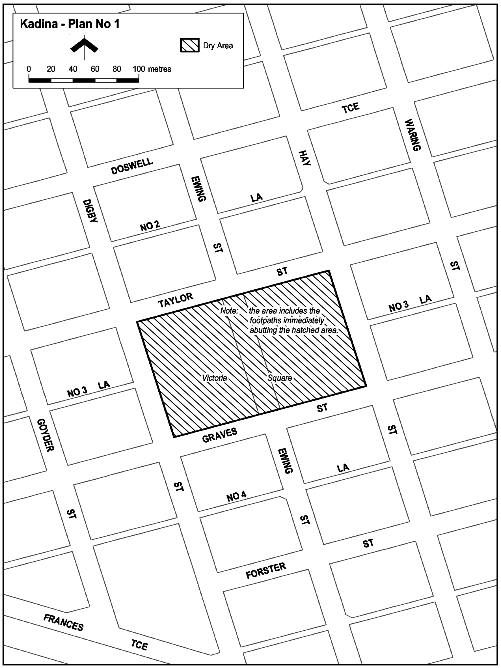
Moonta—Plan No 1
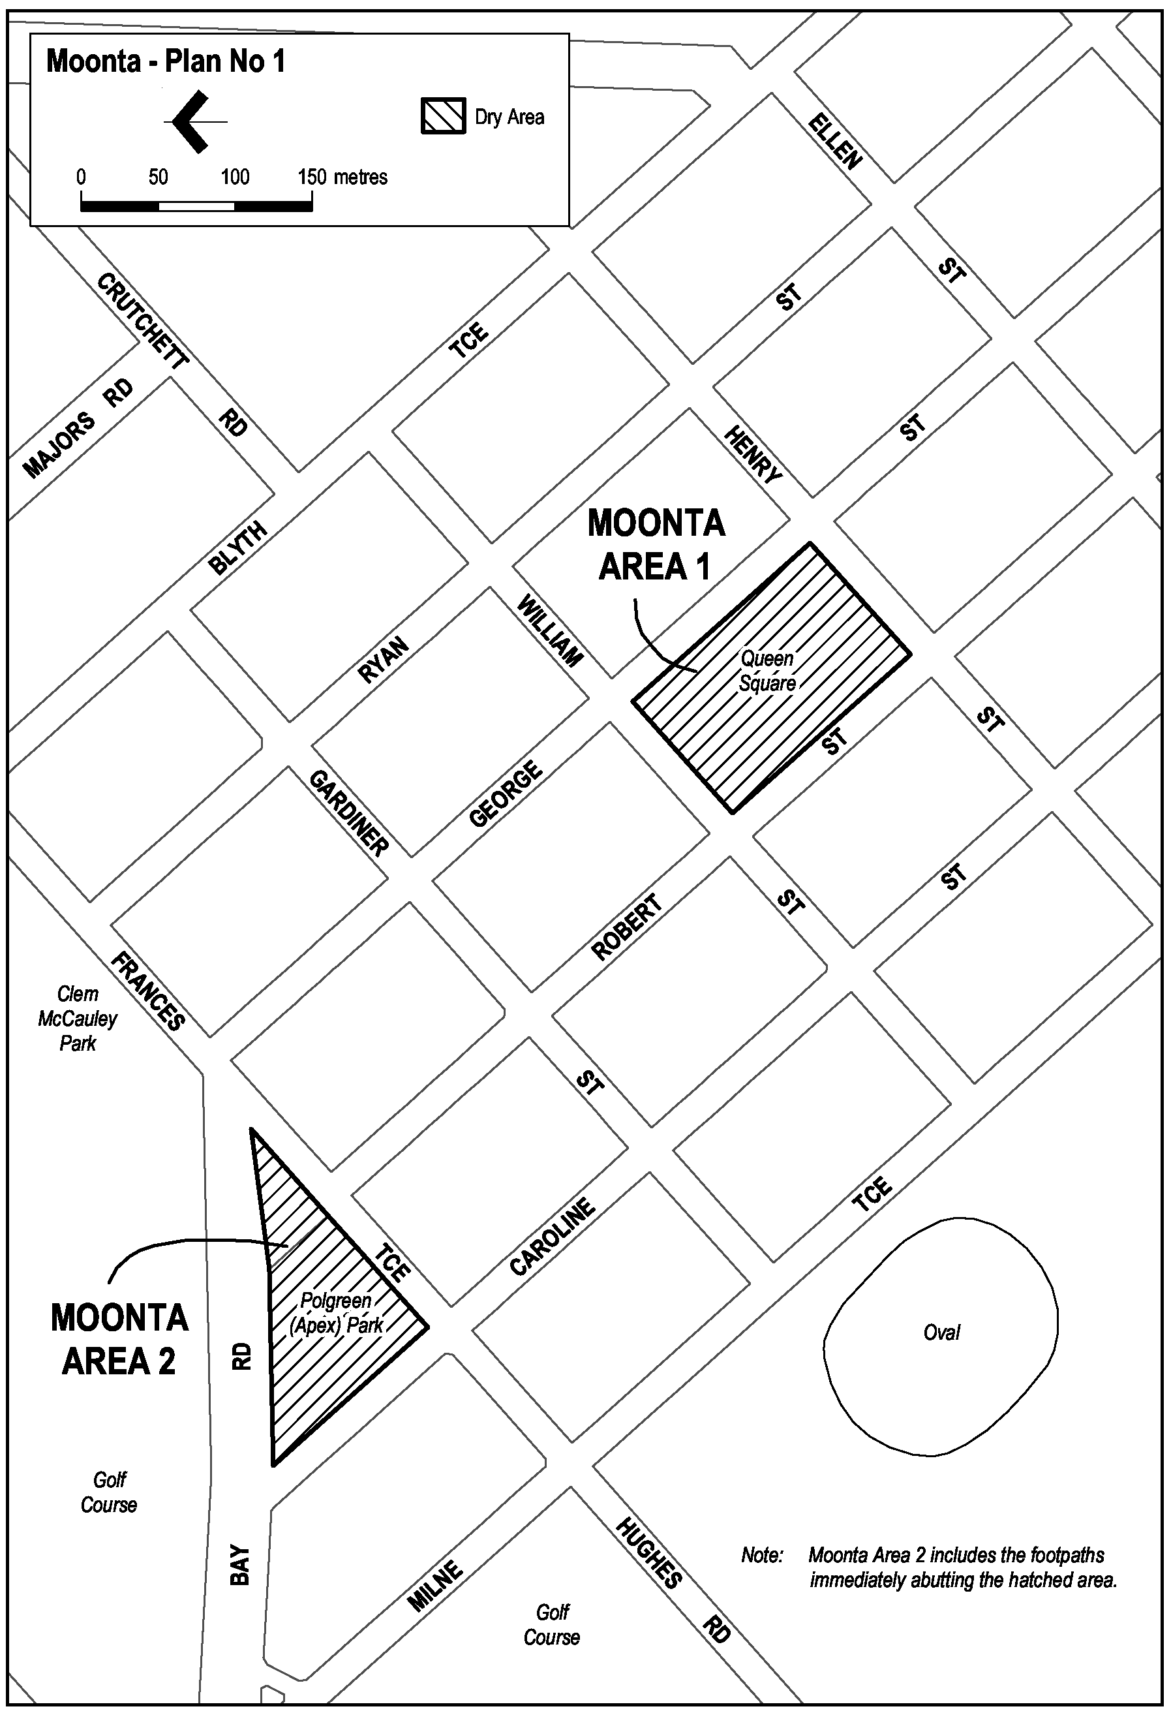
Moonta Bay—Plan No 1
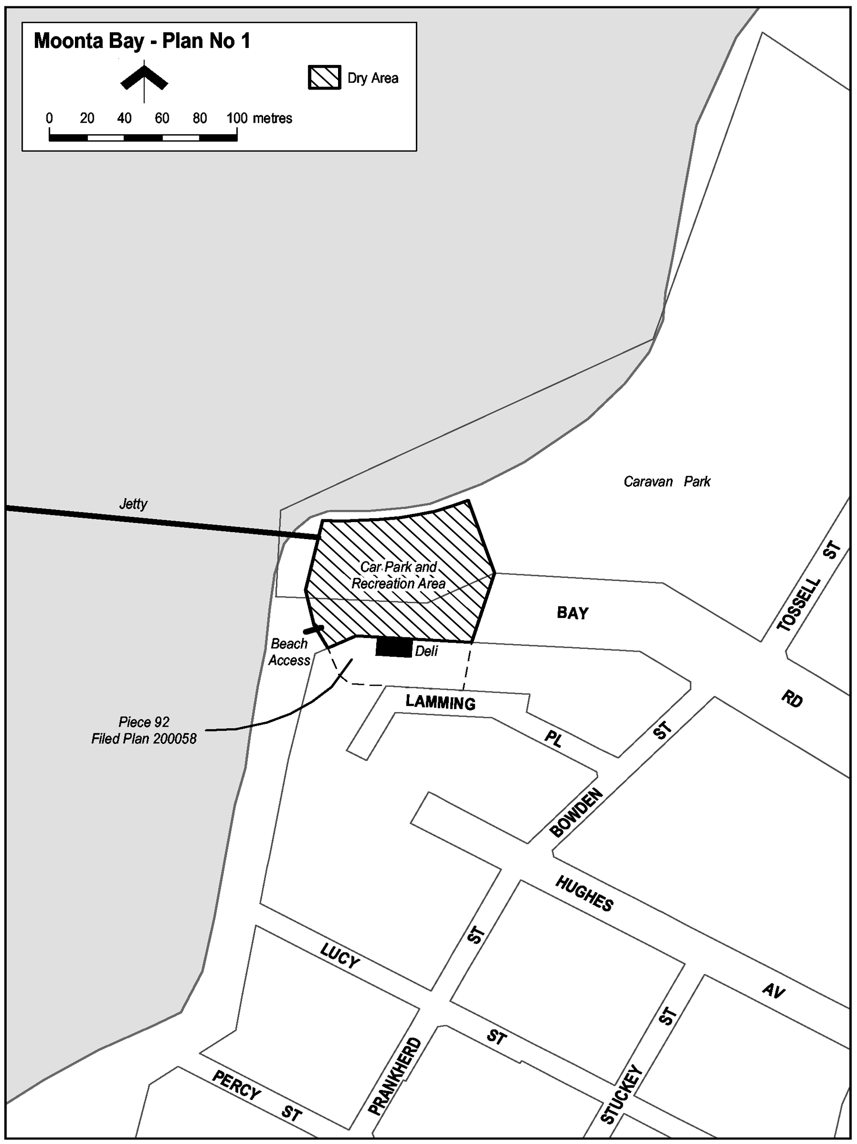
Port Hughes—Plan No 1
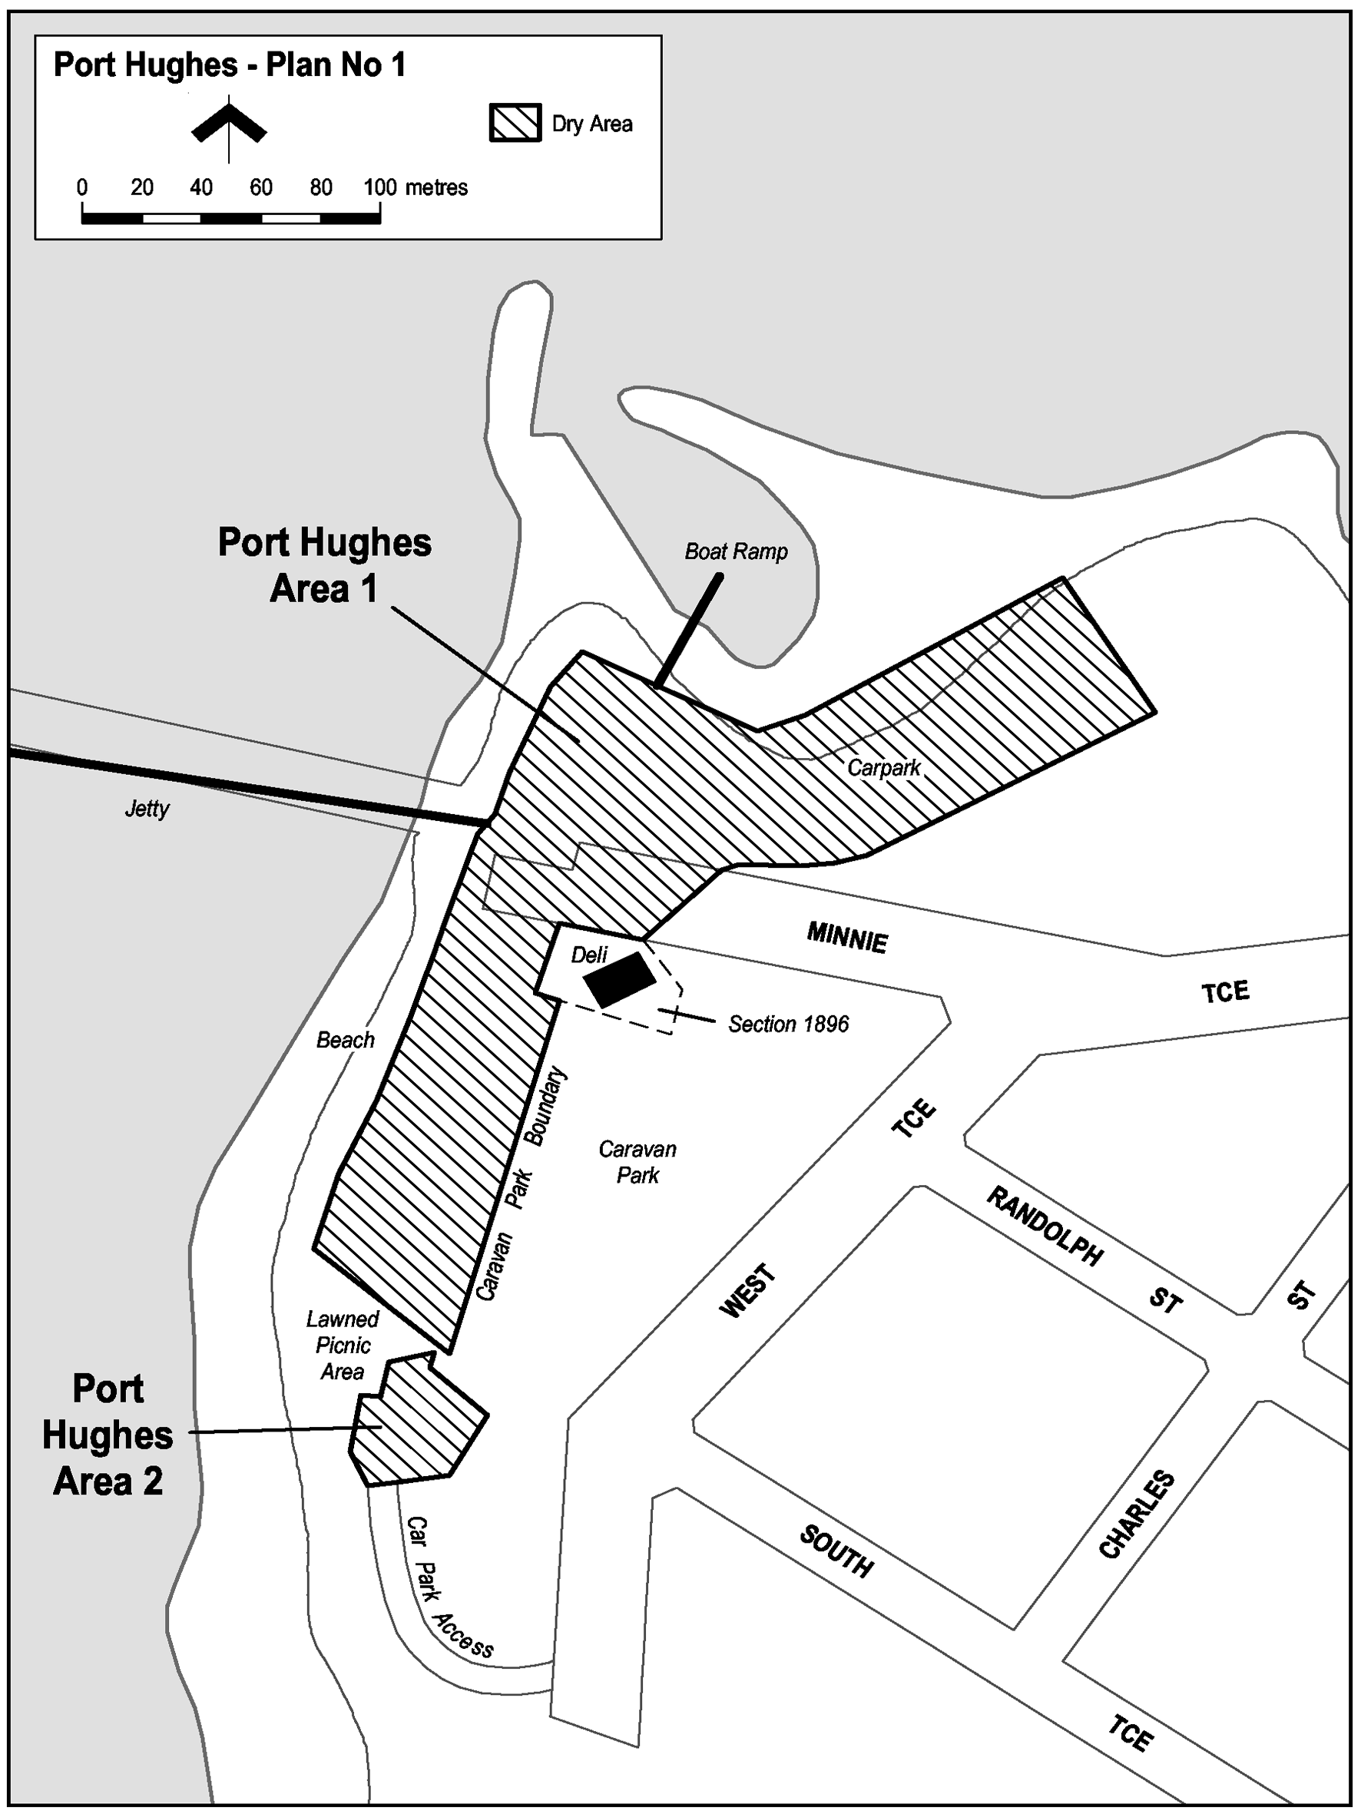
Wallaroo—Plan No 1
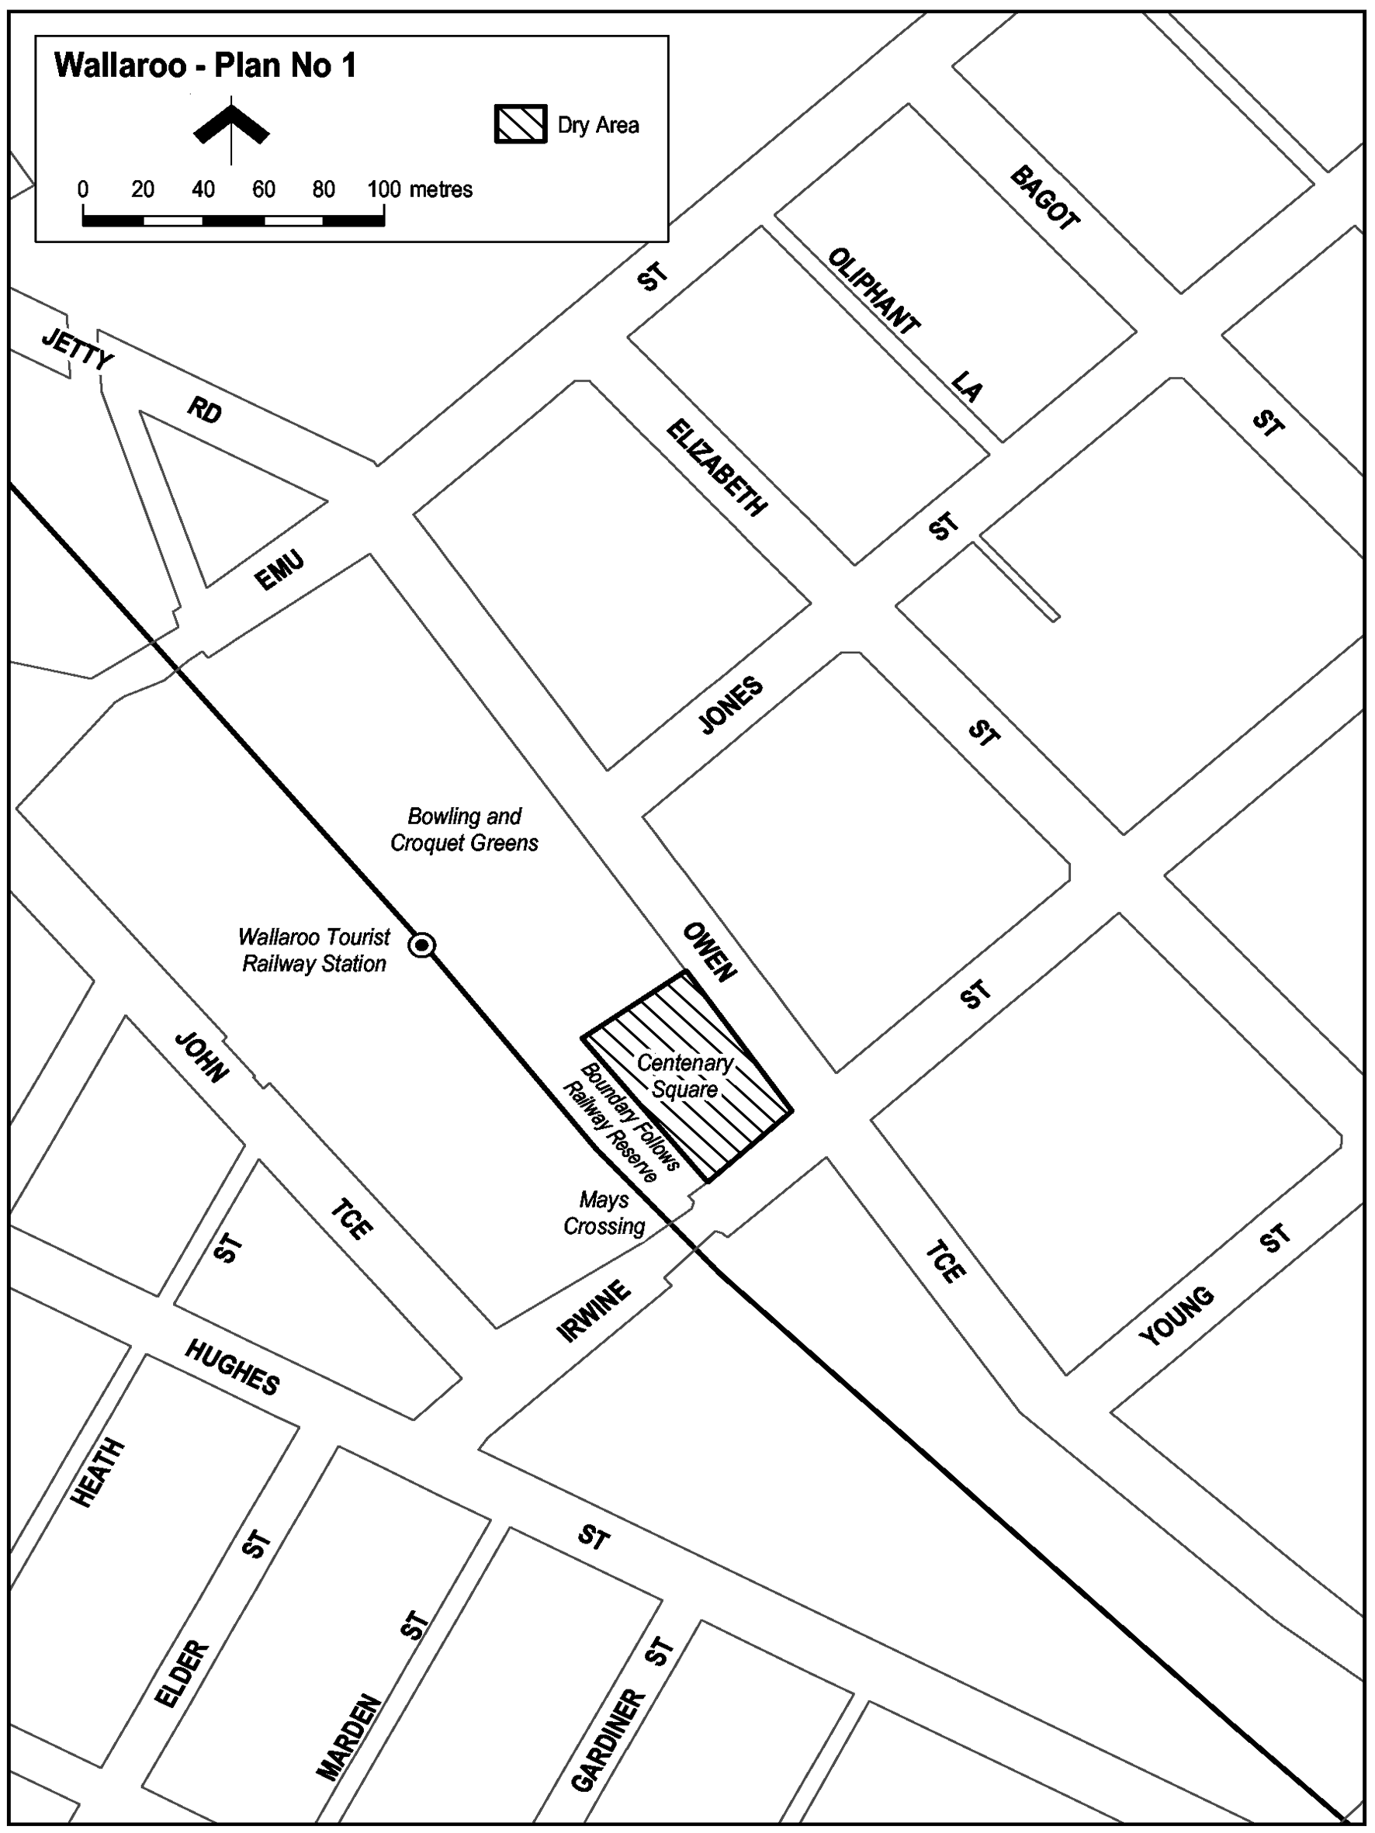
Wallaroo—Plan No 2
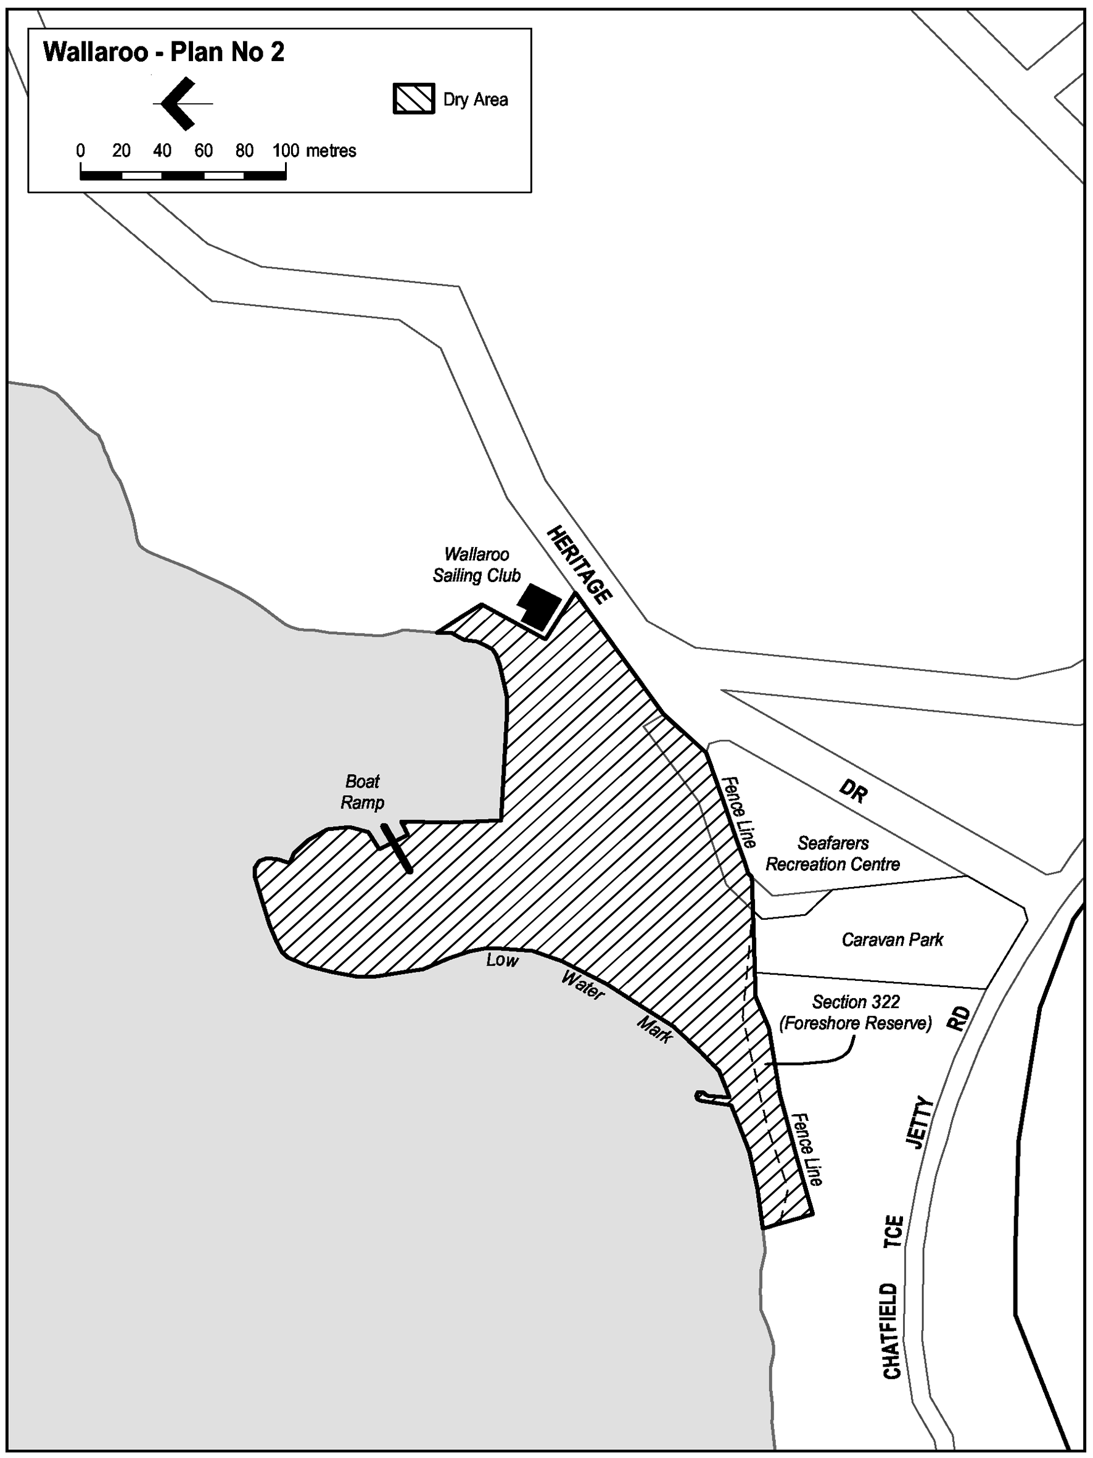
Note—
As required by section 10AA(2) of the Subordinate Legislation Act 1978, the Minister has certified that, in the Minister's opinion, it is necessary or appropriate that these regulations come into operation as set out in these regulations.
Made by the Governor
with the advice and consent of the Executive Council
on 2 September 2004
No 193 of 2004
OLGC12/2004

South Australia
Chicken Meat Industry Regulations 2004
under the Chicken Meat Industry Act 2003

Contents
1 Short title
2 Commencement
3 Interpretation
4 Fee for Registrar's operations
5 Notice to commence negotiations for growing agreements
Schedule 1—Fees for Registrar's operations
Schedule 2—Notice to commence negotiations for growing agreements

1—Short title
These regulations may be cited as the Chicken Meat Industry Regulations 2004.
2—Commencement
These regulations will come into operation on the day on which Part 3 of the Chicken Meat Industry Act 2003 comes into operation.
3—Interpretation
In these regulations—
Act means the Chicken Meat Industry Act 2003.
4—Fee for Registrar's operations
(1) The prescribed fee that must be paid to the Registrar each financial year is the appropriate fee set out in Schedule 1.
(2) The fee for a financial year must be paid to the Registrar by 1 May of that year.
(3) The penalty for default in payment of the prescribed fee is 10 per cent of the prescribed fee.
5—Notice to commence negotiations for growing agreements
For the purposes of section 17 of the Act, the prescribed form is set out in Schedule 2.
Schedule 1—Fees for Registrar's operations

1 | For a processor that—
 | (a) processes more than 2 million meat chickens each year | $12 000
 | (b) processes between 1 million and 2 million meat chickens each year | $8 000
 | (c) processes less than 1 million meat chickens each year | $4 000
2 | For a grower—
 | (a) with more than 20 000 square metres in area of shed space available for growing meat chickens | $900
 | (b) with shed space available for growing meat chickens of between 8 000 and 20 000 square metres in area | $600
 | (c) with less than 8 000 square metres in area of shed space available for growing meat chickens | $300
Schedule 2—Notice to commence negotiations for growing agreements
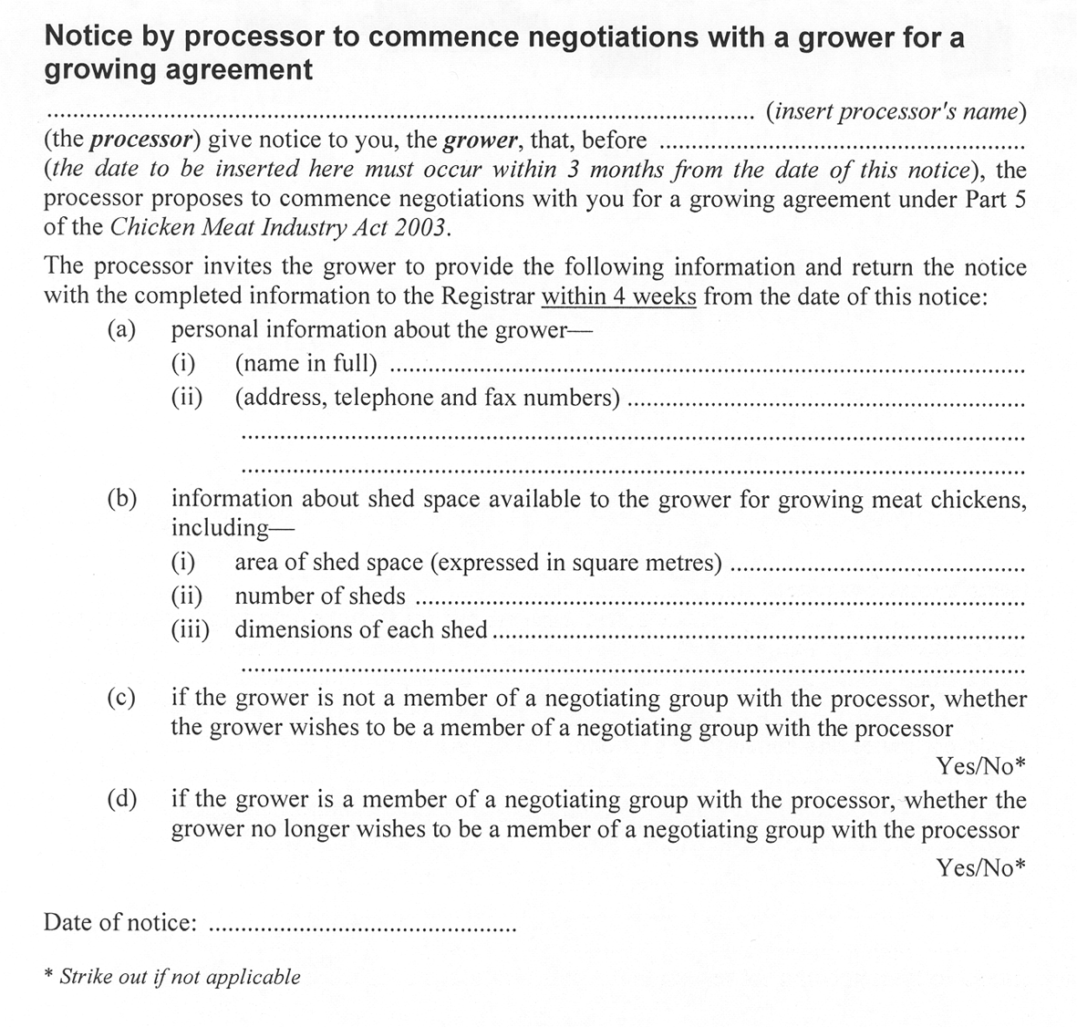
Note—
As required by section 10AA(2) of the Subordinate Legislation Act 1978, the Minister has certified that, in the Minister's opinion, it is necessary or appropriate that these regulations come into operation as set out in these regulations.
Made by the Governor
with the advice and consent of the Executive Council
on 2 September 2004
No 194 of 2004
MAFF03/0039CS

FAXING COPY?
IF you fax copy to Government Publishing SA for inclusion in the Government Gazette, there is no need to send a Confirmation Copy to us as well.
This creates confusion and may well result in your notice being printed twice.
Please use the following fax number:
Fax transmission: (08) 8207 1040
Phone Inquiries: (08) 8207 1045
Please include a contact person, phone number and order number so that we can phone back with any queries we may have regarding the fax copy.
NOTE: Closing time for lodging new copy (fax, hard copy or email) is 4 p.m. on Tuesday preceding the day of publication.

Government Gazette notices can be E-mailed.
The address is:
governmentgazette@saugov.sa.gov.au
Documents should be sent as attachments in Word format.
When sending a document via E-mail, please confirm your transmission with a faxed copy of your document, including the date the notice is to be published.
Fax transmission: (08) 8207 1040
Enquiries: (08) 8207 1045
NOTE: Closing time for lodging new copy (fax, hard copy or email) is 4 p.m. on Tuesday preceding the day of publication.

THE RURAL CITY OF MURRAY BRIDGE
Exclusion of Land from Classification
as Community Land
NOTICE is hereby given that The Rural City of Murray Bridge at its meeting held on 27 May 2002 resolved, pursuant to section 193 (4) (a) of the Local Government Act 1999, to exclude the following parcel of land from classification as community land:
Allotment 6 in Deposited Plan D12310, off Long Island Road, Hundred of Mobilong, being the whole of the land comprised in certificate of title register book volume 5721, folio 267 and of land marked ‘V’ in the plan attached to DA 415/D029/02 which is now entirely encompassed within Allotment 31 in Deposited Plan D62155 and therefore now encompassed entirely within certificate of title register book volume 5910, folio 406.
D. Altmann, Chief Executive Officer

TOWN OF WALKERVILLE
Resignation of Councillor
NOTICE is hereby given in accordance with section 54 (6) of the Local Government Act 1999, that a vacancy has occurred in the office of Councillor for Vale Park Ward, due to the resignation of Councillor Anthony John Reade, to take effect from 23 August 2004.
Dated 27 August 2004.
R. Wallace, Chief Executive Officer

ALEXANDRINA COUNCIL
Roads (Opening and Closing) Act 1991
Portion of Laneway adjacent Colman Terrace, Strathalbyn
NOTICE is hereby given pursuant to section 10 of the said Act, that council proposes to make a Road Process Order to close and transfer to the Strathalbyn Bowling Club Inc. the narrow laneway adjoining allotment 4 in FP5838 shown as ‘A’ on Preliminary Plan No. 04/0075.
A copy of the plan and statement of persons affected are available for public inspection at Council’s office, Dawson Street, Goolwa, and the office of the Surveyor-General, 101 Grenfell Street, Adelaide during normal office hours.
Any application for easement or objections must be made in writing within 28 days from 2 September 2004, to the Council, P.O. Box 21, Goolwa, S.A. 5214 and the Surveyor-General, G.P.O. Box 1354, Adelaide, S.A. 5001, setting out full details.
Where a submission is made, council will give notification of a meeting to deal with the matter.
J. L. Coombe, Chief Executive Officer

ALEXANDRINA COUNCIL
Erratum
Declaration of Public Road
THE declaration of Public Road published on 5 September 2002 on page 3375 is hereby corrected to read:
Notice is hereby given that Alexandrina Council has declared the private laneway between Lot 4 of Filed Plan 5838 and Lot A of Road Plan 5840 within the township of Strathalbyn to be a public road, pursuant to section 210 of the Local Government Act 1999.
J. L. Coombe, Chief Executive Officer

KINGSTON DISTRICT COUNCIL
Appointment
Notice is hereby given that pursuant to section 102 of the Local Government Act 1999, Alistair Martin be appointed Acting Chief Executive Officer of the Kingston District Council for the period from Wednesday, 1 September 2004 to Friday, 29 October 2004.
S. Rufus, Chief Executive Officer

DISTRICT COUNCIL OF ORROROO/CARRIETON
Adoption of Valuation and Declaration of Rates
Notice is hereby given that at a meeting of the District Council of Orroroo/Carrieton (‘the council’) held on 10 August 2004 the council resolved to adopt the 2005 Rating Policy, as required by the Local Government Act 1999.
The 2005 Rating Policy contains the following:
Adoption of Valuations
1. That in accordance with the provisions of section 167 (2) (a) of the Local Government Act 1999, the council adopts for rating proposes for the year ending 30 June 2005, the Valuer-General’s Valuation of the Capital Values applicable to land within the area of the council totalling $115 478 220.
Declaration of Rates
2. In order to raise the amount of $487 005 that is required to be raised the council declares the following rates:
2.1 General Rate—A general rate of 0.2949 cents in the dollar on all rateable land;
2.2 Fixed Rate—A fixed rate of $150 on all rateable properties;
2.3 Service Fee—A service fee of $120 on all rateable properties where a refuse collection service is provided.
A. J. Renshaw, Chief Executive Officer

DISTRICT COUNCIL OF STREAKY BAY
Title of Principal Member
Notice is hereby given that council at its meeting held on 18 August 2004, resolved pursuant to section 51 (1) (b) of the Local Government Act 1999, that the title of the Principal Member of the District Council of Streaky Bay be Mayor with the Deputy Principal Member to be known as Deputy Mayor.
J. Rumbelow, Chief Executive Officer

DISTRICT COUNCIL OF STREAKY BAY
Exclusion of Land from Classification as Community Land
NOTICE is hereby given that the District Council of Streaky Bay at its meeting held on 18 January 2004, resolved, pursuant to section 193 (4) of the Local Government Act 1999, to exclude the following parcel of Land from Classification as Community Land:
Certificate of Title, Volume 5820, Folio 748 being 34 Wells Street, Streaky Bay.
J. Rumbelow, Chief Executive Officer

IN the matter of the estates of the undermentioned deceased persons:
Allwood, Hazel Jean, late of 56 Thomas Street, Murray Bridge, retired business proprietor, who died on 12 May 2004.
Aunger, Olive Gloria Irene, late of 15 Rosemary Street, Woodville West, of no occupation, who died on 4 June 2004.
Brownlow, Edith Rose, late of 10 Morton Road, Christie Downs, of no occupation, who died on 17 September 2003.
Cheesman, Alfred John, late of 4 Hale Street, Everard Park, retired crane driver, who died on 15 June 2004.
Clarke, Daphne Olva, late of 16 Norseman Avenue, West-bourne Park, retired laboratory assistant, who died on 10 July 2004.
Crafter, Elva Marles, late of 103 Fisher Street, Fullarton, of no occupation, who died on 24 May 2004.
Gapper, Thelma May, late of Hazel Grove, Ridgehaven, retired dressmaker, who died on 6 July 2004.
Hall, Doreen Jean, late of 5 Bradford Court, Enfield, of no occupation, who died on 1 July 2004.
Johnson, Cecily Jean, late of 122 St Bernards Road, Magill, retired teacher, who died on 5 July 2004.
Johnson, George Arthur, late of 29 Austral Terrace, Morphettville, retired cleaner, who died on 19 July 2004.

Patouris, Bridget Agnes Imelda, late of 88-94 Robert Street, West Croydon, of no occupation, who died on 31 May 2004.
Quick, Gwendoline May, late of 23 Verco Avenue, Lower Mitcham, home duties who died on 27 June 2004.
Rodley, John Francis, late of 29 Braemore Terrace, Campbelltown, retired sheetmetal worker, who died on 26 February 2004.
Toth, Antonia Sophia, late of 19 Watson Avenue, Rose Park, retired accountant, who died on 26 September 2000.
Vernon, Dorothy Rose, late of Blamey Road, Elizabeth East, retired teacher, who died on 7 July 2004.
Notice is hereby given pursuant to the Trustee Act 1936, as amended, the Inheritance (Family Provision) Act 1972, and the Family Relationships Act 1975, that all creditors, beneficiaries, and other persons having claims against the said estates are required to send, in writing, to the Public Trustee, 25 Franklin Street, Adelaide, S.A. 5000, full particulars and proof of such claims, on or before 1 October 2004, otherwise they will be excluded from the distribution of the said estate; and notice is also hereby given that all persons who are indebted to the said estates are required to pay the amount of their debts to the Public Trustee or proceedings will be taken for the recovery thereof; and all persons having any property belonging to the said estates are forthwith to deliver the same to the Public Trustee.
Dated 2 September 2004.
C. J. O’Loughlin, Public Trustee

SALE OF PROPERTY
Auction Date: Wednesday, 29 September 2004 at 10 a.m.
Location: Government Auctions SA, 47 Transport Avenue, Netley.
NOTICE is hereby given that on the above date at the time and place stated, by virtue of Orders for Sale issued by the Fines Payment Unit of South Australia, Penalty No. EXREG-04-28409/1 and others, are directed to the Sheriff of South Australia in an action wherein Nikolla Gjeka is the Defendant, I, Mark Stokes, Sheriff of the State of South Australia, will by my auctioneers, Government Auctions SA make sale of the following:
Ford Telstar
Registration No. WLK 578.

ATTENTION

CUSTOMERS requiring a proof of their notice for inclusion in the Government Gazette, please note that the onus is on you to inform Government Publishing SA of any subsequent corrections by 10 a.m. on Thursday, which is our publication deadline.

For any corrections to your notice please phone 8207 1045 or Fax 8207 1040 before 10 a.m. on Thursday.

If we do not receive any communication by 10 a.m. on Thursday (day of publication) we will presume the notice is correct and will print it as it is.

Remember—the onus is on you to inform us of any corrections necessary to your notice.

NOTE: Closing time for lodging new copy (electronically, fax or hard copy) is 4 p.m. on Tuesday preceding the day of publication. Phone 8207 1045—Fax 8207 1040.
Email: governmentgazette@saugov.sa.gov.au

Printed and published by authority every Thursday by J. D. FERGUSON, Government Printer, South Australia
Price: $4.85, plus postage; to subscribers, $247.00 per annum.
(The above prices are inclusive of GST)

