No. 90 3737

THE SOUTH AUSTRALIAN

GOVERNMENT GAZETTE
www.governmentgazette.sa.gov.au

PUBLISHED BY AUTHORITY

ALL PUBLIC ACTS appearing in this GAZETTE are to be considered official, and obeyed as such

ADELAIDE, THURSDAY, 30 SEPTEMBER 2004

CONTENTS

Page
Administrative Arrangements Act 1994—Notice 3739
Appointments, Resignations, Etc. 3738, 3796
Aquaculture Act 2001—Notices 3739
Corporations and District Councils—Notices 3793
Crown Lands Act 1929—Notices 3744
Development Act 1993—Notices 3745
Fisheries Act 1982—Notices 3748
Gas Regulations 1997—Notice 3752
Geographical Names Act 1991—Notice 3749
Harbors and Navigation Act 1993—Notice 3749
Housing Improvement Act 1940—Notices 3763
Land and Business (Sale and Conveyancing) Act 1994—
Notices 3765
Legislative Council—Resolution 3749
Liquor Licensing Act 1997—Notices 3765
Mining Act 1971—Notices 3768
National Parks and Wildlife (National Parks) Regulations
2001—Notices 3769

Page
Partnership Act 1891—Notice 3795
Petroleum Act 2000—Notice 3769
Port Augusta Circuit Court—Notice 3776
Private Advertisements 3795
Proclamations 3778
Public Trustee Office—Administration of Estates 3795
REGULATIONS
Lottery and Gaming Act 1936 (No. 209 of 2004) 3785
South Australian Co-operative and Community Housing
Act 1991 (No. 210 of 2004) 3788
Development Act 1993 (No. 211 of 2004) 3790
Renmark Irrigation Trust, The—Notice 3769
Roads (Opening and Closing) Act 1991—Notices 3769
Road Traffic Act 1961—Notice 3770
Rules of Court 3771
State Lotteries Act 1966—Rules 3774
Training and Skills Development Act 2003—Notice 3775
Water Mains and Sewers—Mains Laid, Replaced, Etc. 3776

GOVERNMENT GAZETTE NOTICES
ALL poundkeepers’ and private advertisements forwarded for publication in the South Australian Government Gazette must be PAID FOR PRIOR TO INSERTION; and all notices, from whatever source, should be legibly written on one side of the paper only and sent to Government Publishing SA so as to be received no later
than 4 p.m. on the Tuesday preceding the day of publication. Phone 8207 1045 or Fax 8207 1040. E-mail: governmentgazette@saugov.sa.gov.au. Send as attachments in Word format and please confirm your transmission with a faxed copy of your document, including the date the notice is to be published and to whom the notice will be charged. The Government Gazette is available online at: www.governmentgazette.sa.gov.au

Department of the Premier and Cabinet
Adelaide, 30 September 2004
HER Excellency the Governor in Executive Council has revoked the appointment of Jocelyn Auer as a Deputy Member to Shirley Peisley of the Medical Board, effective from 30 September 2004, pursuant to the Medical Practitioners Act 1983 and the Acts Interpretation Act 1915.
By command,
J. D. Hill, for Premier
MHEA-MGR 0010CS

Department of the Premier and Cabinet
Adelaide, 30 September 2004
HER Excellency the Governor in Executive Council has revoked the appointment of Iris Dobrzinski as a Member of the South Australian Bushfire Prevention Advisory Committee, effective from 30 September 2004, pursuant to the Country Fires Act 1989 and the Acts Interpretation Act 1915.
By command,
J. D. Hill, for Premier
MES 013/04CS

Department of the Premier and Cabinet
Adelaide, 30 September 2004
HER Excellency the Governor in Executive Council has revoked the appointment of Heidi Goess as a Deputy Member to Iris Dobrzinski and Warwick Grace as a Deputy Member to Andrew Watson of the South Australian Bushfire Prevention Advisory Committee, effective from 30 September 2004, pursuant to the Country Fires Act 1989 and the Acts Interpretation Act 1915.
By command,
J. D. Hill, for Premier
MES 013/04CS

Department of the Premier and Cabinet
Adelaide, 30 September 2004
HER Excellency the Governor in Executive Council has been pleased to appoint the undermentioned to the Medical Board, pursuant to the provisions of the Medical Practitioners Act 1983:
Member: (from 30 September 2004 until 26 August 2005)
Jocelyn Auer
Deputy Member: (from 30 September 2004 until 26 August 2005)
Debraha Bills (Deputy to Auer)
By command,
J. D. Hill, for Premier
MHEA-MGR 0010CS

Department of the Premier and Cabinet
Adelaide, 30 September 2004
HER Excellency the Governor in Executive Council has been pleased to appoint the undermentioned to the Training Centre Review Board, pursuant to the provisions of the Young Offenders Act 1993:
Deputy Member: (from 30 September 2004 until 21 January 2007)
Susan Elizabeth Parsons (Deputy to Spence)
By command,
J. D. Hill, for Premier
ATTG 0428/02CS

Department of the Premier and Cabinet
Adelaide, 30 September 2004
HER Excellency the Governor in Executive Council has been pleased to appoint the undermentioned to the Physiotherapists Board of South Australia, pursuant to the provisions of the Physiotherapists Act 1991:
Member: (from 30 September 2004 until 19 March 2006)
Sybil Wakefield
By command,
J. D. Hill, for Premier
MHEA-MGR 0030CS

Department of the Premier and Cabinet
Adelaide, 30 September 2004
HER Excellency the Governor in Executive Council has been pleased to appoint the undermentioned to the Dog and Cat Management Board, pursuant to the provisions of the Dog and Cat Management Act 1995:
Member: (from 1 October 2004 until 30 September 2007)
Max Amber
Ian Ridgway
Greg Waller
Rosemary Ince
Annette Mayer
Member: (from 1 October 2004 until 30 September 2006)
Jeffrey Gordon Cook
Sandie Starr
Ian Douglas Balfour McBryde
Sarah Harris
Chair: (from 1 October 2004 until 30 September 2007)
Max Amber
By command,
J. D. Hill, for Premier
MEC 0075/04CS

Department of the Premier and Cabinet
Adelaide, 30 September 2004
HER Excellency the Governor in Executive Council has been pleased to appoint the Honourable Patrick Frederick Conlon, MP, Minister for Infrastructure, Minister for Energy and Minister for Emergency Services to also be Acting Deputy Premier, Acting Treasurer, Acting Minister Assisting the Premier in Economic Development, Acting Minister for Police and Acting Minister for Federal/State Relations for the period 30 September 2004 to 10 October 2004 inclusive, during the absence of the Honourable Kevin Owen Foley, MP.
By command,
J. D. Hill, for Premier
DTF 050/04CS

Department of the Premier and Cabinet
Adelaide, 30 September 2004
HER Excellency the Governor in Executive Council has been pleased to appoint James Stanley Wright to the position of Chief Executive, Department of Treasury and Finance, for a term of three years commencing on 30 September 2004, pursuant to Part 4 of the Public Sector Management Act 1995.
By command,
J. D. Hill, for Premier
DPC 029/04CS

ADMINISTRATIVE ARRANGEMENTS ACT 1994
Delegation
PURSUANT to section 9 (1) of the Administrative Arrangements Act 1994, I, John Hill, the Minister for Environment and Conservation for the State of South Australia hereby delegate the power vested in me under section 33 of the Native Vegetation Act 1991 (Reprint No. 2) as in force at 1 January 2001 to the Attorney-General, so far as that power relates to the determination of an application by the Native Vegetation Council for an authorisation to commence civil enforcement proceedings pursuant to Division 2 of the Native Vegetation Act 1991 regarding land contained in section 236 in the Hundred of Minecrow.
Dated 24 September 2004.
J. Hill, Minister for Environment and Conservation

AQUACULTURE ACT 2001
Grant of Aquaculture Lease
PURSUANT to the provisions of section 22 of the Aquaculture Act 2001, Rory McEwen, Minister for Agriculture, Food and Fisheries, hereby gives notice of the grant of the following lease for the purposes of aquaculture in the waters of the state:
Lessee:
Geoffrey R. Bayly
Address for notice of the Lessee:
P.O. Box 1231
Port Lincoln, S.A. 5607
Leased Area
2 Hectares
GDA 94—Zone 53 Latitudes Longitudes
578756E 6153175N 34°45′38″ 135°51′38″
578949E 6153178N 34°45′38″ 135°51′46″
578951E 6153075N 34°45′41″ 135°51′46″
578757E 6153072N 34°45′41″ 135°51′38″
Permitted Class of Aquaculture:
Intertidal Mollusc Aquaculture
Expiry Date of the lease is:
30 June 2005

AQUACULTURE ACT 2001
Grant of Aquaculture Lease
PURSUANT to the provisions of section 22 of the Aquaculture Act 2001, Rory McEwen, Minister for Agriculture, Food and Fisheries, hereby gives notice of the grant of the following lease for the purposes of aquaculture in the waters of the state:
Lessee:
Kym Clarke
Address for notice of the Lessee:
P.O. Box 869
Port Lincoln, S.A. 5607
Leased Area:
4 Hectares
GDA 94—Zone 53 Latitudes Longitudes
530415E 6177822N 34°32′27″ 135°19′53″
530615E 6177822N 34°32′27″ 135°20′01″
530615E 6177622N 34°32′34″ 135°20′01″
530415E 6177622N 34°32′34″ 135°19′53″
Permitted Class of Aquaculture:
Intertidal Mollusc Aquaculture
Expiry Date of the lease is:
30 June 2005

AQUACULTURE ACT 2001
Grant of Aquaculture Lease
PURSUANT to the provisions of section 22 of the Aquaculture Act 2001, Rory McEwen, Minister for Agriculture, Food and Fisheries, hereby gives notice of the grant of the following lease for the purposes of aquaculture in the waters of the state:
Lessee:
Brenton J. Lawrence
Stephanie K. Lawrence
Address for notice of the Lessee:
P.O. Box 217
Coffin Bay, S.A. 5607
Leased Area:
—
GDA 94—Zone 53 Latitudes Longitudes
531362E 6178390N 34°32′09″ 135°20′30″
531429E 6178390N 34°32′09″ 135°20′33″
531429E 6178240N 34°32′13″ 135°20′33″
531362E 6178240N 34°32′13″ 135°20′30″
Permitted Class of Aquaculture:
Intertidal Mollusc Aquaculture
Expiry Date of the lease is:
30 June 2023

AQUACULTURE ACT 2001
Grant of Aquaculture Lease
PURSUANT to the provisions of section 22 of the Aquaculture Act 2001, Rory McEwen, Minister for Agriculture, Food and Fisheries, hereby gives notice of the grant of the following lease for the purposes of aquaculture in the waters of the state:
Lessee:
Tondari Fisheries Pty Ltd
Address for notice of the Lessee:
28 Oyster Drive
Cowell, S.A. 5602
Leased Area:
1 Hectare
GDA 94—Zone 53 Latitudes Longitudes
531429E 6178390N 34°32′09″ 135°20′33″
531496E 6178390N 34°32′09″ 135°20′36″
531496E 6178240N 34°32′13″ 135°20′36″
531429E 6178240N 34°32′13″ 135°20′33″
Permitted Class of Aquaculture:
Intertidal Mollusc Aquaculture
Expiry Date of the lease is:
30 June 2023

AQUACULTURE ACT 2001
Grant of Aquaculture Lease
PURSUANT to the provisions of section 22 of the Aquaculture Act 2001, Rory McEwen, Minister for Agriculture, Food and Fisheries, hereby gives notice of the grant of the following lease for the purposes of aquaculture in the waters of the state:
Lessee:
Cowell Properties Pty Ltd
Address for notice of the Lessee:
4 Shaftsbury Terrace
Marino, S.A. 5049
Leased Area:
1 Hectare
GDA 94—Zone 53 Latitudes Longitudes
531496E 6178390N 34°32′09″ 135°20′36″
531562E 6178390N 34°32′09″ 135°20′38″
531562E 6178240N 34°32′13″ 135°20′38″
531496E 6178240N 34°32′13″ 135°20′36″
Permitted Class of Aquaculture:
Intertidal Mollusc Aquaculture
Expiry Date of the lease is:
30 June 2023

AQUACULTURE ACT 2001
Grant of Aquaculture Lease
PURSUANT to the provisions of section 22 of the Aquaculture Act 2001, Rory McEwen, Minister for Agriculture, Food and Fisheries, hereby gives notice of the grant of the following lease for the purposes of aquaculture in the waters of the state:
Lessee:
Brenton J. Lawrence
Stephanie K. Lawrence
Address for notice of the Lessee:
P.O. Box 217
Coffin Bay, S.A. 5607
Leased Area:
2 Hectares
GDA 94—Zone 53 Latitudes Longitudes
531696E 6178390N 34°32′09″ 135°20′43″
531696E 6178240N 34°32′13″ 135°20′43″
531562E 6178240N 34°32′13″ 135°20′38″
531562E 6178390N 34°32′09″ 135°20′38″
Permitted Class of Aquaculture:
Intertidal Mollusc Aquaculture
Expiry Date of the lease is:
30 June 2023

AQUACULTURE ACT 2001
Grant of Aquaculture Lease
PURSUANT to the provisions of section 22 of the Aquaculture Act 2001, Rory McEwen, Minister for Agriculture, Food and Fisheries, hereby gives notice of the grant of the following lease for the purposes of aquaculture in the waters of the state:
Lessee:
Cowell Properties Pty Ltd
Address for notice of the Lessee:
4 Shaftsbury Terrace
Marino, S.A. 5049
Leased Area:
0.25 Hectares
GDA 94—Zone 53 Latitudes Longitudes
543603E 6170108N 34°36′36″ 135°28′32″
543615E 6170108N 34°36′36″ 135°28′33″
543616E 6169908N 34°36′42″ 135°28′33″
543603E 6169908N 34°36′42″ 135°28′32″
Permitted Class of Aquaculture:
Intertidal Mollusc Aquaculture
Expiry Date of the lease is:
30 June 2023

AQUACULTURE ACT 2001
Grant of Aquaculture Lease
PURSUANT to the provisions of section 22 of the Aquaculture Act 2001, Rory McEwen, Minister for Agriculture, Food and Fisheries, hereby gives notice of the grant of the following lease for the purposes of aquaculture in the waters of the state:
Lessee:
Tondari Fisheries Pty Ltd
Address for notice of the Lessee:
28 Oyster Drive
Cowell, S.A. 5602
Leased Area:
0.25 Hectares
GDA 94—Zone 53 Latitudes Longitudes
543615E 6170108N 34°36′36″ 135°28′33″
543628E 6170108N 34°36′36″ 135°28′33″
543628E 6169908N 34°36′42″ 135°28′33″
543616E 6169908N 34°36′42″ 135°28′33″
Permitted Class of Aquaculture:
Intertidal Mollusc Aquaculture
Expiry Date of the lease is:
30 June 2023

AQUACULTURE ACT 2001
Grant of Aquaculture Lease
PURSUANT to the provisions of section 22 of the Aquaculture Act 2001, Rory McEwen, Minister for Agriculture, Food and Fisheries, hereby gives notice of the grant of the following lease for the purposes of aquaculture in the waters of the state:
Lessee:
Gregory M. Lawrence
Address for notice of the Lessee:
28 Bonanza Road
Port Lincoln, S.A. 5606
Leased Area:
0.5 Hectares
GDA 94—Zone 53 Latitudes Longitudes
543628E 6170108N 34°36′36″ 135°28′33″
543653E 6170108N 34°36′36″ 135°28′34″
543653E 6169908N 34°36′42″ 135°28′34″
543628E 6169908N 34°36′42″ 135°28′33″
Permitted Class of Aquaculture:
Intertidal Mollusc Aquaculture
Expiry Date of the lease is:
30 June 2023

AQUACULTURE ACT 2001
Grant of Aquaculture Lease
PURSUANT to the provisions of section 22 of the Aquaculture Act 2001, Rory McEwen, Minister for Agriculture, Food and Fisheries, hereby gives notice of the grant of the following lease for the purposes of aquaculture in the waters of the state:
Lessee:
Brenton J. Lawrence
Stephanie K. Lawrence
Address for notice of the Lessee:
P.O. Box 217
Coffin Bay, S.A. 5607
Leased Area:
1 Hectare
GDA 94—Zone 53 Latitudes Longitudes
543653E 6170108N 34°36′36″ 135°28′34″
543703E 6170108N 34°36′36″ 135°28′36″
543703E 6169908N 34°36′42″ 135°28′36″
543653E 6169908N 34°36′42″ 135°28′34″
Permitted Class of Aquaculture:
Intertidal Mollusc Aquaculture
Expiry Date of the lease is:
30 June 2023

AQUACULTURE ACT 2001
Grant of Aquaculture Lease
PURSUANT to the provisions of section 22 of the Aquaculture Act 2001, Rory McEwen, Minister for Agriculture, Food and Fisheries, hereby gives notice of the grant of the following lease for the purposes of aquaculture in the waters of the state:
Lessee:
South Australian Research & Development Institute
Address for notice of the Lessee:
P.O. Box 120
Henley Beach, S.A. 5022
Leased Area:
0.25 Hectares
GDA 94—Zone 53 Latitudes Longitudes
586111E 6156612N 34°43′44″ 135°56′26″
586161E 6156613N 34°43′44″ 135°56′28″
586161E 6156563N 34°43′46″ 135°56′28″
586111E 6156563N 34°43′46″ 135°56′26″
Permitted Class of Aquaculture:
Research and Development of Southern Bluefin Tuna and Yellowtail Kingfish
Expiry Date of the lease is:
15 April 2005

AQUACULTURE ACT 2001
Grant of Aquaculture Lease
PURSUANT to the provisions of section 22 of the Aquaculture Act 2001, Rory McEwen, Minister for Agriculture, Food and Fisheries, hereby gives notice of the grant of the following lease for the purposes of aquaculture in the waters of the state:
Lessee:
Chrisinda Pty Ltd
Address for notice of the Lessee:
P.O. Box 825
Port Lincoln, S.A. 5607
Leased Area:
1 Hectare
GDA 94—Zone 53 Latitudes Longitudes
530617E 6177442N 34°32′39″ 135°20′01″
530667E 6177462N 34°32′39″ 135°20′03″
530667E 6177261N 34°32′45″ 135°20′03″
530617E 6177242N 34°32′46″ 135°20′01″
Permitted Class of Aquaculture:
Intertidal Mollusc Aquaculture
Expiry Date of the lease is:
30 June 2023

AQUACULTURE ACT 2001
Grant of Aquaculture Lease
PURSUANT to the provisions of section 22 of the Aquaculture Act 2001, Rory McEwen, Minister for Agriculture, Food and Fisheries, hereby gives notice of the grant of the following lease for the purposes of aquaculture in the waters of the state:
Lessee:
Chrisinda Pty Ltd
Address for notice of the Lessee:
P.O. Box 825
Port Lincoln, S.A. 5607
Leased Area:
0.25 Hectares
GDA 94—Zone 53 Latitudes Longitudes
543870E 6170108N 34°36′36″ 135°28′43″
543883E 6170108N 34°36′36″ 135°28′43″
543883E 6169908N 34°36′42″ 135°28′43″
543871E 6169908N 34°36′42″ 135°28′43″
Permitted Class of Aquaculture:
Intertidal Mollusc Aquaculture
Expiry Date of the lease is:
30 June 2006

AQUACULTURE ACT 2001
Grant of Aquaculture Lease
PURSUANT to the provisions of section 22 of the Aquaculture Act 2001, Rory McEwen, Minister for Agriculture, Food and Fisheries, hereby gives notice of the grant of the following lease for the purposes of aquaculture in the waters of the state:
Lessee:
Peter Anderson
Ann Hennessy
Address for notice of the Lessee:
P.O. Box 1328
Coulta, S.A. 5607
Leased Area:
10 Hectares
GDA 94—Zone 53 Latitudes Longitudes
584156E 6170267N 34°36′22″ 135°55′04″
584582E 6170082N 34°36′27″ 135°55′21″
584385E 6169965N 34°36′31″ 135°55′13″
583932E 6170066N 34°36′28″ 135°54′56″
Permitted Class of Aquaculture:
Intertidal Mollusc Aquaculture
Expiry Date of the lease is:
30 June 2005

AQUACULTURE ACT 2001
Grant of Aquaculture Lease
PURSUANT to the provisions of section 22 of the Aquaculture Act 2001, Rory McEwen, Minister for Agriculture, Food and Fisheries, hereby gives notice of the grant of the following lease for the purposes of aquaculture in the waters of the state:
Lessee:
R. Brown Enterprises Pty Ltd
Address for notice of the Lessee:
101 Wells Street
Streaky Bay, S.A. 5680
Leased Area:
2 Hectares
GDA 94—Zone 53 Latitudes Longitudes
424544E 6374411N 32°45′56″ 134°11′40″
424544E 6374221N 32°46′02″ 134°11′40″
424439E 6374225N 32°46′02″ 134°11′36″
424439E 6374417N 32°45′56″ 134°11′36″
Permitted Class of Aquaculture:
Intertidal Mollusc Aquaculture
Expiry Date of the lease is:
30 June 2005

AQUACULTURE ACT 2001
Grant of Aquaculture Lease
PURSUANT to the provisions of section 22 of the Aquaculture Act 2001, Rory McEwen, Minister for Agriculture, Food and Fisheries, hereby gives notice of the grant of the following lease for the purposes of aquaculture in the waters of the state:
Lessee:
Taal J. Johannsen
Rachel V. Johannsen
Address for notice of the Lessee:
P.O. Box 2335
Port Lincoln, S.A. 5607
Leased Area:
0.25 Hectares
GDA 94—Zone 53 Latitudes Longitudes
544695E 6170201N 34°36′33″ 135°29′15″
544789E 6170235N 34°36′32″ 135°29′19″
544797E 6170211N 34°36′32″ 135°29′19″
544703E 6170178N 34°36′33″ 135°29′15″
Permitted Class of Aquaculture:
Intertidal Mollusc Aquaculture
Expiry Date of the lease is:
30 June 2005

AQUACULTURE ACT 2001
Grant of Aquaculture Lease
PURSUANT to the provisions of section 22 of the Aquaculture Act 2001, Rory McEwen, Minister for Agriculture, Food and Fisheries, hereby gives notice of the grant of the following lease for the purposes of aquaculture in the waters of the state:
Lessee:
Robert Swincer
Angela M. Swincer
Address for notice of the Lessee:
P.O. Box 2390
Port Lincoln, S.A. 5607
Leased Area:
0.25 Hectares
GDA 94—Zone 53 Latitudes Longitudes
544703E 6170178N 34°36′33″ 135°29′15″
544797E 6170211N 34°36′32″ 135°29′19″
544806E 6170188N 34°36′33″ 135°29′19″
544712E 6170154N 34°36′34″ 135°29′16″
Permitted Class of Aquaculture:
Intertidal Mollusc Aquaculture
Expiry Date of the lease is:
30 June 2005

AQUACULTURE ACT 2001
Grant of Aquaculture Lease
PURSUANT to the provisions of section 22 of the Aquaculture Act 2001, Rory McEwen, Minister for Agriculture, Food and Fisheries, hereby gives notice of the grant of the following lease for the purposes of aquaculture in the waters of the state:
Lessee:
Anthony M. Guidera
Address for notice of the Lessee:
12 East Terrace
Henley Beach, S.A. 5022
Leased Area:
0.5 Hectares
GDA 94—Zone 53 Latitudes Longitudes
544713E 6170149N 34°36′34″ 135°29′16″
544807E 6170183N 34°36′33″ 135°29′19″
544824E 6170136N 34°36′35″ 135°29′20″
544730E 6170102N 34°36′36″ 135°29′16″
Permitted Class of Aquaculture:
Intertidal Mollusc Aquaculture
Expiry Date of the lease is:
30 June 2005

AQUACULTURE ACT 2001
Grant of Aquaculture Lease
PURSUANT to the provisions of section 22 of the Aquaculture Act 2001, Rory McEwen, Minister for Agriculture, Food and Fisheries, hereby gives notice of the grant of the following lease for the purposes of aquaculture in the waters of the state:
Lessee:
Tony’s Tuna International Pty Ltd
Address for notice of the Lessee:
P.O. Box 1196
Port Lincoln, S.A. 5607
Leased Area:
80 Hectares
GDA 94—Zone 53 Latitudes Longitudes
588714E 6161127N 34°41′17″ 135°58′07″
589978E 6161127N 34°41′16″ 135°58′56″
589979E 6160494N 34°41′37″ 135°58′57″
588714E 6160495N 34°41′37″ 135°58′07″
Permitted Class of Aquaculture:
Tuna Aquaculture
Expiry Date of the lease is:
30 June 2005

AQUACULTURE ACT 2001
Grant of Aquaculture Lease
PURSUANT to the provisions of section 22 of the Aquaculture Act 2001, Rory McEwen, Minister for Agriculture, Food and Fisheries, hereby gives notice of the grant of the following lease for the purposes of aquaculture in the waters of the state:
Lessee:
Tony’s Tuna International Pty Ltd
Address for notice of the Lessee:
P.O. Box 1196
Port Lincoln, S.A. 5607
Leased Area:
71 Hectares
GDA 94—Zone 53 Latitudes Longitudes
592716E 6163382N 34°40′02″ 136°00′43″
593899E 6163382N 34°40′02″ 136°01′30″
593899E 6162783N 34°40′21″ 136°01′30″
592716E 6162783N 34°40′22″ 136°00′43″
Permitted Class of Aquaculture:
Tuna Aquaculture
Expiry Date of the lease is:
30 June 2005

AQUACULTURE ACT 2001
Grant of Aquaculture Lease
PURSUANT to the provisions of section 22 of the Aquaculture Act 2001, Rory McEwen, Minister for Agriculture, Food and Fisheries, hereby gives notice of the grant of the following lease for the purposes of aquaculture in the waters of the state:
Lessee:
Tony’s Tuna International Pty Ltd
Address for notice of the Lessee:
P.O. Box 1196
Port Lincoln, S.A. 5607
Leased Area:
25 Hectares
GDA 94—Zone 53 Latitudes Longitudes
594187E 6163381N 34°40′02″ 136°01′41″
594686E 6163381N 34°40′02″ 136°02′00″
594686E 6162881N 34°40′18″ 136°02′01″
594187E 6162881N 34°40′18″ 136°01′41″
Permitted Class of Aquaculture:
Tuna Aquaculture
Expiry Date of the lease is:
30 June 2005

AQUACULTURE ACT 2001
Grant of Aquaculture Lease
PURSUANT to the provisions of section 22 of the Aquaculture Act 2001, Rory McEwen, Minister for Agriculture, Food and Fisheries, hereby gives notice of the grant of the following lease for the purposes of aquaculture in the waters of the state:
Lessee:
Clean Seas Aquaculture Growout Pty Ltd
Address for notice of the Lessee:
P.O. Box 159
Port Lincoln, S.A. 5607
Leased Area:
20 Hectares
GDA 94—Zone 53 Latitudes Longitudes
646898E 6242973N 33°56′37″ 136°35′22″
647329E 6242719N 33°56′45″ 136°35′39″
647125E 6242376N 33°56′56″ 136°35′32″
646694E 6242629N 33°56′48″ 136°35′15″
Permitted Class of Aquaculture:
Finfish Aquaculture
Expiry Date of the lease is:
30 June 2005

AQUACULTURE ACT 2001
Grant of Aquaculture Lease
PURSUANT to the provisions of section 22 of the Aquaculture Act 2001, Rory McEwen, Minister for Agriculture, Food and Fisheries, hereby gives notice of the grant of the following lease for the purposes of aquaculture in the waters of the state:
Lessee:
Clean Seas Aquaculture Growout Pty Ltd
Address for notice of the Lessee:
P.O. Box 159
Port Lincoln, S.A. 5607
Leased Area:
20 Hectares
GDA 94—Zone 53 Latitudes Longitudes
647611E 6244175N 33°55′57″ 136°35′50″
648043E 6243921N 33°56′05″ 136°36′06″
647839E 6243578N 33°56′16″ 136°35′59″
647407E 6243831N 33°56′08″ 136°35′42″
Permitted Class of Aquaculture:
Finfish Aquaculture
Expiry Date of the lease is:
30 June 2005

AQUACULTURE ACT 2001
Grant of Aquaculture Lease
PURSUANT to the provisions of section 22 of the Aquaculture Act 2001, Rory McEwen, Minister for Agriculture, Food and Fisheries, hereby gives notice of the grant of the following lease for the purposes of aquaculture in the waters of the state:
Lessee:
Smoky Bay Oyster Growers (~ 30 Licensees)
Address for notice of the Lessee:
56 Denton Street
Smoky Bay, S.A. 5680
Leased Area:
0.35 Hectares
GDA 94—Zone 53 Latitudes Longitudes
599430E 6176090N 136°05′01″ 34°33′08″
599530E 6176090N 136°05′05″ 34°33′08″
599530E 6175690N 136°05′06″ 34°33′21″
599430E 6175690N 136°05′02″ 34°33′21″
Permitted Class of Aquaculture:
Marine Aquaculture Holding Site
Expiry Date of the lease is:
30 June 2006

AQUACULTURE ACT 2001
Grant of Aquaculture Lease
PURSUANT to the provisions of section 22 of the Aquaculture Act 2001, Rory McEwen, Minister for Agriculture, Food and Fisheries, hereby gives notice of the grant of the following lease for the purposes of aquaculture in the waters of the state:
Lessee:
Colin Struck
Address for notice of the Lessee:
50 Jervois Street
Port Augusta, S.A. 5700
Leased Area:
10 Hectares
GDA 94—Zone 53 Latitudes Longitudes
761843E 6359038N 32°52′32″ 137°47′55″
761895E 6358484N 32°52′50″ 137°47′58″
761705E 6358579N 32°52′47″ 137°47′50″
761653E 6359133N 32°52′29″ 137°47′48″
Permitted Class of Aquaculture:
Intertidal Mollusc Aquaculture
Expiry Date of the lease is:
30 June 2005

AQUACULTURE ACT 2001
Grant of Aquaculture Lease
PURSUANT to the provisions of section 22 of the Aquaculture Act 2001, Rory McEwen, Minister for Agriculture, Food and Fisheries, hereby gives notice of the grant of the following lease for the purposes of aquaculture in the waters of the state:
Lessee:
Adam J. Barnes
Address for notice of the Lessee:
P.O. Box 9
Port Broughton, S.A. 5522
Leased Area:
9.5 Hectares
GDA 94—Zone 53 Latitudes Longitudes
762212E 6275280N 33°37′48″ 137°49′36″
762290E 6275160N 33°37′52″ 137°49′39″
761754E 6274766N 33°38′05″ 137°49′19″
761676E 6274886N 33°38′01″ 137°49′16″
Permitted Class of Aquaculture:
Intertidal Mollusc Aquaculture
Expiry Date of the lease is:
30 June 2005

CROWN LANDS ACT 1929: SECTION 5
TAKE notice that pursuant to the Crown Lands Act 1929, I, JOHN HILL, Minister for Environment and Conservation, Minister of the Crown to whom the administration of the Crown Lands Act 1929 is committed DO HEREBY resume the land defined in The Schedule.
The Schedule
1. Forestry Reserve, Section 712, Hundred of Encounter Bay, the proclamation of which was published in the Government Gazette of 30 August 1951 at page 450, The Second Schedule, being the whole of the land comprised in Crown Record Volume 5762 Folio 316.
2. Portion of Stone Reserve, Section 651, Hundred of Encounter Bay, the proclamation of which, together with other land was published in the Government Gazette of 11 September 1930 at page 530, The First Schedule, being the whole of the land comprised in Crown Record Volume 5756 Folio 524.
Dated 30 September 2004.
J. Hill, Minister for Environment and Conservation
DEH 12/0573

CROWN LANDS ACT 1929: SECTION 5
TAKE notice that pursuant to the Crown Lands Act 1929, I, JOHN HILL, Minister for Environment and Conservation, Minister of the Crown to whom the administration of the Crown Lands Act 1929 is committed DO HEREBY resume the land defined in The Schedule.
The Schedule
Conservation Reserve, Section 257, Hundred of Talunga, County of Adelaide, the notice of which was published in the Government Gazette of 27 August 1992 at page 940, being the whole of the land comprised in Crown Record Volume 5772 Folio 80.
Dated 30 September 2004.
J. Hill, Minister for Environment and Conservation
DEH 90/0034

CROWN LANDS ACT 1929: SECTION 5
TAKE notice that pursuant to the Crown Lands Act 1929, I, JOHN HILL, Minister for Environment and Conservation, Minister of the Crown to whom the administration of the Crown Lands Act 1929 is committed DO HEREBY resume the land defined in The Schedule.
The Schedule
Portion of Conservation Reserves (Hincks Conservation Reserve), allotment 2 of Deposited Plan No. 31955, Hundred of Peachna, County of Musgrave, the notice of which, together with other land was published in the Government Gazette of 11 November 1993 at pages 2438, 2439 and 2440, The Seventeenth Schedule, being portion of the land comprised in Crown Record Volume 5772 Folio 474.
Dated 30 September 2004.
J. Hill, Minister for Environment and Conservation
DEH 90/0061

CROWN LANDS ACT 1929: SECTION 5
TAKE notice that pursuant to the Crown Lands Act 1929, I, JOHN HILL, Minister for Environment and Conservation, Minister of the Crown to whom the administration of the Crown Lands Act 1929 is committed DO HEREBY:
1. Resume the land defined in The First Schedule.
2. Dedicate the Crown Land defined in The Second Schedule as an Emergency Services Reserve and declare that such land shall be under the care, control and management of the Minister for Emergency Services.
3. Dedicate the Crown Land defined in The Third Schedule as a Recreation Reserve and declare that such land shall be under the care, control and management of the Wattle Range Council.
The First Schedule
Reserve for Recreation purposes, Section 381, Hundred of Rivoli Bay, the Proclamation of which was published in the Government Gazette of 7 March 1963 at page 584, The Second Schedule, being the whole of the land comprised in Crown Record Volume 5656 Folio 597.
The Second Schedule
Allotment 20 in Deposited Plan 63273, Hundred of Rivoli Bay, County of Grey, exclusive of all necessary roads.
The Third Schedule
Allotment 21 in Deposited Plan 63273, Hundred of Rivoli Bay, County of Grey, exclusive of all necessary roads.
Dated 30 September 2004.
J. Hill, Minister for Environment and Conservation
DEHAA 09/1963

DEVELOPMENT ACT 1993
Charles Sturt (City)—Port Road Bulky Goods Plan Amendment Report Prepared By The Minister—
Draft for Public Consultation
NOTICE is hereby given that the Minister for Urban Development and Planning has, pursuant to sections 24 and 26 of the Develop-ment Act 1993, prepared a draft Plan Amendment Report (PAR) to amend the Charles Sturt (City) Development Plan.
The draft PAR proposes to amend the Development Plan by introducing a new policy area within the Industry Zone, with associated objectives and principles of development control, to guide future development of bulky goods retailing on the existing SA manufacturing site at 853-867 Port Road, Woodville.
The draft PAR will be on public consultation from 30 September 2004 to 30 November 2004.
Copies of the draft PAR are available during normal office hours at the Department for Transport and Urban Planning (Planning SA), Level 5, 136 North Terrace, Adelaide, or can be viewed on the Internet at www.planning.sa.gov.au/bulkygood. Alternatively the draft PAR is available for viewing during normal office hours at the Charles Sturt Council Offices, 72 Woodville Road, Woodville.
Written submissions regarding the draft PAR should be sub-mitted no later than 5 p.m. on 30 November 2004. All submissions should be addressed to the Presiding Member, Development Policy Advisory Committee, c/o Katie Taylor, G.P.O. Box 1815, Adelaide, S.A. 5001 and should clearly indicate whether you wish to be heard in support of your submission at the public hearing. If you wish to lodge your submission electronically, please email it to the Presiding Member, Development Policy Advisory Committee at taylor.katie@saugov.sa.gov.au.
Copies of all submissions will be available for inspection
by interested persons at Planning SA, Level 5, 136 North
Terrace, Adelaide, or can be viewed on the Internet at www.planning.sa.gov.au/bulkygoods from 5 p.m. on 3 December 2004 until the conclusion of the public hearing.
A public hearing will be held on 8 December 2004 at 7.30 p.m. at the City of Charles Sturt Council Chambers, 72 Woodville Road, Woodville, at which time interested persons may appear to be heard in relation to the draft PAR and the submissions. The public hearing will not be held if no submissions are received or if no submission makes a request to be heard.
If you would like further information about the draft PAR, contact Katie Taylor of Planning SA on telephone 8303 0656 or via email at taylor.katie@saugov.sa.gov.au.
Dated 30 September 2004.
P. Cockrum, Secretary, Development Policy Advisory Committee

DEVELOPMENT ACT 1993
Draft Osborne Maritime Plan Amendment Report Prepared
By The Minister—
Draft for Public Consultation
NOTICE is hereby given that the Minister for Urban Development and Planning has, pursuant to sections 24 and 26 of the Development Act 1993, prepared a draft Osborne Maritime Plan Amendment Report (PAR) to amend the Port Adelaide Enfield (City) and Land Not Within A Council Area (Metropolitan) Development Plans.
The draft PAR proposes to provide a policy framework, through the creation of two new Policy Area’s with associated objectives and principles of development control, to encourage the co-location of naval ship building and defence related support industries, consistent with the State Government’s Osborne Maritime Precinct project.
The draft PAR will be on public consultation from 30 September 2004 to 30 November 2004.
Copies of the draft PAR are available during normal office hours at the Department for Transport and Urban Planning (Planning SA), Level 5, 136 North Terrace, Adelaide, or can be viewed on the Internet at:
www.planning.sa.gov.au/osbornemaritime.
Alternatively the draft PAR is available for viewing during normal office hours at the City of Port Adelaide Enfield Council Offices, 163 St Vincent Street, Port Adelaide.
Written submissions regarding the draft PAR should be submitted no later than 5 p.m. on 30 November 2004. All submissions should be addressed to the Presiding Member, Development Policy Advisory Committee, c/o Paul Gibbons, G.P.O. Box 1815, Adelaide, S.A. 5001 and should clearly indicate whether you wish to be heard in support of your submission at the public hearing. If you wish to lodge your submission elec-tronically, please email it to gibbons.paul@saugov.sa.gov.au.
Copies of all submissions will be available for inspection at Planning SA, Level 5, 136 North Terrace, Adelaide, or can be viewed on the Internet at:
www.planning.sa.gov.au/osbornemaritime
from 5 p.m. on 3 December 2004 until the conclusion of the public hearing.
A public hearing will be held on 14 December 2004 at 7.30 p.m. at the City of Port Adelaide Enfield Town Hall, 163 St Vincent Street, Port Adelaide, at which time interested persons may appear to be heard in relation to the draft PAR and the submissions. The public hearing may not be held if no submissions are received or if no submission makes a request to be heard.
If you would like further information about the draft PAR, contact Paul Gibbons of Planning SA on telephone 8303 0654 or via email at gibbons.paul@saugov.sa.gov.au.
Dated 30 September 2004.
P. Cockrum, Secretary, Development Policy Advisory Committee

DEVELOPMENT ACT 1993, SECTION 25 (17): RURAL CITY OF MURRAY BRIDGE—HERITAGE (TOWN CENTRE AND ENVIRONS) PLAN AMENDMENT
Preamble
1. The Development Plan Amendment entitled ‘Rural City of Murray Bridge—Heritage (Town Centre and Environs) Plan Amendment’ (the Plan Amendment) has been finalised in accordance with the provisions of the Development Act 1993.
2. The Minister for Urban Development and Planning has decided to approve the Plan Amendment.
Notice
PURSUANT to section 25 of the Development Act 1993, I:
(a) approve the Plan Amendment; and
(b) fix the day on which this notice is published in the Gazette as the day on which the Plan Amendment will come into operation.
Dated 30 September 2004.
Trish White, Minister for Urban Development and Planning
PLN 02/0383

DEVELOPMENT ACT 1993, SECTION 48: DECISION BY THE DEVELOPMENT ASSESSMENT COMMISSION AS DELEGATE OF THE GOVERNOR
Preamble
1. The decision of the Governor’s Deputy under section 48 of the Development Act 1993 to approve the development of a Glass Bottle Manufacturing Facility located 3.5 km north-east of Gawler, was published in the Gazette on 10 May 2001.
2. The development was the subject of a Development Report and an Assessment Report under sections 46 and 46D of the Development Act 1993.
3. Amendments to the development approval were subsequently considered and approved by the Development Assessment Commission, and published in the Gazette on 31 May 2001, 11 October 2001, 26 June 2003, 2 October 2003 and 4 March 2004.
4. A further proposal to amend the stormwater management provisions has been under consideration by the Development Assessment Commission as delegate of the Governor under Division 2 of Part 4 of the Development Act 1993.
5. The amendments to the development are contained in a letter from Leighton Contractors Pty Ltd, dated 11 August 2004 and involve revisions to the stormwater management measures.
6. The Development Assessment Commission is satisfied that the amendments do not require the preparation of a further or amended Development Report.
7. The Development Assessment Commission has, in considering the matter, had regard to all relevant matters under section 48 (5) of the Development Act 1993.
Decision
PURSUANT to section 48 of the Development Act 1993, the Development Assessment Commission, as delegate of the Governor, grants development approval to the amended Glass Bottle Manufacturing Facility located 3.5 km north-east of Gawler.
Conditions of Approval
1. The development must be undertaken in accordance with:
(a) the following plans contained in the Development Application dated 10 October 2000, except to the extent they are varied by the plans described in paragraphs 1 (b), 1 (c) and 1 (d):
• Bassett Acoustics, Glass Bottle Manufacturing Facility Concordia, SA, Locality Plan, Drawing Number: A7510/A/SK1.
• Proposed Bottle Manufacturing Plant—Argent Road Access, Site Layout, Preliminary Road Design, Drawing Titled: 00-0195-DR1.
• Argent Road/Sturt Highway Intersection—Preliminary Design, Traffic Control Layout, Drawing Number: 00-0195-DR2.
• Glass Bottle Manufacturing Plant at Concordia, South Australia, Landscaping and Drainage Plan, Amended Site Plan, sections 340 and 341, CT 5438/640 and 5438/808 respectively, Hundred of Nuriootpa in the area named Kingsford (no Drawing Number).
• Concept Design, Glass Wine Bottle Manufacturing Plant, Concept Elevations, Drawing Number: SD02-13.
• Concept Design, Glass Wine Bottle Manufacturing Plant, Concept Site Plan and sections, Drawing Number: SD01-13.
(b) the following plans contained in the Development Report dated January 2001, except to the extent that they are varied by the plans described in paragraphs 1 (c), 1 (d), 1 (e) and 1 (f):
• Bassett Acoustics, Glass Bottle Manufacturing Facility Concordia, SA, Locality Plan, Drawing Number: A7510/
A/SK1.
• Glass Bottle Manufacturing Plant at Concordia, South Australia, Landscaping and Drainage Plan, Amended Site Plan, sections 340 and 341, CT 5438/640 and 5438/808 respectively, Hundred of Nuriootpa in the area named Kingsford (drawn 10 January 2001; no Drawing Number).
• Concept Design, Glass Wine Bottle Manufacturing Plant, Concept Site Plan and sections, Drawing Number: SD01-12.
• Concept Design, Glass Wine Bottle Manufacturing Plan, Concept Elevations, Drawing Number: SD02-12.
• Bassett Consulting Engineers, Glass Bottle Manufacturing Facility Concordia, SA, Locality Plan, Drawing Number: A7510/E/SK1.
(c) the following plans drawn on 30 March 2001 and subsequently lodged, except to the extent that they are varied by the plans described in paragraph 1 (d):
• Concept Design Glass Wine Bottle Manufacturing Plant, Concept Elevations, Drawing Number: SD02-14 (drawn 30 March 2001).
• AMCOR Glass Bottle Plant Barossa Valley Site, Overall Site Layout Plan, Drawing Number: V627/SD/2702, (drawn 30 March 2001).
(d) the following plans lodged on 4 October 2001 except to the extent that they are varied by the plans described in paragraph 1 (e):
• Ultimate Layout Roseworthy Substation, Drawing Number: 310-566/601-001 Rev 0.
• Drainage Layout and Final Grading Plan Roseworthy Substation, Drawing Number: 310-566/612-001 Rev 0.
• Equipment—132kV Area Roseworthy Substation, Drawing Number: 310-566/623-002.
(e) the following plans dated 24 March 2003 except to the extent that they are varied by the plans described in 1 (f):
• Entitled Stage II Elevations and sections, Drawing A02.
• Entitled Stage II Site Plan A01.
• Entitled Stage II Landscape Plan, Drawing Number: V627/D/L/1801
• Entitled Office Building Floor Plan Concept Layout, Drawing Number: V627/D/O/1016
(f) the following plans lodged on 11 July 2003 and 3 September 2003 except to the extent that they are varied by plans described in (g) and (h), and documents in (i):
• Glass Bottle Plant Barossa Valley Stage 2—Site, Overall Site Layout Plan, Drawing Number: V1100/D/S 2704, Rev. C1.
• Glass Bottle Plant Barossa Valley Stage 2—Existing Dam Remedial Works, Drawing Number: V1100/D/S 2706, Rev. C5.
• Glass Bottle Plant Barossa Valley Stage 2—Existing Dam Remedial Works Details, Drawing Number: V1100/D/S 2707, Rev. C3.
• Glass Bottle Plant Barossa Valley Stage 2—Dam Bulk Earthworks Set Out Plan, Drawing Number: V1100/D/S 2710, Rev. C2.
• Glass Bottle Plant Barossa Valley Stage 2—Dam Bulk Earthworks sections, Drawing Number: V1100/D/S 2711, Rev. C3.
• Glass Bottle Plant Barossa Valley Stage 2—Bulk Earthworks Sheet 1 of 4, Drawing Number: V1100/D/S 2712, Rev. C1.
• Glass Bottle Plant Barossa Valley Stage 2—Bulk Earthworks Sheet 3 of 4, Drawing Number: V1100/D/S 2714, Rev. C1.
• Glass Bottle Plant Barossa Valley Stage 2—Stormwater Drainage Plan Sheet 3 of 4, Drawing Number: V1100/D/S 2724, Rev. C1.
• AMCOR Glass Bottle Manufacturing Plant—Stage II Site Plan, Drawing Number: AO1 Issue 6.
• AMCOR Glass Bottle Manufacturing Plant—Stage II Elevations and sections, Drawing Number: AO2 Issue 5.
• Glass Bottle Plant Barossa Valley, Office Building Proposed Floor Plan, Drawing Number: V1100/D/O/1001 Rev. P5.
(g) the following plan lodged on 19 February 2004:
• Stage 2 Landscape Plan, Drawing Number: V627/D/L/1801 Rev. A5.
(h) the following plans lodged on 11 August 2004:
• Glass Bottle Plant Barossa Valley Stage 2—Existing Dam Remedial Works, Drawing Number: V1100/D/S 2706, Rev. C10.
• Glass Bottle Plant Barossa Valley Stage 2—Dam Bulk Earthworks Set Out Plan, Drawing Number: V1100/D/S 2710, Rev. C7.
• Glass Bottle Plant Barossa Valley Stage 2—Bulk Earthworks Sheet 1 of 4, Drawing Number: V1100/D/S 2722, Rev. C9.
• Glass Bottle Plant Barossa Valley Stage 2—Bulk Earthworks Sheet 2 of 4, Drawing Number: V1100/D/S 2723, Rev. C10.
• Glass Bottle Plant Barossa Valley Stage 2—Bulk Earthworks Sheet 3 of 4, Drawing Number: V1100/D/S 2724, Rev. C7.
(i) the following documents:
• Development Report, Proposed Glass Bottle Manufacturing Facility, sections 340 and 341, Hundred of Nuriootpa, Leighton Contractors Pty Ltd (for AMCOR), dated January 2001 (and attached report on Proposed Bottle Manufacturing Plant—Argent Road, for viewing in Assoc-iation with the Development Report, dated January 2001).
• Assessment Report, AMCOR Glass Bottle Plant Proposal, Minister for Transport and Urban Planning, dated April 2001.
• The letter from Leighton Contractors Pty Ltd to Planning SA, dated 4 October 2001.
• Letter from Resource Developments Pty Ltd, dated 27 March 2003 and report ‘Application for Approval’, dated May 2003.
• Letters from Resource Developments Pty Ltd, dated 11 July 2003 and 3 September 2003 and Flood and Stormwater Management Plan for the Completed Stages I and II, dated 11 July 2003.
• Letters from Leighton Contractors Pty Ltd, dated 19 February 2004 and 11 August 2004.
Unless varied by the following conditions.
2. No works may be commenced unless and until:
(a) a private certifier or the Light Regional Council has certified to the Development Assessment Commission that all work that constitutes building work under the Development Act complies with the Building Rules; and
(b) a Construction Environmental Management Plan (CEMP) to address management issues during construction has been prepared by the proponent to the reasonable satisfaction of the Development Assessment Commission in consultation with the Environment Protection Agency (a branch of the Department for Environment and Heritage).
The matters addressed in the CEMP shall include, but not be limited to:
• Dust control during demolition and construction;
• Stormwater management during demolition and construction;
• Waste water disposal;
• Site clean up during demolition and construction;
• Disposal of all waste;
• Measures for controlling noise impacts from all activities and equipment; and
• Hours of work.
3. Prior to the commencement a detailed flood and stormwater management plan be prepared to the reasonable satisfaction of the Development Assessment Commission. Such a Plan should consider water sensitive water design aspects and ‘best practice’ measures for progressively treating run-off prior to disposal, such as the use of vegetated swales, retention basins (e.g. ephemeral wetlands), gross pollutant traps, oil/grease traps and silt traps. The disposal of run-off and use of ‘treated’ water, such as for irrigating landscape/amenity plantings or use in plant processes, should also be addressed. In particular, such a plan must include measures to ensure that:
• Development does not increase the flood risk to any other property by provision being made to ensure that stormwater run-off leaving the site post development does not exceed that which would be expected in its natural state for a 100 year ARI flood event.
• Development is designed to adequately manage stormwater by provision being made to ensure that run-off from the site post development is suitably collected, treated and disposed of. This shall be achieved by adopting the following principles:
— The peak rate of stormwater run-off from the development should not exceed that which would be expected from the site in its natural state for all storms up to and including a 20 year ARI event. This will require run-off detention and storage.
— The volume of stormwater run-off from the development shall not exceed that which would be expected from the site in its natural state, for all storms up to and including a 20 year ARI event. This will require run-off retention including reuse and/or other means of depletion as may be necessary.
— Provision for stormwater run-off treatment should be incorporated to ensure that all stormwater run-off from the development meets appropriate quality standards.
4. All landscaping indicated on Drawing V627/D/L/1801 Rev. A5 shall be established within 6 months of the date of this approval and shall be maintained and nurtured at all times with any diseased or dying plants being replaced.
5. The main vehicle entrance gate adjacent to Argent Road is to be moved a sufficient distance inside the property boundary to ensure that there is sufficient space so that no part of any vehicle extends onto the road or road reserve.
6. All carparking areas are to be clearly line marked and numbered within 3 months of the date of this approval.
7. Buildings must be clad in a light colorbond colour, such as ‘Marino’.
8. Noise associated with the operation of the proposed development must not exceed an equivalent noise level of 38 dB(A) at any noise sensitive receiver, when measured in accordance with the Environment Protection (Industrial Noise) Policy 1994. This condition shall be achieved for neutral weather conditions.
9. The environmental noise assessment must be repeated by the proponent following final selection of the plant and equipment. The extent and technical details of the noise reduction measures to achieve condition 8 shall be provided with this assessment. The report shall be submitted to the EP Authority for approval prior to construction.
10. An environmental noise assessment associated with the construction phase of the project must be submitted as part of an approved Construction Environment Management Plan (as described in condition 2 (b)). The environmental noise assessment shall identify the noise reduction measures that are reasonable and practicable. The report shall be submitted for approval prior to construction. The relevant content of the assessment must be shown to have been included within an approved construction plan.
11. A particulate monitor must be installed, to the reasonable satisfaction of the Development Assessment Commission in consultation with the Environment Protection Authority, on one of the stacks of each furnace for the purposes of monitoring the level of particulate emissions from the stack.
12. A continuous N0x sampler must be installed, to the reasonable satisfaction of the Development Assessment Commission in consultation with the Environment Protection Authority, on one of the stacks of each furnace for the purposes of monitoring the level of N0x emissions from the stack. Installation in the recuperative section is recommended, being before ambient air dilution.
13. If the stack N0x samplers are installed after the ambient air inlet (not in the recuperative section) then two gas flow velocities (total gas out, furnace gas or ambient air in) must be continuously measured, to determine the dilution factor.
14. On each stack that does not contain the particulate and N0x samplers from each furnace, the flow velocity, temperature and pressure must be continuously monitored.
15. The stack monitoring equipment and sampling ports shall be installed in accordance with the Environment Protection Authority ‘Monitoring Manual—Emission Testing Methodology for Air Pollution Manual’ (1996).
16. During construction, stormwater management must ensure:
• Surface stormwater from outside the construction site is diverted around all disturbed areas;
• Surface stormwater on the construction site is intercepted and redirected to protect all exposed areas;
• Erosion and sediment control structures are installed prior to the commencement of all site disturbance and construction works;
• All stockpiles/spoil heaps are surrounded by a silt fence at the down-slope toe of the stockpile; and
• Provision is made on site for the collection and temporary storage of all site debris and waste. Storage facilities used to store waste materials must be located away from all drainage paths to prevent litter and debris from entering the stormwater system, be covered to prevent the entry of stormwater or dispersal by wind, and be sealed to prevent leakage.
17. Areas containing materials such as fuels and chemicals that have the potential to contaminate stormwater must be adequately bunded. (This requirement would be satisfied by compliance with Australian Standards (AS3780.8) for storage tank and bund design).
Notes to the Applicant:
The Environment Protection Authority recommended that the attached notes be included in any decision notification that may be issued.
Licensing Requirements
The proposed facility will require licensing under the Environment Protection Act 1993. Scheduled activities under the Act (Schedule 1—Activities of Environmental Significance) that would occur as a result of this proposal includes, but may not be limited to:
• 1 (1) Chemical Storage and Warehousing Activities
• 2 (4) Ceramic works
• 3 (4) Activities producing Listed Waste
• 8 (2) Fuel Burning
• 7 (6) Earthworks Drainage (may be required during the con-struction phase)
It should be noted that the onus is on the person proposing to undertake an activity of environmental significance to seek an environmental authorisation (works approval and/or licence) before undertaking any such activity (Refer to Schedule 1 of the Environment Protection Act 1993).
It is recommended that any licence required under the Environment Protection Act be applied for at least six months prior to the planned commencement of commissioning of the plant.
The Environment Protection Authority may attach any relevant conditions to any licence granted under the Environment Protection Act 1993. Licence conditions would include the following, as indicated above:
Recommended Licence Condition 1: Noise monitoring shall occur during commissioning and annually thereafter at positions nominated by the EP Authority. The indices L_{Amax}, L_{Aeq} and LA90 shall be measured as a minimum over consecutive 15 minute periods to record at least the equivalent of 7 days of data. Weather conditions sufficient to determine the Pasquill-Gifford stability category shall be recorded for the measurement period. Attended measurements of the above indices shall occur on two separate occasions during the automatic logging night period. The attended measurements shall also include measurements of the indices in the ¹/₃ Octave band spectrum format. A report summarising the results of the noise monitoring shall be submitted to the nominated EP Authority Licence Co-ordinator within 14 days of completion of the monitoring.
Recommended Licence Condition 2: Where noise monitoring indicates that operation of the facility and ancillary equipment exceeds an equivalent noise level of 38 dB(A) when measured and adjusted in accordance with the Environmental Protection (Industrial Noise) Policy 1994, a noise reduction program shall be carried out. The noise reduction program will comprise identification of the responsible noise sources, determination of the reasonable and practicable measures available and implementation of these measures following approval of the report by the EP Authority. An acoustic engineer shall manage the program.
Recommended Licence Condition 3: Install aerators on the stormwater ponds if odorous conditions arise. Include the Gutteridge Haskins and Daveys (GHD) Report recommend-ations as part of the final design of the stormwater ponds, irrigation and landscaping plan. To be dealt with as a condition of licence.
General Environmental Duty
The applicant is reminded of its general environmental duty, as required by section 25 of the Environment Protection Act, to take all reasonable and practical measures to ensure that its activities on the whole site, including during construction, do not pollute the environment in a way which causes or which may cause environmental harm.
Traffic Management
The applicant is advised to contact Transport SA in regard to proposed transport routes for the delivery of raw materials and the distribution of finished product, so that any possible traffic impacts on the Gawler township and the local road network are satisfactorily addressed and minimised.
Dated 30 September 2004.
P. Cockrum, Secretary, Development Assessment Commission

FISHERIES ACT 1982: SECTION 59
TAKE notice that, pursuant to section 59 of the Fisheries Act 1982, Tom Hyde, P.O. Box 2260, Port Lincoln, S.A. 5607 (the ‘exemption holder’) is exempt from sections 34 and 41 of the Fisheries Act 1982, but only insofar as he may take brownlip abalone (Haliotis conicopora), staircase abalone (Haliotis scalaris), greenlip abalone (Haliotis laevigata), Roe’s abalone (Haliotis roei) and blacklip abalone (Haliotis rubra) for the purpose of aquaculture broodstock (the ‘exempted activity’) in the waters specified in Schedule 1, subject to the conditions in Schedule 2 from the date of Gazettal of this notice until 30 September 2005.
Schedule 1
South Australian coastal waters.
Schedule 2
1. The exemption holder may take a maximum of 50 brownlip abalone (Haliotis conicopora), 50 staircase abalone (Haliotis scalaris), 50 Roe’s abalone (Haliotis roei), 50 blacklip abalone (Haliotis rubra) and 200 greenlip abalone (Haliotis laevigata), however these species may only be taken pursuant to this exemption if they are already a licensed species listed on Landbased Aquaculture Licence No. FT000423.
2. The exemption holder is exempt from the size limit prescribed in Schedule 6 of the Fisheries (General) Regulations 2000 when undertaking the exempted activity in relation to the taking of Roe’s abalone and staircase abalone.
3. All brownlip abalone (Haliotis conicopora), staircase abalone (Haliotis scalaris), Roe’s abalone (Haliotis roei), blacklip abalone (Haliotis rubra) and greenlip abalone (Haliotis laevigata) taken pursuant to this exemption must not be sold or transferred to another party.
4. All brownlip abalone (Haliotis conicopora), staircase abalone (Haliotis scalaris), Roe’s abalone (Haliotis roei), blacklip abalone (Haliotis rubra), and greenlip abalone (Haliotis laevigata) taken pursuant to this exemption must be delivered to and retained on the registered aquaculture site of Landbased Aquaculture Licence No. FT000423.
5. The exempted activity may only be conducted on the exemption holder’s behalf by Doug Graske, Craig Marshall, Shane McLinden, Anthony McNair, Rick Scoones, David Buckland and Andrew Christian.
6. The exemption holder must notify PIRSA Fishwatch on 1800 065 522 at least 24 hours prior to conducting the exempted activity and answer a series of questions about the exempted activity. The exemption holder will need to have a copy of the exemption at the time of making the call, and be able to provide information about the area and time of the exempted activity, the vehicles and boats involved, the number of agents undertaking the exempted activity and other related questions.
7. The exemption holder must, within 50 m of the point of landing of any brownlip abalone, staircase abalone, Roe’s abalone, blacklip abalone and greenlip abalone taken pursuant to this notice, complete the PIRSA Fisheries form ‘Broodstock Collection Report Form’. Immediately upon arrival at the exemption holder’s registered aquaculture site, this form must be faxed to PIRSA Fisheries on (08) 8226 0434. Prior to release into the registered aquaculture site, all abalone taken pursuant to this notice must be tagged so as to be clearly identified as wild broodstock.
8. The exemption holder must record the number of wild broodstock held pursuant to this notice in a register to be maintained at the registered aquaculture site, which must be made available for inspection by a PIRSA Fisheries Officer upon request.
9. The exemption holder must allow a fisheries officer to accompany the exemption holder at any time during the exempted activity.
10. While engaged in the exempted activity the exemption holder must carry or have about or near his person a copy of this notice. Such notice must be produced to a PIRSA Fisheries Officer upon request.
11. The exemption holder must not contravene or fail to comply with the Fisheries Act 1982 or any regulations made under that Act, except where specifically exempted by this notice.
Dated 22 September 2004.
W. Zacharin, Director of Fisheries

FISHERIES ACT 1982: SECTION 59
TAKE notice that pursuant to section 59 of the Fisheries Act 1982, Bernard Starkey, holder of Marine Scalefish Fishery Licence No. M436, c/o P.O., Port Kenny, S.A. 5671 (the ‘exemption holder’) is exempt from Clause 61 of Schedule 1 of the Fisheries (General) Regulations 2000 but only insofar as the exemption holder shall not be guilty of an offence when taking up to 150 razor fish in any one day from South Australian coastal waters (the ‘exempted activity’), subject to the conditions specified in Schedule 1, from the date of gazettal of this notice until 30 June 2005, unless varied or revoked earlier.
Schedule 1
1. The exemption holder may only engage in the exempted activity when fishing pursuant to Marine Scalefish Fishery Licence No. M436.
2. All razor fish taken pursuant to this notice may be used for bait only.
3. The total number of razor fish taken in any one day, shall be no greater than 150.
4. The exemption holder must include all razor fish taken under this exemption on the monthly catch and effort summary provided to the South Australian Research and Development Institute (SARDI).
5. While engaged in the exempted activity, the exemption holder must have in his possession, a copy of this notice and produce a copy of the notice if requested by a PIRSA Fisheries Compliance Officer.
6. The exemption holder must not contravene or fail to comply with the Fisheries Act 1982, or any regulations made under the Act, except where specifically exempted by this notice.
Dated 1 September 2004.
W. Zacharin, Director of Fisheries

FISHERIES ACT 1982: SECTION 59
TAKE note that the notice made under section 59 of the Fisheries Act 1982, and published in the South Australian Government Gazette on page 3627, dated 14 September 2004, being the second notice on that page, referring to Tom Hyde and the collection of abalone for broodstock, is hereby revoked.
Dated 28 September 2004.
J. Presser, Director of Fisheries

GEOGRAPHICAL NAMES ACT 1991
Notice of Declaration of Names of Places
Corrigendum
IN the Government Gazette of 5 August 2004, page 2749 first notice appearing, the following alterations should be made:
Aliena Washout on 1:50 000 Mapsheet 6533-4, (Willochra) should have been on 1:50 000 Mapsheet 6535-2, (Edeowie).
Dated 22 September 2004.
P. M. Kentish, Surveyor-General, Department for Administrative and Information Services
04/0455

HARBORS AND NAVIGATION ACT 1993
Schedule of Shipping Charges Pursuant to Section 31
Marine Facilities Services Charges—Effective from 1 October 2004
THE Marine Facilities Services Charge is to apply to any ferry service using the Minister’s Marine (Port) Facilities and Assets of Cape Jervis, Penneshaw, Kingscote and American River. The Marine Facilties Services Charge will apply for each of the named harbours/ports used by a ferry operator.
The Marine Facilities Services Charges (GST inclusive) are to apply at Cape Jervis, Penneshaw, Kingscote and American River unless otherwise stated.
Passengers departing from or arriving at Cape Jervis, Kingscote, Penneshaw and American River: $0.12 per passenger.
Vehicles (irrespective of size and including prime-mover, motorcycle or equivalent but not including a bicycle): $0.92 per vehicle per departure or arrival.
Trailers/caravans: $0.92 per trailer/caravan per departure or arrival.
Freight: $1.27 per lineal metre of the semi-trailer (or tonne equivalent for bulk freight excluding grain).
Bulk grain: $0.495 per tonne.
Vessel mooring fee: $50 per vessel per day (or part thereof).
Dated 28 September 2004.
Trish White, Minister for Transport

Legislative Council Office, 22 September 2004
FORWARDED to the Honourable the Premier the following Resolution, passed by the Legislative Council on 22 September 2004:
That the Regulations under the District Court Act 1991 concerning Fees, made on 27 May 2004 and laid on the table of this council on 1 June 2004, be disallowed.
J. M. Davis, Clerk

GOVERNMENT GAZETTE ADVERTISEMENT RATES

To apply from 1 July 2004

$  Agents, Ceasing to Act as 35.50  Associations:  Incorporation 18.10  Intention of Incorporation 44.75  Transfer of Properties 44.75  Attorney, Appointment of 35.50  Bailiff’s Sale 44.75  Cemetery Curator Appointed 26.50  Companies:  Alteration to Constitution 35.50  Capital, Increase or Decrease of 44.75  Ceasing to Carry on Business 26.50  Declaration of Dividend 26.50  Incorporation 35.50  Lost Share Certificates:  First Name 26.50  Each Subsequent Name 9.10  Meeting Final 29.75  Meeting Final Regarding Liquidator’s Report on  Conduct of Winding Up (equivalent to ‘Final  Meeting’)  First Name 35.50  Each Subsequent Name 9.10  Notices:  Call 44.75  Change of Name 18.10  Creditors 35.50  Creditors Compromise of Arrangement 35.50  Creditors (extraordinary resolution that ‘the Com-pany be wound up voluntarily and that a liquidator be appointed’) 44.75  Release of Liquidator⎯Application⎯Large Ad. 70.50  ⎯Release Granted 44.75  Receiver and Manager Appointed 41.25  Receiver and Manager Ceasing to Act 35.50  Restored Name 33.50  Petition to Supreme Court for Winding Up 62.00  Summons in Action 53.00  Order of Supreme Court for Winding Up Action 35.50  Register of Interests⎯Section 84 (1) Exempt 80.00  Removal of Office 18.10  Proof of Debts 35.50  Sales of Shares and Forfeiture 35.50  Estates:  Assigned 26.50  Deceased Persons⎯Notice to Creditors, etc. 44.75  Each Subsequent Name 9.10  Deceased Persons⎯Closed Estates 26.50  Each Subsequent Estate 1.15  Probate, Selling of 35.50  Public Trustee, each Estate 9.10 |  | $  Firms:  Ceasing to Carry on Business (each insertion) 23.60  Discontinuance Place of Business 23.60  Land⎯Real Property Act:  Intention to Sell, Notice of 44.75  Lost Certificate of Title Notices 44.75  Cancellation, Notice of (Strata Plan) 44.75  Mortgages:  Caveat Lodgment 18.10  Discharge of 19.00  Foreclosures 18.10  Transfer of 18.10  Sublet 9.10  Leases⎯Application for Transfer (2 insertions) each 9.10  Lost Treasury Receipts (3 insertions) each 26.50  Licensing 53.00  Municipal or District Councils:  Annual Financial Statement⎯Forms 1 and 2 499.00  Electricity Supply⎯Forms 19 and 20 354.00  Default in Payment of Rates:  First Name 70.50  Each Subsequent Name 9.10  Noxious Trade 26.50  Partnership, Dissolution of 26.50  Petitions (small) 18.10  Registered Building Societies (from Registrar-  General) 18.10  Register of Unclaimed Moneys⎯First Name 26.50  Each Subsequent Name 9.10  Registers of Members⎯Three pages and over:  Rate per page (in 8pt) 226.00  Rate per page (in 6pt) 299.00  Sale of Land by Public Auction 45.25  Advertisements 2.50  Advertisements, other than those listed are charged at $2.50 per column line, tabular one-third extra.  Notices by Colleges, Universities, Corporations and District Councils to be charged at $2.50 per line.  Where the notice inserted varies significantly in length from that which is usually published a charge of $2.50 per column line will be applied in lieu of advertisement rates listed.  South Australian Government publications are sold on the condition that they will not be reproduced without prior permission from the Government Printer.
All the above prices include GST

GOVERNMENT GAZETTE NOTICES
ALL private advertisements forwarded for publication in the South Australian Government Gazette must be PAID FOR PRIOR TO INSERTION; and all notices, from whatever source, should be legibly written on one side of the paper only and sent to Government Publishing SA so as to be received no later than 4 p.m. Tuesday preceding the day of publication. Phone 8207 1045 or Fax 8207 1040. E-mail: governmentgazette@saugov.sa.gov.au. Send as attachments in Word format. Please include date the notice is to be published and to whom the notice will be charged. The Government Gazette is available online at: www.governmentgazette.sa.gov.au.

MISCELLANEOUS LEGISLATION AND GOVERNMENT PUBLICATIONS PRICES AS FROM 1 JULY 2004

Acts, Bills, Rules, Parliamentary Papers and Regulations
Pages | Main | Amends | Pages | Main | Amends

1-16 | 2.15 | 0.95 | 497-512 | 30.25 | 29.00
17-32 | 2.90 | 1.80 | 513-528 | 31.25 | 29.90
33-48 | 3.80 | 2.70 | 529-544 | 32.00 | 31.00
49-64 | 4.75 | 3.65 | 545-560 | 33.00 | 32.00
65-80 | 5.60 | 4.60 | 561-576 | 33.75 | 33.00
81-96 | 6.50 | 5.40 | 577-592 | 34.75 | 33.50
97-112 | 7.40 | 6.30 | 593-608 | 35.75 | 34.50
113-128 | 8.30 | 7.25 | 609-624 | 36.50 | 35.50
129-144 | 9.35 | 8.25 | 625-640 | 37.25 | 36.10
145-160 | 10.20 | 9.10 | 641-656 | 38.25 | 37.20
161-176 | 11.20 | 10.00 | 657-672 | 38.75 | 38.00
177-192 | 12.00 | 11.00 | 673-688 | 40.50 | 38.80
193-208 | 13.00 | 11.90 | 689-704 | 41.25 | 39.90
209-224 | 13.80 | 12.70 | 705-720 | 41.75 | 41.00
225-240 | 14.70 | 13.60 | 721-736 | 43.50 | 41.50
241-257 | 15.70 | 14.30 | 737-752 | 44.00 | 42.90
258-272 | 16.60 | 15.30 | 753-768 | 45.00 | 43.40
273-288 | 17.50 | 16.40 | 769-784 | 45.50 | 44.70
289-304 | 18.30 | 17.20 | 785-800 | 46.50 | 45.60
305-320 | 19.30 | 18.20 | 801-816 | 47.25 | 46.00
321-336 | 20.10 | 19.00 | 817-832 | 48.25 | 47.25
337-352 | 21.20 | 20.00 | 833-848 | 49.25 | 48.00
353-368 | 22.00 | 21.00 | 849-864 | 50.00 | 48.80
369-384 | 22.90 | 21.90 | 865-880 | 51.00 | 50.00
385-400 | 23.80 | 22.70 | 881-896 | 51.50 | 50.50
401-416 | 23.70 | 23.50 | 897-912 | 53.00 | 51.50
417-432 | 25.75 | 24.50 | 913-928 | 53.50 | 53.00
433-448 | 26.60 | 25.50 | 929-944 | 54.50 | 53.50
449-464 | 27.50 | 26.25 | 945-960 | 55.50 | 54.00
465-480 | 28.00 | 27.25 | 961-976 | 56.50 | 55.00
481-496 | 29.25 | 28.00 | 977-992 | 57.50 | 56.00

Legislation—Acts, Regulations, etc: $
Subscriptions:
Acts 187.00
All Bills as Laid 447.00
Rules and Regulations 447.00
Parliamentary Papers 447.00
Bound Acts 207.00
Index 103.00
Government Gazette
Copy 4.85
Subscription 247.00
Hansard
Copy 13.50
Subscription—per session (issued weekly) 388.00
Cloth bound—per volume 167.00
Subscription—per session (issued daily) 388.00
Legislation on Disk
Whole Database 2 868.00
Annual Subscription for fortnightly updates 881.00
Individual Act(s) including updates POA
Compendium
Subscriptions:
New Subs 1 700.00
Updates 600.00
(All the above prices include GST)

All Legislation, Government Gazette, Hansard and Legislation on disk are available from:
Counter Sales Service SA, Government Legislation⁺ Outlet
and Mail Orders: Lands Titles Office, 101 Grenfell Street, Adelaide
Phone: 13 23 24 (local call cost), Fax: (08) 8204 1909
Postal: G.P.O. Box 1707, Adelaide, S.A. 5001

Online Shop: www.shop.service.sa.gov.au

Subscriptions and Government Publishing SA
Standing Orders: Box 9, Plaza Level, Riverside Centre, North Terrace, Adelaide, S.A. 5000
Phone: (08) 8207 0908, (08) 8207 0910, Fax: (08) 8207 1040

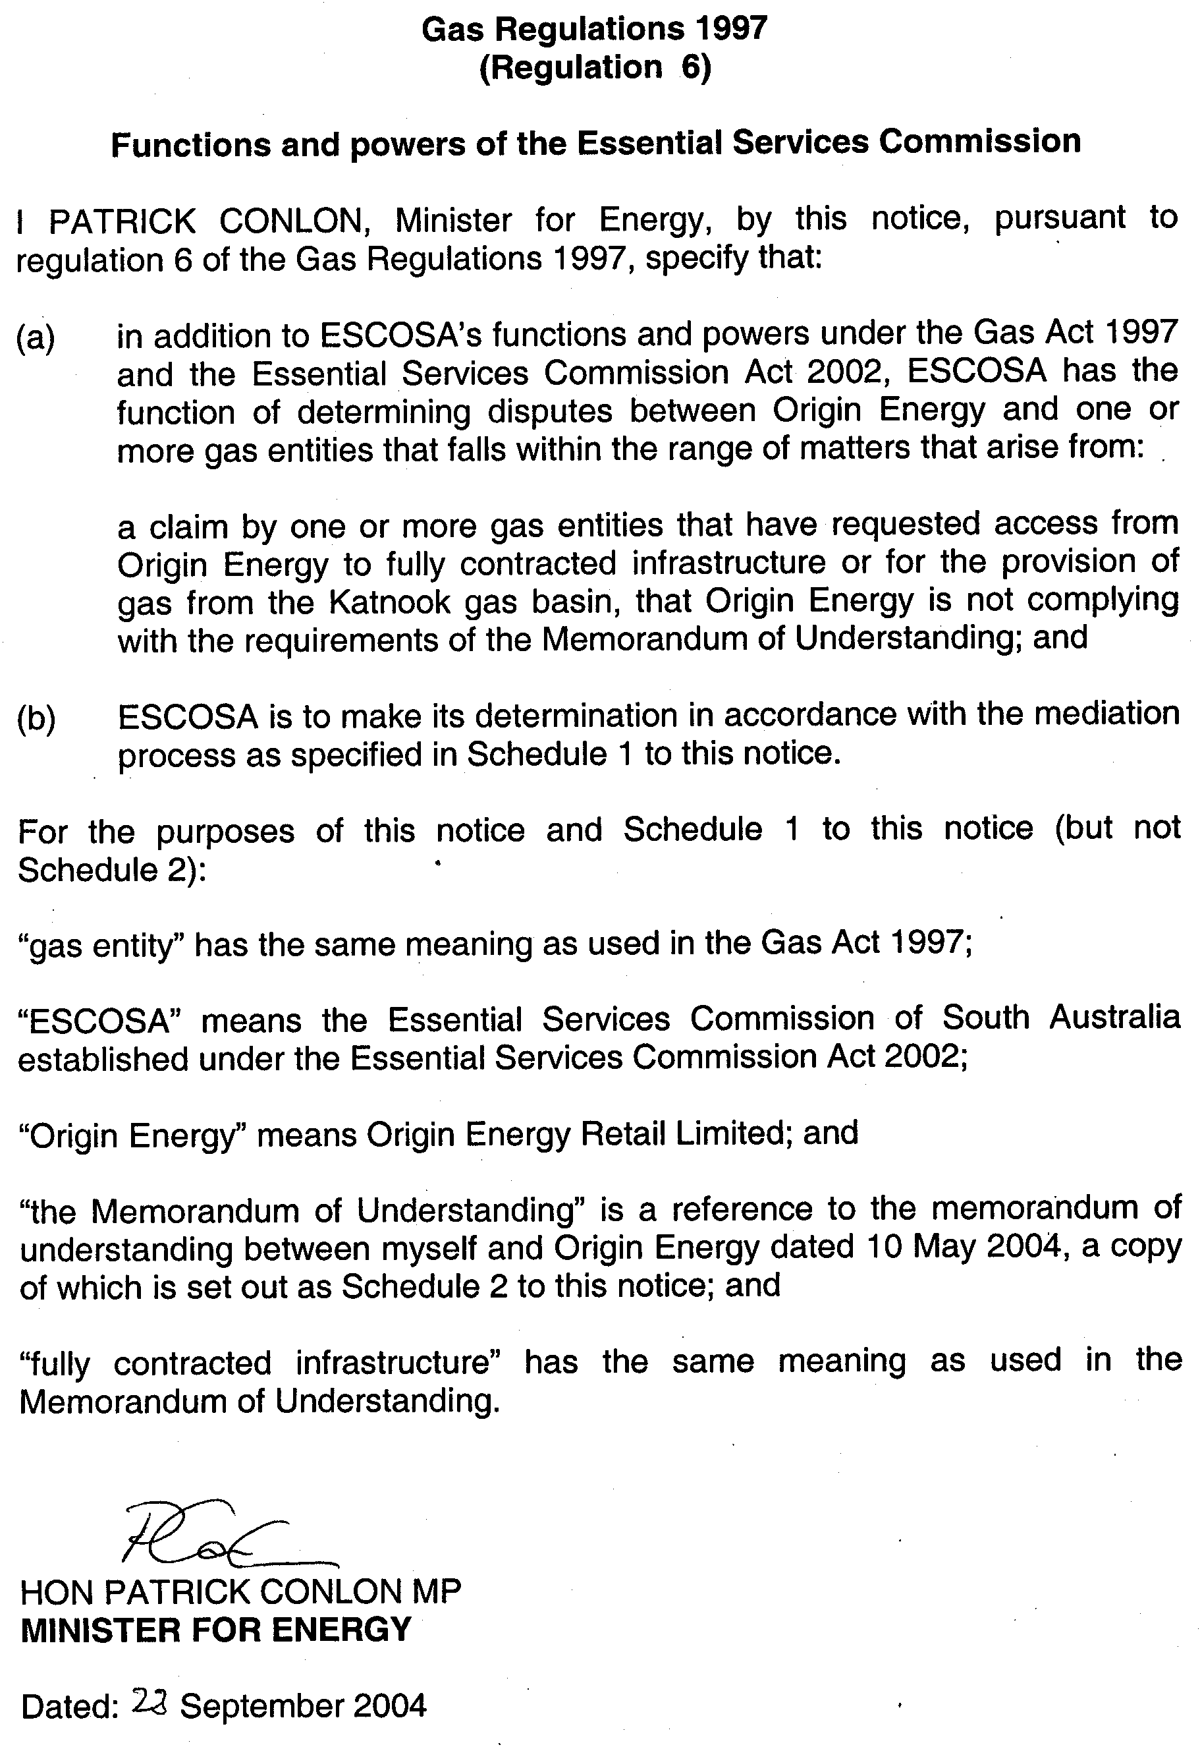
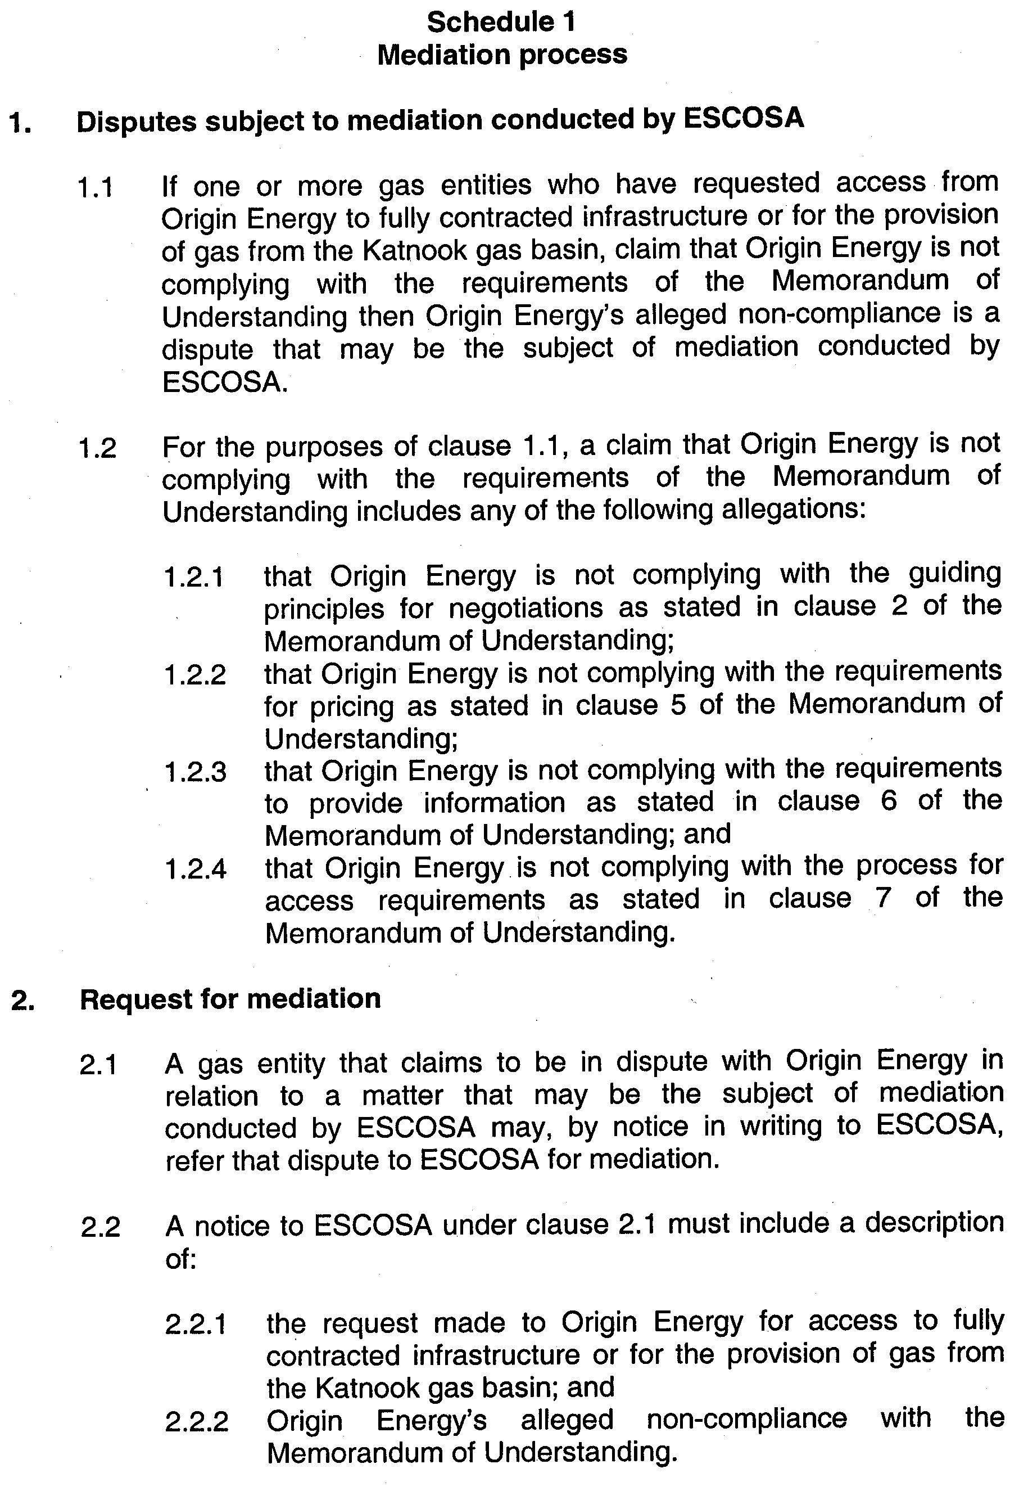
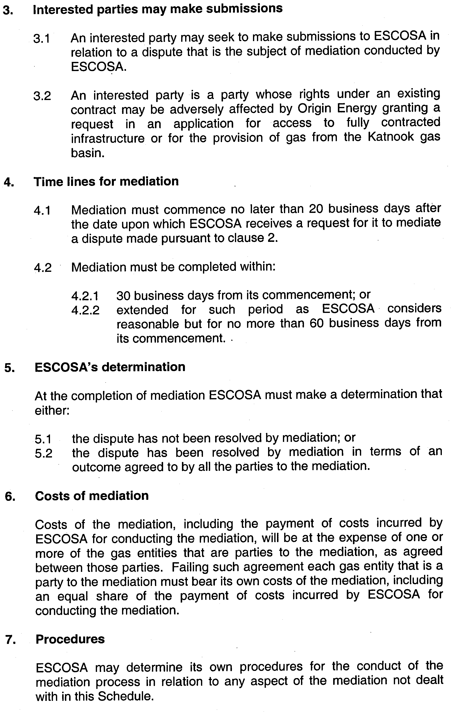
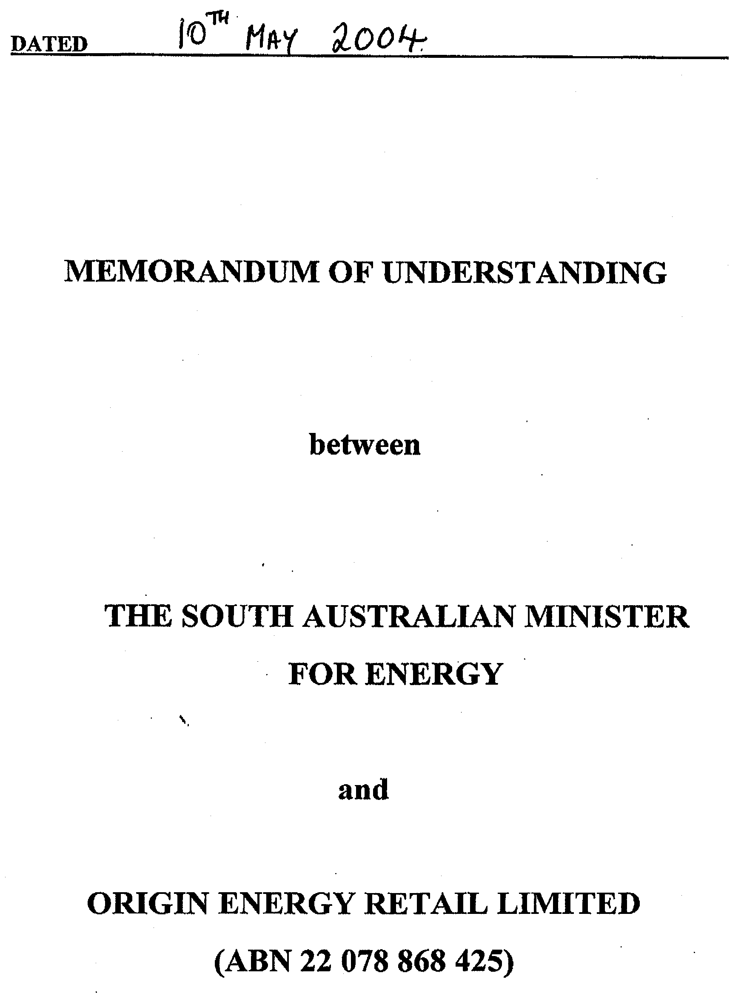
Schedule 2
The Memorandum of Understanding
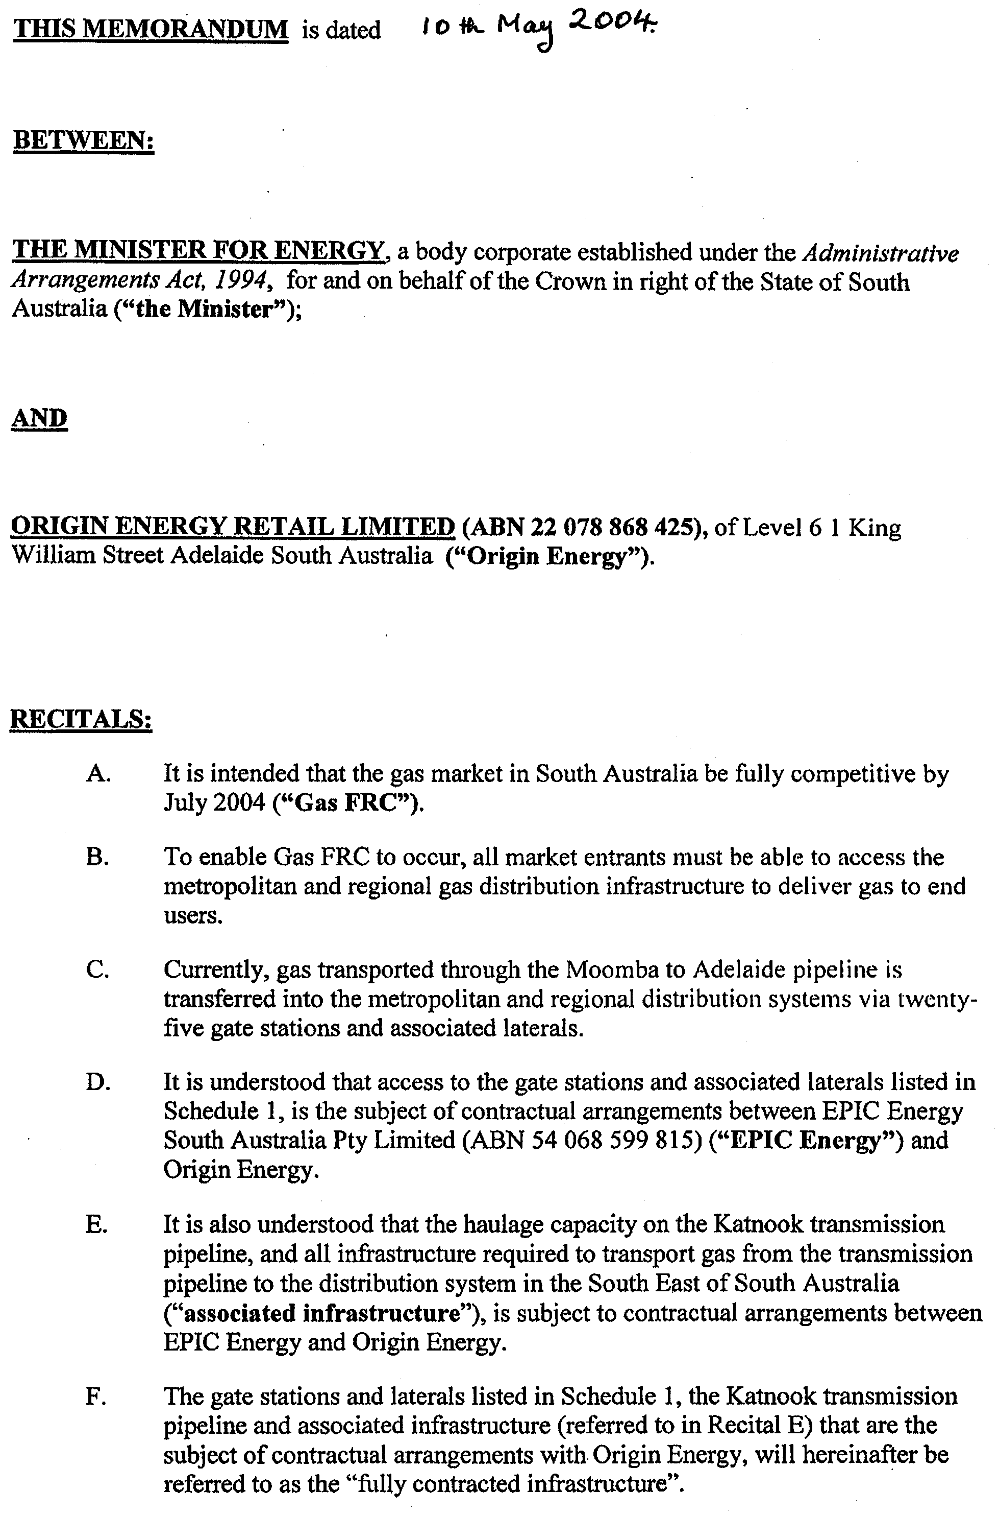
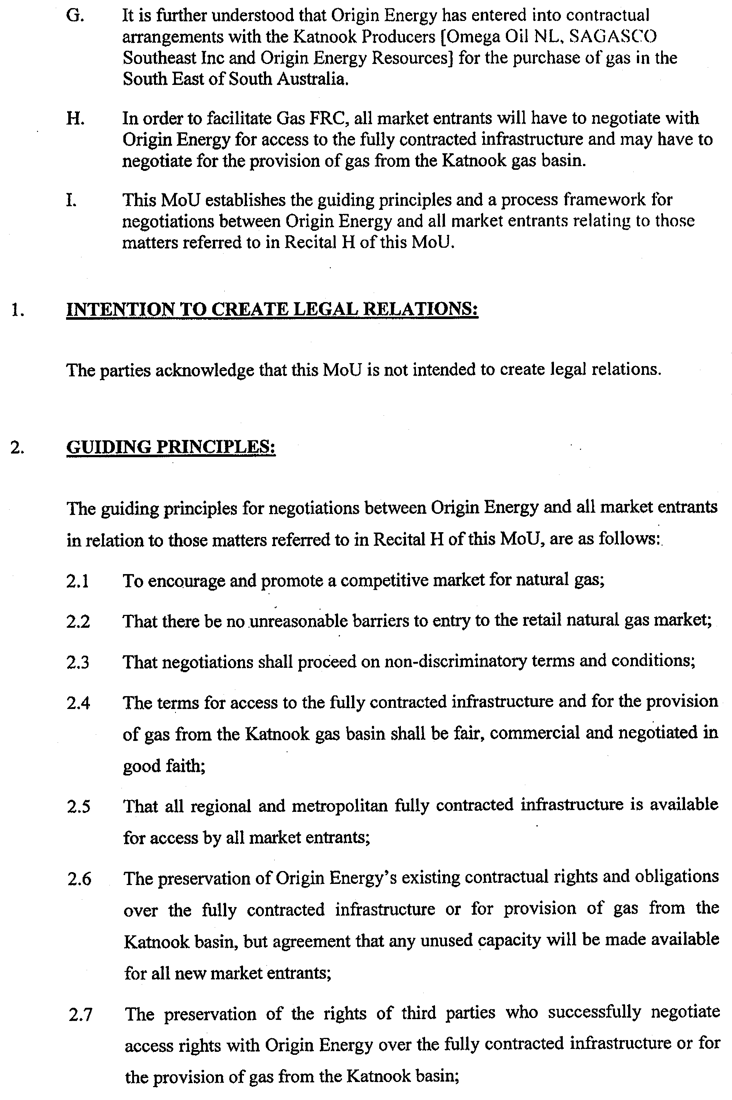
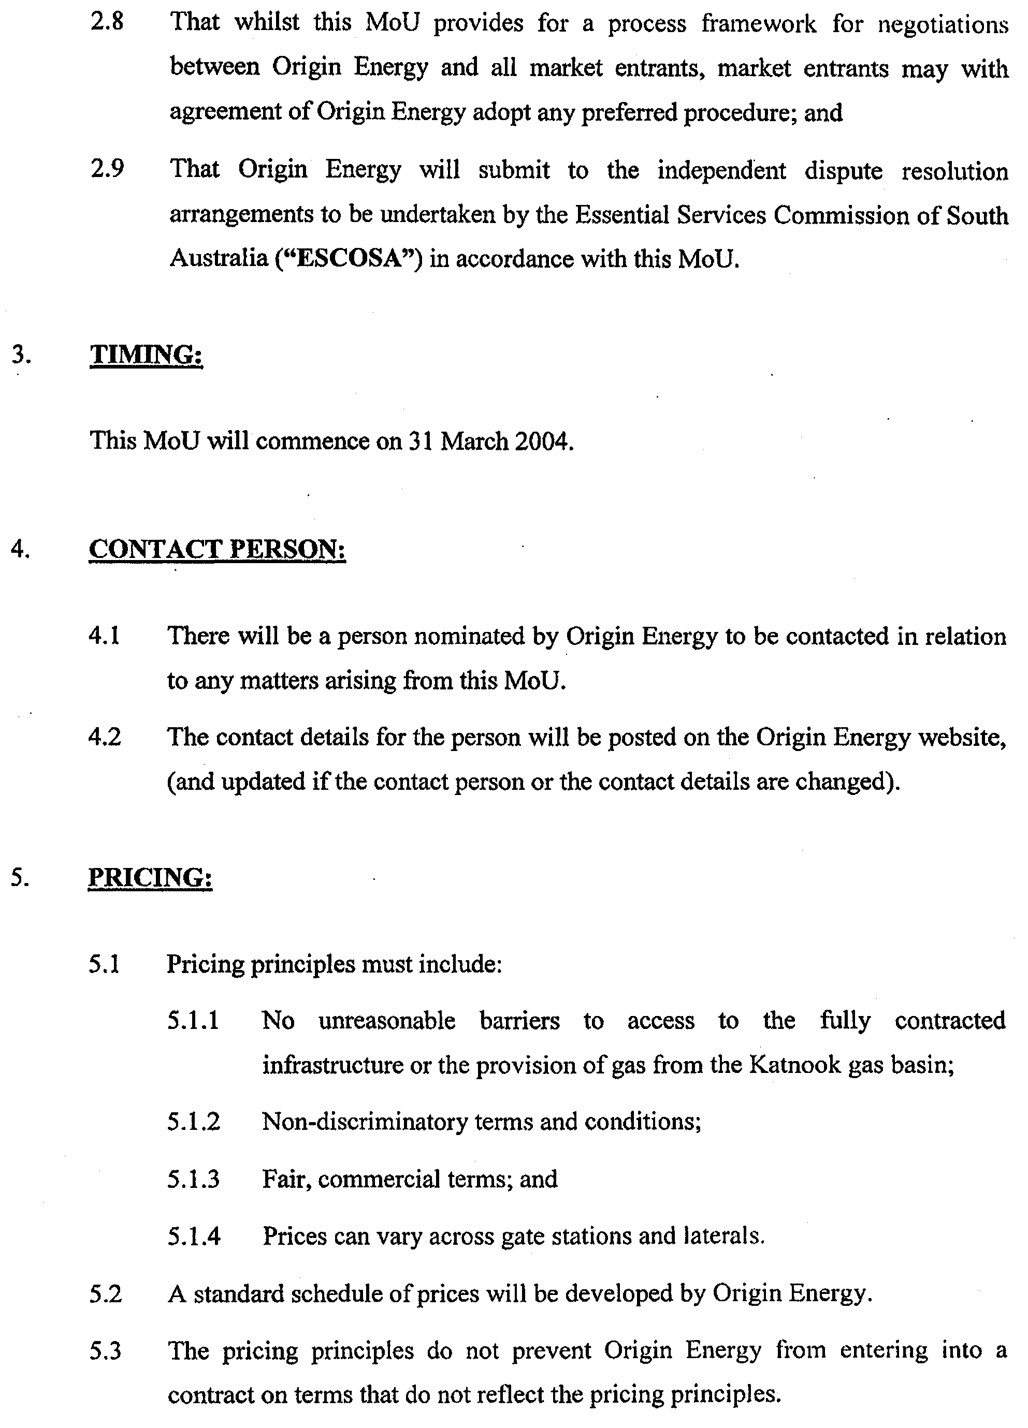
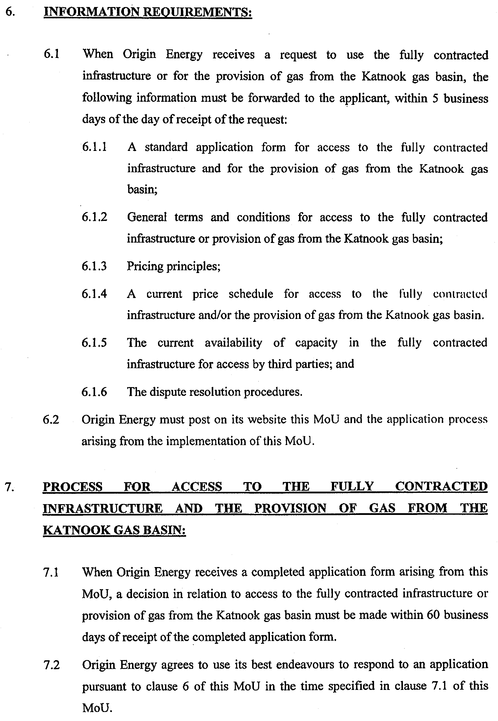
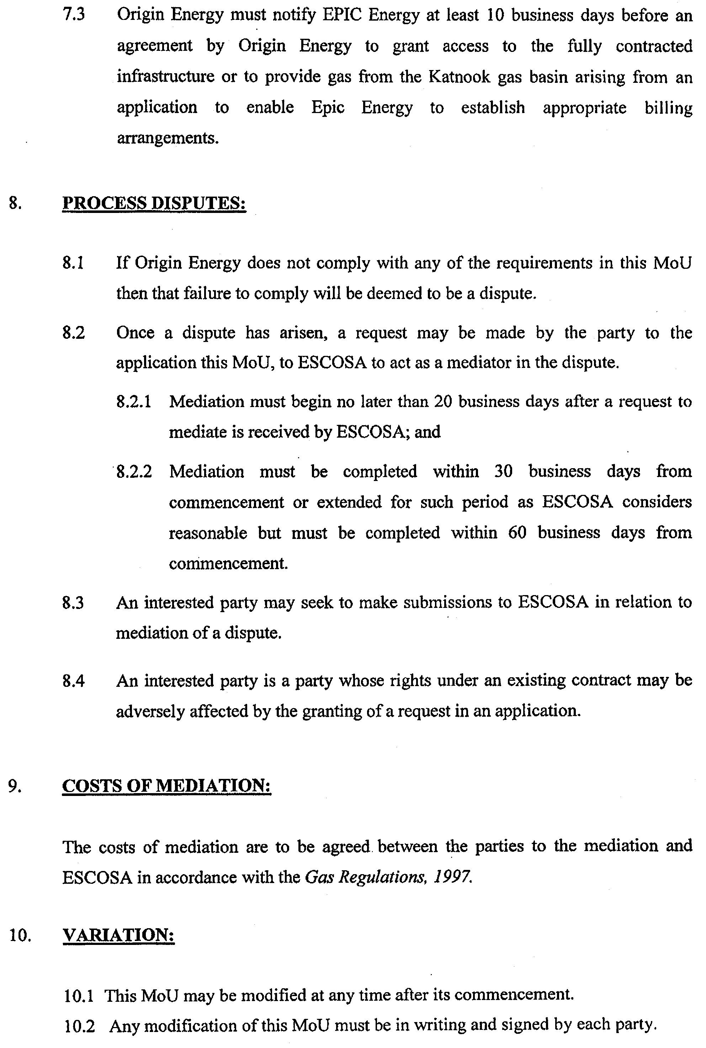
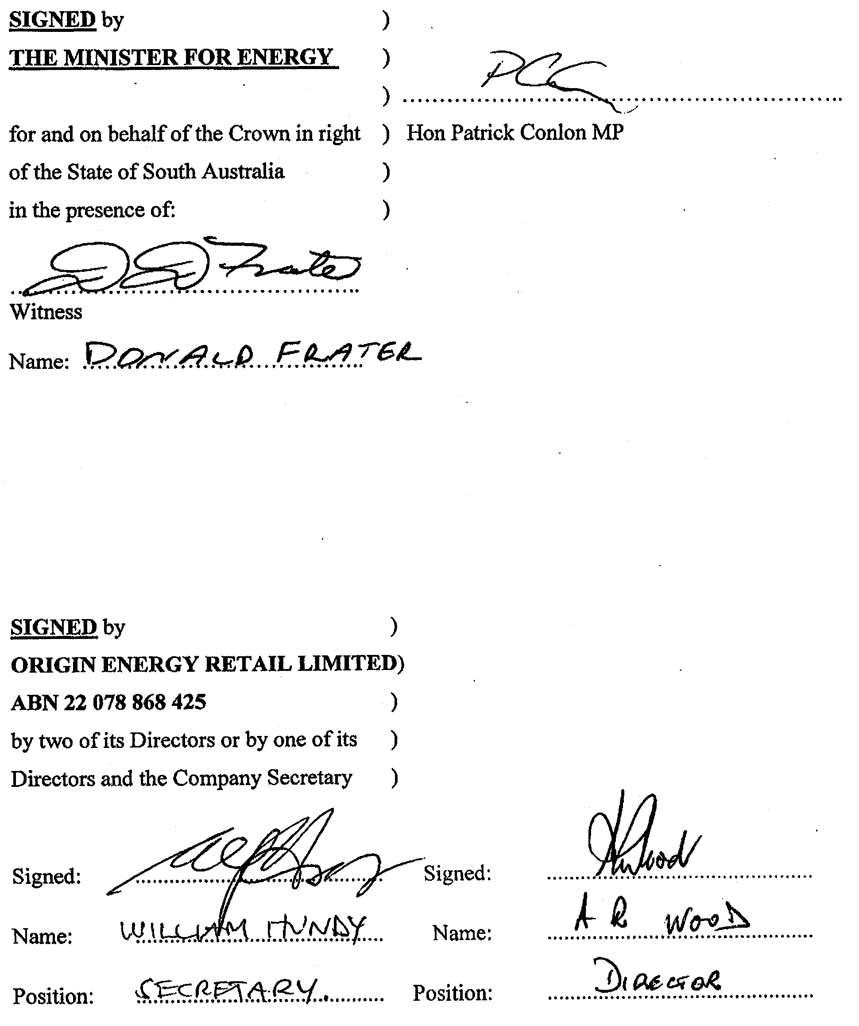

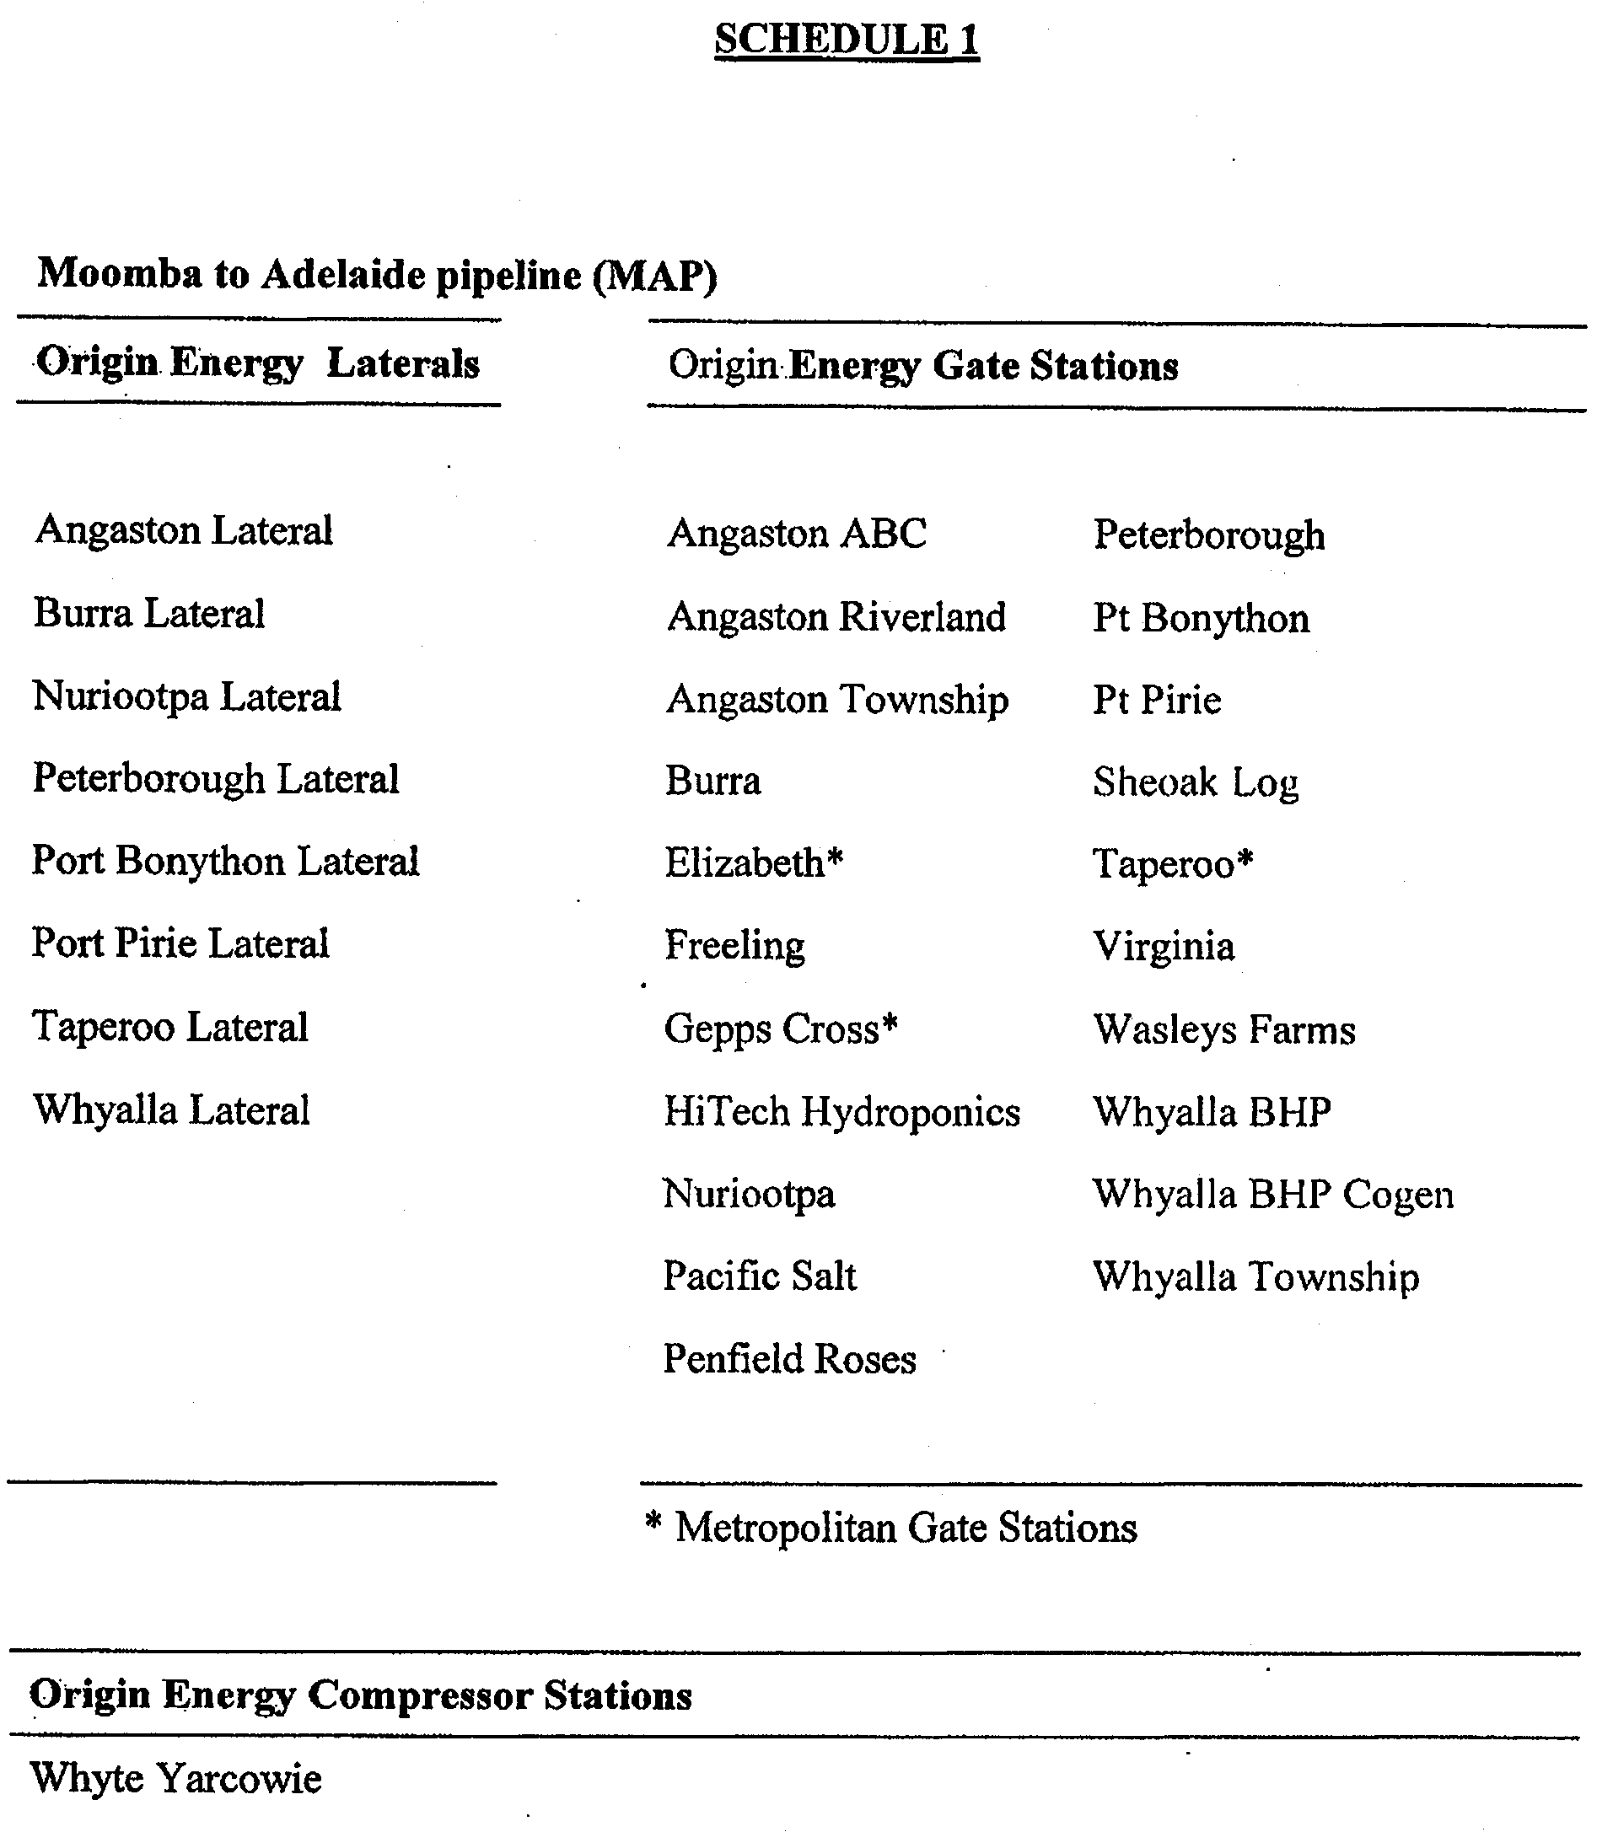

HOUSING IMPROVEMENT ACT 1940
WHEREAS by notice published in the Government Gazette on the dates mentioned in the following table the South Australian Housing Trust did declare the houses described in the said table to be substandard for the purposes of Part 7 of the Housing Improvement Act 1940, and whereas the South Australian Housing Trust is satisfied that each of the houses described hereunder has ceased to be substandard, notice is hereby given that, in exercise of the powers conferred by the said Part, the South Australian Housing Trust does hereby revoke the said declaration in respect of each house.
Address of House | Allotment, Section, etc. | Certificate of Title  Volume Folio | Date and page of Government Gazette in which notice declaring house to be substandard published

17 Johnston Road, Elizabeth Downs |  | Allotment 238 in deposited plan 7072, Hundred of Munno Para | 5552 | 833 |  | 29.8.02, page 3220
41 Wilkins Road, Elizabeth Downs |  | Allotment 34 in deposited plan 53666, Hundred of Munno Para | 5737 | 389 |  | 29.7.04, page 2669
369 Grange Road, Findon |  | Allotment 100 of portion of section 428, Hundred of Yatala | 5835 | 970 |  | 22.10.70, page 1849
40 Milner Road, Hilton |  | Allotment 3 in filed plan 161093, Hundred of Adelaide | 5297 | 737 |  | 29.7.04, page 2669
Block 284 of Block E, Culgoa Street, Renmark |  | Irrigation District sections 130, 131, 133, 179 and 284, Hundred of Renmark | 5630  5637 | 465  614 |  | 25.6.81, page 2007
Lot 4, Orroroo Street, Renmark |  | Allotment 4 in filed plan 121743, Renmark Irrigation District | 5216 | 387 |  | 30.7.92, page 760
Lot 3, Block C, Tarcoola Street, Renmark |  | Allotment 3 in filed plan 137713, Hundred of Renmark | 5251 | 52 |  | 26.1.84, page 208
2 New Street, South Plympton |  | Allotment 37 in deposited plan 2198, Hundred of Adelaide | 5224 | 291 |  | 26.11.92, page 1636

Dated at Adelaide, 30 September 2004. M. Downie, General Manager, Housing Trust

HOUSING IMPROVEMENT ACT 1940
NOTICE is hereby given that the South Australian Housing Trust in the exercise of the powers conferred by the Housing Improvement Act 1940, does hereby declare the houses described in the table hereunder to be substandard for the purposes of Part 7 of the Housing Improvement Act 1940.
No. of House and Street | Locality | Allotment, Section, etc. | Certificate of Title  Volume Folio

23 Kneebone Street |  | Goodwood | Allotment 556 in filed plan 10805, Hundred of Adelaide | 5219 | 264
40 Kitchener Street |  | Kilburn | Allotment 73 in deposited plan 2344, Hundred of Yatala | 5238 | 525
40 York Terrace |  | Salisbury | Allotment 36 in deposited plan 3993, Hundred of Yatala | 5715 | 383
62 Russell Terrace |  | Woodville Park | Allotment 6 in deposited plan 1600, Hundred of Yatala | 5185 | 701

Dated at Adelaide, 30 September 2004. M. Downie, General Manager, Housing Trust

HOUSING IMPROVEMENT ACT 1940
WHEREAS by notice published in the Government Gazette on the dates mentioned in the following table the South Australian Housing Trust did declare the houses described in the said table to be substandard for the purposes of Part 7 of the Housing Improvement Act 1940, the South Australian Housing Trust in the exercise of the powers conferred by the said Part, does hereby fix as the maximum rental per week which shall be payable subject to section 55 of the Residential Tenancies Act 1995, in respect of each house described in the following table the amount shown in the said table opposite the description of such house and this notice shall come into force on the date of this publication in the Gazette.
Address of House | Allotment, Section, etc. | Certificate of Title  Volume Folio | Date and page of Government Gazette in which notice declaring house to be substandard published | Maximum rental per week payable in respect of each house  $

9 Queens Avenue, Burnside |  | Allotment 1 of portion of section 903, Hundred of Adelaide | 5482 | 796 |  | 27.2.97, page 1054 | 142.00
43 Binney Road, Crystal Brook |  | Allotment 62 of portion of section 568, Hundred of Crystal Brook | 5242 | 876 |  | 29.10.92, page 1438 | 135.00
59 Railway Terrace, Cummins |  | Allotment 2 in Filed Plan 12769, Hundred of Cummins | 5246 | 483 |  | 27.5.04, page 1372 | 90.00
7 Bolton Avenue, Devon Park |  | Allotment 76 in Deposited Plan 2630, Hundred of Yatala | 5442 | 59 |  | 29.4.93, page 1555 | 150.00
42 Exmouth Road, Glanville (also known as Exeter) |  | Allotment 71 in Filed Plan 3144, Hundred of Port Adelaide | 5655 | 118 |  | 30.5.68, page 1698 | 235.00
Unit 12/42 Eighth Street, Gawler South |  | Allotment 742 in Deposited Plan 61770, Hundred of Mudla Wirra | 5895 | 484 |  | 27.5.04, page 1372 | 90.00
26 Twelfth Street, Gawler |  | Allotment 145 in Filed Plan 210121, Hundred of Mudla Wirra | 5797 | 962 |  | 8.5.69, page 1375 | 110.00
19 Boundary Road, Glenelg South |  | Allotment 256 in Filed Plan 12522 | 5354 | 390 |  | 25.2.93, page 745 | 185.00
46 Strathalbyn Road, Mylor (residence attached to shop at) |  | Allotment 46 in Town of Mylor, Hundred of Noarlunga | 5139 | 76 |  | 26.7.01, page 2774 | 150.00
144A Gover Street, North Adelaide (Unit 1/144 Gover Street) |  | Unit 1 of Strata Plan 11559, Hundred of Yatala | 5053 | 151 |  | 24.10.02, page 3892 | 500.00
65 Robsart Street, Parkside |  | Allotment 189 in Filed Plan 14671, Hundred of Adelaide | 5860 | 824 |  | 3.7.75, page 6 | 210.00
32 Federation Road, Port Pirie West |  | Allotment 17 of section 537, Hundred of Pirie | 5497 | 843 |  | 25.1.96, page 828 | 110.00
31 Palmer Street, Port Pirie West |  | Allotment 134 in Filed Plan 184216, Hundred of Pirie | 5633 | 814 |  | 28.11.02, page 4338 | 150.00
54 Pybus Street, Port Augusta |  | Allotment 8 in Deposited Plan 1167, Hundred of Davenport | 5680 | 39 |  | 12.5.83, page 1136 | 70.00 (unf)  75.00 (furn)
Unit 1/5 Devon Drive, Salisbury |  | Allotment 80 in Filed Plan 113675, Hundred of Munno Para | 5572 | 413 |  | 29.7.04, page 2669 | 105.00
6 George Street, Strathalbyn |  | Allotment 16 in Deposited Plan 156, Hundred of Bremer | 5296 | 481 |  | 26.7.01, page 2774 | 200.00
Unit 1/26 Quorn Road, Stirling North (also known as Unit 24/26) |  | Allotments 103 and 104 in Deposited Plan 24717, Hundred of Davenport | 5431  5431 | 137  138 |  | 30.8.01, page 3431 | 105.00
20 Main North Road, Willaston |  | Allotment 2 in Filed Plan 9838, Hundred of Mudla Wirra | 5235 | 475 |  | 27.5.04, page 1372 | 150.00

Dated at Adelaide, 30 September 2004. M. Downie, General Manager, Housing Trust

LAND AND BUSINESS (SALE AND CONVEYANCING)
ACT 1994
Exemption
TAKE notice that, pursuant to section 23 (3) of the Land and Business (Sale and Conveyancing) Act 1994, I, Karlene Maywald, Minister for Consumer Affairs, do hereby exempt the person named in Schedule 1 from the application of section 23 (2) of the Act in relation to the purchase of the land specified in Schedule 2.
Schedule 1
Melissa Joy Turner, an employee of Reg Kemp Real Estate Pty Ltd.
Schedule 2
The whole of the land described in certificate of title register book volume 5903, folio 82, situated at 7 Southwater Drive, Port Lincoln, S.A. 5606.
Dated 30 September 2004.
Signed for and on behalf of the Minister for Consumer Affairs by the Commissioner for Consumer Affairs:
M. Bodycoat, Commissioner

LAND AND BUSINESS (SALE AND CONVEYANCING)
ACT 1994
Exemption
TAKE notice that, pursuant to section 23 (3) of the Land and Business (Sale and Conveyancing) Act 1994, I, Karlene Maywald, Minister for Consumer Affairs, do hereby exempt the person named in Schedule 1 from the application of section 23 (2) of the Act in relation to the purchase of the land specified in Schedule 2.
Schedule 1
Nora Catherine Guglielmi, an officer of Athelstone Real Estate Pty Ltd.
Schedule 2
The whole of the land described in certificate of title register book volume 5307, folio 168, situated at 120 George Street, Paradise, S.A. 5075.
Dated 30 September 2004.
Signed for and on behalf of the Minister for Consumer Affairs by the Commissioner for Consumer Affairs:
M. Bodycoat, Commissioner

LIQUOR LICENSING ACT 1997
Notice of Application
NOTICE is hereby given, pursuant to section 52 (2) (b) of the Liquor Licensing Act 1997, that Slatters Traders Pty Ltd has applied to the Licensing Authority for the transfer of a Restaurant Licence in respect of premises situated at 22 Murray Street, Angaston, S.A. 5353 and known as Rendezvous House.
The application has been set down for hearing on 8 October 2004 at 10.30 a.m.
Any person may object to the application by lodging a notice of objection in the prescribed form with the Licensing Authority, and serving a copy of the notice on the applicant at the applicant’s address given above on or before 7 October 2004.
The applicant’s address for service is c/o 22 Murray Street, Angaston, S.A. 5353.
Plans in respect of the premises the subject of the application are open to public inspection without fee at the Office of the Liquor and Gambling Commissioner, 9th Floor, East Wing, 50 Grenfell Street, Adelaide, S.A. 5000. Phone 8226 8410, Fax:
8226 8512. Email: olgc@agd.sa.gov.au.
Dated 23 September 2004.
Applicant

LIQUOR LICENSING ACT 1997
Notice of Application
NOTICE is hereby given, pursuant to section 52 (2) (b) of the Liquor Licensing Act 1997, that Kidman Coonawarra Wines Pty Ltd has applied to the Licensing Authority for a Producer’s Licence in respect of premises situated at Comaum School Road, Coonawarra, S.A. 5263, and to be known as Kidman Coonawarra Wines Pty Ltd.
The application has been set down for hearing on 29 October 2004 at 9 a.m.
Any person may object to the application by lodging a notice of objection in the prescribed form with the Licensing Authority, and serving a copy of the notice on the applicant at the applicant’s address given above, at least seven days before the hearing date (viz: 21 October 2004).
The applicant’s address for service is c/o Thomson Playford (Attention: Scott Lumsden), 101 Pirie Street, Adelaide, S.A. 5000.
Plans in respect of the premises the subject of the application are open to public inspection without fee at the Office of the Liquor and Gambling Commissioner, 9th Floor, East Wing, 50 Grenfell Street, Adelaide, S.A. 5000. Phone 8226 8410, Fax:
8226 8512. Email: olgc@agd.sa.gov.au.
Dated 22 September 2004.
Applicant

LIQUOR LICENSING ACT 1997
Notice of Application
NOTICE is hereby given, pursuant to section 52 (2) (b) of the Liquor Licensing Act 1997, that Wuneta Pty Ltd has applied to the Licensing Authority for a Wholesale Liquor Merchant’s Licence in respect of premises situated at Stonyfell Road, Stonyfell, S.A. 5066 and known as Wuneta Estate.
The application has been set down for hearing on 29 October 2004 at 9 a.m.
Any person may object to the application by lodging a notice of objection in the prescribed form with the Licensing Authority, and serving a copy of the notice on the applicant at the applicant’s address given above, at least seven days before the hearing date (viz: 21 October 2004).
The applicant’s address for service is c/o 44 Bradey Road, Windsor Gardens, S.A. 5087.
Plans in respect of the premises the subject of the application are open to public inspection without fee at the Office of the Liquor and Gambling Commissioner, 9th Floor, East Wing, 50 Grenfell Street, Adelaide, S.A. 5000. Phone 8226 8410, Fax:
8226 8512. Email: olgc@agd.sa.gov.au.
Dated 24 September 2004.
Applicant

LIQUOR LICENSING ACT 1997
Notice of Application
NOTICE is hereby given, pursuant to section 52 (2) (b) of the Liquor Licensing Act 1997, that Waterhouse Range Vineyard Pty Ltd has applied to the Licensing Authority for the removal of a Producer’s Licence in respect of premises situated at Old Robe Road, Robe, S.A. 5276, to be situated at 18 Victoria Street, Robe, S.A. 5276 and known as Waterhouse Range Vineyards.
The application has been set down for hearing on 29 October 2004 at 9 a.m.
Any person may object to the application by lodging a notice of objection in the prescribed form with the Licensing Authority, and serving a copy of the notice on the applicant at the applicant’s address given above, at least seven days before the hearing date (viz: 21 October 2004).
The applicant’s address for service is c/o P.O. Box 237, Robe, S.A. 5276.
Plans in respect of the premises the subject of the application are open to public inspection without fee at the Office of the Liquor and Gambling Commissioner, 9th Floor, East Wing, 50 Grenfell Street, Adelaide, S.A. 5000. Phone 8226 8410, Fax:
8226 8512. Email: olgc@agd.sa.gov.au.
Dated 24 September 2004.
Applicant

LIQUOR LICENSING ACT 1997
Notice of Application
NOTICE is hereby given, pursuant to section 52 (2) (b) of the Liquor Licensing Act 1997, that Surin Yongvanit has applied to the Licensing Authority for the transfer of a Restaurant Licence in respect of premises situated at 1/4 Rupert Avenue, Bedford Park, S.A. 5042 and known as Thai Flowers Restaurant.
The application has been set down for hearing on 1 November 2004 at 9.30 a.m.
Any person may object to the application by lodging a notice of objection in the prescribed form with the Licensing Authority, and serving a copy of the notice on the applicant at the applicant’s address given above, at least seven days before the hearing date (viz: 22 October 2004).
The applicant’s address for service is c/o 1/4 Rupert Avenue, Bedford Park, S.A. 5042.
Plans in respect of the premises the subject of the application are open to public inspection without fee at the Office of the Liquor and Gambling Commissioner, 9th Floor, East Wing, 50 Grenfell Street, Adelaide, S.A. 5000. Phone 8226 8410, Fax:
8226 8512. Email: olgc@agd.sa.gov.au.
Dated 23 September 2004.
Applicant

LIQUOR LICENSING ACT 1997
Notice of Application
NOTICE is hereby given, pursuant to section 52 (2) (b) of the Liquor Licensing Act 1997, that Pavish Pty Ltd, as trustee for Pavish Unit Trust has applied to the Licensing Authority for the transfer of a Restaurant Licence in respect of premises situated at 291-293 Rundle Street, Adelaide, S.A. 5000, and known as Irodori and to be known as Sosta.
The application has been set down for hearing on 2 November 2004 at 9.30 a.m.
Any person may object to the application by lodging a notice of objection in the prescribed form with the Licensing Authority, and serving a copy of the notice on the applicant at the applicant’s address given above, at least seven days before the hearing date (viz: 25 October 2004).
The applicant’s address for service is c/o Jeff Stevens & Associates, Level 1, 86 Pirie Street, Adelaide, S.A. 5000.
Plans in respect of the premises the subject of the application are open to public inspection without fee at the Office of the Liquor and Gambling Commissioner, 9th Floor, East Wing, 50 Grenfell Street, Adelaide, S.A. 5000. Phone 8226 8410, Fax:
8226 8512. Email: olgc@agd.sa.gov.au.
Dated 22 September 2004.
Applicant

LIQUOR LICENSING ACT 1997
Notice of Application
NOTICE is hereby given, pursuant to section 52 (2) (b) of the Liquor Licensing Act 1997, that Stephen Mark and Caroline Bridgette Gill, as trustee for the Patly Hill Trust have applied to the Licensing Authority for the transfer of a Residential Licence in respect of premises situated at Patly Hill Farm, St Georges Terrace, Armagh, Clare, S.A. 5453 and known as Patly Hill Farm.
The application has been set down for hearing on 3 November 2004 at 9 a.m.
Any person may object to the application by lodging a notice of objection in the prescribed form with the Licensing Authority, and serving a copy of the notice on the applicants at the applicants’ address given above, at least seven days before the hearing date (viz: 26 October 2004).
The applicants’ address for service is c/o Patly Hill Farm, P.O. Box 773, Clare, S.A. 5453.
Plans in respect of the premises the subject of the application are open to public inspection without fee at the Office of the Liquor and Gambling Commissioner, 9th Floor, East Wing, 50 Grenfell Street, Adelaide, S.A. 5000. Phone 8226 8410, Fax:
8226 8512. Email: olgc@agd.sa.gov.au.
Dated 22 September 2004.
Applicants

LIQUOR LICENSING ACT 1997
Notice of Application
NOTICE is hereby given, pursuant to section 52 (2) (b) of the Liquor Licensing Act 1997, that Lap Chung Chow, Lap Nghia Chau and Juad Leng Karlsen have applied to the Licensing Authority for the transfer of a Restaurant Licence in respect of premises situated at 297 Montacute Road, Newton, S.A. 5074 and known as Chinese Garden Restaurant.
The application has been set down for hearing on 4 November 2004 at 9 a.m.
Any person may object to the application by lodging a notice of objection in the prescribed form with the Licensing Authority, and serving a copy of the notice on the applicants at the applicants’ address given above, at least seven days before the hearing date (viz: 27 October 2004).
The applicants’ address for service is c/o Scammell & Co. Solicitors, 86 Franklin Street, Adelaide, S.A. 5000.
Plans in respect of the premises the subject of the application are open to public inspection without fee at the Office of the Liquor and Gambling Commissioner, 9th Floor, East Wing, 50 Grenfell Street, Adelaide, S.A. 5000. Phone 8226 8410, Fax:
8226 8512. Email: olgc@agd.sa.gov.au.
Dated 22 September 2004.
Applicants

LIQUOR LICENSING ACT 1997
Notice of Application
NOTICE is hereby given, pursuant to section 52 (2) (b) of the Liquor Licensing Act 1997, that Goodearth Hotels (Empire) Pty Ltd has applied to the Licensing Authority for the transfer of a Hotel and Gaming Machine Licence in respect of premises situated at 414 Prospect Road, Kilburn, S.A. 5084 and known as Empire Hotel.
The application has been set down for hearing on 4 November 2004 at 10.30 a.m.
Any person may object to the application by lodging a notice of objection in the prescribed form with the Licensing Authority, and serving a copy of the notice on the applicant at the applicant’s address given above, at least seven days before the hearing date (viz: 27 October 2004).
The applicant’s address for service is c/o Amanda Warley, Camatta Lempens Pty Ltd, Solicitors, Level 1, 345 King William Street, Adelaide, S.A. 5000.
Plans in respect of the premises the subject of the application are open to public inspection without fee at the Office of the Liquor and Gambling Commissioner, 9th Floor, East Wing, 50 Grenfell Street, Adelaide, S.A. 5000. Phone 8226 8410, Fax:
8226 8512. Email: olgc@agd.sa.gov.au.
Dated 24 September 2004.
Applicant

LIQUOR LICENSING ACT 1997
Notice of Application
NOTICE is hereby given, pursuant to section 52 (2) (b) of the Liquor Licensing Act 1997, that Julie and David Allchurch and Dyane Frame have applied to the Licensing Authority for a Restaurant Licence, Extended Trading Authorisation and Entertainment Consent in respect of premises situated at 5 Memorial Drive, Elliston, S.A. 5670 and to be known as Salty Dog Cafe.
The application has been set down for hearing on 29 October 2004 at 9 a.m.
Conditions
The following licence conditions are sought:
• Extended Trading Authorisation:
Thursday to Saturday: Midnight to 1 a.m. the following day.
• Approval under section 34 (1) (c) to sell liquor for con-sumption on the licensed premises by persons:
(a) seated at a table; or
(b) attending a function at which food is provided.
• Entertainment Consent:
Thursday and Friday: 5 p.m. to midnight;
Saturday: Noon to midnight;
Sunday: Noon to 8 p.m.;
New Year’s Eve: 6 p.m. to 2 a.m. the following day.
• Extended Trading Authorisaton and Entertainment Consent is to apply to the whole of the licensed premises including the outdoor area as shown on the plan lodged with this office.
Any person may object to the application by lodging a notice of objection in the prescribed form with the Licensing Authority, and serving a copy of the notice on the applicants at the applicants’ address given above, at least seven days before the hearing date (viz: 21 October 2004).
The applicants’ address for service is c/o Julie Allchurch, P.O. Box 1138, Elliston, S.A. 5670.
Plans in respect of the premises the subject of the application are open to public inspection without fee at the Office of the Liquor and Gambling Commissioner, 9th Floor, East Wing, 50 Grenfell Street, Adelaide, S.A. 5000. Phone 8226 8410, Fax:
8226 8512. Email: olgc@agd.sa.gov.au.
Dated 22 September 2004.
Applicants

LIQUOR LICENSING ACT 1997
Notice of Application
NOTICE is hereby given, pursuant to section 52 (2) (b) of the Liquor Licensing Act 1997, that Leslie Lu has applied to the Licensing Authority for the transfer of a Restaurant Licence, Extended Trading Authorisation and redefinition of Licensed Area in respect of premises situated at 189-191 Glen Osmond Road, Frewville, S.A. 5063, known as Great Wall Restaurant and to be known as The Glen Wok.
The application has been set down for hearing on 29 October 2004 at 9 a.m.
Conditions
The following licence conditions are sought:
• Approval under section 34 (1) (c) to sell liquor for consumption on the licensed premises by persons:
(a) seated at a table; or
(b) attending a function at which food is provided.
• Redefinition of the licensed premises to include the outdoor area as per plans lodged with this office.
• Extended Trading Authorisation for the whole of the licensed premises including the outdoor area.
Consumption on the Premises
Monday to Thursday: Midnight to 1 a.m. the following day;
Friday and Saturday: Midnight to 2 a.m. the following day;
Sunday: 10 a.m. to 11 a.m. and 8 p.m. to 1 a.m. the following day;
Days preceding other Public Holidays: Midnight to 2 a.m. the following day;
Sundays preceding Public Holidays: 8 p.m. to 2 a.m. the following day.
Any person may object to the application by lodging a notice of objection in the prescribed form with the Licensing Authority, and serving a copy of the notice on the applicant at the applicant’s address given above, at least seven days before the hearing date (viz: 21 October 2004).
The applicant’s address for service is c/o 189-191 Glen Osmond Road, Frewville, S.A. 5063.
Plans in respect of the premises the subject of the application are open to public inspection without fee at the Office of the Liquor and Gambling Commissioner, 9th Floor, East Wing, 50 Grenfell Street, Adelaide, S.A. 5000. Phone 8226 8410, Fax:
8226 8512. Email: olgc@agd.sa.gov.au.
Dated 24 September 2004.
Applicant

LIQUOR LICENSING ACT 1997
Notice of Application
NOTICE is hereby given, pursuant to section 52 (2) (b) of the Liquor Licensing Act 1997, that Peter Donald Keith and Jodie Anne Magor have applied to the Licensing Authority for a Special Circumstances Licence and Extended Trading Authorisation in respect of premises situated at Lot 100 Greenhills-Flaxley Road, Macclesfield, S.A. 5153 and to be known as Magor’s Bus Service.
The application has been set down for hearing on 29 October 2004 at 9 a.m.
Conditions
The following licence conditions are sought:
To sell liquor in accordance with section 40 of the Liquor Licensing Act 1997 and any other conditions of this licence.
For consumption on or adjacent to the licensed vehicles (provided that the passengers are always under the supervision and control of the driver of the subject vehicles) on any day at anytime (except Good Friday).
Extended Trading Authorisation:
Monday to Saturday: Midnight to 4 a.m. the following day;
Sunday: 8.30 a.m. to 11 a.m. and 8 p.m. to 4 a.m. the following day;
Christmas Eve: Midnight to 3 a.m.;
Sunday, Christmas Eve: 8 p.m. to 2 a.m. the following day;
New Year’s Eve: 2 a.m. to 6 a.m.;
Days preceding Public Holidays: Midnight to 4 a.m. the following day;
Sundays preceding Public Holidays: 8 p.m. to 4 a.m. the following day.
Any person may object to the application by lodging a notice of objection in the prescribed form with the Licensing Authority, and serving a copy of the notice on the applicants at the applicants’ address given above, at least seven days before the hearing date (viz: 21 October 2004).
The applicants’ address for service is c/o Magor’s Bus Service, Box 508, Macclesfield, S.A. 5153.
Plans in respect of the premises the subject of the application are open to public inspection without fee at the Office of the Liquor and Gambling Commissioner, 9th Floor, East Wing, 50 Grenfell Street, Adelaide, S.A. 5000. Phone 8226 8410, Fax:
8226 8512. Email: olgc@agd.sa.gov.au.
Dated 23 September 2004.
Applicants

LIQUOR LICENSING ACT 1997
Notice of Application
NOTICE is hereby given, pursuant to section 52 (2) (b) of the Liquor Licensing Act 1997, that Pixton Investments Pty Ltd has applied to the Licensing Authority for an Entertainment Consent in respect of premises situated at 46 Victoria Street, Robe, S.A. 5276 and known as Wild Mulberry Cafe.
The application has been set down for hearing on 29 October 2004 at 9 a.m.
Conditions
The following licence conditions are sought:
Entertainment Consent:
Monday to Saturday: Noon to midnight;
Sunday: Noon to 8 p.m.;
Public Holidays: Noon to midnight.
Entertainment Consent is sought for the areas shown on the plan lodged with this office.
Any person may object to the application by lodging a notice of objection in the prescribed form with the Licensing Authority, and serving a copy of the notice on the applicant at the applicant’s address given above, at least seven days before the hearing date (viz: 21 October 2004).
The applicant’s address for service is c/o Sharon Pixton, 46 Victoria Street, Robe, S.A. 5276.
Plans in respect of the premises the subject of the application are open to public inspection without fee at the Office of the Liquor and Gambling Commissioner, 9th Floor, East Wing, 50 Grenfell Street, Adelaide, S.A. 5000. Phone 8226 8410, Fax:
8226 8512. Email: olgc@agd.sa.gov.au.
Dated 22 September 2004.
Applicant

LIQUOR LICENSING ACT 1997
Notice of Application
NOTICE is hereby given, pursuant to section 52 (2) (b) of the Liquor Licensing Act 1997, that Drymait Hotels Pty Ltd has applied to the Licensing Authority for a variation to Extended Trading Authorisation in respect of premises situated at 621 Magill Road, Magill, S.A. 5072 and known as Tower Hotel.
The application has been set down for hearing on 29 October 2004 at 9 a.m.
Conditions
The following licence conditions are sought:
Variation to Extended Trading Authorisation to include:
Christmas Eve: Midnight to 2 a.m. the following day;
Sunday, Christmas Eve: Midnight to 2 a.m. the following day;
Good Friday: Midnight to 2 a.m.
Any person may object to the application by lodging a notice of objection in the prescribed form with the Licensing Authority, and serving a copy of the notice on the applicant at the applicant’s address given above, at least seven days before the hearing date (viz: 21 October 2004).
The applicant’s address for service is c/o 621 Magill Road, Magill, S.A. 5072.
Plans in respect of the premises the subject of the application are open to public inspection without fee at the Office of the Liquor and Gambling Commissioner, 9th Floor, East Wing, 50 Grenfell Street, Adelaide, S.A. 5000. Phone 8226 8410, Fax:
8226 8512. Email: olgc@agd.sa.gov.au.
Dated 23 September 2004.
Applicant

MINING ACT 1971
NOTICE is hereby given in accordance with section 28 (5) of the Mining Act 1971, that the Minister for Mineral Resources Development proposes to grant an Exploration Licence over the undermentioned area:
Applicant: Pepinnini Minerals Ltd
Location: Bimbowrie area—Approximately 30 km north of Olary.
Term: 1 year
Area in km²: 843
Ref: 2004/00337
Plan and co-ordinates can be found on the PIRSA Sarig website: http://www.minerals.pir.sa.gov.au/sarig or by phoning Mineral Tenements on (08) 8463 3103.
H. Tyrteos, Mining Registrar

MINING ACT 1971
NOTICE is hereby given in accordance with section 28 (5) of the Mining Act 1971, that the Minister for Mineral Resources Development proposes to grant an Exploration Licence over the undermentioned area:
Applicant: Flinders Diamonds Ltd
Location: Twelve Mile area—Approximately 110 km south-east of Port Augusta.
Term: 1 year
Area in km²: 674
Ref: 2004/00261
Plan and co-ordinates can be found on the PIRSA Sarig website: http://www.minerals.pir.sa.gov.au/sarig or by phoning Mineral Tenements on (08) 8463 3103.
H. Tyrteos, Mining Registrar

MINING ACT 1971
NOTICE is hereby given in accordance with section 28 (5) of the Mining Act 1971, that the Minister for Mineral Resources Development proposes to grant an Exploration Licence over the undermentioned area:
Applicant: Iluka Resources Ltd
Location: Jellabinna area—Approximately 80 km north-west of Ceduna.
Term: 1 year
Area in km²: 1 581
Ref: 2003/00237
Plan and co-ordinates can be found on the PIRSA Sarig website: http://www.minerals.pir.sa.gov.au/sarig or by phoning Mineral Tenements on (08) 8463 3103.
H. Tyrteos, Mining Registrar

MINING ACT 1971
NOTICE is hereby given in accordance with section 28 (5) of the Mining Act 1971, that the Minister for Mineral Resources Development proposes to grant an Exploration Licence over the undermentioned area:
Applicant: Platsearch NL
Location: Black Hill area—Approximately 170 km north-west of Ceduna.
Term: 1 year
Area in km²: 738
Ref: 2004/00243
Plan and co-ordinates can be found on the PIRSA Sarig website: http://www.minerals.pir.sa.gov.au/sarig or by phoning Mineral Tenements on (08) 8463 3103.
H. Tyrteos, Mining Registrar

NATIONAL PARKS AND WILDLIFE (NATIONAL PARKS) REGULATIONS 2001
Opening of the Coorong National Park
PURSUANT to Regulation 8 (3) (a), 8 (3) (d) and 41 of the National Parks Regulations 2001, I, Rick Phillip Janssan, the Acting Director of National Parks and Wildlife, open to the public the following areas of the Coorong National Park (which are currently closed) from 10 a.m. on 2 October 2004 until 4 p.m. on 4 October 2004 during daylight hours.
The area contained within the following coordinates:
ID Easting Northing Zone Datum
Number
1 307058.83 6063837.01 54 GDA94
2 307130.42 6064077.80 54 GDA94
3 307527.40 6063967.17 54 GDA94
4 307885.33 6063723.12 54 GDA94
5 308383.18 6063540.90 54 GDA94
6 308292.07 6063261.06 54 GDA94
7 307937.39 6063225.27 54 GDA94
8 307625.01 6063355.43 54 GDA94
9 307511.13 6063485.59 54 GDA94
10 307110.89 6063664.55 54 GDA94
Eastings, Northings are in Universal Transverse Mercator Projection, Zone 54, Datum: Geocentric Datum of Australia 1994.
Dated 28 September 2004.
R. P. Janssan, Acting Director, National Parks and Wildlife

NATIONAL PARKS AND WILDLIFE (NATIONAL PARKS) REGULATIONS 2001
Closure of The Dutchman’s Stern Conservation Park
PURSUANT to Regulation 8 (3) (d) of the National Parks Regulations 2001, I, Edward Gregory Leaman, the Director of National Parks and Wildlife, close to the public the whole of The Dutchman’s Stern Conservation Park from sunrise on 25 October 2004 until sunset on 29 October 2004.
The purpose of the closure is to ensure the safety of the public during a pest control and monitoring program within the reserve during the period indicated.
Use of Firearms within the Reserve
Pursuant to Regulations 8 (4), 20 (1) and 41 of the National Parks Regulations 2001, I, Edward Gregory Leaman, Director of National Parks and Wildlife grant permission to members of the Sporting Shooters Association of South Australia (SA Branch) in possession of both a current Hunting Permit and a firearm to enter and remain in The Dutchman’s Stern Conservation Park from sunrise on 25 October 2004 until sunset on 29 October 2004 for the purpose of taking feral animals.
This permission is conditional upon the observance by each of those persons of the requirement of the National Parks and Wildlife Act 1972, National Parks Regulations 2001, and the National Parks and Wildlife (Hunting) Regulations 1996, including those requiring compliance with the Director’s requests, requirements and orders of a Warden.
Dated 20 September 2004.
E. G. Leaman, Director, National Parks and Wildlife

PETROLEUM ACT 2000
Section 25 (5) (b)
Variation of Petroleum Exploration Licence—PEL 113
NOTICE is hereby given that under the provisions of the Petroleum Act 2000, pursuant to delegated powers dated 28 March 2002, Gazetted 11 April 2002, page 1573, the conditions of the abovementioned Exploration Licence have been varied as follows:
Condition 1 of the licence is omitted and the following substituted:
1. During the term of the licence, the Licensee shall carry out or cause to be carried out exploratory operations on the area comprised in the licence in accordance with such work programs as are approved by the Minister from time to time. Years one to five exploratory operations are guaranteed. These exploratory operations shall include but not necessarily be limited to:
Year of Term of Licence | Minimum Work Requirements
One | 200 km seismic; geological and geophysical studies
Two | 4 wells; 15 km² 3D and 185 km 2D seismic
Three | 4 wells; 300 km 2D seismic
Four | 4 wells; 100 km 2D seismic
Five | 4 wells
This variation provides some flexibility in the timing of drilling wells and the substitution of some 3D seismic for part of the original 2D. The revised work requirements as a result of this variation would not have altered the outcome of the original competitive tender process.
Dated 22 September 2004.
B. A. Goldstein, Director Petroleum
Minerals and Energy Division
Primary Industries and Resources SA
Delegate of the Minister for Mineral
Resources Development

THE RENMARK IRRIGATION TRUST
Water Supply Rate No. 9
AT a meeting of the Renmark Irrigation Trust, duly held on 30 August 2004, a Water Supply Rate incorporating an Access Charge of $123.70 per hectare on all rateable land within the district and a delivery fee of 3.19 cents per kilolitre was declared for the half year ending 31 December 2004. All persons liable are required to pay the amount of the rate, according to the assessment, to the Secretary at the Trust Office.
Dated 24 September 2004.
W. D. Morris, Chief Executive Officer/Secretary

ROADS (OPENING AND CLOSING) ACT 1991:
SECTION 24
NOTICE OF CONFIRMATION OF ROAD
PROCESS ORDER
Walkway—Bottrell/Culbara Avenues, Ingle Farm
Deposited Plan 64836
BY Road Process Order made on 4 January 2004, the City of Salisbury ordered that:
1. The whole of the walkway between Bottrell Avenue and Culbara Avenue and allotments 22, 23, 35 and 36 in Deposited Plan 7895 more particularly lettered ‘A’ and ‘B’ in Preliminary Plan No. 03/0091 be closed.
2. The whole of the land subject to closure lettered ‘A’ be transferred to Derek Frederick Bawden in accordance with agreement for transfer dated 27 November 2003 entered into between the City of Salisbury and D. F. Bawden.
3. The whole of the land subject to closure lettered ‘B’ be transferred to Efstratios and Dionysia Arhontis in accordance with agreement for transfer dated 4 December 2003 entered into between the City of Salisbury and E. and D. Arhontis.
4. The following easement be granted over portion of the land subject to that closure.
Grant to the South Australian Water Corporation an easement for sewerage purposes.
On 8 June 2004 that order was confirmed by the Minister for Administrative Services conditionally on approval and deposit of the survey plan by the Registrar-General. The condition has now been fulfilled.
Pursuant to section 24 (5) of the Roads (Opening and Closing) Act 1991, NOTICE of the order referred to above and its confirmation is hereby given.
Dated 30 September 2004.
P. M. Kentish, Surveyor-General

ROADS (OPENING AND CLOSING) ACT 1991:
SECTION 24
NOTICE OF CONFIRMATION OF ROAD
PROCESS ORDER
Adamson Avenue, Belair—Deposited Plan 65214
BY Road Process Order made on 6 June 2004, the City of Mitcham ordered that:
1. An irregularly-shaped portion of the public road (south-western end of Adamson Avenue) adjoining allotment 6 in Deposited Plan 33250 more particularly lettered ‘C’ in Preliminary Plan No. 04/0021 be closed.
2. The whole of the land subject to closure be transferred to Graham William and Julie Vivien Newcombe in accordance with agreement for transfer dated 18 May 2004 entered into between the City of Mitcham and G. W. and J. V. Newcombe.
3. The following easement is granted over portion of the land subject to that closure.
Grant to the Distribution Lessor Corporation an easement for electricity supply purposes.
On 15 September 2004 that order was confirmed by the Minister for Administrative Services conditionally on approval and deposit of the survey plan by the Registrar-General. The condition has now been fulfilled.
Pursuant to section 24 (5) of the Roads (Opening and Closing) Act 1991, NOTICE of the order referred to above and its confirmation is hereby given.
Dated 30 September 2004.
P. M. Kentish, Surveyor-General

ROADS (OPENING AND CLOSING) ACT 1991:
SECTION 24
NOTICE OF CONFIRMATION OF ROAD
PROCESS ORDER
Olsen Road, Port Wakefield—Deposited Plan 65356
BY Road Process Order made on 16 April 2004, the Wakefield Regional Council ordered that:
1. The whole of Olsen Road between Port Wakefield-Avon and Port Wakefield Roads and sections 44, 45, 328 and 329 in the Hundred of Inkerman, more particularly delineated and lettered ‘B’, ‘C’ and ‘D’ respectively in Preliminary Plan No. 02/0069 be closed.
2. Portion of the land subject to closure lettered ‘B’ and ‘C’ be transferred to A. & M. Gaganis Nominees Pty Ltd, Apostolos Gaganis and Emanouele Gaganis in accordance with agreement for transfer dated 31 May 2004 entered into between Wakefield Regional Council and A. & M. Gaganis Nominees Pty Ltd and A. and E. Gaganis.
3. Issue a Certificate of Title to the Wakefield Regional Council for portion of the land subject to closure lettered ‘D’, which land is being retained by Council as a waste transfer station.
On 23 September 2004 that order was confirmed by the Minister for Administrative Services conditionally on approval and deposit of the survey plan by the Registrar-General. The condition has now been fulfilled.
Pursuant to section 24 (5) of the Roads (Opening and Closing) Act 1991, NOTICE of the order referred to above and its confirmation is hereby given.
Dated 30 September 2004.
P. M. Kentish, Surveyor-General

ROAD TRAFFIC ACT 1961
Road Traffic (Road Rules—Ancillary and Miscellaneous Provisions) Regulations 1999—Regulation 7
Elevated Work Platforms—Notice of Exemption
I, TRISH WHITE, Minister for Transport in the State of South Australia, grant the following exemption, pursuant to Regulation 7 of the Road Traffic (Road Rules—Ancillary and Miscellaneous Provisions) Regulations 1999:
I exempt ETSA Utilities personnel from the provisions of Rule 265 (Wearing of seatbelts by passengers 16 years or older) and Rule 268 (How persons must travel in or on a motor vehicle) subject to the following conditions:
(a) this exemption only applies to ETSA personnel involved in maintenance, repair and replacement of pole mounted electricity distribution assets and public street lighting;
(b) the elevated work platform must be fully retracted before the vehicle moves and the vehicle containing the elevated work platform must be fitted with an elevated work platform support stand equipped with rubber buffers in good order;
(c) the operator within the elevated work platform must wear a full body harness attached to the inside of the elevated work platform at all times when the vehicle is moving;
(d) the vehicle containing the elevated work platform can only travel on smooth roads and must not travel at more than 5 km/h or for a consecutive distance of more than 200 m while there is a person within the elevated work platform;
(e) the ETSA personnel must be undertaking an individual activity at each individual pole;
(f) this exemption does not apply to contract for service staff; and
(g) all ETSA personnel must comply with safety work practices for elevated work platforms.
This exemption is effective immediately and can be varied or revoked at any time by notice in writing.
All other provisions under the Road Traffic Act 1961 continue to have full force and effect.
Dated 20 September 2004.
Trish White, Minister for Transport

RULES OF COURT
Rules for the Court of Disputed Returns under Part 4 of Schedule 3 to the Pitjantjatjara Land Rights
Act 1981
BY virtue and in pursuance of Clause 29 of Schedule 3 to the Pitjantjatjara Land Rights Act 1981, and all other powers me thereunto enabling, I, Terence Anthony Worthington, Chief Judge of the District Court of South Australia, do hereby make the following Rules for the Court of Disputed Returns:
1. These Rules may be cited as the ‘Pitjantjatjara Land Rights Court of Disputed Returns Rules 2004’.
2. In these Rules:
‘the Act’ means the Pitjantjatjara Land Rights Act 1981;
‘Part II of the Rules’ means Part II of the District Court Rules 1992, as amended.
3. A petition under Clause 21 (1) of Schedule 3 to the Act is to be generally in
Form 1 below.
4. (1) A reply under Clause 21 (3) of the Schedule to the Act is to be generally in
Form 2 below.
(2) A reply lodged by one of multiple respondents is to be served by that respondent on all other respondents.
5. (1) Except as is expressly or impliedly otherwise provided by the Act or these Rules, and subject to any contrary directions of the Court, all proceedings under Part 4 of Schedule 3 to the Act will be governed by Part II of the Rules.
(2) Rule 1A in Part II of the Rules, the operation of which is currently suspended, is excluded from these Rules.
(3) For the purposes of applying Part II of the Rules to proceedings under Part 4 of Schedule 3 to the Act:
(a) a petitioner is the equivalent of a plaintiff;
(b) a respondent is the equivalent of a defendant;
(c) a petition is the equivalent of a summons and a statement of claim;
(d) a reply is the equivalent of a notice of address for service and a defence; and
(e) lodge is the equivalent of file.
6. Fees payable in respect of proceedings under these Rules are to be the equivalent of the fees chargeable in the Administrative and Disciplinary Division of the District Court.
Form 1
‘PETITION
SOUTH AUSTRALIA
PITJANTJATJARA LAND RIGHTS ACT
IN THE COURT OF DISPUTED RETURNS

No. of
BETWEEN:
AB
Petitioner
and
CD and Anangu Pitjantjatjara
Respondents
This is the petition under Part 4 of Schedule 3 to the Pitjantjatjara Land Rights Act 1981 of (set out full name and address of petitioner) which alleges:
(Set out in separate numbered paragraphs each of the facts relied on to invalidate the election.)
AND on the above allegations the petitioner seeks the following relief:
(Set out the relief to which the petitioner claims to be entitled).
DATED
..........................................
(Signed by the petitioner)
It is intended to serve this petition on: (Set out the names and addresses of each of the respondents).
The address for service of the petitioner is (Set out an address for service to comply with Part II of the Rules).
(Where the petition is filed by a solicitor acting for the petitioner). This petition is filed by of , solicitor for the petitioner.’

Form 2
‘REPLY

(Heading as on the petition)
In answer to the petition the respondent (set out full name) relies on the following facts:
(Set out in separate numbered paragraphs each of the facts relied upon by the respondent)
The respondent (set out full name) seeks the following relief:
(Set out any relief to which the respondent claims to be entitled)
DATED
....................................................................
(Signed by the respondent or if Anangu
Pitjantjatjara by the Chairperson of the
Executive Board or the Returning Officer)

The address for service of the respondent (set out name) is (set out an address for service to comply with Part II of the Rules)
(Where the reply is filed by a solicitor acting for the respondent) This reply is filed
by of , solicitor for the respondent (insert name).’

Dated 31 August 2004.
T. A. Worthington, Chief Judge

STATE LOTTERIES ACT 1966
LOTTERIES (GENERAL) RULES
1. Preliminary
1.1 These Rules may be cited as the Lotteries (General) Amendment Rules 2004 (No. 1).
1.2 The Lotteries (General) Rules made under the State Lotteries Act 1966 and published in the Government Gazette on 19 July 1999, as amended by the amendments published in the Government Gazette on 22 February 2001, 27 March 2003, and 26 February 2004, are hereinafter referred to as the “Principal Rules”.
1.3 The Principal Rules are hereby amended effective from midnight on 30 September 2004 and these Rules will take effect immediately thereafter, except as provided in these Rules.
2. Amendment of Rule 9.4
Rule 9.4 of the Principal Rules is deleted and the following is substituted therefor:
“Payment of prizes greater than $5 000 or such other amount as the Commission determines may be made by electronic funds transfer, by the Commission’s cheque or by such other means as the Commission determines.”
3. Amendment of Rule 9.5
Rule 9.5 of the Principal Rules is deleted and the following is substituted therefor:
“Payment of prizes equal to or less than $5 000 or such other amount as the Commission determines (either generally or in relation to a particular lottery) may be made in cash, by electronic funds transfer or by cheque drawn on the Commission’s or an Agent’s bank, as the Commission determines.”
4. Amendment of Rule 9.10
Rule 9.10 of the Principal Rules is deleted and the following is substituted therefor:
“The applicant for payment of a prize must provide their name and address:
9.10.1 for payment of a prize greater than $5 000 (or such other amount as provided by law) in any on-line lottery;
9.10.2 for payment of any prize to be paid by cheque; or
9.10.3 in any other case as required by the Commission.
The Common Seal of the Lotteries Commission of South Australia was affixed pursuant to a resolution of the Commission in the presence of:
Dated: 29 July 2004.
S. Shirley, Commission Member
(l.s.)
C. Crago, Commission Member
Approved,
Kevin Foley, Treasurer

TRAINING AND SKILLS DEVELOPMENT ACT 2003

Part 4—Apprenticeships/Traineeships

PURSUANT to the provision of the Training and Skills Development Act 2003, the Training and Skills Commission (TaSC) gives notice that determines the following:
Trades, Declared Vocations or Other Occupations

The following schedule is additional to the gazettals of:

5 February 2004
11 March 2004
1 April 2004
1 July 2004
15 July 2004
22 July 2004

which set out the Trades, Declared Vocations or Other Occupations and the terms and conditions applicable to the Trades, Declared Vocations or other Occupations.

Trades, Declared Vocations or Other Occupations, required Qualifications and Contract of Training Conditions

Community Services Training Package CHC02
*Trade/ #Declared Vocation/Other Occupation | National Code | Qualification | Nominal Term of Contract of Training | Probationary Period
#Personal Servicing Worker (Youthworker | CHC30602 | Certificate III in Youth Work | 12 months | 1 month

SUPREME COURT OF SOUTH AUSTRALIA
PORT AUGUSTA CIRCUIT COURT
Sheriff’s Office, Adelaide, 23 September 2004
IN pursuance of a precept from the Supreme Court of South Australia to me directed, I do hereby give notice that the said court will sit as a Court of Oyer and Terminer and General Gaol Delivery at the Courthouse at Port Augusta on the day and time undermentioned and all parties bound to prosecute and give evidence and all jurors summoned and all others having business at the said Court are required to attend the sittings thereof and the order of such business will be, unless a Judge otherwise orders, as follows:
Monday, 11 October 2004, at 10 a.m. on the first day of the sittings the only business taken will be the arraignment of prisoners in gaol and the passing of sentences on prisoners in gaol committed for sentence; surrender of prisoners on bail committed for sentence; the surrender of persons in response to ex officio informations or of persons on bail and committed for trial who have signified their intentions to plead guilty and the passing of sentences.
Juries will be summoned for Monday, 11 October 2004 and persons will be tried on this and subsequent days of the sittings.
Prisoners in HM Gaol and on bail for sentence and for trial at the sittings of the Port Augusta Courthouse, commencing on Monday,
11 October 2004.
Amos, Damien Kevin |  | Aggravated serious criminal trespass in a place of residence; rape (3); larceny | On bail
Barber, Christopher Michael |  | Attempted murder | In gaol
Gamble, Christopher James |  | Attempted murder; wounding with intent to do grievous bodily harm | In gaol
Prisoners on bail must surrender at 10 a.m. of the day appointed for their respective trials. If they do not appear when called upon their recognizances and those of their bail will be estreated and a bench warrant issued forthwith.
By order of the Court,
M. A. Stokes, Sheriff

WATER MAINS AND SEWERS

Office of the South Australian Water Corporation
Adelaide, 30 September 2004

WATER MAINS LAID

Notice is hereby given that the following main pipes or parts of main pipes have been laid down by the South Australian Water Corporation in or near the undermentioned water districts and are now available for a constant supply of water to adjacent land.

ADELAIDE WATER DISTRICT

CITY OF PORT ADELAIDE ENFIELD
Brooklyn Terrace, Kilburn. p2
Endeavour Drive, Port Adelaide. p19

GOOLWA WATER DISTRICT

ALEXANDRINA COUNCIL
In and across Excelsior Parade, Hindmarsh Island. p24, 25 and 28
Easement in lot 2046 in LTRO DP 64362, Excelsior Parade, Hindmarsh Island. p25
Blanche Parade, Hindmarsh Island. p25-27
Easements in lot 2045 in LTRO DP 64362, Blanche Parade, Hindmarsh Island. p28
Princess Royal Parade, Hindmarsh Island. p28

KADINA WATER DISTRICT

DISTRICT COUNCIL OF THE COPPER COAST
In and across East Terrace, Kadina. p13

MILLICENT WATER DISTRICT

WATTLE RANGE COUNCIL
Skeer Street, Millicent. p6
Bonshor Street, Millicent. p7

MOONTA WATER DISTRICT

DISTRICT COUNCIL OF THE COPPER COAST
Easements in lot 100 in LTRO DP 62300, Moontana Avenue, Moonta Bay. p22

MURRAY BRIDGE WATER DISTRICT

THE RURAL CITY OF MURRAY BRIDGE
Caroline Street, Murray Bridge. p10
Hannaford Street, Murray Bridge. p10
Alice Terrace, Murray Bridge. p10
Albert Place, Murray Bridge. p10
Charles Street, Murray Bridge. p10
Adelaide Road, Murray Bridge. p11
Easements in lots 1 and 2 in LTRO DP 18381, Campbell Drive, Murray Bridge East. p21

PORT AUGUSTA WATER DISTRICT

CITY OF PORT AUGUSTA
Maule Avenue, Stirling North. This main is available on the east side by application only. p5

QUORN WATER DISTRICT

THE FLINDERS RANGES COUNCIL
West Terrace, Quorn. p14
Hospital Road, Quorn. p14

RENMARK WATER DISTRICT

RENMARK PARINGA COUNCIL
Hisgrove Road, Renmark. p8
Easements in lot 900 in LTRO DP 50452, Flinders Street, Renmark. p23

ROBE WATER DISTRICT

DISTRICT COUNCIL OF ROBE
Harold Street, Robe. p1
Thompson Road, Robe. p1
Peter McQueen Avenue, Robe. p1
Charles Bonney Drive, Robe. p1

WHYALLA WATER DISTRICT

THE CORPORATION OF THE CITY OF WHYALLA
Lacey Street, Whyalla. p4

YORKETOWN WATER DISTRICT

DISTRICT COUNCIL OF YORKE PENINSULA
Minlaton Road, Yorketown. p12

WATER MAINS ABANDONED

Notice is hereby given that the undermentioned water mains have been abandoned by the South Australian Water Corporation.

ADELAIDE WATER DISTRICT

CITY OF PORT ADELAIDE ENFIELD
Endeavour Drive, Port Adelaide. p19

GLOSSOP WATERWORKS

OUTSIDE GLOSSOP WATER DISTRICT

THE BERRI BARMERA COUNCIL
Across Woodhouse Crescent, Glossop. p9

KADINA WATER DISTRICT

DISTRICT COUNCIL OF THE COPPER COAST
East Terrace, Kadina. p13

MURRAY BRIDGE WATER DISTRICT

THE RURAL CITY OF MURRAY BRIDGE
Caroline Street, Murray Bridge. p10
Hannaford Street, Murray Bridge. p10
Alice Terrace, Murray Bridge. p10
Albert Place, Murray Bridge. p10
Charles Street, Murray Bridge. p10
Adelaide Road, Murray Bridge. p11

QUORN WATER DISTRICT

THE FLINDERS RANGES COUNCIL
West Terrace, Quorn. p14
Hospital Road, Quorn. p14

YORKETOWN WATER DISTRICT

DISTRICT COUNCIL OF YORK PENINSULA
Minlaton Road, Yorketown. p12

WATER MAINS LAID

Notice is hereby given that the undermentioned water mains have been laid down by the South Australian Water Corporation and are not available for a constant supply of water to adjacent land.

ADELAIDE WATER DISTRICT

CITY OF MITCHAM
Waterworks land (lot 7 in LTRO DP 15601), Brown Hill Creek. p17
Easements in lot 100 in LTRO DP 15506, Brown Hill Creek and Springfield. p17 and 18
Public road west of lot 100 in LTRO DP 15506, Springfield. p18

BERRI WATERWORKS

OUTSIDE BERRI WATER DISTRICT

THE BERRI BARMERA COUNCIL
McLean Street, Berri. p3
Tregenza Drive, Berri. p3

GLOSSOP WATERWORKS

OUTSIDE GLOSSOP WATER DISTRICT

THE BERRI BARMERA COUNCIL
Across and in Woodhouse Crescent, Glossop. p9

SEWERS LAID

Notice is hereby given that the following sewers have been laid down by the South Australian Water Corporation in the under-mentioned drainage areas and are now available for house connections.

BALHANNAH COUNTRY DRAINAGE AREA

ADELAIDE HILLS COUNCIL
Nairne Road, Balhannah. FB 1128 p2

STIRLING COUNTRY DRAINAGE AREA

ADELAIDE HILLS COUNCIL
Sewerage land (lot 120 in LTRO DP 15261), Bridgewater. FB 1128 p8 and 9
Easement in lot 121 in LTRO DP 15261, Cave Avenue, Bridge-water. FB 1128 p8 and 9

WHYALLA COUNTRY DRAINAGE AREA

THE CORPORATION OF THE CITY OF WHYALLA
Scoble Street, Whyalla Norrie. FB 1126 p53 and 54

SEWERS ABANDONED

Notice is hereby given that the undermentioned sewers have been abandoned by the South Australian Water Corporation.

PORT PIRIE COUNTRY DRAINAGE AREA

PORT PIRIE REGIONAL COUNCIL
Barbara Crescent, Risdon Park South—100 mm PVC pumping main. FB 1128 p3
Williams Drive, Risdon Park South—100 mm PVC pumping main. FB 1128 p3
Port Davis Road, Risdon Park South—100 mm PVC pumping main. FB 1128 p3

SEWERS LAID

Notice is hereby given that the undermentioned sewers have been laid down by the South Australian Water Corporation and are not available for house connections.

STIRLING COUNTRY DRAINAGE AREA

ADELAIDE HILLS COUNCIL
Easements in lot 124 in LTRO FP 170938, Ayr Street, Bridge-water—100 mm PVC pumping main. FB 665 p11 and FB 1128 p4 and 5
Across and in Ayr Street, Bridgewater—100 mm PVC pumping main. FB 665 p11 and FB 1128 p4 and 5
Sewerage land (lot 120 in LTRO DP 15261), Bridgewater—200 mm MSCL pumping main. FB 1128 p8 and 9

A. Howe, Chief Executive Officer, South Australian Water Corporation.

South Australia
National Parks and Wildlife (Hincks Conservation Park) Proclamation 2004
under section 29(3) of the National Parks and Wildlife Act 1972
1—Short title
This proclamation may be cited as the National Parks and Wildlife (Hincks Conservation Park) Proclamation 2004.
2—Commencement
This proclamation comes into operation on the day on which it is made.
3—Alteration of boundaries of Hincks Conservation Park
The boundaries of the Hincks Conservation Park are altered by adding to the Park the following Crown land:
Allotment 2 of DP 31955, Hundred of Peachna.
Made by the Governor
with the advice and consent of the Executive Council
on 30 September 2004
EC04/0071CS

South Australia
National Parks and Wildlife (Hincks Conservation Park—Mining Rights) Proclamation 2004
under section 43 of the National Parks and Wildlife Act 1972

Preamble
1 The Crown land described in Schedule 1 is, by another proclamation made on this day, added to the Hincks Conservation Park under section 29(3) of the National Parks and Wildlife Act 1972.
2 It is intended that, by this proclamation, certain existing and future rights of entry, prospecting, exploration or mining be preserved in relation to the land added to the conservation park.

1—Short title
This proclamation may be cited as the National Parks and Wildlife (Hincks Conservation Park—Mining Rights) Proclamation 2004.
2—Commencement
This proclamation comes into operation on the day on which it is made.
3—Acquisition or exercise of mining rights
(1) Subject to clause 4, existing rights of entry, prospecting, exploration or mining under the Mining Act 1971 may continue to be exercised in respect of the land described in
Schedule 1.
(2) Rights of entry, prospecting, exploration or mining may, with the approval of the Minister for Mineral Resources Development and the Minister for Environment and Conservation, be acquired pursuant to the Mining Act 1971 in respect of the land described in Schedule 1 and may, subject to clause 4, be exercised in respect of that land.
4—Conditions for exercise of mining rights
A person in whom rights of entry, prospecting, exploration or mining are vested pursuant to the Mining Act 1971 (whether those rights were acquired before or after the making of this proclamation) must not exercise those rights in respect of the land described in Schedule 1 unless the person complies with the following conditions:
(a) if any drilling, excavation, vegetation clearance, construction or other work in relation to the land in the exercise of rights under the Mining Act 1971 has not previously been authorised, the person must give at least 3 months notice of that proposed work to the Minister for Mineral Resources Development and the Minister for Environment and Conservation and supply each Minister with such information in relation to the proposed work as the Minister may require;
(b) if directions are agreed upon by the Minister for Mineral Resources Development and the Minister for Environment and Conservation and given to the person in writing in relation to—
(i) carrying out work in relation to the land in a manner that minimises damage to the land (including vegetation or wildlife on the land) and the environment generally; or
(ii) preserving objects, structures or sites of historical, scientific or cultural interest; or
(iii) rehabilitating the land (including vegetation or wildlife on the land) on completion of the work; or
(iv) (where the work is being carried out in the exercise of rights acquired after the making of this proclamation) prohibiting or restricting access to any specified area of the land that the Ministers believe would suffer significant detriment as a result of carrying out the work,
the person must comply with those directions in carrying out the work;
(c) if a plan of management is in operation under section 38 of the National Parks and Wildlife Act 1972 in respect of the land, the person must have regard to the provisions of the plan of management;
(d) in addition to complying with the other requirements of this proclamation, the person—
(i) must take such steps as are reasonably necessary to ensure that objects, structures and sites of historical, scientific or cultural interest and any vegetation or wildlife on the land are not unduly affected by any work; and
(ii) must maintain all work areas in a clean and tidy condition; and
(iii) must, upon the completion of any work, obliterate or remove all installations and structures (other that installations and structures designated by the Minister for Mineral Resources Development and the Minister for Environment and Conservation as suitable for retention) used exclusively for the purposes of that work;
(e) if no direction has been given by the Minister for Mineral Resources Development and the Minister for Environment and Conservation under paragraph (b)(iii), the person must rehabilitate the land (including its vegetation and wildlife) on completion of the work to the satisfaction of the Minister for Environment and Conservation.
5—Determination by Governor where Ministers do not agree
If the Minister for Mineral Resources Development and the Minister for Environment and Conservation cannot agree as to whether—
(a) approval should be granted or refused under clause 3(2); or
(b) a direction should be given under clause 4(b),
the Governor may, with the advice and consent of the Executive Council—
(c) grant or refuse the necessary approval under clause 3(2); or
(d) give a direction in writing under clause 4(b).
Schedule 1—Description of land
Allotment 2 of DP 31955, Hundred of Peachna.
Made by the Governor
with the advice and consent of the Executive Council
on 30 September 2004
EC04/0071CS

South Australia
Wilderness Protection (Hambidge Wilderness Protection Area) Proclamation 2004
under section 22(1) of the Wilderness Protection Act 1992

Preamble
1 The land described in Schedule 1 is a reserve (the Hambidge Conservation Park) under the National Parks and Wildlife Act 1972.
2 It is intended that, by this proclamation, the land be constituted as a wilderness protection area under the Wilderness Protection Act 1992.
3 On being so constituted, the land will cease to be a reserve under the National Parks and Wildlife Act 1972 (see section 22(7) of the Wilderness Protection Act 1992).

1—Short title
This proclamation may be cited as the Wilderness Protection (Hambidge Wilderness Protection Area) Proclamation 2004.
2—Commencement
This proclamation comes into operation on the day on which it is made.
3—Constitution of Hambidge Wilderness Protection Area
The land described in Schedule 1 is constituted as a wilderness protection area and is assigned the name Hambidge Wilderness Protection Area.
Schedule 1—Description of land
Section 7, Hundred of Hambidge.
Section 35, Hundred of Palkagee.
Section 364, Out of Hundreds (Kimba).
Made by the Governor
on the recommendation of the Minister for Environment and Conservation and with the advice and consent of the Executive Council
on 30 September 2004
EC 04/0071 CS

South Australia
Wilderness Protection (Hincks Wilderness Protection Area) Proclamation 2004
under section 22(1) of the Wilderness Protection Act 1992

Preamble
1 The land described in Schedule 1 forms part of a reserve (the Hincks Conservation Park) under the National Parks and Wildlife Act 1972.
2 It is intended that, by this proclamation, the land be constituted as a wilderness protection area under the Wilderness Protection Act 1992.
3 On being so constituted, the land will cease to form part of a reserve under the National Parks and Wildlife Act 1972 (see section 22(7) of the Wilderness Protection Act 1992).

1—Short title
This proclamation may be cited as the Wilderness Protection (Hincks Wilderness Protection Area) Proclamation 2004.
2—Commencement
This proclamation comes into operation on the day on which it is made immediately after the National Parks and Wildlife (Hincks Conservation Park) Proclamation 2004 and the National Parks and Wildlife (Hincks Conservation Park—Mining Rights) Proclamation 2004, made on the same day, have come into operation.
3—Constitution of Hincks Wilderness Protection Area
The land described in Schedule 1 is constituted as a wilderness protection area and is assigned the name Hincks Wilderness Protection Area.
Schedule 1—Description of land
Sections 2 and 3, Hundred of Hincks.
Sections 11, 12, 13 and 14, Hundred of Nicholls.
Sections 46, 47 and 48, Hundred of Tooligie.
Section 25, Hundred of Murlong.
Section 365, Out of Hundreds (Kimba).
Made by the Governor
on the recommendation of the Minister for Environment and Conservation and with the advice and consent of the Executive Council
on 30 September 2004
EC04/0071CS
South Australia
Wilderness Protection (Memory Cove Wilderness Protection Area) Proclamation 2004
under section 22(1) of the Wilderness Protection Act 1992

Preamble
1 The land described in Schedule 1 forms part of a reserve (the Lincoln National Park) under the National Parks and Wildlife Act 1972.
2 It is intended that, by this proclamation, the land be constituted as a wilderness protection area under the Wilderness Protection Act 1992.
3 On being so constituted, the land will cease to form part of a reserve under the National Parks and Wildlife Act 1972 (see section 22(7) of the Wilderness Protection Act 1992).

1—Short title
This proclamation may be cited as the Wilderness Protection (Memory Cove Wilderness Protection Area) Proclamation 2004.
2—Commencement
This proclamation comes into operation on the day on which it is made.
3—Constitution of Memory Cove Wilderness Protection Area
The land described in Schedule 1 is constituted as a wilderness protection area and is assigned the name Memory Cove Wilderness Protection Area.
Schedule 1—Description of land
Sections 6, 12, 13, 22 and 23, Hundred of Flinders.
Allotments 1, 2, 4 and 6 of DP 64397, Hundred of Flinders.
Allotment 102 of DP 64387, Out of Hundreds (Lincoln).
Sections 873 (Little Island), 874 (Lewis Island), 875 (Smith Island) and 876 (Hopkins Island), Out of Hundreds (Lincoln).
Allotments 17, 18, 19 and 21 of DP 35926, Out of Hundreds (Lincoln).
Allotment 2 of DP 19500 (Williams Island), Out of Hundreds (Lincoln).
Made by the Governor
on the recommendation of the Minister for Environment and Conservation and with the advice and consent of the Executive Council
on 30 September 2004
EC04/0071CS

South Australia
Lottery and Gaming Variation Regulations 2004
under the Lottery and Gaming Act 1936

Contents
Part 1—Preliminary
1 Short title
2 Commencement
3 Variation provisions
Part 2—Variation of Lottery and Gaming Regulations 1993
4 Variation of regulation 4—Interpretation
5 Revocation of regulation 16
6 Substitution of regulation 17
17 Licence conditions
7 Variation of regulation 20—Major lottery rules
8 Variation of regulation 21—Bingo rules
9 Variation of regulation 22—Instant lottery rules
10 Variation of regulation 24—Calcutta sweepstakes rules
11 Revocation of regulation 30

Part 1—Preliminary
1—Short title
These regulations may be cited as the Lottery and Gaming Variation Regulations 2004.
2—Commencement
These regulations come into operation on the day on which they are made.
3—Variation provisions
In these regulations, a provision under a heading referring to the variation of specified regulations varies the regulations so specified.
Part 2—Variation of Lottery and Gaming Regulations 1993
4—Variation of regulation 4—Interpretation
(1) Regulation 4(1), definition of registered corporation—delete the definition and substitute:
registered corporation means a corporation that is registered under the Corporations Law 2001 of the Commonwealth;
5—Revocation of regulation 16
Regulation 16—delete the regulation
6—Substitution of regulation 17
Regulation 17—delete the regulation and substitute:
17—Licence conditions
(1) A major lottery licence is subject to a condition that the licensee must, in connection with the lottery authorised by the licence, comply with the major lottery rules set out in regulation 20.
(2) A bingo licence is subject to a condition that the licensee must, in connection with bingo sessions authorised by the licence, comply with the bingo rules set out in regulation 21.
(3) An instant lottery licence is subject to a condition that the licensee must, in connection with instant lotteries authorised by the licence, comply with the instant lottery rules set out in regulation 22.
7—Variation of regulation 20—Major lottery rules
Regulation 20(v)(i)—delete "that is separate from all other ADI accounts"
8—Variation of regulation 21—Bingo rules
(1) Regulation 21(e)—delete paragraph (e)
(2) Regulation 21(l)—delete "$200" and substitute:
$300
(3) Regulation 21(n)—delete "30 cents" and substitute:
50 cents
(4) Regulation 21(u)—delete "$100" and substitute:
$150
(5) Regulation 21(y)(ii)—delete subparagraph (ii) and substitute:
(ii) the licensee must not publish or cause to be published an advertisement relating to the conduct of a bingo session unless the advertisement—
(A) consists only of a simple statement of the venue for the session, the date and time of the session and the licensee's name and licence number and does not make any claims related to winning or the prizes or money that can be won; or
(B) has been approved by the Minister;
(6) Regulation 21(y)(vi)—delete "separately from all other accounts"
9—Variation of regulation 22—Instant lottery rules
Regulation 22(i)(i)—delete "that is separate from all other ADI accounts"
10—Variation of regulation 24—Calcutta sweepstakes rules
Regulation 24(a)(i)—delete "Racing Act 1976" and substitute:
Authorised Betting Operations Act 2000
11—Revocation of regulation 30
Regulation 30—delete the regulation
Note—
As required by section 10AA(2) of the Subordinate Legislation Act 1978, the Minister has certified that, in the Minister's opinion, it is necessary or appropriate that these regulations come into operation as set out in these regulations.
Made by the Governor
with the advice and consent of the Executive Council
on 30 September 2004
No 209 of 2004
T&F04/043CS

South Australia
South Australian Co-operative and Community Housing (Electoral Procedures) Variation Regulations 2004
under the South Australian Co-operative and Community Housing Act 1991

Contents
Part 1—Preliminary
1 Short title
2 Commencement
3 Variation provisions
Part 2—Variation of South Australian Co-operative and Community Housing (Electoral Procedures) Regulations 1992
4 Variation of regulation 3—Interpretation
5 Insertion of regulation 9A
9A Election in 2004

Part 1—Preliminary
1—Short title
These regulations may be cited as the South Australian Co-operative and Community Housing (Electoral Procedures) Variation Regulations 2004.
2—Commencement
These regulations will come into operation on 30 September 2004.
3—Variation provisions
In these regulations, a provision under a heading referring to the variation of specified regulations varies the regulations so specified.
Part 2—Variation of South Australian Co-operative and Community Housing (Electoral Procedures) Regulations 1992
4—Variation of regulation 3—Interpretation
Regulation 3, definition of election period—after "regulation 7" insert:
or regulation 9A
5—Insertion of regulation 9A
After regulation 9 insert:
9A—Election in 2004
(1) Regulations 6, 7 and 9 are subject to this regulation.
(2) For the purposes of section 9(1)(b) of the Act, an election will be held in accordance with these regulations in December 2004.
(3) The voters roll for the purposes of the election to be held in December 2004 will close at 5 pm on 31 October 2004.
(4) Pursuant to section 9(2)(b) of the Act, a member of the Authority elected—
(a) at the election held in December 2004; or
(b) if that election wholly or partially fails, or a casual vacancy occurs in the office of a member elected at that election—at a supplementary election held in accordance with regulation 7(3) as a consequence of the failure or vacancy,
will hold office for a period commencing on the day on which notice of the result of the election is published in the Gazette and ending on 30 June 2006.
Note—
As required by section 10AA(2) of the Subordinate Legislation Act 1978, the Minister has certified that, in the Minister's opinion, it is necessary or appropriate that these regulations come into operation as set out in these regulations.
Made by the Governor
with the advice and consent of the Executive Council
on 30 September 2004.
No 210 of 2004
DFCCS/04/006

South Australia
Development (Port Adelaide Centre Zone) Variation Regulations 2004
under the Development Act 1993

Contents
Part 1—Preliminary
1 Short title
2 Commencement
3 Variation provisions
Part 2—Variation of Development Regulations 1993
4 Variation of regulation 103—Constitution of statutory committees
5 Variation of Schedule 10
5 City of Port Adelaide Enfield—Port Adelaide Centre Zone

Part 1—Preliminary
1—Short title
These regulations may be cited as the Development (Port Adelaide Centre Zone) Variation Regulations 2004.
2—Commencement
These regulations will come into operation on the day on which they are made.
3—Variation provisions
In these regulations, a provision under a heading referring to the variation of specified regulations varies the regulations so specified.
Part 2—Variation of Development Regulations 1993
4—Variation of regulation 103—Constitution of statutory committees
(1) Regulation 103(2)—delete ", with criteria for membership determined by the Minister"
(2) Regulation 103(2)—before paragraph (b) insert:
(a) the Port Waterfront Redevelopment Committee, with membership determined by the Minister, to act as a delegate of the Development Assessment Commission to determine applications for which the Development Assessment Commission is the relevant authority under clause 5 of Schedule 10 of these regulations (subject to any referral that may be made under section 34(2) of the Act);
(3) Regulation 103(2)(b)—after "Extractive Industries Committee" insert:
, with criteria for membership determined by the Minister
(4) Regulation 103—after subregulation (2) insert:
(2a) The Minister may determine, in relation to a committee established under subregulation (2)—
(a) the terms and conditions under which a member is appointed; and
(b) the term of office of a member.
(2b) Pursuant to section 20(2)(b) of the Act, the Development Assessment Commission must delegate to the Port Waterfront Redevelopment Committee—
(a) all of its powers to deal with, and to determine, applications for which the Development Assessment Commission is the relevant authority under clause 5 of Schedule 10 of these regulations; and
(b) the power to impose conditions under section 42 of the Act.
5—Variation of Schedule 10
Schedule 10—after clause 4 insert:
5—City of Port Adelaide Enfield—Port Adelaide Centre Zone
All classes of development in those parts of the area of the City of Port Adelaide Enfield within the following policy areas defined in the relevant Development Plan:
(a) Policy Area 27—McLaren's Wharf;
(b) Policy Area 28—Dock One;
(c) Policy Area 34A—Avicennia Waters;
(d) Policy Area 34B—Newport Quays;
(e) Policy Area 34C—North Bank;
(f) Policy Area 34D—Fletcher's Haven;
(g) Policy Area 34E—Hart's Mill;
(h) Policy Area 35—Cruickshank's Corner;
(i) Policy Area 36—Port Approach.
Note—
As required by section 10AA(2) of the Subordinate Legislation Act 1978, the Minister has certified that, in the Minister's opinion, it is necessary or appropriate that these regulations come into operation as set out in these regulations.
Made by the Governor
with the advice and consent of the Executive Council
on 30 September 2004
No 211 of 2004

FAXING COPY?
IF you fax copy to Government Publishing SA for inclusion in the Government Gazette, there is no need to send a Confirmation Copy to us as well.
This creates confusion and may well result in your notice being printed twice.
Please use the following fax number:
Fax transmission: (08) 8207 1040
Phone Inquiries: (08) 8207 1045
Please include a contact person, phone number and order number so that we can phone back with any queries we may have regarding the fax copy.
NOTE: Closing time for lodging new copy (fax, hard copy or email) is 4 p.m. on Tuesday preceding the day of publication.

Government Gazette notices can be E-mailed.
The address is:
governmentgazette@saugov.sa.gov.au
Documents should be sent as attachments in Word format.
When sending a document via E-mail, please confirm your transmission with a faxed copy of your document, including the date the notice is to be published.
Fax transmission: (08) 8207 1040
Enquiries: (08) 8207 1045
NOTE: Closing time for lodging new copy (fax, hard copy or email) is 4 p.m. on Tuesday preceding the day of publication.

CITY OF ADELAIDE
Development Act 1993
Adelaide (City) Development Plan—City Heritage and Character North Adelaide Plan Amendment Report—
Draft for Public and Agency Consultation
NOTICE is hereby given that the Adelaide City Council has prepared a draft City Heritage and Character North Adelaide Plan Amendment Report (PAR) to amend the Adelaide (City) Development Plan.
The proposed changes include:
• the introduction of a number of additional buildings in North Adelaide as local heritage places;
• the introduction of the North Adelaide Historic (Conser-vation) Zone covering all residential areas in North Adelaide;
• the introduction of a number of policy changes relating to the assessment of development in North Adelaide;
• the removal of a small number of existing local heritage places in North Adelaide from the Adelaide (City) Development Plan; and
• the introduction of The Public School’s Club, 207-210 East Terrace, Adelaide (formerly Bragg House) as a local heritage place.
The draft City Heritage and Character North Adelaide PAR and Explanatory Statement will be available for inspection or purchase from the Adelaide City Council Customer Centre, 25 Pirie Street, Adelaide or can be viewed on www.adelaidecitycouncil.com/news by selecting ‘Public Consultation and Communication’ from Thursday, 30 September, 2004. Copies are also available for inspection at all Council Libraries.
Comments on the draft City Heritage and Character
North Adelaide PAR (including 207-210 East Terrace, Adelaide) can be submitted through email by council’s website by
selecting ‘Public Consultation and Communication’ at
www.adelaidecitycouncil.com/news or in writing to the Chief Executive Officer, Adelaide City Council (Draft City Heritage and Character North Adelaide PAR), G.P.O. Box 2252, Adelaide, S.A. 5001.
All submissions should be received by 5 p.m., on Tuesday, 30 November 2004 and should clearly indicate whether you wish to be heard by council at a public hearing in support of your submission and what hearing date you wish to attend.
The public hearings will be held in the Adelaide Town Hall at 6 p.m. on Wednesday, 8 December 2004 and at 6 p.m. on Wednesday, 15 December 2004.
Copies of all submissions received will be available for inspection by interested persons at the Adelaide City Council Customer Centre, 25 Pirie Street, Adelaide from Wednesday, 1 December, 2004 until the date of the first public hearing.
M. Hemmerling, Chief Executive Officer

CITY OF ADELAIDE
Declaration as Public Road—
Notice of Intention
NOTICE is hereby given pursuant to section 210 of the Local Government Act 1999, that at a future meeting Council intends to declare the following road to be Public Road:
The unnamed road contained in portion of certificate of title volume 5585, folio 29, being that portion of Allotment 91 in Filed Plan 208466 not lettered Y.
M. Hemmerling, Chief Executive Officer

CITY OF MOUNT GAMBIER
Development Act 1993
Mount Gambier (City) Development Plan
Bulky Goods (Penola Road) Zone Plan Amendment Report—
Draft for Public Consultation
NOTICE is hereby given that the City of Mount Gambier has prepared a draft Plan Amendment Report to amend the Mount Gambier (City) Development Plan.
The draft Plan Amendment Report seeks to rezone land, situated to the east of Penola Road from the Residential Zone to a new Bulky Goods (Penola Road) Zone, including the following properties:
Allotment 104 in DP 12980, Hundred of Blanche (CT 5717/502).
Allotment 150 in DP 31918, Hundred of Blanche (CT 5065/594).
Allotment 151 in DP 31918, Hundred of Blanche (CT 5065/595).
Allotment 9 in DP 2166, Hundred of Blanche (CT 5508/803).
Allotment 102 in DP 12270, Hundred of Blanche (CT 5472/659).
The new zone is proposed to accommodate bulky goods retailing with specific siting and design guidelines.
The draft Plan Amendment Report and Statement of Investigations will be available for public inspection and purchase at $15 a copy during normal working hours at the Council’s Civic Centre, 10 Watson Terrace, Mount Gambier.
The Plan will be on display from 30 September 2004 to
3 December 2004.
Written submissions regarding the draft amendment should be lodged no later than 5 p.m. on Friday, 3 December 2004. All submissions should be addressed to The Chief Executive Officer, City of Mount Gambier, P.O. Box 56, Mount Gambier, S.A. 5290. Written submissions should clearly indicate whether you wish to speak at the public hearing regarding your submission.
Copies of all submissions will be available for inspection by interested persons at the Civic Centre from 4 December 2004 until the date of the public hearing.
A public hearing will be held on Monday, 13 December 2004 at 5.30 p.m. in the Reception Area of the Civic Centre, 10 Watson Terrace, Mount Gambier. The public hearing may not be held if no submissions are received or if no submission has a request to be heard.
Dated 30 September 2004.
G. Muller, Chief Executive Officer

CITY OF PORT AUGUSTA
Roads (Opening and Closing) Act 1991
Road Closure, Crocker Street, Port Augusta West
NOTICE is hereby given, pursuant to section 10 of the Roads (Opening and Closing) Act 1991, that the City of Port Augusta proposes to make a Road Process Order to close and retain the whole of Crocker Street between the Eyre Highway and Mellor Street, more particularly delineated and lettered ‘A’ on Preliminary Plan No. 04/0090.
A copy of the plan and a statement of persons affected are available for public inspection at the offices of the Council, Civic Centre, 4 Mackay Street, Port Augusta and the office of the Surveyor-General, 101 Grenfell Street, Adelaide during normal office hours.
Any application for easement or objection must set out the full name, address and details of the submission and must be fully supported by reasons.
The application for easement or objection must be made in writing to the Council, P.O. Box 1704, Port Augusta, S.A. 5700 within 28 days of this notice and a copy must be forwarded to the Surveyor-General, G.P.O. Box 1354, Adelaide, S.A. 5001. Where a submission is made, the council will give notification of a meeting at which the matter will be considered.
Dated 30 September 2004.
J. Stevens, City Manager

CITY OF TEA TREE GULLY
Closure of Portion of Falkenburg Road
Addendum
IN Government Gazette dated 16 September 2004 at page 3660, third notice appearing, fourth line, after the words Road Process Order should read in accordance with section 10 of the Roads (Opening and Closing) Act 1991.
Dated 16 September 2004.
G. J. Perkin, Chief Executive Officer

CITY OF WEST TORRENS
Naming of Public Roads
NOTICE is hereby given that at its meeting held on 21 September 2004, the City of West Torrens decided, pursuant to section 219 (1) of the Local Government Act 1999, to assign the names Apollo Circuit and Crawford Court to the public roads at Richmond as shown on Deposited Plan Number 63347.
T. M. Starr, Chief Executive Officer

DISTRICT COUNCIL OF BERRI BARMERA
Appointment
NOTICE is hereby given that pursuant to section 96 of the Local Government Act 1999, Stephen John Rufus has been appointed to the position of Chief Executive Officer as from 20 September 2004, vide resignation of previous Chief Executive Officer, Michael John Hurley.
M. M. Evans, Mayor

KANGAROO ISLAND COUNCIL
Roads (Opening and Closing) Act 1991
NOTICE is hereby given pursuant to section 10 of the Roads (Opening and Closing) Act 1991, that the Kangaroo Island Council proposes to make a Road Process Order to close and transfer that portion of Public Road marked ‘A’ on the Preliminary Plan No. 04/0089.
Transfer ‘A’ to Kangaroo Island Council, Dauncey Street, Kingscote, S.A. 5223 and to merge that portion with Crown Record volume 5757, folio 374.
A statement of persons affected by the proposed road process together with a copy of the preliminary plan is available for inspection at the offices of the Kangaroo Island Council, Dauncey Street, Kingscote, S.A. 5223, during normal office hours. Copies may also be inspected at the Adelaide office of the Surveyor-General, 101 Grenfell Street, Adelaide during normal office hours.
Any person is entitled to object to the proposed road process, or any person affected by the proposed closure is entitled to apply for an easement to be granted in that person’s favour over the land subject to the proposed closure. Such objections or application for an easement must set out the full name and address of the person making the objection of application and must be fully supported by reasons.
Any application for an easement must give full particulars of the nature and location of the easement and, where made by a person as the owner of adjoining land or nearby land, specify the land to which the easement is to be annexed.
The objection or application for an easement must be made in writing to the Kangaroo Island Council, P.O. Box 121, Kingscote, S.A. 5223, within 28 days of this notice and a copy shall be forwarded to the Adelaide office of the Surveyor-General, G.P.O. Box 1354, Adelaide, S.A. 5001. Where a submission is made, the Kangaroo Island Council will give notification of a meeting at which the matter will be considered, so that the person making the submission or a representative may attend, if desired.
Dated 30 September 2004.
M. Dilena, Chief Executive Officer

DISTRICT COUNCIL OF MOUNT REMARKABLE
Resignation of Councillor
NOTICE is hereby given in accordance with section 54 (6) of the Local Government Act 1999, that a vacancy has occurred in the office of Councillor for Forest Ward, due to the resignation of Councillor Kirkhope-Burge, to take effect from 21 September 2004.
S. Cheriton, Chief Executive Officer

DISTRICT COUNCIL OF MOUNT REMARKABLE
Close of Roll for Supplementary Election
NOTICE is hereby given that due to the resignation of a member of the Council, a supplementary election will be necessary to fill the vacancy of Councillor for Forest Ward.
The voters roll to conduct this supplementary election will close at 5 p.m. on Thursday, 30 September 2004.
Nominations to fill the vacancy will open on Thursday, 28 October 2004 and will be received up until 12 noon on Thursday, 18 November 2004.
The election will be conducted entirely by post with the return of ballot material to reach the Deputy Returning Officer no later than 12 noon on Monday, 20 December 2004.
Steve Tully, Returning Officer

WATTLE RANGE COUNCIL
Roads (Opening and Closing) Act 1991
PURSUANT to section 10 of the Roads (Opening and Closing) Act 1991, the Wattle Range Council hereby gives notice of its intention to implement a Road Process Order to:
(i) Close portion of the Public Road, in the Hundred of Mount Muirhead and merge with Allotment 202 in DP23605 held in certificate of title volume 5782, folio 593 in the name of Ian Graham Hamilton more particularly delineated and lettered ‘A’ on Preliminary Plan No. 04/0070.
(ii) Close portion of the Public Road, in the Hundred of Mount Muirhead and merge with Allotment 501 in DP23837 held in certificate of title volume 5782, folio 231 in the name of Rodney Shane and Jill Susan Little more particularly delineated and lettered ‘B’ on Preliminary Plan No. 04/0070.
A statement of persons affected by the Road Process Order, together with a copy of the above drawing is available for inspection at the Council Offices, George Street, Millicent, between the hours of 9 a.m. and 5 p.m. weekdays only. Copies may also be inspected at the Adelaide office of the Surveyor-General during normal office hours.
Any person who may wish to object to the proposed Road Process Order or any person affected by the proposed road closing who may wish to apply for an easement to be granted in that person’s favour over the land subject to the proposed road closing must lodge with the said Council a notice of objection or an application for an easement within 28 days of the date of this notice.
Any objections lodged shall be in writing giving the objector’s full name and address, reasons for the objection and whether the objector wishes to appear in person or be represented at a subsequent meeting when the objection will be determined by Council. A copy of such objection shall also be forwarded to the Surveyor-General, G.P.O. Box 1354, Adelaide, S.A. 5001.
An application for grant of easement shall be in writing giving full name and address of the person applying for the grant, full details of the nature and location of the requested easement, whether it will be in favour of the owner of adjoining or nearby land and if so specify the land to which the easement will be annexed and reasons for the application.
Dated 30 September 2004.
F. Brennan, Chief Executive Officer

IN the matter of the estates of the undermentioned deceased persons:
Baldock, William John David, late of 150-164 Bay Road, Encounter Bay, retired senior technical officer, who died on 4 July 2004.
Boulter, Harry Walter, late of 7 Hardy Street, Croydon Park, retired brewery leading hand, who died on 31 July 2004.
Burton, Bessie Emmeline, late of 2 Alison Street, Athol Park, home duties, who died on 7 August 2004.
Cook, Kenneth Allen, late of 7 Milton Street, Oaklands Park, retired clerical supervisor, who died on 15 August 2004.
Cunningham, Leonard Harold Esmond, late of 341 Gilles Street, Adelaide, retired clerical assistant, who died on 19 July 2004.
Day, Elvie Florence, late of 437 Salisbury Highway, Parafield Gardens, of no occupation, who died on 24 February 2004.
Ewens, Gertrude Jane, late of 19 Caroona Avenue, Hove, widow, who died on 29 July 2004.
Goss, Joyce Mabel, late of 4-30 Homestead Drive, Walkley Heights, of no occupation, who died on 9 August 2004.
Gummow, Malcolm John, late of 21 Columbia Crescent, Modbury North, retired design draftsman, who died on 21 July 2004.
Hamilton, Lily May, late of 37 Cross Road, Kingswood, of no occupation, who died on 21 July 2004.
Hasenbalg, Benjamin, late of 8 Emerald Drive, Ingle Farm, labourer, who died on 25 June 2004.
Hodgeman, Bob Pennington, late of 6 Seventh Avenue, Hove, retired sales representative, who died on 14 July 2004.
Kershaw, Olive Maud, late of 24 Delhi Street, Adelaide, retired tailoress, who died on 12 August 2004.
O’Connell, Mary Carmel, late of 18 Cross Road, Myrtle Bank, widow, who died on 30 May 2004.
Sheehan, Eric Herbert, late of 14 Arden Vale Road, Quorn, retired machinist, who died on 18 July 2004.
Taylor, Harold William, late of 35 Hulbert Street, Hove, retired port superintendent, who died on 29 May 2004.
Van Doorn Barend, late of War Memorial Drive, Balaklava, retired telecommunications officer, who died on 15 July 2004.
Wicks, Monica Florence, late of 72 Stroud Street, North Cheltenham, home duties, who died on 5 August 2004.
Wilcox, Basil William George, late of 342 Marion Road, North Plympton, retired sheet metal worker, who died on 27 July 2004.
Yuill, Peter Paterson, late of 101 Philip Highway, Elizabeth South, retired steel moulder, who died on 30 July 2004.
Notice is hereby given pursuant to the Trustee Act 1936, as amended, the Inheritance (Family Provision) Act 1972, and the Family Relationships Act 1975, that all creditors, beneficiaries, and other persons having claims against the said estates are required to send, in writing, to the Public Trustee, 25 Franklin Street, Adelaide, S.A. 5000, full particulars and proof of such claims, on or before 29 October 2004, otherwise they will be excluded from the distribution of the said estate; and notice is also hereby given that all persons who are indebted to the said estates are required to pay the amount of their debts to the Public Trustee or proceedings will be taken for the recovery thereof; and all persons having any property belonging to the said estates are forthwith to deliver the same to the Public Trustee.
Dated 30 September 2004.
C. J. O’Loughlin, Public Trustee

IN the matter of the estate of the undermentioned deceased person:
Goodall, Irmgard, late of Unit 1, 20 Barnett Terrace, Seacliff Park, widow, who died on 31 August 2004.
Notice is hereby given pursuant to the Trustee Act 1936, the Inheritance (Family Provision) Act 1972 and the Family Relationships Act 1975, that all creditors, beneficiaries and other persons having claims against the above estate are directed to send full particulars and evidence of such claims to the undersigned on or before 29 October 2004, otherwise they will be excluded from the distribution of the estate; and notice is also hereby given that all persons who are indebted to the above estate are required to pay the amount of their debt to the undersigned or proceedings will be taken for the recovery thereof, and all persons having any property belonging to the said estate are forthwith to deliver the same to the undersigned.
Anz Executors & Trustee Company Limited (ACN 006 132 332), 530 Collins Street, Melbourne, Victoria 3000.

PARTNERSHIP ACT 1891
Dissolution of Partnership
NOTICE is hereby given that we the undersigned will not be responsible for any debts incurred for Fat Pig Motorcycles as from Friday, 24 September 2004.
Dated 30 September 2004.
G. J. White
R. G. White

Department of the Premier and Cabinet
Adelaide, 30 September 2004
HER Excellency the Governor in Executive Council has been pleased to appoint the undermentioned to the South Australian Bushfire Prevention Advisory Committee, pursuant to the provisions of the Country Fires Act 1989:
Member: (from 30 September 2004 until 26 September 2007)
Peter Davis
Jane Corin
Michelle Maguire
Michael Williams
Paul Dellaverde
Gary Robert MacPhie
Eric Anthony Drohan
Richard Twisk
Andrew Watson
Deputy Member: (from 30 September 2004 until 26 September 2007)
Libby Hunt (Deputy to Davis)
Jasemin Rose (Deputy to Corin)
Leigh Miller (Deputy to Maguire)
Karan Smith (Deputy to Williams)
Sue Le Febvre (Deputy to Dellaverde)
Iris Dobrzinski (Deputy to MacPhie)
Trevor Dew (Deputy to Drohan)
Frank Crisci (Deputy to Twisk)
John Nairn (Deputy to Watson)
Member: (from 30 September 2004 until 30 November 2004)
Trevor Roocke
Ivan Brooks
Wayne Thorley
Deputy Member: (from 30 September 2004 until 30 November 2004)
Ian Bailey (Deputy to Brooks)
Simon Cox (Deputy to Roocke)
Ken Schutz (Deputy to Thorley)
Member: (from 30 September 2004 until 30 September 2005)
Richard Philip Underdown
Deputy Member: (from 30 September 2004 until 30 September 2005)
Dennis Raymond Page (Deputy to Underdown)
Presiding Member: (from 30 September 2004 until 30 November 2004)
Trevor Roocke
By command,
J. D. Hill, for Premier
MES 013/04 CS

ATTENTION

CUSTOMERS requiring a proof of their notice for inclusion in the Government Gazette, please note that the onus is on you to inform Government Publishing SA of any subsequent corrections by 10 a.m. on Thursday, which is our publication deadline.

For any corrections to your notice please phone 8207 1045 or Fax 8207 1040 before 10 a.m. on Thursday.

If we do not receive any communication by 10 a.m. on Thursday (day of publication) we will presume the notice is correct and will print it as it is.

Remember—the onus is on you to inform us of any corrections necessary to your notice.

NOTE: Closing time for lodging new copy (electronically, fax or hard copy) is 4 p.m. on Tuesday preceding the day of publication. Phone 8207 1045—Fax 8207 1040.
Email: governmentgazette@saugov.sa.gov.au

Printed and published by authority every Thursday by J. D. FERGUSON, Government Printer, South Australia
Price: $4.85, plus postage; to subscribers, $247.00 per annum.
(The above prices are inclusive of GST)

